INTERSECTIONS OF CULTURE AND ROMANTIC RELATIONSHIPS:
A THEMATIC ANALYSIS OF COLLEGE STUDENTS’ INTER-IDENTITY ROMANTIC RELATIONSHIPS

A Dissertation Presented for the
Doctor of Philosophy
Degree
The University of Tennessee, Knoxville

Rachel Miriam Maskin
August 2024

Copyright © 2024 by Rachel Miriam Maskin
All rights reserved.

ACKNOWLEDGEMENTS

This dissertation represents the culmination of a degree in the art of being human, which is to say cracked open. The following people – my friends, family, and mentors – have kept me whole and sane (and laughing) throughout: Cara McClain, Pamela Rosecrance, Zack Darby, Jordan Hicks, Taylor Younginer, Evan Basting, Stephanie Kors, Emilie Mariotti, Maya Barrett, Brynn Chavira, Jane Kim, Sarah Thompson, Lettie Flores, Alden Gaertner, Joyce Cartor, Marisa Whitley, Jenna Gilmore, Tracy Viator, Milanovich, Andrea Gorrondona, Zahra Amer, Alayna Watson, Megan Baumgardner, and K. Deal. My gratitude to Kate Flanagan, who has taught me about friendship and decency for fourteen years, is particularly profound.
I am indebted to my incredible coding team. Sommer Calhoun, Brynn Chavira, and the inimitable Lex Pfearsen – this work would not have existed without you. Thank you for the lively, thought-provoking conversations and for your incredible diligence on my behalf. I also want to thank my committee, Kristi Gordon, Kirsten Gonzalez, Leia Cain, and especially Deborah Welsh, for their insight and assistance throughout the process of writing my dissertation.
Finally, there are no words sufficient to thank my parents, Jenny Sperry and Terry Maskin, and my sister, Sharon Maskin, for their boundless support, brilliance, and commitment to being exactly themselves. For now: I love you. I’ll be home soon.
ABSTRACT

Emerging adulthood is a critical period for identity development. Emerging adults who date outside of their social identity groups (e.g., race, class, sexual orientation) must negotiate issues related to identity difference in their relationships while exploring and refining their own identities. The current study explored the messages emerging adults receive about their own identities and the ways in which they navigate identity-related issues within inter-identity relationships. Undergraduate inter-identity couples (N = 25 couples; N = 50 participants) participated in a semi-structured interview regarding their individual and dyadic experiences of identity. Thematic analysis yielded four themes related to messages individuals receive about their identities (acceptance of identity, discrimination and judgment on the basis of identity, family modeling of identity-related behaviors and attitudes, and majority identity privilege) and five themes related to identity-related negotiations in romantic relationships (supportive conversations and behavior, identity-related conflict, assuming elements of partner’s identity, exploration of partner’s culture, and implications of identity for the relationship in the future). Findings highlight the benefit of inter-identity romantic relationships for overall emerging adult identity development. Implications for clinical work with individuals, couples, and families are discussed.

Table of Contents

CHAPTER ONE LITERATURE REVIEW 1
College Student Identity Development 1
Inter-Identity Romantic Relationships Among College Students 2
Interracial/Interethnic Relationships 2
Interfaith Relationships 6
Cisgender/Transgender Relationships 9
The Present Study 10
CHAPTER TWO METHODOLOGY 12
Participants 12
Procedure 14
Data Analysis 14
Trustworthiness 16
Researchers’ Positionality and Self-Reflection 17
CHAPTER THREE RESULTS 21
What messages do individuals receive about their identities? 23
Acceptance of identity 23
Discrimination and judgment on the basis of identity 26
Family modeling of identity-related behaviors and attitudes 31
Majority identity privilege 33
How do inter-identity couples negotiate issues related to identity? 35
Supportive conversations and behavior 35
Identity-related conflict 38
Assuming elements of partner’s identity 41
Exploration of partner’s culture 42
Implications of identity for the relationship in the future 43
CHAPTER FOUR DISCUSSION 46
Limitations and Directions for Future Research 47
Implications for Clinical Work 50
Conclusion 52
REFERENCES 53
APPENDICES 65
Appendix A. Semi-structured interview 65
Appendix B. Screener 66
Appendix C. Demographics 73
VITA 78

LIST OF TABLES

Table 3.1. Frequency of Identity Categories. 21

LITERATURE REVIEW

College can be isolating for students, especially those with marginalized identities, and social support is critical for maintaining psychological well-being (Hefner & Eisenberg, 2009). Romantic relationships represent one particularly important source of support for college students. Studies have shown that emerging adults in committed romantic relationships report improved mental health outcomes (e.g., less loneliness, fewer depressive symptoms, greater life satisfaction; Beckmeyer & Cromwell, 2019; Whitton et al., 2013, 2020) and less alcohol consumption (Whitton et al., 2013).

College Student Identity Development
The clinical psychologist Ruthellen Josselson (1987) offered the following definition of identity (Josselson, 1987):
Identity is the stable, consistent, and reliable sense of who one is and what one stands for in the world. It integrates one’s meaning to oneself and one’s meaning to others; it provides a match between what one regards as central to oneself and how one is viewed by significant others in one’s life. (p. 10)

The study of identity development within the field of higher education is informed by ideas from several disciplines, including general psychological principles, social psychology, and sociology. Erik Erikson’s stages of psychosocial development and James Marcia’s identity status model both paved the way for current perspectives on identity development (Erikson, 1959/1994; Marcia, 1966, 1994), and Arthur Chickering developed a specific framework for understanding college students’ identity (Chickering, 1969; Chickering & Reisser, 1993).
As the field of research has grown regarding identity development in higher education, the focus has expanded beyond personal identity to include social identity. Models of identity increasingly focus on the manner by which individuals come to understand their social identities (e.g., race, class, sexual orientation) and their interplay. Most recently, scholars have continued to build on these theories using an intersectional framework, examining identity in the context of systems of power, privilege, and oppression (Abes et al., 2019; Duran & Jones, 2019).

Inter-Identity Romantic Relationships Among College Students
Emerging adults face competing developmental demands as their identities begin to crystallize and they enter more serious romantic relationships (Barry et al., 2009). These demands are particularly stark for emerging adults who date outside of their own social identity groups and are forced to contend with the implications of both their own and their partner’s identities.

Interracial/Interethnic Relationships
Following the 1967 landmark ruling Loving v. Virginia, which overturned miscegenation laws in 16 states, the United States saw a significant uptick in interracial marriages. In 1967, 3% of all newlyweds were married to someone of a different race or ethnicity. By 2015, that number had increased to 17% (Livingston & Brown, 2017). Particularly among younger generations, there has been a clear trend toward more interracial marriage, cohabitation, and dating (Livingston & Brown, 2017; Tillman & Miller, 2017).
Given this climate, opinions regarding interracial and interethnic relationships among college students vary widely. Even within similar groups, findings have been mixed. A 2013 review of studies conducted between 1990-2010 regarding attitudes toward interracial relationships among college students found that in general, White students are more disapproving of interracial relationships than Black students. However, in their own study of attitudes toward interracial relationships at historically Black college and universities (HBCUs) and predominantly White institutions (PWIs), the authors found Black students to be more opposed to interracial dating and marriage than White students. Similarly, they found that approval of interracial relationships was lower at HBCUs than PWIs (Field et al., 2013). Consistent with the bulk of previous research, Csizmadia & Lopez (2019) found that White students were less accepting of interracial relationships than students of color, while Stackman and colleagues (2016) found no significant differences between attitudes toward interracial dating at HBCUs and PWIs.
Beyond racial identity, intersecting factors such as gender and campus structure influence attitudes toward interracial dating. Men tend to be more approving of interracial relationships than women, and Black men are more likely to date outside their race than Black women (Field et al., 2013; Stackman et al., 2016). White students at more diverse, urban campuses are less approving of interracial relationships than their White counterparts at PWIs and Black students at both types of institutions (Csizmadia & Lopez, 2019).
A 1995 study found that most college students’ parents disapproved of their dating outside of their race, regardless of students’ age, race, or gender (Mills et al., 1995). While attitudes toward interracial dating have shifted broadly in recent decades, the influence of family relationships remains a significant determinant of college students’ approval of and engagement in interracial relationships. In general, college students are more likely to date interracially if their families approve (Miller et al., 2022; Yahya & Boag, 2014a), and they are more than twice as likely to date outside of their race if they have multiple relatives in interracial relationships (Miller et al., 2022). Specific racial and ethnic identities intersect with the influence of family approval: Whites are more likely to date interracially if they think their parents and grandparents will approve than Blacks and Hispanics who think the same (Miller et al., 2022). Students also reported higher levels of approval for both themselves and their parents for Asian American and White dating relationships versus Black and White dating relationships (Field et al., 2013).
In terms of the specific makeup of interracial and interethnic dating relationships, Herman and Campbell (2012) note that the hierarchy of students’ dating relationships by prevalence tends to mimic the history of racism in the United States. One study found that White students who engage in interracial dating are most likely to date Latinos, then Blacks, and Latinos who date outside of their race are most likely to choose Whites, then Blacks and Asians (Fiebert et al., 2000). Along similar lines, Fujino (1997) found that when Whites, Chinese Americans, and Japanese Americans date outside of their racial group, they are most likely to date members of the other aforementioned groups, then Latinos, then Blacks (Fujino, 1997).
Individual factors, such as worldview, further shape interracial dating attitudes and experiences. Brooks and Neville (2017) investigated the influence of general racial ideology on interracial attraction. They found that students who espoused an ideology of racial color-blindness (i.e., “I don’t see color”) experienced less attraction toward members of other races. Conversely, those who adopted a framework of multiculturalism (i.e., active engagement with and interest in cultures outside their own) reported higher rates of interracial attraction (Brooks & Neville, 2017). This finding is consistent with prior literature indicating that students who are more involved with people, events, and organizations associated with other races and ethnicities, as well as students with lower ingroup identification and intergroup anxiety, are more likely to date outside their race (Harper & Yeung, 2015; Levin et al., 2014).
The literature on mechanisms underlying college students’ interracial romantic relationships is limited. In one notable exception, Reiter and Gee (2008) found that intraracial college student couples were less likely to have conflict in their relationship than interracial couples. However, couples of different races and ethnicities reported that discussing their differences promoted growth in their relationship. Specifically, increased communication about issues in the relationship related to cultural identity was associated with less relationship distress, and more open and supportive communication regarding culture was associated with higher relationship satisfaction.

Interfaith Relationships
As with interracial marriage, the percentage of married couples of different religious backgrounds has grown steadily over the last few decades. While Christianity continues to dominate the American religious landscape, the percentage of Americans who identify as Christian has sharply diminished. At the same time, increasing numbers of Americans report being religiously unaffiliated, and more Americans than ever identify with faiths other than Christianity. This trend toward religious diversity is reflected in marital relationships: while a majority (59%) of married Americans report having the same religious affiliation as their spouse, 14% of married Americans have spouses of another faith, and another 14% are in marriages in which one partner identifies as religious and the other identifies as secular (Cox, 2022). The shifting atmosphere with regard to religious unions sets the stage for college students in dating relationships.
Specific faith and degree of religiosity both influence college students’ likelihood of dating someone of another religion. One study of college students in Australia found that while Jewish and Muslim students were both unlikely to date outside their faith regardless of how religious they were, Christian students were generally more open to interfaith dating. However, Christian students who identified as more religious were less likely to date non-Christians (Yahya & Boag, 2014b). Conversely, a study of Canadian Muslim college students found that religiosity impacts the likelihood of dating non-Muslims. Students who identified more strongly with Islam and had a higher degree of religious fundamentalism (i.e., a more rigid orientation to one’s faith) were less likely to date outside their faith (Cila & Lalonde, 2014). The reverse was also true: non-Muslim college students in Australia who were generally open to dating outside their faith expressed less willingness to date Muslims (Yahya & Boag, 2014b). A potential partner’s degree of religiosity also represents an important factor in dating decisions. College students are most hesitant to choose partners with differing levels of religiosity (e.g., faith vs. no faith) rather than religious affiliation (Mehrotra et al., 2021). Further, higher degree of a potential partner’s religiosity constitutes the greatest deterrent to dating outside one’s faith for college students, regardless of religion (Yahya & Boag, 2014b).
As with interracial dating, the role of family significantly influences college students’ willingness to date outside their faith. College students of multiple religious affiliations report that the manner in which they were raised makes them less interested in interfaith dating; additionally, they report some pressure (whether explicit or implicit) to maintain cultural and religious traditions by dating within their religion. This is particularly true for students who adhere closely to cultural traditions associated with their faith, even beyond religious identification (Yahya & Boag, 2014a). Conversely, students who are more closely identified with mainstream secular culture are more open to dating outside their faith (Cila & Lalonde, 2014). Most students want their parents to approve of their partners and shy away from dating outside their religion in order to avoid their parents’ disapproval; this is particularly important for students who are more religious and/or closer with their families. For example, Canadian Muslim college students who report being more connected to their families are likely to identify more strongly with Islam, which is associated in turn with decreased likelihood of dating outside their faith (Cila & Lalonde, 2014). However, many students report that while they hope for their parents’ approval, their parents’ opinions ultimately do not dictate their choice of partner (Mehrotra et al., 2021). In fact, some students reference a shift in generational attitudes that leads them to actively pursue relationships according to a different value structure from that of their parents and grandparents. Students report that they want to move away from family attitudes they perceive as racist or hostile toward people from other backgrounds; furthermore, they hope to impart a stance of greater openness toward their own future children. As such, these students are more open to selecting partners of other faiths (Yahya & Boag, 2014a).
Cila and Lalonde (2014) also found that male Muslim college students were more open to dating outside their faith than female Muslim college students, even though there were no gender differences in the degree of religious identification or fundamentalism. They hypothesized that this difference may be a function of the stricter scrutiny to which Muslim girls are subjected from an early age. While it is likely that children of other religions are also raised differently according to their gender, given the structural similarities among Islam, Judaism, and Christianity, there have been no studies that specifically address the role of gender in interfaith dating for Jewish and Christian college students.
In terms of the mechanisms underlying relationships themselves, interfaith couples demonstrate similar patterns to those of interracial couples. Partners’ mutual support for each other’s religious identities and beliefs and higher levels of open communication about religion are associated with lower levels of relationship distress. Reiter and Gee (2008) found that interfaith couples had higher levels of conflict than intrafaith couples, but interfaith couples were less likely than interracial couples to report that this conflict contributes to relationship growth. However, a more recent study found that having conversations with partners of other faiths strengthened individuals’ understandings of their own beliefs (Mehrotra et al., 2021). In general, college students in interfaith relationships report that they perceive relational issues related to religion as more distant, such as how they might raise children or navigate tradition after they marry.

Cisgender/Transgender Relationships
While there has been an increasing amount of research regarding the experiences of transgender college students over the last decade, the overwhelming majority of the literature is deficit-based, focusing exclusively on problems and risks associated with transgender identity in college. As such, there is almost no literature on transgender college students’ other experiences, including their romantic relationships (with cisgender partners or otherwise). However, given the recent federal legitimization of same-sex marriage in the 2015 case Obergefell v. Hodges, transgender college students have an increasing range of models for dating relationships. It is likely that as a consequence, romantic relationships are now more accessible to transgender students than they have been previously.
The two studies that have examined transgender college students’ experiences in romantic relationships identify similar themes. Transgender students consistently value relationships in which they feel allowed to express their gender identity authentically. They reported that both cisgender and transgender partners may present threats to their authenticity by expecting them to adhere to community norms (e.g., hetero/cisnormativity or queer/trans community expectations). Transgender students also reported challenges related to managing partners’ discomfort with their gender identity or having to educate their partners. Overall, transgender college students seek relationships in which their partner not only tolerates but affirms their gender identity (Duran & Nicolazzo, 2017; Jourian, 2018).
While there is a robust literature on several types of inter-identity relationships among college students (e.g., interracial/interethnic relationships, interfaith relationships), the literature on college students’ other inter-identity relationships is either sparse (e.g., relationships between transgender and cisgender college students) or virtually nonexistent (e.g., interclass relationships, relationships between partners of different sexual orientations). Thus, the above represents an incomplete overview of the various types of inter-identity romantic relationships between college students.

The Present Study
Taken together, these findings suggest that while college students face numerous threats to their mental health, particularly during the COVID-19 pandemic era, romantic relationships have the potential to function as a protective factor for their psychological well-being. In particular, romantic relationships may benefit students with marginalized identities, who are at greater risk for poor mental health outcomes (Freibott et al., 2022; Lin et al., 2021). While many students enter romantic relationships with individuals who share their social identities, the undergraduate setting may provide more or even students’ first opportunities to date outside of their social identity groups. However, the literature on college students’ inter-identity romantic relationships is almost entirely limited to two categories (interethnic/interracial relationships and interfaith relationships).
The current study sought to gain an understanding of the mechanisms underlying inter-identity relationships in college students. Because the literature in this area is so sparse, the study was exploratory in nature. We sought to answer two questions: (1) What messages do individuals receive about their identities?, and (2) How do individuals navigate issues related to identity within the context of inter-identity romantic relationships?

METHODOLOGY

The current study represents one portion of a larger mixed-methods study of romantic relationship functioning across multiple domains. Approximately 150 minutes were allotted for full virtual study sessions over Zoom, of which 15-20 minutes were devoted to a semi-structured interview regarding the role of identity within participants’ relationship. This portion of the interview (see Appendix A) comprised a series of semi-structured questions regarding identity, including messages participants received about this identity growing up, messages they receive about this identity from others, the role of this identity within the relationship, and their current relationship to this identity on an individual level. Interviews were conducted with both participants simultaneously. Interviewers were encouraged to probe responses (see examples of probing questions in Appendix A) in order to capture rich and multidimensional units of data.

Participants
Participants were couples who met the following criteria: 1) at least one member was an undergraduate student at the University of Tennessee, and 2) there was some difference in identity between partners. Examples of potential identity differences listed on the screener (used to determine eligibility) included race, ethnicity, sexual orientation, gender identity, socioeconomic status, age, and religious background. The sample comprised 25 couples (50 participants total). Braun & Clarke (2021) have stated that there is no useful universal rule regarding data saturation in thematic analysis; instead, they suggest considering factors related to the study aims and pragmatic considerations in considering sample size. For the purposes of the current study, a sample of 25 couples allowed for sufficient representation across a range of identity differences within the temporal and financial constraints of the project. While categories of identity were suggested but not predetermined (i.e., participants were free to name any identity differences in their relationship), multiple couples endorsed most identity categories. Therefore, in most cases, no one couple bore the exclusive responsibility of representing the relational dynamics inherent in the identity difference they hold. To further ensure a relatively even distribution of identity differences, sampling was divided into two stages. For the first 13 couples, we used convenience sampling; all eligible applicants were included in the study. After 13 couples were interviewed, we assessed the existing distribution of identity differences in the sample and switched to purposeful sampling procedures for the remainder of the study (Palinkas et al., 2015). Within a purposeful sampling framework, we worked to identify participants whose identities had been underrepresented thus far in the study. Participants were recruited through the psychology and neuroscience major listserv, announcements in classrooms across multiple disciplines, emails and announcements to student campus organizations, and flyers posted in residence halls, academic buildings, and common spaces across campus. Ethics approval was obtained from the university Institutional Review Board before participant recruitment began.

Procedure
Applicants for the study completed a screener to determine their eligibility (see Appendix B). The screener requested basic identifying, scheduling, and contact information for both partners (though only one partner completed the screener). Applicants were also asked to describe both their own and their partner’s identities within a specific domain. Members of the research team reviewed screeners and reached out to eligible couples to schedule a 2-hour Zoom study session. Participants were asked to enter the meeting using separate devices and from separate spaces to ensure privacy and reduce the possibility of coercion during the consenting procedures and quantitative survey.
Following completion of consent and the survey, both participants returned to the main Zoom room for the interview portion of the study. The research staff member conducted the interview, which covered several domains, including identity (described above). The current study utilizes only data from the portion of the interview related to identity. Participants were given an opportunity to debrief with their interviewer at the conclusion of the study.
The research staff member sent an email to both participants after the study session including a copy of the informed consent form, a list of referrals to mental health and crisis resources in the Knoxville area, and codes for a $20 Amazon gift card for each participant.

Data Analysis
We used thematic analysis to analyze the interview data in order to better understand how people describe and make meaning of the processes inherent in navigating identity within inter-identity relationships (Braun & Clarke, 2006, 2013). Thematic analysis is not necessarily tied to any theoretical framework; as such, researchers using thematic analysis have the flexibility to work in a manner appropriate for the study and consistent with their own paradigmatic commitments. Research for this study was conducted within a social constructionist framework, which assumes that meaning is produced through the lens of the individual’s social landscape, rather than reflecting an inherent and objective truth (Gergen, 1985). Further, data analysis for this study used an inductive approach. While the lead researcher on this study familiarized herself with the literature prior to beginning data analysis for context, we made no attempt to fit the data into an existing theory or analytic structure. Instead, the analysis was data-driven; the research team worked to make meaning from the data themselves (Braun & Clarke, 2006, 2013). We analyzed data for this study at the semantic level, such that researchers focused on explicit content from interviews with participants rather than forming assumptions about the underlying meaning of the data (Braun & Clarke, 2006, 2013).
The research team consisted of three coders and an external auditor. Before beginning analysis, the entire research team met to discuss their assumptions and biases regarding romantic relationships, identity, specific identity categories, inter-identity romantic relationships, and any other relevant topics. This initial meeting was intended to promote ongoing acknowledgment of the impact of coders’ subjectivities on their understanding of the data. In order to gain familiarity with the dataset, all coders independently reviewed every interview transcript before beginning to generate themes. Coders maintained an active and engaged stance during this process, making notes of patterns and initial themes as they read. The research team then met to discuss preliminary themes. During this process, coders proposed and explored themes, and the external auditor provided feedback with attention to coders’ biases and potential blind spots. Coders then reviewed interview transcripts and assigned codes to quotes based on previously identified themes. The research team met weekly to discuss coding discrepancies, revise existing themes, identify new themes, and eliminate themes as appropriate. The coding process was therefore iterative in nature, with no predetermined length or limit to the extent of revisions to themes. Once the coding team agreed that the identified themes adequately captured the data and coded accordingly, the lead researcher aggregated the data and selected excerpts for reporting.

Trustworthiness
We took a number of steps to ensure that our research was conducted in a systematic and rigorous manner in order to establish trustworthiness (Nowell et al., 2017). Two coders reviewed each transcript, and the team engaged in ongoing dialogue to ensure that we conceptualized each theme in a similar manner (Church et al., 2019). An external auditor attended each coding meeting but remained separate from the coding process in order to attend to coders’ biases and facilitate peer examination (Spall, 1998). Members of the coding team kept research journals to track their reactions, thoughts, and emotions in response to the data and analytic process, particularly in light of their own identities, working assumptions, and biases (Gilbert, 2001). The lead researcher recorded detailed memos after every coding meeting in order to create an audit trail of decision-making processes throughout data analysis (Birks et al., 2008). Finally, all themes were clearly discussed and operationalized (Braun & Clarke, 2006).

Researchers’ Positionality and Self-Reflection
At the initial meeting, members of the coding team reflected on our positionality with regard to participants’ stated identity categories, including racial identity, gender identity, sexual orientation, religious affiliation, professional status, socioeconomic status, and ability. We began the discussion by naming our own identities and their implications for the work. The lead researcher and first member of the coding team is a White, cisgender, female, gay, Jewish, atheist, doctoral student in clinical psychology. The second member of the coding team is a Latina, cisgender, female, heterosexual, Catholic doctoral student in clinical psychology. The third member of the coding team is a Black, cisgender, female, heterosexual, agnostic undergraduate psychology major. The external auditor is a White, transmasculine, queer, atheist, Jewish doctoral student in clinical psychology. The first two members of the coding team have previously served as members of qualitative coding teams, and the third member of the coding team has no prior experience with qualitative research. The external auditor has expertise in various forms of qualitative research and has published multiple peer-reviewed qualitative manuscripts. All members of the coding team have been or are currently involved in inter-identity romantic relationships, including interracial, interethnic, differing ability statuses, differing sexual orientations, differing gender identities, differing class statuses, and differing religious identities.
During the first meeting, we discussed how our identities differ from each other and the majority of students at the university from which we drew our sample. Most undergraduate students at the university identify as White, cisgender, heterosexual, and Christian. As such, we discussed our own biases and preconceptions about the overall student population, including the feelings of discomfort related to our respective minority identities we had all experienced on campus and in the surrounding area. However, we also reflected on the ways in which the participants in the transcripts we reviewed named experiences that were more similar to ours than those of the general university population, given many participants’ minority identities.
While the sum total of all our identities and experiences influence our worldviews, the research team reflected on aspects of our identities that were most likely to color our approach to the data. For example, those members of the team who identify as White acknowledged the privilege and blind spots inherent in that identity. Several members of the team, whose ages ranged from 29 to 40, named the potential for ageism in analyzing transcripts from undergraduate participants. We identified a shared sense of surprise at the level of maturity and insight these younger students demonstrated in discussing their identities and relationships. Finally, we discussed our own experiences navigating inter-identity romantic relationships. While some members of the coding team had rarely felt the impact of the difference in identity in their relationships, others named significant identity-related experiences such as supporting their partner’s immigration process and receiving support from their partner during gender affirmation surgery. We acknowledged the potential influence of these experiences in engaging with data from other inter-identity couples.
Throughout the data analysis process, our coding team frequently reminded each other to attend to our biases, particularly around our shared ambivalence about Southern American culture. For example, one of us might note some discomfort with a participant’s nonchalant tone as they described a culture of racism in their hometown. As a group, we would then take time to process our own responses and how they might influence our perception of the data. We then reviewed the transcripts again individually and discussed our further reflections as a team.
Additionally, we tracked our values around the way we framed data. In one of our longest ongoing discussions as a team, we had some difficulty coming to an agreement about the theme we ultimately termed “identity blindness” (referring to an elision of one’s identity in the vein of colorblindness; e.g., “I don’t see color”). One coder suggested “disregard of partner’s identity” as a working name for this theme; however, other members of the team felt that this framing was too negative when the implications of this theme appeared to be generally positive for participants. We discussed our own complex relationships to this construct, from the feeling of having aspects of our identities ignored to taking pleasure in being accepted. Several coders expressed their own negative reactions to the unquestioning deployment of this construct in interviews, as most participants who discussed it did not seem to consider the possible harm of statements such as “I don’t care about [x identity]; I just love her.” However, the coding team felt that it was important to prioritize participants’ lived experiences without imposing our own values. Ultimately, we agreed that more value-neutral language seemed appropriate for this idea, and we felt that the phrase “identity blindness” captured it effectively. Overall, the atmosphere of trust and collaboration allowed us to engage with the data in a more nuanced manner.

RESULTS

Thematic analysis revealed four major themes regarding messages individual participants have received about their identities (i.e., research question 1) and five major themes regarding identity-related negotiations in their romantic relationships (i.e., research question 2). Themes related to messages individuals receive about their identities included: (1) acceptance of identity; (2) discrimination and judgment on the basis of identity; (3) family modeling of identity-related behaviors and attitudes; and (4) majority identity privilege. Themes related to identity-related issues within the relationship included: (1) supportive conversations and behavior; (2) identity-related conflict; (3) assuming elements of partner’s identity; (4) exploration of partner’s culture; and (5) implications of identity for the relationship in the future. All participants were represented within the thematic structure. Of note, while some themes were more heavily represented within certain identity categories, all themes were present within at least two identity categories (see Table 3.1 for frequency of each identity category within the study sample). All quotes are labeled with participants’ stated identity categories and self-described identities. In keeping with convention for qualitative research, results and discussion are presented together (Flick, 2014).

Table 3.1. Frequency of Identity Categories.
Identity Category | Frequency (Number of Dyads)
Socioeconomic status | 4
Sexual orientation | 5
Race/ethnicity | 10
Religious affiliation | 4
Ability | 1
Parents’ marital status | 1

What messages do individuals receive about their identities?

Acceptance of identity
Participants described receiving messages of acceptance and support for their identities and those of their partners’. Several participants reflected on a general atmosphere of acceptance within their childhood homes and social circles. One participant stated:
[My mom] is always really accepting. Let’s say, hypothetically, me or my brother came out as gay or something – I don’t think my mom would really care at all. She’s always been in the school of thought, just do what makes you happy. (Sexual orientation, heterosexual)

More specifically, participants described cultural norms within their regions and other environments that facilitated accepting attitudes. For example:
I grew up in a household where it was really accepted to be whichever sexual orientation and gender identity, or anything that you identify with...growing up, my mom was in the military, and I grew up on a military base for my childhood. So it’s kind of an atmosphere where there’s a lot of different types of people. And I was just raised to be very accepting of all types of people. (Sexual orientation, bisexual)

I’ve lived in Tennessee my whole life, and I will say church is a big Southern thing, if you had to generalize it. But people have the same reaction when they ask if you go to church and you tell them yes and you tell them what church, it doesn’t matter if it’s Baptist or Presbyterian; it all leads up to the same thing, pretty much. They’re like, “Oh, that’s cool.” And then they move on in the conversation. (Religious affiliation, Baptist)

Research has consistently shown that messages of acceptance and support for individuals who hold sexual and gender minority identities have protective effects, particularly for those in the midst of critical identity development stages (such as undergraduate students; Katz-Wise et al., 2016; Price & Green, 2023). LGBTQ individuals whose families support their sexual and gender identities have greater self-esteem and physical functioning, as well as less depression and substance use (Katz-Wise et al., 2016). More broadly, the role of social acceptance has been well established as a fundamental human need (DeWall & Bushman, 2011). As such, messages of this kind are likely to facilitate positive mental health outcomes.
Participants also described a sense of “identity blindness” (e.g., “I don’t see color”) within their home environments and communities. While research has demonstrated that a “color-blind” racial ideology (CBRI) is less conducive to rich and fulfilling relationships than an engaged and curious stance toward racial identities other than one’s own (e.g., Brooks & Neville, 2017), participants in the current study consistently described this type of accepting attitude in positive terms. Of note, while CBRI is an established construct, there has been little research on similarly “blind” attitudes toward other identities. One participant described early experiences at school:
From my teachers, it would just be like, “treat your disabled classmates the same as you would treat anyone else.” (Ability, disabled)

Participants also reflected on their families’ attitudes toward racial diversity:
My parents are an interracial couple…I kind of had both sides. I had some people on my mom’s side that didn’t really support it, but…I was always taught…it doesn’t matter what the race is. Whoever you like, and I guess love, it doesn’t matter their race. (Race/ethnicity, African American)

I was taught…that it really doesn’t matter what color you are. It’s just your morals and your values. (Race/ethnicity, White)

Beyond messages of support for their individual identities, many participants noted that their families demonstrated acceptance of their partners’ identities. In some cases, this took the form of broad acceptance, similar to the “identity blindness” construct. For example:
They trust me to say…I’ve found interest in somebody and I like them a lot, and they’re like, we’re very happy that you’re happy. (Socioeconomic status, lower-middle class)

My parents actually told me…as long as the girl’s good to you, and she’s loyal, she’s good, she’s always there…she’s a good listener – keep her because she’s a diamond. (Race/ethnicity, Peruvian)

Several participants framed their family’s lack of response or discussion regarding their inter-identity relationships as a form of acceptance. One participant described her family’s response to her interethnic relationship:
I don’t think my parents care that much because they’ve never really made any comments about it or anything. (Race/ethnicity, South Asian)

However, some participants described the ways in which their families engaged with their partners’ identities in more specific terms. For instance, one participant described his family’s respectful stance toward his partner’s socioeconomic status:
It makes them respect her more, the fact that she has to do some of the stuff that I…don’t have to when it comes to, like, car payment and any of that stuff. (Socioeconomic status, upper-middle class)

Some participants’ families demonstrated acceptance of their partners’ identities by displaying genuine curiosity about aspects of their culture. A participant whose religious identity differed from her partner’s described conversations with her partner’s mother:
His mom talks to me about religion and stuff sometimes when we’re just talking between us, but it’s never antagonistic or anything ever, it’s always just kind of like, what do you think about this?...if anything, it’s just a little curious. (Religious affiliation, Catholic)

Similarly, one participant reported that her family asked questions about her partner’s ethnic background in order to get to know him better:
They are confused on Hispanic culture, and they may ask him questions just to get to know more. But…they’re supportive, and they’re positive as well. (Race/ethnicity, White)

Finally, some participants (particularly those who held marginalized identities) described their families’ patterns of good-natured teasing related to their partners’ identities as a form of acceptance. For example:
My family calls him a gringo…[it’s] just what we call people in Puerto Rico…it is teasing…it’s almost endearing. They just mess with him…everyone’s not like, oh, he’s a gringo, like yikes. It’s more of like a, oh gringo…just messing with him. (Race/ethnicity, Puerto Rican)

A moderately robust literature exists regarding the deleterious impacts of stigma against inter-identity relationships (Rosenthal & Starks, 2015). However, there is a dearth of literature exploring the effects of family and community acceptance of inter-identity relationships. Participants’ descriptions of the messages of acceptance they receive for their inter-identity relationships suggest that this kind of support may be associated with positive individual and dyadic outcomes.

Discrimination and judgment on the basis of identity
Many participants described receiving discriminatory and judgmental messages from their communities and families; however, these messages varied widely in form, tone, and impact. Some noted instances of systemic and community discrimination rooted in racism and ethnocentrism. The geographic location (most participants were from and currently lived in majority White environments within the American South) played a particularly salient role in these messages, as did the institutional setting of the large, predominantly White university most participants attended. One participant reflected on his experience within the university environment:
Being treated the way I’ve been treated definitely has changed when it comes to [my university]. I can notice it more. Last year was really bad, being in the dorms. A lot of people were just really racist. My RA was racist. Going to the first football game, I was pulled aside by the police, searched. There’s been a lot of…bad situations at [my university] from strangers. People who I thought were friends…it was more noticeable than back home. (Race/ethnicity, Black)

Other participants described microaggressions from their communities reflecting stereotypical attitudes toward their identities and those of their partners:
[I received the message that Puerto Ricans] are kind of lazy, like we’re on island time, is what I’ve heard growing up…just by other White people who had never met a Puerto Rican in their lives, and…they just didn’t really know much about Puerto Ricans at all, so they were just kind of like, Latinos are just lazy, even though they really are working. (Race/ethnicity, Puerto Rican)

Since I grew up here in Tennessee, it’s very predominantly Republican, and a lot of people would talk about wanting to build a wall and wanting to keep Mexicans from getting over. (Race/ethnicity, White)

Participants primarily reported identity-related discrimination within their communities related to their race and ethnicity, which has been linked with poor mental and physical health outcomes across racial and ethnic groups (Paradies et al., 2015). However, discriminatory messages from family members about participants’ identities tended to be rooted in religious differences. This was particularly true for participants who held identities that differed from those of their families, such as sexual orientation. One participant described her parents’ views of individuals who hold sexual minority identities:
Growing up, I was definitely raised in a super homophobic environment, just because I grew up in a Catholic school and a Catholic household. My parents tried to be open-minded, but they were also like, oh, but they [sexual minority couples] shouldn’t be able to get married, they shouldn’t be able to have kids, they shouldn’t be able to express affection in public…it was only once I hit middle or high school that they even acknowledged that different sexual orientations existed. (Sexual orientation, bisexual)

Of note, individuals whose parents reject their gender and sexual identities are at greater risk for negative outcomes, including higher levels of depression, suicidal behaviors, illegal drug use, and risky sexual behaviors (Katz-Wise et al., 2016). Overall, discriminatory and rejecting messages regarding individuals’ identities may have serious consequences for their physical and mental health.
Aside from explicit instances of discrimination and judgment, one subtler negative response to participants’ identity categories was a sense of disbelief. Several participants discussed the ways in which others policed their identities by expressing surprise or even telling them that because they do not appear or behave in a manner consistent with identity stereotypes, it would be impossible for them to identify as they do. One participant described a typical response to her Puerto Rican identity:
Well, nobody thinks I’m Puerto Rican because I don’t look it…I have a relatively fair complexion for a Latina woman, so nobody looks at me and is like, oh yeah, you’re so Latina…so when people do find out, they’re like, oh really? Like, for real?...it’s not a negative reaction, it’s more like, are you for real? Like, nobody 100% believes me when I say that. (Race/ethnicity, Puerto Rican)

Another participant noted that men and women responded differently to her disclosing her bisexuality:
I’ve had several friends, they’ve questioned it. They’re like, are you sure? They’re like, I don’t think so…they wouldn’t really judge me. They would just be like, I don’t think you are…but only…my guy friends…My girl friends, they accepted it pretty quickly. They’re just like, okay. But the guy friends are normally the ones who are confused…they just say that they don’t think so. And that’s it…It’s a bit annoying. It’s like, so you apparently know my identity more than I do. (Sexual orientation, bisexual)

One participant described the ways in which his peers policed his performance of his identity. Although he is visibly Black, his peers made disparaging comments about his identity because he did not engage in stereotypically “Black” activities.
I’m not, like, a normal, like your typical Black person, you know, fried chicken and watermelon. I mean, that sounds good, but I’m a comic book nerd, so I would not do sports or anything like that. But I would be, like…comic books or video games, or something like that, so people wouldn’t really see me as Black. They would say, “Oh, you’re…you’re a White person,” or something like that, just by the way I would act, or the way I present myself. (Race/ethnicity, Black).

Denial and invalidation of one’s identity on the basis of their appearance and/or behavior is associated with poor mental health outcomes and may have a disruptive impact on identity development (Franco et al., 2016). This phenomenon has been demonstrated across identity groups, particularly in multiracial and bisexual individuals whose identities straddle multiple subcategories (Franco et al., 2016; Maimon et al., 2019).
Regarding their inter-identity romantic relationships, many participants described receiving messages that they should not date outside their identity categories. This was particularly prevalent in discussions of racial and ethnic identity. One participant summarized this phenomenon:
My friends of minority backgrounds and also my White friends as well – I think it’s kind of common across all ethnicities – is that you should date within your ethnicity. I think that’s a little subliminal – a kind of pillar that everyone has. (Race/ethnicity, Hispanic)

However, these messages tended to differ in tone between participants who hold majority versus minority identities. Participants with majority identities were more likely to receive messages about maintaining “purity” by dating within their identity category. For example, a participant in an interracial relationship described responses from the local community in the city where the study was conducted.
As soon as we moved to [our current city]…people would come up to me and say I’m ruining my “perfect White bloodline,” and I know comments have been made to [my partner]…I forgot it’s more conservative here, so people are less open to it. (Race/ethnicity, White)

Another participant described early messages she received from her grandmother regarding inter-identity relationships:
Being from a really rural town and having my grandmother who’s very conservative and close-minded…I remember as a kid, she’d always be like, people need to stay with their own kind. (Race/ethnicity, White)

Of note, both participants who described pressure to form romantic relationships within their own identity category associated this framework with political conservatism and White supremacy. Conversely, participants who held minority (i.e., non-White) racial and ethnic identities described pressure to date within their own race or ethnicity from a standpoint of fear or concerns about potential partners’ inability to understand their experiences of oppression. One participant stated:
I went to my barber one time, and he was lecturing me about how because I’m Black, a White girl can’t do nothing for me or him, like he would never date a White person. And then just talking to some of my friends, they would tell me how…bad dating a White person was, and they’d be like, your girlfriend doesn’t know what you’re going through, which is true. But they would judge me for dating who I like and make fun of me and tell me that I was wrong for doing what I was doing…which was dating [my partner]. (Race/ethnicity, Black)

The same participant reflected more broadly later in the interview:

I was actually surprised from the amount of…opposition of our relationship from an African-American standpoint….I can see now that it’s not just people who are White that have opposition, but also African-Americans. And I’ve talked to a lot of other minorities, and they’ve told me the same thing, how a lot of people, like their family members or friends…are definitely not supportive of what they’re doing, because they’re dating out of their race, and that’s scary for them…because of the past. (Race/ethnicity, Black)

Stigmatization of inter-identity relationships may have adverse consequences for both individual and dyadic functioning. Discrimination against inter-identity relationships, particularly by friends and family, is associated with greater anxiety and depressive symptoms (Rosenthal et al., 2019). Further, inter-identity couples who experience discrimination are more likely to have lower relationship commitment, trust, love, and sexual communication, as well as higher odds of intimate partner violence victimization (Rosenthal & Starks, 2015).
In summary, findings from the current study indicate that individuals receive discriminatory messages regarding both their individual identities and their inter-identity relationships, and previous research suggests that these messages may have negative effects for both individual and dyadic functioning.

Family modeling of identity-related behaviors and attitudes
Participants’ families played an important role in modeling behaviors and attitudes related to identity to participants across categories. One participant described how her parents transmitted the financial attitudes with which they had been raised to their children, even as their class status shifted:
My parents came from poverty, so their signaling and messaging has always been very frugal, and they’re still very frugal. So that’s kind of been passed down to me. (Socioeconomic status, upper-middle class)

Children whose parents socialize them to effective financial attitudes and behaviors report higher rates of financial literacy, financial well-being, and positive financial behavior (Zhao & Zhang, 2020). However, children of parents who are anxious about money may be more susceptible to money anxiety themselves (Lim & Sng, 2006).
Another participant outlined one of his father’s behaviors that helped to shape his own cultural attitudes:
My dad is very well traveled, so I luckily got an understanding of different cultures and an appreciation for people and travel from him. (Race/ethnicity, White)

While some families modeled behavior related to internal anxieties (e.g., frugality in order to meet the family’s basic needs), others modeled responses to external pressures. Given the implications of structural racism in the United States, many parents of racial and ethnic minority children find it necessary to prepare their children for bias (Osborne et al., 2021). Preparation for racial bias has been linked to positive racial identity development and self-esteem; however, children whose parents emphasize preparation for racial bias also report more anxiety and depressive symptoms (Evans et al., 2012; Osborne et al., 2021). The participant quoted above who described receiving messages that Puerto Ricans are lazy stated that her parents made a point of both preparing her for racial bias and actively defying this stereotype:
I think [my parents] kind of relayed [the stereotype that Puerto Ricans are lazy] as more of a motivational…kind of a warning, like don’t be lazy, just don’t reinforce that stereotype that…Hispanics are lazy…my parents were working so hard to subvert this stereotype that Latinos are lazy and just not hardworking. They also pushed that onto me to just always keep working, always keep trying to do better. (Race/ethnicity, Puerto Rican)

Consistent with the literature on the relational benefits of participating in religious exercises with family (Chelladurai et al., 2018), many participants reported that their families’ religious rituals represented important points of connection for families themselves and forming new relationships (e.g., with romantic partners). For example:
Whenever I’m with her family, they want me to go to mass with them and take part in that, and the same goes with my family. (Religious affiliation, atheist)

Doing things that go with my religion, like specific holidays or when my grandfather passed, we went to mass together, and it was a big thing that made my parents feel more connected to me. And stuff like that – the connections it brings to my family – is important to me. (Religious affiliation, agnostic)

According to social cognitive learning theory, children continually acquire behaviors from their caregivers (Bandura, 1977). While behaviors and attitudes families modeled to participants varied in nature, it was clear that participants internalized these messages and integrated them into their own lives.

Majority identity privilege
Most couples we interviewed hold identities with imbalanced degrees of power within the geographic and institutional context of the study. As such, while participants who hold minority identities noted that these identities feel more salient due to the context, some participants who hold majority identities reflected on their attendant privileges. One participant recalled an incident in which he avoided arrest:
I did almost get arrested when I was 17, and because I was 100% White and I was there with my White friend…and I knew I could have gotten arrested if I…wasn’t White. So I understood that privilege. And then talking to some of my other friends in high school who also got in trouble with the police, but they were not White…[one friend] was Filipino, and he got put on probation and everything…so knowing that and how the police interacted with me compared to some of my friends definitely showed me I have a significant advantage. And this privilege of that really angered me. It was extraordinarily unfair knowing that I got away with it just because of [my race]. (Race/ethnicity, White)

Most participants with majority identities noted that they rarely find themselves in a position in which they have to reflect on their identities because they have never been oppressed. Further, many appeared surprised to be asked during the clinical interview about the messages they received while growing up about their identities due to their prevalence; it was evident that these participants had rarely reflected on the majority identities they hold.
I’ve never really been – no one has been racist toward me because I’m not a person of color. (Race/ethnicity, White)

I don’t think anyone cares unless you’re something outside of straight. I don’t think anyone cares. (Sexual orientation, heterosexual)

These participants exemplified developmental stages outlined in models of identity development used for specific identity categories. For example, participants who have never reflected on their White privilege occupy the Contact stage of Helms’ five-stage White Racial Developmental Model (Helms, 1984, 1995). In this stage, individuals do not reflect on their own racial identities or race in general; they have little understanding of the realities of racism. The participant who described his fury at being treated differently as a consequence of his White privilege is likely at the Disintegration stage, in which individuals become increasingly aware of systemic racism and may feel angry or guilty about their own privilege. Similarly, heterosexual participants who described a lack of reflection on their own identity status are likely in the Unexplored Commitment stage of Worthington’s model of heterosexual identity development (Worthington et al., 2002). Due to the social primacy of heterosexuality, individuals in this stage have had no occasion to seriously reflect on or question their own sexual identities and group membership status. Of note, while models exist to delineate various developmental stages within specific majority categories (such as Whiteness and heterosexuality), there are no cross-cutting models to describe majority identity development more broadly.

How do inter-identity couples negotiate issues related to identity?

Supportive conversations and behavior
On the dyadic level, many participants described patterns of verbal and behavioral identity-related support from their partners. Some participants mentioned a general sense that their partners accept their identities, and they described positive individual and dyadic outcomes. One group that may benefit from such support is individuals who identify as bisexual. While bisexual individuals face unique stressors relative to their monosexual counterparts (e.g., identity invisibility, exclusion from gay and lesbian communities, discrimination from heterosexual communities), partner support may represent a protective factor (Vencill et al., 2018) A bisexual participant stated of her partner:
I feel very comfortable and happy that he accepts and supports me, and I love him a lot for it. (Sexual orientation, bisexual)

Some participants stated that their partners engaged in supportive behaviors related to specific aspects of their identities. For example, one participant described regularly checking in with her partner (who identifies as disabled) regarding their pain, a display of support that may be both physically and emotionally beneficial for individuals with disabilities (Angel, 2015):
Partner A: A big part of it is when they don’t sit down. I’m like, go sit down.
Partner B: Yeah, you’re very good at…reminding me to take care of myself.
Partner A: If they’re having a bad pain day, I’ll be like, hey, have you checked in with your body? How are we doing? (Ability, able-bodied)
Partner B: Yeah, it’s super helpful. Reminds me to take care of my body, and it’s not a bad thing to accept or need help. (Ability, disabled)

Many noted the value of supportive conversations with their partners regarding one partner’s identity or the differences in their identities and beliefs. This may be particularly true for partners with religious differences, for whom higher levels of open communication about religion have been associated with lower levels of relationship distress (Reiter & Gee, 2008). One participant reflected:
It’s interesting to learn from each other and to discuss things like that, and honestly it’s kind of fun sometimes when we have differing opinions on small things. It’s fun to learn about what the other person thinks and why and stuff like that. I don’t know, I think it’s a positive thing. (Religious affiliation, Catholic)

For some participants, the ability to have conversations with their partners regarding challenging aspects of their identity-related experiences represented an important form of support. One participant described a conversation with her partner after an uncomfortable experience dining with his family, which she attributed to racial differences:
So, his grandparents were here for the week, and I went out to dinner with them, and at some points I felt a little bit uneasy, a little bit uncomfortable. So…I talked to him about it…we were about to talk it out, no arguments or anything like that. (Race/ethnicity, Black)

Given the likelihood that members of interracial relationships will face microaggressions and family opposition to their relationship to varying degrees (i.e., the minoritized partner will likely face a higher proportion of challenges of this kind), it is important that partners communicate effectively as necessary (Leslie & Young, 2015).
Another participant noted that she and her partner have productive conversations about the implications for their relationship of their differing sexual orientations:
I think we’re both very open with each other…I think [our conversations] are productive, and I think [there’s] nothing wrong with having them, and it’s just nice to be on the same page, having the conversation about it. (Sexual orientation, bisexual)

Humor constituted an important form of supportive communication for many participants. One participant described her partner’s humorous displays of acceptance regarding her bisexual identity:
He’s always been very accepting and supportive, sends me Doja Cat thirst traps sometimes. (Sexual orientation, bisexual)

Humor has a variety of functions and outcomes within romantic relationships. In the context of demonstrating support for a partner’s identity, humor functions both relationally (i.e., as a means of creating a shared positive experience for the relationship overall) and functional-positively (i.e., as a specific positive communication to one’s partner – in this case, a tacit indication that their partner’s bisexual identity is acceptable; Hall, 2017).
Another participant described identifying common experiences with their partner, despite their racial differences, through the use of humor:
I think we kind of fit a lot of humor into it because we both actually came from very small, close-minded towns, and we kind of honestly make fun of the way some people talk about these things, because it just doesn’t make much sense when people stigmatize it. But yeah, it’s mostly in a humorous way. (Race/ethnicity, White)

Here, humor serves as both a relational (i.e., connective) technique, as well as a strategy for coping with stressors such as racism (Hall, 2017). Conversely, a participant whose parents were divorced stated that he uses humor in his relationship to highlight the ways in which his family experiences differ from those of his partner.
I kind of noticed it when we first started dating because she would always talk about going to see different people in her family, and she was always very excited about it. If I was going home for the weekend, I would be like, gosh, I have to go all the way home, I have to see all these people. And then she would be like, I get to go home, I get to see everybody. Two different outlooks on that. We kind of joked about it more than anything because it was so amusing that it was so different from each other. We definitely laughed about it a lot. (Parents’ marital status, divorced parents)

Despite underscoring their differences, the use of humor served as a means of connection and mutual support within the dyad (Hall, 2017).
Participants in the current study offered a wide range of specific supportive behaviors and communications to their partners. However, from a broader perspective, partner support is associated with positive outcomes both on an individual level (e.g., increased self-esteem and self-worth) and on a dyadic level (e.g., increased relationship satisfaction; Cramer, 2006; MacGeorge et al., 2011)

Identity-related conflict
Participants described their experiences of navigating conflict related to identity differences within the dyad. Some conflicts were more theoretical in nature; while participants reported feeling strongly enough about their identity-related positions to engage in conflict with their partners, these issues affected their relationships only indirectly or not at all. For example, a participant discussed the degree to which the religious differences between himself and his partner upset him during conflicts on the subject:
Growing up in church…it’s become a good factor in my life….and not everyone has the same opinions. But this is a pretty big, different opinion…sometimes it sets me off a little bit to talk about it, because if we’re not talking about it, then I’m not thinking about it, to be honest. But if it comes up in conversation, sometimes it irritates me a little bit. (Religious affiliation, Baptist)

While open communication about differences in religion may reduce relationship distress (Reiter & Gee, 2008), conflicts may arise when ideological differences become more salient despite partners’ active attempts to suppress reminders of their discrepancies. The notion of relational disunity has been associated with increased stress, anxiety, and negativity (Merrill & Afifi, 2017).
Another participant explained that although his and his partner’s differences in socioeconomic status rarely directly impact their relationship, their distinct backgrounds still shape some conflict due to his sense of being misunderstood. This kind of interaction is consistent with literature suggesting that couples with greater disparities in socioeconomic status are more likely to display negative emotionality in their communications (Cho et al., 2020):
I think sometimes if I was very stressed out in some parts of the year, just with big [school] payments…just like, very stressed out, and sometimes a little bit angry…with her…[she] just [doesn’t] really understand how difficult it is…she was just blessed with it. (Socioeconomic status, lower class)

However, some conflicts related to difference in identity directly impacted participants’ relationships. Two dyads in which one partner identified as bisexual and the other as heterosexual reported conflict regarding boundaries and jealousy. Research has shown that regardless of gender, partners of bisexual individuals report higher rates of jealousy and insecurity (Armstrong & Reissing, 2014). One couple described a scenario in which these issues played out:
Partner A: I was hanging out with my friends at the pool, and he was there too, and one of my girlfriends was saying things like…I’m going to take her away from you [Partner B]. And she was just playing, she wasn’t being serious…that’s when we had an altercation, and he was like, because I’m bi, those words aren’t playful for him. (Sexual orientation, bisexual)
Partner B: The only time I had an issue is when her friend was flirting with her, but I can’t see that as a joke, because that’s actually [real]. (Sexual orientation, heterosexual)

Consistent with results of previous studies of interethnic couples, members of an interethnic couple described a series of literal misunderstandings resulting from their differences in language and cultural expectations (Mayer, 2023). While they reported that these misunderstandings have directly impacted their relationship, they described their process of effectively working through conflict:
Just a couple months ago…we had a huge argument. And I think part of it was a miscommunication, and part of it could have been cultural, and not just cultural, but also language gap. And I think that’s a huge thing, is the fact that English is my first language, and I don’t speak that much Spanish. And for him, English is his second language. So he may mean to say something, and it doesn’t come off right, or I might mean to say something, and it sounds different in his…dialect or his language. So I think that’s a huge thing for us that we’re still trying to overcome and trying to figure out…so that makes communication harder because communication already is hard in relationships. But I think we’re getting through it…I think we’re just honest and open. So if there is something, for instance, that I think may be a language barrier, I’ll say, hey…how is this coming off, or how does this sound? And I think that helps us to stay calm in situations and not to get angry, because sometimes it is just a language thing or a cultural thing. (Race/ethnicity, White)

Conflict is an inevitable element of romantic relationships. In particular, conflict may arise from discrepancies between partners’ identities, whether related to demographic categories, personal attributes, or any other relevant traits (Merrill & Afifi, 2017). As such, conflict itself is not inherently detrimental to relationships; instead, the capacity to resolve conflict either productively or destructively has more bearing on individual and dyadic outcomes (Gesell et al., 2020). Of note, the majority of couples in the present study demonstrated productive conflict resolution behaviors, which suggests that although they may face conflict related to their distinct identities, these negotiations may actually strengthen their relationships.

Assuming elements of partner’s identity
In some cases, participants reported actually taking on elements of their partner’s identities as their lives became increasingly intertwined. One participant discussed his concern that he has instilled a new anxiety in his partner:
I affect her fun because I’ve passively passed this stress…about money to her, so…when she has fun, she’s…worried about how I feel about the money…she’s like, yes, I’m having fun, but I know he’s not, because he’s worried about the money part of it. I can see that happen sometimes. (Socioeconomic status, lower class)

While his partner’s anxiety is not directly related to finances, she assumed an aspect of his emotional experience, which for him is rooted in financial concern associated with his lower-class identity. Another participant described the external imposition of his partner’s ethnic identity when others read him as Puerto Rican while visiting his partner’s family in Puerto Rico:
Partner A: Everyone just assumed he also speaks Spanish…when he goes there, they’d be like, oh yeah, there’s no way that he’s White. (Ethnicity, Puerto Rican)
Partner B: It’s because I’m in a group of all you guys and everybody speaking Spanish, so I think they just jumped to the conclusion that I did too. Because I guess I tan fairly well, I’m still White, but I think my hair is what you’ve said…I have brown, wavy hair.
Interviewer: It sounds like you don’t stand out as not being Puerto Rican in Puerto Rico.
Partner B: Physically, until I have to talk. (Race/ethnicity, White)

Both internal and external manifestations of this phenomenon reflect a deep engagement with the other partner’s identity. While the latter example is more externally imposed, since the participant had no choice in how Puerto Rican citizens read his ethnic identity, the experience of being seen as Puerto Rican still gave him a window into his partner’s world.

Exploration of partner’s culture
Many participants cited the opportunity to explore new cultures and share their own as benefits of their inter-identity relationships. Several participants summarized this experience:
Being able to introduce your culture to the other person and…experiencing their culture…it’s fun to visit his family and try all their food…it’s just really cool. (Race/ethnicity, White)

I think a big positive is that I can get her to try and do stuff that she normally wouldn’t do…it’s a good bonding [experience], a good connection. I always appreciate that I can take her somewhere, try new things. I think that’s a big positive of having that racial difference, and of course, a slightly different point of view. (Race/ethnicity, Hispanic)

Participants described trying new foods, engaging in religious rituals, and connecting with each other’s families as positive consequences of dating someone whose identity differed from theirs:
Partner A: We went to the Asian supermarket, and I got to try a bunch of different foods that I wouldn’t have probably tried. Or like, when we went to New York, we went to Flushing. (Race/ethnicity, White)
Partner B: And [Partner A] brings to the table the very Southern aspects of the U.S. culture, and I really like that. She’s just teaching me a lot of things that I actually didn’t know about, because really I had not ventured into that area of the U.S…it’s nice to be able to explore both of our unique backgrounds and cultures. (Race/ethnicity, Chinese American)

It's foods I’ve never eaten before and things I’ve never seen before. It’s just so different. So I like talking about it. I’ve done a couple different ceremonies with her and her family. So that was pretty interesting because, like I said, I’ve never done anything like that before. (Race/ethnicity, White)

Some participants not only accompanied their partners to places and events related to their cultural identities, but they also deliberately sought out information related to their partners’ identities on their own. For example, one participant whose partner is from Peru reported that she has been learning Spanish. Another stated:
I’m taking Critical Race Theory, and I took African American Literature. So that’s when I really ask him questions because I didn’t understand everything. But he helped me a lot with that. (Race/ethnicity, White)

Participants framed these experiences as a means of both better understanding their partners and broadening their cultural horizons. Further, participants expressed excitement to share their cultures with their partners and appreciation for their partners’ interest. In general, demonstrating curiosity in one’s partner’s cultural background is associated with greater overall relational functioning for inter-identity couples (Seshadri & Knudson-Martin, 2013).

Implications of identity for the relationship in the future
In some cases, participants considered the implications of identity difference within the dyad not only for the present but also the future of their relationships. For one couple, the financial implications of their identity difference were more concrete:
We’ve had more discussion about if this relationship were to continue, how we would handle finances. You know, like having to tell [my partner] I do have student loan debt. I have debt that I do carry, and so obviously if we get married, then that’s gonna become his debt too. (Socioeconomic status, lower class)

However, for another participant, her partner’s lower-class socioeconomic status represented an asset for their shared future:
As we begin the process of getting married, I’m 100% confident that we will be okay financially, because he had to learn the financial ways of life so early on that he kind of already has those life skills. (Socioeconomic status, upper-middle class)

One participant considered the potential implications of having a mixed-race child with her White partner, and she noted her concern that her future child’s experiences might be similar to her own as a mixed-race Black woman:
It’s always been hard for me…I have always been told, oh, you don’t look Black. You don’t sound Black. You don’t fit in here. And I think it is something that I don’t really know my place, because obviously, if I’m in a room full of White women, I’m gonna be black, but if I’m in a room full of Black women, I’m not as dark as them, so do they even consider me Black?...It could be a worry for a child because it was for me. But I would know how to deal with that because I went through it. So even though it may be a concern for [my partner] because he didn’t go through that growing up, I did, so I’m not as worried about it, and I know how to handle that. (Race/ethnicity, Black)

Finally, several couples contemplated how to raise their children given their religious differences:
We were talking about how I would raise [a child]…and that was a really dramatic conversation because I got super upset and worried…but I was like, well, I’m going to be with him for the rest of our lives or have kids, I need to bring that up. (Religious affiliation, atheist)

While many of the themes discussed above may be applicable to inter-identity couples of all ages, coordinating romantic relationships and other life plans constitutes a unique challenge of dating in emerging adulthood. At this stage, individuals integrate considerations around the future, including career aims and building a family, with finding more serious, committed relationships (Shulman & Connolly, 2013). Dyads in which partners hold different identities face additional challenges in considering plans for the future.

DISCUSSION
The present study utilized thematic analysis (Braun & Clarke, 2006, 2013) to identify patterns related to the messages undergraduate students receive about their identities and the ways in which couples negotiate issues related to identities within their relationships. While the majority of literature on identity-related issues tends to focus on one specific identity category (e.g., race, religion, sexual orientation), the current study is among the first to deeply explore the nuances of a wide range of identities. This represents an important contribution to the literature on emerging adulthood, as this period is critical for identity development (Arnett, 2000). Erikson (1950) theorized that during adolescence and early adulthood, individuals develop their identities through psychosocial reciprocity, or interactions with peers. According to Erikson, identity development is a primary task of adolescent and emerging adult romantic relationships in particular. Individuals at this developmental stage test and refine their identities through engagement with romantic partners. Emerging adults who open themselves to other experiences and perspectives in a respectful and intimate manner gain the opportunity to learn about their significant others and share their own experiences. In many cases, participation in an inter-identity relationship forces emerging adults not only to attend to their partners’ identities, but also to clarify their own by contrast. As such, entering an inter-identity romantic relationship may facilitate increased awareness of one’s own identity, which constitutes an important step in the direction of identity development.

Further, due to the demographic limitations of family and community in-groups, emerging adults attending an undergraduate institution (like the majority of the study sample) are likely to encounter a wider range of identity categories than they may have previously. The current study sheds light on some of the concerns associated with undergraduate students’ exploration of their own identities and engagement with their peers’ identities. Additionally, while a moderate amount of literature exists regarding individual categories of inter-identity couples (e.g., interracial couples, interfaith couples), the diversity of the sample in the current study allowed us to extract broader themes from the data, such as general themes of conflict and intercultural exploration. Beyond the specific concerns unique to particular inter-identity couple configurations (e.g., attending religious services, approaches to budgeting), the present study highlights key issues in undergraduate students’ inter-identity romantic relationships.

Limitations and Directions for Future Research
This study is the first to examine identity-related messages and dyadic negotiations across a broad range of identities. However, it should be considered in light of several limitations. Firstly, the breadth of identities represented in the study sample constitutes both a strength and a limitation. While we valued the ability to capture many different perspectives, it was difficult to draw narrower conclusions about aspects of participants’ experiences that may be unique to their identity groups. In order to account for this, we provided more specific empirical context to ground most individual interview excerpts, and we presented broader conclusions related to the overall theme at the end of each section of our results.
We gathered rich data on both the messages individuals receive regarding their identities and the ways in which couples negotiate issues related to their distinct identities. However, due to methodological limitations, we were unable to draw any connections between these two questions. This is at least partially a function of the challenge described above: because of the breadth of the sample, it is impossible to isolate potential links (e.g., individual factors, dyadic factors, cultural factors) between identity-related messages and dyadic negotiations. Future work should explore the same questions in the context of one identity group in order to eliminate one layer of uncertainty from the process of attempting to draw more specific connections. Additionally, future researchers might inquire more directly about participants’ own perceptions of these links. For example, researchers might ask participants, “How do you think the messages you have received about your identity have affected the way you discuss your identity and related issues within your romantic relationship?”
The current study is purely descriptive in nature. While we were able to speculate on potential individual and dyadic outcomes based on literature related to the themes we presented, we made no formal attempt to investigate outcomes of the two research questions we posed. It was beyond the scope of our study to explore the ways in which the messages individuals receive or the identity-related issues couples navigate affect their individual and/or dyadic functioning. However, these questions are certainly relevant to overall study aims, and future work might build on the current study by investigating individual and dyadic outcomes across domains (e.g., psychological outcomes, outcomes related to occupational and academic functioning).
The dyadic structure of the study again represented both a strength and a limitation. By interviewing both partners at once, we were able to observe relevant relational processes, which added rich context to the data. However, the uneven power dynamics inherent in all romantic relationships may have obscured important information. In their partners’ presence, participants may have felt pressure to refrain from fully exploring certain points or even from sharing at all, or to perform beliefs and behaviors for their partners’ benefit. Future studies might address these limitations by interviewing participants separately.
Finally, our data allowed us to explore the particular challenges of emerging adulthood, in which individuals navigate issues related to their own identities, enter more serious romantic relationships, and contemplate future plans (Arnett, 2000; Shulman & Connolly, 2013). However, the majority of participants (we only required a minimum of one partner in each dyad to be enrolled as an undergraduate student at the university where we conducted the survey) were college students. While this restriction in study setting gave us convenient access to a group of participants at this developmental stage, it limits the generalizability of study results. College represents a unique cultural context in which students are almost entirely surrounded by peers of similar ages, there is a disproportionate emphasis on socialization (e.g., partying, spending time with roommates), and most of the population has an affluent background. Thus, the experience, demands, and culture are very different than those of other emerging adults (e.g., those living with parents, working, in the military, and so on). Future researchers may consider replicating the study procedure with different populations, including participants with diverse educational backgrounds.

Implications for Clinical Work
Taken together, findings from the current study have implications for clinical practice. Overall, clinicians will benefit from practicing within the multicultural orientation framework (Davis et al., 2018). The field of psychology has previously emphasized multicultural competencies, or the idea that competence in working with clients with different cultural backgrounds is a stable characteristic of the therapist and remains consistent across clients. The multicultural orientation framework builds on this foundation by suggesting that therapists not only educate themselves (i.e., develop “competencies”) on an ongoing basis, but also maintain a stance of cultural humility and curiosity throughout treatment. The multicultural orientation framework functions as a complement to existing clinical modalities (e.g., interpersonal, psychodynamic), rather than as a standalone intervention. As such, clinicians (regardless of modality) should consider integrating the multicultural orientation framework into their practice.
Whether working with individuals or couples, clinicians should attend to issues of power, privilege, and oppression. These ideas are inherent in a multicultural orientation framework, as all content related to identity and culture occurs within these interlocking systems. Clinicians may more naturally gravitate toward discussing such issues with clients with marginalized identities due to their increased likelihood of facing challenges related to systemic oppression. However, research has shown that oppressive systems have negative effects on all who live within them, not just those whose identities are marginalized (Drustrup, 2021). As such, clients with majority identities will also benefit from reflecting on their own privilege and cultural contexts (e.g., race and racism). These issues may be particularly salient in couples therapy, given that there are inherent power disparities in nearly all couples. Clinicians working with couples should integrate interventions throughout the therapy designed to facilitate open discussion of power and privilege. For example, clinicians might ask at intake about each partner’s specific identities and the ways in which these manifest in the relationship. Throughout treatment, clinicians can ask specific questions or offer reflections about the role of identity. Clinicians may also consider offering periodic separate sessions to clients in couples therapy in order to engage more effectively with particularly complicated power imbalances (Parker, 2009).
Clinicians working with inter-identity couples should encourage both partners to consider strategies for providing affirmation and support to each other generally, but specifically as it relates to their respective identities. In particular, inter-identity couples might strategize in therapy about means of exploring each other’s culture as a form of both support and connection; options might include engaging in activities or rituals related to their partner’s culture or consuming relevant media in order for clients to educate themselves. Additionally, clinicians working with couples who are contemplating the future of their relationship (e.g., marriage, having children, geographic location) should highlight areas in which it might be useful to consider the impact of identity.
These results may also inform clinicians’ approach to family therapy. Clinicians working with parents of children whose identities differ from their parents or who have inter-identity relationships should emphasize the importance of expressing affirmation and support to their children. Supportive parental behaviors not only directly benefit children (and their partners, if applicable) but also model affirming attitudes.

Conclusion
In conclusion, undergraduate students and their partners reflected on the messages they have received about their identities over time and the ways in which identity enters their relationships. For both research questions, participants described positive and negative elements of their experiences. Participants with marginalized identities faced discrimination and disbelief from their families, peers, and institutions. However, they also described the impact of receiving support related to their identities. Family perception and behaviors played a critical role in participants’ relationship to their own identities; in some cases, families modeled behaviors and attitudes to their children. Participants whose identities were more privileged had not been compelled to reflect on their identities in the same way, and they discussed the impact of forming a relationship with a partner with a marginalized identity. Couples provided support to each other but also engaged in conflict related to their identities. Given their status as emerging adults, couples found that identity differences entered conversations about their individual and joint future. Finally, inter-identity couples connected by exploring each other’s culture or even unconsciously assuming elements of each other’s identity. Findings from this study can inform clinical interventions for undergraduate students and expand the literature on emerging adults’ identity negotiations.

REFERENCES
Abes, E. S., Jones, S. R., & Stewart, D. L. (2019). Rethinking college student development theory using critical frameworks. Stylus Publishing, LLC.
Angel, S. (2015). Spinal-cord-injured individuals’ experiences of having a partner: A phenomenological-hermeneutic study. Journal of Neuroscience Nursing, 47(3), E2-E8. https://doi.org/https://doi.org/10.1097/JNN.0000000000000135
Armstrong, H. L., & Reissing, E. D. (2014). Attitudes toward casual sex, dating, and committed relationships with bisexual partners. Journal of Bisexuality, 14, 236-264. https://doi.org/https://doi.org/10.1080/15299716.2014.902784
Arnett, J. J. (2000). Emerging adulthood: A theory of development from the late teens through the twenties. American Psychologist, 55(5), 469-480.
Bandura, A. (1977). Self-efficacy: Toward a unifying theory of behavioral change. Psychological Review, 84(2), 191-215. https://doi.org/https://doi.org/10.1037/0033-295X.84.2.191
Barry, C. M., Madsen, S. D., Nelson, L. J., Carroll, J. S., & Badger, S. (2009). Friendship and romantic relationship qualities in emerging adulthood: Differential associations with identity development and achieved adulthood criteria. Journal of Adult Development, 16, 209-222. https://doi.org/https://doi.org/10.1007/s10804-009-9067-x
Beckmeyer, J. J., & Cromwell, S. (2019). Romantic relationship status and emerging adult well-being: Accounting for romantic relationship interest. Emerging Adulthood, 7(4), 304-308. https://doi.org/10.1177/2167696818772653
Birks, M., Chapman, Y., & Francis, K. (2008). Memoing in qualitative research: Probing data and processes. Journal of Research in Nursing, 13(1), 68-75. https://doi.org/https://doi.org/10.1177/1744987107081254
Braun, V., & Clarke, V. (2006). Using thematic analysis in psychology. Qualitative Research in Psychology, 3(2), 77-101. https://doi.org/10.1191/1478088706qp063oa
Braun, V., & Clarke, V. (2013). Successful qualitative research. Sage.
Braun, V., & Clarke, V. (2021). To saturate or not to saturate? Questioning data saturation as a useful concept for thematic analysis and sample-size rationales. Qualitative Research in Sport, Exercise, and Health, 13(2), 201-216. https://doi.org/10.1080/2159676X.2019.1704846
Brooks, J. E., & Neville, H. A. (2017). Interracial attraction among college men: The influence of ideologies, familiarity, and similarity. Journal of Social and Personal Relationships, 34(2), 166-183. https://doi.org/https://doi.org/10.1177/0265407515627508
Chelladurai, J. M., Dollahite, D. C., & Marks, L. D. (2018). “The family that prays together…”: Relational processes associated with regular family prayer. Journal of Family Psychology, 32(7), 849-859. https://doi.org/http://dx.doi.org/10.1037/fam0000432
Chickering, A. W. (1969). Education and identity. Jossey-Bass.
Chickering, A. W., & Reisser, L. (1993). Education and identity (2nd ed.). Jossey-Bass.
Cho, M., Impett, E. A., Campos, B., Chen, S., & Keltner, D. (2020). Socioeconomic inequality undermines relationship quality in romantic relationships. Journal of Social and Personal Relationships, 37(5), 1722-1742.
Church, S. P., Dunn, M., Prokopy, L. S. (2019). Benefits to qualitative data quality with multiple coders: Two case studies in multi-coder data analysis. Journal of Rural Social Sciences, 34(1), 1-14. Available at https://egrove.olemiss.edu/jrss/vol34/iss1/2/.
Cila, J., & Lalonde, R. N. (2014). Personal openness toward interfaith dating and marriage among Muslim young adults: The role of religiosity, cultural identity, and family connectedness. Group Processes & Intergroup Relations, 17(3), 357-370. https://doi.org/https://doi.org/10.1177/1368430213502561
Cox, D. A. (2022). Emerging trends and enduring patterns in American family life. Retrieved 24 August 2022, from https://www.americansurveycenter.org/research/emerging-trends-and-enduring-patterns-in-american-family-life/
Cramer, D. (2006). How a supportive partner may increase relationship satisfaction. British Journal of Guidance & Counselling, 34(1), 117-131. https://doi.org/http://dx.doi.org/10.1080/03069880500483141
Csizmadia, A., & Lopez, A. S. (2019). College students’ attitudes toward interracial relationships: Variations by student race and campus type. Archives of Psychology, 3(5), 1-10.
Davis, D. E., DeBlaere, C., Owen, J., Hook, J. N., Rivera, D. P., Choe, E., Van Tongeren, D. R., Worthington, E. L., Jr., & Placeres, V. (2018). The multicultural orientation framework: A narrative review. Psychotherapy, 55(1), 89-100. https://doi.org/https://doi.org/10.1037/pst0000160
DeWall, C. N., & Bushman, B. J. (2011). Social acceptance and rejection: The sweet and the bitter. Current Directions in Psychological Science, 20(4), 256-260. https://doi.org/https://doi.org/10.1177/0963721411417545
Drustrup, D. (2021). Talking with White clients about race. Journal of Health Service Psychology, 47(2), 63-72. https://doi.org/https://doi.org/10.1007/s42843-021-00037-2
Duran, A., & Jones, S. R. (2019). Using intersectionality in qualitative research on college student identity development: Considerations, tensions, and possibilities. Journal of College Student Development, 60(4), 455-471. https://doi.org/https://doi.org/10.1353/csd.2019.0040
Duran, A., & Nicolazzo, Z. (2017). Exploring the ways trans* collegians navigate academic, romantic, and social relationships. Journal of College Student Development, 58(4), 526-544. https://doi.org/https://doi.org/10.1353/csd.2017.0041
Erikson, E. H. (1950). Childhood and society. Norton.
Erikson, E. H. (1959/1994). Identity and the life cycle. Norton.
Evans, A. B., Bannerjee, M., Meyer, R., Aldana, A., Foust, M., & Rowley, S. (2012). Racial socialization as a mechanism for positive development among African American youth. Child Development Perspectives, 6(3), 251-257. https://doi.org/https://doi.org/10.1111/j.1750-8606.2011.00226.x
Fiebert, M. S., Karamol, H., & Kasdan, M. (2000). Interracial dating: Attitudes and experience among American college students in California. Psychological Reports, 87, 1059-1064. https://doi.org/https://doi.org/10.2466/pr0.2000.87.3f.1059
Field, C. J., Kimuna, S. R., & Straus, M. A. (2013). Attitudes toward interracial relationships among college students: Race, class, gender, and perceptions of parental views. Journal of Black Studies, 44(7), 741-776. https://doi.org/https://doi.org/10.1177/0021934713507580
Flick, U. (2014). An introduction to qualitative research. SAGE.
Franco, M. G., Katz, R., & O’Brien, K. M. (2016). Forbidden identities: A qualitative examination of racial identity invalidation for Black/White Biracial individauls. International Journal of Intercultural Relations, 50, 96-109. https://doi.org/http://dx.doi.org/10.1016/j.ijintrel.2015.12.004
Fujino, D. C. (1997). The rates, patterns, and reasons for forming heterosexual interracial dating relationships among Asian Americans. Journal of Social and Personal Relationships, 14, 809-828. https://doi.org/https://doi.org/10.1177/0265407597146006
Gergen, K. J. (1985). The social constructionist movement in modern psychology. American Psychologist, 40(3), 266-275. https://doi.org/https://doi.org/10.1037/0003-066X.40.3.266
Gesell, N., Niklas, F., Schmiedeler, S., & Segerer, R. (2020). Mindfulness and romantic relationship outcomes: The mediating role of conflict resolution styles and closeness. Mindfulness, 11, 2314-2324. https://doi.org/https://doi.org/10.1007/s12671-020-01449-9
Gilbert, K. R. (2001). The emotional nature of qualitative research. CRC Press.
Hall, J. A. (2017). Humor in romantic relationships: A meta-analysis. Personal Relationships, 24, 306-322. https://doi.org/https://doi.org/10.1111/pere.12183
Harper, C. E., & Yeung, F. P. (2015). College student characteristics and experiences as predictors of interracial dating. College Student Journal, 49(4), 599-609.
Hefner, J., & Eisenberg, D. (2009). Social support and mental health among college students. American Journal of Orthopsychiatry, 79(4), 491-499. https://doi.org/10.1037/a0016918
Helms, J. E. (1984). Toward a theoretical explanation of the effects of race on counseling: A Black and White Model. The Counseling Psychologist, 12(4), 153-165.
Helms, J. E. (1995). An update of Helm’s White and people of color racial identity models. In J. G. Ponterotto, J. M. Casas, L. A. Suzuki, & C. M. Alexander (Eds.), Handbook of multicultural counseling (pp. 181-198). Sage Publications, Inc.
Herman, M. R., & Campbell, M. E. (2012). I wouldn’t, but you can: Attitudes toward interracial relationships. Social Science Research, 41, 343-358. https://doi.org/https://doi.org/10.1016/j.ssresearch.2011.11.007
Josselson, R. (1987). Finding herself: Pathways to identity development in women. Jossey-Bass.
Jourian, T. J. (2018). Sexua-romanticised pathways of transmasculine college students in the USA. Sex Education, 18(4), 360-375. https://doi.org/https://doi.org/10.1080/14681811.2017.1407305
Katz-Wise, S. L., Rosario, M., & Tsappis, M. (2016). LGBT youth and family acceptance. Pediatric Clinics of North America, 63(6), 1101-1025. https://doi.org/https://doi.org/10.1016/j.pcl.2016.07.005
Leslie, L. A., & Young, J. L. (2015). Interracial couples in therapy: Common themes and issues. Journal of Social Issues, 71(4), 788-803. https://doi.org/https://doi.org/10.1111/josi.12149
Levin, M. E., Maclane, C., Daflos, S., Seeley, J. R., Hayes, S. C., Biglan, A., & Pistorello, J. (2014). Examining psychological inflexibility as a transdiagnostic process across psychological disorders. Journal of Contextual Behavioral Science, 3, 155-163.
Lim, V. K. G., & Sng, Q. S. (2006). Does parental job insecurity matter? Money anxiety, money motives, and work motivation. Journal of Applied Psychology, 91(5), 1078-1087. https://doi.org/https://doi.org/10.1037/0021-9010.91.5.1078
Livingston, G., & Brown, A. (2017). Intermarriage in the U.S. 50 years after Loving v. Virginia. Retrieved 17 August 2022, from https://www.pewresearch.org/social-trends/2017/05/18/1-trends-and-patterns-in-intermarriage/
MacGeorge, E. L., Feng, B., & Burleson, B. R. (2011). Supportive communication. In M. L. Knapp & J. A. Daly (Eds.), The SAGE handbook of interpersonal communication (pp. 317-354). Sage Publications, Inc.
Maimon, M. R., Sanchez, D. T., Albuja, A. F., & Howansky, K. (2019). Bisexual identity denial and health: Exploring the role of societal meta-perceptions and belonging threats among bisexual adults. Self and Identity, 20(4), 515-527. https://doi.org/https://doi.org/10.1080/15298868.2019.1624275
Marcia, J. E. (1966). Development and validation of ego-identity status. Journal of Personality and Social Psychology, 3, 551-558. https://doi.org/https://doi.org/10.1037/h0023281
Marcia, J. E. (1994). Ego identity and object relations. In J. Masling & R. F. Bornstein (Eds.), Empirical perspectives on object relations theory (pp. 59-103). American Psychological Association.
Mayer, C.-H. (2023). Challenges and coping of couples in intercultural romantic love relationships. International Review of Psychiatry. https://doi.org/https://doi.org/10.1080/09540261.2023.2173000
Mehrotra, M., Zemba, S., & Hoffman, K. (2021). Students’ attitudes toward interfaith relationships: The impact of parents, religiosity, and Christian privilege. Journal of College and Character, 22(1), 35-45. https://doi.org/https://doi.org/10.1080/2194587X.2020.1860776
Merrill, A. F., & Afifi, T. D. (2017). Couple identity gaps, the management of conflict, and biological and self-reported stress in romantic relationship. Human Communication Research, 43, 363-396. https://doi.org/https://doi.org/10.1111/hcre.12110
Miller, B., Catalina, S., Rocks, S., & Tillman, K. (2022). It is your decision to date interracially: The influence of family approval on the likelihood of interracial/interethnic dating. Journal of Family Issues, 43(2), 443-466. https://doi.org/https://doi.org/10.1177/0192513X21994130
Mills, J. K., Daly, J., Longmore, A., & Kilbride, G. (1995). A note on family acceptance involving interracial friendships and romantic relationships. Journal of Psychology, 129(3), 349-351. https://doi.org/https://doi.org/10.1080/00223980.1995.9914971
Nowell, L. S., Norris, J. M., White, D. E., & Moules, N. J. (2017). Thematic analysis: Striving to meet the trustworthiness criteria. International Journal of Qualitative Methods, 16, 1-13. https://doi.org/https://doi.org/10.1177/1609406917733847
Osborne, K. R., Caughy, M. O., Oshri, A., Smith, E. P., & Owen, M. T. (2021). Racism and preparation for bias within African American families. Cultural Diversity and Ethnic Minority Psychology, 27(2), 269-279. https://doi.org/https://doi.org/10.1037/cdp0000339
Palinkas, L. A., Horwitz, S. M., Green, C. A., Wisdom, J. P., Duan, N., & Hoagwood, K. (2015). Purposeful sampling for qualitative data collection anad analysis in mixed method implementation research. Administration and Policy in Mental Health and Mental Health Services, 42, 533-544. https://doi.org/https://doi.org/10.1007/s10488-013-0528-y
Paradies, Y., Ben, J., Denson, N., Elias, A., Pieterse, A., Gupta, A., Kelaher, M., & Gee., G. (2015). Racism as a determinant of health: A systematic review and meta-analysis. PLoS ONE, 10(9). https://doi.org/10.1371/journal.pone.0138511
Parker, L. (2009). Disrupting power and privilege in couples therapy. Clinical Social Work Journal, 37, 248-255. https://doi.org/https://doi.org/10.1007/s10615-009-0211-7
Price, M. N., & Green, A. E. (2023). Association of gender identity acceptance with fewer suicide attempts among transgender and nonbinary youth. Transgender Health, 8(1). https://doi.org/https://doi.org/10.1089/trgh.2021.0079
Reiter, M. J., & Gee, C. B. (2008). Open communication and partner support in intercultural and interfaith romantic relationships: A relational maintenance approach. Journal of Social and Personal Relationships, 25(4), 539-559. https://doi.org/10.1177/0265407508090872
Rosenthal, L., Deosaran, A., Young, D. L., & Starks, T. J. (2019). Relationship stigma and well-being among adults in interracial and same-sex relationships. Journal of Social and Personal Relationships, 36(11-12), 3408-3428. https://doi.org/https://doi.org/10.1177/0265407518822785
Rosenthal, L., & Starks, T. J. (2015). Relationship stigma and relationship outcomes in interracial and same-sex relationships: Examination of sources and buffers. Journal of Family Psychology, 29(6), 818-830. https://doi.org/http://dx.doi.org/10.1037/fam0000116
Seshadri, G., & Knudson-Martin, C. (2013). How couples manage interracial and intercultural differences: Implications for clinical practice. Journal of Marital and Family Therapy, 39(1), 43-58. https://doi.org/https://doi.org/10.1111/j.1752-0606.2011.00262.x
Shulman, S., & Connolly, J. (2013). The challenge of romantic relationships in emerging adulthood: Reconceptualization of the field. Emerging Adulthood, 1(1), 27-39. https://doi.org/https://doi.org 10.1177/2167696812467330
Spall, S. (1998). Peer debriefing in qualitative research: Emerging operational models. Qualitative Inquiry, 4(2). https://doi.org/https://doi.org/10.1177/107780049800400208
Stackman, V., Reviere, R., & Medley, B. C. (2016). Attitudes toward marriage, partner availability, and interracial dating among Black college students from historically Black and predominantly White institutions. Journal of Black Studies, 47(2), 169-192. https://doi.org/https://doi.org/10.1177/0021934715623520
Tillman, K. H., & Miller, B. (2017). The role of family relationships in the psychological wellbeing of interracially dating adolescents. Social Science Research, 65, 240-252. https://doi.org/http://dx.doi.org/10.1016/j.ssresearch.2016.11.001
Vencill, J. A., Carlson, S., Iantaffi, A., & Miner, M. (2018). Mental health, relationships, and sex: Exploring patterns among bisexual individuals in mixed orientation relationships. Sexual and Relationship Therapy, 33(1-2), 14-33. https://doi.org/https://doi.org/10.1080/14681994.2017.1419570
Whitton, S. W., Weitbrecht, E. M., Kuryluk, A. D., & Bruner, M. R. (2013). Committed dating relationships and mental health among college students. Journal of American College Health, 61(3), 176-183. https://doi.org/10.1080/07448481.2013.773903
Worthington, R. L., Savoy, H. B., Dillon, F. R., & Vernaglia, E. R. (2002). Heterosexual identity development: A multidimensional model of individual and social identity. The Counseling Psychologist, 30(4), 496-531. https://doi.org/https://doi.org/10.1177/00100002030004002
Yahya, S., & Boag, S. (2014a). “My family would crucify me!”: The perceived influence of social pressure on cross-cultural and interfaith dating and marriage. Sexuality & Culture, 18, 759-772. https://doi.org/https://doi.org/10.1007/s12119-013-9217-y
Yahya, S., & Boag, S. (2014b). Till faith do us part…: Relation between religious affiliation and attitudes toward cross-cultural and interfaith dating and marriage. Marriage & Family Review, 50(6), 480-504. https://doi.org/https://doi.org/10.1080/01494929.2014.909376
Zhao, H., & Zhang, L. (2020). Talking money at home: The value of family financial socialization. International Journal of Bank Marketing, 38(7), 1617-1634. https://doi.org/https://doi.org/10.1108/IJBM-04-2020-0174

APPENDICES

Appendix A. Semi-structured interview
- These are the identities you listed on your screener (list identities). Would you be willing to discuss one of these?
  - Probe: Some people choose to discuss identities such as race, ethnicity gender identity, sexual orientation, religious background, or socioeconomic status. Are any of these identities you might like to discuss during this interview?
- What messages did you receive about [x demographic category] when you were growing up?
- External effects (e.g., how do people [e.g., family members, friends, strangers] typically react to this aspect of your identity independent of your relationship? How do they react to it in the context of your relationship?)
- Internal effects? (e.g., what is your relationship to this aspect of your identity? How do you feel about it? When did you first become aware of this aspect of your identity? How has your relationship to this aspect of your identity changed over time?)
- Relationship effects? (e.g., how do you talk about this aspect of your identity with your partner? How often do you talk about it with your partner? When did you first start talking about it with your partner? If you don’t talk about it with your partner, why not? Does it impact your relationship in any way [positive or negative]?)

Appendix B. Screener
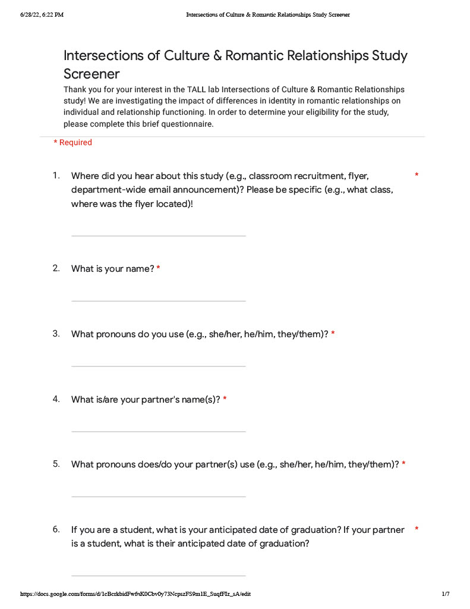
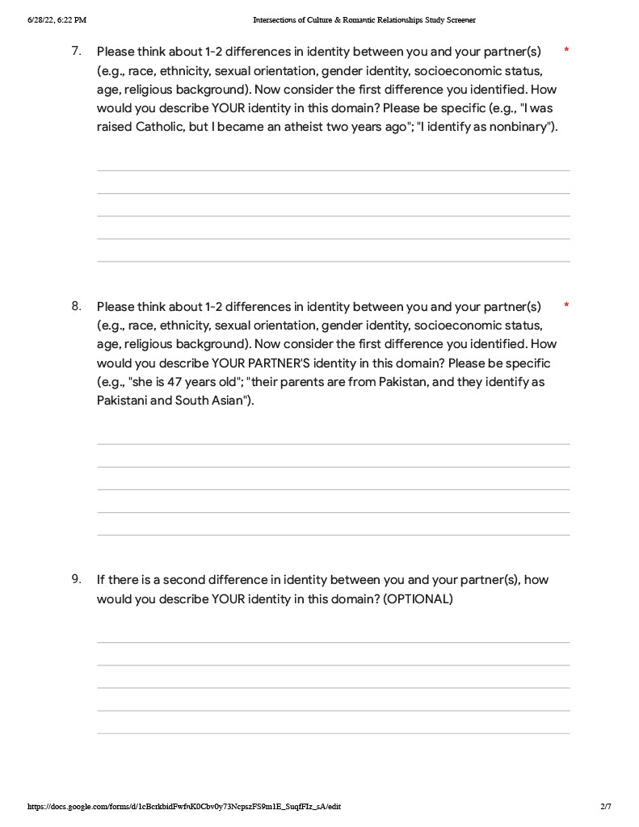
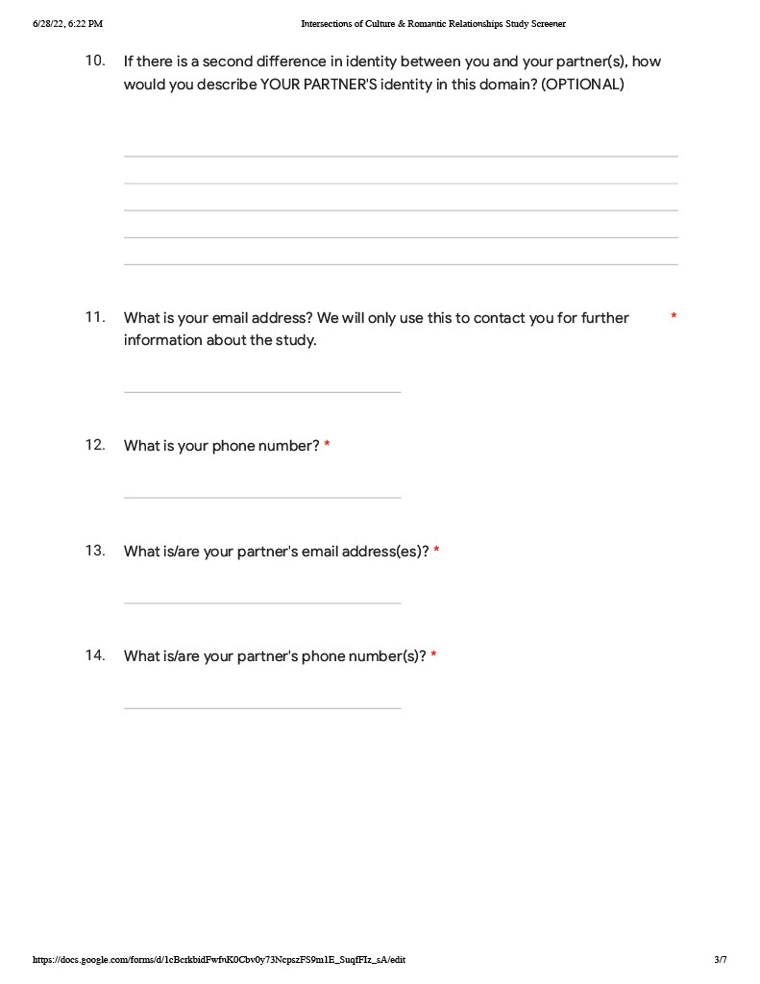
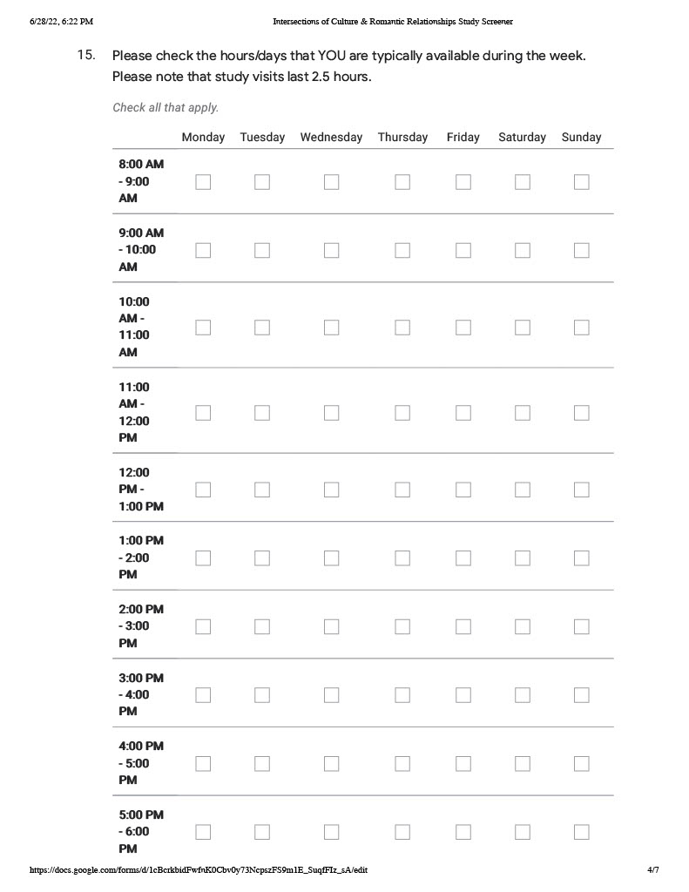
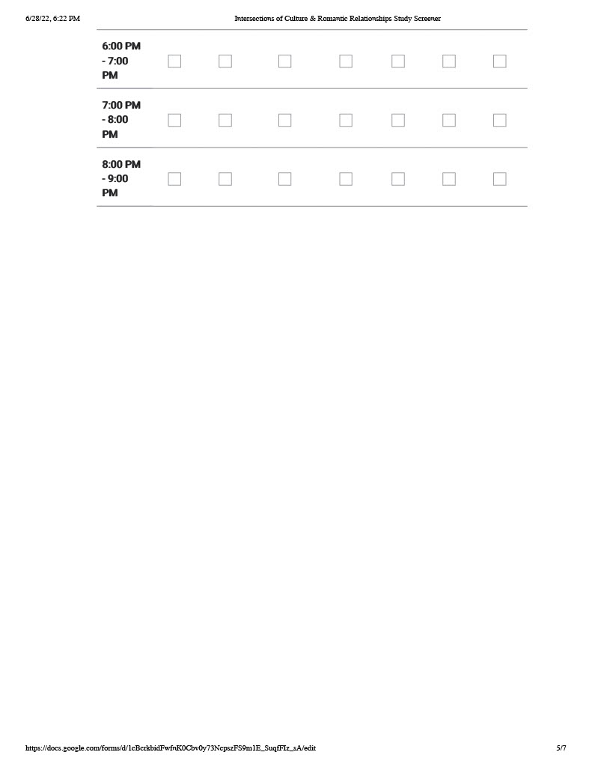
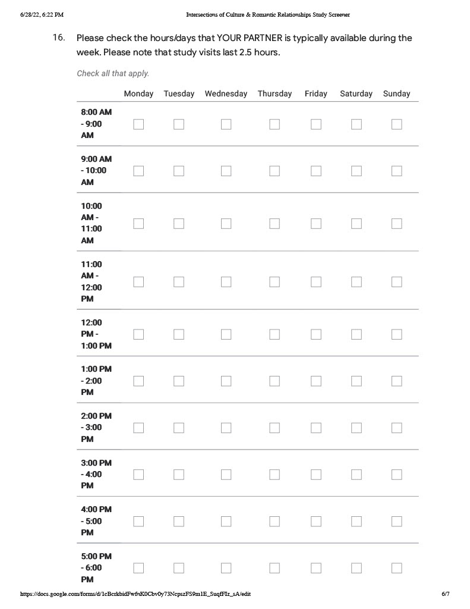
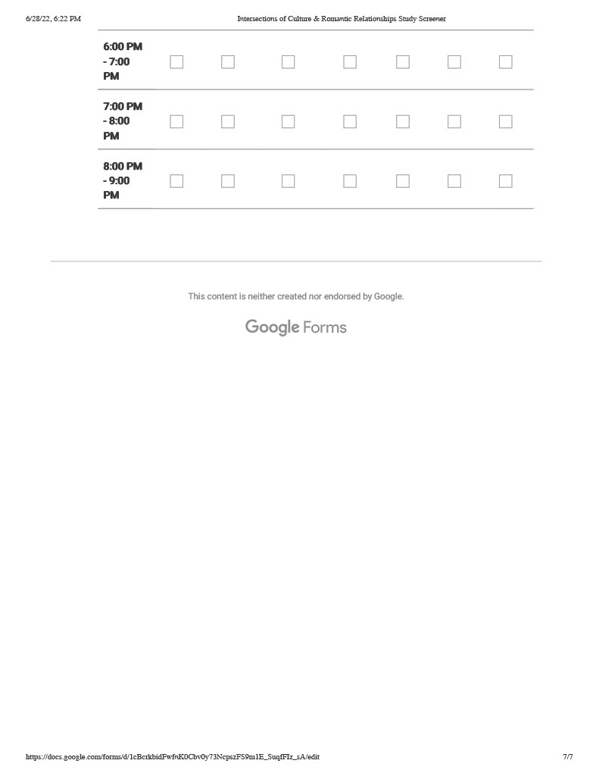

Appendix C. Demographics
1. How old are you?
__

2. What is your class standing?
__First year
__Second year
__Third year
__Fourth year
__Fifth year
__N/A

3. Have you declared a major?
__Yes
__No

4. If yes, what is it?
_______________________

5. What is your gender?
_______________________

6. Which statement best describes your gender?
__ My sex assigned at birth aligns with my gender identity (e.g., assigned male at birth and identify as a man)
__ My sex assigned at birth does not align with my gender identity (e.g., assigned male at birth and identify as a woman)
__ Prefer to self-describe: _______________________

7. Which of the following best describes your sexual orientation? (check all that apply)
__Gay
__Lesbian
__Straight
__Bisexual
__Queer
__I prefer to describe myself as: ____________________

8. Are you an international student? Yes/No

IF YES:

What country are you from?________

Which of the following best describes your racial/ethnic background?
__White/Caucasian
__Asian
__Black/African
__Native/Indigenous
__Biracial/Multiracial
__I prefer to describe myself as: ___________________

8. FOR PEOPLE FROM THE US: Which of the following best describes your racial/ethnic background? (check all that apply)

__White/Caucasian
__Asian/Asian American
__Black/African American
__Native American
__Biracial/Multiracial
__I prefer to describe myself as: ___________________

9. Do you consider yourself Hispanic/Latino/a/x?
__Yes
__No

10. What religious affiliation were you raised in? (check all that apply)
__Protestant
__Baptist
__Catholic
__Jewish
__Muslim
__Buddhist
__None
__Other: ____________________

11. What is your current religious affiliation? (check all that apply)
__Protestant
__Baptist
__Catholic
__Jewish
__Muslim
__None
__Other: ___________________

12. How important is religion in your life?
__Very important
__Somewhat important
__Not too important
__Not at all important
__Prefer not to answer

13. How would you describe your political views?
__Conservative
__Moderate
__Liberal
__Prefer to self-describe: _____________________
__Prefer not to answer

14. What is the highest level of schooling either of your parents completed?
__Some high school
__High school graduate
__Technical school
__Some college
__College graduate
__Graduate school

15. Are you currently employed?
__Yes
__No

16. If yes, how many hours do you work in a typical week?
__Fewer than 10
__11-20
__21-30
__More than 30

17. If yes, do you work...
__On campus?
__Off campus?

18. Which of the following best describes your current living situation?
__On campus (residence hall)
__Off campus (within 5 miles of campus)
__Off campus (more than 5 miles from campus)

19. Which of the following best describe your living situation? (check all that apply)
__Living alone
__Living with students
__Living with non-student roommates
__Living with parents/guardians/relatives
__Living with spouse

20. If you were born in the US, what is the zip code of your hometown? If you were not born in the US, in what country were you born?
__________________________

21. Which of the following best describes your relationship status? (check all that apply)
__I am not currently dating or involved in a sexual or romantic relationship
__I am currently involved in one or more sexual relationships but am not in a romantic relationship
__I am currently involved in one or more romantic relationships
__I am currently in a committed romantic relationship

22. If you indicated that you are in a romantic relationship, how long have you been dating your current partner(s)?

23. Do you have any children?
__Yes
__No

24. Are you a military veteran or active duty member?
__Yes
__No

25. If yes, which of the following best describes your experience?
__U.S. military veteran or active duty member
__Military veteran or active duty member serving a country other than the U.S.
__Current or former member of the U.S. National Guard or Reserves
__Current or former member of the U.S. National Guard or Reserves or similar in a country other than the U.S.
__Current member of the U.S. ROTC
__Other (please specify): __________________

26. What campus activities are you involved in? Check all that apply.
__Academic or professional organization
__Campus activities or event attendance
__Intramural or club sports
__Community service/service-learning
__Greek-letter organization
__Cooperative organizations (co-ops)
__Honor society
__Intercollegiate athletics
__Internships
__Leadership or mentoring program
__Multicultural organization
__On-campus employment
__Orientation leader
__Performing arts
__Political activism
__Recreation or wellness group
__Religious or spiritual group
__Research with faculty
__Residential life (security, desk attendant, resident assistant)
__Student government
__Student media (yearbook, newspaper, radio)
__Study abroad
__Other student club
__Other (please specify):__________________
__Prefer not to answer

VITA
Rachel Miriam Maskin grew up in Charlotte, North Carolina and earned her Bachelor of Arts degree in psychology and English at Mount Holyoke College in 2015. She received her Master of Arts in psychology from the University of Tennessee in 2019. Rachel anticipates receiving her doctoral degree in clinical psychology from the University of Tennessee in 2024, following the completion of a predoctoral internship at the VA Loma Linda Healthcare System.

