POLYMERS WITH DYNAMIC BONDS:
AN EXPERIMENTAL FORAY INTO THEIR FOUNDATIONAL STRUCTURE PROPERTY RELATIONSHIPS

A Dissertation Presented for the
Doctor of Philosophy
Degree
The University of Tennessee, Knoxville

Gregory P. Carden
December 2024

Copyright © 2024 by Gregory Peyton Carden
All rights reserved.

ACKNOWLEDGEMENTS

Thank you to Judy King from OIT for her help making this template! However, this page is optional.
Abstract
Table of Contents

CHAPTER 1: INTRODUCTION 8
CHAPTER 2 LITERATURE REVIEW 12
2.1 Polymers with dynamic bonds 12
2.2 Bond lifetime renormalization model and the strongest bonding regime 14
2.3 Imine functionality 15
2.4 Systems with microphase separation 16
2.5 Dynamics of phase separated systems 19
2.6 Flory-Huggins Model 20
2.7 Hansen Solubility Parameter 21
2.8 Interfacial Layer and the Percolation Model 22
2.9 Bond rearrangement in non-telechelic architectures 26
2.10 Critical solution temperatures in block copolymers 27
2.11 Research Objectives 28
CHAPTER 3 EXPERIMENTAL TECHNIQUES 29
3.1 Small angle X-ray scattering (SAXS) 30
3.1.1 Principles of SAXS 30
3.1.2 SAXS Peak Fitting 31
3.1.3 SAXS measurement Setup 31
3.2. Differential Scanning Calorimetry (DSC) 32
3.2.1 Principles of DSC 32
3.2.2 DSC Measurement Setup 32
3.3 Broadband Dielectric Spectroscopy (BDS) 33
3.3.1 Principles of BDS 33
3.3.2 Dielectric Relaxations 33
3.3.3 BDS Measurement Setup 35
3.4 Small Amplitude Oscillatory Shear Rheology (SAOS) 36
3.4.1 SAOS Principles 36
3.4.2 SAOS Measurement Setup 39
3.5 Thermogravimetric Analysis (TGA) 39
3.5.1 TGA principles 39
3.5.2 TGA measurement setup 39
3.6 Fourier Transform Infrared Spectroscopy (FTIR) 39
3.6.1 FTIR Principles 39
3.6.2 FTIR measurement setup 40
CHAPTER 4 RHEOLOGICAL CONCEPTIONS AND MISCONCEPTIONS 41
4.1 Introduction 41
4.2 Materials and Methods 43
4.2.1 Boronic ester vitrimer 43
4.2.2 Synthesis of the PDMS vitrimer with disulfide bonds 44
4.2.3 Material characterization 45
4.3 Results and Discussion 46
4.3.1 Stress relaxation and the 1/e method 46
4.3.2 Viscosity Estimates from Stress Relaxation 50
4.3.3 Definitions and Estimates of the topology freezing temperature Tv 51
4.3.4 Apparent activation energies, energies of bond dissociation, and the impact of segmental dynamics 53
4.4 Conclusions 54
CHAPTER 5 ASSOCIATING POLYMERS IN THE STRONG INTERACTION REGIME: VALIDATION OF THE BOND LIFETIME RENORMALIZATION MODEL 55
5.1 Introduction 56
5.2 Materials and Methods 57
5.2.1 Synthesis of the Telechelic PDMS Polymers 58
5.2.2 BDS Measurements 60
5.2.3 Rheological Measurements 60
5.2.4 SAXS Measurements 61
5.3 Results 63
5.4 Discussion 66
5.5 Conclusions 75
CHAPTER 6 CRITICAL ROLE OF FREE AMINE GROUPS IN THE IMINE BOND EXCHANGE IN DYNAMIC COVALENT NETWORKDS 76
6.1 Introduction 76
6.2 Materials and Methods 80
6.2.1 Synthesis of the Telechelic and Pendant Imine-functionalized PDMS 80
6.2.2 Thermogravimetric Analyses 85
6.2.3. Broadband Dielectric Spectroscopy 85
6.2.4. Small Amplitude Oscillatory Shear Rheology 86
6.3 Results 86
6.3.1. Thermal Stability 86
6.3.2. Broadband Dielectric Spectroscopy 87
6.3.3. Small Amplitude Oscillatory Shear Rheology 88
6.4 Discussion 92
6.5. Conclusions 101
CHAPTER 7 UNRAVELLING THE MECHANISM OF VISCOELASTICITY IN POLYMERS WITH PHASE-SEPARATED DYNAMIC BONDS 102
7.1 Introduction 103
7.2 Results and Discussion 105
7.2.1 Differential Scanning Calorimeters (DSC) 105
7.2.2 X-ray Scattering 106
7.2.3 Rheology 108
7.3.4 Broadband Dielectric Spectroscopy (BDS) 110
7.2.5 Mechanical Percolation Model 113
7.2.6 Viscoelastic Behavior near Terminal Relaxation 118
7.2.7 Mechanism of Network Rearrangement 120
7.2.7 General Molecular Picture 125
7.3 Conclusions 126
7.4 Materials and Methods 127
7.4.1 Synthesis of PDMS-COOH Polymers 127
7.4.2 Differential Scanning Calorimetry (DSC) Measurements 128
7.4.3 X-ray Scattering 129
7.4.4 Broadband Dielectric Spectroscopy (BDS) 129
7.4.5 Small-Amplitude Oscillatory Shear (SAOS) Measurement 129
7.4.6 Estimates of for telechelic PDMS-COOH using Hansen Solubility Parameter (HSP) 130
7.4.7 Estimates of activation energy for network rearrangements in phase-separated telechelic poly(isobutylene) polymers 131
CHAPTER 8 INFLUENCE OF MOLECULAR ARCHITECTURE ON THE VISCOELASTIC PROPERTIES OF POLYMERS WITH PHASE-SEPARATED DYNAMIC BONDS 132
8.1 Introduction 132
8.2 Materials and Methods 135
8.2.1 Synthesis of Pendant Polymers 135
8.2.2 X-ray Scattering 137
8.2.3 Small-Amplitude Oscillatory Shear Rheology 137
8.2.4 Broadband Dielectric Spectroscopy 137
8.3 Results 138
8.4 Discussion 144
8.5 Conclusions 151
CHAPTER 9 DYNAMICS IN POLYMERS WITH PHASE SEPARATED DYNAMIC BONDS: THE CASE OF A PECULIAR TEMPERATURE DEPENDENCE 153
9.1 Introduction 153
9.2 Materials and Methods 155
9.2.1 Synthesis of multi-OH PDMS polymer 155
9.2.2 Broadband dielectric spectroscopy (BDS) 155
9.2.3 Small amplitude oscillatory shear (SAOS) rheology 155
9.2.4 Small angle X-ray scattering (SAXS) 156
9.2.5 Differential scanning calorimetry (DSC) 156
9.3 Results 156
9.4 Discussion 164
9.4.1 Estimates of the Flory–Huggins interaction parameter using Hansen solubility parameter (HSP) 169
9.5 Conclusions 170
Concluding Remarks and Future Directions 172

LIST OF TABLES

aTable 5.1 VFT Fit Parameters (B and T0) of the Segmental Relaxation, Activation Energy of Bond Dissociation (Ea) Estimated Using eq 5.5, and the Value of 2RT ln N at T = 200 K for PDMS-U and PDMS-S-COOH Samples 69
bTable 6.1 Parameters of the Telechelic and Pendant Samples Targeted in the Syntheses 86
cTable 6.2 Summary of the Fit Parameters Obtained from Analysis of SAOS and BDS Data for the Telechelic and Pendant Functionalized Systems 95
dTable 7.1. DP, Molecular Weight of the PDMS-COOH samples including end groups (𝑀𝑛), 109
eTable 7.2 DP, Volume Fraction of Clusters φcluster, Volume Fraction of the Interfacial Layer φint, Volume Fraction of Clusters in Rigid Phase φcluster,TPM, Volume Fraction of Interfacial Regions in Rigid Phase φint,TPM, and Overall Shear Modulus of Rigid 118
fTable 7.3. The estimated energy barrier 𝐸𝑎 for 3 telechelic PIB associating polymers 126
gTable 8.1 Parameters of the Polymers Studied Here with Pendant Stickers: m – Number of Non-functionalized Monomers in a Polymer; n – Number of Stickers Per Molecule; fe – Weight Fraction of Stickers; Tg of the PDMS Backbone and Tg of Clusters; Distance b 138
hTable 9.1 Weight fraction of the end groups, fe, centre-to-centre distances d and radius Rcluster of phase separated clusters, numbers of end groups per cluster Nend, Tg of the backbone and of the clusters 163

LIST OF FIGURES
1Figure 3. The generally accepted mechanisms of imine bond exchange. 23
Figure 2Figure 4. A phase separated hydrogen bonding chemistry, with a simplified schematic showing various distances related to the clusters. Reprinted from Ref. 29 24
3Figure 5. SAXS data of several phase separated samples (low q peak) and a non phase separated sample (open symbols). Reprinted from Ref. 23 25
4Figure 6. VFT extrapolation of dielectric alpha relaxation times to determine a glass transition temperature 26
5Figure 7. Previously proposed cluster fusion rearrangement mechanism reprinted from Ref. 31 27
6Figure 8. Schematic of chain exchange between micelles as reprinted from Ref. 32 28
7Figure 9. Schematic of the component contributions to the interfacial layer model where f represents the filler, l the layer, m the matrix, and c the composite. Reprinted from Ref 43 31
8Figure 10. Modeled relative shear moduli with and without contribution from the interfacial layer. Reprinted from Ref 43. 32
9Figure 11. Schematic depicting the transition from a system with disparate interfacial layers, to a fully percolated nanocomposite network. Reprinted from Ref 47. 33
10Figure 12. Composite shear modulus of a nanocomposite system of cellulose whiskers in a styrene butyl acrylate copolymer as a function of cellulose whisker volume fraction. Reprinted from Ref 48. 34
11Figure 13. Features of a phase diagram. Reprinted from Ref. 51 36
12Figure 3.1 Schematic of small angle scattering wavevectors. 38
13Figure 3.2 Schematic of Bragg diffraction 39
14Figure 3.3 Simplified configuration of a BDS instrument 42
15Figure 3.4 a) Schematic of a sample’s dipole alignment following the application of an electric field. b) Experimental data showing a dielectric relaxation process 43
16Figure 3.5 Stainless steel dielectric cell used for liquid samples. 44
17Figure 3.6 Rheometer with parallel plate configuration. 45
18Figure 3.7 The applied strain wave and resultant stress phases of a fully elastic, fully viscous, and viscoelastic materials61 46
19Figure 3.8 Rheological master curve spanning several decades of frequency 47
20Figure 3.9 FTIR spectra fit to several gaussian functions 49
21Figure 4.1 a) Reaction coordinate diagram of a dissociative exchange mechanism and an b) associative exchange mechanism 51
22Figure 4.2 Synthetic scheme for the boronic ester vitrimer 53
23Figure 4.3 Scheme for the synthesis of the PDMS vitrimer with disulfide bonds 54
24Figure 4.4 Ratio of 1/e relaxation times (t_1) to KWW relaxation times(τ) as a function of t_0/τ. 57
25Figure 4.5 a) Stress relaxation data with true Young’s modulus values b) stress relaxation data normalized by the first measured Young’s modulus value c) master curve produced by shifting the measurements with respect to their varied temperatures accordi 58
26Figure 4.6 Activation plot comparing the 1/e relaxation times (t_1) and the KWW relaxation times (τ) 59
27Figure 4.3 Rheological master curve of a PDMS vitrimer with disulfide bonds. A gel like behavior is seen rather than terminal flow even at temperatures of 150˚C 60
28Figure 4.4 a-I) Scheme of viscosity vs 1/T in the case where Tv>>Tg a-II) where Tv≈Tg a-III) where Tg>Tv b-I and b-II) Viscosity as a function of temperature deviating from Arrhenius behavior at lower temperatures87, 88 62
29Figure 5.1. Chemical structures of telechelic PDMS samples investigated in this study. DP indicates the degree of polymerization. 67
30Figure 5.2 1H-NMR result for the PDMS-U with DP 50 69
31Figure 5.3 X-ray Scattering spectrum for PDMS-U and PDMS-S-COOH 72
32Figure 5.5 Dielectric loss spectra of (a) PDMS-U (DP 22), (b) PDMS-U (DP 50), (c) PDMS-S-COOH (DP 13), and (d) PDMS-S-COOH (DP 83). The solid lines present the total fit. The dashed lines present the fits of the α relaxation process. The dash-dotted line 74
33Figure 5.6 (a) Shear modulus master curves for (a) PDMS-U with DP 50 (blue) and DP 22 (black) and (b) PDMS-S-COOH with DP 83 (blue) and DP 13 (black) against the radial frequency at a reference temperature of Tg + 5 K. The solid symbols present G′, while 76
34Figure 5.7 Temperature dependence of the relaxation time for segmental α-relaxation (red squares) and the α*-relaxation (blue squares) for the PDMS-U sample with (a) DP 22 and (b) DP 50 and for PDMS-S-COOH samples with (c) DP 13 and (d) DP 83. Red crosse 77
35Figure 5.8 Ratio of the time scales τα*(T) and τα(T) against 1000/T for PDMS-U with (a) DP 22 and (b) DP 50. The red lines present the Arrhenius law fit (eq 5.5), and the blue lines present the linear fit, accounting for the entropic contribution (eq 5.6 80
36Figure 5.9 Comparison of ɛ’’ (red square) and M” (blue square) spectra for (a) PDMS-U (DP 81
37Figure 5.10 Comparison of dielectric modulus τα*–M (red open squares) and rheological τC (blue closed squares) relaxation times for (a) PDMS-U DP 22, (b) PDMS-U DP 50, (c) PDMS-S-COOH DP 13, and (d) PDMS-S-COOH DP 83 samples. For the PDMS-S-COOH DP 83 sa 83
38Figure 5.11 Comparison of the shear viscosity of PDMS-U and PDMS-S-COOH samples to the viscosity of their non-associated counterpart PDMS-H with comparable DPs. The temperatures are scaled with Tg of the samples. Crystallization of samples leads to the g 85
39Figure 6.1 Reversible Processes Involving the Imine Bond: (a) Imine Formation via Condensation; (b) Transimination; (c) Imine Metathesis 89
40Figure 6.2 Final structures of the (a) telechelic and (b) pendant imine-functionalized PDMS-based dynamic polymers. 92
41Figure 6.3 In (a), 1H NMR spectra of the telechelic sample either as-prepared or dried at 105 0C for 15h. The experiments were performed in CDCl3 with a field strength of 400 MHz and 48 scans were collected. The results show the success of synthesizing t 94
42Figure 6.4 X-ray scattering data collected for the (a) telechelic and (b, c) pendant functionalized samples. Peaks around 1Å-1 correspond to the scattering of PDMS chains. The absence of peaks or shoulders at lower q-values indicates no phase segregation 96
43Figure 6.5 TGA scans of the telechelic and pendant-10% samples: (a) temperature-dependent TGA scan; (b) an isothermal TGA analysis at 378 K for 12 h. Apparent weight fluctuations in (b) reflect the accuracy of the isothermal measurements. 99
44Figure 6.6 Representative BDS data collected at (a) 173 K with the telechelic and (b) at 167 K with the pendant functionalized samples highlighting the α*- and α-processes. The arrows highlight the drop in the amplitude of α- after drying the sample at 3 100
45Figure 6.7 SAOS results for the as-prepared telechelic sample at room temperature. The low-frequency decays of G′ and G′′ as functions of ω2 and ω1 show that the sample is already within the terminal regime (flow). 101
46Figure 6.8 SAOS data for the telechelic sample. (a) The phase angle data of the sample dried under N2 flow at 350 K for 15 h highlights the breakdown of the time–temperature superposition. Data was collected between room temperature and 400 K. (b) Master 102
47Figure 6.9. SAOS data for the imine-containing PDMS samples with pendant functionalities either as-prepared (black symbols) or after drying at T = 353 K for 15 h (red symbols). (a) The pendant −10% sample; (b) the pendant −20% sample; (c) the pendant −50 103
48Figure 6.10 (a) Temperature dependence of segmental (open symbols) and terminal (closed symbols) relaxation times in as-prepared (black symbols) and dried at T = 378 K for 15 h (red symbols) telechelic samples. The lines present fits of τα to eq 6.3. (b) 104
49Figure 6.11 FTIR results for the telechelic sample either (a) as-prepared or (b) dried at 473K for 15h. The inset in (b) highlights the presence of stretching vibrations either from -OH or -NH2 groups around 3250 cm-1 even after severely drying the samp 108
50Figure 6.12 FTIR results for the Pendant-50% sample either as-prepared or dried at 353K for 15h. In (a) and (b), the spectral regions between 1585 and 1800 cm-1 were decomposed in Gaussian components to highlight the contributions from the imine (blue cu 110
51Figure 6.13 (a) Temperature dependence of segmental (BDS) relaxation time τα and rheological τr of the systems with pendant imine functionalities. The lines indicate fits of τα with eq 6.3. In (b), the values of τr are zoomed-in, and (c) displays the evo 111
52Figure 6.14 Evolution of the plateau modulus (GN) in dried pendant samples as a function of the functionalization degree. 112
53Figure 7.1 Chemical structure of PDMS-COOH with different DP 118
54Figure 7.2. Heat flow curves of the telechelic PDMS-COOH samples in DSC measurements. Solid lines indicate the Tg of the PDMS matrix and dashed lines mark the 2nd Tg due to cluster phase 119
55Figure 7.3. X-ray Scattering spectrum for PDMS-COOH with DP 19. Red line presents the Gaussian fit of the low-q peak. The peak position is labeled by an arrow. 120
56Figure 7.4. Shift factors of time-temperature superposition (TTS) for the telechelic PDMS-COOH samples used to create the master curves. 122
57Figure 7.5. (a) Shear modulus master curves for the telechelic PDMS-COOH measured at temperatures higher than second Tg. The arrow indicates the increased rubbery plateau value for shorter chains. Slope of 0.5 indicates Rouse-like regime, whereas regime 122
58Figure 7.6. Dielectric loss spectra at various temperatures for telechelic PDMS-COOH with (a) 125
59Figure 7.7 (a) Dielectric loss spectra for PDMS-COOH (DP 19) in the range of 10–2 to 106 Hz. Loss peaks at low temperatures correspond to PDMS segmental motion (α-relaxation), while at higher temperatures, sticker motion within the cluster is visible as 126
60Figure 7.8 dIPS as a function of fe. Range of 2lint value shown as a gray area. The box area indicates the estimated range of percolation threshold, (fe)C, when dIPS ≈ 2lint. Above the percolation threshold, interfacial layers overlap to form a percolate 128
61Figure 7.9 Variation of GPL (red squares) and G0 (black squares) as a function of fe and Xr. Red line shows the fitting based on the mechanical percolation model (eqs 7 and 8). Black dashed line indicates the prediction from classical rubber elasticity t 130
62Figure 7.10 The comparison of 𝜏𝑐 (blue symbols) and 𝜏𝛼2 ― 𝑀 (red symbols) as a function of 134
63Figure 7.11 (a) Comparison between the shear modulus (red and blue symbols) and the dielectric loss modulus spectra (green symbols) for PDMS-COOH with DP of 13 sample at 230 K. Terminal relaxation time scale (τC) and α2-relaxation time scale (τα2 – M) (a 135
64Figure 7.12 Estimated energy barrier for single sticker “pullout” into PDMS matrix. The solid dashed line indicates the average activation energy for this process. Value for the lowest fe data is not reliable due to possible sample crystallization. 137
65Figure 7.13 Activation plot of the telechelic PIB associating polymer (a) 8KBA2, (b) 14KBA2, (c) 140
66Figure 7.14 (a) Cartoon of a single chain exchange process between two clusters, which leads to a macroscopic rearrangement of the network. (b) Qualitative picture of the shear modulus variation with time for a phase-separated associated polymer network 142
67Figure 7.15. 1H-NMR result for the PDMS-COOH with DP of 19 144
68Figure 7.16 Chemical structure of chain ends dividing into 4 parts, all of which are included in the Table A.1 in Ref40. 146
69Figure 8.1 Structure of a pendant sample with the various molar ratios of stickers (a) and of the earlier studied telechelic samples (b). 152
70Figure 8.2 X-ray scattering data for each sample reveals a low-q peak that indicates phase separation. PDMS with no phase separation and no low-q peak is shown as a reference. 155
71Figure 8.3 Dielectric permittivity loss spectra of the DP100 sample at low (a) and high (b) temperatures (K), showing relaxation processes corresponding to the polymer segmental relaxation (alpha), dimeric dissociations (alpha*), and relaxation in cluste 157
72Figure 8.4 Temperature dependence of characteristic relaxation times for the α- and α2-processes estimated from the dielectric spectra (closed symbols) and terminal relaxation time (τC, open symbols) estimated from rheology for studied systems with penda 158
73Figure 8.5 Rheological master curve for each pendant functionalized sample. The spectra of DP70 and DP670 coincide up to the frequency of the loss modulus maximum below the end of the rubbery plateau. 160
74Figure 8.6 Rheological data for the DP100 sample (symbols) and their fit to the Rouse model eq 5 (lines). Arrows indicate two characteristic time scales extracted from the fit. 161
75Figure 8.7 Dependence of the glass transition temperature Tg on the weight fraction of the functional group for telechelic (open circles) and pendant (closed triangles) PDMS–COOH systems. Data for telechelic systems are from ref (26). 163
76Figure 8.8 Activation plot for the DP70 (a) and DP670 (b) samples demonstrating the disparity of the dielectric cluster relaxation times (τα2-M) with the rheological bond rearrangement time (τp), which indicates the onset of Rouse-like dynamics. 165
77Figure 8.9 Comparison of the shear modulus spectra of the DP100 sample with pendant functional groups (black open symbols) to the spectra of the telechelic DP50 sample (red symbols). Lines mark the power law regions with the slope indicated by numbers. 167
78Figure 8.10 Comparison of dielectric and rheological relaxation times for systems with the same fraction of stickers: DP100 with pendant stickers (black open symbols) and DP50 with a telechelic sample (red symbols). 168
79Figure 8.11 Cartoon depicting the regimes of viscoelastic behavior for pendant functionalized and telechelically functionalized associating systems with microphase separation. The stickers are frozen in the clusters until time τα2, they are moving inside 170
80Figure 9.1 Structure of the studied telechelic multi-OH PDMS chains 173
81Figure 9.2 (a) X-Ray scattering data for the studied samples at room temperature. The peak at q B 0.1 Å 1 confirms the presence of phase separated clusters. (b) SAXS data for the DP50 sample at various temperatures. 177
82Figure 9.3 DSC data shows the glass transition at temperatures much higher than the backbone Tg. Tg marked by vertical lines are estimated as the temperature at the middle of the step in the heat flow. 178
83Figure 9.4 dielectric spectra (symbols) measured at different temperatures for samples with DP22 (a) and (b), DP50 (c) and (d) and DP74 (e) and (f). Lines show fits of the peaks. (a), (c) and (e) present the permittivity loss data with a and a* processes 181
84Figure 9.5 Temperature dependence of characteristic dielectric relaxation times for the segmental (a) process, dimeric sticker dissociation (a*) process, and cluster (a2-M) relaxation (closed symbols) and the rheological intermediate and terminal relaxat 183
85Figure 9.6 Rheological master curves for each studied sample. The slope 0.5 indicates the Rouse regime at frequencies above the rubbery plateau. The slopes 2 for G0(o) and 1 for G00(o) indicate terminal regime. The arrows show intermediate relaxation pro 184
86Figure 9.7 The polymer glass transition temperature vs. mole fraction of the 185
87Figure 9.8 The ratio of relaxation times for the intermediate (dimeric) process, ta*, and the segmental relaxation time, ta, from BDS vs. inverse temperature for DP 22 sample. The data for ta(T) were extrapolated to higher temperatures using a VFT fit. T 186
88Figure 9.9 Temperature dependence of the Flory–Huggins interaction parameter estimated using eqn (7). 188
89Figure 9.10 Chemical structure of chain ends dividing into 5 parts. 190

CHAPTER 1: INTRODUCTION
Polymers with dynamic bonds are an exciting emerging class of polymer which incorporate bonds between polymer chains capable of exchange in order to imbue thermoset mechanical resiliency with the processability and recyclability of their thermoplastic counterparts. The incorporation of these bonds introduce other desirable properties such as self-healing, shape memory, and super extensibility. Though there is great interest in these polymers, there is no generally accepted mechanistic picture describing their viscoelastic character, and this understanding only becomes foggier as the systems grow in complexity.
Hydrogen bonding systems are a relatively simple subset of polymers with dynamic bonds which have been described previously using the sticky Rouse and sticky reptation models. The bond lifetime renormalization model has also been used to describe the difference in interaction strength of these stickers, however, the case of stickers with a strong interaction strength has not been experimentally validated.
In a more complex case, dynamic covalent networks functionalized with imine groups have seen widespread application. However, the specifics of their bond rearrangement process remain under contention, particularly with the tricky tendency of imine bonds to hydrolyze in the presence of even ambient amounts of water.
Beyond binary interactions between functional groups, sticker groups are also known to phase separate from the polymer backbone forming clusters. In this case, such polymers have demonstrated rubbery plateaus extending over six decades in time, with a mechanical reinforcement analogous to the behavior seen in polymer systems reinforced with nanoparticles. Though these unusual and attractive properties have been reported, proposed mechanisms of bond rearrangement has yet to see experimental validation. The main goal of this research is to address these gaps in understanding by synthesizing model polymer systems consisting of a hydrogen bonding urea functionality in the strong interaction regime, an imine functionalized samples, and several functionalities which phase separate from the polymer backbone.
These model polymers were characterized with a combination of broadband dielectric rheology (BDS) and rheology to develop a complete picture of the dynamic character of each sample. The relaxation times derived from BDS and rheology allowed for a comparative analysis of bond dissociation and bond rearrangement times, whose overlap suggests an experimental confirmation of the bond lifetime renormalization model in our urea functionalized samples. Similar analysis is performed in the case of our imine functionalized sample to derive an activation energy of ~ 40-60 kJ/mol for network exchange. Additionally through procedural drying steps and synthetic preparation to exclude a significant population of free amine groups, an unmediated imine metathesis exchange is ruled out as a contributor to network rearrangement in imine functionalized systems.
These tools are utilized in conjunction with small angle x-ray scattering (SAXS) and differential scanning calorimetry (DSC) in the case of our phase separated systems. SAXS measurements allow confirmation of the phase separated clusters and provide distances between the centers of these clusters. DSC provides the thermal transitions in our system, most relevantly the glass transition of the phase separated clusters which we see in SAXS. In a comparison of the dielectric cluster relaxation times and the rheological relaxation times, we develop a mechanism of bond rearrangement dependent on the Flory-Huggins solubility parameter, analogous to what is done in block copolymer literature. We apply this understanding to systems with a cross-linking architecture, beyond that of our initial telechelic systems and find a regime of sticky rouse dependence following the pullout of a single sticker from the clusters. Lastly, we investigate a phase separated system which exhibits an unusual temperature dependence in which the cluster relaxation times and terminal relaxation times begin to converge upon a cooling of the system. We attribute this novel temperature dependence to an LCST phase behavior where the energetic barrier necessary to overcome the miscibility difference between the cluster relaxation time and terminal relaxation time falls to zero as the temperature decreases.
This dissertation is organized as such:
Chapter 1 is an introduction and broad scale summary of work and scope of this dissertation.
Chapter 2 is a literature review, providing a contextual background for the concepts discussed regarding polymers with dynamic bonds, phase separated behavior, and the mechanisms of network rearrangement already proposed within literature. This chapter concludes with a statement of this dissertation’s research objectives.
Chapter 3 is an overview of the experimental methods implemented in this dissertation, such as BDS, rheology, and DSC. It also provides theoretical and conceptual foundation for the application of these techniques.
Chapter 4 addresses several rheological misconceptions commonly present in literature and presents prudent practices to intelligently plan experiments and avoid misinterpretation of rheological data.
Chapter 5 presents an experimental validation of the strongest interaction strength regime of the bond lifetime renormalization model. Several model polymers are investigated whose interaction strength is shown to be beyond 2k_{B}TlnN. Rheological and dielectric data are compared to conclude an overlap of bond dissociation and rearrangement time validating this model
Chapter 6 presents an investigation of several imine functionalized samples. The specific impact of water on the network structure and exchange dynamics is considered, and an activation energy of network rearrangement is derived. Through the exclusion of free amine groups, the validity of an unmediated imine metathesis exchange is brought into question.
Chapter 7 looks at a system with microphase separated hydrogen bonding sticker groups. Following a dielectric and rheological analysis of their dynamic behavior, a conclusion is made that the delay from cluster relaxation time to terminal relaxation time can be attributed to the miscibility difference between sticker group and backbone repeat unit; this difference can be related using the Flory-Huggins $χ$ parameter.
Chapter 8 considers the impact of more complex polymer architectures which demonstrate phase separated clusters. Similar analysis shows that the backbone glass transition temperature maintains the same dependence on mole fraction of functional group regardless of architecture. We also show that pendant functionalized samples have the same viscoelastic behavior up to the point of a single bond pullout at which a sticky rouse like dependence precedes the terminal relaxation time for the pendant samples.
Chapter 9 looks to a sample with a different phase separated functionality. Analysis further verifies the linear dependence of backbone Tg on mole fraction of H bonding functional group, regardless of architecture of specific functionality. This system is shown to have an unusual temperature dependence in which the cluster and terminal relaxation times approach each other as the temperature cools.
This is followed with some final concluding remarks and directions for future research.

CHAPTER 2 LITERATURE REVIEW

2.1 Polymers with dynamic bonds
Over the past century, polymers have seen a widespread explosion of industrial, commercial, and scholastic popularity. This is largely thanks to the unique role that polymers have as a class of material. They are incredibly versatile, lightweight, resilient, and relatively inexpensive to produce. Polymers also boast an unparalleled tunability, allowing for the production of complex products made from dozens of component polymers (Fig 1), which can vary in aspects from backbone chemistry, tacticity, molecular weight, crosslink density, and even architecture. With the great and increasing demand for polymer products comes an increasing need to deal with the plastic waste that we see downstream.

aFigure 1. An example of a complex product using dozens of different polymers in its component parts.

Figure 1. An example of a complex product using dozens of different polymers in its component parts.
One of the tactics which have been implemented for dealing with plastic waste is designing future polymers to be intentionally more recyclable. Thermoplastics allow for greater ease of recyclability and processability in contrast to thermosets, however, the permanent crosslinks of thermosets imbue them with a greater material strength and solvent resistance. Associative polymers offer the mechanical strength and solvent resistance by the introduction of reversible bonds (often referred to as stickers), and the reversible nature of these linkers allows for an ease of processability and recyclability not available to thermoset polymers. Additionally, these sticker groups introduce other desirable properties to these systems such as intrinsic self-healing, super extensibility, and shape memory.
It is generally accepted that these sticker groups undergo either an associative or dissociative exchange process¹. An example of a dissociative exchange process would be the interaction that hydrogen bonding groups have between one another. This is because the two groups can exist without chemical change on their own but can bond and dissociate without any sort of mediator. This is in contrast to functionalities such as the vinylogous urethane (Fig 2), which undergo an associative exchange, in which the exchange is similar to that of an S_{N}2 reaction where there is first a formation of a bond before the breaking of the original². This sort of system maintains a constant cross-link density and a viscosity with an Arrhenius temperature, enabling a greater solvent and creep resistance in comparison to dissociative exchange stickers, whereas a dissociative system has a decreasing cross link density with an increase in temperature, but is typically simpler to synthesize and reprocess².

2.2 Bond lifetime renormalization model and the strongest bonding regime
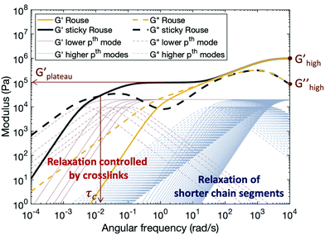
bFigure 2. Simulated data from the Rouse and sticky Rouse models, revealing the contribution of dynamic bonds. Reprinted from Ref. 3
Figure 2. Simulated data from the Rouse and sticky Rouse models, revealing the contribution of dynamic bonds. Reprinted from Ref. 3
When dealing with polymers with a dissociative exchange mechanism, several models are typically employed to describe their viscoelastic behavior. The sticky Rouse model is routinely used to described this behavior in the case of an unentangled polymer system, and the sticky reptation model is used for an entangled polymer system (Figure 2)³. In addition to these models, the bond lifetime renormalization model distinguishes the bond dissociation time from the bond rearrangement time. This model developed by Stukalin and colleagues defines a renormalized bond lifetime through Equation 1 where J is the number of returns a sticker makes to its original partner, $τ_{open}$ is the diffusion time for an open sticker to find another open sticker, and $τ_{b}$ is the time that a bound pair of stickers spend before being dissociated⁴.
$τ_{b}^{renm}=Jτ_{open}τ_{b}+τ_{open}$ (1)
This bond lifetime $τ_{b}$ is related to the bond strength of a given pair of stickers, E_{a}, through Equation 2, in which $τ_{0}$ is the diffusion time of a single monomer length and k_{B} is the Boltzmann constant.
$τ_{b}≈τ_{0}exp⁡(\frac{E_{a}}{k_{B}T})$ (2)
The behavior of a given system depends strongly on this bond strength. In the low strength case (Ea<k_{B}TlnN where N is the number of segments between sticker groups), essentially all sticker groups remain open, and the viscoelastic behavior is similar to a system without sticker groups at all. In the intermediate (K_{B}TlnN<Ea<2K_{B}TlnN) regime however, there exists an active equilibrium of open and closed stickers, allowing for self-healing, super extensibility, and other aspects of associating polymers. The model predicts a disparity between the bond dissociation time with the bond rearrangement time, thanks to the number of returns a sticker makes to its original partner as well as the diffusion time to find another sticker in this regime (Equation 1). In the strongest bonding regime (2K_{B}TlnN<Ea), these two times are anticipated to overlap, as most sticker groups are closed off as partners, the bond dissociation becomes the final process dictating network rearrangement. Though there has been confirmation within the weaker two regimes, this strongest regime has yet to see experimental validation⁵⁻⁷.

2.3 Imine functionality
This regime is of such great interest because of its potential relevance to dynamic covalent functionalities. One particular dynamic covalent functional group of interest is the imine linkage. This bond can be simply made by the condensation reaction of an aldehyde and primary amine group⁸⁻¹⁶. There are three typically accepted exchange mechanisms facilitating bond rearrangement in imine functionalized systems: hydrolysis, where a water molecule cleaves the imine group; transimination where a free amine group can switch places with the nitrogen involved with the imine bond, and imine metathesis where two imine groups can undergo a partner exchange (Fig 3)^{17, 18}.
1Figure 3. The generally accepted mechanisms of imine bond exchange.
Figure 3. The generally accepted mechanisms of imine bond exchange.
The hydrolysis pathway makes these systems inherently water sensitive, this is mentioned frequently in literature, and is even used to help the systems achieve faster rearrangement. When studying the exchange dynamics, commonly only a brief drying step is the full attention paid to its sensitivity ^{19, 20}. It is assumed that when water is at sufficiently residual levels, that the transimination pathway becomes the predominant mode of network rearrangement when free amine groups are available ²¹. The imine metathesis pathway is in theory capable of rearrangement without either free amine or water present, although, this has been shown to be capable in small molecules only through the assistance of catalysts or unreasonably high temperatures and timescales ^{17, 18}.

2.4 Systems with microphase separation
A common situation in the sphere of polymers with dynamic bonds is where dynamic functional groups begin to phase separate from the polymer backbone they are attached to. Often, systems with ionic interactions as their sticker functionality exhibit some form of phase separation from the backbone. Several other dynamic functionalities have demonstrated phase separation, such is the case with the thia-Michael functionality which shows large scale phase separation²². Additionally, there are several hydrogen bonding functionalities which have been shown to phase separate with cluster sizes on the micro scale (radius of ~1.4 nm in Fig. 4) ²³⁻²⁷. Simulation papers have also suggested that phase separation is an inevitability beyond a certain interaction strength, though, this hypothesis has not seen experimental validation with hydrogen bonding species²⁸.
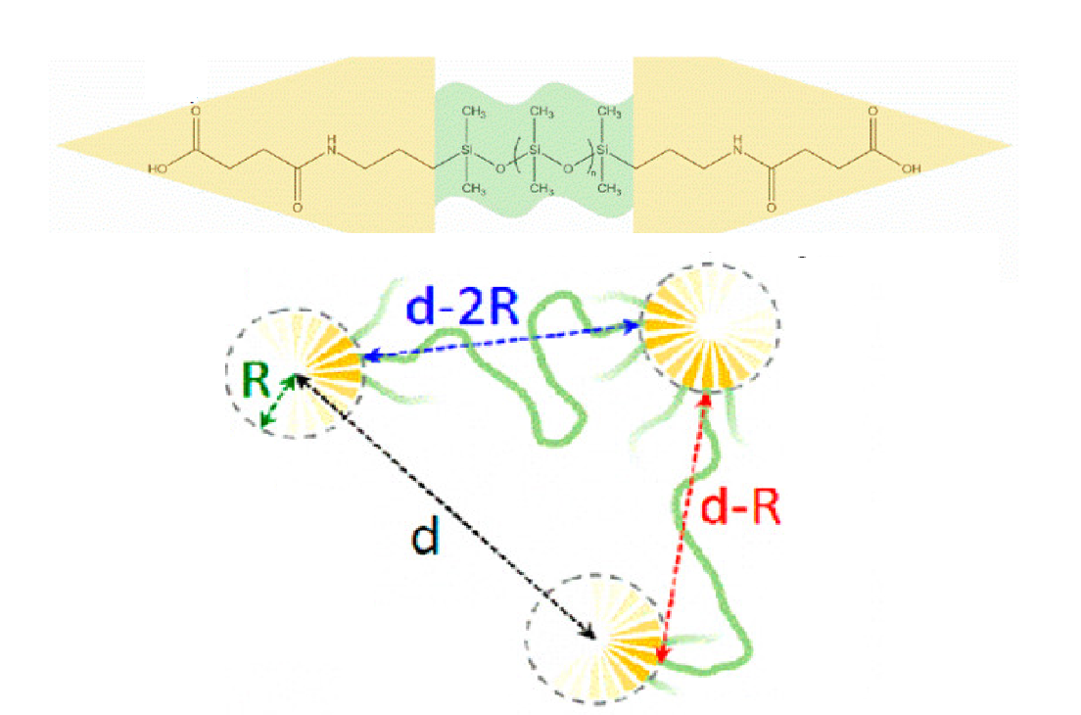
Figure 2Figure 4. A phase separated hydrogen bonding chemistry, with a simplified schematic showing various distances related to the clusters. Reprinted from Ref. 29
Figure 4. A phase separated hydrogen bonding chemistry, with a simplified schematic showing various distances related to the clusters. Reprinted from Ref. ²⁹
In systems with periodic phase separation, small angle X-ray scattering can be used to characterize the size and arrangement of clusters within the matrix. These clusters reveal themselves in SAXS measurements as a low q peak near 0.1 $Å^{-1}$ (Fig. 5) which can be related to the distance between scattering centers through Equation 3.
$D=\frac{2π}{q}$ (3)
With the additional approximation that these clusters arrange themselves in a cubic orientation, and that most sticker groups are sequestered into these clusters, one can conclude also a cluster radius, related to the volume fraction of sticker groups, $f_{e}$, as well as the distance between scattering surfaces, D, through Equation 4³⁰.
$R_{cluster}=\frac{D}{2}{\left(\frac{6}{π}f_{e}\right)}^{\frac{1}{3}}$ (4)
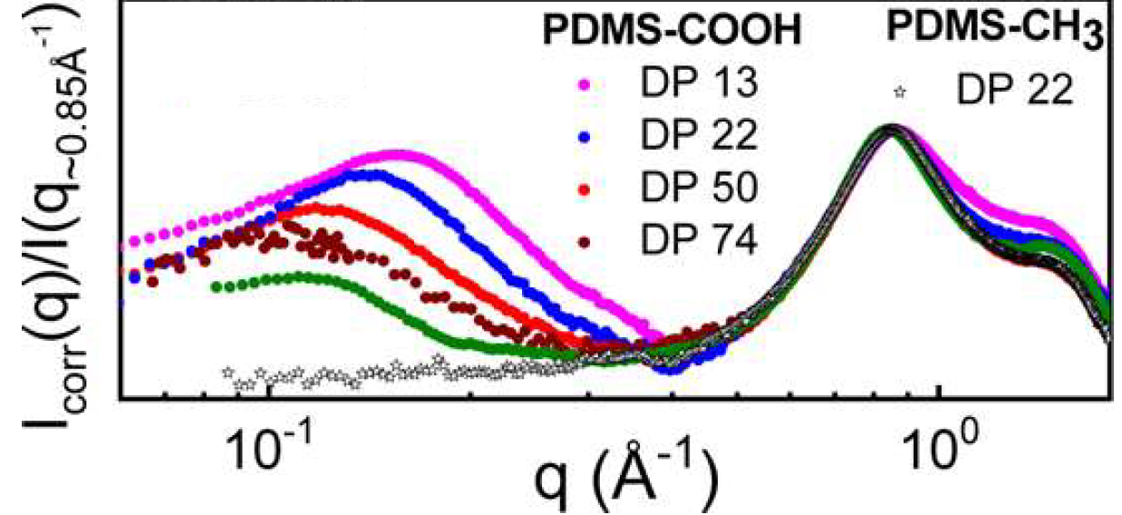
3Figure 5. SAXS data of several phase separated samples (low q peak) and a non phase separated sample (open symbols). Reprinted from Ref. 23
Figure 5. SAXS data of several phase separated samples (low q peak) and a non phase separated sample (open symbols). Reprinted from Ref. ²³
Typically speaking, these clusters introduce an additional thermal transition into their systems as seen by a glass transition separate from that of the backbone glass transition. This temperature, when derived from DSC measurements, can be used with rheological and dielectric measurements to provide further insight into the dynamic character of a given system. A cluster relaxation process can be followed as a function of temperature, and when its relaxation time is extrapolated to $τ=100s$, a dielectric glass transition temperature can also be determined, which should be roughly equal to that which is determined through calorimetric measurements (Fig. 6).
4Figure 6. VFT extrapolation of dielectric alpha relaxation times to determine a glass transition temperature
Figure 6. VFT extrapolation of dielectric alpha relaxation times to determine a glass transition temperature

2.5 Dynamics of phase separated systems
The presence of microphase separated clusters has been shown to have a significant anomalous impact on the viscoelastic behavior of associative polymer systems. Beyond the additional glass transition temperature previously mentioned, clusters have also been shown to extend a system’s rubbery plateau several decades in length²⁹. Additionally, there is a substantial mechanical reinforcement attributed to these clusters comparable to what is seen when nanoparticles are introduced into a system^{23, 29}. Because of this useful and interesting behavior, there have been several mechanisms proposed to describe the mechanism of cluster rearrangement contributing to this unique viscoelasticity. One such mechanism supported by simulation studies suggests that clusters undergo a inter-cluster fusion to facilitate network rearrangement (Fig. 7)³¹.
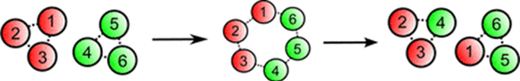
5Figure 7. Previously proposed cluster fusion rearrangement mechanism reprinted from Ref. 31
Figure 7. Previously proposed cluster fusion rearrangement mechanism reprinted from Ref. ³¹
This particular mechanism has seen recent criticism from NMR studies of phase separated systems, leaving the true mechanism undetermined ^{24, 25}.

2.6 Flory-Huggins Model
In recent years, the Flory-Huggins $χ$ interaction parameter, a value used to denote the difference in miscibility between a particular polymer solvent combination, has seen an interesting application in the space of block copolymer micelles. The Lodge group has seen great success in relating this Flory-Huggins $χ$ parameter to the enthalpic energy barrier necessary for an interior core block within a block copolymer micelle to escape the (relatively immiscible) exterior corona block and solvent to facilitate chain exchange between micelles³²⁻³⁵.
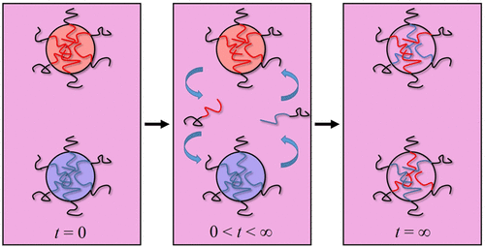
6Figure 8. Schematic of chain exchange between micelles as reprinted from Ref. 32
Figure 8. Schematic of chain exchange between micelles as reprinted from Ref. ³²
This mechanism of micellar exchange relates the miscibility between the two blocks, $χ$, to the enthalpic energy barrier, E_{a}, for chain exchange between micelles can be quantified with Equation 5, where $α$ is a constant near unity, N_{core} is the core block length, and s_{corona} is a stretching parameter related to the corona chains (s_{corona} = R_{g}/R_{g,0} where R_{g} is the radius of gyration of the corona chains in micelles, and R_{g,0} is the radius in an ideal case)³³.
$\frac{E_{a}}{kT}= αχN_{core}-\frac{3}{2}s_{corona}^{2}$ (5)
This mechanism has been considered in diblock copolymer micelle systems which were investigated using time resolved small angle neutron scattering experiments. In these studies, a chain pullout time was described according to Equation 6, where $τ_{rouse}$ is the longest relaxation time for the Rouse dynamics of the interior block³⁶⁻³⁸.
$τ_{pullout}=τ_{Rouse}e^{E_{a}/kT}=τ_{Rouse}e^{aχN_{Core}}$ (6)

2.7 Hansen Solubility Parameter
The Hansen solubility parameter is a value used to approximate the miscibility of two molecules, traditionally a polymer and solvent, given their relative chemistries. This approach has been commonly applied since its conception in 1967³⁹. Though other more accurate methods for predicting relative miscibility have been developed in recent years, the Hansen solubility parameter approach continues to see use as it is simple with a straightforward and intuitive fundamental basis. This Hansen solubility parameter $δ_{t}$ is comprised of three distinct contributions, one from dispersion $δ_{d}$, one from polarity $δ_{p}$, and one from hydrogen bonding $δ_{hb}$ (Equation 7)³⁹.
$δ_{t}=\sqrt{δ_{d}^{2}+δ_{p}^{2}+δ_{hb}^{2}}$ (7)
The specific dispersion, polarity, and hydrogen bonding contributions can be calculated according to Equations 8-10, where $N_{i}$ is the number of first order functional groups of type i with the contribution $C_{i}$ within a molecule, and $D_{j}$ is the contribution of second order functional groups of type j which exist $M_{j}$ times within a molecule⁴⁰.
$δ_{d}={\left(\sum_{i}{N_{i}C_{i}}+\sum_{j}{M_{j}D_{j}}+959.11\right)}^{0.4126}{\left(MPa\right)}^{\frac{1}{2}}$ (8)
$δ_{p}={\left(\sum_{i}{N_{i}C_{i}}+\sum_{j}{M_{j}D_{j}}+7.6134\right)}^{}{\left(MPa\right)}^{\frac{1}{2}}$ (9)
$δ_{d}={\left(\sum_{i}{N_{i}C_{i}}+\sum_{j}{M_{j}D_{j}}+7.7003\right)}^{}{\left(MPa\right)}^{\frac{1}{2}}$ (10)
When these parameters are determined for two particular molecules, they can be related back to the Flory-Huggins solubility parameter $χ$ according to Equation 11, where $δ_{t}$ and $δ_{t'}$ are the Hansen solubility parameters for two molecules and $V_{t}$ is the volume of molecule t ³⁹.
$χ=\frac{{\left(δ_{t}-δ_{t^{'}}\right)}^{2}V_{t}}{RT}$ (11)
From this relationship, similar outcomes are expected where a $χ>1/2$ would correspond to separate phases between the two molecules.

2.8 Interfacial Layer and the Percolation Model
The impact that nanocomposite rigidity has on the local segmental dynamics of a polymer backbone in a polymer nanocomposite system is a phenomenon which has been thoroughly investigated over the past few decades. This area of restricted mobility has been deemed an “interfacial layer”, and key parameters such as its dielectric relaxation time and layer thickness have been previously determined using BDS ²³. This phenomenon has also been observed in ionomer systems with the use of ¹³CNMR and quasielastic neutron scattering^{41, 42}. For these systems, the interfacial layer model (ILM) has been applied to account for the unexpected contribution of the interphase between nanocomposite and polymer, to the overall matrix behavior. The MLM exists as a unified model approach to predict the affect of the interfacial layer on thermal expansivity, bulk and shear modulus, and overall dielectric constant⁴³. The model assumes that the particular response contribution of an element of the composite, is equal to that response of the pure element itself, and this total composite response is ultimately dependent on the relevant volume contributions from each component⁴³.
.

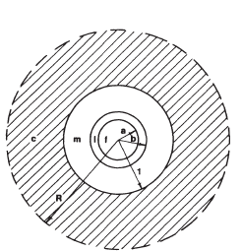
7Figure 9. Schematic of the component contributions to the interfacial layer model where f represents the filler, l the layer, m the matrix, and c the composite. Reprinted from Ref 43
Figure 9. Schematic of the component contributions to the interfacial layer model where f represents the filler, l the layer, m the matrix, and c the composite. Reprinted from Ref ⁴³
The impact of this layer can be clearly seen in Figure 10 where the glass transition temperature sees an increase of 6˚, the transition itself becomes broadened, and the modulus at temperatures higher than the glass transition temperature is increasingly reinforced with increasing particle size.
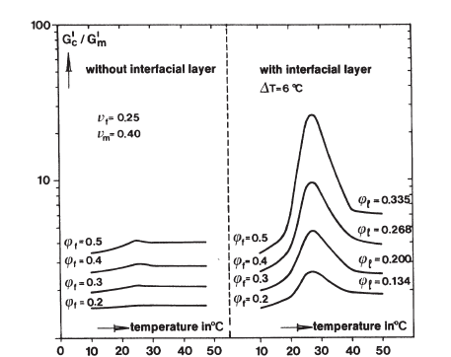
8Figure 10. Modeled relative shear moduli with and without contribution from the interfacial layer. Reprinted from Ref 43.
Figure 10. Modeled relative shear moduli with and without contribution from the interfacial layer. Reprinted from Ref ⁴³.
Though this model has been shown to have experimental agreement for many polymer systems reinforced with nanoparticles, not much is known about this layer’s impact on dynamic polymer systems, particularly those with hydrogen bonding phase separated clusters.
An additional case is the scenario where these reinforced layers begin to overlap with one another forming an interconnected network among themselves amidst the polymer matrix (Figure 11). As one may expect, this situation results in a significant mechanical reinforcement and even has a substantial impact on conductivity in certain cases. Several models have been used to treat the mechanical behavior of reinforced systems, particularly a theoretical mean field approach⁴⁴, however, the percolation model specifically accounts for interactions between nanoparticles as is crucial in the case of a percolated network system^{45, 46}.
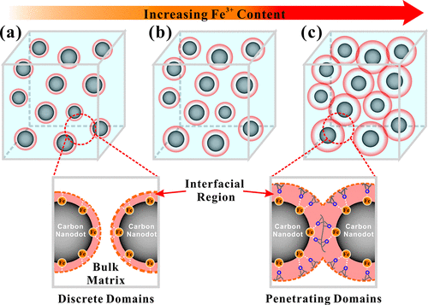
9Figure 11. Schematic depicting the transition from a system with disparate interfacial layers, to a fully percolated nanocomposite network. Reprinted from Ref 47.
Figure 11. Schematic depicting the transition from a system with disparate interfacial layers, to a fully percolated nanocomposite network. Reprinted from Ref ⁴⁷.
This case has been well treated in polymer nanocomposites with the percolation model^{47, 48}. In describing the mechanical reinforcement seen in percolated systems specifically, this model describes a composite shear modulus, $G_{c}$, according to Equation 12 and 13, where $G_{S}$ and $G_{r}$ are the shear moduli of the polymer and nanoparticle phases respectively, $X_{r}$ is the volume fraction of the nanoparticle phase, and $ψ$ is the volume fraction of the percolated network of nanoparticles, achieved when $X_{r}$ exceeds $X_{C}$, the critical volume fraction for the formation of a percolated network⁴⁸.
$G_{c}=\frac{\left(1-2ψ+ψX_{r}\right)G_{S}G_{r}+\left(1-X_{r}\right)ψG_{r}^{2}}{\left(1-X_{r}\right)G_{r}+\left(X_{r}-ψ\right)G_{s}}$ (12)
$ψ=0 X_{r}<X_{c}$ (13)
$ψ=X_{r}{\left(\frac{X_{r}-X_{c}}{1-X_{c}}\right)}^{0.4} X_{r}≥X_{c}$
The efficacy of this simple mathematical model is exemplified in Figure 12 when applied to a nanocomposite system of cellulose whiskers⁴⁸.
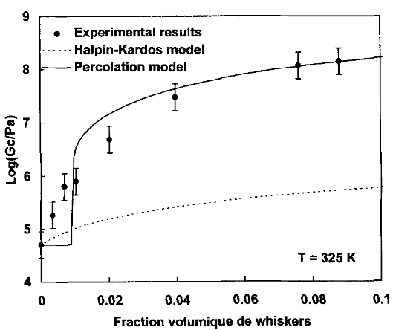
10Figure 12. Composite shear modulus of a nanocomposite system of cellulose whiskers in a styrene butyl acrylate copolymer as a function of cellulose whisker volume fraction. Reprinted from Ref 48.
Figure 12. Composite shear modulus of a nanocomposite system of cellulose whiskers in a styrene butyl acrylate copolymer as a function of cellulose whisker volume fraction. Reprinted from Ref ⁴⁸.

2.9 Bond rearrangement in non-telechelic architectures
The role of sticker placement in phase separated systems is an interesting variable in creating useful polymers. This particular variable has been investigated recently through the application of molecular dynamics simulations. Polymers in these simulation studies have been functionalized both telechelically, with star architectures, and with stickers placed randomly along the backbone^{28, 49, 50}. The simulations suggest a formation of phase separated clusters beyond an interaction energy of 3k_{B}T with a cluster size which increases with interaction strength for each architecture²⁸. These studies have shown that the varying architecture has no impact on cluster size, or the dependence on cluster size with increasing volume fraction of sticker, although the simulated intercluster structure factor peak is higher in intensity for the star than for linear architectures at any interaction strength^{28, 49}. Though these simulations provide insight into the spatial and mechanistic differences between architectures, a direct experimental exploration of this variable has not yet been undertaken.

2.10 Critical solution temperatures in block copolymers
A phase diagram classically used to represent the miscibility between a polymer and solvent at particular volume fractions and temperatures can demonstrate several features: a lower critical solution temperature (LCST), the temperature above which two phases will form for a given volume fraction of polymer; an upper critical solution temperature (UCST), the temperature below which two phases will form for a given volume fraction of polymer; the binodal curves which depict the transition between a one and two phase system for each volume fraction and temperature; and the spinodal curves which denote the metastable region in which the one phase system becomes a two phase system in a non-spontaneous way resembling nucleation and growth (Figure 13) ⁵¹.
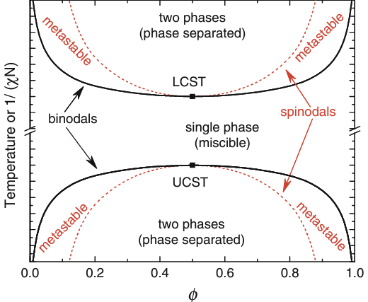
11Figure 13. Features of a phase diagram. Reprinted from Ref. 51
Figure 13. Features of a phase diagram. Reprinted from Ref. ⁵¹
The lower critical or upper critical solution temperature behavior of a system can be described by the negative or positive B value respectively in the classic expression shown in Equation 14, where $χ$ is the Flory Huggins interaction parameter⁵¹.
$χ=A+B/T$ (14)
This generalized phase behavior can be extended to block copolymers as well in cases where blocks have differing miscibility. Certain block copolymers, particularly those which exhibit hydrogen bonding between one type of block, have been shown to fall into a two phase behavior with an increase in temperature (LCST behavior), which provides useful thermoresponsive properties⁵²⁻⁵⁶.

2.11 Research Objectives
The overarching purpose for this research is to deepen the dynamic understanding of polymers with dynamic bonds generally, and dynamic bonding systems with phase separation particularly. To fulfill this purpose, four specific objectives are pursued:
Objective 1: Experimentally test the high bond strength regime of the bond lifetime renormalization model ($ε>2k_{B}TlnN$)
- Probe the dielectric and rheological behavior of a sample with an interaction strength greater than 2k_{B}TlnN
- Consider the segmental, bond dissociation, and terminal dynamics, and normalize the terminal dynamics by the segmental to determine a more accurate activation energy
- Directly compare the bond dissociation and terminal relaxation times
Objective 2: Determine, compare, and deconvolute the activation energies and viscoelastic behavior of vitrimer systems.
- Probe the dielectric and rheological character of a model polymer functionalized with imine sticker groups
- Normalize the terminal dynamics by the segmental dynamics to develop an accurate activation energy to apply in context of the imine chemistry to understand the bond exchange mechanism for network rearrangement
Objective 3 : Utilize Flory-Huggins interaction parameters to investigate the dynamics of functional group clusters and to establish a quantitative model for network rearrangement associated with phase separated clusters
- Confirm the presence and spatial characteristics of phase separated functional group clusters in a dynamic bonding system using X-ray scattering and DSC measurements
- Relate this spatial character to the rheological properties of the system
- Compare the rheological and dielectric relaxation times to elucidate the role of segmental, cluster, and bond dissociation dynamics. Apply the Flory-Huggins interaction parameter to these systems to determine a mechanism of network rearrangement

CHAPTER 3 EXPERIMENTAL TECHNIQUES
The results of this dissertation were collected with a range of experimental techniques. The spatial character of the systems were probed using small angle X-ray scattering. Differential scanning calorimetry was used to determine the thermal transitions of a given sample. Broadband dielectric spectroscopy and small amplitude oscillatory shear rheology were used to uncover the dielectric and mechanical dynamic behavior of the samples respectively. Thermogravimetric analysis was used to determine the degradation temperature of samples as well as to assess the evolution of water for water sensitive samples. Fourier transform infrared spectroscopy was used to confirm the synthesis of certain samples, as well as to perform a semi quantitative evaluation of the population of certain functional groups.

3.1 Small angle X-ray scattering (SAXS)

3.1.1 Principles of SAXS
Small angle X-ray scattering (SAXS) is a technique in which X-rays are produced and collimated towards a sample of interest. The intensities of elastically scattered photons at various angles are determined by detectors. Typically, this data is reported as intensity vs wavenumber (q) whose wavevector (q) is related to the incident (k_{i})and scattered (k_{s}) wavevectors according to equations 3.1. The amplitudes of the incident and scattered wavevectors are related to their wavelength ($λ$) by equation 3.2. Figure 3.1 relates these wavevectors schematically; the magnitude of the wavevector q is given by equation 3.3⁵⁷.
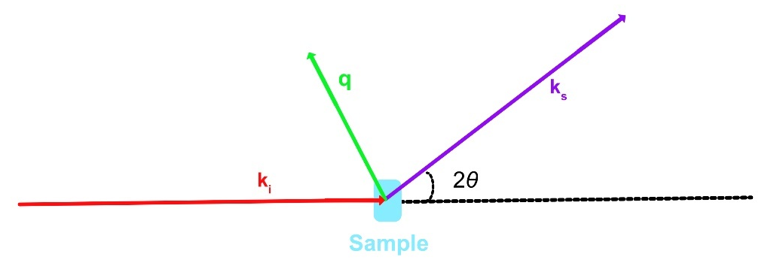
12Figure 3.1 Schematic of small angle scattering wavevectors.
Figure 3.1 Schematic of small angle scattering wavevectors.

$q=k_{s}-k_{i}$ (3.1)
$\left|k\right|=\frac{2π}{λ}$ (3.2)
$q=\frac{4πsinθ}{λ}$ (3.3)
A sample causes scattering at a particular angle because of a periodic difference in electron densities (Figure 3.2). This can be applied broadly to phenomena within the experimental length scale (1-100 nm), ranging from scattering planes within a crystal lattice to phase boundaries between block copolymers, even to phase separated clusters in the case of polymers with dynamic bonds. Using a first order diffraction with Bragg’s law, we can approximate the distance between scattering surfaces (d) with equations 3.3 and 3.4⁵⁸.
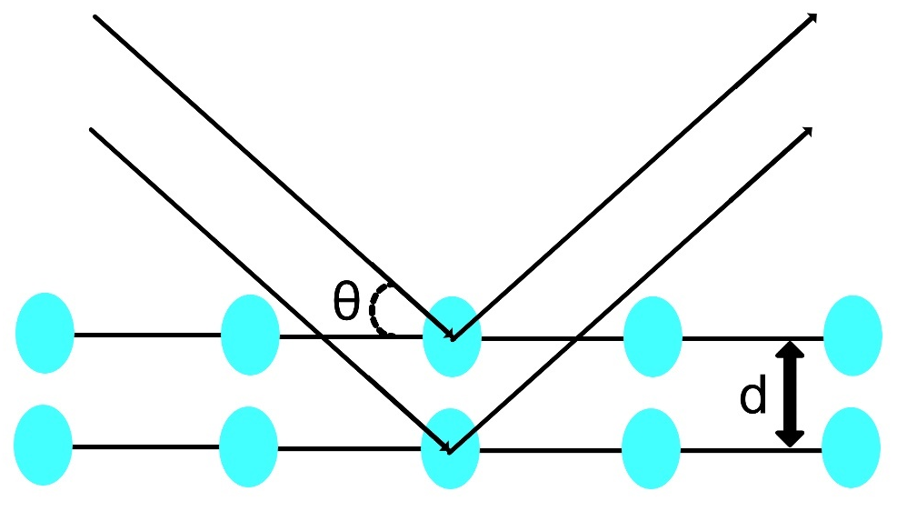
13Figure 3.2 Schematic of Bragg diffraction

Figure 3.2 Schematic of Bragg diffraction
$λ=2dsinθ$ (3.3)
$d≈\frac{2π}{q}$ (3.4)

3.1.2 SAXS Peak Fitting
Though there exist many insightful models for interpreting SAXS spectra, the main focus for this work was to elucidate the distance between scattering surfaces corresponding to a particular SAXS peak. To this end, a simple gaussian equation (equation 3.5) was employed to determine the peak position $q_{c}$ to relate to equation 3.4 where $y_{0}$ is the background intensity, A is the peak intensity, and w is the peak width.
$I\left(q\right)=y_{0}+(A/\left(w{\left(\frac{π}{2}\right)}^{\frac{1}{2}}\right)exp⁡(-{\left(\frac{q-q_{c}}{w}\right)}^{2})$ 3.5

3.1.3 SAXS measurement Setup
All SAXS measurements were performed on a Xeuss 3.0 laboratory beamline, with a with a Cu Kα microfocus source and a Pilatus 300k detector. Scattering wavevector calibrations were made with respect to a silver behenate standard. The sample to detector distance for small, medium, and wide-angle measurements were 0.9m, 0.55m, and 0.35m respectively. Liquid samples were measured in a 1.5mm diameter quartz capillary. The intensity of these measurements were subtracted by the spectra of an empty capillary. Solid samples were measured directly. Measurements made at temperatures other than room temperature were completed in a reactivity stage.

3.2. Differential Scanning Calorimetry (DSC)

3.2.1 Principles of DSC
DSC is an analytical technique used to identify thermal transitions within a wide variety of materials. These transitions are largely identifiable by a change in heat capacity. To see this change, DSC instruments increase the temperature of a sample and reference pan linearly and determine the difference in heat necessary to increase the temperature of the sample pan compared to the reference pan. The sample’s heat flow ($\frac{dH}{dt}$) can be related to the specific heat capacity (C_{p}), heating rate ($\frac{dT}{dt}$), and a kinetic heat flow which is a function of time at an absolute temperature ($f(T,t)$) according to equation 3.6.
$\frac{dH}{dt}=C_{p}\left(\frac{dT}{dt}\right)+f(T,t)$ 3.6
When performing a temperature sweep of a system, a glass transition will be seen as an endothermic step in heat flow as the temperature increases. This is useful in relating to the segmental dynamics of a simple system as well as any other glass transitions, such as where phase separated domains become glassy. The actual glass transition temperature can be determined as the midpoint of this step. Crystallization and melting of crystal domains can also be seen in DSC corresponding to an exothermic and endothermic peak respectively. The melting and crystallization temperatures can be determined by the peak maxima or minima.

3.2.2 DSC Measurement Setup
The instrument used for the DSC measurements in this Q2500 DSC from TA instruments. This is a heat flux instrument, meaning the heat flow is calculated by measuring the difference in heat flux between sample and reference pans. All samples were measured using a hermetically sealed aluminum pan. A ramp up and isotherm at the highest temperature for 10 minutes was made before measuring to remove any thermal history of the samples.

3.3 Broadband Dielectric Spectroscopy (BDS)

3.3.1 Principles of BDS
Broadband dielectric spectroscopy is a powerful tool for understanding the dynamic behavior of a system across vast timescales and temperatures. On a fundamental level, BDS works by sandwiching a sample between two electrodes, applying an electric field at a certain frequency, and observing how dipoles within the sample align to this electric field at certain temperatures and timescales. These electrodes induce an electric field ($E^{*}$) at a known strength and sinusoidal frequency. The current density ($J^{*}$) in response to this applied electric field is measured directly by the instrument, which can be related to the complex impedance ($Z^{*}$) of the sample through equation 3.7 where $ω$ is the angular frequency of the sinusoidal application of the electric field, $ε_{0}$ is the permittivity of free space, and $C_{0}$ is the system’s vacuum capacitance (Figure 3.3)⁵⁹. Additionally, this can be related to the complex permittivity($ε^{*}$), the parameter through which most data analysis is treated for dielectric relaxation spectroscopy⁵⁹.
$\frac{J^{*}\left(ω\right)}{iωε_{0}E^{*}\left(ω\right)}=\frac{1}{iωC_{0}Z^{*}\left(ω\right)}=ε^{*}\left(ω\right)$ (3.7)
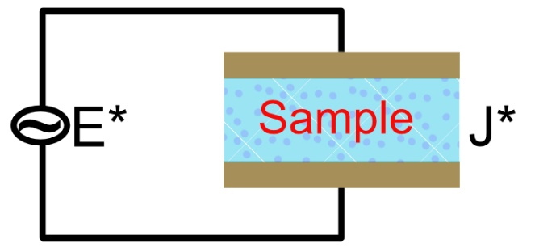
14Figure 3.3 Simplified configuration of a BDS instrument
Figure 3.3 Simplified configuration of a BDS instrument

3.3.2 Dielectric Relaxations
Dielectric relaxations are essential in understanding the dynamic behavior of polymer systems. The permittivity of a sample at a given frequency is proportional to the number of molecular dipoles which align themselves to the applied electric field. At higher temperatures or lower frequencies, systems may exhibit an increased number of aligned dipoles, corresponding to a relaxation of a population which has been freed to align to the electric field (Figure 3.4).
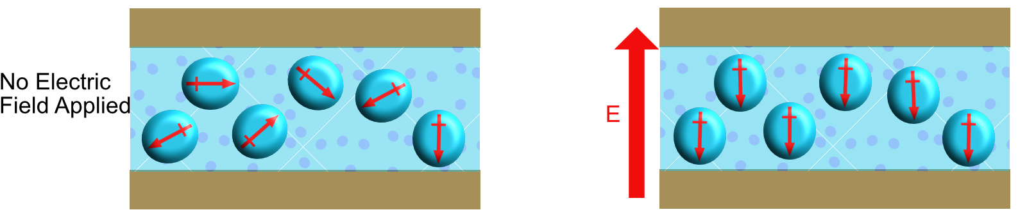
15Figure 3.4 a) Schematic of a sample’s dipole alignment following the application of an electric field. b) Experimental data showing a dielectric relaxation process
Figure 3.4 a) Schematic of a sample’s dipole alignment following the application of an electric field. b) Experimental data showing a dielectric relaxation process
This relaxation process can be fit using a Havriliak-Negami (HN) fitting function to determine the specific relaxation time ($τ_{HN}$) of this process using Equation 3.8, where $ε^{''}$ is the imaginary permittivity, $Δε$ is the dielectric strength or amplitude of the process, $f$ is the frequency of the electric field’s application, and $α$ and $γ$ are shape parameters of the process⁵⁹. This $τ_{HN}$relaxation time can then be related to the loss peak maximum of the process ($τ_{max})$which is typically taken as the characteristic dielectric relaxation time (Equation 3.9)⁵⁹.
$ε^{''}\left(f\right)=\frac{Δε}{{\left(1+{\left(i2πfτ_{HN}\right)}^{α}\right)}^{γ}}$ 3.8
$τ_{max}=τ_{HN}{\left(\frac{\sin\left(\frac{παγ}{2+2γ}\right)}{\sin\left(\frac{πα}{2+2γ}\right)}\right)}^{\frac{1}{γ}}$ 3.9

3.3.3 BDS Measurement Setup
All BDS measurements were made using a Novocontrol Concept 80 with Alpha-A impedance analyzer, ZGS active sample cell interface, and a Quatro Cryosystem thermostat. All measurements were made within the experimental window of 10⁻²-10⁶ Hz. Solid samples were simply trimmed to size and measured between two gold plates. Liquid samples were measured in a custom dielectric cell made of stainless steel, with a sapphire crystal and rubber O-rings, as shown photographically and schematically in Figure 3.5.

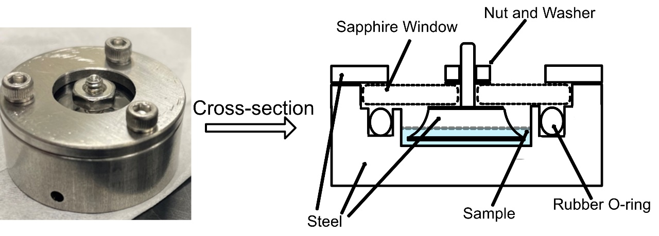
16Figure 3.5 Stainless steel dielectric cell used for liquid samples.

Figure 3.5 Stainless steel dielectric cell used for liquid samples.

3.4 Small Amplitude Oscillatory Shear Rheology (SAOS)

3.4.1 SAOS Principles
Small amplitude oscillatory shear rheology is a form of mechanical spectroscopy which can provide a great deal of insight and understanding to the viscoelastic behavior of a particular system. In many ways, it is analogous to the technique of dielectric spectroscopy. For the experiments in this work, SAOS rheology involves a pair of parallel plates where the bottom plate is controlled by a motor, and the top plate is connected to a transducer (Figure 3.6).

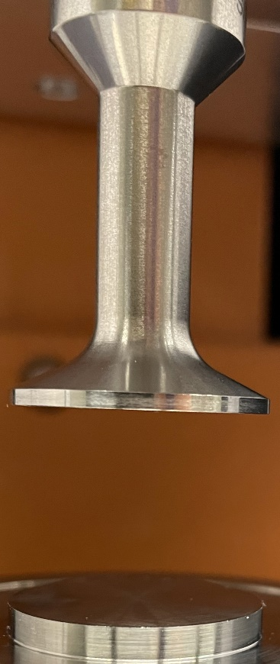
17Figure 3.6 Rheometer with parallel plate configuration.

Figure 3.6 Rheometer with parallel plate configuration.
In the case of a strain-controlled experiment, a strain ($γ=γ_{0}sinωt$) of a particular amplitude ($γ_{0})$ is applied at a given frequency ($ω$) corresponding to a sinusoidal wave. The stress ($σ=F/Σ$ where $F$ is the horizontal force and $Σ$ is the plate surface area) necessary to achieve this strain is recorded, and when the experiment is in a linear response regime, it is seen as a phase shifted wave (Figure 3.7)⁶⁰. A perfectly elastic response corresponds to a shift of 0˚, a viscous response to 90˚, and a viscoelastic response corresponds to a shift >0˚ and <90˚⁶⁰.
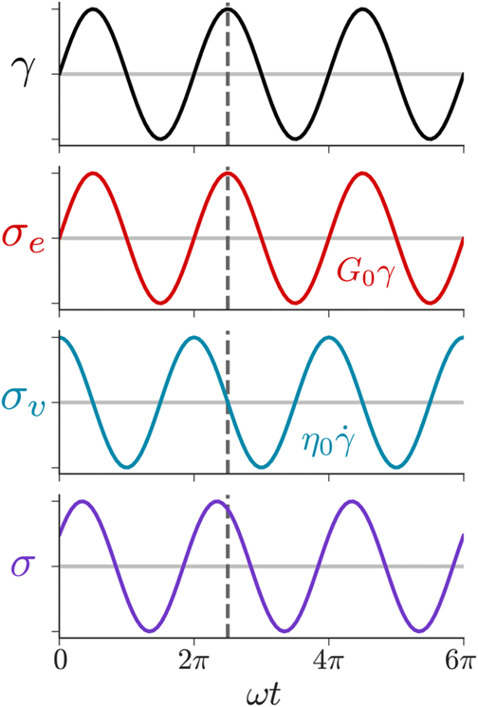
18Figure 3.7 The applied strain wave and resultant stress phases of a fully elastic, fully viscous, and viscoelastic materials61
Figure 3.7 The applied strain wave and resultant stress phases of a fully elastic, fully viscous, and viscoelastic materials⁶¹
The linear response of the stress can be described generally by equation 3.10, where $σ_{0}$ is the stress amplitude, $δ$ is the phase angle, and $G'(ω)$ and $G''(ω)$ are the storage and loss moduli respectively.
$σ\left(t\right)=σ_{0}\sin\left(ωt+δ\left(ω\right)\right)=γ_{0}(G^{'}\left(ω\right)sinωt+G^{''}\left(ω\right)cosωt)$ (3.10)
$G^{'}\left(ω\right)=ω\int_{0}^{∞}{G\left(t\right)\sin\left(ωt\right)dt}$ (3.11)
$G^{''}\left(ω\right)=ω\int_{0}^{∞}{G\left(t\right)\cos\left(ωt\right)dt}$ (3.12)
Compared to dielectric spectroscopy, the downside of this form of SAOS is its limited experimental frequency window of 10⁻¹ to 10² rad/s. However, this limitation is somewhat overcome with the aid of time temperature superposition (TTS), a principle through which a horizontal shift factor (a_{T}) can be used to overlay frequency windows at different temperatures to produce a master curve (Figure 3.8)⁶².
19Figure 3.8 Rheological master curve spanning several decades of frequency
Figure 3.8 Rheological master curve spanning several decades of frequency
For the work of this dissertation, the terminal relaxation time is typically attributed to the inverse frequency at which the storage and loss moduli crossover before they assume their characteristic power law slopes of 2 and 1 respectively (Figure 3.8). When a rheological segmental relaxation time is determined, it is made through an application of an HN fitting function to the loss modulus spectra in a manner similar to that described in section 3.3.2.

3.4.2 SAOS Measurement Setup
SAOS measurements in this work were performed on either an Ares G2 rheometer or an AR2000ex rheometer, which are both produced by TA instruments. These measurements were made in the strain-controlled mode where plate diameters ranging from 4mm-40mm were used depending on the modulus at the temperature being investigated. The strain was varied between 0.01-5% also depending on the modulus. The temperature of the experiments were regulated using a forced convection oven with nitrogen gas, and the sample was allowed at least 5 minutes to equilibrate at each temperature before measuring.

3.5 Thermogravimetric Analysis (TGA)

3.5.1 TGA principles
Thermogravimetric analysis is a technique which measures the mass of a sample with respect to a change in temperature or time at a certain temperature. This technique can determine the decomposition and combustion temperatures of a given sample as related to the change in mass. Additionally, isothermal TGAs can be made to watch the evolution of a certain gas as a function of time at a certain temperature.

3.5.2 TGA measurement setup
TGA measurements in this work were made using a TGA Q-50 instrument with a flow of nitrogen gas. A typical temperature sweep measurement would span from room temperature to 923K. Isothermal measurements were made at various temperatures for 12 hours.

3.6 Fourier Transform Infrared Spectroscopy (FTIR)

3.6.1 FTIR Principles
Infrared (IR) spectroscopy principally depends on the interaction between the specific molecular vibrations in matter and the frequency of IR light. Certain molecular vibrations (rocking, asymmetric stretching, twisting, wagging and others) happen at a frequency which overlaps with that of infrared light. When these frequencies overlap, the molecule can absorb the light shone on it, creating gaps in the detected frequencies of a range of IR light shone onto a sample⁶³. With the implementation of an interferometer, many frequencies of light can be checked for absorbance at once, spanning thousands of wavenumbers. These molecular motions are distinct for particular molecules and functional groups, which allow for the identification of molecules based on an FTIR spectra. The area of these absorbance peaks can be compared to build a semi quantitative understanding about the population of a certain functional group. Following a baseline correction and normalization to a standard peak, a gaussian function can be used to determine the area corresponding to the absorbance peak of interest (Figure 3.9).
20Figure 3.9 FTIR spectra fit to several gaussian functions
Figure 3.9 FTIR spectra fit to several gaussian functions

3.6.2 FTIR measurement setup
All FTIR spectra were collected using a Nicolet iS50R FTIR Spectrometer. Measurements were made at room temperature with 64 scans made for both the background and sample in each measurement.

CHAPTER 4 RHEOLOGICAL CONCEPTIONS AND MISCONCEPTIONS
A version of this chapter was published in Macromolecules, by Murillo L. Martins, Xiao Zhao, Zoriana Demchuk, Jiancheng Luo, Gregory Peyton Carden, Gaukhar Toleutay, and Alexei P. Sokolov “Viscoelasticity of Polymers with Dynamic Covalent Bonds: Concepts and Misconceptions” (Macromolecules 2023 56(21), 8688-8696)
Murillo Longo Martins wrote the manuscript together with Alexei P. Sokolov. Xiao Zhao conceived the idea of the manuscript together with Alexei P. Sokolov and performed stress relaxation and rheological measurements and data analysis. Zoriana Demchuk and Jiancheng Luo synthesized the materials and provided support in the data collection and analysis. Gregory Peyton Carden and Gaukhar Toleutay proofread the text and provided input to the manuscript together with all authors.

4.1 Introduction
Polymers with dynamic bonds have been shown in recent years to be a valuable innovation to polymer science⁶⁴⁻⁶⁷. The introduction of reversible bonds into a polymer chain to endow recyclability under certain conditions of solvent or temperature has been of great interest^{1, 68, 69}. The great variability of bond functionality has also enhanced the appeal of this subclass of material, ranging from hydrogen bonding, hydrophobic interactions, ionic bonding even to dynamic covalent bonding^{66, 70-76}. Within the group of polymers functionalized with dynamic covalent bonding groups, there exists functionalities which exchange through a dissociative mechanism and an associative mechanism. The dissociative mechanism, much like in the case of hydrogen bonding groups, is expected to have a dissociated state E_{d} exist energetically only a few RT above that of the bound state E_{b} (Figure 4.1a). Unlike the hydrogen bonding systems however, the dynamic covalent functional groups are expected to have an activation energy E_{a} of bond dissociation much higher than that which is seen in a single hydrogen bond. Functionalities which undergo an associative exchange are expected to have either a non existent dissociated state, or a dissociated state with an unreasonably high energetic level. The assumption for associative exchange mechanisms is that there exists an associative intermediate state in which three or four sticker groups with a low enough energetic state to facilitate an exchange of bonds within this state (Figure 4.1b). Thereby leading to a cross link density within these systems which remains largely unchanged with variations in temperature⁷⁷⁻⁷⁹.
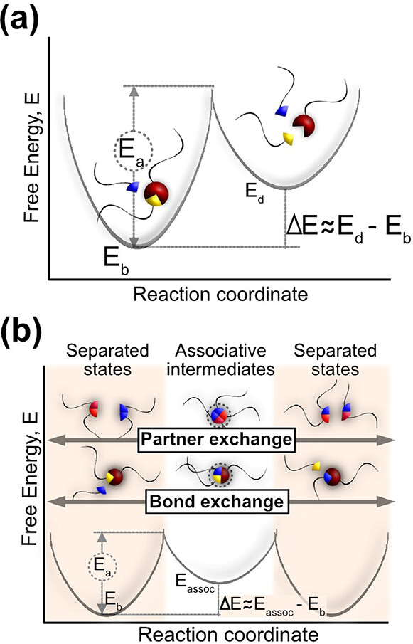
21Figure 4.1 a) Reaction coordinate diagram of a dissociative exchange mechanism and an b) associative exchange mechanism
Figure 4.1 a) Reaction coordinate diagram of a dissociative exchange mechanism and an b) associative exchange mechanism
Networks with this kind of functionality are commonly referred to as vitrimers. In many ways, the specific characteristics of this vitrimer class of material is still in flux. For instance, the Arrhenius like temperature dependence of viscosity has been described as a hallmark of vitrimer behavior, however, this has also been observed in dissociative functionalities with large activation energies^{2, 79, 80}. In this chapter, we discuss some commonly methods for analyzing polymers with dynamic bonds which may lead to confusion and misinterpretation of results. Particularly we look at methods used in stress relaxation experiments as well as the estimates of bond dissociation energies.

4.2 Materials and Methods

4.2.1 Boronic ester vitrimer

4.2.1.1 Synthesis of phenylboronic acid-functionalized 4-arm polyethylene glycol (F-precursor)
4-Arm-Polyethyleneglycol (1.0 g, 0.5 mmol, Mw 2,000 g/mol) was dissolved in 50 mL of anhydrous DCM. 1.38 g (7.5 mmol) of 4-carboxy-3-fluorophenylboronic acid and 0.95 g of N, N’-diisopropylcarbodiimide (DIC) were added sequentially to the reaction mixture and stirred for 30 min under an argon blanket. Then, 0.917 g of 4-dimethylaminopyridine (DMAP) was added under continuous stirring. The reaction was carried out in an ice bath overnight. After the evaporation of the solvent, the resulting product was diluted with methanol, dialyzed against methanol for 24 hours, and then vacuumed to remove the remaining solvent.

4.2.1.2 Synthesis of the F-vitrimer
2 g of F-precursor (0.75 mmol) was dissolved in 10 ml of anhydrous methanol. Then, the crosslinker solution was prepared by dissolving 0.61 g of PAMAM-diol in 3 ml of anhydrous methanol. After full dissolution, the F-precursor was mixed with PAMAM-diol in the molar ratio of 1:1 at which point the polymer samples became more viscous. The polymer solution was then poured into a Teflon mold and allowed to slowly evaporate at room temperature overnight on the bench top. The crosslinked polymer films were then placed in a vacuum oven at 80 ºC to remove any residual solvent.
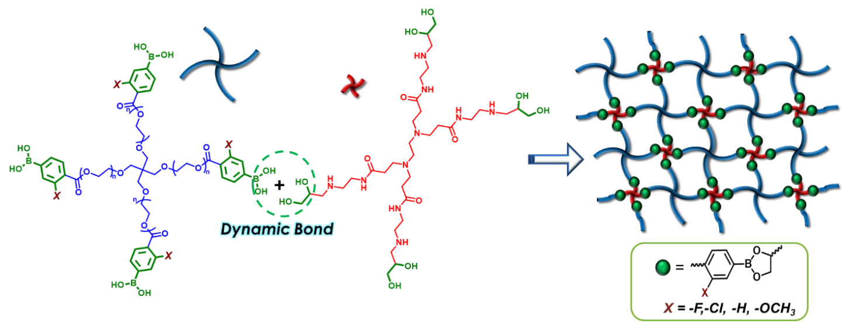
22Figure 4.2 Synthetic scheme for the boronic ester vitrimer
Figure 4.2 Synthetic scheme for the boronic ester vitrimer

4.2.2 Synthesis of the PDMS vitrimer with disulfide bonds

4.2.2.1 Synthesis of the linear PDMS disulfide precursor
2.0 equiv. isophorone diisocyanate (IPDI) was dissolved in anhydrous DMF and sealed in a round bottom flask. The flask was heated in an oil bath at 100 °C. Then 4-aminophenyl disulfide solution (4-AFD, 1.0 equiv. dissolved in DMF) was slowly titrated into the flask via a syringe pump
over 2 hours. The mixed solutions were allowed to react at 100 °C for an additional 6 hours. After
cooling down to room temperature, the solutions were slowly titrated into PDMS-NH2 (2.0 equiv.
Mw = 3000 g/mol) that was dissolved in THF/DMF (v/v=1:1) at 60 °C. The overall titration time
was 2-4 hours. After that, the reaction was stirred overnight at 60 °C, and solvents were evaporated
under a reduced vacuum to obtain PDMS_{n}-disulfide (n= 3000) at quantitative yield. GPC results
confirmed the predicted synthesis represented in Figure 4.3.

4.2.2.2 Synthesis of tetra-PEG-NCO
1.0 equivalent of Tetra-PEG-OH was dissolved in anhydrous chloroform, then 40 equivalents
hexamethylene diisocyanate (HDI) and one drop of dibutyltin dilaurate (~20 mg) were added to
the solution. The reaction was stirred at room temperature for 24 hours. The solution was
concentrated by using a rotary evaporator and then precipitated into diethyl ether. The upper
solution was discarded, and the remaining viscous liquid was dried under vacuum to yield tetra-
PEG-NCO (yield: 92%).

4.2.2.3 Preparation of elastic vitrimers
2.0 equivalents of PDMS3000-disulfide and 1.0 equivalent of tetra-PEG-NCO were dissolved in anhydrous THF separately and mixed in a glass vial. The mixed solutions were poured into a PTFE dish and left in the hood overnight. The residual solvent was removed in an oven to obtain the final network (Figure 4.3).
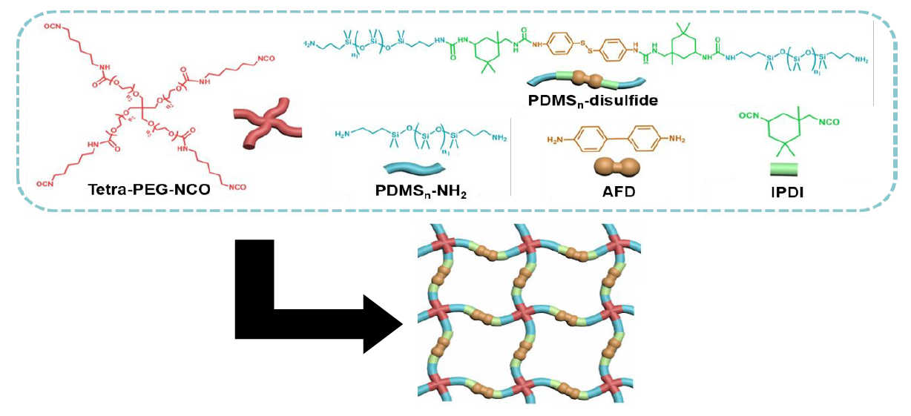
23Figure 4.3 Scheme for the synthesis of the PDMS vitrimer with disulfide bonds
Figure 4.3 Scheme for the synthesis of the PDMS vitrimer with disulfide bonds

4.2.3 Material characterization

4.2.3.1 Stress relaxation measurements
The stress relaxation was measured as the time-dependent Young’s modulus after an instant
change of strain of 5%. The measurement was performed with a TA Discovery DMA850 instrument.
Samples were allowed to equilibrate at the measurement temperature for 30 minutes before the instantaneous strain.

4.2.3.2 SAOS measurements
The oscillatory shear master curve was constructed from the small amplitude frequency
sweeps using time-temperature-superposition. The frequency sweeps were conducted on a TA
AR2000ex rheometer from -120 to 150 °C using stainless steel parallel plates with diameters of 4 and 8 mm; the 4 mm plate was used when the material became rigid at low temperatures. Strain
sweeps were first conducted at 6.28 rad/s to obtain the linear viscoelasticity range where the
modulus was independent of the strain. From high to low temperatures, the frequency sweeps were
tested at the strains of 1% down to 0.02% with an angular frequency range of 0.628 to 628 rad/s.
To produce the master curve, spectra was shifted relative to the reference at -60 °C, and treated with subtle vertical shifts that did not impair the overall data analysis.

4.3 Results and Discussion

4.3.1 Stress relaxation and the 1/e method
In the field of polymers with dynamic bonds, stress relaxation experiments are frequently performed to provide insight to the dynamic character of systems^{70, 71, 73}. This experiment involves measuring the decrease in shear (G(t)) or Young’s modulus (E(t)) as a function of time following an instantaneous deformation applied to the sample⁸¹. The observed relaxation of this stress is due to a multitude of factors, such as the system’s segmental dynamics, chain dynamics, and even bond rearrangements⁸². It is commonplace to define the relaxation time as the time it takes for the modulus to reach 1/e of the first modulus value measured⁸². Though this approach is a simple one, it is inaccurate for every case except the rare scenario where the modulus decays as a single exponential function⁸³. A much more reasonable way of determining the relaxation time of a stress relaxation experiment is to fit the spectra to a Kolraush-Williams-Watts (KWW) function (Equation 4.1) where $G_{0}$ is the first reliable experimental point measured at $t_{0}$, $τ$ is the KWW relaxation time, and $β$ is a stretching parameter for the relaxation process which can vary in value between 0 and 1.
$G\left(t\right)=G_{0}\exp\left(-{\left(\frac{t}{τ}\right)}^{β}\right)$ (4.1)
Using equation 4.1, we can formalize the 1/e method according to equation 4.2 where $t_{1}$ is the relaxation time according to the 1/e method.
$\frac{G\left(t_{1}\right)}{G_{0}}≈\frac{G\left(t_{1}+t_{0}\right)}{G\left(t_{0}\right)}=\exp\left(-{\left(\frac{t_{1}+t_{0}}{τ}\right)}^{β}+{\left(\frac{t_{0}}{τ}\right)}^{β}\right)=\frac{1}{e}$ (4.2)
In comparing the relaxation times from these two methods mathematically, we can provide a ratio of the 1/e method relaxation time to the KWW relaxation time with equation 4.3.
$\frac{t_{1}}{τ}={\left(1+{\left(\frac{t_{0}}{τ}\right)}^{β}\right)}^{\frac{1}{β}}-\frac{t_{0}}{τ}$ (4.3)
Upon comparison of these times, we see that the only case where there is an agreement of times is the case where $β=1$. We see also that the 1/e method consistently overestimates the relaxation times, and that this disparity only grows as the stretching parameter decreases (Figure 4.4). We see that this disparity also increases with an increase in temperature, revealing that the 1/e method skews even the temperature dependence of the relaxation times, leading to mistaken attributions of activation energies.
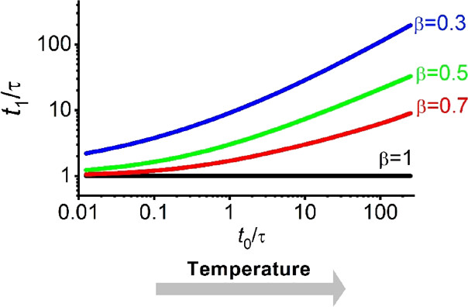
24Figure 4.4 Ratio of 1/e relaxation times (t_1) to KWW relaxation times(τ) as a function of t_0/τ.
Figure 4.4 Ratio of 1/e relaxation times ($t_{1}$) to KWW relaxation times($τ$) as a function of $t_{0}/τ$.
Making use of this distinction, we apply both methods to real experimental data with a boronic ester vitrimer system (Figure 4.2). In Figure 4.5a, we show the stress relaxation data collected for this vitrimer with their true moduli values, in 4.5b we show the same data normalized to the first experimental modulus value to demonstrate the 1/e method, and in 4.5c, we show a master curve produced using time-temperature superposition. The fitting of this data using a KWW function shows a strong stretching behavior with a $β=0.15$, suggesting a strong deviation of 1/e relaxation times from KWW relaxation times.
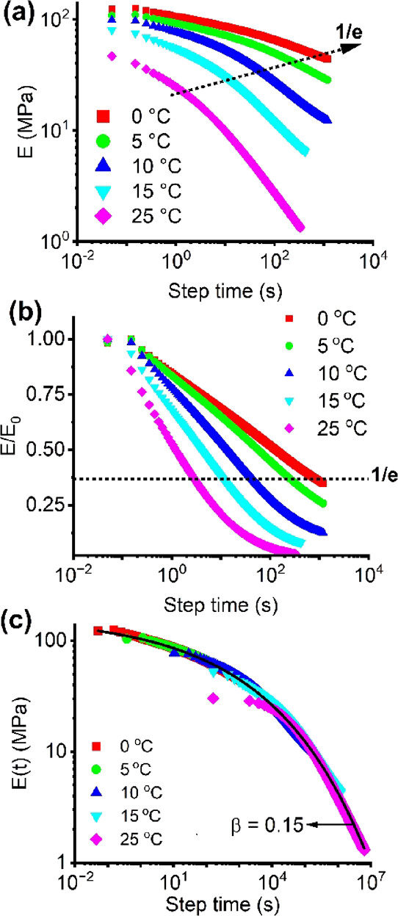
25Figure 4.5 a) Stress relaxation data with true Young’s modulus values b) stress relaxation data normalized by the first measured Young’s modulus value c) master curve produced by shifting the measurements with respect to their varied temperatures accordi
Figure 4.5 a) Stress relaxation data with true Young’s modulus values b) stress relaxation data normalized by the first measured Young’s modulus value c) master curve produced by shifting the measurements with respect to their varied temperatures according to time-temperature superposition
An activation plot of these respective times is shown in Figure 4.6. We can see that the 1/e method returns slower relaxation times and a smaller activation energy than what should truly be expected when using a KWW function.
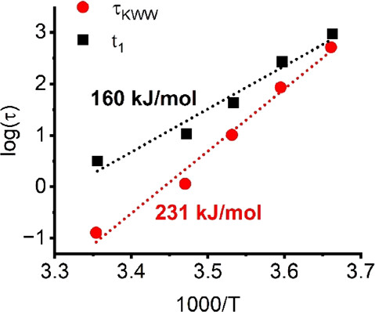
26Figure 4.6 Activation plot comparing the 1/e relaxation times (t_1) and the KWW relaxation times (τ)
Figure 4.6 Activation plot comparing the 1/e relaxation times ($t_{1}$) and the KWW relaxation times ($τ$)

4.3.2 Viscosity Estimates from Stress Relaxation
Stress relaxation experiments are also commonly used to estimate the viscosity of a system. This is done simply through the maxwell relationship $η=G_{0}×τ$. This issue with this approach, is that it is only valid in cases where the measured relaxation is the terminal relaxation which leads to terminal flow⁸⁴. For an accurate measurement, viscosity should only be estimated for materials in which the steady state viscosity exhibits a frequency independent plateau in $η(ω)$ at lower frequencies, or a linear increase with time in measurements of compliance $J\left(t\right)$^{84, 85}. When an estimate of viscosity is made without these conditions met, a finite viscosity could be determined for a system with a truly infinite viscosity, such as the case in Figure 4.7, where the PDMS disulfide vitrimer (Figure 4.3) never reaches terminal flow.
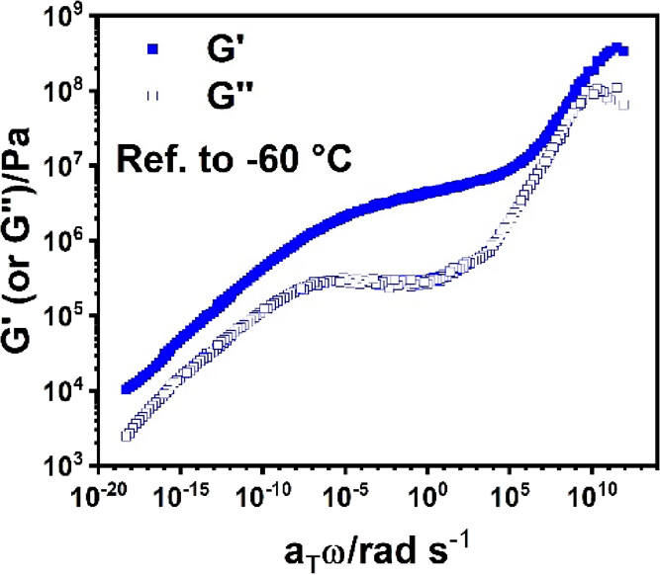
27Figure 4.3 Rheological master curve of a PDMS vitrimer with disulfide bonds. A gel like behavior is seen rather than terminal flow even at temperatures of 150˚C
Figure 4.3 Rheological master curve of a PDMS vitrimer with disulfide bonds. A gel like behavior is seen rather than terminal flow even at temperatures of 150˚C
Despite this sample’s gel like behavior ($G'(ω)∝G''(ω)∝ω^{0.2}$), even towards temperatures of 150˚C terminal relaxation is never seen. Through the application of stress relaxation measurements and the Maxwell relationship, one could be easily mistaken in estimating this system’s viscosity. The most reliable measure of a system’s viscosity in these cases would be through creep rheology or a steady flow test.

4.3.3 Definitions and Estimates of the topology freezing temperature Tv
A parameter growing in popularity with regards to the discussion of vitrimer dynamics is the topology freezing temperature T_{v}, the temperature at which the system’s viscosity reaches 10¹² Pa·s⁸⁶.This parameter was developed by Leibler and colleagues in 2011 to be analogous to the glass transition temperature for polymer and small molecule systems⁸⁶. As this is a parameter defined by the viscosity at a certain temperature, there is potential for confusion with the Maxwell conversion of relaxation time to viscosity in stress relaxation experiments mentioned in the previous section. In addition to this, it is assumed that the viscosity, which should be measured at higher temperatures, maintains its Arrhenius temperature dependence all the way to the T_{v}. In situations where the T_{v} is significantly higher than the glass transition temperature, this may be a reasonable assumption (Figure 4.4a-I). This assumption begins to break down when the T_{v} nears the T_{g}, as the dynamics of bond rearrangement are significantly impacted by segmental dynamics near the glass transition temperature and will cause a deviation from the Arrhenius behavior (Figure 4.4a-II and 4.4b)^{1, 87, 88}. It is also unreasonable to suggest that bond rearrangement can occur at temperatures greater than T_{v} but less than T_{g}, as the segments themselves are frozen, so no bond rearrangement is possible. This case should be treated as strictly hypothetical with no physical meaning (Figure 4.4a-III).
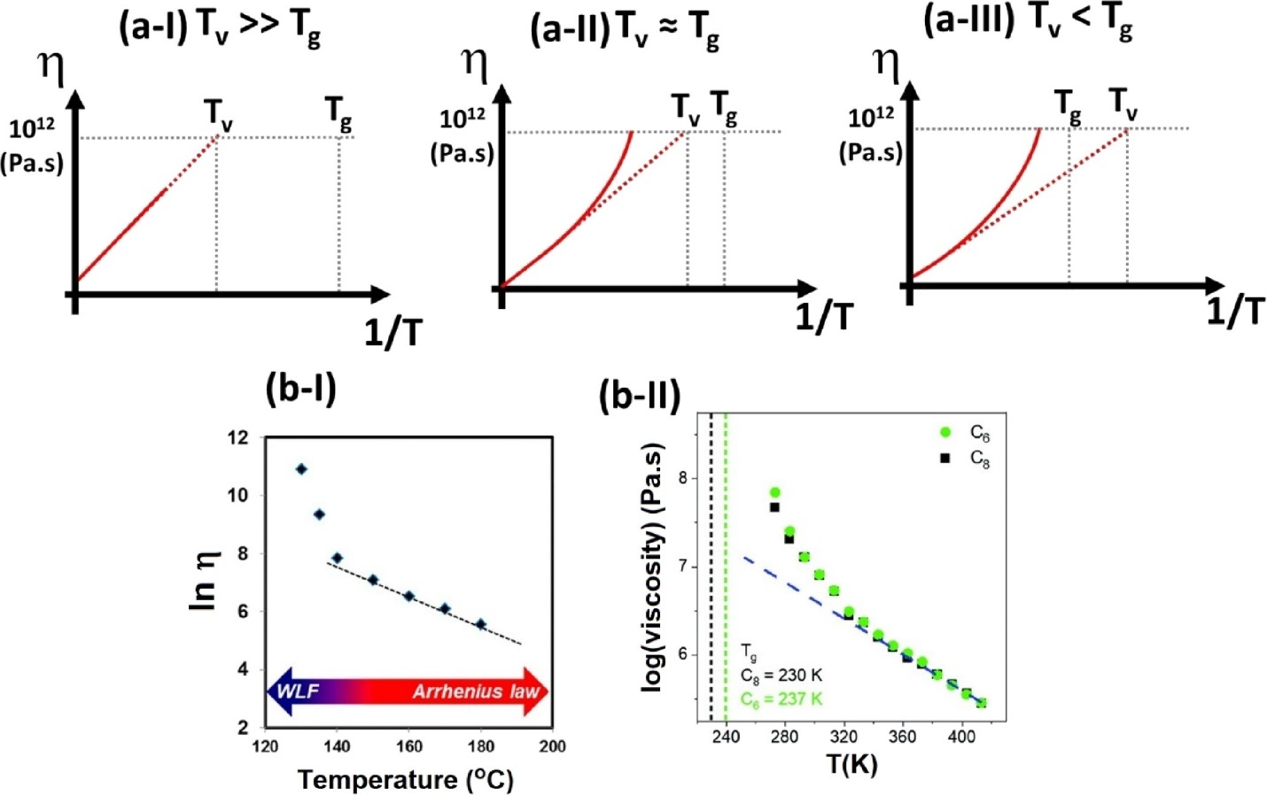
28Figure 4.4 a-I) Scheme of viscosity vs 1/T in the case where Tv>>Tg a-II) where Tv≈Tg a-III) where Tg>Tv b-I and b-II) Viscosity as a function of temperature deviating from Arrhenius behavior at lower temperatures87, 88
Figure 4.4 a-I) Scheme of viscosity vs 1/T in the case where T_{v}>>T_{g} a-II) where T_{v}≈T_{g} a-III) where T_{g}>T_{v} b-I and b-II) Viscosity as a function of temperature deviating from Arrhenius behavior at lower temperatures^{87, 88}
There have been several works of developing various routes to determine the T_{v} of a system⁸⁹⁻⁹². One such work involved the application of multifrequency small amplitude oscillatory shear cooling scans⁹³. In analyzing their data, they saw an unusual frequency independent regime for their loss tangent, loss angle, normalized storage and loss moduli. This frequency independence leads to a power law relaxation modulus, and at this temperature they ascribe the T_{v} of their system (~76˚C). This is an issue as even at temperatures of 170˚C, this system never encounters terminal flow. So, there is a conflict of definitions between this work and Leibler’s in that a T_{v} must have a viscosity of 10¹² Pa·s whereas their viscosity at 76 ˚C is infinite^{86, 93}.

4.3.4 Apparent activation energies, energies of bond dissociation, and the impact of segmental dynamics
The activation energy of bond exchange Ex is a very important parameter in material design of polymers with dynamic bonds. It should be stated that bond dissociation and bond exchange are two different phenomena, where only bond exchange facilitates stress relaxation in a system[]. The bond lifetime renormalization model details the difference between these two events, and suggests that for a sticker pair with intermediate strength, the sticker will dissociate and return to its partner several times before diffusing to find a different partner to facilitate bond exchange[]. This model also states that with sufficiently high binding energies ($E_{a}>2RTln(N)$ where N is the number of segments between stickers), the bond dissociation and bond exchange timescales should overlap[]. In understanding the bond exchange dynamics of these systems, particularly those with higher binding energies, the role of segmental dynamics should be accounted for. Recently, work has been done to show that the bond dissociation times should be normalized by the segmental relaxation times to produce a reasonable activation energy as shown in equation 4.4 where [].
$τ_{d}\left(T\right)=τ_{a}\left(T\right)exp⁡(\frac{E_{a}}{RT})$ (4.4)
In certain cases of hydrogen bonding functional groups, an E_{a} without accounting for segmental motion was over 100kJ/mol, much higher than what should be expected from the dissociation of hydrogen bonds. By normalizing these dissociation times by segmental motion, a fitting activation energy for hydrogen bonds is achieved[]. This is a physically intuitive correction because all bond exchange processes require segmental motion. Though this is the expectation of dissociative dynamic covalent bonds, there has not yet seen experimental validation.
In the case of associative bond exchange, the temperature dependence of bond exchange has been shown to be weaker than that of segmental motion (Figure 4.5)[]. There is no clear explanation for this behavior at present, however segmental dynamics seem to play less of a role in associative exchanges. One possible explanation is that the enthalpic barrier for bond exchange is low, however, the bond exchange requires a particular orientation or configuration of sticker groups to facilitate rearrangement. This is the cause of a substantial precursor or entropic term (Equation 4.5). If this is the case, we would expect two contributions for the relaxation time according to equation 4.5 where $τ_{x}$ is the bond exchange time, $A$ is the entropic relaxation time prefactor, $ΔH_{b}$ is the energy barrier for exchange, $B$ is the prefactor for segmental motion, and $τ_{α}$ is the segmental relaxation time.
$τ_{x}\left(T\right)=Aexp\left(\frac{ΔH_{b}}{RT}\right)+Bτ_{α}(T)$ (4.5)
This is a largely speculative picture, however further study of dynamic bonds with associative exchange is necessary.

4.4 Conclusions
In this chapter, we’ve addressed some common practices used in the characterization and analysis of polymers with dynamic bonds. We’ve demonstrated the limits of applying the 1/e method to stress relaxation experiments, particularly that it inaccurately determines both the timescale and temperature dependence of the relaxation. We’ve shown that a more accurate approach is to fit experimental data to a KWW function, and to use time temperature superposition to develop a master curve.
We discussed viscosity determinations from stress relaxation measurements, and the prerequisite that the terminal relaxation must be what is measured for the Maxwell relationship between relaxation time and viscosity to be true. Along this line, we discussed the definition of T_{v} and how an accurate measure of viscosity is relevant to this value as well. We considered the assumpotion that viscosity has an Arrhenius like temperature dependence up to the point of T_{v}, which may be a reasonable assumption where T_{v}>>T_{g}, but is unreasonable where T_{v}≤T_{g}.
This chapter finished with a discussion of the challenges and expectations of the behavior for dissociative and associative dynamic bond exchange. We emphasize that for dissociative bonds, segmental dynamics play a strong role in bond rearrangement, whereas this is not as true for systems with associative exchange. We reiterate that this is interesting and puzzling behavior which calls for further theoretical and experimental investigation.

CHAPTER 5 ASSOCIATING POLYMERS IN THE STRONG INTERACTION REGIME: VALIDATION OF THE BOND LIFETIME RENORMALIZATION MODEL
A version of this chapter was published in Macromolecules, by Sirui Ge, Gregory Peyton Carden, Subarna Samanta, Bingrui Li, Ivan Popov, Peng-Fei Cao, Alexei P. Sokolov “Associating Polymers in the Strong Interaction Regime: Validation of the Bond Lifetime Renormalization Model” (Macromolecules 2023 56(6), 2397-2405)
Sirui Ge wrote the manuscript together with Alexei P. Sokolov. Sirui performed rheological measurements and the corresponding data analysis. Bingrui Li under the advise of Peng-Fei Cao synthesized the materials. Gregory Peyton Carden performed BDS measurements and the corresponding data analysis with Subarna Samanta. Gregory Peyton Carden also performed the SAXS measurements. Ivan Popov provided input to the manuscript and support with data analysis.

5.1 Introduction
Associating polymers present an interesting class of materials with many unique properties⁹⁴⁻⁹⁶.This field was inspired by a large variety of non-covalent interactions prevalent in natural materials, and synthetic chemists used these transient bonds (hydrogen bonds, ionic bonds, metal−ligand coordination, π−π stacking, etc.) to convert conventional polymers to be more dynamic in nature, enabling intrinsic self-healing ability, and easy processability, along with strong improvements in toughness, adhesion, and many other properties⁹⁷⁻¹⁰⁸. The range of transient bond dissociation energy Ea varies depending on the type of interaction, and this energy controls the characteristic time scale and temperature range of their association−dissociation process¹. The most common interaction type found in nature is based on H-bonding. Although a single H-bond has a low energy barrier for dissociation, Ea ∼6−8 kJ/mol, the combined strength of multiple H-bonding can provide superior mechanical robustness to a low-molecular weight polymer without the aid of permanent cross-linking^{6, 109, 110}. The lifetime of dynamic bonds is one of the key factors controlling the viscoelastic properties and self healing kinetics^{1, 111, 112}. The transient network persists at a time scale shorter than the lifetime of the transient bonds, whereas at longer times, dynamic bonds dissociate and polymer chains become free to move, leading to network rearrangement. Previous experiments in well-defined telechelic polymeric systems with H-bonded functional groups indicate that the time scale of the network rearrangement and the bond dissociation time scale measured by dielectric spectroscopy are not the same^{6, 7, 113}. Essentially, there are two characteristic times: bond dissociation time and bond rearrangement time, and they might be significantly different⁶. This discrepancy has been explained by the Bond Lifetime Renormalization Model introduced by Stukalin et al. to describe the mechanism of self-healing kinetics⁴. According to this model, the above-mentioned time scale difference arises because a dissociated sticker can reassociate with its original partner several times before binding to a new partner. Stress relaxation occurs only when the sticker changes the partner (bond rearrangement event). However, this behavior is predicted only for the intermediate bond-energy regime, RT ln(N) < Ea < 2RT ln(N), where N denotes the number of polymer segments. In this regime, the bond lifetime is short and, as a result, there are plenty of open stickers in the volume pervaded by the dangling chain. Open stickers follow a compact space exploration via sub-diffusive Rouse motion resulting in the bond formation with the same partner again and again. This mechanism has been verified and confirmed experimentally⁵⁻⁷. On the other hand, the model predicts a different behavior at higher dissociation energy, when Ea > 2RT ln N. With higher bond strength, most of the stickers are in the bonded state for along time and equilibrium concentration of open stickers is very low. Thus, the bond dissociation time becomes the major controlling parameter, network relaxation happens through the bond-hopping mechanism, and the bond rearrangement time becomes comparable to the bond dissociation time in this regime. However, this model’s prediction for the high bond dissociation energy has not been thoroughly tested yet. In this study, we tested the above model in the regime of high bond dissociation energy. We analyzed the dynamics of urea and S−COOH-functionalized telechelic poly(dimethyl siloxane) (PDMS) using dielectric spectroscopy, rheology, small-angle X-ray scattering (SAXS), and differential scanning calorimetry (DSC). While both functional groups bind each other through H-bonding, the interaction strength for urea is much higher than that of S−COOH. Broadband dielectric spectroscopy (BDS) was used to investigate the dynamics of these reversible interactions, and rheological measurements indicated the presence of a supramolecular chain in our investigated polymers. Analysis of the data revealed that the time scale of the bond dissociation and terminal relaxation are the same for the ureafunctionalized telechelic systems, whereas for S−COOHfunctionalized chains, they differ by up to 3 orders of magnitude. Detailed analysis of all the data revealed that the bond lifetime renormalization model indeed describes well the behavior of the studied systems in both intermediate and high dissociation energy regimes.

5.2 Materials and Methods
The chemical structures of the investigated PDMS telechelic polymers are shown in Figure 5.1.
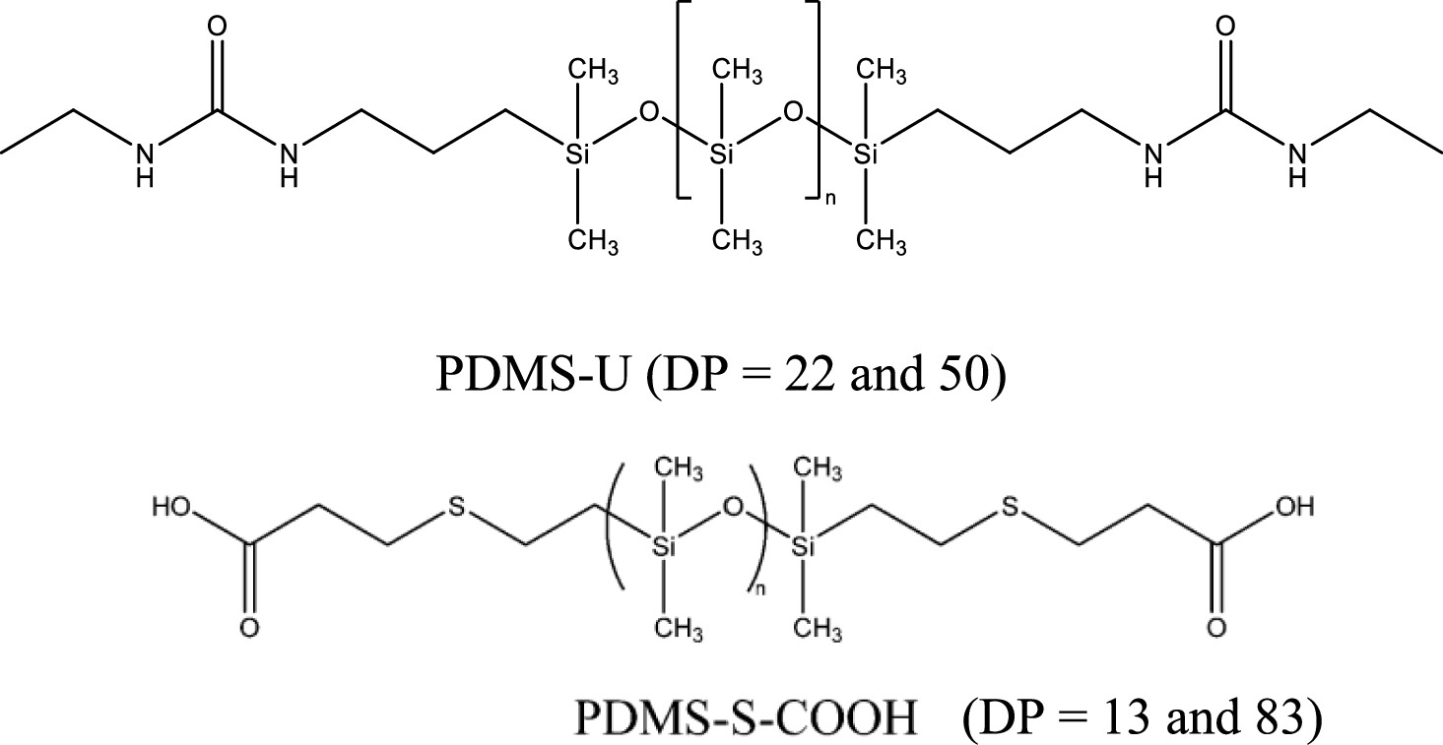
29Figure 5.1. Chemical structures of telechelic PDMS samples investigated in this study. DP indicates the degree of polymerization.
Figure 5.1. Chemical structures of telechelic PDMS samples investigated in this study. DP indicates the degree of polymerization.

5.2.1 Synthesis of the Telechelic PDMS Polymers

5.2.1.1 Urea-Functionalized PDMS
3.0 g (3 mmol) of aminopropyl-terminated PDMS (DMS-A11, Gelest) was added into a flame-dried 100 mL round-bottom flask with a magnetic stir bar inside. The flask was connected to a Schlenk line under vacuum at 50 °C for 30 min to remove water, and the flask was then transferred into a glovebox. 15 mL of anhydrous dichloromethane was added to dissolve PDMS under magnetic stirring. 0.47 g (6.6 mmol) of ethyl isocyanate dissolved in 5 mL of anhydrous dichloromethane was added into the flask dropwise under stirring. After 2 h of reaction, the mixture was removed from the glovebox. A rotary evaporator was used to remove the solvent and extra ethyl isocyanate. 1H NMR results are shown in Figure 5.2.
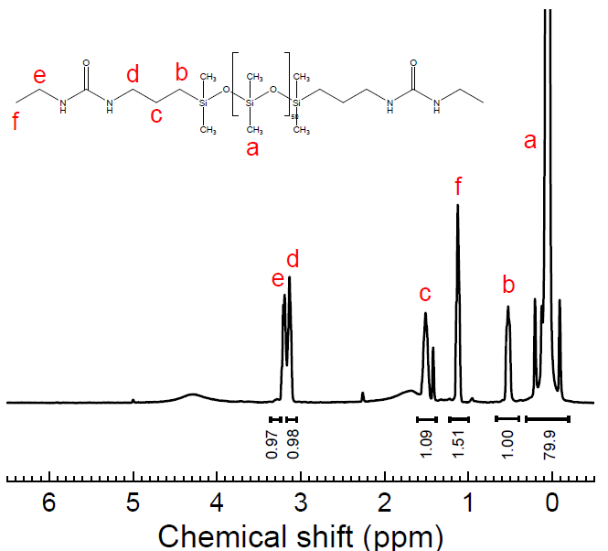
30Figure 5.2 1H-NMR result for the PDMS-U with DP 50
Figure 5.2 ¹H-NMR result for the PDMS-U with DP 50

5.2.1.2 Carboxylic Acid-Terminated PDMS
Synthesis of the carboxylic acid-terminated PDMS (PDMS-S-COOH) sample has been described earlier⁶. As an example, 3 g (0.5 mmol) of vinyl-terminated PDMS (Gelest) with a molecular weight (MW) of 6000 g/mol and 0.2123 g (2 mmol) of 3-mercaptopropionic acid were dissolved in 10 mL of anhydrous toluene. 0.041 g (0.25 mmol) of recrystallized 2,20-azobis(2-methylpropionitrile) (Sigma-Aldrich) was dissolved in 3 ml of toluene and added to the polymer mixture. The mixture was kept overnight at 65 °C under an argon atmosphere. After evaporation of the solvents, hexane was used to wash the product. Subsequently, hexane was evaporated, followed by dialysis against dichloromethane to remove low-molecular-weight impurities.

5.2.2 BDS Measurements
Before BDS measurement, all samples were dried in a vacuum oven at 333 K for 1 day to remove solvent and moisture. Then, BDS spectra in the frequency range from 10–2 to 106 Hz were measured using a Novocontrol system that includes an Alpha-A impedance analyzer and a Quatro Cryosystem temperature control unit. DP 22 and DP 50 urea-functionalized PDMS (PDMS-U) were placed into a parallel-plate dielectric cell made of sapphire and invar steel with an electrode diameter of 10 mm and a capacitance of 3.3 pF with an electrode separation of 210 μm. The PDMS-S-COOH samples were measured in a capacitor composed of two gold-plated electrodes of 20 mm diameter separated by a Teflon spacer of 34.4 μm thickness. To prevent crystallization, all samples were quenched from room temperature to about 113 K and reheated to 10 K below the Tg before the measurements. All spectra were measured on heating. After each temperature increase, the samples were equilibrated for 10 min to reach thermal stabilization within 0.1 K.

5.2.3 Rheological Measurements
Small amplitude oscillatory shear (SAOS) measurements were conducted with the strain-controlled mode of an AR2000ex rheometer (TA Instruments) in the angular frequency range of 10²–10^{–1} rad s^{–1} utilizing parallel plate geometry. Plate diameters of 4 and 8 mm were employed, depending on the magnitude of the shear modulus. The gap distance between the top and bottom plate was approximately 0.5 mm and kept constant throughout the temperature range. Prior to the measurement, each sample was dried as described for the BDS measurements. A strain sweep was conducted before each spectral sweep to determine the appropriate strain, keeping the SAOS in the linear regime. Before each scan, the samples were thermally equilibrated for 10 min; the maximum permitted temperature deviation was 0.2 K.

5.2.4 SAXS Measurements
X-ray scattering spectra for all studied samples as well as the reference sample PDMS-CH3 were measured in the way described previously²³. The samples were measured on XEUSS 3.0 (Xenocs, France) equipped with a Cu Kα microfocus source and a Pilatus 300 k detector (Dectris, Switzerland). The scattering vector (q) was calibrated by silver behenate standard material. The distances between the sample and the detector were 0.9 and 0.55 m for SAXS and WAXS, respectively. The sample was squeezed into a capillary tube made of quartz glass with a diameter of 1.5 mm and a wall thickness of 0.01 mm. The capillary was placed perpendicular to the X-ray beam. The measurement was also done on the empty capillary to subtract the background. X-ray measurements were performed at room temperature.
X-ray scattering spectra for PDMS-U (DP 22, DP 50), PDMS-S-COOH (DP 83, DP 13), and PDMS-CH3 are shown in Figure 5.3. For all samples, a strong and sharp peak is observed at q ∼0.85 Å^{–1}; it reflects spatial correlations between PDMS segments, while the weaker peak around q ∼1.5 Å^{–1} reflects intra-segmental correlations¹¹⁴. The introduction of functional groups did not change the X-ray spectra, and no additional scattering appears at low q, indicating no measurable micro-phase separation. Additionally, DSC curves of these samples also showed a single T_{g} value in the heat flow spectra (Figure 5.4), which is around the glass transition range of the PDMS segments, further confirming no micro-phase separation in the studied samples.
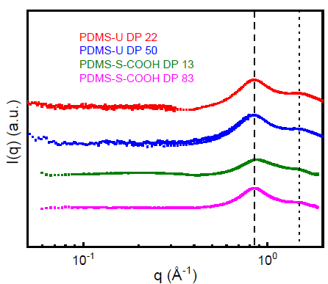
31Figure 5.3 X-ray Scattering spectrum for PDMS-U and PDMS-S-COOH
Figure 5.3 X-ray Scattering spectrum for PDMS-U and PDMS-S-COOH
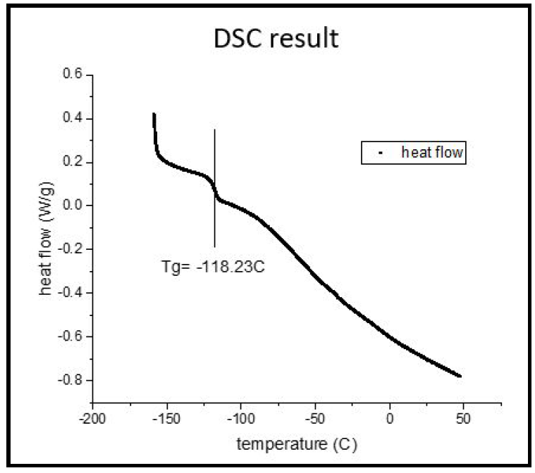
Figure 5.4 Example of the heat flow curves of the telechelic PDMS-U (DP 22) sample in DSC
Figure 5.4 Example of the heat flow curves of the telechelic PDMS-U (DP 22) sample in DSC
measurements. Vertical line indicates the T_{g} of the PDMS matrix.

5.3 Results
Two dielectric processes were observed for PDMS-U samples (Figure 5.5a,b). They are strongly separated in time and appear in the studied frequency range at different temperatures. To fit the loss spectra and to analyze the relaxation times of these processes, the phenomenological Havriliak–Negami (HN) function is used¹¹⁵.
$ε^{''}\left(υ\right)=-Im\sum_{k=1}^{n}{\left(\frac{Δε_{k}}{{\left(1+{\left(2πiυτ_{HN,k}\right)}^{β_{k}}\right)}^{γ_{k}}}\right)}+\frac{σ}{2πυε_{0}}$ (5.1)

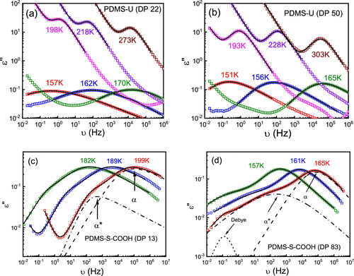
32Figure 5.5 Dielectric loss spectra of (a) PDMS-U (DP 22), (b) PDMS-U (DP 50), (c) PDMS-S-COOH (DP 13), and (d) PDMS-S-COOH (DP 83). The solid lines present the total fit. The dashed lines present the fits of the α relaxation process. The dash-dotted line
Figure 5.5 Dielectric loss spectra of (a) PDMS-U (DP 22), (b) PDMS-U (DP 50), (c) PDMS-S-COOH (DP 13), and (d) PDMS-S-COOH (DP 83). The solid lines present the total fit. The dashed lines present the fits of the α relaxation process. The dash-dotted line presents the fit of the α*-relaxation process. The short dashed line in (d) presents the fit for the Debye-like process for the PDMS-S-COOH (DP 83) sample.
Here, ε₀ is the vacuum permittivity, Δε denotes the dielectric relaxation strength, β and γ represent the shape parameters, τ_{HN} is HN relaxation time, and k indicates the number of processes. The second term in equation 5.1 considers the conductivity (σ) contribution to the loss spectra at higher temperatures. This fit reveals two surprising results for the slow relaxation process. First, the shape of this process is of Debye type (β ≈ γ ≈ 1), which is unusual for polymers but is prevalent in monohydroxy alcohols and some secondary amides¹¹⁶⁻¹¹⁹. Second, it has a relatively high dielectric strength, ∼2 orders higher than the PDMS backbone. Indeed, urea has quite a high dipole moment, ∼6.5–7.5 Debye^{120, 121}. For comparison, the dipole moment per repeating unit of PDMS is ∼0.29 to 0.33 Debye^{122, 123}. In addition, multiple hydrogen bonds are involved in the bond exchange process, which might provide an additional enhancement of the dielectric strength, and the Debye process in mono-alcohols is known to have high strength¹¹⁶⁻¹¹⁸.
BDS spectra for the PDMS-S-COOH sample with DP 83 and DP 13 are shown in Figure 5.5c,d. While the BDS spectra of the sample with DP 13 can be well described using only two peaks, a third peak is required to describe the spectra of the DP 83 sample (Figure 5.5d). So, the spectra of the samples were fit to equation 5.1 with 2 HN functions for the DP 13 sample and 3 HN functions for the DP 83 sample. The analysis revealed that the slowest relaxation peak in the spectra of the DP 83 sample also has a Debye-like shape.
The peak position of the dielectric loss spectra was used to estimate the characteristic relaxation time of these processes. The relaxation time corresponding to the peak position (τ_{max}) is directly related to τ_{HN} ⁵⁹.
$τ_{max}=τ_{HN}{\left(\frac{\sin\left(\frac{παγ}{2+2γ}\right)}{\sin\left(\frac{πα}{2+2γ}\right)}\right)}^{\frac{1}{γ}}$ (5.2)
In the case of the Debye-like peak, the characteristic relaxation time τ_{max} = τ_{HN}.
Rheological data were used to create a master curve assuming time–temperature superposition by horizontal shifting of shear modulus spectra measured at several temperatures (Figure 5.6). Although time–temperature superposition usually does not work in these systems, the obtained master curves provide good qualitative representation of the frequency dependence of the shear modulus. The process at high frequencies corresponds to the segmental relaxation (storage modulus values between 0.1 and 1 GPa). At the lowest frequencies, an additional process appears with the distinctive slopes of 2 and 1 for G′(ω) and G”(ω) (in double-logarithmic representation), respectively. This is typical of the terminal relaxation process, which indicates macroscopic stress relaxation in the system. Since the terminal relaxation in the master curve might be affected by the breakdown of TTS, the characteristic time for the terminal relaxation (τ_{C}) is estimated based on the crossover frequency of G′(ω) and G″(ω) only when it is in the frequency window of the rheometer. In addition, we observed a rubbery plateau in between these two processes, which is of the order of 1 MPa, especially for the PDMS-U (DP 50). We also notice that the shape of the curve is analogous to that of polydisperse polymer melt. This indicates the formation of long chains via transient hydrogen bonds between functional chain ends. In such cases, both the reptation dynamics and the kinetics of transient bond breaking and formation control the terminal relaxation time¹²⁴.
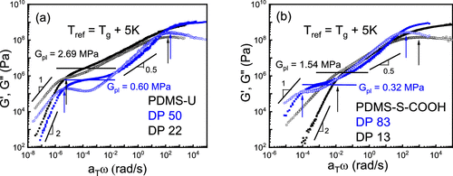
33Figure 5.6 (a) Shear modulus master curves for (a) PDMS-U with DP 50 (blue) and DP 22 (black) and (b) PDMS-S-COOH with DP 83 (blue) and DP 13 (black) against the radial frequency at a reference temperature of Tg + 5 K. The solid symbols present G′, while
Figure 5.6 (a) Shear modulus master curves for (a) PDMS-U with DP 50 (blue) and DP 22 (black) and (b) PDMS-S-COOH with DP 83 (blue) and DP 13 (black) against the radial frequency at a reference temperature of T_{g} + 5 K. The solid symbols present G′, while the open symbols present the G″ spectra. The rubbery plateau modulus levels, G_{pl}, are shown by the solid lines. The peak at higher frequency is related to the segmental relaxation of the PDMS backbones, whereas the peak at lowest frequency indicates the terminal relaxation of the samples.

5.4 Discussion
We start the discussion with assignments of the relaxation processes observed in the dielectric spectra. Figure 5.7 presents the characteristic time of the dielectric processes in the samples studied here. The highest frequency peak in all samples can be assigned to the PDMS segmental relaxation (α-process) because its characteristic relaxation time extrapolated to τ ∼ 100 s agrees well with T_{g} estimated from DSC (Figure 5.4). Following earlier studies, we name the slower relaxation process as α*-process¹²⁵. It should be related to the bond dissociation process because H-bond dissociation changes the dipole moment. Indeed, the amplitude of this process increases with the increase of the end-group fraction (Figure 5.5). The assignment of the slowest process in the PDMS-S-COOH sample with DP 83 will be discussed later.
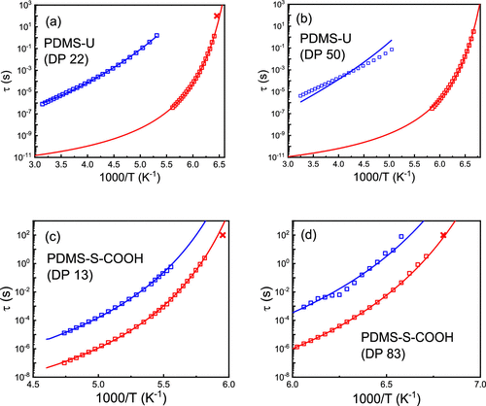
34Figure 5.7 Temperature dependence of the relaxation time for segmental α-relaxation (red squares) and the α*-relaxation (blue squares) for the PDMS-U sample with (a) DP 22 and (b) DP 50 and for PDMS-S-COOH samples with (c) DP 13 and (d) DP 83. Red crosse
Figure 5.7 Temperature dependence of the relaxation time for segmental α-relaxation (red squares) and the α*-relaxation (blue squares) for the PDMS-U sample with (a) DP 22 and (b) DP 50 and for PDMS-S-COOH samples with (c) DP 13 and (d) DP 83. Red crosses mark T_{g} of the samples estimated from the heat flow curve from DSC (Figure 5.4). The red lines show VFT fits (eq 5.3), while the blue lines show the fits to eq 5.4.
The temperature dependence of segmental relaxation time can be fit by the usual Vogel–Fulcher–Tammann (VFT) equation (Figure 5.7)^{126, 127}
$τ_{a}\left(T\right)=τ_{0}\exp\left(\frac{B}{T-T_{0}}\right)$ (5.3)
where τ₀ is the high temperature limit of the segmental relaxation time, and B and T₀ are the VFT parameters. To minimize the number of the free fit parameters, we fixed τ₀ = 10^{–12} s. The fit parameters are presented in Table 5.1.
Table 5.1 VFT Fit Parameters (B and T₀) of the Segmental Relaxation, Activation Energy of Bond Dissociation (E_{a}) Estimated Using eq 5.5, and the Value of 2RT ln N at T = 200 K for PDMS-U and PDMS-S-COOH Samples
cTable 5.1 VFT Fit Parameters (B and T0) of the Segmental Relaxation, Activation Energy of Bond Dissociation (Ea) Estimated Using eq 5.5, and the Value of 2RT ln N at T = 200 K for PDMS-U and PDMS-S-COOH Samples
sample | B | T₀ | 2RT ln N (kJ/mol) | E_{a} (kJ/mol)
PDMS-U DP 22 | 530 | 137 | 6.4 | 28 ± 1
PDMS-U DP 50 | 485 | 133 | 9.2 | 31 ± 1
PDMS-S-COOH DP 13 | 762 | 145 | 4.7 | 8 ± 0.5
PDMS-S-COOH DP 83 | 479 | 132 | 10.9 | 8 ± 0.5
To estimate the activation energy of bond dissociation E_{a}, many authors used the apparent activation energy estimated from the temperature dependence of the α*-process. This is not correct because the dissociation of the bond in this case depends on the polymer segmental motions^{6, 112, 128}. For a dynamic bond to dissociate, the connected segment needs to move, and the attempt time for the bond dissociation should be comparable to the segmental relaxation time. In other words, the bond dissociation process requires motion of functional groups that is controlled by the segmental friction coefficient. Thus, the temperature dependence of segmental relaxation time should be explicitly taken into account for calculations of E_{a}^{6, 112, 128}.
$τ_{a*}\left(T\right)=τ_{α}\left(T\right)\exp\left(\frac{E_{a}}{RT}\right)$ (5.4)
The fits of the τ_{α}*(T) to eq 5.4 are presented in Figure 5.7, and the values obtained from the fit energy barrier for bond dissociation, E_{a}, are presented in Table 5.1. One can rewrite eq 5.4 and estimate the dissociation energy from the ratio of τ_{α}*(T)/τ_{α}(T)
$E_{a}=RTln\left(\frac{τ_{α*}\left(T\right)}{τ_{α}\left(T\right)}\right)$ (5.5)
The overlap of the data for relaxation times of α* and α processes in the case of urea-terminated samples is very limited (Figure 5.7). So, we used VFT fits of the τ_{α} data extrapolated toward a higher temperature for analysis of these data. This analysis revealed a surprisingly good description of the ratio of relaxation times by the Arrhenius approximation (Figure 5.8). Slight deviation from linear behavior observed for the sample with DP 50 (Figure 5.8b) can be the result of the VFT extrapolation. The observed behavior is in contrast to several other examples where strong deviation from the simple Arrhenius relationship was observed and discussed^{113, 129}.
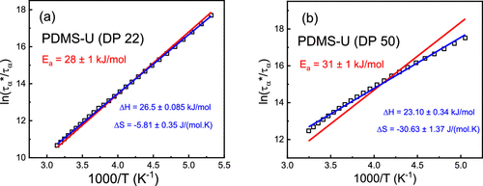
35Figure 5.8 Ratio of the time scales τα*(T) and τα(T) against 1000/T for PDMS-U with (a) DP 22 and (b) DP 50. The red lines present the Arrhenius law fit (eq 5.5), and the blue lines present the linear fit, accounting for the entropic contribution (eq 5.6
Figure 5.8 Ratio of the time scales τ_{α}*(T) and τ_{α}(T) against 1000/T for PDMS-U with (a) DP 22 and (b) DP 50. The red lines present the Arrhenius law fit (eq 5.5), and the blue lines present the linear fit, accounting for the entropic contribution (eq 5.6). Comparison of the fits suggests that the entropic contribution is relatively small.
A linear fit of ln[𝜏𝛼∗(𝑇)/𝜏𝛼(𝑇)] vs 1/T allows estimates of enthalpic ΔH and entropic ΔS contributions to the energy barrier of the bond dissociation in PDMS-U samples
$\frac{E_{a}}{RT}=\frac{ΔH}{RT}-\frac{ΔS}{R}=\ln\left(\frac{τ_{α*}\left(T\right)}{τ_{α}\left(T\right)}\right)$ (5.6)
This fit (Figure 5.8) revealed dominating enthalpic contributions with ΔH ∼ 26.5 kJ/mol for DP 22 to ∼23.1 kJ/mol for DP 50, while relatively small entropic contribution (TΔS at the relevant T = 250 K) increases with the increase of the chain length from ∼1.5 kJ/mol for DP 22 to ∼7.7 kJ/mol for DP 50.
The estimated E_{a} for the urea-terminated samples (Figure 5.8, Table 5.1) is significantly higher than the energy barrier for PDMS-S-COOH samples obtained earlier, E_{a} ∼ 8 kJ/mol (Figure 5.7, Table 5.1)⁶. The latter value is reasonable for a single hydrogen bond. However, the value estimated for the urea dissociation suggests breaking 3–4 hydrogen bonds, which is possible to form for these structural units (Figure 5.1).
As the next step, we compare the bond rearrangement time estimated from rheology (terminal relaxation time) to the bond dissociation time estimated from the dielectric data (α*-process). For direct comparison of these time scales, the dielectric data should be also analyzed in the modulus presentation¹³⁰. So, the dielectric spectra were converted to the dielectric loss modulus M″(ω) according to Ref ⁵⁹.
$M^{*}\left(ω\right)=\frac{1}{ε^{*}\left(ω\right)}=M^{'}\left(ω\right)+iM''(ω)$ (5.7)
and fit to the same HN function (eq 5.1). The so-obtained τ_{α}*_{–M} appears different from τ_{α}* estimated from the permittivity loss spectra for PDMS-U samples due to the high amplitude of the α*-process¹³⁰ (Figures 5.5 and 5.9). There is no significant difference between these time scales in the case of PDMS-S-COOH samples due to the relatively weak strength of this process ¹³⁰ (Figures 5.5 and 5.9).
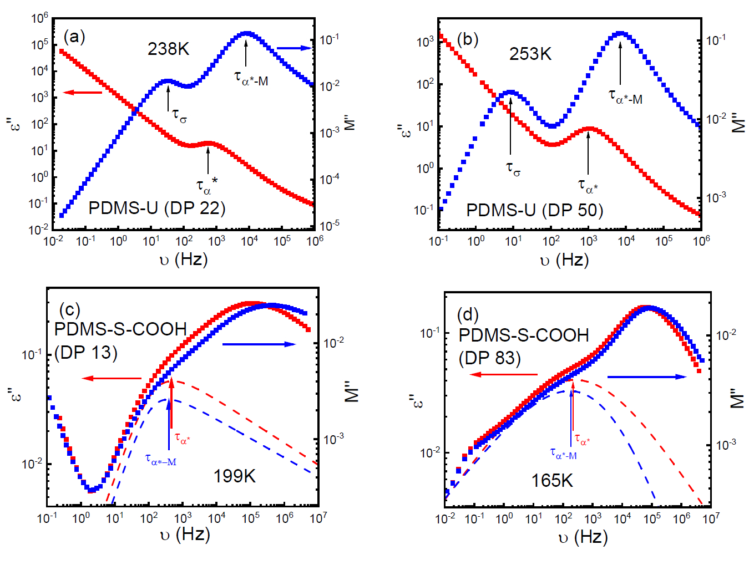
36Figure 5.9 Comparison of ɛ’’ (red square) and M” (blue square) spectra for (a) PDMS-U (DP
Figure 5.9 Comparison of ɛ’’ (red square) and M” (blue square) spectra for (a) PDMS-U (DP
22), (b) PDMS-U (DP 50), (c) PDMS-S-COOH (DP 13) and (d) PDMS-S-COOH (DP 83). Arrows indicate the characteristic relaxation time of α* process estimated from ε” (red) and M” (blue). Dashed lines present the HN fits of the α* process for ε” spectra (red) and M” (blue) spectra for PDMS-S-COOH samples. 𝜏𝜎 in (a) and (b) indicates conductivity relaxation time.
Direct comparison (Figure 5.10) reveals very good agreement between the rheological and dielectric modulus timescales for both PDMS-U samples. This result suggests that the bond dissociation time process observed in the dielectric spectra of these samples is essentially the same as the bond rearrangement time. Rheological time appears only slightly slower than the dielectric modulus time in PDMS-S-COOH with DP 13 (Figure 5.10c), while it is almost 1000 times slower in the sample with DP 83 (Figure 5.10d). Surprisingly, the relaxation time of the slowest dielectric process observed in the DP 83 sample agrees well with the terminal relaxation time (Figure 5.10d). Thus, the slowest dielectric relaxation process in the PDMS-S-COOH sample with DP 83 reflects the bond rearrangement time, and it also has the Debye-like shape as is observed for the α*-process in the PDMS-U samples.
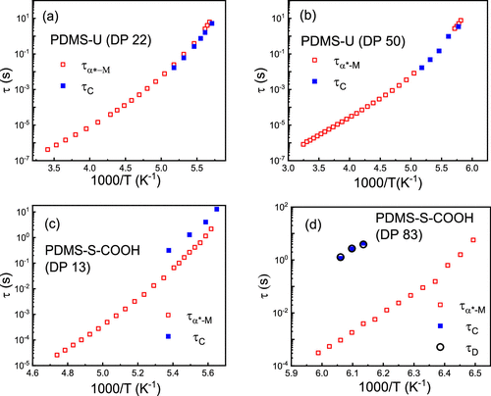
37Figure 5.10 Comparison of dielectric modulus τα*–M (red open squares) and rheological τC (blue closed squares) relaxation times for (a) PDMS-U DP 22, (b) PDMS-U DP 50, (c) PDMS-S-COOH DP 13, and (d) PDMS-S-COOH DP 83 samples. For the PDMS-S-COOH DP 83 sa
Figure 5.10 Comparison of dielectric modulus τ_{α*–M} (red open squares) and rheological τ_{C} (blue closed squares) relaxation times for (a) PDMS-U DP 22, (b) PDMS-U DP 50, (c) PDMS-S-COOH DP 13, and (d) PDMS-S-COOH DP 83 samples. For the PDMS-S-COOH DP 83 sample, the Debye-like process time τ_{D} (black open circle) is also included.
Based on the obtained values of E_{a}, we can relate the bond strength regime of each sample to the criterion introduced by the bond-lifetime renormalization model (Table 5.1)⁴. To estimate the number of segments N, we assume N = 2 × DP/C∞ ≈ DP/3.15 (we used the characteristic value C∞ = 6.3 )¹³¹. PDMS-S-COOH with DP 83 is the only sample with the bond strength well within the intermediate regime, RT ln N < E_{a} < 2 RT ln N (Table 5.1), and our earlier detailed studies indeed revealed that the difference between the bond dissociation time τ_{α*–M} and the bond rearrangement time τ_{C} can be well explained by the bond lifetime renormalization model⁶. Although dissociation energy is essentially the same for the PDMS-S-COOH sample with DP 13 (Table 5.1), the much shorter chain brings it to the border of the strong interaction regime (E_{a} > 2RT ln N), and the observed close values of τ_{α*–M} and τ_{C} in the dynamics of this sample (Figure 5.10c) are in good agreement with the predictions of the model. In contrast, dissociation energy is very high for urea-terminated chains, and both PDMS-U samples are deep in the strong dissociation energy regime (Table 5.1). The observed very good agreement of the terminal relaxation time and the dielectric modulus time for the bond dissociation process (Figure 5.10a,b) is also in perfect agreement with the predictions of the bond lifetime renormalization model. Thus, indeed in the strong dissociation energy regime, the bond dissociation time and bond rearrangement time appear very similar. This justifies the use of mechanical relaxation time for estimates of the bond dissociation energy in the strong interaction regime. However, segmental relaxation should be explicitly taken into account for a good quantitative analysis.
We want to comment specifically on eq 5.4. Although it seems like a reasonable approximation, there are many experimental data which question its simplicity, demonstrating that the ratio of bond dissociation (or rearrangement) time to the segmental relaxation time decreases upon cooling^{113, 129, 132}. The latter contradicts eq 5.4 and requires deeper understanding of the relationship between friction imposed on the stickers by the surrounding polymer matrix and the bond dissociation process. Recently, Schweizer and co-workers suggested that friction might follow weaker dependence on τ_{α}(T) than the one predicted by eq 5.4, and this puzzle remains unsolved¹²⁹. However, in the case of systems studied here, the bond dissociation temperature dependence seems to follow eq 5.4 reasonably well (Figure 5.7) and provides reasonable estimates of the energy barrier for bond dissociation.
Rheological measurements of the investigated polymers also show a rubbery plateau in their shear modulus master curves (Figure 5.6), although molecular weight of our chains is significantly below the entanglement molecular weight of PDMS (M_{e} ∼10–12 kg/mol )¹³³. This indicates the formation of supramolecular polymer chains. From the viscosity measurements (Figure 5.11), it was observed that the viscosity of PDMS-U samples is ∼1000 times higher than its non-associating counterpart, while it is only ∼10 times higher in the case of PDMS-S-COOH samples. This is reasonable because the interaction strength is much higher in urea-functionalized samples than in the PDMS-S-COOH samples, and this leads to the formation of significantly longer transient chains.
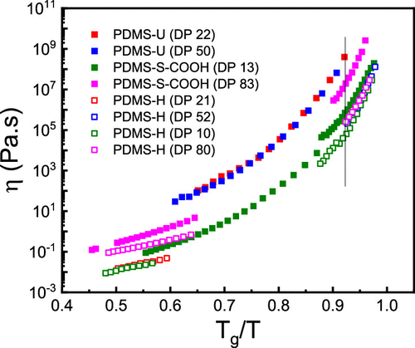
38Figure 5.11 Comparison of the shear viscosity of PDMS-U and PDMS-S-COOH samples to the viscosity of their non-associated counterpart PDMS-H with comparable DPs. The temperatures are scaled with Tg of the samples. Crystallization of samples leads to the g
Figure 5.11 Comparison of the shear viscosity of PDMS-U and PDMS-S-COOH samples to the viscosity of their non-associated counterpart PDMS-H with comparable DPs. The temperatures are scaled with T_{g} of the samples. Crystallization of samples leads to the gap in some data.
One intriguing feature of the systems investigated in this study is the shape of the bond dissociation process in the dielectric spectra. It appears to have a Debye-like shape (single exponential relaxation) which is very unusual for polymers but is well documented for monohydroxy alcohols (MA) and secondary amides. The molecular origin of the Debye peak in these systems remains controversial. The Debye-like dielectric process has been also observed in short hydroxyl-terminated PDMS chains¹³⁴. In our previous studies and also in the case of PDMS-S-COOH samples presented here, the dielectric process of bond dissociation appears strongly stretched (Figure 5.5)^{125, 135}. However, in all these cases the bond rearrangement time was much longer than the bond dissociation time. In the examples studied here, the Debye process appears in the dielectric spectra at the timescale of terminal relaxation, i.e., bond rearrangement time. It is especially illustrative in the example of PDMS-S-COOH with DP 83, where the Debye-like dielectric relaxation process appears exactly at the terminal relaxation time which is much longer than the bond dissociation time (Figure 5.10d). However, currently we do not have any clear explanation for why the bond rearrangement process in the dielectric spectra appears with a Debye-like shape.

5.5 Conclusions
In this study, we investigated dielectric and rheological properties of telechelic PDMS polymers having two different functional groups forming hydrogen bonds. The activation energy of the bond dissociation process in these systems has been estimated using dielectric spectroscopy. The choice of functional groups and chain length enables the experimental test of the bond lifetime renormalization model in the strong and intermediate association regimes. Our analysis revealed good agreement of the experimental data with the model predictions. Most of the current studies use the rheological terminal relaxation time scales to estimate the energy barrier for bond dissociation. In general, this is not correct because rheology actually measures bond rearrangement time, not bond dissociation. The difference between the bond dissociation and bond rearrangement times can be well explained by the bond lifetime renormalization model. Our results clearly show that the use of terminal relaxation to estimate the bond dissociation energy is only valid in the strong interaction regime where both bond dissociation and bond rearrangement times become comparable. Our results also show very clearly that segmental relaxation should be taken explicitly into account for the estimation of bond dissociation energy, at least, in the case of the systems studied here.
Rheological measurements indicate that the viscoelastic properties of the associated polymers deviate considerably from their non-associating counterpart due to the formation of supramolecular chains with no phase separation. High dissociation energy of urea groups leads to the formation of superchains with effective length far exceeding the length of the telechelic chains. It remains a challenge to understand why the bond rearrangement process appears in the dielectric spectra with a Debye-like shape.

CHAPTER 6 CRITICAL ROLE OF FREE AMINE GROUPS IN THE IMINE BOND EXCHANGE IN DYNAMIC COVALENT NETWORKDS
A version of this chapter was published in Macromolecules, by Gregory P. Carden, Murillo L. Martins, Gaukhar Toleutay, Sirui Ge, Bingrui Li, Sheng Zhao, Alexei P. Sokolov “Critical Role of Free Amine Groups in the Imine Bonds Exchange in Dynamic Covalent Networks” (Macromolecules 2024 57(17), 8621-8631)
Gregory P. Carden and Murillo L. Martins wrote the manuscript together with the direction of Alexei P. Sokolov. Gregory P. Carden, Murillo L. Martins and Sirui Ge performed rheological measurements and the corresponding data analysis. Bingrui Li, Sheng Zhao and Gakhar Toleutay synthesized the materials. Gregory Peyton Carden performed BDS measurements and the corresponding data analysis. Gregory Peyton Carden also performed the SAXS measurements. Murillo Longo Martins performed a detailed analysis of the FTIR spectra.

6.1 Introduction
The broad use of polymeric materials in our lives drives a continuous growth of plastic waste caused by their limited recyclability¹³⁶⁻¹⁴². Polymer backbones and cross-links are usually formed by strong covalent bonds, whose breaking for subsequent recycling of the material requires significant energy and costs. However, recent advances in chemistry offer a promising solution–the use of polymers with reversible (dynamic) bonds^{27, 66, 70-77, 86, 143-156}. In these systems, a few covalent bonds, especially chemical cross-links, are replaced by reversible bonds, which enable the design of easily recyclable polymers without loss of their properties within a desired temperature range. Moreover, these often-called dynamic polymers may be designed to exhibit unique properties, including self-healing, shape memory, extreme toughness, and elongation^{1, 68, 69}.
Among the covalent functionalities used to conceive dynamic polymers, imine bonds are exciting candidates since they undergo rapid exchange reactions and can be formed in the absence of catalysts with water being the only byproduct of the reaction. Although the exchange mechanisms of imine bonds are well-established in chemistry and biology literature, (37) there is still some confusion when these are utilized as dynamic moieties in polymers¹⁵⁷. As shown in Figure 6.1, imines are formed via condensation of primary amines with carbonyl compounds and their behavior is highly dependent on the concentration of water and unreacted amines. At high concentrations of water, hydrolysis of the newly formed bond occurs (Figure 6.1a)^{17, 18}. Once water no longer plays a direct role as a reactant in the system but free amine groups are still available, transimination reactions are predominant (Figure 6.1b). Lastly, imine metathesis may, in principle, occur and does not involve either water or free amine groups as reactants (Figure 6.1c). However, such a reaction is only expected to take place at very high temperatures and long times, even between small molecules in organic solvents and in the presence of catalysts^{17, 18}.
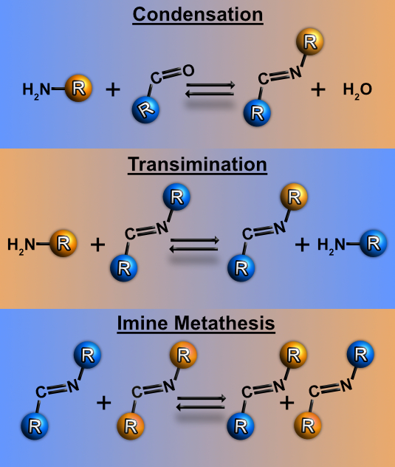
39Figure 6.1 Reversible Processes Involving the Imine Bond: (a) Imine Formation via Condensation; (b) Transimination; (c) Imine Metathesis
Figure 6.1 Reversible Processes Involving the Imine Bond: (a) Imine Formation via Condensation; (b) Transimination; (c) Imine Metathesis
The most often conceptual confusion involving the exchange mechanisms of imine bonds is based on the assumption of imine metathesis (Figure 6.1c) as a viable nonmediated mechanism of the bond exchange. Facing a growing number of reports in the polymer literature that consider this assumption, we stress in the present work that, in the absence of catalysts, unreacted amine groups or imine bonds hydrolyzed by residual water must be considered in the proper description of these bond exchanges^{8, 158-161}. The importance of unreacted amines in the thermodynamics and dynamics of polymers bearing, for example, vinylogous urethanes dynamic functionalities has already been emphasized, but similar works are rarely focused on imine bonds^{74, 149, 162}. Instead, the latter are often utilized in rather complex systems, impairing the detailed understanding of the underlying mechanisms governing the viscoelastic properties of the networks^{8, 163, 164}. Also, detailed studies did reveal a significant influence of water on imine, boronic ester, and some other dynamic covalent bonds^{9, 10, 165, 166}. Nevertheless, water is usually intentionally added to such systems in meaningful concentrations to promote rapid bond rearrangements, and the role of residual water, including water adsorbed from the air and as a simple byproduct of the bond formation, is often overlooked^{9, 10, 165}.
To unravel the details of the imine bond exchange mechanisms, we study the dynamic and viscoelastic behavior of model systems based on polydimethylsiloxane (PDMS) bearing imine bonds. The main focus of our studies is to provide a semiquantitative mechanistic description of the role played by unreacted amine groups and residual water within both telechelic and pendant-functionalized PDMS networks. We controlled the availability of free amine groups and water by specially designed functionalization of pendant groups and by subjecting the samples to different drying regimes. A combination of linear rheology and broadband dielectric spectroscopy (BDS) was employed to analyze the relaxation dynamics and viscoelastic properties of these materials. Our studies unambiguously revealed the critical role of unreacted amine groups in promoting the exchange of imine bonds. We demonstrate that the systems with no free amine groups do not show network rearrangements at any reasonable time even at temperatures close to the chemical degradation of the polymer. These results clearly exclude imine metathesis as a possible bond exchange mechanism within these networks. In fact, since bond exchange only happens in the presence of free amine groups, transimination reactions (Figure 6.1b) must occur to allow for bond exchange. The most surprising result is that the energy barrier for the bond rearrangement increases with the concentration of imine bonds within the system. This unexpected result is consistent with recent reports in the literature¹⁶⁷. Moreover, when part of the imine bonds is hydrolyzed, the activation energy does not change drastically, which suggests a dependence on the concentration of functional groups able to form such bonds (amine and aldehyde) rather than the imine bonds per se. Currently, we do not have a definitive explanation for this behavior. We hypothesize that it is affected by the additional slowing down of chain dynamics by these functional groups either through the formed imine bonds or through the strong hydrogen bonding interactions between amine groups and the carbonyl functionalities formed by hydrolyzed imine bonds. Additional studies, including simulations, will help to draw a definitive picture of this puzzle.

6.2 Materials and Methods

6.2.1 Synthesis of the Telechelic and Pendant Imine-functionalized PDMS
Terephthalaldehyde (TA) was purchased from Sigma-Aldrich, and the different aminopropyl functionalized polydimethylsiloxanes (PDMS-NH₂) were purchased from Gelest. For the synthesis of the telechelic sample (Figure 6.2a), TA (107.3 mg) was initially dissolved in 5 mL of toluene. Then, 1g of PDMS-di-NH₂ (DP = 22) was dissolved in 10 mL of toluene and added dropwise to the TA solution under stirring. Hence, a 1:1 molar ratio between the amine groups from PDMS and the TA’s aldehyde groups was aimed. This mixture was reacted at 40 °C under nitrogen protection for 6 h. The sample was purified by dialysis (benzoylated tubing-Sigma-Aldrich, cut off 2000 Da MW) over toluene and dried in a vacuum oven at 40 °C for 2 days. This synthesis temperature was chosen following the preparation of imine-bearing networks often reported in the literature⁸⁻¹⁶.
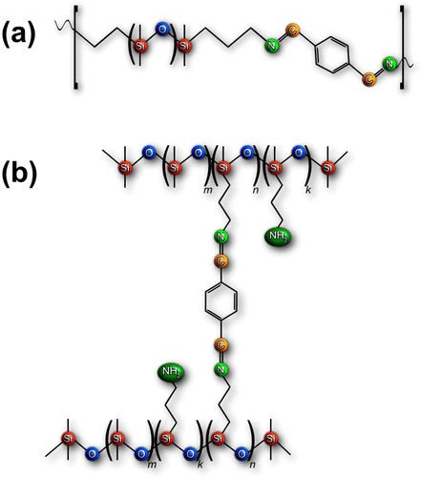
40Figure 6.2 Final structures of the (a) telechelic and (b) pendant imine-functionalized PDMS-based dynamic polymers.
Figure 6.2 Final structures of the (a) telechelic and (b) pendant imine-functionalized PDMS-based dynamic polymers.
The samples not subjected to any additional drying regime are hereafter named “as-prepared” samples. The as-prepared samples were subjected to additional drying regimes for specific experiments and these samples are referred to as “dried samples”. The drying regimes are specified in the text.
For the synthesis of the pendant cross-linked samples (Figure 6.2b), 3 g of PDMS-NH₂ with pendant functionalities (labeled molecular weight = 50,000 g/mol) was dissolved in 15 mL of toluene. This solution was added dropwise to 5 mL of TA solutions in toluene whose concentrations were adjusted depending on the desired degree of functionalization. This mixture was reacted at 40 °C under nitrogen protection for 24 h. The resulting solution was poured into a teflon dish to have the solvent evaporated at room temperature and the sample was further dried in a vacuum oven at 40 °C for 2 days. Like the telechelic sample, the pendant functionalized systems not subjected to additional drying are hereafter referred to as “as-prepared” while those subjected to additional drying regimes are referred to as “dried”. The additional drying regimes are specified in the manuscript. The pendant functionalized samples are named according to their degree of functionalization of amine groups targeted in the synthesis: pendant-10%, pendant-20%, pendant-50%, and pendant-100%. That is, following Figure 6.2b, the samples are named according to the ratio of n to the total number of pendant groups (k + n) of the polymer. The chemical structure of the final samples was verified by either ¹H NMR or infrared spectroscopy, as presented in the Supporting Information (Figure 6.3). Small-angle X-ray scattering (SAXS) data (Figure 6.4) show no phase separation indicating that dynamic functionalities are miscible with the PDMS matrix. Table 6.1 presents the relevant parameters of the synthesized polymers.
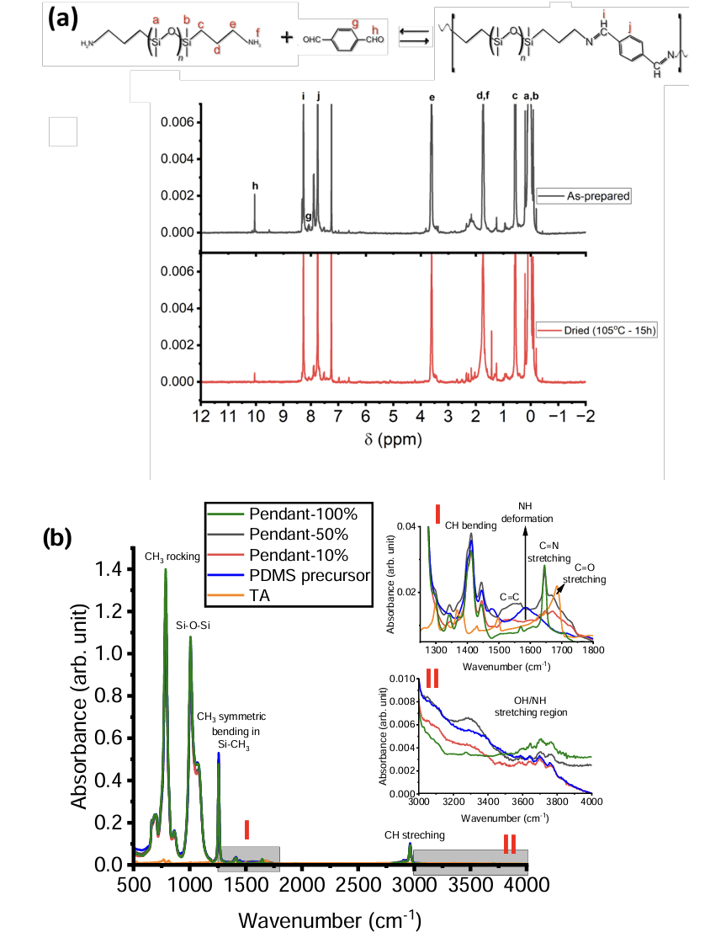
41Figure 6.3 In (a), 1H NMR spectra of the telechelic sample either as-prepared or dried at 105 0C for 15h. The experiments were performed in CDCl3 with a field strength of 400 MHz and 48 scans were collected. The results show the success of synthesizing t
Figure 6.3 In (a), 1H NMR spectra of the telechelic sample either as-prepared or dried at 105 0C for 15h. The experiments were performed in CDCl3 with a field strength of 400 MHz and 48 scans were collected. The results show the success of synthesizing the telechelic system as depicted by the continuous decrease of the aldehyde (C=O) band at ~ 10 ppm as the sample is dried. From the data, the remaining C=O in the system changes from 8.5% in the as-prepared sample to 2.5% in the dried one. The bands labeled “c” were used as the internal standard for the calculations. We highlight that the presence of aldehyde groups in the system even after purifying the samples with dialysis is likely due to the continuous hydrolysis/condensation of the imine bonds. The insets show other regions of interest, including the bands coming from traces of solvent (toluene) in the samples. In (b), FTIR spectroscopy has been used to monitor the synthesis of the pendant functionalized systems. The main figure shows the full spectra of the materials and the synthesis precursors, and the success of the synthesis is confirmed by the appearance of the C=N bands around 1650 cm-1 , as depicted in Inset I. Inset II shows the OH/NH stretching vibrations.
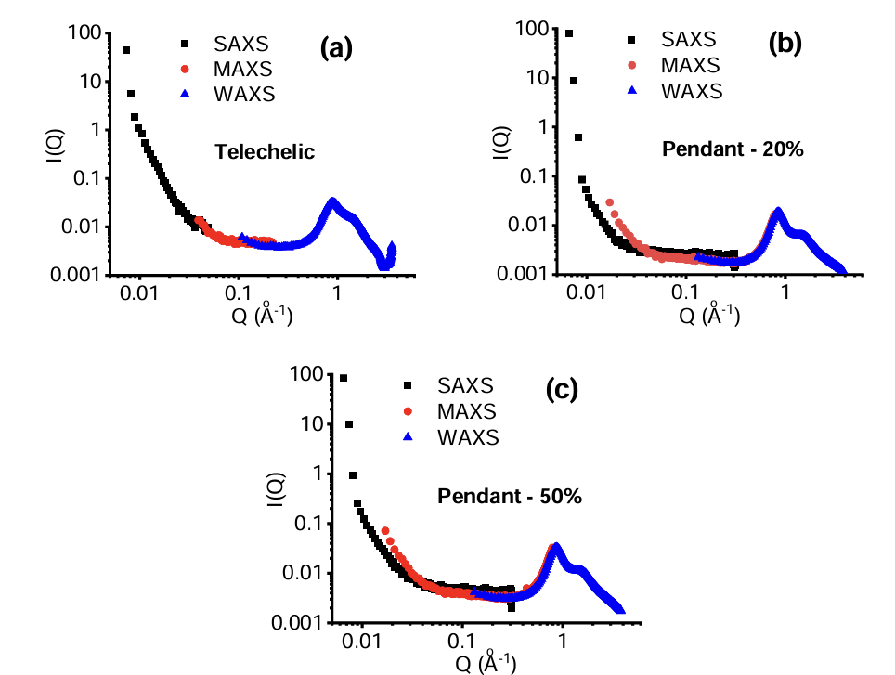
42Figure 6.4 X-ray scattering data collected for the (a) telechelic and (b, c) pendant functionalized samples. Peaks around 1Å-1 correspond to the scattering of PDMS chains. The absence of peaks or shoulders at lower q-values indicates no phase segregation
Figure 6.4 X-ray scattering data collected for the (a) telechelic and (b, c) pendant functionalized samples. Peaks around 1Å-1 correspond to the scattering of PDMS chains. The absence of peaks or shoulders at lower q-values indicates no phase segregation within the samples.

Table 6.1 Parameters of the Telechelic and Pendant Samples Targeted in the Synthesesª
dTable 6.1 Parameters of the Telechelic and Pendant Samples Targeted in the Syntheses
sample | molecular weight (g/mol) | m | n | k
telechelic | ∼ 1500
pendant-10% | ∼ 50,000 | 608 | 4 | 38
pendant-20% | ∼ 50,000 | 608 | 8 | 34
pendant-50% | ∼ 50,000 | 608 | 21 | 21
pendant-100% | ∼ 50,000 | 608 | 42 | 0
ª
The indexes m, n, and k follow the schematics in Figure 6.2 where m indicates the siloxane monomers not functionalized with NH₂, n depicts the monomers bonded by C═N bonds, and k refers to the monomers bearing unreacted NH₂ terminations.

6.2.2 Thermogravimetric Analyses
Thermogravimetric analyses (TGA) analyses were performed using a TGA Q50 instrument. The studies were performed with the telechelic and pendant-10% samples as temperature scans between room temperature and 923 K and as isothermal runs at 378 K for 12 h.

6.2.3. Broadband Dielectric Spectroscopy
Dielectric spectra in the frequency range between 10^{–2} and 10⁶ Hz were measured using a Novocontrol system. This apparatus includes an Alpha-A impedance analyzer and a Quatro Cryosystem temperature control unit. The samples were placed into a parallel plate dielectric cell made of sapphire and invar steel with an electrode diameter of 10 mm and a capacitance of ∼2.9 pF with an electrode separation of ∼220 μm. To prevent crystallization, all samples were quenched from room temperature to about 113 K and reheated to 10 K below the glass transition temperature (T_{g}) before the measurements. All the spectra were measured on heating and the samples were equilibrated for 10 min at each temperature to reach thermal stabilization within 0.1 K.

6.2.4. Small Amplitude Oscillatory Shear Rheology
Small amplitude oscillatory shear rheology SAOS measurements were conducted in the linear regime with the strain-controlled mode of an AR2000ex rheometer (TA Instruments) in the angular frequency range of 10^{–1}–10² rad/s utilizing parallel plate geometry. Plate diameters of 4, 8, and 25 mm were employed, depending on the magnitude of the shear modulus. The gap distance between the top and bottom plate was approximately 0.5 mm and kept nearly constant throughout the temperature range. The samples were equilibrated before each scan to prevent temperature deviations larger than 0.2K and all the experiments were conducted under N₂ flow. The temperature ranges of each experiment are indicated along with the text.

6.3 Results

6.3.1. Thermal Stability
The TGA temperature scan experiment on the telechelic sample estimated its decomposition temperature above 723 K (Figure 6.5a). Meanwhile, the pendant-10% sample (Figure 6.5b) shows an initial offset on its weight around 500 K followed by full decomposition starting at 700 K. To evaluate the water content in the samples, isothermal TGA analyses were performed at 378 K (Figure 6.5b). In the telechelic system, a fast 1% drop in weight, which can also be credited to the elimination of solvent traces from the synthesis procedure (toluene), occurs on times shorter than 1 h, and is followed by subsequent slow weight losses that continued even after 12 h. As for the pendant-10% sample, the initial drop in weight is less pronounced in comparison with the telechelic sample due to lower concentration of functionalized groups, and the subsequent weight losses can also be observed over time. However, the observation of the latter is impaired by experimental accuracy causing the apparent weight fluctuations during the experiment.
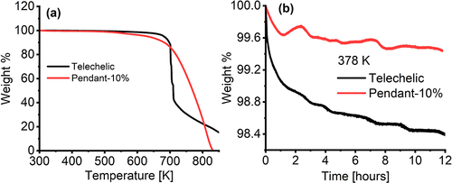
43Figure 6.5 TGA scans of the telechelic and pendant-10% samples: (a) temperature-dependent TGA scan; (b) an isothermal TGA analysis at 378 K for 12 h. Apparent weight fluctuations in (b) reflect the accuracy of the isothermal measurements.
Figure 6.5 TGA scans of the telechelic and pendant-10% samples: (a) temperature-dependent TGA scan; (b) an isothermal TGA analysis at 378 K for 12 h. Apparent weight fluctuations in (b) reflect the accuracy of the isothermal measurements.

6.3.2. Broadband Dielectric Spectroscopy
The permittivity loss spectra of the telechelic sample show the presence of two relaxation processes (Figure 6.6). Following previous studies, the high-frequency process is assigned to the segmental motions (α-process) of the polymer backbone⁶. The slower process has been named α*, and its amplitude drops in comparison with α when the telechelic sample is dried at 378 K for 15 h (Figure 6.6a), and when the functionalization degree increases in the pendant samples (Figure 6.6b).
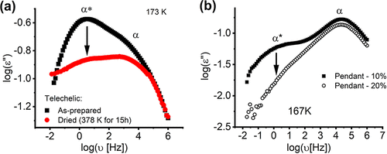
44Figure 6.6 Representative BDS data collected at (a) 173 K with the telechelic and (b) at 167 K with the pendant functionalized samples highlighting the α*- and α-processes. The arrows highlight the drop in the amplitude of α- after drying the sample at 3
Figure 6.6 Representative BDS data collected at (a) 173 K with the telechelic and (b) at 167 K with the pendant functionalized samples highlighting the α*- and α-processes. The arrows highlight the drop in the amplitude of α- after drying the sample at 378 K for 15 h under N₂ flow (a) and by increasing the functionalization of pendant systems (b). In (b) the samples have been measured in their as-prepared state.
For a quantitative analysis of the relaxation processes observed with BDS, the permittivity loss spectra were fit to a sum of two Havriliak–Negami functions
$ε^{''}=-Im\left(\frac{Δε_{1}}{{\left(1+{\left(2πυτ_{HN1}\right)}^{α_{1}}\right)}^{γ_{1}}}+\frac{Δε_{2}}{{\left(1+{\left(2πυτ_{HN2}\right)}^{α_{2}}\right)}^{γ_{2}}}\right)$ (6.1)
where Δε is the dielectric amplitude, τ_{HN} is the characteristic Havriliak–Negami relaxation time, and α and γ are shape parameters of the relaxation processes. Note that the data shown in Figure 6.6 are representative examples in which the α- and α*- processes can be well-resolved. However, strong overlaps of these processes occur at most of the temperatures where both relaxations are accessible, which prevents stable fits of the spectra. Specifically, in the case of the as-prepared telechelic sample, the α*-process is dominant and the fit parameters for the α-process are not reliable, while for the dried sample the α*-process fit parameters became less reliable. The latter situation also stands for the as-prepared pendant samples. τ_{HN} was used to estimate the characteristic relaxation time of the process corresponding to the maximum of the loss spectra⁵⁹
$τ_{max}=τ_{HN}{\left(\frac{\sin\left(\frac{παγ}{2+2γ}\right)}{\sin\left(\frac{πα}{2+2γ}\right)}\right)}^{\frac{1}{γ}}$ (6.2)

6.3.3. Small Amplitude Oscillatory Shear Rheology
First, a SAOS run was performed in the as-prepared telechelic sample. As shown in Figure 6.7, the data collected at room temperature is already within the terminal regime (flow), as characterized by the low-frequency decays of G′ and G″ as functions of ω² and ω¹, respectively.
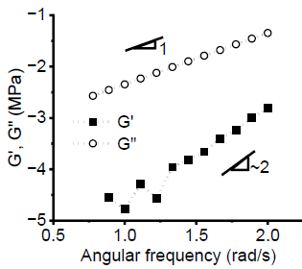
45Figure 6.7 SAOS results for the as-prepared telechelic sample at room temperature. The low-frequency decays of G′ and G′′ as functions of ω2 and ω1 show that the sample is already within the terminal regime (flow).
Figure 6.7 SAOS results for the as-prepared telechelic sample at room temperature. The low-frequency decays of G′ and G′′ as functions of ω2 and ω1 show that the sample is already within the terminal regime (flow).
The sample was then dried inside the rheometer at 350 K under N₂ flow for 15 h and subsequently cooled down to room temperature and new measurements were performed upon heating up to 400 K. As highlighted by the behavior of the phase angle in Figure 6.8 a, our results hardly follow time–temperature superposition. In a subsequent experiment, the telechelic sample was measured upon heating after being treated at three conditions: (i) as-prepared, (ii) dried in a vacuum oven at 378 K for 15 h, and (iii) dried in the rheometer under N₂ flow at 473 K for 15 h. In the first two cases, the samples were measured from their glassy state up to terminal flow (Figure 6.8b). We stress that the bond rearrangement times (τ_{r}) were estimated based on the maxima of G″(ω) preceding terminal relaxation and were only considered when this relaxation process was in the frequency window of the rheometer. This way excludes any potential errors caused by failure of time–temperature superposition. The values of τ_{r} are displayed in the activation plot in Figure 6.10 a. The sample dried under condition (iii) does not show terminal relaxation even at the highest measured T = 473 K (Figure 6.8c). In fact, this sample turns very brittle, which limited the accuracy of the SAOS measurements.
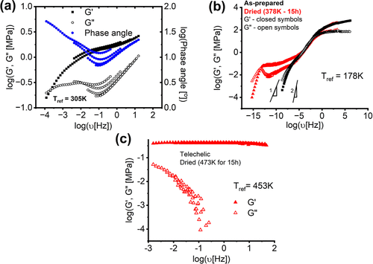
46Figure 6.8 SAOS data for the telechelic sample. (a) The phase angle data of the sample dried under N2 flow at 350 K for 15 h highlights the breakdown of the time–temperature superposition. Data was collected between room temperature and 400 K. (b) Master
Figure 6.8 SAOS data for the telechelic sample. (a) The phase angle data of the sample dried under N₂ flow at 350 K for 15 h highlights the breakdown of the time–temperature superposition. Data was collected between room temperature and 400 K. (b) Master curves for G′(ν) (closed symbols) and G′(ν) (open symbols) for the as-prepared sample (black symbols) or the sample further dried in a vacuum oven at 378 K for 15 h (red symbols). Data was collected between 150 K and terminal flow. (c) Shear modulus data for the sample dried in the rheometer under N₂ flow at 473 K for 15 h. Data was collected between room temperature and 473 K - no terminal flow was observed.
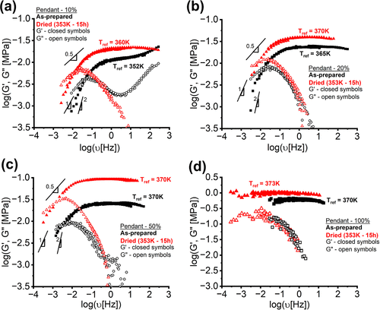
47Figure 6.9. SAOS data for the imine-containing PDMS samples with pendant functionalities either as-prepared (black symbols) or after drying at T = 353 K for 15 h (red symbols). (a) The pendant −10% sample; (b) the pendant −20% sample; (c) the pendant −50
Figure 6.9. SAOS data for the imine-containing PDMS samples with pendant functionalities either as-prepared (black symbols) or after drying at T = 353 K for 15 h (red symbols). (a) The pendant −10% sample; (b) the pendant −20% sample; (c) the pendant −50% sample; and (d) the pendant −100% sample. For the as-prepared samples, the data were collected between room temperature and 373 K, and for the dried ones, the experiments were performed from 373 K down to the temperatures in which a linear response was observed.
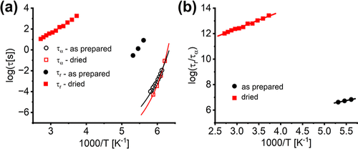
48Figure 6.10 (a) Temperature dependence of segmental (open symbols) and terminal (closed symbols) relaxation times in as-prepared (black symbols) and dried at T = 378 K for 15 h (red symbols) telechelic samples. The lines present fits of τα to eq 6.3. (b)
Figure 6.10 (a) Temperature dependence of segmental (open symbols) and terminal (closed symbols) relaxation times in as-prepared (black symbols) and dried at T = 378 K for 15 h (red symbols) telechelic samples. The lines present fits of τ_{α} to eq 6.3. (b) Temperature dependence of the ratio τ_{r}(T)/τ_{α}(T) for the as-prepared and dried samples. The lines show the fits to the Arrhenius equation.
Polymers with the pendant functionalities were investigated as-prepared and after being further dried at 353 K for 15 h in a vacuum oven. Drying the samples leads to a slower terminal relaxation time and an increase in the plateau moduli (Figure 6.9). The pendant-20% and pendant-50% samples exhibit a pronounced Rouse-like behavior with G′(ω) ∼ G″(ω) ∝ ω^{0.5} between the rubbery plateau and the crossover between the storage and loss moduli (Figure 6.9b,c). We stress that this softening in the plateau is not associated with any phase separation within the samples, as shown by the SAXS data in Figure 6.4. This Rouse-like regime becomes even more pronounced after drying the samples (Figure 6.9). For the pendant-100% sample (Figure 6.9d), the rheological crossover is not observed even at the highest temperature used, T = 473 K.

6.4 Discussion
We start with the analysis of the TGA results that revealed progressive weight loss of the telechelic sample at T = 378 K persisting even after 12 h (Figure 6.5b). We ascribe this slow isothermal weight loss to the removal of water molecules generated as a byproduct of the reverse reaction of hydrolyzed imine bonds (Figure 6.1a). This progressive formation of imine bonds after exposure of the telechelic sample to prolonged drying has been confirmed with ¹H NMR analysis of the dried sample in comparison to the as-prepared one (Figure 6.3). As discussed in detail below, complete removal of all traces of water from the sample is unlikely unless the samples are exposed to very high temperatures. These results, together with the rheological data (Figures 6.8 and 6.9), clearly emphasize the importance of carefully drying the samples if one aims at restoring most of the hydrolyzed imine bonds. In other words, it is not sufficient to dry samples for just a few hours, as reported in many publications.
Turning to the dynamic properties of the telechelic sample, one must notice that unreacted amine groups can only be available at the chain ends due to hydrolysis of the imine bonds, and would completely disappear if all imine bonds are restored and no residual water is left in the system (Figure 6.2)¹⁷. Our BDS results revealed the presence of two relaxation processes, α*- and α-(Figure 6.6a). While the latter has been readily assigned to the segmental relaxation, the time scale of the former is fairly comparable with relaxations previously ascribed to chain end dissociation of H-bonds in NH₂-terminated PDMS⁶. In addition, the behavior exposed in Figure 6.6 a highlights the decrease of the amplitude of the α*-process upon drying, consistent with the decrease of NH₂ groups upon drying. Unfortunately, the strong overlap between α*- and α-processes does not allow reliable estimates of the α* relaxation times, τ_{α*} Therefore, this relaxation process will not be further discussed in this manuscript. The temperature dependence of τ_{α} can be well described by the Vogel–Fulcher–Tammann (VFT) equation (Figure 6.10a)
$τ_{a}\left(T\right)=τ_{0}\exp\left(\frac{B}{T-T_{0}}\right)$ (6.3)
Here, T is the absolute temperature, B and T₀ are system-dependent parameters, and τ₀ is the limiting relaxation time - usually ∼10^{–12} s¹⁶⁸.
As for the rheological characterization, drying the telechelic sample and the subsequent formation of additional imine bonds, lead to the formation of long chains and their entanglement as confirmed by longer terminal relaxation time and the plateau modulus approaching the expected value for entangled PDMS (0.2 MPa) (Figure 6.9b). The bond rearrangement times (τ_{r}) of the imine bonds were determined via rheology, and its temperature dependence in the investigated dynamic range can be described by the Arrhenius equation
$τ_{r\left(T\right)}=τ_{x}\exp\left(\frac{E_{0}}{RT}\right)$ (6.4)
Where τ_{x} is a prefactor, R is the gas constant and E₀ is the apparent activation energy barrier for bond rearrangement. The fit parameters are presented in Table 6.2. The as-prepared telechelic sample shows relatively fast values of τ_{r}, with rather high apparent activation energy barrier E₀ ∼90 kJ/mol (Figure 6.10a). This value is much larger than the apparent activation energy estimated for the moderately dried sample, E₀ ∼41 kJ/mol, although the terminal relaxation time is much slower in the latter case (Figure 6.10a). The moderate drying does not affect τ_{α} significantly (Figure 6.10a) but leads to a strongly extended rubbery plateau (Figure 6.9b), which indicates the formation of imine bonds upon drying and a consequent slowing down of the bond exchange and terminal relaxation by many decades (Figure 6.9b). These results raise the question: why the apparent energy barrier, E₀, for the slower bond rearrangement process is significantly smaller than that for the faster process?
Table 6.2 Summary of the Fit Parameters Obtained from Analysis of SAOS and BDS Data for the Telechelic and Pendant Functionalized Systems
eTable 6.2 Summary of the Fit Parameters Obtained from Analysis of SAOS and BDS Data for the Telechelic and Pendant Functionalized Systems
sample | G_{n} (MPa) | E₀ (kJ/mol) | log[τ_{x}(s)] | E_{a} (kJ/mol) | log[σ] | T_{g} (K)–BDS
telechelic |  | 93 ± 4 | –26 ± 1.1 | 13 ± 0.6 | 2.88 ± 0.0 | 156
telechelic–mildly dried | 0.07 | 41 ± 1.1 | –4.7 ± 0.2 | 26 ± 0.8 | 8.37 ± 0.1 | 156
telechelic–fully dried | 0.45
pendant −10% | 0.01 | 54 ± 2.7 | –7.7 ± 0.4 | 42 ± 2.5 | 5.0 ± 0.4 | 151
pendant −10% - dried | 0.02 | 48 ± 1.7 | –6.1 ± 0.3 | 36 ± 1.9 | 6.6 ± 0.3
pendant −20% | 0.02 | 63 ± 2.9 | –8.2 ± 0.5 | 51 ± 3.1 | 4.5 ± 0.5 | 151
pendant −20%–dried | 0.04 | 60 ± 1.5 | –7.6 ± 0.2 | 49 ± 1.7 | 5.0 ± 0.2
pendant −50% | 0.03 | 70 ± 20 | –8.5 ± 2.9 | 58 ± 20 | 4.1 ± 2.9 | 152
pendant −50%–dried | 0.09 | 84 ± 16 | –10 ± 2.2 | 72 ± 15 | 2.4 ± 2.2
pendant −100% | 0.62
pendant −100%–dried | 0.95
The answer to the question above is related to the role of segmental relaxation in the bond rearrangement process. It has been shown in many studies that segmental dynamics should be explicitly considered in the analysis of the temperature dependence of bond exchange^{1, 83, 112, 135, 169}. Thus, segmental relaxation time ought to be included as a prefactor for τ_{r}(T) in eq 4⁶ and, following the idea proposed in ref.¹⁶⁷, we assume that the bond exchange time can be described by the expression
$τ_{r}\left(T\right)=στ_{α}\left(T\right)\exp\left(\frac{E_{a}}{RT}\right)$ (6.5)
Here σ is a parameter describing the mobility of associative cross-links in the polymer matrix. Following the considerations in eq 6.5, we obtain E_{a} = 13 ± 0.6 kJ/mol for the as-prepared sample and E_{a} = 26 ± 0.9 kJ/mol for the moderately dried sample (the values of E_{a} and σ are summarized in Table 6.2). Thus, the higher apparent activation energy for the rather fast bond exchange in the as-prepared sample (Figure 6.10a) can be simply explained by the steeper temperature dependence of τ_{α}(T) in the temperature range where terminal flow was observed for this sample. Also, the energy barrier for bond rearrangement estimated via eq 6.5 for the as-prepared sample is comparable to the values expected for the rearrangement of H-bonds between NH₂ and C═O groups^{170, 171}. This suggests that the main mechanism governing terminal flow is merely the rearrangement of hydrolyzed NH₂ chain ends instead of the covalent imine bonds. Only upon drying and strong reduction of free NH₂ concentration, does the rearrangement of imine bonds play a more important role, leading to a higher energy barrier, E_{a}. Clearly, the sample dried at 378 K for 15 h still retains some level of NH₂ groups (from hydrolyzed imine bonds) as depicted, for example, by the persistent presence of the α*-relaxation (Figure 6.6a). Thus, the obtained value of E_{a} = 26 ± 0.9 kJ/mol might be still affected by some hydrogen bond rearrangements. As the sample is dried under more severe conditions (473 K for 15 h), terminal relaxation is no longer achieved (Figure 6.8c), even if some residual concentration of water and unreacted amines can still be detected in the sample (see FTIR results in Figure 6.11). This suggests that imine metathesis bond rearrangement is not observed in our samples, even at the highest temperature. A similar outcome has been reported by Bui et al.¹⁰, who also highlighted the irreversible character of a telechelic network once it was extensively dried.
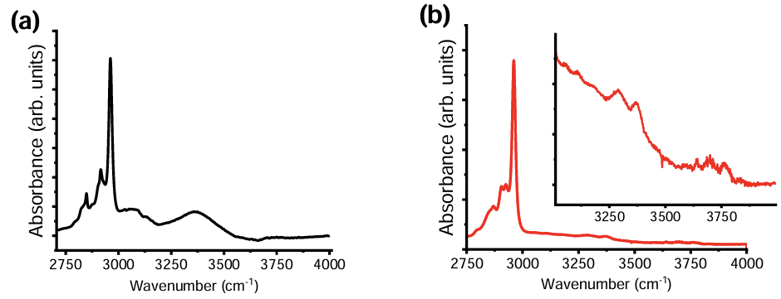
49Figure 6.11 FTIR results for the telechelic sample either (a) as-prepared or (b) dried at 473K for 15h. The inset in (b) highlights the presence of stretching vibrations either from -OH or -NH2 groups around 3250 cm-1 even after severely drying the samp
Figure 6.11 FTIR results for the telechelic sample either (a) as-prepared or (b) dried at 473K for 15h. The inset in (b) highlights the presence of stretching vibrations either from -OH or -NH2 groups around 3250 cm-1 even after severely drying the sample.
The analysis of the pendant system provides more rigorous verification of the above-proposed picture since, by design, these systems have a controlled number of free NH₂ groups even if the samples could be fully dried (Figure 6.2). Hence, the pendant samples were dried at 353 K for 15 h and, as shown in the example in Figure 6.12, there is an additional formation of imine bonds upon drying but NH₂ and C═O groups can still be detected. The pendant-100% sample does not show terminal relaxation even at the higher temperature T = 473 K (Figure 6.9d). This result is consistent with the data for extensively dried telechelic sample (Figure 6.8c),and reinforces our conclusion that imine bond rearrangement does not occur in the absence of a meaningful concentration of free NH₂ groups. In other words, imine metathesis (Figure 6.1c) does not happen in our systems at the experimental time scale even at the highest T = 473 K.
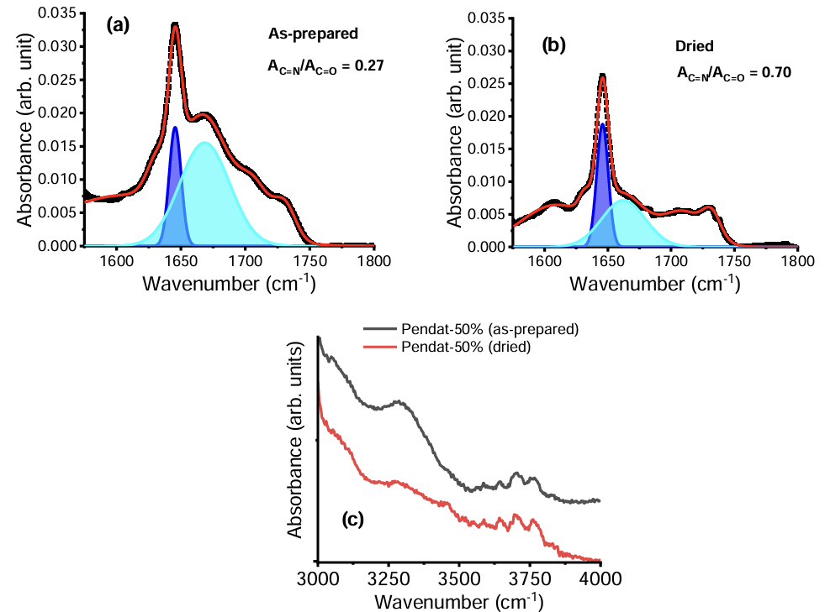
50Figure 6.12 FTIR results for the Pendant-50% sample either as-prepared or dried at 353K for 15h. In (a) and (b), the spectral regions between 1585 and 1800 cm-1 were decomposed in Gaussian components to highlight the contributions from the imine (blue cu
Figure 6.12 FTIR results for the Pendant-50% sample either as-prepared or dried at 353K for 15h. In (a) and (b), the spectral regions between 1585 and 1800 cm-1 were decomposed in Gaussian components to highlight the contributions from the imine (blue curve) and aldehyde (C=O) (cyan curve) vibrations. From the spectra decomposition, the ratios between the areas of the contributions from imine and aldehyde groups (AC=N/AC=O) were estimated and are presented in the figures. In (c), the presence of stretching vibrations around 3250 cm-1 indicates that NH2 groups are still detectable after severely drying the sample.
The segmental relaxation, τ_{α}(T), in the pendant systems remains essentially unchanged when the functionalization changes from 10 to 20% and is only slightly slower in the pendant-50% sample (Figure 6.13a). As expected, drying the samples increases the rubbery plateau modulus (G_{N}) (Figure 6.9), as some of the hydrolyzed imine bonds are restored, which increases the number of cross-links. The value of G_{N} in the dried samples follows the expected linear increase with the increase in functionalization (Figure 6.14). Notice that the value of G_{N} for pendant-100% was not included in Figure 6.14 because this sample is very brittle and quantitative analysis of the values obtained in the rheology experiments are not reliable. Drying of the samples also leads to more pronounced sticky Rouse behavior in the pendant-20% and pendant-50% samples before the rheological crossover (Figure 6.9b,c).
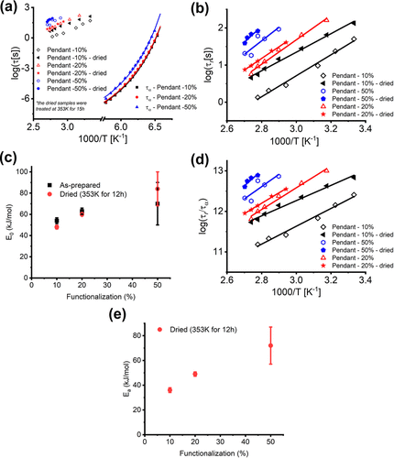
51Figure 6.13 (a) Temperature dependence of segmental (BDS) relaxation time τα and rheological τr of the systems with pendant imine functionalities. The lines indicate fits of τα with eq 6.3. In (b), the values of τr are zoomed-in, and (c) displays the evo
Figure 6.13 (a) Temperature dependence of segmental (BDS) relaxation time τ_{α} and rheological τ_{r} of the systems with pendant imine functionalities. The lines indicate fits of τ_{α} with eq 6.3. In (b), the values of τ_{r} are zoomed-in, and (c) displays the evolution of E₀ before and after drying for the different samples. In (d) the values of τ_{r} are normalized by τ_{α} and (e) displays the evolution of E_{a} in the dried samples. In (b,d) the lines indicate fits with the Arrhenius equation.
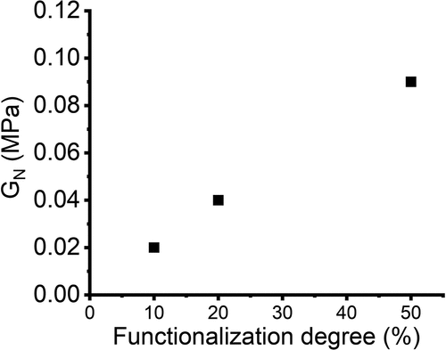
52Figure 6.14 Evolution of the plateau modulus (GN) in dried pendant samples as a function of the functionalization degree.
Figure 6.14 Evolution of the plateau modulus (G_{N}) in dried pendant samples as a function of the functionalization degree.
Rheological data revealed that τ_{r}(T) increases once the pendant samples are dried (Figure 6.13). This result is well in line with other reports in the literature on vinylogous urethane functionalities and is attributed to the reduction in the availability of free NH₂ groups^{162, 172, 173}. Analysis of the temperature-dependence of τ_{r}(T) using apparent Arrhenius fits revealed that E₀ increases from ∼50 to ∼70 kJ/mol with the increase of functionalization (Figure 6.13c, Table 6.2) and does not change significantly with drying. For better visualization, Figure 6.13 b shows a zoomed-in plot for the τ_{r}(T) values shown in Figure 6.13 a. We also analyzed the bond rearrangement energy barrier E_{a} assuming that segmental relaxation plays a role as the prefactor in the bond rearrangement process (eq 6.5). In this case, τ_{α}(T) was estimated by extrapolation of the VFT fit with fixed τ₀ = 10^{–12} s to the relevant temperature range. The difference between the E_{a} and E₀ values appears insignificant because segmental relaxation has rather weak temperature variations at temperatures relevant for the terminal relaxation (Figure 6.13d,e). The values of E_{a} and E₀ obtained in the present work agree reasonably well with previously reported data for imine bond exchange in polymers with different backbones, including polybutadiene (PB) and epoxy-based^{20, 159, 174-176}. Also, the increase in the characteristic times of bond rearrangement as the concentration of imine cross-links increases (Figure 6.13) agrees with earlier studies of imine bonds in PB networks²⁰. It is, however, surprising that E_{a} and E₀ increase with the concentration of functionalized groups since the energy barrier for bond rearrangement should not depend on the concentration of functional groups. Changes of E₀ with the increase of cross-linking density were observed earlier for telechelic PBs, but in that case, E₀ decreases with the increase of imine cross-links concentration²⁰. Such a different behavior might be related to the difference in molecular architecture (telechelic systems in ref ²⁰ vs our pendant imine cross-links) or incomplete drying of the samples performed in ref ²⁰ A trend similar to our results, with the apparent activation energy increasing with the increase of the concentration of functionalities, has been recently reported for systems with dioxaborolane cross-linkers^{167, 177}. The authors of ref ¹⁶⁷ ascribed the additional energy barrier to the temperature dependence of the cross-links’ mobility parameter σ (eq 6.5). However, this assumption still does not provide a microscopic picture of the observed increase in the energy barrier with the amount of functionalization. Another puzzling behavior is that the energy barrier does not change much on drying although terminal relaxation time increases (Figure 6.13, Table 6.2). Although we do not have a clear microscopic picture of this puzzling behavior, we hypothesize that the increase in E₀ might be related to an additional slowing down of chain dynamics with the increase in the concentration of functional groups. According to, Refs ^{170, 171} the strength of hydrogen bonding between NH₂ and C═O groups can be twice stronger than between NH₂ groups, depending on the respective geometries. Thus, even if the additional imine bonds are hydrolyzed, hydrogen bonding formed by carbonyl groups provides additional slowing down of the chain mobility required for the bond rearrangements. Indeed, our earlier studies estimated the energy barrier for the dissociation of H-bonds in telechelic amine-terminated PDMS chains to be ∼6–8 kJ/mol, while this energy is ∼13 kJ/mol in telechelic PDMS with large number of hydrolyzed imine bonds (Figure 6.10b)⁶. We also note that fitting the rheological relaxation times with eq 6.5 reveals an increase in σ upon drying in all the studied samples and a decrease in σ with the increase in functionalization of the pendant samples (Table 6.2). This behavior remains a puzzle and requires more detailed studies combined with molecular dynamics simulations.

6.5. Conclusions
The presented studies revealed several important properties of bond exchange mechanisms in polymers with imine bonds. First of all, our results demonstrate that very rigorous drying of the samples is required to restore the hydrolyzed imine bonds. Apparently, this process is very slow and requires many hours even at high temperatures. Traditional drying during a few hours will leave a significant part of hydrolyzed imine bonds with many free NH₂ groups, and the latter will control the imine bond exchange.
Our results provide clear experimental evidence that the rearrangement of imine bonds in polymers can only occur in the presence of a meaningful concentration of unreacted NH₂ groups. Terminal flow cannot be achieved and, ultimately, the imine systems cannot be regarded as dynamic networks without NH₂ groups. These results suggest that imine metathesis is very unlikely to occur as a stand-alone exchange mechanism at a practical time even at the highest temperatures, at least in the studied here systems. There are many papers presenting imine metathesis as the major mechanism of imine bond exchange. Our results suggest that the observed in these cases bond exchange most probably is transimination with NH₂ groups existing either due to hydrolyzed imine bonds or due to the synthesis.
Overall, we found that the proper context of the samples’ thermal history and architecture must be considered to describe the energy barrier for bond exchange. The observed increase in the energy barrier upon drying in telechelic systems is caused by changing the dominant mechanism of bond exchange from hydrogen bonds (at a high concentration of hydrolyzed imine bonds) to transimination (at a lower NH₂ concentration). In turn, the pendant systems present an increase in the energy barrier for bond rearrangement from ∼40 to 60 kJ/mol as the concentration of imine bonds increases. However, there are no substantial differences in the activation energies when some imine bonds are hydrolyzed (or the samples are not fully dried). We hypothesize that this behavior is driven by the difference in the bond dissociation energies of H-bonds formed between amine groups themselves and those involving amine groups and the carbonyl functionalities from the linker. A definitive picture of this microscopic mechanism remains a puzzle.
Our results also demonstrate that segmental relaxation must be explicitly considered in the description of the bond rearrangement of these systems and should be included as a prefactor in the estimates of E_{a}. This is especially important if the bond rearrangement happens at temperatures close to the polymer glass transition where segmental relaxation has very steep temperature variations. Nevertheless, we also emphasize that there are examples in the literature where terminal relaxation has weaker temperature dependence than segmental relaxation, and these puzzling examples suggest that segmental dynamics might play a less important role in some bond rearrangement mechanisms^{77, 178, 179}.

CHAPTER 7 UNRAVELLING THE MECHANISM OF VISCOELASTICITY IN POLYMERS WITH PHASE-SEPARATED DYNAMIC BONDS
A version of this chapter was published in ACS Nano, by Sirui Ge, Subarna Samanta, Bingrui Li, G. Peyton Carden, Peng-Fei Cao, Alexei P. Sokolov “Unravelling the Mechanism of Viscoelasticity in Polymers with Phase-Separated Dynamic Bond” (ACS Nano 2022 16(3), 4746-4755)
Sirui Ge wrote the manuscript together with the direction of Alexei P. Sokolov. Sirui Ge performed rheological measurements and the corresponding data analysis. Bingrui Li under the guidance of Peng-Fei Cao synthesized the materials. G. Peyton Carden performed BDS measurements and the corresponding data analysis as well as the SAXS and DSC measurements with the advice of Subarna Samanta.

7.1 Introduction
Polymers with dynamic bonds constitute an increasingly promising class of functional materials, where polymer chains are bonded together by reversible covalent (1−3) (e.g., vitrimers) or noncovalent (e.g., hydrogen and ionic bonds) interactions. (4−8) Because of the reversible nature of these transient interactions, it helps not only for developing functional materials such as self-healing ability and extreme stretchability, (9,10) shape memory, (11,12) and controlled stress relaxation but also makes them easy-to-process/recyclable. (13,14) The common interaction type is binary in nature, where two complementary groups form reversible bonds. The important parameter regarding this bond is the binding/dissociation energy along with the lifetime of the transient bonds, (15) which can be tuned based on the chemistry of the functional groups. At shorter time scale, material with these sticky bonds behaves as a network, whereas at time scale longer than that of the bond dissociation, the restriction to material flow is removed. However, this simple picture gets increasingly complicated in the presence of hierarchical structures within the material. Spider silk is one such example from the natural world, where H-bonds between adjacent β-strands of repetitive alanine/alanine-glycine moieties form nanocrystalline domains. (16) These β-sheet nanocrystals act as load-bearing cross-linking clusters within the glycine-rich amorphous matrix, endowing them with high elasticity and exceptional toughness/strength surpassing man-made fibers like Kevlar. (17)
Similar strategies have been employed in designing tough high-performance elastomers. (18−20) This type of nanophase separation can be achieved synthetically when the functional groups are immiscible with polymer matrix and phase-segregate in clusters, as observed in ionomers, (21) associating polymers, (22−24) and recently in vitrimers. (25) Clusters having higher glass transition or melting temperature compared to that of polymer matrix result in a prolonged rubbery plateau. (24) Moreover, recent studies (26) suggest that structural relaxation in these clusters controls viscosity and terminal relaxation of the polymers with phase separated associating groups. However, a detailed microscopic understanding of how the network rearrangement occurs in the presence of phase separated clusters is still lacking. Simulations studies (27) suggested that structural rearrangements in this type of systems should go through fusion and dissociation of the clusters. This idea, however, was questioned in the recent experimental studies. (28,29) Moreover, a clear separation between the time scale of cluster’s structural relaxation time and rheological terminal mode was observed and remains unexplained. (24,29)
Experiments (30−32) also indicated the presence of a thin interfacial polymer layer with restricted mobility around these clusters, which also results in the elevated rubbery plateau modulus explained by the mechanical interfacial layer model (ILM). However, the interfacial layers might overlap forming a percolated network. (33,34) Since the mechanical ILM assumes independent fillers with interfacial later, (35) the previous interpretation from mechanical ILM is questionable. For the polymer nanocomposites systems, the mechanical percolation model has already been utilized to describe the mechanical reinforcement in the presence of percolated network of the overlapping interfacial layers. (36−38) It has, however, never been used to study the analogous system like the phase separated associating polymers. Thus, the mechanism of network rearrangements and its effect on viscoelastic behavior in systems with clusters of the dynamic bonds remains a puzzle. Developing a microscopic understanding of viscoelasticity in polymers with clusters of dynamic bonds will help with rational design of materials with multifunctional properties and relatively easy recyclability.
To address this challenge, we provide a detailed analysis of the earlier studied model telechelic polymers with phase-separated functional end groups. (24,39) We demonstrate that the mechanical percolation model indeed explains well the unusually high rubbery plateau modulus in these materials. Most importantly, based on the analogy to block copolymers, we propose a mechanism of the network rearrangements via single chain hopping between clusters controlled by a thermodynamic energy barrier related to the immiscibility of the dynamic end groups and the polymer matrix. On the basis of these results, we propose a general scenario of viscoelasticity of polymers with clusters of dynamic bonds. The presented in-depth understanding provides design rules for developing functional materials with tunable viscoelastic properties.

7.2 Results and Discussion
The telechelic PDMS-COOH used in this work consists of a backbone with polydimethylsiloxane (PDMS) terminated with 4-(propylamino)-4-oxobutanoic acid (COOH) (Figure 7.1). The telechelic PDMS-COOH has different degrees of polymerization (DP) of 13, 19, 22, 50, and 74.
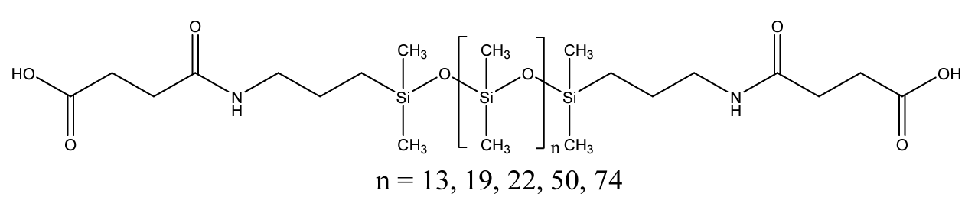
53Figure 7.1 Chemical structure of PDMS-COOH with different DP
Figure 7.1 Chemical structure of PDMS-COOH with different DP

7.2.1 Differential Scanning Calorimeters (DSC)
Each of the investigated PDMS-COOH samples shows two glass transition steps in their heat flow spectra. The one at lower temperature (∼150 K) refers to the glass transition of the segmental motions of PDMS chains, while the one at higher temperature (∼200 K) originates from the end-group motions within the clusters (Figure 7.2). (24)
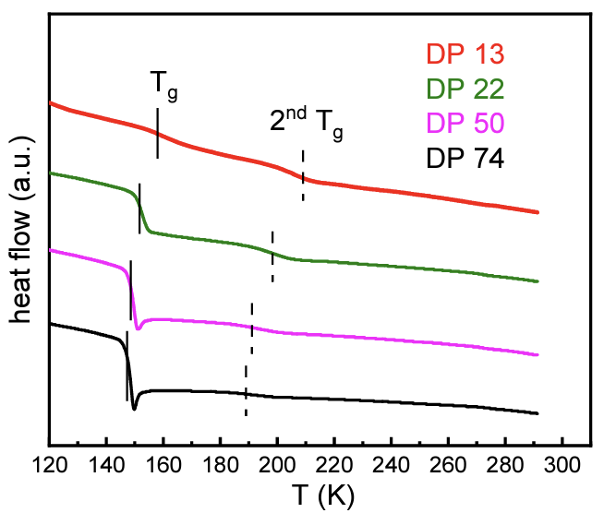
54Figure 7.2. Heat flow curves of the telechelic PDMS-COOH samples in DSC measurements. Solid lines indicate the Tg of the PDMS matrix and dashed lines mark the 2nd Tg due to cluster phase
Figure 7.2. Heat flow curves of the telechelic PDMS-COOH samples in DSC measurements. Solid lines indicate the Tg of the PDMS matrix and dashed lines mark the 2nd Tg due to cluster phase

7.2.2 X-ray Scattering
Phase separation in PDMS-COOH has been verified through X-ray scattering in our previous publication. (32) The low-q weak result at around 0.1 Å ^{–1} indicates the phase separation. The similar X-ray scattering result was observed in DP 19 PDMS-COOH, which has not been studied before (Figure 7.3). The detailed analysis of X-ray scattering spectra (32) provides information on average center-to-center cluster distance (d) and radius of the cluster (R_{cluster}) (Table 7.1). The nearest cluster surface-to-surface distance can be calculated through d_{IPS} = d – 2R_{cluster} (Table 7.1). With R_{cluster}, the grafting density (n_{e}) of PDMS chains on surface of the clusters can be calculated as
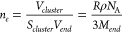
(1)
where M_{end} and ρ are the molecular weight and density of the associating chain end, respectively. N_{A} is the Avogadro’s number. The grafting density was found to be ∼1.7–1.9 nm^{–2} for all associating polymers (Table 7.1).
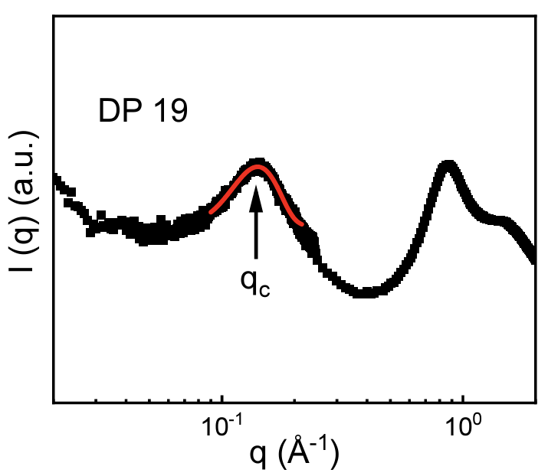
55Figure 7.3. X-ray Scattering spectrum for PDMS-COOH with DP 19. Red line presents the Gaussian fit of the low-q peak. The peak position is labeled by an arrow.
Figure 7.3. X-ray Scattering spectrum for PDMS-COOH with DP 19. Red line presents the Gaussian fit of the low-q peak. The peak position is labeled by an arrow.
Table 7.1. DP, Molecular Weight of the PDMS-COOH samples including end groups (𝑀𝑛),
weight fraction of the end groups (𝑓𝑒), center-to-center distance between clusters (d), radius of
clusters (𝑅𝑐𝑙𝑢𝑠𝑡𝑒𝑟), cluster nearest surface-to-surface distance (𝑑𝐼𝑃𝑆), number of chain ends in each
phase separated cluster (Z) and grafted density 𝑛𝑒. Details of the X-ray data analysis are
presented in the earlier paper²³.
fTable 7.1. DP, Molecular Weight of the PDMS-COOH samples including end groups (𝑀𝑛),
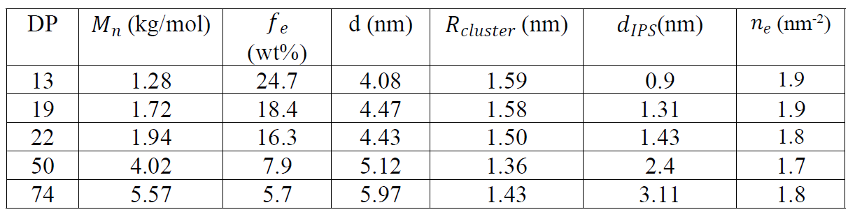

7.2.3 Rheology
Small amplitude oscillatory shear was employed to measure linear viscoelastic behavior of the associating polymers. Shear modulus master curves were constructed (Figure 7.5a) by using time–temperature superposition (TTS) of the measured rheological spectra at different temperatures. The shift factor at various temperature used for TTS is shown in Figure 7.4. As was shown in our earlier studies, (32,39) the rubbery plateau modulus (G_{Pl}) increases as the chain length of the polymer backbone decreases, reaching an unusually high level of G_{Pl} ≈ 100 MPa in the shortest chains with DP = 13 (Figure 7.5a).
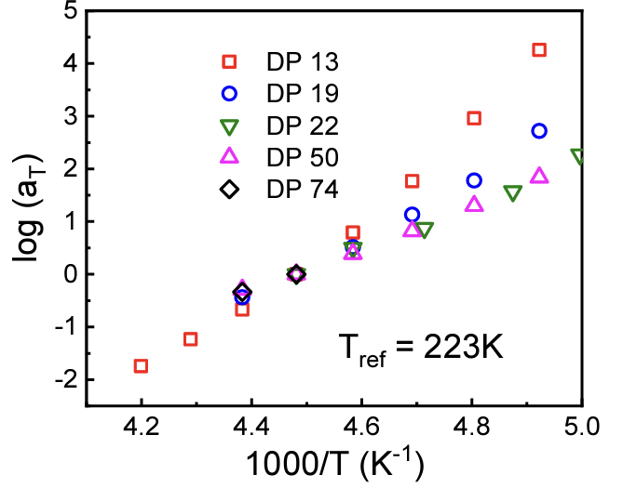
56Figure 7.4. Shift factors of time-temperature superposition (TTS) for the telechelic PDMS-COOH samples used to create the master curves.
Figure 7.4. Shift factors of time-temperature superposition (TTS) for the telechelic PDMS-COOH samples used to create the master curves.
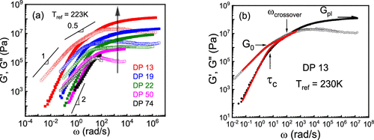
57Figure 7.5. (a) Shear modulus master curves for the telechelic PDMS-COOH measured at temperatures higher than second Tg. The arrow indicates the increased rubbery plateau value for shorter chains. Slope of 0.5 indicates Rouse-like regime, whereas regime
Figure 7.5. (a) Shear modulus master curves for the telechelic PDMS-COOH measured at temperatures higher than second T_{g}. The arrow indicates the increased rubbery plateau value for shorter chains. Slope of 0.5 indicates Rouse-like regime, whereas regime with G′ ≈ ω and G′′ ≈ ω² at lower frequencies indicate terminal flow behavior of these polymers. (b) Master curve of the shear modulus for DP 13 sample based on the reference temperature of 230 K. Solid and open symbols refer to G′ and G′′ spectra, respectively. Fits based on the Rouse model are shown as red lines. τ_{C} refers to terminal relaxation of the material. The values of the rubbery plateau modulus (G_{Pl}) and shear modulus at terminal relaxation (G₀) are indicated with arrows. The crossover of G′ and G′′ is labeled as well, demonstrating that the estimation of the terminal relaxation time from the crossover is not accurate.
Terminal relaxation is observed at low frequencies where G′ and G′′ increase with frequency as ω² and ω¹, respectively. In addition, the samples with DP of 13, 19, and 22 exhibit an intermediate regime between the rubbery plateau and the terminal relaxation where both G′ and G′′ follow power law behavior ∼ω^{α} with the exponent α ≈ 0.5 (Figure 7.5a). In contrast, this regime is absent in spectra of samples with DP 50 and DP 74, where the terminal relaxation is reached right after the end of the rubbery plateau (Figure 7.5a). In our previous publication, the terminal relaxation time was determined from the crossover of G′ and G′′. (24,39) However, this method is only valid for the Maxwellian relaxation behavior. Because of the presence of the Rouse-like spectra in lower DP samples, the crossover is no longer able to provide the accurate estimation of the terminal relaxation time (Figure 7.5b). In such case, the longest Rouse time scale is more accurate. Thus, to acquire the accurate terminal relaxation time (τ_{C}) as well as its corresponding shear modulus level (G₀), the Rouse model (40) is utilized to fit the shear modulus spectra:
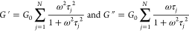 (2)
in which . For PDMS-COOH with DP of 50 and 74, N is chosen to be 1, which corresponds to the Maxwell relaxation. However, for PDMS-COOH with DP of 13, 19, and 22, N is chosen to be an arbitrary number to fit the region of parallel decrease of the G′ and G′′ with slope of 0.5. The proposed fit describes well the shear modulus spectra (see, e.g., Figure 7.5b for PDMS-COOH with DP of 13) and provides estimates of both the G_{Pl} and G₀ as well as τ_{c}.

7.3.4 Broadband Dielectric Spectroscopy (BDS)
To analyze dynamics in the studied systems, we employed dielectric spectroscopy that revealed two major dielectric processes. (24,39) As a representative example, dielectric loss spectra (ε″) for the sample with DP 19 at several temperatures are shown in Figure 7.7a. Dielectric loss spectra for the rest of the samples are presented in Figure S6a–d. The process at lower temperatures is PDMS segmental motion (α-relaxation), while the process at higher temperatures is ascribed to motion of associating groups in the clusters, termed as α₂-relaxation. (24)
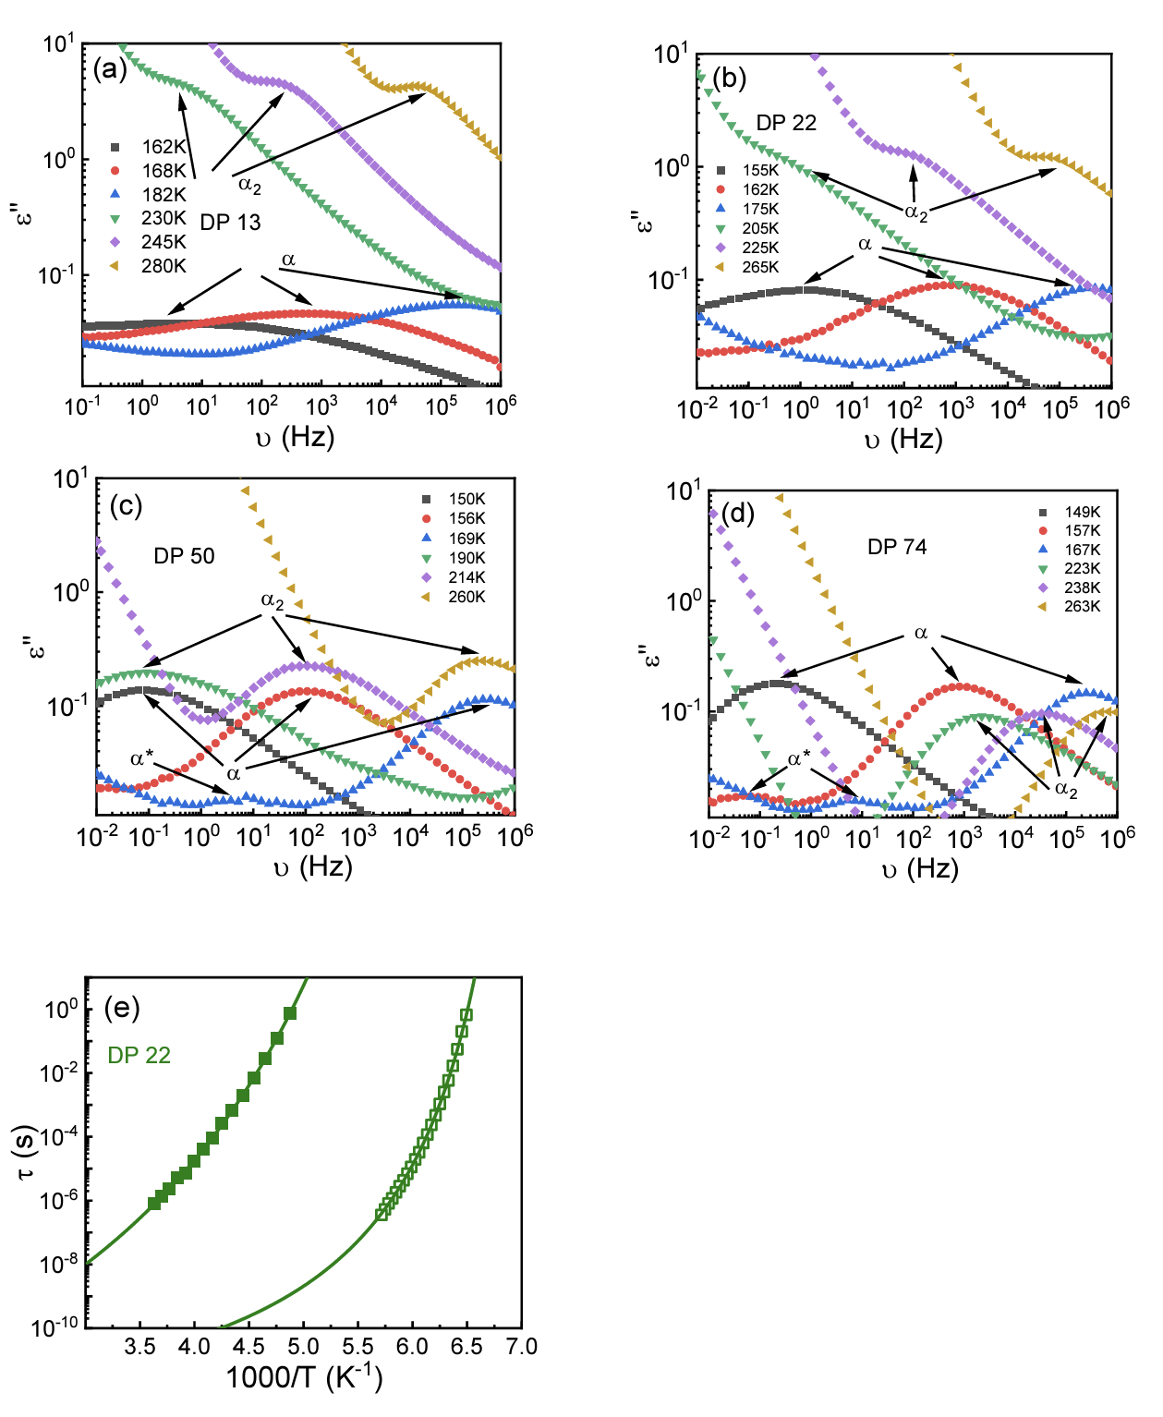
58Figure 7.6. Dielectric loss spectra at various temperatures for telechelic PDMS-COOH with (a)
Figure 7.6. Dielectric loss spectra at various temperatures for telechelic PDMS-COOH with (a)
DP 13, (b) DP 22, (c) DP 50, (d) DP 74. Low temperature process indicates segmental motion of
PDMS, whereas higher temperature process corresponds to sticker dynamics within the cluster.
For PDMS-COOH with DP 50 and DP 74, there is an additional process which correlates with
binary association of the stickers (*). (e) 𝜏𝛼 (open symbols) and 𝜏𝛼2 (close symbols) as a
function of inverse temperature for PDMS-COOH with DP 22.
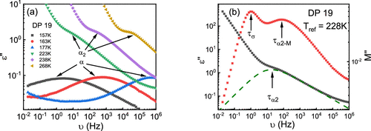
59Figure 7.7 (a) Dielectric loss spectra for PDMS-COOH (DP 19) in the range of 10–2 to 106 Hz. Loss peaks at low temperatures correspond to PDMS segmental motion (α-relaxation), while at higher temperatures, sticker motion within the cluster is visible as
Figure 7.7 (a) Dielectric loss spectra for PDMS-COOH (DP 19) in the range of 10^{–2} to 10⁶ Hz. Loss peaks at low temperatures correspond to PDMS segmental motion (α-relaxation), while at higher temperatures, sticker motion within the cluster is visible as a separate process, termed as α₂ process. (b) Comparison of ε′′ spectra and M′′ spectra for telehelic PDMS-COOH with DP of 19 in which τ_{α2}, τ_{α2} – M, and τ_{σ} are labeled.
To compare rheological and dielectric data, the latter should be converted to the dielectric modulus M* (ω): (41,42)
(3)
M′′ spectra exhibit an additional dielectric process at lower frequencies (Figure 7.7b), which originate from conductivity relaxation (τ_{σ}). (43,44) We also noticed that the time scale of α₂ relaxation process from M′′ (τ_{α2} – M) is faster than that from ε′′ spectra (τ_{α2}). This is expected, as the relationship between characteristic relaxation time from M′′ spectra (τ_{M}) and ε′′ spectra (τ_{ε}) can be expressed by (45)
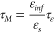
(4)
in which ε_{s} and ε_{inf} indicate the dielectric constant in the limit of high and low frequencies. Thus, τ_{α2} – M is shorter than τ_{α2}, as was already emphasized in the literature. (15,32)
To acquire the characteristic relaxation time from modulus spectra, the M′′ spectra were fit based on one Havrilliak-Negami (HN) function plus one Debye-like process for conductivity relaxation:
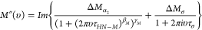
(5)
in which ΔM_{α2} and ΔM_{σ} are the “modulus strength” of α₂ process and conductivity process. τ_{HN–M} and τ_{σ} are the HN relaxation time for α₂ process and the conductivity relaxation time from dielectric modulus. β_{M} and γ_{M} are the stretching parameters for the α₂ process. The relaxation time corresponding to the peak position of α₂ process in M′′ spectra is calculated using (46)
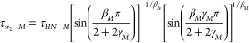
(6)

7.2.5 Mechanical Percolation Model
Our previous studies revealed the existence of an interfacial polymer layer around the phase-separated clusters with a thickness l_{int} ≈ 0.8–0.9 nm regardless of PDMS backbone length. (32) This small thickness was explained by the small radius of the phase separated clusters, R_{cluster} ≈ 1.4–1.6 nm. (32) When the distance between clusters surfaces d_{IPS} < 2l_{int}, the interfacial layers overlap with each other, forming a percolating network. According to Table 7.1, the percolation of the interfacial regions can happen in PDMS-COOH with DP of 13, 19, and 22, while the interfacial layers are expected to be fairly separated in PDMS-COOH with DP of 50 and 74 (Figure 7.8). The critical volume fraction of the cluster, (f_{e})_{c}, for percolation is estimated as d_{IPS} ≈ 2l_{int} and appears in the range ∼13.5 ± 1.2 wt %.
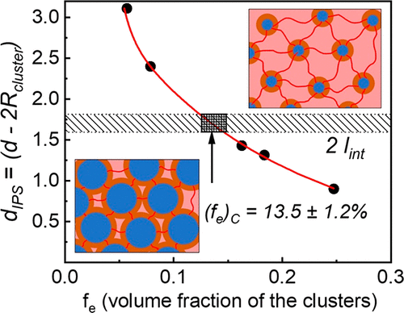
60Figure 7.8 dIPS as a function of fe. Range of 2lint value shown as a gray area. The box area indicates the estimated range of percolation threshold, (fe)C, when dIPS ≈ 2lint. Above the percolation threshold, interfacial layers overlap to form a percolate
Figure 7.8 d_{IPS} as a function of f_{e}. Range of 2l_{int} value shown as a gray area. The box area indicates the estimated range of percolation threshold, (f_{e})_{C}, when d_{IPS} ≈ 2l_{int}. Above the percolation threshold, interfacial layers overlap to form a percolated network, whereas below the threshold, they are well separated. Blue circles represent the clusters of functional groups, which are surrounded by interfacial layers (orange) and linked by PDMS chains (red).
This analysis reveals that indeed interfacial layers form a percolating structure in systems with low DP, and the mechanical percolation model needs to be used to describe the elevated mechanical modulus observed in these samples. According to this model, (47) a composite modulus is expressed as
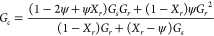
(7)
in which G_{r} is the shear modulus of the rigid phase. G_{s} is the shear modulus of the matrix (in this case PDMS matrix, which can be estimated from the classical rubber elasticity theory). X_{r} is the volume fraction of the overall rigid phase. ψ is the volume fraction of the spanning rigid phase formed in the percolated network through the overlapping of the interfacial layer and defined as
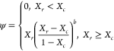
(8)
Here X_{c} is the volume fraction of the rigid phase at the percolation threshold; b is the percolation exponent characterizing the rate of the percolation structure formation with X_{c}.
We assume for simplicity that the clusters and their interfacial layers form a single rigid phase with volume fraction X_{r} = φ_{cluster} + φ_{int}. The mechanical percolation model (eqs 7 and 8) successfully describes the mechanical reinforcements in studied polymers (Figure 7.9). The value of X_{r} at the percolation threshold is found to be 56.5%, which corresponds to the critical volume fraction of the cluster, (f_{e})_{c} ≈ 14.8%. The obtained value is in good agreement with the value estimated assuming an ordered cubic arrangement of the clusters (Figure 7.9). The critical exponent b obtained from the fit is ∼1.7, which also agrees with the prediction from scalar elastic model in 3 dimensions developed by de Gennes. (48) Experimental investigations of percolation in various systems including organic polymer blends, polymer gels, and nanocomposite indicate the exponent b ranges from 1.6 to 2.2. (49−54) The model also provides the estimates of the shear modulus of the rigid phase, G_{r} ≈ 177 MPa.
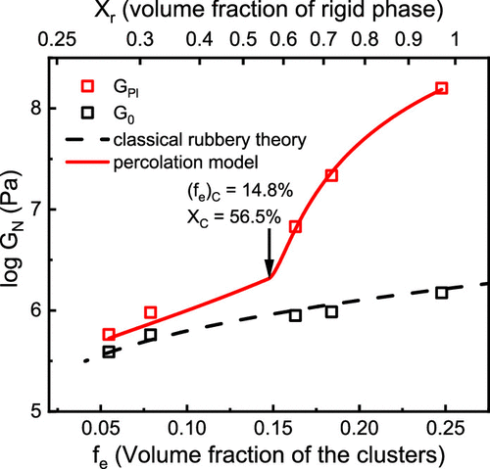
61Figure 7.9 Variation of GPL (red squares) and G0 (black squares) as a function of fe and Xr. Red line shows the fitting based on the mechanical percolation model (eqs 7 and 8). Black dashed line indicates the prediction from classical rubber elasticity t
Figure 7.9 Variation of G_{PL} (red squares) and G₀ (black squares) as a function of f_{e} and X_{r}. Red line shows the fitting based on the mechanical percolation model (eqs 7 and 8). Black dashed line indicates the prediction from classical rubber elasticity theory. The arrow indicates the estimated from the fit value of the percolation threshold.
The obtained G_{r} value agrees well with the estimates of the shear modulus of the rigid phase using the two-phase model (TPM) (Table 7.2f). The two phases are clusters and the interfacial layer. The necessary parameters to estimate the shear modulus using TPM are shear modulus, volume fraction, and Poisson ratio of both clusters and the interfacial layer. The modulus of the interfacial layer was estimated to be ∼100 MPa. (32) The Poisson’s ratio of the interfacial layer (which consists of PDMS segments) is taken from literature (55) based on the PDMS values. For clusters, the modulus and the Poisson’s ratio are assumed to be 3 GPa and 0.33, respectively, which are typical values for glassy hydrogen-bonded systems such as glycerol. (56) The volume fraction of cluster and interfacial layer in the rigid phase were estimated as and , respectively, where values of φ_{cluster} and φ_{int} for PDMS-COOH with DP of 13, 22, 50, and 74 were taken from previously published work, (32) and φ_{int} of DP 19 PDMS-COOH was estimated through
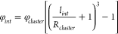
(9)
by using l_{int} = 0.85 nm, the value estimated in our previous studies. (32) The results are in good agreement with the value from mechanical percolation model (∼177 MPa), validating that the percolation model explains well the mechanical reinforcement in the studied samples.
Table 7.2 DP, Volume Fraction of Clusters φ_{cluster}, Volume Fraction of the Interfacial Layer φ_{int}, Volume Fraction of Clusters in Rigid Phase φ_{cluster,TPM}, Volume Fraction of Interfacial Regions in Rigid Phase φ_{int,TPM}, and Overall Shear Modulus of Rigid Phase Estimated Using TPM for PDMS-COOH Associating Polymers
gTable 7.2 DP, Volume Fraction of Clusters φcluster, Volume Fraction of the Interfacial Layer φint, Volume Fraction of Clusters in Rigid Phase φcluster,TPM, Volume Fraction of Interfacial Regions in Rigid Phase φint,TPM, and Overall Shear Modulus of Rigid
material | DP | φ_{cluster} (%) | φ_{int} (%) | φ_{cluster,TPM} (%) | φ_{int,TPM} (%) | G_{r}(TPM) (MPa)
PDMS-COOH | 13 | 24.7 | 71.8 | 25.6 | 74.4 | 171
PDMS-COOH | 19 | 18.4 | 59.1 | 23.7 | 76.3 | 164
PDMS-COOH | 22 | 16.3 | 40.8 | 28.5 | 71.5 | 183
PDMS-COOH | 50 | 7.9 | 26.6 | 22.9 | 77.1 | 161
PDMS-COOH | 74 | 5.7 | 19.7 | 22.4 | 77.6 | 159

7.2.6 Viscoelastic Behavior near Terminal Relaxation
It is interesting that in systems with no percolation (i.e., with DP of 50 and 74), the terminal relaxation demonstrates Maxwellian behavior, that is, the rubbery plateau stops at the terminal relaxation. In contrast, the rubbery plateau in systems with percolating rigid regions (i.e., with DP of 13, 19, and 22) first decreases with a power law before reaching the terminal relaxation (Figure 7.5a). Consequently, the moduli G_{Pl} and G₀ (eq 2) appear to be comparable for nonpercolated systems, while G_{Pl} is much higher than G₀ in percolating systems, and the difference increases with decreases in samples DP (Figure 7.9). Analysis of these data revealed that G₀ obtained from the fit for all the samples follows the classical rubber elasticity (57) predictions for a given length of the PDMS chains (Figure 7.9), demonstrating that the mechanical reinforcement actually vanishes at terminal relaxation.
To study the viscoelastic properties in phase separated associating polymers, we compared shear modulus spectra and dielectric M′′ spectra (Figure 7.11a). It is evident that τ_{c} is significantly slower than τ_{α2} – M, indicating that motion of stickers inside the clusters is not sufficient for terminal relaxation. Interestingly, the shear modulus in percolating systems starts to decrease from the rubbery plateau level at the time scale comparable to τ_{α2} – M (Figure 7.11a), suggesting that the stickers motions within the clusters lead to the softening of the modulus down to the level predicted from classical rubber elasticity. Indeed, when chain ends in clusters are unable to move, the whole system is similar to nanoparticles with extremely high grafting density ∼1.7–1.9 chains/nm² (Table 7.1). This grafting density is ∼3 times higher than in usual polymer grafted nanoparticles, leading to strong crowding and stretching of the chains in the interfacial layer. Stretching of the chain is supported by larger population of the gauche states found from wide-angle X-ray scattering results. (32) All these factors strongly hinder bending of the PDMS segments in the interfacial layer and lead to high modulus. However, when chain ends start to move inside the clusters, the PDMS segments in the interfacial layer can be easily rearranged and change their conformations under external force, and the macroscopic deformation is easier to reach. This results in a gradual softening of the polymer interfacial layer, which is demonstrated through the parallel decrease of the G′ and G′′ with decrease in frequency. This softening reaches the modulus level expected from the rubber elasticity at the time of the terminal relaxation. Moreover, similar temperature dependences of both τ_{α2} – M and τ_{C} (Figures 5b and S7) suggest that dynamics in the clusters might act as a precursor for the macroscopic rearrangement of the network.
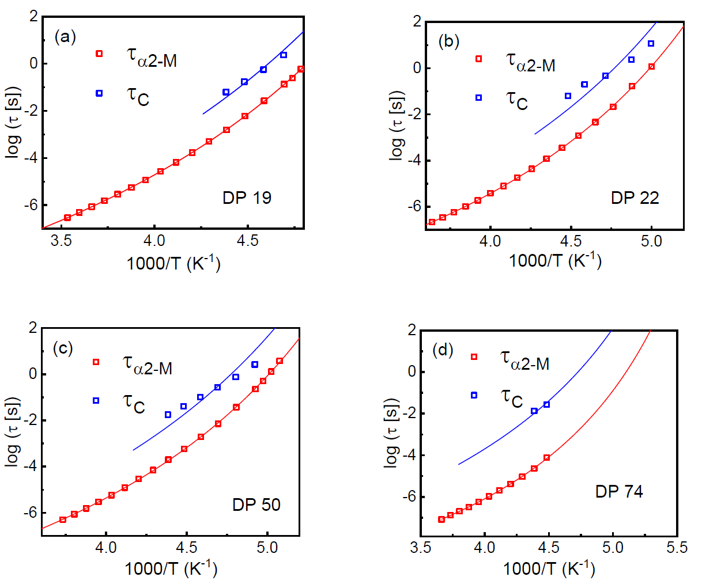
62Figure 7.10 The comparison of 𝜏𝑐 (blue symbols) and 𝜏𝛼2 ― 𝑀 (red symbols) as a function of
Figure 7.10 The comparison of 𝜏𝑐 (blue symbols) and 𝜏𝛼2 ― 𝑀 (red symbols) as a function of
inverse temperature for PDMS-COOH with (a) DP 19, (b) DP 22, (c) DP 50, (d) DP 74. The red
line in each figure presents the VFT fit (eq. 12). The blue line presents the fit using eq. 11.
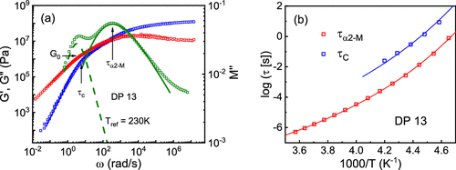
63Figure 7.11 (a) Comparison between the shear modulus (red and blue symbols) and the dielectric loss modulus spectra (green symbols) for PDMS-COOH with DP of 13 sample at 230 K. Terminal relaxation time scale (τC) and α2-relaxation time scale (τα2 – M) (a
Figure 7.11 (a) Comparison between the shear modulus (red and blue symbols) and the dielectric loss modulus spectra (green symbols) for PDMS-COOH with DP of 13 sample at 230 K. Terminal relaxation time scale (τ_{C}) and α₂-relaxation time scale (τ_{α2} – M) (arrows) are separated by more than one order of magnitude. The low-frequency process (dashed line) in the dielectric modulus spectrum corresponds to conductivity relaxation process with a Debye-like shape. (b) Temperature dependence of the two time scales (symbols) and their fit based on eq 12 and eq 11 (lines).

7.2.7 Mechanism of Network Rearrangement
The mechanism of network rearrangement in phase separated associating polymers remains a puzzle. It is obvious that the network rearrangement should involve exchange of the stickers between different clusters. (27,58) On the basis of computer simulations, Amin et al. suggested that exchange should go through a merge of different clusters. (27) This mechanism was questioned by Mordvinkin et al., (28,29) where telechelic poly(isobutylene) (PIB) with functional end groups was studied. These systems, like the polymers studied here, have well-separated clusters, and merging of these clusters is not feasible due to the presence of multiple chains between the clusters. These systems, however, are similar to phase separating triblock copolymers. In phase separating triblock copolymers, network rearrangement process is dominated by a chain pullout process, which needs to overcome the free energy penalty from the immiscibility of different blocks. (58−60) In other words, the block in the phase separated cores needs to be pulled out and diffuse to another phase-separated core to complete the rearrangement process. According to refs (61−63), the pullout time scale is expressed as
(10)
in which τ_{Rouse} is Rouse relaxation time of the block inside the phase separated cores. χ is the Flory–Huggins parameter. N_{core} is the number of Kuhn segments of the block forming phase-separated cores. α is a constant in the order of unity. We hypothesize that the similar mechanism controls bond rearrangements in the studied telechelic systems, and the free energy barrier to “chain end pullout” process determines the network rearrangement process.
Borrowing the idea of chain exchange kinetics in block copolymer micelles, (58−60,64) relationship between τ_{c} and τ_{α2} – M can be expressed as
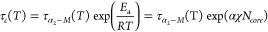
(11)
in which the activation energy barrier, E_{a}, is related to the thermodynamic penalty for the sticker to be placed in the polymer matrix ∼αχN_{core}. To estimate the activation barrier from the experimental result, τ_{α2} – M(T) was fit to the Vogel–Fulcher–Tammann (VFT) eq (Figure 7.11b, red line):
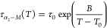
(12)
Here τ₀, B, and T₀ are the VFT fit parameters. Then τ_{C} (T) was fitted using eq 11, in which τ_{α2} – M was substituted by the VFT equation, with the energy barrier E_{a} as the only free fit parameter (Figure 7.11b). The fitting results revealed the average activation energy to be ∼6.6 kJ/mol (Figure 7.12). Strong deviation in the case of the sample with DP 74 might be caused by crystallization that strongly limited the studied temperature range.
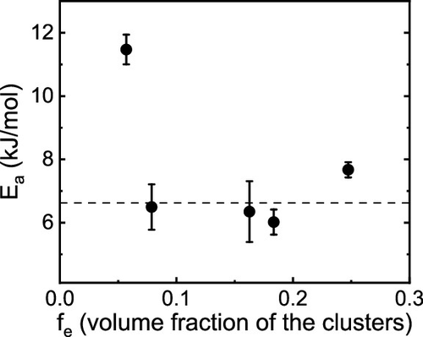
64Figure 7.12 Estimated energy barrier for single sticker “pullout” into PDMS matrix. The solid dashed line indicates the average activation energy for this process. Value for the lowest fe data is not reliable due to possible sample crystallization.
Figure 7.12 Estimated energy barrier for single sticker “pullout” into PDMS matrix. The solid dashed line indicates the average activation energy for this process. Value for the lowest f_{e} data is not reliable due to possible sample crystallization.
The obtained activation energy can be compared to the expected ∼αχN_{core}. N_{core} of the end group is 1, and the Flory–Huggins parameter, χ, can be estimated from the solubility parameters (δ) and molar volume of the chain end instead of the molar volume of a copolymer block: (65)
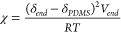
(13)
The solubility parameter of the PDMS backbone δ_{PDMS} is 7.3 cal^{1/2} cm^{–3/2}. (66) The solubility parameter of the chain end (COOH), δ_{end}, is estimated to be 11.86 cal^{1/2} cm^{–3/2} via Hansen solubility parameter (HSP) (67) approach, which divides the solubility parameter into three partial components: dispersion, polarity, and hydrogen-bonding (detailed method is mentioned in the Supporting Information). The molar volume of chain ends V_{end} is calculated using , where the molecular weight of chain ends M_{end} is 158 g/mol, and the density of chain ends is assumed to be the same as that of glycerol, ρ_{end} = 1.26 g/cm³. Thus, (δ_{end} – δ_{PDMS})²V_{end} is estimated to be ∼11 kJ/mol, in reasonable agreement with the experimentally estimated E_{a} assuming α value of ∼0.6. The value of α close to 0.6 has been reported in several studies of chain exchange kinetics in different block copolymer micelles. (60,68,69) Thus, the single chain hopping mechanism provides reasonable estimates of the energy barrier controlling terminal relaxation in polymers with phase separated stickers.
On the basis of these results and analysis, we propose the following mechanism of the terminal relaxation in polymers with phase separated reversible bonds (stickers). Network rearrangements require mobility of stickers in the clusters and a sticker escape from the cluster requires to overcome an energy barrier controlled by miscibility of stickers in a polymer matrix. Once the sticker escaped from the cluster, it will diffuse through the polymer matrix to another cluster with a time scale of τ_{diffusion}, which will be mainly governed by Rouse subdiffusive motion, that is, , here d is the distance between clusters (∼5 nm, Tables S1) and l_{k} is the Kuhn segment length of PDMS (∼1 nm). This provides estimates of τ_{diffusion} ≈ 10³τ_{α}. At the onset of second T_{g}, where stickers can move inside the clusters, τ_{α} is ∼10^{–9} s (Figure 7.6) and τ_{diffusion} is ∼10^{–6} s. This time is many orders faster than terminal relaxation time at the same temperatures. Thus, we can safely assume that sticker escape from the cluster is the rate-determining step in the single chain hopping process. This mechanism is similar to that describing the network rearrangement of Butyl ionomer. (70) However, we introduce the microscopic mechanism of these rearrangements and identify the energy barrier controlling the sticker hopping process. This mechanism also explains the difference between the time scale of network rearrangement and the dynamic bonds motion inside the clusters. The proposed mechanism is consistent with the recent NMR studies (28,29) revealing that single chain relaxation is responsible for the terminal relaxation in the associating polymer with phase separation. These studies of telechelic PIBs with barbituric acid end groups and with thymine end groups also revealed that cluster relaxation process observed in dielectric spectra is faster than the terminal relaxation, and the ratio of these time scales depends on chemistry of the stickers (29) (Figure 7.13). Following the proposed mechanism, we estimated the energy barrier (through eq 11) to be E_{a} ≈ 16–17 kJ/mol for more polar barbituric acid end group and ∼9 kJ/mol for less polar thymine end group (Table 7.3). Moreover, these values agree with estimates of (δ_{end} – δ_{PDMS})²V_{end} (∼26 kJ/mol for barbituric acid end group and ∼13 kJ/mol for thymine end group) assuming α ≈ 0.6 (see Supporting Information). Thus, the proposed mechanism also provides good understanding for the network rearrangement in other systems with phase-separated stickers.
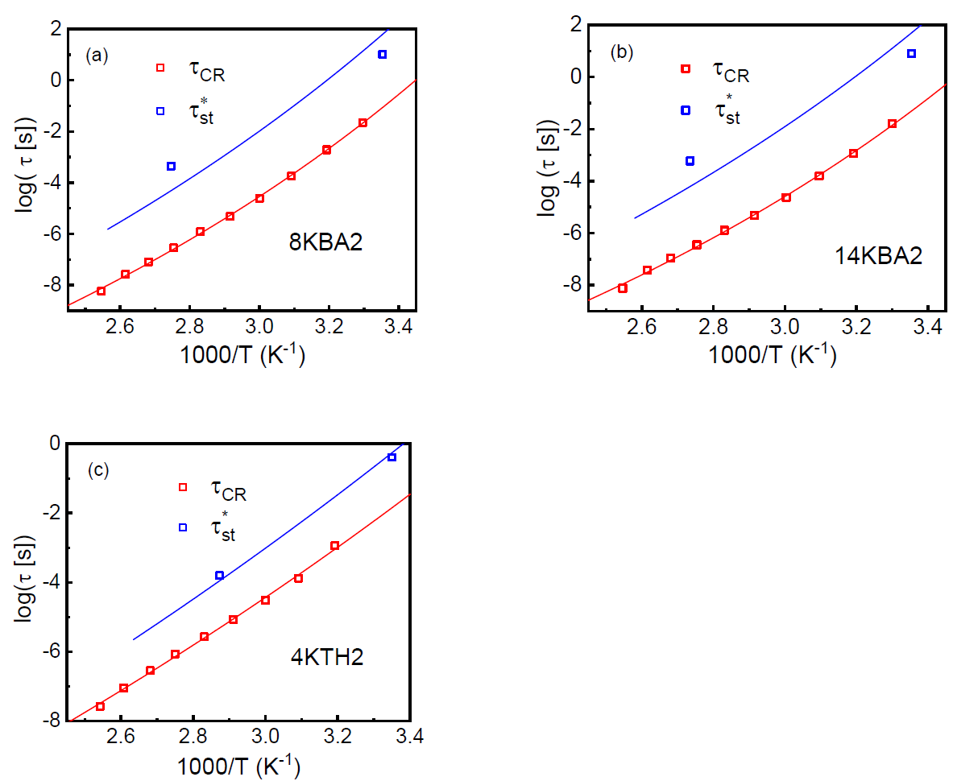
65Figure 7.13 Activation plot of the telechelic PIB associating polymer (a) 8KBA2, (b) 14KBA2, (c)
Figure 7.13 Activation plot of the telechelic PIB associating polymer (a) 8KBA2, (b) 14KBA2, (c)
4KTH2 reflecting the separation between 𝜏𝐶𝑅 and 𝜏 ∗ . Data from Ref.²⁵
Table 7.3. The estimated energy barrier 𝐸𝑎 for 3 telechelic PIB associating polymers
hTable 7.3. The estimated energy barrier 𝐸𝑎 for 3 telechelic PIB associating polymers
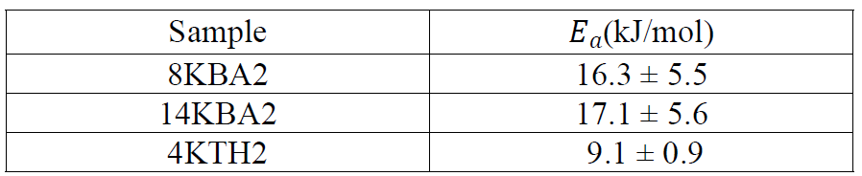

7.2.7 General Molecular Picture
On the basis of analysis of the presented above results, we propose a general picture of viscoelasticity in polymers with phase separated dynamic bonds (Figure 7b). Functional end-group clusters possess a higher T_{g} value than the polymer matrix, and their dynamics is governed by a time scale of structural relaxation in these clusters, τ_{α2}. At times t < τ_{α2}, clusters are glassy and control the rubbery plateau level. In such case, not only chain ends are fixed but also the grafting density is extremely high, resulting in chains crowding and stretching in an interfacial layer around these clusters. These severely restrict segmental mobility and chain bending (similar to polymer grafted nanoparticles), leading to a much higher elastic modulus. (32,39) In the absence of percolation of the interfacial polymer regions, the mechanical reinforcement from the interfacial layer is small, and mechanical strength of the associating polymer is mostly defined by the rubber elasticity of network structure cross-linked by the clusters. However, in a case where interfacial regions overlap, significant mechanical reinforcement is observed, which can be ascribed to a percolation phenomenon (Figure 7b). On time scale τ_{α2} < t < τ_{c}, stickers become mobile within the clusters, and even if the grafting density is high, the segments in the vicinity of clusters can easily rearrange and change conformations. This leads to a subsequent decrease of the mechanical modulus in the interfacial layer down to the level expected in the rubber elasticity theory. As a result, the macroscopic modulus level drops down significantly in the case of percolated network as the effect of percolation fades away with the gradual decreasing of the modulus in the interfacial layer. When there is no percolation, the decrease in the shear modulus is negligible until topological reorganization of network occurs at the terminal relaxation time (τ_{c}). At t > τ_{c}, sticky ends start to move out of the cluster overcoming the free energy barrier due to their immiscibility with the polymer matrix and subsequently diffuse to another cluster. Through this single chain exchange process, macroscopic stress relaxation happens within the network.
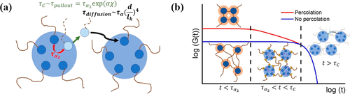
66Figure 7.14 (a) Cartoon of a single chain exchange process between two clusters, which leads to a macroscopic rearrangement of the network. (b) Qualitative picture of the shear modulus variation with time for a phase-separated associated polymer network
Figure 7.14 (a) Cartoon of a single chain exchange process between two clusters, which leads to a macroscopic rearrangement of the network. (b) Qualitative picture of the shear modulus variation with time for a phase-separated associated polymer network with percolated interfacial layers (red line) and with no percolation (blue line). Dashed lines mark two important time scales of the system: τ_{α2}, relaxation in clusters of dynamic bonds; and τ_{C}, terminal relaxation defined by the network rearrangement time.

7.3 Conclusions
In this study, we investigated telechelic PDMS with functional groups phase-separating in clusters due to their immiscibility with the polymer backbone. We demonstrated that mechanical percolation model describes well the strong mechanical reinforcement observed in these systems. Although the result is similar to what we achieved earlier using mechanical ILM, (32) the percolation model is more appropriate to explain the mechanical reinforcement since interfacial layers overlap in most of the studied samples. Moreover, our results and analysis question the proposed earlier mechanism (27) of network relaxation through a merger of phase-separated clusters. Instead, we propose a chain-hopping mechanism of network rearrangement borrowed from the field of block copolymer. It provides a reasonably good description of the presented data even on a quantitative level. This mechanism also describes earlier data on telechelic PIB. (29) Finally, we formulate a general molecular picture describing the viscoelastic behavior of associating polymers. When phase separated clusters are frozen, the system behaves as a permanent network, which show strong mechanical reinforcement depending on whether there is a percolation of interfacial regions or not. Then the softening of the interfacial layer occurs upon the motion of functional groups inside the phase separated clusters, followed by the network rearrangement controlled by additional energy barrier defined by immiscibility of stickers and polymer matrix.
The presented analysis and the proposed mechanism provide a detailed understanding of the viscoelastic behavior of polymers with phase-separated reversible bonds. These mechanisms should work not only for telechelic associating polymers but also for any associating polymer having phase separating dynamic bonds. The developed understanding is of paramount importance for rational design of advanced materials with enhanced mechanical properties, and better recyclability.

7.4 Materials and Methods

7.4.1 Synthesis of PDMS-COOH Polymers
Synthesis of PDMS-COOH polymers was described in detail in our pervious publication. (24,39) The synthesis route is shown in Scheme 1 in Xing et al. (24) DP 19 PDMS-COOH was synthesized in this work. Five grams of PDMS-NH₂ (5 mmol, Gelest Inc. DMS-A11) was added into a flame-dried 100 mL round-bottom flask, and then 2 g of succinic anhydride (20 mmol) was also added followed by the addition of 1.518 g of triethylamine (15 mmol), 0.611 g of 4-dimethylaminopyridine (5 mmol), and 30 mL tetrahydrofuran (THF). The reaction was conducted under an N₂ atmosphere at 40 °C for 2 days. After the reaction was completed, THF was removed by rotary evaporation. Ten milliliters of 1 M hydrochloric acid was added, a total amount of 50 mL of dichloromethane (DCM) was utilized to extract the product from the aqueous solution three times. The organic layer was collected and was removed by rotary evaporation. The final product was obtained and dried in a vacuum oven to remove all residual solvents. ¹H NMR was utilized to confirm the final product with CDCl₃ as solvent. The chemical structure and the ¹H NMR spectra analysis is shown in Figure S2.
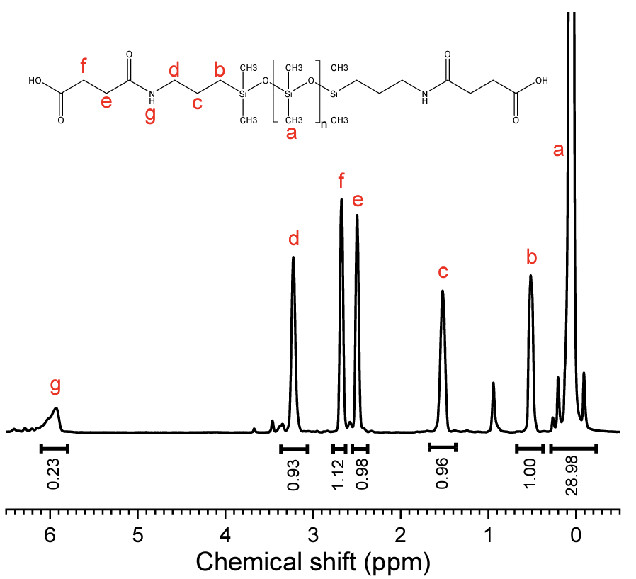
67Figure 7.15. 1H-NMR result for the PDMS-COOH with DP of 19
Figure 7.15. 1H-NMR result for the PDMS-COOH with DP of 19

7.4.2 Differential Scanning Calorimetry (DSC) Measurements
DSC was employed to probe the glass transition temperature (T_{g}) of PDMS-COOH using a Q2500 DSC equipment from TA Instruments. The samples were dried in a vacuum oven at 333 K overnight before being placed into DSC pans. The samples were first equilibrated isothermally at 363 K for 10 min to remove the thermal history before being quenched to 113 K (to avoid crystallization). After equilibration for 10 min, the samples were heated up to 293 K with a rate of 10 K/min. This procedure was repeated twice for each sample to ensure repeatability.

7.4.3 X-ray Scattering
X-ray scattering spectra for DP 13, 22, 50, and 74 PDMS-COOH, as well as the reference sample PDMS-CH₃, were measured previously. The procedure was described in detail in ref (32). The DP 19 PDMS-COOH was measured on XEUSS 3.0 (Xenocs, France) equipped with a Cu Kα microfocus source and a Pilatus 300k detector (Dectris, Switzerland). The scattering vector (q) was calibrated by a silver behenate standard material. The distance between sample and detector was 0.9 m and 0.55 m for SAXS and WAXS, respectively. The sample was squeezed into a capillary tube made of quartz glass with diameter 1.5 mm and wall thickness 0.01 mm. Then the capillary was placed perpendicularly to the X-ray beam. The measurement mentioned above was also done on the empty capillary to subtract the background. X-ray measurements were performed at room temperature.

7.4.4 Broadband Dielectric Spectroscopy (BDS)
BDS in the frequency range from 10^{–2} to 10⁶ Hz was measured utilizing a Novocontrol system that includes an Alpha-A impedance analyzer and a Quatro Cryosystem temperature control unit. DP 13, 22, 50, and 74 PDMS-COOH were placed into a parallel-plate dielectric cell made of sapphire and invar steel with an electrode diameter of 12 mm, and capacitance 20 pF with an electrode separation of 50 μm. DP 19 PDMS-COOH was placed into a parallel plate dielectric cell made of sapphire and invar steel with an electrode diameter of 10 mm, and capacitance 3.3 pF with an electrode separation of 210 μm. To prevent crystallization, all samples were quenched from room temperature to about 113 K and reheated to 10 K below the T_{g} before the measurements. All the spectra were measured on heating. After each temperature increase, the samples were equilibrated for 10 min to reach thermal stabilization within 0.1 K.

7.4.5 Small-Amplitude Oscillatory Shear (SAOS) Measurement
SAOS measurement was utilized to probe the viscoelastic properties of telechelic PDMS-COOH through a strain-controlled mode of the AR2000ex (TA Instruments) with an angular frequency range from 10² to 10^{–1} rad/s using parallel plate geometry with a disk diameter of 4 mm at a variety of temperatures range from second T_{g} to temperatures that the sample can flow freely. The strain amplitude during the measurement was chosen to be in the range from 0.2% to 5% depending on the modulus level at different temperatures.

7.4.6 Estimates of for telechelic PDMS-COOH using Hansen Solubility Parameter (HSP)
𝜹𝒆𝒏𝒅 is estimated using Hansen Solubility Parameter (HSP)2. HSP divides the solubility 𝛿𝑒𝑛𝑑 parameter into 3 partial components, which is, the dispersion part, , the polarity part and 𝛿𝑑 𝛿𝑝 𝛿ℎ𝑏 , the hydrogen-bonding part. The total solubility parameter is calculated as
𝛿𝑡= 𝛿2 𝑑+𝛿2 𝑝+𝛿2 ℎ𝑏 (14)
Each partial parameter can be estimated through the group contribution method3: (15) 𝛿𝑑=(∑𝑖 𝑁𝑖𝐶𝑖+∑𝑗 𝑀𝑗𝐷𝑗+959.11)0.4126 (𝑀𝑃𝑎)1 2
(16) 𝛿𝑝=(∑𝑖 𝑁𝑖𝐶𝑖+∑𝑗 𝑀𝑗𝐷𝑗+7.6134) (𝑀𝑃𝑎)1 2 (17) 𝛿ℎ𝑏=(∑𝑖 𝑁𝑖𝐶𝑖+∑𝑗 𝑀𝑗𝐷𝑗+7.7003) (𝑀𝑃𝑎)1 2 where is the contribution of the first-order groups of type i that appears times in the 𝐶𝑖 𝑁𝑖 compound and is the contribution of the second-order groups of type j that appears times 𝐷𝑗 𝑀𝑗 in the compound.
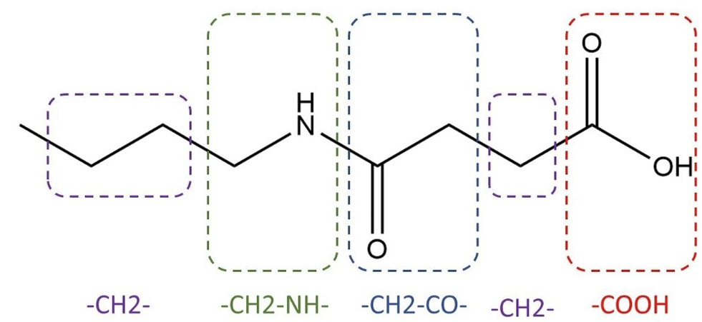
68Figure 7.16 Chemical structure of chain ends dividing into 4 parts, all of which are included in the Table A.1 in Ref40.
Figure 7.16 Chemical structure of chain ends dividing into 4 parts, all of which are included in the Table A.1 in Ref⁴⁰.

According to the PDMS-COOH chain end structure, it possesses 4 different First-order groups in the Table A.1. in3. (Fig. 7.16). By using the equations (eq. 18 – eq. 21), 3 partial parameters are calculated as shown below. (18) 𝛿𝑑=(3𝛿𝑑,𝐶𝐻2+𝛿𝑑,𝐶𝐻2𝐶𝑂+𝛿𝑑,𝐶𝑂𝑂𝐻+𝛿𝑑,𝐶𝐻2𝑁𝐻+959.11)0.4126=18.233 (𝑀𝑃𝑎)1 (19)
𝛿𝑝=(3𝛿𝑝,𝐶𝐻2+𝛿𝑝,𝐶𝐻2𝐶𝑂+𝛿𝑝,𝐶𝑂𝑂𝐻+𝛿𝑝,𝐶𝐻2𝑁𝐻+7.6134)=11.258 (𝑀𝑃𝑎)1 2 (20) 𝛿ℎ𝑏=(3𝛿ℎ𝑏,𝐶𝐻2+𝛿ℎ𝑏,𝐶𝐻2𝐶𝑂+𝛿ℎ𝑏,𝐶𝑂𝑂𝐻+𝛿ℎ𝑏,𝐶𝐻2𝑁𝐻+7.7003)=11.392 (𝑀𝑃𝑎 (21)
Thus, . 𝛿𝑒𝑛𝑑=24.27(𝑀𝑃𝑎)1 2=11.86 𝑐𝑎𝑙1 2𝑐𝑚―3 2 9.

7.4.7 Estimates of activation energy for network rearrangements in phase-separated telechelic poly(isobutylene) polymers
Figure 7 from Mordvinkin et al.4 demonstrates terminal relaxation time from rheology (denoted as ) and the dielectric cluster relaxation time (denoted as ) as a function of 1000/T for a 𝜏∗ 𝑠𝑡 𝜏𝐶𝑅 variety of samples in their research. These times correspond to and , respectively, in our 𝜏𝐶 𝜏𝛼2 study. In their study, the samples labeled as 8kBA2, 14kBA2, 4kTH2 are linear telechelic poly(isobutylene) polymers which has barbituric acid (BA) and thymine (TH) as end groups. The numbers at the beginning indicate the molecular weight of the polymer chain. The temperature dependence of and for these polymers are presented in the Fig. 7.13. 𝜏∗ 𝑠𝑡 𝜏𝐶𝑅 The separation between and also indicates that dynamics of the clusters act as a precursor 𝜏∗ 𝑠𝑡 𝜏𝐶𝑅 for the macroscopic rearrangement of the network, and the corresponding energy barrier, Ea, can be obtained using the following equation:
𝜏∗ 𝑠𝑡=𝜏𝐶𝑅exp (𝐸𝑎 𝑅𝑇) and were fit using the equations below: 𝜏𝐶𝑅 𝜏∗ 𝑠𝑡 (22) 𝜏𝐶𝑅(𝑇)=𝜏0exp ( 𝐵 𝑇―𝑇0 )
𝜏𝐶(𝑇)=𝜏𝐶𝑅(T)exp (𝐸𝑎 𝑅𝑇)=𝜏0exp ( 𝐵 𝑇―𝑇0 +𝐸𝑎 𝑅𝑇) (23)
We assume that this energy barrier also originates from the immiscibility between polymer backbone and the chain ends and can be estimated using. The solubility 𝛼(𝛿𝑒𝑛𝑑―𝛿𝑃𝐼𝐵)2𝑉𝑒𝑛𝑑 parameters of chain ends is and for BA5 and TH2, respectively. The 𝛿𝑒𝑛𝑑 28 𝑀𝑃𝑎1 2 27 𝑀𝑃𝑎1 2 solubility parameters for the PIB backbone is 6. According to the chemical 𝛿𝑃𝐼𝐵 15.8 𝑀𝑃𝑎1 2 structure, the molecular weight of the chain ends is and . 𝑀𝐵𝐴=128𝑔/𝑚𝑜𝑙 𝑀𝑇𝐻=126𝑔/𝑚𝑜𝑙 And in terms of the density, it is and , respectively. Thus, 𝜌𝐵𝐴=0.72𝑔/𝑐𝑚3 𝜌𝑇𝐻=1.23𝑔/𝑐𝑚3 by using the similar methods mentioned above, is estimated to be 26 kJ/mol (𝛿𝑒𝑛𝑑―𝛿𝑃𝐼𝐵)2𝑉𝑒𝑛𝑑 for PIB associating polymers with BA, and 13 kJ/mol for PIB associating polymers with TH, respectively. Comparison of these values with estimated Ea (Table 7.3) suggests that value is 𝛼 ~0.6-0.7.

CHAPTER 8 INFLUENCE OF MOLECULAR ARCHITECTURE ON THE VISCOELASTIC PROPERTIES OF POLYMERS WITH PHASE-SEPARATED DYNAMIC BONDS
A version of this chapter was published in Macromolecules, by Peyton Carden, Sirui Ge, Sheng Zhao, Bingrui Li, Subarna Samanta, Alexei P. Sokolov “Influence of Molecular Architecture on the Viscoelastic Properties of Polymers with Phase-Separated Dynamic Bonds” (Macromolecules 2023 56(13), 5173-5180)
Peyton wrote the manuscript together with the direction of Alexei P. Sokolov. Sirui Ge and Peyton Carden performed rheological measurements and the corresponding data analysis. Bingrui Li and Sheng Zhao synthesized the materials. Peyton Carden performed BDS measurements and the corresponding data analysis as well as the SAXS and DSC measurements with the advice of Subarna Samanta.

8.1 Introduction
Polymers have now penetrated all levels of our life, and the volume of their production combined with their low recyclability has resulted in significant ecological problems and pollution. One of the potential ways to resolve this problem is design of polymers with reversible (dynamic) bonds. (1−3) This will enable much easier recyclability of polymers. Moreover, polymers with dynamic bonds have many properties not available for traditional polymers, including self-healing, shape-memory, and time-programable properties. (4−10) Inserting dynamic bonds enables an additional multitude of design parameters targeting unique mechanical and viscoelastic properties. However, understanding detailed molecular mechanisms controlling the viscoelasticity of polymers with dynamic bonds remains a challenge.
Properties of polymers with dynamic bonds (we will call them stickers) can be varied based on the sticker type (H-bonding, dynamic covalent, ionic, etc.), its bond strength, concentration, placement on the polymer chain (telechelic, pendant, multi-arm, etc.), and even on the miscibility between stickers and the polymer matrix. Low miscibility of the stickers will lead to their phase separation and formation of clusters of stickers. This is well known for polymers with ionic and hydrogen bonds, and recently it was also demonstrated for some systems with dynamic covalent bonds. (11,12) It has been shown that viscoelastic properties and terminal relaxation of these systems are controlled by structural relaxation in the clusters of stickers and not by the segmental dynamics of the polymer. (13−15) This enables a separate control of elasticity and terminal relaxation/viscosity of the system, opening an alternative way to design recyclable elastomers. These systems will behave as regular crosslinked systems (thermosets) at temperatures below the glass transition temperature, T_{g}, of the clusters, while they can be easily recycled at temperatures above this T_{g}.
The sticky Rouse and sticky reptation models (16,17) have been actively employed to describe the behavior of polymers with dynamic bonds, including systems with phase-separated stickers (see, e.g., ref (18)). These models, however, do not consider the detailed microscopic mechanism of bond rearrangements in the specific case of phase-separated dynamic bonds. Theoretical analysis presented in ref (19) suggested that the bond exchange mechanism in systems with phase-separated stickers should occur through fusion and separation of the clusters. However, this mechanism was questioned in experimental studies presented in refs (14) and (20). Our recent studies of telechelic systems with phase-separated dynamic bonds revealed that the bond exchange mechanism (i.e., terminal relaxation in this case) most probably goes through a pulling of individual stickers from the clusters, and it is controlled by the structural relaxation in these clusters and the energy barrier defined by their miscibility in the polymer matrix. (13) However, these studies were performed on telechelic systems, and the role of molecular architecture and placement of stickers on the chain remains unknown. Several recent simulation studies of telechelic and star-like polymers with stickers revealed specific details of linear and non-linear rheological properties of these systems. (21−23) These simulations also suggested that an increase in the energy of the stickers interactions up to ∼5RT will lead to their phase separation from the polymer matrix for both, linear and star chains. (23)
The present study focuses on revealing the role of placement of stickers as pendant groups along the chain with different molecular weights on the dynamics and viscoelastic properties of polymers with phase-separated stickers. We chose polydimethylsiloxane (PDMS) with pendant groups bearing phase-separating hydrogen bonding functionalities as a model system and compared the results with earlier studies of telechelic PDMS with the same functional groups. The interaction strength for this particular functionality was estimated in the previous work to be ∼14 kJ/mol. (15,23) Small-angle X-ray scattering (SAXS) was employed to characterize structure, while broadband dielectric spectroscopy (BDS) and rheology were employed to characterize the dynamics and viscoelastic properties of these systems. Our results revealed that the concentration of stickers appears to be the most important parameter controlling the dynamics of these systems in a broad frequency range from segmental relaxation to the dynamic bond rearrangement (a single sticker pullout), regardless of sticker placement on the chain. Only on time scales longer than the bond rearrangement does the difference in molecular weight and architecture play a role. We demonstrate that this behavior can be explained by the earlier developed model for telechelic systems (13) combined with the sticky Rouse model. Although the model system in this study is based on hydrogen bonding, the developed understanding is applicable to systems with other types of dynamic bonds and provides a guidance for the design of novel functional materials with desired viscoelastic properties and recyclability.

8.2 Materials and Methods

8.2.1 Synthesis of Pendant Polymers
Aminopropylmethylsiloxane–dimethylsiloxane copolymers with labeled molecular weights of 4000–5000 (∼6% functionalized repeat units), 7000–9000 (∼5% functionalized repeat units), and 50,000 g/mol (∼7% functionalized repeat units), respectively, were purchased from Gelest, Inc. 4-(Dimethylamino)pyridine (DMAP) and succinic anhydride were purchased from Sigma-Aldrich; dichloromethane (DCM) and hydrochloric acid (36.5–38%) were purchased from VMR Analytical and used as received. Triethylamine (TEA) was distilled with calcium hydride before use.
The general procedure is based on our earlier work (24,25) with minor change. PDMS-pendant NH₂ (AMS-162, 4 g, 1 mmol) and triethylamine (0.607 g, 6 mmol) were dissolved in 25 mL of anhydrous tetrahydrofuran (THF). 4-(Dimethylamino)-pyridine (0.245 g, 2 mmol) and succinic anhydride (0.8 g, 8 mmol) in 10 mL of anhydrous THF were added to the PDMS solution. The reaction was performed at 40 °C for 2 days under the protection of a nitrogen atmosphere. After evaporating the organic solvent, 1 mol/L hydrochloric acid solution (40 mL) was added, and the mixture was stirred for 3 h. DCM was used to extract the product (30 mL) and then washed with deionized water three times (10 mL × 3). The organic layer was collected and then purified by dialysis over DCM, and dried in a vacuum oven at 60 °C overnight.
The chemical structure of the obtained PDMS samples with various molar ratios of randomly placed pendant functional groups 4-(propylamino)-4-oxobutanoic acid (COOH) was verified by NMR and is presented in Figure 8.1. DP presents the degree of polymerization of the backbone. Figure 8.1 also shows the structure of the earlier studied telechelic PDMS with the same functional groups at chain ends. Various parameters of the studied molecules are presented in Table 8.1.
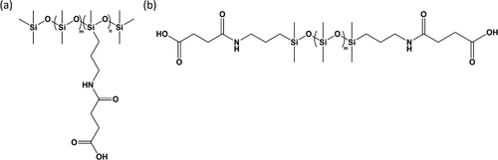
69Figure 8.1 Structure of a pendant sample with the various molar ratios of stickers (a) and of the earlier studied telechelic samples (b).
Figure 8.1 Structure of a pendant sample with the various molar ratios of stickers (a) and of the earlier studied telechelic samples (b).
Table 8.1 Parameters of the Polymers Studied Here with Pendant Stickers: m – Number of Non-functionalized Monomers in a Polymer; n – Number of Stickers Per Molecule; f_{e} – Weight Fraction of Stickers; T_{g} of the PDMS Backbone and T_{g} of Clusters; Distance between Centers of Clusters d and Cluster Radius R_{cluster}ª
iTable 8.1 Parameters of the Polymers Studied Here with Pendant Stickers: m – Number of Non-functionalized Monomers in a Polymer; n – Number of Stickers Per Molecule; fe – Weight Fraction of Stickers; Tg of the PDMS Backbone and Tg of Clusters; Distance b
 | pendant |  |  | telechelic
 | DP70 | DP100 | DP670 | DP13 | DP19 | DP22 | DP50 | DP74
m/n | 64/4 | 95/5 | 629/45 | 11/2 | 17/2 | 20/2 | 48/2 | 72/2
f_{e} | 0.11 | 0.09 | 0.12 | 0.247 | 0.184 | 0.163 | 0.079 | 0.057
T_{g} backbone (K) | 151 | 148 | 151 | 156 | 153 | 151 | 148 | 146
T_{g} clusters (K) | 193.5 | 185 | 194.5 | 209 | 205 | 193.5 | 186.5 | 190
d (nm) | 3.87 | 4.25 | 3.97 | 4.08 | 4.47 | 4.43 | 5.12 | 5.97
R_{cluster} (nm) | 1.16 | 1.13 | 1.19 | 1.59 | 1.58 | 1.5 | 1.36 | 1.43
ª
The same parameters for telechelic polymers with the same stickers are from refs (13), (25), (26).

8.2.2 X-ray Scattering
DP70, DP100, and DP670 samples were measured on XEUSS 3.0 (Xenocs, France) equipped with a Cu Kα microfocus source and a Pilatus 300k detector (Dectris, Switzerland). The scattering wavevector (q) was calibrated by a silver behenate standard material. The distance between sample and detector was 0.9 and 0.55 m for SAXS and WAXS, respectively. The samples were forced into quartz capillaries with a diameter of 1.5 mm and a 0.01 mm wall thickness. These capillaries, as well as an empty reference capillary, were placed perpendicular to the X-ray beam. These measurements were taken at room temperature, and the intensity of the empty reference capillary was subtracted from each sample.

8.2.3 Small-Amplitude Oscillatory Shear Rheology
Small-amplitude oscillatory shear (SAOS) rheological measurements were utilized to probe the viscoelastic properties of pendant functionalized PDMS–COOH through a strain-controlled mode of the AR2000ex (TA Instruments) with an angular frequency range from 10² to 10^{–1} rad/s. We used parallel plate geometry with a disk diameter of 4 mm at a variety of temperatures range from T_{g} of the PDMS backbone to temperatures where the sample can flow freely. The strain amplitude during the measurement was chosen to be in the range from 0.03 to 5%, depending on the modulus level at different temperatures.

8.2.4 Broadband Dielectric Spectroscopy
Dielectric spectra in the frequency range from 10^{–2} to 10⁶ Hz were measured utilizing a Novocontrol system, which includes an Alpha-A impedance analyzer and a Quatro Cryosystem temperature control unit. The pendant functionalized PDMS–COOH samples were placed into a parallel plate dielectric cell made of sapphire and invar steel with an electrode diameter of 10 mm and a capacitance of ∼2.9 pF with an electrode separation of ∼220 μm. To prevent crystallization, all samples were quenched from room temperature to about 113 K and reheated to 10 K below the T_{g} before the measurements. All the spectra were measured on heating. After each temperature increase, the samples were equilibrated for 10 min to reach thermal stabilization within 0.1 K.

8.3 Results
X-ray scattering data (Figure 8.2) provides information about the morphology of the studied samples. The higher q peak around 0.9 Å^{–1} is attributed to the PDMS chains themselves, (27) and the presence of functional group aggregation was confirmed for all samples by the low-q peak around 0.1 Å^{–1}. Although cluster size probably has a large distribution in these systems, we can do estimates of some average parameters important for understanding the structure of these systems. The averaged center-to-center distance between the clusters can be estimated using the low-q peak position q_{c}
𝑑≈2𝜋/𝑞cd≈2π/qc
(1)
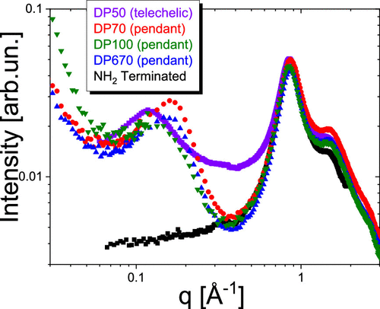
70Figure 8.2 X-ray scattering data for each sample reveals a low-q peak that indicates phase separation. PDMS with no phase separation and no low-q peak is shown as a reference.
Figure 8.2 X-ray scattering data for each sample reveals a low-q peak that indicates phase separation. PDMS with no phase separation and no low-q peak is shown as a reference.
The peak position q_{c} was estimated using a Gaussian fit function. Assuming that all functional groups are segregated in the phase-separated clusters, which have a cubic arrangement within the polymer matrix, and their volume fraction is the same as their weight fraction, we can estimate an average radius of the clusters from the volume fraction of the functional groups f_{e} (28)
𝑅cluster=𝑑2(6𝑓e𝜋)1/3Rcluster=d2(6feπ)1/3
(2)
For systems with similar fraction of functional groups, the distance between clusters and cluster radius appear a bit smaller in pendant systems than in telechelic ones (Table 1), most probably due to a smaller chain length between stickers for pendant systems than for telechelic ones at the same f_{e}.
In agreement with the earlier studies of telechelic PDMS with the same functional end groups, (13,24,25) the BDS spectra for the samples studied here show three processes (Figure 8.3): (1) a high-frequency process corresponding to segmental motion of the polymer backbone (α process); (2) a low-amplitude process in the intermediate frequency range corresponding to the dissociation of dimeric associating groups (α*); and (3) a low-frequency process corresponding to the mobility of stickers within associating clusters (α₂).
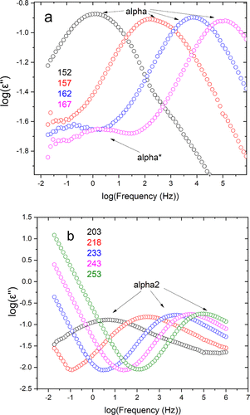
71Figure 8.3 Dielectric permittivity loss spectra of the DP100 sample at low (a) and high (b) temperatures (K), showing relaxation processes corresponding to the polymer segmental relaxation (alpha), dimeric dissociations (alpha*), and relaxation in cluste
Figure 8.3 Dielectric permittivity loss spectra of the DP100 sample at low (a) and high (b) temperatures (K), showing relaxation processes corresponding to the polymer segmental relaxation (alpha), dimeric dissociations (alpha*), and relaxation in clusters (alpha2).
To estimate the relaxation times of these processes, the permittivity loss spectra were fit to a Havriliak–Negami function
𝜀″(𝑓)=−𝐼𝑚Δ𝜀(1+(i2𝜋𝑓𝜏HN)𝛼)𝛾ε″(f)=−ImΔε(1+(i2πfτHN)α)γ
(3)
Here Δε is the dielectric amplitude of a given process, τ_{HN} corresponds to the characteristic Havriliak–Negami relaxation time of the process, while α and γ represent shape parameters for the process. Usually the frequency of the loss peak maximum is used to estimate the characteristic relaxation time, and it can be related to the τ_{HN} (29)
𝜏max=𝜏HNsin(𝜋𝛼𝛾2+2𝛾)sin(𝜋𝛼2+2𝛾)1/𝛾τmax=τHN(sin(παγ2+2γ)sin(πα2+2γ))1/γ
(4)
By extrapolating the VFT temperature dependence of the α relaxation times to τ = 100 s, the T_{g} of the polymer matrix was calculated. The glass transition temperature of the phase-separated clusters was estimated in the same way using the α₂ relaxation time (Figure 8.4, Table 8.1).
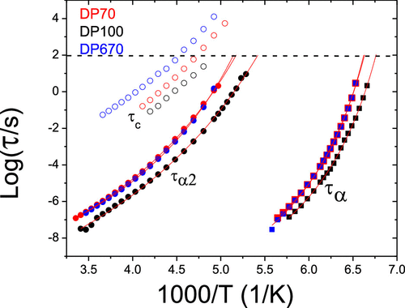
72Figure 8.4 Temperature dependence of characteristic relaxation times for the α- and α2-processes estimated from the dielectric spectra (closed symbols) and terminal relaxation time (τC, open symbols) estimated from rheology for studied systems with penda
Figure 8.4 Temperature dependence of characteristic relaxation times for the α- and α₂-processes estimated from the dielectric spectra (closed symbols) and terminal relaxation time (τ_{C}, open symbols) estimated from rheology for studied systems with pendant stickers. Solid lines show VFT fits and their crossing point with the dashed line corresponding to τ = 100 s is taken as T_{g}.
SAOS rheology was utilized for studies of the viscoelastic behavior of these samples. The master curves were constructed using time–temperature superposition by matching the data measured at different temperatures (Figure 8.5). Although time–temperature superposition quantitatively fails in the case of these samples due to a strong difference in temperature dependence of segmental and terminal relaxation (Figure 8.4), the master curves provide a useful qualitative picture of the viscoelastic behavior. All the master curves show segmental relaxation at higher frequencies that is followed by a rubbery plateau with modulus G_{N} ∼1–4 MPa at intermediate frequencies (Figure 8.5). The DP 100 sample demonstrates a lower plateau modulus in part due to its larger molecular weight between sticker groups. Additional reinforcement for samples with DP 70 and DP 670 came from the interfacial polymer layer with higher mechanical modulus formed around clusters and a relatively short distance between cluster surfaces, d_{IPS}. The latter can be roughly estimated as d_{IPS} = d – 2R_{cluster} (13,24) (see Table 8.1) and is ∼1.55–1.6 nm for DP 70 and DP 670 samples, and ∼2 nm for DP 100 sample. According to our earlier studies, (24) the thickness of the interfacial polymer layer in telechelic systems with clusters of the same stickers is ∼0.7–0.9 nm. Thus, the interfacial layers almost overlap in the DP 70 and DP 670 samples, leading to three times higher plateau modulus than in the DP 100 sample (Figure 8.5). The DP 100 sample also exhibits the fastest segmental and terminal relaxation times due to the lower weight fraction of sticker groups.
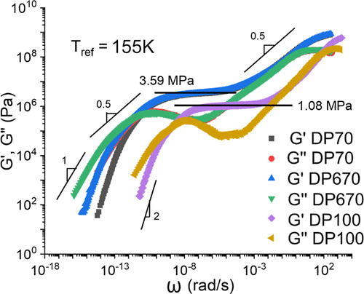
73Figure 8.5 Rheological master curve for each pendant functionalized sample. The spectra of DP70 and DP670 coincide up to the frequency of the loss modulus maximum below the end of the rubbery plateau.
Figure 8.5 Rheological master curve for each pendant functionalized sample. The spectra of DP70 and DP670 coincide up to the frequency of the loss modulus maximum below the end of the rubbery plateau.
At lower frequencies, a power law dependence with G′(ω) ∼ G″(ω) ∝ ω^{0.5} is clearly observed for all the samples, and then terminal relaxation appears at still lower frequency. This behavior can be well described by using the Rouse equations (Figure 8.6) (30)
𝐺′=𝐺0∑𝑗=1𝑁𝜔2𝜏2𝑗1+𝜔2𝜏2𝑗and𝐺″=𝐺0∑𝑗=1𝑁𝜔𝜏𝑗1+𝜔2𝜏2𝑗G′=G0∑j=1Nω2τj21+ω2τj2andG″=G0∑j=1Nωτj1+ω2τj2
(5)
With τ_{j} = τ_{c}/j², where τ_{c} is the terminal relaxation time and N is the number of sticky Rouse modes. The fit of the master curves provided estimates of τ_{c} (Figure 8.4) and the shortest τ_{j} = τ_{N} = τ_{p} which marks the onset of the sticky Rouse regime, i.e., the beginning of the rubbery plateau softening. The fit using eq 5 does not describe high-frequency data well (Figure 8.6), probably due to additional higher-frequency modes. This fit, however, provides good estimates of the characteristic relaxation times. We emphasize that the temperature dependence of these characteristic times is estimated only when the sticky Rouse regime is in the frequency window of the rheometer. In this way, we avoided any inaccuracy due to a breakdown of time-temperature superposition potentially encountered through a construction of the master plots (Figure 8.5).
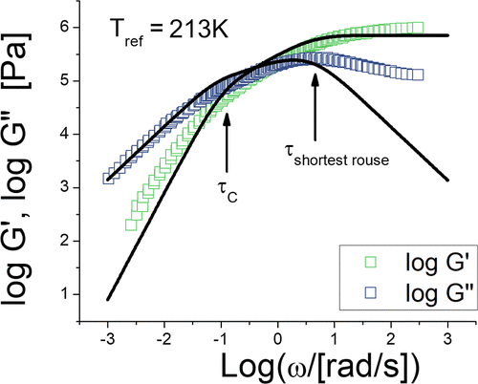
74Figure 8.6 Rheological data for the DP100 sample (symbols) and their fit to the Rouse model eq 5 (lines). Arrows indicate two characteristic time scales extracted from the fit.
Figure 8.6 Rheological data for the DP100 sample (symbols) and their fit to the Rouse model eq 5 (lines). Arrows indicate two characteristic time scales extracted from the fit.

8.4 Discussion
To unravel the role of molecular architecture and the placement of stickers on the chain, we will compare the obtained results to the data on telechelic PDMS–COOH samples with different DPs studied in our earlier publications. (13,24,25) We start with an analysis of T_{g} of these systems. Recent theoretical work (26) suggested that the shift of T_{g} in polymers with stickers should follow a roughly linear increase with the fraction of stickers, regardless of whether stickers are only at the chain ends (telechelic systems) or are placed randomly along the chain. Our data (Figure 8.7) indeed are consistent with this theoretical prediction and reveal that regardless of the chain length and placement of the stickers, their fraction seems to define the system’s T_{g}. Although the pendant samples studied here do not cover a broad range of sticker concentration, they vary by more than a factor of 10 in molecular weight, and their segmental behavior agrees well with the broader body of data available for telechelic systems. This result emphasizes the importance of the changes in segmental dynamics and T_{g} with increasing concentrations of stickers. We want to stress that these changes are usually not considered in sticky Rouse or sticky reptation models, although they strongly affect segmental friction of these systems.
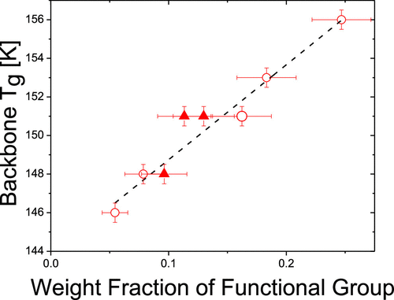
75Figure 8.7 Dependence of the glass transition temperature Tg on the weight fraction of the functional group for telechelic (open circles) and pendant (closed triangles) PDMS–COOH systems. Data for telechelic systems are from ref (26).
Figure 8.7 Dependence of the glass transition temperature T_{g} on the weight fraction of the functional group for telechelic (open circles) and pendant (closed triangles) PDMS–COOH systems. Data for telechelic systems are from ref (26).
The slowest dielectric process marked as α₂-process corresponds to structural relaxation in clusters of stickers. (13,25) To reveal how the process of structural relaxation in clusters affects the viscoelastic properties of the studied materials, we compare rheological and dielectric modulus data. This is necessary for a correct comparison of the dielectric and rheological time scales, (29,31) as the dielectric permittivity is an experimental response analogous to shear compliance rather than shear modulus. The dielectric loss modulus spectra, M″(ω) = Im[1/ε*(ω)], were fit to an HN function, and the characteristic relaxation time τ_{a2M} was estimated from the obtained τ_{HN} using eq 4. Analysis of the data revealed that in all the samples, the dielectric τ_{a2M}(T) is shorter than the rheological τ_{p}(T) by about one order (Figure 8.8). These results are similar to the earlier studies of telechelic PDMS with the same functional group, (13) suggesting that the structural relaxation in clusters is not sufficient for sticker rearrangement between clusters. To explain this difference, we adopt the idea from our previous work, where the additional factor controlling rearrangement of stickers between clusters is the difference in miscibility between the bulk polymer matrix and functional groups. This idea is based on their similarity to block copolymers. (32−35) In this case, the onset of the rubbery plateau softening should be related to the characteristic time of pulling a sticker from a cluster and can be described using the following equation (13)
𝜏p=𝜏𝛼2−Mexp(𝐸a𝑅𝑇)=𝜏𝛼2−Mexp(𝛼𝜒𝑁core)τp=τα2−Mexp(EaRT)=τα2−Mexp(αχNcore)
(6)
Here E_{a} corresponds to the activation energy barrier necessary to overcome the miscibility difference of the stickers and polymer matrix described by the Flory–Huggins solubility parameter χ, N_{core} = 1 in the case of our stickers. The eq 6 describes well the temperature dependence of τ_{p} (Figure 8) and provides an estimate of E_{a} ∼ 6.7 ± 0.5 kJ/mol, in good agreement with our previous studies of telechelic PDMS with the same stickers (∼6.6 kJ/mol). (13) It was demonstrated in ref (13) that this value agrees well with estimates of the Flory–Huggins parameter using the Hansen solubility parameter approach. (36,37)
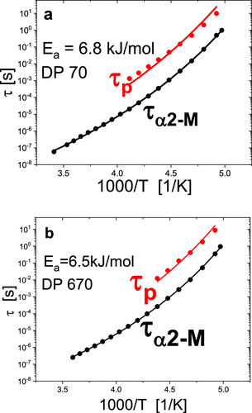
76Figure 8.8 Activation plot for the DP70 (a) and DP670 (b) samples demonstrating the disparity of the dielectric cluster relaxation times (τα2-M) with the rheological bond rearrangement time (τp), which indicates the onset of Rouse-like dynamics.
Figure 8.8 Activation plot for the DP70 (a) and DP670 (b) samples demonstrating the disparity of the dielectric cluster relaxation times (τ_{α2-M}) with the rheological bond rearrangement time (τ_{p}), which indicates the onset of Rouse-like dynamics.
Direct comparison of the rheological data for the DP 100 sample with pendant stickers to those of the DP50 telechelic sample (Figure 8.9), which have approximately the same volume fraction of stickers (Table 8.1), clearly reveals the impact of sticker placement on the viscoelasticity of a polymer with phase-separated functional groups. While in telechelic systems, pulling a sticker out of a cluster results in terminal relaxation, i.e., τ_{c} ∼ τ_{p}, an extended softening regime with a Rouse-like behavior appears in the rheological data of the system with stickers placed along the chain (Figure 8.9). In the latter case, the terminal relaxation time appears significantly slower than the τ_{p} (Figure 8.9), and the difference between these time scales increases with the increase of molecular weight of the chain at approximately the same fraction of stickers placed along the chain (Figure 8.4). This behavior is well explained by the sticky Rouse model, as stickers placed along the chain slow down the Rouse modes by the time of sticker pullout, and the terminal relaxation is then defined by the slowest sticky Rouse mode. The influence of sticker placement becomes even more apparent from direct comparison of relaxation times for samples with comparable fraction of stickers (Figure 8.10). The two architectures show good agreement in their segmental (α) and cluster (α₂) relaxation times, and even their sticker pullout times appear to be the same (Figure 8.10). This suggests that the volume fraction of the functional group is the major parameter controlling these times and the viscoelastic properties of these systems up to the time of pulling a sticker from a cluster, regardless of the sticker’s placement in these systems. The difference appears only at longer time scales: while pulling a sticker from a cluster results in terminal relaxation for telechelic systems, the same event results in the onset of sticky Rouse dynamics in the systems with stickers placed along the chain.
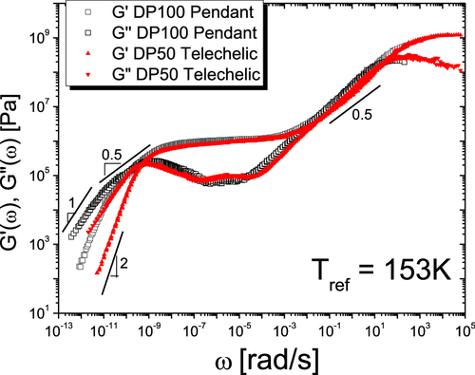
77Figure 8.9 Comparison of the shear modulus spectra of the DP100 sample with pendant functional groups (black open symbols) to the spectra of the telechelic DP50 sample (red symbols). Lines mark the power law regions with the slope indicated by numbers.
Figure 8.9 Comparison of the shear modulus spectra of the DP100 sample with pendant functional groups (black open symbols) to the spectra of the telechelic DP50 sample (red symbols). Lines mark the power law regions with the slope indicated by numbers.
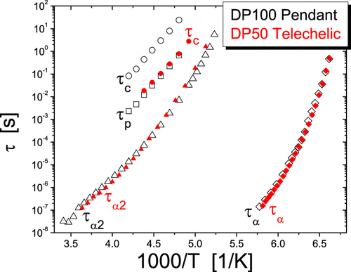
78Figure 8.10 Comparison of dielectric and rheological relaxation times for systems with the same fraction of stickers: DP100 with pendant stickers (black open symbols) and DP50 with a telechelic sample (red symbols).
Figure 8.10 Comparison of dielectric and rheological relaxation times for systems with the same fraction of stickers: DP100 with pendant stickers (black open symbols) and DP50 with a telechelic sample (red symbols).
Based on these results, we propose the following general scenario for the viscoelastic properties of polymers with microphase-separated stickers. Attaching stickers to a polymer chain leads to a slowdown of segmental relaxation and an increase in T_{g} due to the temporary crosslinks introduced by stickers. T_{g} increases roughly linearly with the concentration of stickers, regardless of their placement on the chain (26) (Figure 8.7). Clusters of stickers lead to an extended rubbery plateau even in systems with relatively short chains (Figure 8.5). Clusters also provide reinforcement of the rubbery plateau level, (13,38) the effect similar to the one known for polymer nanocomposites. Especially strong reinforcement appears in the case of percolating interfacial layers as was demonstrated in. (13) Structural relaxation in clusters (the α₂ process) detected in the dielectric spectra is visible in rheological data only for percolated systems. It appears as the onset of softening of the extremely high rubbery plateau. (13) In all other systems, rheological data do not detect the structural relaxation in clusters, and instead detect the events of sticker pullout from a cluster (Figure 8.11). In simple terms, viscoelastic properties are sensitive to the rearrangements of stickers between different clusters. This process is controlled by structural relaxation in clusters and the additional energy barrier defined by the Flory–Huggins interaction parameter of the stickers with the polymer matrix (eq 6). It appears that up to this point, the placement of stickers in the chain (telechelic or pendant along the chain) does not play any significant role in the dynamics of the polymer with microphase-separated stickers. Dynamics up to this point depend only on the total concentration of the stickers. The difference, however, appears at longer time scales, where pulling the sticker from the cluster results in terminal relaxation for telechelic systems, while it leads to the onset of sticky Rouse dynamics in the case of stickers placed along the chain (Figures 8.9-8.11).
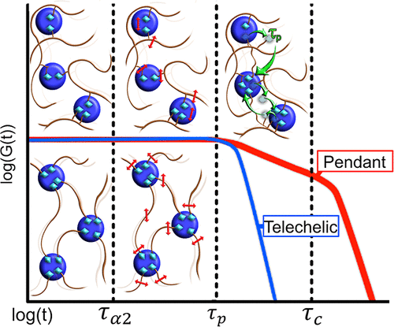
79Figure 8.11 Cartoon depicting the regimes of viscoelastic behavior for pendant functionalized and telechelically functionalized associating systems with microphase separation. The stickers are frozen in the clusters until time τα2, they are moving inside
Figure 8.11 Cartoon depicting the regimes of viscoelastic behavior for pendant functionalized and telechelically functionalized associating systems with microphase separation. The stickers are frozen in the clusters until time τ_{α2}, they are moving inside the clusters at times longer than τ_{α2} and pulling out from the clusters, providing bond exchange between clusters at time τ_{p}. This time corresponds to terminal relaxation in telechelic systems but appears as the onset of a sticky Rouse regime for systems with pendant stickers. Their terminal relaxation time is defined by the longest sticky Rouse mode.

8.5 Conclusions
We presented detailed studies of the dynamics and viscoelastic properties of model polymeric systems with microphase-separated dynamic bonds (stickers). Combined dielectric and rheological data revealed several dynamic processes, including backbone segmental relaxation, structural relaxation in clusters of stickers, the process of sticker pullout from a cluster (the dynamic bond rearrangement process), and terminal relaxation. The most interesting observation is that the dynamics and viscoelastic properties of these materials up to the time of sticker pullout appear to be dependent only on the concentration of stickers and not on their placement on the chain or the molecular weight of the chain. Only at longer time scales do the sticker placement and total molecular weight of the chain with pendant stickers begin to affect the viscoelastic properties of the material.
Based on these results, we propose a general scenario of the viscoelastic properties of the polymers with microphase-separated dynamic bonds. This scenario covers all dynamics starting from segmental relaxation through the terminal regime. It emphasizes the importance of structural relaxation (e.g., T_{g}) of dynamic bond clusters, their miscibility with the polymer matrix, and molecular architecture in the viscoelastic properties of these materials. The results demonstrate a clear decoupling of terminal relaxation of these systems from the polymer segmental dynamics. Terminal relaxation in this case is defined by the structural relaxation in clusters of stickers, stickers miscibility in the polymer matrix and their number along the chain. This enables an independent tuning of the terminal relaxation and elasticity of the system. The use of telechelic polymers enables much faster terminal relaxation with the rest of the dynamics being unaffected. Based on these results, we suggest that the use of telechelic polymers with phase-separated stickers provides the best solution for the design of recyclable elastomers. They will behave as regular thermosets at temperatures below T_{g} of clusters of stickers and provide relatively fast rearrangements at temperatures above this T_{g}. Although current experiments were done on systems with hydrogen bonding functionalities, we expect that they are applicable to any other type of dynamic bond that phase-separates from the polymer backbone. This scenario can be instrumental in the design of polymers containing dynamic bonds with desired viscoelastic properties.

CHAPTER 9 DYNAMICS IN POLYMERS WITH PHASE SEPARATED DYNAMIC BONDS: THE CASE OF A PECULIAR TEMPERATURE DEPENDENCE
A version of this chapter was published in Macromolecules, by Peyton Carden, Sirui Ge, Bingrui Li, Subarna Samanta, and Alexei P. Sokolov “Influence of Molecular Architecture on the Viscoelastic Properties of Polymers with Phase-Separated Dynamic Bonds” (Macromolecules 2023 56(13), 5173-5180)
Peyton wrote the manuscript together with the direction of Alexei P. Sokolov. Sirui Ge and Peyton Carden performed rheological measurements and the corresponding data analysis. Bingrui Li and Sheng Zhao synthesized the materials. Peyton Carden performed BDS measurements and the corresponding data analysis as well as the SAXS and DSC measurements with the advice of Subarna Samanta.

9.1 Introduction
Over the past century, polymers have become some of the most widely used materials, thanks to their light weight, ease of large scale processability, and unparalleled tunability of properties. In recent years, polymers functionalized with dynamic bonds have garnered great interest as they offer solutions to many issues associated with traditional polymers, such as the growing need for recyclability and reduced energy for processability.1 Moreover, the addition of dynamic bonds into polymer systems enables shape memory, super extensibility, extreme toughness, and self-healing capabilities.2–8 The dynamic bonding functionalities (stickers) include various chemistries ranging from ionic interactions, hydrogen bonding, p–p stacking, metal–ligand, and even dynamic covalent bonds. Among those, polymers with hydrogen bonding functionalities hold a particular value because of an easily tunable interaction strength.9,10 In addition, hydrogen bonding functionalities are more stable chemically and are less sensitive to water and unwanted side reactions which may complicate the dynamics and reversibility of other systems.11,12 To provide further mechanical reinforcement and decoupling of terminal flow from segmental dynamics, functionalities that phase separate from the polymer backbone can also be incorporated.13–18 Recent investigations into this sort of system have revealed a mechanism of network rearrangement which can be attributed to structural relaxation in clusters of stickers and to the miscibility difference between the sticker and the polymer matrix.19 Moreover, it has been revealed that these properties together with the concentration of stickers govern the system dynamics up to the point of single sticker pullout from the cluster, regardless of the polymer molecular weight and architecture.20 In the present study, we analyse the dynamics and viscoelastic properties of polydimethylsiloxane (PDMS) chains telechelically functionalized with a multi-OH group (Fig. 1) which form phase separated sticker clusters.
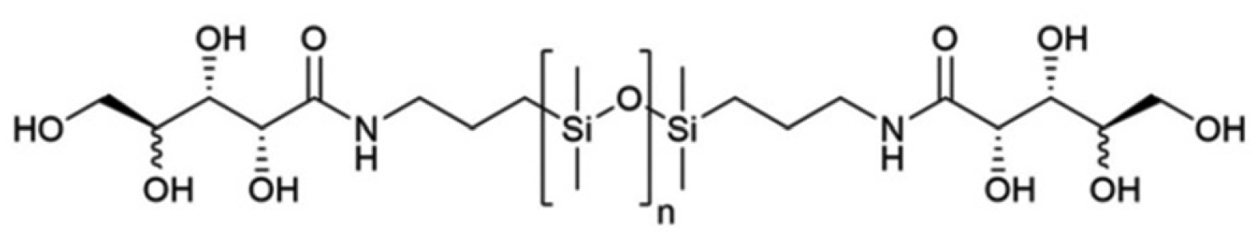
80Figure 9.1 Structure of the studied telechelic multi-OH PDMS chains
Figure 9.1 Structure of the studied telechelic multi-OH PDMS chains
We investigate these systems with a combination of rheology, dielectric spectroscopy, and DSC to probe the dynamic behavior of this system. We utilize X-ray scattering measurements to characterize the arrangement of the clusters within the matrix itself. Our studies revealed that terminal rheological behavior is slower than the structural relaxation in clusters of stickers, but its temperature variations appear slower than that of the relaxation in clusters. These two dynamic processes (terminal relaxation and structural relaxation in clusters) appear to converge upon cooling. We explain this unusual behavior by a peculiar temperature dependence of the Flory–Huggins interaction parameter that is often observed for hydrogen bonding systems. The presented results further expand the horizon for materials design with phase separated dynamic functionalities.

9.2 Materials and Methods

9.2.1 Synthesis of multi-OH PDMS polymer
The multi-OH polymers were synthesized using a procedure slightly adapted from Yepremyan et al.10 Aminopropyl terminated PDMS with different degrees of polymerization (DP; DP22 sample synthesized with a precursor molecular weight (MW) of B1600 g mol_1, DP50 with MW B3000 g mol_1, and DP74 with MW B 5000 g mol_1) were utilized and dried under vacuum before synthesis. 2,3-acetal-protected ribonolactone (2.0 g,10.63 mmol) was added dropwise at 0 1C to a mixture of 1:1 TFA/H2O (10 mL), the reaction was stirred for 12 h at RT and the solvents were evaporated. Then the 2HN-PDMS-NH2 was dissolved in THF and was reacted with the as-prepared deprotected ribonolactone at a 1 : 2 stoichiometric ratio while being stirred at room temperature in a round bottom flask. The THF was removed using rotovap to leave behind the final viscous samples.

9.2.2 Broadband dielectric spectroscopy (BDS)
Dielectric spectra in the frequency range from 10_2 to 106 Hz were measured utilizing a Novocontrol Concept-80 system which includes an Alpha-A impedance analyzer and a Quatro Cryosystem temperature control unit. The multi-OH samples were placed into a parallel plate dielectric cell made of sapphire and stainless steel with an electrode diameter of 10 mm, and capacitance B2.9 pF with an electrode separation of B220 mm. To prevent crystallization, all samples were quenched from room temperature to about 113 K and reheated to 10 K below the PDMS Tg (B145–152 K) before the measurements. All the spectra were measured on heating. After each temperature increase, the samples were equilibrated for 10 min to reach thermal stabilization within 0.2 K.

9.2.3 Small amplitude oscillatory shear (SAOS) rheology
SAOS rheological measurements were utilized to probe the viscoelastic properties of the multi-OH samples through a straincontrolled mode of the AR2000ex (TA Instruments) with an angular frequency range from 102 to 10_1 rad s_1. We used parallel plate geometry with a disk diameter of 4 mm at a variety of temperatures ranging from Tg of PDMS to temperatures where the sample can flow freely. The strain amplitude during the measurement was chosen to be in the range from 0.03% to 5% depending on the modulus level at different temperatures.

9.2.4 Small angle X-ray scattering (SAXS)
DP22, DP50, and DP70 samples were measured on XEUSS 3.0 (Xenocs, France) equipped with a Cu Ka microfocus source and a Pilatus 300 k detector (Dectris, Switzerland). The scattering wavevector (q) was calibrated by a silver behenate standard material. The distance between sample and detector was 0.9 m, 0.55 m, and 0.35 m for SAXS, medium (MAXS) and wide (WAXS) angle scattering, respectively. The samples were forced into quartz capillaries with a diameter of 1.5 mm and a 0.01 mm wall thickness. These capillaries, as well as an empty reference capillary were placed perpendicular to the X-ray beam. These measurements were taken at room temperature, and the intensity of the empty reference capillary was subtracted from each sample. The noise at intermediate q-range (B0.3–0.5 Å_1) appears due to bad statistics at the edge of the SAXS data. For temperature varied experiments, a reactivity stage was utilized. The samples were allowed five minutes to equilibrate at the desired temperature before the start of the measurements.

9.2.5 Differential scanning calorimetry (DSC)
DSC measurements were performed using a Q2500 DSC from TA Instruments. The samples were first equilibrated isothermally at 373 K for 10 min in hermetically sealed pans to remove the thermal history and then cooled to 183 K at a rate of 10 K min_1. After equilibration for 10 min, the samples were heated up to 373 K at a rate of 10 K min_1. This procedure was repeated twice for each sample to ensure reproducibility.

9.3 Results
The presence of phase separated clusters in each sample was confirmed using both SAXS measurements (the presence of a peak at the wave vector q B 0.1 Å_1, Fig. 2a), and DSC (a calorimetric glass transition (Fig. 3) at temperatures higher than the backbone Tg B 145–152 K). The SAXS contrast between polymer matrix and functional groups most probably is related to the presence of Si atoms in the polymer backbone. The SAXS peak suggests a well-defined distance between these clusters, however, a relatively large width of this peak suggests no good lattice-like structure. The peak in SAXS spectra shifts to lower q with an increase in DP (Fig. 2a), reflecting, as expected, an increase of the distance between clusters with the increase of the chain length. The peaks at higher q correspond to intersegmental correlations (q B 0.85 Å_1) and intrasegmental correlations (q B1.5 Å_1) of the PDMS backbone.21 Analysis of the SAXS data does not reveal any particular temperature variations suggesting that the clusters remain intact in the studied temperature range (Fig. 2b).
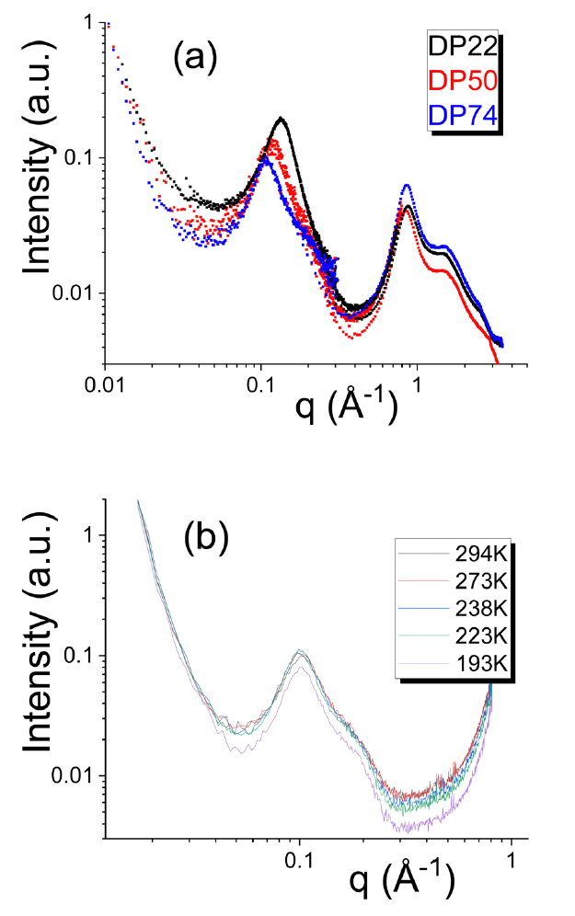
81Figure 9.2 (a) X-Ray scattering data for the studied samples at room temperature. The peak at q B 0.1 Å 1 confirms the presence of phase separated clusters. (b) SAXS data for the DP50 sample at various temperatures.
Figure 9.2 (a) X-Ray scattering data for the studied samples at room temperature. The peak at q B 0.1 Å1 confirms the presence of phase separated clusters. (b) SAXS data for the DP50 sample at various temperatures.
Apparently strong difference in polarity of the end groups and the backbone leads to a stable phase separation in this temperature range (see more details in the Discussion section). Analysis of the peak position near 0.1 Å_1 allows estimates of the distance between clusters (d E 2p/q). Using these values and assuming that all functional groups are segregated into clusters with a cubic arrangement of clusters, an estimate of cluster radius can be made using eqn (1):22
(1)
here fe is the volume fraction of the end groups that we assumed to be equal to the weight fraction. Assuming density in the clusters B 1 g cm_3 provides estimates of the number of end groups Nend per cluster (Table 1). The DSC data show a slight change in the cluster Tg and a broadening of the transition with an increase in DP (Fig. 3). The latter might be related to smaller volume fraction of chain ends in samples with larger DP forming smaller size of clusters (see, Table 1).
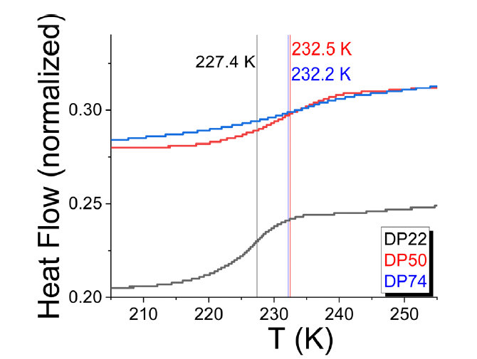
82Figure 9.3 DSC data shows the glass transition at temperatures much higher than the backbone Tg. Tg marked by vertical lines are estimated as the temperature at the middle of the step in the heat flow.
Figure 9.3 DSC data shows the glass transition at temperatures much higher than the backbone Tg. Tg marked by vertical lines are estimated as the temperature at the middle of the step in the heat flow.
Dielectric measurements (Fig. 4) revealed three dynamic processes that we assigned following our earlier studies of similar systems:9,14,19,20 (1) segmental relaxation (the a-process) caused by a change of the monomers’ dipole orientations during motions of PDMS segments; (2) a dimeric sticker dissociation (a* process) caused by change of the dipole moment during dissociation of stickers; and (3) a cluster relaxation (a2 process) caused by change of the dipole moments due to motion of end groups in the clusters. These were present in each sample except the DP22 sample where the a2-process is hidden by conductivity. Apparently, higher concentration of OH and NH groups in DP22 sample leads to higher conductivity (tail at low frequency in the Fig. 4b). This strong conductivity tail covers the expected at lower frequency a2-process in BDS spectra of DP22 sample. The peaks in dielectric loss spectra were fit using a Havriliak–Negami function:
(2)
here De is the dielectric amplitude of a given process, tHN corresponds to the characteristic Havriliak–Negami relaxation time of the process, while a and g represent shape parameters for the given process. The loss peak maximum is traditionally used to estimate the characteristic relaxation time of a relaxation process, and it can be related to the tHN:23
(3)
The fastest dielectric process (a-process, Fig. 4) presents PDMS segmental relaxation,9 and extrapolation of its relaxation times to ta = 100 s provides estimates of the polymermatrix Tg (Table 1). By extrapolating the cluster relaxation times to ta2 = 100 s, we can estimate the Tg of the clusters from BDS data. It agrees well with the calorimetric glass transition temperature (Table 1) supporting our assignment of this dielectric process.
Table 9.1 Weight fraction of the end groups, fe, centre-to-centre distances d and radius Rcluster of phase separated clusters, numbers of end groups per cluster Nend, Tg of the backbone and of the clusters
jTable 9.1 Weight fraction of the end groups, fe, centre-to-centre distances d and radius Rcluster of phase separated clusters, numbers of end groups per cluster Nend, Tg of the backbone and of the clusters
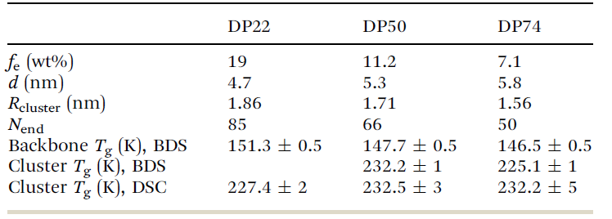
The a* process appears strong enough for an accurate fit only in the DP22 sample (Fig. 4). To compare directly BDS and rheological relaxation times, they should be estimated in the same way using, e.g., modulus spectra. To achieve this, the dielectric loss modulus data (Fig. 4d and f) instead of the dielectric permittivity24 are used to estimate the characteristic relaxation time of the a2 and a* processes:
(4)
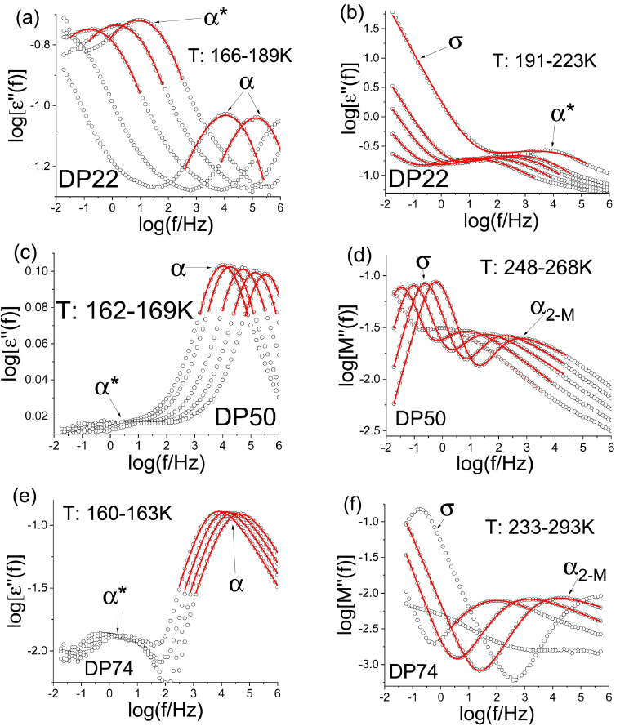
83Figure 9.4 dielectric spectra (symbols) measured at different temperatures for samples with DP22 (a) and (b), DP50 (c) and (d) and DP74 (e) and (f). Lines show fits of the peaks. (a), (c) and (e) present the permittivity loss data with a and a* processes
Figure 9.4 dielectric spectra (symbols) measured at different temperatures for samples with DP22 (a) and (b), DP50 (c) and (d) and DP74 (e) and (f). Lines show fits of the peaks. (a), (c) and (e) present the permittivity loss data with a and a* processes, while (d) and (f) present dielectric loss modulus for a* and a2 processes. The tail of conductivity contribution at lower frequencies covers the a2 process in spectra of the DP22 sample (b).
The characteristic times of all the dielectric processes are shown by closed symbols in Fig. 5. Rheology data revealed an extended rubbery plateau in each sample. Its level increases with the decrease of DP as the density of stickers increases (Fig. 6). Master curves of G*(o) are produced using time-temperature superposition. The timetemperature superposition actually fails in these systems due to different temperature dependence of relaxation processes (Fig. 5). It means that the difference in relaxation times observed in the master curves (Fig. 6) might be misleading. Yet, the obtained master curves serve as a useful qualitative picture presenting different relaxation processes and viscoelastic regimes of the studied systems. The terminal relaxation times are determined as the inverse frequency at which G’(ω) and G’’(ω) are crossing. The loss moduli spectra also show an intermediate process (Fig. 6) that was fit using an HN function to determine its relaxation times (eqn (2) and (3)). To avoid the problems of time-temperature superposition, we estimated characteristic rheological relaxation times only at temperatures when the processes are in the measured frequency range (Fig. 5). The intermediate rheological process has a characteristic time scale comparable to the dimeric dissociation time ta*(T) estimated from the BDS data (Fig. 5).
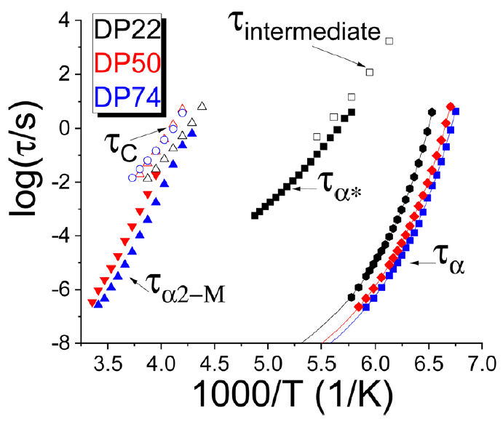
84Figure 9.5 Temperature dependence of characteristic dielectric relaxation times for the segmental (a) process, dimeric sticker dissociation (a*) process, and cluster (a2-M) relaxation (closed symbols) and the rheological intermediate and terminal relaxat
Figure 9.5 Temperature dependence of characteristic dielectric relaxation times for the segmental (a) process, dimeric sticker dissociation (a*) process, and cluster (a2-M) relaxation (closed symbols) and the rheological intermediate and terminal relaxation times (open symbols). Lines show VFT fits for ta(T).
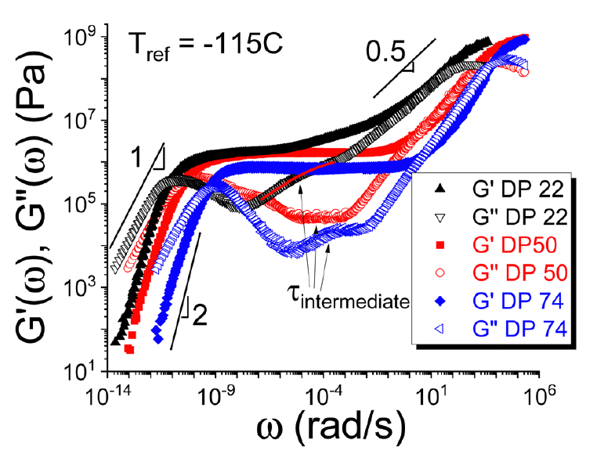
85Figure 9.6 Rheological master curves for each studied sample. The slope 0.5 indicates the Rouse regime at frequencies above the rubbery plateau. The slopes 2 for G0(o) and 1 for G00(o) indicate terminal regime. The arrows show intermediate relaxation pro
Figure 9.6 Rheological master curves for each studied sample. The slope 0.5 indicates the Rouse regime at frequencies above the rubbery plateau. The slopes 2 for G0(o) and 1 for G00(o) indicate terminal regime. The arrows show intermediate relaxation process in the loss modulus spectra. The line shows an example of the fit of the intermediate relaxation process.

9.4 Discussion
We start the discussion with an analysis of the polymer matrix a-relaxation. As has been demonstrated in many publications,20,25 an increase in sticker concentration leads to a slowing down of segmental relaxation and an increase in the polymer matrix Tg (Fig. 5 and Table 1). The latter appears to vary nearly linear with sticker concentration (1/DP), and falls well within the linear dependence seen for other PDMS-based systems regardless of the placement of the stickers on the chain and type of stickers for PDMS20 (Fig. 7).
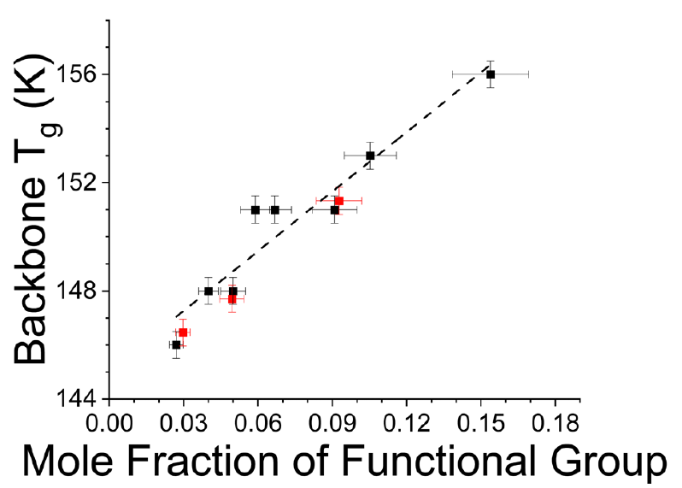
86Figure 9.7 The polymer glass transition temperature vs. mole fraction of the
Figure 9.7 The polymer glass transition temperature vs. mole fraction of the
functional groups. The red symbols present the system investigated in this
work, while the black symbols are from the previous publication.20
These results agree well with the recent theoretical predictions for associating polymers with relatively strong sticker associations.25 The appearance of the binary stickers’ dissociation process in the dielectric relaxation data allows estimates of the energy barrier for their dissociation Ea:26–28
(5)
here R is the gas constant. The temperature range where experimental data can be measured for both ta(T) and ta*(T) is very narrow (Fig. 5), and we extrapolated the data for the ta(T) using Vogel–Fulcher–Tammann (VFT) fit:
(6)
with t0 fixed to 10_12 s. The estimated activation energy for dissociation appears to be B23 kJ mol_1 (Fig. 8), which corresponds to breakingB3–4 hydrogen bonds.
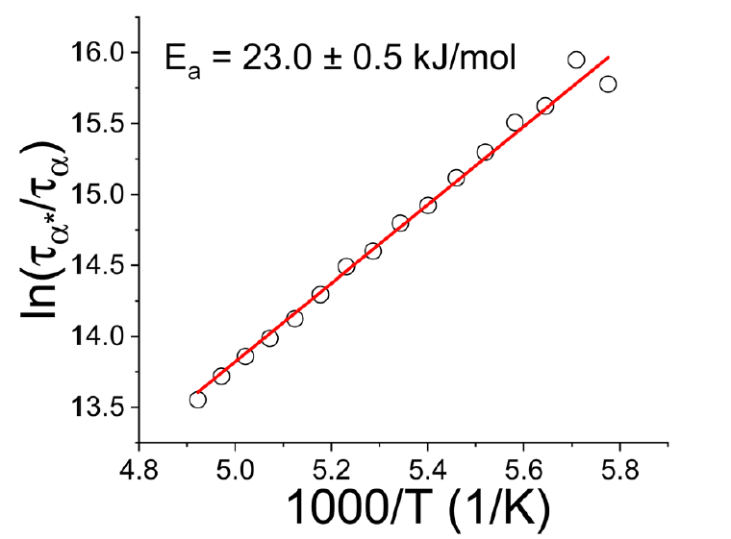
87Figure 9.8 The ratio of relaxation times for the intermediate (dimeric) process, ta*, and the segmental relaxation time, ta, from BDS vs. inverse temperature for DP 22 sample. The data for ta(T) were extrapolated to higher temperatures using a VFT fit. T
Figure 9.8 The ratio of relaxation times for the intermediate (dimeric) process, ta*, and the segmental relaxation time, ta, from BDS vs. inverse temperature for DP 22 sample. The data for ta(T) were extrapolated to higher temperatures using a VFT fit. The slope provides an estimate of the dissociation energy for the binary interactions of the stickers.
Apparently, not all OH and NH groups of the stickers form hydrogen bonding in these binary interactions. The rheological intermediate process has a characteristic time scale similar to ta*(T) from BDS (Fig. 5). The result suggests that this rheological process should be also related to the binary interactions of stickers. It is known, however, that BDS measures the bond dissociation process (change of dipole moment upon bond dissociation) while rheology measures bond rearrangement time.9,26 According to the bond lifetime renormalization model,29 these times might differ significantly but will be similar in the case of a strong interaction regime when Ea c 2RT _ ln(N), here N is the number of backbone segments. Indeed the estimated energy barrier for dissociation appears much higher than 2RT _ ln(N) B 6.4 kJ mol_1 for the DP22 sample,9,29 and this explains why the bond dissociation time measured by BDS and the bond rearrangement time measured by rheology are very similar (Fig. 5). Unfortunately, the a*-process in BDS spectra of DP50 and DP74 samples is weak for detailed quantitative analysis (Fig. 4c and e). But its separation from the a-process is similar to that observed in the DP22 sample, suggesting (as expected) the same energy barrier for the binary bond dissociation independent on the backbone molecular weight. In this case, all the samples remain in the strong dissociation energy regime with Ea much larger than 2RT _ ln(N)B9.2 kJ mol_1 for DP50 andB10.5 for DP74 samples. SAXS and rheological data suggest that the majority of stickers are phase separated in clusters, and structural relaxation in these clusters controls the terminal relaxation (Fig. 5). Molecular weight of all studied here systems is significantly below the entanglement molecular weight of PDMS (Me B 15 000, i.e. DP B 200). Yet, all 3 samples show very extended rubbery plateau with the modulus in MPa range (Fig. 6). This level is significantly higher than in entangled PDMS and is even higher than expected from the molecular weights of PDMS backbone. As has been seen in other phase separated systems, the presence of glassy clusters reinforces the plateau modulus in a mechanism similar to the reinforcement in polymer nanocomposites.13–15 This additional reinforcement comes from a polymer interfacial layer surrounding glassy clusters that has significantly higher elastic modulus than the pure polymer matrix. It can be well described using the interfacial layer model,13–15 which is out of scope of the current studies. The clusters of stickers work as crosslinks and provide a substantial extension of the rubbery plateau in frequency.13 It has been suggested in19 that a single sticker pullout from a cluster controls the terminal relaxation time in telechelic systems. This sticker pullout process is controlled by the structural relaxation in clusters, ta2-M, and an additional energy barrier EC defined by the miscibility of the polymer matrix and sticker:30–33
(7)
here w is the Flory–Huggins interaction parameter between the sticker and the polymer matrix, and Ns is the number of segments in the sticker which we assume to be Ns = 1. a is a constantB0.5– 1.34 This idea was borrowed from the block copolymer field because indeed this telechelic system can be considered as a triblock copolymer. For this specific functionality, an unusual behaviour is evident when comparing the terminal and cluster relaxation times (Fig. 5): The cluster relaxation times exhibit a stronger temperature dependence than the terminal relaxation times, and both times might converge at lower temperatures. This behaviour corresponds to a negative B term in the expression for the effective interaction parameter (Fig. 9):
w = A + B/T (8)
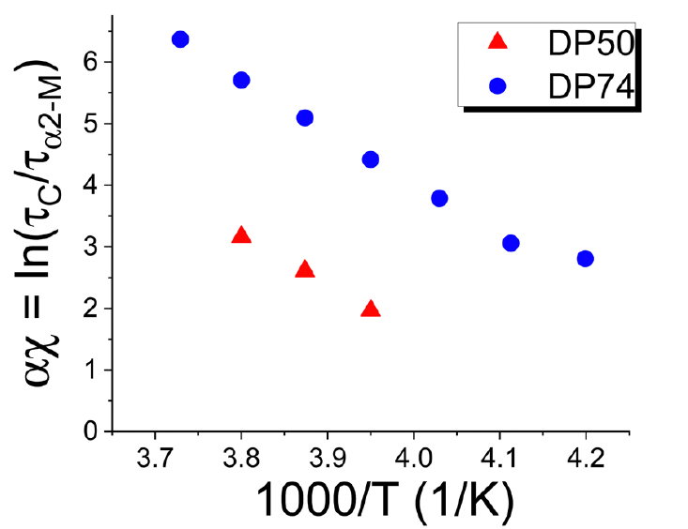
88Figure 9.9 Temperature dependence of the Flory–Huggins interaction parameter estimated using eqn (7).
Figure 9.9 Temperature dependence of the Flory–Huggins interaction parameter estimated using eqn (7).
This behaviour is known for some block copolymers, especially for systems with hydrogen bonding.35–38 It usually leads to a lower critical solution temperature (LCST). Estimates of w using the Hansen solubility parameter approach39 provides a value comparable to the experiment (Fig. 9). Although this approach is useful to estimate w parameter, the classical theory does not predict the temperature dependence observed in our systems. We emphasize that the SAXS measurements did not reveal any significant changes in morphology of the systems even down to 193 K (Fig. 1b). Based on this result we suggest that though the two phases may be more miscible at lower temperatures (as would be implied with an LCST), the clusters might be locked in place at these temperatures because of their glassy state.

9.4.1 Estimates of the Flory–Huggins interaction parameter using Hansen solubility parameter (HSP)
The w-parameter can be roughly estimated using Hansen solubility parameter (HSP) approach.39 In this case,
(S1)
here dend and dPDMS are HSPs for the end group and PDMS backbone, respectively, and Vend is the volume of the end group. dPDMS is B7.3 cal1/2 cm_3/2.41 dend is estimated using HSP34 that divides the solubility parameter into 3 partial components, dd – the dispersion part, dp – the polarity part and dhb – the hydrogen-bonding part. The total solubility parameter is calculated as
(S3)
(S4)
(S5)
where Ci is the contribution of the first-order groups of type I that appears Ni times in the compound and Dj is the contribution of the second-order groups of type j that appears Mj times in the compound. According to the multi-OH chain end structure, it possesses 4 different first-order groups (Fig. 10).42 By using the equations (eqn (S6)–(S8)), 3 partial parameters are calculated as shown below,
(S8)
With Vend B190 cm3 mol_1, we estimate w B 8.8 at T =270 K. With the usual parameter aB0.5,32,41,43 aw will be in the range comparable to the experimental data in the Fig. 9. However, the temperature dependence of the Flory–Huggins parameter (Fig. 9) is opposite to the expected in classical theory (eqn (S1)), leading to the LCST behaviour. The latter behaviour is known for many hydrogen bonding systems.35–38
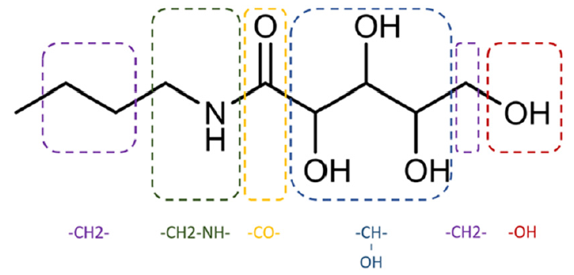
89Figure 9.10 Chemical structure of chain ends dividing into 5 parts.
Figure 9.10 Chemical structure of chain ends dividing into 5 parts.

9.5 Conclusions
We presented a detailed analysis of dynamics in associating telechelic polymers with multiple hydrogen bonding stickers. Segmental relaxation of the polymers slows down with an increase of concentration of stickers leading to a nearly linear increase in Tg with the mole fraction of stickers. The latter agrees well with the recent theoretical predictions.25 Both dielectric and rheological data revealed the existence of an intermediate relaxation process assigned to the binary stickers’ dissociation and rearrangement processes. The energy barrier for the stickers dissociation appears relatively high, B23 kJ mol_1, as expected for multiple hydrogen bonds. This high energy barrier explains why the bond rearrangement and bond dissociation processes for the binary interactions have similar time scales. The most interesting result is that the majority of these stickers form micro-phase separated clusters, as evidenced by SAXS data and the existence of the second Tg.We analysed the dynamics and terminal relaxation of these systems using the idea proposed in earlier studies,19,20 which suggests that terminal relaxation is defined by the process of pulling a sticker from a cluster. This process is controlled by the structural relaxation time in the clusters with an additional energy barrier defined by the miscibility of the sticker with the polymer backbone, i.e. by the Flory–Huggins interaction parameter.30–33 This mechanism enables control of terminal relaxation and viscoelastic properties of materials essentially independent of the polymer segmental relaxation. Detailed analysis of the dielectric and rheological data in the studied systems revealed a surprising result: the χ parameter decreases upon cooling, suggesting potential LCST behaviour, where the stickers and polymer chain become more miscible with decreasing temperature. This behaviour is known for some block copolymers, especially those with hydrogen bonds.37,38,40 We speculate that glass transition prevents the dissolution of clusters in the polymer matrix at lower temperatures preventing in this way observation of the expected LCST. This leads to a regime of rheological behaviour in which terminal flow is defined largely by structural relaxation in the clusters at lower temperatures, whereas it is delayed substantially beyond this time at higher temperatures when the stickers become less miscible in the polymer matrix. The presented results shed more light on the interplay between functional group cluster and backbone chain, allowing for more intelligent and precise design of functional materials with required viscoelastic properties.

Concluding Remarks and Future Directions
e

                - List of References
(1) Samanta, S.; Kim, S.; Saito, T.; Sokolov, A. P. Polymers with Dynamic Bonds: Adaptive Functional Materials for a Sustainable Future. J Phys Chem B 2021, 125 (33), 9389-9401. DOI: 10.1021/acs.jpcb.1c03511 From NLM.
(2) Elling, B. R.; Dichtel, W. R. Reprocessable Cross-Linked Polymer Networks: Are Associative Exchange Mechanisms Desirable? ACS Central Science 2020, 6 (9), 1488-1496. DOI: 10.1021/acscentsci.0c00567.
(3) Zhang, X.; Vidavsky, Y.; Aharonovich, S.; Yang, S. J.; Buche, M. R.; Diesendruck, C. E.; Silberstein, M. N. Bridging experiments and theory: isolating the effects of metal–ligand interactions on viscoelasticity of reversible polymer networks. Soft Matter 2020, 16 (37), 8591-8601, 10.1039/D0SM01115K. DOI: 10.1039/D0SM01115K.
(4) Stukalin, E. B.; Cai, L.-H.; Kumar, N. A.; Leibler, L.; Rubinstein, M. Self-Healing of Unentangled Polymer Networks with Reversible Bonds. Macromolecules 2013, 46 (18), 7525-7541. DOI: 10.1021/ma401111n.
(5) Brassinne, J.; Cadix, A.; Wilson, J.; van Ruymbeke, E. Dissociating sticker dynamics from chain relaxation in supramolecular polymer networks—The importance of free partner! Journal of Rheology 2017, 61 (6), 1123-1134. DOI: 10.1122/1.4997594 (acccessed 9/4/2024).
(6) Ge, S.; Tress, M.; Xing, K.; Cao, P.-F.; Saito, T.; Sokolov, A. P. Viscoelasticity in associating oligomers and polymers: experimental test of the bond lifetime renormalization model. Soft Matter 2020, 16 (2), 390-401, 10.1039/C9SM01930H. DOI: 10.1039/C9SM01930H.
(7) Gold, B. J.; Hövelmann, C. H.; Lühmann, N.; Székely, N. K.; Pyckhout-Hintzen, W.; Wischnewski, A.; Richter, D. Importance of Compact Random Walks for the Rheology of Transient Networks. ACS Macro Letters 2017, 6 (2), 73-77. DOI: 10.1021/acsmacrolett.6b00880.
(8) He, Z.; Niu, H.; Liu, L.; Xie, S.; Hua, Z.; Li, Y. Elastomeric polyolefin vitrimer: Dynamic imine bond cross-linked ethylene/propylene copolymer. Polymer 2021, 229, 124015. DOI: https://doi.org/10.1016/j.polymer.2021.124015.
(9) Feng, Z.; Yu, B.; Hu, J.; Zuo, H.; Li, J.; Sun, H.; Ning, N.; Tian, M.; Zhang, L. Multifunctional Vitrimer-Like Polydimethylsiloxane (PDMS): Recyclable, Self-Healable, and Water-Driven Malleable Covalent Networks Based on Dynamic Imine Bond. Industrial & Engineering Chemistry Research 2019, 58 (3), 1212-1221. DOI: 10.1021/acs.iecr.8b05309.
(10) Bui, R.; Brook, M. A. Dynamic covalent Schiff-base silicone polymers and elastomers. Polymer 2019, 160, 282-290. DOI: https://doi.org/10.1016/j.polymer.2018.11.043.
(11) Wang, P.; Yang, L.; Dai, B.; Yang, Z.; Guo, S.; Gao, G.; Xu, L.; Sun, M.; Yao, K.; Zhu, J. A self-healing transparent polydimethylsiloxane elastomer based on imine bonds. European Polymer Journal 2020, 123, 109382. DOI: https://doi.org/10.1016/j.eurpolymj.2019.109382.
(12) Lei, X.; Huang, Y.; Liang, S.; Zhao, X.; Liu, L. Preparation of highly transparent, room-temperature self-healing and recyclable silicon elastomers based on dynamic imine bond and their ion responsive properties. Materials Letters 2020, 268, 127598. DOI: https://doi.org/10.1016/j.matlet.2020.127598.
(13) Wang, P.; Wang, Z.; Cao, W.; Zhu, J. Facile Preparation of a Transparent, Self-Healing, and Recyclable Polysiloxane Elastomer Based on a Dynamic Imine and Boroxine Bond. In Polymers, 2024; Vol. 16.
(14) Zhang, B.; Zhang, P.; Zhang, H.; Yan, C.; Zheng, Z.; Wu, B.; Yu, Y. A Transparent, Highly Stretchable, Autonomous Self-Healing Poly(dimethyl siloxane) Elastomer. Macromolecular Rapid Communications 2017, 38 (15), 1700110. DOI: https://doi.org/10.1002/marc.201700110 (acccessed 2024/09/04).
(15) dos Santos, M. P.; Magosso, H. A.; Yoshida, I. V. P.; Gushikem, Y. Poly(dimethylsiloxane) (PDMS)-Schiff base, a new polymeric network and its adsorbent capability for copper ions from ethanol. Colloids and Surfaces A: Physicochemical and Engineering Aspects 2012, 398, 1-8. DOI: https://doi.org/10.1016/j.colsurfa.2012.01.030.
(16) Lu, X.; Dong, Y.; Yang, K.; Song, L.; Wu, Y.; Deng, J. Multifunctional Fluorescent Self-Healing Elastomers Consisting of Polydimethylsiloxane and Carbon Dots Linked via a Schiff Base Reaction. ACS Applied Polymer Materials 2023, 5 (12), 10458-10468. DOI: 10.1021/acsapm.3c02322.
(17) Ciaccia, M.; Di Stefano, S. Mechanisms of imine exchange reactions in organic solvents. Organic & Biomolecular Chemistry 2015, 13 (3), 646-654, 10.1039/C4OB02110J. DOI: 10.1039/C4OB02110J.
(18) Ciaccia, M.; Cacciapaglia, R.; Mencarelli, P.; Mandolini, L.; Di Stefano, S. Fast transimination in organic solvents in the absence of proton and metal catalysts. A key to imine metathesis catalyzed by primary amines under mild conditions. Chemical Science 2013, 4 (5), 2253-2261, 10.1039/C3SC50277E. DOI: 10.1039/C3SC50277E.
(19) Porath, L. E.; Evans, C. M. Importance of Broad Temperature Windows and Multiple Rheological Approaches for Probing Viscoelasticity and Entropic Elasticity in Vitrimers. Macromolecules 2021, 54 (10), 4782-4791. DOI: 10.1021/acs.macromol.0c02800.
(20) Liu, Y.; Tang, Z.; Chen, J.; Xiong, J.; Wang, D.; Wang, S.; Wu, S.; Guo, B. Tuning the mechanical and dynamic properties of imine bond crosslinked elastomeric vitrimers by manipulating the crosslinking degree. Polymer Chemistry 2020, 11 (7), 1348-1355, 10.1039/C9PY01826C. DOI: 10.1039/C9PY01826C.
(21) Cho, S.; Hwang, S. Y.; Oh, D. X.; Park, J. Recent progress in self-healing polymers and hydrogels based on reversible dynamic B–O bonds: boronic/boronate esters, borax, and benzoxaborole. Journal of Materials Chemistry A 2021, 9 (26), 14630-14655, 10.1039/D1TA02308J. DOI: 10.1039/D1TA02308J.
(22) Herbert, K. M.; Getty, P. T.; Dolinski, N. D.; Hertzog, J. E.; de Jong, D.; Lettow, J. H.; Romulus, J.; Onorato, J. W.; Foster, E. M.; Rowan, S. J. Dynamic reaction-induced phase separation in tunable, adaptive covalent networks. Chemical Science 2020, 11 (19), 5028-5036, 10.1039/D0SC00605J. DOI: 10.1039/D0SC00605J.
(23) Ge, S.; Samanta, S.; Tress, M.; Li, B.; Xing, K.; Dieudonné-George, P.; Genix, A.-C.; Cao, P.-F.; Dadmun, M.; Sokolov, A. P. Critical Role of the Interfacial Layer in Associating Polymers with Microphase Separation. Macromolecules 2021, 54 (9), 4246-4256. DOI: 10.1021/acs.macromol.1c00275.
(24) Mordvinkin, A.; Döhler, D.; Binder, W. H.; Colby, R. H.; Saalwächter, K. Terminal Flow of Cluster-Forming Supramolecular Polymer Networks: Single-Chain Relaxation or Micelle Reorganization? Physical Review Letters 2020, 125 (12), 127801. DOI: 10.1103/PhysRevLett.125.127801.
(25) Mordvinkin, A.; Döhler, D.; Binder, W. H.; Colby, R. H.; Saalwächter, K. Rheology, Sticky Chain, and Sticker Dynamics of Supramolecular Elastomers Based on Cluster-Forming Telechelic Linear and Star Polymers. Macromolecules 2021, 54 (11), 5065-5076. DOI: 10.1021/acs.macromol.1c00655.
(26) Stuparu, M. C.; Khan, A.; Hawker, C. J. Phase separation of supramolecular and dynamic block copolymers. Polymer Chemistry 2012, 3 (11), 3033-3044, 10.1039/C2PY20368E. DOI: 10.1039/C2PY20368E.
(27) Scheutz, G. M.; Lessard, J. J.; Sims, M. B.; Sumerlin, B. S. Adaptable Crosslinks in Polymeric Materials: Resolving the Intersection of Thermoplastics and Thermosets. Journal of the American Chemical Society 2019, 141 (41), 16181-16196. DOI: 10.1021/jacs.9b07922.
(28) Senanayake, M.; Perahia, D.; Grest, G. S. Effects of interaction strength of associating groups on linear and star polymer dynamics. The Journal of Chemical Physics 2021, 154 (7), 074903. DOI: 10.1063/5.0038097 (acccessed 8/31/2024).
(29) Tress, M.; Ge, S.; Xing, K.; Cao, P.-F.; Saito, T.; Genix, A.-C.; Sokolov, A. P. Turning Rubber into a Glass: Mechanical Reinforcement by Microphase Separation. ACS Macro Letters 2021, 10 (2), 197-202. DOI: 10.1021/acsmacrolett.0c00778.
(30) Wu, S. Phase structure and adhesion in polymer blends: A criterion for rubber toughening. Polymer 1985, 26 (12), 1855-1863. DOI: https://doi.org/10.1016/0032-3861(85)90015-1.
(31) Amin, D.; Likhtman, A. E.; Wang, Z. Dynamics in Supramolecular Polymer Networks Formed by Associating Telechelic Chains. Macromolecules 2016, 49 (19), 7510-7524. DOI: 10.1021/acs.macromol.6b00561.
(32) Ma, Y.; Lodge, T. P. Chain Exchange Kinetics in Diblock Copolymer Micelles in Ionic Liquids: The Role of χ. Macromolecules 2016, 49 (24), 9542-9552. DOI: 10.1021/acs.macromol.6b02212.
(33) Wang, E.; Lu, J.; Bates, F. S.; Lodge, T. P. Effect of Corona Block Length on the Structure and Chain Exchange Kinetics of Block Copolymer Micelles. Macromolecules 2018, 51 (10), 3563-3571. DOI: 10.1021/acs.macromol.7b02732.
(34) Wang, E.; Zhu, J.; Zhao, D.; Xie, S.; Bates, F. S.; Lodge, T. P. Effect of Solvent Selectivity on Chain Exchange Kinetics in Block Copolymer Micelles. Macromolecules 2020, 53 (1), 417-426. DOI: 10.1021/acs.macromol.9b01877.
(35) Lu, J.; Bates, F. S.; Lodge, T. P. Chain Exchange in Binary Copolymer Micelles at Equilibrium: Confirmation of the Independent Chain Hypothesis. ACS Macro Letters 2013, 2 (5), 451-455. DOI: 10.1021/mz400167x.
(36) Lu, J.; Bates, F. S.; Lodge, T. P. Remarkable Effect of Molecular Architecture on Chain Exchange in Triblock Copolymer Micelles. Macromolecules 2015, 48 (8), 2667-2676. DOI: 10.1021/acs.macromol.5b00294.
(37) Peters, A. J.; Lodge, T. P. Comparison of Gel Relaxation Times and End-Block Pullout Times in ABA Triblock Copolymer Networks. Macromolecules 2016, 49 (19), 7340-7349. DOI: 10.1021/acs.macromol.6b01921.
(38) Zhao, D.; Ma, Y.; Lodge, T. P. Exchange Kinetics for a Single Block Copolymer in Micelles of Two Different Sizes. Macromolecules 2018, 51 (6), 2312-2320. DOI: 10.1021/acs.macromol.7b02550.
(39) Hansen, C. M. Hansen solubility parameters: a user's handbook; CRC press, 2007.
(40) Stefanis, E.; Panayiotou, C. A new expanded solubility parameter approach. International journal of pharmaceutics 2012, 426 (1-2), 29-43.
(41) Vanhoorne, P.; Jerome, R.; Teyssie, P.; Laupretre, F. Direct NMR Evidence for a Local Restriction in the Segmental Chain Mobility of a Model Ionomer. Macromolecules 1994, 27 (9), 2548-2552. DOI: 10.1021/ma00087a024.
(42) Sinha, K.; Maranas, J. K. Segmental Dynamics and Ion Association in PEO-Based Single Ion Conductors. Macromolecules 2011, 44 (13), 5381-5391. DOI: 10.1021/ma2005074.
(43) Maurer, F. H. J. An Interlayer Model to Describe the Physical Properties of Particulate Composites. In Controlled Interphases in Composite Materials, Dordrecht, 1990//, 1990; Ishida, H., Ed.; Springer Netherlands: pp 491-504.
(44) Halpin, J. C.; Kardos, J. L. Moduli of Crystalline Polymers Employing Composite Theory. Journal of Applied Physics 1972, 43 (5), 2235-2241. DOI: 10.1063/1.1661482 (acccessed 8/31/2024).
(45) Takayanagi, M.; Uemura, S.; Minami, S. Application of equivalent model method to dynamic rheo-optical properties of crystalline polymer. Journal of Polymer Science Part C: Polymer Symposia 1964, 5 (1), 113-122. DOI: https://doi.org/10.1002/polc.5070050111 (acccessed 2024/08/31).
(46) Ouali, N.; Cavaillé, J.; Perez, J. Elastic, viscoelastic and plastic behavior of multiphase polymer blends. Plastics, Rubber and Composites Processing and Applications(UK) 1991, 16 (1), 55-60.
(47) Wu, S.; Qiu, M.; Tang, Z.; Guo, B. Interphase Percolation Mechanism Underlying Elastomer Reinforcement. The Journal of Physical Chemistry C 2017, 121 (51), 28594-28603. DOI: 10.1021/acs.jpcc.7b11239.
(48) Favier, V.; Cavaille, J. Y.; Canova, G. R.; Shrivastava, S. C. Mechanical percolation in cellulose whisker nanocomposites. Polymer Engineering & Science 1997, 37 (10), 1732-1739. DOI: https://doi.org/10.1002/pen.11821 (acccessed 2024/08/27).
(49) Mohottalalage, S. S.; Senanayake, M.; Clemmer, J. T.; Perahia, D.; Grest, G. S.; O’Connor, T. Nonlinear Elongation Flows in Associating Polymer Melts: From Homogeneous to Heterogeneous Flow. Physical Review X 2022, 12 (2), 021024. DOI: 10.1103/PhysRevX.12.021024.
(50) Amin, D.; Wang, Z. Nonlinear rheology and dynamics of supramolecular polymer networks formed by associative telechelic chains under shear and extensional flows. Journal of Rheology 2020, 64 (3), 581-600. DOI: 10.1122/1.5120897 (acccessed 8/31/2024).
(51) Manias, E.; Utracki, L. A. Thermodynamics of Polymer Blends. In Polymer Blends Handbook, Utracki, L. A., Wilkie, C. A. Eds.; Springer Netherlands, 2014; pp 171-289.
(52) Yuan, Y.; Raheja, K.; Milbrandt, N. B.; Beilharz, S.; Tene, S.; Oshabaheebwa, S.; Gurkan, U. A.; Samia, A. C. S.; Karayilan, M. Thermoresponsive polymers with LCST transition: synthesis, characterization, and their impact on biomedical frontiers. RSC Applied Polymers 2023, 1 (2), 158-189, 10.1039/D3LP00114H. DOI: 10.1039/D3LP00114H.
(53) Schilli, C. M.; Zhang, M.; Rizzardo, E.; Thang, S. H.; Chong, Y. K.; Edwards, K.; Karlsson, G.; Müller, A. H. E. A New Double-Responsive Block Copolymer Synthesized via RAFT Polymerization: Poly(N-isopropylacrylamide)-block-poly(acrylic acid). Macromolecules 2004, 37 (21), 7861-7866. DOI: 10.1021/ma035838w.
(54) Kawata, Y.; Kozuka, S.; Yusa, S.-i. Thermo-Responsive Behavior of Amphoteric Diblock Copolymers Bearing Sulfonate and Quaternary Amino Pendant Groups. Langmuir 2019, 35 (5), 1458-1464. DOI: 10.1021/acs.langmuir.8b01684.
(55) Bütün, V.; Liu, S.; Weaver, J. V. M.; Bories-Azeau, X.; Cai, Y.; Armes, S. P. A brief review of ‘schizophrenic’ block copolymers. Reactive and Functional Polymers 2006, 66 (1), 157-165. DOI: https://doi.org/10.1016/j.reactfunctpolym.2005.07.021.
(56) Han, X.; Zhang, X.; Zhu, H.; Yin, Q.; Liu, H.; Hu, Y. Effect of Composition of PDMAEMA-b-PAA Block Copolymers on Their pH- and Temperature-Responsive Behaviors. Langmuir 2013, 29 (4), 1024-1034. DOI: 10.1021/la3036874.
(57) Hamley, I. W. Small-angle scattering : theory, instrumentation, data, and applications / Ian W. Hamley; John Wiley & Sons, Inc., 2021. DOI: 10.1002/9781119768364.
(58) Millikan, R. A. X-rays and Crystal Structure. By W. H. Bragg and W. L. Bragg. G. Bell & Sons, Ltd., London, 1915. Pp. i + vii, 1-228. Science 1916, 44 (1126), 137-138. DOI: 10.1126/science.44.1126.137 (acccessed 2024/09/10).
(59) F, K.; A, S. Broadband Dielectric Spectroscopy;; Springer-Verlag, 2003.
(60) Phenomenological Description of Linear Viscoelasticity. In Nonlinear Polymer Rheology, 2017; pp 3-22.
(61) Ricarte, R. G.; Shanbhag, S. A tutorial review of linear rheology for polymer chemists: basics and best practices for covalent adaptable networks. Polymer Chemistry 2024.
(62) Ewoldt, R. H.; Johnston, M. T.; Caretta, L. M. Experimental Challenges of Shear Rheology: How to Avoid Bad Data. In Complex Fluids in Biological Systems: Experiment, Theory, and Computation, Spagnolie, S. E. Ed.; Springer New York, 2015; pp 207-241.
(63) Berthomieu, C.; Hienerwadel, R. Fourier transform infrared (FTIR) spectroscopy. Photosynthesis research 2009, 101, 157-170.
(64) Goujon, N.; Casado, N.; Patil, N.; Marcilla, R.; Mecerreyes, D. Organic batteries based on just redox polymers. Progress in Polymer Science 2021, 122, 101449. DOI: https://doi.org/10.1016/j.progpolymsci.2021.101449.
(65) Fan, L.-Z.; He, H.; Nan, C.-W. Tailoring inorganic–polymer composites for the mass production of solid-state batteries. Nature Reviews Materials 2021, 6 (11), 1003-1019. DOI: 10.1038/s41578-021-00320-0.
(66) Zhang, Y.; Zhang, L.; Yang, G.; Yao, Y.; Wei, X.; Pan, T.; Wu, J.; Tian, M.; Yin, P. Recent advances in recyclable thermosets and thermoset composites based on covalent adaptable networks. Journal of Materials Science & Technology 2021, 92, 75-87. DOI: https://doi.org/10.1016/j.jmst.2021.03.043.
(67) Salgado, P. R.; Di Giorgio, L.; Musso, Y. S.; Mauri, A. N. Recent Developments in Smart Food Packaging Focused on Biobased and Biodegradable Polymers. Frontiers in Sustainable Food Systems 2021, 5, Review. DOI: 10.3389/fsufs.2021.630393.
(68) Hillewaere, X. K. D.; Du Prez, F. E. Fifteen chemistries for autonomous external self-healing polymers and composites. Progress in Polymer Science 2015, 49-50, 121-153. DOI: https://doi.org/10.1016/j.progpolymsci.2015.04.004.
(69) Yang, Y.; Ding, X.; Urban, M. W. Chemical and physical aspects of self-healing materials. Progress in Polymer Science 2015, 49-50, 34-59. DOI: https://doi.org/10.1016/j.progpolymsci.2015.06.001.
(70) Li, Q.; Ma, S.; Li, P.; Wang, B.; Feng, H.; Lu, N.; Wang, S.; Liu, Y.; Xu, X.; Zhu, J. Biosourced Acetal and Diels–Alder Adduct Concurrent Polyurethane Covalent Adaptable Network. Macromolecules 2021, 54 (4), 1742-1753. DOI: 10.1021/acs.macromol.0c02699.
(71) Alraddadi, M. A.; Chiaradia, V.; Stubbs, C. J.; Worch, J. C.; Dove, A. P. Renewable and recyclable covalent adaptable networks based on bio-derived lipoic acid. Polymer Chemistry 2021, 12 (40), 5796-5802, 10.1039/D1PY00754H. DOI: 10.1039/D1PY00754H.
(72) Zhao, X.-L.; Tian, P.-X.; Li, Y.-D.; Zeng, J.-B. Biobased covalent adaptable networks: towards better sustainability of thermosets. Green Chemistry 2022, 24 (11), 4363-4387, 10.1039/D2GC01325H. DOI: 10.1039/D2GC01325H.
(73) Li, Q.; Ma, S.; Li, P.; Wang, B.; Yu, Z.; Feng, H.; Liu, Y.; Zhu, J. Fast Reprocessing of Acetal Covalent Adaptable Networks with High Performance Enabled by Neighboring Group Participation. Macromolecules 2021, 54 (18), 8423-8434. DOI: 10.1021/acs.macromol.1c01046.
(74) Taplan, C.; Guerre, M.; Du Prez, F. E. Covalent Adaptable Networks Using β-Amino Esters as Thermally Reversible Building Blocks. Journal of the American Chemical Society 2021, 143 (24), 9140-9150. DOI: 10.1021/jacs.1c03316.
(75) Swartz, J. L.; Li, R. L.; Dichtel, W. R. Incorporating Functionalized Cellulose to Increase the Toughness of Covalent Adaptable Networks. ACS Applied Materials & Interfaces 2020, 12 (39), 44110-44116. DOI: 10.1021/acsami.0c09215.
(76) Chao, A.; Zhang, D. Investigation of Secondary Amine-Derived Aminal Bond Exchange toward the Development of Covalent Adaptable Networks. Macromolecules 2019, 52 (2), 495-503. DOI: 10.1021/acs.macromol.8b02654.
(77) Jourdain, A.; Asbai, R.; Anaya, O.; Chehimi, M. M.; Drockenmuller, E.; Montarnal, D. Rheological Properties of Covalent Adaptable Networks with 1,2,3-Triazolium Cross-Links: The Missing Link between Vitrimers and Dissociative Networks. Macromolecules 2020, 53 (6), 1884-1900. DOI: 10.1021/acs.macromol.9b02204.
(78) Wu, S.; Chen, Q. Advances and New Opportunities in the Rheology of Physically and Chemically Reversible Polymers. Macromolecules 2022, 55 (3), 697-714. DOI: 10.1021/acs.macromol.1c01605.
(79) Winne, J. M.; Leibler, L.; Du Prez, F. E. Dynamic covalent chemistry in polymer networks: a mechanistic perspective. Polymer Chemistry 2019, 10 (45), 6091-6108, 10.1039/C9PY01260E. DOI: 10.1039/C9PY01260E.
(80) Guerre, M.; Taplan, C.; Winne, J. M.; Du Prez, F. E. Vitrimers: directing chemical reactivity to control material properties. Chemical Science 2020, 11 (19), 4855-4870, 10.1039/D0SC01069C. DOI: 10.1039/D0SC01069C.
(81) Ashter, S. A. 7 - Characterization. In Thermoforming of Single and Multilayer Laminates, Ashter, S. A. Ed.; William Andrew Publishing, 2014; pp 147-192.
(82) Ogden, W. A.; Guan, Z. Recyclable, Strong, and Highly Malleable Thermosets Based on Boroxine Networks. Journal of the American Chemical Society 2018, 140 (20), 6217-6220. DOI: 10.1021/jacs.8b03257.
(83) Ricarte, R. G.; Shanbhag, S. Unentangled Vitrimer Melts: Interplay between Chain Relaxation and Cross-link Exchange Controls Linear Rheology. Macromolecules 2021, 54 (7), 3304-3320. DOI: 10.1021/acs.macromol.0c02530.
(84) Ferry, J. D.; Myers, H. S. Viscoelastic Properties of Polymers. Journal of The Electrochemical Society 1961, 108 (7), 142C. DOI: 10.1149/1.2428174.
(85) Agapov, A. L.; Novikov, V. N.; Hong, T.; Fan, F.; Sokolov, A. P. Surprising Temperature Scaling of Viscoelastic Properties in Polymers. Macromolecules 2018, 51 (13), 4874-4881. DOI: 10.1021/acs.macromol.8b00454.
(86) Montarnal, D.; Capelot, M.; Tournilhac, F.; Leibler, L. Silica-Like Malleable Materials from Permanent Organic Networks. Science 2011, 334 (6058), 965-968. DOI: 10.1126/science.1212648 (acccessed 2024/09/18).
(87) Nishimura, Y.; Chung, J.; Muradyan, H.; Guan, Z. Silyl Ether as a Robust and Thermally Stable Dynamic Covalent Motif for Malleable Polymer Design. Journal of the American Chemical Society 2017, 139 (42), 14881-14884. DOI: 10.1021/jacs.7b08826.
(88) Soman, B.; Evans, C. M. Effect of precise linker length, bond density, and broad temperature window on the rheological properties of ethylene vitrimers. Soft Matter 2021, 17 (13), 3569-3577, 10.1039/D0SM01544J. DOI: 10.1039/D0SM01544J.
(89) Kaiser, S.; Novak, P.; Giebler, M.; Gschwandl, M.; Novak, P.; Pilz, G.; Morak, M.; Schlögl, S. The crucial role of external force in the estimation of the topology freezing transition temperature of vitrimers by elongational creep measurements. Polymer 2020, 204, 122804. DOI: https://doi.org/10.1016/j.polymer.2020.122804.
(90) Pritchard, R. H.; Redmann, A.-L.; Pei, Z.; Ji, Y.; Terentjev, E. M. Vitrification and plastic flow in transient elastomer networks. Polymer 2016, 95, 45-51. DOI: https://doi.org/10.1016/j.polymer.2016.04.060.
(91) Hubbard, A. M.; Ren, Y.; Sarvestani, A.; Picu, C. R.; Varshney, V.; Nepal, D. Thermomechanical analysis (TMA) of vitrimers. Polymer Testing 2023, 118, 107877. DOI: https://doi.org/10.1016/j.polymertesting.2022.107877.
(92) Hubbard, A. M.; Ren, Y.; Konkolewicz, D.; Sarvestani, A.; Picu, C. R.; Kedziora, G. S.; Roy, A.; Varshney, V.; Nepal, D. Vitrimer Transition Temperature Identification: Coupling Various Thermomechanical Methodologies. ACS Applied Polymer Materials 2021, 3 (4), 1756-1766. DOI: 10.1021/acsapm.0c01290.
(93) Fang, H.; Ye, W.; Ding, Y.; Winter, H. H. Rheology of the Critical Transition State of an Epoxy Vitrimer. Macromolecules 2020, 53 (12), 4855-4862. DOI: 10.1021/acs.macromol.0c00843.
(94) Brunsveld, L.; Folmer, B. J. B.; Meijer, E. W.; Sijbesma, R. P. Supramolecular Polymers. Chemical Reviews 2001, 101 (12), 4071-4098. DOI: 10.1021/cr990125q.
(95) Amabilino, D. B.; Smith, D. K.; Steed, J. W. Supramolecular materials. Chemical Society Reviews 2017, 46 (9), 2404-2420, 10.1039/C7CS00163K. DOI: 10.1039/C7CS00163K.
(96) Lehn, J.-M. Supramolecular chemistry — Molecular information and the design of supramolecular materials. Makromolekulare Chemie. Macromolecular Symposia 1993, 69 (1), 1-17. DOI: https://doi.org/10.1002/masy.19930690103 (acccessed 2024/09/18).
(97) Binder, W. H.; Zirbs, R. Supramolecular Polymers and Networkswith Hydrogen Bonds in the Main- and Side-Chain. In Hydrogen Bonded Polymers, Binder, W. Ed.; Springer Berlin Heidelberg, 2007; pp 1-78.
(98) Wu, S.; Cao, X.; Zhang, Z.; Chen, Q.; Matsumiya, Y.; Watanabe, H. Molecular Design of Highly Stretchable Ionomers. Macromolecules 2018, 51 (12), 4735-4746. DOI: 10.1021/acs.macromol.8b00617.
(99) Yount, W. C.; Loveless, D. M.; Craig, S. L. Small-Molecule Dynamics and Mechanisms Underlying the Macroscopic Mechanical Properties of Coordinatively Cross-Linked Polymer Networks. Journal of the American Chemical Society 2005, 127 (41), 14488-14496. DOI: 10.1021/ja054298a.
(100) Burattini, S.; Colquhoun, H. M.; Fox, J. D.; Friedmann, D.; Greenland, B. W.; Harris, P. J. F.; Hayes, W.; Mackay, M. E.; Rowan, S. J. A self-repairing, supramolecular polymer system: healability as a consequence of donor–acceptor π–π stacking interactions. Chemical Communications 2009, (44), 6717-6719, 10.1039/B910648K. DOI: 10.1039/B910648K.
(101) Cordier, P.; Tournilhac, F.; Soulié-Ziakovic, C.; Leibler, L. Self-healing and thermoreversible rubber from supramolecular assembly. Nature 2008, 451 (7181), 977-980. DOI: 10.1038/nature06669.
(102) Li, B.; Zhao, S.; Zhu, J.; Ge, S.; Xing, K.; Sokolov, A. P.; Saito, T.; Cao, P.-F. Rational Polymer Design of Stretchable Poly(ionic liquid) Membranes for Dual Applications. Macromolecules 2021, 54 (2), 896-905. DOI: 10.1021/acs.macromol.0c02335.
(103) Lessard, J. J.; Garcia, L. F.; Easterling, C. P.; Sims, M. B.; Bentz, K. C.; Arencibia, S.; Savin, D. A.; Sumerlin, B. S. Catalyst-Free Vitrimers from Vinyl Polymers. Macromolecules 2019, 52 (5), 2105-2111. DOI: 10.1021/acs.macromol.8b02477.
(104) Cao, P.-F.; Li, B.; Hong, T.; Townsend, J.; Qiang, Z.; Xing, K.; Vogiatzis, K. D.; Wang, Y.; Mays, J. W.; Sokolov, A. P.; et al. Superstretchable, Self-Healing Polymeric Elastomers with Tunable Properties. Advanced Functional Materials 2018, 28 (22), 1800741. DOI: https://doi.org/10.1002/adfm.201800741 (acccessed 2023/09/13).
(105) Rahman, M. A.; Bowland, C.; Ge, S.; Acharya, S. R.; Kim, S.; Cooper, V. R.; Chen, X. C.; Irle, S.; Sokolov, A. P.; Savara, A.; et al. Design of tough adhesive from commodity thermoplastics through dynamic crosslinking. Science Advances 2021, 7 (42), eabk2451. DOI: doi:10.1126/sciadv.abk2451.
(106) Zhang, Z.; Ghezawi, N.; Li, B.; Ge, S.; Zhao, S.; Saito, T.; Hun, D.; Cao, P.-F. Autonomous Self-Healing Elastomers with Unprecedented Adhesion Force. Advanced Functional Materials 2021, 31 (4), 2006298. DOI: https://doi.org/10.1002/adfm.202006298 (acccessed 2024/09/18).
(107) Pan, Y.; Ge, S.; Rashid, Z.; Gao, S.; Erwin, A.; Tsukruk, V.; Vogiatzis, K. D.; Sokolov, A. P.; Yang, H.; Cao, P.-F. Adhesive Polymers as Efficient Binders for High-Capacity Silicon Electrodes. ACS Applied Energy Materials 2020, 3 (4), 3387-3396. DOI: 10.1021/acsaem.9b02420.
(108) Zhang, Z.; Luo, J.; Zhao, S.; Ge, S.; Carrillo, J.-M. Y.; Keum, J. K.; Do, C.; Cheng, S.; Wang, Y.; Sokolov, A. P.; et al. Surpassing the stiffness-extensibility trade-off of elastomers via mastering the hydrogen-bonding clusters. Matter 2022, 5 (1), 237-252. DOI: https://doi.org/10.1016/j.matt.2021.11.007.
(109) Grabowski, S. J. Understanding Hydrogen Bonds; The Royal Society of Chemistry, 2020. DOI: 10.1039/9781839160400.
(110) Li, Z.-T.; Wu, L.-Z. Hydrogen Bonded Supramolecular Materials; Springer, 2015.
(111) Van Ruymbeke, E. Preface: Special Issue on Associating Polymers. Journal of Rheology 2017, 61 (6), 1099-1102. DOI: 10.1122/1.5008817 (acccessed 9/19/2024).
(112) Zhang, Z.; Huang, C.; Weiss, R. A.; Chen, Q. Association energy in strongly associative polymers. Journal of Rheology 2017, 61 (6), 1199-1207. DOI: 10.1122/1.4997586 (acccessed 9/13/2023).
(113) Shabbir, A.; Javakhishvili, I.; Cerveny, S.; Hvilsted, S.; Skov, A. L.; Hassager, O.; Alvarez, N. J. Linear Viscoelastic and Dielectric Relaxation Response of Unentangled UPy-Based Supramolecular Networks. Macromolecules 2016, 49 (10), 3899-3910. DOI: 10.1021/acs.macromol.6b00122.
(114) Mitchell, G. R.; Odajima, A. The Local Conformation of Poly(dimethylsiloxane). Polymer Journal 1984, 16 (4), 351-357. DOI: 10.1295/polymj.16.351.
(115) Havriliak, S.; Negami, S. A complex plane representation of dielectric and mechanical relaxation processes in some polymers. Polymer 1967, 8, 161-210. DOI: https://doi.org/10.1016/0032-3861(67)90021-3.
(116) Gainaru, C.; Figuli, R.; Hecksher, T.; Jakobsen, B.; Dyre, J. C.; Wilhelm, M.; Böhmer, R. Shear-Modulus Investigations of Monohydroxy Alcohols: Evidence for a Short-Chain-Polymer Rheological Response. Physical Review Letters 2014, 112 (9), 098301. DOI: 10.1103/PhysRevLett.112.098301.
(117) Bierwirth, S. P.; Honorio, G.; Gainaru, C.; Böhmer, R. Linear and nonlinear shear studies reveal supramolecular responses in supercooled monohydroxy alcohols with faint dielectric signatures. The Journal of Chemical Physics 2019, 150 (10), 104501. DOI: 10.1063/1.5086529 (acccessed 9/19/2024).
(118) Kremer, F.; Loidl, A. The scaling of relaxation processes; Springer, 2018.
(119) Gilchrist, J. Dielectric relaxation of Amines by inversion and internal rotation. Chemical Physics 1982, 65 (1), 1-17. DOI: https://doi.org/10.1016/0301-0104(82)85051-9.
(120) Mukherjee, K.; Das, S.; Tarif, E.; Barman, A.; Biswas, R. Dielectric relaxation in acetamide + urea deep eutectics and neat molten urea: Origin of time scales via temperature dependent measurements and computer simulations. The Journal of Chemical Physics 2018, 149 (12), 124501. DOI: 10.1063/1.5040071 (acccessed 9/19/2024).
(121) Shi, M. W.; Thomas, S. P.; Hathwar, V. R.; Edwards, A. J.; Piltz, R. O.; Jayatilaka, D.; Koutsantonis, G. A.; Overgaard, J.; Nishibori, E.; Iversen, B. B.; et al. Measurement of Electric Fields Experienced by Urea Guest Molecules in the 18-Crown-6/Urea (1:5) Host–Guest Complex: An Experimental Reference Point for Electric-Field-Assisted Catalysis. Journal of the American Chemical Society 2019, 141 (9), 3965-3976. DOI: 10.1021/jacs.8b12927.
(122) Yamada, T.; Yoshizaki, T.; Yamakawa, H. Mean-square electric dipole moment of oligo- and poly(dimethylsiloxanes) in dilute solutions. Macromolecules 1992, 25 (5), 1487-1492. DOI: 10.1021/ma00031a020.
(123) Yamakawa, H.; Shimada, J.; Nagasaka, K. Statistical mechanics of helical wormlike chains. X. Dipole moments, electric birefringence, and electric dichroism. The Journal of Chemical Physics 1979, 71 (9), 3573-3585. DOI: 10.1063/1.438814 (acccessed 9/19/2024).
(124) Cates, M. E. Reptation of living polymers: dynamics of entangled polymers in the presence of reversible chain-scission reactions. Macromolecules 1987, 20 (9), 2289-2296. DOI: 10.1021/ma00175a038.
(125) Xing, K.; Tress, M.; Cao, P.; Cheng, S.; Saito, T.; Novikov, V. N.; Sokolov, A. P. Hydrogen-bond strength changes network dynamics in associating telechelic PDMS. Soft Matter 2018, 14 (7), 1235-1246, 10.1039/C7SM01805C. DOI: 10.1039/C7SM01805C.
(126) Vogel, H. The law of the relation between the viscosity of liquids and the temperature. Phys. Z 1921, 22 (1), 645-646.
(127) Tammann, G.; Hesse, W. Die Abhängigkeit der Viscosität von der Temperatur bie unterkühlten Flüssigkeiten. Zeitschrift für anorganische und allgemeine Chemie 1926, 156 (1), 245-257. DOI: https://doi.org/10.1002/zaac.19261560121 (acccessed 2024/09/19).
(128) Chen, Q.; Tudryn, G. J.; Colby, R. H. Ionomer dynamics and the sticky Rouse modela). Journal of Rheology 2013, 57 (5), 1441-1462. DOI: 10.1122/1.4818868 (acccessed 9/13/2023).
(129) Ghosh, A.; Schweizer, K. S. Physical Bond Breaking in Associating Copolymer Liquids. ACS Macro Letters 2021, 10 (1), 122-128. DOI: 10.1021/acsmacrolett.0c00697.
(130) Richert, R.; Wagner, H. The dielectric modulus: relaxation versus retardation. Solid State Ionics 1998, 105 (1), 167-173. DOI: https://doi.org/10.1016/S0167-2738(97)00461-X.
(131) Ding, Y.; Sokolov, A. P. Comment on the dynamic bead size and Kuhn segment length in polymers: Example of polystyrene. Journal of Polymer Science Part B: Polymer Physics 2004, 42 (18), 3505-3511. DOI: https://doi.org/10.1002/polb.20235.
(132) Tress, M.; Xing, K.; Ge, S.; Cao, P.; Saito, T.; Sokolov, A. What dielectric spectroscopy can tell us about supramolecular networks⋆. The European Physical Journal E 2019, 42 (10), 133. DOI: 10.1140/epje/i2019-11897-4.
(133) Fetters, L. J.; Lohse, D. J.; Richter, D.; Witten, T. A.; Zirkel, A. Connection between Polymer Molecular Weight, Density, Chain Dimensions, and Melt Viscoelastic Properties. Macromolecules 1994, 27 (17), 4639-4647. DOI: 10.1021/ma00095a001.
(134) Xing, K.; Chatterjee, S.; Saito, T.; Gainaru, C.; Sokolov, A. P. Impact of Hydrogen Bonding on Dynamics of Hydroxyl-Terminated Polydimethylsiloxane. Macromolecules 2016, 49 (8), 3138-3147. DOI: 10.1021/acs.macromol.6b00262.
(135) Xing, K.; Tress, M.; Cao, P.-F.; Fan, F.; Cheng, S.; Saito, T.; Sokolov, A. P. The Role of Chain-End Association Lifetime in Segmental and Chain Dynamics of Telechelic Polymers. Macromolecules 2018, 51 (21), 8561-8573. DOI: 10.1021/acs.macromol.8b01210.
(136) Zhu, Y.; Romain, C.; Williams, C. K. Sustainable polymers from renewable resources. Nature 2016, 540 (7633), 354-362. DOI: 10.1038/nature21001.
(137) Christensen, P. R.; Scheuermann, A. M.; Loeffler, K. E.; Helms, B. A. Closed-loop recycling of plastics enabled by dynamic covalent diketoenamine bonds. Nature Chemistry 2019, 11 (5), 442-448. DOI: 10.1038/s41557-019-0249-2.
(138) MacArthur, E. Beyond plastic waste. Science 2017, 358 (6365), 843-843. DOI: 10.1126/science.aao6749 (acccessed 2024/09/19).
(139) Stubbins, A.; Law, K. L.; Muñoz, S. E.; Bianchi, T. S.; Zhu, L. Plastics in the Earth system. Science 2021, 373 (6550), 51-55. DOI: 10.1126/science.abb0354 (acccessed 2024/09/19).
(140) Jiang, J.; Shi, K.; Zhang, X.; Yu, K.; Zhang, H.; He, J.; Ju, Y.; Liu, J. From plastic waste to wealth using chemical recycling: A review. Journal of Environmental Chemical Engineering 2022, 10 (1), 106867. DOI: https://doi.org/10.1016/j.jece.2021.106867.
(141) Khoo, K. S.; Ho, L. Y.; Lim, H. R.; Leong, H. Y.; Chew, K. W. Plastic waste associated with the COVID-19 pandemic: Crisis or opportunity? Journal of Hazardous Materials 2021, 417, 126108. DOI: https://doi.org/10.1016/j.jhazmat.2021.126108.
(142) Shams, M.; Alam, I.; Mahbub, M. S. Plastic pollution during COVID-19: Plastic waste directives and its long-term impact on the environment. Environmental Advances 2021, 5, 100119. DOI: https://doi.org/10.1016/j.envadv.2021.100119.
(143) Sun, S.; Fei, G.; Wang, X.; Xie, M.; Guo, Q.; Fu, D.; Wang, Z.; Wang, H.; Luo, G.; Xia, H. Covalent adaptable networks of polydimethylsiloxane elastomer for selective laser sintering 3D printing. Chemical Engineering Journal 2021, 412, 128675. DOI: https://doi.org/10.1016/j.cej.2021.128675.
(144) Khan, A.; Ahmed, N.; Rabnawaz, M. Covalent Adaptable Network and Self-Healing Materials: Current Trends and Future Prospects in Sustainability. In Polymers, 2020; Vol. 12.
(145) Wu, Y.; Wei, Y.; Ji, Y. Polymer actuators based on covalent adaptable networks. Polymer Chemistry 2020, 11 (33), 5297-5320, 10.1039/D0PY00075B. DOI: 10.1039/D0PY00075B.
(146) Luo, C.; Lei, Z.; Mao, Y.; Shi, X.; Zhang, W.; Yu, K. Chemomechanics in the Moisture-Induced Malleability of Polyimine-Based Covalent Adaptable Networks. Macromolecules 2018, 51 (23), 9825-9838. DOI: 10.1021/acs.macromol.8b02046.
(147) Podgórski, M.; Fairbanks, B. D.; Kirkpatrick, B. E.; McBride, M.; Martinez, A.; Dobson, A.; Bongiardina, N. J.; Bowman, C. N. Toward Stimuli-Responsive Dynamic Thermosets through Continuous Development and Improvements in Covalent Adaptable Networks (CANs). Advanced Materials 2020, 32 (20), 1906876. DOI: https://doi.org/10.1002/adma.201906876.
(148) Sheridan, R. J.; Bowman, C. N. Understanding the process of healing of thermoreversible covalent adaptable networks. Polymer Chemistry 2013, 4 (18), 4974-4979, 10.1039/C2PY20960H. DOI: 10.1039/C2PY20960H.
(149) Van Herck, N.; Maes, D.; Unal, K.; Guerre, M.; Winne, J. M.; Du Prez, F. E. Covalent Adaptable Networks with Tunable Exchange Rates Based on Reversible Thiol–yne Cross-Linking. Angewandte Chemie International Edition 2020, 59 (9), 3609-3617. DOI: https://doi.org/10.1002/anie.201912902.
(150) Yang, H.; Yu, K.; Mu, X.; Shi, X.; Wei, Y.; Guo, Y.; Qi, H. J. A molecular dynamics study of bond exchange reactions in covalent adaptable networks. Soft Matter 2015, 11 (31), 6305-6317, 10.1039/C5SM00942A. DOI: 10.1039/C5SM00942A.
(151) Bowman, C.; Du Prez, F.; Kalow, J. Introduction to chemistry for covalent adaptable networks. Polymer Chemistry 2020, 11 (33), 5295-5296, 10.1039/D0PY90102D. DOI: 10.1039/D0PY90102D.
(152) Kloxin, C. J.; Scott, T. F.; Adzima, B. J.; Bowman, C. N. Covalent Adaptable Networks (CANs): A Unique Paradigm in Cross-Linked Polymers. Macromolecules 2010, 43 (6), 2643-2653. DOI: 10.1021/ma902596s.
(153) Bowman, C. N.; Kloxin, C. J. Covalent Adaptable Networks: Reversible Bond Structures Incorporated in Polymer Networks. Angewandte Chemie International Edition 2012, 51 (18), 4272-4274. DOI: https://doi.org/10.1002/anie.201200708 (acccessed 2024/09/19).
(154) Kloxin, C. J.; Bowman, C. N. Covalent adaptable networks: smart, reconfigurable and responsive network systems. Chemical Society Reviews 2013, 42 (17), 7161-7173, 10.1039/C3CS60046G. DOI: 10.1039/C3CS60046G.
(155) Denissen, W.; Winne, J. M.; Du Prez, F. E. Vitrimers: permanent organic networks with glass-like fluidity. Chemical Science 2016, 7 (1), 30-38, 10.1039/C5SC02223A. DOI: 10.1039/C5SC02223A.
(156) Zheng, J.; Png, Z. M.; Ng, S. H.; Tham, G. X.; Ye, E.; Goh, S. S.; Loh, X. J.; Li, Z. Vitrimers: Current research trends and their emerging applications. Materials Today 2021, 51, 586-625. DOI: https://doi.org/10.1016/j.mattod.2021.07.003.
(157) Belowich, M. E.; Stoddart, J. F. Dynamic imine chemistry. Chemical Society Reviews 2012, 41 (6), 2003-2024, 10.1039/C2CS15305J. DOI: 10.1039/C2CS15305J.
(158) Luo, C.; Wang, W.; Yang, W.; Liu, X.; Lin, J.; Zhang, L.; He, S. High-Strength and Multi-Recyclable Epoxy Vitrimer Containing Dual-Dynamic Covalent Bonds Based on the Disulfide and Imine Bond Metathesis. ACS Sustainable Chemistry & Engineering 2023, 11 (39), 14591-14600. DOI: 10.1021/acssuschemeng.3c04345.
(159) Liu, X.; Liang, L.; Lu, M.; Song, X.; Liu, H.; Chen, G. Water-resistant bio-based vitrimers based on dynamic imine bonds: Self-healability, remodelability and ecofriendly recyclability. Polymer 2020, 210, 123030. DOI: https://doi.org/10.1016/j.polymer.2020.123030.
(160) Schoustra, S. K.; Dijksman, J. A.; Zuilhof, H.; Smulders, M. M. J. Molecular control over vitrimer-like mechanics – tuneable dynamic motifs based on the Hammett equation in polyimine materials. Chemical Science 2021, 12 (1), 293-302, 10.1039/D0SC05458E. DOI: 10.1039/D0SC05458E.
(161) Hu, J.; Mo, R.; Sheng, X.; Zhang, X. A self-healing polyurethane elastomer with excellent mechanical properties based on phase-locked dynamic imine bonds. Polymer Chemistry 2020, 11 (14), 2585-2594, 10.1039/D0PY00151A. DOI: 10.1039/D0PY00151A.
(162) Guerre, M.; Taplan, C.; Nicolaÿ, R.; Winne, J. M.; Du Prez, F. E. Fluorinated Vitrimer Elastomers with a Dual Temperature Response. Journal of the American Chemical Society 2018, 140 (41), 13272-13284. DOI: 10.1021/jacs.8b07094.
(163) Sun, Y.; Sheng, D.; Wu, H.; Tian, X.; Xie, H.; Shi, B.; Liu, X.; Yang, Y. Bio-based vitrimer-like polyurethane based on dynamic imine bond with high-strength, reprocessability, rapid-degradability and antibacterial ability. Polymer 2021, 233, 124208. DOI: https://doi.org/10.1016/j.polymer.2021.124208.
(164) Lee, S.-H.; Shin, S.-R.; Lee, D.-S. Self-healing of cross-linked PU via dual-dynamic covalent bonds of a Schiff base from cystine and vanillin. Materials & Design 2019, 172, 107774. DOI: https://doi.org/10.1016/j.matdes.2019.107774.
(165) Taynton, P.; Yu, K.; Shoemaker, R. K.; Jin, Y.; Qi, H. J.; Zhang, W. Heat- or Water-Driven Malleability in a Highly Recyclable Covalent Network Polymer. Advanced Materials 2014, 26 (23), 3938-3942. DOI: https://doi.org/10.1002/adma.201400317.
(166) Song, K.; Ye, W.; Gao, X.; Fang, H.; Zhang, Y.; Zhang, Q.; Li, X.; Yang, S.; Wei, H.; Ding, Y. Synergy between dynamic covalent boronic ester and boron–nitrogen coordination: strategy for self-healing polyurethane elastomers at room temperature with unprecedented mechanical properties. Materials Horizons 2021, 8 (1), 216-223, 10.1039/D0MH01142H. DOI: 10.1039/D0MH01142H.
(167) Ricarte, R. G.; Shanbhag, S.; Ezzeddine, D.; Barzycki, D.; Fay, K. Time–Temperature Superposition of Polybutadiene Vitrimers. Macromolecules 2023, 56 (17), 6806-6817. DOI: 10.1021/acs.macromol.3c00883.
(168) Gainaru, C.; Kumar, R.; Popov, I.; Rahman, M. A.; Lehmann, M.; Stacy, E.; Bocharova, V.; Sumpter, B. G.; Saito, T.; Schweizer, K. S.; et al. Mechanisms Controlling the Energy Barrier for Ion Hopping in Polymer Electrolytes. Macromolecules 2023, 56 (15), 6051-6059. DOI: 10.1021/acs.macromol.3c00879.
(169) Zhang, Z.; Chen, Q.; Colby, R. H. Dynamics of associative polymers. Soft Matter 2018, 14 (16), 2961-2977, 10.1039/C8SM00044A. DOI: 10.1039/C8SM00044A.
(170) Halder, A.; Data, D.; Seelam, P. P.; Bhattacharyya, D.; Mitra, A. Estimating Strengths of Individual Hydrogen Bonds in RNA Base Pairs: Toward a Consensus between Different Computational Approaches. ACS Omega 2019, 4 (4), 7354-7368. DOI: 10.1021/acsomega.8b03689.
(171) Lewis, D. F. V. Hydrogen Bonding in Human P450-Substrate Interactions: A Major Contribution to Binding Affinity. The Scientific World Journal 2004, 4 (1), 720301. DOI: https://doi.org/10.1100/tsw.2004.210 (acccessed 2024/09/19).
(172) Van Lijsebetten, F.; De Bruycker, K.; Winne, J. M.; Du Prez, F. E. Masked Primary Amines for a Controlled Plastic Flow of Vitrimers. ACS Macro Letters 2022, 11 (7), 919-924. DOI: 10.1021/acsmacrolett.2c00255.
(173) Van Lijsebetten, F.; De Bruycker, K.; Spiesschaert, Y.; Winne, J. M.; Du Prez, F. E. Suppressing Creep and Promoting Fast Reprocessing of Vitrimers with Reversibly Trapped Amines. Angewandte Chemie International Edition 2022, 61 (9), e202113872. DOI: https://doi.org/10.1002/anie.202113872 (acccessed 2024/09/19).
(174) Zhang, H.; Wang, D.; Liu, W.; Li, P.; Liu, J.; Liu, C.; Zhang, J.; Zhao, N.; Xu, J. Recyclable polybutadiene elastomer based on dynamic imine bond. Journal of Polymer Science Part A: Polymer Chemistry 2017, 55 (12), 2011-2018. DOI: https://doi.org/10.1002/pola.28577 (acccessed 2024/09/19).
(175) Wang, S.; Ma, S.; Li, Q.; Yuan, W.; Wang, B.; Zhu, J. Robust, Fire-Safe, Monomer-Recovery, Highly Malleable Thermosets from Renewable Bioresources. Macromolecules 2018, 51 (20), 8001-8012. DOI: 10.1021/acs.macromol.8b01601.
(176) Taynton, P.; Ni, H.; Zhu, C.; Yu, K.; Loob, S.; Jin, Y.; Qi, H. J.; Zhang, W. Repairable Woven Carbon Fiber Composites with Full Recyclability Enabled by Malleable Polyimine Networks. Advanced Materials 2016, 28 (15), 2904-2909. DOI: https://doi.org/10.1002/adma.201505245.
(177) Cash, J. J.; Kubo, T.; Dobbins, D. J.; Sumerlin, B. S. Maximizing the symbiosis of static and dynamic bonds in self-healing boronic ester networks. Polymer Chemistry 2018, 9 (15), 2011-2020, 10.1039/C8PY00123E. DOI: 10.1039/C8PY00123E.
(178) Soman, B.; Schweizer, K. S.; Evans, C. M. Fragile Glass Formation and Non-Arrhenius Upturns in Ethylene Vitrimers Revealed by Dielectric Spectroscopy. Macromolecules 2023, 56 (1), 166-176. DOI: 10.1021/acs.macromol.2c01657.
(179) Martins, M. L.; Zhao, X.; Demchuk, Z.; Luo, J.; Carden, G. P.; Toleutay, G.; Sokolov, A. P. Viscoelasticity of Polymers with Dynamic Covalent Bonds: Concepts and Misconceptions. Macromolecules 2023, 56 (21), 8688-8696. DOI: 10.1021/acs.macromol.3c01545.

Vita

