IMAGING NORMAL FLUID FLOW IN HE II WITH NEUTRONS AND LASERS — A NEW APPLICATION OF NEUTRON BEAMS FOR STUDIES OF TURBULENCE

A Dissertation Presented for the
Doctor of Philosophy
Degree
The University of Tennessee, Knoxville

Xin Wen
December 2022

Copyright © 2022 by Xin Wen
All rights reserved.

ACKNOWLEDGEMENTS

I would like to first express my gratitude to my advisor Prof. Michael Fitzsimmons for his guidance, his unserved support for me and for his patience and forbearance with my flaws.
And I would like to thank Prof. Wei Guo of Florida State University (FSU) / National High Magnetic Field Laboratory (MagLab) and Dr. Josh Pierce of the Neutron Technologies Division (NTD) at Oak Ridge National Laboratory (ORNL) for sharing their wisdom in liquid helium and cryogenics and many other topics that we came across.
I would also like to thank my committee members Prof. Adrian Del Maestro, Prof. Geoff Greene Prof. Anthony Mezzacappa, Prof. Ryan Glasby of University of Tennessee (UTK) and Dr. Josh Pierce for reviewing this dissertation and providing many valuable insights and suggestions.
I want to thank my colleague and friend, Landen McDonald of UTK and NTD for helping me build the experiments from scratch and for overcoming all difficulties in this research by my side. This dissertation won’t be completed without him.
I want to thank Xin Tong, Lowell Crow of NTD, Shiran Bao of FSU / Maglab for their guidance and engagement during the previous HFIR experiment, Peter Jiang of NTD for proving us with the space and some equipment for setting up the experiment, Harish Agrawal of the Neutron Scattering Division (NSD) at ORNL for helping with issues with our cryogenic system, Jason Hodges of NTD for providing advice and insights in ICCD cameras and in imaging, Kevin Berry of NTD for providing us with Cf source and neutron detectors, Steven Randolph and Nick Lavrik of the Center for Nanophase Materials Sciences (CNMS) of ORNL for design and fabrication of the lithographically patterned microheaters, critical to creating flow in He-II, Jason Craig and Carlos Rodriguez of ORNL Glass shop for art and skill in fabricating the glass sample sticks, Jacob Tosado of NTD and Tim Charlton of NSD for implementing scheme to monitor photodiode output during experiment, Andre Parizzi, Haile Ambaye, Vladislav Sedov, and Rich Crompton for facility support, computer support and establishing data management, Tyler White and Chris Redmon for providing Optistat expertise in time of need. I would also like to thank Yu Zhao, Fankang Li and Ann Jennings of NTD for always being ready to offer help when needed.
Also, I would like to express my gratitude to the LDRD Seed funding of ORNL in 2018 to kick off the project, the Go! Program of ONRL to fund the first and second year of my research, the Shull Wollan Center Graduate Research Fellowship to fund my third year and GATE fellowship of Science Alliance of UTK to fund my last two years. I also appreciate the facilities and resources that HFIR and SNS provided for my research project.
Finally, I want to thank my parents, Yuxia Hu and Yong Wen for their love and for respecting my choice. I want to thank my girlfriend Yuzhen Cheng for always being by my side though all the hardships in this long-distance relationship during the past 5 years. I want to thank my cat, Jojo for all the happiness and peacefulness that she has brought me.

ABSTRACT

Turbulence is ubiquitous in life —from biology to astrophysics. The best direct numeric simulations (DNS) , have only been benchmarked against low resolution, time-averaged experimental configurations—partly because of limitations in computing power. With time, computing power has greatly increased, so there is need for higher quality data of turbulent flow. In this dissertation, we explore a solution that enables quantitative visualization measurement of the velocity field in liquid helium, which has the potential of breaking new ground for high Reynolds number turbulence research and model testing.
Our technique involves creation of clouds of molecular tracers using 3He-neutron absorption reaction in liquid helium and the tracking of tracer clouds using laser-induce fluorescence. The extremely small kinematic viscosity of liquid helium enables the generation of such high-Re flows in compact facilities for laboratory research, which would not otherwise be possible with conventional fluids. We applied machine learning to identify clusters of excimers and tracked their centroids as the excimers flowed in an empty channel, and a channel with two bluff objects. The technique also broadens the application of neutron beams.

TABLE OF CONTENTS

Chapter 1 Introduction 1
1.1. Laminar and turbulent flow 1
1.2 Unique properties of liquid helium 2
1.2.1. Liquid helium 2
1.2.2. Two-fluid model 4
1.2.3. Thermal counterflow 6
1.2.4. Quantum Vortices 6
1.2.5. Quantum turbulence, mutual friction 9
1.3. Metastable ${He}_{2}^{*}$ molecules 10
1.3.1. Properties of ${He}_{2}^{*}$ molecules 10
1.3.2. Creating ${He}_{2}^{*}$ excimers in liquid helium 10
1.3.3. Destruction of ${He}_{2}^{*}$ excimers 11
1.3.4. Imaging ${He}_{2}^{*}$ excimers 12
Chapter 2 Demonstration of ${He}_{2}^{*}$excimercreation with neutron capture 14
2.1. Experiment design 15
2.2. Generating excimers 20
2.3. Helium bath experiment 21
2.4. Helium bulb experiment 23
2.5. Fluorescence signal analysis 23
2.5.1. Influence of neutron flux and ³He concentration on fluorescence signal intensity 23
2.5.2. Raw data and background reduction 30
2.5.3. Signal decay and steady state 31
2.5.4. Time dependence explained in terms of a Resistor-Capacitor model 34
2.5.5. Size of a typical event measured from experiment at Larmor 35
2.5.6. Efficiency of excimer production using neutron beams compared to electrostatic discharge 38
2.6. Summary 39
Chapter 3 Demonstration of flow created using thermal counterflow 41
3.1. Upgrades in the thermal counterflow experiment 41
3.1.1. Wire heater 41
3.1.2. Local neutron shutter 42
3.1.3. Broad neutron wavelength spectrum 42
3.1.4. Boron-Nitride (BN) neutron absorber 42
3.2. First glance of normal component flow 45
3.2.1. Data processing and background removal 45
3.3. Application of velocimetry techniques to infer flow directly from excimer light 52
3.4. Clustering and the correlator metric 57
3.4.1. Implementation of a clustering algorithm 59
3.4.2. Correlator metric 62
3.4.3. Eulerian grid 64
3.5. Summary 66
Chapter 4 Flow of the normal component of He II about Bluff objects 67
4.1. Introduction 67
4.2. Methods 69
4.3. Results 71
4.4. Discussion 78
4.5. Summary 87
Chapter 5 Conclusions and future directions 89
5.1. Conclusions 89
5.2. Technical issues solved 91
5.3. Future directions 92
LIST OF REFERENCES 94
Appendix 1 Absolute Neutron Flux Measurement of BL4A 104
A1.1. Absolute flux measurement for Beamline-4A 104
A1.2. Comparison of method to estimate absolute flux with the actual measurement using the BN aperture 111
A1.3. Comparison of method to estimate absolute flux with an actual measurement of a direct beam 111
A1.4. Application of the absolute flux measurement to estimate neutron current incident on a sample 113
A1.5. Estimate of the production of excimer clouds 116
APPENDIX 2 Codes 118
VITA 119

LIST OF TABLES

Table 2.1 Parameters obtained from fitting Equations (2.1) to data of the variation of ³He pressure in Figure 2.6 27
Table 2.2 Parameters obtained from fitting Equations (2.1) to data of the variation of neutron flux shown in Figure 2.7 29

LIST OF FIGURES

Figure 1.1 Heat capacity of ⁴He showing the liquid goes through the $λ$ transition at $T = 2.17 K$. The heat capacity tends to infinity at the transition. 3
Figure 1.2 Superfluid and normal fluid density of He II vs temperature. 5
Figure 1.3 The velocity of second sound as computed by Evgeny Lifshitz (red curve) and the velocity of first sound (blue curve).. 7
Figure 1.4 The energy levels of ${He}_{2}^{*}$ molecules. 13
Figure 2.1 (a) Schematic of the experiment. (b) Photo of the experiment. 16
Figure 2.2 A photo of the arrangement of the optical components. 17
Figure 2.3 Timing diagram of the experimental components 19
Figure 2.4 Schematic of the “Bath Experiment”. 22
Figure 2.5 (left) Schematic of the “Bulb Experiment”. (right) A photo of the quartz bulb. 24
Figure 2.6 The influence of a fixed quantity of ³He injected into the ⁴He bath on the net fluorescence signal. 26
Figure 2.7 The influence of neutron beam flux on the net fluorescence signal. 28
Figure 2.8 The net fluorescence integrated over the camera’s field of view as a function of time 32
Figure 2.9 An analogy of time dependent fluorescence to an RC circuit 36
Figure 2.10 Distributions of (a) integrated intensity and (b) size of events 37
Figure 3.1 Neutron spectrum of measure at beamline 4A of Spallation Neutron Source. 43
Figure 3.2 Schematic of thermal counterflow experiment 44
Figure 3.3 Movie frames of the fluorescence recorded by the camera’s field of view as a function of time (2-s integration time). 46
Figure 3.4 (left) Excimer fluorescence integrated across the horizontal field-of-view per second recorded versus time and vertical position. (right) Fluorescence integrated over the entire field-of-view vs. time 49
Figure 3.5 Mean velocity of fluorescence motion (aka fluid flow) vs. heater power 51
Figure 3.6 Images of events identified in two sequential frames (heater power 7.3 mW). Each frame contains ~80 events (or records of 80 photons) over the 1 cm² view 53
Figure 3.7 Solid angle subtended by the camera lens $Ω = 0.3 rad$. The probability that an emitted photon enters our camera lens is given by $Ω/4π≃1/42$. 55
Figure 3.8 A simulation of the Valid Detection Probability (VDP) vs. the effective number of particle-image-pairs in the interrogation window using a cross-correlation function 56
Figure 3.9 Simulated images of excimer clusters illustrating clusters (a) immediately after formation confined to the mean free path of ionizing radiation (b) immediately after annihilation of many excimers due to Penning ionization and (c) diffusion of excimers after ~11 s. The grid represents a camera pixel of 40 mm by 40 mm. 58
Figure 3.10 (left) Excimer fluorescence having intensity $>4σ$ above background (right) Positions of centroids for times of 17.184 and 17.166 s. Four pairs of red and blue centroids were identified by the correlator metric. 61
Figure 3.11 The influence of choice of $D$ on the correlator metric 63
Figure 3.12 Box averaging of velocity vectors inferred from correlated-cluster-pairs (gray dots show locations of ~4800 cluster-centroid-pairs) from all images acquired at 7.3 mW heater power 65
Figure 4.1 (a) Cuvette with sample rod, heater and flat plate inserted. (b) Schematic arrangement of the cuvette with respect to laser and neutron beams ($l1=l2=10$ mm). The labyrinth heater (c) is $d2\sim 6$ mm from the bottom of the cuvette (a). (d) Sample rod with glass cylinder installed $d1\sim 6$ mm from the heater. 70
Figure 4.2 Exposure taken for 27 s of fluorescence of ${He}_{2}^{*}$ excimers around (a) cylinder and (b) flat plate bluff objects. 72
Figure 4.3 (a) Image for heater power of 0 mW integrated over the first four seconds after the lasers were turned off, but heater not on for a combination of several measurements. The upper shadow is the neutron beam shadow produced by the BN beam blocker. Absence of light in this region implies the absence of flow. Images for 10 mW power integrated over a period of 0.5 s. These images show the wake of the cylinder devoid of light at (b) 14.25 s and then filling with light from excimers that have flowed into the wake at (c) 14.75 s. A sequence of images for 15 mW power integrated over a period of 0.5 s showing circulation of excimer light and thus flow about the cylinder. 74
Figure 4.4 Intensity integrated over the entire field of view vs. time for heater powers of 0, 10 and 40 mW for the cylinder object experiment 76
Figure 4.5 Correlated cluster pairs about the cylinder object shown as gray dots for heater powers of (a) 7.5 (b) 15 and (c) 40 mW 77
Figure 4.6 Excimer fluorescence at heater power of 20 mW taken in 2 s intervals showing light rounding (a,b) the right edge of the flat plate to (c) fill its wake. 79
Figure 4.7 Intensity integrated over the entire field of view vs. time for heater powers of 20 mW for the flat plate object experiment. 80
Figure 4.8 Correlated cluster pairs about the flat plate object shown as gray dots for heater power of 20 mW 81
Figure 4.9 (a) Superposition of 100 images shown in the movie of Ref. [55] Region of the white box in (b) shows filaments of high intensity corresponding to light scattered by polymer spheres. The variations of intensity vs. time corresponding to tracers transiting 44 mm by 44 mm regions of interest corresponding to light (l) and dark (s) regions labeled in (b) are shown in (c). (d) Superposition of 1000 images recorded by us for conditions of 100 mW heater power applied for 4 s during the 27 s measurement. Filaments were not observed ${He}_{2}^{*}$ excimers. 85

Introduction

1.1. Laminar and turbulent flow
Laminar flow is a type of fluid flow in which the fluid flows in smooth and parallel layers without disruption between them. Laminar flow can transition to turbulent flow; time-dependent chaotic flow. In turbulent flow, fluid undergoes irregular fluctuations and mixing; the speed of fluid at a point is always changing in both magnitude and direction. Turbulent flows are common in everyday life, from the airflow over aircraft wings to blood flowing though the cardiovascular system.
The onset of turbulent flow can be predicted by a dimensionless quantity, the Reynolds number (Re), named after Osborne Reynolds. Re is proportional to the ratio inertial force to the viscous force and is defined as
$Re= \frac{vL}{ξ}= \frac{ρvL}{μ}$ (1.1)
where $v$ is flow speed, $L$ is the characteristic dimension, $ρ$ is the density of the fluid, $ξ$ is the kinematic viscosity of the fluid and $μ$ is the dynamic viscosity of the fluid. The definition of Re in Eq. 1 is appropriate for classical fluid flow. In the case of quantum fluid flow, the interpretation for Re is more complex, because for example in He II there exists a viscous and an inviscid component. For a system, Re is smaller when flow is laminar than when it’s turbulent. Osborne discovered that transition between laminar flow and turbulent flow in a pipe occurs when Re is approximately 2300.
Both laminar and turbulent flows are governed by the Navier-Stokes equations (N-S equations), a set of partial differential equations arise from Newton’s second law that describe the flow of incompressible, viscous, Newtonian fluids. The Navier-Stokes equations are one of the most important and fundamental equations in fluid mechanics.
The form of the equations is
$∇⋅v=0$ (1.2)
$ρ\frac{dv}{dt}=-∇p+μ∇^{2}v+ ρf$ (1.3)
where $v$ is the flow speed, $ρ$ is the fluid density, $p$ is the pressure, $t$ is time, $μ$ is the dynamic viscosity of the fluid and $f$ is the external force per unit volume.
The N-S equations are derived using conservation of mass and momentum for classical fluids. For certain cases, such as Hagen-Poiseuille flow and the Submerged Landau jet,⁹ some exact solutions to the N-S equations can be solved. In most cases, only an approximate solution can be obtained. Due to the non-linear term in the N-S equations and the different mixing length scales, it is extremely hard to numerically solve the equations for turbulent flow. A direction numerical simulation (DNS)^{2,3} of turbulent flow involves the whole range of spatial and temporal scales of turbulence and are usually computationally expensive. Understanding the theoretical solutions of the N-S equations is an important step to the understanding of turbulence. In 2000, the Clay Mathematics Institute selected the smooth solutions to the Navier-Stokes equations one of its seven Millennium Prize problems in mathematics.

1.2 Unique properties of liquid helium

1.2.1. Liquid helium
Helium has two isotopes, ⁴He, a boson and the rare ³He, a fermion. The boiling point of ⁴He at one atmosphere is 4.2K. Unlike any other substance, helium doesn’t solidify as temperature approaches zero, unless external pressure is applied. Kammerlingh Onnes first liquified helium in 1908. Twenty years later, Onnes’ student Willem Keesom discovered that helium underwent a phase transition at 2.17 K. This is the so-called $λ$ transition and 2.17 K is called $λ$ point, $T_{λ}$(Figure 1.1).
This new phase of helium was named He II, and the original phase, He I. Superfluid He II is famous for its very large thermal conductivity, millions of times larger than He I. Hence, He II is widely used as coolant in industry and research. The liquid ceases boiling when the temperature drops below $λ$ point because heat is instantly transferred to the liquid container and so no bubbles of vapor can form.
An interesting feature about He II is its superfluidity. In 1938, J. F. Allen, A.D.Misner and Pyotr Kapitsa independently discovered that He II exhibited frictionless flow—hence the name superfluid. Fritz London suggested that superfluidity could have some connection
Figure 1.1 Heat capacity of ⁴He showing the liquid goes through the $λ$ transition at $T = 2.17 K$. The heat capacity tends to infinity at the transition.

with Bose-Einstein condensation—many bosons occupy (condense into) the ground state. Later, he and Laszlo Tisza suggested that superfluid He II can be treated as a two-fluid model. The ‘condensed’ and ‘non-condensed’ helium atoms being the superfluid and normal fluid components, respectively. This theory advances the understanding of He II, but it did not explain well the behavior of state properties.
In 1941, Lev Landau published his theory of He II that addresses the physics of properties such as specific heat and entropy in terms of the thermally excited states of the liquid: the phonons and rotons. Like all liquids, longitudinal phonons are expected to exist in helium. Roton is another elementary excitation introduced by Landau that’s unique to He II and causes higher wave-number excitations in the He II spectrum. This theory advanced the understanding of two-fluid model from a microscopic point of view.

1.2.2. Two-fluid model
In the two-fluid model, He II is treated as if it consists of both normal (viscous) and superfluid (inviscid) components. The normal fluid behaves like an ordinary fluid with a density of $ρ_{n}$, a viscosity of $μ_{n}$, $\sim {10}^{-7}{ m}^{2}/s$. In comparison, the kinematic viscosity of water is $\sim {10}^{-6}{ m}^{2}/s$ at room temperature. The normal fluid complement carries all the entropy and contains the excitations in the fluid. The superfluid is frictionless ($μ_{s}=0$), has a density of $ρ_{s}$ and carries no entropy ($S_{s}=0$). The total density of the fluid is the sum of the two component densities: ${{ρ=ρ}_{s}+ρ}_{n}$. The densities of superfluid and normal fluid components are temperature dependent. The superfluid component starts to appear at the $λ$ point and the fluid is a pure superfluid ($\frac{ρ_{s}}{ρ}=1)$ at absolute zero (Figure 1.2).
In 1940s, E. Andronikashvili studied the damping of torsional oscillation of closely stacked rotating disks in helium. He found that the damping in He II and He I were the same, but the period of the oscillations was temperature dependent. His experiment showed that the fractions of superfluid and normal fluid component were temperature dependent and, most importantly, provided evidence of the two-fluid model.
Figure 1.2 Superfluid and normal fluid density of He II vs temperature.

1.2.3. Thermal counterflow
Heat in He II is transported via motion of the normal fluid component. In order to conserve mass and momentum of the system, the superfluid component flows in a direction opposite to that of the normal component. This process is called (thermal) counterflow. The momentum density of He II can be given as $\overset{⃑}{J}={ρ_{s}{\overset{⃑}{v}}_{s}+ρ}_{n}{\overset{⃑}{v}}_{n}$, where ${\overset{⃑}{v}}_{s}$ and ${\overset{⃑}{v}}_{n}$ are superfluid normal fluid velocities, respectively. Because there is no net mass flow in the liquid, $\overset{⃑}{J}=0$ and ${ρ_{s}{\overset{⃑}{v}}_{s}= -ρ}_{n}{\overset{⃑}{v}}_{n}$. The superfluid and normal fluid move in opposite directions.
Since only the normal fluid component carries the entropy, the total entropy of He II can be written in terms of just the normal fluid entropy, and the thermal energy transfer rate per unit area is $q=ρsT{\overset{⃑}{v}}_{n}$,⁹ where $s$ is the entropy per unit mass at temperature $T$. The average normal fluid velocity for conditions of thermal counterflow is then ${\overset{⃑}{v}}_{n}=\frac{q}{ρsT}$ . The thermal transport is very effective and only limited by the small viscosity of the normal fluid.
The two fluids in He II allow two modes of longitudinal wave propagation. The two components can oscillate in phase, resulting in so-called first sound. Or they can oscillate in out of phase, resulting in so-called second sound. First sound is like ordinary sound in a fluid, the oscillation of density and pressure. The speed of first sound in He II is $u_{1}={(\frac{∂p}{∂ρ})}_{S}^{1/2}≈240m/s$. The change in density of the normal (and superfluid) components give rise to second sound. The second sound wave results in the oscillations of temperature and entropy in He II and its speed is about 20m/s in the range of 1~2K. Note for our work we observer motion of the normal component of He II with a speed of order tens mm/s.

1.2.4. Quantum Vortices
Because the superfluid component is inviscid (i.e., having no viscosity on account of being frictionless), the superfluid velocity cannot have a velocity gradient perpendicular to the flow direction, i.e.,
$∇×{\overset{⃑}{v}}_{s}=0$ (1.4)

Figure 1.3 The velocity of second sound as computed by Evgeny Lifshitz (red curve) and the velocity of first sound (blue curve). The yellow squares are today’s accepted values of second-sound velocity. Data are adapted from Ref [22].

To show consequences of this relation, we can define the circulation (i.e., rotation of the fluid) Γ along any closed path $L$ in He II
$Γ=\oint{{\overset{⃑}{v}}_{s}∙d\overset{⃑}{l}}$ (1.5)
which is a measure of the circulation of the rotation of the fluid. In cases where the temperature is below 1 K and the He II is essentially pure superfluid, $ρ_{s}≈ρ$, applying Stokes’s law yields
$Γ=\oint{{\overset{⃑}{v}}_{s}∙d\overset{⃑}{l}}=\int_{s}{∇×{\overset{⃑}{v}}_{s}∙d\overset{⃑}{s}}$ (1.6)
where $d\overset{⃑}{s}$ is the integral over the surface enclosed by $Γ$. To achieve $∇×{\overset{⃑}{v}}_{s}=0$, then $\oint{{\overset{⃑}{v}}_{s}∙d\overset{⃑}{l}}$ must be zero. The circulation around any closed loop in the superfluid is zero, i.e., the superfluid must by irrotational, if the region enclosed by $Γ$ is connected. However, in the rotating helium experiment reported by Osborne in 1950 showed that He II behaves as viscous fluid inside a rotating container. The Osborne experiment, which observes rotational motion, thus implies viscosity in He II which cannot originate from a pure superfluid. To resolve the discrepancy leads to the concept of quantum vortices in the superfluid component. A vortex line in the superfluid is a quantum of circulation around a tiny cylindrical hole of ~$Å$ in the helium. The hole may contain excited particles, air, or vacuum, etc. The velocity of the superfluid is proportional to the gradient of it phase given by the wavefunction. With the holes, or absence of superfluid, the circulation $Γ$ becomes
$Γ=\oint{{\overset{⃑}{v}}_{s}∙d\overset{⃑}{l}}=\frac{ℏ}{m_{4}}\oint{∇φ∙d\overset{⃑}{l}}=\frac{ℏ}{m_{4}}Δφ$ (1.7)
where $ℏ$ is the Planck’s constant $h$ divided by $2π$ and $m_{4}$ is the mass of a ⁴He atom. The wavefunction is the same after an integral number of turns around the vortex, so $Δφ=2πn$, where n is an integer. Thus, we can see that the circulation Γ along a closed path $L$ is quantized.
$Γ=\oint{{\overset{⃑}{v}}_{s}∙d\overset{⃑}{l}}=n\frac{2πℏ}{m_{4}}=nκ$ (1.8)
where $κ=\frac{h}{m_{4}}$ is a unit of circulation. Each vortex line contains a unit of angular momentum or carries a unit of circulation, and each unit of circulation is governed by the quantization rule:
$\oint{\overset{⃑}{P}∙d\overset{⃑}{q}=nh}$ (1.9)
where $\overset{⃑}{P}=m_{4}\overset{⃑}{v}$ is the momentum and $d\overset{⃑}{q}=d\overset{⃑}{l}$.
The vortex lines carry the angular momentum in the superfluid and allow the superfluid to rotate in a rotating container. Vinen first observed the existence of quantized circulation in experiments through the observance of second sound attenuation in uniformly rotating helium. The existence of the quantized vortices is a concern to us, especially when choosing the type of tracer particles for mapping the flow as the particles may get trapped in these vortices due to the energy binding of the particle to a vortex.

1.2.5. Quantum turbulence, mutual friction
Earlier, we discussed laminar and turbulent flow in classical fluids. However, in this work, we studied flow using He II—a non-classical fluid. Vinen demonstrated that when the superfluid velocity is above a critical velocity, turbulence appears in the superfluid component called quantum turbulence. Quantum turbulence is the stochastic motion that exists in quantum fluids. Quantum turbulence is more complex than classical turbulence, so it cannot be described by classical physics entirely.
At the (temperature) $T→0$ limit, $ρ_{n}/ρ=0$, there is only the superfluid component in the liquid, and the turbulence is pure superfluid turbulence. Quantum turbulence in this case is the chaotic motion of disordered tangles of quantized vortices. When T is small but not zero, both superfluid and normal fluid component exist in the fluid, and the quantized vortex lines of superfluid can interact with the normal fluid component by scattering the excitations of the normal fluid.,, As a result, a frictional force between the two fluids, called mutual friction, arises adding more complexity to the flow. Although quantum fluids are very different from classical fluids, the Kolmogorov (or quasi-classical) turbulence⁸ which contains large vortex structures in quantum fluid has some analogies with turbulence in classical fluids and provides opportunities to understand turbulence in both classical fluids and quantum fluids.

1.3. Metastable ${He}_{2}^{*}$ molecules

1.3.1. Properties of ${He}_{2}^{*}$ molecules
Metastable ${He}_{2}^{*}$ molecules or ${He}_{2}^{*}$ excimers can be created in many ways though the ionization or excitation of the ground state helium atoms. ,
$$e^{-}+{He}^{+}+He→{He}^{*}+He→{He}_{2}^{*}$$
or $e^{-}+{He}^{+}+He→e^{-}+{He}_{2}^{+}→{He}_{2}^{*}$
The “*” represents an excited electronic state. An excited ${He}_{2}^{*}$ molecules can be in spin singlet states or triplet states depending on their total electronic spins. The excited molecules emit visible photons as they quench to their singlet${ A}^{1}Σ_{u}^{+}$ or triplet $a^{3}Σ_{u}^{+}$ states, their lowest-energy electronically excited states in liquid helium. From there, the singlet molecules${ A}^{1}Σ_{u}^{+}$ radiatively decay (from an excited energy state to a lower energy state) in a few microseconds, while the triplet molecules $a^{3}Σ_{u}^{+}$ have a long radiative lifetime of 13(2) s due to a forbidden spin flip during decay. The triplet $a^{3}Σ_{u}^{+}$ state molecules form a spherical bubble of 6.9 Å radius.
${He}_{2}^{*}$ excimers have many merits that make them excellent tracers to study the hydrodynamics in liquid helium. In comparison to massive particles, such as frozen hydrogen particles, and polystyrene particles, above 0.6 K, the viscous drag force on the ${He}_{2}^{*}$ excimers dominates and the ${He}_{2}^{*}$ excimers are exclusively entrained by the viscous normal fluid component. The motion and configuration of vortices in quantum matter should be relatively unperturbed by the excimer tracers.,,, Furthermore, there is no need to seed foreign particles in the fluid (and concomitant heat in doing so) when using ${He}_{2}^{*}$ excimers because they can be produced in situ.

1.3.2. Creating ${He}_{2}^{*}$ excimers in liquid helium
Recently, electrostatic discharge from needles and lasers,, have been used to ionize ⁴He which form small “clouds”—regions of high excimer density—of ${He}_{2}^{*}$ excimers. The dimensions of the clouds formed with lasers³⁹ or electric discharge³⁸ range from 10 to 800 $μm$, respectively. The buoyancy and small mass of the ${He}_{2}^{*}$ excimers mean that perturbations to flow caused by tracer clouds composed of excimers is much reduced compared to relatively massive particles.
Another way to create ${He}_{2}^{*}$ excimers is by using ionizing radiation. In this dissertation, we used neutron beams and absorption of the neutron beam as the source of ionizing radiation. The source is produced by capture of neutrons by ³He atoms (which we introduced into the ⁴He). ³He has a large neutron capture cross-section $σ=16318×{10}^{-24}$ cm² for 5.5 Å neutrons—the cross-section varies as neutron wavelength, $λ$.,, Through the reaction ${}_{}^{3}{He}+n → {}_{}^{3}{H+} {}_{}^{1}H+764 keV$ a triton (191 keV) and proton (573 keV) are created. These particles ionize He and create the metastable ${He}_{2}^{*}$ excimers. The mean path lengths of the triton and proton in liquid He are 15 and 59 μm, respectively. The energy produced by neutron capture negligibly minimally affects the thermal energy of the liquid.
Comparing with electrostatic discharge and lasers, which creates ${He}_{2}^{*}$ excimers in highly confined region with high density, neutron beams can create ${He}_{2}^{*}$ excimers in a relatively large volume ~10cc, thus, allowing imaging of the ${He}_{2}^{*}$ excimers in three dimensions around cm-size objects. Furthermore, we will show in Chapter 2 that neutron absorption has higher efficiency of ${He}_{2}^{*}$ excimers production than using lasers or electrostatic discharge.

1.3.3. Destruction of ${He}_{2}^{*}$ excimers
Besides the radiative decay, J. W. Keto et al., found that the molecules in the ${ A}^{1}Σ_{u}^{+}$ state are destroyed in liquid helium in a bimolecular process, collision of two particles. V. B. El'tsov et al., observed that the destruction of ${He}_{2}^{*}$ excimers can involve Penning ionization; an ionization process involving reactions between two neutral molecules.
$${He}_{2}\left(a^{3}Σ_{u}^{+}\right)+{He}_{2}\left(a^{3}Σ_{u}^{+}\right)→3He\left(1{}_{}^{1}S\right)+{He}^{+}+e^{-}$$
or ${He}_{2}\left(a^{3}Σ_{u}^{+}\right)+{He}_{2}\left(a^{3}Σ_{u}^{+}\right)→2He\left(1{}_{}^{1}S\right)+{He}_{2}^{+}+e^{-}$
In either case, two ${He}_{2}^{*}$ excimers are destroyed, yielding an electron, a cation (${He}^{+}$ or ${He}_{2}^{+}$) and a neutral molecule. Then a new ${He}_{2}^{*}$ excimer will form upon the recombination of the electron and ion.
The destruction process of the ${He}_{2}^{*}$ molecules is a concern to us when using these molecules as tracer particles. Ideally, we do not want to lose any tracers when mapping the flow. The loss of the excimers will need to be balanced with higher efficiency of excimer production and recycling (discussed later) of excimers once made.

1.3.4. Imaging ${He}_{2}^{*}$ excimers
The technique to image ${He}_{2}^{*}$ excimers has been thoroughly investigated by W. G. Rellergert, D. N. McKinsey, W. Guo et al., ^{39 ,,,} using laser-induced fluorescence (LIF). This process uses three infrared lasers to optimally produce fluorescence of triplet $a^{3}Σ_{u}^{+}$ molecules. Shown in Figure 1.4 is the energy diagram of the triplet ${He}_{2}^{*}$ excimers. Through a two-step process³⁹, two 905 nm photons (one after the other) excite ${He}_{2}^{*}$ from the $a^{3}Σ_{u}^{+}$ state to a higher excited state $d^{3}Σ_{u}^{+}$. The $d^{3}Σ_{u}^{+}$ molecules have a lifetime of only $48±2$ ns.⁵² About 90% of $d^{3}Σ_{u}^{+}$ state molecules quickly decay to $b^{3}Π_{g}$ while spontaneously emitting a 640 nm photon, while the other 10% molecules decay to the $c^{3}Σ_{g}^{+}$ state, and then quickly decay to $a^{3}Σ_{u}^{+}$ state. The entire cycle happens in ~50 ns⁵², and can be repeated many times to image the molecule. The emitted 640 nm red photon is far from the 905 nm photons that induce the fluorescence; hence, one can easily separate the 640 nm signal from the 905 nm signal with a bandpass filter and record the 640 nm photon with an Intensified CCD (ICCD) camera.
The $a^{3}Σ_{u}^{+}$ state has three vibrational states, a₀, a₁ and a₂. After fluorescence, the ${He}_{2}^{*}$ molecules in $b^{3}Π_{g}$state may quench back to the a₀ state or to one of two vibrational levels of $a^{3}Σ_{u}^{+}$, a₁ and a₂. Excimers in a₁ and a₂ states cannot fluoresce until they decay into the a₀ state through vibrational relaxation⁴⁹—a lengthy (~2 s) process.³⁹
In order to speed up the transition out of the a₁ and a₂ states, a 1073 nm and a 1099 nm laser can excite molecules trapped in vibrational levels a₁ and a₂ into the zeroth and first vibrational levels of $c^{3}Σ_{g}^{+}$, c₀ and c₁. They then decay back to the a₀ state very quickly and become ready to be used for subsequent cycles (thus called a recycling transition).⁵² This way, the transition to the triplet a₀ state are sped up and the efficiency of ${He}_{2}^{*}$ fluorescence is improved.

Figure 1.4 The energy levels of ${He}_{2}^{*}$ molecules.

Demonstration of ${He}_{2}^{*}$excimercreation with neutron capture
To observe flow around an object requires production of tracers in a fluid, and the ability to visualize the locations of the tracers. Our goal is to develop a technique that can observe flow in a large Re (turbulent) environment. Because liquid helium has extremely low viscosity, it can provide access to large Re-numbers. Further, to minimize the disturbance of the flow from tracers, we use ${He}_{2}^{*}$ excimers as tracers, since ${He}_{2}^{*}$ excimers have little mass. In addition, interactions between ${He}_{2}^{*}$ excimers are much weaker than those for example of massive polymer particles or frozen hydrogen, which may aggregate due to electrostatic charge or easily get trapped in quantized vortices,. The production of ${He}_{2}^{*}$ excimers in liquid helium and the ability to visualize the locations of the excimer clouds to form three dimensional images of flow remain outstanding challenges. Visualization is accomplished by observing and tracking fluorescence of the excimers with a camera. In this chapter, we show neutron capture by ³He produces radiation that can ionize ⁴He to form small (~60 micrometers) clouds of metastable ${He}_{2}^{*}$ excimer molecules. Using the Larmor beamline at the High Flux Isotorpe Reactor (HFIR), a new method to produce ${He}_{2}^{*}$ was demonstated. The ${He}_{2}^{*}$ excimers fluoresce (640 nm) when illuminated with laser light. The fluorescence was recorded by a camera as a movie in two dimensions. This development is readily scalable to larger length scales and three dimensions, which distinguishes our approach from those that produce excimers using lasers or electric discharge. In addition, hotwire (e.g., anemometry) and pressure pitot tube methods enable single point measurement of flow at large Re, while our approach enables 3D visualization of the point-to-point correlation of the velocity flow field about a macroscopic object as a function of time at large Re. We also show several significant advances we achieved later using beamline 4A at the Spallation Neutron Source (SNS), a multi-wavelength beam. We show how the ³He concentration, neutron flux, neutron wavelength affects the production rate of the ${He}_{2}^{*}$ molecules, and how the repumping lasers affect the observed fluorescence signal.

2.1. Experiment design
An Oxford Optistat CF2 cryostat (Static Exchange Gas Continuous Flow Cryostat) equipped with 5 quartz windows transparent to 640-1100 nm light and neutrons cooled a liquid ⁴He bath to 1.7 K. Laser light entered the cryostat from the left-hand side of Figure 2.1(a); neutrons entered from the right-hand side, and the image of the fluorescence was recorded by a camera. (Note, the lasers in our application induce fluorescence and quenching of metastable states of excimers—the lasers do not create the excimers.)
The technique to induce fluorescence of ${He}_{2}^{*}$ excimers has been introduced in 1.3.4. Here we describe our implementation of the approach used for two configurations of our neutron experiments. To induce the fluorescence, three lasers were used. The main laser is a 905 nm pulsed laser made by Ekspla. The laser produces pulsed light of 4 ns duration, 0.9mJ energy at 1 kHz. Alongside the main laser are two Raytum Photonics brand diode lasers each producing 1072 and 1097 nm continuous wave light. The two fiber lasers serve as repumping lasers to recover the molecules trapped in the vibrational levels. The choices of 1072 and 1097 nm lasers are not ideal. The optimum wavelengths needed to excite the molecules in a₁ and a₂ states to c₀, c₁ states are 1073 and 1099 nm (see Figure 1.4). During the early experiments we only had 1072 and 1097 nm lasers of fairly low power ~0.5 W available. Later we show data that indicated a need for more power, so the later experiments used new, more powerful and optimally suited 1073 and 1099 nm lasers.
The light from the three lasers was focused onto a plane parallel to the x-z plane 1 mm wide (along y) and 10 mm tall (along z) in the center of the liquid He bath (which defines the origin of Figure 2.1. The laser illuminated the 2 cm length of the bath (and the 1 cm length of the bulb which sits inside the bath) along x (Figure 2.1). Owing to the transparency of liquid He to 1$μm$ light (we measured the absorption length of the laser light in liquid He to be $0.0135 {cm}^{-1}$), the illumination of the plane is uniform along x (the path of the lasers and neutron beam, though due to absorption of the neutron beam by the ³He, the illumination of the neutron beam along the same path is not uniform).
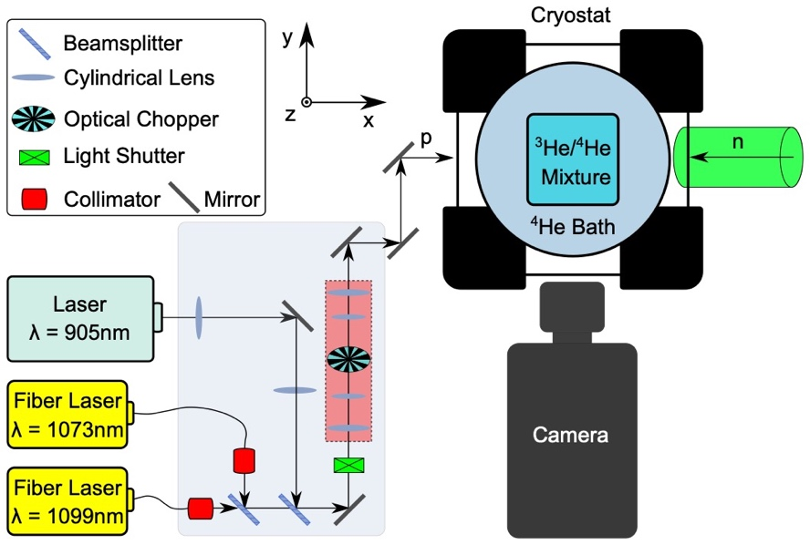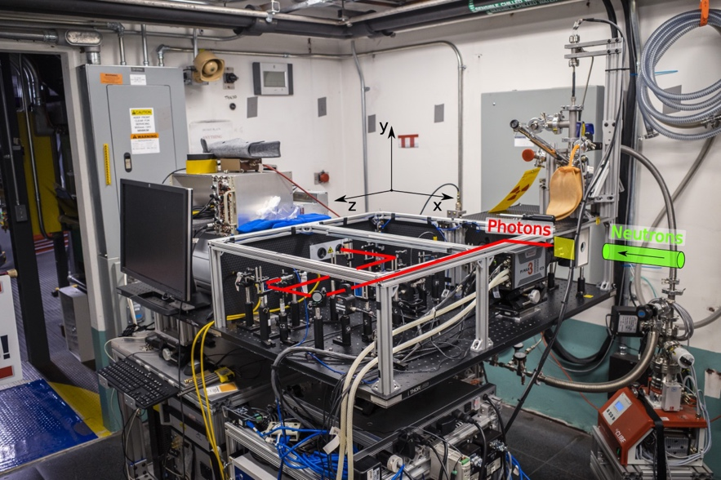
Figure 2.1 (a) Schematic of the experiment. Schematic of the equipment to excite fluorescence of ${He}_{2}^{*}$ excimers, which are created by ionizing radiation produced by neutron capture. Laser light excites the excimer molecules, which fluoresce by emission of 640 nm light. The position and time of the fluorescence is recorded by a camera. The figure is not shown to scale. The dimensions of the entire apparatus measures approximately 120 cm by 75 cm by 30 cm. The camera’s lateral field of view is 5 mm by 5 mm. The focal plane of the camera is ~1 mm thick. The excimer cloud size is ~25 $μm$ (see text) and a camera pixel is ~5 $μm$ by 5 $μm$. (inset) Schematic of the ³He/⁴He reservoir and bulb. (b) Photo of the experiment.

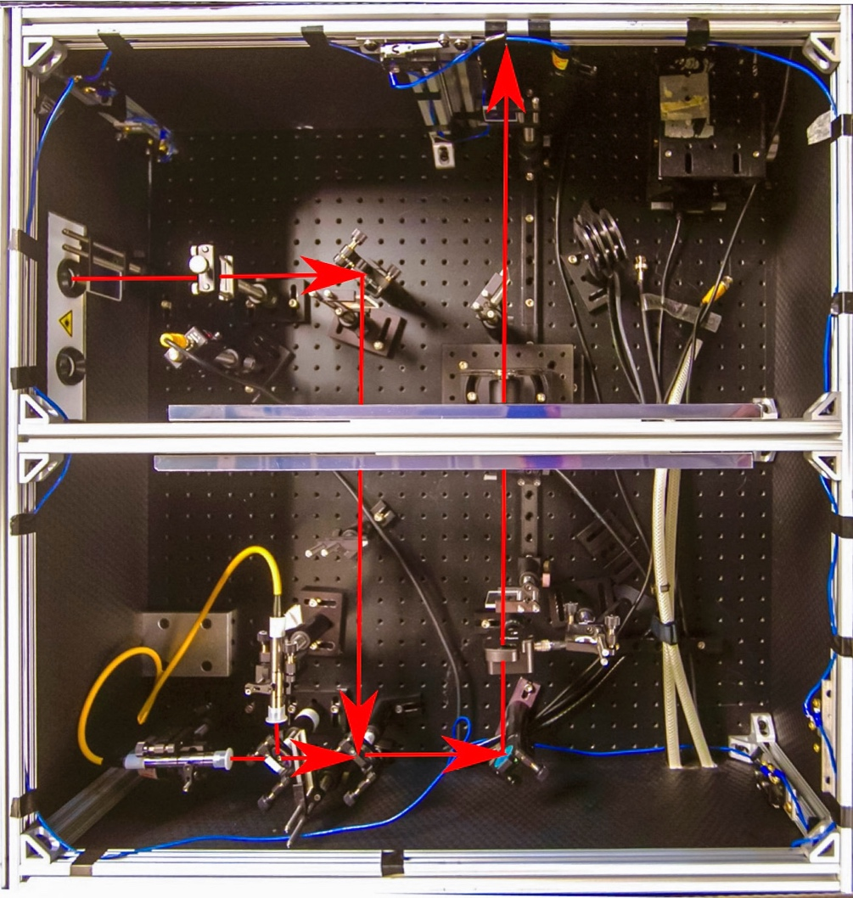
Figure 2.2 A photo of the arrangement of the optical components.

We used a Princeton Instruments PI-MAX 3 1024i camera to record images with resolution ranging from 256 x 256 to 1024 x 1024 mapped onto a field of view measuring 5.5 mm x 5.5 mm. The camera used a 18mm Gen III filmless GaAsP photocathode (HBf) image intensifier, that has P46 phosphor (Y₃Al₅O₁₂:Ce). This intensifier has a quantum efficiency of ~37% for 640 nm photons. The lens of the camera was focused onto the plane illuminated by the lasers. The axis of the camera was perpendicular to this plane and to the neutron and laser beams. A band pass filter transparent to the 640 nm light but opaque to the infrared laser light was installed in front of camera’s CCD to reduce background. Images with pixel sizes ranging from 5.4 $μm$ ($1024 ×1024$ pixels) to 21 $μm$ ($256 × 256$ pixels) were taken over the camera’s 5.5(1) mm by 5.5(1) mm field of view. Data were exported using the vendor’s LightField software.
A Quantum 9520 series pulse generator synchronized the 905 nm laser pulse, camera, a Thorlabs SH05R beam shutter and a Thorlabs MC1F10A optical chopper blade following the timing diagram shown in Figure 2.3.
The pulse generator has 8 channels of signal output. We use channel A to produce a series of reference pulses [see “Reference Trigger” Figure 2.3] with a frequency of 1 kHz. All other channel outputs are referenced to channel A each with different duty cycles, delays, and pulse durations. Because the motor of the chopper takes about 5~8s to accelerate and synchronize to the set frequency and phase, we first send a trigger to warm up the chopper. 10s later, another pulse triggers the beam shutter to open. A laser light shutter opens after ~5 ms, then the light shutter stays open for the whole duration. The first, third and fifth pulses trigger the camera to take three exposures (snapshots)—each a time $t_{1}=478.5 μs$ after the preceding pulse, each with a duration of 10 $μs$.
A laser pulse is initiated a time $t_{2}=480 μs$ after every trigger pulse. The duration of the laser pulse is 4 ns. $t_{2}$ is slightly larger than $t_{1}$ (1.5 $μs$), thus ensuring the snapshots collect the maximum excimer fluorescence while minimizing the collection of light from sources of background (that occur at all times). In addition to the pulsed laser light, light from a pair of continuous wave (CW) lasers also enter the cryostat. The purpose of the optical chopper is to block the CW light from unnecessarily heating the cryostat.

Figure 2.3 Timing diagram of the experimental components

The three infrared lasers have very high power and absorption by the quartz windows of the cryostat can cause the cryostat to warm. During our experiment, we found that the heating of lasers raises the temperature of our liquid quickly and drastically reduces the time to acquire data. Limited by the camera frame rate, the time between two camera exposures is much longer than the actual exposure time. Between exposures, the induced fluorescence emitted from excited molecules is not recorded by this camera. Essentially, laser light between exposures unnecessarily adds heat to our liquid helium bath. By synchronizing the camera exposure with laser pulse and optical chopper, we could shut the laser between camera exposures to minimize the heating. Thus, by keeping the duration of the camera exposure short, we could maximize the ratio of the fluorescence of ${He}_{2}^{*}$ excimers signal to the ambient background.

2.2. Generating excimers
The natural abundance of ³He in ⁴He is too low (0.000137% on earth) to create enough triplet excimers. Therefore, we add ³He to the ⁴He in the cryogenic bath to facilitate neutron absorption. After considerable testing (discussed later), a nearly optimal concentration of ³He/⁴He was determined. Factors that contributed to optimization included: absorption of the neutron beam, neutron wavelength, excimer production throughout the camera’s entire field-of-view, and minimization of ³He to lower cost and to minimize concerns about influencing hydrodynamics of fluid flow due to presence of too many rotons.
We expect the fluorescence to be proportional to the number of excimers, thus, the fluorescence should also be proportional to the neutron flux and $λ$, because these factors determine the production rate of the ionizing radiation which create the excimers. A $1.3 cm × 1.3 cm$ continuous wave neutron beam with $λ=5.48 Å$ and flux $I_{0}= {10}^{4} n⋅s^{-1}{⋅cm}^{-2}$ from beamline CG4B (the Larmor instrument) of HFIR illuminated the helium bath. The opportunity provided by a neutron beam with cross-section of O(10 cm²) is to produce excimers in a O(10³ cm³) volume as opposed to other methods,^{40,41} thus, flow about many parts of a macroscopic sized object could be observed at the same time (with multiple lasers and cameras).

2.3. Helium bath experiment
The first attempt to introduce ³He into the liquid ⁴He was by injecting room temperature 3He gas into the liquid ⁴He from a pre-injection reservoir (a small piece of stainless steel tubing with valves on either end) through stainless steel tubing entering the liquid just above the field of view of the camera. The pressure inside this reservoir was monitored with a pressure gauge. In the early experiments, we controlled the pressure in the reservoir by slowly filling a small amount of ³He gas each time until the pressure research the desired pressure. By controlling the amount of ³He and monitoring the time dependence of the fluorescence, we determined the optimal range of ³He concentration for the experiment. We call the first approach the ‘bath’ experiment because neutron capture happens throughout the liquid helium bath. (Figure 2.4)
Although this method provides flexibility to change the amount of ³He for each measurement, it has many drawbacks. Firstly, in this configuration, the bath was being pumped by a mechanical pump the entire time, making the liquid helium bath’s surface the cooling surface. Thus, the bath does not provide a quiescent environment.
Secondly, the “bath” experiments were difficult to control reliably. The analog (dial) pressure gauge on the ³He pre-injection reservoir lacked accuracy. There will be human and instrumental error when filling ³He based on pressure reading. Later, this motivated use of a mass flow controller. Apart from the pressure error, neither the volume of the pre-injection reservoir nor the volume of the liquid bath (~41 ml) can be measured accurately. The fluctuation of room temperature at HFIR is another cause for error in determining the amount of ³He in the reservoir. These limitations make helium injection too crude to guarantee the consistency of ³He amount for each measurement. Meanwhile, when releasing ³He from the reservoir by hand, the speed of how fast we open the valve is also inconsistent each time, and that may affect our observations. For a couple of experiments, we believe ³He gas was temporarily trapped in the mechanical valve after opening the valve, so the contents of the pre-injection reservoir did not always enter the liquid He bath at once—sometimes resulting in a second small fluorescence peak at after the main peak. Finally, in this configuration, ³He is eventually pumped into the atmosphere after each measurement, making the experiment very expensive.
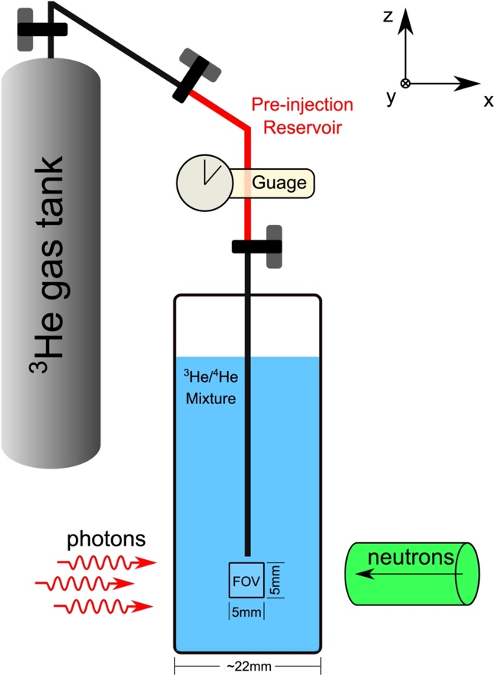
Figure 2.4 Schematic of the “Bath Experiment”. In the ”Bath Experiment”, ³He gas from a pre-injection reservoir was injected into the cryostat with stainless steel tubing just above the field of view, and eventually pumped out.

These limitations led to the second approach which involved inserting a glass bulb (or cuvette) into the liquid He bath and use of a mass flow controller to fill the ³He into a reservoir of ⁴He. Nevertheless, the bath approach had given us a general ideal of how the ³He concentration would affect fluorescence signal that would otherwise would have been cumbersome using the second approach.

2.4. Helium bulb experiment
To overcome the aforementioned challenges, we developed a means to controllably mix ³He and ⁴He in a closed environment and then to allow this mixture to condense inside a glass bulb that was immersed in ⁴He liquid. We designed a glass bulb measuring $1 cm× 1 cm × 3.6 cm$ and inserted it into the liquid He bath [Figure 2.5]. The bulb was connected to a 3.5 liter stainless steel reservoir with a ³He/⁴He gas ratio equal to 1:241 at a pressure of 65 kPa (though later experiments used different concentrations and pressures). Aluminum foil, which is just visible at the top of the cryostat in Figure 2.1(b), prevented light from entering the glass bulb from along the glass pipe (connecting the gas reservoir to the bulb). Outside the bulb is the less quiescent liquid helium bath that was pumped by the mechanical pump to 1.7 K temperatures.
When liquid He condensed in the bath, gas from the ³He/⁴He reservoir condensed inside the bulb. The glass bulb and the steel reservoir are isolated from the helium bath in the cryostat sample space. At low temperatures, the contents of the ³He/4He reservoir condense into the bulb and then above 4.2 K, the mixture vaporizes, while being contained inside the closed reservoir. This configuration enabled us to explore the dependence of the fluorescence on neutron flux of a liquid of constant ³He/⁴He composition and importantly, allowed us to repeatedly take data with recycled ³He.

2.5. Fluorescence signal analysis

2.5.1. Influence of neutron flux and ³He concentration on fluorescence signal intensity
Using the configuration of the helium bath experiment (the original configuration), we investigated the influence of ³He amount on the fluorescence signal intensity. At this point, we only focused on the integrated intensity over the whole field of view instead of the flow.
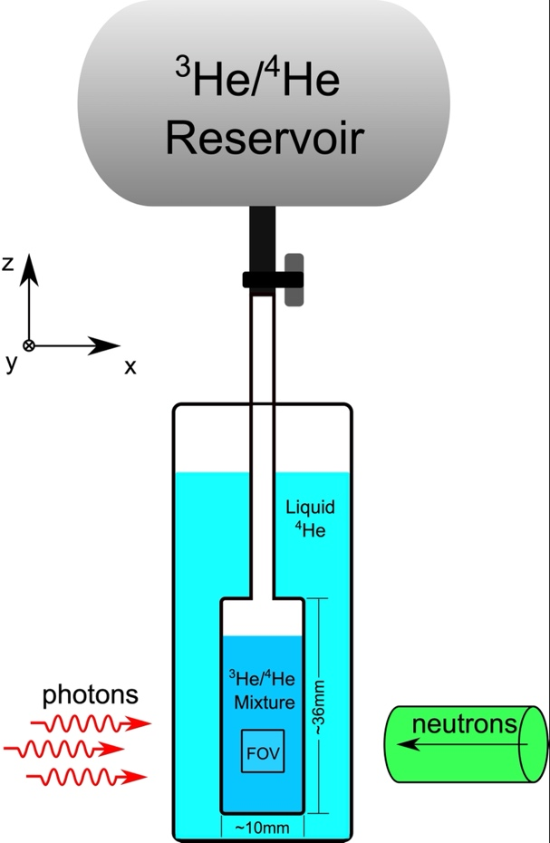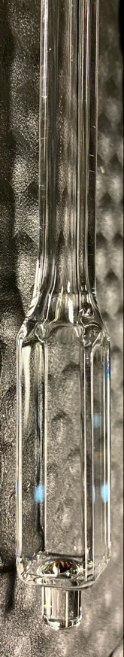

Figure 2.5 (left) Schematic of the “Bulb Experiment”. (right) A photo of the quartz bulb. In the “Bulb Experiment”, a pre-filled ³He/⁴He mixture in a tank condenses inside a quartz bulb that was immersed in the ⁴He bath. The ³He/⁴He ratio was the same for every measurement.

These measurements were taken with the full resolution of the camera (1024 ×1024) and a slow frame rate of about 3~4 frames/second.
The amount of ³He was controlled by tuning the pressure of gaseous ³He in the pre-injection reservoir volume (~15 ml). A series of measurements were taken with continuous neutron flux of $I_{0}= {10}^{4} n⋅s^{-1}{⋅cm}^{-2}$ and $λ=5.48 Å$. The time dependent fluorescence intensity is shown in Figure 2.6 and fitted to Equations (2.1) with results in Table 2.1.
The quantity of ³He corresponding to a 15 ml reservoir pressurized to 0.48 MPa corresponds to $3.2 × {10}^{-3} mole$. The neutron flux is $I_{0}= {10}^{4} n⋅s^{-1}{⋅cm}^{-2}$. The solid curves were obtained from fits of Equations (2.1) to the data,
$Y=\left\{\begin{aligned}E(1-e^{-(t-t_{0})/τ_{3}}), &x<0 \\ F e^{-(t-t_{1})/τ_{4}}+G , &x≥0\end{aligned}\right.$ (2.1)
and the parameters of the equation are shown in Table 2.1 . These data indicate that a $3.4×$ increase of ³He in the liquid He bath yields a similar increase in the fluorescence peak but only about half as much an increase of the steady state fluorescence. The background (corresponding to the 0.00 MPa data) is ~${10}^{9} charge⋅s^{-1}⋅{cm}^{-2}$.
For some of the measurements, a secondary peak was observed at t ~ 20s. One possible reason is that when we open the valve to release ³He gas in the pre-injection reservoir, some of the gas is trapped in the valve and later released.
In Figure 2.7, we show the influence of neutron flux on the fluorescence signal. The neutron flux was tuned by adding sheets of Poly(methyl methacrylate) (PMMA) into the incident neutron beam. PMMA partially absorbs neutrons and scatters neutrons in all directions thus reducing the intensity of the neutron beam (incident on the cryostat). As we lower the neutron flux, the fluorescence decreases correspondingly.
The data shown in Figure 2.7 were collected after introducing $1.4 ×{10}^{-3} mole$ of ³He at time $t = 0$for each measurement. The solid curves were obtained from fits of Equations (2.1) to the data, and the parameters of the equation are shown in Table 2.2. These data indicate that a 20$×$ increase of neutron flux yielded an increase of 4$×$ in the peak fluorescence and an increase of 2$×$ of the steady state fluorescence. Even for the weakest
Figure 2.6 The influence of a fixed quantity of ³He injected into the ⁴He bath on the net fluorescence signal.

Table 2.1 Parameters obtained from fitting Equations (2.1) to data of the variation of ³He pressure in Figure 2.6. The neutron flux is ${10}^{4} s^{-1}⋅{cm}^{-2}$. The number of ³He atoms was calculated for T = 300K, a volume of 15 cm³ for the pressure listed in the table.
³He Pressure (MPa) | 0.14 | 0.21 | 0.28 | 0.34 | 0.41 | 0.48
Number of ³He atoms injected | 5.1 × 10²⁰ | 7.6 × 10²⁰ | 10 × 10²⁰ | 12 × 10²⁰ | 15 × 10²⁰ | 17 × 10²⁰
E (charge·s⁻¹·cm⁻²) | 1.38 (8)× 10¹⁰ | 4.4 (2)× 10¹⁰ | 5.3 (1) × 10¹⁰ | 6.6 (2) × 10¹⁰ | 6.7 (2) × 10¹⁰ | 6.7 (2) × 10¹⁰
τ₃ (s) | 6.6 (8) | 16.0 (9) | 17.0 (8) | 16.4 (6) | 16.9 (6) | 15.5 (-7/+5)
t₀ (s) | -1.8 (8) | -0.6 (3) | -0.7 (3) | -0.4 (3) | -0.4 (2) | -0.6 (2)
t₁ (s) | 9 (1) | 9.2 (4) | 9 (1) | 8.6 (-2/+3) | 10.0 (2) | 10.3 (-2/+3)
τ₄ (s) | 16 (-4/+6) | 11 (1) | 9 (1) | 10 (1) | 6.8 (-4/+5) | 3.5 (-3/+4)
G (charge·s⁻¹·cm⁻²) | 6 (1)×10⁹ | 5.9 (8)×10⁹ | 9.9 (8)×10⁹ | 9.2 (8)×10⁹ | 9.9 (7)×10⁹ | 9.9 (-6/+7)×10⁹
$${χ^{2}(χ}_{υ}^{2})$$ | 27.0 (0.3) | 113 (1) | 111 (1) | 137 (1) | 93 (1) | 70 (1)

Figure 2.7 The influence of neutron beam flux on the net fluorescence signal.

Table 2.2 Parameters obtained from fitting Equations (2.1) to data of the variation of neutron flux shown in Figure 2.7. 0.21 MPa of ³He was loaded into the pre-injection volume.
Neutron Flux (s⁻¹·cm⁻²) | 9853 | 4237 | 1675 | 788 | 493
E (charge·s⁻¹·cm⁻²) | 3.7 (1)×10¹⁰ | 2.1 (1)×10¹⁰ | 1.26 (8)×10¹⁰ | 5.9 (-6/+8)×10⁹ | 3.6 (4)10⁹
τ₃ (s) | 12.6 (5) | 14 (1) | 10 (1) | 14 (-2/+3) | 10 (3)
t₀ (s) | -0.7 (2) | -1.3 (4) | -1.5 (5) | -7 (2) | -10 (-6/+3)
t₁ (s) | 4.5 (2) | 6.7 (4) | 6.3 (6) | 8 (-1/+2) | 9 (-5/+6)
τ₄ (s) | 16 (1) | 5 (1) | 10 (2) | 3 (-2/+4) | 13 (-12/+127)
G (charge·s⁻¹·cm⁻²) | 2.0(5)×10⁹ | 4.1 (3)×10⁹ | 3.0 (4)×10⁹ | 2.6 (3)×10⁹ | 2.6 (4)×10⁹
$${χ^{2}(χ}_{υ}^{2})$$ | 86 (1) | 47 (1) | 38 (1) | 28.0 (0.3) | 30.5 (0.3)

neutron beam (${0.05 I}_{0}$), the signal was larger than background of ${10}^{9} charge⋅s^{-1}⋅{cm}^{-2}$ (corresponding to 0.00 MPa, Figure 2.6).

2.5.2. Raw data and background reduction
After we quantified the influence of the laser and neutron beams and ³He number density on the detection of fluorescence from ${He}_{2}^{*}$. We focused on visualizing the excimers and the flow, to wit, we switched to helium bulb experiment. Unless stated otherwise, all data presented henceforth in this dissertation are from experiments using the glass bulb and ³He/⁴He reservoir.
Movie 2.1 shows 1000 frames collected at 55.6 Hz. Each frame consists of intensity measured by 256 × 256 pixels that are mapped to the camera’s field of view. The reason why we picked resolution of 256 × 256 instead of 1024 ×1024 is that we were limited by the bandwidth of data transmission from the camera to the computer, especially when we tried to achieve higher frame rates. Furthermore, the large size of 1024 ×1024 frame could also taxed our computer memory after recording for a short period of time.
The intensity profiles on the lower and right sides (of the movie) represent the amount of charge integrated along the direction perpendicular to the side of the figure. The quasi-uniform gray color of the image is the ambient background corresponding to the gain setting of the camera and duration of the exposure. Most of the bright spots/regions correspond to excimer fluorescence from a cloud of excimers.
The ambient background of the camera was obtained by performing a 1000-frame long measurement with the local neutron shutter closed. In this configuration, no excimers were produced, so the influence of electronic noise, cosmic and gamma rays, etc. on the camera could be quantified. The mean, $\overline{B}$, and standard deviation, $σ$, of the background measurement were computed.
To obtain images exclusively of excimer fluorescence, the background $\overline{B}$ was subtracted. Next to ensure we consider only excimer fluorescence, we established an intensity criterion such that only events with intensity >4s would be used. The result applied to Movie 2.1⁶⁵ is shown in Movie 2.2⁶⁵. Because Movie 2.2⁶⁵ does not include background that dominated the integration to achieve the profiles for Movie 2.1⁶⁵, the variation of the intensity profiles as a function of position and time on the bottom and right sides of Movie 2.2⁶⁵ is much more dramatic than those of Movie 2.1⁶⁵.

2.5.3. Signal decay and steady state
Next, we focused on the time dependence (decay) of the (excimer) signal. A background image was measured from the camera under conditions without laser light or neutrons. Figure 2.8 is the net signal (signal image – background image) integrated over the entire field of view as a function of time. In this figure we show two measurements. For the first measurement (red in Figure 2.8), the process involved cooling the liquid He to 1.7 K, opening the neutron beam shutter, then after about 4 seconds turning on the lasers and camera. The red curve shows the variation of the net signal with time for the conditions of the lasers and neutron beams on. The decay of the net fluorescence signal, Z, was fitted to
$Z\left(t\right)=A e^{-t/τ_{1}}+B$ ( 2.2)
where $t$is time, $τ_{1}$is decay time and A and B are constants. $τ_{1}$, $A$ and $B$ are parameters that were adjusted to optimize the goodness of fit metric $χ^{2}$. The solid red curve is the result of fitting which yielded: $τ_{1}=2.4\left(2\right) s$, $A=4.0\left(2\right)× {10}^{10} charge⋅s^{-1}⋅{cm}^{-2}$, and B $=2.24\left(4\right)× {10}^{10} charge⋅s^{-1}⋅{cm}^{-2}$ with $χ^{2}=270 (χ_{υ}^{2}=0.3)$. These data demonstrate detection of fluorescence when ³He is present and laser and neutron beams are on. The net signal decays to a non-zero steady state value $\left(=B\right)$ (not to be confused with the mean background $\overline{B}$). Thus, fluorescence is present, yet with time, there is an initial loss of efficiency in producing and/or detecting fluorescence. The loss may be due to some excimers being trapped in the metastable vibrational states (the a₁ and a₂ states), and lack of power from the repumping lasers to drive the excimers out of the vibrational states. Later, with higher power repumping lasers wavelengths better optimized to empty the vibration states, we observed significantly less decay.
The data shown in the black curve of Figure 2.8 were collected beginning with the lasers and camera on and the neutron beam off. After ~11 s, the neutron beam shutter was opened (the shutter opens in < 0.5 s). The increase of the net fluorescence signal, R, was

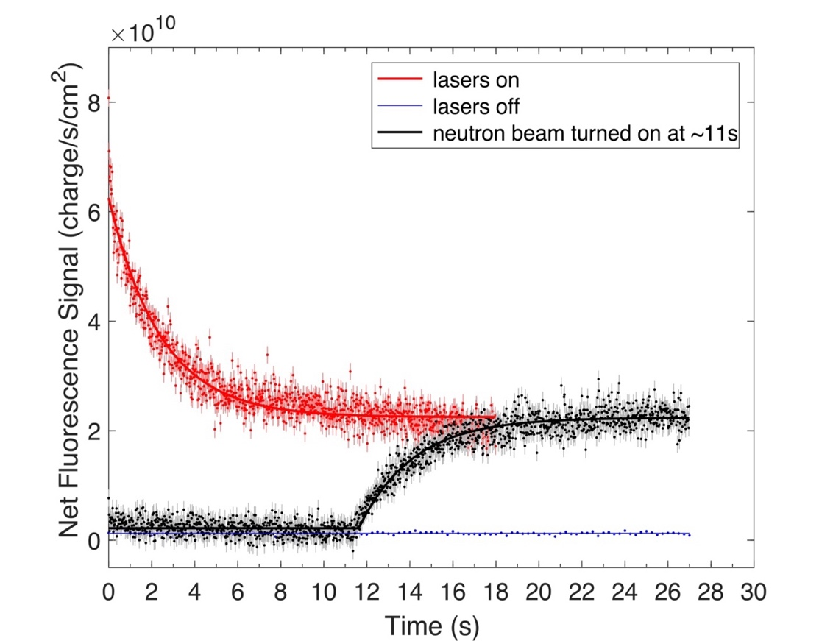
Figure 2.8 The net fluorescence integrated over the camera’s field of view as a function of time. (red) For neutron beam continuously on and for lasers turned on at time = 0. (blue) For neutron beam on and lasers off. (black) For lasers on, neutron beam off and then turned on at time ~11s. The bars represent 3-$σ$ errors. The solid curves are fits to functions discussed in the text.

fitted to the function that is the integral of the $e^{-t/τ}$ portion of Equation (2.2) from $t_{0}$ to $t$. The result is
$f\left(x\right)=\left\{\begin{aligned}C , &t<t_{0} \\ D\left(1-e^{-(t-t_{0})/τ_{2}}\right)+C, &t≥t_{0}\end{aligned}\right.$ (2.3)
with values of: $τ_{2}=2.8\left(3\right) s$, $C=2.2\left(4\right)× {10}^{9}{ charge⋅s}^{-1}⋅{cm}^{-2}$, and $D=2.02\left(6\right)×{10}^{10}{ charge⋅s}^{-1}⋅{cm}^{-2}$ for $χ^{2}=188 (χ_{υ}^{2}=0.2)$. $C$ represents an underestimation of the background used in subtraction from the raw image. $B \sim C+ D$, thus, the strength of the fluorescence at steady state is nearly the same for the two protocols. The variation of the black data from zero (neutron beam off) to a non-zero value (neutron beam on) shows that neutron illumination of the ³He/⁴He mixture is a necessary condition to produce fluorescence. The blue curve of Figure 2.8 shows the net signal integrated over a long camera exposure time for the case of the neutron beam on and the lasers off. The data in Figure 2.8 show that laser illumination of the excimers is required to observe their fluorescence.
Focusing on the red data in Figure 2.8, the decay of the signal can be understood in terms of the neutron beam first creating a large abundance of ${He}_{2}^{*}$ excimers, which primarily occupy the triplet a₀ state shown as in Figure 1.4, because the lasers are not yet on. The concentration of excimer clouds can be estimated to be $A_{0} \sim {10}^{4} clouds/{cm}^{3}$ from the beam flux, the time of a few seconds (4 s) prior to turning on the lasers, and the volume of the bulb. Excimers were confined to the liquid inside the bulb. Because the neutron absorption length of 0.4% ³He in liquid ⁴He is large $μ=2 {cm}^{-1}$ for $λ=5.5 Å$, 63% of the excimer production occurs in the region of the bulb outside the field of view of the camera as the neutron beam enters the bulb. 23% of the excimer production occurs inside the field of view.
Next, the lasers were turned on to produce fluorescence of the excimers. For the conditions of our experiment, we find the steady state fluorescence signal is ~33% of the maximum. The steady state value is achieved about 2.4(2) s after the lasers are turned on.
Focusing on the black data in Figure 2.8, the increase of the signal can be understood in terms of the absence of excimers ($A_{0}=0 excimers/{cm}^{3}$) before the neutron beam is turned on. Once the neutron beam is turned on, ${He}_{2}^{*}$ excimers are created, and in the presence of laser light they fluoresce. With time, more excimers are created, yet because the fluorescence does not increase unabated, i.e., achieves a steady state, there must be a competition between the production of excimers capable of fluorescence (those in a₀ state) and loss of these excimers. Equations (2.3) represents the strength of the fluorescence at time $t > t_{0}$, from the superposition of excimers created before $t$ that decay with the time scale of $τ_{2}=2.8\left(3\right)s$.
Because only the initial conditions of the two protocols (red: neutron exposure before laser illumination, black: laser illumination before neutron exposure) were changed, we expect the two protocols to achieve the same steady state values. Further, because the steady state value is controlled by the rate active excimers are lost, the decay times for the two protocols should be the same. The steady state values achieved by the red and black data in Figure 2.8 ($=B \sim C+D$) could be increased were the decay time longer. Presently the decay time is ~3 s, yet the excimer half-life is 13(2) s.⁵² Later, with repumping lasers of higher power, we increase the steady state value of fluorescence by 50%.

2.5.4. Time dependence explained in terms of a Resistor-Capacitor model
The time dependence of the fluorescence can be represented in the same manner as charging and discharging of a simple resistor-capacitor (RC) circuit. Similar to Equations (2.2) and (2.3), in a RC circuit, the charge in the capacitor as a function of time can be given by for discharging and charging.
$q\left(t\right)=Q_{F}\left(1-e^{-\frac{t}{RC}}\right)+Q_{0}e^{-\frac{t}{RC}}$ (2.4)
$$q\left(t\right)=Q_{F}\left(1-e^{-\frac{t}{RC}}\right)$$
$$Q_{F}=Cε$$
where $ε$ is the supply voltage, $Q_{F}$ is the maximum charge, $Q_{0}$ is the initial charge in the capacitor, $R$ is the resistance, $C$ is the capacitance of the capacitor, $ε$ is the supply voltage, and $τ≡RC$ is the time constant of the RC charging circuit.
The red curve in Figure 2.8 is the discharging of the capacitor while the black curve is the charging curve. The difference between the red and black curves is whether there is an initial charge on the capacitor. The neutron beam is analogous to the electromotive force or a source of charge. The laser plays the role of the switch that controls on and off for the fluorescence signal. The excimer fluorescence is analogous to voltage across the capacitor. The losses of excimers (such as flowing out of field of view, trapped in a₁ and a₂ states, etc.) are represented by the resistor. And the charge in the capacitor is the excimer fluorescence.

2.5.5. Size of a typical event measured from experiment at Larmor
From the movies (an example is Movie 2.1⁶⁵), we quantified the intensities, sizes, and positions of the excimer clouds as a function of time. Clouds of fluorescence consist of charge recorded by the camera in a region of pixels numbering from one to several. Because the charge integrated over the field of view is dominated by background and not the occasional fluorescence, the mean of the entire measurement, $ϕ$, and the standard deviation above the mean, $σ$, were used to quantify the background. Events with peak intensity 4-$σ$ greater than $ϕ$ were identified, and $ϕ$ was uniformly subtracted from the images. For data recorded from an exposure with 1024 × 1024 pixels, approximately 2000 events per frame were identified, and about 70% of these correspond to clusters of two or more pixels. In a region of interest (ROI) that was stepped across an image, the center of mass (CM) of a single event or cluster, the standard deviation of the CM, $σ_{CM}$, and the net charge of the cluster (i.e., charge greater than $ϕ$) integrated within ${2σ}_{CM}$ of the CM were computed for each event/cluster. (In chapter 3, we describe a different approach involving application of machine learning to identify excimer clusters.) The number of events versus net charge integrated over the duration of the exposure is shown in Figure 2.10 (a) (single pixel events are shown as gray). The size distribution of clusters corresponding to two or more events (numbering 90,725) in close spatial proximity (but not in the same pixel) and occurring at the same time is shown in Figure 2.10 (b). The clouds are isotropic given the similar distribution along x and z direction. The average of the size distribution is $25\left(3\right) μm$. This average is within the range of 15 to 59 $μm$ expected from the mean free path of tritons and protons in liquid He⁴⁵ and may represent a dimension characteristic of a cluster of ${He}_{2}^{*}$ excimers. If the path length is assumed to be a top-hat function, the rms width of the path
Figure 2.9 An analogy of time dependent fluorescence to an RC circuit

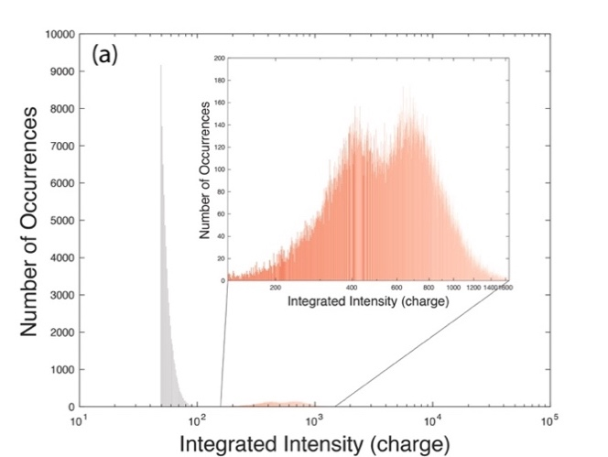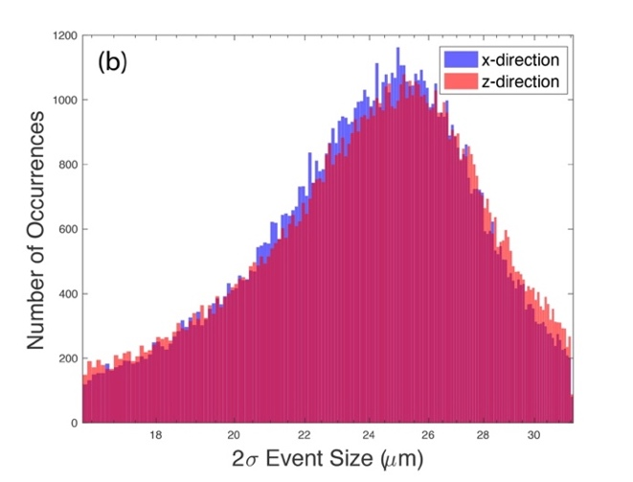
Figure 2.10 Distributions of (a) integrated intensity and (b) size of events. Data are recorded in a field of view mapped to 1024 × 1024 pixels in 50 exposures of $10 μs$ each.

is $\frac{15μm+59 μm}{\sqrt{12}}=21 μm$. The mean size we observe is consistent with the rms width of the ionization trail.

2.5.6. Efficiency of excimer production using neutron beams compared to electrostatic discharge
Before moving our experiment to HFIR’s neutron beam, we performed an electrostatic discharge experiment to check our laser alignment and timing sequence. A tungsten needle was placed in liquid ⁴He, just above a few millimeters above a copper plate near the bottom of the liquid. The tungsten needle and copper plate were connected to a high voltage supply. We slowly raised the voltage applied to the tungsten needle until the breakdown voltage was reached, i.e., until current became non-zero. In this experiment, the breakdown voltage was 1300V. Excimers suddenly appeared when breakdown occurred and the current measured to be 6 nA.
We can define the excimer production efficiency as the fluorescence signal current produced per 1 joule of energy deposited into the system. For the electrostatic discharge experiment, the energy deposited into the liquid can be straightforwardly calculated as Current $×$ Voltage $×$ Total exposure time 22 nJ. The fluorescence measured in the discharge experiment was on the level of 6$×{10}^{10}$ $counts∙s^{-1}∙{cm}^{-2}$. And the efficiency for the electrostatic discharge method is 2.75$×{10}^{18} counts∙s^{-1}∙{cm}^{-2}∙J^{-1}$.
For the neutron experiment, the energy deposited by the neutron can be inferred from the number of neutrons absorbed in the liquid and the energy of ionizing radiation—764 keV. The neutron absorption rate can be calculated using $R = ρ_{{}_{}^{3}{He}}I_{0}σ$, where $ρ_{{}_{}^{3}{He}}$ is ³He number density, $I_{0}$ is the neutron flux and $σ$ is ³He cross section. With this, we calculated the bath experiment efficiency to be 0.44~3.06$×{10}^{22} counts∙s^{-1}∙{cm}^{-2}∙J^{-1}$ and the bulb experiment efficiency to be 1.05$×{10}^{23} counts∙s^{-1}∙{cm}^{-2}∙J^{-1}$.
Comparing the fluorescence signal level from electrostatic discharge experiment with neutron experiment, the neutron absorption method is ${10}^{3}\sim {10}^{5}$ times more efficient than the electrostatic discharge in creating excimers. The inefficiency of electrostatic discharge is largely due to that energy that is dissipated in a very localized region that creates visible bubbles, thus, evidence for energy being spent to make heat.

2.6. Summary
Conclusions:
- Using the Larmor beamline at HFIR, we demonstrated the ability to create numerous ${He}_{2}^{*}$ excimers corresponding to the excimer cloud density of 10⁴ /cm³ in a ~ 10 cm³ volume of liquid He.
- The fluorescence from the excimers was captured in images of clouds measuring ~25(3) $μm$ in diameter and numbering ~34 per image in a 0.03 cm³ volume defined by the camera’s field of view and the 1 mm thickness of the focal plane illuminated by the lasers. This calculation suggests ~10% of the excimer production contributes towards excimer fluorescence. From Movie 2.2⁶⁵ the sample density (of fluorescence from clouds or clusters of ${He}_{2}^{*}$ excimers) in the region across the camera’s field of view is approximately one per mm². The uncertainty in the extraction of the positions of centroids of the events, i.e., the spatial resolution of the technique, was ~5 $μm$.
- We investigated the influence of neutron flux and ³He concentration on the fluorescence signal.
- We compared excimer production via electrostatic discharge and the neutron beam method. Not only could we produce ${He}_{2}^{*}$ excimers a ~ 10 cm³ volume, comparing to electrostatic discharge, which produces excimers in a very confined region (~mm³), the neutron absorption is ${10}^{3}\sim {10}^{5}$ times more efficient in producing ${He}_{2}^{*}$ excimers.
Challenges encountered and surmounted:
- By using the bulb configuration, we prevented the loss of ³He and solved the lack of inconstancy of ³He/⁴He concentration.
- The bulb also mitigated unwanted flow of the liquid compared to the bath configuration.
- Overheating of the helium bath was mitigated using an optical chopper to block unnecessary heating between camera exposures.
- By using a mass flow controller, we achieved accurate control of the amount of ³He to add to the ⁴He closed reservoir.
- The steady state rate of Larmor experiment was limited by the loss of active excimers—those capable of being excited to fluoresce. The decay time of ~3 s is much less than the 13 s half-life of the excimer. Using lasers with higher power and optimal wavelength, we reduce the decay of the fluorescence signal by 50% percent.
Outstanding challenges:
- From the technical perspective, the spatial and temporal resolutions are limited by the speed of the camera, and the lack of a large fast buffer to store data.

Demonstration of flow created using thermal counterflow
In Chapter 2, we introduce our original proof of concept experiment with which we demonstrate the ability to of create and visualize ${He}_{2}^{*}$ excimers with neutrons and lasers in a ~10 cm³ volume of liquid He. Although limited by some technical issues, we quantitatively studied the factors that affect the intensity of the fluorescence signal. In subsequent experiments, we surmounted some of the technical limitations and turned our focus to induce and control the flow of ${He}_{2}^{*}$ excimers. We will discuss the experimental upgrade and the data analysis method we developed for the new challenge.

3.1. Upgrades in the thermal counterflow experiment

3.1.1. Wire heater
The major upgrade, serving the core function of the counterflow experiment, is a heater made of a 37cm long 32 AWG Lakeshore Nichrome Heater wire wrapped around a 1/16” diameter G10 fiberglass rod. The rod and heater were inserted into the glass cell terminating just above the bottom of the cell. Also installed on the G10 rod was a temperature sensor. The heater position is adjusted so that it is right beneath the camera’s field of view, and the temperature sensor is above the field of view. The heater is powered by a Keithley 2614B source meter through two 32-AWG Lakeshore Quad-wire cryogenic wires that have relatively high resistivity for wire (so as to mitigate thermal conduction). When power is applied to the heater, the normal fluid component transports the heat (entropy) from the heater towards cooler parts of the cell. This creates a flux of heat that produces a gradient of temperature from heater to the cell boundaries and a flux of the normal fluid component (from hot to cold). Conservation of momentum requires the superfluid component to flow in the opposite our counter direction (without transporting heat because of its superfluid properties), hence, the process is called thermal counterflow. Thermal counterflow,, is critically important in cryogenic applications such as cooling superconducting cavities, spacecraft, etc.

3.1.2. Local neutron shutter
At the Larmor instrument (Chapter 2), the manual opening and closing of the neutron beam produced inconsistent operation of the experiment. In addition, our subsequent worked involved using Beamline 4A at the Spallation Neutron Source, and for this beamline the shutter requires a few minutes to cycle from open to close. Since the control systems of the neutron beamline and our equipment are independent, we required a separate (local) neutron beam shutter. To address these problems, we added a small neutron shutter just in front of our cryostat. This local shutter was integrated into our control system. Thus, our instrument control program, could remotely and quickly open and close the local shutter.

3.1.3. Broad neutron wavelength spectrum
The neutron source at BL4A has a wide spectrum of wavelength from ~2-14 Å compared to a fixed wavelength of 5.48 Å at Larmor (HFIR). With BL4A, we can select a small band ~3 Å (limited to the 60 Hz frequency of the accelerator and distance from source to the cryostat) of neutron wavelength with a neutron disk chopper.
The choice of the neutron wavelength band affects the neutron absorption rate. The absorption rate scales with flux $ϕ_{s}$ and wavelength (see Appendix 1). The neutron absorption rate per unit volume can be calculated using$R= ρ_{{}_{}^{3}{He}}ϕ_{s}σ$ and the cross section of ${}_{}^{3}{He}$ for neutrons $σ$ can be empirically calculated using: $σ\left(λ\right)=5333\left(\frac{λ}{1.8Å}\right)barns/atom$. However, the nearly fully moderated neutron flux is inversely proportional to wavelength (Figure 3.1), thus, a compromise is required in order to maximize neutron absorption by the 3He. We tested various wavelength bands and found that $\overline{λ}=4.3 Å (±1.5Å)$ yields the strongest excimer signal.

3.1.4. Boron-Nitride (BN) neutron absorber
A 6.4-mm thick plate of boron-nitride (BN) (an effective neutron absorber) was placed on the front surface of the cryostat to block the neutron beam from entering either the top or alternately the bottom half of the glass cuvette to form a neutron shadow. There are no excimers created in the shadow of the neutron beam. Thus, fluorescence observed in the
Figure 3.1 Neutron spectrum of measure at beamline 4A of Spallation Neutron Source.

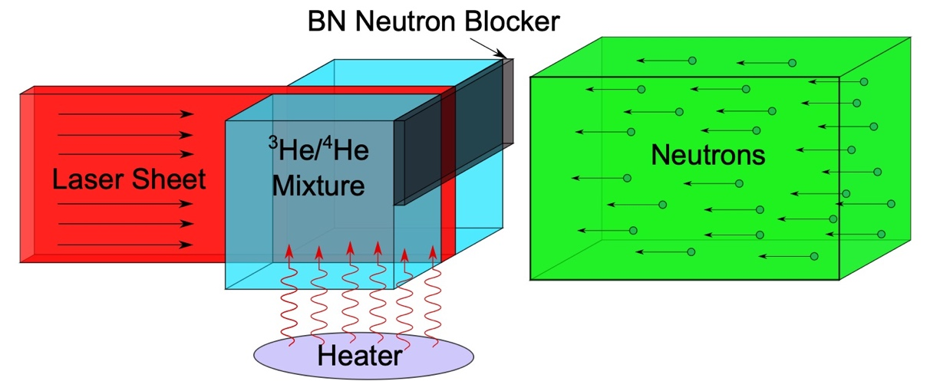
Figure 3.2 Schematic of thermal counterflow experiment. A laser sheet (red) ~10 mm high by 1 mm thick illuminated a quartz cell of liquid ³He/⁴He mixture (cyan) from the left. A collimated neutron beam (green) ~12 mm high by 8 mm thick consisting of wavelengths ranging from 2.8 Å to 5.8 Å irradiate the liquid from the right. The focal plane of the camera lies within the laser sheet, and the field of view was adjusted to be 1cm by 1cm. A neutron blocker (gray) made of Boron Nitride (BN) shadows the upper half of the liquid mixture so that ${He}_{2}^{*}$ excimers are only created in lower half of the cell. ${He}_{2}^{*}$ excimers. A heater (purple) installed below the field view is the source of heat that causes flow of normal component upwards. The excimers track the motion of the normal component flow and so drift upwards. Only excimers illuminated by the laser can fluoresce.

neutron shadow must originate from excimers that moved from the neutron-illuminated region into the shadow.

3.2. First glance of normal component flow

3.2.1. Data processing and background removal
Before processing the raw data, we established a new protocol to improve measurement of the background recorded by the camera. Sources of background include electronic noise, gamma and cosmic rays, etc. Previously, we removed the background by subtracting a single-frame background taken by the LightField software⁶³ when the lasers were turned off and the neutrons were off. A single-frame background, or one random sample is not necessarily representative of the background recorded during excimer fluorescence. In our new protocol, a typical experiment involved collecting two datasets. The first, called the “Raw Dataset”, recorded ~1000 images at a rate of 55.6 Hz. For Raw Dataset, the three lasers were on, laser shutter open, neutron beamline shutter open and local (fast) neutron shutter open. The liquid ³He/⁴He mixture was condensed in the bulb. The second, called the “Background Dataset”, recorded ~1000 images in the same manner as the Raw Dataset except the local neutron shutter was closed. This ensured no excimers were produced by the cold neutron beam, while contributions of electronic noise, cosmic and gamma ray interactions with the camera etc. to the data were the same for both measurements. In fact, we observed a slightly higher background level with this configuration compared to the lasers off case. The per-frame mean of the 1000-frame background was subtracted from the signal data (i.e Raw Dataset).
The signal in the Background Dataset was reasonably uniform equivalent to ~600 (arbitrary units for a fixed value of camera gain) per pixel. Occasionally in the field of view ~2.6% pixels were persistently on, i.e., always had a very large signal. These pixels were flagged as defective (camera) pixels and were not used in our analysis. From the remaining pixels we calculated the mean signal per frame, $\overline{B}$, and the root-mean-square of the distribution, $σ$.
Next, we calculated the net signal above background which is the difference between Raw Dataset and $\overline{B}$. We call the result “Net Dataset”. In Movie 3.1⁶⁵, we show a movie of
(a)
(b)
Figure 3.3 Movie frames of the fluorescence recorded by the camera’s field of view as a function of time (2-s integration time). (a) No heater power was applied. (b) 7.3mW heater power applied. The background noise has been subtracted. The neutron shutter was opened at 5 s, the laser shutter opened at $t_{l}=10$ s, and the bottom heater energized at $t_{h}=12$ s. All excimers are first seen in the region where the vertical position is < 0 because no neutrons enter the vertical region > 0. After the bottom heater was energized (7.3 mW), the thermal gradient caused the normal component of He II to move upwards. The vertical shadow near the center of field of view is the shadow of our sample rod that holds the heaters. The color bar scale represents the net signal (above background) of a pixel recorded by the camera. Movie 3.1⁶⁵ is the mp4 format of the movie is uploaded to Github repository⁶⁵.

Net Dataset (heater power = 7.3 mW) integrated over a 0.5 s time window. N.b., the integration serves only to provide visual clarity for the movie in Movie 3.1⁶⁵ the integration was not used in analysis of the data. In Figure 3.3, we show 6 frames of a movie with no heater power applied (Figure 3.3 (a)) and 6 frames of the Movie 3.1⁶⁵ with 7.3mW power applied (Figure 3.3 (b)). Each frame is integrated over a 2 s window.
The fluorescence integrated across the horizontal dimension of the camera (i.e., for each image in the Movie 3.1⁶⁵) is plotted as a function of vertical position and time in Figure 3.4. The region of the cuvette in the neutron shadow corresponds to vertical position > 0.5 mm relative to the center of the field-of-view at 0 mm. The neutron beam was turned on at time = 5 s, and the recording started at time = 8 s. Once the neutron beam was turned on, excimers form in the neutron-illuminated region (laser light enters the cryostat from the side opposite to the BN neutron beam blocker, so only the neutron beam is blocked). The lasers were turned on at $t_{l}=10$s, and fluorescence was immediately observed. Fluorescence is absent for vertical position > 0.5 mm for time < 12 s. The heater was turned on at $t_{h}=12$ s. Shortly thereafter, fluorescence was observed in the neutron shadow, and the fluorescence moved to larger vertical positions with increasing time. Eventually, the field-of-view became saturated with fluorescence [Figure 3.4 (right)].
The red line in Figure 3.4 represents the peak of the fluorescence that is indicative of flow. To obtain the line, we fitted Gaussian profiles in the direction perpendicular to the line along its length. The fitting optimized parameters of the Gaussians, e.g., width and amplitude, background, and importantly the slope and intercept of the line. The inverse of the slope is the component of the velocity of the normal fluid flow along the vertical direction (corresponding to positive vertical position in Movie 3.1⁶⁵).
We fitted the slopes of the stripes to data for power ranging from 0 to 29 mW. Shown in Figure 3.5 is the normal fluid (vertical) velocity as a function of heater power. The error bars represent uncertainties of the linear fits (corresponding to “red lines” for each power) to the data. Landau and Lifshitz⁹ provide an equation $q= ρsTv_{n}$, that relates the heat flux, $q$, to normal fluid velocity, $v_{n}$, , through the mass density of liquid He,$ρ$, its entropy, $s$, and temperature, $T$. We estimated a value of $q$ as the ratio of the heater power, $P$, to the surface area of the coil of $A=2.4$ cm². Using values of$ρ=1.452 g/{cm}^{3}$, $s$
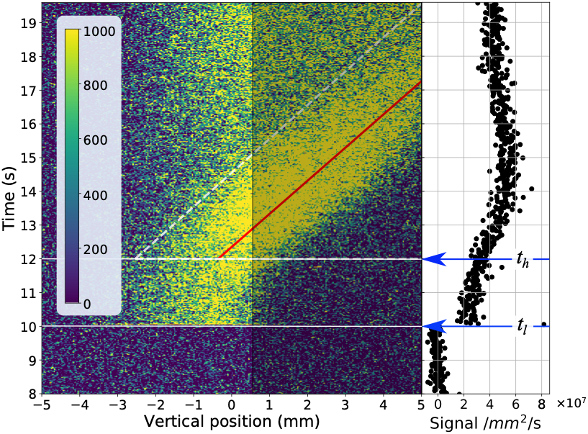
Figure 3.4 (left) Excimer fluorescence integrated across the horizontal field-of-view per second recorded versus time and vertical position. Only the region for < 0.5 mm is illuminated by the neutron beam. The red line is the best fit to the peak of the fluorescence position vs. time. The inverse of the slope of the red line is the velocity of the flow for a heater power of 7.3 mW (this case). (right) Fluorescence integrated over the entire field-of-view vs. time. The neutron shutter was opened at 5 s, the laser shutter opened at $t_{l}=10$ s, and the bottom heater energized at $t_{h}=12$ s.

Figure 3.5 Mean velocity of fluorescence motion (aka fluid flow) vs. heater power. The error bars represent the uncertainty of the fitted velocities (for example the uncertainty of the slope of the red line in Figure 3.4). The green line was obtained using Landau and Lifshitz’s equation for heat flux in He II,⁹ $q= ρsTv_{n}$, and the blue line is the best weighted fit to the data with slope of 0.09(1) m/J.

$=0.236 J/g∙K$ for T = 1.55 K, we calculated the expected value of $v_{n}$ vs. power $\left(v_{n}=\frac{1}{AρST}P\right)$, which is shown as the green line in Figure 3.5. The blue line is the error-weighted best fit to the data subject to the constraint $v_{n}=0$ for $P=0.$ Because not all windings of the coil were fully exposed, the effective surface area of the coil in the experiment is less than our estimate of $A$, consequently, the slope [= 0.09(1) m/J] of the fitted line (blue) is somewhat larger than $v_{n}(P)$ (green line).
Using Net Dataset and the peak finding python routine: photutils.detection.find_peaks
we located all peaks in Net Dataset with signals greater than 4$σ$. Our call to this routine:
photutils.detection.find_peaks(array, threshold = dthreshold, box_size = 5) with dthreshold = 4$σ$ = $4 ×15$.
This result produced a list of excimer peaks as a function of position across the field of view and as a function of frame number, which is a proxy for time. Shown in Figure 3.6 are images of sequential frames for which excimer fluorescence was greater than four times the standard deviation of a background measurement (a measurement with the local neutron shutter closed so no excimers were produced), >4s. Such excimer fluorescence is called an excimer peak. Each frame contains ~80 peaks (or records of 80 photons) over the 1 cm² view. An entire series of 1000 such frames is shown in a movie, Movie 3.2⁶⁵ for one experiment (heater power 7.3 mW).

3.3. Application of velocimetry techniques to infer flow directly from excimer light
Particle tracking velocimetry (PTV),, and particle image velocimetry (PIV),,, are common and mature techniques to study flow velocity field in fluid study. PTV is used to track motions of individual particles, so its use is constrained to a relatively small numbers of particles. PIV is used when the number density of particles is much higher, and it measures the means displacement of groups of particles. PIV and PTV are used in different situations with unique requirements for the algorithms to work properly. We investigated these requirements and performed a series of simulations of flow to test the methods. We found that the two methods cannot be applied to infer flow from direct

Figure 3.6 Images of events identified in two sequential frames (heater power 7.3 mW). Each frame contains ~80 events (or records of 80 photons) over the 1 cm² view. These events all have intensity > 4s above the background. Given that the trajectory of an emitted photon is random, an excimer that produce a photon captured in Figure 3.6 (left) has only a 1 in 42 chance to produce a photon in the second frame, Figure 3.6 (right).

observations of excimer peaks (later we discuss a form of PTV to track centroids of excimer clusters).
Because the trajectory of an emitted photon is random, given the small solid angle subtended by the camera lens (Figure 3.7), there is only a 1 in 42 chance that an excimer producing a photon recorded in one image (Figure 3.6 (right)) is the same excimer that produced a photon recorded in previous frame (Figure 3.6 (left)) for the conditions of our lens, aperture and camera. Thus, the two images of excimer peaks are unlikely to be correlated.
To quantify how unlikely, we simulated random configurations of tracers of varying number imposing known displacements of the second configuration relative to the first. We calculated the cross-correlation of the two configurations for various sizes of Eulerian grids. Shown in Figure 3.8 is the success rate called the “Valid Detection Probability”^{77,78} (VDP) which identifies the likelihood that the cross-correlation is strongly peaked at the position of the imposed displacement. The VDP is plotted vs. the product of the number density of pairs of the same tracer from one frame to the next (normalized by the area of the grid element), $N_{i}$, the fraction of image pairs (from the same tracer) that exhibits displacement parallel to the field-of-view and remain in the same grid element, $f_{i}$, and the fraction of pairs that do not move away from the focal plane of the field-of-view, $f_{o}$. If the product $N_{i}f_{i}f_{o}$ is large enough, then VDP approaches unity. We show two calculations that illustrate how the VDP is affected by choice of grid size (Figure 3.8 (a)) and magnitude of the displacement (Figure 3.8 (b)). Our calculations are consistent with those in Ref. [77,78]. Taking as an example of a successful application of PIV, we estimate from the movie provided in Ref. [55] there are 1600(100) tracers covering a 4 cm² field-of-view from which a velocity vector field was obtained for a grid divided into ~36 by ~36 elements. Using these values, we estimate $N_{i}=1.23(8)$ per grid element or 400(25) per cm² and assuming $f_{i}= f_{o}=1$, the product $N_{i}f_{i}f_{o}$ yields a VDP >0.5. For our experiment, we observe ~ $O\left({10}^{2}\right)$ excimer events (tracers) in each frame covering the 1 cm² area of the plane illuminated by the laser, i.e., $N_{i} \sim O\left({10}^{2}\right)$ per cm². (The power of our laser is sufficient to excite all excimers in the illuminated plane so there are many more excited excimers, yet most do not emit photons that enter the camera’s lens.) Assuming a grid size
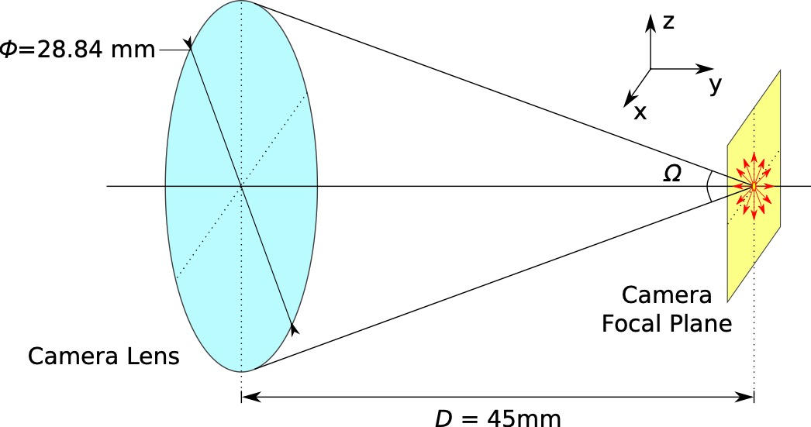
Figure 3.7 Solid angle subtended by the camera lens $Ω = 0.3 rad$. The probability that an emitted photon enters our camera lens is given by $Ω/4π≃1/42$.

Figure 3.8 A simulation of the Valid Detection Probability (VDP) vs. the effective number of particle-image-pairs in the interrogation window using a cross-correlation function. (a) shows the effect of interrogation window size on the VDP, and (b) shows the VDP with different imposed displacements of the tracer particles.

equal to that of Ref. [55], or 18 by 18 (for 1 cm²), and accounting for the probability of 1/42 that the same excimer emits photons captured by the camera in sequential frames, then at most $N_{i}f_{i}f_{o}\sim O\left({10}^{-2}\right)$ per grid element, consequently, the VDP is near zero. For the conditions of our experiment, we do not expect PIV to be successful if applied to fluorescence from individual excimers (i.e., transiently visible tracers) and confirmed as much applying openPIV software to our data.
The reliability of cross-correlation scales with the “Valid Detection Probability” (VDP). Even with the best choice of interrogation window size and the smallest tracer displacement, the effective number of particles image pairs $N_{i}f_{i}f_{o}$should be > 3. For our experiment, if we regard individual excimer events, the effective number of image pairs is only $N_{i}f_{i}f_{o}\sim O\left({10}^{-2}\right)$ per grid element. Thus, we cannot apply PIV and cross-correlation to individual excimers. Instead, we are motivated to apply PTV techniques to track flow represented by motion of excimer clusters.

3.4. Clustering and the correlator metric
Electrons produced by electric discharge from needles³⁹ or laser induced ionization³⁰ are means to initially produce high densities (e.g., $1.4×{10}^{9}/{cm}^{3}$ ³⁹) of excimers in very localized regions (e.g., ~0.005 cm³, see Figure. 2 of Ref. [40]), although Penning ionization of the excimers is expected to reduce the density with time. The images of fluorescence in Ref. [30] are well-defined and typical of all other approaches to track flow using ${He}_{2}^{*}$ excimers. In contrast, the images Movie 3.1⁶⁵ are not well-defined. The lack of definition is due to two challenges: (1) the small number of neutrons captured (and excimers produced throughout a cm³ volume) and (2) the low probability 1/42 that a photon emitted by an excited excimer travels in the solid angle of 0.3 steradian subtended by the camera lens.
Because neutron capture only occurs in the unshadowed part of the 1 cm³ volume of the cuvette and the neutron capture rate is low, the data are sparse. The neutron capture rate, $R=22\left(4\right)n/{s∙{cm}^{3}}$, is the product of the neutron beam intensity, $1.3(2)×{10}^{5}n/{s∙{cm}^{2}}$ integrated over neutron wavelength from 3.07 to 5.53Å, the average neutron cross-section of ³He $\overline{σ}=13511$ barns for this wavelength range, and the density of ³He, $1.26(8)×{10}^{16}{cm}^{-3}$. Using the upper limit of 14,700 (spin triplet state) excimers per
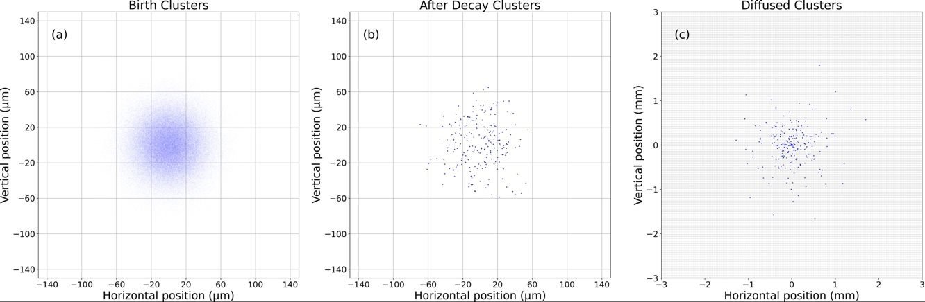
Figure 3.9 Simulated images of excimer clusters illustrating clusters (a) immediately after formation confined to the mean free path of ionizing radiation (b) immediately after annihilation of many excimers due to Penning ionization and (c) diffusion of excimers after ~11 s. The grid represents a camera pixel of 40 mm by 40 mm.

neutron capture, and $R$, excimers are produced at a rate of $\sim {10}^{5} s^{-1}{cm}^{-3}$. This value corresponds to an excimer density averaged over the volume of liquid illuminated by the neutron beam. The neutron capture rate can be increased by either increasing the neutron beam intensity (e.g., by performing the experiment at a different neutron source) or by increasing the concentration of ³He. An increase in the ³He concentration will (1) increase the possibility that the ³He alters the hydrodynamics of the ⁴He liquid, and (2) lead to a highly non-uniform absorption of the neutron beam across the field-of-view. Our choice of the ³He/⁴He ratio balances the need for many excimers and the consequences of too much ³He.
What the neutron capture approach lacks in terms of (localized) signal compared to other approaches is possibly offset by the opportunity to monitor flow simultaneously about large scale structures in three dimensions. Rather than tracking the motion of individual excimers that are not consistently visible to the camera, we developed a means to quantify flow by observing the motion of ensembles (clouds or clusters) of excimers (because some excimer events in a cluster will be recorded by the camera). To observe flow requires means (1) to identify individual excimer clusters in an image and (2) to observe the motion of the clusters from one image to the next. To identify excimer clusters, we applied a machine learning algorithm to each image of excimer peaks with intensities >4$σ$ (e.g., those shown in Figure 3.6 and Movie 3.2⁶⁵). To track the clusters, we used a metric to estimate the likelihood that a cluster in one image is correlated (i.e., is the same) as a cluster in the subsequent image.

3.4.1. Implementation of a clustering algorithm
To facilitate automation, an unsupervised clustering algorithm is desirable. Further, to avoid biasing the number of clusters in any given image (because the intensity of the fluorescence can change with time, Figure 3.4 (right)), an algorithm that does not constrain a priori the number of clusters is preferred. We found the Mean Shift clustering algorithm worked best. This approach identifies arbitrarily shaped objects as clusters and obtains the centroids of the clusters using a well-established pattern recognition procedure—the Mean Shift procedure., During execution of the algorithm, a so-called mean-shift-vector is calculated that points in the direction of increasing density of events (to form the cluster). Upon convergence, i.e., no further significant increase of density detected, the centroid of the cluster and the excimer peaks comprising the cluster are reported. The approach regards the image as a probability density function of a parameter—in our case the positions of fluorescence in the same frame. The Mean-Shift approach differs from another popular class of clustering approaches that use hierarchical clustering based on proximity measures.
The call to the routine was:
sklearn.cluster.MeanShift(*, bandwidth=None, seeds=None, bin_seeding=True, min_bin_freq=1, cluster_all=True, n_jobs=None, max_iter=300)
The default bandwidth = None forces a call to another routine: sklearn.cluster.estimate that estimates the bandwidth to be used by sklearn.cluster.MeanShift. The choice of bandwidth is related to the size of the cluster. This is a number produced by sklearn.cluster.estimate. The call to the routine was:
sklearn.cluster.estimate_bandwidth(X, *, quantile=0.1, n_samples=None, random_state=0, n_jobs=None)
As input to this routine the user provides a value for quantile, which for our case is related to the distance between pairs of excimer peaks. The choice of quantile affects the value of bandwidth and ultimately the size of the cluster and thus the number of clusters. For example, in some images we see many excimer peaks, so we expect more clusters to be identified in such an image than had there been very few peaks. We used a value of quantile = 0.1 to achieve cluster sizes that contained a number of excimer peaks that was consistent with the number we expect (9(7)) based on the energy released during neutron absorption, the path length of the ionizing radiation and the frequency of neutron absorption. The value of bin_seeding=True provided a reasonably uniform distribution of clusters. The same call to sklearn.cluster.MeanShift was used for analysis of all experiments.
An example of the application of the algorithm to data collected for time slice of 17.184 s of Figure 3.6 is shown in Figure 3.10 (left). The large symbols represent the centroid obtained for the cluster; the small dots of the same color show excimers peaks comprising
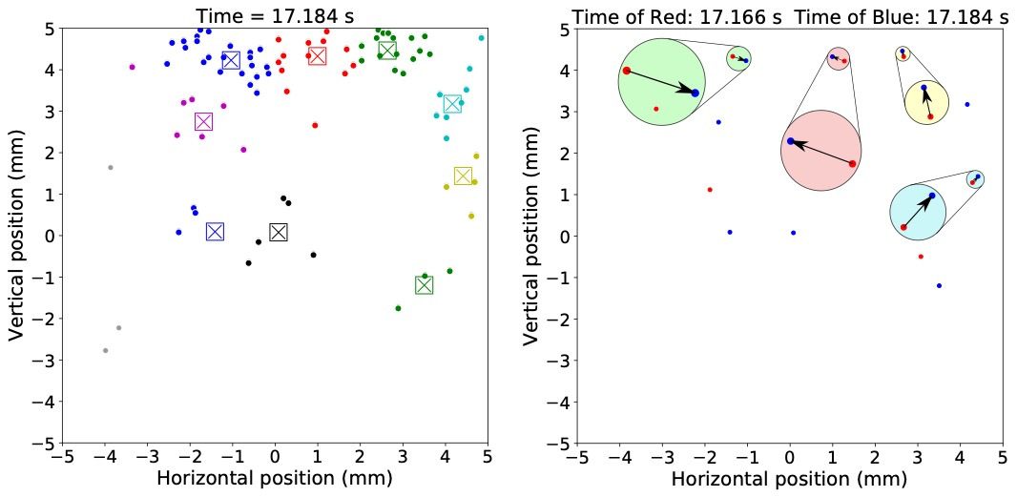
Figure 3.10 (left) Excimer fluorescence having intensity $>4σ$ above background (small dots) color-coded according to cluster identity obtained using the MeanShift clustering algorithm (bottom heater power = 7.32 mW). The center of the large symbol represents the cluster centroid. Figure 3.10 (right) Positions of centroids for times of 17.184 (shown as the large symbols for this time on the left) and 17.166 s corresponding to blue and red dots, respectively. Specifically, the blue symbols in Figure 3.10 (right) correspond to the positions of cluster centroids in Figure 3.10 (left). In Figure 3.10 (right), four pairs of red and blue centroids were identified by the correlator metric discussed in the text as being the same clusters that moved from time = 17.166 to time = 17.184 s (arrows). The arrows are the four displacement vectors calculated for the four cluster centroid pairs. The figure also shows the pairs and displacement vector magnified five times.

the cluster. A movie of the clusters vs. time showing the upward motion of the clusters is presented in Movie 3.3⁶⁵. The time-average number of clusters identified per frame from Movie 3.2⁶⁵ was 6(2). The time-average number of excimer peaks in each cluster of Movie 3.3⁶⁵ was 9(7). Gray dots in Figure 3.10 (left) and Movie 3.3⁶⁵ are excimer peaks (~15%) that do not belong to any cluster and were ignored in our analysis.

3.4.2. Correlator metric
Next, we compare centroids of the i-th image taken at time $t_{i}$ with those in the next image at $t_{i+1}$. The comparison involved summing over the distances between centroids in the first image with those in the second image for every combination of cluster pairs (a pair is a cluster in the first frame and ideally the same cluster in the next frame) that did not exceed a distance of $D$ apart. The approach is very similar to the so-called particle displacement determination algorithm. Given the velocity of flow, there are values of $D$ that are not reasonable, i.e., would represent a velocity that far exceeds the mean velocity of the flow. The influence of choice of $D$ on the mean velocity computed from the excimer clusters is shown in Figure 3.11. For the condition of 7.3 mW heater power, we chose $D=390 μm$ (10 $×$ the camera pixel dimension) so that the velocity of cluster-pairs on average equaled the mean velocity of the motion of fluorescence over the same field-of-view and time interval [Figure 3.4 (red line) and Figure 3.5]. Application of this metric (and the particle displacement algorithm) can yield erroneous results.⁸⁸ For example, the production of a new excimer cloud by neutron capture in one frame could be mistaken for motion of an excimer cloud from the previous frame. However, this situation cannot be realized for clouds that are tracked in the shadow of the neutron beam.
The movement of the centroid of the cluster from one frame to the next is the velocity projected onto the focal plane of the cluster. Shown in Figure 3.10 (right) are the cluster-centroids (not the excimer peaks) for time = 17.166 s (red symbols) and time = 17.184 s (blue symbols). Note the blue symbols in Figure 3.10 (right) correspond to the centers of the squares shown in Figure 3.10 (left). Using the correlator algorithm, four cluster pairs Figure 3.10 (right) were identified for images taken at 17.166 and 17.184 s. In Figure 3.10 (right) an arrow shows the displacement of the centroid of one cluster in the first frame to
Figure 3.11 The influence of choice of $D$ on the correlator metric. The vertical axis shows the average velocity of all the image pairs identified with our metric when choosing $D$ as a search radius limit. With 7.3 mW heater power applied, we can directly measure the average velocity to be 0.985 mm/s from the motion of the excimer fluorescence (shown in Figure 3.4). We choose $D$ = 10 pixels ($390 μm$) to achieve a similar average velocity of 1 mm/s when integrated over the same field-of-view and same range of time used to obtain the mean velocity from the motion of the fluorescence.

the next. Centroids of clusters that are not connected by an arrow are separated by a distance greater than $D$, thus, such clusters do not form a cluster-pair—they are different clusters, not the same cluster that just moved. Movie 3.4⁶⁵ shows the displacement vectors of correlated cluster-centroids from one frame to the next for 1000 frames of one experiment (heater power 7.3 mW). Clusters and the cluster-centroids were identified with machine learning applied to the positions of the excimer peaks with intensity >4$σ$ shown in Movie 3.2⁶⁵, and the result shown in Movie 3.3⁶⁵. The correlator algorithm identifies cluster-centroid-pairs across sequential frames in Movie 3.3⁶⁵, and vectors connecting the pair of centroids—the displacement vectors. The displacement vectors obtained from data in Movie 3.3⁶⁵ are shown in Movie 3.4⁶⁵. The motion (velocity) of a cluster is obtained by dividing the displacement vector by the time between frames, 18 ms. The consistency between motion of the clusters (Movie 3.4⁶⁵) and motion of the fluorescence (Figure 3.3) demonstrates the opportunity of the approach to quantify the velocity vector field flow in two dimensions extracted from individual excimer clouds and sparse data.

3.4.3. Eulerian grid
The last step involves facilitating visualization of the velocity vector flow field. To do this requires a method to interpolate the irregularly sampled displacement vectors across the field of view onto a regular (Eulerian) grid. The flow field represents the position dependence of the velocity vector integrated over all time. By superimposing all the correlated-cluster images for up to five experiments with the same heater power into a single image, we can obtain the velocity vector field flow in the plane illuminated by the laser. The flow field was obtained by averaging the velocity vectors of cluster-pairs within a 2 mm by 2 mm box (red box, Figure 3.12) and scanning the box across the field of view in 1 mm steps. The standard error on the mean of the horizontal and vertical components of the velocity are represented by the axes of an ellipse at the tip of the arrow. The gray dots show locations of correlated-cluster-pairs numbering 4841 for heater power of 7.3 mW. The standard error on the mean velocity is small where there are many cluster pairs. Away from the boundaries of the glass cuvette, the velocity vector flow field is primarily along the positive vertical axis corresponding to the direction of heat flux.
Figure 3.12 Box averaging of velocity vectors inferred from correlated-cluster-pairs (gray dots show locations of ~4800 cluster-centroid-pairs) from all images acquired at 7.3 mW heater power. An arrow indicates the mean velocity of correlated-cluster-pairs inside a 2mm x 2mm box (an example is the red box) centered at the origin of the arrow. The axes of the ellipse at the apex of the arrow represent the standard error on the mean for the two components of the velocity vector. The box was scanned in steps of 1 mm to produce the figure.

3.5. Summary
What we achieved:
- We successfully created flow with Re ranging from 1000~3000 and demonstrated the ability to observe the motion of ${He}_{2}^{*}$ excimers through their fluorescence across a 1 cm2 field-of-view.
- We extracted the average velocities from the laminar flow that we created with 3-30mW heat power applied from the bottom. We observed only laminar flow for each of the power applied and the net flow was in the vertical direction, even though our liquid surface is not a cooling surface. The average velocities agree with the calculated values from Landau and Lifshitz.
Limitations:
- Because a photon has only 1/42 chance to be captured by our camera lens, we are not able to image the same excimer continuously to obtain one-on-one correlation. We cannot apply PIV or PTV algorithms to extract the velocity field directly from the excimer fluorescence.
- We are still limited by our computer speed and data transmission bandwidth to acquire faster frame rate and higher resolution images.
How we mitigated the limitations:
- We applied an unsupervised machine learning algorithm and a cross-correlation algorithm to identify and track the centroids of individual excimer clusters in the focal plane of the camera as a function of time in a manner most closely resembling PTV. This allows us to obtain the velocity vector field of the flow averaged over a ~2mm² region from sparse data. The data themselves, i.e., the centroids, have a positional (spatial) resolution of ~39 $μm$ (the uncertainty in location of a centroid cluster) and a temporal resolution of 18 ms across 1 cm in two dimensions. Using measurements of the average vertical component of velocity observed from the fluorescence data, we can determine a choice of integration window to identify cross-correlation between cluster-centroids in adjacent frames.

Flow of the normal component of He II about Bluff objects
In Chapter 3, we demonstrated the ability to create flow in a channel with thermal counterflow. Now we investigate the normal fluid flow about bluff objects inserted into the channel. In this chapter, we created flow of the normal component of He II about a cylinder and flat plate constrained to a channel with a square cross-section and observed the flow using ${He}_{2}^{*}$ excimers. Flow at temperatures of 1.4-1.6 K was produced using a custom-made flat heater (fabricated at the Center for Nanophase Materials, ORNL). The direction and speed of flow projected onto a plane parallel to the axis of the channel and perpendicular to the heater exhibits significant changes with time even after the heater was turned off. We observed evidence for circulation of flow from inspection of movies. Velocity vector field maps of flow suggest formation of eddies downstream of the cylinder object. No evidence for eddies upstream of either object, which for the case of a cylinder is unique to flow in a quantum fluid and observed by another group, was observed by us. However, the conditions of our experiment were not ideally suited to produce such turbulence.

4.1. Introduction
Previously, Zhang and Van Sciver⁵⁵ observed flow of He II about a cylindrical bluff object using the particle image velocimetry (PIV) to record the motion of many 1.7 mm diameter polymer spheres. The spheres, bluff object and He II were contained inside a channel-shaped cuvette. To induce flow a heater at the bottom of the cuvette was energized, and the surface of the He II actively pumped to 2 K. For low heater power, laminar flow was observed about the object. For high power a pair of eddies (turbulence) in the wake of the object and, remarkably, a pair of eddies in front of the object (the latter displaced to the sides of cuvette) were observed. The eddies in the object’s wake are consistent with expectations of strong flow of a classical fluid; however, the eddies in front of the object are not consistent with classical flow. Speculation at the time was that turbulence in front of the object was a manifestation of the unique properties of thermal counterflow between normal and superfluid components of He II.
Subsequently, Chagoverts and Van Sciver⁶⁹ reproduced the essential results of the previous study—namely observation of laminar flow for lightly-driven counterflow and eddies in front and behind the cylinder for strongly-driven counterflow. For the later work, He II was seeded with a fewer number of 1-5 mm diameter solid H₂ spheres, and the motion of the spheres tracked using particle tracking velocimetry (PTV). PTV enabled Chagoverts and Van Sciver⁶⁹ to track the H₂ tracer particles being dragged by the normal component of He II, and H₂ tracer particles trapped by quantum vortices in the superfluid component. Tracers in the two components were observed to travel in opposite directions—a clear manifestation of thermal counterflow.
A year later, Duda et al., reported results of thermal counterflow of He II past opaque and transparent cylinders under conditions like those of Refs. [55,69] using solid H₂ tracers. Duda et al., observed eddies in front and in the wake of the cylinder when the data were analyzed using PIV. However, they found no evidence for eddies in front of the object when the motion of the H₂ tracers was tracked using PTV. They suggest PIV tends to report vortices when none are observed with PTV. We note the observations of vortices were consistent for applications of PIV and PTV reported in Refs. [55,69].
Numerical simulations of thermal counterflow in He II about a cylinder provided insight into the physics leading to the formation of turbulence in a quantum fluid. Soulaine et al.,⁷⁰ found that for a ratio of superfluid $\left(ρ_{s}\right)$ to normal fluid $\left(ρ_{n}\right)$ density, $a=\frac{ρ_{s}}{ρ_{n}}<1$, friction between the normal component and the walls of the cuvette and object would induce eddies in the wake of the object for flow corresponding to modest heater powers of Refs. [55,69,90]. For higher power, if the product of $a$ and the mutual friction between normal and superfluid components, $γ$, was sufficiently large, then eddies are expected to form in front of the object. Thus, qualitatively explaining the observations of Refs. [55,69]. Mutual friction between superfluid and normal components of He II is critical to the manifestation of turbulence in front of a cylindrical bluff object. Understanding flow in such a fluid is unquestionably important to applications such as cryogenic cooling of complex objects, e.g., accelerators, or components having porous materials (to maximize surface area in contact with the cooling medium).
Because ${He}_{2}^{*}$ excimers are small and buoyant, they hardly perturb flow and for temperatures > 0.6 K exclusively track the normal component.^{34,37,37} They can also be created in the fluid without introducing much heat. Finally, interactions between excimers are extremely weak in comparison to micron-sized polymer or frozen Hydrogen spheres. Because ${He}_{2}^{*}$ excimers are entrained only in the normal component of He II (> 0.6 K), the interpretation of their motion and attribution to the normal component is not complicated by entrapment in the superfluid component. Thus, use of ${He}_{2}^{*}$ excimers as tracers complements information from conventional approaches which are affected by both fluid components. In this chapter we present studies of flow of the normal component of He II about two kinds of bluff objects—a cylinder and a flat plate.

4.2. Methods
The instrumentation for the object experiment (Figure 4.1) is most similar to the thermal counterflow experiment introduced in Chapter 3; notably a BN beam blocker was used to block the neutron beam from entering the top half of the camera’s field-of-view. There are two important differences. (1) A 50 $Ω$ labyrinth microheater was created by photolithographically patterning gold electrodes onto a quartz wafer. The wafer was subsequently diced into 9mm by 4 mm chips (Figure 4.1 (c)) that were secured to G10 pucks. The labyrinth was energized using a constant current source and provided a source of heat uniformly distributed across its 3.3 mm by 7.5 mm surface. The long dimension of the heater was parallel to the focal plane, laser plane and neutron incident beam vector (Figure 4.1). The heater was located 6 mm from the bottom of the cuvette just outside the field-of-view and attached to a G10 rod. The G10 rod was displaced behind the focal plane by ~2 mm. (2) A bluff object (either a 2 mm diameter glass cylinder 4 mm long, or a 1 mm thick by 6 mm by 4 mm glass plate) was attached to the G10 rod ~6 mm above the heater (Figure 4.1).
Because the liquid/vapor interface of the ³He/⁴He mixture was not actively pumped and so not an actively cooled interface, the flow of heat inside the cuvette may not be as simple
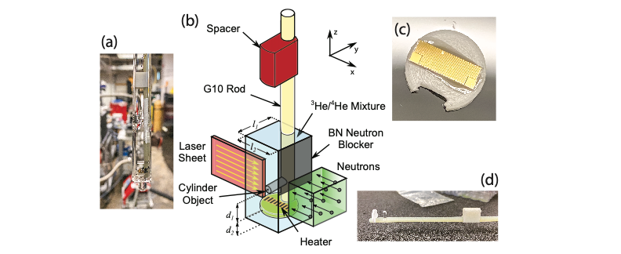
Figure 4.1 (a) Cuvette with sample rod, heater and flat plate inserted. (b) Schematic arrangement of the cuvette with respect to laser and neutron beams ($l_{1}=l_{2}=10$ mm). The labyrinth heater (c) is $d_{2}\sim 6$ mm from the bottom of the cuvette (a). (d) Sample rod with glass cylinder installed $d_{1}\sim 6$ mm from the heater.

as if the upper interface were the only actively cooled region. Nevertheless, from Chapter 3, we know in the absence of an object, the excimer flow (which tracks the normal component) is upwards, i.e., away from the heat source.

4.3. Results
We collected ~27 s of data taken at a rate of 55.6 Hz for heater powers of $P =$ 0, 2.5, 5, 7.5, 10, 15, 20, 30, 40, 60, 80 and 100 mW (heat flux $q = P/A$, where $A =$ 0.25 cm²). One to three 27-s-long measurements were taken for each power. All measurements used the same timing sequence consisting of $t=5$ s neutron shutter open, $t=8$ s camera recording start, $t=10$ s lasers on, $t=14$ s heater on, $t=18$ s heater off, and $t=35$ s measurement (all) stop. During image acquisition, data from the temperature sensor on the G10 rod and ³He/⁴He vapor pressure sensor were recorded every 0.5 s. Prior to turning the heater on, the temperature of the cuvette equilibrated between 1.5 and 1.8 K for the series of experiments. Just after the heater was turned off ($t = 18$ s), and depending upon the power selected, the temperature of the cuvette increased by not more than 0.3 K compared to the temperature at $t =$ 14 s. In addition, a measurement with the neutron shutter closed (so no excimers were produced) and with the heater off was made using the same timing protocol. This measurement was used to quantify the background which was removed in the manner described in Chapter 3. We report the data for the cylinder object first and then data for the flat plate. Each presentation consists of a high-resolution image of the excimer light to show the refraction of the object, still images and movies of the excimer fluorescence for selected powers and the velocity vector flow fields inferred from application of the machine learning and correlator metric algorithms discussed and vetted for the object-free flow study in Chapter 3.
A high-resolution image recorded for 10 s of the excimer fluorescence about the cylinder bluff is shown in Figure 4.2 (a). The dark streaks to the right of the object result from the loss of 905 nm laser power (the laser light needed to excite the excimers) due to refraction of the light from the cylinder. Thus, fewer excimers are excited in the regions where the laser light is diminished. A similar image of refraction of light from a bluff object, although produced differently, is shown in Figure 1 of Ref. [55]. An important consequence
Figure 4.2 Exposure taken for 27 s of fluorescence of ${He}_{2}^{*}$ excimers around (a) cylinder and (b) flat plate bluff objects. The 905 nm light used to excite the ${He}_{2}^{*}$ excimers is refracted by the objects producing the nonuniform intensity distributions. The BN neutron beam blocker was removed to acquire these images.

of the dark streaks is that they introduce boundaries that may affect the machine learning algorithm to identify clusters. In the regions of the dark streaks, the centroids of the clusters may be shifted towards the bright regions between the streaks, thus, confining the motion of the cluster-centroids to smaller values than had the density of excimer peaks been uniform. We regard the velocity vector field (shown later) in the regions of the streaks (just to the right of the object) to be less reliable than elsewhere. A second feature of the image is that there is more excimer fluorescence on the right side than the left side of the cuvette. This is a consequence of the absorption of the neutron beam due to ³He as the neutron beam travels through the cell (the 1/e absorption length is ~4 mm for the average of the neutron beam wavelength ranging from 2.8 to 5.8 Å used for our experiment). The absorption of the neutron beam along the path means that there are fewer ${He}_{2}^{*}$ excimers produced on the left side than the right side of the cuvette. The loss of excimer production (i.e., density) does not lead to erroneous results in clustering or the process to identify cluster motion; however, there are fewer clusters and ${He}_{2}^{*}$ excimers in the clusters to follow the flow.
Figure 4.3 shows images recorded by the camera with only the background light subtracted. Otherwise, the images are minimally processed, e.g., about 2.5% of the camera pixels are defective and have not been removed from these images. Figure 4.3 (a) is a collection of measurements from three experiments taken from $t = 10$ to $14$ s, with the heater off. This figure shows fluorescence is generally strongest in the region below the neutron beam shadow which appears above a vertical position of ~1 mm. The relative absence of fluorescence in the neutron shadow indicates the lack of flow to carry ${He}_{2}^{*}$ excimers from the bottom to the top of the cuvette, however, diffusion of ${He}_{2}^{*}$ excimers from bottom to top can still occur contributing to light in the neutron beam shadow. The diffusion length for ${He}_{2}^{*}$ excimers at 1.6 K during the 5 s period from neutron shutter open to lasers on is estimated to be ~1 mm. Figure 4.3 (b,c) are 0.5 s integrations of data corresponding to $P = 10$mW for times of $t = 14.25$ s and 14.5 s, respectively. Figure 4.3 (b) shows the absence of fluorescence in the wake of the cylinder and then filling of the wake with fluorescence Figure 4.3 (c). Figure 4.3 (d,e,f) show a sequence of 0.5 s time integrations of data taken with 15 mW heater power. These images show circulation of

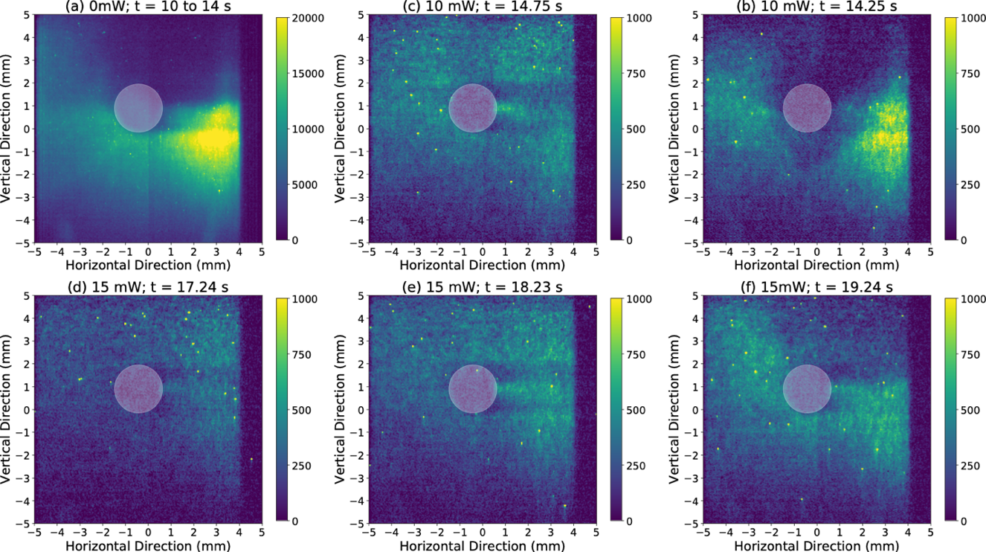
Figure 4.3 (a) Image for heater power of 0 mW integrated over the first four seconds after the lasers were turned off, but heater not on for a combination of several measurements. The upper shadow is the neutron beam shadow produced by the BN beam blocker. Absence of light in this region implies the absence of flow. Images for 10 mW power integrated over a period of 0.5 s. These images show the wake of the cylinder devoid of light at (b) 14.25 s and then filling with light from excimers that have flowed into the wake at (c) 14.75 s. A sequence of images for 15 mW power integrated over a period of 0.5 s showing circulation of excimer light and thus flow about the cylinder.

light in a counterclockwise direction corresponding to times of 21.72, 26.22, and 30.72—exhibiting persistence of flow even after the heater was turned off at $t = 18 s$.
Movies of experiments recorded for all powers are shown in the Github repository.⁶⁵ Defective camera pixels were excluded from the movies. In addition, the movies show only excimer peaks with intensities greater than three times the standard deviation of the background measurements ($3σ$). The excimer peaks in the movies will be used to identify clusters of excimers in the manner of Chapter 3 (discussed later). Movies (see Github repository⁶⁵) show complex time-dependent flow of the fluorescence that persists after the heater is turned off. Figure 4.4 shows the intensity of the excimer light integrated over the entire field of view (after background subtraction) and for 0.5 s periods vs. time. For the case of $P = 0$ mW, the intensity is mostly steady. For the cases of $P = 10$ and 40 mW, the intensity oscillates with time. Note the strongly diminished intensity while the heater is on for the case of the 40 mW data and recovery of the intensity when the heater is turned off. This observation was consistently present for all measurements taken with $P > 30$ mW for the cylinder object.
Superposition of many frames of data (for example taken while the heater is on), can for cases in which the time-dependence of flow repeats itself in the same manner, e.g., an eddy that circulates in the same direction, allows the velocity vector field flow (projected onto the focal plane) to be inferred. We applied the unsupervised machine learning algorithm introduced in Section 3.4. to identify clusters of excimer light from which the centroids of the clusters were determined for every frame. Then the correlator metric introduced in Section 3.4. was applied to identify pairs of centroids that were correlated frame to frame from which a displacement vector for each cluster pair was determined. Using the displacement vector and the frame rate of the camera, some 1000+ or so velocity vectors were obtained for measurements while the heater was on and another 1000+ after the heater was turned off. Finally, to facilitate visualization of the vector velocity flow field, an Eulerian grid with a mesh of 1 mm by 1 mm was defined, and the average of the velocity vectors in a 2 mm by 2 mm integration window was obtained for each grid point. Results for a selection of heater powers is shown in Figure 4.5. The gray dots in the figure show the origin of the velocity vectors for the 1000+ cluster pairs. The black arrows show the
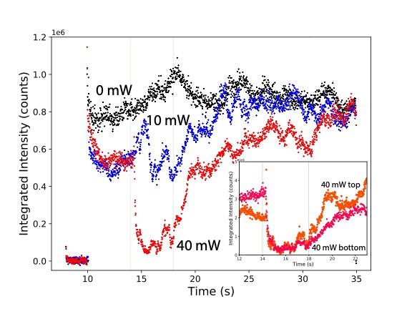
Figure 4.4 Intensity integrated over the entire field of view vs. time for heater powers of 0, 10 and 40 mW for the cylinder object experiment. The faint green lines at $t = 14$ and $18$ s correspond to the time when the heaters were turned on (except for the 0 mW measurement). (inset) Intensity integrated over the top (orange •) and bottom (red ∆) halves of the field of view vs. time for heater power of 40 mW.

Figure 4.5 Correlated cluster pairs about the cylinder object shown as gray dots for heater powers of (a) 7.5 (b) 15 and (c) 40 mW. Velocity flow field shown by the arrows averaged over velocity vectors of the cluster pairs within a 2 mm by 2 mm integration window centered at each point of the Eulerian grid. The ellipses represent the uncertainty equal to the standard deviation of the mean for the vertical and horizontal components of the cluster pair velocities. Color represents the direction of the flow per the color wheel with up being 90°.

direction and magnitude of the velocity for a grid point representing an average of cluster pair vectors in the 2 mm by 2 mm integration window. The color wheel shows the direction of the flow in the manner used to show the spatial dependence of the vector magnetization of skyrmions.
Mimicking the presentation of data for the cylinder object, data taken using the flat plate object show refraction of the light in Figure 4.2 (b) and data for P = 20 mW in Figures 6-9. Specifically, time-integrated still images (Figure 4.6) (see Github repository⁶⁵ for the movie), field-of-view integrated intensity vs. time (Figure 4.7), and velocity vector flow fields (Figure 4.8) for the flat plate object.

4.4. Discussion
We first offer discussion of the results of the cylinder object study. The still images of Figure 4.3 and the field-of-view-integrated intensity vs. time plots of Figure 4.4 exhibit remarkable changes in the position and intensity of the excimer fluorescence with time—dynamic behavior—behind the region of the neutron shadow and integrated over the whole field of view. Thus, the flow of the normal component of He II must similarly change with time. Rough estimates for the components of the velocity of excimer motion can be extracted from the data in Figure 4.3. Specifically from Figure 4.3 (b,c), for $P = 10$ mW (corresponding to $q = 400$ W/m²) and $t=14.25$ s the wake above the cylinder is absent of excimer fluorescence and then at $t = 14.5$ s the region is filled with light. Assuming excimers flow into the wake from either side, the horizontal component of the velocity is about ~5 mm/s for this time interval and power.
For the case of $P = 40$ mW, the intensity of the fluorescence (Figure 4.4 (c)), changes even more dramatically 0.18 s after the heater is turned on at $t = 14$ s, and then recovers more slowly in 1.5 s after the heater is turned off at $t = 18$ s. The change of intensity is about 80%. This implies many excimers left the 1 cm tall field of view at a rate of ~56 mm/s once the heater was turned on for $P = 40$ mW.
Even when the heater is off (for many powers), the intensity of the fluorescence continues to oscillate by ~20% with a period of a couple of seconds (Figure 4.4). The

Figure 4.6 Excimer fluorescence at heater power of 20 mW taken in 2 s intervals showing light rounding (a,b) the right edge of the flat plate to (c) fill its wake.

Figure 4.7 Intensity integrated over the entire field of view vs. time for heater powers of 20 mW for the flat plate object experiment.
Figure 4.8 Correlated cluster pairs about the flat plate object shown as gray dots for heater power of 20 mW. Velocity flow field shown by the arrows averaged over velocity vectors of the cluster pairs within a 2 mm by 2 mm integration window centered at each point of the Eulerian grid. The ellipses represent the uncertainty equal to the standard deviation of the mean for the vertical and horizontal components of the cluster pair velocities. Color represents the direction of the flow per the color wheel with up being 90°.

diminished intensity for certain times after the heater is turned off means that ${He}_{2}^{*}$ excimers have moved outside the 1 cm by 1 cm field of view. After time, ${He}_{2}^{*}$ excimers reappear.
There are two sources of ${He}_{2}^{*}$ excimers that can repopulate the field of view. One source of ${He}_{2}^{*}$ excimers is through creation of new ${He}_{2}^{*}$ excimers in the bottom half of the cuvette. This source can only partially replenish the ${He}_{2}^{*}$ excimer population. A second source is recirculation of normal component flow from the top of the cuvette back to the bottom thus bringing ${He}_{2}^{*}$ excimers back into the field of view. To test this hypothesis, the $I(t)$ data for $P =$ 40 mW are shown separately for the top and bottom halves of the field of view in the inset of Figure 4.4. The intensity in the top half recovers its $t = 10$ s value 1.5 s after the heater is turned off ($t = 18$s). Whereas the intensity of the bottom half recovers its $t = 10$ s value after 3 s. The factor of 2 longer time for ${He}_{2}^{*}$ excimers to repopulate the bottom half implies that the ${He}_{2}^{*}$ excimers must be coming into view from above the field of view. Assuming ${He}_{2}^{*}$ excimers move from the middle of the top half to the middle of the bottom half (~ 5 mm) in 1.5 s, then we estimate the speed of the recirculation flow to be ~3.3 mm/s. We associate the rapid loss (equivalent to a velocity of ~56 mm/s) of excimer fluorescence with application of $P > 30$ mW to the heat flux being produced by the heater, and the return of fluorescence when the heater is turned off to recirculation of flow from above the field of view to bring ${He}_{2}^{*}$ excimers back into view.
The motion of the fluorescence in position and the time dependence of the fluorescence implies complexity of the transport of ${He}_{2}^{*}$ excimers and by extension flow of the normal component. This is a situation that was not observed by Ref. [55] in recordings of polymer tracers in He II, nor in numerical simulations of Ref. [70] which suggest steady state should be achieved for the conditions of Ref. [55] after about 4 s. N.b., we are not suggesting the results of Ref. [55] lack complexity, rather we are making a distinction between complexity of trajectories that are stable with time and those that are not. We return to this distinction later.
The evolution of flow in time adds complexity to the interpretation of the velocity vector flow fields in Figure 4.5 Figure 4.5. The flow fields were obtained by applying the correlator metric introduced in section 3.4 to excimer clusters having excimer peaks with intensities >3s. Then, velocity vectors of cluster-centroid-pairs taken from a ~1000 images during the 4 s period when the heater was on one to three experiments were combined (superimposed). Thus, the flow fields represent the net (in time) motion of flow. In the case of Figure 4.5 (a) for $P = 7.5$ mW, flow is directed upwards in the upper right corner as shown by the blue-purple coloring corresponding to the color wheel. On the upper left side, the flow is directed to the left side of the cuvette (a surface in contact with the cold He bath).
Figure 4.3 (d,e,f) ($P = 15$ mW) show a sequence of images in which the fluorescence rotates about the cylinder counterclockwise. If these images are representative of the entire 4-s measurement window, then the flow field in Figure 4.5 (b) ($P = 15$ mW) should also exhibit a similar trend. Starting from the right side of the object (Figure 4.5 (b)) and moving counterclockwise, the color changes from blue-purple to red to green to cyan—circumnavigating the color wheel. The flow field changes in the same manner as that observed in the still images and the movie of the fluorescence. ⁶⁵
Next, inspection of the rotation of the flow field for $P = 40$ mW power at the top of Figure 4.5 (c), i.e., in the wake of the cylinder shows a region on the left exhibiting clockwise rotation (yellow to red) and a region on the right exhibiting counterclockwise rotation (yellow to cyan) consistent with eddies. Only the bottom half of eddies are observed (their top halves being out of view). The direction of the eddies is such that heat is transported to the cold vertical surfaces of the cuvette to the left and right of the cylinder. The heat flux from the heater for $P = 40$ mW corresponds to 1 kW/m², and the average of the flow velocity magnitude in these regions is 2-5 mm/s. The uncertainty of the flow (i.e., the sizes of the ellipses representing the standard error of the mean of the velocities) is larger in comparison to the lower power cases because there are fewer correlated-cluster-pairs when the heater is on for $P > 30$ mW (80% of the excimer clusters were swept out of view). Nevertheless, eddies downstream of the cylinder object is anticipated for classical fluids for sufficiently large heat flux.
We were unable to identify eddies upstream (in front of) the cylinder, in contrast to Refs. [55,69]. There are several reasons why none were seen in our research that will require further work to resolve. First, per the numerical simulations of Ref. [70], a value of $a=\frac{ρ_{s}}{ρ_{n}}<1$ is optimal to generate vortices in the wake of the object, and second the mutual friction between superfluid and normal components should be large to generate vortices in front of the object. These conditions were fulfilled by Refs. [55,69] which used temperatures of ~2 K just below the lambda point. Our experiment was performed significantly colder ~1.6 K for which the value of $a\sim 5$. Thus, the conditions of our experiment were less conducive to formation of both types of vortices (though we believe some of the data are consistent with vortices in the wake of the cylinder). Second, the cuvette used by Refs. [55,69] was optimally suited to produce uniform heat flux by using a heater at the bottom of the cuvette and actively pumping on the liquid/vapor interface at the top. This situation is impossible to achieve using our technique which requires the He II to be spiked with ³He, thus, pumping on the mixture is economically prohibitive. Heat flux in our system may not be as uniform as in Refs. [55,69]. Third, the polymer spheres or solid H₂ used in Refs. [55,69,90] are micron-sized massive particles that pose unique challenges of their own. Uniformity of seeding He II with these particles and the heat introduced by injection of the particles are more serious technical challenges than is the case for ${He}_{2}^{*}$ excimers created by a large neutron beam (across the plane perpendicular to the neutron beam, excimer production is uniform, however, the excimer production drops by ~90 % along the field of view parallel to the beam). Further massive tracers can be entrained in normal and superfluid components. ${He}_{2}^{*}$ excimers on the other hand are light, buoyant and very small ~ 6 Å, and thus track exclusively the normal component (for temperatures > 0.6 K^{35,37}). Being small and light, the He excimers may also be more sensitive to non-uniformity of the heat flux in space and time than heavy tracers (having much more inertia). Finally, the interaction between ${He}_{2}^{*}$ excimers is much weaker than those of massive tracers, e.g., the latter may acquire electrostatic charge.
In comparing our results with those of Ref. [55] we identified a here-to-fore unremarked feature in data from Ref. [55] that is absent from our data. In Figure 4.9 (a) is the superposition of 100 images in the movie of the Supplemental Materials of Ref. [55] and a subset of the figure is shown in Figure 4.9 (b). Streaks of intensity we call filaments that depending upon the region of the cuvette are consistent with laminar or turbulent flows are seen in Figure 4.9 (b). The filaments are separated by thin regions with very little intensity. The separation of the filaments in the region corresponding to vertical position
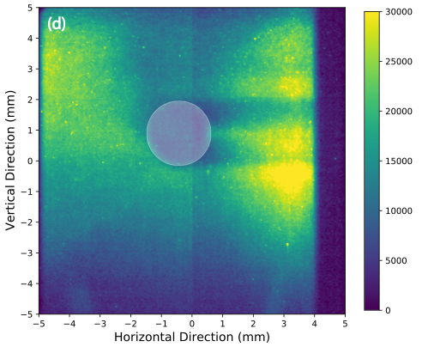
Figure 4.9 (a) Superposition of 100 images shown in the movie of Ref. [55] Region of the white box in (b) shows filaments of high intensity corresponding to light scattered by polymer spheres. The variations of intensity vs. time corresponding to tracers transiting 44 mm by 44 mm regions of interest corresponding to light (l) and dark (s) regions labeled in (b) are shown in (c). (d) Superposition of 1000 images recorded by us for conditions of 100 mW heater power applied for 4 s during the 27 s measurement. Filaments were not observed ${He}_{2}^{*}$ excimers.

14 to 20 mm is ~0.26(2) mm, i.e., nearest neighbor high intensity filaments are separated by ~0.26 mm wide regions of low intensity light. We measured the frequency of tracers transiting light and dark regions for five pairs of regions of interest (ROI) measuring 44 mm by 44 mm each at various locations as labeled in the image. In Figure 4.9 (c) we plot the intensity vs. time recorded in the light (l) and dark (s) ROIs (the intensity becomes high as a tracer transits the ROI). We found on average ~4 tracers travel through the light ROI’s during the 10 s movie of Ref. [55] (~ 1 tracer per 2.5 s) and ~1 though the dark ROI’s in the same time. From inspection of the movie of Ref. [55], tracer motion in regions corresponding to the ROIs we selected in Figure 4.9 (b) exhibit speeds ranging from 4 to 10 mm/s. Using the time between tracer observations (in an ROI) of 2.5 s, then the physical spacing of tracers along a filament ranges from 10 to 25 mm—a large distance comparable to the width of the channel of Ref. [55]. An explanation could be a single tracer circumnavigates a closed filament (i.e., loop), or different tracers enter the filament from different directions, e.g., perhaps from outside the focal plane of the camera. In any case, the physical spacing corresponding to tracer(s) transiting ROIs at different times is much larger than the physical separation between filaments, tens of mm compared to a quarter mm, respectively.
In contrast to the images shown in Figure 4.9 (a,b), the superposition of a 1000-frame movie from our work with heat flux of 4 kW/m² ($P = 100$ mW) during a 4-s window from 14 to 18 s Figure 4.9 (d) shows no evidence for formation of filaments, i.e., we see no tendency for ${He}_{2}^{*}$ excimers to trace special paths. We put forward four hypotheses for the non-uniformity of the trajectories traced by the polymer spheres. (1) The polymers spheres may not have been seeded uniformly into the He II. (2) Repulsive interactions between the spheres, possibly of electrostatic origin, cause the spheres to be distanced from one another. (3) The spheres tend to follow each other for reasons analogous to why cyclists form a peloton (path of least resistance). (4) The trajectories are an example of a recurrent solution to the Navier-Stokes equation for fluid flow.
Our discussion turns to the study of flow about the flat plate. The cross-section of the flat plate is ~3 times larger than that of the cylinder, so more flow is diverted to the periphery of the cuvette than for the case of the cylinder. Diminishment of intensity while the heater was first energized (shown in Figure 4.7 for P = 20 mW) was observed for power as low as P = 7.5 mW for the flat plate compared to $P > 30$ mW for the cylinder. Figure 4.6 is composed of a sequence of images taken after the heater is turned off at times of 23.48, 25.48, and 27.48 s. These images show fluorescence moving to the right, upper right corner and then along the top of the flat plate. This sequence is reflected in the velocity flow field of Figure 4.8 as counterclockwise flow around the object’s right edge following the color wheel from cyan, to blue to magenta to green.
In addition to the 7.5 mW data from the flat plate, data were also acquired for the entire series of heater powers used in the cylinder object study. The observations of the flat plate for powers > 7.5 mW were remarkably similar to that shown in Figure 4.7 for 20 mW. These observations are in contrast to those of the cylinder object for which differences were seen in the images corresponding to different powers. For the case of the flat plate, we believe we selected the size of the plate poorly. The cross-section of the plate was a much larger fraction of the entire cross-section of the channel which we believe inhibited flow. Further, owing to the lack of fine control of the object within the field of view (or vice versa), the flat plate was too high in the field of view, so formation of eddies above the plate could not be recorded.

4.5. Summary
What we achieved:
- We have observed flow of the normal component of He II about two bluff objects, a cylinder and a flat plate, by recording the motion of fluorescence of ${He}_{2}^{*}$ excimers.
- For conditions of 1.6 K and heat flux of 1.6 kW/m² to produce thermal counterflow, we detected eddies in the wake the cylinder object with a speed of 2-5 mm/s. No eddies were observed in front of the objects for any condition; however, the conditions of our experiment are not like those of previous work which reported such eddies for cylinder bluff objects.
- We observed significant changes to the motion of excimer fluorescence and hence normal component flow with time, i.e., a steady state was not achieved during 27 s long measurements. Even after power to the heater was discontinued, the intensity of the fluorescence oscillated by about 20% every couple of seconds.
- For the cylinder study and high power, e.g., $P > 30$ mW, nearly 80% of the ${He}_{2}^{*}$ excimers were swept out of the field of view in ~0.2 s corresponding to a speed of tens of mm/s. The number of ${He}_{2}^{*}$ excimers in the field of view recovered in ~1 s after power to the heater was turned off. We attribute such dramatic and quick changes of ${He}_{2}^{*}$ excimer population (in the field of view) to the small inertia of the ${He}_{2}^{*}$ excimers, so they respond to rapid changes of flow of the normal component of He II about bluff objects in our cuvette.
Limitations and possible solutions:
- Our operating temperature is around 1.5~1.8 K. In this range, the $\frac{ρ_{s}}{ρ_{n}}$ is about 2~4, too large to facilitate production of eddies up and downstream of the cylinder per Ref. [11]. In order to generate vortices in front of the object, we need a higher operating temperature just below lambda point to increase the fraction of the normal component to the superfluid component. This would enhance mutual friction force between the two components critical to formation of eddies upstream of the object.
- To reproduce configurations of other group, a means to cool the surface of the cuvette opposite to the heater is needed.
- The right-hand side of our field of view is affected by the refraction from the cylinder object, ergo, the reliability of the right ROI is less reliable than the left side. Yet, the left side shows less fluorescence because the neutron beam is strongly absorbed as it travels through the cell. A solution is to illuminate the object with laser and neutron beams from the same side.

Conclusions and future directions

5.1. Conclusions
In this dissertation, we’ve demonstrated a novel technique to create ${He}_{2}^{*}$ excimers in He II with neutron beams. Using thermal counterflow, we observed and quantified the fluorescence of the ${He}_{2}^{*}$ excimers and motion of the excimers as they were dragged by the normal component of the fluid. Finally, we combined our advances to trace the normal component flow in He II about bluff objects—namely a cylinder and a flat plate. Being able to create and track the normal fluid component provides opportunities to study turbulence in a quantum fluid. Although turbulence in quantum fluids is more complicated and can be very different from that in the classical fluids in many aspects, the Kolmogorov (or quasiclassical) turbulence of quantum fluid shares similarities with turbulence in classical fluids, providing opportunities to understand turbulence in both classical fluids and quantum fluids.
5.1.1.
Using the Larmor beamline at HFIR, we demonstrated the ability to create the ${He}_{2}^{*}$ excimers with a density of 10⁴ /cm³ in a ~ 10 cm³ volume of liquid He. These excimers form ~34 clouds per image in the 0.03 cm³ volume defined by the camera’s field of view and the 1 mm thickness of the focal plane illuminated by the lasers, each measuring ~25(3) $μm$ in diameter. About 10% of the excimer production contributes towards excimer fluorescence. The uncertainty of the position of the cloud centroids, i.e. the resolution of the technique is about 5 $μm$.
5.1.2.
We investigated the influence of ³He concentration and neutron flux on the fluorescence signal. Both factors contribute to excimer production. Besides being able to create these excimers in ~10 cm³ volume, in comparison to just ~mm³ with electrostatic discharge, we also calculated based on the measured signal that the efficiency of the excimer production that the neutron production technique is ${10}^{3}\sim {10}^{5}$ more energy efficient than the competing production techniques of electrostatic discharge and laser induced production.
5.1.3.
In the thermal counterflow experiment, we successfully created flow with Re ranging from 1000~3000 and demonstrated the ability to observe the motion of ${He}_{2}^{*}$ excimers through their fluorescence across a 1 cm² field-of-view. We extracted the average velocities from the laminar flow that we created with 3-30mW heat power applied from the bottom. We observed only laminar flow for each of applied power, and the net flow was in the vertical direction, even though our liquid surface is not a cooling surface. The average velocities agree with the calculated values based on the relation $q= ρsTv_{n}$, where q is the heat flux, $ρ$ and $s$ are the density and entropy of He II at temperature $T$, and $v_{n}$ is the normal fluid velocity.
5.1.4.
In the object experiment, we have observed flow of the normal component of He II about two bluff objects, a cylinder and a flat plate, through motion ${He}_{2}^{*}$ excimers fluorescence. For conditions of 1.6 K and heat flux of 1.6 kW/m² to produce thermal counterflow, we detected eddies in the wake the cylinder object with a speed of 2-5 mm/s. No eddies were observed in front of the objects for any condition, which have been observed by another group and attributed to the unique properties of quantum fluids. There are a few explanations for why we could not confirm earlier work, e.g., we use buoyant mostly non-interacting tracers as opposed massive tracers. However, the conditions of our experiment are not ideally suited to produce eddies upstream of a cylinder object.
5.1.5.
We observed significant changes to the motion of excimer fluorescence and hence normal component flow with time, i.e., a steady state was not achieved during 27 s long measurements. Even after power to the heater was discontinued, the intensity of the fluorescence oscillated by about 20% every couple of seconds. We confirmed the origin of the oscillation as movement of the excimer above and out of the field of view, and then shortly thereafter the excimers return to the field of view. For the cylinder study and high power, e.g., $P > 30$ mW, nearly 80% of the ${He}_{2}^{*}$ excimers were swept out of the field of view in ~0.2 s corresponding to a speed of tens of mm/s. The number of ${He}_{2}^{*}$ excimers in the field of view recovered in ~1 s after power to the heater was turned off. We attribute such dramatic and quick changes of ${He}_{2}^{*}$ excimer population (in the field of view) to the small inertia of the ${He}_{2}^{*}$ excimers, so they respond to rapid changes of flow of the normal component of He II about bluff objects in our cuvette. The ability to detect and monitor rapid changes in normal component flow with the techniques developed here is perhaps the most important achievement of the dissertation.

5.2. Technical issues solved
We identified and solved some of the problems and technical issues during experiments and data analysis.
5.2.1.
In the Larmor experiments, we were unable to reproducibly dope ³He into He II with the ‘bath’ configuration. To solve this issue, we switched to the ‘bulb’ configuration; a configuration that prevented the loss of ³He and guaranteed the consistency of ³He/⁴He concentration for every measurement. With a mass flow controller, a capable of being excited to fluoresce. The decay time of ~3 s is much less than the 13 s half-life of the excimer. Later during the SNS experiment, we used repumping lasers with higher power and optimal wavelength, the decay of fluorescence was reduced, and the saturated signal was higher.
5.2.2.
Although we tried our best to increase the light collection angle of the lens, a photon has only 1/42 chance to be captured by our camera lens. Thus, we are not able to image the same excimer continuously to obtain one-on-one correlation of individual excimer peaks. We cannot apply the well-developed PIV or PTV algorithms to extract the velocity field directly from the excimer fluorescence. To overcome this issue, we applied an unsupervised machine learning algorithm and a cross-correlation algorithm to identify and track the centroids of individual excimer clusters in the focal plane of the camera as a function of time in a manner most closely resembling PTV. This allowed us to obtain the velocity vector field of the flow averaged over a ~2mm² region from sparse data. The data themselves, i.e., the centroids, have a positional (spatial) resolution of ~39$μm$ (the uncertainty in location of a centroid cluster) and a temporal resolution of 18 ms across 1 cm in two dimensions. Using measurements of the average vertical component of velocity observed from the fluorescence data, we determined a choice of integration window to identify cross-correlation between cluster-centroids in adjacent frames.

5.3. Future directions
Although some of the limitations and technical issues that we encountered were solved, others remain. Here we discuss how future work should improve the opportunities of the technique.
5.3.1.
One of the major limitations is the spatial resolution and temporal resolutions (frame rate) of the camera. This can be solved with faster camera and a fast means to transfer data from the camera to the computer/storage. In fact, we demonstrated the capability of a new Photonis-brand camera that uses a TimePix3 imaging chip. This camera can record photons with ps accuracy at 80 MHz. Importantly, the Photonis camera can record excimer fluorescence at the rate of the laser, 1 kHz, as opposed to the camera we use, 55 Hz and represents nearly a $20×$ improvement in data acquisition.
5.3.2.
The density of excimer clusters can be increased by $10×$ by increasing the concentration of ³He accordingly. The increased density of ³He would be ~1% of the roton density and thus not expected to affect the hydrodynamics of He II at 1.7 K. With more excimer clusters and a faster camera, the spatial and temporal resolution will improve.
5.3.3.
Right now, we only have 1/42 chance to capture a photon from ${He}_{2}^{*}$ excimers by the camera lens. This factor is calculated without considering the absorption of photons by lens. To increase the chance of capturing photos from ${He}_{2}^{*}$ excimers, a new cryostat with larger viewing windows and new set of lenses with higher light transmission rate can be adapted. Another possible way to increase the chance of photon capture is to record the signal with more cameras placed in different positions. This will also allow us to track the flow in three dimensions. A higher chance of photon capture will increase of accuracy of identifying the centroid position in the clustering algorithm. Perhaps, adding mirrors to reflect some of the photons travelling in opposite direction into the camera can also increase the chance of capturing photons. We estimate that combining these measures can lead to a factor of 10$×$improvement in capturing photons.
5.3.4.
Our operating temperature is around 1.5~1.8 K. In this range, the $ρ_{s}/ρ_{n}$ is about 2~4, too large to facilitate production of eddies up and downstream of the cylinder according to C. Soulaine et al.⁷⁰. In order to generate vortices in front of the object, we need a higher operating temperature just below lambda point to increase the fraction of the normal component to the superfluid component. This would enhance mutual friction force between the two components critical to formation of eddies upstream of the object. A larger cryostat can help maintain the temperature from rising too fast upon turning on the heater and lasers. The changing temperature will also change the fractions of normal fluid and superfluid components.
5.3.5.
To reproduce configurations of other group, a means to cool the surface of the cuvette opposite to the heater is needed. A heater with larger surface area will produce more even heating.
5.3.6.
The right-hand side of our field of view is affected by the refraction from the bluff object, so the reliability of the right side is not as high as the left side. Yet, the left side shows less fluorescence because the neutron beam is strongly absorbed as it travels through the cell. A solution is to illuminate the object with laser and neutron beams from the same side. We note however that with the experimental improvements discussed previously leading to a factor of 10$×$, application of PIV and/or PTV directly to excimer fluorescence (as opposed to relying upon clustering and correlation) may be possible. In this case the loss of intensity associated with refraction is a manageable problem as demonstrated by Van Sciver.

LIST OF REFERENCES
I. Eames and J.B. Flor, Introduction: New developments in understanding interfacial processes in turbulent flows, Philosophical Transactions: Mathematical, Physical and Engineering Sciences 369, No. 1937, pp 702–705 (2011). http://www.jstor.org/stable/41061691
2 P. Moin and K. Mahesh, Direct Numerical Simulation: A Tool in Turbulence Research. Annual review of fluid mechanics. 30, 539-578 (1998). https://doi.org/10.1146/annurev.fluid.30.1.539
3 Y. F. Yao and N. D. Sandham, DNS of turbulent flow over a bump with shock/boundary-layer interactions, Engineering Turbulence Modelling and Experiments 5, pp 677-686, ISBN 9780080441146, (2002). https://doi.org/10.1016/B978-008044114-6/50065-X.
4 S.A. Oszag, Analytical Theories of Turbulence, J. Fluid Mech. 41 pp 363–386. (1970). https://doi.org/10.1017/S0022112070000642
5 C. M. Rhie and W. L. Chow, Numerical study of the turbulent flow past an airfoil with trailing edge separation, AIAA Journal, 22 11 (1983). https://doi.org/10.2514/3.8284
6 A. J. Pappano and W. G. Wier, Physiology (Tenth Edition), pp 119-134 ISBN 9780323086974 (2013). https://doi.org/10.1016/B978-0-323-08697-4.00006-X
7 O. Reynolds, An experimental investigation of the circumstances which determine whether the motion of water shall be direct or sinuous, and of the law of resistance in parallel channels. Philosophical Transactions of the Royal Society, 174, 935 (1883). https://doi.org/10.1098/rstl.1883.0029
8 L. Skrbek, D. Schmoranzer, Š. Midlik, and K. R. Sreenivasan, Phenomenology of quantum turbulence in superfluid helium. Proc. Natl. Acad. Sci., 118 16 (2021). https://doi.org/10.1073/pnas.2018406118
9 L. D. Landau, E. M. Lifshitz. Fluid Mechanics (2nd ed.), (Pergamon Press, Oxford, 1987). ISBN 0-08-033933-6.
1⁰ J. Pfitzner, Poiseuille and his law. Anaesthesia, 31, 273-275 (1976). https://doi.org/10.1111/j.1365-2044.1976.tb11804.x
¹ J. Carlson, A. Jaffe and A. Wiles, The millennium prize problems. Clay Mathematics Institute. ISBN: 978-0-8218-3679-8 (2006). https://www.claymath.org/library/monographs/MPPc.pdf
1² W. KEESOM, Solidification of Helium. Nature 118, 81(1926). https://doi.org/10.1038/118081a0
³ H. Kamerlingh Onnes, The liquefaction of helium. Communications from the Physical Laboratory of the University of Leiden, 108, 3-23 (1908). https://doi.org/10.1007/978-94-009-2079-8_7
1⁴ W. H. Keesom and M. Wolfke, The two different liquid states of helium. Communications from the Physical Laboratory of the University of Leiden, 190b, 15-22 (1927).
1⁵ J. F. Allen and A. D. Misner, Flow Phenomena in Liquid Helium II. Nature 142 634-644 (1938). https://doi.org/10.1038/142643a0
¹⁶ P. Kapitza, Viscosity of Liquid Helium below the λ-Point, Nature 141, 74 (1938). https://doi.org/10.1038/141074a0
1⁷ F. London, On the Bose-Einstein Condensation. Phys. Rev. 54, 947–954 (1938). https://doi.org/10.1103/PhysRev.54.947
⁸ L Tisza, The Theory of Liquid Helium. Phys. Rev. 72, 838 (1947). https://doi.org/10.1103/PhysRev.72.838
⁹ L. Landau, Theory of the Superfluidity of Helium II, Phys. Rev. 60, 356 (1941). https://doi.org/10.1103/PhysRev.60.356
²⁰ R. J. Donnelly, Special Issue: Helium‐3 and Helium‐4, Physics Today 40, 2, 23 (1987); https://doi.org/10.1063/1.2819903
² E. L. Andronikashvili and Yu. G. Mamaladz, Quantization of Macroscopic Motions and Hydrodynamics of Rotating Helium II. Rev. Mod. Phys. 38, 567(1966). https://doi.org/10.1103/RevModPhys.38.567
2² Russell J. Donnelly, The two-fluid theory and second sound in liquid helium. Physics Today 62, 10, 34 (2009). https://doi.org/10.1063/1.3248499
2³ D. V. Osborne, The Rotation of Liquid Helium II, Proc. Phys. Soc. A 63 909 (1950). https://doi.org/10.1088/0370-1298/63/8/315
2⁴ W. F. Vinen, The detection of single quanta of circulation in liquid helium II, Proc. R. Soc. Lond. A 260 218–236 (1961). http://doi.org/10.1098/rspa.1961.0029
2⁵ W. F. Vinen, Mutual friction in a heat current in liquid helium II I. Experiments on steady heat currents, Proc. R. Soc. Lond. A 240, 114 -127 (1957). https://doi.org/10.1098/rspa.1957.0071
2⁶ W. F. Vinen, Mutual friction in a heat current in liquid helium II. II. Experiments on transient effects, Proc. R. Soc. Lond. A 240, 128-143 (1957). https://doi.org/10.1098/rspa.1957.0072
2⁷ W. F. Vinen, Mutual friction in a heat current in liquid helium II III. Theory of the mutual friction, Proc. R. Soc. Lond. A 242, 493-515 (1957). https://doi.org/10.1098/rspa.1957.0191
2⁸ W. S. Dennis, E. Durbin, Jr., W. A. Fitzsimmons, O. Heybey, and G. K. Walters. Spectroscopic Identification of Excited Atomic and Molecular States in Electron-Bombarded Liquid Helium, Phys. Rev. Lett. 23, 1083 (1969). https://doi.org/10.1103/PhysRevLett.23.1083
²⁹ J. C. Hill, O. Heybey, and G. K. Walters, Evidence of Metastable Atomic and Molecular Bubble States in Electron-Bombarded Superfluid Liquid Helium, Phys. Rev. Lett. 26, 1213 (1971). https://doi.org/10.1103/PhysRevLett.26.1519
3⁰ A.V. Benderskii, R. Zadoyan, N. Schwentner and V.A. Apkarian, Photodynamics in superfluid helium: Femtosecond laser-induced ionization, charge recombination, and preparation of molecular Rydberg states, J. of Chem. Phys., 110, 1542 (1999). https://doi.org/10.1063/1.477796
³ C. F. Chabalowski, J. O. Jensen, D. R. Yarkony and B. H. Lengsfield III, Theoretical study of the radiative lifetime for the spin‐forbidden transition a ³Σ⁺_{u}→X ¹Σ⁺_{g} in He², J. Chem. Phys. 90, 2504 (1989). https://doi.org/10.1063/1.455993
3² D. N. McKinsey, C. R. Brome, J. S. Butterworth, S. N. Dzhosyuk, P. R. Huffman, C. E. H. Mattoni, J. M. Doyle, R. Golub, and K. Habicht. Radiative decay of the metastable He₂(a³Σ⁺_{u}) molecule in liquid helium, Phys. Rev. A 59, 200 (1999). https://doi.org/10.1103/PhysRevA.59.200
3³ A. V. Benderskii, J. Eloranta, R. Zadoyan and V. A. Apkarian. A direct interrogation of superfluidity on molecular scales, J. Chem. Phys. 117, 2101 (2002). https://doi.org/10.1063/1.1485955
3⁴ D. E. Zmeev, F. Pakpour, P. M. Walmsley, A. I. Golov, W. Guo, D. N. McKinsey, G. G. Ihas, P. V. E. McClintock, S. N. Fisher, and W. F. Vinen, Excimers ${He}_{2}^{*}$ as Tracers of Quantum Turbulence in ⁴He in the T = 0 Limit, Phys. Rev. Lett., 110 175303 (2013). https://doi.org/10.1103/PhysRevLett.110.175303
3⁵ W. Guo, Molecular Tagging Velocimetry in Superfluid Helium-4: Progress, Issues, and Future Development, J. of Low Temp. Phys., 196 60-72 (2019). https://doi.org/10.1007/s10909-018-2102-1
3⁶ D. Mateo, J. Eloranta and G. A. Williams, Interaction of ions, atoms, and small molecules with quantized vortex lines in superfluid 4He. J. Chem. Phys. 142, 064510 (2015). https://doi.org/10.1063/1.4907597
³⁷ W. F. Vinen, Quantum Turbulence: Where Do We Go From Here?, AIP Conference Proceedings 850, 169 (2006); https://doi.org/10.1063/1.2354655
3⁸ W. Guo, J. D. Wright, S. B. Cahn, J. A. Nikkel, and D. N. McKinsey, Metastable Helium Molecules as Tracers in Superfluid ⁴He, Phys. Rev. Lett., 102 235301 (2009). https://doi.org/10.1103/PhysRevLett.102.235301
3⁹ A. Marakov, J. Gao, W. Guo, S.W. Van Sciver, G. G. Ihas, D. N. McKinsey, and W. F. Vinen, Visualization of the normal-fluid turbulence in counterflowing superfluid ⁴He, Phys. Rev. B 91, 094503 (2015). https://doi.org/10.1103/PhysRevB.91.094503
4⁰ W. Guo, S. B. Cahn, J. A. Nikkel, W. F. Vinen and D. N. McKinsey, Visualization Study of Counterflow in Superfluid ⁴He using Metastable Helium Molecules, Phys. Rev. Lett., 105, 045301 (2010). https://doi.org/10.1103/PhysRevLett.105.045301
⁴ W. Guo, M. La Mantia, D. P. Lathrop, and S. W. Van Sciver, Visualization of two-fluid flows of superfluid helium-4, Proc. Natl. Acad. Sci., 111 4653-4658 (2014). https://doi.org/10.1073/pnas.1312546111
⁴² S. Falahat, A. Best, M. Couder, J. Görres, K. Kratz, U. Ott, Ed Stech, M. Wiescher, A ³He neutron detector for the measurement of ($α$,n) Reactions. Nucl. Instr. and Methods in Phys. Res. A, 700 53-58 (2013). https://doi.org/10.1016/j.nima.2012.10.036
4³ Albert-Jose Dianoux and Gerry Lander, et al,. Neutron Properties in Neutron Data Booklet, eds. (Institut Laue-Langevin, Grenoble 2002) pp. 1.1-4. ISBN 0-9704143-7-4. https://www.ill.eu/fileadmin/user_upload/ILL/1_About_ILL/Documentation/NeutronDataBooklet.pdf
4⁴ J. M. Carpenter and C.-K. Loong, Elements of Slow-Neutron Scattering, p287 (2019). ISBN: 9781139029315. https://doi.org/10.1017/CBO9781139029315
4⁵ C.F. Williamson, J.P. Boujot, J. Picard, Tables of range and stopping power of chemical elements for charged particles of energy 0.05 to 500 MeV. Rapport Centre D’Etudes Nucleaires de Saclay, CEA-R3042 pp. 3-151 (1966).
4⁶ M.J. Buckingham and W.M. Fairbank, Chapter III The Nature of the λ-Transition in Liquid Helium. Progress in Low Temperature Physics, 3 80-112 (1961). https://doi.org/10.1016/S0079-6417(08)60134-1
4⁷ J.W. Keto, M. Stockton, and W.A. Fitzsimmons. Dynamics of Atomic and Molecular Metastable States Produced in Electron-Bombarded Superfluid Helium, Phys. Rev. Lett. 28, 792 (1972). https://doi.org/10.1103/PhysRevLett.28.792
4⁸ J.W. Keto, F.J. Soley, M. Stockton, and W.A. Fitzsimmons. Dynamic properties of neutral excitations produced in electron-bombarded superfluid helium. II. Afterglow fluorescence of excited helium molecules, Phys. Rev. A 10, 873 (1974). https://doi.org/10.1103/PhysRevA.10.887
4⁹ V.B. El'tsov, A.Ya. Parshin, and I.A. Todoshchenko, Optical spectra of the triplet molecules ⁴He*₂ in superfluid helium in a magnetic field, Journal of Experimental and Theoretical Physics. 81, 5 (1995). https://www.osti.gov/biblio/379396
5⁰ V.B. El'tsov, S.N. Dzhosyuk, A.Ya. Parshin, and I.A. Todoshchenko, Spectroscopic Studies of the Triplet-state ⁴He*₂ Molecules in Superfluid Helium Up to the Solidification Pressure, J. Low Temp. Phys. 110, 219 (1998). https://doi.org/10.1023/A:1022503926297
⁵ R. Stephen Berry, The Theory of Penning Ionization, Radiation Research 59 2, pp. 367-375 (1974). https://doi.org/10.2307/3573984
⁵² W. G. Rellergert, S. B. Cahn, A. Garvan, J. C. Hanson, W. H. Lippincott, J. A. Nikkel, and D. N. McKinsey. Detection and Imaging of He2 Molecules in Superfluid Helium, Phys. Rev. Lett. 100, 025301 (2008). https://doi.org/10.1103/PhysRevLett.100.025301
5³ D. N. McKinsey, W. H. Lippincott, J. A. Nikkel, and W. G. Rellergert. Trace Detection of Metastable Helium Molecules in Superfluid Helium by Laser-Induced Fluorescence, Phys. Rev. Lett. 95, 111101 (2005). https://doi.org/10.1103/PhysRevLett.95.111101
5⁴ W. Guo and A. I. Golov. Shape fluctuations and optical transition of ${He}_{2}^{*}$ excimer tracers in superfluid ⁴He, Phys. Rev. B 101, 064515 (2020). https://doi.org/10.1103/PhysRevB.101.064515
5⁵ T. Zhang and S.W. Van Sciver, The motion of micron-sized particles in He II counterflow as observed by the PIV technique. J Low Temp Phys. 138, 865–870 (2005). https://doi.org/10.1007/s10909-005-2316-x
5⁶ Y.A. Sergeev, C.F. Barenghi, Normal Fluid Eddies in the Thermal Counterflow past a Cylinder, J Low Temp Phys 156, 268–278 (2009). https://doi.org/10.1007/s10909-009-9900-4
⁵⁷ M. Hultmark, M. Vallikivi, S. C. C. Bailey, and A. J. Smits. Turbulent Pipe Flow at Extreme Reynolds Numbers, Phys. Rev. Lett., 108 094501 (2012). https://doi.org/10.1103/PhysRevLett.108.094501
⁵⁸ S. C. C. Bailey, M. Hultmark, J. P. Monty, P. H. Alfredsson, M. S. Chong, R. D. Duncan, J. H. M. Fransson, N. Hutchins, I. Marusic, B. J. McKeon, H. M. Nagib, R. Örlü, A. Segalini, A. J. Smits and R. Vinuesa. Obtaining accurate mean velocity measurements in high Reynolds number turbulent boundary layers using Pitot tubes. J. Fluid Mech., 715 642-670 (2013). https://doi.org/10.1017/jfm.2012.538
5⁹ http://www.pi-j.jp/pdf/manual/PI-MAX3_SystemManual.pdf
6⁰ D. J. Denvir and E. Conroy. Electron-multiplying CCD: the new ICCD, Low-Light-Level and Real-Time Imaging Systems, Components, and Applications. 4796 (2003). https://doi.org/10.1117/12.457779
6¹ K. Chrzanowski, Review of night vision technology. Opto−Electronics Reciew., 21(2), 153–181. (2013). https://doi.org/10.2478/s11772-013-0089-3
⁶² A. Baciero, K. J. McCarthy, M. A. Acedo, L. Rodriguez-Barquero, J. Avila, Y. Huttel, V. Perez Dieste, M. C. Asensio and B. Zurro. A study of the response of Y3Al5O12:Ce phosphor powder screens in the vacuum ultraviolet and soft X-ray regions using synchrotron radiation, J. Synchrotron Rad, 7, 215-220 (2000). https://doi.org/10.1107/S0909049500006646
6³ https://www.princetoninstruments.com/products/software-family/lightfield
⁶⁴ K. J. R. Rosman and P. D. P. Taylor. Isotopic Compositions of the elements 1997 (Technical Report). Pure & Appl. Chern., Vol. 70, No. 1, pp. 217-235, 1998. http://dx.doi.org/10.1351/pac199870010217
6⁵ https://github.com/xwen0518/turbulence/tree/main/Movies
6⁶ W.H. Press, S. A. Teukolsky, W. T. Vetterling, B. P. Flannery. Numerical Recipes, The Art of Scientific Computing (Cambridge University Press, London (1986)), p. 470.
6⁷ https://www.mcmaster.com/grade-g-10-garolite-rods/multipurpose-flame-retardant-garolite-g-10-fr4-rods/
6⁸ W.F.Vinen. The physics of Superfluid Helium CAS - CERN Accelerator School: Superconductivity and Cryogenics for Accelerators and Detectors, pp.363-373. http://doi.org/10.5170/CERN-2004-008.363
6⁹ T. V. Chagovets and S. W. Van Sciver. Visualization of He II counterflow around a cylinder, Phys. Fluids 25, 105104 (2013) https://doi.org/10.1063/1.4824004
7⁰ C. Soulaine, M. Quintard, B. Baudouy and R. Van Weelderen, Numerical Investigation of Thermal Counterflow of He II Past Cylinders, Phys. Rev. Lett., 118, 074506 (2017). https://doi.org/10.1103/PhysRevLett.118.074506
⁷ Russell J. Donnelly and Carlo F. Barenghi. The Observed Properties of Liquid Helium at the Saturated Vapor Pressure, Journal of Physical and Chemical Reference Data 27, 1217 (1998). https://doi.org/10.1063/1.556028
⁷² Bradley et al. astropy/photutils: 1.5.0. https://doi.org/10.5281/zenodo.6825092
⁷³ Dana Dabiri and Charles Pecora, Particle Tracking Velocimetry, (IOP Publishing, Bristol, UK, 2019). ISBN: 978-0-7503-2203-4. https://doi.org/10.1088/978-0-7503-2203-4
⁷⁴ S. J. Baek and S. J. Lee. A new two-frame particle tracking algorithm using match probability, Experiments in Fluids 22, 23-32 (1996). https://doi.org/10.1007/BF01893303
⁷⁵ Kazuo Ohmi and Hang-Yu Li, Particle-tracking velocimetry with new algorithms, Meas. Sci. Technol 11, 603 (2000). https://doi.org/10.1088/0957-0233/11/6/303
7⁶ R. J. Adrian and J. Westerweel, Particle Image Velocimetry, (Cambridge University Press, Cambridge, 2011). ISBN 978-0521440080
7⁷ M. Raffel, C. Willert, S. Wereley, J. Kompenhans, Particle Image Velocimetry: A Practical Guide. (Springer-Verlag, Berlin, 2007). ISBN 978-3-540-72308-0. https://doi.org/10.1007/978-3-540-72308-0
7⁸ R. D. Keane and R. J. Adrian, Theory of cross-correlation analysis of PIV images, Applied Scientific Research 49, 191-215 (1992). https://doi.org/10.1007/BF00384623
7⁹ R.J. Donnellly, A.N. Karpetis, J.J. Niemela, K.R. Sreenivasan, W.F. Vinen, and C.M. White. The Use of Particle Image Velocimetry in the Study of Turbulence in Liquid Helium, J. Low Temp. Phys., 126, 327 (2002). https://doi.org/10.1023/A:1013745118386
8⁰ http://www.openpiv.net
8¹ A similar dichotomy is faced in the choice between using a nuclear reactor—a neutron source with high time averaged flux ideally suited to examine discrete regions of reciprocal space—or a pulsed neutron source—a source with high instantaneous brightness best suited to acquire data from an expansive and continuous range of reciprocal space—for neutron scattering.
8² D. Comaniciu and P. Meer, Mean shift: a robust approach toward feature space analysis, IEEE Trans. Pattern Analysis and Machine Intelligence, 24(5), 603 (2002). https://doi.org/10.1109/34.1000236
8³ K. Fukunaga and L.D. Hostetler, The estimation of the gradient of a density function, with applications in pattern recognition, IEEE Trans. Information Theory, 21, 32 (1975). https://doi.org/10.1109/TIT.1975.1055330
8⁴ Miguel Á. Carreira-Perpiñán, Clustering Methods Based on Kernel Density Estimators: Mean-Shift Algorithms, in Handbook of Cluster Analysis, ed. By C. Hennig, M. Meila, F. Murtagh, R. Rocci, (Chapman and Hall/CRC, New York 2015). https://doi.org/10.1201/b19706
8⁵ Yikun Zhang and Yen-Chi Chen, Kernel Smoothing, Mean Shift, and Their Learning Theory with Directional Data, J. of Machine Learning Res. 22 1-92 (2021). https://www.jmlr.org/papers/volume22/20-1194/20-1194.pdf
8⁶ A.K. Jain, R.P.W. Duin and J. Mao, Statistical pattern recognition: a review, IEEE Trans. Pattern Analysis and Machine Intelligence, 22(1) 4 (2000). https://doi.org/10.1109/34.824819
8⁷ https://scikit-learn.org/stable/modules/generated/sklearn.cluster.estimate_bandwidth.html
8⁸ Béla Sokoray-Varga and Jánós Jozsa, Particle tracking velocimetry (PTV) and its application to analyse free surface flows in laboratory scale models, Periodica Polytechnica, 52, 63 (2008). https://doi.org/10.3311/pp.ci.2008-2.02
8⁹ P. R. Bevington and D. K. Robinson, (2003). Data Reduction and Error Analysis for the Physical Sciences, 3rd edn. (McGraw-Hill, New York 1969). ISBN 0-07-247227-8
9⁰ D. Duda, M. La Mantia, M. Rotter and L. Skrbek. On the Visualization of Thermal Counterflow of He II Past a Circular Cylinder, J. Low Temp. Phys. 175, 331 (2014).
https://doi.org/10.1007/s10909-013-0961-z
9¹ Ph. Lebrun and L. Tavian, Cooling with Superfluid Helium, Proceedings of the CAS-CERN Accelerator School: Superconductivity for Accelerators, pp 453-476 (2014).
https://doi.org/10.5170/CERN-2014-005.453
9² S.W.K. Yuan, T.C. Nast, T.H.K. Frederking, Advances in cryogenic engineering. Vol. 35A - Proceedings of the 1989 Cryogenic Engineering Conference, Los Angeles, CA, July 24-28, 1989 (A92-13337 03-31). New York, Plenum Press, 1990, p. 197-204.
9³ https://www.ncnr.nist.gov/resources/activation/
9⁴ W. Guo, D.N. McKinsey, A. Marakov, K.J. Thompson, G.G. Ihas and W.F. Vinen. Visualization Technique for Determining the Structure Functions of Normal-Fluid Turbulence in Superfluid Helium-4, J. Low Temp. Phys., 171, 497 (2013). https://doi.org/10.1007/s10909-012-0708-2
9⁵ X.Z. Yu, Y. Onose, N. Kanazawa, J.H. Park, J.H. Han, Y. Matsui, N. Nagaosa and Y. Tokura, Real-space observation of a two-dimensional skyrmion crystal, Nature 465, 901 (2010). https://doi.org/10.1038/nature09124
9⁶ D. J. Tritton, Flow past a circular cylinder. In: Physical Fluid Dynamics. (Springer, Dordrecht, 1977). pp 18-29. https://doi.org/10.1007/978-94-009-9992-3_3
9⁷ N. R. Visaveliya, J. M. Köhler. Hierarchical Assemblies of Polymer Particles through Tailored Interfaces and Controllable Interfacial Interactions, Adv. Funct. Mater. 31, 2007407 (2021). https://doi.org/10.1002/adfm.202007407
9⁸ C.J. Crowley, J.L. Pughe-Sanfor, W. Toler, M.C. Krygier, R.O. Grigoriev, M.F. Schatz, Turbulence tracks recurrent solutions, Proc. Natl. Acad. Sci. 119, e2120665119 (2022). https://doi.org/10.1073/pnas.2120665119
9⁹ M.R. Fitzsimmons and T.R. Charlton, Strategies to minimize the influence of instrumental bias in neutron scattering, Nuclear Instrumentation and Methods A 941, 162330 (2019). https://doi.org/10.1016/j.nima.2019.06.071
1⁰⁰ M. L. Dantas, B. M. Freitas, C. L. P. Mauricio, K. C. de Souza Patrão. Estimate of scattering and air attenuation correction factors for a ²⁴¹Am-Be source in the IRD low scattering room, INAC 2011. ISBN: 978-85-99141-04-5
1⁰¹ https://docs.scipy.org/doc/scipy/reference/generated/scipy.interpolate.UnivariateSpline.html

Appendix 1 Absolute Neutron Flux Measurement of BL4A

A1.1. Absolute flux measurement for Beamline-4A
To measure the absolute neutron flux of Beamline-4A (BL4A), we placed a BN aperture with a hole which had a diameter of $d_{BN}=0.3429 mm$ in the beam 111 mm in front of a position sensitive detector (PSD). The purpose of the BN aperture is to define the solid angle of the neutron source viewed by the PSD. The small size of the aperture also restricts the neutron current measured by the PSD to a value <2 kHz which ensures the detector’s electronics are not saturated. Figure A1.1 shows the arrangement of the components of the absolute flux measurement.
$Ω_{BN}$ is the solid angle subtended by the BN aperture defined by area $A_{BN}$ at a distance of $D_{BN}$ from the neutron source.
$Ω_{BN}= \frac{A_{BN}}{{D_{BN}}^{2}} \left[ster\right]$ (A.1)
where $A_{BN}= π∙{\left(\frac{d_{BN}}{2}\right)}^{2}$.
The neutron flux through the BN aperture is
$ϕ_{BN}= \frac{I_{BN}}{A_{BN}}=\frac{N_{BN}}{t∙A_{BN}}$ (A.2)

where $I_{BN}$ is the neutron current through the BN aperture and $N_{BN}$ is the total number of neutrons that pass through the aperture in time t.
The flux of the beam confined by BN aperture at the detector is
$ϕ_{D^{'}}= \frac{I_{D^{'}}}{A_{D^{'}}}= \frac{I_{BN}}{A_{D^{'}}}=\frac{A_{BN}}{A_{D^{'}}}ϕ_{BN}$ (A.3)
where we assume there are no losses of neutrons due to absorption and ignore time dilation from $A_{BN}$ to $A_{D}$, so $I_{D^{'}}=I_{BN}$. The assumptions are reasonable given the loss is < 1% for a 4$Å$ neutron beam traveling through 1m of air and the difference between D_{BN} and D’ is small.

Figure A1.1 Schematic of a neutron beam from a point neutron source going through a circular BN aperture. Figure is not drawn to scale.

Figure A1.2 Neutron beam from a point neutron source going through an “imaginary aperture”.

Now, remove the BN aperture. We will assume there exists an aperture elsewhere upstream of the detector, which constrains the area illuminated by the beam at the position sensitive detector. Because the detector allows us to measure the area of the beam at $D_{D}$, $A_{D}$ is known, and we can calculate the solid angle $Ω_{D}$,
$Ω_{D}= \frac{A_{D}}{{D_{D}}^{2}} [ster]$ (A.4)
The area of the beam at $D_{BN}$, $A_{{BN}^{'}}$ , is:
$A_{{BN}^{'}}= Ω_{D}∙{D_{BN}}^{2}= A_{D}∙{\left(\frac{D_{BN}}{D_{D}}\right)}^{2}$ (A.5)
which is larger than $A_{BN}$. We assume the measured flux $ϕ_{BN}$ is representative of the larger area (i.e., the flux at D_{BN} is reasonably uniform). The neutron current passing through $A_{{BN}^{'}}$ at $D_{D}$ is
$I_{{BN}^{'}}= ϕ_{BN}∙A_{{BN}^{'}}= ϕ_{BN}∙Ω_{D}{{∙D}_{BN}}^{2}$ (A.6)
We assume no losses of the neutron beam, so $I_{D}=I_{{BN}^{'}}$
$I_{D}=ϕ_{D}∙A_{D}= ϕ_{BN}∙Ω_{D}{{∙D}_{BN}}^{2}=ϕ_{BN}∙\frac{A_{D}}{{D_{D}}^{2}}{∙D_{BN}}^{2}$ (A.7)
$ϕ_{D}=ϕ_{BN}∙{\left(\frac{D_{BN}}{D_{D}}\right)}^{2}$ (A.8)
In general, $D_{D}$ can be anywhere, so
$ϕ={(ϕ}_{BN}{∙D_{BN}}^{2})∙\frac{1}{D^{2}}$ (A.9)
Suppose we want the neutron current I at a point $L$ through area $A$, then
$I=ϕA={(ϕ}_{BN}{∙D_{BN}}^{2})∙\frac{A}{L^{2}}=(ϕ_{BN}{∙D_{BN}}^{2}) ∙Ω$ (A.10)
where $I$ is the neutron current for a particular wavelength.
$$I=I\left(λ\right)$$
$$ϕ=ϕ\left(λ\right)$$
From Equation A.10 we have
$$I\left(λ\right)={[ϕ}_{BN}\left(λ\right){∙D_{BN}}^{2}]∙Ω=\left\lceil N_{BN}\left(λ\right)∙\frac{1}{t∙A_{BN}}{∙D_{BN}}^{2}\right\rceil ∙Ω$$
$=\left\lceil \frac{N_{BN}\left(λ\right)}{t}∙\frac{1}{Ω_{BN}}\right\rceil ∙Ω = I_{0}\left(λ\right)Ω$ (A.11)
To obtain $I_{0}\left(λ\right)$, we measured $N_{BN}\left(λ\right)$, $t$,${ P}_{ }(=1.4MW)$ for particular conditions of accelerator power, source frequency $f (=60Hz and 30 Hz)$. Below we define a ‘normalized $I_{0}$’, $I_{0}$—normalized to the conditions of the measurement. This normalization scheme allows others to calculate neutron currents for different accelerator conditions.
$I_{0}\left(λ,{ P}_{BN },f \right)=\frac{N_{BN}\left(λ\right)}{716s}∙\frac{1}{Ω_{BN}}∙\frac{1}{0.1261Å}∙\frac{1}{{ P}_{ }} [n∙s^{-1}{∙{ster}^{-1}∙MW}^{-1}∙Å^{-1}∙{Hz}^{-1}]$ (A.12)
The factor of 716 s corresponds to the time to accumulate ~1C of charge on the neutron production target with the accelerator operating at 1.4MW and 60Hz (twice the factor would be used for 30 Hz operation). The spectrum of wavelength subtends a range of $∆λ$. This range is typically divided into equal-sized wavelength bins—each having a range of $dλ$. For our measurements, $dλ=0.1261Å$.
So far, we have provided a normalized spectrum for users to estimate the neutron current flowing through their samples when the neutron source is an ideal point source. However, the source is not a point source on BL4A, rather it is somewhat extended. Neutrons are guided to the instrument through a neutron guide from the moderator to just in front of the BL4A cave. The area of the guide is $A_{G}=a×b$ where $a=b=25 m$(Figure A1.3).
The neutron current measured through BN came from contributions of many point sources across the exit of the guide. We assume the neutron flux across the guide, $ϕ_{0}\left(x,y\right)$, is uniform across the guide and ignore variation of $Ω_{BN}\left(x,y\right)$, which varies in second order with $x/D_{BN}$ (or $y/D_{BN}$), yielding:
$I_{0}\left(λ,{ P}_{BN },f \right)=\iint_{A_{G}}{ϕ_{0}\left(x,y\right)dxdy=ϕ_{G}A_{G} }$ (A.13)
And using Equation A.12
$$Φ_{0}\left(λ,{ P}_{BN }, dλ\right){=\frac{1}{A_{G}}I}_{0}\left(λ,{ P}_{BN },dλ \right)=\frac{N_{BN}\left(λ\right)}{716s}∙\frac{1}{Ω_{BN}}∙\frac{1}{0.1261Å}∙\frac{1}{{ P}_{ }} ∙ \frac{1}{A_{G}}$$
$[n∙s^{-1}{∙{ster}^{-1}∙cm}^{-2}∙Å^{-1}∙{MW}^{-1}∙{Hz}^{-1}]$ (A.14)
Note for 30 Hz the factor of 716 would be replaced with twice the value, i.e., 1432 s. $Φ_{0}\left(λ\right)$ is shown in Figure A1.4.
The solid red curve of 60 Hz unpolarized beam data was obtained using an interpolation averaging function for $λ <5 Å$ and for $λ>5 Å$ an exponential function was fitted to the data. The purple curve (30 Hz unpolarized data) and green curve (60 Hz
Figure A1.3 Schematic including the neutron guide as an extended neutron source

Figure A1.4 (upper) Plot of $Φ_{0}$ for three measurement conditions. For the unpolarized beam measurements $A_{G}=25mm × 25mm$. For the transmission polarized beam measurement $A_{G}=25mm × 20mm$. The curves are fits of spline functions and exponential to provide an estimate of $Φ_{0}$. (bottom)

transmission polarized data) were obtained in the same way, but the break point was $λ=6 Å$ rather than $5 Å$.
We provide three examples of application of the data shown in Figure A1.4 to estimate the neutron current for conditions of an experiment.

A1.2. Comparison of method to estimate absolute flux with the actual measurement using the BN aperture
The first is to use Figure A1.4 to estimate the neutron current for the measurement that produced the figure with schematic shown in Figure A1.5 —namely is the estimate for the conditions of the BN aperture measurement consistent with the observed neutron current? We integrate the curve (see Figure A1.4, bottom) for the 60 Hz unpolarized beam measurement from $λ_{min}=3.0Å$ to $λ_{max}=5.0Å$ , $P=1.4 MW$ and $Ω_{BN}=1.79×{10}^{-7}ster$. We obtained a value of $760 n/s$. The actual number of events recorded across the entire surface of detector is 176902 during the120s recording time. However, we are only interested in neutrons that are contained within the region of interest (ROI) illuminated by the BN aperture (thus we do not wish to include background) The measured neutron current within the ROI is 735 n/s, which compares favorably to the estimate of $760 n/s$.

A1.3. Comparison of method to estimate absolute flux with an actual measurement of a direct beam
The second example compares an estimate for what the neutron current would be for conditions of direct beam measurement compared to the actual measurement (Run 36252). The measured neutron current at P=1.4MW in a wavelength range from 4.32$Å$ to 6.28$Å$ within a region of interest was 986613 in 716s, thus
$I_{meas}= \frac{986613}{716s}=1378 n∙s^{-1}$ (A.15)

The neutron beam on detector has an area of $A_{s}= 3.035 mm × 31.86 mm=96.7 { mm}^{2}$. The detector is$4887 mm$ away from neutron guide. A slit (S3) of $1 mm× 0.75 mm$ defined the width and height of the beam at the location of the slit ~$1880 mm$ downstream of the neutron guide. The solid angle of neutron beam $Ω_{s}$ is
Figure A1.5 Schematic of absolute flux measurement experiment

$Ω_{s}= \frac{A_{s}}{{D_{s}}^{2}} =\frac{{96.7 mm}^{2}}{{\left(4887 mm-1880 mm\right)}^{2}}=1.07 ×{10}^{-5} ster$ (A.16)
We calculate the neutron current using Equation A.13,
$$I_{calc}=\int_{λ_{min}}^{λ_{max}}{Φ_{0}\left(λ,P,60Hz \right)PΩ_{s}S dλ}$$
$$= \int_{4.32Å}^{6.28Å}{Φ_{0}\left(λ,P,60Hz \right)×1.4MW×1.07×{10}^{-5} ster×0.0075{cm}^{2} dλ}$$
$=1776 n/s$ (A. 17)

The estimate of the neutron current, 1776 $n/s$, is reasonably consistent with the measured current of 1378 $n/s$ (22% error).

A1.4. Application of the absolute flux measurement to estimate neutron current incident on a sample
For the third application, we will estimate the neutron current illuminating the liquid He bath of the cryostat used in the turbulent flow experiment. The center of the cryostat (sample) was located at $23273(5) mm$ downstream of neutron source, the chopper frequency of 60Hz was used and the mean of the wavelength spectrum, $\overline{λ}$ = 4.3$Å$ ($∆λ=2.46 Å)$. For $\overline{λ}=4.3$ $Å$, the minimum and maximum wavelengths are
$$λ_{min}=3.07Å$$
$$λ_{max}=5.53Å$$
Slit S3 = $12 m$ tall $×$ $8 m$ wide at 17993 mm downstream of the neutron source was used. The accelerator power was 1.4 MW. Between the neutron guide and our sample, we placed another rectangular aperture of 1.26 cm wide by 1.90 cm tall, which was located at about 0.5 m upstream of cryostat to reduce the background. The solid angle subtended by the sample $Ω_{s}$ is defined by a laser sheet of 1mm wide by 10mm tall.

Figure A1.6 Direct beam measurement

Figure A1.7 Schematic of turbulent flow experiment

$Ω_{s}= \frac{A_{s}}{{D_{S3-C}}^{2}} =\frac{1.0(1)mm×10(1)mm}{{(23273\left(5\right)mm-17993mm)}^{2}}=3.6(5)×{10}^{-7}ster$ (A.18)
Integrating the curve in Figure A1.4 for the 60 Hz unpolarized beam from $λ_{min}$ to $λ_{max}$, we can obtain the actual neutron current through the sample,
$$I_{s}=\int_{λ_{min}}^{λ_{max}}{Φ_{0}\left(λ\right)PΩA_{s}dλ}$$
$$=\int_{3.07Å}^{5.53Å}{Φ_{0}\left(λ, 1.4MW,60Hz \right)×1.4MW×3.6\left(5\right)×{10}^{-7}ster ×0.96{ cm}^{2} dλ}$$
$=1.3\left(2\right)×{10}^{4} n∙s^{-1}$ (A. 19)
Where $0.96{ cm}^{2}$ is the area of slit S3. The neutron current illuminating the excimer fluorescence zone is around 13000 n/s. The neutron flux across the projection of this zone on the incident beam direction is
$ϕ_{s}= \frac{I_{s}}{A_{S}}=\frac{1.3(2)×{10}^{4} n∙s^{-1}}{1.0(1)mm × 10(1)mm}=1.3(2)×{10}^{5} n∙s^{-1}∙{cm}^{-2}$ (A. 20)

A1.5. Estimate of the production of excimer clouds
The neutron absorption rate per unit volume can be calculated using $R= ρ_{{}_{}^{3}{He}}ϕ_{s}σ$, where $ρ_{{}_{}^{3}{He}}$ is the number density of ${}_{}^{3}{He}$ atoms and $σ$ is the cross section of ${}_{}^{3}{He}$ for neutrons. $σ$ is wavelength dependent^{43,44} and can be empirically calculated using:
$σ\left(λ\right)=5333\left(\frac{λ}{1.8Å}\right)barns/atom$ (A. 21)
Since we have a spectrum of neutrons, we will use the mean cross section for absorption rate calculation.
$\overline{σ}=\frac{1}{λ_{max}-λ_{min}}\int_{λ_{min}}^{λ_{max}}{σ\left(λ\right) dλ}=13511 barn$ (A. 22)
In this experiment, we have 0.38(2) torr of ${}_{}^{3}{He}$ contained in a 3.5(1) liter tank at room temperature 293(2) K. Using the ideal gas law,
$PV=nRT$ (A.23)
we estimate the number of ${}_{}^{3}{He}$ atoms to be:
$n_{{}_{}^{3}{He}}= \frac{PV}{RT}=0.000073(4) mol$ (A.24)
where $R =8.314 J{mol}^{-1}K^{-1}$ is the gas constant.
${}_{}^{3}{He}$ number density is then given by
$ρ_{{}_{}^{3}{He}}=\frac{n_{{}_{}^{3}{He}}}{V}=1.26(8)×{10}^{16}{cm}^{-3}$ (A.25)
The excimer production rate per volume is
$$R= ρ_{{}_{}^{3}{He}}{ ϕ}_{s }\overline{σ}$$
$$=1.26\left(8\right)×{10}^{16}{cm}^{-3}× 1.3\left(2\right)×{10}^{5} n∙s^{-1}∙{cm}^{-2}×13511 barn$$
$=22(4)n∙s^{-1}∙{cm}^{-3}$ (A.26)
Around 22(4) neutrons are captured by${}_{}^{3}{He}$ per cubic centimeter per second. In our experiment the volume of the laser zone (the volume illuminated by the lasers) is $1mm× 10mm×10mm$, so about 2.2(5) neutrons are captured in the zone per second.

APPENDIX 2 Codes
All codes used in this work can be found through the link:
https://github.com/xwen0518/turbulence

VITA
Xin Wen was born in 1994 in Qiqihar, Heilongjiang Providence, China to Yuxia Hu and Yong Wen. He graduated from Dalian University of Technology with a Bachelor of Science in physics in 2016 before he joined the Department of Physics and Astronomy at the University of Tennessee, Knoxville. He started working under the supervision of Prof. Michael Fitzsimmons in 2017. Together they worked on the development of a new technique to image turbulent flow in He II with their collaborators from Florida State University and National High Magnetic Field Laboratory. Xin published his first paper on this work on Physical Review Letters in 2020, which was selected as Editors’ suggestion, following a second paper published on Scientific Reports in 2022 and a third paper under review to this date.

