Title: Climate-driven selection results in powerful geographic framework for predicting phenotype

Authors: Alexandra Neild¹*, Ian M. Ware², Dailee Metts, Shannon L.J. Bayliss¹, Jennifer A Schweitzer¹, Joseph K. Bailey¹

Affiliations:
¹Department of Ecology and Evolutionary Biology, 569 Dabney Hall, University of Tennessee, Knoxville, TN, USA
²Institute of Pacific Islands Forestry, USDA Forest Service, Pacific Southwest Research Station, Hilo, HI, 96720

*Corresponding Authors:
¹Department of Ecology and Evolutionary Biology, 569 Dabney Hall, University of Tennessee, Knoxville, TN, USA, aneild@vols.utk.edu

²Institute of Pacific Island Forestry, Pacific Southwest Research Station, USDA Forest Service, 60 Nowelo Street, Hilo, HI, 96720, ian.ware@usda.gov, +18088542647

Abstract
Our ability to prepare for and mitigate the likely ecological and evolutionary impacts of climate change largely depends upon our ability to predict the phenotypic responses of organisms that allow them to persist, adapt, and migrate along environmental stress gradients. Using fifteen populations of cottonwoods, a dominant riparian forest tree, that are distributed along elevation gradients and represent three genetic provenances, we hypothesized and show that: 1) populations within a provenance demonstrate parallel evolutionary responses to climatic gradients associated with elevation; and 2) the evolutionary effects of elevation on bud-break phenology varied by provenance. Across all populations, we find strong evidence of directional selection on bud-break phenology in response to variation in potential evapotranspiration. Overall, there is a 4-day difference between high and low elevation sites when averaged across the western United States. The difference between high and low populations was nearly 11 days in southern latitudes compared to a single day in northern latitudes; a 90% difference in the evolutionary response in bud-break phenology to climatic gradients associated with elevation. Our results raise questions about the general consequences of limiting study locations to a single clime but demonstrate the broad applicability for using elevation gradients and associated environmental gradients in predicting plant phenotypic responses to climate.

Keywords: Parallel Evolution, Geographic Mosaics, Phenology, Elevation Gradients, Climate Change

Introduction
Predicting evolutionary responses of species to climatic changes on a landscape-scale is challenging. Evolutionary dynamics can vary with background genetic structure, selective agents, strength of the selective agents, and the targets of selection. Furthermore, these dynamics often vary among populations, making landscape-scale predictions of evolutionary patterns difficult or even impossible for most species (Thompson 2005, Brodie et al. 2002, Waldvogel et al. 2020). However, it is clear that many species evolve along contemporary climatic gradients (Read et al. 2014, Bayliss et al. 2020, Van Nuland et al. 2016, Ware et al., 2019) and that closely related populations can converge phenotypically if the selection gradient is strong enough (Foster et al. 2007, Read et al. 2014). For example, Foster et al. (2007) found evidence of convergent evolution of dwarfism in three distantly related populations of Eucalyptus globulus along a strong edaphic parent material gradient. Dwarf populations were more closely related to adjacent tall populations than to other dwarf populations -- these ecotypic differences are maintained by differences in flowering phenology. Together these results suggest that one can meet the challenges for predicting phenotypic evolutionary responses to climate, given an appropriate experimental selective gradient.
Elevational gradients are utilized as space-for-time substitutions to infer trait responses to climate due to the natural covariance of temperature and precipitation with elevation (Barber & Jackson 1957, Oleksyn et al. 1998, Vitasse et al. 2009, Bresson et al. 2011, Read et al. 2014, Vitasse et al. 2014). Further, numerous common garden experiments have attributed variation in functional trait responses across elevation to either genetic divergence (Oleksyn et al. 1998, Vitasse et al. 2009), phenotypic plasticity (Bresson et al. 2011, Anderson and Gezon 2015), or both (Hoffmann et al. 2009, Read et al. 2014, Vitasse et al. 2014). These findings suggest possible general evolutionary responses of plants to environmental gradients associated with elevation. However, due to a lack of replication of populations and gradients (S1; but see Foster et al. 2007, Read et al. 2014, Pfennigwerth et al. 2017), it is difficult to determine if genetic divergence along elevation gradients is a general phenomenon or unique to a single sampling location, gradient, or population.
To address whether there are predictable phenotypic evolutionary responses to climatic gradients associated with elevation, we used a range wide collection of Populus angustifolia, a foundation riparian species that naturally occur along elevation gradients throughout the intermountain western United States, to examine patterns of bud-break phenology along elevation gradients. Phenological response to shifting environmental conditions is well documented in natural populations globally and has been shown to have strong impacts on biodiversity and ecosystem function (Walther et al. 2002, Parmesan 2006, Cleland et al. 2007, Walther et al. 2010, Ware et al. 2019). Using 15 populations from three genetic provenances, we ask the following questions:
- Does bud-break phenology vary along elevation gradients? We know that there is a genetic basis to bud-break phenology and that it varies among populations and provenances across the western United States (Ware et al. 2019). Here we build upon our previous work to examine the strength and direction of the relationship between bud-break phenology and elevation within and among populations and provenances.
- Does bud-break phenology differ between high and low elevation sites? We know that across species, populations commonly diverge along elevation gradients (Read et al. 2014). After determining geographic variation in the relationship between bud-break phenology and elevation, we compared bud-break phenology of high and low elevation sites within and among each population, provenance, and overall, to identify geographic variation in the evolutionary response of P. angustifolia.
- What are the evolutionary mechanisms affecting differences in bud-break phenology (drift or selection)? We know from molecular and quantitative genetic approaches that among population level differences in bud-break phenology across the western U.S. were driven by natural selection not by genetic drift (Ware et al. 2019). Using these same approaches, we can identify the evolutionary mechanisms driving patterns of evolution along elevation gradients and ask which abiotic factors are driving divergence in bud-break phenology along elevation gradients?
- Finally, we asked whether: a) the elevation-phenology relationship (from Q1) varies by provenance using standardized betas ($β$); and b) the evolutionary response in bud-break phenology varies by provenance using standardized z-scores for each population (from Q2). Here, differences in the standardized betas and z-scores are an indication of how the strength of selection and genetic divergence vary geographically by provenance.
We hypothesized that: 1) climate gradients associated with elevation are a general selective force affecting bud-break phenology; and 2) the evolutionary effects of elevation on bud-break phenology would vary geographically. Overall, we show that climate-driven selection along elevation gradients can result in a powerful geographic framework for predicting plant phenological phenotypes.

Materials and Methods
Study species and Site Selection
We used Populus angustifolia James to identify patterns of plant evolution in bud-break phenology along elevation gradients across the western United States. Narrow-leaf cottonwood (P. angustifolia) is a foundation riparian tree species distributed in high elevation riparian zones (2000 to 2500 m) throughout the intermountain U.S. (Cooke & Rood 2007). River drainages function as distinct genetic populations where gene flow among geographically separate forest stands is reduced by geographic barriers, climatic factors, and the obligate riparian nature of P. angustifolia distributions (Evans et al. 2015). In 2012, fifteen populations were collected from three different genetic provenances (Mogollon Rim, Great Basin, and Rocky Mountains) across a gradient of ~1700 km latitude from southeastern Arizona to south-central Montana. The rivers sampled were Blue River (BL), Oak Creek (OC), Dolores River (DOL), Great Sand Dunes (GSD), Indian Creek (IC), San Juan River (SJ), San Miguel River (SMIG), Snake River (SNR), Shoshone River (SHO), Logan River (LOG), Ogden Creek (OGC), Weber River (WR), Yellowstone River (YEL), Lexington Creek (LEX), and Snake Creek (SNC). We sampled trees from 3-5 collection sites along each river: the highest and lowest elevation site and 1-3 intermediate locations for each population. Within each site, ten putative genotypes were randomly sampled, with 30-50 genotypes per river. All trees used in the study were geolocated, and sampled trees were at least 30 m apart to avoid measuring and collecting genetic clones. Morphological differences in size, phenology, and growth form were also used to differentiate clones in the field. The average elevational gradient for each river was approximately 450 meters. Because of its distribution along rivers, narrowleaf cottonwood naturally occur along elevation gradients and is a model species for understanding how genetic variation and natural selection interact to drive geographic variation in evolutionary responses to climate. The collection sites varied by 10.4 degrees Celsius in mean annual temperature (-0.1C to 10.3 C) and 67.8 cm in mean annual precipitation (21.7 cm to 89.5 cm) (extracted from WorldClim; Fick & Hijmans, 2017).

Common Garden
Common gardens minimize environmental variation and are thus powerful tools for understanding how hierarchical genetic variation affects plant phenotypes (Vitasse et al. 2009, Kreyling et al. 2014). To understand patterns of genetic variation in bud-break phenology and its relationship to environmental gradients, we established a common garden with terminal shoot cuttings from the genotypes sampled in the field. Stem cuttings were transported (at ~1-4° C) to a greenhouse where the base of each cutting was scored, treated with a rooting hormone (Hormodin® 2, OHP Inc, Mainland, Pennsylvania, USA), and planted in a general potting mix (Pro-Mix BX General Purpose). After rooting for four months, each surviving cutting was transplanted to individual plastic 6.4 x 36 cm pots (D60, Stuewe and Sons Inc, Tangent, Oregon, USA). All transplanted cuttings were randomized on the bench tops using a random number generator to remove any microsite variation in light and temperature within the greenhouse. After saplings grew for two years (quadrupling in growth) in ambient light with weekly water, seasonal fertilizer (a water soluble balanced 20-20-20 of N, P, K), fungicide after bud-break and as needed to control fungal outbreaks, pesticide oil treatments before bud-break and after leaf senescence, as well as temperature regulation coinciding with seasonal changes, we randomly selected 2-4 replicate saplings from each surviving genotype to measure foliar bud-break. Foliar bud-break phenology (n=695) was measured every 48 h by recording bud-break as the ordinal day when new leaves unfurl during spring emergence representing the onset of annual aboveground biomass production (Ware et al. 2019, Ware et al. 2021).

Statistical analyses
Previous research has indicated significant among-population level genetic variation in bud-break phenology in this system (Ware et al. 2019, 2021). To understand geographic variation in patterns of genetic divergence and the evolutionary mechanism underlying those patterns, we used general linear mixed models (GLMM, R package lme4). To examine whether bud-break phenology varies along elevation gradients (Q1), we first analyzed how bud-break phenology varied in response to the fixed effects of population, elevation, and their interaction. Second, we analyzed how bud-break phenology varied in response to the fixed effects of provenance, elevation, and their interaction. For provenance models, population was included as a random effect. For population models, provenance was included as a random effect. In both cases, a significant interaction term would indicate that the relationship between bud-break phenology and elevation varied geographically depending upon the population or provenance. When significant interaction terms were detected, the model was reduced to identify main effects to understand within and among provenance patterns of genetic divergence in bud break phenology. Here, we used a general linear model where bud-break phenology was a function of elevation for each individual population. From these analyses standardized beta values for the relationship between elevation and phenology were extracted for each model (β). These values reflect the strength and direction of the response of bud-break phenology to elevation.
To examine whether bud-break phenology differed between high and low elevation sites (Q2), we compared all low elevation sites to all high elevation sites within and among all populations. Again, we used a GLMM where site of collection (high or low), population/provenance (two separate analyses), and their interaction were fixed effects. Plant genotype was included in models as a random effect nested within either population or provenance, respectively. Here, a significant elevation-by-site (EBS) by population interaction supports a hypothesis of a geographic mosaic pattern of evolutionary divergence in response to elevation across populations. From these data we quantified population standardized effect sizes as z-scores for bud-break phenology (n=15). These data represent the magnitude of genetic divergence along elevation gradients and provide an estimate of geographic variation in evolutionary response in bud-break phenology for each population.

DNA extraction, molecular comparison, and clone identification
In order to understand whether the patterns of evolution that we detected were due to random processes such as genetic drift or non-random processes such as natural selection, leaf samples were collected for molecular genetic analyses to compare to quantitative traits (Q3). Field-collected samples were oven dried (70°C for 48 h) and ground into a fine powder with a SPEX SamplePrep 8000D Dual Mixer/Mill (SPEX SamplePrep, Metuchen, NJ, USA) and used to extract genomic DNA (gDNA) to determine genotypes. Approximately 0.2 g of leaf powder was used to extract gDNA with the Qiagen DNeasy Plant Mini Kit (Qiagen, Valencia, CA, USA) according to manufacturer’s instructions, except the initial incubation step was conducted overnight (a minimum of 12 hours). Although gDNA yields were low (some less than 5 ng/µL), samples were diluted 1/10 (one-part gDNA into nine parts molecular grade water) to minimize the effects of PCR inhibitors for downstream reactions. We generated multi-locus genotypes for each sample using nine microsatellite markers from the following sources: eight markers from “The International Populus Genome Consortium (http://www.ornl.gov/sci/ipgc/ssr_resource.htm)” and one previously published marker from Tuskan et al. (2004). PCRs were carried out in 10 µL volumes containing the following reagents (given in final concentrations): 1-5 ng of DNA template, 1x PCR buffer, 2.5 mM MgCl₂, 0.2 mM dNTPs, 0.8 U Platinum Taq polymerase (Invitrogen, Carlsbad, CA, USA), and 0.4 µM of each primer. Betaine and/or bovine serum albumin (BSA) were added to increase target specificity and PCR yield for two markers (GCPM_2315 and GCPM_3592). A final concentration of 1.2 µM Betaine was added to PCR for marker GCPM_2315, while 0.5 µg/µL of BSA was needed for marker GCPM_3592. PCRs were thermocycled according to the following conditions: 10 minutes at 95°C to release the Platinum Taq® antibody, followed by 40 cycles of 60s at 94°C, 30 s at the annealing temperature (T_{a}) and 30 s at 72°C. Diluted PCR products were electrophoresed on an AB3730xl instrument with LIZ®-1200 size standard and analyzed using the software GENEMAPPER v4.0 (Applied Biosystems, Foster City, CA, USA). All genotypes were manually checked for accuracy and positive controls were included on all runs. We checked for the presence of clone genotypes (two or more trees with a 100% match at all microsatellite loci) in GenAlEx v6.4 (Peakall & Smouse 2006, 2012) using the “multilocus matching” function. Although we do not have data on specific mutation rates, we do know the range of allelic diversity at each locus (5-25 alleles) is typical for natural populations and we expect the markers to provide accurate estimates of molecular data. Single clones had been inadvertently sampled 2-3 times from 9 of the 16 river sites. We kept one individual tree from each clone and removed the redundant samples before running genetic analyses (See S1 for structure results). With these microsatellite data (from 270 tree genotypes), we conducted a principal component analysis using the vegan R package. Principal component axes one and two (termed genetic PCA1 and PCA2 below) represent neutral genetic variance and account for underlying population genetic structure.
Evolutionary Mechanisms. To understand whether genetic divergence in bud-break phenology along elevation gradients was a consequence of neutral or non-neutral evolutionary processes, we used a model selection approach that integrates abiotic factors and molecular data described above to determine which factors were correlated with genetic clines in bud-break phenology. Significant correlations between abiotic parameters and genetically based traits provide evidence of local adaptation to the environmental parameter (Aitken et al., 2008; Primack & Kang 1989). In order to understand how variation in abiotic climatic factors were related to bud-break phenology, latitude to represent variation in day length, mean annual temperature (MAT) and mean annual precipitation (MAP) and mean annual potential evapotranspiration (PET) were extracted from the CGIAR‐CSI GeoPortal (Trabucco & Zomer, 2009) using geo‐referenced locations of our collection sites (S2).
Stepwise model selection based on minimum AIC scores was used to identify the most parsimonious subset of predictor variables that explain variation in bud-break phenology (StepAIC, R package MASS). We included Latitude, MAT, MAP, PET, as well as PCA1 and PCA2 axes. Latitude, PET and PCA2 were identified as the model predictors. Once the most parsimonious subset was determined, we included those predictor variables in a GLMM (R package lme4). For this model, latitude was used as a random effect to control for the relationship between day length and phenology. This approach is robust and directly integrates phenotypic and molecular data into a single analytical approach (see Kooyers et al., 2015, Ware et al. 2019). If the effects of environmental variables remain significant after including genetic PC effects, then environment–trait correlations are consistent with adaptive trait differentiation (i.e., natural selection). In contrast, if environment–trait correlations become non‐significant, neutral, and demographic processes are important in any trait differentiation on the landscape (i.e., genetic drift).

Patterns of evolution.
To address the hypothesis that: 1) populations within a provenance would demonstrate parallel evolutionary responses to climatic gradients associated with elevation (Q1; and 2) the evolutionary effects of elevation on bud-break phenology would vary by provenance (Q4) we used a GLM with provenance as a fixed effect against standardized z-scores and beta values (β). A significant result indicates that the magnitude of genetic divergence in bud-break phenology and the strength and direction of the relationship between elevation and bud-break phenology are similar within provenance but vary by population.

Results
We find evidence of a general convergent evolutionary response to elevation across the western United States as high elevation populations break bud an average of 4 days later than low elevation populations (F=8.3(1) p=0.004). However, the relationship between elevation and bud-break phenology depended upon the population and provenance, indicating potential geographic mosaics in evolutionary dynamics (Table 1; Figure 1). Overall, bud-break phenological responses to elevation gradients were similar within, but different among provenances.
Consistent with the hypothesis of geographic mosaics, we found that genetic divergence among high and low elevation sites varied depending upon population and provenance (Q2 - Table 2; Figure 2). These evolutionary dynamics were not random and were consistent with the previous results relating bud-break phenology to elevation. Overall, the magnitude of genetic divergence in bud-break phenology between high and low elevation sites were similar within, but different among provenances. Consistent with previous results, the difference between high and low populations was nearly 11 days in southern latitudes compared to a single day in northern latitudes; a 90% difference in the evolutionary response in bud-break phenology to climatic gradients associated with elevation.
The phenological response of bud-break phenology along elevation gradients across the western US were related to geographic differences potential evapotranspiration (r²=0.42; Table 3). There was no evidence for a genetic drift model (Q3). When the PCA axes representing molecular variation, were included in the model, PET remained significant suggesting that the atmospheric demand for water from plants was a strong driver of evolutionary dynamics across the western United States.
Finally, consistent with the hypothesis that (Q4) populations within a provenance would demonstrate convergent evolutionary responses to climatic gradients associated with elevation; and 2) the evolutionary effects of elevation on bud-break phenology would vary by provenance, we found that the strength of the relationship between elevation and bud-break phenology was strongly related to the strength and direction of genetic divergence in response to elevation (Figure 3A; r²=0.91, F-ratio = 131.92, p<0.0001). Further the relationship between elevation and bud-break phenology (Figure 3B; F-ratio = 4.84, p=0.028) and the strength and direction of genetic divergence varied by provenance (F-ratio – 5.05, p=0.025). These results indicate that: 1) there is a general convergent evolutionary response where all high elevation populations break bud later than low elevation populations irrespective of the provenance; 2) populations within provenances have similar evolutionary dynamics; and 3) the magnitude of genetic divergence varies by provenance supporting geographic mosaics.

Discussion
Developing general frameworks for how organisms may evolve in response to climatic gradients are challenging. There are questions of temporal and spatial scale as well as past evolutionary history that different populations experience which are important to consider (Putten et al. 2010, Guittar et al. 2016, Waldvogel et al. 2020). Irrespective of genetic background or geographic position, our results indicate that climatic gradients associated with elevation exert a consistent selective pressure on plants for timing of bud-break. High elevation populations break bud 4 days later than low elevation populations. Such a consistent evolutionary response from independent genetic provenances provides evidence of a general convergent evolutionary response to climatic gradients associated with elevation at sub-continental scales across the western United States. However, the magnitude of genetic divergence varies by up to 90% depending upon the population and geographic location.
Both background genetics and biogeography are important factors in predicting organismal responses to climatic gradients. Since Janzen (1967), at least, it has been understood that there are biogeographic patterns to climatic gradients associated with elevation. Janzen (1967) examined how mountain passes in the tropics have distinct differences in locally adapted ecotypes in the highest peaks of the mountain as compared to the lowest elevation. It was hypothesized that high and low elevation climatic zones were strongly differentiated in the tropics as compared to elevation gradients in more temperate locations (see Sheldon et al. 2018). Such strong climatic stratification in the tropics had the effect of reducing gene flow between populations and increasing the likelihood of evolutionary divergence. Our results are consistent with this hypothesis. There is an 11-day difference in bud-break phenology between high and low elevation sites when averaged across all populations in the southern provenance compared to a single day difference in the northern provenance. Overall, we found that the relationship between bud-break phenology and the magnitude of divergence between high and low elevation populations was similar for populations within provenances but varied among those provenances. These results simultaneously point to similar evolutionary responses within provenances and predictable geographic mosaics among provenances. They also demonstrate the importance of understanding background genetic variation for predicting organismal responses to climatic gradients.
Potential evapotranspiration (PET) is an integrated abiotic variable that captures the interaction between precipitation and temperature and represents the atmospheric demand for water from plants across the landscape. PET is known to be a strong driver of bud-break phenology across the landscape (Jolly and Running 2004, Jolly, Nemani, and Running 2005, Ma et al. 2015). PET has also recently been shown to be an important driver of a variety of eco-evolutionary processes that affect the linkage and feedback between genes and ecosystems at the landscape scale (Bayliss et al. 2020). Our results suggest that geographic variation in PET is a primary driver of bud-break phenology, once day length has been considered. Moreover, previous studies (Ware et al. 2019, 2021, Van Nuland et al. 2020, 2021) in this system demonstrate strong eco-evolutionary plant-soil linkages and feedbacks that are related to variation in bud-break phenology; suggesting that geographic variation in above and belowground feedbacks may be related.
Conclusions. Overall, climate-driven selection related to PET results in a powerful geographic framework for predicting bud-break phenology along elevation gradients. Patterns of convergent, parallel and geographic mosaics of evolution exist across the western United States. In general, the patterns of evolution are related to population differences in background genetic structure and geographic distribution. Genetic divergence in bud-break phenology is greater in southern latitudes. Finally, as climates become warmer and drier across the western U.S., climate-driven strength of selection may increase potentially driving rapid evolution of bud-break phenology across the west.

Acknowledgements
We would like to extend gratitude to Stephanie Kivlin, Mike Blum, Kendall Beals, Alex Faidiga, Linsey Passarella, and Sarah Love for invaluable discussion, and members of the UTK EEB Community for field and lab support. ACN & JKB were supported by the University of Tennessee, Knoxville.

References
Aitken, S. N., Yeaman, S., Holliday, J. A., Wang, T., & Curtis‐McLane, S. (2008). Adaptation, migration or extirpation: Climate change out- comes for tree populations. Evolutionary Applications, 1(1), 95–111. https://doi.org/10.1111/j.1752-4571.2007.00013.x
Anderson, J. T., & Gezon, Z. J. (2015). Plasticity in functional traits in the context of climate change: a case study of the subalpine forb Boechera stricta (Brassicaceae). Global change biology, 21(4), 1689-1703.
Barber, H. N., & Jackson, W. D. (1957). Natural selection in action in Eucalyptus. Nature, 179(4573), 1267-1269.
Bayliss, S. L., Mueller, L. O., Ware, I. M., Schweitzer, J. A., & Bailey, J. K. (2020). Plant genetic variation drives geographic differences in atmosphere–plant–ecosystem feedbacks. Plant‐Environment Interactions, 1(3), 166-180.
Bresson, C. C., Vitasse, Y., Kremer, A., & Delzon, S. (2011). To what extent is altitudinal variation of functional traits driven by genetic adaptation in European oak and beech? Tree physiology, 31(11), 1164-1174.
Brodie, E. D. III, Ridenhour, B. J., & Brodie, E. D. Jr (2002). The evolutionary response of predators to dangerous prey: Hotspots and coldspots in the geographic mosaic of coevolution between garter snakes and newts. Evolution, 56(10), 2067–2082.
Cleland, E. E., Chuine, I., Menzel, A., Mooney, H. A., & Schwartz, M. D. (2007). Shifting plant phenology in response to global change. Trends in ecology & evolution, 22(7), 357-365.
Cooke, J. E. K., & Rood, S. B. (2007). Trees of the people: The growing science of poplars in Canada and worldwide. Canadian Journal of Botany, 85(12), 1103–1110.
Evans, L. M., Allan, G. J., DiFazio, S. P., Slavov, G. T., Wilder, J. A., Floate, K. D., ... Whitham, T. G. (2015). Geographical barriers and climate influence demographic history in narrowleaf cottonwoods. Heredity, 114(4), 387–396. https://doi.org/10.1038/hdy.2014.115
Fick, S. E., & Hijmans, R. J. (2017). WorldClim 2: new 1‐km spatial resolution climate surfaces for global land areas. International journal of climatology, 37(12), 4302-4315.
Foster, S.A., McKinnon, G.E., Steane, D.A., Potts, B.M. and Vaillancourt, R.E. (2007), Parallel evolution of dwarf ecotypes in the forest tree Eucalyptus globulus. New Phytologist, 175: 370-380.
Ghalambor, C. K., Huey, R. B., Martin, P. R., Tewksbury, J. J., & Wang, G. (2006). Are mountain passes higher in the tropics? Janzen's hypothesis revisited. Integrative and comparative biology, 46(1), 5-17.
Guittar, J., Goldberg, D., Klanderud, K., Telford, R. J., & Vandvik, V. (2016). Can trait patterns along gradients predict plant community responses to climate change?. Ecology, 97(10), 2791-2801.
Hoffmann et al. 2009
Janzen, D. H. (1967). Why mountain passes are higher in the tropics. The American Naturalist, 101(919), 233-249.
Jolly, W. M., & Running, S. W. (2004). Effects of precipitation and soil water potential on drought deciduous phenology in the Kalahari. Global Change Biology, 10(3), 303-308.
Jolly, W. M., Nemani, R., & Running, S. W. (2005). A generalized, bioclimatic index to predict foliar phenology in response to climate. Global Change Biology, 11(4), 619-632.
Kooyers, N. J., Greenlee, A. B., Coloicchio, J. M., Oh, M., & Blackman, B. K. (2015). Replicate altitudinal clines reveal that evolutionary flexibil- ity underlies adaptation to drought stress in annual Mimulus guttatus. New Phytologist, 206, 152–165. https://doi.org/10.1111/nph.13153
Kreyling, J., Buhk, C., Backhaus, S., Hallinger, M., Huber, G., Huber, L., ... Beierkuhnlein, C. (2014). Local adaptations to frost in marginal and central populations of the dominant forest tree Fagus sylvatica L. as affected by temperature and extreme drought in common garden experiments. Ecology and Evolution, 4(5), 594–605.
Ma, X., Huete, A., Moran, S., Ponce‐Campos, G., & Eamus, D. (2015). Abrupt shifts in phenology and vegetation productivity under climate extremes. Journal of Geophysical Research: Biogeosciences, 120(10), 2036-2052.
Oleksyn, J., Modrzýnski, J., Tjoelker, M. G., Z· ytkowiak, R., Reich, P. B., & Karolewski, P. (1998). Growth and physiology of Picea abies populations from elevational transects: common garden evidence for altitudinal ecotypes and cold adaptation. Functional Ecology, 12(4), 573-590.
Parmesan, C. (2006). Ecological and evolutionary responses to recent cli- mate change. Annual Review of Ecology Evolution and Systematics, 37, 637–669.
Peakall, R., & Smouse, P. E. (2006). GENALEX 6: Genetic analysis in Excel. Population genetic software for teaching and research. Molecular Ecology Resources, 6(1), 288–295.
Peakall, R., & Smouse, P. E. (2012). GenAlEx 6.5: Genetic analysis in Excel. Population genetic software for teaching and research‐an update. Bioinformatics, 28(19), 2537–2539.
Pfennigwerth, A. A., Bailey, J. K., & Schweitzer, J. A. (2017). Trait variation along elevation gradients in a dominant woody shrub is population-specific and driven by plasticity. AoB Plants, 9(4), plx027.
Primack, R. B., & Kang, H. (1989). Measuring fitness and natural selection in wild plant populations. Annual Review of Ecology, Evolution, and Systematics, 20, 367–396.
Read, Q. D., Moorhead, L. C., Swenson, N. G., Bailey, J. K., & Sanders, N. J. (2014). Convergent effects of elevation on functional leaf traits within and among species. Functional ecology, 28(1), 37-45.
Sheldon, K. S., Huey, R. B., Kaspari, M., & Sanders, N. J. (2018). Fifty years of mountain passes: A perspective on Dan Janzen’s classic article. The American Naturalist, 191(5), 553-565.
Smith, M. A. (2018). Janzen’s mountain passes hypothesis is comprehensively tested in its fifth decade. Proceedings of the National Academy of Sciences, 115(49), 12337-12339.
Srivastava, D. S., & Vellend, M. (2005). Biodiversity-ecosystem function research: is it relevant to conservation? Annu. Rev. Ecol. Evol. Syst., 36, 267-294.
Thompson, J. N. (2005). The geographic mosaic of coevolution. Chicago, IL: The University of Chicago Press.
Trabucco, A., & Zomer, R. J. (2009). Global aridity index (global-aridity) and global potential evapo-transpiration (global-PET) geospatial database. CGIAR Consortium for Spatial Information, 89, 1-2.
Van der Putten, W. H., Macel, M., & Visser, M. E. (2010). Predicting species distribution and abundance responses to climate change: why it is essential to include biotic interactions across trophic levels. Philosophical Transactions of the Royal Society B: Biological Sciences, 365(1549), 2025-2034.
Van Nuland, M. E., Bailey, J. B., & Schweitzer, J. A. (2017). Divergent plant‐soil feedbacks could alter future elevation ranges and ecosys- tem dynamics. Nature Ecology & Evolution, 1, 0150. https://doi.org/ 10.1038/s41559-017-0150
Van Nuland, M. E., Smith, D. P., Bhatnagar, J. M., Stefanski, A., Hobbie, S. E., Reich, P. B., & Peay, K. G. (2020). Warming and disturbance alter soil microbiome diversity and function in a northern forest ecotone. FEMS microbiology ecology, 96(7), fiaa108.
Van Nuland, M. E., Ware, I. M., Schadt, C. W., Yang, Z., Bailey, J. K., & Schweitzer, J. A. (2021). Natural soil microbiome variation affects spring foliar phenology with consequences for plant productivity and climate‐driven range shifts. New Phytologist.
Vitasse, Y., Delzon, S., Bresson, C. C., Michalet, R., & Kremer, A. (2009). Altitudinal differentiation in growth and phenology among popula- tions of temperate‐zone tree species growing in a common garden. Canadian Journal of Forest Research, 39(7), 1259–1269. https://doi. org/10.1139/X09-054
Vitasse, Y., Lenz, A., & Körner, C. (2014). The interaction between freezing tolerance and phenology in temperate deciduous trees. Frontiers in Plant Science, 5, 541.
Waldvogel, A. M., Feldmeyer, B., Rolshausen, G., Exposito‐Alonso, M., Rellstab, C., Kofler, R., ... & Pfenninger, M. (2020). Evolutionary genomics can improve prediction of species’ responses to climate change. Evolution Letters, 4(1), 4-18.
Walther, G. R., Post, E., Convey, P., Menzel, A., Parmesan, C., Beebee, T. J., ... & Bairlein, F. (2002). Ecological responses to recent climate change. Nature, 416(6879), 389-395.
Walther, G. R. (2010). Community and ecosystem responses to recent cli- mate change. Philosophical Transactions of the Royal Society of London. Series B, Biological Sciences, 365, 2019–2024.
Ware, I. M., Van Nuland, M. E., Schweitzer, J. A., Yang, Z., Schadt, C. W., Sidak‐Loftis, L. C., ... & Bailey, J. K. (2019). Climate‐driven reduction of genetic variation in plant phenology alters soil communities and nutrient pools. Global change biology, 25(4), 1514-1528.

Table 1. Relationships between elevation and bud-break phenology at multiple genetic scales. General Linear Mixed Model examining the relationship between bud-break phenology and elevation at two genetic scales: population and provenance.
Model F(df) p
Population 5.07 (14) <0.0001
Elevation 5.18 (1) 0.023
Pop. X Elev. 2.02 (14) 0.0156

Model F(df) p
Provenance 0.25 (2) 0.78
Elevation 8.19 (1) 0.0044
Prov. X Elev. 3.67 (1) 0.026

Table 2. Genetic divergence in bud-break phenology along elevation. General Linear Mixed Model examining the strength of divergence between the bud-break phenology of high and low elevation (EBS= elevation by site) individuals at two genetic scales: population and provenance.
Model F(df) p
Population 9.4 (14) <0.0001
EBS 4.47 (1) 0.034
Pop. X EBS 1.46 (14) 0.127

Model F(df) p
Provenance 8.15 (2) 0.0066
EBS 13.29 (1) 0.0003
Prov. X EBS 3.85 (2) 0.0226

Table 3. Climatic Drivers in Evolution. Multiple regression and stepwise model selection of abiotic factors predicting variation in average bud-break time (foliar phenology).
Factor t-ratio p
PET -2.89 0.004
PCA2 2.30 0.022

FIGURE LEGENDS

Figure 1. The range-level relationship between bud-break phenology and elevation. Panel A shows elevation (m) is not consistently correlated with bud-break days (ordinal days) along the species range. The regression lines are drawn here for each unique population. Panel B shows the difference between bud-break for high elevation sites vs. low elevation sites averaged across the species range. The regression lines represent a single genetic provenance made up of populations from the above panel.

Figure 2. Elevation is correlated with bud-break phenology on both provenance and population level patterns. Panel A shows elevation (m) is correlated with bud-break days (ordinal days) both in population-level patterns, and in Panel B provenance-level patterns.

Figure 3. Latitude is correlated with strength of selection and strength of divergence on a provenance level. Panel A shows the standardized beta values (calculated from the slope of the relationship between elevation and bud-break for individuals) grouped by provenance. Below, Panel B shows the standardized Z-score for the relationship between elevation and bud-break grouped by provenance.

FIGURES
Figure 1.
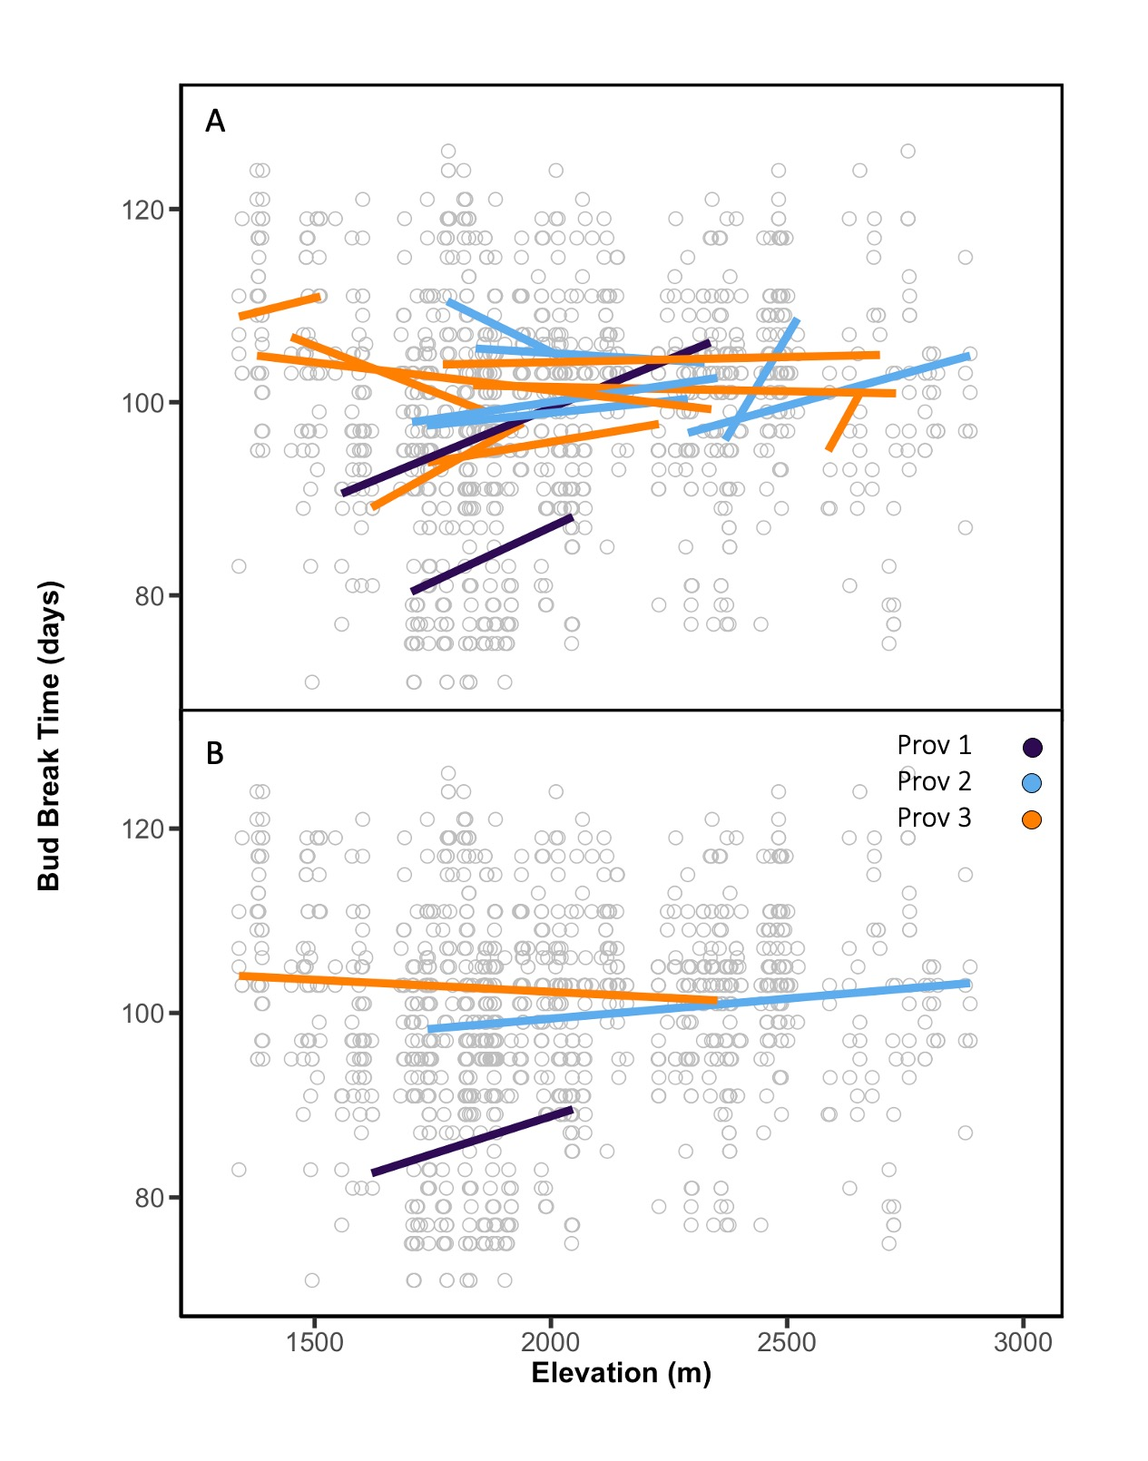

Figure 2.
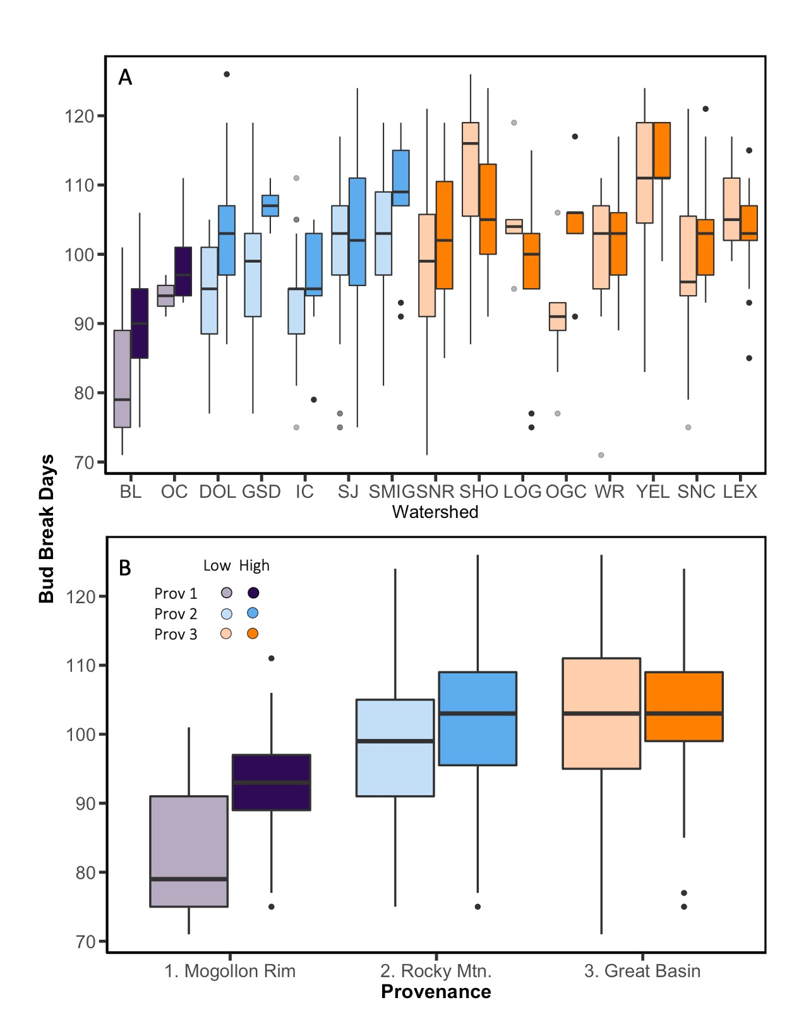

Figure 3.
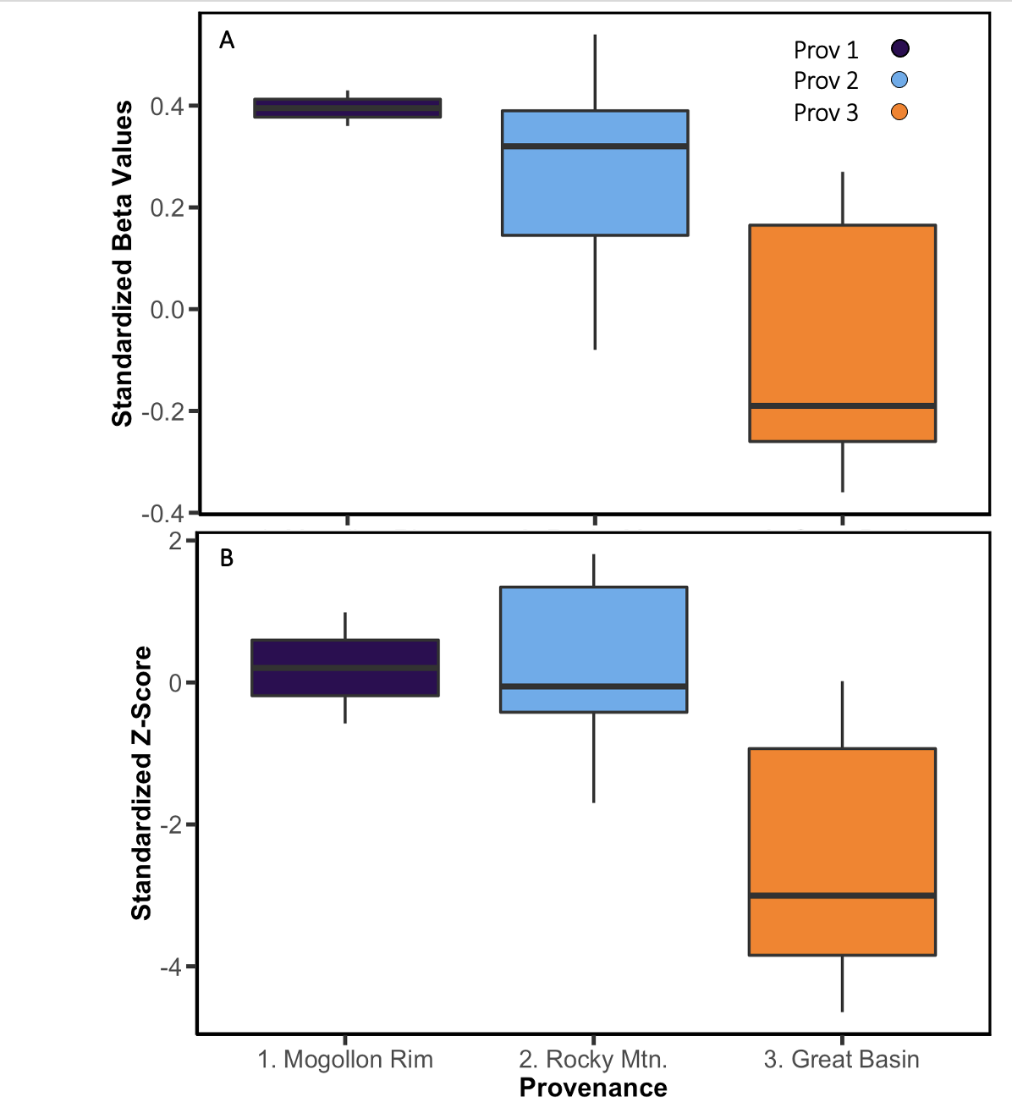

Supplement 1. To assess the levels of genetic differentiation between the provenance and population (watershed) level, the STRUCTURE and CLUMPAK results were utilized. According to these analyses, there are three distinct genetic provenances.
S1. K = 3 yields the most accurate depiction of genetic relatedness among the studied individuals. The analysis was performed using population parameters K = 1 to 5. Out of 15 runs, K = 3 yielded the most accurate depiction of genetic relatedness (15/15), showing that there are three distinct genetic populations among sites studied.
S1.
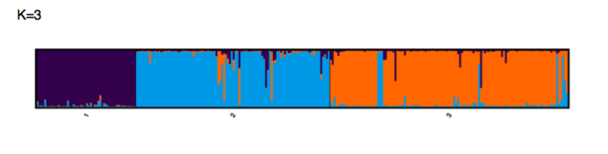

Supplement 2. We assessed the relationship between elevation and three different abiotic factors that are important predictors on the landscape: Mean annual temperature (MAT, Celsius), mean annual precipitation (MAP, millimeters), and potential evapotranspiration (PET). The regression lines represent a single population.

Table 1. Relationships between elevation and multiple abiotic factors at the population level scale. General Linear Mixed Model examining the relationship between the environmental abiotic factors MAT, MAP, & PET and elevation at the population level.

Response Variable: Mean Annual temperature (MAT)
Model F(df) p
Population 401.81 (14) <0.0001
Elevation 2135.59 (1) <0.0001
Pop. X Elev. 8.06 (14) <0.0001

Response Variable: Mean Annual Precipitation (MAP)
Model F(df) p
Population 98.34 (14) <0.0001
Elevation 224.68 (1) <0.0001
Pop. X Elev. 10.88 (14) <0.0001

Response Variable: Potential Evapotranspiration (PET)
Model F(df) p
Population 92.42 (14) <0.0001
Elevation 10.76 (1) 0.0013
Pop. X Elev. 8.87 (14) <0.0001

S2. There is population-level variation in abiotic factors that drive phenotypic traits. Panel A shows the relationship between Elevation and Mean Annual Temperature (MAT) along the species range. Panel B shows the relationship between Elevation and Mean Annual Precipitation (MAP), and Panel B shows the relationship with Elevation and Potential Evapotranspiration (PET).

S2.
