Plant Community Assembly after Volcanic Eruptions: Review, Patterns and Drivers

A Dissertation Presented for the

Doctor of Philosophy

Degree

The University of Tennessee, Knoxville

Elsie Mariah Denton

December 2025

Copyright © 2025 by Elsie Mariah Denton
All rights reserved.

DEDICATION
I dedicate this dissertation to my parents who introduced me to all of the wonderful things you can see and do in the great outdoors. I dedicate it to my siblings, who shared those experiences with me. Finally I dedicate it to my kids for whom I tried to provide the same opportunities and who have put up with me occasionally working weekends to get the dissertation done as soon as possible.

ACKNOWLEDGEMENTS
I would like to thank all members of my committee for their help and encouragement throughout the dissertation process, particularly my advisor, Dr. Virginia Dale. Members of my committee are Drs. Hannah Herrero, Mona Papeş and James Fordyce.
Funding for this work was provided by the National Science Foundation grant DEB 2043870. Technology and infrastructure on which the work was done was provided by the University of Tennessee Knoxville. Additional thanks are extended to Drs. Sergei Grishin and Elizabeth and William Clarkson for sharing manuscripts that were not readily available. We appreciate comments provided by Donald Brown, Parker Maynard, and Tara Blackman on an earlier draft of the manuscript. Wyatt Miner helped prepare maps and analysis of the pyroclastic flow. The USDA Forest Service shared shape files of disturbance zones. A final thanks to Allison Gonzalez who helped me proof 40 years of cover data.

ABSTRACT
Disturbance is a fundamental part of ecosystems but varies in scale, intensity, frequency and resulting influence on species. Large infrequent disturbances are extreme in two or more of those aspects and may have disproportionate influences on resulting communities. Humans are altering landscapes at an unprecedented rate and frequently want to manage resulting landscapes for ecosystem services and quick recovery. By studying the way ecosystems reassemble after naturally occurring large, infrequent disturbances we can gain insight into how to effectively manage anthropogenically altered landscapes. Volcanic eruptions provide an excellent opportunity to study ecosystem assembly processes after disturbance because they often involve several disturbances differing in scale and severity but not in timing, thereby providing excellent opportunities to infer differences in processes. This thesis focuses mostly on vegetative recovery after volcanic debris avalanches, volcanic landslides, but will also addresses recovery processes within areas devastated by lateral blasts, pyroclastic flows and lahars. In each chapter vegetative community assembly after disturbance is examined from a different scale, starting with a global review of the literature. Next is a comparison of different volcanic disturbances at Mount St. Helens after its 1980 eruption, and finally, drivers of vegetation change are examined in detail on the debris avalanche deposit at Mount St. Helens.

TABLE OF CONTENTS
INTRODUCTION 1
The Need to Study Large Infrequent Disturbances 1
Volcanic Debris Avalanches (VDAs) 1
Community Assembly and Succession 2
The Goal of Informing Land Management Decisions 7
CHAPTER I Plant Community Assembly on Volcanic Debris Avalanche Deposits around the World 10
Abstract 11
Introduction 12
Literature Review 13
Approach 13
General Description of Studies 14
The Problem of Terminology 18
Major Predictors of Processes in Community Formation and Succession 18
Biotic Legacies 19
Climatic Zone 21
More Nuanced Predictors of Processes in Community Formation and Succession 24
Species Functional Groups 24
Topography 28
Secondary Disturbance 32
Anthropogenic Disturbance 34
Knowledge Gaps and Directions for Further Inquiry 35
What is Meant by Recovery? 35
Repeat Sampling Needed 37
Further Topics 40
Implications for Management beyond Debris Avalanches 41
Conclusions 42
APPENDIX – CHAPTER 1 44
CHAPTER II Multiple trajectories of land-cover change: influence of disturbance severity over four decades after the eruption of Mount St. Helens 46
Abstract 47
Introduction 48
Research questions 52
Methods 52
Study area 52
Focal disturbance events of the 1980 eruption of Mount St. Helens 53
Data Set 55
Change Detection and Classification 56
Time Until Change 57
Where Change Occurred 57
In situ data 57
Results 58
Do patterns of land-cover change differ between primary and secondary successional areas? 58
Discussion 70
Lessons Learned from an Unmanaged System 71
Application to Management 75
Conclusions 76
APPENDIX – CHAPTER 2 77
CHAPTER III Shifting Constraints: Site Condition, Propagule Limitation and Priority Effects across 42 Years of Succession after the Mount St. Helens Eruption 81
Abstract 82
Introduction 83
Methods 85
Study System 85
The Debris Avalanche Deposit 86
Spatial Imagery 88
Land Cover Classification 89
Ground Based Dataset 90
Modeling 91
Alternative Approach: Piecewise Growth Curve Modeling 93
Results 93
Success of Random Forest Classification 93
Panel Model 95
The Growth Curve Model 96
Discussion 96
Management implications 104
Conclusions 105
REFERENCES 108
APPENDIX – CHAPTER 3 130
CONCLUSION 132
VITA 133

LIST OF TABLES
Table 1. Summary of the types of data collected in published research on vegetative assembly and change counted by volcanic debris avalanche deposits studied and subset by years after emplacement when studies were conducted. Individual studies detailed by author in Table 6 in Appendix – Chapter I. 16
Table 2. Summary of findings on continuing species community change and tree line recovery by volcano where these reported metrics were sampled. Where available, findings from primary and secondary areas on debris avalanches are presented separately. 17
Table 3. Table detailing differences between a volcanic debris avalanche and other types of volcanic disturbances these landslides might be confused with in the literature. 19
Table 4. Search terms and initial records from systematic search for three databases 19 Sept - 9 Dec 2022 44
Table 5. Studies broken up by time since emplacement that they covered and major types of data reported. These numbers are summarized in Table 2 in the main text. 45
Table 6. Rates of change in proportion of each land-cover type by five-year intervals from 5 to 40 years after the eruption as defined by a linear model. Bold indicates estimates whose confidence intervals (CI) don’t include zero. 60
Table 8. Model results from linear models predicting when change happened at Mount St. Helens based on elevation, distance from water and disturbance type. A generalized linear model predicted whether two step or one step conversion from barren to forest was more likely to happen with the same predictors. 30m, 100 m and 500 m elevation steps were tested for each model, only the best model is presented here, and the rest can be found in the Supplementary Table 5. Bolded values are significantly different from each other (alpha<0.05). 69
Table 9. Contingency table comparing LCMAP land-cover predictions with land cover as estimated from in situ vegetation monitoring of long-term 250 m2 plots on the debris avalanche deposit. Plot-based data were collected in 1983, 1989, 1994, 2000, 2004, 2010, 2015, and 2020 and compared to the nearest year in our LCMAP dataset. Bolded numbers are land covers that are the same in both datasets. Overall accuracy of 41%. 70
Table 11. Percent of the landscape that underwent change and type of conversion between 5 and 40 years after the eruption. Secondary zones are BDF: blowdown forest and MF: mudflow. Primary zones are DA: debris avalanche and PF: pyroclastic flow. 80
Table 11. GIS layers used for explanatory variables in a study of the revegetation of Mount St. Helens after its 1980 eruption. Some values estimated at this point. 90
Table 12. Error matrix for the random forest classification includes plots from the following years (1984, 1990, 1994, 2000, 2004, 2010, 2015, 2022) all based on training done during the growing season to identify the following land cover types at Mount St. Helens, WA. Predicted land cover in rows, in situ land cover in columns. 92

LIST OF FIGURES
Figure 1. Image of entire mountainside giving way at initiation of Mount St. Helens debris avalanche, art by Elsie M. Denton. 3
Figure 2. Volcanic debris avalanches (VDAs) deposits (black triangles), as compared to other rockslide avalanches (grey circles) as compiled by Korup et al. (2013), reprinted with permission. VDAs are on average larger than other rockslide avalanches and cover a greater area at any given volume. Special attention is drawn to those VDAs where vegetative establishment and change has been studied (red). Both axes are presented as logarithmic scales. 4
Figure 3. View of the Mount St. Helens debris avalanche deposit shortly after emplacement, showcasing hummocky terrain and novel substrates with ridges affected by the lateral blast in the background and a wooden seed trap in the foreground. Photo taken by Virginia Dale 1981. 5
Figure 4. A simplified diagram of how species assembly and succession might progress with Mount St. Helens as an example system. Grey arrows represent state transition that may be directed by the tolerance model and neutral processes. Jagged black arrows represent transitions that take place with the assistance of disturbance. Circular black arrows represent communities that will persist in a stable state in the absence of disturbance. Bare rock, grass, and alder (Alnus rubra) are alternative transient states, while moss and conifer communities are alternative stable states. Art by Elsie M. Denton. 9
Figure 5. Global map of the distribution of volcanic debris avalanches where vegetative establishment and change has been studied on deposits. All triangles are proportionally scaled to the deposit area in km². The color of the triangle represents elapsed time since emplacement associated with when research was conducted. Dashed line represents the boundary of the tropics and solid line boundary between temperate and boreal regions. 16
Figure 6. A) Vegetative cover as reported by years since emplacement of volcanic debris avalanche (VDA) deposits, color-coded by climatic zone (black: tropical, grey: temperate, and white: boreal). B) Species richness on VDA deposits scaled to a 250 m² plot reported by years since emplacement and color-coded by climatic zone. 23
Figure 7. A) Location of Mount St. Helens, where this study was conducted, indicating the extent of each disturbance zone within the Mount St. Helens National Volcanic Monument. B) Percent of total land surface within each disturbance zone that has undergone land-cover conversion since monitoring began in 1985 through 2020 (5 to 40 years post-eruption). Blue/green colors indicate disturbances that instigated secondary succession; brown/yellow colors indicate disturbances that resulted in primary succession. 54
Figure 8. Percent of land surface broken out by disturbance zone between 5 and 40 years since eruption for each cover type: A) extent of Barren land, B) extent of Grass/Shrubland, C) extent of Forest. Blue/green colors indicate disturbance zones that instigated secondary succession, and brown/yellow colors indicate disturbance zones that resulted in primary succession. 61
Figure 9. Rate of change for each land-cover conversion type as percentage of total area, as divided by disturbance zone. A) Barren to Grass/Shrubland conversion, B) Grass/Shrubland to Forest conversion. Blue/green colors indicate areas where the disturbance resulted in secondary succession, brown/yellow colors indicate disturbances that resulted in primary succession. 63
Figure 10. Detection results of land-cover change dynamics for the transition between Barren and Grassland. Time since eruption until the land-cover transition occurred (between 10 and 40 years) is marked with a colored coded pixel, see scale bar. White areas did not undergo this land-cover conversion during the study period. Inset maps for each disturbance are color coded and represent enlarged views of areas of interest. 64
Figure 11. Detection results of land-cover change dynamics for the transition between Grass/shrubland and Forest. Time since eruption until the land-cover transition occurred (between 10 and 40 years) is marked with a color-coded pixel, as shown in the legend. Black areas did not undergo this land-cover change during the study period. Inset maps for each disturbance are color coded and represent enlarged views of areas of interest. 65
Figure 12. Land-cover change over time for the rare Barren-to-Forest conversion type. There are two possible pathways of change. The multistep transition Barren-to-Grass/Shrubland-to-Forest (marked with yellow), and the one step transition Barren-to-Forest (marked with purple). 67
Figure 13. Percent of conversion from Barren-to-Forest that followed each pathway. Marked in orange is a two-step process Barren-to-Grass/Shrubland then Grass/Shrubland-to-Forest. Marked in purple is a single step process from Barren directly to Forest. Disturbances that resulted in secondary succession were lateral blast and mudflow. Disturbances that resulted in primary succession were debris avalanche and pyroclastic flow. 68
Figure 14. Photos of plots representing correspondence between land cover as predicted by LCMAP and the 250 m² vegetation plots on the debris avalanche deposit. The plot number and the year the photo was taken is in the lower right corner under each photo. 72
Figure 15. Land cover as predicted by Land Cover Mapping and Projection data from USGS at the beginning (1985, five years after the eruption) and end (2020, 40 years after the eruption). rey areas are Barren, yellow Grassland and green Forest. Black lines indicate boundaries between disturbance zones. 77
Figure 16. Percent of land surface that experience each type of change between 1985 and 2020 (5 to 40 years after the eruption). Grey for no change, yellow for Barren to Grassland conversion, blue for Grassland to Forest conversion and red for Barren to Forest conversion. Disturbances that resulted in secondary succession: lateral blast and mudflow. Disturbances that resulted in primary succession: debris avalanche and pyroclastic flow. 78
Figure 17. Mount St. Helens area showing location of study plots on the debris avalanche deposit, and relationship to other disturbance zones from eruption. 87
Figure 18. Extent of the debris avalanche deposit with land cover as classified using the random forest algorithm at roughly five-year time points from 1984 to 2022, 4 to 42 years after the eruption of Mount St. Helens. Land cover is grey for barren, yellow for herbaceous, and green for woody, water is blue, and No Data is white (from clouds). 90
Figure 19. A set of potential models for how land cover type (LC: representing Barren, herbaceous and woody) may change over time. In Model A land cover at each time point is informed independently through two latent factors representing successional drivers: site condition and propagule limitation, these conceptual variables are informed by measured predictor variables. In Model B, much of the above structure is the same, but the cover type at Ti-1 has a direct effect on the cover type at Ti. 94
Figure 20. Panel models fit to the land-cover predictions of our random forest models. data between years 4 and 42 after the eruption at roughly 5-year time steps. Model A predicts land cover based only on site condition and propagule limitation at each time point. Model B allows for site condition and propagule limitation to predict cover at each time point but also allows the land cover at previous times to predict land cover at the next times, an estimate of the influence of priority effects. Size of the error is proportionate to the size of the effect. 98
Figure 21. Standardized direct influences of drivers of land cover based on the panel structural equation models. (A) includes the influences when only site condition and propagule pressure explain land cover at each time point between years 4 and 42 after the eruption. (B) Once priority effects and the stochastic influences they include are included in the panel model the perceived influence of the drivers change dramatically. 99
Figure 21. (A) Mean land cover as estimated by the growth curve model over time from classified data. The influence of environmental covariates on the slope of land cover change was further investigated for each period indicated by A, B and C using a piecewise growth model. (B) Piece-wise growth curve model fit to the land cover predictions of our random forest models. Land cover data was between years 4 and 42 after the eruption at roughly 5-year time steps. The piecewise-growth model estimates rate of change over different times so that the influence of predictors can vary with time. Most lines are greyed out for readability. However, arrows towards covariates are grey if the effect is negative, black if positive, and width is scaled to the size of the effect. Dashed lines are not significant. Site condition variables are purple, and propagule limitation variables are peach. 100
Figure 23. (A) Conceptual diagram of the phases of succession represented by our model in an idealized disturbance system similar to the debris avalanche deposit at Mount St. Helens, darker greens represent areas vegetation establishes first and lighter greens represent later establishing vegetation. In the initial phase site conditions are harsh and propagule limitation is strong because all seed must arrive from outside of the disturbed area. Any propagules that do arrive struggle to establish so site condition dominates the land cover that is first to establish. During the mosaic period site conditions have begun to ameliorate so no longer strongly influences land cover, but most seed is still arriving from outside of the disturbed area, so propagule pressure becomes the dominant control on land cover. During the fill in phase, propagules from previously established vegetation are the primary source of seed, so distance from original seed sources no longer matters, but long-lasting legacies of site condition may make themselves apparently again. (B) An example of what a mosaic phase might look like. A mosaic area may include bare ground and patchy vegetation representing different plant types, with no vegetation type dominant. At Mount St. Helens this vegetation phase occurred around 14 years after the eruption, but in a burned system like (C) it might occur at year 4. 106
Figure 23. Generic growth curve model for land cover at Mount St. Helens by modeling the intercepts and slope of land-cover change by year. Setting the intercept to 1 indicates that all plots start at the same point (barren), and allowing the slope to vary across time indicates that land cover at each time point can influence the rate of land-cover change. 130
Figure 23. Growth curve model for land cover at Mount St. Helens by modeling the intercepts and slope of land-cover change by year. Setting the intercept to 1 indicates that all plots start at the same point (barren), and allowing the slope to vary across time indicates that land cover at each time point can influence the rate of land-cover change. 131

INTRODUCTION

The Need to Study Large Infrequent Disturbances
Disturbance is a fundamental part of ecosystems, but vary in scale, intensity, frequency and resulting influence on species. Large infrequent disturbances are extreme two or more of those aspects and may have disproportionate influences on resulting communities. Humans are altering landscapes at an unprecedented rate and frequently want to manage resulting landscapes for ecosystem services and quick recovery. By studying the way ecosystems reassemble after naturally occurring large, infrequent disturbances we can gain insight into how to effectively manage anthropogenically altered landscapes. Volcanic eruptions provide an excellent opportunity to study ecosystem assembly processes after disturbance because they often involve several different disturbances differing in scale and severity but not in timing, providing excellent opportunities to infer differences in processes. This thesis will focus mostly on vegetative recovery after volcanic debris avalanches, volcanic landslides, but will also address recovery processes within areas devastated by lateral blasts, pyroclastic flows and lahars. In each chapter vegetative community assembly after disturbance will be examined from a different scale, starting with a global review of the literature. Next will be a comparison of different volcanic disturbances at Mount St. Helens after its 1980 eruption, and finally, drivers of vegetation change will be examined in detail on the debris avalanche deposit at Mount St. Helens.

Volcanic Debris Avalanches (VDAs)
Landslides come in many types, from simple slumps of a small area to slides that move the whole mass of the disturbed material downslope - often further than the length of the scar left behind. The later class, known as long-runout landslides, cause considerably more disturbance than the former, as slumps can leave ecosystems largely intact. The volume of material transported in long-runout landslides varies widely from 0.01 km³ to as high as 100 km³. The largest long-runout landslides are volcanic debris avalanches (VDAs); these result from the catastrophic collapse of volcanic flanks and edifices (Figure 1) and comprise roughly 20% of all long-runout landslides (Korup et al. 2007). VDAs have several features that distinguish them from other long-runout landslides, including their overall larger volume and proportionally wider extent because they tend to be unconstrained by existing topography (Figure 2). The initiating slope of VDAs tends to be shallower, and the material that makes up the resulting deposit comes from a deeper depth than comparable non-volcanic landslides (Siebert 1984). VDAs travel faster, cover longer distances, and contain higher volumes of water than other long-runout landslides. They tend to be composed of mechanically weak and hydrothermally altered debris, as the rock is highly weathered from long-term stresses of temperature and pressure within the volcanic edifice (Siebert 1984; Korup et al. 2013). The resulting deposits are wide and characterized by unevenly spaced depressions and mounds known as hummocks (Figure 3). The soils associated with VDAs tend to be coarse-grained, poorly sorted, and nutrient-poor (Adams and Adams 1982; Adams and Dale 1987; Parker 1993; Glicken 1996; Velázquez and Gómez-Sal 2008).

Community Assembly and Succession
Understanding of ecological succession, or changes that occur after disturbance in the biological and physical conditions of an ecosystem, has developed substantially since the first studies addressed vegetative recovery after VDAs. Some argue that “succession” is no longer even the correct word, preferring to refer to “alternative stable states” or the “neutral theory of plant assembly.” As “succession” has been in consistent use since the earliest of the publications included in this review, we will retain the term. However, readers need to be aware of the many
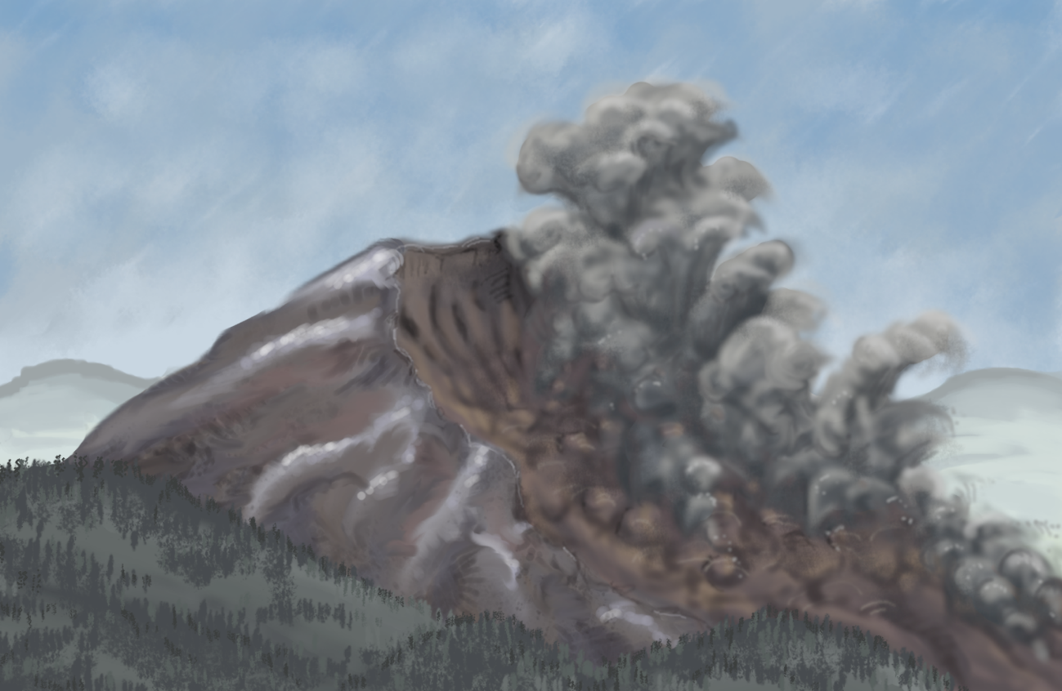
Figure 1. Image of entire mountainside giving way at initiation of Mount St. Helens debris avalanche, art by Elsie M. Denton.

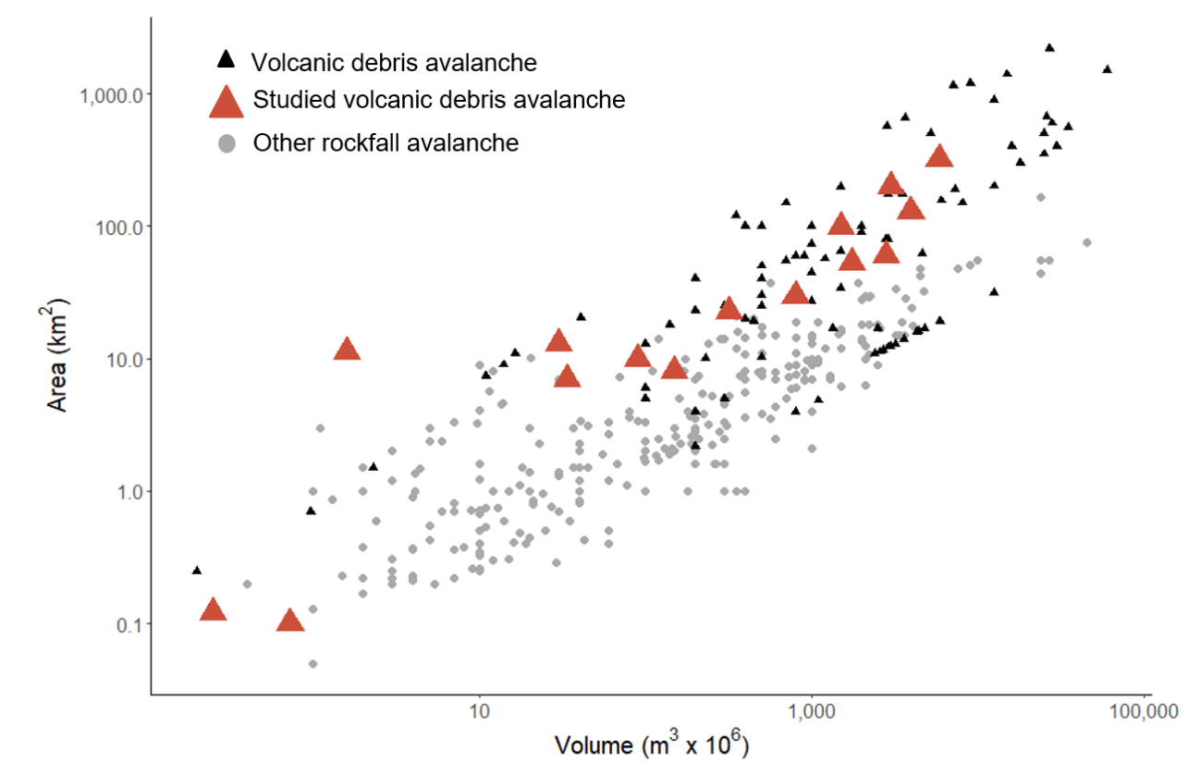
Figure 2. Volcanic debris avalanches (VDAs) deposits (black triangles), as compared to other rockslide avalanches (grey circles) as compiled by Korup et al. (2013), reprinted with permission. VDAs are on average larger than other rockslide avalanches and cover a greater area at any given volume. Special attention is drawn to those VDAs where vegetative establishment and change has been studied (red). Both axes are presented as logarithmic scales.

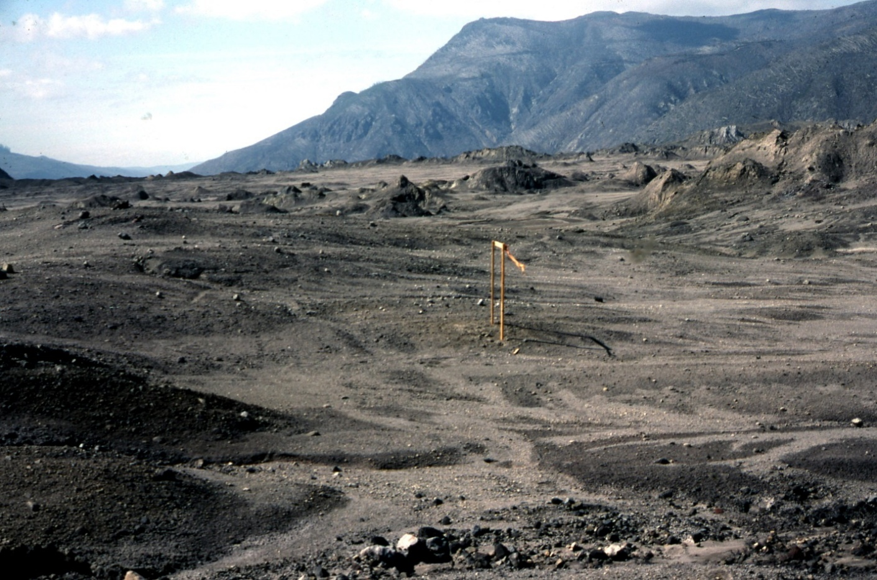
Figure 3. View of the Mount St. Helens debris avalanche deposit shortly after emplacement, showcasing hummocky terrain and novel substrates with ridges affected by the lateral blast in the background and a wooden seed trap in the foreground. Photo taken by Virginia Dale 1981.

ways succession has been conceptualized over time and the current understanding of related processes.
Historically, ecologists distinguished between primary succession, which occurs on new substrates free of biological legacies, and secondary succession, which proceeds after a disturbance that leaves remnants of the previous ecosystem. Many disturbance events are mixtures of the two processes.
- Inhibition model
The inhibition model assumes that, once a given community is established, it persists, in the absence of further disturbance, by maintaining abiotic conditions favorable to its continuance and unfavorable for establishment of new species complexes (Connell and Slatyer 1977). For instance, high richness of initial algal communities in intertidal areas may inhibit further community change as all niches are occupied (Maggi et al. 2011). Competition plays a large role in the inhibition model.
- Tolerance model
In the tolerance model of succession, a cohesive community does not exist (Connell and Slatyer 1977). Under this theory, it would be more apt to describe the plants in a landscape as a collection of species that happened to arrive and establish. Species neither facilitate nor inhibit their successors, and the assemblage is determined by neutral processes. The characteristics of this assemblage shift and change based on the life history traits of each species, with little cohesion between them. Over time, the community is dominated by species that best tolerate the changing conditions. An analysis of post-mine succession in Germany determined that neutral processes well describe succession in a dry grassland in the first 20 years after mining cessation (Baasch et al. 2010a). This type of succession also tends to preserve fugitive species (Pulsford et al. 2016) those that can only establish in disturbed conditions, such as the acorn barnacle (Balanus pacificus), which primarily establishes on sandy substrates and small pebbles and is outcompeted by other species on solid rocky areas (Hurley 1973).
Instead of thinking of succession in terms of species communities, Tilman (1985a) suggested considering the process as shifts in resource availability through time, with species assemblies changing to take the best advantage of those niches. A frequently occurring shift in succession is the switch from nutrient limitation and high light availability in early succession to easy and higher availability of nutrients in late successional communities and limited light. Johnson (1996) amended this theory by clarifying that this shift in resource partitioning was not driven by time per se but by interactions between species. The available species pool can greatly affect the rates of transitions between resource limitations.
Of course, all these theories assume a stable climatic regime and species pool, which is often not the situation. Prach and Walker (2019) found large differences in rates of recovery between cold versus warm biomes, such differences may influence rates of succession in a warming climate. They also found invasive species to be more likely to alter the trajectory of recovery in a secondary as opposed to a primary successional landscape.
A more modern synthesis of disturbance and succession considers alternative stable states. These alternative states are potential communities under the same climatic regime and species pool. Which state exists is determined by stochastic processes or outside forcing. For example, species richness and abundance of early colonists can determine whether inhibition or facilitation is the dominant operative process (Maggi et al. 2011). There is evidence that alternative states are best considered transient (but may persist for many generations), and any genuinely undisturbed community would converge to a cohesive successional endpoint (Fukami and Nakajima 2011). However, since no natural community exists without ongoing disturbance, these ‘alternative transient states’ remain important for understanding successional processes. Figure 4 shows an idealized diagram of how these multiple states might coexist on a landscape.

The Goal of Informing Land Management Decisions
While interesting, the goal of studying successional processes is not just improved understanding, but to then leverage that understanding to help us improve management of disturbed landscapes. Primary succession, such as after a volcanic debris avalanche is analogous to human caused disturbances like mining, large industrial areas, dam draining and loss of water in inland seas. Other volcanic disturbances such as mudflows or lateral blasts are similar in degree to floods or wildfires. These similarities mean that lessons learned from processes in volcanic systems are directly applicable to managing other disturbed lands.

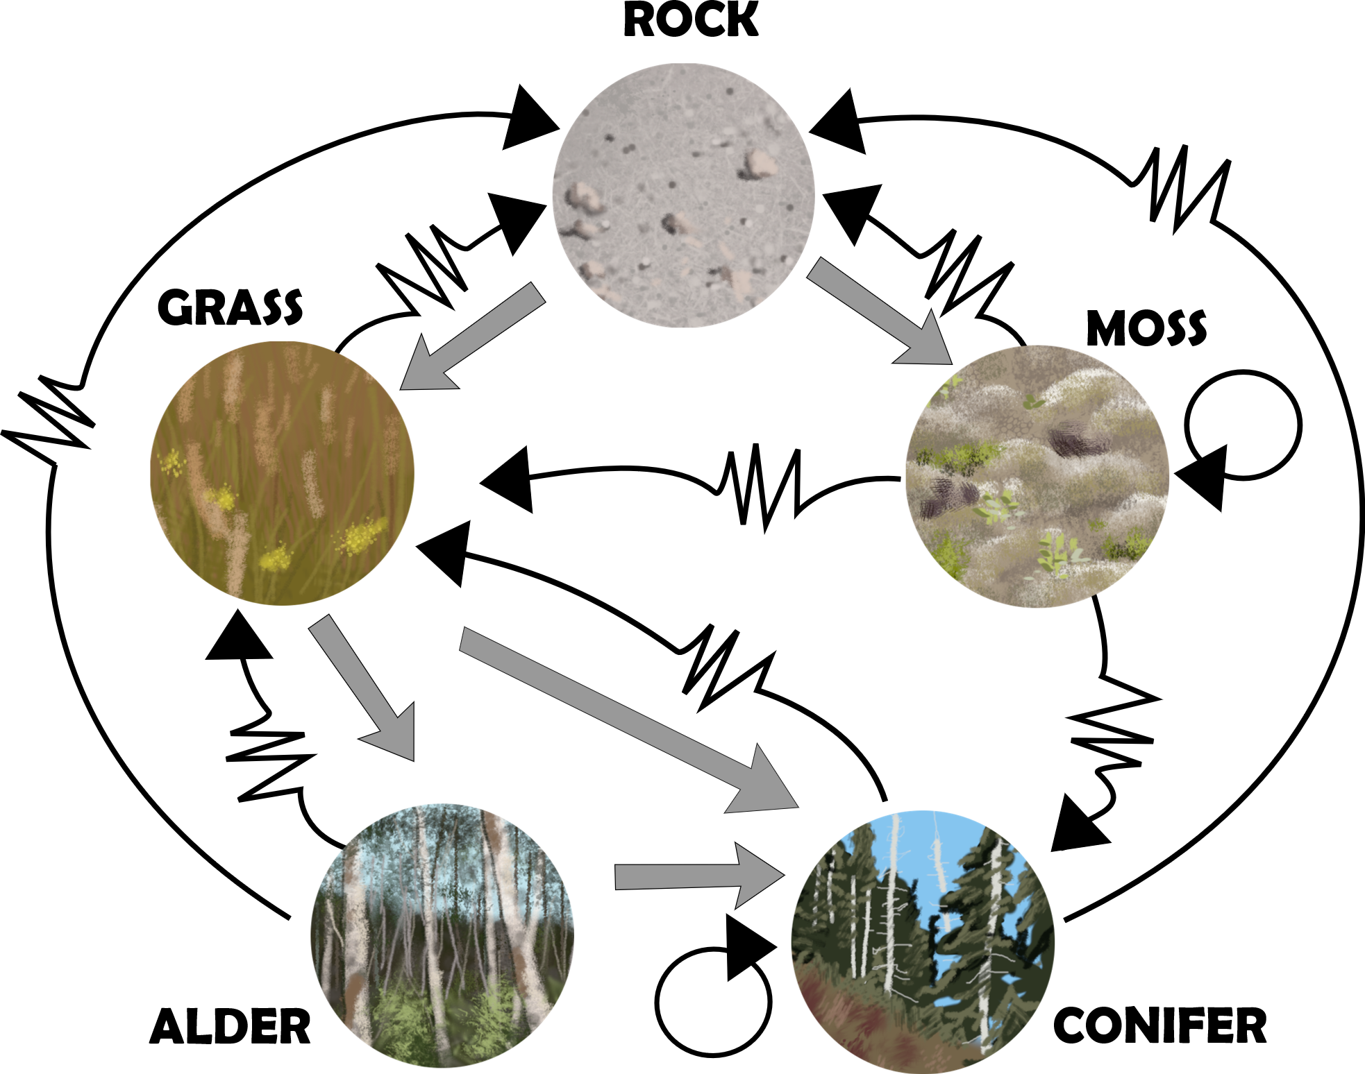
Figure 4. A simplified diagram of how species assembly and succession might progress with Mount St. Helens as an example system. Grey arrows represent state transition that may be directed by the tolerance model and neutral processes. Jagged black arrows represent transitions that take place with the assistance of disturbance. Circular black arrows represent communities that will persist in a stable state in the absence of disturbance. Bare rock, grass, and alder (Alnus rubra) are alternative transient states, while moss and conifer communities are alternative stable states. Art by Elsie M. Denton.

CHAPTER I
Plant Community Assembly on Volcanic Debris Avalanche Deposits around the World

A version of this chapter has been accepted to be published by Elsie Mariah Denton and Virginia H. Dale:
Elsie M. Denton, Virginia H. Dale “Plant community assembly on volcanic debris avalanche deposits around the world.” Environmental Reviews (accepted).
The only change to this article, other than reformatting for thesis requirements is that information that was originally included in boxes for the journal article has instead been moved to the Introduction of the entire thesis. Virginia H. Dale is my advisor and provided insight, ideas and comments throughout the conception and execution of this manuscript.

Abstract
Volcanic debris avalanches are among the largest and most severe disturbances known. Therefore, studying processes of ecosystem formation on the deposits emplaced by these landslides provides insights into the patterns of community assembly after the most severe disruptions. In this review we synthesize findings of 60 vegetation studies from 15 volcanic debris avalanche deposits. One of the most impactful drivers of the speed with which communities reestablish is the climatic region in which the debris avalanche occurs. The fastest recovery occurs in the tropics and slowest in the boreal latitudes. The existence of biotic legacies, or remnant soils or biota from the previous communities accelerates community establishment, and these legacies are found more frequently on smaller debris avalanche deposits. Where these legacies exist, recovery proceeds many times more rapidly than in primary successional areas of the deposits. Similar patterns across mountains are observed in the species guilds that arrive and become established on the deposits with nitrogen fixers and early seral species doing particularly well. Complete recovery, meaning that communities match those of surrounding undisturbed areas, from this extreme class of disturbance takes a very long time, decades in the tropics and centuries to millennia at higher latitudes. Secondary disturbances are frequent and often reshape the direction of community development. Understanding of community development on debris avalanches would be greatly expanded if continuous time series over decadal to millennial scales were available on more disturbances. This could be achieved through repeat monitoring of permanent plots, remote sensing, or use of pollen core analysis. Such studies may enable inference about whether long-lasting community differences from surrounding areas are due to alternative stable states or simply the slow turnover of long-lived species on volcanic debris avalanches. Further study of these topics will foster better management of human disturbed landscapes, such as those from large-scale mining.

Introduction
Large, infrequent disturbances, such as volcanic eruptions, hurricanes, tornadoes, floods, and wildfires, can completely transform landscapes (Foster et al., 1998; Lugo, 2020). The type, magnitude, spatial extent and duration of the disturbance and the composition of the preexisting community all impact how plant communities recover afterwards (Turner and Dale 1998). A volcanic debris avalanche (VDA) is both a large, infrequent disturbance and a truly dramatic event. VDAs occur when the edifice of a volcano gives way, collapsing downslope. This process may be part of an eruption event or be triggered by an earthquake, rainfall, or rapid snowmelt (Roverato et al. 2021). Debris avalanches can completely bury preexisting vegetation communities and form broad, mostly flat landscapes punctuated by large hummocks formed by semi-intact blocks from the volcanic edifice. These novel landscapes are largely devoid of life and present opportunities for the formation of novel ecosystems (Adams et al. 1987a). Thousands of these deposits are identified in volcanic records (Roverato et al. 2021). As with other types of ecosystem disturbances, vegetative communities begin to reestablish immediately after VDAs occur (White 1979; Stuart Chapin et al. 1994b; Mueller-Dombois 2000b; Young et al. 2001; Chang and Turner 2019). Since these avalanches are among the most severe of disturbance events, the resulting deposits provide living laboratories for studying the upper thresholds of community processes regarding vegetation reestablishment on landscapes.
Despite over a thousand individual VDAs identified in the geologic record (Roverato et al. 2021), vegetative communities after these disturbances have been studied at few deposits. Vegetative establishment and change on individual debris avalanche deposits has been studied since 1933 (Griggs 1933) and accelerated after 1980, when the eruption of Mount St. Helens clarified which volcanic disturbance formed these distinctive, hummocky deposits (Voight B et al. 1981; Glicken 1996). This knowledge spurred investigations of VDA deposits at other volcanoes. There exists no previous synthesis of the findings of the 60 published studies, reports, and theses investigating plant communities after VDAs. As characteristics unique to debris avalanches may determine pathways of plant community succession post-disturbance (Foster et al. 1998), a comprehensive synthesis is needed. This review highlights the importance of covariates such as climate, elevation, prevailing ecotype, and pre-disturbance biotic legacies in the form of soils and surviving vegetation on the successional trajectory of vegetation re-establishment. In this review we aim to identify 1) major predictors of processes in community formation and succession on VDA deposits worldwide, 2) secondary processes that have more nuanced influences, and 3) knowledge gaps that can guide future work in these systems.

Literature Review

Approach
This systematic literature review was conducted by locating all primary research publications on vegetative succession on VDA deposits up until 9 Dec 2022 using the databases Web of Science, JSTOR, and Google Scholar. We supplemented articles from our personal collections not located by the search.
Ten search terms with wildcards were used in each database to account for alternative spellings around a root word (see Table 5 in the Appendix). The seemingly obvious term ‘succession’ was not included in the search terms because it has an alternative geologic meaning (Sigurdsson 2015) that resulted in thousands of off-target results.
Titles and abstracts of articles identified were reviewed to determine if they reported findings from vegetative succession or community assembly on VDA deposits. As some databases included a massive number of off-target results, a stopping criterion was used. If 100 consecutive records were reviewed without finding an article that might meet the search criteria, the search was ceased. Articles were downloaded only once, even if they turned up in multiple searches. Some 18 (Web of Science) + 118 (Jstor) + 195 (Google Scholar) = 331 potential titles were found in the initial sweep, with an additional eight articles added from our personal collections.
The primary reasons that articles were excluded was for landslides that did not occur on volcanoes or for studies on a different type of volcanic deposit. A total of 18.1% of the originally identified articles met the above criteria for inclusion after closer review.

General Description of Studies
A total of 60 studies fit our research criteria, covering research on 15 distinct VDAs (Attachment 1). Out of that total, 32 (53%) of publications are from Mount St. Helens ─ the most intensively studied VDA deposit in the world; six studies focus on the Chaos Jumbles of Lassen Peak California, five are from the Casita Volcano in Nicaragua, and four are from Mt. Taranaki in New Zealand. Bezymyanny in Russia and Mt. Mageik in Alaska, USA, were the subject of three publications each. All other deposits are represented by only one or two publications. 12% of studies were from tropical regions, 78% were from temperate zones, and 10% were from boreal ecosystems. Area impacted by these VDAs ranged from 0.1 km² (New Zealand, Mt. Tongariro) to 320–500 km² (New Zealand, Mt. Taranaki, Ngaere formation) (Figure 5).
The time from emplacement to the end of the first decade was exclusively examined in 21 publications. Succession or vegetative assembly was documented at decadal time scales in 29 published papers. Six studies examined communities and cover several centuries after emplacement, and six reported findings hundreds to thousands of years post-avalanche.
The most frequently reported metrics were vegetative cover (39 studies) and richness (28 studies) (Table 1) while 17 studies included some measure of community change (Table 2). A subset of studies (15) focused only on specific species on debris avalanche deposits. To standardize richness across studies for better comparison, we used a linear simplification of a rarefaction curve. The area of one plot and mean number of species per plot was used to define one point, and the total area of all plots and total number species found defined the other. Then linear regression was used to set all plots to number of species per 250 m², the unit of measurement at Mount St. Helens, which comprises the largest percentage of the data.
Most studies focused only on plants, but 10 addressed interactions between plants and other trophic levels. The effects of secondary disturbances such as landslides, ashfalls, or human interventions on successional pathways was examined in 16 studies. Most studies used plot-based measurements (72%); others used satellite-based greenness measures (21%). Four of the published studies reported results of greenhouse experiments using substrates collected from debris avalanche deposits.

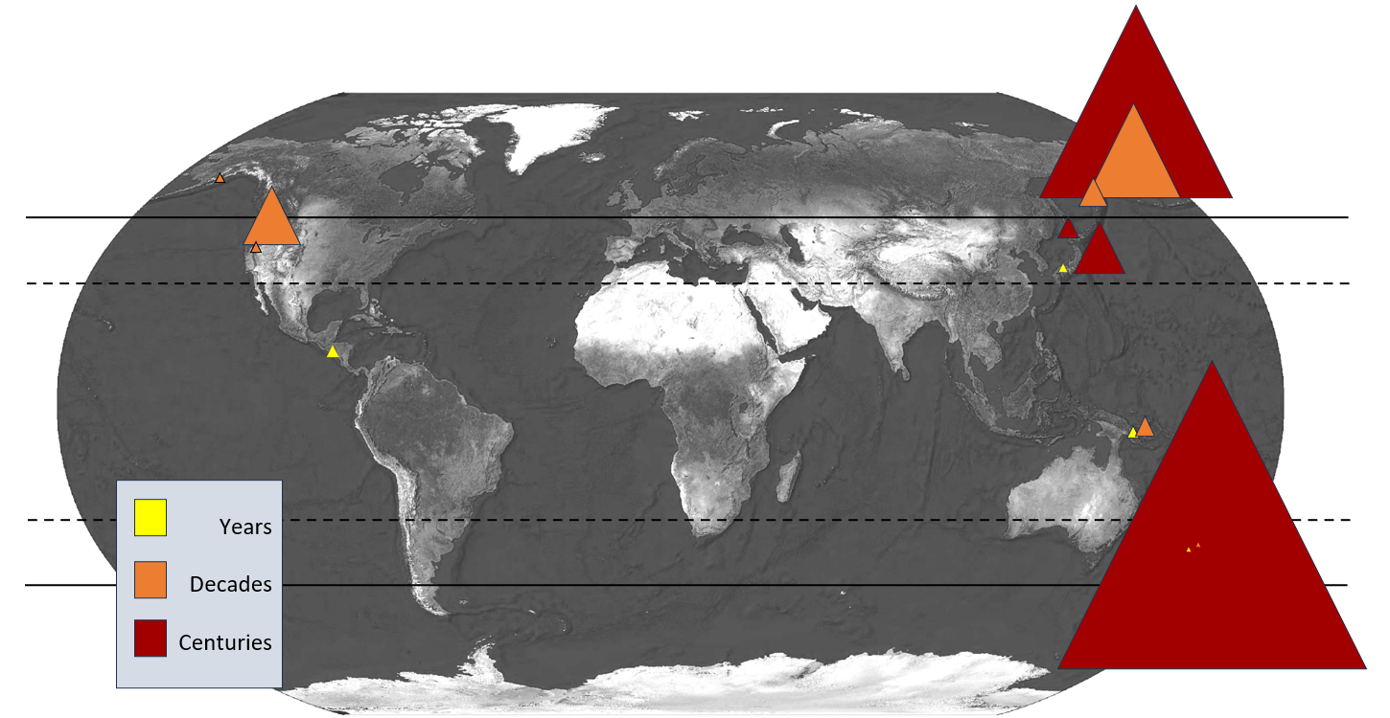
Figure 5. Global map of the distribution of volcanic debris avalanches where vegetative establishment and change has been studied on deposits. All triangles are proportionally scaled to the deposit area in km². The color of the triangle represents elapsed time since emplacement associated with when research was conducted. Dashed line represents the boundary of the tropics and solid line boundary between temperate and boreal regions.

Table 1. Summary of the types of data collected in published research on vegetative assembly and change counted by volcanic debris avalanche deposits studied and subset by years after emplacement when studies were conducted. Individual studies detailed by author in Table 6 in Appendix – Chapter I.
 | Years  (0-9) | Decades  (10-100 years) | Centuries  (100-1000+ years)
Species accumulation | 14 | 10 | 2
Plant cover | 12 | 21 | 5
Community composition | 6 | 4 | 5
Tree line | 0 | 3 | 5

Table 2. Summary of findings on continuing species community change and tree line recovery by volcano where these reported metrics were sampled. Where available, findings from primary and secondary areas on debris avalanches are presented separately.
Species composition | Verdict | Sampled and Analyzed | Type of Analysis
Mount St. Helens, USA | Still changing | Years 0-30 | Permutational analysis of variance, multispectral imaging, ordination, change in plant functional type distribution
Ontake, Japan | Primary: still changing  Secondary: still changing | Years 0-5 | Raw lifeform frequencies
Casita, Nicaragua | Primary: still changing  Secondary: stable | Years 0-4 | Detrended change detection
Mt. Lassen, USA | Tree community is stable but differs from areas around disturbance | Years 300-350 | Density Counts
Mt. Taranaki, New Zealand | Stable | ~ Year 27,300 | Importance values and direct gradient analysis
Mt. Usu, Japan | Stable | ~ year 8,000 to 20,000 (dating of deposit is uncertain) | Text description of community
Tree line | Depressed by | Years post emplacement | Biome
Mt. Victory, Papua New Guinea | 1500 m | 83 | Tropical
Shiveluch 13, Russia | 600 m | 364 | Boreal
Mt. Fuji, Japan | 1000 m | 2900 | Temperate
Mt. Lassen, USA | 120 m | 320 | Temperate
Bezymyanny, Russian | 300-350 m | 32 | Boreal
Mt. Taranaki, New Zealand | 0 | 27,300 | Temperate
Mt. Usu | 0 | 8,000-20,000 | Temperate

The Problem of Terminology
There were many inconsistencies in the use of terminology across the studies included in this review. Particularly in older literature, VDAs are frequently referred to simply as large landslides, and we often had to consult outside sources to determine if classification as a VDA is appropriate (Siebert and Roverato 2021). Alternatively, it was occasionally difficult to distinguish a pyroclastic flow, often called a ‘hot avalanche,’ from a debris avalanche. For instance, Taylor (1957) described the deposits from Mt. Victory as ‘of the same type’ as Mt. Lamington’s deposits. The latter volcano experienced both a debris avalanche and pyroclastic flows during the studied eruption. As descriptions of Mt. Vicory in subsequent volcanic literature are sparse, it is difficult to tell if that deposit is a VDA. The geologic literature may also refer to debris avalanches as sector collapses Bernard et al. (2021) and occasionally refers to the same deposit as both a debris avalanche and a lahar (Procter et al. 2014), even though these are distinct types of volcanic disturbance distinguished by the amount of water in the material. Table 3 details the differences between these three types of volcanic disturbance. In addition, some authors use the term debris avalanche to refer to any landslide that is not confined to a channel. For example, Jomelli et al. (2011) produced off-target results in our literature search that had to be removed. We suggest following the conventions specified by Bernard et al. (2021) in their review of the geological characteristics of VDAs. Consistence in terminology will help eliminate further confusion.

Major Predictors of Processes in Community Formation and Succession
Two factors appear to be the largest determinants of community development post-VDA: 1) biotic legacies – remnants of pre-disturbance communities and 2) the climatic zone where the VDA occurred. These factors explain the rate and shape of successional trajectories across VDAs and could be used to make generalizations about how succession would proceed on new VDAs. The total surface area of the resulting deposit emplaced by the debris avalanche also affects successional pathways, though this is hard to separate from the influence of biotic legacies.

Biotic Legacies
Biotic legacies, in the form of surviving plants or mineral soil, profoundly affect the speed of vegetative cover development, the return of plant species, and the stabilization of species composition. These legacies are predominantly found at the tail end of avalanche deposits (Nakashizuka et al. 1993; Velázquez and Gómez-Sal 2007, 2008, 2009b, a; Dale and Denton 2018) and along their margins (Adams et al., 1987; Velázquez & Gómez-Sal, 2007). The rest of the surface area of debris avalanches is devoid of any form of biotic legacy, and plant community formation must begin from scratch on bare mineral substrates, a process that is many times slower, often referred to as primary succession. For example, on the Nicaraguan Casita Volcano, one of the smallest VDAs studied, down slope areas where soil and rock were extensively intermixed exceeded one hundred percent plant cover after only one year.

Table 3. Table detailing differences between a volcanic debris avalanche and other types of volcanic disturbances these landslides might be confused with in the literature.
Characteristic | Volcanic Debris Avalanche^{α} | Lahar (Volcanic Mudflow)^{β} | Pyroclastic Flow^{γ}
Trigger | Flank collapse, edifice failure | Heavy rains, earthquakes, volcanic eruptions, lake breakouts | Explosive eruption column collapse, lava dome collapse
Composition | Blocks of fragmented edifice rock, unconsolidated debris (non-juvenile material), water (<50%) | Water (>50%), volcanic ash, rock fragments | Hot gas, ash, pumice, rock fragments
Temperature | Usually cold (0-30 C), but Mount St. Helens avalanche was warmer. | Cold to warm (0-30 C, occasionally up to 100 C) | Very hot (200–1000+ C)
Velocity | Fast (10 to 110 m/s) but slower than pyroclastic flows | Moderate (1 to 25 m/s) | Extremely fast (10 to >300 m/s)
Travel Distance | Very long (tens to 100+ km) | Can be very long (100+ km via river valleys) | Short to medium (less than one to tens of km)
Deposits | Hummocky terrain, large blocks, chaotic landscapes | Stratified mud/ash/rock deposits along valleys | welded tuffs, unconsolidated pumice, scoria or blocks to several meters
Primary Hazard | Landscape burial, river damming, long-term geomorphic change | Valley inundation, flooding | Extreme heat, asphyxiation, burial
However, in upslope primary successional areas, cover was approximately 50% after four years on the same deposit (Velázquez & Gómez-Sal, 2008), a transitional zone that contained fewer biotic legacies had recovery rates between the two extremes. Similarly, to the pattern seen at Casita, plant cover developed ten times faster where biotic legacies existed as compared to primary successional areas in Japan (Ontake Volcano) (Nakashizuka et al. 1993). In a boreal region, the tail end of the deposit from the Mt. Mageik landslide (Alaska, USA) was noted by Griggs (1920) to have extensive soil mixed in with the deposit and was completely covered with vegetation when the landslide was revisited 93 years after the disturbance (Jorgenson et al. 2004). In general, run-outs and margins make up a higher percentage of the area on small VDA deposits so the influence of legacies is more evident.
Furthermore, downslope areas influenced by extensive biotic legacies in Nicaragua (Casita Volcano) were the sole locations on that volcano where community composition stabilized during the four-year observation period (Velázquez & Gómez-Sal, 2008). Additional evidence of community stabilization is the fact that areas with extensive biotic legacies on the Nicaraguan debris avalanche closely match the plant cover and species composition of other disturbed areas, such as nearby 5 ha non-volcanic landslides. On the other hand, plant communities on the landslide undergoing primary succession differed markedly from each other, and nearby disturbed areas and were unstable over time - changing from year to year (Velázquez & Gómez-Sal, 2008) (Table 2).
Evidence of the importance of biotic legacies is also seen at California’s Mt. Lassen. Even more than 300 years post-disturbance, the substrate on this debris avalanche deposit remains so nutrient-poor and dry that a full canopy of coniferous trees has not established and, compared to nearby undisturbed areas, species composition differs and cover is much reduced (Parker, 1991; Parker, 1993). This recovery pattern contrasts with a large mudflow on the same mountain that occurred in 1915. Mudflows differ from debris avalanches by having more than 50% water and usually result in secondary succession. Species composition and cover on the mudflow were found to match surrounding undisturbed areas after only 80 years (Parker 1992). This discrepancy in speed of succession at the same mountain was thought to be due to the extensive biotic legacies in the mudflow as opposed to the barren debris avalanche deposits (Parker 1992).
Succession was not accelerated by every measure in secondary successional areas at every mountain. For instance, the number of species found in primary and secondary successional areas was not different at Nicaragua’s Casita Volcano (Velázquez & Gómez-Sal, 2008). Conversely, in Japan (Ontake Volcano), areas where biotic legacies existed had at least twice the number of species as primary successional areas (Nakashizuka et al. 1993). experiments using substrates collected from debris avalanche deposits.

Climatic Zone
The climatic zone where a VDA occurs also exerts influence on the rate of succession. In the tropics, 100% vegetation cover and most species arrive within months. In contrast, in boreal
regions it may take many decades to centuries for cover to reach that of surrounding communities (see Figure 6A). Temperate regions fall somewhere in between. Similar trends are seen when using plant richness (number of species found) as a metric of recovery (Figure 6B).
In temperate regions, where plant community formation has been studied on a larger number of deposits, cover accumulation seems to follow a logit function. Cover accumulation is very slow in the first few years after emplacement. Five to 10 years may pass before even 5% vegetative cover is observed (Nakashizuka et al. 1993; McCann 2017; Dale and Denton 2018). Rapid acceleration in cover accumulation occurs between one and two decades after the event, and eventually complete ground cover is achieved, probably between 50 and 100 years (Dale & Denton, 2009). In contrast, species accumulation, or plant richness, follows a linear trajectory over most of the measurement period, with a trend towards eventual saturation beginning to occur after four decades (Nakashizuka et al. 1993; Dale and Denton 2018). Similar patterns are observed in tropical regions, albeit at a much faster pace. In the tropics of Nicaragua, maximum number of species per plot is reached within the first year, after which species richness declines (Velázquez and Gómez-Sal 2009b). The decline in species richness is attributed to the dominance of one or two species, which outcompete and displace rarer species (Velázquez and Gómez-Sal 2009b).
Complete recovery is observed in the temperate regions several thousand years after emplacement (Clarkson 1977; Lees 1987b; Végh and Tsuyuzaki 2022). Though it is not known exactly when this recovery occurred.
Studies of vegetation on VDA deposits in boreal regions are scant, possibly because locations are more difficult to access. A second visit to the same boreal volcano was reported in published literature in only two cases, and therefore trends are inconclusive. However, both species and cover accumulation rates are markedly slower compared to other zones (Grishin 1996, 2011, 2019; Grishin et al. 2000) likely due to shorter growing seasons, harsher abiotic conditions, and smaller available species pools. Even Mt. Mageik, the most progressed of the boreal locations in terms of plant cover (Jorgenson et al. 2004), is dominated by grasses while the surrounding forest is tall alder shrub after nearly a century (Alaska Inventory and Monitoring Program 2016). That said, high latitude sites may be more likely to return to a vegetative

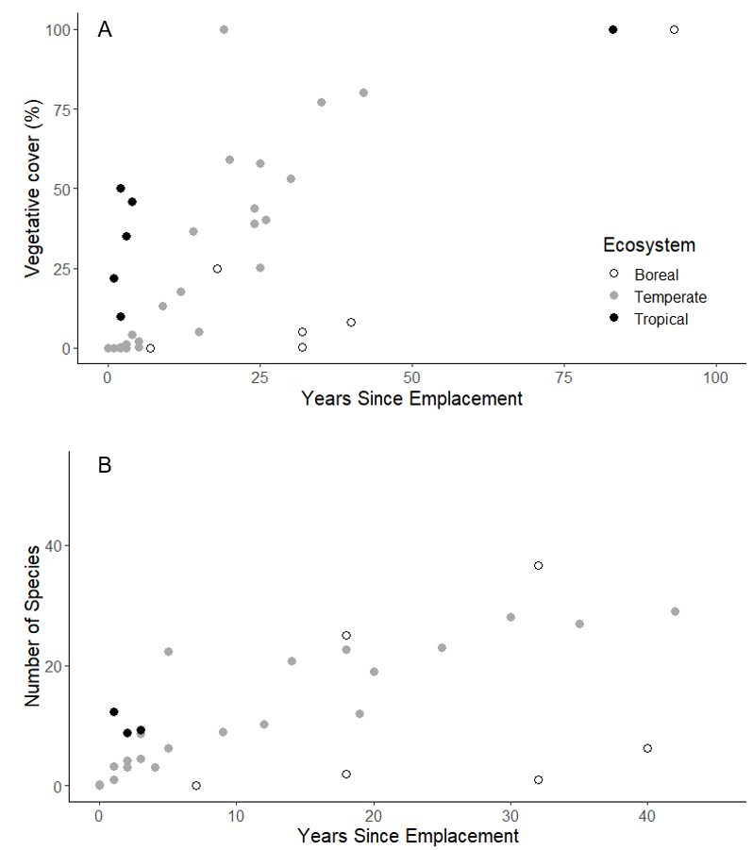
Figure 6. A) Vegetative cover as reported by years since emplacement of volcanic debris avalanche (VDA) deposits, color-coded by climatic zone (black: tropical, grey: temperate, and white: boreal). B) Species richness on VDA deposits scaled to a 250 m² plot reported by years since emplacement and color-coded by climatic zone.

composition mirroring surrounding undisturbed sites, due to those same harsh conditions and a limited species pool reducing the viability of alternative stable states (Prach and Walker 2019).

More Nuanced Predictors of Processes in Community Formation and Succession
While climatic zone and biotic legacies determine rates of community development across mountains and describe the broad sweep of recovery trajectories across years and decades, other influences can be distilled from the literature that add finesse to our understanding of these processes. These factors include certain species and plant functional types, topography and secondary disturbances. Trends related to these factors are less able to be generalized than the major takeaways either because conflicting evidence has been found in at least some cases or because they simply haven’t been as well studied. As such, these topics would provide rich areas for further research.

Species Functional Groups
While numerous species manage to arrive and establish themselves on VDA deposits, certain guilds are particularly influential. Early seral species, nitrogen-fixing plants, mosses, lichens, and plants with belowground meristems all play predictable roles across most VDAs studied and across climatic zones.
- Annuals and Early Seral Species:
Annual species play a crucial role in the early years (first few years after a debris avalanche in the tropics and the first two decades in the temperate regions) following the emplacement of a debris avalanche. This question is yet to be addressed in boreal regions. Although late seral species may also arrive and establish soon after emplacement, annual species typically dominate in terms of early cover (Adams et al. 1987a; Dale 1989; Velázquez and Gómez-Sal 2007). In Washington State at Mount St. Helens, annual and biennial species with plumed, fluffy seeds, capable of wind dispersal were among the first dominants, comprising all the seeds collected in traps in the first year after the eruption (Dale 1989). Similarly, annual species were the most abundant, comprising 63% of the cover among the most abundant species after 4 years in Nicaragua (Velázquez and Gómez-Sal 2009b); all of these were wind dispersed species as well. Annuals may play a lesser role however if there is no seed source nearby from which they can disperse (Nakashizuka et al. 1993).
- Geophytes:
Like annual species, geophytes, or species with belowground growth points (Mueller-Dombois and Ellenberg 1974) also play an outsized role in the initial stages of community establishment. These species are well-equipped to survive the abrasion and shock of transportation within the avalanche material, making them poised for growth when other propagules have yet to arrive. Often, they are the only surviving species (Adams and Adams 1982; Adams et al. 1987a). Geophytes have been found at notably high abundance in the initial years after disturbance across various volcanic sites. This pattern was identified up to 14 years post-eruption in the USA at Mount St. Helens and was also documented in Nicaragua and Japan (Casita and Ontake Volcanoes, respectively) (Adams et al. 1987a; Nakashizuka et al. 1993; Dale and Adams 2003; Dale et al. 2005).
- Nitrogen Fixers:
The presence of nitrogen-fixing species plays an important role in soil genesis (Bishop 2002; Walker et al. 2003) and community assembly in primary successional landscapes. Nitrogen fixers, throughout their life, death, and decomposition, greatly alter the environment by increasing the available nutrients for other plant species, thereby increasing the number of species than can survive and thrive (Tilman 1985b; Walker 1989; Gill et al. 2006; Marleau 2009). Several nitrogen-fixing species have been observed to have this influence on primary successional landscapes: lupines (Lupinus spp.) (Dale and Adams 2003), alders (Alnus spp.) (Ohsawa 1984; Nakashizuka et al. 1993; Dale and Adams 2003), and birches (Betula spp.),(Ohsawa 1984; Grishin et al. 2000; Grishin 2011, 2019). Moreover, other species have been found to fix nitrogen under low nutrient conditions, including poplars (Populus spp.) and willows (Salix spp.) (Von Wuehlisch 2011; Doty et al. 2016) and are abundant on many VDA deposits (Ohsawa 1984; Nakashizuka et al. 1993; Dale and Adams 2003).
The potential for nutrients to be drivers of community composition was explicitly evaluated in Nicaragua at the Casita Volcano. The presence of sufficient nutrients, primarily controlled by decomposition from nitrogen fixers, was one of the primary determinants of community composition at Casita, at least in primary successional areas (Velázquez and Gómez-Sal 2008, 2009b, a). Nitrogen additions on Washington’s Mount St. Helens debris avalanche increased forb abundance, particularly of non-native species (Bishop et al. 2010). Further, lupine (Lupinus lepidus var. lobbii – a nitrogen fixer) mortality created high-quality, islands of fertility that facilitated the succession of other species (Bishop 2002). Combined nitrogen and phosphorus additions to debris avalanche soils in the first years after the slide increased growth up to 14 times that of controls that did not receive additional nutrients (Adams and Dale 1987).
Absence of nitrogen fixers may also slow down succession. At California’s Mt. Lassen volcano, species composition has stabilized on the Chaos Craigs debris avalanche deposit, but even after 300 years the community here does not match that of surrounding undisturbed communities (Heath 1967; Crandell et al. 1974; Parker 1991; Kroh et al. 2008b). Notably, lupines and other nitrogen fixers are almost entirely absent from this community (Kroh et al. 2008b).
- Mosses and Lichens:
Moss communities thrive in these dry, nutrient-poor landscapes and are found early in succession across various biomes, including Papua New Guinea (Mt. Lamington, tropical), the USA (Washington: Mount St. Helens and California: Mt. Lassen, both temperate; Alaska: Mt. Magik, boreal), and both Russian volcanoes (Shiveluch and Bezymianny, boreal). At Mount St. Helens, Mt. Magik, and the Russian Volcanoes, these communities have persisted for decades after the initial disturbance. In some cases, such as the Russian volcanoes, succession appears to be stalled at the moss and lichen stage unless conditions are ameliorated, such as in depressions or wind-protected areas (Grishin et al. 2000). Furthermore, moss communities may inhibit the formation of other types of communities through a combination of physical barriers to seeds and allelopathy (Steijlen et al. 1995). When succession is stalled, growth of lichens can even be used to date the age of debris avalanche deposits (Crandell et al. 1974).
- Non-native Species:
Non-native species are often among the first dominants on VDAs after emplacement. Whether non-natives facilitate the arrival and establishment of other species, however, is less predictable. Non-native species have been found to be particularly important on the tail end of debris avalanche deposits in Nicaragua and the USA (Casita and Mount St. Helens volcanoes, respectively) (Dale and Adams 2003; Velázquez and Gómez-Sal 2009b; Dale and Denton 2018). Most species initially found on the Casita landslide were dispersed by wind and were non-native (all but one of the 12 most abundant species) (Velázquez and Gómez-Sal 2009b). In Nicaragua, this led to decreased diversity, as the most dominant exotic species competitively excluded natives (Velázquez and Gómez-Sal 2009b). Conversely, at Mount St. Helens, plots with a higher presence of non-native species also exhibited increased cover of native species (Dale and Adams 2003; Dale and Denton 2018). Though, at Mount St. Helens, the relationship between the prevalence of non-native species and diversity is further complicated by a soil stabilization seeding effort conducted in 1980 on the lower section of the deposit, which introduced numerous non-native species (Townsend 1990).
The finding that invasive dominance leading to a community shift in the tropics is not unique. Prach and Walker (2019) found that novel ecosystems were more prone to form during succession in the tropics due to susceptibility to invasion by nonnative species than at higher latitude. This concept has not yet been directly tested on any debris avalanche deposit but may explain the difference in response to non-natives at Mount St. Helens as opposed to Casita Volcano.

Topography
The size and shape of a debris avalanche deposit influence the trajectory of plant community development. Among important topographic drivers of community development are distance from the source and the edge of the deposit, microtopography, and elevation.
  - Distance from Source:
Increasing distance from the avalanche scar increases the rate of plant community development. While debris avalanches roll and tumble the material, there is still substantial sorting of materials (Dufresne et al. 2021). Larger, intact blocks of rock are deposited early in the slide. Finer material continues to travel down the slope at high speeds and is deposited in much more even terrain (Glicken 1996; Korup et al. 2013; Dufresne et al. 2021). On the debris avalanche in Washington (Mount St. Helens), Lawrence and Ripple (1998) found that distance from the source crater accounted for 15 percent of the explained variation in accumulation of greenness in the first five years after the eruption; however, Lawrence (2005) found it accounted for 13 percent after 13 years, but only 4 percent after 20 years. The sorting of material can influence subsequent community development. The Mount Lassen VDA highlights this effect clearly as the deposit is the result of three distinct avalanches that happened nearly simultaneously, each one with increasing coarseness of material (Crandell et al. 1974). After three centuries, the first avalanche, with the finest material, had nearly complete canopy closure. The last avalanche, with the coarsest material, was barely vegetated at all in the same period (Heath 1967).
Distance from the source of the VDA also interacts with biotic legacies. Soils and organic debris picked up by the avalanche can be pushed ahead or mixed in with the terminus of the deposit, creating biotic legacies that accelerate succession (Taylor 1957; Velázquez and Gómez-Sal 2007, 2008, 2009b, a; Velázquez et al. 2014). Similarly, smaller zones of mixed mineral soil and landslide material are often observed on the margins of deposits along valley walls (Adams et al. 1987a; Dale 1989). The terminal ends of debris avalanche deposits with increased biotic legacy tend to recover faster (Velázquez and Gómez-Sal 2007, 2008, 2009b; Velázquez et al. 2014). For instance, in Papua New Guinea, one year after the 1951 slide at Mt. Lamington, the lower portion of the debris avalanche deposit was already covered in chest-high grass (Taylor 1957). Similarly, in Japan at Ontake volcano (Nakashizuka et al. 1993) and in Nicaragua at Casita, cover establishment and stabilization of species communities were faster on the runout ends of the deposits (Lawrence 2005; Velázquez and Gómez-Sal 2007, 2008, 2009b).
  - Edge Effects:
Debris avalanches typically remove or bury most existing vegetation. However, the vegetative communities proximal to the avalanche path and the resulting deposit often remain largely intact, though other volcanic disturbances can affect these communities (Dufresne et al. 2021). Intact vegetative communities that are adjacent to VDA deposits facilitate seed dispersal, colonization by organisms, and organic input through litter fall (Velázquez and Gómez-Sal 2008). All these factors help ameliorate the harsh conditions of VDA deposits and potentially expedite vegetation establishment.
Analysis of satellite imagery of Mount St. Helens identified this transitional zone or edge as being no more than 150 m wide along the margins of the deposit (Lawrence et al. 2000; Lawrence 2005). Edge effects were also noted in Japan at Ontake volcano; however, they were most prevalent at lower elevations (Nakashizuka et al. 1993). This prevalence might be attributed to the milder conditions resulting from an interaction of biotic legacies and lower elevations leading to greater likelihood of successful establishment during seed dispersal from surrounding vegetation.
Edge effects were not found in the plot-based vegetation studies in Washington (Mount St. Helens), but that might be because all plots were beyond the 150 m from the edge of the deposit zone identified from satellite imagery (Dale 1989). Furthermore, the abundance of seeds caught in the three years after emplacement of the debris avalanche deposit did not relate to distance from the south edge of the deposit where remnant intact forest exists. This lack of relationship between seed number and distance from edge of deposit may be the result of prevailing winds sweeping up the valley from the terminus of the deposit. Most seeds (87%) caught in those first few years after the avalanche event were lightweight and wind dispersed (Dale 1986, 1989). In support of this theory, vegetation was found to establish radially from richness hotspots around water on the avalanche deposit (Adams and Dale 1987; Dale 1987). Similarly, no increased similarity to vegetation in the neighboring intact community was found in plots closest to the margin of the deposit in Nicaragua at the Casita volcano (Velázquez and Gómez-Sal 2007).
  - Microtopography:
Topography and microsite conditions are significant factors influencing the establishment of plant species (Lawrence 2005; Velázquez and Gómez-Sal 2007, 2009b; Velázquez et al. 2014). However, this influence may be confounded by the effect of slope, which tends to be steeper at higher elevations. Elevation was not a significant predictor of vegetation establishment 15 years after the landslide at Mount St. Helens (Lawrence et al. 2000), so long as the analysis controlled for increasing slope, which often correlates with elevation. Nevertheless, 25 years post-eruption and beyond, elevation became the most influential predictor of plant cover. This shift suggests that environmental gradients, such as temperature and precipitation changes, may gradually exert more influence on vegetative patterns (Lawrence 2005). Slope as an important individual predictor dropped out of the models at Mount St. Helens with time. Conversely, in California at Mt. Lassen, slope was a major predictor of tree cover on the Chaos Jumbles deposit 340 years after the landslide, a factor that did not predict vegetation patterns elsewhere on that volcano (Parker 1991).
The uneven terrain of hummocky debris avalanche deposits allows for the development of microsites that facilitate or inhibit establishment. For instance, in Russia at Bezymianny, conifers and other trees only established in low-lying areas that retained extra moisture and were shielded from wind, even four decades after the deposit was formed (Grishin et al. 2000). On a smaller scale, in Washington at Mount St. Helens, depressions of less than a meter trapped significantly more seed than nearby flat sites and trapped the only conifers seeds found in the study (Dale 1989; Dale et al. 2005). In addition, these low spots were moister than surrounding areas. Combined, this protection from wind and increased moisture may explain why low areas became hot spots of species accumulation (Adams and Dale 1987; Dale 1989). On a larger scale, low laying wet plots had richer, more diverse communities, four years after emplacement than dry, hummocky areas (Adams et al. 1987c).
Microtopography also has the potential to influence multi-species interactions. At Mount St Helens, spider webs were more common on mounds than adjacent flat areas or depressions. The spider webs captured high amounts of seeds and moisture (Dale 1989), which may have led to subsequent faster development of plants on the mounds as opposed to nearby flat substrate.

Secondary Disturbance
A VDA is a massive, discreet disturbance, but by no means the last or only disturbance a landscape experiences. Often, subsequent disturbances occur, either immediately or years after the initial landslide. These secondary disturbances vary in scale, ranging from ponds drying up due to changes in the water table, insect outbreaks, or minor slumps to massive events such as extensive flooding, fires and further landsliding. Additionally, secondary disturbances may be the result of other volcanic disturbance types, such as tephra fall (Ohsawa 1984; Grishin et al. 2000). In some cases, secondary disturbance can accelerate the process of succession. For example, in Russia (Bezymianny), ash fall from a nearby eruptions enriched nutrient-poor debris avalanche deposits soils allowing for the rapid colonization of herbaceous plants in an area that had previously remained barren (Grishin et al. 2000).
For secondary disturbances with low intensity, effects on the resulting community may be minimal. For example, Campbell (2001) conducted an elk exclosure experiment that found ungulate browsing did not inhibit growth of woody species, though it did somewhat increase grass cover (Campbell 2001; Dale et al. 2005). Similarly, Dale (1989) hypothesized that a rodent population increase may have caused tree seedlings to die in seeded plots four years after the debris avalanche, however this was found to have no long-term influence on tree species community compositions (Dale and Denton 2018). Worth noting, the cause of this tree seedling die-off is disputed. Adams et al. (1987c) identified the mortality as the result of summer drought or spring flooding.
Secondary disturbances of moderate intensity can redirect the development of new ecosystems. For instance, repeated resliding may have delayed the establishment of self-sustaining populations in Nicaragua (Velázquez et al. 2014), resulting in the persistence of random ordering of species as opposed to species accretion. Extensive resliding was also noted as a visible disturbance on higher slopes at Mt. Vicory 80 years after the emplacement of that deposit and may have contributed to the observed treeline reduction (Taylor 1957). Resliding further appears to be the reason the Japanese Gotenba debris avalanche area has not developed fir forests as elsewhere on the mountain, even after 2900 years, and remains stalled at a larch dominated community (Ohsawa 1984). Slope, which is closely correlated with the probability of resliding, was also associated with the speed of revegetation in Washington at Mount St. Helens increasing the speed of revegetation according to early NDVI studies (Lawrence et al. 2000; Lawrence 2005). A different type of secondary disturbance, repeated off gassing of the nearby crater, reputedly kept the debris avalanche deposit at Whakaari almost entirely free of vegetation save for one isolated individual even 45 years after the initial emplacement (Hamilton and Baumgart 1959).
At the extreme end of the intensity continuum, some secondary disturbances can be so severe that community assembly must start again, initiating primary succession. This reset of succession was seen after the severe flooding in 1996 that washed away approximately 18 long-term plots at Mount St. Helens (or 15% of the 120 original plots) leaving behind steep, bare unstable slopes (Dale and Adams 2003). Similarly, in Russia at Shiveluch, when one debris avalanche flowed over the deposit of a previous VDA, plant communities were completely reset (Grishin 1996; Grishin et al. 2000).
However, even after secondary disturbance has occurred, it is possible that harsh abiotic attributes of debris avalanche deposits still have a lasting influence on resulting communities. In Japan, on Mount Usu, a study looking at forest recovery after ashfall found forests growing on the ash overlying the debris avalanche deposits remained more open, without a closed canopy, than forests growing at the same elevation where ashfall overlapped previous ashfall (Végh and Tsuyuzaki 2022).

Anthropogenic Disturbance
Many secondary disturbances have human origins, as observed in studies at the Casita Volcano in Nicaragua (Velázquez and Gómez-Sal 2007, 2008, 2009b, a; Velázquez et al. 2014). Located near the Pan-American Highway and surrounded by small towns, the Casita Volcano experienced immediate human utilization of the landscape, including firewood harvesting and controlled burns. These human disturbances led to diverse trajectories of plant community change (Velázquez and Gómez-Sal 2007, 2009b; Velázquez et al. 2014). Specifically, wood cutting promotes aggregation of individuals from species that thrive in high light environments, as canopy openings from treefall facilitate seedling aggregation. Burning also encourages the growth of new seedlings around dead parent plants (Velázquez et al. 2014).
- Management Decisions
Management decisions by humans can alter the trajectory of community assembly on volcanic debris avalanches. As in Nicaragua, in Washington at Mount St. Helens, several human interventions profoundly affected the course of succession. The Army Corps of Engineers’ decision to remove the debris collected on the lower portion of the debris avalanche deposit removed much of the organic debris and soil that would have formed the basis of a secondary successional zone on this deposit (Glicken 1996). Furthermore, the National Soil Conservation Service initiated a large-scale reseeding effort on the lower portion of the debris avalanche deposit and some of the surrounding blowdown zone (Townsend 1990). While the primary goal of this intervention was to mitigate soil erosion – a goal deemed unsuccessful (Collins and Dunne 1988) – the seeding had persistent effects on the plant community. Due to limited seed availability, the seed mix was comprised mostly of grass and legume species that were not indigenous to the Mount St. Helens region. In plots that received this additional seed input, plant cover developed faster and overall species richness was higher than in unseeded plots. Furthermore, this rapid development coincided with a higher dominance of introduced species (Dale and Adams 2003; Dale and Denton 2018). The effects were still detectable 35 years after the eruption and intervention but were diminishing (Dale and Adams 2003; Dale and Denton 2018). It is not known how long community differences from this unsuccessful management intervention will last.

Knowledge Gaps and Directions for Further Inquiry

What is Meant by Recovery?
Our literature review suggests that it takes several centuries for plant communities on VDA deposits to resemble surrounding, undisturbed areas, even without secondary disturbances yet no time series of studies captures the full suite of change trajectories at a single mountain. Supporting the notion that ecosystems on VDA deposits will be in flux for several centuries are observations at the five volcanoes where treeline measurements were taken (Mt. Victory, Papua New Guinea; Shiveluch 13, Russia; and Mt. Fuji and Mt. Usu, Japan; Mount Taranaki, New Zealand ), the treeline remained depressed for decades to centuries following the debris avalanche, even in tropical regions, but recovery eventually occurred after several thousand years (see Table 3). Similarly, in California (Mt. Lassen), tree composition and cover were still distinctly different after three centuries as compared to surrounding forests; tree cover on the debris avalanche deposit reaching only 20% of cover in undisturbed areas nearby (Parker 1991). Photos included in the papers indicate that tree line remains depressed at Mt. Lassen by about 120 meters, with very sparse tree cover (Heath 1967; Crandell et al. 1974; Kroh et al. 2008b). However, eventually treeline recovery does occur, as there is no notable difference in tree line on the ancient deposits of Mount Usu (Japan) (Végh and Tsuyuzaki 2022) and Mount Taranaki (New Zealand) (Clarkson 1977; Lees 1987b) where many thousands of years have passed since the avalanche deposit was emplaced.
How we measure ‘recovery’ matters. Recovery appears to happen much faster if only cover or greenness is used as the metric of recovery as has been examined extensively using satellite imagery at Mount St. Helens. Primary successional areas such as the debris avalanche deposit are among the slowest areas to green up after the 1980 eruption. Only the edges of the deposit were beginning to accumulate greenness in the first 4 to 14 years after emplacement (Lawrence and Ripple 1998, 1999; Lawrence et al. 2000; Teltscher and Fassnacht 2018) but rapid accumulation of greenness occurs across the entire deposit between years 14 and 24 (Teltscher and Fassnacht 2018; Li 2022). Greenness accumulation largely plateaued between years 24 and 36 (end of the study) (Teltscher and Fassnacht 2018; Li 2022). However, vegetation classes did not match those of surrounding undisturbed areas (coniferous forest), comprising meadows, sparse vegetation, deciduous trees shrubs and occasional coniferous trees, as well and bare soil and rock (Teltscher and Fassnacht 2018). It is not known how long these mixed and varied communities will persist.

Repeat Sampling Needed
One major limitation in our understanding of debris avalanche plant community development is the lack of repeated sampling on most deposits. Without appropriate time series, it is unclear if the centuries-long impact on species composition and tree line depression is due to the formation of alternative stable states or if these are artifacts of very slow rates of change once longer-lived species, such as trees, become established. Only Mount St. Helens and Mt. Lassen provide a true time-series of change at decadal scales. Without consistent monitoring over time, it is challenging to draw conclusions about the progression of community assembly (Baasch et al. 2010b). To address this limitation, extant permanent plots should be maintained and resampled on all existing deposits. Ongoing monitoring should be coupled with the initiation of regular monitoring programs as further debris avalanches occur. These endeavors are crucial for drawing further insight into successional pathways on these massive disturbances. We realize that such time and monetarily expensive options are not feasible in all cases and certainly cannot be conducted retroactively. Fortunately, methods like remote sensing, repeat photography and pollen analysis may allow inferences to be made about change that has happened over previous time intervals.
Modern satellite technology can also be leveraged to improve time series inference on existing and newly formed deposits. With space-based imagery available globally since the launch of LandSat in 1972, untapped potential exists to study trends and community changes across volcanoes (Zhu et al. 2022). So far, remote sensing is used only at Mount St. Helens (Harrington et al. 1998; Lawrence and Ripple 1998; Lawrence 1998, 2005; Lawrence et al. 2000; Marzen 2001; Kuzera et al. 2005; Marzen et al. 2011; Teltscher and Fassnacht 2018; Li 2022), but such studies could be easily expanded to VDAs elsewhere in the world. Focusing on satellite studies through time may make up for some of the lack of repeated ground-based monitoring particularly as high-resolution spectral data that allows for assessment of community composition becomes more readily available (Teltscher and Fassnacht 2018). Inference is of course limited by the scale at which the relevant sensors function but provides a ready way to compare directly across VDAs and is available when most other data may not be.
Repeat photography using existing historic images is another avenue to infer change over time when other data may not exist. So far repeat photography has been exploited by one study examining vegetation change that happens to include images from a VDA. Jorgenson et al. (2004) compared historic images taken by Griggs on the Mageik Landslide (Griggs 1920) to photography in the same locations taken 96 years later. Since volcanic disturbances are dramatic events that invite documentation, a concerted effort to mine the historical photographic record of journalists and researchers active at locations where VDAs have occurred may yield rich insights into the way vegetation has changed at many debris avalanches that have occurred since the invention of the camara.
Many debris avalanches occurred long before the advent of the technologies detailed above however. For debris avalanches that occurred within the last hundred to thousand years, it may be possible to gain insight into community formation and change by studying the dendrochronological record. This may be a particularly fruitful method for comparing across multiple VDAs that occurred at different times on the same mountain (space for time substitutions), such as at Mt. Shiveluch in Russia (Grishin et al. 2000) or Mt. Agustine (Siebert et al. 1995) in the USA. Mt. Lassen (Crandell et al. 1974) also in the USA would be a particularly good location to use dendrochronology as three VDA with different texture compositions occurred there in rapid sequence. It would be difficult to employ dendrochronology to study tree communities before and after a single VDA as this technique has been successfully employed after lahars (Hupp 1984) because VDAs generally bury or remove entire communities leaving no surviving individuals or communities to be studied.
For VDAs that occurred even further back in geologic time, it may be possible to gain inference about community development and change using palaeoecological techniques like pollen cores from bogs and lake sediments, stable-isotope composition of charcoal, and X-ray analyses of sediments and preserved individuals (Birks 2012; Jackson 2012) that allow for accurate reconstruction of ancient environments. To date, only pollen cores have been used to study temporal change in plant communities overlaying debris avalanche deposits, and even this study was incidental to the location atop a debris avalanche. (Lees 1987b, a) collected cores above ancient (20 ka+) debris avalanches at Mt. Taranaki in New Zealand. These pollen cores indicated that communities were similar where they overlaid debris avalanche deposits and areas where they did not overlay these deposits as far back as high-quality sequences could be established (4,000-11,000 years) so long as communities were not disturbed by subsequent volcanic or human events. This technique could be intentionally deployed to examine community change centuries to thousands of years in the past at many existing debris avalanche deposits. This application would substantially expand the number of deposits where a chronological sequence of change could be inferred. However, accurate inference of past communities and change would require high resolution sampling after emplacement of the VDA deposit and would be limited in taxonomic resolution to families or genera, for many species have similar pollen morphologies (Jackson 2012).
The ideas presented above are not an exhaustive list of the alternative way community formation could be examined on VDA deposits but will hopefully provide inspiration for researchers hoping to understand temporal change on these truly massive, but infrequent, disturbances.

Further Topics
Many topics have also not yet been examined or investigated in sufficient depth for VDA deposits to expand our understanding of community formation after disturbance. For instance, secondary disturbance, where it has been studied, results in huge and lasting community shifts but has only been investigated at Mount St. Helens, Washington (Campbell 2001; Dale and Adams 2003; Dale and Denton 2018) and the Casita Volcano, Nicaragua (Velázquez and Gómez-Sal 2007, 2009b; Velázquez et al. 2014). Another promising path for further investigation is plant interactions with other trophic groups and how these may change, delay or accelerate paths of community assembly. So far, a suite of papers at Mount St. Helens are just beginning to investigate this rich landscape of multitrophic interactions between plants, insects, and ungulates (Bishop and Schemske 1998; Campbell 2001; Bishop 2002; Bishop et al. 2010; Che‐Castaldo et al. 2015). Such multi-tropic interactions are common and influential (Paine 1988), but their effects on successional pathways are largely unstudied. Interactions with bacteria and fungi and their association with plants may accelerate or delay plant establishment on debris avalanche deposits and have only been briefly touched upon at other volcanic disturbances (reviewed in Muñoz et al., 2021). These microbial associations are often combined with root traits thought to promote establishment in nutrient-poor environments. For example, at Mount St. Helens on a pyroclastic flow deposit, it was found that the bacteria (Frankia) that allows alders to fix nitrogen only triggered extensive root nodulation in seedlings establishing within existing alder thickets, and seedlings without nodulation grew much more slowly (Seeds and Bishop 2009). This indicates that lack of microbial symbiotes might be inhibiting alder expansion in this ecosystem. Understanding the facilitation versus inhibitory effects microbes may have during community assembly would extend our understanding of successional dynamics after disturbance. Lastly, studies on founder effects, species inertia, and spatial autocorrelation are lacking in the VDA succession literature.

Implications for Management beyond Debris Avalanches
While VDAs are rare and infrequent events, their spatial extent and severity are comparable to some of the most intense disturbances caused by human activities, particularly mining (Liu et al. 2022; Yang et al. 2022), as well as phenomena such as the drying of inland seas due to climate change and water diversion (Seltenrich 2023). Managing these systems to develop stable and productive ecosystems requires understanding factors that influence species assembly and ecosystem development and the time frames over which these factors operate. This knowledge may enable better management of massive disturbed systems.
Compared to a global review of succession rates on a variety of other disturbances resulting in primary (mining, lava flows, glacial retreat, landslides, industrial disturbance) and secondary succession (wildfires and old field succession) (Coradini et al. 2022), ecosystems post debris avalanches were among the slowest to recover. In many cases, cover takes longer to develop on VDAs than even the mean of 15 years when 50% cover is reported for landslides and lava flows in the review. Coradini et al. (2022) however did find some variables influencing rate of succession that are similar to those compile the present review. Firstly, that coarser substrates often delay succession, and that disturbance scale, particularly at upwards of 100 km² precipitously delays cover development. Interestingly, (Coradini et al. 2022) did not find that absolute latitude emerged as an independent predictor of speed of vegetation recovery, but this may be because the authors included mean annual temperature, which correlates strongly with latitude in their model. Mean annual temperature was found to explain the single largest contribution of cover return rates of any predictor evaluated in their study. The authors also found that succession rates were roughly five times faster in areas undergoing secondary succession as areas undergoing primary succession, which is in line with our findings.
Findings from our review of existing research on VDA revegetation indicate that management strategies must be tailored based on biome and spatial extent. Restoration processes are likely to proceed more rapidly in areas where biological legacies exist. Secondary disturbances or human inputs can significantly alter ecosystem processes, but not all interventions have the same impact. Therefore, careful planning is needed that takes into account the overall goals of interventions, the time frame desired by managers and how chosen interventions will impact existing species.

Conclusions
This review aims to provide a comprehensive synthesis of the current understanding of succession on VDAs. We have identified the climatic zone in which the disturbance occurs as one of the most crucial predictors of rate of community development, along with the presence of biological legacies from the pre-disturbance ecosystem. Initial accumulation of cover and species can occur rapidly, especially in tropical regions, but differences in community and vegetation structure can persist for decades to centuries compared to surrounding undisturbed areas. However, the true impact of other factors, such as elevation, scale of disturbance, and precipitation, has not been adequately studied, particularly as these variables often interact, confounding their effects.
Secondary disturbances, whether natural or human-induced, can alter the trajectory and pace of succession, with lasting impacts on vegetative communities decades later. Despite progress, many knowledge gaps remain, particularly regarding the pathways of succession, interactions between trophic levels, the presence of alternative stable states and reliable reconstructions of chronosequences.

APPENDIX – CHAPTER 1
Appendix for “Plant Community Assembly on Volcanic Debris Avalanche Deposits around the World”
Table 4. Search terms and initial records from systematic search for three databases 19 Sept - 9 Dec 2022
 |  | Initial records found
 | Search term | Web of Science | JStor | Google Scholar
1 | Vegetat* recover* debris avalanche volcan* | 5 | 245 | 17,100*
2 | Plant recover* debris avalanche volcan* | 3 | 273 | 15,100*
3 | Plant reestablish* volcan* landslide | 2 | 73 | 7,150*
4 | Vegetat* reestablish* volcan* landslide | 2 | 56 | 4,760*
5 | Vegetat* recover* volcan* landslide | 16 | 439 | 9,930*
6 | Plant reestablish* debris avalanche volcan* | 1 | 45 | 18,400*
7 | Plant establish* debris avalanche volcan* | 3 | 341 | 17,700*
8 | Plant establish* volcan* landslide | 14 | 746* | 1,620*
9 | Vegetat* establish* volcan* landslide | 15 | 625* | 16,900*
10 | Vegetat* establish debris avalanche volcan* | 3 | 330 | 18,500*

 | Years  (0-9) | Decades  (10-100 years) | Centuries  (100-1000+ years)
Species accumulation | Taylor 1957  Adams and Adams 1982  Adams et al. 1987a  Adams et al. 1987b  Adams et al. 1987c  Dale 1987  Dale 1989  Dale 1991  Dale 1992  Nakashizuka et al 1993  Velazques and Gomez-Sal 2007  Velazques and Gomez-Sal 2008  Velazques and Gomez-Sal 2009a  MaCann 2017 | Griggs 1933  Hamilton and Baumgart 1959  Taylor 1957  Titus et al. 1998  Grishin et al. 2000  Campbell 2001  Dale and Adams 2003  Dale et al. 2005  Dale and Denton 2018  Grishin 2019 | Clarkson 1977  Moore 2017
Plant cover | Griggs 1920  Taylor 1957  Adams and Adams 1982  Martin et al. 1986  Adams et al. 1987a  Adams et al. 1987b  Adams et al. 1987c  Dale 1991  Velazques and Gomez-Sal 2007  Velazques and Gomez-Sal 2008  Velazques and Gomez-Sal 2009a  MaCann 2017 | Griggs 1933  Taylor 1957  Lawrence 1998  Harrington et al. 1998  Lawrence and Ripple 1998  Lawrence and Ripple 1999  Grishin et al. 2000  Lawrence and Ripple 2000  Campbell 2001  Marzen 2001  Dale and Adams 2003  Dale et al. 2005  Kuzera et al. 2005  Lawrence 2005  Jorgenson et al. 2006  Bishop et al. 2010  Marzen et al. 2011  Sparkes 2016  Dale and Denton 2018  Grishin 2019  Li 2022 | Heath 1967  Clarkson 1977  Parker 1993  Kroh et al. 2008  Moore 2017
Community composition | Adams et al. 1987a  Dale 1991  Nakashizuka et al 1993  Velazques and Gomez-Sal 2007  Velazques and Gomez-Sal 2008  Velazques et al. 2014 | Campbell 2001  Sparkes 2016  Dale and Denton 2018  Teltscher and Fassnacht 2018 | Crandell et al. 1974  Clarkson 1977  Lees 1987a  Parker 1991  Kroh et al. 2008  Vegh and Tsuyuzaki 2022
Tree line | 0 | Taylor 1957  Grishin 1996  Grishin 2019 | Heath 1967  Crandell et al. 1974  Clarkson 1977  Ohsawa 1984  Vegh and Tsuyuzaki 2022
Table 5. Studies broken up by time since emplacement that they covered and major types of data reported. These numbers are summarized in Table 2 in the main text.

CHAPTER II
Multiple trajectories of land-cover change: influence of disturbance severity over four decades after the eruption of Mount St. Helens

A version of this chapter has been accepted to be published by Elsie Mariah Denton, Andrea Staten, McKenzie Owen, Virginia H. Dale, Hannah V. Herrero
Elsie M. Denton, Andrea Staten, McKenzie Owen, Virginia H. Dale, Hannah V. Herrero “Multiple trajectories of land-cover change: influence of disturbance severity over four decades after the eruption of Mount St. Helens.” Landscape Ecology (accepted).
No changes have been made to this article other than reformatting. All authors contributed to the study conception and design. Material preparation, data collection and analysis were performed by Elsie M. Denton, McKenzie Owen and Andrea Staten. The first draft of the manuscript was written by Elsie M. Denton, and all authors commented on previous versions of the manuscript. All authors read and approved the final manuscript.

Abstract
Context: To understand land-cover change, it is necessary to monitor landscapes over long temporal extents. The 1980 eruption of Mount St. Helens (MSH) provides an opportunity to analyze vegetation recovery trajectories over four decades after disturbances of different severities.
Objectives: We aim to enhance understanding of land-cover changes after major disturbances to inform management of the processes influencing ecosystem reestablishment.
Methods: We assessed land-cover change using Land Cover Mapping and Projection data (derived from Landsat) at 5-year intervals from 1985-2020. Non-water pixels within the MSH National Volcanic Monument were classified as Barren, Grass/Shrubland, or Forest. We calculated land-cover changes for severely disturbed (undergoing secondary succession) areas created by a lateral blast and mudflows and for extremely disturbed (undergoing primary succession) areas created by pyroclastic flows and a debris avalanche.
Results: Disturbance severity strongly influenced which land-cover conversion was likely to occur and the extent of land surface converted. However, severity had little influence on when change occurred or on starting land cover (except for Forest, which was initially only found in secondary successional areas). Grass/Shrubland-to-Forest conversion is accelerating across all disturbances 40 years after the eruption. Alternative successional pathways occurred in all disturbance zones.
Conclusions: Contrary to conclusions of earlier studies at Mount St. Helens using NDVI (Normalized Difference Vegetation Index), land-cover change is ongoing 40 years after the eruption. Many aspects of land cover and land-cover change are unique to individual disturbances. Hence land managers should carefully assess the initial conditions of their systems before undertaking any management planning.

Introduction
After major disturbance, it is important to know why and when land-cover changes so landscapes can be better managed to enhance ecosystem services as well as economic and cultural resources. Land-cover change is a nuanced process, and the rate and direction of the change may depend upon the severity of the disturbance event (Foster et al. 1998). It is important to understand these subtleties to manage landscapes for desired outcomes (Lister et al. 2020). The conventional view of succession as a consistent, unidirectional process – derived largely from studies of old-field succession – does not hold true across all landscapes (Pulsford et al. 2016). In some cases, multiple or complex successional pathways may occur (Fukami and Nakajima 2011). While such alternative communities form after disturbances of different intensities (Halpern 1988), how long these communities persist and the lasting effect of disturbance severity on community trajectory is unclear.
Disturbance events shape ecosystem recovery – yet the long-term effects of initial conditions on landscapes and their changes remains uncertain. Some disturbance events are so severe that they remove all elements of the preexisting community – leaving no soil, biota, or even dead material (Walker and del Moral 2011). These landscapes, known as primary successional areas, start from the beginning in terms of community assembly. In contrast, other disturbance events result in landscapes that harbor biotic legacies, such as soils, surviving organisms, or downed woody debris (reviewed in Coradini et al. 2022). These secondary successional areas have remnants, or biotic legacies, of the previous ecosystem. Biotic legacies can accelerate community development through the availability of propagules and more favorable conditions for establishment. These conditions may result in communities that develop five times as quickly as areas without legacies (Nakashizuka et al. 1993; Velázquez and Gómez-Sal 2009b). While initial differences in communities undergoing primary versus secondary succession are well described (Franklin et al. 2018), it is unclear how long initial conditions influence the amount, direction, and rate of change.
The Mount St. Helens (MSH) landscape is ideal for comparing land-cover change in primary and secondary successional areas, with minimal confounding factors due to similar timing of disturbance, initial and surrounding habitat, and climate. The volcanic disturbances in the 1980 eruption occurred within minutes of each other (Lipman and Mullineaux 1981), affecting areas that were once relatively uniform in habitat (evergreen forest) and in the same climate zone, as they are adjacent (Swanson et al. 2005). Thus, the influence of spatial and temporal differences is minimal, making it more likely that variations in land-cover change after the eruption are due to the conditions created by the disturbance, rather than other confounding factors (Kreyling 2024). Further, after Mount St. Helens erupted, much of its surrounding ecosystems were protected by the creation of the Mount St. Helens National Volcanic Monument (est. 1982) with the goal to support research and education. Therefore, changes observed within the monument reflect ecological processes in the absence of human intervention (USDA Forest Service, 1985). As a result, this post-volcanic landscape provides the opportunity to observe how unmanaged ecosystems change over time. The understanding of recovery patterns and processes developed from the study of Mount St. Helens can then be used to inform management actions in other landscapes (Jensen et al. 1996).
Over the course of the eruption, multiple, large-scale disturbances devastated great swaths (~600 km²) of old-growth and young evergreen forests at Mount St. Helens (Lipman and Mullineaux 1981). Two of the volcanic disturbances were so severe that the resulting landscapes could be aptly classified as undergoing primary succession (Adams and Adams 1982; Crawford 1985). Primary successional areas were caused by the pyroclastic flows (incandescent currents of ash, gas, and volcanic debris) and the debris avalanche (a massive landslide resulting from the collapse of the north flank of the volcano). In contrast, other disturbed areas retained substantial remnants of pre-existing communities and were classified as secondary successional areas (del Moral 1983; Andersen and Macmahon 1985). Secondary successional areas include land devastated by the lateral blast (explosive eruption of high-pressure gas, ash, and rock moving at a high speed horizontally away from the crater that toppled the forest like matchsticks) and volcanic mudflows (flows of loose soil and melting glaciers with more than 50% water that swept down the flanks of the mountain). Studying land-cover change in these diverse disturbances allows for a broad understanding of multidecadal succession.
Remote sensing has previously been used to study land-cover change at Mount St. Helens. While many vegetation indices exist to assess change, only Normalized Difference Vegetation Index (NDVI) has been used extensively at Mount St. Helens (Harrington et al. 1998; Lawrence et al. 2000; Lawrence 2005; Kuzera et al. 2005; Marzen et al. 2011; Li 2022). NDVI was also identified as the most accurate index for assessing change in this landscape (Lawrence and Ripple 1998). Prior analysis of NDVI data from Mount St. Helens estimated biomass suggested land-cover change ceased on the landscape after two decades (Harrington et al. 1998; Lawrence et al. 2000; Lawrence 2005; Kuzera et al. 2005; Marzen et al. 2011; Li 2022), Relying only on NDVI data, it would seem that the landscapes have reached a stable state, but it is more likely that this finding is due to a phenomena known as pixel saturation where it becomes difficult to identify change as greenness increases (Morresi et al. 2019).
In contrast to satellite-based work, plot-based studies indicate that plant communities are still shifting even 30 years after the eruption (Dale and Denton 201809; del Moral and Chang 2015). On the debris avalanche deposit, for example, early seral species that favor open habitats are giving way to forest species (Dale and Denton 201809). Furthermore, land cover is far from homogeneous. In some areas, vast carpets of moss can be observed; in other areas, willow and alder thickets dominate (Teltscher and Fassnacht 2018). Still other landscapes are fields of small conifers growing among the brush (Teltscher and Fassnacht 2018). Additionally, it appears that there is no singular narrative of land-cover change on this volcanically disturbed landscape (del Moral and Chang 2015). It is evident that understanding land-cover change at Mount St. Helens requires looking beyond NDVI.
Fortunately, advances in both satellite imaging and post-processing of remote sensing data in recent years allow us to move beyond the current story that suggests change has ceased on this dynamic landscape (Friedl et al. 2022). The United States Geological Survey’s Land Change Monitoring, Assessment, and Projection (LCMAP) dataset not only documents the amount of greenness on a landscape but also reliably distinguishes between eight different land-cover classes: Water, Snow/Ice, Barren, Grass/Shrubland, Forest, Wetland, Agriculture, and Urban (Brown et al. 2020). The LCMAP product uses all seven bands from the Landsat satellite and multiple images within a year to produce accurate landcover classification which has been extensively tested with in situ data for the continental United States (Young 2008). By using this existing landcover classification system, we present findings that will be easily interpretable by land managers and testable across a wide variety of systems. Using LCMAP data in this study, we ask two questions:

Research questions
- Do patterns of land-cover change differ between primary and secondary successional areas?
This question can be broken down into subcomponents:
  - What was the initial land cover of each disturbance?
  - How did it change?
  - When did that change occur?
  - Where did that change occur?
- Is there evidence of alternative successional pathways?

Methods

Study area
This study focuses on the area around Mount St. Helens (46.202950, -122.200354), a volcano in Washington State, USA, that erupted violently in 1980 (Figure 7). Prior to the eruption, the area was dominated by evergreen forest consisting of Douglas-fir (Pseudotsuga menziesii (Mirbel) Franco), western hemlock (Tsuga spp.) and true firs (Abies spp.) in the canopy and associated forest understory species, such as swordfern (Polystichum munitum (Kaulf.) C. Presl), huckleberry (Vaccinium spp.), and bunchberry (Cornus canadensis L) (St. John 1975).
In upland areas of southwestern Washington, Douglas-fir is the most common early succession tree species because it produces abundant seed that can germinate and grow under high light conditions (Hofmann 1920; Franklin et al. 2018). However, red alder (Alnus rubra) quickly became the dominant tree species on the debris avalanche deposit (Dale and Denton 2018) and the mudflows (Frenzen et al. 2005) created by the 1980 eruption. When red alder (Alnus rubra) is present, it can dominate and overtop Douglas-fir (Shainsky and Radosevich 1992). Red alder has a maximum life span of 100 years (Harrington 1990); whereas Douglas-fir lives as long as 1000 years (Lavender and Hermann 2014). Hence while red alder will give way to Douglas-fir, early succession forest conditions can exist in the region for centuries.

Focal disturbance events of the 1980 eruption of Mount St. Helens
More things and stuff and words and information. The 18 May eruption of Mount St. Helens resulted in a mosaic of different disturbance events, which damaged or destroyed preexisting communities (Fig. 1). In this paper, we focus on areas impacted by four different volcanic forces. Two areas were devastated by disturbances so severe that they resulted in primary succession: the debris avalanche and the pyroclastic flows. Two areas were less severely impacted and retained remnants of their preexisting communities. The disturbances that created these secondary successional areas were the lateral blast and mudflows, also known as lahars. The debris avalanche was triggered by a 5.1 magnitude earthquake that caused the north flank of the mountain to collapse in the largest landslide in recorded history (Siebert 1984). This landslide laid down 60 km² of material in valleys, completely burying the preexisting vegetation and soils. The debris avalanche deposit averages 45 m deep (Glicken 19986).
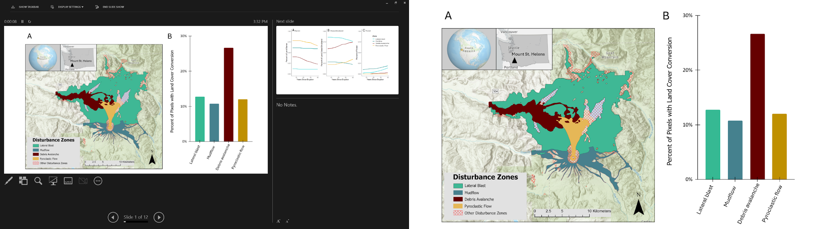
Figure 7. A) Location of Mount St. Helens, where this study was conducted, indicating the extent of each disturbance zone within the Mount St. Helens National Volcanic Monument. B) Percent of total land surface within each disturbance zone that has undergone land-cover conversion since monitoring began in 1985 through 2020 (5 to 40 years post-eruption). Blue/green colors indicate disturbances that instigated secondary succession; brown/yellow colors indicate disturbances that resulted in primary succession.

The pyroclastic flows scoured the landscape after a Plinian column of ash shot high into the atmosphere and then collapsed, releasing a tumult of incandescent gas and molten rock (Rowley et al. 1985). The pyroclastic flows burned and buried the impacts from previous disturbances and all vegetation, creating a 15 km² area of light and porous volcanic rock averaging 20 m deep.
The lateral blast was released by the debris avalanche because of the extreme pressure and heat that had been building inside the volcano. The lateral blast of rock, ash, and superheated gas was directed northward. Close to the volcano, trees, and other vegetation disintegrated, but further away, the trees were blown over and laid down like giant matchsticks. The lateral blast covers an area of nearly 500 km² (Kieffer 1981). The heat from the eruption melted glaciers, which caused mudflows to sweep down the slopes of the volcano at speeds of about 140 km hr⁻¹ washing away and burying trees, scouring stream channels, and inundating the rivers with silt. These mudflows covered a total area of about 50 km² (Lipman and Mullineaux 1981). Other types of volcanic disturbance were not included in the present analysis.

Data Set
Land cover was assessed using data from the US Geological Survey made available through the Landsat program. The Land Change Monitoring, Assessment, and Projection (LCMAP) product was available for 1985 through 2021 at the time this work was completed (Young 2008; Brown et al. 2020). Using multiple Landsat scenes within one year, the LCMAP primary land cover product is produced using the Continuous Change Detection and Classification (CCDC) algorithm (Zhu and Woodcock 2014) to assign each pixel to one of eight primary land-cover classes: Water, Snow/Ice, Barren, Grass/Shrubland, Wetland, Agricultural, Forest, and Urban. A primary land-cover class is defined as the cover type for a pixel based on the classification algorithm. LCMAP includes a measure of confidence for the land-cover assignment for each pixel. To assess land-cover change over the entire period but reduce computational load, we downloaded LCMAP scenes for the Continental US dataset version 3, vertical tile positions 2 and 3, and horizontal tile positions 3 from 1985-2020 at five-year intervals. We masked out pixels that contained Snow/Ice or Water at any time point and reclassified the land-cover classes since barren areas can have a high degree of misclassification (Brown et al. 2020). The reclassification is as follows: Barren (Barren and Urban), Grass/Shrubland (Agricultural, Wetland and Grass/Shrubland), and Forest was left unaltered. A total of 26,589 pixels were reclassified, or 1% of the entire area. Reclassification was more frequent in primary successional areas (4% of pixels) than secondary successional areas (0.6% of pixels). Authors’ familiarity with the area was used to justify this reclassification since there are no agricultural areas, urban areas do not exist to a meaningful extent within the monument, and wetlands occupy a small enough and very fragmented fraction of the land surface that examining them separately would be unlikely to inform broad patterns. To reduce the influence of management factors on resulting patterns, scenes were clipped to the boundary of the MSH National Volcanic Monument. To allow comparisons between disturbance types, the reclassified land-cover rasters were masked to the extent of each of the four disturbances. Mask defining layers were shapefiles of the MSH National Monument Boundary and disturbance zone were obtained from the US Forest Service. Data preparation and analysis were done in ArcGIS Pro (Esri, Version 3.3.2).

Change Detection and Classification
We used our maps of land cover between 1985 and 2020 to quantify the degree of land conversion each disturbance experienced. Using conditional statements within the raster calculator, we determined the land-cover change trajectory for each pixel (see example code in supplementary). Those pixels that had undergone change were the focus of the rest of our study. For each pixel where land-cover change was detected, we classified and mapped the type of change observed: Barren to Grass/Shrubland, Grass/Shrubland to Forest, or Barren to Forest. To quantify the potential for alternative pathways of succession, pixels where the Barren-to-Forest conversion had occurred were further split into those that experienced multi-step change (e.g., Barren to Grass/Shrubland, then Grass/Shrubland to Forest) and direct conversion (e.g., Barren directly to Forest). Differences in each land-cover type (Barren, Grass/Shrubland, and Forest) over every time-step were calculated and compared between primary and secondary successional areas. Linear mixed models were used with successional type and timestep as fixed predictors. Because n = 2 in each successional type at each time-step, we did not attempt a more complicated model. Assumptions of homogeneity of variance and linearity and normality of residuals were assessed for each model.

Time Until Change
We quantified how long it took for land-cover conversion to happen. For both pixels experiencing Barren-to-Grass/Shrubland and pixels undergoing Grass/Shrubland-to-Forest conversion, we calculated the number of years (in 5-year bins) it took for each type of change to occur (see example code in supplementary). Barren-to-Forest conversion was so rare over the landscape and complicated due to the two pathways of change that time until change was not calculated for that land-cover change pathway.

Where Change Occurred
We quantified the environmental variables elevation and distance from water and how they influenced when and what change occurred. For both the Barren to Grass/Shrubland conversion and the Grass/Shrubland conversion, we fit a linear regression with time until change as the dependent variable and explanatory variables being disturbance type, elevation above sea level, distance to nearest water source (in 30 m bins due to pixel size). We also fit a logistic regression with the same predictor variables for the binary outcome one-step versus two-step Barren to Forest Conversion. For elevation about sea level, we expected that small steps in elevation might not produce much of an effect but larger ones would; so we ran a series of models at 30 m, 100 m, and 500 m steps and used Akaike Information Criterion values to select the best fitting model, see supplementary table 5 (Burnham et al. 2011).

In situ data
It is important to quantify the accuracy of the LCMAP dataset as applied to the Mount St. Helens landscape. We ground-truthed LCMAP land-cover assessment using 82 long-term 250 m² plots on the debris avalanche deposit (Dale and Denton 201809) for which high quality global positioning system data exist. Plant cover, composition, and percentage of bare ground were collected in these plots at eight time points that roughly correspond to the years we quantified land cover with LCMAP (Dale plots measured in 1983, 1989, 1994, 2000, 2004, 2010, 2015, and 2022 correspond to 1985, 1990, 1995, 2000, 2005, 2010, 2015 and 2020 LCMAP images, respectively). Species-level cover data from the Dale plots were summed by plant functional type to result in the following cover classes: Barren/Litter and Grass/Forb/Shrub. We then assigned each plot to a dominant cover class (>50% cover) at each sampling period. Once closed canopy forest began to develop, canopy densiometer readings were taken at the center of each Dale plot. If canopy cover was >50%, a land-cover class of Forest was assigned. A confusion matrix was used to assess the degree of misclassification between the plot-based data and the LCMAP pixels at each time point (Salmon et al. 2015); a total of 652 pixels were compared. Significant differences were detected using a Monte Carlo simulation to test for the association between LCMAP and plot-based land-cover classification [associate from the regclass package] (Petrie 2016). Data analysis was done in R 4.2.

Results

Do patterns of land-cover change differ between primary and secondary successional areas?

What Was the Land Cover?
Land cover varied widely. Only five years after the eruption, the extent of Barren land was as low as 12% in the lateral blast zone, and as high as 78% on the pyroclastic flows (Figure 8A). Disturbance type did not seem to determine the extent of bare ground, however, as the mudflow zone had the second highest extent of Barren ground, 61%, followed by the debris avalanche 40%. This pattern in the distribution of Barren ground was still present 40 years after the eruption. In most areas an average of 12% of the land surface underwent land-cover conversion during the study period, but land-cover change was most extensive on the debris avalanche where 27% of the land surface had converted (Figure 7B).
Similarly, Grass/Shrubland cover was not determined by successional classification and varied widely between individual disturbances (Figure 8B). The pyroclastic flow area had the least Grass/Shrubland (22%) five years after the eruption, and the lateral blast zone had the most (86%). The mudflow and debris avalanche zones had intermediate extents of Grass/Shrubland (28% and 59% respectively). This distribution of Grass/Shrubland reordered slightly by the end of the monitoring period, 40 years after the eruption. The Grass/Shrubland was more abundant on the pyroclastic flow than on the mudflow deposits by that time.
Forest land cover was the only land-cover type where initial succession conditions mattered (Figure. 8C). Both primary successional areas had 0% Forest cover at the beginning of the monitoring period, five years after the eruption. At that time, Forest was rare, but present, in both secondary successional areas: 2% in the lateral blast zone and 10% in the mudflow area. By the end of the study period, there was 11 times as much Forest in secondary successional areas as in the primary successional areas.
- How did land cover change
The direction of change and extent of change, however, were explained by successional type. Barren land to Grass/Shrubland conversion was most common in primary successional areas (primary 17.4% versus secondary 1.8% of the landscape), while Grass/Shrubland to Forest conversion was more common in secondary successional areas (primary 1.6% versus secondary 9.8% of the landscape). Conversion from Barren to Forest was rare in all zones (<0.3% of the landscape). There is statistical evidence of differences in land-cover change by successional type (Table 6). Land cover classified as Barren disappeared at an average rate of 2.1% per five-year time-step in primary successional areas while change was not statistically different from zero in secondary successional areas (F-statistic: 20.84 on 2 and 25 DF, p-value: 4.722e-06, Adjusted R-squared: 0.5951, with assumptions moderately supported by this model).
Grassland extent increased in primary successional areas and decreased in secondary successional areas by an average rate of 1.9% and -1.2% respectively per five-year time-step (F-statistic: 23.78 on 2 and 25 DF, p-value: 1.642e-06, Adjusted R-squared: 0.6279, with severe non-linearities in the residuals of this model because rates of change vary over time). Forested land increased at an average rate of 1.5% in secondary successional areas but was not different from zero in primary successional areas at each time-step (F-statistic: 37.81 on 2 and 25 DF, p-value: 2.761e -08, Adjusted R-squared: 0.7316, assumptions well supported). Unique among land-cover classes examined, the rate of change in Forest cover increased with time at an average rate of 0.2% with each five-year time-step.
Table 6. Rates of change in proportion of each land-cover type by five-year intervals from 5 to 40 years after the eruption as defined by a linear model. Bold indicates estimates whose confidence intervals (CI) don’t include zero.
 | Estimate |  | Lower CI |  | Upper CI
Barren
Primary | -0.021 | -0.026 |  | -0.016
Secondary | -0.001 | -0.006 |  | 0.004
Time-step | -0.002 | -0.004 |  | 0.000
Grass/Shrubland
Primary | 0.019 | 0.012 |  | 0.025
Secondary | -0.012 | -0.019 |  | -0.006
Time-step | -0.001 | -0.003 |  | 0.001
Forest
Primary | 0.002 | -0.001 |  | 0.005
Secondary | 0.015 | 0.012 |  | 0.018
Time-step | 0.002 | 0.001 |  | 0.003
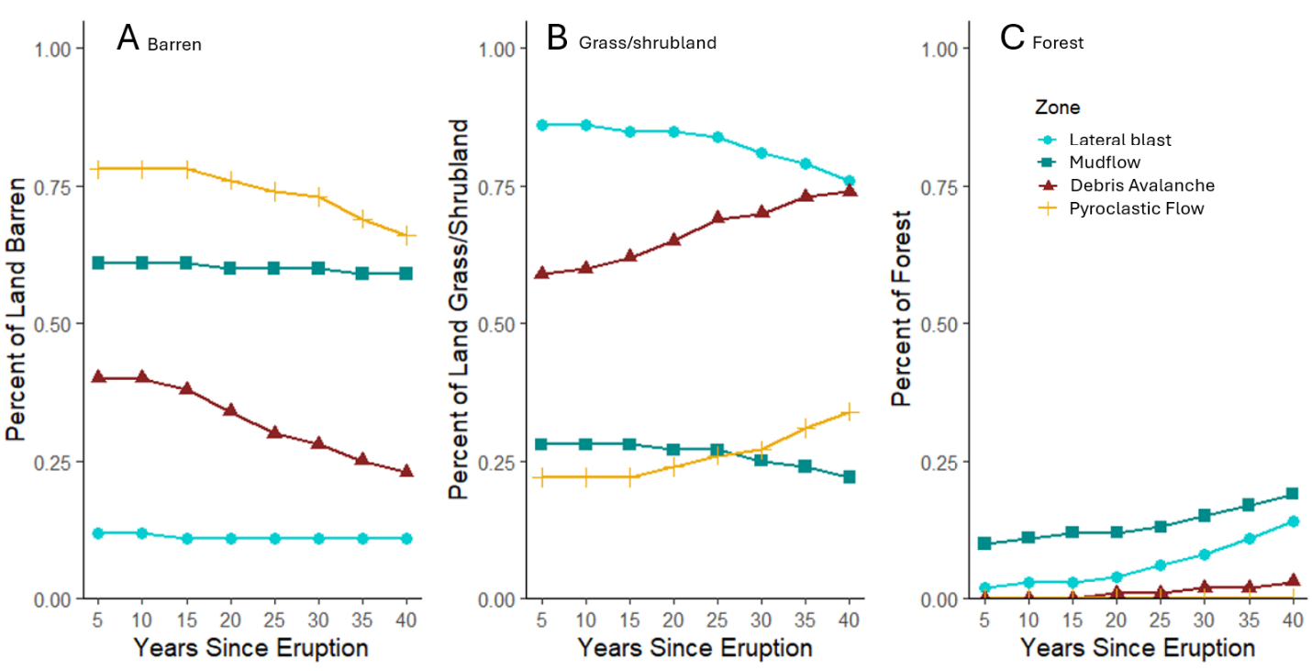
Figure 8. Percent of land surface broken out by disturbance zone between 5 and 40 years since eruption for each cover type: A) extent of Barren land, B) extent of Grass/Shrubland, C) extent of Forest. Blue/green colors indicate disturbance zones that instigated secondary succession, and brown/yellow colors indicate disturbance zones that resulted in primary succession.
c) When did land cover change?
The time until land conversion happened was determined more by the type of conversion (i.e., Barren to Grass/Shrubland versus Grass/Shrubland to Forest) as opposed to successional type. The rate of conversion from Barren to Grass/Shrubland followed a humped-shaped pattern over time in all disturbances (slow initial rate of change, followed by rapid change, followed by deceleration) (Figure 9A; Figure 10). The most rapid period of change was detected at year 20 in the lateral blast zone, year 25 in both the mudflow and debris avalanche zones, but not until year 35 for the pyroclastic flow. Grass/Shrubland conversion to Forest increased over time in all zones following a nearly linear pattern (Figure 9B; Figure 11). Maximum rates of Grass/Shrubland to Forest conversion were seen in the final time-step at year 40 in all zones. The rate of any given land-cover conversion was strongly influenced by successional type. Higher rates of Barren-to-Grass/Shrubland conversion were found in primary successional zones (Figure 9A). The highest rate of change was when 5.08% of the total land area on the debris avalanche underwent this conversion during a single time-step, and on the pyroclastic flow a maximum rate of 3.68% of the land area occurred in a single time-step. Secondary successional areas never exceeded more that 1% of their total land area undergoing the Barren to Grass/Shrubland conversion at a single step, with a maximum of 0.26% and 0.84% for the lateral blast and mudflow zones, respectively.
The rate of Grass/Shrubland-to-Forest conversion was also strongly determined by successional type (Figure 9B). Secondary successional areas always underwent this conversion more rapidly. Maximum rates of change in the secondary successional areas were 3.02% and 1.87% of total land area for the lateral blast and mudflow zones, respectively, for a single five-year time-step. In primary successional zones, the rate of change was much lower, reaching a maximum of 0.88% of land in the debris avalanche and a maximum of only 0.01% of land surface on the pyroclastic flow.
d) Is there evidence of alternative successional pathways?
The Barren-to-Forest land-cover conversion was rare across all successional zones (Figure 12), but its occurrence via two pathways provides evidence for the existence of alternative successional pathways. In most disturbance zones, the two-step Barren-to-Grass/Shrubland-to-Forest conversion was more common, occurring between 62-77% of the time, but on the pyroclastic flow the single-step Barren directly to Forest conversion was more common, occurring 79% of the time (Figure 12).
e) Where Did Land-cover Change Happen?
Disturbance type, distance to water and elevation all influenced how long land-cover

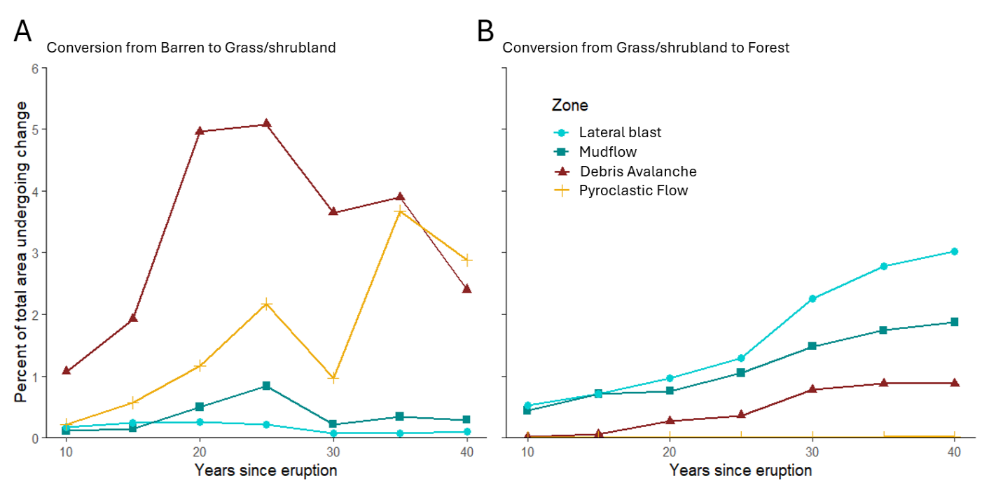Figure 9. Rate of change for each land-cover conversion type as percentage of total area, as divided by disturbance zone. A) Barren to Grass/Shrubland conversion, B) Grass/Shrubland to
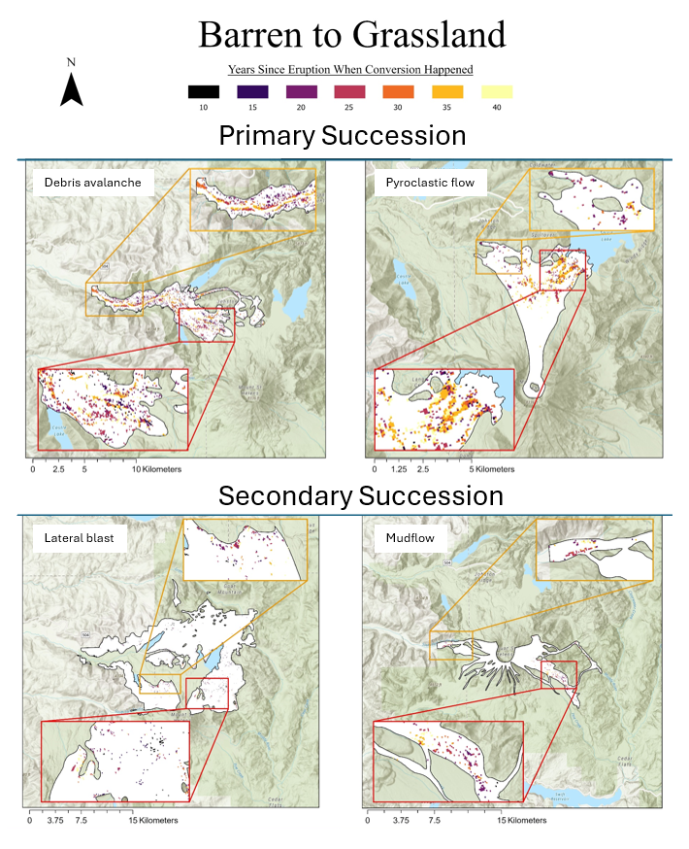
Figure 10. Detection results of land-cover change dynamics for the transition between Barren and Grassland. Time since eruption until the land-cover transition occurred (between 10 and 40 years) is marked with a colored coded pixel, see scale bar. White areas did not undergo this land-cover conversion during the study period. Inset maps for each disturbance are color coded and represent enlarged views of areas of interest.

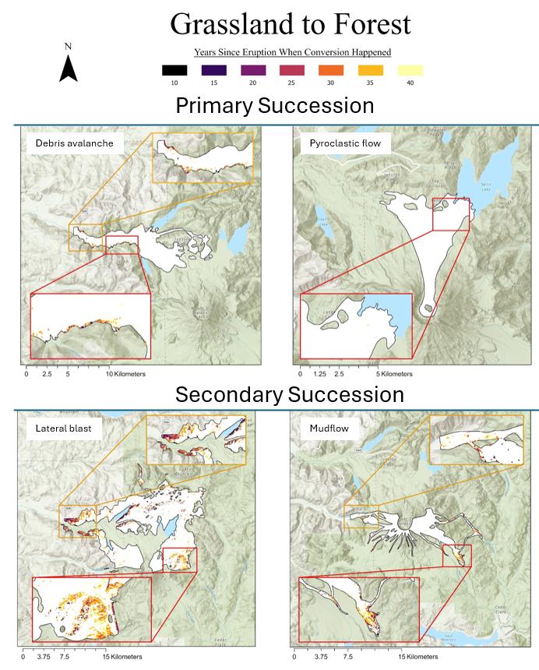
Figure 11. Detection results of land-cover change dynamics for the transition between Grass/shrubland and Forest. Time since eruption until the land-cover transition occurred (between 10 and 40 years) is marked with a color-coded pixel, as shown in the legend. Black areas did not undergo this land-cover change during the study period. Inset maps for each disturbance are color coded and represent enlarged views of areas of interest.

Forest conversion. Blue/green colors indicate areas where the disturbance resulted in secondary succession, brown/yellow colors indicate disturbances that resulted in primary succession. conversion took to happen (Table 7).
For both Barren to Grass/Shrubland conversion and Grass/Shrubland to Forest conversion, pixels further from water and higher in elevation were slower to undergo conversion. Disturbance type is a predictor of when conversion will happen. Barren to Grass/Shrubland conversion occurred at a mean of 23 years on the Debris Avalanche, 27.1 years on the Pyroclastic flow, 18 years on the mudflow, and 17.2 years in the lateral blast zone. Grass/Shrubland to Forest conversion takes longer, a mean of 32 years for the pixels that have so far converted on the Debris Avalanche, 22.8 years in the Mudflow, and 27.1 years in the Lateral Blast Zone. There was no detectable difference in when Grass/Shrubland to Forest conversion happened between the Debris Avalanche and Pyroclastic Flow.
For those rare pixels that converted from Barren to Forest during the 40 years since the eruption, the one-step Barren to Forest was 11.1 times the odds less likely to occur than the two-step Barren to Grass/Shrubland to Forest conversion. However, several factors did increase the likelihood of one-step conversion. Closer proximity to water and higher elevation slightly increased the odds of one-step conversion. Pixels in the Pyroclastic Flow zone were 5.1 times more likely to undergo one-step conversion than pixels in the Debris Avalanche zone, and this conversion was 4.6 times less likely in the Lateral Blast zone than the Debris Avalanche. The odds of one-step versus two-stem Barren to Forest conversion did not differ between the Debris Avalanche and the Mudflow zones.
- In Situ Data?
There was a significant difference between land cover as estimated by LCMAP and as
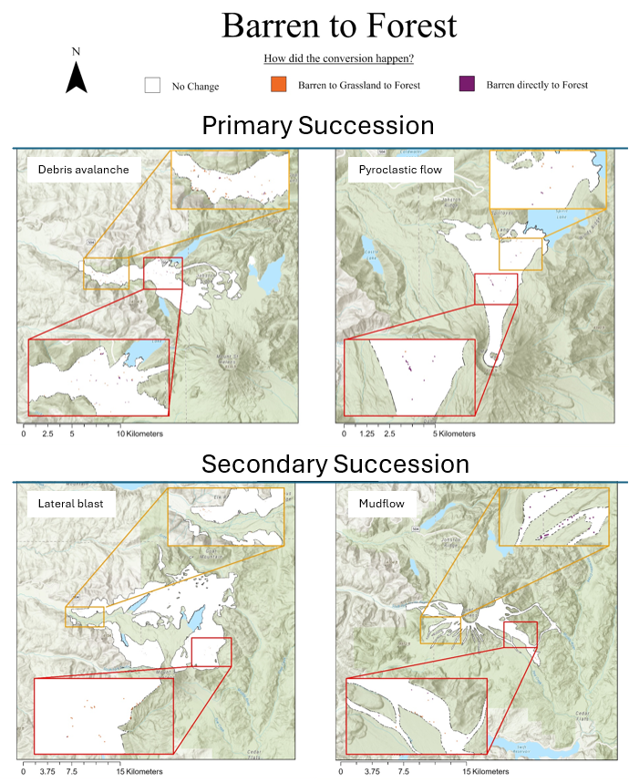
Figure 12. Land-cover change over time for the rare Barren-to-Forest conversion type. There are two possible pathways of change. The multistep transition Barren-to-Grass/Shrubland-to-Forest (marked with yellow), and the one step transition Barren-to-Forest (marked with purple).

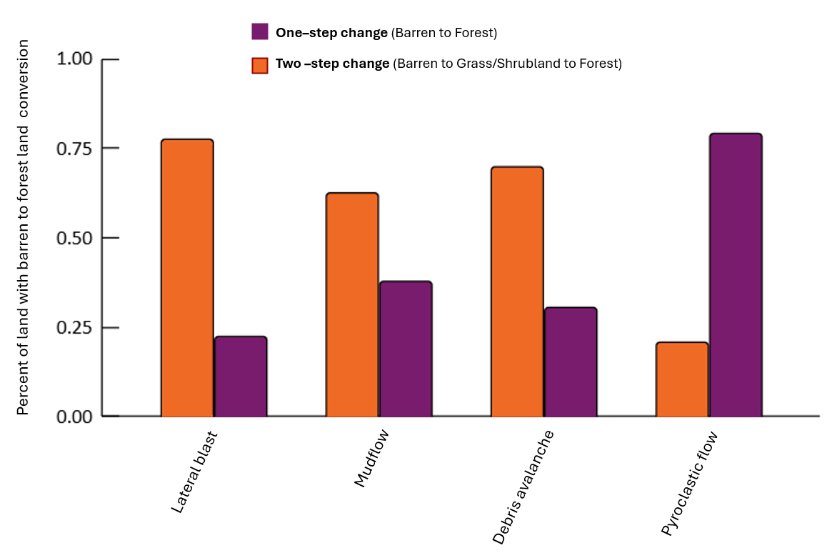
Figure 13. Percent of conversion from Barren-to-Forest that followed each pathway. Marked in orange is a two-step process Barren-to-Grass/Shrubland then Grass/Shrubland-to-Forest. Marked in purple is a single step process from Barren directly to Forest. Disturbances that resulted in secondary succession were lateral blast and mudflow. Disturbances that resulted in primary succession were debris avalanche and pyroclastic flow.

determined at the plot level [estimated p-value = 0, with 1000 permutations, we are 95% confident that the p-value is between 0 and 0.004 (Table 9)]. Overall accuracy of the LCMAP land-cover classifications based on in situ data is only 41%. This seems to be mostly the result of the Grass/Shrubland category being assigned to many pixels that were identified as either Barren or Forest in situ (Figure 14). However, this misclassification does not appear to be due to wobble between categories as only 5 pixels in the entire landscape demonstrate reversion to a prior landcover type.
Table 8. Model results from linear models predicting when change happened at Mount St. Helens based on elevation, distance from water and disturbance type. A generalized linear model predicted whether two step or one step conversion from barren to forest was more likely to happen with the same predictors. 30m, 100 m and 500 m elevation steps were tested for each model, only the best model is presented here, and the rest can be found in the Supplementary Table 5. Bolded values are significantly different from each other (alpha<0.05).

 | Barren to Grassland conversion |  |  | Grassland to forest Conversion
 | Coefficient (yrs) | Std Error | T-value | Coefficient (yrs) | Std Error | T-value
Intercept  (Debris Avalanche) | 23 | 0.37 | 62.6 | 32 | 0.36 | 90.7
Distance to water (30 m) | 0.0010 | 0.00007 | 14.0 | 0.0014 | 0.00004 | 37.2
Elevation (500 m step) | 0.0007 | 0.0001 | 4.89 | 0.0003 | 0.00007 | 4.00
Pyroclastic Flow | 4.1 | 0.23 | 17.5 | 6.02 | 4.9 | 1.22
Mudflow | -5.0 | 0.43 | -11.7 | -9.2 | 0.38 | -24.0
Lateral Blast | -5.8 | 0.25 | -23.1 | -4.9 | 0.32 | -15.2
 | Barren to Forest Conversion
 | Coefficient (log odds) |  | Std Error | z-value
1-step vs 2-step conversion | -2.40 |  | 0.68 | -3.54
Distance to water (30 m) | -0.0005 |  | 0.0001 | -4.58
Elevation (500 m step) | 0.001 |  | 0.0003 | 3.40
Pyroclastic Flow | 1.62 |  | 0.70 | 2.12
Mudflow | 1.09 |  | 0.57 | 1.90
Lateral Blast | -1.54 |  | 0.46 | -3.34

Table 9. Contingency table comparing LCMAP land-cover predictions with land cover as estimated from in situ vegetation monitoring of long-term 250 m2 plots on the debris avalanche deposit. Plot-based data were collected in 1983, 1989, 1994, 2000, 2004, 2010, 2015, and 2020 and compared to the nearest year in our LCMAP dataset. Bolded numbers are land covers that are the same in both datasets. Overall accuracy of 41%.

Plot Based Land Cover | LCMAP Land Cover Class
 | Barren | Grass/Shrub | Forest | Total | Omission  Error Rate | Commission Error Rate
Barren | 51 | 220 | 0 | 271 | 81% | 13%
Grass/Shrub | 8 | 213 | 0 | 221 | 3.6% | 64%
Forest | 0 | 159 | 5 | 164 | 97% | 0%
Total | 59 | 592 | 5

Discussion
We investigated patterns in land-cover change at Mount St. Helens and the way these patterns were modified by successional pathway via four subquestions. Each aspect of investigation yielded a different perspective. 1a) The amount of Barren ground and Grass/Shrubland on the MSH landscape was unaffected by successional pathway. Each
disturbance exhibited a distinctly different land-cover extent. Forest land cover, however, was more common in areas following the secondary successional pathway. 1b) How land cover changed was strongly influenced by successional pathway. Primary successional areas were more likely to convert from Barren to Grass/Shrubland, and secondary successional areas were more likely to convert from Grass/Shrubland to Forest. 1c) In contrast, when land-cover conversion occurred it was determined principally by the type of conversion. Maximum rates of land-cover change from Barren to Grass/Shrubland occurred around twenty years after the eruption on most landscapes, and maximum rates of conversion from Grass/Shrubland to Forest increased with time, with maximum conversion rate probably yet to be reached on any of the volcanic disturbances. 1d) Water and elevation appear to be predictors of when land-cover change occurs. 2) Evidence of alternative successional trajectories was found in landscapes undergoing both primary and secondary succession.

Lessons Learned from an Unmanaged System
Knowing both the severity of the disturbance and initial land cover allows us to make predictions about future change processes. Without knowing both the initial cover and the severity of the initial disturbance, the story is incomplete. When examining the accumulation of cover, evidence from multiple locations indicates that succession can progress up to five times more rapidly in secondary disturbance (Nakashizuka et al. 1993; Velázquez and Gómez-Sal 2009b). However, a review looking at primary versus secondary succession across many different initiating disturbances indicates that predicting subsequent change might not be that simple. Coradini et al. (2022) found that in some primary successional sites woody vegetation may develop faster than woody vegetation in similar areas undergoing secondary succession, even if ground cover develops faster in secondary successional areas. Coradini et al. (2022) suggests this result may be due to lack of competition for space with herbaceous vegetation, but it may also be because soil properties of some developing soils are more favorable to wood as opposed to herbaceous vegetation (Frouz et al. 2018; López-Marcos et al. 2020). Our work extends these findings by pointing to the importance of current land cover for determining what happens next, suggesting the importance of initial chance colonization, and highlighting the enduring legacy of those events and the complexity of trying to describe succession.
Succession is not only an orderly march from bare ground to climax community as it is often presented in textbooks (e.g., Mcintosh 1981). The deficiency of the orderly concept of
succession is recognized (Pickett and Cadenasso 2009), and theories of alternative stable states or recovery trajectories have been proposed in the literature since the 1970s (e.g., Cattelino et al. (1979)). However, actual test cases where alternative trajectories of community development can be shown are rare. Where these proofs exist, the studies have been plot-based and presented at
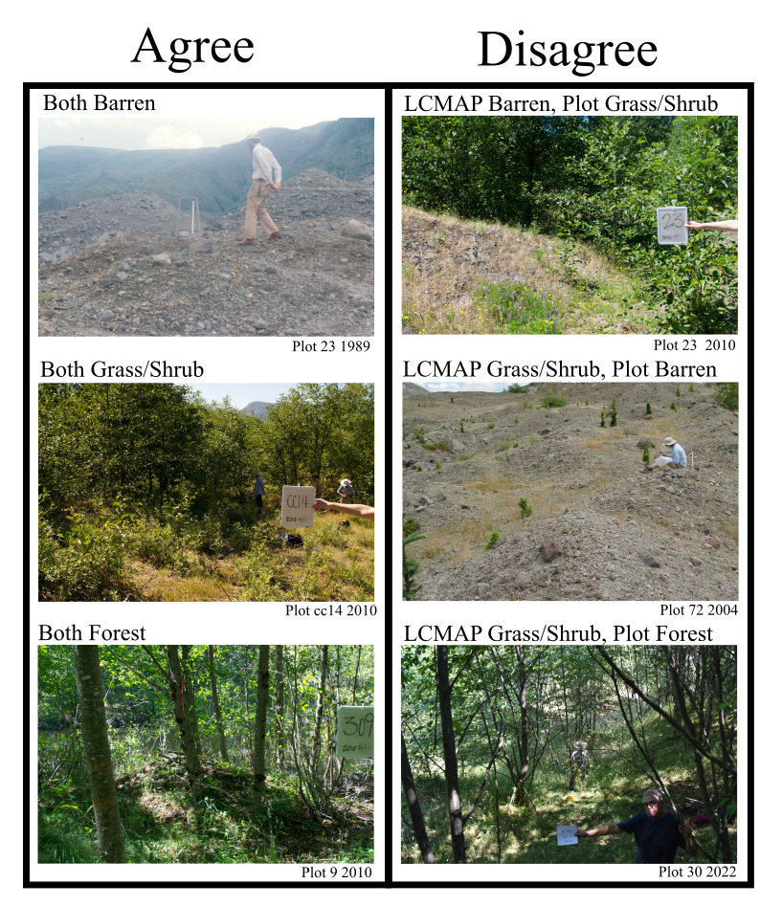
Figure 14. Photos of plots representing correspondence between land cover as predicted by LCMAP and the 250 m² vegetation plots on the debris avalanche deposit. The plot number and the year the photo was taken is in the lower right corner under each photo.

the species and community level. These studies show evidence of differing communities existing directly after a disturbance, but rapid convergence of trajectories towards the pre-disturbance community after only three (Abrams et al. 1985) to five years, even though actual return to pre-disturbance community can still take several decades (Halpern 1988). Our work provides evidence for alternative successional trajectories occurring over decades (the paths of transition from a barren to a forested landscape. Further, we were able to detect these pathways even at a very coarse scale (30 m x 30 m pixel based resolution). If alternative trajectories are visible at the resolution of long-term remote sensing technology such as Landsat, a much wider variety of trajectories likely exist when considered at the functional type or species community level. The ability to remotely identify areas following alternative successional paths will make studying why they occur much easier. We documented alternative pathways in both primary and secondary successional areas, with some evidence that alternative pathways might be more common after primary succession (e.g., the direct Barren-to-Forest conversion pathway was most likely on the pyroclastic flow deposit).
Alternative trajectories of land-cover change may be determined by environmental covariates or secondary disturbance. Coradini et al. (2022) found that covariates such as soil pH, temperature, evapotranspiration, and disturbance extent influence the rate of plant cover growth after primary succession with only latitude affecting the rate of recovery in both primary and secondary successional areas. At Mount St. Helens a review of plot-based work indicates that, across multiple measures of change, recovery rates are slowed by ongoing disturbances as well as by isolation, elevation and exposure (del Moral and Chang 2015). The pyroclastic flow deposit has the highest average elevation of all the disturbances we considered, is the furthest from outside seed sources (Adams and Adams 1982), and is prone to repeat disturbances from erosion (del Moral 1999). The fact that alternative paths of succession were found to be more common on the pyroclastic flow as compared to the debris avalanche deposit provides support for the influence of elevation on trajectory of change. Additionally, in our study alternative pathways occurred more frequently in drainages across all disturbances, which is also where erosion was more common.
Contrary to previous NDVI based work on the Mount St. Helens system, land-cover change has not ceased on the landscape, and succession is not complete. Previous remote sensing work indicated that initial vegetation development was slow in the first 10 years after the eruption, then accelerated rapidly roughly 15 years after the disturbance, and then slowed again (Harrington et al. 1998; Lawrence et al. 2000; Marzen et al. 2011). By 20 years after the eruption, the accumulation of vegetation as suggested by NDVI had essentially stopped (Kuzera et al. 2005; Teltscher and Fassnacht 2018; Li 2022). However, we found that the Grass/Shrubland cover type is converting rapidly to Forest across much of the landscape, and this process is still accelerating 40 years after the eruption. This result makes clear that delineating land-cover classifications beyond NDVI is essential to understand recovery processes after a disturbance, particularly over long-time scales. It should be noted however, that simply classifying the establishing vegetation as forest does miss some of the story as large areas of the current forest in the blast zone are dominated by red alder (Frenzen et al. 2005; Dale and Denton 2018), which is unusual in the Pacific Northwest (Franklin et al. 2018). Meanwhile, coniferous stands are developing in other parts of the disturbance area (Teltscher and Fassnacht 2018). Distinguishing between these alternative successional pathways will require a different methodology from the wide land-cover classification analysis done here.
An even more nuanced story of land-cover conversion would be revealed if finer divisions of land-cover type could be derived from satellite imagery. The roughly 30% accuracy in Grass/shrubland classification when compared to in-situ data is not unique to our study (Abdi et al. 2022). Also, large areas of barren land are difficult for existing classification algorithms to distinguish properly (Brown et al. 2020). However, it is possible to improve land-cover classification to near 80% accuracy by incorporating both measures of greenness and temperature as evidenced on savanna landscapes (Herrero et al. 2019), so long as some in-situ training data are used. We strongly recommend this approach rather than relying solely on national land-cover products derived from satellite imagery for further studies investigating land- cover change.

Application to Management
The study of unmanaged systems can guide management decisions. Because we found large differences in land cover even within a single type of succession, land managers might be led astray if they rely on rules of thumb like ‘secondary successional areas will recover first.’ Given that each disturbance area is unique, it is important to assess existing cover after each disturbance and compare current conditions to management goals. This approach better informs management than a single arbitrary rule. Further, it may be possible to manage primary and secondary successional areas similarly once existing land cover is known, as the time until land-cover conversion is largely dependent on starting conditions.
Managers may need to consider extensive intervention if goals do not align with the inertia of the system (e.g., increasing the amount of grassland after the second decade or establishing forests earlier). This type of intervention was, in fact, conducted on private, Federal, and Washington State lands within the Mount St. Helens blast area and outside the National Monument, where tree plantations were reestablished within the first decade (Harrington et al. 1998). These types of extensive, active interventions can be very expensive as compared with allowing succession to proceed naturally (Mercer 2004); however, depending on management goals, such interventions may make sense. For example, it is expected that complete coverage by conifer forest would take 100-200 years in the Pacific Northwest without intervention (Kreyling 2024).
However, highly disturbed systems with no legacies of previous vegetation will still recover naturally. If heterogeneous habitats that provide a range of ecosystem services like water filtrations, habitat for wildlife, and erosion prevention are the goal, then allowing natural recovery processes to proceed may be desirable. Allowing for natural recovery is easier and cheaper in many habitats, yet still successful (Frouz et al. 2020).
Relying on a national remote sensing product like LCMAP may be feasible if managers are attempting to remotely detect bare areas after disturbance or well-developed forest. However, if attempting to manage a grassland or matrix of shrubby vegetation, improved classification will be necessary for accurate decision making.

Conclusions
To understand land-cover change processes at Mount St. Helens and elsewhere, it is necessary to understand both initial land cover and the severity of disturbance. This information has allowed us to determine that succession is still ongoing four decades after the eruption. As alternative successional pathways occurred in all disturbances, further work should attempt to elucidate under what conditions alternative pathways may occur. In all cases, it is important to include both in situ and remotely sensed data to accurately assess change over time.

APPENDIX – CHAPTER 2
Supplementary Material for Multiple trajectories of land-cover change: disturbance severity and patterns over four decades after the eruption of Mount St. Helens
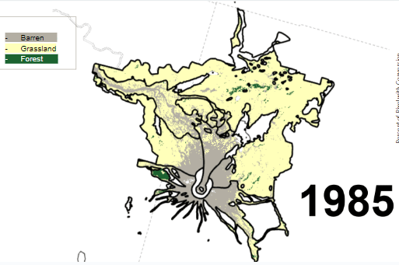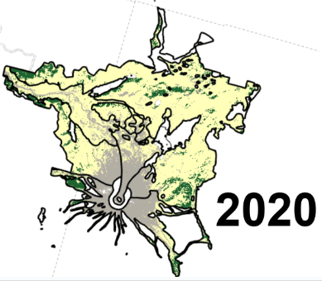
Figure 15. Land cover as predicted by Land Cover Mapping and Projection data from USGS at the beginning (1985, five years after the eruption) and end (2020, 40 years after the eruption). rey areas are Barren, yellow Grassland and green Forest. Black lines indicate boundaries between disturbance zones.

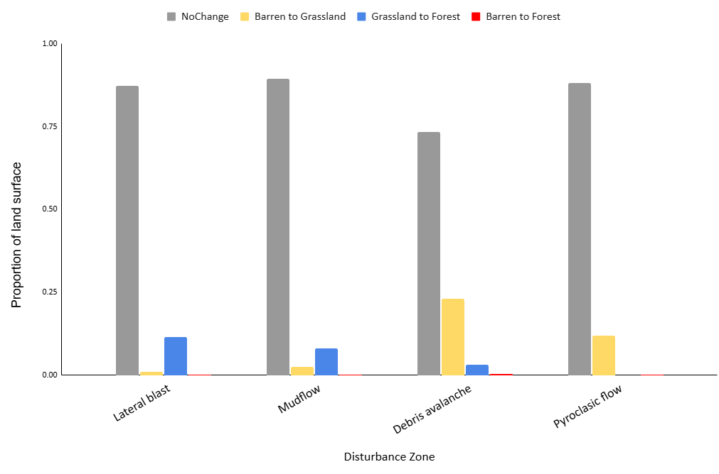
Figure 16. Percent of land surface that experience each type of change between 1985 and 2020 (5 to 40 years after the eruption). Grey for no change, yellow for Barren to Grassland conversion, blue for Grassland to Forest conversion and red for Barren to Forest conversion. Disturbances that resulted in secondary succession: lateral blast and mudflow. Disturbances that resulted in primary succession: debris avalanche and pyroclastic flow.

Table 10. Percent of land cover by type in each disturbance area by year. Secondary zones are BDF: blowdown forest and MF: mudflow. Primary zones are DA: debris avalanche and PF: pyroclastic flow.
Year | Zone | Barren | Grassland | Forest
1985 | BDF | 12% | 86% | 2%
1990 | BDF | 12% | 86% | 3%
1995 | BDF | 11% | 85% | 3%
2000 | BDF | 11% | 85% | 4%
2005 | BDF | 11% | 84% | 6%
2010 | BDF | 11% | 81% | 8%
2015 | BDF | 11% | 79% | 11%
2020 | BDF | 11% | 76% | 14%
1985 | DA | 40% | 59% | 0%
1990 | DA | 40% | 60% | 0%
1995 | DA | 38% | 62% | 0%
2000 | DA | 34% | 65% | 1%
2005 | DA | 30% | 69% | 1%
2010 | DA | 28% | 70% | 2%
2015 | DA | 25% | 73% | 2%
2020 | DA | 24% | 73% | 3%
1985 | MF | 61% | 28% | 10%
1990 | MF | 61% | 28% | 11%
1995 | MF | 61% | 28% | 12%
2000 | MF | 60% | 27% | 12%
2005 | MF | 60% | 27% | 13%
2010 | MF | 60% | 25% | 15%
2015 | MF | 59% | 24% | 17%
2020 | MF | 59% | 22% | 19%
1985 | PF | 78% | 22% | 0%
1990 | PF | 78% | 22% | 0%
1995 | PF | 78% | 22% | 0%
2000 | PF | 76% | 24% | 0%
2005 | PF | 74% | 26% | 0%
2010 | PF | 73% | 27% | 0%
2015 | PF | 69% | 31% | 0%
2020 | PF | 66% | 34% | 0%

Table 11. Percent of the landscape that underwent change and type of conversion between 5 and 40 years after the eruption. Secondary zones are BDF: blowdown forest and MF: mudflow. Primary zones are DA: debris avalanche and PF: pyroclastic flow.
Zone | No Change | Some change |  |  |  | Type of conversion
 |  |  |  | Barren to Grassland |  |  | Grassland to Forest |  | Barren to Forest
BDF | 87.33% | 13% |  | 1.12% |  |  | 11.48% |  | 0.07%
MF | 89.43% | 11% |  | 2.42% |  |  | 7.91% |  | 0.24%
DA | 80.37% | 20% |  | 17.00% |  |  | 2.34% |  | 0.30%
PF | 87.99% | 12% |  | 11.84% |  |  | 0.01% |  | 0.13%

CHAPTER III
Shifting Constraints: Site Condition, Propagule Limitation and Priority Effects across 42 Years of Succession after the Mount St. Helens Eruption

Abstract
In our increasingly dynamic world, it is important to understand the ways ecosystems change after disturbance. Gap: Propagule limitation, site condition, and priority effects are all known to influence the way ecosystems reestablish after disturbance; However, the relative strengths of these influences and how they change over time has rarely been compared within a single system. Using the post-eruptive landscape of Mount St. Helens after 1980 we sought to determining? (1): What is the influence of priority effects versus site condition versus propagule limitation on land cover (LC) over time? (2a): How do specific covariates of site condition and propagule pressure influences rates of change in land cover. (2b): does this influence vary with time since disturbance
To test these questions we used a series of structural equation models and land cover classification derived from Landsat imagery using random forest algorithms based on in situ data to train the models. Land cover and rates of land cover change were assessed at roughly five-year intervals between 4 and 42 years after the eruption of Mount St. Helens, WA, 1980.
We found that including priority effects in the model transforms our understanding of succession in the system. Without including priority effects we overestimated the influence of site condition and propagule pressure on land cover in the first decades. Including priority effects in our model indicates the direct influence of these forces on land cover is smaller and the stochastic influence captured by priority effects in the initial period is large. Later land cover is largely determined by conditions of the system in terms of site condition and propagule limitation, these swamp out the individual influence of priority effects. Further, stochasticity was initially very important for explaining cover development. However, while land cover change is initially limited by harsh site conditions, but those ameliorate while propagule pressure is still limiting. This means that there is a period during community formation that might be particularly suitable for management interventions when restoration efforts are likely to succeed and may have a long-lasting impact on the community due to priority effects.

Introduction
Following major disturbances, understanding the causes and timing of land cover changes is essential for effectively managing landscapes to improve ecosystem services, along with economic and cultural resources. The process of community formation after disturbance, or succession, can be described as the initial arrival, persistence and sometimes replacements of species through time (Pickett and Cadenasso 2009). Primary succession occurs when a disturbance is so severe that no biological remnants of the former community remain and plant community formation must begin from scratch. While successional processes have been studied for over a century (Gleason 1926; Clements 1928; Connell and Slatyer 1977), most research considers each driver of vegetation recovery in isolation from other pressures. It is likely that drivers of change experience synergistic and interacting influences on rates of plant reestablishment (Meiners et al. 2015). Further, how drivers of community change shift in influence through time is largely unexamined but may explain important characteristics of long-term ecosystem dynamics (Chang and HilleRisLambers 2016).
Site condition, propagule limitation, species performance and priority effects are among the most important drivers of successional dynamics (Pickett and Cadenasso 2009). Site condition includes severity of disturbance, abiotic factors such as temperature, precipitation and resource availability (Meiners et al. 2015). Propagule limitation relates to the ability of individual seeds or diaspores to arrive at a site and includes dispersal mechanisms, seed banks and distances to nearest seed sources (Pickett and Cadenasso 2009). A third major class of successional drivers, species performance, includes variables such as species’ life history, resource use, phenology, and interaction with pathogens and symbionts among many other factors (Pickett and Cadenasso 2009). Priority effects are the influence preexisting or first arriving vegetation has on the future state of a system through preemption of space or resources (Fukami 2015). Distinct from the influences of the previous three classes of drivers, priority effects include stochasticity, which is important as chance events can dramatically alter community composition (Kreyling et al. 2011). Variation in any of these drivers may lead to changes in the composition or structure of a plant community during succession.
While studies of succession inherently consider change over time, how drivers of succession might change in magnitude of influence over time is still largely unknown. In a review of succession world-wide, Coradini et al. (2022) found that many site condition variables such as latitude, soil pH, the size of the disturbed area, temperature, and evapotranspiration affect the rate of vegetation recovery in primary succession. However, their review focused only on the initial period of community formation during which vegetation cover went from zero to 50%. It is not known whether these drivers continued to influence rates of succession similarly as communities continued to develop.
There is reason to suspect that drivers of successional processes change in influence over time. Assessing land-cover change after volcanic disturbance in the first 15 after disturbance revealed both site condition (severity of disturbance and slope) and propagule limitation (distance to surviving forest) as important predictors of cover in the initial period after the 1980 eruption of Mount St. Helens (Lawrence et al. 2000). However, 20 years after the eruption, a single site condition variable (elevation) accounted for the majority of the explained variation in land cover change rates (Lawerence 2005). Several studies have also assessed the idea of environmental filtering early in succession (site condition) giving way to competition (species performance) controlling community composition in more developed communities. This has been used successfully to describe the variation in leaf traits in early successional and developed communities in the tropics (Lohbeck et al. 2014) and distribution of resource acquisition strategies temperate rain forest (Mason et al. 2012). Both of these latter examples use chronosequences to infer drivers, rarely is there an opportunity to test the effects and interactions of community change drivers as a system develops.
In this study, we aim to assess the interplay between site condition, propagule limitation, and priority effects and how these drivers influence land cover and rates of change over time. We use the volcanic debris avalanche deposit at Mount St. Helens (Figure 1) as our study system, and Landsat time series data to identify land-cover classes over time trained using in situ data from the system. While finer community detail is difficult with the scale of satellite imagery available, species performance is included in our model by identifying three broad land-cover classes. Barren, areas yet to be extensively colonized by vegetation; herbaceous, communities typically considered early successional; and woody, communities dominated by trees and shrubs.
We ask: (1): What is the influence of priority effects versus site condition versus propagule limitation on land-cover (LC) over time? (2a): How do specific covariates of site condition and propagule pressure influences rates of change in land cover? (2b): Does this influence vary with time since disturbance?

Methods

Study System
This study focuses on the area around Mount St. Helens (46.202950, -122.200354), a volcano in Washington State, USA, that erupted violently in 1980 (Figure 17). Prior to the eruption, the area was dominated by evergreen forest consisting of Douglas-fir (Pseudotsuga menziesii (Mirbel) Franco), western hemlock (Tsuga spp.) and true firs (Abies spp.) in the canopy and associated forest understory species such as swordfern (Polystichum munitum (Kaulf.) C. Presl), huckleberry (Vaccinium spp.) and bunchberry (Cornus canadensis L) (St. John 1975). In upland areas of southwestern Washington, Douglas-fir is the most common early succession tree species because it produces abundant seed that can germinate and grow under high-light conditions (Hofmann 1920; Franklin et al. 2018). However, red alder (Alnus rubra) quickly became the dominant tree species on the debris avalanche deposit left by the 1980 eruption (Dale and Denton 2018) . When red alder (Alnus rubra) is present, it can dominate and overtop Douglas-fir (Shainsky and Radosevich 1992). Red alder has a maximum life span of 100 years (Harrington 1990); whereas Douglas-fir lives as long as 1000 years (Lavender and Hermann 2014). Hence while red alder will give way to Douglas-fir, early succession forest conditions can exist in the region for centuries.

The Debris Avalanche Deposit
The Mount St. Helens debris avalanche resulted in a massive deposit of homogenized rubble and fractured blocks from the mountain edifice (Glicken 1996). The Mount St. Helens avalanche deposit is the largest landslide in recorded history and occurred as a triggering event to the 1980 eruption of the volcano (Voight B et al. 1981). The deposit averaged 45 m thick but reached a maximum depth of 195 m (Voight B et al. 1981). Large hummocks of up to 50 m and deep depressions dot what is otherwise a mostly flat deposit. Directly after the avalanche the area was almost completely devoid of life. The deposit either completely buried or pushed in front of it the preexisting community. Only along the margins and the tail end of the deposit were any survivors found in rafts of soil formed by root wads (Adams and Adams 1982)
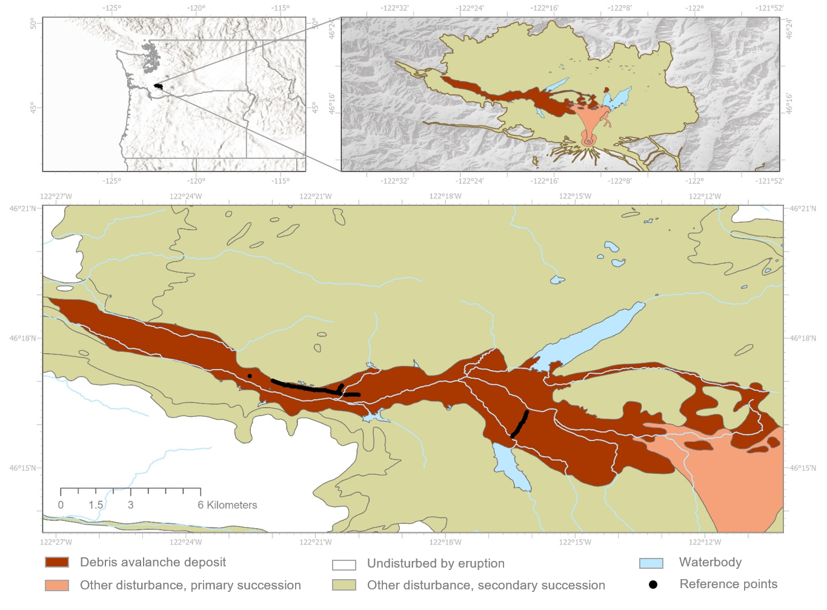
Figure 17. Mount St. Helens area showing location of study plots on the debris avalanche deposit, and relationship to other disturbance zones from eruption.

The deposit was hot at time of emplacement – up to 100 C in some locations. Once cooled, the conditions were adequate but not ideal for plant growth (Adams et al. 1987a). There was limited water holding capacity due to a rough texture consisting mostly of sand, gravel, and larger materials (Adams and Dale 1987). The substrate had extremely low levels of nitrogen (700 ppm) and organic matter (0.31% weight loss on ignition) and was acidic (pH 4.8) (Adams and Dale 1987). Seedlings planted in these soils under green-house conditions survived but did not thrive (Adams and Dale 1987).

Spatial Imagery
A variety of spectral indices were calculated from remotely sensed data from the Landsat satellite program. Use of multiple indices in land cover classification allows for improved accuracy as different indices emphasize different aspects of a system, making it more likely differences will be detected (Loukili et al. 2025). Landsat imagery at roughly five-year intervals were downloaded from Earth Explorer (accessed January 2025). To allow for best correspondence with the long-term plots, the years 1984, 1989, 1994, 2000, 2004, 2010, 2015, and 2022 were used. Landsat images chosen include cloud free (or nearly so) images between July 1 and July 31, the peak growing season at Mount St. Helens. Black body surface temperatures, which allow for estimation of temperature differences across vegetation types, but do not directly correspond to actual temperatures, which would have to account for greenness, were derived from the thermal infrared bands (TIRS) (eq. 1) (Herrero et al. 2019). Greenness and vegetation health was estimated using the normalized different vegetation index (NDVI) calculated from the red and near infrared bands using the following formula (band numbers corresponding to these data types vary across the generations of Landsat satellites this project covers) (Kshetri 2018) (eq. 2). Normalized difference moisture index (NDMI), which estimates the moisture content of vegetation, was derived using the near infrared and shortwave infrared bands as per equation 3 (Gao 1996). The enhanced vegetation index (EVI) uses several corrections to increase sensitivity to dense vegetation, derived as per the following equation 4 (Liu and Huete 1995). The soil adjusted vegetation index (SAVI) includes a soil correction factor that improves sensitivity at high reflectance values resulting from bare ground as per equation 5 (Huete 1988). The tassel cap wetness (TCW) index estimates surface moisture by contrasting the sum of the visible and near-infrared bands with the sum of the shortwave infrared bands multiplied by specific coefficients (these vary depending on which Landsat satellite is being used Landsat 5 equation 6, Landsat 8/9 equation 7) (Crist and Cicone 1984).
$BBST=\frac{K2}{ln⁡(\frac{K1}{radience}+1)}$ eq. 1
$NDVI=\frac{(NIR-Red)}{(NIR+Red)}$ eq.2
$NDMI=\frac{(NIR-SWIR)}{(NIR+SWIR)}$ eq. 3
$EVI=\frac{G_{gain}×(NIR-Red)}{(NIR+Red×C_{aerosol resistance 1}-Blue×C_{aerosol resistance 2}+{L }_{soil adjustment})}$ eq. 4
$SAVI=\frac{(NIR-Red)}{(NIR+Red+{L }_{soil adjustment})×\left(1+{L }_{soil adjustment}\right)}$ eq.5
${TCW}_{L5}= 0.1509×Blue + 0.1973×Green+0.3279×Red+0.3406×NIR-0.7112×SWIR1-0.4572×SWIR2$ eq. 6
${TCW}_{L8\&9}= 0.1511×Blue + 0.1973×Green+0.3283×Red+0.3407×NIR-0.7117×SWIR1-0.45559×SWIR2$ eq. 7

Land Cover Classification
We classified land cover type using the Random Forest algorithm (ArcGIS Pro v3.0.3), a machine learning tool capable of distinguishing groups within high dimensional data with non-linear relationships and multicollinearity (Breiman 2001). Inputs were the multispectral indices calculated in equations 1-7. Pixels were classified as either Water, Barren, Herbaceous or Woody. Due to extreme difference in reflectivity between the early years after the eruption when the ground was mostly unvegetated and later when nearly the entire deposit was vegetated, we used two different years as base years for our classifier. Ten years since the eruption (YSE), or 1990, was used as a base year for 1984 (4 YSE) through 1994 (14 YSE). For the latter period, 2010 (30 YSE) was used as a base year, 2000 (20 YSE) – 2022 (42 YSE). The base years’ pixels corresponding to the location of the long-term plots were randomly split into 70% (58 training pixels), 30% (24 testing pixels) data. Once trained the algorithm was applied to the testing data applicable to each base year, and then again to all pixels corresponding to long-term plots in other years within the period (82 testing pixels per year). After verification, the algorithm was applied to all pixels within the debris avalanche deposit (Table 11 and Figure 18).
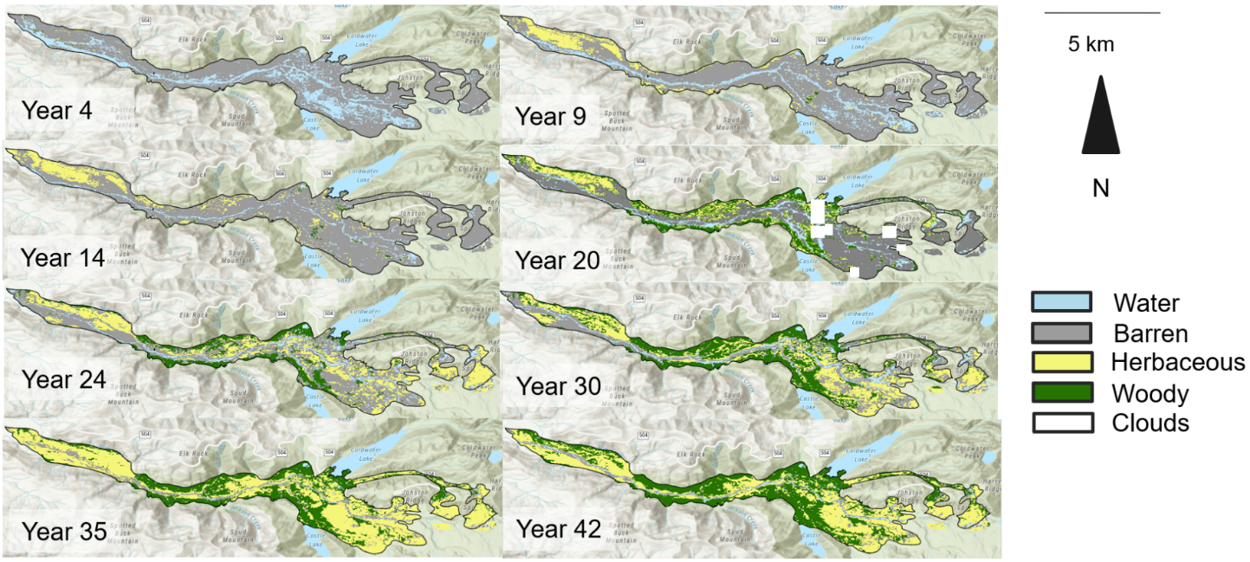
Figure 18. Extent of the debris avalanche deposit with land cover as classified using the random forest algorithm at roughly five-year time points from 1984 to 2022, 4 to 42 years after the eruption of Mount St. Helens. Land cover is grey for barren, yellow for herbaceous, and green for woody, water is blue, and No Data is white (from clouds).

Table 11. GIS layers used for explanatory variables in a study of the revegetation of Mount St. Helens after its 1980 eruption. Some values estimated at this point.
GIS layer/variable | Driver | Range of values | Original data source
Severity of Disturbance | Site Condition | 3-15 km | (Voight B et al. 1981)
Distance from surviving forest | Propagule Limitation | 25-8225 m | (Voight B et al. 1981)
Distance from edge of deposit | Propagule Limitation | 0-1500 m | (Voight B et al. 1981)
Distance to water | Site Condition | 30-2200 m | Calculated

Ground Based Dataset
Accuracy of the remote sensing information was examined using in situ data from vegetation monitored in a network of permanent plots installed in 1981 and 1982 (one or two years after the eruption). The vegetation in these permanent plots was measured during ten summers over a 42-year period (actual time points: 1981, 1982, 1983, 1989, 1994, 2000, 2004, 2010, 2015, and 2022). The 250 m² circular plots were placed at 50 m intervals along two transects: one between Castle and Coldwater Lakes and another down the western extent of the deposit (Figure 17). The initial 120 plots represented the variety of geologic and topographic conditions on the debris avalanche deposit and distances from surviving vegetation in the adjacent landscapes (Adams et al. 1987a). However, during the first two decades after the eruption, 38 of the plots were lost to erosion and lahars or could not be located in four or more years. When one to three years of in situ data were missing for a given plot random forest-based imputation was used to determine land cover for those years (Breiman 2003). This approach gives n=82 considering plots with complete land-cover estimates. Because these plots correspond to a large portion of the area of a Landsat pixel (pixels are a total of 900 m²), we use them as in situ data to estimate the accuracy of the models’ predictions.

Modeling
To determine the relationships between site condition, propagule limitation, and priority effects and how these determine land cover over time, we used a series of structural equation models (SEMs) (Barker et al. 2014). SEMs can be used to test hypothesized relationships between variables based on model implied covariance matrices. If a model is theoretically correct, the implied pattern of covariances should match the pattern seen in the data. SEMs are ideal for testing hypothesized relationships in complex systems, for instance how site condition and propagule limitation influence each other and jointly affect land-cover change and how those relationships might change over time. SEMs also allow for the incorporation of indirect effects through interactions that might be missed by standard regression. Further, it is possible to estimate effects that can’t be directly observed through the use of ‘latent’ variables. This allows for the direct incorporation of complete ecological concepts in models and reduction in uncertainty by accounting for multicollinearity between predictors. For instance, a latent variable of site condition might be estimated through the measured predictors severity of disturbance and distance to water. SEM can incorporate cross-lagged or autoregressive structures, making it well-suited for analyzing land-cover change over time. Finally, in SEM it is possible to test goodness-of-fit which makes it possible to infer how well the model fits the data and also allows for direct comparison of the fit of competing models.
To incorporate change over time we used a SEM panel model (Mayerl and Andersen 2019). The outcome variable, land cover, had three cover classes (barren (0), herbaceous (1) and woody (2)). Land cover was predicted by two latent variables: site condition and propagule limitation. Site condition was parameterized by distance from the eruptive crater, a proxy for severity of the disturbance, and distance to the nearest water source (we tried including elevation as well, but it proved too highly correlated with severity of disturbance in our system).
Table 12. Error matrix for the random forest classification includes plots from the following years (1984, 1990, 1994, 2000, 2004, 2010, 2015, 2022) all based on training done during the growing season to identify the following land cover types at Mount St. Helens, WA. Predicted land cover in rows, in situ land cover in columns.
Error Matrix |  | Water | Barren | Herbaceous | Woody | Total | Class Error Omission % |  | Class Error Commission %
 | Random Forest Classification
Water |  | 39 | 20 | 0 | 1 | 60 |  | 29.1 | 35.0
Barren |  | 10 | 176 | 5 | 9 | 200 |  | 14.1 | 12.0
Herbaceous |  | 1 | 4 | 42 | 10 | 57 |  | 30.0 | 26.3
Woody |  | 5 | 5 | 13 | 132 | 155 |  | 13.2 | 14.8
Total |  | 55 | 205 | 60 | 152 | 472 |  | - | -
Random Forest classifier overall accuracy: 82.4%, yearly accuracy (1984: 77.4%, 1990: 100% , 1994: 75%, 2000: 63.6, 2004: 100%, 2010: 63.6%, 2015: 76.6%, 2022: 90.3%)

Propagule pressure is estimated through the measured predictors of distance to nearest seed source and distance to undisturbed forest. (Table 12). The indicator variables used to parameterize the model were previously identified as important both initially and later in the time series of change since the deposit was (Lawrence et al. 2000; Lawrence 2005). See Figure 19A for an illustration of the simplest panel model considered. A second model (See figure 19B) includes priority effects by allowing land cover at one time point to directly influence land cover at the succeeding time point. Comparing fit between the two models allows us to infer which model better captures successional processes in this system. Fit statistics like χ², RMSEA (Good <0.05, Acceptable 0.05 – 0.08, mediocre 0.08-0.10, Poor > 0.10) and CFI (Good >0.95, Acceptable 0.90-0.95, Poor <0.90) were used to assess model fit. All variables were standardized before inclusion in the models.

Alternative Approach: Piecewise Growth Curve Modeling
We also estimated the influence of successional drivers on rate of land cover change over time using an approach known as growth curve modeling (Miller et al. 2024). Using a growth curve model made it possible to determine the influence of predictors on rates of change (slopes) at different time points over the course of succession by using a piece-wise modeling approach (Harring et al., 2021). (See supplementary figure 23 for a conceptual figure of a growth curve model). This approach allows us to understand longitudinal trends and how site condition and propagule limitation variables shape the pattern of land-cover change over time.(See supplementary Figure 24 for a conceptual figure of a piece-wise growth curve model).

Results

Success of Random Forest Classification
Random forest classification resulted in a highly accurate land-cover classification as compared to in situ data (overall 82.4% accuracy, range 63%-100% across years) (Table 13). Most of the debris avalanche deposit underwent land-cover conversion from barren to some other land-cover type between year 4 and year 42 after the eruption (Figure 18) according to our classification scheme.

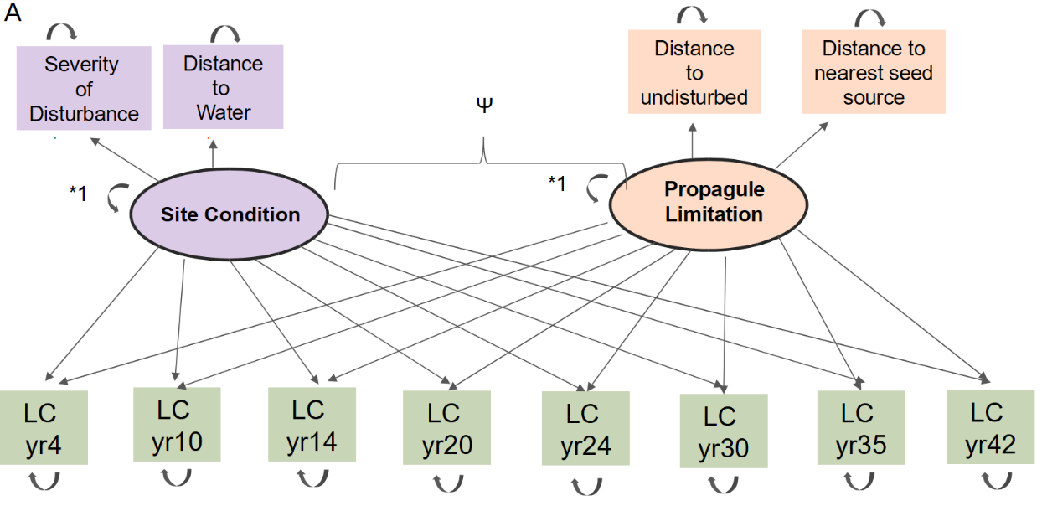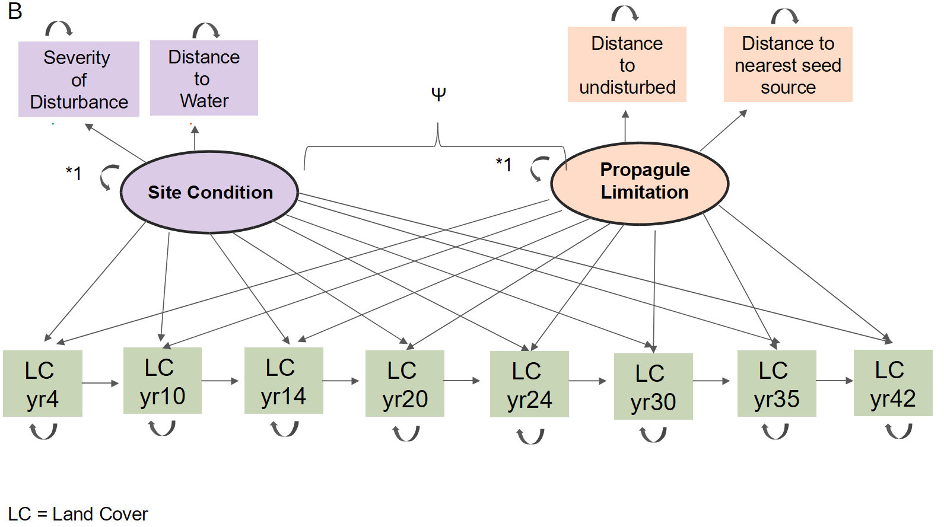
Figure 19. A set of potential models for how land cover type (LC: representing Barren, herbaceous and woody) may change over time. In Model A land cover at each time point is informed independently through two latent factors representing successional drivers: site condition and propagule limitation, these conceptual variables are informed by measured predictor variables. In Model B, much of the above structure is the same, but the cover type at T_{i-1} has a direct effect on the cover type at T_{i}.

Panel Model
Model A: The site condition and propagule limitation model is a mediocre fit for the data (RMSEA mediocre, TFI poor, CFI acceptable) (Figure 20A). Site condition had one strongly informative indicator (severity of disturbance) and one weakly informative indicator (distance to water). Propagule pressure has one strongly informative indicator (distance to undisturbed forest) and one weakly informative indicator (distance to nearest seed source). Both latent variables informed land cover at most time points, but their influence was not large (Figure 21A). Harsher site conditions suppressed the establishment of herbaceous and woody vegetation between years 10 and 20 after the eruption, but this effect shrunk and even became positive in the succeeding decades. Increased distance from seed sources showed an initial positive influence on cover change from barren to herbaceous to woody land cover, but this relationship became negative by year 24 after the eruption. Model B: Including priority effects essentially eliminated the influence of both site condition and propagule pressure during the first 14 years after emplacement. The model of priority effects included with site condition and propagule limitation was an acceptable fit for the data (RMSEA = acceptable, TFI=acceptable, CFI=acceptable) and fit the data better than Model A. The quality of the indicator variables on their latent factors did not change much, but the effect of the latent factors on land cover was modulated substantially by the inclusion of priority effects (Figure 20B). Land cover at every time point was a strong predictor of land cover at the next time point between years 4 and 30 after emplacement. Harsher site condition slightly decreased the potential for herbaceous and woody vegetation to develop through year 14 YSE, but thereafter harsher conditions strongly correlated with increased cover type. Propagule limitation has essentially no influence during the first 15 years after emplacement but strongly limits cover change between years 20 and 42 after emplacement.

The Growth Curve Model
The initial unconstrained growth-curve model indicated three separate periods of land-cover change (Figure 22A), so we fit a piece wise growth model which estimated the influence of site condition and propagule limitation indicators on rate of land-cover change during each time segment (YSE 4-14, 14-30, and 30-42) (Figure 22B). The piece-wise model was a mediocre fit for the data (RMSEA = acceptable, TFI=poor, CFI=acceptable). Severity of disturbance initially slowed land-cover change, but, by two to three decades post eruption, more severely disturbed areas were developed cover faster. However, in the final time period, a negative effect of severe disturbance on rate of land cover change was detected. Distance from water is never a large predictor of land-cover change. Greater distance to water was initially promoted faster land-cover change, presumably due to increased erosion near water. Distance to water had no influence during the middle period, and by the final period proximity to water increased the rate of land-cover change, presumably because soils had stabilized sufficiently.
Both propagule limitation variables behaved similarly. These variables have a very small influence in the initial period, and increased distance from both seed sources slowed land-cover development in the middle period. This influence reversed in the final period of the study as areas further from initial seed sources developed land cover more quickly, presumably because the actual seed sources have moved inward (Figure 22B).

Discussion
In this study we sought to determine how site condition, propagule limitation and priority effects interact to determine land cover and rate of land-cover change, and if these processes influence the ecosystem differently over the course of succession. We found that including priority effects shifted our understanding of how site condition and propagule pressure influence land cover and that a model including all three drivers was the best fit for the data. Without including priority effects site condition and propagule pressure only weakly explained land cover, and primarily in the first decades after the eruption. However, once the stochasticity associated with priority effects was included in the model, site condition and propagule pressure had a much weaker influence in the early decades with the explained land cover mostly accounted for by priority effects. In later decades, the independent influence of priority effects was swamped by the effects of propagule pressure and site condition. The effects of individual drivers were not consistent throughout the study period with all variables shifting in influence. Generally, there was an initial period when harsh site conditions and seed limitation slowed successional rate, but these conditions ameliorated over time. Together, these results highlight that no single factor consistently drives post-disturbance dynamics; instead, the balance of priority effects, site condition, and propagule
limitation shifts over time, helping to explain the complex and changing pathways through which ecosystems recover after disturbance.
Priority effects play a dominant role in shaping land cover during the earliest stages of succession, the first vegetation to arrive influenced vegetation at subsequent time points, as evidenced at Mount St. Helens. Failure to include priority effects leads to an over estimation of the role of site condition and propagule limitation in initial vegetation establishment. This suggests that stochasticity associated with initial arrival of vegetation has an enduring legacy on subsequent communities (Fukami 2015). Indeed, the existing vegetation on the debris avalanche arrival is still intact after three decades. It is unknown how long this mosaic of community types will persist on the landscape (Fukami and Nakajima 2011). Most studies of priority effects last less than a decade, for instance when seeding grasses and legumes into a California grassland
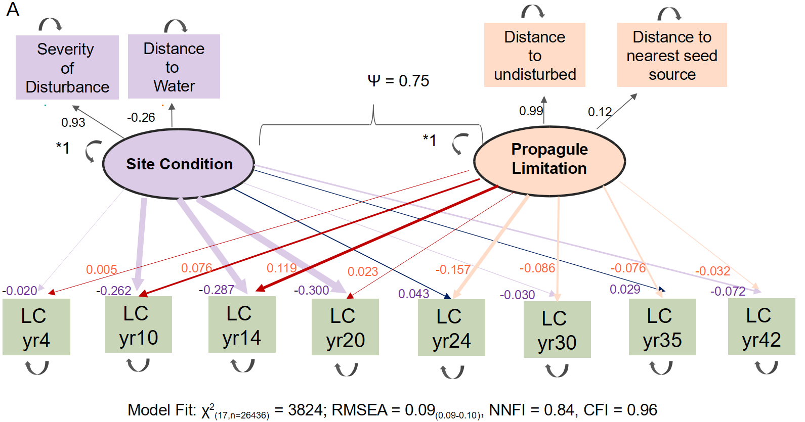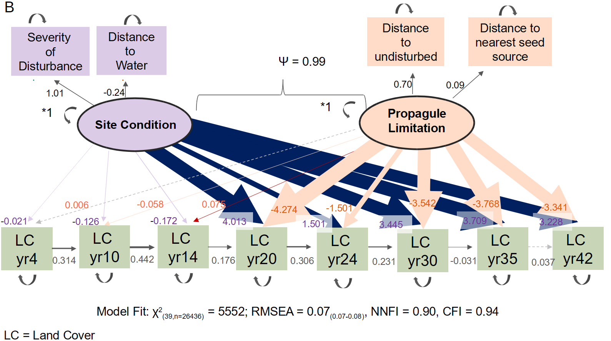
Figure 20. Panel models fit to the land-cover predictions of our random forest models. data between years 4 and 42 after the eruption at roughly 5-year time steps. Model A predicts land cover based only on site condition and propagule limitation at each time point. Model B allows for site condition and propagule limitation to predict cover at each time point but also allows the land cover at previous times to predict land cover at the next times, an estimate of the influence of priority effects. Size of the error is proportionate to the size of the effect.

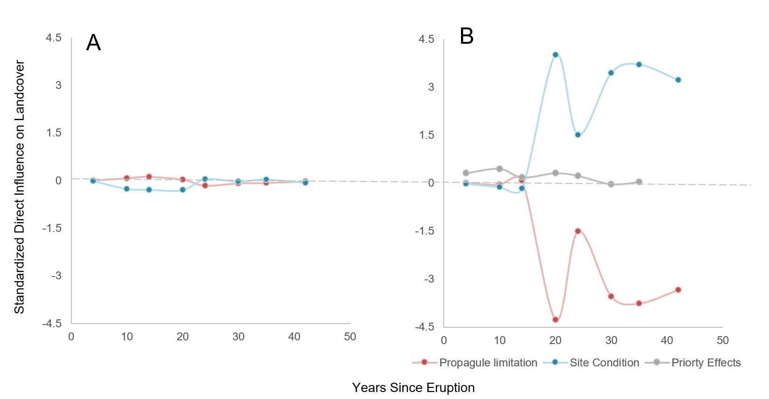
Figure 21. Standardized direct influences of drivers of land cover based on the panel structural equation models. (A) includes the influences when only site condition and propagule pressure explain land cover at each time point between years 4 and 42 after the eruption. (B) Once priority effects and the stochastic influences they include are included in the panel model the perceived influence of the drivers change dramatically.

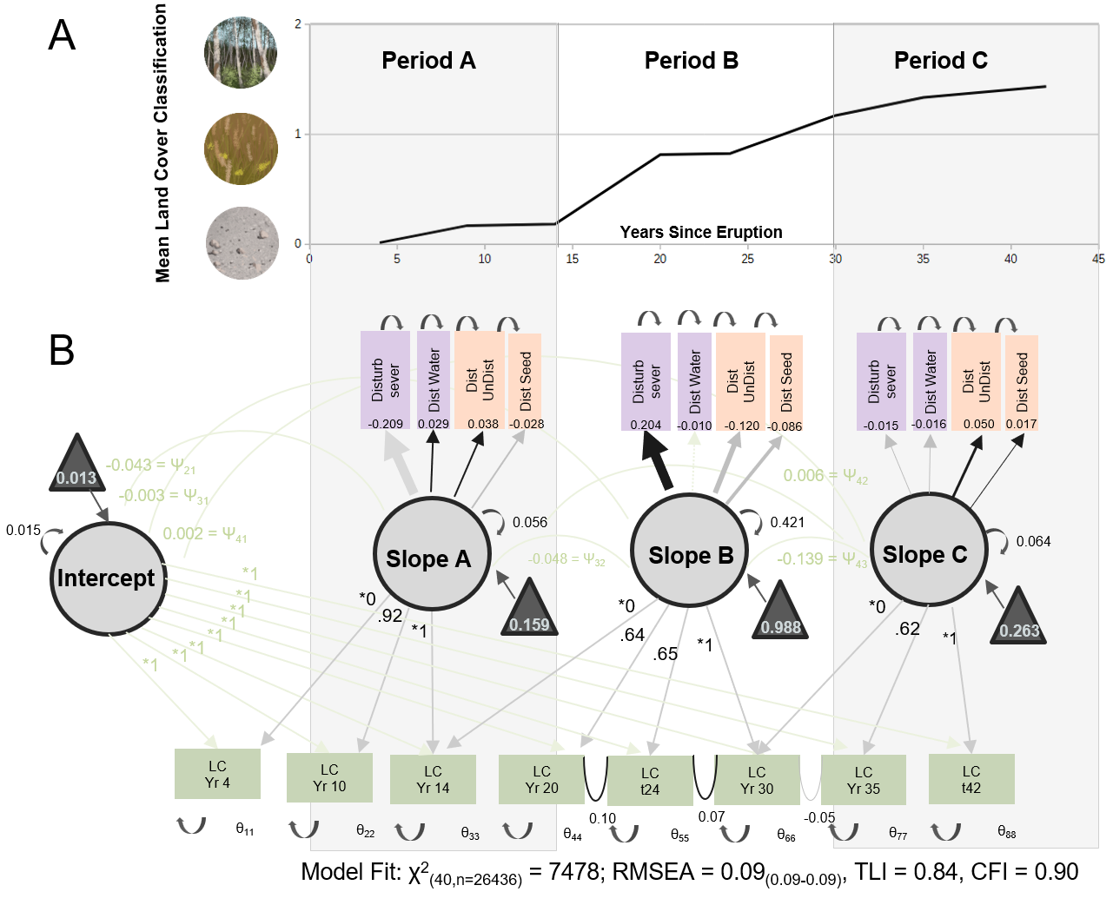
Figure 21. (A) Mean land cover as estimated by the growth curve model over time from classified data. The influence of environmental covariates on the slope of land cover change was further investigated for each period indicated by A, B and C using a piecewise growth model. (B) Piece-wise growth curve model fit to the land cover predictions of our random forest models. Land cover data was between years 4 and 42 after the eruption at roughly 5-year time steps. The piecewise-growth model estimates rate of change over different times so that the influence of predictors can vary with time. Most lines are greyed out for readability. However, arrows towards covariates are grey if the effect is negative, black if positive, and width is scaled to the size of the effect. Dashed lines are not significant. Site condition variables are purple, and propagule limitation variables are peach.

initial dominance of the seeded species was observed but community composition convergence deposit is quite patchy and includes at least eight different different plant and ground surface cover types (Teltscher and Fassnacht 2018) perhaps indicating that the legacy of initial vegetation after only seven years (Collinge and Ray 2009). While we also found the influence of priority effects to dimension with time, they were still detectable up to three decades so this insight dramatically expands the time scales over which this mechanism may influence ecosystem development (Weidlich et al. 2021).
Harsh site condition receded as a limiting factor with time but it did not disappear completely as a driver of community change. Harsh site conditions like coarse soil texture, compaction, and poor nutrient content have also been found to limit community establishment after mining operations (Polster 2016). In previous work at Mount St. Helens Lawrence (2005) found that site condition variables such as elevation and a proxy for disturbance severity explained a larger fraction of the observed variance with time. However, because of the way Lawrence (2005) did their analysis, the direction of the effect is obscured. We found harsh site condition caused both an initial and lingering negative effect on the rate of land-cover change but it was correlated with higher rates of land-cover change during the middle period. This interim acceleration was likely due to the dramatic expansion of alder as a canopy tree between the years 14 and 20 after the eruption (Dale et al., 2005; Dale and Denton, 2018). (While this change was observed in the plot data, that period is also the transition point between the two reference years for the land-cover classification, so of the jump in cover type may also be partially an artifact of the classification process). Woody vegetation can return more rapidly during primary succession than after secondary succession (Coradini et al. 2022), potentially because a greater variety of open niche space and tendencies towards conservative use of nutrients that allow woody plants to grow well in nutrient poor soils (Meiners et al. 2015) or, in the case of alder, the ability to supplement nutrient supply via fungal mutualism (Shainsky and Radosevich 1992). It has also been found that the addition of dead plant material and debris with no further treatment improves site condition allowing for establishment of desired vegetation post mining operations, indicating that perhaps the death of the first generation or generations of plants on the debris avalanche deposit was sufficient to reduce the influence of harsh site condition on vegetation development (Polster 2016).
While harsh site condition did not suppress vegetation change throughout the study period, it did have a lingering negative influence on rates of change in the final decades of the study. This lingering negative influence of disturbance severity on the rate of land-cover change may last for centuries. A series of studies at the Mount Lassen debris avalanche in California found that even 350 years after the disturbance there were still marked differences in canopy closure based only on coarseness of the deposit (Crandell et al. 1974; Parker 1991, 1992, 1993; Kroh et al. 2008b). Végh and Tsuyuzaki (2022) also observed a potential lingering effect of harsh site conditions on canopy closure several thousand years after the Mount Usu debris avalanche in Japan. After a subsequent ashfall eruption, areas developing forest did so more slowly and less completely when the ashfall overlaid the old debris avalanche deposit compared to areas where the ashfall overlaid previous ashfall. Harris and Van Couvering (1995) suggested that it is possible to detect debris avalanches in the paleo-ecological record due to apparent desert-like conditions in the sedimentary record that persist for centuries but are unobserved in the surrounding deposits.
Site condition variables did not affect the system to the same magnitude or over the same time periods. For instance, close proximity to water initially inhibited vegetation establishment, but eventually promoted vegetation. This may be because the same mechanisms are not captured by this driver throughout succession. Perhaps it was initially conducive to vegetation establishment to be far from water because after the eruption unconsolidated substrates and poorly defined river channels were prone to flooding and erosion, which in turn could wash away establishing vegetation. Indeed roughly 1/6th of the permanent plots were lost after a year of heavy flooding16 years after the eruption (Dale and Adams 2003). However, distance from stagnant water or ponds may promote growth, and may do so throughout the study period. Both effects would have been captured by our distance from water variable, obscuring the overall influence of water on the system. Most studies assessing the role of water availability do so at large spatial scales using chronosequences (Trindade et al. 2020) or in relation to plant water acquisition strategies (Bretfeld et al. 2018), so it is unknown how common these oppose influences of distance to water source are in other systems.
Our model revealed many nuances associated with propagule limitation. Propagule limitation on vegetation establishment was most evident in the middle decades of the study, but no longer suppressed vegetation change in later decades. This reversal in sign within the model suggests that vegetation is now spreading from within the deposit, and the previous geographic boundaries of distance from seed sources no longer constrain vegetation establishment. However, while only seen when priority effects were not included in the model it is possible that an initial positive correlation between distance from seed source is a real effect. Dale (1989) found higher concentrations of windblown seeds towards the middle of the deposit. These highly vagile fluffy seeds may have been blowing in from far away with the prevailing winds that run up the middle of the deposit (Burrows 1973). These complexities and shifting influences would not be detectable considering just one time point which indicates the importance of continuing studies at decadal times scales as the full story is often not captured by studying only the initial years after disturbance

Management implications
We propose a theoretical framework that may be useful for making management decisions after severe disturbance. Based on our findings vegetation establishment has three phases: initial, mosaic and fill in (Figure 7). In the initial period both harsh site conditions and dispersal barrens limit the ability of plants to establish, but propagules that do arrive struggle to establish making site condition the dominate driver of vegetation establishment in this period. Plants may only grow where conditions are ameliorated in some way, like in depressions that capture more moisture (Dale 1989), or where substrates are finer (Griggs 1920). However, with time, site conditions improve, but propagules still arrive from outside of the disturbance as initial vegetation is sparse and still immature. During the mosaic phase propagule pressure is the dominant driver of plant community change. Following the mosaic phase in the fill in phase. Propagule limitation no longer inhibits vegetation establishment during this phase as previously established communities within the disturbance now serve as the primary source of new propagules. However, some harsh site conditions may have enduring legacies, such as extremely course soils that limit moisture holding capacity (Kroh et al. 2008b). These conditions may limit the types of vegetation that can be established. The asynchrony in when harsh site conditions ameliorate and when propagule limitation no longer slows land-cover changes suggests there is a window of time when management interventions like seeding may be particularly effective right at the beginning of the mosaic phase. Targeting this window would maximize return in investment dollars spent to foster rates of land-cover change. Notably, this period is not directly after the disturbance when restoration funds are usually available but occurred after the first decade in our system. After other disturbances the boundary between the initial and mosaic period may occur sooner, such as 2-4 years after wildfire (Dawe et al. 2022). Ensuring that funds are available for restoration effort at the beginning of mosaic periods may necessitate a re-evaluation of funding structures.
These management implications apply to situations where there is little to no living or dead biotic material subsequent to the disturbance. Large excavations for roads or buildings are examples of conditions that have no or few biotic legacies. In addition, above-ground mining, dam removals, and newly dried lake beds can result in large areas with few biotic legacies. The lessons may also be useful to desert or barren areas experiencing wetter conditions as climate changes.

Conclusions
In extreme environments like Mount St. Helens, early successional trajectories may be governed less by deterministic drivers and more by chance events whose legacy can persist for decades. Further, successional change is not explained by a single process. It is necessary to consider both accidents of initial arrival and the conditions experienced on the ground when trying to understand how land cover changes over time after a severe disturbance. Factors explaining land-cover conversion do not necessarily stay directionally and spatially as communities establish which means understanding succession means understanding this temporal complexity. It may be possible to use knowledge of the shifting influences of community change drivers to improve timing of management interventions, allowing improved outcomes for funds spent.

Figure 23. (A) Conceptual diagram of the phases of succession represented by our model in an idealized disturbance system similar to the debris avalanche deposit at Mount St. Helens, darker greens represent areas vegetation establishes first and lighter greens represent later establishing vegetation. In the initial phase site conditions are harsh and propagule limitation is strong because all seed must arrive from outside of the disturbed area. Any propagules that do arrive struggle to establish so site condition dominates the land cover that is first to establish. During the mosaic period site conditions have begun to ameliorate so no longer strongly influences land cover, but most seed is still arriving from outside of the disturbed area, so propagule pressure becomes the dominant control on land cover. During the fill in phase, propagules from previously established vegetation are the primary source of seed, so distance from original seed sources no longer matters, but long-lasting legacies of site condition may make themselves apparently again. (B) An example of what a mosaic phase might look like. A mosaic area may include bare ground and patchy vegetation representing different plant types, with no vegetation type dominant. At Mount St. Helens this vegetation phase occurred around 14 years after the eruption, but in a burned system like (C) it might occur at year 4.

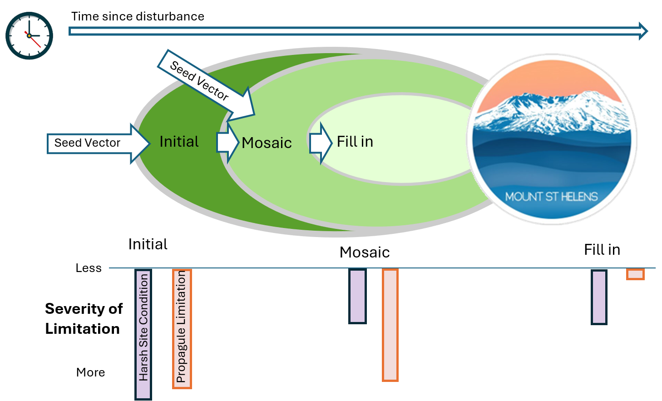 a.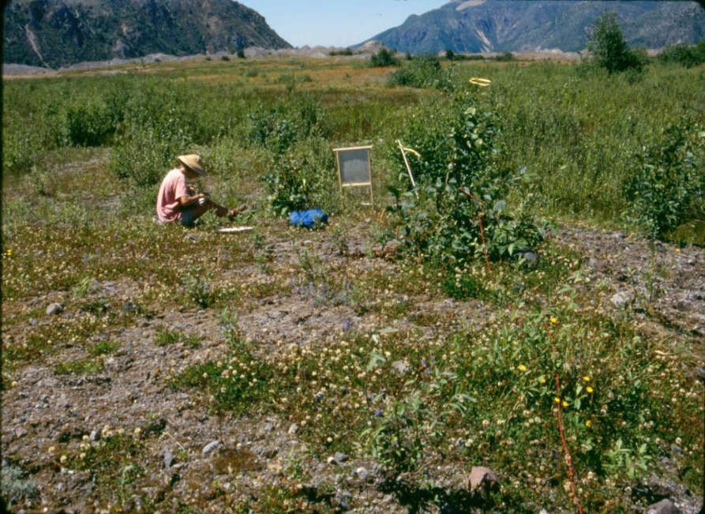 b. 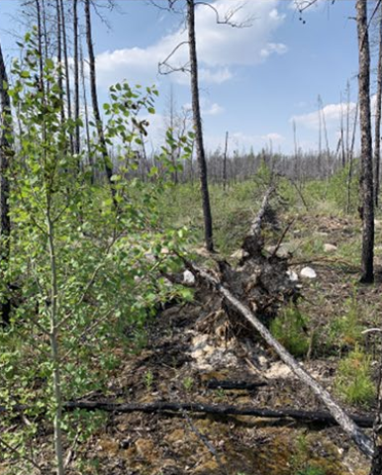

REFERENCES
Abdi AM, Brandt M, Abel C, Fensholt R (2022) Satellite remote sensing of savannas: current status and emerging opportunities. Journal of Remote Sensing (United States) 2022:1–20. https://doi.org/10.34133/2022/9835284
Abrams MD, Sprugel DG, Dickmann DI (1985) Multiple successional pathways on recently disturbed jack pine sites in Michigan. For Ecol Manage 10:31–48
Adams AB, Dale VH (1987) Vegetative succession following glacial and volcanic disturbances in the Cascade Mountain Range of Washington, U.S.A. In: Dilderback DE (ed) Mount St. Helens 1980: Botanical consequences of the explosive eruptions. University of California Press, Berkeley, pp 70–146
Adams AB, Dale VH, Smith EP, Kruckeberg AR (1987a) Plants Survival, Growth Form and Regeneration Following the 18 May1980 Eruption of Mount St. Helens. Northwest Science 61:160–170
Adams AB, Hinckley KE, Hinzman C, Leffler SR (1987b) Recovery of small mammals in three habitats in the northwest sector of the Mount St. Helens National Volcanic Monument. In: Keller SAC (ed) Mount St. Helens - Five hears later. Eastern Washington University Press, Cheney, Washington, pp 307–324
Adams AB, Wallace JR, Jones JT, McElroy WK (1987c) Plant Ecosystem resilience following the 1980 eruptions of Mount St. Helens Washington. In: Keller SAC (ed) Mount St. Helens, five years later. Eastern Washington University Press, Cheney, Washington, pp 182–207
Adams VD, Adams AB (1982) Initial recovery of the vegetation on Mount St. Helens. In: Keller SAC (ed) Mount St. Helens: one year later. Eastern Washington University Press, pp 105–115
Alaska Inventory and Monitoring Program (2016) Katmai National Park and Preserve landcover classification poster. https://irma.nps.gov/DataStore/Reference/Profile/2227651 (accessed Mar 24, 2025)
Andersen DC, Macmahon JA (1985) The effects of catastrophic ecosystem disturbance: the residual mammals at Mount St. Helens. J Mammal 66:581–589
Baasch A, Tischew S, Bruelheide H (2010a) Twelve years of succession on sandy substrates in a post-mining landscape: a Markov chain analysis. Ecological Applications 20:1136–1147
Baasch A, Tischew S, Bruelheide H (2010b) Twelve years of succession on sandy substrates in a post-mining landscape: a Markov chain analysis. Ecological Applications 20:1136–1147
Barker DH, Rancourt D, Jelalian E (2014) Flexible models of change: Using structural equations to match statistical and theoretical models of multiple change processes. J Pediatr Psychol 39:233–245. https://doi.org/10.1093/jpepsy/jst082
Bernard B, Takarada S, Andrade SD, Dufresne A (2021) Terminology and strategy to describe large volcanic landslide and debris avalanches. In: Roverato M, Dufresne A, Procter J (eds) Volcanic debris avalanches: from collapse to hazard, 1st edn. Springer Nature Switzerland, Cham, Switzerland, pp 175–210
Birks HJB (2012) Ecological palaeoecology and conservation biology: controversies, challenges, and compromises. Int J Biodivers Sci Ecosyst Serv Manag 8:292–304. https://doi.org/10.1080/21513732.2012.701667
Bishop JG (2002) Early primary succession on Mount St. Helens: Impact of insect herbivores on colonizing lupines. Ecology 83:191–202
Bishop JG, O’Hara NB, Titus JH, et al (2010) N-P co-limitation of primary production and response of arthropods to N and P in early primary succession on Mount St. Helens Volcano. PLoS One 5:. https://doi.org/10.1371/journal.pone.0013598
Bishop JG, Schemske DW (1998) Variation in flowering phenology and its consequences for lupines colonizing Mount St Helens. Source: Ecology 79:534–546
Breiman L (2003) Using random forests. 1–33
Breiman L (2001) Random Forests. Mach Learn 45:5–32
Bretfeld M, Ewers BE, Hall JS (2018) Plant water use responses along secondary forest succession during the 2015–2016 El Niño drought in Panama. New Phytologist 219:885–899. https://doi.org/10.1111/nph.15071
Brown JF, Tollerud HJ, Barber CP, et al (2020) Lessons learned implementing an operational continuous United States national land change monitoring capability: the Land Change Monitoring, Assessment, and Projection (LCMAP) approach. Remote Sens Environ 238:. https://doi.org/10.1016/j.rse.2019.111356
Burnham KP, Anderson DR, Huyvaert KP (2011) AIC model selection and multimodel inference in behavioral ecology: Some background, observations, and comparisons. Behav Ecol Sociobiol 65:23–35. https://doi.org/10.1007/s00265-010-1029-6
Burrows FM (1973) Calculation of the primary trajectories of plumed seeds in steady winds with variable convection. New Phytologist 72:647–664. https://doi.org/10.1111/j.1469-8137.1973.tb04414.x
Campbell D (2001) Keystone herbivores and their impact on vegetation and successional dynamics within the debris avalanche deposit at Mount St. Helens National Volcanic Monument. Masters, University of Wisconsin
Cattelino PJ, Noble IR, Slatyer RO, Kessell SR (1979) Predicting the multiple pathways of plant succession. Environ Manage 3:41–50
Chang C, HilleRisLambers J (2016) Integrating succession and community assembly perspectives. F1000Res 5
Chang CC, Turner BL (2019) Ecological succession in a changing world. Journal of Ecology 107:503–509. https://doi.org/10.1111/1365-2745.13132
Che-Castaldo C, Crisafulli CM, Bishop JG, Fagan WF (2015) What causes female bias in the secondary sex ratios of the dioecious woody shrub Salix sitchensis colonizing a primary successional landscape? Am J Bot 102:1309–1322. https://doi.org/10.3732/ajb
Che‐Castaldo C, Crisafulli CM, Bishop JG, Fagan WF (2015) What causes female bias in the secondary sex ratios of the dioecious woody shrub Salix sitchensis colonizing a primary successional landscape? Am J Bot 102:1309–1322. https://doi.org/10.3732/ajb.1500143
Clarkson BD (1977) Vegetational change along an altitudinal gradient, Mount Egmont, New Zealand. Masters of Science, University of Waikato
Clements FE (1928) Plant succession and indicators; a definitive edition of plant succession and plant indicators. H. W. Wilson Company, New York
Collinge SK, Ray C (2009) Transient patterns in the assembly of vernal pool plant communities. Ecology 90:3313–3323
Collins BD, Dunne T (1988) Effects of forest land management on erosion and revegetation after the eruption of Mount St. Helens. Earth Surf Process Landf 13:193–205. https://doi.org/10.1002/esp.3290130302
Connell JH, Slatyer RO (1977) Mechanisms of succession in natural communities and their role in community stability and organization. Am Nat 111:1119–1144
Coradini K, Krejčová J, Frouz J (2022) Potential of vegetation and woodland cover recovery during primary and secondary succession, a global quantitative review. Land Degrad Dev 33:512–526. https://doi.org/10.1002/ldr.4166
Crandell D, Mullineaux DR, Sigafoos RS, Rubin M (1974) Chaos Crags eruptions and rockfall-avalanches, Lassen Volcanic National Park, California. Geol Survey 2:49–59
Crawford RL (1985) Mt. St. Helens and spider biogeography. Proceedings of the Washington State Entomological Society 46:700–702
Crist EP, Cicone RC (1984) A physically-based transformation of thematic mapper data-the TM Tasseled Cap. IEEE Transactions on Geoscience and Remote Sensing
Dale VH (1989) Wind dispersed seeds and plant recovery on the Mount St. Helens debris avalanche. Canadian Journal of Botany 67:1434–1441
Dale VH (1991) Mount St. Helens: revegetation of Mount St. Helens debris avalanche 10 years post eruption. National Geographic Research and Exploration 7:328–342
Dale VH (1987) Plant recovery on the debris avalanche at Mount St. Helens. In: Keller SAC (ed) Mount St. Helens, five years later. Eastern Washington University Press, Cheney, Washington, pp 208–214
Dale VH (1992) Exotic seeds reduce biodiversity on the Mount St. Helens debris avalanche. The northwest environmental journal 8:183–185
Dale VH, Adams WM (2003) Plant reestablishment 15 years after the debris avalanche at Mount St. Helens, Washington. Science of the Total Environment 313:101–113. https://doi.org/10.1016/S0048-9697(03)00332-2
Dale VH, Campbell DR, Adams WM, et al (2005) Plant succession on the Mount St. Helens debris-avalanche deposit. In: Ecological Responses to the 1980 Eruption of Mount St. Helens. pp 59–73
Dale VH, Denton EM (2018) Plant succession on the Mount St. Helens debris-avalanche deposit and the role of non-native species. In: Ecological Responses at Mount St. Helens: Revisited 35 years after the 1980 Eruption. pp 149–163
Dawe DA, Parisien MA, Van Dongen A, Whitman E (2022) Initial succession after wildfire in dry boreal forests of northwestern North America. Plant Ecol 223:789–809. https://doi.org/10.1007/s11258-022-01237-6
del Moral R (1983) Initial recovery of subalpine vegetation on Mount St. Helens, Washington. Am Midl Nat 109:72–80
del Moral R (1999) Plant succession on pumice at Mount St. Helens Washington. American Midland Naturalist 141:101–114
del Moral R, Chang CC (2015) Multiple assessments of succession rates on Mount St. Helens. Plant Ecol 216:165–176. https://doi.org/10.1007/s11258-014-0425-9
del Moral R, Clampitt CA (1985) Growth of native plant species on recent volcanic substrates from Mount St. Helens. Am Midl Nat 114:374–383
Doty SL, Sher AW, Fleck ND, et al (2016) Variable nitrogen fixation in wild Populus. PLoS One 11:. https://doi.org/10.1371/journal.pone.0155979
Dufresne A, Zernack A, Bernard K, et al (2021) Sedimentology of volcanic debris avalanche deposits. In: Roverato M, Dufresne A, Procter J (eds) Volcanic debris avalanches: from collapse to hazard, 1st edn. Springer Nature Switzerland, Cham, Switzerland, pp 175–210
Foster DR, Knight DH, Franklin JF (1998) Landscape patterns and legacies resulting from large, infrequent forest disturbances. Ecosystems 1:497–510
Franklin JF, Johnson KN, Johnson DL (2018) Ecological forest management. Waveland Press Inc., Long Grove, Illinois
Frenzen PM, Hadley KS, Major JJ, et al (2005) Geomorphic change and vegetation development on the Muddy River Mudflow Deposit. In: Dale VH, Swanson FJ, Crisafulli CM (eds) Ecological Responses to the 1980 Eruption of Mount St. Helens. Springer-Verlag, New York, New York, pp 75–91
Friedl MA, Woodcock CE, Olofsson P, et al (2022) Medium spatial resolution mapping of global land cover and land cover change across multiple decades from Landsat. Frontiers in Remote Sensing 3:1–15. https://doi.org/10.3389/frsen.2022.894571
Frouz J, Bartuška M, Hošek J, et al (2020) Large scale manipulation of the interactions between key ecosystem processes at multiple scales: Why and how the falcon array of artificial catchments was built. European Journal of Environmental Sciences 10:51–60. https://doi.org/10.14712/23361964.2020.7
Frouz J, Mudrák O, Reitschmiedová O, et al (2018) Rough wave-like heaped overburden promotes establishment of. Woody vegetation while leveling promotes grasses during unassisted post-mining site development. J Environ Manage 205:50–58
Fukami T (2015) Historical contingency in community assembly: Integrating niches, species Pools, and priority effects. Annu Rev Ecol Evol Syst 46:1–23. https://doi.org/10.1146/annurev-ecolsys-110411-160340
Fukami T, Nakajima M (2011) Community assembly: Alternative stable states or alternative transient states? Ecol Lett 14:973–984. https://doi.org/10.1111/j.1461-0248.2011.01663.x
Gao B-C (1996) Naval Research Laboratory, 4555 Overlook Ave. ©Elsevier Science Inc
Gill RA, Boie JA, Bishop JG, et al (2006) Linking community and ecosystem development on Mount St. Helens. Oecologia 148:3–12. https://doi.org/10.1007
Gleason HA (1926) The individualistic concept of the plant association. Bulletin of the Torrey Botanical Club 53:7–26
Glicken H (1996) Rockslide-debris avalanche of May 18, 1980, Mount St. Helens Volcano, Washington
Griggs RF (1933) The colonization of the Katmai ash, a new and inorganic “soil.” Am J Bot 20:92–113
Griggs RF (1920) The great Magiek landslide. Ohio Journal of Science 20:325–354
Grishin S (2019) The main trends in the dynamics of vegetation on the territory affected by the by the catastrophic eruption of Bezymyanny Volcano on March 30, 1956 (Kamchatka) (in Russian). Izvestiya Russkogo Geograficheskogo Obshestva 151:32–47
Grishin S (2011) Влияние извержений вулкана Ключевского на растительность. Influence of eruptions of Kliuchevskoi volcano (Kamchatka) on vegetation. (Russian). Journal of Russian Geographical Society 44–54
Grishin S (1996) Vegetation of subalpine belt of Klyuchevskaya group of volcanoes (in Russian). http://www.rfbr.ru/rffi/ru/books/o_27794#1
Grishin S, Krestov P, VP V, Yakubov V (2000) Restoration of vegetation on Sheveluch volcano after disaster of 1964 (in Russian). Komarov Memorial Lectures 73–104
Haemmerle HE (1984) Three herbaceous species and their relationship to succession on the debris avalanche at Mt. St. Helens. Independent study project, University of Puget Sound
Halpern CB (1988) Early successional pathways and the resistance and resilience of forest communities. Ecology 69 (6):1703–1715
Hamilton WM, Baumgart IL (1959) Bulletin 127: White Island. Willington, New Zealand
Harring JR, Strazzeri MM, Blozis SA (2021) Piecewise latent growth models: beyond modeling linear-linear processes. Behav Res Methods 53:593–608. https://doi.org/10.3758/s13428-020-01420-5
Harrington LMB, Harrington JA, Frenzen PM (1998) Vegetation change in the Mount St. Helens (U.S.A.) blast zone, 1979–1992. Geocarto Int 13:75–82. https://doi.org/10.1080/10106049809354631
Harris J, Van Couvering J (1995) Mock aridity and the paleoecology of volcanically influenced ecosystems. Geology 23:593–596
Heath JP (1967) Primary conifer succession, Lassen Volcanic National Park. Ecology 48:270–275
Herrero HV, Southworth J, Bunting E, et al (2019) Integrating surface-based temperature and vegetation abundance estimates into land cover classifications for conservation efforts in savanna landscapes. Sensors (Switzerland) 19:. https://doi.org/10.3390/s19163456
Hofmann J V (1920) The establishment of a Douglas Fir forest. Ecology 1:49–53
Huete AR (1988) A soil-adjusted vegetation endex (SAVI). Remote Sensing of the Environment 25:295–309
Hupp CR (1984) Dendrogeomorphic evidence of debris flow frequency and magnitude at Mount Shasta, California. Reston, Virginia
Hurley AC (1973) Fecundity of acorn barnacle balanus-pacificus pilsbry - fugitive species. Limnol Oceanogr 18:386–393
Jackson ST (2012) Representation of flora and vegetation in Quaternary fossil assemblages: known and unknown knowns and unknowns. Quat Sci Rev 49:1–15
Jensen ME, Bourgeron P, Everett R, Goodman I (1996) Ecosystem management: A landscape ecology perspective. J Am Water Resour Assoc 32:203–216. https://doi.org/10.1111/j.1752-1688.1996.tb03445.x
Johnson EA (1996) Fire and vegetation dynamics: studies from the North American boreal forest. Cambridge University Press, Cambridge
Jomelli V, Pavlova I, Utasse M, et al (2011) Are debris floods and debris avalanches responding univocally to recent climatic change – a case study in the French Alps. In: Climate Change - Geophysical Foundations and Ecological Effects. InTech
Jorgenson MT, Frost G V., Lentz WE, Bennett AJ (2004) Photographic monitoring of landscape change in the Southwest Alaska Network of National Parklands, 2006. Anchorage, Alaska
Kieffer SW (1981) Blast dynamics at Mount St Helens on 18 May 1980. Nature 568–570
Korup O, Clague JJ, Hermanns RL, et al (2007) Giant landslides, topography, and erosion. Earth Planet Sci Lett 261:578–589. https://doi.org/10.1016/j.epsl.2007.07.025
Korup O, Schneider D, Huggel C, Dufresne A (2013) Long-runout landslides. In: Treatise on Geomorphology: Volume 1-14. Elsevier, pp 183–199
Kreyling J (2024) Space-for-time substitution misleads projections of plant community and stand-structure development after disturbance in a slow-growing environment. Journal of Ecology 00:1–13. https://doi.org/10.1111/1365-2745.14438
Kreyling J, Jentsch A, Beierkuhnlein C (2011) Stochastic trajectories of succession initiated by extreme climatic events. Ecol Lett 14:758–764. https://doi.org/10.1111/j.1461-0248.2011.01637.x
Kroh GC, McNew K, Pinder JE (2008a) Conifer colonization of a 350-year old rock fall at Lassen Volcanic National Park in northern California. Plant Ecol 199:281–294. https://doi.org/10.1007/s11258-008-9432-z
Kroh GC, McNew K, Pinder JE (2008b) Conifer colonization of a 350-year old rock fall at Lassen Volcanic National Park in northern California. Plant Ecol 199:281–294. https://doi.org/10.1007/s11258-008-9432-z
Kshetri TB (2018) Geomatics for Sustainable Development NDVI, NDBI AND NDWI CALCULATION USING LANDSAT 7 AND 8. GeoWorld 2:32–34
Kuzera K, Rogan J, Eastman R (2005) Monitoring vegetation regeneration and deforestation using change vector analysis: Mt. St. Helens study area. In: ASPRS Annual Conference. Baltimore, Maryland, pp 1–9
Lavender DP, Hermann RK (2014) Douglas-fir: the genus Pseudotsuga. Forest Research Publications Office, Oregon State University, Corvallis, OR
Lawrence R (2005) Remote sensing of vegetation responses during the first 20 years following the 1980 eruption of Mount St. Helens: a spatially and temporally stratified analysis. In: Ecological Responses to the 1980 Eruption of Mount St. Helens. pp 111–124
Lawrence RL (1998) A landscape-scale analysis of vegetation recovery at Mount St. Helens. PhD, Oregon State University
Lawrence RL, Ripple WJ (1998) Comparisons among vegetation indices and bandwise regression in a highly disturbed, heterogeneous landscape: Mount St. Helens, Washington. Remote Sensing and the Environment 64:91–102
Lawrence RL, Ripple WJ (1999) Calculating change curves for multitemporal satellite imagery Mount St. Helens 1980-1995. Remote Sensing and the Environment 67:309–219
Lawrence RL, Ripple WJ, Lawrence1 RL, Ripple2 WJ (2000) Fifteen years of revegetation of Mount St. Helens: a landscape-scale analysis. Ecology 81:2742–2752
Lees CM (1987a) Late holocene changes in the vegetation of Western Taranaki investigated by soil palynology vol. 2. PhD, Massey University
Lees CM (1987b) Late Holocene changes the vegetation of western Taranaki investigated by soil palynology Vol 1. Ph.D., Massey University
Li Z (2022) Spatial distribution and temporal change of vegetation restoration after the eruption of Mount St. Helens: from 1984 to 2019. Highlights in Science, Engineering and Technology 17:133–141
Lipman PW, Mullineaux DR (1981) The 1980 eruption of Mount St. Helens, Washington. U.S. Geological Survey, Washington D.C.
Lister AJ, Andersen H, Frescino T, et al (2020) Use of remote sensing data to improve the efficiency of national forest inventories: a case study from the United States national forest inventory. Forests 11:1–41. https://doi.org/10.3390/f11121364
Liu HQ, Huete A (1995) A feedback based modification of the NDVI to minimize canopy background and atmospheric noise. IEEE Transactions on Geoscience and Remote Sensing 33:457
Liu S, Liu L, Li J, et al (2022) Spatiotemporal variability of human disturbance impacts on ecosystem services in mining areas. Sustainability (Switzerland) 14:. https://doi.org/10.3390/su14137547
Lohbeck M, Poorter L, Martínez-Ramos M, et al (2014) Changing drivers of species dominance during tropical forest succession. Funct Ecol 28:1052–1058. https://doi.org/10.1111/1365-2435.12240
López-Marcos D, Belén Turrión M, Martínez-Ruiz C (2020) Linking soil variability with plant community composition along a mine-slope topographic gradient: implications for restoration. Ambio 49:337–349
Loukili I, Laamrani A, El Ghorfi M, et al (2025) Monitoring land changes at an open mine site using remote sensing and multi-spectral indices. Heliyon 11:. https://doi.org/10.1016/j.heliyon.2025.e41845
Maggi E, Bertocci I, Vaselli S, Benedetti-Cecchi L (2011) Connell and Slatyer’s models of succession in the biodiversity era. Ecology 92:1399–1406. https://doi.org/10.1890/10-1323.1
Marleau JN (2009) Modelling early plant primary succession on Mount St. Helens. M.Sc., University of Alberta
Martin DJ, Wasserman LJ, Dale VH (1986) Influence of Riparian Vegetation on Posteruption Survival of Coho Salmon Fingerlings on the West-Side Streams of Mount St. Helens, Washington. N Am J Fish Manag 6:1–8. https://doi.org/10.1577/1548-8659(1986)6<1:iorvop>2.0.co;2
Marzen LJ (2001) Remote sensing of change in the Mount St. Helens blast zone. Doctorate , Kansas State University
Marzen LJ, Szantoi Z, Harrington LMB, Harrington JA (2011) Implications of management strategies and vegetation change in the Mount St. Helens blast zone. Geocarto Int 26:359–376. https://doi.org/10.1080/10106049.2011.584977
Mason NWH, Richardson SJ, Peltzer DA, et al (2012) Changes in coexistence mechanisms along a long-term soil chronosequence revealed by functional trait diversity. Journal of Ecology 100:678–689. https://doi.org/10.1111/j.1365-2745.2012.01965.x
Mayerl J, Andersen HK (2019) Recent developments in structural equation modeling with panel data. causal analysis and change over time in attitude research. In: Mayerl J, Krause T, Wahl A, Wuketich M (eds) Einstellungen undVerhalten in der empirischen Sozialforschung. Springer Fachmedien, pp 415–449
McCann LA (2017) Vegetation recovery following volcanic disturbance on Mt. Tongariro, New Zealand. M.Sc., University of Waikoto
Mcintosh RP (1981) Succession and ecological theory. In: West DC,, et al. (eds) Forest Succession. Springer-Verlag, New York, New York, pp 10–23
Meiners SJ, Cadotte MW, Fridley JD, et al (2015) Is successional research nearing its climax? New approaches for understanding dynamic communities. Funct Ecol 29:154–164. https://doi.org/10.1111/1365-2435.12391
Mercer DE (2004) Policies for encouraging forest restoration. In: Stanturf JA, Madson P (eds) Restoration of boreal and temperate forests. CRC Press, Boca Raton, FL, pp 97–109
Miller ML, Ferrer E, Ghisletta P (2024) The current practice of latent growth curve modeling in the social and behavioral sciences: Observations and recommendations. Int J Behav Dev. https://doi.org/10.1177/01650254241269723
Moore TG (2017) Community composition, assembly and priority effects in a volcanically disturbed alpine herbfield, Mount Taranaki, New Zealand. Masters of Science, University of Waikato
Morresi D, Vitali A, Urbinati C, Garbarino M (2019) Forest spectral recovery and regeneration dynamics in stand-replacing wildfires of central Apennines derived from Landsat time series. Remote Sens (Basel) 11:. https://doi.org/10.3390/rs11030308
Mueller-Dombois D (2000a) Rain forest establishment and succession in the Hawaiian Islands. Landsc Urban Plan 51:147–157
Mueller-Dombois D (2000b) Rain forest establishment and succession in the Hawaiian Islands. Landsc Urban Plan 51:147–157
Mueller-Dombois D, Ellenberg H (1974) Aims and Methods of Vegetation Ecology. John Wiley & Sons, New York
Muñoz G, Orlando J, Zuñiga-Feest A (2021) Plants colonizing volcanic deposits: root adaptations and effects on rhizosphere microorganisms. Plant Soil 461:265–279. https://doi.org/10.1007/s11104-020-04783-y
Nakashizuka T, Iida S, Suzuki W, Tanimoto T (1993) Seed dispersal and vegetation development on a debris avalanche on the Ontake Volcano, central Japan. Journal of Vegetation Science 4:537–542
Ohsawa M (1984) Differentiation of vegetation zones and species strategies in the subalpine region of Mt. Fuji. Vegetatio 57:15–51
Paine RT (1988) Road maps of interactions or grist for theoretical development? Ecology 69:1648–1654
Parker AJ (1993) Structural variation and dynamics of lodgepole pine forests in Lassen Volcanic National Park, California. Annals of the Association of American Geographers 83:613–629. https://doi.org/10.1111/j.1467-8306.1993.tb01956.x
Parker AJ (1991) Forest/environment relationships in Lassen Volcanic National Park, California, U.S.A. J Biogeogr 18:543–552
Parker AJ (1992) Spatial variation in diameter structures of forests in Lassen Volcanic National Park, California. Professional Geographer 44:147–160
Petrie AG (2016) Introduction to regression and modeling with R, 1st edn. Cognella,Inc., United States of America
Pickett STA, Cadenasso ML (2009) Ever since Clements: from succession to vegetation dynamics and understanding to intervention. Appl Veg Sci 12:9–21
Polster DF (2016) Natural processes for the restoration of drastically disturbed sites. Journal American Society of Mining and Reclamation 2016:77–90. https://doi.org/10.21000/jasmr16020077
Prach K, Walker LR (2019) Differences between primary and secondary plant succession among biomes of the world. Journal of Ecology 107:510–516. https://doi.org/10.1111/1365-2745.13078
Procter JN, Cronin SJ, Zernack A V., et al (2014) Debris flow evolution and the activation of an explosive hydrothermal system; Te Maari, Tongariro, New Zealand. Journal of Volcanology and Geothermal Research 286:303–316. https://doi.org/10.1016/j.jvolgeores.2014.07.006
Pulsford SA, Lindenmayer DB, Driscoll DA (2016) A succession of theories: purging redundancy from disturbance theory. Canberra Australia
Roverato M, Di Traglia F, Procter J, et al (2021) Factors contributing to volcano lateral collapse. In: Doverato M, Dufresne A, Procter J (eds) Advances in Volcanology. Springer, Cham
Rowley P, MacLeod NS, Kuntz MA, Kaplan AM (1985) Proximal bedded deposits related to pyroclastic flows of May 18, 1980, Mount St. Helens, Washington. GSABulletin 96:1373–1383
Salmon BP, Kleynhans W, Schwegmann CP, Olivier J.C. (2015) Proper comparison among methods using a confusion matrix. IEEE, Milan, Italy
Seeds JD, Bishop JG (2009) Low Frankia inoculation potentials in primary successional sites at Mount St. Helens, Washington, USA. Plant Soil 323:225–233. https://doi.org/10.1007/s11104-009-9930-3
Seltenrich N (2023) A terminal case? Shrinking inland seas expose salty particulates and more. Environ Health Perspect 131:. https://doi.org/10.1289/EHP12835
Shainsky LJ, Radosevich SR (1992) Mechanisms of competition between Douglas-Fir and red alder seedlings. Ecology 73:30–45
Siebert L (1984) Large volcanic debris avalanches characteristics of source areas deposits and associated eruptions. Journal of Volcanology and Geothermal Research 22:163–197
Siebert L, Beget JE, Glicken H (1995) The 1883 and late-prehistoric eruptions of Augustine volcano, Alaska. Journal of Volcanology and Geothermal Research 66:367–395
Siebert L, Roverato M (2021) A historical perspective on lateral collapse and volcanic debris avalanches. In: Roverato M, Dufresne A, Procter J (eds) Volcanic debris avalanches: from collapse to hazard, 1st edn. Springer Nature Switzerland, Cham, Switzerland, pp 11–50
Sigurdsson H (2015) The encyclopedia of volcanoes, 2nd edn. Academic Press, University of Rhode Island, Narragansett, RI, USA
Sparkes SNM (2016) Forest succession and nutritional carrying capacity of elk since the 1980 eruption of Mount St. Helens. M. Sc., University of Alberta
St. John H (1975) The flora of Mt. St. Helens, Washington. The Mountaineer 65–78
Steijlen I, Nilsson MC, Zackrisson O (1995) Seed regeneration of Scots pine in boreal forest stands dominated by lichen and feather moss. Canadian Journal of Forest Research 25:713–723. https://doi.org/10.1139/x95-079
Stuart Chapin F, Walker LR, Fastie CL, Sharman LC (1994a) Mechanisms of primary succession following deglaciation at Glacier Bay, Alaska. Ecol Monogr 64:149–175
Stuart Chapin F, Walker LR, Fastie CL, Sharman LC (1994b) Mechanisms of primary succession following deglaciation at Glacier Bay, Alaska. Ecol Monogr 64:149–175
Swanson FJ, Crisafulli CM, Yamaguchi DK (2005) Geological and ecological settings of Mount St. Helens before May 18, 1980. In: Dale VH, Swanson FJ, Crisafulli CM (eds) Ecological responses to the 1980 eruption of Mount St. Helens. Springer, New York, New York
Taylor BW (1957) Plant succession on recent volcanoes in Papua. Journal of Ecology 45:233–243
Teltscher K, Fassnacht FE (2018) Using multispectral landsat and sentinel-2 satellite data to investigate vegetation change at Mount St. Helens since the great volcanic eruption in 1980. J Mt Sci 15:1851–1867. https://doi.org/10.1007/s11629-018-4869-6
Tilman D (1985a) The resource-ratio hypothesis of plant succession. Am Nat 125:827–852
Tilman D (1985b) The resource-ratio hypothesis of plant succession. Am Nat 125:827–852
Titus JH, Moore S, Arnot M, Titus PJ (1998) Inventory of the vascular flora of the blast zone, Mount St. Helens, Washington. Madrono 45:146–161
Townsend LR (1990) Erosion control efforts by the U.S. Soil Conservation Service in the Mt. She Helens blast zone. Portland, Oregon
Trindade DPF, Sfair JC, de Paula AS, et al (2020) Water availability mediates functional shifts across ontogenetic stages in a regenerating seasonally dry tropical forest. Journal of Vegetation Science 31:1090–1101
Turner MG, Dale VH (1998) Comparing large, infrequent disturbances: What have we learned? Ecosystems 1:493–496
Végh L, Tsuyuzaki S (2022) Differences in canopy and understorey diversities after the eruptions of Mount Usu, northern Japan — Impacts of early forest management. For Ecol Manage 510:1–10. https://doi.org/10.1016/j.foreco.2022.120106
Velázquez E, De la Cruz M, Gómez-Sal A (2014) Changes in spatial point patterns of pioneer woody plants across a large tropical landslide. Acta Oecologica 61:9–18. https://doi.org/10.1016/j.actao.2014.09.001
Velázquez E, Gómez-Sal A (2008) Landslide early succession in a neotropical dry forest. Plant Ecol 199:295–308. https://doi.org/10.1007/s11258-008-9433-y
Velázquez E, Gómez-Sal A (2009a) Different growth strategies in the tropical pioneer tree Trema micrantha during succession on a large landslide on Casita Volcano, Nicaragua. J Trop Ecol 25:249–260. https://doi.org/10.1017/S0266467409006026
Velázquez E, Gómez-Sal A (2009b) Changes in the herbaceous communities on the landslide of the Casita Volcano, Nicaragua, during early succession. Folia Geobot 44:1–18. https://doi.org/10.1007/s
Velázquez E, Gómez-Sal A (2007) Environmental control of early succession on a large landslide in a tropical dry ecosystem (Casita Volcano, Nicaragua). Biotropica 39:601–609. https://doi.org/10.1111/j.1744-7429.2007.00306.x
Voight B, Glicken H, Janda R, Douglass PM (1981) Catastrophic rockslide avalanche of May 18. In: The 1980 eruptions of Mount St. Helens, Washington: US Geological Survey Professional Paper. pp 347–378
Von Wuehlisch G (2011) Evidence for nitrogen-fixation in the Salicaceae family. Tree Planters’ Notes 54:38–41
Walker LR (1989) Soil nitrogen changes during primary succession on a floodplain in Alaska, U.S.A. Arctic and Alpine Research 21:341–349. https://doi.org/10.1080/00040851.1989.12002748
Walker LR, Clarkson BD, Silvester WB, Clarkson BR (2003) Colonization dynamics and facilitative impacts of a nitrogen-fixing shrub in primary succession. Journal of Vegetation Science 14:277–290. https://doi.org/10.1111/j.1654-1103.2003.tb02153.x
Walker LR, del Moral R (2011) Primary Succession. In: Encyclopedia of Life Sciences. John Wiley & Sons, Ltd, Chichester, pp 1–9
Weidlich EWA, Nelson CR, Maron JL, et al (2021) Priority effects and ecological restoration. Restor Ecol 29:. https://doi.org/10.1111/rec.13317
White PS (1979) Pattern, process, and natural disturbance in vegetation. Botanical Review 45:229–299
Yang W, Mu Y, Zhang W, et al (2022) Assessment of ecological cumulative effect due to mining disturbance using Google Earth Engine. Remote Sens (Basel) 14:. https://doi.org/10.3390/rs14174381
Young S (2008) Land Change Monitoring, Assessment, and Projection (LCMAP) Revolutionizes Land Cover and Land Change Research: General Information Product 172. Reston, VA
Young TP, Chase JM, Huddleston RT (2001) Community succession and assembly: Comparing, contrasting and combining paradigms in the context of ecological restoration. Ecological Restoration 19:5–18
Zhu Z, Qiu S, Ye S (2022) Remote sensing of land change: A multifaceted perspective. Remote Sens Environ 282:. https://doi.org/10.1016/j.rse.2022.113266
Zhu Z, Woodcock CE (2014) Continuous change detection and classification of land cover using all available Landsat data. Remote Sens Environ 144:152–171. https://doi.org/10.1016/j.rse.2014.01.011

APPENDIX – CHAPTER 3
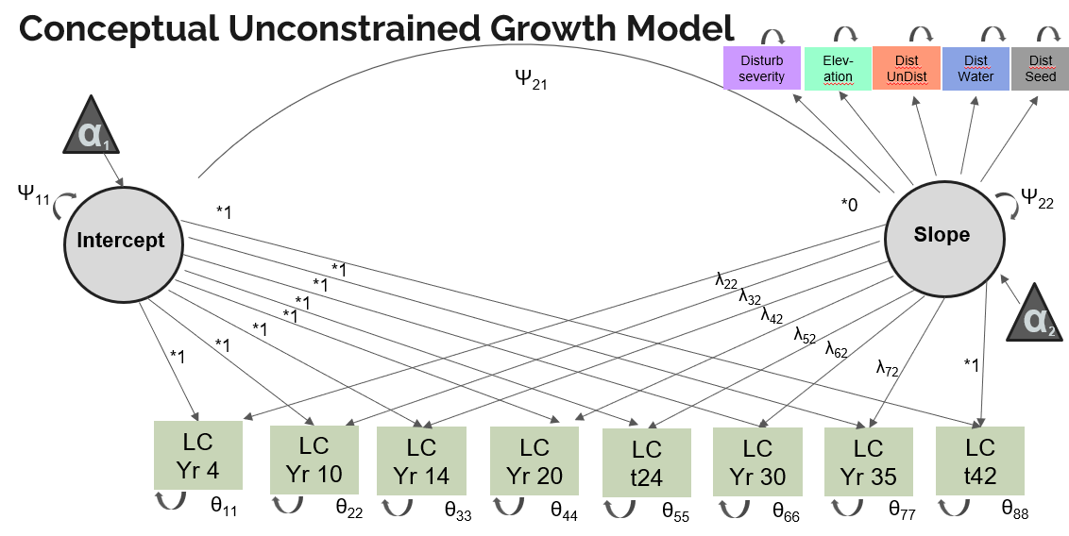
Figure 23. Generic growth curve model for land cover at Mount St. Helens by modeling the intercepts and slope of land-cover change by year. Setting the intercept to 1 indicates that all plots start at the same point (barren), and allowing the slope to vary across time indicates that land cover at each time point can influence the rate of land-cover change.

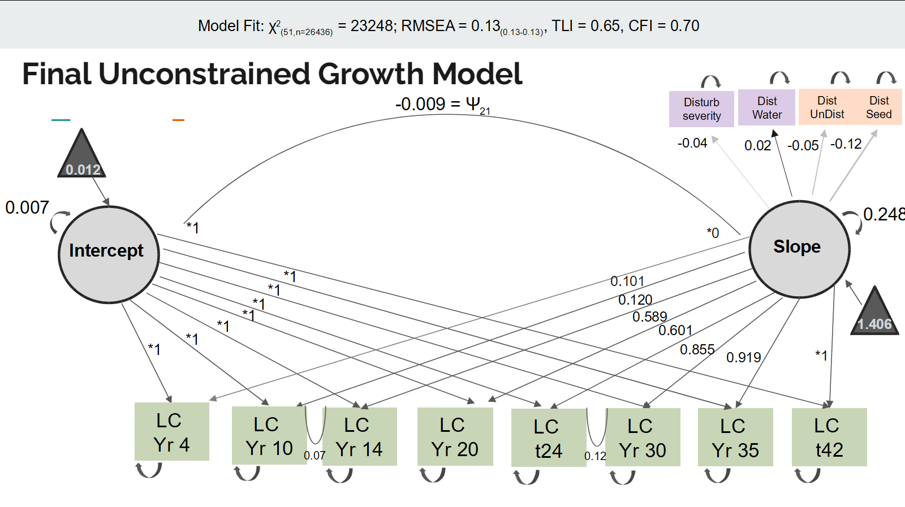
Figure 23. Growth curve model for land cover at Mount St. Helens by modeling the intercepts and slope of land-cover change by year. Setting the intercept to 1 indicates that all plots start at the same point (barren), and allowing the slope to vary across time indicates that land cover at each time point can influence the rate of land-cover change.

CONCLUSION
To manage land in a changing world with increasing incidence of disturbance, it is very important to understand how species communities assemble naturally so that cost effective and efficient interventions can be planned. Here we found that volcanic systems make a good study system in which to examine natural processes as all important drivers of community change can be identified as influencing vegetation patterns in these systems: site condition, propagule limitation, species performance and priority effects. Examining just one site condition variable, disturbance severity, we showed that rates of change between land cover classes vary temporally, and that the severity of disturbance determines what type of land cover change is more likely and rate of conversion. Digging deeper into the complexity of drivers of community composition through time we demonstrated that in extreme environments like Mount St. Helens, early successional trajectories may be governed less by deterministic drivers and more by chance events whose legacy can persist for decades. It is necessary to consider both accidents of initial arrival and the conditions experienced on the ground when trying to understand how land cover changes over time after a severe disturbance It may be possible to use knowledge of the shifting influences of community change drivers to improve timing of management interventions, allowing improved outcomes for funds spent.

VITA
Elsie Mariah Denton grew up in the Hood River Valley, Oregon where they learned to love the outdoors and science. Their interest in these two subjects led them to study post-disturbance processes from the Great Plains, to remote Pacific islands off the Coast of Chile, and over course on volcanoes. They have slowly been experiencing most parts of the United States while going to school there. They completed their Bachelor’s in Arts in Biology at Colgate University, New York in 2009. Their Master’s in Science in Ecology at Colorado State University, Colorado in 2014. Early in their career they had the opportunity to work at Mount St. Helens for several field seasons, where they fell in love with the dynamic post-eruptive landscape. However, it was a fortuitous thank you letter sent during the height of the COVID pandemic that brought them back to volcanoes after working in grasslands for over a decade. Elsie will be forever grateful to their advisor, Dr. Virginia Dale for inviting them to the University of Tennessee - Knoxville to complete their dissertation working at Mount St. Helens again. to They wrote a thesis. Now the dissertation is complete they are looking forward to discovering what the future holds.

