SOIL HEALTH, MICROBIAL COMMUNITIES, AND NITROGEN DYNAMICS IN AGROECOSYSTEMS: INSIGHTS FROM LONG-TERM CROPPING SYSTEMS

A Dissertation Presented for the
Doctor of Philosophy
Degree
The University of Tennessee, Knoxville

Facundo Lussich Rachetti
December 2025

ACKNOWLEDGEMENTS
First and foremost, I want to thank my advisor and mentor, Dr. Debasish Saha, for the time, energy, and guidance he has invested in me over these years. I’ve grown tremendously as a scientist, a writer, and a person under his mentorship, and I will always be grateful for his patience and support. I also owe deep thanks to my committee members: Dr. Shawn Brown, Dr. Sindhu Jagadamma, Dr. Melissa Cregger, and Dr. Sean Schaeffer. Your wisdom, encouragement, and faith in me have shaped not only this dissertation but also the scientist I’m becoming.
To my lab family, Ryan Ackett, Arjun Chhetri, Jashan Dhaliwal, and Presley Nickens, thank you for being there through the ups and downs. I couldn’t have asked for a kinder, more supportive group. A special shout-out to Jashan: we were a team through these four years, and beyond being an incredible colleague, I gained a lifelong friend. Our endless discussions (sometimes productive, sometimes completely random) were crucial for both my professional and personal growth.
I’m also grateful to the many others who guided me through soil analyses and lab work, especially Rachel Wooliver, Rounak Patra, and Ravi Teja. Huge thanks as well to everyone who made the field experiments in Jackson possible: Dr. Nutifafa Adotey, Kacey Cannon, and Randi Carole. Without your help, carrying out those experiments would have been impossible. And to Wesley Wright and David Smith, thank you for bringing to life all the crazy ideas we tried to pull off in the field.
To my friends, both old and new. As the saying goes: “Make new friends, but keep the old; those are silver, these are gold.” To my old friends, Tablón: Manu, Tsoro, Bola, Kl, Santi, Simbo, Berner, Iri, Marvo; distance and years don’t matter, you’re always there. To the amazing friends life gifted me: Nico, Regla, Mathi, Facu, Pande, Pilar, and Nacho; thank you for being part of this journey. To my close friends and colleagues who shaped the professional I am today: Turco, Alejo, Mario, Mono, Agus, Belu, Mandorla, Mochi, Coco, Joaco, La Letra, Juan, Ele, Nico, and Vale. I couldn’t have made it without you. And to my Tennessee crew, who quickly became my family: Santi, Pablito, Kev, Caio, Ceci, Christoph, Anna, Agu, Pedrito, Gabi, Edu, Rodri, Patrick, Josh, Dominic, and Fede. As the quote says: “Call it a clan, call it a network, call it a tribe, call it a family: whatever you call it, whoever you are, you need one.” I’m so lucky to have found mine here.
To my family, the ones I never chose but could never live without. “You don’t choose your family. They are God’s gift to you, as you are to them.” To my extended family, Los Rachettitos y La Lussichada, thank you for always rooting for me and for making every return home feel like a celebration. A special mention to Tommy, Javi, Paulita, and Nico - you always made me feel your support, even from afar.
The biggest thanks go to my parents, Diego and Rosina. You not only shaped my values and personality, but also, from the very beginning, taught me the importance of education and dreaming big. For your endless love and support, THANK YOU! To my siblings: Mili, Diegui, Nico, Dioni, Ro, and Mati, thank you for always supporting my craziest endeavors. And to my nephews and nieces, the little people I can’t wait to hug every time I go home, you remind me of what really matters.
And finally, to Nico, my soulmate and the greatest gift life has given me. I don’t know what I did to deserve you, but I’m grateful every single day. Thank you for your unconditional love and support, for grounding me when things get hard, and for celebrating every victory along the way. I truly couldn’t have done this without you.

ABSTRACT
This dissertation examines the legacy effects of long-term soil health practices on nitrogen cycling, soil aeration, microbial ecology, and predictive modeling of nitrous oxide (N₂O) emissions in continuous cotton systems. Specifically, it integrates five complementary studies conducted within a 41-year cotton field experiment, including a laboratory incubation and four field-based investigations under contrasting tillage, cover cropping, and nitrogen (N) fertilization regimes, that collectively link management, process responses, and predictive modeling. Results showed that tillage and N inputs shaped nitrogen acquisition strategies in hairy vetch (HV) cover crops, with no-till (NT) enhancing soil-derived N uptake, which was associated with greater soil organic matter accumulation, while conventional tillage increased reliance on biological nitrogen fixation (BNF), particularly under low fertilization. In parallel, long-term NT and HV cover cropping improved soil oxygen (O₂) availability and resilience after heavy rainfall, resulting in 3- to 4-fold fewer hours of hypoxia across the cotton growing season compared with conventional tillage and no cover crops. Complementary laboratory experiments showed that cover crop residue decomposition, especially from high-quality vetch, accelerated O₂ depletion and promoted high N₂O emissions even under suboptimal water-filled pore space (WFPS) for denitrification, with aerobic-condition emissions posing greater environmental risks than water-induced anoxia. These results indicate that cover crop residues can decouple the typical relationship between soil moisture and N₂O emissions, showing that moisture alone may be an insufficient proxy for soil O₂ availability under residue-rich conditions. Microbial analyses identified depth-specific and seasonally dynamic associations between microbial taxa and N₂O fluxes, with N fertilization exerting the strongest influence through long-term acidification, favoring taxa linked to higher emissions potential. Finally, a novel “Class-Swap” machine learning approach, which classifies emissions into hot-moments and background before modeling, significantly improved prediction accuracy for both temporal dynamics and cumulative N₂O emissions compared with traditional random forest models, by capturing the distinct drivers of each emission type. Together, these findings reveal how long-term management shapes plant-soil-microbe interactions, controls biogeochemical processes underlying N₂O production, and advances predictive tools. The insights generated provide actionable guidance for optimizing nutrient management, enhancing soil functioning, and improving greenhouse gas forecasting in agroecosystems.

Table of Contents
Introduction 1
Chapter 1: Legacy of 41-year of tillage and nitrogen fertilization on biological nitrogen fixation and nutritional status of hairy vetch cover crop in a continuous cotton system.....8
Abstract 9
Introduction 10
Materials and Methods 11
Study site and experimental design 11
Plant and soil measurements 12
Statistical analysis 13
Results and discussion 14
Conclusions 22
Chapter 2: 42 years of no-tillage and cover cropping improved soil oxygen availability and resilience 23
Abstract 24
Introduction 25
Materials and Methods 26
Results and discussion 28
Conclusions 34
Chapter 3: Cover crop residue decomposition exacerbated soil oxygen depletion and promoted nitrous oxide emissions 35
Abstract 36
Introduction 37
Materials and Methods 41
Experimental site and soil sampling 41
Cover crop biomass sampling 41
Incubation experimental set up 42
Gas sampling, analysis, and N₂O source calculations 43
Soil O₂ measurements 44
Soil analysis 46
Statistical analysis 46
Results 47
Cover crop residue and N fertilization impacts on temporal N₂O and CO₂ emissions 47
Cumulative N₂O and CO₂ emissions 51
Soil O₂, C, and N availability 54
Drivers of N₂O emissions 61
Discussion 62
Respiration induced anoxia during cover crop residue decomposition decouples WFPS control on N₂O emissions 63
Cover crop residue influenced nitrogen fertilizer derived N₂O losses under different WFPS 65
Differential drivers and processes of N₂O emissions in response to cover crops and WFPS 66
Cover crop type did not significantly influence N₂O emissions under both 50 and 80% WFPS 69
Conclusions 70
Chapter 4: Depth-dependent links between microbial taxa and nitrous oxide emissions in a long-term cotton cropping system employing soil health practices 72
Abstract 73
Introduction 75
Materials and Methods 79
Experimental site and soil sample collection 79
Soil chemical properties, greenhouse gas, and environmental data collection 80
DNA extraction and MiSeq sequencing 82
Bioinformatics and statistical analysis 83
Results 87
Effect of management practices on temporal N₂O emissions 87
Influence of management practices, sampling time-point, and biochemical variables on microbial community composition across soil depths 89
Microbial taxa associated with nitrous oxide emissions and their relationship with biochemical variables 91
Management-driven temporal dynamics of key microbial taxa across soil depths 97
Discussion 106
Influence of management practices on microbial communities across soil depths 106
Soil biochemical drivers of microbial community structure and N₂O-associated taxa 108
Management and soil depth shape key N₂O-associated microbial taxa 111
Linking temporal N₂O flux variability to shifts in microbial communities 116
Conclusions 118
Chapter 5: Enhancing predictions of nitrous oxide emissions from agricultural soils using a classification-swap machine learning approach 120
Abstract 121
Introduction 123
Materials and Methods 127
Study site and experimental design 127
Greenhouse gas flux measurements 128
Soil measurements and environmental data collection 128
Data for model training and validation 129
Model training 129
Traditional Random Forest: Base Model 131
Classification of background and hot-moment emissions: Class-Swap Model 131
Traditional Random Forest with oversampling techniques: Base-Over Model 135
Classification of emissions with oversampling techniques: Class-Swap-Over Model 135
Model performance evaluation 136
Results 138
Predictive performance of models for daily N₂O fluxes 138
Cumulative N₂O emissions 145
Differential drivers of low and high N₂O emission events as identified by the Class-Swap model 151
Discussion 154
Predictability and interpretability of Class-Swap ML models 154
Limitations and possible improvement 157
Conclusions 159
General conclusions 161
References 165
Vita 208

LIST OF TABLES
Table 2.1: Effect of nitrogen fertilization rate and tillage on nitrogen sources in hairy vetch, expressed as the amount of nitrogen (kg N) per Mg of dry matter in plant biomass. 16
Table 2.2: Loadings of response variables on the first two RDA axes (RDA1 and RDA2). Values represent the contribution (correlation coefficients) of each variable to the constrained ordination space. Higher absolute values indicate stronger influence on the corresponding axis. Loadings were derived from PCA performed on the fitted values of the multivariate linear model constrained by Tillage, Fertilization, Block, and Year. 18
Table 3.1: Average soil oxygen concentration and cumulative hours under soil oxygen <10% throughout the growing season, July, and August (1st-15th) in response to long-term tillage and cover cropping. 28
Table 4.1: Cumulative CO₂ emissions from all eight treatments after 21-day incubation. 52
Table 4.2: Nitrate ($NO3-$) and ammonium ($NH4+$) concentration over the incubation period for four cover crop treatments at 50% and 80% WFPS. 59
Table 4.3: Soil permanganate oxidizable carbon (POXC) over the incubation period for four cover crop treatments at 50% and 80% WFPS. 60
Table 4.4: Features importance to predict N₂O emissions under 50% and 80% WFPS conditions as predicted by the Random Forest. Model R² value indicates variability explained on the test data set. 61
Table 5.1: Four-way factorial PERMANOVA results for soil microbial community composition (846 taxa) across depths (0-10 and 10-20 cm), based on Bray-Curtis dissimilarities of relative abundances. Shown are pseudo-F statistics, degrees of freedom (total df =153 for 0-10 cm and 109 for 10-20 cm), p-values, and partial omega-squared effect sizes for significant factors. 89
Table 5.2: Taxonomic classification of top ten microbial taxa identified by the random forest analysis across soil depths 96
Table 5.3: Effects of management practices and sampling time-point on the relative abundance of microbial taxa associated with N₂O emissions in the 0-10 cm soil layer. F-test statistics are shown, with significance levels indicated as follows: * 0.05 < P $≤$ 0.10, ** 0.001 < P $≤$ 0.05, *** P $≤$ 0.001, and NS (not significant) P > 0.10. When significant, the direction of relative abundance shifts is indicated based on Tukey’s HSD test. 100
Table 5.4: Effects of management practices and sampling time-point on the relative abundance of microbial taxa associated with N₂O emissions in the 10-20 cm soil layer. F-test statistics are shown, with significance levels indicated as follows: * 0.05 < P $≤$ 0.10, ** 0.001 < P $≤$ 0.05, *** P $≤$ 0.001, and NS (not significant) P > 0.10. When significant, the direction of relative abundance shifts is indicated based on Tukey’s HSD test. 102
Table 5.5: Functional annotation of microbial taxa associated with N₂O emissions based on FAPROTAX database and additional literature sources 103
Table 6.1: Optimized hyperparameters for each model following tuning process. 130
Table 6.2: Hyperparameters for HBOS Outlier Detection Algorithm 132
Table 6.3: Performance metrics of all models evaluated using the 2022 independent validation dataset. 145
Table 6.4: Performance metrics of all models evaluated using the 2023 training dataset 145
Table 6.5: Observed and predicted cumulative N₂O emissions by treatment, based on the 2023 training dataset. 149
Table 6.6: Observed and predicted cumulative N₂O emissions by treatment, based on the 2022 independent validation dataset. 150

LIST OF FIGURES

Figure 2.1: Scattered boxplots showing the effects of fertilization and tillage on (A) nitrogen nutrition index (NNI), (B) proportion of nitrogen derived from the atmosphere (Ndfa), (C) nitrogen fixed (kg N fixed), and (D) nitrogen derived from soil (kg N soil). Points represent individual observations; boxes indicate the interquartile range, with median shown as horizontal lines. In panel A, the solid red line indicates NNI = 1, representing optimal nitrogen status, while the dashed red line marks NNI = 0.9, below which nitrogen limitation become more pronounced. 15
Figure 2.2: Scattered boxplots showing the effects of fertilization and tillage on soil organic matter (SOM) in 2013. 16
Figure 2.3 : Scattered boxplots showing the effects of fertilization and tillage on dry matter production. 18
Figure 2.4: Redundancy Analysis (RDA) biplot showing individual samples and treatments centroids based on nitrogen-related variables. Transparent markers represent individual observations, while solid, enlarged markers indicate group centroids for each Tillage × Fertilization treatment combination. Black arrows represent the response variables (NNI, Ndfa, kg N fix, kg N soil, and SOM), with direction and length indicating their contribution to the constrained ordination axes. 19
Figure 3.1: Soil oxygen availability and its resilience following rainfall events during the 2023 cotton growing season (A), during July (B), and during August (C) in response to long-term tillage and cover cropping practices. NT, no tillage; CT, conventional tillage; HV, Hairy vetch; NC, no cover crop 30
Figure 3.2: Average soil oxygen content for the days since an extreme precipitation event for tillage and cover crop treatments. The soil oxygen average includes three large precipitation events each receiving more than 67 mm of rain within a 48-hour period. Bars indicate standard deviation. Different letters associated with the treatments under each level of day since extreme precipitation event indicate significance at P < 0.05. NT, no tillage; CT, conventional tillage; HV, Hairy vetch; NC, no cover crop. 32
Figure 4.1: Illustration of the experimental set-up (not to scale) and calibration image. 46
Figure 4.2: Daily nitrous oxide (N₂O) emissions (a, b) and N₂O emissions derived from N fertilizer (c, d) over the incubation period from four cover crops treatments at 50% WFPS (a, c), and 80% WFPS (b, d). Nitrogen fertilizer was added at the beginning of the incubation experiment as indicated by black arrow in panels (a) and (b). Bars in panels (a) and (b) indicate mean standard error. HV, Hairy vetch; WW, Winter wheat; No cover, No cover crop; No cover+0 N, Control. 49
Figure 4.3: Daily carbon dioxide (CO₂) emissions over the incubation period from four cover crops treatments at (a) 50% WFPS, and (b) 80% WFPS. Bars represents mean standard error. HV, Hairy vetch; WW, Winter wheat; No cover, No cover crop; No cover + 0 N, Control. 50
Figure 4.4: Cumulative N₂O emissions over the experiment incubation period derived from the fertilizer (yellow) and soil organic matter and/or cover crops (brown) for four cover crops treatments at 50% and 80% WFPS. The error bars represent the mean standard errors for the total N₂O emissions, and the percentage shown in the columns represents the proportion of cumulative total N₂O emissions from each source. Uppercase letters indicate significant differences (p < 0.05) in cumulative N₂O emissions and N₂O emissions derived from N fertilizer among the treatments, while lowercase letters indicate differences in N₂O emissions derived from SOM and/or cover crops among the treatments. HV: Hairy vetch, WW: Winter wheat, NC: No cover crop, NC + 0 N: Control. 51
Figure 4.5: Average soil O₂ content expressed as percentage of air saturation at 0 to 3 cm depth over the incubation period from four cover crops treatments at (a) 50% WFPS and (b) 80% WFPS. Bars represent the mean standard error. HV, Hairy vetch; WW, Winter wheat; No Cover, No cover crop; No cover+0 N, Control. 54
Figure 4.6: Selected images of O₂ content expressed as percentage of air saturation in 0 to 3 cm soil depth over the incubation period from different treatments: A) 50% WFPS with hairy vetch, B) 50% WFPS control, and C) all 80% WFPS treatments. Images (one of the four replicates) are an example of the effect of the different treatments. 56
Figure 4.7: Selected images of O₂ content expressed as percentage of air saturation in 0–3 cm soil depth over the incubation period from two treatments: (A) 50% WFPS with winter wheat+160 N, (B) 50% WFPS with no cover crop+160 N. Images (one of the four replicates) illustrate the maximum achieved O₂ depletion effect resulting from cover crop addition. 58
Figure 4.8: Predicted vs observed N₂O emissions from the Random Forest N₂O flux model on the test data set: a) 50% WFPS and b) 80% WFPS. HV: Hairy vetch, WW: Winter wheat, No cover: No cover crop, No cover + 0 N: Control. 61
Figure 5.1: Effect of fertilizer (A), tillage (B), and cover cropping (C) on average nitrous oxide (N₂O) fluxes during the 25 days prior to five sampling dates in the 2022 cotton growing season. Arrows indicate timing of key management practices. Asterisks (*) indicate statistically significant differences (p $≤$ 0.05). Cover Crop (CC); No-till (NT), Conventional tillage (CT); No-Cover crop (NC), Vetch (V). 87
Figure 5.2: Distance-based Redundancy Analysis (db-RDA) of microbial community composition (Bray-Curtis dissimilarity) by fertilization level at (A) 0-10 cm and (B) 10-20 cm depth. Arrows represent biochemical variables with p-values $≤$ 0.10 identified through permutation tests. 90
Figure 5.3: Venn diagram showing (A) the total soil microbial taxa (n = 846) and (B) the subset of taxa associated with N₂O emissions (n = 57), comparing their presence across two soil depths (0-10 cm and 10-20 cm). 91
Figure 5.4: Heatmap showing correlations between soil microbial taxa associated with N₂O emissions and soil biochemical variables across depths. Asterisks (*) indicate statistically significant correlations (p $≤$ 0.05), as determined using generalized linear models (GLMs). POXC (PC); WFPS (WF). 92
Figure 5.5: Key microbial taxa contributing to N₂O fluxes across soils depths, identified using random forest analysis. Panels A and B show the top 10 taxa with the highest increases in mean squared error (MSE) when permuted, at 0-10 cm and 10-20 cm depths, respectively. Panels C and D present partial dependence plots illustrating N₂O flux predictions for these taxa at 0-10 cm and 10-20 cm, respectively. 95
Figure 5.6: Time-series horizon plots showing the relative abundance of microbial taxa associated with N₂O emissions, as identified by the Random Forest model, at 0-10 (A) and 10-20 cm (B) depths. Each plot shows one taxon’s relative abundance over time, with the median (depth-specific) as baseline. Blue shades indicate above-median values and red below, with color intensity reflecting the magnitude of deviation. Note: color scales are not comparable across taxa or depths, as medians are calculated independently. 98
Figure 5.7: Time-series horizon plots of microbial taxa relative abundance linked to N₂O emissions, identified by the Random Forest model and associated with N fertilization (A), tillage (B), and cover cropping (C) practices. Taxa shown had p-values $≤$ 0.10, see Tables 2 and 3 for details. Median relative abundance was centered at zero, with a bandwidth of 0.7% and five bands used to standardize abundance dynamics across treatments and depths. 105
Figure 6.1: HBOS-based classification of hot-moments (red, n = 137) and background emissions (blue, n = 535) across 32 plots in the 2023 training dataset. 133
Figure 6.2: HBOS-based classification of hot-moments (red, n = 286) and background emissions (blue, n = 573) across 32 plots in the 2022 independent validation dataset. 134
Figure 6.3: Observed and predicted nitrous oxide (N₂O) fluxes with Base and Class-Swap models across treatments over the 2022 independent validation period. Dashed T-lines represent standard deviation (± SD). Vertical black dashed lines indicate transitions between treatments, and black arrows indicate the timing of nitrogen fertilization in fertilized treatments. 140
Figure 6.4: Observed and predicted nitrous oxide (N₂O) fluxes with Base-Over and Class-Swap-Over models across treatments over the 2022 independent validation period. Dashed T-lines represent standard deviation (± SD). Vertical black dashed lines indicate transitions between treatments, and black arrows indicate the timing of nitrogen fertilization in fertilized treatments. 141
Figure 6.5: Observed versus predicted nitrous oxide (N₂O) fluxes by the Base and Class-Swap models across treatments for the 2022 independent dataset. The dashed black line denotes the 1:1 reference line, indicating perfect prediction accuracy. r²: coefficient of determination (square of the Pearson correlation coefficient). 142
Figure 6.6: Observed versus predicted nitrous oxide (N₂O) fluxes by the Base Over and Class-Swap Over models across treatments for the 2022 independent dataset. The dashed black line denotes the 1:1 reference line, indicating perfect prediction accuracy. r²: coefficient of determination (square of the Pearson correlation coefficient). 143
Figure 6.7: Violin plot comparing observed and predicted nitrous oxide (N₂O) fluxes from the Base, Base-Over, Class-Swap, and Class-Swap-Over models, based on the 2023 training dataset. 144
Figure 6.8: Violin plot comparing observed and predicted nitrous oxide (N₂O) fluxes from the Base, Base-Over, Class-Swap, and Class-Swap-Over models, based on the 2022 independent validation dataset. 144
Figure 6.9: Observed and model-predicted cumulative N₂O emissions average across all treatments, based on the 2022 independent validation dataset. 146
Figure 6.10: Observed and predicted cumulative N₂O emissions by treatment, based on the 2022 independent validation dataset. 147
Figure 6.11: Variable importance in the Class-Swap model for (a) low (background emissions) and (b) high (hot-moments) N₂O emission scenarios. 151
Figure 6.12: Partial dependence plots for the most influential variables in the Class-Swap model under low (a-d) and high (e-f) N₂O emission scenarios: a,e) 48 hours cumulative precipitation, b,f) WFPS, c) CO₂ fluxes, and d) ammonium. 153

Introduction
Soil health practices, such as cover cropping and no-tillage (NT), provide a wide range of environmental benefits to agricultural systems, including carbon sequestration, reduced erosion, improved nutrient retention, enhanced biodiversity, and increased resilience of agroecosystems (Poeplau and Don, 2015; Rejesus et al., 2021; Shah et al., 2022). The 2017 U.S. Department of Agriculture Census revealed a growing adoption of these practices across the country between 2012 and 2017. Notably, NT increased by 8.3%, covering 37% of U.S. cropland, while cover cropping rose by 50%. Tennessee led these trends, with 79% of arable lands under NT and an 85% increase in cover crop area during the same period (Zulauf and Brown, 2019a; b).
Long-term implementation of NT and cover cropping has been widely recognized for improving soil organic carbon (SOC) and soil quality across diverse agricultural systems in the U.S. (Paustian et al., 2000; Blanco-Canqui and Lal, 2008; Blanco-Canqui et al., 2011, 2015). NT reduces soil disturbance, slows residue decomposition, and enhances soil aggregation, thereby protecting SOC from microbial breakdown (Six et al., 2000). It also improves water retention by reducing evaporation and increasing infiltration (Hill et al., 1985; Díaz-Zorita et al., 2004). Meanwhile, cover crops, especially legumes, contribute organic inputs and atmospheric nitrogen, enhancing fertility and nutrient cycling (Decker et al., 1994; Torbert et al., 1996; Poeplau and Don, 2015). However, the long-term impacts of tillage and fertilization on biological nitrogen fixation (BNF) and the N status of legume cover crops remain poorly understood. These processes are often assumed to be self-sustaining in legumes, yet legacy effects from decades of management could significantly alter the balance between soil-derived and atmosphere-derived N. Understanding how these legacy effects influence BNF is critical for evaluating the sustainability of low-input systems and for optimizing N management strategies.
In addition to nutrient cycling, NT and cover cropping strongly affect the physical properties of soil that regulate air and water balance. Improvements in soil structure and hydrologic function under conservation practices promote better drainage, greater water retention, and enhanced aeration, all of which support healthy root development and stable crop productivity. These benefits are especially relevant in the context of increasing weather variability, which has brought more frequent and prolonged drought periods, as well as intense rainfall events that can cause waterlogging (Seneviratne et al., 2021). Oxygen (O₂) concentration below 10% in the soil can negatively affect plant growth (Geigenberger, 2003; Najeeb et al., 2015), disrupt nutrient transformations through elemental reductions (Turner and Patrick, 1968), and negatively impacts soil biology (Pett-Ridge and Firestone, 2005). Despite the importance of soil O₂, field-level high-resolution measurements remain scarce due to methodological limitations. This lack of data limits our understanding of how soil health practices influence aeration and the resilience of these systems to rapid environmental changes. Therefore, examining soil O₂ dynamics is essential for understanding the ecological functioning of long-term health practices, especially in relation to N cycling, crop productivity, and environmental quality.
Although the adoption of soil health practices continues to increase, their effect on N cycling and nitrous oxide (N₂O) emissions remain complex and poorly understood. For example, NT can alter the vertical distribution of SOC, with gains in surface layers sometimes offset by losses in deeper layers (Luo et al., 2010; Jagadamma et al., 2019; Patra et al., 2022; Feng et al., 2025). Similarly, although legume cover crops increase N supply, asynchronies between N release and crop uptake can elevate the risk of N losses, including N₂O, a potent greenhouse gas (GHG), which may ultimately offset some of the intended environmental benefits of cover cropping practices.
Understanding the drivers of N₂O emissions from agricultural soils is essential for developing effective mitigation strategies. N₂O has a global warming potential approximately 273 times greater than that of carbon dioxide (CO₂) over a 100-year period. Its contribution to total GHG emissions in the United States is estimated at 6.2%, with the agricultural sector responsible for 73% of all anthropogenic N₂O emissions (EPA, 2023). These emissions are closely linked to N fertilization and microbial transformations in the soil, particularly under conditions of limited O₂ and high substrate availability (Thompson et al., 2019; Tian et al., 2020). Globally, increasing concentrations of GHGs, including CO₂, methane, and N₂O, have been identified by the Intergovernmental Panel on Climate Change as key drivers of climate change (IPCC, 2023). From the late 20th century to 2021, concentrations of these gases have risen significantly, contributing to a global temperature increase of approximately 1.1 degrees Celsius compared to pre-industrial levels. In response, there is growing interest in climate-smart agricultural practices that can reduce emissions while supporting food production. Reducing N₂O emissions from soils remains one of the most persistent challenges in this effort. Addressing this challenge requires a better understanding of how long-term management practices influence both the production and regulation of N₂O under field conditions.
Oxygen availability plays a central role in regulating the microbial pathways responsible for N₂O emissions. Soil health practices influence O₂ distribution by altering soil structure, porosity, and organic matter inputs, which in turn affect microbial activities and redox conditions. Studies such as Araya et al. (2022) highlight the significant influence of tillage on soil structure and soil pore architecture, directly affecting O₂ content and distribution throughout the soil profile. However, direct measurements of soil O₂ remains challenging under field conditions. As a result, soil moisture is commonly used as a proxy for O₂ availability, particularly in predicting soil N₂O production (Davidson et al., 2000), despite its limitations. This approach oversimplifies the relationship between moisture and O₂ availability, especially when microbial respiration increases following the decomposition of cover crop residues. Such decomposition can rapidly consume available O₂, creating anaerobic microsites that promote denitrification and N₂O production, even when soil moisture is not elevated (Chen et al., 2013). The quality of the residue, such as whether it is derived from a legume or a grass species, may also influence the rate of O₂ depletion and the magnitude of N₂O emissions. Yet, little is known about how respiration-induced anoxia interacts with cover-crop residue type and N fertilization to affect N₂O losses. Therefore, predicting the magnitude and direction of N₂O emissions in response to changes in soil O₂ and substrate availability is a critical knowledge gap that adds uncertainty to N₂O emissions from cover crop-based rotations.
Given these complexities in N₂O production, which arise from the interactions among soil O₂ availability, residue quality, microbial activity, and N inputs, accurately predicting emissions under field conditions remains a major challenge. Process-based models, while useful for understanding biogeochemical mechanisms, often require extensive calibration and parameterization and they are limited in their ability to capture the temporal variability of N₂O emissions. In particular, they tend to perform poorly in predicting short-term pulses, or hot-moments, that contribute disproportionately to cumulative N₂O emissions (Ehrhardt et al., 2018). These episodic events are difficult to simulate because they result from complex and nonlinear interactions between soil, environmental and management factors. In contrast, data-driven machine learning (ML) approaches offer a promising alternative, with the ability to learn complex relationships directly from observational data without the need for mechanistic assumptions (Shahhosseini et al., 2019; Saha et al., 2021a). However, conventional ML approaches may still struggle to represent episodic, high-flux N₂O events (“hot moments”) that deviate from background emissions. To address this limitation, we propose a novel approach Classification Swap (Class-Swap) modeling approach that separates background and hot-moment fluxes using an outlier detection algorithm. This enables tailored model training for each class of emission events with the potential for improving both prediction accuracy and better identification of environmental drivers associated with episodic N₂O fluxes.
In addition to shaping soil chemistry and physical properties, NT and cover cropping also influence the structure and function of soil microbial communities. These microbial shifts are particularly relevant because N₂O production is a microbially mediated process. While many studies have documented changes in microbial diversity in surface soils under conservation management (Vargas Gil et al., 2011; Mbuthia et al., 2015), the effects of long-term practices on microbial communities across soil depths remain underexplored. Recent evidence suggests that management-induced changes in subsurface microbial communities can influence soil processes well beyond the topsoil (Piazza et al., 2019). As such, it is likely that legacy effects of management extended into deeper layers having an impact on temporal dynamics of N₂O emissions. However, the relationship between temporal N₂O emissions and the abundance of specific surface and subsoil microbial taxa functionally relevant to N cycling is poorly understood.
Elevated N₂O emissions not only contribute to climate change but also pose the risk of shifting agricultural systems from net C sinks to sources (Guenet et al., 2021). The soil has the potential capacity to act as a C sink by sequestering atmospheric CO₂ into stable C pools and securely storing it to prevent its reemission (Smith, 2012). The estimated global soil sink capacity is about 50 to 66% of the historical carbon loss, totaling 42 to 78 Gt of carbon (Lal, 2004). Recognizing the potential of soils as a carbon sink, conservation practices have emerged as a strategy to enhance soil health, promoting C sequestration and mitigating GHG emissions (Paustian et al., 2016). However, gaining a better understanding of the linkage between substrate availability, soil moisture, and O₂ concentration and the associated N₂O production is essential for accurately assessing the effective GHG mitigation potential of long-term soil health practices.
In addition to their recognized benefits such as C sequestration, enhanced fertility, productivity, and reduced erosion, runoff, and water pollution, the influence of implementing soil health practices on microbial community structure, BNF in legume cover crops, soil oxygen dynamics, and N₂O emissions remains a complex and elusive aspect. This research dissertation aims to address some of the prevailing knowledge gaps concerning the effects of long-term soil health practices on both proximal biogeochemical drivers to influence N₂O emissions and soil microbial communities within agricultural systems. By unraveling these complexities, we strive to provide insights that allow us to accurately assess the effective GHG mitigation potential of key soil health practices.

Legacy of 41 years of tillage and nitrogen fertilization on biological nitrogen fixation and nutritional status of hairy vetch COver CROP in A continuous cotton system

A version of this chapter was previously submitted for publication to Agricultural & Environmental Letters. Facundo Lussich was responsible for conceptualization, formal analysis, investigation, methodology, and writing. Debasish Saha, Sindhu Jagadamma, and Jashanjeet Kaur Dhaliwal provided input on methodology, review & editing.

Abstract
Legume cover crops (CCs) rely on a balance of soil-derived nitrogen (N) and biological N fixation (BNF) to maintain optimum N status, yet how long-term management shapes this balance remains poorly understood. This study leveraged a 41-year continuous cotton system to evaluate how legacy effects of tillage and N fertilization influence BNF, N status, and N sources in hairy vetch – a common cover crop known for its N contributions to cropping systems. Using the ¹⁵N natural abundance method and multivariate analyses, we found that tillage was the dominant factor influencing legume N acquisition pathways, specifically BNF, N status, and the relative contribution of soil- versus atmosphere-derived N: no-till (NT) plots exhibited higher N status, soil organic matter, soil-derived N, and total N uptake than conventional tillage. Fertilization effects were less pronounced but modulated BNF efficiency. However, on average, NT alone was insufficient to overcome N limitation under unfertilized conditions, highlighting the need for integrated management. These findings underscore how legacy effect of long-term practices shape N acquisition by legumes and support combining NT with crop rotation-specific N fertilization to optimize N inputs and sustain CC performance in low-input systems.

Introduction
Achieving sustainable crop production while reducing adverse environmental impacts requires the continued adoption of soil health-promoting practices. Among these practices, long-term no-tillage (NT) and strategic use of leguminous cover crops (CCs) are central to conservation agriculture, contributing to improved soil structure, enhanced organic matter accumulation, and efficient nutrient cycling (Blanco-Canqui et al., 2015; Blanco-Canqui and Ruis, 2018; Lussich et al., 2024b). However, sustaining these benefits also depends on effective nutrient management, particularly nitrogen (N), which governs both soil fertility and greenhouse gas outcomes. N management remains a critical challenge in conservation agriculture systems, as it influences crop productivity, cost of production, and environmental outcomes (Nouri et al., 2021; Dhaliwal et al., 2024 ). In this context, biological N fixation (BNF) by leguminous CCs, such as hairy vetch (HV, Vicia villosa), provides the capacity to acquire atmospheric N, potentially reducing the dependency on synthetic fertilizers and improving the N use efficiency and balance of the system (Parr et al., 2011; Louarn et al., 2021).
While the benefits of NT and leguminous CCs on soil health and cash crop performance are well documented (Blanco-Canqui et al., 2011), less is known about how their long-term legacy effects influence the N fixation, N status, and N acquisition strategies of subsequent leguminous CCs. Specifically, how these management factors influence the relative contributions of soil-derived versus atmospherically fixed N remains unclear. This gap is particularly relevant for legumes, which are often assumed to meet their N needs through BNF alone. However, BNF is an energy-intensive microbial process and is influenced by both soil fertility from soil organic matter (SOM) and external N inputs under long-term management.
Moreover, a few studies have applied integrative, biomass adjusted indicators such as the nitrogen nutrition index (NNI) to evaluate legume N status in long-term conservation systems (Lemaire, 1997), where NNI values below 1 indicate N limitation (Sadras and Lemaire, 2014). When paired with estimates of the proportion of N derived from the atmosphere (Ndfa), such approaches can provide a clearer understanding of how legumes balance soil and atmosphere-derived N sources under varying fertility conditions. To address these knowledge gaps, this study leverages a 41-year continuous cotton (Gossypium hirsutum L.) cropping system to evaluate how the implementation of long-term tillage and N fertilization practices affect BNF, N status, and N sources in HV CC. By integrating plant and soil measurements with multivariate analyses, we aim to reveal how soil health practices influence legume N acquisition strategies, BNF, and N status, with implications for nutrient management in low-input systems.

Materials and Methods

Study site and experimental design
This study was conducted in 2022 and 2024 (CCs failed to establish in 2023) within a long-term cotton cropping experiment established in 1981 at the University of Tennessee’s West Tennessee AgResearch and Education Center in Jackson, Tennessee (35°37′22″ N, 88°50′47″ W), on a Lexington silt loam soil (fine-silty, mixed, thermic, Ultic Hapludalfs). The experiment follows a randomized complete block design with a split-split plot arrangement of N rates, CCs, and tillage treatments, including four replications and a total of 128 experimental units (12 m × 8 m). Treatment and management practices are described in detail by Nouri et al. (2020). For this study, 32 HV subplots were used, which included four N levels (0, 34, 67, 101 kg N ha⁻¹) and two tillage levels (NT and conventional tillage; CT). This combination resulted in eight treatments: CT-0N, CT-34N, CT-67N, CT-101N, NT-0N, NT-34N, NT-67N, and NT-101N – with four replicates each. Fertilization and tillage treatments were applied during the preceding cotton crop, while N fixation and N status were evaluated in the HV during the subsequent cover crop phase.

Plant and soil measurements
Prior to HV termination each year in April-May, aboveground plant biomass was collected from each plot to determine total dry matter (DM) production. Total N and natural abundance of ¹⁵N, expressed as δ¹⁵N, were analyzed in both HV and associated non-legume reference plants (broadleaf weeds such as Stellaria media and Plantago major) in each plot, following recommendations by Unkovich et al. (2008).
BNF was estimated as the percentage of N derived from atmosphere (%Ndfa) using the ¹⁵N natural abundance method based on the δ¹⁵N values of the legume (δ¹⁵N_{legume}), the non-fixing reference plant (δ¹⁵N_{ref}), and a published reference B-value (-0.79‰; Unkovich et al., 2008), which represents the δ¹⁵N of the legume when entirely dependent on atmospheric N₂, according to Equation 1:
 | $$Ndfa \left(\%\right)=\frac{δ^{15}N_{ref}-δ^{15}N_{legume}}{δ^{15}N_{ref}-B}$$ | Equation 1
We additionally estimated total N uptake (plant N concentration × biomass), N fixed in HV aboveground biomass (%Ndfa × total N uptake), and N derived from soil (by difference between total N uptake and N fixed), all expressed in kg N Mg⁻¹ to standardize N content per unit of dry biomass.
To assess N status, we calculated the NNI, which compares actual tissue N concentration (%N) to a critical concentration (%Nc) derived from the N dilution curve for legumes (Lemaire et al., 1985; Lemaire, 1997). NNI values close to 1 indicate optimal N status, whereas values <1 reflect N limitation for plant growth. The NNI was calculated according to Equation 2, and the %Nc estimated using Equation 3:
 | $$NNI=\frac{\%N}{\%Nc}$$ | Equation 2
 | $$\%Nc=4.8 × {DM}^{-0.32} (for DM>1 Mg {ha}^{-1})$$  $$\%Nc=4.8 (for DM ≤1 Mg {ha}^{-1})$$ | Equation 3
Previously collected SOM data from 2013, corresponding to 7.5 cm depth soil samples, were used to explore relationships with plant N sources, status, and fixation.

Statistical analysis
To evaluate the effects of tillage and N fertilization on plant traits (NNI, Ndfa, kg N fixed, kg N from soil, total plant N, and DM) and SOM, we fitted linear mixed effects models using the lme4 package in R (version 4.3.0; Bates et al., 2015). Tillage and N fertilization were treated as fixed effects, while block and year were included as random effects. Where main effects or interactions were significant (α = 0.05), pairwise comparisons were conducted using estimated marginal means (emmeans package; Lenth, 2025) with Tukey’s Honest Significant Difference (HSD) test. Variables were log or square root transformed as needed to meet model assumptions.
To examine multivariate relationships between SOM and plant N variables, a redundancy analysis (RDA) was conducted using standardized values of NNI, Ndfa, kg N fixed, kg N from soil, and SOM. The model was constrained by tillage and fertilization treatments, with block and year included as covariates. The RDA was performed in Python using the scikit-learn library (version 3.10.12; Pedregosa et al. (2011).

Results and discussion
This study evaluates how legacy effects of long-term tillage and N fertilization influence N status, BNF, and N acquisition strategies in HV within a continuous cotton system. Across N treatments, HV grown under CT exhibited a lower NNI compared to NT plots (mean: 0.82 vs 0.92), with the gap widening under higher N fertilization rates except at 67 kg N ha⁻¹ (Figure 2.1A). Notably, NNI differences between CT and NT were minimal under unfertilized conditions (mean: 0.79 vs 0.82), with both values below 0.90, indicating a marked N limitation for HV growth regardless of tillage treatment. These findings support the idea that NT systems enhance soil N supply, likely due to the higher SOM accumulation (Figure 2.2) and thus greater availability of soil derived N (Table 2.1). However, the results also suggest that NT alone may not be sufficient to sustain legume N status in the absence of fertilization; underscoring the importance of adequate N management across the entire crop rotation sequence to prevent soil fertility depletion and avoid N limitation not only for the cash crop but also during the CC phase.
The %Ndfa was consistently higher in HV from CT plots compared to NT plots (mean: 80.5 vs 72.5%), and this difference became more pronounced with increasing N fertilization except at 67 kg N ha⁻¹ (Figure 2.1B). This pattern suggests a compensatory increase in %Ndfa in CT plots, where soil N availability is lower due to SOM depletion from continued tillage and reduced mineralization potential (Peoples et al., 1995; Reiter et al., 2002). Conversely, NT plots showed significantly higher total N uptake (Table 2.1), aligned with greater SOM content (Figure 2.2), and relied more on soil derived N (Table 2.1), indicating enhanced fertility under long-term conservation practices. This is consistent with known suppression of %Ndfa under elevated soil nitrate (Unkovich, 2012; Sun et al., 2019), further emphasizing the role of soil N status in regulating N fixation. This trade-off between soil N uptake and %Ndfa has been previously reported across legume systems (Doughton et al., 1993; Matus et al., 1997) and represents a key mechanism by which legumes maintain N status and avoid N limitations across diverse environments.
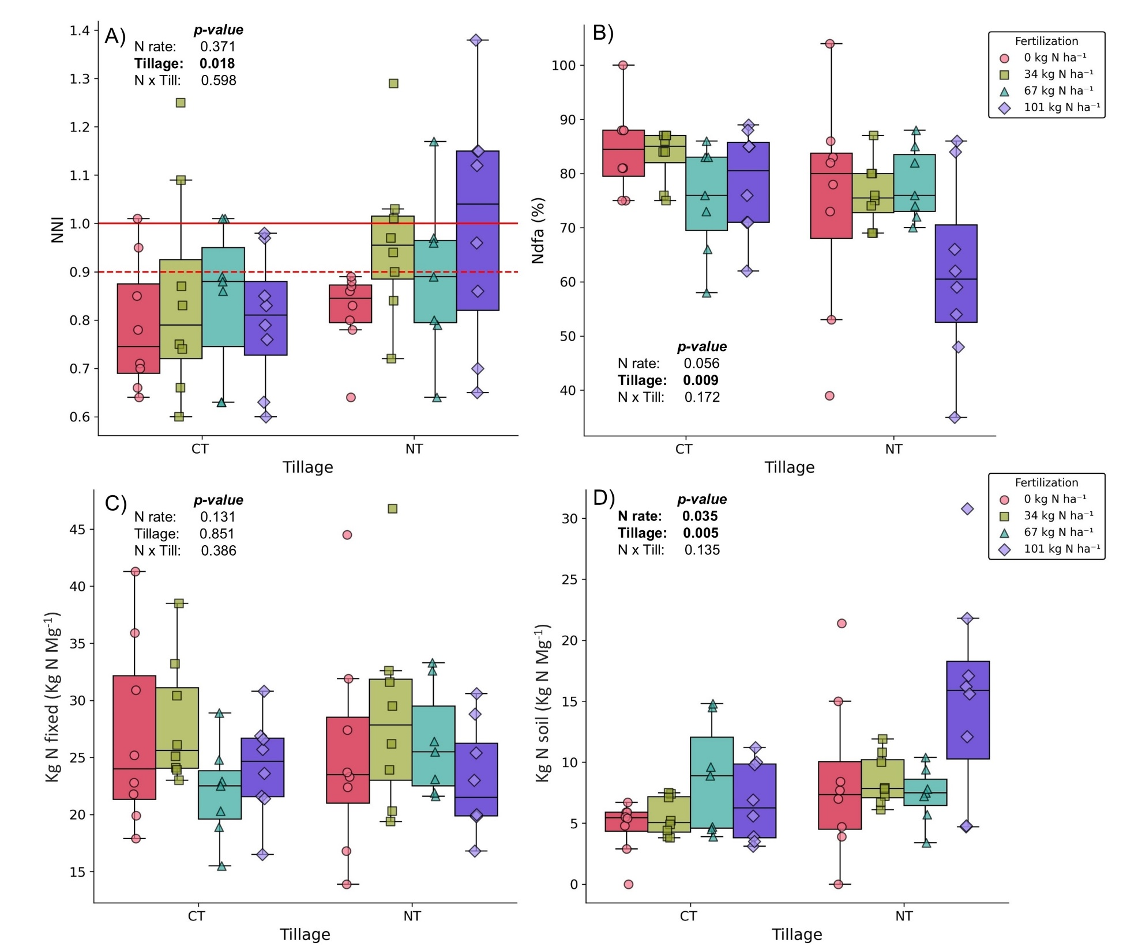
Figure 2.1: Scattered boxplots showing the effects of fertilization and tillage on (A) nitrogen nutrition index (NNI), (B) proportion of nitrogen derived from the atmosphere (Ndfa), (C) nitrogen fixed (kg N fixed), and (D) nitrogen derived from soil (kg N soil). Points represent individual observations; boxes indicate the interquartile range, with median shown as horizontal lines. In panel A, the solid red line indicates NNI = 1, representing optimal nitrogen status, while the dashed red line marks NNI = 0.9, below which nitrogen limitation become more pronounced.

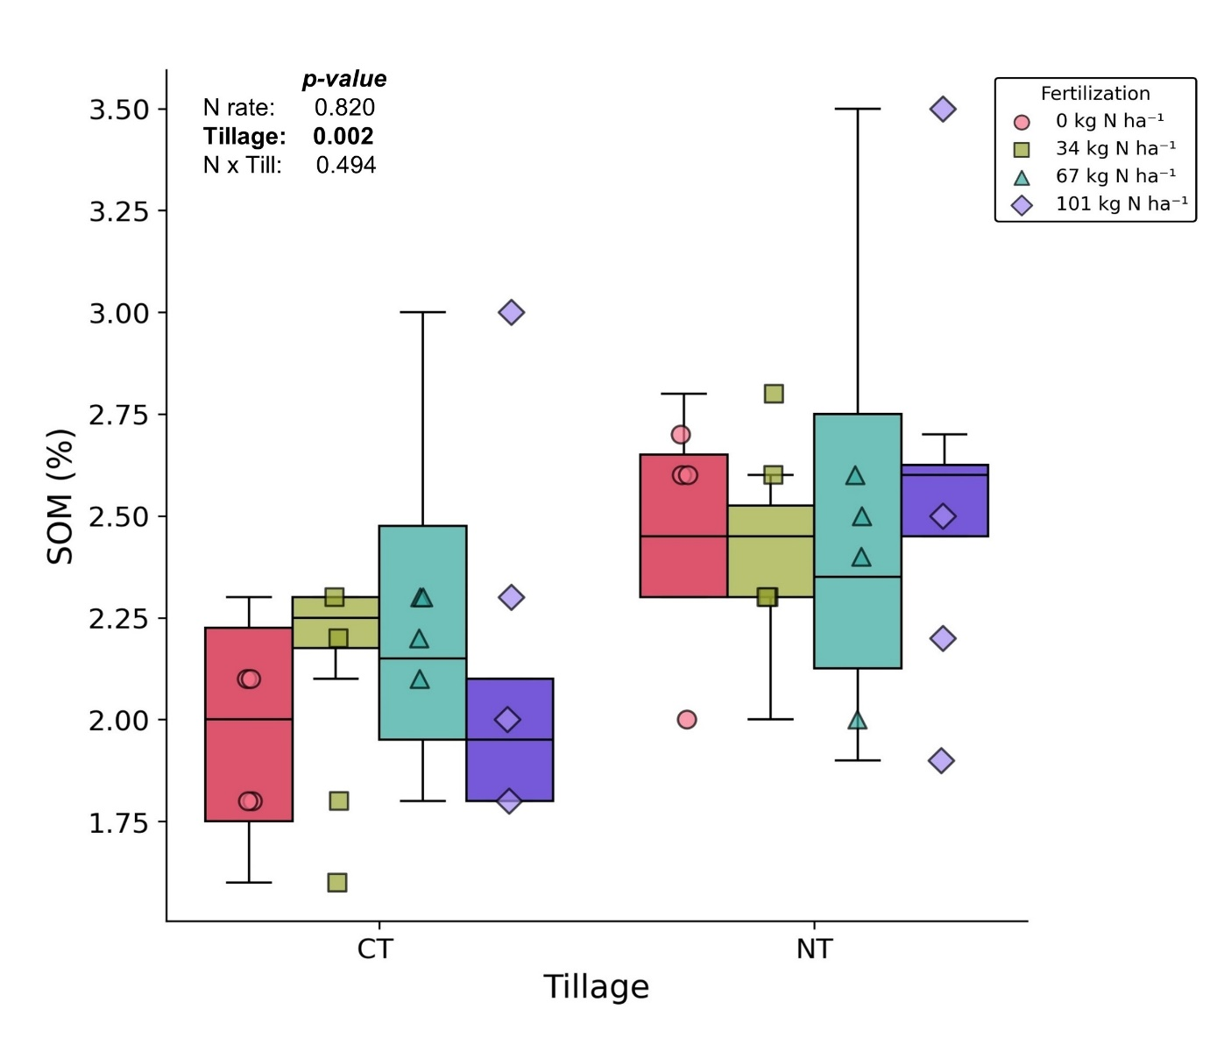
Figure 2.2: Scattered boxplots showing the effects of fertilization and tillage on soil organic matter (SOM) in 2013.

Table 2.1: Effect of nitrogen fertilization rate and tillage on nitrogen sources in hairy vetch, expressed as the amount of nitrogen (kg N) per Mg of dry matter in plant biomass.
Treatments | Sources of Nitrogen in Legumes
 | Kg N fix | Kg N soil | Kg N total
 | (kg N Mg⁻¹) | (kg N Mg⁻¹) | (kg N Mg⁻¹)
N rate
0 | 26.2 ($±$8.7) | 6.6 ($±$5.3) b | 32.7 ($±$6.7)
34 | 28.4 ($±$7.1) | 7.0 ($±$2.4) ab | 35.4 ($±$7.4)
67 | 24.2 ($±$5.0) | 8.0 ($±$3.6) ab | 32.2 ($±$4.5)
101 | 23.6 ($±$4.5) | 11.1 ($±$7.7) a | 34.7 ($±$6.7)
Tillage
CT | 25.4 ($±$6.1) | 6.3 ($±$3.3) b | 31.7 ($±$5.7) b
NT | 25.9 ($±$7.3) | 10.0 ($±$6.4) a | 35.9 ($±$6.5) a
Note: Letters indicate significant treatment effects (p-value $≤$ 0.05); interactions were not significant.

While HV aboveground biomass production remained unaffected by tillage or fertilization (Figure 2.3), tillage strongly influenced soil N supply. Total N uptake was significantly higher under NT compared to CT, primarily due to greater soil derived N availability, while the amount of atmospheric N fixed did not differ between systems (Table 2.1, Figure 2.1C, Figure 2.1D). Conversely, long-term application of different N rates had a less pronounced effect: total N uptake by vetch remained unchanged across fertilization rates. However, the relative contributions of soil and atmospheric sources shifted with increasing N input. Higher N application to the preceding cotton crop significantly increased the amount of N in HV derived from soil, while the amount of atmospheric N fixed per unit biomass marginally declined (p > 0.05) with increasing N rate – indicating a compensator role by soil N supply (Table 2.1).
The RDA provided further insight into treatments effects, with the first two axes explaining 83.2% of the variance in N related variables (Figure 2.4). RDA1 primarily captured a gradient in N source and status: higher NNI, soil derived N, and SOM were associated with more negative scores, while higher %Ndfa aligned with more positive scores (Table 2.2). This reflects a tradeoff between reliance on soil derived N and atmospheric N fixation, with treatments positioned along this axis according to their dominant N source. NT treatments clustered on the negative side of RDA1 – NT-101N, NT-67N, NT-34N, and NT-0N – following a gradient of increasing soil derived N and N status with greater fertilization. CT treatments, in contrast, were distributed along the positive side – CT-0N, CT-34N, NT-67N, and CT-101 N – reflecting lower soil N supply and a stronger dependence on BNF, particularly under low N inputs. This separation is consistent with the long-term benefits of NT in enhancing SOM and soil N availability (Zakeri et al., 2012), and with the inhibitory effects of elevated soil nitrate on BNF (Peoples et al., 1995; Sun et al., 2019). RDA2 captured variation related to BNF efficiency and SOM, where more positive scores corresponding to higher kg N fixed per Mg dry matter and greater SOM. Treatments such as NT-34N, NT-0N, NT-101N, and NT-67N were associated with higher RDA2 values, reflecting both enhanced SOM and, for NT-0N and NT-34N, higher N fixation efficiency under low N input. In contrast, CT treatments generally showed lower RDA2 scores, indicating reduced SOM under CT, though CT-0N and CT-34N still aligned with greater BNF efficiency under low fertilization.
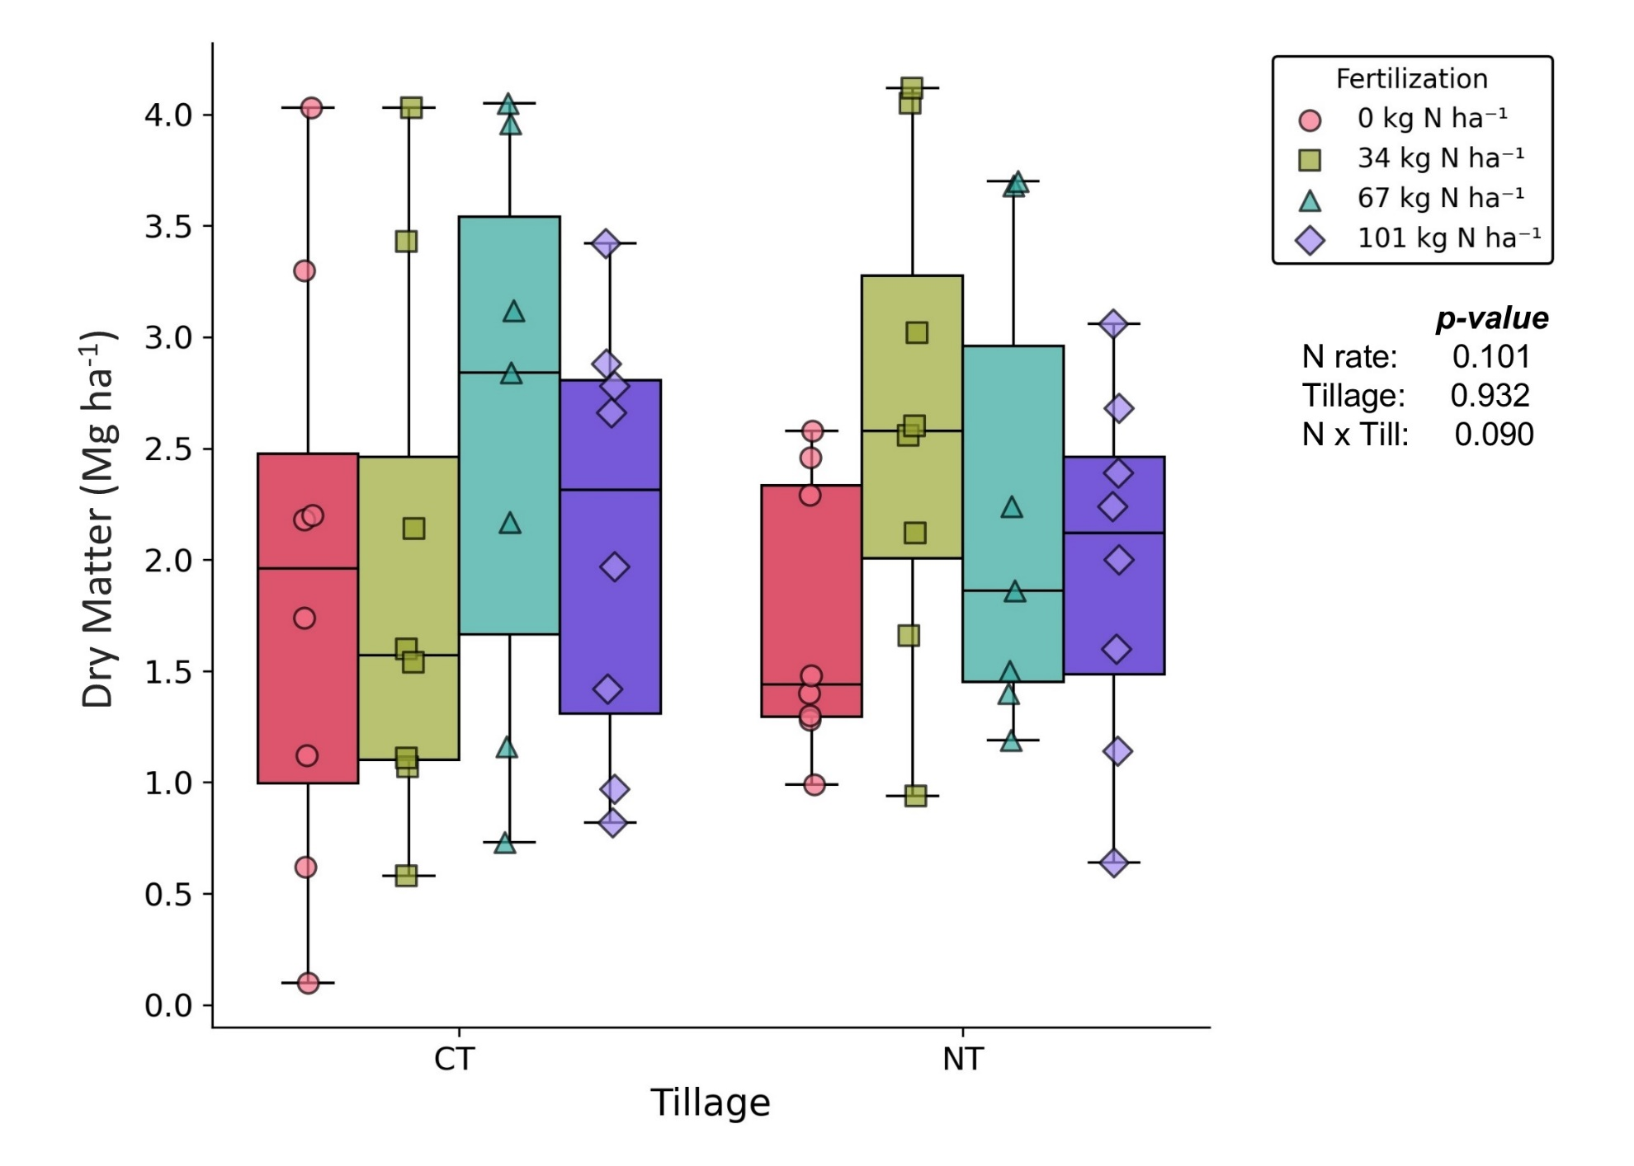
Figure 2.3 : Scattered boxplots showing the effects of fertilization and tillage on dry matter production.

Table 2.2: Loadings of response variables on the first two RDA axes (RDA1 and RDA2). Values represent the contribution (correlation coefficients) of each variable to the constrained ordination space. Higher absolute values indicate stronger influence on the corresponding axis. Loadings were derived from PCA performed on the fitted values of the multivariate linear model constrained by Tillage, Fertilization, Block, and Year.
Variables | RDA1 loading | RDA2 loading
NNI | -0.42 | -0.13
Ndfa (%) | 0.54 | 0.11
Kg N fix Mg⁻¹ | 0.31 | 0.74
Kg N soil Mg⁻¹ | -0.51 | 0.13
SOM | -0.43 | 0.64

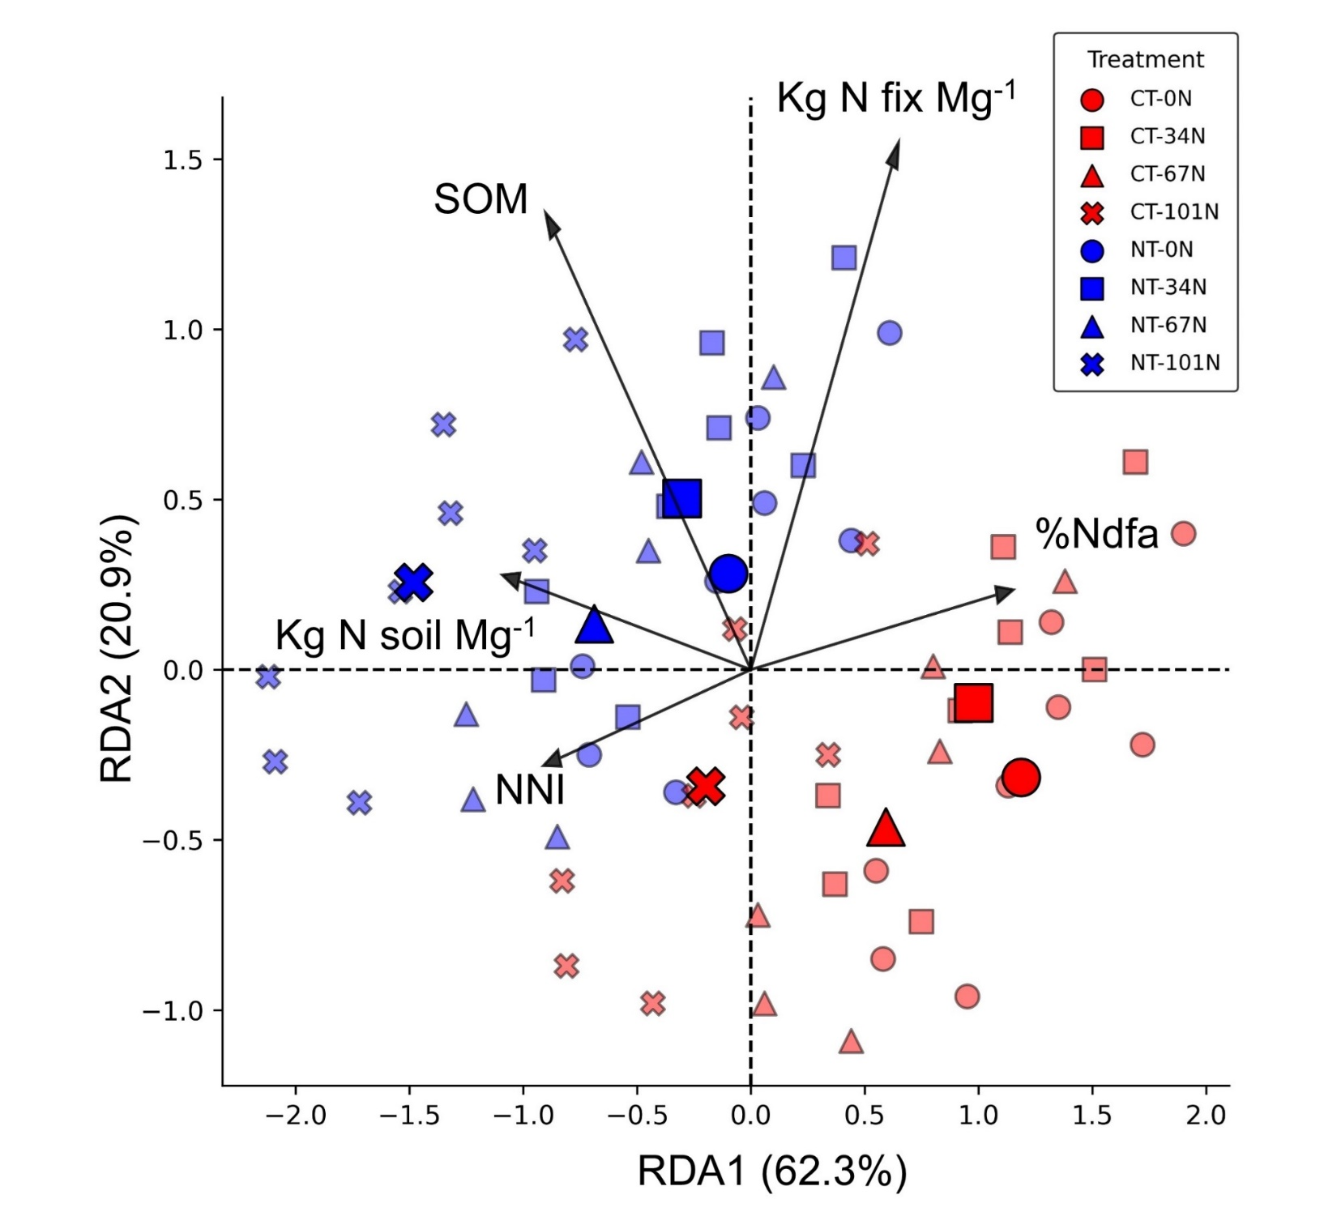
Figure 2.4: Redundancy Analysis (RDA) biplot showing individual samples and treatments centroids based on nitrogen-related variables. Transparent markers represent individual observations, while solid, enlarged markers indicate group centroids for each Tillage × Fertilization treatment combination. Black arrows represent the response variables (NNI, Ndfa, kg N fix, kg N soil, and SOM), with direction and length indicating their contribution to the constrained ordination axes.

Our findings demonstrate that the legacy effects of long-term tillage and N fertilization shape N status, BNF, and N acquisition strategies in HV within a continuous cotton system. Overall, the RDA reveals clear management driven patterns: NT plots aligned with improved N status, greater soil derived N uptake, and enhanced SOM, while CT plots were characterized by lower SOM and a greater compensatory reliance on atmospheric N fixation. Although less pronounced than tillage effects, fertilization history shaped N acquisition strategies in both tillage systems. Lower N inputs (0 and 34 kg N ha⁻¹) were consistently associated with higher BNF efficiency, suggesting the concept of a compensatory response under limited soil N availability (Peoples et al., 1995; Lemaire, 1997; Sun et al., 2019). Importantly, total HV aboveground biomass N contribution was not altered due to this compensatory mechanism, however, shifts in the balance of N sourcing are likely to influence soil N status over time, either through mining of soil reserves or the introduction of external N via fixation. Together, these results underscore how legacy effects of tillage and fertilization history regulate the balance between soil and atmospheric N sources in legume systems, helping to contextualize the tested treatments combinations in terms of N acquisition strategies, SOM status, and overall plant N dynamics.

Conclusions
Our findings demonstrate that long-term management practices shape N acquisition strategies in legume CCs within continuous cotton systems. The combined effects of tillage and N fertilization influenced the balance between soil and atmosphere derived N in HV. NT promoted greater SOM accumulation and hence overall higher soil derived N uptake, while CT was associated with lower SOM and increased reliance on BNF, particularly under low fertilization. Although total N input from HV was not significantly affected by fertilization, the relative contribution of atmospheric N increased under reduced N inputs, indicating a compensatory shift in fixation efficiency. This pattern, consistent in both tillage systems and supported by the RDA results, suggests that legume CCs can partially offset reduced fertilizer inputs through enhanced BNF.
These results highlight the importance of long-term soil health practices, particularly NT, in improving soil fertility and supporting legume N status in nutrient-limited systems. While legumes can rely on BNF, their N status remains closely tied to soil mineral N availability. CCs exhibited flexible N acquisition strategies, adjusting their reliance on BNF and soil derived N across fertilization levels. However, in unfertilized systems, legume N status markedly declined (NNI < 0.85), highlighting the need for adequate N fertilization throughout the crop rotation even under NT. Overall, these findings support integrating NT with fertilization rates adjusted to the crop rotation as part of sustainable nutrient management to sustain legume performance, soil function, and long-term agricultural resilience.

42 years of no-tillage and cover cropping improved soil oxygen availability and resilience

A version of this chapter was published in Agricultural & Environmental Letters. Facundo Lussich was responsible for conceptualization, formal analysis, investigation, methodology, and writing. Debasish Saha, Wesley Wright, and Jashanjeet Kaur Dhaliwal provided input on methodology, review & editing.

Abstract
Healthy soil air-water balance is critical for crop growth. Conservation agricultural practices improve soil physical properties to influence soil oxygen availability. We evaluated the impact of 42 years of hairy vetch (HV) cover cropping (CC) and no-tillage (NT) on soil oxygen dynamics during a cotton growing season experiencing multiple intensive rain events in silt loam soil. HV and NT treatments exhibited higher growing season soil oxygen availability (p < 0.05), and experienced 3 to 4-times fewer hours of oxygen limitation (i.e., oxygen concentration <10%) as compared to no cover (NC) and conventional tillage (CT) treatments. After a heavy rainfall, NT-HV treatment exhibited the highest soil oxygen availability, followed by NT-NC, CT-HV, and CT-NC treatments (p < 0.05). While CC and/or NT treatments quickly regained soil oxygen status within 24 hours after saturating rain events, CT-NC suffered from sub-optimal soil aeration until the third-day post-rainfall. The combination of CC with NT practices enhanced soil oxygen availability and resilience to extreme precipitation events.

Introduction
The adoption of long-term cover cropping and no-tillage (NT) practices has demonstrated a consistent improvement in soil organic carbon accumulation across diverse agricultural systems in the US (Paustian et al., 2000; Grandy et al., 2006; Blanco-Canqui et al., 2011; Poeplau and Don, 2015), leading to enhanced soil quality and productivity. Besides increasing carbon input, cover crops (CC) alleviate soil compaction as well as improve soil structural and hydraulic properties (Blanco-Canqui et al., 2015). Similarly, NT practices minimize soil disturbance and protects soil organic carbon from microbial decomposition, improving soil physical health through improved soil aggregation and aggregate stability, thereby also enhancing soil hydrologic properties (Six et al., 2000).
Improved soil hydrologic properties positively influence soil drainage and moisture retention to maintain a healthy soil air-water balance supportive of root growth and optimal crop performance (Abid and Lal, 2009). Oxic conditions in the rhizosphere are crucial for healthy root respiration to facilitate efficient water and nutrient uptake - essential for achieving high yields. Poor soil physical health due to compaction and poor aggregation impacts hydrologic conditions (Nouri et al., 2019) that can restrict oxygen availability following precipitation events and may constrain plant performance (Walne and Reddy, 2021; Zhang et al., 2021; Huang et al., 2022). Furthermore, soil aeration and oxygen availability controls soil biotic (e.g. nitrification, denitrification) and abiotic (e.g. redox processes, Fe and Mn) processes (Turner and Patrick, 1968; Sexstone et al., 1985). These processes regulate nutrient losses in agricultural systems, such as greenhouse gas emissions and nitrate leaching, influencing the overall environmental impact of soil health practices.
Increasing weather variability brings frequent extreme events (Seneviratne et al., 2021), including intense precipitation events to cause waterlogging. Studies have reported adverse effects of soil oxygen depletion during both short and prolonged waterlogging periods on plant growth (Malik et al., 2002; Arduini et al., 2016; Zhang et al., 2023). Soil oxygen level below 10% affects crop growth (Geigenberger, 2003; Najeeb et al., 2015), elemental reductions (Turner and Patrick, 1968), and soil biology (Pett-Ridge and Firestone, 2005). However, high-resolution soil oxygen data is often unavailable, which hinders our understanding of how soil health practices contribute to soil aeration. The resilience of soil aeration to sudden environmental changes is crucial for sustaining crop productivity and environmental quality. By leveraging a long-term cotton experiment employing NT and CC for 42 years, we continuously monitored surface soil oxygen dynamics during the growing season. We hypothesized that soil oxygen availability and resilience after extreme precipitation events will significantly improve under cover cropping and NT practices compared to conventional tillage (CT) and no cover cropping practices.

Materials and Methods
This study (2023) was conducted in a long-term continuous cotton experiment established in 1981 at the University of Tennessee in Jackson, Tennessee (35°37′22″ N, 88°50′47″ W), in a site with a Lexington silt loam soil (fine-silty, mixed, thermic, Ultic Hapludalfs). Cotton crop is followed by either winter CC or fallow. The experiment is laid out in randomized complete blocks with split-split plot design with four replications and a total of 128 experimental units (12 m × 8 m). Further experimental design and management details can be found in Nouri et al. (2020). To test our hypothesis, 12 plots were used in this study including: two levels of CC (no cover crop, NC; and hairy vetch, HV), two levels of tillage (NT and CT) randomized in three blocks. This arrangement resulted in four treatments: NT + NC, NT + HV, CT + NC, and CT + HV. All the treatments received 67 kg N ha⁻¹ as urea.
Soil oxygen sensors (SO-110 series, Apogee Instruments, Logan UT; non-condensing) were installed at a 10-cm depth in between two crop rows at the center of each plot in spring 2023. These sensors were equipped with a thermistor temperature sensor for temperature correction and a diffusion head to maintain a clear sensor opening. CR1000X data-loggers (Campbell Scientific, INC.) were used to read the oxygen and temperature measurements every 30 s and log the average every 30 min. The sensors were allowed to equilibrate for several weeks after installation before data collection began shortly after cotton planting. Soil oxygen data was collected from May 22 to October 20. Before installation, the oxygen sensors were individually tested in a controlled gas chamber environment and corrected to minimize inter-sensor variability.
The impact of CC, tillage practices, and their interaction on average soil oxygen concentration and cumulative hours of soil oxygen < 10% during the cotton growing season were analyzed using a generalized linear mixed model with lme4 package in R statistical software (version 4.3.0). The analysis of variance (ANOVA) model included tillage and CC factors as fixed effects and block as a random effect. The average soil oxygen dynamics in response to three large summer precipitations events was analyzed using a linear model, followed by a one-way ANOVA. Unless otherwise indicated, means were compared using Tukey´s honest significant difference (HSD) test at p ≤ 0.05. Data were transformed using arcsine or log transformations, as appropriate, to meet the assumptions of normality and homoscedasticity.

Results and discussion
Cover crops significantly influenced soil oxygen dynamics, with approximately 4x shorter period when soil oxygen dropped <10% during the growing season, and consistently maintained higher average soil oxygen availability compared to NC treatments (Table 3.1). Similarly, NT treatments showed higher soil oxygen content during July (p ≤ 0.05) and August (p ≤ 0.10) compared to CT treatments. Moreover, NT treatments experienced nearly three times fewer hours of oxygen stress throughout the growing season compared to the CT counterpart (p ≤ 0.10). Better soil air-water balance to sustain oxygenated soil environment under cover cropping and NT is connected to improved soil physical properties impacting water infiltration and transmissions (Horn and Smucker, 2005; Blanco-Canqui et al., 2011; Nouri et al., 2019). Greater aggregate stability under NT and HV (Martínez et al., 2008; Laudicina et al., 2017) was reported to increase water infiltration and transmission (Franzluebbers, 2002; Nouri et al., 2019), in response to higher surface soil organic carbon accumulation under these practices (Blanco-Canqui et al., 2011; Patra et al., 2022). In a previous study at this experimental site, Nouri et al. (2019) reported 96% and 157% higher cumulative infiltration and transmissivity, respectively, in plots with HV compared to NC plots. Similarly, the NT treatments showed 104% and 222% higher infiltration and transmissivity, respectively, than the CT treatments. Interestingly, CC exhibited a more pronounced effect than NT in our study in maintaining soil oxygen availability (Table 3.1), possibly due to the greater influence of CC in improving profile-scale soil organic carbon compared to NT that mainly enhanced soil organic carbon in the thin topsoil layer (Patra et al., 2022). Residue input from CC is especially important for soil health in low-residue crops like cotton in the warm and humid Southern USA favoring soil organic carbon decomposition (Mullen et al., 1998; Franzluebbers, 2010). Furthermore, CC roots can increase biological pores that play an important role in improving soil hydraulic properties, gas diffusivity, and aeration status by influencing macro and micro-pore architecture (Dhaliwal et al., 2024; Lu et al., 2020; Lucas et al., 2022; Strudley et al., 2008).
Table 3.1: Average soil oxygen concentration and cumulative hours under soil oxygen <10% throughout the growing season, July, and August (1st-15th) in response to long-term tillage and cover cropping.
Treatments | Average soil oxygen concentration |  |  | Hours under 10% soil oxygen concentration
 | (%) |  |  | Hours
 | Growing Season | July | August  (1st-15th) | Growing Season
Tillage
NT | 17.8 (± 1.01) | 16.6 (± 1.39) | 15.8 (± 2.17) | 57.3 (± 107.5)
CT | 17.3 (± 1.64) | 15.2 (± 2.48) | 13.4 (± 4.47) | 166.4 (± 235.9)
Cover crop
NC | 16.8 (± 1.58) | 15.0 (± 2.65) | 12.9 (± 4.43) | 183.3 (± 243)
HV | 18.2 (± 0.47) | 16.8 (± 0.48) | 16.3 (± 1.15) | 40.4 (± 55.4)
ANOVA for significance
Sources of variation | p | p | p | p
Tillage | 0.35 | 0.04 | 0.10 | 0.07
Cover crop | 0.01 | 0.02 | 0.02 | 0.04
Till x CC | 0.17 | 0.18 | 0.50 | 0.99
Notes: Abbreviations: NT, no tillage; CT, conventional tillage; HV, Hairy vetch; NC, no cover crop; CC, cover crop

Temporal soil oxygen dynamics showed different trends across CC and tillage treatments following precipitations events throughout the cotton growing season (Figure 3.1A), which experienced a total precipitation of 1244 mm in 2023. Cover crops under NT showed the least decline and quickest recovery in soil oxygen, which ranged from 12 to 19.8% (mean 18.1%) following precipitation events during the growing season. In contrast, soil oxygen levels for the NC treatment under CT, ranged from 7.5 to 19.8% (mean 16.4%), sharply decreased and took the longest time to recover. Formation of plow pan horizontally concentrated below the tilled layer under long-term CT was previously reported at the study site (Nouri et al., 2019), which perhaps limited deep-water percolation to reduce soil oxygen availability. Intermediate effects were observed in CC treatments under CT and NC treatments under NT practices, more pronounced following extreme precipitation events, particularly in July (received 215 mm, Figure 3.1B) and August (received 172 mm, Figure 3.1C).
To better quantify the CC and tillage effects on soil’s resilience in sustaining soil oxygen availability, Figure 3.2 summarizes the average speed at which soil oxygen concentration was regained after three large rainfall events each receiving ≥ 67 mm of rain within a 48-hour period. In general, soil oxygen steadily improved with time since the last precipitation, but at different rates among the treatments. While the CT-NC treatment showed a slower response in regaining soil aeration status, other treatments with CC (i.e., CT-HV) and/or NT (i.e., NT-HV and NT-NC) exhibited a non-linear response in resuming oxygenated soil environment. Immediately after rainfall, NT-HV treatment exhibited the highest soil oxygen content, followed by NT-NC, CT-HV, and least in CT-NC. Twenty-four hours after precipitation, soil oxygen content showed no difference across treatments with CC and/or NT, except for the CT-NC, which remained under oxygen stress until the third day after rainfall cessation. Higher saturated hydraulic conductivity and transmissivity in NT than CT, especially under the protective cover of HV residue (Nouri et al., 2019), may have created better pore connectivity for rapid oxygen diffusion into soil shortly after rainfall cessation (Gangwar et al., 2006).
These findings hold significant implications for managing cropping systems in the face of increasing weather variability coupled with extreme precipitation events under climate change (Ukkola et al., 2020; Karl et al., 2009). Combined NT and HV cover cropping improved soil aeration and reduced oxygen stress which perhaps contributed to sustain high and stable yields as shown in previous analysis using the same long-term experiment (Nouri et al., 2020, 2021). In that study, the greatest and most stable yields were achieved under NT combined with HV, emphasizing the synergistic effect of these practices on productivity and resilience. Furthermore, improving soil oxygen availability could reduce nutrient losses, including nitrous oxide and methane emissions (Silver et al., 1999; Owens et al., 2017; Rohe et al., 2021; Song et al., 2022b; Preza-Fontes et al., 2023), hence improve sustainability of production practices. While acreages under NT is steadily growing in the US (NASS, 2022), CC adoption is much slower. In cotton production, a low-residue crop, NT adoption falls behind corn, soybean, and wheat (Claassen et al., 2018). Our study showed the positive impact of adopting at least one conservation practice, NT or cover cropping, on soil functionality by facilitating plant growth promoting conditions (i.e., reduced root oxygen stress) buffered against extreme weather conditions.
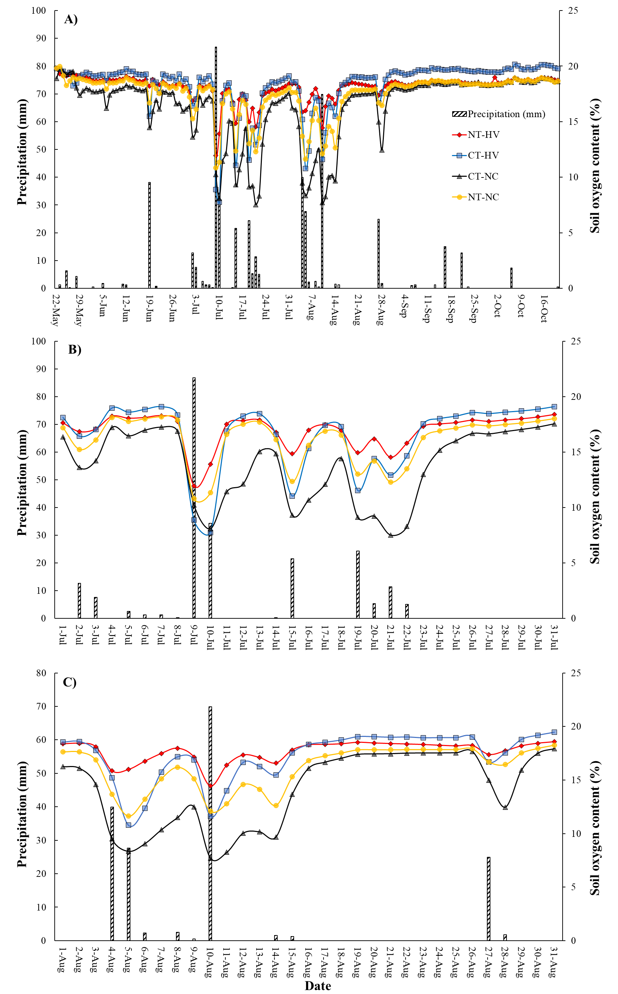
Figure 3.1: Soil oxygen availability and its resilience following rainfall events during the 2023 cotton growing season (A), during July (B), and during August (C) in response to long-term tillage and cover cropping practices. NT, no tillage; CT, conventional tillage; HV, Hairy vetch; NC, no cover crop
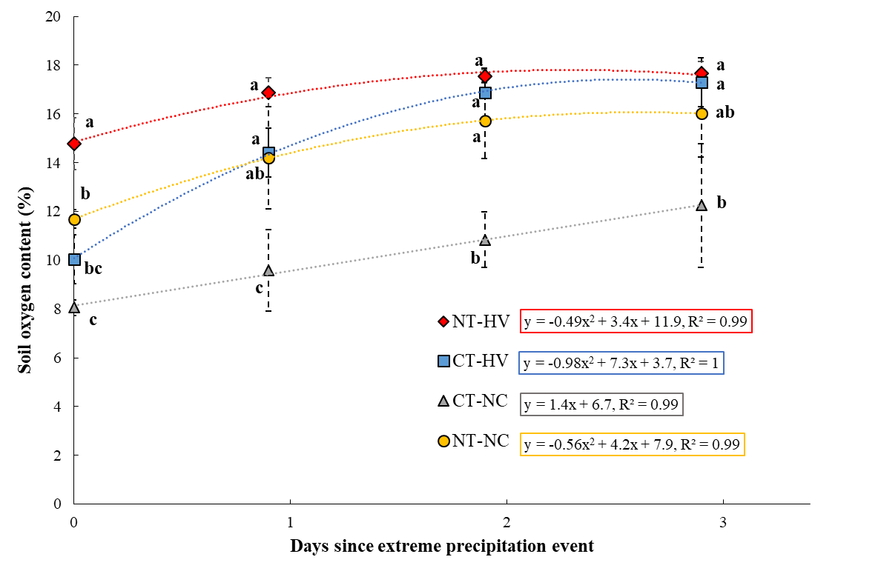
Figure 3.2: Average soil oxygen content for the days since an extreme precipitation event for tillage and cover crop treatments. The soil oxygen average includes three large precipitation events each receiving more than 67 mm of rain within a 48-hour period. Bars indicate standard deviation. Different letters associated with the treatments under each level of day since extreme precipitation event indicate significance at P < 0.05. NT, no tillage; CT, conventional tillage; HV, Hairy vetch; NC, no cover crop.

Conclusions
While further studies including diverse soil types, climate, and cropping system management are warranted to establish a robust linkage between soil health and its role in promoting crop growth, our study demonstrates a soil health-soil functionality context in terms of maintaining a healthy and resilient soil oxygen level, critical for unimpeded root growth. Long-term combined adoption of NT and HV cover cropping significantly improved soil oxygen availability and resilience to minimize the duration of soil oxygen stress after heavy rainfall as compared to the CT and NC management. Moreover, adopting at least one of these soil health practices (NT and cover cropping) could lead to a more rapid recovery of soil oxygen levels following extreme precipitations events than adopting none as in case CT-NC management.

Cover crop residue decomposition exacerbated soil oxygen depletion and promoted nitrous oxide emissions

A version of this chapter was published in Scientific Reports. Facundo Lussich was responsible for conceptualization, formal analysis, investigation, methodology, and writing. Debasish Saha, Jashanjeet Kaur Dhaliwal, Anthony M. Faiia, Sindhu Jagadamma, and Sean M. Schaeffer provided input on methodology, review & editing.

Abstract
Cover cropping is a promising strategy to improve soil health, but it may also trigger greenhouse gas emissions, especially nitrous oxide (N₂O). Beyond nitrogen (N) availability, cover crop residue decomposition may accelerate heterotrophic respiration to limit soil O₂ availability, hence promote N₂O emissions from denitrification under sub-optimal water-filled pore space (WFPS) conditions that are typically not conducive to large N₂O production. We conducted a 21-day incubation experiment to examine the effects of contrasting cover crop residue (grass vs legume) decomposition on soil O₂ and biogeochemical changes to influence N₂O and CO₂ emissions from ¹⁵N labeled fertilized soils under 50% and 80% WFPS levels. Irrespective of cover crop type, mixing cover crop residue with N fertilizer resulted in high cumulative N₂O emissions under both WFPS conditions. In the absence of cover crop residues, the N fertilizer effect of N₂O was only realized under 80% WFPS, whereas it was comparable to the control under 50% WFPS. The N₂O peaks under 50% WFPS coincided with soil O₂ depletion and concomitant high CO₂ emissions when cover crop residues were mixed with N fertilizer. While N fertilizer largely contributed to the total N₂O emissions from the cover crop treatments, soil organic matter and/or cover crop residue derived N₂O had a greater contribution under 50% than 80% WFPS. Our results underscore the importance of N₂O emissions from cover crop-based fertilized systems under relatively lower WFPS via a mechanism of respiration-induced anoxia and highlight potential risks of underestimating N₂O emissions under sole reliance on WFPS.

Introduction
Global agriculture annually generates approximately 3.8 billion Mg of crop residues, of which 4.8 million Mg is contributed by the U.S. (Lal, 2005). Increasing adoption of winter cover crops as a soil health practice will continue generating organic residues. For example, U.S. cover crop acres in 2017 (15.4 million acres) was 50% higher than that in 2012 (10.3 million acres) (NASS, 2017). When cover and cash crop residues are returned back to the soils, they can provide diverse ecosystem services including soil carbon (C) sequestration (Lal, 1995; Blanco-Canqui et al., 2011) and overall improvement of soil health (Alliaume et al., 2014; Blanco-Canqui et al., 2015; Basche et al., 2016; Daryanto et al., 2018). However, decomposing fresh residues can influence coupled soil C and nitrogen (N) cycling, which could be important with regards to the emission of nitrous oxide (N₂O) (Gomes et al., 2009; Basche et al., 2014; Saha et al., 2021b; Acharya et al., 2022; Panday et al., 2022); a long-lived potent greenhouse gas (GHG) largely emitted from global agricultural soils (IPCC, 1996). This process has the potential to be amplified when winter cover crops are used, as their decomposition upon termination often coincides with N fertilization before summer crop planting in many agricultural production systems.
Cover crop residue quality determines N release during decomposition, with high-quality residues (low C:N ratio, e.g., legumes) often exhibiting faster mineralization and N release than high C:N ratio non-legume residues (Poffenbarger et al., 2015; Finney et al., 2016). However, the cover crop residue influence on N₂O emissions is far from straightforward and further depends on management practices (termination method, N fertilization source and rate) and environmental conditions (Basche et al., 2014; Yang et al., 2021). Beyond N supply, simultaneous increase in C availability during residue decomposition can trigger heterotrophic microbial respiration, leading to rapid soil oxygen (O₂) consumption. Under such conditions, water induced O₂ diffusion limitation may not be required to prevail anoxic conditions and N₂O emissions (Parkin, 1987). While N₂O emissions in response to residue addition have been widely attributed to altered C and N availability (Oliveira et al., 2022a), wetness independent anoxia during residue decomposition as a possible mechanism of N₂O production has only been postulated with limited direct evidence (Chen et al., 2013; Saha et al., 2021b). The challenge lies in the lack of an effective approach to capture high-resolution soil O₂ consumption in the pore spaces where critical C and N cycling processes occur to trigger N₂O emissions.
Although the relevance of nitrification and denitrification processes as pathways of soil N₂O production is well-established (Butterbach-Bahl et al., 2013), multiple microbial pathways of N₂O production can often co-occur in the soil (Lourenço et al., 2018). Typically, microbial denitrification is one of the dominant pathways of soil N₂O production, in which N₂O is produced as an intermediate product during stepwise reduction of nitrate (${NO}_{3}^{-}$) to di-nitrogen (N₂) gas under anoxic conditions (Wijler and Delwiche, 1954). Complex interactions between O₂ concentration in soil microsites and ${NO}_{3}^{-}$ and C availability regulate not only the total amount of denitrification but also the ratio between N₂ and N₂O produced (Weier et al., 1993; Morley et al., 2014; Kemmann et al., 2023). Under limited soil O₂ but abundant ${NO}_{3}^{-}$ supply, increasing C availability from residue decompositions could stimulate heterotrophic denitrification with N₂O being the dominant product (Parton et al., 1996). Therefore, when cover crop residues and N fertilizer co-occur in space and time, decomposing cover crop residues could enhance N₂O losses from fertilizer N by providing C for energy to microbes (Mitchell et al., 2013) and increased heterogeneity in soil O₂ availability around the decomposing residues, a key control for denitrification (Parkin, 1987; Song et al., 2019).
While spatial distribution of soil O₂ has long been recognized as a proximal driver of N₂O production (Burgin and Groffman, 2012; Rohe et al., 2021), its high-resolution measurements are difficult under field conditions. As a surrogate for O₂ availability, water-filled pore space (WFPS) is often used to link N₂O production with soil O₂ availability (Dobbie et al., 1999; Davidson et al., 2000; Dobbie and Smith, 2003). It is generally accepted that soil N₂O emissions from nitrification occur within the range of 30 to 60% WFPS content, whereas denitrification dominates at higher WFPS (60-100%), with N₂O as the major product up to 80% WFPS and N₂ with increasing WFPS thereafter (Davidson et al., 2000; Bateman and Baggs, 2005). Despite this prevailing consensus, certain studies have identified a decoupling of the relationship between WFPS and N₂O production pathways, where changes in WFPS did not have the anticipated impact on N₂O source partitioning (Zhu et al., 2013b; Oh et al., 2023). Soil WFPS only accounts for diffusion limitation due to soil wetness and neglects soil O₂ depletion due to accelerated heterotrophic respiration that could create anoxia to promote denitrification even under lower WFPS conditions, otherwise not conducive for denitrification and significant N₂O emissions (Loecke and Robertson, 2009; Robertson, 2023). Given abundant ${NO}_{3}^{-}$ supply, those conditions could trigger equally high N₂O emissions as in diffusion induced O₂ limitation under high WFPS that could quickly escape to the atmosphere due to greater diffusivity under lower WFPS. Further understanding the interplay among N fertilizer management, cover cropping, and N₂O emissions in cropping systems is imperative due to the increasing adoption of soil health practices such as cover cropping, which promote residue addition to soils, alongside the concerning trend in increasing atmospheric N₂O concentration in recent decades (Tian et al., 2018; Thompson et al., 2019). This is crucial to effectively assess net GHG mitigation potential of cover crops as elevated N₂O emissions can offset soil C sequestration benefits (Guenet et al., 2021; Grados et al., 2022), leading agricultural systems to shift from net C sink to a C source.
In a laboratory microcosm study, we investigated the effects of contrasting cover crop residue (grass vs legume) decomposition on high-resolution soil O₂ dynamics to influence N₂O emissions from N fertilized soils under different WFPS levels (50% and 80%). We hypothesized that accelerated O₂ depletion caused by heterotrophic respiration in the presence of decomposing cover crop residues will create O₂ limited conditions that promote N₂O emissions even under WFPS conditions that are sub-optimal for denitrification and high N₂O emissions. We also hypothesized that in presence of N fertilizer, high-quality vetch cover crop residue will deplete soil O₂ at a much faster rate than wheat cover crop residue and produce greater N₂O emissions from N fertilizer.

Materials and Methods

Experimental site and soil sampling
Surface soil samples (0-10 cm depth) were collected from a no-till corn (Zea mays) field at the University of Tennessee’s West Tennessee Research and Education Center in Jackson, Tennessee (35°37′22″ N, 88°50′47″ W; elevation 125 m), United States, in August 2022. A total of 50 kg of dry soil were randomly collected from four replicated plots maintained without N fertilization for two years to achieve a low background soil N level. The study site soil is classified as a Lexington silt loam (fine-silty, mixed, thermic Ultic Hapludalfs), organic matter was 15.5 g kg ⁻¹, total N was 0.85 g kg ⁻¹, and pH (H₂O) was 6.3. The moist soil was thoroughly mixed, air dried, sieved (<6 mm), and stored at 21°C until the experiment started. At the start of the incubation experiment, the soil contained 0.6 mg kg ⁻¹ ${NO}_{3}^{-}$ and 7.1 mg kg ⁻¹ ammonium-N $({NH}_{4}^{+})$.

Cover crop biomass sampling
Two cover crops were included in this study, 1) hairy vetch (Vicia villosa), which is a legume with a low C/N ratio (10:1), and 2) winter wheat (Triticum aestivum L.), which is a cereal with a relatively higher C/N ratio (24:1). Above ground cover crop biomass was sampled at approximately 2 cm above the soil surface in April 2022, just before cover crop termination. Oven dried (60°C for 48 h) samples were cut into 5 mm pieces and stored until the start of the incubation experiment. Total C and N concentrations of ground residue subsamples were determined using an Elementar vario Max cube CN analyzer (Elementar, Hanau, Germany).

Incubation experimental set up
A three-week long incubation experiment was established in a randomized complete block design with three factors: two levels of N addition (control 0 N and equivalent rate of 160 kg N ha⁻¹ as K¹⁵NO₃ at 10 atom % excess), three levels of cover crop residue addition (hairy vetch, winter wheat, and no cover crop) and two levels of WFPS (50% and 80%). The experimental design resulted in eight treatments as follows: T1: 50% WFPS + hairy vetch + 160 kg N ha⁻¹, T2: 50% WFPS + wheat + 160 kg N ha⁻¹, T3: 50% WFPS + no cover crop + 160 kg N ha⁻¹, T4: 50% WFPS (0 N and no cover crop addition as Control), T5: 80% WFPS + hairy vetch + 160 kg N ha⁻¹, T6: 80% WFPS + wheat + 160 kg N ha⁻¹, T7: 80% WFPS + no cover crop + 160 kg N ha⁻¹, and T8: 80% WFPS (0 N and no cover crop addition as Control). Cover crop residues were added at an equivalent rate of 3 Mg dry matter (DM) ha⁻¹, a typical biomass production for spring cover crops in Tennessee under desirable weather conditions. Four replicates were prepared for each of the 8 treatments and four additional sets of samples were included for five-time points destructive soil samplings, with a total of 160 (32 for gas sampling + 128 for destructive soil sampling) experimental units.
Soil cores (5 cm w ×5 cm l × 10 cm h) were packed at a bulk density of 1.2 g cm⁻³ in 15 cm long rectangular transparent acrylic liners. The soil and cover crops residues were weighed (300 g dry soil and 0.750 g DM residue equivalent to 3 Mg DM ha⁻¹ for treatments receiving cover crops), mixed, and added to each acrylic liner. Experimental units were pre-incubated in the dark for 72 hrs with a soil water content amended to achieve the targeted 50% and 80% WFPS, saving 10 mL of water to dissolve the N fertilizer. Water was added from the bottom end of the cores, which were sealed with parafilm with small holes to prevent soil leakage but allows wetting through capillary rise. The top end of plastic liners was covered with perforated parafilm to minimize evaporation, which was removed 1 hr before gas sampling.
At the start of incubation, 0.289 g K¹⁵NO₃ (10 atom % excess ¹⁵N), equivalent to the recommended 160 kg N ha⁻¹, was dissolved in 10 mL de-ionized water and applied to the fertilized treatments with a syringe from the top (133 mg N kg⁻¹ soil was added as KNO₃). We used K¹⁵NO₃ as fertilizer source to facilitate testing our hypothesis that anoxia from residue decomposition would promote N₂O production from denitrification (i.e., reduction of ${NO}_{3}^{-}$) independent of WFPS conditions. All experimental units were incubated in the dark at 21 °C until gas sampling for 21 consecutive days and kept at a constant %WFPS level for the duration of the incubation experiment by adding water based on daily weight losses of the cores.

Gas sampling, analysis, and N₂O source calculations

Gas samples were taken on days 0 (12 hours after N fertilizer addition), 1, 2, 3, 4, 5, 7, 9, 11, 13, 16, and 21. Each core was transferred to a 2 L jar and closed with a lid that contains a septum for gas sampling. Headspace samples (120-mL) were withdrawn from the jars at 60 and 120 min after closure. Three additional samples of lab air were taken each sampling day. The 60 mL syringe was plunged 3 times to mix the gas in the 2L chamber before final collection. The collected gas samples were injected into pre-evacuated 100 mL crimp top clear serum vials and analyzed for CO₂ and N₂O on a Delta+XL mass spectrometer (Thermo Finnigan) coupled with a Precon and Gasbench II (ThermoScientific). Overpressure in the vials allowed for sequential sampling of the gas sample for the two gases. CO₂ was measured and then the overpressure in the jar was vented. The entire volume of the vial gas was then transferred to a liquid N cooled trap for N₂O measurement.
The fluxes of CO₂ and N₂O were calculated from the increasing gas concentrations during the 120-minute headspace closure. The cumulative gas fluxes during the 21-day experiment were calculated by linear interpolation of daily fluxes.
The ¹⁵N abundance in N₂O was determined using the same headspace samples. The relative contributions of N₂O by fertilizer-N (f_{N2O_fertilizer}) and other-N sources (SOM + cover crop residues, f_{N2O_Other}) were determined with a mixing model as follows:
 | f_{N2O_fertilizer} + f_{N2O_Other} = 1 | Equation 1

 | δ¹⁵N_{Treatment} = δ¹⁵N_{fertilizer} × f_{N2O_fertilizer} + δ¹⁵N_{Other} × f_{N2O_Other} | Equation 2

where δ¹⁵N_{Treatment} is the measured δ¹⁵N of the total N₂O, δ¹⁵N_{fertilizer} is the δ¹⁵N of KNO₃ (10 atom % excess ¹⁵N), and δ¹⁵N_{Other} is the δ¹⁵N in the N₂O produced by the SOM and/or cover crop residues. Since the natural enrichment in ¹⁵N between soil and cover crop residues is small compared to the ¹⁵N enrichment in the labelled N fertilizer, the isotopic composition of the N₂O produced by the other sources was assumed to be the value measured in the control treatments (T4 and T8).

Soil O₂ measurements
Spatially resolved soil O₂ dynamics, measured as % air saturation, was monitored using planar optode technology of VisiSensTM A1 system (PreSens GmbH, Germany) with a portable detector unit DU01 containing a Universal Serial Bus (USB) microscope (Larsen et al., 2011; Tschiersch et al., 2012; Rubol et al., 2016). Each incubation core for gas sampling had an O₂ sensor foil (SF-RPSu4) attached to the inner side of the acrylic liner wall throughout the length of the 10-cm soil column that allowed the high-resolution 2-D imaging of soil O₂ saturation. Briefly, the O₂ sensor foil contains fluorescent dyes sensitive to soil O₂ concentration that, when exposed to the LED light from the detector unit, emit fluorescence of specific wavelengths that are captured by the microscope, which translates the data into color images. The images were taken immediately after gas sampling and under dark conditions. Prior to starting the measurements, calibration was performed with identical ambient and temperature conditions as experimental readings. Calibration was performed using a two-point calibration method as recommended by the manufacture´s instruction manual, where a solution of oxygen-free water (0% air saturation) was used as first calibration point and ambient air (100% air saturation) was used as second calibration point. Three images were captured in each acrylic liner by placing the detector in the sensor foil at 0 to 3, 3 to 6 and 6 to 9 cm respectively, to ensure the measurement of real-time high resolution spatial distribution of O₂ along the soil profile. Image processing was performed using ViSiens Imaging System Software (version VA1.12). A description of the measurement setup is provided in Figure 4.1. For a more detailed description refer to Keiluweit et al.(2018).
Based on O₂ content, soils O₂ can be categorized into three groups as in Wang et al.(2021): oxic (> 2.00 mg L⁻¹, equivalent air saturation > 22.5%), hypoxic (0.14 to 2.00 mg L⁻¹, equivalent air saturation 1.6 to 22.5%) and anoxic (< 0.14 mg L⁻¹, equivalent air saturation < 22.5%) conditions.

Soil analysis
On days 2, 7, 11, 16, and 21, soil cores were destructively sampled and analyzed for soil inorganic N (${NH}_{4}^{+}$ and ${NO}_{3}^{-}$) content by 2M KCl extraction (Forster, 1995; Doane and Horwáth, 2003) and permanganate oxidizable C (POXC) (Weil et al., 2003).

Statistical analysis
Statistical analysis were conducted using R statistical software version 4.3.0 (2023) (R Core Team, 2013) with a significance level set at p < 0.05. The ANOVA model included treatments (a combination of cover crop, N fertilization, and WFPS content) as fixed effects, and block as a random effect. Following significant ANOVA results, Tukey´s honest significant difference (HSD) test was performed to compare treatments for cumulative CO₂ and N₂O emissions, as well as soil O₂, ${NH}_{4}^{+}$ , ${NO}_{3}^{-}$ , and POXC concentrations. Data were transformed using Box-Cox, logistic, or square root transformations, as appropriate, to meet the assumptions of normality and homoscedasticity. Throughout the paper, the error terms reported are the mean standard errors.
Random Forest regression model (Breiman, 2001) was used to understand the differential controls of N₂O emissions under 50% and 80% WFPS. The dataset was separately analyzed for 50% and 80% WFPS treatments (n = 352 for each WFPS). The input variables included CO₂, O₂, ${NH}_{4}^{+}$, ${NO}_{3}^{-}$, and POXC, with the aim of identifying the main drivers of N₂O fluxes and evaluating model performance. Briefly, each dataset was split into training (80% data, n = 281) and testing (20% data, n = 71) data, with the training set used to train the Random Forest model using the model parameters as follows: random_state = 42 and n_estimators = 100. The importance of predictor variables was assessed for 50% and 80% WFPS conditions, and model performance was evaluated on the test data set using RMSE and R² model metrics. The Random Forest model was fitted using “RandomForestRegressor” function from the “sklearn.ensemble” modules in Python (Python 3.10).

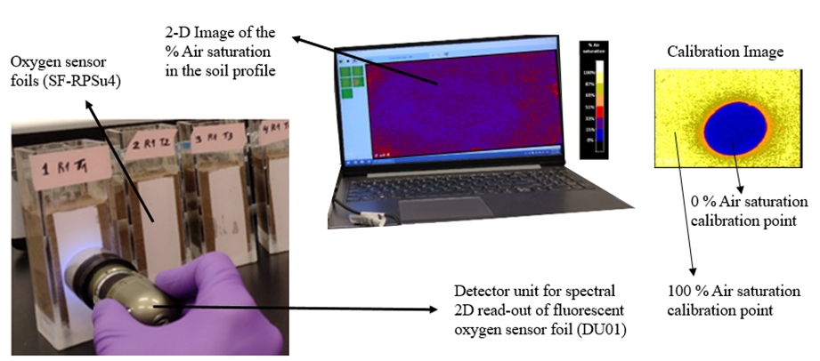
Figure 4.1: Illustration of the experimental set-up (not to scale) and calibration image.

Results

Cover crop residue and N fertilization impacts on temporal N₂O and CO₂ emissions
The combination of cover crop residue and N fertilizer addition exhibited higher peak N₂O emissions than the N fertilized without cover crop and control treatments under both 50% and 80% WFPS conditions (Figure 4.2a, b). Temporal N₂O fluxes showed different trends across cover crop treatments under 50% and 80% WFPS. First, cover crop treatments under 80% WFPS immediately showed high daily fluxes ranging from 674 to 2728 µg N₂O-N kg soil⁻¹ day⁻¹ during day 0 to 4. Whereas peak N₂O emissions were slightly delayed under 50% WFPS ranging from 529 to 2824 µg N₂O-N kg soil⁻¹ day⁻¹, the same or slightly higher in magnitude than that under 80% WFPS. Second, N₂O emissions from the cover crop treatments sharply decreased following the peak emissions under 80% WFPS, with identical emissions to the control treatment after day 7. In contrast, the decline in emissions were more gradual under 50% WFPS where moderate daily N₂O fluxes (ranging from 88 to 607 µg N₂O-N kg soil⁻¹ day⁻¹), significantly higher than the control treatment (p < 0.05), were observed until the end of the incubation experiment. Third, in the absence of cover crop residues, the N fertilized treatment produced very little N₂O emissions under 50% WFPS, about the same as the control treatment. In contrast, N fertilization under 80% WFPS had significantly higher N₂O fluxes than the control treatment from day 1 to day 16; however, the peak fluxes were much lower in magnitude (ranging from 44 to 859 µg N₂O-N kg soil⁻¹ day⁻¹) and showed a slightly different emission patterns than the cover crop treatments. Lastly, residue type (legume vs grass) effect on temporal N₂O emissions was not consistent across the WFPS treatments, with higher peak emissions from hairy vetch than winter wheat residue addition with N fertilizer under 50% WFPS (p > 0.05).
The temporal variability of N₂O fluxes derived from N fertilizer showed different patterns across WFPS and cover crop treatments that were consistent with the temporal N₂O emission trends (Figure 4.2c and Figure 4.2d). Firstly, in the cover crops treatments under 80% WFPS, a high proportion of N₂O fluxes was derived from N fertilizer, ranging from 89 to 97% during day 0 to 4, coinciding with peak N₂O emissions. However, the contribution sharply decreased after day 5, concomitant with the decline in N₂O fluxes. Similarly, in the same treatments under 50% WFPS, N₂O emissions derived from N fertilizer closely followed the daily N₂O flux pattern, accounting for 79 to 91% of total N₂O emissions during day 2 to 5, and gradually decreased to 33% by the end of the incubation experiment. Secondly, in the absence of cover crop residues under 50% WFPS, around one-third of the total N₂O emissions was derived from N fertilizer after day 2, and it remained relatively constant until the end of the experiment. Nitrogen fertilizer derived N₂O under 80% WFPS from only N fertilized treatment comprised a much greater proportion (50-80%) to the total emission from day 1 to 16.
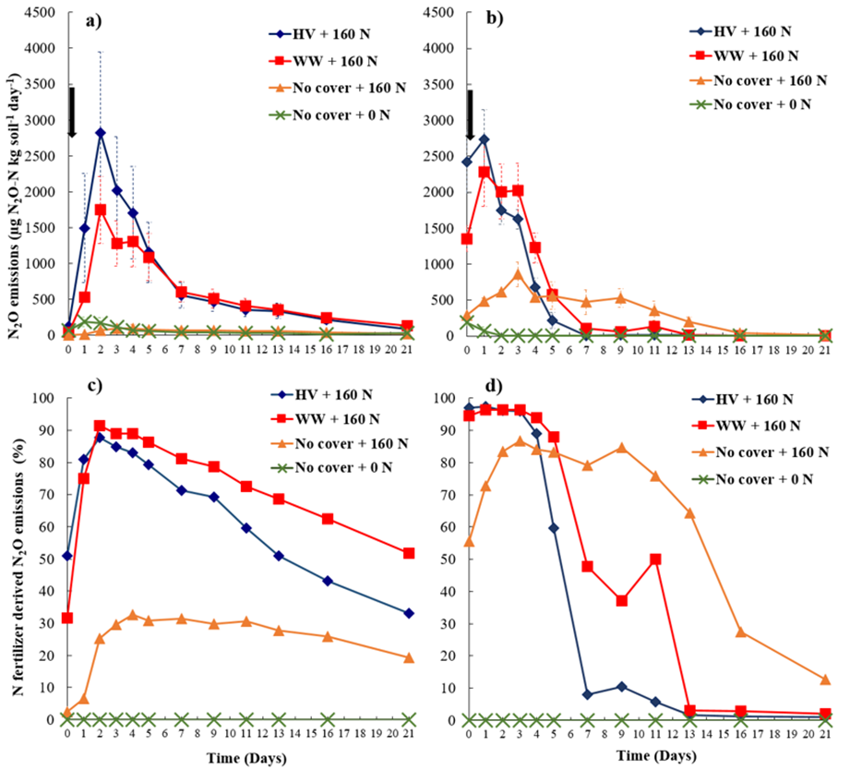
Figure 4.2: Daily nitrous oxide (N₂O) emissions (a, b) and N₂O emissions derived from N fertilizer (c, d) over the incubation period from four cover crops treatments at 50% WFPS (a, c), and 80% WFPS (b, d). Nitrogen fertilizer was added at the beginning of the incubation experiment as indicated by black arrow in panels (a) and (b). Bars in panels (a) and (b) indicate mean standard error. HV, Hairy vetch; WW, Winter wheat; No cover, No cover crop; No cover+0 N, Control.

Soil CO₂ emissions were higher under cover crop treatments at 50% WFPS (Figure 4.3), especially until day 4 (ranging from 17541 to 58734 µg CO₂-C kg soil⁻¹ day⁻¹), than the non-cover crop treatments (N fertilizer and control). Treatments under 80% WFPS exhibited lower CO₂ emissions (764 to 16329 µg CO₂-C kg soil⁻¹ day⁻¹) than under 50% WFPS and did not differ among the treatments.

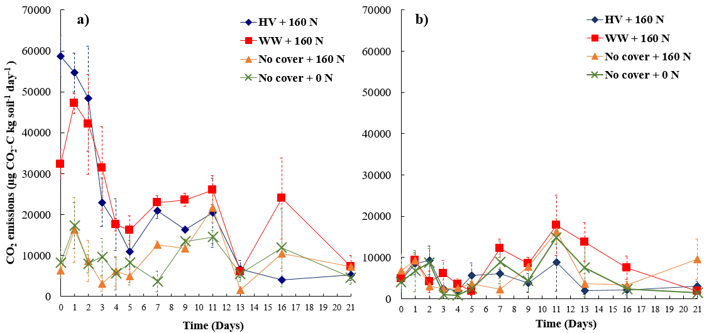

Figure 4.3: Daily carbon dioxide (CO₂) emissions over the incubation period from four cover crops treatments at (a) 50% WFPS, and (b) 80% WFPS. Bars represents mean standard error. HV, Hairy vetch; WW, Winter wheat; No cover, No cover crop; No cover + 0 N, Control.

Cumulative N₂O and CO₂ emissions
Cumulative N₂O and CO₂ emissions reflected their daily flux patterns (Figure 4.4 and Table 4.1). Irrespective of cover crop type, residue addition with N fertilizer under 50% WFPS produced statistically similar N₂O emissions to 80% WFPS (Fig. 3, p > 0.05), known to facilitate large N₂O emissions. However, 50% WFPS treatments with cover crop exhibited a greater variability of total N₂O emissions compared to the corresponding treatments under 80% WFPS. Contrastingly, sole N fertilizer application increased N₂O emissions only under 80% WFPS, the total emission being similar to the cover crop treatments (p > 0.05). Whereas N fertilization alone under 50% WFPS resulted in cumulative N₂O emissions comparable to the control treatment (p > 0.05) and six times less than that in 80% WFPS (p < 0.05). Cover crop residue addition effect on CO₂ emissions was more pronounced under 50% WFPS content and exhibited approximately twice as high cumulative CO₂ emissions compared to the only N fertilizer and control treatments (p < 0.05) (Table 4.1). CO₂ emissions were suppressed in all the treatments under 80% WFPS (p > 0.05).

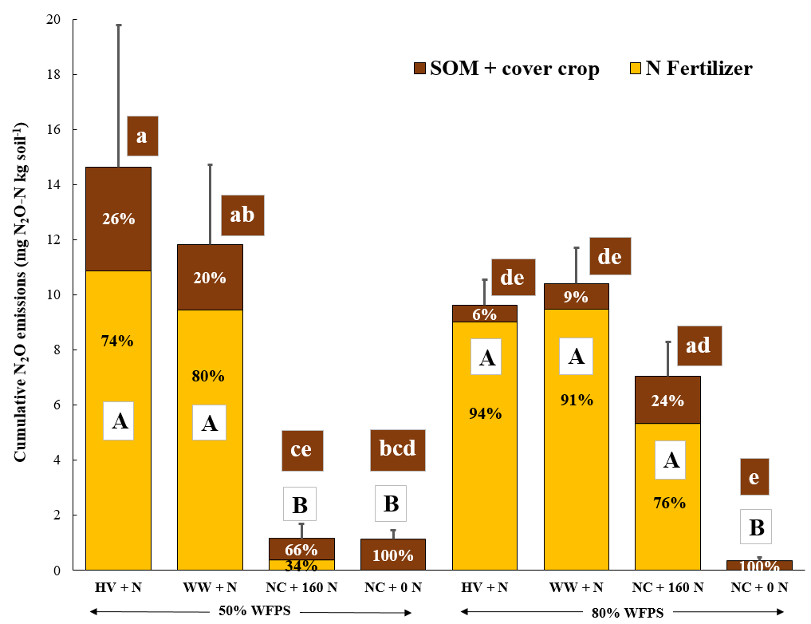

Figure 4.4: Cumulative N₂O emissions over the experiment incubation period derived from the fertilizer (yellow) and soil organic matter and/or cover crops (brown) for four cover crops treatments at 50% and 80% WFPS. The error bars represent the mean standard errors for the total N₂O emissions, and the percentage shown in the columns represents the proportion of cumulative total N₂O emissions from each source. Uppercase letters indicate significant differences (p < 0.05) in cumulative N₂O emissions and N₂O emissions derived from N fertilizer among the treatments, while lowercase letters indicate differences in N₂O emissions derived from SOM and/or cover crops among the treatments. HV: Hairy vetch, WW: Winter wheat, NC: No cover crop, NC + 0 N: Control.

Table 4.1: Cumulative CO₂ emissions from all eight treatments after 21-day incubation.
Cover crop | WFPS | Cumulative CO₂ emissions (mg C-CO₂ kg soil⁻¹)
Hairy vetch + 160 N | 50% | 382.8 (44.2) ^{ab}
Hairy vetch + 160 N | 80% | 95.1 (13.1) ^{e}
Winter wheat + 160 N | 50% | 472.4 (26.0) ª
Winter wheat + 160 N | 80% | 177.4 (17.7) ^{ce}
No cover crop + 160 N | 50% | 207.9 (33.2) ^{bc}
No cover crop + 160 N | 80% | 133.1 (24.9) ^{ce}
No cover crop + 0 N | 50% | 199.8 (49.9) ^{cd}
No cover crop + 0 N | 80% | 113.6 (45.1) ^{de}
*Values are means and standard errors in parenthesis. Lowercase letters indicate significant differences among the treatments (p < 0.05). No cover crop + 0 N: Control

Fertilizer N was the main source of N₂O across WFPS conditions, except for the only N fertilized treatment under 50% WFPS (Figure 4.4). Under 80% WFPS, cover crop addition had little or no effect on N₂O emissions derived from non-fertilizer sources such as soil organic matter (SOM) and/or cover crop. Cover crop treatments exhibited around 1.7 times higher fertilizer derived N₂O emissions compared to the only N fertilized treatments under 80% WFPS. Cover crop addition had significantly (p < 0.05) greater N₂O emission contribution from non-fertilizer (SOM and/or cover crop) sources under 50% than 80% WFPS. Under 50% WFPS, cover crop addition resulted in 23x and 3x higher N₂O emissions derived from fertilizer and SOM and/or cover crop, respectively, than the N fertilized treatments. In presence of cover crop, N₂O emissions derived from SOM and/or cover crop was 2x higher than that in the control treatment under 50% WFPS.

Soil O₂, C, and N availability
Soil O₂ concentration in the top 3-cm soil layer remained at anoxic levels during the whole incubation period for 80% WFPS treatments (Figure 4.5b and Figure 4.6c). The 50% WFPS treatments with hairy vetch and winter wheat residues exhibited a sharp drop in O₂ concentration by day 1 (mean air saturation of 20% and 27%, respectively), reaching anoxic soil O₂ levels in some replicates (Figure 4.7a and Figure 4.6a). Such a drop in soil O₂ following cover crop residue incorporation under 50% WFPS also coincided with high CO₂ emissions and concomitant onset of peak N₂O emissions (Figure 4.3a and Figure 4.2a). Soil remained oxic throughout the incubation period under the N fertilized treatment without cover crop under 50% WFPS (Figure 4.5a and Figure 4.7b). Divergence in soil O₂ between the 50% WFPS treatments with and without cover crops remained noticeable until around day 11 of the incubation experiment, and thereafter became comparable, with a much shorter duration for hairy vetch than winter wheat (Figure 4.5a, 4.6a, 4.6b, 4.7).
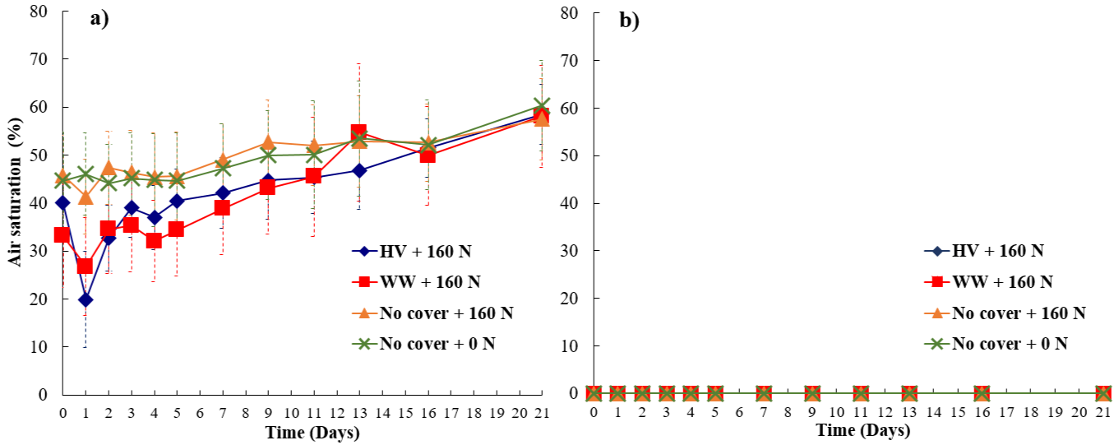
Figure 4.5: Average soil O₂ content expressed as percentage of air saturation at 0 to 3 cm depth over the incubation period from four cover crops treatments at (a) 50% WFPS and (b) 80% WFPS. Bars represent the mean standard error. HV, Hairy vetch; WW, Winter wheat; No Cover, No cover crop; No cover+0 N, Control.

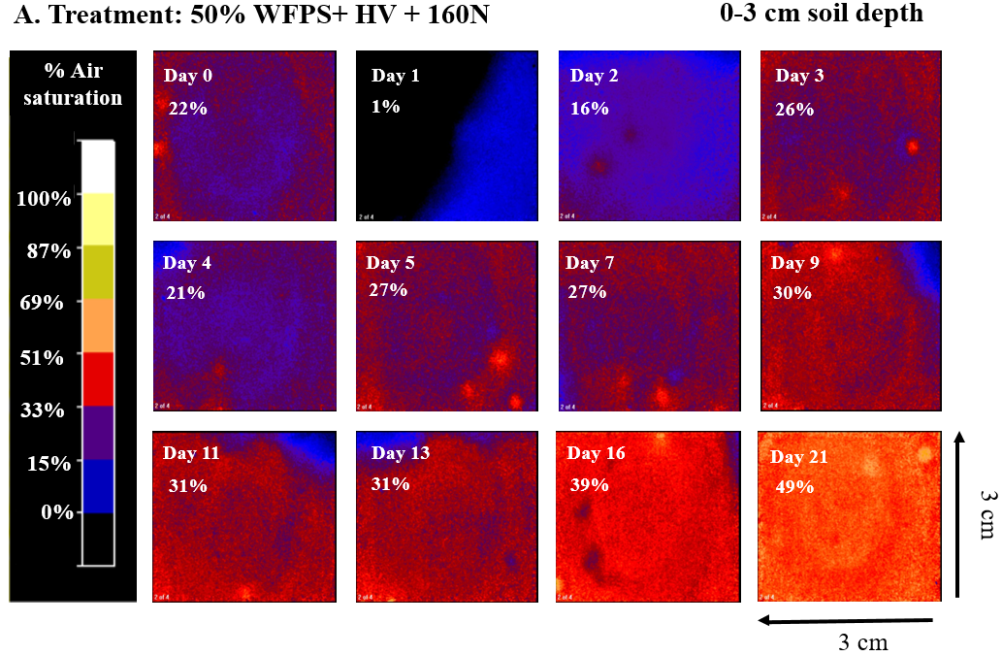
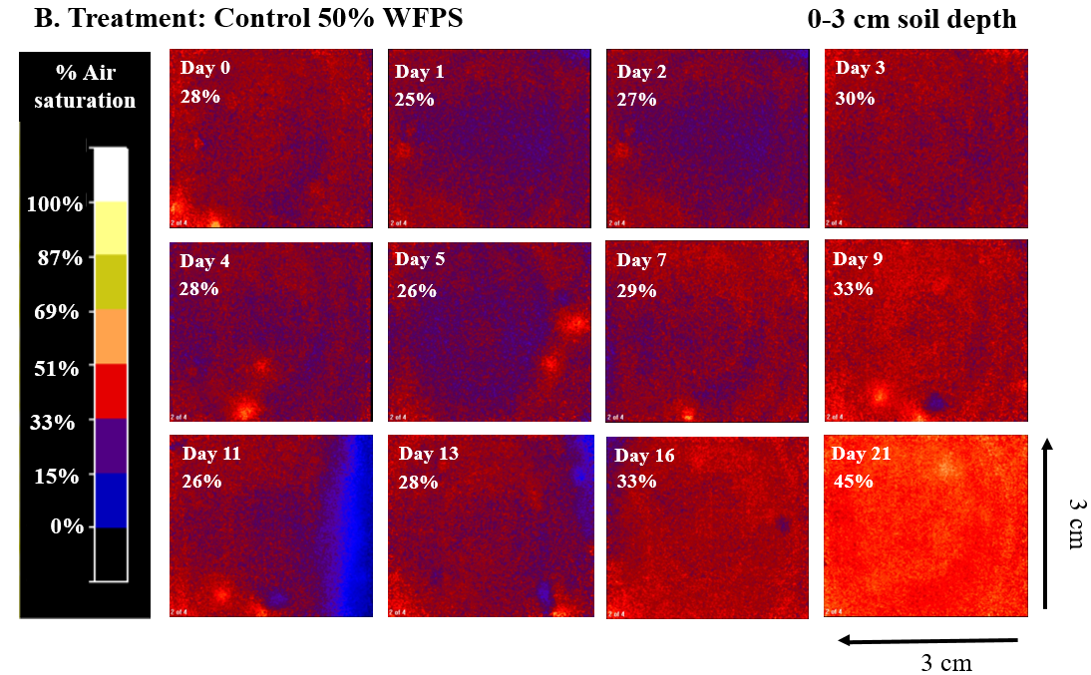
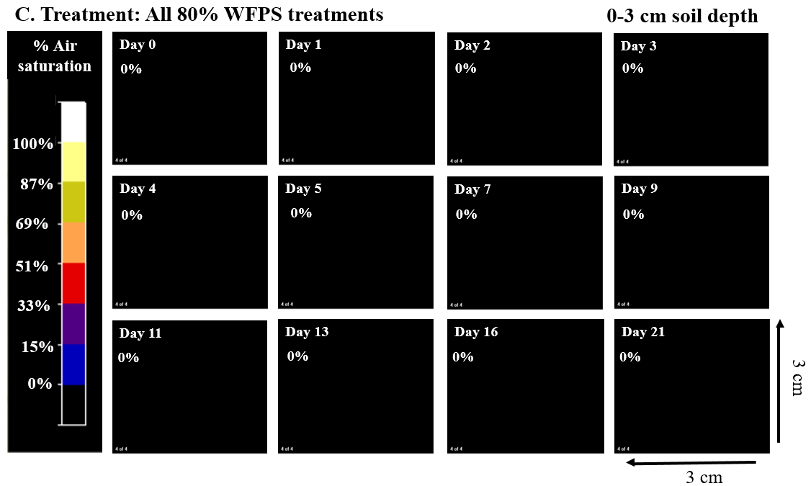
Figure 4.6: Selected images of O₂ content expressed as percentage of air saturation in 0 to 3 cm soil depth over the incubation period from different treatments: A) 50% WFPS with hairy vetch, B) 50% WFPS control, and C) all 80% WFPS treatments. Images (one of the four replicates) are an example of the effect of the different treatments.

Prior to N fertilizer addition, all treatments had very low initial soil ${NO}_{3}^{-}$ and ${NH}_{4}^{+}$ concentrations (0.76 and 7.02 mg N kg⁻¹, respectively). As expected, on day 2 after N addition, all N fertilized treatments showed significantly higher ${NO}_{3}^{-}$levels than the controls under each WFPS (p < 0.05), except for the 50% WFPS treatment with vetch (Table 4.2). In general, ${NO}_{3}^{-}$ concentrations consistently decreased over time in all fertilized treatments under 80% WFPS, with only N fertilization maintained slightly higher ${NO}_{3}^{-}$ levels for most of the sampling days. By day 7, 80% WFPS treatments with cover crop addition had ${NO}_{3}^{-}$ concentrations comparable to the 80% WFPS control. In contrast, ${NO}_{3}^{-}$ concentrations under 50% WFPS treatments with N addition either remained constant or slightly decreased over time and remained substantially higher than that under 80% WFPS. Unlike ${NO}_{3}^{-}$, soil ${NH}_{4}^{+}$ concentrations decreased over time under 50% WFPS and the hairy vetch treatment had notably higher ${NH}_{4}^{+}$ concentrations than the other treatments.
In general, soil POXC concentrations were higher in the 80% WFPS than the 50% WFPS treatments (mean value: 735 vs 677 mg kg soil⁻¹), and the differences were only significant under the cover crop treatments on days 7, 11 and 21, and on day 2 in the hairy vetch treatment (Table 4.3). Cover crop residue addition had no significant effect on POXC concentrations when compared to the only N fertilized and control treatments under each WFPS condition.

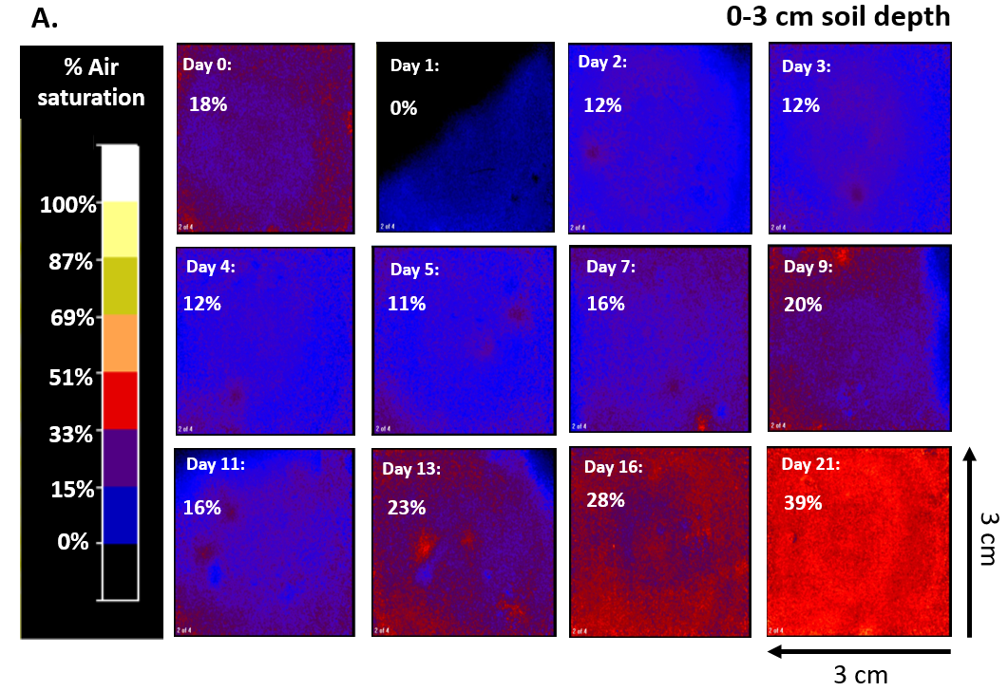
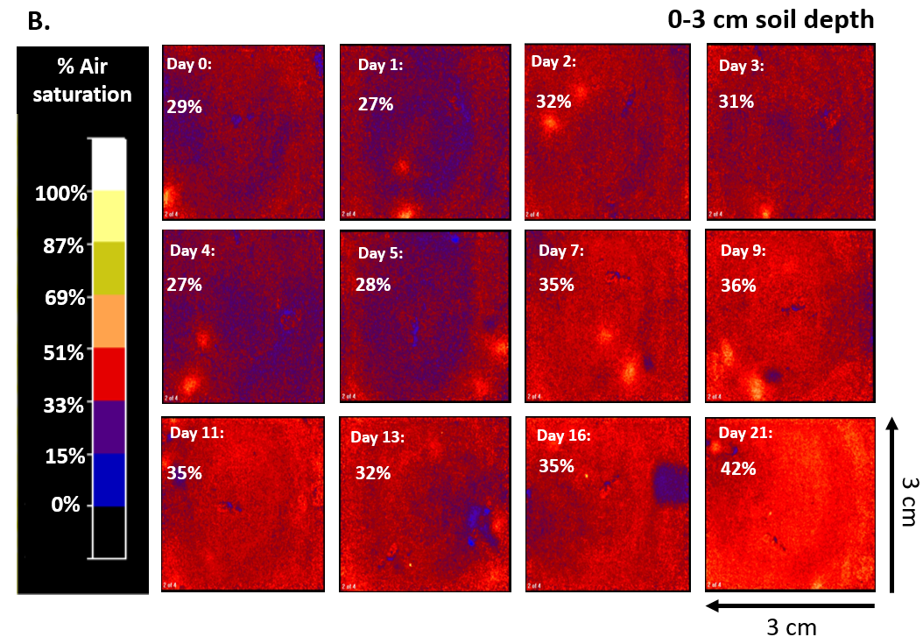
Figure 4.7: Selected images of O₂ content expressed as percentage of air saturation in 0–3 cm soil depth over the incubation period from two treatments: (A) 50% WFPS with winter wheat+160 N, (B) 50% WFPS with no cover crop+160 N. Images (one of the four replicates) illustrate the maximum achieved O₂ depletion effect resulting from cover crop addition.

Table 4.2: Nitrate (${NO}_{3}^{-}$) and ammonium (${NH}_{4}^{+}$) concentration over the incubation period for four cover crop treatments at 50% and 80% WFPS.
Cover Crop | WFPS | NO₃-N (mg N kg⁻¹ soil)
Cover Crop | WFPS | Day 2 | Day 7 | Day 11 | Day 16 | Day 21
HV + 160 N | 50% | 83 (17) ^{bd} | 163 (26) ª | 133 (11) ª | 154 (30) ª | 147 (14) ª
HV + 160 N | 80% | 106 (34) ^{abc} | 23 (7) ^{de} | 5 (3) ^{c} | 4 (2) ^{b} | 1 (0) ^{d}
WW + 160 N | 50% | 126 (18) ^{ab} | 115 (13) ^{ac} | 126 (19) ª | 114 (24) ª | 124 (9) ^{ab}
WW + 160 N | 80% | 168 (24) ^{ab} | 47 (19) ^{ce} | 9 (1) ^{c} | 8 (4) ^{b} | 2 (0) ^{d}
NC + 160 N | 50% | 179 (35) ª | 135 (27) ^{ab} | 160 (9) ª | 124 (17) ª | 107 (5) ^{b}
NC + 160 N | 80% | 166 (21) ^{ab} | 80 (27) ^{bcd} | 68 (22) ^{b} | 32 (8) ^{b} | 2 (1) ^{cd}
NC + 0 N | 50% | 17 (1) ^{cd} | 12 (1) ^{de} | 10 (2) ^{c} | 11 (2) ^{b} | 26 (2) ^{c}
NC + 0 N | 80% | 1 (0) ^{d} | 2 (0) ^{e} | 3 (1) ^{c} | 2 (0) ^{b} | 1 (0) ^{d}

Cover Crop | WFPS | NH₄ –N (mg N kg⁻¹ soil)
Cover Crop | WFPS | Day 2 | Day 7 | Day 11 | Day 16 | Day 21
HV + 160 N | 50% | 89 (3) ^{b} | 31 (8) ^{b} | 20 (3) ^{cd} | 14 (5) ^{b} | 6 (2) ^{c}
HV + 160 N | 80% | 107 (6) ª | 86 (3) ª | 116 (5) ª | 93 (12) ª | 107 (9) ª
WW + 160 N | 50% | 14 (2) ^{e} | 6 (1) ^{cd} | 11 (2) ^{de} | 5 (2) ^{b} | 5 (1) ^{c}
WW + 160 N | 80% | 36 (4) ^{c} | 26 (6) ^{bd} | 30 (2) ^{b} | 11 (5) ^{b} | 51 (4) ^{b}
NC + 160 N | 50% | 18 (2) ^{de} | 7 (1) ^{bd} | 12 (1) ^{de} | 3 (1) ^{b} | 5 (1) ^{c}
NC + 160 N | 80% | 31 (3) ^{cd} | 28 (7) ^{bd} | 26 (2) ^{bc} | 12 (4) ^{b} | 41 (2) ^{b}
NC + 0 N | 50% | 13 (1) ^{e} | 4 (0) ^{d} | 5 (1) ^{e} | 2 (1) ^{b} | 4 (1) ^{c}
NC + 0 N | 80% | 35 (0) ^{c} | 29 (13) ^{bc} | 22 (4) ^{bc} | 14 (5) ^{b} | 44 (3) ^{b}
*Values are means and standard errors in parenthesis. Lowercase letters indicate significant differences among the treatments (p < 0.05) within a column. HV: Hairy vetch, WW: Winter wheat, NC: No cover crop, NC + 0 N: Control

Table 4.3: Soil permanganate oxidizable carbon (POXC) over the incubation period for four cover crop treatments at 50% and 80% WFPS.
Cover Crop | WFPS | POXC (mg C kg⁻¹ soil)
Cover Crop | WFPS | Day 2 | Day 7 | Day 11 | Day 16 | Day 21
HV + 160 N | 50% | 679 (24) ^{c} | 686 (22) ^{c} | 669 (11) ^{bc} | 691 (15) ^{ab} | 653 (20) ^{c}
HV + 160 N | 80% | 795 (14) ª | 803 (13) ª | 744 (21) ª | 721 (9) ª | 784 (12) ª
WW + 160 N | 50% | 753 (15) ^{ac} | 683 (19) ^{c} | 648 (7) ^{c} | 653 (20) ^{ab} | 703 (31) ^{bc}
WW + 160 N | 80% | 783 (15) ^{ab} | 776 (6) ^{ab} | 716 (31) ^{ab} | 704 (21) ª | 791 (9) ª
NC + 160 N | 50% | 695 (9) ^{c} | 684 (18) ^{c} | 648 (11) ^{c} | 660 (15) ^{ab} | 712 (27) ^{ac}
NC + 160 N | 80% | 743 (23) ^{ac} | 702 (9) ^{bc} | 694 (11) ^{ac} | 653 (17) ^{ab} | 685 (10) ^{bc}
NC + 0 N | 50% | 706 (23) ^{bc} | 665 (29) ^{c} | 651 (13) ^{bc} | 626 (8) ^{b} | 671 (27) ^{c}
NC + 0 N | 80% | 729 (29) ^{ac} | 711 (17) ^{bc} | 714 (19) ^{ab} | 684 (37) ^{ab} | 764 (20) ^{ab}
*Values are means and standard errors in parenthesis. Lowercase letters indicate significant differences among the treatments (p < 0.05) within a column. HV: Hairy vetch, WW: Winter wheat, NC: No cover crop, NC + 0 N: Control

Drivers of N₂O emissions
The Random Forest model explained daily N₂O flux variations on the test data for 50% (R²=0.67, RMSE=21.3) and 80% (R²=0.62, RMSE=19.3) WFPS conditions (Table 4.4 and Figure 4.8). For 50% WFPS treatments, the model identified ${NH}_{4}^{+}$ and O₂ as the most influential variables impacting N₂O fluxes (Table 4.4). These variables collectively accounted for nearly 75% of the model´s performance, explaining 67% of the variance in N₂O fluxes on the test data set (Table 4.4). Conversely, at 80% WFPS, ${NO}_{3}^{-}$ was the main driver of N₂O fluxes, and the model accounted for 62% of the N₂O flux variance on the test data set.

Table 4.4: Features importance to predict N₂O emissions under 50% and 80% WFPS conditions as predicted by the Random Forest. Model R² value indicates variability explained on the test data set.
Model variables | 50% WFPS model | 80% WFPS model
Ammonium (NH₄⁺) | 0.49 | 0.12
Nitrate (NO₃⁻) | 0.07 | 0.62
Oxygen (O₂) | 0.25 | 0.00
CO₂ | 0.13 | 0.16
POXC | 0.06 | 0.10
Model R² | 0.67 | 0.62
*Values in the table rank the relevance of features in the model based on the Gini importance or mean decrease impurity

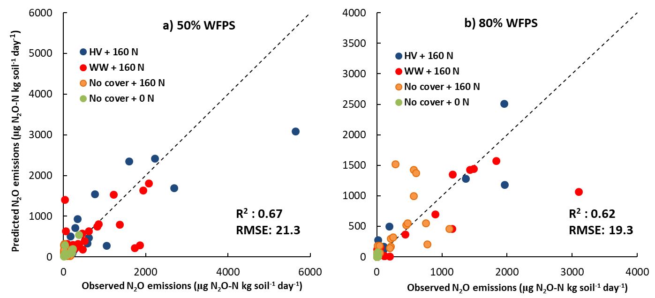

Figure 4.8: Predicted vs observed N₂O emissions from the Random Forest N₂O flux model on the test data set: a) 50% WFPS and b) 80% WFPS. HV: Hairy vetch, WW: Winter wheat, No cover: No cover crop, No cover + 0 N: Control.

Discussion
Our findings revealed that even under suboptimal WFPS levels for denitrification (i.e., 50% WFPS in this study), N fertilized soils with cover crop residue addition exhibited N₂O emissions of similar or higher magnitude than soils experiencing water-induced anoxia at 80% WFPS, widely reported to promote N₂O emissions from denitrification (Dobbie and Smith, 2003; Schaufler et al., 2010; Pimentel et al., 2015). This is in line with previous studies contradicting the conventional understanding that full pore saturation is a prerequisite for denitrification (Oh et al., 2023). These findings carry notable implications for managing agricultural systems incorporating cover crops in the rotation to improve soil health through soil C sequestration. While elevated N₂O emissions can offset the soil C sequestration benefits, our study underscores the importance of understanding the fundamental mechanisms of water-independent soil anoxia and controls of N₂O emissions in response to cover crop management practices through the lens of high-resolution soil O₂ measurements, a proximal driver of N₂O emissions. This understanding is critical for accurate assessment of the net GHG mitigation potential of cover crops.

Respiration induced anoxia during cover crop residue decomposition decouples WFPS control on N₂O emissions
Mixing cover crop residues with N fertilizer created anoxia conducive for N₂O production under 50% WFPS, which is otherwise well-aerated to limit large N₂O emissions, especially from denitrification (Butterbach-Bahl et al., 2013). This led to high cumulative N₂O emissions comparable with the respective treatments under 80% WFPS conditions (Figure 4.4). On the other hand, the no cover crop treatments that received only N fertilizer under 50% WFPS produced N₂O emissions as low as the control treatment and six times lower than that under primarily water-induced anoxia at 80% WFPS. These findings align with our first hypothesis which postulated that respiration-induced anoxia caused by decomposing cover crop residues can promote N₂O emissions, even under sub-optimal WFPS conditions for denitrification. There are several lines of evidence that support this hypothesis. First, under 50% WFPS condition, cover crop residue addition exhibited a two-fold increase in cumulative CO₂ production compared to the no cover crop and control treatments (Table 4.1). This indicates higher heterotrophic respiration from residue C mineralization in well-aerated conditions under moderate WFPS. Increased C availability, acting as energy source for the denitrifiers (Weier et al., 1993), during cover crop residue decomposition was previously found to increase N₂O emissions (Mitchell et al., 2013). However, such an effect was decreased under the water-induced anoxia environment at 80% WFPS due to decreased overall residue decomposition. The divergence in temporal N₂O emissions from the cover crop treatments under 50% and 80% WFPS conditions was conspicuous up to day 5 of the incubation (Figure 4.2a, Figure 4.2b) indicating an accelerated phase of decomposition. Second, under 50% WFPS, peak N₂O and CO₂ emissions from the cover crop treatments coincided with depletion of soil O₂ concentration two days following N fertilization (Figure 4.2a; Figure 4.3a; Figure 4.5a). As previously reported in other studies (Zhu et al., 2015; Wang et al., 2021b), the use of optode technology enables the visualization of highly-resolved spatial soil O₂ dynamics following exogenous C incorporation. In the present study, the O₂ images clearly demonstrated that within 24 hours following N fertilization, the top 3 cm of soil experienced significant O₂ depletion in treatments with cover crops and 50% WFPS (Figure 4.5a, Figure 4.7a), leading to the development of hypoxic or even anoxic conditions in certain replicas. Such a mechanism to produce anoxia with a simultaneous increase in N₂O will remain unexplained when WFPS alone is used as surrogate of soil O₂ availability. Therefore, these findings further highlight the limitations of relying solely on WFPS in interpreting and predicting N₂O fluxes, which can only account for biophysical mechanisms of anoxia resulting from O₂ diffusion limitation in wet soils (Moldrup et al., 2000; Thorbjørn et al., 2008), while neglecting anoxia caused by microbial O₂ consumption during residue decomposition (Chen et al., 2013).
Cover crop incorporation led to high N₂O emissions in 50% WFPS soils, which can pose a greater environmental risk compared to the same emissions in soils under water-induced anoxia. This is due to the higher relative gas diffusivity of N₂O in soil versus air under 50% WFPS, with air-filled macropores, compared to 80% WFPS. The higher diffusivity would facilitate rapid escape of N₂O from the soil (Balaine et al., 2013, 2016), reducing the chances of biological N₂O reduction to N₂. Under 80% WFPS, a greater potential exists for the further reduction of N₂O to N₂ before the gas escapes from the soil into the atmosphere (Ciarlo et al., 2007). This scenario is particularly plausible in our study due to the depletion of substrates with a higher redox reaction energy yield, such as soil ${NO}_{3}^{-}$ supply under 80% WFPS (Table 4.2). In response, it is conceivable that microbes resort to using a redox couple with a lower energy yield, forcing greater N₂O reduction to N₂ (Weier et al., 1993).

Cover crop residue influenced nitrogen fertilizer derived N₂O losses under different WFPS
The fraction of fertilizer derived N₂O was greater under the co-presence of cover crops and N fertilizer compared to N fertilization with no cover crops, irrespective of WFPS status. However, a greater fraction of N₂O emissions was derived from SOM and/or cover crop sources under 50% than 80% WFPS (Figure 4.4). This may be explained by the additional N mineralized from the cover crop residues and the native SOM pool under 50% WFPS contributing to soil ${NH}_{4}^{+}$ and ${NO}_{3}^{-}$ pools that are substrates for N₂O production (Basche et al., 2014). Depletion of the ${NH}_{4}^{+}$ pool over time and relatively high ${NO}_{3}^{-}$ levels sustained throughout the incubation period indicates that nitrification of ${NH}_{4}^{+}$ released from mineralization of cover crop residues and SOM was continued under 50% WFPS (Table 4.2). The mineral N trend was in sharp contrast with the cover crop treatments under 80% WFPS where once the available ${NO}_{3}^{-}$ from N fertilizer was exhausted, the system became ${NO}_{3}^{-}$ limited due to inhibited nitrification of SOM and/or cover crops under wetter soils (Davidson et al., 2000). This was also reflected by high ${NH}_{4}^{+}$ availability sustained throughout the experiment. Therefore, the additional N sources, other than N fertilizer, under 50% WFPS perhaps resulted in three to six times higher N₂O contribution from the SOM and/or cover crop residues than that under 80% WFPS.

Differential drivers and processes of N₂O emissions in response to cover crops and WFPS
The patterns of N₂O daily fluxes differed among treatments with cover crop inclusion at 50% and 80% WFPS content, associated with distinct drivers of N₂O emissions in each case (Figure 4.2a, b). Under 80% WFPS content, peak N₂O fluxes for treatments with cover crops were exhibited at the initial stages of the incubation experiment until ${NO}_{3 }^{-}$ became a limiting factor (Table 4.2). The Random Forest model indicated a strong association between ${NO}_{3}^{-}$ levels and N₂O fluxes under 80% WFPS, where ${NO}_{3}^{-}$ was the most important feature in a model that accounted for 62% of the variability in N₂O fluxes (Table 4.4). Under water induced anaerobic conditions at 80% WFPS, the N₂O production was likely governed by denitrification primarily dependent on ${NO}_{3}^{-}$ from the fertilizer, while nitrification was restricted (Wang et al., 2023). This was indicated by the small change in soil ${NH}_{4}^{+}$ over the incubation period, particularly in the treatments with hairy vetch (Table 4.2). Consequently, approximately 90% of the N₂O emissions were derived from NO₃-N fertilizer from day 0 to day 5 of the incubation experiment for treatments with cover crops (Figure 4.2d). The restriction in nitrification resulted in consistently low N₂O emissions once fertilizer ${NO}_{3}^{-}$ levels were exhausted (Figure 4.2b, Table 4.2). The low importance assigned to soil O₂ concentration in the Random Forest model to explain the variability in N₂O emissions under 80% WFPS highlights that NO₃-N availability becomes the main driver under reduced gas diffusivity.
Conversely, N₂O emissions under 50% WFPS were heavily related to ${NH}_{4}^{+}$, soil O₂, and CO₂ fluxes as these parameters were the main features in a model that explained 67% of the variability in N₂O emissions (Table 4.4). Peak N₂O emissions for treatments with cover crop coincided with elevated soil CO₂ fluxes and depletion of soil O₂ contents two days following N fertilization (Figure 4.3a, Figure 4.5a). During the peak of emissions, N₂O fluxes were primarily derived from readily available NO₃-N from N fertilizer (75 to 91%, Figure 4.2c), suggesting that even under 50% WFPS, a large proportion of the total N₂O emissions in the early stages of the incubation experiment were from denitrification (Li et al., 2016; Kravchenko et al., 2017). This finding is consistent with previous existing studies, which identified a decoupling of the conventional relationship between WFPS and N₂O production pathways (Zhu et al., 2013b; Oh et al., 2023). Similar to these studies, our findings contrast with the conceptual model of sources of N₂O presented by Davidson et al. (2000), which propose nitrification as the main source of N₂O under 60% WFPS soil content. However, denitrification was not the sole process contributing to N₂O emissions under 50% WFPS. A declining soil ${NH}_{4}^{+}$ pool with a sustained supply of ${NO}_{3}^{-}$ over the incubation period (Table 4.2), along with a reduction in the fraction of N₂O derived from fertilizer (Figure 4.2c) but with a sizable amount of total N₂O production after the initial peak emission phase, suggests that nitrification (Wang et al., 2023) or even nitrifier denitrification (Zhu et al., 2013a), might have also contributed to N₂O fluxes, and accounted for the importance of the ${NH}_{4}^{+}$ feature in the Random Forest model.
While ${NO}_{3}^{-}$ drove N₂O emissions in all treatments under 80% WFPS conditions, the N₂O daily flux pattern and magnitude differ between treatments with and without cover crop residues addition (Figure 4.2b). In residue amended soils, peak N₂O fluxes were approximately three-fold higher than those without residue, evidencing that the exogenous addition of labile C triggered N₂O emissions. As previously documented, these results confirm that C limitation to microbes is a crucial driver for heterotrophic denitrification (Aulakh et al., 1991; Li et al., 2022), particularly under water-induced anoxia and high soil ${NO}_{3}^{-}$ levels, and that cover crop residues can overcome such limitation to add to the risks of enhanced N₂O emissions (Oliveira et al., 2022b; Panday et al., 2022).
The occurrence of respiration-induced anoxia under 50% WFPS is expected to be closely linked with organic matter mineralization (Keiluweit et al., 2018). Peak N₂O and CO₂ emissions were closely associated when cover crop residues were added under 50% WFPS (Figure 4.2a, Figure 4.3a). A recent study by Ye et al.(2023), showed that straw residue incorporation affected soil N₂O and CO₂ emissions by altering the dissolved organic carbon and O₂ content of the soil. A greater association of CO₂ than POXC with N₂O emissions (Table 4.4), especially under 50% WFPS, highlights that microbial respiration is closely linked to soil CO₂ emissions, while POXC represents net C availability.

Cover crop type did not significantly influence N₂O emissions under both 50 and 80% WFPS
Irrespective of the WFPS content, there was no significant difference in cumulative N₂O production between legume and non-legume cover crops (hairy vetch vs winter wheat, Figure 4.4). This finding does not support our second hypothesis, which proposed that co-locating mineral N fertilizer and high-quality vetch cover crop residues would deplete soil O₂ at a faster rate compared to grass wheat cover crop residues, resulting in greater N₂O emissions. This finding contrasts with several studies that have demonstrated higher N₂O emissions via denitrification from legume residues compared to grass residues, across different WFPS content (Gomes et al., 2009; Pimentel et al., 2015; Li et al., 2016). This discrepancy between studies can be attributed to the following reasons: First, due to mixing of residues with a high level of N fertilizer, ${NO}_{3}^{-}$ levels were never limiting throughout the entire incubation period under 50% WFPS (Table 4.2). Thus, the ${NH}_{4}^{+}$ supply from vetch residue decomposition and the subsequent N₂O emissions derived from nitrification were not sufficient to significantly differentiate cumulative N₂O emissions between treatments with hairy vetch and winter wheat. Second, soil O₂ levels during the incubation period exhibited similar patterns (Figure 4.5a) between the different cover crop types under 50% WFPS content, suggesting that the easily decomposable C fraction did not differ significantly between treatments. Third, winter wheat C:N ratio (24:1) was not high enough to induce net N immobilization and reduce soil N₂O emissions (Chen et al., 2013; Abalos et al., 2022; Olesen et al., 2023).

Conclusions
Our study illustrates the biogeochemical mechanism of anoxia formation by accelerated microbial respiration following cover crop residue and N fertilizer addition to influence N₂O emissions. This was achieved by using a novel planar optode sensing technology, enabling high-resolution measurement of soil profile O₂ dynamics in response to residue addition. Under suboptimal WFPS levels for denitrification, N₂O emissions can be triggered by cover crop residues to a similar or even higher level than in soils experiencing water-induced anoxia that typically promotes large N₂O emissions from denitrification. Under water induced anaerobic conditions (80% WFPS), cover crops controlled N₂O emissions via altering labile C availability and had little effect on mineral N availability. Whereas under relatively aerobic conditions (50% WFPS), cover crop residue decomposition consumed soil O₂ to promote anoxia that led to increased N₂O emissions. This scenario poses a greater environmental risk compared to soils under water-induced anoxia as it enables the rapid escape of N₂O from soil due to higher diffusivity and reduces the likelihood of biological N₂O reduction to N₂. These findings hold crucial implications for managing agricultural systems using cover crops. The respiration-induced anoxia mechanism observed in this study along with cover crop’s role in altering coupled soil C, N, and water cycling will drive net soil N₂O emissions which should be accounted for within the broader context of assessing cover crop impacts on soil health. Elevated N₂O emissions can offset the benefits of soil C sequestration, often a common goal in using cover crops. This further highlights the importance of accurately assessing the C footprint of cover crops by quantifying their impacts on N₂O emissions.
The decoupling of WFPS controls on soil O₂ can be prominent as decomposition rate increases. This poses a formidable challenge in accurately predicting N₂O emissions, particularly in the context of growing adoption of cover cropping for soil health. Our study suggests that the occurrence of respiration-induced anoxia during cover crop residue decomposition in fertilized soils can disrupt the traditional WFPS controls on N₂O emissions. Relying solely on WFPS, an imperfect proxy for diffusion-induced O₂ limitation, may lead to the underestimation and inaccurate prediction of potential risks associated with N₂O emissions, especially in cover crop based fertilized agricultural systems. Therefore, models should incorporate a more comprehensive understanding of these dynamics to enhance predictive accuracy and better capture the complexities of N₂O emissions in such agroecosystems.

Depth-dependent links between microbial taxa and nitrous oxide emissions in a long-term cotton cropping system employing soil health practices

A version of this chapter was submitted for publication in Geoderma. Facundo Lussich was responsible for conceptualization, formal analysis, investigation, methodology, and writing. Debasish Saha, Jashanjeet Kaur Dhaliwal, Melissa Cregger, and Shawn Brown provided input on methodology, review & editing.

Abstract
Long-term management practices can shape soil microbial communities in ways that influence nitrogen (N) dynamics and nitrous oxide (N₂O) emissions. We leverage a 41-year continuous cotton cropping experiment with contrasting tillage, cover cropping, and N fertilization regimes to investigate how these long-term strategies influence soil microbial communities and their association with N₂O fluxes during the cotton growing season. Using 16S rRNA gene metabarcoding, we assessed microbial composition in surface and subsurface soils and evaluated in relation to temporal N₂O emissions. Among the management practices, N fertilization – a known driver of N₂O emissions – had the strongest effect on microbial community composition and was linked to a greater number of taxa correlated to N₂O emissions, particularly in surface soils. Soil pH emerged as a key variable influencing microbial structure across depth and was negatively associated with both N₂O emissions and microbial composition in the surface layers of fertilized soils. In total, 57 archaeal/bacterial taxa were correlated with N₂O fluxes, but only seven were shared across depths, suggesting distinct microbial contributors in surface and subsurface soils. Several of these taxa have been previously reported to be associated with N and C cycling processes such as nitrate respiration or carbon turnover, providing ecological context for their correlations with fluxes. Temporal shifts in the abundance of key taxa aligned with seasonal peaks in N₂O emissions, notably in early and late August, and were most pronounced under conventional tillage, hairy vetch cover cropping, and N fertilization. While 16S-based associations cannot confirm functional gene presence or activity, these findings demonstrate that long-term fertilization and associated soil acidification are dominant drivers of microbial shifts linked to N₂O emissions and highlight the importance of accounting for depth-specific and seasonal microbial dynamics when evaluating management impacts on greenhouse gas emissions.

Introduction
Nitrous oxide (N₂O) is a potent greenhouse gas and its emissions from agricultural systems accounts for nearly two-thirds of global anthropogenic N₂O emissions (EPA, 2023). Nitrous oxide emissions from agricultural soils are primarily driven by microbial transformations of nitrogenous compounds added in managed systems. Intensive nitrogen (N) fertilization exacerbates these processes, not only increasing N₂O emissions but also reducing crop N use efficiency, thereby undermining both crop productivity and environmental sustainability (Thompson et al., 2019; Tian et al., 2020). To address these challenges, implementing soil health practices offers a promising avenue to mitigate the environmental footprint while enhancing resilience of agricultural production systems.
In this context, long-term adoption of no-till and cover cropping has emerged as a viable strategy to reduce the environmental impacts of managed agricultural systems (Blanco-Canqui et al., 2015; Poeplau and Don, 2015). These practices influence soil physical and chemical properties, including organic matter content, soil structure, pore network, and moisture dynamics (Govaerts et al., 2009; Nouri et al., 2019; Mondal and Chakraborty, 2022; Nugroho et al., 2023; Dhaliwal et al., 2024a). In turn, these changes impact soil microbial communities by altering their diversity, structure, and functional potential (Li et al., 2024). This is particularly relevant for mitigating N₂O emissions, as microbial pathways responsible for N₂O production are sensitive to shifts in biogeochemical conditions (Song et al., 2022).
Management practices such as N fertilization, tillage, and cover cropping are well known to influence soil microbial communities (Ceja-Navarro et al., 2010; Wessén et al., 2010; Chaudhry et al., 2012; Lupwayi et al., 2012; Navarro-Noya et al., 2013; Mbuthia et al., 2015; Jiménez-Bueno et al., 2016; Liu et al., 2020; Hu et al., 2021). For instance, N fertilization often favors copiotrophic taxa that thrive in nutrient-rich environments (Wessén et al., 2010; Jiménez-Bueno et al., 2016; Piazza et al., 2019). Whereas tillage can promote the occurrence of Actinobacteria, Betapreoteobacteria, and Gammaproteobacteria, an effect modulated by soil carbon (C) and clay content (Navarro-Noya et al., 2013). However, the overall effect of tillage on microbial diversity remains inconclusive, with some studies reporting increased diversity (Duan et al., 2022) and others finding no significant change (Li et al., 2018). Despite these well-documented management effects, depth-specific microbial responses and their seasonal contributions to N₂O emissions under long-term management remain poorly understood. These responses are often stratified along soil depth, shaped by vertical gradients in soil physicochemical properties under the legacy of long-term management practices (Piazza et al., 2019; Polain et al., 2020; Patra et al., 2022). Although microbial communities play a central role in N₂O production, few studies have integrated temporal and depth-specific microbial composition dynamics alongside N₂O flux measurements.
Most efforts to explain N₂O dynamics have focused on soil properties such as moisture, temperature, and N availability (Cayuela et al., 2014; Wang et al., 2021; Dhaliwal et al., 2024), which alone often fail to capture the full complexity of emissions patterns (Saha et al., 2021a). Incorporating microbial data has been shown to improve predictions of ecosystem processes (Graham et al., 2016), promoting interest in exploring associations between microbial communities and N₂O emissions. In this context, several studies have quantified the abundance and expression of functional genes linked to N₂O production using quantitative and reverse transcription qPCR (Yang et al., 2017, 2022; Tang et al., 2019; Tosi et al., 2020; Hu et al., 2021). Although these functional gene-based approaches provide valuable insights into the microbial potential for N transformations, they often lack consistent relationships between gene or transcripts abundance and actual process rates (Rocca et al., 2015). This suggests that the presence or activity of N-cycling genes does not necessarily translate to in situ N₂O fluxes, challenging the assumption that microbial functional potential alone can reliably predict emissions dynamics.
Given these limitations, there is growing interest in exploring microbial community composition as a complementary approach for understanding N₂O dynamics. Rather than focusing solely on functional gene abundance, identifying specific microbial taxa may provide a more direct link to N₂O emissions. Although linking taxa to function is inherently challenging due to functional redundancy and the complexity of soil microbial networks (Fierer, 2017), emerging evidence suggests that certain microbial taxa disproportionately influence ecosystems functions, including N cycling, compared to the entire community (Wertz et al., 2007; Wilhelm et al., 2014; Louca et al., 2018; Gu et al., 2024; Mao et al., 2024). Integrating high-throughput sequencing with data driven modeling provides a promising avenue to detect these key taxa and evaluate their potential as indicators or drivers of N₂O fluxes (Bano et al., 2024; Xu et al., 2024).
Understanding these relationship is further complicated by the high temporal and spatial variability of N₂O emissions, often driven by hot-spots and hot-moments associated with weather (e.g., precipitation) and management shifts (e.g., N fertilization, tillage) (Wagner-Riddle et al., 2020; Song et al., 2022b). However, microbial assessments are commonly limited to single time point measurements, overlooking the temporal dynamics essential to linking microbial activity with emission patterns. Such temporal dynamics are increasingly recognized as critical, since management effects on microbial communities may vary across crop growth stages and environmental conditions. For example, fertilization and tillage effects on bacterial community structure have been shown to shift across multiple sampling dates, whereas cover cropping and soil moisture effects may only emerge at specific phenological stages (Duan et al., 2022). Similarly, tillage-driven differences in bacterial and fungal communities can weaken or intensify depending on the timing of measurement (Degrune et al., 2017). Consequently, single time-point sampling can mask management-induced microbial responses and limit the ability to link community changes with episodic N₂O fluxes. Additionally, the role of soil depth is often neglected, despite its critical influence on microbial processes due to biogeochemical stratification of the soil profile. Long-term experiments incorporating contrasting tillage, cover crops, and N fertilization levels offer a unique opportunity to explore how management practices shape microbial communities over time and depth, and how these shifts, in turn, relate to N₂O emission dynamics.
Leveraging a 41-year continuous cotton cropping experiment with contrasting tillage, cover cropping, and N fertilization treatments, this study aimed to: i) identify associations between surface and subsurface archaeal/bacterial taxa and temporal N₂O emissions during the growing season using high-throughput sequencing, and ii) evaluate how these taxa are influenced by management practices and key soil biogeochemical drivers. We hypothesized that N fertilization, tillage, and cover cropping would differentially influence N₂O emissions by altering the abundance and composition of microbial taxa, particularly in the surface soil layer where management impacts are most realized. Because nutrient availability and soil O₂ dynamics vary with depth, we further expected that management-induced changes in microbial communities would be strongest in the surface soil, where greater fluctuations in moisture, redox conditions, and inputs occur, and progressively weaker with depth. Consequently, the strength of taxa-N₂O relationships was predicted to decline with increasing soil depth. Specifically, we expected temporal patterns in N₂O fluxes to coincide with depth-dependent shifts in the relative abundance of key microbial groups functionally relevant to N cycling. Furthermore, we anticipated that long-term management practices would exert legacy effects on microbial community structure, driven by cumulative changes in soil properties such as pH and organic matter content.

Materials and Methods

Experimental site and soil sample collection
This study was conducted in a long-term continuous cotton (Gossypium hirsutum L.) experiment, established in 1981 at the University of Tennessee’s West Tennessee Research and Education Center in Jackson, Tennessee (35°37′23.1″ N, 88°50′47.4″ W; elevation 125 m). The soil at the site is Lexington silt loam (fine-silty, mixed, thermic, Ultic Hapludalfs), with a mean annual precipitation of 1415 mm and an average air temperature of 15.6 º C. The experiment follows a randomized complete block design with split-split plots, including four replications and a total of 128 experimental units (12 m × 8 m). The long-term conservation management practices in the field involved different N fertilization rates, winter cover cropping, and no-till. Detailed descriptions of the experimental design, treatments, and management practices can be found in Dhaliwal et al. (2024). For this study, a subset of 32 plots was selected, including two levels of N (0; 67 kg N ha⁻¹), two levels of cover crop (no cover crop, NC; hairy vetch, HV), and two levels of tillage (no-tillage, NT; conventional disk tillage, CT), across four blocks. This subset was chosen to represent common management practices while balancing the resource limitations associated with intensive microbial and gas flux analyses. This combination resulted in eight treatments: CT-NC-0, CT-NC-67, CT-HV-0, CT-HV-67, NT-NC-0, NT-NC-67, NT-HV-0, and NT-HV-67. Although the experiment is generally rainfed, two critical irrigation events were applied during the 2022 cotton growing season (July 7 and July 26), each delivering 55 mm of water, to alleviate severe drought stress observed in June and July.
Soil samples were collected five times during the 2022 cotton growing season, aligned with key management timings and crop growth stages from two soil depths (0-10 cm and 10-20 cm). An exception was made for the final sampling event, where only surface soil (0-10 cm) was collected, as dry late-season conditions made deep sampling difficult without compromising sample integrity. The first sampling occurred on April 27, 2022, the day before cover crop termination as baseline, followed by the second on June 17, 2022, shortly after tillage and cotton planting. The third sampling took place on August 2, 2022, 10 days after fertilization, and the fourth on August 30, 2022, 40 days after fertilization. The final sampling was conducted on October 20, 2022, shortly after cotton harvest. After each sampling event, soil samples were divided into two subsamples: one stored at -80°C until sequencing analyses and the other used for soil chemical property analysis.

Soil chemical properties, greenhouse gas, and environmental data collection
Soil samples from the first sampling time-point were analyzed for soil organic C and total N concentrations using the dry combustion method with an Elementar vario Max cube CN analyzer, which was then used to estimate soil organic matter (SOM). At each sampling events, soil samples were analyzed for inorganic N (${NH}_{4}^{+}$ and ${NO}_{3}^{-}$) availability by 2M KCl extraction (Forster, 1995; Doane and Horwáth, 2003), permanganate oxidizable C (POXC) based on the method described by Weil et al. (2003), and soil pH using a pH electrode at a 1:2 ratio of soil to water. Local daily air temperature and precipitation were recorded throughout the entire growing season using an on-site meteorological station.
The N₂O and carbon dioxide (CO₂) fluxes were measured using a static closed chamber technique, consistently conducted between 8:00 am and 12:00 pm on each sampling day. N₂O fluxes were measured using a portable Integrated Cavity Output Spectroscopy (ICOS) instrument (Los Gatos Research Inc., Quebec, Canada), while CO₂ fluxes were measured using an infrared gas analyzer (LI-850, LI-COR Biosciences NE, USA). Both instruments operated in a closed loop with the chambers (Dhaliwal et al., 2024b). Greenhouse gases (GHG) fluxes were collected intensively following cover crop termination, tillage, fertilizer application, and heavy precipitation events, totaling 24 sampling events during the cotton growing season in 2022. However, the more frequent gas flux measurements were aligned with soil sampling events by averaging flux values over the intervals between consecutive soil sampling dates.
Soil temperature and volumetric moisture were recorded to a depth of 20 cm on each sampling day using a thermocouple temperature sensor and HydroSense II portable soil moisture sensor, respectively. Water-filled pore space (WFPS) was calculated based on bulk density and volumetric soil moisture data.

DNA extraction and MiSeq sequencing
Total soil DNA was extracted using a DNeasy PowerSoil® Kit (QIAGEN, Germantown, MD, USA) from 0.25 g of soil per sample using standard procedures. DNA quality and concentration were measured using a Nanophotometer (N60, Implen, Munich, Germany) and DNA concentrations were standardized to 20 ng/μL.
To generate amplicon sequencing libraries, a two-step PCR approach was used (Brown et al., 2018). Primary amplicon libraries for bacteria were generated by targeting the V4 hypervariable region of 16S rDNA with the modified primers 515f and 806r (Caporaso et al., 2011; Apprill et al., 2015; Parada et al., 2016). Primary PCR primer constructs also included Nextera sequencing primers (nexF and nexR) as well as a range of ambiguous nucleotides (N[3-6]) and were constructed as follows: nexF-N[3-6]-515f and nexR-N[3-6]-806r for bacteria and archaea. PCRs were conducted in 25 μL reactions containing: 2 μL DNA template (40ng), 12.5 μL Phusion Green™ Hot Start II High-Fidelity Master Mix (ThemoFisher Scientific, Waltham, MA, USA), 5.5 μL nuclease-free H₂O, and 2.5 μL each of the forward and reverse primers (at 1 μM). PCR parameters were set for: initial denaturation (98 °C; 30 s); 25 cycles of denaturation (98 °C; 10 s), primer annealing (52.5 °C; 30 s), extension (72 °C; 40 s); final extension step (72 °C; 10 min). The ramp rate was 1.0 °C s⁻¹ for annealing steps. All amplifications were visually confirmed with gel electrophoresis.
Secondary PCR was conducted using respective forward and reverse primer pairs P5-i5-overlap and P7-i7-overlap, comprised of unique dual-barcoded MIDs (i5 and i7), Illumina Adaptor sequence (P5 and P7) and partial overlap with the nexF and nexR sequences that acts as the annealing site for primers. Forward and reverse secondary primers were mixed to generate unique dual-barcoded primers. Multiplexed amplicons were generated by PCR in a 25 μL reaction containing: 2.5 μL primary PCR product, 12.5 μL Phusion Green Hot Start II High-Fidelity PCR Master Mix, 7.5 μL molecular grade nuclease-free H₂O, and 2.5 μL of dual-barcoded primer mix (0.5 μM each primer). PCR parameters were set for: denaturation (98 °C; 30 s); 10 cycles of denaturation (98 °C; 20 s), primer annealing (50 °C; 20 s), and elongation (72 °C; 50 s); a final extension step (72 °C; 10 min). In total, 35 cycles were run. All amplification was confirmed visually and negative controls consisting of sterile water were extracted, amplified, and sequenced and remained free of contamination.
PCR products were cleaned using AxyPrep™ Mag PCR Clean-up kits using a 1:1 ratio of PCR product to beads (Brown and Jumpponen, 2014). Cleaned PCR products were quantified using a Qubit 3.0 fluorometer with QubitⓇ dsDNA HS assay kits and pooled at equal concentrations and cleaned once again as above. Libraries were sequenced on a single Illumina MiSeq (300PE) at the Integrated Genomics Facility (Manhattan, KS, USA). Sequence data were demultiplexed using the unique i5 and i7 sequence combinations to produce fastq files for each sample.

Bioinformatics and statistical analysis
All bioinformatics and statistical analysis were conducted using R (version 4.2.764) and Python (version 3.10.12). Sequence processing was carried out using the Dada2 pipeline (Callahan et al., 2016). Primer sequences were removed with Cutadapt (version 3.5; Martin 2011), followed by denoising, dereplication, error model training, merging of forward and reverse reads, and chimera removal. Taxonomic assignment was performed using the SILVA reference database (version 138.1). To ensure standardized estimates of diversity across samples, all sequences were rarefied to a depth of 3351 reads per sample.
To evaluate the effects of management practices and sampling time-point on N₂O fluxes, a linear mixed effects model was fitted using the lme4 package in R (Bates et al., 2015). Nitrous oxide flux data were transformed using the Box-Cox method to meet assumption of normality, which was tested using the Shapiro-Wilk test. The model included N fertilization rate, cover cropping, tillage, and sampling time-point as fixed effects, along with their interactions. Block was included as a random effect. When main effects or interactions were statistically significant at α = 0.05, pairwise comparisons were performed using estimated marginal means from the emmeans package in R (Lenth, 2025), followed by Tukey’s HSD test to determine differences between groups.
To examine the influence of long-term management on microbial community structure, a four-way factorial permutational multivariate analysis of variance (PERMANOVA, Anderson, 2017) was conducted using the adonis2 function from the vegan package in R (Oksanen et al., 2025), with 999 permutations. Effect sizes for each factor were calculated as partial omega squared ($ω_{p}^{2}$), following Cumming (2013). When factors were statistically significant, effect sizes were interpreted based on thresholds proposed by Cohen (1988): $ω_{p}^{2}$ = 0.01 (small effect), $ω_{p}^{2}$ = 0.06 (medium effect), and $ω_{p}^{2}$ = 0.14 (large effect). To assess the influence of soil biochemical variables on microbial community composition, a distance-based redundancy analysis (db-RDA) was performed using Bray-Curtis dissimilarity matrices with the capscale function from the vegan package in R. Analyses were conducted separately for each significant management factor with sampling time-point and block included as conditioning variables. Explanatory biochemical variables with permutation tests p-values $≤$ 0.10 (anova.cca function) were retained for final visualization.
To examine the relationship between microbial taxa and N₂O emissions, Spearman’s correlation coefficients were calculated between N₂O fluxes and the relative abundance of each taxon. Although correlations were computed at the ASV level, results are presented using the lowest available taxonomic classification for each ASV to aid interpretability. Correlations were calculated using the cor and cor.test functions from the stats package in R (Bolar, 2019), following methods adapted from Carrell et al. (2023) and Sant’Anna et al. (2024). Correlations between these taxa and soil biogeochemical variables were assessed using the same approach. Taxa showing significant associations with N₂O emissions, defined as Spearman’s correlation coefficient greater than |0.20| with p-value $≤$ 0.05, were selected for further visualization. These relationships were displayed in a heatmap generated in Python using the seaborn package (Waskom, 2021). To confirm statistical significance, generalized linear models (GLMs) were applied with relative abundances as response variables and individual biochemical variables as predictors. All statistical tests were evaluated at a significance threshold of p-value $≤$ 0.05.
To identify the top ten microbial taxa most strongly associated with N₂O emissions, Random Forest (RF) regression models were fitted using the RandomForestRegressor function from the sklearn.ensemble module in Python (Pedregosa et al., 2011), following methods adapted from Gu et al. (2024); Xu et al. (2024). Separate models were developed for the 0-10 cm and 10-20 cm soil depths using the relative abundance of taxa at the ASV level. Results are presented based on the lowest available taxonomic classification assigned to each ASV to facilitate interpretation. After hyperparameter tuning, the 0-10 cm model used: random_state = 42, n_estimators = 200, max_depth = 20, max_features = ‘sqrt’, min_samples_leaf = 3. The model for 10-20 cm used: random_state = 42, n_estimators = 500, max_depth = 20, max_features = ‘sqrt’, min_samples_leaf = 4. Feature importance scores from each model were used to rank taxa, and the ten taxa with the highest scores were selected for further analysis. To interpret the relationship between these key taxa and N₂O fluxes, partial dependence plots were generated using the partial_dependence function from sklearn.inspection module (Pedregosa et al., 2011).
A four-way analysis of variance (ANOVA) was conducted to evaluate the effects of management practices and sampling time-point on the relative abundance of the top ten taxa associated with N₂O emissions at each soil depth. Prior to analysis, relative abundance data were logit-transformed to meet model assumptions. When significant effects were detected, Tukey’s HSD test was applied to determine the direction of changes. To visualize seasonal dynamics, BiomeHorizon plots (Fink et al., 2022) were generated to display the relative abundance dynamics of the top ten taxa over the growing season, stratified by soil depth. Comparisons between management practices levels were shown only when p-value $≤$ 0.10.

Results

Effect of management practices on temporal N₂O emissions
Mean daily N₂O fluxes, estimated by averaging the daily measurements taken during the 25 days in between two microbial sampling dates, were significantly influenced by the interaction between management practices and sampling time-point (Figure 5.1). Major emissions peaks were observed on August 2 and 30, following N fertilization and large precipitation events. N fertilization had the strongest and most consistent effect (Figure 5.1A), with fertilized plots showing higher fluxes than unfertilized plots on both August 2 (13.4 vs 9.8 g N-N₂O ha⁻¹ day⁻¹) and August 30 (14.0 vs 7.3 g N-N₂O ha⁻¹ day⁻¹). While tillage and cover crop effects were more limited in duration. On August 2, CT plots resulted in higher emissions compared to NT plots (14.5 vs 8.3 g N-N₂O ha⁻¹ day⁻¹; Figure 5.1B). On August 30, HV plots exhibited higher emissions than NC plots (13.2 vs 8.3 N-N₂O ha⁻¹ day⁻¹; Figure 5.1C).

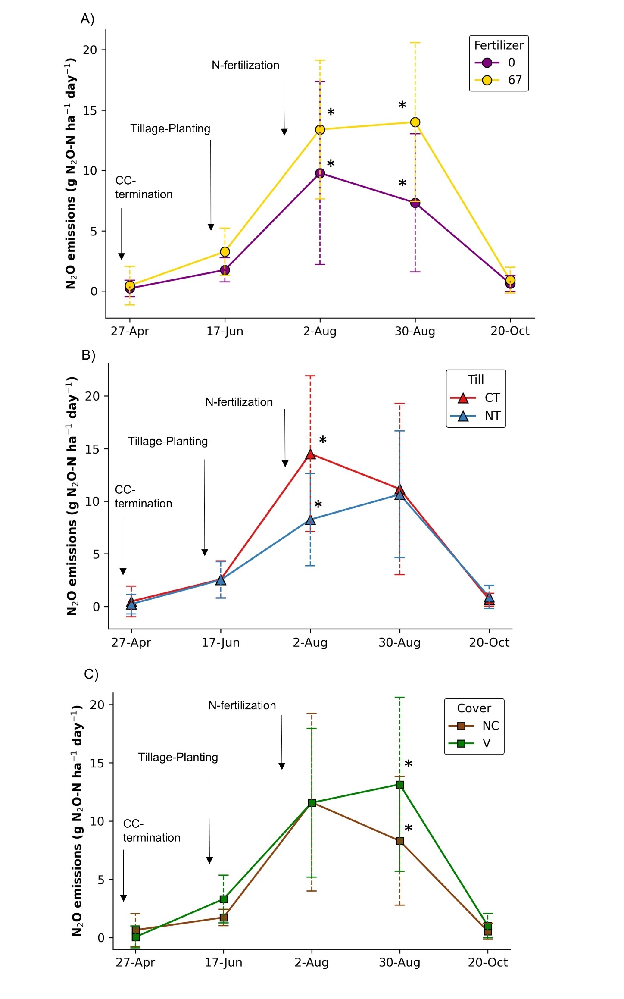
Figure 5.1: Effect of fertilizer (A), tillage (B), and cover cropping (C) on average nitrous oxide (N₂O) fluxes during the 25 days prior to five sampling dates in the 2022 cotton growing season. Arrows indicate timing of key management practices. T-bars represent standard deviation. Asterisks (*) indicate statistically significant differences (p $≤$ 0.05). Cover Crop (CC); No-till (NT), Conventional tillage (CT); No-Cover crop (NC), Vetch (V).

Influence of management practices, sampling time-point, and biochemical variables on microbial community composition across soil depths
A total of 846 taxa were identified. N fertilization was the strongest driver of microbial community composition, in surface soils (0-10 cm), with a medium effect size ($ω_{p}^{2}$ = 0.085), followed by sampling time-point ($ω_{p}^{2}$ = 0.076, medium), tillage ($ω_{p}^{2}$ = 0.061, medium), and cover cropping ( $ω_{p}^{2}$ = 0.016, small) (Table 5.1). The influence of management was more pronounced in the surface than in the subsurface (10-20), where all four factors had small but significant effects (Table 5.1). Consistent with PERMANOVA results, fertilization effects on microbial community composition were visually more distinct at 0-10 cm than at 10-20 cm (Figure 5.2). Distance-based redundancy analysis (db-RDA) based on Bray-Curtis distances showed that in fertilized surface soils, N₂O fluxes aligned with shifts in microbial composition and followed a similar directional influence as NO₃⁻ , POXC, SOM, and total N (Figure 5.2A). In contrast, soil pH was negatively associated with N₂O emissions and community composition in these fertilized surface soils. At 10-20 cm depth, microbial communities were more dispersed and less clearly structured by fertilization, though pH consistently exhibited an opposite directional influence on community composition in N fertilized subsoils (Figure 5.2B).

Table 5.1: Four-way factorial PERMANOVA results for soil microbial community composition (846 taxa) across depths (0-10 and 10-20 cm), based on Bray-Curtis dissimilarities of relative abundances. Shown are pseudo-F statistics, degrees of freedom (total df =153 for 0-10 cm and 109 for 10-20 cm), p-values, and partial omega-squared effect sizes for significant factors.

 | 0-10 cm
Treatments | Pseudo-F | df | p-value | $$ω_{p}^{2}$$ | Effect size
Time-point | 3.43 | 4 | 0.001* | 0.076 | Medium
Fertilizer | 11.7 | 1 | 0.001* | 0.085 | Medium
Till | 8.51 | 1 | 0.001* | 0.061 | Medium
Cover | 2.83 | 1 | 0.001* | 0.016 | Small
Time-point x Fert | 0.78 | 4 | 0.897
Time-point x Till | 0.89 | 4 | 0.651
Fert x Till | 1.94 | 1 | 0.003* | 0.008 | Negligible
Time-point x Cover | 0.77 | 4 | 0.912
Fert x Cover | 1.20 | 1 | 0.146
Till x Cover | 1.41 | 1 | 0.071
Time x Fert x Till | 0.86 | 4 | 0.732
Time x Fert x Cover | 0.73 | 4 | 0.960
Time x Till x Cover | 0.71 | 4 | 0.983
Fert x Till x Cover | 1.00 | 1 | 0.345
Time x Fert x Till x Cover | 0.73 | 4 | 0.973
 | 10-20 cm
Treatments | Pseudo-F | df | p-value | $$ω_{p}^{2}$$ | Effect size
Time-point | 2.20 | 3 | 0.001* | 0.042 | Small
Fertilizer | 3.86 | 1 | 0.001* | 0.035 | Small
Till | 4.73 | 1 | 0.001* | 0.045 | Small
Cover | 3.37 | 1 | 0.001* | 0.029 | Small
Time-point x Fert | 1.35 | 3 | 0.035* | 0.013 | Small
Time-point x Till | 0.95 | 3 | 0.405
Fert x Till | 1.64 | 1 | 0.044* | 0.008 | Negligible
Time-point x Cover | 1.21 | 3 | 0.097
Fert x Cover | 2.30 | 1 | 0.004* | 0.016 | Small
Till x Cover | 1.34 | 1 | 0.129
Time x Fert x Till | 1.29 | 3 | 0.051
Time x Fert x Cover | 0.96 | 3 | 0.434
Time x Till x Cover | 0.97 | 3 | 0.364
Fert x Till x Cover | 1.05 | 1 | 0.280
Time x Fert x Till x Cover | 0.76 | 3 | 0.802
*p-values were obtained using 999 permutations

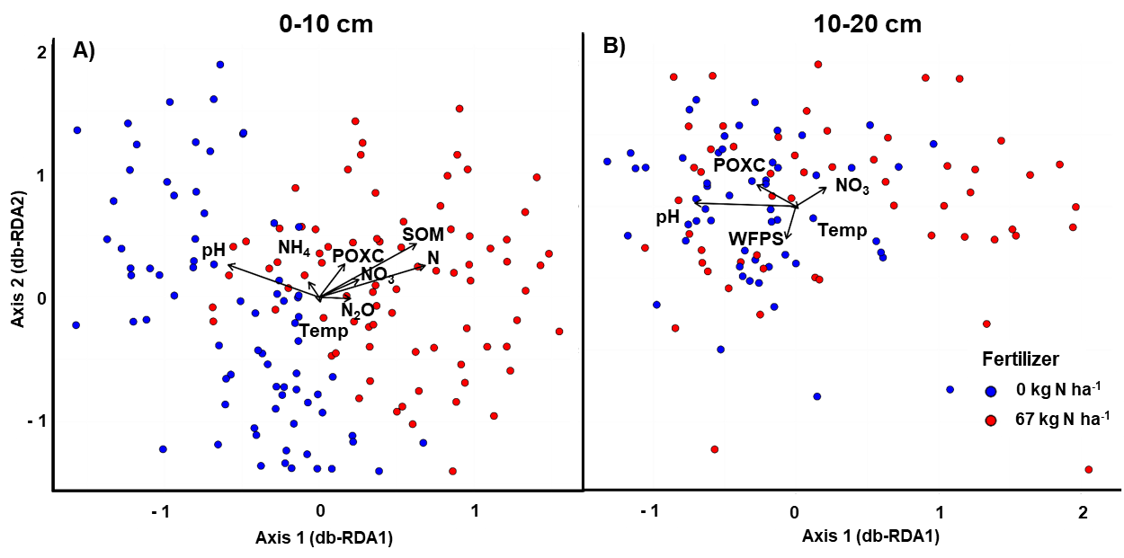
Figure 5.2: Distance-based Redundancy Analysis (db-RDA) of microbial community composition (Bray-Curtis dissimilarity) by fertilization level at (A) 0-10 cm and (B) 10-20 cm depth. Arrows represent biochemical variables with p-values $≤$ 0.10 identified through permutation tests.

Microbial taxa associated with nitrous oxide emissions and their relationship with biochemical variables
Approximately 65% (n = 547) of all identified taxa were shared between surface (0-10 cm) and subsurface (10-20 cm) soils (Figure 5.3A). Of the 57 taxa significantly correlated with N₂O emissions (Spearman’s correlation coefficient > |0.20|, p-value $≤$ 0.05), only 7 overlapped across depths (Figure 5.3B). In contrast, 38 were unique to the surface and 12 to the subsurface. Overall, 45 surface taxa were associated with N₂O emissions, compared to 19 in the subsurface (Figure 5.3B; Figure 5.4). These results indicate stronger associations between N₂O and microbial communities observed in surface soils.

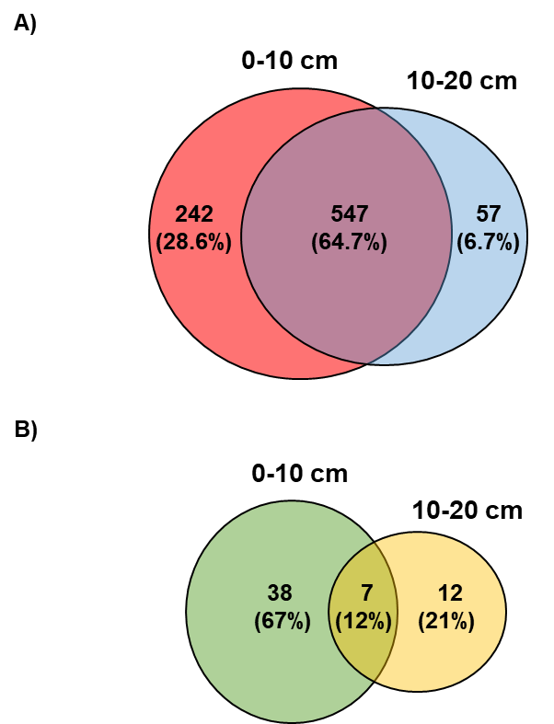

Figure 5.3: Venn diagram showing (A) the total soil microbial taxa (n = 846) and (B) the subset of taxa associated with N₂O emissions (n = 57), comparing their presence across two soil depths (0-10 cm and 10-20 cm).

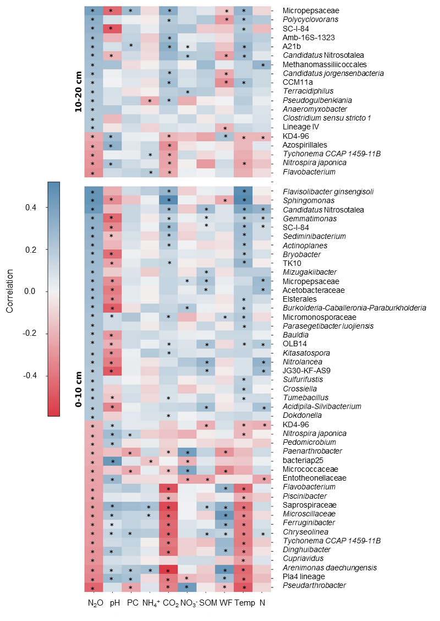
Figure 5.4: Heatmap showing correlations between soil microbial taxa associated with N₂O emissions and soil biochemical variables across depths. Asterisks (*) indicate statistically significant correlations (p $≤$ 0.05), as determined using generalized linear models (GLMs). POXC (PC); WFPS (WF).
Distinct taxa were associated with N₂O emissions at each depth. In surface soils (0-10 cm), positively associated taxa included those best identified as Flavisobacter ginsengisoli, Sphingomonas sp., and Gemmatiomonas sp.. In contrast, A21b, Polycyclovorans sp., and Amb16S-1323 were uniquely linked to emissions in the subsurface (10-20 cm) (Figure 5.4). Only a few taxa, including SC-I-84, Candidatus Nitrosotalea sp., Micropepsaceae sp., Nitrospira japonica, KD4-96, Tychonema CCAP 1459-11B, and Flavobacterium sp. were shared across depths. Across soils depths, taxa positively associated with N₂O emissions also tended to correlate positively with soil temperature and CO₂, but negatively with pH.
To identify the most influential taxa associated with N₂O emissions, RF models were fitted using the relative abundance of all 864 taxa, with the top ten ranked by model importance (Figure 5.5A and 5.5B). At both depths, nine of the ten taxa were positively associated with N₂O emissions, and one negatively associated (Figure 5.5C, D). Most overlapped taxa already identified as strongly correlated with N₂O emissions (Figure 5.4), reinforcing their ecological relevance.
At the 0-10 cm, positively associated taxa included Sphingomonas sp., Candidatus Nitrosotalea sp., Falvisolibacter ginsengisoli, Gemmatimonas sp., Mizugakiibacter sp., SC-I-84, Ktedonobacteraceae sp., Micromonosporaceae sp., and Acetobacteracea sp., while Pseudarthrobacter sp. was negatively associated. At 10-20 cm, positively associated taxa included Anaeromyxobacter sp., Pseudogulbenkiana sp., Conexibater sp., Candidatus Nitrosotalea sp., A21b, Amb-16S-1323, SC-I-84, Micropepsaceae sp., and Methanomassiliicoccales sp., with Flavobacterium sp. showing a negative relationship. Only SC-I-84 and Candidatus Nitrosotalea sp. were common among the top ten taxa at both soil depths, suggesting that the most influential contributors to N₂O emissions were largely depth specific. Full taxonomic classifications of the RF selected taxa are provided in Table 5.2.

Management-driven temporal dynamics of key microbial taxa across soil depths
The temporal dynamics of the top ten microbial taxa, associated with N₂O emissions, as identified by the RF models, were visualized using BiomeHorizon plots depicting relative abundance changes over the growing season (Figure 5.6). Each plot represents one taxon, with depth specific resolution. Relative abundances at both depths generally increased on August 2 and August 30, aligning with the peak N₂O fluxes (Figure 5.6; also see Figure 5.1). In contrast, negatively associated taxa, such as Flavobacterium sp. and Pseudarthrobacter sp., showed reduced relative abundance during high N₂O flux period.

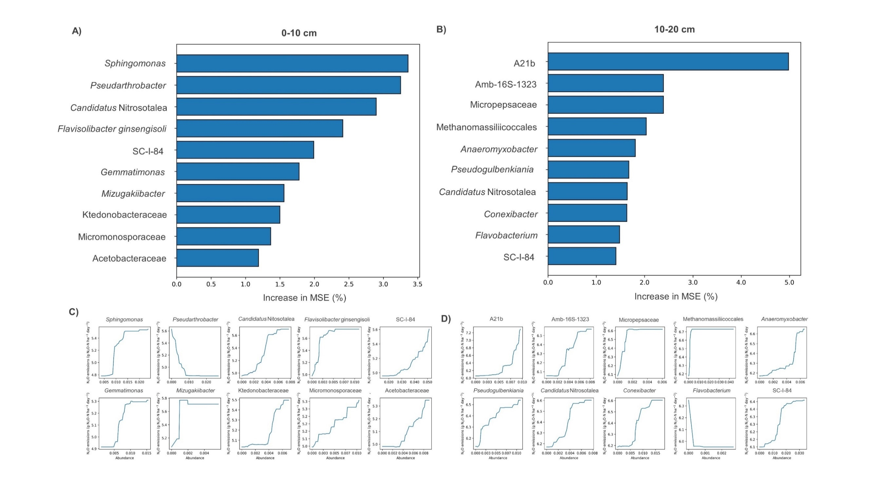
Figure 5.5: Key microbial taxa contributing to N₂O fluxes across soils depths, identified using random forest analysis. Panels A and B show the top 10 taxa with the highest increases in mean squared error (MSE) when permuted, at 0-10 cm and 10-20 cm depths, respectively. Panels C and D present partial dependence plots illustrating N₂O flux predictions for these taxa at 0-10 cm and 10-20 cm, respectively.

Table 5.2: Taxonomic classification of top ten microbial taxa identified by the random forest analysis across soil depths
0-10 cm
Phylum | Class | Order | Family | Genus
Actinobacteriota | Actinobacteria | Micrococcales | Micrococcaceae | Pseudarthrobacter
Proteobacteria | Alphaproteobacteria | Sphingomonadales | Sphingomonadaceae | Sphingomonas
Proteobacteria | Gammaproteobacteria | Burkholderiales | SC-I-84 | NA
Proteobacteria | Alphaproteobacteria | Acetobacterales | Acetobacteraceae | NA
Gemmatimonadota | Gemmatimonadetes | Gemmatimonadales | Gemmatimonadaceae | Gemmatimonas
Crenarchaeota | Nitrososphaeria | Nitrosotaleales | Nitrosotaleaceae | Candidatus Nitrosotalea
Actinobacteriota | Actinobacteria | Micromonosporales | Micromonosporaceae | NA
Chloroflexi | Ktedonobacteria | Ktedonobacterales | Ktedonobacteraceae | NA
Bacteroidota | Bacteroidia | Chitinophagales | Chitinophagaceae | Flavisolibacter
Proteobacteria | Gammaproteobacteria | Xanthomonadales | Rhodanobacteraceae | Mizugakiibacter
10-20 cm
Phylum | Class | Order | Family | Genus
Proteobacteria | Gammaproteobacteria | Burkholderiales | SC-I-84 | NA
Crenarchaeota | Nitrososphaeria | Nitrosotaleales | Nitrosotaleaceae | Candidatus Nitrosotalea
Actinobacteriota | Thermoleophilia | Solirubrobacterales | Solirubrobacteraceae | Conexibacter
Proteobacteria | Alphaproteobacteria | Rhizobiales | Amb-16S-1323 | NA
Proteobacteria | Gammaproteobacteria | Burkholderiales | Chromobacteriaceae | Pseudogulbenkiania
Proteobacteria | Gammaproteobacteria | Burkholderiales | A21b | NA
Proteobacteria | Alphaproteobacteria | Micropepsales | Micropepsaceae | NA
Bacteroidota | Bacteroidia | Flavobacteriales | Flavobacteriaceae | Flavobacterium
Myxococcota | Myxococcia | Myxococcales | Anaeromyxobacteraceae | Anaeromyxobacter
Thermoplasmatota | Thermoplasmata | Methanomassiliicoccales | NA | NA
*NA: Unknown

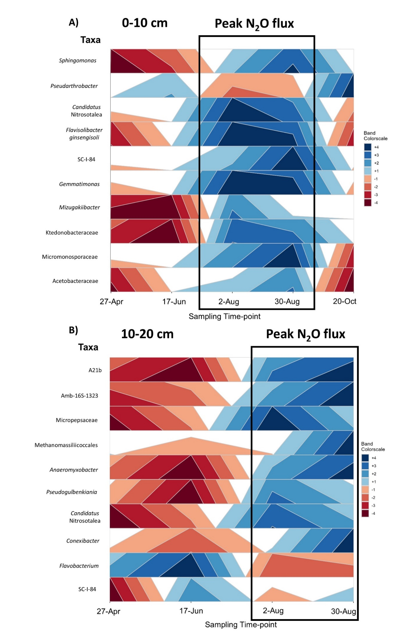
Figure 5.6: Time-series horizon plots showing the relative abundance of microbial taxa associated with N₂O emissions, as identified by the Random Forest model, at 0-10 (A) and 10-20 cm (B) depths. Each plot shows one taxon’s relative abundance over time, with the median (depth-specific) as baseline. Blue shades indicate above-median values and red below, with color intensity reflecting the magnitude of deviation. Note: color scales are not comparable across taxa or depths, as medians are calculated independently. Black boxes indicate periods of highest N₂O flux.

To evaluate the relationship between the relative abundance of the top ten taxa and management practices across sampling time-points, statistical analyses were conducted separately for each soil depth (Table 5.3 and 5.4). Sampling time-point significantly influenced the abundance of 8 out of 10 taxa in the topsoil, and 7 out of 10 taxa in the subsoil (p-value $≤$ 0.10). Nitrogen fertilization was often a major driver of taxonomic shifts. In the topsoil, SC-I-84, Acetobacteraceae sp., Gemmatimonas sp., Candidatus Nitrosotalea sp., Ktedonobacteraceae sp., and Mizugakiibacter sp. were positively associated with fertilization (Table 5.3), whereas in the subsoil, Micropepsaceae sp. and Candidatus Nitrosotalea sp. showed significant responses to N fertilization (Table 5.4). All of these taxa were previously reported as being associated with nitrate respiration or aerobic ammonia oxidation pathways (Table 5.5). Tillage also influenced the relative abundance of several taxa. In the topsoil, Pseudarthrobacter sp., Ktedonobacteraceae sp., and Mizugakiibacter sp., were more abundant under CT than NT (p-value $≤$ 0.05), while Sphingomonas sp. and Flavobacterium ginsengisoli showed marginal responses (p-value $≤$ 0.10) (Table 5.3). In the subsoil, only Pseudogulbenkiania sp. was significantly affected by tillage (Table 5.4). Notably, Sphingomonas sp., which plays a role in lignin and aromatic compound degradation, may respond to the tillage induced redistribution of cotton residues rich in recalcitrant carbon (Table 5.5). Cover cropping effects were minimal. No significant changes were observed in the topsoil (Table 5.3), and in the subsoil only Amb-16S-1323 and Micropepsaceae sp. responded significantly (Table 5.4).

Table 5.3: Effects of management practices and sampling time-point on the relative abundance of microbial taxa associated with N₂O emissions in the 0-10 cm soil layer. F-test statistics are shown, with significance levels indicated as follows: * 0.05 < P $≤$ 0.10, ** 0.001 < P $≤$ 0.05, *** P $≤$ 0.001, and NS (not significant) P > 0.10. When significant, the direction of relative abundance shifts is indicated based on Tukey’s HSD test.

0-10 cm
Lowest assigned Taxonomic Level | Sampling Time-point | Fertilizer | Tillage | Cover Crop
Pseudarthrobacter | F = 17.63***  (Lower mid-growing season) | F = 0.012^{NS} | F = 3.91**  CT >NT | F = 0.63^{NS}
Sphingomonas | F = 5.86***  (Higher mid-growing season) | F < 0.001^{NS} | F = 2.64*  CT>NT | F = 1.47^{NS}
SC-I-84 | F = 2.07*  (Higher mid-growing season) | F = 4.32**  0N < 60N | F = 0.44^{NS} | F = 2.16^{NS}
Acetobacteraceae | F = 1.49^{NS} | F = 11.39**  0N < 60N | F = 0.61^{NS} | F = 0.06^{NS}
Gemmatimonas | F = 2.96**  (Higher mid-growing season) | F = 16.95***  0N < 60N | F = 0.032^{NS} | F = 0.04^{NS}
Candidatus Nitrosotalea | F = 6.96***  (Higher mid-growing season) | F = 20.05***  0N < 60N | F = 1.94^{NS} | F = 0.77^{NS}
Micromonosporaceae | F = 6.26***  (Higher mid-growing season) | F = 0.013^{NS} | F = 0.37^{NS} | F = 0.05^{NS}
Ktedonobacteraceae | F = 1.17^{NS} | F = 9.60**  0N < 60N | F = 23.07***  CT > NT | F = 0.51^{NS}
Flavisolibacter ginsengisoli | F = 12.54***  (Higher early and mid-growing season) | F = 0.89^{NS} | F = 3.35*  CT>NT | F = 0.045^{NS}
Mizugakiibacter | F = 2.63**  (Higher mid-growing season) | F = 14.44***  0N < 60N | F = 6.69**  CT > NT | F = 0.46^{NS}
*0N: Unfertilized, 60N: Fertilized, CT: conventional tillage, NT: no-tillage. Growing season, early: 27-Apr and 17-Jun, mid: 2-Aug and 30-Aug, late: 20-Oct

Table 5.4: Effects of management practices and sampling time-point on the relative abundance of microbial taxa associated with N₂O emissions in the 10-20 cm soil layer. F-test statistics are shown, with significance levels indicated as follows: * 0.05 < P $≤$ 0.10, ** 0.001 < P $≤$ 0.05, *** P $≤$ 0.001, and NS (not significant) P > 0.10. When significant, the direction of relative abundance shifts is indicated based on Tukey’s HSD test.

10-20 cm
Lowest assigned Taxonomic Level | Sampling Time-point | Fertilizer | Tillage | Cover Crop
SC-I-84 | F = 2.22*  (Higher mid-growing season) | F = 0.64^{NS} | F = 0.84^{NS} | F = 0.016^{NS}
Conexibacter | F = 0.35^{NS} | F =0.14^{NS} | F = 0.67^{NS} | F = 2.14^{NS}
Amb-16S-1323 | F = 1.81^{NS} | F =0.50^{NS} | F = 0.016^{NS} | F = 6.95**  NC < HV
Pseudogulbenkiania | F = 7.41***  (Higher mid-growing season) | F =1.70^{NS} | F = 10.68**  CT > NT | F = 0.31^{NS}
A21b | F = 5.08**  (Higher mid-growing season) | F =0.008^{NS} | F = 0.082^{NS} | F = 0.18^{NS}
Micropepsaceae | F = 3.97**  (Higher mid-growing season) | F = 9.83**  0N < 60N | F = 0.69^{NS} | F = 5.15**  NC < HV
Candidatus Nitrosotalea | F = 2.45*  (Higher mid-growing season) | F = 13.67***  0N < 60N | F = 0.008^{NS} | F = 0.025^{NS}
Anaeromyxobacter | F = 2.19* (Higher mid-growing season) | F = 0.048^{NS} | F = 0.25^{NS} | F = 0.001^{NS}
Flavobacterium | F = 4.67***  (Lower mid-growing season) | F = 0.50^{NS} | F = 0.016^{NS} | F < 0.001^{NS}
Methanomassiliicoccales | F = 1.86^{NS} | F = 0.013^{NS} | F = 0.91^{NS} | F = 0.049^{NS}
*0N: Unfertilized, 60N: Fertilized, CT: conventional tillage, NT: no-tillage, NC: no cover crop, HV: Hairy Vetch. Growing season, early: 27-Apr and 17-Jun, mid: 2-Aug and 30-Aug, late: 20-Oct

Table 5.5: Functional annotation of microbial taxa associated with N₂O emissions based on FAPROTAX database and additional literature sources
0-10 cm
Taxa | Functional annotation
Pseudarthrobacter
Sphingomonas | Ligninolysis/ nitrogen fixation/ aromatic hydrocarbon degradation/ aromatic compound degradation (non-lignin, non-xylan), plastic degradation
SC-I-84 | Nitrate respiration¹
Acetobacteraceae | Nitrate respiration (dissimilatory)
Gemmatimonas | Nitrate respiration²
Candidatus Nitrosotalea | Aerobic ammonia oxidation
Micromonosporaceae | Nitrate respiration (dissimilatory)
Ktedonobacteraceae | Nitrate respiration³
Flavisolibacter ginsengisoli | Nitrate respiration⁴, $β$-glucosidase activity⁵
Mizugakiibacter | Nitrate respiration (dissimilatory)
10-20 cm
Taxa | Functional annotation
SC-I-84 | Nitrate respiration¹
Conexibacter | Nitrate respiration (assimilatory or dissimilatory)/ aerobic chemoheterotrophy (C)
Amb-16S-1323
Pseudogulbenkiania | Nitrate respiration⁶
A21b | Nitrate respiration⁷
Micropepsaceae | Aerobic ammonia oxidation⁸
Candidatus Nitrosotalea | Aerobic ammonia oxidation
Anaeromyxobacter | Nitrate respiration (dissimilatory)/ Nitrate ammonification (DNRA)/ nitrite ammonification/ nitrite respiration/ aerobic chemoheterotrophy (C)/ fumarate respiration
Flavobacterium | Nitrate respiration (assimilatory or dissimilatory)/ nitrate denitrification/ chitinolysis/ DNRA/ nitrite ammonification/ nitrite respiration/ xylanolysis/ fermentation/ aerobic chemoheterotrophy (C)/ fumarate respiration
Methanomassiliicoccales | Methanogens⁹
*1: Jin et al. 2022; 2: Pessi et al. 2022, Xiao et al. 2024; 3: Xu et al. 2024; 4: Bano et al. 2024; 5: Zhao et al. 2015; 6: Dong et al. 2024; 7: Dong et al. 2024, Truu et al. 2020; 8: Hao et al. 2021; 9: Chen et al. 2023, Gu et al. 2024.

While BiomeHorizon plots in Figure 5.6 highlight temporal abundance, the calculated medians are taxa- and depth-specific and not directly comparable across taxa or soil layers. To overcome this limitation, abundances were standardized across samples to assess whether the temporal dynamics of the top ten taxa associated with each management practice aligned with N₂O fluxes during the growing season. Standardization facilitated treatment and depth comparisons but reduced resolution for detecting changes in relative abundance (Fink et al., 2022), given the small and uneven abundance of these taxa. Among the top ten taxa, only those with management differences at p $≤$ 0.10 are shown in Figure 5.7 (see also Table 5.3 and 5.4). Standardized abundances of taxa positively associated with N₂O emissions increased across depths on August 2 and 30 (Figure 5.7), coinciding with the mid-season peaks in N₂O fluxes (Figure 5.1); with stronger responses under fertilized, CT, and HV plots. At 0-10 cm, the relative abundance of Pseudarthrobacter sp., a taxon negatively associated with N₂O emissions (Figure 5.5C), declined during these same time-points. Although more abundant in CT plots overall (Table 5.3), the decline in its relative abundance during peak N₂O emissions period was also more pronounced in CT compared to NT plots (Figure 5.7B).
In the subsoil, absolute abundances were generally lower than in the surface soils, yet clear temporal changes were observed, such as for Candidatus Nitrosotalea sp. (Figure 5.7A). These patterns suggest management practices influence microbial dynamics throughout the soil profile, although the effects are comparatively weaker in the subsoil.
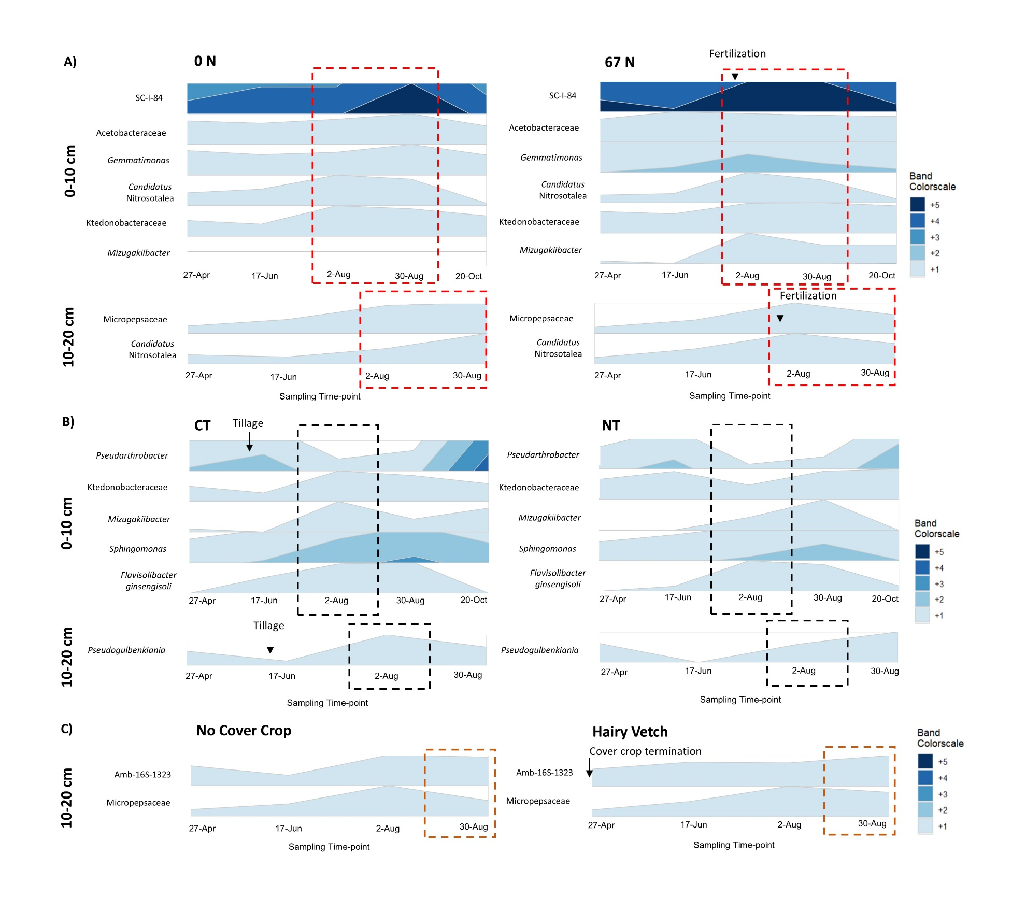
Figure 5.7: Time-series horizon plots of microbial taxa relative abundance linked to N₂O emissions, identified by the Random Forest model and associated with N fertilization (A), tillage (B), and cover cropping (C) practices. Taxa shown had p-values $≤$ 0.10, see Tables 2 and 3 for details. Median relative abundance was centered at zero, with a bandwidth of 0.7% and five bands used to standardize abundance dynamics across treatments and depths. Dashed boxes indicate timing of treatment differences in N₂O fluxes (based on Figure 5.1), and black arrows mark key management practices.

Discussion
In this study, we used 16S rRNA metabarcoding to explore the long-term impacts of 41 years of soil health practices on microbial communities and their relationship with N₂O emissions. Our findings showed that: (i) N fertilization had a stronger influence on soil microbial community structure than tillage or cover cropping; (ii) a greater number of microbial taxa associated with N₂O emissions were found in the surface soil layer compared to deeper layers; (iii) some taxa linked to N₂O fluxes were unique to specific soil layers, while only few were shared across depths; (iv) the top ten taxa associated with N₂O emissions were often linked to specific management practices; (v) the abundance of these taxa mirrored N₂O fluxes, being higher under CT than NT, HV than NC, and 67 N than 0 N, and increased markedly on August 2 and August 30, coinciding with mid-season peaks in N₂O emissions; and (vi) several soil biochemical variables were correlated with the abundance of microbial taxa linked to N₂O emissions, with pH showing the strongest and most consistent association, suggesting that acidic conditions selectively favored taxa contributing to N₂O production across the soil profile.

Influence of management practices on microbial communities across soil depths
Our results show that N fertilization exerted a stronger influence on the structure of soil microbial communities compared to tillage and cover cropping. This observation partially aligns with the results of Duan et al. (2022), who reported that fertilization and tillage have long-lasting impacts on soil bacterial communities, whereas cover cropping primarily induces short-term effects following termination. Both studies focus on surface soils, where management practices tend to exert the strongest influence. Importantly, our study extends this understanding by showing that the effects of management practices on microbial community structure diminish with depth (Table 5.1, Figure 5.2B). This divergence in subsoil community structure likely reflects the attenuation of management-induced effects with depth and biogeochemical stratification in the soil profile (Patra et al., 2022), which have previously reported to shape the abundance, composition, and structure of microbial communities (Fierer et al., 2003; Gu et al., 2017; Ma et al., 2018; Naylor et al., 2022). Deeper horizons often harbor slower-growing oligotrophic taxa adapted to nutrient scarcity, whereas surface soils are enriched with copiotrophic groups that exploit labile carbon inputs from residues and roots (Kim et al., 2020; Naylor et al., 2022). These ecological contrast help explain why management effects were more pronounced in surface soils than in the subsoil. Piazza et al., (2019) further showed that the interaction between tillage and N fertilization shifted soil prokaryotic and fungal communities toward a higher presence of functional taxa linked to nutrient cycling, which is consistent with our observation that a greater number of microbial taxa were associated with N₂O emissions in the surface layer compared to the subsoil.
Our findings accordingly indicate that microbial taxa linked to N₂O emissions vary by depth, with more distinct taxa identified in the surface layer (45 taxa) than in the subsoil (19 taxa), and limited overlap between them (7 taxa). This highlights the importance of considering soil depth when evaluating microbial contributions to N₂O fluxes in response to management practices. It is important to note that N₂O fluxes were measured at the soil surface, reflecting net emissions rather than total production in each soil layer. Some N₂O produced in subsoil may have been reduced before reaching the surface, potentially underestimating subsoil microbial contributions. Nevertheless, the observed depth specific patterns provide valuable insights into the spatial distribution of microbial drivers of N₂O emissions.

Soil biochemical drivers of microbial community structure and N₂O-associated taxa
Long-term N fertilizer application directly influences soil microbial biomass and community composition by increasing nutrient availability and indirectly by changing soil pH (Zeng et al., 2016; Zhang et al., 2017). In fertilized surface soils (0-10 cm), N₂O fluxes were positively associated with shifts in microbial composition and aligned with patterns in NO₃⁻, POXC, SOM, and total N (Figure 5.2A). Labile C pools captured by POXC represent readily available substrates that can fuel heterotrophic denitrifiers, thereby enhancing N₂O production under conditions of sufficient N and reduced O₂ availability (Culman et al., 2021; Lussich et al., 2024a). In contrast, SOM reflects more stable organic matter that shapes microbial community composition over longer timescales, while still contributing to substrate availability through gradual mineralization (Mbuthia et al., 2015; Fierer, 2017; Mao et al., 2024). Together, these C pools influence the balance between copiotrophic and oligotrophic taxa and modulate microbial functional potential under long-term fertilization (Kim et al., 2020; Duan et al., 2022). In contrast, soil pH consistently emerged as a key environmental factor shaping community structure across depths and showed negative association with both N₂O emissions and microbial community structure in these plots (Figure 5.2). At our experimental site, higher N application rates were associated with lower soil pH than the unfertilized plots (Mbuthia et al., 2015). This is consistent with prior findings of a negative relationship between soil pH and N₂O emissions (Russenes et al., 2016; Samad et al., 2016). A similar trend was observed in the subsoil (10-20 cm), where microbial communities were more dispersed and less structured by fertilization, yet the negative association between pH and microbial community composition was evident (Figure 5.2B).
Building on the community level patterns, our results also showed that individual microbial taxa positively associated with N₂O emissions were negatively influenced by soil pH, whereas they were positively associated with soil temperature and CO₂ fluxes across both depths (Figure 5.4). These results indicate that both overall microbial community composition and N₂O associated taxa were structured by pH, with acidic conditions favoring the specific taxa contributing to N₂O emissions. Long-term N fertilization likely promotes N₂O emissions by lowering soil pH, favoring acid-tolerant, N₂O-producing bacterial and archaeal taxa. This pH effect likely operates through multiple, complementary mechanisms. First, lowering pH increases the N₂O yield of denitrification (i.e., N₂O/(N₂ + N₂O) leading to greater N₂O accumulation (Hu et al., 2015). Second, acidic conditions inhibit the activity and synthesis of nitrous oxide reductase (NosZ) – the enzyme responsible for reducing N₂O to inert N₂ – thereby limiting the final step of denitrification (Bakken et al., 2012). Finally, while NosZ is inhibited, the upstream denitrification steps often remain active or are even enhanced by lower pH and greater N availability under fertilized soils, leading to increased N₂O production (Hu et al., 2015). Together, these mechanisms highlight how acidification alters microbial community composition and amplifies N₂O emissions.
Beyond its role in N₂O regulation, pH acts as a fundamental ecological filter, shaping bacterial and archaeal diversity across the soil profile. Studies at continental and field scales consistently identify pH as one of the strongest predictors of microbial community structure in agricultural soils (Wang et al., 2019; Tan et al., 2020; Xiong et al., 2024). Acidification tends to favor acidophilic groups such as Acidobacteria and certain Proteobacteria, while constraining lineages like Actinobacteria and Bacteroidota, ultimately reshaping soil microbial community structure. These shifts in taxonomic composition often translate into altered alpha and beta diversity, with evidence that microbial richness and diversity peak near a soil’s native pH and decline under strong acidification or alkalization (Tan et al., 2020; Xiong et al., 2024).
Such pH-driven restructuring has important implications for microbial-mediated nutrient cycling. By selectively filtering microbial groups, acidification influences functional processes including nitrification, denitrification, and organic matter decomposition (Tan et al., 2020; Xiong et al., 2024). For example, suppression of Actinobacteria and Bacteroidota under low pH may constrain the degradation of complex carbon substrates, while enrichment of Acidobacteria and certain Proteobacteria promotes metabolic pathways adapted to acidic conditions. These community-level adjustments highlight how long-term N fertilization and associated acidification extend beyond altering N₂O fluxes to fundamentally reorganize microbial assemblages and their functional potential in agricultural soils.

Management and soil depth shape key N₂O-associated microbial taxa
In the surface layer, several bacterial and archaeal taxa, including those within the genera Sphingomonas, Candidatus Nitrosotalea, Falvisolibacter ginsengisoli, Gemmatimonas, Mizugakiibacter, and members of SC-I-84, Ktedonobacteraceae, Micromonosporaceae, and Acetobacteracea were positively correlated with N₂O emissions. Many of these taxa have been previously reported to harbor genes involved in nitrification or denitrification. For example, members of the class Gammaproteobacteria, such as SC-I-84 and Mizugakiibacter, have been reported to carry the nirS denitrification gene (Dong et al., 2024), with SC-I-84 also showing strong positive correlations with multiple N cycling genes, including nifH, amoB, nirK, and nosZ (Jin et al., 2022). Similarly, Flavisolibacter has been reported to carry nirK, while Sphingomonas has been associated with norG and norB, and may also participate in nitrification (Hao et al., 2021; Bano et al., 2024). Archaea from the genus Candidatus Nitrosotalea are well-known ammonia-oxidizing archaea (AOA) in acidic soils and are recognized contributors to N₂O emissions (Pu, 2019). Other positively associated taxa, such as Gemmatimonas and Acetobacteraceae sp., have been identified as denitrifiers (Pessi et al., 2022; Xiao et al., 2024), while Ktedonobacteraceae and Micromonosporaceae have been linked to N₂O emissions in fertilized soils (Ren et al., 2020; Xu et al., 2024). In contrast, Pseudarthrobacter was negatively correlated with N₂O fluxes. Previous studies have shown that biochar amendments can increase the abundance of Pseudarthrobacter while reducing N₂O emissions, likely by promoting denitrifying reductases (NAR, NIR, NOR, and NOS) and enhancing complete denitrification (Su et al., 2019). These associations should be interpreted as correlations with N₂O fluxes, not direct evidence of gene presence or activity in this study.
In the subsoil, most of the top ten taxa associated with N₂O emissions differed from those in the surface layer. These included taxa from the groups Anaeromyxobacter, Pseudogulbenkiana, Conexibater, Candidatus Nitrosotalea, and members of A21b, Amb-16S-1323, SC-I-84, Micropepsaceae, and Methanomassiliicoccales. Members of Thermoplasmata (e.g. Methanomassiliicoccales) have been identified as anaerobic methanotrophic archaea capable of producing N₂O as an intermediate product during denitrification (Carvajal et al., 2016; Chen et al., 2023; Gu et al., 2024). Conexibacter and A21b have been reported to harbor the nirS gene (Dong et al., 2024), with A21b also carrying the nosZ gene (Truu et al., 2020), while Anaeromyxobacter and Pseudogulbenkiania were associated with nirK (Dong et al., 2024). Members of Micropepsaceae have been linked to nitrification and NO₃⁻ availability in soil (Hao et al., 2021), and have also been associated with N₂O emissions (Yu et al., 2024). Amb-16S-1323 family, though less studied, are known to increase with compost applications (Rodríguez-Berbel et al., 2020). Conversely, Flavobacterium was negatively associated with N₂O emissions. Flavobacterium spp. are abundant Clade II nosZ-carrying organisms with the potential to act as N₂O sinks in natural environments (Yoon et al., 2017, 2019; Behrendt et al., 2022).
Long-term management practices significantly influenced the abundance of these top ten taxa (Table 5.3, Table 5.4, and Figure 5.7), with N fertilization exerting the strongest and most consistent effects in the surface soil layer. Taxa such as those within SC-I-84, Mizugakiibacter, Gemmatimonas, Acetobacteraceae, Ktedonobacteraceae, Micropepsaceae, and Candidatus Nitrosotalea were more abundance under fertilized conditions, consistent with previous findings (Megyes et al., 2021; Yang et al., 2021; Li et al., 2023b; Wang et al., 2023). These taxa have been previously associated with nitrate respiration and/or aerobic ammonia oxidation pathways (Table 5.5), suggesting a potential contribution to N₂O production. The pronounced effect of fertilization likely stems from increased substrate availability and shifts in soils chemistry, particularly acidification (Barabasz et al., 2002).
In contrast to N fertilization, tillage had a more limited influence, affecting a smaller subset of taxa, including those within Pseudarthrobacter, Sphingomonas, Ktedonobacteraceae, Falvisolibacter ginsengisoli, Mizugakiibacter, and Pseudogulbenkiania. These taxa have been reported to be associated with nitrate respiration and may rely on available C sources for heterotrophic metabolism (Table 5.5). For instance, Falvisolibacter ginsengisoli has been functionally associated with nitrate respiration and $β$-glucosidase activity, enabling in the degradation of labile C compounds such as simple sugars and cellulose-derived oligosaccharides (Zhao et al., 2015; Bano et al., 2024). Similarly, Pseudarthrobacter, Ktedonobacteraceae, Mizugakiibacter, and Pseudogulbenkiania have been reported to be associated with nitrate reducing pathways and may respond to shifts in C availability driven by soil disturbance (Dong et al., 2024; Xu et al., 2024). Sphingomonas, in contrast, has been characterized for its role in degrading recalcitrant C compounds such as lignin and aromatics (Table 5.5), which are abundant in cotton residues. Reported responses of these taxa to tillage vary widely across studies. For instance, Sphingomonas and Ktedonobacteraceae have been observed to increase under NT systems in some studies (Dong et al., 2017; Kim et al., 2020), while others reported greater abundance under CT (de Vries et al., 2015; Feng et al., 2021; Liu et al., 2024). Similarly, Pseudogulbenkiania has shown to respond to tillage practices (Bevivino and Dalmastri, 2017), and increases in Flavisolibacter abundance have been link to the incorporation of maize residues (De la Cruz-Barrón et al., 2017). These variable outcomes underscore the complex and context-dependent nature of tillage effects on microbial communities, likely driven by site-specific conditions, residue characteristics, and interactions with other management practices.
Cover cropping had minimal influence on the dominant taxa in the surface soil, consistent with previous findings at the same site that microbial responses to cover crops are strongest shortly after termination (Duan et al., 2022). However, in the subsoil, two taxa, Micropepsaceae sp. and Amb-16S-1323, were significantly influenced by cover cropping, both showing increased abundance under hairy vetch. These taxa are involved in C cycling and have been previously linked to cover crop use (Behnke et al., 2021), suggesting that cover cropping may exert delayed or localized effects on microbial functional potential below the surface layer. In contrast, Cheng et al. (2025) demonstrated that diversifying crop rotations, rather than maintaining continuous cotton, restructured denitrifier communities by altering the abundance of nirS, nirK, and particularly nosZI gene groups, thereby enhancing the microbial potential for N₂O reduction. Together, these findings highlight that while diversification through rotations can promote N₂O-consuming groups, cover cropping within continuous monoculture may elicit more localized microbial responses in subsoils, potentially influencing C-N interactions relevant to N₂O dynamics.

While many of the identified taxa have previously been linked to N and C cycling pathways, their ecological roles extend well beyond N₂O production. For instance, Sphingomonas is widely recognized for its ability to degrade aromatic compounds and other recalcitrant pollutants, thereby contributing to residue decomposition and potentially influencing C availability in soils; some strains also promote plant growth through phytohormone production and nutrient cycling (Asaf et al., 2020; Bano et al., 2024). Gemmatimonas includes species capable of chemoheterotrophy and photoheterotrophy and has been reported to reduce N₂O under varying oxygen conditions, suggesting a potential role as an N₂O sink, while also contributing to C stabilization in resource-limited soils (Mujakić et al., 2022; Oshiki et al., 2022). Similarly, Micropepsaceae are versatile fermenters that degrade plant-derived sugars and polysaccharides and can use nitrate or ferric iron as electron acceptors, linking them to both C turnover and anaerobic respiration processes (Harbison et al., 2017). Finally, the uncultured group Amb-16S-1323 has been correlated with rhizosphere acid phosphatase activity, suggesting a potential role in P cycling and plant–soil interactions (Wang et al., 2021). Together, these examples emphasize that management-driven changes in microbial composition influence not only greenhouse gas dynamics but also broader soil ecological processes, including residue decomposition, carbon stabilization, nutrient transformations, and microbial adaptation to disturbance.
Together, these results show that the top ten taxa associated with N₂O fluxes exhibit distinct patterns across soil depths and in response to long-term management practices. Considering both vertical gradients and treatments effects offers a deeper insight into how key microbial taxa may contribute to N₂O emissions under field conditions. While depth imposes strong environmental constraints, fertilization, tillage, and cover cropping significantly influenced the abundance of these taxa, all of which have been previously reported to be involved in N and C cycling pathways. It is important to note, however, that the use of 16S rRNA sequencing provides only taxonomic associations and does not directly confirm the presence or activity of functional genes. The correlations observed here should therefore be interpreted as hypothesis-generating, and future studies integrating functional gene quantification will be necessary to validate these associations and establish mechanistic links to N₂O emissions. Understanding how these functionally relevant taxa respond to environmental and management gradients nonetheless provides a valuable foundation for improving N₂O mitigation strategies in agroecosystems.

Linking temporal N₂O flux variability to shifts in microbial communities
Distinct N₂O flux peaks on August 2 and 30 coincided with marked shifts in microbial community composition across soil depths (Figure 5.1 and Figure 5.6). These shifts were characterized by increased relative abundance of taxa positively associated with N₂O fluxes and concurrent decline in those negatively associated, emphasizing the central role of microbial communities in modulating high N₂O emission events. Both peaks followed emergency irrigation and rainfall events and coincided with elevated soil temperatures, conditions known to amplify the regulatory effect of N fertilization on microbial activity. High soil moisture creates anaerobic microsites that stimulate denitrification, while warmer temperatures accelerate microbial metabolism, together reinforcing community-level shifts associated with N₂O production (Baggs and Philippot, 2010; Butterbach-Bahl et al., 2013). Many of the enriched taxa during these peaks have been previously reported to be functionally associated with nitrification and denitrification. This aligns with findings from Dhaliwal et al. (2024), who used isotopomer measurements to show that 46% to 58% of N₂O emissions at this site during August 2022 originated from denitrification, with the remaining 42% to 54% likely derived from nitrification. The balanced contribution of both pathways is consistent with the observed shifts in taxa suggested to represent these functional groups during peak emissions events.
Temporal abundance patterns of the top N₂O-associated taxa were strongly influenced by long-term management practices. In fertilized plots, taxa such as SC-I-84, Mizugakiibacter sp., Gemmatimonas sp., Acetobacteraceae sp., Ktedonobacteraceae sp., Micropepsaceae sp., and Candidatus Nitrosotalea sp. were more abundant compared to unfertilized plots (Figure 5.7A). These findings suggest that long-term nutrient enrichment fosters microbial communities conducive to N₂O production under favorable conditions. Similarly, CT plots showed higher N₂O fluxes and greater relative abundance of potential denitrifiers and C-degrader-associated taxa, including members of Pseudarthrobacter, Sphingomonas, Ktedonobacteraceae, Falvisolibacter ginsengisoli, Mizugakiibacter, and Pseudogulbenkiania, compared to NT plots (Figure 5.7B). These shifts likely reflect enhanced substrate availability, especially in labile C and ${NO}_{3}^{-}$ (Figure 5.4), under long-term tillage promoting denitrifying activity (de Vries et al., 2015; Dong et al., 2017; Kim et al., 2020; Behnke et al., 2021; Singh et al., 2023). In contrast, cover cropping exhibited more localized effects, significantly increasing the relative abundance of only two subsoil taxa – Micropepsaceae sp. and Amb-16S-1323 – under HV compared to bare fallow treatment (Figure 5.7C). These taxa have been linked to C cycling and have been previously associated with cover crop use (Behnke et al., 2021; Barber et al., 2023), indicating that cover cropping may modulate microbial function at depth, even in the absence of broad community shifts in surface soil.
Collectively, these results demonstrate that management practices shape not only the overall microbial community structure, but also their temporal dynamics during peak N₂O emission periods. By promoting microbial taxa potentially functionally linked to N₂O production, fertilization, tillage, and cover cropping can enhance GHG fluxes under certain environmental conditions. Understanding these relationships is essential for efficient GHG mitigation potential of soil health practices and their broader environmental impacts.

Conclusions
This study investigated seasonal variations in N₂O emissions and associated microbial communities in a 41-year continuous cotton experiment under contrasting N fertilization rates, tillage regimes, and cover cropping practices. Among these management practices, N fertilization – a known driver of N₂O emissions – had the strongest influence on community composition and increased the number of N₂O-associated taxa, especially in the surface soil layer. This effect was largely driven by soil acidification under long-term N fertilization, favoring microbial taxa previously reported to promote N₂O emissions. These findings underscore the dual role of fertilization, providing substrate for N₂O production while also shaping microbial composition, and reinforce the importance of refining fertilization strategies. At the same time, our results suggest that conservation practices such as no-tillage can support microbial groups like Pseudarthrobacter, which are associated with N₂O consumption, and thereby offer complementary mitigation potential. Together, this highlights that while fertilization management is critical, its integration with practices such as no-tillage may provide a more sustainable pathway to reduce emissions while maintaining crop productivity and soil resilience.
Microbial contributions to N₂O production were shaped by both soil depth and the interplay between seasonal dynamics and management legacies. Distinct taxa in surface and subsoil layers responded differently to environmental and management drivers, with only a few taxa shared across depths. Seasonal abundance pattern of key taxa reflected higher N₂O fluxes from CT than NT, HV than NC, and fertilized compared to unfertilized treatments. These findings underscore the depth-specific and temporally dynamic nature of microbially regulation of N₂O emissions, highlighting the importance of considering both long-term management legacies and short-term microbial responses when developing strategies to mitigate emissions. It is important to note that associations between microbial taxa and N₂O emissions reported here are correlative and based on taxonomic profiling. While informative, these results should be viewed as hypothesis-generating and complementary to future studies that directly quantify functional genes to confirm microbial contributions to N₂O dynamics.

Enhancing predictions of nitrous oxide emissions from agricultural soils using a classification-swap machine learning approach

A version of this chapter was submitted for publication in Journal of Environmental Quality. Facundo Lussich was responsible for conceptualization, formal analysis, investigation, methodology, and writing. Debasish Saha, Jashanjeet Kaur Dhaliwal, Ryan Ackett, and Hao Gan provided input on methodology, review & editing.

Abstract
Accurate prediction of N₂O emissions in agricultural systems is essential for developing effective climate-smart practices. This study introduces a novel ensemble approach, termed the ‘Class-Swap’ machine learning model, which employs two independent Random Forest (RF) models trained separately on background and hot-moment emissions. A statistical anomaly detection algorithm first classifies each flux observation, and the model then swaps between the two RF models accordingly, enabling emission specific predictions based on distinct biogeochemical drivers. The objective was to evaluate the performance of this approach against traditional RF models in predicting N₂O fluxes from a long-term continuous cotton crop rotation in west Tennessee, which includes different tillage, N fertilization, and cover cropping treatments. The Class-Swap approach consistently outperformed traditional RF models on an independent unseen holdout dataset, achieving higher R² values (0.33 to 0.34 vs 0.08 to 0.25) and lower RMSE (9.8 to 9.9 vs 10.5 to 11.6 g N₂O-N ha⁻¹ day⁻¹), while accurately capturing the magnitude and temporal dynamics of emissions - something traditional RF models failed to replicate. Key predictors varied by emission type: in the background model, moderate to high soil moisture (0.45 – 0.7 WFPS), soil ${NH}_{4}^{+}$ , and increased soil CO₂ positively contributed to N₂O fluxes; in the hot-moment model, fluxes were primarily driven by large precipitation events and high soil moisture (>0.65 WFPS). This study underscores the effectiveness of differentiating between the distinct biogeochemical dynamics underlying background emissions and hot-moments in predictive modeling. Further assessment across diverse sites, years, and agroecosystems remains necessary to validate the potential of the Class-Swap approach as a robust alternative for predicting N₂O fluxes.

Introduction
Nitrous oxide (N₂O) emissions from agricultural systems have received considerable attention in the recent years, as N₂O is a major ozone-depleting gas with a global warming potential ~273 times greater than that of carbon dioxide (CO₂) over a century (EPA, 2023; IPCC, 2023). Agricultural soils largely contribute to N₂O production, with the agriculture sector accounting for nearly two-thirds of global anthropogenic N₂O emissions (EPA, 2023), particularly associated with nitrogen (N) fertilization (Thompson et al., 2019; Tian et al., 2020). Given its outsized environmental impact, accurately predicting N₂O emissions is critical for informing climate mitigation strategies and sustainable fertilizer N management in agroecosystems.
In response to this need, dynamic process-based models such as DNDC (Li et al., 1992) and DayCent (Parton et al., 1998) have been widely adopted. These models simulate key soil biogeochemical processes and are used for regional or national greenhouse gas inventories, assessing climate change impacts, and developing N₂O emission factors (Gaillard et al., 2018; Fuchs et al., 2020). However, despite their utility, process-based models often struggle to accurately simulate N₂O fluxes due to the complex, nonlinear interactions among environmental, biogeochemical, and management factors driving large spatial and temporal flux variability (Brilli et al., 2017; Wang et al., 2021). Additionally, they require extensive parameterization and calibration across multiple soil, climate, and management gradients, often limiting their transferability across sites and climate conditions (Brilli et al., 2017). Although they can capture seasonal dynamics at specific sites, process-based models tend to underestimate episodic peak emissions, known as “hot-moments”, and often fail to simulate temporally-resolved N₂O flux patterns (Del Grosso et al., 2002; Gaillard et al., 2018).
To address these limitations, data driven approaches and particularly machine learning (ML) models have shown great potential for predicting daily N₂O fluxes at field scale (Dhaliwal et al., 2024a; Garnier et al., 2024; Hamrani et al., 2020; Saha et al., 2021; Yang et al., 2022). Unlike process-based models, ML algorithms can learn complex relationships directly from observational data and identify the key drivers of N₂O emissions. However, their empirical nature means that ML models are inherently limited by the scope, quality, and availability of the training data, and their performance under unseen conditions or missing key drivers cannot always be guaranteed. Random Forest (RF) models, in particular, have demonstrated strong predictive performance in estimating N₂O fluxes from agricultural systems by capturing complex interactions among environmental and management variables (Philibert et al., 2013; Saha et al., 2021a; Yin et al., 2022). Nevertheless, accurately predicting both the magnitude and timing of hot-moments remains a challenge for most ML approaches (Khalil et al., 2023; Adler et al., 2024).
A major reason for this difficulty lies in the complex and heterogeneous nature of N₂O production. Multiple microbial pathways, including nitrification, denitrification, and nitrifier denitrification, can independently or simultaneously contribute to N₂O emissions (Zhu et al., 2013a; Wang et al., 2023). The relative dominance of these pathways is regulated by dynamic environmental conditions and management practices in nonlinear ways (Butterbach-Bahl et al., 2013; O’Brien et al., 2022). As a result, agricultural soils typically exhibit low background N₂O fluxes interrupted by infrequent but intense emissions peaks, often caused by the coincidence of triggering factors such as fertilization, residue addition, and precipitation occurring together or in close succession (Groffman et al., 2009; Molodovskaya et al., 2012; Lussich et al., 2024). Although rare, these hot-moments represent disproportionately contribute to the cumulative emissions (Li et al., 2015; Anthony and Silver, 2024; Ackett et al., 2025), leading to datasets dominated by low background fluxes and only a few high flux data points . Although infrequent hot-moment events in N₂O time-series data represent real biogeochemical phenomena, their scarcity provides limited information for training ML models, often leading to underprediction of these fluxes (Adler et al., 2024; Anthony & Silver, 2024; Dhaliwal et al., 2024b; Joshi et al., 2024; Kotlar et al., 2022). It is also important to accurately represent the dynamics of background fluxes to ensure reliable cumulative emissions estimates, as these fluxes dominate the temporal dataset despite their lower magnitude. This typically skewed distribution, where the proportion of background emissions and hot moments are imbalanced (i.e. class imbalance), makes it challenging to train data-driven models that can accurately predict both emissions regimes.
Accurately distinguishing hot-moments from background emissions remains a challenge, as standardized quantitative methods are still lacking (Bernhardt et al., 2017). Recent work by Stuchiner et al. (2025) addressed this gap by evaluating various outlier detection algorithms to classify N₂O fluxes. However, most traditional approaches using ML models still attempt to predict both background and hot-moments emissions with a single model, even though datasets are dominated by background fluxes and provide few cases of high-emission events for effective learning. This imbalance often causes models to replicate background dynamics and struggle to capture peak fluxes accurately (Adler et al., 2024; Anthony and Silver, 2024). A more targeted approach that separates background and hot-moment emissions and trains specialized models for each group of observations could significantly improve predictive accuracy, particularly for capturing peak flux events.
In this study, we introduce a novel modeling approach, referred to as the “Class-Swap” modeling framework, for predicting daily N₂O emissions. This approach involves two steps: first, flux observations are segmented into two categories background emissions and hot moments using an outlier detection algorithm. Second, following this classification, separate RF models are trained on each category, and thus are each tailored to one of the emission classes. During model validation, the appropriate model is dynamically selected based on the flux classification for the time point to predict N₂O fluxes. This ensemble strategy has the potential to improve N₂O predictions, as similar multi-model approaches have enhanced process-based simulations under contrasting emission conditions (Fuchs et al., 2020). By analogy, applying an ensemble concept in data-driven models may help address the common challenge of underestimating hot-moment events (Gaillard et al., 2018).
To assess the effectiveness of the Class-Swap modeling approach, we compared its performance against a traditional RF model and an alternative approach that applies an oversampling technique, often used in ML to correct for class imbalance (Chawla et al., 2002; Saha et al., 2021a). Both the Class-Swap and traditional models were evaluated with and without oversampling, allowing us to test the distinct value of class separation and traditional data balancing strategies.
Our objectives were: i) to determine whether the Class-Swap modeling approach improves N₂O flux predictions relative to traditional ML approaches, and ii) to identify the key environmental drivers differentiating background from hot-moment emissions. We hypothesized that the Class-Swap models would outperform traditional RF models in both the cross-validation and independent testing by better representing the distinct processes driving N₂O variability.

Materials and Methods

Study site and experimental design
This study was conducted from January 2022 to October 2023 in a long-term continuous cotton field experiment, established in 1981 at the University of Tennessee’s West Tennessee Research and Education Center in Jackson, Tennessee (35°37′22″ N, 88°50′47″ W; elevation 125 m). The soil at the site is Lexington silt loam (fine-silty, mixed, thermic, Ultic Hapludalfs), with a mean annual precipitation of 1415 mm and an average air temperature of 15.6 º C. The experiment follows a randomized complete block design with split-split plots, including four replications and a total of 128 experimental units (12 m $×$ 8 m). Detailed descriptions of the experimental design, treatments, and management practices can be found in Dhaliwal et al. (2024). For this study, a subset of 32 plots was selected, including two levels of N (0 and 67 kg N ha⁻¹), two levels of cover crop (no cover crop, NC; hairy vetch, HV), and two levels of tillage (no-tillage, NT; conventional tillage, CT), across four blocks. This combination resulted in eight treatments: CT-NC-0, CT-NC-67, CT-HV-0, CT-HV-67, NT-NC-0, NT-NC-67, NT-HV-0, and NT-HV-67. Although the experiment was generally rainfed, two critical irrigation events were applied during the 2022 cotton growing season (July 7 and July 26), each delivering 55 mm of water, to alleviate severe drought stress observed in June and July.

Greenhouse gas flux measurements
The N₂O and CO₂ fluxes were measured using a static closed chamber technique, consistently conducted between 8:00 am and 12:00 pm on each sampling day, with randomized plot order. Vented polyvinyl chloride (PVC) collars (25 cm diameter $×$ 25 cm height) were installed between cotton rows at 5 cm depth. N₂O fluxes were measured using a portable Integrated Cavity Output Spectroscopy (ICOS) instrument (Los Gatos Research Inc., Quebec, Canada), and CO₂ fluxes were measured using an infrared gas analyzer (LI-850, LI-COR Biosciences NE, USA). Gas concentrations were recorded at 5 second intervals for ~5 minutes per plot using a closed-loop system (Dhaliwal et al., 2024). Fluxes were calculated based on the rate of change in gas concentration within the chamber headspace over the measurement period. Gas sampling was carried out intensively following cover crop termination, tillage, fertilizer application, and heavy precipitation events. In total, 27 sampling events (859 observations) were conducted in 2022 and 21 sampling events (672 observations) in 2023.

Soil measurements and environmental data collection
Soil temperature and volumetric moisture content were recorded at a 10 cm depth on each sampling day using a thermocouple temperature sensor and HydroSense II portable soil moisture sensor. Water-filled pore space (WFPS) was calculated based on bulk density and volumetric soil moisture measurements.
Soil samples were collected five times during each growing season at a 10 cm depth and analyzed for ammonium (${NH}_{4}^{+}$) and nitrate (${NO}_{3}^{-}$) concentration using a 2-M KCl extraction method (Forster, 1995; Doane and Horwáth, 2003). Soil samples from the first sampling time point were analyzed for soil organic carbon concentration using the dry combustion method with an Elementar vario Max cube CN analyzer, which was then used to estimate soil organic matter (SOM). Soil ${NH}_{4}^{+}$ and ${NO}_{3}^{-}$ concentration data were interpolated to match the temporal GHG flux sampling scale. Additionally, daily air temperature and precipitation data were recorded using an on-site meteorological station.

Data for model training and validation
Daily N₂O fluxes in the 2023 dataset, used for RF model training and cross-validation performance evaluation, ranged from -17.19 to 217.58 g N₂O-N ha⁻¹ day⁻¹. Subsequently, the model was independently tested on a holdout dataset from 2022, which exhibited fluxes ranging from -6.77 to 149.86 g N₂O-N ha⁻¹ day⁻¹.

Model training
To evaluate the effectiveness of the Class-Swap approach, four RF models were developed and tested to predict daily N₂O fluxes. Model development was conducted in Python 3 using the ‘RandomForestRegressor’ function from the ‘sklearn.ensemble’ package (Pedregosa et al., 2011). All models were trained on the 2023 dataset (n = 672 observations), which corresponded to a growing season with normal precipitations patterns. The predictor variables included precipitations accumulated over the last 48 hours (PP2, mm), WFPS, CO₂ (g C-CO₂ ha⁻¹ day⁻¹), soil ${NH}_{4}^{+}$ (mg kg⁻¹), soil ${NO}_{3}^{-}$ (mg kg⁻¹), soil temperature (Soil T, °C), and SOM (%).
Each model underwent independent hyperparameter tuning prior to evaluation with parameters optimized based on the mean absolute error (MAE) and mean percentage error (MPE) (optimized parameters are presented in Table 6.1). Model performance was initially assessed through eight-fold cross-validation using 2023 dataset, where one treatment was excluded in each fold to ensure robust evaluation. Following cross-validation, models were tested on an independent holdout dataset from 2022, a contrasting year characterized by extremely dry summer conditions allowing robust model testing. This unseen holdout evaluation provides a more rigorous assessment of model generalizability by incorporating varying environmental conditions and flux patterns, while minimizing the risk of overfitting to the training data.
The four RF modeling approaches differed in their strategies for handling data imbalance and classifying hot-moments versus background emissions, as described below.
Table 6.1: Optimized hyperparameters for each model following tuning process.
Models | Random Forest Parameters
Models | n estimators | Max depth | Min samples split | Min samples leaf
Base | 200 | 3 | 2 | 5
Class-Swap
Low | 500 | 15 | 5 | 10
High | 300 | 5 | 5 | 12
Base-Over | 200 | 3 | 2 | 2
Class-Swap-Over
Low | 500 | 15 | 5 | 10
High | 300 | 5 | 5 | 12
*Notes: Low: model for background emissions, High: model for hot-moments

Traditional Random Forest: Base Model
The Base model served as the standard RF implementation. It was trained directly on the measured 2023 dataset (n = 672), without any prior flux classification or modifications to the distribution of background and hot-moment observations. This model represented a traditional approach that treated all N₂O fluxes equally during training.

Classification of background and hot-moment emissions: Class-Swap Model
The Class-Swap model introduced a flux classification step prior to quantitative prediction, distinguishing between hot-moments and background emissions. To classify daily fluxes, the Histogram-Based Outlier Score (HBOS) algorithm (Zhao et al., 2019) from the ‘pyod’ package (Chen et al., 2024) was individually applied to each time series of measurements from the 32 plots, in combination with the interquartile range (IQR) method to further identify extreme values. The HBOS method assigns a score to each observation, identifying potential outliers by constructing individual univariate histograms for each feature of the dataset, where bins with low frequencies indicate a higher likelihood of outliers (Goldstein and Dengel, 2012). Details on the HBOS implementation parameters used in this study are provided in Table 6.2. N₂O fluxes were classified as hot-moments if they met one of the two criteria: (1) the HBOS score > 0.23 combined with a flux value exceeding the plot’s median flux, or (2) a N₂O flux value greater than 1.5 times the interquartile range (IQR) above the upper quartile (Walfish, 2006). The HBOS threshold of 0.23 was selected after extensive calibration across a range of thresholds, as it consistently provided reliable identification of local hot-moments across treatments. This dual criterion approach leverages the complementary strengths of HBOS and IQR. Recent studies have shown the context-dependent appropriateness and performance of N₂O hot-moment identification methods in data classification (Ackett et al., 2025; Stuchiner et al., 2025). Our selection of dual-criterion classification methods by leveraging HBOS and IQR is based on simplicity, wider applicability, and superior performance compared to other methods evaluated in the context of our dataset. HBOS is more aggressive and sensitive, effectively detecting a broader range of true positives, while IQR is more conservative, minimizing false positives but often missing subtle anomalies. This ensemble strategy draws on a similar rationale to that of Stuchiner et al. (2025), who observed a comparable dynamic between IQR and Isolation Forest, though without formalizing their complementary potential. Using this dual–criterion classification method, the 2023 (total observation, n = 672; hot-moments, n = 137; background emissions, n = 535) and 2022 (total observation, n = 859; hot-moments, n = 286; background emissions, n = 573) datasets were classified for training and validation (Figures 6.1 and 6.2).
Based on the classified data, two RF models were trained: one for predicting background emissions and another for hot-moment emissions. During prediction, the appropriate model was dynamically selected based on the HBOS + IQR classification outcomes, an approach referred to as Class-Swap.
Table 6.2: Hyperparameters for HBOS Outlier Detection Algorithm
Parameter | Value | Description
Contamination | 0.5 | Proportion of data expected to be anomalies; used to define the decision threshold
n_bins | 20 | Number of bins used to construct histograms for each feature, capturing data distribution
alpha | 0.75 | Regularization factor to avoid zero probabilities in bins, improving robustness

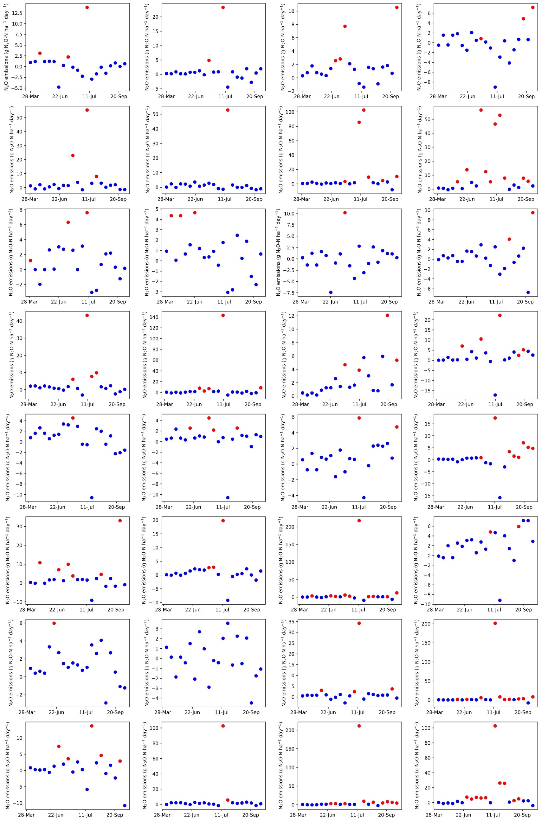
Figure 6.1: HBOS-based classification of hot-moments (red, n = 137) and background emissions (blue, n = 535) across 32 plots in the 2023 training dataset.
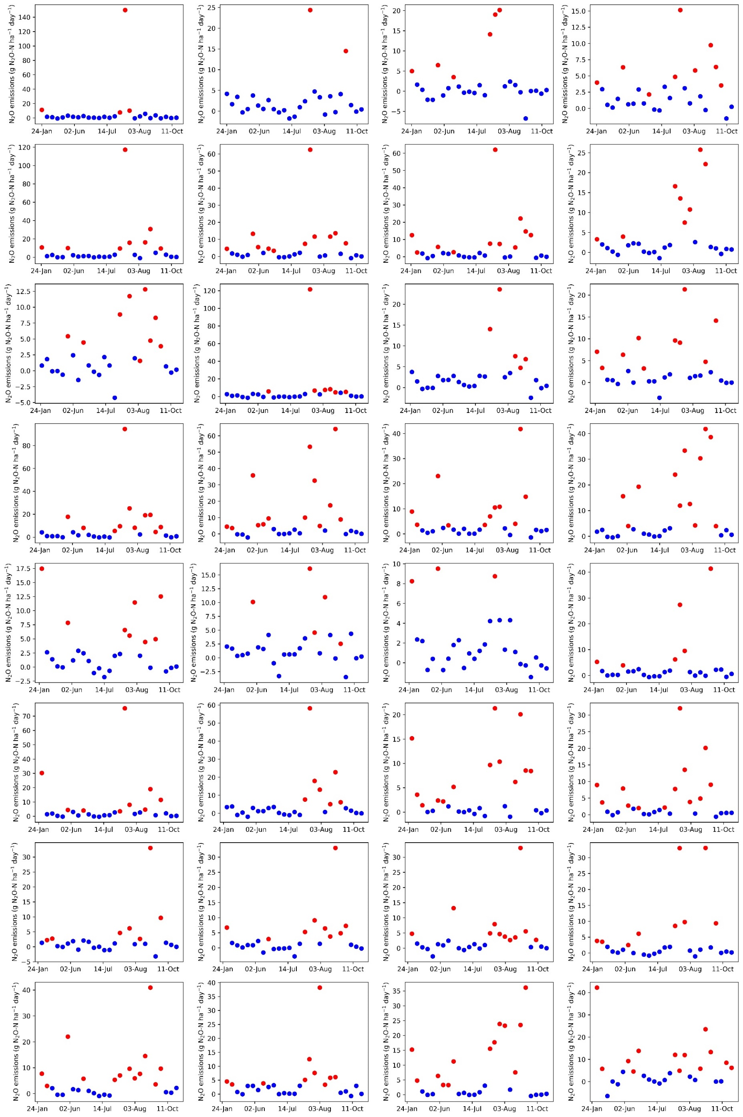
Figure 6.2: HBOS-based classification of hot-moments (red, n = 286) and background emissions (blue, n = 573) across 32 plots in the 2022 independent validation dataset.

Traditional Random Forest with oversampling techniques: Base-Over Model
The Base-Over model addressed the class imbalance problem by oversampling the minority class (i.e. hot-moments) prior to training (Chawla et al., 2002; Torgo et al., 2013). The Synthetic Minority Over-Sampling Technique (SMOTE algorithm) was applied to generate synthetic hot-moment observations, increasing their number from 137 to 274, approximately half the size of the background emissions (n = 535). SMOTE creates new synthetic cases by selecting one of the five nearest neighbors (k=5) for each minority-class observation and interpolating between the two data points to generate a new sample (Chawla et al., 2002). This approach has been shown to outperform traditional resampling techniques that rely solely on duplicating existing observations or removing data (Chawla et al., 2002). After balancing the dataset, a standard RF model was trained following the same procedure as the Base model. In contrast to the Class-Swap model, the Base-Over model did not differentiate between emission types during prediction but relied solely on oversampling to account for class imbalance during training.

Classification of emissions with oversampling techniques: Class-Swap-Over Model
The Class-Swap-Over model combined both techniques: the classification of emissions into hot-moments and background emissions using HBOS + IQR, and the balancing of the dataset with SMOTE oversampling of the minority class. After oversampling, hot-moments were increased to 274 observations, maintaining the background class at 535 observations.
As in the Class-Swap model, two separate RF models were trained, one for each emission type, and dynamically swapped during prediction based on the HBOS + IQR classification. This approach was designed to simultaneously address class imbalance and improve model specialization for the distinct emission types, an approach referred to as Class-Swap-Over.

Model performance evaluation
Evaluating model performance on temporal data series is inherently challenging, particularly for N₂O emissions data, which are highly skewed. In such cases, no single metric can fully capture the model performance across background and high flux observations. Some metrics tend to overvalue extreme outliers (e.g., R²), while others may undervalue them (e.g., Mean Absolute Percentage Error) (Wang et al., 2020). Thus, multiple complementary metrics were assessed to provide a more robust and comprehensive evaluation of model accuracy and reliability, acknowledging that each metric has its limitations (Chicco et al., 2021).
Performance was assessed through root mean square errors (RMSE), coefficients of determination (R²), mean absolute error (MAE), and symmetric mean absolute error (SMAPE). Additionally, observed and predicted average daily N₂O fluxes were interpolated to estimate cumulative N₂O emissions by treatment over the cotton growing season, and mean absolute percentage error (MAPE) was calculated for both total cumulative N₂O emissions by treatment and the average cumulative N₂O emissions across all treatments.
The performance metrics, along with their equations and key characteristics, are summarized below. In the following formulas, X_{i} denotes the predicted value, Yi denotes the observed value, and n represents the number of observations.
Coefficient of determination (R²), measures the proportion of variance explained by the model:
 | $$R^{2}=1-\frac{MSE}{MST}$$ | Equation 1

where MSE is mean square error and MST is mean total sum of squares. R² indicates overall model fit but does not reflect magnitude of prediction errors.
Root mean square error (RMSE): evaluates the average magnitude of errors, giving more weight to larger errors:
 | $$RMSE=\sqrt{\frac{1}{n}\sum_{i=1}^{n}{{\left(Xi-Yi\right)}^{2}}}$$ | Equation 2
Lower RMSE values indicate better performance, but RMSE is sensitive to outliers (penalizes large errors more heavily).
Mean Absolute Error (MAE), calculates the average of the absolute differences between predictions and observations:
 | $$MAE= \frac{1}{n}\sum_{i=1}^{n}{|Xi-Yi|}$$ | Equation 3
MAE provides an intuitive measure of average error but is less sensitive to large deviation than RMSE.
Mean absolute percentage error (MAPE), expresses the prediction errors as a percentage of the observed values:
 | $$MAPE=\frac{1}{n}\sum_{i=1}^{n}{|\frac{Yi-Xi}{Yi}|}$$ | Equation 4
While useful for comparing relative errors across scales, MAPE can become problematic when observed values are very small.
Symmetric mean absolute percentage error (SMAPE), modifies MAPE by normalizing over the sum of observed and predicted values:
 | $$SMAPE=\frac{1}{n}\sum_{i=1}^{n}{\frac{|Xi-Yi|}{(\left|Xi\right|+\left|Yi\right|)/2}}$$ | Equation 5
SMAPE values range from 0 to 200%. SMAPE reduces some of MAPE’s bias but remains sensitive to near-zero values.
By using a combination of these metrics, we aimed to better capture model performance across the wide range of N₂O fluxes and to avoid over reliance on any single evaluation criterion.

Results

Predictive performance of models for daily N₂O fluxes
The classification-swap approach generally enhanced the accuracy of daily N₂O flux predictions across the treatments, consistently outperforming traditional models on both measured and oversampled datasets (Figure 6.3, Figure 6.4, Figure 6.5, and Figure 6.6). The Class-Swap model outperformed the Base model (R²: 0.31 vs 0.07) and similarly, the Class-Swap-Over model surpassed the Base-Over model (R²: 0.32 vs 0.23) in predicting N₂O fluxes in the 2022 independent validation dataset, which was excluded from model training. In contrast to the 3-fold gain in predictive performance of the Base model (R²: 0.07 vs 0.23), oversampling had minimal effect under the classification-swap approach (R²: 0.31 vs 0.32). The classification-swap approach not only improved overall prediction accuracy but also effectively captured both the low and high ranges of N₂O fluxes in the training and independent validation datasets (Figures 6.7 and Figure 6.8). In contrast, the Base model struggled to predict hot-moments in the independent dataset (Figure 6.3, Figure 6.8, and Figure 6.5). While the Base-oversampling model was better at identifying hot-moments, it frequently over-predicted medium emissions and underestimated the magnitude of hot-moments (Figure 6.4 and Figure 6.6). Overall, the classification swap model approach improved all performance metrics, whether using measured or oversampled data, for both training or independent validation datasets, reducing RMSE by 6-17% and MAE by 9-25% compared to the Base model variants (Table 6.3 and Table 6.4).

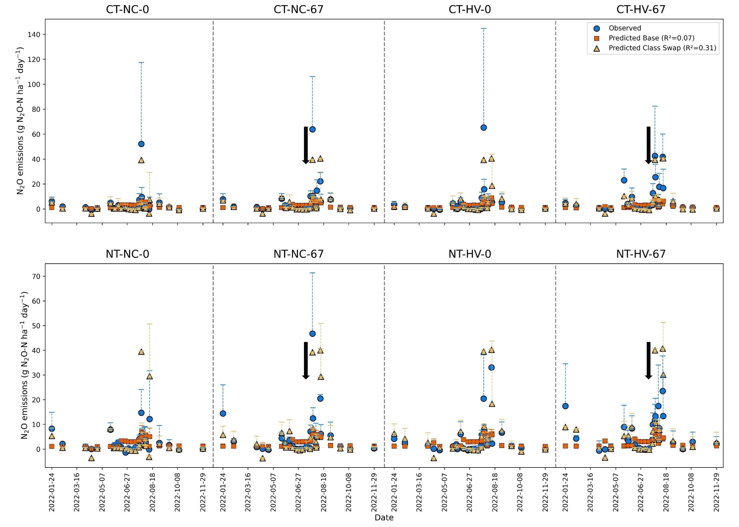
Figure 6.3: Observed and predicted nitrous oxide (N₂O) fluxes with Base and Class-Swap models across treatments over the 2022 independent validation period. Dashed T-lines represent standard deviation (± SD). Vertical black dashed lines indicate transitions between treatments, and black arrows indicate the timing of nitrogen fertilization in fertilized treatments.

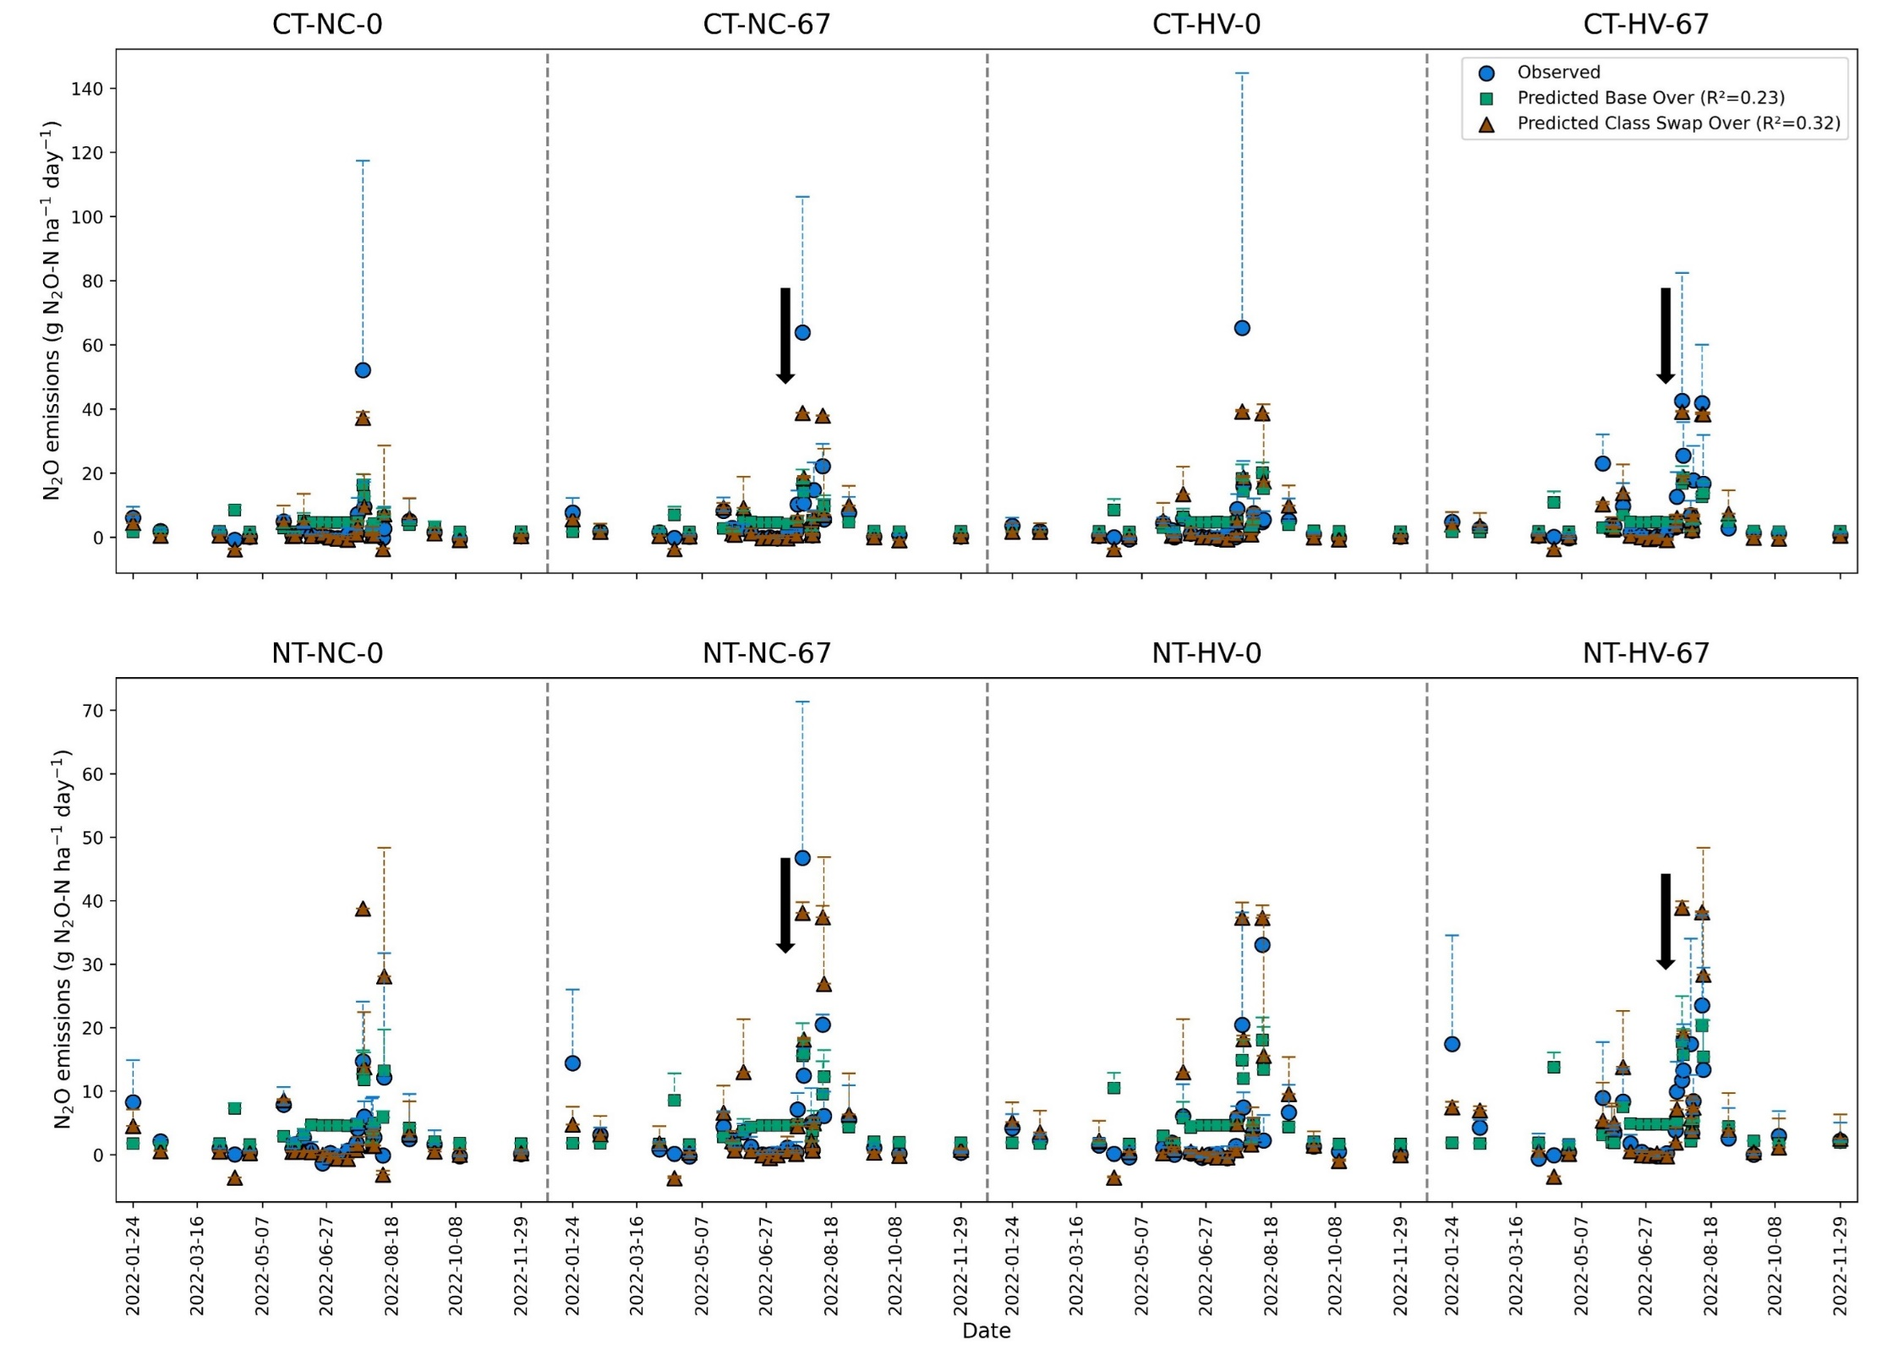
Figure 6.4: Observed and predicted nitrous oxide (N₂O) fluxes with Base-Over and Class-Swap-Over models across treatments over the 2022 independent validation period. Dashed T-lines represent standard deviation (± SD). Vertical black dashed lines indicate transitions between treatments, and black arrows indicate the timing of nitrogen fertilization in fertilized treatments.

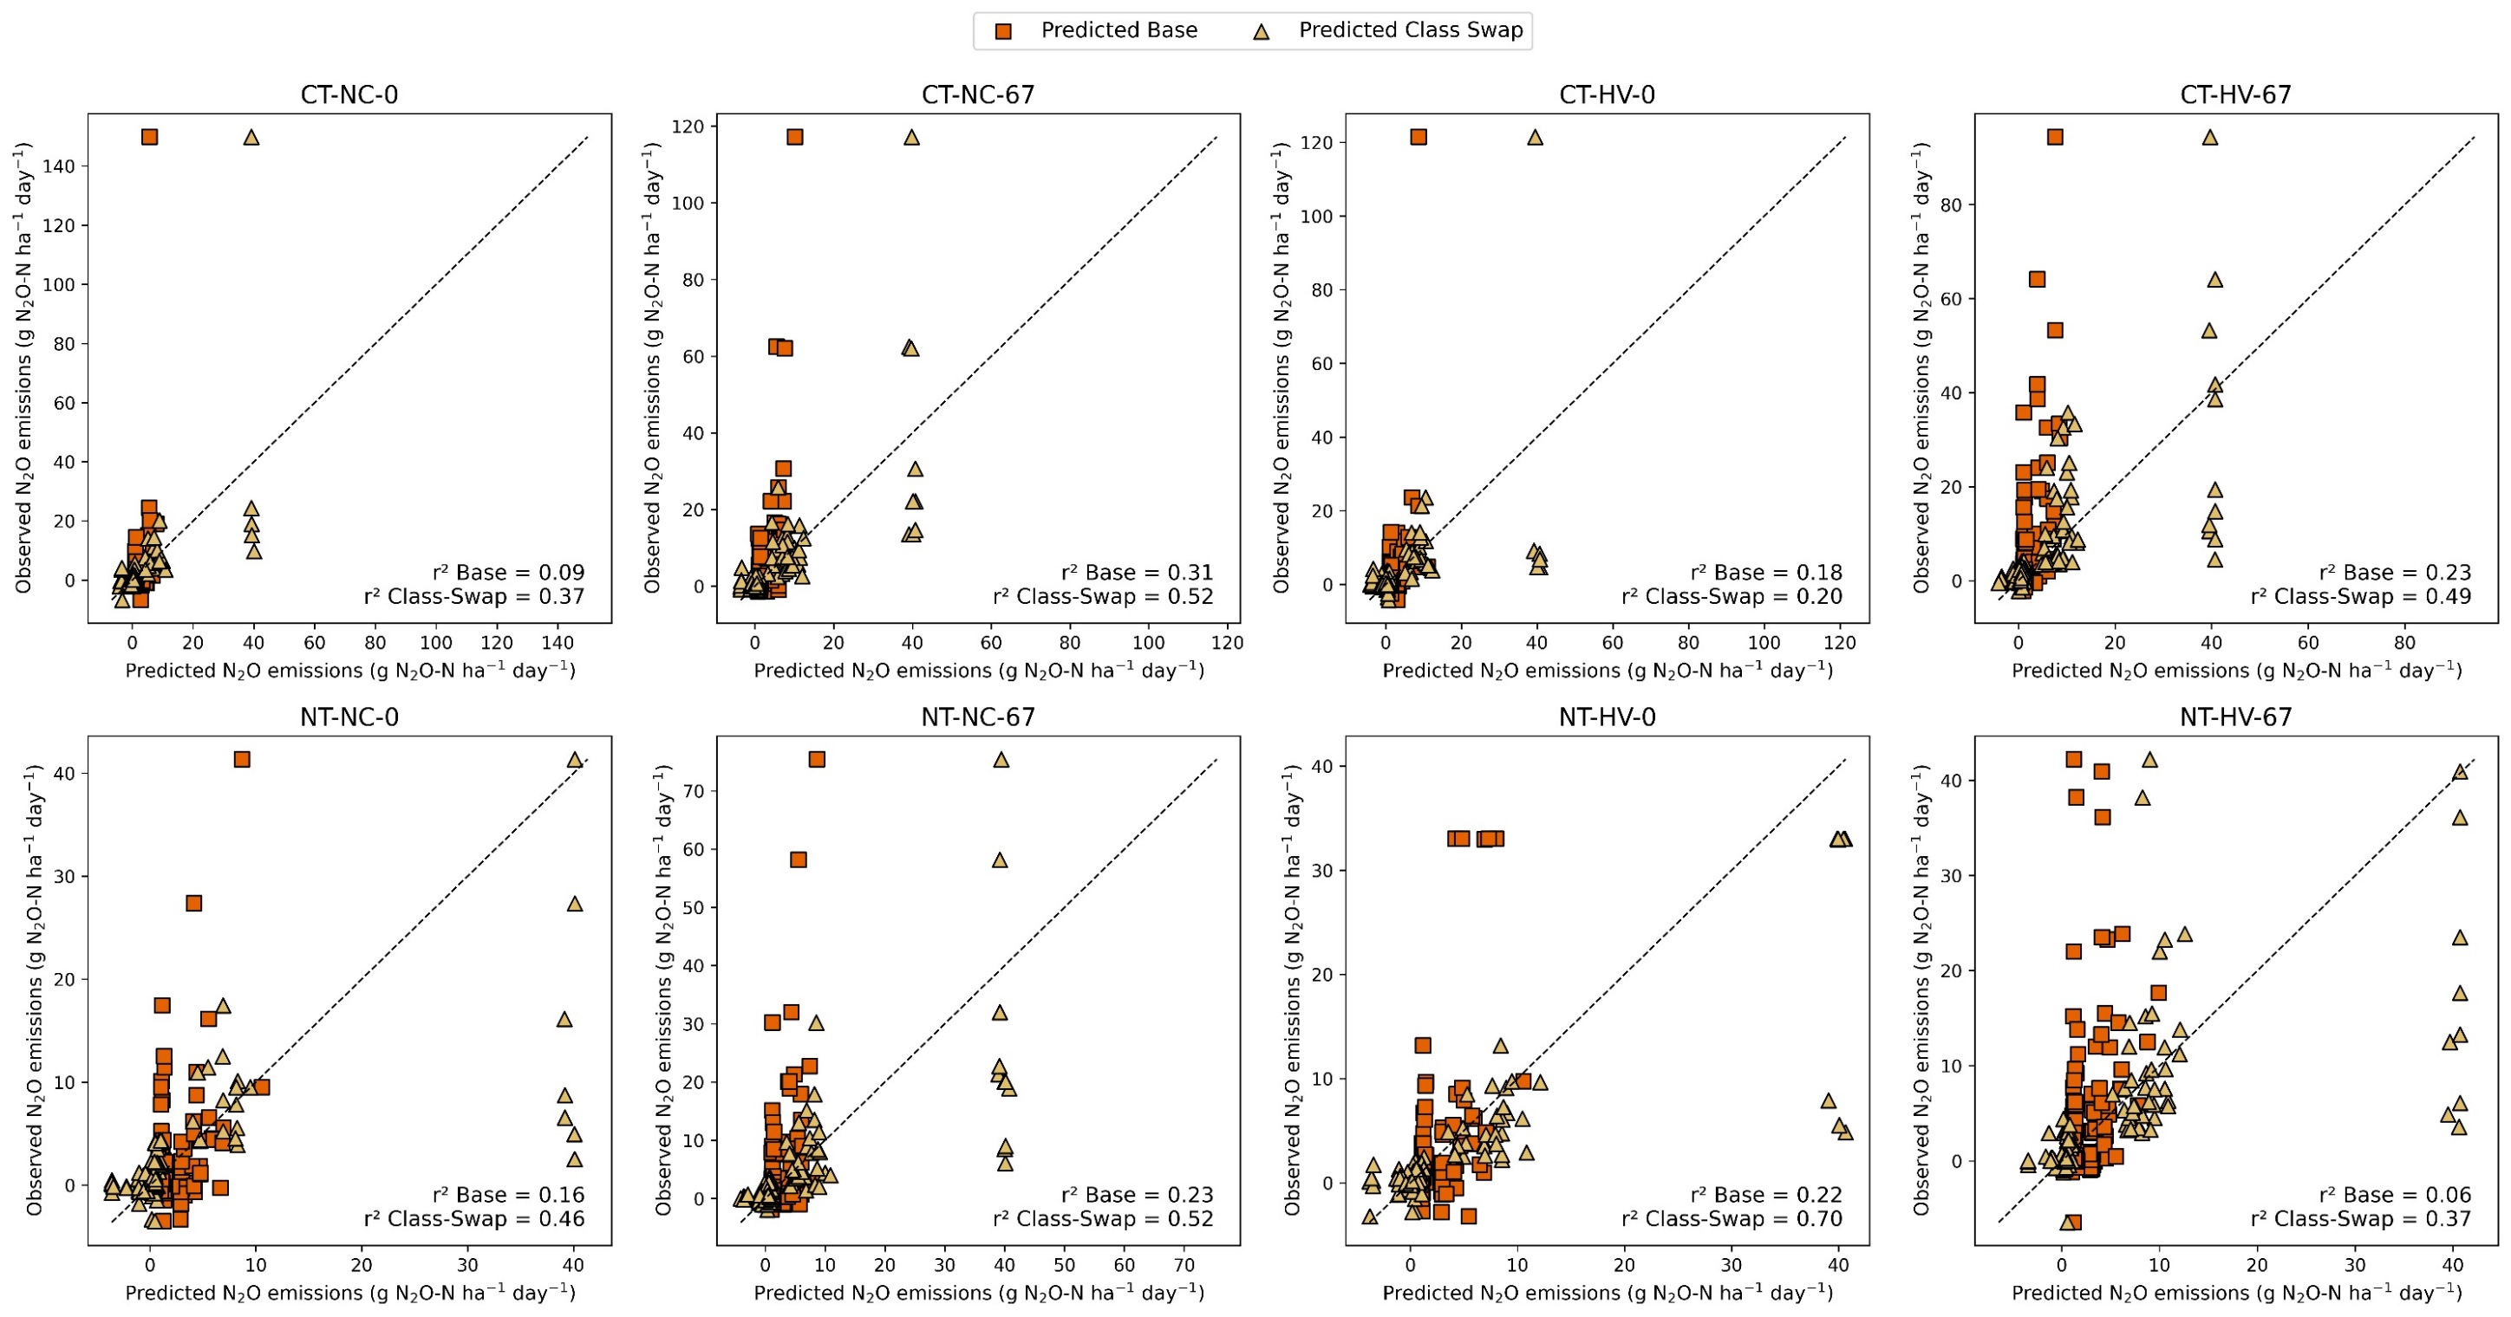
Figure 6.5: Observed versus predicted nitrous oxide (N₂O) fluxes by the Base and Class-Swap models across treatments for the 2022 independent dataset. The dashed black line denotes the 1:1 reference line, indicating perfect prediction accuracy. r²: coefficient of determination (square of the Pearson correlation coefficient).

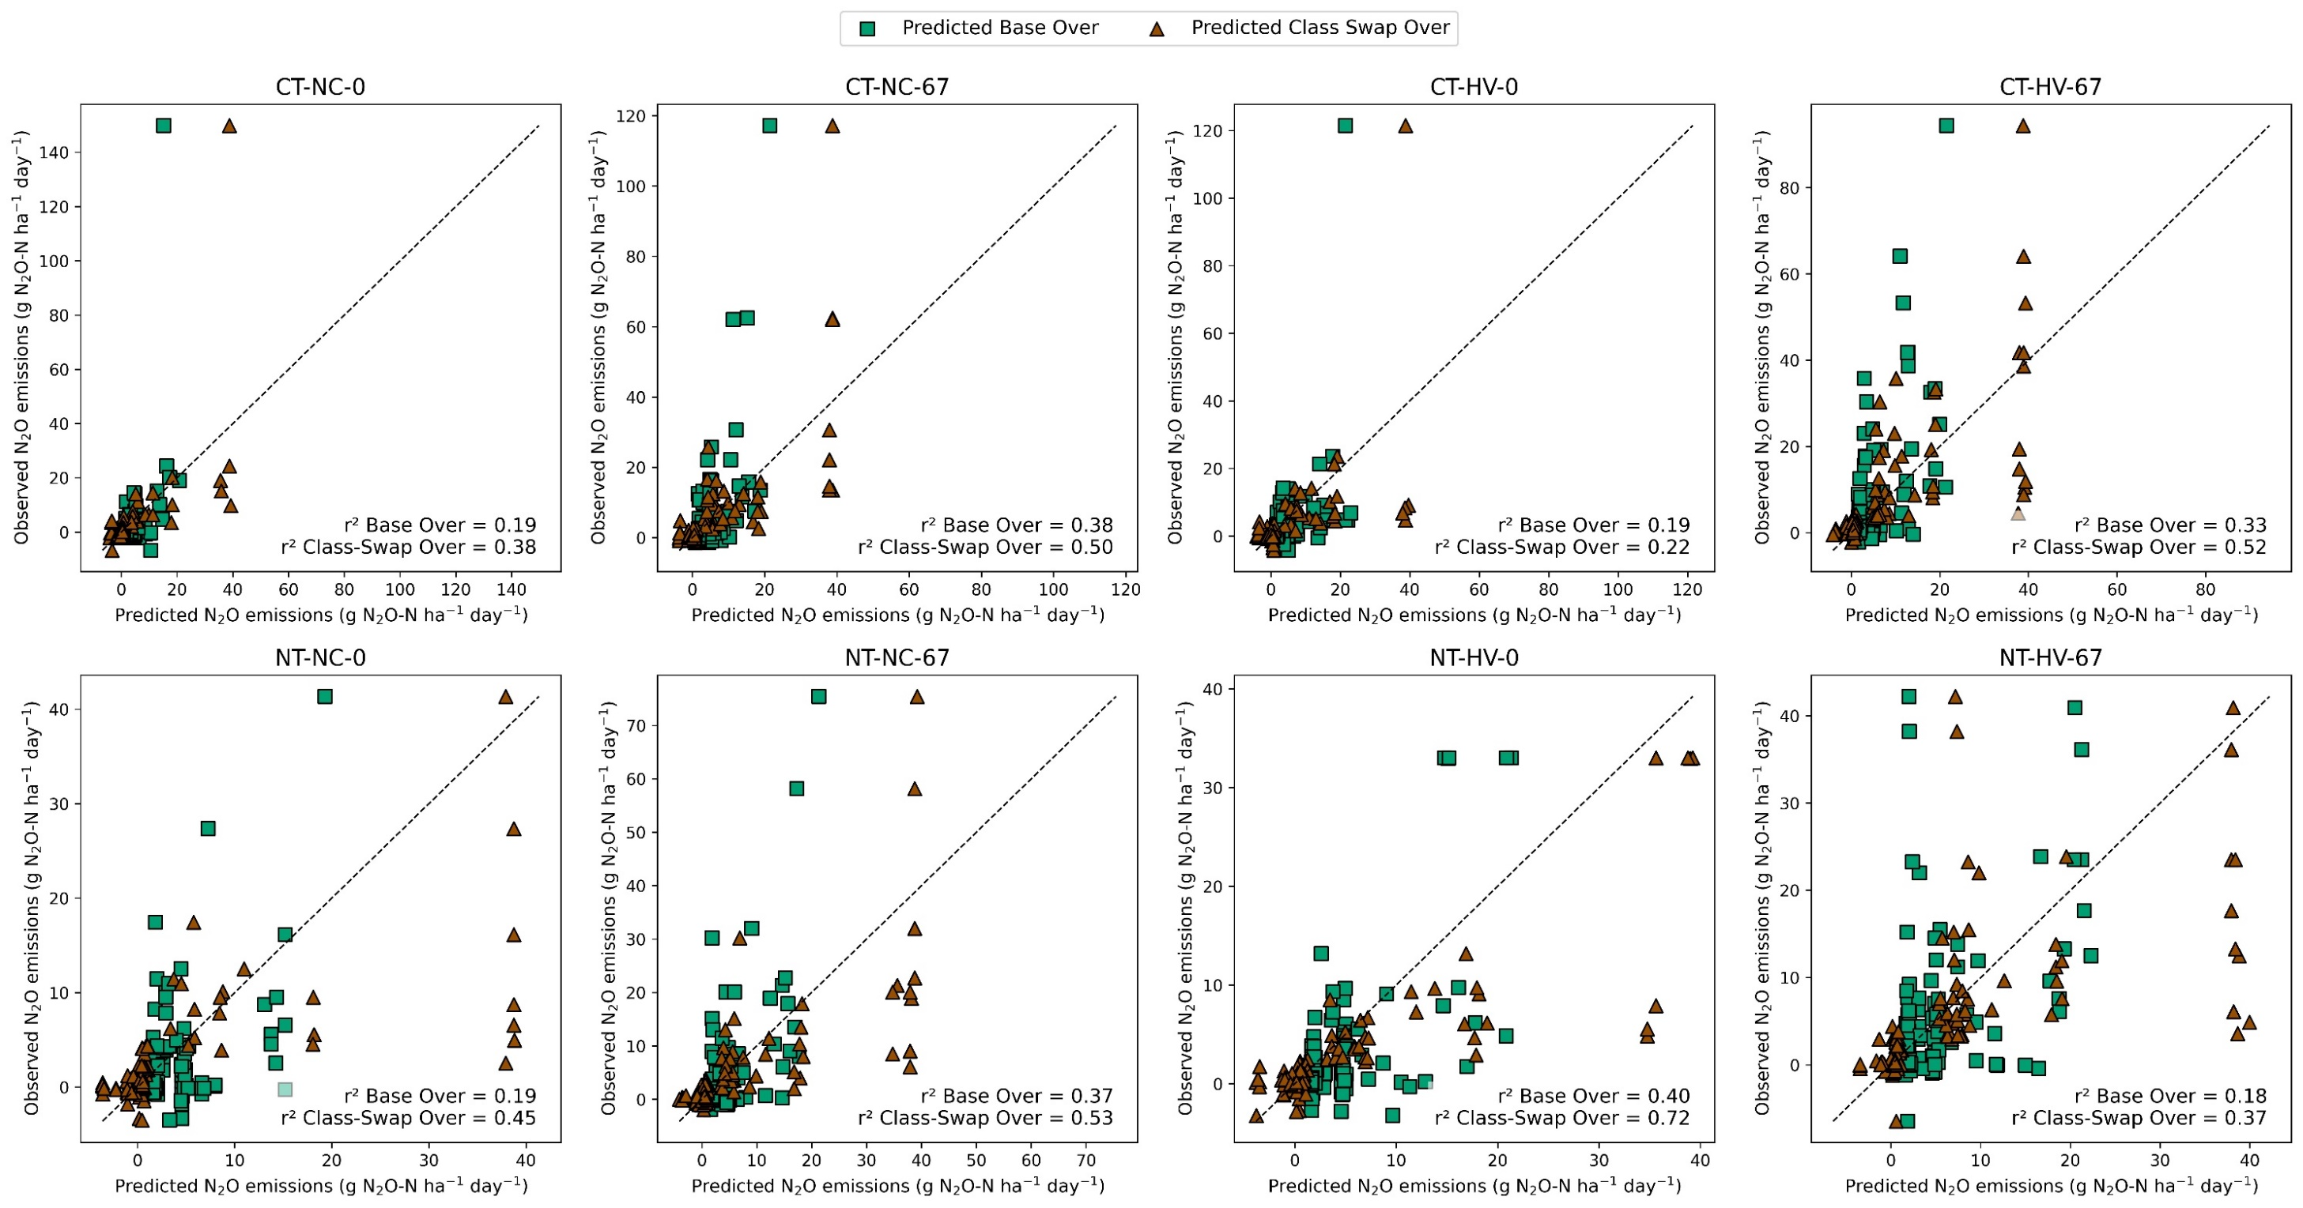
Figure 6.6: Observed versus predicted nitrous oxide (N₂O) fluxes by the Base Over and Class-Swap Over models across treatments for the 2022 independent dataset. The dashed black line denotes the 1:1 reference line, indicating perfect prediction accuracy. r²: coefficient of determination (square of the Pearson correlation coefficient).

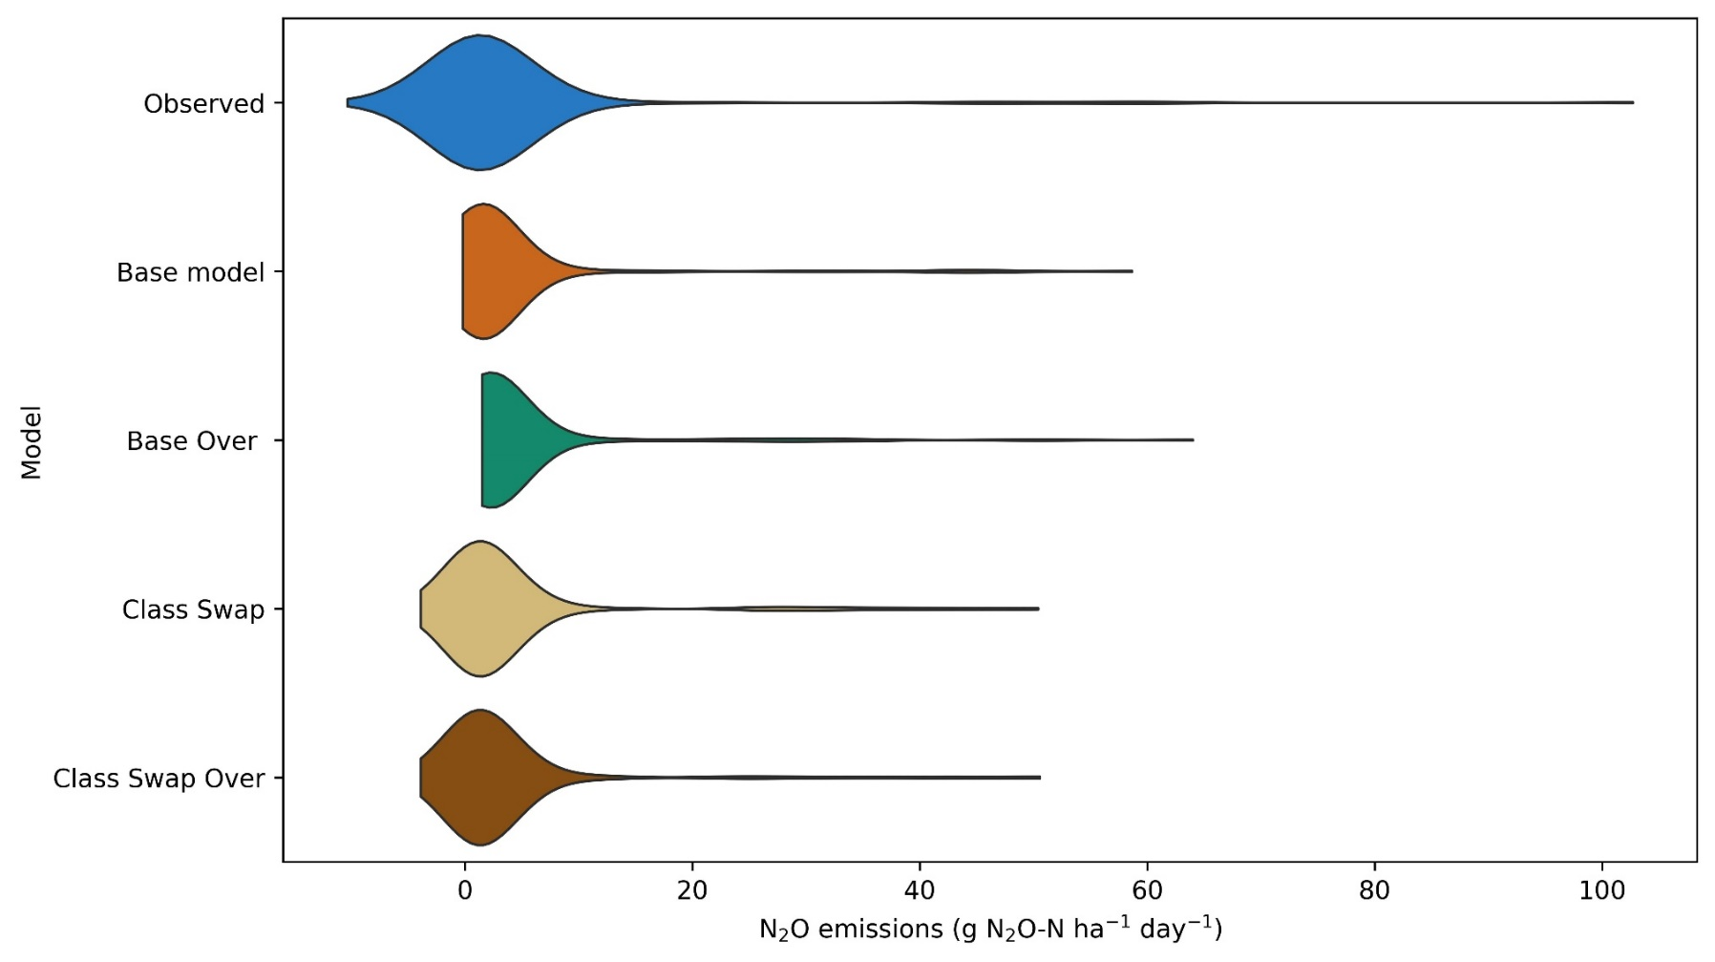
Figure 6.7: Violin plot comparing observed and predicted nitrous oxide (N₂O) fluxes from the Base, Base-Over, Class-Swap, and Class-Swap-Over models, based on the 2023 training dataset.

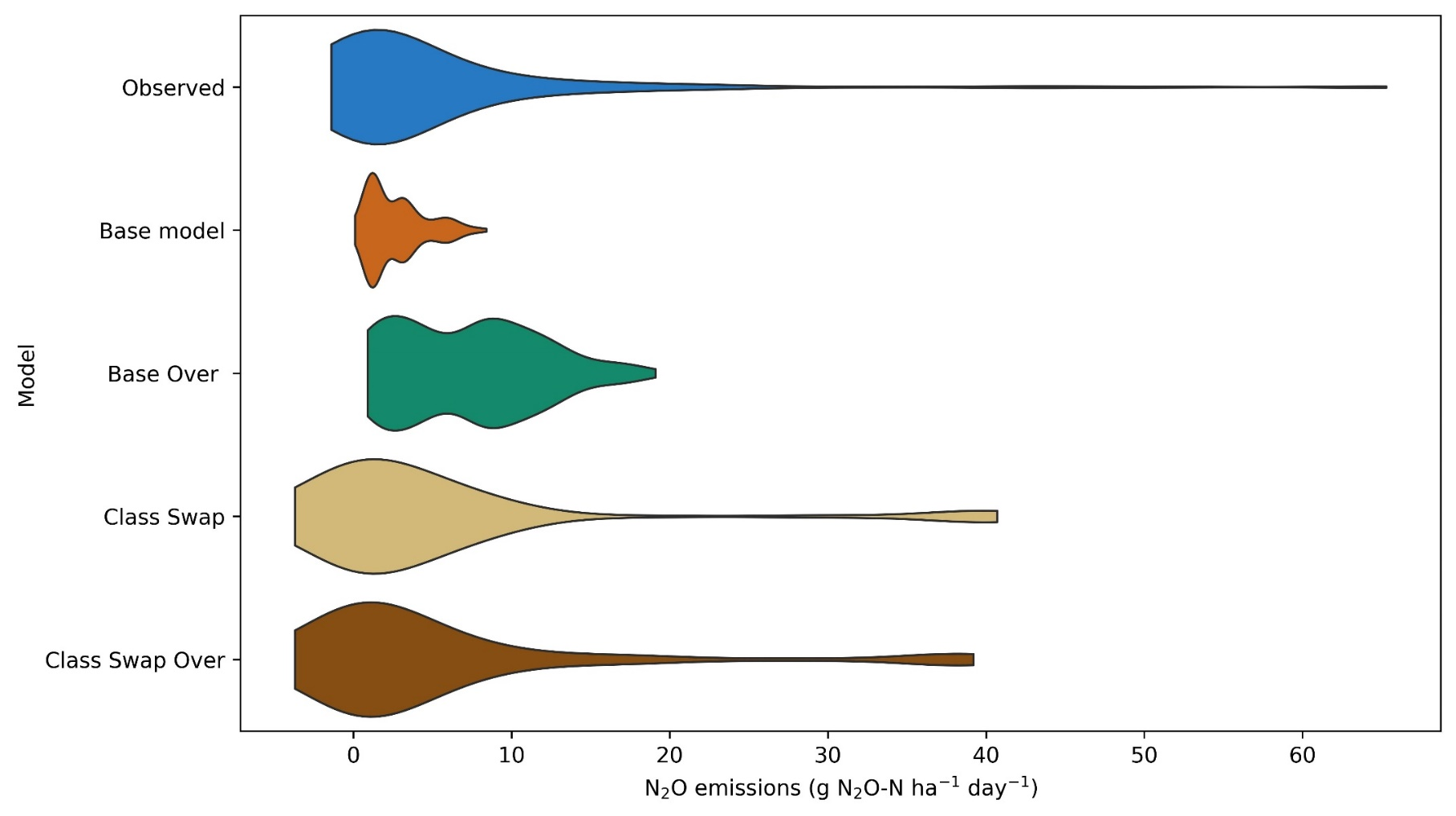
Figure 6.8: Violin plot comparing observed and predicted nitrous oxide (N₂O) fluxes from the Base, Base-Over, Class-Swap, and Class-Swap-Over models, based on the 2022 independent validation dataset.

Table 6.3: Performance metrics of all models evaluated using the 2022 independent validation dataset.
Models | Independent dataset 2022
Models | R² | RMSE | MAE | SMAPE
Models |  | (g N₂O-N ha⁻¹ d⁻¹) | (g N₂O-N ha⁻¹ d⁻¹) | (%)
Base | 0.07 | 11.3 | 4.6 | 55.6
Class-Swap | 0.31 | 9.8 | 4.2 | 53.0
Base-Over | 0.23 | 10.3 | 5.0 | 53.7
Class-Swap-Over | 0.32 | 9.7 | 4.3 | 53.4
R²: Coefficient of determination, RMSE: Root mean square error, MAE: Mean absolute error, SMAPE: Symmetric mean absolute percentage error

Table 6.4: Performance metrics of all models evaluated using the 2023 training dataset
Models | Train dataset 2023
Models | R² | RMSE | MAE | SMAPE
Models |  | (g N₂O-N ha⁻¹ d⁻¹) | (g N₂O-N ha⁻¹ d⁻¹) | (%)
Base | 0.14 | 16.5 | 5.2 | 54.6
Class-Swap | 0.41 | 13.7 | 3.9 | 53.5
Base-Over | 0.24 | 15.5 | 5.4 | 55.2
Class-Swap-Over | 0.37 | 14.1 | 4.1 | 53.8
R²: Coefficient of determination, RMSE: Root mean square error, MAE: Mean absolute error, SMAPE: Symmetric mean absolute percentage error

Cumulative N₂O emissions
To further evaluate model performance on temporally aggregated scale, both the Class-Swap and Base model predictions were used to estimate cumulative N₂O emissions over the cotton growing season, complementing the assessment of daily fluxes. Cumulative emissions were calculated by linearly interpolating daily N₂O fluxes between sampling dates for each treatment. Observed and predicted cumulative N₂O emissions are reported as average across treatments (Figure 6.9) and disaggregated by individual treatments (Figure 6.10). Time series comparison indicates that the Class-Swap models, using both measured and oversampled data, effectively captured the magnitude and temporal progression of cumulative N₂O emissions, closely reflecting the average observed trends over time across the treatments (Figure 6.9). In contrast, the Base-Over model overestimated cumulative N₂O emissions – a bias primarily manifested through overestimation of daily fluxes - whereas the Base model underestimated cumulative N₂O emissions by systematically underestimating hot-moment events.

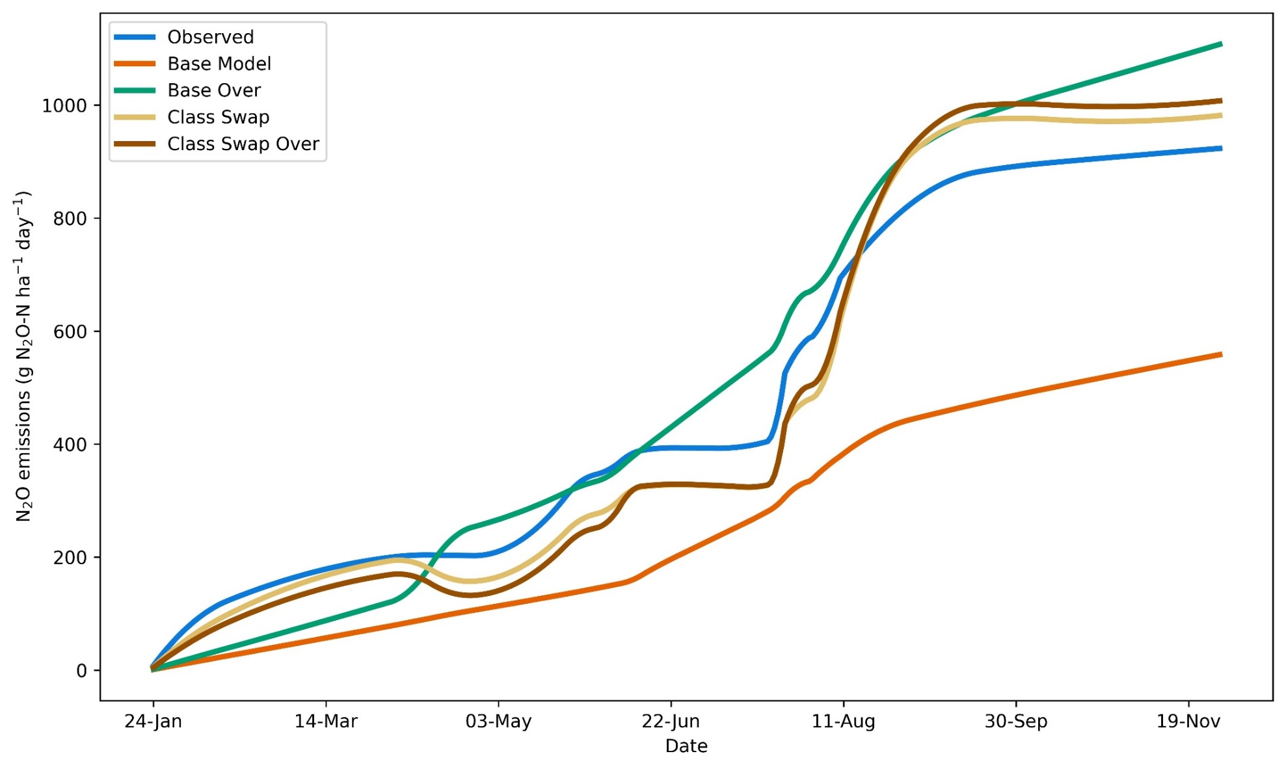
Figure 6.9: Observed and model-predicted cumulative N₂O emissions average across all treatments, based on the 2022 independent validation dataset.

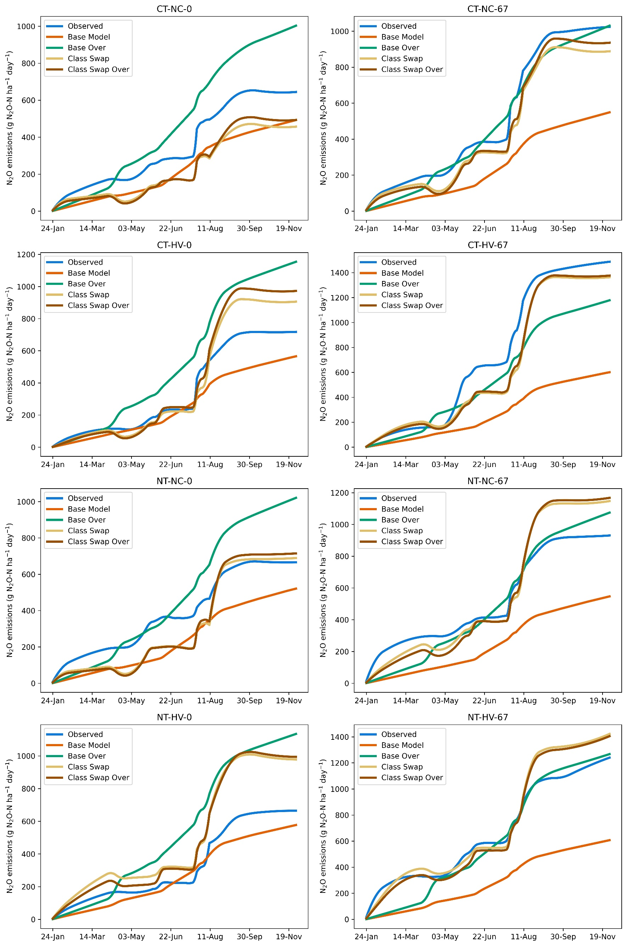
Figure 6.10: Observed and predicted cumulative N₂O emissions by treatment, based on the 2022 independent validation dataset.

Overall, the Class-Swap approach significantly reduced the MAPE between observed and predicted cumulative N₂O emissions, regardless of whether measured or oversampled data were used, and across both training and independent datasets (Table 6.5 and Table 6.6). This approach reduced MAPE by 40-63% compared to the Base models. Using measured data (Base vs Class-Swap model), the Class-Swap model markedly improved predictions for N-fertilized treatments, where cumulative N₂O emissions were high. Under the oversampling approach (Base-Over vs Class-Swap-Over model), Class-Swap models significantly enhanced predictions for treatments without N fertilizer, where cumulative N₂O emissions were lower. Notably, the Class-Swap and Class-Swap-Over models exhibited similar performance in estimating cumulative N₂O emissions.

Table 6.5: Observed and predicted cumulative N₂O emissions by treatment, based on the 2023 training dataset.
Treatments | Models- Train Dataset
Treatments | Cumulative N₂O emissions (g N₂O-N ha⁻¹)
Treatments |  | Base |  | Class-Swap |  | Base-Over |  | Class-Swap-Over
Treatments | Observed | Predicted | MAPE | Predicted | MAPE | Predicted | MAPE | Predicted | MAPE
CT-NC-0 | 194 | 392 | 102 | 234 | 21 | 553 | 185 | 239 | 23
CT-NC-70 | 534 | 330 | 38 | 421 | 21 | 477 | 11 | 395 | 26
CT-HV-0 | 95 | 446 | 369 | 270 | 184 | 572 | 502 | 258 | 172
CT-HV-70 | 453 | 470 | 4 | 454 | 0 | 520 | 15 | 430 | 5
NT-NC-0 | 193 | 388 | 101 | 325 | 68 | 532 | 176 | 325 | 68
NT-NC-70 | 574 | 490 | 15 | 318 | 45 | 605 | 5 | 314 | 45
NT-HV-0 | 251 | 364 | 45 | 308 | 23 | 524 | 109 | 303 | 21
NT-HV-70 | 533 | 474 | 11 | 647 | 21 | 656 | 23 | 673 | 26
Average* | 353 | 419 | 86 | 372 | 48 | 555 | 128 | 367 | 48
MAPE: mean absolute percentage error. *mean cumulative emissions across all treatments for each model

Table 6.6: Observed and predicted cumulative N₂O emissions by treatment, based on the 2022 independent validation dataset.
Treatments | Models- Independent Dataset
Treatments | Cumulative N₂O emissions (g N₂O-N ha⁻¹)
Treatments |  | Base |  | Class-Swap |  | Base-Over |  | Class-Swap-Over
Treatments | Observed | Predicted | MAPE | Predicted | MAPE | Predicted | MAPE | Predicted | MAPE
CT-NC-0 | 644 | 495 | 23 | 457 | 29 | 1003 | 56 | 494 | 23
CT-NC-70 | 1025 | 548 | 47 | 888 | 13 | 1031 | 1 | 937 | 9
CT-HV-0 | 717 | 567 | 21 | 906 | 26 | 1154 | 61 | 972 | 36
CT-HV-70 | 1488 | 600 | 60 | 1364 | 8 | 1178 | 21 | 1376 | 8
NT-NC-0 | 666 | 523 | 21 | 691 | 4 | 1021 | 53 | 716 | 8
NT-NC-70 | 931 | 549 | 41 | 1147 | 23 | 1075 | 15 | 1168 | 25
NT-HV-0 | 665 | 578 | 12 | 977 | 47 | 1135 | 71 | 993 | 49
NT-HV-70 | 1241 | 607 | 51 | 1423 | 9 | 1268 | 2 | 1405 | 13
Average* | 922 | 558 | 34 | 982 | 20 | 1108 | 35 | 1008 | 21
MAPE: mean absolute percentage error. *mean cumulative emissions across all treatments for each model

Differential drivers of low and high N₂O emission events as identified by the Class-Swap model
The most important variables influencing N₂O fluxes in both the low (background emissions) and high (hot-moment) emissions models within the Class-Swap approach were precipitation (PP2) and soil moisture (WFPS), accounting for 55 and 99% of the total feature importance, respectively (Figure 6.11). However, PP2 was the single most important variable driving episodic hot moment emissions following rainfall and irrigation water inputs (Figure 6.11b). Whereas additional variables such as soil respiration rate (CO₂) and ammonium availability (${NH}_{4}^{+}$) substantially (together accounting for 23% of the variable importance) contributed to the variability of background emission, bringing the collective contribution of the top four variables to approximately 80%.
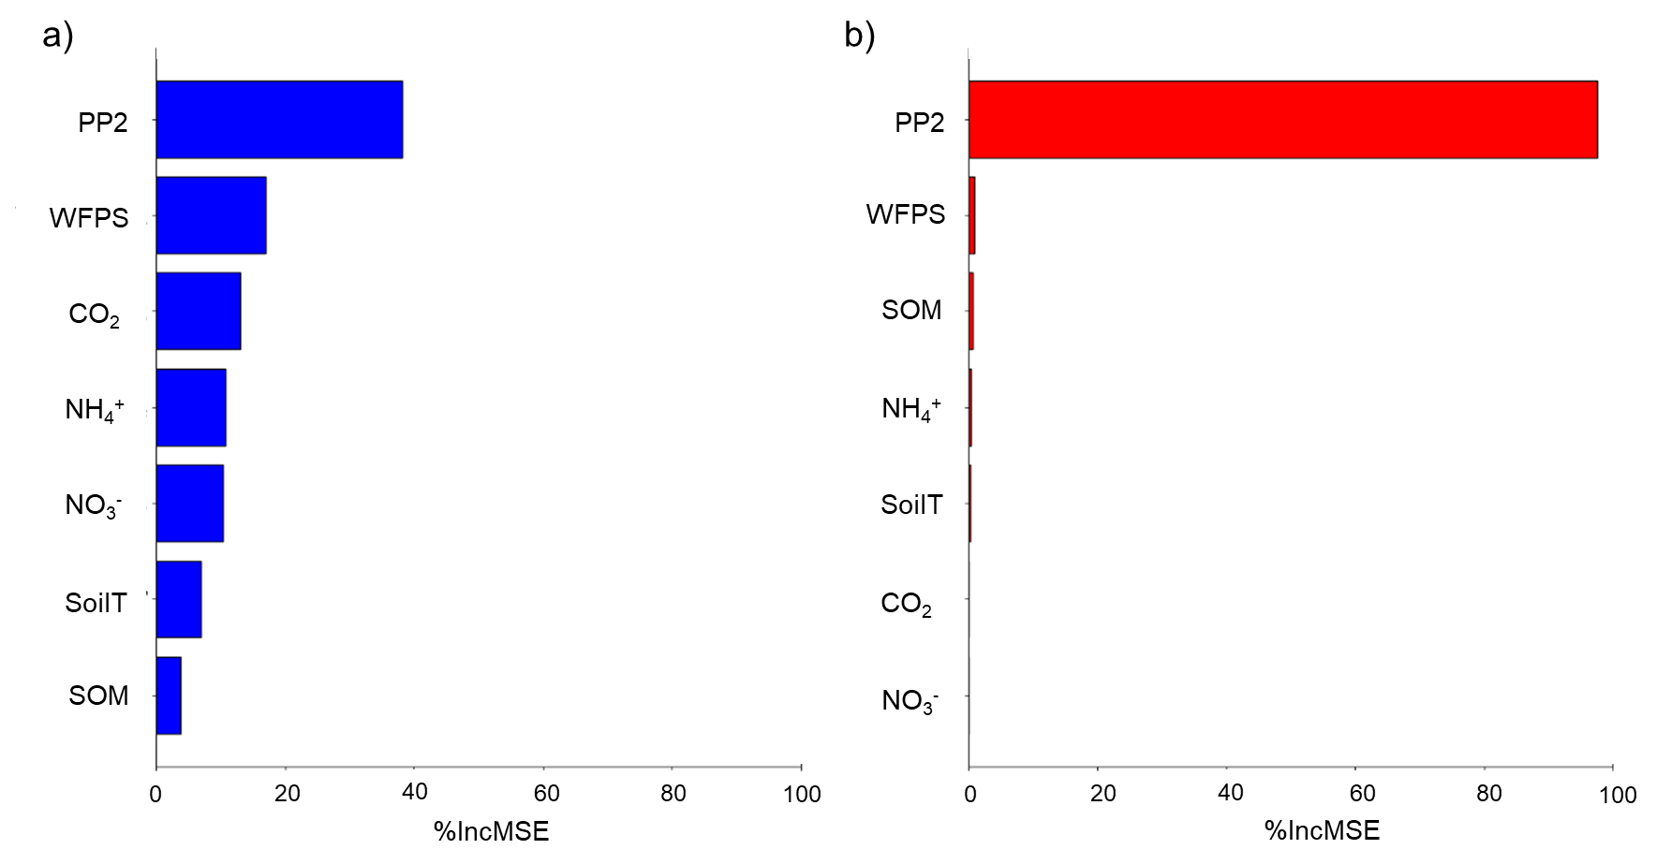
Figure 6.11: Variable importance in the Class-Swap model for (a) low (background emissions) and (b) high (hot-moments) N₂O emission scenarios.

While both models identified PP2 and WFPS as the most important predictors, their influence on N₂O fluxes differed markedly, as illustrated by the partial dependence plots (Figure 6.12). In the background emissions model, high rainfall (PP2) was associated with lower N₂O fluxes, whereas in the hot-moment model, N₂O emissions sharply increased during extreme precipitation events, which could arise from either the physical displacement of N₂O stored in the soil or enhanced microbial production under saturated conditions. Additionally, moderate to high soil moisture levels (0.45 to 0.7 WFPS) positively influenced background emissions, while only very high moisture levels (> 0.65 WFPS) triggered N₂O hot moments. Moreover, increases in soil CO₂ emissions and NH₄⁺ concentrations above 8 mg kg⁻¹ were associated with higher N₂O fluxes in the background emissions model.
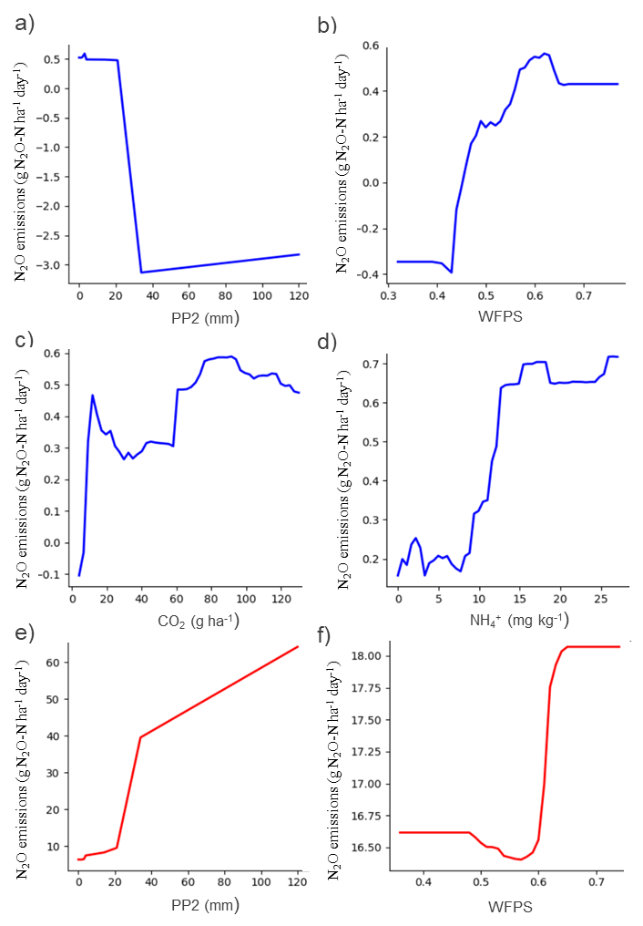
Figure 6.12: Partial dependence plots for the most influential variables in the Class-Swap model under low (a-d) and high (e-f) N₂O emission scenarios: a,e) 48 hours cumulative precipitation, b,f) WFPS, c) CO₂ fluxes, and d) ammonium.

Discussion
This study presents the Class-Swap ML approach as a promising method demonstrating improved predictive performance over traditional ML modeling approaches in predicting agricultural soil N₂O emissions at both daily and seasonal scales. By objectively classifying hot-moments and background emissions, differential model training on the labeled data, and employing model swapping, we developed models that predict N₂O emissions based on their distinct nature and driving factors, leading to more robust and generalizable predictions. Consequently, Class-Swap ML model consistently outperformed traditional ML models, achieving higher R² values in both eight-fold cross-validation (R²: 0.37-0.41 vs 0.14-0.24) and independent testing (R²: 0.31-0.32 vs 0.07-0.23). Additionally, this approach effectively captured the temporal dynamics and magnitude of N₂O emissions, closely replicating the observed N₂O emissions patterns during the 2022 cotton growing season, a pattern that traditional ML models could not accurately reproduce.

Predictability and interpretability of Class-Swap ML models
When tested on an independent dataset from a contrasting drier year (2022), the Class-Swap model explained 31 to 32% of the variability in daily N₂O fluxes, with an RMSE of 9.7 to 9.8 g N₂O-N ha⁻¹ d⁻¹. These results represent a 1.4 to 4-fold improvement in predictive accuracy over traditional RF models and highlights the Class-Swap model’s superior ability to generalize beyond its training dataset compared to conventional approaches. Notably, the performance of our model, despite being trained on a relatively small dataset (n = 672), is comparable to other studies using traditional RF models trained on much larger datasets. For instance, Garnier et al. (2024) reported an R² value of 0.36 for their validation dataset (30% of the training dataset, n = 1073), with an RMSE of 9.9 g N₂O-N ha⁻¹ d⁻¹, using six years of N₂O flux data across three different sites and crop rotations. Similarly, Saha et al. (2021) documented an R² of 0.38 for average daily N₂O emissions, with an RMSE 9.8 g N₂O-N ha⁻¹ d⁻¹ in an independent test dataset from a long-term corn-soybean-wheat rotation in the upper US Midwest. In comparison, Class-Swap modeling approach in this study accounted for 55% of the variation observed in average daily N₂O emissions during the 2022 growing season, which experienced a very different weather than 2023 used for model training. This suggests that even with fewer observations, Class-Swap approach aided better learning of dynamic controls of N₂O emissions under different conditions to result predictive performance comparable to models built on much larger datasets.
It is important, however, to acknowledge the inherent limitations in directly comparing model performance across studies, and even across contrasting years within the same site, as in the case of the present study. Data characteristics such as measurement frequency, environmental variability, and especially prevalence of hot-moments, strongly influence perceptibility. Some datasets may be inherently more challenging to predict than others. Thus, these comparisons should not be viewed as definitive benchmarks but rather as useful context. The key point is that, even with relatively small training dataset, the Class-Swap model produced reliable predictions on an independent dataset, an encouraging result given the data-intensive nature of ML approaches.
The effectiveness of the Class-Swap approach likely lies in its ability to distinctly categorize and predict N₂O emissions based on their unique drivers under different environmental contexts. By first classifying data into background and hot-moment emissions, and then tailoring prediction models to each class, this approach accounts for the fundamentally different biophysical mechanisms underlying these fluxes. For example, background emissions were best predicted by moderate soil moisture (WFPS 40-60%), elevated CO₂ emissions, and high soil ${NH}_{4}^{+}$ levels, conditions consistent with nitrification driven N₂O production (Davidson et al., 2000; Butterbach-Bahl et al., 2013; Wang et al., 2023). In contrast, hot-moment emissions were triggered by recent large precipitation and WFPS above 60%, reflecting oxygen-limiting conditions that favor denitrification (Ryden and Lund, 1980; Mosier and Hutchinson, 1981; Bateman and Baggs, 2005; Song et al., 2019, 2022b; Rohe et al., 2021). Capturing these distinct pathways, indicated by differential variable importance under hot-moment and background emission scenarios, likely contributed to the superior performance of Class-Swap models. While ML models theoretically have the capacity to learn such complex, nonlinear relationships in one model, the class imbalance problem combined with the lack of available large, diverse datasets leads to insufficient learning from the minority class (hot moments) and a bias toward the majority class (background emissions). This dynamic was true in our single-model approaches even when employing oversampling, a traditional technique to address this problem.
Interestingly, both measured and oversampled versions of the Class-Swap model exhibited similar results, demonstrating that oversampling, while often used to balance skewed N₂O datasets, provided no significant benefit in this case. This is likely true because our Class-Swap approach can be thought of as oversampling taken to the extreme, where the minority class is not just overrepresented but becomes the exclusive training data of one model, forcing the model to learn from rare events. This finding is particularly valuable for two reasons. Firstly, this avoids the need for oversampling and prevents the introduction of artificial data points which may misrepresent actual biogeochemical dynamics, and can increase the risk of overfitting and fail to provide meaningful insights into minority classes (Hussein et al., 2019; Azhar; et al., 2023). Secondly, even without oversampling, our cross-validation process reduced bias compared to other techniques, as our models do not consider the entire range of the response variable in the training dataset at any given moment. Finally, the ability of the Class-Swap model to improve performance compared to traditional techniques with a small dataset highlights its practicality for studies where N₂O flux data are limited, and hot-moments are rare yet critical to model. This characteristic makes the approach particularly promising for broader applications in ecosystems, where N₂O data are typically limited and capturing a large number of hot-moments is challenging (Luo et al., 2012; Wagner-Riddle et al., 2017), warranting further investigation. By lowering the data requirements needed to develop robust predictive models, this approach also facilitates the creation of site and region specific models, offering a key advantage over process-based models, which require intensive tuning and parameterization, and remain a major barrier to wider adoption of Tier 3 emissions modeling outside the US.

Limitations and possible improvement
This study serves as a proof of concept, demonstrating the potential of the Class-Swap ML modeling approach for predicting temporally dynamic N₂O emissions under varying management practices with limited data. While the analysis is based on a single site, improved model performance across a diversity of management practices including tillage, N fertilization, and cover cropping provides reasonable confidence that such performance improvements are replicable across other contexts. Although the Class-Swap models outperformed traditional RF models across eight distinct management treatments, their effectiveness across multiple sites, years, and agroecosystems remain necessary. Moreover, this modeling approach opens avenues for supervised adaptive modeling strategies, such as separate model training based on data labels (background vs hot-moment emissions). This insight was supported by the observed difficulties in predicting emissions in zero-N input systems, an inherent challenged observed in other studies (Abdalla et al., 2010; Yue et al., 2019), likely due to the complexity of such predictions as the drivers of hot-moments and background emissions may differ substantially between these scenarios (Yin et al., 2022). While the Class-Swap approach currently relies on prior classification of hot-moment versus background emission events to dictate ML model selection for quantitative predictions, future development of robust ML-based classification models, using management and environmental variables, could automate this step in simultaneously classifying and predicting N₂O fluxes. This advancement would enable seamless integration of classification and prediction, enhancing the accuracy and scalability of temporal N₂O flux modeling. Also, the dual-criterion method (HBOS + IQR) used in this study is based on our internal evaluation comparing different methods in the context of our dataset. Evaluating the bias introduced by different classification methods on quantitative predictions is an important consideration for future studies, especially when comparing datasets from diverse soil–climate–management regimes that shape distinct temporal N₂O emission patterns. Since this aspect largely determines the appropriate approach for hot moment identification (Ackett et al., 2025), it falls beyond the scope of this study. Furthermore, we recognize that access to intensive environmental and management data, as used in the present study, may be limited in many contexts. Therefore, identifying alternative variables that are more commonly available and broadly accessible will be essential to support the wider applicability of this approach. In addition, hybrid modeling strategies that leverage process-model outputs as inputs for ML could provide a valuable pathway, particularly since most process models perform well in simulating variables such as CO₂. Although limitations exist, this study points to a clear and actionable research agenda for scaling, refining, and deploying the Class-Swap approach in predicting soil greenhouse gas emissions from agroecosystems.

Conclusions
This study introduced a novel Class-Swap approach to predict daily N₂O fluxes in agricultural systems by first classifying emissions into hot-moments and background fluxes, and then leveraging RF algorithms to model each class separately. By explicitly accounting for the distinct drivers of these emission types, the Class-Swap approach significantly improved both daily and cumulative N₂O predictions compared to traditional RF models. Our findings underscore the value of distinguishing between emission types in predictive modeling, particularly given the sporadic nature of hot-moments. This targeted strategy not only enhanced predictive accuracy but also demonstrated greater generalization across varied management practices within a single site dataset. While the results highlight the promise of the Class-Swap approach, further evaluation across multiple sites, years, and agroecosystems in needed to validate its robustness and scalability.

GENERAL Conclusions
This dissertation demonstrates how long-term soil health practices influence N dynamics, microbial communities, soil O₂-water balance, and the predictability of N₂O emissions in continuous cotton cropping systems. Across five integrated studies, key insights emerged into the mechanisms and interactions by which management legacies shape agroecosystem functioning.
The long-term implementation of NT and diverse N fertilization regimes emerged as central strategies for improving soil fertility and sustaining legume CC performance. The legacy effects of tillage and N fertilization acted as key modulators of soil N supply capacity, which in turn influenced the balance between soil-derived N and atmospheric N fixed through BNF. While hairy vetch exhibited flexible N acquisition strategies, its N status remained closely tied to soil mineral N availability, especially under low-input conditions. These findings highlight the importance of integrating NT with context-specific fertilization to support resilient nutrient cycling and optimize the benefits of legume CCs.
The legacy effects of NT and CC extended beyond nutrient cycling, improving soil O₂ availability and resilience under environmental stress. Long-term adoption of these practices reduced the duration of hypoxic conditions following rainfall events, reinforcing their importance in enhancing soil physical function and supporting plant productivity. This feature becomes increasingly relevant under future climate scenarios where more frequent extreme precipitation events are expected. However, complementary laboratory incubation experiments revealed that decomposition of high-quality CC residues can rapidly deplete soil O₂, promoting N₂O emissions even under relatively aerobic conditions. This underscores the dual role of CCs as both mitigators and potential amplifiers of greenhouse gas emissions depending on their interaction with fertilizer and moisture dynamics. These findings provide crucial insights for improving future models and accurately predicting N₂O emissions in CC-based fertilized systems.
The functional understanding of temporal N₂O fluxes was further advanced through high-resolution microbial analyses. Microbial community composition, shaped by long-term N fertilization and tillage legacies, exhibited strong depth-dependent responses, with specific taxa associated with seasonal N₂O fluxes. Soil acidification under long-term N fertilization emerged as a key driver enhancing the abundance of N₂O-promoting taxa. These results emphasize the importance of improving nutrient management to mitigate emissions and highlight the key role of management practices in regulating microbially mediated N₂O production.
Finally, the development and application of a novel Class-Swap machine learning approach provided an encouraging proof of concept for improving daily N₂O flux predictions. By classifying emissions into background and episodic hot-moment events and modeling each class separately, this approach significantly improved predictive accuracy compared to traditional models. It captured the distinct drivers behind each emission type and offers a scalable and interpretable framework to support decision-making in climate-smart agriculture.
Together, these findings illustrate the complex influence of long-term soil health practices on agroecosystem function, spanning from plant N acquisition and microbial dynamics to soil O₂ availability and greenhouse gas emissions. By integrating field and laboratory evidence with machine learning innovations, this dissertation advances both scientific understanding and practical tools for building resilient, low-input cropping systems that improve soil function and mitigate environmental impacts.
Looking forward, this work highlights several broader impacts and avenues for future research. First, the soil O₂ dynamics observed in relation to cover crop residues point to a mechanism causing soil O₂ depletion and thereby promoting N₂O production that is not solely dependent on soil water content. With cover crop adoption rapidly expanding across the U.S. as a cornerstone of soil health, the WFPS-independent O₂ consumption identified here could become increasingly relevant for predicting and mitigating N₂O emissions in residue-incorporated systems. Future studies should evaluate how cover crop species, residue quantity and quality, and incorporation timing interact with soil moisture content to influence O₂ depletion and emissions.
Second, the Class-Swap modeling approach demonstrates the potential of data-driven tools to advance N₂O prediction, particularly as global soil greenhouse gas databases become more widely available. While many machine learning models struggle with episodic fluxes, the class-based framework developed here shows promise for disentangling emission drivers and improving accuracy at daily timescales. Future research should test this approach across diverse cropping systems, soil types, climates, and explore hybrid frameworks where process-based model outputs (e.g., soil CO₂, mineral N dynamics) are integrated as predictors. A further step would be to combine this framework with models capable of predicting hot-moment occurrence, enabling robust models trained on global datasets to forecast both the timing and magnitude of episodic fluxes. Such predictive capacity could ultimately support farmers in making proactive management decisions to lower environmental impacts. Such advances will be critical to build transferable, scalable models that support mitigation targets.
More broadly, this dissertation underscores the importance of connecting long-term management legacies with emerging modeling frameworks. Future work should continue integrating field experiments, microbial ecology, and data-driven modeling to both refine mechanistic understanding and deliver predictive tools that are practical for farmers, policymakers, and climate assessments. In doing so, the research community can accelerate progress toward resilient agroecosystems that maintain productivity, improve soil function, and mitigate greenhouse gas emissions in the face of global change.

REFERENCES
Abalos, D., S. Recous, K. Butterbach-Bahl, C. De Notaris, T.F. Rittl, et al. 2022. A review and meta-analysis of mitigation measures for nitrous oxide emissions from crop residues. Sci. Total Environ. 828. doi: 10.1016/j.scitotenv.2022.154388.
Abdalla, M., M. Jones, J. Yeluripati, P. Smith, J. Burke, et al. 2010. Testing DayCent and DNDC model simulations of N₂O fluxes and assessing the impacts of climate change on the gas flux and biomass production from a humid pasture. Atmos. Environ. 44(25): 2961–2970. doi: 10.1016/j.atmosenv.2010.05.018.
Abid, M., and R. Lal. 2009. Tillage and drainage impact on soil quality: II. Tensile strength of aggregates, moisture retention and water infiltration. Soil Tillage Res. 103(2): 364–372. doi: 10.1016/j.still.2008.11.004.
Acharya, P., R. Ghimire, W.S. Paye, A.C. Ganguli, and S.J. Delgrosso. 2022. Net greenhouse gas balance with cover crops in semi ‑ arid irrigated cropping systems. Sci. Rep.: 1–13. doi: 10.1038/s41598-022-16719-w.
Ackett, R., H. Hilafu, I. Gelfand, and D. Saha. 2025. A novel statistical context to define and identify nitrous oxide hot moments and their significance across global agroecosystems. J. Geophys. Biogeosciences. doi: (accepted).
Adler, P.R., H. Nguyen, B.M. Rau, and C.J. Dell. 2024. Modeling N₂O emissions with remotely sensed variables using machine learning. Environ. Res. Commun. 6(9). doi: 10.1088/2515-7620/ad707c.
Alliaume, F., W.A.H. Rossing, P. Tittonell, G. Jorge, and S. Dogliotti. 2014. Reduced tillage and cover crops improve water capture and reduce erosion of fine textured soils in raised bed tomato systems. Agric. Ecosyst. Environ. 183: 127–137. doi: 10.1016/j.agee.2013.11.001.
Anderson, M.J. 2017. Permutational multivariate analysis of variance (PERMANOVA). Wiley StatsRef Stat. Ref. Online: 1–15. doi: 10.1002/9781118445112.stat07841.
Anthony, T.L., and W.L. Silver. 2024. Hot spots and hot moments of greenhouse gas emissions in agricultural peatlands. Biogeochemistry 167(4): 461–477. doi: 10.1007/s10533-023-01095-y.
Apprill, A., S. Mcnally, R. Parsons, and L. Weber. 2015. Minor revision to V4 region SSU rRNA 806R gene primer greatly increases detection of SAR11 bacterioplankton. Aquat. Microb. Ecol. 75(2): 129–137. doi: 10.3354/ame01753.
Araya, S.N., J.P. Mitchell, J.W. Hopmans, and T.A. Ghezzehei. 2022. Long-term impact of cover crop and reduced disturbance tillage on soil pore size distribution and soil water storage. Soil 8(1): 177–198. doi: 10.5194/soil-8-177-2022.
Arduini, I., C. Orlandi, S. Pampana, and A. Masoni. 2016. Waterlogging at tillering affects spike and spikelet formation in wheat. Crop Pasture Sci. 67(7): 703–711. doi: 10.1071/CP15417.
Asaf, S., M. Numan, A.L. Khan, and A. Al-Harrasi. 2020. Sphingomonas: from diversity and genomics to functional role in environmental remediation and plant growth. Crit. Rev. Biotechnol. 40(2): 138–152. doi: 10.1080/07388551.2019.1709793.
Aulakh, M.S., J.W. Doran, D.T. Walters, and J.F. Power. 1991. Legume residue and soil water effects on denitrification in soil of different textures. Soil Biol. Biochem. 23(12).
Azhar;, N.A., M.S.M. Pozi;, A.M. Din;, and A. Jatowt. 2023. An investigation of SMOTE based methods for imbalanced datasets with data complexity analysis. IEEE Trans. Knowl. Data Eng. 35(7): 6651–6672.
Baggs, E., and L. Philippot. 2010. Microbial terrestrial pathways to nitrous oxide. Nitrous Oxide Clim. Chang.: 4–35.
Bakken, L.R., L. Bergaust, B. Liu, and Å. Frostegård. 2012. Regulation of denitrification at the cellular level: A clue to the understanding of N₂O emissions from soils. Philos. Trans. R. Soc. B Biol. Sci. 367(1593): 1226–1234. doi: 10.1098/rstb.2011.0321.
Balaine, N., T.J. Clough, M.H. Beare, S.M. Thomas, E.D. Meenken, et al. 2013. Changes in relative gas diffusivity explain soil nitrous oxide flux dynamics. Soil Sci. Soc. Am. J. 77(5): 1496–1505. doi: 10.2136/sssaj2013.04.0141.
Balaine, N., T.J. Clough, M.H. Beare, S.M. Thomas, and E.D. Meenken. 2016. Soil gas diffusivity controls N₂O and N₂ emissions and their ratio. Soil Sci. Soc. Am. J. 80(3): 529–540. doi: 10.2136/sssaj2015.09.0350.
Bano, S., Q. Wu, S. Yu, X. Wang, and X. Zhang. 2024. Soil properties drive nitrous oxide accumulation patterns by shaping denitrifying bacteriomes. Environ. Microbiome 19(1). doi: 10.1186/s40793-024-00643-9.
Barabasz, W., D. Albińska, M. Jaśkowska, and J. Lipiec. 2002. Biological effects of mineral nitrogen fertilization on soil microorganisms. Polish J. Environ. Stud. 11(3): 193–198.
Barber, N.A., D.M. Klimek, J.K. Bell, and W.D. Swingley. 2023. Restoration age and reintroduced bison may shape soil bacterial communities in restored tallgrass prairies. FEMS Microbiol. Ecol. 99(3): 1–12. doi: 10.1093/femsec/fiad007.
Basche, A.D., T.C. Kaspar, S. V. Archontoulis, D.B. Jaynes, T.J. Sauer, et al. 2016. Soil water improvements with the long-term use of a winter rye cover crop. Agric. Water Manag. 172: 40–50. doi: 10.1016/j.agwat.2016.04.006.
Basche, A.D., F.E. Miguez, T.C. Kaspar, and M.J. Castellano. 2014. Do cover crops increase or decrease nitrous oxide emissions? a meta-analysis. J. Soil Water Conserv. 69(6): 471–482. doi: 10.2489/jswc.69.6.471.
Bateman, E.J., and E.M. Baggs. 2005. Contributions of nitrification and denitrification to N₂O emissions from soils at different water-filled pore space. Biol. Fertil. Soils 41(6): 379–388. doi: 10.1007/s00374-005-0858-3.
Bates, D., M. Mächler, B. Bolker, and S. Walker. 2015. Fitting linear mixed-effects models using lme4. J. Stat. Softw. 67(1): 1–48. doi: doi:10.18637/jss.v067.i01.
Behnke, G.D., N. Kim, M.C. Zabaloy, C.W. Riggins, S. Rodriguez-Zas, et al. 2021. Soil microbial indicators within rotations and tillage systems. Microorganisms 9(6). doi: 10.3390/microorganisms9061244.
Behrendt, U., T. Spanner, J. Augustin, D.H. Zak, M.A. Horn, et al. 2022. Consumption of N₂O by Flavobacterium azooxidireducens sp. nov. isolated from decomposing leaf litter of Phragmites australis (Cav.). Microorganisms 10(11). doi: 10.3390/microorganisms10112304.
Bernhardt, E.S., J.R. Blaszczak, C.D. Ficken, M.L. Fork, K.E. Kaiser, et al. 2017. Control points in ecosystems: moving beyond the hot spot hot moment concept. Ecosystems 20(4): 665–682. doi: 10.1007/s10021-016-0103-y.
Bevivino, A., and C. Dalmastri. 2017. Impact of agricultural land management on soil bacterial community: A case study in the Mediterranean area. Sustain. Plant Crop Prot.: 77–95. doi: doi.org/10.1007/978-3-319-63336-7_5.
Blanco-Canqui, H., and R. Lal. 2008. No‐tillage and soil‐profile carbon sequestration: An on‐farm assessment. Soil Sci. Soc. Am. J. 72(3): 693–701. doi: 10.2136/sssaj2007.0233.
Blanco-Canqui, H., M.M. Mikha, D.R. Presley, and M.M. Claassen. 2011. Addition of cover crops enhances no-till potential for improving soil physical properties. Soil Sci. Soc. Am. J. 75(4): 1471–1482. doi: 10.2136/sssaj2010.0430.
Blanco-Canqui, H., and S.J. Ruis. 2018. No-tillage and soil physical environment. Geoderma 326(April): 164–200. doi: 10.1016/j.geoderma.2018.03.011.
Blanco-Canqui, H., T.M. Shaver, J.L. Lindquist, C.A. Shapiro, R.W. Elmore, et al. 2015. Cover crops and ecosystem services: Insights from studies in temperate soils. Agron. J. 107(6): 2449–2474. doi: 10.2134/agronj15.0086.
Bolar, K. 2019. STAT: Interactive document for working with basic statistical analysis. doi: 10.32614/CRAN.package.STAT.
Breiman, L. 2001. Random Forests. Mach. Learn. 45(45): 5–32. doi: 10.1007/978-3-030-62008-0_35.
Brilli, L., L. Bechini, M. Bindi, M. Carozzi, D. Cavalli, et al. 2017. Review and analysis of strengths and weaknesses of agro-ecosystem models for simulating C and N fluxes. Sci. Total Environ. 598(April): 445–470. doi: 10.1016/j.scitotenv.2017.03.208.
Brown, S.P., and A. Jumpponen. 2014. Contrasting primary successional trajectories of fungi and bacteria in retreating glacier soils. Mol. Ecol. 23(2): 481–497. doi: 10.1111/mec.12487.
Brown, S.P., D.R. Leopold, and P.E. Busby. 2018. Protocols for investigating the leaf mycobiome using high-throughput DNA sequencing. In: Ma, W. and Wolpert, T., editors, Methods in Molecular Biology. Springer, New York, NY, USA. p. 39–51
Burgin, A.J., and P.M. Groffman. 2012. Soil O₂ controls denitrification rates and N2O yield in a riparian wetland. J. Geophys. Res. Biogeosciences 117(1): 1–10. doi: 10.1029/2011JG001799.
Butterbach-Bahl, K., E.M. Baggs, M. Dannenmann, R. Kiese, and S. Zechmeister-Boltenstern. 2013. Nitrous oxide emissions from soils: How well do we understand the processes and their controls? Philos. Trans. R. Soc. B Biol. Sci. 368(1621). doi: 10.1098/rstb.2013.0122.
Callahan, B.J., P.J. McMurdie, M.J. Rosen, A.W. Han, A.J.A. Johnson, et al. 2016. DADA2: High-resolution sample inference from Illumina amplicon data. Nat. Methods 13(7): 581–583. doi: 10.1038/nmeth.3869.
Caporaso, J.G., C.L. Lauber, W.A. Walters, D. Berg-Lyons, C.A. Lozupone, et al. 2011. Global patterns of 16S rRNA diversity at a depth of millions of sequences per sample. Proc. Natl. Acad. Sci. U. S. A. 108: 4516–4522. doi: 10.1073/pnas.1000080107.
Carrell, A.A., B.B. Hicks, E. Sidelinger, E.R. Johnston, S.S. Jawdy, et al. 2023. Nitrogen addition alters soil fungal communities, but root fungal communities are resistant to change. Front. Microbiol. 13: 1–13. doi: 10.3389/fmicb.2022.1033631.
Carvajal, A.M., R.A. Vargas, and M. Alfaro. 2016. Abundance of denitrifying genes and microbial community structure in volcanic soils. J. Soil Sci. Plant Nutr. 16(3): 677–688. doi: 10.4067/s0718-95162016005000049.
Cayuela, M.L., L. van Zwieten, B.P. Singh, S. Jeffery, A. Roig, et al. 2014. Biochar’s role in mitigating soil nitrous oxide emissions: A review and meta-analysis. Agric. Ecosyst. Environ. 191: 5–16. doi: 10.1016/j.agee.2013.10.009.
Ceja-Navarro, J.A., F.N. Rivera-Orduña, L. Patiño-Zúñiga, A. Vila-Sanjurjo, J. Crossa, et al. 2010. Phylogenetic and multivariate analyses to determine the effects of different tillage and residue management practices on soil bacterial communities. Appl. Environ. Microbiol. 76(11): 3685–3691. doi: 10.1128/AEM.02726-09.
Chaudhry, V., A. Rehman, A. Mishra, P.S. Chauhan, and C.S. Nautiyal. 2012. Changes in bacterial community structure of agricultural land due to long-term organic and chemical amendments. Microb. Ecol. 64(2): 450–460. doi: 10.1007/s00248-012-0025-y.
Chawla, N. V., K.W. Bowyer, L.O. Hall, and W.P. Kegelmeyer. 2002. SMOTE: Synthetic minority over-sampling technique. J. Artif. Intell. Res. 16: 321–357.
Chen, H., X. Li, F. Hu, and W. Shi. 2013. Soil nitrous oxide emissions following crop residue addition: A meta-analysis. Glob. Chang. Biol. 19(10): 2956–2964. doi: 10.1111/gcb.12274.
Chen, S., Z. Qian, W. Siu, X. Hu, J. Li, et al. 2024. PyOD 2: A Python library for outlier detection with LLM-powered model selection. : 3–6. http://arxiv.org/abs/2412.12154.
Chen, X., D. Xue, Y. Wang, Q. Qiu, L. Wu, et al. 2023. Variations in the archaeal community and associated methanogenesis in peat profiles of three typical peatland types in China. Environ. Microbiome 18: 1–18. doi: 10.1186/s40793-023-00503-y.
Cheng, L., T. Yu, R. Yang, Y. Liu, H. Zang, et al. 2025. Diversified crop rotations exert a profound influence on the nosZI denitrifier community. Sci. Total Environ. 958(2). doi: 10.1016/j.scitotenv.2024.177871.
Chicco, D., M.J. Warrens, and G. Jurman. 2021. The coefficient of determination R-squared is more informative than SMAPE, MAE, MAPE, MSE and RMSE in regression analysis evaluation. PeerJ Comput. Sci. 7: 1–24. doi: 10.7717/PEERJ-CS.623.
Ciarlo, E., M. Conti, N. Bartoloni, and G. Rubio. 2007. The effect of moisture on nitrous oxide emissions from soil and the N₂O /(N₂O + N₂) ratio under laboratory conditions. Biol. Fertil. Soils: 675–681. doi: 10.1007/s00374-006-0147-9.
Claassen, R., M. Bowman, J. McFadden, D. Smith, and S. Wallander. 2018. Tillage intensity and conservation cropping in the United States. U.S. Dep. Agric. 197: 4–21.
Cohen, J. 1988. Statistical power analysis for the behavioral sciences. Second Edi. Lawrence erlbaum associates, New York, NY, USA.
Culman, S.W., T.T. Hurisso, and J. Wade. 2021. Permanganate Oxidizable Carbon: An Indicator of Biologically Active Soil Carbon. Lab. Methods Soil Heal. Anal.: 152–175. doi: 10.1002/9780891189831.ch9.
Cumming, G. 2013. Understanding the new statistics: effect sizes, confidence intervals, and meta-analysis. Taylor and Francis.
Daryanto, S., B. Fu, L. Wang, P.A. Jacinthe, and W. Zhao. 2018. Quantitative synthesis on the ecosystem services of cover crops. Earth-Science Rev. 185: 357–373. doi: 10.1016/j.earscirev.2018.06.013.
Davidson, E.A., M. Keller, H.E. Erickson, L. V. Verchot, and E. Veldkamp. 2000. Testing a conceptual model of soil emissions of nitrous and nitric oxides. Bioscience 50(8): 667–680. doi: 10.1641/0006-3568(2000)050[0667:TACMOS]2.0.CO;2.
Decker, A.M., A.J. Clark, J.J. Meisinger, F.R. Mulford, and M.S. McIntosh. 1994. Legume cover crop contributions to no-tillage corn production. Agron. J. 86(1): 126–135. doi: 10.2134/agronj1994.00021962008600010024x.
Degrune, F., N. Theodorakopoulos, G. Colinet, M.P. Hiel, B. Bodson, et al. 2017. Temporal dynamics of soil microbial communities below the seedbed under two contrasting tillage regimes. Front. Microbiol. 8. doi: 10.3389/fmicb.2017.01127.
Dhaliwal, J.K., S.H. Anderson, J. Lee, S. Jagadamma, and D. Saha. 2024a. Computed tomography scanning revealed macropore-controlled N₂O emissions under long-term tillage and cover cropping practices. Sci. Total Environ. 926(March): 171782. doi: 10.1016/j.scitotenv.2024.171782.
Dhaliwal, J.K., F. Lussich, S. Jagadamma, S.M.. Schaeffer, and D. Saha. 2024b. Long-term tillage and cover cropping differentially influenced soil nitrous oxide emissions from cotton cropping system. Agron. J.: 22.
Dhaliwal, J.K., D. Panday, G.P. Robertson, and D. Saha. 2024c. Machine learning reveals dynamic controls of soil nitrous oxide emissions from diverse long-term cropping systems. J. Environ. Qual.: 132–146. doi: 10.1002/jeq2.20637.
Dhaliwal, J.K., D. Panday, G.P. Robertson, and D. Saha. 2024d. Machine learning reveals dynamic controls of soil nitrous oxide emissions from diverse long-term cropping systems. J. Environ. Qual. 54(1): 132–146. doi: 10.1002/jeq2.20637.
Díaz-Zorita, M., J.H. Grove, L. Murdock, J. Herbeck, and E. Perfect. 2004. Soil structural disturbance effects on crop yields and soil properties in a no-till production system. Agron. J. 96(6): 1651–1659. doi: 10.2134/agronj2004.1651.
Doane, T.A., and W.R. Horwáth. 2003. Spectrophotometric determination of nitrate with a single reagent. Anal. Lett. 36(12): 2713–2722. doi: 10.1081/AL-120024647.
Dobbie, K.E., I.P. McTaggart, and K.A. Smith. 1999. Nitrous oxide emissions from intensive agricultural systems: Variations between crops and seasons, key driving variables, and mean emission factors. J. Geophys. Res. Atmos. 104(D21): 26891–26899. doi: 10.1029/1999JD900378.
Dobbie, K.E., and K.A. Smith. 2003. Nitrous oxide emission factors for agricultural soils in Great Britain: The impact of soil water-filled pore space and other controlling variables. Glob. Chang. Biol. 9(2): 204–218. doi: 10.1046/j.1365-2486.2003.00563.x.
Dong, W., E. Liu, C. Yan, J. Tian, H. Zhang, et al. 2017. Impact of no tillage vs. conventional tillage on the soil bacterial community structure in a winter wheat cropping succession in northern China. Eur. J. Soil Biol. 80: 35–42. doi: 10.1016/j.ejsobi.2017.03.001.
Dong, W., Z. Zhang, B. Chen, D. Sun, and E. Liu. 2024. Plastic mulch stimulates denitrification by interaction between soil environment and denitrifying bacteria. Plant Soil 499(1–2): 155–171. doi: 10.1007/s11104-022-05754-1.
Doughton, J.., I. Vallis, and P.. Saffigna. 1993. Nitrogen fixation in chickpea. I. Influence of prior cropping or fallow, nitrogen fertilizer and tillage. Aust. J. Agric. Res. 44(6): 1403–1413. doi: 10.1071/AR9931403.
Duan, N., L. Li, X. Liang, A. Fine, J. Zhuang, et al. 2022. Variation in bacterial community structure under long-term fertilization, tillage, and cover cropping in continuous cotton production. Front. Microbiol. 13: 1–14. doi: 10.3389/fmicb.2022.847005.
Ehrhardt, F., J.F. Soussana, G. Bellocchi, P. Grace, R. McAuliffe, et al. 2018. Assessing uncertainties in crop and pasture ensemble model simulations of productivity and N₂O emissions. Glob. Chang. Biol. 24(2): e603–e616. doi: 10.1111/gcb.13965.
EPA. 2023. Inventory of U.S. greenhouse gas emissions and sinks: 1990-2021. U.S. Environ. Prot. Agency, EPA: 205.
Feng, W., J. Ai, A.R. Sánchez-Rodríguez, S. Li, W. Zhang, et al. 2025. Depth-dependent patterns in soil organic C, enzymatic stochiometric ratio, and soil quality under conventional tillage and reduced tillage after 55-years. Agric. Ecosyst. Environ. 385. doi: 10.1016/j.agee.2025.109584.
Feng, B., Qinggeer, J. Gao, X. Yu, S. Hu, et al. 2021. Effects of different tillage methods on soil enzyme activity, microbial biomass and community composition. J. North. Agric. 49(3): 64–73. doi: 10.12190/j.issn.2096-1197.2021.0309.
Fierer, N. 2017. Embracing the unknown: Disentangling the complexities of the soil microbiome. Nat. Rev. Microbiol. 15(10): 579–590. doi: 10.1038/nrmicro.2017.87.
Fierer, N., J.P. Schimel, and P.A. Holden. 2003. Variations in microbial community composition through two soil depth profiles. Soil Biol. Biochem. 35(1): 167–176. doi: 10.1016/S0038-0717(02)00251-1.
Fink, I., R.J. Abdill, R. Blekhman, and L. Grieneisen. 2022. BiomeHorizon: Visualizing microbiome time series data in R. mSystems 7(3). doi: 10.1128/msystems.01380-21.
Finney, D.M., C.M. White, and J.P. Kaye. 2016. Biomass production and carbon/nitrogen ratio influence ecosystem services from cover crop mixtures. Agron. J. 108(1): 39–52. doi: 10.2134/agronj15.0182.
Forster, J. 1995. Soil nitrogen. In: Alef, K. and Nannipieri, P., editors, Methods in Applied Soil Microbiology and Biochemistry. Academic Press, San Diego. p. 79–87
Franzluebbers, A.J. 2002. Water infiltration and soil structure related to organic matter and its stratification with depth. Soil Tillage Res. 66(2): 197–205. doi: 10.1016/S0167-1987(02)00027-2.
Franzluebbers, A.J. 2010. Achieving Soil Organic Carbon Sequestration with Conservation Agricultural Systems in the Southeastern United States. Soil Sci. Soc. Am. J. 74(2): 347–357. doi: 10.2136/sssaj2009.0079.
Fuchs, K., L. Merbold, N. Buchmann, D. Bretscher, L. Brilli, et al. 2020. Multimodel evaluation of nitrous oxide emissions from an intensively managed grassland. J. Geophys. Res. Biogeosciences 125(1): 1–21. doi: 10.1029/2019JG005261.
Gaillard, R.K., C.D. Jones, P. Ingraham, S. Collier, R.C. Izaurralde, et al. 2018. Underestimation of N₂O emissions in a comparison of the DayCent, DNDC, and EPIC models. Ecol. Appl. 28(3): 694–708. doi: 10.1002/eap.1674.
Gangwar, K.S., K.K. Singh, S.K. Sharma, and O.K. Tomar. 2006. Alternative tillage and crop residue management in wheat after rice in sandy loam soils of Indo-Gangetic plains. Soil Tillage Res. 88(1–2): 242–252. doi: 10.1016/j.still.2005.06.015.
Garnier, J., A. Casquin, B. Mercier, A. Martinez, E. Gréhan, et al. 2024. Six years of nitrous oxide emissions from temperate cropping systems under real-farm rotational management. Agric. For. Meteorol. 354. doi: 10.1016/j.agrformet.2024.110085.
Geigenberger, P. 2003. Response of plant metabolism to too little oxygen. Curr. Opin. Plant Biol. 6(3): 247–256. doi: 10.1016/S1369-5266(03)00038-4.
Goldstein, M., and A. Dengel. 2012. Histogram-based outlier score (hbos): A fast unsupervised anomaly detection algorithm. KI-2012 poster demo track (1): 59–63.
Gomes, J., F. De Souza, M. De Cassia, A. Zanatta, F. Costa, et al. 2009. Soil nitrous oxide emissions in long-term cover crops-based rotations under subtropical climate. Soil Tillage Res. 106: 36–44. doi: 10.1016/j.still.2009.10.001.
Govaerts, B., N. Verhulst, A. Castellanos-Navarrete, K.D. Sayre, J. Dixon, et al. 2009. Conservation agriculture and soil carbon sequestration: Between myth and farmer reality. CRC. Crit. Rev. Plant Sci. 28(3): 97–122. doi: 10.1080/07352680902776358.
Grados, D., K. Butterbach-Bahl, J. Chen, K. Jan van Groenigen, J.E. Olesen, et al. 2022. Synthesizing the evidence of nitrous oxide mitigation practices in agroecosystems. Environ. Res. Lett. 17(11). doi: 10.1088/1748-9326/ac9b50.
Graham, E.B., J.E. Knelman, A. Schindlbacher, S. Siciliano, M. Breulmann, et al. 2016. Microbes as engines of ecosystem function: When does community structure enhance predictions of ecosystem processes? Front. Microbiol. 7: 1–10. doi: 10.3389/fmicb.2016.00214.
Grandy, A.S., T.D. Loecke, S. Parr, and G.P. Robertson. 2006. Long‐term trends in nitrous oxide emissions, soil nitrogen, and crop yields of till and no‐till cropping systems. J. Environ. Qual. 35(4): 1487–1495. doi: 10.2134/jeq2005.0166.
Groffman, P.M., K. Butterbach-Bahl, R.W. Fulweiler, A.J. Gold, J.L. Morse, et al. 2009. Challenges to incorporating spatially and temporally explicit phenomena (hotspots and hot moments) in denitrification models. Biogeochemistry 93(1–2): 49–77. doi: 10.1007/s10533-008-9277-5.
Del Grosso, S., D. Ojima, W. Parton, A. Mosier, G. Peterson, et al. 2002. Simulated effects of dryland cropping intensification on soil organic matter and greenhouse gas exchanges using the DAYCENT ecosystem model. Environ. Pollut. 116: 75–83. doi: 10.1016/S0269-7491(01)00260-3.
Gu, Y.Z., C.J. Dong, S.Y. Chen, J.W. Jin, P.Z. Yang, et al. 2024. Effect of soil archaea on N₂O emission in alpine permafrost. Res. Cold Arid Reg. 16(2): 45–62. doi: 10.1016/j.rcar.2024.04.002.
Gu, Y., Y. Wang, S. Lu, Q. Xiang, X. Yu, et al. 2017. Long-term fertilization structures bacterial and archaeal communities along soil depth gradient in a paddy soil. Front. Microbiol. 8(AUG): 1–15. doi: 10.3389/fmicb.2017.01516.
Guenet, B., B. Gabrielle, C. Chenu, D. Arrouays, J. Balesdent, et al. 2021. Can N₂O emissions offset the benefits from soil organic carbon storage? Glob. Chang. Biol. 27(2): 237–256. doi: 10.1111/gcb.15342.
Hamrani, A., A. Akbarzadeh, and C.A. Madramootoo. 2020. Machine learning for predicting greenhouse gas emissions from agricultural soils. Sci. Total Environ. 741: 140338. doi: 10.1016/j.scitotenv.2020.140338.
Hao, D.C., L. Wang, W. Gao, H. Xie, X. Bao, et al. 2021. Disentangling effects of moisture/gas regimes on microbial community, network configuration and nitrogen turnover of black soil. Eurasian Soil Sci. 54: S42–S61. doi: 10.1134/S1064229322030073.
Harbison, A.B., L.E. Price, M.D. Flythe, and S.L. Bräuer. 2017. Micropepsis pineolensis gen. nov., sp. nov., a mildly acidophilic alphaproteobacterium isolated from a poor fen, and proposal of micropepsaceae fam. nov. within micropepsales ord. nov. Int. J. Syst. Evol. Microbiol. 67(4): 839–844. doi: 10.1099/ijsem.0.001681.
Hill, R.L., R. Horton, and R.M. Cruse. 1985. Tillage effects on soil water retention and pore size distribution of two Mollisols. Soil Sci. Soc. Am. J. 49(5): 1264–1270. doi: 10.2136/sssaj1985.03615995004900050039x.
Horn, R., and A. Smucker. 2005. Structure formation and its consequences for gas and water transport in unsaturated arable and forest soils. Soil Tillage Res. 82(1): 5–14. doi: 10.1016/j.still.2005.01.002.
Hu, H.W., D. Chen, and J.Z. He. 2015. Microbial regulation of terrestrial nitrous oxide formation: Understanding the biological pathways for prediction of emission rates. FEMS Microbiol. Rev. 39(5): 729–749. doi: 10.1093/femsre/fuv021.
Hu, J., V.L. Jin, J.Y.M. Konkel, S.M. Schaeffer, L.G. Schneider, et al. 2021. Soil health management enhances microbial nitrogen cycling capacity and activity. mSphere 6(1): 1–19.
Huang, C., Y. Gao, A. Qin, Z. Liu, B. Zhao, et al. 2022. Effects of waterlogging at different stages and durations on maize growth and grain yields. Agric. Water Manag. 261: 107334. doi: 10.1016/j.agwat.2021.107334.
Hussein, A.S., T. Li, C.W. Yohannese, and K. Bashir. 2019. A-SMOTE: A new preprocessing approach for highly imbalanced datasets by improving SMOTE. Int. J. Comput. Intell. Syst. 12(2): 1412–1422. doi: 10.2991/ijcis.d.191114.002.
IPCC. 1996. Revised 1996 IPCC guidelines for national greenhouse gas inventories.
IPCC. 2023. Climate Change 2023: Synthesis report. Contribution of working groups I, II and III to the sixth assessment report of the Intergovernmental Panel on Climate Change. In: Romero, H.L. and J., editor. IPCC. Geneva, Switzerland. p. 35–115
Jagadamma, S., M.E. Essington, S. Xu, and X. Yin. 2019. Total and active soil organic carbon from long‐term agricultural management practices in west Tennessee. Agric. Environ. Lett. 4(1): 1–5. doi: 10.2134/ael2018.11.0062.
Jiménez-Bueno, N.G., C. Valenzuela-Encinas, R. Marsch, D. Ortiz-Gutiérrez, N. Verhulst, et al. 2016. Bacterial indicator taxa in soils under different long-term agricultural management. J. Appl. Microbiol. 120(4): 921–933. doi: 10.1111/jam.13072.
Jin, X., X. Yang, S. Peng, E. Ma, H. Zhang, et al. 2022. Cropping system has stronger effect on Tobacco soil bacterial community than fertilization. SSRN: 1–31. doi: http://dx.doi.org/10.2139/ssrn.4295735.
Joshi, D.R., D.E. Clay, S.A. Clay, J. Moriles-Miller, A.L.M. Daigh, et al. 2024. Quantification and machine learning based N₂O–N and CO₂–C emissions predictions from a decomposing rye cover crop. Agron. J. 116(3): 795–809. doi: 10.1002/agj2.21185.
Karl, T.R., J.M. Melillo, and T.C. Peterson. 2009. Global climate change impacts in the United States (C.U. Press, editor).
Keiluweit, M., K. Gee, A. Denney, and S. Fendorf. 2018. Anoxic microsites in upland soils dominantly controlled by clay content. Soil Biol. Biochem. 118: 42–50. doi: 10.1016/j.soilbio.2017.12.002.
Kemmann, B., T. Ruf, A. Matson, and R. Well. 2023. Waterlogging effects on N₂O and N₂ emissions from a Stagnosol cultivated with Silphium perfoliatum and silage maize. Biol. Fertil. Soils 59(1): 53–71. doi: 10.1007/s00374-022-01673-6.
Khalil, M., A. AlSayed, Y. Liu, and P.A. Vanrolleghem. 2023. Machine learning for modeling N₂O emissions from wastewater treatment plants: Aligning model performance, complexity, and interpretability. Water Res. 245: 120667. doi: 10.1016/j.watres.2023.120667.
Kim, N., M.C. Zabaloy, M.B. Villamil, C.W. Riggins, and S. Rodríguez-Zas. 2020. Microbial shifts following five years of cover cropping and tillage practices in fertile agroecosystems. Microorganisms 8(11): 1–21. doi: 10.3390/microorganisms8111773.
Kotlar, A.M., J. Singh, and S. Kumar. 2022. Prediction of greenhouse gas emissions from agricultural fields with and without cover crops. Soil Sci. Soc. Am. J. 86(5): 1227–1240. doi: 10.1002/saj2.20429.
Kravchenko, A.N., E.R. Toosi, A.K. Guber, N.E. Ostrom, J. Yu, et al. 2017. Hotspots of soil N₂O emission enhanced through water absorption by plant residue. Nat. Geosci. 10(7): 496–500. doi: 10.1038/ngeo2963.
De la Cruz-Barrón, M., A. Cruz-Mendoza, Y.E. Navarro–Noya, V.M. Ruiz-Valdiviezo, D. Ortíz-Gutiérrez, et al. 2017. The bacterial community structure and dynamics of carbon and nitrogen when Maize (Zea mays L.) and its neutral detergent fibre were added to soil from Zimbabwe with contrasting management practices. Microb. Ecol. 73(1): 135–152. doi: 10.1007/s00248-016-0807-8.
Lal, R. 1995. The role of residues management in sustainable agricultural systems. J. Sustain. Agric. (May 2013).
Lal, R. 2004. Soil carbon sequestration impacts on global climate change and food security. Science (80-. ). 304(5677): 1623–1627. doi: 10.1126/science.1097396.
Lal, R. 2005. World crop residues production and implications of its use as a biofuel. Environ. Int. 31(4): 575–584. doi: 10.1016/j.envint.2004.09.005.
Larsen, M., S.M. Borisov, B. Grunwald, I. Klimant, and R.N. Glud. 2011. A simple and inexpensive high resolution color ratiometric planar optode imaging approach: Application to oxygen and pH sensing. Limnol. Oceanogr. Methods 9(SEP): 348–360. doi: 10.4319/lom.2011.9.348.
Laudicina, V.A., E. Palazzolo, P. Catania, M. Vallone, A.D. García, et al. 2017. Soil quality indicators as affected by shallow tillage in a vineyard grown in a semiarid Mediterranean environment. L. Degrad. Dev. 28(3): 1038–1046. doi: 10.1002/ldr.2581.
Lemaire, G. 1997. Diagnosis of the nitrogen status in crops (G. Lemaire, editor). Library of Congress Cataloging-in-Publication Data.
Lemaire, G., P. Cruz, G. Gosse, and M. Chartier. 1985. Etude des relations entre la dynamique de prélèvement d’azote et la dynamique de croissance en matière sèche d’un peuplement de luzerne (Medicago sativa L.). Agronomie 5(8): 685–692. doi: 10.1051/agro:19850803.
Lenth, R. 2025. emmeans: Estimated marginal means, aka least-squares means. https://rvlenth.github.io/emmeans/.
Li, C., S. Frolking, and T.A. Frolking. 1992. A model of nitrous oxide evolution from soil driven by rainfall events: 2. Model applications. J. Geophys. Res. 97: 9777–9783. doi: 10.1029/92jd00510.
Li, H., N. Hill, and J. Wallace. 2023a. A perennial living mulch system fosters a more diverse and balanced soil bacterial community. PLoS One 18: 1–20. doi: 10.1371/journal.pone.0290608.
Li, Z., A.N. Kravchenko, A. Cupples, A.K. Guber, Y. Kuzyakov, et al. 2024. Composition and metabolism of microbial communities in soil pores. Nat. Commun. 15(1): 1–16. doi: 10.1038/s41467-024-47755-x.
Li, Z. ren, S. quan Luo, Y. jun Peng, C. zhong Jin, and D. cai Liu. 2023b. Effect of long-term application of bioorganic fertilizer on the soil property and bacteria in rice paddy. AMB Express 13(1). doi: 10.1186/s13568-023-01559-2.
Li, M., M. Shimizu, and R. Hatano. 2015. Evaluation of N₂O and CO₂ hot moments in managed grassland and cornfield, southern Hokkaido, Japan. Catena 133: 1–13. doi: 10.1016/j.catena.2015.04.014.
Li, X., P. Sørensen, J.E. Olesen, and S.O. Petersen. 2016. Evidence for denitrification as main source of N₂O emission from residue-amended soil. Soil Biol. Biochem. 92: 153–160. doi: 10.1016/j.soilbio.2015.10.008.
Li, Z., Z. Tang, Z. Song, W. Chen, D. Tian, et al. 2022. Variations and controlling factors of soil denitrification rate. Glob. Chang. Biol. 28(6): 2133–2145. doi: 10.1111/gcb.16066.
Li, L., Y. Xi, E. Chen, L. He, L. Wang, et al. 2018. Effects of tillage and green manure crop on composition and diversity of soil microbial community. J. Ecol. Rural Environ. 34: 342–348.
Liu, S., C. Hao, Z. Xie, Y. Wu, A. Liang, et al. 2024. Conservation tillage impacts on soil biodiversity: Additional insights from the Collembola-associated bacteria. Agric. Ecosyst. Environ. 362: 108827. doi: 10.1016/j.agee.2023.108827.
Liu, C., L. Li, J. Xie, J.A. Coulter, R. Zhang, et al. 2020. Soil bacterial diversity and potential functions are regulated by long-term conservation tillage and straw mulching. Microorganisms 8(6). doi: 10.3390/microorganisms8060836.
Loecke, T.D., and G.P. Robertson. 2009. Soil resource heterogeneity in terms of litter aggregation promotes nitrous oxide fluxes and slows decomposition. Soil Biol. Biochem. 41(2): 228–235. doi: 10.1016/j.soilbio.2008.10.017.
Louarn, G., L. Bedoussac, N. Gaudio, E.P. Journet, D. Moreau, et al. 2021. Plant nitrogen nutrition status in intercrops– a review of concepts and methods. Eur. J. Agron. 124. doi: 10.1016/j.eja.2021.126229.
Louca, S., M.F. Polz, F. Mazel, M.B.N. Albright, J.A. Huber, et al. 2018. Function and functional redundancy in microbial systems. Nat. Ecol. Evol. 2(6): 936–943. doi: 10.1038/s41559-018-0519-1.
Lourenço, K.S., M.R. Dimitrov, A. Pijl, J.R. Soares, J.B. do Carmo, et al. 2018. Dominance of bacterial ammonium oxidizers and fungal denitrifiers in the complex nitrogen cycle pathways related to nitrous oxide emission. GCB Bioenergy 10(9): 645–660. doi: 10.1111/gcbb.12519.
Lu, J., Q. Zhang, A.D. Werner, Y. Li, S. Jiang, et al. 2020. Root-induced changes of soil hydraulic properties – A review. J. Hydrol. 589: 125203. doi: 10.1016/j.jhydrol.2020.125203.
Lucas, M., L.T.T. Nguyen, A. Guber, and A.N. Kravchenko. 2022. Cover crop influence on pore size distribution and biopore dynamics: Enumerating root and soil faunal effects. Front. Plant Sci. 13: 1–13. doi: 10.3389/fpls.2022.928569.
Luo, G.J., N. Brüggemann, B. Wolf, R. Gasche, R. Grote, et al. 2012. Decadal variability of soil CO₂, NO, N₂O, and CH₄ fluxes at the Höglwald Forest, Germany. Biogeosciences 9(5): 1741–1763. doi: 10.5194/bg-9-1741-2012.
Luo, Z., E. Wang, and O.J. Sun. 2010. Can no-tillage stimulate carbon sequestration in agricultural soils? A meta-analysis of paired experiments. Agric. Ecosyst. Environ. 139(1–2): 224–231. doi: 10.1016/j.agee.2010.08.006.
Lupwayi, N.Z., G.P. Lafond, N. Ziadi, and C.A. Grant. 2012. Soil microbial response to nitrogen fertilizer and tillage in barley and corn. Soil Tillage Res. 118: 139–146. doi: 10.1016/j.still.2011.11.006.
Lussich, F., J.K. Dhaliwal, A.M. Faiia, S. Jagadamma, S.M. Schaeffer, et al. 2024a. Cover crop residue decomposition triggered soil oxygen depletion and promoted nitrous oxide emissions. Sci. Rep. 14(1): 1–14. doi: 10.1038/s41598-024-58942-7.
Lussich, F., J.K. Dhaliwal, W. Wright, and D. Saha. 2024b. Forty-two years of no-tillage and cover cropping improved soil oxygen availability and resilience. Agric. Environ. Lett. 9(1): 1–7. doi: 10.1002/ael2.20135.
Ma, M., J. Zhou, M. Ongena, W. Liu, D. Wei, et al. 2018. Effect of long-term fertilization strategies on bacterial community composition in a 35-year field experiment of Chinese Mollisols. AMB Express 8(1). doi: 10.1186/s13568-018-0549-8.
Malik, A.I., T.D. Colmer, H. Lambers, T.L. Setter, and M. Schortemeyer. 2002. Short-term waterlogging has long-term effects on the growth and physiology of wheat. New Phytol. 153(2): 225–236. doi: 10.1046/j.0028-646X.2001.00318.x.
Mao, H., G. Li, K. Leng, L. Sun, K. Liu, et al. 2024. Effects of core soil microbial taxa on soil carbon source utilization under different long-term fertilization treatments in Ultisol. Soil Ecol. Lett. 6(4). doi: 10.1007/s42832-024-0241-7.
Martin, M. 2011. Cutadapt removes adapter sequences from high-throughput sequencing reads. EMBnet.journal 17(17): 10–12.
Martínez, E., J.P. Fuentes, P. Silva, S. Valle, and E. Acevedo. 2008. Soil physical properties and wheat root growth as affected by no-tillage and conventional tillage systems in a Mediterranean environment of Chile. Soil Tillage Res. 99(2): 232–244. doi: 10.1016/j.still.2008.02.001.
Matus, A., D.A. Derksen, F.L. Walley, H.A. Loeppky, and C. Van Kessel. 1997. The influence of tillage and crop rotation on nitrogen fixation in lentil and pea. Can. J. Plant Sci. 77(2): 197–200. doi: 10.4141/P96-078.
Mbuthia, L.W., V. Acosta-Martínez, J. DeBryun, S. Schaeffer, D. Tyler, et al. 2015. Long term tillage, cover crop, and fertilization effects on microbial community structure, activity: Implications for soil quality. Soil Biol. Biochem. 89: 24–34. doi: 10.1016/j.soilbio.2015.06.016.
Megyes, M., A.K. Borsodi, T. Árendás, and K. Márialigeti. 2021. Variations in the diversity of soil bacterial and archaeal communities in response to different long-term fertilization regimes in maize fields. Appl. Soil Ecol. 168. doi: 10.1016/j.apsoil.2021.104120.
Mitchell, D.C., M.J. Castellano, J.E. Sawyer, and J. Pantoja. 2013. Cover crop effects on nitrous oxide emissions: role of mineralizable carbon. Soil Sci. Soc. Am. J. 77(5): 1765–1773. doi: 10.2136/sssaj2013.02.0074.
Moldrup, P., T. Olesen, J. Gamst, P. Schjønning, T. Yamaguchi, et al. 2000. Predicting the gas diffusion coefficient in repacked soil water-induced linear reduction model. Soil Sci. Soc. Am. J. 64(5): 1588–1594. doi: 10.2136/sssaj2000.6451588x.
Molodovskaya, M., O. Singurindy, B.K. Richards, J. Warland, M.S. Johnson, et al. 2012. Temporal variability of nitrous oxide from fertilized croplands: Hot moment analysis. Soil Sci. Soc. Am. J. 76(5): 1728–1740. doi: 10.2136/sssaj2012.0039.
Mondal, S., and D. Chakraborty. 2022. Global meta-analysis suggests that no-tillage favourably changes soil structure and porosity. Geoderma 405: 115443. doi: 10.1016/j.geoderma.2021.115443.
Morley, N.J., D.J. Richardson, and E.M. Baggs. 2014. Substrate induced denitrification over or under estimates shifts in soil N₂/N₂O ratios. PLoS One 9(9): 1–6. doi: 10.1371/journal.pone.0108144.
Mosier, A.R., and G.L. Hutchinson. 1981. Nitrous oxide emissions from cropped fields. J. Environ. Qual. 10(2): 169–173. doi: 10.2134/jeq1981.00472425001000020009x.
Mujakić, I., K. Piwosz, and M. Koblížek. 2022. Phylum Gemmatimonadota and its role in the environment. Microorganisms 10(1): 1–17. doi: 10.3390/microorganisms10010151.
Mullen, M.., C.. Melhorn, D.D. Tyler, and B.. Duck. 1998. Biological and biochemical soil properties in no-till corn with different cover crops. Soil Water Conserv. 53(3): 219–224.
Najeeb, U., M.P. Bange, D.K.Y. Tan, and B.J. Atwell. 2015. Consequences of waterlogging in cotton and opportunities for mitigation of yield losses. AoB Plants 7. doi: 10.1093/aobpla/plv080.
NASS, U. 2017. United States Summary and State Data.
NASS, U. 2022. 2022 census of Agriculture. 2022 Census Agric. 1(51): 820.
Navarro-Noya, Y.E., S. Gómez-Acata, N. Montoya-Ciriaco, A. Rojas-Valdez, M.C. Suárez-Arriaga, et al. 2013. Relative impacts of tillage, residue management and crop-rotation on soil bacterial communities in a semi-arid agroecosystem. Soil Biol. Biochem. 65: 86–95. doi: 10.1016/j.soilbio.2013.05.009.
Naylor, D., R. McClure, and J. Jansson. 2022. Trends in microbial community composition and function by soil depth. Microorganisms 10(3). doi: 10.3390/microorganisms10030540.
Nouri, A., J. Lee, X. Yin, D.D. Tyler, and A.M. Saxton. 2019. Thirty-four years of no-tillage and cover crops improve soil quality and increase cotton yield in Alfisols, Southeastern USA. Geoderma 337: 998–1008. doi: 10.1016/j.geoderma.2018.10.016.
Nouri, A., J. Lee, D.C. Yoder, S. Jagadamma, F.R. Walker, et al. 2020. Management duration controls the synergistic effect of tillage, cover crop, and nitrogen rate on cotton yield and yield stability. Agric. Ecosyst. Environ. 301: 107007. doi: 10.1016/j.agee.2020.107007.
Nouri, A., D.C. Yoder, M. Raji, S. Ceylan, S. Jagadamma, et al. 2021. Conservation agriculture increases the soil resilience and cotton yield stability in climate extremes of the southeast US. Commun. Earth Environ. 2(1). doi: 10.1038/s43247-021-00223-6.
Nugroho, P.A., K. Juhos, N. Prettl, B. Madarász, and Z. Kotroczó. 2023. Long-term conservation tillage results in a more balanced soil microbiological activity and higher nutrient supply capacity. Int. Soil Water Conserv. Res. 11(3): 528–537. doi: 10.1016/j.iswcr.2023.03.003.
O’Brien, P.L., B.D. Emmett, R.W. Malone, M.R. Nunes, J.L. Kovar, et al. 2022. Nitrate losses and nitrous oxide emissions under contrasting tillage and cover crop management. J. Environ. Qual. 51(4): 683–695. doi: 10.1002/jeq2.20361.
Oh, S., K. Cho, S. Park, M.J. Kwon, J. Chung, et al. 2023. Denitrification dynamics in unsaturated soils with different porous structures and water saturation degrees: A focus on the shift in microbial community structures. J. Hazard. Mater. 445(November 2022): 130413. doi: 10.1016/j.jhazmat.2022.130413.
Oksanen, J., G. Simpson, F. Blanchet, R. Kindt, P. Legendre, et al. 2025. vegan: Community ecology package. doi: 10.32614/CRAN.package.vegan.
Olesen, J.E., R.M. Rees, S. Recous, M.A. Bleken, D. Abalos, et al. 2023. Challenges of accounting nitrous oxide emissions from agricultural crop residues. Glob. Chang. Biol.: 6846–6855. doi: 10.1111/gcb.16962.
Oliveira, D.M.S., L.G. Pimentel, M.S.C. Barreto, D.A. Weiler, and C. Bayer. 2022a. Greenhouse gas emissions and C costs of N release associated with cover crop decomposition are plant specific and depend on soil moisture: A microcosm study. J. Environ. Qual. 51(2): 193–204. doi: 10.1002/jeq2.20330.
Oliveira, D.M.S., L.G. Pimentel, M.S.C. Barreto, D.A. Weiler, and C. Bayer. 2022b. Greenhouse gas emissions and C costs of N release associated with cover crop decomposition are plant-specific and depend on soil moisture: A microcosm study. 21(1): 1–9. doi: 10.1002/jeq2.20330.This.
Oshiki, M., Y. Toyama, T. Suenaga, A. Terada, Y. Kasahara, et al. 2022. N₂O reduction by Gemmatimonas aurantiaca and potential involvement of Gemmatimonadetes bacteria in N₂O reduction in agricultural soils. Microbes Environ. 37(2): 1–11. doi: 10.1264/JSME2.ME21090.
Owens, J., T.J. Clough, J. Laubach, J.E. Hunt, and R.T. Venterea. 2017. Nitrous oxide fluxes and soil oxygen dynamics of soil treated with cow urine. Soil Sci. Soc. Am. J. 81(2): 289–298. doi: 10.2136/sssaj2016.09.0277.
Panday, D., D. Saha, J. Lee, S. Jagadamma, N. Adoptey, et al. 2022. Cover crop residue influence on soil N₂O and CO₂ emissions under wetting-drying intensities : An incubation study. Eur. J. Soil Sci.: 1–14. doi: 10.1111/ejss.13309.
Parada, A.E., D.M. Needham, and J.A. Fuhrman. 2016. Every base matters: Assessing small subunit rRNA primers for marine microbiomes with mock communities, time series and global field samples. Environ. Microbiol. 18(5): 1403–1414. doi: 10.1111/1462-2920.13023.
Parkin, T.B. 1987. Soil microsites as a source of denitrification variability. Soil Sci. Soc. Am. J. 51(5): 1194–1199. doi: 10.2136/sssaj1987.03615995005100050019x.
Parr, M., J.M. Grossman, S.C. Reberg-Horton, C. Brinton, and C. Crozier. 2011. Nitrogen delivery from legume cover crops in no-till organic corn production. Agron. J. 103(6): 1578–1590. doi: 10.2134/agronj2011.0007.
Parton, W.J., M. Hartman, D. Ojima, and D. Schimel. 1998. Daycent and its land surface submodel: description and testing. Glob. Planet. Change: 35–48.
Parton, W.J., A.R. Mosier, D.S. Ojima, D.W. Valentine, D.S. Schime, et al. 1996. Generalized model for N₂ and N₂O production from nitrification and denitrification. Global Biogeochem. Cycles 10(3): 401–412. doi: 10.1029/96GB01455.
Patra, R., D. Saha, and S. Jagadamma. 2022. Winter wheat cover crop increased subsoil organic carbon in a long-term cotton cropping system in Tennessee. Soil Tillage Res. 224: 105521. doi: 10.1016/j.still.2022.105521.
Paustian, K., J. Lehmann, S. Ogle, D. Reay, G.P. Robertson, et al. 2016. Climate-smart soils. Nature 532(7597): 49–57. doi: 10.1038/nature17174.
Paustian, K., J. Six, E.T. Elliott, and H.W. Hunt. 2000. Management options for reducing CO₂ emissions from agricultural soils. Biogeochemistry 48(1): 147–163. doi: 10.1023/A:1006271331703.
Pedregosa, F., G. Varoquaux, A. Gramfort, V. Michel, and B. Thirion. 2011. Scikit-learn: Machine learning in Python. J. Mach. Learn. Res. 127(9): 2825–2830. doi: 10.1289/EHP4713.
Peoples, M.B., J.K. Ladha, and D.F. Herridge. 1995. Enhancing legume N₂ fixation through plant and soil management. Plant Soil 174(1–2): 83–101. doi: 10.1007/BF00032242.
Pessi, I.S., S. Viitamäki, A.M. Virkkala, E. Eronen-Rasimus, T.O. Delmont, et al. 2022. In-depth characterization of denitrifier communities across different soil ecosystems in the tundra. Environ. Microbiomes 17(1): 1–17. doi: 10.1186/s40793-022-00424-2.
Pett-Ridge, J., and M.K. Firestone. 2005. Redox fluctuation structures microbial communities in a wet tropical soil. Appl. Environ. Microbiol. 71(11): 6998–7007. doi: 10.1128/AEM.71.11.6998-7007.2005.
Philibert, A., C. Loyce, and D. Makowski. 2013. Prediction of N₂O emission from local information with Random Forest. Environ. Pollut. 177: 156–163. doi: 10.1016/j.envpol.2013.02.019.
Piazza, G., L. Ercoli, M. Nuti, and E. Pellegrino. 2019. Interaction between conservation tillage and nitrogen fertilization shapes Prokaryotic and fungal diversity at different soil depths: Evidence from a 23-year field experiment in the Mediterranean area. Front. Microbiol. 10: 1–20. doi: 10.3389/fmicb.2019.02047.
Pimentel, L.G., D.A. Weiler, G.M. Pedroso, and C. Bayer. 2015. Soil N₂O emissions following cover-crop residues application under two soil moisture conditions. J. Plant Nutr. Soil Sci. 178(4): 631–640. doi: 10.1002/jpln.201400392.
Poeplau, C., and A. Don. 2015. Carbon sequestration in agricultural soils via cultivation of cover crops - A meta-analysis. Agric. Ecosyst. Environ. 200: 33–41. doi: 10.1016/j.agee.2014.10.024.
Poffenbarger, H.J., S.B. Mirsky, R.R. Weil, M. Kramer, J.T. Spargo, et al. 2015. Legume proportion, poultry litter, and tillage effects on cover crop decomposition. Agron. J. 107(6): 2083–2096. doi: 10.2134/agronj15.0065.
Polain, K., O. Knox, B. Wilson, and L. Pereg. 2020. Subsoil microbial diversity and stability in rotational cotton systems. Soil Syst. 4(3): 1–18. doi: 10.3390/soilsystems4030044.
Preza-Fontes, G., L.E. Christianson, and C.M. Pittelkow. 2023. Investigating tradeoffs in nitrogen loss pathways using an environmental damage cost framework. Agric. Environ. Lett. 8(1): 2–7. doi: 10.1002/ael2.20103.
Pu, J. 2019. Enrichment and characterisation of novel microorganisms involved in the nitrogen cycle Jiaoyang. Univ. Queensland, Aust. (1). http://scioteca.caf.com/bitstream/handle/123456789/1091/RED2017-Eng-8ene.pdf?sequence=12&isAllowed=y%0Ahttp://dx.doi.org/10.1016/j.regsciurbeco.2008.06.005%0Ahttps://www.researchgate.net/publication/305320484_SISTEM_PEMBETUNGAN_TERPUSAT_STRATEGI_MELESTARI.
R Core Team, R. 2013. R: A language and environment for statistical computing.
Reiter, K., K. Schmidtke, and R. Rauber. 2002. The influence of long-term tillage systems on symbiotic N₂ fixation of pea (Pisum sativum L.) and red clover (Trifolium pratense L.). Plant Soil 238(1): 41–55. doi: 10.1023/A:1014240311597.
Rejesus, R.M., S. Aglasan, L.G. Knight, M.A. Cavigelli, C.J. Dell, et al. 2021. Economic dimensions of soil health practices that sequester carbon: Promising research directions. J. Soil Water Conserv. 76(3): 55A-60A. doi: 10.2489/jswc.2021.0324A.
Ren, X., J. Tang, X. Liu, and Q. Liu. 2020. Effects of microplastics on greenhouse gas emissions and the microbial community in fertilized soil. Environ. Pollut. 256: 113347. doi: 10.1016/j.envpol.2019.113347.
Robertson, G.P. 2023. Denitrification and the challenge of scaling microsite knowledge to the globe. mLife 2(3): 229–238. doi: 10.1002/mlf2.12080.
Rocca, J.D., E.K. Hall, J.T. Lennon, S.E. Evans, M.P. Waldrop, et al. 2015. Relationships between protein-encoding gene abundance and corresponding process are commonly assumed yet rarely observed. ISME J. 9(8): 1693–1699. doi: 10.1038/ismej.2014.252.
Rodríguez-Berbel, N., R. Ortega, M.E. Lucas-Borja, A. Solé-Benet, and I. Miralles. 2020. Long-term effects of two organic amendments on bacterial communities of calcareous mediterranean soils degraded by mining. J. Environ. Manage. 271(February). doi: 10.1016/j.jenvman.2020.110920.
Rohe, L., B. Apelt, H.J. Vogel, R. Well, G.M. Wu, et al. 2021. Denitrification in soil as a function of oxygen availability at the microscale. Biogeosciences 18(3): 1185–1201. doi: 10.5194/bg-18-1185-2021.
Rubol, S., T. Dutta, and D. Rocchini. 2016. 2D visualization captures the local heterogeneity of oxidative metabolism across soils from diverse land-use. Sci. Total Environ. 572: 713–723. doi: 10.1016/j.scitotenv.2016.06.252.
Russenes, A.L., A. Korsaeth, L.R. Bakken, and P. Dörsch. 2016. Spatial variation in soil pH controls off-season N₂O emission in an agricultural soil. Soil Biol. Biochem. 99: 36–46. doi: 10.1016/j.soilbio.2016.04.019.
Ryden, J.C., and L.J. Lund. 1980. Nitrous Oxide Evolution from Irrigated Land. J. Environ. Qual. 9(3): 387–393.
Sadras, V.O., and G. Lemaire. 2014. Quantifying crop nitrogen status for comparisons of agronomic practices and genotypes. F. Crop. Res. 164(1): 54–64. doi: 10.1016/j.fcr.2014.05.006.
Saha, D., B. Basso, and G.P. Robertson. 2021a. Machine learning improves predictions of agricultural nitrous oxide (N₂O) emissions from intensively managed cropping systems. Environ. Res. Lett. 16(2). doi: 10.1088/1748-9326/abd2f3.
Saha, D., J.P.K. Kaye, A. Bhowmik, M.A. Bruns, J.M. Wallace, et al. 2021b. Organic fertility inputs synergistically increase denitri fi cation- derived nitrous oxide emissions in agroecosystems. Ecol. Appl. 31(7): 1–18. doi: 10.1002/eap.2403.
Samad, M.D.S., A. Biswas, L.R. Bakken, T.J. Clough, C.A.M. De Klein, et al. 2016. Phylogenetic and functional potential links pH and N₂O emissions in pasture soils. Sci. Rep. 6: 1–10. doi: 10.1038/srep35990.
Sant’Anna, G.S.L., L.A.L. de Carvalho, M.S.R. de A. da Silva, J.V. da S. Gonçalves, D.G. Pinheiro, et al. 2024. Short-term effects of poultry litter and cattle manure on soil’s chemical properties and bacterial community. Agronomy 14(7): 1–14. doi: 10.3390/agronomy14071382.
Schaufler, G., B. Kitzler, A. Schindlbacher, U. Skiba, M.A. Sutton, et al. 2010. Greenhouse gas emissions from European soils under different land use: Effects of soil moisture and temperature. Eur. J. Soil Sci. 61(5): 683–696. doi: 10.1111/j.1365-2389.2010.01277.x.
Seneviratne, S.I., X. Zhang, M. Adnan, W. Badi, C. Dereczynski, et al. 2021. Weather and climate extreme events in a changing climate. In climate change 2021: The physical science basis. Contribution of working group I to the sixth assessment report of the Intergovernmental Panel on Climate Change (V. Masson-Delmotte, P. Zhai, A. Pirani, S.L. Connors, C. Péan, et al., editors). Cambridge University Press, Cambridge, New York.
Sexstone, A.J., N.P. Revsbech, T.B. Parkin, and J.M. Tiedje. 1985. Direct measurement of oxygen profiles and denitrification rates in soil aggregates. Soil Sci. Soc. Am. J. 49(3): 645–651. doi: 10.2136/sssaj1985.03615995004900030024x.
Shah, A., A. Weersink, and R. Vyn. 2022. Adoption of beneficial management practices to improve soil health. Can. J. Soil Sci. 102(4): 825–834. doi: 10.1139/cjss-2021-0187.
Shahhosseini, M., R.A. Martinez-Feria, G. Hu, and S. V. Archontoulis. 2019. Maize yield and nitrate loss prediction with machine learning algorithms. Environ. Res. Lett. 14(12). doi: 10.1088/1748-9326/ab5268.
Silver, W.L., A.E. Lugo, and M. Keller. 1999. Soil oxygen availability and biogeochemistry along rainfall and topographic gradients in upland wet tropical forest soils. Biogeochemistry 44(3): 301–328. doi: 10.1023/A:1006034126698.
Singh, S., S. Singh, S.B. Lukas, S. Machado, A. Nouri, et al. 2023. Long-term agro-management strategies shape soil bacterial community structure in dryland wheat systems. Sci. Rep. 13(1): 1–14. doi: 10.1038/s41598-023-41216-z.
Six, J., K. Paustian, E.T. Elliott, and C. Combrink. 2000. Soil structure and organic matter I. distribution of aggregate‐size classes and aggregate‐associated carbon. Soil Sci. Soc. Am. J. 64(2): 681–689. doi: 10.2136/sssaj2000.642681x.
Smith, P. 2012. Soils and climate change. Curr. Opin. Environ. Sustain. 4(5): 539–544. doi: 10.1016/j.cosust.2012.06.005.
Song, Y., X. Cheng, C. Song, M. Li, S. Gao, et al. 2022a. Soil CO₂ and N₂O emissions and microbial abundances altered by temperature rise and nitrogen addition in active-layer soils of permafrost peatland. Front. Microbiol. 13: 1–13. doi: 10.3389/fmicb.2022.1093487.
Song, X., X. Ju, C.F.E. Topp, and R.M. Rees. 2019. Oxygen regulates nitrous oxide production directly in agricultural Soils. Environ. Sci. Technol. 53(21): 12539–12547. doi: 10.1021/acs.est.9b03089.
Song, X., H. Wei, R.M. Rees, and X. Ju. 2022b. Soil oxygen depletion and corresponding nitrous oxide production at hot moments in an agricultural soil. Environ. Pollut. 292: 118345. doi: 10.1016/j.envpol.2021.118345.
Strudley, M.W., T.R. Green, and J.C. Ascough. 2008. Tillage effects on soil hydraulic properties in space and time: State of the science. Soil Tillage Res. 99(1): 4–48. doi: 10.1016/j.still.2008.01.007.
Stuchiner, E.R., J. Xu, W.C. Eddy, E.H. DeLucia, and W.H. Yang. 2025. Hot or not? An evaluation of methods for identifying hot moments of nitrous oxide emissions from soils. J. Geophys. Res. Biogeosciences 130(1). doi: 10.1029/2024JG008138.
Su, X., Y. Wang, Q. He, X. Hu, and Y. Chen. 2019. Biochar remediates denitrification process and N₂O emission in pesticide chlorothalonil-polluted soil: role of electron transport chain. Chem. Eng. J. 370(42): 587–594.
Sun, D., V. Müllerová, M.M. Ardestani, and J. Frouz. 2019. Nitrogen fertilization and its legacy have inconsistent and often negative effect on plant growth in undeveloped post mining soils. Soil Tillage Res. 195. doi: 10.1016/j.still.2019.104380.
Tan, W., J. Wang, W. Bai, J. Qi, and W. Chen. 2020. Soil bacterial diversity correlates with precipitation and soil pH in long-term maize cropping systems. Sci. Rep. 10(1): 1–12. doi: 10.1038/s41598-020-62919-7.
Tang, Y., G. Yu, X. Zhang, Q. Wang, D. Tian, et al. 2019. Environmental variables better explain changes in potential nitrification and denitrification activities than microbial properties in fertilized forest soils. Sci. Total Environ. 647: 653–662. doi: 10.1016/j.scitotenv.2018.07.437.
Thompson, R.L., L. Lassaletta, P.K. Patra, C. Wilson, K.C. Wells, et al. 2019. Acceleration of global N₂O emissions seen from two decades of atmospheric inversion. Nat. Clim. Chang. 9(12): 993–998. doi: 10.1038/s41558-019-0613-7.
Thorbjørn, A., P. Moldrup, H. Blendstrup, T. Komatsu, and D.E. Rolston. 2008. A gas diffusivity model based on air-, solid-, and water-phase resistance in variably saturated soil. Vadose Zo. J. 7(4): 1276–1286. doi: 10.2136/vzj2008.0023.
Tian, H., R. Xu, J.G. Canadell, R.L. Thompson, W. Winiwarter, et al. 2020. A comprehensive quantification of global nitrous oxide sources and sinks. Nature 586(7828): 248–256. doi: 10.1038/s41586-020-2780-0.
Tian, H., J. Yang, R. Xu, C. Lu, J.G. Canadell, et al. 2018. Global soil nitrous oxide emissions since the preindustrial era estimated by an ensemble of terrestrial biosphere models: Magnitude, attribution, and uncertainty. Glob. Chang. Biol. 25(2): 640–659. doi: 10.1111/gcb.14514.
Torbert, H.A., D.W. Reeves, and R.L. Mulvaney. 1996. Winter legume cover crop benefits to corn: Rotation vs. fixed-nitrogen effects. Agron. J. 88(4): 527–535. doi: 10.2134/agronj1996.00021962008800040005x.
Torgo, L., R.P. Ribeiro, B. Pfahringer, and P. Branco. 2013. SMOTE for regression BT - progress in artificial intelligence.
Tosi, M., S. Brown, P.V. Ferrari Machado, C. Wagner-Riddle, and K. Dunfield. 2020. Short-term response of soil N-cycling genes and transcripts to fertilization with nitrification and urease inhibitors, and relationship with field-scale N₂O emissions. Soil Biol. Biochem. 142: 107703. doi: 10.1016/j.soilbio.2019.107703.
Truu, M., H. Nõlvak, I. Ostonen, K. Oopkaup, M. Maddison, et al. 2020. Soil bacterial and archaeal communities and their potential to perform N-cycling processes in soils of Boreal Forests growing on well-drained peat. Front. Microbiol. 11: 1–22. doi: 10.3389/fmicb.2020.591358.
Tschiersch, H., G. Liebsch, L. Borisjuk, A. Stangelmayer, and H. Rolletschek. 2012. An imaging method for oxygen distribution, respiration and photosynthesis at a microscopic level of resolution. New Phytol. 196: 926–936. doi: 10.1111/j.1469-8137.2012.04295.x.
Turner, F.., and W.H. Patrick. 1968. Chemical changes in waterlogged soils as a result of oxygen depletion. Transactions. 9th int. Congr. Soil Sci. Adelaide. p. 53–65
Unkovich, M. 2012. Nitrogen fixation in Australian dairy systems: Review and prospect. Crop Pasture Sci. 63(9): 787–804. doi: 10.1071/CP12180.
Unkovich, M., D. Herridge, M. Peoples, G. Cadisch, B. Boddey, et al. 2008. Measuring plan-associated nitrogen fixation in agricultural systems.
Vargas Gil, S., J. Meriles, C. Conforto, M. Basanta, V. Radl, et al. 2011. Response of soil microbial communities to different management practices in surface soils of a soybean agroecosystem in Argentina. Eur. J. Soil Biol. 47(1): 55–60. doi: 10.1016/j.ejsobi.2010.11.006.
de Vries, M., A. Schöler, J. Ertl, Z. Xu, and M. Schloter. 2015. Metagenomic analyses reveal no differences in genes involved in cellulose degradation under different tillage treatments. FEMS Microbiol. Ecol. 91(7): 1–10. doi: 10.1093/femsec/fiv069.
Wagner-Riddle, C., E.M. Baggs, T.J. Clough, K. Fuchs, and S.O. Petersen. 2020. Mitigation of nitrous oxide emissions in the context of nitrogen loss reduction from agroecosystems: managing hot spots and hot moments. Curr. Opin. Environ. Sustain. 47: 46–53. doi: 10.1016/j.cosust.2020.08.002.
Wagner-Riddle, C., K.A. Congreves, D. Abalos, A.A. Berg, S.E. Brown, et al. 2017. Globally important nitrous oxide emissions from croplands induced by freeze-thaw cycles. Nat. Geosci. 10(4): 279–283. doi: 10.1038/ngeo2907.
Walfish, S. 2006. A review of statistical outlier methods. Pharm. Technol. 30(11): 82–86.
Walne, C.H., and K.R. Reddy. 2021. Developing Functional Relationships between Soil Waterlogging and Corn Shoot and Root Growth and Development. Plants 10(2095): 2095.
Wang, C., B. Amon, K. Schulz, and B. Mehdi. 2021a. Factors that influence nitrous oxide emissions from agricultural soils as well as their representation in simulation models: A review. Agronomy 11(4). doi: 10.3390/agronomy11040770.
Wang, C., X. Ma, G. Wang, G. Li, and K. Zhu. 2021b. Implication of ­ O₂ dynamics CH₄ emissions for both ­ N₂O and ­ from soil during biological soil disinfestation. Sci. Rep. (0123456789): 1–13. doi: 10.1038/s41598-021-86026-3.
Wang, Q., Y. Ma, K. Zhao, and Y. Tian. 2020. A comprehensive survey of loss functions in machine learning. Ann. Data Sci. 9: 187–212. doi: doi.org/10.1007/s40745-020-00253-5.
Wang, Y., R. Wang, B. Lu, A. Guerin-Laguette, X. He, et al. 2021c. Mycorrhization of Quercus mongolica seedlings by Tuber melanosporum alters root carbon exudation and rhizosphere bacterial communities. Plant Soil 467(1–2): 391–403. doi: 10.1007/s11104-021-05112-7.
Wang, H., Z. Yan, X. Ju, X. Song, J. Zhang, et al. 2023. Quantifying nitrous oxide production rates from nitrification and denitrification under various moisture conditions in agricultural soils: Laboratory study and literature synthesis. Front. Microbiol. 13: 1–10. doi: 10.3389/fmicb.2022.1110151.
Wang, C., X. Zhou, D. Guo, J. Zhao, L. Yan, et al. 2019. Soil pH is the primary factor driving the distribution and function of microorganisms in farmland soils in northeastern China. Ann. Microbiol. (69): 1461–1473. doi: 10.1007/s13213-019-01529-9.
Waskom, M.L. 2021. seaborn: statistical data visualization. J. Open Source Softw. 6(60): 3021. doi: https://doi.org/10.21105/joss.03021.
Weier, K.L., J.W. Doran, J.F. Power, and D.T. Walters. 1993. Denitrification and the dinitrogen/nitrous oxide ratio as affected by soil water, available carbon, and nitrate. Soil Sci. Soc. Am. J. 57(1): 66–72. doi: 10.2136/sssaj1993.03615995005700010013x.
Weil, R.R., K.R. Islam, M.A. Stine, J.B. Gruver, and S.E. Samson-Liebig. 2003. Estimating active carbon for soil quality assessment: A simplified method for laboratory and field use. Am. J. Altern. Agric. 18(1): 1–17. https://www.ag.gov.au/tobaccoplainpackaging#_dapjo.
Wertz, S., V. Degrange, J.I. Prosser, F. Poly, C. Commeaux, et al. 2007. Decline of soil microbial diversity does not influence the resistance and resilience of key soil microbial functional groups following a model disturbance. Environ. Microbiol. 9(9): 2211–2219. doi: 10.1111/j.1462-2920.2007.01335.x.
Wessén, E., S. Hallin, and L. Philippot. 2010. Differential responses of bacterial and archaeal groups at high taxonomical ranks to soil management. Soil Biol. Biochem. 42(10): 1759–1765. doi: 10.1016/j.soilbio.2010.06.013.
Wijler, J., and C.C. Delwiche. 1954. Investigations on the denitrifying process in soil. Plant and Soil. p. 155–169
Wilhelm, L., K. Besemer, C. Fasching, T. Urich, G.A. Singer, et al. 2014. Rare but active taxa contribute to community dynamics of benthic biofilms in glacier-fed streams. Environ. Microbiol. 16(8): 2514–2524. doi: 10.1111/1462-2920.12392.
Xiao, W., Q. Zhang, S. Zhao, D. Chen, Z. Zhao, et al. 2024. Combined metabolomic and microbial community analyses reveal that biochar and organic manure alter soil C-N metabolism and greenhouse gas emissions. Environ. Int. 192: 109028. doi: 10.1016/j.envint.2024.109028.
Xiong, R., X. He, N. Gao, Q. Li, Z. Qiu, et al. 2024. Soil pH amendment alters the abundance, diversity, and composition of microbial communities in two contrasting agricultural soils. Am. Soc. Microbiol. 12(8): 1–19.
Xu, S., Y. Yu, H. Fan, N. Bilyera, X. Meng, et al. 2024. Microbial communities overwhelm environmental controls in explaining nitrous oxide emission in acidic soils. Soil Biol. Biochem. 194: 109453. doi: 10.1016/j.soilbio.2024.109453.
Yang, Y., H. Liu, and J. Lv. 2022. Response of N₂O emission and denitrification genes to different inorganic and organic amendments. Sci. Rep. 12(1): 1–8. doi: 10.1038/s41598-022-07753-9.
Yang, L., X. Zhang, and X. Ju. 2017. Linkage between N₂O emission and functional gene abundance in an intensively managed calcareous fluvo-aquic soil. Sci. Rep. 7: 1–11. doi: 10.1038/srep43283.
Yang, L., X. Zhang, X. Ju, and D. Wu. 2021. Oxygen-depletion by rapid ammonia oxidation regulates kinetics of N₂O, NO and N₂ production in an ammonium fertilised agricultural soil. Soil Biol. Biochem. 163. doi: 10.1016/j.soilbio.2021.108460.
Ye, X., H. Ran, X. Wang, G. Li, P. Ambus, et al. 2023. Delayed nitrogen application after straw and charred straw addition altered the hot moment of soil N₂O emissions. Eur. J. Soil Sci. 74(1): 1–15. doi: 10.1111/ejss.13349.
Yin, Y., Z. Wang, X. Tian, Y. Wang, J. Cong, et al. 2022. Evaluation of variation in background nitrous oxide emissions: A new global synthesis integrating the impacts of climate, soil, and management conditions. Glob. Chang. Biol. 28(2): 480–492. doi: 10.1111/gcb.15860.
Yoon, H., M.J. Song, D.D. Kim, F. Sabba, and S. Yoon. 2019. A serial biofiltration system for effective removal of low-concentration nitrous oxide in oxic gas streams: Mathematical modeling of reactor performance and experimental validation. Environ. Sci. Technol. 53(4): 2063–2074. doi: 10.1021/acs.est.8b05924.
Yoon, H., M.J. Song, and S. Yoon. 2017. Design and feasibility analysis of a self-sustaining biofiltration system for removal of low concentration N₂O emitted from wastewater treatment plants. Environ. Sci. Technol. 51(18): 10736–10745. doi: 10.1021/acs.est.7b02750.
Yu, N., S. Alam, B. Ren, B. Zhao, P. Liu, et al. 2024. Long-term integrated soil-crop system management promoted rhizosphere nitrogen cycling and reduced N₂O emission of maize. F. Crop. Res. 319: 109641. doi: 10.1016/j.fcr.2024.109641.
Yue, Q., K. Cheng, S. Ogle, J. Hillier, P. Smith, et al. 2019. Evaluation of four modelling approaches to estimate nitrous oxide emissions in China’s cropland. Sci. Total Environ. 652: 1279–1289. doi: 10.1016/j.scitotenv.2018.10.336.
Zakeri, H., G.P. Lafond, J.J. Schoenau, M. Hadi Pahlavani, A. Vandenberg, et al. 2012. Lentil performance in response to weather, no-till duration, and nitrogen in Saskatchewan. Agron. J. 104(6): 1501–1509. doi: 10.2134/agronj2011.0339.
Zeng, J., X. Liu, L. Song, X. Lin, H. Zhang, et al. 2016. Nitrogen fertilization directly affects soil bacterial diversity and indirectly affects bacterial community composition. Soil Biol. Biochem. 92: 41–49. doi: 10.1016/j.soilbio.2015.09.018.
Zhang, Y., Y. Li, T. Liang, Y. Yuan, Z. Li, et al. 2023. Field-grown cotton shows genotypic variation in agronomic and physiological responses to waterlogging. F. Crop. Res. 302: 109067. doi: 10.1016/j.fcr.2023.109067.
Zhang, Y., G. Liu, H. Dong, and C. Li. 2021. Waterlogging stress in cotton: Damage, adaptability, alleviation strategies, and mechanisms. Crop J. 9(2): 257–270. doi: 10.1016/j.cj.2020.08.005.
Zhang, Y., H. Shen, X. He, B.W. Thomas, N.Z. Lupwayi, et al. 2017. Fertilization shapes bacterial community structure by alteration of soil pH. Front. Microbiol. 8. doi: 10.3389/fmicb.2017.01325.
Zhao, Y., Q. Liu, M.S. Kang, F. Jin, H. Yu, et al. 2015. Flavisolibacter ginsenosidimutans sp. Nov., with ginsenoside-converting activity isolated from soil used for cultivating ginseng. Int. J. Syst. Evol. Microbiol. 65(12): 4868–4872. doi: 10.1099/ijsem.0.000660.
Zhao, Y., Z. Nasrullah, and Z. Li. 2019. PyOD: A python toolbox for scalable outlier detection. J. Mach. Learn. Res. 20: 1–7.
Zhu, K., S. Bruun, M. Larsen, R.N. Glud, and L.S. Jensen. 2015. Heterogeneity of O₂ dynamics in soil amended with animal manure and implications for greenhouse gas emissions. Soil Biol. Biochem. 84: 96–106. doi: 10.1016/j.soilbio.2015.02.012.
Zhu, X., M. Burger, T.A. Doane, and W.R. Horwath. 2013a. Ammonia oxidation pathways and nitrifier denitrification are significant sources of N₂O and NO under low oxygen availability. Proc. Natl. Acad. Sci. U. S. A. 110(16): 6328–6333. doi: 10.1073/pnas.1219993110.
Zhu, J., J. Mulder, L. Bakken, and P. Dörsch. 2013b. The importance of denitrification for N₂O emissions from an N-saturated forest in SW China: Results from in situ ¹⁵N labeling experiments. Biogeochemistry 116(1–3): 103–117. doi: 10.1007/s10533-013-9883-8.
Zulauf, C., and B. Brown. 2019a. Cover crops, 2017 US census of agriculture. Farmdoc Dly. 9(141): 1–4. https://farmdocdaily.illinois.edu/2019/07/tillage-practices-2017-us-census-of-agriculture.html%0A.
Zulauf, C., and B. Brown. 2019b. Tillage practices, 2017 US census of agriculture. Farmdoc Dly. 9(136): 1–5. https://farmdocdaily.illinois.edu/2019/07/tillage-practices-2017-us-census-of-agriculture.html%0A.

Vita
Facundo Lussich Rachetti was born in Uruguay. He earned a Bachelor’s degree in Agricultural Engineering and a Master’s degree in Plant Science from the Universidad de la República, where his research focused on biological nitrogen fixation in forage legumes. He worked as a research assistant at the National Agricultural Research Institute (INIA), collaborating with farmers and industry partners on sustainable forage and soil management. In 2021, he began his doctoral studies in Environmental and Soil Science at The University of Tennessee, Knoxville, under the mentorship of Dr. Debasish Saha. His research has focused on soil health, nitrogen cycling, greenhouse gas emissions, and machine learning modeling of nitrous oxide emissions in long-term agricultural systems. During his PhD, he presented his work at national and international conferences, published peer-reviewed articles, and contributed to outreach and extension activities. He will complete his doctoral degree in December 2025.

