Evaluation of Medicaid Expansion on Food Insecurity Amongst Households with a Disability

A Thesis Presented for the
Master of Science
Agricultural Economics
The University of Tennessee, Knoxville

Trinity Douglass
May 2021

ABSTRACT
Food insecurity is disproportionately high amongst households that include someone with a disability. This population is also more likely to incur higher health care expenses related to their disability or secondary diseases. Higher health care expenditures may limit a household’s ability to purchase a sufficient quantity of food, which increases their risk for becoming food insecure. Increased access to free or subsidized health insurance may reduce either current expenditures on health care, or the concern with the potential of incurring high medical bills in the future, either of which may improve a household’s food security status. Therefore, this paper utilizes the expansion of Medicaid through the Affordable Care Act as a natural experiment to investigate the relationship between increased access to health care and food insecurity amongst households that include someone with a disability. Data for this project came from the 2011 to 2018 Current Population Survey’s (CPS) Food Security Supplement (FSS). A Fixed Effects Difference and Difference (FE-DD) was used to estimate the effect of Medicaid expansion, which occurred in three different treatment periods 2014, 2015, and 2016. The overall treatment effect estimate is interpreted using the Goodman-Bacon decomposition method. The results from this paper suggests that Medicaid expansion had no significant effect on household food security amongst households with someone with a disability.
Table of Contents
CHAPTER ONE 1
INTRODUCTION 1
CHAPTER TWO 4
BACKGROUND 4
Food Insecurity 4
Medicaid Expansion 6
Policy Evaluation 8
CHAPTER THREE 15
METHODS 15
Data 15
Analysis 17
CHAPTER FOUR 20
RESULTS and CONCLUSION 20
Results 20
Conclusion 22
REFERENCES 24
VITA 48

List of Tables
Table 1. Medicaid Requirements by State and Medicaid Expansion Date 29
Table 2. State Level Summary Statistics for Medicaid Expansion States and Non-Expansion States from 2011-2018 30
Table 3. Fixed Effect Difference in Difference Measuring the Impact of Medicaid Expansion on State Food Security 33
Table 4. Decomposition of Fixed Effect Difference in Difference Measuring into 2x2 Comparisons of Impact of Medicaid Expansion on Average State Food Security Scores 34
Table 5. Decomposition of Beta Estimate from FE-DD Regression Measuring the Impact of Medicaid Expansion on State Food Security 35
Table 6. Fixed Effect Difference in Difference Measuring the Impact of Medicaid on State Food Security with Covariates 36
Table 7. Decomposition of Treatment Effect Estimate from FE-DD Regression Measuring the Impact of Medicaid Expansion on State Food Security with Covariates 37
Table 8. Variance Weighted Common Trends of Food Security Score Test 38

List of Figures
Figure 1. Medicaid Expansion Impact on Household Consumption of Food and Other Goods 39
Figure 2. Difference-in-difference of Medicaid expansion at one treatment period 40
Figure 3. Fixed effects difference-in- difference of Medicaid Expansion in 2014, 2015, and 2016 41
Figure 4. 2x2 Differenc in Difference Comparisons for Medicaid Expanison on Food Insecurity in 2014, 2015, and 2016 42
Figure 5. Average Household Food Security Score by Medicaid Expansion Year from 2011-2018 43
Figure 6. Decomposition of Fixed Effects Difference in Difference Beta Estimate of Medicaid Expansion on Food Insecurity with No Covariates 44
Figure 7. Event Study Estimating the Effect of Medicaid Expansion on Household Food Security Score and Rate of Very-Food Insecure Households with No Covariates 45
Figure 8. Decomposition of Fixed Effects Difference in Difference Beta Estimate of Medicaid Expansion on Food Insecurity with Covariates 46
Figure 9. Event Study Estimating the Effect of Medicaid Expansion on Household Food Security Score and Rate of Very-Food Insecure Households with Covariates 47

CHAPTER ONE

INTRODUCTION
Households that are food insecure lack adequate access to safe and nutritious foods and are at an increased risk for hunger and poor health outcomes (Bickel et al., 2000; Gunderson and Ziliak, 2014; USDA, 2020). Having a household member with a disability increases the risk for food insecurity because people with a disability are often paid less, less likely to be employed, and incur additional expenditures related to their disability (Coleman-Jensen and Nord, 2013). In 2009 food insecurity amongst households with a working-age adult with a disability was 24.8% compared to 12% amongst households without someone with a disability in the United States (Coleman-Jensen and Nord, 2013b). Increasing access to affordable health insurance may reduce the financial burden associated with relatively higher medical expenditures that disproportionately impact individuals with a disability. The 2010 Affordable Care Act (ACA) gave states the option to expand Medicaid to adults, aged 18 to 65, with incomes less than 138% of the federal poverty line (FPL). Prior to Medicaid expansion, adults with a disability could qualify for Medicaid but eligibility was based on stringent disability and income guidelines that varied by state (Musumeci, Chidambaram, and O’Mally, 2019). Thus, Medicaid expansion may benefit low-income individuals with a disability by simplifying the enrollment criteria and expanding access to those who did not previously meet the disability requirements. This project will investigate the effect of Medicaid expansion, which began in 2014, on food insecurity amongst households that include an individual between the ages of 18 to 65 that has a disability. Setting these criteria excludes individuals who would dually qualify for Medicare and Medicaid.
For non-institutionalized adults with a disability, there were four main pathways to qualify for Medicaid prior to the 2014 Medicaid expansion: the Supplemental Security Income (SSI) pathway, the medically needy pathway, the buy in program, and the seniors and people with disabilities pathway that expands the income and or asset limits beyond SSI (Musumeci et al., 2019). The SSI pathway is the only pathway that is federally mandated for states and is adopted in all 50 states and the District of Columbia. In all but eight states all individuals that qualify for SSI automatically qualify for Medicaid. All states except Alabama have at least one additional pathway for people with a disability to qualify for Medicaid (Musumeci et al., 2019). For an individual to qualify for Medicaid through one of these disability pathways, they not only have to meet strict limitations on asset and income requirements, but also have a qualified disability based on federal regulations (The Kaiser Family Foundation, 2019a).
The ACA created a fifth pathway allowing individuals to qualify through Medicaid expansion. The Medicaid expansion pathway only includes an income criterion and thus eliminates the barriers that individuals may face in receiving approval based upon their disability. Additionally, even in states with seniors and people with the highest income thresholds for individuals with a disability (100% FPL) the income threshold through Medicaid expansion is higher. This increases accessibility for individuals that have a disability and an income of less than 138% of the FPL but do not meet the guidelines provided through the disability pathway regulations, household income or assets exceeds the states previous limits through the disability pathways, or individuals that are waiting for approval through the disability pathways. The expansion pathway was adopted in 2014 by 24 states and the District of Columbia and five additional states adopted in 2015 and 2016 (The Kaiser Family Foundation, 2020).
Medicaid expansion was instituted as a part of the ACA’s goals to increase access to affordable health care (U.S. Centers for Medicare & Medicaid Services, n.d.). However, an indirect benefit of the increased access to health insurance is the likely reduced financial burden on households that were previously uninsured or paying unsubsidized healthcare premiums. This improvement in household financial security may also result in improved food security, particularly amongst households with a disability given their increased likelihood of experiencing high medical expenditures and low household food security.
Medicaid and increased access to health care have been associated with several measures of increased financial security amongst low-income households. Medicaid expansion through the ACA as well as past expansions of the Medicaid program were found to have reduced the probability of low-income households having a medical collection balance exceeding $1000, reduced bankruptcy filings, and increased credit scores, which are in post-secondary benefits of Medicaid expansion (Caswell and Waidmann, 2017). In a county-wide study in California, Medicaid expansion was found to reduce the amount of new high interest payday loans (Allen et al., 2017). Additionally, Medicaid expansion was found to change attitudes towards financial stability. Medicaid expansion was identified to reduce stress related to paying rent or mortgages, and stress of accessing nutritious foods for households below 138% of the FPL (Kino, Sato, and Kawachi, 2018). Their research indicates that Medicaid likely improves low-income households’ financial well-being and sense of financial stability. While Medicaid and health care access are believed to contribute to improved overall financial permanence, there is little research investigating the impact of health care access, or Medicaid, on the financial stability of people with a disability. This project’s analysis will both expand on current research of improved food security increased access to health care and contribute new information on how Medicaid expansion provides stability to people with a disability.
This analysis investigates the effect of Medicaid expansion has on food security status of low-income households with a disability using data from the Current Population Survey Food Security Supplement (CPS-FSS), from the years 2011-2018. The contribution of this analysis to the literature on food security is twofold. First, we will use a fixed effects difference-in-difference (FE-DD) model to estimate the relationship between Medicaid expansion and food insecurity amongst low-income households with a disability. Prior research on the effect of Medicaid expansion on food insecurity has focused on the entire population that is eligible for Medicaid through the new expansion guidelines (Moellman, 2018). This study found that Medicaid expansion decreased food insecurity only in households that were enrolled in SNAP. This project will expand on this by focusing on the impact that this policy change had specifically on households with a disability, allowing for an understanding of some of the heterogenous effects of Medicaid expansion. Second, we will use the Goodman-Bacon decomposition, a method not currently applied in Medicaid literature, to interpret the findings. The decomposition as proposed by Goodman-Bacon allows for a clearer interpretation of time variation in difference in difference models, identifying where variation in the treatment effect estimate is produced and weighted (Goodman-Bacon, 2019).

CHAPTER TWO

BACKGROUND

Food Insecurity
Households that are food insecure experience uncertainty related to or the inability to access an adequate amount of nutritious food (USDA, 2020). Given the relationship between food insecurity and other nutrition or health outcomes it has become a serious economic and public health concern. Food security is a complex measurement of overall household well-being, indicating household financial struggle and is measured through a standardized 18-question survey called the Core Food Security Module (CFSM) (Bickel et al., 2000). The CFSM asks questions relating to how a household’s purchasing and food consumption is affected by the household’s budgetary constraints. Food insecurity can be broken into low food security and very-low food security. Households are classified as having low food security if they answer affirmatively to three or more food-insecure conditions in the CFSM, which captures concern about food adequacy, and possibility of reduction in food quality, but does not indicate a reduction in food intake. Households are classified as having very-low food security if they affirmatively answer six or more food insecure conditions for households without children and 8 or more for households with children (USDA, 2020).
Previous research has investigated the relationship between socioeconomic, demographic, and household composition and impacts on food insecurity in the United States. Household income is often a key indicator for food insecurity, as households at or below the FPL are more likely to experience food insecurity than households with incomes exceeding the FPL (Gunderson and Gruber, 2001; Gunderson, Kreider, and Pepper, 2011). While household income is a significant determinant of household food security there are still many households that exceed the FPL that are food insecure and other households below the FPL that remain food secure indicating that household income is not sufficient in determining households food security status (Bhattacharya, Currie, and Haider, 2004; Gunderson et al., 2011). Capital and assets protect households from income volatility and food insecurity (Gunderson et al., 2011). Households that are food insecure are also more likely to face income shocks and experience a greater variance in income compared to households that are food secure (Gunderson and Gruber, 2001). Having more than two months of income in liquid assets significantly reduces risk of food insecurity (Gunderson and Gruber, 2001).
Household characteristics such as being in a single income household, geographical area (with Mississippi experiencing the highest food insecurity rates), and people of color have all been found to be significant in increasing the likelihood of a household being food insecure (Gunderson, 2019; Gunderson, Engelhard, and Waxman, 2014). Additionally, having children and someone in the household having a disability both increase the household’s likelihood of being food insecure (Gunderson, 2019; Gunderson and Ziliak, 2014). Having a disability remained a significant determinant of household food insecurity even after controlling for income, capital, and assets, the three main financial predictors of food insecurity (Coleman-Jensen and Nord, 2013a; Gunderson, 2019; Schwatz, Buliung, and Wilson, 2019).
Beyond concerns about adequate nutrition and disrupted eating patterns, food insecurity remains a serious public health concern due to the increased prevalence of chronic diseases including hypertension and coronary heart disease in food insecure households (Gregory and Coleman-Jensen, 2017; Schwatz et al., 2019). Households that are food insecure utilize health care more often and have more emergency room visits than households that are food secure (Brucker, 2017). Despite experiencing poorer health outcomes, food insecure households are also less likely to have health insurance coverage (Gunderson and Gruber, 2001). These poor health outcomes are often exacerbated in disabled populations, where disabled populations are often at greater risk of secondary diseases and have poorer overall mental and physical health even when they are food secure (Brucker, 2017; Musumeci, 2014; Pumkam et al., 2013; Schwatz et al., 2019).
Higher rates of food insecurity is persistent amongst individuals with disabilities, who are also more likely to be very-food insecure (Coleman-Jensen and Nord, 2013a). In 2009, about 25% of the disabled population reported being food insecure, including 11.8% that was very-food insecure, this was double the rate of food insecurity amongst households without a individual with a disability in the United States (Coleman-Jensen and Nord, 2013a).
Research suggests that households with an individual with a disability often experience greater expenses, while having lower incomes thus making these households more susceptible to food insecurity (Coleman-Jensen and Nord, 2013a). Due to increased expenses, people with a disability require two to three times the income to be food secure compared to someone without a disability (Coleman-Jensen and Nord, 2013b; Schwatz et al., 2019). Mobility and food access are strongly associated with food security amongst the disabled population, but effects of social capital and urban versus rural living and type of disability create great variability in these results (Schwatz et al., 2019). Collectively these likely explain part of food insecurity amongst this population, but given the variety of types of disability and differentiation in how disability is measured there are significant limitations in comparisons between research results challenging (Gunderson and Ziliak, 2018).

Medicaid Expansion
The overall goals of the ACA was to increase health care coverage, access to care, and usage of preventative care (Cawley, Soni, and Simon, 2018). Expanding Medicaid helps to achieve the goals of the ACA by addressing the insurance gap that impacts many very low-income individuals that are unemployed or otherwise do not receive health insurance through their employer. Because people with a disability face higher rates of under or unemployment many report having difficulty accessing sufficient health care, and spend significantly more and a larger percentage of their household income on out of pocket expenses for health care (Coleman-Jensen and Nord, 2013a; Kennedy, Geneva Wood, and Frieden, 2017). People with disabilities are far more likely to rely on public insurance due to challenges that many people with a disability face such as gaining employment and accessing privatized insurance that sufficiently covers their health care needs (Kennedy et al., 2017).
Prior to the passage of the ACA, individuals with a disability had four primary pathways through which they could access Medicaid: 1) the Supplemental Security Income (SSI) pathway, 2) the medically needy pathway, 3) the buy in program, and 4) the blind and disabled pathway. The only pathway mandated at the federal level was the SSI pathway, all other pathways were optional for states. The SSI pathway covers individuals that qualify for SSI, those who previously qualified for SSI but have earnings making them no longer eligible, or those that lost eligibility for SSI that are over 18 but had a disability prior to age 22 (MACPAC, 2017). The SSI pathway in most states has an income limit set at the 74% of the FPL. Even within the federally mandated SSI pathway there are some state level variations in how the pathway is implemented. There are eight states that elected the 209(b) option for Medicaid through the SSI pathway, which allows states to be more restrictive than the current qualifications for SSI, but no more restrictive than the SSI requirements in 1972 when the SSI program was originally implemented (Musumeci et al., 2019). Additionally, 41 states and the District of Columbia allow for automatic enrollment in Medicaid if determined eligible for SSI (Rupp and Riley, 2016).
To meet the disability requirements through SSI an individual may not have substantial gainful activity, and either has mental or physical impairment that is expected to result in death or has/will last(ed) 12 months (Social Security Administration, 2019). The SSI pathway has an income limit of 74% of the FPL. While SSI is the main pathway that individuals with disabilities access Medicaid, Medicaid expansion increased the income eligibility limit, and allowed individuals with disability who did not previously meet the requirements of SSI disability (Musumeci and Orgera, 2020).
The remaining three pathways, the medically needy pathway, the buy in program, and the blind and disabled pathway are optional and give states flexibility to set qualification requirements limiting the assets and income of households that are eligible to qualify for Medicaid through each pathway. The medically needy pathway provides the option for states to cover individuals with high medical expenses, the income restrictions through this pathway are often less than the income limit set for SSI (Musumeci et al., 2019). The buy in pathway allows individuals that are working disabled to buy into the Medicaid program with subsidized rates based upon income (MACPAC, 2017). Seniors and people with disabilities pathway allows states to cover persons with a disability with incomes up to 100% of the FPL, which increases the income limit of SSI which is 74% of the FPL (Musumeci et al., 2019). Each states’ income and asset restrictions for the varying pathways in which persons with a disability access Medicaid are outlined in Table 1.
Eligibility through the Medicaid expansion pathway created by the ACA is primarily based on having an income of less than 138% of the FPL. Prior research has shown Medicaid expansion led to an increase in insurance enrollment, health care access, and use of preventative care (Cawley et al., 2018; Sommers and Epstein, 2010). From 2013 to 2015 Medicaid insurance enrollment grew from 7.2 million to 8.4 million for working age adults with disabilities, additionally fewer people with disabilities reported difficulty in accessing health care (Kennedy et al., 2017). Beyond increased health care usage and access, Medicaid expansion has also provided additional benefits to low income households that qualified for this program, including increased financial stability and decreased food insecurity rates (Courtemanche, Denteh, and Tchernis, 2019; Himmelstein, 2019; Londhe and Schlesinger, 2019; Moellman, 2018). Medicaid expansion in counties that experience the highest level of uptake experience the greatest degree also have the most significant decrease in food insecurity (Londhe and Schlesinger, 2019). Additional research suggests that households that participate in SNAP and meet Medicaid requirements under expansion requirements, experienced a greater percentage decrease in food security if they lived in an expansion state than households than those that did not live in expansion states (Moellman, 2018). This suggests that SNAP and Medicaid complement each other (Moellman, 2018). Collectively the reviewed studies show how social programs such as Medicaid indirectly impact rates of food insecurity. This research suggests that Medicaid expansion could both increase uptake in insured rates among the population of interest and allow household income to be reallocated from healthcare expenditures to food and other household goods.
While there is substantial research in areas of food insecurity and barriers to food access for those that are disabled, there are limitations in the literature for investigations of how non-food policies impact food security and relationship of disability to food security. The previous literature review on food insecurity, increased vulnerability of those that are disabled, and poor health outcomes suggest that increasing access to health care would impact low-income households that include someone with a disability. Gaining a greater understanding of Medicaid expansion’s impact on food insecurity on households with an individual with a disability could offer insights to the reciprocal relationship between health care access and food security amongst this population. This would provide a more robust understanding of the heterogenous impact of the Medicaid expansion program on qualifying populations.

Policy Evaluation
The underlying hypothesis of this paper is that increased access to subsidized health care through Medicaid improves household food security by decreasing household medical expenditures. A basic model of consumer demand (Figure 1) can be used to demonstrate how receiving Medicaid could result in an improvement in food security. Receiving Medicaid decreases the amount households with a disability spend on medical goods and services, not graphed. This increases the amount of remaining income they have to spend on other household goods and food, which causes the budget constraint to shift in Figure 1 from line A to line C. Given and equal share of the expanded budget, this would shift consumption of food and other household goods from (F_{0,} G₀) to (F_{1,} G₁) (Moellman, 2018, p. 41). An increased household budget is expected to increase in households that are food insecure, making households more food secure.
However, given that food insecurity is often linked to poverty, other good purchases may have been limited among households that experienced food insecurity. Because of this, consumers may use the increased budget to purchase other household goods rather than food. This would be captured at a point (F₀, G₂) where there is no increase in food purchases and a greater increase in expenditures on other household goods compared to the movement to (F_{1,} G₁) (Moellman, 2018). Additionally, while Medicaid expansion is intended to reach low income households many individuals who qualify for Medicaid choose to not enroll, or face additional barriers to access the program that vary across states (Kennedy et al., 2017). The empirical analysis will provide an understanding of the change expenditures resulting from the expected new budget allocation.
The effect of a policy or program on a household’s outcomes is known as the treatment effect. To measure the household’s treatment effect for Medicaid it would be necessary to observe a household’s food security status at a time period in which they receive Medicaid, and simultaneously do not receive Medicaid. This individual measurement is not feasible, as a single observation cannot simultaneously receive Medicaid and not receive Medicaid, making the absence of receiving Medicaid, the counterfactual, an unobservable outcome (Morgan and Winship, 2015). Since the household’s treatment effect is not measurable the impact of Medicaid enrollment must be measured as the difference between the average outcome for groups of households based on their participation in Medicaid which is known as the average treatment effect (ATE). In our specific example, the Medicaid ATE would be measured as the difference in the average food security status for households participating in Medicaid less the average food security status for households not participating in Medicaid.
A major challenge when trying to estimate the relationship between Medicaid and food insecurity comes from the voluntary nature of Medicaid participation. This voluntary participation can result in a sample selection bias if households that choose to participate in Medicaid are also more or less likely to be food insecure due to unobservable or unmeasurable household characteristics, such as having poorer health. Creating a randomized control trial (RCT) would minimize the bias by randomly assigning individuals to either receive or not receive Medicaid (i.e. randomly assign both treatment and control groups) allowing both measurable and unmeasurable covariates to be balanced amongst the two groups. However, the effects of Medicaid are generally estimated using natural experiments due to ethnical and practical concerns of randomly assigning household units to Medicaid (Allen et al., 2017; Cawley et al., 2018; Moellman, 2018). Medicaid expansion created as part of the Affordable Care Act (ACA) provides a natural experiment that can be utilized to study the effects of increased access to Medicaid on household outcomes.
Medicaid expansion was enacted at the state level beginning in 2014 and it created a natural experiment because expansion did not occur in all states and an individual household could not choose if their state expanded Medicaid. This moves the treatment group assignment to the state level instead of the household. The household can now only fall into a treated group if the state selected to participate in Medicaid expansion, which makes the assignment to a treatment group exogenous from the perspective of the household. Thus, the natural experiment can be used to address the selection bias created by voluntary participation in Medicaid.
A natural experiment is created by the immediate effect of the change in state policy allowing for the Medicaid evaluated using a difference-in-difference model (DD). In the classic DD model, if expansion had occurred only in a single period, there are two time periods (pre and post) and two groups (treatment and comparison) shown in Figure 2. The DD model predicts the counterfactual based upon linear trends, assuming that both expansion states and non-expansion states follow a similar trend in the outcome variable pre-treatment (prior to T=0) and resumes a similar trend post treatment (after T=0). Then the difference in the outcome and expected counterfactual represents the treatment effect which is estimated by comparing the difference across time in the treatment group (Medicaid expansion states) to the difference across time in the comparison group (non-expansion states) (Angrist and Pischke, 2009).
In a linear regression DD analysis a dummy variable are added to represent time, as either pre expansion or post expansion noted as subscript t , and another for the group of each observation, as either expansion states or non- expansion states for each observation i, and an interaction term that captures the treatment effect represented as $β_{3}$ in Equation [1] (Goodman-Bacon, 2019).
 | $${FoodInsec}_{ti}={β_{0}+β}_{1}time+β_{2}expansion+β_{3}(time×expansion)+ε_{ti}$$ | (1)
The treatment effect captured in the DD model allows for treatment to only occur in a single time-period. When there are multiple treatment times the traditional DD model is adapted by using time and state fixed effects, called the fixed effect difference-in-difference model (FE-DD) (Angrist and Pischke, 2009). This is a frequent occurrence in state level policy analysis when states choose to adopt or implement the same policy in different time periods.
Similar to the classic DD model the goal of the FE-DD model is to estimate the average treatment effect, but there is no longer a single pre- and post- period. Instead, time and group effects are controlled for using a series of time and state fixed effects. The FE-DD model is represented by the Equation [2] below where $α_{i}$ are the state cross-sectional dummies and $α_{t}$ are time dummies and $D_{it}$ is the treatment dummy (Goodman-Bacon, 2019). The state cross-sectional fixed effect will measure the differences amongst states that remain constant over time. The time fixed effect measures differences across time but remain constant across all states. The treatment dummy, $D_{it}$ , takes a value of 1 in states that have expanded Medicaid after the expansion occurs in time t and is 0 otherwise.
 | $${FoodInsec}_{it}=α_{i}+α_{t}+β^{DD}D_{it}+ε_{it}$$ | (2)
While the use of the FE- DD model to estimate the ATE in cases where there is variation in the timing of treatment is common, there is no straight forward interpretation of the treatment effect. Unlike in the classic DD model where the treatment effect is measured as the average difference across time between two groups, the FE-DD model has multiple groups that are compared over multiple time periods. Goodman-Bacon (2019) suggests that the estimated value ($β^{DD })$from the FE-DD regression cannot be explained as simply as the classic DD model, which he refers to as the 2x2 DD model. Rather, his decomposition theorem shows how the $β^{DD }$ , the overall treatment effect, is the weighted average of all possible 2X2 DD treatment effects. Decomposition is not only significant for interpreting the treatment effect, but it also identifies possible sources of bias in the estimated treatment effect. Importantly Goodman-Bacon (2019) shows that if the 2x2 DD treatment effects vary over time, it will bias the overall FE-DD treatment effect.
Similar to the 2x2 DD model, the decomposition also shows that the FE-DD model requires a different assumption regarding pre-treatment trends. Unlike the 2x2 DD model which requires pre-treatment trends to be parallel in the treatment and comparison groups, the FE-DD requires the variance weight common trends (VWCT) to be zero (Goodman-Bacon, 2019). The VWCT compares the variance in trends across each of the 2x2 DD estimators.
 | $${\hat{β}}_{ku}^{2x2}=\left({\overline{FoodInsec}}_{k}^{post}-{\overline{FoodInsec}}_{k}^{pre}\right)-\left({\overline{FoodInsec}}_{u}^{post}-{\overline{FoodInsec}}_{u}^{pre}\right)$$ | (3)
 | $${\hat{β}}_{kl}^{2x2}=\left({\overline{FoodInsec}}_{k}^{mid}-{\overline{FoodInsec}}_{k}^{pre}\right)-\left({\overline{FoodInsec}}_{l}^{mid}-{\overline{FoodInsec}}_{l}^{pre}\right)$$ | (4)
 | $${\hat{β}}_{kl}^{2x2}=\left({\overline{FoodInsec}}_{l}^{post}-{\overline{FoodInsec}}_{l}^{mid}\right)-\left({\overline{FoodInsec}}_{k}^{post}-{\overline{FoodInsec}}_{k}^{mid}\right)$$ | (5)
Figure 3 provides an illustration of how the FE-DD and Goodman-Bacon decomposition apply to the Medicaid expansion experiment, where the effect of the state policy occurs in shocks in each year, $t_{2014}$, $t_{2015},$ $t_{2016}$, in which a state or group of states enact Medicaid expansion. These expansion groups are outlined in Table 1. The policy shock shifts the food insecurity rates of each of the expansion groups. The decomposition theory breaks this large experiment into smaller experiments. Each smaller experiment is a 2x2 comparisons between expansion groups and year. For the Medicaid example there are nine 2x2 comparisons made, represented in Figure 4. A MID treatment period is created between expansion periods where expansion groups act as a comparison group when they are not receiving treatment (Goodman-Bacon, 2019).
The decomposition of Medicaid expansion’s impact on food insecurity can be described using each of in the 2x2 DD seen in Figure 4, which are also captured in Equations [3-5]. These equations compare each group by the year in which they expand Medicaid as well as to the group of states that did not expand Medicaid (ie. compares 2014 expansion group to 2015 expansion group). The estimated ${ \hat{β}}^{2x2}$ is the ATE of Medicaid expansion on the household’s food insecurity for each 2x2 DD. The treatment groups are defined in the subscripts, k represents the states that opted to expand early relative to the comparison group, l represents the states that expanded Medicaid late relative to the comparison group, and u represents the states that did not expand Medicaid during the time observed, when there are more treatment periods additional pairwise comparisons are added to compare each of the treatment groups to each other as well as to the untreated group. $\overline{FoodInsec}$ is the outcome variable at each time-period measuring the change in household food security score or share of households that are very food insecure. The super script denotes the time relative to the treatment in each treatment group where mid(k, l) represents the time after treatment occurred for the early treatment group but before treatment occurs for the late treatment group (Goodman-Bacon, 2019). Thus, equation [3] is the comparison between treated and untreated groups and represented by (I-III) in Figure 4. Equation [4] compares the early treatment groups to the later treatment groups that act as a control and represented by (IV-VI) in Figure 4. Equation [5] compares the late treatment group to the earlier treatment groups that as a control and represented by (VII-IX) in Figure 4.
The weighted sum of equations [3-5] is equal to the overall ATE which is $β^{DD}$ in Equation [2] (Goodman-Bacon, 2019).
 | $$β^{DD}=\sum_{k≠u}{s_{ku}{\hat{β}}_{ku}^{2x2}+\sum_{k≠u}{\sum_{l>k}{[{s_{kl}}^{k}{\hat{β}}_{kl}^{2x2_{k}}+{s_{kl}}^{l}{\hat{β}}_{kl}^{2x2_{l}}}}}]$$ | (6)
 | $$s_{ku}=\frac{{(n}_{k}{{+n}_{u})}^{2}n_{ku}(1-n_{ku}){\overline{D}}_{k}\left(1-{\overline{D}}_{k}\right)}{{\hat{V}}^{D}}$$ | (7)
 | $${s_{kl}}^{k}=\frac{((n_{k}+n_{l})(1-{{\overline{D}}_{l}))}^{2}n_{kl}(1-n_{kl})\frac{{\overline{D}}_{k}-{\overline{D}}_{l}}{1-{\overline{D}}_{l}}\frac{1-{\overline{D}}_{k}}{1-{\overline{D}}_{l}}}{{\hat{V}}^{D}}$$ | (8)
 | $${s_{kl}}^{l}=\frac{((n_{k}+n_{l}){{\overline{D}}_{k})}^{2}n_{kl}(1-n_{kl})\frac{{\overline{D}}_{l}}{{\overline{D}}_{k}}\frac{{\overline{D}}_{k}-{\overline{D}}_{l}}{{\overline{D}}_{k}}}{{\hat{V}}^{D}}$$ | (9)
The formula for the weights $s_{ku}$and $s_{kl}$ in Equation [6] are given in Equations [7-9], where ${\hat{V}}^{D}$ is the variance of the overall treatment dummy, ${\overline{D}}_{k}$ is the share of time that each treatment group spends in treatment, and $n_{k}$ is the sample share in each group (Goodman-Bacon, 2019). Weights are distributed to each of the 2x2 summing to a total of 1. The weights vary by where the data falls within the panel with the middle sub samples receiving the largest weights, allowing the researcher to manipulate how weights are distributed for the overall estimate (Goodman-Bacon, 2019). The other portion of weight comes form the size of the group within the panel, with the largest amount of weight is distributed to the groups that are largest (Goodman-Bacon, 2019).
Including demographic or other covariates introduces additional sources of variation in the model that will influence the $β^{DD}$ estimate. In the treatment effect decomposition this is described as the “within” component this is caused by the estimate being conditioned on covariates which changes the estimate due to variation from the covariates at the observational level (Goodman-Bacon, 2019). The linear regression equation outlining the FE-DD with covariates is shown in Equation [10].
 | ${FoodInsec}_{st}=α_{s}+α_{t}+$Φ$X_{st}+β^{DD}D_{st}+ε_{st}$ | (10)
 | $$β^{DD}=Ω{\hat{β}}_{w}^{p}+(1-Ω)\sum_{k}{\sum_{l>k}{s_{kl}^{b|x}}β_{kl}^{2x2|d}}$$ | (11)
Where $X_{st}$ represents all other variables included in the model and $β^{DD}$ is conditional upon the added covariates. Equation 11 shows the decomposition of the covariate model with additional weight generated from the “within” variation is $Ω$, the estimate of the within variation is ${\hat{β}}_{w}^{p}$, and $\sum_{k}{\sum_{l>k}{s_{kl}^{b|x}}β_{kl}^{2x2|d}}$ is the estimate of the 2x2s of each estimate conditional on added covariates.
The FE-DD model will allow for inclusion of multiple Medicaid expansion periods into the natural experiment. The decomposition will provide more interpretability of the $β^{DD}$estimate in the FE-DD model, and for greater confidence that the estimate is unbiased by time variation of the treatment as it shows where variation the estimate occurs as well as how the overall estimate is weighted. This analysis will provide an important contribution to current literature on policy analysis using the Goodman-Bacon method for interpreting FE-DD models.

CHAPTER THREE

METHODS

Data
This project used data from the December 2011-2018 Current Population Survey (CPS), which included the Food Security Supplement (FSS). The CPS is produced by the United States (US) Census Bureau and United States Bureau of Labor Statistics, which samples households from all 50 states and the District of Columbia (Chao et al., 2006). Data from the CPS and FSS was accessed and harmonized through IPUMS USA (Flood et al., 2020).
The population of interest are households that were eligible for the Medicaid expansion pathway and include at least one member with a disability. To be included in the sample set, households were required to meet the following inclusion criteria: a person between the ages 18-65 with a recorded disability, not in the armed forces or an institution, is a US citizen, and the family income must be equal to or less than 150% of the FPL. Households that did not respond to the food security survey are also excluded. The final sample included 13,142 households across all eight years of data. There were 1,755 households in 2011, 1,844 households in 2012, 1,650 households in 2013, 1,914 households in 2014, 1,696 households in 2015, 1,636 households in 2016, 1,415 households in 2017, and 1,232 households in 2018.
Household’s disability status was determined using the self-reported disability status of each adult in each household. Each adult in the household was asked a series of Yes/No questions to determine if they had difficulty with or have the following disabilities: deaf or hearing, blind or seeing, remembering, walking, dressing or bathing, and running errands. An affirmative response to any of these questions indicated the individual has a self-reported disability. Individual level disability status was determined by a dummy variable that equals one if that observation answered affirmatively to any of the disability questions. Household level disability status was determined by summing across responses from all adults in the households. If household disability was equal to zero, the household was excluded from the sample set.
All outcome variables were created from the household’s food security score, which was calculated from affirmative responses to questions in the Current Food Security Module (CFSM). In order to reduce respondent burden the first two questions of the FSS survey screened respondents preventing individuals likely to be highly food secure from having to take the full food security module. Households that had incomes exceeding 185% of the FPL and did not affirmatively answer the least severe food insecurity condition, are assumed to be food secure and are assigned a food security score of 0. All other households that pass the screener were asked the remaining questions in the survey.
Households can score between 0-18 with higher scores indicating the household is less food secure. A household is defined as food insecure if they answer three or more questions affirmatively and very food insecure if a household without children responds affirmatively to 6 or more questions or 8 or more if the household has children (Flood et al., 2020). As the survey progresses the food security questions are designed to capture household behavior that reflects increasing food insecurity severity. The lowest severity question is, “Which of these statements best describes the food eaten in your household-- enough of the kinds of food (I/ we) want to eat, enough but not always the kinds of food (I/ we) want to eat, sometimes not enough to eat, or often not enough to eat?” and the most severe question for households without children is “In the last 12 months, did (you/you or other adults in your household) ever not eat for a whole day because there wasn't enough money for food? (Yes/No)” and with children the most severe condition is “In the last 12 months, did (the child/any of the children) ever not eat for a whole day because there wasn't enough money for food? (Yes/No)” (Bureau of the Census, 2018). The food security score was used to create two outcome variables of interest. The first was the total household score, the second was an indicator variable for very-low food security outcome. These were aggregated to the state year level by taking the average of all households within each state year.
Household income was determined using the family income reported by the head of the household and is recorded as a bracketed value (i.e. income between $0 and $25,000). To convert household income to a percentage of the FPL the highest possible value in each bracket is used as the income. The FPL is determined annually and is based on the number of people within the family. Five household income dummy variables were created based on range values relative to the FPL: income ≤50% FPL, income 50% FPL< x ≤100% FPL, income 100% FPL< x ≤130% FPL income 130% FPL< x ≤150% FPL and with income >150% FPL. Households with incomes that exceed 150% FPL are excluded from the sample set.
Additional covariates capture household and state characteristics Individual level data is aggregated to the state level including sex, race, ethnicity, education level, age, employment status, number of children, household size, residing in a metropolitan area, and whether the household participates in SNAP are aggregated to the state level based upon the head of the household’s response. This is done by finding the state year average of respondents for each of the variables. The republican power variable was created by giving binary points for republican legislative power and governor republican power and summing them together for each year, holding a maximum value of 2 per year and a minimum of 0 (National Conference of State Legislatures, 2021). These variates are important for predicting enrollment in and food insecurity, and thus are included in models to isolate the treatment effect and minimize omitted-variable bias.

Analysis
Descriptive statistics were calculated for all covariates and outcome variables and are separately calculated for Medicaid expansion and non-expansion states. Joint p-values are used to determine if there are statistically significant differences between the Medicaid expansion and non-expansion states.
 | $${FoodInsec}_{st}=α_{s}+α_{t}+β^{DD}{Medicaid}_{st}+ε_{st}$$ | (12)
 | $${FoodInsec}_{st}=α_{s}+α_{t}+ΦX_{st}+β^{DD}{Medicaid}_{st}+ε_{st}$$ | (13)
The effect of Medicaid expansion on state level food insecurity amongst household that include an individual with a disability is estimated using a linear FE-DD, and the Bacon-Goodman decomposition is used to interpret the results. The FE-DD model and decomposition were estimated in STATA version 16.
Fixed effects are included in the model to capture unobserved heterogeneity in state and time. State fixed effects ($α_{s})$are dummy variables for each of the 50 states and DC, and captures differences in food security across states that is constant over time. Time fixed effects ($α_{t})$ includes 8 dummy variables for years 2011-2018 that captures variation in each year that is constant across all states. The treatment dummy variable was created to indicate the year in which a state implemented Medicaid expansion (${Medicaid}_{st})$. For each state and year, the treatment variable takes a value of 1 for all years following states implementation of Medicaid and is 0 otherwise (ie. California implemented Medicaid expansion in 2014 so from 2011-2013 the treatment variable is 0 and from 2014-2018 it is 1). Table 1 shows which states expanded Medicaid and the time that the policy was implemented. Models with (Equation 13) and without (Equation 12) demographic covariates were estimated.
The FE-DD decomposition was completed using the command bacondecomp (Goodman-Bacon, Goldring, and Nichols, 2019). This code calculates the weights and treatment effect estimates for each 2x2 DD. Additionally, bacondecomp produces a graphical summary of each of the 2x2 DD weights and FE-DD estimates. Equations [3-5] illustrate the decomposition of the overall treatment effect, described in Equation [6], for the Medicaid expansion into the nine 2X2 DD, where there are three treatment timing groups of states that expand Medicaid in 2014, 2015, and 2016, and a group of states that did not expand Medicaid.
For this model to produce an unbiased estimate of the treatment effect there are several assumptions that must hold. The first assumption is the variance weighted common trends (VWCT), which is similar to the parallel trends assumption from the basic DD model. The VWCT assumption is that the variance weighted of food insecurity trends amongst states that expanded Medicaid in 2014, 2015, and 2016, and did not expand should be zero, or there should be no significant difference between the variance weighted trends of the counterfactuals amongst each of the treated groups (Goodman-Bacon, 2019). The VWCT assumption is tested using a reweighted balance t-test from an OLS regression of the time average of a covariate on the weighted treatment effect indicator shown in Equation [14], requiring ${ β}_{1}=0$ (Goodman-Bacon, 2019).
 | $${\overline{HH Income}}_{k}={ β}_{0}+{ β}_{1}\left(B_{k}×w_{k}\right)+e$$ | (14)
 | $w_{k}$=$w_{t}-w_{c}$ | (15)
 | $${B_{k}=1 when w}_{t}{-w}_{c}>0$$  $$B_{k}=0 when w_{t}-w_{c}≤0$$ | (16)
The dependent variable is the time average of the prevalence of households with an income between 50% FPL and 100% FPL in each timing-treatment group. This covariate acts as a proxy, that is a covariate for food security and is variant over time. The only independent variable included in this regression is a weighted effective treatment indicator ($B_{k}×w_{k})$. Because each treatment timing group serves as both a treatment and comparison group in the FE-DD the effective treatment indicator, $B_{k}$, assigns only groups that receive relatively greater weight when acting as a treatment group ($w_{t})$ as compared to a control group ($w_{c})$ to the effective treatment group (i.e. $w_{t}-w_{c}>0).$ Then, the effective treatment indicator, $B_{k}$, is weighted by the difference in weights$[15]$. The weights for each of the $β^{DD}$ were calculated using equations [7-9].
The other assumption is that the average treatment effect does not change over time. We use the shorthand ∆ATT to refer to this assumption. This ∆ATT assumption is tested using an event study. An event study predicts the difference in the outcome variable over time (Equation 17) (Sun and Abraham, 2020).
 | ${FoodInsec}_{st}=α_{s}+α_{t}+μ_{l}1\{t-E_{s}=l\}$+$ε_{st}$ | (17)
Event studies recenters the treatment period, so that for all years that expansion occurs (2014, 2015, 2016) the treatment occurs at ̟$l$ ؘ=0. For $μ_{l}$ measures the average treatment effect at periods $l$. $E_{s}$ is the year that treatment occurs for state s (Sun and Abraham, 2020). For the event study to show that this assumption holds there would be a change in household food security status at $l$ =0, when treatment occurs, in all other periods there should be no statistically significant difference in household food security scores (Goodman-Bacon, 2019; Sun and Abraham, 2020).

CHAPTER FOUR

RESULTS and CONCLUSION

Results
Table 2 contains the descriptive statistics and tests for differences in average values across the Medicaid expansion and non-expansion states. Both outcome variables, average household food security score (non-expansion=3.69, expansion=3.56, p-value=0.11) and prevalence of low food security (non-expansion=0.28, expansion 0.26 p-value=0.09), had statistical similar means in the non-expansion and expansion states at the 95% CI. The average age is 49.42 and 49.48 in non-expansion and expansion states, respectively. The prevalence of female heads of household is 0.58 in both expansion and non-expansion states. The prevalence of black heads of household is 0.21 and 0.17 in non-expansion and expansion states, respectively. The prevalence of heads of households that are Hispanic is 0.06 and 0.10 in non-expansion and expansion states, respectively. The prevalence of head of households unemployed is 0.05 in both non-expansion and expansion states. The prevalence of households participating in SNAP is 0.46 and 0.48 in non-expansion and expansion states, respectively. The average number of children is 0.67 and 0.65 in non-expansion and expansion states, respectively. The average family size is 2.29 and 2.21 in non-expansion and expansion states, respectively. The prevalence of heads of household receiving less than a high-school degree are 0.25 in both non-expansion and expansion states. The average state republican control is 1.78 and 0.80 in non-expansion and expansion states, respectively. Several covariates were similar amongst the treated and untreated groups, but marital status (p-value=0.00), Hispanic (p-value=0.00), metropolitan area (p-value=0.00), family size (p-value=0.02), and republican state control (p-value=0.00), had statistically significant difference between their means at the 95% CI. Additionally, the average household food security score variable is reported graphically over time to reflect how household food security scores changed in the years from 2011-2018 in each of the treatment groups. This is shown in Figure 5, showing that the trends amongst expansion groups and non-expansion states are relatively similar across time.
Results from the FE-DD without demographic and state government covariates are reported in Table 3. The first column contains results for the model that used the state average household food security score as the outcome, and it shows the treatment effect was negative but not statistically significant (coef=-0.06, pval=0.70). The prevalence of very food insecure households is reported in the second column and was also negative but statistically insignificant (coef=-0.02; pval= 0.39). The results from the decomposition for the average variable household food security score is reported in Table 4 with the break-down of the treatment effect estimate into each 2x2 sub-experiment between treated and untreated groups and treated and other treated groups, as well as how the weights are distributed for each 2x2. Majority of the weight, 74%, of the treatment effect estimate comes from the 2x2 with the 2014 treatment timing group compared to untreated group, and the treated to untreated 2x2s carry 84% of the weight. This weight distribution is because most states expanded Medicaid in 2014, and 2014 fell in the middle of the panel. The estimate and weights for the groups of comparisons for both outcome variables are recorded in Table 5. Figure 5 shows each of the 2x2s with their respective weights on the x-axis and the estimates on the y-axis.
The following two models included covariates to control for state level variation that could impact the state food security score. These are included to isolate the treatment effect from other state level variation. After including covariates in the model to the ATE estimate on the outcome variable household food security score was negative but statistically insignificant (coef= 0.00; pvalue= 0.98). The results are reported in column 1 of Table 6. These results are decomposed by the treatment group and reported in part A of Table 7. The variation coming from the covariates (coef=1.73; weight=0.03), the variation from between the treatment groups (coef= -0.29; weight=0.13), the variation that comes from between the treated and untreated group is (coef= -0.01; weight= 0.83). The same covariates were included with the outcome variable share of very food insecure with the overall estimate (coef= -0.01; pvalue=0.47). The complete results are reported in column 2 of Table 6. The decomposition results are reported by the variation in part B of Table 7. The variation coming from the covariates (coef=0.14; weight=0.03), the variation from between the treatment groups (coef=-0.04; weight=0.13), the variation that comes from between the treated and untreated group is (coef=-0.01; weight= 0.84).
Following the regression, two tests were performed to indicate whether the VWCT and ∆ATT assumptions hold so that FE-DD can be interpreted as the variance weighted treatment effect The VWCT was completed on models including no demographic or state covariates, and the outcome variable household food security score. The results from the VWCT test are reported in Table 8. The VWCT assumption held, the weighted variance of the trends was not statistically different (VWCT=0). The ∆ATT was tested using an event study. This was repeated on each of the four models shown in Figure 7 and Figure 9. The event studies suggests that there is no significant change in the treatment effect over time. This is indicated by the confidence intervals passing through zero at each time period on the graph. This suggests that regardless of year pre or post treatment there is no statistical difference in the food security score or the very-food insecure outcome variables. Additionally, the event study allows the ∆ATT assumption to hold for each of the models.

Conclusion
The purpose of this study was to determine the relationship between access to health insurance and food security amongst households with a disability. This study utilized the expansion of Medicaid that resulted from the passage of the ACA as a natural experiment to investigate this relationship. Our results suggest that access to health insurance may not be sufficient to improve the food security of households with a disability. This finding is similar to Moellman (2018) who found that Medicaid expansion was only statistically significant improvement in food security status amongst households that also participated in SNAP.
Despite having statistically insignificant results the decomposition provided additional information about the estimate from the FE-DD. The decomposition showed that the treatment effect estimate is not only driven by comparing the treated to untreated groups but also from comparisons between the treatment groups. This allows for more understanding about the treatment effect produced in the FE-DD estimate. The primary comparison that drove the estimate was the 2014 to untreated group in each of the models. Adding covariates to the FE-DD additional variation comes from the covariates within the expansion states. This was a large source of variation with the covariate models.
These results imply that increased access to health care through Medicaid expansion may not be sufficient to decrease household food security status for households that include an adult with a disability. There are several limitations to this analysis, the first is heterogeneity in treatment. Because some states had more inclusive pre-expansion policies for individuals with disabilities to access Medicaid the treatment effect may vary across states even within the same treatment period. This was not controlled for in this analysis. This may have significant implications for states that have yet to expand Medicaid, with many holding relatively more stringent Medicaid income and asset requirements. The treatment effect may additionally be heterogenous based on the type of disability, because SSI has disability requirements that have to be met to receive Medicaid through this pathway many people who identify a disability do not meet these requirements (Musumeci and Orgera, 2020). Medicaid expansion allows for individuals with a disability that previously were not meeting these criteria to gain access to Medicaid, but this would likely vary across types of disability. Because this study did not measure change in enrollment status, we may have created too broad of inclusion criteria including more individuals that qualified for Medicaid prior to expansion. To address some of these issues, future research could attempt to measure the heterogeneity from the state policies by attempting to measure change in enrollment status instead of just change in access. Additionally, the possible heterogeneity amongst type of disability could be addressed using a triple difference model, repeated for each disability type.
Other key limitations to this analysis and were not controlled for were the share of households that participate in other social programs including SSI and SNAP. While both of these programs are likely to have significant impacts on household food security status, SNAP is a known endogenous variable and there were data limitations to knowing which households participated in SSI. While SNAP was not included in the model from are review of the data the mean share of households participating in SNAP were similar amongst treated and untreated states.

REFERENCES

Allen, H., A. Swanson, J. Wang, T. Gross, and C. Chase. ‘Early Medicaid Expansion Associated With Reduced Payday Borrowing In California’. Health Affairs 36,10(October 2017):1769–1776.
Angrist, J., and J.-S. Pischke. Mostly Harmless Econometrics: An Empiricist’s Companion. Princeton University Press. 2009.
Bhattacharya, J., J. Currie, and S. Haider. ‘Poverty, food insecurity, and nutritional outcomes in children and adults’. Journal of Health Economics 23,4(July 2004):839–862.
Bickel, G., M. Nord, C. Price, W. Hamilton, and J. Cook. ‘Measuring Food Security in the United States: Guide to Measuring Household Food Security’. USDA.
Brucker, D. ‘The Association of Food Insecurity with Health Outcomes for Adults with Disabilities’. Disability and Health Journal ,10(2017):286–293.
Bureau of the Census. ‘Current Population Survey, December 2018 Food Security File: Technical Documentation’. U.S. Census Bureau.
Caswell, K., and T. Waidmann. ‘The Affordable Care Act Medicaid Expansions and Personal Finance’. Medical Care Research and Review 76,5(July 2017):538–571.
Cawley, J., A. Soni, and K. Simon. ‘Third Year of Survey Data Shows Continuing Benefits of Medicaid Expansions for Low-Income Childless Adults in the U.S.’ Journal of General Internal Medicine 33,9(September 2018):1495–1497.
Chao, E., P. Rones, C. Gutierrez, D. Sampson, and C. Glassman. ‘Design and Methodology: Current Population Survey’. U.S. Census Bureau and U.S. Bureau of Labor Statistics.
Coleman-Jensen, A., and M. Nord. Disability Is an Important Risk Factor for Food Insecurity. United States Department of Agriculture. 2013a.
Coleman-Jensen, A., and M. Nord. ‘Food Insecurity Among Households with Working-Age Adults with Disabilities’. Economic Research Service 144(January 2013).
Courtemanche, C., A. Denteh, and R. Tchernis. ‘Estimating the Associations between SNAP and Food Insecurity, Obesity, and Food Purchases with Imperfect Administrative Measures of Participation’. Southern Economic Journal 86,1(2019):202–228.
Flood, S., R. Rodgers, S. Rugglers, and J. Robert Warren. Integrated Public Use Microdata Series, Current Population Survey: Version 7.0 [dataset]. Minneapolis, MN: IMPUMS. 2020. https://doi.org/10.18128/D030.V7.0 (Accessed
Goodman-Bacon, A. ‘Difference-In-Difference with Variation in Treatment Timing’. National Bureau of Economic Research (July 2019):1–47.
Goodman-Bacon, A., T. Goldring, and A. Nichols. bacondecomp: STATA module for Decomposing difference-in-differences estimation with variation in treatment timing. Stata Command. 2019.
Gregory, C., and A. Coleman-Jensen. ‘Adults in Households With More Severe Food Insecurity Are More Likely To Have a Chronic Disease’. United Sates Department of Agriculture Economic Research Service (October 2017).
Gunderson, C. ‘Food Assistance Programmes and Food Insecurity in the United States’. EuroChoices 18,1(2019):56–61.
Gunderson, C., E. Engelhard, and E. Waxman. ‘Map the Meal Gap : Exploring Food Insecurity at the Local Level’. Applied Economic Perspectives and Policy 36,3(July 2014):373–386.
Gunderson, C., and J. Gruber. ‘The Dynamic Determinants of Food Insufficiency’ (Vol. II, pp. 91–109). Presented at the Second Food Security Measurement and Research Conference. 2001.
Gunderson, C., B. Kreider, and J. Pepper. ‘The Economics of Food Insecurity in the United States’. Applied Economic Perspectives and Policy 33,3(July 2011):281–303.
Gunderson, C., and J. Ziliak. ‘Food Insecurity and Health Outcomes’. Health Affairs 34,11(2014):1830–1839.
Gunderson, C., and J. Ziliak. ‘Food Insecurity Research in the United States: Where We Have Been and Where We Need to Go’. Applied Economic Perspectives and Policy 40,1(2018):119–135.
Himmelstein, G. ‘Effect of the Affordable Care Act’s Medicaid Expansions on Food Security, 2010–2016’. American Journal of Public Health 109,9(November 2019):1243–1248.
Kennedy, J., E. Geneva Wood, and L. Frieden. ‘Disparities in Insurance Coverage, Health Services Use, and Access Following Implementation of the Affordable Care Act: A Comparison of Disabled and Nondisabled Working-Age Adults’. The Journal of Health Care 54(August 2017):1–10.
Kino, S., K. Sato, and I. Kawachi. ‘Spillover benefit of improved access to healthcare on reducing worry about housing and meal affordability’. International Journal for Equity in Health 17,1(December 2018):174.
Londhe, S., and M. Schlesinger. ‘Medicaid Expansion in Social Context: Examining Relationships Between Medicaid Enrollment and County-Level Food Insecurity’. Journal of Health Care for the Poor and Underserved 30,2(May 2019):532–546.
MACPAC. ‘People with disabilities’. 2017. https://www.macpac.gov/subtopic/people-with-disabilities/ (Accessed 18 May 2020).
Moellman, N. Healthcare and Hunger: Impacts of the Affordable Care Act on Food Insecurity in America. 2018, August 24.
Morgan, S., and C. Winship. Counterfactuals and Causal Inference (2nd ed.). Cambridge University Press. 2015.
Musumeci, M. The Affordable Care Act’s Impact on Medicaid Eligibility, Enrollment, and Benefits for People with Disabilities (The Kaiser Commision on Medicaid and the Uninsured). The Henry Family Kaiser Foundation. 2014.
Musumeci, M., P. Chidambaram, and O’Mally. ‘Medicaid Financial Eligibility for Seniors and People with Disabilities: Findings from a 50-State Survey - Issue Brief’. The Henry J. Kaiser Family Foundation (June 2019).
Musumeci, M., and K. Orgera. ‘People with Disabilities Are At Risk of Losing Medicaid Coverage Without the ACA Expansion’. Kaiser Family Foundation.
National Conference of State Legislatures. State Partisan Composition. 2021.
Pumkam, C., J. C. Probst, K. J. Bennett, J. Hardin, and S. Xirasagar. ‘Health care expenditures among working-age adults with physical disabilities: Variations by disability spans’. Disability and Health Journal 6,4(October 2013):287–296.
Rupp, K., and G. Riley. ‘State Medicaid Eligibility and Enrollment Policies and Rates of Medicaid Participation among Disabled Supplemental Security Income Recipients’. Social Security Bulletin 76,3(2016).
Schwatz, N., R. Buliung, and R. Wilson. ‘Disability and food access and insecurity: A scoping review of the literature’. Health and Place 57(March 2019):107–121.
Social Security Administration. Red Book. 2019.
Sommers, B., and A. Epstein. ‘Medicaid Expansion — The Soft Underbelly of Health Care Reform?’
Sun, L., and S. Abraham. ‘Estimating Dynamic Treatment Effects in Event Studies with Heterogenous Treatment Effects’. Department of Economics MIT (November 2020).
The Kaiser Family Foundation. ‘Total SSI Beneficiaries’. 2018, October 3. https://www.kff.org/medicaid/state-indicator/total-ssi-beneficiaries/ (Accessed 18 May 2020).
The Kaiser Family Foundation. ‘Medicaid Eligibility through Buy-In Programs for Working People with Disabilities’. 2019a, March. https://www.kff.org/other/state-indicator/medicaid-eligibility-through-buy-in-programs-for-working-people-with-disabilities/ (Accessed 18 May 2020).
The Kaiser Family Foundation. ‘Medicaid Eligibility through the Aged, Blind, Disabled Pathway’. 2019b, March. https://www.kff.org/medicaid/state-indicator/medicaid-eligibility-through-the-aged-blind-disabled-pathway/ (Accessed 18 May 2020).
The Kaiser Family Foundation. ‘Medicaid Eligibility through the Medically Needy Pathway’. 2019c, March. https://www.kff.org/other/state-indicator/medicaid-eligibility-through-the-medically-needy-pathway/ (Accessed 18 May 2020).
The Kaiser Family Foundation. ‘Status of State Action on the Medicaid Expansion Decision’. 2020, March 13. https://www.kff.org/health-reform/state-indicator/state-activity-around-expanding-medicaid-under-the-affordable-care-act/ (Accessed 5 April 2020).
U.S. Centers for Medicare & Medicaid Services. ‘Affordable Care Act (ACA)’. n.d. https://www.healthcare.gov/glossary/affordable-care-act/ (Accessed 8 March 2021).
USDA. ‘Definitions of Food Insecurity’. 2020, November 9. https://www.ers.usda.gov/topics/food-nutrition-assistance/food-security-in-the-us/definitions-of-food-security/ (Accessed 8 March 2021).

Tables

Table 1. Medicaid Requirements by State and Medicaid Expansion Date
 |  |  |  | Medically Needy Pathway |  |  | Medicaid through Buy in Program |  |  | Seniors and People with Disabilities |  |  | SSI
State | Medicaid Expansion |  | Date Implemented | Income Limit | %FPL | Asset Limit | Income Limit | Asset Limit | Monthly Income Where Premium Starts | Income Limit | %FPL | Asset limit | 209b Adoption | Automatic Enrollment in Medicaid
Alabama | No |  | - | - | - | - | - | - | - | 9000 | 74 | 2000 | No | Yes
Alaska | Yes |  | 9/1/2015 | - | - | - | 3163 | 10000 | 100 FPL | 9000 | 74 | 2000 | No | No
Arizona | Yes |  | 1/1/2014 | - | - | - | 2530 | None | 50 FPL | 12144 | 100 | None | No | Yes
Arkansas | Yes |  | 1/1/2014 | 108 | 11 | 3000 | - | - | - | 9648 | 80 | 7560 | No | Yes
California | Yes |  | 1/1/2014 | 600 | 59 | 3000 | 2530 | 2000 | 0 FPL | 12144 | 100 | 2000 | No | Yes
Colorado | Yes |  | 1/1/2014 | - | - | - | 4553 | None | 41 FPL | 9000 | 74 | 2000 | No | Yes
Connecticut | Yes |  | 1/1/2014 | 523 | 52 | 2400 | 3082.5 | 10000 | 200 FPL | 6276 | 63 | 1600 | Yes | No
Delaware | Yes |  | 1/1/2014 | 652 | 64 | 6000 | 2782 | None | 100 FPL | 12144 | 100 | 2000 | No | Yes
DC | Yes |  | 1/1/2014 | - | - | - | 3036 | None | None | 9000 | 74 | 2000 | No | Yes
Florida | No |  | - | 180 | 18 | 6000 | 2024 | 5000 | None | 10692 | 88 | 5000 | No | Yes
Georgia | No |  | - | 317 | 32 | 4000 | 3036 | 4000 | 150 FPL | 9000 | 74 | 2000 | No | Yes
Hawaii | Yes |  | 1/1/2014 | 469 | 40 | 3000 | - | - | - | 13968 | 100 | 2000 | Yes | No
Idaho | Yes |  | 1/1/2020 | - | - | - | 5080 | 10000 | 133 FPL | 9636 | 80 | 2000 | No | No
Illinois | Yes |  | 1/1/2014 | 1012 | 100 | 3000 | 3433 | 25000 | 25 FPL | 12144 | 100 | 2000 | Yes | No
Indiana | Yes |  | 2/1/2015 | - | - | - | 2024 | 2000 | 150 FPL | 12144 | 100 | 2000 | No | Yes
Iowa | Yes |  | 1/1/2014 | 483 | 48 | 10000 | 2530 | 12000 | > 150 FPL | 9000 | 74 | 2000 | No | Yes
Kansas | No |  | - | 475 | 47 | 3000 | 3035 | 15000 | 100 FPL | 9000 | 74 | 2000 | No | No
Kentucky | Yes |  | 1/1/2014 | 235 | 24 | 4000 | 2530 | 5000 | None | 9000 | 74 | 2000 | No | Yes
Louisiana | Yes |  | 7/1/2016 | 100 | 10 | 3000 | 1012 | 10000 | None | 9000 | 74 | 2000 | No | Yes
Maine | Yes |  | 1/10/2019 | 315 | 32 | 3000 | 2530 | 8000 | $10-$20 | 12144 | 100 | 2000 | No | Yes
Maryland | Yes |  | 1/1/2014 | 350 | 35 | 3000 | 3036 | 10000 | $25/$40/$55 | 12144 | 100 | 2000 | No | Yes
 |  |  |  | Medically Needy Pathway |  |  | Medicaid through Buy in Program |  |  | Seniors and People with Disabilities |  |  | SSI
State | Medicaid Expansion |  | Date Implemented | Income Limit | %FPL | Asset Limit | Income Limit | Asset Limit | Monthly Income Where Premium Starts | Income Limit | %FPL | Asset limit | 209b Adoption | Automatic Enrollment in Medicaid
Massachusetts | Yes |  | 1/1/2014 | 522 | 52 | 3000 | None | None | >150 FPL | 12144 | 100 | 2000 | No | Yes
Michigan | Yes |  | 4/1/2014 | 1012 | 100 | 3000 | 2023 | 4000 | None | 12144 | 100 | 2000 | No | Yes
Minnesota | Yes |  | 1/1/2014 | 810 | 80 | 6000 | None | 20000 | 0 FPL | 12144 | 100 | 3000 | Yes | No
Mississippi | No |  | - | - | - | - | 2530 | 24000 | 150 FPL | 9000 | 74 | 2000 | No | Yes
Missouri | No |  | - | - | - | - | - | - | - | 10560 | 87 | 3000 | Yes | No
Montana | Yes |  | 1/1/2016 | 525 | 52 | 3000 | 2530 | 15000 | 100 FPL | 9000 | 74 | 2000 | No | Yes
Nebraska | Yes |  | TBD | 392 | 39 | 6000 | 2530 | 4000 | 200 FPL | 12144 | 100 | 4000 | No | No
Nevada | Yes |  | 1/1/2014 | - | - | - | 2529 | 15000 | 0 FPL | 9000 | 74 | 2000 | No | No
New Hampshire | Yes |  | 8/15/2014 | 591 | 58 | 4000 | 2530 | 28568 | 150 FPL | 9000 | 74 | 1500 | Yes | No
New Jersey | Yes |  | 1/1/2014 | 367 | 37 | 6000 | 2530 | 20000 | 150 FPL | 12144 | 100 | 2000 | No | Yes
New Mexico | Yes |  | 1/1/2014 | - | - | - | 1519 | 1000 | None | 9000 | 74 | 2000 | No | Yes
New York | Yes |  | 1/1/2014 | 842 | 84 | 22200 | 2530 | 20000 | None | 10044 | 83 | 2000 | No | Yes
North Carolina | No |  | - | 242 | 24 | 3000 | 2024 | 2000 | 150 FPL | 12144 | 100 | 2000 | No | Yes
North Dakota | Yes |  | 1/1/2014 | 840 | 83 | 6000 | 2277 | 13000 | 225FPL | 9000 | 74 | 3000 | Yes | No
Ohio | Yes |  | 1/1/2014 | - | - | - | 2530 | 11901 | 150 FPL | 9000 | 74 | 2000 | No | No
Oklahoma | No |  | - | - | - | - | - | - | - | 12144 | 100 | 2000 | No | No
Oregon | Yes |  | 1/1/2014 | - | - | - | 2530 | 5000 | 75 FPL | 9000 | 74 | 2000 | No | No
Pennsylvania | Yes |  | 1/1/2015 | 425 | 42 | 3200 | 2530 | 10000 | 0 FPL | 12144 | 100 | 2000 | No | Yes
Rhode Island | Yes |  | 1/1/2014 | 903 | 88 | 6000 | 2529 | 10000 | 150 FPL | 12144 | 100 | 4000 | No | Yes
South Carolina | No |  | - | - | - | - | - | - | - | 12144 | 100 | 7560 | No | Yes
South Dakota | No |  | - | - | - | - | 2530 | 8000 | None | 9000 | 74 | 2000 | No | Yes
Tennessee | No |  | - | 241 | 24 | 3000 | - | - | - | 9000 | 74 | 2000 | No | Yes
Texas | No |  | - | 104 | 11 | 3000 | 2530 | 5000 | 150 FPL | 9000 | 74 | 2000 | No | Yes
Utah | Yes |  | 1/1/2020 | 1012 | 100 | 3000 | 2529 | 15000 | 100 FPL | 12144 | 100 | 2000 | No | No
Vermont | Yes |  | 1/1/2014 | 1041 | 110 | 3000 | 2530 | 10000 | None | 9000 | 74 | 2000 | No | Yes
 |  |  |  | Medically Needy Pathway |  |  | Medicaid through Buy in Program |  |  | Seniors and People with Disabilities |  |  | SSI
State | Medicaid Expansion |  | Date Implemented | Income Limit | %FPL | Asset Limit | Income Limit | Asset Limit | Monthly Income Where Premium Starts | Income Limit | %FPL | Asset limit | 209b Adoption | Automatic Enrollment in Medicaid
Virginia | Yes |  | 1/1/2019 | 493 | 49 | 3000 | 810 | 2000 | None | 9720 | 81 | 2000 | Yes | No
Washington | Yes |  | 1/1/2014 | 750 | 75 | 3000 | 2226 | None | 6.5 FPL | 9000 | 74 | 2000 | No | Yes
West Virginia | Yes |  | 1/1/2014 | 200 | 20 | 3000 | 2530 | 2000 | 0 FPL | 9000 | 74 | 2000 | No | Yes
Wisconsin | No |  | - | 592 | 59 | 3000 | 2529 | 15000 | 150 FPL | 10005 | 83 | 2000 | No | Yes
Wyoming | No |  | - | - | - | - | 2250 | None | 0 FPL | 9000 | 74 | 2000 | No | Yes
(Rupp and Riley, 2016; The Kaiser Family Foundation, 2018, 2019a, 2019c, 2019b, 2020)

Table 2. State Level Summary Statistics for Medicaid Expansion States and Non-Expansion States from 2011-2018
 | Non-Expansion |  | Medicaid Expansion
Raw Food Security Score | 3.69 |  | 3.56
 | (0.77) |  | (0.82)
State Very Food Insecure | 0.28* |  | 0.26*
 | (0.08) |  | (0.10)
State Under FPL (%) | 0.63** |  | 0.63**
 | (0.10) |  | (0.11)
State Average Age | 49.42 |  | 49.48
 | (2.35) |  | (2.43)
State Female (%) | 0.58 |  | 0.58
 | (0.09) |  | (0.09)
State Married (%) | 0.27*** |  | 0.23***
 | (0.09) |  | (0.09)
State Black (%) | 0.21* |  | 0.17*
 | (0.17) |  | (0.20)
State Hispanic (%) | 0.06*** |  | 0.10***
 | (0.08) |  | (0.13)
State Unemployed (%) | 0.05 |  | 0.05
 | (0.05) |  | (0.04)
State SNAP Participation (%) | 0.46* |  | 0.48*
 | (0.13) |  | (0.12)
State Metropolitan (%) | 0.24*** |  | 0.31***
 | (0.18) |  | (0.23)
State Average Number Children | 0.67 |  | 0.65
 | (0.21) |  | (0.20)
State Average Family Size | 2.29*** |  | 2.21***
 | (0.31) |  | (0.35)
State Less Than High School Degree (%) | 0.25 |  | 0.25
 | (0.10) |  | (0.10)
Republican State Control | 1.78*** |  | 0.8***
 | (0.41) |  | (0.82)
Note: SNAP = Supplemental Nutrition Assistance Program, reporting means (standard deviation)
*** p<0.01, ** p<0.05, * p<0.1

Table 3. Fixed Effect Difference in Difference Model Results Measuring the Impact of Medicaid Expansion on State Food Security
 | (1) |  | (2)
Variables | Average Food Security Score |  | Prevalence of Very Food Insecure Households
Medicaid Treatment Effect | -0.06 |  | -0.02
 | (0.15) |  | (0.02)
Constant | 3.58*** |  | 0.27***
 | (0.11) |  | (0.01)
R-squared | 0.06 |  | 0.05
Time Fixed Effects | YES |  | YES
State Fixed Effects | YES |  | YES
Note: Standard errors in parentheses
*** p<0.01, ** p<0.05, * p<0.1

Table 4. Decomposition of Fixed Effect Difference in Difference Measuring into 2x2
Comparisons of Impact of Medicaid Expansion on Average State Food Security Scores
Treated to Comparison Groups of Medicaid Expansion | Estimate Value | Weight
2014 to Untreated | -0.03 | 0.74
2015 to Untreated | 0.13 | 0.09
2016 to Untreated | -0.18 | 0.05
2014 to 2015 | -0.27 | 0.02
2014 to 2016 | -0.65 | 0.03
2015 to 2016 | 0.20 | 0.00
2015 to 2014 | -0.02 | 0.03
2016 to 2014 | -0.44 | 0.03
2016 to 2015 | 0.15 | 0.00

Table 5. Decomposition of Beta Estimate from Fixed Effect Difference in Difference Regression Measuring the Impact of Medicaid Expansion on State Food Security
 | Average DD¹ Estimate | Total Weight
- Average State Food Security Score Outcome Variable
Early Medicaid Expansion V. Late Medicaid Expansion (control) | -0.46 | 0.06
Late Medicaid Expansion V. Early Medicaid Expansion (control) | -0.22 | 0.06
Medicaid Expansion v. Non-Expansion | -0.02 | 0.88
- Prevalence Very-Food Insecurity Outcome Variable
Early Medicaid Expansion V. Late Medicaid Expansion (control) | -0.05 | 0.06
Late Medicaid Expansion V. Early Medicaid Expansion (control) | -0.04 | 0.06
Medicaid Expansion v. Non-Expansion | -0.01 | 0.88
¹ Difference-in-Difference

Table 6. Fixed Effect Difference in Difference Model Results Measuring the Impact of Medicaid on State Food Security with Covariates
 | (1) |  |  |  | (2)
Variables | Average Food Security Score |  |  |  | Prevalence Very Food Insecure
Medicaid | 0.00 |  |  |  | -0.01
 | (0.15) |  |  |  | (0.02)
State Age | -0.04** |  |  |  | -0.00**
 | (0.02) |  |  |  | (0.00)
State Female | 0.86* |  |  |  | 0.04
 | (0.48) |  |  |  | (0.06)
State Married | -0.29 |  |  |  | 0.05
 | (0.59) |  |  |  | (0.07)
State African American/Black | 0.26 |  |  |  | 0.02
 | (0.73) |  |  |  | (0.09)
State Hispanic | 0.22 |  |  |  | 0.02
 | (0.78) |  |  |  | (0.09)
State Unemployment | 0.36 |  |  |  | 0.13
 | (1.00) |  |  |  | (0.12)
State Number of Children | -0.06 |  |  |  | -0.10**
 | (0.39) |  |  |  | (0.05)
State Metropolitan | 0.66 |  |  |  | 0.11**
 | (0.40) |  |  |  | (0.05)
State Less than High School Degree | 1.28*** |  |  |  | 0.11*
 | (0.53) |  |  |  | (0.06)
State Family Size | -0.01 |  |  |  | 0.00
 | (0.27) |  |  |  | (0.03)
State Republican Power | 0.03 |  |  |  | 0.00
 | (0.12) |  |  |  | (0.01)
Constant | 4.58*** |  |  |  | 0.47***
 | (1.09) |  |  |  | (0.13)
R-squared | 0.11 |  |  |  | 0.11
Time Fixed Effects | YES |  |  |  | YES
State Fixed Effects | YES |  |  |  | YES
Standard errors in parentheses
*** p<0.01, ** p<0.05, * p<0.1
All household demographic information is aggregated to the state level by taking the average within the state

Table 7. Decomposition of Treatment Effect Estimate from FE-DD Regression Measuring the Impact of Medicaid Expansion on State Food Security with Covariates
 | Average DD Estimate | Total Weight
- Average State Food Security Score Outcome Variable
Medicaid Expansion V. Medicaid Expanison (control) | -0.29 | 0.14
Medicaid Expansion v. Non-Expansion (control) | -0.01 | 0.83
Effect from Covariate Variation (within) | 1.73 | 0.03
- Prevalence Very-Food Insecure Outcome Variable
Medicaid Expansion Group V. Medicaid Expanison Group | -0.05 | 0.14
Medicaid Expansion v. Non-Expansion | -0.01 | 0.83
Effect from Covariate Variation (within) | 0.14 | 0.03

Coefficient | Estimate  (std. error) | p>|t|
Intercept | 183.8  (149.9) | 0.436
Treatment Weight | -17517.4  (31146.0) | 0.674
* VWCT was only completed for the main outcome variable of interest, household food security score

Table 8. Variance Weighted Common Trends of Food Security Score Test

Figures
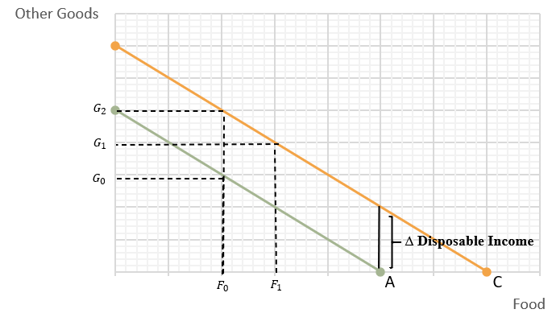

Figure 1. Medicaid Expansion Impact on Household Consumption of Food and Other Goods

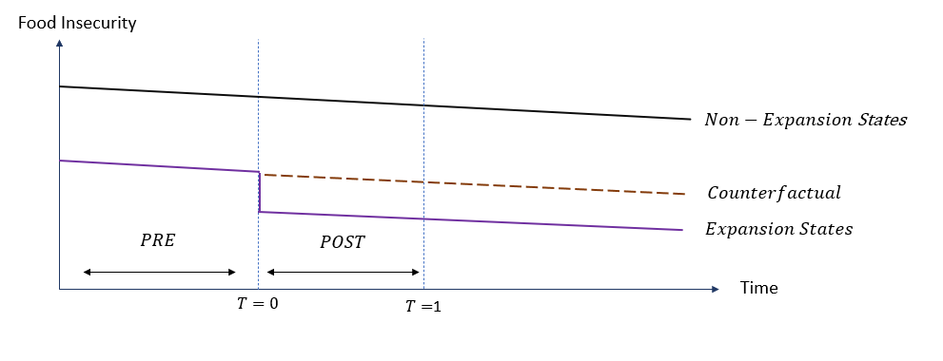

Figure 2. Difference-in-difference of Medicaid expansion at one treatment period
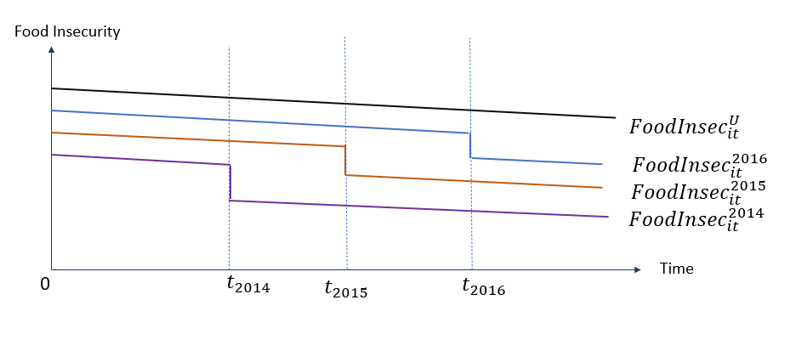

Figure 3. Fixed effects difference-in- difference of Medicaid Expansion in 2014, 2015, and 2016

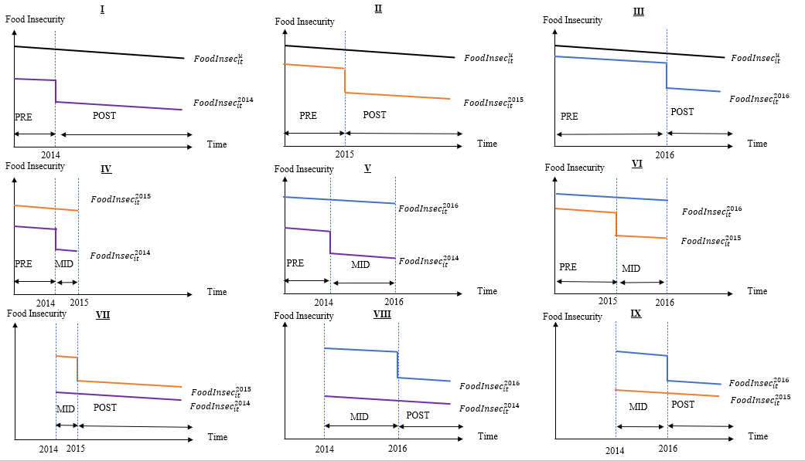

Figure 4. 2x2 Differenc in Difference Comparisons for Medicaid Expanison on Food Insecurity in 2014, 2015, and 2016

Figure 5. Average Household Food Security Score by Medicaid Expansion Year from 2011-2018

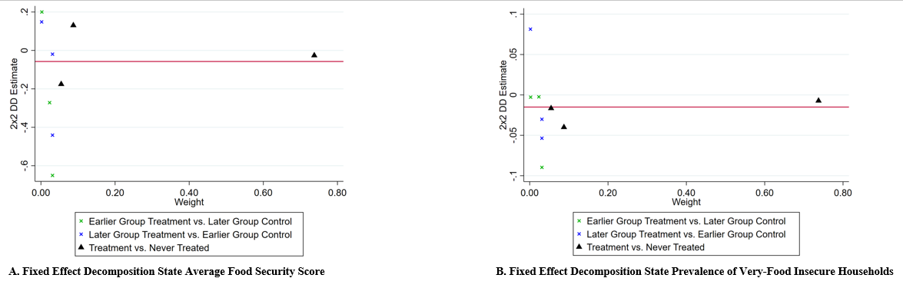
¥ State and Year Fixed Effects Included

Figure 6. Decomposition of Fixed Effects Difference in Difference Beta Estimate of Medicaid Expansion on Food Insecurity with No Covariates

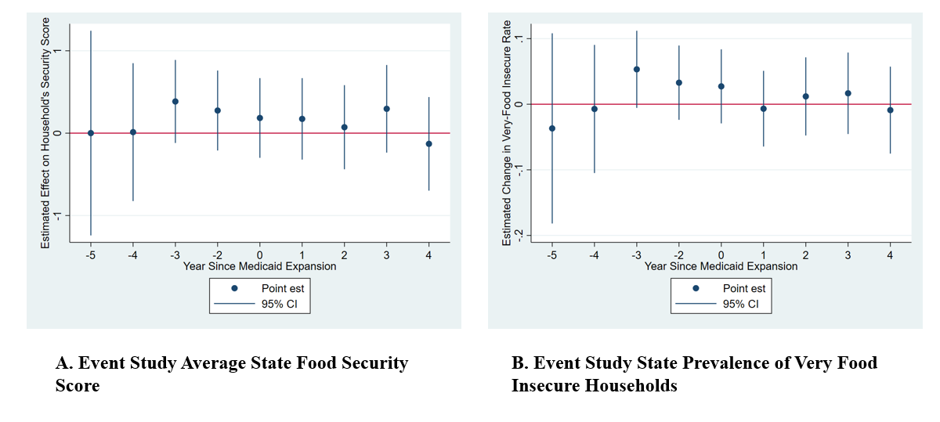
¥ State and Year Fixed Effects Included

Figure 7. Event Study Estimating the Effect of Medicaid Expansion on Household Food Security Score and Rate of Very-Food Insecure Households with No Covariates

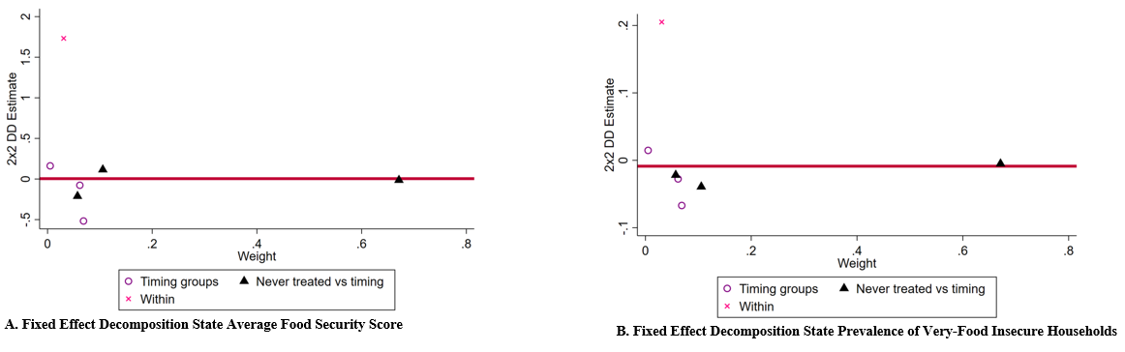¥ State and Year fixed Effects Included and Covariates Age, Sex, Marital Status, Race, Hispanic, Unemployment, Number of Children, Less Than High School Diploma, Family Size, State Republican Power

Figure 8. Decomposition of Fixed Effects Difference in Difference Beta Estimate of Medicaid Expansion on Food Insecurity with Covariates

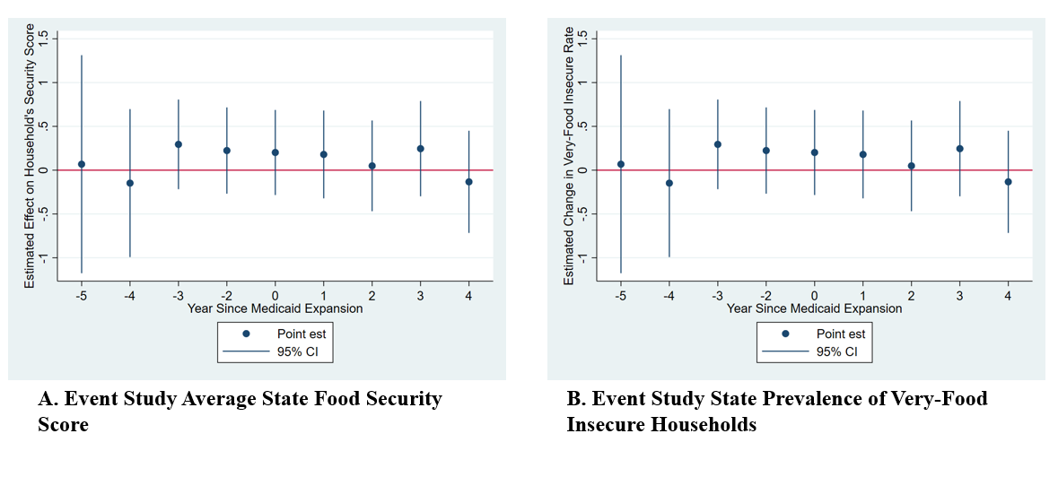
¥ State and Year fixed Effects Included and Covariates Age, Sex, Marital Status, Race, Hispanic, Unemployment, Number of Children, Less Than High School Diploma, Family Size, State Republican Power

Figure 9. Event Study Estimating the Effect of Medicaid Expansion on Household Food Security Score and Rate of Very-Food Insecure Households with Covariates

VITA
Trinity Douglass is originally from Apple Valley, CA. She graduated from Victor Valley High School class of 2013. After graduating high school, she attended the University of Washington in Seattle, where she received a Bachelor of Arts in Public Health. Following her degree, she served in AmeriCorps for a year, where she helped provide food services to children in a low-income school. She continued her work in food security by working on staff at a food bank in Seattle and graduate research work. Upon completion of the University of Tennessee’s Master of Science in Agricultural Economics Trinity Douglass will continue her education at University of Tennessee with the intent to receive her PhD in Economics.

