Using Video Modeling to Teach Vocational Tasks: Increasing the Job Skills of Individuals with Special Needs

Mary Margaret Musacchio
Submitted to the University of Tennessee
Chancellor’s Honors Program

December 2015

Table of Contents
Chapter 1: Introduction……………………………………………………………………………………4

Chapter 2: Literature Review…………………………………………………………………...6
2.1 Autism Spectrum Disorders (ASD) and Employment Outcomes………………………..6
2.2 Video Modeling strategies effective for ASD and Intellectual Disorders………………..7
2.3 Video Modeling and Employment……………………………………………………….10
2.4 Video Modeling and Mobile Devices …………………………………………………..11
2.5 Accessing Visual Supports………………………………………………………………12

Chapter 3: Methods………………………………………………………………………………14

Chapter 4: Results………………………………………………………………………………21

Chapter 5: Discussion…………………………………………………………………………..22

Appendices………………………………………………………………………………………24

References………………………………………………………………………………………..38

Abstract

The purpose of this study was to investigate the effects of accessing video modeling supports to acquire and maintain vocational skills for young adults with Autism Spectrum Disorders (ASD) or Intellectual Disabilities (ID). A single-subject multiple-probe across behaviors design was used to examine the effects of accessing video supports and vocational task acquisition. The participants for this study were three college-aged students who had either an ASD or an ID. The results indicated that jobs skills could be effectively learned if the students were able to access instructional videos on YouTube.com.

Chapter 1: Introduction

Individuals with Autism Spectrum Disorders (ASD) and Intellectual Disabilities (ID) face a variety of challenges and have many unique needs concerning employment. According to the U.S. Department of Labor, the unemployment rate for individuals with disabilities is 12.5%, which is twice the rate for the general population. Furthermore, individuals with disabilities across all age groups were more than twice as likely to attain only part time employment compared to individuals without disabilities (U.S. Dept. of Labor, 2014). There are several factors that individuals with disabilities experience that contribute to these findings.
Of the many challenges associated with ASD and ID, the most profound is cognitive ability, which varies based on severity of the disability. Additional difficulties are speech and language impairments, maladaptive behavior, and concomitant disabilities (Wehman, Schall, McDonough, Kregel, Brooke, Molinelli, Ham, Graham, Reihle, Collins & Thiss, 2014, p. 488). Because of the many variables that can impact job performance, employers are hesitant to hire individuals with disabilities, especially if they have little independence when completing tasks (Wehman et al., 2014, p. 488).
Not all individuals with disabilities have access to post-secondary education or job training programs, but those who do are more likely to attain employment (Burgess & Cimera, 2014). The goal of effective job training programs is to teach individuals how to complete tasks as independently as possible (Laarhoven, Winiarski, Blook, & Chan, 2014). One method that has been shown to help foster independence is the provision of picture, audio, and visual supports. One example is video modeling, which is an approach where students watch a video of someone else performing the task that the student will perform, providing both audio and visual supports (Laarhoven et al., 2012).
If students can learn to access instructional videos, then they would be able to self-operate their supports and improve their independence. If a student is presented with a task that they do not know how to complete, they can access a website, database, or video library to search for instruction video about how to complete that task. The ability to do this allows the student to learn virtually any skill, and if they can do so independently, their employment outcomes are significantly increased (Smith, Ayres, Alexander, Ledford, Shepley & Shepley, 2015).

Chapter 2: Review of Literature
ASD and ID Employment Outcomes
Individuals with disabilities experience many barriers to employment, all of which contribute to a significantly higher unemployment rate compared to the general population. While decreased cognitive function, maladaptive behavior, and speech and language impairments are daily challenges for individuals with ASD and ID, many studies have been conducted to help increase employment opportunities for these individuals (Wehman et at., 2014). Approaches that target independence skills and increase accessibility to job resources greatly impact the likelihood of attaining employment (Laarhoven et al, 2014).
One method that was explored was a modified version of Project SEARCH that catered to the specific needs of individuals with ASD. This three year program included an internship component, and the intensive job skills program lead to 87.5% employment rate for those who participated, as opposed to the 6.25% employment rate that was seen in the control group (Wehman et al., 2014). The ASD-specific supports that were provided in the program targeted maladaptive behavior and social skills. Visual supports, structured schedules, behavior specialist meetings, and non-figurative language in the workplace were some measures that were taken to address the unique needs of individuals with ASD. Systematic Instruction that was based on principles of applied behavior analysis and the direct instruction provided by job coaches in the context of internship placements resulted in students more proficiently acquiring job skills. Students also exhibited lower rates of inappropriate behavior, aggression, anxiety, and depression, which further increased their chances of attaining employment.
Barnett and Crippen also investigated the effectiveness of job training programs, and determined an eight step method that lead to increased employment for individuals with ASD and ID (2014). The method can be used by teachers to implement effective job training programs. One of the steps is to connect programs to real work experiences by creating a “realistic vocational setting” (Barnett & Crippen, 2014, p. 4). This can be achieved by setting up a room to look like a job site or by providing materials that are essential to completing a job task. The performance of routine job assignments can increase the likelihood that students with disabilities can acquire necessary job skills prior to working the actual job. Other components of the method is the incorporation of “prevocational tasks that mimic real world processes” and creating activities that incorporate life skills (Barnett et al., p. 6). Students in classrooms where teachers have implemented these strategies have been reported to have better employment prospects, leading to “greater economic self-sufficiency” and “social and community inclusion” (Barnett et al., 2014, p. 1).
Employment outcomes for individuals with ASD and ID have been shown to improve through the implementation of Vocational Rehabilitation (VR) services. Burgess and Cimera examined the effectiveness of VR for individuals with ASD who were in the transition-aged population (2014). By looking at statistics over a ten year period, the authors determined that VR services provided by the state resulted in more employment opportunities compared to those who did not receive services, however, these individuals still received lower wages and worked fewer hours compared to the general population. The authors concluded that individuals who had the best employment outcomes were “young adults who participated in post-secondary education” programs (Burgess et al., 2014, p. 65).
Video Modeling Strategies effective for ASD and ID
Video Modeling involves making a video recording of a model performing a task. This is then shown to someone who does not know how to complete the task and they can watch the video multiple times until they can confidently and accurately complete the task. This is helpful for people who are new to a job site because if they have access to these videos, then they can independently learn job skills. Several studies have been conducted to examine the effectiveness of video modeling for individuals with ASD and ID.
Jones, Lerman, and Lechago used video modeling to teach appropriate social responses to students with ASD (2014). Adults were recorded as models for scripted social situations, and after students watched the videos, they performed interactions with adults. The students later played out the same social interactions with their peers. The generalization of skills was assessed based on using the scripted responses on individuals who were not recorded in the videos (Jones et al., p. 37). Although the students less consistently responded using the scripted responses when interacting with their peers than with adults, they were reported to have benefitted from the video modeling (Jones et al, p. 39). The authors reported that the video modeling technique that was used in the study provided more stimulus control and yielded overall effective learning.
Mechling and Swindle studied the use of video modeling to teach individuals with ID and ASD fine and gross motor skills (2012). Three students with ASD and three students with ID watched videos on how to preform nine fine motor skills tasks and nine gross motor skills tasks. The tasks included turning on small toys, balancing objects, and bouncing on a large ball (Mechling et al, 2012, p. 137). The authors wanted to determine whether individuals with different disabilities could both benefit from video modeling and whether the type of skill taught through video modeling impacted a student’s ability to learn. The researchers found that students with ID learned more tasks overall than students with ASD; however, both groups struggled to acquire the fine motor skills shown in videos. One finding from the study is that students with lower cognitive abilities were able to acquire the skills taught in the videos. Across all tasks, 83% of individuals with ID who had lower cognitive ability performed better than 73.8% of students with ASD who had higher cognitive abilities (Mechling et al, p. 145-146). Video modeling can be effective for multiple types of tasks as well as for individuals who have varying cognitive abilities.
Students with ID have also been shown to be able to acquire skills that allow them to navigate electronic interfaces on mobile devices (Walser, Ayres, & Foote, 2012). Three students with ID were shown three videos, each showing a different task to be completed on an iPhone 3GS. Students were then evaluated as they attempted the following tasks: taking a picture, viewing a picture, and accessing and viewing a video on the phone. Although each of these tasks involved using fine motor abilities where details were “difficult to discriminate,” they were reported to have acquired skills to the proficient in completing these tasks (Walser et al, 2012, p. 320). All students were able to master each skill “accurately and independently” and they were able to generalize these skills to perform other tasks on the iPhone (Walser et al., 2012 p. 324).
Video modeling has also been shown to be effective in teaching important safety skills. Mechling, Gast, and Gustafson used video modeling to teach three students with ID how to extinguish kitchen fires using a fire extinguisher, place a lid on a pan, and by pouring flour on a burning appliance (2009). Each video showed the student three situations in which they could a given method, and the students were evaluated based on replicating those situations, as well as being able to perform the skill on a novel task (Mechling et al., 2009, p. 71). Each video included captions and students had to complete one task before moving on to the next. Not only were all the students able to master the tasks, but “levels of performance were maintained when video modeling was no longer present” (Mechling et al., 2009, p. 73).
Video Modeling and Employment
Researches have also examined the effectiveness of video modeling in teaching employment skills. Allen, Wallace, Greene, Bowen, and Burke investigated whether video modeling could be used to teach three individuals with ASD the job skill of wearing a mascot costume to attract customers to a retail store (2010). Individuals with ASD, regardless of cognitive ability, have difficulty making and maintaining “appropriate personal and professional relationships,” making it hard for these students to perform a job that primarily consists of interacting with customers (Allen et al., 2010, p. 187). Students were observed prior to being shown video models of how to best perform their job as well as after they were shown the videos. After the videos were introduced, the students were reported as directly mimicking the videos in “sequence and combination” (Allen et al., 2010, p. 186). Additionally, “participants reported they enjoyed work and comments from supervisors were positive” (Allen et al., 2010, 186). Although this study yielded promising results for using video modeling to teach employment skills, the authors concluded that video modeling is only effective for teaching job skills that can be easily modeled and recorded.
Laarhoven, Winiarski, Blood, and Chan also reported on the effectiveness of using video models to teach employment skills to individuals with ASD (2012). In this study, each student was given two tasks to perform, one included a video model and the other was a control. Students were given a baseline evaluation, then they had two weeks to watch the video for the one task. Upon reevaluation, the students were able to more independently complete both tasks despite the fact that only one task had a video model. For the video modeled task, the average increase of improved independence was 24%, while the average increase of improved independence for the control task was 14% (Laarhoven et al., 2012, p. 456). The authors concluded that “video based supports often result in increased independence, generalization, and maintenance of job related skills for learners and less reliance on job coaches, or coworkers, all of which are critical for sustaining competitive employment” (Laarhoven et al., 2012, p. 459). Video modeling is shown to not only be effective in teaching a specific skill, but in increasing the employment outcomes for individuals with ASD.
Another study was conducted by Laarhoven, Johnson, Laarhoven-Myers, Grider and Grider to examine the effectiveness of using a video iPod as a prompting device to teach job skills in a community based employment setting (2009). The researchers found that when a video iPod was used as a prompting device for a man with a developmental disability, there were “immediate and substantial gains in independent correct responding and a decrease in the number of prompts given from a job coach” (Laarhoven et al., 2009, p. 119). This finding supports the job prospects of individuals with disabilities because it means that they can more independently function while working and need less assistance from job coaches or coworkers while acquiring new skills.
Video Modeling and Mobile Devices
One aspect of video modeling that makes it difficult to integrate into all job settings is how it is accessed and the availability of technology with which to access videos. In 2011, Mechling wrote a review of portable devices that individuals with ASD and ID can use to access video models. Mechling stated that individuals with ASD and ID can effectively and appropriately complete tasks and self-manage behavior “when provided with the proper tools and technologies” (Mechling, 2011, p. 479). Cell phones were reported to be effective for managing safety issues and for providing memory aids in the forms of alarms and reminders. Handheld computers and video players were effective for providing reminders, assisting during transitions, and for prompting and modeling multi-step tasks. Although devices can be helpful across settings and skills, individuals with disabilities often have difficulty using generic devices to complete tasks, and therefore may need to depend on more specialized devices, which still can be relatively inaccessible due to the expense. Generic devices that are used by the general population can be developed to include features that assist individuals with disabilities, which will make them more accessible. Additionally, when an individual can use a generic device that is more accepted by the general public, individuals with disabilities have a better chance of being accepted and included in a community activities and job opportunities.
Carey, Friedman, and Bryen also reported on the availability of technology to individuals with disabilities (2005). In a group of eighty-three adults with ID, 41% used a computer, 25% used the internet, and 11% used electronic organizers. The common barriers for people with disabilities while using technology are “lack of access, training and support, and expense of technologies” (Carey et al., 2005, p. 322).
Accessing Visual Supports through YouTube
YouTube is a web-based video database where users can access, view, and upload a variety of videos. For individuals with disabilities who are looking to learn job skills from instructional videos on YouTube, there is great potential to find helpful videos, given the opportunity and materials to do so. One study examined how students with special needs can access videos on YouTube on their own at home and the effectiveness of those videos (Langhorst, 2007). A special education teacher looked into assisting his students with disabilities who were falling behind in reading by recording himself reading the text that they were reading aloud in class. The video was uploaded to YouTube, and students could access it at home. The teacher reported that when his students were given the opportunity to access the videos outside of class, they were able to follow along better at their own pace. This supports the notion that students with disabilities can access and acquire skills from YouTube videos.

Chapter 3: Methods
Research Question
What are the effects of accessing video modeling supports to acquire and maintain vocational skills for young adults with ASD or ID?
Participants
The participants for this study were three college-aged students who attended a post-secondary education program (PSE) at a large university in the Southeast. Student A was a boy with ASD who was in his first year of the two year program. Student B was a girl with Down Syndrome and she was also in her first year of the program. Student C was a boy with ID and he also had other health impairments. He was in his second year of the program.
Settings
The study was carried out in the computer lab and office of the PSE Program in Fall 2015. The Copy machine was in the hallway of the office and the computer lab had enough computers where each student could work on their own computer and not see the screens of the other participants while data was being collected.
Materials
This project required a camera to record videos, either a phone with high quality graphics or a video camera. A Google account was also needed so that videos could be posted to YouTube and all the documents could be found on a single Google Drive that all participants had access. Students were provided with a notecard that had the login credentials necessary for accessing the Google Drive and YouTube Videos. Students also needed computers with internet to access the videos and headphones to use while watching the videos.
The first task required a copy machine with capabilities to make double-sided copies. For the second task, students needed to access Microsoft Access. Additionally, two job applications needed to be filled out ahead of time so students had information to enter into an EXCEL spreadsheet. These job applications were formatted differently and information was in different orders so students needed to pay close attention to the content of each document. The third task required a document to be uploaded on the Google Drive, and it needed to be a document with information in paragraph form. A sticky note was also needed so that students could see the list of tasks that they needed to perform.
Variables
The independent variable for this study was watching instructional YouTube videos that were created for each individual task. The video models changed for each task, and the effectiveness of them is seen in whether or not the student was able to complete the modeled task. The videos ranged from one minute long to five and a half minutes long. They were filmed from the point of view of the person doing the task. Each step of the task was narrated by the person who made the video. The dependent variable for this study was learning how to complete the assigned tasks as measured by the number of task analyzed steps completed independently.
Data Collection
Event recording procedures were used to record each participant’s performance on individual steps of the task analysis. Researchers recorded each step that the student successfully completed, regardless of whether or not it was in the prescribed order. Researchers had a packet for each student, and there was a page for each task, which had a task analysis spreadsheet (shown in Appendices A through C). During each session, researchers recorded the date and how many times the student watched the video during the intervention phase. If multiple sessions were conducted in one day, then they needed to be spaced out so that there were at least 15 minutes between the end of one session and the start of the next. Results were indicated on the spreadsheet, which had steps listed in reverse order so that a graph of the student’s progress was created as the project went on.
Research Design
This was a multiple baseline across behaviors design in which multiple students were evaluated while completing multiple tasks (Alberto & Troutman, 2013). This was done in order to determine a causal relationship between the use of video models as intervention and the ability for students to master the given tasks.
Procedures
This multiple probes across tasks study began with a practice phase where students were evaluated on their ability to access YouTube videos, which was a required step to complete the three tasks. Baseline data were collected. If students were unable to complete this first assignment, they were shown by the researcher how to access videos. Once they were able to successfully access a YouTube video three times in a row, then they were able to start the first task.
The first part of this phase was taking a single baseline measure for each task. If a student knew how to complete at least one of the tasks, then they are removed from the study. Once students were verified as being eligible for the study, then two more baseline measures were taken for the first task, which was making a double-sided stapled copy of a document. At each session, a researcher delivered the scripted question, “Can you make one double-sided stapled copy of this document?” After three baseline measures were taken, intervention was introduced. Students were given the login credentials to access the YouTube videos that were made specifically for this task. Students needed to complete three consecutive attempts at completing the task with 100% accuracy before moving on to the next task.
Once a student progressed to the next task, additional baseline measures were recorded until there were at least three baseline measures that indicated that the student was unable to complete the task.. Then, the intervention was introduced for the second task. The same intervention procedures that were used in the first task were used for the second and third tasks.
Each time a student was given a task to complete they were given one of three scripted prompts:
Task 1: “Can you make one double sided stapled copy of this document” (given a stack of three papers and began task.)
Task 2: “Can you locate the file entitled ‘Job Applicants’ on the Google Drive and insert the information from these applications into the spreadsheet?” (given two job applications that were filled out with the necessary information to complete the task.)
Task 3: “Can you edit the document on the Google Drive entitled ‘File Formatting’ to be Times New Roman, size 12, unbolded, and double-spaced, and then place the word count at the bottom of the page?” (Given a sticky note that was placed on the desktop monitor so that they could see the list what they needed to do for the task.)

During the intervention phase of each task, the student accessed a YouTube video that modeled each task. Each video showed each step and was narrated by the researcher that made the video. The video for the copy machine task was a video of one researcher completing the task, filmed from the perspective of the person completing the task. The steps were filmed in the order in which they appeared on the task analysis and spreadsheets. The second and third videos were creating using screencast software found on Mac Computers. The researcher filmed the videos by showing the exact screen that the students saw. The second video did not include images of the job applications that were used so that students did not see exactly which fields belonged on the spreadsheet, rather the researcher narrated directions on how to locate the required information and input it into the spreadsheet. The final video was much more straightforward than the other two because it showed every component of the electronic interface that the students saw as they completed the task. The screencast video captured every step of the process that students needed to complete.
During the intervention phase of the study, students were able to watch the videos an unlimited number of times. Students were also allowed to stop their session after they started, watch the videos again, and resume the session, self-correcting if necessary. Every time a student watched the video or interrupted their session to go back and watch the video again, the researcher indicated so on the spreadsheet.
The spreadsheets provided in Appendices A-C show the steps that were completed for each task, and the task analysis is detailed on the left column of each spreadsheet. Appendix D shows a screenshot of the Google Drive that has all the files that were used in this study. Appendix E is a series of screenshots that show examples of the videos that were part of the intervention phase of each task.
Maintenance procedures were conducted for task one eight weeks after acquisition; however, not enough time had elapsed for the other tasks to continue such procedures. Future research will be conducted once enough time has passed to allow for maintenance data to be collected.

Interobserver Agreement (IOA) and Treatment Integrity
Interobserver agreement data was collected on 57.14% of the baseline data and 40% of the intervention data. Intervobserver agreement was calculated by dividing the number of agreements and disagreements for each session that was observed by both researchers. Agreements were data points in which both had consistent positive or negative marks on each step of the task analysis. The interobserver agreement for this study was 100%.
Treatment integrity was calculated by observing one researcher as they conducted the study. For each intervention phase, the researcher needed to offer the student the opportunity to watch the video for that specific task. Although the student was not required to watch the video if they felt they did not need to watch it, the researcher was required to offer it. After one researcher observing the other for a minimum of 40% of the sessions in each task in the intervention phase, the treatment integrity was 100%.
Social Validity
Social validity was determined in the practice phase of the study where students were evaluated on their ability to access YouTube videos and also in other phases by being verbally instructed on how to access the necessary videos. Because students were able to consistently access the correct YouTube video given primarily verbal instructions, the social validity is that students felt confident enough to access YouTube videos given the opportunity to learn new skills. Because YoutTube is available on any device with an internet connection, students are able to translate these skills into real world situations. This also means that students can discretely access videos and not be singled out as needed assistive technology in community based settings.

Data Analysis
The students in this study were evaluated based on the number of completed steps on each task of the multiple probes across tasks design.

Chapter 4: Results
Data for this study is shown in Tables 1 and 2, as well as in Appendices A-C. The results indicated that all students were able to master all tasks as defined as three consecutive sessions for each task with 100% accuracy. By examining the immediacy in which students increased the number of steps they completed after intervention was introduced, students can be determined to have benefitted from the video modeling approach that was taken in this study. Not only did students improve their own performance after intervention was introduced, each student performed better than both of their peers on at least one task. This means that regardless of disability and time spent in the PSE Program, each student showed considerable improvement.

Table 1: Percent Increase in the number of correct steps immediately after intervention was introduced.
 | Student A | Student B | Student C
Task 1 | 200% | 162%* | 150%
Task 2 | 540%* | 183% | 142%
Task 3 | 357%* | 190.9% | 208.3%*
* Student immediately achieved 100% of the steps after being introduced to the video modeling.
Table 2: Number of intervention sessions needed to achieve 3 consecutive 100% accurate sessions.
 | Student A | Student B | Student C
Task 1 | 4* | 4* | 5
Task 2 | 3* | 5 | 6
Task 3 | 5 | 4 | 3*
*Student was the quickest to earn 3 consecutive 100% accurate sessions for that task.

Chapter 5: Discussions
Video modeling is a relatively new approach to teaching job skills to individuals with ASD and ID, and it has the potential to make job opportunities more attainable for this population. As technology and resources become more attainable, video modeling is improving the employment skills for more people. This, in theory, will decrease the unemployment rate for America’s population with disabilities. Because the improvements found in the data were consistent across all students and tasks, the results of this study were not anomalies.
Extensions of Current Research
The findings of this study have implications that are mostly similar to those found in previous studies. Previous studies reported that intensive job training programs that used systematic direct instruction methods to teach a job skill were effective for individuals with disabilities (Barnett et al., 2014). Video models have been proven to successfully teach specific job skills that are used on a job site (Allen et al., 2010). The findings of this study support these claims as individuals with disabilities were able to learn how to complete three tasks after watching video models that explained each step of the task.
Video models have also been reported to be useful in teaching individuals with disabilities how to use technology (Walser et al., 2012). Although authors in that study were using technology that had a smaller interface and more detailed graphics, tasks two and three in this study primarily used technology, and the tasks were effectively taught.
The findings of this study partially refuted the findings in a study that concluded that students with ID were more successful in mastering new skills compared to their peers with ASD (Mechling et al., 2012). In this study, Student A, who had ASD, more quickly completed all the steps of tasks two and three compared to his peers who had ID. This could be a function of the tasks that were chosen for this study. In the previous study, the tasks that were examined did not involve technology, which was an integral part of tasks two and three in this study.
New Insights
This study confirms that students with both ASD and ID are capable of attaining new job skills through the use of video modeling. An extension of these findings is that if these students can be taught the parameters of how to search for instructional videos on their own, then they have essentially no limit to what they can access for independent job training.
Strengths and Weaknesses
The main strength for this study is that the positive outcomes after intervention was introduced were replicated for all students in all tasks. Although there was strong evidence to support the use of video modeling, there were a few limitations. The sample size was very small and represents a small portion of the transition-aged individuals with disabilities because very few people with disabilities have access to post-secondary education with intensive job intervention. Furthermore, maintenance data was not collected in its entirety to support the idea that students can learn and retain necessary job skills.
Future Research
The first step in future research is collecting maintenance data to show whether or not students were able to retain the skills they learned that are necessary for accessing informational YouTube videos to learn job skills. Although they may not be expected to remember how to perform each task, they should be evaluated based on their ability to find the videos. Additional future research can allow for generalization by introducing a novel task and giving the student access to an instructional video so that they have the opportunity to acquire a new skill in the way they might in a job setting.
Appendix A: Student A Data Collection

Task 1: Copy Machine | Baseline 1 | Baseline 2 | Baseline 3 | 4 | 5 | 6 | 7 | 8 | 9
 | 9/8/2015 | 9/10/2015 | 9/21/2015 | 9/21/2015 | 9/21/2015 | 9/22/2015 | 9/22/2015 | 9/29/2015 | 11/2/2015
13. Pick up newly copied packet | ‐ | ‐ | ‐ | ‐ | x | x | x | x | x
12. Remove originals from below the feeder | ‐ | ‐ | ‐ | ‐ | x | x | x | x | x
11. Press the start button (blue light) | ‐ | ‐ | ‐ | x | x | x | x | x | x
10. Press corner staple top left | ‐ | ‐ | ‐ | x | x | x | x | x | x
9. Press OK | ‐ | ‐ | ‐ | x | x | x | x | x | x
8. Press 1-Sided > 2-Sided | ‐ | ‐ | ‐ | x | x | x | x | x | x
7. Press Duplex/Combine | ‐ | ‐ | ‐ | x | x | x | x | x | x
6. Press Login | ‐ | ‐ | x | x | x | x | x | x | x
5. Press Code 9 | ‐ | x | x | x | x | x | x | x | x
4. Press Code 7 | ‐ | x | x | x | x | x | x | x | x
3. Press Code 3 | ‐ | x | x | x | x | x | x | x | x
2. Press Code 1 | ‐ | x | x | x | x | x | x | x | x
1. Place paper face up on the copier feed | ‐ | ‐ | ‐ | ‐ | x | x | x | x | x
Number of times video was watched |  |  |  | 5 | 0 | 3 | 0 | 1 | 2

Shaded area indicates intervention period.

Task 2: Job Application | Baseline 1 | Baseline 2 | Baseline 3 | 4 | 5 | 6
 | 9/8/2015 | 9/10/2015 | 9/29/2015 | 10/5/2015 | 10/3/2015 | 10/13/2015
26. Press Log Out | ‐ | ‐ | ‐ | x | x | x
25. Press Windows File Icon | ‐ | ‐ | ‐ | x | x | x
24. Click Okay | ‐ | ‐ | ‐ | x | x | x
23 Click Save | ‐ | ‐ | ‐ | x | x | x
22. Click File | ‐ | ‐ | ‐ | x | x | x
21. Second Job Application: Position Title | ‐ | ‐ | ‐ | x | x | x
20. Second Job Application: Phone Number | ‐ | ‐ | ‐ | x | x | x
19. Second Job Application: Home Address | ‐ | ‐ | ‐ | x | x | x
18. Second Job Application: Last Name | ‐ | ‐ | ‐ | x | x | x
17. Second Job Application: First Name | ‐ | ‐ | ‐ | x | x | x
16. First Job Application: Position Title | ‐ | ‐ | ‐ | x | x | x
15. First Job Application: Phone Number | ‐ | ‐ | ‐ | x | x | x
14. First Job Application: Home Address | ‐ | ‐ | ‐ | x | x | x
13. First Job Application: Last Name | ‐ | ‐ | ‐ | x | x | x
12. First Job Application: First Name | ‐ | ‐ | ‐ | x | x | x
11. Click “Job Applicants” on the left toolbar | ‐ | ‐ | ‐ | x | x | x
10. Click “download” | ‐ | ‐ | ‐ | x | x | x
9. Click on “Job Applicants” | ‐ | ‐ | ‐ | x | x | x
8. Click on “Video Modeling Project” Folder | ‐ | ‐ | ‐ | x | x | x
7. Click on Google Drive | ‐ | ‐ | ‐ | x | x | x
6. Click on Google Apps icon | ‐ | ‐ | ‐ | x | x | x
5. Log into Google account- password | x | ‐ | x | x | x | x
4. Log into Google account- email address | x | ‐ | x | x | x | x
3.Click on Google Chrome icon | x | x | x | x | x | x
2.Log into UTK computer- password | x | x | x | x | x | x
1.Log into UTK computer- username | x | x | x | x | x | x
Number of times video was watched |  |  |  | 2 | 2 | 0

Shaded area indicates intervention period.

Task 3: File Formatting | Baseline 1 | Baseline 2 | Baseline 3 | 4 | 5 | 6 | 7 | 8
 | 9/8/2015 | 9/10/2015 | 10/29/2015 | 10/29/2015 | 11/2/2015 | 11/2/2015 | 11/10/2015 | 11/10/2015
25. Log out of Computer | ‐ | ‐ | ‐ | x | x | x | x | x
24. Select Windows file icon | ‐ | ‐ | ‐ | x | x | x | x | x
23. Exit out of Chrome | ‐ | ‐ | ‐ | x | x | x | x | x
22. Select drive icon at the top left of page | ‐ | ‐ | ‐ | x | x | x | x | x
21. Type Word Count at bottom of page | ‐ | ‐ | ‐ | x | x | x | x | x
20. Click Word Count | ‐ | ‐ | ‐ | x | x | x | x | x
19. Select tools | ‐ | ‐ | ‐ | x | x | x | x | x
18. Change to double | ‐ | ‐ | ‐ | x | x | x | x | x
17. Select line spacing icon | ‐ | ‐ | ‐ | x | x | x | x | x
16. Deselect B (Bold icon) | ‐ | ‐ | ‐ | x | ‐ | x | x | x
15. Change to 12 | ‐ | ‐ | ‐ | x | x | x | x | x
14. Select 9 (size menu) | ‐ | ‐ | ‐ | x | x | x | x | x
13. Select Times New Roman | ‐ | ‐ | ‐ | x | x | x | x | x
12. Press Comic Sans (font menu) | ‐ | ‐ | ‐ | x | x | x | x | x
11. Select all text (ctl+A or select with mouse) | ‐ | ‐ | ‐ | x | x | x | x | x
10. Press Open | ‐ | ‐ | ‐ | x | x | x | x | x
9. Select Final CSEL file | ‐ | ‐ | ‐ | x | x | x | x | x
8. Open Video Modeling Project Folder | ‐ | x | ‐ | x | x | x | x | x
7. Select Drive App | ‐ | x | x | x | x | x | x | x
6. Click Google apps icon | ‐ | x | x | x | x | x | x | x
5. Log into Google- password | ‐ | x | x | x | x | x | x | x
4. Log into Google- username | ‐ | x | x | x | x | x | x | x
3. Open Google Chrome | x | x | x | x | x | x | x | x
2. Log onto UTK computer- password | x | x | x | x | x | x | x | x
1. Log onto UTK computer- username | x | x | x | x | x | x | x | x
Number of times video was watched |  |  |  | 3 | 2 | 1 | 0 | 0

Shaded area indicates intervention period.

Student A Graphs for Multiple Probes Across Tasks

Baseline
Intervention

Formatting documents
Entering Data
Making Copies

Appendix B: Student B Data Collection
Task 1: Copy Machine | Baseline 1 | Baseline 2 | Baseline 3 | 4 | 5 | 6 | 7 | 8
 | 9/2/2015 | 9/9/2015 | 9/10/2015 | 9/16/2015 | 9/17/2015 | 9/17/2015 | 9/17/2015 | 9/17/2015
13. Pick up newly copied packet | ‐ | ‐ | ‐ | ‐ | x | x | x | x
12. Remove originals from below the feeder | ‐ | ‐ | ‐ | ‐ | x | x | x | x
11. Press the start button (blue light) | ‐ | ‐ | ‐ | ‐ | x | x | x | x
10. Press corner staple top left | ‐ | ‐ | ‐ | ‐ | x | x | x | x
9. Press OK | ‐ | ‐ | ‐ | x | x | x | x | x
8. Press 1-Sided > 2-Sided | ‐ | ‐ | ‐ | x | x | x | x | x
7. Press Duplex/Combine | ‐ | ‐ | x | x | x | x | x | x
6. Press Login | x | x | x | x | x | x | x | x
5. Press Code 9 | x | x | x | x | x | x | x | x
4. Press Code 7 | x | x | x | x | x | x | x | x
3. Press Code 3 | x | x | x | x | x | x | x | x
2. Press Code 1 | x | x | x | x | x | x | x | x
1. Place paper face up on the copier feed | ‐ | ‐ | ‐ | ‐ | x | x | x | x
Number of times video was watched |  |  |  | 4 | 0 | 0 | 0 | 0

Shaded area indicates intervention period.

Task 2: Job Application | Baseline 1 | Baseline 2 | Baseline 3 | 4 | 5 | 6 | 7 | 8
 | 9/2/2015 | 9/9/2015 | 9/10/2015 | 9/16/2015 | 9/16/2015 | 9/17/2015 | 9/17/2015 | 9/17/2015
26. Press Log Out | ‐ | ‐ | ‐ | ‐ | ‐ | x | x | x
25. Press Windows File Icon | ‐ | ‐ | ‐ | ‐ | ‐ | x | x | x
24. Click Okay | ‐ | ‐ | ‐ | ‐ | ‐ | x | x | x
23 Click Save | ‐ | ‐ | ‐ | ‐ | ‐ | x | x | x
22. Click File | ‐ | ‐ | ‐ | ‐ | ‐ | x | x | x
21. Second Job Application: Position Title | ‐ | ‐ | ‐ | ‐ | ‐ | x | x | x
20. Second Job Application: Phone Number | ‐ | ‐ | ‐ | ‐ | ‐ | x | x | x
19. Second Job Application: Home Address | ‐ | ‐ | ‐ | ‐ | ‐ | x | x | x
18. Second Job Application: Last Name | ‐ | ‐ | ‐ | ‐ | ‐ | x | x | x
17. Second Job Application: First Name | ‐ | ‐ | ‐ | ‐ | ‐ | x | x | x
16. First Job Application: Position Title | ‐ | ‐ | ‐ | ‐ | x | x | x | x
15. First Job Application: Phone Number | ‐ | ‐ | ‐ | ‐ | x | x | x | x
14. First Job Application: Home Address | ‐ | ‐ | ‐ | ‐ | x | x | x | x
13. First Job Application: Last Name | ‐ | ‐ | ‐ | ‐ | x | x | x | x
12. First Job Application: First Name | ‐ | ‐ | ‐ | ‐ | x | x | x | x
11. Click “Job Applicants” on the left toolbar | ‐ | ‐ | ‐ | x | x | x | x | x
10. Click “download” | ‐ | ‐ | ‐ | x | x | x | x | x
9. Click on “Job Applicants” | ‐ | ‐ | ‐ | x | x | x | x | x
8. Click on “Video Modeling Project” Folder | ‐ | ‐ | ‐ | x | x | x | x | x
7. Click on Google Drive | ‐ | ‐ | ‐ | x | x | x | x | x
6. Click on Google Apps icon | x | x | x | x | x | x | x | x
5. Log into Google account- password | x | x | x | x | x | x | x | x
4. Log into Google account- email address | x | x | x | x | x | x | x | x
3.Click on Google Chrome icon | x | x | x | x | x | x | x | x
2.Log into UTK computer- password | x | x | x | x | x | x | x | x
1.Log into UTK computer- username | x | x | x | x | x | x | x | x
Number of times video was watched |  |  |  | 1 | 1 | 1 | 0 | 0

Shaded area indicates intervention period.

Task 3: File Formatting | Baseline 1 | Baseline 2 | Baseline 3 | 4 | 5 | 6 | 7
 | 10/29/2015 | 10/29/2015 | 10/29/2015 | 10/29/2015 | 11/2/2015 | 11/17/2015 | 11/18/2015
25. Log out of Computer | ‐ | ‐ | ‐ | ‐ | x | x | x
24. Select Windows file icon | ‐ | ‐ | ‐ | ‐ | x | x | x
23. Exit out of Chrome | ‐ | ‐ | ‐ | ‐ | x | x | x
22. Select drive icon at the top left of page | ‐ | ‐ | ‐ | ‐ | x | x | x
21. Type Word Count at bottom of page | ‐ | ‐ | ‐ | x | x | x | x
20. Click Word Count | ‐ | ‐ | ‐ | x | x | x | x
19. Select tools | ‐ | ‐ | ‐ | x | x | x | x
18. Change to double | ‐ | ‐ | ‐ | x | x | x | x
17. Select line spacing icon | ‐ | ‐ | ‐ | x | x | x | x
16. Deselect B (Bold icon) | ‐ | ‐ | ‐ | x | x | x | x
15. Change to 12 | ‐ | ‐ | ‐ | x | x | x | x
14. Select 9 (size menu) | ‐ | ‐ | ‐ | x | x | x | x
13. Select Times New Roman | ‐ | ‐ | ‐ | x | x | x | x
12. Press Comic Sans (font menu) | ‐ | ‐ | ‐ | x | x | x | x
11. Select all text (ctl+A or select with mouse) | ‐ | ‐ | x | x | x | x | x
10. Press Open | ‐ | ‐ | x | x | x | x | x
9. Select Final CSEL file | ‐ | ‐ | x | x | x | x | x
8. Open Video Modeling Project Folder | ‐ | ‐ | x | x | x | x | x
7. Select Drive App | x | ‐ | x | x | x | x | x
6. Click Google apps icon | x | ‐ | x | x | x | x | x
5. Log into Google- password | x | x | x | x | x | x | x
4. Log into Google- username | x | x | x | x | x | x | x
3. Open Google Chrome | x | x | x | x | x | x | x
2. Log onto UTK computer- password | x | x | x | x | x | x | x
1. Log onto UTK computer- username | x | x | x | x | x | x | x
Number of times video was watched |  |  |  | 2 | 2 | 0 | 0

Shaded area indicates intervention period.

Student B Graphs for Multiple Probes Across Tasks

Entering Data
Making Copies
Formatting documents

Appendix C: Student C Data Collection
Task 1: Copy Machine | Baseline 1 | Baseline 2 | Baseline 3 | 4 | 5 | 6 | 7 | 8 | 9 | 10
 | 9/2/2015 | 9/3/2015 | 9/8/2015 | 9/8/2015 | 9/9/2015 | 9/10/2015 | 9/10/2015 | 9/21/2015 | 9/22/2015 | 11/2/2015
13. Pick up newly copied packet | ‐ | ‐ | ‐ | ‐ | ‐ | x | x | x | x | x
12. Remove originals from below the feeder | ‐ | ‐ | ‐ | ‐ | x | x | x | x | x | x
11. Press the start button (blue light) | ‐ | ‐ | ‐ | ‐ | x | x | x | x | x | x
10. Press corner staple top left | ‐ | ‐ | ‐ | ‐ | x | x | x | x | x | x
9. Press OK | ‐ | ‐ | ‐ | ‐ | x | x | x | x | x | x
8. Press 1-Sided > 2-Sided | ‐ | ‐ | ‐ | ‐ | x | x | x | x | x | x
7. Press Duplex/Combine | ‐ | ‐ | ‐ | x | x | x | x | x | x | x
6. Press Login | x | x | ‐ | x | x | x | x | x | x | x
5. Press Code 9 | x | x | x | x | x | x | x | x | x | x
4. Press Code 7 | x | x | x | x | x | x | x | x | x | x
3. Press Code 3 | x | x | x | x | x | x | x | x | x | x
2. Press Code 1 | x | x | x | x | x | x | x | x | x | x
1. Place paper face up on the copier feed | ‐ | ‐ | ‐ | ‐ | ‐ | ‐ | x | x | x | x
Number of times video was watched |  |  |  | 2 | 1 | 2 | 2 | 2 | 1 | 2

Shaded area indicates intervention period.

Task 2: Job Application | Baseline 1 | Baseline 2 | Baseline 3 | Baseline 4 | 5 | 6 | 7 | 8 | 9 | 10
 | 9/2/2015 | 9/3/2015 | 9/3/2015 | 9/30/2015 | 10/1/2015 | 10/1/2015 | 10/8/2015 | 10/20/2015 | 10/20/2015 | 10/21/2015
26. Press Log Out | ‐ | ‐ | ‐ | ‐ | ‐ | ‐ | ‐ | x | x | x
25. Press Windows File Icon | ‐ | ‐ | ‐ | ‐ | ‐ | ‐ | ‐ | x | x | x
24. Click Okay | ‐ | ‐ | ‐ | ‐ | ‐ | ‐ | ‐ | x | x | x
23 Click Save | ‐ | ‐ | ‐ | ‐ | ‐ | ‐ | ‐ | x | x | x
22. Click File | ‐ | ‐ | ‐ | ‐ | ‐ | ‐ | ‐ | x | x | x
21. Second Job Application: Position Title | ‐ | ‐ | ‐ | ‐ | ‐ | ‐ | ‐ | x | x | x
20. Second Job Application: Phone Number | ‐ | ‐ | ‐ | ‐ | ‐ | ‐ | ‐ | x | x | x
19. Second Job Application: Home Address | ‐ | ‐ | ‐ | ‐ | ‐ | ‐ | ‐ | x | x | x
18. Second Job Application: Last Name | ‐ | ‐ | ‐ | ‐ | ‐ | ‐ | ‐ | x | x | x
17. Second Job Application: First Name | ‐ | ‐ | ‐ | ‐ | ‐ | ‐ | ‐ | x | x | x
16. First Job Application: Position Title | ‐ | ‐ | ‐ | ‐ | ‐ | ‐ | x | x | x | x
15. First Job Application: Phone Number | ‐ | ‐ | ‐ | ‐ | ‐ | ‐ | x | x | x | x
14. First Job Application: Home Address | ‐ | ‐ | ‐ | ‐ | ‐ | ‐ | x | x | x | x
13. First Job Application: Last Name | ‐ | ‐ | ‐ | ‐ | ‐ | ‐ | x | x | x | x
12. First Job Application: First Name | ‐ | ‐ | ‐ | ‐ | ‐ | ‐ | x | x | x | x
11. Click “Job Applicants” on the left toolbar | ‐ | ‐ | ‐ | ‐ | ‐ | x | x | x | x | x
10. Click “download” | ‐ | ‐ | ‐ | ‐ | x | x | x | x | x | x
9. Click on “Job Applicants” | x | ‐ | ‐ | ‐ | x | x | x | x | x | x
8. Click on “Video Modeling Project” Folder | x | ‐ | ‐ | ‐ | x | x | x | x | x | x
7. Click on Google Drive | x | x | x | x | x | x | x | x | x | x
6. Click on Google Apps icon | x | x | x | x | x | x | x | x | x | x
5. Log into Google account- password | x | x | x | x | x | x | x | x | x | x
4. Log into Google account- email address | x | x | x | x | x | x | x | x | x | x
3.Click on Google Chrome icon | x | x | x | x | x | x | x | x | x | x
2.Log into UTK computer- password | x | x | x | x | x | x | x | x | x | x
1.Log into UTK computer- username | x | x | x | x | x | x | x | x | x | x
Number of times video was watched |  |  |  |  | 2 | 0 | 1 | 1 | 0 | 0

Shaded area indicates intervention period.

Task 3: File Formatting | Baseline 1 | Baseline 2 | Baseline 3 | 4 | 5 | 6
 | 9/2/2015 | 9/3/2015 | 9/3/2015 | 10/29/2015 | 11/2/2015 | 11/2/2015
25. Log out of Computer | ‐ | ‐ | ‐ | x | x | x
24. Select Windows file icon | ‐ | ‐ | ‐ | x | x | x
23. Exit out of Chrome | ‐ | ‐ | ‐ | x | x | x
22. Select drive icon at the top left of page | ‐ | ‐ | ‐ | x | x | x
21. Type Word Count at bottom of page | ‐ | ‐ | ‐ | x | x | x
20. Click Word Count | ‐ | ‐ | ‐ | x | x | x
19. Select tools | ‐ | ‐ | ‐ | x | x | x
18. Change to double | ‐ | ‐ | ‐ | x | x | x
17. Select line spacing icon | ‐ | ‐ | ‐ | x | x | x
16. Deselect B (Bold icon) | ‐ | ‐ | ‐ | x | x | x
15. Change to 12 | ‐ | ‐ | ‐ | x | x | x
14. Select 9 (size menu) | ‐ | ‐ | ‐ | x | x | x
13. Select Times New Roman | ‐ | ‐ | ‐ | x | x | x
12. Press Comic Sans (font menu) | ‐ | ‐ | ‐ | x | x | x
11. Select all text (ctl+A or select with mouse) | ‐ | ‐ | ‐ | x | x | x
10. Press Open | x | x | x | x | x | x
9. Select Final CSEL file | x | x | x | x | x | x
8. Open Video Modeling Project Folder | x | x | x | x | x | x
7. Select Drive App | x | x | x | x | x | x
6. Click Google apps icon | x | x | x | x | x | x
5. Log into Google- password | x | x | x | x | x | x
4. Log into Google- username | x | x | x | x | x | x
3. Open Google Chrome | x | x | x | x | x | x
2. Log onto UTK computer- password | x | x | x | x | x | x
1. Log onto UTK computer- username | x | x | x | x | x | x
Number of times video was watched |  |  |  | 2 | 1 | 0

Shaded area indicates intervention period.

Student C Graphs for Multiple Probes Across Tasks
Baseline
Intervention

Making Copies

Entering Data

Formatting documents

Appendix D: Screenshot of Google Drive used for this project
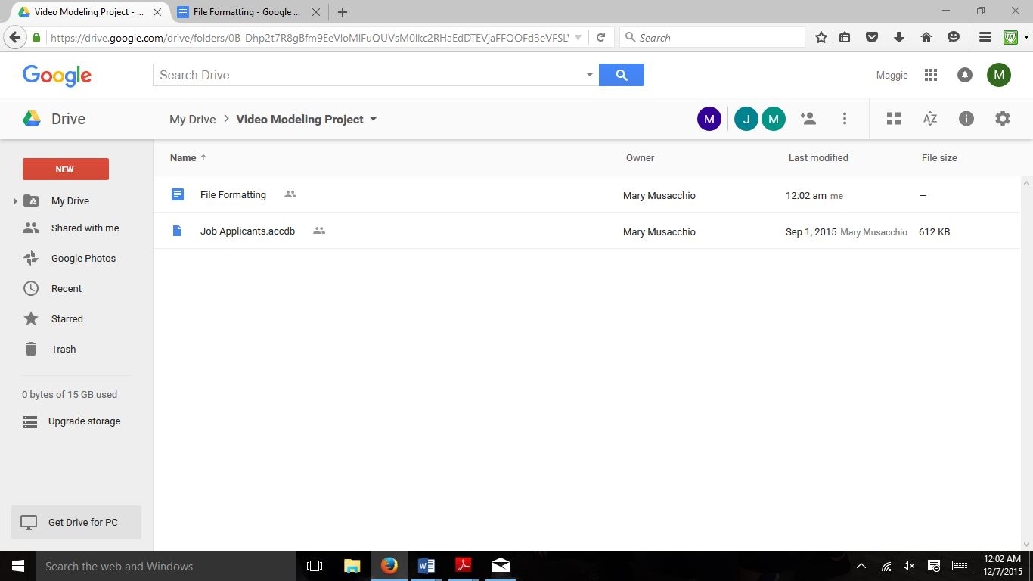

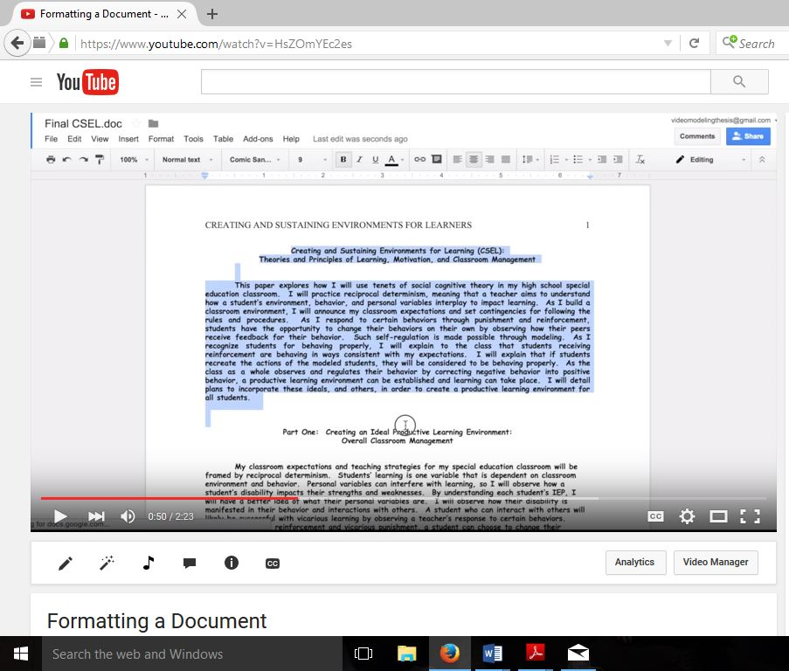
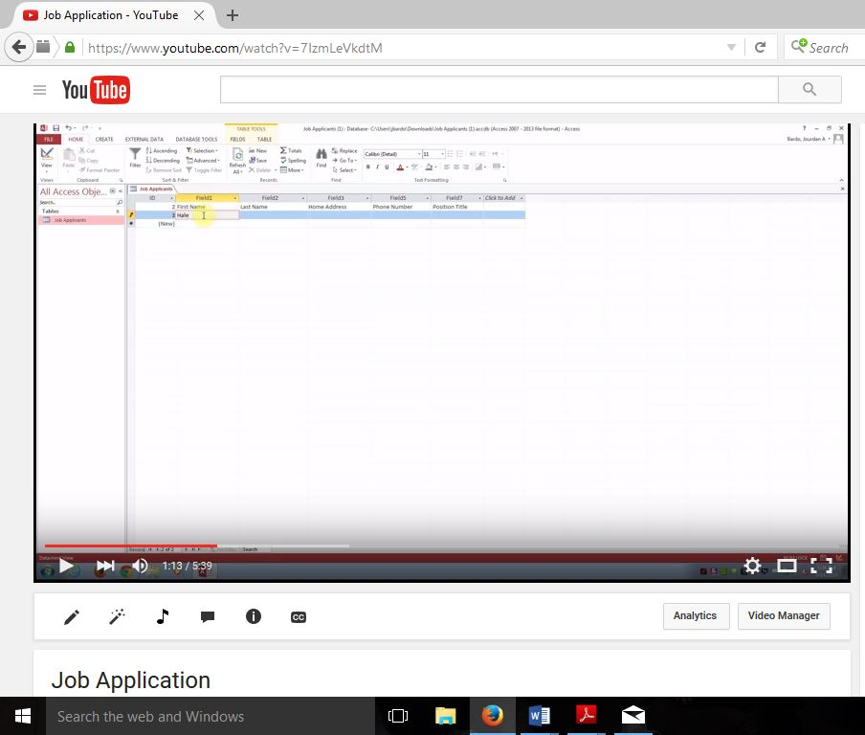
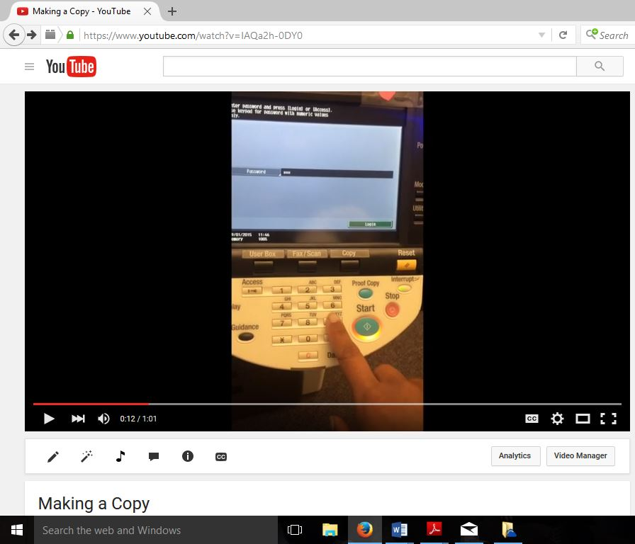
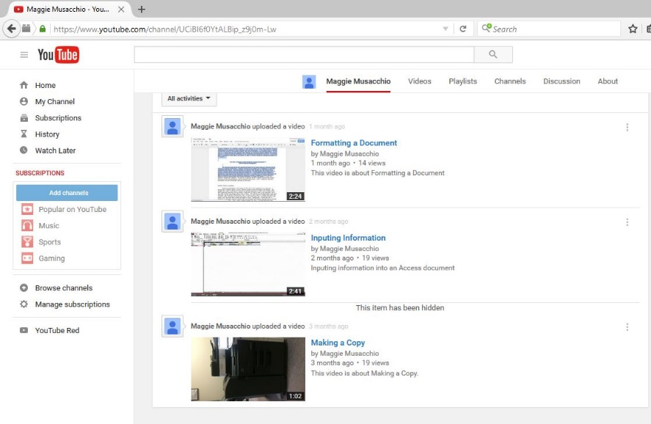
Appendix E: Screenshots of YouTube videos used for this project

References
Allen, K., Wallace, D., Greene, D., Bowen, S., & Burke, R. (2010). Community-Based Vocational Instruction Using Videotaped Modeling for Young Adults With Autism Spectrum Disorders Performing in Air-Inflated Mascots. Focus on Autism and Other Developmental Disabilities, 25(3), 186-192.
Barnett, J., & Crippen, R. (2014). Eight Steps to School-Based Employment Training for Adolescents with Autism Spectrum Disorder and Intellectual Disability. PDERS Physical Disabilities: Education and Related Services, 33(2), 1-15.
Burgess, S., & Cimera, R. (2014). Employment Outcomes of Transition- Aged Adults with Autism Spectrum Disorders: A State of the States Report. American Journal on Intellectual and Developmental Disabilities, 119(1), 64-83.
Carey, A., Friedman, M., & Bryan, D. (2005). Use of electronic technologies by people with intellectual disabilities. Mental Retardation, 43(5), 322-333.
Jones, J., Lerman, D., & Lechago, S. (2013). Assessing stimulus control and promoting generalization via video modeling when teaching social responses to children with autism. Journal of Applied Behavior Analysis, 47(1), 37-50.
Laarhoven, T., Johnson, J., Laarhoven-Myers, T., Grider, K., & Grider, K. (2009). The Effectiveness of Using a Video iPod as a Prompting Device in Employment Settings. Journal of Behavioral Education J Behav Educ, 18, 119-141.
Laarhoven, T., Winiarski, L., Blood, E., & Chan, J. (2012). Maintaining Vocational Skills of Individuals with Autism and Developmental Disabilities through Video Modeling. Education and Training in Autism and Developmental Disabilities, 47(4), 447-461.
Langhorst, E. (2007). After the Bell, Beyond the Walls. Educational Leadership, 64(8), 74-77.
Mechling, L. (2011). Review of Twenty-First Century Portable Electronic Devices for Persons with Moderate Intellectual Disabilities and Autism Spectrum Disorders. Education and Training in Autism and Developmental Disabilities, 46(4), 479-498.
Mechling, L., Gustafson, M., & Gast, D. (2009). Use of Video Modeling to Teach Extinguishing of Cooking Related Fires to Individuals with Moderate Intellectual Disabilities. Education and Training in Autism and Developmental Disabilties, 44(1), 67-79.
Mechling, L., & Swindle, C. (2012). Fine and Gross Motor Task Performance When Using Computer-Based Video Models by Students With Autism and Moderate Intellectual Disability. Journal of Special Education, 47(3), 135-147.
Smith, K. A., Ayres, K. A., Alexander, J., Ledford, J. R., Shepley, C., & Shepley, S. B. (2015). Initiation and generalization of self-instructional skills in adolescents with autism and intellectual disability. J Autism Dev Disord. doi:10.1007/s10803-015-2654-8
The U.S. Bureau of Labor Statistics. (2014). Persons with a disability: labor force characteristics. Retrieved from: http://www.bls.gov/news.release/disabl.nr0.htm.
Walser, K., Ayres, K., & Foote, E. (2012). Effects of a Video Model to Teach Students with Moderate Intellectual Disability to Use Key Features of an iPhone. Education and Training in Autism and Developmental Disabilties, 47(3), 319-331.
Wehman, P., Schall, C., Mcdonough, J., Kregel, J., Brooke, V., Molinelli, A., . . . Thiss, W. (2013). Competitive Employment for Youth with Autism Spectrum Disorders: Early Results from a Randomized Clinical Trial. Journal of Autism and Developmental Disorders, 487-500.

