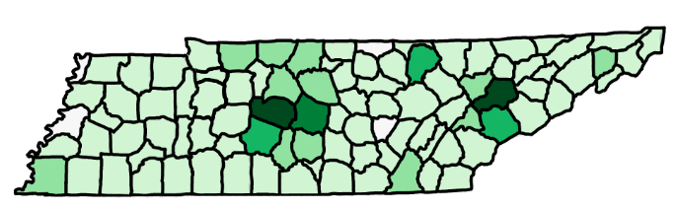
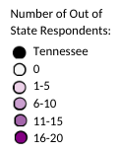
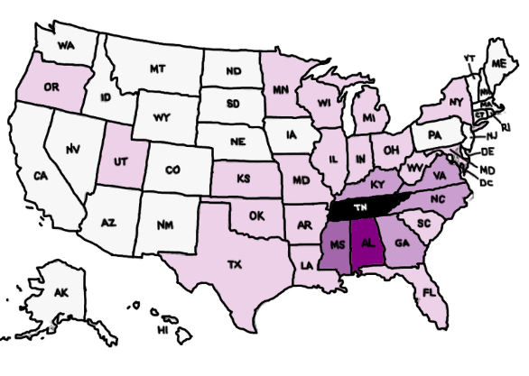
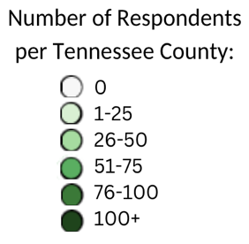
Respondents (n=104) identified their state of residence. There were eighteen other states represented with Alabama (n=19) being the highest.
Figure 1: Number of Respondents per Tennessee County
Figure 2: Number of Out of State Respondents
Respondents (n=1,647) identified their county of residence. The top three counties represented were Knox (n = 109), Williamson (n=107), Rutherford (n=92). The counties that went unrepresented were Lake, Lauderdale, Clay, and Van Buren.

Figure 3: Tennessee Resident Industry Involvement
The equine industry has several different components and because of this each respondent was asked how they were involved in the industry. Respondents (n = 1,815) were able to select multiple areas of involvement leading to a larger number of observations (k = 2,131). The activities were broken into four categories, activities directly related to facilities or facility ownership (yellow), equine businesses (green), occupations or businesses directly related to the equid (blue), and activities that do not fall into any other group (purple). Not pictured is the own or lease equids category because a majority of respondents were owners/leasers (n= 1,815; k= 1,741) (figure 3).

Respondents that lived out of state were asked how they are involved in the equine industry. The activities were broken into four categories, activities directly related to facilities or facility ownership (yellow), equine businesses (green), occupations or businesses directly related to the equid (blue), and activities that do not fall into any other group (purple). Not pictured is the own or lease equids category because a majority of respondents were owners/leasers (n= 131) (k = 221) (figure 4).
n = 107
k = 221
Figure 4: Out of State Industry Involvement
Figure 5: Type of Equid Owned
Participants were asked to report the number of equids they owned within each category. Respondents (n = 2,225) reported that they owned 8,041 equids. Of this, 83% (6,691) were horses, followed by 9% (743) being ponies, 5% (382) being donkeys, 3% (199) being mules, and 0% (26) in the “other” category, comprised of zebras, zonkeys, etc (figure 5).

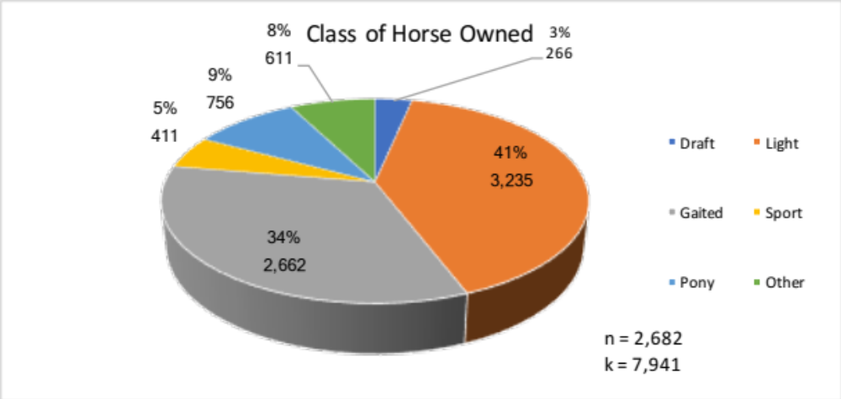
Draft breeds were defined as a horse bred for working and pulling heavy weight (Hurcombe, 2014). The light breeds were defined as being bred for endurance, agility, riding, etc (citation). The gaited breeds were defined as being bred for pleasure riding and a smooth gait (citation). The sport breeds were defined as being bred for athleticism and sport (citation). The pony breeds were defined as a horse measuring less than 14.2 hands (Britannica.com). The other equid category was filled with horses that did not fit into any of the other categories, such as, donkeys, mules, zebras, etc (citation). Results showed that the light, 41% (X) and the gaited, 34% (X) breeds made-up 75% of the equids owned (figure 6).

Figure 6: Class of Equid Owned
Figure 7: Draft Breeds Owned
Draft breeds were defined as a horse bred for work and pulling heavy weight (Hurcombe, 2014). Of 302 identified, 69% of breeds owned were allotted to Percheron (23% or 71), Friesian (16% or 47), Belgian (12% or 37), and draft cross breeds (18% or 53) (figure 7).

Figure 8: Light Breeds Owned
The light breeds were defined as being bred for endurance, agility, riding, etc. Of the 3,218 light-type horses identified, 59% or 1,890 were Quarter Horses, followed by the American Paint Horse (10% or 321), then the Thoroughbred (10% or 315) (figure 8).

Gaited breeds were defined as being bred for pleasure riding and a smooth gait. Of the 2,632 horses identified as being gaited, 62% or 1,628 were the Tennessee Walking Horse. This was followed by the Spotted Saddle Horse (11% or 290), American Saddlebred (8% or 221), and the Racking Horse (4% or 117). The remaining breeds accounted for the other 15% (figure 9).

Figure 9: Gaited Breeds Owned
The sport breeds were defined as being bred for athleticism and sport. Of the 316 sport horses identified, a majority were the Warmblood (44% or 140), which included Belgian and Dutch Warmbloods, followed by the Oldenburg (13% or 40) and the Trakhener (20% or 31). (figure 10).
Figure 10: Sport Breeds Owned
The pony breeds were defined as a horse measuring less than 14.2 hands. With a sample size of 1,424 ponies identified, 53% (756) were identified under the general pony option, which is comprised of any horse breed and the horse measures less than 14.2 hands (figure 11).
Figure 11: Pony Breeds Owned

Figure 12: Other Equids Owned
The other equid category was filled with equids that did not fit into any of the other categories, such as, donkeys, mules, zebras, etc. Of the 564 identified, 67% (377) were identified as donkeys (figure 12).
Figure 13: Equids Owned Gender
Respondents were asked to place their equids into a gender category. Of 7,519 equids identified, geldings made up 44% (3,294), followed by mares at 43% (3,238) (figure 13).
Respondents were asked to age their equids into one of the seven age groups. Of 7,699 equids identified, the largest group was the 11-15 age range at 23% (1,753). (figure 14).

Figure 14: Age of Equids Owned
Figure 15: Primary Use of Equids Owned
Due to the versatility of equids, participants were asked to identify the primary use of their equids. The most common use of equids identified (k=7,230) in Tennessee was for companion or recreational use (1340), followed by trail riding (1157), and then equids that are retired, idle, or not working (1028) (figure 15).

Figure 16: Location of Equids Owned
Respondents (n=117) reported that they leased 194 equids. Of 194 equids, 85% (165) were horses (figure 17).
Figure 17: Type of Equids Leased
Participants were asked the location of the equids owned. Of the 7,487 identified, 79% (5,887) were housed at a property owned by the participant (figure 16).
Figure 18: Class of Equids Leased
Draft breeds were defined as a horse bred for work and pulling heavy weight (citation). There was a very small sample size (n=5) of draft breeds leased. Draft crosses were the majority at 40% (2), followed by 20% (1) each of the other breeds, American Cream, Friesian, and Percheron (figure 19).

Figure 19: Draft Breeds Leased
Draft breeds were defined as a horse bred for working and pulling heavy weight (citation). The light breeds were defined as being bred for endurance, agility, riding, etc (citation). The gaited breeds were defined as being bred for pleasure riding and a smooth gait (citation). The sport breeds were defined as being bred for athleticism and sport (citation). The pony breeds were defined as a horse measuring less than 14.2 hands (citation). The other equid category was filled with horses that did not fit into any of the other categories, such as, donkeys, mules, zebras, etc. Equids leased followed a similar trend to the equids owned. Light breeds accounted for 47% (84), followed by gaited breeds at 22% (40) (figure 18).

Figure 20: Light Breeds Leased
Gaited breeds leased had a smaller sample size (n=40). Of th3 40 horses identified, 47% (19) were Tennessee Walking Horses. (figure 21).

A smaller sample size was identified for light breeds leased (k=82) than were owned. Similar trends were followed with a majority being Quarter Horses (40% or 33), Thoroughbreds (18% or 15) and the American Paint Horse (16% or 13) (figure 20).

Figure 21: Gaited Breeds Leased
Figure 23: Pony Breeds Leased
Ponies leased had a small sample size of n=19, with a 37% (7) being the Welsh Pony and Cob (figure 23).

Participants identified 28 sport horses that were leased. Of 28 identified, 61% (17) were Warmbloods (figure 22).

Figure 22: Sport Breeds Leased

Of the 3 equids leased, 67% (2) were mules, an 33% (1) were zebras (figure 24).

Figure 24: Other Equids Leased
Figure 26: Gender of Equids Leased
The gender of leased equids followed a similar trend to the gender of equids owned, but with a sample size of 189. Geldings held the majority at 53% (101) (figure 26).

The age range of equids leased had with a sample size of 182 equids identified. The most common age range was 11-15 (29% or 53), followed by 16-20 (27% or 49) (figure 25).

Figure 25: Age of Equids Leased
Figure 28: Location of Equids Leased
The most common use of equids identified (n=175) was for hunter/jumper activities (59) (figure 27).

Figure 27: Primary Use of Equids Leased
Of the 154 equids identified, 68% (104) were housed at a boarding facility, while only 24% (37) resided at a property owned by the participant (figure 28).
 | Number of Respondents | Total Paid to Lease Equids | Min | Max | Mean | Std. Dev.
Base Rate Paid for All Equids Leased ($) | 62 | 37,732 | 1 | 4000 | 608.58 | 647.63
Respondents were asked how much they pay to lease all of their equids per month. Respondents (n=62) paid on average $608.58 (+/- 647.63) monthly to lease all equids per month (table 1).
Table 1: Equid Leasing Cost
Of the 174 observations, 22% (38) of owners were required to supply daily management and care, per the leasing agreement (figure 30).

Figure 30: Services Provided by the Owner of the Equine Being Leased
Of the 292 responses, 23% (68) reported that they were required to provide exercise, followed by 18% (52) providing feed costs, 17% (51) daily management and care, 17% (51) farrier services, and 17% (49) health or veterinary maintenance (figure 29).

Figure 29: Services Provided by the Individual Leasing an Equid

Figure 31: Permissible Activities of the Equid Being Leased
Of the 180 observations, 34% (62) were permitted to show on or off the property, 33% (60) could ride on or off property, and 25% (46) could use them for any and all riding, breeding, or showing purposes (figure 31).
Average Monthly Board ($) | Number of Respondents | Total Number of Equids Boarded | Total Paid | Min | Max | Mean | Std. Dev.
Average Monthly Board ($) | 385 | 955 | 304,845 | 75 | 10,000 | 791.81 | 1,018.78
Average Monthly Travel | n | Min | Max | Mean | Std. Dev.
Miles Traveled | 493 | 1 | 860 | 59.02 | 123.61
Times Traveled Per Month | 64 | 1 | 31 | 18.73 | 8.96
Participants were asked to report the average number of miles traveled per month Respondents indicated that they traveled on average 59 miles round trip, approximately 19 times monthly (table 3).
Table 3: Average Monthly Travel to Boarding Facility
Respondents were asked to report how much money they paid per month for boarding for all of their equids. Respondents (n=385) reported that they paid on average $791.81 (+/- $1,018.78) per month for boarding. The average price for boarding a single equid is approximately $306.38 per month (table 2).
Table 2: Average Monthly Board Costs
Participants were asked to report what types of services are provided by the facility where their equids are boarded. Based on the number of observations (k=1,748), a majority of respondents (n=391) reported that feeding (19% or 327) was included in their monthly board fee (figure 32).
Figure 32: Services Provided by Boarding Facility (Client Perspective)

Participants were asked to report what types of services they were expected to provide for their equids are boarded. Based on the number of observations (k=1,170), a majority of respondents (n=324) reported they were required to groom (24% or 281) and exercise (24% or 277) their equid (figure 33).
Figure 33: Services Provided by Boarding Facility Client (Client Perspective)

Respondents that reported that they owned an equine facility were asked to differentiate the type of facility owned. Respondents (n=143) were able to select multiple types of facilities leading to 174 observations (k). A majority of the facilities owned were boarding facilities (69% or 120) (figure 34).
Figure 34: Types of Equine Facilities Owned in Tennessee

 | n | Min | Max | Mean | Std. Dev
Acres Allotted to Equid Use | 143 | 4 | 300 | 32.87 | 40.90
Events Yearly | 11 | 2 | 40 | 10.34 | 10.58
Price Per Weekend | 14 | 40 | 2500 | 735.71 | 833.37
Facility Events | n | Min | Max | Mean | Std. Dev
Events Yearly | 11 | 2 | 40 | 10.34 | 10.58
Price Per Weekend ($) | 14 | 40 | 2500 | 735.71 | 833.37
Respondents that owned an equine if they held events, how many were held yearly, and the average cost to rent the facility for a weekend. Respondents (n = 11) held approximately 10 (+/- 10.58) events per year. Furthermore, respondents (n=14) reported that they charged on average $735.71 (+/- 833.37) to rent their facility for a single weekend (table 5).
Table 5: Facility Events
Respondents that owned an equine facility were asked how many acres they allocated to equine use. Respondents (n = 143) reported that they allocated approximately 32.87 (+/- 40.90) acres to equine use (table 4).
Table 4: Facility Acreage
Boarding facility owners were asked to quantify the number of equids they housed on property. On average, property owners housed 7 (+/- 17.6) equids owned by them and 12 (+/-293.81) owned by their clients (table 6).
Table 6: Boarding Facility Equid Count

Equids on  Property | Number of Observations | Total Number of Equids | Min | Max | Mean | Std. Dev
Owned by You | 124 | 915 | 1 | 52 | 7.38 | 17.6
Owned by Client | 109 | 1309 | 1 | 150 | 12.01 | 293.81
Boarding Fee | Number of Observations | Min | Max | Mean | Std. Dev
Price ($) | 96 | 50 | 1500 | 481.25 | 293.81
Boarding facility owners were asked how much they charge for monthly board. Facility owners charged an average of $481.25 (+/- 293.81) per horse for one month of board (table 7).
Table 7: Boarding Fee (Facility Owner Perspective)
Boarding facility owners were asked what services they provide in exchange for monthly board. Owners (n=106) had the ability to select multiple options leading to 483 observations (k). A majority of owners provided feeding services (90% or 96). (figure 35).
Figure 35: Services Provided by the Boarding Facility (Owner Perspective)

Boarding facility owners were asked what add-on services they provide in exchange for. Owners (n=92) had the ability to select multiple options leading to 267 observations (k). The red bar shows that 38% (35) of owners reported that they did not provide any add on services. The most common service provided was exercising or riding the animal (70) (figure 36).
Figure 36: Add-On Services Provided by the Boarding Facility (Owner Perspective)
Figure 37: Short-term Board Availability
Boarding facility owners were asked if they provided the option for clients to do short-term boarding. Of the 107 responses (n), 64% (69) owners reported that they did provide short-term board (figure 37).
Average Cost per Night for Short-Term | n | Min | Max | Mean | Std. Dev.
Cost Per Night ($) | 35 | 5 | 200 | 40.29 | 38.06
Boarding facility owners that indicated that they offered short-term board were asked the average cost per night. Respondents (n=35) charged an average of $40.29 (+/- 38.06) per night (table 8).
Table 8: Short-term Board Cost
Average Number of Nights Stayed with Equids | n | Min | Max | Mean | Std. Dev.
Number of Nights | 18 | 1 | 30 | 11.33 | 10.82
Number of Equids | 18 | 2 | 65 | 9.22 | 14.59
Boarding facility owners that indicated that they offered short-term board were asked the average number of nights stayed. They were also asked the average number of equids housed on a short-term basis. Respondents (n=18) housed 9 equids (+/-10.82) at a given time, and they stayed on average 9.22 (+/- 14.59) nights (table 9).
Table 9: Short-term Clients Stays
Figure 38: Trainer Employment

Style of Riding Taught to Individuals | n | Min | Max | Mean | Std.Dev.
English | 50 | 1 | 200 | 20.76 | 32.67
Western | 50 | 1 | 800 | 25.46 | 113.14
Gaited/Non-Trotting | 40 | 1 | 50 | 7.83 | 10.49
Other | 11 | 1 | 1000 | 93.73 | 300.6
Style of Riding Taught to Equids | n | Min | Max | Mean | Std.Dev.
English | 42 | 1 | 50 | 6.48 | 9.24
Western | 38 | 1 | 60 | 6.29 | 11.99
Gaited/Non-Trotting | 34 | 1 | 50 | 9.74 | 12.99
Other | 9 | 1 | 15 | 6 | 4.64
Table 10/Figure 39: Riding Styles Taught to Individuals and Equids
Boarding facility were asked if they employ a trainer at their facility. Respondents (n=104) reported that 42% (31) did not employ a trainer at their facility (figure 38).
Table 11: Ownership Status of Lesson Equids

Lessons Taught per Week | n | Min | Max | Mean | Std. Dev.
Number Taught | 103 | 1 | 120 | 12.04 | 19

Lesson Equids’ Ownership/Use | n | Min | Max | Mean | Std. Dev.
Owned by Me and Used by One Student/Client | 40 | 1 | 20 | 3.13 | 3.52
Owned by Me and Used by 2+ Students/Clients | 40 | 1 | 35 | 4.8 | 6.1
Owned by Someone Else and Used by One Student/Client | 33 | 1 | 30 | 3.67 | 5.82
Owned by Someone Else and Used by 2+ Students/Clients | 21 | 1 | 60 | 10.9 | 15.5

Price Charged Per Lesson | n | Min | Max | Mean | Std. Dev.
Private Lesson (one rider) | 83 | 3 | 150 | 49.98 | 20.96
Group Lesson (2+ riders) | 45 | 1 | 120 | 43.73 | 21.59
Training Session (for equid) | 55 | 1 | 750 | 71.71 | 124.54

Price to Lease Facility | n | Min | Max | Mean | Std. Dev.
Price | 9 | 350 | 4500 | 1544.44 | 1321.33

Number of equids Trained | n | Min | Max | Mean | Std. Dev.
Personal Use | 62 | 1 | 60 | 4.66 | 8.3
Client Use | 62 | 1 | 50 | 9.63 | 11.91

Clients to Events | n | Min | Max | Mean | Std. Dev.
Clients/Students to Event in TN | 57 | 1 | 45 | 7.77 | 8.96
Equid to Event in TN | 47 | 1 | 65 | 9.83 | 13.73
Clients/Students to Event Out of State | 32 | 1 | 25 | 6.72 | 6.23
Equid to Event Out of State | 31 | 1 | 40 | 8.35 | 10.08

Respondents that indicated they owned a business attracting tourists were asked what type of services they provide. Respondents (n=61) reported that 62% (38) owned a business involving trail rides, either with use of equids owned by the client (27 or 44%) or owned by the business (11 or 18%) (figure 40).
Figure 40: Tourism Businesses
Tourism Revenue | n | Min | Max | Mean | Std. Dev.
Tennessee (%) | 49 | 1 | 100 | 86.45 | 26.84
Out of State (%) | 15 | 10 | 100 | 57.6 | 31.41
Respondents that indicated they owned a business attracting tourists were asked what percentage of their income was generated in Tennessee. Respondents (n=49) reported that 86.45% (+/- 26.84) of their yearly revenue was generated in Tennessee (table 11).
Table 11: Revenue Generated from Tourism Business
Figure 41: Type of Veterinarian
Respondents that indicated were veterinarians were asked what type of clients they service. Respondents (n=24) were able to select multiple options, leading to 49 observations (k). Respondents (n=24) reported that 18 provided services to equids (figure 41).
Figure 42: Number of Veterinarians Servicing Tennessee Counties
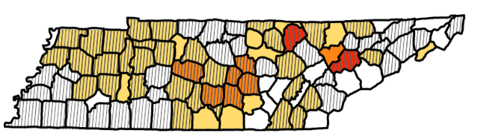
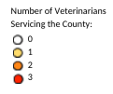
n=24
k = 39
Respondents that indicated that they provided services to equids (n=18) were asked to identify what counties they provide services to. Knox county (n=3) and Fentress county (n=3) had the highest number of veterinarians that provided equine care. The stripes across the counties represent counties that had veterinarians that indicated to the Tennessee Department of Agriculture that they provided services to that county (figure 42).
Figure 43: Types of Services Offered by Veterinarians
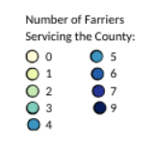
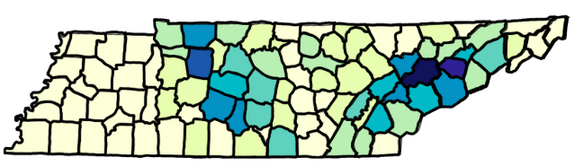
n = 31
k = 136
Respondents that indicated that they were farriers were asked what counties they provide services to. Knox county had the largest number farriers providing services (n=9), followed by Jefferson (n=7), and Dickson (n=6). There were 43 counties without farrier representation (figure 44).
Figure 44: Tennessee Counties with Access to Farrier Care
Equine veterinarians were asked what types of services they provided to their clients. Respondents (n=13) had the option to select multiple services, leading to 52 observations (k). A majority of veterinarians provided routine care services, such as, vaccinations (11), Coggins tests (11), and teeth floating (9). Surprisingly, only 1 veterinarian provided emergency services to their clients (figure 43).
Respondents that indicated that they operated a breeding operation were asked what gender they provided services to. Of the 141 respondents, 55% (77), managed breeding operations that provided services to mares only, followed by 44% (62) providing services to mares and stallions, leaving only 1% (2) respondents providing services to only stallions (figure 45).
Figure 45: Equids Managed by Breeding Operations

Respondents that performed services for mares were asked what types of services were offered. Most of the respondents performed services for their own equids (n=187) versus for clients (n=40). Of the services provided, live cover was the most commonly practiced overall (k=82), followed by artificial insemination (k=80) (figure 46).
Figure 46: Mare Reproductive Services Offered by Breeding Operations
Table 12: Price Charged for Mare Reproductive Services
Prices Charged for Mare Services | n | Min | Max | Mean | Std. Dev.
Live Cover | 34 | 10 | 1500 | 498.09 | 288.58
Artificial Insemination | 22 | 1 | 20000 | 1809.77 | 4260.02
Foaling Services | 9 | 140 | 5000 | 1298.89 | 1574.13
Recipient Mare | 5 | 100 | 12000 | 3140.00 | 5007.29
Other (undisclosed) | 1 | 250 | 250 | 250.00 | 0
Respondents that performed services for mares were asked the average price charged per service available. The least expensive service was $250.00, however, that service was not disclosed. The most expensive service was for recipient mares, at $3,140 (table 12).
Respondents that performed services for stallions were asked what type and if it was for their equids or client equids. Respondents performed more services on their own equids (n=59) versus for clients (n=10) (figure 47).
Figure 47: Mare Reproductive Services Offered by Breeding Operations
Prices Charged for Stallion Services | n | Min | Max | Mean | Std. Dev.
Live Cover | 36 | 200 | 1000 | 456.94 | 180.54
Semen Collection (without extending) | 3 | 150 | 800 | 433.33 | 332.92
Semen Collection (extended) | 4 | 200 | 800 | 506.25 | 312.5
Semen Collection (extended and shipped) | 4 | 350 | 3000 | 1300.00 | 1174.02
Collect and Freeze | 3 | 500 | 1000 | 766.67 | 251.66
Respondents that performed services for stallions were asked the average price per service. The least expensive service was for semen collection without extension ($433.33). The most expensive service was for semen collection with extension and shipping ($1,300.00) (table 13).
Table 13: Price Charged for Stallion Reproductive Services

Participants were asked if they were involved in the buying or selling of any equids in Tennessee. Of 1,592 respondents, 69% (1,092) had participated in either buying or selling of equids in Tennessee (figure 48).

Figure 48: Participants Involved in Buying and/or Selling of Equids in Tennessee
Respondents (n=477) purchased 735 (k) equids in Tennessee. The most common price range between $2,001-$5,000. There were 4 equids purchased for more than $100,001 (figure 49).

n = 480
k = 735
Figure 49: Participants Involved in Buying of Equids in Tennessee
Respondents (n=282) purchased 514 (k) equids in Tennessee. The most common price range between $2,001-$5,000. There were 4 equids sold for more than $100,001 (figure 50).

Figure 50: Participants Involved in the Selling of Equids in Tennessee
Respondents (n=1,524) reported that the COVID-19 pandemic had a no impact to a moderate impact on their finances (figure 51).

Respondents (n=1,524) reported that the COVID-19 pandemic did not change their involvement within the equine industry (figure 52).

Figure 52: COVID Impact on Respondent Industry Involvement
Figure 51: COVID Impact on Respondent Finances
Respondents (n=1,503) were asked if they would attend a live horse racing event in Tennessee. There was a fairly even split between respondents. 38% (571) reported that they would attend a racing event (figure 54).

Figure 54: Respondent Previous Attendance on Live Horse Racing
Respondents (n=1,502) were asked if they had ever attended a live horse racing event. 60% (901) of respondents had previously attended a live race at some point in their life (figure 53).

Figure 53: Respondent Previous Attendance on Live Horse Racing
Respondents (n=584) were asked to justify why they oppose a racing industry being developed in Tennessee. For the most part, respondents were opposed to racing because of concerns for the animal (yellow). The other concerns pertained to concerns of the attendee (green), overall disinterest in the sport (blue), and unsure responses (red) (figure 55).

Figure 55: Respondent Previous Attendance on Live Horse Racing
Respondents (n=?) were asked what type of impact the addition of a racing sector would be on different parts on the equine industry. Overall, a majority of respondents found the addition of a racing sector to have a positive impact on the industry (blue), except for the breed development category (figure 56).

Figure 56: Impact of a Racing Sector to the Tennessee Equine Industry

Hurcombe, S. D. A. (2014). Emergency Problems Unique to Draft Horses (4th ed.). https://www.sciencedirect.com/topics/immunology-and-microbiology/draft-horse#:~:text=Draft%20horses%20are%20large%2C%20heavy,%2C%20plowing%2C%20and%20farm%20labor.

