Hormonal and Developmental Signaling During Plant-Cyst Nematode Interaction

A Dissertation Presented for the

Doctor of Philosophy

Degree

The University of Tennessee, Knoxville

Sarbottam Piya

May 2017

Copyright © 2017 by Sarbottam Piya

All rights reserved.

DEDICATION

Sheela Shrestha

ACKNOWLEDGEMENTS
I would like to express my deep gratitude and sincere appreciation to Dr. Tarek Hewezi, for his guidance and constant encouragement during my research and dissertation preparation. I am also thankful to members of my advisory committee, Dr. Brad Binder, Dr. Feng Chen, Dr. Max Cheng and Dr. Neal Stewart for their constructive feedback and helpful suggestion
I would also like to thank the members of Dr. Hewezi’s lab: John Hollis Rice, Yin Fang, Aditi Rambani, Valeria Lopes, Jin Yi, Nana Cheng, Jordan Skeen, Christina Kihm for providing technical support. In addition, I would also like acknowledge Sandesh Shrestha, Tyra McCray, Arakadipta Bakshi, and Thomas Lane for their assistance.
I would like to express my deep gratitude and heartfelt respect to all my family members, and friends for their encouragement and, and constant support.
Most of all, I would like to thank my beloved wife Utsala, without whom, this dissertation would not have been possible.

ABSTRACT
microRNAs (miRNAs) recently have been established as key regulators of transcriptome reprogramming that defines cell function and identity. However, the molecular functions of the large majority of miRNA genes remain to be determined. Here, we report cooperative regulatory functions of miR858 and its MYB83 transcription factor target gene in transcriptome reprogramming during Heterodera cyst nematode parasitism of Arabidopsis. Gene expression analyses and promoter–GUS fusion assays documented a role of miR858 in post-transcriptional regulation of MYB83 in the Heterodera schachtii–induced feeding sites, the syncytia. Constitutive overexpression of miR858 interfered with H. schachtii parasitism of Arabidopsis, leading to reduced susceptibility, while reduced miR858 abundance enhanced plant susceptibility. Similarly, MYB83 expression increases were conducive to H. schachtii infection because overexpression of a non-cleavable variant of MYB83 significantly increased plant susceptibility, whereas a myb83 mutation rendered the plants less susceptible. In addition, RNA-seq analysis revealed that genes involved in hormone signaling pathways, defense response and glucosinolate biosynthesis, cell wall modification, sugar transport, and transcriptional control are the key etiological factors by which MYB83-facilitates nematode parasitism of Arabidopsis. Furthermore, we discovered that miR858-mediated silencing of MYB83 is tightly regulated through a feedback loop that might contribute to fine-tuning the expression of more than a thousand of MYB83-regulated genes in the H. schachtii–induced syncytium. Together, our results suggest a role of the miR858–MYB83 regulatory system in finely balancing gene expression patterns during H. schachtii parasitism of Arabidopsis to ensure optimal cellular function.
Keywords: phytohormone, auxin, cyst nematode, microRNA

TABLE OF CONTENTS
Chapter 1 General introduction and literature review on nematode, phytohormones, and miRNA in plant-nematode interaction 12
1. Introduction 13
2. Role of phytohormones in plant nematode interaction 15
3. Role of microRNA in plant-nematode interaction 19
4. Role of GRF1/3 in plant-nematode interaction 21
5. Dissertation organization 22
References 22
Chapter 2 Protein-protein interaction and gene co-expression maps of ARFs and Aux/IAAs in Arabidopsis 30
Abstract 32
1. Introduction 33
2. Materials and Methods 35
2.1 Plasmid Construction 35
2.2 Yeast Two-Hybrid Assays 35
2.3 Bimolecular Fluorescence Complementation (BiFC) Assays 35
2.4 Gene Co-Expression Network Analysis 36
2.5 Phylogenetic Analysis 37
3. Results 37
3.1 Construction of Comprehensive Interaction Map of ARFs and Aux/IAA 37
3.2 Phylogenetically-Related ARFs Exhibited Various Interactions with Aux/IAA Proteins 38
3.3 Co-Expression Analysis of Interacting ARF-Aux/IAA Proteins 39
4. Discussion 40
References 44
Appendix 48
Figures 48
Chapter 3 Cooperative regulatory functions of miR858 and MYB83 in transcriptome reprogramming during cyst nematode parasitism of Arabidopsis 54
Abstract 56
1. Introduction 57
2. Materials and Methods 60
2.1 Plant material and growth conditions 60
2.3 Nematode infection assay 60
2.4 Plasmid construction and generation of transgenic plants 61
2.5 RNA isolation and quantitative real-time RT-PCR analysis 62
2.6 RNA-seq library preparation and data analysis 63
3. Results 63
3.1 miR858 is expressed in the syncytium during the initiation and progression of nematode parasitism. 63
3.2 miR858 post-transcriptionally regulates MYB83 transcription factor during H. schachtii parasitism of Arabidopsis 64
3.4 Overexpression of a mimic sequence for miR858 augments plant susceptibility to H. schachtii 66
3.5 Ectopic overexpression of a non-cleavable variant of MYB83 enhances plant susceptibility to H. schachtii. 67
3.6 RNA-seq analysis of miR858 and rMYB83 overexpression plants-regulated genes 68
3.7 Identification of putative direct targets of MYB83 69
3.8 MYB83 regulates key cellular processes in the syncytium of H. schachtii 69
3.9 miR858 and MYB83 constitute a feedback regulatory loop that involves MYB12 70
4. Discussion 72
5. Acknowledgement 76
References 78
Appendix 88
Figures 88
Supplemental Figures 99
Chapter 4 106
Conclusion 108
Vita 109

LIST OF TABLES
No table of figures entries found.

LIST OF FIGURES
Figure 2-1. Yeast two-hybrid interaction between ARF10 and various Aux/IAAs. 53
Figure 2-2. BiFC visualization of the ARF-Aux/IAA interactions. 54
Figure 2-3. Protein-protein interaction map of Arabidopsis ARF and Aux/IAA proteins. ARFs (top) and Aux/IAAs (left) are arranged according to their sequence similarity. Empty boxes indicate no interaction while gray and black boxes indicate weak and strong interaction, respectively. 55
Figure 2-4. Gene co-expression network of the interacting ARF-Aux/IAA proteins. 56
Figure 2-5. Heatmap demonstrating gene co-expression patterns of the interacting ARF-Aux/IAA proteins in various Arabidopsis tissues and organs. 57
Figure 3-6. Histochemical staining of GUS activity driven by miR858 and MYB83 promoters in transgenic Arabidopsis lines in response to H. schachtii infection. 92
Figure 3-7. miR858 post-transcriptionally downregulates MYB83 during H. schachtii parasitism of Arabidopsis. 93
Figure 3-8. Overexpression of miR858 confers enhanced resistance to H. schachtii.. 94
Figure 3-9. Constitutive downregulation of miR858 increased plant susceptibility to H. schachtii. 96
Figure 3-10. Constitutive overexpression of miR858-resistant variant of MYB83 increased plant susceptibility to H. schachtii. 97
Figure 3-11. Functional classification and Gene Ontology enrichment analyses of differentially expressed genes identified in 35S:miR858 and 35S:rMYB83 lines. 98
Figure 3-12. Differential expression patterns of a set of MYB83-regulated genes involved in key biological processes associated with nematode parasitism. 99
Figure 3-13. miR858/MYB83 regulatory loop involves MYB12. 100
Figure 3-14. Model for miR858–MYB83 interaction 101

General introduction and literature review on nematode, phytohormones, and miRNA in plant-nematode interaction

1. Introduction
Nematodes are one of the most diverse living organisms with more than 25,000 species and are ubiquitously distributed across various habitats that include different soils types, marine and fresh water (Hugot et al., 2001; Blaxter, 2003; Goverse and Smant, 2014). Majority of these nematodes are beneficial or free living but there are few notorious species that parasitize human, animals and different crop plants causing devastating loss (Jasmer et al., 2003; Neher, 2010).
Plant parasitic nematodes (PPNs) are among the most serious and widely spread plant pathogens with more than 4100 species (Decraemer and Hunt, 2006). It is estimated that every year these plant parasitic nematodes cause agricultural loss worth $157 billion (Abad et al., 2008).
Based on the feeding habits, PPNs can be grouped into three major groups: ectoparasites, semi-endoparasites and endoparasites. Ectoparasitic nematodes live outside of the plant and extract nutrient from the plant root using the stylet. Semi-endoparasitic nematodes partially penetrate the root. Usually, their head penetrate the root where they establish their feeding site. Endoparasitic nematodes are the one that penetrate completely into the plants. These nematodes can be further classified into migratory endoparasites and sedentary endoparasites. Migratory endoparastic nematodes are mobile throughout their life-cycle and feed on the plant cells as they move while the sedentary endoparastic nematodes forms their feeding site and become sedentary. Sedentary endoparasitic nematodes are the most devastating plant parasitic nematodes and include two major groups of nematodes cyst nematode (Heterodera and Globodera) and root-knot nematode (Meloidogyne). These sedentary endoparasitic nematodes live underground in roots and cause no obvious aboveground symptoms like other plant pathogens (Wang et al., 2003). Nevertheless, the disturbance caused by these nematodes in the root system reduces availability of water and nutrients resulting stunted plant growth with leaf chlorosis, wilting and ultimately lower yield and hence the loss caused by these nematodes are attributed to abiotic stress or unfavorable cultural practices.
Cyst nematodes belong to the family Heteroderidae and are characterized by the formation of feeding site termed syncytium from where they extract all essential nutrient once they become sedentary. The most economically important species in this family are soybean cyst nematode (Heterodera glycines) and potato cyst nematode (Globodera rostochiensis and G. pallida). The beet cyst nematode (Heterodera schachtii) is another economically important species that infect sugar beet. H. schachtii also infects Arabidopsis thaliana and the H. schachtii-Arabidopsis interaction has been used as a model system for studying plant-cyst nematode interaction (Sijmons et al., 1991).
The life cycle of cyst nematode comprises of egg, four juvenile stages, and the adult. The first stage juvenile (J1) develop within the egg. Under favorable conditions, the J1 undergoes molting to develop J2 which hatches out of the egg. After hatching, the migratory J2s migrate towards the root, penetrate the root mostly near the zone of elongation or near the lateral roots with the stylet and enter the epidermal cells. Once the J2s penetrate epidermal root cells, these juveniles migrate intracellularly via the cortex into vascular cylinders. J2 selects a competent cell and injects its stylet into the cell to probe the cell. If the plant responds, for instance by callose deposition or cytoplasm collapse, J2 retracts its stylet and select another neighboring cell (Hewezi and Baum, 2017). The J2 probes several cells until it finds competent cell. Once the J2 selects suitable cell, it anchors in the cell to form initial feeding cell (IFC). The J2 injects effector proteins via their stylet into the host cell to suppress defense response. These effectors also target host proteins to manipulate the development of the ISC and integrate few hundreds neighboring cells to develop into the syncytium (Davis et al., 2008; Hewezi and Baum, 2013). Various cell wall modifying and cell wall degrading enzymes such as expansins, cellulases and pecinases facilitate dissolution of neighboring cell wall and incorporation into the syncytium (Bohlmann and Sobczak, 2014). The syncytium undergoes considerable cellular changes that include repeated endoreduplication leading to polyploidy and multinucleate protoplast, several small vacuoles, thickened cell wall and high metabolic activity (Szakasits et al., 2009; Engler and Gheysen, 2013). After fourth molting, males become mobile and leave the root to mate with the female. Females spend all their life attached to the same syncytium sequestering the essential nutrients from the host plant. Females release a gelatinous matrix from the posterior end of the body where they deposit the eggs. The body of the females hardens and becomes the cyst after its death that can keep the eggs safe for several years until the eggs hatch.
Successful establishment of syncytium by the nematode dictate the compatible interaction between plant and cyst nematode. Therefore, understanding syncytium ontogeny would help exploit the vulnerability of the feeding site to engineer plant resistant to cyst nematode (Mitchum, 2016). However, the mechanism by which cyst nematode induce re-differentiation of normal root cells into syncytial cell type is not well-understood. Transformation of undifferentiated root into specialized feeding site involves a substantial change in gene expression. The role of different phytohormones and microRNAs (miRNAs) in transcriptional regulation is well established pointing to the role of phytohormones and miRNAs in the development of syncytium. In fact, there is an accumulating body of evidence suggesting the role of phytohormones particularly auxin and ethylene, and microRNAs in syncytium ontogeny (Hewezi et al., 2008; Gheysen and Mitchum, 2009; Hewezi et al., 2012; Quentin et al., 2012; Cabrera et al., 2016).

2. Role of phytohormones in plant nematode interaction
Role of various phytohormones and their interaction during plant-pathogen interactions is well established. Particularly, there occurs interactions among defense related plant hormones (salicylic acid, jasmonic acid and ethylene) during plant-pathogen interactions. Since there occur trade-off between growth and defense response, multiple hormonal signaling pathways associated with both plant defense related, and plant growth and development get activated during pathogen attack resulting in their cross-talk to fine-tune the balance between plant growth and defense response. This is supported by various studies that demonstrate interactions of phytohormones associated with plant growth and development (auxin, cytokinin, gibberellins and abscisic acid) with phytohormones associated with plant defense.
Although hormonal crosstalk during plant nematode interactions has not been explored much, studies have shown role of several phytohormones such as auxin, ethylene, jasmonic acid, salicylic acid and cytokinin during plant-nematode interaction. However, the underlying mechanism on how these phytohormones affect the plant-nematode interaction is not well understood. Various genomic studies have shown that genes associated with auxin and ethylene are among the genes that are differentially expressed in the syncytium (Gheysen and Mitchum, 2009; Cabrera et al., 2014) suggesting the major role of these phytohormones in syncytium development.
Auxin
Auxin is a key player of the root development and is involved in various root development processes that includes cell division, and establishing and maintaining root meristem (De Smet et al., 2010). In general, sites with increased auxin levels correspond with organ primordia initiation sites in plant tissues (Tanaka et al., 2006). The auxin level increases in the initial nematode feeding sites and after 2-5 days, auxin response shift to the neighboring cells (Hutangura et al., 1999; Karczmarek et al., 2004) pointing to the role of auxin in nematode feeding site initiation and development. Balasubramanian and Rangaswami (1962) provided the first evidence on the occurrence of auxin in nematode feeding site by demonstrating the presence of indole compounds in the root galls induced by various root knot nematodes. Over the years, several other studies have shown similar results in various plant-nematode interaction systems (Bird, 1962; Yu and Viglierchio, 1964; Cutler and Krusberg, 1968). Apart from these studies, impaired feeding sites development in tomato auxin insensitive mutant diageotropica (dgt) when infected with M. incognita or Globodera rostochiensis (Goverse et al., 2000) further consolidated the role of auxin in nematode feeding site development.
Molecular and biochemical analyses revealed that AUXIN RESPONSE FACTOR (ARF)-AUXIN/INDONE-3-ACETIC ACID (Aux/IAA) module regulates the auxin signaling pathway (Chapman and Estelle, 2009). In the presence of auxin, AUXIN F-BOX (AFB) proteins AFB1, AFB2 and AFB3 degrade AUX/IAAs via 26S proteasome and hence Aux/IAAs fail to repress ARF activity. ARFs bind to auxin response element present in auxin responsive genes and regulate the expression of the gene. In contrast, in the absence of auxin, Aux/IAA proteins bind to ARFs and inhibit their function (Chapman and Estelle, 2009). Studies have shown that Aux/IAAs and ARFs play vital roles in the plant-nematode interaction. GFP reporters driven by various ARF promoter showed expression of various ARFs at different sites of syncytium and at different stages of syncytium development suggesting distinct and overlapping functions of ARFs during H. schachtii induced syncytium formation (Hewezi et al., 2014). Various auxin transcriptional repressor mutant axr2/iaa7, slr/iaa14 and iaa16 have altered susceptibility to H. schachtii (Goverse et al., 2000; Grunewald et al., 2008; Hewezi et al., 2015). Hewezi et al. (2015) reported that the H. schachtii secretes an effector 10A07 which employs IAA16 to interfere auxin signaling. IAA16 overexpression lines demonstrated reduced expression of ARF6-8 and 19 under non-infected condition while the expression of these ARFs were upregulated under H. schachtii infected condition suggesting that in response to H. schachtii infection IAA16 releases these ARFs which in turn regulate the expression of auxin responsive genes to manipulate syncytium development. Various auxin responsive genes that differentially express in response to cyst nematode infection have been identified. For instance, auxin repressed genes such as ADR6, 11 and 12 are downregulated in the early stage of H. glycine infection (Hermsmeier et al., 1998). Furthermore, several cell wall degrading genes that differentially express in the syncytium contain auxin response elements in their promoter. For example, endo-β-1,4-glucanase genes such as NtCel7 from tobacco and its homolog SlCel7 from potato, and AtCel2 from Arabidopsis contain auxin response element in their promoter and are strongly induced in syncytium (Wang et al., 2007; Karczmarek et al., 2008; Wieczorek et al., 2008). These results point to a role of auxin signaling in cyst nematode induced syncytium initiation/development. Considering the facts that Aux/IAAs bind with ARFs and repress ARFs functions, and several members of both transcription factors have role in plant-nematode interaction, constructing the protein-protein interaction map of the ARFs and Aux/IAAs will elucidate possible interlinks between ARFs and Aux/IAAs in mediating auxin signaling during plant-nematode interaction.
Ethylene
Ethylene is a gaseous plant hormone that regulates a wide range of plant metabolic, physiological, and developmental processes including defense against various pathogens (Broekaert et al., 2006; Schaller, 2012). The role of ethylene in syncytium development was suggested through the finding that Arabidopsis ethylene-overproducing mutants (eto1, eto2 and eto3) are more susceptible to the cyst nematode. In addition, eto2 also exhibit enhanced cell wall breakdown during cyst nematode infection suggesting that ethylene is a positive regulator of Arabidopsis susceptibility to H. schachtii (Goverse et al., 2000; Wubben et al., 2001). However, the role of ethylene in plant nematode interaction is complex and contradictory (Kyndt et al., 2013). Several ethylene insensitive mutants such as etr1-1, ein2-1, ein3-1 and eir1-1 were less susceptible to H. schachtii, implying a role of ethylene in the regulation of Arabidopsis susceptibility to H. schachtii (Wubben et al., 2001; Wubben et al., 2004). Wubben et al. (2001) also reported that increase attractiveness of H. schachtii towards the root exudates of ethylene over-producing mutant eto3 could be attributed for observed susceptibility of eto3 mutant to H. schachtii. In contrast, the expression of ethylene responsive ethylene binding protein family genes- RAP2.3 and RAP2.6 that enhance plant basal defense response, were downregulated in the beet cyst nematode induced syncytium (Hermsmeier et al., 2000; Ali et al., 2013). Likewise, expression of soybean ethylene responsive element- binding protein gene (EREBP1) was also downregulated in cyst nematode infected soybean root and upregulated in resistant plants suggesting that EREBP1 is a positive regulator of ethylene mediated defense response (Mazarei et al., 2002; Mazarei et al., 2007). A plausible explanation for this discrepancy in the role of ethylene in plant-cyst nematode interaction is that the role of ethylene is dependent in the stage of parasitism where it plays positive role during early stage for nematode attraction and invading the roots, and later it plays negative role in nematode development (Kammerhofer et al., 2015).

Studies have shown cross-talk of ethylene with other stress hormones namely salicylic acid and jasmonic acid. Plants with reduced expression of EIN3 and EIL1 showed enhanced pathogen-associated molecular patterns (PAMP) response and reduced susceptibility to Pseudomonas syringae (Chen et al., 2009). Further analysis showed that these two ethylene signaling transcription factors directly regulate the expression of SALICYLIC ACID INDUCTION DEFICEINT 2 (SID2) that encode isochorismate synthase necessary for salicylic acid biosynthesis suggesting that EIN3/EIL1 directly target SID2 to repress PAMP response (Chen et al., 2009). In contrast to antagonistic interaction of ethylene signaling with salicylic acid biosynthesis, ethylene signaling has positive interaction with jasmonic acid signaling pathway. Zhu et al. (2011) reported that plants lacking EIN3 and EIL1 expression have reduced resistance to Botrytis cinerea. They observed that the expression of JA induced pathogenesis related genes, PDF1.2, ERF1 and ORA59, was absent in ein3eil1 double mutant in presence of JA that explain the susceptibility of this mutant against Botrytis cinerea. However, crosstalk of ethylene with any of these plant defense related hormones is not known for plant-nematode interaction.
Small RNA
Small RNAs (sRNAs) are non-coding short (18 to 25) nucleotides that play important regulatory roles by controlling the transcriptional activity of their target genes containing complementary sequences. In plants, sRNAs has emerged as an important player that regulate different biological processes such as plant morphogenesis and development, nutrient uptake and metabolism, hormone signaling, abiotic and biotic stress responses. sRNA can be divided into microRNAs (miRNAs), hairpin derived siRNAs (hp-siRNAs), natural antisense siRNAs (natsiRNAs), secondary siRNAs and heterochromatic siRNAs (hetsiRNAs). Despite the difference in the origin of these sRNA, these sRNAs share following four similarities; 1) production of double stranded RNA, 2) cleaving of the dsRNA into 18-25 nucleotides, 3) 3’-O-methylation of sRNA, and 4) loading into the effector that facilitates association with the target having complementary sequence.
Mature microRNAs (miRNAs) are short (21-23 nucleotides long), non-coding RNAs processed from transcripts forming a stem-loop secondary structure that play important regulatory roles by controlling the transcriptional activity of their target genes containing complementary sequences (Bartel, 2004; Voinnet, 2009). In plants, miRNAs have been identified as one of the important regulators of plant gene expression that regulate not only plant developmental processes like vascular tissue development, root initiation and development, flower development, and seed development but also plant defense against various pathogens [reviewed in (Kidner and Martienssen, 2005; Chen, 2009; Chuck et al., 2009; Weiberg et al., 2014)].
The primary transcript of miRNA is encoded from endogenous gene by RNA polymerase II into single stranded that fold into hairpin-like structure. The stem-loop precursor molecules undergoes sequential cleavage by DICER-like 1 (DCL1) and generate miRNA-miRNA* duplex (Voinnet, 2009; Axtell et al., 2011). Upon processing by DCL1, 3ˈ end of miRNA-miRNA* duplex is 2ˈ-O- methylated by methyltransferase HUA ENHANCER 1 (HEN1) that prevent decay of miRNAs (Yu et al., 2005). This duplex is transported to the cytoplasm where the duplex separate and the passenger miRNA (miRNA*) is degraded. Guide miRNA (mature miRNAs) is loaded into ARGONAUTE1 (AGO1)-containing RNA-induced silencing complex (RISC). Mature miRNA in RISC serves as guide to bind the target mRNAs that has complementary sequence while the AGO1 protein functions as effector that recruits factors for post-transcriptional gene silencing (PTGS) by endonucleolytic cleavage or translational repression (Huntzinger and Izaurralde, 2011).

3. Role of microRNA in plant-nematode interaction
Several Arabidopsis mutants such as dcl1-9, ago1-25 and ago1-27 with impaired miRNA activity have impaired basal defense response, implicating the role of miRNA in plant immunity (Navarro et al., 2008; Li et al., 2010). The activity of miR393 in plant pattern-triggered immunity (PTI) against Pseudomonas syringae by regulating auxin-signaling pathway was the first report on the role of miRNA in plant immunity (Navarro et al., 2006). Thereafter, an increasing number of studies have reported the role of various miRNAs in plant-pathogen interactions. Recent advancement in the field of deep sequencing and bioinformatics has allowed genome wide identification of differentially expressed miRNAs in response to pathogen infection (Zhang et al., 2011; Li et al., 2014). Despite identifying large number of miRNAs that are regulated in response to pathogen, functional role of only few miRNAs in plant-pathogen interaction are known. Functional characterization of some miRNAs has shown that these miRNAs may positively or negatively regulate plant susceptibility to a large array of pathogens including bacteria, fungi, viruses, and nematodes. These functional characterization studies of various miRNAs and their target have shown that miRNA-target gene regulate genes associated with various PTI responses in plants such as callose deposition, ROS production under pathogen attack (Sunkar et al., 2006; Li et al., 2010). In addition, increasing number of evidences has also shown that miRNA guide cleavage of R genes in different species, pointing to the role of miRNAs in effector triggered immunity (Li et al., 2012; Shivaprasad et al., 2012; Boccara et al., 2014).
Several miRNAs that show significant change in their expression in response to plant parasitic nematode infection has been identified (Hewezi et al., 2008; Li et al., 2012; Zhang et al., 2016) suggesting the role of miRNAs in plant-nematode interaction. In the last few years, role of few plant miRNA in the development of nematode feeding sites and plant defense response against the nematodes has been characterized (Hewezi et al., 2012; Zhao et al., 2015; Cabrera et al., 2016; Hewezi et al., 2016). Arabidopsis miR396 mediated regulation of GROWTH REGULATING FACTOR 1 (GRF1)/GRF3 facilitate the formation and development of syncytia during H. schachtii infection (Hewezi and Baum, 2012). It was also reported that this module regulate the expression of large number of genes that are differentially expressed in the syncytium mostly associated with hormone signaling, defense response and disease resistance (Hewezi and Baum, 2012; Hewezi et al., 2012; Liu et al., 2014). In another study, miR319/TEOSINTE BRANCHED1/CYCLOIDEA/PRO-LIFERATING CELL FACTOR 4 (TCP4) module was found to regulate plant susceptibility to Meloidogyne incognita by regulating the jasmonic acid level in tomato (Zhao et al., 2015). Another study suggested regulatory role of Arabidopsis miR390a/TAS3 on Meloidogyne javanica triggered gall formation apparently by regulating auxin response factors (Cabrera et al., 2016). More recently, Hewezi et al. (2016) reported that miR827 functions as a negative regulator of plant defense response against H. schachtii where miR827-NITROGEN LIMITATION ADAPTATION (NLA) regulatory module participates in H. schachtii-Arabidopsis interaction by regulating basal defense response.

4. Role of GRF1/3 in plant-nematode interaction
In Arabidopsis, miR396 is encoded by two loci, miR396a and miR396b, and regulates the expression of seven of the nine GROWTH REGULATING FACTOR (GRF) genes. GRFs are known to be involved in various aspects of plant growth and development (Omidbakhshfard et al., 2015). Beside growth and development, GRFs are also involved in plant defense mechanism. Hewezi et al. (2012) showed that miR396 and its target genes GRF1 and GRF3 play vital role in cyst nematode induced feeding site development and ultimately affect plant susceptibility to cyst nematode. During early stage of nematode infection, the expression of miR396 reduces with concomitant increase in GRF1 and GRF3 expression that facilitate initiation of feeding site. During the maintenance and development of feeding site, the expression of miR396 increases while the expression of GRF1/3 decreases. In addition, transgenic lines overexpressing miR396 resistant version of GRF1/3 were less susceptible to beet cyst nematode with reduced syncytium size. Collectively, these results point to the role of miR396-GRF1/3 module in beet cyst nematode induced syncytium. Furthermore, this study also revealed that miR396-GRF1/3 system regulates 44% of the 7225 genes that are differentially expressed in the syncytium suggesting pivotal roles of this regulatory system in the reprogramming of the root cells into syncytium cell type. Using mRNA expression profile, genes associated with developmental pathways and defense signaling were identified as the putative targets of GRF1 and 3 suggesting that GRF1/3 may mediate the trade-off between growth and defense (Hewezi et al., 2012; Liu et al., 2014).
Several recent studies have combined transcriptomic data with identification of genome-wide targets of transcription factors to unravel the transcription factor specific underlying mechanisms associated with plant immunity (Liu et al., 2015; Sun et al., 2015; Birkenbihl et al., 2016). For example, Liu et al. (2015) identified that WRKY33 directly regulate the ABA biosynthesis genes NCED3 and NCED5 to negatively regulate ABA biosynthesis which in turn infuence plant immunity. In another study, identification of genome-wide HB1 binding sites along with transcriptome analysis revealed that HB1 is the primary node that arbitrate the trade-off between growth and immunity in Arabidopsis (Fan et al., 2014). Since GRF1 and 3 regulate the expression of exceptionally large number of genes that are differentially expressed in the syncytium, identification of the genes that are directly or indirectly regulated by these transcription factors would allow identification of networks or pathways that dictate Arabidopsis-cyst nematode interaction. In addition, considering the role of GRF1/3 in both plant growth and development, and plant defense, identification of direct targets of GRF1/3 could possibly provide evidence that GRF1/3 act as the node that mediate trade-off between growth and defense.

5. Dissertation organization
This dissertation is organized into five chapters based on the objective of the project.
- Literature review on general introduction of cyst nematode and current understanding on role of phytohormones particularly auxin and ethylene, and miRNA in plant-nematode interaction.
- Generate protein-protein interaction map of all auxin response factor (ARF) and auxin/indole-3-acetic acid (Aux/IAA) proteins and integrate the global gene co-expression profile with the protein interaction map to identify tissue-specificity for the ARF-Aux/IAAs interactions.
- Understand the role of different ethylene signaling component and their interactions with other phytohormones during H. schachtii-Arabidopsis interaction.
- Identify genome-wide targets of GRF1 and GRF3 and determine the functional role of the regulatory pathway/network in plant response to cyst nematode infection.
- Understand the role of miR858-MYB83 module in H. schachtii-Arabidopsis interaction.

References
Abad P, Gouzy J, Aury JM, Castagnone-Sereno P, Danchin EGJ, Deleury E, Perfus-Barbeoch L, Anthouard V, Artiguenave F, Blok VC, Caillaud MC, Coutinho PM, Dasilva C, De Luca F, Deau F, Esquibet M, Flutre T, Goldstone JV, Hamamouch N, Hewezi T, Jaillon O, Jubin C, Leonetti P, Magliano M, Maier TR, Markov GV, McVeigh P, Pesole G, Poulain J, Robinson-Rechavi M, Sallet E, Segurens B, Steinbach D, Tytgat T, Ugarte E, van Ghelder C, Veronico P, Baum TJ, Blaxter M, Bleve-Zacheo T, Davis EL, Ewbank JJ, Favery B, Grenier E, Henrissat B, Jones JT, Laudet V, Maule AG, Quesneville H, Rosso MN, Schiex T, Smant G, Weissenbach J, Wincker P (2008) Genome sequence of the metazoan plant-parasitic nematode Meloidogyne incognita. Nat Biotechnol 26: 909-915
Ali MA, Abbas A, Kreil DP, Bohlmann H (2013) Overexpression of the transcription factor RAP2.6 leads to enhanced callose deposition in syncytia and enhanced resistance against the beet cyst nematode Heterodera schachtii in Arabidopsis roots. BMC Plant Biol 13
Axtell MJ, Westholm JO, Lai EC (2011) Vive la difference: biogenesis and evolution of microRNAs in plants and animals. Genome Biol 12
Balasubramanian M, Rangaswami G (1962) Presence of indole compound in nematode galls. Nature 194: 774 - 775
Bartel DP (2004) MicroRNAs: genomics, biogenesis, mechanism, and function. Cell 116: 281-297
Bird AF (1962) The inducement of giant cells by Meloidogyne javanica. Nematologica 8: 1-10
Birkenbihl RP, Kracher B, Somssich IE (2016) Induced genome-wide binding of three Arabidopsis WRKY transcription factors during early MAMP-triggered immunity. Plant Cell doi: http://dx.doi.org/10.1105/tpc.16.00681
Blaxter ML (2003) Nematoda: genes, genomes and the evolution of parasitism. Adv Parasit 54: 101-195
Bohlmann H, Sobczak M (2014) The plant cell wall in the feeding sites of cyst nematodes. Front Plant Sci 5: 89
Broekaert WF, Delaure SL, De Bolle MF, Cammue BP (2006) The role of ethylene in host-pathogen interactions. Annu Rev Phytopathol 44: 393-416
Cabrera J, Barcala M, Fenoll C, Escobar C (2014) Transcriptomic signatures of transfer cells in early developing nematode feeding cells of Arabidopsis focused on auxin and ethylene signaling. Front Plant Sci 5: 107
Cabrera J, Barcala M, Garcia A, Rio-Machin A, Medina C, Jaubert-Possamai S, Favery B, Maizel A, Ruiz-Ferrer V, Fenoll C, Escobar C (2016) Differentially expressed small RNAs in Arabidopsis galls formed by Meloidogyne javanica: a functional role for miR390 and its TAS3-derived tasiRNAs. New Phytol 209: 1625-1640
Chapman EJ, Estelle M (2009) Mechanism of auxin-regulated gene expression in plants. Annu Rev Genet 43: 265-285
Chen HM, Xue L, Chintamanani S, Germain H, Lin HQ, Cui HT, Cai R, Zuo JR, Tang XY, Li X, Guo HW, Zhou JM (2009) ETHYLENE INSENSITIVE3 and ETHYLENE INSENSITIVE3-LIKE1 repress SALICYLIC ACID INDUCTION DEFICIENT2 expression to negatively regulate plant innate immunity in Arabidopsis. Plant Cell 21: 2527-2540
Chen XM (2009) Small RNAs and their roles in plant development. Annu Rev Cell Dev Biol 25: 21-44
Chuck G, Candela H, Hake S (2009) Big impacts by small RNAs in plant development. Curr Opin Plant Biol 12: 81-86
Cutler HG, Krusberg LR (1968) Plant growth regulators in Ditylenchus dipsaci, Ditylenchus triformis and host tissues. Plant Cell Physiol 9: 479-497
Davis EL, Hussey RS, Mitchum MG, Baum TJ (2008) Parasitism proteins in nematode-plant interactions. Curr Opin Plant Biol 11: 360-366
De Smet I, Lau S, Voss U, Vanneste S, Benjamins R, Rademacher EH, Schlereth A, De Rybel B, Vassileva V, Grunewald W, Naudts M, Levesque MP, Ehrismann JS, Inze D, Luschnig C, Benfey PN, Weijers D, Van Montagu MC, Bennett MJ, Jurgens G, Beeckman T (2010) Bimodular auxin response controls organogenesis in Arabidopsis. Proc Natl Acad Sci U S A 107: 2705-2710
Decraemer W, Hunt DJ (2006) Structure and classification. In R Perry, M Moens, eds, Plant nematology. CABI, Wallingford, UK ; Cambridge, MA, USA, pp 3-32
Engler JD, Gheysen G (2013) Nematode-induced endoreduplication in plant host cells: why and how? Mol Plant Microbe Interact 26: 17-24
Fan M, Bai MY, Kim JG, Wang TN, Oh E, Chen L, Park CH, Son SH, Kim SK, Mudgett MB, Wang ZY (2014) The bHLH transcription factor HBI1 mediates the trade-off between growth and pathogen-associated molecular pattern-triggered immunity in Arabidopsis. Plant Cell 26: 828-841
Gheysen G, Mitchum MG (2009) Molecular insights in the susceptible plant response to nematode infection. In RH Berg, CG Taylor, eds, Cell Biology of Plant Nematode Parasitism. Springer, Verlag Berlin Heidelberg
Goverse A, Overmars H, Engelbertink J, Schots A, Bakker J, Helder J (2000) Both induction and morphogenesis of cyst nematode feeding cells are mediated by auxin. Mol Plant Microbe Interact 13: 1121-1129
Goverse A, Smant G (2014) The activation and suppression of plant innate immunity by parasitic nematodes. Annual Review of Phytopathology, Vol 52 52: 243-265
Grunewald W, Karimi M, Wieczorek K, Van de Cappelle E, Wischnitzki E, Grundler F, Inze D, Beeckman T, Gheysen G (2008) A role for AtWRKY23 in feeding site establishment of plant-parasitic nematodes. Plant Physiol 148: 358-368
Hermsmeier D, Hart JK, Byzova M, Rodermel SR, Baum TJ (2000) Changes in mRNA abundance within Heterodera schachtii-infected roots of Arabidopsis thaliana. Mol Plant Microbe Interact 13: 309-315
Hermsmeier D, Mazarei M, Baum TJ (1998) Differential display analysis of the early compatible interaction between soybean and the soybean cyst nematode. Mol Plant Microbe Interact 11: 1258-1263
Hewezi T, Baum T (2017) Communication of sedentary plant-parasitic nematodes with their host plants. In Advances in Botanical Research, Vol http://dx.doi.org/10.1016/bs.abr.2016.11.004. Elsevier
Hewezi T, Baum TJ (2012) Complex feedback regulations govern the expression of miRNA396 and its GRF target genes. Plant Signal Behav 7: 749-751
Hewezi T, Baum TJ (2013) Manipulation of plant cells by cyst and root-knot nematode effectors. Mol Plant Microbe Interact 26: 9-16
Hewezi T, Howe P, Maier TR, Baum TJ (2008) Arabidopsis small RNAs and their targets during cyst nematode parasitism. Mol Plant Microbe Interact 21: 1622-1634
Hewezi T, Juvale PS, Piya S, Maier TR, Rambani A, Rice JH, Mitchum MG, Davis EL, Hussey RS, Baum TJ (2015) The cyst nematode effector protein 10A07 targets and recruits host posttranslational machinery to mediate its nuclear trafficking and to promote parasitism in Arabidopsis. Plant Cell 27: 891-907
Hewezi T, Maier TR, Nettleton D, Baum TJ (2012) The Arabidopsis microRNA396-GRF1/GRF3 regulatory module acts as a developmental regulator in the reprogramming of root cells during cyst nematode infection. Plant Physiol 159: 321-335
Hewezi T, Piya S, Qi M, Balasubramaniam M, Rice JH, Baum TJ (2016) Arabidopsis miR827 mediates post‐transcriptional gene silencing of its ubiquitin E3 ligase target gene in the syncytium of the cyst nematode Heterodera schachtii to enhance susceptibility. Plant J 88: 179-192
Hewezi T, Piya S, Richard G, Rice JH (2014) Spatial and temporal expression patterns of auxin response transcription factors in the syncytium induced by the beet cyst nematode Heterodera schachtii in Arabidopsis. Mol Plant Pathol 15: 730-736
Hugot JP, Baujard P, Morand S (2001) Biodiversity in helminths and nematodes as a field of study: an overview. Nematology 3: 199-208
Huntzinger E, Izaurralde E (2011) Gene silencing by microRNAs: contributions of translational repression and mRNA decay. Nat Rev Genet 12: 99-110
Hutangura P, Mathesius U, Jones MG, Rolfe BG (1999) Auxin induction is a trigger for root gall formation caused by root-knot nematodes in white clover and is associated with the activation of the flavonoid pathway. Funct Plant Biol 26: 221-231
Jasmer DP, Goverse A, Smart G (2003) Parasitic nematode interactions with mammals and plants. Annu Rev Phytopathol 41: 245-270
Kammerhofer N, Radakovic Z, Regis JM, Dobrev P, Vankova R, Grundler FM, Siddique S, Hofmann J, Wieczorek K (2015) Role of stress-related hormones in plant defence during early infection of the cyst nematode Heterodera schachtii in Arabidopsis. New Phytol 207: 778-789
Karczmarek A, Fudali S, Lichocka M, Sobczak M, Kurek W, Janakowski S, Roosien J, Golinowski W, Bakker J, Goverse A, Helder J (2008) Expression of two functionally distinct plant endo-beta-1,4-glucanases is essential for the compatible interaction between potato cyst nematode and its hosts. Mol Plant Microbe Interact 21: 791-798
Karczmarek A, Overmars H, Helder J, Goverse A (2004) Feeding cell development by cyst and root-knot nematodes involves a similar early, local and transient activation of a specific auxin-inducible promoter element. Mol Plant Pathol 5: 343-346
Kidner CA, Martienssen RA (2005) The developmental role of microRNA in plants. Curr Opin Plant Biol 8: 38-44
Kyndt T, Vieira P, Gheysen G, de Almeida-Engler J (2013) Nematode feeding sites: unique organs in plant roots. Planta 238: 807-818
Li XY, Wang X, Zhang SP, Liu DW, Duan YX, Dong W (2012) Identification of soybean microRNAs involved in soybean cyst nematode infection by deep sequencing. Plos One 7: e39650
Li Y, Lu YG, Shi Y, Wu L, Xu YJ, Huang F, Guo XY, Zhang Y, Fan J, Zhao JQ, Zhang HY, Xu PZ, Zhou JM, Wu XJ, Wang PR, Wang WM (2014) Multiple rice microRNAs are involved in immunity against the blast fungus Magnaporthe oryzae. Plant Physiol 164: 1077-1092
Li Y, Zhang Q, Zhang J, Wu L, Qi Y, Zhou JM (2010) Identification of microRNAs involved in pathogen-associated molecular pattern-triggered plant innate immunity. Plant Physiol 152: 2222-2231
Liu J, Rice JH, Chen N, Baum TJ, Hewezi T (2014) Synchronization of developmental processes and defense signaling by growth regulating transcription factors. Plos One 9: e98477
Liu SA, Kracher B, Ziegler J, Birkenbihl RP, Somssich IE (2015) Negative regulation of ABA signaling by WRKY33 is critical for Arabidopsis immunity towards Botrytis cinerea 2100. Elife 4: e07295
Mazarei M, Elling AA, Maier TR, Puthoff DP, Baum TJ (2007) GmEREBP1 is a transcription factor activating defense genes in soybean and Arabidopsis. Mol Plant Microbe Interact 20: 107-119
Mazarei M, Puthoff DP, Hart JK, Rodermel SR, Baum TJ (2002) Identification and characterization of a soybean ethylene-responsive element-binding protein gene whose mRNA expression changes during soybean cyst nematode infection. Mol Plant Microbe Interact 15: 577-586
Mitchum MG (2016) Soybean resistance to the soybean cyst nematode Heterodera glycines: an update. Phytopathology 106: 1444-1450
Navarro L, Dunoyer P, Jay F, Arnold B, Dharmasiri N, Estelle M, Voinnet O, Jones JDG (2006) A plant miRNA contributes to antibacterial resistance by repressing auxin signaling. Science 312: 436-439
Navarro L, Jay F, Nomura K, He SY, Voinnet O (2008) Suppression of the microRNA pathway by bacterial effector proteins. Science 321: 964-967
Neher DA (2010) Ecology of plant and free-living nematodes in natural and agricultural soil. Annu Rev Phytopathol 48: 371-394
Omidbakhshfard MA, Proost S, Fujikura U, Mueller-Roeber B (2015) Growth-regulating factors (GRFs): a small transcription factor family with important functions in plant biology. Mol Plant 8: 998-1010
Quentin M, Hewezi T, Damiani I, Abad P, Baum T, Favery B (2012) How pathogens affect root structure. Root Genomics and Soil Interactions: 189-210
Schaller GE (2012) Ethylene and the regulation of plant development. BMC Biol 10: 9
Sijmons PC, Grundler FMW, Vonmende N, Burrows PR, Wyss U (1991) Arabidopsis thaliana as a new model host for plant-parasitic nematodes. Plant Journal 1: 245-254
Sun T, Zhang Y, Li Y, Zhang Q, Ding Y, Zhang Y (2015) ChIP-seq reveals broad roles of SARD1 and CBP60g in regulating plant immunity. Nat Commun 6: 10159
Sunkar R, Kapoor A, Zhu JK (2006) Posttranscriptional induction of two Cu/Zn superoxide dismutase genes in Arabidopsis is mediated by downregulation of miR398 and important for oxidative stress tolerance. Plant Cell 18: 2051-2065
Szakasits D, Heinen P, Wieczorek K, Hofmann J, Wagner F, Kreil DP, Sykacek P, Grundler FM, Bohlmann H (2009) The transcriptome of syncytia induced by the cyst nematode Heterodera schachtii in Arabidopsis roots. Plant J 57: 771-784
Tanaka H, Dhonukshe P, Brewer PB, Friml J (2006) Spatiotemporal asymmetric auxin distribution: a means to coordinate plant development. Cell Mol Life Sci 63: 2738-2754
Voinnet O (2009) Origin, biogenesis, and activity of plant microRNAs. Cell 136: 669-687
Wang J, Niblack TL, Tremain JA, Wiebold WJ, Tylka GL, Marett CC, Noel GR, Myers O, Schmidt ME (2003) Soybean cyst nematode reduces soybean yield without causing obvious aboveground symptoms. Plant Dis 87: 623-628
Wang XH, Replogle A, Davis EL, Mitchum MG (2007) The tobacco Cel7 gene promoter is auxin-responsive and locally induced in nematode feeding sites of heterologous plants. Mol Plant Pathol 8: 423-436
Weiberg A, Wang M, Bellinger M, Jin H (2014) Small RNAs: a new paradigm in plant-microbe interactions. Annu Rev Phytopathol 52: 495-516
Wieczorek K, Hofmann J, Blochl A, Szakasits D, Bohlmann H, Grundler FM (2008) Arabidopsis endo-1,4-beta-glucanases are involved in the formation of root syncytia induced by Heterodera schachtii. Plant J 53: 336-351
Wubben MJ, 2nd, Rodermel SR, Baum TJ (2004) Mutation of a UDP-glucose-4-epimerase alters nematode susceptibility and ethylene responses in Arabidopsis roots. Plant J 40: 712-724
Wubben MJE, Su H, Rodermel SR, Baum TJ (2001) Susceptibility to the sugar beet cyst nematode is modulated by ethylene signal transduction in Arabidopsis thaliana. Mol Plant Microbe Interact 14: 1206-1212
Yu B, Yang ZY, Li JJ, Minakhina S, Yang MC, Padgett RW, Steward R, Chen XM (2005) Methylation as a crucial step in plant microRNA biogenesis. Science 307: 932-935
Yu PK, Viglierchio DR (1964) Plant growth substances and parasitic nematodes. I. Root knot nematodes and tomato. Exp Parasitol 15: 242-248
Zhang W, Gao S, Zhou X, Chellappan P, Chen Z, Zhou X, Zhang X, Fromuth N, Coutino G, Coffey M, Jin H (2011) Bacteria-responsive microRNAs regulate plant innate immunity by modulating plant hormone networks. Plant Mol Biol 75: 93-105
Zhang YQ, Wang YS, Xie FL, Li C, Zhang BH, Nichols RL, Pan XP (2016) Identification and characterization of microRNAs in the plant parasitic root-knot nematode Meloidogyne incognita using deep sequencing. Funct Integr Genomic 16: 127-142
Zhao W, Li Z, Fan J, Hu C, Yang R, Qi X, Chen H, Zhao F, Wang S (2015) Identification of jasmonic acid-associated microRNAs and characterization of the regulatory roles of the miR319/TCP4 module under root-knot nematode stress in tomato. J Exp Bot 66: 4653-4667
Zhu ZQ, An FY, Feng Y, Li PP, Xue L, Mu A, Jiang ZQ, Kim JM, To TK, Li W, Zhang XY, Yu Q, Dong Z, Chen WQ, Seki M, Zhou JM, Guo HW (2011) Derepression of ethylene-stabilized transcription factors (EIN3/EIL1) mediates jasmonate and ethylene signaling synergy in Arabidopsis. Proc Natl Acad Sci USA 108: 12539-12544

Protein-protein interaction and gene co-expression maps of ARFs and Aux/IAAs in Arabidopsis

A version of this chapter was published in Frontiers in Plant Sciences by Sarbottam Piya, Sandesh Shrestha, Brad Binder, Neal Stewart and Tarek Hewezi.
My contributions to this manuscript include performing experiments, data analysis, results interpretation, and writing.

Abstract
The phytohormone auxin regulates nearly all aspects of plant growth and development. Based on the current model in Arabidopsis thaliana, Auxin/indole-3-acetic acid (Aux/IAA) proteins repress auxin-inducible genes by inhibiting auxin response transcription factors (ARFs). Experimental evidence suggests that heterodimerization between Aux/IAA and ARF proteins are related to their unique biological functions. The objective of this study was to generate the Aux/IAA-ARF protein-protein interaction map using full length sequences and locate the interacting protein pairs to specific gene co-expression networks in order to define tissue-specific responses of the Aux/IAA-ARF interactome. Pairwise interactions between 19 ARFs and 29 Aux/IAAs resulted in the identification of 213 specific interactions of which 79 interactions were previously unknown. The incorporation of co-expression profiles with protein-protein interaction data revealed a strong correlation of gene co-expression for 70% of the ARF-Aux/IAA interacting pairs in at least one tissue/organ, indicative of the biological significance of these interactions. Importantly, ARF4-8 and 19, which were found to interact with almost all Aux-Aux/IAA showed broad co-expression relationships with Aux/IAA genes, thus, formed the central hubs of the co-expression network. Our analyses provide new insights into the biological significance of ARF-Aux/IAA associations in the morphogenesis and development of various plant tissues and organs.
Keywords:

1. Introduction
The plant hormone auxin (indole-3-acetic acid; IAA), regulates a wide range of developmental and physiological processes in plants including for example, apical dominance, root development, vascular differentiation, shoot elongation, and embryo patterning (Benjamins and Scheres, 2008; Zhao, 2010). Also, auxin regulates various cellular processes that are associated with plant responses to biotic and abiotic stresses (Kazan and Manners, 2009).
Characterization of plant responses to IAA treatments led to the identification of various classes of early auxin-responsive genes. Members of the Aux/IAA gene family were among the first auxin-regulated genes to be identified. In Arabidopsis, the Aux/IAA gene family comprises 29 members and encodes short-lived nuclear proteins. The hallmark characteristic of Aux/IAA proteins is the presence of four highly conserved domains (domains I–IV), which underlie the functional properties of these proteins. Domain I mediates the transcriptional repression of the proteins, whereas domain II mediates protein degradation (Chapman and Estelle, 2009). Domains III and IV are responsible for homo- and hetero-dimerization with other Aux/IAA proteins as well as heterodimerization with the auxin response factors (ARFs) (Chapman and Estelle, 2009). In Arabidopsis, ARFs are encoded by a large gene family containing 22 members. These transcription factors bind specifically to auxin-responsive cis-acting elements that are frequently found in the promoters of early auxin-responsive genes. Aux/IAA proteins negatively regulate the abundance of ARFs, and subsequently the expression of auxin-responsive genes. Extensive molecular and biochemical analyses revealed the mechanism of this regulation (Chapman and Estelle, 2009). More specifically, in the presence of auxin, the degradation of the Aux/IAA proteins is enhanced, thus alleviating the repression of ARF activity and allowing them to drive the transcription of auxin-responsive genes. By contrast, in the absence of auxin, Aux/IAA protein levels increase and they bind to AFRs to inhibit their function. Based on this model, auxin signaling involves TRANSPORT INHIBITOR RESPONSE1/AUXIN-BINDING F-BOX PROTEIN (TIR1/AFB) auxin receptors, Aux/IAA inhibitors, and ARF cis-acting transcription factors regulating the expression of auxin-responsive genes. Because these proteins are encoded by multigene families in Arabidopsis (5 TIR/AFB, 29 Aux/s and 22 ARFs) there are opportunities for numerous combinatorial interactions among these proteins to mediate specific responses.
Experimental evidence suggests that heterodimerization between Aux/IAA and ARF proteins are important to define their unique biological functions (Weijers et al., 2005). For example, ARF7 was found to be regulated by Aux/IAA3 in roots and by Aux/IAA19 in hypocotyls (Tatematsu et al., 2004), suggesting that the activities of ARFs could be regulated by different Aux/IAA proteins in a tissue-dependent fashion. Thus, it is possible that the formation of a wide range of dimer combinations among and between these two gene family proteins represents the mechanisms by which ARF transcription factors regulate diverse cellular processes. Several studies have reported on combinatorial protein-protein interactions between ARFs and Aux/IAAs (Fukaki et al., 2005; Weijers et al., 2005; Uehara et al., 2008; Li et al., 2011; Vernoux et al., 2011; Arase et al., 2012). However, most of these studies used partial ARF sequences containing the C-terminal protein-protein interaction domain (CTD) and discrepancies in protein-protein interactions between Aux/IAA proteins and that of the full-length or truncated ARFs are frequently found. For example, Aux/IAA17 was found to interact strongly with the full-length of ARF1 (Ouellet et al., 2001) but no interaction was detected when a truncated version of ARF1 containing the CTD was used (Tiwari et al., 2003; Vernoux et al., 2011). Similarly, differences in interaction intensity between rice Aux/IAAs and intact or truncated versions of ARFs were observed (Shen et al., 2010).
The global protein-protein interaction network of a specific gene family provides information of all physical associations that can occur among family members. However, weighing the biological significance of such an interactome is a real challenge because of tissue specificities and the dynamic nature of protein-protein interactions. Global gene co-expression analysis has recently emerged as a powerful approach to identify the tissues and the conditions in which important interactions occur. This is based on the idea that proteins can physically interact in particular cell types or tissues only if their genes are co-expressed in these cell types or tissues. The integration of global gene expression data with a protein interaction network has been used to determine the cellular conditions and tissues specificity of protein interaction network of human proteins (Bossi and Lehner, 2009), and Arabidopsis MADS Box transcription factors (de Folter et al., 2005), cell cycle proteins (Boruc et al., 2010), and G-proteins (Klopffleisch et al., 2011).
In this study, we generated the protein–protein interaction map of Arabidopsis ARF and Aux/IAA proteins using full-length sequences in yeast two-hybrid assays. We identified 213 specific interactions between ARFs and Aux/IAAs in which 79 interactions have not been reported previously. In addition, we integrated the global gene co-expression profile with the protein interaction map and identified tissue-specificity for the majority of the ARF-Aux/IAAs interactions.

2. Materials and Methods

2.1 Plasmid Construction
Full-length coding sequences for 19 ARFs and 29 Aux/IAAs were obtained from Arabidopsis Biological Resource Center or isolated from cDNA. The coding sequences of these ARF and Aux/IAA genes were PCR amplified using forward and reverse primers containing specific restriction enzyme sites. PCR amplification was performed using PrimeSTAR GXL DNA polymerase (Takara Bio) following manufacturers' instructions. PCR products of ARFs were digested, purified and fused to the GAL4 DNA binding domain of the pGBKT7 vector (Clontech) to generate pGBKT7-ARFs. Similarly, PCR products of Aux/IAAs were digested, purified and fused to the GAL4 DNA activation domain of pGADT7 vector (Clontech) to generate pGADT7-Aux/IAAs. All constructs were verified by sequencing.

2.2 Yeast Two-Hybrid Assays
Saccharomyces cerevisiae strain AH109 was co-transformed with 551 pairs of pGBKT7-ARF and pGADT7-Aux/IAA vectors and yeast cells containing both vectors were selected using SD/-Leu/-Trp medium. The interactions between ARFs and Aux/IAA were assayed by plating the transformed cells onto the stringent SD/-Ade-His-Leu-Trp selective medium using at least 10 independent colonies. Serial dilutions of yeast co-transformed cells were used to measure the strength of the interaction.

2.3 Bimolecular Fluorescence Complementation (BiFC) Assays
The coding sequence of ARF5, 6, and 19 were PCR amplified using forward and reverse primers containing restriction enzyme sites. After digestion, Purified PCR products were cloned into pSAT4-cEYFP-C1-B to generate cEYFP-ARF5, 6, and 19 fusions. Likewise, Aux/IAA5, 6, 17, 32, and 34 were cloned into pSAT4-nEYFP-C1 to generate nEYFP-Aux/IAA5, 6, 17, 32, and 34 fusions. All constructs were verified by sequencing. Ten combinations of cEYFP and nEYFP fusions, in addition to controls, were co-expressed in onion (Allium cepa) epidermal cells using particle bombardment as previously described by Hewezi et al. (2008). Co-transformed tissues were incubated at 25°C in dark for 16–24 h before being assayed for YFP activity. Bright field and fluorescent images were observed using EVOS® FL Auto Cell Imaging System (Life Technologies).

2.4 Gene Co-Expression Network Analysis
Raw RNA seq data for 65 samples including root, shoot apical meristem, seedlings, hypocotyls, leaves, floral buds, flowers, embryos, and whole plants were downloaded from NCBI Sequence Read Archive (SRA) (Leinonen et al., 2011). The SRA files were converted to FASTQ file using fastq-dump of SRA Toolkit (http://www.ncbi.nlm.nih.gov/Traces/sra/sra.cgi?view=toolkit_doc&f=fastq-dump). Quality assessment of sequence reads was performed using FastQC (http://www.bioinformatics.babraham.ac.uk/projects/fastqc/). Quality filtering and trimming were conducted using FASTX-Toolkit (http://hannonlab.cshl.edu/fastx_toolkit/). After quality filtering and trimming, each sequence read was aligned to the TAIR10 Arabidopsis thaliana reference genome (Swarbreck et al., 2008) using TopHat v2.0.11 (Trapnell et al., 2009). The output from TopHat (bam file) was used to quantify gene expression level as FPKM (fragments per kilobase of transcript per million mapped reads) using Cufflink v2.2.1 (Trapnell et al., 2010). Output from cufflink was filtered to extract the expression value for ARF and Aux/IAA genes using AWK command. FPKM value of 2 was used as a threshold for expressed genes, and hence, only those genes having FPKM values more than two in at least one tissue were included in the gene co-expression analysis. To determine the tissues in which ARF-Aux/IAA pairs are co-expressed, we computed the Z-score for each of the FPKM values. The Z-score values were averaged across different samples of a given tissue and positive values of Z-score indicate high expression. ARF-Aux/IAA combinations are considered co-expressed in a tissue only if Z-score for both genes in this tissue is positive with a P value less than 0.05. A heatmap of all co-expressed ARF-Aux/IAA pairs in various tissues was constructed using sample contribution score in Multi Experiment Viewer (http://www.tm4.org/mev.html). Sample contribution scores were calculated by multiplying Z-score of ARFs and Aux/IAAs for each tissue as described in CoexViewer available at ATTED-II database (Obayashi et al., 2014). Positive values of sample contribution score resulting from negative Z-scores of both ARFs and Aux/IAAs was made negative. Cytoscape (Shannon et al., 2003) was used to integrate gene co-expression data with protein-protein interaction data.

2.5 Phylogenetic Analysis
Protein sequences of all ARFs and Aux/IAAs were downloaded from the The Arabidopsis Information Resource (TAIR) website. Sequences were aligned using ClustalX (Jeanmougin et al., 1998) and neighbor-joining tree was constructed using MEGA6 (Tamura et al., 2013) with default settings.

3. Results

3.1 Construction of Comprehensive Interaction Map of ARFs and Aux/IAA
To generate a comprehensive protein-protein interaction map between ARF and Aux/IAA proteins, yeast co-transformation assays were performed between 19 ARFs and 29 Aux/IAAs. The full-length coding sequences of 19 ARFs (ARF1-13 and ARF16-20 and ARF22) were cloned in a bait vector and full-length coding sequences of 29 Aux/IAAs (Aux/IAA1-20 and Aux/IAA26-34) were cloned in a prey vector. Yeast cells were co-transformed with 551 pairs of bait and prey vectors and potential interactions were visualized by differential growth on the non-selective synthetic dropout (SD) medium (SD/-Leu/-Trp) and on the selective medium (SD/-Leu/-Trp/-His/-Ade). An example of the interaction between ARF10 and Aux/IAAs is provided in Figure 2.1. Of the 551 interactions tested, 213 interactions between ARFs and Aux/IAAs were detected. To confirm the protein-protein interactions in planta, bimolecular fluorescence complementation (BiFC) assays (Citovsky et al., 2006) were performed with ARFs and Aux/IAAs that displayed weak-to-strong interactions in yeast. Coding sequences of ARF5, 6, and 19 were fused to the N-terminal half of a yellow fluorescent protein gene (nEYFP), while Aux/IAA5, 6, 17, 32, and 34 were fused to the C-terminal half of a yellow fluorescent protein gene (cEYFP). Ten different combinations between nEYFP and cEYFP fusions were co-expressed in onion epidermal cells. All ARF-Aux/IAA interaction combinations, including those showing weak interaction in yeast (ARF6-Aux/IAA32 and ARF19-Aux/IAA34), reconstituted the fluorescent YFP in the nucleus of transformed cells (Figure 2.2), validating our yeast co-transformation data. Onion epidermal cells co-transformed with 4 non-interacting pairs yielded no YFP fluorescence.
It is interesting to note that all ARFs that function as activators (ARF5, ARF6, ARF7, ARF8, and ARF19) were found to interact with all Aux/IAA proteins except ARF7 with Aux/IAA7 (Figure 2.3). In contrast, ARFs that function as repressors showed interactions with certain Aux/IAAs. One exception is ARF4, which interacted strongly with all Aux/IAA proteins. One remarkable finding is that ARFs that functioned as repressors dimerized preferentially with Aux/IAA32 and Aux/IAA34 (Figure 2.3). For example, out of the 14 ARFs we included in our analysis that functioned as repressors 9 and 8 ARFs were found to interact with Aux/IAA32 and Aux/IAA34, respectively (Figure 2.3). Of these ARFs, ARF1, 10, 16, and 18 showed strong interactions with both Aux/IAA32 and 34. No interactions were detected for ARF3, ARF11, ARF12 and ARF13. ARF3 and ARF13 do not contain the C-terminal protein-protein interaction domain (CTD), which mediates the interaction with Aux/IAAs through binding to motif III and IV found in Aux/IAAs. ARF17 does not contain the CTD but was found to interact with 9 Aux/IAA proteins including Aux/IAA5, 8, 9, 13–16, 33, and 34 (Figure 2.3).

3.2 Phylogenetically-Related ARFs Exhibited Various Interactions with Aux/IAA Proteins
We tested whether phylogenetically-related ARF and Aux/IAA proteins would have similar protein-protein interaction patterns. In general, we found that phylogenetically-related ARF and Aux/IAA proteins formed similar protein-protein interactomes. For example, ARF5-8 and ARF19, which are phylogenetically-related, interacted with almost all Aux/IAA proteins. Similarly, ARF10 and 16, which clustered together, were found to interact with the same Aux/IAA proteins including Aux/IAA5, and Aux/IAA32-34 (Figure 2.3). In contrast, the closely-rated ARF3 and 4 showed distinct interaction patterns. While ARF4 interacted strongly with all Aux/IAA protein, none of the Aux/IAA proteins was detected as ARF3 interactor, perhaps owing to the absence of the CTD in ARF3. Likewise, ARF11 and 18 showed different interaction patterns despite the fact that they are phylogenetically-related.

3.3 Co-Expression Analysis of Interacting ARF-Aux/IAA Proteins
Auxin-specific response in plant tissues is defined by specific ARF-Aux/IAA pairs that co-express in these tissues (Weijers et al., 2005). Therefore, interacting ARF-Aux/IAA pairs that co-express in particular tissues are the potential combinations that facilitate the conversion of auxin signal into specific responses during morphogenesis. To test the biological significance of the physical ARF-Aux/IAA associations, we integrated the protein interaction map with the co-expression map. We analyzed gene co-expression profiles of ARF and Aux/IAA genes in different Arabidopsis tissues/organs using 65 different RNAseq datasets from the SRA (Leinonen et al., 2011). Pair-wise gene co-expression values of genes encoding ARFs and Aux/IAAs in various tissues and organs were used to generate the co-expression network of the ARF-Aux/IAA interacting proteins shown in Figure 2.4. The network included 44 nodes (15 ARFs and 29 Aux/IAA) and 213 edges (interacting combinations). Out of the 213 interacting combinations, 149 combinations (70%) had co-expression patterns in at least one tissue and were represented by continuous edges (Figure 2.4). The remaining 64 interacting combinations did not show significant co-expression relationships, represented by dotted edges (Figure 2.4). ARF4-8 and 19, which were found to interact with almost all Aux/IAAs, showed broad co-expression relationships with Aux/IAA genes, and thus constituted the central hubs of the map. Notably, all the interacting combinations of ARF1, 2, and 16 showed significant co-expression correlations. In contrast, ARF20, ARF22 and Aux/IAA33 did not show any co-expression association in the tissues included in our analysis.
In order to map the co-expression events of the interacting ARF-Aux/IAA proteins to specific tissues or organs, the co-expression between pairs was determined using Z score as described in the Material and Methods. We set the “fragments per kilobase of transcript per million mapped reads” (FPKM) value of 2.0 as the threshold for expressed genes. As a result, ARF12-14, ARF20, ARF22 and Aux/IAA15, which have FPKM value less than 2 were considered as non-expressed in the samples included and hence, were not included in the co-expression analysis. Also, IAA33 and IAA34 showed very low expression levels across all tissues except in the roots and seedlings, respectively. The co-expression profiles of ARFs and Aux/IAAs in embryos, floral buds, flowers, hypocotyls, leaves, roots, shoot apical meristems, seedlings, and whole plant are presented as a heatmap in Figure 2.5. It is very interesting to note that we observed general trends of co-expression specificity in which the majority of the ARF/Aux/IAA pairs are expressed in only one tissue/organ. In few cases, the co-expression associations of the pairs were found in two and to a much lower extent in three tissues, these occurred in tissues with related functions such as flowers, floral buds and embryos. For example, ARF5-Aux/IAA12, ARF5-Aux/IAA27, and ARF17-Aux/IAA8 were co-expressed in floral buds and embryos. Similarly, ARF6-Aux/IAA9, ARF6-Aux/IAA11, ARF8-Aux/IAA9, and ARF8/Aux/IAA11 were co-expressed in flowers and floral buds. It is also interesting to note that in each tissue, several co-expression events occurred in which only a few ARFs were observed. For example, the 16 co-expression events detected in roots were contributed by ARF7 and ARF19. In other tissues, the number of co-expression events was very limited. For example, in SAM only 5 co-expression events between ARFs and Aux/IAAs were detected (ARF5-Aux/IAA8, ARF5-Aux/IAA32, ARF8-Aux/IAA8, ARF8-Aux/IAA32, and ARF10-Aux/IAA32).

4. Discussion
Models for auxin signal transduction pathway have positioned ARF and Aux/IAA proteins centrally in the network in which auxin signals are converted into specific physiological responses (Muday et al., 2012). ARFs contain N-terminal DNA binding domain that binds to the TGTCTC cis regulatory element in the promoters of auxin-response genes, a middle region (MR) that functions as activator or repressor, and frequently a CTD involved in protein-protein interactions (Guilfoyle and Hagen, 2007). Likewise, Aux/IAAs contain an N-terminal repression domain (domain I), a degradation domain (domain II) that facilitates degradation of Aux/IAAs through ubiquitin–proteasome pathway in response to auxin, and protein-protein interaction domains (domain III and IV), which resemble CTD of the ARFs (Guilfoyle and Hagen, 2012). The CTD of ARFs and domains III and IV of Aux/IAAs mediate ARF-Aux/IAA heterodimerization (Weijers et al., 2005). Because ARF and Aux/IAA proteins are encoded by multigene families, there are opportunities for many combinatorial interactions between these proteins, which apparently are necessary to mediate auxin-specific responses in various developmental and physiological contexts. Studies of protein-protein interactions between Arabidopsis ARFs and Aux/IAAs have been conducted using truncated ARFs with only CTDs (Tiwari et al., 2003; Tatematsu et al., 2004; Szemenyei et al., 2008; Vernoux et al., 2011) with the assumption that the ARF protein domains other than CTD have no role in facilitating ARF-Aux/IAA interactions. Although the interaction between these two gene families are mediated through the CTD, using truncated proteins might not be physiologically relevant in that the result could be instable or misfolded protein domains or fragments that could impact the interaction outcomes.

In this study, we identified 213 specific interactions between 19 ARFs and 29 Aux/IAAs using yeast two-hybrid assays. A subset of 10 interacting combinations in yeast was also validated in planta using BiFC, indicating that these interactions were functional and of biological relevance in plants. When we compared our protein-protein interaction data with those reported by Vernoux et al. (2011), we found that 134 interaction combinations were common between studies. In contrast, we detected 79 new interactions, but failed to confirm 39 previously-reported interactions. The identification of 79 new interactions in the current study suggests that protein structure or regions other than CTD of ARFs likely influence ARF-Aux/IAA interactions, which was supported by ARF17, which does not contain a CTD, interacted with 9 Aux/IAA proteins including Aux/IAA5, 8, 9, 13–16, 33, and 34. Thus, using truncated ARFs might constrict the ability of ARFs to interact with Aux/IAA proteins. Consistent with this suggestion, an interaction between intact ARF1 and Aux/IAA17 was observed in our study and also previously (Ouellet et al., 2001), whereas the truncated version of ARF1 containing only CTD failed to produce positive interaction (Tiwari et al., 2003; Vernoux et al., 2011). In addition, a recent study of protein-protein interactions between ARFs and Aux/IAAs in rice indicated that full-length and truncated ARFs could differ in their capacity to interact with Aux/IAA proteins (Shen et al., 2010).
We found that all ARFs that are known to be transcriptional activators (ARF5-8, and 19), interacted with almost all Aux/IAA proteins, a result that was also found in rice (Shen et al., 2010). It is unknown whether this is the case across the plant kingdom. Consistent with previous studies, we found that ARFs that function as repressors have none-to-limited interactions with Aux/IAA proteins (Shen et al., 2010; Vernoux et al., 2011). This limited ability is not primarily due to the absence of the CTD from certain ARFs (ARF3 and 13), because other CTD-containing ARFs (ARF11 and 12) showed no interaction with Aux/IAA proteins. A recent study indicated that truncated ARFs lacking CTD can regulate gene expression in an auxin-dependent manner Wang et al. (2013), suggesting that these ARFs might function through mechanisms other than the ARF-Aux/IAA module. One such hypothesis is that ARF repressors compete with ARFs that function as activators by binding to the promoters of auxin inducible genes without forming heterodimer with Aux/IAAs (Vernoux et al., 2011). If this scenario is accurate, targeting these ARFs by Aux/IAA proteins in absence of auxin is not required. However, it seems most likely that the physical association between ARF repressors and Aux/IAA proteins is of biological significance under specific physiological or developmental circumstances, since 69 interaction combinations between 10 ARF repressors and Aux/IAA proteins were detected in yeast and some were confirmed in planta. In this perspective, the generation and functional characterization of double mutants of various ARF and Aux/IAA genes will deepen our knowledge about the roles of ARFs-Aux/IAA association in mediating auxin-specific responses under specific developmental and physiological settings.
While global protein-protein interaction networks provide an indication for all possible physical interaction combinations that can occur between proteins, the biological significance of such interaction requires the genes coding for these proteins to be co-expressed in particular cells. One approach to investigate the biological importance of such interactomes is to combine expression data with protein interaction data. This is because interacting proteins whose corresponding genes are co-expressed generally co-function in particular processes or pathways (Boruc et al., 2010; Klopffleisch et al., 2011). The incorporation of gene co-expression profiles with protein-protein interaction data revealed a strong correlation of gene expression for 70% of the ARF-Aux/IAA interacting pairs, providing evidence for the biological significance of these interactions. For these interacting pairs one tissue/organ was generally deduced as the site of the co-function, indicative of the specificity of the co-expression patterns. Our data point to previously unknown tissues for the majority of ARF-Aux/IAA associations and confirmed the tissue specificity of previously identified and functionally validated ARF-Aux/IAA pairs. For example, ARF7-Aux/IAA19 were found to co-function in hypocotyls (Tatematsu et al., 2004), whereas ARF7-Aux/IAA14, ARF19-Aux/IAA14, ARF7-Aux/IAA28, and ARF19-Aux/IAA28 were found to co-function in roots (Fukaki et al., 2005; De Rybel et al., 2010; Goh et al., 2012), consistent with our gene co-expression analysis. In addition, the co-expression analysis has assigned particular ARFs for specific tissue/organ. ARF6 and 8 were found to co-express with various Aux/IAA genes only in flowers and floral buds. This finding is in agreement with the redundant function of ARF6 and 8 in regulating floral structures (Nagpal et al., 2005; Tabata et al., 2010).
ARF4-8 and 19, which tend to interact with all Aux/IAAs were also found to be broadly expressed and hence constitute the main hubs in the interaction and co-expression networks (Figure 2.5). Our data show that these ARFs have protein interactions with Aux/IAAs that can occur only in specific tissues/organs. Thus, broadly expressed ARFs can mediate tissue-specific functions through their association with restrictedly expressed Aux/IAAs such as IAA33 and IAA34. It should be noted that several significant gene co-expression associations for the interacting proteins were identified in various tissues. This can be explained by the possibility that co-expression correlations may occur in various subsets of tissues or in specific cell types. In this context, analyzing the temporal and spatial gene expression patterns of the interacting protein pairs in the target tissues will precisely define their specific transcriptional signatures. On the other hand, we were unable to identify significant co-expression associations for about 30% of the interacting proteins in the tissues included in our analysis. The co-expression associations of these pairs may take place in specific tissues at particular developmental stages that are not included in our analysis. Alternatively, the co-functions of these pairs may be limited to particular physiological circumstances, including biotic and abiotic stresses.
In conclusion, our analysis confirmed most of the published protein-protein interactions between ARFs and Aux/IAAs and provided a new set of previously unknown interactions. In addition, the combination of co-expression data with protein-protein interaction data provided new leads to the site of the co-functions of ARF and Aux/IAA proteins. Taken together, these analyses set the stage for detailed functional analysis to reveal the biological significance of ARF-Aux/IAA interactions in the morphogenesis and development of various plant tissues and organs.

Acknowledgments
We thank Sujata Agarwal and the UTIA Genomics Hub for providing access to the imaging system. This work was partially supported by a grant from National Science Foundation (Award #: 1145053) to Tarek Hewezi, Hewezi Laboratory startup funds from the University of Tennessee and a University of Tennessee AgResearch Innovation Grant (2013).

References
Arase F, Nishitani H, Egusa M, Nishimoto N, Sakurai S, Sakamoto N, Kaminaka H (2012) IAA8 involved in lateral root formation interacts with the TIR1 auxin receptor and ARF transcription factors in Arabidopsis. PLoS One 7: e43414
Benjamins R, Scheres B (2008) Auxin: the looping star in plant development. Annu Rev Plant Biol 59: 443-465
Boruc J, Van den Daele H, Hollunder J, Rombauts S, Mylle E, Hilson P, Inze D, De Veylder L, Russinova E (2010) Functional modules in the Arabidopsis core cell cycle binary protein-protein interaction network. Plant Cell 22: 1264-1280
Bossi A, Lehner B (2009) Tissue specificity and the human protein interaction network. Molecular Systems Biology 5
Chapman EJ, Estelle M (2009) Mechanism of auxin-regulated gene expression in plants. Annu Rev Genet 43: 265-285
de Folter S, Immink RG, Kieffer M, Parenicova L, Henz SR, Weigel D, Busscher M, Kooiker M, Colombo L, Kater MM, Davies B, Angenent GC (2005) Comprehensive interaction map of the Arabidopsis MADS Box transcription factors. Plant Cell 17: 1424-1433
De Rybel B, Vassileva V, Parizot B, Demeulenaere M, Grunewald W, Audenaert D, Van Campenhout J, Overvoorde P, Jansen L, Vanneste S, Moller B, Wilson M, Holman T, Van Isterdael G, Brunoud G, Vuylsteke M, Vernoux T, De Veylder L, Inze D, Weijers D, Bennett MJ, Beeckman T (2010) A novel aux/IAA28 signaling cascade activates GATA23-dependent specification of lateral root founder cell identity. Curr Biol 20: 1697-1706
Fukaki H, Nakao Y, Okushima Y, Theologis A, Tasaka M (2005) Tissue-specific expression of stabilized SOLITARY-ROOT/IAA14 alters lateral root development in Arabidopsis. Plant J 44: 382-395
Goh T, Kasahara H, Mimura T, Kamiya Y, Fukaki H (2012) Multiple AUX/IAA-ARF modules regulate lateral root formation: the role of Arabidopsis SHY2/IAA3-mediated auxin signalling. Philos Trans R Soc Lond B Biol Sci 367: 1461-1468
Guilfoyle TJ, Hagen G (2007) Auxin response factors. Curr Opin Plant Biol 10: 453-460
Guilfoyle TJ, Hagen G (2012) Getting a grasp on domain III/IV responsible for Auxin Response Factor-IAA protein interactions. Plant Sci 190: 82-88
Jeanmougin F, Thompson JD, Gouy M, Higgins DG, Gibson TJ (1998) Multiple sequence alignment with Clustal X. Trends Biochem Sci 23: 403-405
Kazan K, Manners JM (2009) Linking development to defense: auxin in plant-pathogen interactions. Trends Plant Sci 14: 373-382
Klopffleisch K, Phan N, Augustin K, Bayne RS, Booker KS, Botella JR, Carpita NC, Carr T, Chen JG, Cooke TR, Frick-Cheng A, Friedman EJ, Fulk B, Hahn MG, Jiang K, Jorda L, Kruppe L, Liu C, Lorek J, McCann MC, Molina A, Moriyama EN, Mukhtar MS, Mudgil Y, Pattathil S, Schwarz J, Seta S, Tan M, Temp U, Trusov Y, Urano D, Welter B, Yang J, Panstruga R, Uhrig JF, Jones AM (2011) Arabidopsis G-protein interactome reveals connections to cell wall carbohydrates and morphogenesis. Mol Syst Biol 7: 532
Leinonen R, Sugawara H, Shumway M, C INSD (2011) The Sequence Read Archive. Nucleic Acids Research 39: D19-D21
Li JF, Bush J, Xiong Y, Li L, McCormack M (2011) Large-scale protein-protein interaction analysis in Arabidopsis mesophyll protoplasts by split firefly luciferase complementation. PLoS One 6: e27364
Muday GK, Rahman A, Binder BM (2012) Auxin and ethylene: collaborators or competitors? Trends Plant Sci 17: 181-195
Nagpal P, Ellis CM, Weber H, Ploense SE, Barkawi LS, Guilfoyle TJ, Hagen G, Alonso JM, Cohen JD, Farmer EE, Ecker JR, Reed JW (2005) Auxin response factors ARF6 and ARF8 promote jasmonic acid production and flower maturation. Development 132: 4107-4118
Obayashi T, Okamura Y, Ito S, Tadaka S, Aoki Y, Shirota M, Kinoshita K (2014) ATTED-II in 2014: evaluation of gene coexpression in agriculturally important plants. Plant Cell Physiol 55: e6
Ouellet F, Overvoorde PJ, Theologis A (2001) IAA17/AXR3: biochemical insight into an auxin mutant phenotype. Plant Cell 13: 829-841
Shannon P, Markiel A, Ozier O, Baliga NS, Wang JT, Ramage D, Amin N, Schwikowski B, Ideker T (2003) Cytoscape: a software environment for integrated models of biomolecular interaction networks. Genome Res 13: 2498-2504
Shen C, Wang S, Bai Y, Wu Y, Zhang S, Chen M, Guilfoyle TJ, Wu P, Qi Y (2010) Functional analysis of the structural domain of ARF proteins in rice (Oryza sativa L.). J Exp Bot 61: 3971-3981
Swarbreck D, Wilks C, Lamesch P, Berardini TZ, Garcia-Hernandez M, Foerster H, Li D, Meyer T, Muller R, Ploetz L, Radenbaugh A, Singh S, Swing V, Tissier C, Zhang P, Huala E (2008) The Arabidopsis Information Resource (TAIR): gene structure and function annotation. Nucleic Acids Research 36: D1009-D1014
Szemenyei H, Hannon M, Long JA (2008) TOPLESS mediates auxin-dependent transcriptional repression during Arabidopsis embryogenesis. Science 319: 1384-1386
Tabata R, Ikezaki M, Fujibe T, Aida M, Tian C, Ueno Y, Yamamoto KT, Machida Y, Nakamura K, Ishiguro S (2010) Arabidopsis AUXIN RESPONSE FACTOR6 and 8 regulate jasmonic acid biosynthesis and floral organ development via repression of class 1 KNOX genes. Plant and Cell Physiology 51: 164-175
Tamura K, Stecher G, Peterson D, Filipski A, Kumar S (2013) MEGA6: Molecular Evolutionary Genetics Analysis version 6.0. Mol Biol Evol 30: 2725-2729
Tatematsu K, Kumagai S, Muto H, Sato A, Watahiki MK, Harper RM, Liscum E, Yamamoto KT (2004) MASSUGU2 encodes Aux/IAA19, an auxin-regulated protein that functions together with the transcriptional activator NPH4/ARF7 to regulate differential growth responses of hypocotyl and formation of lateral roots in Arabidopsis thaliana. Plant Cell 16: 379-393
Tiwari SB, Hagen G, Guilfoyle T (2003) The roles of auxin response factor domains in auxin-responsive transcription. Plant Cell 15: 533-543
Trapnell C, Pachter L, Salzberg SL (2009) TopHat: discovering splice junctions with RNA-Seq. Bioinformatics 25: 1105-1111
Trapnell C, Williams BA, Pertea G, Mortazavi A, Kwan G, van Baren MJ, Salzberg SL, Wold BJ, Pachter L (2010) Transcript assembly and quantification by RNA-Seq reveals unannotated transcripts and isoform switching during cell differentiation. Nat Biotechnol 28: 511-515
Uehara T, Okushima Y, Mimura T, Tasaka M, Fukaki H (2008) Domain II mutations in CRANE/IAA18 suppress lateral root formation and affect shoot development in Arabidopsis thaliana. Plant Cell Physiol 49: 1025-1038
Vernoux T, Brunoud G, Farcot E, Morin V, Van den Daele H, Legrand J, Oliva M, Das P, Larrieu A, Wells D, Guedon Y, Armitage L, Picard F, Guyomarc'h S, Cellier C, Parry G, Koumproglou R, Doonan JH, Estelle M, Godin C, Kepinski S, Bennett M, De Veylder L, Traas J (2011) The auxin signalling network translates dynamic input into robust patterning at the shoot apex. Molecular Systems Biology 7: 508
Wang S, Hagen G, Guilfoyle TJ (2013) ARF-Aux/IAA interactions through domain III/IV are not strictly required for auxin-responsive gene expression. Plant Signal Behav 8: e24526
Weijers D, Benkova E, Jager KE, Schlereth A, Hamann T, Kientz M, Wilmoth JC, Reed JW, Jurgens G (2005) Developmental specificity of auxin response by pairs of ARF and Aux/IAA transcriptional regulators. Embo Journal 24: 1874-1885
Zhao Y (2010) Auxin biosynthesis and its role in plant development. Annu Rev Plant Biol 61: 49-64

Appendix

Figures
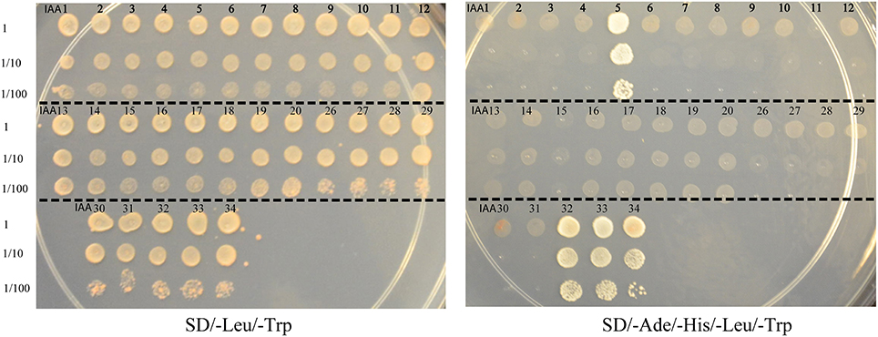
Figure 2-1. Yeast two-hybrid interaction between ARF10 and various Aux/IAAs.
Yeast strain AH109 was co-transformed with ARF10 bait vector in combination with 29 Aux/IAA prey vectors. Protein-protein interactions between ARF10 and each of Aux/IAA5, Aux/IAA32, Aux/IAA33 and Aux/IAA34 were visualized by differential growth on the SD/-Leu/-Trp non-selective medium (left) and on the SD/-Ade/-His/-Leu/-Trp selective medium (right).

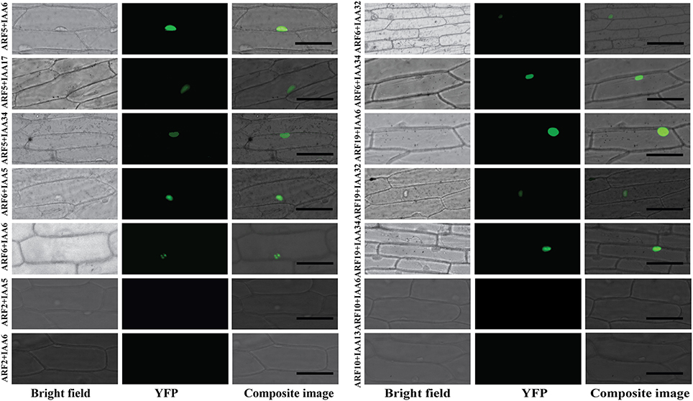

Figure 2-2. BiFC visualization of the ARF-Aux/IAA interactions.
Onion epidermal cells were co-transformed with ten different combinations of constructs expressing cEYFP-ARF5, 6, and 19 fusions and nEYFP-Aux/IAA5, 6, 17, 32, and 34 fusions. Bright field, YFP and composite images were taken 16–24 h after bombardment. Four combinations of non-interacting ARF-Aux/IAA pairs in yeast (ARF2-Aux/IAA5, ARF2-Aux/IAA6, ARF10-Aux/IAA6 and ARF10-Aux/IAA13) were used as negative control and showed no YFP signal. Bar = 100 μM.
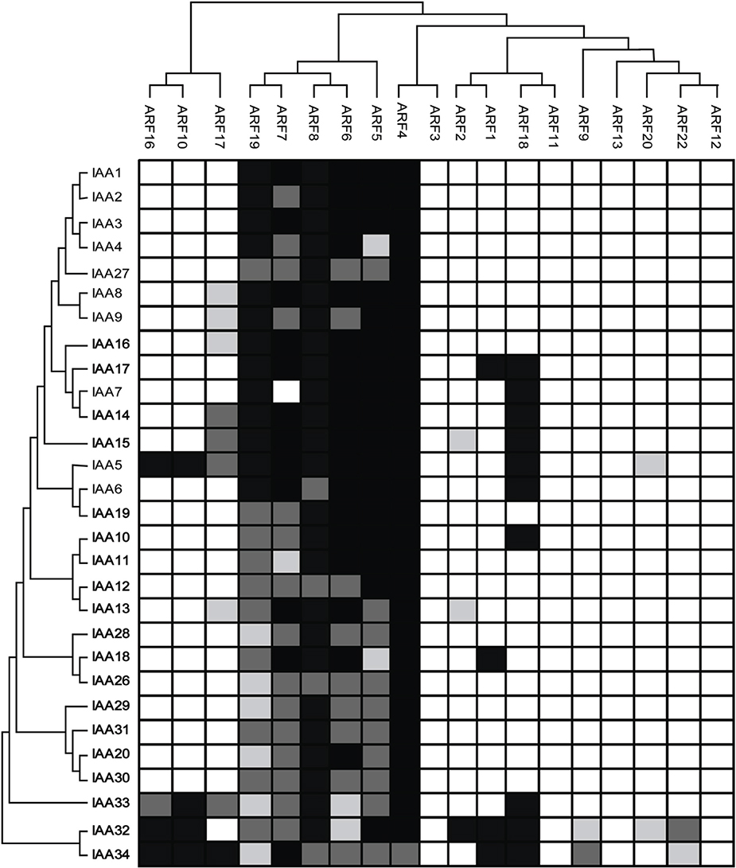
Figure 2-3. Protein-protein interaction map of Arabidopsis ARF and Aux/IAA proteins.
ARFs (top) and Aux/IAAs (left) are arranged according to their sequence similarity. Empty boxes indicate no interaction while gray and black boxes indicate weak and strong interaction, respectively.

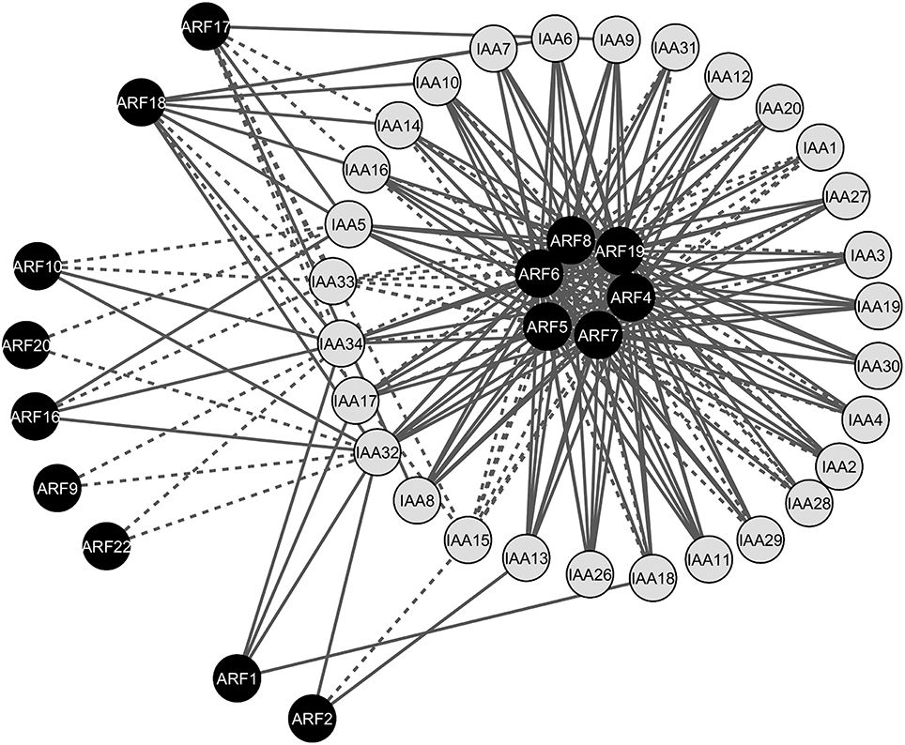
Figure 2-4. Gene co-expression network of the interacting ARF-Aux/IAA proteins.
The network contained 44 nodes (15 ARFs and 29 Aux/IAAs) and 213 edges (interacting combinations). Continuous edges indicate protein pairs with significantly correlated expression profiles in at least one tissue, whereas dotted edges indicate protein pairs without significantly correlated expression profiles.

Figure 2-5. Heatmap demonstrating gene co-expression patterns of the interacting ARF-Aux/IAA proteins in various Arabidopsis tissues and organs.
Sample contribution scores were calculated for each ARF-Aux/IAA interacting combinations and used to construct the heatmap using the Multi Experiment Viewer (http://www.tm4.org/mev.html). Red color represents pairs with highly correlated gene co-expression profiles and green represents highly anti-correlated pairs.

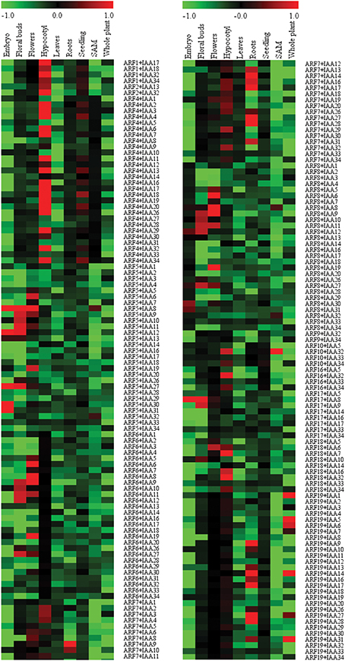
Figure 2-5 contd.

Cooperative regulatory functions of miR858 and MYB83 in transcriptome reprogramming during cyst nematode parasitism of Arabidopsis

A version of this chapter is a manuscript submitted to Plant Physiology by Sarbottam Piya, Christina Kihm, John Hollis Rice, Thomas J Baum and Tarek Hewezi.
T.H. and T.J.B. conceived and designed the original research plans; S.P. performed most of the experiments; C.K., and J.H.R provided technical assistance to S.P.; S.P. and T.H. analyzed the data and wrote the manuscript. T.H. supervised the experimental work.

Abstract
microRNAs (miRNAs) recently have been established as key regulators of transcriptome reprogramming that defines cell function and identity. However, the molecular functions of the large majority of miRNA genes remain to be determined. Here, we report cooperative regulatory functions of miR858 and its MYB83 transcription factor target gene in transcriptome reprogramming during Heterodera cyst nematode parasitism of Arabidopsis. Gene expression analyses and promoter–GUS fusion assays documented a role of miR858 in post-transcriptional regulation of MYB83 in the Heterodera schachtii–induced feeding sites, the syncytia. Constitutive overexpression of miR858 interfered with H. schachtii parasitism of Arabidopsis, leading to reduced susceptibility, while reduced miR858 abundance enhanced plant susceptibility. Similarly, MYB83 expression increases were conducive to H. schachtii infection because overexpression of a non-cleavable variant of MYB83 significantly increased plant susceptibility, whereas a myb83 mutation rendered the plants less susceptible. In addition, RNA-seq analysis revealed that genes involved in hormone signaling pathways, defense response and glucosinolate biosynthesis, cell wall modification, sugar transport, and transcriptional control are the key etiological factors by which MYB83-facilitates nematode parasitism of Arabidopsis. Furthermore, we discovered that miR858-mediated silencing of MYB83 is tightly regulated through a feedback loop that might contribute to fine-tuning the expression of more than a thousand of MYB83-regulated genes in the H. schachtii–induced syncytium. Together, our results suggest a role of the miR858–MYB83 regulatory system in finely balancing gene expression patterns during H. schachtii parasitism of Arabidopsis to ensure optimal cellular function.
Keywords:

1. Introduction
Mature microRNAs (miRNAs) are short 21-22 nucleotides-long non-coding RNAs that are processed from transcripts forming a stem-loop secondary structure. miRNAs negatively regulate the expression of their target genes through base pairing (Bartel, 2004; Voinnet, 2009). Once they bind to their target sequences, miRNAs can trigger mRNA degradation or translational repression, causing post-transcriptional gene silencing of the target genes. With the fast development of high throughput sequencing technology, genome-wide identification and differential expression profiling of miRNAs have been achieved in an increasing number of plant species (Zhang et al., 2011; Li et al., 2014). Despite the large number of miRNA genes showing differential expression under a wide range of developmental and stress conditions, a limited number of these miRNAs has been functionally characterized.
Initial functional studies of miRNA genes revealed their involvement in regulating a number of developmental processes (Kidner and Martienssen, 2005; Chen, 2009; Chuck et al., 2009; Weiberg et al., 2014). Nonetheless, the key regulatory functions of miRNAs in mediating plant responses to pathogen infection are now being increasingly recognized (Seo et al., 2013; Staiger et al., 2013; Weiberg et al., 2014; Fei et al., 2016). Recent studies have provided compelling evidence for the involvement of miRNAs in regulating defense signaling and immune responses during plant interaction with various phytopathogens, including bacteria, fungi, oomycetes, viruses, and nematodes (Seo et al., 2013; Gupta et al., 2014; Yang and Huang, 2014; Hewezi and Baum, 2015). miRNAs can function as negative regulators of plant defenses, leading to increasing plant susceptibility to pathogen infection. For instance, miR844 and miR400 were found to enhance plant susceptibility to Pseudomonas syringae and Botrytis cinerea, respectively, when overexpressed in Arabidopsis (Park et al., 2014; Lee et al., 2015). In addition, members of the miR9863 gene family in barely have been shown to target distinct alleles of the Mla immune receptors to inhibit immune response signaling upon infection by the powdery mildew fungus, Blumeria graminis (Liu et al., 2014). A number of miRNA genes have also been reported to function as positive regulators of plant innate immunity. For example, overexpression of Arabidopsis miR160a, which targets ARF10, ARF16 and ARF17, activated callose deposition, resulting in enhanced plant resistance against Pseudomonas syringae (Li et al., 2010). More recently, miR444 has been found to activate plant innate immunity against rice strip virus in rice. In response to virus infection, the expression of miR444 was activated and this activation was accompanied by downregulation of its target genes OsMADS23, OsMADS27a, and OsMADS57, the repressors of RNA-DEPENDENT RNA POLYMERASE1 (RdRP1), leading to activation of the RdRP1–dependent antiviral silencing pathway (Wang et al., 2016).
Detailed functional studies also revealed that the same miRNA gene can execute diverse functions against different pathogens. For example, overexpression of rice miR398b resulted in increasing plant susceptibility to P. syringae via inhibiting callose deposition (Li et al., 2010). On the other hand, miR398b overexpression can also enhance plant resistance against the blast fungus Magnaporthe oryzae via increasing the production of hydrogen peroxide (Li et al., 2014). Similarly, it has been shown that miR863-3p can mutually regulate positive and negative regulators of plant defense in a pathogen infection stage-specific fashion to fine-tune the timing of defense response (Niu et al., 2016).
Plant-parasitic cyst nematodes are sedentary endoparasites that induce the formation of a specialized multi-nucleate feeding site, termed syncytium, in the roots of their host plants. The syncytium is a metabolically hyperactive sink-like structure from which nematodes feed throughout the parasitic stages. Formation of functional syncytia is a sophisticated cellular process that involves an intricate interplay of numerous signaling and developmental pathways, whose regulation remains poorly understood. However, recent studies point at key regulatory roles of miRNAs in syncytium formation and function. For example, miR396–targeting of growth regulating factor 1 (GRF1) and GRF3 was found to control syncytium initiation and development via regulating numerous hormonal signaling and developmental pathways (Hewezi et al., 2012; Hewezi and Baum, 2012; Liu et al., 2014). More recently, it has been shown that Heterodera schachtii–induced upregulation of miR827 post-transcriptionally silences its Nitrogen Limitation Adaptation (NLA) target gene specifically in the syncytium to permanently attenuate immune responses and enable successful parasitism (Hewezi et al., 2016). Also, miRNAs seem to have functional roles in regulating phytohormone signaling during plant interactions with root-knot nematodes. It has been recently demonstrated that tomato miR319 regulates jasmonic acid level in response to infection by the root-knot nematode Meloidogyne incognita (Zhao et al., 2015). Another recent study has suggested a role of Arabidopsis miR319 in modulating auxin signaling during M. javanica parasitism (Cabrera et al., 2016).
miRNA-mediated post transcriptional regulation of gene expression is a highly dynamic process that determines not only transcript stability and protein level but also allows plant cells to establish metabolic and physiological re-adjustment to cope with new functions or fluctuating conditions. In plants, a significant number of miRNA genes target transcription factors (Bonnet et al., 2004; Jones-Rhoades and Bartel, 2004). In turn, miRNAs-regulated transcription factors have tremendous potential to achieve such re-adjustment in cellular metabolism and physiology because of their ability to control numerous downstream targets. In addition, miRNA genes and their targeted transcription factors may correspondingly regulate each other’s expression through feedback regulatory loops, in which the transcription factors directly regulate the expression of their negative regulators, resulting in tight control over gene expression patterns (Meng et al., 2011). Furthermore, a transcription factor and its miRNA regulators may antagonistically regulate common targets, although such mechanisms have not yet been described in plants.
In Arabidopsis, miR858 post-transcriptionally regulates the expression of several MYB transcription factors including MYB6, MYB11, MYB12, MYB13, MYB20, MYB42, MYB63, MYB83 and MYB111 (Fahlgren et al., 2007; Addo-Quaye et al., 2008; Sharma et al., 2016). These miR858-targeted MYBs are involved in a variety of cellular processes, including plant responses to drought (MYB20 and 60), the phenylpropanoid pathway (MYB11, 12, and 111), and secondary wall biosynthesis (MYB46 and 83) (Cominelli et al., 2005; McCarthy et al., 2009; Oh et al., 2011; Gao et al., 2014; Sharma et al., 2016). Here, we report a novel function of the miR858-MYB83 regulatory system in plant-cyst nematode interaction. Both miR858 and MYB83 were transcriptionally activated in the H. schachtii–induced syncytia, and manipulation of their expression through gain- and loss-of-function approaches altered Arabidopsis response to nematode infection. Consistent with a functional role of MYB83 in facilitating nematode parasitism of Arabidopsis, our transcriptome analysis revealed that MYB83 regulates a substantial number of syncytial genes encoding components essential for syncytium formation and function. Also, our results establish that MYB83 through a feedback loop activates the expression of miR858 thereby stabilizing its own transcript abundance and its downstream regulated genes during the initiation and progression of nematode parasitism.

2. Materials and Methods

2.1 Plant material and growth conditions
All transgenic Arabidopsis lines were generated in Coloumbia-0 (Col-0) background. The myb83 T-DNA insertional mutant (CS1004395) in the Col-4 background was obtained from the Arabidopsis Biological Resource Center. The myb12 T-DNA mutant (FLAG_150B05) in the Wassilewskija (WS) background was obtained from the Genomic Resource Center, INRA-Versailles, France. Plants were grown under long day conditions 16 hour light/8 hour dark at 24°C.

2.3 Nematode infection assay
Seeds of the transgenic and mutant lines as well as the wild-type controls (Col-0 or Col-4) were sterilized using a 2.8 % bleach solution for five minutes followed by four washes with sterilized double-distilled water. The sterilized seeds were then distributed in 12-well culture plates (BD Biosciences) containing modified Knop’s medium solidified with 0.8% Daishin agar (Brunschwig Chemie) using a randomized complete block design with 20 replicates per line. The plates were placed in a growth chamber at 24⁰C with 16 hour light/8 hour dark conditions. Freshly hatched J2 H. schachtii nematodes were surface-sterilized using a fresh solution of 0.01% mercuric chloride for five minutes followed by four washes with sterilized double-distilled water. The sterilized J2 nematodes were then suspended in a 0.1% agarose solution and used to inoculate ten-day-old seedlings with approximately 250 nematodes per seedling. The nematode susceptibility of the lines was determined three weeks after inoculation by counting the number of J4 female nematodes per plant using a dissecting microscope. Statistically significant differences between the lines and the corresponding wild-type control were determined using a modified t test on SAS with a P value cut-off of 0.05.

2.3.1 Histochemical analysis of GUS activity
GUS activity of the pmiR858:GUS and pMYB83:GUS transgenic plants was determined by staining the plants at various time points post H. schachtii infection using the method previously described by Jefferson et al. (1987). The images of both infected and non-infected plants were taken using a Zeiss digital camera and then analyzed using Zeiss Axio Vision SE64 software (version 4.8).

2.4 Plasmid construction and generation of transgenic plants
The binary vector of miR858 overexpression was constructed by amplifying the miR858 precursor (a 200-bp) from Col-0 genomic DNA using a primer pair containing BamHI and SacI restriction sites. The amplified fragment was digested, gel-purified and then ligated into the binary vector pBI121 under the control of 35S promoter. The wild-type MYB83 coding sequence was amplified from first-strand cDNA and the non-cleavable MYB83 variant was generated by introducing 10 mismatches in the miR858-binding sites without altering the amino acid sequences. The modified MYB83 sequence was then cloned in the pBI121 binary vector under 35S promoter using XbaI and SacI restriction sites. The MIM858 overexpression was generated as recently described by Hewezi et al. (2016). Briefly, the 22 nucleotide miR399-complementary region in the Arabidopsis IPS1 gene, a non-coding phosphate starvation-induced transcript, was substituted with a mimic sequence for the mature miR858 sequences. The miR858 mimic sequence contained a three-nucleotide bulge (TGA) between the nucleotide number 10 and 11 of the biding region and two additional mismatches at the nucleotides number 1 and 10 of the binding site. The modified IPS1 genes containing the miR858 mimic sequence was cloned in the pBI121 vector under the control of 35S promoter using SacI and BamHI restriction sites.
The miR858 promoter (2KB upstream of the miR858 precursor sequence) was amplified from Col-0 genomic DNA using a primer pair containing BamHI and SacI restriction sites. Similarly, the MYB83 promoter (2 kb upstream of the translation start codon) was amplified using a primer pair containing BamHI and SalI restriction sites. The PCR-amplified products were digested, gel-purified, and finally ligated to the binary vector pBI101 in the corresponding restriction sites to drive GUS gene expression. All constructs were verified by sequencing and then introduced into Agrobacterium tumefaciens strain C58 by the freeze-thaw method. The bacteria were used to transform Arabidopsis ecotype Col-0 plants by the floral dip method (Clough and Bent, 1998). Transgenic T1 lines were identified by screening the seeds on MS agar medium supplemented with 50 mg/L kanamycin. Transgene expression in various transgenic lines was quantified using qPCR. The primers used for binary vector construction are listed in Supplemental Table 7.

2.5 RNA isolation and quantitative real-time RT-PCR analysis
To assess the expression level of miR858 (both mature and primary transcripts), total RNA was isolated from 20 mg root tissues using TRIzol reagent (Invitrogen) following the manufacturer’s instructions. Mir-X miRNA First-Strand Synthesis Kit (Clontech) was used for polyadenylation and reverse transcription of the total RNA. Approximately, 50 ng of the synthesized cDNA was used as a template for qPCR reaction. qPCR was performed using SYBR Advantage qPCR Premix (Clontech). The mature miR858 sequence appended with two adenine residues on the 3’ end was used as forward primer sequence to ensure correct biding of the primer to the poly(T) region of the mature miR858 cDNA and prevent potential binding to the miR858 precursor. The primary transcript of miR858 was quantified using forward primer specific to miRNA precursor. U6 small nuclear RNA, the most comely used internal control for miRNA gene expression normalization, was used to normalize the expression levels of both mature and primary miR858 transcripts. The mRQ 3’ primer (supplied with Mir-X miRNA First-Strand Synthesis Kit) was used as a universal reverse primer. The PCR reactions were performed in QuantStudio 6 Flex Real-Time PCR System (Applied Biosystems) using the following program: 95°C for 3 min followed by 40 cycles of 95°C for 30 s and 60°C for 30 s. The amplified products were then subjected to a temperature ramp to create the dissociation curves and determine amplification specificity. The dissociation program was 95°C for 15 s and 50°C for 15 s, followed by a slow gradient from 50°C to 95°C. For the quantification of MYB83 expression levels, total RNA was extracted from 20 mg frozen ground root tissues following the method described by (Verwoerd et al., 1989). The isolated total RNA was treated with DNase I (Invitrogen) and approximately 25 ng of DNase-treated RNA was used as a template in qPCR reactions to quantify gene expression levels using Verso SYBR green One-Step qRT-PCR Rox mix (Thermo Scientific) following the manufacturer’s protocol: 50°C for 15 min, 95°C for 15 min, and 40 cycles of 95°C for 15 s, 60°C for 90 s and 72°C for 30S. The PCR amplification products were then subjected to a temperature ramp to create the dissociation curves using the following program: 95°C for 15 s and 60°C for 75 s, followed by a slow gradient from 60°C to 95°C. Primer sequences used for qPCR quantification assays are listed in Supplemental Table 7.

2.6 RNA-seq library preparation and data analysis
P35S:miR858 (Line 1-4), P35S:rMYB83 (Line 8-1) and Col-0 were grown in MS plates using a randomized complete-block design with three independent replications per line. Root tissues were collected of two-week-old plants. mRNA was isolated from 20 mg grounded root tissue using magnetic mRNA isolation kit (NEB) following manufacturer’s protocol. Approximately, 250 ng of mRNA was used for RNA-seq library preparation using NEBnext mRNA library prep master mix (NEB) following manufacturer’s protocol. The nine RNA-seq libraries were multiplexed and sequenced using HiSeq 2500 system with 100 bp single-end reads. Quality of the sequenced data was assessed using FastQC (http://www.bioinformatics.babraham.ac.uk/projects/fastqc/). Low quality reads were trimmed using Trimmomatic (Bolger et al., 2014). After trimming, uniquely mapped read was aligned to the Arabidopsis reference genome (TAIR10) using TopHat v2.0.14 (Trapnell et al., 2009). Number of reads assigned to each gene were counted using HTSeq (Anders et al., 2015). Differentially expressed genes (DEGs) were determined using the R package DESeq2 (Love et al., 2014) using an adjusted P value less than 0.05. GO terms enrichment analysis of the DEGs was performed using agriGO database (Du et al., 2010) using Fisher’s exact test and Bonferroni multi-test adjustment with a significance cut-off P value of 0.05.

3. Results

3.1 miR858 is expressed in the syncytium during the initiation and progression of nematode parasitism.
In Arabidopsis, miR858 is encoded by one functional genomic locus (miR858a, AT1G71002) that produces 21-nucleotide mature molecules and targets nine MYB transcription factor genes that contain the miR858 complementary sequences (Sharma et al., 2016). To elucidate the functional role of miR858 during the compatible interactions between Arabidopsis and the beet cyst nematode Heterodera schachtii, we first generated several transgenic Arabidopsis lines expressing the β-glucuronidase (GUS) reporter gene under the control of miR858 promoter (pmiR858:GUS). GUS activity of four independent transgenic lines (T2 generation) were assayed both under non-infected and H. schachtii–infected conditions. In non-infected 2-week-old-plants, GUS activity was observed in the vascular tissues of both leaves and roots (Supplemental Fig. S1, A-C). Under H. schachtii–infected conditions, GUS activity was observed in the developing syncytium of the second stage nematode juvenile (J2) at 3 day post infection (dpi) as well as in the syncytium of the early J3 stage at 7 dpi (Figure 3-6, A and B). However, at 10 and 14 dpi (late J3 and J4 stages), GUS activity in the syncytium was dramatically reduced (Figure 3-6, C and D). The expression patterns of miR858 in the syncytium point to a functional role of miR858 of suppressing its target genes during the initiation and progression of nematode parasitism. Reduced miR858 promoter activity at later stages, therefore, suggests an uninhibited expression of these target genes at these time points.

3.2 miR858 post-transcriptionally regulates MYB83 transcription factor during H. schachtii parasitism of Arabidopsis
It has been shown recently that miR858 post-transcriptionally silences the ten MYB transcription factors MYB6, MYB11, MYB12, MYB13, MYB20, MYB42, MYB48, MYB63, MYB83 and MYB111 that contain the miR858 binding site (Sharma et al., 2016). Among these transcription factors, MYB83 was reported to be differentially expressed in the H. schachtii-induced syncytium (Szakasits et al., 2009). In addition, recent functional analyses have implicated MYB83 (AT3G08500) in the regulation of secondary wall biosynthesis and cell wall modifications in Arabidopsis (McCarthy et al., 2009; Zhong and Ye, 2012), both of which are functions of fundamental cellular processes impacting syncytium formation and development (Bohlmann and Sobczak, 2014; Hewezi, 2015), Therefore, we directed our focus to elucidating the potential regulatory role of the miR858-MYB83 system in modulating the interactions between Arabidopsis and H. schachtii. We generated pMYB83:GUS transgenic lines to determine if MYB83 shares the temporal expression patterns with miR858 in the syncytium, which would suggest that MYB83 is post-transcriptionally regulated by miR858 also in the syncytium. GUS activities were assayed in four independent transgenic lines (T2 generation) both under non-infected and H. schachtii–infected conditions. In non-infected 2-week-old plants, GUS activity was observed in leaf and root vascular tissues (Supplemental Fig. S2, A-C). Under H. schachtii infection, strong GUS activity was observed in the syncytium during the J2, early J3, late J3 and J4 developmental stage at 3, 7, 10, and 14 dpi, respectively (Figure 3-6, E-H). The coincident upregulation of miR858 and MYB83 promoters in the syncytium at 3 and 7 dpi suggests that MYB83 is targeted by miR858 for post-transcriptional regulation during the early syncytium development stage. At later stages, MYB83 expression appears to be uninhibited by miR858.
In order to provide additional evidence that miR858 mediates post-transcriptional regulation of MYB83 during H. schachtii infection of Arabidopsis, we used quantitative real-time RT-PCR (qPCR) to quantify the abundance of miR858 primary transcripts (pri-miR858), mature miR858 as well as total and uncleaved transcript levels of MYB83 in the roots of wild-type (Col-0) Arabidopsis plants inoculated with H. schachtii at 4, 7, 10 and 14 dpi, relative to the corresponding non-inoculated controls. The relative levels of uncleaved MYB83 transcripts were determined using a primer pair flanking the miR858 binding site, whereas the relative levels of total (cleaved and uncleaved) MYB83 transcripts were determined using a primer pair located downstream of the miR858 binding site as previously described by Hewezi et al. (2016). Expression data from three biologically independent replicates revealed upregulation of both primary and mature miR858 in H. schachtii–infected roots at 4 and 7 dpi relative to non-infected roots (Figure 3-7), a result which is consistent with the increased activity of the miR858 promoter in the syncytium at the same time points. Meanwhile, the levels of uncleaved MYB83 transcripts was lower than the level of total transcripts in infected roots relative to non-infected roots at both time points (Figure 3-7). At 10 dpi, the expression levels of both primary and mature miR858 were slightly upregulated and this upregulation was accompanied with small insignificant reduction in the level of uncleaved MYB83 transcripts compared with the total transcript level (Figure 3-7). At 14 dpi, the expression of primary and mature miR858 was sharply decreased in the infected roots compared to the control, and this downregulation was associated with comparable levels of total and uncleaved MYB83 transcripts (Figure 3-7). These temporal expression patterns, which show that the abundance of uncleaved MYB83 transcripts are inversely correlated with the expression level of miR858, further indicating that MYB83 is subjected to post-transcriptional regulation by miR858 following H. schachtii infection. Given our promoter data, this regulation likely is at work in the syncytium.

3.3 Overexpression of miR858 confers enhanced resistance to H. schachtii
Promoter and qPCR analyses of miR858 expression during nematode infection revealed two distinct patterns (i.e. upregulation during J2 and early J3 stages, and downregulation during late J3 and J4 stages). Thus, we investigated whether constitutive overexpression of miR858 would modulate Arabidopsis susceptibility to H. schachtii. To this end, we generated transgenic Arabidopsis lines overexpressing the primary miR858 sequence under the control of 35S promoter (35S:miR858). Four independent non-segregating T2 overexpression lines (1-3, 1-4, 19-1, and 21-1) showing between 6 to 18 fold increases in miR858 expression levels relative to the wild-type Col-0 plants were selected (Supplemental Fig. S3A). MYB83 transcripts accumulated at significantly lower levels in these lines relative to Col-0 plants (Figure 3-8A), which is consistent with post-transcriptional degradation of MYB83 transcripts by miR858. The root lengths of miR858 overexpression lines were comparable to the wild-type Col-0 plants, with the exception that line 21-1 showed a slight increase of about 5% (Figure 3-8B, and Supplemental Fig. S4A). No other developmental defects were observed when these lines were grown under standard growth conditions, which is in line with the results recently obtained by Sharma et al. (2016) (Figure 3-8, B and C). The four miR858 overexpression lines along with the wild-type Col-0 were assayed for H. schachtii susceptibility. These lines showed statistically significant decreases in susceptibility levels with 30 to 42% reduction in J4 female nematode counts compared to Col-0 plants (Figure 3-8D). These results indicate that constitutive overexpression of miR858 interferes with H. schachtii parasitism of Arabidopsis.

3.4 Overexpression of a mimic sequence for miR858 augments plant susceptibility to H. schachtii
The involvement of miR858 in the modulation of Arabidopsis response to H. schachtii infection was further examined by generating transgenic Arabidopsis plants with reduced miR858 expression. This was accomplished by expressing a mimic sequence for miR858 in its mature form (MIM858) (Figure 3-9A). The artificial non-cleavable binding site for the mature miR858 contained a three-nucleotide bulge (TGA) that does not interfere with miR858 binding but would prevent transcript cleavage and hence sequester miR858 activity. Three independent transgenic lines showing between 2.7 and 6.8 fold reduction in the mature miR858 expression levels were selected (Supplemental Fig. S3B). qPCR quantification revealed that miR858 downregulation in the MIM858 lines was correlated with significant increases in MYB83 expression levels (Figure 3-9B), a finding that confirms the efficiency of our target mimicry construct in sequestering the activity of miR858. Other than minor reductions in root lengths of MIM858 plants, no noticeable morphological differences between MIM858 lines and Col-0 plants were detected (Figure 3-9, C and D). Interestingly, when the susceptibility of the MIM858 lines to H. schachtii was determined, these lines were significantly more susceptible than the wild-type plants, showing up to 56% increase in the number of J4 nematodes (Figure 3-9E). Together, these data confirm that increased expression of miR858 is responsible for the reduced susceptibility phenotype observed in miR858 overexpression plants.

3.5 Ectopic overexpression of a non-cleavable variant of MYB83 enhances plant susceptibility to H. schachtii.
The gene expression analyses and nematode susceptibility assays of miR858 and MIM858 overexpression lines mentioned above indicate that inhibition of miR858 activity facilitates H. schachtii infection, most likely through the upregulation of its MYB target genes. If miR858 modulates plant susceptibility mainly through post-transcriptional regulation of MYB83, manipulation of MYB83 expression should also impact plant susceptibility to H. schachtii but in the opposite direction. To test this hypothesis, we generated transgenic Arabidopsis lines overexpressing a miR858-resistant variant of MYB83 under the control of 35S promoter (35S:rMYB83). The non-cleavable variant rMYB83 was generated by introducing six nucleotide mismatches in the miR858 binding sites without changing the protein coding sequences (Figure 3-10A). Four non-segregating T2 lines showing between 16 and 31 fold MYB83 mRNA upregulation were selected and phenotypically analyzed (Supplemental Fig. S3C). These lines were indistinguishable from the wild-type plants in term of root and shoot growth and development (Supplemental Fig. S4C). Interestingly, when these lines were used in H. schachtii infection assays, all lines exhibited statistically significant increases in susceptibility with up to 65% increase in the number of J4 nematodes compared with the wild-type Col-0 plants (Figure 3-10B). In contrast to the rMYB83 overexpression lines, a MYB83 T-DNA mutant line (CS1004395) (Supplemental Fig. S5) showed reduced susceptibility to H. schachtii relative to the wild-type Col-4 plants (Figure 3-10C). Taken together, these results link the activity of the MYB83 transcription factor to the function of miR858 in modulating plant responses to H. schachtii infection.

3.6 RNA-seq analysis of miR858 and rMYB83 overexpression plants-regulated genes
The robust effects of MYB83 overexpression and knockout mutant lines on nematode susceptibility suggest that this transcription factor may control downstream target genes encoding proteins necessary for syncytium formation/function. Therefore, we performed RNA-seq analysis on root tissues isolated from the 35S:miR858 (Line 1-4), 35S:rMYB83 (line 8-1), and wild-type (Col-0) plants in order to identify the downstream targets that may be directly or indirectly controlled by MYB83. Three biological samples of root tissues were collected from each plant line (2-week-old) for mRNA isolation and library preparation. After sequencing, high quality reads were mapped to the Arabidopsis reference genome (TAIR10), and differentially expressed genes (DEGs) were determined using a false discovery rate of 0.05. We identified 4,386 and 2,908 DEGs in P35S:miR858 and 35S:rMYB83, respectively, compared with the wild-type Col-0 plants. Out of the 4,386 DEGs identified in the 35S:miR858 plants 2,082 genes were upregulated and 2,304 genes were downregulated (Supplemental Table 1). Similarly, in the 35S:rMYB83 plants 1,249 genes were upregulated and 1,659 genes were downregulated (Supplemental Table 2). Comparison of the DEGs in these two transgenic lines revealed that 2,193 genes were common to both sets (Figure 3-11A; Supplemental Table 3). The fact that this overlapping gene list represents more than 50% of the DEGs identified in the 35S:miR858 plants, indicates that MYB83 is the main target of miR858 in roots.
Gene Ontology (GO) classification and enrichment analyses of the DEGs in the 35S:miR858 and 35S:rMYB83 plants were performed. Thirty five GO biological process terms, which are mainly associated with metabolic processes and response to biotic and abiotic stimuli were identified (Figure 3-11B). While several GO terms were enriched among the upregulated or downregulated genes in both lines, enriched GO terms specific to each line were also seen. For example, GO terms corresponding to defense response, response to bacterium, and response to abscisic acid stimulus were enriched uniquely among the upregulated genes in 35S:miR858 plants (Figure 3-11B). Similarly, GO terms corresponding to carbohydrate metabolic processes as well as secondary metabolic process were significantly overrepresented uniquely among the upregulated genes in 35S:rMYB83 plants, (Figure 3-11B). The same observation is equally evident among the downregulated genes. For example, enrichment of GO terms corresponding to flavonoid biosynthesis and metabolic processes were identified only among the downregulated genes in 35S:miR858 plants (Figure 3-11B). GO terms corresponding to signal transduction, auxin transport, lignin metabolic process, cell wall organization, and responses to wounding, osmotic stress, oxidative stress, salt stress, chitin, auxin stimulus, and jasmonic acid stimulus were significantly enriched exclusively among the downregulated genes in the 35S:rMYB83 plants (Figure 3-11B).

3.7 Identification of putative direct targets of MYB83
Recently, the ACC(A/T)A(A/C)(T/C) consensus sequence has been identified as MYB83-responsive element in Arabidopsis (Zhong and Ye, 2012). Therefore, we scanned the promoters of the DEGs identified in the 35S:rMYB83 plants (2,908 genes) for the presence of this cis element within 1.5 kb upstream of the transcription start site (TSS) to identify putative direct targets of MYB83. The number of cis elements identified in these DEGs ranged between 0 and 15 elements, with the large majority containing between 0 and 2 elements (Supplemental Fig. S6A). Also, we determined the average number of this cis element in the promoters of 2,908 randomly selected genes to be 1.02 elements. Thus, DEGs with at least three MYB83 cis-binding elements in the promoters of the MYB83-regulated genes were considered as putative direct targets of MYB83 (P value 2.69E-65, Fisher’s exact test). As a result, 1,055 of the MYB83-regulated genes were identified as bona fide direct target candidates (Supplemental Table 4). The cis elements are equally distributed across the gene promoters (Supplemental Fig. S6B). However, 77% (815/1055) of these putative direct targets contain at least one cis element within 500 bp of the TSS (Supplemental Fig. S6C). GO analysis showed that genes involved in transport, primary metabolic processes, secondary metabolic processes, particularly glucosinolate, and responses to biotic and abiotic stresses were significantly enriched among the direct targets that were positively regulated in the 35S:rMYB83 plants. GO categories associated with transcription, metabolic process, defense response, and responses to stress, nematode, hormone and biotic stimuli were significantly enriched among the putative direct target genes that were negatively regulated in the 35S:rMYB83 plants (Supplemental Fig. S7).

3.8 MYB83 regulates key cellular processes in the syncytium of H. schachtii
Consistent with the role of MYB83 in promoting plant response to H. schachtii parasitism we found a significant overlap between the MYB83-regulated genes and the syncytium DEGs previously reported by Szakasits et al. (2009). Of the 2,908 MYB83-regulated genes 1,286 overlapped with the 7,725 syncytium DEGs (Figure 3-11C; Supplemental Table 5). This significant overlap (44.2%, χ²= 224.729, P value = 1.909E-48) indicates that 16.6 % of the syncytium transcriptome is regulated by MYB83. Also, we compared the identified 1,055 direct target genes of MYB83 with the syncytium DEGs to determine the extent to which MYB83 directly regulates gene expression in the syncytium. A common set of 471 genes (44.6%, χ²= 79.765, P value = 3.452E-17) was identified, implying that 6% of syncytium genes are under direct control of MYB83 (Figure 3-11D; Supplemental Table 6). Of these 471 genes, 216 (46%) were upregulated in of MYB83 overexpression plants and 255 (54%) were downregulated, suggesting that MYB83 has a dual transactivation and transrepression function. GO term analysis of the 1,286 MYB83-regulated genes overlapping with the syncytium DEGs revealed an enrichment of genes involved in receptor-mediated signaling pathways, transport, metabolic processes, cell-wall organization, and responses to stress, chitin, and bacterium, as well as responses to biotic, abiotic, hormone, auxin, and ethylene stimuli (Figure 3-11E). When this analysis was conducted to include only the 471 genes predicted as putative direct targets of MYB83 in the syncytium, GO terms associated with transcription, transport, metabolic process, responses to stress, oxidative stress, bacterium, and biotic stimulus were significantly enriched (Figure 3-11E).
In addition to GO analysis, careful examination of the known functions of MYB83-regulated genes overlapping with the syncytium DEGs enabled more detailed insights into the functional role of MYB83 during H. schachtii infection. As shown in Figure 8, genes involved in hormone signaling pathways (Figure 3-12A), defense response and glucosinolate biosynthesis (Figure 3-12B), cell wall modification and sugar transport (Figure 3-12C) and transcriptional control (Figure 3-12D) seem to be the key etiological factors of MYB83 in facilitating nematode parasitism of Arabidopsis.

3.9 miR858 and MYB83 constitute a feedback regulatory loop that involves MYB12
We next examined the promoter of miR858, 2 kb upstream of the primary transcript, for the presence of MYB83 cis-biding element. Interestingly, 7 cis-elements were identified, emphasizing the possibility that MYB83 regulates the expression of miR858. To investigate this possibility, we quantified the expression of primary and mature miR858 in the 35S:rMYB83 plants as well as the myb83 knockout mutant line (CS1004395) using qPCR. Data from three biological samples indicated about 2-fold upregulation of both primary and mature miR858 in the transgenic plants overexpressing MYB83 (Figure 3-13A) compared to the wild-type Col-0 plants. In contrast, both primary and mature miR858 transcripts were downregulated in the myb83 mutant compared to the wild-type Col-4 (Figure 3-13B). Together, these results demonstrate that MYB83 positively regulates the expression of its negative regulator through a feedback regulatory loop to maintain proper level of its transcripts.
We then examined our RNA-seq data to determine whether any of the confirmed targets of miR858 were inversely regulated in the MYB83 overexpression plants, and hence constitute part of the regulatory loop. Interestingly, we identified MYB12, a confirmed target of miR858, among the MYB83-positively regulated genes. This finding guided us to test whether MYB12 is an integral part of the miR858/MYB83 regulatory circuit impacting plant response to nematode infection. To this end, we generated transgenic plants overexpressing a miR858-resistant variant of MYB12 (rMYB12) under the control of 35S promoter (Supplemental Fig. S8). Nematode infection assay of 3 independent overexpression lines displayed significant increases in plant susceptibility to H. schachtii compared with the wild-type Col-0 plant (Figure 3-13C). Contrary to rMYB12 overexpression lines the myb12 mutant FLAG_150B05 (Supplemental Fig. S9) exhibited reduced susceptibility compared with the wild-type Wassilewskija (WS) plants (Figure 3-13D). Together, these results indicate that MYB12 is part of miR858/MYB83 regulatory loop regulating plant response to nematode infection.

4. Discussion
Recent studies have implicated miR858 in the regulation of various growth and plant developmental processes (Guan et al., 2014; Jia et al., 2015; Sharma et al., 2016). However, a regulatory role of miR858 in plant-pathogen interactions has not been reported. In this study, we report a novel regulatory function of miR858 during H. schachtii parasitism of Arabidopsis. In response to H. schachtii infection miR858 showed a biphasic expression pattern, including strong activation in the developing syncytia at 3 and 7 dpi and a subsequent downregulation in the mature syncytia at 10 and 14 dpi. This pattern of miR858 expression suggests different functions during the two distinct stages of syncytium formation and maintenance. As a result, constitutive overexpression of miR858 resulted in significant decreases in plant susceptibility to H. schachtii. In contrast, inactivation of miR858 by overexpressing an artificial target mimic sequence produced the opposite phenotype of enhanced susceptibility. The influence of miR858 expression changes on plant responses to H. schachtii seems to be mediated through post-transcriptional regulation of its MYB transcription factor genes, specifically MYB83. The MYB83 promoter was predominantly active in the syncytium during all nematode parasitic stages. Post-transcriptional silencing of MYB83 by miR858 was evident at 4 and 7 dpi as shown by low levels of uncleaved MYB83 transcripts compared with the total transcript levels. MYB83 expression increase seems to be conducive to H. schachtii infection of Arabidopsis because rMYB83 overexpression enhanced plant susceptibility, whereas a myb83 mutation rendered the plants less susceptible.
The regulatory relationship between miR858 and MYB83 seems to be established through a feedback regulatory loop. Our finding that the MYB83 binding motif occurs repeatedly in the miR858 promoter led us to examine a possible role of MYB83 in regulating the expression of miR858. The expression levels of both pri-miR858 and mature miR858 were significantly increased in the rMYB83 overexpressing plants but decreased in the myb83 mutant, indicating that MYB83 participates in a feedback loop with its negative regulator to stabilize its own transcript abundance. A reciprocal feedback loop controlling the expression of miR396 and its target transcription factors GRF1 and GRF3 has been shown to coordinate transcriptional events required for proper syncytium formation and function (Hewezi and Baum, 2012; Hewezi et al., 2012; Liu et al., 2014). In addition, a number of miRNAs and their trans-acting targets were found to be intricately connected through feedback circuits in different growth and developmental contexts, where robust and adaptable transcriptional responses were established (Xie et al., 2003; Gutierrez et al., 2009; Wu et al., 2009; Marin et al., 2010; Yant et al., 2010; Merelo et al., 2016). Our data suggest that the miR858/MYB83 regulatory circuit may involve MYB12, a confirmed target of miR858, whose transcript abundance was positively regulated by MYB83. Thus, miR858 appears to fine-tune the function of MYB83 at various levels. MYB12 is also of functional importance for nematode parasitism since constitutive changes in its expression levels through overexpression and T-DNA insertional mutant lines altered plant response to nematode infection.

The miR858/MYB83 regulatory loop may enable controlling precise expression levels of genes involved in critical cellular processes required for syncytium differentiation without turning gene expression on and off to prevent syncytium degeneration and collapse. Our finding that 1,286 genes of the 2,193 MYB83-regulated genes were among the previously identified syncytium DEGs (Szakasits et al., 2009), may reflect a key regulatory function of MYB83 in reprogramming syncytium transcriptomes. We therefore focused our discussion on this gene list. Levels and signaling of phytohormones are known to play fundamental roles in determining syncytium cell fate reprograming and differentiation (Grunewald et al., 2009; Gheysen and Mitchum, 2011; Goverse and Bird, 2011; Cabrera et al., 2015; Kammerhofer et al., 2015). In particular, auxin signaling has been shown to be rapidly activated upon nematode infection leading to syncytium differentiation and development (Goverse et al., 2000; Karczmarek et al., 2004; Grunewald et al., 2009; Absmanner et al., 2013; Hewezi et al., 2014). Several genes encoding various components of the auxin signaling pathway including the auxin receptor TIR1, the auxin response factors 2, 4, 6, 9, and 10, the auxin influx carrier LAX1, and the auxin efflux transporter ABCB4 were among MYB83-regulated genes in the syncytium (Figure 3-12A). Additional key genes involved in the auxin response (SHY2, ARGOS, and PLDP2) and auxin homeostasis (GH3.17) were also regulated by MYB83 in the syncytium (Figure 3-12A). It has been recently reported that cytokinin signaling is critical for syncytium development and successful H. schachtii parasitism of Arabidopsis (Shanks et al., 2015; Siddique et al., 2015). MYB83-regulated genes overlapping with syncytium DEGs included various components of cytokinin signaling pathway, namely, the cytokinin synthase IPT5, the histidine kinase receptors AHK2 and AHK4, and the histidine phosphotransfer proteins AHP (Figure 3-12A). Together, these results indicate that MYB83 regulates auxin and cytokinin responses at various levels of biosynthesis, signal transduction, and downstream responses.
Also, ethylene has been shown to play contrasting dual functions during various nematode parasitic stages (Wubben et al., 2001; Kammerhofer et al., 2015). Notably, several ethylene response factors (ERFs), which control the downstream signaling of ethylene response, were also identified among the MYB83-indcued genes overlapping with the syncytium DEGs (Figure 3-12A). This included ERF6, ERF9, and ERF72, which play key regulatory functions in biotic stress responses (Ogawa et al., 2005; Camehl and Oelmüller, 2010; Moffat et al., 2012; Maruyama et al., 2013; Meng et al., 2013; Chen et al., 2014; Xu et al., 2016), as well as ERF109, which regulates the accumulation of reactive oxygen species in response to biotic and abiotic stresses (Matsuo et al., 2015). Remarkably, a substantial number of genes involved in gibberellin, jasmonic acid and abscisic acid signaling pathways were also directly or indirectly regulated by MYB83 in the syncytium (Figure 3-12A). While the role of jasmonic acid and abscisic acid signaling in directing plant response to cyst nematodes is poorly understood, it has been recently demonstrated that these pathways regulate defense responses and basal immunity against sedentary and migratory nematodes (Nahar et al., 2011; Nahar et al., 2012; Ozalvo et al., 2014; Kammerhofer et al., 2015).
Interestingly, we noted that genes encoding functions that mediate the interplay between various hormone signaling pathways were also regulated by MYB83 (Figure 3-12A). This included for example ERF109 and ANTHRANILATE SYNTHASE ALPHA SUBUNIT 1 (ASA1), which mediate the interplay between jasmonic acid and auxin biosynthesis and transport in roots (Sun et al., 2009; Cai et al., 2014), and the acyl acid amido synthetase GH3.5, which regulates the homeostasis and responses of both auxin and salicylic acid during pathogen infection (Zhang et al., 2007; Westfall et al., 2016). Thus, miR858/MYB83-mediated precise regulation of transcript levels of various phytohormone signaling genes may allow infected root cells to properly differentiate and develop into functional syncytia in a stage-specific manner, taking into consideration that the levels of these phytohormones are anticipated to vary throughout various stages of syncytium initiation, formation and maintenance. It is plausible also that MYB83 may integrate signals from these hormone pathways to fine-tune the biosynthesis of defense components. In this context, pathogenesis-related (PR) genes, whose expression is linked to the signaling pathways of salicylic acid (thaumatin-like) and jasmonic acid (PR4 and PDF2.1), were among the identified MYB83–regulated genes in the syncytium (Figure 3-12B). PDF2.1 was recently confirmed to be strongly expressed in the syncytium using reporter lines (Siddique et al., 2011). Interestingly, two genes encoding the cytochrome P450 enzymes CYP79B2 and CYP79B3, which are involved in the conversion of tryptophan to indole-3-acetaldoxime (IAOx), were oppositely regulated by MYB83 (Figure 3-12B and E). The fact that IAOx is the metabolic branch node leading to the biosynthesis of auxin and indole glucosinolate (Bak et al., 2001) suggests a role of MYB83 in regulating the balance between auxin homeostasis and glucosinolate biosynthesis. In support with this suggestion, several syncytium DEGs that are involved in the biosynthesis of glucosinolate were among the identified MYB83–regulated genes, from which four were considered as direct target gene candidates (Figure 3-12E).
Several transcription factors of MYB, NAC and WRKY families were among the MYB83–regulated genes in the syncytium (Figure 3-12D), suggesting a role of MYB83 in forming a complex and highly interconnected regulatory network in the syncytium. Of the MYB transcription factors, MYB108, which regulates wound-induced cell death in an abscisic acid-dependent manner (Cui et al., 2013), and MYB51, a key regulator of indole glucosinolate biosynthesis (Frerigmann and Gigolashvili, 2014) were found. Additional MYB transcription factors included MYB12 and MYB59 that are involved in phenylpropanoid biosynthesis and cell cycle progression, respectively (Mehrtens et al., 2005; Mu et al., 2009). Thus, cross-regulation among certain MYB transcription factors in the syncytium may constitute a sub-regulatory network that contributes to the establishment of a syncytium-specific transcriptional program. Of the WRKY transcription factors regulated by MYB83, WRKY72 was previously reported to contribute to basal resistance against the root-knot nematode Meloidogyne incognita and the oomycete Hyaloperonospora arabidopsidis (Bhattarai et al., 2010). Also, WRKY60 and WRKY11, the negative regulators of basal resistance (Journot-Catalino et al., 2006; Xu et al., 2006), were found to be regulated by MYB83 in opposite direction, implying a role of MYB83 in the control of defense response and inhibition of autoimmunity.
Positive and negative regulators of plant immunity are frequently dysregulated upon cyst nematode infection (Szakasits et al., 2009; Kandoth et al., 2011). Notably, master regulators of plant immunity were identified among the MYB83-regulated genes in the syncytium (Figure 3-12B). This included the KUNITZ TRYPSIN INHIBITOR 1 (KTI1) and the alpha-dioxygenase1 (DOX1), which encode functions that antagonize oxidative stress and cell death during pathogen infection (De León et al., 2002; Li et al., 2008). Other regulators of plant immunity included, for example, PROPEP1, the precursor of Pep1, which stimulates the transcription of the plant defensin gene PDF1.2 (Huffaker et al., 2006), the SUPPRESSOR OF MKK1 MKK2 2 (SUMM2), an immune receptor whose function is required for activation of defense responses against bacteria (Zhang et al., 2012), and the BON ASSOCIATION PROTEIN 1 (BAP1), a general suppressor of defense responses and programmed cell death (Yang et al., 2006; Yang et al., 2007).
Further inspection of the MYB83-regulated genes in the syncytium provided additional insights into the function of MYB83 during nematode parasitism. Interestingly, a number of genes encoding transmembrane sugar transport proteins were positively or negatively regulated by MYB83, including SWEET2, 12, 13, and 14, the sugar transporter protein 7 and 12, and the MONOSACCHARIDE TRANSPORTER 6 (PMT6) (Figure 3-12C). These sugar transporters may function in sugar remobilization to the syncytium during nematode feeding (Hofmann et al., 2009). As shown in Figure 8C, MYB83–regulated genes in the syncytium also included several expansins and genes encoding enzymes that participate in cell wall biogenesis and modification, including cellulose-synthases, beta-glucosidases, pectate lyases, and peroxidases; some of them were previously shown to modulate plant-nematode interactions (Wieczorek et al., 2006; Jin et al., 2011; Bohlmann and Sobczak, 2014; Wieczorek et al., 2014). Collectively, these data suggest a functional role of MYB83 in a variety of cellular processes associated with nematode infection.
Based on our data, we propose a model for miR858-MYB83 interaction during H. schachtii parasitism of Arabidopsis (Figure 3-14). H. schachtii–induced activation of miR858 during the initiation and progression of nematode parasitism post-transcriptionally silences MYB83. MYB83 in turn positively regulates the expression of miR858, which contains several MYB83 cis-binding elements in its promoter. This feed-back regulatory circuit may function as a homeostatic control mechanism to ensure proper expression levels of more than a thousand of MYB83-regulated genes in the H. schachtii–induced syncytium. The miR858/MYB83 regulatory system may also involve MYB12, which was oppositely regulated by miR858 and MYB83, providing additional layer of tight control over unidentified MYB12-regulated genes in the syncytium.

5. Acknowledgement
Accession numbers
Sequence data from this article can be found in The Arabidopsis Information Resource database under the following accession numbers: miR858 (AT1G71002), MYB83 (AT3G08500), MYB12 (AT2G47460), and Actin8 (AT1G49240).
The RNA-seq data described in this study were submitted to the National Center for Biotechnology Information, Gene Expression Omnibus (http://www.ncbi.nlm.nih.gov/geo/) under accession number XXXX.

References
Absmanner B, Stadler R, Hammes UZ (2013) Phloem development in nematode-induced feeding sites: the implications of auxin and cytokinin. Front Plant Sci 4: 241
Addo-Quaye C, Eshoo TW, Bartel DP, Axtell MJ (2008) Endogenous siRNA and miRNA targets identified by sequencing of the Arabidopsis degradome. Curr Biol 18: 758-762
Anders S, Pyl PT, Huber W (2015) HTSeq-a Python framework to work with high-throughput sequencing data. Bioinformatics 31: 166-169
Bak S, Tax FE, Feldmann KA, Galbraith DW, Feyereisen R (2001) CYP83B1, a cytochrome P450 at the metabolic branch point in auxin and indole glucosinolate biosynthesis in Arabidopsis. Plant Cell 13: 101-111
Bartel DP (2004) MicroRNAs: genomics, biogenesis, mechanism, and function. Cell 116: 281-297
Bhattarai KK, Atamian HS, Kaloshian I, Eulgem T (2010) WRKY72‐type transcription factors contribute to basal immunity in tomato and Arabidopsis as well as gene‐for‐gene resistance mediated by the tomato R gene Mi‐1. Plant J 63: 229-240
Bohlmann H, Sobczak M (2014) The plant cell wall in the feeding sites of cyst nematodes. Front Plant Sci 5: 89
Bolger AM, Lohse M, Usadel B (2014) Trimmomatic: a flexible trimmer for Illumina sequence data. Bioinformatics 30: 2114-2120
Bonnet E, Wuyts J, Rouzé P, Van de Peer Y (2004) Detection of 91 potential conserved plant microRNAs in Arabidopsis thaliana and Oryza sativa identifies important target genes. Proc Natl Acad Sci USA 101: 11511-11516
Cabrera J, Barcala M, Garcia A, Rio-Machin A, Medina C, Jaubert-Possamai S, Favery B, Maizel A, Ruiz-Ferrer V, Fenoll C, et al. (2016) Differentially expressed small RNAs in Arabidopsis galls formed by Meloidogyne javanica: a functional role for miR390 and its TAS3-derived tasiRNAs. New Phytol 209: 1625-1640
Cabrera J, Diaz-Manzano FE, Fenoll C, Escobar C (2015) Developmental pathways mediated by hormones in nematode feeding sites. In Plant Nematode Interactions: A View on Compatible Interrelationships, Vol 73. Elsevier, Boston, pp 167-188
Cai X-T, Xu P, Zhao P-X, Liu R, Yu L-H, Xiang C-B (2014) Arabidopsis ERF109 mediates cross-talk between jasmonic acid and auxin biosynthesis during lateral root formation. Nat Commun 5: 5833
Camehl I, Oelmüller R (2010) Do ethylene response factors-9 and -14 repress PR gene expression in the interaction between Piriformospora indica and Arabidopsis? Plant Signal Behav 5: 932-936
Chen XM (2009) Small RNAs and their roles in plant development. Annu Rev Cell Dev Biol 25: 21-44
Chen YC, Wong CL, Muzzi F, Vlaardingerbroek I, Kidd BN, Schenk PM (2014) Root defense analysis against Fusarium oxysporum reveals new regulators to confer resistance. Sci Rep 4: 5584
Chuck G, Candela H, Hake S (2009) Big impacts by small RNAs in plant development. Curr Opin Plant Biol 12: 81-86
Clough SJ, Bent AF (1998) Floral dip: a simplified method for Agrobacterium-mediated transformation of Arabidopsis thaliana. Plant J 16: 735-743
Cominelli E, Galbiati M, Vavasseur A, Conti L, Sala T, Vuylsteke M, Leonhardt N, Dellaporta SL, Tonelli C (2005) A guard-cell-specific MYB transcription factor regulates stomatal movements and plant drought tolerance. Curr Biol 15: 1196-1200
Cui F, Brosché M, Sipari N, Tang S, Overmyer K (2013) Regulation of ABA dependent wound induced spreading cell death by MYB108. New Phytol 200: 634-640
De León IP, Sanz A, Hamberg M, Castresana C (2002) Involvement of the Arabidopsisα‐DOX1 fatty acid dioxygenase in protection against oxidative stress and cell death. Plant J 29: 61-72
Du Z, Zhou X, Ling Y, Zhang Z, Su Z (2010) agriGO: a GO analysis toolkit for the agricultural community. Nucleic acids Res 38: W64-70
Fahlgren N, Howell MD, Kasschau KD, Chapman EJ, Sullivan CM, Cumbie JS, Givan SA, Law TF, Grant SR, Dangl JL, et al. (2007) High-throughput sequencing of Arabidopsis microRNAs: evidence for frequent birth and death of MIRNA genes. Plos One 2: e219
Fei Q, Zhang Y, Xia R, Meyers BC (2016) Small RNAs add zing to the zig-zag-zig model of plant defenses. Mol Plant Microbe Interact 29: 165-169
Frerigmann H, Gigolashvili T (2014) MYB34, MYB51, and MYB122 distinctly regulate indolic glucosinolate biosynthesis in Arabidopsis thaliana. Mol Plant 7: 814-828
Gao S, Zhang YL, Yang L, Song JB, Yang ZM (2014) AtMYB20 is negatively involved in plant adaptive response to drought stress. Plant and soil 376: 433-443
Gheysen G, Mitchum MG (2011) How nematodes manipulate plant development pathways for infection. Curr Opin Plant Biol 14: 415-421
Goverse A, Bird D (2011) The role of plant hormones in nematode feeding cell formation. In J Jones, G Gheysen, C Fenoll, eds, Genomics and Molecular Genetics of Plant-Nematode Interactions. Springer, pp 325-347
Goverse A, Overmars H, Engelbertink J, Schots A, Bakker J, Helder J (2000) Both induction and morphogenesis of cyst nematode feeding cells are mediated by auxin. Mol Plant Microbe Interact 13: 1121-1129
Grunewald W, Cannoot B, Friml J, Gheysen G (2009) Parasitic nematodes modulate PIN-mediated auxin transport to facilitate infection. Plos Pathog 5: e1000266
Grunewald W, Van Noorden G, Van Isterdael G, Beeckman T, Gheysen G, Mathesius U (2009) Manipulation of auxin transport in plant roots during Rhizobium symbiosis and nematode parasitism. Plant Cell 21: 2553-2562
Guan X, Pang M, Nah G, Shi X, Ye W, Stelly DM, Chen ZJ (2014) miR828 and miR858 regulate homoeologous MYB2 gene functions in Arabidopsis trichome and cotton fibre development. Nat Commun 5: 3050
Gupta OP, Sharma P, Gupta RK, Sharma I (2014) Current status on role of miRNAs during plant–fungus interaction. Physiol Mol Plant Pathol 85: 1-7
Gutierrez L, Bussell JD, Pacurar DI, Schwambach J, Pacurar M, Bellini C (2009) Phenotypic plasticity of adventitious rooting in Arabidopsis is controlled by complex regulation of AUXIN RESPONSE FACTOR transcripts and microRNA abundance. Plant Cell 21: 3119-3132
Hewezi T (2015) Cellular signaling pathways and posttranslational modifications mediated by nematode effector proteins. Plant Physiol 169: 1018-1026
Hewezi T, Baum TJ (2012) Complex feedback regulations govern the expression of miRNA396 and its GRF target genes. Plant Signal Behav 7: 749-751
Hewezi T, Baum TJ (2015) Gene silencing in nematode feeding sites. In C Escobar, C Fenoll, eds, Advances in Botanical Research, Vol 73. Elsevier, Boston, pp 221-239
Hewezi T, Maier TR, Nettleton D, Baum TJ (2012) The Arabidopsis microRNA396-GRF1/GRF3 regulatory module acts as a developmental regulator in the reprogramming of root cells during cyst nematode infection. Plant Physiol 159: 321-335
Hewezi T, Piya S, Qi M, Balasubramaniam M, Rice JH, Baum TJ (2016) Arabidopsis miR827 mediates post‐transcriptional gene silencing of its ubiquitin E3 ligase target gene in the syncytium of the cyst nematode Heterodera schachtii to enhance susceptibility. Plant J 88: 179-192
Hewezi T, Piya S, Richard G, Rice JH (2014) Spatial and temporal expression patterns of auxin response transcription factors in the syncytium induced by the beet cyst nematode Heterodera schachtii in Arabidopsis. Mol Plant Pathol 15: 730-736
Hofmann J, Hess PH, Szakasits D, Blöchl A, Wieczorek K, Daxböck-Horvath S, Bohlmann H, van Bel AJ, Grundler FM (2009) Diversity and activity of sugar transporters in nematode-induced root syncytia. J Exp Bot 60: 3085-3095
Huffaker A, Pearce G, Ryan CA (2006) An endogenous peptide signal in Arabidopsis activates components of the innate immune response. Proc Natl Acad Sci USA 103: 10098-10103
Jefferson RA, Kavanagh TA, Bevan MW (1987) GUS fusions: beta-glucuronidase as a sensitive and versatile gene fusion marker in higher plants. EMBO J 6: 3901-3907
Jia X, Shen J, Liu H, Li F, Ding N, Gao C, Pattanaik S, Patra B, Li R, Yuan L (2015) Small tandem target mimic-mediated blockage of microRNA858 induces anthocyanin accumulation in tomato. Planta 242: 283-293
Jin J, Hewezi T, Baum TJ (2011) Arabidopsis peroxidase AtPRX53 influences cell elongation and susceptibility to Heterodera schachtii. Plant Signal Behav 6: 1778-1786
Jones-Rhoades MW, Bartel DP (2004) Computational identification of plant microRNAs and their targets, including a stress-induced miRNA. Mol Cell 14: 787-799
Journot-Catalino N, Somssich IE, Roby D, Kroj T (2006) The transcription factors WRKY11 and WRKY17 act as negative regulators of basal resistance in Arabidopsis thaliana. Plant Cell 18: 3289-3302
Kammerhofer N, Radakovic Z, Regis JM, Dobrev P, Vankova R, Grundler FM, Siddique S, Hofmann J, Wieczorek K (2015) Role of stress-related hormones in plant defence during early infection of the cyst nematode Heterodera schachtii in Arabidopsis. New Phytol 207: 778-789
Kandoth PK, Ithal N, Recknor J, Maier T, Nettleton D, Baum TJ, Mitchum MG (2011) The soybean Rhg1 locus for resistance to the soybean cyst nematode Heterodera glycines regulates expression of a large number of stress-and defense-related genes in degenerating feeding cells. Plant Physiol 155: 1960-1975
Karczmarek A, Overmars H, Helder J, Goverse A (2004) Feeding cell development by cyst and root-knot nematodes involves a similar early, local and transient activation of a specific auxin-inducible promoter element. Mol Plant Pathol 5: 343-346
Kidner CA, Martienssen RA (2005) The developmental role of microRNA in plants. Curr Opin Plant Biol 8: 38-44
Lee HJ, Park YJ, Kwak KJ, Kim D, Park JH, Lim JY, Shin C, Yang KY, Kang H (2015) MicroRNA844-guided downregulation of Cytidinephosphate Diacylglycerol Synthase3 (CDS3) mRNA affects the response of Arabidopsis thaliana to bacteria and fungi. Mol Plant Microbe Interact 28: 892-900
Li J, Brader G, Palva ET (2008) Kunitz trypsin inhibitor: an antagonist of cell death triggered by phytopathogens and fumonisin b1 in Arabidopsis. Mol Plant 1: 482-495
Li Y, Lu YG, Shi Y, Wu L, Xu YJ, Huang F, Guo XY, Zhang Y, Fan J, Zhao JQ, et al. (2014) Multiple rice microRNAs are involved in immunity against the blast fungus Magnaporthe oryzae. Plant Physiol 164: 1077-1092
Li Y, Zhang Q, Zhang J, Wu L, Qi Y, Zhou JM (2010) Identification of microRNAs involved in pathogen-associated molecular pattern-triggered plant innate immunity. Plant Physiol 152: 2222-2231
Liu J, Cheng X, Liu D, Xu W, Wise R, Shen QH (2014) The miR9863 family regulates distinct Mla alleles in barley to attenuate NLR receptor-triggered disease resistance and cell-death signaling. PLoS Genet 10: e1004755
Liu J, Rice JH, Chen N, Baum TJ, Hewezi T (2014) Synchronization of developmental processes and defense signaling by growth regulating transcription factors. Plos One 9: e98477
Love MI, Huber W, Anders S (2014) Moderated estimation of fold change and dispersion for RNA-seq data with DESeq2. Genome Biol 15: 550
Marin E, Jouannet V, Herz A, Lokerse AS, Weijers D, Vaucheret H, Nussaume L, Crespi MD, Maizel A (2010) miR390, Arabidopsis TAS3 tasiRNAs, and their AUXIN RESPONSE FACTOR targets define an autoregulatory network quantitatively regulating lateral root growth. Plant Cell 22: 1104-1117
Maruyama Y, Yamoto N, Suzuki Y, Chiba Y, Yamazaki K, Sato T, Yamaguchi J (2013) The Arabidopsis transcriptional repressor ERF9 participates in resistance against necrotrophic fungi. Plant Sci 213: 79-87
Matsuo M, Johnson JM, Hieno A, Tokizawa M, Nomoto M, Tada Y, Godfrey R, Obokata J, Sherameti I, Yamamoto YY, et al. (2015) High REDOX RESPONSIVE TRANSCRIPTION FACTOR1 levels result in accumulation of reactive oxygen species in Arabidopsis thaliana shoots and roots. Mol Plant 8: 1253-1273
McCarthy RL, Zhong RQ, Ye ZH (2009) MYB83 is a direct target of SND1 and acts redundantly with MYB46 in the regulation of secondary cell wall biosynthesis in Arabidopsis. Plant Cell Physiol 50: 1950-1964
Mehrtens F, Kranz H, Bednarek P, Weisshaar B (2005) The Arabidopsis transcription factor MYB12 is a flavonol-specific regulator of phenylpropanoid biosynthesis. Plant Physiol 138: 1083-1096
Meng X, Xu J, He Y, Yang KY, Mordorski B, Liu Y, Zhang S (2013) Phosphorylation of an ERF transcription factor by Arabidopsis MPK3/MPK6 regulates plant defense gene induction and fungal resistance. Plant Cell 25: 1126-1142
Meng Y, Shao C, Chen M (2011) Toward microRNA-mediated gene regulatory networks in plants. Briefings in bioinformatics: bbq091
Merelo P, Ram H, Pia Caggiano M, Ohno C, Ott F, Straub D, Graeff M, Cho SK, Yang SW, Wenkel S, et al. (2016) Regulation of MIR165/166 by class II and class III homeodomain leucine zipper proteins establishes leaf polarity. Proc Natl Acad Sci U S A 113: 11973-11978
Moffat CS, Ingle RA, Wathugala DL, Saunders NJ, Knight H, Knight MR (2012) ERF5 and ERF6 play redundant roles as positive regulators of JA/Et-mediated defense against Botrytis cinerea in Arabidopsis. Plos One 7: e35995
Mu R-L, Cao Y-R, Liu Y-F, Lei G, Zou H-F, Liao Y, Wang H-W, Zhang W-K, Ma B, Du J-Z (2009) An R2R3-type transcription factor gene AtMYB59 regulates root growth and cell cycle progression in Arabidopsis. Cell Res 19: 1291-1304
Nahar K, Kyndt T, De Vleesschauwer D, Höfte M, Gheysen G (2011) The jasmonate pathway is a key player in systemically induced defense against root knot nematodes in rice. Plant Physiol 157: 305-316
Nahar K, Kyndt T, Nzogela YB, Gheysen G (2012) Abscisic acid interacts antagonistically with classical defense pathways in rice–migratory nematode interaction. New Phytol 196: 901-913
Niu D, Lii YE, Chellappan P, Lei L, Peralta K, Jiang C, Guo J, Coaker G, Jin H (2016) miRNA863-3p sequentially targets negative immune regulator ARLPKs and positive regulator SERRATE upon bacterial infection. Nat Commun 7: 11324
Ogawa T, Pan L, Kawai-Yamada M, Yu LH, Yamamura S, Koyama T, Kitajima S, Ohme-Takagi M, Sato F, Uchimiya H (2005) Functional analysis of Arabidopsis ethylene-responsive element binding protein conferring resistance to Bax and abiotic stress-induced plant cell death. Plant Physiol 138: 1436-1445
Oh JE, Kwon Y, Kim JH, Noh H, Hong SW, Lee H (2011) A dual role for MYB60 in stomatal regulation and root growth of Arabidopsis thaliana under drought stress. Plant Mol Biol 77: 91-103
Ozalvo R, Cabrera J, Escobar C, Christensen SA, Borrego EJ, Kolomiets MV, Castresana C, Iberkleid I, Brown Horowitz S (2014) Two closely related members of Arabidopsis 13‐lipoxygenases (13‐LOXs), LOX3 and LOX4, reveal distinct functions in response to plant‐parasitic nematode infection. Mol Plant Pathol 15: 319-332
Park YJ, Lee HJ, Kwak KJ, Lee K, Hong SW, Kang H (2014) MicroRNA400-guided cleavage of Pentatricopeptide repeat protein mRNAs Renders Arabidopsis thaliana more susceptible to pathogenic bacteria and fungi. Plant Cell Physiol 55: 1660-1668
Seo JK, Wu J, Lii Y, Li Y, Jin H (2013) Contribution of small RNA pathway components in plant immunity. Mol Plant Microbe Interact 26: 617-625
Shanks CM, Rice JH, Zubo Y, Schaller GE, Hewezi T, Kieber JJ (2015) The role of cytokinin during infection of Arabidopsis thaliana by the cyst nematode Heterodera schachtii. Mol Plant Microbe Interact 29: 57-68
Sharma D, Tiwari M, Pandey A, Bhatia C, Sharma A, Trivedi PK (2016) MicroRNA858 is a potential regulator of phenylpropanoid pathway and plant development in Arabidopsis. Plant Physiol 171: 944-959.
Siddique S, Radakovic ZS, Carola M, Chronis D, Novák O, Ramireddy E, Holbein J, Matera C, Hütten M, Gutbrod P (2015) A parasitic nematode releases cytokinin that controls cell division and orchestrates feeding site formation in host plants. Proc Natl Acad Sci USA 112: 12669-12674
Siddique S, Wieczorek K, Szakasits D, Kreil DP, Bohlmann H (2011) The promoter of a plant defensin gene directs specific expression in nematode-induced syncytia in Arabidopsis roots. Plant Physiol Biochem 49: 1100-1107
Staiger D, Korneli C, Lummer M, Navarro L (2013) Emerging role for RNA-based regulation in plant immunity. New Phytol 197: 394-404
Sun J, Xu Y, Ye S, Jiang H, Chen Q, Liu F, Zhou W, Chen R, Li X, Tietz O (2009) Arabidopsis ASA1 is important for jasmonate-mediated regulation of auxin biosynthesis and transport during lateral root formation. Plant Cell 21: 1495-1511
Szakasits D, Heinen P, Wieczorek K, Hofmann J, Wagner F, Kreil DP, Sykacek P, Grundler FM, Bohlmann H (2009) The transcriptome of syncytia induced by the cyst nematode Heterodera schachtii in Arabidopsis roots. Plant J 57: 771-784
Trapnell C, Pachter L, Salzberg SL (2009) TopHat: discovering splice junctions with RNA-Seq. Bioinformatics 25: 1105-1111
Verwoerd TC, Dekker BMM, Hoekema A (1989) A small-scale procedure for the rapid isolation of plant RNAs. Nucleic acids Res 17: 2362-2362
Voinnet O (2009) Origin, biogenesis, and activity of plant microRNAs. Cell 136: 669-687
Wang H, Jiao X, Kong X, Hamera S, Wu Y, Chen X, Fang R, Yan Y (2016) A signaling cascade from miR444 to RDR1 in rice antiviral RNA silencing pathway. Plant Physiol 170: 2365-2377
Weiberg A, Wang M, Bellinger M, Jin H (2014) Small RNAs: a new paradigm in plant-microbe interactions. Annu Rev Phytopathol 52: 495-516
Westfall CS, Sherp AM, Zubieta C, Alvarez S, Schraft E, Marcellin R, Ramirez L, Jez JM (2016) Arabidopsis thaliana GH3.5 acyl acid amido synthetase mediates metabolic crosstalk in auxin and salicylic acid homeostasis. Proc Natl Acad Sci USA 113: 13917-13922
Wieczorek K, Elashry A, Quentin M, Grundler F, Favery B, Seifert G, Bohlmann H (2014) A distinct role of pectate lyases in the formation of feeding structures induced by cyst and root-knot nematodes. Mol Plant Microbe Interact 27: 901-912
Wieczorek K, Golecki B, Gerdes L, Heinen P, Szakasits D, Durachko DM, Cosgrove DJ, Kreil DP, Puzio PS, Bohlmann H, et al. (2006) Expansins are involved in the formation of nematode-induced syncytia in roots of Arabidopsis thaliana. Plant J 48: 98-112
Wu G, Park MY, Conway SR, Wang JW, Weigel D, Poethig RS (2009) The sequential action of miR156 and miR172 regulates developmental timing in Arabidopsis. Cell 138: 750-759
Wubben MJE, Su H, Rodermel SR, Baum TJ (2001) Susceptibility to the sugar beet cyst nematode is modulated by ethylene signal transduction in Arabidopsis thaliana. Mol Plant Microbe Interact 14: 1206-1212
Xie Z, Kasschau KD, Carrington JC (2003) Negative feedback regulation of Dicer-Like1 in Arabidopsis by microRNA-guided mRNA degradation. Curr Biol 13: 784-789
Xu J, Meng J, Meng X, Zhao Y, Liu J, Sun T, Liu Y, Wang Q, Zhang S (2016) Pathogen-responsive MPK3 and MPK6 reprogram the biosynthesis of indole glucosinolates and their derivatives in Arabidopsis immunity. Plant Cell 28: 1144-1162
Xu X, Chen C, Fan B, Chen Z (2006) Physical and functional interactions between pathogen-induced Arabidopsis WRKY18, WRKY40, and WRKY60 transcription factors. Plant Cell 18: 1310-1326
Yang H, Li Y, Hua J (2006) The C2 domain protein BAP1 negatively regulates defense responses in Arabidopsis. Plant J 48: 238-248
Yang H, Yang S, Li Y, Hua J (2007) The Arabidopsis BAP1 and BAP2 genes are general inhibitors of programmed cell death. Plant Physiol 145: 135-146
Yang L, Huang H (2014) Roles of small RNAs in plant disease resistance. J Integr Plant Biol 56: 962-970
Yant L, Mathieu J, Dinh TT, Ott F, Lanz C, Wollmann H, Chen X, Schmid M (2010) Orchestration of the floral transition and floral development in Arabidopsis by the bifunctional transcription factor APETALA2. Plant Cell 22: 2156-2170
Zhang W, Gao S, Zhou X, Chellappan P, Chen Z, Zhou X, Zhang X, Fromuth N, Coutino G, Coffey M, et al. (2011) Bacteria-responsive microRNAs regulate plant innate immunity by modulating plant hormone networks. Plant Mol Biol 75: 93-105
Zhang Z, Li Q, Li Z, Staswick PE, Wang M, Zhu Y, He Z (2007) Dual regulation role of GH3.5 in salicylic acid and auxin signaling during Arabidopsis-Pseudomonas syringae interaction. Plant Physiol 145: 450-464
Zhang Z, Wu Y, Gao M, Zhang J, Kong Q, Liu Y, Ba H, Zhou J, Zhang Y (2012) Disruption of PAMP-induced MAP kinase cascade by a Pseudomonas syringae effector activates plant immunity mediated by the NB-LRR protein SUMM2. Cell Host Microbe 11: 253-263
Zhao W, Li Z, Fan J, Hu C, Yang R, Qi X, Chen H, Zhao F, Wang S (2015) Identification of jasmonic acid-associated microRNAs and characterization of the regulatory roles of the miR319/TCP4 module under root-knot nematode stress in tomato. J Exp Bot 66: 4653-4667
Zhong R, Ye ZH (2012) MYB46 and MYB83 bind to the SMRE sites and directly activate a suite of transcription factors and secondary wall biosynthetic genes. Plant Cell Physiol 53: 368-380

Appendix

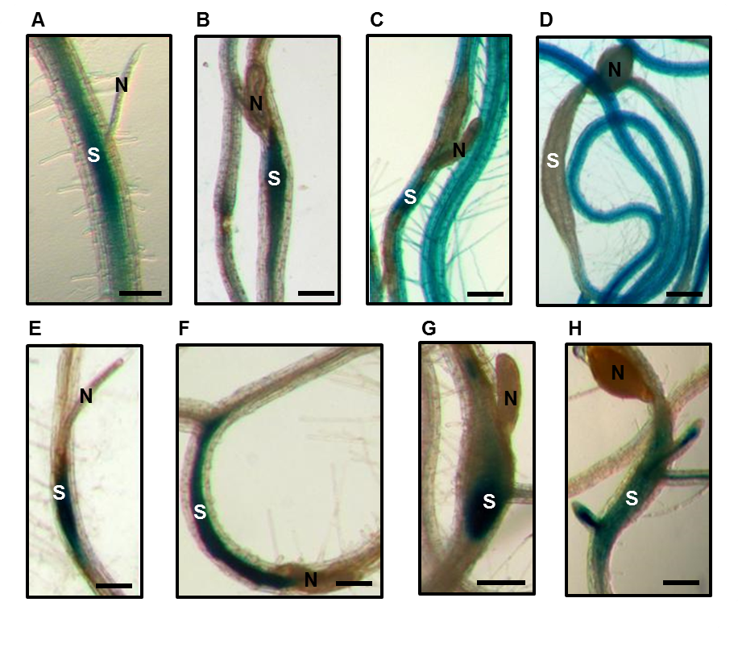
Figures
Figure 3-6. Histochemical staining of GUS activity driven by miR858 and MYB83 promoters in transgenic Arabidopsis lines in response to H. schachtii infection.
(A) to (D) GUS activity of the pmiR858:GUS plants in response to H. schachtii infection. Strong GUS activity was observed in the H. schachtii–induced syncytia at 3 (A) and 7 (B) dpi, whereas at 10 and 14 dpi GUS activity was dramatically reduced in the syncytia (C and D). (E) to (H) GUS activity of the pMYB83:GUS plants in response to H. schachtii infection. Strong GUS activity was observed in the H. schachtii–induced syncytia at 3 (E) and 7 (F), 10 (G) and 14 (H) dpi. “N” indicates nematode and “S” indicates syncytium. Bars = 100 μm.
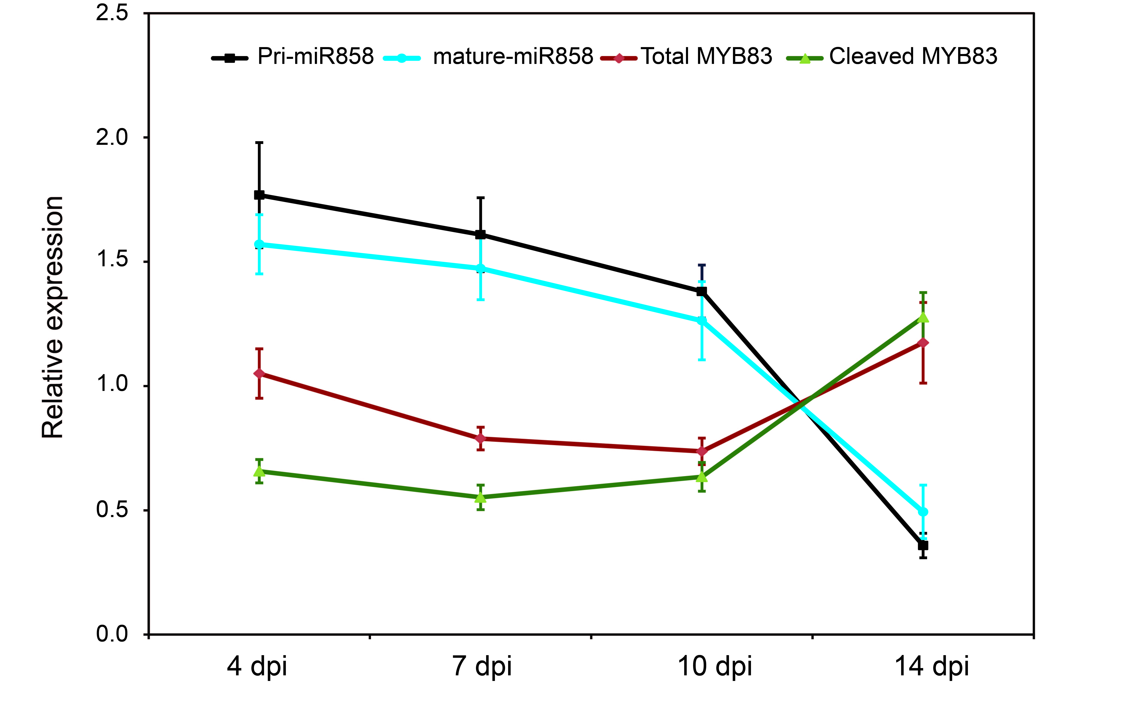
Figure 3-7. miR858 post-transcriptionally downregulates MYB83 during H. schachtii parasitism of Arabidopsis.
The abundance of primary and mature miR858 as well as total and uncleaved transcript levels of MYB83 were measured using qPCR in the roots of wild-type Col-0 plants at 4, 7, 10 and 14 d post H. schachtii infection, relative to non-infected control plants. The total transcript levels of MYB83 were inversely correlated with the expression levels of primary and mature miR858 at the four time points. In addition, the levels of uncleaved MYB83 transcripts were lower than the level of total transcripts at 4 and 7 dpi, indicative of a post-transcriptional downregulation of MYB83 by miR858 at these two time points. Data were obtained from three biological samples and represented as mean ± SE.

Figure 3-8. Overexpression of miR858 confers enhanced resistance to H. schachtii..
(A) Constitutive overexpression of miR858 in four independent transgenic Arabidopsis lines resulted in significant decreases in MYB83 expression levels. The expression levels of MYB83 were determined in the roots of two-week-old transgenic lines relative to the wild-type Col-0 plants using qPCR. Shown are average expression levels obtained from three biological samples ± SE.
(B) and (C), Root (C) and shoot (B) phenotypes of three-week-old transgenic Arabidopsis plants overexpression miR858.
(D) Nematode infection assays of the miR858 overexpression lines showing reduced susceptibility to H. schachtii compared with the wild-type Col-0 plants. Shown are average numbers of J4 females per root system ± SE (n =20) at three weeks post inoculation. Asterisks indicate statistically significant differences from wild-type Col-0 plants at P value less than 0.05.

Figure 3-8. contd
Figure 3-9. Constitutive downregulation of miR858 increased plant susceptibility to H. schachtii.
(A) Approach for creating a mimic binding site for miR858 (MIM858). The miR399 mimic sequence in the IPS1 was replaced by an artificial non-cleavable binding site for the mature miR858. The artificial biding site contained a three-nucleotide bulge (TGA) that would prevent transcript cleavage and hence sequester miR858 activity. (B) and (C), Shoot (B) and root (C) phenotypes of three-week-old transgenic Arabidopsis plants overexpression MIM858. (D) Constitutive overexpression of MIM858 in three independent transgenic Arabidopsis lines resulted in significant upregulation of MYB83. The expression levels of MYB83 were quantified in the roots of two-week-old transgenic lines relative to the wild-type Col-0 plants using qPCR. Shown are average expression levels obtained from three biological samples ± SE. (E) Nematode infection assays of the MIM858 overexpression lines showing increased susceptibility to H. schachtii compared with the wild-type Col-0 plants. Shown are average numbers of J4 females per root system ± SE (n =20) at three weeks post inoculation. Asterisks indicate statistically significant differences from wild-type Col-0 plants at P value less than 0.05.

Figure 3-10. Constitutive overexpression of miR858-resistant variant of MYB83 increased plant susceptibility to H. schachtii.

(A) Schematic representation showing the generation of a miR858-resistant variant of MYB83 (rMYB83) by introducing synonymous mutations to the miR858 binding site in the MYB83 coding sequence.(B and C) Nematode infection assays of rMYB83 overexpression lines and a MYB83 mutant line. Three independent transgenic lines overexpressing 35S:rMYB83 construct showed increased susceptibility to H. schachtii compared with the wild-type Col-0 plants (B). In contrast, the myb83 knockout mutant line CS1004395 showed reduced susceptibility compared with the wild-type Col-4 plants (C). Shown are average numbers of J4 females per root system ± SE (n =20) at three weeks post inoculation. Asterisks indicate statistically significant differences from the corresponding wild-type plants at P value less than 0.05.

Figure 3-11. Functional classification and Gene Ontology enrichment analyses of differentially expressed genes identified in 35S:miR858 and 35S:rMYB83 lines.
(A) Venn diagram displaying the number and overlap of the differentially expressed genes (DEGs) identified in miR858 and rMYB83 overexpression lines. (B) Gene Ontology classification and enrichment analyses of the DEGs identified in 35S:miR858 and 35S:rMYB83 lines. Enrichment analyses of upregulated and downregulated genes were performed separately.
(C) Venn diagram shown the overlap between MYB83-regulated genes and syncytium differentially expressed genes. (D) Venn diagram shown the overlap between MYB83 putative targets and syncytium differentially expressed genes. (E) Gene Ontology classification and enrichment analyses of MYB83-regulated genes and its putative direct targets overlapping with syncytium differentially expressed genes. Enrichment analyses of upregulated and downregulated genes were performed separately. Enrichment analysis was performed using Fisher’s exact test and Bonferroni multi-test correction with a significance cut-off P < 0.05.

Figure 3-12. Differential expression patterns of a set of MYB83-regulated genes involved in key biological processes associated with nematode parasitism.
The RKPM values of the selected MYB83-regulated genes overlapping with the syncytium DEGs were row-wise normalized using Z score and used to construct the heat maps. Shown are genes involved in hormone signaling pathways (A), defense response (B), cell wall modification and sugar transport (C), transcriptional control (D), and glucosinolate biosynthesis (E).

A) and (B) MYB83 positively regulates the expression of miR858. The expression levels of primary and mature miR858 transcripts were quantified in the roots of two-week-old rMYB83 overexpression plants (A) as well as the myb83 mutant line CS1004395 (B) relative to the wild-type Col-0 or Col-4 plants, respectively using qPCR. Shown are relative expression values obtained from three biological samples ± SE. (C) and (D) MYB12 phenocopied the effects of MYB83 on plant susceptibility to H. schachtii. Three independent transgenic lines overexpression 35S:rMYB12 construct increased susceptibility to H. schachtii compared with the wild-type Col-0 plants (C), whereas the myb12 mutant line FLAG_150B05 showed reduced susceptibility compared with the wild-type Ws plants (D). Shown are average numbers of J4 females per root system ± SE (n =20) at three weeks post inoculation. Asterisks indicate statistically significant differences from the corresponding wild-type plants at P value less than 0.05
Figure 3-13. miR858/MYB83 regulatory loop involves MYB12.
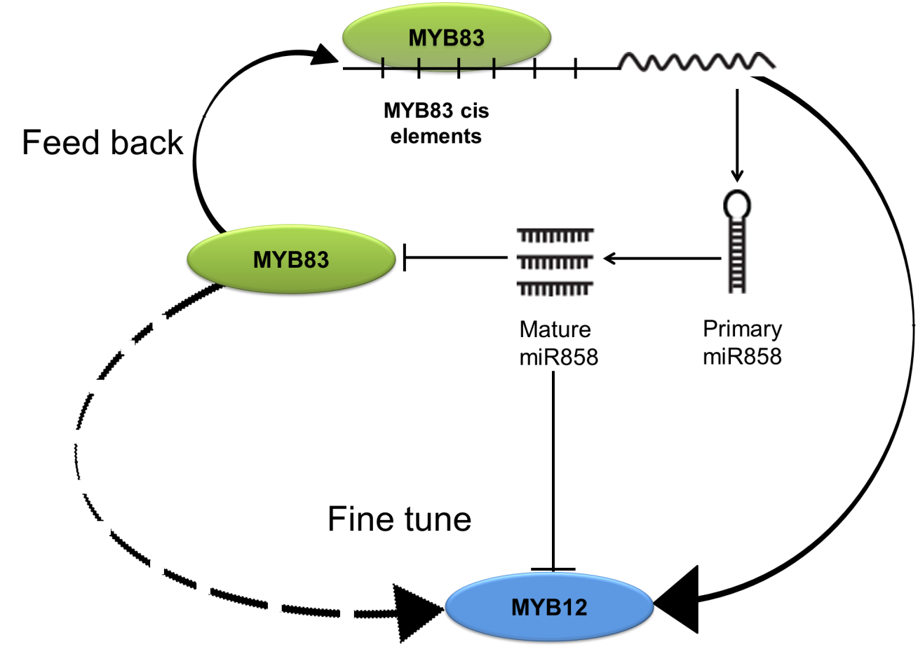

Figure 3-14. Model for miR858–MYB83 interaction
Our results indicate that miR858 and MYB83 expression are connected through a feedback circuit in which miR858 regulates the expression of MYB83 and responds to its expression levels. This regulatory mechanism ensures proper expression levels of more than a thousand of MYB83-regulated genes in the H. schachtii-induced syncytium. This fine-tuning mechanism appears to include MYB12, which was oppositely regulated by miR858 and MYB83, providing additional layer of tight control over gene expression.

Supplemental Figures
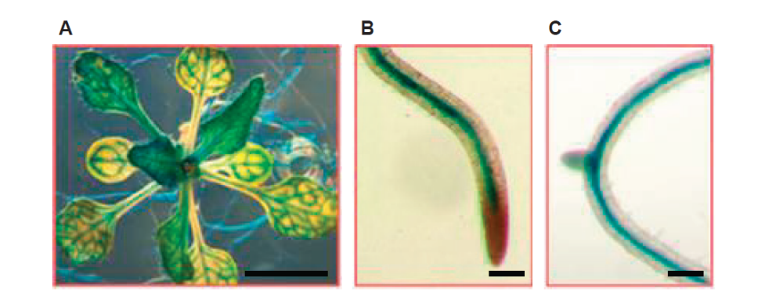
Supplemental Figure 1: Histochemical staining of GUS activity driven by miR858 promoter in transgenic Arabidopsis lines under non-infected condition. Shown are GUS activity in the vascular tissues of leaves (A) and roots (B and C) of 2-week-old plants. Bars = 1 cm in (A) and 100 μm in (B) and (C).
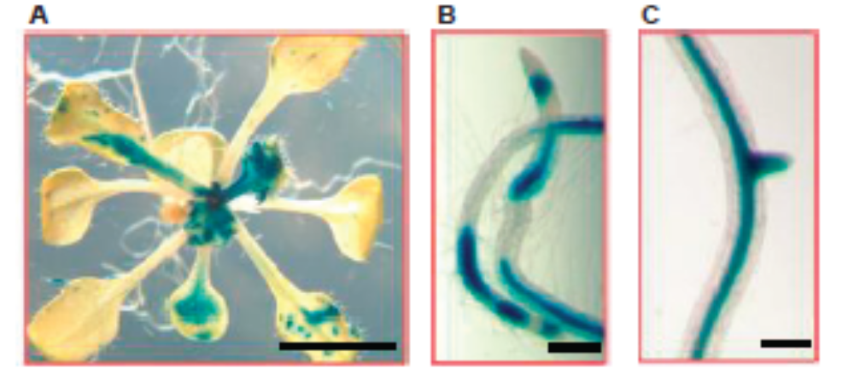

Supplemental Figure 2: Histochemical staining of GUS activity driven by MYB83 promoter in transgenic Arabidopsis lines under non-infected condition. Shown are GUS activity in leaves (A), and vascular root tissues (B and C) of two-week-old plants. Bars = 1 cm in (A) and 100 μm in (B) and (C).
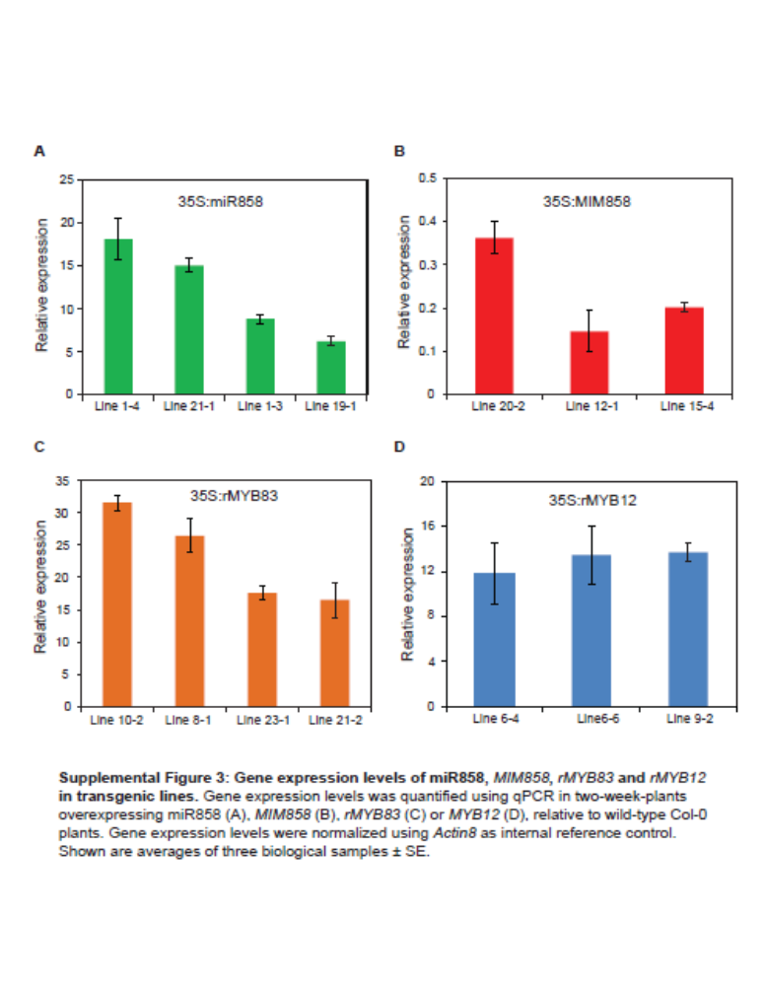
Supplemental Figure 3: Gene expression levels of miR858, MIM858, rMYB83 and rMYB12 in transgenic lines. Gene expression levels was quantified using qPCR in two-week-plants overexpressing miR858 (A), MIM858 (B), rMYB83 (C) or rMYB12 (D), relative to wild-type Col-0 plants. Gene expression levels were normalized using Actin8 as internal reference control. Shown are averages of three biological samples ± SE.

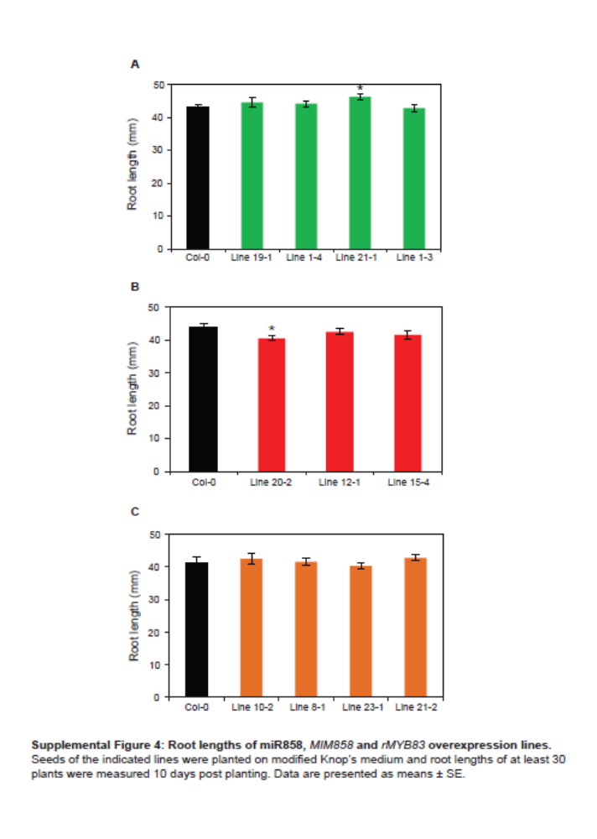
Supplemental Figure 4: Root lengths of miR858, MIM858 and rMYB83 overexpression lines.
Seeds of the indicated lines were planted on modified Knop’s medium and root lengths of at least 30 plants were measured 10 days post planting. Data are presented as means ± SE.

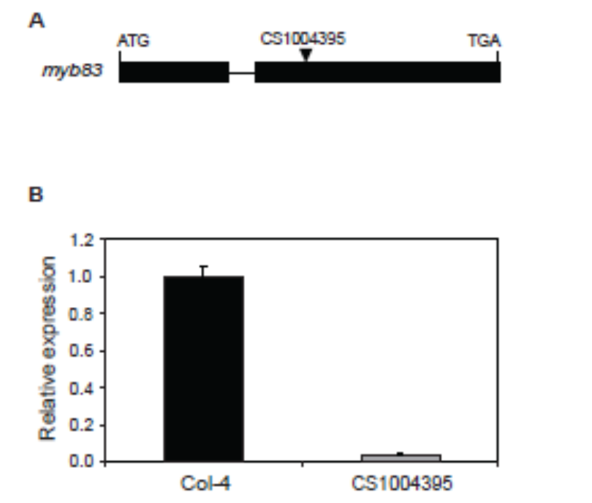

Supplemental Figure 5: Characterization of the MYB83 T-DNA mutant line (CS1004395).
(A) Schematic representation of T-DNA insertion site in the myb83 mutant.
(B) MYB83 expression level in the myb83 mutant relative to the wild-type Col-4 plants. MYB83 expression level was quantified in two-week- old plants using qPCR and Actin8 as internal reference control. Shown are averages of three biological samples ± SE.

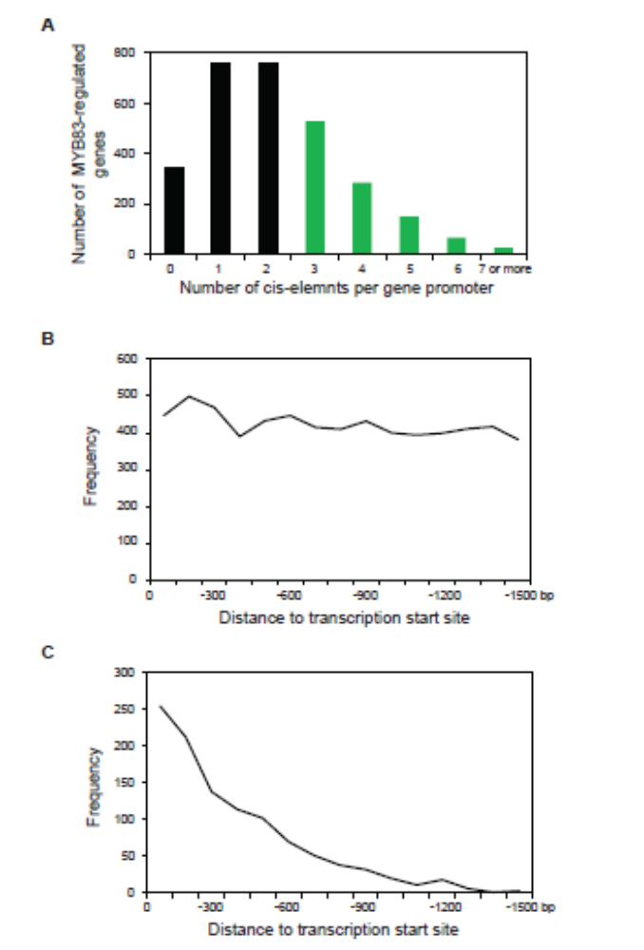

Supplemental Figure 6: Enrichment of MYB83 cis-binding element in the MYB83-regulated genes. (A) Frequency of the MYB83 cis-binding elements in the promoters of MYB83-regulated genes. MYB83-regulated genes containing 3 or more cis elements were considered as putative direct targets (highlighted in green). (B) Frequency of the MYB83 cis-binding elements in the promoters of the putative direct targets with respect to their distance from the transcription start site. (C) Frequency of the first MYB83 cis-binding elements in the promoters of the putative direct targets with respect to their distance from the transcription start site.

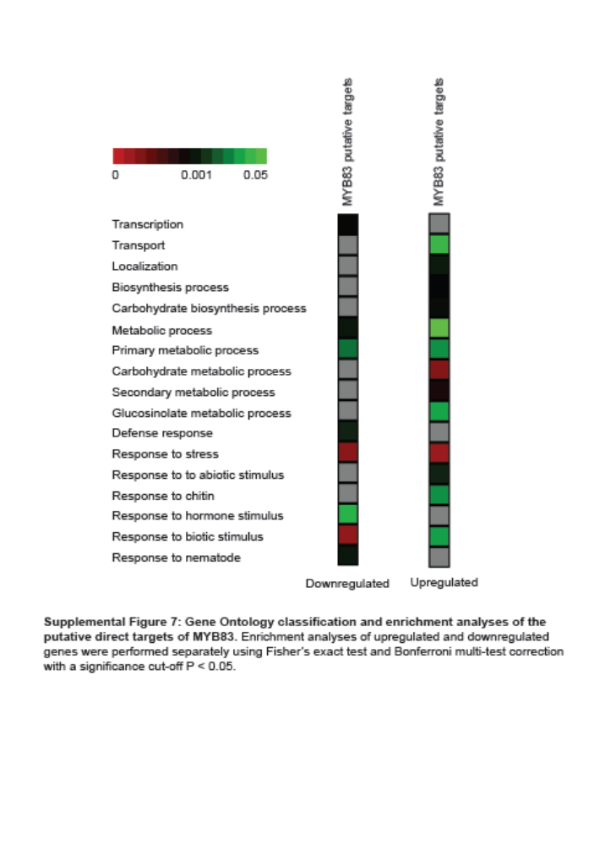

Supplemental Figure 7: Gene Ontology classification and enrichment analyses of the putative direct targets of MYB83. Enrichment analyses of upregulated and downregulated genes were performed separately using Fisher’s exact test and Bonferroni multi-test correction with a significance cut-off P < 0.05.

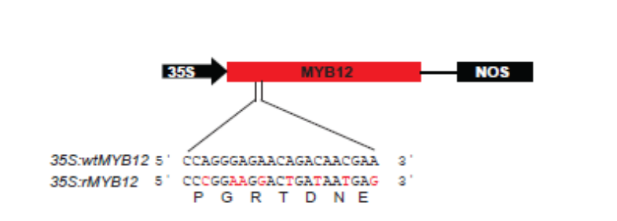
Supplemental Figure 8. Schematic representation showing the construction of a miR858-resistant variant of MYB12 (rMYB12) by introducing synonymous mutations to the miR858 binding site in the MYB12 coding sequence.

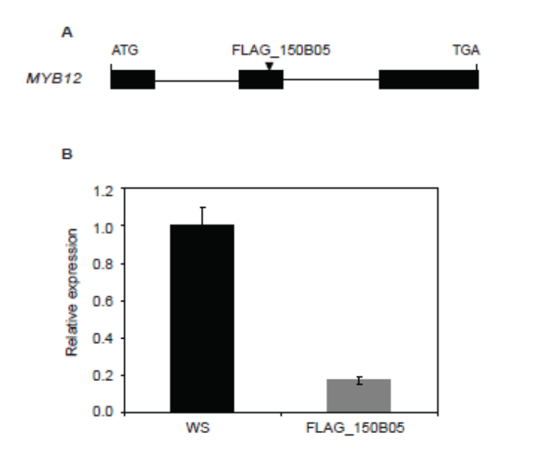

Supplemental Figure 9: Characterization of the MYB12 T-DNA mutant line (FLAG_150B05).
(A) Schematic representation of T-DNA insertion site in the MYB12 mutant.
(B) MYB12 expression level in the mutant relative to the wild-type WS plants. MYB12 expression level was quantified in two-week-old plants using qPCR and Actin8 as internal reference control. Shown are averages of three biological samples ± SE.

Chapter 4

Conclusion
H. schachtii–induced activation of miR858 during the initiation and progression of nematode parasitism post-transcriptionally silences MYB83. MYB83 in turn positively regulates the expression of miR858, which contains several MYB83 cis-binding elements in its promoter. This feed-back regulatory circuit may function as a homeostatic control mechanism to ensure proper expression levels of more than a thousand of MYB83-regulated genes in the H. schachtii–induced syncytium. The miR858/MYB83 regulatory system may also involve MYB12, which was oppositely regulated by miR858 and MYB83, providing additional layer of tight control over unidentified MYB12-regulated genes in the syncytium.

Vita
The author was born on July 1983 as the son of Mr. Jagannath Piya and Mrs. Jaumaya Piya in Bandipur-6 Tanahun, Nepal. He obtained his Bachelor Degree in Agricultural Science majoring in Plant Breeding from Tribhuvan University, Institute of Agriculture and Animal Science, Rampur, Chitwan in 2007 and obtained his Master degree from South Dakota State University in Biology in 2013. He started his Doctor of Philosophy program in the Department of Plant Sciences at the University of Tennessee, Knoxville, under the direction of Dr. Tarek Hewezi in spring 2014. His dissertation research focused on understanding the role of hormonal and signaling pathways in plant-cyst nematode interaction.
For this dissertation research, he was financially supported by National Science Foundation (NSF).

