Using Predictive Modeling, Optimization, and Lean for Healthcare to Comply with the Affordable Care Act Hospital Value-Based Purchasing Program

A Thesis Presented for the
Master of Science
Industrial Engineering
The University of Tennessee, Knoxville

Kelcee Storme Ramsey
April 2014
Abstract
The healthcare industry has recently been given an additional set of guidelines called the Affordable Care Act (ACA). The guidelines (or measurements) will be utilized to assess each hospital compared with other hospitals of similar size, and based on score reimbursed for Medicare payments accordingly. An important measurement in these guidelines pertains to patient satisfaction; therefore, increasing patient satisfaction is an important goal for hospitals. To accomplish this goal, many hospitals are re-evaluating their nurse staffing procedures to try to match patient demand with nurse availability.
Using predictive modeling with optimization, hospital administrators can develop/improve their plans for the future. Each concept provides benefits to the hospital in the utilization of the nursing staff. Predictive modeling uses historical and real time data to forecast plans for the future. This provides the hospital administrators a baseline to estimate the number of nurses needed and the number of nurses to be hired. Optimization provides the best case scenario for the number of nurses required to meet patient demand while minimizing cost to the hospital. This research combines the two ideas into multiple models using AnyLogic and Excel as predictive/analysis tools.
The implementation of these models into a hospital environment provides new insight to the nurse staffing process allowing changes to be made to accommodate new regulations. The models can also provide the ability for management to run “What-If” analysis to understand what the staffing levels should be in a given situation. Results will provide the additional tools required to be prepared for emergencies. Healthcare is an industry where seconds count, and expanding the ability to be prepared is always an asset.
Table of Contents
Chapter 1 Introduction 1
Chapter 2 Problem Definition 3
Chapter 3 Literature Review 5
Section 3.1 Affordable Care Act, Hospital Value-Based Purchasing Program 5
Section 3.1.1 Clinical Process of Care Domain 5
Section 3.1.2 Patient Experience of Care Domain 6
Section 3.1.3 Outcome Domain 7
Section 3.1.4 Efficiency Domain 8
Section 3.1.5 Scoring 9
Section 3.2 Capacity Planning 9
Section 3.3 Simulation in Healthcare 10
Section 3.4 Nurse Staffing 12
Chapter 4 Methodology 15
Section 4.1 Data Collection 15
Section 4.1.1 Historical Data 15
Section 4.1.2 Direct Nursing Data 18
Section 4.1.3 Administrative Preferences 20
Section 4.2 Forecasting/Capacity Planning 22
Section 4.2.1 Forecasting Patient Census 22
Section 4.2.2 Forecasting Admissions and Discharges 23
Section 4.2.3 Seasonality 25
Section 4.4 The Model 27
Section 4.4.1 Model Interface 27
Section 4.4.2 Model Uses 33
Section 4.4.3 Model Supplement – Short-Term Forecasting in AnyLogic 34
Section 4.5 Scheduling 37
Section 4.5.1 The Tool – Excel 38
Section 4.5.2 The Tool – AnyLogic 40
Chapter 5 Hospital Implementation 42
Section 5.1 People 43
Section 5.2 Using the Data 44
Section 5.2.1 Short-Term 44
Section 5.2.2 Long-Term 44
Chapter 6 Conclusions 46
Chapter 7 Further Research 48
List of References 50
Appendix 53
Work Instruction 54
Nurse Scheduling AnyLogic Tool Model Overview 57
Vita 61

List of Figures
Figure 1: Implementation Domains by Year 1
Figure 2: Outcome Domain Measures 8
Figure 3: Efficiency Domain Measures 8
Figure 4: Example Data Reports from MIDAS 16
Figure 5: Worksheets used to determine hospital census levels by day 17
Figure 6: Example summary from historical reports 17
Figure 7: Number of Beds Filled by Day – 2008 25
Figure 8: Number of Beds Filled by Day - 2012 25
Figure 9: Data Entry Form 28
Figure 10: Model Interface 29
Figure 11: Nurses by Day from Dashboard 30
Figure 12: Dashboard Graphs 31
Figure 13: Pivot Table of Month of Interest Daily Data 32
Figure 14: Output from Nurse Hiring Tool at Hospital A 33
Figure 15: Output from AnyLogic Nurse Staffing Tool 35
Figure 16: Parameters Variation Window - Nurse Staffing Model 37
Figure 17: Excel Scheduling Tool 38
Figure 18: Workload Analysis from Excel Scheduling Tool 39
Figure 19: Shift Analysis Based on Excel Tool 39
Figure 20: Screenshot of Nurse Scheduling Model 40
Figure 21: Scheduling Optimization Tool Output 41
Figure 22: High Level Process Flow Diagram of Implemenation Steps at Hospital A 42

List of Tables
Table 1: Summary of Nurse Questionnaire Results 19
Table 2: MResults from Mediation Pass Time Studies 20
Table 3: Results from Admission/Discharge Time Studies 20
Table 4: Summary of Responses to Administration Questionnaires 21
Table 5: Variables used for predicting admissions and discharges 24

Chapter 1 Introduction
Increasing costs and the Affordable Care Act (ACA) are creating financial burdens for American hospitals. One major part of the ACA is the Medicare Hospital Value-Based Purchasing Program which will assess hospitals based on the quality of care they provide to Medicare patients. Previously, hospitals were paid based on quantity of services provided. Under the new ACA program, the reimbursement hospitals’ receive will be based on three things: quality of care, how closely best clinical practices are followed, and how well hospitals enhance their patients’ experience of care during their stay.
The majority of integration of this specific program is occurring between the years of 2013 – 2015 with some minor changes until 2017. Below is a chart summarizing the integration steps for the specified years:
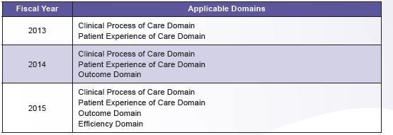

Figure 1: Implementation Domains by Year

These phases are described in depth in Section 3.1 which explains the Hospital Value-Based Purchasing Program in more detail. Without proper changes to current operations, it will be easy for a hospital to fall behind and possibly even be shut down or bought out by a larger hospital chain.("Hospital Value-Based Purchasing Program," 2013)
From a hospital’s perspective, when trying to accommodate for something as complex as this portion of the ACA, the first step is to figure out where to start. The common ground for each of these domains is nurses. Nurses are the face of the hospital. Patients see their nurses several times per day and doctors depend on nurses for support to complete medication passes and provide appropriate care. Nurses cover the entire hospital from the Emergency Department to the Inpatient floors. If the nurses are well equipped to handle their responsibilities, the domains listed in this program can be covered successfully. If nurses are not trained appropriately and/or are not able to meet patient expectations; then, the hospitals’ reimbursement will likely be penalized through this program.
For hospitals to be successful and remain successful with the new regulations, they must start with a solid nursing foundation. Studies show that most hospitals are not currently equipped with a nursing foundation to match the requirements of the ACA. Many U.S. hospitals are dealing with low nurse staffing levels which can lead to many adverse hospital events, including decreased quality of care and decreased patient safety. These are all major issues that will penalize the hospital under the Hospital Value-Based Purchasing Program. Unfortunately, low nurse staffing levels are comfortable for hospitals because that is the current mode of operations to meet their financial objectives. With the new regulations, change is required for hospitals to remain open. Predictive modeling, simulation, and optimization principles can be used to offset these changes and help to maintain hospitals cash flow. Integrating a nurse staffing model, as well as a nurse scheduling system to match nursing resources to patient demand will provide the necessary information to hospital administration to allow them to meet ACA standards.

Chapter 2 Problem Definition
Many U.S. hospitals have been dealing with a nursing shortage for several years. Research done in the early 2000‘s suggested that by 2029 there could be a shortage of 800,000 hospital nurses in the U.S. (Admin, 2010). This shortage is caused by several reasons including: changes in workforce expectations (i.e., meaning wanting to be paid more while times for doing less), an increase in patient acuity requiring more time to care for patients, and a decline in nursing skills. To offset this shortage, many hospitals have moved to a team nursing strategy. (Admin, 2010) Team nursing means an RN leads a team of LPN’s and CNA’s to care for a group that could range from 10-20 patients. Work is delegated to each team member at the beginning of the shift and all work performed by non-licensed members of the team is the responsibility of the RN in charge. A summary of care for each patient is given by those working under the RN at the end of each shift. The advantage to this system is fewer nurses are needed and fewer work-related stress/fatigue issues are reported from nurses who work in this environment. (Admin, 2010) A major disadvantage is communication is required and teamwork is essential. Communication and team work are difficult for humans to grasp; therefore, communication barriers are often an issue. Continuity of care leading to patient dissatisfaction is another concern. Support staff is re-shuffled which changes patient assignments confusing nurses and preventing the staff from building relationships and trust with their patients. (Admin, 2010) This methodology does not align with the ACA program discussed.
The other popular methodology used in hospitals is called primary care nursing. Primary care nursing is when a RN is responsible for a given number of patients. During their shift, the RN’s are responsible for all RN tasks for a specific patient and will not receive help with these tasks unless necessary. (Admin, 2010) The advantage of this is that patients are able to gain trust and build a relationship with their nurse that generally leads to increased patient satisfaction. The disadvantage is the cost. More RN’s are required to staff the hospital with less support staff. Support staff costs are less than the average RN’s salary which increases the total staffing cost. (Admin, 2010) Primary care nursing leads to outcomes that will satisfy the goals of the Hospital Value-Based Purchasing Program. Aside from the program, increasing patient satisfaction would allow the hospital to reap other benefits including an increased census due to word of mouth advertisement and an all-around better reputation. Although the program goals are satisfied with primary nursing, the costs are still an issue. The question remains, how can hospitals affordably meet the goals of the program, the needs of their patients, and the desires of the nursing staff?

Chapter 3 Literature Review

Section 3.1 Affordable Care Act, Hospital Value-Based Purchasing Program
The Affordable Care Act of 2010 (ACA) placed a huge burden on hospitals and the means by which they are reimbursed. A specific part of the act known as the Hospital Value-Based Purchasing Program is a major reason reimbursement is more difficult to receive. Previously, hospitals were reimbursed based on the quantity of services rendered. With this program, they will be reimbursed based on the quality of care and patient satisfaction during their hospital stay. The act contains several quality dimensions grouped into four main domains which assess hospital performance related to specific quality and patient satisfaction measures. These domains are: clinical process of care, patient experience, outcome, and efficiency. Through this program, Medicare makes incentive payments to hospital based on one of two things:
- How well they perform on each measure or
- How much they improve performance on a certain measure compared to their performance during a baseline period.
Each domain contains its own performance measures. The following sections will describe these in some detail. ("Hospital Value-Based Purchasing Program," 2013)

Section 3.1.1 Clinical Process of Care Domain
The clinical process of care domain refers to a number of important processes occurring while a patient is in the hospital. These processes are to verify the hospital is handling significant patient events properly while providing the best quality care possible. Below is a list of the measures in this domain that are collected to integrate into the overall hospital rating score:
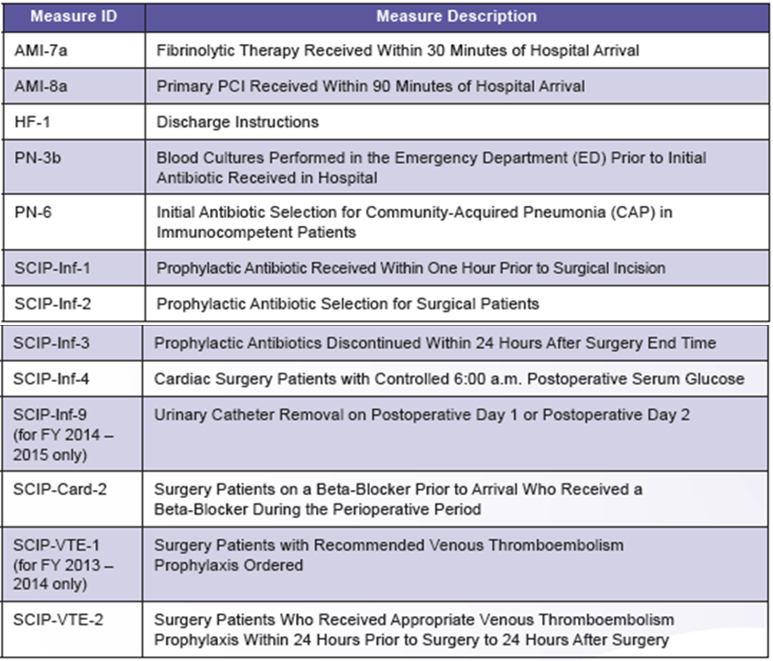
Figure 2: Clinical Process of Care Domain measures for quality of care, FY 2013-2015
These measures are the responsibility of the doctor with assistance from the nurses. Most of the measures must be ordered by the doctor, but the nurse completes the action by giving medication, discontinuing medications, completing procedures, and/or discharging the patient. ("Hospital Value-Based Purchasing Program," 2013)

Section 3.1.2 Patient Experience of Care Domain
The patient experience of care domain summarizes important information on how patient satisfaction will be measured for reimbursement purposes from Medicare. The following is a list of dimensions that will be considered:
- Nurse Communication
- Doctor Communication
- Hospital Staff Responsiveness
- Pain Management
- Medicine Communication
- Hospital Cleanliness and Quietness
- Discharge Information
- Overall Hospital Rating
Looking at each dimension, it’s obvious that the responsibility falls on either a doctor or in most cases a nurse. Doctors must be good communicators and provide medicine to the patient, and nurses must provide follow up. Nurses must help the patient manage pain, communicate details about the medicine given, be prepared to respond to whatever happens, and provide discharge information to the patient. ("Hospital Value-Based Purchasing Program," 2013)

Section 3.1.3 Outcome Domain
The outcome domain is simple. Each of the five categories listed in Figure 2 below is measured to assess the care provided while the patient is in the hospital. These appear to be simple and direct statistics to measure, but most healthcare professionals are against the 30-day mortality rates. After most cases of Acute Myocardial Infarction, people are sent home before the 30 day period is complete. There is no accountability from the hospital staff to assure patients are following orders communicated at discharge. If a patient leaves the hospital in good condition but continues smoking and does not take medication as prescribed by hospital staff; then, the responsibility for the death of this patient is placed on the hospital for purposes of this metric despite their efforts to heal the patient. This is a very controversial method that will have to be followed for many years as the kinks are worked out. ("Hospital Value-Based Purchasing Program," 2013)
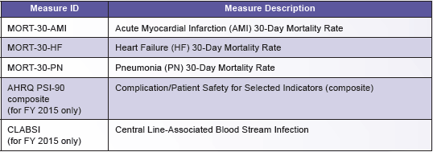
Figure 2: Outcome Domain Measures

Section 3.1.4 Efficiency Domain
The final category is the efficiency domain. Below is the table of the single metric to be measured in this domain.
Figure 3: Efficiency Domain Measures
The MSPB measure assesses Medicare Part A and Part B payments for services provided to a Medicare beneficiary during a spending-per-beneficiary episode that spans from 3 days prior to an inpatient hospital admission through 30 days after discharge. This measure will be used and compared with other hospitals and then scored based on the results. ("Hospital Value-Based Purchasing Program," 2013)

Section 3.1.5 Scoring
To score each hospital, the domains above are given individual scores (either Achievement or Improvement depending on which is higher) based on the metrics. Once the scores are given, they are then multiplied by a given weight and the final scores for the domain are available. The sum will be taken from the scores in each domain and the hospital will be given their overall score. ("Hospital Value-Based Purchasing Program," 2013)

Section 3.2 Capacity Planning
Predictive Modeling in the healthcare industry can be used for a variety of things including staffing, inventory, room scheduling, etc. In the case of capacity planning, predictive modeling plays a vital role to assist hospital administration in better understanding what will likely be needed in the future. Research/data has been compiled pertaining to capacity planning and predictive modeling in multiple industries. Some have found types of problems that work best using a linear programming approach to identify the appropriate answer. These particular problems will answer questions similar to the following:
What effect will any given demand forecast have on capacity plans?
What will be the effect of an expected change in ownership of costs?
If prices for leased capacity increase by specific amount, how will plans and
costs be affected?
What is the sensitivity of decisions and costs to forecast error? (Fetter, 1961)
All of these are important answers to acquire from a model in specific situations, but sometimes more is required.
The healthcare industry has three main constraints which are (1) time, (2) inventory (referring to employees in this case) and (3) high uncertainty. These specific constraints make using only linear programming an insufficient option. Generally, there are not direct correlations between two given variables and the uncertainty is so great that it cannot be accounted for in simple linear programming. From research, we have learned that creating robust solutions to problems will help to avoid complexities in nonlinear stochastic formulations. (Dimitris Paraskevopoulos, 1991) This allows us to use non-linear predictive modeling to more accurately predict future states with less complexities despite the high uncertainty. Creating models in this manner allows the user to increase or decrease the emphasis on the defined sensitive term within the model in order to increase or decrease excess capacity (available nurses). This type of model developed for the healthcare industry would allow for administrative “what-if” analysis to be performed and more informed estimates to be provided.

Section 3.3 Simulation in Healthcare
The use of simulation in healthcare is growing in popularity while saving money and becoming more efficient is increasingly more important to hospitals of all sizes. Major complaints from patients are their wait times and the lack of time spent with their health care provider. In the case of an inpatient hospital unit, a common issue from patients is that their nurse is not available when they are needed or wanted. Another complaint is the nurse is seen very little throughout the day. Most complaints received by inpatients at hospitals can be directly related to a staffing issue.
Studies have been performed to try to minimize wages paid by the hospital by predicting the correct staffing range to meet patient demand while minimizing hospital cost using simulation models with minimal inputs to predict optimal ranges. (McHugh, 1989) Other research has been done to test the idea of using simulation to decrease nursing overtime. This is important in an inpatient facility because most nurses working more than their allotted shift are paid overtime pay which costs the hospital additional money. This research revealed that simulation can help hospital administrators stagger nurse scheduling to better meet patient demand throughout the day. (Javad Taheri, 2012) Both areas of research are important in healthcare. Each is targeting a specific portion of the healthcare industry, but the ideals can span many healthcare areas and provide methodologies for improved patient service.
Simulation in healthcare plays a role in the quality of service provided to the patients and can have a role in training new and existing employees. An important tool from simulation is the “What-If” scenario tool. With this tool, real life scenarios can be established and “practiced” in training sessions or analyzed by hospital administration to prepare the healthcare facility for various scenarios that will occur. (Barjis, 2011) This will allow alternative plans to be implemented by the hospital which could help with a broad spectrum of issues from saving money to saving lives.
With specific data, a simulation can portray possible future outcomes given the specified circumstances. This is beneficial in healthcare because it allows administrators to more accurately plan for the future and potentially save money. Simulation has the ability to identify underutilized and over utilized resources and alleviate these concerns. Unfortunately, the healthcare industry has long suffered from a lack of valuable data collection. This led to simulations being run with data that will only predict approximate results. In this instance, the results would likely be subpar in some instances and unreliable to users. It is difficult to accept the benefits of the simulation software due to its potential inaccuracies. (Barjis, 2011) Another issue that arises in the healthcare industry is the constant changing of processes. It is difficult to collect the same data when processes change dramatically. Often, a simulation model is set up to requiring very specific data that may not be readily available after process alterations; therefore, leaving the model as unusable. If a simulation is not set up in a manner that requires simple data entry, it will become obsolete very quickly.

Section 3.4 Nurse Staffing
Nurse staffing has long been a researched issue in the healthcare industry from several different academic areas including industrial engineering, nursing, medicine, business analytics, and operations research. Along with the multiple research areas have come multiple research methods that could be used for nurse staffing. One of the most popular methods is to staff by patient acuity. Research has found that having a computer to update each acuity score by patient two hours before the next shift will help the hospital to accommodate the patients with the appropriate nursing staff. This requires having the appropriate information at the appropriate time and knowing what to do with it when it is available. (Bagg, 1987) While this is a very effective means of staffing nurses, there is no way to forecast the nursing need 2 months out and the idea of using acuity has been an issue in many medical facilities for a long time. Despite the many ways to test acuity, some of the score is still dependent on what the person scoring the patient thinks. This leaves the scores somewhat subjective and therefore they have the potential of being inaccurate as Bagg points out in her research. (Bagg, 1987) Finding ways to improve nursing accountability for their decision making allows for improvement in this system. The overall thought process of the system meets the needs of a nurse staffing department because the multiple facets of the decisions are taken into consideration, but the subjectivity of the process makes it potentially unreliable.
Another method researched for staffing nurses uses a queuing perspective to further understand appropriate nurse to patient staffing ratios. In this method a model is built to match a medical unit at a hospital. This methodology is simple to implement and takes into consideration many of the factors that affect patient satisfaction including nurse fatigue, nurse scheduling, and patient specific delays. (Franci de Vericourt, 2011) Other methods that have been researched for scheduling nurses include mathematical programming models which take nursing preference into consideration, nurse scheduling optimization using mathematical programming, and a resource allocation approach to staffing nurses on a medical unit. Each of these has benefits and downfalls just as the previous two discussed.
Staffing based on nurse preference is a way to keep nurses happy and has been heavily researched. In this model the algorithms are set up to assign minimum numbers of each nursing type to the schedule for a 4 to 6 week period. (Warner, 1976) The mathematical programming approach that uses two stages for nurse staffing is based on specified constraints. It takes into consideration vacation schedules and nurse schedules in order to create something that will increase both hospital satisfaction and nurse satisfaction while meeting the patient demand (if that is a listed constraint). This is a versatile approach to nurse staffing that can be easily altered to fit other areas of the hospital. (Chang-Chun Tsai, 2010)
The resource allocation method takes a slightly different approach to nurse staffing. Instead of creating a schedule, the point of this model is to use Goal Programming to determine how many nurses of multiple types are needed to meet the needs of patients. (HJ.P. Oddoye, 2007) Again, this is different from the previous approaches researched, but it does provide the intent to satisfy multiple goals that are related to the patient outcome. In this method, targets are set and deviations are found portraying either underachievement or overachievement of the goal. In Goal Programming, the decision maker can assign penalties for deviations which will further constrain the model to most accurately meet the needs of the decision maker. This model provides results (based on the assigned constraints) similar to those of the others, but it takes into consideration different types of nursing staff. (HJ.P. Oddoye, 2007)
A three stage model has also been researched specifically for nurse staffing in acute care facilities. (William J. Abernathy, 1973) This model takes into consideration policy decisions, staff planning, and short-term scheduling as the three times phases. While it is made for the acute care hospitals, it can be implemented in any service industry creating a versatile approach. This is comparable to the aggregate planning models with slight variation because there is no known inventory and back-stock to use in case of an emergency. The issue with nurse staffing is much more finite and contains more constraints. (William J. Abernathy, 1973) Since this model is set up to accommodate large variation, there are some hospital units that would not work as well in the model as others. An example would be the cardiac unit where most patients will have severe cardiac illnesses and need similar care. This leads to a decreased amount of variations in patient demand which is very uncommon in most parts of the healthcare industry.
The staffing models listed plus many other nurse staffing models have been researched over the years. Since nurse staffing is an essential task in manpower planning (Chang-Chun Tsai, 2010) for hospitals, it is important to continue research on this issue to provide a basis for future researchers for continued learning. With the cost of the Nursing Department increasing to over 50% of the hospitals budget, it is imperative to maintain appropriate levels and plan for the future. (Natalia Yakovic, 2011) With the campaign from consumers and government to keep healthcare costs down, the demand is increasing for a better way to provide quality care to patients at a minimal cost.

Chapter 4 Methodology
The idea behind staffing nurses efficiently in hospitals is not a new concept to the healthcare industry. As discussed in the Literature Review section, several methods have been created to decrease nursing costs and increase nursing efficiency. With new healthcare laws in place, cost and efficiency are no longer the only important goals related to nurse staffing. With revenue at stake, patient satisfaction has grown increasingly more important to hospital administrators catching up in importance to budget needs. To successfully comply with healthcare laws, it is more important for nurses to be able to do their jobs and do them well while feeling comfortable in their position. This is the basis behind the methodology used to complete this research project.

Section 4.1 Data Collection
One of the first steps in any project is collecting the data needed. Data collection took several forms for this project ranging from historical data outputs of hospital census levels to shadowing nurses during their shift to collect information about their workload and time constraints.

Section 4.1.1 Historical Data
Hospital A (HA) uses MIDAS, a multimedia digital archiving system, to store historical data. From this program, data can be retrieved in several ways to get the information needed. For purposes of this research, data reports were run that included the following information:
Patient Unique ID Number
Patient Admission Time
Patient Admission Date
Patient Admission Location
Patient Encounter Type
Patient Discharge Time
Patient Discharge Date
Patient Discharge Location
This information is necessary for the model related to the situation HA is in currently. Small adjustments to data collection might be required for different model scenarios depending on the hospital and the type of nurses being considered. This data was used to create tables that provide data on census by specified time period.
Taking HIPAA regulations into consideration, patient Unique ID’s provided by HA were altered in data tables to further protect patient identification. An example of the data report is shown below:
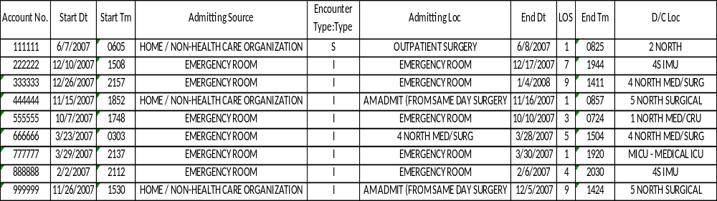
Figure 4: Example Data Reports from MIDAS
This information was then modified to create tables similar to the one shown below:
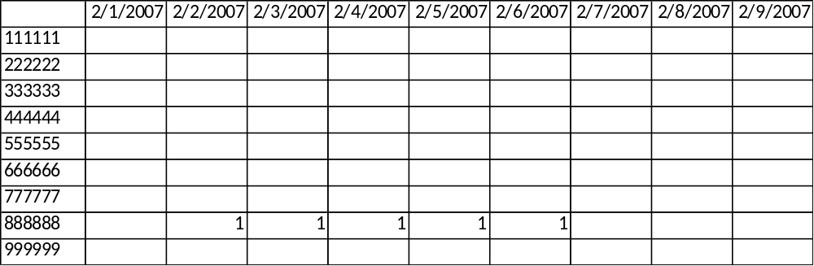
Figure 5: Worksheets used to determine hospital census levels by day
This table can be read as follows: Figure 6 shows that patient 888888 was in the hospital from 2/2/2007 to 2/6/2007. This table also provided information on the number of admissions and the number of discharges by day. Below is an example of the summary information these charts provided, giving the daily census of the hospital.
Figure 6: Example summary from historical reports
Further, an analysis of the admissions and discharges was done and the total number was subtracted from the census total from the graph:
$${Census Total}_{i}-{{(Admissions}_{i}-Discharges}_{i)}= {Total Rooms Filled}_{i}$$
$$where i=the day number 1,…,N$$
This provides the number of rooms filled per day i. This particular data point is important because when one patient is discharged from a room, it is likely another patient will be admitted into that room during the same day. This does not mean the nurse has two rooms to care for as is shown on the census data, rather she has some additional work to do for that particular room. After some data analysis, it was that found that there could be +/- 5% error in census using this methodology. Prior to using this technique, the error agreed upon with HA administration was 7.5% therefore validating the methodology. This becomes important when building the model.

Section 4.1.2 Direct Nursing Data
When researching how to staff nurses more effectively in a hospital setting, there is only so much historical data will tell. Shadowing nurses was 250 hours of the data collection portion of this research. Watching the way nurses interact with the patients, timing nurses on particular tasks, counting the number of times nurses visit each patient during the day, and the purpose of each visit were all data points that were collected.
No one knows better how to be a nurse, then a nurse. This time was also spent asking questions and getting feedback from those people who live the hectic life of a nurse each day. This was an important part of data collection because it was during this time that reasons why patient satisfaction scores were declining became obvious. Below is a table of questions asked during this portion of data collection:
- Do you have enough time during a regular 7a-7p shift to meet your assigned patients’ needs?
- Do you have sufficient support (from other nurses, LPN’s, and CNA’s) to complete all tasks during a given shift?
- During a 7p-7a shift, how much down time do you have when no tasks are being done?
- In your opinion, what is the one task done daily that takes up the most time?
- What is one task you do often that should be done by supporting personnel?
- How often are you called in to work a shift that you were not originally scheduled to work (times per month)?
- How often (per week) on average do you receive a patient in one of your assigned rooms that you are not properly trained to care for (i.e. a stroke patient, a heart patient, a post-op surgery patient, etc.)? a. (1-2 times) b. (3-4 times) c. (5+ times)
The answers received were anonymous to avoid any indication that a nurse was unhappy with his/her job. During this exercise, 5 inpatient units (wings on specified floor) were given the survey and 36 nurses returned their responses.
The following table summarizes the responses given to each question:

Table 1: Summary of Nurse Questionnaire Results
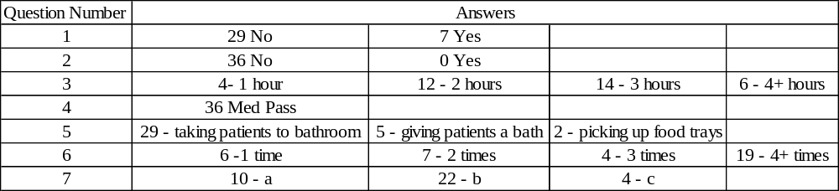

This information provided input from those who know the processes best in order to focus on some specific tasks that need to be considered in the system. From the questionnaires, medication passes were chosen as an area to focus on. After several hours of research focusing on medication passes, admissions and discharges also became a focal point. Nurses working the 7a-7p shift at HA spent 86.2% of their work day performing these tasks. Time studies provided the following results:

Table 2: MResults from Mediation Pass Time Studies
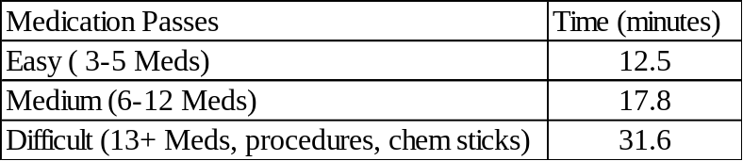

Table 3: Results from Admission/Discharge Time Studies
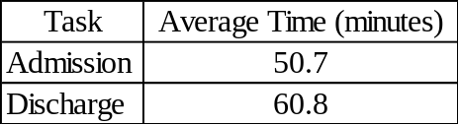

The hospital population over a 120 day time period was broken down into percent of patients receiving each level of med pass. The breakdown is as follows:
Easy – 7%
Medium – 70%
Difficult – 20%
The assumption in the program calculates this to be the same each day, but can be easily changed by the program operator when needed.

Section 4.1.3 Administrative Preferences
Talking with hospital administration about their wants/needs for nurse staffing is an integral part of data collection. If the end product of a nurse staffing tool does not follow along similar lines as to what is expected; then, it is likely the tool will not be implemented in the hospital. A questionnaire was distributed to those on the administrative staff who had a stake in the decision making of the nurse staffing model. This included the hospitals’ CMO, CNO, CFO, and CEO. The questionnaire distributed contained the following questions:
- What is the most important thing you want this nursing tool to do for the hospital?
- What are three things you view as problems with the current methodology of nurse staffing at Hospital A?
- What is one thing you would like to see being done differently with the frontline nursing staff?
- Please provide additional comments in the area below with regards to the nursing effectiveness at Hospital A and the nursing tool.
The responses to each of these questions are summarized in the table below:
Table 4: Summary of Responses to Administration Questionnaires
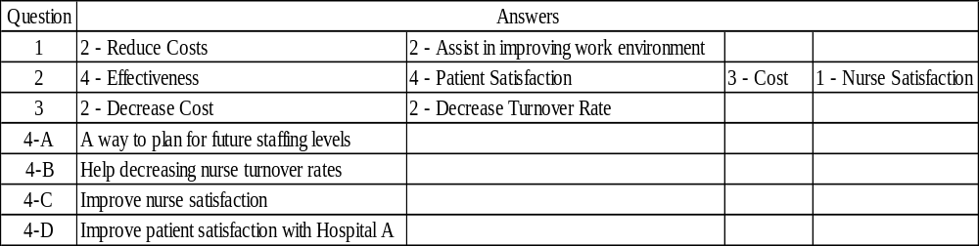

While the results do provide a variety of answers, it is clear that each management employee who has a stake in nursing change has consistent goals in mind. They are interested in reducing costs and increasing patient satisfaction. Most of the management staff mentioned something about the tool helping to plan for future staffing levels and increase nurse satisfaction at their hospital. These responses help guide the direction of the tool when building and emphasizing the importance of reducing costs and planning for the future.

Section 4.2 Forecasting/Capacity Planning
Forecasting means to predict or estimate a future state. Forecasting is a large part of the development phase for this nurse staffing model. During the creation process, multiple forecasting methods were attempted to find one that would allow for only minor deviations from actual data.

Section 4.2.1 Forecasting Patient Census
After collecting the historical data necessary, forecasting the number of beds filled in the future became the next most important step because this would be the basis of how many nurses the hospital needed to have each day. To do this, historical data from the past 7 years was gathered and calculated using the methodology explained in the previous section. This data was fed into multiple forecasting formulations and optimized to choose the method that produced the smallest deviation from the actual data. The following methods were all tested for number of beds filled per day: Linear prediction, moving average, weighted moving average, and exponential smoothing. None of these methods seemed to fit the data accurately. Subsequently, day-to-day, week-to-week, and month-to-month forecasting methodologies were applied by using the percentage change from one time period i to the next time period i+1.
The day-to-day methodology is used in the model. The change from day to day is optimized using the following formulation:
$i=day of week \left(1,2,3,4,5,6,7\right)$; 1 = Sunday, 2= Monday, 3 = Tuesday, 4 = Wednesday, 5 = Thursday, 6 = Friday, 7 = Saturday; exception when i = 7, i +1 = 1
$j=change from day i to day i+1 \left(1,2,3,4,5,6,7\right);$ $1=Sunday to Monday,2=Monday to Tuesday, 3=Tuesday to Wednesday, 4=Wednesday to Thursday, 5=Thursday to Friday, 6=Friday to Saturday, 7=Saturday to Sunday$
$k=week number \left(1,…,m\right)$ $where m has no limit in this model;$ $week 1 starts Sunday January 1, 2006 and continues to Saturday January 7, 2006;$ week 2 starts on Sunday January 8, 2006 and so on.
$${minimize Actual (A}_{ik})-{Predicted(P}_{ik})= Difference(D_{ik})$$
$$\frac{D_{i}-D_{i+1}}{D_{i}}=\% change from day i to day i+1 \left(K_{j}\right)$$
$Min K_{j}$ for all i
$$s.t. -1≤K_{j}≤1$$
When $K_{j}$is established, it can then be used as a guide for day to day changes in the predictive modeling process. Example of this is shown below:
Example 1: $A_{1}*\left(1+K_{1}\right)= P_{2}$
Example 2: $A_{7}*\left(1+K_{7}\right)= P_{1}$
This methodology aligns with historical data from the previous seven years with the average error being ±1.76 nurses per day shift.

Section 4.2.2 Forecasting Admissions and Discharges
Admissions and discharges are forecasted using an alternate method known as exponential smoothing. When using exponential smoothing, an alpha (α) value must be found in order to predict the next occurrence. The importance of knowing the number of admissions/discharges in the future is to allow for workload increases or decreases by day depending on the number that must be done. The specific number of each does not matter, but the workload per day depends on the aggregate forecast of the two therefore making it important to forecast as accurately as possible.
Each day (Sunday through Saturday) is forecasted independently in order to predict the occurrences most accurately. Below is a summary of the variables used by day for the prediction model:

Table 5: Variables used for predicting admissions and discharges
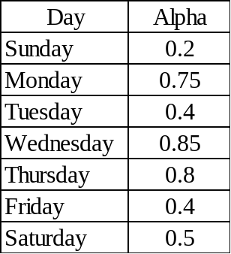

These alpha values are plugged into the model using the following formulation:
F_{t+1} = D_{t} + ( 1 - ) F_{t}
This model forecasts the admissions/discharges one week in advance of the actual data collected for the model. After the one week, historical data is used to predict the workload from admissions and discharges based on an average by day. This means that all Sundays in the data set are averaged together to come up with the appropriate number. This contributes to the deviation found in the model from the actual number of nurses needed. Once these are forecasted, they are plugged back into the model and the workload by day is adjusted accordingly.

Section 4.2.3 Seasonality
A simple seasonality approach was taken to adjust the model to match the patient census. After analyzing seven years of data, it was obvious that there are more patients during the Winter months than were in the hospital during the Summer months. Fall and Spring show similar results. Graphs from this analysis are below:
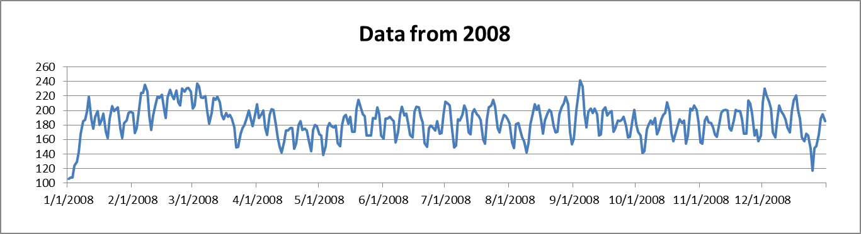
Figure 7: Number of Beds Filled by Day – 2008

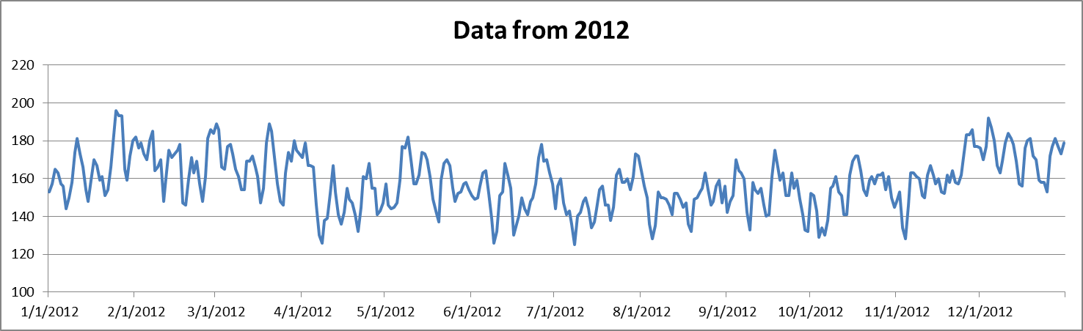
Figure 8: Number of Beds Filled by Day - 2012

This data shows a similar pattern from day to day in both years despite the volume difference. The winter months from December to April are slightly increased from the months in the Summer and Fall. Therefore, there should be a seasonality adjustment for the hospital to accurately predict these changes.
The methodology used for this change is as follows:
- Formulas are set up to calculate dates in the following ranges:
  - Nov – April
  - February to March
  - January
  - October
  - November
  - April
If the date falls within any of these time frames the number one is reflected in that column.
- The sum of the numbers in the corresponding columns is totaled in the next column for each day.
- The total column as well as a factor for each of the a-f columns above is then used to adjust the data to reflect the seasonality change for the hospital census. These factors were determined by the average error in that month after other adjustments were made.
- Once each factor is evaluated, the predicted value is seasonally adjusted based on the information collected.
This is very important in creating accuracy in the model when forecasting passed one month of data. Without these adjustments, recognized trends would not be accounted for and therefore the data would be inaccurate.

Section 4.4 The Model
Much of the information included in the methodology up to this point has reflected how different portions of this predictive modeling tool are built. In this section, the model will come together and how it works and ways it can be used will be illustrated. The work instruction for use of the model can be found in Appendix A.

Section 4.4.1 Model Interface
The model interface for this tool is setup to accommodate the desires of HA administration. The interface is simple with few adjustable inputs to avoid misuse of the tool. The graphs and tables provided were those requested by the personnel who would be hands on with the tool to help plan for the future. Each part is discussed in the following sections.

Section 4.4.1.1 Input Data
Inputting data into the model is a very important step. The more data the model has to use for calculations, the more accurate the model will be in the future. The “Data Input” button on the right side of the model interface allows for easy, daily data entry. When the button is pushed, the following form will appear:
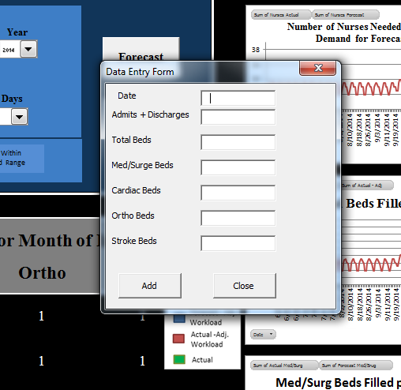
Figure 9: Data Entry Form

It is important to input each data point into this form before pushing “Add”. This form will then formulate the model accordingly and the information will be updated once the Forecast button is pressed. Directions for inputting data are further explained in the Work Instruction for this model. Data should only be entered a day at a time using this form. The model’s administrator will have the ability to enter large quantities of data at once if the need arises.

Section 4.4.1.2 Forecasting
The interface for this model (shown at the end of this section) allows users to input a forecasting period (length of forecast), a forecasting start date, and a month of interest which is a month that more specific information will be provided from the model. The interface also allows for data input by day.
After the start date, forecasting period, and month of interest are entered, the “Forecast” button should be pushed. This will update all graphs and tables to match the time frame of interest. Each time new data is entered into the model, the model should be re-forecasted because numbers could change slightly. Figure 14 shows the interface of the model.
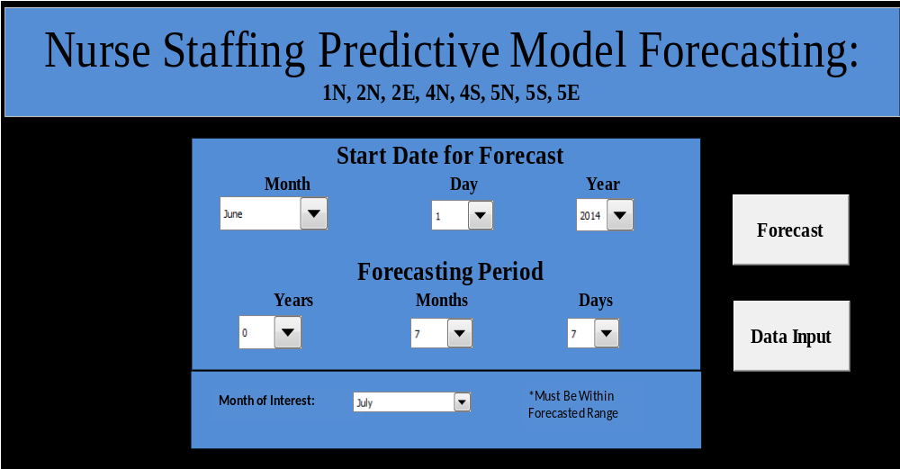
Figure 10: Model Interface

Section 4.4.1.3 Provided Data
Once the desired data is entered and the forecasting time frame has been set, several pieces of information will be provided from the model. First, the number of nurses by day of week for month of interest is displayed: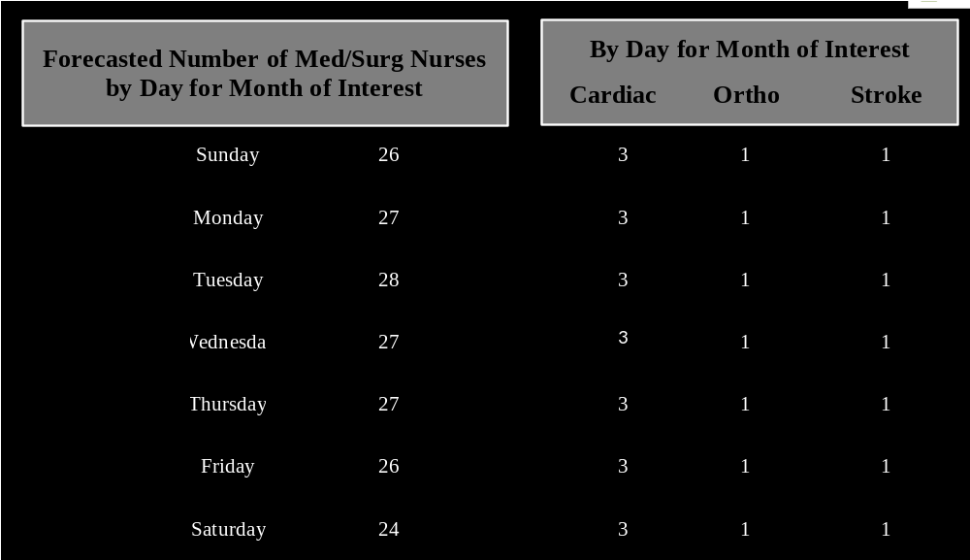
Figure 11: Nurses by Day from Dashboard

Next, graphs of the number of nurses, total beds filled, and specifically the number of Med/Surg beds filled is shown to the right of the model interface. This information is important to notice changing trends that could occur with new data entry. Noticing these trends could help to avoid overstaffing or understaffing in certain situations.
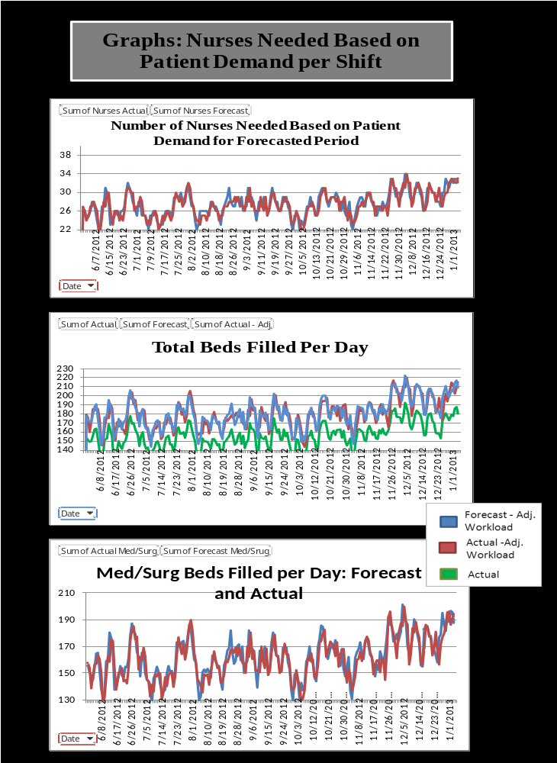
Figure 12: Dashboard Graphs

The other data that is updated and provided when forecasts are updated is shown below:
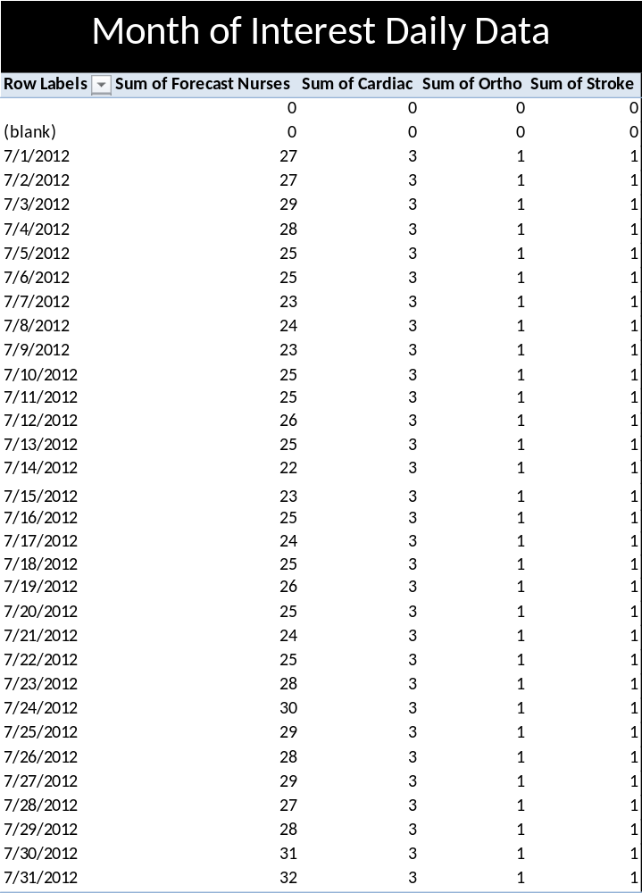
Figure 13: Pivot Table of Month of Interest Daily Data

This is very similar to what is shown in Figure 15 above, but Figure 18 breaks the month down by date. This shows exactly how many nurses are estimated to be needed on a specific day during the month of interest.
The information provided from the dashboard is chosen based on hospital preference. Each of these items were requested by hospital administration and added for purposes of use at Hospital A. There is no limit to the amount of metrics that could be used for a hospital to make the most use out of the tool. Metrics such as Average Length of Stay, Nurses Hours Worked by Day, Admissions and Discharges by Day, etc. are all ideas for different display options.

Section 4.4.2 Model Uses
Since the model provides valuable information about nurses needed based on patient demand, it can be used for multiple tasks. These tasks include using the information to make hiring decisions based on nurse turnover rates, scheduling nurses to work specified shifts, increasing nurse satisfaction by taking nurse workload into account, staggering shifts to decrease hours worked per day, and decreasing overall costs for nursing, etc. The model itself does not perform all of these tasks, but the output from the model makes it possible to move forward with these improvements. An area of further research could be to incorporate these things into the model. This will be discussed further in Chapter 7.
Using this model for scheduling shifts will be explained in more detail in the following section. Another use that Hospital A has for the model is illustrated below as an output from their hiring system:
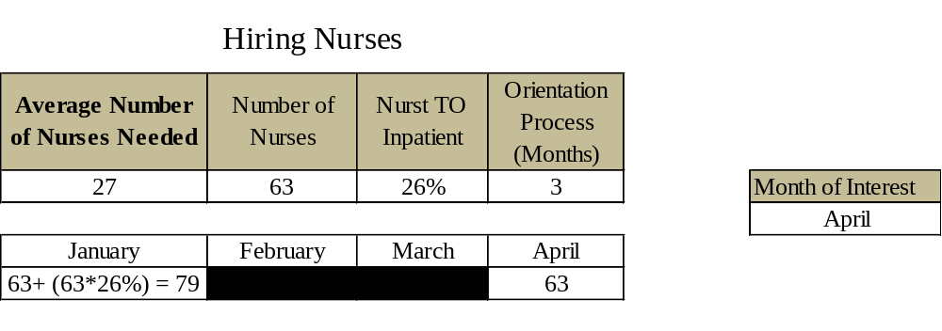
Figure 14: Output from Nurse Hiring Tool at Hospital A

As is shown in the above figure, if orientation is a 3 month process and the Nurse Turnover ratio is 26%, the hospital will need to have 79 nurses in January (with 16 of them starting orientation) in order to have the 63 required to work by April. April would need to have some additional nurses starting orientation in order to have the necessary nurses in July. This is a pattern that can be followed to help the Nurse Staffing Department make hiring decisions for their inpatient units. The data from the model is necessary to know about how many nurses are needed in April. The box in bold in the above figure, will be more accurate with use of the forecasting tool.
Another use for the model mentioned is to increase nurse satisfaction. Staffing based on the numbers generated from the model will accelerate the process for improving this issue in hospitals. As previously discussed, this model takes into consideration extra work from admissions and discharges as well as time to do medication passes based on difficulty. Compared to historical staffing levels, this methodology will increase (only slightly) the number of nurses on the inpatient units by day which will allow them to feel less responsibility and less overworked. To accommodate the additional employees, Section 4.5 Scheduling will discuss a scheduling tool that can be used to align the employees with the patient demanded work load.

Section 4.4.3 Model Supplement – Short-Term Forecasting in AnyLogic
The many uses of the model have been discussed in previous sections. A supplement to the model is an AnyLogic model that can be easily updated with real time information. This will allow for best results of the following day to be calculated quickly to make schedule adjustment decisions. This model operates with the same parameters as the Excel model, but the changes to it can be made more quickly and efficiently allowing nurse staffing to make more accurate short term decisions. The parameters that can be varied are the percentage of patients in each patient type (easy, medium, difficult med passes), the amount of time for each type of med pass, and the amount of time for admissions and discharges. It is important for hospital administration to be able to vary these parameters because there is very little consistency in hospital processes that lead to system wide changes. This tool will allow the necessary time for the model administrator to make accurate updates while providing nurse staffing data to the hospital.
The model is set up to take into consideration a thirty minute lunch break for each nurse and the amount of time it will take to care for each patient. The model has six patient types: easy medication pass with an admission or discharge, medium medication pass with an admission or discharge, difficult medication pass with admission or discharge, easy medication pass that stays in the hospital all day, medium medication pass that stays in the hospital all day, difficult medication pass that stays in the hospital all day. Each model area is shown in Appendix B.
Once the model runs, the total time to care for patients will be calculated and the number of nurses need can then be decided. Below, is an example of the output provided from this model. The average time to care for each patient type is calculated; then, the total number of nurses necessary can be calculated using this information.
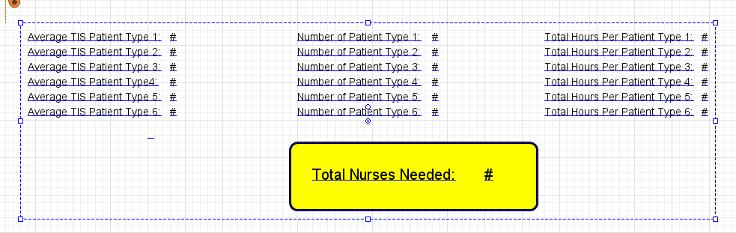
Figure 15: Output from AnyLogic Nurse Staffing Tool

This information can be seen in the AnyLogic tool by going to the Nurses Needed view.
The figure below shows the parameter variation portion of this model. This allows for multiple scenarios to be run providing a more accurate estimate of what will happen the following day can be found; therefore, a more accurate staffing methodology can be implemented. In the model, the time it takes to do easy, medium, and difficult medication passes as well as the time to do an admission or discharge are varied based on the triangular distributions collected in the data collection phase. The mean can be found in the upper right hand corner which will likely be the most accurate staffing number for the current conditions at the hospital. This number can also be found on the graph, where the red line falls. The graph at the bottom of the window shows the multiple runs and iterations that were done and the results of these. This is important because the range of results is noticeable. Nurse staffing employees working with this model can see that the appropriate number of nurses could be slightly different from the average.
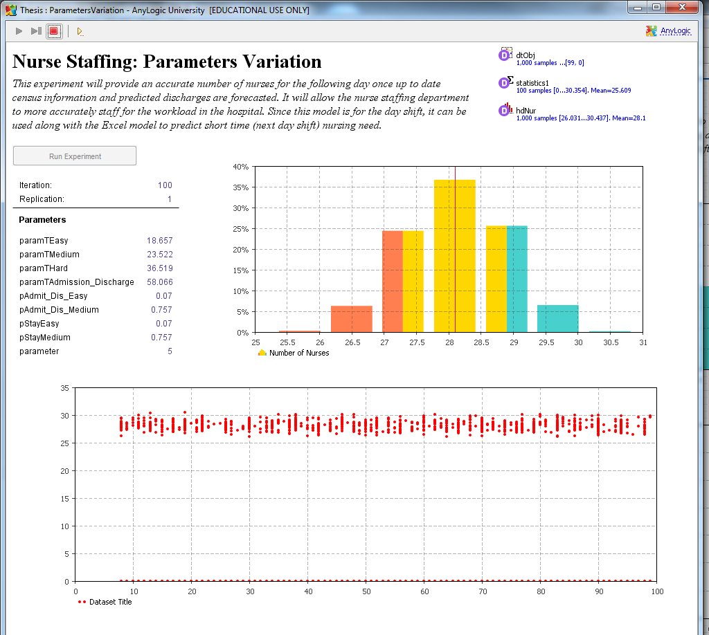
Figure 16: Parameters Variation Window - Nurse Staffing Model

With this information, the nurse staffing office can make an educated decision on the number of nurses needed for the following day shift.

Section 4.5 Scheduling
Several additional tools could stem from the creation of this base model for use in a hospital (explained further in Chapter 6 Further Research). The scheduling tool is one option that is found useful in hospitals. With the combination of the two tools, there can be increased patient satisfaction, increased nurse satisfaction, and decreased cost for staffing nurses.

Section 4.5.1 The Tool – Excel
The Excel portion of the tool is important. It provides the graphical view of the current situation to inform the interested parties of the problems to be analyzed. Figure 20 below shows the input items necessary (shaded in yellow) to obtain the graphical data output. These inputs are: time to do an easy med pass, time do a medium med pass, time to do a difficult med pass, the percentage of patients that are easy medication passes, the percentage of patients that are medium medication passes, the percentage of patients that are difficult medication passes, time to do an admission or discharge, admissions by hour, discharges by hour, nurses by hour, percentage of patient receiving medication by hour, and the number of patients. From this output, it is obvious that the shaded purple area which represents available nursing hours is inadequate in some areas (where it goes below the 0 line) and over done in others (where there are large chunks of purple with no obvious tasks for nurses to complete).
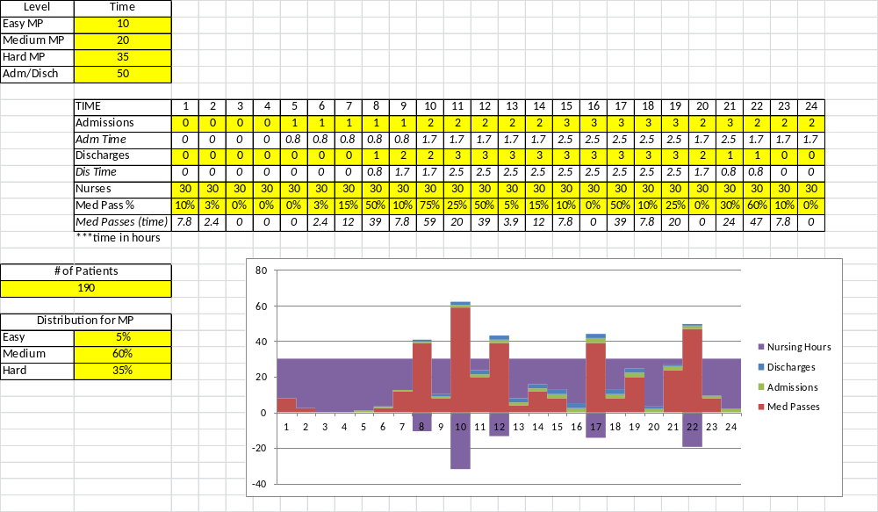
Figure 17: Excel Scheduling Tool

From this tool, an analysis of nursing shifts can be done. Below in Figure 22 and Figure 23, graphs of the data provided and an alternative nurse scheduling strategy are shown.
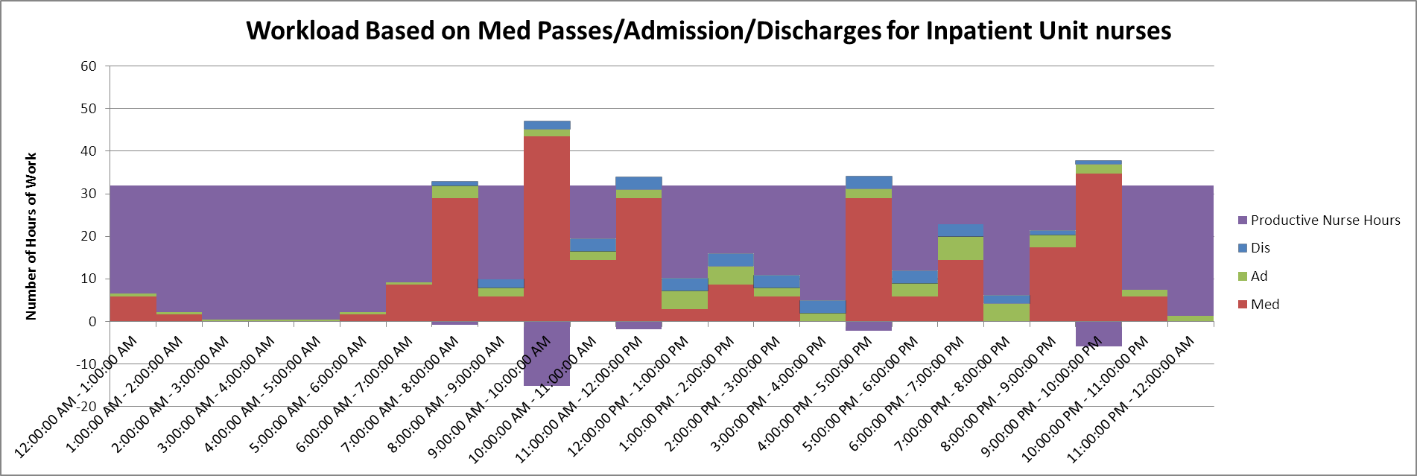
Figure 18: Workload Analysis from Excel Scheduling Tool

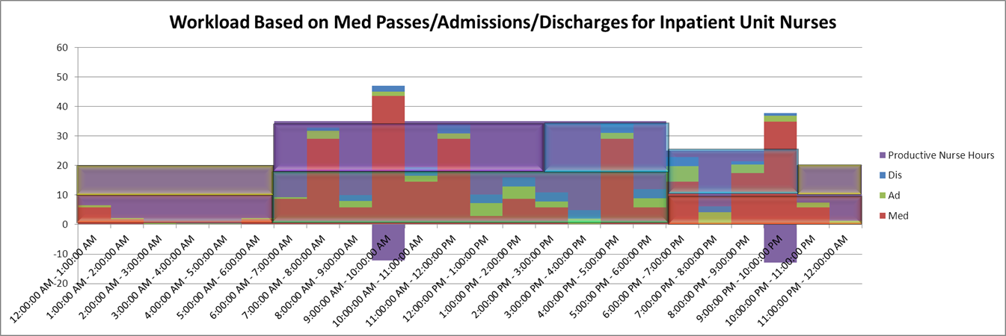
Figure 19: Shift Analysis Based on Excel Tool

The alternative strategy decreases the number of times workload exceeds available nurses and also decreases the number of worked hours. This solution was done by simply eyeballing the information and changing nursing shifts accordingly. It would save the hospital 88 nursing hours in a 24 hour period. The AnyLogic portion of this scheduling tool will provide optimized results based on inputs provided.

Section 4.5.2 The Tool – AnyLogic
Similar to the AnyLogic tool used for nurse scheduling, this AnyLogic model will provide similar information, but will optimize the results and provide information for when nurses are needed and when they are not. In this model, the work hours per time are entered into the source schedule. This means that the total hours calculated by hour in the Excel model can be copied and pasted into the AnyLogic source schedule for it to work properly. Below is a screen shot of the Scheduling model that has been run for the entire day. Since the hours of work per time are being introduced into the model at the source, it is assumed that for every hour in the system, one nurse is needed.
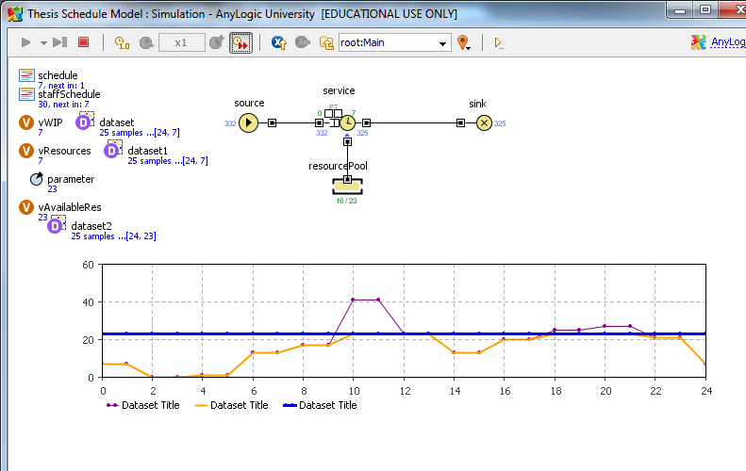
Figure 20: Screenshot of Nurse Scheduling Model

The graph shows three pieces of data. The first is the number of hours that need to be addressed. This is shown by the purple line. The second is the number of available nurses which is shown by the blue line. The third is the number of resources being used which is shown by the orange line. This graph highlights the areas where there is more work than nurses available and also shows when there are more nurses than work to complete. The nurses schedule can be changed to fit the line by entering the times a specific number of nurses will work to match the above diagram. When this is done, the model can be run again to see how well the new model fits the patient demand. For this model, an assumption used for this tool is that this represents100% of a day shift including lunches.
As part of this model, an optimization tool is used. In this tool the number of nurses is the varied parameter. The number of nurses to minimize down time and maximize meeting patient demand is calculated.
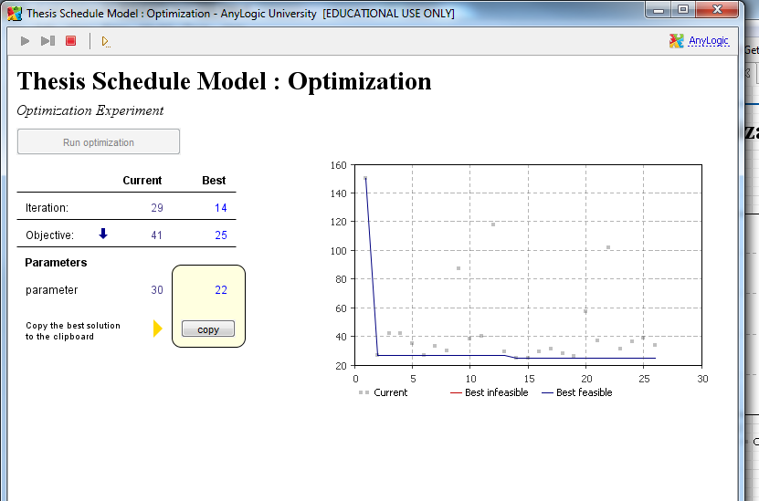
Figure 21: Scheduling Optimization Tool Output

The optimal solution is provided in the yellow box, but the gray dots on the graph show potential numbers in the experiment. When looking at this experiment a few nurses could be added as a cushion factor. This is based on having a specified number of nurses at any given time.
This tool provides the nurse staffing employees a way to quickly verify the areas where scheduling adjustments could be made. It is also easy to vary the nurse schedules in this tool to create a better understanding of how it would affect patient demand. Using this tool and the Excel portion described previously could add important insight into nurse staffing.

Chapter 5 Hospital Implementation
This section discusses an example process explaining how the predictive modeling tool and the scheduling tools could be implemented into a Hospital using examples from the implementation process at Hospital A. A process flow diagram of the implementation steps at Hospital A is provided below:
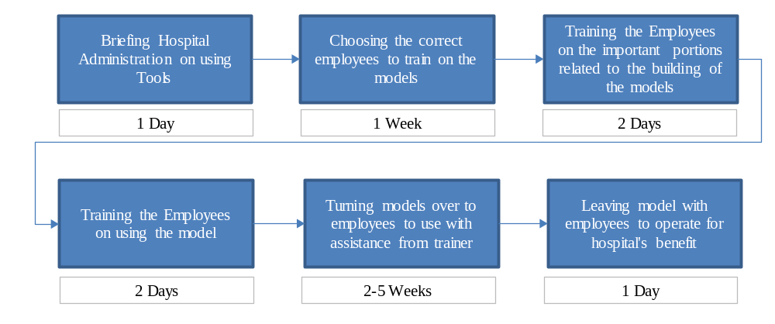
Figure 22: High Level Process Flow Diagram of Implemenation Steps at Hospital A

Section 5.1 People
Implementation of these processes at Hospital A took the support and training of several individuals. The administrators at Hospital A including the CNO, CFO, CMO, and CEO had to discuss the benefits and risks of implementing a new system. Once agreed upon, the Nurse Staffing Department became involved in the decision making process. At this point, a representative from the Nurse Staffing Department, a Management Engineer and a few chosen nurses became involved in the use of the tool. Once the tool was explained and each individual was trained on the use of the Excel portions and the AnyLogic tools, the team took charge. The people involved in this implementation will vary from hospital to hospital depending on the variation of the tool implemented. Having an understanding of who is affected by the tool and who can have the biggest effect on the tool is very important in determining who to train for use.
There should be one primary administrator who understands how the tool works (calculations, relations, etc.) and have full access to make changes within the tool. A backup for this administrator would be helpful if something needs to be done when he/she is out of the office. It is important to have people (nurses, engineers, etc.) with a complete understanding of the models. This will allow staff to collect and update base data used in the model increasing accuracy in the system. The more data collected from people who understand the model, the more accurate the output. Those using the data from the model should have basic knowledge of how it works to better understand the output provided to the management team. Finally, hospital administration should have a working knowledge of the system in order to accurately incorporate it into future improvement plans.

Section 5.2 Using the Data
While implementation of the models into the hospital processes is very important, if the data produced from them is not used effectively the implementation does not matter. Below are brief explanations of how using the models and data in the short term and long term will make a difference for the hospital’s plan for the future

Section 5.2.1 Short-Term
In the short term, the AnyLogic models can be used to gain an understanding of current staffing levels for nurses and what required levels should be in the following days. It is important for the people using the output to understand the models and the system by which the model is built. If the AnyLogic model shows that the hospital is overstaffed from 12am to 7am, but there are extenuating circumstances (i.e. paperwork, etc.) as to why extra nurses may be needed during this time; therefore, this should be considered when making the decisions.
The short term tools can be useful for the hospital when used in the appropriate capacity and at the appropriate times. This will be model specific as different variations will be used for different purposes. For the model described in this paper, the short term tool could be used the evening before around 9 pm to verify the Excel models predictions. Since the Excel model is based off 86.2% of a workday and adjusted to fit 100% of a 7am – 7pm shift, the numbers could be compared for validity. Another way the short term scheduling tool could be used the previous evening would be to push a nurses start time back an hour or pull it forward to meet patient demand forecasts. This could be a last minute adjustment made to improve patient satisfaction.

Section 5.2.2 Long-Term
Long-term, it is important for the people assessing the data from the Excel models to understand the system from which the models were built. While it is impossible to know that in three months there will be x number of people staying at Hospital A, the models do provide a representation of what the census will likely be. If the census trends change creating a new pattern, someone must identify the changes to be implemented in the system. It is imperative that multiple nurses understand required data inputs to the model. When changes are identified, they can be provided to the model administrator for updates. Understanding the basis of the calculations will help nurses identify hospital census and workload trends. If multiple people are involved, there is a better chance that changes will be noticed and incorporated for long-term planning. Too many people looking for change will cause the model to change too often. A balance between too many and not enough should be found to be able to notice the big changes in hospital trends.
An additional use for the long term data is estimating the total number of nurses to be hired now to start orientation and be prepared in 3 months (or the length of the orientation cycle) for work on the inpatient floors. When a hospital has a lead time after hiring nurses for them to begin working, it confuses the hiring process. For example, if ABC Hospital needs 5 nurses to be staffed according to patient demand and there is no lead time for the nurses to begin work; then, they can hire 5 nurses and meet patient demand. In the case of Hospital A, they have a 3 month lead time for the nurses after hiring. Using the data output from the Excel model, administration can more easily predict how many nurses to hire and when by utilizing baseline estimate workload forecasting three months into the future.

Chapter 6 Conclusions
Nurse Staffing in U.S. hospitals is becoming increasingly more important with the introduction of the Affordable Care Act (ACA). Nurse staffing affects the quality of care provided by the hospital as well as the patient satisfaction with their stay in the hospital. Both play important roles in insurance reimbursement plans under the new ACA. Finding ways to utilize resources in a way that will alleviate negative effects from these changes is at the forefront for hospital administrators.
Using predictive modeling techniques to help prepare for patient demand shifts and avoid negative patient satisfaction scores is one very important route a hospital can take. There are many ways to use predictive modeling and other mathematical approaches to forecast the number of nurses required. With the combination of Excel and AnyLogic tools as well as predictive modeling and optimization, the information in this paper provides hospital administrators with important planning methodologies.
This combination provides a dynamic approach for planning near term (based on real-time data) and long term (based on historical and real time data) for nurse staffing levels. Management can use “What-If” analysis by changing tool parameters to see the effects of different scenarios on their nurse staffing levels. This will provide a basis for decision making and reasons for hiring additional staff to prepare for upcoming census surges. On the other hand, when nurses leave and the predicted census is decreasing, there will be no reason to hire back every position.
In summary, the tools will allow appropriate staffing levels to be kept depending on time of year and nurse turnover. Several benefits will be recognized: it will help decrease nursing costs because additional nurses will no longer be hired if the nursing staff is sufficient to meet patient demand, administration will be able to hire nurses in advance so that they will have time to complete their 3 months (length of time orientation lasts at HA) of orientation making them better prepared to take on patients, doctors at the hospital will have sufficient support from nursing staff which will improve the hospitals’ reputation and make the hospital more likely to recruit top doctors, and patients will be satisfied with their nursing care because nurses will be less overwhelmed and have more time to spend with patients each day.
The dashboards provided in the models are customizable and easy to change to meet hospital needs. Without understanding the needs of the hospital or healthcare facility (step 1), it will be difficult to provide a product that is useful. This paper provides one way to use important hospital data to increase staffing efficacy and meet the needs of administrators. There are several ways explained in the following section that could change and improve this methodology with further research.

Chapter 7 Further Research
There are multiple directions that continued research from this particular project could continue. Since the dashboard is built for a specified hospital’s request, continued research could alter this dashboard based on what a majority of hospitals would like to see in order to create a system that would be readily available for use. This research would need to use further data collection as well as additional surveys to Nurse Staffing Departments at different hospital locations. Alterations to the programming of the dashboard would be necessary once the variables were chosen to meet the demand of the Nurse Staffing Departments.
The scheduling tool (which was not part of the original project) has the potential for much more research and development. The provided Excel and AnyLogic programs are simplified to meet the needs of Hospital A. This could be a vital tool for hospitals, to consider. At Hospital A, this tool was made simple because three main categories (Admissions, Discharges, and Medication Passes) combined to take 86.2% of a nurses work day. Since this is far more than the majority of the work day, those are the activities included. There is little basis to show why the 86.2% is enough for the model other than agreement from the CMO and CNO at Hospital A. The additional 13.8% of the workday is added into the model as an adjustment factor which could play a small role in the models variability. Further research on the percentage of the workday to be considered a majority (at most hospitals) and the tasks nurses do to take up that time, would be essential pieces of information to improve the tool to accommodate the needs of multiple hospitals. Creating an interface that would allow for either of these things to be changed easily to fit hospital preference would be even more beneficial. Currently the scheduling tool, there is no way to optimize the nurse schedules using Excel rather than an eyeball estimation. Creating an interface in Excel would make the tool more useful in the healthcare industry because most hospitals have access to the Microsoft software. Additionally, a more efficient version where the two interfaces (Nurse Staffing and Scheduling) work together would increase the use of the tools in order to verify the importance of each.
Alternative research could be used for more specific information the tool could provide to hospital administration. Using real time data from the hospital data system could help to increase the accuracy of the tool and provide further knowledge to the Nurse Staffing Department. The connection to the real time data system used at the hospital would have to be integrated into the Excel dashboard where data would be imported at certain intervals. At the current time of this project at Hospital A, this could not be done without extensive programming knowledge. This tool could be very useful to hospitals in making decisions both within the day and in a three month time period.
Additional areas of research extending from this paper include: obtaining a better understanding of how this information could be used to assign nurses to particular rooms, understanding more of the dynamics of what makes a patient difficult to care for and how those can be forecasted, integrating information that would show how many nurses to hire now to prepare for the future based on nurse turnover rates into the model, incorporating the 7pm – 7am shift into the predictive modeling tool, changing the predictive modeling tools that shifts can be chosen base on the scheduling tools, etc.

List of References

Admin. (2010). Nursing Management: Team vs. Primary.
Bagg, H. M. (1987). NUrse Staffing: Accurate INformation at the COrrect PLace and Time. Computers Industrial Engineering, 13(1-4), 175-179.
Barjis, J. (2011, Jan 2011). Heatlhcare Simulation and Its Potential Areas and Future Trends. SCS M&S Magazine, 2-4.
Chang-Chun Tsai, C.-J. L. (2010). Optimization of Nurse Scheduling Problem with a Two-Stage Mathematical Programming Model. Asia Pacific Management Review, 14(4), 503-516.
Dimitris Paraskevopoulos, E. K., and Berc Rustem. (1991). Robust Capacity Planning under Uncertainty. Management Science, 37(7), 787-800.
Fetter, R. F. (1961). A Linear Programming Model for Long Range Capacity Planning. Management Science, 7(4), 372-378.
Franci de Vericourt, O. B. J. (2011). Nurse Staffing in Medical Units: A Queueing Perspective. Operations Research, 59(6), 1320-1331.
HJ.P. Oddoye, M. A. Y., M. Tamiz, D.F Jones and P. Schmidt. (2007). A Multi-Objective Modelt to Determine Efficient Resource Levels in a Medical Assessment Unit. The Journal of Operational Research Society, 58(12), 1563-1573.
Hospital Value-Based Purchasing Program. (2013). http://www.cms.gov/Outreach-and-Education/Medicare-Learning-Network- MLN/MLNProducts/downloads/Hospital _VBPurchasing_Fact_Sheet_ICN907664.pdf
Javad Taheri, Z. G., Dariele Burchfield, Kevin Cooper. (2012). A Simulation Study to Reduce Nurse Overtime and Improve Patient Flow Time at a Hospital Endoscopy Unit. Paper presented at the Winter Simulation Conference.
McHugh, M. L. (1989). Computer Simulation as a Method for Selecting Nurse Staffing Levels in Hospitals. Paper presented at the Winter Simulation Conference.
Natalia Yakovic, L. V. G. (2011). Identifying Good Nursing Levels: A Queuing Approach. Operations Research, 59(4), 942-955.
Warner, D. M. (1976). Schdeuling NUrsing Personnel According to Nursing Preference: A Mathematical Programming Approach. Operations Research, 24(5), 842-856.
William J. Abernathy, N. B., John C. Hershey, and Sten Wandel. (1973). A Three-Stage Manpower Planning and Scheduling Model - A service Sector Example. Operations Research, 21(3), 693-711.

Appendix

Work Instruction
Work Instruction for Staffing Dashboard

Inputting Data

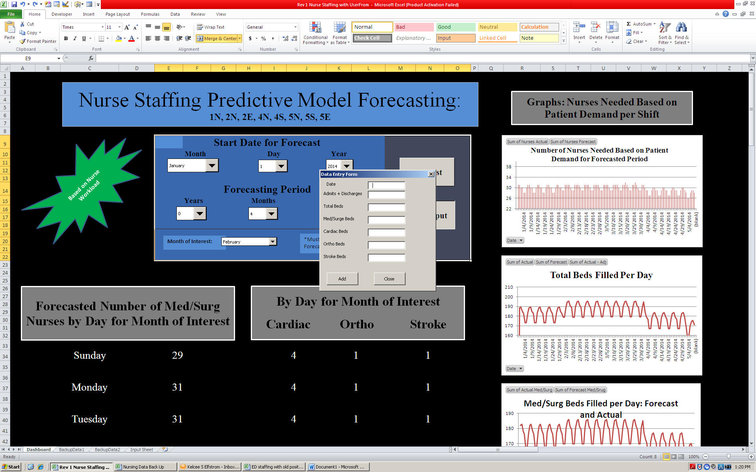
- When the Dashboard is open, push “Data Input” button. A form will pop up with blank fields to input needed data.
- The date must be put in the form in the following way:
- If the month is a single digit, type in a single digit month. (i.e. 1/1/2012)
- If the month is a two digit month, type in both digits. (i.e. 10/1/2012)
- If the day is a single digit day, type in the single digit. (i.e. 1/1/2012)
- If the day is a double digit day, type in two digits. (i.e. 1/14/2012)
- The year must always have 4 digits. (i.e. 1/14/2012)
If the date is typed in incorrectly, an error will show up. The data will not be imported into the file in this case and must be re-entered again.
- Each data field should be filled before pressing “Add”.
- Once the data is in the form and confirmed correct, push “Add”. The data will then be part of the model.
- Press “Close” once the form has emptied to get back to the model.
- If the data is entered with an error, please call Brian Canfield or Thomas Florian to correct the data input.
Please remember, each time data is entered the forecast button must be pressed in order to update the data output.

Using the Dashboard
FORECAST BUTTON
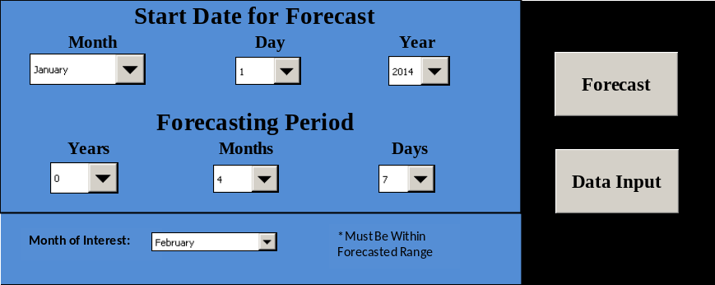
Step Three
Step Two
Step One
- Choose a date to start the forecasting period you wish to see.
For example: If the forecasting period you wish to see is January 2015, the start date would be January 1, 2015.
- Choose a length for the forecast. This can be based on number of days weeks or months.
For example: If the forecasting period you wish to see is January 2015, choose either 1 month or 31 days.
- Once the data is updated choose the “Month of Interest”. This month must be included in the time period within the length of forecast.
For example: If the forecasting start date is January 1, 2015 and the forecasting period is 3 months then the month of interest can either be January, February, or March. No other months of interest would be appropriate for these dates.
- Once all fields are filled in, press the “Forecast” button. All information will update accordingly with data filled in to the most recent entries.
- If a screen pops up with a message, push “Yes” and the updates will complete.

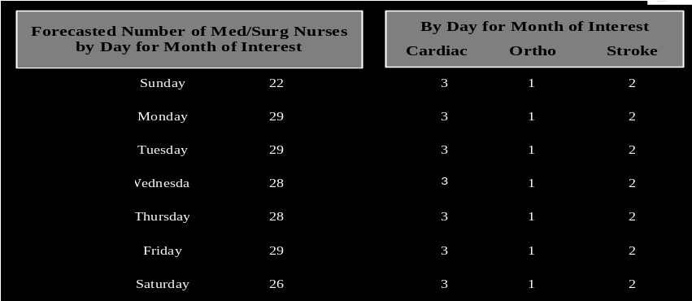
- Above is a picture of the data listed below the Dashboard area. This information provides averages by day for the Med/Surg units as well as Stroke, Cardiac, and Ortho trained nurses needed by day.
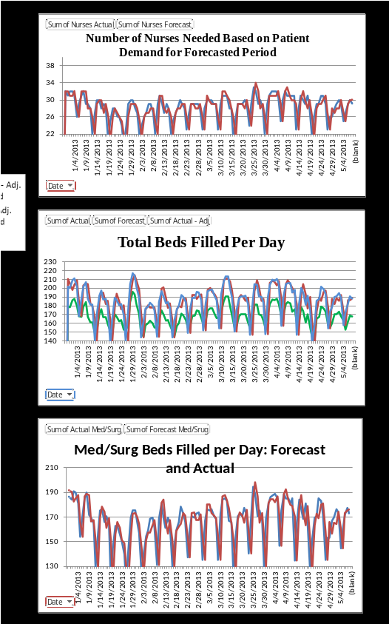
- To the right of this information are three graphs providing more specific data. These graphs will show trends that could occur based on data that has been input into the system. These graphs are shown at right.

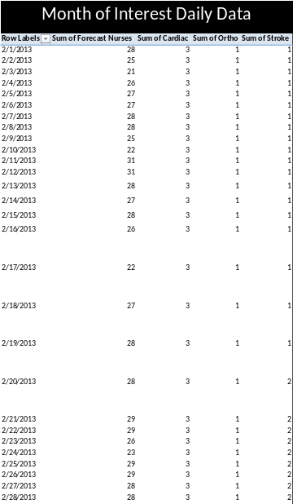
- Under the average data section is a pivot table that will provide specific numbers for the “Month of Interest” by day for each patient category. These could differ slightly from the averages based on historical information.

If there are any questions about the operations of this system, please contact the program administrator for assistance.

Nurse Scheduling AnyLogic Tool Model Overview
Below is an image of the whole Nurse Scheduling model in AnyLogic. This shows how each patient type is separated. The top portion represents those patients who are either admitted or discharged from the hospital in a given day. The bottom portion represents the work required for those patient who stay in the hospital for the entire day.
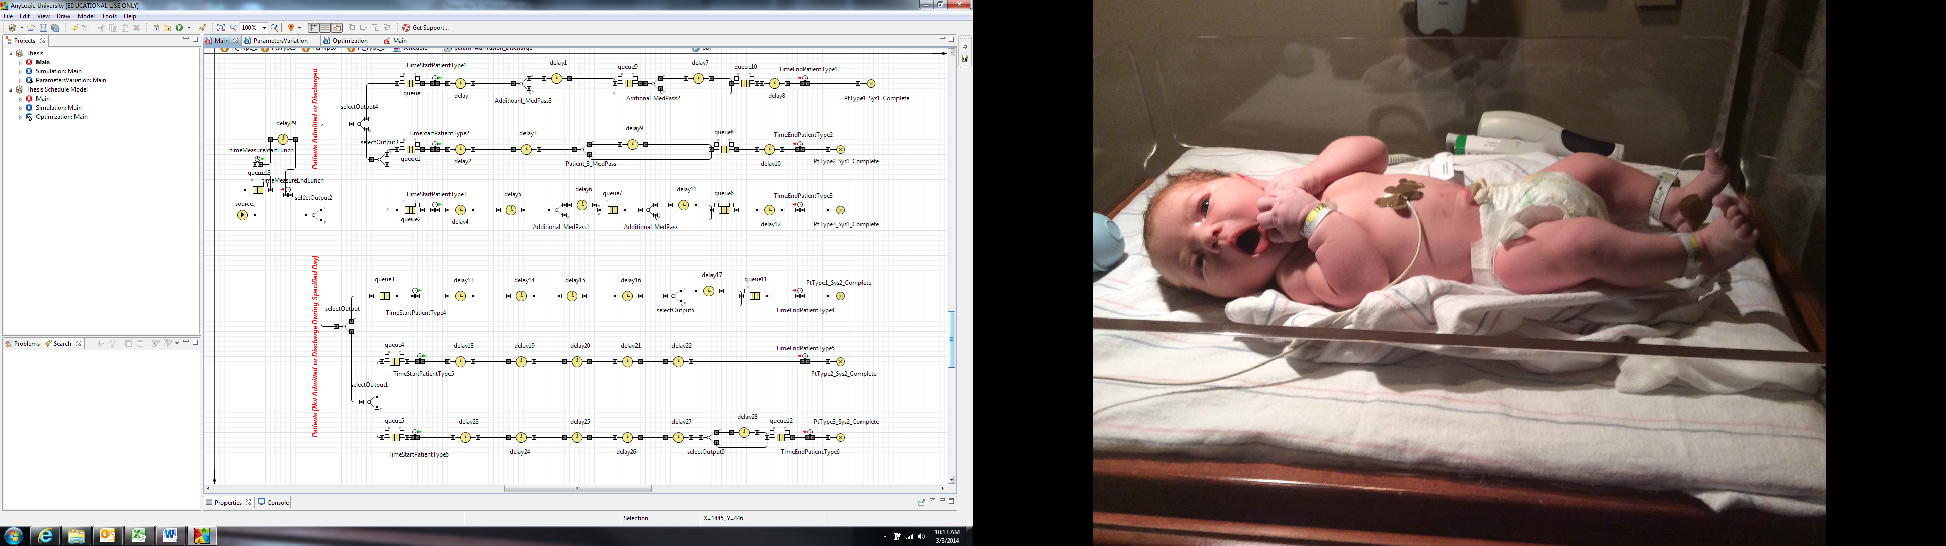
Next, the beginning of the model is shown in more detail. This is where the patients enter the system and go through delay29 which represents nurses’ lunch breaks. This time is added to the total time to calculate the number of nurses needed.
The following diagrams represent each patient type and the work accompanied with each. The delays represent medication passes.
Easy Medication Pass, Admission, Discharge:
In this diagram, dealy8 represents an admission or discharge.
Medium Medication Pass, Admission, Discharge:
In this diagram, dealy10 represents an admission or discharge.

Difficult Medication Pass, Admission, Discharge:
In this diagram, dealy12 represents an admission or discharge.
Easy Medication Pass, stays in hospital
Medium Medication Pass, stays in hospital
Difficult Medication Pass, stays in hospital
Each patient type has a start time and end time in the system. These calculate the amount of time it takes a nurse to care for one patient throughout the day regarding medication passes (and admissions/discharges if applicable). As explained in the AnyLogic Nurse Staffing section of this paper, the is a formula to calculate total nurses needed from this information. The formula is as follows:
$\left[Total Time for Patient Type 1+Total Time for Patient Type 2+Total Time for Patient Type 3+Total Time for Patient Type 4+Total Time for Patient Type 5+Total Time for Patient Type 6+Total Time for Nurse Lunch Breaks\right]$ ÷ 60 ÷ 12 + 3
This will add the total time calculated for patients going through the system and divide those minutes into hours then into 12 hour shifts The additional three nurses are added because the processes accounted for in this model only add up to 85% of nurse work during the day. The three is used as a buffer for this. This number is subject to change based on hospital administration preference.

Vita
Kelcee Ramsey Elfstrom was born in Oak Ridge, TN to the parents of Dale and Linda Ramsey. She has an older brother, Tyson Ramsey. She attended Woodland Elementary School, Jefferson Middle School, and Oak Ridge High School. After graduating, Kelcee enrolled at the University of Tennessee, Knoxville, to study Industrial Engineering. She obtained her Bachelors of Science in May 2012 in Industrial Engineering from UT. The following semester she enrolled in the dual MBA/MS Industrial Engineering program at the University of Tennessee, Knoxville. She took a graduate assistantship position at Y-12 National Security Complex and held two internship positions. One of the internships was in the summer of 2013 at East Tennessee Children’s Hospital. The other position spanned the summer of 2013 to December 2013 at Blount Memorial Hospital. At the beginning of 2014, Kelcee accepted a job with Ascension Health as a Senior Analyst for the Operations Resource Group. Kelcee will graduate with her MBA and MS in Industrial Engineering in May 2014.

