Education & Crime: A Study in Student Perceptions of Culpability

A Thesis Presented for
the Masters of Arts in Sociology
Degree
The University of Tennessee, Knoxville

Larry Curtis Long
December 2011

Copyright © 2011 by Larry Curtis Long
All Rights Reserved
Abstract

Criminological research has long been concerned with how stereotypes of offender’s race and gender affect their perceived culpability. For this study, a sample of college students was surveyed by administering six vignettes written in the form of police blotters. The vignettes that were given depicted different crimes being committed by offenders with differing educational characteristics. Using this dataset, I explored whether or not an offender’s educational characteristics affect their perceived culpability. Although the data collected indicated that the suspected offenders were deemed culpable regardless of their educational characteristics, the research showed that some degree of sociopathy is assigned to offenders that are described as educated and suspected of both white collar and street crimes.

Table of Contents

Chapter 1 Introduction and General Information 1
Chapter 2 Literature Review 4
A History of Offender Sterotypes, Perceptions and Sentencing 4
Hypothese Formation. 11
Chapter 3 Methods and Procedures 14
Sample Formation and Respondent Charcteristics 14
Description of Treatments 17
Data 20
Methods 23
Chapter 4 Results and Discussion 26
Chapter 5 Discussions and Conclusions 35
List of References 39
Appendix 50
Vita 59

List of Tables

Table 1. Respondents Demographic Charcteristics 16
Table 2.1. Bivariate Regression of Crime-Robbery 27
Table 2.2. Bivariate Regression of Crime-Assault 28
Table 2.3. Bivariate Regression of Crime-Embezzlement 30
Table 2.4. OLS Regression with Variable Sociopath 32
Table 2.5. Regression of Demographic Charcteristics on Culpability 34

List of Figures

Figure 1. Crime Reaction Study 19

Chapter I

Introduction

Criminological literature concerning the relationship between crime and education has primarily focused on how education can cause or prevent delinquent or criminal behavior (e.g. Gottfredson, 2002; Liazos, 1978; Cohen, 1955). Within this discussion there is an interest in understanding criminal justice and how we arrive at decisions of guilt and innocence (Kelley, 1977; Slaney & Brown, 1983; Luzzo, 1993; Swanson & Tokar, 1991; Russel & Rush, 1987). In order to understand the complexity of criminal justice decisions, criminologists have to consider what extralegal factors affect these decisions.
Justice decisions are made through a process that is aimed at determining whether or not the suspected offender is culpable. Research has stated that culpability is attributed to a suspected offender when they have committed an act that shows insufficient concern for how their actions will affect the rest of society (Simmons, 1993; Alexander, 2000). In these cases, the suspected offenders who impose risk on others without just reasoning are often ostracized for being callous or indifferent (Alexander, 2000).
Extralegal factors often play a role in ascribing whether or not a suspected offender is deemed as culpable. Researchers have found that extralegal factors often affect the decisions of police officers, parole boards, judges and jurors (e.g. Schlesinger, 2005; Peterson, Krivo and Hagan, 2006; Warr, 1980; Hurwitz & Peffley, 1997; May, 1999; Maruna, Matravers and King, 2004). Of these extralegal factors, race and gender are shown to have the most significant effect on decisions of many police officers, parole board members, judges, and jurors in regards to the incarceration of suspected and convicted offenders (Warr, 1980; Hurwitz & Peffley, 1997; May, 1999; Maruna, Matravers and King, 2004). When you consider what has been found concerning the effects of race and gender on criminal justice decisions, it is reasonable to assume that other extralegal factors, such as the offender’s level of educational attainment, could also influence decisions of guilt or innocence.
Unfortunately, little research has been conducted on whether or not the educational attainment of suspected offenders has any effect on decisions regarding their culpability. That being said, the research that has been done does give some evidence to support the idea that highly educated suspects are perceived differently than less educated suspects (Hagan, Nagel-Bernstein, and Albonetti, 1980). This finding, along with those of research concerned with the effects of race and gender stereotypes (e.g. Flannigan & Longmire, 1997; Blumstien & Cohen, 1980; Cullen, Fisher & Applegate, 2000), provides the groundwork for an argument to be made for exploring all of the perceptions concerning suspected offenders.
The purpose of this study is to gain an understanding of how a suspected offender’s level of educational attainment affects their perceived culpability. Using a dataset collected by surveying the perceptions of a college aged population, I will seek to add to the current literature concerning stereotypes within the criminal justice system, by exploring the relationship between presumed educational attainment and culpability. The established connection between race, gender and culpability that has been presented by previous research (e.g. Flannigan & Longmire, 1997; Blumstien & Cohen, 1980; Cullen, Fisher & Applegate, 2000), will serve as a blueprint for how to measure the relationship between the educational characteristics of suspected offenders and their perceived culpability. In addition to exploring this relationship, I will also explore the other ascribed attributes that are used to assess culpability.
As stated previously, criminologists have given some consideration to the possible relationships between education and crime. This has resulted in a body of research that is concerned with understanding if education can insulate the individual from criminal action. Similarly, previous literature has explored popular public stereotypes about the characteristics of offenders and their influence on decisions made within the criminal justice system. What is absent from both of these analyses is a discussion of how the public’s perceptions of the educational characteristics of offenders could result in the attribution of yet another stereotype that affects the determination of a suspected offender’s culpability. The information obtained from this study is a step towards filling the gap that exists in previous literature and aids researchers as they attempt to figure out the complicated relationship between society, the offender, and the criminalization of the offender.

Chapter II

Literature Review

A History of Offender Stereotypes, Perceptions and Sentencing
Much research has been conducted on the relationship between crime and education, yet there is only a small body of literature that speaks directly to public opinions regarding the relationship between the educational characteristics of suspected offenders and their perceived culpability. Research on crime and education is mainly focused on the causal effects education have on delinquent and criminal behavior (Gottfredson, 2002; Liazos, 1978; Cohen, 1955). In this body of literature, very little has been said about what effects the educational characteristics of the suspected offender have on judicial outcomes.
Criminological literature concerned with the characteristics of suspected offenders is primarily focused on public stereotypes of race and gender. These studies have consistently noted that the perception of suspected offenders racial and gender characteristics have resulted in disparities in sentencing (Flannigan & Longmire, 1997; Blumstein & Cohen, 1980). Specifically, many studies have focused on the role of stereotypes in the formation of “get tough” policies, such as the three-strikes-and-you’re-out laws. These studies have consistently noted that many times these policies are portrayed as addressing public concern about the nature of certain offenses, but in their application these policies appear to be disproportionately applied to offenders of color (Cullen, Fisher & Applegate, 2000).
Also mentioned in this research is the idea that juries use race and ethnicity when determining the overall culpability of the offender (Ruby & Brigham, 1996). This research suggests that juries are more likely to convict and recommend harsh punishments for defendants that are a different race or ethnicity than their own (Ruby & Brigham, 1996). Other research on the relationship between gender and sentencing, found that male offenders are more likely to be subjected to harsh punishment, such as death (Blumstein & Cohen, 1980). By contrast, female offenders convicted of similar crimes were found to receive less harsh punishment than their male counterparts (Blumstein & Cohen, 1980).
Social constructionists have taken aim at the relationship between offender characteristics and judicial decisions by examining the role of politics in judicial policy formation (Percival, 2011). In this body of research, the concept of social constructionisim is often illustrated in the context of how political figures use group stereotypes for the purpose of advancing their own political agendas (2011). In this process, specific target groups are socially constructed in the political realm as having characteristics such as laziness, welfare-dependency, and delinquency (2011). These constructions are then used to portray the target group as being connected on a deeper level to specific social problems such as crime, unemployment, and health epidemics (2011). The political authorities are then given the task of deciding whether or not the socially constructed group will receive the burden or benefits of public policies (2011).
The premise that a social construction is based on the idea that a person’s interpretation of the situation can be manipulated by the media and their agents is the basis for this body of research (Percival, 2011). This idea gives some explanation as to why some social and criminal justice policies create benefits for some groups while punishing other groups. This point can best be illustrated by looking at the idea of socially “deviant groups.” Specifically, socially “deviant groups” (i.e. young black men) are seen as a threat and danger. As a result, they are portrayed as a group that should be punished through the process of policy formation (2011). For example, three-strikes-and-you’re-out policies prescribe sentencing minimums for “serial” offenders. Since black men are more likely to be arrested than white men, the policies disproportionately affect black men (Schneider and Ingram, 1993). Politicians and others involved in the design of public policy, justify these racially biased, harsher “get tough policies” by arguing that these policies are beneficial to society as a whole because they are aimed at discouraging deviant behavior (Schneider and Ingram, 1993; Beckett and Sasson, 2000).
The ideas presented in the social constructionist literature have lead to a discussion of how societal stereotypes affect suspected offenders. This discussion is focused on whether or not characteristics of the accused are consistent with prior expectations of behavior (Jones & McGillis, 1976; McCaughly, Stitt & Segal 1980; Hamilton 1979; Kelley, 1973). Often stereotypes are employed because they allow the observer to base their perceptions on a pre-determined casual schema (i.e. young black males make up the largest percentage of incarcerated men, therefore, all young black males are dangerous). This pre-determined schema tells the observer what inferences to make about a particular situation based on any prior knowledge they might have (Jones & McGillis, 1976; Hamilton, 1979; Kelley, 1973). Engaging in this process of societal stereotyping allows the observer to avoid thinking critically and processing more complex information (Lochner, 2004).
The stereotypes that many Americans attribute to the criminal offender, often leads to the practice of profiling (Lever, 2005; Lee, Baumgartner, Widner, and Luo, 2007). Profiling is a process that uses behavioral and background characteristics to identify suspects (Holmes and Holmes, 2008). These Criminal profiles include several associations that are aimed at predicting the likely characteristics of offenders. These profiles often include age-crime association as well as an education-crime association (Lochner, 2004; Lee et al., 2007). Holmes and Holmes (2008) states that police and private security use profiling for the purpose of achieving three main goals:
- Provide law enforcement with a social and psychological assessment of the offender.
- Provide law enforcement with a psychological assessment of the offender’s possessions.
- Provide law enforcement with strategies for handling the interview process.
Although these practices serve a benefit to law enforcement, they are a detriment to the rest of society because they create societal schemas that can be used to discriminate against different societal groups (Holmes and Holmes, 2008; Lee et al., 2007).
Society often views street criminals as being young, male, violent, and possessing a low intelligence (White, Moffitt, and Scilia, 1989; Lochner, 2004). These views are often the result of public stereotypes that have been further affirmed by media depictions of criminals and the crimes associated with them (Lee et al., 2007; Lochner, 2004). Because of the violent nature of the many of street crimes (i.e. assault, armed robbery, etc…), most members of the general public feel that the role of the criminal justice agency is to protect them from these criminals (Privateer, 2006). This view of street criminals leads to the overall perception that suspected offenders must be deemed culpable because they are a “risk” to themselves and the rest of society because they cannot control themselves (Alexander, 2000).
Research has shown that what society deems as risky behavior differs depending on what crime has been committed (Rossi, Waite, Bose, and Berk, 1974; Wheeler, Mann, and Sarat, 1988; Schoepfer, Carmichael, & Piquero, 2007). Because white collar crime is far reaching and has a substantial number of victims, it has had a more damaging effect on people than street crime has. Despite this, white collar crime is not viewed with the same severity as street crime (Sutherland, 1949; Geis, 1973; Rossi et al., 1974; Wheeler et al., 1988). A common stereotype of white collar criminals is that they are generally intelligent, older males (Sutherland, 1949; Geis, 1973: Rossi et al., 1974: Wheeler et al., 1988). When considering the culpability of these suspects, the public often points to the non-violent nature of white collar crimes and the non-threatening profile of suspected white collar crime offenders, as reason to render the white collar suspected offenders as less culpable of these crimes (Schoepfer, Carmichael, & Piquero, 2007). This research implies that even though street criminals and white collar criminals can be accused of crimes that are threatening to the rest of society, it is ultimately their background and overall perception that has the largest impact on which offender the public will be determined as the culpable party (Warr, 1980; Hurwitz & Peffley, 1997; May, 1999; Maruna et al., 2004).
When stereotypes based upon offender characteristics (e.g., race, socioeconomic state, and gender) are employed, a situation is created that facilitates a form of self-fulfilling prophecy (Kelley 1977; Slaney & Brown, 1983; Luzzo, 1993; Swanson & Tokar, 1991; Russel & Rush, 1987; Goffman, 1959). Young individuals who are poorly educated often expect to be the source of blame in many criminal situations because of the way they are depicted by the mass media and other mediums (Luzzo, 1993). As a result, these individuals begin to display stereotypical criminal characteristics because the expectation of them is to low (Kelley 1977; Slaney & Brown, 1983; Luzzo, 1993; Swanson & Tokar, 1991; Russel & Rush, 1987; Goffman, 1959). Ultimately, the situation is circular: those with certain ascribed characteristics are labeled as criminals; they, in turn, engage in criminal behavior, thus underscoring the stereotype (Kelley 1977; Slaney & Brown, 1983; Luzzo, 1993; Swanson & Tokar, 1991; Russel & Rush, 1987; Goffman, 1959).
The level of culpability attributed to the offender is often reflected in their sentences (Hagan and Palloni, 1986). In most cases, the punishments being more lax or lenient generally mean shorter sentences and less secure prison facilities (Hagan and Palloni, 1986). The disparity in sentencing between white-collar and street criminals may also depend on such factors such as race, education, income, and age. For example, white defendants are more likely than black or Hispanic defendants to receive fines in the place of jail time (Shanzenbach & Yeager, 2003). These fines generally replace prison time for white defendants (2003). This finding illustrates the role that stereotypes play in determining the culpability of suspected offenders.
While previous research supports the notion that those charged with determining culpability may discriminate based upon the characteristics of the suspected offender, other research shows that jurors of different race, class, and gender use the characteristics of the crime to ascribe different degrees of severity in the sentencing. For example, Gordon, Bindrim, McNicholas, and Walden (1988), established a mock jury-type situation to measure juror opinions about crime. The results showed that the juror’s race had an effect on how they felt about the severity of certain crimes (1988). Specifically, they found that white jurors felt embezzlement was more serious than burglary while black jurors felt that burglary was more serious than embezzlement. In essence, Gordon et al. (1988) makes the argument that the perceived seriousness of a crime differs between races and how likely members of that race are to commit that crime.
However, Bensman (1988) contends that since middle and upper class values (i.e. puritanical work ethic, understanding of right and wrong, etc…) shape the majority of the public opinion, these values may be a significant factor in determining the perceived guilt of white-collar criminals. This implies that individuals who have more in common with the suspected offender are more likely to empathize and provide a more lenient outlook on their crime. That being said, if the offender displays characteristics unlike one’s own, the public may be more likely to encourage harsher punishment (1988). Bensman goes on to imply that individuals who share commonalities with an offender are still capable of having a harsh outlook on the crime that has been committed (1988). In these situations, the individual applies a stigma to the offender. Applying this stigma allows them to separate themselves from the actions of the offender, despite having similar characteristics (1998). Often the stigmas being placed on the offender are anti-social personality disorders that are aimed at explaining the behavior of the suspected offender (Lykken, 1996).
When an offender is seen as acting against the best interests of society, they are deemed to be anti-social (Sutkur & Allain, 1982; Lykken, 1996). Most commonly these characteristics are consistent with an assessment of sociopathy. Sociopathy is a disorder that implies that the suspected offender lacks consciousness or remorse for breaking a societal norm (Lykken, 1996). When behaviors or actions of criminals are deemed as anti-social or anti-society, their decisions are deemed to be self-centered (Sutkur & Allain, 1982). This self-centered behavior implies that the suspected offender is not capable of thinking about the greater good of society, and they are seen as having no conscience (Stout, 2006). This has raised the question of what is legal culpability.
Defining criminal culpability has been a concern of previous legal research (Dressler, 2000; Alexander, 2000). Larry Alexander (2000) proposes a fault system in which law distinguishes between the mental states of purpose, knowledge, and recklessness (2000). According to Alexander, these culpable mental states share a “basic moral vice of insufficient concern for the interest of others” (Dressler, 2000). These culpable mental states have been broken down into a hierarchal system that identifies purpose as the most culpable state of mind, followed by knowledge and then recklessness (Simmons, 1992). This means that a person who purposely commits an act should be seen a more culpable than a person recklessly commits an act (Simmons, 1992). Alexander states that these three mental states can be reduced to simple recklessness, because they all possess a belief state and a desire state that demonstrates a lack of concern for the rights of others (Alexander, 2000; Dressler, 2000). In essence, if an offender commits an act that poses a sufficient risk to others, they are deemed as culpable.
Important to this discussion is the idea that an offender can be identified being more culpable or less culpable. This is the idea that an offender’s actions can present a sufficient risk to others, but the offender is not seen as being a sufficient risk to others (Dressler, 2000). Research on the sentencing of white collar offenders, finds that extralegal factors, such as educational level, have been considered by courts when assessing the level of culpability and threat level that an offender poses to the rest of society (Hagan, Nagel-Bernstein, and Albonetti, 1980). Factors like being college educated, have resulted in offenders being seen as less culpable and as a result receiving more lenient sentences (Hagan et al. 1980).

Hypothesis Formation

Hagan, Nagel-Bernstein, and Albonetti (1980) set out to address how status characteristics affect the sentences received by white collar criminals. Hagan et al. (1980) used data on sentencing from ten federal district courts to address three research questions:
- Are there any substantial differences in the prosecution of white collar cases?
- Are there corresponding sentencing differences in white collar cases?
- Within jurisdictions are there further differences that influence decisions in white collar cases?
This study showed that in the majority of the districts they studied, there was no evidence of more lenient treatment in sentencing for white collar offenders than for others (Hagan et al. 1980). However, in the largest district they studied, they found that white collar criminals that were college educated received more lenient sentences than uneducated white collar criminals (Hagan et al. 1980).
Using the findings put forth by Hagan et al. (1980) that college educated white collar offenders are more likely to have lenient punishments levied against them; this study will look to see if this finding can be found in those suspected of committing common street crimes. With that in mind I propose the following hypotheses:
H1: A highly educated person suspected of armed robbery (i.e. using a weapon to unlawfully take from another) will be deemed less culpable than the less educated suspect.
H2: A highly educated person suspected of simple assault (i.e. physically harming another) will be deemed less culpable than the less educated suspect.
For the formation of my third hypothesis, I will use the contention put forth Bensman (1988) that middle and upper class values are used as a measuring stick for society as a whole. Because the highly educated offender suspected of embezzlement will be viewed as having an understanding of those upper and middle class values, I propose that:
H3: The highly educated person suspected of embezzlement (i.e. corporate theft of monies) will be deemed more culpable that the less educated suspect.
Additionally, expounding on the finding of Bensman (1988) concerning how middle and upper class values shape societal opinions, I propose that respondents will attribute some sort of stigma to the educated suspected offender in cases where they deem them culpable. This is in large part due to the fact that college students are more likely to relate to the highly educated suspected offender. If Bensman’s findings are accurate then in order to deem the offender culpable, the respondent will have to disassociate themselves from the offender by implying a lack of normalcy to the offender. I believe this will manifest itself in the form of sociopathy, which will imply the offender’s lack of consciousness or remorse for committing an act that society has deemed unacceptable (Lykken, 1996). In order to measure this I will test the following hypotheses:
H4: Among suspects described as highly educated, respondents are more likely to assign sociopathic traits to the suspect if he is deemed culpable.
H5: Among suspects described as poorly educated, culpability will not affect the likelihood that respondents will ascribe sociopathic traits to the suspect.

Chapter III

Methods and Procedures

To test my hypotheses, I engaged in quasi-experimental research. My dataset was constructed by sampling undergraduate students at the University of Tennessee. I gave each student one of six vignettes designed to emulate a brief newspaper account of an arrest. In each vignette, the educational characteristics of the suspected offender and the brief account of the crime committed were changed. Respondents were then asked to evaluate the suspected offender’s culpability and to identify his likely traits. The responses were analyzed using the appropriate statistical tests, as outlined below.

Sample Formation and Respondent Characteristics

The sampling frame for this survey was constructed from undergraduate students that were enrolled in twelve sections of Sociology 110 (Social Justice and Social Change) and ten sections of Sociology 120 (General Sociology). These sections were offered in the Spring of 2008 at the University of Tennessee-Knoxville, and the study was conducted on the last day of class before the final exam. Because these are introductory courses, it is reasonable to assume that the majority of students in these classes were in their first or second year of college and had a limited knowledge of the tenets of Sociology or Criminology. For the most part, many of the students in these classes were either underclassmen taking their first Sociology class or upperclassmen looking to gain credits to graduate. Opinions of this population are useful because they often hold the middle class values that are reflected by the rest of society. Similarly, this population is often called to serve on juries and one day could possibly be agents of the court involved in processes such as plea-bargaining.
The total number of students enrolled in these classes was unknown to me, but my volunteer survey of these classes yielded a sample size of 845 non-random respondents. Student participation in the quasi-experiment was entirely voluntary. I recruited my sample by contacting the instructors of each section of Sociology 110 and 120 offered in Spring of 2008, and I asked for a total of twenty minutes to administer my survey at the end of one of their classes. This survey was administered to any student who was in attendance and wished to participate. Once in the class, a statement was read to the students indicating that their participation was anonymous and voluntary. They were also given the option to leave early and not participate in the quasi-experiment. The number of students who did not participate in the survey was not recorded, but none of the classes in which the vignettes were administered had one hundred percent participation.

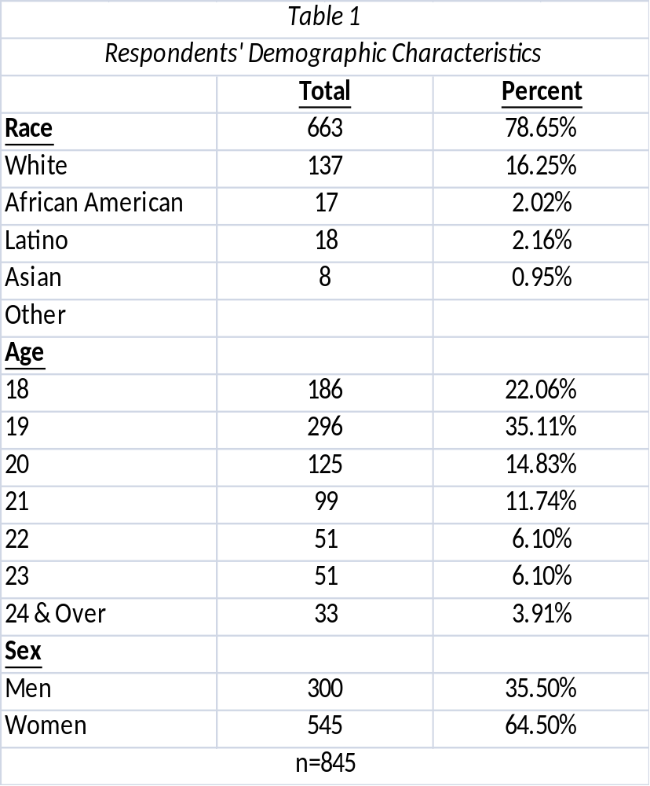

Table 1 provides demographic information for the respondents. As the table indicates, the majority of the respondents identified themselves as white (78.65%), followed by African American (16.25%), Asian (2.16%) and Latino (2.02%). The description of the age variance shown in Table 1 shows that the majority of respondents indicated that they were between the ages of 18-21 (83.74%), with age 19 being the most common response given (35.11%). Since so many students in the sample are 18 and 19, this lends further support to my notion that most of these students were first and second year students. Additionally, the frequencies indicated show that the majority of the respondents identified themselves as women (64.50%).

Description of Treatments
Written vignettes are commonly used to give a brief description to elicit responses about typical situations (Hill, 1997), and they were used in this study. In previous research, this experimental method has been able to identify cultural norms that are derived from the respondents’ attitudes and beliefs about a specific situation (Finch, 1987). Despite this, researchers have raised some questions about the accuracy of being able to relate abstract responses to actions in everyday life (Carlson, 1996; Hughes, 1998). Regardless of this debate, the greatest benefit of using vignettes for this particular study is that they can be used to explore sensitive topics the respondents might find otherwise difficult to discuss.
Each of the vignettes used in my study described the arrest of an individual for a crime. These descriptions were given in the form of a police blotter. The survey instrument had two variable conditions with six total outcomes (treatments). One condition was the educational attainment of the suspect (suspect has a college degree or suspect is a high school dropout). The second condition was the crime for which the suspect had been arrested (simple assault, armed robbery and embezzlement). These conditions can be seen bracketed and underlined in Figure 2 below.

Please read the following crime report carefully and then answer the short questions on the following page.
Knoxville Man Arrested

A Knoxville man has been arrested after he gave an acquaintance a ride and then [robbed him of cash and other valuables early this morning], the Knox County Sheriff’s Department reported. John Brown, 30, was charged with first-degree robbery, a felony, and second-degree unlawful imprisonment, a misdemeanor. Brown, a white male, is a [graduate of the University of Tennessee, Knoxville.] He stands accused of committing the armed robbery around 3:45 a.m. in the vicinity of the Fort Sanders area. The weapon, of an unknown type, was not recovered according to a spokesman for the Knox County Sheriff’s Department. An investigation is continuing. Mr. Brown is currently awaiting arraignment on the charges at the Knox County Jail.

Figure 1
Crime Reaction Study

Each of the students was given one of six treatments (see appendix A). The treatments were identified by the placement of a small identifying mark on the page that appeared as a typological error. Students were not aware that there were different versions of the vignette being administered.
The vignettes referencing the commission of the white collar crime of embezzlement differed from the other treatments in that the information given for the highly educated and lower educated suspected offenders was not the same. While the treatment for the educated suspect followed those of those given for the offender suspected of committing the street crimes of robbery and assault, the vignette depicting the lower educated offender suspected of embezzlement includes information about how the suspect was able to obtain such high level position despite having a limit education. Because white collar crimes are usually committed by individuals with well documented educational backgrounds, this information is meant to convey a “sense of belonging” for the lower educated offender suspected of committing embezzlement.

Data
Using a method advocated by Davis and Houck (1990), I constructed a survey instrument consisting of two parts. The first part of my instrument contained responses to each of my treatments, while the second part of the instrument collected demographic information from the respondents (i.e., sex, race and age). After the treatment (which consisted of reading one of six vignette versions), each respondent was asked to ascribe certain global indentifying characteristics to the suspected offender such as the ability to have clear thought, socioeconomic status, likelihood of drug dependency, culpability, and the ability to achieve success. These characteristics were assessed using a Likert scale ranging from 1 to 7, where 1 indicated that the characteristic was not attributed to the suspect, and 7 indicated that the characteristic was fully ascribed to the suspect.
To specifically gauge culpability the statement was made “John Brown committed the crime,” respondents were then asked to give their level of agreement on a Likert scale where 1 indicated little to no agreement and 7 indicated the strongest level of agreement. Due to lack of variation in responses, these results were later collapsed into dichotomous variables by assigning responses of 1, 2, 3 and 4 as 0 and responses of 5, 6 and 7 as 1. As a result, the variable culpability was generated where responses coded 1 indicate that the respondent found the suspect more culpable and responses coded 0 indicate that the respondent identified the suspected offender as less culpable.
These responses were consolidated because of the lack of mid-range responses for questions that asked them to indicate the strength of their answer on the given scale. A majority of these responses indicate strong agreement (i.e. responses 6 & 7) or strong disagreement (i.e. responses 1 & 2). As a result, answers indicating moderate to no feelings were combined with responses indicating strong feelings to create two responses that only indicated agreement or disagreement. Because of this, some of my response that might have very little agreement or no feeling about the question asked, are perceived to have the same level of intensity as the responses that indicated strong agreement or disagreement to a particular question. Regardless, implementing this coding method was necessary in order to give statistical power to those responses that were considered moderate.
In the second part of the survey each respondent was asked to identify specific characteristics that they felt were associated with the suspected offender being described in their treatment (see appendix). This list of characteristics was constructed by consulting a list of common attributes associated with the profile of sociopaths (e.g., remorseful, callous, narcissistic, selfless, psychopath: Hare 1991; Lykken 1997). This information was used to address hypotheses 4 and 5, which were aimed at determining how attributes of sociopathology and educational attainment are ascribed to the suspected offenders being described in each treatment. Each of the attributes given was coded either 0 or 1, where 0 indicates the absence of the characteristic and 1 indicates the presence of the characteristic.
The characteristics callous, narcissistic, evil, unfocused, nervous, impatient, psychopathic, impoverished, and cold were considered sociopathic traits. Similarly, the characteristics has direction, remorseful, responsible, constructive, friendly, relaxed, selfless, good, patient and wealthy were considered to be the traits of those who do not have sociopathic characteristics.
These traits were used to test the idea that if the respondent is more likely to be lenient on white collar offenders with whom they easily relate to, then respondents must attribute some sort of stigma to the offender in order to disassociate themselves from the offender and assess them as culpable (Bensen 1988). Because sociopathy was described as unremorseful behavior that violates a moral or societal norm, this term was used to encompass all negative traits that the respondent could ascribe to offenders suspected of committing the white collar crime of embezzlement (Hare 1991; Lykken 1997). These ascriptions were important to testing my assertion that in order for the student respondent to deem educated offenders as culpable, they will need to define the offender as not normal or typical.
I created a sociopathological attribute scale by summing each of the nine sociopathic traits and then summing all ten of the non-sociopathic traits. The positive (non-sociopathic) summative score was then subtracted from the sociopathic score in order to create a socipathological ascription scale. Thus, if a respondents ascribed the characteristics narcissistic, nervous, impatient, impoverished, and cold and also ascribed has direction, constructive, and patient to the suspect, that respondent would be given a score on the sociopathological ascription scale of 2 (5-3=2).

Methods
Quasi-experimental vignettes were administered with the aim of addressing the questions: (1) are highly educated people assumed to be less culpable of some types of crime, and (2) when highly educated people are judged culpable of committing a street crime, is that culpability attributed to some level of sociopathic behavior? From this question the following hypotheses were formulated:
H1: A highly educated person suspected of armed robbery will be deemed less culpable than the less educated suspect.
H2: A highly educated person suspected of simple assault will be deemed less culpable than the less educated suspect.
H3: The highly educated person suspected of embezzlement will be deemed more culpable that the less educated suspect.
H4: Among suspects described as highly educated, respondents are more likely to assign sociopathic traits to the suspect if he is deemed culpable.
H5: Among suspects described as poorly educated, culpability will not affect the likelihood that respondents will ascribe sociopathic traits to the suspect.
In order to test hypothesis H1, I distributed 279 vignettes to students in which the suspect was suspected of armed robbery. Forty-nine point eight percent of the students who received the robbery vignette received a version of the story in which the suspect was a college graduate. The remaining 50.1 percent received a version in which the suspect was a high school drop-out. Similarly, in order to test H2, I distributed a total of 282 vignettes describing a suspected convicted of assault. Fifty percent of the students received a version of the vignette that described a college graduate that had been suspected of committing the crime and the other half received a version that described a high school drop-out that had been suspected of committing the crime. H3 was tested by distributing 281 vignettes to students in which a suspect was suspected of committing embezzlement. For this treatment, 59.5 percent of students were given vignettes describing the suspect as a college graduate suspected of embezzlement. Fifty point five percent of students received the embezzlement vignette, in which a high school drop-out was suspected of committing the crime.
For all three hypotheses, respondents were assigned a response code of 1 if the vignette described a highly educated suspect and a response code of 0 if the vignette described a less educated offender. Since the variable of interest (level of the suspect’s education) and the dependent variable (assumed culpability) were each measured as dichotomous variables, coded as dummies, I treated them as ordinal. As such, I used a tau-b test of association to measure the direction and degree of the relationship between the two variables. Since tau-b does not have an associated significance test, I also ran a chi-square test of association, which does yield a p-value, which indicates that the two variables’ (culpability and education) values are dependent on each other (if the p-value of the chi-square test is less than .05) or independent of each other (if p is greater than or equal to .05).
In all three hypothesis tests, if the tau-b value was greater than 0 then the two variables were seen as having positive association, meaning that greater education was associated with greater culpability, and if tau-b was less than 0 then a negative association was indicated, meaning that greater education was associated with less culpability, assuming the chi-square test of independence was significant. Additionally, if the tau-b score is closer to 1 or -1, it indicated a strong association between the two variables. If the result is closer to 0, then a weaker association was indicated. Of course, if the p-value associated with the chi-square test was not significant (i.e., greater than or equal to .05), then it was assumed that any tau-b score generated was likely due to sampling error rather than a true reflection of the population’s stereotypes of offenders.
In order to test H4, I used a subsample of vignettes in which the respondent was described as a college graduate. Using the sociopathology scale as my dependent variable, I regressed sociopathology on the dichotomous culpability using OLS regression. My hypothesis was supported if the regression coefficient associated with culpability was positive (meaning those who assumed the suspect to be culpable also assumed him to be more sociopathic) and it was statistically significant.
Similarly, in order to test H5, a subsample of vignettes was used in which the respondents were described as a high school dropout. Like H4, I used a scale of sociopathology as my dependent variable, and regressed the culpability score using OLS regression. Again, if the regression coefficient associated with culpability was positive and statistically significant, my hypothesis was seen as supported.

Chapter IV

Results and Findings

Tables 2.1, 2.2, and 2.3 show the cross-tabulations between ascribed culpability and the education of the suspected offender, as described by the vignette. The results of the chi-square test of hypotheses H1, H2, and H3 failed to yield significant p-values. For the robbery vignettes, Table 2.1 shows that there were a total of 140 students who received the treatment that depicted a less educated offender suspected of committing robbery and 139 students who received the treatment describing a highly educated offender suspected of committing robbery. In both vignettes, the students assumed the suspect to be culpable about 70 percent of the time. The findings fail to provide support for hypothesis 1.

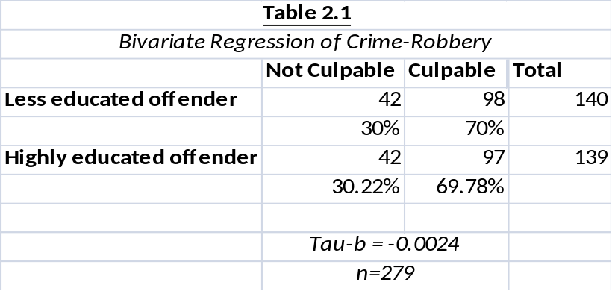

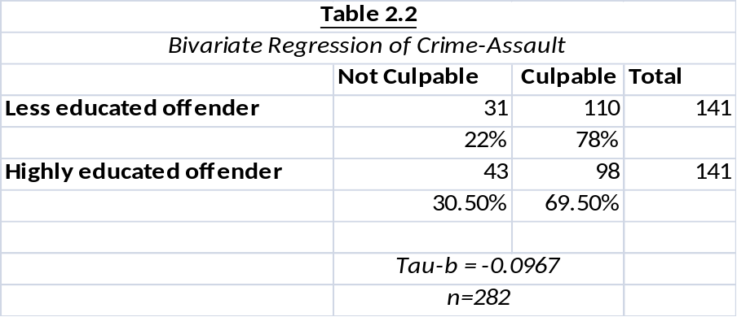

Table 2.2 indicates the results of the test for a relationship between the education of the offender suspected of committing assault and their perceived culpability. This table shows that 141 students each received treatments of both the less and highly educated offenders. Like with the test for hypothesis H1, the result for the chi-square test was not significant, failing to provide support for the hypothesis. Again, most respondents, regardless of the treatment, assigned culpability to the suspect. Although a larger percent of students (78 percent) ascribed culpability to the less educated suspected offender than the percent of students (about 70 percent) who ascribed culpability to the college educated suspect, the differences appear purely due to chance.
Table 2.3 gives a cross-tabulation of the variables used to test hypothesis H3 which asserts that the highly educated person suspected of embezzlement will be deemed more culpable that the less educated suspect.

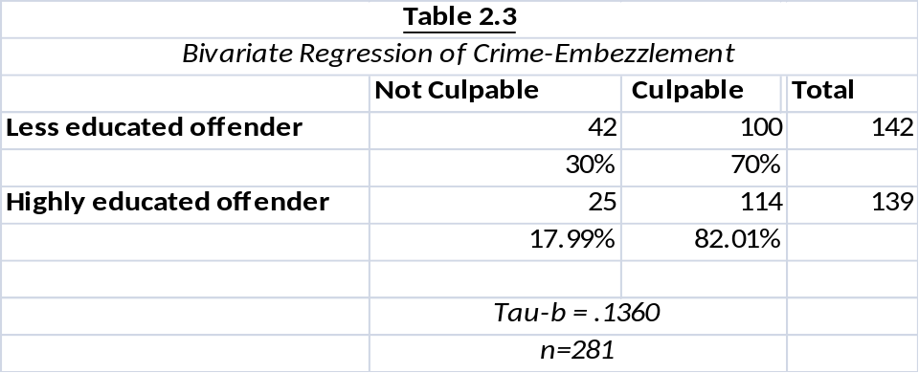

As the table indicates, there were slightly more students that were given the treatment depicting the less educated offender suspected of committing the crime of embezzlement than those given the treatment depicting a college educated offender suspected of committing embezzlement ( 142 and 139 responses, respectively). Regardless of treatment, the results for the chi-square test indicated that the tau-b score cannot be reliably interpreted. The relationship between the education level of the offender suspected of committing embezzlement and their perceived culpability is not established by these results. Regardless of the suspected offender’s education level, differences in deemed culpability of the crime of embezzlement is due to sampling error. Thus, similar to H1 and H2, H3 is also not supported. Overall, it appears that if a statement is issued that a person was arrested for a crime, about seventy percent of the students in my sample believed that the person was also culpable of the crime. The educational level of the suspected offender and the type of crime committed did not appear to matter to the students in my sample.
In order to test H4 and H5, a regression was run between the variable sociopath, culpability (as measured by responses to the Likert-type statement “John Brown committed the crime”) and vignette type. In this case, responses to vignettes 1, 3 and 5 were combined to indicate reactions to crimes reportedly committed by less educated suspects. Similarly, responses to vignettes 2, 4 and 6 were combined to indicate crimes reportedly committed by highly educated suspects. The results of those regressions are shown in table 2.4 next to the headings Less Educated Suspect and Highly Educated Suspect:

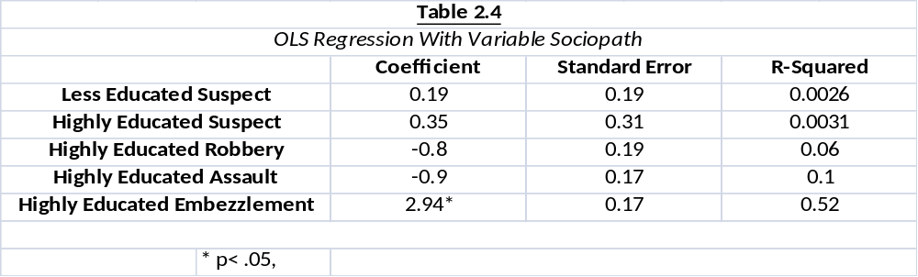

As the table indicates, the regression models yields no significant results. As a result, my contentions that highly educated suspects are more likely to have characteristics of sociopathy attributed to them if they are deemed culpable and the less educated suspects are less likely to have characteristics of sociopathy attributed to them regardless of perceived culpability are unsupported.
Also, listed in table 2.4 are the results of the regressions between the variables culpability and sociopathy. Similarly to previous regression, the result for highly educated assault suspect and highly educated robbery suspect are insignificant. However, the regression that looks at the relationship between culpability and sociopathy in relation to the highly educated offender suspected of the white collar crime embezzlement yields some strong results. In this case, 52% of the variance in sociopathy scores among respondents who received the white collar vignettes can be explained by culpability. In this case, respondents who found the highly educated offender suspected of committing embezzlement to be highly culpable, on average assigned scores of sociopathy that were 2.94 points higher than those that found the suspected offender to be less culpable. This is the only case where the regression results show any support for H4.
Additional regression analyses, listed below in table 2.5, give some insight to how the respondent’s demographic characteristics affected the results of this study. These results showed that as a whole, female respondents were more likely to assess high levels of culpability. Being white was also a good predictor of whether or not you would ascribe higher levels of culpability to the offender. This meant that respondents that identified themselves as white, were more likely than other races to ascribe higher levels of culpability to the offender. Age did not appear to be a significant predictor in this model.

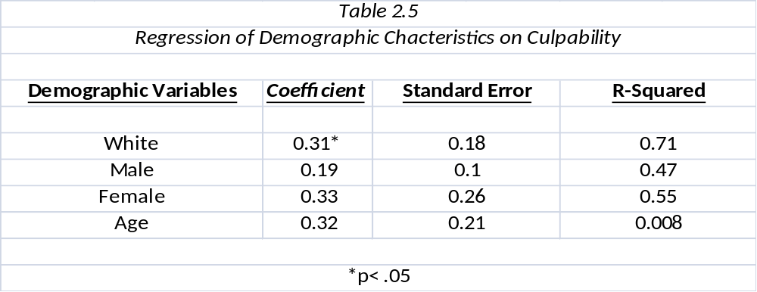

Chapter V

Discussions and Conclusions

Despite the fact that all five hypotheses were not directly supported by my research, this study does yield some interesting findings. Previous works on perceptions and punishment of offenders had found that college-educated individuals had received more lenient punishments than less educated individuals (Clinard & Yeager, 1980; Hagan 1980; Coleman, 1985; Geis, 1984; Hagan, 1990; Rossi et al., 1974). It was this idea that lead to the formation of the first three hypotheses in this study. However, the results of this study showed that culpability was not differently assigned because of stated differences in the education level of the person arrested for the crime in the quasi-experimental vignettes. Even when the offender was arrested for a white collar crime like embezzlement, the respondents ascribed high levels of culpability to the offender.
Although my findings conflict with previous findings, especially those of Hagan (1980), my findings with regard to the tests of my fourth and fifth hypotheses expound some points raised by Bensman (1988). Bensman notes that an offender that exhibits middle class values is punished less severely because their middle class values are shared by those who are determining the punishment. Following this line of thinking, I asked the question: what happens when offenders are deemed culpable by those who share their same value system? In this study it became clear that the student respondents were not more likely to ascribe culpability and sociopathy to the highly educated suspects. The only exception to this was when we looked at the crime of embezzlement separate from the other offenses.
In this case, when the highly educated offender suspected of embezzlement, was perceived to be highly culpable, responses also indicated a higher perception of sociopathic traits. Although I did not measure the values of the respondents, I believe my findings reflect that many of the students identified closely with the social class of the highly educated suspected offender. As a result, they were able to differentiate themselves from that suspected offender by defining the suspected offender’s behavior as odd or not normal. In turn, this allowed them to ascribe high levels of culpability to the suspected offender.
While pointing out the significance of the findings of this study, it is also important to note my study’s limitations. The study is extremely limited because of the homogenous nature of the sample. Any generalization made about sex, age or ethnicity as predictors of assessing culpability are not valid because my subjects were taken from a non-representative sample and do not reflect the US population (or even, necessarily, the student population from which the sample was drawn) in terms of race, gender and age. Thus, my findings are exploratory and can be generalized only to students in the classes from which the sample was drawn. It would be interesting to look at these results next to those of a sample population that was more ethnically and sexually diverse to determine whether or not these demographic factors truly matter when ascribing culpability to suspected offenders.
One unintentional flaw can be found in the vignette that gives the depiction of the lower educated offender suspected of committing the white collar crime of embezzlement. In this vignette, additional commentary was given to describe how this lower educated suspect was able to rise into a position of power despite having a limited educational background. This information was meant to give the suspect a “sense of belonging”. In turn, though unintended, this information could have could have cause the respondent to have a sense of empathy towards the lower educated suspected offender. This feeling of empathy could have affected the level of culpability that the respondent assessed to the suspected offender.
Another problematic area of this study is evident in the measurement of culpability. Culpability was assessed by simply asking the question “Did John Brown commit this crime?” The responses to this question indicated the obvious fact that the offender committed the crime. Although this question did allow me to assess whether high or low levels culpability were assigned to the suspected offender, this measure did not give me any indication as to whether or not the suspected offenders was knowledgeable of risk of his actions posed to others. Having this information would have allowed my assess culpability in a manner that is more in line with the definition presented in Lawerence (2000). If I were to replicate this study I believe that an assessment of perceived culpability should be measured by stating “John Brown’s actions were reckless” and “John Brown had knowledge that his actions would be harmful to others.” These statements should be measured by asking respondents to indicate their level of agreement on a Likert scale, where 1 indicates little to no agreement and 7 indicates strong agreement. This measure would give the study the ability to determine if the perceived intentions of the suspected offender have any effect on how culpability is assessed.
Overall, my study was limited by time and monetary restrictions. Also, a considerable amount of time has passed between the collection of the data and the analysis of the results, which has allowed me to reflect more closely on what I might have done differently. More money to conduct a study like this would allow for the better constructed vignettes. Specifically, I would have liked to have used a method suggested by Gordon, Bindrim, McNicholas, and Walden (1988). They set up mock jury situations which showed that jurors did differ in the way they considered race as it relates to crime severity. Their model could be used to measure the effect of educational characteristics in much the same way they measured the effects of race. Similarly, more money and more time would allow for the development of a larger and more diverse sample size.
With this in mind, future research should employ a research design that uses video vignettes to measure the visual perceptions of offenders. Each vignette would show a suspected offender in a court room setting being cross examined. A study of this nature would be able to measure what visual cues cause a respondent to perceive a suspect as highly educated or lower educated, and how that perception factors into the level of culpability assessed to the offender.
The benefit of this research design is that it creates a mock trail setting that puts the respondent in the position of a juror. In this case, the respondents visual perceptions of the offender would close mimic those of a juror hearing the arguments of an actual trial. Research of this type would help to expand the findings of previous research that has noted that juries have disproportionately assessed a suspect’s culpability because of the influences of gender and ethnicity (Blumstien & Cohen, 1980; Ruby & Bingham, 1996).
Regardless of these shortcomings, my study contributes to the body of literature that is concerned with the stereotypes of those arrested for crime and punishments given to offenders. Specifically, I offer some insight into the question, “What occurs when respondents ascribe culpability to offenders with similar backgrounds as the respondents?” My findings suggest that when well-educated respondents read about well-educated people who are arrested for committing white collar crimes, they ascribe abnormal psychological traits to the suspect (specifically, sociopathology) arguably to differentiate the suspect from themselves. With more resources, better answers to questions about offender traits and ascription could be found that would make significant contributions to criminological and social psychological literature.
List of References

Alexander, Larry 2000. “Insufficient Concern: A Unified Conception of Criminal Culpability.”
California Law Review. 88(3): 931-954.

Beckett, Katherine and Theodore Sasson. 2000. The Politics of Injustice: Crime and
Punishment in America. Thousand Oaks, CA: Pine Forge Press.

Bensman, Joseph. 1988. “White collar crime: Re-examination of a concept.” International
Journal of Politics, Culture, and Society. 2:4-14.

Blumstein, Alfred and Jacqueline Cohen. 1980. “Sentencing of Convicted Offenders: An
Analysis of the Public’s View.” Law & Society Review. 14(2): 223-2611.

Carlson, Bonnie. 1996. “Competing Value Premise for the Provision of Drug Treatment to
Probationers.” Crime & Delinquency. 42(4): 574-592.

Clinard, Marshall and Peter Yeager. 1980. Corporate crime. New York. Free Press.

Cohen, Albert. 1955. Deliquent Boys: The Culture of Gangs. Glencoe, IL: The Free Press.

Coleman, James. 1985. The criminal elite: The sociology of white-collar crime. New York: St. Martins Press.

Cullen, Francis, Bonnie Fisher and Brandon Applegate. 2000. “Public Opinion about Punishment
and Corrections.” Crime and Justice. 27: 1-79.

Cullen, Francis, Gregory Clark, Bruce Link, Richard Mathers, Jennifer Niedospial, and Michael
Sheahan. 1985. “Dissecting White-Collar Crime: Offense Type and Punitiveness.”
International Journal of Comparative and Applied Criminal Justice. 9:15-28.

Cullen, Francis, Bruce Link, and Craig Polanzi. 1982. “The seriousness of crime revisited.” Criminology. 20: 83-102.

Davis, Lawrence and Charles Houck. 1990. “Female Regional Speech and Occupational
Classification: Linguistics and Attitudes in Hoosierdom.” American Speech.
65(2):127-135.

Dressler, Joshua. 2000. “Does One Mens Rea Fit All: Thoughts on Alexander’s Unified Concept
of Criminal Culpability.” California Law Review. 88(3): 955-963.

Finch, Janet. 1987. “The Vignette Technique in Survey Research.” Sociology. 21(1): 105-
114.

Flanagan, Timothy and Dennis Longmire. 1997. “Americans View of Crime and Justice: A
National Public Opinion Survey.” Journal of Criminal Justice. 25(2): 173-174.

Geis, Gilbert. 1973. “Deterring Corporate Crime.” Pp. 182-197 in Corporate Power in
America, edited by R. Nader and M.J. Greed. New York: Grossman.

Geis, Gilbert. 1984. White-collar and corporate crimes. In R. Meir (Ed). Major forms of crime
Beverly Hills, CA: Sage.

Goffman, Erving 1959. The Presentation of Self in Everyday Life. Garden City, NY: Prentice
Hall.

Gordon, Randall, Thomas Bindrim, Michael McNicholas, and Teresa Walden. 1988.“Perceptions
of Blue-Collar and White-Collar Crime: The Effect of Defendant Race on Simulated
Juror Decisions.” Journal of Social Psychology. 128: 191-197.

Gottfredson, Denise. 2002. “Evidence Based Crime Prevention.” Journal of Quantitative
Criminology. 3: 247-252.

Hagan, John. 1990. Introduction to criminology (2nd ed.). Chicago: Nelson Hall.

Hagan, John, Ilene Nagel-Bernstein, & Celesta Albonetti. 1980. The differential sentencing of
white-collar offenders in ten federal district courts. American Sociological Review.
45: 802-820.

Hagan, John, & Alberto Palloni. 1986. “Club Fed” and the sentencing of white-collar offenders
before and after Watergate. Criminology, 24, 603-622.

Hamilton, David. 1979. “A Cognitive Attributional Analysis of Stereotyping.” Pp. 53-84 in
Advances in Experimental Social Psychology vol. 12, edited by L. Berkowitz. New York:
Academic Press.

Hare, Robert. 1991. The Hare Pschopathy Checklist-Revised. Toronto: Multi-Health
Systems.

Holmes, Ronald and Stephen Holmes. 2008. Profiling Violent Crimes: An Investigative Tool.
Thousand Oaks, CA: Sage Publications, Inc.

Hughes, Gordon. 1998. Understanding Crime Prevention: Social Control, Risk and Late
Modernity. Bristol, PA: Open University Press.

Hurwitz, Jon and Mark Peffley. 1997. “Public Perceptions of Race and Crime: The Role of
Racial Stereotypes.” American Journal of Political Science. 41(2): 375-401.

Kandel, Elizabeth, Sarnoff Mednik, Lis Kirkegaard-Sorenson, Barry Hutchings, Joachim Knop,
Raben Rosenberg and Fini Schulsinger. 1988. “IQ as a Protective Factor for Subjects at
High Risk For Antisocial Behavior.” Journal of Consulting and Clinical Psychology.
56:224-226.

Kelley, Harold. 1973. “The Process of Causal Attributions.” American Psychologist. 28:
107-128.

Kelley, C. 1977. Crime in the United States. Washington: U.S. Government Printing
Office.

Lee, Yueh-Ting, Jeffery Baumgarner, Robert Widner, and Zhen- Lei Luo. 2007. “Psychological
Models of Stereotyping and Profiling in Law enforcement: How to Increase Accuracy by
Using More Non-racial Cues.” Journal of Crime and Justice. 30(1): 87-129.

Lever, Annabelle. 2005. “Why Racial Profiling Is Hard To Justify: A Response to Risse and
Zeckhauser.” Philosophy and Public Affairs. 33(1): 94-110.

Liazos, Alexander. 1978. “Schools, Alienation, and Delinquency.” Crime & Delinquency.
24:355-370.

Lochner, Lance. 2004. “Education, Work and Crime: A Human Capital Approach.” International
Economic Review. 45(3): 811-843.
Luzzo, Darrell. 1993. “Ethnic differences in college students’ perceptions of barriers to career
development.” Journal of Multicultural Counseling and Development.
21(4): 227-236.

Lykken, David. 1996. “Psycopahty, Sociopathy, and Crime.” Society. 34(1): 29-38.

Lykken, David. 1997. “The American Crime Factory.” Psychological Inquiry. 8(3): 261-270.

Maruna, Shadd, Amanda Matravers, and Anna King. 2004. “Disowning Our Shadow: A Psychoanalytic Approach to Understanding Public Attitudes.” Deviant Behavior. 25(3):
277-299.

May, Hazel. 1999. “Who Killed Whom: Victimization and Culpability in the Social
Construction of Murder.” British Journal of Sociology. 50(3): 489-506.

McCaughly, Clark, Christopher Stitt and Mary Segal. 1980. “Stereotyping: From Prejudice to Prediction.” Psychological Bulletin. 87(1): 195-215.

Percival, Garrick. 2009. “Testing the Influence of Racial Attitudes and Racial Diversity on
Prisoner Re-entry Policies in the U.E. States.” State Politics and Policy
Quarterly. (9)2: 176-203.

Percival, Garrick. 2011. “Smart on Crime: How a Shift in Political Attention is Changing
Penal Policy in America.” (August 28, 2011). Available at SSRN:
http://ssrn.com/abstract=1918345

Peterson, Ruth., Lauren Krivo, and John Hagan. 2006. A Deeper Understanding of Race,
Ethnicity, Crime, and Criminal Justice. New York: New York University Press.

Privateer, Paul. 2006. Inventing Intelligence: A Social History of Smart. Malden, MA:
Blackwell Publishing.

Rossi, Peter, Emily Waite, Christine Bose, and Richard Berk. 1974. “The Seriousness of Crimes:
Normative Structure and Individual Difference.” American Sociological Review.
39: 224-237.

Ruby, C. L. and John Brigham. 1996. “A Criminal Schema: The Role of Chronicity, Race,
and Socioeconomic Status in Law Enforcement Officials’ Perceptions of
Others.” Journal of Applied Social Psychology. 26(2): 95-112.

Russell, Joyce and Michael Rush. 1987. “A comparative study of age-related variations in
women’s views of career in management.” Journal of Vocational Behavior. 30:
280-294.

Schanzenbach, Max, and Michael Yeager. 2003. “Prison time and fines: Explaining racial
disparities in sentencing for white-collar criminals.” Federal Sentencing Reporter.
15: 194.

Scheingold, Stuart. 1998. “Constructing the New Political Criminology: Power, Authority,
and the Post-Liberal State.” Law and Social Inquiry 23, 4:857-895.

Schlesinger, Traci. 2005. “Racial and Ethnic Disparities.” Justice Quarterly. 22(2): 170-192.

Schneider, Anne and Helen Ingram. 1993. “The Social Construction of Target
Populations.” American Political Science Review. 87(2): 334-346.

Schoepfer, Andrea, Stephanie Carmicheal, and Nicole Piquero. 2007. “Do Perception of
Punishment Vary Between White-Collar and Street Crimes?” Journal of Criminal
Justice. 35(2): 151-163.

Schrager, Laura, and James Short. 1980. In G. Geis & E. Stotland (Eds) White collar crime:
Theory and research. Beverly Hills, CA: Sage. 14-31.

Simmons, Kenneth. 1992. “Rethinking The Mental State.” Boston University Law Review.
72(3): 463-515.

Slaney, Robert and Michael Brown. 1983. “Effects of Race and Socioeconomic Status on
Career Variables among College Men.” Journal of Vocational Behavior. 23: 257-
269.

Stout, Martha. 2006. The Sociopath Next Door. United States: Random House.

Sutherland, Edwin. 1949. White Collar Crime. New York: Holt, Rinehart and Winston Inc.

Sutker, Paricia and Albert Allain. 1982. “Behavior and Personality Assessment in Men Labeled
Adaptive Sociopaths.” Journal of Psycopathology and Behavioral Assessment. 5(1): 65-
79.

Swanson, Jane and David Tokar. 1991. “College Students’ Perceptions of Barriers to
Career Development.” Journal of Vocational Behavior. 38: 92-106.

Warr, Mark 1980. “The Accuracy of Public beliefs about Crime.” Social Forces. 59(2): 456-
470.

Wheeler, Stanton, Kenneth Mann, and Austin Sarat.1988. Sitting in judgment: The sentencing of
white-collar offenders. New Haven, CT: Yale University Press.

White, Jennifer, Terrie Moffitt, and Phil Silca. 1989. “A Prospective Replication of the
Protective Effects of IQ in Subjects at High Risk for Juvenile Delinquency”. Journal of
Consulting and Clinical Psychology. 57: 719-724.

Appendix

______________________________________________________________________
Thank you for volunteering for this important study. Results will be used as a partial fulfillment of my MA thesis in Sociology. Return of the survey will constitute your informed consent to participate.
THANK YOU

______________________________________________________________________

Vignette 1
Crime Reaction Study
Please read the following crime report carefully and then answer the short questions on the following page.
Knoxville Man Arrested

A Knoxville man has been arrested after he gave an acquaintance a ride and then robbed him of cash and other valuables early this morning, the Knox County Sheriff’s Department reported. John Brown, 30, was charged with first-degree robbery, a felony, and second-degree unlawful imprisonment, a misdemeanor. Brown, a white male, is a graduate of the University of Tennessee, Knoxville. He stands accused of committing the armed robbery around 3:45 a.m. in the vicinity of the Fort Sanders area. The weapon, of an unknown type, was not recovered according to a spokesman for the Knox County Sheriff’s Department. An investigation is continuing. Mr. Brown is currently awaiting arraignment on the charges at the Knox County Jail.

Vignette 2

Crime Reaction Study
Please read the following crime report carefully and then answer the short questions on the following page.

Knoxville Man Arrested

A Knoxville man has been arrested after he gave an acquaintance a ride and then robbed him of cash and other valuables early this morning, the Knox County Sheriff’s Department said. John Brown, 30, was charged with first-degree robbery, a felony, and second-degree unlawful imprisonment, a misdemeanor. Brown, a white male, is a high school dropout. He stands accused of committing the armed robbery around 3:45 a.m. in the vicinity of the Fort Sanders area of campus. The weapon, of an unknown type, was not recovered according to a spokesman for the Knox County Sheriff’s Department. An investigation is continuing. Mr. Brown is currently awaiting arraignment on the charges at the Knox County Jail.

Vignette 3
Crime Reaction Study
Please read the following crime report carefully and then answer the short questions on the following page.

Knoxville Man Arrested

A Knoxville man was arrested after he struck an acquaintance with a pool cue, the Knox County Sheriff’s Department said. John Brown, 30, was charged with simple assault. Brown, a white male, is a graduate of the University of Tennessee, Knoxville. He stands accused of committing the assault on an acquaintance around 3:45 a.m. in the vicinity of Fort Sanders. An investigation is continuing. Mr. Brown is currently awaiting arraignment on the charges at the Knox County Jail.

Vignette 4
Crime Reaction Study

Please read the following crime report carefully and then answer the short questions on the following page.

Knoxville Man Arrested
On February 2nd at 3:55 a.m. Knox County Sheriff’s officers responded to a report of an assault. Witnesses had reported that two men had been arguing over a bet that was made on a pool game when one man struck the other with a pool cue and fled the scene, according to court documents. John Brown, 30, was arrested for simple assault in connection with this incident. Brown is a white male and who is described as a high school dropout. He is scheduled to appear in the Knox County Courthouse on February the 28th.

Vignette 5
Crime Reaction Study

Please read the following crime report carefully and then answer the short questions on the following page.

Knoxville Man Arrested
John Brown, a prominent Knoxville businessman and CEO, has been indicted on charges of embezzlement, but insist he is innocent. Brown, 30, is being indicted because of his role in hiding foreign investment funds from his company in off shore accounts for personal use. In an interview last week Brown said that he is innocent but the indictment is in no way surprising. “My lawyers have said virtually from day one that it was going to be a lot tougher decision for someone to decide not to indict me than to indict me," he said. Brown’s story of dropping out of high school at the age of 16 and starting out in the mail room before making his rise to the top, is one that is well documented. A full investigation into this matter continues. Until then Brown has been released on bail after pleading not guilty to the charges brought against him and has been instructed not to leave the Knoxville area while he awaits trial.

Vignette 6
Crime Reaction Study
Please read the following crime report carefully and then answer the short questions on the following page.

Knoxville Man Arrested

A Knoxville man has been arrested on charges of embezzlement, the Knox County Sheriff’s Department reported. John Brown, 30, was charged with misappropriation of funds. Brown, a white male, is a graduate of the University of Tennessee, Knoxville. He stands accused of diverting the funds of a company located in the Fort Sanders area. According to a spokesman for the Knox County Sheriff’s Department, an investigation is continuing. Mr. Brown is currently awaiting arraignment on the charges at the Knox County Jail.

Instructions: When people read newspaper accounts, they often create visual images about the characters in these accounts. Think about the article you just read and focus on visual images of John that you created in your head as you read the story, then rate your level of agreement with the following statements on a scale of 1 to 7 where 1 is strongly disagree and 7 is strongly agree.

Strongly Strongly
Disagree Agree
______________________________________________________________________
1. John Brown is middle class. 1 2 3 4 5 6 7
2. John Brown is capable of clear rational 1 2 3 4 5 6 7
thought.

3. John Brown is a drug addict. 1 2 3 4 5 6 7

4. John Brown is a person who achieves. 1 2 3 4 5 6 7

5. John Brown committed the crime 1 2 3 4 5 6 7

Instructions: In the follow section please circle all of the characteristics that you would associate with John. If you do not understand the meaning of any of these words please raise your hand and someone will assist you.

Please circle all that apply:

1. Callous 6.Calm 11.Psychopathic 16.Self-less

2. Narcissistic 7.Remorseful 12. Constructive 17.Good

3. Has Direction 8.Nervous 13.Friendly 18.Patient

4. Evil 9.Responsible 14.Relaxed 19. Wealthy

5. Unfocused 10.Impatient 15.Impoverished 20.Cold

Now please tell us about yourself. Remember that your responses will be kept confidential.

1. What is your gender?

1. Male

2. Female
2. Which of the following categories best describes you?
1. Black/African American
2. White/Caucasian
3. Hispanic/Latino
4. Asian
5. Native American Indian
6. Other (please specify)_________________________

3. How old are you?
18
19
20
21
22
23
24 or older

Vita
Larry Curtis Long, Jr. was born in Paducah, Kentucky, on the 30th September 1982, the son of Lisa Burgess and Larry Long. After completing his work at Alcoa High School in Alcoa, TN, he went on to the University of Tennessee-Knoxville where he studied Sociology and Political Science. He received his first Bachelor of Arts in December 2005 and his second Bachelor of Arts Degree in May of 2006. Upon graduation he decided to pursue a graduate degree in Sociology, and was admitted to The Graduate program in Criminology at The University of Tennessee-Knoxville in the spring of 2007.

This thesis was typed by the author.

