CHARACTERIZATION OF THE CHEA2 CHEMOTAXIS OPERON IN AZOSPIRILLUM BRASILENSE

Undergraduate Thesis
By
Erin Lutz

Major: Biological Sciences with a Concentration in Biochemistry and Cellular and Molecular Biology

The University of Tennessee, Knoxville
Spring 2017

Abstract
Flagella are surface organelles that allow bacteria to move toward or away from specific environments, helping to define locations in which bacteria can thrive. Different bacteria have different motility requirements based on their presumptive environments. Certain bacteria, like Azospirillum brasilense, possess a dual flagella system wherein they express both a polar flagella required for swimming in liquid environments and several lateral flagella required for motility in viscous environments as well as swarming on surfaces (Soutourina & Bertin 2003). In A. brasilense, the mechanism behind this flagella system has not been fully characterized, but it is thought to resemble another phylogenetically related bacterium, Rhodospirillum centenum, in which the chemotaxis operon named che2 is responsible for components of flagella biosynthesis (Berleman & Bauer 2005).
Here, we characterize the role of the major histidine kinase encoded by the che2 system from A. brasilense, cheA2, in motility and flagella biosynthesis by comparing wild type A. brasilense and a mutant lacking the che2 operon. Results indicate that the mutant lacking the operon is deficient in polar flagella biosynthesis, rendering the bacteria non-motile in liquid environments while the lateral flagella appear to be produced constitutively.

Introduction
Flagella allow bacteria to move in their surroundings. The pattern of flagellation (number of flagella, location around the cells) is highly variable. In the soil bacterium A. brasilense, a single polar flagellum is used for swimming and it also mediates adhesion to wheat roots (Croes et. al. 1993). When on surfaces, lateral flagella, a distinct type from the polar flagella, are produced and used by the bacteria to translocate across surfaces. The dual flagella system in A. brasilense shows continuous expression of polar flagella and induced expression of lateral flagella based on environmental conditions (Soutourina & Bertin 2003). Motility afforded by these flagellar systems allows bacteria to move into favorable environments by sensing chemical gradients of attractants and moving toward these environments using chemotaxis. This cellular behavior requires signal transduction between chemoreceptors that detect the attractant signal and the flagellar motors, which ultimately facilitate the direction of movement of the motile bacterium. The CheA protein, a histidine kinase, is the central signal transduction protein for bacterial chemotaxis (Manson et. al. 1998).
Recently, several signal transduction pathways that resemble chemotaxis pathways and include CheA homologs have been implicated in the regulation of cellular functions unrelated to chemotaxis (Wuichet & Zhulin 2010). One of these chemotaxis-like pathways has been implicated in flagellar biosynthesis and named che2 in the alphaproteobacterium Rhodospirillum centenum, which possesses a dual flagellar system similar to that of A. brasilense (Berleman & Bauer 2005). Analysis of the complete genome sequence of the soil bacterium A. brasilense indicated the presence of a che2 homologous pathway, suggesting it may also function to regulate flagella biosynthesis in A. brasilense.
Here, we tested this hypothesis by characterizing the motility and flagella biosynthesis of an A. brasilense mutant derivative carrying an insertion inside the cheA2 gene, which is expected to disrupt Che2 function. Without the Che2 pathway, we expect to see motility deficiencies due to a lack of one or both types of flagella.

Materials and Methods
Culture growth conditions
For this experiment we maintained A. brasilense on minimal media (MMAB) containing carbon and nitrogen (+N+C), or containing carbon only (-N+C) and tryptone-yeast media (TY) (per liter, 10 g Bacto tryptone, 5 g yeast extract) for liquid cultures. Both types of media were used because one is minimal (MMAB) and one is nutrient rich (TY), ensuring that the results were not because of varying nutrient needs. Sp7 (wild type) was grown with Ampicillin (200 μg/mL) and the cheA2 mutant was grown with Ampicillin (200 μg/mL) and Tetracycline (10 μg/mL). All cultures were grown at 28º C with shaking to an optical density around 0.7.

Mutant construction
To create the cheA2 knockout mutant, a Wizard Genomic DNA Purification Kit was first used to purify the Sp7 wild type DNA. PCR was then performed to amplify an internal fragment of the cheA2 gene using the following forward and reverse primers: 5’CCCCCCGGGTGCTGCGTGTCGAGGCCG-3’ and 5’ CCCCCCGGGATGGCCGAGGTGCTGAGC 3’.
Conditions for PCR included an initial denaturation temperature of 95ºC for 5 minutes, followed by a cycle of denaturation at 95 ºC for 1 minute, annealing at 73.5 ºC for 10 seconds, and extension at 72 ºC for 1.5 minutes. This cycle was repeated 40 times and was followed by an additional extension period at 72 ºC for 10 minutes, followed by lowering of the temperature to 4 ºC until the product was removed from the thermocycler.
After the product was obtained from PCR, we ran it on an agarose gel in order to determine if we obtained the expected product at a specific size. The PCR product was then purified using a gel purification kit (Nucleospin). Next, the suicide vector pKNOCKTet that carries tetracycline resistance (Alexeyev 1999) and the purified PCR fragment were digested with SmaI (New England Biolabs). A 20μL ligation reaction was set up on ice including 2 μL T4 DNA ligase buffer, 50 ng vector DNA, 37.5 ng insert DNA, 1 μL T4 DNA ligase, and nuclease free water to 20 μL total volume (New England BioLabs). The reaction was mixed gently by pipetting, incubated at room temperature for 10 minutes, heated at 65 ºC for 10 minutes, and the reaction mixture was transformed into competent cells (DH5α pyr selected on Luria-Bertani media (per liter, 10g Bacto-tryptone. 5g yeast extract, 10g NaCl)) supplemented with tetracycline. Insertion was verified using colony PCR followed by a triparental mating between A. brasilense Sp7, the E.coli donor, DH5α pyr(pKNOCK_cheA2) and helper cells, E.coli HB1010(pRK2013) for 16 hours, at 28 ºC in a chamber with constant humidity to prevent drying. Transconjugants were selected 3 times on solid plates of MMAB –N+C supplemented with tetracycline.

Growth curve analysis
Using a growth curve computer program (BioTek Gen5 data analysis software), we tested growth patterns of both Sp7 and the cheA2 mutant in liquid TY media and MMAB +N+C media. Growth curves were set up using microplate assays with 200 μL blanks (3 blanks per media type) and 180 μL liquid media mixed with 20 μL culture samples (9 samples each of Sp7 wild type in TY, Sp7 wild type in MMAB +N+C, cheA2 mutant in TY, and cheA2 mutant in MMAB +N+C). Analysis was performed at 28 ºC with an OD600 measurement taken every 20 minutes for 16 hours.

Swim assays
Swim assays were used to measure how the cells were able to swim through media. Optical density of liquid cultures was taken to ensure that the OD was around 0.7. If not, it was standardized to 0.7 using (0.7/(actual concentration of culture))*100 = number of microliters of culture spun. If both Sp7 cultures and cheA2 mutant cultures were around 0.7 OD, 1 mL was used. Once OD was standardized, the calculated amount of culture was spun down in a microcentrifuge for 3 minutes at 8,000 rpm. Then, supernatant was decanted and the resulting pellets were resuspended in 1 mL of Che buffer (500 mL total volume, 0.85g K₂HPO₄, 0.68g KH₂PO₄, pH 6.85-7.0). The samples were spun down again using the same conditions three times to ensure proper washing and purification with Che buffer. Once the third wash was complete, the pellet was resuspended in 100 μL of Che buffer and a 10 μL sample of the product was injected via pipet into the middle of a plate with 25 mL of MMAB +N+C 0.3% semisolid media. The plates were left overnight at 28 ºC and swimming diameter in centimeters was measured and pictures were taken the next day.

Swarm assays
Swarm assay samples were used to measure how the cells were able to move on top of media as opposed to through it. Cells were purified via the same protocol. A 10 microliter sample of the resulting product was released via pipet onto the surface of a 25 mL plate of Nutrient Broth 0.7% semisolid media. The plates were also left overnight at 28 ºC and measured and pictured the following day for swarming diameter.

Western Blots
An SDS-PAGE gel with a Western Blot was utilized to determine if either polar or lateral flagellin, the protein responsible for flagella formation, was present in both types of cells.
Liquid cultures were created using 5 mL of TY with Ampicillin 200 with inoculation of Sp7 and cheA2 mutant cells and overnight growth shaking at 28 ºC. After growth to around OD 0.7, these 5 mL cultures were then added to 45 mL of both TYAmp200 and MMAB +N+C Amp200. These 50mL cultures were grown overnight shaking at 28 ºC. Once 50 mL liquid cultures were grown to around OD 0.7, each culture was centrifuged at 14,000 RPMs for 20 minutes and the supernatant was discarded. The pellets were then resuspended in 500 µL of lysis buffer (per liter, 20 mM Tris(hydroxymethyl)aminomethane, 150 mM NaCl, 20 mM Imidazole). The lysis buffer-pellet solution was mixed until the pellet was dissolved completely. After mixing, the solution was mixed in a 1:1 ratio (50 µL each) in a microcentrifuge tube with Lammeli buffer (62.5 mM Tris-HCl, 2%SDS, 25% glycerol, 0.01% bromophenol blue). 1 µL of 2-mercaptoethanol was added to each microcentrifuge tube and the tubes were placed in a hot water bath (100 ºC) for 5 minutes. After heating, the tubes were microcentrifuged at 13,000 rpm for 5 minutes to avoid sticky consistency. A 10% polyacrylamide Precise Protein gel (Thermo Scientific) in Tris-Glycine buffer, pH 8.8, (Pierce) (100 V for 75 minutes) was utilized for all samples. Samples were loaded at the following volumes: 8 µL Thermo Fisher Scientific Spectra Multicolor Broad-Range Protein Ladder, 40 µL protein mixture in alternating wells with 40 µL Lammeli buffer in between.
Prior to semi-dry transfer of proteins from the SDS-PAGE to a polyvinylidene difluoride (PVDF) membrane, the PVDF membrane was soaked in methanol for 5 minutes followed by soaking in Western Blot Transfer Buffer (0.15 M glycine, 20% methanol, 25mM Tris, 0.1% SDS) for at least 5 minutes. Whatmann 3M filter paper used for the transfer was also saturated with transfer buffer by capillarity. The semi-dry transfer (Bio-Rad) was conducted at 25 V for 20 minutes. Following transfer, the PVDF membrane was left to air dry overnight at room temperature.
For the Western Blot, the PVDF membrane was blocked for at least an hour in a solution of 5% nonfat dry milk in Tris Buffered Saline (TBS) (200mM tris(hydroxymethyl)aminomethane, 1.5M NaCl, pH 7.5) at room temperature. The membrane was then washed 3 times for 5 minutes each by shaking incubation at room temperature in TBS-Tween (0.05%) sufficient to cover the membrane completely. After washing, the blot was incubated for 1 hour at room temperature with shaking in 20 mL of a 5% milk solution containing a 1:1000 dilution of primary antibody (antipolar flagellin antiserum, does cross-react with lateral flagellin). The membrane was then washed again three times with TBS-Tween (0.05%). Next, the membrane was incubated for 1 hour at room temperature with shaking in 20 mL of a 5% milk solution containing a 1:1000 dilution of secondary antibody (goat anti-rabbit lgG (H&L)-HRP conjugate, Immunoreagents Inc ). After incubation, the membrane was washed three times with TBS-Tween (0.05%). The membrane was incubated at room temperature with shaking in 6 mL of chemiluminescent substrate (Millipore Luminata Classico Western HRP Substrate) for 5 minutes, making sure that the membrane was maintained in the dark. An HRP substrate is essential for use because HRP induces a reaction that releases photons that can be captured on x-ray films for visualization of the subject of interest. The membrane was then carefully placed in cellophane and exposed to x-ray films for development.

Results
Growth curves
Growth curves were performed using Sp7 and the cheA2 mutant in both nutrient rich (TY) and minimal (MMAB) media to determine if loss of cheA2 impaired growth.

Fig. 1: Sp7 and cheA2 mutant growth curves, MMAB +N+C. Grown at 28 ºC shaking with an OD600 measurement taken every 20 minutes for 16 hours.

Fig 2: Sp7 and cheA2 mutant growth curves, TY. Grown at 28 ºC shaking with an OD600 measurement taken every 20 minutes for 16 hours.

Growth in minimal media (MMAB) may suggest that the cheA2 strain would grow slightly faster than the wild type strain, since the exponential phase of growth seems to occur at a faster rate in the mutant. This is somewhat unexpected and should be confirmed in future experiments. There was no difference in growth between the two strains in nutrient-rich media.

Swim assays
Swim assays were performed in MMAB +N+C 0.3% semisolid media to determine differences in swimming patterns of Sp7 wild type and cheA2 mutant. Differences in swimming under these conditions could reflect either a difference in growth and/or polar flagellum-dependent motility.

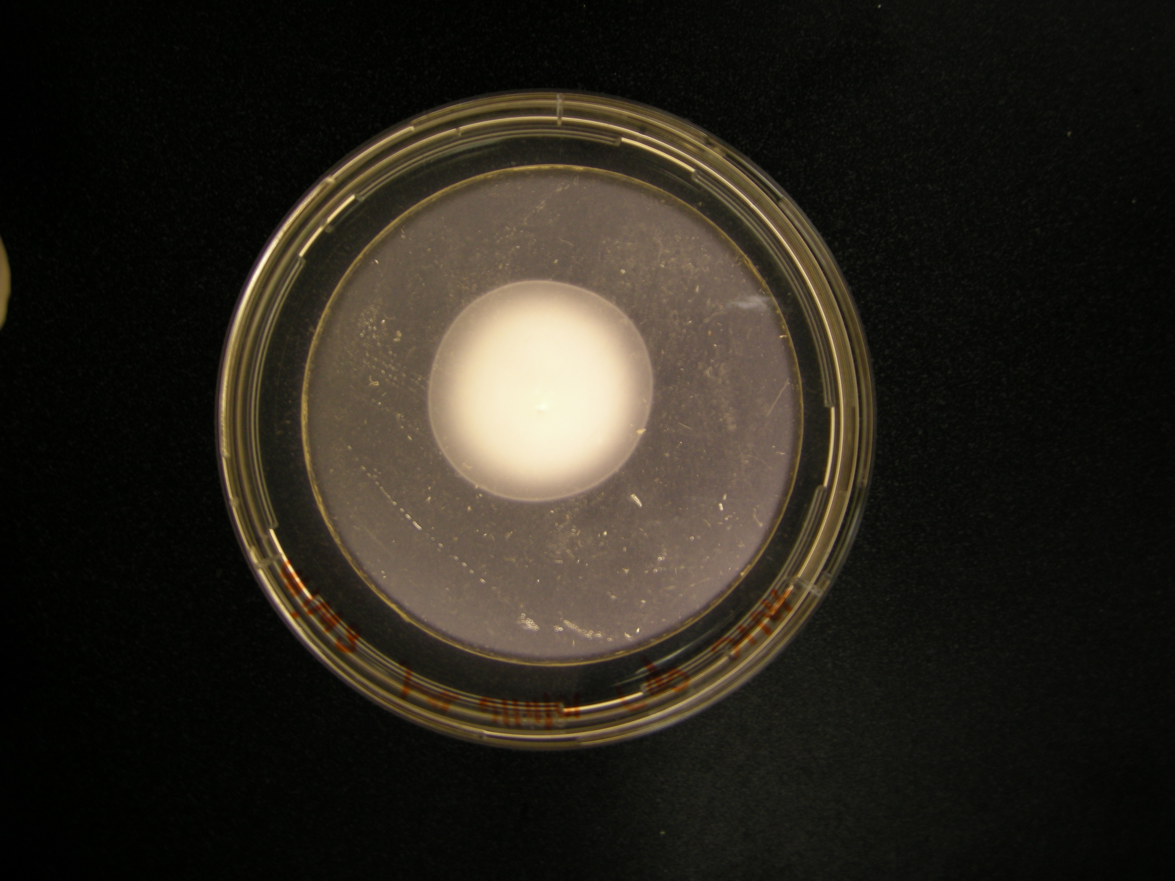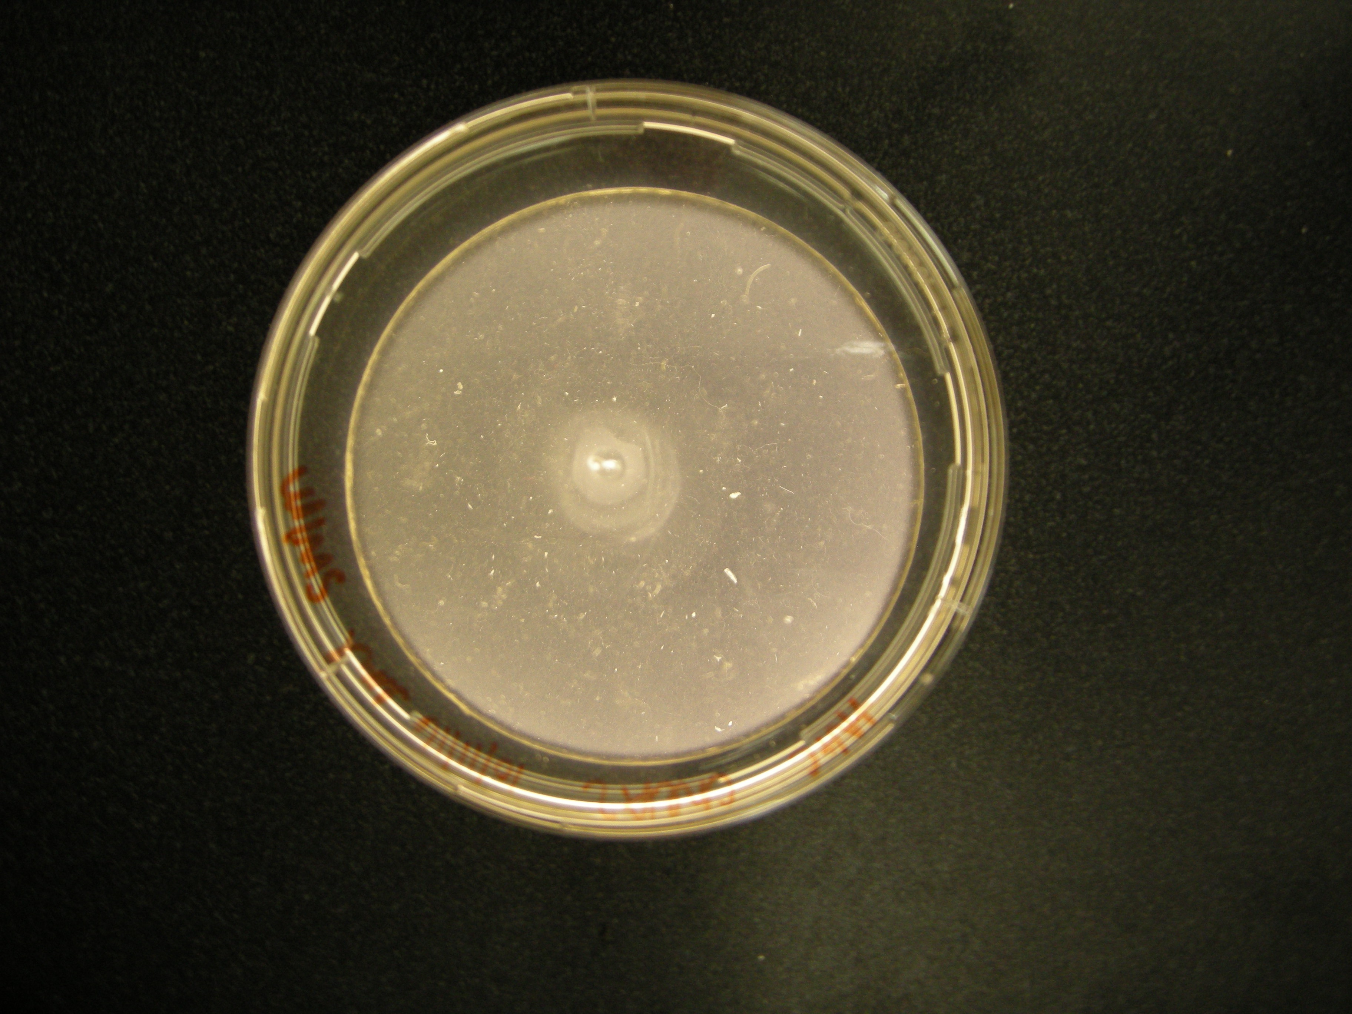

Fig 3: Sp7 (left) and cheA2 mutant (right) swim assays. Measured diameters: Sp7: 3.5cm, cheA2 mutant: 1.9cm.

We did not detect a significant difference in doubling times between the strains in rich media and possibly an unconfirmed slightly faster growth rate in the cheA2 strain relative to wild type in minimal media. The severely reduced ring diameter displayed by the cheA2 mutant is inconsistent with increased growth rate, which further suggests a deficiency in swimming motility, compared to the Sp7 wild type.

Swarm assays
Swarm assays were performed on nutrient broth to determine differences in surface swarming patterns of Sp7 wild type and cheA2 mutant. Barring any difference in growth under these conditions, differences in surface swarming are most likely related to lateral flagella function.

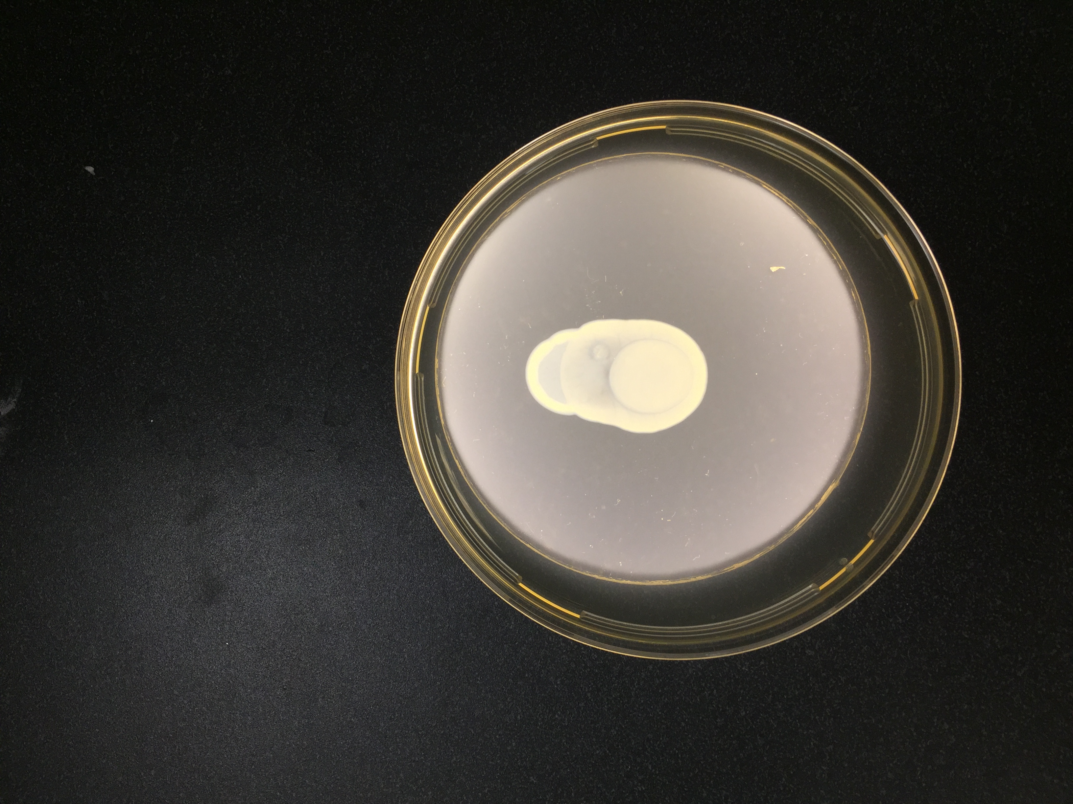 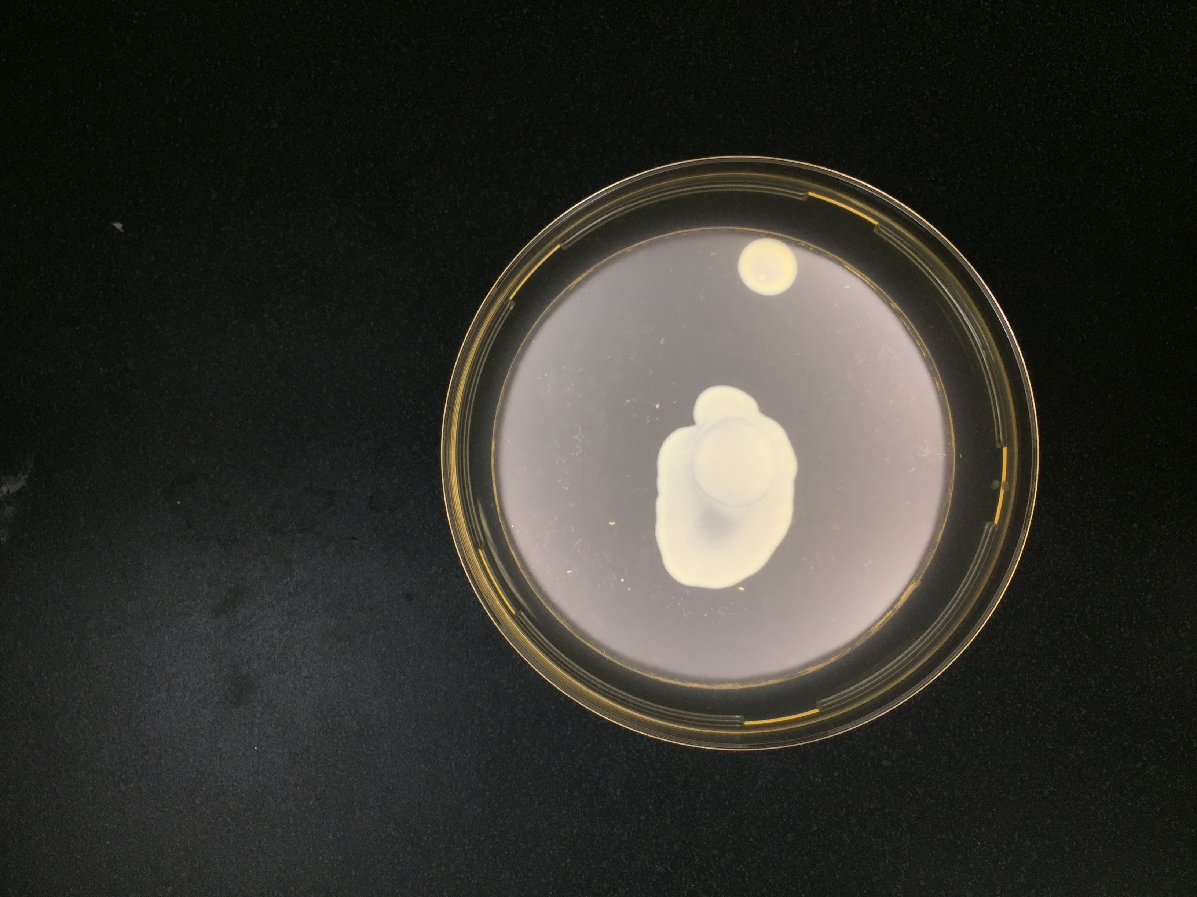Fig 4: Sp7 (left) and cheA2 mutant (right) swarm assays. Measured diameters: Sp7: 1.8cm, cheA2: 2.0cm.

Swarming patterns show no significant difference between Sp7 wild type and cheA2 mutant, suggesting that both strains can produce lateral flagella under these conditions.

Western blot  
An antiserum specific for the polar flagellin identified this protein, produced in large amount in the wild type strain (left panel) but failed to identify the same protein in the cheA2 mutant. This observation is consistent with the lack of swimming observed of the mutant strain by microscopy (data not shown). On the other hand, a band that could correspond to the lateral flagellin was strongly expressed in the cheA2 mutant but lacking in the wild type, as expected for liquid grown cultures.
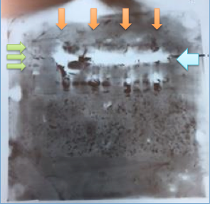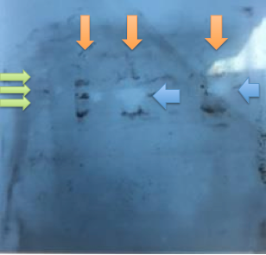
Fig. 5: Sp7 (left) and cheA2 (right) blot films. Orange arrows from left to right on first film: Sp7 in MMAB +N+C, Sp7 in TY, Sp7 in MMAB +N+C, Sp7 in TY. Green arrows from top to bottom on first film (ladder bands indicating a specific protein size): 140 kDa, 100 kDa, 70 kDa. Blue arrow on first film indicates an area where protein from Sp7 wild type samples was indicated, around 96 kDa. Orange arrows from left to right on second film: cheA2 +N+C, cheA2 TY, cheA2 +N+C. Green arrows from top to bottom on second film (ladder bands indicating a specific protein size): 70 kDa, 50 kDa, 40 kDa. Blue arrows on second film indicate areas where protein from cheA2 mutant samples was indicated, around 45 kDa.

Discussion
Above results imply that the cheA2 mutant is deficient in swimming motility compared to the Sp7 wild type. This is based on differing ability to swim through media, which would imply that swimming mechanisms are deficient in the cheA2 knockout. As swimming mechanisms are controlled mainly through polar flagella in A. brasilense, it is our continued hypothesis that the che2 operon in A. brasilense deals mainly with flagella biosynthesis and that the mutant species is deficient in polar flagellum biosynthesis. Previous experiments have indicated that polar flagella are responsible for motility in liquid conditions such as liquid cultures or even semisolid media, whereas lateral flagella are responsible for motility in viscous environments such as solid media as well as swarming patterns (Green 2010). Based on notable differences in swim and swarm assays observed here and the observation that the cheA2 mutant did not produce the polar flagellin but constitutively produced lateral flagella, it can be logically inferred that polar flagellin biosynthesis is disrupted but lateral flagellin can still be produced by the mutant if required by environmental conditions. Under the conditions of growth used for the Western blots (liquid cultures) we would expect only the polar flagella that permit swimming to be produced, as we observed in the wild type strain. This preliminary finding would suggest that lack of polar flagellum alone triggers lateral flagellum production, suggesting that Che2 may in fact regulate polar flagellum synthesis and/or that Che2 may control the repression of lateral flagella biosynthesis. More Western blots may be done in the future to confirm this result, as well as further observation of liquid cultures under a microscope to confirm a lack of motility as would be expected from a mutant lacking polar flagella.
Future studies should continue to optimize the SDS-PAGE gel and Western blot process. Specifically, antibody concentration should be altered such that protein concentration is optimized for visualization via x-ray film. Time of incubation with antibodies could also be optimized. In addition, growth curves should be repeated to indicate whether there is a significant difference in growth times and thus energy expenditure between the mutant and wild type.
The future implications of this research include characterization of a previously uncharacterized chemotaxis operon of A. brasilense, which could increase understanding of chemotaxis systems in other pathogenic or microbial species. This could have implications in medicine or plant biology as it could help researchers to better understand the way pathogens move through the body and how to target them or how roots are colonized in the plant. This could lead to development of new antibiotics or new agricultural techniques, both of which could potentially have major benefits to society.

References

Soutourina, O. A., & Bertin, P. N. (2003). Regulation cascade of flagellar expression in Gram-negative bacteria. FEMS Microbiology Reviews,27(4), 505-523. doi:10.1016/s0168-6445(03)00064-0

Berleman, J. E., & Bauer, C. E. (2005). A che-like signal transduction cascade involved in controlling flagella biosynthesis in Rhodospirillum centenum. Molecular Microbiology, 55(5), 1390-1402. doi:10.1111/j.1365-2958.2005.04489.x

Croes, C. L., Moens, S., Bastelaere, E. V., Vanderleyden, J., & Michiels, K. W. (1993). The polar flagellum mediates Azospirillum brasilense adsorption to wheat roots. Journal of General Microbiology, 139(9), 2261-2269. doi:10.1099/00221287-139-9-2261

Manson, M., Armitage, J., Hoch, J., & Macnab, R. (1998). Bacterial Locomotion and Signal Transduction. Journal of Bacteriology, 180(5), 1009-1022.

Wuichet, K., & Zhulin, I. B. (2010). Origins and Diversification of a Complex Signal Transduction System in Prokaryotes. Science Signaling, 3(128). doi:10.1126/scisignal.2000724

Alexeyev, M. (1999). The pKNOCK series of broad-host-range mobilizable suicide vectors for gene knockout and targeted DNA insertion into the chromosome of gram-negative bacteria. Biotechniques, 26(5), 824-826.

Green, C. S. (2010). Characterizing cell-cell and cell-surface interactions in the rhizobacterium Azospirillum brasilense(Unpublished master's thesis). University of Tennessee, Knoxville.

