Case Study of the Plant proteins ISE2 and IPI1:
General Defects in Chloroplast RNA Metabolism Do Not Affect PD-mediated Intercellular Trafficking

A Dissertation Presented for the
Doctorate of Philosophy
Degree
The University of Tennessee, Knoxville

Tyra Nadine McCray
December 2016

Copyright © 2016 by University of Tennessee
All rights reserved.

ACKNOWLEDGEMENTS

Thank you to my advisor, Tessa Burch-Smith for her guidance and the Burch-Smith lab members. Thank you also to my committee members: von Arnim, Barry Bruce, Elena Sphak and Brad Binder for their time, assistance, patience and helpful suggestions. Thank you to sequencing center employees Veronica and Joe for experimental assistance and helpful discussions. Thank you to P.E.E.R, PRC, ASPB and ICAR for funding. I would also like to thank members of the BCMB/GST administration: Sekeenia Haynes, Donna, Terry, Rodger, Amneka and family and friends for the encouragement and motivation.
ABSTRACT

INCREASED SIZE EXCLUSION LIMIT 2 (ISE2) is a nuclear gene encoding a chloroplast-localized DEVH RNA helicase essential for Arabidopsis embryogenesis, chloroplast RNA metabolic events and the regulation of plasmodesmal permeability. Here report that ISE2 is essential for the editing of several chloroplast transcripts. Emb175/PPR103 is a nuclear gene encoding a pentatricopeptide repeat (PPR) protein that is also required for embryogenesis in Arabidopsis thaliana and seedling survival in Zea mays (cite). EMB175/PPR103 was identified in an interaction screen with ISE2 via their C-terminal regions. Confocal fluorescence microscopy illustrates that IPI1-YFP, similar to ISE2-YFP, localizes to chloroplasts, consistent with its predicted chloroplast N-terminal targeting sequence. In Nicotiana benthamiana (Nb), silencing of emb175/PPR103 in mature leaf tissue produces a chlorotic phenotype coupled to defective chloroplast structural integrity. Interestingly, virus induced gene silencing (VIGs) of both Nb emb175/PPR103 and Nb ISE2 reveal defects in RNA editing of Nb chloroplast transcripts. However, while VIGS of ISE2 was found to previously lead to increased intercellular trafficking, no intercellular trafficking defect was observed in plants silenced for Nb emb175/PPR103. To obtain a global picture of the RNA processing landscape in Nb plants silenced for IPI1, RNA-seq was conducted on total RNA from chloroplasts of control and mutant tissue. Collectively our results identify IPI1 as an ISE2 interacting protein that localizes to the chloroplast and that shares an essential requirement with ISE2 in the proper RNA editing of select Nb chloroplast transcripts, adding to the rapidly growing knowledge base of RNA helicase and PPR protein function in plants

Other RNA processing events disrupted in ISE2 mutants include the processing of 23S ribosomal RNA, splicing of group II introns and changes in the steady state level of translation. However, it is unlikely that these events within themselves affect plasmodesmal permeability because other mutations in other chloroplast targeted proteins that cause defects in processing of ribosomal RNAs do not lead to defects in plasmodesmal permeability as this thesis shows. However, we cannot rule out the possibility that a unique ‘signature’ in RNA processing may somehow be correlated with particular defects in intercellular trafficking that we see in ise2 mutants.

PREFACE

This dissertation is largely based off experiments performed in the Burch-Smith lab. Authors that contributed to this work are greatly appreciated and acknowledged. The text in this dissertation is not yet published. TEM was done by Tessa, the initial Y2H screen, constructs for Y2H analysis, constructs for VIGS of IPI1 and Northern blots were provided by Tessa and present and current lab members. The library preparation and sequencing was done by the UTK Genomics Sequencing center. The GFP movement assay utilizing infiltration and bombardment techniques were assisted by George Butler.

Table of Contents

Chapter One Introduction 1
Intercellular Trafficking in Higher Plants 1
Regulators of Intercellular Trafficking 2
Molecular Factors that Regulate Intercellular Trafficking 4
Cellular Processes that regulate Intercellular Trafficking 9
Regulation of Organelle RNA Metabolism 14
Aims of This PhD Thesis 25
Chapter Two Results 26
ISE2 is Involved in the Editing of Chloroplast Transcripts 26
Characterization of ISE2 Interacting Protein (IPI1) 37
IPI1 physically interacts with ISE2 via the C-terminal region 37
IPI1 is a conserved PPR protein in plants 38
IPI1 is localized to chloroplasts 39
Phenotypic characterization of Nb IPI1: 39
IPI1 is necessary for the accumulation of chloroplast rRNA species 40
IPI1 is necessary for editing chloroplast transcripts 41
No IPI1 intercellular trafficking defects are seen in IPI1 mutants 42
Transcriptome Wide Analysis 42
Chapter Three Discussion 50
Biological Implications of ISE2 Role in RNA Editing 50
Functions of Arabidopsis Edited Transcripts 50
Biological Implications of RNA Editing Defects in Nb IPI1 mutants 54
Function of Edited Transcripts affected in VIGS-IPI1 plants 54
Insight into Factors that govern Plasmodesmata Regulation 55
Transcriptome Wide Profiling of Chloroplast Localized Factors 56
Chapter Four Materials and Methods 59
I plan to put a List of Primers here and annealing temps used 67
References 69
Appendix 85
Vita 87

LIST OF TABLES

Table 2.1. Functions of chloroplast transcripts whose editing extents are reduced in D3Y plants. 31
Table 4.1. List of Primers Used Will Go Here. 67

LIST OF FIGURES

Figure 1.1. Representative PD structures. 3
Figure 1.2. PD Permeability in embryogenesis 4
Figure 1.3. Domain architecture of the DEVH box RNA helicase ISE2 7
Figure 1.4. Intercellular Trafficking is Misregulated in ISE2 mutants 8
Figure 1.5. Gene Expression Changes in ISE1 and ISE2 mutants 13
Figure 1.6. RNA editing is the conversion of a C to U 15
Figure 1.7. PPR proteins are found to be site specific factors involved in RNA editing. 16
Figure 1.8. Domain architecture of PPR protein family in plants 21
Figure 2.1. Chloroplast transcripts with known editing sites 27
Figure 2.2. RT-PCR results of known editing sites 28
Figure 2.3 Defects in D3Y plants affect individual editing sites within chloroplast transcripts 30
Figure 2.4. Editing occurs in 4wk Nb leaves. 32
Figure 2.5. Editing defects are seen in leaves of plants silenced for ISE2. 34
Figure 3.1. Model of ISE2 and IPI1 Function in Chloroplast Metabolism but not in Intercellular Traffiking. 58

Introduction

Intercellular Trafficking in Higher Plants

Intercellular communication, or the transfer of information between cells, is an essential cellular phenomenon within the Eukarya domain of life (Leister et al., 2013). In multi-cellular organisms, intercellular communication is necessary for the coordination of cellular function and thus for the survival of the organism. In plants, this informational transfer is impeded due to the presence of cellulosic cell walls. Plant cells overcome this barrier through the presence of structures called plasmodesmata (PD). Plasmodesmata are membrane lined cytoplasmic channels that adjacent plant cells and that regulate the symplastic exchange of informational molecules such as water, nutrients, ions, sugars, hormones, metabolites, or developmental signaling molecules such as transcription factors and RNA (Burch-Smith et al., 2011). Thus, PD are essential to plant survival, growth and development; a characteristic buttressed by the observation that several PD mutants are either embryo lethal or exhibit severe developmental abnormalities.

PD can form during cell division originating when the endoplasmic reticulum (ER) become trapped in the cell plate prior to Golgi-mediated cell wall deposition (primary PD) or after cell-division through the pre-existing cell wall (secondary PD) (Burch-Smith et al., 2011). Primary PD typically form a single channel, while complex PD (that originate through the existence of cell walls after cell-division) can form a variety of complex shapes (Figure 1). Simple and branched forms resemble Y, X and H shapes and twined PD are comprised of two simple parallel tunnels within 100 nm of each other (Burch-Smith et al., 2011). Simple PD are mostly found in young immature tissue and branched PD are predominately found in mature tissues (Burch-Smith et al., 2011).

During embryogenesis, PD connect all cells allowing the embryo to exist as one symplastic unit. However, as plant development proceeds starting at the torpedo stage, intercellular trafficking through PD becomes restricted at defined symplastic boundaries within the embryo (Figure 2a, Kim et al., 2002). Such a restriction allows the developmental coordination of individual organs to occur (Figure 2b, Kim et al., 2005).

The size exclusion limit (SEL) is defined as the molecule size at which movement is restricted through PD aperture (Burch-Smith et al., 2011) once the transition from young to mature tissue development proceeds. The size exclusion limit in tabacco cells of mature leaves has been reported to be dynamic and dependent upon leaf developmental stage (Burch-Smith et al., 2011).

The regulation of PD occurs in response to the initiation of cellular differentiation and to prevent the invasion of harmful pathogenic signaling molecules from spreading cell to cell. Despite the fundamental importance of PD to plant survival growth and development, knowledge of the regulation of PD remains elusive.

Regulators of Intercellular Trafficking

A well-known mechanism of PD regulation involves callose deposition at PD neck regions. However, it has been postulated that callose deposition may regulate PD aperture in response to dormancy as a long-term response but is not likely to be the main transient regulator of PD aperature during development (Burch-Smith et al., 2011). Here I summarize molecular factors and potential cellular processes that may regulate PD aperture.

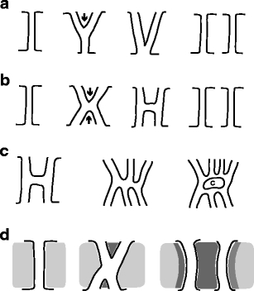

Figure 1.1. Representative PD structures.
PD adopt several conformational shapes (a,b) twined PD formation from simple PD (c) complex PD structure formation (d) branched or twined PD formation from deposited cell wall material. Figure adopted from Burch-Smith et al., 2011.

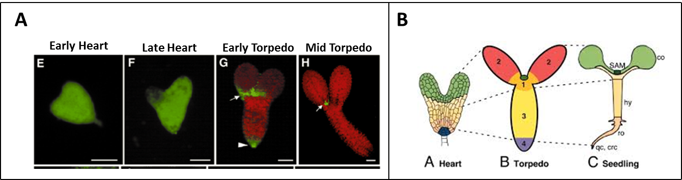
Figure 1.2. PD Permeability in embryogenesis
PD-mediated intercellular trafficking becomes restricted at the torpedo stage in wild-type embryos (a) 10 kDa F-dextran freely moves within early heart and later hear t embryos, but becomes restricted in torpedo stage embryos. Chlorophyll fluorescence represents the cytoplasm. Arrows indicate the radical tip and the regions that the cotyledons join as regions where the movement of loaded dextran is restricted (b) Subdomains that are restricted at the mid-torpedo stage later develop into (i) shoot apex (ii) cotyledons (iii) hypocotyl and (iv)root, respectively. Figure 2a is adopted from Kim et al., 2002 “Identification of a developmental transition in plasmodesmal function during embryogenesis in Arabidopsis thaliana” and Figure 2b is adopted from Kim et al., 2005 “Subdomains for transport via plasmodesmata corresponding to the apical-basal axis are established during Arabidopsis embryogenesis.” I need to obtain permissions.

Molecular Factors that Regulate Intercellular Trafficking

b-1,3-glucanase is a PD-localized enzyme that regulates callose deposition by degrading the polysaccharide callose and therefore regulates PD-mediated intercellular trafficking. PD-callose-binding protein 1 (PDCB1) also localizes to plasmodesma. Another group of PD-localized enzymes that may potentially regulate callose deposition are reversibly glycosylated polypeptides (RGPs). The silencing of RGPs result in increased intercellular trafficking, while the overexpression of RGPs result in decreased intercellular trafficking (Burch-Smith et al., 2011).

KOB1 is predicted to be a glycosyl transferase which may play a role in carbohydrate metabolism (plant responses to abscisic acid and Glc) that are necessary for the biosynthesis of cellulose during cell elongation (cell wall metabolism) and also plasmodesmata closure (Kong).; however a disruption in cellulose biosynthesis was not found to affect PD permeability or in an increase in cellulose biosynthesis (Kong). It has been postulated that the increased stomata mutant phenotype of erl1 erl2 kob1 is due to increased plasmodesmal permeability, allowing unphosphorylated bHLH transcription factors (e.g SPEECHLESS, MUTE, FAMA, ICE1/SCREAM and SCREAM2) to traffick and thus promote differentiation leading to stomata clustering (Kong). Thus, KOB1 was postulated to play a role in regulating the plasmodesmata size exclusion limit (Kong). Interestingly, kob1-3 is allelic to both eld1-1 and ABSISSIC ACID INSENSITIVE 3 (ABI3). KOBITO1’s (ABI8) has been previously implicated as playing a role in cell wall metabolism (Kong). Although increased intercellular trafficking (such as that that is seen in kob1-3 mutants) is sometimes associated with decreased callose deposition at plamodesmal neck regions, a slight increase in callose accumulation actually occurs in the kob1-1 mutant allele (Kong), suggesting that kob1 is a callose removal enzyme. However, cellulose biosynthesis was not found to affect stomata differentiation in the erl1 erl2 backround. ERL1 and ERL2 are receptor-like kinases that inhibit differentiation of metistemoids into mother guard cells.

A mutation in a gene encoding CHORUS phenotypically resembles kob1-3 mutant phenotypes (Guseman et al., 2010). Mutations in CHOR have few stomata clusters when tmm/erf pathway is functional); however; in erecta erl1 mutants and erecta erl2 mutants, chor also has increased stomata clusters, coupled to increased intercellular trafficking of macromoleucles including SPEECHLESS (SPCH), a transcription factor involved in stomata cell differentiation (Guseman et al., 2010). This defect was not caused by a general cytokinesis defect. The CHOR gene encodes a predicted callose synthase, GLUCAN SYNTHASE-LIKE 8 (GSL8).GSL8 is required for callose deposition of cell plate, cell wall and plasmodesmata regions (Gussman et al., 2010). Interestingly, CHORUS is misregulated in mutations of the RNA helicase, ISE2 that has an increased intercellular trafficking phenotype (see below).

Mutations in the plastid thioredoxin, GAT 1, exhibit decreased intercellular trafficking coupled to increased callose production and elevated ROS production (Burch-Smith et al., 2011).

ATP-dependent proteins, such as actin and kinases, may also function in the regulation of the trafficking of molecules through PD. Cytoskeleton-associated proteins, including actin and myosin have been reported to localized to PD (cite).
The inhibition of actin with the drug latrunculin led to an increase in PD aperture between leaf mesophyll cells and the metabolic inhibitor coupled to a decrease in cellular ATP levels in all tissue types examined (Burch-Smith et al., 2011). And phosphorylation is necessary for the trafficking of several developmentally important transcription factors through PD (Burch-Smith et al., 2011). ATP-dependent RNA helicases are also involved in the regulation of PD aperture size and intercellular trafficking. RNA helicases function in almost all RNA metabolic processes within the cell, usually involving their ability to unwind secondary RNA structures. RNA helicases are known to be involved in diverse metabolic functions, including but not limited to: ribosome biogenesis, pre-mRNA splicing and RNA editing.

The chloroplast localized RNA helicase INCREASED SIZE EXCLUSION LIMIT 2 (ISE2) and the mitochrondrial localized RNA helicase INCREASED SIZE EXCLUSION LIMIT 1 (ISE1) were identified in a forward genetic screen designed to identify critical regulators of plasmodesmata-mediated movement (Kobayashi et al., 2007, Kim et al., 2002). More specifically, ISE2 is a nuclear gene encoding the DEVH RNA helicase (Figure 1.3) essential for Arabidopsis thaliana embryogenesis. Mutations in At ISE2 arrest at the mid-torpedo embryonic stage (Kim et al., 2002). At the mid-torpedo stage of embyogenesis, embryos that are mutant for ISE2 display increased plasmodesmal movement of a 10-kD fluorescent dextran dye in Arabidopsis (Figure 4a; Kobayashi et al., 2007 and Kim et al., 2002); ISE2 was later found to additionally essential for the regulation of plasmodesmal permeability in mature leaves, as plants silenced for ISE2 display increased intercellular trafficking of 2XGFP (Figure 4b).

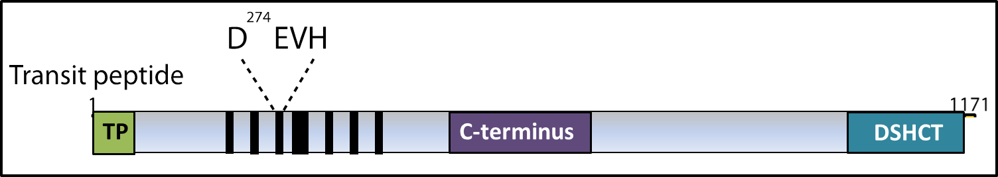
Figure 1.3. Domain architecture of the DEVH box RNA helicase ISE2
ISE2 is a nuclear encoded gene that encodes for a chloroplast targeted ski-type RNA helicase. The ISE2 protein product belongs to the DEVH box RNA helicase family and is characterized by: (i) an N-terminal transit peptide (ii) motifs I-VI which function in ATP-dependent RNA unwinding, and (iii) a C terminal region with the characteristic conserved DSHCT motif. Figure courtesy of Kryseik Bobik is re-colored.

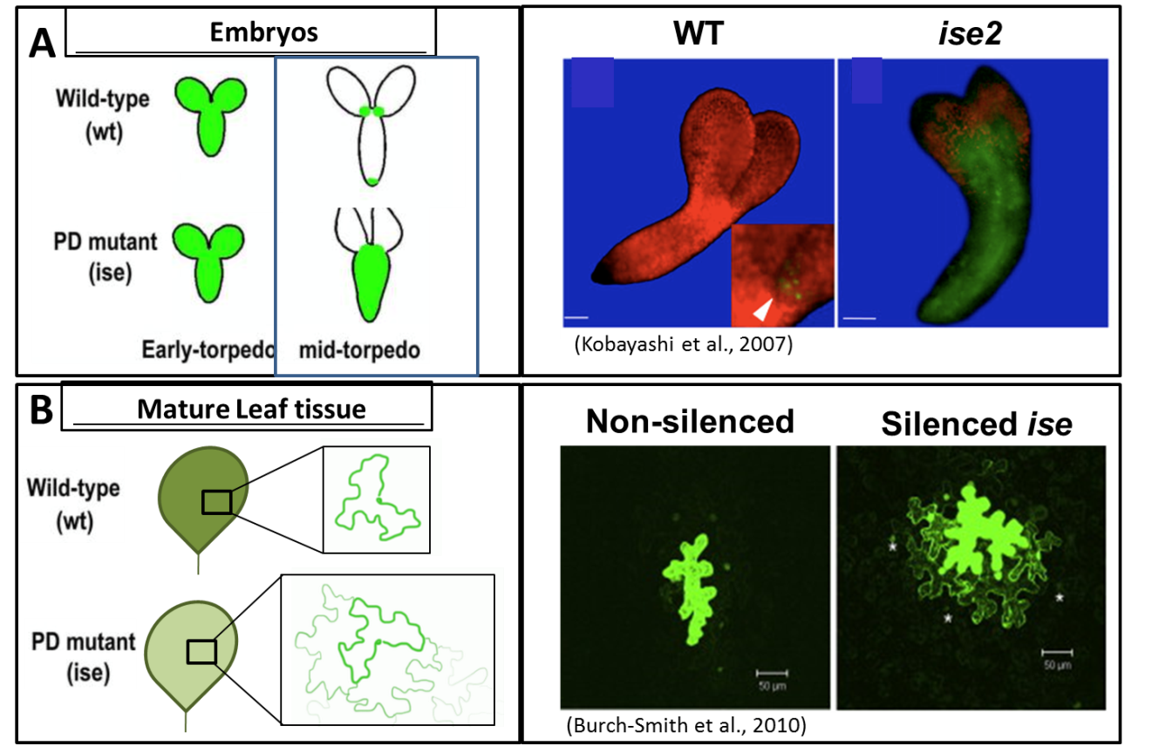
Figure 1.4. Intercellular Trafficking is Misregulated in ISE2 mutants

Mutations in ISE2 lead to increased plasmodemal permeability (A) Increased movement of F-Dextran occurs in ise2 mid-torpedo stage embryos. Left: a schematic illustrating the differences in movement of a tracer dye in Wild-type (wt) and in ise mutants. Right: Microscope image of movement differences of the tracer dye in WT as compared to ise2 mutant embryos (B) Increased movement of 2XGFP occurs in mature leaf tissue silenced for ISE1. Left: a schematic illustrating the differences in movement of 2XGFP in Wild-type (wt) and in ise mutant mature leaf tissue. Right: Confocal image of movement differences of 2XGFP in WT as compared to leaf tissue silenced for ISE1.

In addition to the intercellular trafficking defect seen in mature leaf tissue, plants silenced for ISE2 display a chlorotic leaf phenotype and TEM analysis of chloroplast ultrastructure reveals fewer grana and starch grains and a greater stromal area in ise2 mutants compared to non-silenced control leaves. Further characterization of ISE2 revealed that it is essential for the processing of chloroplast rRNA species, splicing of group II introns and in transcription, which is consistent with general functions of RNA helicases (unpublished). Additionally, ise2 mutants exhibit splicing defects in group II introns (including ycf) and post-transcriptional processing defects in 23S rRNA (unpublished data). Besides rRNA processing defects, ise2 mutants result in defects in the expression of genes transcribed in the chloroplast and in nuclear-encoded genes that function in photosynthesis or plasmodesmata (PD)-regulated transport (Burch-Smith et al., 2011). Several translational defects seen in ise2 mutants include reduced levels of D2 protein (PsbD), a dimerization partner of D1 protein (PsbD); D1 and D2 protein together form the Photosystem II (PSII) reaction center.

Cellular Processes that regulate Intercellular Trafficking

Organellar metabolism has been postulated to be a regulator of plasmodesmal permeability. Communication originating from organelles to the plasmodesmata is termed Organelle Nucleus Plasmodesmata Signaling (ONPS) [2]. A primary goal of our lab is to understand how signals from plant organelles such as the chloroplast may directly regulate plasmodesmata-mediated intercellular trafficking. A current hypothesis is that plastids produce the signals that eventually converge on the regulation of plasmodesmata function (cite). It is thought that chloroplasts may communicate their status to the PD as a short-term response contrasted to a long-term responses that may involve retrograde signaling mechanisms. The short-term response may involve the production of signals that include (i) ROS (ii) hormones (iv) tetrapyroles (iv) sugars or other signaling intermediates or (v) some quantitative combination of these signals.
The production of such signals would likely require upstream processing by chloroplast resident or targeted proteins that function in the regulation of chloroplast metabolism and several signals may be generated due to RNA metabolic processing defects in the chloroplast.

ROS: Levels of the reaction oxygen species, H2O2, a well-known secondary messenger signaling factor in plant developmental and stress responses, have been postulated to regulate PD aperature (Burch-Smith et al., 2011). An additional study showed that hydrogen peroxide stress restricts the intercellular movement of GFP as compared with the PSUC2-GFP control (cite). Interestingly, redox state can affect the binding of RNA-binding proteins to RNA substrates (cite). However, ROS production within itself does not lead to a particular effect on PD transport. For example, although mutations in the RNA mitochondrial RNA helicase ise1 and plastid gat1 mutations lead to increased ROS, they have opposite effects on PD-mediated intercellular trafficking (ise1 causes an increase while gat1 causes a decrease). This may indicate that certain redox-responsive proteins and signaling factors affected in each particular mutant may be involved in the regulation of plasmodesmal permeability. Additionally, there may however be a correlation of the amount of ROS produced to the particular effect on PD transport, with low levels of hydrogen peroxide leading to an increase in PD-mediated intercellular movement, whereas higher concentrations decrease it (cite). It has been also been postulated that in addition to the amount of ROS produced, the site of ROS production (i.e the redox status of the reduced chloroplast and the oxidized mitochrondria) is an important factor in determining the effect of PD transport (Stonebloom et al., : Redox states of plastids and mitochondria differentially regulate intercellular transport via plasmodesmata); increased ROS production in mitochrondria leads to increased plasmodesmal permeability while increased ROS production in chloroplasts leads to reduced plasmodesmal permeability (cite). This information indicates that the redox state of the chloroplast and mitochrondria may differentially regulate plasmodesmata-mediated intercellular trafficking (cite)

Hormone metabolism: Several studies indicate that elevated levels of chloroplast-derived hormones such as SA lead to increased intercellular trafficking. Secondary metabolites such as SA, ABA and jasmonic acid are produced in the chloroplast.

Sugar metabolism: Hormone metabolism and sugar metabolism are closely linked. For example, many ABA insensitive mutants have known functions in sugar metabolism. As mentioned previously, KOB1 is known to affect plasmodesmal permeability and is also allelic to ABI8.

Other RNA processing events disrupted in ISE2 mutants include the post-transcriptional processing of chloroplast 23S ribosomal RNA, splicing of group II introns (including ycf) and changes in the steady state level of transcription and translation, which is consistent with general functions of RNA helicases (unpublished) as mentioned previously. Some studies also suggest that ISE2 localizes with mRNA decapping enzyme 2 in chloroplast processing bodies and was found to physically interact with PNPase, involved in RNA degradation (cite). ISE2 was also found to interact with RH3, a chloroplast-localized DEAD box RNA helicase that functions in RNA processing and RPL15, a plastid ribosomal protein. Microarray analysis of transcripts that are affected in mid-torped stages embryos in Arabidopsis ise2 mutants reveal misregulation of many genes that encode plastid targeted proteins. Microarray analysis has revealed that ise2 mutants result in defects in the expression of nuclear-encoded plasmodesmata (PD) related genes. For example, the expression of callose-binding proteins that are localized to plasmodesmata neck regions and cell wall genes are misexpressed in ise2. These include: CHORUS/GLUCAN SYNTHASE-LIKE 8 (callose synthesis), ATBG_PPAP (callose degradation), RGP3, PDL5,6,8 (glycosylation enzymes which increase the size exclusion limit). Mis-regulated cell wall genes include: cellulose glycosyl transferases, XyG endotransglucosylase/hydrolase (XTH) and expansins (Burch-Smith 2011). These gene expression results may potentially provide a starting point to investigate the link between disrupted nuclear gene expression and plasmodesmata structure leading to the increased intercellular trafficking and an increased plasmodesmata phenotype seen in ise2 mutants; however these particular expression pattern of these misregulated genes (induced/repressed) do not expain the increased intercellular trafficking phenotype of ise2 mutants (Burch-Smith 2010).Nuclear-encoded (i.e LHCII) and chloroplast-encoded transcripts are also misregulated in ise2 mutants (Burch-Smith 2011). Despite their different organelle destination, mutations in both ISE1 and ISE2 result in increased intercellular trafficking. Commonalities in the misregulated nuclear and plastid-encoded genes shared in both ise1 and ise2 mutants are shown in Figure 5 (Figure Moified from Burch-Smith et al., 2011: Organelle-nucleus cross-talk).
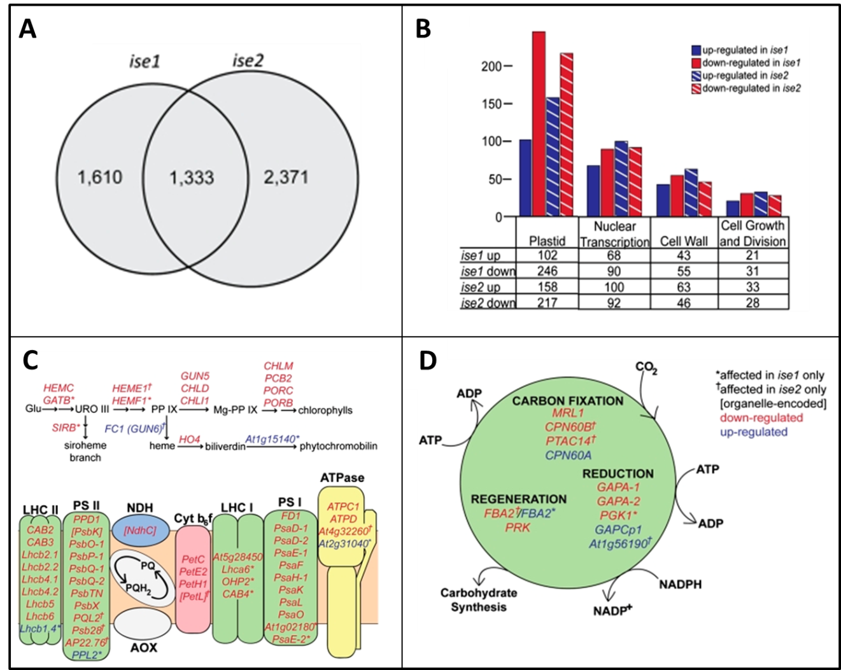

Figure 1.5. Gene Expression Changes in ISE1 and ISE2 mutants

Misregulated genes in ise1 or ise2 mutants compared with WT midtorpedo embryos (A) Misregulated genes that are common in ise1 and ise2 mutants or that are unique to ise1 or ise2 mutants (B) Function and quantification of genes exhibiting altered expression in ise1 or ise2. As indicated in Burch Smith et al., 2011, most affected genes in both ise1 and ise2 mutants belong to genes involved in plastid function (C,D) Misregulated genes in ise1 or ise2 that encode proteins involved in plastid function include those involved in tetrapyrrole synthesis (top) in photosynthetic electric transport chain(bottom) As indicated in Burch Smith et al., 2011, most affected genes are repressed in mutants and genes in brackets are encoded by the plastid genome; all other genes are nuclear D) Misregulated genes ise1 or ise2 mutants encoding plastid proteins.

Regulation of Organelle RNA Metabolism

Subcellular fractionation experiments of the chloroplast reveal that the chloroplast proteome contains over 200 proteins; both nucleus and chloroplast-encoded. Factors that participate in chloroplast function include proteins encoding components of PSII, PSI, photosynthetic and calvin cycle redox reactions, tetrapyrole/chlorophyll metabolism, fatty acid biosynthesis, and RNA processing (including degradation) factors of chloroplast transcripts.

Several organelle-targeted RNA helicases were reported to have a role in the processing of chloroplast transcripts, likely in part due to their ability to unwind secondary RNA structures. RH3, RH22 and RH39-3 are ISE2 interacting chloroplast DEAD-box proteins that are required for rRNA processing in chloroplasts. Other ISE2 interacting proteins that have a role in chloroplast RNA processing include PNPase, involved in RNA processing and editing in the chloroplast and RPL15. Another plant family found to heavily influence organelle RNA metabolic events are encoded by the PPR genes (see chapter 3 for characterization of the ISE2 Interacting PPR protein, IPI1). The PPR protein family is greatly expanded in plants (with over 450 nuclear genes encode PPR proteins in Arabidopsis) that are predominantly targeted to the chloroplast or mitochrondria. Although ABA, sugars and tetrapyroles as signaling molecules were found to modulate chloroplast translation (cite numerous sources), the focus of this section will be on two key regulators of chloroplast RNA metabolism: RNA helicases and PPR proteins and their role in the important RNA metabolic process with a focus on chloroplast RNA editing.

A major goal of the Burch-Smith lab is to make progress towards answering the question: If and if so how does ISE2’s effect on organelle RNA metabolism influence PD structure and function related to the regulation of intercellular communication? ISE2 is a great starting point to dissect a potential relationship between chloroplast RNA metabolism and intercellular communication as ise2 mutants have defects in both organelle RNA metabolism and plasmodesmata structure and function. To further elucidate ISE2’s role in unknown RNA metabolic processes, we set out to first further to examine a potential extended role in RNA editing, a major metabolic function in plant organelles.

RNA editing is a post-transcriptional mechanism to change the transcript sequence information prior to organelle translation. In angiosperms, RNA editing is the site-specific conversion of a C-U within chloroplast and mitochrondrial transcripts (Figure 6) (Bock et al., 2000).

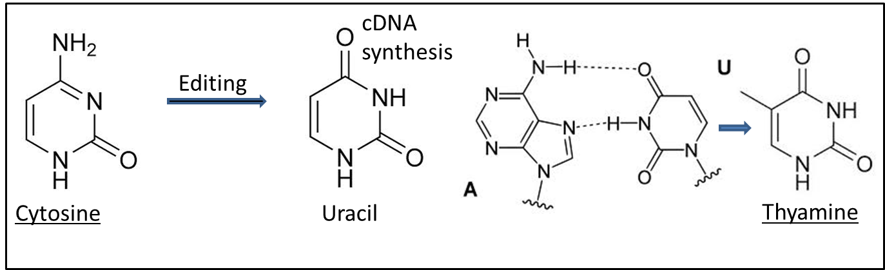

Figure 1.6. RNA editing is the conversion of a C to U

RNA editing in plant organelles is thought to proceed via a deamination reaction, involving deamination of a cytosine in order to produce a uracil.

In addition to RNA processing events such as splicing operon structure, transcription, translation (assoc with ribosomal RNAs, PSII/PSI photosynthetic electron transport, retrograde signaling) RNA helicases have long been hypothesized to function in RNA editing in Eukarotes in general. In plants, the most characterized protein family that functions in RNA editing comprises the PPR protein family.

RNA editing in plant organelles is thought to proceed via a deamination reaction, involving deamination of a cytosine in order to produce a uracil, presumably requiring at least one PPR protein or enzyme conferring the deaminase activity and other trans-factor (s) (Figure 7). Residues modified by C-to-U RNA editing function to restore conserved amino acid (i.e accD (S->L), atpF (P->L), clpP(H->Y),matK(H->Y),ndhB(S->L)) and to change a codon to a start codon (i.e ndhD)). The edited transcripts typically functions in organelle processes involving transcription, PSII/PSI photosynthetic electron transport, steady state regulation (protein stability/turnover), and retrograde signaling.

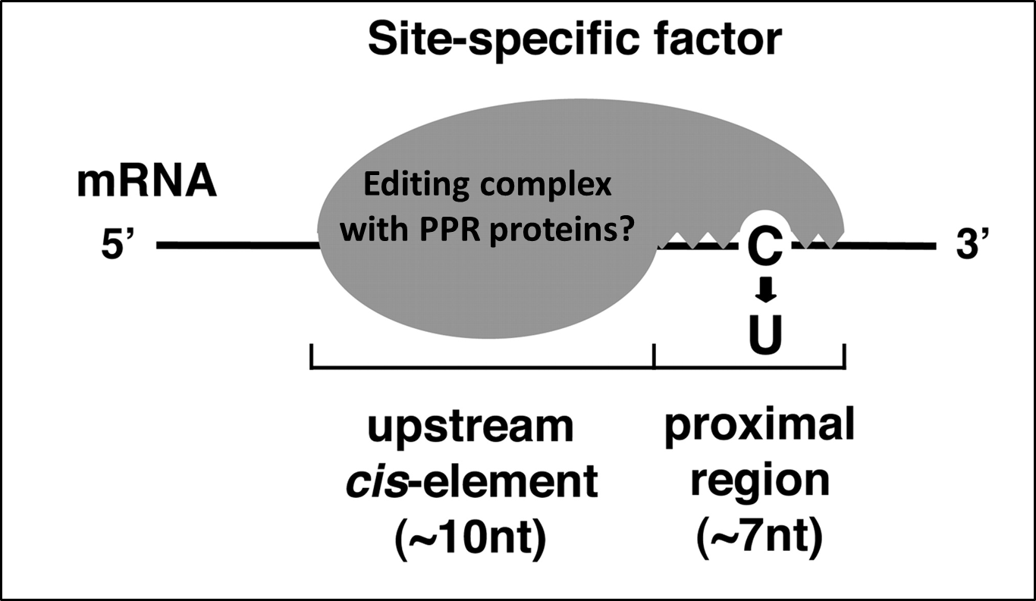

Figure 1.7. PPR proteins are found to be site specific factors involved in RNA editing.

PPR are necessary for RNA editing, directly associate with transcripts that are edited to an upstream cis element and are hypothesized to contain cytidine deaminase activity (Modified from Miyamoto et al., 2004).

Although deamination of a C to a U base pair is the accepted mechanism for RNA editing, mitochrondrial transcripts are edited involving a deletion mechanism (Chasan 1991). In most plants, only a subset of plastid and mitochrondrial RNA transcripts undergo RNA editing. There are far more RNA editing events in photosynthetic plants than there are in non-photo synthetically active plants, thus RNA editing is thought to have evolved during the water to land transitioning of plants (Tillich and Krause 2010).

The editing and splicing of chloroplast transcripts is necessary for photosynthesis (Tillich et al., 2010) and editing may be a prerequisite for splicing in a subset of plant organelle transcripts (Castandet et al., 2010). Unlike photoauthotropic plants (photosynthetic plants), holoparasitic plants have an increase in point mutation rates that parallel the disappearance of RNA editing sites and also parallel loss of plastid intron maturase and group II a introns (self-catalytic ribozymes and mobile genetic elements) (Tillich et al., 2010). Some plastid transcript products may play distinct roles from photosynthesis and gene expression, as the non-photosynthetic, parasitic flowering plant Epifagus virginiana, contains nine conserved plastid genes with photosynthetic plants (Marden et al., 1991, Ems S et al. 1995); however fewer polymerase subunits are encoded by the plastid genome illustrating that these subunits are translocated from the cytoplasm into the plastid, unlike flowering plants that undergo RNA editing of these subunits (Marden et al., 1991). The nuclear genome of Arabidopsis thaliana encodes three single-subunit bacteriophage type RNA polymerases, two of which are likely mitochrondrial enzymes and the third, the nuclear-encoded RNA polymerase (NEP) in plastids (Hess et al., 1999). The plastid also encodes its own polymerase, the plastid-encoded RNA polymerase (PEP) (Hess et al., 1999).

Perhaps in order to facilitate amino acid changes, most editing sites are found within the first or second base pair of the codon (Gray et al., 1993). Sometimes editing changes a codon to a start or a stop codon and in some cases, editing in mitochrondria is essential for mitochrondria function (Gray et al., 1993), splicing of mitochrondrial transcripts (Castandet et al., 2010, Farre´ et al., 2012 ). RNA editing is also essential for gene expression (Grennan et al., 2011, Hirose T et al., 1999), translation (Stevenson et al., 2008) and even plant immunity (Garcı´a-Andrade et al., 2013). As unedited mature RNA was found in both polysomal and non-polysomal fractions, there appears to be no difference in translation efficiency between unedited and unedited transcripts, illustrating that unedited transcripts may also play important roles under certain conditions or may interfere with other processes due to a potentially aberrant structure (Chasan, 1991).

There are cis-elements required for editing in chloroplasts and mitochrondria and they normally occur are within 30 nucleotides (nt) 5’ and 10 nt 3’ of the C target (Robbins et al., 2009). There are several cases of editing occurring in tabacco (Nicotiana tabacum cv. Petit Havana) (Chateigner-Boutin et al., 2003 and ), where about 30 of the 34 sites are clustered in 2-5 sites based on sequence similarity 5’ of the edited C in chloroplasts (Chateigner-Boutin et al., 2003). The presence of a site-specific trans-factor was suggested due to results showing reduced editing of transcripts with sequence similarity when one member (with same consensus) sequence was over-expressed (Chateigner-Boutin et al., 2003). Further support of a trans-factor involved in editing comes from results where exogenous expression of the rpoB transcript resulted in reduced editing efficiency of the endogenous rpoB transcript (Stern et al., 2010). Additionally, in maize, as some sites are edited and others are not within the same transcript, specific trans-factors for each editing site have been postulated (Peeters et al., 2002). While some trans-factors may be specific to one site, other trans-factors may edit more than 1 site (Robbins et al., 2009). Compared to tabacco leaves, most of the NADH dehydrogenase subunits show drastically reduced editing in roots illustrating that transfactors that are required for RNA editing may exhibit differential expression depending on the tissue (Chateigner-Boutin et al., 2003), although most are expressed at very low levels (Robbins et al., 2009). In maize, ndhB is edited about 100% in green leaf chloroplasts, but only 8% in roots (Peeters et al., 2002).

Maize plastids contain 27 C-to-U editing sites within transcripts, which affect the expression of 15 genes (Peeters et al., 2002) and in maize it has been suggested that RNA quantity rather than RNA editing extent affect gene expression as a range of transcript abundances are efficiently edited (Peeters et al., 2002).
RNA helicases function in a diverse array of metabolic processes, in addition to unwinding secondary structures in an ATP-dependent manner and functioning as adapters to bring together multi RNA-protein complexes (Linder et al., 2011), they are involved in abiotic stress, RNA maturation, ribosome biogenesis, RNA splicing, transport, turnover, transcription, translation, RNAi, RNA editing, and development (Owttrim 2006).

Albino phenotypes can be developed as a result of RNA metabolism defects. For example, a RNA editing defect at the atpA site causes an albino phenotype in tabacco (Schmitz-Linneweber et al., 2005). Not surprisingly, RNA editing does not require chloroplast translation for ropB (showing that the factor that participates in RNA editing of some chloroplast transcripts are nuclear encoded (Zeltz et al., 1993).

Chloroplast Editing Factors: Thus far, the eukaryotic nuclear-encoded pentatricoptide repeat (PPR) protein family consists of a well-conserved group of RNA-binding proteins that are critical for diverse roles in plant signaling (cite).
Loss of a single PPR protein can result in embryonic arrest or severe developmental defects, demonstrating their fundamental importance to plant survival and development (cite). (PPR) proteins have been classified as site-specific trans-factors involved in group II intron splicing, intergenic processing of chloroplast transcripts, endoribonuclease processing, stabilization and RNA editing (Nakamura 2008, Mach J, 2009).

Plant PPR proteins are typically targeted to either the mitochondria or chloroplast, where they act by binding to one or several single-stranded RNA molecules via 2-30 N-terminal tandem and degenerate helical repeat motifs(cite). Within plant mitochondria and chloroplasts, most characterized PPR proteins mediate specific events in post-transcriptional processing and maturation of RNA (cite) by influencing RNA splicing (cite), RNA cleavage (cite), RNA stability/turn-over (cite) ,translation (cite) and the site-specific sequence alteration of RNA transcripts through a process called RNA editing (cite). Other cellular processes that are affected by PPR proteins include nuclear gene expression (cite) and plastid biosynthesis (cite).

Pentatricoptide repeat proteins are characterized by the occurrence of 35bp motifs that occur tandemly throughout the length of the protein (Shikani T 2006). PPR proteins are divided into the P subfamily or the plant-specific PLS subfamily. The PLS subfamily is further classified according to the following domains present in the C terminal region: (i)E groups are classified as those containing a E domain (ii) E+ groups are classified as those containing an E and an E+ and (iii) DYW groups are classified as those containing an E, E+ and DYW domain (Figure 8) (Shikani T 2006).

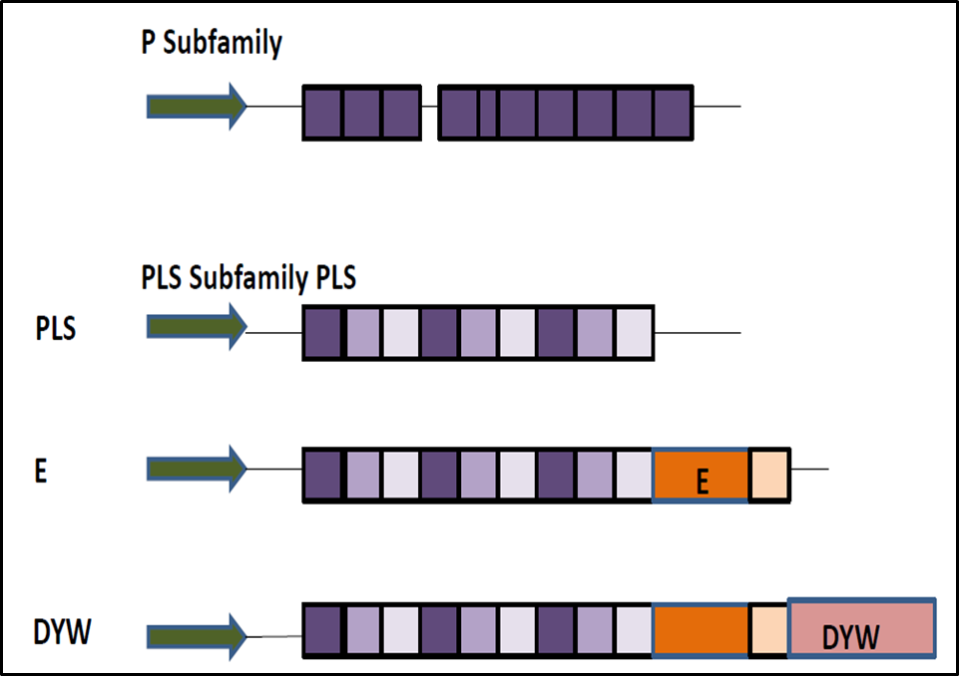

Figure 1.8. Domain architecture of PPR protein family in plants

PPR proteins are divided into the P subfamily or the plant-specific PLS subfamily. The PLS subfamily is further classified according to the following domains present in the C terminal region: (i)E groups are classified as those containing a E domain (ii) E+ groups are classified as those containing an E and an E+ and (iii) DYW groups are classified as those containing an E, E+ and DYW domain (Modified from Shikanai et al., 2006).

Mutations in several PPR proteins display a chloroitc phenotype similar to: ise2 mutants (albeit more severe) and mutants defective in chloroplast secondary metabolism (PDS). These mutants also have defective chloroplast structures (Tseng et la., 2010).

Although the original editing defects were found to be due to mutations in PPR proteins (cite original science paper), since then several studies have documented editing defects due to not only mutations in genes encoding for PPR proteins but also genes encoding for other factors involved in general RNA metabolism. For example, stress or defects in chloroplast function cause RNA editing defects as well as mutations in an exoribonuclease polynucleotide phosphorylase (PNPase), which functions in 3’ end maturation and tRNA precursor degradation (Castandet B et al., 2013, Tseng et al., 2010, Kakizaki et al., 2012, Ruwe et al., 2013) was found to display RNA editing defects. Interestingly, PNPase was identified as an ISE2 interacting partner and displays a very similar defective editing profile as ISE2 mutants in Arabidopsis (cite: Stern et al., 2013). Additionally, cp31, a common chloroplast RNA-binding protein and members of the tetrepyrole biosyntethic pathway were required for editing several sites (Hirose T and Sugiura M, 2001 cite:tetrapyrole paper). Although the DYW domain is commonly found in PPR factors that are necessary for editing certain sites, it is not required. For example, while RARE 1 contains 15 PPR motifs, an E/E+ and a DYW domain, other editing factors such as CRR4 (edits ndhD start codon), CRR21, and CLB19 lack a DYW domain (Robbins et al., 2009). Interactions among PPR proteins have also been documented and may provide access to DYW domains that are not normally accessible for some PPR proteins. For example, both DYW1 and CRR4 PPR proteins physically interact and are necessary for editing ndhD-1 (Boussardon et al., 2012).

PPR proteins play important roles in organelle biogenesis and several (i.e CRR4) were found to specifically bind to the transcripts that they are necessary for editing (i.e ndhD)(Okuda et al., 2006). Another PPR protein (CRR21) was also involved in this process. The Arabidopsis RNA editing-Interacting Protein 1 (RIP1) has been identified as an essential component of the plant RNA editing machinery that is involved in the editing extent of 75% of mitochondrial sites and around 20 % of plastid sites (Bentolila, S., et al. 2013). RIP3 and RIP8, together with RIP1 also are involved in the editing of over 85% of mitochondrial sites (Bentolila, S., et al. 2013).

What role might the RNA helicase, ISE2, play in the RNA editing process in Arabidopsis chloroplasts? RNA helicases in a variety of other organisms have been implicated as playing a functional role in RNA editing (Seeburg et al., 2000, Simpson et al., 2003). For example, RNA helicases have been proposed to be involved in the editing of pre-mRNAs utilizing a guide RNA mechanism in trypanosome mitochondria (Simpson et al., 2003). However, proteins rather than guide RNAs appear to be involved in editing of chloroplast RNA transcripts as treatment with RNAse did not abolish RNA editing in plastids (Schmitz-Linneweber C and Barkan A (2007). Plastid editing requires an energy source, such as hydrolysable NTP which may indicate that an RNA helicase may be necessary for plastid editing (Schmitz-Linneweber C and Barkan A (2007)).

In the case of mammals and drosophilia, most editing appears to occur in gated channels of the nervous system (Tan et al., 2009) and in drosophilia, the RNA helicase mlenapts is involved in splicing of the transcript encoding the Na+ channel in the same region where RNA editing occurs (Reenan et al., 2000). RNA helicases were also found to be involved in RNA editing of the U-insertion/deletion type (Kruse E et al., 2013). The mHEL61p DEAD-box RNA helicase was purified from a complex of editing proteins using mass spectrometry coupled to exchange chromatography and sedimentation (Bass ed., 2001). Interestingly, however, no RNA helicase activity was detected in the purified sample (Bass ed., 2001), indicating the need for other constituents to activate its potential role in RNA editing. Although mutations in mHEL61 (from T. bruccei insect mitochondria) do not completely abolish RNA editing, the editing efficiency is drastically reduced, suggesting that this RNA helicase, as a component of the editing complex, has a non-essential but important role in RNA editing (Bass ed., 2001).

Despite the suggestions of an RNA helicases involvement in RNA editing, the exact RNA helicase that is necessary for RNA editing has not been identified in plants or other eukaryotes.

Aims of This PhD Thesis

Based on this information the specific aims of this PhD thesis are to:
- Examine additional roles for ISE2 in chloroplast RNA metabolism by investigating a potential role for ISE2 in the editing of chloroplast transcripts
- Characterize an interacting partner of ISE2 to examine if it shares functions with ISE2 in chloroplast RNA metabolism and in intercellular trafficking and
- Examine the global impact of this ISE2 interacting factor on chloroplast metabolism.

The observations made from the investigation of these aims indicate that not all regulators of RNA metabolism affect intercellular trafficking.

Results

This chapter investigates a potential role for ISE2 in the editing of chloroplast transcripts. Besides long-held speculation of the involvement of an RNA helicase in RNA editing, support for the idea that ISE2 is involved in RNA editing, potentially within a protein complex that includes at least one other PPR protein, comes from the observation that ISE2 physically interacts with a PPR protein. Due to ISE2’s involvement in RNA post-transcriptional processing and its interaction with a PPR protein, we asked whether ISE2 is necessary for efficient editing of chloroplast transcripts. If so, then RNA editing of chloroplast transcripts should be affected by loss of ISE2 function.

ISE2 is Involved in the Editing of Chloroplast Transcripts

A role for ISE2 in chloroplast editing has remained elusive. There are 34 well-known editing sites in plastids of seed plants (Tseng C et al., 2013), effecting 24 transcripts. Using primer pairs specific to known editing sites within Arabidopsis (Figure 2.1) chloroplast transcripts, RNA was isolated from wild type and ise2 mutants, reverse-transcribed (Figure 2.2) and observed for editing defects (Supplemental Figures for all chromatograms). The data indicates that ISE2 is required for RNA editing of several chloroplast genes, including transcripts which function in photosynthetic electron transport, protein degradation and chloroplast transcription.
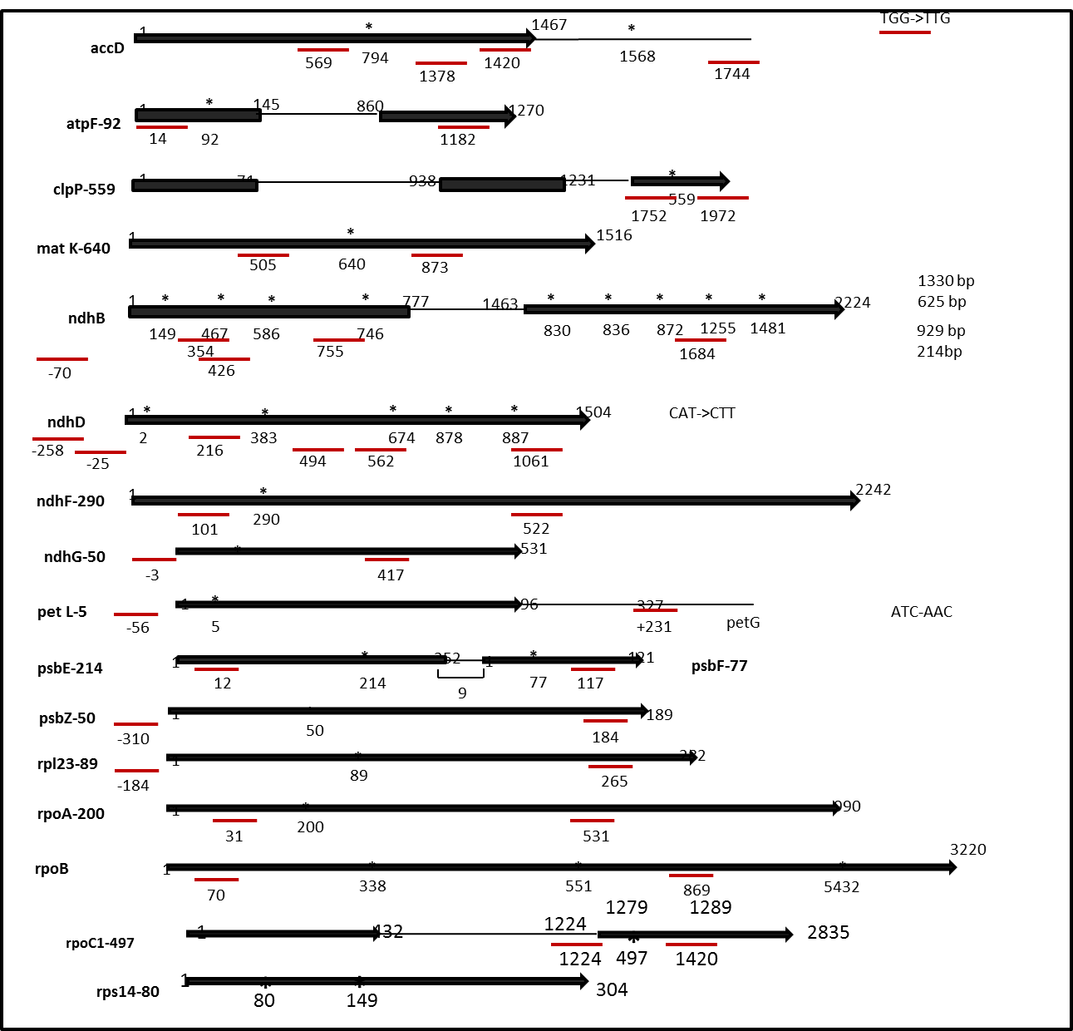
Figure 2.1. Chloroplast transcripts with known editing sites

Asterisks indicate the editing sites and red lines below indicate primer binding locations

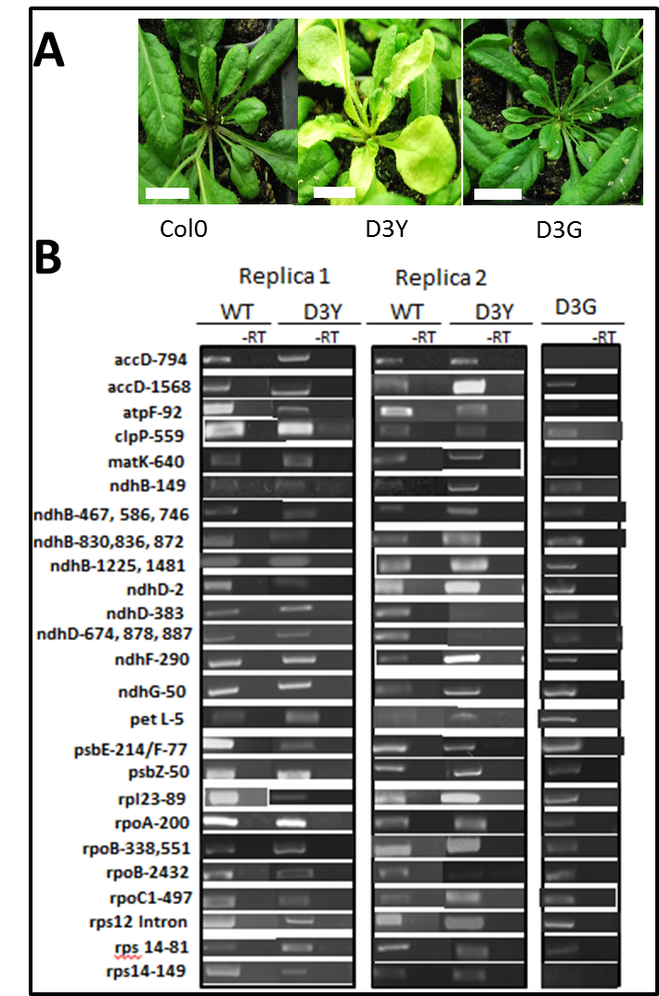

Figure 2.2. RT-PCR results of known editing sites

(A)ISE2 plants display chlorosis, a phenotypic defect that is suppressed in D3G plants
Col-0 is WT, D3Y are plants with reduced ISE2 levels, and D3G are plants over-expressing ISE2 and therefore rescuing the phenotype. Scale bar is 0.725 inches (B) RT-PCR results indicate that there is no genomic DNA contamination in the –RT control (same PCR reaction without reverse transcriptase in the reaction).

ISE2 is necessary for the full editing of a subset of transcripts to different extents in Arabidopsis mature leaf tissue

Editing defects in ise2 mutants are seen in about 50% of chloroplast transcripts (Figure 2.3). The results from RNA editing experiments were highly reproducible, illustrating that the chromatogram method can be used in addition to the PPE method. Additionally, the editing profile for the wild type Arabidopsis plants is consistent with previous reports (Tseng et al., 2013). The functional classifications of transcripts with reduced editing efficiency are listed in Table 1. ClpP and PetL are the most severely affected showing approximately 25% and 50% reduced editing efficiency in ise2 mutants as compared to wild type (~82%), respectively (Figure 2.3). However, the editing extent of transcripts whose editing efficiency is affected in ise2 mutants varies. For example, rpl23-89 transcripts are edited to a lesser extent than WT in ise2 mutants (D3Y plants), while rpoC1-497 transcripts are edited to a higher extent in D3Y plants than WT (Figure 2.3). Additionally, ISE2 is necessary for editing some sites but not others within the same transcript. For example, ISE2 is needed for full editing at site 1568 but not at site 794 within the accD transcript (Figure 2.3). These defects are likely due to reduced ISE2 function as the editing defects are suppressed in plants that overexpress ISE2 (Figure 2.3).
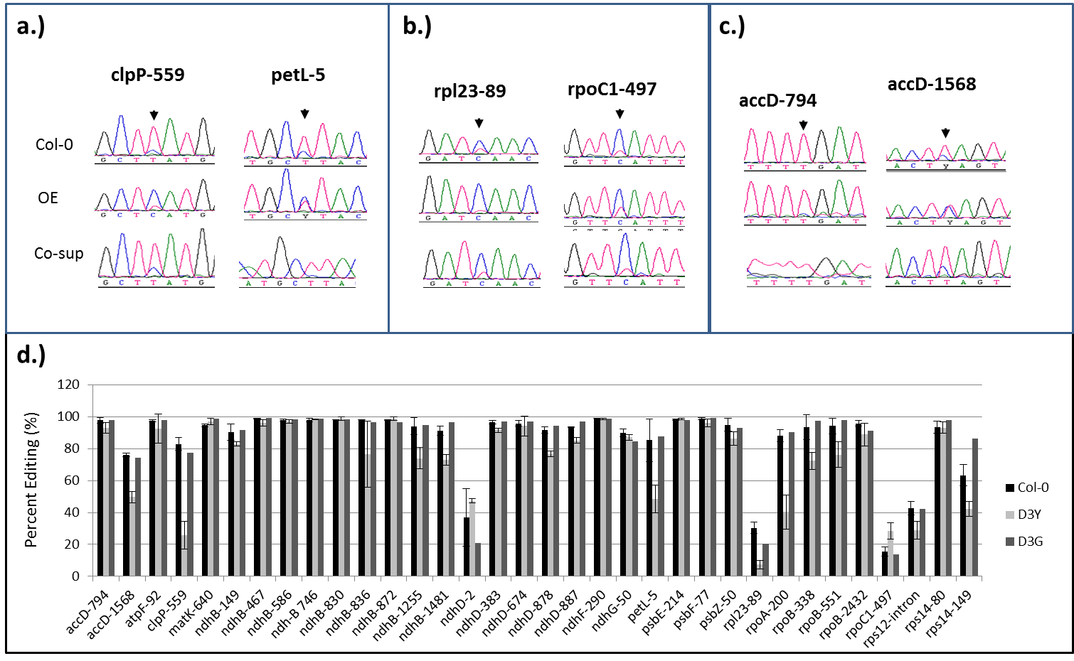
Figure 2.3 Defects in D3Y plants affect individual editing sites within chloroplast transcripts

a.) ClpP and PetL are the most severely affected b.) rpl23-89 transcripts are edited to a lesser extent than WT in ise2 mutants , while rpoC1-497 transcripts are edited to a higher extent in D3Y plants than WT c.) ISE2 is needed for full editing at site 1568 but not at site 794 within the accD transcript d.) Editing extent in Col-0, D3Y, and D3G plants is calculated as T/(T+C).

Table 2.1. Functions of chloroplast transcripts whose editing extents are reduced in D3Y plants. ISE2 is necessary for the full extent of editing for the transcripts listed to the left. **Transcripts that require ISE2 for editing at some sites

Gene | Functions of Proteins whose transcripts required ISE2 for Editing
accD ** | Encodes the carboxytransferase beta subunit of the Acetyl-CoA carboxylase (ACCase) complex in plastids (fatty acid biosynthesis).
clpP | Encodes the only ClpP (caseinolytic protease) encoded within the plastid genome. Part of the 350 kDa chloroplast Clp complex (protein degradation).
ndhB** | NADH dehydrogenase ND2 (ATP synthesis coupled electron transport, NADH dehydrogenase (ubiquinone) activity, chloroplast, oxidation-reduction process).
ndhD | Represents a plastid-encoded subunit of a NAD(P)H dehydrogenase complex (ATP synthesis coupled electron transport).
petL | Cytochrome b6f subunit (photosynthesis e transport).
Rpl23 | One of two chloroplast genes that encode chloroplast ribosomal protein L23, a constituent of the large subunit of the ribosome (RNA binding/translation).
rpoA | RNA polymerase beta subunit-1 (transcription).
rpoB | Chloroplast DNA-dependent RNA polymerase B subunit (transcription).
Rps12-intron | chloroplast gene encoding ribosomal protein s12 (translation).
Rps14 | 30S chloroplast ribosomal protein S14(translation).
psbZ | Subunit of photosystem II (photosynthesis).

Editing sites are conserved in Nicotiana benthamiana 4 wk leaf tissue

Conserved edited sites have been reported for Arabidopsis thaliana, Zea mays, Orza stavia and Nicotiana tabacum (cite alignment paper). To confirm that these editing events extend to Nicotiana benthamia, we examined conserved editing extents at several leaf developmental stages. Editing was detected in Nb for the majority of transcripts and interestingly, there appears to be a developmental dependence of editing for at least some of the transcripts with overall reduced editing extent in older leaf tissue (Figure 2.4).

Figure 2.4. Editing occurs in 4wk Nb leaves. Editing extent was examined in leaves of different ages (leaf 4,6,8) with leaf 4 being an older leaf and leaf 8 being a younger leaf at conserved edited sites.

Editing defects are detected in Nicotiana benthamiana ise2 VIGS tissue
Nicotiana benthamiana plants silenced for ISE2 produce a chlorotic phenotype 14 days after virus induced gene silencing (Figure 2.5). Previous publications have reported editing defects for rpoA in Nicotiana tabacum (Hirose et al., 1999). Given that the editing site sequences are nearly identical for Nb and Nt, it is surprising that no editing for rpoA was observed in wild-type plants, nor in plants silenced for ISE2 or PPR in Nicotiana benthamiana (Figure 2.6). However; several Nb chloroplast transcripts, including ndhD-1 appear to display editing defects in ISE2 silenced plants (Figure 2.6). As the Nicotiana plants tested for editing defects were approximately six weeks old (four weeks and 2 weeks to observe phenotype), we also tested editing in wild-type four week old Nicotiana benthmiana leaves as reported in (Hirose et al., 1999). We failed to detect editing of rpoA in any of the leaves in wild-type plants (Figure 2.4). Perhaps, the plants need to be grown in light/dark cycles instead or under continuous white light for editing of rpoA, indicating that circadian rhythm may factor into RNA editing events.

In an effort to understand the connection between ISE2s effect on chloroplast RNA metabolism and plasmodesmata function we used ISE2 as bait to screen an Arabidopsis cDNA library. IPI1 was identified as interacting with ISE2. IPI1 belongs to the DYW class of PPR proteins, typically known for their role in RNA metabolism events in chloroplasts and mitochondria (Cushing et al., 2005). RNA processing that involves PPR proteins includes translation, stability/turn-over, processing (splicing) or RNA editing (Barka et al., 2014). However IPI1’s role in RNA processing remains uncharacterized. We thus set out to further characterize the function of IPI1 using a combination of cell biology and biochemical methods.

Figure 2.5. Editing defects are seen in leaves of plants silenced for ISE2. (A) Three replicates of ISE2 mutants were tested and there appears to be no genomic DNA contaimination for individual PCR reactions of these replicas (B) The editing extent of rpoA, ndhB4, ndhD1 are reduced while ndhB3 is increased. Overall, there appears to be a slight editing increase in VIGS-ISE2 plants although not statistically significant (C) Editing efficiencies at predominantly non-conserved edited sites.

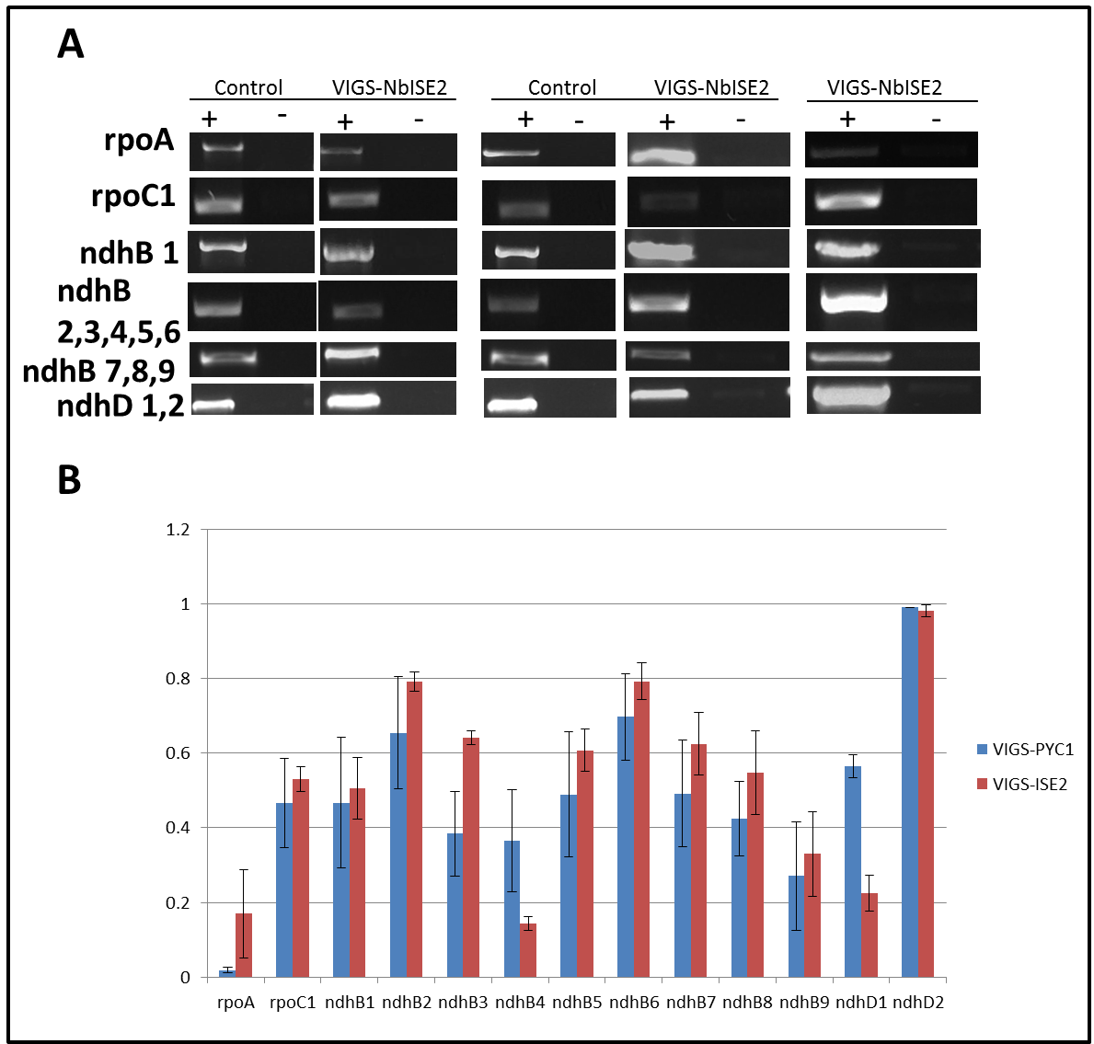

Figure 2.5 continued
C

Figure 2.5 continued

Characterization of ISE2 Interacting Protein (IPI1)

To further characterize ISE2, interacting proteins of ISE2 were identified. A yeast-two-hybrid screen of an Arabidopsis cDNA library revealed a PPR protein, encoded by At5g03800, as a potential ISE2 interactor, which we named ISE2 Protein Interactor 1 (IPI1). IPI1 belongs to the DYW sub-class of PPR proteins which have essential roles in both RNA editing and RNA processing events including group II intron splicing. Perturbed organelle RNA editing defects have been linked to perturbed retrograde signaling and therefore we asked whether ISE2 is additionally involved in RNA editing of chloroplast transcripts, potentially within a protein complex that includes at least one other PPR protein. Additionally, IPI1’s function in these events may partially overlap with ISE2’s function in organelle RNA metabolism.

IPI1 physically interacts with ISE2 via the C-terminal region

A yeast-two hybrid screen identified IPI1 as interacting protein of the RNA helicase, ISE2, a chloroplast-localized RNA helicase that has been previously found to affect plasmodesmata-mediated intercellular trafficking and chloroplast RNA metabolism (unpublished). Truncations of IPI1 and ISE2 full length protein were constructed and tested for interaction using a Yeast Two Hybrid assay. A weak interaction through the C-terminal domains of both ISE2 and IPI1 was detected (Figure #). The function of the C-terminal domain of ISE2 remains uncharacterized and IPI1’s C-terminal region contains high sequence similarity to cytidine deaminases and to other DYW PPR proteins that have been found to both function in RNA editing and bind zinc (cite).

IPI1 is a conserved PPR protein in plants

While PPR proteins are found in all domains of life, IPI1 belongs to the DYW subclass within the plant specific PLS subfamily in higher land plants. In Arabidopsis, several of the top blast searches to IPI1/emb175 include CRR22, a PPR protein that has been reported to be necessary for chloroplast editing events5 and members of the MEF protein family that have been previously shown to be required for RNA editing of mitochondrial mRNAs55. It is also note-worthy that several of the top blast hits of IPI1 in Arabidopsis thaliana also include the ubiquitous TPR proteins which contain protein-protein interaction domains.

To gain insight into Nicotiana benthamiana’s IPI1 (Nb IPI1) relationship to other Nb PPR proteins, a BLAST search using Nb IPI1 as a query in the Nb protein database (benthgeome.qut.edu.au) was conducted. Unlike in Arabidopsis, where a plethora of At PPR proteins exhibit high sequence similarity to At IPI1, the blast search of the Nb IPI1 against the Nicortiana benthamiana genome revealed few Nb PPR proteins that contain high sequence similarity to Nb IPI1 (Figure #). In Nicotiana benthamiana, IPI1 displays 53% identity and 69% similarity to its nearest top-hit “homologue”. However, the C-terminal region of this top hit only displays 32% identity to the C-terminal region of Nb IPI1. The rest of the top hits display less than 33% sequence similarity to NbIPI1.

A homology search and alignment using MUSCLE revealed that NbIPI1 has orthologues in the well-characterized maize, rice, and Arabidopsis species (cite PPR 103 paper, Figure #). The protein sequence alignment illustrates the presence of a highly conserved C-terminal region containing both a predicted zinc/heme binding region and a variation of the terminal DYW amino acids in all orhtologues except maize. Although the C-terminal region contains higher sequence similarity among the othologues than the N-terminal region, the N-terminal amino acid code that predicts the target RNA substrate of PPR103 contains conserved residues (Figure #).

IPI1 is localized to chloroplasts

The N-terminal transit peptide sequence of IPI1 was predicted to be targeted to the chloroplast according to Target P and AtIPI1 was identified as one of the 8071 proteins found to be localized to the plastid in the plant proteome database (ppdb.tc.cornell.edu). To confirm that Nb IPI1 is localized to chloroplasts and verify the true orthologue nature of IPI1, we examined its subcellular localization. The full length Arabidopsis IPI1 sequence was fused to a YFP tag, transiently expressed in Nicotiana benthamiana leaves and visualized using confocal microscopy. A western blot on the same leaf tissue that was examined using confocal microscopy confirmed that the IPI1-YFP protein was expressed in this tissue (supplemental figure). Interestingly, a longer incubation time of the expression cassette was needed to observe a YFP expression signal as compared to incubation times for other proteins71, indicating that IPI1 may normally be under regulatory control to maintain its low protein levels within the cell. IPI1-YFP was found to be expressed in the mesophyll (Figure # and supplemental figure #) and epidermal cells. NbIPI1 also appears to localize to speckles within the chloroplast (data not shown), suggesting that it may function within the chloroplast stroma as part of an RNA processing complex.

Phenotypic characterization of Nb IPI1:

As IPI1 is localized to chloroplast, we then set out to examine the effect of knocking down its function in Nb leaf tissue. Virus induced gene silencing of IPI1 expression in Nb produces a bleached phenotype (Figure #) and qPCR confirmed the knock down in gene expression of IPI1 in three independent biological replicas (supplemental). A blast search of primers used to silence Nicotiana benthamiana IPI1 returned only IPI1, suggesting that the phenotypic defects are due to specific knock down of IPI1 and not off-target effects. Consistent with the detection of IPI1 expression in leaves, its chloroplast localization and chlorotic phenotype, the levels of chlorophyll and the quantum efficiency of PSII is zero (data not shown). TEM analysis additionally reveals defective chloroplast ultra-structure in VIGS-NbIPI1 mutants, as have been observed for many other PPR mutants and chloroplast RNA processing factors (cite).

IPI1 is necessary for the accumulation of chloroplast rRNA species

The NbIPI1 orthologue, PPR103 was shown to display an albino phenotype when its expression was silenced in leaves and to drastically affect rRNA levels in leaf tissue (cite). To test whether IPI1 may cause similar defects in RNA metabolism; we conducted a Northern blot of total RNA. The Northern blot revealed that IPI1 displays major defects in organelle RNA processing, with drastic reductions in 4.5S, 16S and 5S rRNA (Figure #). These results indicate that IPI1’s role in rRNA processing is conserved with its orthologue in maize (cite). The amino acids that are involved in contacting rpl 16 are also conserved among IPI1 and its orthologues (supplemental figure #), indicating that NbIPI1 may target rpl16, similar to its maize orthologue.

In addition to rRNA processing, albino and chlorotic phenotypes can be developed as a result of other general RNA metabolism defects within defective chloroplasts56. For example, a RNA editing defect at the atpA site is associated with an albino phenotype in tabacco (cite). Coupled to the observation that IPI1 belongs to a class of PPR proteins that are traditionally associated with RNA editing events in plants, we decided to test whether IPI1 mutants exhibit any RNA editing defects in chloroplast encoded transcripts.

IPI1 is necessary for editing chloroplast transcripts

IPI1 was confirmed to be expressed in the wild-type leaf tissue examined for editing in 4 week old leaves (figure #). Nuclear-encoded RNA processing factors that are organelle-targeted are thought to be responsible for RNA editing as defects in chloroplast translation did not affect RNA editing58. Thus far, nuclear-encoded pentatricoptide repeat (PPR) proteins have been classified as site-specific trans-factors involved in RNA editing59. The DYW domain’s predicted structure resembles that of cytidine deaminases (CDA) which are known to directly bind zinc in order to confer RNA editing activity. Mutations within the DYW domain of DYW1, a PPR protein that is highly similar to IPI1 (figure #), greatly impair both zinc-binding and RNA editing, indicating that the DYW domain may confer cytidine deaminase activity (cite).

Although, the Arabidopsis IPI1 contains a degenerate DYW domain, indicating that it may not be involved in RNA editing (K. Howell & I. Small, pers. comm.), we found editing defects of a subset of conserved editing sites in Nicotiana benthamina plants that were silenced for the endogenous Nb IPI1 transcript (Figure # ).

We have previously reported a role for the interacting protein of IPI1, ISE2 in the editing of several chloroplast transcripts in mature Arabidopsis leaf tissue. Interestingly, the editing defects observed in Nicotiana benthamina leaf tissue for plants silenced for IPI1 appear to resemble the editing defects observed in Nicotiana benthamina leaf tissue for plants silenced for ISE2. To examine whether these editing events are due to a secondary response to chlorotic tissue, we examined editing in mature Nb leaf tissue silenced for the carotenoid biosynthesis gene, PYTOENE DESATURASE (PDS). While Nb plants silenced for PDS also exhibit editing defects (indicating that at least for some sites, editing defects may be due to a general stress response), the editing “signature” of the mutants are distinct, indicating that each factor may differentially affect the downstream editing reaction of particular transcripts. (To test whether IPI1 is directly involved, Id have to see whether or not IPI1 is associated with RNA).

No IPI1 intercellular trafficking defects are seen in IPI1 mutants

As the IPI1 Interacting partner ISE2 also displays defects in PD mediated trafficking in addition to defects in rRNA processing and RNA editing, we checked whether there are intercellular trafficking defects in Nb plants silenced for IPI1. Unlike VIGS-NbISE2, there does not appear to be any major intercellular trafficking defects in VIS-IPI1 Nb plants (Figure #), suggesting that ISE2 and IPI1 may physically interact for a role that is related to RNA processing. This RNA processing role may be mutually exclusive to a role in PD-mediated trafficking. IPI1’s role in intercellular trafficking was verified using GFP infiltration and bombardment.

Transcriptome Wide Analysis

An understanding of chloroplast function requires the understanding of the function of chloroplast-localized proteins. Although several plant PPR proteins have been characterized, their global effect on chloroplast (cp) RNA metabolism remains poorly understood. Insight into the abundance and architecture of the chloroplast transcriptional landscape can provide insight into gene regulation; however such a comprehensive study has not yet been attempted for any ppr mutant. Here we report the use of a high-throughput Illumina sequencing approach on isolated chloroplasts to comphrehensively and quantitatively asses the RNA metabolic response of a mutant lacking the chloroplast-localized pentatricopeptide repeat protein. Our data provide the first widespread view of changes to the chloroplast transcriptome in any ppr mutant. Here we report (i) that known editing sites are conserved in Nicotiana benthamiana (ii) identify new editing site in Nicotiana benthamiana (iii) and implicate that several editing sites within transcripts are specifically affected by the silencing of the PPR gene, IPI1. The data additionally implicate new stabilization functions for this PPR gene. Overall, our results provide the first glimpse of the global regulatory (and novel?) function of IPI1 or any PPR gene within chloroplasts.
PPR proteins are global regulators of RNA organelle metabolism. Yet, to date, no genome-wide analysis using RNA-seq on isolated organelles has been done in ppr mutants despite their wide/pleotropic effect on organelle biosynthesis and function. In fact very few organelle RNA-seq experiments on isolated organelles have been conducted, in general. The high-throughput sequencing platform offers a powerful tool to provide insight into the global regulation of organelle RNA metabolism and consequences of ppr mutations. To this end, total RNA was isolated from chloroplasts of intact leaf tissue from control plants or plants silenced for IPI1. Overall, () million mapped bases identified a number of editing sites that are differentially affected in the control and mutant tissue. IPI1 is a protein that contains a domain that traditionally contributes to RNA editing reactions. We observed editing, differential expression, stability and other processing defects in the mutant relative to the control.
PPR proteins represent a greatly expanded protein family in plants[2]. Although several PPR genes have been characterized over the last decade, the global regulatory mechanism of PPR gene product function has not been closely examined. No species in Nicotiana has been examined for defective PPR function. As a consequence, esp in Nb, many aspects of RNA metabolic changes in the ppr mutants remain poorly understood [3]. More specifically, we do not know in any detail how defects in individual plant PPR genes (on a global scale) affect the physical landscape of the transcriptome and other organelle RNA metabolic events, although this information is crucial to understanding the regulatory function of PPR proteins. Additionally, although pletiropic effects are observed in many ppr mutants, there have been next to no attempts to comprehensively examine the transcriptional consequence of PPR defect in any plant.
PPR proteins attract scientific attention as potential biotechnological agents due to their involvement in the regulation of organelle processes such as transcription, translation, and RNA processing (cite). We have examined that transcriptome response of isolated chloroplasts from a tobacco mutant that is defective for one PPR protein, IPI1 (cite). Analysis of millions of bases of sequenced cDNAs yielded a transcriptome profile. The analysis led to the discovery of new previously unidentified editing sites. This study highlights transcriptome sequencing as a key tool for understanding the mechanism and extent of organelle RNA-based regulation by PPR proteins (cite).

RNA-seq analysis confirms and extends IPI1s role in chloroplast RNA metabolism

General Pipeline
To examine what the chloroplast RNA metabolic defects are in ppr mutant tissue in Nicotiana benthamiana, we silenced IPI1 in mature leaf tissue. After the albino phenotype was apparent (Figure), chloroplasts were isolated from control and bleached tissue (Figure: schematic of chloroplast isolation procedure). Visualization of intact chloroplasts using the inverted microscope illustrated that chloroplasts isolated from ppr mutant tissue were clearly defective with no thylakoid structures or starch granules apparent (Figure). Total RNA was subsequently isolated from chloroplasts, treated with DNase and subjected to quality inspection using a bioanalyzer (Figure). To ensure that enough chloroplast tissue was available for RNA isolation and subsequent cDNA library preparation, leaf tissue was pooled from all leaves that exhibited a bleached phenotype and from the corresponding leaves in the control plant. We did not enrich for mRNA by depleting the 16S and 23S ribosomal RNAs from our samples (see Fig. S1 in the supplemental material-Bioanalyzer results of isolated RNA). Double-stranded cDNA was prepared using random-hexamer priming on total RNA and then subjected to Next Tera library preparation. The prepared libraries were again subjected to bioanalyses analysis (Figure) to ensure that high quality libraries were sequenced on the MiSeq Illumina platform. Resulting adapter-ligated cDNA fragments were sequenced using the Miseq illumine platform yielding sequence reads that allowed coverage of the entire cellular transcript lengths. Three samples of PYC1 and four samples of IPI1 were used for the analysis (Table #; methods). The sequenced reads revealed a high quality score before and after trimming adapters (Figure), illustrating a good quality contigs to be used for mapping to the Nicotiana cp reference genome. The percentage of mapped sequence reads (of the total input) for each library are represented in table 1. (Note I also need to compute R2 correlation values between experiments and present this information in Tables # and #).
Analysis was conducted on a similar number of sequence reads (# of reads, and nucleotides per read) from each library. Reads were mapped to the Nicotiana benthamiana genome (NC_000….) using the (algorithm information) from the software Next Gen Seq (DNA star license information). A small percentage (roughly 30%) of the reads mapped to the cp genome; however, this was sufficient to examine RNA metabolic differences between the two plants.
RNA editing defects:
Our model system for this study was Nicotiana benthamina, a tabacco plant. Studies over the past several years have defined editing sites in Nicotiana tabacum (1), and we used those data to identify a set of 34 editing sites in the closely related Nicotiana benthamina species. To verify these sites and to identify new editing sites, RNA from enriched chloroplasts was subjected to next-generation sequencing.
The short (∼250-nt) sequence reads produced were mapped to the Nicotiana genome using DNA array star Next Gene Seq software (cite ref). Reads that mapped to multiple locations were not excluded from subsequent analysis as the algorithm used is able to additionally detect potential SNPs on the inverted repeat strand of ndhB, a site that is heavily edited. The uniquely mapped reads were used to assemble coverage summary information for each sample. The coverage summary additionally reveals the depth of sequence reads mapped at each loci in the Nicotiana genome. A similar number reflecting the percentage of input were mapped in all samples.
Comparison of the mapped RNA-seq results in the PYC1 control and the mutants defective for IPI1 revealed editing efficiency differences between the two samples (Figure). The resulting 250 bp reads were mapped to the Nicotiana benthamiana chloroplast genome with no mismatch penalty to allow the detection of multiple editing events (SNPs) recognized within the same transcript. In this analysis, reads that mapped to multiple positions in the Nb cp genome, as well as reads that mapped to ribosomal locations were retained (Table #). The majority of edited sites were detected by the Seq Man Pro SNP algorithm; however four of the editing sites (rpoA, pet B, ndhA-1, ndhB4) were not detected with the SNP algorithm and had to be manually quantified. An ideal criteria for analysis would be that each edited site contains at least 10 sequence reads mapped to that site. However, the rpoA edited site, that is previously identified and characterized in Nicotiana, only contained around 4 contigs that were mapped, potentially indicating its low expression. Nonetheless, number of contigs were not used as a filtering criteria in downstream analysis.
Identification of New Editing Sites
Excitingly, novel sites were identified that have not been reported in any Nicotiana species (Table of new sites). Many of these are in the ndhD transcript which is involved in electron transport. There are currently only 2 reported editing sites in the ndhD transcript. One changes the codon to a start site and the other one changes the amino acid from ( ) to ( ). The amino acid changes for the new edited sites are indicated in table #. Interestingly most of the reveal a change from an S to a L, and this is also the most common source of edited change that occurs for known edited sites. A sequence alignment shows that the newly identified editing sites (are/are not) conserved with other species. The editing changes occur in regions of the ndhD transcript that are known to be involved in regions of the protein that function in ().
Identification of Editing in the duplicated regions of ndhB:
Interestingly, the SNP algorithm used to identify individual editing events also identified editing events in the repetitive regions of the genome (called as C->T instead of G->A). These results indicate that the editing factors do not discriminate between particular sequences within inverted and duplicated regions of the chloroplast genome (Figure and Table #).
Motif examination of Editing Sites
It appears that IPI1 does not affect every editing site, indicating that there may be at least some level of selectivity involved. The ndhB and ndhD sites are the most affected in plants that are silenced for IPI1. NAD(P)H-quinone oxidoreductase (NDH) is composed of 16 subunits, 5 in the nucleus and 11 in the chloroplast. The chloroplast-encoded ndhB and ndhD comprise components of the fully assembled NDH complex located in the chloroplast thylakoid membrane. NDH is involved in cyclic electron transport around photosystem I (PSI)(cite). The NDH function is to shuttle 2 electrons from NAD(P)H:plastoquinone to ubiquinone (forming plastoquinols) in the chloroplast photosynthetic chain via route through the FMN and iron-sulfur (Fe-S) centers. This reaction creates a proton gradient and allows proton translocation for eventual ATP synthesis, and thus conserves redox energy and alleviates oxidative stress as this subunit complex is a major source of ROS due to electron transport from FMNH(cite).
The ndhB2 (subunit 2A of the NDH dehydrogenase) is a multi-pass membrane protein and is specific to higher land plants (cite). Editing is defective at sites (Figure). It was not clear in the literature search where the quinone binding site actually is, but it the NDH complex cannot bind quinone, oxidative stress may occur. Thus, it would be interesting to see if defective editing occurs near the quinone binding site within the NDH subunit(s) that is/are responsible for quinone binding. In cyanobacteria, ndhB2 mutants require high levels of CO2 for growth, supporting its role in both CO2 uptake. In cyano bacteria ndhB2 is also involved in PSI cyclic electron transport (cite). These two roles are due to two distinct complexes in the cyanobacterial ndhB2 subunit (cite). Cp31 along with other unknown factors was postulated to contribute to editing at the ndhB edited site in plants (cite).The ndhD (ndh4) is also a transmembrane protein with similar protein architecture to the ndhB subunit. It is also postulated to participate in quinone binding although the exact binding site is unknown (or I could not find it). It appears that editing sites do not specifically overlap with a phosphorylation site or any part of the protein that is reported to have crucial function as of yet.
As site ndhB1, ndhB2, ndhB3 and ndhD were affected, the motif algorithm was used to try and identify particular consensus sequences that may be found in all three target sequences (rpoA was excluded because editing defects may likely be a result of a general stress response as this editing site is encoded by the plastid encoded polymerase and affected in PDS and ISE2 silenced tissue samples). The identified motifs are found in Figure.
The Zea Mays orthologue of IPI1, PPR103, was found to bind to sequences just upstream of the rpl16 coding sequence. The amino residues that are responsible for contacting base pairs within the rpl16 sequence are highly conserved (Figure), therefore the motifs identified in ndhB and ndhD sites that are affected in IPI1 mutants and the target site prediction were compared to identify any sequence overlap that may suggest potential IPI1 target sites (Figure) shows that…..
Correlation of Edited Sites with Absolute expression level
The mapped reads were visualized in IGV. To get an idea of absolute expression level at edited sites, the data were not normalized. The absolute levels of mapped reads to the Nb chloroplast genome is shown in Figure. At a glance, it appears that a function of wild-type IPI1 may lead to the degradation of chloroplast transcripts that are known to undergo editing, as levels of these transcripts are higher in the ipi1 mutant (Figure ). This function would contrast with its function in the stabilization of the rpl16 transcript, a direct target of Zm IPI1.
It will be interesting to observe how the expression of edited transcripts correlates with their editing efficiency (Figure). Indicate results here once the figure is made.
Biological Significance of IPI1 and ISE2 interaction
IPI1 and ISE2 are found to interact through the C-terminal region. While the exact function of the C-terminal region of ISE2 is unknown, the C-terminal region of IPI1 displays sequence similarity to cytodine deaminases which are known to function in RNA editing. The C-terminal region of IPI1 displays high sequence similarity to other known editing factors in plants that have been found to bind zinc and contribute to the editing reaction. The interaction of ISE2 with the C-terminal region of IPI1 indicates that ISE2 may regulate the function of IPI1 with respect to RNA editing, suggesting antagonistic functions. Indeed, comparison of the complete ISE2 editing data and the IPI1 editing data reveal an opposite effect on editing; ISE2 seems to perform a slight inhibitory role while IPI1 seems to be necessary for certain editing events to occur. Interestingly, the sites that are similarly affect in ISE2 mutants and IPI1 mutants (exhibiting a reduction in both respective mutants) area also affected in plants that are silenced for PDS (indicating that these sites may be due to a general stress response of the plant) (Figure table and figure with PDS). Additionally, IPI1 and ISE2 do not appear to share a role in the regulation of intercellular trafficking (see chapter 2). A model for hypothesized mode of action of ISE2 and IPI1 is summarized in Figure.
Future Analysis
Future analysis includes ascertaining whether IPI1 has a direct role in editing ndhB2 (an editing site that is not affected in ISE2 or PDS mutants). The assessment of whether IPI1 binds to RNA within the vicinity of this RNA editing site is definitely a future direction. If so, amino acid substitutions may clarify the role that the DYW amino acids and other amino acids play in mediating this potential interaction.

Discussion

Biological Implications of ISE2 Role in RNA Editing

Functions of Arabidopsis Edited Transcripts

Our data indicate that ISE2 is required for RNA editing of the following chloroplast genes at the following sites: accD-1658, clpP-559, petL-5, rpoA-200, rpoC1, rpl23, rps12, and ndhD-2 (Figure 2.3). The accD gene encodes a beta carboxyltransferase subunit of acetyl CoA carboxylase, which catalyzes the first step in fatty acid biosynthesis in chloroplasts. The accD transcript is C-to-U edited by a PPR-DYW protein in Arabidopsis chloroplasts (Robbins et al., 2009) and in several plant species, the editing of accD is required for both functional acetyl-CoA carboxylate (Sasaki et al., 2000) and development in tabacco (Kode et al., 2005) and has been suggested to be a general housing keeping gene (Lee et al., 2004). Interestingly, the catalytic site in potatoe accD resides within the C-terminal region within motif II (PLIIVCASGGARMQE) (Lee S et al., 2004); the C-terminal region of accD has defects in editing in ise2 mutants but not the N-terminal region (Figure 10c). The subunit Pet L plays a role in the assembly, stability and dimerization of the cytochrome b6f complex in tabacco (Schwenkert S et al., 2007, Schöttler et al., 2006). ClpP transcript encodes the catalytic subunit of the plastid ClpP RS protease complex (Chateigner-Boutin et al.,2008). Interestingly, reduced accumulation of regulatory subunit (clpR2) led to reduced accumulation of the clpPRS protease complex and a yellow phenotype (Chateigner-Boutin et al., 2008). Moreover, an E/E’ subclass PPR yellow-leaf mutant, clb19, shows defective editing at rpo200-A and clpP-559 (Chateigner-Boutin et al., 2008) , two sites that are defective in ISE2-knockdown plants. Interestingly, the editing sites within in rpoA and clpP transcripts do not contain an apparent conserved cis elements (Chateigner-Boutin et al., 2008). Both clpP and accD are essential for tabacco development, illustrating their importance outside of the chloroplast (Kode et al., 2005), and in fact, clpP has been implicated in retrograde signaling (Ramundo et al., 2014). ClpP, rpoA, and accD are transcribed by the NEP.

The observation that similar editing sites are affected by loss of ISE2 and in clb19, cia5-2, ispF, and ispG albino mutants, and that ISE2 physically interacts with a PPR protein collectively suggest that ISE2 may functionally be linked to several PPR-mediated RNA editing events.

Importantly, editing at site ndhD-2, in which the first codon ACG, is converted to an AUG, was recently found to be abolished in the cia5-2, ispF, and ispG albino mutants (Tseng et al., 2013). However, editing at sites ndhB-148 and ndhB-1255, two sites unaffected by loss of ISE2 were also unaffected in these albino mutants. As ndhD encodes a subunit of the NDH complex, the observation that editing is abolished in the ISE2-knockdown plants and these albino mutants suggests that the NDH complex may not be functional in these particular mutants, and thus plants may be more susceptible to photooxidative damage (Tseng et al., 2013). Photooxidative damage may be a secondary effect that occurs in bleached (albino mutants) or chlorotic leafs (ise2 mutants) (Tseng et al., 2013). Although beyond the scope of this proposal, it may be of interest to measure the levels of oxidative species in ise2 mutants as a separate future direction.

The observation of editing defects in ise2 mutants of Arabidopsis but not Nicotiana benthamiana plants may indicate that (i) silencing activated by an over expressed factor (i.e D3Y) rather than a virus (i.e VIGs-ISE2) may have differential consequences on RNA editing (ii) the species differ in editing machinery and/or their requirement for ISE2-mediated editing may depend on other molecular factors. Interestingly ppr silenced plants in Arabidopsis, using the VIGs technology also do not display editing defects at conserved sites.
Because certain consensus sequences have been found to occur within edited chloroplast transcripts (Bentiolia et al., 2013), AtISE2 may associate with particular sequences within the RNA transcript; perhaps these sequences are located at or near the edited site. AtISE2 affects about 50% of transcripts to some extent but about 10% are severely affected (statistically significant). ISE2 may specifically interact with PPR proteins required for editing these transcripts. Alternatively, ISE2 may act (within a separate complex) to unwind secondary structures to facilitate access to RNA editing sites by several PPR proteins. If an RNA helicase is directly involved in un-winding, it may associate with nucleic acid sequences with the RNA transcript. Future experiments to test whether RNA structures are unwound in in ise2 mutants include predicting secondary structure of RNA and using a FRET-based or another probe to detect whether certain bases that should contact each other in secondary RNA structures are in contact or farther apart from each other. Interestingly, ISE2 also plays a role in post transcriptional gene silencing and therefore, it has been postulated that the accumulation of normally degraded RNAs at the midtorpedo stage may accumulate in ise2 mutants (Burch-Smith grant). However rather than the accumulation of these transcripts leading to increased plasmodesmata and therefore increased intercellular trafficking, it seems as though ISE2’s role in RNA interference may be linked to its role in RNA editing. This hypothesis is interesting given that there seems to be some cross-talk between RNA editing and RNA interference in eukaryotes (Nishikura K et al., 2006; Habig, J.W et al., 2007 and Bass 2006).

Although both RNA editing and PD dynamic structure formation vary across development, it is unclear if a potential role between RNA editing and plasmodesmata-to-chloroplast signaling (or retrograde signaling) plays a functional role in communication between the plastid/chloroplast and PD. Chloroplast biogenesis starts during embryogenesis (the same stage that ISE2 plays a key role) and ends during maturation (Allorent et al., 2013). Some transcripts but not others were editing at the seedling stage out of a subset of those assayed (Supplemental figure 6) and many PPR proteins are found to be necessary for RNA editing of certain organelle transcripts at the seedling stage (Tseng et a.2010). Interestingly, several PPR mutations also have chloroplast defects in their ultra structure and retrograde signaling (Tseng et a.2010). It may be interesting to examine the ultrastructure of plasmodesmata in these ppr mutations which exhibit defects in chloroplast ultrastructure. However, the observation of such a correlation may not rule out the possibility that defects in chloroplast RNA metabolic processes such as RNA editing may be secondary defects of damaged altered chloroplast structures, supported by the observation that RNA editing defects co-occur with general stress responses in the plant (Zhua et al., 2013).

Interestingly, RNA editing was thought to have arisen to correct organelle mutations by nuclear encoded factors (Castandet B et al., 2012). Concerted nuclear and chloroplast gene expression is necessary for the biosynthesis of the photosynthetic apparatus, as the photosynthetic apparatus consists of both nuclear and chloroplast encoded factors. Additionally, nuclear encoded factors are necessary for other RNA metabolic events that occur within the chloroplast, such as RNA stability, splicing, processing, protein complex assembly, and translation in addition to RNA editing (Chan KC et al., 2010). Nuclear encoded factors, such as the nuclear-encoded RNA polymerase and sigma units also work with the plastid-encoded polymerase to maintain chloroplast biogenesis (Chan KC et al., 2010). Interestingly, a mammalian DEAD box RNA helicase was found to coordinate transcription and ribosomal RNA processing by sensing the transcriptional status of RNA polymerase (Pol) I and II in human cells (Calo et al., 2015).The co-occurrence of damaged chloroplast and altered plasmodesmata suggests that these two plant structures may depend on concerted mechanism to simultaneously regulate their function.
Our results put, ISE2 upstream of RNA editing events, which may not be surprising given that many mutants defective in chloroplast structure and/or function lead to RNA editing defects. Future experiments include identifying the association sites of ISE2 with the transcripts that it is necessary to fully edit (Shikanai et al., 2011), and observing mutants (perhaps ppr mutants) that have defective chloroplast but not plasmodesmata to aid in identifying a specific role of ISE2 in mediating both intracellular organelle communication and intercellular communication via plasmodesmata.

Biological Implications of RNA Editing Defects in Nb IPI1 mutants

Function of Edited Transcripts affected in VIGS-IPI1 plants

We report here cp RNA metabolic defects found in Nb IPI1 mutants confirming its role in rRNA processing reported for its maize orthologue PPR103 and extending its role to RNA editing of chloroplast transcripts. Interestingly the specific terminal amino acid residues (DYW) or any variation of the DYW amino acids is not found at the terminal end in the maize NbIPI1 orthologue, PPR103 (Figure #),where almost no editing events were disrupted in the mutant (cite). This observation may suggest that the specific DYW or a variation of the DYW amino acid residues may contribute to the editing reaction at several chloroplast editing sites.

Around 5 of the 34 previously reported editing sites in Nicotiana benthamina exhibit statistically significant altered editing profiles in IPI1 mutants. Therfore, there may be some selective level of activities that affect the editing of particular transcripts. However, we cannot rule out the possibility that defects in chloroplast RNA metabolic processes such as RNA editing may be secondary defects of damaged altered chloroplast structures supported by the observation that RNA editing defects co-occur with general stress responses in the plant (cite).

The current model of chloroplast RNA editing entails (i) a site-specific trans-acting factor that binds an upstream cis-element in a sequence-specific manner (probably through the PPR motifs to determine binding specificity) (ii) an interaction with the actual editing site in a sequence specific manner based on the upstream cis-element by allowing contact of the PPR catalytic domain with the target C residue (the E/E+ domain is required for the editing reaction).

Insight into Factors that govern Plasmodesmata Regulation

IPI1 was identified in our lab in an interaction screen with INCREASED SIZE EXCLUSION LIMIT2 (ISE2), an RNA helicase that has essential roles in retrograde signaling, embryogenesis, RNA processing including RNA editing, and the regulation of PD-mediated intercellular trafficking (cite). However, no defect in intercellular trafficking of GFP was observed in VIGs-IPI1 plants. None the less, our study sheds light on the unique roles of chloroplast-localized proteins that are involved in RNA processing and intercellular trafficking or solely RNA processing. Future studies include the further dissection of these functionalities to identify shared roles that are unique to those groups that affect intercellular trafficking. Such examinations will eventually clarify the roles that specific RNA processing events may have on the regulation of intercellular trafficking.

In chloroplast, increased ROS production leads to reduced intercellular trafficking. It would be interesting to measure the levels of ROS in PPR silenced tissue.

Transcriptome Wide Profiling of Chloroplast Localized Factors

Here we offer an unprecedented approach to examining the global consequences of defective PPR gene on chloroplast RNA editing metabolism. Very few experiments have reported the use of high-throughput sequencing technology to examine the organelle RNA metabolic profile of samples of interest by isolated RNA from purified organelles. And no published information has reported the use of this approach to characterize the global organelle RNA metabolic defects in any ppr mutant. Here we report the use of the Mi-seq platform to sequence libraries prepared from total RNA that was isolated from purified chloroplast organelles. Our results confirm that previous reported conserved editing events in other species (including other Nicotiana species) are conserved in Nicotiana benthamiana. Additionally, our findings extend our knowledge of editing in Nicotiana benthamiana through the identification of novel editing sites. Finally, our results offer insight into the global role of IPI1 on chloroplast RNA metabolism. This technique (albeit expensive) can be applied to the examination of other plants that are defective in ppr genes.

Care was taken to isolate plastids from bleached tissue (tissue that showed the IPI1 phenotype). (Additional note: results represent an average of all tissue to ensure that enough tissue was retained to isolate chloroplasts). It has been previously documented that white leaves or white parts of leaves (in mutants) do not contain ribosomes and lack all plastid-encoded proteins [1]. Interestingly, however, transcription still occurs, albeit by Nuclear Encoded Polymerase (NEP) instead of by Plastid Encoded Polymerase (PEP), indicating that plastid protein import is not completely abolished. In fact, NEP activity is reported to be higher in white leaves than in green leaves (cite). Surprisingly, many proteins of the photosynthetic apparatus are actually encoded by NEP (cite). Overall, the editing defects are likely due to defects in protein import.

Overall, our pipeline has allowed us to confirm RNA editing defects, identify new edited sites and examine global IPI1’s role on cp RNA metabolism in Nicotiana benthamina.
Figure 3.1. Model of ISE2 and IPI1 Function in Chloroplast Metabolism but not in Intercellular Traffiking. ISE2 and IPI1 are both localized to chloroplast and interact through their C-terminal region. While both Nb ISE2 and Nb IPI1 contribute to RNA editing in chloroplasts, Nb plants silenced for ISE2 display intercellular trafficking defects while there is no major intercellular trafficking defect in plants that are silenced for IPI1.

Materials and Methods
RNA Editing

Total RNA was isolated from mature leaf tissue in Col-0 and ise2 mutant plants using a Plant RNeasy Mini Kit (QIAGEN), and reverse transcribed using Invitrogen SuperScript III Reverse Transcriptase (Life Technologies) and random hexamers. Primers used for cDNA synthesis are designed to amplify chloroplast genes which have previously been shown to undergo editing were previously published (Bentolia et al., 2008).

Plant Material and Growth conditions
Nicotiana benthamiana (N. benthamiana) seedlings were grown in an open growth chamber rack at 25 degrees under fluorescent white light in a 16:8-h light/dark cycle. Approximately 6 week old leaves were detached and used for RNA isolation

VIGS N. benthamiana:
Agrobacterium containing constructs for silencing IPI1, ISE2 (positive control), PYC1 (negative control), PDS (positive control), and pYL192 were streaked out on plates containing kan50, Rif50, Gen50 selection antibiotic and grown at 28 degrees overnight. For agrobacterium infiltration, an over-night culture of 5 ml of these respective constructs and antibiotic were incubated in a 28 degree shaker. The cell culture was spun for 15minutes at 3000 rpm. The cells were then vortexed and re-suspended in infiltration buffer (10mM MES, 10mM MgCl2, 200uM acetosenygone). The O.D (600nm) was recorded using the spectrophotometer to an O.D of 1.0, then pYL92 was mixed with PCY1, VIGS-ISE2, VIGS-IPI1 in a 1:1 ratio and incubated on a shaker for at least two hours. Approximately 3 week old N. benthamiana plants were infiltrated with the respective constructs and placed in the dark over-night. The subsequent morning, these tobacco plants were transferred to the light growth chamber.

Fv/Fm measruments and Chlorophyll Extraction:
Fv/Fm measurements were taken with a Os-30p hand held device under kinetics mode with a 5 second flash and with Flurocam on approx. 5 week old plants. Chlorophyll was extracted from plants silenced for IPI1 and the empty vector control, PYC1 and that were about 5.5 weeks old.

Editing: For examination of editing in 4 week old WT N. benthamiana plants, seeds were sowed to soil and transferred to individual pots one week later. These plants were snap frozen in liquid nitrogen at exactly 4 weeks of age. RNA was isolated using Trizol and RT-PCR was conducted according to manufactures instructions. The PCR cocktail consisted of (13.8 ul x4=55.2 ul water, 2x4=8ul 10x Taq buffer, 1x4=4 ul dNTP, 1x4=4ul primer 61, 1x4=4ul primer 62, 0.2ulx4=0.8 ul Taq (1 ul) and PCR was conducted using 53 degrees annealing temperature, the same PCR conditions, 30 cycles (94 degrees at 2 minutes 30 seconds, 94 degrees for 10 seconds, 53 annealing temp for 30 seconds, 72 degrees for 5 minutes). Three individual biological replicates were analyzed. The same cDNA used for editing experiments was also used to assay NbIPI1 expression. For Editing in Nb older leaves (PYC1, ISE2 and IPI1), RNA was isolated from snap frozen Nicotiana benthimaina (N.b) leaves that were stored at -80 and that were silenced for PYC1, ISE2 or IPI1. RNA was isolated from these leaves using Trizol. RT-PCR was conducted using 1 ug RNA (Table 3) micrograms of RNA using the promega Moloney Murine Leukemia Virus Reverse Transcriptase (M-MLV RT) reaction. In a sterile RNase-free microcentrifuge tube, 0.5 micrograms of primer-adapter (random hexamers) and water were added to a total volume of 14 ul. The pcr tubes were heated to 70 degrees Celsius in a pcr thermocycler for 5 minutes to melt secondary structures within the template. The tube was then immediately put on ice to prevent secondary structures from reforming, then briefly spun to collect the solution at the bottom of the tube. Subsequently, 5 ul M-MLV 5X reaction buffer, 1.5 ul dNTP (10mM), 1ul M-MLV RT (200 units), and 2.5 ul nuclease-free water was added to the annealed primer/template. A tube containing the same reagents minus the reverse transcriptase was performed in parallel with the experimental cDNA synthesis reaction. The tube was gently mixed by flicking, incubated for 5 minutes at room temperature and then incubated at 42 degrees for 60 minutes. Second-strand PCR synthesis was performed using 2.5 ul cDNA according to manufactures instructions RT-PCR Taq kit manual) where 12.5 ul reaction buffer, 2.5 ul cDNA, 0.5 ul each primer and 9 ul water was used in a 25 ul reaction. A 53 degree annealing temperature was used. For each PCR reaction, 2 ul buffer, 1 ul dNTP, 0.5 ul of ppr primer (RpoA-Tobacco), 0.2 ul Taq, and 5 ul cDNA. The PCR cycle parameters consisted of 94 denaturing, 55 degree annealing, for 30 cycles. 5 ul was run on the gel. PCR products were gel purified using the promega kit Amplicons were bulk sequenced by diluting the PCR reaction to about 5 to 10ng per 100bp.

RNA gel blot (from first trial)
Prior to running the RNA gel, glassware was baked in the oven and unautoclaved DEPC water was added to the RNA gel apparatus to soak overnight. Additionally, DEPC was put on the shaker overnight to mix. The next morning, LC was autoclaved for 15 minutes. The RNA electrophoresis was run with: DEPC; DEPC-treated autoclaved water, 10 xFF buffer (200mM HEPES and 10mM EDTA at pH 7.8), and loading dye (5 ul of 0.5% bromophenol blue & 25 ul formaldehyde). The first day the gel box, tray and comb was treated with DEPC treated (not autoclaved) water over night. The next day the gel box, tray and comb was rinsed with autoclaved DEPC water and allowed to air dry on paper towels. 88 ml water and 0 ml of 10xFF solution were mande in an autoclaved flask and 1 gram of agarose was added. The solution came to a boil in microwave oven; was cooled to 60 degrees and 1.8ml of formaldehyde in the hood was added. The gel was poured and allowed to sit; covered with clear wrap. The gel was allowed to sit until samples were loaded. To prepare RNA for loading RNA (5ul of 5-10 ug total RNA or 1 ug of poly A RNA), Formamide (5 ul), Formaldehyde (2ul), 10X FF (1ul) and Ethidiumbromide (1ul of 400 ug/ml stock) were added to the RNA (resuspended in DEPC autoclaved water). The buffer consisted of 75 ml in 750 ml 1x FF (75 ml 10xFF + 675 ml DEPC H2O + 13.35ml formaldehyde). The samples were incubated at 80 degrees for 1 minute and then at 65 degrees for 15 minutes, vortexted briefly and 1.5 ul of loading dye added. To prepare the running buffer 17.8 ul formaldehyde was added per liter of 1xFF buffer. The gel was run at 80 volts, and the buffer mixed every 20 minutes for approximately 2 hours.

Yeast Two Hybrid
Y2H media was prepared (10g tryptone, 5g NaCl, 5 g Yeast extract per liter), Ph to 7.5 with 5M NaOH and autoclaved at 121 C for 20 minutes). YPDA media for plates consisted of 10 grams of agar per liter. One pouch (1x0.5L pouch constituting YPD supplemented with adenine hemisulfate) was dissolved in 500ml ddH20, autoclaved for 15min at 121C and then cooled. PPR constructs (full length and C-terminal) were transformed into yeast strain Y187 using LiCl transformation (1ml 10xLioAc, 1 ml 10xTE, 8ml H20) and (1ml 10xLiOAc, 1 ml 10xTE, 8 ml 50% PEG) with salmon sperm DNA and 1-2 ug plasmid DNA and were subsequently patched onto Sc-Leu plates. A yeast mating assay was performed by incubating bait and prey plasmids for 20-24 hrs at 30 degrees. Yeast culture O.D was around 0.85. One to ten, one hundred, and one thousand dilutions were plated on single Trp and Leu drop out plates and Trp/Leu double drop out plates, as well as various combinations of double, triple, and quadruple knock out plates supplemented with x-alpha gal (sc-leu-trp, ddo xgal and qdo xgal). positive control a is p53(-T) and T7(-L). negative control b is Lam and T7.–DDO X/A (X is alpha gal and A is the antibiotic A) , -QDO X/Z, -QDO (-A, -H). 5 ul (1:10, 1:100, and 1:1000 dillution) were plated.

Western Blot:
Tissue harboring the construct containing c-myc IPI1 was ground from (leaf # 7,8,9) in liquid N2 and IPI1-CFP . A SDS-PAGE gel (10%) was run and a transfer conducted for 2 hours at 8V and blocked with 5% milk for 1 hour. The primary antibody was anti-myc (mouse) at 1:1000 overnight 4 degrees shaking with 15% powered milk in TBST. The membrane was washed with TBST 4x for 10 minutes each (1st time only 30 sec), and used the secondary antibody in 5% milk at 1:10,000 mouse IgG (rabbit host) for 1.5 hours. I washed with TBST four times at 10 minutes each (1st time only 30 sec) and developed with ECL for 30 minutes. WT Nb plants were infiltrated with IPI1-Myc (O.D 1.007) and allowed to sit overnight in the dark. The next morning, plants were transferred to white light. Tissue was snap frozen in liquid Nitrogen about 65 hours later. The buffer for western blot (5x migration buffer) consisted of.002 M (20ml of 10% SDS. Running buffer for 1 gel consisted of 4 ml water, 2.7ml bisacrylamide, 2.25 running buffer, 50ul APS, 5 ul TEMED. The stacking buffer was 2.35ml water, 1 ml stacking buffer, 0.6 ml bisactylamide, 50ul APS, 5ul TEMED. The blot was developed using supersignal, west data extended duration substrate.

Chloroplast extraction:
Chloroplasts were extracted according to the protocol (here). Chloroplast extraction buffer (sorbitol 18.2 g sorbitol in 100ml ddH20, HEPES 23.83 grams in 100ml-pH with KOH to 7.0, and EDTA-18.61 grams Na2.EDTA.2H20 in 80 ml, 1 gram solid NaOH, pH to 8.0, up to 100ml).Briefly, fresh leaf tissue was ground, filtered and centrifuge through a Percoll gradient. Chloroplasts were then shock-frozen and RNA-isolated from RNA-seq.

YFP analysis:
About 5 week old WT Nb plants infiltrated with IPI1-YFP (O.D: 1.018) buffer pH:5.6. About 65 hours after infiltration, the signal was observed on a confocal microscope with an Argon lamp.

2X GFP Movement Assay:
1 week after being transplanted to soil, individual plants were infiltrated with GV3101 agrobacterium containing the following constructs: pTBS10(O.D: 1.09), pTBS13(O.D: 1.076), pRM102 (O.D: 1.068), PYC1(O.D: 1.063). After the constructs were mixed in a 1:1 ratio with PyL192(O.D 1.080) and allowed to incubate overnight, the next day, the plants were transferred to white light for about 18 more days until they were infiltrated with 2XGFP. Nicotiana plants, either silenced for IPI1 or PYC1, were infiltrated with 2XGFP (0.1 of 0.008 O.D), and put in the dark over night. About 48 hours after infiltration with 2X GFP, plants were examined for GFP movement using confocal microscopy. 2x GFP agrobacterium was patched onto LB Rif, Gent, Kan plates and infiltrated into plants (PPR and PYC1) with an O.D of around .001, transferred plants to WL until analysis.
Second attempt: Nicotiana seeds were sown to soil and transferred to individual pots about 2 weeks later. About 2 weeks after being transferred to individual pots, Nicotiana seedlings were infiltrated with PYC1 (O.D: 1.045), pRM102(O.D: 1.033), pTBS10(O.D: 0.993) each in a 1:1 ratio with pyL192(O.D: 1.020). Two weeks after infiltration with the respective constructs for virus-induced silencing (picture 3), plants were infiltrated with 2xGFP(O.D~0.0001). After 48 hours, plants were visualized for GFP movement using confocal microscopy. Alternating images for PYC1 and pRM102 were taken and these are the data that were used to calculate cell-to-cell movement. The respective leaf positions are also noted.
Gateway cloning: To amplify At5g03800 (promoter, CDS, 3’UTR) with attB F and attB R flanking primers, I diluted the PCR purified At5g03800 reaction 50 times (a dilute PCR reaction will ensure that the attB primers have annealed to the ends). The reaction consisted of 10 ul 5x HF buffer, 1 ul 10mM dNTPs, 1ul primer 616, 1ul primer 617, and 1 ul template DNA, 0.2 ul phusion DNA pol and 35.8 ul water were added in a 50 ul total reaction. 98 degrees was used for initial denaturation at 30 seconds, then 31 cycles of 98 degrees at 10 seconds for denaturation, 72 degrees annealing for 1 minutes and 30 seconds (note: 72 degree annealing works better than 68), and a 72 degree temperature at 10 sec was used for extension. The final extension temperature was 72 degrees for 5 minutes. The PCR bands were purified from the gel using the wizard SV gel and PCR clean-up system to rid the PCR rxn of enzymes, primers, and buffer prior to the BP reaction.

For the BP reaction using the pDonar/Zeo vector, low salt LB plates were made (10g tryptone, 5g NaCl, 5g yeast extract, 15 g Agar, autoclave and cool-then add 250 u light sensitive Zeomycin (100mg/ml) per 500 ml LB. For the BP reaction, 150 ng of insert was used and 157 ng of vector was used. 6 ul (25ng/u l PCR product), 1.20 ul (131 ng/ul vector), and 0.80 ul of TE buffer for a total reaction volume of 8ul were added to a 1.5 microcentrifuge tube. After thawing on ice for about 2 minutes, the BP Clonase II enzyme was briefly vortexed and 2 ul added to the reaction. After briefly micro centrifuging, the reaction was allowed to incubate on the bench at room temperature 16 hours, overnight. 1 ul of proteinase K solution was then added to terminate the reaction. The reaction was then vortexed briefly and incubated at 37 degrees for 10 minutes. 1 ul of the BP reaction was subsequently transformed into 50 ul of One Shot chemically competent E.coli cells.

To do colony PCR, 15.5 ul water, 2 ul 10x Taq buffer, 1 ul dNTP, 0.5 ul Taq, 1 ul (either 614 or 615) and 1 ul primer M13 F was used. The PCR conditions were 5 minutes at 95 degrees, and 30 cycles of 30 seconds at 96 degrees, 15 seconds at 46 degrees, and 4 minutes at 60 degrees. The final extension was 5 minutes at 72 degrees. (Note the tm of 614/615 is 58 degrees and of M13F is 51 degrees).

Transcriptome Wide Analysis:

Growth of plants
About 2 week old Nicotiana plants were silenced for IPI1, PDS or the empty vector control, PYC1 using Virus Induced Gene Silencing (VIGS). At about the 4 week stage, chloroplasts were isolated from pooled leaves showing the phenotype in the mutant and the corresponding leaves in the control using the protocol (ref protocol here). The resulting chloroplasts were suspended in () ul buffer….
Total RNA isolation from purified chloroplasts
Total RNA was isolated from purified chloroplasts using the Trizol method or the Quiagen RNeasy method as per manufactures instructions (ref the full protocol). For each plant, approximately 100 mg of tissue was ground to isolate cpRNA. Removal of cp DNA was done by treating the samples with DNase (Ambion). Because rRNA typically constitutes over 75% of total RNA and its depletion can results in very low yields of RNA for cDNA preparation, a rRNA was not performed. The RNA integrity of the isolated RNA was examined on a Bioanalyzer machine and quantitated on a NanoDrop 1000 spectrophotometer prior to library preparation.
cDNA synthesis
About one microgram (double check) of cp total RNA was treated with Ambion DNase in a final volume of 50 ul. The reaction was incubated for 30 min at 37 C and stopped by addition of DNase inactivation buffer. A bioanalyzer was used to check the quality of the isolated RNA. Approximatley one microgram of non rRNA-depleted RNA was used to make ds cDNA. Double-strand cDNA (ds-cDNA) was produced using the Invitrogen SuperScript II Double Stranded cDNA Synthesis kitwith random hexamers random hexamers instead of oligo (dT) primers for first-strand synthesis. The cleaned ds-cDNA was then used to construct a library using Illumina Next Tera Library prep kit. After examination of the library quality using the bioanalyzer, multi-plexed libraries were sequenced using the Illumina Miseq sequencing platform per manufacturer’s instructions (a schematic of enzymatic cleavage and adapter ligation are shown in Fig).
DNA sequencing
Library preparation and MiSeq sequencing was conducted at the UTK Genomics Core Facility (Knoxville, TN). Library preparations including fragmentation steps were conducted according to standard Next Tera protocol with no adaptations. Standard Miseq run parameters were also maintained according to Illumina protocol manuals.
Mapping and data statistical analysis
Sequence data generated from the Miseq platform were examined for sequence quality, trimmed using trimmomatic software or base space graphical user app and mapped to the Nicotiana benthamina genome using DNA array star next Gen Seq software permitting multiple mismatches to detect multiple SNPs. To validate the identified SNPs, primer sequences are indicated in Table #.

I plan to put a List of Primers here and annealing temps used

Table 4.1. List of Primers Used Will Go Here.
Transcript | Primer F | Primer R
Data | Data | Data
Data | Data | Data
Data | Data | Data
Data | Data | Data
Data | Data | Data
Data | Data | Data
Data | Data | Data
Data | Data | Data
Data | Data | Data
Data | Data | Data
Data | Data | Data
Data | Data | Data

References

Chapter 1 References:

“Guseman JM, Lee JS, Bogenschutz N, Peterson KM, Virata RE, Xie B, Kanaoka MM, Hong Z and Torii KU (2010) Dysregulation of cell-to-cell connectivity and stomatal patterning by loss-of-function mutation in Arabidopsis CHORUS (GLUCAN SYNTHASE-LIKE 8). Development 137, 1731-1741 (2010) doi:10.1242/dev.049197

Kobayashi K, Otegui MS, Krishnakumar S, Mindrinos M and Patricia Zambryskia P (2007). INCREASED SIZE EXCLUSION LIMIT2 Encodes a Putative DEVH Box RNA Helicase Involved in Plasmodesmata Function during Arabidopsis Embryogenesis. Plant Cell, 19: 1885–1897.

Kim I, Hempel FD, Sha K, Pfluger J, Zambryski PC (2002) Identification of a developmental transition in plasmodesmatal function during embryogenesis in Arabidopsis thaliana. Development 129: 1261–1272.

Burch-Smith T.M and Stonebloom (2011). Plasmodesmata during development: re-examination of the importance of primary, secondary, and branched plasmodesmata structure versus function. Protoplasma 248, 61-74.
Burch-Smith T.M and Zambryski (2010). Loss of INCREASED SIZE EXCLUSION LIMIT (ISE)1 or ISE2 Increases the Formation of Secondary Plasmodesmata. Current Biology 20(11), 989-993.

Burch-Smith T.M, Brunkard J.O, Choi Y.G, and Zambryski P.C (2011). Organelle-nucleus cross-talk regulates plant intercellular communication via plasmodesmata. PNAS 108(51), 1451-1460.

Bock, R. (2000). "Sense from nonsense: How the genetic information of chloroplasts is altered by RNA editing." Biochimie 82(6–7): 549-557.

Tillich, M. and K. Krause (2010). "The ins and outs of editing and splicing of plastid RNAs: lessons from parasitic plants." New Biotechnology 27(3): 256-266.
Castandet B, Choury D, Begu D, Jordana X and Alejandro Araya A (2010). Intron RNA editing is essential for splicing in plant mitochondria. Nucleic Acids Research, 38(20): 7112–7121.
Morden, C. W., et al. (1991). "Plastid translation and transcription genes in a non-photosynthetic plant: intact, missing and pseudo genes." The EMBO Journal 10(11): 3281-3288.
Ems, S., et al. (1995). "Transcription, splicing and editing of plastid RNAs in the nonphotosynthetic plant Epifagus virginiana." Plant Molecular Biology 29(4): 721-733.
Hess, W. R. and T. Börner (1999). Organellar RNA Polymerases of Higher Plants. International Review of Cytology. W. J. Kwang, Academic Press. Volume 190: 1-59.
Gray, M. W. and P. S. Covello (1993). "RNA editing in plant mitochondria and chloroplasts." The FASEB Journal 7(1): 64-71.
Farre´ J, Aknin C, Araya A, Castandet B (2012). RNA Editing in Mitochondrial Trans-Introns Is Required for Splicing. PLOS ONE, 7(12): e52644.
Hirose T, Kusumegi T, Tsudzuki T and Sugiura M (1999). RNA editing sites in tobacco chloroplast transcripts: editing as a possible regulator of chloroplast RNA polymerase activity. Mol Gen Genet 262: 462-467.
Boussaradon C, Salon V, Avon A, Berthome R, Hammani K, Okuda K, Shikanai T, Small I, Lurin C (2012) Two interacting proteins are necessary for the editing of the ndhD-1 site in Arabidopsis plastids. Plant Cell
Ramundo, S., et al. (2014). Conditional depletion of the Chlamydomonas chloroplast ClpP protease activates nuclear genes involved in autophagy and plastid protein quality control. Plant Cell 26: 2201–2222.
Grennan AK (2011). To Thy Proteins Be True: RNA Editing in Plants. Plant Physiology, 156: 453–454.
Stevenson AL and McCarthy J (2008). Found in Translation: Another RNA Helicase Function Molecular Cell 32, 755-756.
Garcı´a-Andrade J, Ramı´rez V, Lo´ pez A, Vera P (2013). Mediated Plastid RNA Editing in Plant Immunity. PLoS Pathogens 9(10): e1003713. doi:10.1371.
Chasan R (1991) Splices and Edits: RNA Processing in Plants. Plant Cell, 3:1045-1047.
Robbins JC, Heller WP, Hanson MR (2009). A comparative genomics approach identifies a PPR-DYW protein that is essential for C-to-U editing of the Arabidopsis chloroplast accD transcript. RNA 15(6):1142-53.
Chateigner-Boutin A and Hanson MR (2003). Cross-competition in transgenic chloroplasts expressing single editing sites reveals shared cis elements. Molecular and Cellular Biology; 22(24):8448-56.
Stern DB, Goldschmidt-Clermont M and Hanson MR (2010). Chloroplast RNA Metabolism. Annu. Rev. Plant Biol. 61:125–55.
Peeters, N. M. and M. R. Hanson (2002). "Transcript abundance supercedes editing efficiency as a factor in developmental variation of chloroplast gene expression." RNA 8(4): 497-511.
Linder P and Jankowsky E (2011). From unwinding to clamping — the DEAD box RNA helicase family. Nature Reviews molecular cell biology, 12: 505.
Owttrim GW (2006) Survey and Summary RNA helicases and abiotic stress. Nucleic Acids Research, 34(11): 3220–3230.
Mach J (2009) Chloroplast RNA Editing by Pentatricopeptide Repeat Proteins. Plant Cell, 21(17).
Shikani T (2006). RNA editing in plant organelles: machinery, physiological function and evolution. Cellular and Molecular Life Sciences CMLS 63(6): 698-708.
Schmitz-Linneweber C, Kushnir S, Babiychuk B, Poltnigg P, Herrmann RG and Maiera RM (2005). Pigment Deficiency in Nightshade/Tobacco Cybrids Is Caused by the Failure to Edit the Plastid ATPase α-Subunit mRNA. Plant Cell; 17(6): 1815–1828.
Zeltz P, Hess WR, Neckermann K, Börner T, and Kössel H (1993). Editing of the chloroplast rpoB transcript is independent of chloroplast translation and shows different patterns in barley and maize. EMBO J; 12(11): 4291–4296.
Castandet B, Hotto AM, Fei Z, Stern DB (2013). Strand-specific RNA sequencing uncovers chloroplast ribonuclease functions. FEBS Letters 587, 3096–3101.
Kakizaki, T., Yazu, F., Nakayama, K., ItoInaba, Y. and Inaba, T. (2012) Plastid signalling under multiple conditions is accompanied by a common defect in RNA editing in plastids. J. Exp. Bot. 63, 251–260.
Ruwe H, Castandet B, Schmitz-Linneweber C, Stern DB (2013). Arabidopsis chloroplast quantitative editotype. FEBS Letters 587, 1429–1433.
Hirose T and Sugiura M (2001) Involvement of a site-specific trans-factor and a common RNA-binding protein in the editing of chloroplast mRNAs: development of a chloroplast in vitro RNA-editing system. EMBO, 20(5):1144-1152.
Nakamura T, Sugita M (2008) A conserved DYW domain of the pentatricopeptide repeat protein possesses a novel endoribonuclease activity. FEBS Letters;582(30):4163-8.
Okuda K, Nakamura T, Sugita M, Shimizu T, Shikanai T (2006). A pentatricopeptide repeat protein is a site recognition factor in chloroplast RNA editing. J Biol Chem ;281(49):37661-7.
Bentolila, S., et al. (2013). Comprehensive High-Resolution Analysis of the Role of an Arabidopsis Gene Family in RNA Editing. PLoS Genetics 9(6): e1003584.
Seeburg P.H (2000). RNA Helicase Participates in the Editing Game. Neuron, 25, 261–263.
Simpson L, Sbicego S and Aphasizhev R, et al (2003). Uridine insertion/deletion RNA editing in trypanosome mitochondria: A complex business. RNA 9: 265-276.
Schmitz-Linneweber C and Barkan A (2007). RNA splicing and RNA editing in chloroplasts. R Bock (Ed.): Cell and Molecular Biology of Plastids. Topics in Current Genetics, 19.
Tan, B. Z., et al. (2009). "Dynamic regulation of RNA editing of ion channels and receptors in the mammalian nervous system." Mol Brain 2: 13.
Reenan RA, Hanrahan CJ and Ganetzky B (2000) The mlenapts RNA Helicase Mutation in Drosophila Results in a Splicing Catastrophe of the para Na+ Channel Transcript in a Region of RNA Editing. Neuron 25(1): 139 – 149.
Kruse E, Voigt C, Leeder WM, Göringer HU (2013) RNA helicases involved in U-insertion/deletion-type RNA editing. Biochim Biophys Acta;1829(8):835-41.
Bass, B.L., Editor (2001). RNA Editing: Frontiers in Molecular Biology, Oxford University Press.
Tseng C-C, Lee C-J, Chung Y-T, Sung T-Y and Hsieh M-H (2013). Differential regulation of Arabidopsis plastid gene expression and RNA editing in non-photosynthetic tissues. Plant Mol Biol 82, 375-392.
Lee SS, Jeong WJ, Bae JM, Bang JW, Liu JR and Ham CH (2004). Characterization of the plastid-encoded carboxyltransferase subunit (accD) gene of potatoe. Mol Cells 17(3):422-429.
Schwenkert S, Legen J, Takami T, Shikanai T, Herrmann RG and Meurer J (2007) Role of the Low-Molecular-Weight Subunits PetL, PetG, and PetN in Assembly, Stability, and Dimerization of the Cytochrome b6 f Complex in Tobacco. Plant Physiology, 144(4): 1924-1935.
Schöttler M, Flügel C, Thiele W and Bock R (2006) Knock-out of the Plastid-encoded PetL Subunit Results in Reduced Stability and Accelerated Leaf Age-dependent Loss of the Cytochrome b6f Complex. J. Biol. Chem, 282:976-985.
Chateigner-Boutin A, Ramos-Vega M, Guevara-Garcı A, Andre C, Gutierrez-Nava M, Cantero A, Delannoy E, Felipe L, Lurin C, Small I and Leo P (2008). CLB19, a pentatricopeptide repeat protein required for editing of rpoA and clpP chloroplast transcript. The Plant Journal, 56, 590–602.
Sasaki Y, Kozaki A, Ohmori A, Iguchi H and Nagano Y (2000). Chloroplast RNA editing required for functional acetyl-CoA carboxylase in plants. J. Biol. Chem. Doi:
Kode V, Mudd EA, Iamtham S and Day A (2005) The tobacco plastid accD gene is essential and is required for leaf development. The Plant Journal 44, 237–244.
Nishikura K (2006). Editor meets silencer: crosstalk between RNA editing and RNA interference. Nat Rev Mol Cell Biol (12):919-31.
Habig, J.W., Dale, T. and Bass, B.L. (2007). miRNA editing--we should have inosine this coming. Molecular Cell, 25: 792-793.
Bass, B.L. (2006). How does RNA editing affect dsRNA-mediated gene silencing? Cold Spring Harbor Symposia on Quantitative Biology, 71: 285-292.
Allorent, G., et al. (2013). "Plastid gene expression during chloroplast differentiation and dedifferentiation into non-photosynthetic plastids during seed formation." Plant Molecular Biology 82(1-2): 59-70.
Tseng CC, Sung TY, Li YC, Hsu SJ, Lin CL, Hsieh MH (2010). Editing of accD and ndhF chloroplast transcripts is partially affected in the Arabidopsis vanilla cream1 mutant. Plant Mol Biol;73(3):309-323.
Zhua Q, Dugardeyna J, Chunyi Zhang C, Mühlenbock P, Eastmonde P, Valckef R, Coninckg BD, Odenh S, Karampeliasa M, Cammueg B, Prinsenh E and Straete D (2013). The Arabidopsis thaliana RNA Editing Factor SLO2, which Affects the Mitochondrial Electron Transport Chain, Participates in Multiple Stress and Hormone Responses. Molecular Plant, 1-22.
Castandet, B. and A. Araya (2012). "The nucleocytoplasmic conflict, a driving force for the emergence of plant organellar RNA editing." IUBMB Life 64(2): 120-125.
Chan KC, Crisp PA, estavillo GM and Pogson BJ (2010)Chloroplast-to-nucleus communication. Plant Signaling & Behavior 5:12, 1575-1582.
Calo E, Flynn R.A, Martin L, Spitale R, Chang H and Wysocka J (2015). RNA helicase DDX21 coordinates transcription and ribosomal RNA processing. Nature (518), 249-253.
Shikanai, T. and K. Okuda (2011). In Vitro RNA-Binding Assay for Studying Trans-Factors for RNA Editing in Chloroplasts. Chloroplast Research in Arabidopsis. R. P. Jarvis, Humana Press. 774: 199-208.
Chapter 2 (IPI1)Ref:

- Chapter Two References
1. Huang W, Yu C, Hu J, Wang L, Dan Z, Zhou W, He C, Zeng Y (2015). "Pentatricopeptide-repeat family protein RF6 functions with hexokinase 6 to rescue rice cytoplasmic male sterility." PNAS
2. Schmitz-Linneweber, C. and I. Small (2008). "Pentatricopeptide repeat proteins: a socket set for organelle gene expression." Trends in Plant Science 13(12): 663-670.
3. Saha, D., et al. (2007). "Pentatricopeptide repeat proteins and their emerging roles in plants." Plant Physiology and Biochemistry 45(8): 521-534.
4. Nakamura, T., et al. (2012). "Mechanistic Insight into Pentatricopeptide Repeat Proteins as Sequence-Specific RNA-Binding Proteins for Organellar RNAs in Plants." Plant and Cell Physiology 53(7): 1171-1179.
5. Liu, Y., et al. (2010). "ABA overly-sensitive 5 (ABO5), encoding a pentatricopeptide repeat protein required for cis-splicing of mitochondrial nad2 intron 3, is involved in the abscisic acid response in Arabidopsis." The Plant Journal 63(5): 749-765.
6. Barkan A and Small I (2014) "Pentatricopeptide repeat proteins in plants." Annual Review of Plant Biology 65:415-42.
7. Shikani T (2006). "RNA editing in plant organelles: machinery, physiological function and evolution." Cellular and Molecular Life Sciences CMLS 63(6): 698-708.
8. Barkan, A., et al. (2012). "A Combinatorial Amino Acid Code for RNA Recognition by Pentatricopeptide Repeat Proteins." PLoS Genetics 8(8): e1002910.
9. Okuda, K., et al. (2007). "Conserved domain structure of pentatricopeptide repeat proteins involved in chloroplast RNA editing." Proceedings of the National Academy of Sciences of the United States of America 104(19): 8178-8183.
10. Tavares-Carreón, F., Camacho-Villasana, Y., Zamudio-Ochoa, A., Shingú-Vázquez, M., Torres-Larios, A., and Pérez-Martínez, X. (2008). "The pentatricopeptide repeats present in Pet309 are necessary for translation but not for stability of the mitochondrial COX1 mRNA in yeast. " J. Biol. Chem. 283, 1472-1479.
11. Schallenberg-Rüdinger, M., et al. (2013). "A survey of PPR proteins identifies DYW domains like those of land plant RNA editing factors in diverse eukaryotes." RNA Biology 10(9): 1549-1556.
12. Khrouchtchova, A., et al. (2012). "A short PPR protein required for the splicing of specific group II introns in angiosperm chloroplasts." RNA 18(6): 1197-1209.
13. Ban, T., et al. (2013). "Structure of a PLS-Class Pentatricopeptide Repeat Protein Provides Insights into Mechanism of RNA Recognition." Journal of Biological Chemistry.
14. Ke, J., et al. (2013). "Structural basis for RNA recognition by a dimeric PPR-protein complex." Nat Struct Mol Biol 20(12): 1377-1382.
15. Tan, J., et al. (2014). "A Novel Chloroplast-Localized Pentatricopeptide Repeat Protein Involved in Splicing Affects Chloroplast Development and Abiotic Stress Response in Rice." Molecular Plant 7(8): 1329-1349.
16. de Longevialle, A.F., Hendrickson, L., Taylor, N.L., Delannoy, E., Lurin, C., Badger, M., Millar, A.H., et al. (2008). "The pentatricopeptide repeat gene OTP51 with two LAGLIDADG motifs is required for the cis-splicing of plastid ycf3 intron 2 in Arabidopsis thaliana." Plant J. 56, 157-168
17. Hattori, M., Miyake, H., and Sugita, M. (2007). "A pentatricopeptide repeat protein is required for RNA processing of clpP Pre-mRNA in moss chloroplasts." J. Biol. Chem. 282, 10773-10782.
18. Hattori, M., and Sugita, M. (2009). "A moss pentatricopeptide repeat protein binds to the 3' end of plastid clpP pre-mRNA and assists with mRNA maturation." FEBS J. 276, 5860-5869.
19. Meierhoff, K., Felder, S., Nakamura, T., Bechtold, N., and Schuster, G. (2003). "HCF152, an Arabidopsis RNA binding pentatricopeptide repeat protein involved in the processing of chloroplast psbB-psbT-psbH-petB-petD RNAs." Plant Cell 15, 1480-1495
20. de Longevialle, A.F., Meyer, E.H., Andrés, C., Taylor, N.L., Lurin, C., Millar, A.H., and Small, I.D. (2007). "The Pentatricopeptide repeat gene OTP43 Is required for trans splicing of the mitochondrial nad1 intron 1 in Arabidopsis thaliana." Plant Cell 19, 3256-3265
21. Fisk, D., Walker, M., and Barkan, A. (1999). "Molecular cloning of the maize gene crp1 reveals similarity between regulators of mitochondrial and chloroplast gene expression." EMBO J. 18, 2621-2630.
22. Schmitz-Linneweber C, Kushnir S, Babiychuk B, Poltnigg P, Herrmann RG and Maiera RM (2005). "Pigment Deficiency in Nightshade/Tobacco Cybrids Is Caused by the Failure to Edit the Plastid ATPase α-Subunit mRNA." Plant Cell; 17(6): 1815–1828.
23. Hashimoto, M., Endo, T., Peltier, G., Tasaka, M., and Shikanai, T. (2003). "A nucleus-encoded factor, CRR2, is essential for the expression of chloroplast ndhB in Arabidopsis." Plant J. 36, 541-549.
24. Beick, S., Schmitz-Linneweber, C., Williams-Carrier, R., Jensen, B., and Barkan, A. (2008)."The pentatricopeptide repeat protein PPR5 stabilizes a specific tRNA precursor in maize chloroplasts " Mol. Cell. Biol. 28, 5337.
25. Yamazaki, H., Tasaka, M., and Shikanai, T. (2004). "PPR motifs of the nucleus-encoded factor, PGR3, function in the selective and distinct steps of chloroplast gene expression in Arabidopsis." Plant J. 38, 152-163.
26. Johnson, X., Wostrikoff, K., Finazzi, G., Kuras, R., Schwarz, C., Bujaldon, S., Nickelsen, J., et al. (2010). "MRL1, a conserved pentatricopeptide repeat protein, is required for stabilization of rbcL mRNA in Chlamydomonas and Arabidopsis." Plant Cell 22, 234-248.
27. Loiselay, C., Gumpel, N.J., Girard-Bascou, J., Watson, A.T., Purton, S., Wollman, F.A., and Choquet, Y. (2008). "Molecular identification and dunction of cis- and trans-acting determinants for petA transcript stability in Chlamydomonas reinhardtii chloroplasts." Mol. Cell. Biol. 28, 5529-5542.
28. Williams-Carrier, R., et al. (2008). "Sequence-specific binding of a chloroplast pentatricopeptide repeat protein to its native group II intron ligand." RNA 14(9): 1930-1941.
29. Pfalz, J., Liere, K., Kandlbinder, A., Dietz, K.J., and Oelmuller, R. (2006). "pTAC2, -6, and -12 are components of the transcriptionally active plastid chromosome that are required for plastid gene expression." Plant Cell 18, 176-197.
30. Zoschke, R., et al. (2012). "The pentatricopeptide repeat-SMR protein ATP4 promotes translation of the chloroplast atpB/E mRNA." The Plant Journal 72(4): 547-558.
31. Wang, Z., Zou, Y., Li, X., Zhang, Q., Chen, L., Wu, H., Su, D., et al. (2006). “Cytoplasmic male sterility of rice with boro II cytoplasm is caused by a cytotoxic peptide and is restored by two related PPR motif genes via distinct modes of mRNA silencing.” Plant Cell 18, 676 - 687.
32. Williams, P.M., and Barkan, A. (2003). “A chloroplast-localized PPR protein required for plastid ribosome accumulation.” Plant J. 36, 675-686.
33. Uyttewaal, M., Mireau, H., Rurek, M., Hammani, K., Arnal, N., Quadrado, M., and Giegé, P. (2008). “PPR336 is associated with polysomes in plant mitochondria.” J. Mol. Biol. 375, 626-636.
34. Koussevitzky, S., Nott, A., Mockler, T.C., Hong, F., Sachetto-Martins, G., Surpin, M., Lim, J., et al. (2007). “Signals from chloroplasts converge to regulate nuclear gene expression.” Science 316, 715-719.
35. Ding, Y.-H., Liu, N.-Y., Tang, Z.-S., Liu, J., and Yang, W.-C. (2006). “Arabidopsis GLUTAMINE-RICH PROTEIN23 is essential for early embryogenesis and encodes a novel nuclear PPR motif protein that interacts with RNA polymerase II subunit III.” Plant Cell 18, 815-830.
36. {Schallenberg-Rüdinger, 2013 #161}
37. Okuda, K., et al. (2014). "Quantitative analysis of motifs contributing to the interaction between PLS-subfamily members and their target RNA sequences in plastid RNA editing." Plant J.
38. Schmitz-Linneweber, C., and Small, I. (2008). “Pentatricopeptide repeat proteins: a socket set for organelle gene expression.” Trends Plant Sci. 13, 663-670.
39. Bock (2000) "Sense from nonsense: How the genetic information of chloroplasts is altered by RNA editing." Biochimie 82(6–7): 549-557.
40. Tillich, M. and K. Krause (2010). "The ins and outs of editing and splicing of plastid RNAs: lessons from parasitic plants." New Biotechnology 27(3): 256-266.
41. Gray, M. W. and P. S. Covello (1993). "RNA editing in plant mitochondria and chloroplasts." The FASEB Journal 7(1): 64-71.
42. Castandet B, Choury D, Begu D, Jordana X and Alejandro Araya A (2010). "Intron RNA editing is essential for splicing in plant mitochondria." Nucleic Acids Research, 38(20): 7112–7121.
43. Farre´ J, Aknin C, Araya A, Castandet B (2012). RNA Editing in Mitochondrial Trans-Introns Is Required for Splicing. PLOS ONE, 7(12): e52644.
44. Grennan AK (2011). To Thy Proteins Be True: RNA Editing in Plants. Plant Physiology, 156: 453–454.
45. Stevenson AL and McCarthy J (2008). Found in Translation: Another RNA Helicase Function Molecular Cell 32, 755-756.
46. Kotera, E., et al. (2005). "A pentatricopeptide repeat protein is essential for RNA editing in chloroplasts." Nature 433(7023): 326-330.
47. Okuda K, Nakamura T, Sugita M, Shimizu T, Shikanai T (2006). "A pentatricopeptide repeat protein is a site recognition factor in chloroplast RNA editing." J Biol Chem ;281(49):37661-7.
48. Chateigner-Boutin A, Ramos-Vega M, Guevara-Garcı A, Andre C, Gutierrez-Nava M, Cantero A, Delannoy E, Felipe L, Lurin C, Small I and Leo P (2008). "CLB19, a pentatricopeptide repeat protein required for editing of rpoA and clpP chloroplast transcript. " The Plant Journal, 56, 590–602.
49. Bentolila, S., et al. (2013). "Comprehensive High-Resolution Analysis of the Role of an Arabidopsis Gene Family in RNA Editing. " PLoS Genetics 9(6): e1003584.

50. Sun, T., Shi, X., Friso, G., Van Wijk, K., Bentolila, S., & Hanson, M. R. (2015). A Zinc Finger Motif-Containing Protein Is Essential for Chloroplast RNA Editing. PLoS Genetics, 11(3), e1005028. http://doi.org/10.1371/journal.pgen.1005028
51. Okuda, K., Hammani, K., Tanz, S.K., Peng, L., Fukao, Y., Myouga, F., Motohashi, R., et al. (2010). "The pentatricopeptide repeat protein OTP82 is required for RNA editing of plastid ndhB and ndhG transcripts. " Plant J. 61, 339-349.
52. Doniwa, Y., Ueda, M., Ueta, M., Wada, A., Kadowaki, K.-i., and Tsutsumi, N. (2010). “The involvement of a PPR protein of the P subfamily in partial RNA editing of an Arabidopsis mitochondrial transcript.” Gene 454, 39-46.
53. Takenaka, M. (2010). "MEF9, an E-subclass pentatricopeptide repeat protein, is required for an RNA editing event in the nad7 transcript in mitochondria of Arabidopsis." Plant Physiol. 152, 939-947.
54. Cushing DA, Forsthoefel NR, Gestaut DR, Vernon DM (2005). "Arabidopsis emb175 and other ppr knockout mutants reveal essential roles for pentatricopeptide repeat (PPR) proteins in plant embryogenesis. " PLANTA 221(3):424-36
55. Zehrmann, A., Verbitskiy, D., van der Merwe, J.A., Brennicke, A., and Takenaka, M. (2009). “A DYW domain-containing pentatricopeptide repeat protein is required for RNA editing at multiple sites in mitochondria of Arabidopsis thaliana.” Plant Cell 21, 558-567.
56. Tseng CC, Sung TY, Li YC, Hsu SJ, Lin CL, Hsieh MH (2010). Editing of accD and ndhF chloroplast transcripts is partially affected in the Arabidopsis vanilla cream1 mutant. Plant Mol Biol;73(3):309-323.
57. Schmitz-Linneweber, C., et al. (2005). "RNA Immunoprecipitation and Microarray Analysis Show a Chloroplast Pentatricopeptide Repeat Protein to Be Associated with the 5′ Region of mRNAs Whose Translation It Activates." The Plant Cell 17(10): 2791-2804.
58. Zeltz P, Hess WR, Neckermann K, Börner T, and Kössel H (1993). "Editing of the chloroplast rpoB transcript is independent of chloroplast translation and shows different patterns in barley and maize. " EMBO J; 12(11): 4291–4296.
59. Mach J (2009) "Chloroplast RNA Editing by Pentatricopeptide Repeat Proteins. " Plant Cell, 21(17).
60. Okuda K, Chateigner-Boutin A-L, Nakamura T, Delannoy E, Sugita M, Myougaf F, Motohashi R, Shinozaki K, Small ID, Shikanai T (2009) Pentatricopeptide repeat proteins with the DYW motif have distinct molecular functions in RNA editing and RNA cleavage in Arabidopsis chloroplasts The Plant Cell 21(1.):146-56.
61. Van Norman, J. M., Breakfield, N. W., & Benfey, P. N. (2011). “Intercellular Communication during Plant Development.” The Plant Cell, 23(3), 855–864.
62. O'Toole et al., 2008
63. Barkan, A., et al. (2012). "A Combinatorial Amino Acid Code for RNA Recognition by Pentatricopeptide Repeat Proteins." PLoS Genetics 8(8): e1002910.
64. Boussaradon C, Avon A, Kindgren P, Bond CS, Challenor M, Lurin C, Small I (2014) "The cytidine deaminase signature HxE(x)n CxxC of DYW1 binds zinc and is necessary for RNA editing of ndhD-1." New Phytologist 203(4): 1090-5.
65. Yagi, Y., et al. (2013). "Elucidation of the RNA Recognition Code for Pentatricopeptide Repeat Proteins Involved in Organelle RNA Editing in Plants." PLoS ONE 8(3): e57286.
66. Yagi, Y., et al. (2014). "The potential for manipulating RNA with pentatricopeptide repeat proteins." The Plant Journal 78(5): 772-782.
67. Manna, S., et al. (2013). "Identification of Pentatricopeptide Repeat Proteins in the Model Organism Dictyostelium discoideum." International Journal of Genomics 2013: 586498.
68. {add Mingler, 2006 #162}
69. Zhua Q, Dugardeyna J, Chunyi Zhang C, Mühlenbock P, Eastmonde P, Valckef R, Coninckg BD, Odenh S, Karampeliasa M, Cammueg B, Prinsenh E and Straete D (2013). The Arabidopsis thaliana RNA Editing Factor SLO2, which Affects the Mitochondrial Electron Transport Chain, Participates in Multiple Stress and Hormone Responses. Molecular Plant, 1-22.
70. Becker, M. G., Hsu, S.-W., Harada, J. J., & Belmonte, M. F. (2014). “Genomic dissection of the seed.” Frontiers in Plant Science, 5, 464.
71. Burch-Smith T.M and Zambryski (2010). Loss of INCREASED SIZE EXCLUSION LIMIT (ISE)1 or ISE2 Increases the Formation of Secondary Plasmodesmata. Current Biology 20(11), 989-993.
72. Lau, S., et al. (2010). "Cell–cell communication in Arabidopsis early embryogenesis." European Journal of Cell Biology 89(2–3): 225-230.
73. Gallagher KL and Benfey PN ( 2005) “Not just another hole in the wall: understanding intercellular protein trafficking.” Genes Dev. 19(2):189-95.
74. Benitez-Alfonso, Y., et al. (2013). "Symplastic Intercellular Connectivity Regulates Lateral Root Patterning." Developmental Cell 26(2): 136-147.
75. Imlau, A., et al. (1999). "Cell-to-cell and long-distance trafficking of the green fluorescent protein in the phloem and symplastic unloading of the protein into sink tissues." The Plant Cell 11(3): 309-322.
76. Aaziz, R., et al. (2001). "Plasmodesmata and plant cytoskeleton." Trends in Plant Science 6(7): 326-330.
77. Chen, C., et al. (2010). "The actin cytoskeleton is involved in the regulation of the plasmodesmal size exclusion limit." Plant Signaling & Behavior 5(12): 1663-1665.
78. Faulkner, C., et al. (2013). "LYM2-dependent chitin perception limits molecular flux via plasmodesmata." Proceedings of the National Academy of Sciences of the United States of America 110(22): 9166-9170.
79. Kong, D., et al. (2012). "Regulation of Plasmodesmatal Permeability and Stomatal Patterning by the Glycosyltransferase-Like Protein KOBITO1." Plant Physiology 159(1): 156-168.
80. Lau, S., et al. (2010). "Cell–cell communication in Arabidopsis early embryogenesis." European Journal of Cell Biology 89(2–3): 225-230.
81. Han, X., et al. (2014). "Auxin-Callose-Mediated Plasmodesmal Gating Is Essential for Tropic Auxin Gradient Formation and Signaling." Developmental Cell 28(2): 132-146.
82. Ham BK, Li G, Kang BH, Zeng F, Lucas WJ. 2012. “Overexpression of Arabidopsis plasmodesmata germin like proteins disrupts root growth and development.” The Plant Cell
83. Buch-Smith and Zambriski (2012) “Plasmodesmata paradigm shift: regulation from without versus within.” Annu Rev Plant Biol. 63:239-60.
84. Stonebloom, S., et al. (2012). "Redox States of Plastids and Mitochondria Differentially Regulate Intercellular Transport via Plasmodesmata." Plant Physiology 158(1): 190-199.
85. Van Norman JM, Murphy C, Sieburth LE. (2011) “BYPASS1: .
Nv1synthesis of the mobile root-derived signal requires active root growth and arrests early leaf development.” BMC Plant Biology 11, 28.
86. Koizumi, K. and K. L. Gallagher (2013). "Identification of SHRUBBY, a SHORT-ROOT and SCARECROW interacting protein that controls root growth and radial patterning." Development 140(6): 1292-1300.
87. Guseman, J. M., et al. (2010). "Dysregulation of cell-to-cell connectivity and stomatal patterning by loss-of-function mutation in Arabidopsis CHORUS (GLUCAN SYNTHASE-LIKE 8)." Development 137(10): 1731-1741.
88. Burch-Smith T.M and Stonebloom (2011). "Plasmodesmata during development: re-examination of the importance of primary, secondary, and branched plasmodesmata structure versus function." Protoplasma 248, 61-74.
89. Kobayashi K, Otegui MS, Krishnakumar S, Mindrinos M and Patricia Zambryskia P (2007) "INCREASED SIZE EXCLUSION LIMIT2 Encodes a Putative DEVH Box RNA Helicase Involved in Plasmodesmata Function during Arabidopsis Embryogenesis." Plant Cell, 19: 1885–1897.
90. Kim I, Hempel FD, Sha K, Pfluger J, Zambryski PC (2002) "Identification of a developmental transition in plasmodesmatal function during embryogenesis in Arabidopsis thaliana." Development 129: 1261–1272.

Citations go here…

Appendix

Appendix material here (tables and figures, indicate that tables and figures are in the appendix after the first mention in the text, can place some tables/figures in the text and others in the appendix).

Vita

This is where I’ll put the vita in third person and paragraph form (as opposed to a resume or CV). This page is required.

