Development of experimental and computational platform for enhanced characterization of modified peptides and proteins in environmental proteomics

A Dissertation Presented for the

Doctor of Philosophy Degree

The University of Tennessee, Knoxville

Ritin Sharma

May 2014

DEDICATION

ACKNOWLEDGEMENTS

Thank you all for your help.

ABSTRACT

TABLE OF CONTENTS

CHAPTER I
Introduction to MS-based proteomics and current challenges in metaprotemics studies 7
1.1 Mass Spectrometry in Biological Sciences 7
1.2 Introduction to mass spectrometry for system level characterization of proteins 7
1.3 Growth of mass spectrometry: From simple sequences to complex metagenomes…………………………………………………………………………7
1.4 Challenges in environmental proteomics: Experimental and Computational…………………………………………………………………………...7
1.5 Brief overview of dissertation……………………………………………………7
CHAPTER II
Experimental approaches for the MS-based proteomics 7
2.1 Sample preparation for protein extraction 7
2.2 Peptide loading and multidimensional chromatographic separation 7
2.3 Mass Spectrometry instrumentation 7
2.4 Computational Methods 7
CHAPTER III
Coupling a detergent lysis/cleanup methodology with intact protein fractionation for enhanced proteome characterization 7
3.1 Abstract 7
3.2 Introduction 7
3.3 Materials and Methods 7
3.4 Results and Discussion 7
3.5 Conclusions 7
CHAPTER IV
Improving protein extraction for optimal coverage of complex environmental samples 7
4.1 Protein extraction methods for native soil and water samples 7
4.2 Computational challenges to assign RAW MS data on poorly characterized environmental metagenomes 7
4.3 Conclusions 7
CHAPTER V
Challenges in identification of modified peptides: Using alternate proteases and fragmentation methods for comprehensive identification of post-translational modifications. 7
5.1 Mass spectrometry in identification of modifications and substitutions on peptide sequences 7
5.2 Proteins to peptides: Trypsin and beyond 7
5.3 Introduction to fragmentation methods for peptide sequencing. 7
5.4 Qualitative analysis of post-translational modifications in microbial isolate 7
5.5 Conclusions 7

CHAPTER VI
Global survey of post-translational modification in a complex eukaryotic model plant system: Populus trichocarpa. 7
6.1 Introduction to Populus trichocarpa: Systems level analysis of a complex eukaryote 7
6.2 Proteomics measurement of different organ types of Populus trichocarpa: the leaf, the stem and the root 7
6.3 Introduction to sequence tagging methods and their role in PTM identification. 7
6.4 PTM diversity in Populus trichocarpa genome 7
6.5 Conclusions 7
CHAPTER VII
Strategies to delineate alternate coding sequences in a microbial community. 7
7.1 Introduction to natural microbial community in a tidal sea flat and replicating it in a chemostat 7
7.2 Introduction to enigmatic BD1-5/SR-1 Phyla 7
7.3 Proteomics measurement of artificially grown microbial community. 7
7.4 Inferring alternate codon usage in BD1-5/SR-1 using multiple genomes 7
7.5 Conclusions 7
CHAPTER VIII
Future Outlook. 7
List of References. 7
VITA 7

LIST OF TABLES

Table 3.1. Total proteins and unique proteins identified by each GELFrEE fraction for the three sample types in our study. 31

LIST OF FIGURES

Figure 3.1 A schematic diagram of GELFrEE fractionation system. 8
Figure 3.1 A schematic overview of the experimental design used in this study…………......................................................................................................10
Figure 3.3 Unique and common proteins identified in E. coli K-12 lysate after SDS lysis / removal using four different methods and three different protein amounts 19
Figure 3.4 Average numbers of (a) proteins (b) peptides and (c) spectra identified by LC-MS/MS in E. coli K-12 lysate with three different protein amounts (1 mg, 100 µg and 10 µg) and prepared by four different SDS clean-up methods 21
Figure 3.5 Predicted localization of proteins identified by LC-MS/MS after SDS clean-up method in a 1 mg E. coli K-12 sample (a) total number of proteins identified by each method (b) proteins uniquely identified by each method 23
Figure 3.6 Hydrophobicity and protein length distribution of uniquely identified proteins by each SDS clean-up method in E. coli K-12 samples (a) 1 mg, (b) 100 µg and (c) 10 µg. 25
Figure 3.7 Unique and common proteins identified by fractionation and whole cell lysate proteomic methods in three biological samples of increasing complexity. 28
Figure 3.8 Fractionation of 5MM sample using the 8% GELFrEE cartridge. 29
Figure 3.9 Distribution of unique proteins identified in MS run of each GELFrEE fraction from a mixture of 5 microbial isolates. 32
Figure 3.10 Both the GELFrEE fractionation and whole cell lysate approaches complement each other by providing more biological information as reflected in selected pathways of (a) S. oneidensis MR-1 and (b) S. putrefaciens CN-32 33

CHAPTER III
Coupling a Detergent Lysis/Cleanup Methodology with Intact Protein Fractionation for Enhanced Proteome Characterization

Text and figures were taken from: Sharma R, Dill BD, Chourey K, Shah M, VerBerkmoes NC and Hettich RL. Coupling a detergent lysis/cleanup methodology with intact protein fractionation for enhanced proteome characterization. Journal of Proteome Research. 2012(11) 6008-6018

Ritin Sharma’s contributions included: Experimental design, performed all the proteomics sample preparation and mass spectrometry runs, data analysis, wrote, edited and revised the manuscript.

3.1 ABSTRACT

The expanding use of surfactants for proteome sample preparations has prompted the need to systematically optimize the application and removal of these MS-deleterious agents prior to proteome measurements. Here we compare four detergent clean-up methods (Trichloroacetic acid (TCA) precipitation, Chloroform/Methanol/Water (CMW) extraction, a commercial detergent removal spin column method (DRS) and filter-aided sample preparation (FASP)) to provide efficiency benchmarks with respect to protein, peptide, and spectral identifications in each case. Our results show that for protein-limited samples, FASP outperforms the other three clean-up methods, while at high protein amounts, all the methods are comparable. This information was used to investigate and contrast molecular weight-based fractionated with unfractionated lysates from three increasingly complex samples (Escherichia coli K-12, a five microbial isolate mixture, and a natural microbial community groundwater sample), all of which were prepared with an SDS-FASP approach. The additional fractionation step enhanced the number of protein identifications by 8%-25% over the unfractionated approach across the three samples.

3.2 INTRODUCTION

Current research in environmental microbiology is heavily focused on a more comprehensive understanding of what microbial species are present in specific ecosystems, how they co-exist and cooperate/compete for resources, the range of their genetic potential, and how they thrive in their natural habitats. This is driven by two primary biological factors; 1) microbes do not exist in isolation and, thus, a community-level understanding gives a more representative picture of their metabolic activities as compared to an isolated culture in a lab, and 2) many of the microbes found in community samples are not amenable to culture under lab conditions.
To this end, Liquid Chromatography-Mass Spectrometry (LC-MS)-based proteomics has become a powerful method for characterization of global protein changes, either at the single organism or at the consortium/community level (referred to as metaproteomics). This approach provides an unprecedented level of biological detail that has not been attainable with any other approach. While early studies have provided in-depth knowledge of protein abundance for numerous model organisms, such as E. coli, Saccharomyces cerevisiae, or Drosophila melanogaster., recent work in this field has shifted towards analyzing more complex microbial communities, such as those found in acid-mine drainage systems, oceans, and even human gut microbiota. By taking a global approach to investigate community metabolic function, metaproteomics can reveal gene product information for the active community members, and can highlight pathways that are either activated or deactivated by environmental factors. More broadly, proteome research, whether focused on microbes, eukaryotic tissues, or cell lines, is heavily impacted by numerous experimental factors (protein biomass, preparation method, instrumentation, and proteome bioinformatics techniques) that need to be carefully evaluated for optimum proteome coverage and depth. Key challenges for metaproteomics include intractable matrices, low microbial biomass, interference from compounds within the environmental sample (such as humic acids in soil), strain variation, and inter-species and intra-species similarities. To overcome these challenges, efficient ways of extracting clean proteomes from such samples is critical and therefore, traditional sample preparation methods for microbial isolates have to be either modified or completely replaced by more advanced methods for microbial communities.
Detergents and surfactants have been used extensively in the field of protein biochemistry. Over the last few years, detergents and surfactants have been heavily employed in proteomic sample preparations due to the high efficiency with which they disrupt membranes and solubilize proteins. One of the most commonly used detergents is sodium dodecyl sulphate (SDS), which is very efficient in disrupting membranes and solubilizing a wide range of protein types, as evidenced by applications in polyacrylamide gel electrophoresis for GeLC-MS experiments. Other detergents, such as sodium-3-[(2-methyl-2-undecyl-1,3-dioxolan-4-yl)-methoxyl]-1-propanesulfonate (RapiGest) and 3-[3-(1,1-bisalkyloxyethyl)pyridin-1-yl]propane-1-sulfonate (PPS), have also been evaluated for proteomics sample preparation. While the use of SDS effectively facilitates cellular lysis, it poses a major impediment for LC-MS/MS experiments. In particular, the presence of SDS negatively affects the efficiency of trypsin digestion and hinders the resolving power of reverse phase liquid chromatography. The introduction of SDS into the mass spectrometer during electrospray can lead to a variety of problems, such as ion suppression or accumulation inside the ion source.
To increase the compatibility of SDS with LC-MS/MS based experiments, numerous methods have been proposed to remove SDS from a sample prior to LC-MS analysis. These methods include alternate chromatography techniques, such as hydrophobic interaction chromatography, size exclusion chromatography or ion exchange chromatography, or organic solvent precipitations like ethyl acetate extraction, acetone precipitation, TCA precipitation, or CMW precipitation. Recent methodologies to remove SDS include the FASP approach, a spin-column-based detergent removal (DRS), and strong-cation exchange (SCX) liquid chromatography.
A related and also critically important aspect to consider during sample preparation using detergent based lysis/solubilization is the starting amount of protein in the sample, which often dictates the choice of sample preparation method that can be used. To our knowledge, there is very limited information about the efficacy of SDS lysis/solubilization and cleanup at varying protein amounts. The FASP method has been evaluated and compared to SDS-PAGE and tri-fluoroethanol methods at low (150 ng) and high (50 µg) protein amounts. In an effort to extend this work, we sought to compare four commonly used SDS removal methods with respect to starting protein amount. The four SDS removal methods evaluated here include TCA precipitation followed by cold acetone wash, CMW precipitation, DRS, and FASP. Each of these methods has specific advantages for proteomic sample preparation. The TCA precipitation protocol is inexpensive, straightforward, and can be used for diverse types of samples. In fact, the applicability of TCA for protein extraction has been demonstrated in complex biological samples such as soil. The major disadvantage of this approach is that a reasonable amount of protein starting material is needed to obtain a visible and stable pellet during the wash steps. The CMW precipitation protocol has been used extensively for lipid extraction and has been employed for protein extraction. However, this approach requires somewhat more complicated sample handling (precise pipetting/extraction) and involves use of a hazardous chemical (chloroform) that is difficult to use and dispose of in many standard laboratories. The DRS method employs a proprietary resin for one-step detergent removal in a spin column format. The FASP method is a recent protocol which uses molecular weight cut-off (MWCO) filters to capture proteins and remove incompatible MS reagents, such as SDS and urea. The filter acts as a mini reactor for efficient trypsin digestion and enables simple peptide elution. The method has been successfully used for mammalian cell cultures, yeast, and paraffin embedded tissue samples with remarkable results, but little information is available for its performance with microbial systems. Therefore, we evaluated the performance of these four SDS clean-up methods on E. coli, specifically varying the starting amount of protein from 10 µg to 1 mg.
The increased lysis/solubilization efficiency of the SDS-based lysis approach generates a complex sample rich with a variety of proteins, and thus it is natural to consider coupling this approach with an additional separation methodology that can enhance proteomic measurements. For example, reduction of complexity at the protein level can be accomplished by chromatographic fractionation prior to proteolysis, generating fractions which can then be incorporated into the typical two dimensions of an on-line chromatographic separation at the peptide level. The fractionation process can enhance the measurement of low abundance proteins from the mixture by providing fractions with decreased complexity, thereby giving these proteins more opportunity to be identified in the LC-MS experiment. Protein fractionation typically targets the physicochemical properties of molecular weight or isoelectric point. The most commonly used molecular weight-based separation of proteins is by SDS-PAGE and proteins can be further separated by pI in 2D-PAGE. Proteins are thus separated into discrete bands/spots, which are then cut out and digested, a process which is commonly referred to as GeLC-MS. However, GeLC-MS has some known complications, including incomplete recovery of peptides from gel slices, added potential for keratin contamination, and added sample handling steps of in-gel digestion techniques. A recent development for extending proteome coverage is molecular weight-based fractionation using Gel-eluted Liquid Fraction Entrapment Electrophoresis or GELFrEE technology (Protein Discovery), which yields liquid fractions collected at pre-defined times (Figure 3.1). This technology has shown great promise in high throughput top-down proteomics.

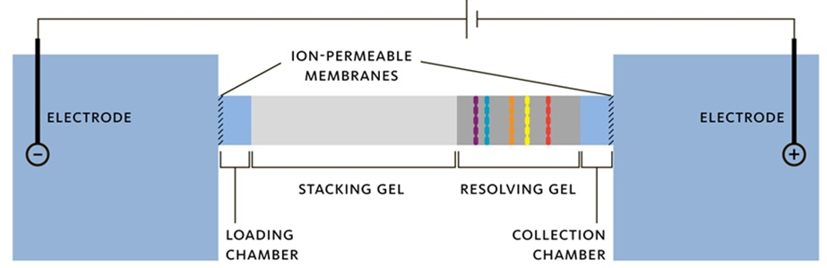
Figure 3.1: A schematic diagram of GELFrEE fractionation system
The sample is loaded into the loading chamber and the voltages are applied which results in migration of proteins based on their molecular weight. The low molecular weight proteins elute first into the collection chamber followed by proteins with high molecular weight. The instrument is paused at pre-defined specific time intervals to collect liquid fractions from the collection chamber.

To further develop advanced separation methods for enhanced proteome measurement depth in microbial samples, we systematically evaluated the efficacy of complementary molecular weight based in-solution fractionation of proteome samples using the GELFrEE device. We analyzed three different sample types with increasing complexity (E. coli, a five microbial isolate mixture (5MM) and a natural microbial community from an environmental ground water sample) via LC-MS/MS based proteomics measurements of whole cell lysates, in conjunction with their intact protein fractionated counterparts. (Figure 3.2)

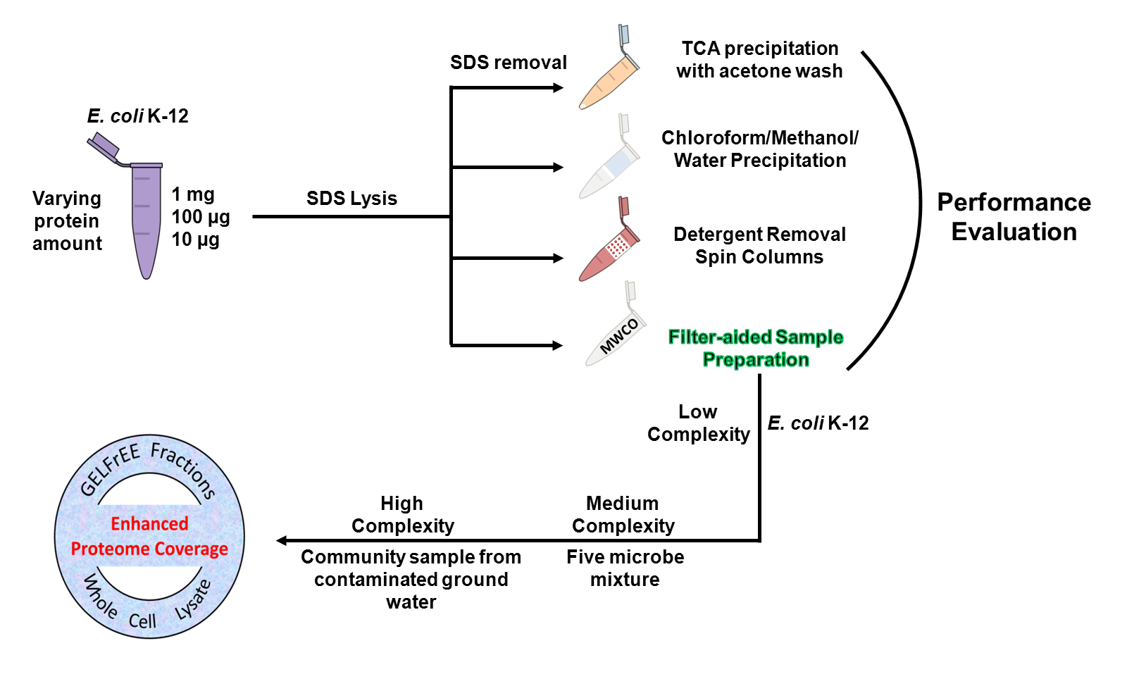

Figure 3.2: A schematic overview of the experimental design used in this study.

E. coli K-12 with three different protein concentrations were lysed by SDS and the SDS was removed with four different detergent removal methods. Next, the advantage of detergent based lysis and removal was utilized by combining a molecular weight based GELFrEE fractionation and unfractionated analysis scheme on three increasingly complex biological samples.

3.3 MATERIALS AND METHODS

Microbial samples

The bacterial strains Shewanella oneidensis MR-1, Shewanella putrefaciens CN-32, and Pseudomonas putida F1 were cultivated aerobically under constant agitation (250 rpm) at 30°C in Luria-Bertani (LB) medium (pH 7.2). The bacterial strain of E. coli K-12 was cultivated aerobically under constant agitation (250 rpm) at 37°C in LB medium (pH 7.2). When each culture reached an O.D. of ~0.8, it was centrifuged (1000 rpm for 10 min), and the resulting pellet washed with PBS. The pellet was flash frozen in liquid nitrogen with long term storage at – 80°C. A cell pellet of Geobacter uraniireducens was a generous gift from Dr. Derek Lovely, University of Massachusetts, Amherst, MA. Rhodopseudomonas palustris CGA010 cell pellet was graciously donated by Dr. Dale Pelletier, ORNL. The ground water microbial community sample was obtained from the DOE Integrated Field Research Challenge site at Rifle Colorado, provided by Dr. Kenneth Williams (Lawrence Berkeley National Lab).

Cell lysis

Protein Biomass Study: The protein concentration for cell cultures and the ground water sample were determined via an RC DC protein assay (Bio-Rad). A small aliquot from each stock culture was lysed by SDS-containing GELFrEE buffer with 50 mM DTT, and the RC DC assay was performed on the subsequent lysate. From this, a total protein amount in each stock culture was determined, and aliquots of E. coli K-12 corresponding to 1 mg, 100 µg or 10 µg total protein amount were removed. These aliquots were lysed using GELFrEE Sample Buffer (10% SDS starting concentration, 2% effective SDS concentration in solution) and 50 mM DTT by heating at 60 °C for 10 minutes. A similar procedure was adopted for the 5MM sample and Rifle ground water sample used in the study.

Fractionation and whole cell lysate complementary study: 500 µg of E. coli K-12 was lysed using SDS containing GELFrEE sample buffer (final concentration 2% SDS) and 50 mM DTT by heating at 60 °C for 10 minutes. For the 5MM sample, five microbes i.e. P. putida F1 (50%, 500 µg), R. palustris CGA010 (25%, 250 µg), S. oneidensis MR1 (20%, 200 µg), S. putrefaciens CN-32 (4%, 40 µg) and G. uraniireducens (1%, 10 µg) were combined (total protein amount of 1 mg) after cellular lysis via sonication. Following combination, cells were solubilized in GELFrEE sample buffer and 50 mM DTT and heated for 10 minutes at 60 °C (total volume 300 µL, of which 200 µL was taken up for LC-MS/MS experiment). The ground water sample corresponding to 500 µg total protein was lysed using GELFrEE sample buffer and 10 mM DTT and heated at 60 °C for 10-15 minutes.

GELFrEE fractionation

The 500 µg samples of E. coli K-12 and ground water were loaded onto a single channel of a GELFrEE 8100 mid-mass cartridge after cellular lysis. The lysate from 1 mg of the 5MM sample was divided equally and loaded into two channels of GELFrEE 8100 mid-mass cartridge. Following this, 12 fractions (~ 150 µL each) were collected at specified time intervals (57.5, 59.5, 61.5, 64.5, 66.5, 68.5, 71.5, 76.5, 83.5, 93.5, 108.5, 128.5 min). Fractions from the two channels of 1 mg of 5MM sample were pooled (total 300 µL), and 200 µL was used for further downstream sample preparation, while the remaining volume was kept for analysis via SDS-PAGE. For the fractions from the E. coli K-12 and ground water, all the fraction volume (150 µL) was used for downstream sample preparation.

SDS clean-up procedures

TCA precipitation: TCA (100%) was added to 150 µl of SDS lysed E. coli K-12 cells to a final concentration of 25% (w/v) TCA. The TCA/protein solution was kept overnight on ice at 4 °C, then the precipitate was centrifuged at 20800 g for 10 min. The supernatant was discarded and the pellet was washed twice with chilled acetone by centrifugation at 20800 g and finally air-dried. The air-dried and acetone washed pellet was re-suspended in 6M guanidine.

Chloroform/Methanol/Water precipitation: The method was an adaptation from the protocol by Wessel and Flugge. To the 1 mg, 100 µg and 10 µg E. coli K-12 lysate (150 µl volume), 600 μL of methanol, followed by 150 μL chloroform and then 450 μL water was added with brief vortexing after each solvent addition. The sample was centrifuged for 15 min at 20800 g and the top layer was removed. A further 600 μL aliquot of methanol was added without vortexing, and spun at 20800 g for 15 min. Following this step, the supernatant was carefully removed without disturbing the pellet. The pellet was air-dried and re-suspended in 6M guanidine.

Detergent removal spin column: The 150 µl of E. coli K-12 lysate was loaded on to a 0.5 mL column size Pierce detergent removal spin column and used per manufacturer’s guidelines. Briefly, SDS lysed samples were loaded on the spin column and incubated for a couple of minutes at room temperature. Finally, the SDS-free sample was eluted by spinning the column for 2 min at 1,500 g.

Filtration/FASPKits: To test the filter assisted sample preparation method we digested E. coli K-12 lysates via a commercial FASPTM Protein Digestion kit (Protein Discovery, Knoxville TN), as well as a method similar to the original paper describing use of spin filters. E. coli K-12 lysate (150 µl) was loaded on to a 10kDa MWCO filter (VWR centrifugal filters with Polyether sulfone membrane), and 200 µL of 8M urea was added on top of the filter, which was then vortexed and centrifuged at 20,800 g. The urea wash step was repeated twice. Following urea spins, 200 µL of 100mM Tris; 10 mM CaCl2 buffer (pH 8) was added. The filter was again vortexed and centrifuged at 20,800 g. This step was repeated twice. The sample was then subjected to trypsin digestion. The commercial FASPKits employed a 30kDA filter and use a 50 mM ammonium bicarbonate buffer in place of the Tris-CaCl2 buffer used for VWR filters. The filters were operated as per the protocol for handling GELFrEE fractions described in the instruction sheet.

Protein Digestion: Except for samples cleaned up using the Filtration/FASPKits method, protein lysates from other cleanup methods (i.e. TCA, CMW and DRS method) were subjected to chemical denaturation by 6M guanidine and reduction by10mM DTT. Following this, the samples were diluted 6 fold and trypsin (Promega, Madison, WI) was added (1:20 Trypsin: Sample ratio). Digestion was carried out for 4 hours at 37°C, followed by addition of another aliquot of trypsin for overnight digestion at 37°C. Samples were desalted using C-18 Solid Phase extraction (Sep-Pak Lite, Waters). E. coli K-12 samples cleaned up via the filtration method (protein biomass variation study) were digested on the MWCO filter using two aliquots of trypsin (first for 4 hours and then for overnight) at room temperature. The peptides were eluted by 0.5 M NaCl and desalted using C-18 Solid Phase extraction (Sep-Pak Lite, Waters). The FASPKits samples (fractionation and whole cell lysate complementary study) were digested on the MWCO filter using two aliquots of trypsin, described as above for filtration prep at room temperature. The resulting peptides were collected in a fresh tube by eluting them with 0.5 M NaCl. The FASPKit samples were desalted on the column by loading the sample on Reverse Phase (RP)-Strong Cation Exchange (SCX) back column and washing from high water to high organic three times over 25 minutes.

LC-MS/MS

Digested samples were pressure cell-loaded onto a 3 cm SCX only fused silica back column (150-µm inner diameter) back column. For the FASPKits prepped samples, 3 cm of C18 reverse phase resin (Aqua, 300 Å pore size, Phenomenex) was added up-stream from the SCX resin. The back column was connected to a 15-cm-long 100-μm-I.D. C18 RP resin PicoFrit column (New Objective) and placed in-line with a U3000 quaternary HPLC (Dionex, San Francisco, CA). The SCX LC separation was performed with either eleven salt pulses (peptides from whole cell lysates, protein biomass studies with 100 μg and 1 mg E. coli), six salt pulses (peptides from 10 μg E. coli samples) or three salt pulses (peptides from GELFrEE fractions) containing increasing concentration of 500mM ammonium acetate. Each salt pulse was followed by a 2 hr. reverse phase gradient from 100% Solvent A (95% H2O, 5%ACN and 0.1% formic acid) to 60% Solvent B (30% H2O, 70% ACN and 0.1% formic acid). The LC eluent was directly nanosprayed into either a Thermo Scientific LTQ Orbitrap-XL mass spectrometer (protein biomass variation study) or a LTQ-XL mass spectrometer (GELFrEE fractions and unfractionated lysate study) with an ionization voltage of 4-4.2 kV. During LC, the mass spectrometer was operated in data-dependent mode and under the control of the Xcalibur software (Thermo Scientific). The data-dependent acquisition used the following parameters: collision-induced dissociation of 5 parent ions were performed following every full scan; 2 microscans were averaged for every full MS and MS/MS spectrum; a 3 m/z isolation width; 35% collision energy was used for fragmentation; and a dynamic exclusion repeat of 1 with duration of 60 seconds.

Peptide and protein identifications

The raw MS/MS data from E. coli K-12 samples was searched against an E. coli K-12 predicted database having 4170 proteins (downloaded January 20, 2011 from Department of Energy-Joint Genome Institute (DOE-JGI) server) including common contaminants (trypsin, keratin etc.). The raw MS/MS data from the 5MM runs was searched against a concatenated database (23098 proteins) of the predicted proteomes of P. putida F1, S. putrefaciens CN-32, S. oneidensis MR-1, R. palustris CGA009, G. uraniireducens and common contaminants (downloaded January 8, 2008 from DOE-JGI server). The ground water samples were searched against a microbial database (totaling 30758 proteins plus common contaminants) assembled from eight Geobacter isolates (downloaded January 1, 2008 from DOE-JGI server) 33, the dominant microbial species in these samples. All searches were done by SEQUEST using search parameters described previously. The output DTA files were then filtered and sorted using DTASelect algorithm using the following parameters: fully tryptic peptides only with ΔCN of at least 0.08 and cross-correlation scores (Xcorr) of at least 1.8 (+1), 2.5 (+2), and 3.5 (+3). FDR were calculated using a concatenated forward-reverse database on selected runs.

Bioinformatics

The whole proteomes of all the microbes (i.e., of P. putida F1, S. putrefaciens CN-32, S. oneidensis MR-1, R. palustris CGA009, G. uraniireducens and E. coli K-12) were analyzed by PSORTb v3.0.2. Pathway analysis was done by Pathway Tools v15.0. For the analysis, we imported Ecocyc and other databases (PGDBs) corresponding to microbes involved in our study into Pathway tools. Following the import, Gene IDs corresponding to protein identifications from the MS/MS search were mapped on the pre-built pathways. For the GRAVY analysis, protein sequences corresponding to protein identifications from MS/MS data were imported into the PROMPT tool (Protein Mapping and Comparison Tool). All the Venn diagrams were made using Venny or Venn Diagram Plotter (PNNL; http://omics.pnl.gov).

3.4 RESULTS AND DISCUSSION

Effect of protein amount on efficacy of different detergent clean-up methods: In order to evaluate the performance of the detergent removal methods, SDS-lysed E. coli K-12 at different protein amounts were processed with four commonly used approaches: TCA precipitation, CMW method, DRS method and FASP (Figure 3.2). After determining the protein concentration of the starting E. coli K-12 culture, aliquots of 1 mg, 100 µg and 10 µg total protein were lysed for proteomics experiments.

Based on the results, the FASP method performs slightly better at the high protein (1 mg) amount and strikingly superior relative to the other three methods at the low protein conditions (10 µg) The four-way Venn diagram in Figure 3.3 shows unique and common proteins identified after combining results from the two technical replicates of E. coli K-12 lysates with varying protein amount and employing different detergent clean-up methods. At the highest protein amount tested, 1 mg of total protein, ~51% of the identifications are common to all the methods; this number decreases to ~45% with 100 µg total protein and then takes a sharp dip to just 10% with 10 µg total protein. For the 10 µg E. coli K-12 lysate, the number of proteins uniquely identified from the DRS and the CMW methods are insignificant compared to the unique proteins identified by the FASP method. Surprisingly, the TCA precipitation protocol failed to identify a single unique protein at the 10 µg level.

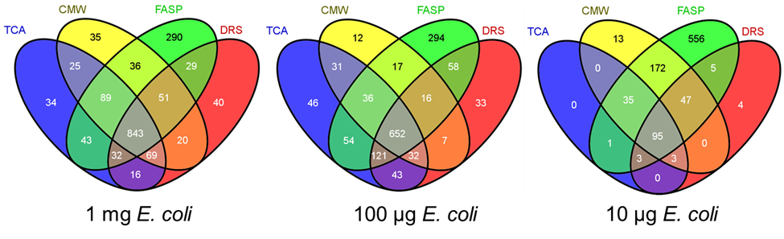

Figure 3.3: Unique and common proteins identified in E. coli K-12 lysate after SDS lysis / removal using four different methods and three different protein amounts.
The number of peptides and spectra identified by each SDS clean-up method showed a similar trend to the protein identifications, except for a few variations. As shown in the Figure 3.4a and 3.4b, in the case of the DRS method, as expected, the average number of proteins is lower for a 100 µg sample than a 1 mg sample, but surprisingly the average number of peptides follows the reverse trend. The 100 µg sample of the E. coli K-12 prepped by the DRS method yields more peptides compared to a 1 mg protein sample. The number of proteins, peptides and spectra identified by the FASP method shows an almost linear trend for differing protein amounts, but a very sharp decrease is observed for the other three SDS clean-up methods when the starting protein amount is reduced from 100 µg to 10 µg. Also, it is notable that the FASP method does not always yield an improvement in peptide and spectral identification rates for each starting protein amount, even though more proteins are identified at each level. From the 1 mg sample, the highest number of peptides was identified by the CMW method, followed by the FASP, TCA and DRS methods. For the 100 µg sample, both the DRS method and the CMW method resulted in more identified peptides then the FASP method, with the least identified by the TCA method. However, for the samples with 10 µg starting protein, FASP was clearly superior in the number of peptides identified.
The number of spectra identified by each method also reflects the performance of each method in recovering sample. The FASP method identifies more spectra than the remaining three methods for the 1 mg and the 10 µg protein samples but is in between DRS and CMW method for the 100 µg protein sample (Figure 3.4c). Even though the FASP method yields slightly higher protein identifications at the 1 mg protein level, this is above the threshold limit recommended for the FASP kits (400 µg). The high protein amount can lead to clogging of the filter, which can be more problematic for proteomes extracted from biofilms and other
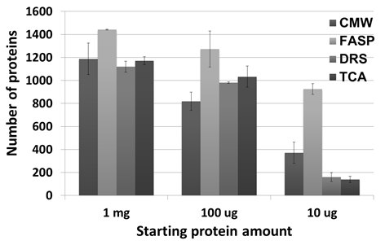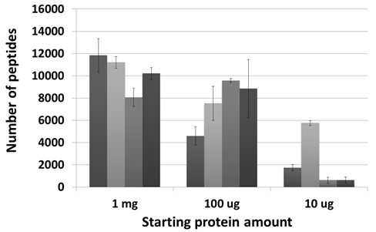
(a) (b)
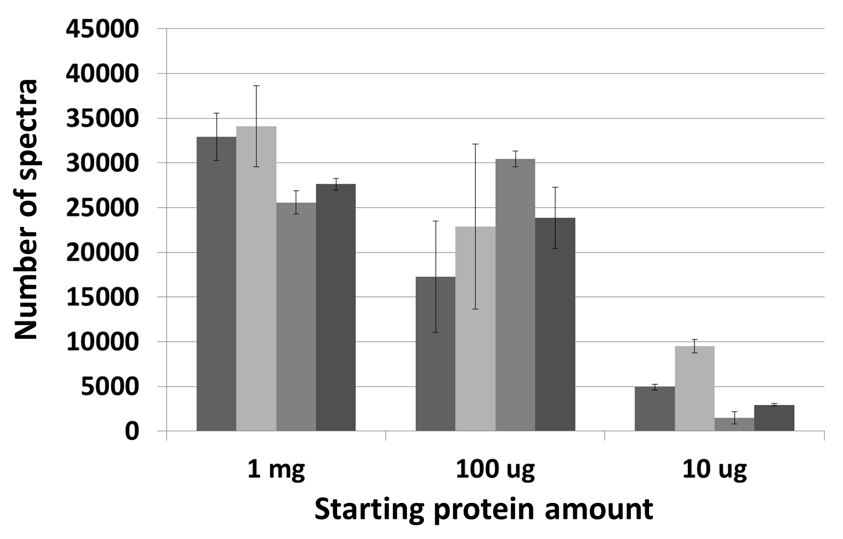
(c)
Figure 3.4: Average numbers of (a) proteins (b) peptides and (c) spectra identified by LC-MS/MS in E. coli K-12 lysate with three different protein amounts (1 mg, 100 µg and 10 µg) and prepared by four different SDS clean-up methods.
For calculating the average protein count, peptide count and spectral count, data is taken from the summary table of individual DTASelect.txt outputs, including those assigned to contaminants. Error bars denote 1 standard deviation.

microbial communities with thick matrices. Even for microbial isolates, we performed a 10 min spin at 20800 g after the SDS lysis to pellet the cellular debris.
In discovery driven proteomics experiments, a sample preparation method should be efficient in extracting proteins from all the cellular compartments in an unbiased manner. Extracting membrane proteins is more difficult than the cytosolic proteins, so we investigated whether the four SDS clean-up methods are preferentially distinct in recovering membrane proteins. In order to evaluate differences in the cellular localization profiles of samples resulting from biased protein recovery of each method, the PsortB bacterial localization prediction program was used to predict localization of the identified proteins. Figure 3.5a shows the prediction of all the proteins identified from the 1 mg E. coli K-12 sample, while Figure 3.5b represents the proteins identified uniquely by each SDS clean-up method. The FASP method identified a higher number of proteins for each bacterial location, but it is the number of unique protein identifications which clearly demarcates the efficacy of the FASP method over the other three methods. FASP identified 60 proteins which are predicted to localize to the membrane, compared to 4, 2, and 5 proteins identified by DRS, CMW, and TCA methods, respectively. The number of cytoplasmic proteins identified by FASP is also significantly higher.
To further investigate soluble versus hydrophobic protein identifications, the GRAVY scores for all the identified proteins were calculated. A positive GRAVY
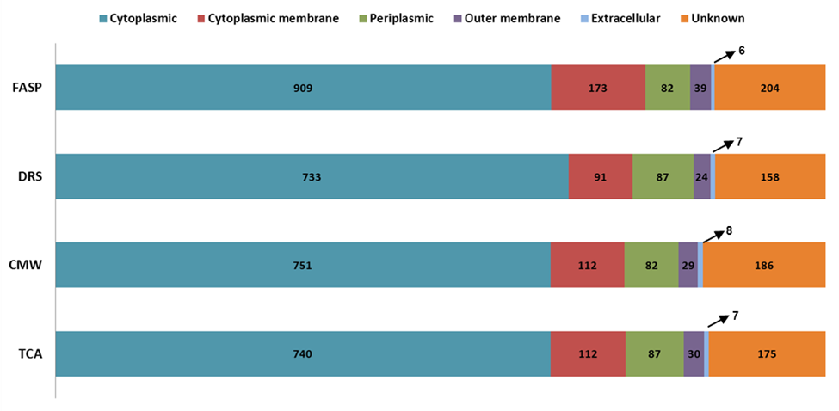
(a)
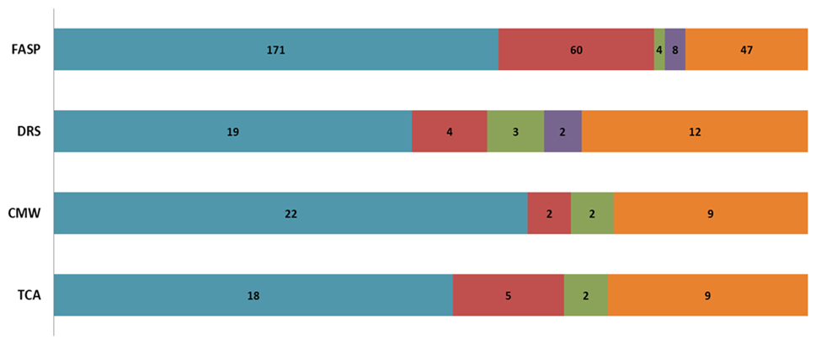
(b)
Figure 3.5: Predicted localization of proteins identified by LC-MS/MS after SDS clean-up method in a 1 mg E. coli K-12 sample (a) total number of proteins identified by each method (b) proteins uniquely identified by each method.
score indicates that a protein is hydrophobic in nature, while a negative GRAVY score indicates a protein with a hydrophilic nature. Figure 3.6 a, b and c shows GRAVY scores of all the unique proteins identified by each SDS clean-up method in 1 mg, 100 µg, and 10 µg E. coli K-12 samples. The unique proteins identified by FASP trend more towards the positive side of the GRAVY scale compared to other three methods, suggesting that FASP performs better in retaining hydrophobic proteins compared to other three protocols.
The results suggest that the FASP method is superior to the other three methods at the protein concentrations tested. At a 1 mg protein concentration, all the methods are at a baseline level of ~1200-1300 protein identifications, with FASP faring slightly better. However, the clearest advantage of using FASP is under sample limitation conditions. FASP outperforms the other three SDS clean-up methods at a 10 µg protein concentration. While the other methods identify ~120 proteins, FASP performs 7 times better by identifying ~900 proteins. We think the considerable gain in performance using FASP over the precipitation methods is that FASP does not involve a precipitation step as in TCA and CMW protocols, which can result in loss of an invisible pellet when working with minimal material. Furthermore, the DRS method employs a relatively large resin volume, providing for surface area-associated protein loss. Another advantage of FASP is that all sample preparation steps take place in a small reaction container, which greatly aids in efficient trypsin digestion and minimal protein contact with other surfaces. However, if one wants to evaluate samples with very high protein biomass or

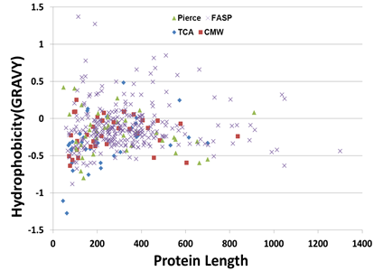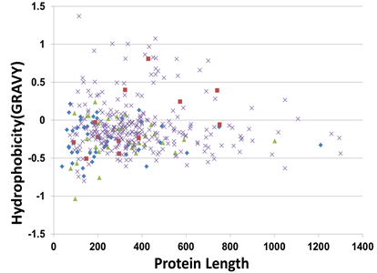
(a) (b)

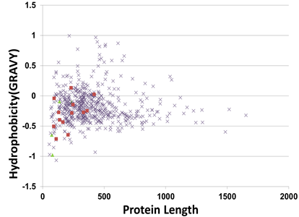
(c)
Figure 3.6: Hydrophobicity and protein length distribution of uniquely identified proteins by each SDS clean-up method in E. coli K-12 samples (a) 1 mg, (b) 100 µg and (c) 10 µg.

samples that are associated with a complex matrix, FASP is unlikely to perform as well. For example, preparation of soil samples using FASP have not been successful, because even after SDS solubilization and centrifugation to remove insoluble material, the supernatant is rich with low density particulate matter. These particulates can easily clog the FASP filter, making it impossible to extract the proteome. In such cases, TCA precipitation is the preferred method of SDS removal, as it has already been shown to work with soil samples.

Coupling in-solution intact protein fractionation with a 2D LC-MS/MS experiment

After evaluating different SDS clean-up methods, we sought to examine how to use additional protein fractionation to deepen the proteome coverage. To do so, we employed intact protein separation based on protein molecular weight using GELFrEE technology. The GELFrEE approach shares the principles of SDS-PAGE, fractionating proteins based on their molecular weight, but instead of producing separate bands as in SDS-PAGE, GELFrEE yields proteins in liquid fractions. The separation of proteins into distinct liquid fractions instead of gel bands reduces sample loss and improves protein recovery. Lower molecular weight proteins elute first in the GELFrEE cartridge and subsequent fractions have proteins in order of increasing molecular weight. The performance of the GELFrEE approach was tested on three different biological samples with increasing complexity, i.e. an E. coli lysate, 5MM sample, and a ground water microbial community sample (Figure 3.2). After solubilization in the SDS sample buffer, the samples were divided into two equal aliquots, one for unfractionated 2D-LC-MS/MS and the other for GELFrEE fractionation prior to 2D-LC-MS/MS. While fractionation of the proteome reduces sample complexity, there is a concomitant reduction of total protein amount available for downstream sample processing. For example, a 500 µg protein biomass sample, when fractionated into twelve fractions, will on average yield only ~ 40 µg proteins per fraction, assuming no protein loss. Therefore, SDS removal from such fractions needs to be performed using a method which can give best results with a low amount of protein. As shown earlier, FASP stands out as the method of choice for the 10 µg – 100 µg range of protein amounts, and, thus, was utilized for preparation of all the GELFrEE fractions. The unfractionated sample was run in three replicates on an LTQ mass spectrometer, using a 24 hr. 2D-LC-MS/MS method, while the twelve GELFrEE fractions were run individually using a shorter 6 hr. 2D-LC-MS/MS method, thereby keeping the total instrument time almost same for each scheme. For both schemes, we used similar protein amounts per sample type: the E.coli K-12 sample and ground water sample utilized 500 µg total protein for each scheme, while 1 mg of 5MM sample was utilized for each of the fractionation and whole cell lysate approach. As seen in Figure 3.7, there is significant overlap in identifications between the fractionated and whole lysate schemes, however, the total identifications are boosted by the contributions of identifications unique to each method, in particular for the more complex community samples.

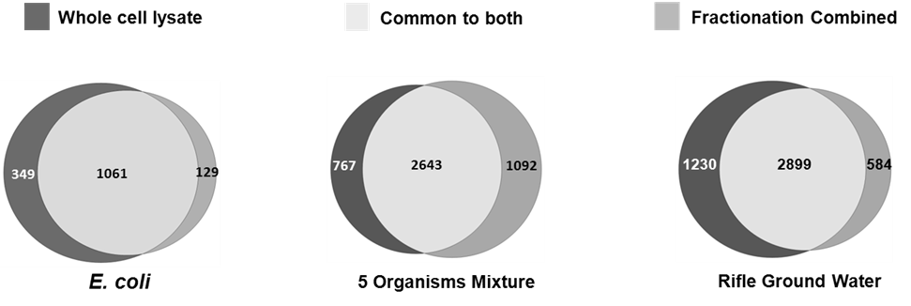

Figure 3.7: Unique and common proteins identified by fractionation and whole cell lysate proteomic methods in three biological samples of increasing complexity.

The GELFrEE approach uniquely identifies 129, 1092, and 584 proteins in the whole lysate E.coli K-12, 5MM sample, and ground water samples, respectively. Similarly, the unfractionated approach identifies 349 unique proteins in the E. coli sample, 767 unique proteins in 5MM sample and 1230 unique proteins in ground water sample. Although repeated technical replicates can increase total identifications, the whole cell lysate scheme missed many proteins identified by the fractionation approach, even after three technical replicates.
The GELFrEE fractionation scheme yield 12 fractions collected at different time points, with earlier fractions having low molecular weight proteins, while the later fractions are enriched for high molecular weight proteins. As can be seen in Figure 3.8, the Coomassie blue stained 1D gel of GELFrEE fractions from 5MM sample shows that the fractions are well resolved and fairly distinct. The overlap between fractions is a function of sample loading, as shown by Tran & Doucette. In our study, we used either one channel (E. coli and ground water sample) or 2 channels (5MM sample) of 8% GELFrEE mid mass cartridge, which fractionates proteins ranging from 3.5 kDa to 150 kDa with optimized resolution at 35-150 kDa.

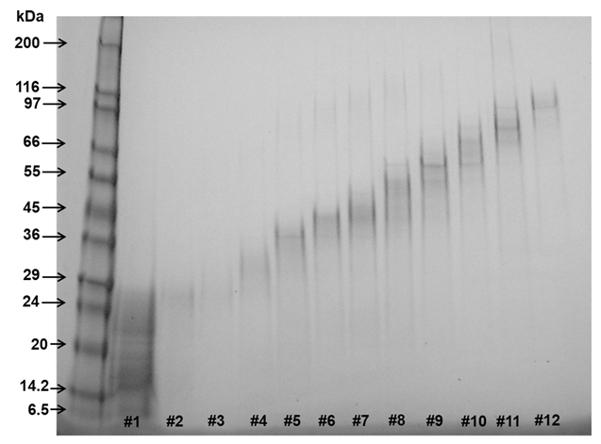

Figure 3.8: Fractionation of 5MM sample using the 8% GELFrEE cartridge. A 500 µg aliquot of 5MM sample was fractionated into 12 fractions. The figure shows an SDS-PAGE gel image of GELFrEE fraction numbers 1 to 12 ran on a 4-20% gel

Table 1 shows the number of total proteins as well as the unique proteins identified by each GELFrEE fraction for all the sample types. From this table, it is clear that each GELFrEE fraction contributes to the total protein identification and by manipulating fraction collection time one can get optimum proteome coverage for a given sample.
As reflected in the SDS-PAGE gel (Figure 3.8), the GELFrEE fractions are enriched in a specific molecular weight zone, and we confirm the same via mass spectrometry. We also observed that the GELFrEE fractionation scheme is unbiased towards the pI of the proteins present in the proteome (Figure 3.9).
On-line LC-MS/MS is a robust and efficient approach for bottom-up proteomics. However, due to the high complexity of samples, simplification of protein mixtures is a necessary step prior to protein digestion. Our study shows that by analyzing a whole cell lysate in conjunction with fractionation in a tandem approach, we can obtain deeper proteomic coverage of biological samples. In Figure 3.10 a and b, we show two representative metabolic pathways from S. putrefaciens CN-32 and S. oneidensis MR-1, microbes which were part of the 5MM sample. The near completeness of enzyme identifications in these pathways is possible because of the complementary nature of the fractionation and whole cell lysate approach.
The complementarity of the tandem fractionation and whole cell lysate approach provides for greater biological information. By focusing on the gluconeogenesis pathway (Figure 3.10 a) of S. putrefaciens CN-32, the two-prong scheme reveals
Table 1: Total proteins and unique proteins identified by each GELFrEE fraction for the three sample types in our study
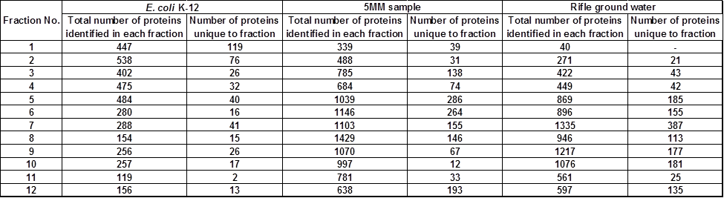

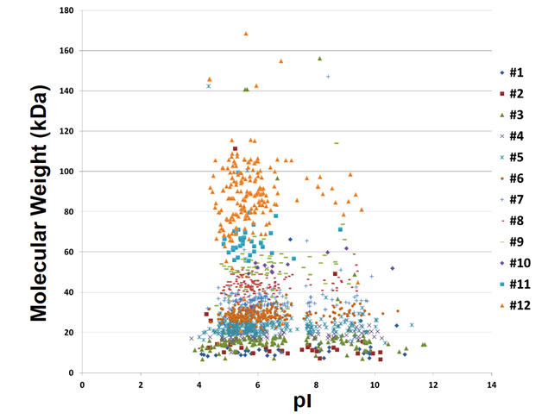

Figure 3.9: Distribution of unique proteins identified in MS run of each GELFrEE fraction from a mixture of 5 microbial isolates.

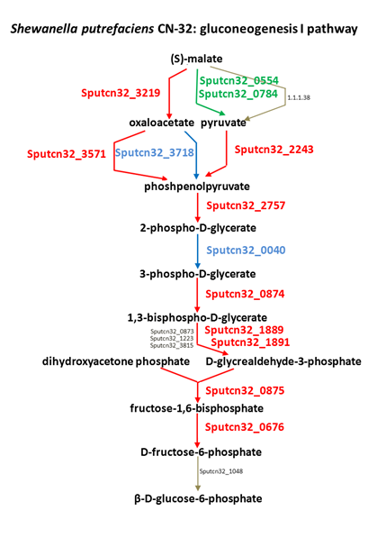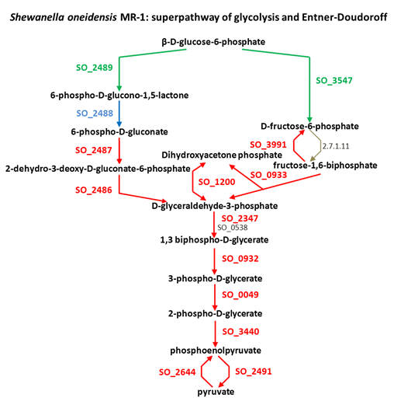
(a) (b)

Figure 3.10: Both the GELFrEE fractionation and whole cell lysate approaches complement each other by providing more biological information as reflected in selected pathways of (a) S. oneidensis MR-1 and (b) S. putrefaciens CN-32.
Red represents proteins identified by both the approaches; blue represents proteins identified only by the fractionation method while the green represents proteins identified only by the whole cell lysate approach. Gray denotes proteins that were not identified by any method.

that malate can either be transformed into oxaloacetate (Gene Sputcn32_3219) or into pyruvate (Gene Sputcn32_0554, Sputcn32_0784). If we had used only the fractionation scheme, we would have obtained only partial information. Similarly, we found that the conversion of oxaloacetate into phosphoenolpyruvate can be mediated by two genes Sputcn32_3571 and Sputcn32_3718. Thus, if one gene is knocked out, the pathway is still functional, as the second gene can take over the role of the first gene. This information would not have been evident if we had not used fractionation scheme in our proteomics experiment.
Likewise, complementary information is evident for the glycolysis pathway (Figure 8b) of S. oneidensis MR1. Here the whole cell lysate scheme reveals that β-d-glucose-phosphate can either be converted to 6-phospho-D-glucose-1,6 lactone by SO_2489, or it can be converted to D-fructose-6-phosphate by SO-3547. The fractionation scheme provides the connection for conversion of 6-phospho-D-glucose-1, 6 lactone to 6-phospho-D-gluconate by SO_2488. Therefore, it is evident that both possible routes are functionally active in the glycolysis pathway of S. oneidensis MR1. The increase in pathway information can enable more informed decisions for other genetic or molecular biology studies.
3.5 CONCLUSIONS

Systematic investigations suggest that the choice of detergent removal method heavily relies on the amount of protein in a sample. At high protein amounts, the performance of different SDS removal methods is fairly comparable. However, when the sample is limited with low protein amounts, the experimental approach needs to be carefully planned by taking into consideration all the pros and cons associated with different SDS removal methods. For example, we demonstrated that for an E. coli K-12 sample with a low protein amount, FASP significantly outperforms the other three SDS removal methods. However, the FASP method should be further optimized and evaluated with microbial samples from more complex matrices. We also investigated benefits of coupling whole lysate 2D-LC-MS/MS with intact protein fractionation followed by short 2D-LC-MS/MS on collected fractions. Our study demonstrates a definite merit in protein-level fractionation prior to digestion and downstream peptide separations. This method not only has the potential to increase the total number counts of identified proteins, but also would favorably impact a more targeted approach, when one is only interested in proteins belonging to specific molecular weight range of the proteome.

VITA

Ritin Sharma was born in Udaipur, Rajasthan (INDIA). He completed his High School education from The Study School, Udaipur in 1999. Following the completion of his BSc. in 2003 and PG Diploma in 2005 he worked for two years in AstraZeneca India gaining valuable experience in bioinformatics and structural biology. In 2009, he joined the Genome Science and Technology at the University of Tennessee. He is working on his dissertation under the guidance of Dr. Robert L. Hettich and expect to complete it by May of 2014.

