FABRICATION AND THERMO-PHYSICAL PROPERTIES OF MOLYBDENUM-TUNGSTEN CERMETS AND ZIRCONIUM CARBIDE CERCERS USING SPARK PLASMA SINTERING FOR USE IN NUCLEAR THERMAL PROPULSION

A Dissertation Presented for the
Doctor of Phillosphy
Degree
The University of Tennessee, Knoxville

Neal D. Gaffin
July 2022

Copyright © 2021 by Neal D. Gaffin
All rights reserved.

DEDICATION

This work is dedicated first and foremost to my wife, Miquela, who has supported me throughout my long and tiresome educational pursuits

To my children Zachary and Brynlee, who greeted me with smiles and hugs every time I came home,

And to my parents and my sister for encouraging me to follow my dreams.

ACKNOWLEDGEMENTS

Thank you to my advisor, Dr. Steven Zinkle, who has advised me throughout my entire graduate career. He has helped to not only have success in my research but to also grow and develop the skills that are necessary for my future success. Thank my committee, Dr. Kelsa Palomares, Dr. Justin Milner, Dr. Lawrence Heilbronn.

Thank you Caen Ang and Tim Ironman.

Thank you to Madison Vandergriff, Annie Berens, Josh Morely.

Thank you Dr. Lignell and Dr. Memmott, who both took the time to help an undergraduate student determine which graduate experience would be best.
ABSTRACT

Nuclear thermal propulsion (NTP) utilizes nuclear fission to double the efficiency of in-space propulsion systems compared with traditional combustion systems. One of the most difficult aspects with designing an NTP system is determining a viable fuel element material candidate. The material needs to endure temperatures up to 3000 K, multiple thermal cycles with rapid heating and cooling, exposure to hot flowing hydrogen, large thermal gradients, and high radiation flux. Ceramic-metallic (CERMET) and ceramic-ceramic (CERCER) composites are both promising fuel element material candidates for nuclear thermal propulsion (NTP). While a lot of effort is being spent to test materials at the higher operating temperatures, it is important to understand the thermal and mechanical properties of the fuel element materials for the parts of the reactor that will never exceed 1000 K. Currently, there exists very little data on the thermophysical and mechanical properties of CERMET and CERCER composites, especially above room temperature. A CERMET with a molybdenum-tungsten matrix, and a CERCER with a zirconium carbide matrix, each using surrogate ceramic fuel particles with 10-70% volume loadings, have been sintered to >97% theoretical density using pulsed electric current sintering. These materials then underwent compressive and notched bend-bar tests up to 800 ºC. They have also undergone heat capacity, thermal diffusivity, thermal expansion experiments. From these results, a model has been made to determine the value of a property with respect to the test temperature, matrix material, surrogate particle, and volume loading.
PREFACE

I will likely not include this page.

Table of Contents

Chapter One Introduction and General Information 1
Background 1
NTP Operating Conditions and Material Requirements 1
Legacy NTP Fuel Systems 6
Rover/NERVA 8
CERMET Programs 12
USSR CIS Programs 20
Spark Plasma Sintering 22
CERMET and CERCER Fuel Forms 22
Research Objectives 22
Chapter Two Literature Review 24
Pulsed Electric Current Sintering (Spark Plasma Sintering) 24
SPS Background 24
Effect of Control Parameters on SPS 24
Heading 2 25
Heading 2 25
Heading 3 25
Heading 3 25
Heading 2 26
Chapter Three Literature Review 27
Pulsed Electric Current Sintering (Spark Plasma Sintering) 27
SPS Background 27
Effect of Control Parameters on SPS 27
Sintering of Refractory Metals and Alloys 32
Sintering of Zirconium Carbide 44
Sintering of Refractory Composites and CERMETs 48
Properties of Molybdenum and Tungsten 53
Crystal Structure of Molybdenum and Tungsten 53
Thermal Properties of Molybdenum and Tungsten 53
Mechanical Properties of Refractory Alloys 66
Properties of Zirconium Carbide 78
Crystal Structure of ZrC 78
Thermal Properties of Zirconium Carbide 78
Mechanical Properties of Zirconium Carbide 88
Surrogate Ceramic Particle Selection and Properties 97
Properties of Oxide Fuels 97
Properties of Nitride Fuels 106
Chapter Five Fabrication of Matrix and Composite Materials Using SPS 112
Chapter Six Thermophysical Properties 113
Chapter Seven Mechanical Properties 114
Chapter Nine Conclusions and Recommendations 115
List of References 116
Appendix 124
Vita 126

LIST OF TABLES

Table 1.1. Summary of fuel element materials [4]. 7
Table 1.2. Summary of GE 710 program issues and solutions as summarized by Smith [17]. 14
Table 2.1. Sintering conditions, relative density, and hardness of ZrC fabricated using reactive SPS [34]. 45
Table 2.2. Sintering conditions for W/HfO₂ cermet powders by Tucker et al. [39]. 50
Table 2.3. Fitting parameters for thermal expansion of Mo and W determined by Suh et al [52]. 59
Table 2.4. Zerilli and Armstrong model parameters for Mo and W determined by Škoro et al. [62]. 71
Table 2.5. Tensile properties of pure Mo tested at 973, 1273, and 1623 K. [65] 73
Table 2.6. Typical elastic properties of ZrC at room-temperature compiled by Jackson and Lee [69]. 88
Table 2.7. Room temperature mechanical properties of hot pressed ZrC as reported by Korklan et al. [75] and Feng et al. [76]. 96
Table 2.8. A summary of material properties for UO2 and YSZ. 98
Table 2.9. Room temperature properties of UN, HfN, and Hf₃N₄. 108

LIST OF FIGURES

Figure 1.1. Schematic of NERVA derived liquid hydrogen NTR engine [8]. 3
Figure 1.2. Estimated maximum operating conditions for several different NTP fuel core materials [4]. 5
Figure 1.3. Diagrams of the 4 tested Rover/NERVA fuel forms [4]. 9
Figure 1.4. Corrosion Rates for various Rover/NERVA fuel forms, illustrating mid-band corrosion [4]. 10
Figure 1.5. W-UO₂ fuel elements manufacture by ANL [4]. 17
Figure 1.6. Mass loss data for ANL W cermet tests at 2500 ºC [4]. 18
Figure 1.7: Derived Cermet operating limit from GE710 and ANL experiments [4]. 19
Figure 1.8. Candidate fuels for the USSR CIS program [4]. 21
Figure 2.1. Displacement rate with respect to temperature for the sintering of a copper powder using SPS [24]. 29
Figure 2.2. Displacement and displacement rate curves as a function of temperature for three different copper powder sizes, as sintered by SPS [24]. 29
Figure 2.3. ln d ((Δ L/L₀)/dT) versus the inverse temperature for pure titanium and titanium alloy at different heating rates to determine the activation energy and constant [25]. 31
Figure 2.4. Densification behavior of pure molybdenum using SPS compared to isothermal sintering using traditional methods [28]. 33
Figure 2.5. SEM micrographs of pure Mo sintered at 67 MPa using SPS [28]. 33
Figure 2.6. Corrected piston travel vs. sintering time for different heating rates at an applied pressure of 67 MPa [28]. 35
Figure 2.7. Relative density and hardness of as sintered Mo for a) various temperatures with a constant hold time of 5 minutes, and b) for various hold times at a constant temperature of 1850 ºC [29]. 36
Figure 2.8. a) the micro-structure of pure Mo consolidated using SPS, b) a histogram of the grain size for a sample sintered at 1850 ºC, c) the average grain size with respect to temperature, and d) the average grain size with respect to time [29]. 37
Figure 2.9. Micrographs of pure W powder prior to consolidation [30]. 38
Figure 2.10. a) Relative density of W consolidate with SPS with respect for temperature, and b) the relative density for three runs at 60 MPa during sintering [30]. 38
Figure 2.11. a) Grain with respect to time at 1700 and 1800 ºC, and b-e), grain coarsening of W microstructure with increasing sintering time. 40
Figure 2.12. a) Densities of mechanically alloyed and pure elemental mixing of Mo and W powders sintered for 6 hours at various temperatures, and an SEM micrograph of the sintered Mo30W alloy [32]. 40
Figure 2.13. Relative density versus sintering temperature for Mo-30wt%W 1) sintered in using SPS, and 2) sintered in hydrogen [33]. 41
Figure 2.14. Relative density versus sintering temperature for 1) Mo-10weight% W, 2) Mo-20weight% W, and 3) Mo-30weight% W [33]. 41
Figure 2.15. Hardness variation with sintering temperature for 1) Mo-10wt%W, 2) Mo-20wt%W, and 3) Mo-30wt%W [33]. 43
Figure 2.16. Micrographs of unspecified Mo-W alloys sintered at a) 1400 ºC, b) 1600 ºC, and c) 1800 ºC [33]. 43
Figure 2.17. SPS densification curves of ZrC powder as received and for various ball-milling times [35]. 46
Figure 2.18. Microstructure of ZrC consolidated using SPS at 2100 ºC for 3 minutes with an applied pressure of 65 MPa [36]. 46
Figure 2.19. Relative density of various ZrC samples produced by SPS and HP under a variety of different conditions [37]. 47
Figure 2.20. Densification curves of the Hot pressed ZrC (blue) and SPS ZrC at 1600 ºC for 60 minutes at 55 MPa. 47
Figure 2.21. W coated HfO₂ using AC-617A PE binder [39]. 49
Figure 2.22. SEM micrographs of the polished surface of the W/HfO2 at a) 40 x and b) 150 x [39]. 49
Figure 2.23. W-UO₂ cermets sintered using HIP with a 60vol% fuel loading for (left) angular UO₂ prepared without any powder coating and (right) spherical UO₂ prepared using the binding agent technique developed by Tucker et al. [39]. 52
Figure 2.24. The Mo-W binary phase diagram [44]. 54
Figure 2.25. Coefficients of thermal expansion of Mo, W, Ta, and Nb as compiled by Martienssen and Warlimont [45]. 54
Figure 2.26. Thermal expansion of Mo and Ta determined from two heating and cooling cycles by Rasor and McClelland [46]. 56
Figure 2.27. Thermal expansion of Mo from 1100 to 2100 K, calculated using the change in lattice parameter determined from XRD [47]. 56
Figure 2.28. Volume CTE of pure Mo up to the melting point as compiled by Bodryakov [48]. 58
Figure 2.29. Volume CTE of pure W up to the melting point as compiled by Bodryakov [49]. 58
Figure 2.30. Molar volume thermal expansion of pure tungsten up to the melting point determined from XRD as measured by Dubrovinsky and Saxena [50]. 59
Figure 2.31. Linear thermal expansion of Mo and W determined from push rod dilatometry and XRD compiled by Suh et al. [52]. The dark circles represent values collected using push rod dilatometry by Suh et al. [52], the open circles were calculated from XRD by Waseda et al. [53], the solid line was determined by XRD from Demarquay [54], and the line broken line with dot was determined by XRD from Worthing [55]. 60
Figure 2.32. Percent linear thermal expansion [56]. 60
Figure 2.33. Thermal conductivity of Mo, W, Ta, and Nb as compiled by Martienssen and Warlimont [45]. 61
Figure 2.34. Thermal conductivity of molybdenum above 2300 ºC [51]. 61
Figure 2.35. Thermal conductivity of tungsten above 2300 ºC [51]. 62
Figure 2.36. Specific heat capacity of Mo, W, Ta, and Nb as compiled by Martienssen and Warlimont [45]. 64
Figure 2.37. Heat capacity of pure Mo up to the melting point from data from 23 sources compiled by Bodryakov [48]. 64
Figure 2.38. Heat capacity of pure W up to the melting point from 24 sources compiled by Bodryakov [49]. 65
Figure 2.39. a) Vapor pressure and b) evaporation rate of Mo, W, Ta, and Nb as compiled by Martienssen and Warlimont [45]. 65
Figure 2.40. Young's modulus of Mo, W, Ta, and Nb as compiled by Martienssen and Warlimont [45], taken from Tietz and Wilson [57]. 67
Figure 2.41. The elastic modulus at elevated temperature for polycrystalline and single crystal W from Robinson et al. [64]. 67
Figure 2.42. Vickers’s hardness of W (open triangles) measured by Mutoh et al. [59]. 68
Figure 2.43. Tensile strength with respect to test temperature for Mo30W and other Mo alloys [60]. 68
Figure 2.44. Mechanical properties of W at elevated temperatures (sample 1) including a) the ultimate tensile strength and b) the yield strength [61]. 69
Figure 2.45. a) Elongation and b) compression of pure W (1) and other W alloys (2 and 3) from 773 to 2773 K [61]. 69
Figure 2.46. High temperature yield strength data of pure Mo (left) and pure W (right) fitted to the Zerilli and Armstrong BCC plastic deformation model by Škoro et al. [62]. 71
Figure 2.47. Yield strength (blue) and total elongation (orange) of pure tungsten tensile tested from room temperature to 1000 ºC [66]. 73
Figure 2.48. Total absorbed energy with respect to test temperature for pure Mo (open circle) determined by Hiraoka et al. [67]. 74
Figure 2.49. Yield strength determined from the impact test with respect to test temperature for pure Mo (open circle) determined by Hiraoka et al. [67]. 74
Figure 2.50. Temperature dependence of K_{IC} fracture toughness (left) and J_{IC} fracture toughness (right) for pure tungsten (open triangles) and some W-rhenium alloys from Mutoh et al. [59]. 75
Figure 2.51. Fractographs collected by Mutoh et al. for W and two W-rhenium alloys for samples fractured up to 1600 ºC [59]. 75
Figure 2.52. Fracture toughness K_{Q} of pure W and other tungsten alloys up to 800 ºC [68]. 77
Figure 2.53. Zr-C binary phase diagram as assessed by Fernandez-Guillermet [73] and compiled by Jackson and Lee [69]. 79
Figure 2.54. Heat capacity of ZrC for various stoichiometries up to 3000 ºC as compiled by Jackson and Lee [69]. 79
Figure 2.55. Specific heat capacity of ZrC as a function of temperature as compiled by Katoh et al. [72]. 80
Figure 2.56. Heat capacity at 298 K for various C/Zr ratios as compiled by Jackson and Lee [69]. 82
Figure 2.57. Specific heat capacity of ZrC with respect to the C/Zr ratio at ~300 K compiled by Katoh et al. [72]. 82
Figure 2.58. Thermal conductivity of ZrC at various stoichiometries as a function of temperature compiled by Jackson and Lee [69]. 83
Figure 2.59. Thermal conductivity of ZrC at room temperature as a function of C/Zr ratio compiled by Jackson and Lee [69]. 83
Figure 2.60. Linear coefficient of thermal expansion (CTE) of ZrC with respect to temperature compiled by Jackson and Lee [69]. 85
Figure 2.61. CTE of ZrC at 1273 K with respect to the C/Zr ratio compiled by Jackson and Lee [69]. 85
Figure 2.62. Thermal expansion and CTE, for two high stoichiometric ZrC powders with measured free carbon compile by Katoh et al. [72]. 86
Figure 2.63. Vapor pressures of C and Zr as a function of temperature as compiled by Jackson and Lee [69]. 87
Figure 2.64. Langmuir evaporation rate of ZrC for different stoichiometric ratios at various temperatures as compiled by Jackson and Lee [69]. 87
Figure 2.65. Young's Modulus of ZrC as a function of temperature compiled by Jackson and Lee [69]. 89
Figure 2.66. Young's modulus at room temperature as a function of the C/Zr ratio compiled by Jackson and Lee [69]. 89
Figure 2.67. Indentation hardness of ZrC as a function of temperature compiled by Jackson and Lee [69]. 90
Figure 2.68. Room temperature hardness of ZrC as a function of the C/Zr ratio compiled by Jackson and Lee [69]. 90
Figure 2.69. a) Indentation hardness of single crystal ZrC with respect to test temperature and b) variation of indentation hardness of ZrC with respect to the C/Zr ratio including hypo-stoichiometric carbon compiled by Katoh et al. [72]. 91
Figure 2.70. Ultimate Tensile strength of ZrC with various stoichiometries as a function of temperature compiled by Jackson and Lee [69]. 93
Figure 2.71. Bend strength of ZrC with respect to temperature, compiled by Jackson and Lee [69]. 93
Figure 2.72. Compressive yield stress of ZrC_{0.94} from 1200 to 1800 ºC taken from Darolia and Archbold [74]. 94
Figure 2.73. a) Uranium-oxygen binary phase diagram [83], and b) ZrO₂ – YO_{1.5} phase diagram [79]. 99
Figure 2.74. Dynamic elastic modulus of YSZ compared with transformation-toughened ZrO₂ [86]. 101
Figure 2.75. Heat capacity of UO2 (solid blue line) from Fink et al. [87], of 7.76 x 10⁻² mole fraction YSZ (orange line) from Tojo et al. [88], and of 3 mole percent YSZ (green squares) and 8 mole percent YSZ (yellow squares) from Sasaki et al. [94]. 101
Figure 2.76. Heat capacity of solid UO₂ compiled by Fink [87]. 102
Figure 2.77. Heat capacity of UO₂ with the lines representing various models, and the open circles and crosses representing data from Grønvold et al. [95]. 102
Figure 2.78. Heat capacity of UO₂ from various sources compiled by Naito [96]. 103
Figure 2.79. Thermal conductivity of fully dense UO₂ to 370 ºC (blue line) [91], a model for UO₂ up to 3000 ºC (yellow line) , and YSZ samples of 3 (orange squares) and 8 mol% (green circles) yttria stabilized zirconia up to 1000 ºC [92]. 103
Figure 2.80. Thermal diffusivity of UO₂ up to the melting point [97]. 104
Figure 2.81. Coefficient of thermal expansion for UO₂ [89], and for YSZ of various molar percentages [90]. 104
Figure 2.82. Thermal expansion of stoichiometric UO₂ from various sources, compiled by Martin [98]. 105
Figure 2.83. a) Uranium-nitrogen phase diagram [100] and b) hafnium-nitrogen phase diagram [101]. 107
Figure 2.84. Computed heat capacity of HfN [110]. 109
Figure 2.85. High temperature heat capacity of HfN carbo-oxides [103]. 109
Figure 2.86. Thermal conductivity of HfN_{0.92} (blue) [113] and of UN (green) [112]. 110
Figure 2.87. Thermal conductivity of uranium nitride from various studies compiled by Muta et al. [109]. 110
Figure 2.88. Unit thermal expansion of HfN_{0.92} (blue) [113], UN (orange) [109], and UN (green) [114]. 111
Figure 2.89. Young's modulus of UN with respect to porosity compiled by Muta et al. [109]. 111

Introduction and General Information

Background
Over the past seventy years, nuclear thermal propulsion (NTP) has been examined as a potential alternative to chemical rockets for in space propulsion. Interest in developing these systems comes in waves and is highly dependent upon current political agendas and exploration goals of the associated countries. Currently, there is significant interest in developing an NTP system for use in a crewed mission to Mars. The greatest challenge in developing these systems is to identify fuel and matrix materials that are capable of withstanding the extremely detrimental environment related to NTP. Several different materials have been considered for use in NTP with varying levels of success. Any material that will be used will have to be rigorously tested under a variety of extreme conditions that are highly detrimental to most materials. Additionally, the thermophysical properties of these materials up to just below their melting points need to be well understood in order to ensure a safe and functioning design. This thesis will discuss the fundamental synthesis and testing of two different NTP composite fuel forms. In both options the fuel will be a high temperature ceramic (UO2, UN or UC/UC2) that may or may not be encased in a “BISO” or “TRISO”-style containment. One of the composite fuel systems is a refractory metal matrix with a ceramic particulate fuel known as a ceramic-metallic (cermet) fuel. The matrix will consist of a molybdenum (Mo)–tungsten (W) alloy. The other composite fuel form is a ceramic matrix and ceramic particulate fuel form known as a ceramic-ceramic (cercer) fuel, with zirconium carbide (ZrC) acting as the matrix material. To ease in fabrication and testing, a variety of non-radioactive oxide and nitride fuel surrogate particles were used in place of the uranium-based fuels.

NTP Operating Conditions and Material Requirements
Nuclear thermal propulsion (NTP) is an in-space propulsion system with good promise for crewed missions to Mars [1-3]. A solid state NTP system generates all its power from fission. In its simplest form, NTP consists of a nuclear reactor core, turbopump system, and nozzle, as shown in Figure 1.1. Heat is generated in the reactor core, and cryogenic hydrogen (H₂) stored in tanks is pumped into the reactor and heated. The heated hydrogen is then expelled from the reactor and expanded out of a nozzle to generate thrust. Rocket efficiency can be described using specific impulse (Isp) that takes into account both energy and mass of the system/fuel. The higher the Isp, the more efficient the propulsion system. Efficiency of the system is directly related to the outlet temperature of the hydrogen, with a greater efficiency as temperature increases. This maximum temperature is limited by the fuel core materials due to melting point and hydrogen compatibility considerations. NTP has the potential to achieve very high Isp, 875 – 950+ seconds (s), compared with 400 s for chemical systems, while at comparable thrust levels, 10¹ – 10² thousand pounds of force (klbf) with current chemical engines. This combination of high thrust and Isp allows for larger mission abort windows, increased cargo and science capacity, and a decrease in total launch mass. More importantly, NTP can shorten Mars transit times. Current opposition-class missions will last between 160 and 180 days [1]. Shortening transit times is especially important for crewed missions as deep space provides an inhospitable environment to humans from the exposure to microgravity and cosmic radiation. However, achieving these high ISP values requires the hydrogen outlet temperatures to be >2700 K, which places severe temperature and hydrogen corrosion demands on the core matrix and fuel materials.

Between 1955 and 1972, the nuclear engine for rocket vehicle application (NERVA)/Rover program designed, built, and tested twenty full-scale reactors [1, 4]. These reactors utilized mostly graphite moderated fuel cores and operated with varying levels of success. Other programs used ceramic fuels suspended in a refractory metal matrix, called ceramic-metallic (cermet) fuels. These programs only tested up to fuel elements and no prototypic systems were ever built [4]. Other systems such as pure carbide and TRISO-like fuels were also tested by the Soviet Union and the United States [4].

NTP creates a very difficult environment for all materials involved, especially those in the fuel core. The fuel element specifically has to endure the harshest environment, with exposure to hot hydrogen, irradiation, temperatures up to 3000 K, thermal transients, and large thermal stresses. Moreover, current opposition mission designs call for multiple burns for acceleration and deceleration as well as course corrections totaling 3 hours of total run time [5]. Other designs call for a bimodal system, where the reactor operates at a lower power during the coasting phases of the trip to produce electricity [6]. The fuel core has to be capable of surviving this environment [7]. A list of fuel core materials requirements is provided.

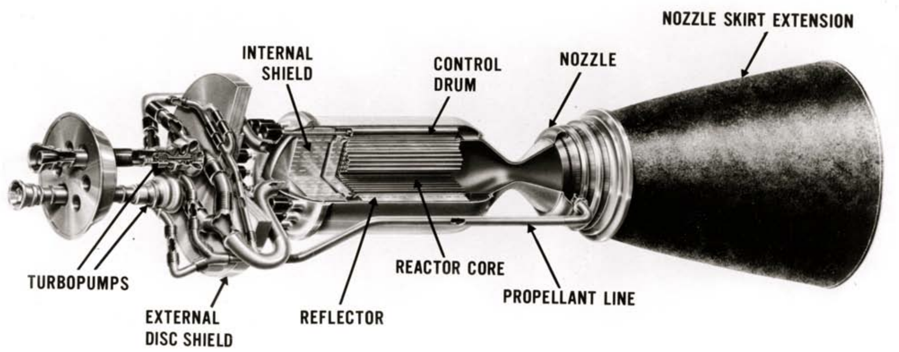
Figure 1.1. Schematic of NERVA derived liquid hydrogen NTR engine [8].

1) High temperature capability without melting or excessive dimensional changes (2500 -3000 K)
2) Low neutron absorption cross section
3) High thermal conductivity
4) Compatibility with a high-temperature uranium compound (UO₂ or UN)
5) Reasonable fabricability
6) Compatibility with hot H₂
7) Low mass and molecular weight
8) Resistance to irradiation

As discussed previously there are three primary options for NTP materials. The first is carbon-based materials. These include graphite, carbon-composite, and mixed carbide fuels; for all of these carbon-based materials, a robust impermeable surface coating is required to inhibit hydrogen reactions with carbon. These carbon-based fuel systems experienced some limited success in the Rover/NERVA program, but the inherent incompatibility with hydrogen make them a less desirable selection. Another option is the ceramic metallic (cermet) fuel consisting of ceramic fuel particles suspended in a refractory metal matrix. These materials were tested heavily in the laboratory scale, but a full-scale system was not built and tested. The estimated maximum operating conditions are illustrated below in Figure 1.2., but these ranges, especially for the mixed carbide are extrapolated based on limiting testing and therefore have large uncertainties [4].

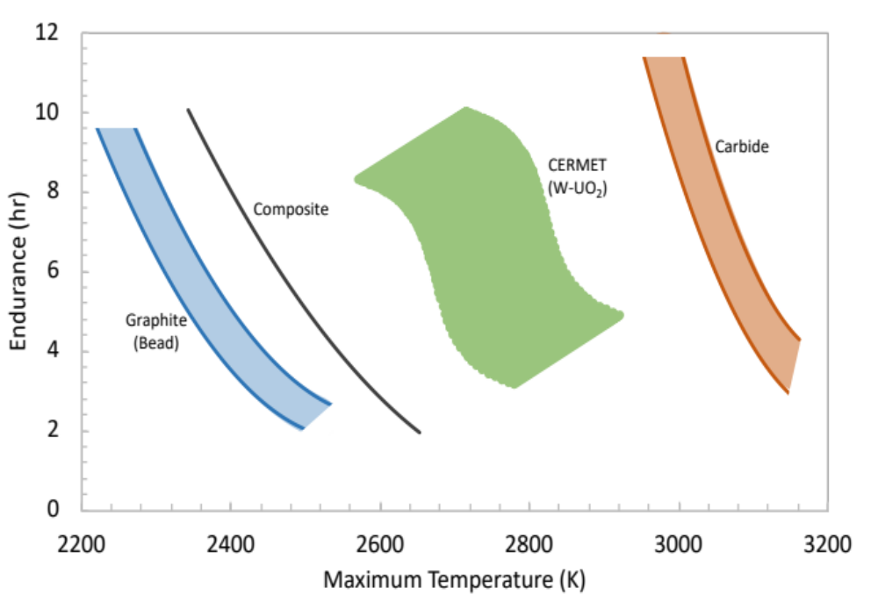
Figure 1.2. Estimated maximum operating conditions for several different NTP fuel core materials [4].

Legacy NTP Fuel Systems

Several different fuel forms have been proposed for use in NTP. Only three basic classes of materials have melting points high enough to be considered for use in an NTP fuel core. These are refractory metals, graphite, and carbides/ceramics. All three material options have been tested to some extent through various programs starting in the 1950’s [7]. Table 1.1. includes a summary of the major NTP fuel element programs for the US and USSR.

Table 1.1. Summary of fuel element materials [4].
Program | Fuel Composition | Fuel Geometry
Rover/NERVA | UC₂ in graphite  (U, Zr) C, graphite composite  (U, Zr) C, solid solution | Solid blocks with coolant channels
SNTP (PBR) | Coated UC₂  Binary, ternary carbides | Particle
CIS (USSR) | Coated (U, Zr, Nb) C  (Other ternary carbides)  Carbonitrides | Twisted Ribbon
Cermet | UO₂ in W | Solid blocks with coolant channels

Rover/NERVA

The largest NTP program conducted by the United States was the Rover/NERVA program which began in 1955. 20 full-scale NTP systems were built and tested in the Nevada desert. Graphite was selected as the preliminary fuel for the Rover program due to its high temperature, ease of fabricability, and familiarity of working with graphite for terrestrial based high temperature gas reactors [9].

The graphite fuel form consisted of fuel particles suspended in a graphite matrix. Graphite as a fuel form had several additional advantages as listed below [7].

- Weak neutron absorption
- Good neutron moderation
- Good high temperature compressive strength
- High thermal conductivity
- Good compatibility with uranium ceramics
- Low density (and thus low total mass)

Despite these advantages, graphite also had several issues. The primary issue was graphite’s innate incompatibility with hydrogen, especially at elevated temperatures. Coatings were required to prevent rapid deterioration from corrosion. Further issues with graphite NTP systems will be discussed with respect to specific systems.

Rover/NERVA developed four different fuel forms as show in Figure 1.3. The first form consisted of UC₂ particles dispersed in a graphite matrix, known as bead loaded graphite. This system was only used for the KIWI A test and it suffered from serious corrosion and fuel failure. Pyrolytic carbon coating on the fuel particles was also later used to prevent fissile fuel loss and better hold the UC₂ in the graphite matrix [4].

Later NTP systems also utilized an NbC coating which successfully reduced corrosion when compared to the exposed graphite. Still, post operation analysis of the fuel elements found significant mass loss in both the mid-band region as well as near the nozzle chamber where temperatures were the hottest, as illustrated in the top curve of Figure 1.4 [4, 9].

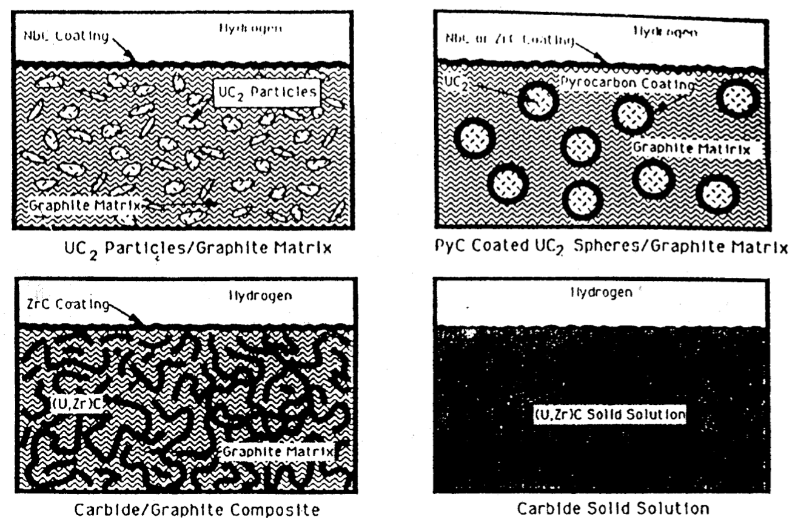
Figure 1.3. Diagrams of the 4 tested Rover/NERVA fuel forms [4].

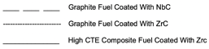
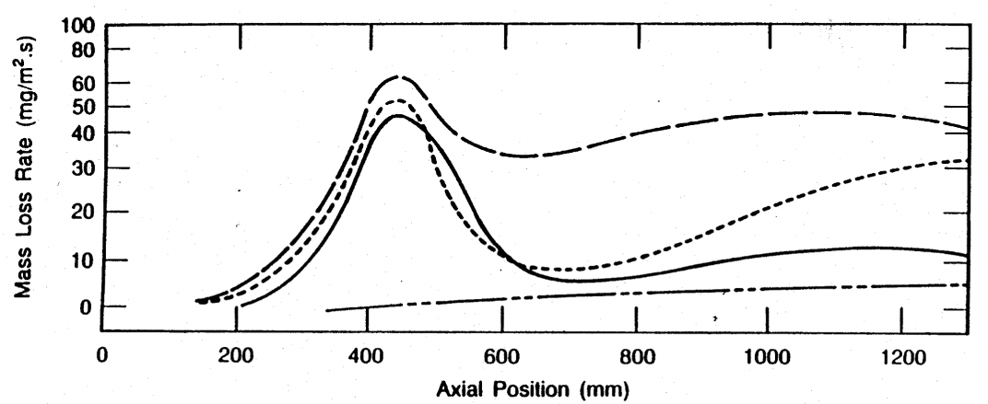
Figure 1.4. Corrosion Rates for various Rover/NERVA fuel forms, illustrating mid-band corrosion [4].

Mid-band corrosion was found to be one of the most significant materials challenges facing the fuel core. caused by several issues. It was found to have several causes. First, it resulted from cracking of the coating caused by the mismatch in the coefficient of thermal expansion between the NbC coating (7 m/mK) compared to the graphite (3 m/mK) [4]. Second, most materials experience a transition from brittle to ductile deformation at a certain temperature. In the mid-band region, just above the centerline, a vast majority of the coating is still operating in the brittle regime where it is more prove to cracking under thermal stresses. At higher temperatures, the coating is more ductile and resistant to cracking. The third cause of mid-band corrosion was the high-power density and neutron flux in that region of the core. The fission product production was highest in this region. Diffusion of these fission products caused further embrittlement and cracking. The result of the cracking was exposure of the graphite matrix to hydrogen and significant corrosion [4, 9].

Mid-band corrosion for the Rover bead loaded graphite systems was mitigated by switching from NbC cladding to zirconia carbide (ZrC) cladding. The ZrC not only had a slightly better CTE match with the graphite, but also prevent fission product diffusion that resulted in embrittlement. The result of the cladding change can be seen in Figure 1.4. Not only did the ZrC cladding perform a little better in the mid-band region, but it also performed significantly better in the high temperature region.

In an attempt to further improve corrosion resistance, two other fuel forms were considered and tested in the NERVA NF-1 system. A carbide/graphite composite and the carbide solid solution form both used uranium zirconium carbides as seen in the bottom two images in Figure 1.3 [9]. The composite consisted of (U, Zr) C-graphite composite fuel elements with a carbide volume fraction of 30-35%. These had significantly higher thermal expansion coefficients that closely matched the ZrC cladding. It saw improved corrosion resistance in both the mid-band and high temperature regions with the graphite bead fuels as seen in Figure 1.4., though still suffered significant mass loss in the mad-band region. The composite also experienced inferior irradiation resistance as it began to breakdown under the intense flux [10].

The Carbide element utilized 100% (U, Zr) C-graphite fuel. This material had the highest melting point and therefore the highest potential for NTP. It was introduced late in the NERVA program so it experienced only limited testing. While analysis of these tests yielded significant corrosion and serious cracking in the NF-1 experiments, it was unsure if these resulted from corrosion from the test or from poor manufacturing [9].

Based on the test data from the Rover/NERVA program, NTP endurance lifetimes with given operating temperatures were approximated. Figure 1.2 illustrates these conclusions. While the carbide fuel has the highest potential, it had the least amount of testing and is the least understood of the graphite-based fuels.

CERMET Programs

Ceramic Metallic (cermet) fuel form consists of ceramic fuel particles, namely uranium dioxide (UO₂) or uranium nitride (UN) suspended in a refractory metal matrix. Refractory metals are the elements on the periodic table with the highest melting points. Cermets were considered a viable option for NTP systems due to their fission product retention, resistance to thermal shock, hydrogen compatibility, corrosion resistance, high thermal conductivity, and high strength [11-13].

The use of refractory materials for nuclear power applications was first considered in the 1940’s. Two programs tested cermets in the 1960’s. These were the GE-710 and the Argonne National Laboratory (ANL) programs. Both looked focused on tungsten (W) UO₂ cermets. W was chosen for the matrix due to its high melting point. Tantalum (Ta) and molybdenum (Mo) were also considered, but known oxygen migration in Ta and the lower melting point of Mo excluded these materials from the initial program [14].

The two programs had four major outcomes. The first was the optimization of fabrication of UO₂ and UN based cermet fuels. These fuels underwent both steady-state and thermal cycling non-nuclear hot H₂ testing to temperatures up to 3000 K. Steady state irradiation tests occurred up to 2000 K and up to U burnups of 1.6 a/o. Finally, transient nuclear testing occurred with heating rates up to 16000 K/s and temperatures of 2900 K [4]. The programs were canceled before any prototypic cermet NTP systems could be built and tested.

One limit for interparticle spacing between the cermets is associated with potential fission fragment damage to the metal matrix. 60 vol% UO₂ seems to be a good balance between high fuel load and interparticle spacing. Cermet fuel particles are typically around 100 μm in diameter. This size is large enough to also minimize the fission fragment damage to the metal matrix without causing a temperature spike in the fuel particle (due to the low thermal conductivity of the particle in relation to the metal matrix). Porosity is also introduced to the cermet to allow for fission gas retention, though due to the relatively low burnup of an NTP system, this is a smaller concern [15].

The GE-710 program ran from 1962 to 1968 as an offshoot to the aircraft nuclear propulsion program. The program originally called for an NTP system that could operate at 2750 K for 100 thermal cycles to a longer lived system that could operate for 10,000 hours in the range of 2000-2250 K range [4]. The program considered both closed cycle systems for power generation and open cycle systems for propulsion [14]. Due to the focus on long life systems, testing occurred at temperatures between 2000 – 2250 K. Even though these temperatures are low for NTP requirements, information on failure mechanisms were determined [4].

Most of the early work was spend on fuel fabrication. Powder metallurgy processes along with sintering were used to fabricate the UO₂ cermet hexagonal wafers for both W and Mo matrix.

The GE-710 program included of several out-of-pile thermal cycling and life tests. W-25Re clad (W-UO₂-ThO₂) cermets were exposed to hot flowing hydrogen at 3270 K for one hour, 3180 K for three hours, and 3070 K for ten hours for two cycles. These results yielded no leaking and no apparent macroscopic failure. Another test with the same material at 2865 K for 50 hours found the same result. W-UO₂-ThO₂ cermets with W-Re-Mo clad were also tested for up to 51 cycles for over 500 hours from 2420 to 530 K and also found no leaks. Early hot hydrogen testing saw difficulties with U precipitation due to lack of stoichiometric control of the UO₂. The addition of the ThO₂ added stoichiometric stability and demonstrated success [4, 16]. The mechanism of U precipitation will be discussed in the fissile fuel section.

Post-test microstructural characterization occurred for all of these tests. The W-25Re clad (W-UO₂-ThO₂) cermets were found to be exceptionally stable up to 3270 K. At 3270 K a few samples experienced loss of bonding for the fuel-cladding. Further examination did not find any melting of the UO₂ fuel, but did find fuel deposition at the core-cladding interface. Due to the high volatility of UO₂ at 3270, it was able to transport via the vapor phase to the interface. Examination of the cladding did not find any porosity. It was still single phase, though it experienced grain growth typical of high temperature annealing. Cracking was found in the fuel component of all the specimens tested, but this may have been caused by the sectioning of the samples that took place after the tests. Pulse-echo inspection before the sectioning found no issues of incomplete bonding to the surface.

The GE-710 program performed three different steady-state irradiation experiments. They occurred at the ETR at INEL, and the Low Intensity Test Reactor (LITR) and Oak Ridge Research Reactor (ORR) at Oak Ridge National Laboratory (ORNL). W and W-Re matrix cermets with 60 volume% (vol%) ThO₂ stabilized UO₂ were tested with Ta, Ta-10W, W-30Re-30Mo and W-25Re-3Mo cladding. From the hydrogen and irradiation testing of the cermet fuel elements, several failure mechanism were determined and resolved.
Table 1.2 summarizes these mechanisms [17].

Table 1.2. Summary of GE 710 program issues and solutions as summarized by Smith [17].
Fuel Failure Mode | Mechanism | Solution
Loss of oxygen | Ta cladding oxygen transparency | Used W instead
Volumetric expansion and cracking | Coefficient of thermal expansion mismatch | Used W alloyed with Re and Mo-Re
Void formation | Insufficient autoclaving | W alloys to improve ductility
Fission product release | Building up pressure, dislocation weakness | Sinter to 84% theoretical density
Vaporization of Mo in cladding | Vapor pressure of Mo significant above 2470 K | Problem not solved

In the first experiment, all of the Ta clad samples experienced leaking. The leaks were caused by the formation of sub-stoichiometric UO₂. Free uranium was then able to penetrate the cladding wall during subsequent thermal cycling. The mechanism for this loss is described in the fissile fuel section. Since the issue only occurred in the tantalum cladded alloys, it was discovered that Ta is relatively transparent to oxygen at high temperatures and became embrittled with the oxygen. The removal of Ta from the cladding resolved this issue [4, 16, 17].

Another failure mechanism was cracking of the W-UO₂ fuel matrix caused by the volume expansion of the UO₂ particles after significant thermal cycling. This volume expansion was caused by the thermal coefficient mismatch between W and UO₂ at high temperatures. After multiple thermal cycles, the fuel particles begin to pull apart from the W matrix. One tested solution was to alloy tungsten with Re or with Mo-Re to better match CTEs. Another was to use UN instead of UO₂. Once again, this occurred after significant thermal cycling, greater than expected for a crewed NTP mission [4].

Another observed issue was the formation of voids between the cermet fuel and the alloy “can” cladding during fabrication and early operation. This was caused by difficulties in getting a good seal between the two components. It was resolved using electron beam welding and would likely be easily resolved today due to advances in high temperature materials manufacturing [4].

Several samples experienced fission product damage and release after 4000 hours of operation between 1870 and 2270 K. This release occurred in samples sintered to 95% or higher theoretical density. Fission product damage to the cermet and eventually to cladding material is caused by accumulated buildup of pressure, lattice stresses, and dislocation weaknesses inherent in fuel materials under irradiation. The fission products could then diffuse out of the sample or would cause embrittlement. To resolve this issue, samples were sintered to 84% theoretical density. The internal porosity present in these low-density sintered products created sinks for the fission products to diffuse to without the buildup of stresses in the cermets. Testing of the 84% theoretical density cermets saw a factor of 10 increase in allowable burnup [4].

Yet another fuel failure mode occurred after 4000 to 7500 hours operating at 1870-2270 K when fission products were released in specimens sintered to 95% or greater theoretical density. Fission product damage to the cermet/clad led to the formation of small surface blisters that were caused by the accumulated buildup of pressure, lattice stress inherent in the fuel materials under irradiation. To resolve this issue, samples were sintered to only 84% theoretical density to avoid stresses above the tungsten matrix capacity at high temperatures. This led to the samples surviving a burnup a factor of 10 greater than saw failure with the highly sintered samples [4].

For most of the fuel failure modes discussed previously and listed in
Table 1.2, solutions were developed that resolved the problem. It is important to note that a majority of the issues occurred in testing to burnups significantly higher than what would be expected for a crewed NTP mission. Overall, the GE 710 program proved the viability of cermets for use in NTP. Unfortunately, the program ended before any prototypic systems could be built and tested.

Another cermet based NTP program was conducted at Argonne National Laboratory (ANL) between 1960 and 1966. W matrix cermets with gadolinia stabilized UO₂ fuel were the primary cermets tested. Samples were tested in out of pile hydrogen loops and in-pile pulse testing [4].

Despite difficulties in manufacturing refractory metals, namely tungsten, the ANL program was able to manufacture a large number of samples using powder metallurgy processes and cold isostatic pressing followed by sintering at ~1950 K. Cladding was deposited using chemical vapor deposition. Large samples were successfully manufactured up to 50 cm long as shown in Figure 1.5.

Like with the GE 710 program, several out-of-pile thermal cycling tests were performed. W-UO₂ cermets were tested in hot flowing hydrogen up to 2770 K. Only minimal fuel loss was observed for up to 45 hours and 180 cycles. In pile testing occurred in the TREAT reactor at INL. The highest temperature reached was 3023 K with a ramp rate of 16,000 K/s. Only one failure occurred during these tests that was later attributed to issues with manufacturing. One specimen in particular survived eight transients at high temperature with a peak temperature of 2900 K.

Samples were tested to higher burnups and more thermal cycles than would ever be used in an NTP mission. They found that both the W and W-Re-Mo based cermets would contain fission products until burnup significantly higher than would be used in an NTP mission. Also, during the hydrogen thermocycling, it was found that the samples would operate below the set 1.0 % fuel loss up to around 200 cycles equating to 50 hours at temperature as seen in Figure 1.6.

Combining the data and lessons learned from the GE 710 and ANL programs, suggested operating conditions for W based cermet fuel was determined as shown in Figure 1.7.

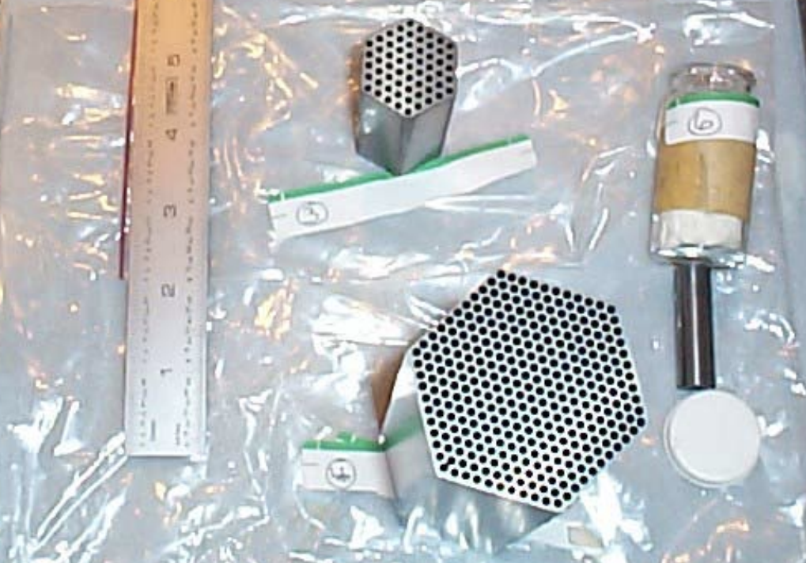
Figure 1.5. W-UO₂ fuel elements manufacture by ANL [4].

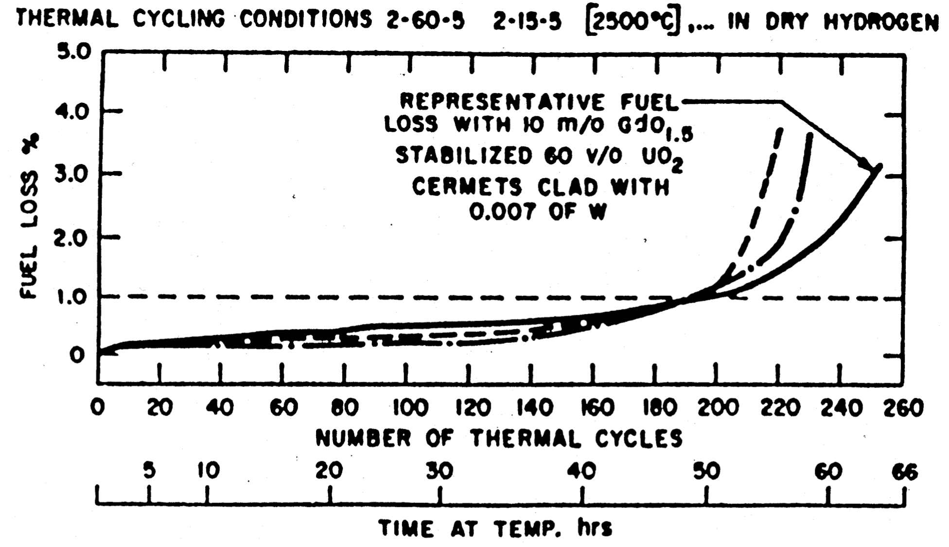
Figure 1.6. Mass loss data for ANL W cermet tests at 2500 ºC [4].

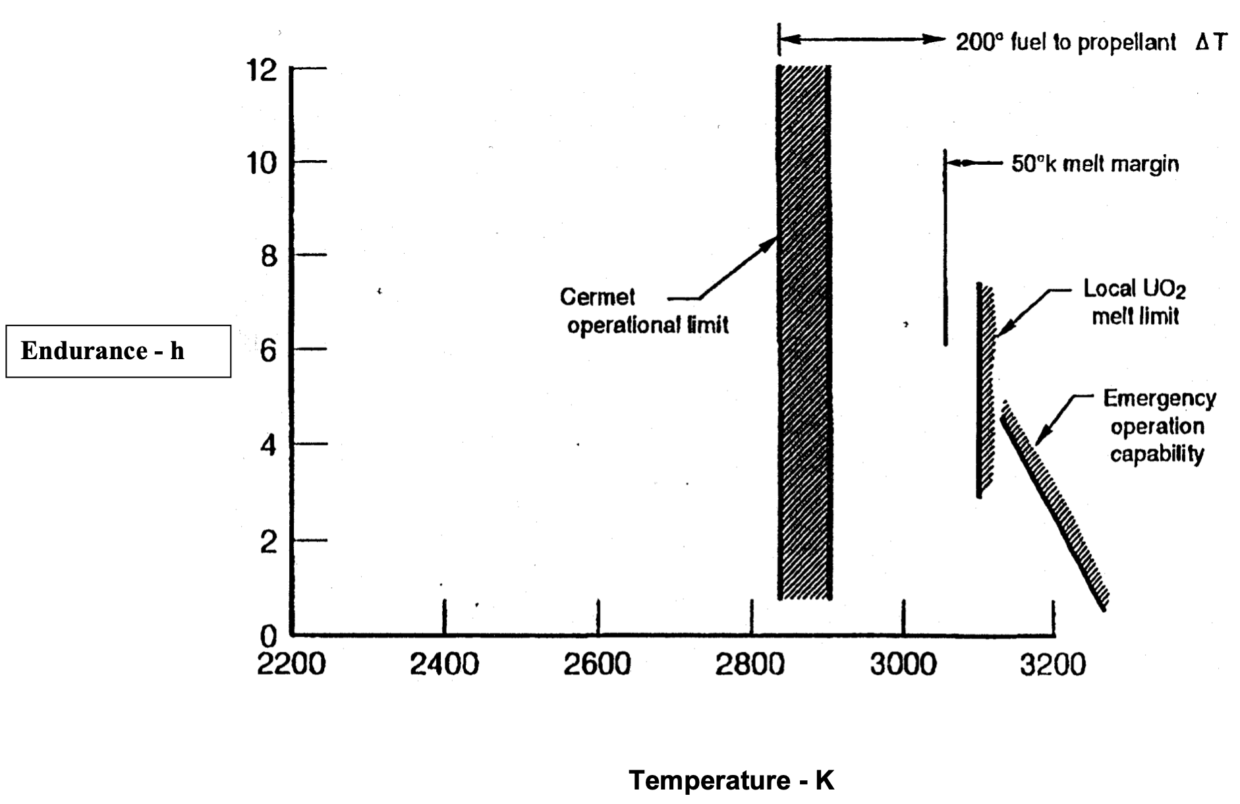
Figure 1.7: Derived Cermet operating limit from GE710 and ANL experiments [4].

USSR CIS Programs

Overlapping the US programs, the USSR looked at a variety of different materials for use in NTP. While the US focused primarily on graphite and cermet-based fuels, the CIS program looked at carbides, carbonitrides, and cermet carbonitrides. Unfortunately, a lot of the data from these tests is currently unavailable in the United States [4]. What is known is summarized in Figure 1.8. Solid solution carbides operated from 2500 to 3700 K. The carbonitrides operated as high as 3100 K. Finally, the cermets operated at 2900 K. Most of the development was focused on the solid solution carbides, with Zr, Nb, and Ta being the solute elements with uranium.

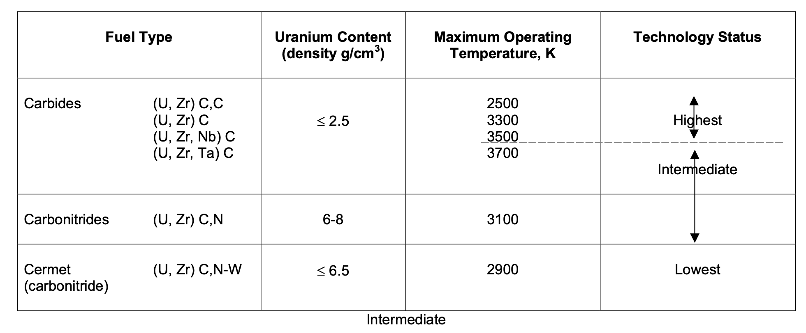
Figure 1.8. Candidate fuels for the USSR CIS program [4].

Spark Plasma Sintering
High temperature materials, namely carbides and refractory metals are more difficult to fabricate due to their high melting point and difficulty in machining. By applying a significant pressure, powder can be consolidated into a solid material at temperatures below the melting point, such as with Hot Isostatic Pressure Sintering (HIPS). Pulsed electric current sintering (PECS) also known as spark plasma sintering (SPS) is another technique to consolidate powders into solid materials [18]. SPS uses a pulsed direct current (DC) to heat the powder. With an applied uniaxial load, the powder will consolidate. SPS is able to fabricate materials at lower temperatures, applied pressures, and for shorter times compared with other powder consolidation techniques. Additionally, SPS allows for the fabrication of more complicated geometries. Finally, SPS can allow for greater control on final sintered material properties compared with other similar techniques. Further discussion into the benefits of SPS are discussed later.

CERMET and CERCER Fuel Forms
Ceramic-Metallic (Cermet) fuels have high promise as the fuel core for solid state nuclear thermal rockets [1]. Cermets consist of ceramic fuel particles made from either uranium dioxide (UO₂) or uranium nitride (UN) randomly dispersed in a refractory metal matrix. Cermets have the potential to survive the harsh environment of the NTP fuel core because of their fission product retention, resistance to thermal shock, hydrogen compatibility, corrosion resistance, high thermal conductivity, and high temperature strength [12, 13]. Currently Mo and W are two of the best candidates due to their hydrogen compatibility, corrosion resistance, high melting points, high thermal conductivity, and availability [11, 19]. There is also a wider range of manufacturing possibilities for these materials.

Ceramic-ceramic (Cercer) fuel forms are also being considered. Ceramic fuels have potential advantages compared to refractory metal-based fuels, particularly due to an increase in melting point of the matrix material. Additionally, ceramic fuels have the potential for improved neutronics and hydrogen resistance. The US NTP programs did not focus heavily on ceramic based fuels, but the Russian CIS program reported success in producing, shaping, and testing of mixed carbide [4]. The current program is focusing heavily on zirconium carbide (ZrC) as the matrix material, due to its high melting point, great neutronic properties, and high thermal conductivity for a ceramic material. Oxide, nitride, and carbide fuel particles are being considered, as well as a solid solution carbide and carbonitride.

Research Objectives
The primary objective for this research is to lay the groundwork for new matrix materials development for NTP systems. Two different matrix materials will be considered: ceramic-metallic (cermet) and ceramic-ceramic (cercer). For the cermet, an alloy of molybdenum with 30 weight percent tungsten (Mo30W) has been selected for the metal matrix [20]. Ideally, a cermet fuel core utilizing pure tungsten would produce the highest ISP with a large factor of safety, due to tungsten’s high melting point of 3,422 ºC. However, tungsten is incredibly dense, and would increase the mass and corresponding launch costs from Earth. Additionally, with the current interest to switch from high enriched uranium (HEU) to high assay low enriched uranium (HALEU) for a variety of logistic and safeguards and security considerations, the high parasitic thermal neutron absorption of tungsten creates a neutronics issue. Molybdenum is less dense than tungsten and has a much smaller parasitic thermal neutron absorption cross-section, but also has a lower melting point. Alloying Mo with W to 30 weight percent provides an acceptable compromise by increasing the pure Mo melting point without increasing the parasitic neutron absorption to levels preventing reactor criticality for a HALEU core. For cercer systems, zirconium carbide (ZrC) was selected as the ceramic matrix material due to its high melting point, good thermal properties, and good neutronics properties.

The thermal properties of the cermet and cercer fuel forms are important to understand up to high temperatures, in order to insure the best design of an NTP fuel core. NASA is currently collecting material property data for all materials relevant to space nuclear propulsion [21]. There is very limited thermophysical data available for Mo30W, especially at higher temperatures. Additionally, the thermal properties available for ZrC depend heavily on the manufacturing technique and composition, and can vary quite drastically. Moreover, the effect of adding the oxide and nitride surrogate particles to the Mo30W and ZrC on the thermal properties has not been quantified. This project aims to fill the knowledge gap of thermal properties for low to intermediate temperatures. Coefficient of thermal expansion (CTE), specific heat capacity (CP), thermal diffusivity (TD), and dynamic modulus (DM) will all be determined for the matrix materials and the cermet and cercer composites.

The thesis will focus primarily on understanding the effect that the surrogate particles have on the sintering and thermophysical properties of the cermet and cercer. Two different hypotheses will be tested, which are listed below.

1) The surrogate particles will aid in the sintering of the matrix material.
2) The surrogate particles will affect the thermophysical properties in a predictable way with relation to the particle geometry and volume loading.

For the first hypothesis, during sintering, both the spherical and angular particles will deform, but to a much less significant extent than the powder. With a proper coating, the particles will not sinter to one another as well. Experiments testing densification mechanisms of the matrix and surrogate cermet/cercer materials will allow for the extrapolation of the onset sintering temperature and the activation energy of sintering. Once these are determined and understood, it can be applied to the volume loading and ideal sintering conditions can be approximated for cermets and cercers with uranium fuel particles.

For the second hypothesis, thermophysical property data will be collected through thermal properties testing, hardness, tensile, compression, and single edge notched bend-bar testing. Different volume loadings will be tested for each particle material and geometry. From these experiments, the effect of particle loading and geometry will be understood and a predictive model can be made for the properties of any volume loading.

Literature Review
An extensive literature review was conducted in preparation for this work. Prior to material selection, legacy NTP fuel materials were considered. A review was also conducted on the sintering of refractory metals, carbides, and composite materials using SPS. Additionally, the thermal and mechanical properties of zirconium carbide and molybdenum and tungsten were also reviewed. Different surrogate materials were also compared to their uranium-based analogs. Finally, some hot hydrogen testing of NTP materials was included.

Pulsed Electric Current Sintering (Spark Plasma Sintering)

SPS Background
Pulsed Electric Current Sintering (PECS) known colloquially as Spark Plasma Sintering (SPS) is an alternative sintering process that uses an electric current to aid in the sintering processes. It has three distinct advantages to more traditional sintering mechanisms (hot pressing, pressure less sintering, etc.). These are lower maximum consolidation temperatures, shorter sintering times, and improved mechanical properties [18]. Moreover, greater control can be exerted on the microstructural development of the sintering material, while still achieving high final densities. SPS works by taking a powdered material loaded into a high temperature compatible die, normally graphite, and running a current through the material. A pulsed DC current is applied, and the material is heated through a process known as Joule heating. Typically, a uniaxial pressure is also applied to assist in the consolidation process.

The electric field created during SPS operations increases diffusional mass transfer within the material in question [18]. Asoka-Kumar et al. proposed that the field increases the vacancy concentration in the material, which then acts to increase diffusion [22]. Munir et al. experimented further using positron annihilation spectroscopy to show that the application of a DC current could decrease the activation energy for defect mobility by 24% [18].

Effect of Control Parameters on SPS

Another benefit to using SPS is the increased control over a variety of parameters. Firstly, particle selection, namely size, geometry, and purity, and sample preparation can have a significant effect on the final sintered material. During SPS, the heating rate, applied pressure, maximum hold temperature, hold time at maximum temperature, and vacuum/atmosphere can all play a role on the consolidation of the powder.

Several studies have proven the effect that particle size has on final sintering. Typically, a smaller or finer powder produces a higher density given the same conditions. This is primarily due to the different stages of sintering observed under SPS. Zhaohui et al. proposed the sintering of most powders occurs in four different stages [23].
1) Activation and refining of the powder
2) Formation and growth of the sintering induced neck
3) Rapid densification
4) Plastic deformation and final densification
These four stages and their temperature dependence are illustrated in Figure 3.1. Diouf and Molinari looked at the sintering of copper [24]. The first stage of activating the powder or rearranging the powder occurs first. Under applied pressure, the particles rearrange to form a green body without any significant deformation. The next stage occurs when the powder begins to deform and neck. The following stage is where most of the densification takes place. This bulk deformation occurs when the temperature is high enough to allow the particles to neck and become interconnected. This is where the most significant densification occurs and leaves the material interconnected, but porous. The final stage is the closing of the porosity from the mass transport of the material.

Heading 2
Begin writing text here. You may use single, double, or 1.5 spacing. You may use any font of your choosing, but you must be consistent.

Heading 2
Use subheadings consistently. Check spacing, capitalization, and punctuation.

Heading 3
Use of styles is helpful in generating a table of contents. This sample document uses the headings to automatically generate the table of contents, list of tables, and list of figures.

Heading 3
Once you use styles to generate the lists, you can update them quickly and easily.

Heading 2
Don’t forget to submit your thesis/dissertation to the thesis/dissertation consultant by the preliminary review deadline (this specific deadline can be found here: http://gradschool.utk.edu/ddategraduation.shtml)

Literature Review
An extensive literature review was conducted in preparation for this work. Prior to material selection, legacy NTP fuel materials were considered. A review was also conducted on the sintering of refractory metals, carbides, and composite materials using SPS. Additionally, the thermal and mechanical properties of zirconium carbide and molybdenum and tungsten were also reviewed. Different surrogate materials were also compared to their uranium-based analogs. Finally, some hot hydrogen testing of NTP materials was included.

Pulsed Electric Current Sintering (Spark Plasma Sintering)

SPS Background

Pulsed Electric Current Sintering (PECS) known colloquially as Spark Plasma Sintering (SPS) is an alternative sintering process that uses an electric current to aid in the sintering processes. It has three distinct advantages to more traditional sintering mechanisms (hot pressing, pressure less sintering, etc.). These are lower maximum consolidation temperatures, shorter sintering times, and improved mechanical properties [18]. Moreover, greater control can be exerted on the microstructural development of the sintering material, while still achieving high final densities. SPS works by taking a powdered material loaded into a high temperature compatible die, normally graphite, and running a current through the material. A pulsed DC current is applied, and the material is heated through a process known as Joule heating. Typically, a uniaxial pressure is also applied to assist in the consolidation process.

The electric field created during SPS operations increases diffusional mass transfer within the material in question [18]. Asoka-Kumar et al. proposed that the field increases the vacancy concentration in the material, which then acts to increase diffusion [22]. Munir et al. experimented further using positron annihilation spectroscopy to show that the application of a DC current could decrease the activation energy for defect mobility by 24% [18].

Effect of Control Parameters on SPS

Another benefit to using SPS is the increased control over a variety of parameters. Firstly, particle selection, namely size, geometry, and purity, and sample preparation can have a significant effect on the final sintered material. During SPS, the heating rate, applied pressure, maximum hold temperature, hold time at maximum temperature, and vacuum/atmosphere can all play a role on the consolidation of the powder.

Several studies have proven the effect that particle size has on final sintering. Typically, a smaller or finer powder produces a higher density given the same conditions. This is primarily due to the different stages of sintering observed under SPS. Zhaohui et al. proposed the sintering of most powders occurs in four different stages [23].

1) Activation and refining of the powder
2) Formation and growth of the sintering induced neck
3) Rapid densification
4) Plastic deformation and final densification

These four stages and their temperature dependence are illustrated in Figure 3.1. Diouf and Molinari looked at the sintering of copper [24]. The first stage of activating the powder or rearranging the powder occurs first. Under applied pressure, the particles rearrange to form a green body without any significant deformation. The next stage occurs when the powder begins to deform and neck. The following stage is where most of the densification takes place. This bulk deformation occurs when the temperature is high enough to allow the particles to neck and become interconnected. This is where the most significant densification occurs and leaves the material interconnected, but porous. The final stage is the closing of the porosity from the mass transport of the material.

In the study mentioned previously, Diouf and Molinari tested the effect particle size has on the sintering of copper [24].Three different powder sizes, <25 um, 25-45 um, and 45-90 um, were selected for the study. Figure 3.2 contains the displacement rate data for the three different particle sizes under the same sintering conditions, 25 MPa applied pressure and a heating rate of 100 ºC/min. Powder size played a major role in the initial sintering stage where the particles rearrange. This is likely due to localized overheating, which is enhanced with increased particle size. Powder size was also found to play a major role in the final densification stage controlled by mass transport. Decreasing the powder size increased the mass transport, resulting in a higher final density. Overall, the final stage sintering played a larger role on final sample density and the conclusion was made that a smaller powder size produces a higher final density with lower open porosity.

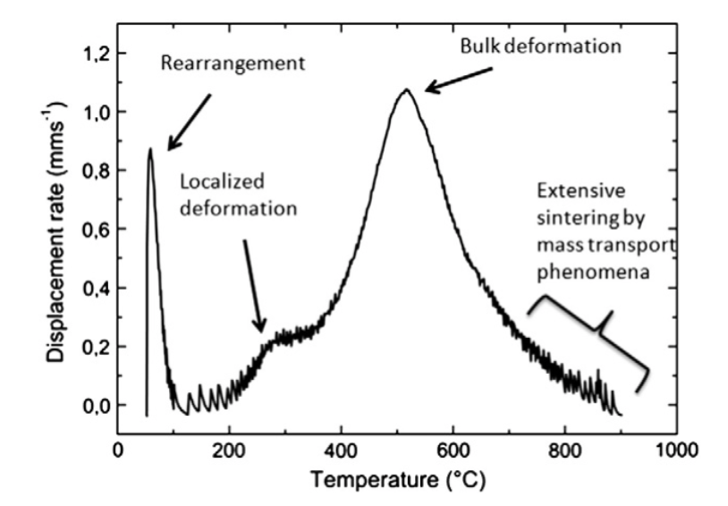
Figure 3.1. Displacement rate with respect to temperature for the sintering of a copper powder using SPS [24].

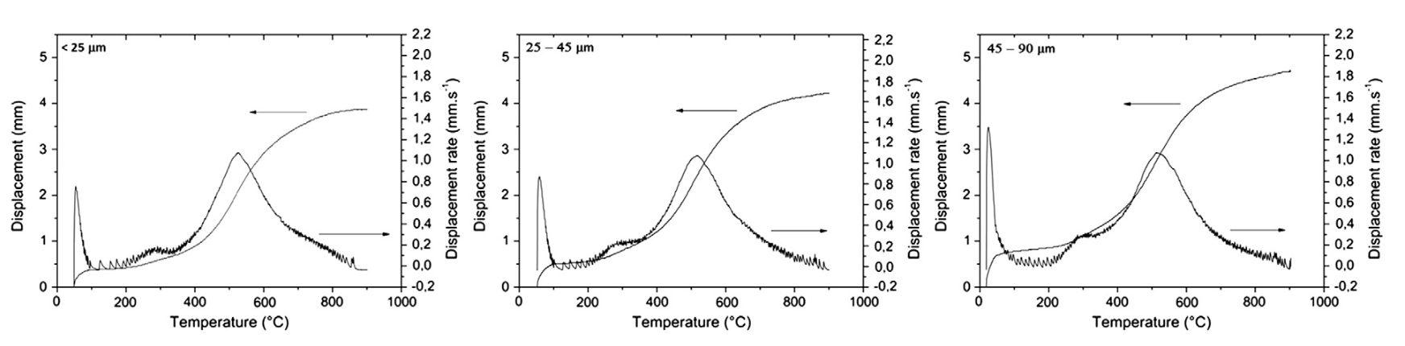
Figure 3.2. Displacement and displacement rate curves as a function of temperature for three different copper powder sizes, as sintered by SPS [24].

Another study conducted by Yang et al. compared the sintering of two different powders and different heating rates of pure titanium and a titanium alloy [25]. One powder was a spherical atomized and the other was produced through high purity milling. The atomized powder is described as having a smaller average size and a more regular geometry. The milled powder was found to have a lower early densification stage and a higher final densification stage relative to the atomized powder. The heating rate lowered the onset temperature for maximum densification for both powders. In order to quantify the results, Yang et al. used the Frenkel model for Newtonian viscous materials [26], as seen in

 | $$\frac{ΔL}{L_{0 }}=\frac{3γ}{4Dη}t$$ | Equation 3.1

where ${ΔL}/{L_{0}}$ is the powder linear shrinkage, $γ$ is the surface energy (J/m²), $t$ is the time (s), $D$ is the average particle size (m), and $η$ is the viscosity (Pa•s). The viscosity is a temperature dependent function that follows an Arrhenius relationship [27].

 | $$η=η_{0}\exp\left(\frac{Q}{RT}\right)$$ | Equation 3.2
$η_{0}$ is the frequency factor (Pa•s), $R$ is the gas constant (J/mol K), $T$ is the absolute temperature (K), and $Q$ is the instantaneous activation energy (J). Using $c$ as the definition of the heating rate as seen in Equation 3.3, Equation 3.1 can be differentiated with respect to temperature. Taking the natural logarithm of both sides produces Equation 3.5.
 | $$\frac{dT}{dt}=c$$ | Equation 3.3

 | $$\frac{d\left(\frac{ΔL}{L_{0}}\right)}{dT}=\frac{3γ}{4Dcη_{0}}\exp\left(\frac{-Q}{RT}\right)$$ | Equation 3.4

 | $$\ln{\frac{d\left(\frac{ΔL}{L_{0}}\right)}{dT}}=\ln{\frac{3γ}{4Dcη_{0}}}-\frac{Q}{RT}$$ | Equation 3.5

This equation allows the activation energy of viscous flow under SPS to be determined. To simplify the equation, Yang et al. combined several terms into a single factor, $f$.
 | $$f=\frac{3γ}{4Dcη_{0}}$$ | Equation 3.6
By plotting data of $\ln{d({{ΔL}/{L_{0}}}/{dT})}$ with respect to inverse temperature, a linear relationship can be delivered. By using Equation 3.5, the activation energy of sintering and the factor, $f$ were determined, as shown in Figure 3.3. The activation energy decreased with increasing heating rate for all temperatures.

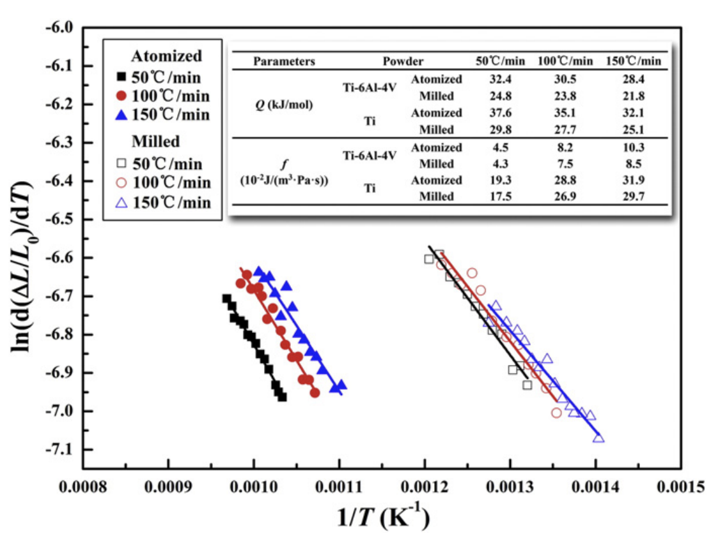
Figure 3.3. ln d ((Δ L/L₀)/dT) versus the inverse temperature for pure titanium and titanium alloy at different heating rates to determine the activation energy and constant [25].

Sintering of Refractory Metals and Alloys

Both molybdenum and tungsten powders have been consolidated using SPS. A wide range of sintering conditions and powder types have been analyzed. Most showed an improvement in density for materials consolidated in SPS compared with more traditional powder consolidation techniques. A selection of these experiments will be discussed.

Since the alloy of interest is primarily Mo, prior studies of the sintering of pure Mo [28] are of relevance. One prior study used powder with 3-5 um particle diameters. Applied pressures of 29, 57, and 67 MPa, sintering temperatures between 850 and 2000 ºC, and heating rates from 130 to 360 K/min were all examined. Densification results from this study is shown in Figure 3.4. The sintering was conducted using SPS and compared with isothermal sintering. Below 1400 ºC, samples experienced relatively low densification, even at higher pressures. Above 1400 ºC, densities reached 90 % for all pressures. According to the data in Figure 3.4, there is very little difference in density between the 57 and 67 MPa applied pressure. There is a noticeable decrease in density for the 29 MPa pressures. The grain size increases exponentially with temperature, as would be expected, for a hold time of three minutes. There was also a noticeable decrease in grain growth for the SPS fabricated samples compared with the isothermal sintering samples, as seen in the right plot of Figure 3.4. The microstructure of the sintered Mo is captured in micrographs in Figure 3.5. At lower temperatures, below 1400 ºC, the microstructure of the sintered samples appears to be deformed powder that has interconnected during initial sintering. Above 1400 ºC, the open porosity closes. Grain growth also increases drastically above 1600 ºC, with little increase in density.

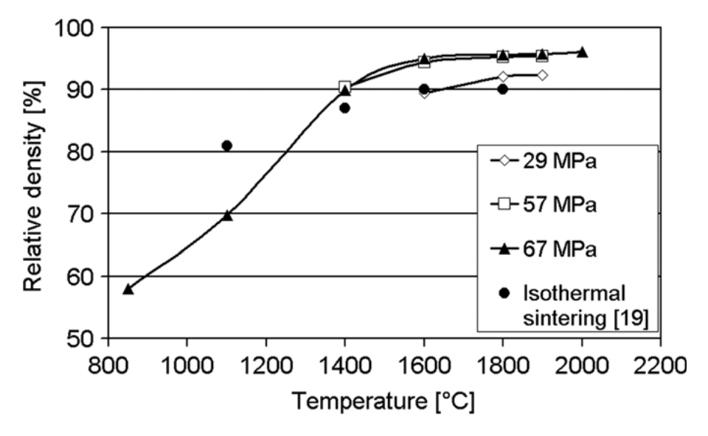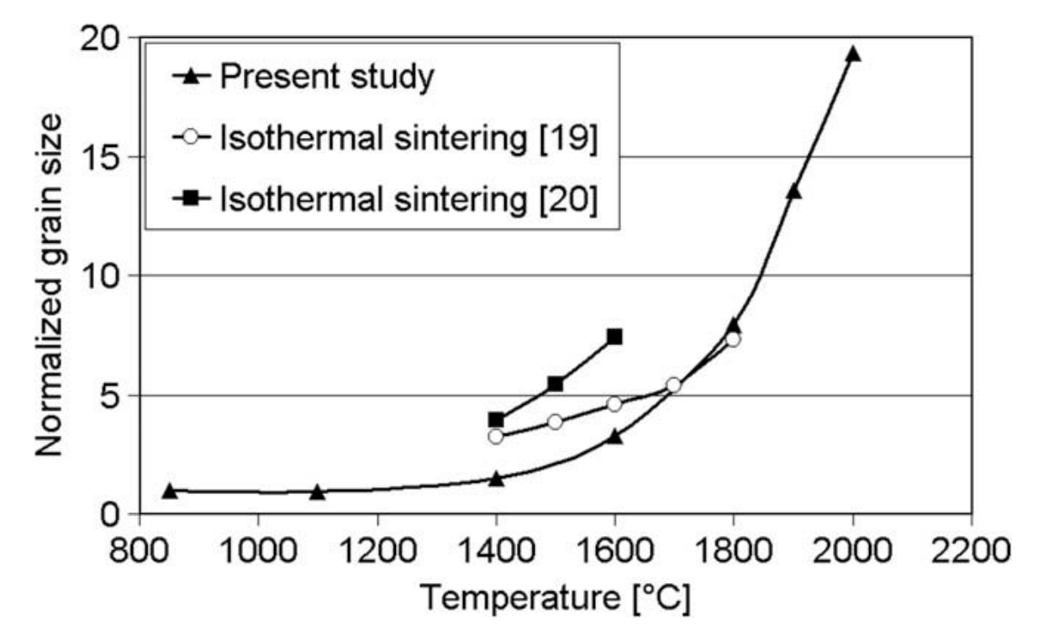
Figure 3.4. Densification behavior of pure molybdenum using SPS compared to isothermal sintering using traditional methods [28].
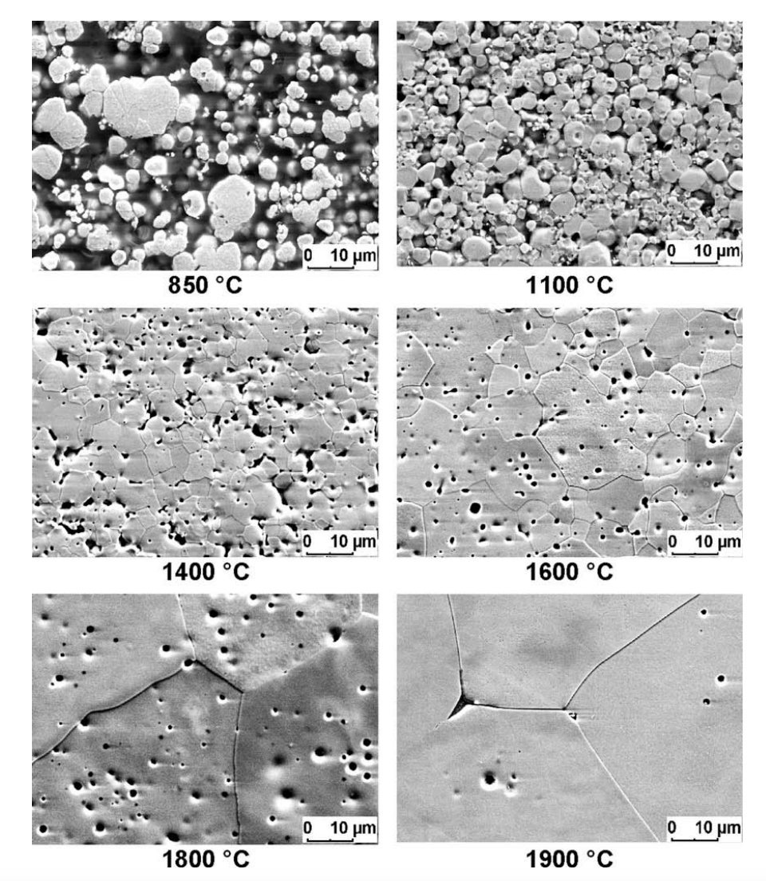
Figure 3.5. SEM micrographs of pure Mo sintered at 67 MPa using SPS [28].

This study found that most of the shrinkage and consolidation occurs during the rapid heating. Referencing the four stages of sintering [23], this includes the first three stages of sintering. The final stage occurs during the isothermal hold. These stages are illustrated in the corrected piston travel of the sintering of Mo in Figure 3.6. This study did not look at the effect of vacuum pressure on the final density.

Another study by Mouawad et al. looked at the consolidation of Mo using SPS with the primary goal of achieving a fully densified matrix [29]. Pressure was held constant at 67 MPa. They also used a rapid heating rate of 700 K/min for all sintering conditions. The maximum hold temperature was varied from 1200 to 1950 ºC and hold times at maximum temperature from 5 to 30 minutes. Figure 3.7 a. contains the relative density of the final sintered samples with respect to temperature. As expected, the final relative density increases with increasing temperature. However, above 1550 ºC the increase in density becomes relatively small. Interestingly, they reported no decrease in hardness with increasing temperature, as would be expected for a material with an increasing grain size. Figure 3.7 b. illustrates the effect of hold temperature on the final sample density. Increasing the time increases the density, but after 10 minutes the increase begins to diminish rapidly. Once again, the reported hardness values did not exhibit the expected decrease with increasing grain size.

Mouawad et al. examined the microstructure of each sintered sample. An example microstructure is presented in Figure 3.8 a. with a histogram presented in Figure 3.8 b. The grain size follows a gaussian distribution, as would be expected. Figure 3.8 c. presents an exponential relationship of grain size with temperature. Finally, Figure 3.8 d. presents a linear relationship of increasing grain size with time. Generally, grain growth is not linear with respect to time. In all likelihood, this data would fit better to a second or third order exponential. In the end, they reported achieving near 100% theoretical density with a hold temperature of 1850 ºC, a uniaxial pressure of 67 MPa, and a hold time of 30 minutes.

Pure W has also been consolidated using SPS. One study by Lee et al. studied the densification mechanism of a pure tungsten powder [30]. The powder, shown in Figure 3.9, was between 1 and 12 μm, with a tendency to form into agglomerates. The powder was consolidated using SPS with 60 and 120 MPa of applied pressure, at 1600 to 1800 ºC maximum temperature, up to 120-minute hold times, with a heating rate of 100 ºC/min. The effect of temperature and time on the final sintered density of the W samples is presented in Figure 3.10 a. For shorter sintering times, below 6 minutes, there is an increase in density with increasing temperature, however, for hold times of 30 minutes, the final relative density actually decreases with increasing temperature.

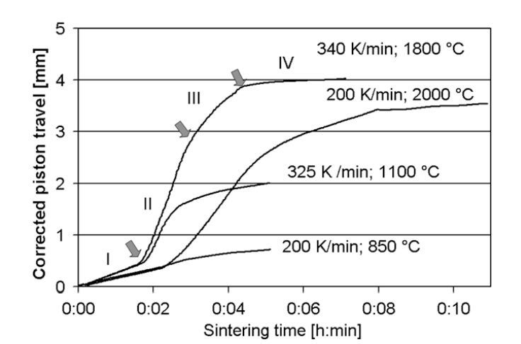
Figure 3.6. Corrected piston travel vs. sintering time for different heating rates at an applied pressure of 67 MPa [28].

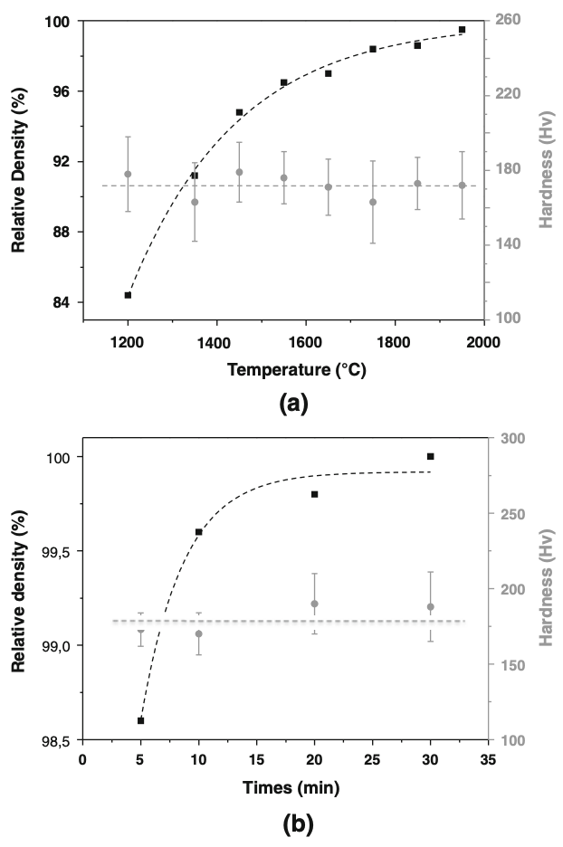
Figure 3.7. Relative density and hardness of as sintered Mo for a) various temperatures with a constant hold time of 5 minutes, and b) for various hold times at a constant temperature of 1850 ºC [29].
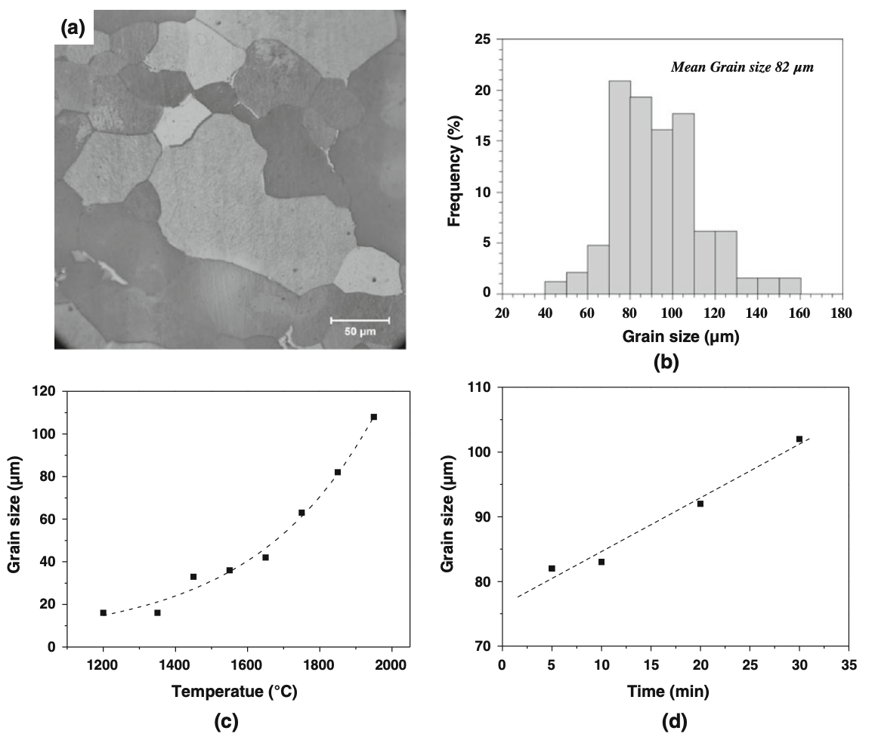
Figure 3.8. a) the micro-structure of pure Mo consolidated using SPS, b) a histogram of the grain size for a sample sintered at 1850 ºC, c) the average grain size with respect to temperature, and d) the average grain size with respect to time [29].

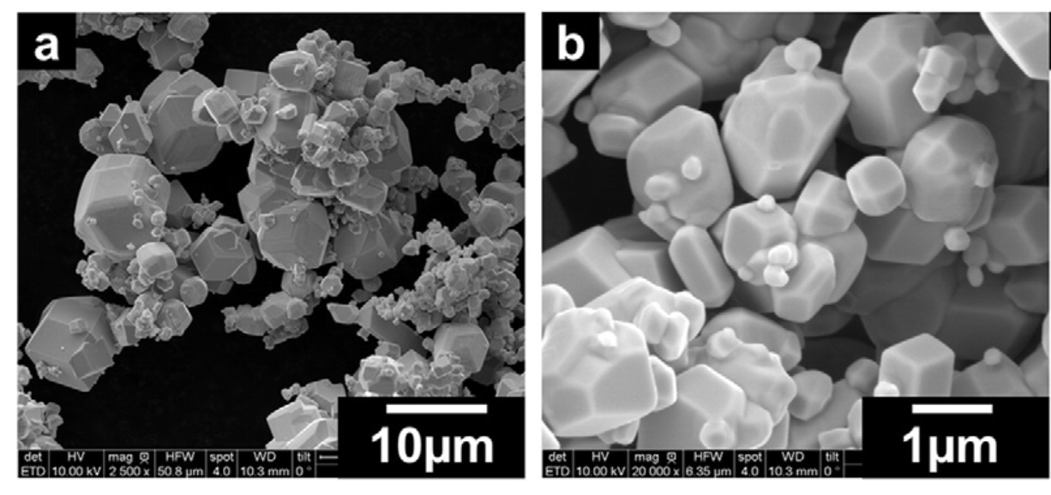
Figure 3.9. Micrographs of pure W powder prior to consolidation [30].

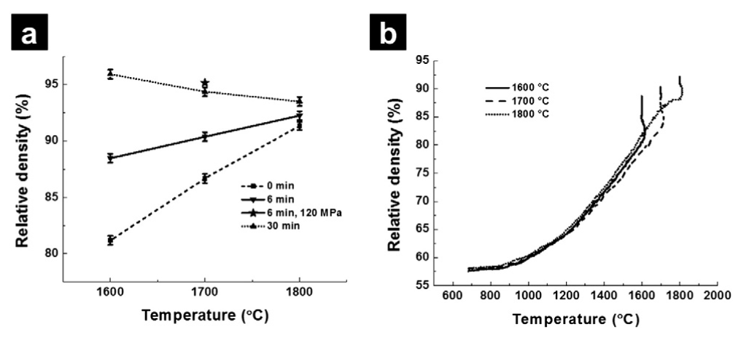
Figure 3.10. a) Relative density of W consolidate with SPS with respect for temperature, and b) the relative density for three runs at 60 MPa during sintering [30].

Figure 3.11 contains the grain growth kinetics for tungsten sintered at 1700 and 1800 ºC. Grain growth with respect to time follows the following exponential equation [31].
 | $$D^{S}-D_{0}^{S}=kt$$ | Equation 3.7
where $D$ is the average grain size, $D_{0}$, is the starting grain size, $S$ is the grain growth exponent, $k$ is a constant dependent upon the applied pressure and sintering temperature, and $t$is the time. Increasing the temperature decreases the grain growth exponent.

Lee et al. treated the sintering of W using SPS as a creep deformation mechanism. Fitting the consolidation data, a strain rate sensitivity of 0.39 was calculated, with a sintering activation energy between 412 and 433 kJ/mol obtained. This is much higher than the calculated activation energy of pure Mo. However, powder size also plays a role in this value.

A few recent studies have looked at the consolidation of Mo-W alloys, including Mo30W. Chakraborty et. al. created two different Mo30W pre-alloyed powders through a mechanical alloying technique and by simply mixing a Mo and W powder [32]. The powders were consolidated using traditional hot sintering technique between 600 and 1500 ºC for 6 hours in a reducing atmosphere. The highest reported density was 99% of theoretical, though the value used for the theoretical density was not provided. Figure 3.12 a. contains the densification results for the two different powders over the tested temperature range. Below 900 ºC, the mixed powder achieved a higher sintered density, but above 900 ºC, the mechanically alloyed material achieved the higher final density. This is likely due to the difference in powder size and geometry between the two types of powders.

Another study conducted by Batienkov et al. sintered three different Mo-W alloys, with 10, 20, and 30 wt% W, using SPS [33]. The powders were prepared using a ball milling technique combing pure Mo and W powder. The powders were consolidated from 35 to 50 MPa at 1000 to 1950 ºC with heating rates of 50 to 150 ºC/min and hold times of 3 to 30 minutes. Figure 3.13 compares the sintering of Mo30W using SPS and hot pressing in hydrogen. SPS shows a considerable improvement with at the same temperatures with respect to the traditional sintering. The relative density of the three materials consolidated using SPS is shown in Figure 3.14. The most interesting trend was the decrease in final density with increasing tungsten content. This is likely due to tungsten requiring a higher temperature to deform more rapidly. The highest reported density of Mo30W was 96% with a sintering temperature of 1850 ºC and a pressure of 50 MPa.

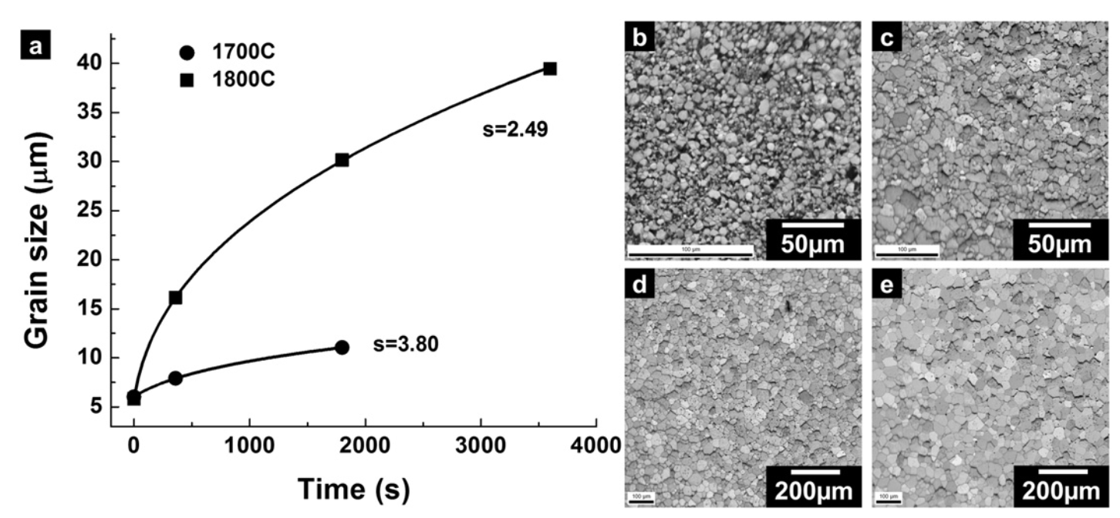
Figure 3.11. a) Grain with respect to time at 1700 and 1800 ºC, and b-e), grain coarsening of W microstructure with increasing sintering time.

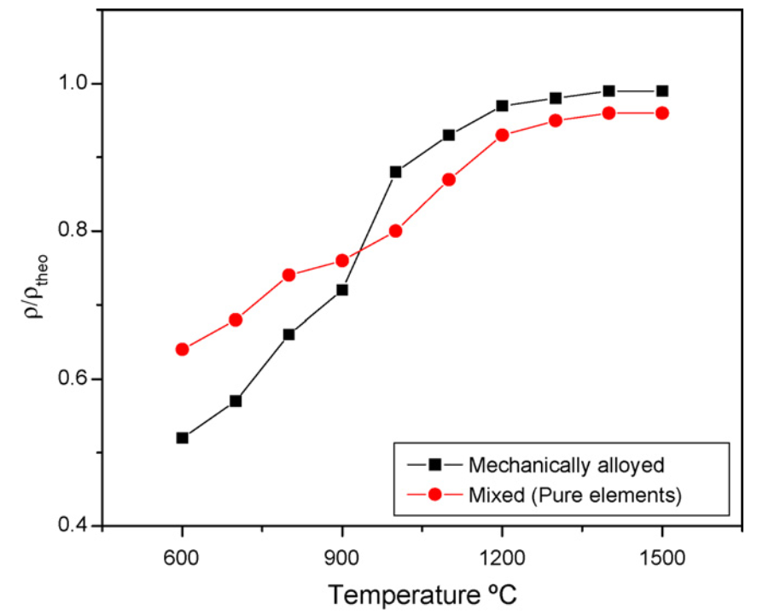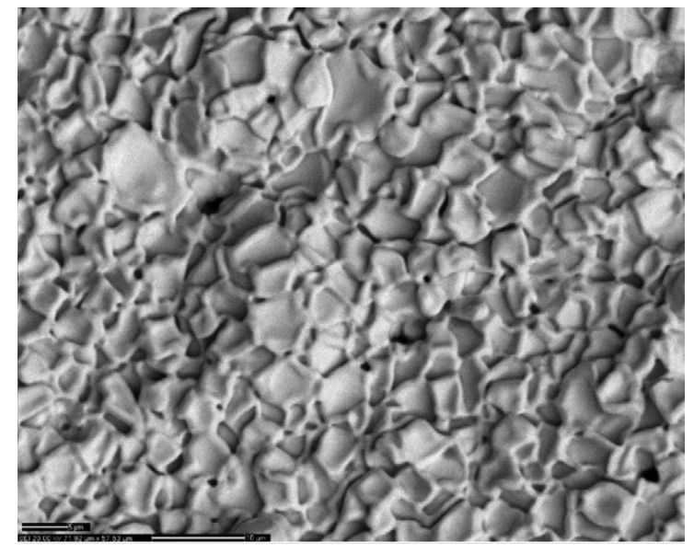
Figure 3.12. a) Densities of mechanically alloyed and pure elemental mixing of Mo and W powders sintered for 6 hours at various temperatures, and an SEM micrograph of the sintered Mo30W alloy [32].

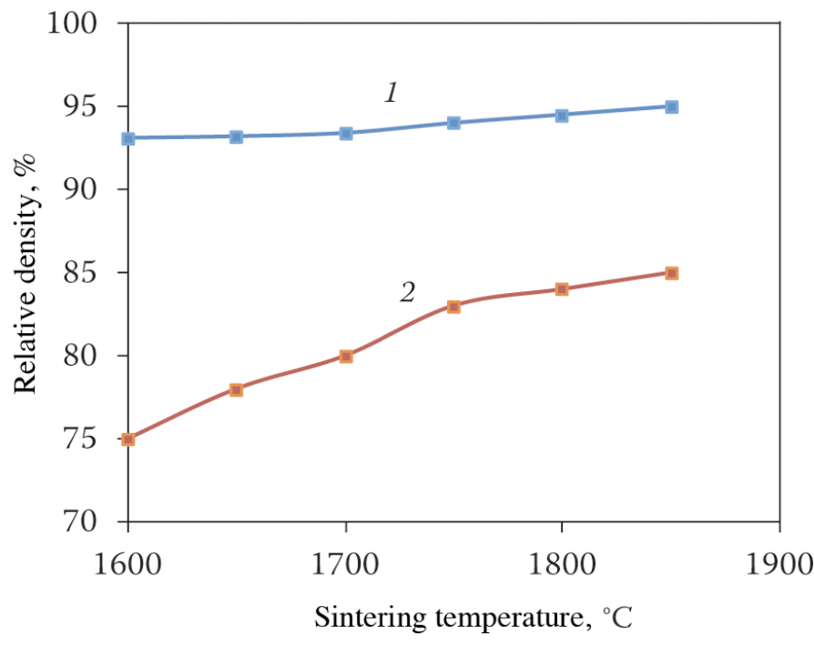
Figure 3.13. Relative density versus sintering temperature for Mo-30wt%W 1) sintered in using SPS, and 2) sintered in hydrogen [33].

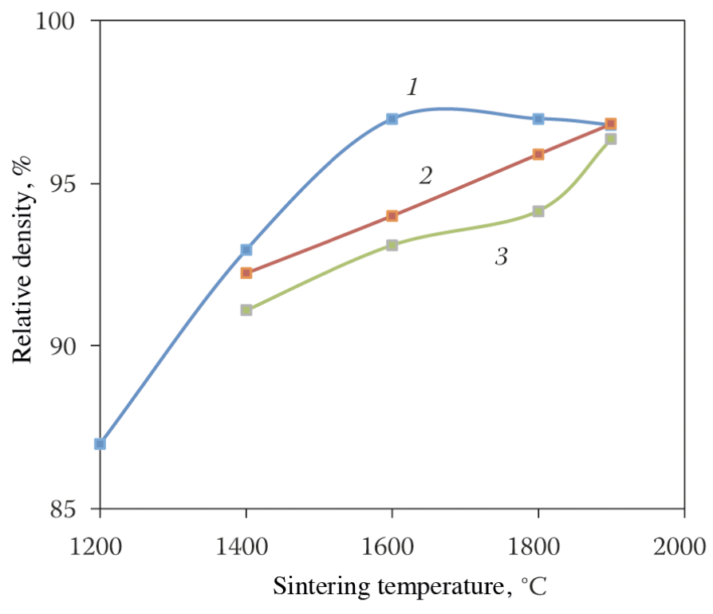
Figure 3.14. Relative density versus sintering temperature for 1) Mo-10weight% W, 2) Mo-20weight% W, and 3) Mo-30weight% W [33].

The hardness of the final materials is presented in Figure 3.15. The materials followed an increase in hardness with increasing sintering temperature. This increase is likely due to a decrease in porosity with increasing sintering temperature. Finally, Figure 3.16 contains micrographs of the final sintered material. Even at the higher sintering temperatures, the microstructure has relatively high porosity. There are also significant oxide inclusions between the grain boundaries.

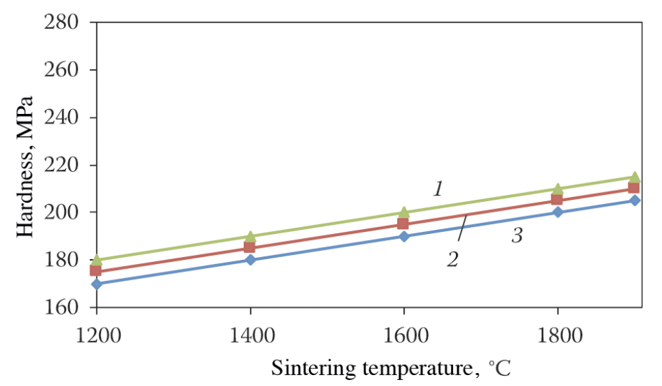
Figure 3.15. Hardness variation with sintering temperature for 1) Mo-10wt%W, 2) Mo-20wt%W, and 3) Mo-30wt%W [33].
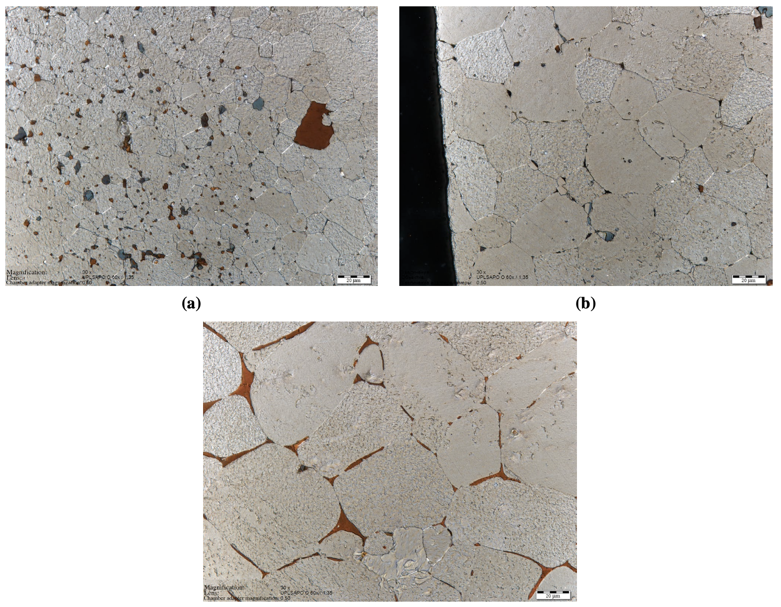
Figure 3.16. Micrographs of unspecified Mo-W alloys sintered at a) 1400 ºC, b) 1600 ºC, and c) 1800 ºC [33].

Sintering of Zirconium Carbide

ZrC, like other carbides, is a difficult material to produce. SPS has proven its potential in fabricating ZrC from powder. One study, conducted by Sun et al., used reactive SPS to produce solid ZrC [34]. The material was formed by first mixing zirconia (ZrO₂) powder with carbon black and then heating the powder mixture to allow the carbothermal reduction to occur. This releases oxygen and leaves behind near stoichiometric ZrC. The powder was then sintered using SPS. Three different sintering conditions were tested, as shown in
Table 3.1. All samples used a heating rate of 100 ºC/min. The highest density achieved was 96.1% that of theoretical, by sintering at 1900 ºC for 10 minutes at 60 MPa.

Another study by Núñez-Gonzélez et al., looked at the fabrication of ZrC using SPS and the effect of high energy ball milling [35]. High energy ball milling was used to reduce crystalline size and improve sintering of ZrC. The ball-milling primarily reduced the crystalline size. Ball-milling times from 1 to 180 minutes were investigated. As illustrated in Figure 3.17, the characteristic sintering temperature is reduced with increasing ball-milling time (reduction in crystalline size). A shift of almost 300 ºC was observed comparing the as received material for the material ball-milled for 180 minutes.

Another study by Sciti et al. reported a sintered density of 99% relative density using SPS [36]. Commercially available ZrC powder, with an average size of 3.8 μm, was cleaned in ethanol and ball-milled for 1 hour. The material was sintered using SPS with a 3-minute hold at 2100 ºC and a uniaxially applied pressure of 65 MPa. The average grain size 13 ± 1 μm. Densification began at around 1650 ºC, with the maximum densification rate occurring above 2000 ºC. The final microstructure is shown below in Figure 3.18. The darker specks were identified as free carbon, which was said to make up 2% of the total volume. No other information on the stoichiometry of the ZrC was provided.

Another more comprehensive study was conducted by Wei et al., which looked at densification kinetics, grain growth, and the thermal properties of ZrC [37]. Commercially available powder with an average particle size of 1 μm was acquired and characterized. A wide range of sintering conditions were tested. These results are summarized in Figure 3.19. The highest density achieved was around 98% with a 24-minute hold at 1700 ºC, with an applied pressure of 60 MPa. The SPS runs were compared to a single hot pressing (HP) conducted at 55 MPa and 1900 ºC for 60 minutes. SPS was able to increase the densification kinetics of the ZrC compared with the HP technique as seen in Figure 3.20. Finally, the SPS produced a more uniform microstructure with much lower porosity.

Table 3.1. Sintering conditions, relative density, and hardness of ZrC fabricated using reactive SPS [34].
Hold temperature (ºC) | Hold time (minutes) | Applied pressure (MPa) | Relative density (%) | Vickers hardness (HV10, GPa)
1750 | 5 | 5 | 46.9
1850 | 10 | 60 | 85.3 | 9.1 ± 1.4
1900 | 10 | 60 | 96.1 | 16.3 ± 1.6

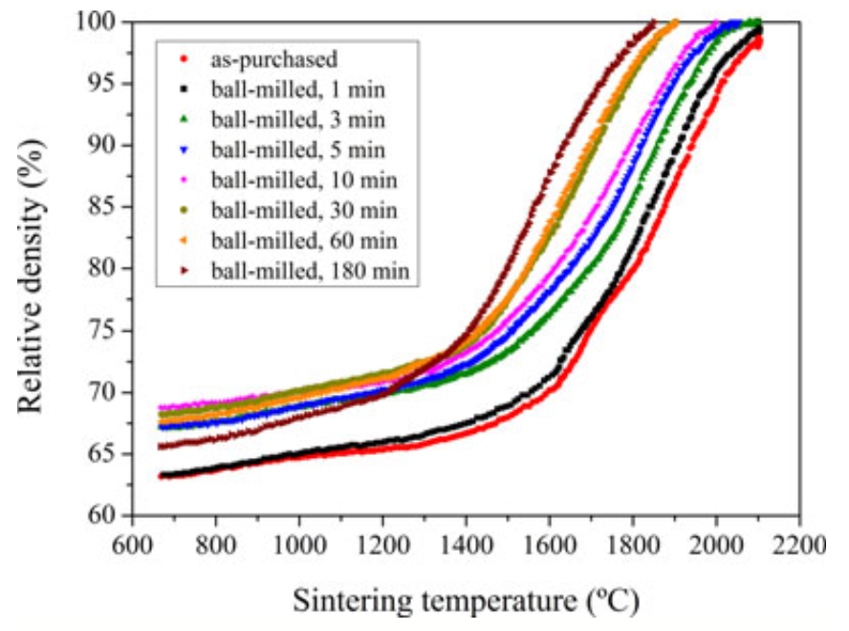
Figure 3.17. SPS densification curves of ZrC powder as received and for various ball-milling times [35].
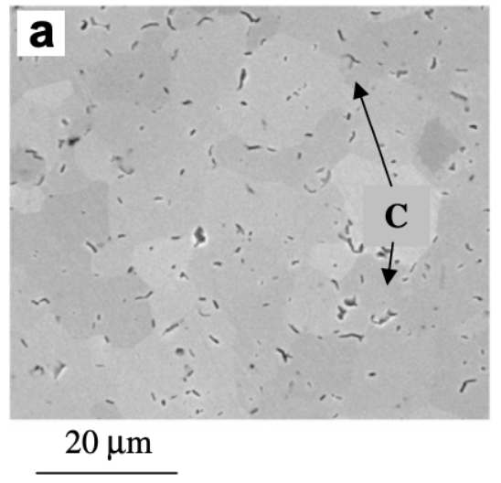
Figure 3.18. Microstructure of ZrC consolidated using SPS at 2100 ºC for 3 minutes with an applied pressure of 65 MPa [36].

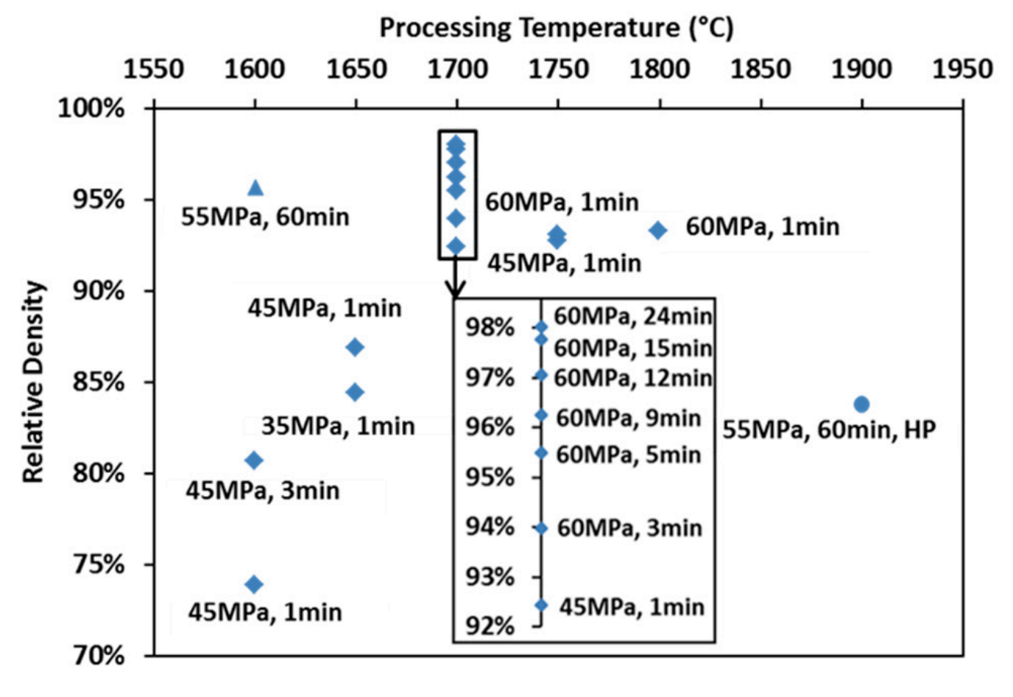
Figure 3.19. Relative density of various ZrC samples produced by SPS and HP under a variety of different conditions [37].

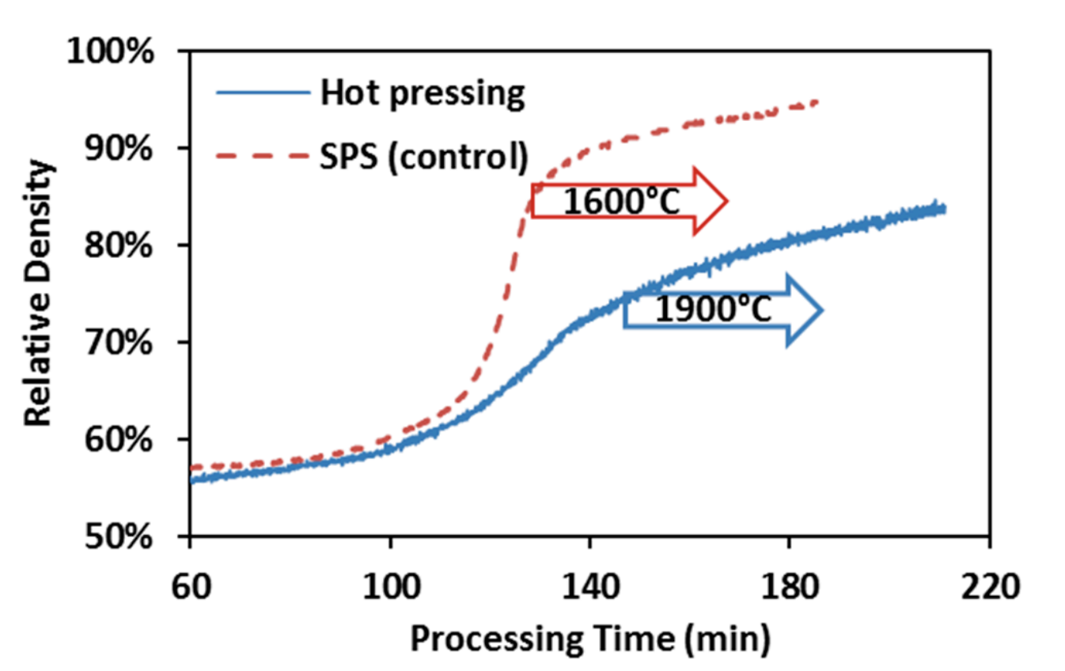
Figure 3.20. Densification curves of the Hot pressed ZrC (blue) and SPS ZrC at 1600 ºC for 60 minutes at 55 MPa.

Sintering of Refractory Composites and CERMETs

One of the earliest studies on using SPS to produce cermets was conducted by O’Brien et al. [38]. W with 25 weight percent rhenium (Re) matrix with 50 volume % UO₂ particles was produced. A 99.95% pure W powder 0.6-0.99 μm, a Re powder less than 20 μm, and depleted UO₂ powder 3 μm in size were mixed mechanically using ball milling. The powder was sintered using a heating rate of 100 ºC/min, with a hold temperature and time of 1500 ºC and 20 minutes, respectively. The sintered samples reached 97.9 % theoretical density, with good interface between the W-Re matrix and the UO₂.

Tucker et al. developed a powder coating method in order to produce tungsten based cermet materials with minimal particle interconnectivity and high final density [39]. Initially, 250 μm diameter spherical hafnium oxide (HfO₂) was used as a surrogate for UO₂. A volume loading of 60 percent was used for the initial testing. It became apparent that a binding agent was necessary to coat the oxide particles in the matrix material. After testing several different binding agents, it was discovered that the Polyethylene homopolymer, AC-617A, produced the best results, as seen in Figure 3.21. The powder coating method used involved first milling the binder using alumina balls for 30 minutes in a Turbula mixer. Next, the tungsten, HfO₂, and binder were all mixed for 30 minutes in the Turbula to uniformly disperse the binder. Binding amounts from 0.25 to 1.0 wt% were tested. The powder mixture was then stirred on a hot plate for 5 minutes at 5 ºC above the drop point of the powder (101 ºC). It was found that 0.5 wt% binder produced the optimal coating on the particles. A lower percentage of binding agent did not uniformly coat the HfO₂ particles in tungsten, while a higher percentage caused significant clumping of the tungsten particles.

Once the powder coating method was optimized, the powder was sintered using SPS. The uniaxial pressure was fixed at 50 MPa. The sintering temperature varied from 1400 to 1700 and the sintering time ranged from 5 to 20 minutes. The density of the final samples was measured using Archimedes technique. The results of these sintering experiments are presented in
Table 3.2. The highest achieved density was 96 percent theoretical, by sintering at 1700 ºC for 20 minutes. Density increased with both increasing sintering density and sintering time. Figure 3.22 contains an SEM image of the polished surface. Very little porosity was observed in the matrix. More importantly, the particles were fairly evenly spaced.

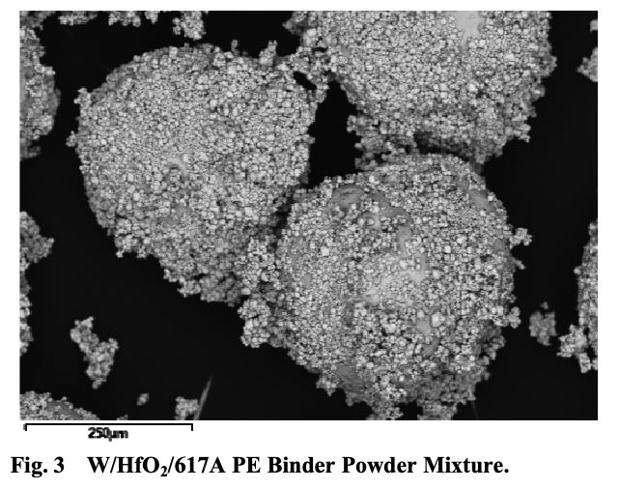
Figure 3.21. W coated HfO₂ using AC-617A PE binder [39].

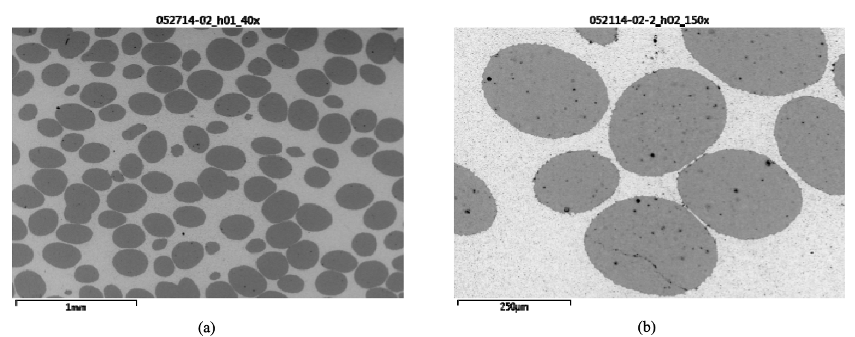
Figure 3.22. SEM micrographs of the polished surface of the W/HfO2 at a) 40 x and b) 150 x [39].

Table 3.2. Sintering conditions for W/HfO₂ cermet powders by Tucker et al. [39].
Sintering temperature (ºC) | Sintering time (minutes) | % of theoretical density
1400 | 5 | 82
1500 | 5 | 85
1500 | 20 | 91
1600 | 20 | 93
1700 | 20 | 96

This powder coating technique was also applied to the sintering of spherical and angular depleted UO₂ based cermets. Due to material licensing concerns, the W-UO2 cermets were sintered using hot isostatic pressing (HIP). The material was pressed at 1800 ºC with a uniaxial force of 27000 psi for 4 hours. As a control, angular UO₂ was also used without any powder coating prior to sintering. Figure 3.23 contains SEM micrographs of the polished surface of the two W-UO₂ cermets. The angular powder was not well dispersed and significant matrix porosity in the W was observed. While the spherical W-UO₂ cermet still had porosity in the tungsten matrix, the particles were found to be much more evenly dispersed. It was also found that SPS produced a higher density in the matrix compared with HIP.

The technique developed by Tucker et al. has been used to produce Mo and W based surrogate cermets with spherical YSZ used in place of UO₂ [40]. Recently, Cureton et al. used a similar methodology to produce Mo matrix UO₂ cermets [41].

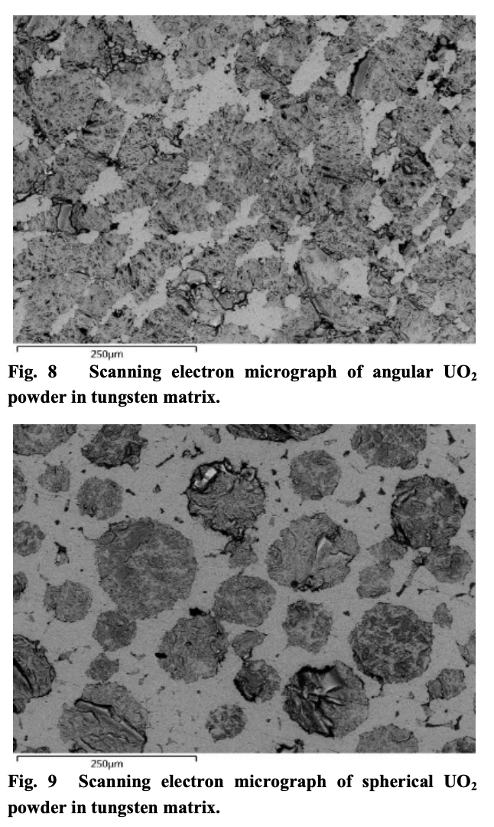
Figure 3.23. W-UO₂ cermets sintered using HIP with a 60vol% fuel loading for (left) angular UO₂ prepared without any powder coating and (right) spherical UO₂ prepared using the binding agent technique developed by Tucker et al. [39].

Properties of Molybdenum and Tungsten

Crystal Structure of Molybdenum and Tungsten

The refractory metals of interest for a cermet material are traditionally molybdenum (Mo) and tungsten (W). As discussed previously, legacy NTP projects favored W as the cermet matrix material due to its higher melting point of 3422 ºC, compared with 2623 ºC for Mo. However, W has two current disadvantages with current NTP designs compare with Mo. First, W has a much higher density than Mo, with a value of 19.3 g/cm³ compared to the 10.2 g/cm³ for pure Mo. For any space system, mass reduction is important for both decreasing launch costs as well as increasing ISP. The other issue is the high parasitic neutron absorption of W. While legacy programs overcame this issue by using highly enriched uranium, current proliferation and launch safety concerns have caused current designs to pursue high assay low enriched uranium (HALEU, <20% ²³⁵U) instead. Current studies have been looking at replacing the W metal matrix with pure Mo and Mo alloys [12, 40, 41]. However, pure Mo has too low a melting point to achieve the desired ISP. A compromise is to use an alloy of Mo with 30 weight percent W (Mo30W) to balance the parasitic neutron absorption cross-section with a higher melting point.

Both Mo and W have a BCC crystal structure. They also have similar lattice parameters of around 0.315 nm for Mo and 0.316 nm for W. Because of their similarities in crystal structure, Mo and W form a solid solution when alloyed together, as seen in Figure 3.24. The ideal density and lattice parameter’s calculated from Vegard’s Law [42] for Mo30W are 11.889 g/cm³ and 0.315 nm, respectively. The theoretical melting point is 2816 ºC, determined from the solid–solid+liquid two phase boundary.

Thermal Properties of Molybdenum and Tungsten

There is very little thermophysical data available for Mo30W. However, there is significant data available for pure Mo and W. The thermophysical properties of the pure refractory elements can provide a good estimate for the expected properties of the alloy.

Martienssen and Warlimont compared the CTE of Mo and W, along with niobium (Nb) and tantalum (Ta) as seen in Figure 3.25. W has the lowest CTE, with Mo averaging a value of about 25% than that of W. This experiment only tested CTE to a value of 1500 ºC, and higher temperature CTE data is needed.

Lower temperature thermal expansion of both Mo and W (<300 K) were tested by and fit to Grueneisen plots by Nix and MacNair [43]. Temperatures below 300 K are expected before startup, but after the first operation, the system is expected to be kept at a higher temperature than ambient space due to the decay heat in the core.

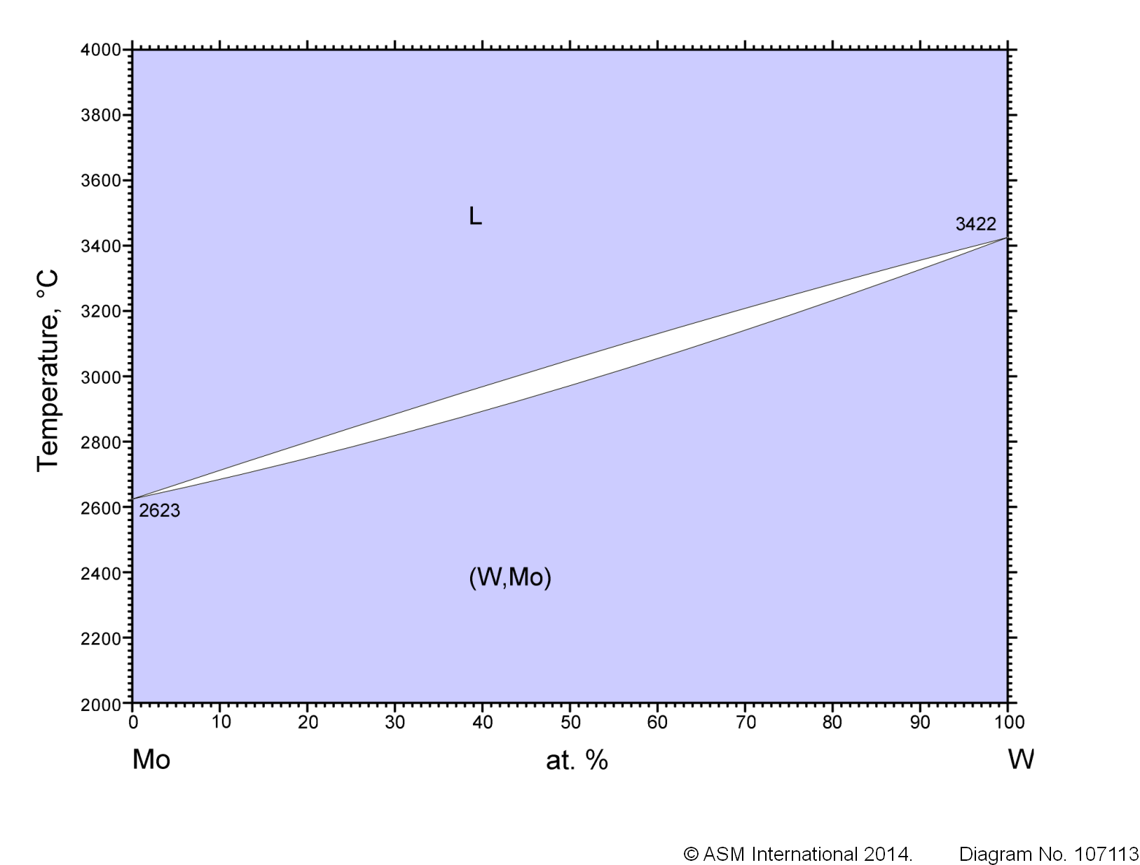
Figure 3.24. The Mo-W binary phase diagram [44].
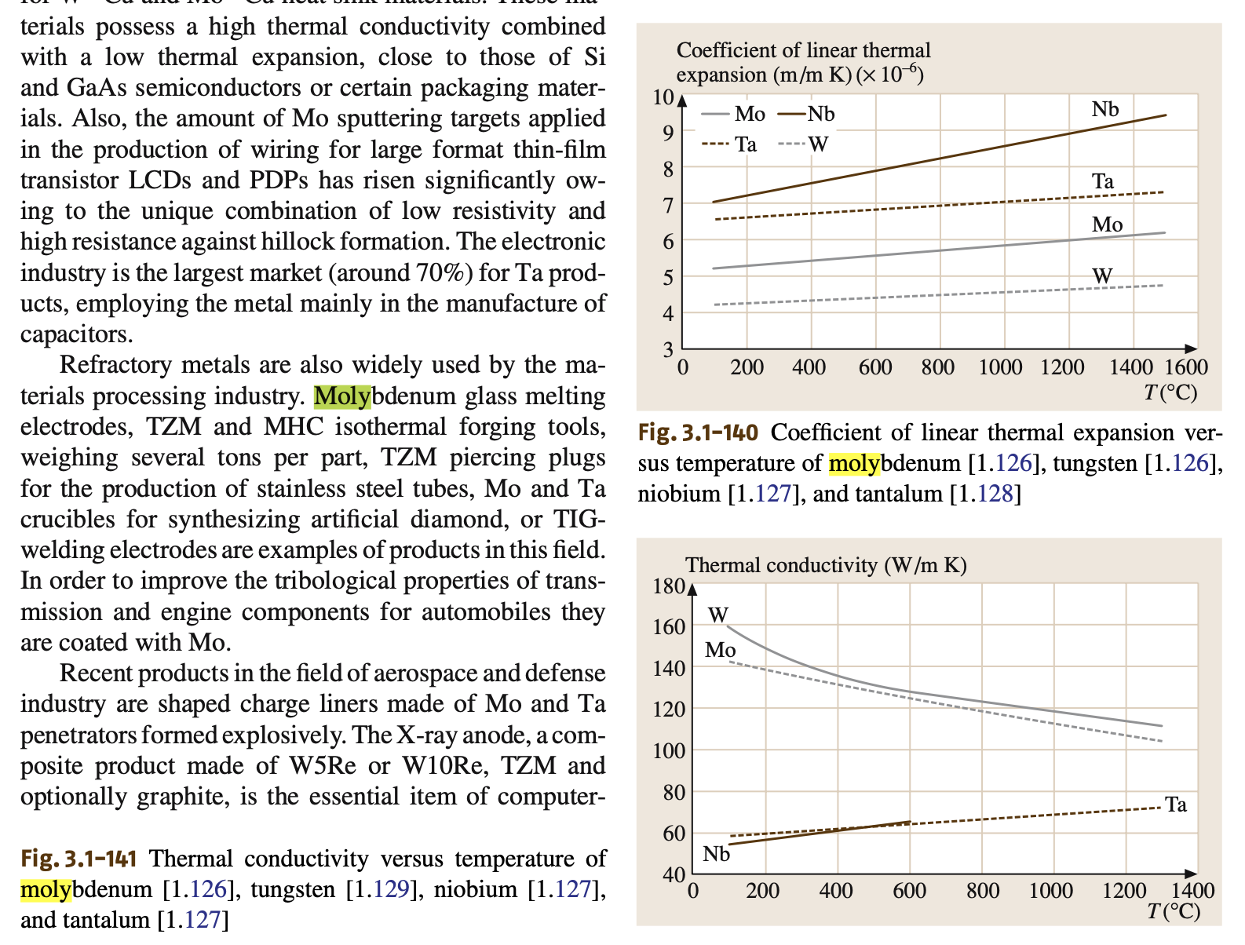
Figure 3.25. Coefficients of thermal expansion of Mo, W, Ta, and Nb as compiled by Martienssen and Warlimont [45].

One study by Rasor and McClelland measured the thermal expansion of pure molybdenum by heating a sample in a carbon-tube furnace, then measuring the distance between two fiducial marks on the specimen [46]. The results are plotted in Figure 3.26. Two heating and cooling cycles were conducted on the samples. They observed a small permanent elongation from the initial heating, but saw very little change between the two heating and cooling cycles. From this experiment, they were able to fit the data to an equation for the coefficient of thermal linear expansion, as shown in in Equation 3.8, where $α$ represents the linear CTE and $T_{e}$ is the difference between the test and reference temperatures, which was 20 ºC in this case.

 | $$α=2.95×{10}^{-6}+4×{10}^{-9}T_{e}^{2}$$ | Equation 3.8

Thermal Expansion of pure Mo was also calculated from Xray diffraction (XRD) up to 2100 K [47]. Compared with the data in Figure 3.26, the thermal expansion from XRD matched well with the thermal expansion calculated using a dilatometer.

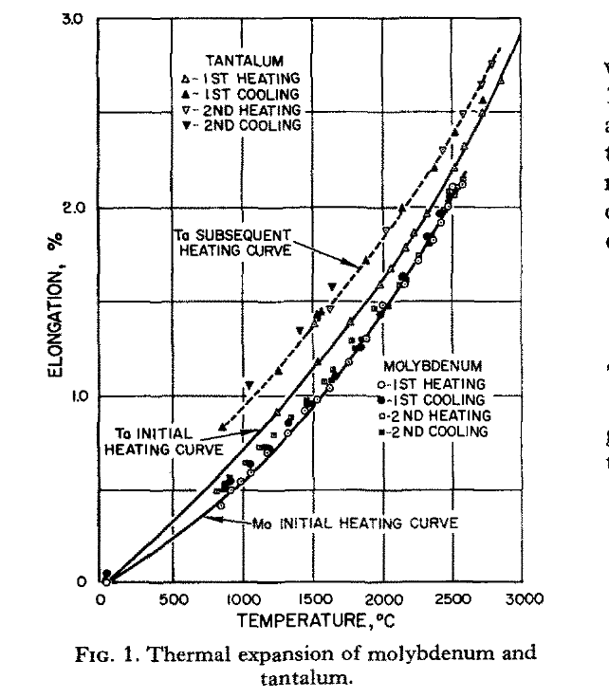
Figure 3.26. Thermal expansion of Mo and Ta determined from two heating and cooling cycles by Rasor and McClelland [46].
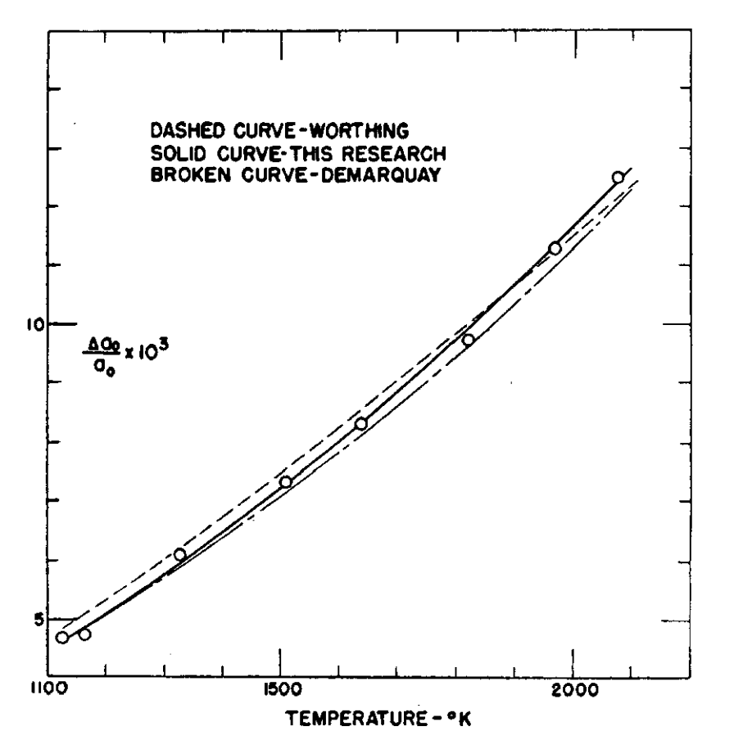
Figure 3.27. Thermal expansion of Mo from 1100 to 2100 K, calculated using the change in lattice parameter determined from XRD [47].
Bodryakov compiled data from 23 different CTE experiments on pure Mo ranging from 0 K to the melting point, as seen in Figure 3.28 [48]. From 0 K to room temperature, there is a sharp increase in the volume expansion followed by a linear regime up to roughly 2000 K. Above 2000 K, there appears to be an increasing rate in the volume expansion up to the melting point. Below 2000 K, there is very good fit among all the data, considering the CTE was measured from a variety of techniques. Above 2000 K, the data spread increases, but the trend is the same.

Bodryakov also compiled data from 25 different CTE experiments on pure W ranging from 0 K to the melting point, as seen in Figure 3.29 [49]. The general trend matched that of pure Mo, but is lower in magnitude for similar temperatures. Also, the same trend of the data spread increasing at higher temperatures, especially above 3000 K, was observed.

Dubrovinsky and Saxena tested the thermal expansion of pure tungsten up the melting point using XRD [50]. The lattice parameter was determined at different temperature ranges from room temperature up to above 3500 K. The volume thermal expansion is shown in Figure 3.30. It exhibited a good fit with more traditional thermal expansion methods.

Suh et al. compared the thermal expansion of pure Mo and W determined from push rod dilatometry and XRD experiments, as seen in Figure 3.31. The XRD experiments were able to test the materials up to above 2600 K. Suh et al. found good agreement with the two experimental test methods. Suh et al. then fit the data to a second order equation to model the linear expansion and compare the two test methods. Equation 3.9 contains the model, where $A_{1}$ and $A_{2}$ are constants listed in Table 3.3, and $T$ is the temperature in K.

 | $$ΔL/{L_{0}}=A_{1}\left(T-293\right)+ A_{2}{\left(T-293\right)}^{2}$$ | Equation 3.9

Martienssen and Warlimont also compiled thermal conductivity data of Mo, W, Ta and Nb as seen in Figure 3.33 [45]. The data for Mo and W was acquired from 100 ºC up to 1300 ºC. W had a higher thermal conductivity than Mo over the tested range, and both materials saw a decrease in thermal conductivity with increasing temperature.

Allen et al. tested the thermal conductivity of pure Mo and W above 2300 K [51]. These high temperature measurements are shown in Figure 3.34 for pure Mo and Figure 3.35 for pure W.

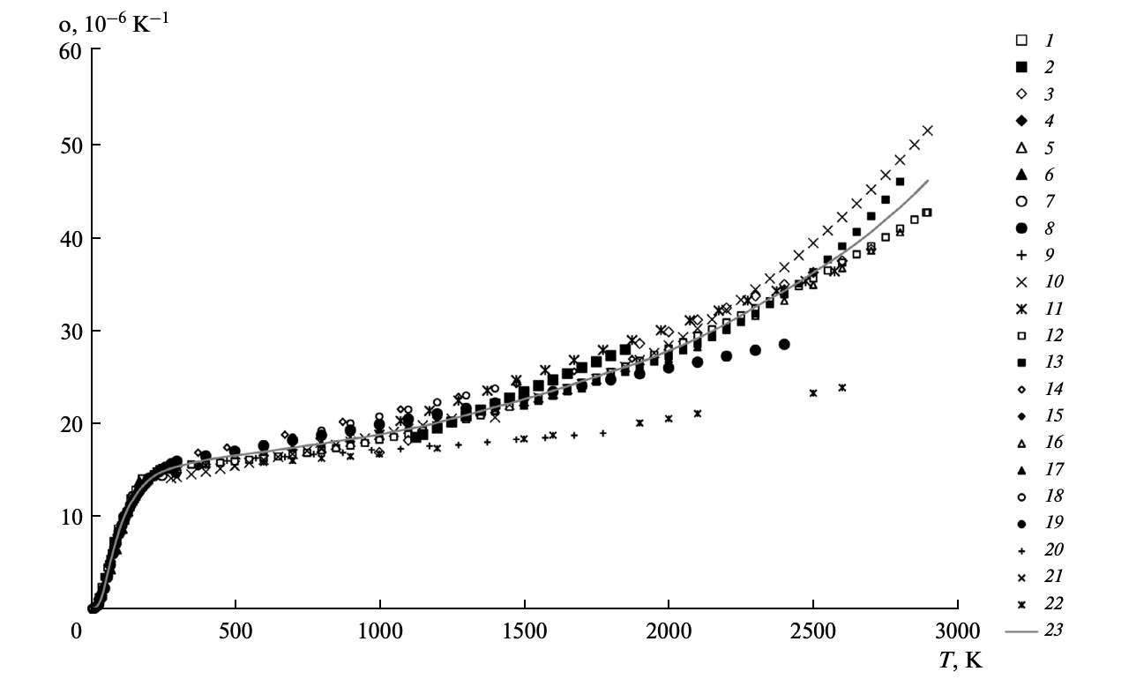
Figure 3.28. Volume CTE of pure Mo up to the melting point as compiled by Bodryakov [48].

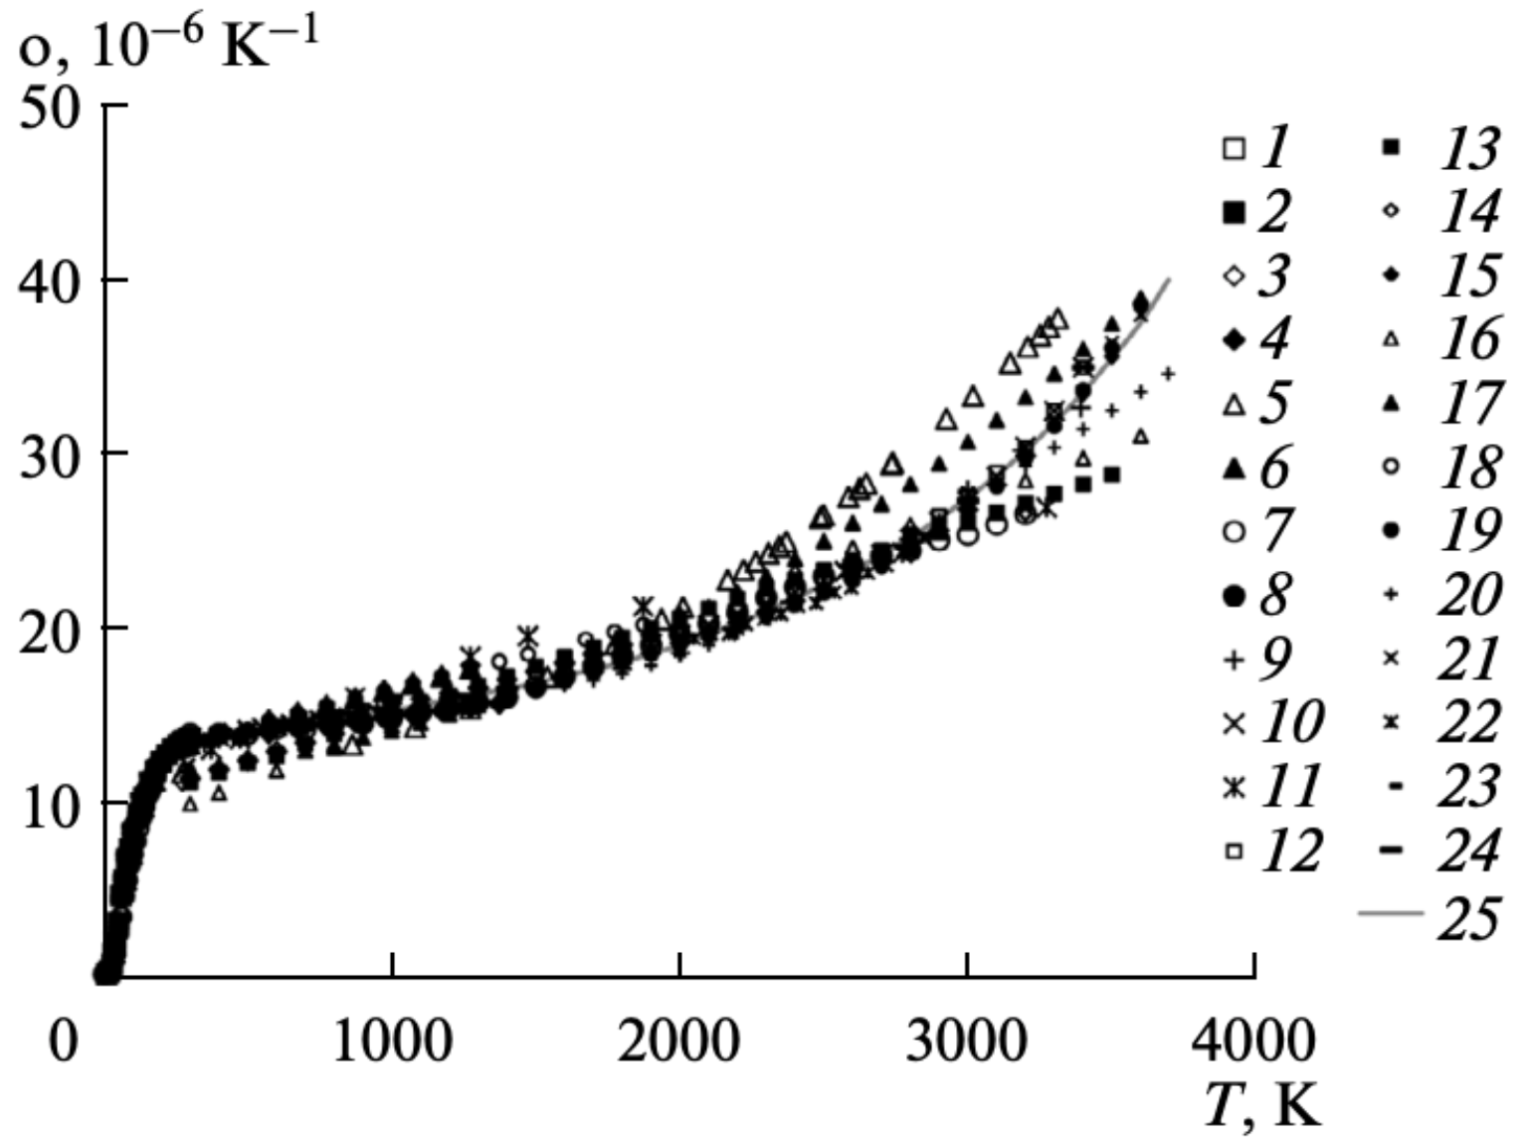
Figure 3.29. Volume CTE of pure W up to the melting point as compiled by Bodryakov [49].

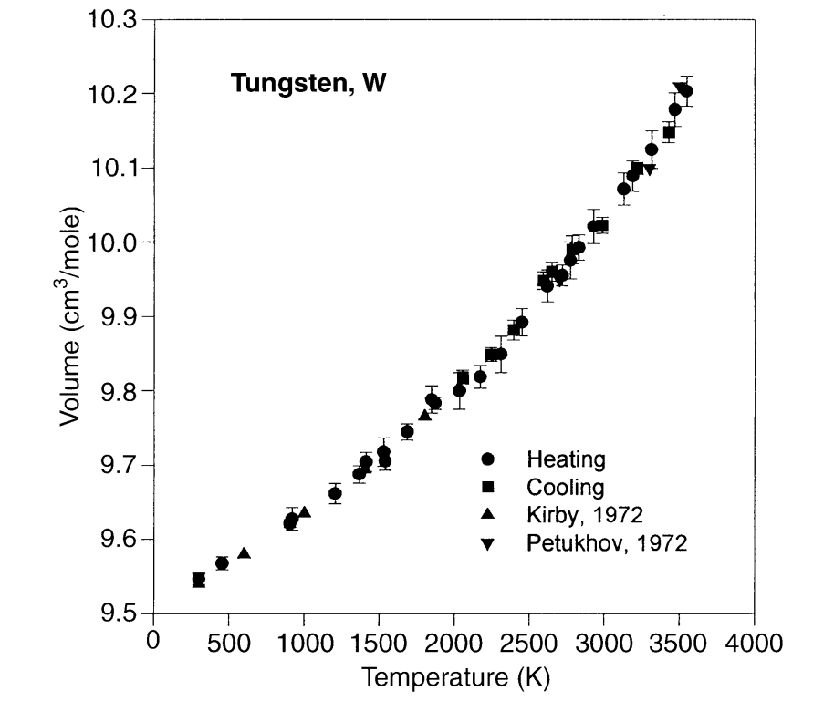
Figure 3.30. Molar volume thermal expansion of pure tungsten up to the melting point determined from XRD as measured by Dubrovinsky and Saxena [50].

Table 3.3. Fitting parameters for thermal expansion of Mo and W determined by Suh et al [52].
 | Method | $$A_{1}$$ | $$A_{2}$$ | Range (K)
Mo | Dilatometer | $$5.08×{10}^{-6}$$ | $$1.41×{10}^{-9}$$ | 293 to 1200
 | XRD | $$3.91×{10}^{-6}$$ | $$1.81×{10}^{-9}$$ | 298 to 2614
W | Dilatometer | $$4.97×{10}^{-6}$$ | $$3.16×{10}^{-11}$$ | 293 to 1700
 | XRD | $$5.37×{10}^{-6}$$ | $$1.81×{10}^{-10}$$ | 298 to 2621

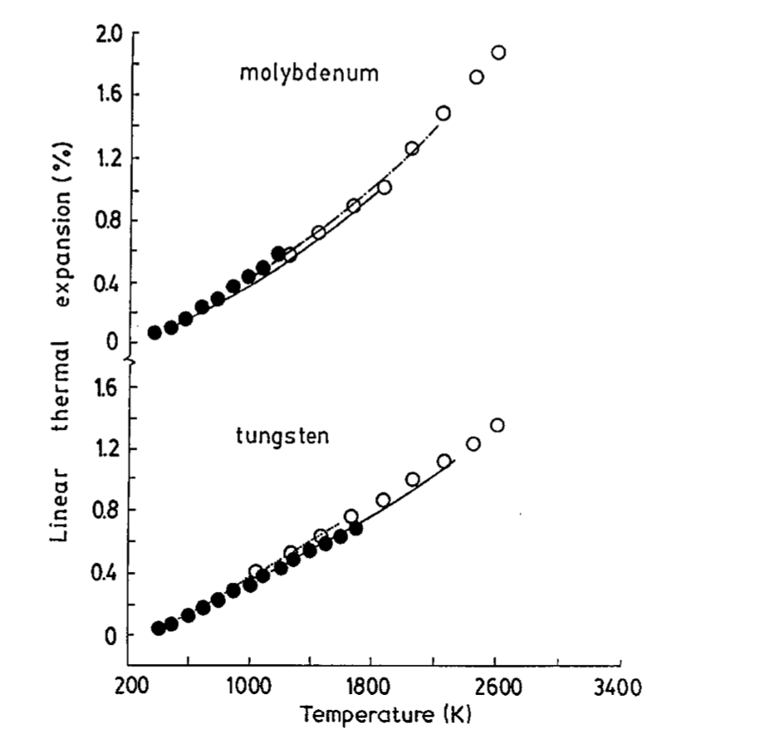
Figure 3.31. Linear thermal expansion of Mo and W determined from push rod dilatometry and XRD compiled by Suh et al. [52]. The dark circles represent values collected using push rod dilatometry by Suh et al. [52], the open circles were calculated from XRD by Waseda et al. [53], the solid line was determined by XRD from Demarquay [54], and the line broken line with dot was determined by XRD from Worthing [55].

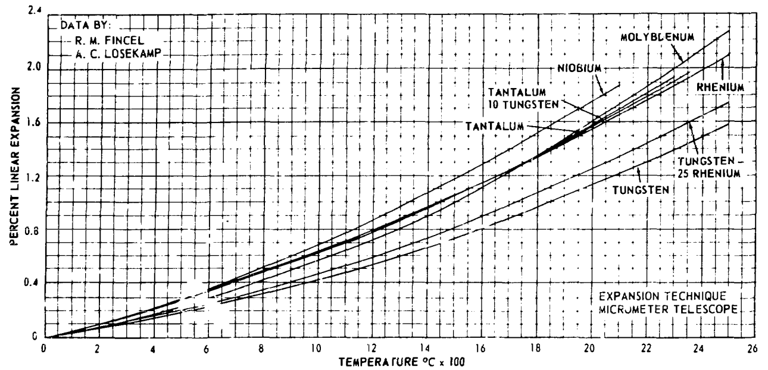
Figure 3.32. Percent linear thermal expansion [56].

Figure 3.33. Thermal conductivity of Mo, W, Ta, and Nb as compiled by Martienssen and Warlimont [45].

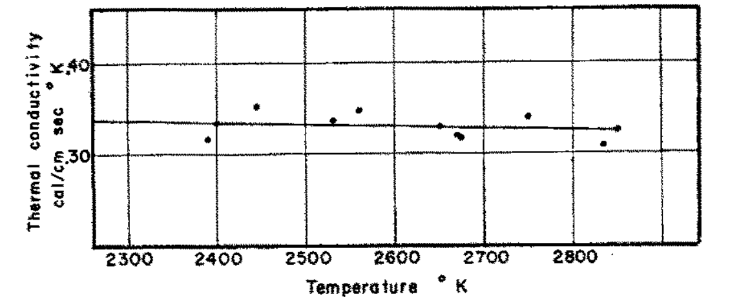
Figure 3.34. Thermal conductivity of molybdenum above 2300 ºC [51].

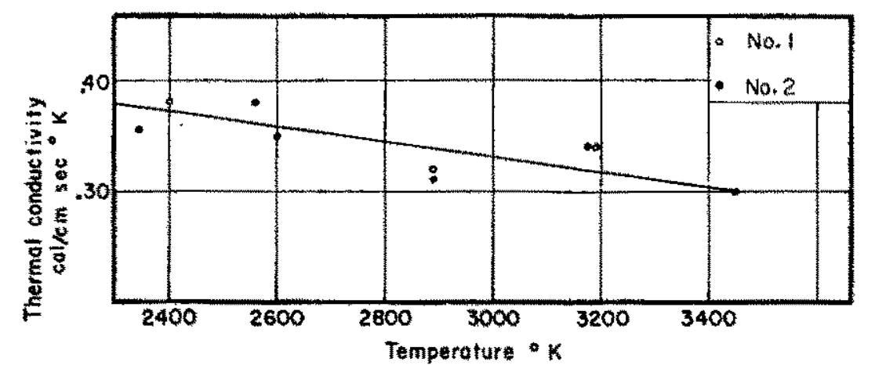
Figure 3.35. Thermal conductivity of tungsten above 2300 ºC [51].

Martienssen and Warlimont also compiled specific heat capacity data for Mo, W, Ta and Nb as seen in Figure 3.36 [45]. The heat capacity shows the greatest disparage between Mo and W, compared with the other thermal properties of interest. Mo has almost double the specific heat capacity of W over the tested range of 100 to 1400 ºC. This is likely due to the fact that W is about twice as dense as Mo. The value for both metals increases with increasing temperature.

Bodryakov compiled heat molar heat capacity data from a variety of sources up to the melting point of pure Mo [48] and pure W [49]. As with other metals, the heat capacity of Mo and W increases with increasing temperature. Below 300 K, the heat capacity increases rapidly, then levels off. From 300 to around 2200 K, the increase in heat capacity is linear with temperature. Above 2200 K, the increase in heat capacity with regard to temperature moves from a linear relationship to a second order relationship. The heat capacity as a function of temperature for pure Mo is shown in Figure 3.37 and for pure W in Figure 3.38. For pure W, the spread increases rapidly above 3200 K between the various sources.

Martienssen and Warlimont also compiled vapor pressure and evaporation rate data up to 2900 ºC for Mo, W, Ta and Nb as seen in Figure 3.39 [45]. Over the range of 1500 to 2400 ºC, Mo has a much higher vapor pressure than W, by almost five orders of magnitude. Correspondingly, the evaporation rate of Mo over the same range is five orders of magnitude greater than that of tungsten.

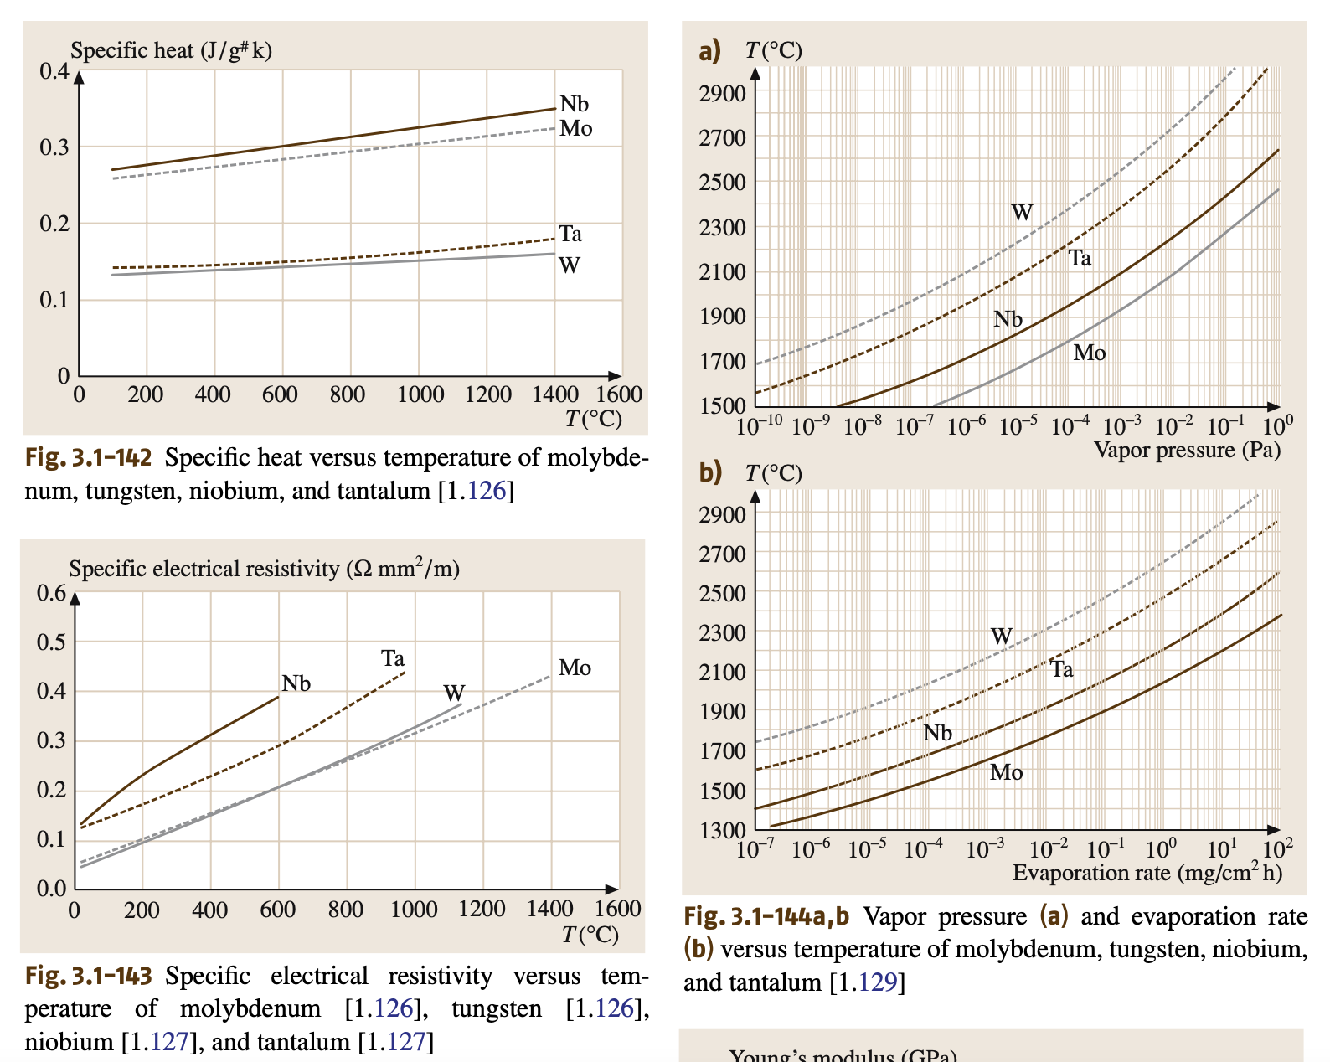
Figure 3.36. Specific heat capacity of Mo, W, Ta, and Nb as compiled by Martienssen and Warlimont [45].

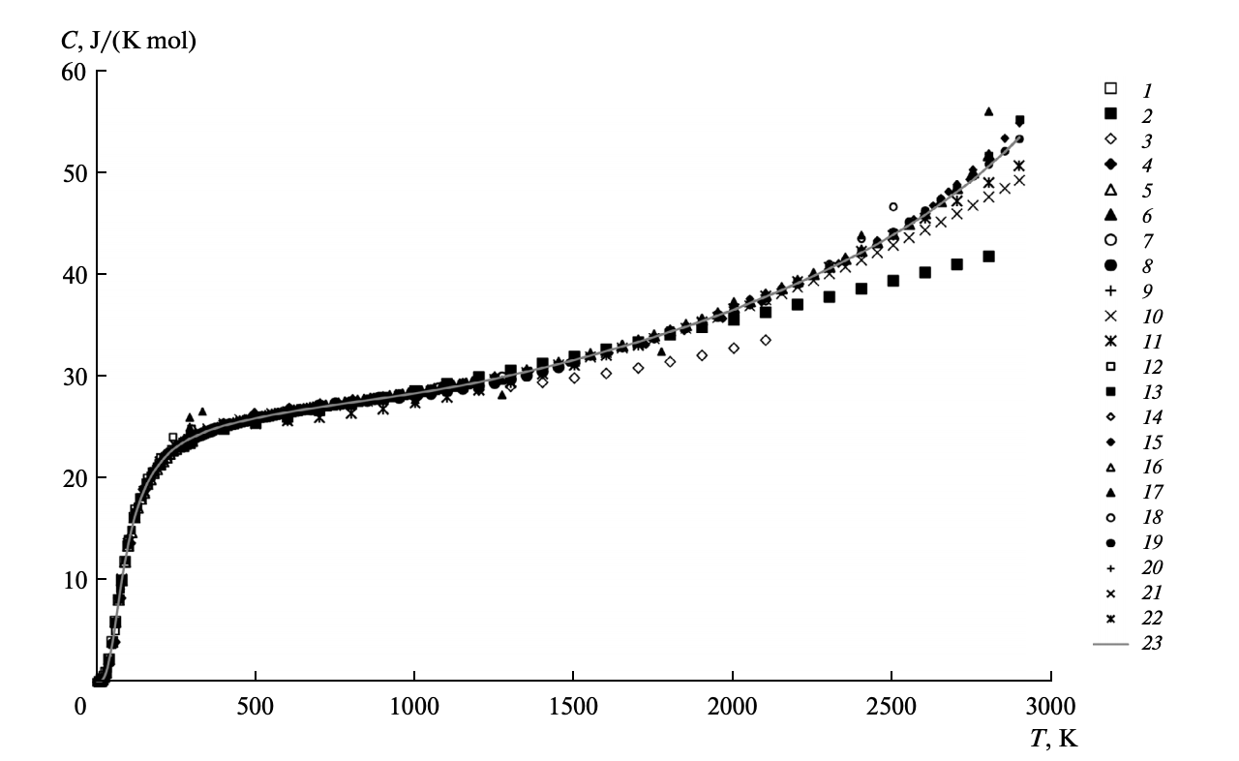
Figure 3.37. Heat capacity of pure Mo up to the melting point from data from 23 sources compiled by Bodryakov [48].

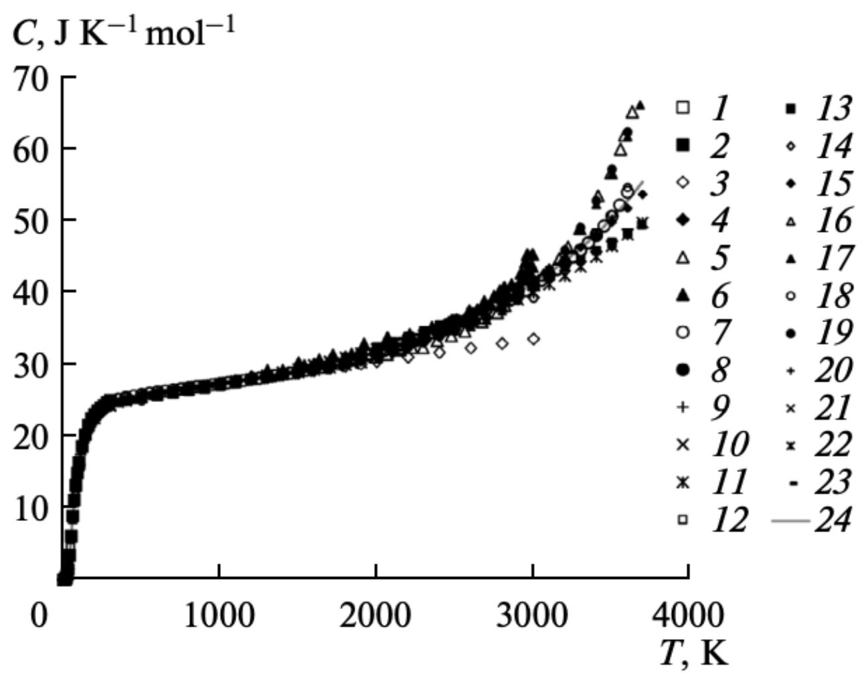
Figure 3.38. Heat capacity of pure W up to the melting point from 24 sources compiled by Bodryakov [49].
Figure 3.39. a) Vapor pressure and b) evaporation rate of Mo, W, Ta, and Nb as compiled by Martienssen and Warlimont [45].

Mechanical Properties of Refractory Alloys

Young’s modulus for most metals decreases with increasing temperature, i.e., the material becomes less stiff. Martienssen and Warlimont [45] compiled modulus data for both Mo and W from Tietz and Wilson [57] and plotted it in Figure 3.40. The modulus of W is typically between 75 and 100 GPa higher than that of Mo. Figure 3.41 contains the modulus of W up to 3000 ºC for a single crystal and up to 2000 ºC for a polycrystal. Above 2000 ºC, Young’s modulus begins to decrease more rapidly. Depending on the material, the modulus of pure W has been observed to decrease to little as one third of the room temperature value near the melting point.

The hardness of BCC metals is a good indicator for the strength of a material. The well understood Tabor relationship for BCC metals, $H (GPa)=3σ_{Y}$, correlates the yield strength with the measured hardness [58]. Mutoh et al. collected hardness data for pure W at elevated temperatures [59]. Up to around 1100 ºC, W experiences a slight decrease in hardness with increasing temperature, as seen in Figure 3.42. At 1100 ºC, W experiences a significant drop in hardness to roughly 80 % the value at room temperature. This material was not recrystallized, as W normally is prior to use in various applications. This drop likely reflects a decrease in the dislocation density above the recrystallization temperature.

One study conducted in the 1970’s by Burman, produced some initial tensile data for pure Mo, Mo30W, and TZM (another Mo based alloy) [60]. At the time Mo30W was being used in pump equipment for molten Zinc. Figure 3.43 contains the tensile strength of Mo30W up to 1200 C. Compared with pure Mo, Mo30W exhibits a slightly higher tensile strength, resulting from the solid solution strengthening. At 1100 ºC, pure Mo experiences a greater decrease in tensile strength with increasing temperature, but Mo30W does not. This is likely due to the W increasing the recrystallization temperature.

The tensile properties of pure W are summarized well in Figure 3.44 and Figure 3.45 up to 2773 K [61]. Both the ultimate tensile strength (UTS) and yield strength (YS) decrease with increasing test temperature. Above 2000 K, the decrease levels off and becomes less noticeable. The uniform elongation of pure W spikes at around 2000 K, while the compression spikes at the lower temperature of 1273 K.

Škoro et al. used Mo and W wires 0.5 and 0.8 mm in diameter to test for high temperature yield strength [62]. The metals were pressed, sintered, forged, then drawn with the W also undergoing stress relief at 400 ºC. The wires were heated then subject to high stresses by using a fast high current wire pulse until yielding or bending. This technique alloyed for testing the yield strength of Mo up to 2400 K and W up to 2700 K. These data are presented in Figure 3.46. The data was fit to the model presented by Zerilli and Armstrong [63], which is a constitutive equation for the flow stress of BCC metals.

 | $$σ=C_{1}e^{\left(-C_{2}T+C_{3}T\ln{\dot{ϵ}}\right)}+C_{4}+C_{5}ϵ^{n}+kd^{-1/2}$$ | Equation 3.10
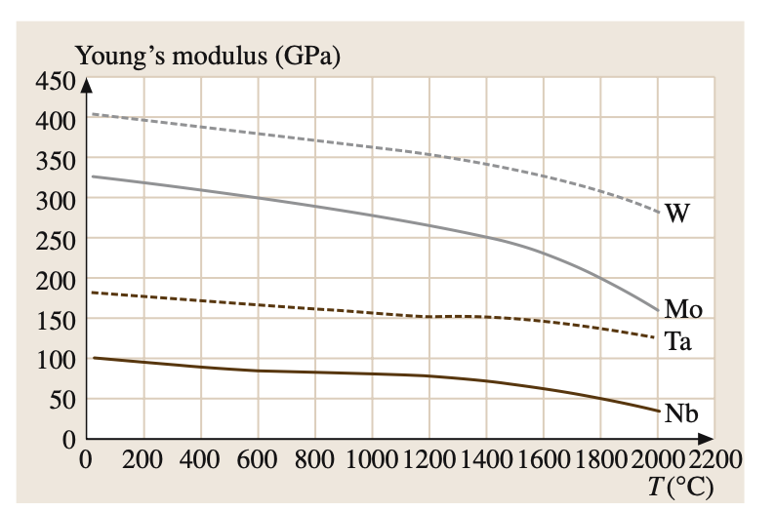
Figure 3.40. Young's modulus of Mo, W, Ta, and Nb as compiled by Martienssen and Warlimont [45], taken from Tietz and Wilson [57].

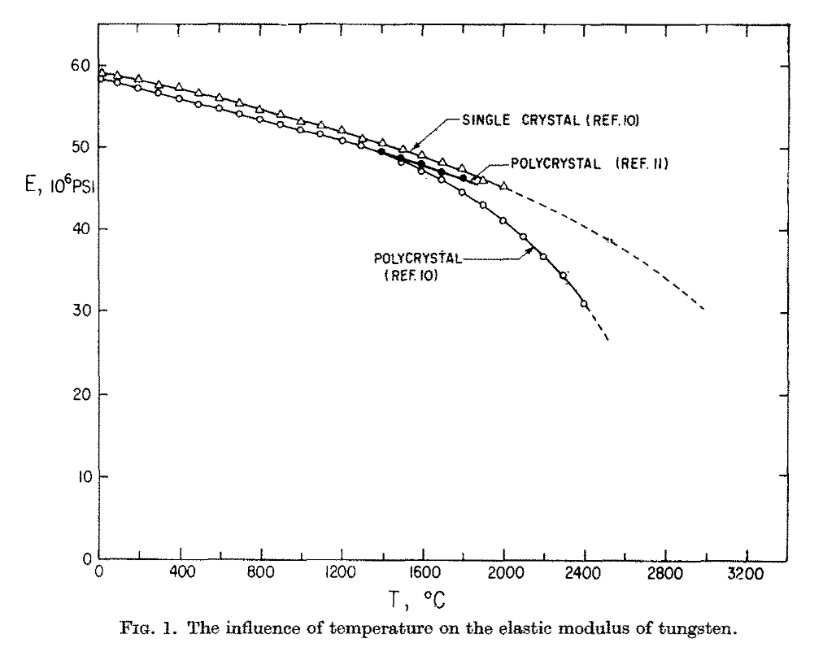
Figure 3.41. The elastic modulus at elevated temperature for polycrystalline and single crystal W from Robinson et al. [64].

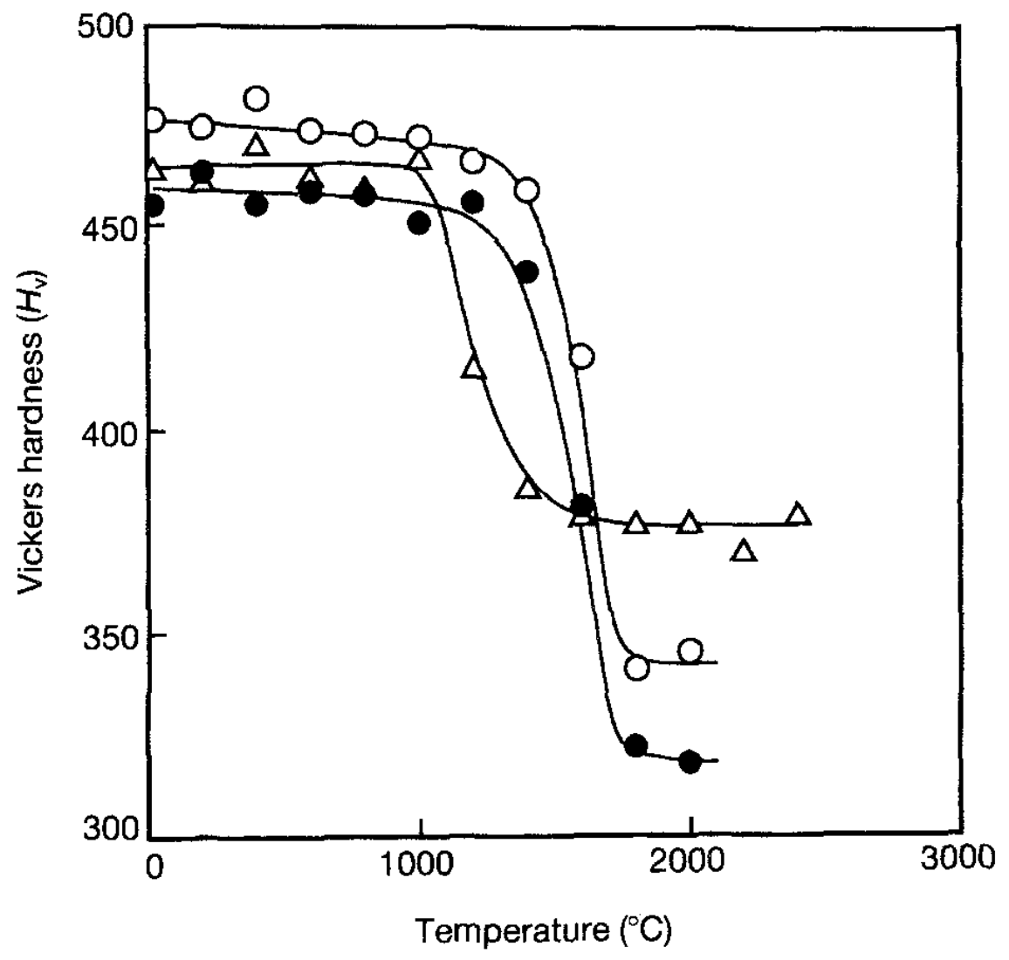
Figure 3.42. Vickers’s hardness of W (open triangles) measured by Mutoh et al. [59].
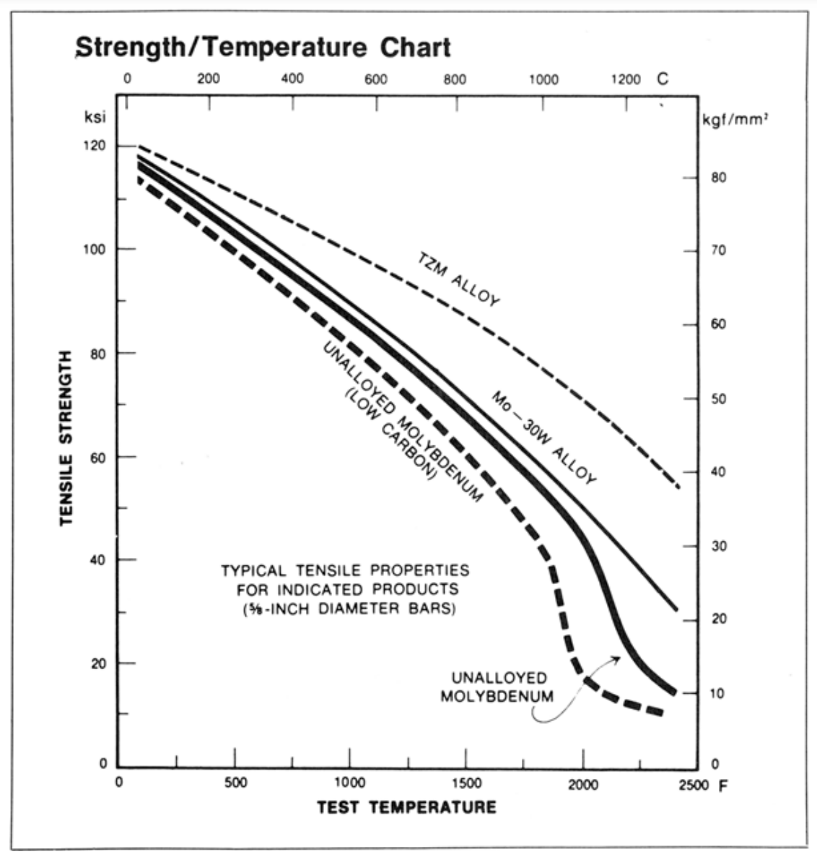
Figure 3.43. Tensile strength with respect to test temperature for Mo30W and other Mo alloys [60].

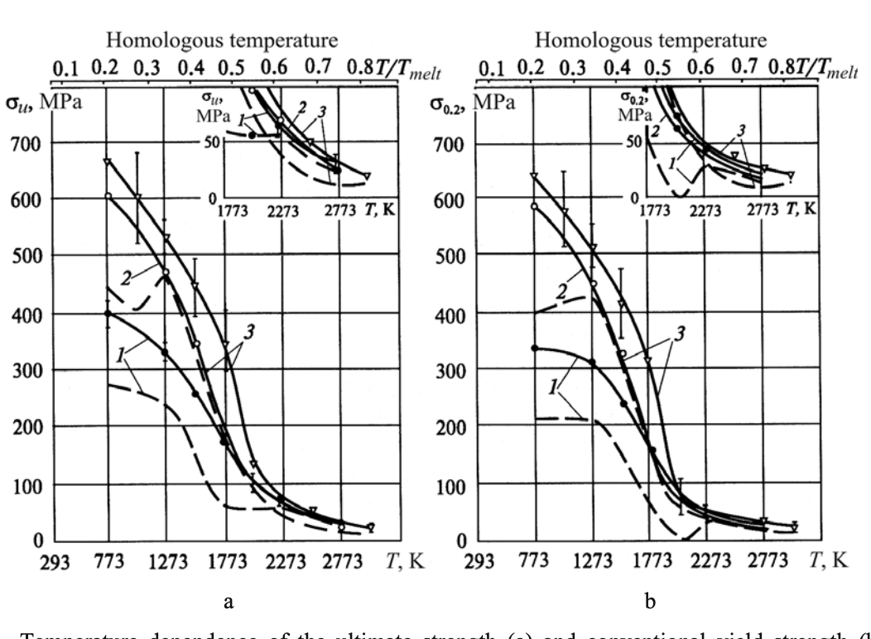
Figure 3.44. Mechanical properties of W at elevated temperatures (sample 1) including a) the ultimate tensile strength and b) the yield strength [61].
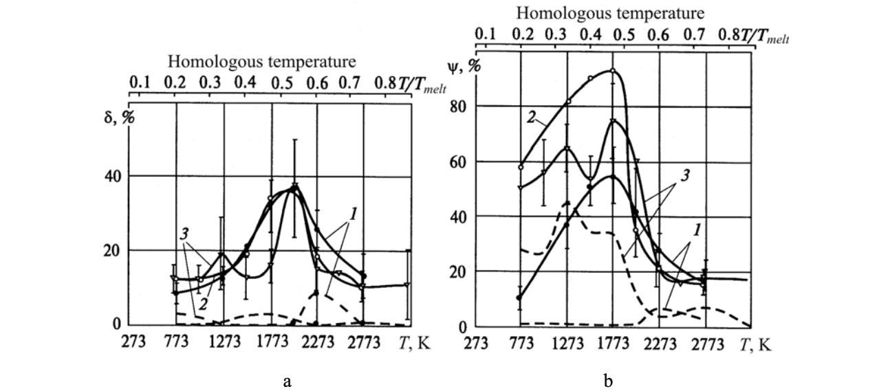
Figure 3.45. a) Elongation and b) compression of pure W (1) and other W alloys (2 and 3) from 773 to 2773 K [61].

$T$ is the temperature, $ϵ$ is the strain, $\dot{ϵ}$ is the strain rate, $d$ is the average grain size, and $C_{1}$, $C_{2}$, $C_{3}$, $C_{4}, C_{5}$, $n$, and $k$ are all constant material parameters. Škoro et al. did not measure the grain size of the samples, so they combined the $kd^{-1/2}$ with the $C_{4}$ constant as seen in Equation 3.11. These parameters were experimentally determined by Škoro et al. and are presented in Table 3.4.

 | $$σ=C_{1}e^{\left(-C_{2}T+C_{3}T\ln{\dot{ϵ}}\right)}+C_{4}+C_{5}ϵ^{n}$$ | Equation 3.11

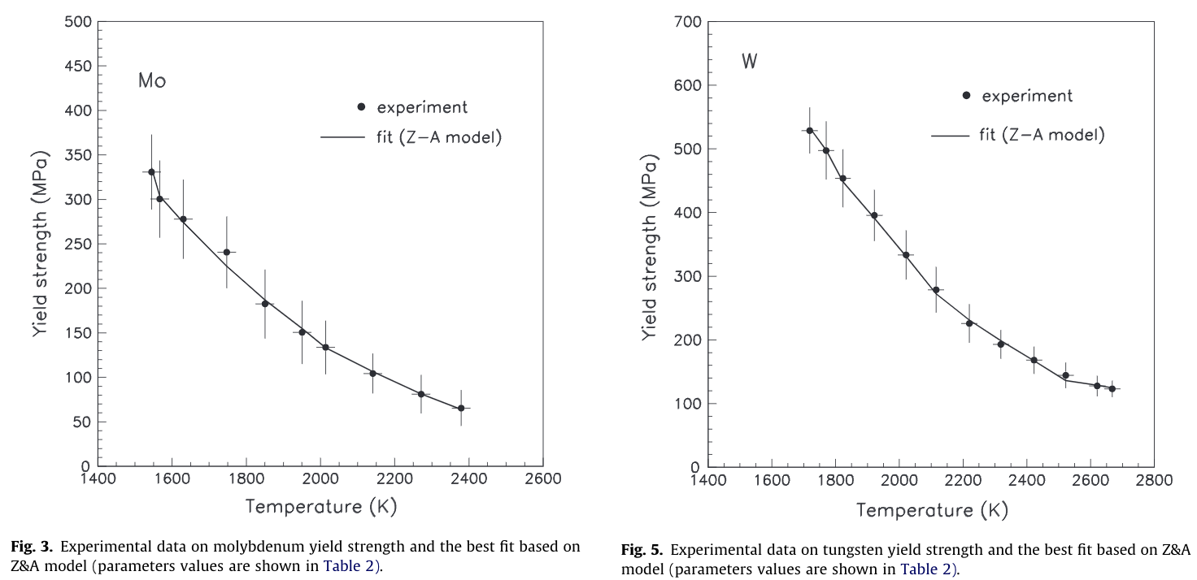
Figure 3.46. High temperature yield strength data of pure Mo (left) and pure W (right) fitted to the Zerilli and Armstrong BCC plastic deformation model by Škoro et al. [62].

Table 3.4. Zerilli and Armstrong model parameters for Mo and W determined by Škoro et al. [62].
Parameter | Molybdenum (Mo) | Tungsten (W)
$C_{1}$ (MPa) | 2259 ± 149 | 4711 ± 261
$C_{2}$ (K⁻¹) | (5.01 ± 0.05) x 10⁻³ | (5.97 ± 0.28) x 10⁻³
$C_{3}$ (K⁻¹) | (5.05 ± 0.07) x 10⁻⁴ | (6.24 ± 0.42) x 10⁻⁴
$C_{4}$ (MPa) | 22 ± 5 | 94 ± 8
$C_{5}$ (MPa) | 158 ± 42 | 133 ± 20
$$n$$ | 0.59 ± 0.10 | 0.51 ± 0.07

Wang et al. tensile tested 10 mm diameter specimens of pure Mo at 973, 1273, and 1623 K as part of a recrystallization study on pure Mo and Mo with dopants [65]. The results are presented in
Table 3.5. The pure Mo samples experienced a decrease in yield and ultimate tensile strengths with increasing temperature. Using total elongation and reduction in are as measures of ductility, there was a slight increase in ductility from 973 to 1273 K, followed by a significant decline in ductility at 1623 K, where the material lost a considerable amount of strength. It appears only one sample was tested at each temperature, so no error information was provided to collaborate the increase in ductility from 973 to 1273 K.

Steichen et al. conducted tensile testing on pure tungsten from room temperature to 1000 ºC [66]. Figure 3.47 contains the yield strength and total elongation measured as part of this experiment. Steichen et al. also calculated a DBTT of around 65 ºC for tungsten, which seems low. Tensile DBTT is typically lower than the DBTT determined from impact and fracture tests, which will be discussed later.

Hiraoka et al. determined the DBTT for pure Mo by using impact and static bend tests [67]. The impact test determined a DBTT temperature of 375 K, while the static bend tests produced a DBTT of 200 K. The total absorbed energy with respect to test temperature for pure Mo is shown in Figure 3.48. The DBTT is represented by the drastic increase in total absorbed energy, from almost nothing to around 300 mJ. The yield strength determined from the impact testing is presented in Figure 3.49. The YS decreases with increasing temperature for pure Mo.

The DBTT for pure W was determined from fracture toughness testing by Mutoh et al. [59]. Two different fracture toughness tests were utilized. K_{IC} was used at lower temperatures and J_{IC} was used at higher temperatures. Figure 3.50 contains the fracture toughness of pure W with K_{IC} values up to 800 ºC, and J_{IC} values up to 1600 ºC. From this, the DBTT was determined to be 900 ºC. Fractographs of the fractured samples are shown in Figure 3.51.

Table 3.5. Tensile properties of pure Mo tested at 973, 1273, and 1623 K. [65]
Properties | 973 K | 1273 K | 1623 K
Yield Strength (MPa) | 136 | 76 | 44
Ultimate Tensile Strength (MPa) | 293 | 258 | 53
Total Elongation (%) | 16 | 18 | 13
Reduction in Area (%) | 86 | 94 | 31

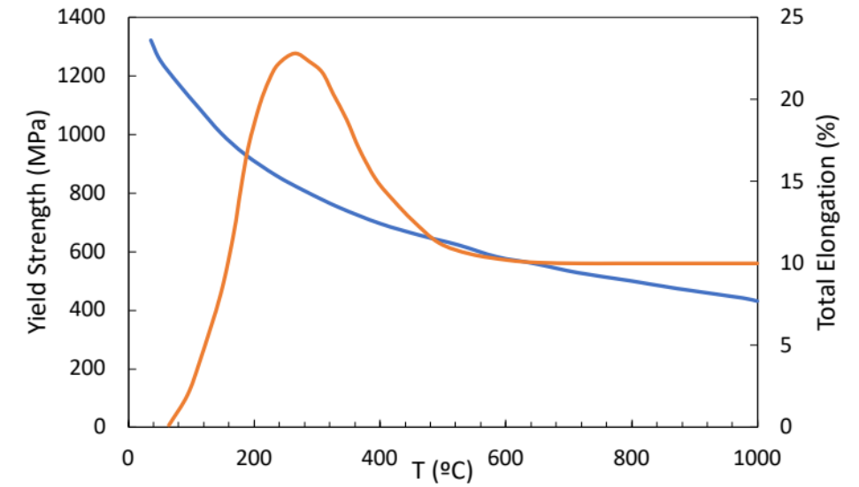
Figure 3.47. Yield strength (blue) and total elongation (orange) of pure tungsten tensile tested from room temperature to 1000 ºC [66].

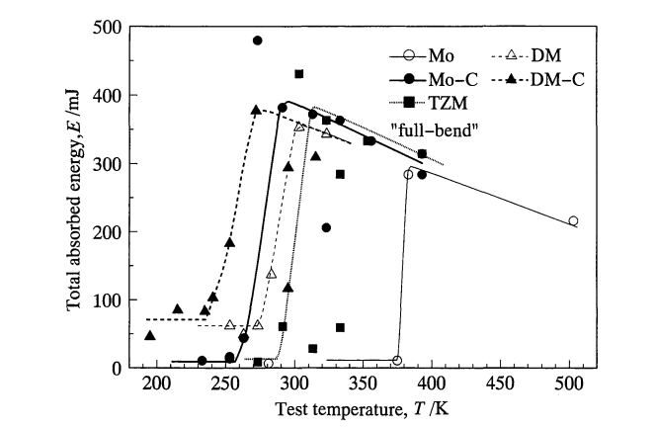
Figure 3.48. Total absorbed energy with respect to test temperature for pure Mo (open circle) determined by Hiraoka et al. [67].

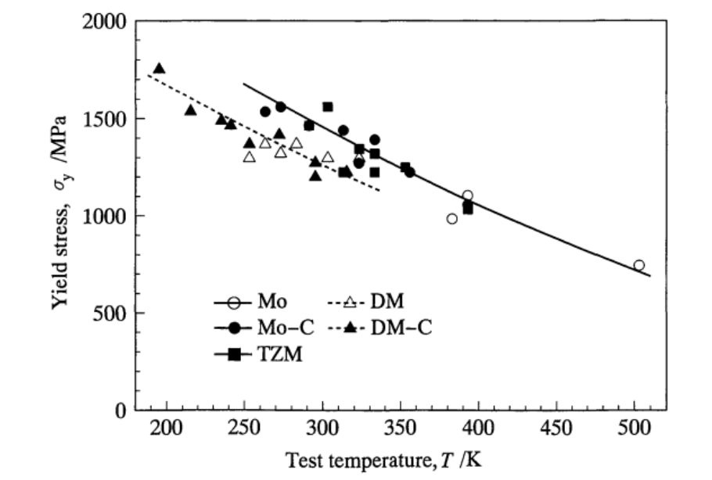
Figure 3.49. Yield strength determined from the impact test with respect to test temperature for pure Mo (open circle) determined by Hiraoka et al. [67].

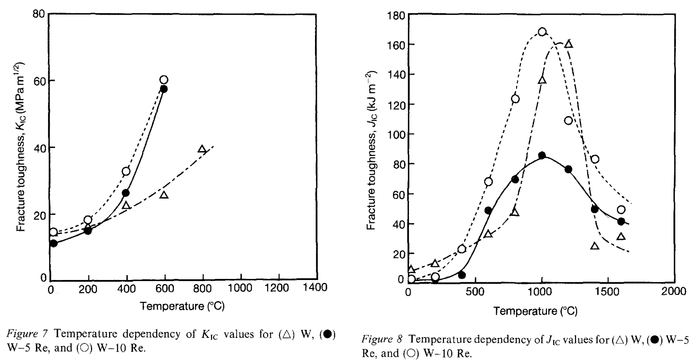
Figure 3.50. Temperature dependence of K_{IC} fracture toughness (left) and J_{IC} fracture toughness (right) for pure tungsten (open triangles) and some W-rhenium alloys from Mutoh et al. [59].

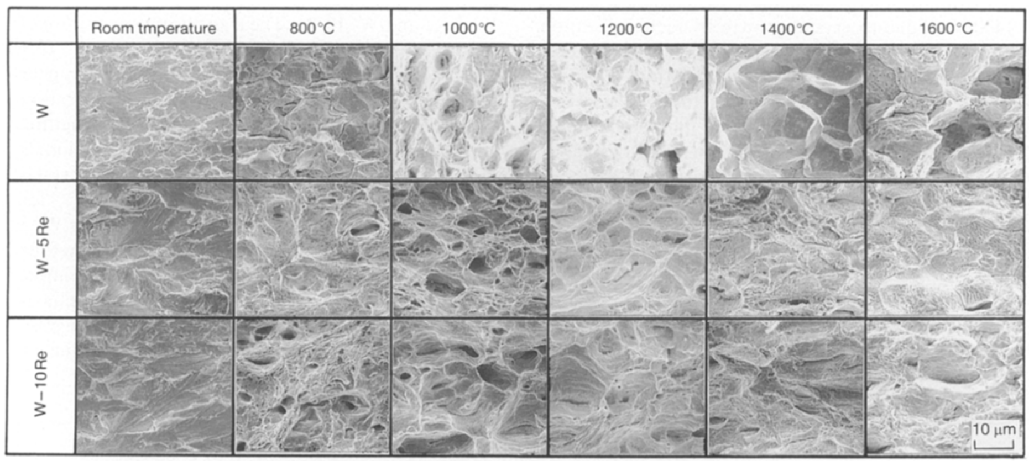
Figure 3.51. Fractographs collected by Mutoh et al. for W and two W-rhenium alloys for samples fractured up to 1600 ºC [59].

Gludovatz et al. collected the fracture toughness through three different methods, 3-point bending, double cantilever beam, and compact tension specimens [68]. K_{Q} fracture toughness values of W and three other W alloys are presented in Figure 3.52. The fracture toughness of pure tungsten is relatively low below 400 ºC, but there is a significant increase in fracture toughness at 800 ºC.

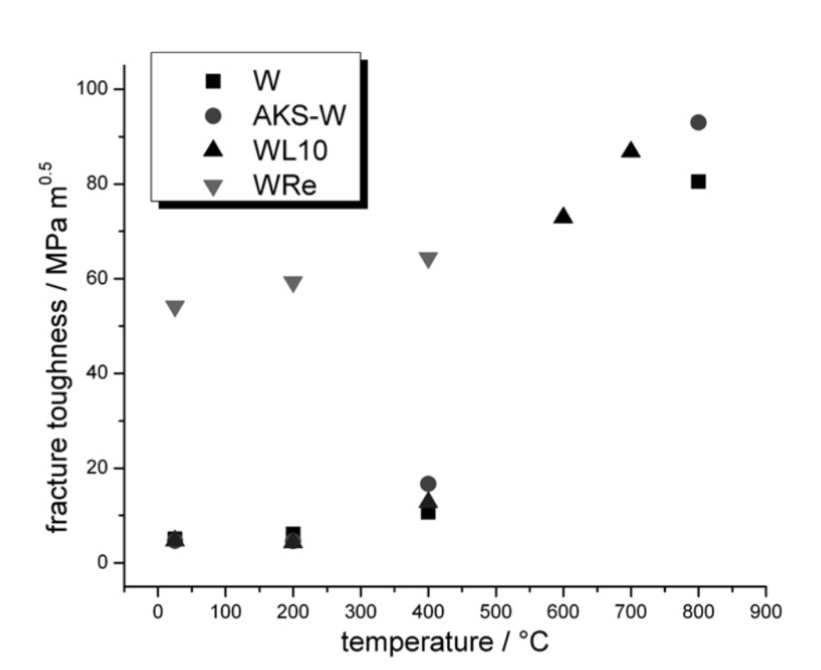
Figure 3.52. Fracture toughness K_{Q} of pure W and other tungsten alloys up to 800 ºC [68].

Properties of Zirconium Carbide
Zirconium carbide (ZrC) is a great candidate for the matrix material for a solid fuel element for NTP. Its high melting point, high strength, high thermal conductivity, and excellent neutronic properties all make it a good candidate for NTP [69].

Crystal Structure of ZrC

ZrC is a refractory ceramic with only one stable cubic phase. This stable phase is an FCC B1 (NaCl-type) symmetry with an Fm3m space group. The ZrC phase is stable from around 0.36 to 0.5 atomic percent carbon, as seen in Figure 3.53, with the highest melting point existing for ZrC_{0.85}. The melting point is around 3700 K. Two types of bonds exist in the ZrC crystal lattice, namely the Zr-Zr metallic bonds and the C-Zr covalent/ionic metal to carbon bonds [70]. Most ZrC feedstocks currently available are sub stoichiometric and contain free carbon impurity [71]. This can have a significant effect on the thermal and mechanical properties of the material.

Thermal Properties of Zirconium Carbide

As with the refractory materials, the thermal properties of greatest interest are heat capacity, thermal conductivity and diffusivity, thermal expansion, and vapor pressure. Not only do the thermal properties of ZrC depend the temperature of the material, but they also depend on the stoichiometry of the material. The stoichiometry of ZrC is typically specified by the carbon to zirconium (C/Zr) ratio, with a value of one representing perfectly stoichiometric ZrC. Porosity and free carbon can also affect the properties of ZrC.

The heat capacity of ZrC with various stoichiometries have been measured using a variety of techniques up to 3000 K. Several of these experiments were compiled by Jackson and Lee and are shown in Figure 3.62 [69]. Below room temperature, the heat capacity drops off pretty rapidly. From room temperature to 2700 K, there is only a slight increase in heat capacity for most stoichiometries. Katoh et al. took similar data and used it to plot the specific heat capacity and then also fit an equation for the heat capacity as a function of temperature as shown in Figure 3.55.

From the different experiments, Katoh et al. developed four models for the specific heat capacity of ZrC for four different C/Zr ratios, with value of 0.69, 0.76, 0.96 and 0.99.
Equation 3.12 through Equation 3.15 contain these models [72]. Equation 3.15 is shown in Figure 3.55 overlayed with the data.

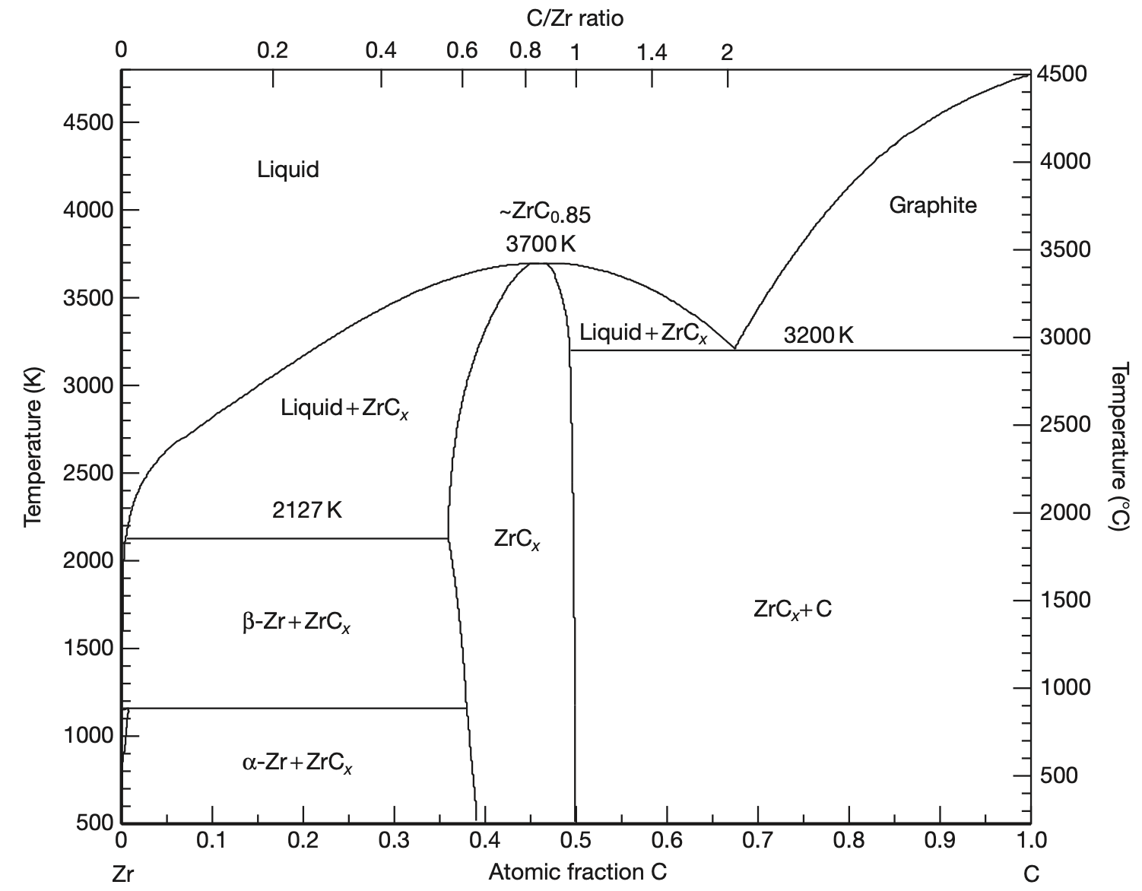
Figure 3.53. Zr-C binary phase diagram as assessed by Fernandez-Guillermet [73] and compiled by Jackson and Lee [69].
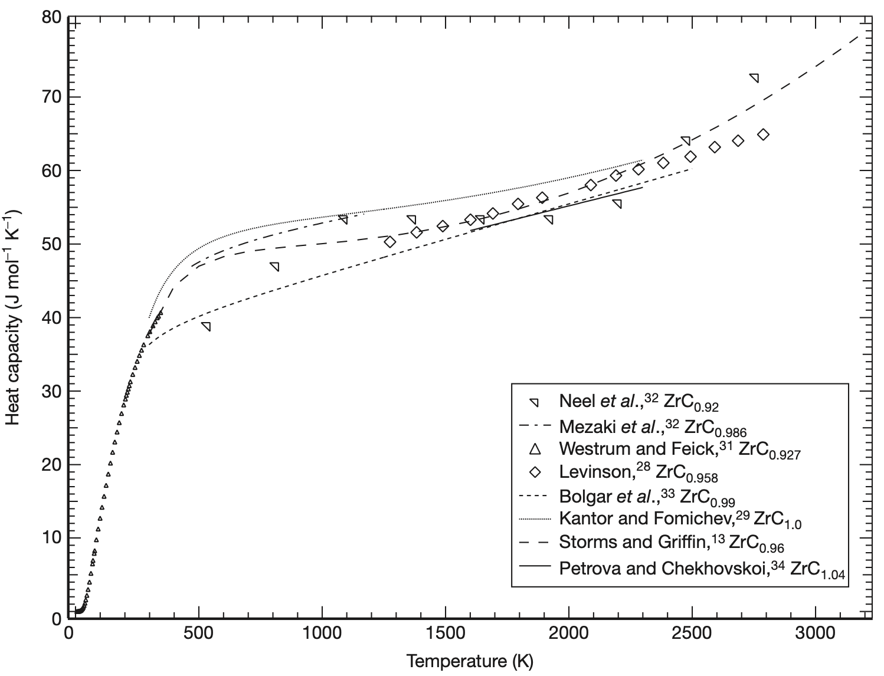
Figure 3.54. Heat capacity of ZrC for various stoichiometries up to 3000 ºC as compiled by Jackson and Lee [69].
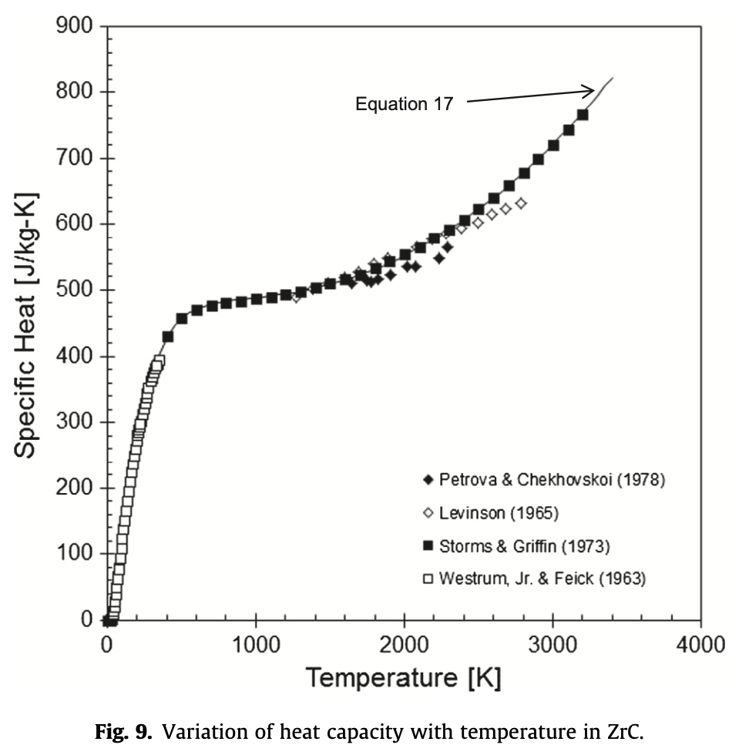
Equation 2.4
Figure 3.55. Specific heat capacity of ZrC as a function of temperature as compiled by Katoh et al. [72].

 | $$C_{p}\left(ZrC_{0.69}\right)=8.057+1.928×{10}^{-3}T+\frac{7.623×{10}^{9}e^{(\frac{-31.4×{10}^{3}}{T})}}{T^{2}}$$ | Equation 3.12
 | $$C_{p}\left(ZrC_{0.76}\right)=7.762+2.348×{10}^{-3}T+\frac{33.11×{10}^{9}e^{(\frac{-19.9×{10}^{3}}{T})}}{T^{2}}$$ | Equation 3.13
 | $$C_{p}\left(ZrC_{0.99}\right)=7.33+3.32×{10}^{-3}T$$ | Equation 3.14
 | $$C_{p}\left(ZrC_{0.96}\right)=8.71+2.28×{10}^{-3}T+\frac{70.65×{10}^{5}}{T^{2}}$$ | Equation 3.15

The effect of the C/Zr ratio on heat capacity can be seen in Figure 3.56. The heat capacity at room temperature from C/Zr ratios from 0.6 to 1.0 show an increase in heat capacity as the C/Zr ratio increases. While the ratio does affect the heat capacity, the effect is minimal, less than 15 percent for the entire range. Figure 3.57 contains the specific heat capacity of ZrC as a function of the C/Zr ratio, as compiled by Katoh et al. Katoh et al. proposed a model for the room temperature specific heat capacity as a function of the C/Zr ratio which is presented as Equation 3.16 [72].

 | $$C_{p}=373.2-355.6x+686.0x^{2}-334.3x^{3} (0.65<x<1.0)$$ | Equation 3.16

The thermal conductivity of the matrix material is very important, as a significant amount of heat will need to be conducted throughout the NTP fuel element. A higher thermal conductivity can prevent the formation of hot spots and help the material heat up and cool off during the rapid thermal transients proposed for NTP. The thermal conductivity ($k$) and diffusivity ($α$) are related by the following equation:

 | $$k=αρC_{P}$$ | Equation 3.17

where $ρ$ is the density in g/cm³ and $C_{P}$ is the specific heat capacity in J/g K. Unlike most ceramics, with ZrC, as the temperature increases, the thermal conductivity also increases. This is likely due to the large contribution of conduction band electrons to thermal conductivity along with the high phonon conductivity common in most ceramics [72]. Figure 3.58 contains thermal conductivity data of ZrC of various stoichiometries as a function of temperature. Once again, it becomes apparent that the stoichiometry of the ZrC plays a significant effect in the thermal conductivity of the material. Figure 3.59 illustrates this effect by comparing the thermal conductivity for C/Zr ratios from 0.6 to 1.0 at room temperature. As the carbon ratio increases, so too does the thermal conductivity. The highest thermal conductivity at room temperature is found in stoichiometric ZrC with a value of around 45 W/mK. Unlike heat capacity, the stoichiometry of the ZrC plays a major role in the thermal conductivity of the material. Once the C/Zr ratio drops below 0.9, the thermal conductivity at room temperature drops by a factor of 4. This is a major impact and suggests that near-stoichiometric material will be required for an NTP system.
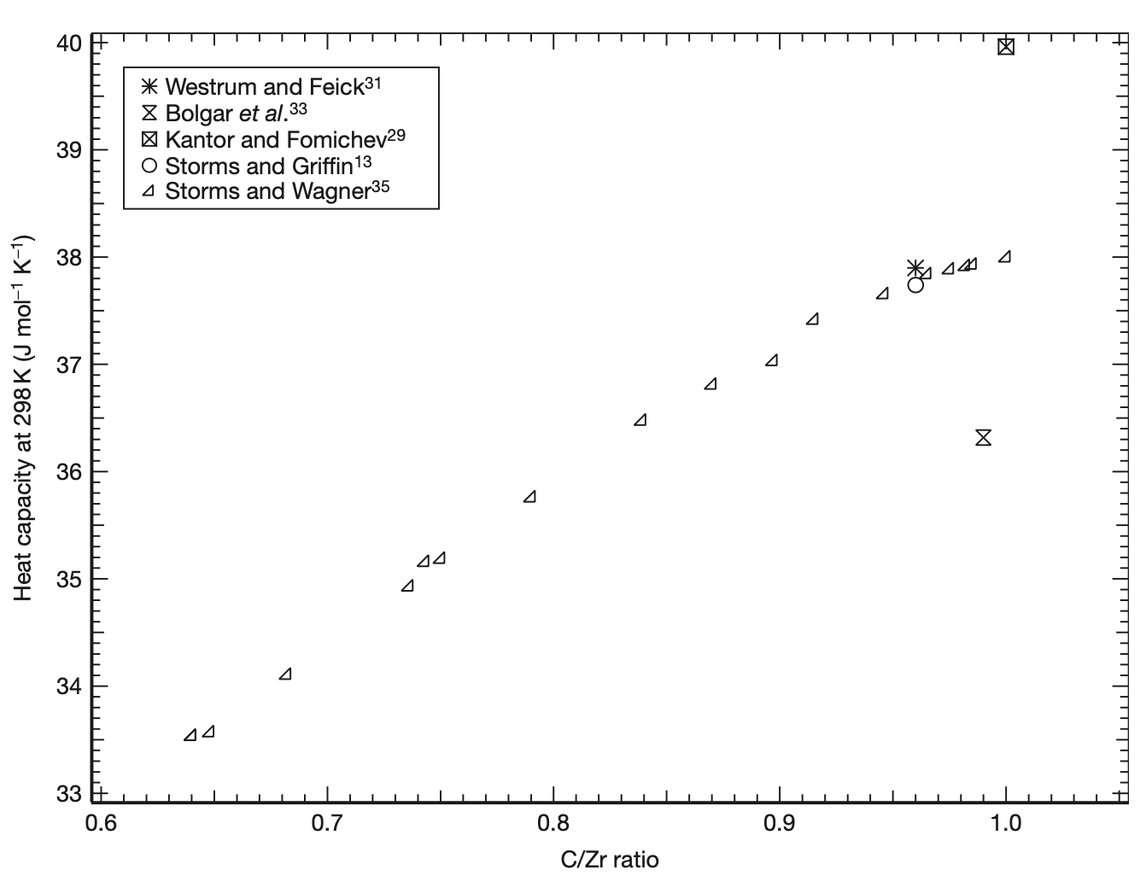
Figure 3.56. Heat capacity at 298 K for various C/Zr ratios as compiled by Jackson and Lee [69].
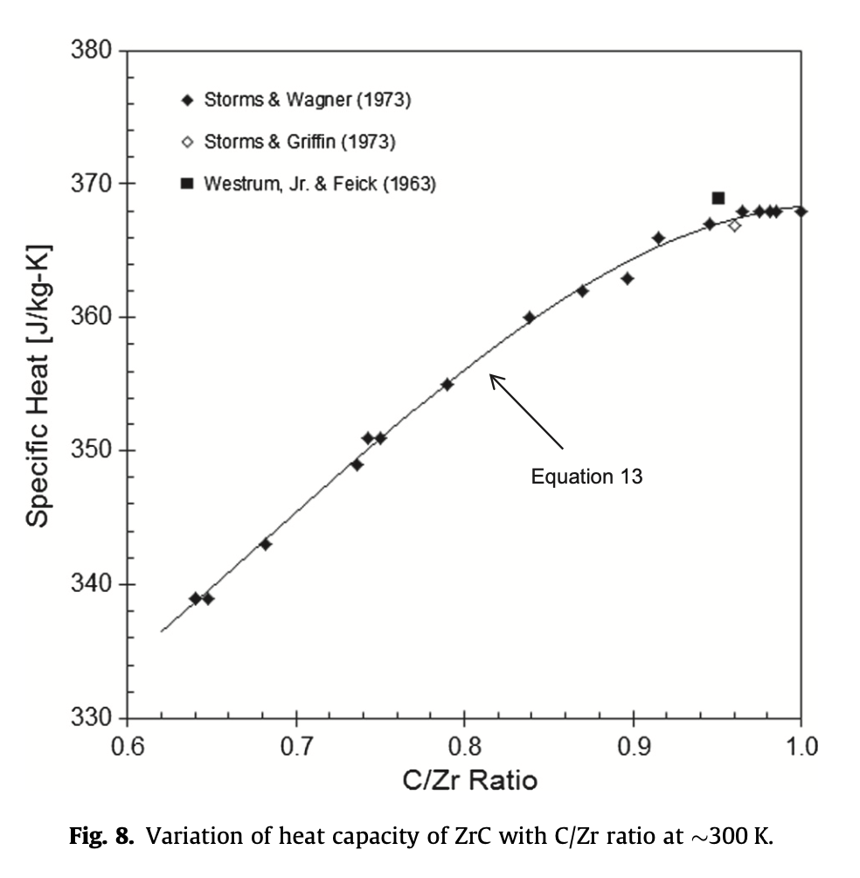
Figure 3.57. Specific heat capacity of ZrC with respect to the C/Zr ratio at ~300 K compiled by Katoh et al. [72].

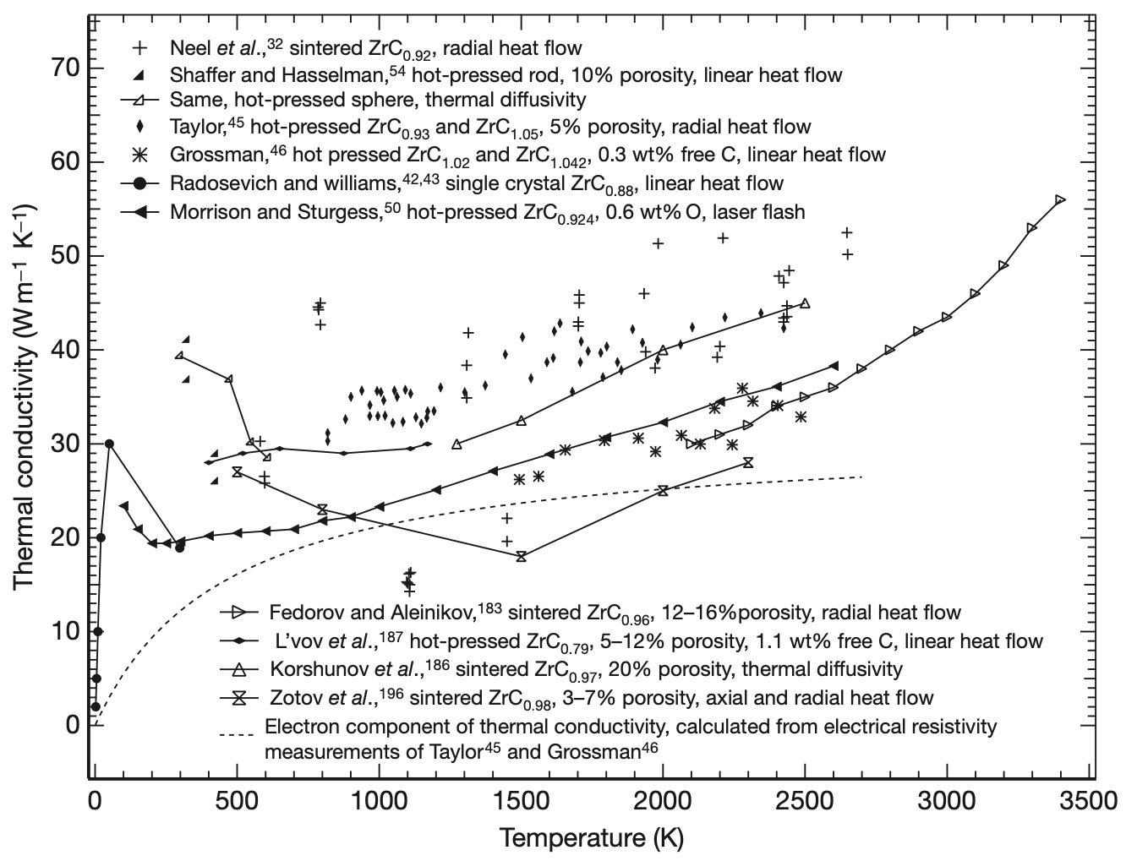
Figure 3.58. Thermal conductivity of ZrC at various stoichiometries as a function of temperature compiled by Jackson and Lee [69].

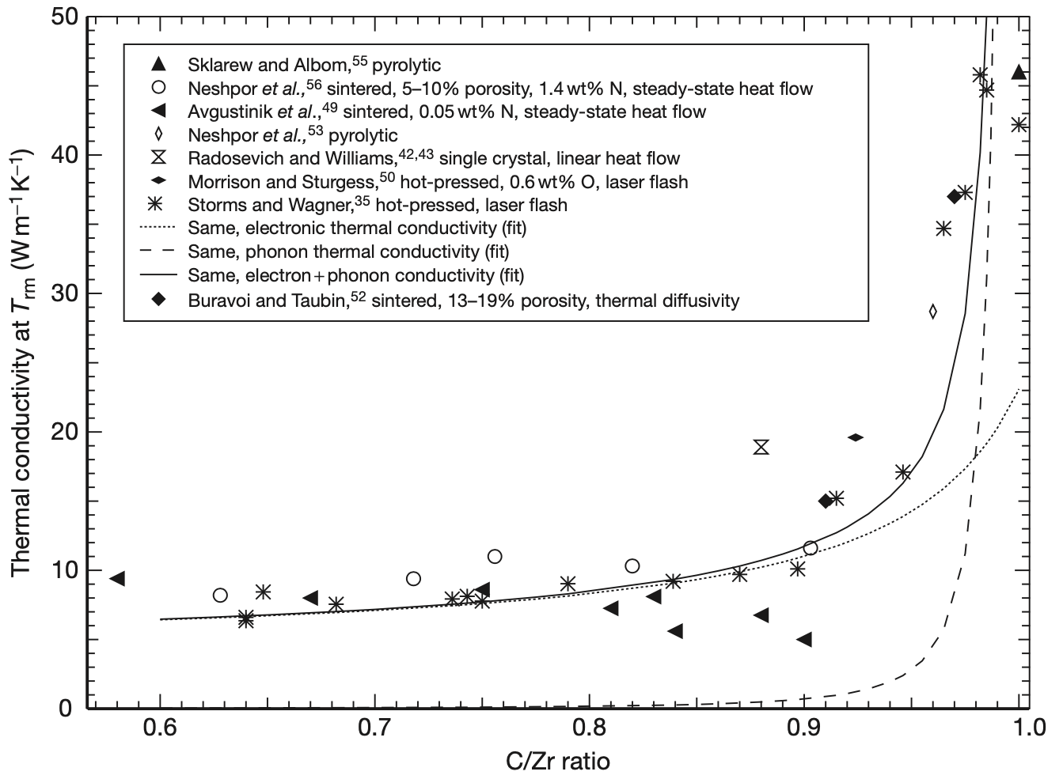
Figure 3.59. Thermal conductivity of ZrC at room temperature as a function of C/Zr ratio compiled by Jackson and Lee [69].

As with most metals and ceramics, ZrC has an increasing coefficient of thermal expansion with increasing temperature. This property depends more heavily on the porosity of the material compared with the C/Zr ratio. Figure 3.60 contains the CTE data for several ZrC materials with different stoichiometries and porosities up to 3000 ºC. The maximum measured CTE is $10×{10}^{-6} K^{-1}$ for ZrC_{0.946} sintered and tested at 2800 ºC. The effect of C/Zr ratio on the CTE is illustrated in Figure 3.61. There appears to be a slight decrease in CTE at 1273 K with increasing C/Zr ratio up to a value of 1. Most ZrC feedstocks have free carbon. The effect of free carbon on CTE was analyzed in two different studies. As shown in Figure 3.62, free carbon up to 0.5 weight percent has almost no effect on the thermal expansion of ZrC.

The vapor pressure and evaporation rates of ZrC are also important for NTP systems. The vapor pressure of ZrC, shown in Figure 3.63, follows an Arrhenius relationship. The evaporation rate, shown in Figure 3.64, also follows and Arrhenius relationship. Given the short operating time of the NTP system, these values should not cause significant concern against using ZrC as a matrix material.
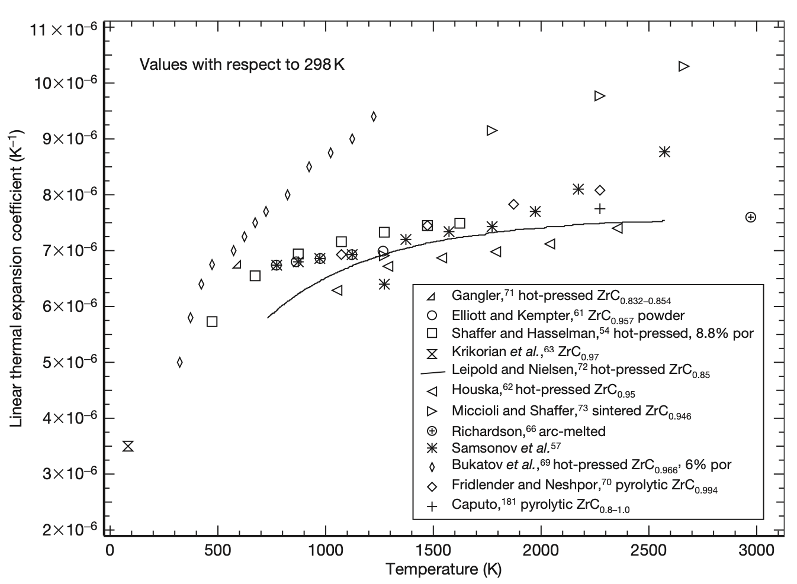
Figure 3.60. Linear coefficient of thermal expansion (CTE) of ZrC with respect to temperature compiled by Jackson and Lee [69].
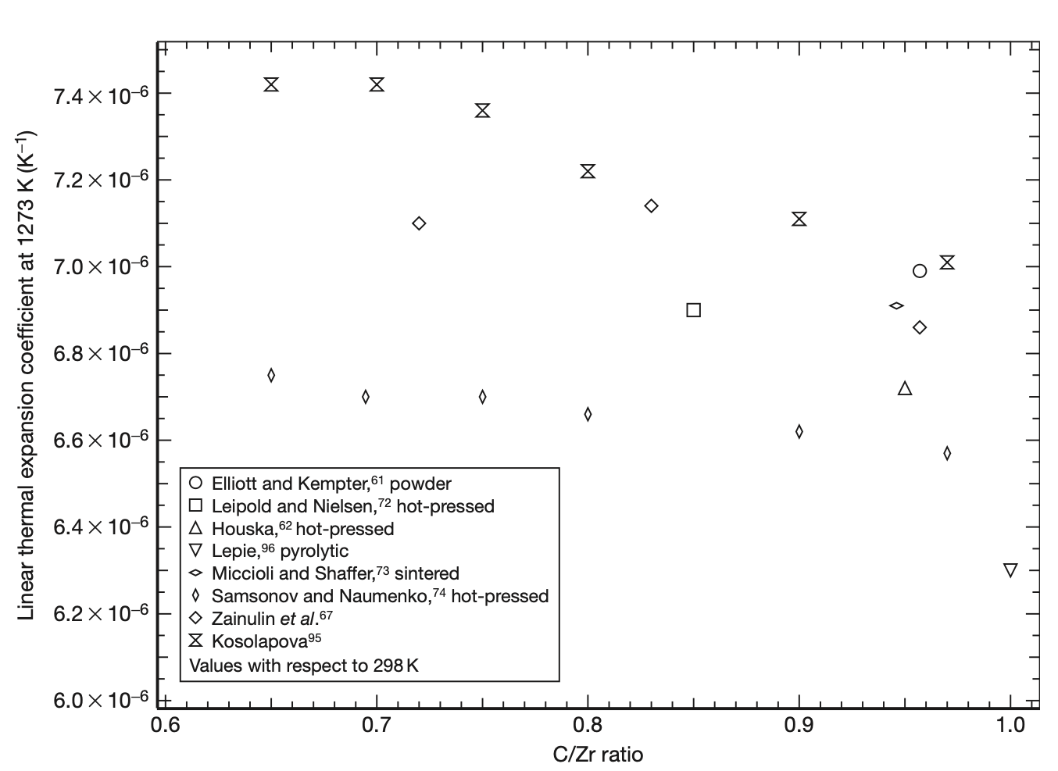
Figure 3.61. CTE of ZrC at 1273 K with respect to the C/Zr ratio compiled by Jackson and Lee [69].
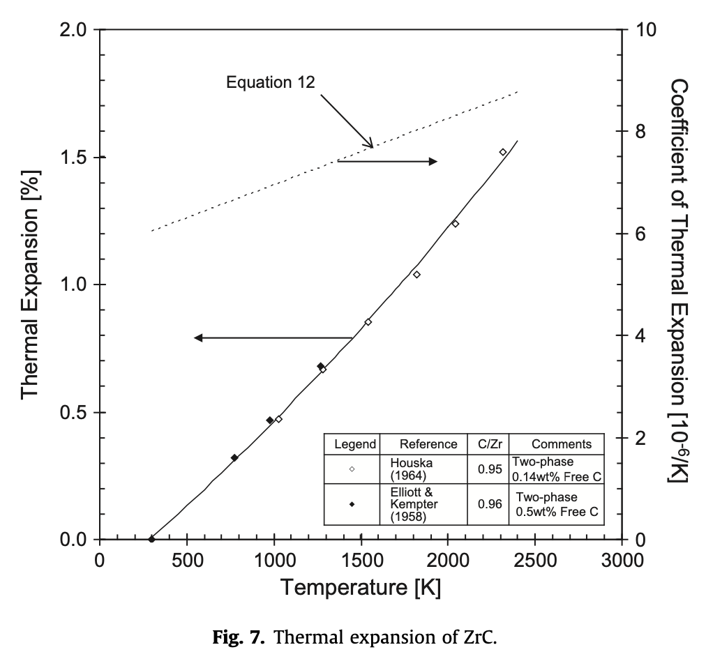
Figure 3.62. Thermal expansion and CTE, for two high stoichiometric ZrC powders with measured free carbon compile by Katoh et al. [72].

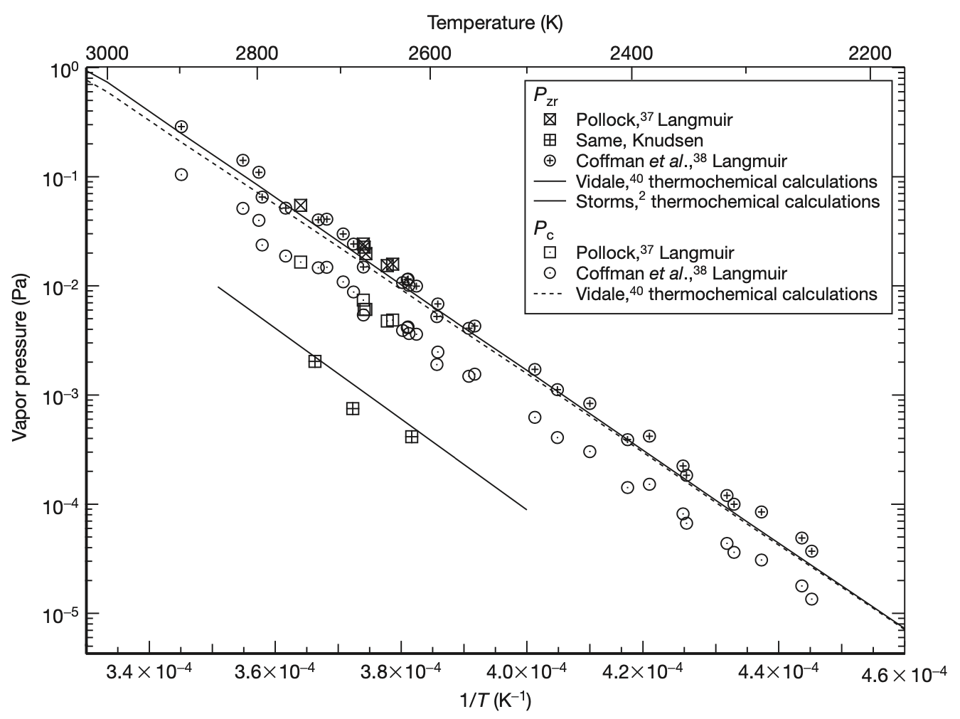
Figure 3.63. Vapor pressures of C and Zr as a function of temperature as compiled by Jackson and Lee [69].
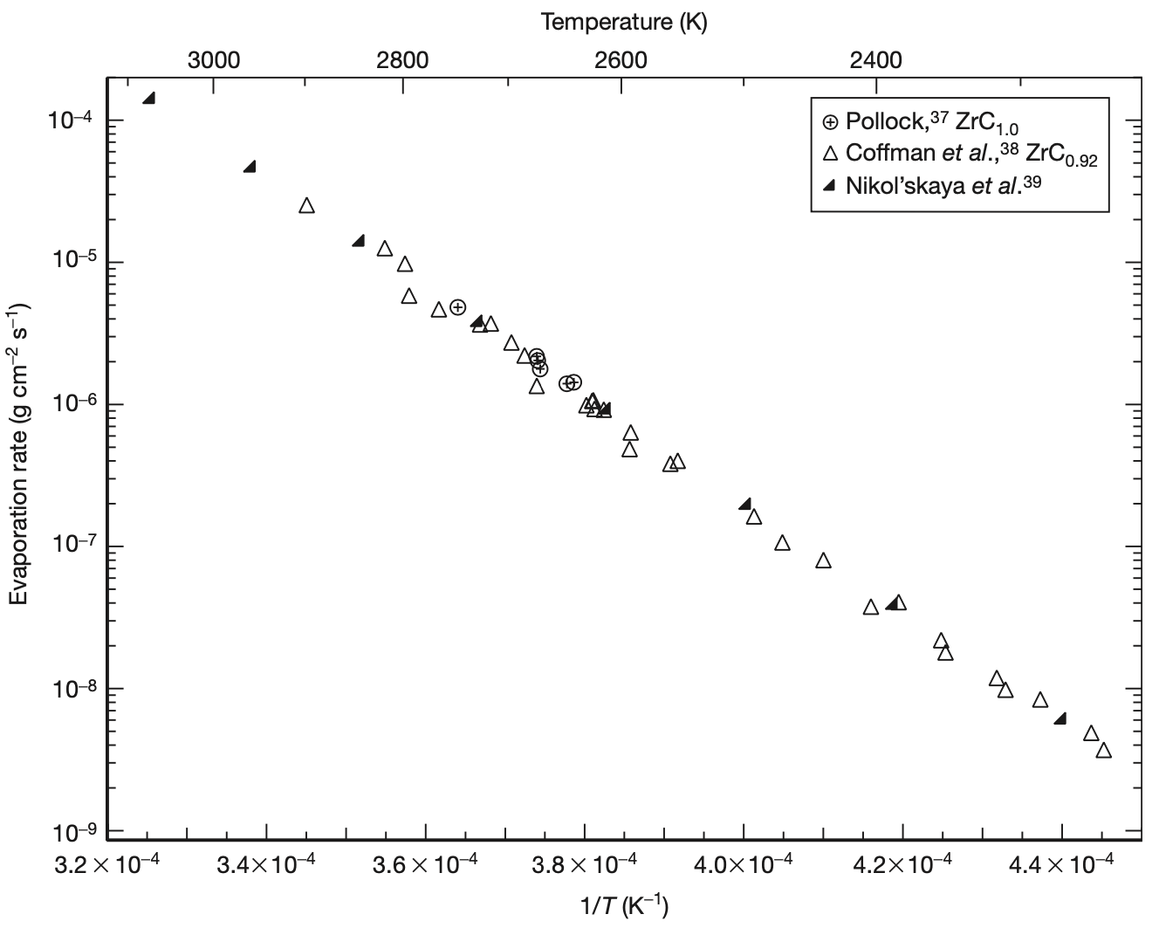
Figure 3.64. Langmuir evaporation rate of ZrC for different stoichiometric ratios at various temperatures as compiled by Jackson and Lee [69].

Mechanical Properties of Zirconium Carbide

Zirconium carbide shares similar mechanical properties to most metallic carbides. Room temperature elastic properties for stoichiometric as summarized by Jackson and Lee [69] can be found in Table 3.6.

Table 3.6. Typical elastic properties of ZrC at room-temperature compiled by Jackson and Lee [69].
C₁₁ (GPa) | 468.2 to 472
C₁₂ (GPa) | 98.7 to 99.7
C₄₄ (GPa) | 157.3 to 159.3
Young’s modulus (GPa) | 398 ± 20
Shear modulus (GPa) | 167 ± 5
Bulk modulus (GPa) | 229 ± 25
Poisson’s ratio | 0.197 ± 0.023

Like the thermal properties, the elastic moduli depend on the temperature and the C/Zr ratio. As seen in Figure 3.65, as the temperature increases, the value of Young’s modulus decreases. The change is roughly linear until around 2250 K, where there appears to be a more significant drop. More higher temperature data is needed to confirm this result. Figure 3.66 illustrates the effect of the C/Zr ratio on Young’s modulus. As the ratio decreases, so too does the value of the modulus. This change is less severe than that caused by the elevated temperature.

Hardness is a good measure of strength in a material. The hardness of ZrC decreases dramatically with increasing temperature. As seen in Figure 3.67, the loss of strength is pretty apparent above 1000 K, with the loss saturated at 1400 K. The C/Zr ratio seems to have less of an impact on the hardness, but still a noticeable one. As the C/Zr ratio falls, so too does the hardness, but much less dramatically, as show in Figure 3.68. Hardness also depends pretty heavily on grain size and porosity, which was not reported in the figure. This accounts for the wide spread of values obtained.

Katoh et al. provided a more in-depth review of hardness of ZrC by looking at single crystals with specific orientations and including hypo-stoichiometric ZrC [72]. As seen in Figure 3.69 a), there is not much effect in the hardness of ZrC based on the crystallographic plane and direction tested. This is especially true above 1000 K. Figure 3.69 b) illustrates the affect stoichiometry has on room temperature hardness. Below a C/Zr value of 1, there is an increasing hardness with increasing ratio, until there is a drop off at a value of ~0.8. Since this represents data from a single study, this is likely the case, at least for the specific material tested. Above a C/Zr ratio of 1.0, where a second phase of free carbon is present, the hardness drops of drastically, as would be expected.

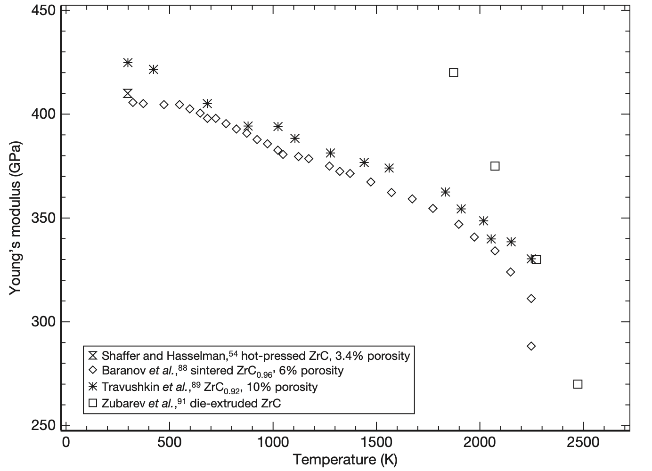
Figure 3.65. Young's Modulus of ZrC as a function of temperature compiled by Jackson and Lee [69].

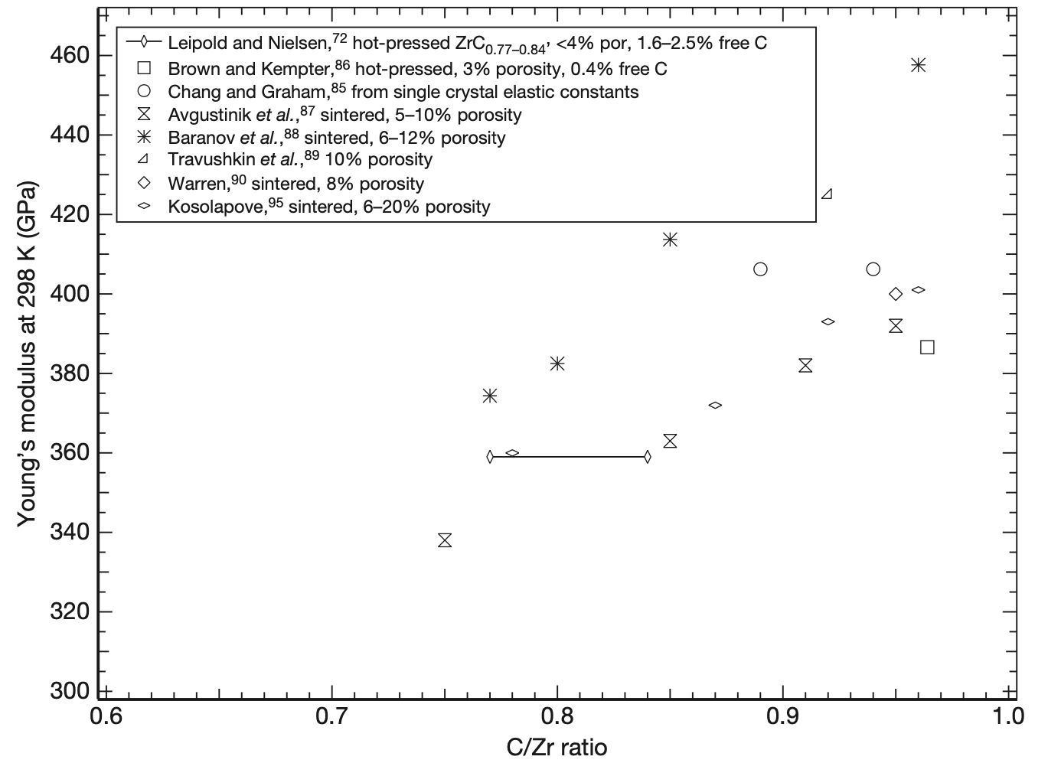
Figure 3.66. Young's modulus at room temperature as a function of the C/Zr ratio compiled by Jackson and Lee [69].

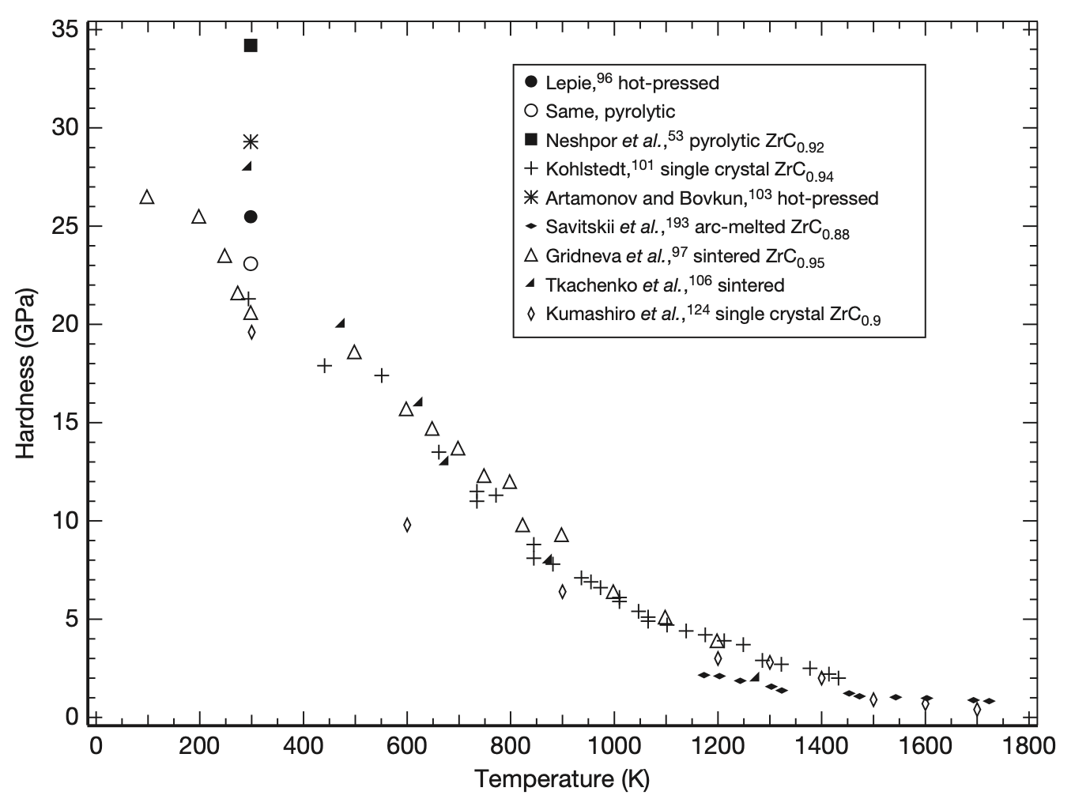
Figure 3.67. Indentation hardness of ZrC as a function of temperature compiled by Jackson and Lee [69].

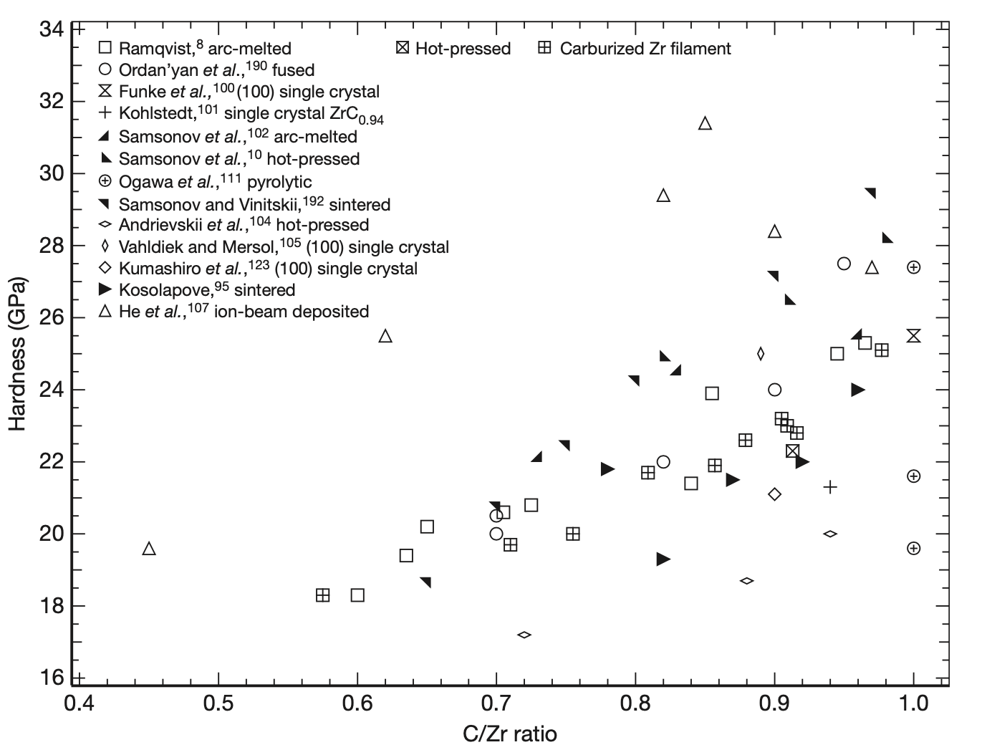
Figure 3.68. Room temperature hardness of ZrC as a function of the C/Zr ratio compiled by Jackson and Lee [69].

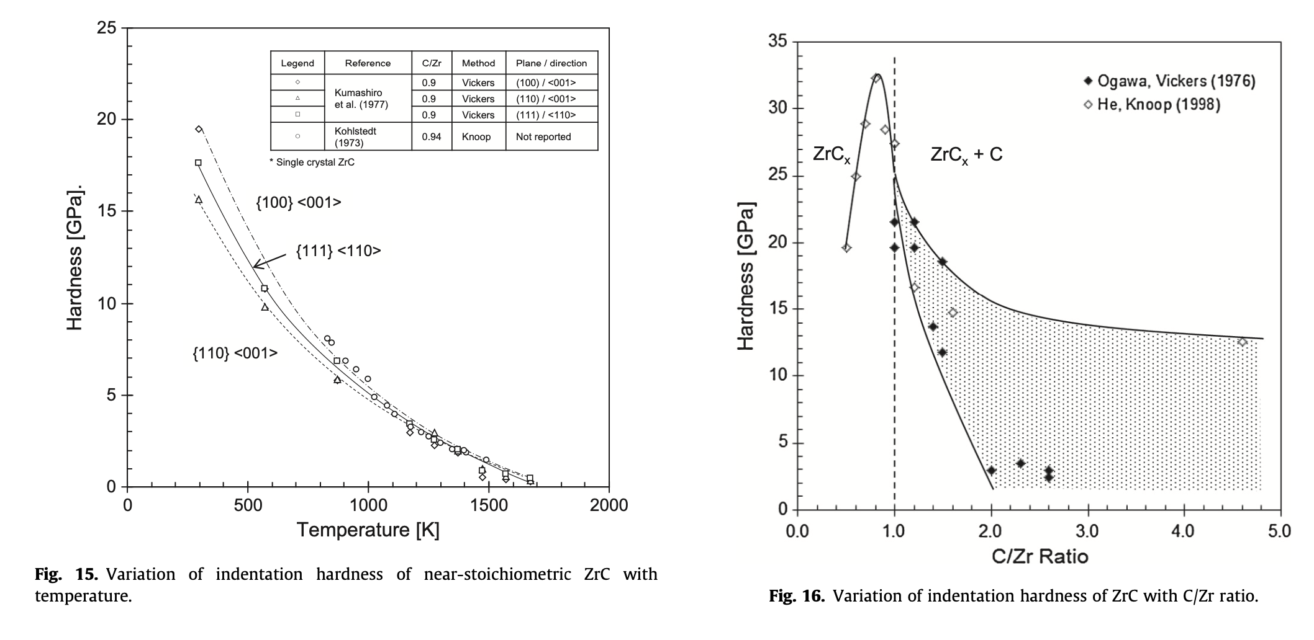
Figure 3.69. a) Indentation hardness of single crystal ZrC with respect to test temperature and b) variation of indentation hardness of ZrC with respect to the C/Zr ratio including hypo-stoichiometric carbon compiled by Katoh et al. [72].

While hardness is a convenient test to gauge mechanical properties, more information can be inferred from larger scale mechanical testing. Figure 3.70 and Figure 3.71 contain the ultimate tensile strength of ZrC and the bend strength of ZrC with respect to temperature, respectively, as compiled by Jackson and Lee [69]. The ultimate tensile strength depends heavily on the C/Zr ratio, the porosity, and the free carbon. Near stoichiometric ZrC appears to increase in strength with temperature until around 2300 K, at which point the strength begins to diminish rapidly. Other materials appear to have ultimate tensile strengths which decrease with increasing temperature. The data from the bend bar tests appears even more convoluted. Several materials experienced an increase in bend strength at moderate temperatures, while others experienced a steady decrease in bend strength with increasing temperature. Even at room temperature, the bend strength varied from around 100 to 300 MPa. The sample with the highest reported bend strength was pyrolytic ZrC_{1.03}, suggesting that a small amount of free carbon may help the mechanical properties of ZrC.

Compression testing is typically conducted on ceramics and other brittle materials to quantify strength values. Darolia and Archbold compression testing from 1200 to 1800 ºC [74].

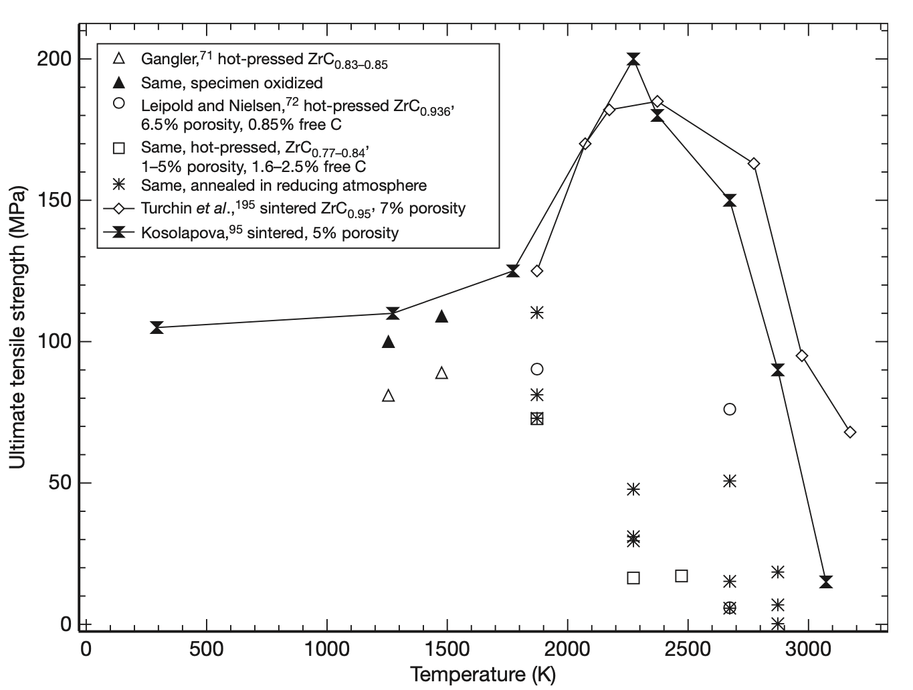
Figure 3.70. Ultimate Tensile strength of ZrC with various stoichiometries as a function of temperature compiled by Jackson and Lee [69].
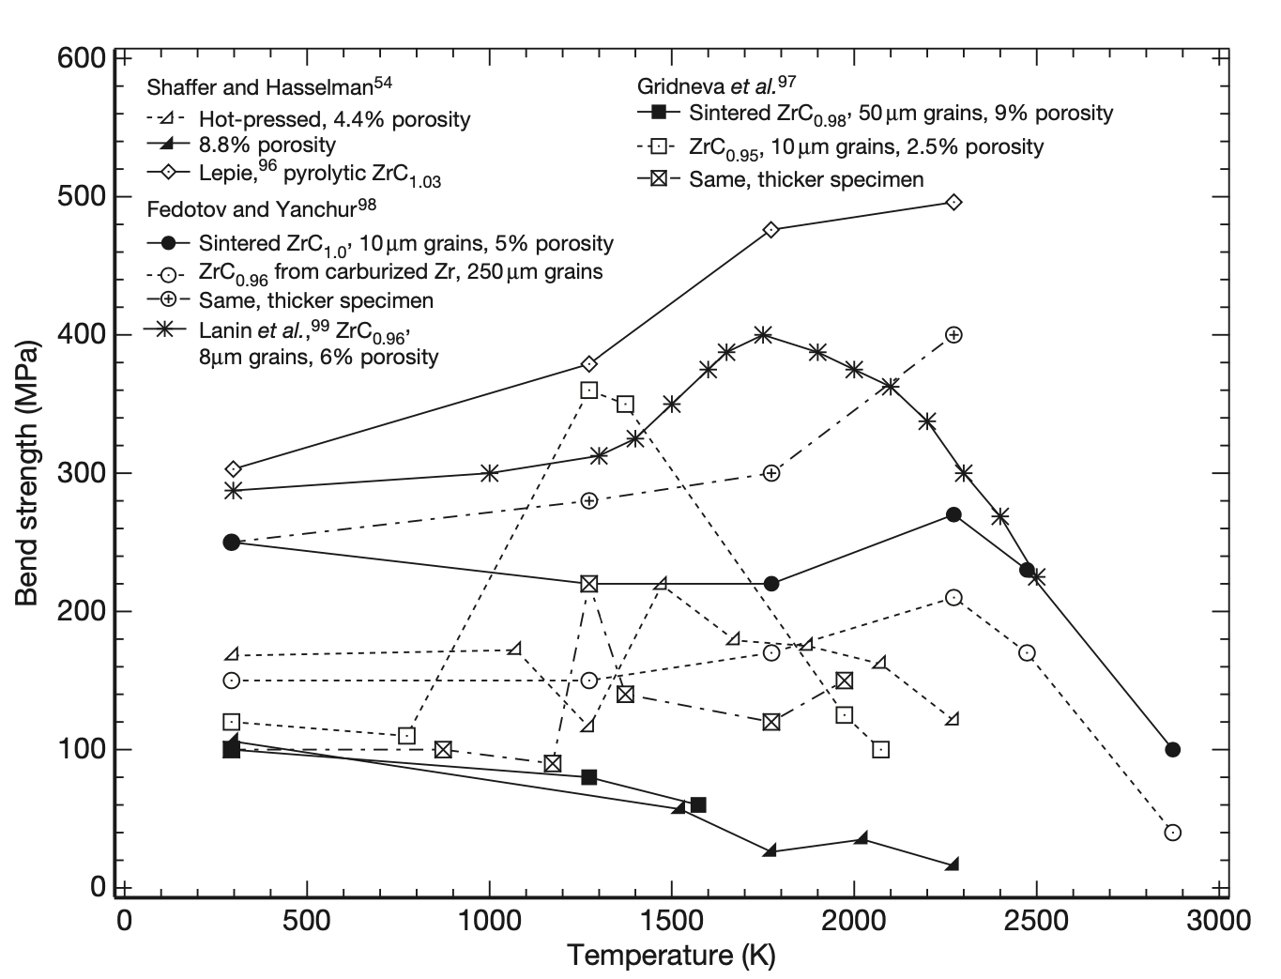
Figure 3.71. Bend strength of ZrC with respect to temperature, compiled by Jackson and Lee [69].

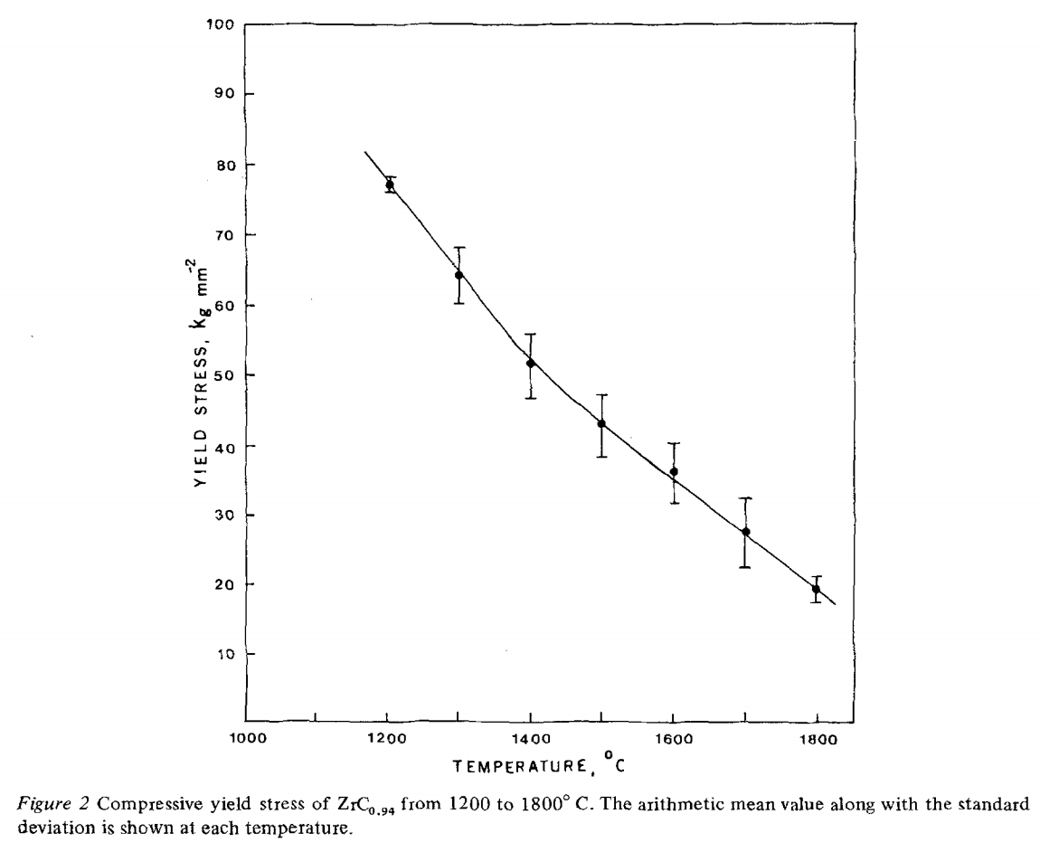
Figure 3.72. Compressive yield stress of ZrC_{0.94} from 1200 to 1800 ºC taken from Darolia and Archbold [74].

Two studies looked at the room temperature mechanical properties of hot pressed ZrC. These properties are listed in
Table 3.7. Korklan et al. tested the mechanical properties ZrC_{0.92} at room temperature [75]. The material was hot pressed using a step method starting at 1600 ºC and with a maximum temperature of 2150 ºC for 35 minutes with a uniaxial pressure of 32 MPa. Fracture toughness tests were conducted using a chevron notched ben bar test. Feng et al. also looked at the room temperature mechanical properties of ZrC [76]. These samples were hot pressed at 1900 ºC and 32 MPa for 1 hour. The final stoichiometry of the ZrC was not reported in the article. Feng et al. also tested the fracture toughness of the ZrC material. Short type-B bars (24 mm x 4 mm x 3 mm) were prenotched using a Vickers indenter to a load of 5 kg. This notch acted as the crack propagation site. The samples were then tested using a four-point bending apparatus. The fracture toughness was determined from Equation 3.18, where $η_{V}^{R}$ is a geometric constant, $E$is the Young’s modulus (GPa), $H$is the Vickers hardness (GPa), $σ$is the four-point bending strength (MPa), and $P$is the indentation load (N).
 | $$K_{IC}=η_{V}^{R}{\left(\frac{E}{H}\right)}^{\frac{1}{8}}{\left(σP^{\frac{1}{3}}\right)}^{\frac{3}{4}}$$ | Equation 3.18

As discussed previously, the stoichiometry can greatly affect certain mechanical properties of ZrC. These two studies show similar values, with noticeable differences. The material produced by Korklan et al. had a higher flexural strength and fracture toughness. The flexural strength tests were almost identical, except for the specimen size, but the fracture toughness measurements utilized two different testing methods, which makes it difficult to compare directly.

Table 3.7. Room temperature mechanical properties of hot pressed ZrC as reported by Korklan et al. [75] and Feng et al. [76].
Source | Composition | Relative Density (%) | Grain Size (μm) | Young’s Modulus (GPa) | Shear Modulus (GPa) | Hardness (GPa) | Flexural Strength (MPa) | Fracture Toughness (MPa m^{1/2})
Korklan et al. | ZrC_{0.92} | 95.9 | 2.7 ± 1.4 | 397 ± 13 | 161 ± 4 | 17.0 – 19.5 | 362 ± 46 | 2.9 ± 0.1
Feng et al. | Not Given | 96.8 | 0.6 ± 0.3 | 405 | N/A | 18.6 ± 0.8 | 310 ± 10 | 2.35 ± 0.20

Surrogate Ceramic Particle Selection and Properties

As discussed previously, to simplify the fabrication and testing of the sintered materials, non-radioactive surrogate ceramic particles were used. Currently, the three fuel forms of interest are uranium dioxide (UO2), uranium nitride (UN), and uranium carbide (UC).

Properties of Oxide Fuels

Uranium dioxide (UO₂) is the most common fuel form for commercial nuclear reactors. Its properties are well understood. Yttria stabilized zirconia (YSZ) has been used as a surrogate for UO₂ for a variety of different research applications, mostly pertaining to NTP [40, 77, 78]. At room temperature, normal zirconia (ZrO₂) exists in the monoclinic crystal structure. The addition of yttria, allows for the cubic phase to become stable at room temperature as seen in Figure 3.73 [79].
Table 3.8 contains a summary of room temperature properties for UO₂ and YSZ. Several properties line up well, such as young’s modulus and Poisson’s ratio. The coefficient of thermal expansion is also close at room temperature. There are significant differences in density and thermal conductivity between the two materials.

Table 3.8. A summary of material properties for UO2 and YSZ.
Properties | UO₂ | YSZ
Crystal Structure | Cubic ^{[80]} | Cubic ^{[79]}
Lattice Parameter (Å) | 5.473 ^{[81]} | 5.143 – 5.152 ^{[82]}
Density (g/cm³) | 11.084 ^{[80]} | 5.8 – 6.1
Melting Point (ºC) | 2852 ^{[83]} | > 2600
Poisson Ratio | 0.324 ^{[84]} | 0.3
Young’s Modulus at 298 K (GPa) | 220 ± 1 ^{[85]} | 200-210 ^{[86]}
Heat Capacity at 298 K (J/mol K) | 63 ^{[87]} | 55 ^{[88]}
Thermal Expansion at 298 K (x 10⁻⁶/ºC) | 8.9 ^{[89]} | 7.2-8.7 ^{[90]}
Thermal Conductivity at 298 K (W/mK) | 10.2 ± 1 ^{[91]} | 1.7 – 3.1 ^{[92]}

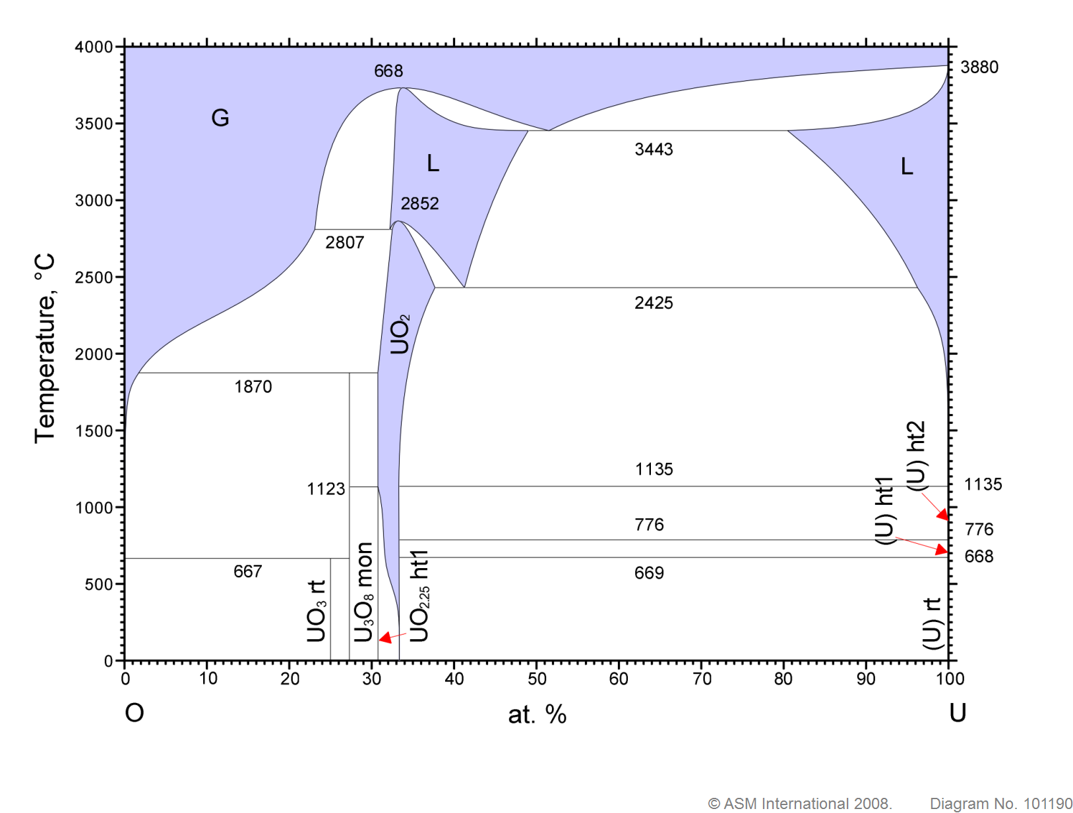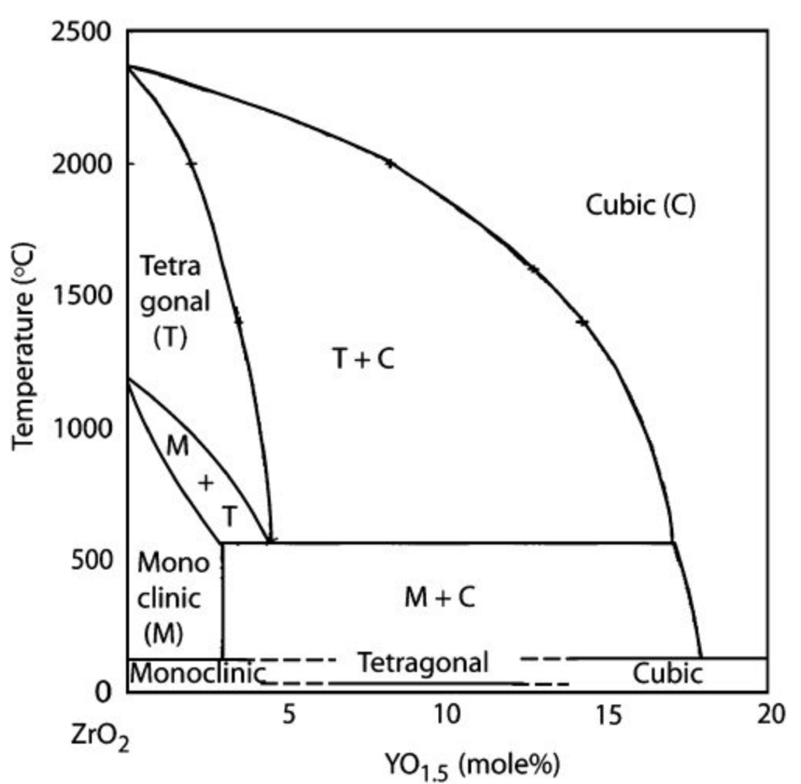
Figure 3.73. a) Uranium-oxygen binary phase diagram [83], and b) ZrO₂ – YO_{1.5} phase diagram [79].

Figure 3.74 summarizes the temperature dependence of the dynamic elastic modulus of YSZ compared with pure ZrO₂. There is very limited data available for the modulus of UO₂ at elevated temperatures.

Given the data available, the heat capacity of YSZ matches that of UO₂ fairly well over a large yttria concentration up to 1500 K. Above 1500 K, there is a lack of data available for YSZ. The heat capacity of UO2 did not vary much with different material compositions, as shown in Figure 3.76 up to 3000 K.

The thermal conductivity of UO₂ is significantly higher than YSZ, at least below 400 ºC as seen in Figure 3.79. Above 400 ºC, UO₂ appears to be trending down towards values more comparable to that of YSZ. Figure 3.80 contains the thermal diffusivity of UO₂ up to the melting point. Above 1600 K, the decrease in thermal diffusivity levels off. Fink et al. presented a model for the thermal conductivity of UO₂ up to the melting point [93]. This equation is presented in Equation 3.19.

 | $$λ_{0}\left(T\right)=\frac{115.8}{7.5408+17.692t+3.6142t^{2}}+7410.5t^{-\frac{5}{2}}\exp\left(-\frac{16.35}{t}\right)$$ | Equation 3.19

Thermal expansion is an important property, especially when considering the fabrication of cermets and cercers above 1600 ºC. As samples are heated, sintered, then cooled, mismatch between thermal expansion can cause cracking and significant stresses to be introduced into the cooled, solidified composite. Figure 3.81 compares the CTE of YSZ from 3 to 10 mol% yttria with UO₂. There is a good match above 500 K. However, below 500 K UO₂ experiences a significantly lower CTE compared with YSZ. Additional thermal expansion data for UO2 up to the melting point is presented in Figure 3.82.

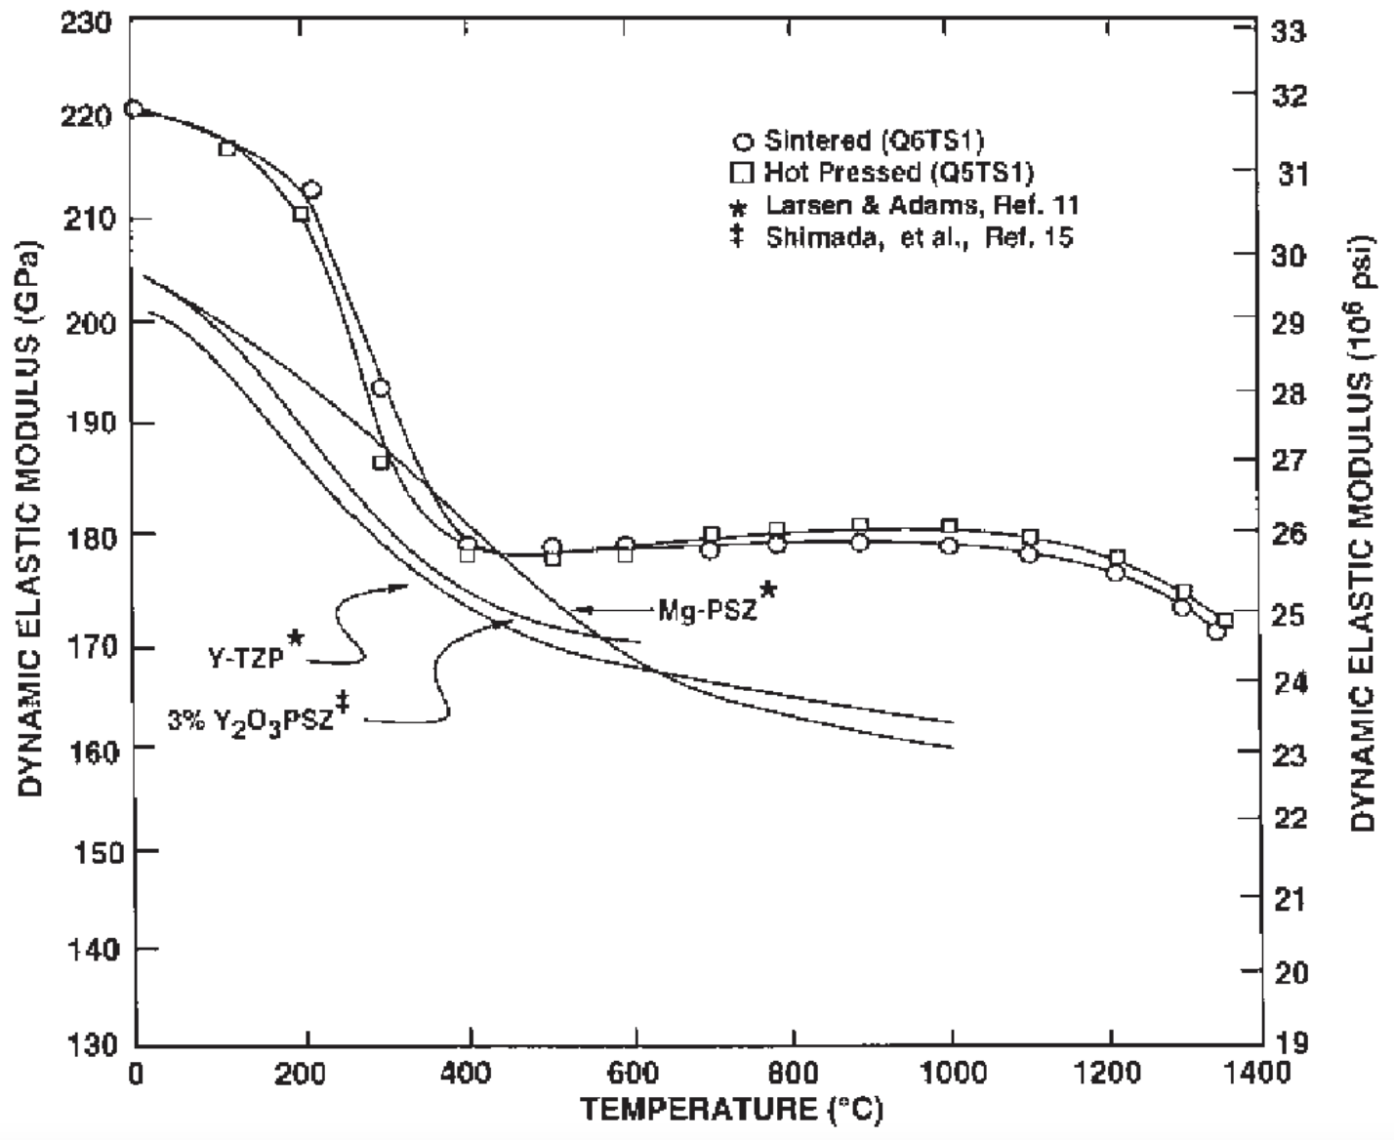
Figure 3.74. Dynamic elastic modulus of YSZ compared with transformation-toughened ZrO₂ [86].
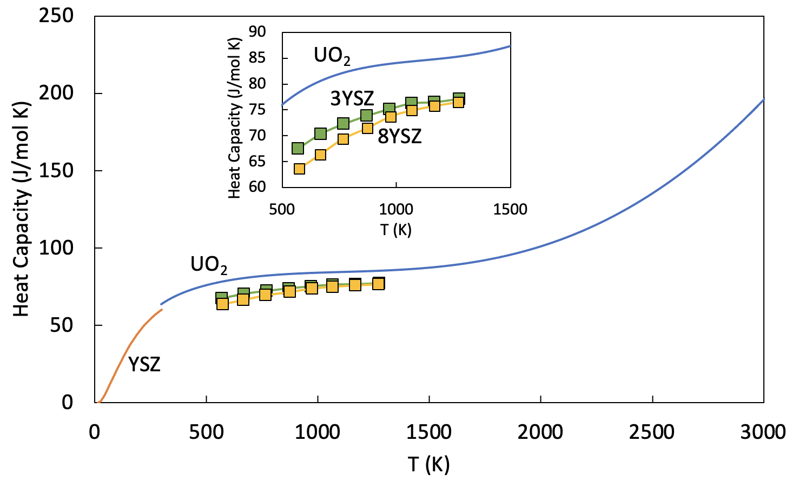
Figure 3.75. Heat capacity of UO2 (solid blue line) from Fink et al. [87], of 7.76 x 10⁻² mole fraction YSZ (orange line) from Tojo et al. [88], and of 3 mole percent YSZ (green squares) and 8 mole percent YSZ (yellow squares) from Sasaki et al. [94].

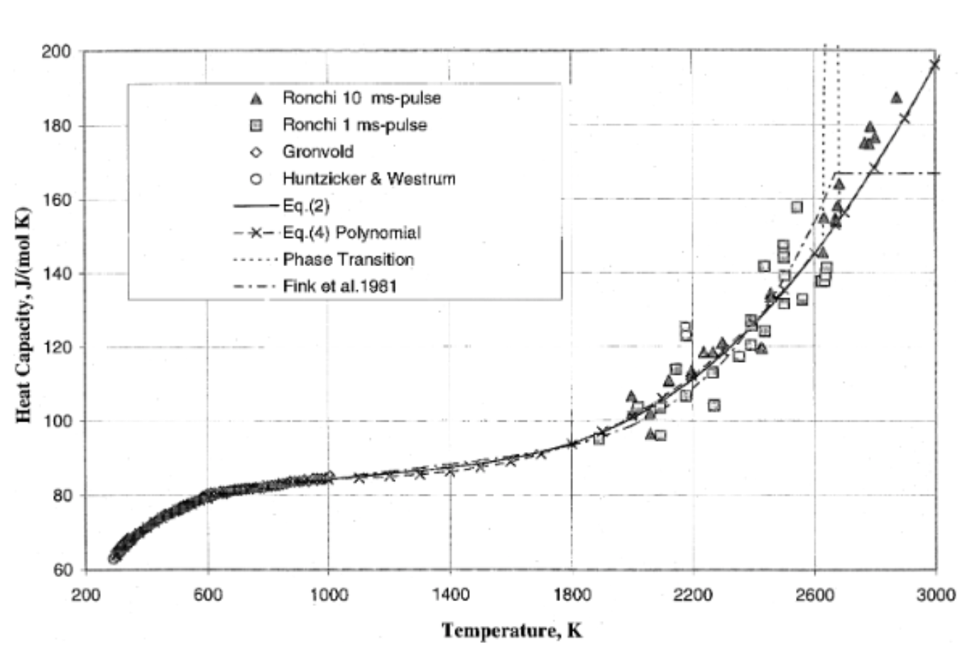
Figure 3.76. Heat capacity of solid UO₂ compiled by Fink [87].
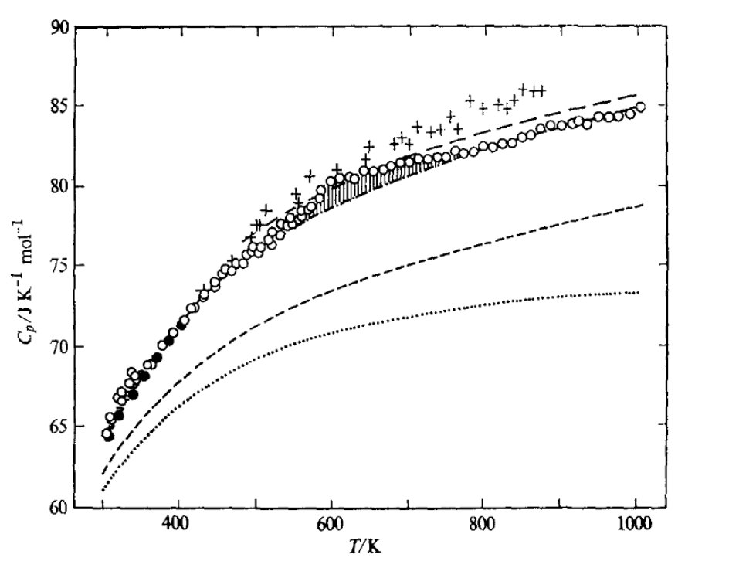
Figure 3.77. Heat capacity of UO₂ with the lines representing various models, and the open circles and crosses representing data from Grønvold et al. [95].
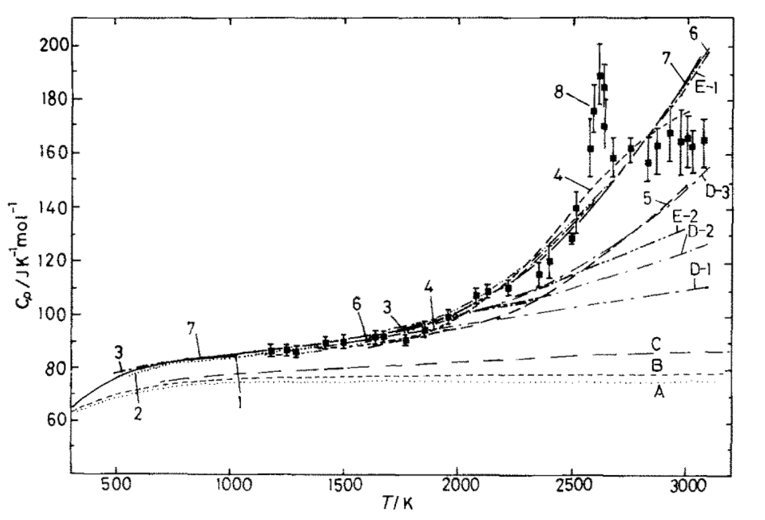
Figure 3.78. Heat capacity of UO₂ from various sources compiled by Naito [96].

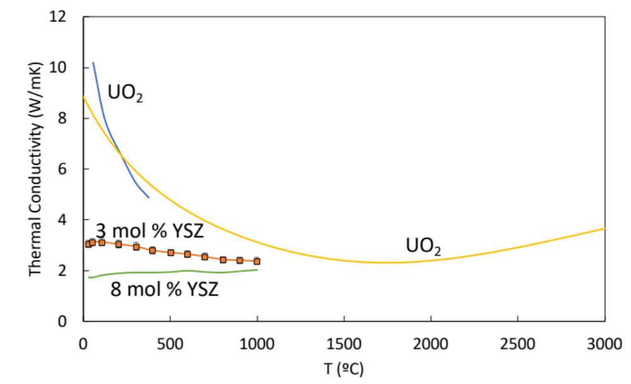
Figure 3.79. Thermal conductivity of fully dense UO₂ to 370 ºC (blue line) [91], a model for UO₂ up to 3000 ºC (yellow line) , and YSZ samples of 3 (orange squares) and 8 mol% (green circles) yttria stabilized zirconia up to 1000 ºC [92].

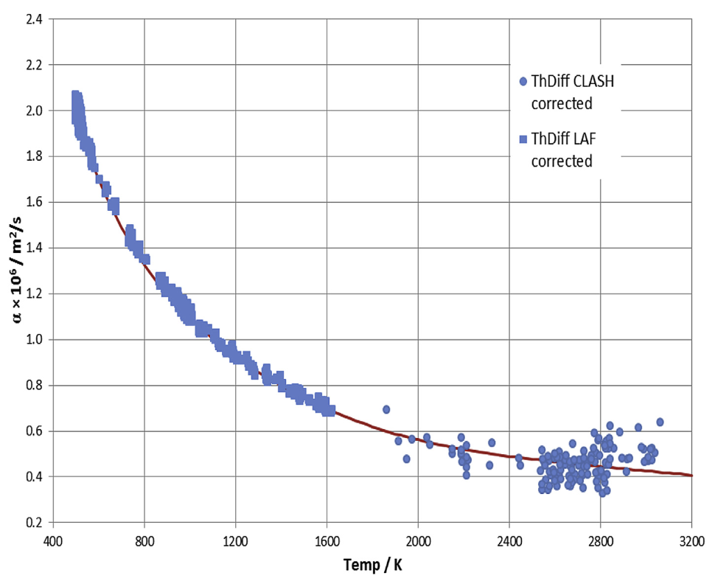
Figure 3.80. Thermal diffusivity of UO₂ up to the melting point [97].
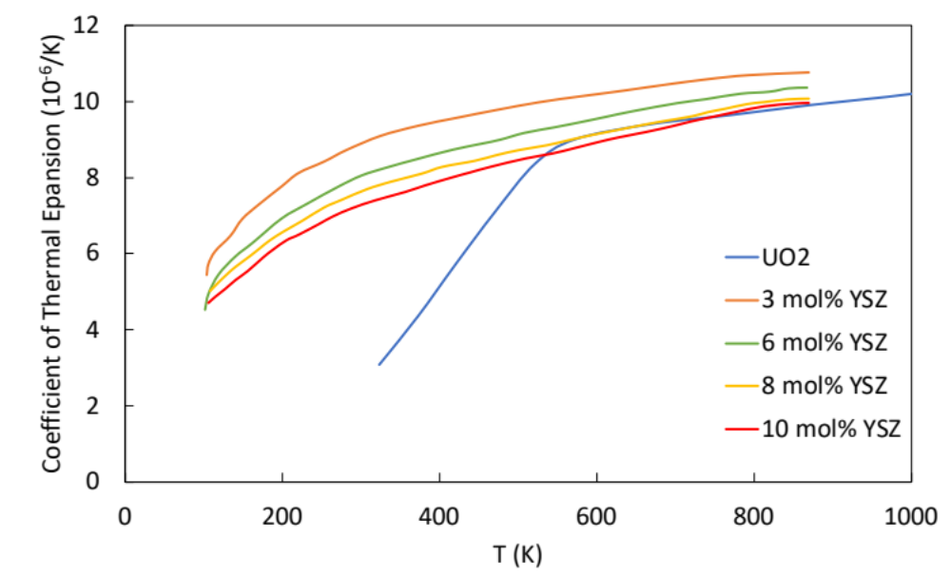
Figure 3.81. Coefficient of thermal expansion for UO₂ [89], and for YSZ of various molar percentages [90].

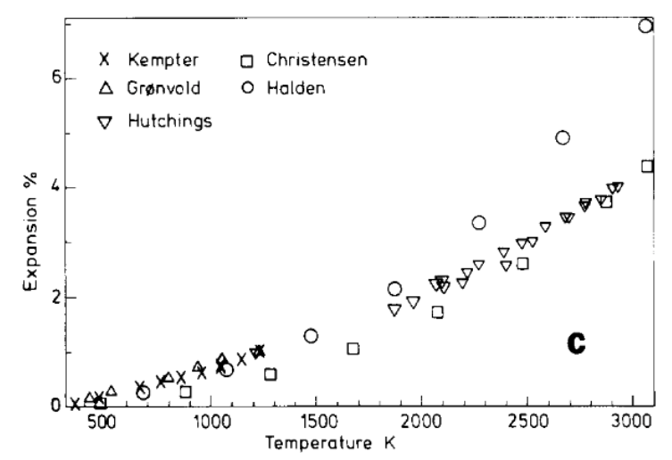
Figure 3.82. Thermal expansion of stoichiometric UO₂ from various sources, compiled by Martin [98].

Properties of Nitride Fuels

Uranium nitride (UN) is a promising fuel for NTP due to its similar melting point and higher uranium density compared with UO₂. UN is less understood than UO₂, since UO₂ has been heavily utilized as the primary fuel in commercial light water reactors. A major concern with UN is that it begins to dissociate at temperatures above ~1800 K (generating low-melting metallic U) [99], so the stability of UN at NTP-relevant temperatures above 2700 K needs careful evaluation. Hafnium nitride (HfN) was selected as the surrogate for UN. Stoichiometric UN is very similar to HfN, as seen in the room temperature properties summarized in
Table 3.9. The crystallographic and elastic properties of both materials are very similar. Conversely, there is a significant difference in the thermal expansion and thermal conductivity of UN compared with HfN. Interestingly, Hf₄N₃ is sometimes sold as stoichiometric HfN from commercial venders. For this reason, some properties of Hf₄N₃ were also included in the table. The phase diagrams of the uranium nitrogen and hafnium nitrogen systems are included as well in Figure 3.83.

Heat capacity data at elevated temperatures for HfN is presented in Figure 3.84 and Figure 3.85. The increase in heat capacity from 800 K to 2000 K is roughly linear.

The thermal conductivity of UN and HfN match fairly well up to high temperatures. Figure 3.86 compares stoichiometric UN to slightly sub stoichiometric HfN. The thermal conductivity of HfN is higher than that of UN by 15% at 0 ºC. The difference increases with increasing temperature. Figure 3.87 contains additional thermal conductivity data for UN, illustrating how dependent this property is upon stoichiometry and sample porosity.

The thermal expansion of UN and HfN also matches fairly well up to 800 ºC, as seen in Figure 3.88. The higher temperature expansion of the two materials was determined using the change in lattice parameter with increasing temperature.

Young’s modulus of nitrides is highly dependent upon the porosity of the material. Young’s modulus as a function of porosity is shown in Figure 3.89. As porosity increases, the modulus decreases.
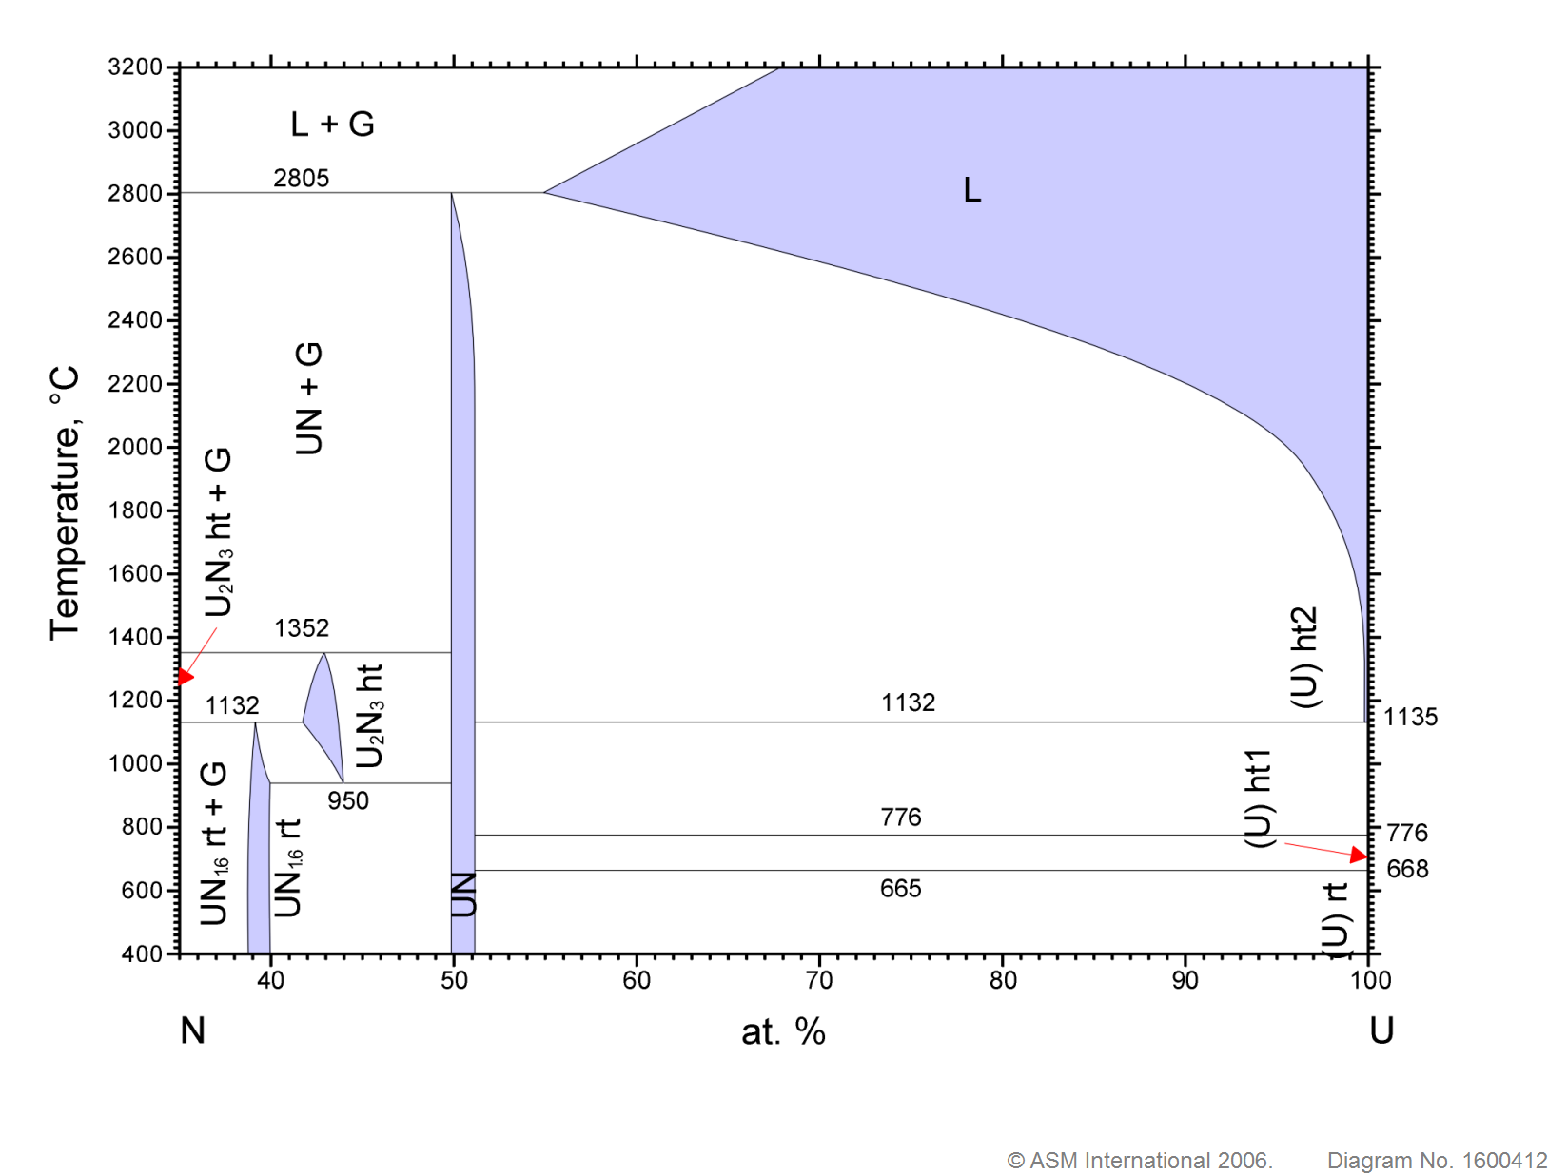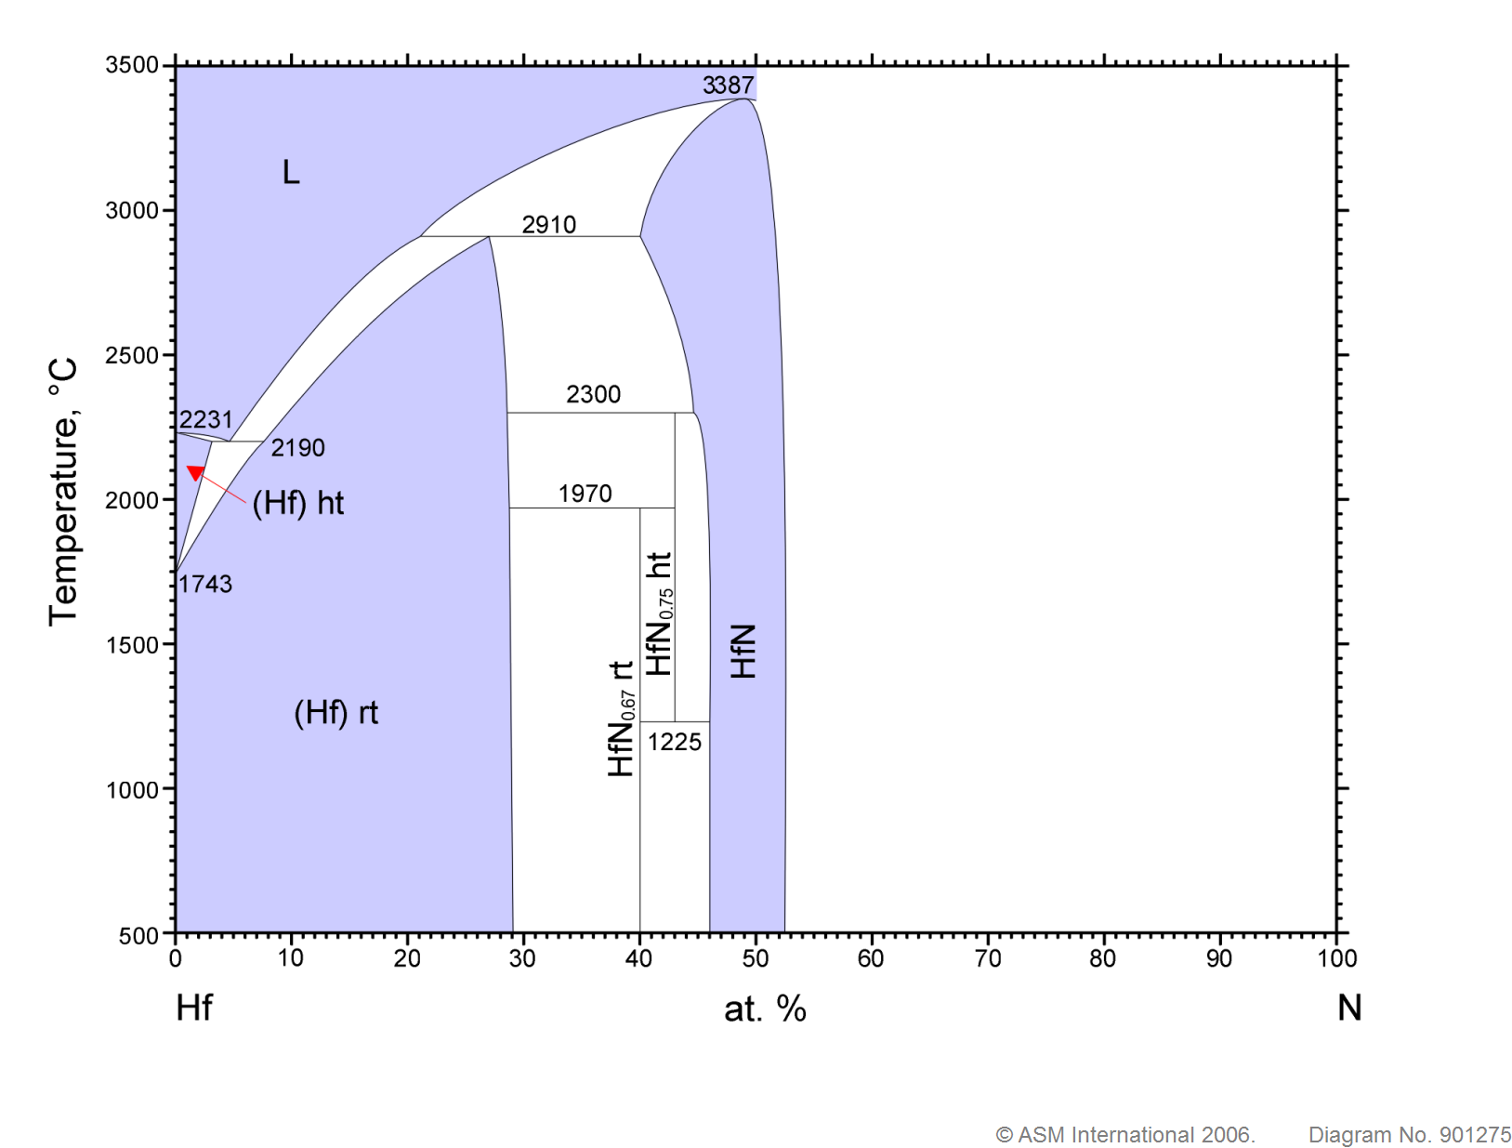
Figure 3.83. a) Uranium-nitrogen phase diagram [100] and b) hafnium-nitrogen phase diagram [101].

Table 3.9. Room temperature properties of UN, HfN, and Hf₃N₄.
Properties | UN | HfN | Hf₃N₄
Crystal Structure | Fm3m ^{[102]} | Fm3m ^{[103]} | -I42 ^{[104]}
Lattice Parameter (Å) | 4.88 ^{[105]} | 4.52 ^{[103]} | 6.701(6) ^{[106]}
Density (g/cm³) | 14.32 ^{[105]} | 13.83 ^{[107]} | 13.058 ^{[106]}
Melting Point (ºC) | 3416 ^{[108]} | 3387 ^{[107]} | N/A
Young’s Modulus at 298 K (GPa) | 200-250 ^{[109]} | 266 ^{[104]} | 260 ^{[104]}
Poisson Ratio | 0.34 ^{[104]} | 0.25 ^{[104]} | 0.30 ^{[104]}
Heat Capacity at 298 K (J/mol K) | 37.5 ^{[110]} | 38.01 ^{[107]}
Thermal Expansion at 298 K (x 10⁻⁶/ºC) | 7.5 ^{[111]} | 21.7 ^{[107]}
Thermal Conductivity at 298 K (W/mK) | 12.7 ^{[112]} | 14.9 ^{[113]}

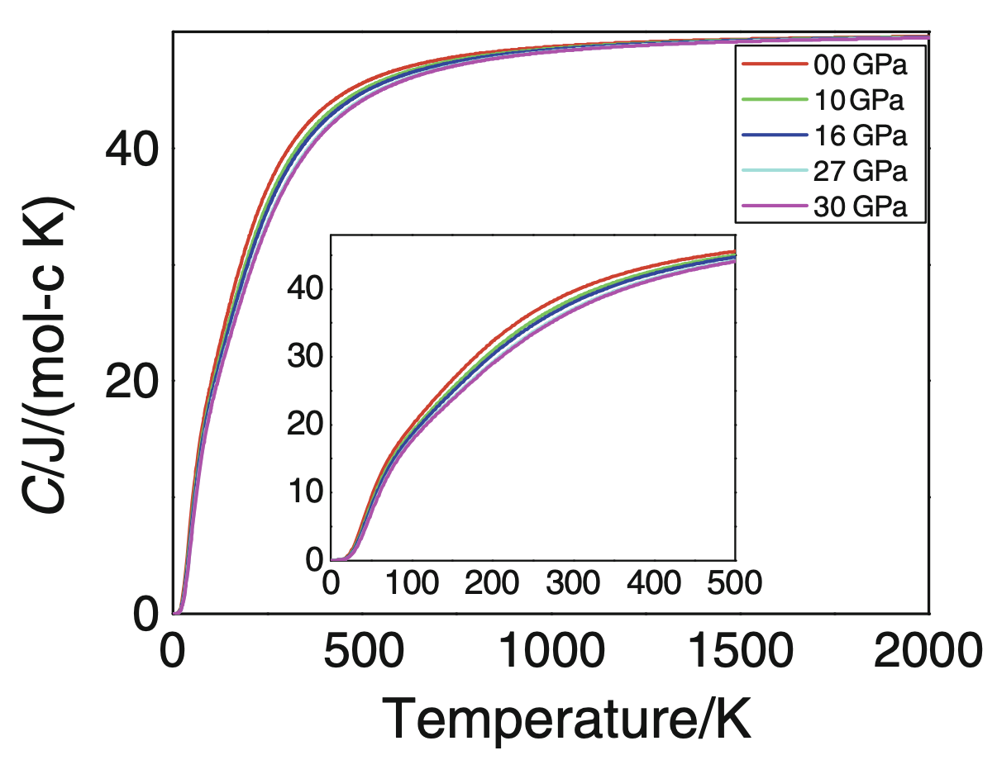
Figure 3.84. Computed heat capacity of HfN [110].
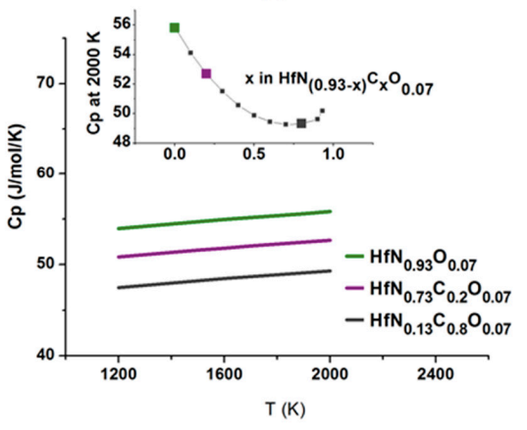
Figure 3.85. High temperature heat capacity of HfN carbo-oxides [103].

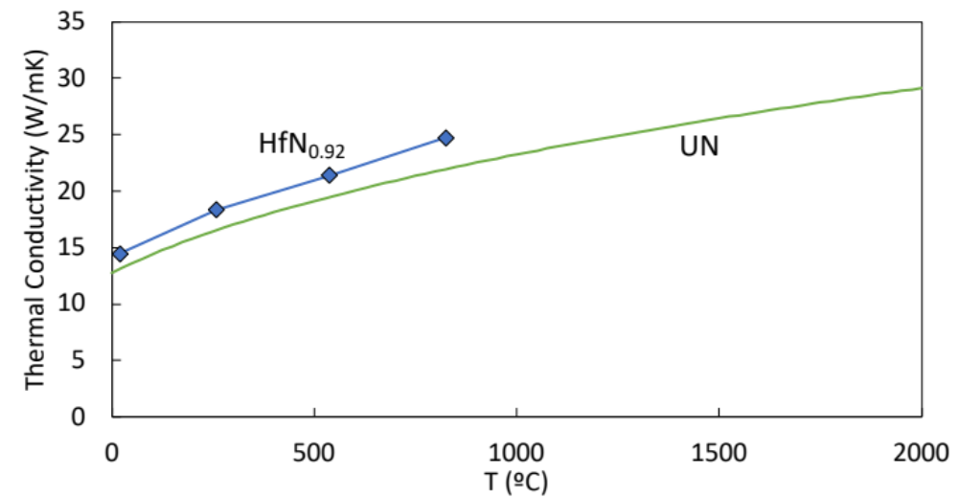
Figure 3.86. Thermal conductivity of HfN_{0.92} (blue) [113] and of UN (green) [112].
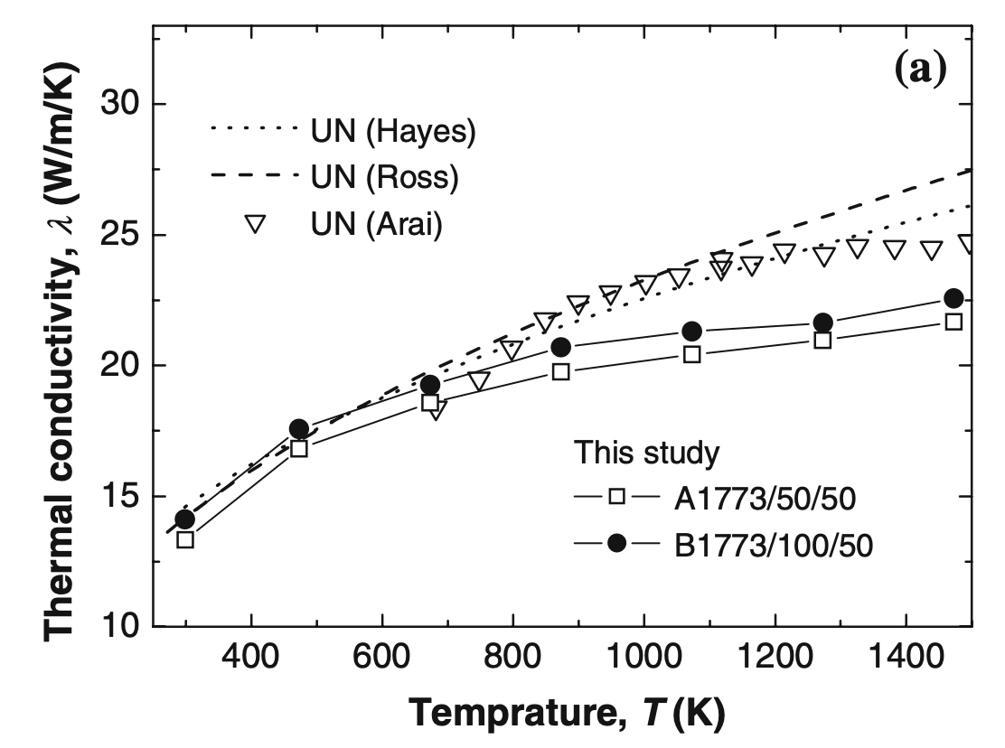
Figure 3.87. Thermal conductivity of uranium nitride from various studies compiled by Muta et al. [109].

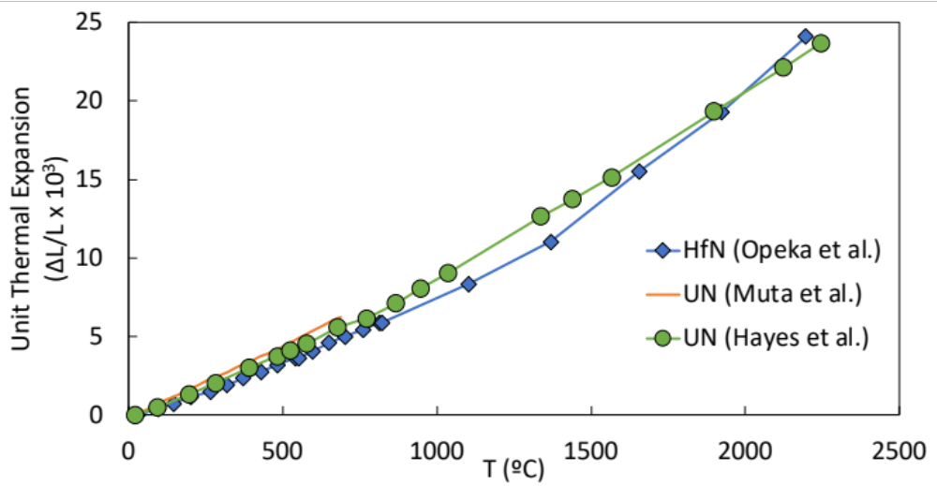
Figure 3.88. Unit thermal expansion of HfN_{0.92} (blue) [113], UN (orange) [109], and UN (green) [114].
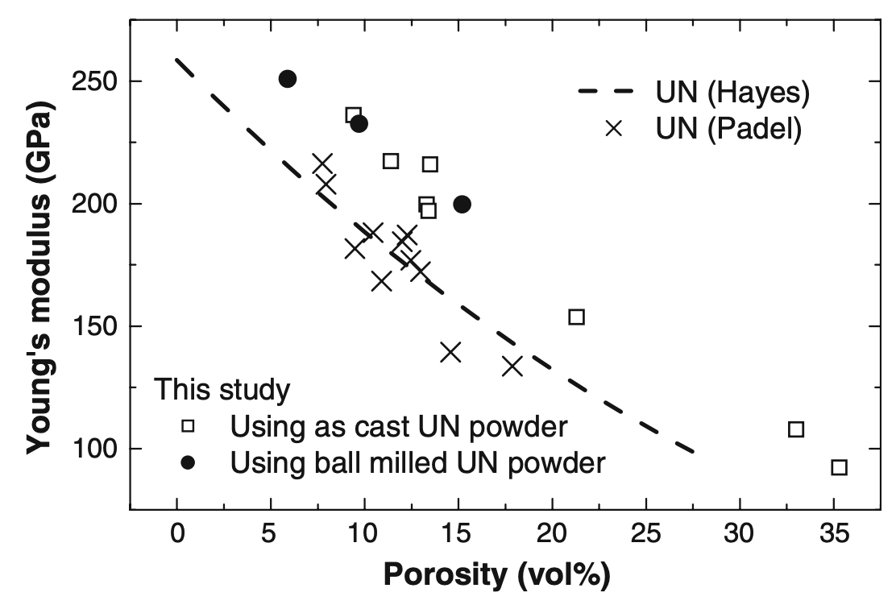
Figure 3.89. Young's modulus of UN with respect to porosity compiled by Muta et al. [109].

Fabrication of Matrix and composite Materials Using SPS

Thermophysical Properties And Model

Mechanical Properties And Model

Conclusions and Recommendations

List of References
References

[1] Borowski S.K., McCurdy D.R., Packard T.W. Nuclear thermal propulsion (ntp): A proven growth technology for human neo/mars exploration missions. Aerospace Conference, 2012 IEEE: IEEE; 2012. p. 1-20.
[2] Joyner C.R., Deason W., Eades M., Kokan T., Levack D.J., Widman F., et al. Ntp design sensitivities for human lunar and mars missions. 2018 Joint Propulsion Conference2018. p. 1-13.
[3] Stewart M., Schnitzler B.G. A comparison of materials issues for cermet and graphite-based ntp fuels. 49th aiaa/asme/sae/asee joint propulsionconference2013. p. 3999.
[4] Bhattacharyya S. An assessment of fuels for nuclear thermal propulsion. Argonne National Lab., IL (US); 2002.
[5] Reynolds C.B., Joyner C.R., Kokan T.S., Levack D.J., Muzek B. Ntp robustness for mars conjunction and opposition class missions. Ascend 20202020. p. 4124.
[6] Clark J. Analysis of crewed missions enabled by a bimodal nuclear thermal electric propulsion system: The Ohio State University; 2019.
[7] Watson C.W. Nuclear rockets: High-performance propulsion for mars. Los Alamos National Lab., NM (United States); 1994.
[8] Koenig D.R. Experience gained from the space nuclear rocket program (rover). LA-10062-H: Los Alamos National Laboratory; 1986. p. 1-58.
[9] Finseth J. Rover nuclear rocket engine program: Overview of rover engine tests. N--92-15117. Huntsville, AL (United States): Sverdrup Technology, Inc.; 1991.
[10] Walton J. An overview of tested and analyzed ntp concepts. Conference on Advanced SEI Technologies1991. p. 3503.
[11] Hickman R., Broadway J., Mireles O. Fabrication and testing of cermet fuel materials for nuclear thermal propulsion. 48th AIAA/ASME/SAE/ASEE Joint Propulsion Conference & Exhibit2012. p. 1-18.
[12] Stewart M., Schnitzler B.G. A comparison of materials issues for cermet and graphite-based ntp fuels. 49th AIAA/ASME/SAE/ASEE Joint Propulsion Conference2013.
[13] Hickman R., Panda B., Shah S. Fabrication of high temperature cermet materials for nuclear thermal propulsion. 2005.
[14] Anghaie S., Harris P. Evaluation of cermet fuels test data. Proceedings of the 2004 international congress on advances in nuclear power plants-ICAPP'042004.
[15] BRENGLE R., HARTY R., BHATTACHARYYA S. The promise and challenges of cermet fueled nuclear thermal propulsion reactors. 29th Joint Propulsion Conference and Exhibit1993. p. 2111.
[16] Kruger G. 710 high temperature gas reactor program summary report – volume 3, fuel element development. GEMP-600 Cincinnati, OH: General Electric; 1973.
[17] Smith T.E.R. Ablation study of tungsten-based nuclear thermal rocket fuel. The George Washington University. 2014.
[18] Munir Z.A., Anselmi-Tamburini U., Ohyanagi M. The effect of electric field and pressure on the synthesis and consolidation of materials: A review of the spark plasma sintering method. Journal of Materials Science. 2006;41:763-777.
[19] Haertling C., Hanrahan R.J. Literature review of thermal and radiation performance parameters for high-temperature, uranium dioxide fueled cermet materials. J Nucl Mater. 2007;366:317-335.
[20] Krecicki M., Kotlyar D. Low enriched nuclear thermal propulsion neutronic, thermal hydraulic, and system design space analysis. Nuclear Engineering and Design. 2020;363:110605.
[21] Space nuclear propulsion material property handbook. NASA; 2021.
[22] Asoka-Kumar P., Alatalo M., Ghosh V.J., Kruseman A.C., Nielsen B., Lynn K.G. Increased elemental specificity of positron annihilation spectra. Phys Rev Lett. 1996;77:2097-2100.
[23] Zhaohui Z., Fuchi W., Lin W., Shukui L., Osamu S. Sintering mechanism of large-scale ultrafine-grained copper prepared by sps method. Materials Letters. 2008;62:3987-3990.
[24] Diouf S., Molinari A. Densification mechanisms in spark plasma sintering: Effect of particle size and pressure. Powder Technology. 2012;221:220-227.
[25] Yang C., Zhu M.D., Luo X., Liu L.H., Zhang W.W., Long Y., et al. Influence of powder properties on densification mechanism during spark plasma sintering. Scripta Mater. 2017;139:96-99.
[26] Frenkel J. Viscous flow of crystalline bodies under the action of surface tension. J. phys. 1945;9:385.
[27] Chen Q., Tang C.Y., Chan K.C., Liu L. Viscous flow during spark plasma sintering of ti-based metallic glassy powders. Journal of Alloys and Compounds. 2013;557:98-101.
[28] Ohser-Wiedemann R., Martin U., Seifert H.J., Muller A. Densification behaviour of pure molybdenum powder by spark plasma sintering. International Journal of Refractory Metals & Hard Materials. 2010;28:550-557.
[29] Mouawad B., Soueidan M., Fabregue D., Buttay C., Bley V., Allard B., et al. Full densification of molybdenum powders using spark plasma sintering. Metall Mater Trans A. 2012;43a:3402-3409.
[30] Lee G., McKittrick J., Ivanov E., Olevsky E.A. Densification mechanism and mechanical properties of tungsten powder consolidated by spark plasma sintering. International Journal of Refractory Metals & Hard Materials. 2016;61:22-29.
[31] Malow T.R., Koch C.C. Grain growth in nanocrystalline iron prepared by mechanical attrition. Acta Mater. 1997;45:2177-2186.
[32] Chakraborty S., Banerjee S., Sanyal G., Bhave V., Paul B., Sharma I., et al. Studies on the synthesis of a mo–30 wt% w alloy by non-conventional approaches. Journal of Alloys and Compounds. 2010;501:211-217.
[33] Batienkov R.V., Efimochkin I.Y., Osin I.V., Khudnev A.A. Study of molybdenum-tungsten powder compaction processes by spark plasma sintering. Metallurgist. 2020;63:1329-1336.
[34] Sun S.K., Zhang G.J., Wu W.W., Liu J.X., Suzuki T., Sakka Y. Reactive spark plasma sintering of zrc and hfc ceramics with fine microstructures. Scripta Mater. 2013;69:139-142.
[35] Núñez‐González B., Ortiz A.L., Guiberteau F., Nygren M. Improvement of the spark‐plasma‐sintering kinetics of zrc by high‐energy ball‐milling. J Am Ceram Soc. 2012;95:453-456.
[36] Sciti D., Guicciardi S., Nygren M. Spark plasma sintering and mechanical behaviour of zrc-based composites. Scripta Mater. 2008;59:638-641.
[37] Wei X., Back C., Izhvanov O., Haines C.D., Olevsky E.A. Zirconium carbide produced by spark plasma sintering and hot pressing: Densification kinetics, grain growth, and thermal properties. Materials (Basel). 2016;9.
[38] O’Brien R., Jerred N. Spark plasma sintering of w–uo2 cermets. J Nucl Mater. 2013;433:50-54.
[39] Tucker D.S., Barnes M.W., Hone L., Cook S. High density, uniformly distributed w/uo2 for use in nuclear thermal propulsion. J Nucl Mater. 2017;486:246-249.
[40] Duffin T.G., Benensky K.M., Zinkle S.J., Barnes M.W., Tucker D.S. Production and hot hydrogen testing of subscale molybdenum cermets for nuclear thermal propulsion. 2018 Joint Propulsion Conference2018. p. 1-8.
[41] Cureton W.F., Zillinger J., Rosales J., Wilkerson R.P., Lang M., Barnes M. Microstructural evolution of mo-uo2 cermets under high temperature hydrogen environments. J Nucl Mater. 2020;538:152297.
[42] Vegard L. The constitution of the mixed crystals and the filling of space of the atoms. Zeitschrift Fur Physik. 1921;5:17-26.
[43] Nix F.C., MacNair D. The thermal expansion of pure metals ii molybdenum, palladium, silver, tantalum, tungsten, platinum, and lead. Physical Review. 1942;61:74-78.
[44] Wang C.P., Wang J., Guo S.H., Liu X.J., Ohnuma I., Kainuma R., et al. Experimental investigation and thermodynamic calculation of the phase equilibria in the co-mo-w system. Intermetallics. 2009;17:642-650.
[45] Martienssen W., Warlimont H. Springer handbook of condensed matter and materials data: Springer Science & Business Media; 2006.
[46] Rasor N.S., Mcclelland J.D. Thermal properties of graphite, molybdenum and tantalum to their destruction temperatures. Journal of Physics and Chemistry of Solids. 1960;15:17-26.
[47] Edwards J.W., Speiser R., Johnston H.L. High temperature structure and thermal expansion of some metals as determined by x‐ray diffraction data. I. Platinum, tantalum, niobium, and molybdenum. J Appl Phys. 1951;22:424-428.
[48] Bodryakov V.Y. Correlation of temperature dependencies of thermal expansion and heat capacity of refractory metal up to the melting point: Molybdenum. High Temperature. 2014;52:840-845.
[49] Bodryakov V.Y. Correlation of temperature dependences of thermal expansion and heat capacity of refractory metal up to the melting point: Tungsten. High Temperature. 2015;53:643-648.
[50] Dubrovinsky L.S., Saxena S.K. Thermal expansion of periclase (mgo) and tungsten (w) to melting temperatures. Physics and Chemistry of Minerals. 1997;24:547-550.
[51] Allen R.D., Glasier L.F., Jordan P.L. Spectral emissivity, total emissivity, and thermal conductivity of molybdenum, tantalum, and tungsten above 2300-degrees-k. J Appl Phys. 1960;31:1382-1387.
[52] Suh I.-K., Ohta H., Waseda Y. High-temperature thermal expansion of six metallic elements measured by dilatation method and x-ray diffraction. Journal of Materials Science. 1988;23:757-760.
[53] Waseda Y., Hirata K., Ohtani M. High-temperature thermal expansion of platinum, tantalum, molybdenum, and tungsten measured by x-ray diffraction. High Temperatures-High Pressures. 1975;7:221-226.
[54] Demarquay J. *chaleur - nouvelle methode pour letude de la dilation des corps aux temperatures elevees - dilatation du tungstene et du molybdene. Comptes Rendus Hebdomadaires Des Seances De L Academie Des Sciences. 1945;220:81-83.
[55] Worthing A.G. Physical properties of well seasoned molybdenum and tantalum as a function of temperature. Physical Review. 1926;28:190-201.
[56] Conway J. Mechanical and physical properties of refractory metals and alloys. Refractory alloy technology for space nuclear power applications. 1984:227.
[57] Tietz T.E., Wilson J.W. Behavior and properties of refractory metals: Stanford University Press; 1965.
[58] Tabor D. The hardness of metals: Oxford university press; 2000.
[59] Mutoh Y., Ichikawa K., Nagata K., Takeuchi M. Effect of rhenium addition on fracture-toughness of tungsten at elevated-temperatures. Journal of Materials Science. 1995;30:770-775.
[60] Burman R. Molybdenum—a super superalloy. JOM. 1977;29:12-17.
[61] Giorgi E., Grasso S., Zapata-Solvas E., Lee W.E. Reactive carbothermal reduction of zrc and zroc using spark plasma sintering. Advances in Applied Ceramics. 2018;117:S34-S47.
[62] Škoro G., Bennett J., Edgecock T., Booth C. Yield strength of molybdenum, tantalum and tungsten at high strain rates and very high temperatures. J Nucl Mater. 2012;426:45-51.
[63] Zerilli F.J., Armstrong R.W. Dislocation‐mechanics‐based constitutive relations for material dynamics calculations. J Appl Phys. 1987;61:1816-1825.
[64] Robinson S.L., Sherby O.D. Mechanical behavior of polycrystalline tungsten at elevated temperature. Acta Metallurgica. 1969;17:109-&.
[65] Wang Y., Gao J.C., Chen G.M., Li W.Q., Zhou Y.G., Zhang W. Properties at elevated temperature and recrystallization of molybdenum doped with potassium, silicon and aluminum. International Journal of Refractory Metals & Hard Materials. 2008;26:9-13.
[66] Steichen J.M. Tensile properties of neutron-irradiated tzm and tungsten. J Nucl Mater. 1976;60:13-19.
[67] Hiraoka Y., Kurishita H., Narui M., Kayano H. Fracture and ductile-to-brittle transition characteristics of molybdenum by impact and static bend tests. Materials Transactions Jim. 1995;36:504-510.
[68] Gludovatz B., Wurster S., Hoffmann A., Pippan R. Fracture toughness of polycrystalline tungsten alloys. International Journal of Refractory Metals & Hard Materials. 2010;28:674-678.
[69] Jackson H.F., Lee W.E. Properties and characteristics of zrc. In: Konings RJM, editor. Comprehensive nuclear materials. Oxford: Elsevier; 2012. p. 339-372.
[70] Nickl J.J. The refractory carbides. Von e. K. Storms. Aus der reihe refractory materials. Vol. 2, herausgeg. Von j. L. Margrave. Academic press, new york-london 1967. 1. Aufl., xiii, 285 s., 74 abb. Und 83 tab. $ 12.50. Angewandte Chemie. 1969;81:436-436.
[71] Gasparrini C., Rana D.S., Le Brun N., Horlait D., Markides C.N., Farnan I., et al. On the stoichiometry of zirconium carbide. Sci Rep. 2020;10:6347.
[72] Katoh Y., Vasudevamurthy G., Nozawa T., Snead L.L. Properties of zirconium carbide for nuclear fuel applications. J Nucl Mater. 2013;441:718-742.
[73] Fernández Guillermet A. Analysis of thermochemical properties and phase stability in the zirconium-carbon system. Journal of Alloys and Compounds. 1995;217:69-89.
[74] Darolia R., Archbold T.F. Plastic-deformation of polycrystalline zirconium carbide. Journal of Materials Science. 1976;11:283-290.
[75] Korklan N., Hilmas G.E., Fahrenholtz W.G. Processing and room temperature mechanical properties of a zirconium carbide ceramic. J Am Ceram Soc. 2021;104:413-418.
[76] Feng L., Fahrenholtz W.G., Hilmas G.E., Watts J., Zhou Y. Densification, microstructure, and mechanical properties of zrc-sic ceramics. J Am Ceram Soc. 2019;102:5786-5795.
[77] Tucker D.S., O’Connor A., Hickman R. A methodology for producing uniform distribution of uo2 in a tungsten matrix. Journal of Phyisical Science. 2015;5:255-262.
[78] Gaffin N., Benensky K.M., Zinkle S.J. Irradiation testing of molybdenum and tungsten based cermets for use in nuclear thermal propulsion. Nuclear Emerging Technologies for Space. Knoxville, TN: ORNL; 2020.
[79] Witz G., Shklover V., Steurer W., Bachegowda S., Bossmann H.P. Phase evolution in yttria‐stabilized zirconia thermal barrier coatings studied by rietveld refinement of x‐ray powder diffraction patterns. J Am Ceram Soc. 2007;90:2935-2940.
[80] Wang B.T., Zhang P., Lizarraga R., Di Marco I., Eriksson O. Phonon spectrum, thermodynamic properties, and pressure-temperature phase diagram of uranium dioxide. Phys Rev B. 2013;88:104107.
[81] Idiri M., Le Bihan T., Heathman S., Rebizant J. Behavior of actinide dioxides under pressure: U o 2 and th o 2. Phys Rev B. 2004;70:014113.
[82] Pomfret M.B., Stoltz C., Varughese B., Walker R.A. Structural and compositional characterization of yttria-stabilized zirconia: Evidence of surface-stabilized, low-valence metal species. Anal Chem. 2005;77:1791-1795.
[83] Chevalier P.Y., Fischer E., Cheynet B. Progress in the thermodynamic modelling of the o-u-zr ternary system. Calphad-Computer Coupling of Phase Diagrams and Thermochemistry. 2004;28:15-40.
[84] Fritz I.J. Elastic properties of uo2 at high-pressure. J Appl Phys. 1976;47:4353-4358.
[85] Igata N., Domoto K. Fracture stress and elastic-modulus of uranium-dioxide including excess oxygen. J Nucl Mater. 1973;45:317-322.
[86] Adams J.W., Ruh R., Mazdiyasni K. Young's modulus, flexural strength, and fracture of yttria‐stabilized zirconia versus temperature. J Am Ceram Soc. 1997;80:903-908.
[87] Fink J.K. Thermophysical properties of uranium dioxide. J Nucl Mater. 2000;279:1-18.
[88] Tojo T., Atake T., Mori T., Yamamura H. Heat capacity and thermodynamic functions of zirconia and yttria-stabilized zirconia. Journal of Chemical Thermodynamics. 1999;31:831-845.
[89] Yun Y., Legut D., Oppeneer P.M. Phonon spectrum, thermal expansion and heat capacity of uo2 from first-principles. J Nucl Mater. 2012;426:109-114.
[90] Hayashi H., Saitou T., Maruyama N., Inaba H., Kawamura K., Mori M. Thermal expansion coefficient of yttria stabilized zirconia for various yttria contents. Solid State Ionics. 2005;176:613-619.
[91] Weisensee P.B., Feser J.P., Cahill D.G. Effect of ion irradiation on the thermal conductivity of uo2 and u3o8 epitaxial layers. J Nucl Mater. 2013;443:212-217.
[92] Schlichting K.W., Padture N.P., Klemens P.G. Thermal conductivity of dense and porous yttria-stabilized zirconia. Journal of Materials Science. 2001;36:3003-3010.
[93] Fink J.K., Sofu T., Ley H. International nuclear safety center database on thermophysical properties of reactor materials. International Journal of Thermophysics. 1999;20:279-287.
[94] Sasaki K., Terai T., Suzuki A., Akasaka N. Effect of the y2o3 concentration in ysz on the thermophysical property as a thermal shielding material. International Journal of Applied Ceramic Technology. 2010;7:518-527.
[95] Grønvold F., Kveseth N.J., Sveen A., Tichý J. Thermodynamics of the uo2+ x phase i. Heat capacities of uo2. 017 and uo2. 254 from 300 to 1000 k and electronic contributions. The Journal of Chemical Thermodynamics. 1970;2:665-679.
[96] Naito K. High-temperature heat-capacities of uo2 and doped uo2. J Nucl Mater. 1989;167:30-35.
[97] Vlahovic L., Staicu D., Kust A., Konings R.J.M. Thermal diffusivity of uo2 up to the melting point. J Nucl Mater. 2018;499:504-511.
[98] Martin D.G. The thermal-expansion of solid uo2 and (u, pu) mixed oxides - a review and recommendations. J Nucl Mater. 1988;152:94-101.
[99] Baranov V.G., Tenishev A.V., Kuzmin R.S., Pokrovskiy S.A., Mikhalchik V.V., Astafyev V.A., et al. Thermal stability investigation technique for uranium nitride. Annals of Nuclear Energy. 2016;87:784-792.
[100] Okamoto H. Nu (nitrogen-uranium). Journal of phase equilibria. 1997;18.
[101] Okamoto H. The hf-n (hafnium-nitrogen) system. Bulletin of Alloy Phase Diagrams. 1990;11:146-149.
[102] Xiaofang W., Yin H., Qifa P., Ruilong Y., Zhong L., Kezhao L. Crystal structure and electronic structure of uranium nitrides. Progress in Chemistry. 2018;30:1803.
[103] Ushakov S.V., Navrotsky A., Hong Q.J., van de Walle A. Carbides and nitrides of zirconium and hafnium. Materials (Basel). 2019;12:2728.
[104] de Jong M., Chen W., Angsten T., Jain A., Notestine R., Gamst A., et al. Charting the complete elastic properties of inorganic crystalline compounds. Sci Data. 2015;2:150009.
[105] Rundle R., Baenziger N., Wilson A., McDonald R. The structures of the carbides, nitrides and oxides of uranium1. Journal of the American Chemical Society. 1948;70:99-105.
[106] Zerr A., Miehe G., Riedel R. Synthesis of cubic zirconium and hafnium nitride having th 3 p 4 structure. Nature materials. 2003;2:185-189.
[107] Pierson H.O. Handbook of refractory carbides and nitrides: Properties, characteristics, processing and applications: William Andrew; 1996.
[108] Nunez U.C., Prieur D., Bohler R., Manara D. Melting point determination of uranium nitride and uranium plutonium nitride: A laser heating study. J Nucl Mater. 2014;449:1-8.
[109] Muta H., Kurosaki K., Uno M., Yamanaka S. Thermal and mechanical properties of uranium nitride prepared by sps technique. Journal of Materials Science. 2008;43:6429-6434.
[110] Gupta S.D., Gupta S.K., Jha P.K. High pressure study on the phonon spectra and thermal properties in hafnium nitride and zirconium nitride. Journal of Thermal Analysis and Calorimetry. 2012;107:49-53.
[111] Speidel E.O., Keller D.L. Fabrication and properties of hot-pressed uranium mononitride. Battelle Memorial Inst., Columbus, Ohio; 1963.
[112] Ross S.B., Elgenk M.S., Matthews R.B. Thermal-conductivity correlation for uranium nitride fuel between 10 and 1923 k. J Nucl Mater. 1988;151:313-317.
[113] Opeka M.M., Talmy I.G., Wuchina E.J., Zaykoski J.A., Causey S.J. Mechanical, thermal, and oxidation properties of refractory hafnium and zirconium compounds. Journal of the European Ceramic Society. 1999;19:2405-2414.
[114] Hayes S.L., Thomas J.K., Peddicord K.L. Material property correlations for uranium mononitride. J Nucl Mater. 1990;171:289-299.

Appendix
Hot Hydrogen Test Appendix
You’ll put appendix material here. This section is optional. You can place tables and figures in the appendix if you like. If you choose this option, you should indicate that tables and figures are in the appendix after the first mention in the text. You can place some tables/figures in the text and others in the appendix, or all tables/figures in the appendix.

Vita
Neal Gaffin was born in Las Vegas, Nevada on April 8, 1944. He attended Brigham Young University from August 2012 to April 2018, where he graduated with a bachelor of science degree in Chemical Engineering. From July 2013 to July 2015, he volunteered as a missionary for the Church of Jesus Christ of Latter-Day Saints, living in northeaster Brazil. He also worked as an engineering intern at Los Alamos National Laboratory from the summers of 2016, 2017, and 2018. He worked on projects including groundwater cleanup, cosmic-ray muon tomography, and radioisotope thermal electric generator production.

He started his doctoral program at the University of Tennessee – Knoxville in the department of Nuclear Engineering in August 2018. While working towards his doctorate, he decided to pursue a Master’s of Science in Materials Science and Engineering, which he obtained in May 2021.

Add

