Appendix

Contents
All Example Images from BLEAT with M-Values………………………………………………………… 2
Sierpiński Code…………………………………………………………………………………………………………. 11
Reverse Sierpiński Code……………………………………………………………………………………………. 15
Changing the Region of the Hilbert Curve…………………………………………………………………. 19
Finding the Lip(1/2) Norm and other top M-Values………………………………………………….. 20

Sierpiński Level 1 normal

max_M row1 row2

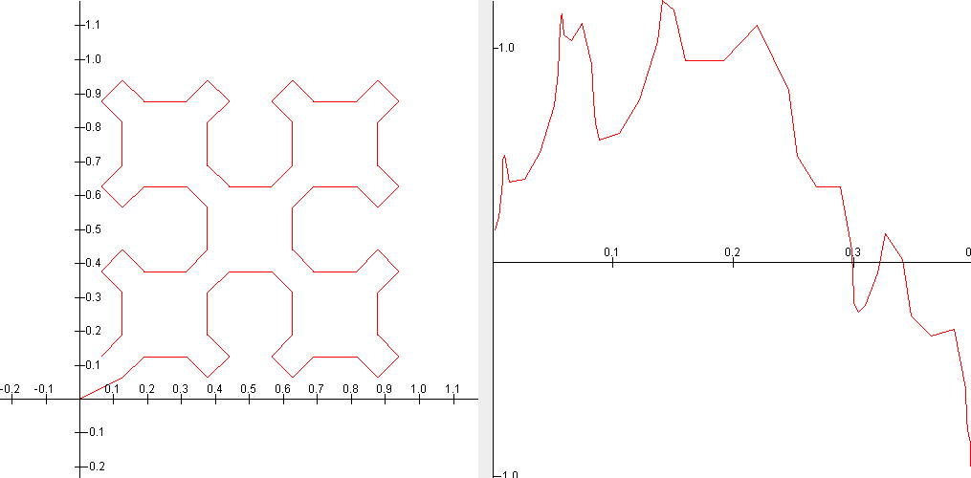
8.22226867898107 55 59
8.04052441901347 55 58
7.56260107504751 55 57
7.21497153873538 55 60
6.64159457455441 63 66
6.55255480102561 55 56
6.24258053163201 54 60
6.19382747190232 63 65
6.16704052252734 51 66
6.14141975213342 13 14

Sierpiński Level 1 x*2

max_M row1 row2

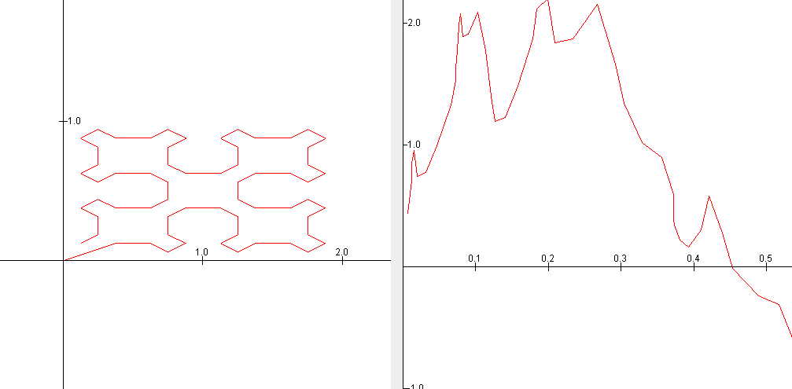
9.26335798452393 12 13
9.2349866356427 62 64
8.85602731649908 62 63
8.72909357116098 38 39
8.64379585966448 38 40
8.43273438774479 53 59
8.39748034489222 53 58
8.37626497957099 62 65
8.34111063869587 53 57
8.24325576268427 53 56

Sierpiński Level 1 y*2

max_M row1 row2

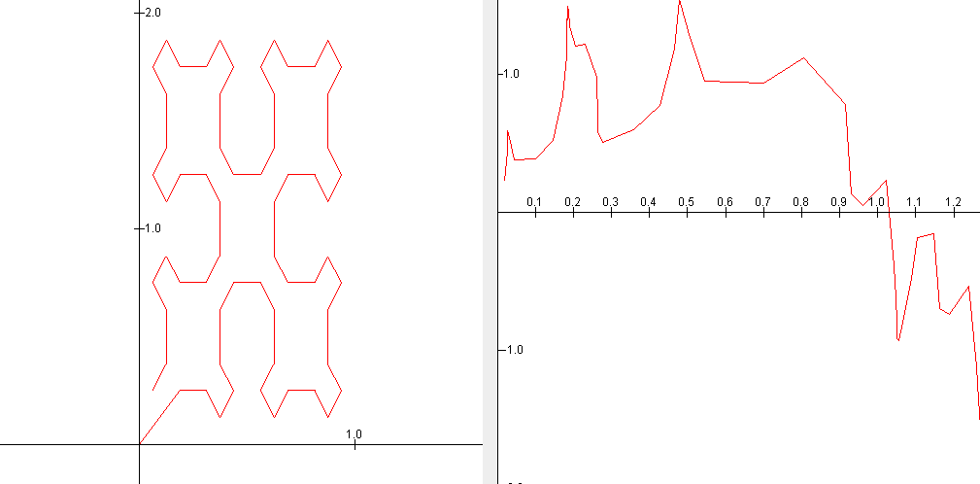
10.3082076129054 54 55
10.2975932060809 54 56
8.43644555218906 54 57
7.51440737366401 49 65
7.41161445331151 49 64
7.22788410608533 54 58
7.22091303378394 49 63
7.00281412288447 54 59
6.97971336142109 49 62
6.97673452145685 49 59
Sierpiński Level 2 normal

max_M row1 row2

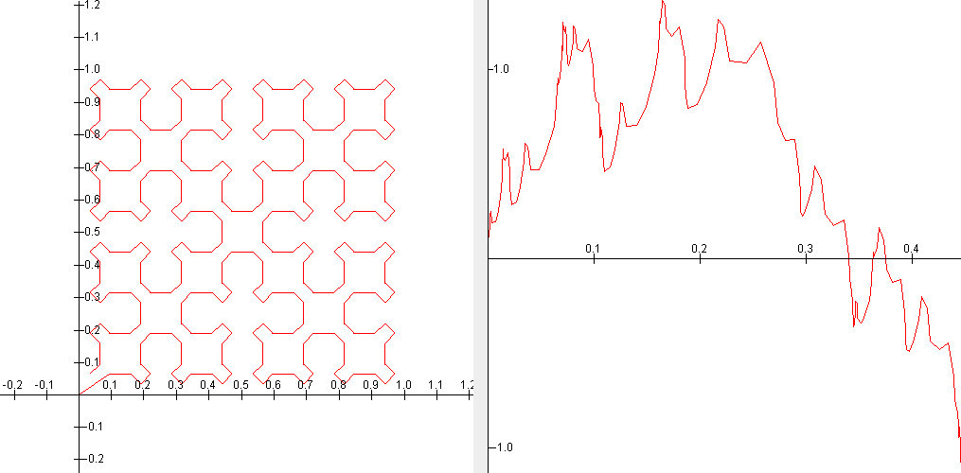
8.59404836170554 214 218
8.34182012401325 214 217
8.13044571269691 246 250
8.01926895169472 150 154
7.94102983578152 246 249
7.87158584114029 150 153
7.85874224566457 214 216
7.75809915000954 214 219
7.66506008376089 86 90
7.61451297227085 86 89

Sierpiński Level 2 with x*1.5

max_M row1 row2

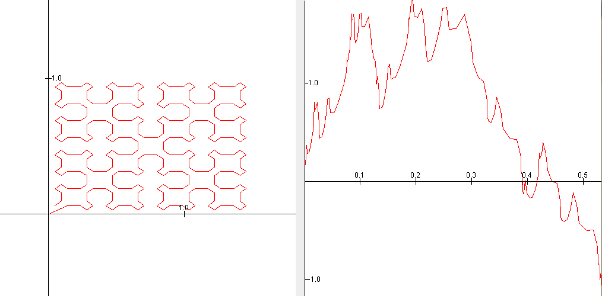
9.47244174866207 214 216
9.16152565897723 214 217
9.01715192744789 214 215
8.75959004380579 214 218
8.24793832490389 214 219
8.24738394879005 86 88
7.86517916660435 246 250
7.84488941587819 150 154
7.80801095625296 86 87
7.78593878493715 86 89

Sierpiński Level 2 with y*2

max_M row1 row2

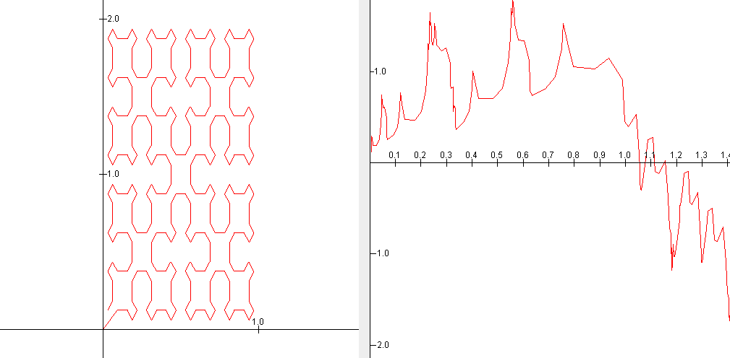
10.1810679851214 246 247
10.1560261931872 246 248
10.0298038237408 150 151
10.0235865996047 150 152
9.16289648941083 198 199
9.09027398749447 198 200
8.74188864868209 213 219
8.70698068490562 213 218
8.67212106565874 222 224
8.65134207898356 213 217
Sierpiński Level 3 normal

max_M row1 row2

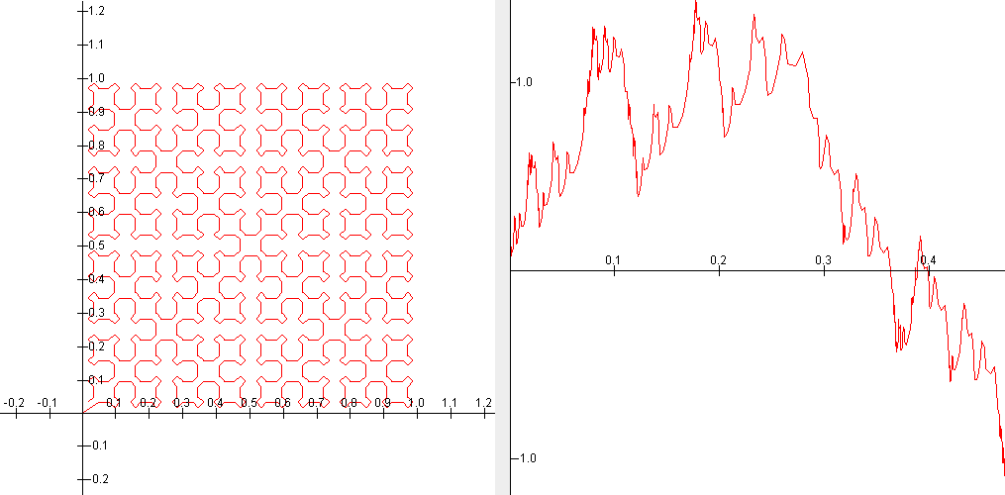
8.6299720136314 854 858
8.55341426099685 598 602
8.53265760541201 342 346
8.51648024496764 982 986
8.44811037074392 886 890
8.36546574901571 854 857
8.30521033671841 598 601
8.30050657934186 982 985
8.29935456183418 342 345
8.20131881800108 886 889

Sierpiński Level 3 with x*1.5

max_M row1 row2

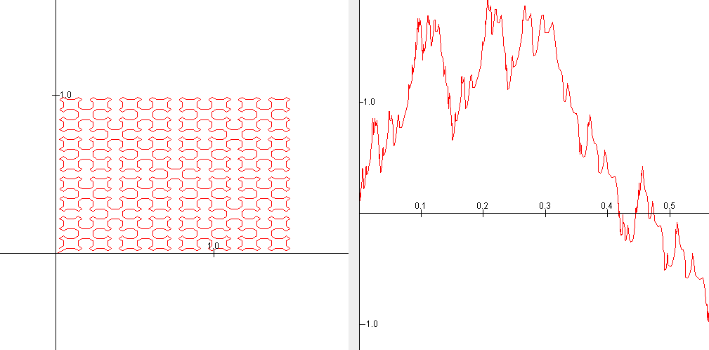
9.45182359103723 598 600
9.44173403249645 982 984
9.35463955344304 886 888
9.13904889559466 598 601
9.10898356151242 982 985
9.0350107770377 886 889
8.99846412838563 598 599
8.99223949472984 982 983
8.92577503238755 886 887
8.73534926574416 790 792

Sierpiński Level 3 with y*1.5

max_M row1 row2

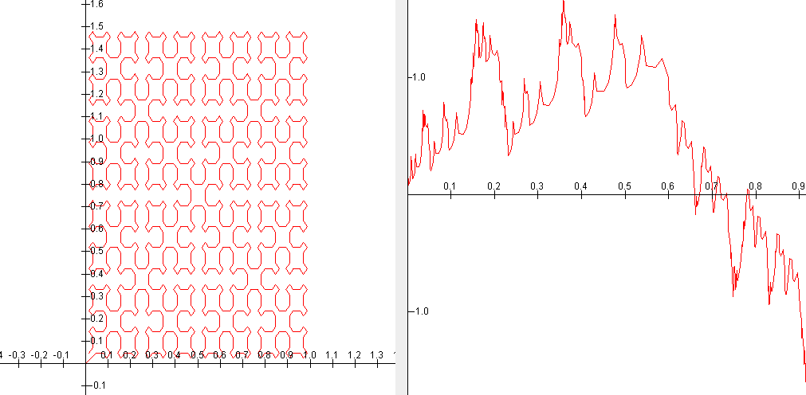
9.50307975808057 854 856
9.40830269778036 342 344
9.19820137274414 854 857
9.08768194392471 342 345
9.0436132352804 854 855
8.95982344070969 342 343
8.81158111632527 854 858
8.66136202442395 342 346
8.64353274136538 1014 1016
8.5211375369149 534 536
Sierpiński Reverse Level 1 normal

max_M row1 row2

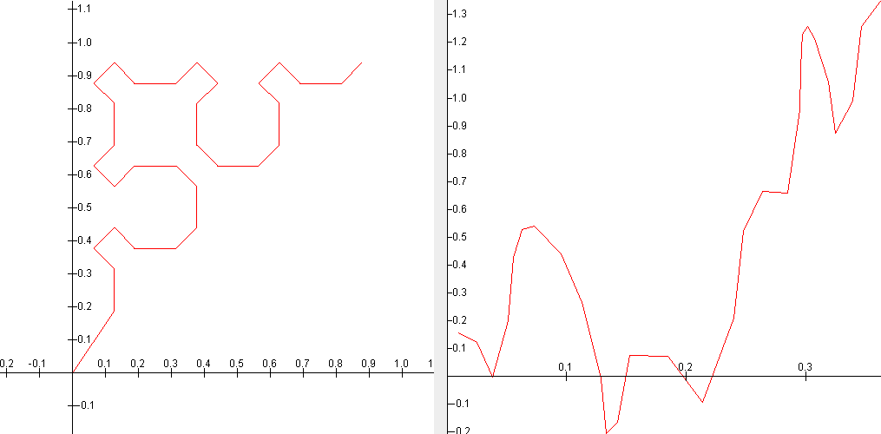
5.95006406061327 22 24
5.76756727906841 22 25
5.17892511828056 22 23
5.16565991089098 21 25
4.85628342426261 21 24
4.65400317513797 21 26
4.58060862515743 17 25
4.55813193741167 17 26
4.41767504748658 17 24
4.29203878148921 21 23

Sierpiński Reverse Level 1 x*2

max_M row1 row2

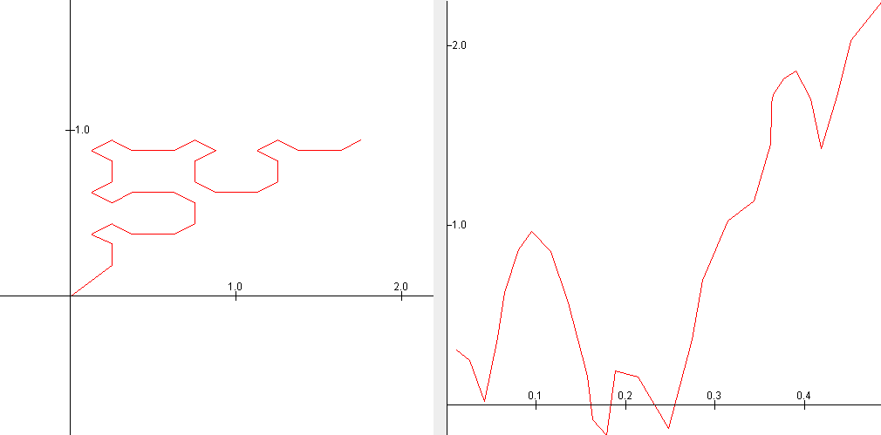
8.32304393848155 22 23
8.13502170312662 22 24
5.5145341800211 22 25
5.45144065971422 17 25
5.44871201385413 17 26
5.35784050988066 17 24
5.28591604071048 17 27
5.24461918674405 17 23
4.86975770168335 17 32
4.7952910377855 17 31

Sierpiński Reverse Level 1 y*2

max_M row1 row2

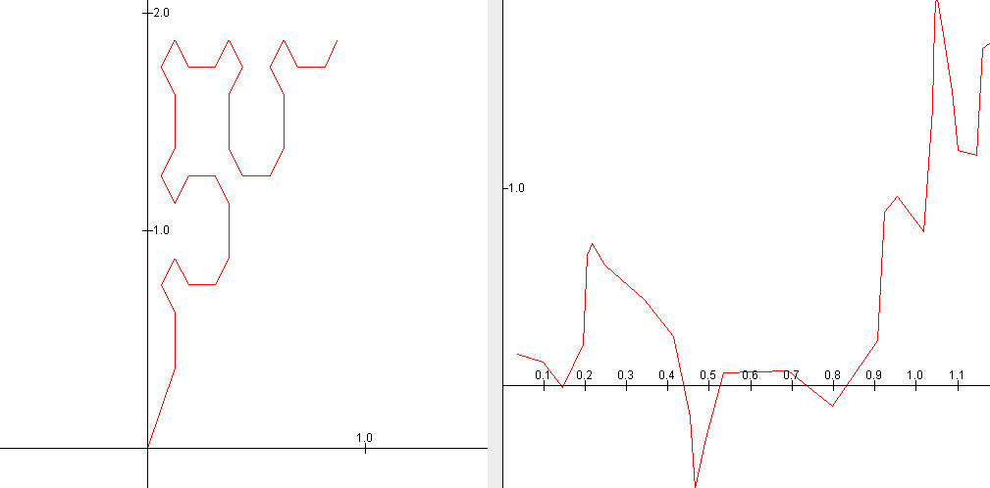
6.82790456801228 21 25
6.35835620470688 21 24
6.31298057564322 21 26
6.0186093927903 22 25
5.47108051421869 21 23
5.37165011817853 22 24
5.16171685365922 6 7
5.06795343995159 18 19
4.88550994258424 21 27
4.7188812841822 22 26
Sierpiński Reverse Level 2 normal

max_M row1 row2

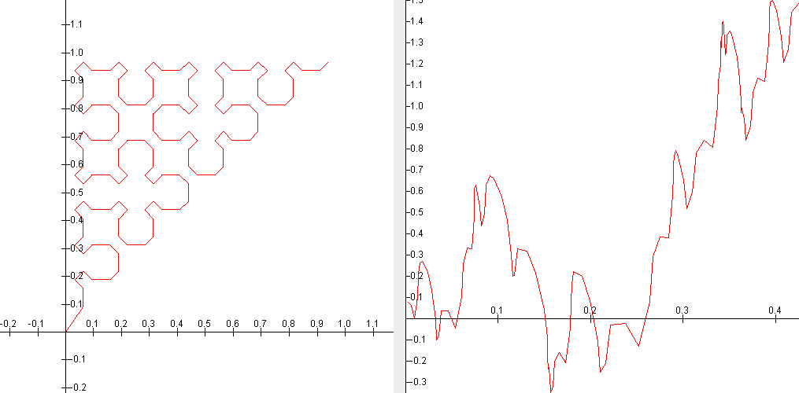
7.95639102039623 86 90
7.82468110755159 86 89
7.34978674323917 86 88
6.79161408475879 86 91
6.33335107888 86 87
6.05663705419259 85 91
5.99843448016764 70 72
5.95006406062824 22 24
5.94007023443215 82 97
5.91678937623362 81 97

Sierpiński Reverse Level 2 x*2

max_M row1 row2

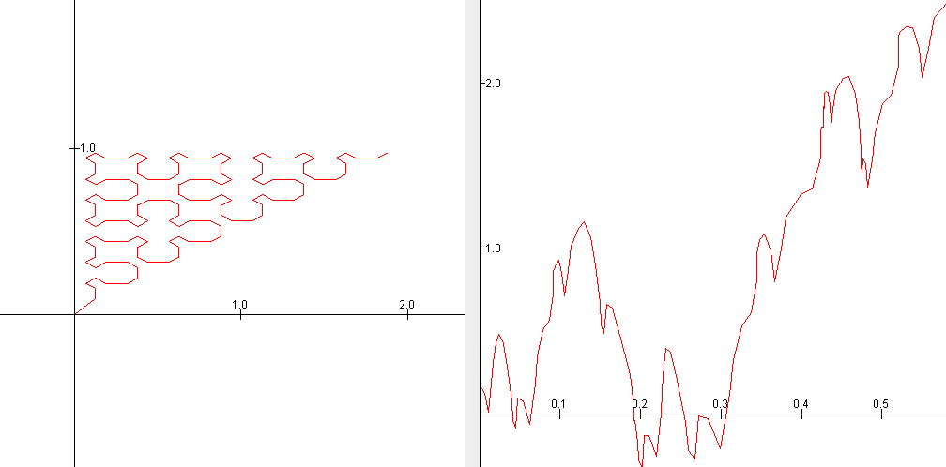
8.64948385362456 70 71
8.5644606142008 70 72
8.32304393848109 22 23
8.13502170312606 22 24
7.81236002620368 85 91
7.79891537580128 118 119
7.77702288455457 85 90
7.70438818469152 85 89
7.57920772184497 85 88
7.52691004605946 118 120

Sierpiński Reverse Level 2 y*2

max_M row1 row2

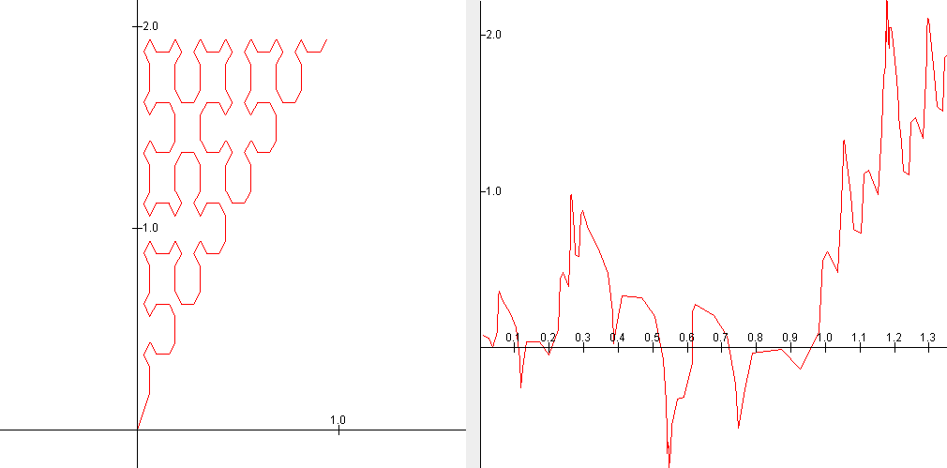
9.99750177342084 86 87
9.99163965582514 86 88
8.12032121248723 86 89
7.66687342910534 81 97
7.5182916906182 81 98
7.44395416597657 81 96
7.09354991146854 81 95
6.94999829768347 81 99
6.94855088970988 54 55
6.90601874852137 81 91
Sierpiński Reverse Level 3 normal

max_M row1 row2

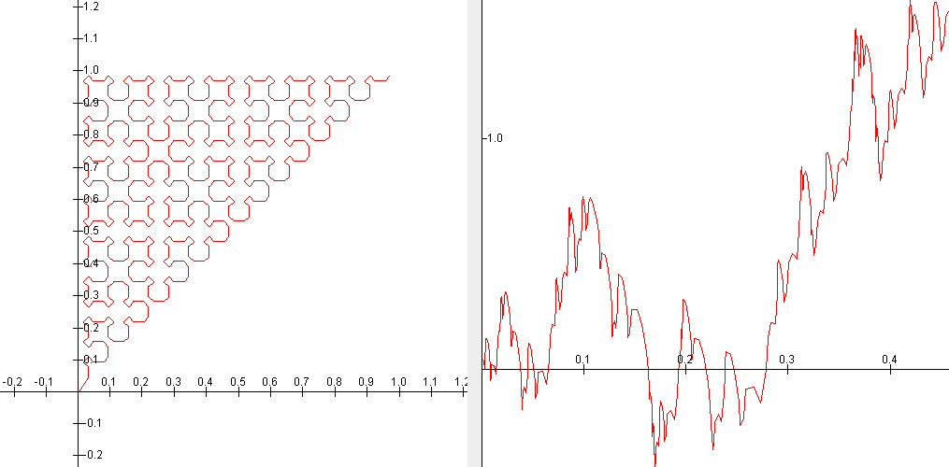
8.56043925525413 342 346
8.31191176473573 342 345
8.00361579959668 278 282
7.95639102042719 86 90
7.85843047163365 278 281
7.83006075263885 470 474
7.8283160075557 342 344
7.82468110751677 86 89
7.78669057699681 374 378
7.74362222290504 470 473

Sierpiński Reverse Level 3 x*1.5

max_M row1 row2

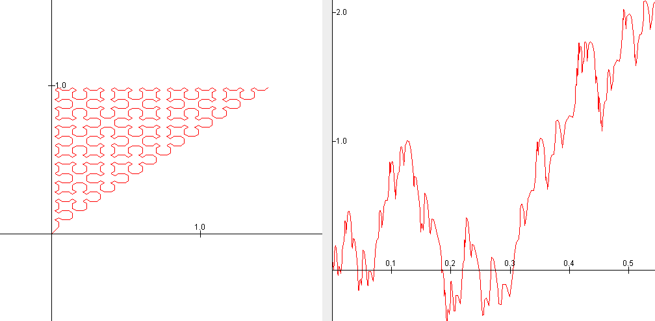
9.43893257597268 342 344
9.12529073152998 342 345
8.98645027981257 342 343
8.71830138888999 342 346
8.26706411999134 214 216
8.20119006820922 342 347
7.83820612786883 278 282
7.82407329100356 214 215
7.81026936383566 214 217
7.7916893719533 86 90

Sierpiński Reverse Level 3 y*2

max_M row1 row2

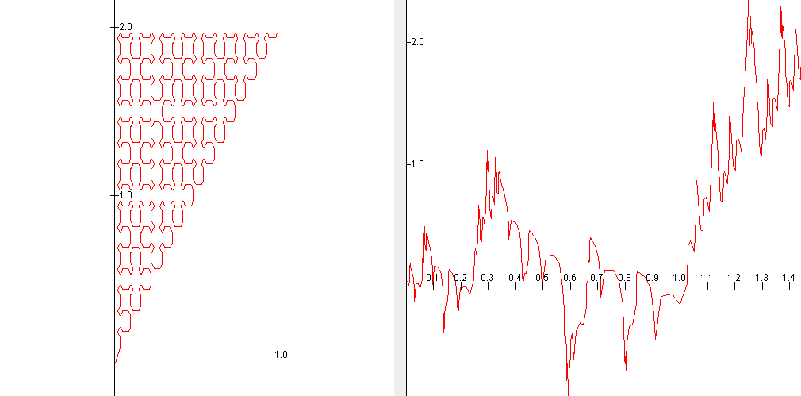
9.99750177333158 86 87
9.99163965574257 86 88
9.97980104983099 278 279
9.97435851088304 278 280
9.85826535272723 470 471
9.84566382963229 470 472
9.79144361514827 374 375
9.77222623075155 374 376
9.03933278286302 326 327
8.96552945785541 326 328
Sierpiński Reverse Level 4 normal

max_M row1 row2

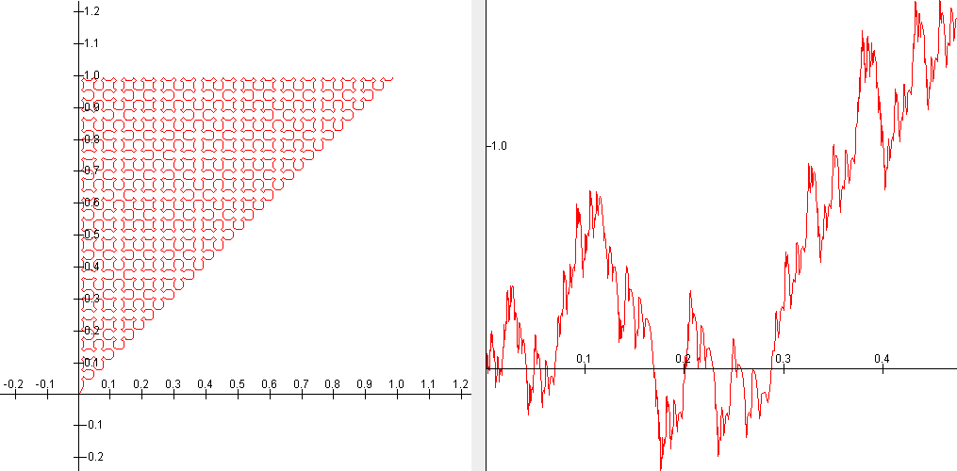
8.63630394070912 1366 1370
8.56455235501658 1110 1114
8.56043925902416 342 346
8.54787016547131 1878 1882
8.5281990136697 854 858
8.49775774240243 1494 1498
8.45781123330075 1398 1402
8.37334005250395 1366 1369
8.31586410657765 1110 1113
8.31191177238675 342 345

Sierpiński Reverse Level 4 x*1.5

max_M row1 row2

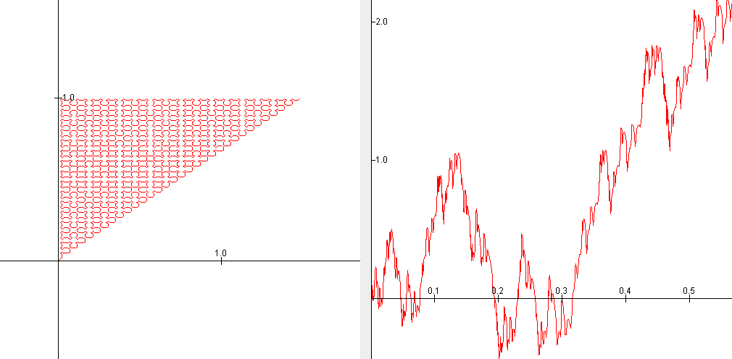
9.45030707373418 1110 1112
9.43893257697156 342 344
9.42742928845134 1878 1880
9.40141882901927 1494 1496
9.35284597532226 1398 1400
9.13720365678005 1110 1113
9.12529073268472 342 345
9.1119625408121 1878 1881
9.06619021627166 1494 1497
9.03246003113558 1398 1401

Sierpiński Reverse Level 4 y*1.5

max_M row1 row2

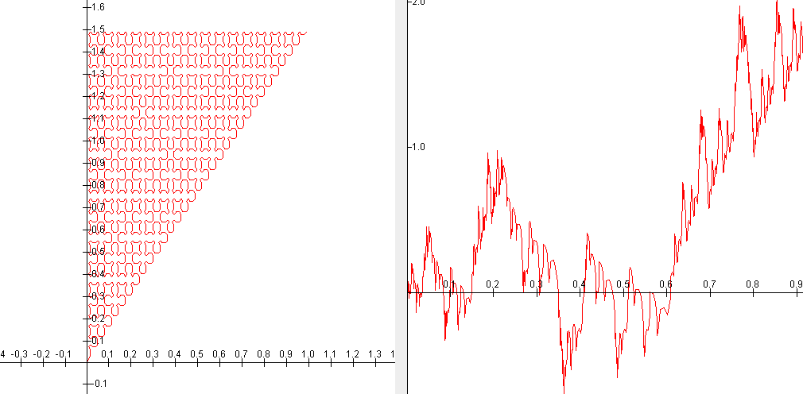
9.49977424877478 1366 1368
9.41075908272559 854 856
9.19341874081521 1366 1369
9.09148391451948 854 857
9.040971741358 1366 1367
8.961911639359 854 855
8.8024134490698 1366 1370
8.66985380110498 854 858
8.51699378357471 278 280
8.51259531993348 1046 1048
Hilbert Level 3 normal

max_M row1 row2

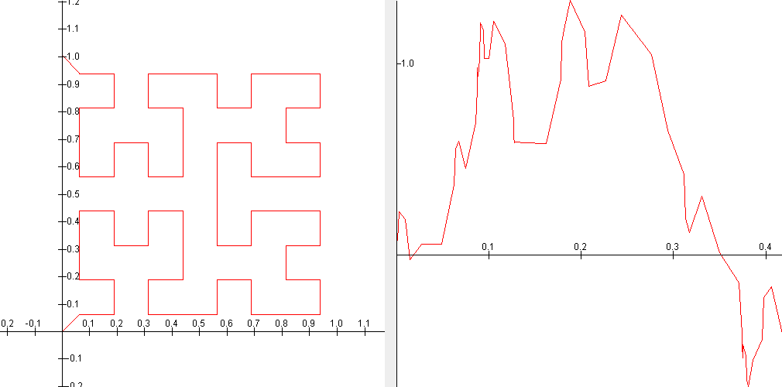
11.8860390347992 15 17
11.2861556745657 15 16
7.90863221056792 21 22
7.84662516065865 31 32
7.74620120602045 53 56
7.60680118144757 53 54
7.4953495225266 13 24
7.21348368149857 31 33
6.93176420786201 13 19
6.89828723203284 21 24

Hilbert Level 3 x*1.3
***This level does not want to stretch in the x direction using any multiple above 1.3. The upper levels also do not work when we try to stretch them, and so we are not including any data from stretching Level 4 or Level 5.

max_M row1 row2

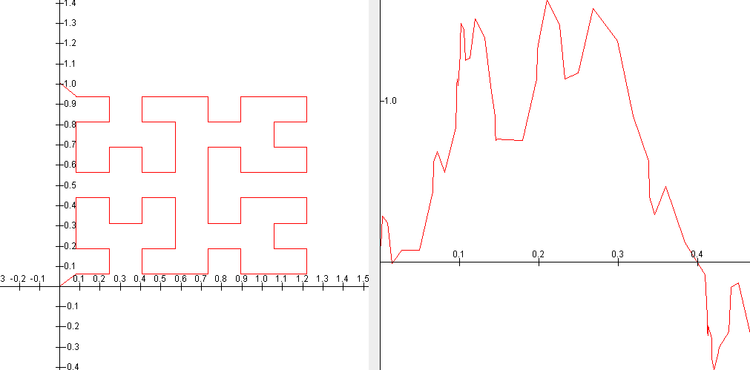
13.9356723644146 15 17
13.4016683306781 15 16
8.53230504308283 53 54
8.40427745424157 53 56
8.00820302483311 21 22
7.91008180203265 13 24
7.60821897773435 21 24
7.52378530707195 53 55
7.2030357315802 31 32
6.97876355748179 13 19

Hilbert Level 3 y*2

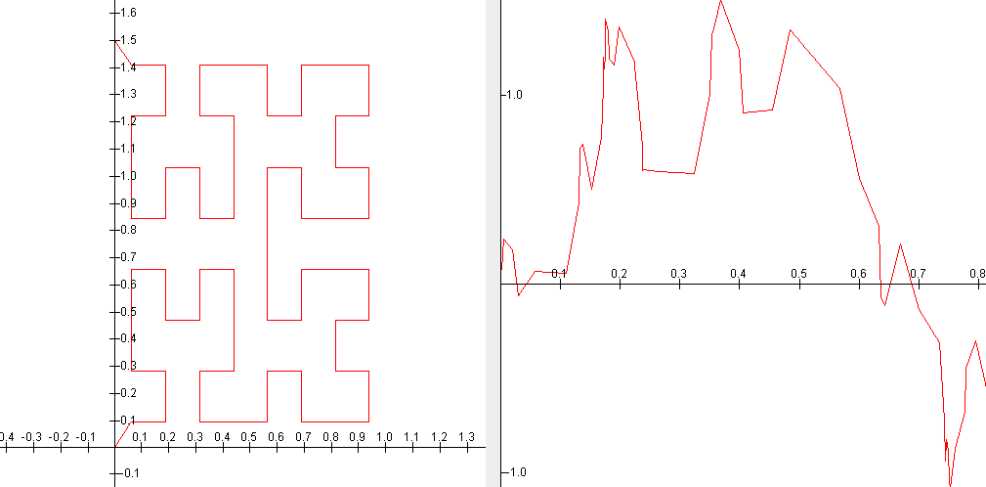
max_M row1 row2

10.2590926482906 15 17
9.62300878630334 31 32
9.47961044133159 15 16
9.28255520744307 31 33
7.93857381899943 21 22
7.5133111009263 53 56
7.34385990076653 13 24
7.25013527579399 13 19
6.97302436554094 13 18
6.87786573637199 13 17

Hilbert Level 4 normal

max_M row1 row2
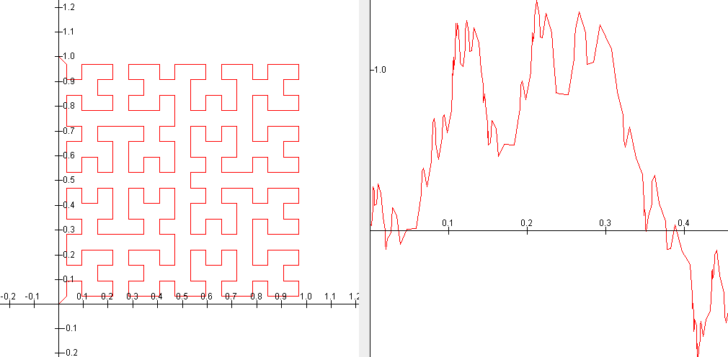
11.7881686040222 79 81
11.1944183991248 79 80
10.2545486618434 59 61
9.98498037691413 207 208
9.67225046287144 53 56
9.61991210383108 207 209
9.52048159276892 59 60
9.36577541812819 143 144
9.35861783863691 53 54
9.24664326805695 52 63

Hilbert Level 5 normal

max_M row1 row2
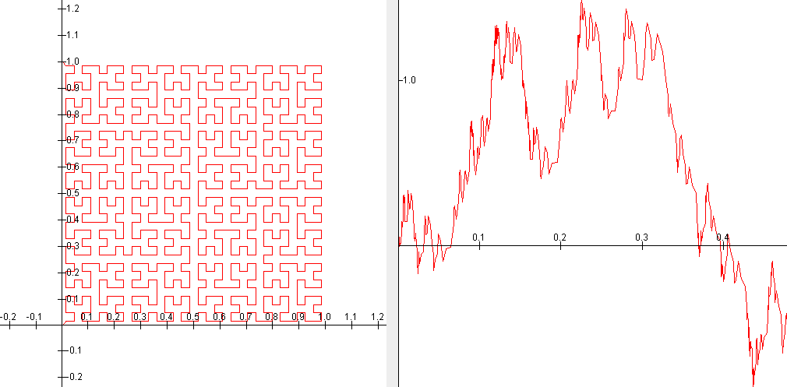
11.8860390351279 15 17
11.7782080960011 335 337
11.5731410226849 255 257
11.2861556748948 15 16
11.1839569965711 335 336
10.9711712646097 255 256
10.2643592530918 207 208
10.2300956961362 315 317
10.2150171960241 235 237
10.1673634410522 463 464

This MATLAB code is the original code we made to create the Sierpiński curve at any complexity.

You can change the complexity: “for iteration = 1 : 4”
You can change the region by altering: “S(:, 1) = truncR(:, 1);
S(:, 2) = truncR(:, 2)*1.5;”
You can change the file that the curve is written to by uncommenting and changing the .txt file of this line: “%dlmwrite('iteration4_ytimes_1_5.txt', S, 'delimiter', ',', 'precision', 9)”

function rep

%initial configuration
P = [1, 1/4, 1/4;
2, 3/4, 1/4;
3, 3/4, 3/4;
4, 1/4, 3/4;
5, 1/4, 1/4];

s = 1/2;

% P(i, :) accesses row i
% size(P, 1) is the number of rows in P

for iteration = 1 : 4
%this iteration level changes the complexity of the picture
newP = zeros(size(P,1)*5, 3);
j = 1;

for i = 1 : size(P, 1)
%takes the current list and produces the new list

Q = replace(P(i, 1), P(i, 2), P(i, 3), s);

for k = 1 : size(Q, 1)
newP(j, :) = Q(k, :);
j = j+1;
end

end

P = newP(1:(j-1),:);

s = s/2;

end

%now we will use "decoding" and then plot it!

R = zeros(size(P, 1)*4, 2);

j = 1;

for i = 1 : size(P, 1)

T = decoding(P(i, 1), P(i, 2), P(i, 3), s);

for k = 1 : size(T, 1)
R(j, :) = T(k, :);
j = j+1;
end

end

truncR = R(1:(j-1), :);

S = zeros(size(truncR, 1), 2);

S(:, 1) = truncR(:, 1);
S(:, 2) = truncR(:, 2)*1.5; %change *1.5 to alter the region we are considering

plot(S(:,1), S(:,2));

%dlmwrite('iteration4_ytimes_1_5.txt', S, 'delimiter', ',', 'precision', 9)

end

function a = replace(N, x, y, s)
%supporting function that gives replacement commands

% H = 1;
% G = 2;
% L = 3;
% A = 4;
% D = 5;
% M = 6;
% B = 7;
% C = 8;

if N == 1
a = [1, x - s/4, y - s/4;
2, x + s/4, y - s/4;
1, x + s/4, y + s/4];
elseif N == 2
a = [8, x - s/4, y + s/4;
7, x - s/4, y - s/4;
2, x + s/4, y - s/4;
3, x + s/4, y + s/4;
6, x - s/4, y + s/4];
elseif N == 3
a = [1, x - s/4, y - s/4;
2, x + s/4, y - s/4;
3, x + s/4, y + s/4;
4, x - s/4, y + s/4;
5, x - s/4, y - s/4];
elseif N == 4
a = [6, x + s/4, y - s/4;
3, x + s/4, y + s/4;
4, x - s/4, y + s/4;
7, x - s/4, y - s/4;
8, x + s/4, y - s/4];
elseif N == 5
a = [5, x + s/4, y + s/4;
4, x - s/4, y + s/4;
5, x - s/4, y - s/4];
elseif N == 6
a = [6, x + s/4, y - s/4;
3, x + s/4, y + s/4;
6, x - s/4, y + s/4];
elseif N == 7
a = [5, x + s/4, y + s/4;
4, x - s/4, y + s/4;
7, x - s/4, y - s/4;
2, x + s/4, y - s/4;
1, x + s/4, y + s/4];
elseif N == 8
a = [8, x - s/4, y + s/4;
7, x - s/4, y - s/4;
8, x + s/4, y - s/4];
end

end

function a = decoding(N, x, y, s)
%supporting function that gives decoding commands,
%which give the sequence of turning points for each picture

% H = 1;
% G = 2;
% L = 3;
% A = 4;
% D = 5;
% M = 6;
% B = 7;
% C = 8;

if N == 1
a = [x, y - s/4;
x + s/4, y];
elseif N == 2
a = [x - s/4, y;
x, y - s/4;
x + s/4, y;
x, y + s/4];
elseif N == 3
a = [x, y - s/4;
x + s/4, y;
x, y + s/4;
x - s/4, y];
elseif N == 4
a = [x + s/4, y;
x, y + s/4;
x - s/4, y;
x, y - s/4];
elseif N == 5
a = [x, y + s/4;
x - s/4, y];
elseif N == 6
a = [x + s/4, y;
x, y + s/4];
elseif N == 7
a = [x, y + s/4;
x - s/4, y;
x, y - s/4;
x + s/4, y];
elseif N == 8
a = [x - s/4, y;
x, y - s/4];
end

end

This function creates the Sierpiński curve in reverse, but since it often gets stuck in BLEAT halfway through the formation, we have the last half of the curve commented out in the initial configuration. The same things can be changed in this code as in the regular Sierpiński code above.

function rep_reverse_lind

%initial configuration
P = [5, 1/4, 1/4;
4, 1/4, 3/4;
5, 3/4, 3/4
%2, 3/4, 1/4;
%1, 1/4, 1/4
];

s = 1/2;

% P(i, :) accesses row i
% size(P, 1) is the number of rows in P

for iteration = 1 : 4
%this iteration level changes the complexity of the picture
newP = zeros(size(P,1)*5, 3);
j = 1;

for i = 1 : size(P, 1)
%takes the current list and produces the new list

Q = replace(P(i, 1), P(i, 2), P(i, 3), s);

for k = 1 : size(Q, 1)
newP(j, :) = Q(k, :);
j = j+1;
end

end

P = newP(1:(j-1),:);

s = s/2;

end

%now we will use "decoding" and then plot it!

R = zeros(size(P, 1)*4, 2);

j = 1;

for i = 1 : size(P, 1)

T = decoding(P(i, 1), P(i, 2), P(i, 3), s);

for k = 1 : size(T, 1)
R(j, :) = T(k, :);
j = j+1;
end

end

truncR = R(1:(j-1), :);

S = zeros(size(truncR, 1), 2);

S(:, 1) = truncR(:, 1);
S(:, 2) = truncR(:, 2)*1.5; %change *1.5 to alter the region we are considering

plot(S(:,1), S(:,2));

%dlmwrite('reverse4_ytimes_1_5.txt', S, 'delimiter', ',', 'precision', 9)

end

function a = replace(N, x, y, s)
%supporting function that gives replacement commands

% H = 1;
% G = 2;
% L = 3;
% A = 4;
% D = 5;
% M = 6;
% B = 7;
% C = 8;

if N == 1
a = [1, x + s/4, y + s/4;
2, x + s/4, y - s/4;
1, x - s/4, y - s/4];
elseif N == 2
a = [6, x - s/4, y + s/4;
3, x + s/4, y + s/4;
2, x + s/4, y - s/4;
7, x - s/4, y - s/4;
8, x - s/4, y + s/4];
elseif N == 3
a = [5, x - s/4, y - s/4;
4, x - s/4, y + s/4;
3, x + s/4, y + s/4;
2, x + s/4, y - s/4;
1, x - s/4, y - s/4];
elseif N == 4
a = [8, x + s/4, y - s/4;
7, x - s/4, y - s/4;
4, x - s/4, y + s/4;
3, x + s/4, y + s/4;
6, x + s/4, y - s/4];
elseif N == 5
a = [5, x - s/4, y - s/4;
4, x - s/4, y + s/4;
5, x + s/4, y + s/4];
elseif N == 6
a = [6, x - s/4, y + s/4;
3, x + s/4, y + s/4;
6, x + s/4, y - s/4];
elseif N == 7
a = [1, x + s/4, y + s/4;
2, x + s/4, y - s/4;
7, x - s/4, y - s/4;
4, x - s/4, y + s/4;
5, x + s/4, y + s/4];
elseif N == 8
a = [8, x + s/4, y - s/4;
7, x - s/4, y - s/4;
8, x - s/4, y + s/4];
end

end

function a = decoding(N, x, y, s)
%supporting function that gives decoding commands,
%which give the sequence of turning points for each picture

% H = 1;
% G = 2;
% L = 3;
% A = 4;
% D = 5;
% M = 6;
% B = 7;
% C = 8;

if N == 1
a = [x + s/4, y;
x, y - s/4];
elseif N == 2
a = [x, y + s/4;
x + s/4, y;
x, y - s/4;
x - s/4, y];
elseif N == 3
a = [x - s/4, y;
x, y + s/4;
x + s/4, y;
x, y - s/4];
elseif N == 4
a = [x, y - s/4;
x - s/4, y;
x, y + s/4;
x + s/4, y];
elseif N == 5
a = [x - s/4, y;
x, y + s/4];
elseif N == 6
a = [x, y + s/4;
x + s/4, y];
elseif N == 7
a = [x + s/4, y;
x, y - s/4;
x - s/4, y;
x, y + s/4];
elseif N == 8
a = [x, y - s/4;
x - s/4, y];
end

end

This code takes the Hilbert curve that is programmed into BLEAT, changes the region, and writes the resulting region to a new text file

conformal = importdata('Hilbert3_Conformal_Map.txt');

M = zeros(size(conformal, 1), 2);

M(:, 1) = conformal(:, 1)*1.3;
M(:, 2) = conformal(:, 2); %change *1.3 to alter the region we are considering

plot(M(:,1), M(:,2));

dlmwrite('Hilbert3_xtimes1_3.txt', M, 'delimiter', ',', 'precision', 9)

MATLAB code to find the biggest XXX M-Values

function find_big_M_values

% csvread starts at element row 0, col 0
% C(5) is the fifth element of the FIRST column

format long

filename = 'Level_3_from_BLEAT_for_Hilbert_xtimes1_3.txt';
%change this depending on what file you want it to read
%nothing special is needed to make the text file compatible

C = csvread(filename, 1, 0);
%csvread starts at row 0, column 0

%initializing the variables

N = csvread(filename, 0, 0, [0, 0, 0, 0]);
% N = number of rows in the file
% starts at row 0, column 0 and reads to row 0, column 0
% used instead of manually inputting the number of rows for each file

M = zeros(N*(N-1)/2, 1);
row1 = zeros(N*(N-1)/2, 1);
row2 = zeros(N*(N-1)/2, 1);

%finding and outputting the maximum M value and the rows that give that
%value

i = 1;

for k = 1 : N-1

for n = k+1 : N %can change k+_ to pull from rows that are
%different distances apart

M(i) = (abs(C(k, 2)-C(n, 2))/(sqrt(abs(C(k)-C(n)))));
row1(i) = k+1; %row k+1 in the text file because it starts reading at 0
%row1_values = C(k, :);
row2(i) = n+1; %note row n+1
%row2_values = C(n, :);

i = i+1;

end

end

m = 10; %can change to pull more or less of the biggest values

[sortM, IX] = sort(M, 'descend');
max_M = sortM(1:m);

sortrow1 = row1(IX);
max_row1 = sortrow1(1:m);
row1 = max_row1;

sortrow2 = row2(IX);
max_row2 = sortrow2(1:m);
row2 = max_row2;

table(max_M, row1, row2)

end

