Distribution, Ecological Niche, Movement, and Home Range of the Sickle Darter (Percina williamsi) in the Upper Tennessee River Basin.

A Dissertation Presented for the

Doctor of Philosophy

Degree

The University of Tennessee, Knoxville

Kyler B. Hecke

December 2021

DEDICATION
I dedicate this dissertation to my grandfather Roy E. Hecke, who passed away before he could see me finish my doctoral degree.

ACKNOWLEDGEMENTS
I would like to first acknowledge the funding that made my dissertation research possible, State Wildlife Grants from the Tennessee Wildlife Resources Agency, and secondly, Student-Faculty Research Awards from the University of Tennessee Graduate School. This research would not have been possible if not for numerous research associates, research technicians, and volunteers, who came out in the field and lab with me to help conduct various sampling for my research. I would also like to thank the numerous family members, friends, and mentors who have helped me develop as a young professional during my time as a doctoral student by providing an immense amount of support. Most specifically, this includes my parents Dee Dee and Joe Hecke, who always believed in me and supported me in pursuing my life goals.

ABSTRACT

The Sickle Darter (Percina williamsi) is a rare and imperiled species that is endemic to the upper Tennessee River basin. Over the last ~50 years it has declined across much of its range, and as a result it has been petitioned for federal listing under the Endangered species Act. This species has been relatively understudied, and important questions remain to be addressed: 1.) What is the current distribution of the Sickle darter and how has it varied spatiotemporally? 2.) What is the ecological niche of the Sickle Darter? and 3.) What is the movement capability of the Sickle Darter and what is its home range? To address these questions, a total of 154 Sickle Darters were observed at 15 sites throughout the upper Tennessee River Basin. Sickle Darters were observed in the Little River, Emory River, and Middle Fork Holston River sub-basins. A total of 133 unique historical occurrences were used for the spatiotemporal analyses. Sickle Darters have declined in 8 out of 10 historically occupied sub-basins. Our best model for the whole distribution suggests that habitat fragmentation (due to damming) and temperature (likely due to climate change) have had adverse effects on Sickle Darter populations across this species’ distribution. The accuracy of the whole basin model was evaluated with 70% of the testing area under the curve metric, which was high (0.85), and correctly predicted the presences used to test the model. The most important variable contributing to this model was stream order (48.2%). The ecological niche models varied from the whole basin to the sub-basin scale in terms of their accuracy and variable importance, but they were similar in accurately predicting the area of suitable habitat for the Sickle Darter. Best sub-sets regressions modeling suggest that Sickle Darter movement is significantly related to discharge (m³/sec) at multiple temporal levels. Home range for each individual varied in size. Median home range size was 157.5 m² and median degree of overlap for estimated home range was 23.3 %. The data outlined in this study provide information to inform conservations for this species to ensure that it is preserved for future generations.

TABLE OF CONTENTS

INTRODUCTION 1
Concepts of Rarity and their Relevance to Southeastern Aquatic Fauna 1
Management of Rare Aquatic Faunal Groups 2
Ecological Niche Models and Their Utility in Conservation 2
Rare Species Movement 3
Telemetry Applications in Fish 3
Research Goals and Questions 3
Management Implications 4
References 5
CHAPTER I: The Spatiotemporal Assessment of Sickle Darter (Percina williamsi Page and Near, 2007) Distribution in the Upper Tennessee River Basin 7
Abstract 128
Introduction 128
Methods 1310
Study Area 1310
Site Selection 11
Sickle Darter Surveys 11
Historical Occurences 11
Environmental and Habitat Covariates 12
Data Organization 13
Data Aalyses 14
Results 16
Disussion 18
References 22
Appendix 28
CHAPTER II: Ecological Niche Modeling of the Sickle Darter (Percina williamsi) Across Multiple Spatial Scales 34
Abstract 35
Introduction 35
Materials and Methods 37
Study Area 37
Contemproary Occurences 37
Environmental Covariates 37
Data Analyses 38
Model Set……………………………………………….……………………..38
Model Fit…………………….………………………………………………....38
Model Organization……………...………………………………………..….39
Results 39
Discussion 40
References 43
Appendix 48
CHAPTER III: Movement and Home Range of the Sickle Darter (Percina williamsi) in the upper Emory River of Tennessee, USA. 54
Abstract 55
Introduction 55
Methods 57
Study Area 57
Fish Collection and Tagging 57
Fish Tracking 58
Environmental and Habitat Variables 59
Data Analyses 59
Results 61
Discussion 62
References 67
Appendix 72
CONCLUSION 79
VITA......………………………………………………….……………………..………80

LIST OF TABLES

Table 1.1 The USGS gauges (median annual discharge and median spawning season discharge). 29
Table 1.2 Analysis of variance results for best subsets multiple linear regression 33
Table 2.1 The unit and scale of each covariate considered for our ecological 49
Table 2.2 The percent contribution of all covariates 52
Table 3.1 Analysis of variance results for best subsets multiple linear regression 79

LIST OF FIGURES

Figure 1.1 The HUC-8 sub-basins historically occupied by Sickle Darters. 28
Figure 1.2 The sites sampled for Sickle Darters during the current survey . 29
Figure 1.3 The distribution of the Sickle Darter throughout three temporal periods 31
Figure 1.4 Temporal variation in the number of total dams. 33
Figure 2.1 Historical distribution of Sickle Darters. 48
Figure 2.2 Contemporary (2000-present) occurrences. 50
Figure 2.3 The predicted habitat suitability 51
Figure 2.4 The ecological niche model projection for the Emory River sub-basin 53
Figure 2.5 The ecological niche model projection for the Little River sub-basin 54
Figure 3.1 The Emory River sub-basin. 73
Figure 3.2 The mean (±SE) movement (m) of PIT-tagged Sickle Darters. 74
Figure 3.3 Estimates of detection (0-1), total effort (min), and catch-per-effort (min/fish). 75
Figure 3.4 The frequency of movement of Sickle Darters. 76
Figure 3.5 The estimates for the landscape variables. 77
Figure 3.6 The median daily discharge . 78
Figure 3.7 Estimates of the total frequency of substrates. 78
Figure 3.8 The home range estimates of Sickle Darters . 80

LIST OF ATTACHMENTS

Attachment 1.1 The stream distance occupied by Sickle Darters
Attachment 1.2 Results of best subsets multiple linear regression modeling
Attachment 2.1 The median (min.-max) of all covariates
Attachment 3.1 The mean (±SE) environmental variables
Attachment 3.2 Results of best subsets multiple linear regression modeling

INTRODUCTION
Concepts of Rarity and their Relevance to Southeastern Aquatic Fauna
In the southeastern region of the U.S., aquatic fauna, especially mussels and fish, boast one of the highest species diversities compared to other faunal groups in the temperate, forested biome (Herig and Shute 2002). Many of these species can be classified as rare, but what makes them rare? Rabinowitz (1981) developed a standard classification of rarity, with seven categories of rarity. Many fishes and mussels have small, non-dominant populations, and either a wide or narrow geographic range (Ranibowitz 1981). This means that population densities of these fish and mussel species are constantly sparse (i.e., low population densities) and many are geographically restricted to only a few habitats or very specific habitat types (Ranibowitz 1981). Many of these species have evolved and/or adapted to live in narrow habitat niches within a vast array of other environmental characteristics. Subsequently, these species are intolerant of immense variation in their aquatic environment, unlike other more common species that can tolerate a wide range of environmental characteristics, like variability in flow thermal regime, sediment yields, or chemical effluents (Rabinowitz 1981; Townsend 1989; Ward 1998).
One example of a rare aquatic species that occurs in the upper Tennessee River basin (UTRB) is the Sickle Darter Percina williamsi (Page and Near 2007), formerly known as the Longhead Darter P. macrocephala, until extensive morphological and genetic analyses warranted separation of the two species. The Sickle Darter is endemic to the UTRB of North Carolina, Tennessee, and Virginia (Page and Near 2007; Jett 2010). It was once thought to be widespread throughout the UTRB, but now it may only occur in the upper Clinch River drainage in Tennessee and Virginia, upper North Fork Holston River drainage in Virginia, the Emory River drainage in Tennessee, and the Little River drainage in Tennessee (Page and Near 2007). It is considered extirpated from its historic localities in North Carolina. This species can be considered rare by classifications of Rabinowitz (1981) due to it inhabiting specific habitat types (sparsely available habitat) within a range of other available environmental characteristics. Unlike most darters (Family Percidae) that are benthic, this species is semi-pelagic and has a fusiform body, where it can be found swimming in the water column of medium-sized creeks and small rivers, almost entirely in pool habitats adjacent to flow and over substrates consisting of rocky, sandy, or silty substrates (Page and Near 2007). It is strongly associated with woody debris and aquatic vegetative cover, such as Water Willow Justicia americana (Page and Near 2007). The life history and ecology of the species has been relatively understudied, such that it is presumed to have the same spawning requirements, demographics, habitat use, diet, and dispersal as that of its sister species, the Longhead Darter P. macrocephala (Page and Near 2007; Jett 2010). The current conservation status of the Sickle Darter is as a species of greatest conservation concern (SGCN) and threatened in Tennessee and Virginia, extirpated in North Carolina, vulnerable by the International Union for Conservation of Nature (IUCN), and it is currently being petitioned by the Center for Biological Diversity to be listed as threatened/endangered by the U.S. Fish and Wildlife Service (USFWS 2011; Burns et al. 2012; NatureServe 2013; Angermeier and Pinder 2015; TWRA 2015, VDWR 2015; Tracy 2020). This species is in need of attention to understand its actual distribution, how it moves within and among its habitats, and how habitat and environmental variability determine where this species can occur throughout its range. Potentially, the damming of aquatic systems has resulted in fragmented populations and stymied the dispersal of this species, which in turn may have contributed to its decline.
Management of Rare Aquatic Faunal Groups
Conservation actions are integral to the preservation of aquatic species. At the federal level, rare species are first listed by the U.S. Fish and Wildlife Service (USFWS) in accordance with the Endangered Species Act of 1973, where the USFWS reviews petitions for federal listing of candidate species and determines if the species should be designated as threatened or endangered with extinction (United States 1973). The USFWS also develops species recovery plans and may identify critical habitat for a listed species (United States 1973). Recovery actions for aquatic species may include hatchery-rearing and stocking, translocating individuals from healthy source populations, protecting critical habitat, and/or restoring habitat. At the state level, states develop wildlife action plans (WAPs) to identify species occurring in that respective state that are in most need of conservation (TWRA 2015; VDWR 2015). State WAPs were first developed in the early 2000s and must be approved by the USFWS, and they are updated every 10 years (2005 and 2015 edition of the Tennessee Wildlife Action Plan). The purpose of these WAPs is for states to identify reasons why species are declining and determine what conservation measures should be made to help preserve and restore these species (TWRA 2015; VDWR 2015). Species listed as threatened or endangered at the state level are protected under state laws, even if they are not listed as threatened or endangered at the federal level. State natural resource agencies, such the Tennessee Wildlife Resources Agency (TWRA) and Virginia Department of Wildlife Resources (VDWR), develop regulations that prevent the harvest or other “take” of rare and nongame aquatic species (e.g., via toxic spills or habitat destruction), including the Sickle Darter where the species occurs in these states. Many other common aquatic species are sometimes used as bait for sportfish angling, and these regulations prevent the removal of rare aquatic species for that purpose. State natural resource agencies also initiate species recovery programs, through species re-introductions, species translocations, and propagating species for stocking (personal communication, Tim Lane, and Mike Pinder, VDWR).
Ecological Niche Models and Their Utility in Conservation
Ecological niche modeling is an innovative way to predict species distributions based on a species’ occurrence data and measured environmental/habitat characteristics (Soberón and Peterson 2005; Elith and Leathwick 2009). A species’ ecological niche is an extension of the Hutchinson’s n-dimensional hypervolume (Hutchinson 1978). Making the ecological niche the actual or realized portion of the niche in which a species occurs or may be able inhabit, in space and time, when taking into account competition and predation on a species’ fitness (Hutchinson 1978; Soberón and Peterson 2005; Colwell and Rangel 2009; Elith and Leathwick 2009). The advantages of ecological niche modeling are that it works well with rare species (e.g., does not require a lot of presences), and ecological niche models also allow for further analyses beyond just single species ecological niche models. Additional analyses may include ecological niche overlap and interspecific similarity estimation, as well as predicting ecological niche models of species (Soberón and Peterson 2005; Colwell and Rangel 2009; Elith and Leathwick 2009).
Rare Species Movement
Movement of rare species is widely unknown, especially in aquatic fauna like mussels and fish (Holden 1978; Rodriguez 2002). Movement of large-bodied sportfish, like many salmonids, has been widely documented on multiple scales (Holden 1978; Rodriguez 2002). Rare species movement can be assessed on multiple scales, such as within-habitat movement, within-reach movement, and then from system-to-system movement (one tributary to another). There are multiple reasons why species move, such as seasonal movement for spawning purposes, short-term movement (e.g., movement to a thermal refugium in the summertime), or movement to another reach in response to a habitat disturbance or loss of resources (e.g., food). Understanding the movement of rare species can aid in the monitoring of a species, observations of a rare species’ response to environmental change (a period of rain causing high flow, movement to shelter to evade high flows), and understanding how a species utilizes the areas within a habitat (Holden 1978; Rodriguez 2002).
Telemetry Applications in Fish
Telemetry is relatively new in its application to small-bodied stream fish (≤ 150 mm total length). Recent advancements in the size and design of telemetry technology have made this possible for use with small-bodied stream fish. Passive Integrated Transponder (PIT) tags are generally used to track all kinds of fishes from a variety of environments. Recent telemetry studies (e.g., Baker et al. 2017; Allan et al. 2018; Pennock et al. 2018) have utilized PIT tags inserted in small-bodied stream fishes. These researchers have outlined methods to track the movement of individuals on a large and small scale, and they have observed movement of individuals across multiple habitat types within a stream.
Research Goals and Questions
Many aquatic species, particularly mussels and fishes, are declining at alarming rates. Monitoring their conservation status, understanding their available habitat and how they move within and among these habitats is crucial to conceptualizing how to conserve these species. The goal of my research is to use current, standard methodologies in aquatic science to model the dynamics of species declines, model rare species distribution, and estimate dispersal capability for the Sickle Darter. This goal will be accomplished by answering 3 research questions: 1.) What is the current distribution of the Sickle darter and how has it varied spatiotemporally? 2.) What is the ecological niche of the Sickle Darter and how does it vary spatially? and 3.) What is the dispersal capability of the Sickle Darter?
Management Implications
The results of this study can be used by state and federal agencies that can be used for making adaptive management decisions to preserve the Sickle Darter in the UTRB. Results will provide insight on how the distribution of this species has varied spatially and temporally. Understanding the changes in the distribution of this species will allow fisheries managers to identify areas where this species has potentially declined and determine the factors associated with the potential decline. Ecological niche modeling can be used by regulatory agencies to predict suitable habitat for this rare species that can inform future monitoring and management of this species. Knowledge on the movement and home range of this species will aid the understanding of how this species moves within a habitat and how large of an area an individual occupies. This information can be used to determine how environmental factors on large and small scales may impact an individual’s ability to disperse, as well as how changes in habitat may impact an individual’s home range. Results of my research will be beneficial to aquatic resource managers, biologists, and researchers when they determine the conservation actions that should be taken to preserve the rare Sickle Darter.

References
Allan, H., P. Unmack, R.P. Duncan, & M. Lintermans. (2018). Potential Impacts of PIT Tagging on a Critically Endangered Small‐Bodied Fish: A Trial on the Surrogate Mountain Galaxias. Transactions of the American Fisheries Society, 147:1078-1084
Angermeier, P.L., & M.J. Pinder. (2015). Viewing the Status of Virginia’s Environment Through the Lens of Freshwater Fishes. Virginia Journal of Science, 66:147-169.
Baker, C.F., K. Reeve, D. Baars, D. Jellyman & P. Franklin. (2017). Efficacy of 12 mm 603 half-duplex passive integrated transponder tags in monitoring fish movements through 604 stationary antenna systems. North American Journal of Fisheries Management, 37: 1289-1298.
Burns C.E., Peoples, C., Fields, M., & Barnett, A. (2012). Protecting North Carolina’s freshwater systems: A state wide assessment of biodiversity, condition and opportunity. The Nature Conservancy, Durham, NC. <https://www.conservationgateway.org/ConservationByGeography/North merica/UnitedStates/edc/Docu ments/ED_freshwater_ARA_TNC%20Freshwater%20Assessment%20Fi al%20Report%20_%20ForDistr bution_June2012.pdf>.
Colwell, R. K., & T.F. Rangel. (2009). Hutchinson’s duality: The once and future niche. Proceedings of the National Academy of Sciences of the USA, 106:19651–19658.
Elkins, D.C., S.C. Sweat, K.S. Hill, B.R. Kuhajda, A.L. George, & S.K. Wegner, (2016). The Southeastern Aquatic Biodiversity Conservation Strategy, Final Report. University of Georgia River Basin Center <http://southeastfreshwater.org/wp- content/uploads/2016/12/SE_Aquatic_Biodiv_Strat_Body_Apdx1_Apdx2 Apdx3.pdf>.
Elith, J., & J.R. Leathwick. (2009). Species distribution models: ecological explanation and prediction across space and time. Annual Review of Ecology, Evolution and Systematics, 40: 677-697.
Herrig, J., & P. Shute. (2002). Aquatic animals and their habitats. In: Wear, D.N.; Greis, J.G., eds. Southern forest resource assessment. General Technical Report SRS-53. Asheville, NC: U.S. Forest Service, Southern Research Station: 537-582. < https://www.srs.fs.usda.gov/pubs/4833>.
Holden, P. B. (1978). A study of the habitat and movement of the rare fishes in the Green River, Utah. Transactions of the American Fisheries Society, 107: 64-89.
Hutchinson, G. E. (1978). An Introduction to Population Ecology (1st ed.). New Haven, CT: Yale University Press,
Page, L. M., & T.J. Near, T.J. (2007). A new darter from the upper Tennessee River drainage related to Percina macrocephala (Percidae: Etheostomatinae). Copeia, 605-613.
Rabinowitz, D. (1981). Seven forms of rarity in The Biological Aspects of Rare Plant Conservation, editor H. Synge. pp. 205-217., Hoboken, New Jersey: Wiley.
Rodriguez, M.A. (2002). Restricted movement in stream fish: the paradigm is incomplete, not lost. Ecology 83: 1–13.
Soberón, J., & A.T. Peterson, A.T. (2005). Interpretation of Models of Fundamental Ecological Niches and Species’ Distributional Areas. Biodiversity Informatics, 2:1-10.
Townsend, C.R. (1989). The patch dynamics concept of stream community. Journal of North American Benthological Society, 8:36-50.
Tracy, B.H. F.C. Rohde, & G.M. Hogue. (2020). An Annotated Atlas of the Freshwater Fishes of North Carolina. Southeastern Fishes Council Proceedings, 60:1-198.
United States. (1973). The Endangered Species Act as Amended by Public Law 97-304 (the Endangered Species Act Amendments of 1982). Washington: U.S. G.P.O., 1983. < https://www.fws.gov/endangered/laws policies/>.
U.S. Fish and Wildlife Service. (2011). Endangered and Threatened Wildlife and Plants; Partial 90-Day Finding on a Petition to List 404 Species in the Southeastern United States as Endangered or Threatened with Critical Habitat. Docket No. FWS–R4–ES–2011–0049; MO 92210–0 0009. Dept. of the Interior, Washington D.C.
Virginia Department of Wildlife Resources (2015). Virginia’s 2015 Wildlife Action Plan. Virginia Department of Wildlife Resources. Henrico, VA.< http://bewildvirginia.org/wildlife-action-plan/>.
Ward, J.V. (1998). Riverine landscapes: biodiversity patterns, disturbance regimes, and aquatic conservation. Biological Conservation, 83:269-78.

CHAPTER I
Spatiotemporal Assessment of Sickle Darter (Percina williamsi) Distribution in the Upper Tennessee River Basin

.

The following chapter is formatted to the specific author guidelines for the Journal of Applied Ichthyology by myself and my adviser J. Brian Alford:
Hecke, K.B. and Alford, J.B. 2021 Spatiotemporal Assessment of Sickle Darter (Percina williamsi Page and Near, 2007) Distribution in the Upper Tennessee River Basin. Journal of Applied Ichthyology.

Abstract
The Sickle Darter Percina williamsi (Page and Near, 2007) is a species of fish endemic to the upper Tennessee River basin in eastern Tennessee, southwestern Virginia, and western North Carolina. Because of its narrow range and presumed decline in occupied sites over the last half century, it is being proposed for federal listing under the U.S. Endangered Species Act. We analyzed the current distribution of the Sickle Darter and temporal trends in its distribution in relation to temporal trends in environmental and habitat covariates for each of the historically occupied sub-basins (upper Clinch, Emory, upper French Broad, Little, Little Pigeon, Middle Fork Holston, North Fork Holston, Powell, South Fork Holston, and Watauga) with multiple linear regression modeling. A total of 154 Sickle Darters were observed at 15 sites throughout the upper Tennessee River Basin. Sickle Darters were observed in the Little River, Emory River, and Middle Fork Holston River sub-basins. A total of 133 unique historical occurrences were used for the spatiotemporal analyses. Sickle Darters have declined in 8 out of 10 historically occupied sub-basins. Our best model for the whole distribution (Mallow's Cp = 2.13; Adjusted R² = 0.91) suggests that habitat fragmentation (due to damming) and temperature (likely due to climate change) have had adverse effects due to damming has had adverse effects on Sickle Darter populations across its distribution. Models were very similar for the sub-basin specific models as well. The results from this study highlight the drivers of decline in Sickle Darter distribution and outline the future research needs for this species that should be used to inform future conservation decisions regarding this species.
Introduction
The Sickle Darter Percina williamsi (Page and Near, 2007) is a species endemic to the upper Tennessee River basin (UTRB) of North Carolina, Tennessee, and Virginia (Jett, 2010). It was once thought to be widespread throughout the UTRB, but now it may only occur in the upper Clinch River and North Fork Holston River sub-basins in Tennessee and Virginia, Middle Fork Holston River sub-basin in Virginia, and the Emory River and Little River sub-basins in Tennessee (Fig. 1.1; Page & Near, 2007). It is considered extirpated from its historic localities in North Carolina. This species can be considered rare following the classifications of Rabinowitz (classification D; 1981) because it inhabits specific habitat types (sparsely available habitat) within a range of other available environmental characteristics. Unlike most darters (Family Percidae) that are benthic, this species is benthi-pelagic and has a fusiform body, where it can be found swimming in the water column and benthic areas of low-gradient medium-sized creeks and small rivers. Anecdotal observations suggest that within these systems the species occurs almost entirely in pool habitats adjacent to flow > 10 cm/s, and it is commonly found in or near woody debris piles or aquatic vegetation over a mix of cobble, gravel, sand, and silt substrates (Page & Near, 2007).
The spatiotemporal distribution of the species has been understudied, but it is presumed to have declined across much of its historical range (Page & Near, 2007; USFWS, 2011). However, causes of decline are currently unknown, but are speculated to be habitat degradation and fragmentation due to damming across the UTRB (USFWS, 2011). This uncertainty brings into question the species’ conservation status on state and federal levels (USFWS, 2011; TWRA, 2015; VDWR, 2015). The current conservation status of the Sickle Darter is a species of greatest conservation concern (GCN) and threatened in Tennessee and Virginia, extirpated in North Carolina, vulnerable by the International Union for Conservation of Nature (IUCN), threatened by the American Fisheries Society (AFS), and it is currently proposed to be listed as threatened by the U.S. Fish and Wildlife Service (USFWS) under the Endangered Species Act (Jelks et al., 2008; USFWS, 2011; Burns et al., 2012; NatureServe, 2013; Angermeier & Pinder, 2015; TWRA, 2015; VDWR, 2015; Tracy et al., 2020). State listings are due to the species’ endemism and habitat specialization in Tennessee and Virginia (TWRA, 2015; VDWR, 2015). While the spatiotemporal trends of Sickle Darter distribution are widely unknown, more information is available on spatiotemporal changes in the UTRB (Hampson et al., 2000; USFWS, 2014).
The UTRB has undergone immense physicochemical and hydrological changes in the last ~150 years (Hampson et al., 2000; USFWS, 2014). With the creation of Tennessee Valley Authority (TVA) in 1933, many streams and rivers of the drainage were dammed for hydroelectric power (Etnier & Starnes, 1993; Jenkins & Burkhead, 1994; Hampson et al., 2000). With 50 dams having been constructed in the UTRB drainage (not including mill dams; Hampson et al., 2000), aquatic habitats for aquatic fauna have become fragmented. Many of these dams have caused system restarts in flow and temperature regime, as predicted by the serial discontinuity concept of human-altered riverine ecosystems (Ward & Stanford, 1983). Serial discontinuity is a problem for all fish because each species requires a specific flow and temperature regime (Poff et al., 1997.) There has been a vast increase in industrial/commercial land use in this drainage in the past ~150 years, such as coal mining, silviculture, agriculture, and urbanization (Hampson et al., 2000). Decades of land cover change has impaired water quality, aquatic habitat suitability, and ecosystem function in the UTRB (Hampson et al., 2000; Diamond et al.,2002). Cumulatively, these landscape-level changes have led to the decline and imperilment of UTRB aquatic fauna (USFWS, 2014; Elkins et al., 2016).
The UTRB boasts one of the highest aquatic faunal diversities of all river systems in the North America (Hampson et al., 2000; Elkins et al., 2016). It is historically home to over 175 fish species, with 14 of these species being endemic to the drainage, and 9 threatened and endangered fish species (USFWS listing; Environmental Conservation Online System, Washington D.C., https://ecos.fws.gov/ecp/). There are 60 mussel species, with 5 of those being endemic (USFWS 2014), 25 threatened and endangered mussel species in the UTRB (Etnier & Starnes, 1993; Jenkins & Burkhead, 1994; Burns et al., 2012; USFWS, 2014; TWRA, 2015; VDWR, 2015). Range contraction and population declines of mussels and fish in the last 50 years and the main reasons for their imperilment (Etnier & Starnes, 1993; Jenkins & Burkhead, 1994; Hampson et al., 2000; Burns et al., 2012; USFWS, 2014). Causes for their decline include habitat fragmentation from dams, poor water quality from non-point and point source effluents, and the introduction of invasive species. (Etnier & Starnes, 1993; Jenkins & Burkhead, 1994; Hampson et al., 2000; Burns et al., 2012; USFWS, 2014; Elkins et al., 2016)
A spatiotemporal assessment of Sickle Darter distribution is needed to understand how the distribution of this species has changed within its historical range in the UTRB and to ascertain likely causes of this species’ decline. Furthermore, more information is needed at the sub-basin spatial scale to understand why the Sickle Darter no longer occurs in some sub-basins within the UTRB (Little Pigeon River sub-basin, for example) but persists in others. Potentially, the damming of aquatic systems has resulted in fragmented populations and prevented the dispersal of this species, which in turn may have contributed to its decline. Deteriorating water quality and habitat degradation in the UTRB have quite possibly added to the decline of this species. The goal of our study was to assess the changes in distribution of this species and the spatiotemporal relationships between Sickle Darter distribution and environmental/habitat covariates. We achieved this goal by setting the following objectives: 1) determine the current distribution of the Sickle Darter, 2) assess the temporal changes in the distribution of the Sickle Darter on the whole-basin scale (UTRB) and the sub-basin scale, and 3) explore the factors influencing changes in the distribution of the Sickle Darter across both spatial scales. The data presented in this study will aid our understanding of why the Sickle Darter has experienced changes it its distribution across two scales and help inform managers where this species needs conservation measures to help preserve it for the future.
Methods
Study Area
The UTRB originates as a predominantly spring-fed system in the southern portion of the Appalachian Mountains (Fig. 1.1). It flows through four different Level-III ecoregions: the Blue Ridge Mountains, the Ridge and Valley, the Southwestern Appalachians, and the Central Appalachians (Omernik, 1997). This basin drains an area of 4.5 million hectares (Hampson et al., 2000). It consists of 6 major hydrologic units: Watts Barr Lake, the Little Tennessee River, the Hiwassee River, the Clinch River, the Holston River, and the French Broad River (Hampson et al., 2000).
Site selection
Sickle Darter sample sites were selected from a pool of sites where the species had been previously observed and a they potentially suitable sites that have not been sampled prior to this study. A site consisted of a 100-m to 500-m reach that included pool and riffle-run macrohabitats. Contemporary sites for this study were sampled in the upper Clinch River, Emory River, French Broad River, Little Pigeon River, Little River, Middle Fork Holston River, North Fork Holston River, Powell River, South Fork Holston River, and Watauga River sub-basins.
Sickle Darter Surveys
Sickle Darters were sampled by the authors during late spring to fall months during 2017-2019 using multiple gears that are standard for sampling fishes in wadeable warmwater-streams (Bonar et al., 2009; Weaver et al., 2014). The gears selected for observing Sickle Darters were backpack electrofishing with dip nets and/or seines, seine hauls, and snorkeling. Multiple gears were employed to increase the probability of detecting Sickle Darters. At a site, we deployed a 10-m x 1.5-m minnow seine, with 6-mm nylon mesh, and pools were sampled with seine hauls, using a 15-m x 1.5-m minnow seine, with 6-mm nylon mesh. Backpack electrofishing was conducted using a Smith-Root® backpack electrofishing unit on AC settings, and shocking took place within 10-40 Hz, which is standard for percid fishes (Bonar et al., 2009). On some occasions, a single-pass technique was used while sampling with a backpack electrofisher and a dip netter (Meador et al., 2002). Snorkel surveys were done with two or more snorkelers and covered the entire reach of a site (Davis et al., 2011; Weaver et al., 2014). All habitats (e.g., riffles, runs, and pools) of a site that are visible were snorkeled. All fish captured or observed while sampling were identified to the species level. Fish captured by seining and electrofishing were identified and released immediately after capture. A subsample of Sickle Darters (n=18) were sacrificed in an overdose of MS-222, fixed in 10% buffered formalin, and later preserved in 70% ethanol for other analyses under approved scientific collection permits from the States of Tennessee and Virginia.
Historical Occurrences
Historical occurrence data were gathered from a variety of sources. To ensure we included every possible occurrence record for this species, we performed a search for Longhead Darter (P. macrocephala Cope, 1867) historical occurrence, because the Sickle Darter was “recently” split from that species (Page and Near, 2007). We concluded that if a historical occurrence record for the Longhead Darter occurred in the range of the Sickle Darter, then it was an occurrence record for the Sickle Darter. Historical occurrence records were obtained from the Global Biodiversity Information Network (GBIF, 2020), Freshwater Information Network (FIN; TNACI, 2019), FishNet2 (2017), FishMap (2020), Tennessee Wildlife Resources Agency (TWRA) fish sampling data base (personal communication with TWRA Region 4 Fisheries Coordinator Bart Carter), Virginia Department of Wildlife Resources (VDWR) fish sampling data base (personal communication with VDWR Region 3 Aquatic Biologist Mike Pinder) and with and Conservation Fisheries Inc. (CFI) snorkel-monitoring database (personal communication with Senior Conservation Biologist Crystal Ruble). Every acquired occurrence record was cross-referenced with repeating occurrence points in multiple databases. Data associated with each occurrence record generally consisted of date, sub-basin, gear type, geographic coordinates, and geographic locality. Gear type used to sample Sickle Darters in each of these databases varied. For example, TWRA sampling data used multiple methods (seining, backpack electrofishing with seining, backpack electrofishing with dip netters, etc.) and targeted the whole community, while VDWR used backpack electrofishing with dip netters targeted to target game species, and CFI sampling was by snorkel only. Museum data mostly consisted of seine haul collections made by ichthyologists. Because of this disparity, we could not make any population abundance estimates, but occurrence analyses (i.e., presence-absence) are suitable for these data.
Environmental and Habitat Covariates
A large set of environmental and habitat covariates was considered for our analyses. We selected available covariate data that covered the same period for known Sickle Darter occurrences (1880-present). We selected the following covariates to act as predictor variables for our models. Total human population by county was considered a surrogate for anthropogenic disturbances such as urban runoff and water quality impairment. Number of dams (hydropower and low-head) was chosen as a surrogate for stream connectedness/fragmentation, because dams block the dispersal of benthic fishes like darters, and impoundments can negatively affect larval fish dispersal. Median annual discharge (m³/sec), median spawning season discharge (m³/sec during February to April), median total annual precipitation (cm), median total spawning season precipitation (cm), median annual air temperature (֯C), and median spawning season air temperature (֯C). These discharge and temperature covariates were selected because of their potential impact on the life-history strategy of the Sickle Darter (USFWS, 2014). Flow and temperature are major influences on stream fish spawning success and recruitment (Townsend, 1989; Harvey et al., 2011). Air temperature was used as a proxy for water temperature and has been found to be a suitable variable to use in freshwater fisheries research (Arismendi et al., 2014). The scale at which these variables have been previously used has varied due to the scale of other studies (Freeman et al., 2001; Arismendi et al., 2014). However, most studies have used median flow, and temperature estimates when factoring in annual or time-series components in an analysis.
We gathered human population data from the U.S. Census Bureau (2018) for counties that occurred within each sub-basin. We did not differentiate the proportion of a county’s population that occurred in a sub-basin, as census tract data by watershed data were incomplete or unavailable for the temporal period and scale used in these analyses. Data for dams were gathered from the National Inventory of Dams (NID) database (USACE, 2018). We only counted dams that occurred on the main stem or major tributaries in each sub-basin, and we included dams that had been removed. Dams not included in our data set were those that impounded smaller tributaries, creating mostly farm ponds. This resulted in ~75 lowhead dams being removed from the data set. No hydropower dams were removed from the data set. Dams that had been removed were added to a dataset until the time in which a particular dam had been removed. This only consisted of 1 dam on the Middle Fork Holston River. Dams on the main stem and major tributaries of sub-basin were used because this encompassed the potential areas of occurrence for Sickle Darters. Associated data included construction date, type of dam, and geographical location. We sorted the NID data into three different groups: hydropower, low-head, and total (hydropower + low-head). Discharge covariate data were gathered from U.S. Geological Survey (USGS) gauges in each sub-basin. We selected the USGS gauge in each sub-basin that offered the most complete data coverage for our period (1880-2020; Table 1.1). We collected median annual discharge for each year in each sub-basin and median spawning season discharge for each year in each sub-basin. Median annual total precipitation and median annual air temperature data were gathered from the proximal National Oceanic Atmospheric Administration (NOAA) primary or secondary climatological data site in each sub-basin (NOAA, 2020; Table 1.1). Precipitation and air temperature data were also collected for each year in each sub-basin and median total spawning season precipitation and median annual spawning season air temperature for each year in each sub-basin. Air temperature was used because water temperature data was only patchily available for our temporal period and sub-basins. Harvey et al. (2011), provides justification for our use of air temperature, by highlighting the importance of air temperature on water temperature and other water quality parameters.
Data Organization
Sickle Darter occurrences were organized spatially by sub-basin and temporally by decade (Emory River and 1990-1999 for example). Consequently, we had 14 data points of Sickle Darter occurrence for each of the ten sub-basins. Upper French Broad River and Powell River sub-basins were removed from analyses because they lacked sufficient sampling data. Sickle Darter occurrences were transformed into an estimation of distance of stream occupied (km) for sub-basins by decade. Distance of stream occupied has been used in ESA status assessments conducted on other darter species, such as Longhead Darter (unpublished; personal communication, Mike Floyd USFWS). We estimated these values by considering the most upstream and downstream occurrence records, while also factoring in barriers, such as dams or natural barriers. Once our upstream and downstream thresholds were estimated, we estimated the distance (km) from the most downstream (potential) occurrence-threshold, to the most upstream occurrence-threshold. Stream measurements were done in ArcMap (v.10.7; ESRI, 2018) using the measure tool. The benefits of this estimate are that one can account for all the potential distributions (upstream and downstream) of a said species in a system, and allows to relate it to natural and humanmade barriers. Some disadvantages of this estimate are that it may overestimate the actual distribution of species in a system, and that it does not factor in the species abundance or density of a species in a particular system, like density or abundance estimates by site or reach would do. But neither, distance of stream occupied or a density estimate, would be able to predict the distribution of a said species in a system with 100% accuracy. To discern changes in distribution for Sickle Darters across decades in a sub-basin, we explored fish community sampling studies that were devoid of Sickle Darter occurrences. For sub-basins that did not have sufficient temporal fish community data, we considered the occurrence of Sickle Darters to be constant in these sub-basins. For our whole-basin estimates, we summed the values of distance of stream occupied across all sub-basins. We opted to aggregate all sub-basins into a whole sub-basin estimate because even though some sub-basins may be larger than others, occurrence of Sickle Darters may not be similar throughout the sub-basin, which may make the data non-normal. To counteract this potential effect of non-normal data, a box-cox logarithmic transformation was done to the aggregated data, i.e. natural log of the distance of stream occupied.
Environmental and habitat covariate data were organized in a similar manner to Sickle Darter occurrence data. For each environmental and habitat covariate, we estimated the median and range for each sub-basin during each decade. For the whole basin by decade estimate, we summed the county population and number of dams by year. For the discharge covariates we used two-types of data: (1) discharge covariates from a high impacted sub-basin with many dams (multiple hydropower and mill dams) and (2) from a low impacted sub-basin. We used estimates for our discharge covariates for a low-impacted sub-basin from the Emory River, and we used South Fork Holston River estimates of discharge covariates for a high-impacted sub-basin. This provided us with a good representation of discharge covariates throughout the whole basin. For ambient temperature and precipitation estimates, we estimated median annual, spawning season air temperature, median total annual precipitation, and median total spawning season precipitation for each sub-basin. For our whole basin estimates, we used the median of all sub-basins for median air temperature, median air spawning season temperature, median total annual precipitation, and median total spawning season precipitation.
Data Analyses
Our spatiotemporal data were analyzed in multiple ways. Each sub-basin or whole basin estimate of distance of stream occupied was assessed for temporal trends. It was inferred that if there was a significant relationship, then there has been a change (positive or negative) in the distance of stream occupied for the Sickle Darter in a sub-basin. Temporal distribution of Sickle Darters was analyzed by creating time-series maps in ArcMap to observe temporal changes in distribution. We mapped occurrences and absences from the contemporary survey (2016-2019) for this species. For our temporal observations, we generated 3 different maps of distribution for the whole-basin scale. Each of the three maps consisted of different time periods: pre-damming (prior to 1960), post damming (post 1960), and modern (2000-present). The year cutoffs for these three periods were chosen to capture occurrences in the UTRB associated with varying levels of stream connectivity. Our high connectivity period included years before damming was completed by TVA (i.e., prior to 1960). The next period was selected to capture occurrences of Sickle Darters in response to fragmented habitats due to damming by TVA (1960-2000). The last period was selected to capture the modern occurrences of Sickle Darters in the UTRB (2000-present) following the cessation of dam construction by TVA. To avoid redundancy, we did not generate sub-basin specific maps since the distribution data were already displayed in the whole-basin maps. We used simple linear regressions to assess the relationship of time on distance of stream occupied at each spatial level (basin and sub-basin). We only performed simple linear regressions in each sub-basin using the decades that also included a corresponding data point for the environmental covariates. For example, distance of stream occupied was available for the Middle Fork Holston sub-basin from 1880-2010, but covariate data was only available for that sub-basin from 1920-2010; so simple linear regression was used with distance of stream occupied from 1920-2010.
We modeled the distance of stream occupied by Sickle Darters on the various temporal environmental and habitat covariates. We did this by creating best-subsets multiple linear regression models following Zar (1999). We chose best-subsets regression modeling because the predictor and response variables consisted of continuous quantitative data. Mallow’s Cp and Adjusted R² were used to determine how well the models fit the data, to select models for further interpretation with the best fit at each spatial scale. Further, we used corrected Akaike information criterion (AIC_{c}) to select the number of models to interpret at each spatial scale (whole basin and sub-basin). Corrected Akaike information criterion was used to account for the small samples size used in our analyses. At each spatial scale, the best 5 models with a ΔAIC_{c} ≥ 5 were retained for interpretation (Akaike, 1973; Burnham & Anderson, 2004; Symonds & Moussalli, 2011; Liao et al., 2018). These analyses were done separately at the whole basin scale and sub-basin scale. Only sub-basin models were performed when a significant relationship was found between distance of stream occupied and time. We used 11 environmental covariates as predictors in the models. Each covariate was checked for normal distribution (at each spatial scale) using a Shapiro-Wilk test and multicollinearity test, and spatial correlation effects were tested among each covariate using a Pearson’s correlation coefficient. If a covariate was strongly correlated with another covariate (r>0.65 or r<-0.65), then the more ecologically relevant covariate was retained for use in the analyses. The data used for each sub-basin model varied due to the availability and completeness of temporal environmental and habitat covariate data in each sub-basin. Due to a lack of available occurrence data in the upper French Broad River sub-basin and Powell River sub-basin (1 occurrence record in each sub-basin), we did not perform sub-basin specific models for these two sub-basins, but we included them in the whole basin model. All analyses were completed in the software RStudio (2015). An alpha level of 0.05 was used for significance testing in all analyses.

Results
From our contemporary survey, a total of 154 Sickle Darters were observed at 15 out of 58 sites throughout the UTRB (Fig. 1.2). Sickle Darters were observed in the Emory River (5 sites), Little River (8 sites), and Middle Fork Holston River (2 sites) sub-basins. More Sickle Darters were observed in the Emory River (83) and Little River (66) sub-basins than the Middle Fork Holston River (5) sub-basin.
A total of 133 unique occurrences of Sickle Darters were compiled from a search in historic occurrence-record databases. Sickle Darter distribution appears to have declined throughout its range (Fig. 1.3). Sickle Darter distribution seems to contract after the post-damming period (post-1960), and even further into the modern period (2000-present). Distance of stream occupied by Sickle Darters varied by sub-basin (Attachment 1.1; Att_1.xlsx). In some sub-basins we estimated that distance of stream reach occupied was 0 m, suggesting extirpation from a sub-basin.
The distance of stream occupied by Sickle Darters varied spatially across sub-basins. There was a significant negative relationship of distance of stream occupied over time in the Little Pigeon River (p-value= <0.01, R²= 0.-77), upper Clinch River (p-value= <0.01, R²= -0.52), Middle Fork Holston River (p-value= 0.02, R²= 0.40), North Fork Holston River (p-value= <0.01, R²= 0.80), South Fork Holston River (p-value=<0.01, R²=0.03), and Watauga River (p-value= <0.01, R²= 0.82; (Attachment 1.1; Att_1.xlsx). There was also a significant negative relationship of distance of stream occupied and time for the whole distribution of the Sickle Darter (p-value= <0.01, R²= 0.93). There was no significant relationship of distance of stream occupied and time in the Little River and Emory River because values of distance of stream occupied were constant (Attachment 1.1; Att_1.xlsx). Consequently, Little River, Emory River, and Middle Fork Holston sub-basin multiple regressions models were not attempted since there was no significant temporal change in distance of stream occupied or the available temporal period of covariates did not cover the entire period (Middle Fork Holston River). Further, a South Fork Holston River sub-basin multiple regression model was not attempted because of a lack of variation in model covariates.
The environmental covariates varied temporally and by sub-basin. Because there was some correlation among our covariates, only total dams were used, and total hydropower dams and total low-head dams were removed from consideration in our multiple regression models.
The relationships between distance of stream-occupied and the environmental covariates varied at each spatial scale and at each sub-basin. At the whole basin scale, the 5 best model sub-sets included the covariates total dams, air temperature, spawning season air temperature, and discharge (Attachment 1.2; Att_2.xlsx). At the Little Pigeon River sub-basin scale, the 5 best model sub-sets included human population, discharge, spawning season discharge, air temperature, and spawning season precipitation (Attachment 1.2; Att_2.xlsx). At the North Fork Holston River sub-basin scale, the 5 best model sub-sets included human population, discharge, air temperature, and spawning season precipitation (Attachment 1.2; Att_2.xlsx). At the South Fork Holston River sub-basin scale, the 4 best model sub-sets included total dams, precipitation, discharge, and air temperature, (Attachment 1.2; Att_2.xlsx). At the upper Clinch River sub-basin scale, the 5 best model sub-sets included human population, total dams, discharge, and air temperature (Attachment 1.2; Att_2.xlsx). At the Watauga River sub-basin scale, the 5 best model sub-sets included total dams, spawning season precipitation, air temperature, and spawning season discharge (Attachment 1.2; Att_2.xlsx). There was no significant decline in distance in stream occupied in the Emory River sub-basin, and Little River sub-basin. A best-subsets regression model was not run for the Middle Fork Holston sub-basin because the environmental covariate data did not cover the period of the distance of stream occupied estimate for the sub-basin. The top model from each scale and response variable were retained for interpretation because they met assumptions regarding least-squared regression analyses (Table 1.2). At the whole basin scale, the number of total dams (t = -7.36; p-value= <0.01), and air temperature (t = -3.39; p-value= <0.01) were negatively associated with distance of stream occupied and were statistically significant. In the South Fork Holston sub-basin, total dam number had a slightly positive association with distance of stream occupied, and this association was significant (t = 0.01; p-value= <0.01). In the Watauga River sub-basin, the number of total dams was significantly and negatively associated with distance of stream occupied (t = -5.44; p-value = <0.01). Further interpretation was not conducted for the top model in the Little Pigeon River sub-basin, North Fork Holston sub-basin, and upper Clinch River sub-basin because the top model from those sub-based did not contain variables with a variance inflation factor (VIF) ˂4. (Table 1.2).
The relative accuracy of the sub-basin models was greater (Root MSE = 0.01 and 4.95 for both) than the whole basin model (Root MSE = 6.37). Standardized B_{i} coefficients of environmental covariates suggested that, except for the Little Pigeon River, North Fork Holston, upper Clinch sub-basins best models, total dams had a stronger influence than other environmental covariates such as discharge and air temperature (Table 1.2).

Discussion
Our study is the first attempt to discern the current status and distribution of the rare Sickle Darter. Anthropogenic, climatic, and hydrologic influences on Sickle Darter occurrence at large spatial and temporal scales had not been assed prior to this study (Page & Near, 2007; Jett, 2010). The occurrence of Sickle Darters in the UTRB, particularly in certain sub-basins, has declined since it was first documented (1860s). However, Sickle Darter occurrence have remained steady in three of the sub-basins where they have historically been observed: the Little River, Emory River, and Middle Fork Holston River sub-basins. We were unable to detect any Sickle Darters in the upper Clinch River sub-basin or in the North Fork Holston sub-basin, where they have been recently observed (Etnier & Starnes, 1993; Page & Near, 2007). Some populations of Sickle Darters may occur at such low abundance that they appear un-detectable. Welsh (1992), Rosenberg et al. (1995), and Bayley & Peterson (2001) have highlighted how species at low-abundance levels are harder to detect, no matter the gear/effort/method used to observe them, which supports why we employed multiple methods for detecting this species (snorkel surveys, seine hauls, and standardized back-pack electrofishing with a seine). This also highlights the cryptic nature of the Sickle Darter, since it has been observed scarcely from a historical perspective (Etnier & Starnes, 1993; Page & Near, 2007). It is also quite possible that Sickle Darters occupy dynamically available patches, but when these patches are disconnected by press disturbances associated with dams and their impoundments (Ward, 1983; Townsend, 1989), then populations within these impacted patches become extirpated. Future research should consider how elimination of habitat patches (i.e., sub-basins within the UTRB that are dammed) prevents dispersal and recruitment. Likewise, research should be conducted to understand if or how the removal of barriers such as dams may increase populations throughout the UTRB.
The likely causes of Sickle Darter decline are variable depending upon scale. However, Sickle Darter decline can be generally associated with habitat fragmentation and habitat destruction due to damming across multiple spatial scales (whole basin and sub-basin; Fig. 1.4). Habitat fragmentation has been highlighted as one of the key factors influencing a species’ conservation status in fishes (Wilcove et al. 1998; Nilsson & Berggren 2000; Allan 2004: USFWS 2014). While it is plausible that other factors may have influenced the temporal distribution of the Sickle Darter, some of these other environmental factors may have more of an impact at smaller spatial scales than what was explored in this study, such as the stream reach or stream segment scale. Other variables not assessed in this study that may also have a negative impact on the temporal distribution of the Sickle Darter, such as water quality variables (water temperature ֯C), and many other microhabitat factors, both of which, are hard to quantify from a temporal perspective, because data for microhabitat are not widely and completely available for the UTRB. With regard to other species that have experienced declines of a similar nature, habitat fragmentation and destruction have been the primary stressors (USFWS 2014). For example, the Snail Darter (P. tanasi; Etnier 1975), is a species endemic to the UTRB that also declined due to the 20th century “damming boom” in the basin (Etnier1975; Starnes 1977). The Yellowcheek Darter (Nothonotus moorei Raney & Suttkus, 1964) is another species that declined in its distribution due to damming of the Little Red River in Arkansas (Wine et al. 2008). Future conservation measures of the Sickle Darter should consider removal of small, low-head dams in the sub-basins within the UTRB. Low-head dam removal may have positive impacts on all aquatic species, by reconnecting fragmented habitat patches for multiple species.
The results from this study highlight the need for further research on this imperiled species. For example, information is needed on if and how microhabitat utilization varies by occupied sub-basin. Jett (2010) estimated the microhabitat preference of Sickle Darters in the Little River, but this pattern may be different in the Emory and Middle Fork Holston River sub-basins. Understanding the availability of preferred microhabitat combined with knowing the broad-scale ecological constraints identified in our study will aid in the further understanding of why this species has declined. Ecological niche-modeling should be conducted to estimate the probability of suitable habitat available to the Sickle Darter. Very little information is also available on the diet of the Sickle Darter (see Page 1978), and the only available information on Sickle Darter diet comes from a few individuals collected in the Little River and Emory sub-basins. Further assessment of its diet and how it varies spatially may provide further evidence into this species’ decline. The dispersal ability of Sickle Darter needs to be assessed to determine if this species is capable of repopulating other sub-basins that may have suitable microhabitat. It is unknown if this species moves out of certain patches within a sub-basin during disturbance events, like floods or droughts. (Hill & Grossman, 1987; Roberts & Angermeier, 2007). Page (1978) suggests that this species makes short movements to shallow gravel riffles from runs and shallow pools for spawning and moves to the bottom of deep pools during the winter months (December-February). Dispersal ability of Sickle Darters to other more distant riffle-pool areas is currently unknown. Holcomb et al. (2020) determined the habitat-abundance relationships of the Harlequin Darter (Etheostoma histrio D. S. Jordan & C. H. Gilbert, 1887) in Florida and outlined an exceptional method for assessing a species’ status by using mark-recapture, snorkel surveys, and side-scan sonar to estimate the abundance of this cryptic species and its available habitat.
Analyzing temporal changes in a species’ distribution and/or status is a very challenging task because data are lacking or most often incomplete. Because of this, our ability to incorporate enough meaningful covariates in our models may have biased our results. We may have also overfit some of our models due to low or negative estimates of Mallow’s Cp, which may have influenced our interpretation of model results. However, previous studies have attempted to assess temporal changes in darter species status, abundance, and distribution. Wine et al. (2008) assessed temporal changes in the abundance of the Yellowcheek Dater (Nothonotus moorei Raney & Suttkus, 1964) in the Little Red River basin of Arkansas, where they compared site-densities over a 25-year period Their estimates of site-density for the Yellowcheek Darter were highly variable, due to varying sampling effort over the temporal scale explored (Wine et al. 2008). We obtained similar results in variability of sampling effort when compiling occurrence data for the Sickle Darter, because this species was observed mainly as part of community fish sampling, with no targeted sampling efforts. One study, by (Sterling et al., 2013) assessed the changes in distribution of the Yazoo Darter (E. raneyi Suttkus & Bart, 1994) in Mississippi, but used sites occupied rather than distance of stream occupied, and they were able to observe changes in Yazoo Darter occurrence. However, unlike the Sickle Darter, more sampling effort has been employed for the Yazoo Darter, but Sterling et al. (2013) suggests that with even more sampling effort more and/or new occurrence localities are likely to be discovered for the Yazoo Darter, this would most likely be true for the Sickle Darter as well. Other studies have attempted to capture spatiotemporal variation in fish community composition, but many of these studies are done on various temporal scales and do not focus on single species assessments (Parks et al., 2014; Calloway et al, 2017). From a global perspective, most spatiotemporal assessments of freshwater fish distributions have focused on community composition over shorter temporal periods (Sylvie et al. 1999; Garcia et al. 2003). Thus, spatiotemporal assessments of rare freshwater fish species are relatively new to the management of fishes. This study provides an outline for a novel way for assessing temporal changes in the range-wide distribution of a rare and imperiled stream fish species.
In summary, we conclude that the Sickle Darter has declined on a temporal scale. However, there are still many questions that need to be answered to determine what conservation measures need to be taken to preserve this species. Previous studies on this species have not addressed the causes of decline for the Sickle Darter, except for anecdotally alluding to habitat fragmentation from dams and water quality degradation (Page & Near 2007; Angermeier & Pinder 2015). This study highlights the multi-scale causes of Sickle Darter decline based off best subsets regression modeling. Our models found that Sickle Darters have declined due to habitat fragmentation caused by damming at the whole basin and sub-basin scales. These results should inform what habitat/environmental problems (i.e., habitat fragmentation) should be addressed for potentially reintroducing this species into previously occupied sub-basins, such as the Little Pigeon River. USFWS (2014) addressed the conservation needs and developed a conservation strategy for imperiled aquatic species in the UTRB, and this strategy should also be considered when determining future conservation efforts for this species. This species is in need of conservation efforts to ensure its preservation, and the results of this study provide the foundation for some of those conservation decisions to be made.
Recent changes in river operations of the UTRB may provide some opportunities to conserve the aquatic diversity within this basin. In the mid-1990s river operations were changed and started to mimic normal flow regimes experienced by many species in decline (Scott et al. 1996). These changes in river operations provided minimum flows and improved water quality, mainly dissolved oxygen in fragmented areas of the UTRB (Scott et al. 1996) There may be reasons to believe that better river operations and subsequent improvements to water quality in the UTRB could lead to the recovery of populations of species in decline. One species, the Lake Sturgeon (Acipenser fulvescens Rafinesque, 1817), once extirpated from the UTRB, has benefited from these changes in river operations (Collier et al. 2001; Amacker & Alford 2017). Since 2000, Lake Sturgeon have been reintroduced in the UTRB annually, where populations have become established and should be approaching ages of sexual maturity in the next 5-10 years (Amacker & Alford 2017, Dave Matthews, Tennessee Valley Authority). Another species, the Snail Darter, has benefitted from changes in river operations and improved water quality (Williams & Plater 2019). The Snail Darter has experienced population increases and was recently petitioned for delisting from the Endangered Species Act (Williams & Plater 2019). The changes in river operations may have already had a positive impact on the Sickle Darter, because one individual Sickle Darter was captured in the Sequatchie River sub-basin in 2016 (Jon Michael Mollish, Tennessee Valley Authority, personal communication). However, it is unknown if a self-sustaining population has been established there. The recovery of the Lake Sturgeon and the Snail Darter provide hope for reconnecting fragmented populations of declining species like the Sickle Darter.

References
Akaike, H. (1973). Information theory and an extension of the maximum likelihood principle. In: Petrov BN and Csáaki F (eds.) Second International Symposium Information Theory. Akademiai Kiado, Budapest, pp 267-281.
Allan, J.D. (2004) Landscapes and riverscapes: the influence of land use on stream ecosystems. Annual Review of Ecology, Evolution, and Systematics, 35:257 284. https:// doi.org: 10.1146/annurev.ecolsys.35.120202.110122
Amacker, T.M., & Alford, J.B. (2017). Selective predation by reintroduced juvenile Lake sturgeon (Acipenser fulvescens) in Ft. Loudoun reservoir, Tennessee (USA). Environmental Biology of Fishes 100, 1301–1314. https://doi.org/10.1007/s10641-017-0643-9
Angermeier, P.L., & Pinder, M.J. (2015). Viewing the Status of Virginia’s Environment Through the Lens of Freshwater Fishes. Virginia Journal of Science, 66: 3 147 169. https://doi.org/10.25778/yyy2-g953
Arismendi, I., M. Sefeeq, J.B. Dunham, & S. L. Johnson. (2014). Can air temperature be used to project influences of climate change on stream temperature? Environmental Research Letters 9, 084015.
Bayley P.B., & Peterson, J.T. (2001). An Approach to Estimate Probability of Presence and Richness of Fish Species. Transactions of the American Fisheries Society, 130, 620–633. https://doi.org/10.1577/1548
Bonar, S.A., Hubert, W.A., & Willis, D.A. editors. (2009). Standard methods for sampling North American freshwater fishes. Bethesda, Maryland: American Fisheries Society.
Burnham, K.P., Anderson, D.R. (2004). Multimodal inference: understanding AIC and BIC in model selection. Sociological Methods & Research 33:261 304. https://doi.org/10.1177/0049124104268644
Burns C.E., Peoples, C., Fields, M., & Barnett, A. (2012). Protecting North Carolina’s freshwater systems: A state wide assessment of biodiversity, condition and opportunity. The Nature Conservancy, Durham, NC. <https://www.conservationgateway.org/ConservationByGeography/North meric/UnitedStates/edc/Docments/ED_freshwater_ARA_TNC%20Fresh ater%20Asessment%20Final%20Report%20_%20ForDistrbution_June2 12.pdf>.
Calloway, M.T., Roberts, M.E., & Taylor, C. (2017). Temporal and Spatial Patterns of Fish Distribution and Diversity in the Noxubee River, Mississippi and Alabama. Copeia, 105. 100-107. https://doi.org/10.1643/CI-16-428.
Collier, W.R., Bettoli, P.W., & Scholten, G.D. (2001). Dispersal and dam passage of sonic-tagged juvenile lake sturgeon in the Upper Tennessee River. Proceedings Annual Conference Southeastern Association Fish and Wildlife Agencies 65:143 147.
Davis, J.G., Miller, J.B., Billings, M.S., Gibbs, W.K., & Cook, S.B. (2011) Capture Efficiency of Underwater Observation Protocols for Three Imperiled Fishes. Southeastern Naturalist, 10:155-166. https://doi.org/10.1656/058.010.0113
Diamond J.M., Bressler, D.W., & Serveiss, V.B. (2002). Assessing relationships between human land uses and the decline of native mussels, fish, and macroinvertebrates in the Clinch and Powell River Watershed, USA. Environmental Toxicology and Chemistry, 21:1147–1155. https://doi.org/10.1002/etc.5620210606
Elkins, D.C., Sweat, S.C., Hill, K.S., Kuhajda, B.R., George, A.L., & Wegner, S.J. (2016). The Southeastern Aquatic Biodiversity Conservation Strategy, Final Report. University of Georgia River Basin Center <http://southeastfreshwater.org/wp-cont nt/uploads/2016/12/SE_Aquatic_Biodiv_Strat_Body_Apdx1_Apdx2_Apdx .pdf>.
Etnier, D.A. (1975). Percina (Imostoma) tanasi, a new percid fish from the Little Tennessee River, Tennessee. Proceedings of the Biological Society of Washington, 88:469-488.
ESRI. (2018). ArcGIS Desktop: Release 10.7 Redlands, CA: Environmental Systems Research Institute.
Etnier, D.A., & Starnes, W.C. (1993). The Fishes of Tennessee. Knoxville, TN: University of Tennessee Press.
FishMap. (2020). Sickle Darter - Percina williamsi. Available online at <http://fishmap.org/species/Sickle Darter.html >
____. (2020). Longhead Darter - Percina macrocephala. Available online at <http://fishmap.org/species/Longhead Darter.html>.
Garcia, A. M., Vieira, J. P., & Winemiller, K.O. (2001). Dynamics of the shallow water fish assemblage of the Patos Lagoon estuary (Brazil) during cold and warm ENSO episodes. Journal of Fish Biology 59, 1218. https://doi.org/1238. 10.1111/j.1095-8649.2001.tb00187.x
FishNet2 (2020) <www.fishnet2.org>.
Freeman, M.C. et al. (2001). Flow and habitat effects on juvenile fish abundance in natural and altered flow regimes. Ecological Applications 11, 179–190. https://doi.org/10.1890/1051-0761(2001)011[0179:FAHEOJ]2.0.CO;2
GBIF, (2020). Percina williamsi Page & Near, 2007 in GBIF Secretariat (2019). GBIF Backbone Taxonomy. https://doi.org/10.15468/39omei
____. (2020). Percina macrocephala (Cope, 1867) in GBIF Secretariat (2019). GBIF Backbone Taxonomy. https://doi.org/10.15468/39omei
Hampson, P.S., Treece, M.W., Johnson, G.C., Ahlstedt, S.A., & Connell, J.F. (2000) Water quality in the Upper Tennessee River Basin, Tennessee, North Carolina, Virginia, and Georgia 1994-98: U.S. Geological Survey Circular 1205, Reston, VA. https://doi.org/10.3133/cir1205
Harvey, R., Lye, L., Khan, A., & Paterson, R. (2011). The Influence of Air Temperature on Water Temperature and the Concentration of Dissolved Oxygen in Newfoundland Rivers. Canadian Water Resources Journal, 36:2, 171-192. https://doi.org/10.4296/cwrj3602849
Herrig, J., & Shute, P. (2002). Aquatic animals and their habitats. In: Wear, D.N.; Greis, J.G., eds. Southern forest resource assessment. General Technical Report SRS-53. Asheville, NC: U.S. Forest Service, Southern Research Station: 537-582. <https://www.srs.fs.usda.gov/pubs/4833>.
Hill, J., & Grossman, G.D. (1987). Home Range Estimates for Three North American Stream Fishes. Copeia, 2: 376-380. https://doi.org/10.2307/1445773
Holcomb, K.M., Schueller, P., Jelks, H.L., Knight, J.R., & Allen, M.S. (2020). Use of Strong Habitat–Abundance Relationships in Assessing Population Status of Cryptic Fishes: An Example Using the Harlequin Darter. Transactions of the American Fisheries Society, 148: 320-334. https://doi.org/10.1002/tafs.10231
Jelks, H.L., Walsh, S.J., Burkhead, N.M., Contreras-Balderas, S., Diaz-Pardo, E., Hendrickson, D.A., Lyons, J., Mandrak, N.E., McCormick, F., Nelson, J.S., Platania, S.P., Porter, B.A., Renaud, C.B., Schmitter-Soto, J.J., Taylor, E.B., & Warren Jr, M.L. (2008). Conservation Status of Imperiled North American Freshwater and Diadromous Fishes. Fisheries, 33:8, 372-407. https://doi.org/10.1577/15488446-33.8.372
Jenkins, R.E., & Burkhead, B.M. (1994). Freshwater Fishes of Virginia. Bethesda, Maryland: American Fisheries Society.
Jett, R.T. (2010). Underwater observation and habitat utilization of three rare darters (Etheostoma cinereum, Percina burtoni, and Percina williamsi) in the Little River, Blount County, Tennessee. Master's Thesis, University of Tennessee. <https://trace.tennessee.edu/cgi/viewcontent.cgi?article=1623&context=u k_gra es.
Liao, J.G., Cavanaugh, J.E., & McMurry, T.L. 2018, Extending AIC to best subset regression. Computational Statistics, 33, 787–806. https://doi.org/10.1007/s00180-018-0797-8
Meador, M.R., McIntyre, J.P., & Pollock, K.H. (2003). Assessing the Efficacy of Single Pass Backpack Electrofishing to Characterize Fish Community Structure. Transactions of the American Fisheries Society, 132: (1) 39-46. https://doi.org/10.1577/1548-8659(2003)132<0039:ATEOSP>2.0.CO;2
NatureServe. (2013). Percina williamsi. The IUCN Red List of Threatened Species 2013: e.T202600A19034888. http://dx.doi.org/10.2305/IUCN.UK.2013 1.RLTS.T202600A19034888.en
Nilsson C., & Berggren, K. (2000). Alterations of riparian ecosystems caused by river regulation. BioScience, 50:783–92. https://doi.org/10.1641/0006 3568(2000)050[0783:AORECB]2.0.CO;2
NOAA. (2020). Climate Data Online. National Centers for Environmental Information, U.S. Department of Commerce, Washing D.C.< https://www.ncdc.noaa.gov/cdoweb/datatools/findstation>.
Omemik, J. (1987). Ecoregions of the conterminous United States. Annuals of the Association of American Geographers, 77: 118–125. https://doi.org/10.1111/j.1467-8306.1987.tb00149.x
Page, L.M. (1978). Redescription, distribution, variation, and life history notes on Percina macrocephala (Percidae). Copeia 1 97 8: 655-664. https://doi.org/10.2307/1443693
Page, L. M., & Near, T.J. (2007). A new darter from the upper Tennessee River drainage related to Percina macrocephala (Percidae: Etheostomatinae). Copeia, 605-613. https://doi.org/10.1643/00458511(2007)2007[605:ANDFTU]2.0.CO;2
Page, L.M. & Burr, B.M. (2011). Peterson field guide to freshwater fishes. Boston, Massachusetts: Haughton Mifflin Harcourt.
Parks, T.P., Quist, M.C., & Pierce, C.L. (2014). Historical Changes in Fish Assemblage Structure in Midwestern Nonwadeable Rivers. The American Midland Naturalist, 171: 27-53. https://doi.org/10.1674/0003-0031 171.1.27
Rabinowitz, D. (1981). Seven forms of rarity in The Biological Aspects of Rare Plant Conservation, editor H. Synge. pp. 205-217., Hoboken, New Jersey: Wiley
Roberts, J., & Angermeier, P. (2007). Spatiotemporal Variability of Stream Habitat and Movement of Three Species of Fish. Oecologia, 151:417-430. https://doi.org/10*.1007/s00442-006-0598-6
Rosenberg, D.K., Overton, W.S., & Anthony, R.G. (1995). Estimation of animal abundance when capture probabilities are low and heterogeneous. Journal of Wildlife Management, 59: 252-261. https://doi.org/10.2307/3808938
RStudio Team. (2020). RStudio: Integrated Development for R. RStudio, Inc., Boston, MA URL <http://www.rstudio.com/>.
Scott, E.M., Gardner., Baxter, D.S., & Yeager, B.L. (1996). Biological and water quality responses to tributary tailwaters to dissolved oxygen and minimum flow improvements. Resource Group, Water Management, Tennessee Valley Authority, Norris, Tennessee
Starnes, W. C. (1977). The ecology and life history of the endangered snail darter, Percina (Imostoma) tanasi Etnier. Tennessee Wildlife Resources Agency Technical Report 77-52.
Sterling, K., Warren, M. & Henderson, L. (2013). Conservation Assessment of the Yazoo Darter (Etheostoma raneyi). Southeastern Naturalist, 12:816 842. https://doi.org/10.1656/058.012.0429
Sylvie, M., Érigoux, & Ponton, D. (1999). Spatio-temporal distribution of young fish in tributaries of natural and flow-regulated sections of a neotropical river in French Guiana. Freshwater Biology, 42, 177-198. https://doi.org/10.1111/J.13652427.2007.01904.X
Symonds, M.R.E., & A. Moussalli. (2011). A brief guide to model selection, multimodel inference and model averaging in behavioural ecology using Akaike's information criterion. Behavioral Ecology and Sociobiology 65, 13-21. https://doi.org/10.1007/s00265-010-1037-6
Tennessee Aquarium Conservation Institute. (2019). Freshwater Information Network: Sickle Darter Percina williamsi. Chattanooga, TN. < https://tnacifin.com/fish/sickle-darter-percina-williamsi>.
Tennessee Wildlife Resources Agency. (2015). Tennessee State Wildlife Action Plan 2015. <https://www.tn.gov/content/tn/twra/wildlife/action plan/tennessee-wildlifeaction-plan.html>.
Townsend, C.R. (1989). The patch dynamics concept of stream community. Journal of North American Benthological Society 8:36-50. https://doi.org/10.2307/1467400
Tracy, B.H.; Rohde, F.C., & Hogue, G.M. (2020). An Annotated Atlas of the Freshwater Fishes of North Carolina. Southeastern Fishes Council Proceedings, 60: 1-198.
United States. (1973). The Endangered Species Act as Amended by Public Law 97-304 (the Endangered Species Act Amendments of 1982). Washington: U.S. G.P.O., 1983. < https://www.fws.gov/endangered/laws policies/>.
U.S. Army Corps of Engineers. (2020). National Inventory of Dams. Federal Emergency Management Agency. Department of the Army, Washington, DC. <https://nid.sec.usace.army.mil/ords/f?p=105:1::::::>.
U.S. Census Bureau. (2018). Data Main. Department of Commerce, Washington D.C. <https://data.census.gov/cedsci/>.
U.S. Fish and Wildlife Service. (2011). Endangered and Threatened Wildlife and Plants; Partial 90-Day Finding on a Petition to List 404 Species in the Southeastern United States as Endangered or Threatened with Critical Habitat. Docket No. FWS–R4–ES–2011–0049; MO 92210–0–0009. Dept. of the Interior, Washington D.C.
U.S. Fish and Wildlife Service. (2014). Imperiled Aquatic Species Conservation Strategy for the Upper Tennessee River Basin. Southwestern Virginia Field Office, Abingdon, VA. <https://www.landscapepartnership.org/maps-data/aquaticspecies conservation-strategy>.
Virginia Department of Wildlife Resources, 2015. Virginia’s 2015 Wildlife Action Plan. Virginia Department of Game and Inland Fisheries. Henrico, VA.< http://bewildvirginia.org/wildlife-action-plan/>.
Ward, J.V., & Stanford, J.A. (1983). The serial discontinuity concept of lotic ecosystems in Dynamics of Lotic Ecosystems editors Fontaine, D., & Bartell, S.M. pp. 29–42. Ann Arbor, Michigan: Ann Arbor Science Publishers.
Ward, J.V. (1998). Riverine landscapes: biodiversity patterns, disturbance regimes, and aquatic conservation. Biological Conservation, 83:269- 78. https://doi.org/10.1016/S0006-3207(97)00083-9
Weaver, D.M., Kwak, T.J., & Pollock, K.H. (2014). Sampling characteristics and calibration of snorkel counts to estimate stream fish populations. North American Journal of Fisheries Management 34: 1159-1166. https://doi.org/10.1080/02755947.2014.951808
Welsh, A.H., Cunningham, R.B., Donnelly, C.F., & Lindenmayer, D.B. (1996). Modelling the abundance of rare species: statistical models for counts with extra zeros. Ecological Modelling, 88:297–308. https://doi.org/10.1016/0304-3800(95)00113-1
Wilcove, D., Rothstein, D., Dubow, J., Phillips, A., & Losos, E. (1998). Quantifying Threats to Imperiled Species in the United States. BioScience, 48(8), 607-615. doi:10.2307/1313420
Williams, J.D., & Z. Plater. (2019). Petition to Delist the Snail Darter Under the Endangered Species Act. Center for Biological Diversity, Arizona. <https://www.biologicaldiversity.org/species/fish/pdfs/Center-Williams-and Plater -2019-Snail-Darter-Delisting-Petition.pdf>.
Wine, M., Weston, M., & Johnson, J. (2008). Density Dynamics of a Threatened Species of Darter at Spatial and Temporal Scales. Southeastern Naturalist, 7:665-678. https://doi.org/10.1656/1528-7092-7.4.665
Zar, J.H., (1999). Biostatistical analysis. Prentice Hall, Upper Saddle River, New Jersey.

APPENDIX

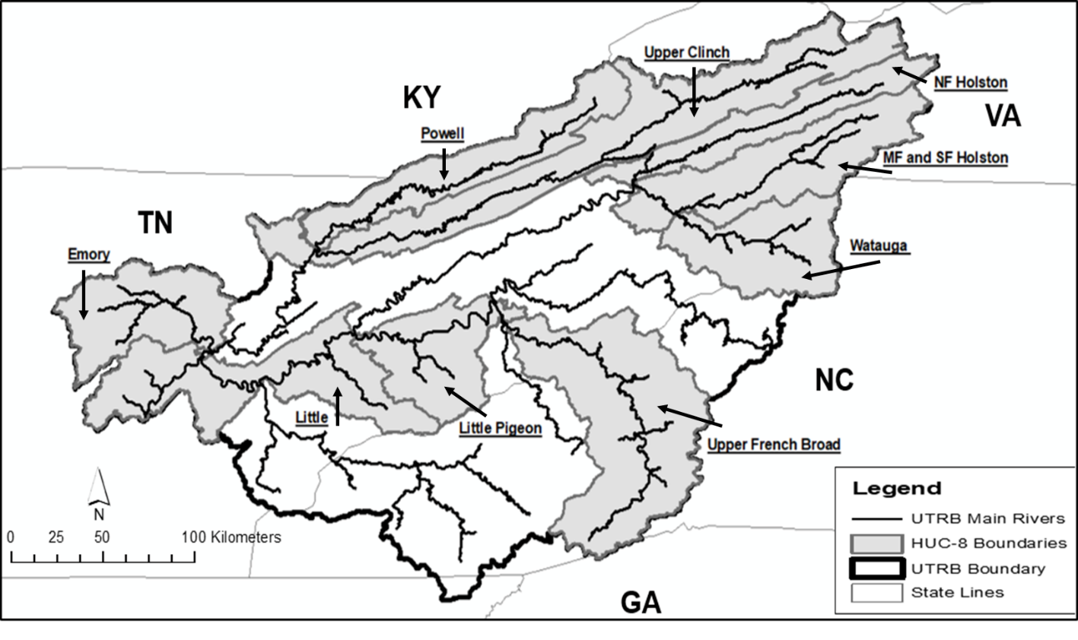
Fig. 1.1 The historically occupied HUC-8 sub-basins (shaded) by the Sickle Darter in the upper Tennessee River Basin.

Table 1.1 The USGS gauges (median annual discharge and median spawning season discharge) and the NOAA Climatic Data site (median total annual precipitation, median spawning precipitation, median annual air temperature, median spawning season air temperature) used to collect respective environmental variables in this study.
Sub-Basin | USGS Gauge | NOAA Climactic Sites
Little | USGS 03498500 Little River near Maryville, TN | Knoxville Airport, TN GHCND:USW00013891
Emory | USGS 03540500 Emory River at Oakdale, TN | Crossville Memorial Airport, TN GHCND:USW00003847
Little Pigeon | USGS 03470000 Little Pigeon River at Sevierville, TN | Gatlinburg, TN GHCND:USC00403420
Upper Clinch | USGS 03527000 Clinch River at Speers Ferry, VA; | Kingsport, TN GHCND:USC00404858
NF Holston | USGS 03488000 NF Holston River near Saltville, VA | Kingsport, TN GHCND:USC00404858
MF Holston | 03475000 MF Holston River near Meadowview, VA | Kingsport, TN GHCND:USC00404858
SF Holston | USGS 03473000 SF Holston River near Damascus, VA | Kingsport, TN GHCND:USC00404858
Watauga | USGS 03485500 Doe River at Elizabethton, TN | Elizabethton, TN GHCND:USC00402806
Upper French Broad | USGS 03451500 French Broad River at Asheville, NC | Asheville, NC GHCND:USW00013872
Powell | USGS 03532000 Powell River near Arthur, TN | Kingsport, TN GHCND:USC00404864

Fig. 1.2 The sites sampled for Sickle Darters during the current survey (2016). Sites with an open diamond signify Sickle Darter absence, and sites with a solid black circle signify Sickle Darters presence.

Fig. 1.3 The distribution of the Sickle Darter through our three temporal periods: pre-damming (pre-1960, A), post-damming (post-1960-1999, B), and modern (2000-present, C)

Fig. 1.4 Temporal variation in the number of total dams (DamsT), hydropower dams (DamsH), and low-head dams (DamsL) across the historic range of the Sickle Darter.

Table 1.2 Analysis of variance results for best subsets multiple linear regression for distance of stream occupied by the Sickle Darter across two spatial scales (whole basin and sub-basin). Results shown are for the best model from Table 4. Root MSE = root mean square error, Stand. B_{i} = standardized beta coefficient, VIF = variance inflation factor. The +/- sign for t-value indicates the direction of the association between the environmental covariate and distance of stream occupied. Further interpretation was not done for the top model in the Little Pigeon River sub-basin, North Fork Holston sub-basin, and upper Clinch River sub-basin because the top model from those sub-based did not contain variables with a VIF (˂4). Variable definition: DamsT (total number of dams)
*Distance of Stream Occupied: Scale | Variable | t-value | P-value | Stand. Bi. | VIF
Whole Basin
Root MSE=6.37
 | Intercept | 4.43 | ˂0.01 | 0.00 | 0.00
 | DamsT | -7.36 | ˂0.01 | -1.04 | 3.81
 | Temp | -3.39 | 0.02 | -0.49 | 2.22
South Fork Holston Sub-basin
Root MSE=0.01
 | Intercept | 0.01 | ˂0.01 | 0.00 | 0.00
 | DamsT | 0.01 | ˂0.01 | 0.01 | 1.1
Watauga Sub-basin
Root MSE=4.95
 | Intercept | 1.23 | 0.29 | 0.00 | 0.00
 | DamsT | -5.44 | ˂0.01 | -0.92 | 2.16

CHAPTER II
Ecological Niche Modeling of the Sickle Darter (Percina williamsi) Across TWO Spatial Scales.

-A version of this chapter was submitted for publication in Ecology of Freshwater Fish by Kyler B. Hecke and Brian J. Alford:
Hecke, K.B. and Alford, J.B. 2021 Ecological Niche-Modeling of the Sickle Darter (Percina williamsi) Across Two Spatial Scales. Ecology of Freshwater Fish.

Abstract
Ecological niche modeling is a useful tool for predicting the distribution of rare species. The Sickle Darter Percina williamsi is a rare fish species that has been relatively understudied until recently. It is endemic to the upper Tennessee River basin in eastern Tennessee, southwestern Virginia, and western North Carolina. The number of sites occupied by this species has declined in the last ~50 years and the species has been petitioned for federal listing under the U.S. Endangered Species Act. Ecological-niche modeling was used to identify stream reaches with a high probability of suitable habitat. Two spatial scales were chosen for modeling: the whole basin and sub-basin. We used recent (2000-present) occurrences for this species to train our models. We trained the models with species presences and background samples from the study area, and we used cross-validation to evaluate the models. The accuracy of the whole basin model was evaluated with the testing AUC metric, which was high (0.98) and correctly predicted the presences used to test the model (OR =0.0). The most important variable contributing to this model was stream order (48.2%). The ecological niche models varied from the whole basin to the sub-basin scale in terms of accuracy and variable importance, but they were similar in accurately predicting the area of suitable habitat for the Sickle Darter. Results from this study will be useful in identifying stream reaches to concentrate conservation efforts for this species. The ecological niche model projections of probability of suitable habitat will provide fisheries managers and biologists with a guide of where high probability of suitable habitats could occur for this species in the upper Tennessee River basin.

Introduction
Ecological niche modeling is a useful tool for the management and conservation of rare species, especially for estimating the distribution of aquatic species (McNyset 2005; Elith and Leathwick 2009; Franklin 2009; Dunith 2012; Domisch et al. 2015; Holley 2018; Taylor et al. 2018; Taylor et al. 2019;). There are multiple approaches to modeling the distribution of species, from occupancy modeling (MacKenzie et al. 2017) to ecological niche modeling (Peterson & Soberon 2012), which can be based on presence/absence data, pseudo-presence data, and other background samples. These types of models can help researchers and fisheries managers discern changes in a species distribution and status, by providing a baseline for repeatable monitoring studies (Elith and Leathwick 2009; Franklin 2009). This is important when managing fish species that are imperiled or rare in nature, like the Sickle Darter Percina williamsi (Hecke and Alford 2021).
The Sickle Darter is a rare species endemic to the upper Tennessee River Basin (UTRB) in the United States of America that has been relatively understudied until recently (Page and Near 2007, Jett 2010, Hecke and Alford 2021). Hecke and Alford (2021) determined that the distance of stream section occupied by Sickle Darters has declined due to habitat alteration and fragmentation caused by both hydropower and low head dams, as well as the adverse effects of an increase in human population density (deteriorating water quality). But there are still many unknowns regarding the ecology and life history of this species. This species was recently petitioned for federal listing under the U.S. Endangered Species Act due to this decline (USFWS). Historically, The Sickle Darter was observed in tributary systems of the UTRB (Fig. 2.1). The UTRB is a large basin (4.5 million hectares) but has undergone immense changes over the last 70 years, such as habitat fragmentation due to damming and water quality impairment from anthropogenic pollution sources (Hampson et al. 2000).
Many of the areas where Sickle Darters occur consist of fragmented habitats due to damming and deteriorating water quality (Hampson et al. 2000; Hecke and Alford 2021). Determining a species’ ecological niche with ecological niche modeling is a useful way to predict the species distribution based on occurrence data and measured environmental/habitat characteristics (Soberón and Peterson 2005; Elith and Leathwick 2009). Ecological niche modeling is conceptually based on Hutchinson’s n-dimensional hypervolume (Hutchinson 1978). The occupied distribution is the actual or realized portion of the fundamental niche within which it exists in space and time, after taking into account competition and predation effects on the species’ fitness (Hutchinson 1978; Soberón and Peterson 2005; Colwell and Rangel 2009; Elith and Leathwick 2009). The advantages of ecological niche modeling are that it works well with rare species (e.g., large number of absences relative to presences; Soberón and Peterson 2005; Colwell and Rangel 2009; Elith and Leathwick 2009; Holley 2018). Some disadvantages of ecological-niche models are that the usefulness of the model is approach dependent (presence-background data vs. presence-absence data), and that appropriate covariate selection and utilization can drive how well the model fits available data (Peterson and Soberón 2002). Ecological niche-modeling is just one method to identify the stream reaches that may be most suitable for Sickle Darters. We chose this method because ecological niche modeling has been used to determine the ecological niche of other rare and imperiled darter species, like the ecologically similar Longnose Darter P. nasuta (Holley 2018).
We used ecological niche modeling to determine areas of greatest habitat suitability for the Sickle Darter by incorporating multiple approaches. We achieved this goal with the following objectives: (1) determine the ecological niche of the Sickle Darter and how it varies on two spatial scales (whole distribution and sub-basin), and (2) determine the most important variables that drive the ecological niche of the Sickle Darter. The results of these models will provide valuable information for fisheries managers and biologists to use when determining the conservation measures needed for this species.

Materials and Methods
Study Area
The UTRB originates as a spring-fed system in the southern portion of the Appalachian Mountains. This basin flows through four different EPA-Level III ecoregions: the Blue Ridge Mountains, the Ridge and Valley, the Southwestern Appalachians, and the Central Appalachians (Omernik 1997; Fig. 2.1). This basin drains an area of 4.5 million hectares (Hampson et al. 2000). It consists of 6 major sub-basins: Watts Barr Lake, the Little Tennessee River, the Hiwassee River, the Clinch River, the Holston River, and the French Broad River (Hampson et al. 2000).
Contemporary Occurrences
Contemporary occurrences for this species were collected from multiple data sources. To be considered a contemporary occurrence record, we set a temporal threshold of 2000 to present. We felt this threshold would capture the current distribution for the Sickle Darter. These occurrence data were gathered from a recent distribution study on the Sickle Darter (Hecke and Alford, 2021), Global Biodiversity Information Network (GBIF, 2020), Freshwater Information Network (FIN; TNACI, 2019), FishNet2 (2017), FishMap (2020), and Conservation Fisheries Inc. sampling database (personal communication with CFI owners Pat Rakes and J.R. Schute). Contemporary occurrences were cross-referenced for potential double-listing of occurrences in multiple datasets. We plotted our contemporary occurrences in ArcGIS (ESRI 2021) with the NHDPlus (v.2; NHDPlus; McKay et al. 2012) and stream catchment datasets (StreamCat; Hill et al. 2015) to get a corresponding stream-segment identifier (FID) for each occurrence. Each stream segment varied in size (length in meters). This allowed us to correlate occurrences with specific environmental covariate data.
Environmental Covariates
Landscape-level environmental and habitat covariates were collected from the NHDPlus and StreamCat datasets. Data from these two sources correspond to a stream segment (NHDPlus), which is a specific measured reach of a stream and/or river from one tributary confluence to another. The stream catchment was defined as the topographical drainage area of a specific point on a stream or river where Sickle Darters occurred. We selected 12 environment covariates that were ecologically relevant to darters, specifically the Sickle Darter (Lindquist and Page 1984; Jett 2010; Holley 2018; Table 2.1). Landuse covariate data were measured in 2014, so these variables will suffice for use in our models because they are roughly the midpoint of the period where contemporary occurrences took place. From this data set, we removed data for stream segments with stream order of 1 or 2, following the methodology of Holley (2018) who utilized ecologicalniche modeling on the Slenderhead Darter (P. phoxocephala). These headwater stream segments were removed because the Slenderhead Darter and Sickle Darter occupy similar habitats in mid-order perennial streams and share similar life-histories. Environmental covariates were summarized further by stream segments and stream catchment occupied by Sickle Darters. We did not perform normality or spatial correlation tests for our environmental covariates because MaxEnt accounts for redundancy in the environmental covariates (Feng et al. 2019).
Data Analyses
Model Set: The presence-background with cross-validation was used in Maxent (Phillips et al. 2017) to estimate the ecological niche of the Sickle Darter within the UTRB. Maxent is a machine-learning tool that minimizes the relative entropy between values of environmental covariates associated with known presence locations and values of environmental covariates associated with background samples within the study area (Elith et al., 2011; Phillips et al., 2017; Taylor et al., 2019). Presence-background was the approach used to estimate the ecological niche of the Sickle Darter across two spatial scales (whole distribution and sub-basin) following the methods outlined by Holley (2018). Due to a lack of contemporary occurrences to train the ecological niche, sub-basin specific models were only performed for the Emory River, and Little River. For all of the models, the presence-background models, we used a random subset (25%) of our contemporary occurrences to train our model. Further, we used the cross-validation presence-background method to account for spatial sampling bias. We followed the methodology of Holley (2018) and Taylor et al. (2019) for our model designs because their datasets and species were similar to that for the Sickle Darter. All model projections of Sickle Darter probability of suitable habitat were plotted in ArcGIS (ESRI 2021) for further inference. The projections of probability of suitable habitat are between 0-1, and a specific projection of probability of suitable habitat suggests that the habitat in that particular stream segment is x% suitable for the species used in that ecological-niche modeling. For example, a stream segment with a probability of suitable habitat project of 0.75 (75%) signifies that the model predicts that there is a 75% chance of there being suitable habitat for the species in that stream segment.
Model Fit: The fit of ecological niche models was assessed in multiple ways. To estimated model performance, we used a threshold-independent measure called the area under the curve (AUC; Fielding and Bell 1997; Taylor et al. 2019). Higher values of AUC reflect an improved ability to discriminate presence locations from background locations (Muscarella et al., 2014; Warren and Seifert 2011). Testing AUC values were reported for each ecological niche model. In addition, we used omission rate (OR), which is a threshold-dependent measure (training omission error) to further assess the discrimination capacity of models (Fielding and Bell 1997; Jiménez-Valverde, 2014; Taylor et al. 2019; i.e., a false negative, an occurrence is mistakenly predicted as an area with low probability of suitable habitat). We also determined the percent contribution and permutation importance of each covariate included in each of the model. Percent contribution is the impact that a particular variable has on predicting the occurrence of that species (Phillips et al. 2017). The percent permutation measures the decline in training AUC when permuting the values of each variable at a time with the background values (Phillips et al. 2017) Also, we looked at the single-covariate response of the environmental covariate relating to Sickle Darter habitat suitability. We did this for each model by using the covariate in each model each with the highest percent contribution.
Model Comparison: We employed multiple methods to compare the spatial bias in ecological niche model projections for each of the models, i.e., whole basin vs sub-basin. Model projections were compared via testing AUC and % variable contribution.

Results
We collected 31 unique Sickle Darter occurrences to train the ecological-niche models (8 in the Emory River, 16 in the Little River, 4 in the Middle Fork Holston, 2 in the North Fork Holston, and 1 in the upper Clinch). Contemporary occurrences of Sickle Darters were observed in 5 sub-basins (upper Clinch, Emory, Little, Middle Fork Holston, and North Fork Holston; Fig. 2.2). The median estimate of covariates in occupied stream segments displayed some variations across the spatial scales (Attachment 2.1; Att_3.xlsx). The covariates percent urban-low, percent urban-medium, percent urban-high, percent crop, road crossing density, dam density, and mean predicted summer temperature were consistent for occupied stream segments across both spatial scales. All other covariates were variable across spatial scales, whole basin to sub-basin, and between sub-basins.
The Sickle Darter ecological-niche models shared some similarities between the two spatial scales. The whole basin ecological-niche model (7 testing occurrences and 31 training occurrences) had a testing AUC value of 0.85 and correctly predicted the occurrences of the training data with an OR of 0.0 (Fig. 2.3). Stream order was the variable with the highest percent contribution (48.2%; Table 2.2), and stream order had the highest permutation importance (29.2% Table 2.2) in this model. The Emory River sub-basin specific cross-validation models had a mean (±SE) testing AUC value of 0.84 (±0.22) and moderately predicted the occurrences of the testing data (OR=0.17; Fig. 2.4). Elevation was the variable with the highest percent contribution (51.4%) and had the highest permutation importance (29.0%; Table 2.2). The Little River sub-basin specific cross-validation model had a mean (±SE) testing AUC of 0.91 (±0.01), which was similar to the whole basin ecological-niche model (Fig. 2.5). In this model, the variable stream order had the highest percent contribution (51.7%) and the variable predicted mean summer temperature had the highest percent permutation importance (56.6%; Table 2.2). Sub-basin specific models were not performed for the Middle Fork Holston River (n=3), North Fork Holston River (n=2) or upper Clinch River (n=1) because there were too few occurrences to train an ecological niche model for these sub-basins. Across all models, the variable stream order (48.2%) had the highest average of contribution and predicted mean summer temperature (22.8%) had the highest average permutation importance.

Discussion
Ecological niche modeling is useful tool for determining the habitat suitability for rare species, such as the Sickle Darter. This is the first study to model the distribution and predict suitable stream reaches for the Sickle Darter. Hecke and Alford (2021) assessed temporal changes in its distribution and determined its current range but did not predict its distribution. Ecological-niche modeling has been useful for modeling the distribution of many other imperiled fish species. (McNyset 2005; McNyset 2009; Simpson 2011; Dunithan 2012; Pinkerton 2016; Holley 2018). However, not many studies have utilized ecological-niche modeling for species distribution modeling with darters (McNyset 2005; McNyset 2009; Holley 2018). McNyset (2005) used ecological-niche modeling to predict the distribution of the Arkansas Darter (Etheostoma cragini) and Fantail Darter (E. flabellare) in Kansas. McNyset (2009) also used ecological-niche modeling to predict the distribution of Sand Darter species (Ammocrypta spp.) across their ranges in the southeastern U.S. Holley (2018) used ecological-niche modeling to predict the distribution of a species similar to the Sickle Darter, the Longnose Darter (P. nasuta), and found it to be a successful method for predicting the distribution of this species based on testing occurrences. Ecological-niche modeling should be utilized more to predict the distribution of rare fish species, especially darters.
Sickle Darter ecological niche models varied in accuracy, error, and variable importance across the two spatial scales in our study. Our ecological-niche models may have varied spatially due to a number of reasons, more than likely due to an unequal number of training occurrences at each of the spatial scales. For example, we had 31 training occurrences in the UTRB compared to just 8 in the Emory River sub-basin. This may have influenced our ability to accurately predict the suitable habitat across each of the sub-basins, suggesting that sample size is an important factor in both modeling and fisheries research (Hernandez et al. 2005; Pearson et al. 2007; Pyne et al. 2007; Yackulic et al. 2013; Domisch et al. 2017; Marckovic et al. 2019; Støa et al. 2019). This supports that scale is important in fisheries research (Peterson & Dunham, 2010). Our ecological-niche models had a range of testing AUC values between 0.84 and 0.91 and a range of OR between 0.0 and 0.2. Hecke and Alford (2021) found that there are spatial relationships (whole basin vs. sub-basin) with the distribution of the Sickle Darter, which may be why our ecological niche models vary spatially. However, we did not include diet or microhabitat variables in our models which could differ by sub-basin. Another factor to consider in our spatial ecological niche models is the actual size of each basin assessed in each model. The size of basins included in our models (whole basin and sub-basin) were between 980 and 55,400 km². The Sickle Darter has a fairly wide range consisting of fragmented populations, so accurately predicting the ecological-niche model of this species may be difficult across spatial scales. Other studies have found that spatial scale is also important when determining a species’ ecological niche (Laub and Budy, 2015; Kärcher et al., 2019; Taylor et al., 2019). Laub and Budy (2015) found spatial differences in their niche overlap analysis with Bluehead Sucker (Catostomus discobolus), Flannelmouth Sucker (C. latipinnis), and Roundtail Chub (Gila robusta) in the Colorado River basin. Kärcher et al. (2019) found that spatial scale was an important factor in the variance of validation performances in their ecological-niche models for 8 freshwater species in the Danube River. Taylor et al. (2019) found that there was spatial sampling bias in their ecological-niche models of the Paddlefish (Polyodon spathula) in the Arkansas River basin. Domisch et al. (2015) outlined the challenges associated with modeling species distribution across temporal scales in stream ecosystems. While challenges exist in any distribution study, especially those challenges from a spatial perspective, ecological-niche modeling is still an adequate method for predicting the distribution of species when used appropriately.
The variables most important for determining the ecological niche models of the Sickle Darter varied between the two spatial scales. This variability is most likely due to spatial differences in each of the sub-basins, i.e., different values of model variables in each sub-basin (Table 2.2). We also saw differences in variable contribution from the whole basin scale to the sub-basin scale. These differences may be due to the wide range of variable values in the UTRB ecological niche model compared to the sub-basin specific ecological niche models (Dyer et al.,2013; Table 2.2). This highlights the importance of scale in ecological-niche modeling (Hernandez et al. 2005; Pearson et al. 2007; Pyne et al. 2007; Yackulic et al. 2013; Domisch et al. 2017; Marckovic et al. 2019; Støa et al. 2019). Future research should consider the potential cascading effects that may be present with some of these covariates, such as road-crossing density. In a comparable study on a Percina species, the Longnose Darter, Holley (2018) found that in their ecological niche models that mean annual discharge (68.4%) for a stream segment model and the reach area (85.4%) for a reach scale model were the variables that had the highest contribution to those respective models. We found contrasting results with the variables with the highest percent contribution to our models because these species inhabit different aquatic systems (Arkansas River basin compared to the UTRB) and have varying habitat requirements. Essentially, the Longnose Darter and Sickle Darter have differing environmental backgrounds (Nori and Rojas-Soto, 2019). In our study, elevation appears to be the most important variable across all models, suggesting that stream gradient plays an important role in the distribution of the Sickle Darter. This finding is supported by Poff and Allan (1995), who found that stream gradient plays a critical role in the functional organization of stream fish assemblages. However, we also found that different variables contributed to the importance of the sub-basin specific models. This suggests that Sickle Darters may have location-specific requirements for suitable habitat in each of the sub-basins.
The ecological niche models outlined in this study could be used to drive conservation efforts for this species. This study is the first to predict areas of suitable habitat for this species. Hecke and Alford (2021) predicted the distance of stream occupied by this species but did not relate it to microhabitat. The UTRB ecological niche model suggests, that, outside of its currently known range, that the Little Pigeon River should be an emphasis for potentially habitat improvements and/or species reintroductions. However, this sub-basin has gone through an immense number of changes in the last ~30 years due to an increase in urbanization and impervious surfaces (Hampson et al. 2000). Before conservation measures are enacted for this species in this sub-basin, microhabitat and water quality issues should be addressed as outlined by (USFWS, 2014). The North Fork Holston River sub-basin is another sub-basin to consider for future conservations efforts. The Sickle Darter has only been observed at two sites in this sub-basin in the last ~20 years. Hecke and Alford (2021) were unable to detect any Sickle Darters in this sub-basin in a recent distribution study on the species. This species may occur at such low abundance levels that they appear undetectable. This may be another area where Sickle Darters would benefit from species reintroductions if suitable microhabitat is available.
The results of this study provide a baseline for moving forward with the conservation of this species. Ultimately, this study provides data to guide the future monitoring of the Sickle Darter. A new monitoring effort may yield new occurrences of this species. Thus, sampling areas with high values of predicted suitable habitat in the Little Pigeon River and North Fork Holston Rivers, for example, may uncover new records of this species. However, some of these areas of high suitable habitat may not be accessible to the Sickle Darter since contemporary populations are fragmented by dams and their impoundments. Barve et al. (2011) highlighted how ecological-niche models do not always predict areas where a species may occur. This will be an important factor to consider when using these models to inform conservation decision for this imperiled species.

References
Anderson, R.P., Lew, D., & Peterson, A.T. (2003). Evaluating predictive models of species’ distributions: criteria for selecting optimal models. Ecological Modelling, 162,211-232. doi:10.1016/S0304-3800(02)00349-6
Araújo, M.B., & Williams, P.H. (2000). Selecting areas for species persistence using occurrence data. Biological Conservation, 96,331-345. doi:10.1016/S0006-3207(00)00074-4
Barve, N., Barve, N. Jimenez-Valverde, A., Lira-Noriega, A., Maher, S.P., Peterson, A.T., Soberon, J., & Villalobos, F. (2011). The crucial role of the accessible area in ecological niche modeling and species distribution modeling. Ecological Modelling, 222, 1810–1819. doi:0.1016/j.ecolmodel.2011.02.011
Colwell, R. K., &Rangel, T.F. (2009). Hutchinson’s duality: The once and future niche. Proceedings of the National Academy of Sciences of the USA, 106, 19651–19658. doi:10.1073/pnas.0901650106
Domisch, S., Jähnig, S.C., Simaika, J.P., Kuemmerlen, M., & Stoll, S. (2015). Application of species distribution models in stream ecosystems: The challenges of spatial and temporal scale, environmental predictors and species occurrence data. Fundamental and Applied Limnology, 186, 45–61. doi:10.1127/fal/2015/0627
Dunithan, A. (2012). Using ecological niche modeling to predict occurrence of rare fish and unionid mussels in East Texas. Master’s Thesis, University of Texas at Tyler. Retrieved from https://scholarworks.uttyler.edu/cgi/viewcontent.cgi?article=1012&context biology_grad
Dyer, J.J., Brewer, S.K., Worthington, T.A., & Bergey, E.A. (2013). The influence of coarse-scale environmental features on current and predicted future distributions of narrow-range endemic crayfish populations. Freshwater Biology, 58, 1071–1088. doi:10.1111/ fwb.12109
Elith, J., & Leathwick, J.R. (2009). Species distribution models: ecological explanation and prediction across space and time. Annual Review of Ecology, Evolution and Systematics, 40, 677-697. doi:10.1146/annurev.ecolsys.110308.120159
Elith, J., Phillips, S. J., Hastie, T., Dudík, M., Chee, Y. E., & Yates, C. J. (2011). A statistical explanation of MaxEnt for ecologists. Diversity and Distributions, 17, 43–57. doi:10.1111/j.1472-4642.2010.00725.x
ESRI. 2021. ArcGIS Desktop: Release 10.6 Redlands, CA: Environmental Systems Research Institute.
Feng X., Park, D.S., Liang Y., Pandey R., & Papeş M. (2019). Collinearity in ecological niche modeling: Confusions and challenges. Ecology and Evolution, 9, 10365-10376. doi:10.1002/ece3.5555

Fielding, A. H., & Bell, J. F. (1997). A review of methods for the assessment of prediction errors in conservation presence/absence models. Environmental Conservation, 24, 38–49. doi:10.1017/S0376892997000088
FishNet2. (2020) Percina williamsi. Retrieved from www.fishnet2.org.
Franklin, J. (2009). Mapping species distribution: spatial inference and prediction (1st ed.). Cambridge, UK: Cambridge University Press.
Hampson, P.S., Treece Jr., M.W., Johnson, G.C., Ahlstedt, S.A., & Connell, J.F. (2000). Water quality in the Upper Tennessee River Basin, Tennessee, North Carolina, Virginia, and Georgia 1994-98: U.S. Geological Survey Circular 1205, Reston, VA. doi:10.3133/cir1205
Hecke, K.B., & Lochmann, S.E. (2020) Occupancy and status of the strawberry darter in the Strawberry River drainage of Arkansas, USA. Environmental Biology of Fishes, 103, 1481–1493. https://doi.org/10.1007/s10641 020010379
Hecke, K.B., and J.B. Alford. 2021 Spatiotemporal Assessment of Sickle Darter (Percina williamsi, Page and Near, 2007) Distribution in the Upper Tennessee River Basin. Journal of Applied Ichthyology. doi:10.1111/jai.14235
Hernandez, P.A., Graham, G.H., Master, L.L., & Albert, D.L. (2006). The effect of sample size and species characteristics on performance on different species distribution modeling methods. Ecography, 29,773-785.
Hill, R., Weber, M., Leibowitz, S., Olsen, T., & Thornbrugh, D. (2015). The Stream-Catchment (StreamCat) Dataset: A database of watershed metrics for the conterminous USA. Journal of *the American Water Resources Association, 53, 120-28. doi:10.1111/1752-1688.12372
Hutchinson, G. E. (1978). An Introduction to Population Ecology (1st ed.). New Haven, CT: Yale University Press.
Jett, R.T. (2010). Underwater observation and habitat utilization of three rare darters (Etheostoma cinereum, Percina burtoni, and Percina williamsi) in the Little River, Blount County, Tennessee. Master's Thesis, University
of Tennessee. Retrieved from https://trace.tennessee.edu/cgi/viewcontent.cgi?article=1623&context=ut _gradthes
Jiménez-Valverde, A. (2014). Threshold-dependence as a desirable attribute for discrimination assessment: implications for the evaluation of species distribution models. Biodiversity and Conservation, 23, 369 385. doi:10.1007/s10531-013-0606-1
Kärcher, O., Frank, K., Walz, A., & Markovic, D. (2019). Scale effects on the performance of niche-based models of freshwater fish distributions. Ecological Modeling, 405,33-42. doi:10.1016/j.ecolmodel.2019.05.006
Laub, B.G., & Budy, P. (2015). Assessing the likely effectiveness of multispecies management for imperiled desert fishes using niche overlap analysis. Conservation Biology, 29, 1153-1163. doi:10.1111/cobi.12457
Lindquist, D. G., and Page, L.M. 1984. Environmental biology of darters. Springer Science & Business Media
McKay, L., Bondelid, T., Dewald, T., Johnston, J., Moore, R., & Rea, A. (2012). NHDPlus version 2: User guide. Washington, DC: National Operational Hydrologic Remote Sensing Center. Retrieved from https://nctc.fws.gov/courses/references/tutorials/geospatial/CSP7306/Re dings/NHDPlusV2_User_Guide. df
Markovic, D., Walz, A., & Kärcher, O. (2019). Scale effects on the performance of niche-based models of freshwater fish distributions: Local vs. upstream area influences. Ecological Modelling, 411, 33-42. doi:10.1016/j.ecolmodel.2019.108818
McNyset, K.M. (2005). Use of ecological niche modelling to predict distributions of freshwater fish species in Kansas. Ecology of Freshwater Fish, 14, 243– 255. doi:10.1111/j.1600-0633.2005.00101.x
McNyset, K.M. (2009). Ecological niche conservatism in North American freshwater fishes. Biological Journal of the Linnean Society, 96, 282-295. doi:10.1111/j.1095-8312.2008.01121.x
Muscarella, R., Galante, P. J., Soley-Guardia, M., Boria, R. A., Kass, J. M., Uriarte, M., & Anderson, R. P. (2014). ENMeval: An R package for conducting spatially independent evaluations and estimating optimal model complexity for Maxent ecological niche models. Methods in Ecology and Evolution, 5, 1198–1205. doi:10.1111/2041-210X.12261
NatureServe. (2013). Percina williamsi. The IUCN Red List of Threatened Species 2013: e.T202600A19034888. doi:10.2305/IUCN.UK.2013 1.RLTS.T202600A19034888.en.
Nori, J., & Rojas-Soto, O. (2019). On the environmental background of aquatic organisms for ecological niche modeling: a call for caution. Aquatic Ecology, 53, 595–605. doi:10.1007/s10452-01909711-6. doi:10.1007/s10452-019-09711-6
Omemik, J. (1987). Ecoregions of the conterminous United States. Annals of the Association of American Geographers, 77,118-125. doi:10.1111/j.1467 8306.1987.tb00149.x
Page, L. M., & Near, T.J. (2007). A new darter from the upper Tennessee River drainage related to Percina macrocephala (Percidae: Etheostomatinae). Copeia, 3, 605-613. doi:10.1643/0045 8511(2007)2007[605:ANDFTU]2.0.CO;2
Pearson, R. G., Raxworthy, C. J., Nakamura, N., & Poret‐Peterson, A. T. (2007). Predicting species distributions from small numbers of occurrence records: A test case using cryptic geckos in Madagascar. Journal of Biogeography, 34, 102–117. doi:10.1111/j.1365-2699.2006.01594.x
Peterson, A.T., & Soberon, J. (2012). Species distribution: modeling and ecological niche modeling: getting the concepts right. Nature Conservation, 10, 102–107. doi:10.4322/NATCON.2012.019
Peterson, J.T., & Dunham, J. (2010). Scale and fishery management. Pages 81 105 in W. Hubert and M. Quist, editors. Inland fisheries management (3rd edition). Bethesda, MD: American Fisheries Society.
Phillips, S. J. (2006). A brief tutorial on Maxent. AT&T Research. Retrieved from https://biodiversityinformatics.amnh.org/open_source/maxent/Maxent_tut rial2017.pdf
Phillips, S.J., Dudík, M., & Schapire, R.E. (2017). Maxent software for modeling species niches and distributions (Version 3.4.1). Retrieved from http://biodiversityinformatics.amnh.org/open_source/maxent/.
Pinkerton, J.J. (2016). Predicting the Potential Distribution of Two Threatened Stream Fish Species in Northeast Ohio. Master’s Thesis, Ohio State University. Retrieved from https://etd.ohiolink.edu/apexprod/rws_etd/send_file/send?accession=osu 461189304&disposition=inline
Poff, N. L., & J. D. Allan, J.D. (1995). Functional organization of stream fish assemblages in relation to hydrological variability. Ecology, 76, 606–627. doi:10.2307/1941217
Pyne, M. I., Rader, R. B., & Christensen, W. F. (2007). Predicting local biological characteristics in streams: A comparison of landscape classifications. Freshwater Biology, 52, 1302–1321.doi:10.1111/j.13652427.2007.01767.x
RStudio Team (2020). RStudio: Integrated Development for R. RStudio, Inc., Boston, MA URL http://www.rstudio.com/.
Simpson, J. K. (2011). Ecological niche models for the sabine shiner. Master’s thesis, Stephen F. Austin University. Retrieved from https://utk.idm.oclc.org/login?url=https://www.proquest.com/dissertations theses/ecological-niche-models-sabine-shiner/docview/898782927/se 2?accountid=14766
Soberón, J., & Peterson, A.T. (2005). Interpretation of Models of Fundamental Ecological Niches and Species’ Distributional Areas. Biodiversity Informatics, 2, 1-10. doi:10.17161/bi.v2i0.4
Støa, B., Halvorsen, R., Stokland, J.N., & Gusarov, V. I. (2019). How much is enough? Influence of number of presence observations on the performance of species distribution models. Sommerfeltia, 39, 1–28. doi:10.2478/som-2019-0001
Taylor, A. T., Papeş, M., & Long, J. M. (2018). Incorporating fragmentation and non‐native species into distribution models to inform fluvial fish conservation. Conservation Biology, 32, 171–182. doi:10.1111/cobi.13024
Taylor, A.T., Hafen T., Holley, C.T., González, A., & Long, J.M. 2019 Spatial sampling bias and model complexity in stream-based species distribution models: A case study of Paddlefish (Polyodon spathula) in the Arkansas River basin, USA. Ecology & Evolution, 10,705-717. doi:10.1002/ece3.5913
Tennessee Aquarium Conservation Institute. (2019). Freshwater Information Network: Sickle Darter Percina williamsi. Chattanooga, TN. Retrieved from https://tnacifin.com/fish/sickle-darter-percina-williamsi
U.S. Fish and Wildlife Service. (2011). Endangered and Threatened Wildlife and Plants; Partial 90-Day Finding on a Petition to List 404 Species in the Southeastern United States as Endangered or Threatened with Critical Habitat. Docket No. FWS–R4–ES–2011–0049; MO 92210–0 0009. Dept. of the Interior, Washington D.C. Retrieved from https://www.federalregister.gov/documents/2011/09/27/2011 24633/endangered-and-threatened-wildlife-and-plants-partial-90-day finding-on-a-petition-to-list-404
U.S. Fish and Wildlife Service. (2014). Imperiled Aquatic Species Conservation Strategy for the Upper Tennessee River Basin. Southwestern Virginia Field Office, Abingdon, VA. Retrieved from https://www.fws.gov/northeast/virginiafield/pdf/MISC/2014_UTRB_imperil d_aquatic_strategy.pdf
Warren, D. L., & Seifert, S. N. (2011). Ecological niche modeling in Maxent: The importance of model complexity and the performance of model selection criteria. Ecological Applications, 21, 335–342. doi:10.1890/10-1171.1
Yackulic, C B., Chandler, R., Zipkin, E F., Royle, J.A., Nichols, J.D., Campbell Grant, E.H., & Veran, S. (2013). Presence‐only modelling using MAXENT: When can we trust the inferences? Methods in Ecology and Evolution, 4, 236–243. doi:10.1111/2041-210x.12004
Zar, J.H. (1999). Biostatistical analysis. Upper Saddle River, NJ: Prentice Hall.

APPENDIX

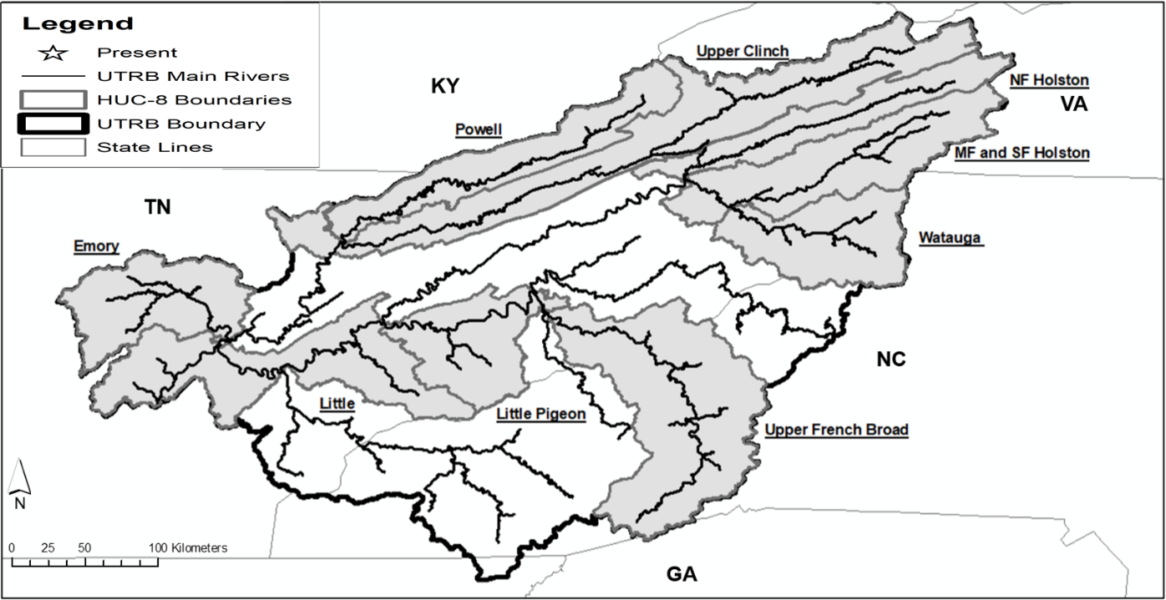

Fig 2.1. Historical distribution of Sickle Darters (shaded areas) in the UTRB (From Hecke & Alford, 2021).

Table 2.1. The unit and scale of each covariate considered for our ecological niche models. PctUr is the percent of the urban land cover type across low, medium, and high levels, PctMxFrst is the percent of mixed deciduous/evergreen forest land cover type, PctCrop is the percent of the crop landcover type, MSST is the predicted summer temperature, and BFI is the ratio of baseflow to total flow.
Covariate | Units | Scale
Area | km² | Catchment
Dam Density | dams/km² | Catchment
Elevation | M | Catchment
Road Crossing Density | crossings/km² | Catchment
PctUr_Low | % | Catchment
PctUr_Med | % | Catchment
PctUr_Hi | % | Catchment
PctMxFrst | % | Catchment
PctCrop | % | Catchment
MSSST | ֯C | Catchment
Stream Order | Unitless | Segment
BFI | % | Catchment

**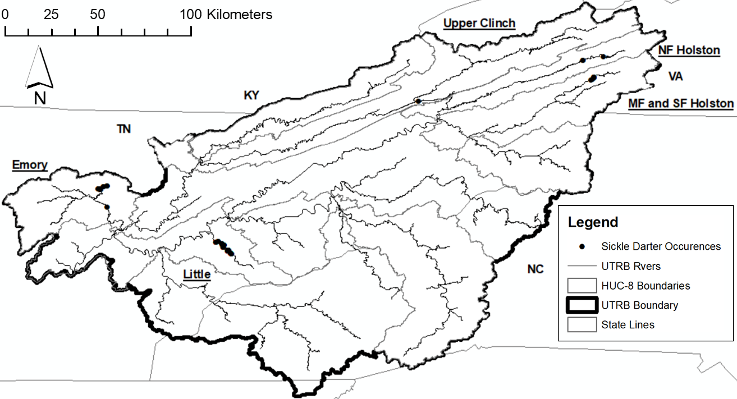
Fig. 2.2 Contemporary (2000-present) occurrences of Sickle Darters in the UTRB.

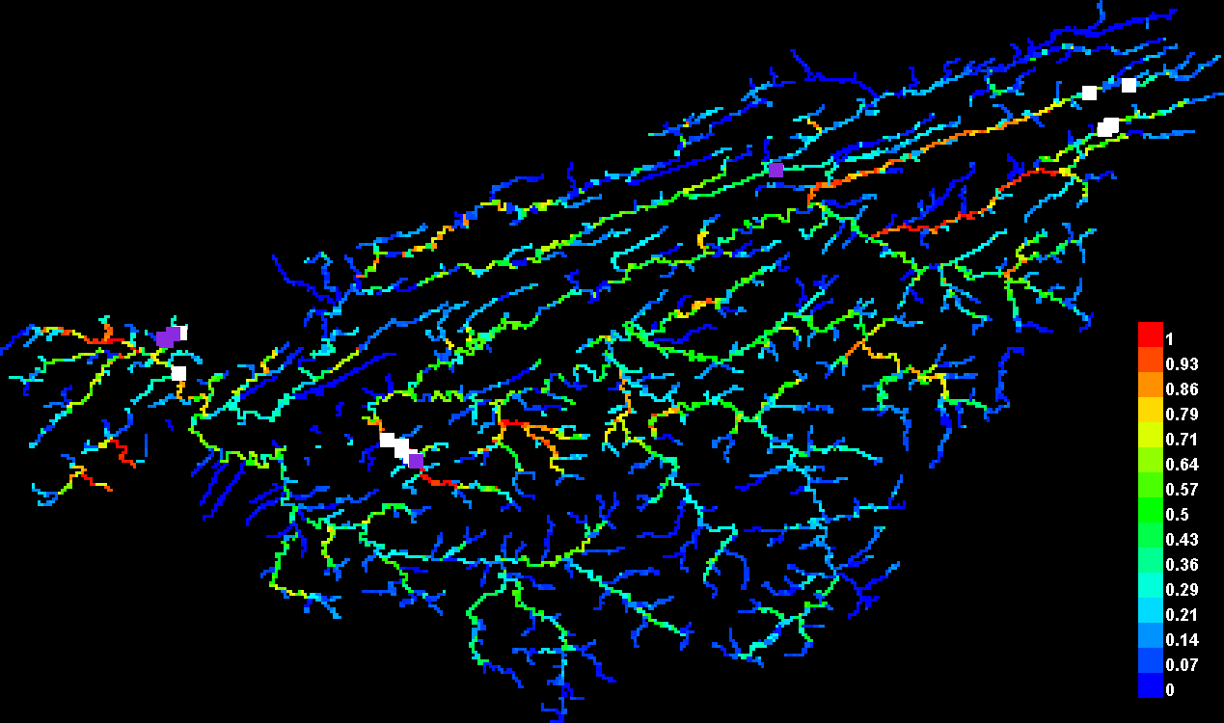

Fig. 2.3 The predicted habitat suitability (0.0-1.0) for Sickle Darters in the UTRB stream segments. Red stream segments signify high levels of habitat suitability, while blue values signify low values of habitat suitability. White squares are the occurrences used to train this model, while violet squares are the occurrences used to test this model.

Table 2.2. The percent contribution (standard deviation; %) and permutation importance (%) of each variable among all models. Percent contribution and permutation importance were averaged from all models. "-" signifies variables where there was insufficient data to include that variable in a model for the Emory River sub-basin.
 | Model
Variable | Upper Tennessee | Emory | Little | Average
Percent contribution
Stream Order | 48.2 | 6.8 (2.4) | 51.7 (4.6) | 35.6
Elevation | 0.0 | 51.4 (7.1) | 5.3 (1.3) | 18.9
PctUr_Med | 13.8 | 17.2 (9.3) | 13.6 (3.8) | 14.9
Catchment Area | 15.3 | - | 0.0 (0.0) | 7.7
BFI | 5.5 | 4.8 (1.3) | 10.4 (2.2) | 6.9
MSSST | 1.9 | 8.1 (2.2) | 7.6 (3.4) | 5.9
PctUr_Hi | 1.9 | 6.9 (1.4) | 7.8 (4.1) | 5.5
PctCrop | 5.4 | 0.8 (0.1) | 0.0 (0.0) | 2.1
PctUr_Low | 5.3 | 0.9 (0.2) | 0.0 (0.0) | 2.1
Road Crossing Density | 0.4 | 3.1 (1.5) | 0.1 (0.1) | 1.2
Reach Length | 0.9 | - | 0.8 (0.3) | 0.9
Dam Density | 0.2 | 0.0 (0.0) | 2.1 (0.3) | 0.8
PctMxFrst | 0.0 | - | 0.7 (0.1) | 0.4
Permutation importance
MSSST | 4.8 | 6.9 (2.6) | 56.6 (5.6) | 22.8
Stream Order | 29.2 | 25.4 (6.5) | 0.0 (0.0) | 18.2
Elevation | 0.0 | 29.0 (3.5) | 17.4 (3.2) | 15.5
PctUr_Hi | 16.8 | 10.8 (2.7) | 10.0 (6.4) | 12.5
PctUr_Med | 23.4 | 1.1 (0.4) | 4.5 (2.8) | 9.7
BFI | 4.5 | 19.0 (5.3) | 0.0 (0.0) | 7.8
PctCrop | 17.3 | 0.0 (0.0) | 0.0 (0.0) | 5.8
PctMxFrst | 0.0 | - | 8.4 (2.1) | 4.2
Reach Length | 2.5 | - | 1.8 (0.7) | 2.2
PctUr_Low | 0.0 | 6.1 (4.2) | 0.0 (0.0) | 2.0
Road Crossing Density | 1.5 | 1.8 (0.1) | 0.2 (0.1) | 1.2
Dam Density | 0.0 | 0.0 (0.0) | 1.1 (0.2) | 0.4
Catchment Area | 0.0 | - | 0.0 (0.0) | 0.0

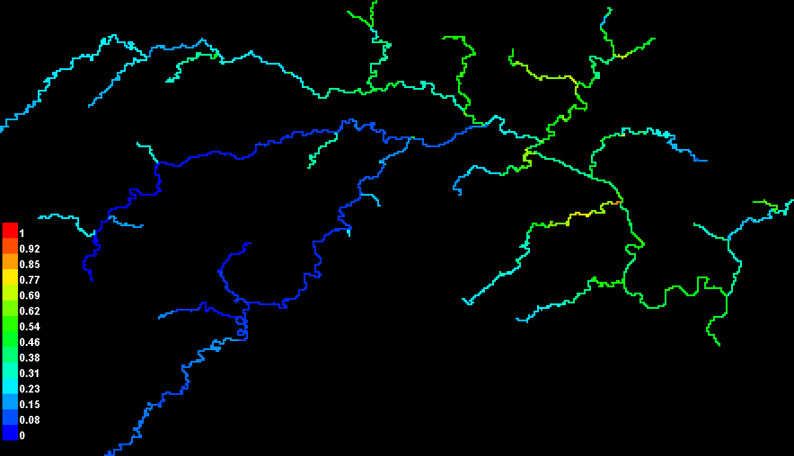
Fig. 2.4 The ecological niche model projection for the Emory River sub-basin.

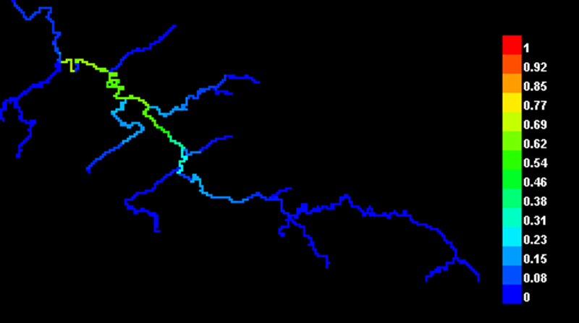
Fig. 2.5 The ecological niche model projection for the Little River sub-basin.

CHAPTER III
The Movement and Home Range of the Sickle Darter (Percina williamsi) in the upper Emory River of Tennessee, USA.

The following chapter is formatted to the specific author guidelines for the Hydrobilogia journal by myself and my adviser J. Brian Alford.
Hecke, K.B. and Alford, J.B. 2021. Movement and Home Range of the Sickle Darter (Percina williamsi) in the Upper Emory River of Tennessee. Hydrobilogia.

Abstract
Understanding movement patterns and home range of rare species is challenging, especially for aquatic fauna like fishes. The Sickle Darter Percina williamsi is a rare fish species endemic to the upper Tennessee River basin in eastern Tennessee, southwestern Virginia, and western North Carolina (USA). It has been listed as threatened by the states of Tennessee and Virginia and is being petitioned for federal listing under the United States Endangered Species Act. Little is known about the movement and home range of this species. A total of 8 Sickle Darters from the upper Emory River system were implanted with 8-mm PIT tags and released at the point of capture. The mean (±SD) total length and weight of all fish PIT tagged was 70.1 ±3.4 mm and 3.08 ±1.4 g. Movement for each individual was tracked every two weeks for 6 months (September-March; including spawning season) with a Biomark® HPR Plus reader and BP Plus portable antenna. Associated environmental data (discharge, water temperature, photoperiod, and precipitation) were collected throughout the study. Best sub-sets regressions modeling suggest that Sickle Darter movement is significantly related to discharge (m/sec³) at multiple temporal levels. Home range for each individual varied in size. Median home range size was 157.5 m² and median degree of overlap for estimated home range was 23.3 %. The results from this study suggest that Sickle Darters exhibit strong site fidelity except when discharge is extremely high. Therefore, conservation measures that protect or attempt to reconnect fragmented habitats will need to factor in the low dispersal ability of this species.

Introduction
Understanding movement patterns and home range of rare species is challenging, especially aquatic fauna like fishes. (Holden, 1978; Rodriguez, 2002). Movement of large-bodied sport fishes, like salmonids, has been widely documented on multiple scales (Holden, 1978; Rodriguez, 2002). Rare species movement can be assessed on multiple scales, such as within-habitat movement, within-reach movement (movement within a stream reach), and system-to-system movement (one tributary to another). There are multiple reasons why species move, such as seasonal spawning migrations, short-term movement to minimize stress (e.g., movement to a thermal refugium), or movement to another reach in response to a habitat disturbance (e.g., flood or drought) or loss of resources (e.g., food, cover). Understanding the movement of a rare species can improve the efficacy of monitoring its population trajectory. In addition, movement studies allow researchers to understand how individuals respond behaviorally to environmental change, and how they may utilize available habitat at various spatiotemporal scales (Holden, 1978; Rodriguez, 2002; Baxter, 2015; Baker et al., 2017; Pennock et al., 2018).
The Sickle Darter Percina williamsi is a rare fish species that has been understudied until recently (Jett 2010; Tennessee Wildlife Resources Agency [TWRA], 2015 Virginia Department of Wildlife Resources [VDWR], 2015; Hecke & Alford 2021). Historically, its distribution included the upper Tennessee River basin (UTRB) in the states of North Carolina (NC), Tennessee (TN), and Virginia (VA; Etnier & Starnes, 1993; Jenkins & Burkhead, 1994; Page & Near, 2007; Jett, 2010; Burns et al., 2007; TWRA, 2015; VDWR, 2015; Tracy et al., 2020; Hecke & Alford, 2021). However, due to fragmentation of populations by dams and other environmental disturbances, it currently occurs only in the upper Clinch River and North Fork Holston River sub-basins in Tennessee and Virginia, Middle Fork Holston River sub-basin in Virginia, and the Emory River and Little River sub-basins in Tennessee (Page & Near, 2007; Hecke & Alford, 2021). Previous studies on this species have focused on its life history, diet, and microhabitat utilization, primarily within one river where it is found—the Little River in Tennessee (Etnier & Starnes, 1993; Page & Near, 2007; Jett, 2010). Without a more complete understanding of this species, it is hard to prescribe suitable conservation measures to preserve it. At the microhabitat scale, the Sickle Darter occupies flow-adjacent pools over a mix of substrate types (e.g., cobble, boulder, sand, gravel, silt), and it is strongly associated with small woody debris or macrophyte cover (Etnier & Starnes, 1993; Jett, 2010). This species is thought to remain in the same reach for the majority of the year, and individuals are captured in the same microhabitats year after year. However, there have been cases where it moves to deeper pools in the winter season (Etnier & Starnes, 1993). There is anecdotal evidence that suggests they migrate short distances from pools to gravel areas of riffles for spawning; however, no study has documented this (Etnier & Starnes, 1993; J.R. Shute, personal communication). Studies on darter (Family Percidae) movement, in general, show that movement tends to be species-specific and location dependent. For example, Baxter (2015), found that Kentucky Arrow Darters Etheostoma spilotum in tributaries of the Red Bird River (Kentucky, USA) will annually move both upstream and downstream and cover distances from 40 m to 4,000 m.
There have been many recent advancements in the application of telemetry technology in small-bodied fishes (< 150 mm total length) for studying individual dispersal and microhabitat selection (Ruetz et al., 2006; Knaepkens et al., 2007; Baxter, 2015). Passive Integrated Transponder (PIT) tags have been used for decades to track many fish species from all types of environments (Smyth & Nebel, 2013; Baxter, 2015). However, most species that are PIT tagged are prized commercially or recreationally, easily recognized and valued by society (e.g., sharks) or they are invasive (e.g., carps in North America). Recent telemetry studies have used PIT tags to track small-bodied stream fishes that tend to be rare or of conservation value (Baxter, 2015; Baker et al., 2017; Cary et al., 2017; Kelly et al., 2017; Allan et al., 2018; Pennock et al., 2018). These researchers have outlined methods to track the movement of individuals at large and small scales, and they have observed movement of individuals across multiple habitat types within a stream.
The goal of our study was to assess how the Sickle Darter moves spatially within a stream and to determine the variability to which it moves temporally. We achieved this goal with the following objectives: 1) determine the movement extent of the Sickle Darter in the upper Emory River system and the potential environmental drivers of this movement, 2) assess the variation in microhabitat use on a temporal scale, and 3) determine the species’ home range and the degree to which individuals overlap in their habitat use. The data presented in this study will further our knowledge on Sickle Darters and help inform future conservation measures to preserve this species.

Methods
Study Area
The Emory River is a predominantly spring-fed tributary system of the upper Tennessee River watershed in east Tennessee (Etnier & Starnes, 1993; TDEC, 2002; Fig. 3.1). This river originates in Morgan County, and it flows southeasterly until it meets its confluence with the Clinch River in Roane County, Tennessee (Tennessee Department of Environmental Conservation [TDEC], 2002). The Emory River main stem is 74 km long and its basin drains an area of ~2,300 km² (TDEC, 2002). This basin flows through two different EPA-Level III ecoregions: the Southwestern Appalachian Mountains and the Ridge and Valley (Omernik, 1997).
Fish Collection and Tagging
Sickle Darters were captured from known occurrence locations within the Emory River drainages (IACUC protocol # 2257; Fig. 3.1; Page & Near, 2007; Jett, 2010; Hecke & Alford, 2021). This river and occurrence locations were chosen because it supports one of only two robust populations remaining in its fragmented distribution (Page & Near, 2007; Hecke & Alford 2021). These capture locations consisted of long shallow pools and short riffle areas over various substrate types. These two sites were selected because they are known occurrence locations of Sickle Darters where they have persisted over many decades. Backpack electrofishing and minnow seines were used to capture individuals (Bonar et al., 2009). A total of eight Sickle Darters varying in size from 56 to 88 mm total length were collected, tagged, and released at their point of capture in the Emory River system, which included Rock Creek, a small tributary to the Emory River in Morgan County, Tennessee (09/27/2019 and 11/16/2019).
PIT tags were used to track individual Sickle Darter movement (Smyth & Nebel, 2013). The model of PIT tags deployed were Biomark® HPT8 minichipTM (8.4mm X 1.4mm, 134.2KHz). These PIT tags are known to not hinder growth, movement, or behavior of small benthic fishes (Ruetz et al., 2006; Knaepkens et al., 2007). Tagging methods closely followed Baxter (2015). Sickle Darters were tagged on the ventral side and on the posterior end between the gular area and the vent. This is the standard PIT-tagging location for small-bodied freshwater fishes (Kuechle & Kuechle, 2012; Baxter, 2015). A scalpel was used to make a small insertion at this location, then the PIT tag was inserted by hand following the mid-ventral line at an approximate 45֯ angle. After insertion of the PIT tag, the location was treated with a petroleum jelly made of an antiseptic betadine solution. All materials used were sterilized with 75% ethanol, and the individuals assisting with the PIT tagging of a fish wore nitrile gloves to avoid potential infection of the PIT-tagging location. After insertion, each fish was checked for a unique PIT-tag number. Fish were placed in a container of ambient river water with aeration and allowed to recover for 45 min. After the recovery period, the tagged fish were released back into the river at its capture location. Each individually tagged fish was checked once again prior to release in the river for a corresponding PIT-tag number. PIT-tagging mortality and retention was not assessed due to the conservation status and limitations of collecting of this species. Instead, we estimated tag retention and mortality from methods in Ruetz (2006), and Knaepkens et al. (2007) based on their studies on PIT-tagging small-bodied stream fishes, where tag retention is the percent of individuals that retained their tag, and tag mortality is the percent of individuals that died during the tagging process.
Fish Tracking
The movement of PIT-tagged individuals was tracked biweekly after the original tagging date for one year. These PIT tags can remain active for up to 70 years. Tagged fish were tracked using a Biomark® HPR Plus reader and a BP Plus portable antenna. The antenna allows the PIT-tag reader to detect the tags under water, even if the fish is hiding under cover (e.g., a rock or vegetation) simply by holding the reader within about 30 cm of the animal. The antenna has been found to sufficiently detect a benthic PIT-tagged species, the Mottled Sculpin Cottus bairdii, which is strongly associated with rock cover (Kelly et al., 2017). Cross-channel paths (i.e., left bank to right bank) were conducted in a zig-zag motion across the wetted width of the stream at each tagging site to track the PIT-tagged individuals. These paths were done continuously until all fish were accounted for, or the detection reach was covered (≈500 m) at each tagging site. The paths did not overlap and there was ˂0.15 m between each of the individual paths. Each time a PIT-tagged fish was located a weighted fluorescent marker was placed in water to identify the point of detection. To determine if the “detection” was from a live fish, we used visual confirmation to determine that the PIT-tagged fish was still alive (i.e., gill or body movement observed) and that the PIT tag had not been lost. The corresponding geolocation of the “detected” Sickle Darter was recorded. The detection locations were marked so that microhabitat and environmental data could be collected for each detected individual. Time of tracking (min) was also estimated for each tracking event so that additional movement and detection efficiency variables could be estimated. Movement of each fish was estimated by measuring the distance traveled by a tag fish by estimating the distance in meters from a fish’s previous tracking event detection to the current tracking event detection. This was done for each fish during every tracking event. Movement upstream and downstream was also recorded during this process. Movement distances were estimated in ArcMap
Environmental and Habitat Variables
We measured microhabitat characteristics within a 2-m² area around each weighted marker (Table 1). These data included canopy cover (%), dissolved oxygen (mg/L), pH, stream depth (m), stream wetted-width (m), water temperature (֯C), water velocity (cm/sec), and percentage of substrate types (e.g., gravel, sand). These environmental variable and habitat variables were selected because they best represent the known microhabitat of darters (Chips et al. 1994). Dissolved oxygen and water temperature data were collected with a Pro20 Dissolved Oxygen Meter. The pH data were collected with an Oakton PCSTestr 35 pH tester. Stream depth data were collected with a Keson 50-m field-measuring tape. Water velocity data were collected using the neutrally-buoyant object method, whereby a floating marker was dropped at an upstream point 2 m from a darter detection, and the time was measured (s) for the marker to travel downstream to the point of detection. Current velocity for the detected darter was calculated as m/s. This was done three times total to get an estimate of mean water velocity for the area of detection. Substrate data were collected by visually determining the percentage of each substrate type (sand/silt, gravel, cobble, and boulder) at each detection location within the 2-m² detection area. Other environmental data were collected daily throughout the study for the Emory River watershed, and these data included discharge(m³/sec) from the U.S. Geological Survey (USGS) gauge # 03540500 at Oakdale, TN, and precipitation (cm) and photoperiod (hours) from the National Oceanic and Atmospheric Administration (NOAA) National Weather Service (2020) climate station GHCND: USW00053868 at Oak Ridge, TN. Water temperature (֯C) data were collected every hour using two Onset HOBO temperature loggers, with one deployed at the Rock Creek site and another deployed at the upper Emory River site.
Data Analyses
We characterized movement by estimating total effort (min), effort-per-detection (min./detection), and detection (0-1; Hubert and Fabrizo, 2007). We ran simple linear regressions to assess the temporal relationship of these variables throughout the study. To determine the spatial movement of Sickle Darters, we plotted geolocations in ArcMap (ESRI, 2020), and used the point-distance function to get an estimate of distance (m) between points from tracking events. We did this for every tracking point, determining the distance moved compared to the most previous tracking event. We estimated a mean (±SD) movement distance of Sickle Darters for each tracking event. Furthermore, we determined the frequency of upstream and downstream movement throughout this study. A two-tailed Kolmogorov-Smirnov test was used to assess if frequency of Sickle Darter movement upstream or downstream was distributed equally.
For the environmental and microhabitat data measured at each detection point, we estimated a mean (±SE) value for all variables for each tracking event. For the watershed-scale environmental data, we estimated total daily photoperiod (hours), mean daily temperature (֯C), daily temperature change (֯C), total daily precipitation (cm), and median daily discharge (m³/sec). We chose these variables because discharge and temperature are known to be important to fish movement, and because darters are active diurnally, we chose photoperiod to reflect potential associations between movement and hours of sunlight. We assessed the relationship of time to the tracking characteristics and environmental variables. We estimated a total frequency of substrate use during each tracking event for all fish detected. All statistical analyses were evaluated at an alpha = 0.05, and all analyses were completed in RStudio (2020; Zar, 1999).
We modeled the mean movement distance of Sickle Darters against the various temporal environmental and microhabitat variables. We did this by using best-subsets regression modeling, a form of multiple regression, (Zar, 1999). We chose best-subsets regression modeling because the response and predictor variable data were continuous. Mallow’s Cp and Adjusted R² were used to select models with the best fit at each temporal scale (7-day, 3-day, 1-day). We chose these temporal scales to capture potential delayed effects on Sickle Darter movement associated with environmental or microhabitat characteristics. We estimated a median value for the environmental and microhabitat characteristics for each of the temporal scales, i.e., for the 3-day temporal, we used the median estimate for discharge. We considered the best models for interpretation as those with the lowest Mallow’s Cp values and highest adjusted R² values, because these metrics allowed us to interpret the most parsimonious models (i.e., less risk of overparameterization). We further interpreted our best models at each spatial scale by assessing model fit with Analysis of Variance. Further, we used corrected Akaike information criterion (AIC_{c}) to determine the number of models to interpret at each spatial scale. Corrected Akaike information criterion was used to account for the small samples size used in our analyses. At each spatial scale, all models with ΔAIC_{c} value ≥ 5 were interpreted further (Akaike, 1973; Burnham & Anderson, 2004; Liao et al., 2018).
To estimate the home range (90% of contour) and the core range (50% of contour) for each PIT-tagged Sickle Darter, we used the kernel density tool in ArcMap (ESRI,2020). We used the Fish Tracker tool in ArcMap to smooth out the home range estimates and make them fit the actual riverine system (i.e., remove obstructions) where this study took place (upper Emory River watershed; Laffan & Taylor, 2013). This tool applies the home range estimate to a more fish-like habitat (rivers), by making the estimate more “aquatic” in nature, compared to estimates of home range for terrestrial species (Laffan & Taylor, 2013). This does not remove movement points from the map. We estimated the total size (m²) of home ranges for each PIT-tagged Sickle Darter and determined a mean home range size. If there was overlap of home ranges between individuals, we estimated the percentage of overlap (%) for each individual.
Results
A total of 8 Sickle Darters were tagged on two different dates (09/27/2019 and (11/16/2019). At the Rock Creek site, 6 individuals were tagged, and 2 individuals were tagged at the upper Emory River site. The fish in Rock Creek were electrofished and the ones in the upper Emory River were seined. On the first tagging date, there was an initial tagging survival rate of 75% (4 total fish: 2 from Emory River, and 2 from Rock Creek). One fish died after being tagged, but this fish was small in comparison to other PIT-tagged fish (56 mm) and showed signs of stress immediately after capture and prior to tagging. On the second date, there was an initial tagging survival rate of 100% (4 fish total, all from Rock Creek). The mean (±SE) size of all PIT-tagged fish was 70 (±4.1) mm and 3.1 (±0.5) g.
We had a total of 10 tracking events (09/2019-03/2020). Our study was cut short due to travel restrictions associated with the COVID-19 pandemic and extreme discharge events that seemed to displace Sickle Darters outside of our detectable range or cause mortality. In February of 2020, the Emory River experienced a record flood event (2089.78 m³/sec at the USGS Gauge at Oakdale, TN on 02/06/2020). Overall, Sickle Darter movement declined throughout out the study (09/2019-03/2020; P-value = >0.01, Adj. R²=0.40; Fig. 3.2). Our detection of Sickle Darters also significantly declined throughout out the study (P-value=˂0.01, Adj. R²=0.28 Fig. 3.3). However, this may have been a result of the high-flow event that took place in February 2020. Our total effort significantly increased throughout the study (P-value= ˂0.01, Adj. R²=0.76; Fig. 3.3). Like detection, this was likely caused by the high flow event. Unlike detection and total effort, effort-per-detection remained constant throughout the study (P-value=0.50, Adj. R²=0.41; Fig. 3.3. The frequency of Sickle Darter movement downstream or upstream from its capture site was not significantly different (P-value= 0.88; Fig. 3.4).
The environmental and microhabitat variables measured at each geolocation for a detected fish remained constant throughout the study. However, water temperature (֯C) significantly declined throughout the study (P-value= ˂0.01; Attachment 3.1; Att_4.xlsx). The watershed-scale environmental variables varied widely. Mean daily temperature (֯C) significantly declined throughout the study (P-value= ˂0.01, Adj. R²=0.37; Fig. 3.5). However, daily temperature change (֯C) did not significantly change throughout the study (P-value= 0.13, Adj. R²=0.10; Fig. 3.5). Precipitation (cm) did significantly change throughout the study also (P-value=<0.01, Adj. R²=0.55; Fig. 5c). Daily photoperiod (hours; P-value= ˂0.01, Adj. R²=0.98; Fig. 3.5) and median daily discharge (m³/sec; P-value=˂0.01, Adj. R²=0.37; Fig. 3.6) significantly changed throughout the study. Sand and cobble were utilized the most frequently by tagged Sickle Darters throughout the study (Fig. 3.7).
There was little variation in the relationship of environmental variables and Sickle Darter movement between the three temporal scales. At the 1-day temporal scale, the top 5 best sub-sets models included median daily discharge, precipitation, and daily temperature change, with the model including median daily discharge being the best model (6.14 AIC_{c}; Attachment 3.2; Att_5.xlsx). At the 3-day temporal scale, the top 5 best sub-sets models included median daily discharge, daily temperature change, mean daily temperature, and precipitation, with the model including median daily discharge being the best model (6.14 AIC_{c}; Attachment 3.2; Att_5.xlsx). At the 7-day temporal scale, the top 5 best sub-sets models included median daily discharge, daily temperature change, mean daily temperature, and precipitation, with the model including median daily discharge being the best model (8.39 AIC_{c}; Attachment 3.2; Att_5.xlsx) The top model from each scale and response variable was retained for interpretation because they met assumptions regarding least-squared regression analyses (Table 3.1). At the 1-day temporal scale, the median daily discharge was negatively associated with Sickle Darter movement, but this relationship was not statistically significant (t = -1.88; P-value = 0.16). At the 7-day temporal scale, the median daily discharge was negatively associated with Sickle Darter movement, but this relationship was not statistically significant (t = -1.82; P-value = 0.14). At the 7-day temporal scale, the median daily discharge was negatively associated with Sickle Darter movement and was statistically significant (t = -6.51; P-value =<0.01).
Sickle Darter home range size varied individually (Fig. 3.8). Only PIT-tagged fish from Rock Creek (n=6) were considered for the home range analyses. The median (min.-max.) size of home ranges was 157.5 (86.0-312.5) m². Home range overlap existed with every individual, but not with more than 2 individual home ranges. Degree of overlap between Sickle Darter home ranges varied individually as well. The median (min.-max.) degree of overlap among all individuals was 23.3 (6.2-34.0) %.
Discussion
PIT tagging of rare small-bodied fish, specifically Darters, is possible, and yields a high PIT-tag retention and tagging-survival rate. This study outlines a way to conduct movement studies on such cryptic species. We experienced a low tagging-mortality (~14%), and tag loss (0%) throughout this study, comparable to other PIT-tagging studies on darters (Baxter, 2015). Baxter (2015) observed similar results with tagging-mortality (none reported) and tag loss (0%) on the Kentucky Arrow Darter. Ideally, we would have retained individuals outside of our actual study and monitored PIT-tag retention and mortality through a pilot study, but due to the rareness (proposed for federal listing; USFWS, 2011) of the Sickle Darter, we were unable to collect a large number of fish to support such a study. Nonetheless, we did find that Sickle Darters ≥ 55 mm should be PIT tagged. This is confirmed by Baxter (2015), who suggest that larger individuals of a darter species should be PIT tagged. This leads to higher tag survival and retention rates.
Sickle Darter movement varied temporally, but overall, they moved very little spatially. Thus, it is likely that Sickle Darters exhibit high site fidelity, especially during average to low discharge. Prior to this study, there was anecdotal evidence suggesting that Sickle Darters in Little River (Tennessee, USA) move to deep pools during the winter months and to shallow gravel riffles to spawn in the spring (Etnier & Starnes, 1993; J.R. Shute, personal communication). However, the movement of Sickle Darters in the Emory River system may be different compared that in the Little River. The Little River is considered a small to medium-sized river, and it has a mosaic of riverine features, such as complex riffles, runs, and pools. The upper Emory River system, on the other hand, consists of short and few riffles with long shallow pools and runs (<1 m deep). The riverine features of these two systems, and amount of available habitat may influence the extent to which individuals from these two fragmented populations move. Other studies on darter movement have found variable results pertaining to the distance moved by darters (Roberts & Angermeier, 2007; Roberts et al., 2008; Holt et al., 2013; Baxter, 2015; Hicks & Servos, 2017). Roberts et al. (2008) found that the Roanoke Logperch, P. rex, exhibited high site fidelity throughout their tagging study based on movement between similar habitat types. Holt et al. (2013) and Hicks & Servos (2017) found that the Brown Darter E. edwini and Rainbow Darter E. caeruleum, respectively, exhibited high site fidelity throughout their tagging studies, i.e., movement to similar habitat types. In contrast, the Blackbanded Darter, P. nigrofasciata, a species more ecologically similar and phylogenetically closer to the Sickle Darter, was found to move farther distances (~350 m) than what we report for the Sickle Darter (Freeman, 1995). These differences may be due to the shifting sandy bottom streams that Blackbanded Darters occupy in coastal plain ecoregions, compared to Sickle Darters which are found in more interior mountain streams. Baxter (2015) found that Kentucky Arrow Darters can move a large distance as well, with some individuals moving up to 4 km. Thus, differences in movement of darters are probably due to a multitude of factors, dependent on species and location (i.e., stream type). Unfortunately, our study was cut short due record flooding in the Emory River, which resulted in displacement of PIT-tagged individuals outside of our detectable range or caused mortality due to the high flow event. This prevented us from observing Sickle Darter movement during the spawning season of this species (late February to early April; Etnier & Starnes, 1993). A new movement study should be completed to observe how this species moves on an annual basis to encompass the spawning season and summer months which we failed to observe in our study. Future studies should also consider how the movement of this species potentially varies spatially. There are three remaining viable populations of Sickle Darters that are fragmented by dams and impoundments (Hecke & Alford 2021), in the upper Emory River sub-basin, Little River sub-basin, and Middle Fork Holston River sub-basin. It is possible that Sickle Darters move differently in these sub-basins due to each sub-basin’s unique riverine features, size, and amount of available habitat (Ward, 1998).
Sickle Darter movement can be linked to changes in discharge. We found that discharge, no matter the temporal scale, had a negative influence on Sickle Darter movement. Sickle Darters appeared to move more in response to variation in discharge, i.e., more peaks in discharge over a given time. However, we may have experienced modeling bias due to high Mallow’s Cp estimates for some of our models, suggesting that we may not have considered the best environmental variables for our models, which may be a product of our small sample size. We may have also overfit some of our models due to low or negative estimates of Mallow’s Cp, which may have influenced our interpretation of model results. Albanese et al. (2004) found that flooding can strongly affect the movement of stream fishes, which further supports our findings that Sickle Darter movement is linked to discharge. Other studies on darter movement have found that darter movement is more related to the amount of habitat available and multiple environmental characteristics within a specific river (Roberts & Angermeier, 2007; Roberts et al.2008). Mundahl & Ingersoll (1983) found that seasonal (fall) movement was of the Johnny Darter E. nigrum and Fantail Darter E. flabellare was driven by population density and quality of habitat. Baxter (2015) found that there was very little seasonal effect on the movement on Kentucky Arrow Darters. We observed a significant change in water temperature in our study, but this variable was not a significant driver of Sickle Darter movement. If we would have been able to carry out our study for a whole year as originally planned, water temperature may have been a significant variable in the movement of Sickle Darters. We were only able to observe Sickle Darter movement during fall and winter, when water temperature may not be as variable as during the spring season. Future studies should look at the potential relationship of Sickle Darter movement throughout a complete seasonal cycle to determine if water temperature plays a significant role in the movement of this species.
Microhabitat utilized by Sickle Darters throughout this study remained constant. Sickle Darters were found to inhabit the same substrate at each detection site during each tracking event (i.e., sand and cobble). Other studies on darter movement have found varying results. Skyfield et al. (2008) found sex-linked differences in microhabitat use by the Gilt Darter P. evides. We did not distinguish between male and female individuals in our study. Future studies should consider this component when looking at the movement of the Sickle Darter. Holt et al. (2013) found that Brown Darters did not move to different microhabitats, but rather moved to different areas of the river with the same available microhabitats. Baxter (2015) also found that Kentucky Darters did not move between microhabitats, but rather moved to different areas where the preferred microhabitat was available. Freeman (1995) found that the Blackbanded Darter moved across different habitats to reach a desired microhabitat. The section of Rock Creek where we observed Sickle Darter movement is not comprised of a mosaic of habitats, and habitat is homogenous, consisting primarily of cobble and sand substrates and shallow pools. As mentioned earlier, future studies should look at the potential difference in movement of Sickle Darter in another sub-basin, such as the Little River sub-basin, which is comprised of a highly diverse array of habitats. Sickle Darters may move greater distances in Little River compared to the Emory River to find suitable microhabitats.
Sickle Darter home ranges are relatively small compared to many other freshwater fish species (Minns, 1995). There have been very few home range studies on darters, but home range of small stream fishes appears to be restricted (Gerking, 1953; Winn, 1958; Hill & Grossman, 1987; Rakocinski, 1988; Freeman, 1995; Minns, 1995; Hicks & Servos, 2017). Hicks & Servos (2017) found the Rainbow Darter E. caeruleum had a small home range (median = 5 m) and remained in the same riffle in which they were tagged. This is similar to what we found with the Sickle Darter (small home range); however, Rainbow Darters had a much smaller median home range (5 m) and tend to inhabit riffle/run habitats which are generally smaller and more restricted compared to pools in the riverine landscape. Winn (1958) estimated the food, reproductive, and escape range (all of which comprise the home range) for 10 species of darters in rivers and reservoirs, where they found that home range was relatively small (˂ 5 m) for each of the species. However, these estimates of home range were based on visual observations, because no tagging or mark-recapture study was conducted to quantitatively determine home range. Scalet (1973) found that Orangebelly Darters E. radiosum appear to have a small range but did not estimate actual size of this species’ home range. Compared to other benthic-like species, the European Sculpin C. cobio (45-m² home range) and the Banded Sculpin C. carolinae (47 m²), the home range of the Sickle Darter is relatively similar (Greenberg & Holtzman, 1987; Downhower et al., 1990; Minns, 1995). This study outlines a method to estimate the home range of darters and other rare, benthic, and small-bodied fish species. Future research should consider how Sickle Darter home ranges vary from sub-basin to sub-basin, such as the upper Emory River compared to the Little River population.
There is an interesting relationship with hydrology and the Sickle Darter. Future research should explore these relationships by assessing this species’ critical swimming speed in the presence and absence of refugia (habitat complexity; Scott & Magoulick, 2008). This will help researchers understand what happens to the Sickle Darter during high flow events. Further, this will also help researchers understand the functional organization of this species within the fish assemblage (Poff & Allan, 1995). With a more variable environment (more frequent high flow events) being inevitable due to climate change, understanding the hydrologic and climatic factors that negatively affect populations of Sickle Darters will be key to the preservation of this rare fish (Ficke et al., 2007; Hecke & Alford 2021). Future research should consider the movement of Sickle Darters on a smaller temporal scale. We only assessed Sickle Darter movement every ~2 weeks between tracking events, and this may have caused us to underestimate how much Sickle Darters move. Future movement studies based on PIT tagging, should consider using flatbed (streambed) arrays to detect PIT-tagged fish, and this would allow for fine scale (daily) and more estimates of Sickle Darter movement, rather than the portable antenna that we used in this present study (Johnston et al., 2009).
Our study provides further knowledge to the understanding of Sickle Darters. Adding to our knowledge base of Sickle Darters will be important for the future of this species as it was proposed federal listing under the U.S. Endangered Species Act (US, 1973; TWRA, 2015; VDWR, 2015; USFWS, 2011). This species is considered an imperiled species due to anthropogenic factors in the upper Tennessee River basin, particularly habitat fragmentation from dams and other environmental disturbances (Hampson et al., 2002; Jelks et al,.2008; Angermeier & Pinder, 2015; Hecke and Alford 2021). This study developed further research questions for this species which should be addressed when considering how to preserve this species. However, our study found that Sickle Darters do not move spatially and have a high site fidelity. This is likely to prevent them from recolonizing habitat that become reconnected due to dam removal and improved/mitigated river operations.

References
Akaike, H., 1973. Information theory and an extension of the maximum likelihood principle. In Petrov, B.N. & F. Csáaki (eds.) Second International Symposium Information Theory. Akademiai Kiado, Budapest: 267-281.
Albanese, B., P.L. Angermeier & S. Dorai-Raj, 2004. Ecological correlates of fish movement in a network of Virginia streams. Canadian Journal of Fisheries and Aquatic Sciences 61: 857-869.
Allan, J.D., 2004. Landscapes and riverscapes: the influence of land use on stream ecosystems. Annual Review of Ecology, Evolution, and Systematics 5: 257–284.
Allan, H., P. Unmack, R.P. Duncan & M. Lintermans, 2018. Potential Impacts of PIT Tagging on a Critically Endangered Small‐Bodied Fish: A Trial on the Surrogate Mountain Galaxias. Transactions of the American Fisheries Society 147:1078-1084.
Angermeier, P.L. & M.J. Pinder, 2015. Viewing the Status of Virginia’s Environment Through the Lens of Freshwater Fishes. Virginia Journal of Science, 66:147-169.
Baker, C.F., K. Reeve, D. Baars, D. Jellyman & P. Franklin, 2017. Efficacy of 12 mm 603 half-duplex passive integrated transponder tags in monitoring fish movements through 604 stationary antenna systems. North American Journal of Fisheries Management, 37: 1289-1298.
Baxter J., 2015. Distribution, movement, and ecology of Etheostoma spilotum (Gilbert), the Kentucky Arrow Darter, in Gilberts Big Creek and Elisha Creek, Red Bird River Basin, Clay and Leslie Counties, Kentucky. Unpublished M.S. Thesis, Eastern Kentucky University, Richmond, KY
Bonar, S.A., W.A. Hubert & D.A. Willis (eds), 2009. Standard methods for sampling North American freshwater fishes. Bethesda, Maryland: American Fisheries Society.
Burnham, K.P. & D.R. Anderson, 2004. Multimodal inference: understanding AIC and BIC in model selection. Sociological Methods & Research 33:261 304.
Burns C.E., C. Peoples, M. Fields & A. Barnett, 2012. Protecting North Carolina’s freshwater systems: A state wide assessment of biodiversity, condition and opportunity. The Nature Conservancy, Durham, NC. <https://www.conservationgateway.org/ConservationByGeography/North merica/UnitedStates/edc/Doc ments/ED_freshwater_ARA_TNC%20Freshwater%20Assessment%20Fi al%20Report%20_%20ForDistrbution_June2012.pdf>.
Cary, J.B, J.L. Holbrook, M.E. Reed, T.B. Austin, M.S. Steffensen, S. Kim, K.C. Pregler & Y. Kanno, 2017. Survival of Upper Piedmont Stream Fishes Implanted with 8-mm Passive Integrated Transponder Tags, Transactions of the American Fisheries Society, 146:1223-1232.
Chipps, S., W. Perry & S. Perry, S. 1994. Patterns of Microhabitat Use Among Four Species of Darters in Three Appalachian Streams. The American Midland Naturalist, 131: 175-180.
Downhower, J.F., P. Lejeune, P Gaudin & L. Brown, 1990.Movements of the chabot (Cottus gobio) in a small stream. Polskie Archiwum Hydrobiologii. 37: 119-126.
ESRI, 2020. ArcGIS Desktop: Release 10.7 Redlands, CA: Environmental Systems Research Institute.
Etnier, D.A. & W.C. Starnes, 1993. The Fishes of Tennessee. University of Tennessee Press. Knoxville, TN.
Ficke, A.D., C.A. Myrick & L.J. Hansen, 2007. Potential impacts of global climate change on freshwater fisheries. Reviews in Fish Biol Fisheries 17: 581 613.
Freeman, M. C., 1995. Movements by two small fishes in a large stream. Copeia 2: 361–367.
Gerking S.D., 1953. Evidence for the concepts of home range and territory in stream fishes. Ecology 34: 347-365.
Greenberg L.A. & D.A. Holtzman, 1987. Microhabitat Utilization, Feeding Periodicity, Home Range and Population Size of the Banded Sculpin, Cottus carolinae. Copeia 1: 19–25.
Hampson, P.S., M.W. Treece, G.C. Johnson, S.A. Ahlstedt & J.F. Connell, 2000. Water quality in the Upper Tennessee River Basin, Tennessee, North Carolina, Virginia, and Georgia 1994-98: U.S. Geological Survey Circular 1205, Reston, VA.
Hecke, K.B., and J.B. Alford. 2021 Spatiotemporal Assessment of Sickle Darter (Percina williamsi, Page and Near, 2007) Distribution in the Upper Tennessee River Basin. Journal of Applied Ichthyology. doi:10.1111/jai.14235
Hicks K.A. & M.R. Servos. 2017. Site fidelity and movement of a small-bodied fish species, the rainbow darter (Etheostoma caeruleum): implications for environmental effects assessment. River Research Applications 33: 1016 1025.
Hill, J. & G.D. Grossman, G.D, 1987. Home Range Estimates for Three North American Stream Fishes. Copeia 2: 376-380.
Holden, P. B., 1978. A study of the habitat and movement of the rare fishes in the Green River, Utah. Transactions of the American Fisheries Society 107: 64-89.
Holt, D. E., H. L. Jelks & F. Jordan, 2013. Movement and longevity of imperiled Okaloosa Darters (Etheostoma okaloosae). Copeia 4: 653–659.
Hubert, W.A. & M.C. Fabrizio, 2007. Relative abundance and catch per unit effort. Pages 279-F327 in Guy, C.S. & Brown. M.L. (edis). Analysis and interpretation of freshwater fisheries data. American Fisheries Society, Bethesda, Maryland. .
Jelks, H.L., S.J. Walsh, N.M. Burkhead, S. Contreras-Balderas, E. Diaz-Pardo, D.A. Hendrickson, J. Lyons, N.E. Mandrak, F. McCormick, J.S. Nelson, S.P. Platania, B.A. Porter, C.B. Renaud, J.J. Schmitter-Soto, E.B. Taylor & M.L. Warren Jr., 2008. Conservation Status of Imperiled North American Freshwater and Diadromous Fishes. Fisheries 33: 372-407.
Jenkins, R.E. & B.M. Burkhead, 1994. Freshwater Fishes of Virginia. American Fisheries Society Bethesda, Maryland.
Jett, R.T, 2010. Underwater observation and habitat utilization of three rare darters (Etheostoma cinereum, Percina burtoni, and Percina williamsi) in the Little River, Blount County, Tennessee. Master's Thesis, University of Tennessee. <https://trace.tennessee.edu/cgi/viewcontent.cgi?article=1623&context=u k_gradthes.
Johnston, P., F. Bérubé & N. E. Bergeron, 2009. Development of a flatbed passive integrated transponder antenna grid for continuous monitoring of fishes in natural streams. Journal of Fish Biology 74: 1651–1661.
Kelly, B.B., J.B. Cary, A.D. Smith, K.C. Pregler, S. Kim & Y. Kanno, 2017. Detection Efficiency of a Portable PIT Antenna for Two Small-Bodied Fishes in a Piedmont Stream, North American Journal of Fisheries Management 37: 1362-1369.
Kuechle, V.B. & P.J. Kuechle, 2012. Radio telemetry in fresh water: the basics. In Adams, N.S., J.W. Beeman, & J.H. Eiler, (eds.). Telemetry techniques: A users guide for fisheries research. American Fisheries Society, Bethesda, Maryland.
Laffan S.W. & M.D. Taylor, 2013. Fish Tracker: A GIS Toolbox for Kernel Density Estimation of Animal Home Ranges That Accounts for Transit Times and Hard Boundaries. 20th International Congress on Modelling and Simulation, Adelaide, Australia. http://www.mssanz.org.au/modsim2013
Liao, J.G., J.E. Cavanaugh & T.L. McMurry, 2018. Extending AIC to best subset regression. Computational Statistics 33: 787–806.
Minns C.K., 1995. Allometry of home range size in lake and river fishes. Canadian Journal of Fisheries and Aquatic Sciences, 52: 1499–1508
Mundahl, N.D. & C.G. Ingersoll, 1983. Early autumn movements and densities of johnny (Etheostoma nigrum) and fantail (E. flabellare) darters in a southwestern Ohio stream. Ohio Journal of Science 83: 103–108.
NOAA, 2020. Climate Data Online. National Centers for Environmental Information, U.S. Department of Commerce, Washing D.C.< https://www.ncdc.noaa.gov/cdo-web/datatools/findstation>.
Omernik, J., 1987. Ecoregions of the conterminous United States. Annuals of the Association of American Geographers, 77: 118– 125.
Page, L. M. & T.J. Near, 2007. A new darter from the upper Tennessee River drainage related to Percina macrocephala (Percidae: Etheostomatinae). Copeia 3: 605-613.
Pennock, C.A., C.N. Cathcart, S.C. Hedden, R. E. Weber & K.B. Gido, 2018. Fine-scale movement and habitat use of a prairie stream fish assemblage. Oecologia 186: 831-842.
Poff, N. L. & J. D. Allan, 1995. Functional organization of stream fish assemblages in relation to hydrological variability. Ecology 76: 606–627
Rakocinski, C., 1988. Population structure of stream-dwelling darters: correspondence with habitat structure. Environmental Biology of Fishes 23: 215–224.
Roberts, J. & P. Angermeier, 2007. Spatiotemporal Variability of Stream Habitat and Movement of Three Species of Fish. Oecologia 151: 417-430.
Roberts, J.H., A.E. Rosenberger, B. Albanese & P.L. Angermeier, 2008. Movement patterns of endangered Roanoke logperch (Percina rex). Ecology of Freshwater Fish 17: 374–381.
Rodriguez, M.A, 2002. Restricted movement in stream fish: the paradigm is incomplete, not lost. Ecology 83: 1–13.
Ruetz III, C.R., B.M. Earl & S.L. Kohler, 2006. Evaluating passive integrated transponder tags for marking mottled sculpins: effects on growth and mortality. Transaction of the American Fisheries Society 135: 1456-1461.
Scalet, C.G., 1973. Stream movements and population density of the orangebelly darter, Etheostoma radiosum cyanorum (Osteichthyes: Percidae). Southwestern Naturalist 17:381–387.
Scott, M. K. & D. D. Magoulick, 2008. Swimming performance of five warmwater stream fish species. Transactions of the American Fisheries Society 137: 209– 215.
Skyfield, J.P. & G.D. Grossman, 2008. Microhabitat use, movements and abundance of gilt darters (Percina evides) in southern Appalachia (USA) streams. Ecology of Freshwater Fish 17: 219–230.
Smyth, B. & S. Nebel, 2013. Passive Integrated Transponder (PIT) Tags in the Study of Animal Movement. Nature Education Knowledge 4: 3.
Tennessee Department of Environmental Conservation, 2002. Emory River Watershed (06010208) of the Tennessee River Basin: Water Quality Management Plan. Division of Water Pollution Control, Watershed Management Section, Knoxville, TN.
Tennessee Wildlife Resources Agency, 2015. Tennessee State Wildlife Action Plan 2015. <https://www.tn.gov/content/tn/twra/wildlife/action plan/tennessee-wildlife-action-plan.html>.
Tracy, B.H., F.C. Rohde & G.M. Hogue, 2020. An Annotated Atlas of the Freshwater Fishes of North Carolina. Southeastern Fishes Council Proceedings 60: 1-198.
United States, 1973. The Endangered Species Act as Amended by Public Law 97-304 (the Endangered Species Act Amendments of 1982). Washington: U.S. G.P.O. < https://www.fws.gov/endangered/laws policies/>.

U.S. Fish & Wildlife Service, 2011. Endangered and Threatened Wildlife and Plants; Partial 90-Day Finding on a Petition to List 404 Species in the Southeastern United States as Endangered or Threatened with Critical Habitat. Docket No. FWS–R4–ES–2011–0049; MO 92210–0 0009. Dept. of the Interior, Washington D.C.
U.S. Fish & Wildlife Service, 2014. Imperiled Aquatic Species Conservation Strategy for the Upper Tennessee River Basin. Southwestern Virginia Field Office, Abingdon, VA. <https://www.landscapepartnership.org/maps-data/aquatic-species conservation-strategy>.
Virginia Department of Wildlife Resources, 2015. Virginia’s 2015 Wildlife Action Plan. Virginia Department of Game and Inland Fisheries. Henrico, VA.< http://bewildvirginia.org/wildlife-action-plan/>.
Ward, J.V., 1998. Riverine landscapes: biodiversity patterns, disturbance regimes, and aquatic conservation. Biological Conservation 83: 269- 78.
Winn, H.E., 1958. Comparative reproductive behavior and ecology of fourteen species of darters (Pisces Percidae). Ecological Monographs 28: 155-19.
Zar, J.H., 1999. Biostatistical analysis. Prentice Hall, Upper Saddle River, New Jersey.

-

Appendix

-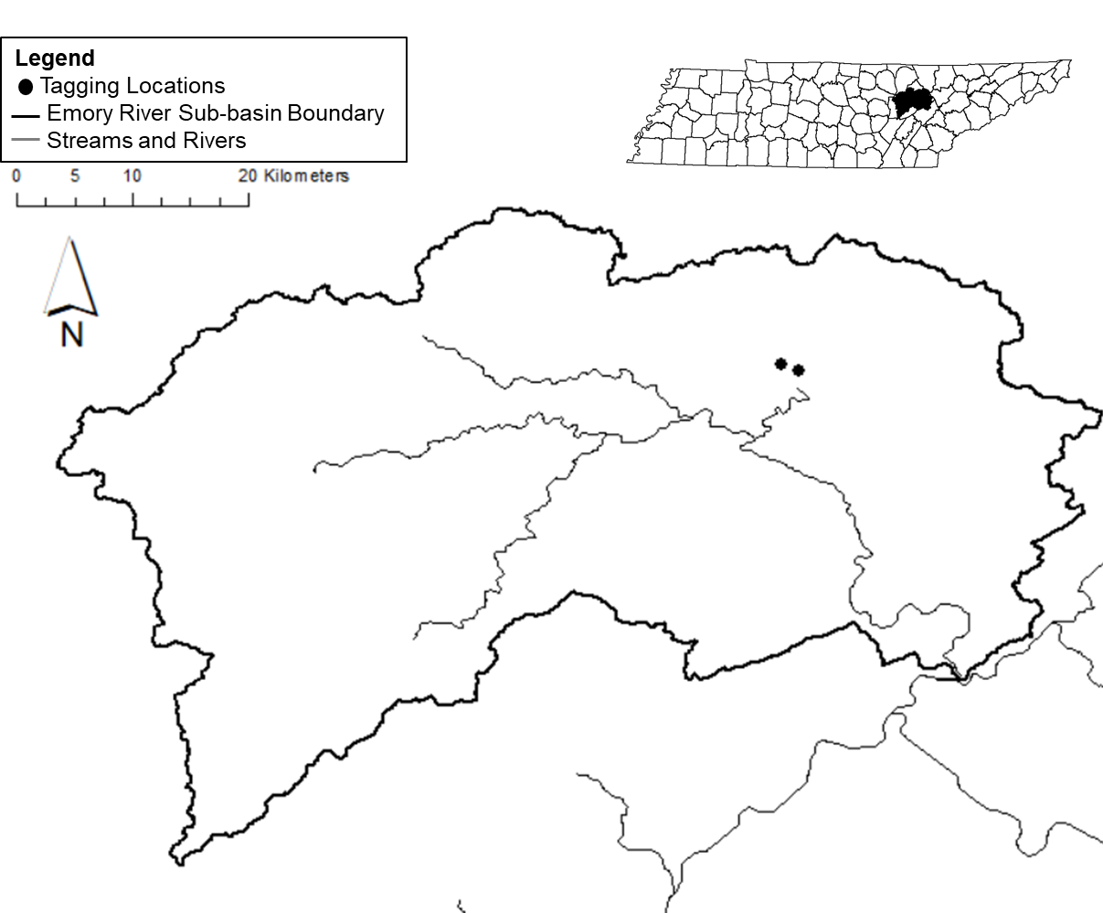
Fig. 3.1 The Emory River sub-basin. The black circles signify the two tagging locations used in this study.

Fig. 3.2 The mean (±SE) movement (m) of PIT-tagged Sickle Darters during each tracking event throughout the study. Black lines are mean movement estimates throughout the study, dashed black lines are estimates of standard error associated with the estimates of mean movement.

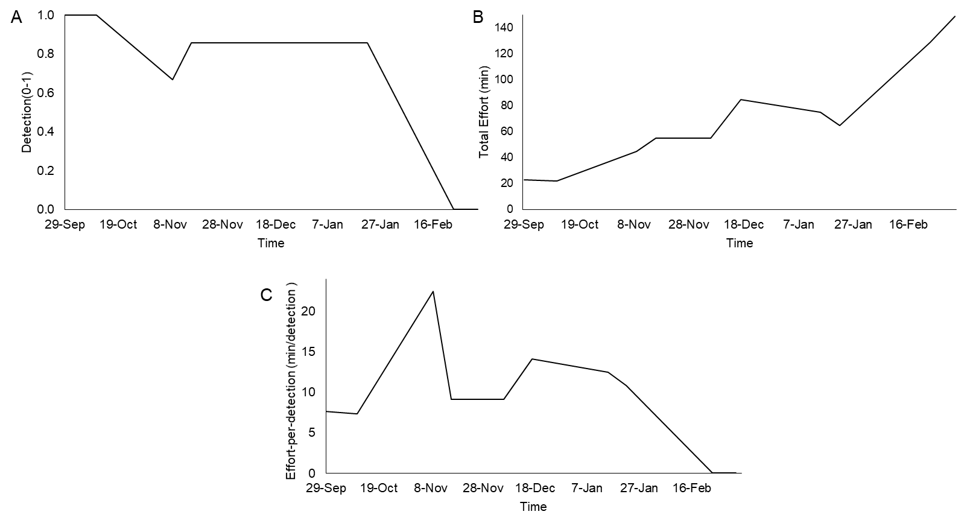

Fig. 3.3 Estimates of detection (A; 0-1), total effort (B; min), and catch-per-detection (C; min/fish) of PIT-tagged Sickle Darters during each tracking event throughout the study.

Fig. 3.4 The frequency of movement upstream (positive) and downstream (negative) by PIT-tagged Sickle Darters throughout the study.

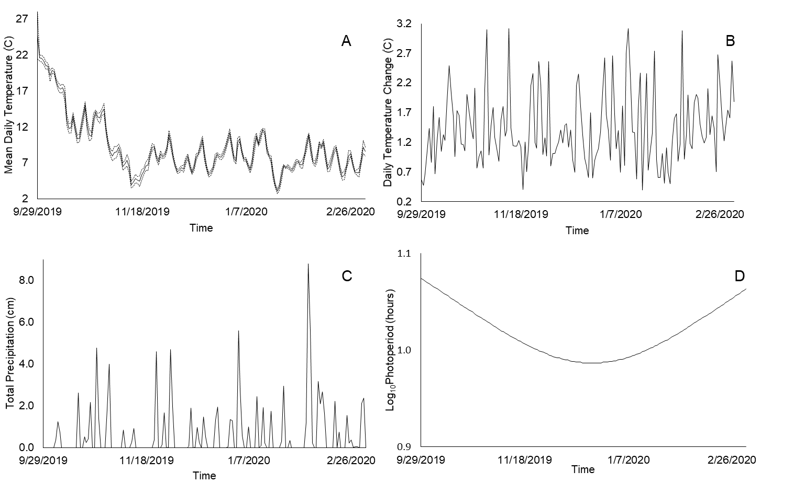

Fig. 3.5. The estimates for the landscape variables mean (±SE) daily water temperature (֯C; A), daily temperature change (֯C; B), total precipitation (cm; C), and Log₁₀photoperiod (hours; D) observed throughout the study.

Fig. 3.6 The median daily discharge (cm³/sec) observed throughout the study. (* signifies the date the Emory River sub-basin experienced a record flood of 2089.78 m³/sec on 02/06/2020 at the Emory River-Oakdale, TN USGS Stream Gauge).

Fig. 3.7 Estimates of the total frequency of substrates during each of the 8-tracking periods.

Table 3.1 Analysis of variance results for best subsets MLR for movement by the Sickle Darter across 3 temporal scales (1-day, 3-day, 7-day). Results shown are for the best model from Table 3. Root MSE = root mean square error, Stand. B_{i} = standardized beta coefficient, VIF = variance inflation factor. The +/- sign for t-value indicates the direction of the association between the environmental covariate and distance of stream occupied. Discharge =median discharge.
Models: Temporal Scale | Variable | t-value | P-value | Stand. Bi. | VIF
1-day
Root MSE=2.36
 | Intercept | 2.72 | 0.05 | 0.00 | 0.00
 | Discharge | -1.82 | 0.14 | -1.08 | 3.44
3-day
Root MSE=7.21
 | Intercept | 0.66 | 0.56 | 0.00 | 0.00
 | Discharge | -1.88 | 0.16 | -1.11 | 2.65
7-day
Root MSE=1.09
 | Intercept | 2.01 | 0.140 | 0.00 | 0.00
 | Discharge | -6.51 | <0.01 | -1.44 | 2.51

-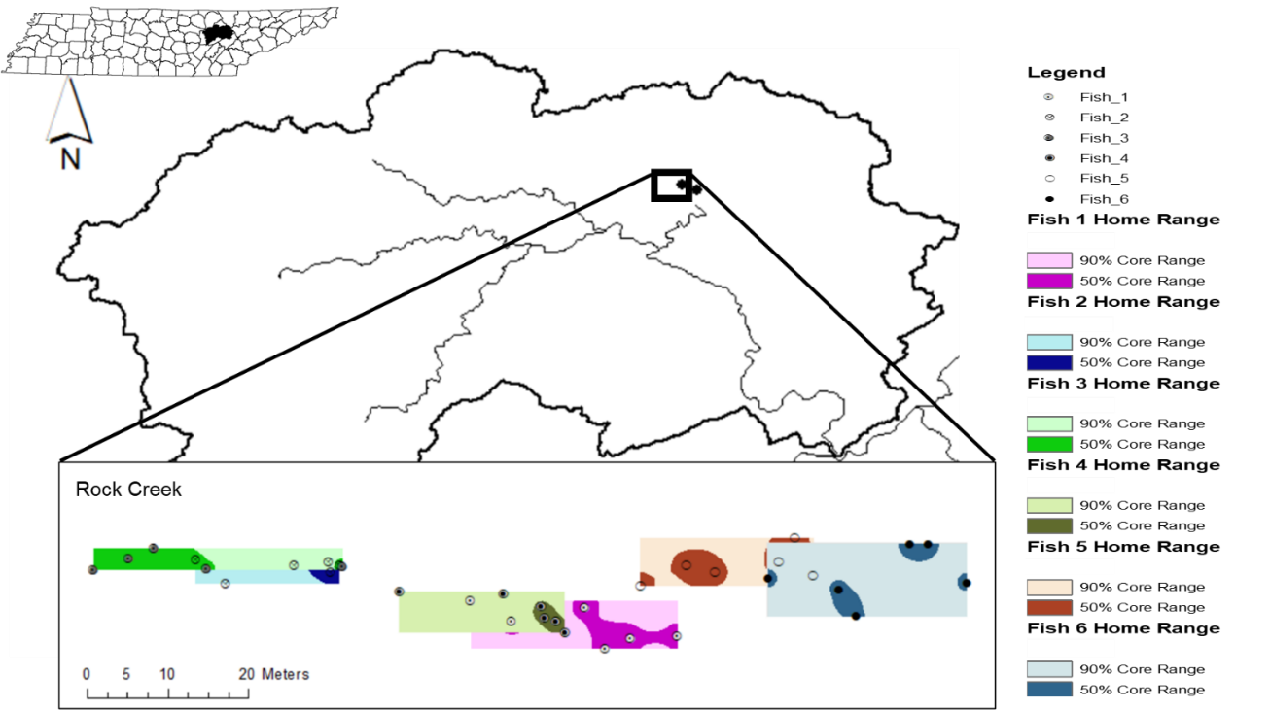

Fig. 3.8 The home range estimates for the 6 PIT-tagged fish from the Rock Creek site. Each fish’s home range displays the 90% core range and 50% core range.

Conclusion

This dissertation answers many of the research questions associated with the Sickle Darter. Sickle Darters have declined across their historical range and the decline is a result of habitat fragmentation/destruction due to damming. This dissertation was the first study to predict the probability of suitable habitat across their range, which varies spatially. Sickle Darters move very little and have a small home range. Sickle Darter movement is related to discharge. This dissertation also developed many new research questions for this species. The data outlined in this dissertation could be used to inform monitoring for this species and future conservation efforts for this species. This rare species is in need of conservation efforts to ensure it is preserved for future.

VITA

Kyler Hecke was born in Hot Springs, Arkansas. He graduated from the University of Arkansas with a Bachelor of Science degree in Biology, then graduated from the University of Arkansas at Pine Bluff with a Master of Science degree in Aquaculture and Fisheries. He then decided to pursue a doctorate degree in Natural Resources at the University of Tennessee. He was awarded a Doctor of Philosophy degree in natural resources in December of 2021.

