Ecogeographical and Micromorphological Differentiation Between Selfing and Outcrossing Sister Species

A Dissertation Presented for the
Doctor of Philosophy
Degree
The University of Tennessee, Knoxville

Alannie-Grace Gabrielle Grant
May 2021

Copyright © 2021 by Alannie-Grace Gabrielle Grant.

DEDICATION
This dissertation is dedicated to all the homeless students. Don’t ever give up.

ACKNOWLDGEMENT
During my doctoral studies I was encouraged and supported by so many wonderful professors. Dr. Susan Kalisz, my advisor, helped me find my niche as scientist and grow as a person. I also want to thank all my committee members throughout the years – starting with Drs. Nathan Morehouse, Johnathan Pruitt, and Tia-Lynn Ashman during my time at the University of Pittsburgh. My committee current members at the University of Tennessee, Drs. Brian O’Meara, Sally Horn, and Joseph Williams, have gone above and beyond to help me reach the endpoint of my dissertation. I have had the fortune of receiving generous financial support from many funding sources throughout my graduate career including, the University of Pittsburgh, National Science Foundation, and the University of Tennessee. I am especially thankful for support provided by Dr. Dixie Thompson and her office.
I would also like to thank Mr. Kurtz – my high school science research teacher who exposed me to science as a career path.

ABSTRACT
Since their emergence during the Cretaceous period, Angiosperms, or flowering plants, have achieved incredible success on land, colonizing an extensive range of environmental conditions and creating the structure of the Earth’s ecosystems. As they have adapted to these conditions, Angiosperms diverged in their niche breadth, morphological, physiological, biochemical, and phenological traits and evolved into the plant species known today. Some of the diversification within Angiosperm species is attributed to the adaptive evolution of floral traits that facilitate cross-fertilization by attracting and rewarding animal pollinators who transport their pollen or reductions in these traits to maximize self-fertilization.
In this dissertation, I explore diversification between Angiosperm species pairs with contrasting cross- and self-fertilizing mating systems, a powerful model for analyzing evolutionary patterns. In Chapter I, I used sister species pairs within Collinsia and Tonella (Plantaginaceae) to determine whether self-fertilizing species have wider niche breadths than their cross-fertilizing counterparts. I modeled niche breadth and niche overlap using bioclimatic variables and Maxent species distribution models. Next, Chapter II explores whether this relationship holds across other Angiosperm cross- and self-fertilizing species pairs. In Chapter III, Collinsia sister species pairs were analyzed to determine if conical petal cells, a trait associated with cross-fertilization, are lost during the evolution of self-fertilization. Conical cells on the petal epidermis were examined using scanning electron microscopy (SEM) to characterize the shape and size of cells.
The results of these analyses found that self-fertilizing species tend to have greater niche breadth than their cross-fertilizing sisters. There is also evidence of a reduction or loss of conical cells is associated with self-fertilizing species and could be a trait in the “selfing syndrome”.

TABLE OF CONTENTS

INTRODUCTION 1
Dissertation Overview 1
Organization of Dissertation Research 8
References 11
CHAPTER I DO SELFING SPECIES HAVE GREATER NICHE BREADTH? SUPPORT FROM ECOLOGICAL NICHE MODELING 16
Abstract 17
Introduction 17
Methods 22
Species and occurrence data 22
Ecogeographic Variables 24
Maxent Species Distribution Modeling and Pre-Model Processing 26
Niche Metrics and Ecogeographic Variation between Selfing and Outcrossing Sister Species 28
Results 31
Discussion 34
References 45
Appendix A 56
CHAPTER II IN CLOSELY RELATED ANGIOSPERM SPECIES, SELFERS HAVE GREATER NICHE BREADTHS THAN OUTCROSSERS 74
Abstract 75
Introduction 76
Methods 81
Results 85
Discussion 87
References 92
Appendix B 101
CHAPTER III DIMINISHED PETAL CONICAL CELLS – A NEW TRAIT IN THE SELFING SYNDROME? 104
Abstract 105
Introduction 106
Methods 112
Study system 112
Results 113
Qualitative differences between sister pairs 115
Quantitative differences between sister pairs 118
References 123
CHAPTER IV SUMMARY AND CONCLUSIONS 128
Summary and Conclusion of Chapter I and II 128
Further Directions 130
Summary and Conclusion of Chapter III 131
Future Directions 132
References 134
VITA 135

Error! Hyperlink reference not valid.
Error! Hyperlink reference not valid.
Error! Hyperlink reference not valid.
Error! Hyperlink reference not valid.
Error! Hyperlink reference not valid.
Error! Hyperlink reference not valid.
Error! Hyperlink reference not valid.
Error! Hyperlink reference not valid.
Error! Hyperlink reference not valid.
Error! Hyperlink reference not valid.
Error! Hyperlink reference not valid.
Error! Hyperlink reference not valid.
Error! Hyperlink reference not valid.
Error! Hyperlink reference not valid.
Error! Hyperlink reference not valid.
Error! Hyperlink reference not valid.
Error! Hyperlink reference not valid.
Error! Hyperlink reference not valid.
Error! Hyperlink reference not valid.
Error! Hyperlink reference not valid.
Error! Hyperlink reference not valid.
Error! Hyperlink reference not valid.
Error! Hyperlink reference not valid.
Error! Hyperlink reference not valid.
Error! Hyperlink reference not valid.
Error! Hyperlink reference not valid.
Error! Hyperlink reference not valid.
Error! Hyperlink reference not valid.
Error! Hyperlink reference not valid.
Error! Hyperlink reference not valid.
Error! Hyperlink reference not valid.
Error! Hyperlink reference not valid.
Error! Hyperlink reference not valid.
Error! Hyperlink reference not valid.
Error! Hyperlink reference not valid.
Error! Hyperlink reference not valid.
Error! Hyperlink reference not valid.
Error! Hyperlink reference not valid.
Error! Hyperlink reference not valid.
Error! Hyperlink reference not valid.
Error! Hyperlink reference not valid.

LIST OF TABLES
Table A1.1 Herbaria and herbarium consortia sources used to acquire occurrence data for sister species pairs of Collinsia and Tonella. 56
Table A1.2 Ecogeographic variables used in Maxent analyses of sister species pairs of Collinsia and Tonella. 57
Table A1.2 Continued. 58
Table 2.1 Studies that compared selfing and outcrossing species pairs for range or niche. 80
Table A2.1 Species used in analysis and calculated metrics. 101
Table A2.1 continued. 102
Table A2.1 continued. 103
Table 3.1 Species and SEM analysis type. 114
Error! Hyperlink reference not valid.
Error! Hyperlink reference not valid.
Error! Hyperlink reference not valid.
Error! Hyperlink reference not valid.
Error! Hyperlink reference not valid.
Error! Hyperlink reference not valid.
Error! Hyperlink reference not valid.
Error! Hyperlink reference not valid.
Error! Hyperlink reference not valid.
Error! Hyperlink reference not valid.
Error! Hyperlink reference not valid.

LIST OF FIGURES
Figure 1.1 Chronogram and maximum-clade-credibility tree of Collinsia and Tonella 25
Figure 1.2 Maxent Ecological Niche Model maps of habitat suitability for Tonella and Collinsia sister taxa pairs. 32
Figure 1.3 Distribution of Levins’ B. 33
Figure 1.4 Niche Overlap. 35
Figure 1.5 Boxplots of pooled annual precipitation, temperature seasonality and elevation. 36
Figure A1.1 Occurrence maps of Tonella and Collinsia sister taxa. 63
Figure A1.2 Niche equivalency and niche similarity metrics for Collinsia and Tonella sister species pairs. 64
Figure A1.2 Continued. 65
Figure A1.3 Regression of niche overlap value on divergence time for sister species pairs of Collinsia and Tonella. 66
Figure A1.4 Boxplots of EGVs for each of the 14 species of Collinsia and Tonella. Plots are grouped by sister species pair for comparison. 67
Figure A1.4 continued. 68
Figure A1.4 continued. 69
Figure A1.4 continued. 70
Figure A1.4 continued. 71
Figure A1.4 continued. 72
Figure A1.4 continued. 73
Figure 2.1 Histograms of the distribution of posterior probability of sister species pairs. 83
Figure 2.2 Correlation between niche overlap and time since divergence. 86
Figure 3.1 Collinsia morphology and petal regions. A) Bee foraging on a Collinsia flower. Bee claw position represents foraging position. B) Petal Regions 111
Figure 3.2 Outcrossing sister species conical cell types by region. Scalebars are all 50 µm. 116
Figure 3.3 Selfing sister species conical cell types by region. Scalebars are all 50 µm. 117
Figure 3.4 Cell height measurements by region. A) Cell height for all 4 regions. B) Cell height differences between pollinator interfacing regions 2 and 3. 119
Error! Hyperlink reference not valid.
Error! Hyperlink reference not valid.
Error! Hyperlink reference not valid.
Error! Hyperlink reference not valid.
Error! Hyperlink reference not valid.
Error! Hyperlink reference not valid.
Error! Hyperlink reference not valid.
Error! Hyperlink reference not valid.
Error! Hyperlink reference not valid.
Error! Hyperlink reference not valid.
Error! Hyperlink reference not valid.
Error! Hyperlink reference not valid.
Error! Hyperlink reference not valid.
Error! Hyperlink reference not valid.
Error! Hyperlink reference not valid.
Error! Hyperlink reference not valid.
Error! Hyperlink reference not valid.
Error! Hyperlink reference not valid.
Error! Hyperlink reference not valid.
Error! Hyperlink reference not valid.
Error! Hyperlink reference not valid.
Error! Hyperlink reference not valid.

INTRODUCTION

Dissertation Overview
Since their first emergence during the Cretaceous period, flowering plants have achieved incredible success on land, colonizing an extensive range of environmental conditions and creating the structure of the Earth’s ecosystems ranging from desert to rain forest. As they have adapted to these conditions, vascular plants diverged in their morphological, physiological, biochemical, and phenological traits and evolved to form the estimated 452 plant families and 390,900 species known today (Willis 2017). Much of the diversification of the ~369,000 extant Angiosperm species is attributed to the adaptive evolution of floral traits that facilitate cross-pollination (here after outcrossing) by attracting and rewarding animal pollinators who transport their pollen grains (Stebbins 1974). Outcrossing has several significant advantages, including greater genetic diversity of offspring, which reduces the risk of expression of deleterious recessive mutations and of inbreeding depression (Williams 1975; Bell 2019), and an increased lineage diversity (Stebbins 1957). Interestingly, it has long been held that the most common evolutionary transition within Angiosperms is that from outcrossing to self-fertilization (here after selfing) (Stebbins Jr 1950).
Short growing seasons favors selfing as a bi-product of selection for rapid development (Aarssen 2000; Snell and Aarssen 2005). The fact that the transition to selfing from outcrossing is so common suggests both that these ecological conditions must be commonly experienced by plants in nature and that selfing provides fitness advantages.
Since self-fertilizing plants provide both pollen and ovules to produce their own seed, as well as export pollen to fertilize ovules on other plants, they are afforded a 3/2 genetic transmission advantage over outcrossing individuals (Fisher 1941). Selfing has been shown empirically to impart additional fitness advantages in environments that are either abiotically-stressful (e.g., Galen 2000, Elle 2004, Gerst et al. 2011), have low mate availability (e.g., Fausto, Eckhart et al. 2001), or low pollinator availability (e.g., Kalisz, Vogler et al. 2004). Under the latter two conditions, self-fertilization decouples a plant's reliance upon mutualistic interactions with pollinators for conspecific pollen deposition, termed reproductive assurance (Darwin 1876; Baker 1955; Lloyd 1979). This decoupling may be an essential trait that ensures population increase at species range edges (e.g., Busch 2005, Herlihy and Eckert 2005; Moeller, Geber et al. 2012; Gould, Moeller et al. 2014) or after long-distance dispersal events (Baker 1955).
Indeed, seed dispersal can place plants in habitats that are highly dissimilar from their natal sites. Given that a dispersed genotype is tolerant to the new abiotic conditions it landed in, it may grow and survive to flowering. However, successful seed set of the colonist is contingent upon its tolerance of the reproductive environment. In the early stages of colonization, by definition, the reproductive environment is characterized by low conspecific density and low pollinator visitation, since one or a few individuals of a species generally will not attract pollinators to an area. Under such conditions, colonist genotypes with autonomous selfing ability can drive rapid increases in population size and increase establishment success. These ideas are the underpinnings of Baker’s law (Baker 1955, 1967), which states that self-compatible species should be better colonists under long-distance dispersal because selfing provides reproductive assurance. More recently, Pannell et al. (2015) narrowed the scope of Baker's law to “an enrichment of a capacity for uniparental reproduction in colonizing situations”, which underscores autonomous selfing ability as the key trait when colonizing novel habitats.
In addition to increasing colonization success, selfing is also expected to increase the rate of adaptation to new environments. If recombination creates new locally adapted genotypes, selfing can subsequently both “freeze” the genomes of these high fitness individuals (sensu Mather 1941) and reduce hybridization through gene flow from nearby populations (Lloyd 1965; Antonovics 1968). In this way, selfing may facilitate and maintain local adaptation to a new environment (Mayr 1963; Antonovics and Bradshaw 1970). One way that selfing genotypes can limit gene flow is if their floral traits temporally or physically limit the opportunity for outcross pollen receipt (Levin 2009; Levin 2010). For example, flowers that exhibit prior self-fertilization (i.e. autonomously self-pollination before pollinators can visit the flower, Lloyd 1992), or species that exhibit short lifespans with small vegetative size, fast developmental rates, and early onset of flowering (time limitation hypothesis, Snell and Aarssen 2007), can favor self-fertilization over outcrossing (Kalisz et al. 2012; Jorgensen and Arathi 2013). Thus, selfing can provide the same ecological and evolutionary advantages as assortative mating and is therefore expected to increase the frequency of locally adapted genotypes (Lloyd 1965).
Given that selfing may increase colonization rates of new environments and local adaptation to those environments, a logical extension is that selfing ability will be a critical functional trait influencing both species’ geographic range size and niche breadth. For the most part, these plant traits reflect an evolutionary history of selection for reproduction and survival in a set of biotic and abiotic conditions, describing its ecological niche. In his seminal paper, Hutchinson (1957) elegantly conceptualized the niche as an “n-dimensional hypervolume” of resources and environmental conditions in which a species will express an intrinsic rate of growth r > 0. Hutchinson referred to the sum of environmental conditions for a species, its resource requirements, and tolerances as the fundamental niche. Holt (2009) expanded this concept by describing the habitat characteristics required in terms of population dynamics. Holt’s establishment niche is defined as the environmental conditions in which a species can reproduce despite low conspecific density (i.e., intrinsic rate of growth r₀ > 0). Further, Holt defines the persistence niche as the environmental conditions that allow some threshold population density (N > 0) at which a population remains stable. Within this context, for a species to expand its niche breadth, two ecologically dependent processes need to be invoked: 1) reproductive ability that permits establishment and 2) physiological response to particular environmental conditions that permits persistence. Species that can reproduce at low population densities and possess adequate physiological responses across various environments, will occupy a wider niche breadth.
While it is widely accepted that selfing provides reproductive assurance when colonizing new habitats (reviewed in Pannell et al. 2015), the consequences of mating system on niche breadth have only recently received expanded theoretical attention. Levin (2010) argued that “environmentally-enhanced self-fertilization” has the power to facilitate establishment of new niches. This idea of phenotypic plasticity in selfing is supported by numerous studies of mating systems (e.g., Oakley et al. 2007; Vallejo - Marín and Barrett 2009; Volger, Das, and Stephenson 1998) and mating system traits (e.g., Webb and Williams 1988, Bishop et al. 2010, Brys et al. 2013, Spigler and Kalisz 2013) that demonstrate high sensitivity to local or stressful conditions and enhanced rates of selfed-seed production. Peterson and Kay (2015) expanded Levin’s verbal model to simulate the effect of plasticity in selfing on colonizing ability and niche diversification. They show that during colonization, obligate selfing and intermediate selfing populations expressed a temporary increase in additive genetic variance, compared to obligate outcrossers. Genotypes generated during this brief episode of increase in additive genetic variance by selfing can be acted on by natural selection, supporting the benefit of selfing during population establishment. Because greater additive genetic variance can increase the speed of and potential for local adaptation, reduce extinction risk, and increase persistence in new environments (Frankham 2005), the capacity to self-fertilize should enhance range spread and niche evolution. Notably, lower extinction risk and increased speed of niche breadth evolution could greatly outweigh any disadvantage obligate selfing poses on the speed of local adaptation. These benefits of selfing explain the prevalence of uniparental reproduction in successful migrants to islands or those reaching the edge of their species’ range (Baker 1955, Pannell et al. 2015).
In summary, environmental conditions experienced during colonization can directly or indirectly favor selfing, conferring a positive fitness effect during niche breadth expansion. Thus, traits that affect the local expression of mating system should exert profound effects on niche breadth, but research integrating patterns in mating system with niche theory are lacking. My research attempts to fill some of this gap.
While developing my dissertation research, I was a participant in the NESCent working group, “Linking self-fertilization, dispersal and distribution traits of species: Is Baker’s law an exception to the rule?”, and a recipient of the NESCent graduate research fellowship, I was able to refine my hypothesis and have fruitful discussions with scientists studying plant mating system evolution from across the world. As a participant in the working group, I co-authored two papers leveraging pre-existing databases and new compilations of plant trait and life history data. In the first paper, we suggested a narrowing of the conditions under which Baker’s Law may apply and emphasized the enrichment of capacity for uniparental reproduction during colonization, rather than a focus on high selfing rates (Pannell et al. 2015). In the second paper, we found that the presence of self-compatibility strongly explained geographical patterns in plants. Self-compatibility was identified as a key reproductive trait in filtering colonizing species (Grossenbacher et al. 2017).
Another facet of my dissertation addresses the divergence of floral traits of selfing and outcrossing plant species. Within Angiosperms, selfing species have been shown to exhibit a common set of floral traits, collectively termed the selfing syndrome (Sicard and Lenard 2011). This syndrome includes smaller flower size, reduced scent and nectar production, lower pollen to ovule ratios and shorter flower lifespans. Changes in allocation to these traits are considered a reduction in the investment of reward and attraction of pollinators. The assumption is that energy not spent on floral traits that attract and reward pollinators can be reinvested in the production of more seeds that are self-fertilized. Further, highly successful selfing populations may benefit from traits that discourage, rather than encourage floral visitation (Spigler and Kalisz 2017). Petal characteristics can alter pollinator attraction and affect successful interaction at the flower-pollinator interface. One intriguing aspect of petals of insect-pollinated flowers is that they produce conical cells. The function of conical cells with respect to pollinator behavior has been reviewed in Whitney et al. (2011a). Specifically, because of the function of conical cells in attraction, it is suspected that they are more costly to produce and maintain than flat petal cells that cover the majority of the surface of petals (Whitney et al. 2011b). The mixta mutant of the self-incompatible outcrossing Antirrhinum is caused by the loss of transcription factor that is expressed only in the petals and is phenotypically characterized by the loss of conical cells in the petal epidermis (Glover et al. 1998). These mixta mutants have been used to test the effectiveness of conical cells in mediating the petal-pollinator interface (reviewed in Whitney et al. 2011b). In a field study where pollinators were limiting seed set, mixta mutant and wild type (WT) plants were used in pollinator choice arrays to explore the effect of conical cell loss on flower-pollinator interactions. The presence of conical cells of WT Antirrhinum flowers significantly increased their attractiveness to pollinators relative to mixta mutant flowers that did not express conical cells (Glover and Martin 1998). More recently, Whitney et al. (2009) showed that conical cells significantly affect the ability of pollinators to maintain a grip on the petal surfaces and successfully pollinate the flowers. The mixta mutants exhibited a ~60% increase in aborted landings when pollinators attempted to alight on a flower relative to a wild type Antirrhinum flower. Together, these studies demonstrate that the presence of potentially costly conical cells have positive effects on plant-pollinator interactions in outcrossing species. It is not known if primarily selfing species also produce conical cells or what role they may play in pollinator visitation or reproduction.
My research on the topic was further enhanced through participation in the microMORPH workshop on Phenotypic Plasticity: Evolution at the Intersection of Ecology, Genetics, and Development. There, I presented my research ideas looking at shifts in selfing due to phenotypic plasticity and became interested in plant micromorphology. I went on to receive a microMORPH training grant, which funded my research on conical petal cells. This work is detailed in the third chapter of my dissertation work.
For my thesis, I conducted research at the intersection of mating system traits, species ranges and niche diversity and floral evolution. My research tackled this intersection with the goal of testing for emergent patterns predicted by niche and mating system theory and poses two general questions: To what extent does mating system influence the distribution of plant species? Do selfing and outcrossing species differ in other traits besides those traditionally considered part of the selfing syndrome?

Organization of Dissertation Research
Does mating system influence the distributions of plant species? To address this question, I selected phylogenetically paired (sister) species that differ in mating system. Leveraging over 52,000 herbarium occurrence records, I used statistical niche models to map species spatial distributions and habitat affinities. I conducted comparative analyses on two phylogenetic levels: I) a detailed analysis of 7 sister taxa within two closely related genera (Collinsia and Tonella); and II) a broader analysis of 34 selfing-outcrossing sister pairs across 13 diverse Angiosperm families.
In the first data chapter, I address the research question 1) Do selfing species have wider niche breadths than their outcrossing sister species?
Study System: I focused on selfing outcrossing sister species pairs in the genera Collinsia and Tonella (Plantaginaceae). Both genera are self-compatible winter annuals, endemic to North America, with well-supported phylogenetic relationships with estimates of species bifurcation times (Baldwin et al. 2011), and detailed understanding of the ecology and evolution of mating systems in this clade (e.g., Kalisz et al. 2004; Randle et al. 2009, Elle et al. 2010; Kalisz et al. 2012). The seven sister species pairs selected for analyses exhibit a repeated pattern of small- versus large-flowered phenotypes and selfing versus outcrossing mating systems (Kalisz et al. 2012). Together, the detailed phylogeny and ecological information for this genus make it an excellent system for comparative tests of the evolution of selfing and niche breadth. I modeled niche breadth and niche overlap using bioclimatic variables and Maxent species distribution models (Phillips et al. 2006) for species locations derived from ~5000 herbarium records.
In the second data chapter, I address research question 2) Does the mating system-niche breadth relationship hold across Angiosperm sister species pairs?
Study System: I used a subset of phylogenetically supported selfing and outcrossing sister species pairs originally studied by Grossenbacher et al. (2015) chosen from across the Angiosperm phylogeny. As in the first data chapter, I used Maxent species distribution modeling to estimate niche breadth.
Finally, I explore a third research question related to traits in the selfing syndrome: Specifically, I asked: Is conical cell expression diminished in selfing species relative to outcrossing species? The observation of diminished conical cell expression in predominantly selfing species relative to highly outcrossing species would lend support to my hypothesis that diminished conical cell expression might be another characteristic in the selfing syndrome.
Study system: Multiple sister species across the Collinsia phylogeny exhibit a pattern in which one species is large-flowered and outcrossing and its sister is small-flowered and selfing (Baldwin et al. 2012). Thus these Collinsia sister pairs exhibit dimorphism related to mating system differentiation and flower size (Randle et al. 2009).To address this question of diminished expression of conical cells in selfers in general, I used four sister species pairs in the genus Collinsia. Preliminary examination of petal cells in the outcrosser, C. heterophylla, confirmed that the presence of conical cell in the genus and preliminary data from one species pair (C. linearis and C. rattanii) demonstrated that production of conical cells is reduced in the small-flowered selfing species, C. rattanii, relative to its large-flowered, outcrossing sister species, C. linearis (Collandato 2012), making this genus an excellent system for my investigation.

References
Aarssen, L. W. 2000. Why are most selfers annuals? A new hypothesis for the fitness benefit of selfing. Oikos 89:606-612.
Antonovics, J. 1968. Evolution in closely adjacent plant populations. V. Evolution of self-fertility. Heredity 23:219-238.
Antonovics, J. and A. D. Bradshaw. 1970. Evolution in closely adjacent plant populations. VIII. Glinal patterns at a mine boundary. Heredity 25:349-362.
Baker, H. G. 1955. Self-compatibility and establishment after'long-distance'dispersal. Evolution 9:347-349.
Baker, H. G. and G. L. Stebbins. 1965. genetics of colonizing species, proceedings. International Union of Biological Sciences Symposia on General Biology 1964: Asilomar, Calif.). Academic Press.
Baldwin, B. G., D. Goldman, D. J. Keil, R. Patterson, and T. J. Rosatti. 2012. The Digital Jepson Manual: Vascular Plants of California. Univ of California Press.
Baldwin, B. G., S. Kalisz, and W. S. Armbruster. 2011. Phylogenetic perspectives on diversification, biogeography, and floral evolution of Collinsia and Tonella (Plantaginaceae). American Journal of Botany 98:731-753.
Bell, G. 2019. The masterpiece of nature: the evolution and genetics of sexuality. Routledge.
Busch, J. W. 2005. The evolution of self-compatibility in geographically peripheral populations of Leavenworthia alabamica (Brassicaceae). American Journal of Botany 92:1503-1512.
Callodonato, Rebecca. 2014. A new trait in the selfing syndrome? Exploring the loss of specialized petal cells in selfing Collinsia. University of Pittsburgh.
Elle, E. 2004. Floral adaptations and biotic and abiotic selection pressures. Plant adaptation: Molecular genetics and ecology. National Research Council of Canada, Ottawa, Ontario:111-118.
Elle, E., S. Gillespie, S. Guindre‐Parker, and A. L. Parachnowitsch. 2010. Variation in the timing of autonomous selfing among populations that differ in flower size, time to reproductive maturity, and climate. American Journal of Botany 97:1894-1902.
Fausto Jr, J. A., V. M. Eckhart, and M. A. Geber. 2001. Reproductive assurance and the evolutionary ecology of self‐pollination in Clarkia xantiana (Onagraceae). American Journal of botany 88:1794-1800.
Fisher, R. A. 1941. Average excess and average effect of a gene substitution. Annals of Eugenics 11:53-63.
Galen, C. 2000. High and dry: drought stress, sex‐allocation trade‐offs, and selection on flower size in the alpine wildflower Polemonium viscosum (Polemoniaceae). The American Naturalist.
Gerst, K. L., A. L. Angert, and D. L. Venable. 2011. The effect of geographic range position on demographic variability in annual plants. Journal of Ecology 99:591-599.
Glover, B. J. and C. Martin. 1998. The role of petal cell shape and pigmentation in pollination success in Antirrhinum majus. Heredity 80:778-784.
Glover, B. J., M. Perez-Rodriguez, and C. Martin. 1998. Development of several epidermal cell types can be specified by the same MYB-related plant transcription factor. Development (Cambridge, England) 125:3497-3508.
Grossenbacher, D., R. Briscoe Runquist, E. E. Goldberg, and Y. Brandvain. 2015. Geographic range size is predicted by plant mating system. Ecology Letters 18:706-713.
Herlihy, C. R. and C. G. Eckert. 2005. Evolution of self-fertilization at geographical range margins? A comparison of demographic, floral, and mating system variables in central vs. peripheral populations of Aquilegia canadensis (Ranunculaceae). Am J Bot 92:744-751.
Jorgensen, R. and H. Arathi. 2013. Floral longevity and autonomous selfing are altered by pollination and water availability in Collinsia heterophylla. Annals of botany 112:821-828.
Kalisz, S., A. Randle, D. Chaiffetz, M. Faigeles, A. Butera, and C. Beight. 2012. Dichogamy correlates with outcrossing rate and defines the selfing syndrome in the mixed-mating genus Collinsia. Annals of Botany 109:571-582.
Kalisz, S., D. W. Vogler, and K. M. Hanley. 2004. Context-dependent autonomous self-fertilization yields reproductive assurance and mixed mating. Nature 430:884-887.
Levin, D. A. 2009. Flowering time plasticity facilitates niche shifts in adjacent populations. New Phytologist 183:661-666.
Levin, D. A. 2010. Environment‐enhanced self‐fertilization: implications for niche shifts in adjacent populations. Journal of Ecology.
Lloyd, D. G. 1965. EVOLUTION OF SELF-COMPATIBILITY AND RACIAL DIFFERENTIATION IN LEAVENWORTHIA (CRUCIFERAE). Contributions from the Gray Herbarium of Harvard University:3-134.
Lloyd, D. G. 1979. Some reproductive factors affecting the selection of self-fertilization in plants. American Naturalist:67-79.
Lloyd, D. G. 1992. Self- and Cross-Fertilization in Plants. II. The Selection of Self- Fertilization. International Journal of Plant Sciences 153:370-380.
Mather, K. 1941. Variation and selection of polygenic characters. J. Genet 41:159-193.
Mayr, E. 1963. Animal species and evolution. Animal species and evolution.
Moeller, D. A., M. A. Geber, V. M. Eckhart, and P. Tiffin. 2012. Reduced pollinator service and elevated pollen limitation at the geographic range limit of an annual plant. Ecology 93:1036-1048.
Phillips, S. J., R. P. Anderson, and R. E. Schapire. 2006. Maximum entropy modeling of species geographic distributions. Ecological Modelling.
Randle, A. M., J. B. Slyder, and S. Kalisz. 2009. Can differences in autonomous selfing ability explain differences in range size among sister-taxa pairs of Collinsia (Plantaginaceae)? An extension of Baker's Law. New Phytologist 183:618-629.
Snell, R. and L. W. Aarssen. 2005. Life history traits in selfing versus outcrossing annuals: exploring the'time-limitation'hypothesis for the fitness benefit of self-pollination. BMC ecology 5:2.
Spigler, R. B. and S. Kalisz. 2017. Persistent pollinators and the evolution of complete selfing. American journal of botany 104:1783-1786.
Stebbins, G. L. 1957. Self fertilization and population variability in the higher plants. American Naturalist.
Stebbins, G. L. 1974. Flowering plants: evolution above the species level. London: Arnold xviii, 399p.. Illustrations. General (KR, 197500089).
Stebbins Jr, C. 1950. Variation and evolution in plants. Variation and evolution in plants.
Whitney, H. M., K. M. V. Bennett, M. Dorling, L. Sandbach, D. Prince, L. Chittka, and B. J. Glover. 2011a. Why do so many petals have conical epidermal cells? Annals of Botany 108:609-616.
Whitney, H. M., L. Chittka, T. J. A. Bruce, and B. J. Glover. 2009. Conical Epidermal Cells Allow Bees to Grip Flowers and Increase Foraging Efficiency. Current Biology 19:948-953.
Whitney, H. M., R. Poetes, U. Steiner, L. Chittka, and B. J. Glover. 2011b. Determining the contribution of epidermal cell shape to petal wettability using isogenic Antirrhinum lines. PLoS One 6:e17576.
Williams, G. C. 1975. Sex and Evolution.(MPB-8), Volume 8. Princeton University Press.
Willis, K. J. 2017. State of the world's plants report-2017. Royal Botanic Gardens.

CHAPTER I
DO SELFING SPECIES HAVE GREATER NICHE BREADTH? SUPPORT FROM ECOLOGICAL NICHE MODELING

Abstract
I explore the relationship between plant mating system (selfing or outcrossing) and niche breadth to gain new insights into processes that drive species distributions. Using a comparative approach with highly selfing vs. highly outcrossing sister species, I test the extent to which: 1) species pairs have evolved significant niche divergence and less niche overlap, 2) selfers have wider niche breadths than outcrossers or vice versa, and 3) niches of selfers and outcrossers are defined by significant differences in environmental variables. I applied predictive ecological niche modeling approaches to estimate and contrast niche divergence, overlap and breadth, and to identify key environmental variables associated with each species’ niche for seven sister species with divergent mating systems. Data from 4862 geo-referenced herbarium occurrence records were compiled for 14 species in Collinsia and Tonella (Plantaginaceae) and 19 environmental variables associated with each record. I found sister species display significant niche divergence, though not as a function of divergence time, and overall, selfers have significantly wider niche breadths compared to their outcrossing sisters. The results suggest that a selfing mating system likely contributes to the greater capacity to reach, reproduce, establish and adapt to new habitats, which increases niche breadth of selfers.

Introduction
Understanding the factors that limit species’ spatial extents continues to motivate the research efforts of ecologists and evolutionary biologists (reviewed in Sexton et al. 2017). As changing climatic conditions shift species’ distributions and ecology, it is perhaps more critical than ever to understand the traits that influence their ability to colonize and persist in novel environments. At the broadest scale, a species’ distribution is affected by traits that shape its dispersal, establishment and evolutionary potential (reviewed in Brown et al. 1996; Gaston 2003). Closely-related species often have geographic distributions that differ by several orders of magnitude (Brown et al. 1996; Anacker and Strauss 2014), and express divergence in key phenotypic traits (Anacker and Strauss 2014) including traits that affect colonization (Stebbins 1957).
Traits that directly affect a species’ standing genetic variation, speed of adaptation, or the ability to colonize and establish in novel environments should affect both range size and niche breadth (i.e. the range of environmental and biotic conditions a species can live within, Hutchinson 1957), potentially accounting for large range size differences observed between closely related species. Mating systems (i.e. the degree to which offspring are produced by self-fertilization or outcrossing) are may affect species’ geographic distributions and range size (e.g. Geber 2008; Grossenbacher et al. 2015; Grossenbacher et al. 2018; Petanidou et al. 2012; Randle et al. 2009, Tabassum and Leishman 2019), but to what degree is uncertain. Despite this, mating system remains a remarkably less explored trait with respect to niche theory and niche breadth (Proulx 1999; Holt 2009; Levin 2010; Peterson and Kay 2015).
Mating system theory and empirical work provide insights into how this trait could influence a species’ range and niche. First, mating system has the potential to significantly affect niche characteristics because the mating system fundamentally controls the distribution of genetic variation within a species. For instance, outcrossing species maintain greater standing genetic variation within individuals and populations relative to selfing species (e.g. Hamrick and Godt 1996; Crawford and Whitney 2010; López-Villalobos and Eckert 2018), which should increase the ability to adapt in outcrossers (Fisher 1930) and thus increase their niche breadth. When gene flow occurs among outcrossing populations, it can homogenize them while increasing the overall standing genetic variation (reviewed in Hamrick and Godt 1996), and promote niche breadth evolution (Holt and Gaines 1992). Yet, empirical studies show that gene flow can limit or severely slow adaptation to novel habitats (e.g. Antonovics 1968). Further, outcrossing populations at the range edge may still lack specific multivariate genetic variation in traits that permit adaptation to novel habitats (Bradshaw 1991; Blows and Hoffmann 2005) or adaptation may be swamped by gene flow from central populations (Paul et al. 2011), effectively halting niche breadth expansion and evolution. Population demographic processes, including bottlenecks, founder events, and inbreeding, can further diminish standing genetic variation Frankham (2005). In contrast, little to no gene flow and reduced genetic diversity in selfing species is expected to preclude adaptation to new or changing environments, reducing the likelihood of a selfing species evolving broad environmental tolerances (Lowry and Lester 2006), and ultimately diminishing selfing lineages’ longevity (Stebbins 1957).
Unlike outcrossing, selfing can act as a reproductive isolation barrier, reducing the influx of maladaptive alleles, increasing the rate of adaptive evolution or maintaining co-adapted gene complexes (Levin 2010). As a result, Levin (2010) asserts that if selfers arrive in a novel habitat, pre-adapted to the local environment, then the act of selfing can maintain these pre-adapted genotypes and enhance niche expansion. Supporting this idea at a larger scale, empirical studies demonstrate that selfers have greater among-population differentiation (F_{st}) than outcrossers (Hamrick and Godt 1996; Charlesworth and Pannell 2001). While greater potential for population-level genetic variation may persist in outcrossers, selfers may have a similar capacity for local adaptation (Hereford 2010), but whether tolerance for a new environment arrives as a pre-adaptation or evolves in situ is generally not known. Local adaptation can be expedited by low and moderate rates of self-fertilization (i.e. mixed-mating), acting as a pre-zygotic isolation barrier, which can increase the additive genetic variance for environmental tolerance in a novel habitat (Peterson and Kay 2015), suggesting the possibility for post-colonization local adaptation. As a result, mixed mating species, possessing the flexibility to self-fertilize may be more likely to experience niche shifts than obligate selfers. Additionally, in the long term, obligate selfing is likely not sustainable, and is associated with increased risk of extinction and decreased adaptive potential (Peterson and Kay 2015).
Finally, a species’ mating system will influence its ability to colonize and establish in novel environments or into areas with competition from congeners. Upon dispersal to a novel habitat, autonomous selfing provides reproductive assurance when mates or pollinators are absent or scarce, increasing the probability of colonization and establishment success over outcrossing or self-incompatible species, (i.e., Baker’s Law, Baker 1955; Pannell et al. 2015). The potential positive consequences of selfing may help to explain the predicted enrichment in the capacity for selfing on islands or at range edges (Baker 1955; Pannell et al. 2015) and the enhanced range sizes of selfers (Randle et al. 2009; Levin 2010). Indeed, the proportion of selfing species relative to outcrossing species is enriched on islands (Grossenbacher et al. 2017), and on continents higher selfing rates led to both a larger species distributional extent and higher elevation (Randle et al. 2009; Grossenbacher et al. 2015), supporting a contribution of mating system in range expansion (but see Park 2018).
In this light, one logical extension of Baker’s Law is that species with a predominantly selfing mating system may colonize and persist in novel habitats more readily than outcrossing species, leading to the gradual accrual of greater niche breadths in selfing species over time. Since self-fertilization can affect the geographic patterns of speciation (i.e., Baker’s Law), ecological differentiation (i.e., reduced sharing of pollinators), and promote reproductive isolation, selfing should promote niche divergence. Additionally, time since divergence is expected to influence co-occurrence and overlap in sister species’ distributions. Range overlap was shown to be negatively related to time since divergence of 71 sister species (Anaker and Strauss 2014), while character divergence and reproductive isolation over time can allow secondary range overlap between closely related selfing/outcrossing species (Grossenbacher et al. 2016).
Here, I explore this extension of Baker’s Law and compare the association between mating system and niche breadth using species distribution modeling (SDM) techniques. SDM analyses apply predictive modeling to link abiotic or climatic variables to associated geographical sites and identify parameters necessary for a species to survive and reproduce (Grinnell 1917; Hirzel and Le Lay 2008). SDM approaches have already been applied to various topics, including identification of niche differences and quantify divergence in closely related species (Nakazato et al. 2010), in invasive vs. native taxa (Laura et al. 2016), and in diploid vs. polyploid taxa (Spyros et al. 2013). In these analyses, I define the niche breadth narrowly as the set of abiotic environmental conditions potentially inhabited by a species.
I employ SDM to a unique system containing seven selfing/outcrossing sister species pairs in the genera Collinsia and Tonella (Plantaginaceae). Selfing species are generally considered to be derived from outcrossers and in these genera, phylogenetic analyses support this hypothesis (Baldwin et al. 2011). Replicate selfing-outcrossing sister pairs allowing for exploration of the implications of the independent evolution of selfing on niche breadth, controlling for divergence time within a pair. I consider three possibilities. First, over long timescales, niches of sister species pairs may become increasingly diverged if selfing both increases the likelihood of colonization success and local adaptation, resulting in selfers with wider niche breadths than outcrossers. Alternatively, outcrossing sister species may have greater niche breadths, due to higher genetic variation and potentially a greater capacity for local adaptation. Finally, I cannot assume that their outcrossing sisters’ niches are closer to the ancestral one, even though selfing species are typically expected to have evolved from an outcrossing ancestor. Sister species, by definition, have diverged for an equal amount of time. Therefore, I predict that both sister species may have shifted their niches in various ways, yielding no consistent pattern between selfers or outcrossers. Therefore, I address the following specific questions: 1) Over long timescales, do niche characteristics between selfers and outcrossers emerge such that selfing and outcrossing sister species express significant niche divergence? 2) Have their niches diverged with respect to distinct environmental variables? 3) Do selfing sister species have wider niche breadths than their outcrossing sisters? 4) Is there a relationship between niche overlap and divergence time?

Methods

Species and occurrence data
Tonella (2 species) and its sister genus Collinsia (~23 species) (Plantaginaceae) are winter annual genera endemic to North America (Baldwin et al. 2011). All Tonella and Collinsia species are diploid (apart from some populations of C. heterophylla, C. torreyi, and C. grandiflora, see Baldwin et al. 2011) and self-compatible. Yet, Collinsia species exhibit a range of outcrossing rates, from highly selfing to highly outcrossing (Kalisz et al. 2012). In both genera, the selfing mating system is associated with reduced flower size and loss of dichogamy (temporal separation of male and female phases), resulting in shorter flower lifespans with early within-flower selfing (Kalisz et al. 2012). Selfing rates in the absence of pollinators for species selfers included in this study range between 0.38 to 1.00 and wild outcrossing rates between 1.00 and 0.001. Additionally, their seeds are gravity dispersed, generally lacking traits related to long-distance dispersal (Baldwin et al. 2012). Tonella and Collinsia are an ideal system for evolutionary comparative analyses of mating system, since selfing has evolved independently at least eight times (Baldwin et al. 2011), resulting in selfing-outcrossing sister species pairs (Baldwin et al. 2011; Kalisz et al. 2012). Selfing-outcrossing sister species used in these analyses have phylogenetic relationships that are supported by all lines of molecular evidence (Figs 7-10, 12 in Baldwin et al. 2011), and are well-resolved and with posterior probabilities ranging from 0.98 to 1.0 (Figure 7, Baldwin et al. 2011), thus I did not test additional tree topologies. The use of sister species pairs enhances the power of the analyses; because sister species share a common evolutionary history, direct comparisons of niche breadth differences with shifts in mating system are possible. Further, the dated phylogeny for these genera (Baldwin et al. 2011) permits comparison of niche differences among sister species pairs of different ages. Since selfing can reduce gene flow between sister species, I can test the additional hypothesis that there will be high niche overlap for recently diverging sisters that will decline with species’ pair age (Paul and Tonsor 2008).
In this study, I build on prior range size work in Collinsia (Randle et al. 2009), by testing hypotheses about the evolution of niches, increasing the number of sister pairs modeled, greatly increasing the number of occurrence records analyzed, and including Collinsia’s sister genus, Tonella. The seven sister taxa pairs (Figure 1.1) within Tonella and Collinsia (Tonella tenella/T. floribunda, Collinsia rattanii/C. linearis, C. parviflora/C. grandiflora, C. bartsiifolia/C. corymbosa, and C. parryi/C. concolor, C. torreyi var. wrightii/C. torreyi var. torreyi (hereafter C. wrightii/C. torreyi), and C. sparsiflora var. collina/C. sparsiflora var. sparsiflora (hereafter C. collina/C. sparsiflora)) exhibit the repeated trait patterns that define selfing vs. outcrossing mating systems in plants (i.e. small vs. large flowers, early vs. late stigmatic receptivity, low vs. high stigma anther separation, and lower (0.001-0.5) vs. higher outcrossing (0.6-0.9) rates based on molecular markers; see Table S1.1 in (Kalisz et al. 2012).
For these 14 species, I retrieved a total of 4862 occurrence records from multiple herbarium databases (Table A1.1 and Figure A1.1). All occurrences records are based on geo-referenced coordinate data compiled primarily from the Global Biodiversity Information Facility (http://www.gbif.org/) and supplemented with occurrence records from regional herbaria and herbarium consortiums. Occurrence records with incomplete data (e.g., missing specific epithet, latitude or longitude data), duplicate records, or ambiguous identification (e.g., disagreement on specific epithet) were removed from the dataset.

Ecogeographic Variables
To develop a quantitative description of the niche breadth for each species, I selected a range of ecogeographic variables (hereafter EGVs) that are widely accepted to affect plant performance (e.g. Nakazato et al. 2010, Grossenbacher et al. 2014, Sobel 2014). In total, I used 25 EGVs in the description of each species’ niche: 19 bioclimatic variables (30 x 30 arc seconds

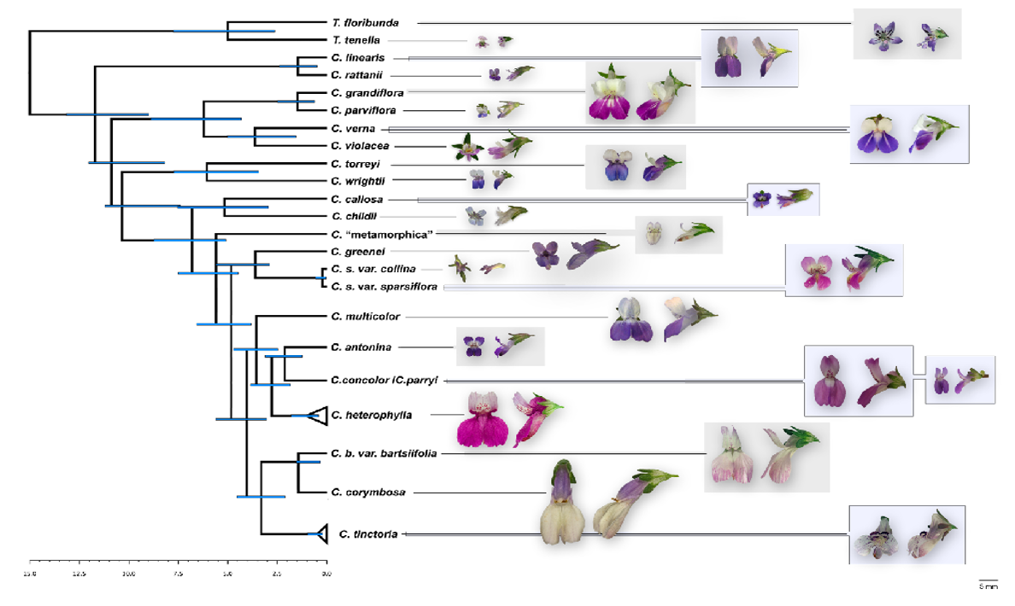
Figure 1.1 Chronogram and maximum-clade-credibility tree of Collinsia and Tonella
Chronogram and maximum-clade-credibility tree of Collinsia and Tonella based on Bayesian phylogenetic analysis of combined sequences of nrDNA external and internal transcribed spacer (ETS and ITS) regions, 3’ matK/3’ trnK intron chloroplast DNA (cpDNA), and the single-copy nuclear gene CYCLOIDEA 1 (CYC1) using BEAST. Redrawn from Baldwin et al. 2011 to highlight selfing and outcrossing sister pairs Estimated maximum ages are given to the left of the node (blue bars delimit the 95% highest probability density for ages). Branch lengths are scaled to time, in million years, with maximal basal calibration at 15 Ma.

(~1 km resolution)) and elevation data (3 arc second (~ 90m resolution)) from WorldClim (Hijmans et al. 2004), and three soil variables (soil pH, soil carbon as a broad indicator of soil nutrient quality, and soil moisture), net primary productivity, and evapotranspiration from SAGE Atlas of the Biosphere (0.5 x 0.5 degree resolution http://nelson.wisc.edu/sage/data-and-models/atlas/index.php) (Table A1.2). All EGVs were retrieved in ESRI GRID (raster) format and the cell size was converted into 30 x 30 arc seconds (~1 km resolution) to standardize their resolution for subsequent analyses.

Maxent Species Distribution Modeling and Pre-Model Processing
Because EGVs play an important role in determining the abundance, distribution, and evolution of species, spatial analyses of patterns of ecogeographic divergence between species can provide insight into niche breadth differences (Kozak et al. 2008; Nakazato et al. 2010). I used species distribution models (SDMs) and associated analysis tools to describe niche differences between selfing and outcrossing species. SDMs generate a species’ distribution and provide environmental suitability estimates, based on its presence records and EGV data. SDMs parameterizes a species’ niche as the subset of EGVs linked to the locations where a species is found, and therefore can live and reproduce (Hutchinson 1957; Phillips et al. 2006). I used the software program Maxent version 3.3.3k (Phillips et al. 2006) to model the realized niches of each species and generate niche heat maps (hereafter, Maxent SDMs). The Maxent SDMs predict the environment suitability score of an area, which ranges between 0 (not suitable) and 1 (highly suitable). Maxent was selected for these analysis because it performs as well or better than other presence-only SDM methods (Phillips et al. 2006; Franklin 2010; Elith et al. 2011), provides robust statistical performance for both small and large sample sizes (Wisz et al. 2008), and, is relatively straightforward to implement. I then used the Maxent SDMs outputs for further analyses.
Maxent produces an environmental suitability model based on a species’ associations with EGV data at all occurrence records across its range, hereafter referred to as the background (Elith et al. 2011). Therefore, to model a species’ niche using Maxent, the species must be analyzed in relationship to an appropriate background area to reduce statistical over- or under-fitting of the model (Phillips et al. 2006). Additionally, the inclusion of too much or too little background area may be biologically incorrect, due to dispersal limitation or other ecological processes (Brown 2014). To avoid these issues and better ensure biologically relevant background areas, I combined the locations where the species of interest occurs, and an additional buffer region around the locations (Warren et al. 2010; Brown 2014; Sobel 2014). Following (Sobel 2014), I tested background areas with buffer sizes of 0.05, 0.025, 0.5, 0.75, 1, 1.5, 2, 3, 4, 5, and 8 decimal degrees by running Maxent a single time for each sister pair and observing the value of the area under the receiving operator curve (AUC). The AUC value is a metric of model performance that ranges between 0 and 1, with values < 0.5 indicative of poor model performance and values close to 1 indicative of high model performance. Although accuracy issues with the use of AUC for model performance have been raised (Lobo et al. 2008), I used AUC because it is still the most commonly applied method, allowing the results to be compared with others. Among all buffer sizes examined for each species pair, AUC values plateaued after 2 decimal degrees, with no additional model performance gains from larger buffers. All the reported Maxent models used 2 decimal degree buffers and AUC values > 0.85 (Table A1.3). Based on herbarium occurrence records and species lists, two decimal degrees encompassed areas well beyond the known distribution of each species. The use of a common background area for each sister pair allowed me to take advantage of the power of sister taxa comparisons by computing niche overlap, directly contrasting niche breadth, and contrasting the distributions of each pair.
Prior to implementation of the Maxent models, I reduced the dimensionality of the EGV data for each sister pair using principal components analysis (PCA) in ArcGIS 10.1 (ESRI 2012), keeping the first three principal component (PC) axis. PCAs also reduce the collinearity of the predictive layers (e.g., Fitzpatrick et al. 2006). These three PCAs generated a new set of variables that explained >70% of the variation in the original data set, while maintaining the spatial format for each analysis. In addition, the AUC’s from Maxent analyses did not differ for the PCA EGVs or the untransformed, raw EGVs. Therefore, I used the PCA output variables for all the Maxent models without sacrificing model performance (Fitzpatrick et al. 2007). Finally, because geographic projections in Maxent introduce a latitudinal bias, I corrected for this by creating a bias file using ENMToolbox (Brown 2014) for each sister pair. I ran the final models for each species using collection records that were assigned randomly to equal-sized training and testing, and 100 bootstrap replicates were performed, with a unique set of training and testing data drawn for each replicate, following Sobel (2014).

Niche Metrics and Ecogeographic Variation between Selfing and Outcrossing Sister Species
I quantified niche divergence between sister species and between mating system types by calculating niche breadth, niche overlap, and overall ecogeographic variation for each species. First, using Maxent SDMs, I calculated niche breadth using Levins’ B (Levins 1968) implemented in ENMTools (Warren, et al. 2008) using the bootstrap sampling method and leaving the other settings at default. For each species, I resampled Levins’ B from the 100 bootstrap Maxent replicate SDMs, generating a distribution of Levins’ B values. Next, I tested whether members of each sister pair differed in their distribution of Levins’ B using two-tailed, Mann-Whitney U tests in R. I then performed a phylogenetically corrected ANOVA (Garland et al 1993) to test for overall differences in niche breadth between selfing and outcrossing sister species, which corrects for non-independence in species’ age and relatedness. I pruned the tree from Baldwin et al. (2011; Fig. 7; nexus file harvested from TreeBASE v2 R version 3.3) to match the seven sister pairs and used the aov.phylo function in the geiger R package (Alfaro et al. 2009) for this analysis (Model: Niche.Breadth ~ MS + Age), which tests the extent to which niche breadth is affected by mating system (MS) or phylogenetic age (Age).
To determine whether niche overlap values were consistent with the hypothesis for niche divergence, I performed two types of randomization tests: niche equivalency and niche similarity (Di Cola et al. 2017). The niche equivalency test assesses the constancy of niche overlap of two species’ distributions and asks whether the ecological niche models (SDMs) of two species are more different than expected if they were drawn from the same underlying distribution (Warren et al. 2008). To run this test, the occurrence records of both species are pooled and then randomly divided into two data sets, maintaining the original sample size for each species. The occurrence records are then randomly redistributed into the distributions for each species and the niche overlap is calculated as Schoener’s D (Schoener 1968). This process was repeated 1000 times, creating a frequency distribution of Schoener’s D values. If sister species have niches diverged, I expect their niches to be less equivalent than expected by chance. In addition, I used species pairs’ niche overlap values to assess the relationship between niche overlap and species pair age, again using the dated phylogeny for this group (Baldwin et al. 2011).
Niche similarity (or background similarity) test asks whether SDMs drawn from species with partially or entirely non-overlapping distributions are any more different in their niche characteristics from one another than expected by random chance. Niche similarity is more likely if species share common ancestry (Warren et al. 2008). To do so, this test shifts the smoothed kernel density of occurrences of one species into the distribution of the other species and calculate the niche overlap. The center of the kernel-smoothed density is randomly simulated for each of the 1000 replicates, generating a distribution of Schoener’s D values. Due to close phylogenetic relationships between sister species pairs and niche conservatism (Peterson et al. 1999; Wiens and Graham 2005; Warren et al. 2008), I expect the sister species tested to exhibit greater niche similarity than expected by chance. These two methods also allowed me to calculate niche overlap between sister species pairs while accounting for some of the sampling issues that arise with herbarium data, which may be an incomplete estimate of a species distribution, by using geographic space that is smoothed by a kernel density (Broennimann et al. 2012).
The final set of analyses uses the EGVs associated with each species’ coordinate location data to determine which variables are the most important for SDMs and contribute to significant differences in niche axes between species pairs and mating system groups. I performed MANOVAs on the raw EGVs and spatial PCA scores for each sister pair to determine if sister species vary significantly in these variables (Sobel 2014).

Results
Overall, Maxent SDMs showed significant differences between selfing and outcrossing species pairs in their overall distributions of environmental suitability. In six of the seven pairs, selfers have greater areas of environmental suitability than do outcrossers (Figure 1.2), indicating conditions where each species is predicted to be capable of living. Only the sister taxa pair C. torreyi and C. wrightii showed the opposite pattern (Figure 1.2E). Pairwise, two-tailed statistical tests for niche breadth differences (Figure 1.3) between sister species pairs generated from Maxent SDM replicates, revealed that six of the seven selfers have greater niche breadths (p < 0.0001 for each comparison, Table 1.1). Only C. torreyi and C. wrightii showed the opposite direction and significant pattern (two-tailed test, outcrosser niche breadth > selfer niche breadth; p <0.0001).
The phylogenetically corrected ANOVA tested for overall differences in niche breadth between selfing and outcrossing species, correcting for non-independence in species age and relatedness, shows that selfers have significantly greater niche breadths than their outcrossing sisters (Model: Niche.Breadth ~ MS + Age, DF = 1; SS = 0.086; F value = 5.29; p = 0.019). Age was not significant in this model (p = 0.28).
The degree of niche overlap (Schoener’s D; Table 1.1) exhibited by sister species pairs ranged between 0.05 and 0.65. Consistent with initial predictions, niche equivalency is less than expected by chance (Figure A1.2: p < 0.05), except for C. torreyi/C. wrightii, indicating niche divergence for six of the seven sister pairs. Only two species pairs (C. torreyi/C. wrightii and C. sparsiflora/C. collina) had niches similarity values greater than expected by chance. For the other species pairs, I observed no directionality in niche similarity tests.

Figure 1.2 Maxent Ecological Niche Model maps of habitat suitability for Tonella and Collinsia sister taxa pairs.
Maxent Ecological Niche Model maps of habitat suitability for Tonella and Collinsia sister taxa pairs displayed as the average bootstrapped values from 100 replicate runs. Cool colors indicate low habitat suitability; warm colors indicate high habitat suitability. Overall, selfers have larger predicted regions of habitat suitability than outcrossers.
Figure 1.3 Distribution of Levins’ B.
Distribution of Levins’ B (niche breadth) values for selfing and outcrossing Tonella and Collinsia sister taxa pairs outcrossing species (orange) and selfing species (teal) generated from 100 ecological niche model bootstrapped replicates per species run in Maxent. Dashed lines indicate median values, with p-values generated from two-tailed test non-parametric Mann-Whitney U test. Note: All sister pairs significantly differ in niche breadth. Six of the seven sister species pairs show the pattern of the selfing sister with a greater niche breadth than the outcrossing sister. For, C. torreyi and C. wrightii, the outcrossing sister has significantly greater niche breadth than its selfing sister.

Niche overlap graphs (Figure 1.4) highlight the principal component (PC) axes that contribute to niche overlap and the shift in niche centroid of the outcrosser to the centroid of selfer. If it is assumed that the selfer shares an outcrossing ancestor with a niche similar to its outcrossing sister, then the arrow will indicate the direction of the niche shift centroid for a species pair. Further analysis of PC loadings for all species (Table A1.4) shows that the highest contributing individual EGVs in the first three PCs (accounting for > 99% of the total variance) are bio4 (Temperature Seasonality (Average Annual Temperature Standard Deviation * 100)), bio12 (Average Annual Precipitation), and Elevation. The medians and distributions of these variables significantly differ between selfers and outcrossers (Figure 1.5). Selfers were found in locations with significantly greater Temperature Seasonality, lower Average Annual Precipitation, and higher Elevation (MANOVA Table A1.5, p < 0.001), which likely contribute to broad scale niche differences. Overall, the majority of the EGVs were significantly different between species pairs ((Table A1.5, p < 0.001), Figure A1.3). The regression of niche overlap values for sister species pairs on divergence time is U-shaped (R²=0.28), with the youngest and oldest species pairs exhibiting more overlap (Figure A1.4).

Discussion
This study is the first to apply SDM approaches to explicitly test for and document a significant relationship between niche metrics and mating system for phylogenetically well-supported sister species pairs. I found that, in general, the large range sizes of selfing sister species in the genera Collinsia and Tonella are associated with wider niche breadths and significant niche divergence relative to their outcrossing sister species. Analyses of individual environmental variables reveal that selfers live in habitats associated with greater variation in growing season
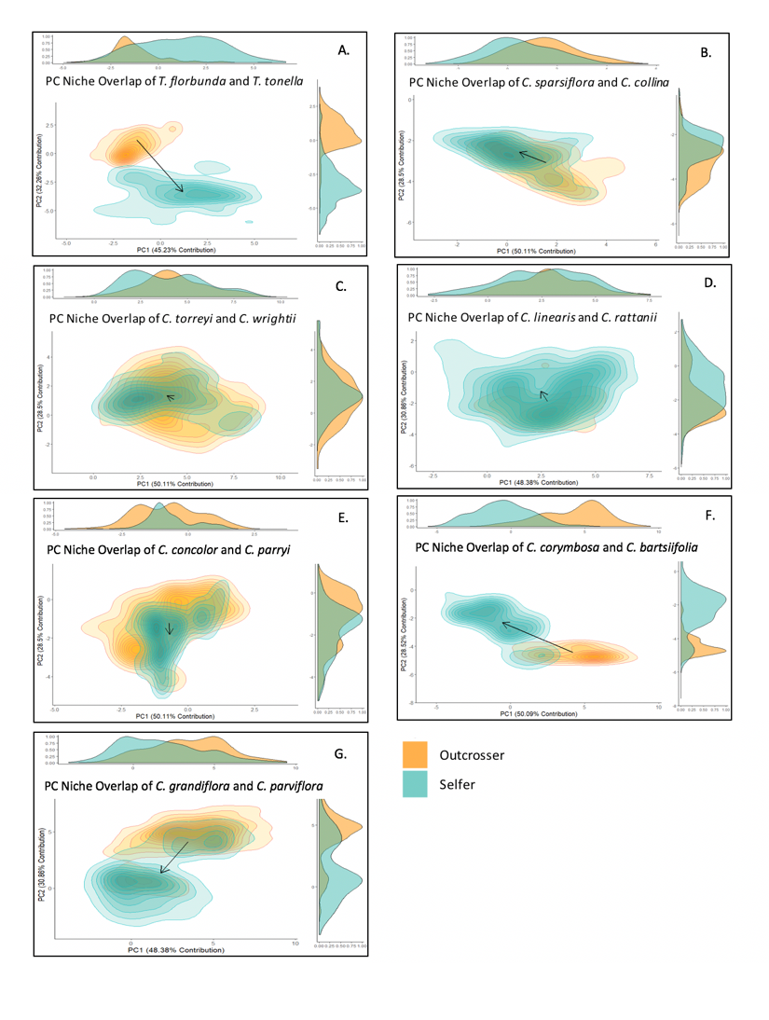

Figure 1.4 Niche Overlap.
Niche overlap of seven Collinsia and Tonella sister species pairs generated from principal components for outcrossing species (orange) and selfing species (teal) used in ecological niche models. Arrows indicate observed shift in the niche centroids (from outcrosser to selfer) within principal component space. Densities of occurrence records are represented by isoclines.
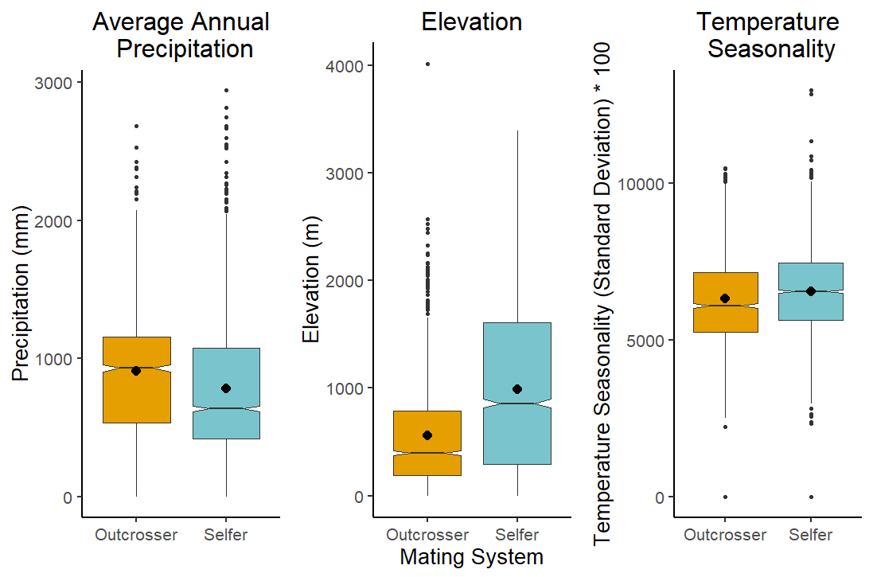
Figure 1.5 Boxplots of pooled annual precipitation, temperature seasonality and elevation.
Boxplots of pooled annual precipitation, temperature seasonality and elevation variables for seven selfing or outcrossing sister species pairs of Collinsia and Tonella. These ecogeographic variables (EGV) account for > 99% of the total variance in the first three principal components. Medians are indicated by notches; means are represented by black dots. Overall, the selfing species are found in sites with significantly lower precipitation, higher temperature seasonality, and higher elevation than outcrossing species, suggesting they inhabit more stressful sites.

temperature and lower precipitation. These findings suggest that selfers may have shifted their niches relative to their outcrossing ancestors into more stressful environmental conditions.

Interestingly, prior studies assessing niche breadth between selfing/self-compatible species versus outcrossing/self-incompatible species found no relationship between mating system and niche breadth. These studies used differences in species range/area metrics and univariate or multivariate analyses of environmental variables, but not using SMDs. Using a minimum convex polygon method in ArcGIS, Randle et al. (2010) found selfers occupied significantly greater range areas and were found at higher elevations than outcrossers, but no significant association between mating system and elevational niche breadth. I also found that mean elevation is greater for Collinsia and Tonella selfers, but in contrast to Randle et al. (2010), elevation significantly contributed to niche breadth in the PC analyses. An analysis of 21 Fragaria species found that the four selfing species had greater range sizes, but had no greater bioclimatic niche breadth than the outcrossers (Johnson et al. 2014). More recently, Park et al. (2018) estimated niche breadth of 194 pairs of species chosen from the same 20 time-calibrated phylogenies (Grossenbacher et al. 2015). The posterior probabilities for the sister species relationships examined ranged from 0.00 to 1.00, and included sister genera, not members of the same genus. For each species, they calculated niche breadth as the PCA of the convex hull surrounding the species occurrence records and as the average Euclidian distance of the 19 bioclim variables for each record in each species’ range. Further, they calculated niche overlap using Schoener’s D and modified Hellinger distance (I) following Warren et al. (2008). These values are descriptive of the current locations, but not predictive of areas where the species had not been found, as in MaxEnt analyses. These metrics were compared to congener niches to contrast mating system effects (selfer-selfer; outcrosser-selfer; outcrosser-outcrosser) on niche breadth. Park et al. (2018) found no association between niche breadth and mating system for any of the three comparisons and no association between niche overlap and divergence time.
Why might I have detected significant differences in niche breadth by mating system, where others did not? This study uses different methodologies from those discussed above. Johnson et al. (2014) and Park et al. (2018) performed statistical tests on individual bioclimatic variables, calculated niche overlap, and then contrasted differentiation between species pairs using dimension reduction methods. In addition to their statistical tests and niche overlap methods I applied SDMs. This approach allows the prediction of the multidimensionality of species’ habitat preferences by estimating environmental suitability scores, which allowed me to predict individual species’ niche breadth (Levins’ B). I also applied the descriptive methods MANOVA and PCA using bioclimatic variables. SDM is a robust approach widely used to address questions related to niche breadth evolution in invasive species, polyploid vs. diploid species, and divergence between closely related species, but to my knowledge, had not yet been applied to specifically test the mating system’s relationship to niche breadth. Since I relied on herbarium-based species occurrence records, it is likely that I was not able to accurately capture the entirety of each species distribution. Going beyond the descriptive methods, the SDM approach predicts habitat suitability beyond regions of known species occurrence while also accounting for the multidimensionality of niche characteristics, further allowing me to assess niche divergence between species pairs. I found that niche equivalency, a metric of shared niche space, for most species pairs tested indicates significant niche divergence. Additionally, these results were not confounded by geographic vs. evolutionary processes (Warren et al. 2014), since the niche similarity tests generally supported the idea that the species pairs show no signal of niche conservatism (Wiens and Graham 2005). Furthermore, this analysis exclusively focused on sister species pairs with high posterior probabilities that suggest a likely sister species relationship. In Collinsia and Tonella, species pair divergence is thought to be coincident with the shift in mating system to selfing in one sister (Baldwin et al. 2011), and thus the assumptions of a recent shared common ancestor and shared niche are valid. This contrasts with prior analyses (Johnson et al. 2014; Grossenbacher et al. 2015; Park et al. 2018), which used sister species or the closest congeneric species pair with contrasting mating systems. It is also possible that diversity in the biology of species analyzed in the prior studies could obscure a signal of mating system on niche breadth if other life history factors more strongly influence niche characteristics than mating system. All 14 species used in the analyses are self-compatible, herbaceous winter annuals primarily found in time-limited habitats. This shared species’ biology in combination with the predictive SDM methods used, may have improved the ability to detect mating system effects where others did not.
The PCA analyses identified three EGVs that contribute greatly to differences in niche breadth of sister species: Precipitation, Temperature Seasonality, and Elevation. Precipitation is significantly lower in selfers than outcrossers, suggesting that selfers may have greater environmental tolerance to dry or water-limited conditions. Both Tonella and Collinsia are winter annuals that primarily live in western North America where the Mediterranean climate imposes low rainfall, short growing seasons, and summer drought (Baldwin et al. 2012). Under such environmentally stress conditions, selfing can be favored as a consequence of direct selection on traits other than the mating system, including flower size and rapid development. Flower size may be the direct, primary target of selection to reduce water loss (Galen 2000). In this case, small, inconspicuous flowers favored by selection may be inherently more likely to autonomously self-pollinate because they also have smaller anther-stigma distances (Guerrant 1989) due to developmental integration (Diggle 1992). Further, ephemeral and/or stressful environments present another scenario where the selfing species may be favored. The “time limitation” hypothesis posits that primary selection for rapid development (Aarssen 2000; Snell and Aarssen 2005) would favor selfing. However, whether the focal selfing species arrived with pre-adapted traits suited to the new environment, experienced local selection and adaptation after colonization, or persisted because of phenotypic plasticity (Roughgarden 1972; Lynch and Gabriel 1987; Sheth and Angert 2014; Sexton et al. 2017) is unknown.
Together, the analyses further suggest that selfers may have a greater range of environmental tolerances than outcrossers. Although selfing species are expected to have lower genetic variation than outcrossers (Loveless and Hamrick 1984), this may not limit selfers’ capacity for local adaptation to the environment (Hereford 2010). For two Collinsia sister pairs investigated here, similar genetic diversity within wild populations of sister species indicates that the potential for local adaptation may not be constrained in the selfers relative to outcrossers (C. rattanii and C. linearis, Hazzouri et al. 2013; C. parryi and C. concolor, Salcedo et al. 2014). While genetic diversity has been shown to correlate with fitness, I acknowledge that genetic diversity at the genomic level may not accurately estimate quantitative genetic variation (Reed and Frankham 2003). Interestingly, recent selection experiments show that genomic change can be as fast as phenotypic changes for some traits, resulting in adaptation to novel niches (Marques et al. 2018). Alternatively, selfers’ wider niche breadths could be attributable to greater phenotypic plasticity than outcrossers. The extent to which vegetative phenotypic plasticity is beneficial for plant survival and therefore contribution to niche breadth, remains an open question (Gratani 2014). For example, widely distributed Mimulus species have greater thermal performance breadth and greater genetic variation in thermal reaction norms for relative growth rate than more narrowly distributed species, suggesting thermal tolerance, but this result was not consistently related to mating system (Sheth and Angert 2014).
Since self-fertilization can greatly reduce gene flow and enforce reproductive isolation, selfers and outcrossers could be expected to co-occur at small spatial scales, which should increase their niche overlap (Grossenbacher et al. 2016). In an analysis of 98 sister species pairs, Grossenbacher et al. (2016) found no association between selfing or outcrossing mating system and range overlap and a weakly positive association between species age and range overlap. The results of the study show a U-shaped relationship between niche overlap and divergence time for sister species pairs (R²= 0.28; Figure A1.3). While this regression is based on only seven sister pairs, nevertheless it suggests that different mechanisms are likely influencing niche overlap of the youngest versus oldest sister species (Paul and Tonsor 2008). Other studies with plants using sister pairs, but where the pairs did not differ in mating system, found mixed results: generally high niche conservatism, high niche overlap, and a negative correlation between niche overlap and species age (71 sister species in the California floristic province, Anaker and Strauss 2010) or low niche similarity and no relationship of species age to range size (four Solanum sister species pairs, Nakazo et al. 2010).
I acknowledge limits to the inferences that can be made from SDM analyses. Additional abiotic factors not included in the model may importantly affect the species distributions. Further, biotic factors, including dispersal ability, competition, pathogens, pollinators, and other biotic interactions (Wisz et al. 2013), may be more important that abiotic factors. Indeed, experiments with C. sparsiflora transplants growing on or off serpentine soils demonstrated that both abiotic and biotic factors shape its niche, specifically heavy metals in the soil and herbivory (Lau et al. 2008). Unfortunately, data on biotic interactions are not available for these 14 species and collecting detailed fitness and biotic interaction data for them across their ranges is not feasible within this study. Despite this lack of local data, SDMs accurately convey niche characteristics. A recent synthesis found that SDMs closely match range limits obtained from field transplant experiments (Lee-Yaw et al. 2016). Additionally, I acknowledge that the models used species occurrence records from herbarium records rather than directly sampling species in the field. Such data can be prone to high spatial autocorrelation and sampling bias (Broennimann et al. 2012). Sampling effects are a common concern in studies that examine range size and niche breadth (Mandle et al. 2010; Cardillo et al. 2019). Some studies suggest that sampling patterns and spatial autocorrelation can eliminate correlation between range size and niche breadth (Burgman 1989). However, the results of a recent meta-analysis on the topic suggest that small sample sized do not have a statistically significant effect on the associations between range size and niche breadth (Slatyer et al. 2013).
Although biotic data are not available for the SDMs, the findings lend support to the importance of the biotic niche related to mating system. All else being equal, relative to selfing species, the niches of outcrossing species are expected to be limited by the pollen vectors required for seed set (Baker 1955). As a group, Collinsia and Tonella species are pollinated by specialist and generalist bees (Lankinen et al. 2009), and the ability of plants to attract pollinators is a density-dependent function of population size (Rathcke 1983). Thus, even if the outcrosser could survive in a novel habitat post dispersal, the expected lack of appropriate pollinators in newly colonized sites, the low probability of a single individual or small population in attracting pollinators post-colonization (Rathcke 1983), and the reduction in the quantity and quality of pollen received (i.e. primarily pollen from other species) (e.g. Larson and Barrett 2000; Morales and Traveset 2008) are expected to combine to suppress reproductive success of outcrossers relative to selfers. In contrast, if a selfer can survive in a novel habitat, reproductive assurance could contribute to a positive population growth rate, thereby expanding its niche breadth. Reliance on mutualisms can restrict range limits (Nunez et al. 2009; Lankau and Keymer 2016), however, there is mixed empirical support for the role of access to pollinators in impeding range limits (Hargreaves et al. 2015; Theobald et al. 2016; Koski et al. 2017; Urbanowicz et al. 2018).
Finally, the results lend support for higher colonization ability and adaptability of selfing species in environmentally variable habitats (Peterson and Kay 2015) and hopefully will motivate further research on the relative contributions of mating system, floral traits, and niche breadth evolution. I observed significantly greater niche breadth in selfers over outcrossers, which are consistent with a role for pollination mutualisms and conspecific density (i.e., density-dependent reproduction) in limiting outcrossing species’ niches. Alternatively, reduced dependence on pollination mutualisms may permit selfers to occupy a wider range of environmental variables and habitats that are unsuitable for specialized pollinators. Empirical tests that examine pollinator visitation rates, colonization, and range limits would be important next steps to discern the causes of these patterns. Additionally, I identified precipitation as the primary environmental factor differentiating niches of selfers and outcrossers and are currently testing the contributions of drought tolerance to niche breadth in Collinsia sister species. I advocate for the application of niche modeling to both explore preexisting hypotheses (i.e., time limitation, Baker’s Law) and generate additional testable hypotheses (i.e., experimental tests of physiology tolerances) based on its output. This combined approach can help to advance niche and range shift research by relating niche models to species biology, increasing the number of studies that validate the metrics of environmental suitability, and encouraging the use of niche models in new applications. The findings support the notion that selfers are better colonists, possibly due to reproductive assurance or time limitation (Baker 1955), are consistent with the findings that selfers have wider range sizes than outcrossers (Kalisz et al. 2012; Johnson et al. 2014; Grossenbacher et al. 2015), and provide novel insights into the potential benefits of a selfing mating system on niche evolution.

References
Aarssen, L. W. 2000. Why are most selfers annuals? A new hypothesis for the fitness benefit of selfing. Oikos 89:606-612.
Alfaro, M. E., F. Santini, C. Brock, H. Alamillo, A. Dornburg, D. L. Rabosky, G. Carnevale, and L. J. Harmon. 2009. Nine exceptional radiations plus high turnover explain species diversity in jawed vertebrates. Proceedings of the National Academy of Sciences 106:13410.
Anacker, B. L. and S. Y. Strauss. 2014. The geography and ecology of plant speciation: range overlap and niche divergence in sister species. Proceedings of the Royal Society B: Biological Sciences 281.
Antonovics, J. 1968. Evolution in closely adjacent plant populations. V. Evolution of self-fertility. Heredity 23:219-238.
Baker, H. G. 1955. Self-compatibility and establishment after 'long-distance' dispersal. Evolution 9:347-349.
Baldwin, B. G., D. Goldman, D. J. Keil, R. Patterson, and T. J. Rosatti. 2012. The Digital Jepson Manual: Vascular Plants of California. Univ of California Press.
Baldwin, B. G., S. Kalisz, and W. S. Armbruster. 2011. Phylogenetic perspectives on diversification, biogeography, and floral evolution of Collinsia and Tonella (Plantaginaceae). American Journal of Botany 98:731-753.
Blows, M. W. and A. A. Hoffmann. 2005. A reassessment of genetic limits to evolutionary change. Ecology 86:1371-1384.
Bradshaw, A. D. 1991. The Croonian Lecture, 1991. Genostasis and the limits to evolution. Phil. Trans. R. Soc. Lond. B 333:289-305.
Broennimann, O., M. C. Fitzpatrick, P. B. Pearman, B. Petitpierre, L. Pellissier, N. G. Yoccoz, W. Thuiller, M. J. Fortin, C. Randin, N. E. Zimmermann, C. H. Graham, and A. Guisan. 2012. Measuring ecological niche overlap from occurrence and spatial environmental data. Global Ecology and Biogeography 21:481-497.
Brown, J. H., G. C. Stevens, and D. M. Kaufman. 1996. The Geographic Range: Size, Shape, Boundaries, and Internal Structure. Annual Review of Ecology and Systematics 27:597-623.
Brown, J. L. 2014. SDMtoolbox: a python‐based GIS toolkit for landscape genetic, biogeographic and species distribution model analyses. Methods in Ecology and Evolution 5:694-700.
Burgman, M. A. 1989. The habitat volumes of scarce and ubiquitous plants: a test of the model of environmental control. The American Naturalist 133:228-239.
Cardillo, M., R. Dinnage, and W. McAlister. 2019. The relationship between environmental niche breadth and geographic range size across plant species. Journal of Biogeography 46:97-109.
Charlesworth, D. and J. Pannell. 2001. Mating systems and population genetic structure in the light of coalescent theory. SPECIAL PUBLICATION-BRITISH ECOLOGICAL SOCIETY 14:73-96.
Crawford, K. M. and K. D. Whitney. 2010. Population genetic diversity influences colonization success. Molecular Ecology 19:1253-1263.
Di Cola, V., O. Broennimann, B. Petitpierre, F. T. Breiner, M. D'amen, C. Randin, R. Engler, J. Pottier, D. Pio, and A. Dubuis. 2017. ecospat: an R package to support spatial analyses and modeling of species niches and distributions. Ecography 40:774-787.
Elith, J., S. J. Phillips, T. Hastie, M. Dudík, Y. E. Chee, and C. J. Yates. 2011. A statistical explanation of MaxEnt for ecologists. Diversity and Distributions 17:43-57.
ESRI. 2012. ArcGIS. Environmental Systems Research Institute, Redlands, CA.
Fisher, R. A. 1930. The genetical theory of natural selection: a complete variorum edition. Oxford University Press.
Frankham, R. 2005. Genetics and extinction. Biological Conservation 126:131-140.
Franklin, J. 2010. Mapping species distributions: spatial inference and prediction. Cambridge University Press.
Galen, C. 2000. High and dry: drought stress, sex‐allocation trade‐offs, and selection on flower size in the alpine wildflower Polemonium viscosum (Polemoniaceae). The American Naturalist.
Gaston, K. J. 2003. The structure and dynamics of geographic ranges. Oxford University Press on Demand.
GBIF. 2011. Global Biodiversity Information Facility.
Geber, M. A. 2008. To the edge: studies of species’ range limits. New Phytologist 178:228-230.
Gratani, L. 2014. Plant Phenotypic Plasticity in Response to Environmental Factors. Advances in Botany 2014:17.
Grinnell, J. 1917. The niche-relationships of the California Thrasher. The Auk 34:427-433.
Grossenbacher, D., R. Briscoe Runquist, E. E. Goldberg, and Y. Brandvain. 2015. Geographic range size is predicted by plant mating system. Ecology Letters 18:706-713.
Grossenbacher, D., R. D. Briscoe Runquist, E. E. Goldberg, and Y. Brandvain. 2016. No association between plant mating system and geographic range overlap. American Journal of Botany 103:110-117.
Grossenbacher, D., R. B. Runquist, and J. Smith. 2018. Self-Fertilization and Herbivory in a Rare Alpine Plant in California, Claytonia megarhiza (Montiaceae). Madroño 65:22-28.
Grossenbacher, D. L., Y. Brandvain, J. R. Auld, M. Burd, P. O. Cheptou, J. K. Conner, A. G. Grant, S. M. Hovick, J. R. Pannell, and A. Pauw. 2017. Self‐compatibility is over‐represented on islands. New Phytologist 215:469-478.
Grossenbacher, D. L., S. D. Veloz, and J. P. Sexton. 2014. Niche and range size patterns suggest that speciation begins in small, ecologically diverged populations in north american monkeyflowers (mimulus spp.). Evolution 68:1270-1280.
Guerrant, E. 1989. Early maturity, small flowers and autogamy: a developmental connection. The evolutionary ecology of plants:61-84.
Hamrick, J. L. and M. J. W. Godt. 1996. Effects of Life History Traits on Genetic Diversity in Plant Species. Philosophical Transactions of the Royal Society of London B: Biological Sciences 351:1291-1298.
Hargreaves, A. L., J. L. Weiner, and C. G. Eckert. 2015. High-elevation range limit of an annual herb is neither caused nor reinforced by declining pollinator service. Journal of Ecology 103:572-584.
Hazzouri, K. M., J. S. Escobar, R. W. Ness, L. Killian Newman, A. M. Randle, S. Kalisz, and S. I. Wright. 2013. Comparative population genomics in Collinsia sister species reveals evidence for reduced effective population size, relaxed selection, and evolution of biased gene conversion with an ongoing mating system shift. Evolution 67:1263-1278.
Hereford, J. 2010. Does selfing or outcrossing promote local adaptation? American Journal of Botany 97:298-302.
Hijmans, R., S. Cameron, J. Parra, P. Jones, and A. Jarvis. 2004. The WorldClim interpolated global terrestrial climate surfaces. Version 1.3.
Hirzel, A. H. and G. Le Lay. 2008. Habitat suitability modelling and niche theory. Journal of Applied Ecology 45:1372-1381.
Holt, R. D. 2009. Bringing the Hutchinsonian niche into the 21st century: ecological and evolutionary perspectives. Proceedings of the National Academy of Sciences of the United States of America 106 Suppl 2:19659-19665.
Holt, R. D. and M. S. Gaines. 1992. Analysis of adaptation in heterogeneous landscapes: implications for the evolution of fundamental niches. Evolutionary Ecology 6:433-447.
Hutchinson, G. 1957. Population studies-animal ecology and demography-concluding remarks. Pp. 415-427. Cold Spring Harbor Symposia on Quantitative Biology. Cold Spring Harbor Lab Press 1 Bungtown Rd, Plainview, NY 11724.
Johnson, A. L., R. Govindarajulu, and T.-L. Ashman. 2014. Bioclimatic evaluation of geographical range in Fragaria (Rosaceae): consequences of variation in breeding system, ploidy and species age. Botanical Journal of the Linnean Society 176:99-114.
Kalisz, S., A. Randle, D. Chaiffetz, M. Faigeles, A. Butera, and C. Beight. 2012. Dichogamy correlates with outcrossing rate and defines the selfing syndrome in the mixed-mating genus Collinsia. Annals of Botany 109:571-582.
Koski, M. H., D. L. Grossenbacher, J. W. Busch, and L. F. Galloway. 2017. A geographic cline in the ability to self‐fertilize is unrelated to the pollination environment. Ecology 98:2930-2939.
Kozak, K. H., C. H. Graham, and J. J. Wiens. 2008. Integrating GIS-based environmental data into evolutionary biology. Trends in ecology & evolution 23:141-148.
Lankau, R. A. and D. P. Keymer. 2016. Ectomycorrhizal fungal richness declines towards the host species’ range edge. Molecular ecology 25:3224-3241.
Lankinen, Å., J. Maad, and W. S. Armbruster. 2009. Pollen-tube growth rates in Collinsia heterophylla (Plantaginaceae): one-donor crosses reveal heritability but no effect on sporophytic-offspring fitness. Annals of Botany 103:941-950.
Larson, B. M. and S. C. Barrett. 2000. A comparative analysis of pollen limitation in flowering plants. Biological journal of the Linnean Society 69:503-520.
Laura, C., C. Martina, G. Belinda, and T. J. L. 2016. Combining trade data and niche modelling improves predictions of the origin and distribution of non‐native European populations of a globally invasive species. Journal of Biogeography 43:967-978.
Lee-Yaw, J. A., H. M. Kharouba, M. Bontrager, C. Mahony, A. M. Csergő, A. M. Noreen, Q. Li, R. Schuster, and A. L. Angert. 2016. A synthesis of transplant experiments and ecological niche models suggests that range limits are often niche limits. Ecol. Lett. 19:710–722
Levin, D. A. 2010. Environment‐enhanced self‐fertilization: implications for niche shifts in adjacent populations. Journal of Ecology.
Levins, R. 1968. Evolution in changing environments: some theoretical explorations. Princeton University Press.
Lobo, J. M., A. Jiménez‐Valverde, and R. Real. 2008. AUC: a misleading measure of the performance of predictive distribution models. Global ecology and Biogeography 17:145-151.
López-Villalobos, A. and C. G. Eckert. 2018. Consequences of multiple mating-system shifts for population and range-wide genetic structure in a coastal dune plant. Molecular Ecology 27:675-693.
Loveless, M. D. and J. L. Hamrick. 1984. Ecological determinants of genetic structure in plant populations. Annual review of ecology and systematics 15:65-95.
Lynch, M. and W. Gabriel. 1987. Environmental tolerance. The American Naturalist 129:283-303.
Mandle, L., D. L. Warren, M. H. Hoffmann, A. T. Peterson, J. Schmitt, and E. J. von Wettberg. 2010. Conclusions about niche expansion in introduced Impatiens walleriana populations depend on method of analysis. PLoS One 5:e15297.
Marques, D. A., F. C. Jones, F. Di Palma, D. M. Kingsley, and T. E. Reimchen. 2018. Experimental evidence for rapid genomic adaptation to a new niche in an adaptive radiation. Nature ecology & evolution 2:1130.
Morales, C. L. and A. Traveset. 2008. Interspecific Pollen Transfer: Magnitude, Prevalence and Consequences for Plant Fitness. Critical Reviews in Plant Sciences 27:221-238.
Nakazato, T., D. L. Warren, and L. C. Moyle. 2010. Ecological and geographic modes of species divergence in wild tomatoes. American Journal of Botany 97:680-693.
Nunez, M. A., T. R. Horton, and D. Simberloff. 2009. Lack of belowground mutualisms hinders Pinaceae invasions. Ecology 90:2352-2359.
Pannell, J. R., J. R. Auld, Y. Brandvain, M. Burd, J. W. Busch, P. O. Cheptou, J. K. Conner, E. E. Goldberg, A. G. Grant, and D. L. Grossenbacher. 2015. The scope of Baker's law. New Phytologist 208:656-667.
Park, D. S., A. M. Ellison, and C. C. Davis. 2018. Mating system does not predict niche breath. Global Ecology and Biogeography 0.
Paul, J. R., S. N. Sheth, and A. L. Angert. 2011. Quantifying the impact of gene flow on phenotype-environment mismatch: a demonstration with the scarlet monkeyflower Mimulus cardinalis. The American Naturalist 178:S62-S79.
Paul, J. R. and S. J. Tonsor. 2008. Explaining geographic range size by species age: a test using Neotropical Piper species. Tropical forest community ecology. Oxford, UK: Blackwell Publishing:46-62.
Petanidou, T., R. C. Godfree, D. S. Song, A. Kantsa, Y. L. Dupont, and N. M. Waser. 2012. Self-compatibility and plant invasiveness: Comparing species in native and invasive ranges. Perspectives in Plant Ecology, Evolution and Systematics 14:3-12.
Peterson, A., J. Soberón, and V. Sánchez-Cordero. 1999. Conservatism of ecological niches in evolutionary time. Science 285:1265-1267.
Peterson, M. L. and K. M. Kay. 2015. Mating system plasticity promotes persistence and adaptation of colonizing populations of hermaphroditic angiosperms. The American Naturalist 185:28-43.
Phillips, S. J., R. P. Anderson, and R. E. Schapire. 2006. Maximum entropy modeling of species geographic distributions. Ecological Modelling.
Proulx, S. R. 1999. Matings Systems and the Evolution of Niche Breadth. The American Naturalist 154.
Randle, A. M., J. B. Slyder, and S. Kalisz. 2009. Can differences in autonomous selfing ability explain differences in range size among sister-taxa pairs of Collinsia (Plantaginaceae)? An extension of Baker's Law. New Phytologist 183:618-629.
Rathcke, B. 1983. Competition and facilitation among plants for pollination. Pollination biology:305-329.
Reed, D. H. and R. Frankham. 2003. Correlation between Fitness and Genetic Diversity. Conserv. Biol. 17:230-237
Roughgarden, J. 1972. Evolution of Niche Width. The American Naturalist 106:683-718.
Salcedo, A., S. Kalisz, and S. Wright. 2014. Limited genomic consequences of mixed mating in the recently derived sister species pair, Collinsia concolor and Collinsia parryi. Journal of Evolutionary Biology 27:1400-1412.
Schoener, T. W. 1968. The Anolis lizards of Bimini: resource partitioning in a complex fauna. Ecology 49:704-726.
Sexton, J. P., J. Montiel, J. E. Shay, M. R. Stephens, and R. A. Slatyer. 2017. Evolution of Ecological Niche Breadth. Annual Review of Ecology, Evolution, and Systematics 48:183-206.
Sheth, S. N. and A. L. Angert. 2014. The evolution of environmental tolerance and range size: a comparison of geographically restricted and widespread mimulus. Evolution 68:2917-2931.
Slatyer, R. A., M. Hirst, and J. P. Sexton. 2013. Niche breadth predicts geographical range size: a general ecological pattern. Ecology Letters 16:1104-1114.
Snell, R. and L. W. Aarssen. 2005. Life history traits in selfing versus outcrossing annuals: exploring the'time-limitation'hypothesis for the fitness benefit of self-pollination. BMC ecology 5:2.
Sobel, J. M. 2014. Ecogeographic isolation and speciation in the genus Mimulus. The American Naturalist 184:565-579.
Spyros, T., R. Christophe, B. Olivier, P. Theofania, and C. Elena. 2013. Divergent and narrower climatic niches characterize polyploid species of European primroses in Primula sect. Aleuritia. Journal of Biogeography 40:1278-1289.
Stebbins, G. L. 1957. Self-fertilization and population variability in the higher plants. American Naturalist.
Tabassum, S. and M. R. Leishman. 2019. It doesn’t take two to tango: increased capacity for self-fertilization towards range edges of two coastal invasive plant species in eastern Australia. Biological Invasions 21:2489-2501.
Team, R. C. 2000. R Language Definition. Available from CRAN sites.
Theobald, E. J., H. Gabrielyan, and J. HilleRisLambers. 2016. Lilies at the limit: Variation in plant-pollinator interactions across an elevational range. American Journal of Botany 103:189-197.
Urbanowicz, C., R. A. Virginia, and R. E. Irwin. 2018. Pollen limitation and reproduction of three plant species across a temperature gradient in western Greenland. Arctic, Antarctic, and Alpine Research 50:S100022.
Warren, D. L., R. E. Glor, and M. Turelli. 2008. Environmental niche equivalency versus conservatism: quantitative approaches to niche evolution. Evolution 62:2868-2883.
Warren, D. L., R. E. Glor, and M. Turelli. 2010. ENMTools: a toolbox for comparative studies of environmental niche models. Ecography 33:607-611.
Warren, D. L., A. N. Wright, S. N. Seifert, and H. B. Shaffer. 2014. Incorporating model complexity and spatial sampling bias into ecological niche models of climate change risks faced by 90 C alifornia vertebrate species of concern. Diversity and distributions 20:334-343.
Wiens, J. J. and C. H. Graham. 2005. Niche Conservatism: Integrating Evolution, Ecology, and Conservation Biology. Annual Review of Ecology, Evolution, and Systematics 36:519-539.
Wisz, M. S., R. Hijmans, J. Li, A. T. Peterson, C. Graham, and A. Guisan. 2008. Effects of sample size on the performance of species distribution models. Diversity and Distributions 14:763-773.
Wisz, M. S., J. Pottier, W. D. Kissling, L. Pellissier, J. Lenoir, C. F. Damgaard, C. F. Dormann, M. C. Forchhammer, J.-A. Grytnes, A. Guisan, R. K. Heikkinen, T. T. Høye, I. Kühn, M. Luoto, L. Maiorano, M.-C. Nilsson, S. Normand, E. Öckinger, N. M. Schmidt, M. Termansen, A. Timmermann, D. A. Wardle, P. Aastrup, and J.-C. Svenning. 2013. The role of biotic interactions in shaping distributions and realised assemblages of species: implications for species distribution modelling. Biol. Rev. 88:15-30

Appendix A
Table A1.1 Herbaria and herbarium consortia sources used to acquire occurrence data for sister species pairs of Collinsia and Tonella.
Herbaria and Databases Used | URL | Species
Global Biodiversity Information Facility | www.gbif.org/ | Tonella floribunda, T. tenella; Collinsia linearis, C. rattanii, C. concolor, C. parryi, C. grandiflora, C. parviflora, C. torreyi var torreyi, C. torreyi var. wrightii, C. sparsiflora var. sparsiflora, C. sparsiflora var. collina, C. bartsiifolia, C. corymbosa
Consortium of California Herbaria | ucjeps.berkeley.edu/consortium/ | Tonella tenella; Collinsia linearis, C. rattanii, C. concolor, C. parryi, C. grandiflora, C. parviflora, C. torreyi var torreyi, C. torreyi var. wrightii, C. sparsiflora var. sparsiflora, C. sparsiflora var. collina, C. bartsiifolia, C. corymbosa
Consortium of Pacific Northwest Herbaria | http://www.pnwherbaria.org/ | Tonella floribunda, T. tenella; Collinsia linearis, C. rattanii, C. grandiflora, C. parviflora, C. sparsiflora
Arctos University of Alaska Museum of the North | http://arctos.database.museum/SpecimenSearch.cfm | Collinsia parviflora
Canadian Museum of Nature | http://collections.nature.ca/en/Search | Collinsia grandiflora, C. parviflora, C. torreyi
Northern Great Plains Regional Herbarium Network | http://ngpherbaria.org/portal/collections/index.php | Tonella floribunda, T. tenella; Collinsia linearis, C. rattanii, C. concolor, C. parryi, C. grandiflora, C. parviflora, C. torreyi var torreyi, C. torreyi var. wrightii, C. sparsiflora var. sparsiflora, C. sparsiflora var. collina, C. bartsiifolia, C. corymbosa
Northern Ontario Plant Database | http://www.northernontarioflora.ca/ | Collinsia parviflora
University of British Columbia Herbarium | http://www.biodiversity.ubc.ca/museum/herbarium/database.html | Collinsia grandiflora, C. parviflora

Table A1.2 Ecogeographic variables used in Maxent analyses of sister species pairs of Collinsia and Tonella.
Variable Meaning | Variable Code | URL | Citation
Annual Mean Temperature | bio_01 | www.worldclim.org | (Hijmans et al. 2005)
Mean Diurnal Range (Mean of monthly (max temp - min temp) | bio_02 | www.worldclim.org | (Hijmans et al. 2005)
Isothermality (BIO2/BIO7) (* 100) | bio_03 | www.worldclim.org | (Hijmans et al. 2005)
Temperature Seasonality (standard deviation *100) | bio_04 | www.worldclim.org | (Hijmans et al. 2005)
Max Temperature of Warmest Month | bio_05 | www.worldclim.org | (Hijmans et al. 2005)
Min Temperature of Coldest Month | bio_06 | www.worldclim.org | (Hijmans et al. 2005)
Temperature Annual Range (BIO5-BIO6) | bio_07 | www.worldclim.org | (Hijmans et al. 2005)
Mean Temperature of Wettest Quarter | bio_08 | www.worldclim.org | (Hijmans et al. 2005)
Mean Temperature of Driest Quarter | bio_09 | www.worldclim.org | (Hijmans et al. 2005)
Mean Temperature of Warmest Quarter | bio_10 | www.worldclim.org | (Hijmans et al. 2005)
Mean Temperature of Coldest Quarter | bio_11 | www.worldclim.org | (Hijmans et al. 2005)
Annual Precipitation | bio_12 | www.worldclim.org | (Hijmans et al. 2005)
Precipitation of Wettest Month | bio_13 | www.worldclim.org | (Hijmans et al. 2005)
Precipitation of Driest Month | bio_14 | www.worldclim.org | (Hijmans et al. 2005)
Precipitation Seasonality (Coefficient of Variation) | bio_15 | www.worldclim.org | (Hijmans et al. 2005)
Precipitation of Wettest Quarter | bio_16 | www.worldclim.org | (Hijmans et al. 2005)
Precipitation of Driest Quarter | bio_17 | www.worldclim.org | (Hijmans et al. 2005)
Precipitation of Warmest Quarter | bio_18 | www.worldclim.org | (Hijmans et al. 2005)
Precipitation of Coldest Quarter | bio_19 | www.worldclim.org | (Hijmans et al. 2005)
Elevation: Height Above Sea Level | Elev | www.diva-gis.org | (Jarvis et al. 2008)
Evapotranspiration (EVAP): The amount of water removed from a gridcell through the processes of evaporation and transpiration. | EVAP | http://nelson.wisc.edu/sage/data-and-models/atlas/index.php | (Willmott and Court 2001)

Table A1.2 Continued.
Variable Meaning | Variable Code | URL | Citation
Net Primary Productivity: The total net primary productivity (NPP) in each gridcell | NPP | http://nelson.wisc.edu/sage/data-and-models/atlas/index.php | (Foley et al. 1996 and Kucharik et al. 2000)
Soil Organic Carbon: The total mass of soil carbon (to one meter) contained in a gridcell | scarbon | http://nelson.wisc.edu/sage/data-and-models/atlas/index.php | (IGBP-DIS 1998)
Soil Moisture: The average amount of water in the soil of a grid cell | smoisture | http://nelson.wisc.edu/sage/data-and-models/atlas/index.php | (Willmott and Court 2001)
Soil pH: The pH of the soil in a gridcell | Sph | http://nelson.wisc.edu/sage/data-and-models/atlas/index.php | (IGBP-DIS 1998)

Table A1.3 Area-Under-Curve (AUC) for Maxent Species distribution models of sister species pairs of Collinsia and Tonella.
Sister Pair | Selfer AUC | Outcrosser AUC
Tonella floribunda & T. tenella | 0.954 | 0.979
Collinsia linearis & C. rattanii | 0.851 | 0.969
Collinsia grandiflora & C. parviflora | 0.808 | 0.963
Collinsia torreyi & C. wrightii | 0.979 | 0.957
Collinsia sparsiflora & C. collina | 0.935 | 0.954
Collinsia parryi & C. concolor | 0.950 | 0.968
Collinsia bartsiifolia & C. corymbosa | 0.919 | 0.984

Table A1.4 Principal Component Analysis loadings of ecogeographic variables.
Bioclim Variable Code | Bioclim Variable Name | PC1 | PC2 | PC3 | PC4 | PC5
bio_1 | Annual Mean Temperature | -0.0028 | 0.04013 | 0.01875 | -0.1235 | 0.32415
bio_2 | Mean Diurnal Range (Mean of monthly (max temp - min temp)) | 0.00363 | -0.0099 | 0.01168 | -0.1166 | 0.11729
bio_3 | Isothermality (BIO2/BIO7) (* 100) | -0.0025 | -0.0014 | 0.00063 | -0.0317 | 0.03986
bio_4 | Temperature Seasonality (standard deviation *100) | 0.98591 | 0.07493 | -0.1217 | -0.0658 | -0.0238
bio_5 | Max Temperature of Warmest Month | 0.01148 | 0.02946 | 0.02334 | -0.2393 | 0.31278
bio_6 | Min Temperature of Coldest Month | -0.0212 | 0.03974 | 0.01422 | -0.1244 | 0.21995
bio_7 | Temperature Annual Range (BIO5-BIO6) | 0.03271 | -0.0103 | 0.00913 | -0.1146 | 0.09292
bio_8 | Mean Temperature of Wettest Quarter | 0.01221 | 0.04753 | 0.00201 | 0.15137 | 0.65204
bio_9 | Mean Temperature of Driest Quarter | -0.0224 | 0.02035 | 0.03956 | -0.4768 | 0.00162
bio_10 | Mean Temperature of Warmest Quarter | 0.00912 | 0.03873 | 0.01727 | -0.1315 | 0.32597
bio_11 | Mean Temperature of Coldest Quarter | -0.017 | 0.03527 | 0.01964 | -0.1386 | 0.3282
bio_12 | Annual Precipitation | -0.0872 | 0.0811 | -0.8308 | 0.21113 | 0.09135
bio_13 | Precipitation of Wettest Month | -0.0246 | 0.01189 | -0.132 | -0.0918 | 0.02039
bio_14 | Precipitation of Driest Month | 0.00515 | 0.00388 | -0.0134 | 0.08017 | -0.0009
bio_15 | Precipitation Seasonality ( | -0.0093 | 0.00293 | -0.0006 | -0.1191 | 0.07534
bio_16 | Precipitation of Wettest Quarter | -0.0697 | 0.03003 | -0.3791 | -0.2293 | -0.0077
bio_17 | Precipitation of Driest Quarter | 0.01491 | 0.014 | -0.0594 | 0.26223 | -0.0306
bio_18 | Precipitation of Warmest Quarter | 0.02969 | 0.02533 | -0.0753 | 0.43756 | 0.16948
bio_19 | Precipitation of Coldest Quarter | -0.083 | 0.01267 | -0.3349 | -0.4545 | -0.1798
elev | Elevation (m) | 0.06398 | -0.988 | -0.0935 | -0.0141 | 0.09257
Principal Component Analysis loadings of ecogeographic variables (EGVs) for the first 5 PCs displayed. The highest loading EGVs in the first 3 PCs are in bold.
Species Pair | Tonella floribunda/ T. tenella |  | Collinsia concolor/ C. parryi |  | Collinsia corymbosa/ C. bartsiifolia
Metric | p value | greater mean | p value | greater mean | p value | greater mean
Elevation | 0 | O>S | 0.15 | O>S | 0 | O<S
Soil pH | 0 | O>S | 0 | O>S | 0 | O<S
Soil Moisture | 0.01 | O<S | 0 | O<S | 0 | O>S
Soil Carbon | 0 | O<S | 0.58 | O<S | 0 | O>S
NPP | 0 | O<S | 0 | O<S | 0 | O>S
EVAP | 0.06 | O<S | 0 | O<S | 0 | O>S
Bio 1 | 0 | O<S | 0.8 | O<S | 0 | O<S
Bio 2 | 0 | O>S | 0.01 | O>S | 0 | O<S
Bio 3 | 0 | O<S | 0 | O>S | 0 | O>S
Bio 4 | 0 | O>S | 0.03 | O<S | 0 | O<S
Bio 5 | 0 | O>S | 0.96 | O<S | 0 | O<S
Bio 6 | 0 | O<S | 0.35 | O>S | 0 | O>S
Bio 7 | 0 | O<S | 0.5 | O<S | 0 | O<S
Bio 8 | 0 | O<S | 0.6 | O>S | 0.57 | O>S
Bio 9 | 0 | O<S | 0 | O<S | 0 | O<S
Bio 10 | 0 | O>S | 0.34 | O<S | 0 | O<S
Bio 11 | 0 | O<S | 0.34 | O>S | 0.04 | O>S
Bio 12 | 0 | O<S | 0.02 | O<S | 0 | O>S
Bio 13 | 0 | O<S | 0 | O<S | 0 | O>S
Bio 14 | 0 | O>S | 0 | O>S | 0 | O>S
Bio 15 | 0 | O<S | 0 | O<S | 0.09 | O<S
Bio 16 | 0 | O<S | 0 | O<S | 0 | O>S
Bio 17 | 0 | O>S | 0 | O>S | 0 | O>S
Bio 18 | 0 | O>S | 0 | O>S | 0 | O>S
Bio 19 | 0 | O<S | 0 | O>S | 0 | O>S
PCA1 | 0 | O>S | 0.2 | O<S | 0 | O<S
PCA2 | 0.03 | O<S | 0.09 | O<S | 0.03 | O>S
Table A1.5 MANOVA

MANOVA using ecogeographic variables (EGVs) and ArcGIS PCA data from sister species pairs occurrence records of Collinsia and Tonella. Within each pair, most individual variables were significantly different, suggesting a role of ecological differentiation between these selfing-outcrossing sister species pairs. O>S indicates that the outcrossing species has a greater mean and O<S indicates that the selfing species has a greater mean. Overall MANOVA results for each species pair are significant, but there is no directionality for this overall test. For additional details on the distribution of the ecogeographic variables, see Figure A1.4 boxplots.

Table A1.5 MANOVA continued.

Species Pair | Collinsia linearis/ C. rattanii |  | Collinsia sparsiflora/ C. collina |  | Collinsia torreyi/ C. wrightii |  | Collinsia grandiflora/ C. parviflora
Metric | p value | greater mean | p value | greater mean | p value | greater mean | p value | greater mean
Elevation | 0 | O<S | 0.11 | O<S | 0 | O<S | 0 | O<S
Soil pH | 0.22 | O<S | 0.52 | O>S | 0 | O<S | 0 | O<S
Soil Moisture | 0 | O<S | 0 | O>S | 0 | O>S | 0 | O>S
Soil Carbon | 0.4 | O>S | 0 | O>S | 0 | O>S | 0 | O>S
NPP | 0 | O>S | 0 | O>S | 0.36 | O>S | 0 | O>S
EVAP | 0 | O<S | 0.01 | O>S | 0.05 | O>S | 0 | O>S
Bio 1 | 0.01 | O>S | 0 | O<S | 0 | O>S | 0 | O>S
Bio 2 | 0.69 | O<S | 0 | O>S | 0 | O>S | 0 | O<S
Bio 3 | 0 | O>S | 0 | O>S | 0.11 | O>S | 0 | O>S
Bio 4 | 0 | O<S | 0 | O<S | 0 | O>S | 0 | O<S
Bio 5 | 0.4 | O>S | 0 | O<S | 0 | O>S | 0.01 | O<S
Bio 6 | 0 | O>S | 0 | O<S | 0.42 | O>S | 0 | O>S
Bio 7 | 0 | O<S | 0.09 | O<S | 0 | O>S | 0 | O<S
Bio 8 | 0 | O>S | 0 | O<S | 0.19 | O>S | 0.04 | O>S
Bio 9 | 0.22 | O>S | 0 | O<S | 0 | O>S | 0 | O<S
Bio 10 | 0.27 | O>S | 0 | O<S | 0 | O>S | 0.8 | O<S
Bio 11 | 0 | O>S | 0.02 | O<S | 0.16 | O>S | 0 | O>S
Bio 12 | 0.01 | O>S | 0 | O>S | 0.15 | O>S | 0 | O>S
Bio 13 | 0 | O>S | 0 | O>S | 0.26 | O>S | 0 | O>S
Bio 14 | 0.98 | O>S | 0.01 | O<S | 0.05 | O>S | 0.11 | O<S
Bio 15 | 0.16 | O>S | 0 | O>S | 0.01 | O<S | 0 | O>S
Bio 16 | 0 | O>S | 0 | O>S | 0.38 | O>S | 0 | O>S
Bio 17 | 0.53 | O>S | 0.09 | O<S | 0.41 | O>S | 0 | O>S
Bio 18 | 0.87 | O>S | 0.71 | O<S | 0.01 | O<S | 0.2 | O<S
Bio 19 | 0.01 | O>S | 0 | O>S | 0.31 | O>S | 0 | O>S
PCA1 | 0 | O>S | 0 | O<S | 0.01 | O>S | 0 | O<S
PCA2 | 0.02 | O<S | 0.17 | O<S | 0 | O>S | 0 | O<S

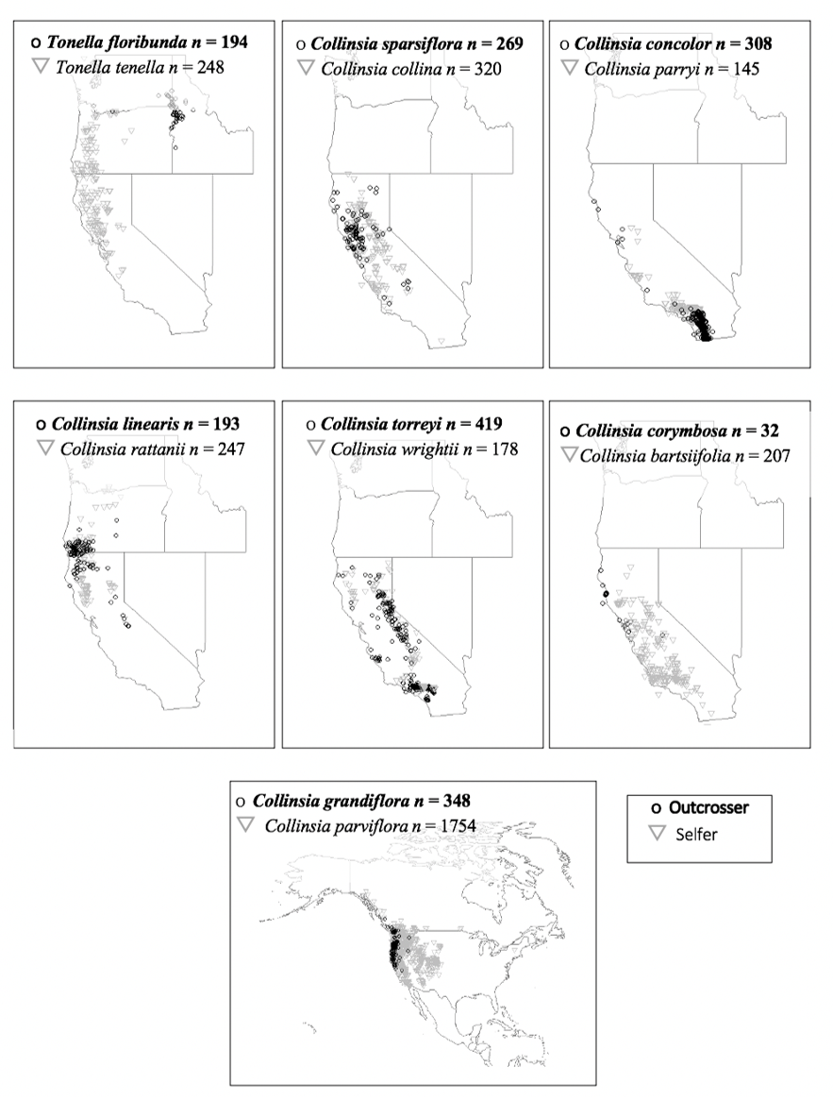
Figure A1.1 Occurrence maps of Tonella and Collinsia sister taxa.
The occurrence maps of Tonella and Collinsia sister taxa based on a total of 4862 herbarium records. The records per species are listed next to the species’ name on the map. Grey triangles are selfing taxa and black circles are outcrossing taxa.

Figure A1.2 Niche equivalency and niche similarity metrics for Collinsia and Tonella sister species pairs.

Niche equivalency and niche similarity metrics for Collinsia and Tonella sister species pairs given above in figure S1.2. Niche equivalency and similarity tests show that all species pairs are less similar than expected by chance, except for C. torreyi and C. wrightii.
Schoener’s D

Figure A1.2 Continued.

Figure A1.3 Regression of niche overlap value on divergence time for sister species pairs of Collinsia and Tonella.
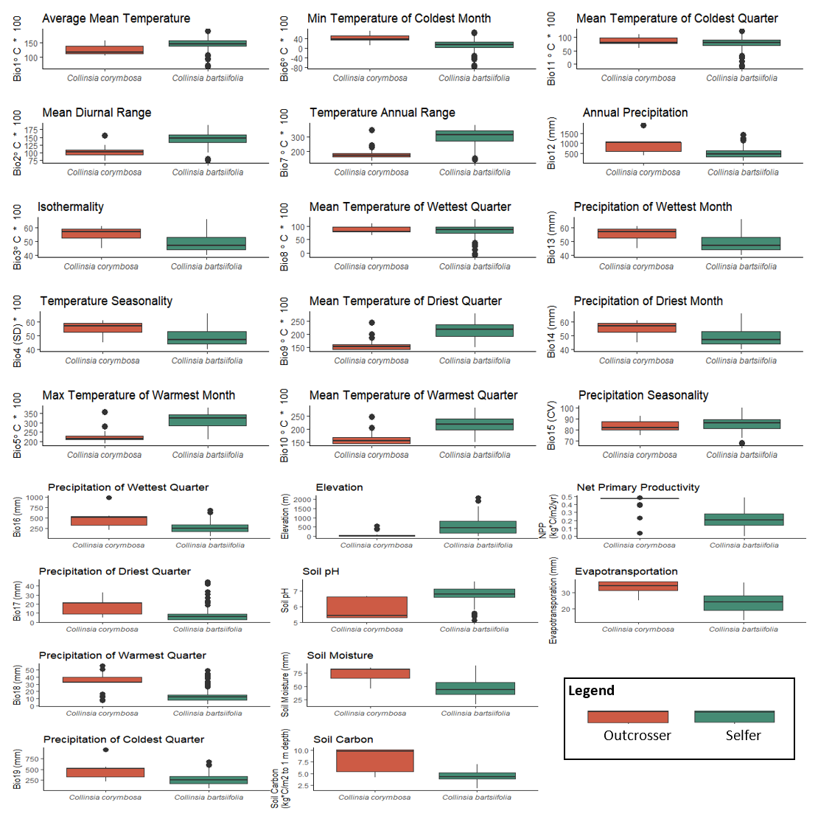

Figure A1.4 Boxplots of EGVs for each of the 14 species of Collinsia and Tonella. Plots are grouped by sister species pair for comparison.
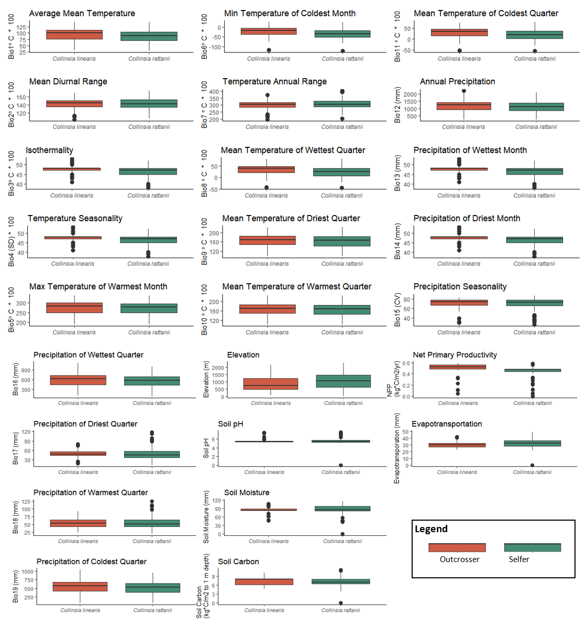

Figure A1.4 continued.
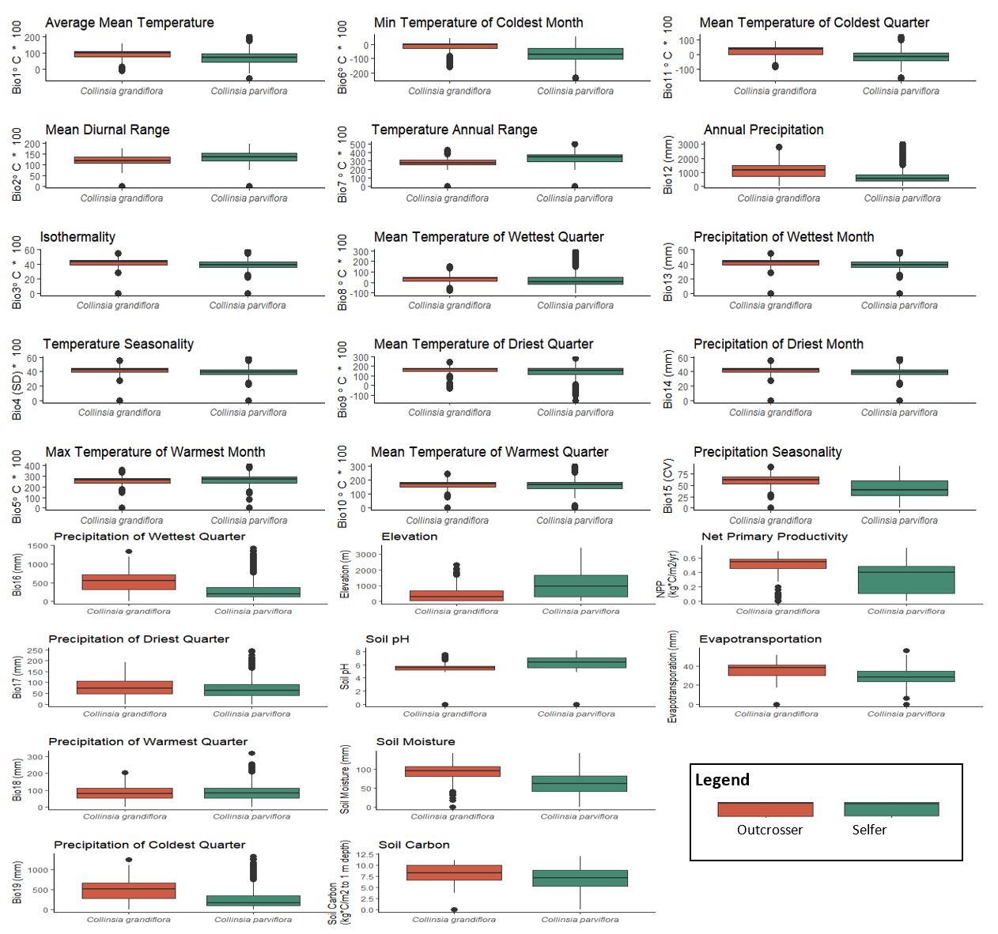
Figure A1.4 continued.
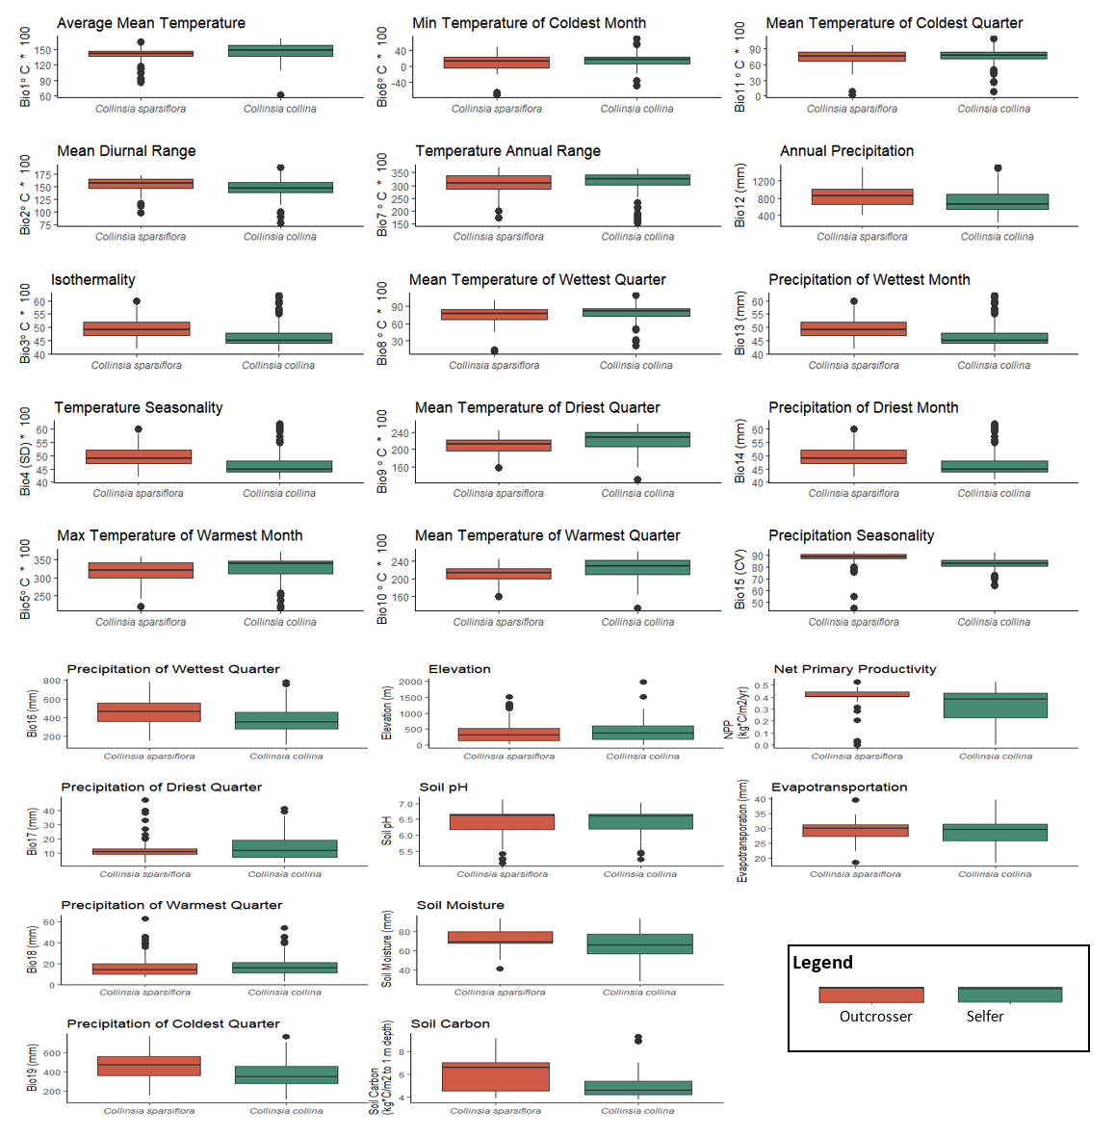
Figure A1.4 continued.
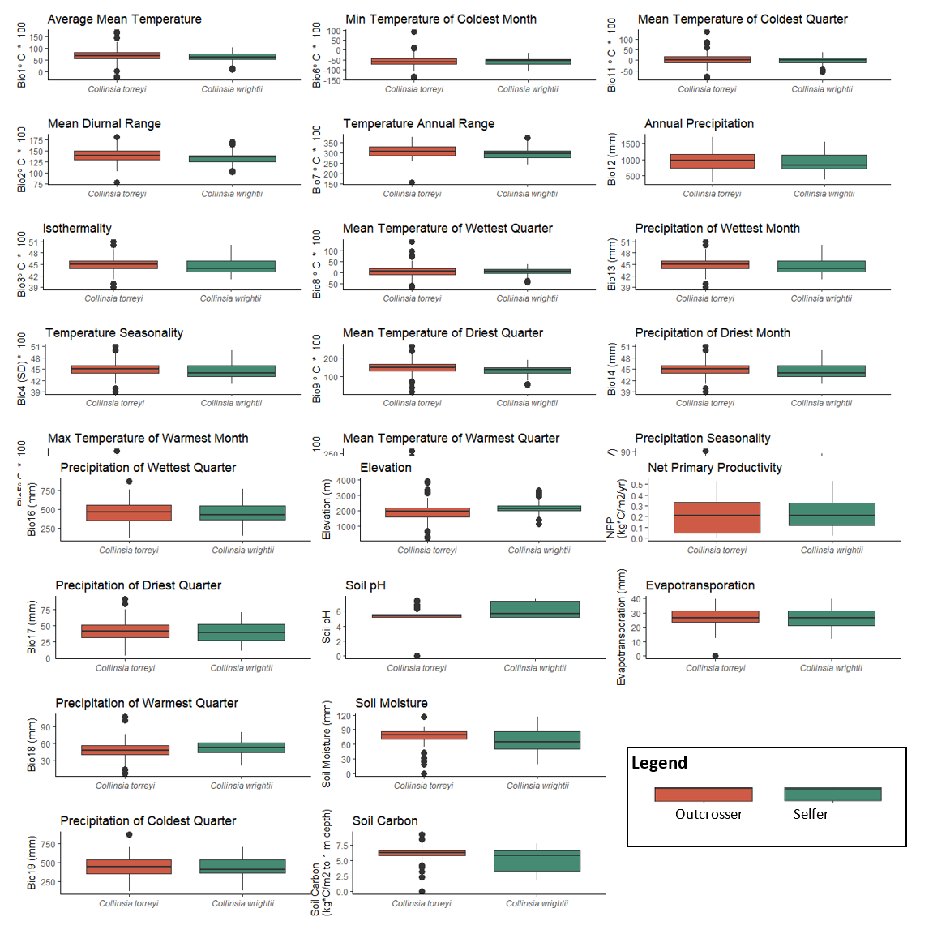
Figure A1.4 continued.
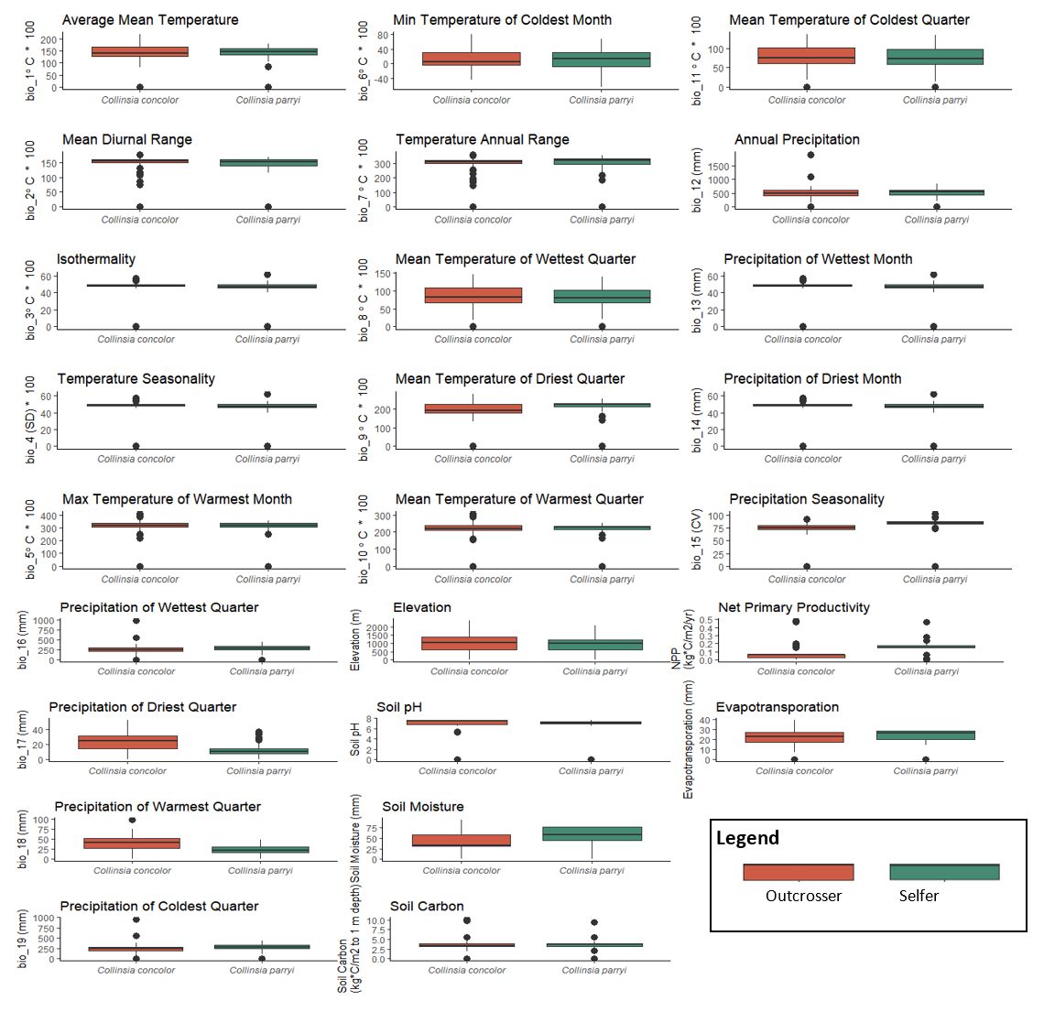
Figure A1.4 continued.
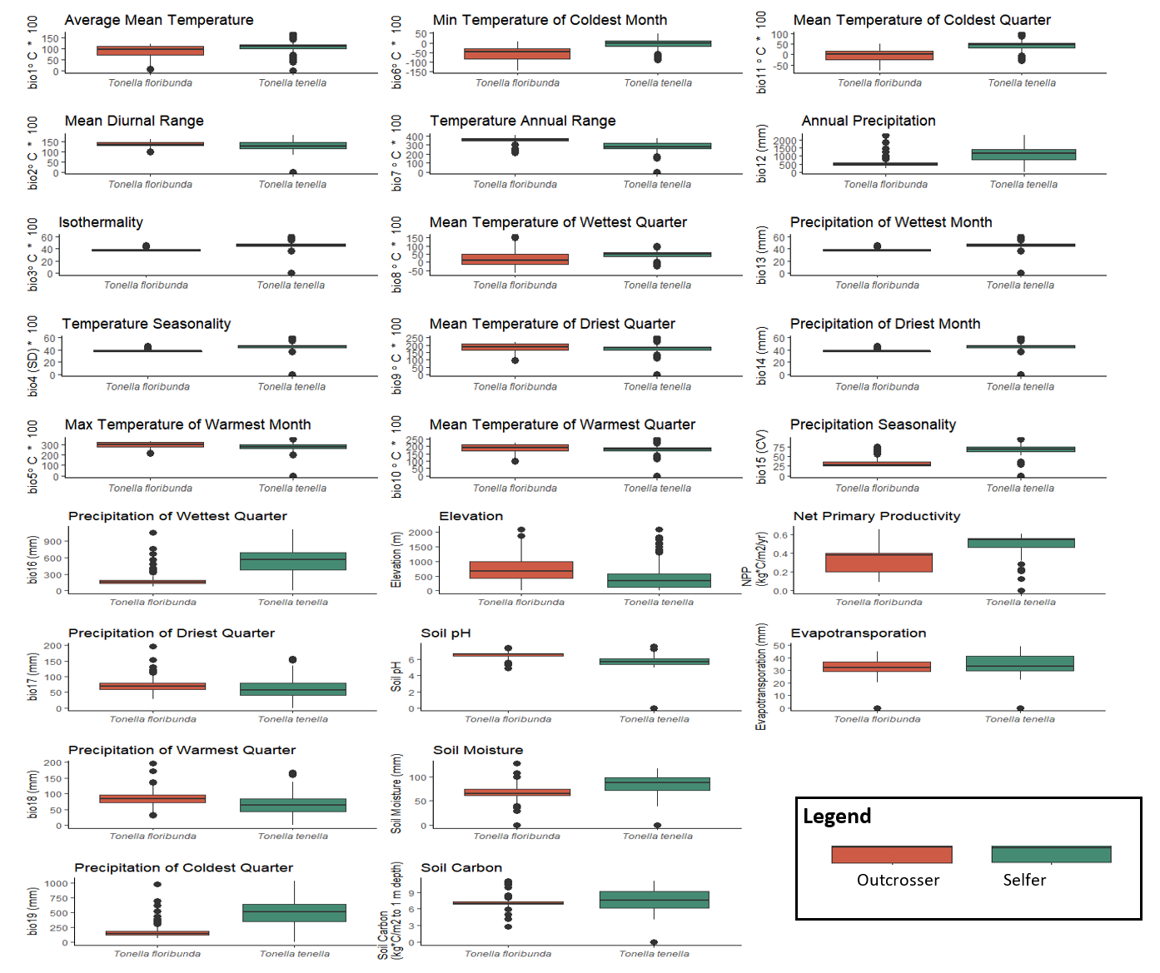
Figure A1.4 continued.

CHAPTER II
IN CLOSELY RELATED ANGIOSPERM SPECIES, SELFERS HAVE GREATER NICHE BREADTHS THAN OUTCROSSERS

Abstract
Baker’s Law suggests that under long-distance dispersal, self-compatible plant species would be better colonists than self-incompatible species, since they may autonomously self-fertilize and set seed. In contrast, self-incompatible species require multiple individuals and adequate pollen vectors for reproduction. With dispersal to non-natal sites, self-fertilization may speed the rate of local adaptation by reducing gene flow from maladapted neighboring populations. Additionally, recent theoretical work has discovered that self-compatibility, even when plastically induced, may enhance the likelihood of niche shifts, or the expansion of niche breadth. Therefore, we predict that compared to their progenitor outcrossing lineages, self-fertilizing lineages will have wider niche-breadths. Here, I test the general applicability of this prediction using 34 selfing-outcrossing sister species pairs from across angiosperm genera. We used Maxent modeling to estimate Levins’ B, the niche breadth and analyzed the data using paired Mann-Whitney-U tests. Sister species assumptions were validated with phylogenetic data and in pairs with likely sister species relationships, selfers had greater niche breadth. However, in pairs that are less likely to be sister pairs, niche breadth did not follow this pattern. These results support the hypothesis that selfing may affect species niche breadth, potentially by increasing the likelihood of colonization success. Important future directions for this research are to determine if local adaptation or phenotypic plasticity in selfing rate plays an important role in the niche breadth differences of sister species.

Introduction
Understanding the determinants of species distribution and range size remains an important topic in ecological and evolutionary biology research (Sheth et al. 2020; Urban et al. 2020). Within closely related species, such as sister species or congeners, range size, and niche breadth can vary by several orders of magnitude (Anacker and Strauss 2014, Grant and Kalisz 2020). While closely related species often display niche conservatism (Peterson et al. 1999; Burns and Strauss 2011), when this breaks down, there is an opportunity to use a comparative approach to understand niche divergence (Peterson et al. 1999). Because sister species share an evolutionary history either due to being descended one from the other or through a recent shared common ancestor, they present a unique opportunity to test evolutionary hypotheses by controlling for both environment and time (Dawson 2014). Furthermore, since the underlying dispersion in range size observed between sister species is likely a consequence, at least in part, of their ecological niche differences (Pulliam 2000), then an examination of the traits influencing speciation and adaptive differentiation can provide insights into the evolutionary mechanisms driving both range size and niche breadth.
Within flowering plants, the evolution of selfing-fertilizing species from predominantly outcrossing ancestors is considered among the most frequently documented evolutionary transitions (Stebbins 1957; Grant 1981). As a result, there are many examples of an outcrossing species with selfing sister species (e.g. Clarkia (Vasek 1958), Mimulus (Ritland and Ritland 1989), Capsella (Hurka and Neuffer 1997), and species within Collinsia (Randle et al. 2009). Selfing sometimes evolves concomitantly with speciation (Foxe et al. 2009), with traits that enhance selfing (e.g., stigma-anther overlap, reduced flower size, and faster development time) also acting as a pre-zygotic isolating barrier to reproduction (Widmer et al. 2009; Sicard and Lenhard 2011; Kalisz et al. 2012; Brys et al. 2013; Brys et al. 2016; Randle et al. 2018). While outcrossing species are generally considered more evolutionarily robust than selfers (i.e., selfing could be an evolutionary dead-end; Takebayashi and Morrell 2001), the transition to selfing may have several important downstream genetic, ecological, and evolutionary implications that are not typically experienced by strict outcrossers. Selfers may have low effective population sizes, which in turn, may reduce their fitness and evolvability. Specifically, small effective population size reduces genetic variation available for adaptation (Pollak 1987; Wright et al. 2013) as well as increases the accumulation of deleterious mutations (Glémin and Ronfort 2013; Arunkumar et al. 2015). Selfing could further magnify these effects by creating a process similar to “Muller’s Ratchet,” leading to local population extinction (Muller 1964; Heller and Smith 1978). Conversely, the capacity to self-pollinate without the aid of a pollen vector can have several key advantages on short timescales (Baker 1955).
Since selfing individuals can fertilize their own ovules, as well as have the potential to export pollen to fertilize ovules on other plants, they are afforded a 3/2 genetic transmission advantage over strictly outcrossing individuals (Fisher 1941). Through selfing, species may also reinforce an extreme form of assortative mating, which may enhance their propensity for local adaptation. Specifically, selfing may help maintain coadapted gene complexes by resisting “gene swamping” via gene flow from non-adjacent populations (Mather 1941) while gene flow from similarly adapted edge populations has been shown to increase local fitness (Lenormand 2002; Sexton et al. 2011; Bontrager and Angert 2019). Under changing environmental conditions, selfing species may have faster rates of adaptation (Glémin and Ronfort 2013). Selfing may also be plastically induced under specific environments, offering individuals similar benefits, especially in less hospitable environments (Levin 2010), including trailing range edges (Levin 2012). Thus, selfing could potentially accelerate the rate of adaptation to a novel set of environmental conditions, while also ensuring reproduction in the absence of pollinators or mates - resulting in a potential colonization advantage for selfing species (Baker 1955).
It is here where the theoretical underpinnings of the evolution of selfing intersect with the concept of the ecological niche. Hutchinson (1957) described the niche as the set environmental conditions where a species can survive and reproduce. It follows that traits that enhance the ability to survive and reproduce should enhance niche breadth (Proulx 1999). By providing reproductive assurance (Darwin 1876), selfing may evolve under conditions where mates or pollinators are scarce (e.g. Lloyd 1992; Baker 1955), explicitly linking survival and sexual reproduction to niche, and potentially outweighing any disadvantages to selfing, such as inbreeding depression (Pujol et al. 2009). Selfing may be especially advantageous at range margins, since selfing species can more readily colonize high-quality habitats to which they are already adapted, given there are no obvious physical or dispersal barriers (Levin 2010; Hargreaves and Eckert 2014). During the initial phases of range expansion and at the trailing edge of the range (Levin 2012), populations at the margins are typically small. Thus, they are likely to experience decreased access to adequate pollinators attraction and outcross pollen receipt, selfing will again be favored (Pujol et al. 2009).
Consistent with these ideas, elevated selfing rates for self-compatible populations/species are often observed at the periphery of the congeneric outcrossing taxa (e.g., Solbrig and Rollins, 1977; Kiang and Hamrick 1978; Schoen 1982; Griffin et al. 2014, but see Herlihy and Eckert 2005, Darling et al. 2008, Moeller et al. 2011, Moeller et al. 2012, but see Latron et al. 2020 for a counter example). Life at the range periphery may impose distinct selective pressures compared to more central areas of the range. For example, in many arid, ephemeral, or Mediterranean habitats, plants can experience strong selection for rapid development (i.e., the time limitation hypothesis (Snell and Aarssen 2005)), which indirectly selects for early sexual maturity, short floral lifespan, and self-fertilization (Arroyo 1973, Mazer et al. 2004, Dudley et al. 2007, Duncan and Rausher 2013). Similarly, reduced corolla size may be favored in suboptimal environments; petals typically lack stomata so species with reduced corolla surface area may lower both floral maintenance costs and water loss (Galen et al. 1999; Kelly et al. 2008). Thus, selfing may be generally selected for directly or indirectly in suboptimal habitats.
If we consider the colonization (i.e., expression of positive population growth, (Holt 2009)) of a suboptimal habitat as equivalent to a niche shift or expansion of niche breadth, then selfing may play a key role in species niches - a perspective that is receiving increasing attention in the literature (e.g., Park et al. 2018, Grant and Kalisz 2020, Evans et al. 2020, Latron et al. 2020, Fumia et al. 2020).
By comparing the niches of species pairs with close phylogenetic ancestry and age with contrasting mating systems, we can potentially gain insight into the relationship between mating systems and species’ distributions. Only a handful of studies have taken this approach, with varying support for the role of the mating system on the niche (Table 2.1). However, many of these studies used pairs with varying degrees of support for sister species relationships. If a tree was available, degrees of likely sister species relationships were quantified through posterior probabilities that range from 0% to 100%. Species pairs with high posterior probabilities are expected to closely share evolutionary histories and may be considered “sister species”. However, analyzing species pairs with low posterior probabilities, which are unlikely to be true pairs or sister
Table 2.1 Studies that compared selfing and outcrossing species pairs for range or niche.
Taxa compared | Relevant Findings | Reference
Sisters species; Collinsia | Selfers had greater range size and elevational breadth than outcrossers | Randle et al. 2010
Congeners; Fragaria | Selfers had greater range size but not bioclimatic breadth than outcrossers | Johnson et al. 2014
Sister species; Solanum | No relationship between niche and mating system | Nakazato et al. 2010
Sister species and congeners; Many species | Selfers had greater range size and elevational breadth than outcrossers | Grossenbacher et al. 2015
Sister species and congeners; Many species | Selfers had greater range size but not bioclimatic breadth | Park et al. 2018
Collinsia and Tonella | Selfers had greater niche breadth | Grant & Kalisz 2020
Congeners; Epipactis | No relationship between niche and mating system | Evans et al. 2020
Crithmum maritimum L., and Viola tricolor subsp. curtisii | Increased selfing rates at range edge | Latron et al. 2020
Congeners; Solanum section Petota | Species with both self-compatible polyploid and self-incompatible diploid populations had the greatest niche diversity | Fumia et al. 2020

species, should decrease the ability to detect a statistical difference between mating system and the geographic distribution of the species under consideration. In addition to the degree of relatedness of species being compared, the time since divergence is also expected to affect both co-occurrence and niche overlap in sister species’ distributions. Niche overlap was shown to negatively correlate with time since divergence in 71 sister species (Anaker and Strauss 2014). In contrast, for selfing and outcrossing sister species pairs in the genera Collinsia and Tonella, no association between niche overlap and divergence time was identified, though there were significant differences in niche breadth (Grant and Kalisz 2020).
Here, we use species distribution modeling as a proxy for the ecological niche to generate metrics of both niche breadth and overlap for 34 selfing vs. outcrossing species pairs with relatively high posterior probabilities. We consider how niche metrics are associated with mating systems and divergence time. We predict that selfers will have inhabit greater niche breadths than outcrossers when there is a high probability of a sister species relationship. We also explore the degree of niche overlap, which is expected to be a function of time since divergence.

Methods
In our analyses, we used selfing-outcrossing sister species pairs identified previously by Grossenbacher et al. (2015) from published species-level phylogenies where there was at least one predominantly selfing (or functionally selfing species) and one predominantly outcrossing species. These authors generated time-calibrated phylogenies for all 20 clades (201 species pairs) in their study and accounted for phylogenetic uncertainty. Thus, each pair also had an associated probability estimate or posterior probability of phylogenetic relatedness. Following Grant and Kalisz (2020), we focused the current analyses on the species pairs with high posterior probabilities. To identify these species, we performed exploratory data analysis to visualize the distribution of posterior probabilities for pairs in the Grossenbacher et al. (2015) data set. Due to few species’ pairs being well supported by posterior probability estimates (75% of pairs had posterior probabilities at < 0.1, an indicator of an unlikely sister species relationship), we narrowed the scope of our analyses to include pairs with posterior probabilities estimates >/= 0.1 (Figure 2.1A). To maximize coverage of taxa in our data analysis, we also included some species with posterior probabilities < 0.1 if there was no representation from that genus (Figure 2.1B). Based on these criteria, our analyses primarily included species pairs with a posterior probability higher than 0.1, with three additional pairs with lower posterior probabilities. Of the remaining 51 species pairs in this group, we were able to produce Maxent species distribution models for only 34 pairs. The other 17 pairs could not be modeled because of either low occurrence record data or non-convergence of their Maxent models (Table A2.1).
For the 34 pairs that fit our criteria, we modeled their species distributions with Maxent implemented in R Statistical Programming Language 3.6 (R Core Team 2019). First, species occurrence records for each species were downloaded from GBIF in R with the dismo package (GBIF 2008; Hijmans et al. 2017). Most species were native to a single continent and we assumed that all occurrence records on the species’ native continent were native occurrences. Species pairs were modeled on continental scales (e.g. North America) that best fit distributional data in GBIF. When species pairs occurred on more than one continent (e.g., North and South America), both continents were used for the background area (the geographic area selected for the environmental

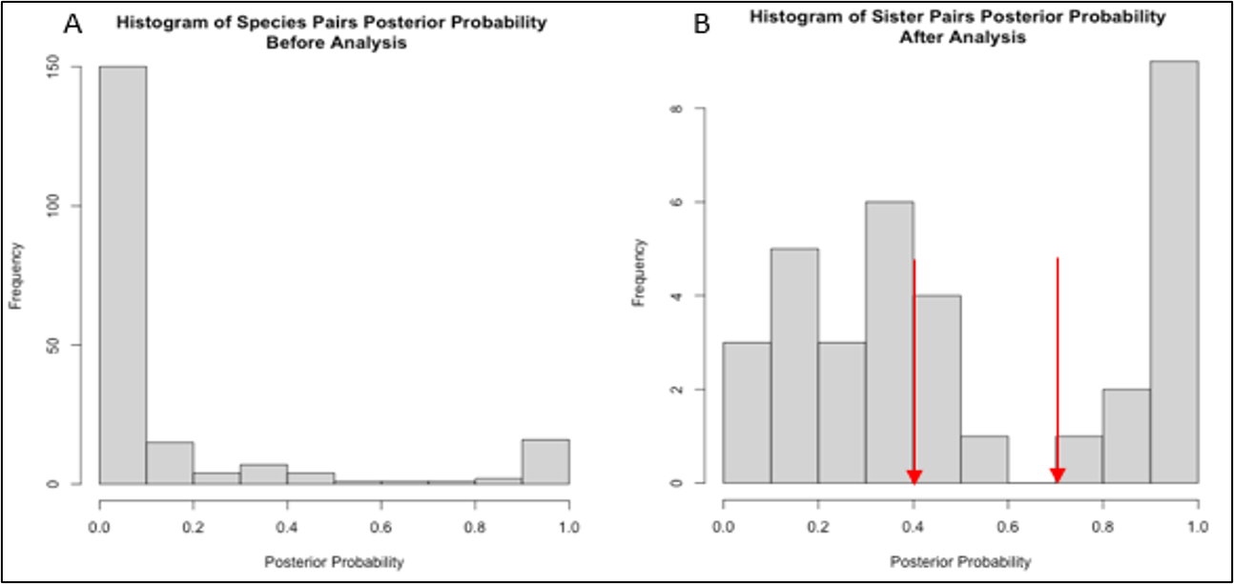
Figure 2.1 Histograms of the distribution of posterior probability of sister species pairs.
Histograms of the distribution of posterior probability of sister species pairs from Grossenbacher et al. 2015, and species pairs used in our analyses which are given in Figure 2.1 A) Distribution of probabilities of 34 species pairs shows that the data is left-skewed toward low probability values, suggesting that many pairs in the data set have low statistical support for sister species relationships. B) The posterior probability distribution after application of threshold of 0.1 and maxent analysis with model convergence. Posterior probability thresholds of 0.4 and 0.7 used in statistical analyses are highlighted with red arrows.

variables). When historical and/or herbarium records suggested that a species was introduced on other continents, we omitted these records from our analyses.

Next, we applied Maxent species distribution models (SDMs) as our proxy for the ecological niche. While there are disadvantages to this method (Merow et al. 2013), one important feature is Maxent’s ability to predict environmental suitability beyond a species’ known range. Maxent models can incorporate complex interactions between different variables, having a closed-form mathematical solution that will converge on an optimal probability distribution, and the ability to reduce overfitting by using ℓ1-regularization (Di Cola et al. 2017). For each species, we generated a Maxent model for each combination of feature classes (a transformation of covariates, (Morales et al. 2017) that consist of a combination of linear, quadratic, or polynomial regularization multipliers. From this set of models, the model with the lowest delta AIC was selected as our final model for subsequent analyses, including calculating the niche breadth (Levins’ B) and niche overlap (Schoener's D).
Very generally, Maxent generates a probability distribution that adheres to a set of constraints derived from presence-only species occurrence data. The constraints are expressed as functions (e.g., linear and quadratic feature classes) of the environmental variables. Maxent calculates the conditional probability of occurrence for the species using the conditional density of the environmental variables at species occurrence locations compared to the background environmental variables (i.e., the value of environmental variables in the geographic area the species lives within). The final function is one that recognizes the constraints of the occurrence records in environmental space and minimizes variation compared to the background variables (e.g., minimizing the distance in variable space). Thus, the model would be selected that has the species’ mean for a variable close to the mean of that variable in the background. (See Elith et al. 2011 for a full description of Maxent modeling for ecology.)
The resulting Maxent raster data describing the probability of habitat suitability of the background area was then used to estimate niche breadth (Levins B) and niche overlap (Schoener's D) (Warren et al. 2008). We then compared niche breadth values between species pairs using a paired Wilcoxon signed-rank test. To further examine the effect of increasing posterior probability support on niche breadth, we tested the significance of two posterior probability thresholds: 1) above and below 0.4 and 2) above and below 0.7. Since our analysis contained several species pairs within the same genera, we also resampled the pairs used in the Wilcoxon signed-rank test 100 times to allow for the inclusion of only one pair from each genus at a time. We report the median p-value for the final results. Finally, we examined the linear correlation between divergence time and niche breadth or niche overlap for selfing and outcrossing sister taxa pairs to determine if the two groups differ in these niche characteristics.

Results
Our study applies advanced species distribution modeling techniques to study the relationship between niche metrics and mating systems across phylogenetically diverse sister species pairs within Angiosperms. Consistent with our predictions, selfers, on average, have broader niches than outcrossers for the 34 selfing-outcrossing species pairs across 13 plant families tested. However, mating system type was not associated with any degree of niche overlap or correlated with species pair age (Figure 2.2).

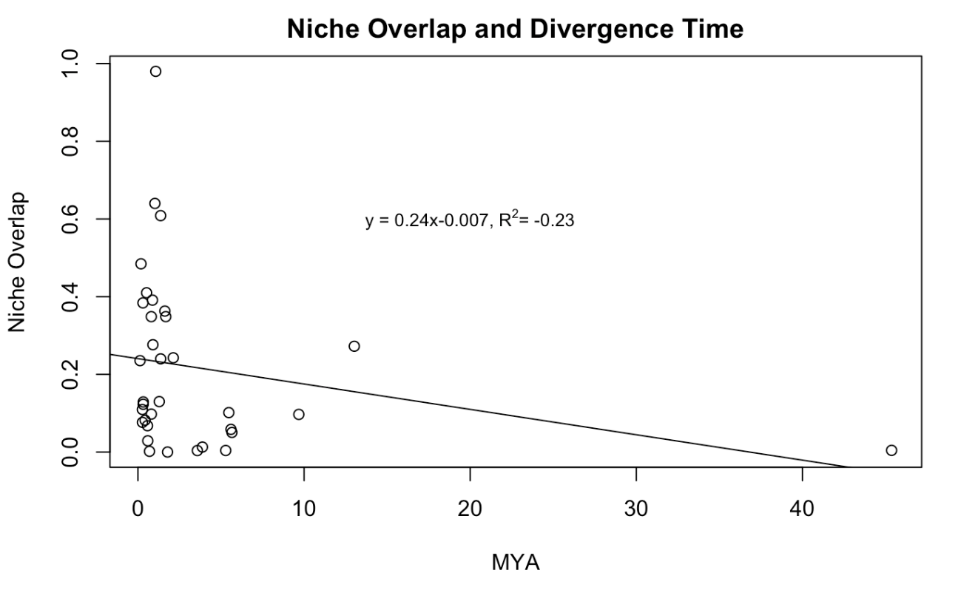
Figure 2.2 Correlation between niche overlap and time since divergence.
Niche breadth of selfers (r = 0.11, p-value = 0.53) and outcrossers (r = 0.05, p-value = 0.74) is not significantly correlated with divergence time. Likewise, we detected no association between niche overlap and divergence time (Figure 2.1, r = -0.23). Niche overlap was below 50% for all but 3 species pairs (Table A2.1).

Our analysis revealed that 58% of selfers have broader niche breadths than their outcrossing sisters (Table A2.1). The median niche breadth value for selfers was significantly greater than those of outcrossers (W = 397, p-value = 0.045). To examine the effect of posterior probability on these results, we used a similar analysis to test for differences for pairs at 0.4 and 0.7 posterior probability thresholds. The first threshold, we further defined low support pairs as those with posterior probabilities that are < 0.4 and high as those > 0.4. When we restricted the analysis on sister species pairs to those with high posterior probabilities, our results were still significant (W = 113, p-value = 0.04, N = 17), however analysis of the sister pairs with posterior probabilities < 0.4 were insignificant (W = 90, p-value = 0.27, N = 17). When we focused on posterior probabilities > 0.7 (high posterior probability), the statistical confidence increased (W = 67, p-value = 0.01). Again, the low posterior probability group (< 0.7) was not significant (W =

133, p-value = 0.42). Thus, the significant relationship of is driven by the species with high posterior probabilities. The niche breadth between selfers and outcrossers was also significantly correlated within sister species pairs (r = 0.7, p-value < 0.0001).

Discussion
Analysis of 34 selfing and outcrossing sister species pairs revealed that selfers have greater niche breadth. Based on analyses of groups of sister species assigned posterior probability thresholds, this may be influenced by the closeness of sister species phylogenetic relationships. For putative sister species pairs with high posterior probability estimates (in our analysis, either >0.4 or >0.7), we found greater statistical confidence in this conclusion compared to the full data set. In contrast, sister species pairs with lower posterior probability estimates (in our analysis, either < 0.4 or < 0.7), did not fit this pattern. Interestingly, previous studies that did not examine the degree of posterior support of species relatedness, reached no strong conclusion on whether outcrossers or selfers have greater niche breadth (Table 2.1). This maybe unsurprising since the evolutionary mechanisms that make sister species useful model organisms (i.e., shared common ancestry, shared temporal and environmental conditions (Dawson 2014) might be less applicable when there is a weaker phylogenetic relationship.
Due to the imprecision of how sister species are defined by most researchers, defining strict criteria for the inclusion of sister pairs may be crucial for the detection of evolutionary patterns that rely on this assumption. Lack of precise definitions might also contribute to the weak justifications also found in many studies. The justification for using sister species pairs as an ideal model system in comparative analysis has included controlling for environmental effects (Nakazato et al. 2010), closest known relative representing evolutionary replicates (Grossenbacher et al. 2015), but often no justification is provided at all. Aside from a narrower definition of sister species for specific justifications, different methodology used among the studies may also account for different conclusions when studying niche breadths and mating systems. For example, Park et al. (2018), who found no relationship between niche and mating system, used sister species regardless of posterior probability assigned and used area-based estimates of niche based on Euclidian distance, range and standard deviation, and PCA. Our study, in contrast, uses Maxent modeling. Our approach allows for several modeling advantages, including feature selection via regularization (Elith et al. 2011), which reduces redundant or non-contributing environmental covariates from the models and provides a more accurate description of the multivariate niche. Evans et al. 2020 also used Maxent in their analyses, their finding of no relationship between mating system and niche breadth may in part be due to the fact that they did not compare sister species.
We found that overall, niche breadth was not associated with divergence time yet within sister species pairs, niche breadth was significantly correlated. Given that selfers have on average 40% greater niche breadth than outcrossers with ~ equal divergence dates suggest that age of species alone cannot account niche breadth differences. Niche breadth may also be phylogenetically conserved in some lineages. Niche overlap was not significantly associated with divergence time overall but does decrease with age for species pairs with posterior probabilities greater than 0.7 (the most likely sister species pairs in our data set). Again, selfing species’ ability to inhabit greater niche breadth may explain the decrease in overlap with time since divergence.
Our results are similar to the patterns observed by Grant and Kalisz (2020), where selfers in Collinsia and Tonella sister species pairs had broader niche breadths than outcrossers. The current study expands their approach to generalize the pattern across multiple genera with probable sister species pairs, as measured by higher posterior probabilities. Wider niche breadths in selfers are consistent with Baker’s Law (Baker 1955), which suggests that selfers should be better colonizers under long-distance dispersal. This is because unlike outcrossers, selfers may reproduce without mates or pollen vectors. Long-distance dispersal may involve encountering habitat environmentally distinct from a population’s natal sites. Since the niche may be define as the range of environmental conditions in which an organism can survive and reproduce (Hutchinson 1957; Holt 2009), successful reproduction after long-distance dispersal may entail a niche shift or expansion. Survival in a new habitat would additionally require either a pre-adaptation or the ability to induce plasticity (Levin 2010).
In contrast, post long-distance dispersal, an outcrosser will need to establish a minimum density of conspecifics to attract adequate pollen vectors. Thus, colonization of novel environmental conditions by selfers is more likely to expand both niche breadth and geographic range size. While we did not examine geographic range size directly, our results are consistent with previous studies that found that selfers have greater range sizes than outcrossers (Randle et al. 2009; Grossenbacher et al. 2015) and range size is strongly correlated with niche breadth (Slatyer et al. 2013).
Although it was beyond the scope of this paper to examine genetic diversity directly, our results may have important implications for the genetic diversity and mating system of plants. Selfing lineages are considered evolutionary dead-ends due to higher extinction rates, lower diversification rates (Stebbins 1957; Grant 1958; Wyatt 1988; Takebayashi and Morrell 2001; Igic and Busch 2013), and lower effective population sizes (Wright et al. 2013). Small effective population size can magnify the consequences of low genetic diversity and the accumulation of deleterious mutations, leading to extinction (Heller and Smith 1978; Lynch et al. 1995; Wright et al. 2013). However, greater niche breadths in selfers imply a potential for greater ecological specialization, which may precede ecological divergence (Futuyma and Moreno 1988; Via 2009; Nakazato et al. 2010). Differences in environmental tolerances likely underlie niche breadth differences observed in this study (Sheth and Angert 2014). Aiding the adaptive process, selfing specifically may reduce the introgression of maladapted alleles from adjacent populations (Mather 1941; Levin 1978), whereas outcrossing would, by definition, essentially enhance it. Underlying our observations of niche breadth are genetically controlled or plastically induced environmental tolerances (Lynch and Gabriel 1987). While selfers have been observed to have lower or similar genetic diversity than outcrossers (Loveless and Hamrick 1984; Schoen and Brown 1991), this may not equate to lower adaptability in selfing species (Hereford 2010)
Overall, our analysis of niche breadth differences between selfers and outcrossers provide the most general evidence to date linking mating system to niche breadth, with selfers holding greater niche breadths. Selfers may be more adaptable to novel or changing environmental conditions than previously appreciated.

References
Anacker, B. L. and S. Y. Strauss. 2014. The geography and ecology of plant speciation: range overlap and niche divergence in sister species. Proceedings of the Royal Society B: Biological Sciences 281.
Arroyo, M. T. K. 1973. Chiasma frequency evidence on the evolution of autogamy in Limnanthes floccosa (Limnanthaceae). Evolution:679-688.
Arunkumar, R., R. W. Ness, S. I. Wright, and S. C. Barrett. 2015. The evolution of selfing is accompanied by reduced efficacy of selection and purging of deleterious mutations. Genetics 199:817-829.
Baker, H. G. 1955. Self-compatibility and establishment after'long-distance'dispersal. Evolution 9:347-349.
Bontrager, M. and A. L. Angert. 2019. Gene flow improves fitness at a range edge under climate change. Evolution letters 3:55-68.
Brys, R., J. Cauwenberghe, and H. Jacquemyn. 2016. The importance of autonomous selfing in preventing hybridization in three closely related plant species. Journal of Ecology.
Brys, R., B. Geens, T. Beeckman, and H. Jacquemyn. 2013. Differences in dichogamy and herkogamy contribute to higher selfing in contrasting environments in the annual Blackstonia perfoliata (Gentianaceae). Annals of botany:mct031.
Burns, J. H. and S. Y. Strauss. 2011. More closely related species are more ecologically similar in an experimental test. Proceedings of the National Academy of Sciences 108:5302-5307.
Darling, E., K. E. Samis, and C. G. Eckert. 2008. Increased seed dispersal potential towards geographic range limits in a Pacific coast dune plant. New Phytologist 178:424-435.
Darwin, C. 1876. The effects of cross and self fertilisation in the vegetable kingdom. J. Murray.
Dawson, M. N. 2014. Natural experiments and meta-analyses in comparative phylogeography. Journal of biogeography 41:52-65.
Di Cola, V., O. Broennimann, B. Petitpierre, F. T. Breiner, M. D'amen, C. Randin, R. Engler, J. Pottier, D. Pio, and A. Dubuis. 2017. ecospat: an R package to support spatial analyses and modeling of species niches and distributions. Ecography 40:774-787.
Dudley, L. S., S. J. Mazer, and P. Galusky. 2007. The joint evolution of mating system, floral traits and life history in Clarkia (Onagraceae): genetic constraints vs. independent evolution. Journal of Evolutionary Biology 20:2200-2218.
Duncan, T. M. and M. D. Rausher. 2013. Evolution of the selfing syndrome in Ipomoea. Frontiers in Plant Science 4:301.
Elith, J., S. J. Phillips, T. Hastie, M. Dudík, Y. E. Chee, and C. J. Yates. 2011. A statistical explanation of MaxEnt for ecologists. Diversity and Distributions 17:43-57.
Evans, A. and H. Jacquemyn. 2020. Impact of mating system on range size and niche breadth in Epipactis (Orchidaceae). Annals of Botany 126:1203-1214.
Fisher, R. A. 1941. Average excess and average effect of a gene substitution. Annals of Eugenics 11:53-63.
Foxe, J. P., T. Slotte, E. A. Stahl, B. Neuffer, H. Hurka, and S. I. Wright. 2009. Recent speciation associated with the evolution of selfing in <em>Capsella</em>. Proceedings of the National Academy of Sciences 106:5241-5245.
Fumia, N., D. Rubinoff, R. Zenil-Ferguson, C. K. Khoury, S. Pironon, M. A. Gore, and M. B. Kantar. 2020. Interactions between specific breeding system and ploidy play a critical role in increasing niche adaptability in a global food crop. bioRxiv:2020.2009.2009.290429.
Futuyma, D. J. and G. Moreno. 1988. The evolution of ecological specialization. Annual Review of Ecology and Systematics:207-233.
Galen, C., R. A. Sherry, and A. B. Carroll. 1999. Are flowers physiological sinks or faucets? Costs and correlates of water use by flowers of Polemonium viscosum. Oecologia 118:461-470.
GBIF. 2008. GBIF Work Programme 2009-2010. Global Biodiversity Information Facility, Copenhagen:.
Glémin, S. and J. Ronfort. 2013. ADAPTATION AND MALADAPTATION IN SELFING AND OUTCROSSING SPECIES: NEW MUTATIONS VERSUS STANDING VARIATION. Evolution 67:225-240.
Grant, A.-G. and S. Kalisz. 2020. Do selfing species have greater niche breadth? Support from ecological niche modeling. Evolution 74:73-88.
Grant, V. 1958. The regulation of recombination in plants. Pp. 337-363. Cold Spring Harbor Symposia on Quantitative Biology. Cold Spring Harbor Laboratory Press.
Griffin, P. C. and Y. Willi. 2014. Evolutionary shifts to self-fertilisation restricted to geographic range margins in North American Arabidopsis lyrata. Ecology Letters 17:484-490.
Grossenbacher, D., R. Briscoe Runquist, E. E. Goldberg, and Y. Brandvain. 2015. Geographic range size is predicted by plant mating system. Ecology Letters 18:706-713.
Hargreaves, A. L. and C. G. Eckert. 2014. Evolution of dispersal and mating systems along geographic gradients: implications for shifting ranges. Functional Ecology 28:5-21.
Heller, R. and J. M. Smith. 1978. Does Muller's ratchet work with selfing? Genetics Research 32:289-293.
Hereford, J. 2010. Does selfing or outcrossing promote local adaptation? American Journal of Botany 97:298-302.
Herlihy, C. R. and C. G. Eckert. 2005. Evolution of self-fertilization at geographical range margins? A comparison of demographic, floral, and mating system variables in central vs. peripheral populations of Aquilegia canadensis (Ranunculaceae). Am J Bot 92:744-751.
Hijmans, R. J., S. Phillips, J. Leathwick, J. Elith, and M. R. J. Hijmans. 2017. Package ‘dismo’. Circles 9:1-68.
Holt, R. D. 2009. Bringing the Hutchinsonian niche into the 21st century: ecological and evolutionary perspectives. Proceedings of the National Academy of Sciences of the United States of America 106 Suppl 2:19659-19665.
Hurka, H. and B. Neuffer. 1997. Evolutionary processes in the genusCapsella (Brassicaceae). Plant Systematics and Evolution 206:295-316.
Hutchinson, G. 1957. Population studies-animal ecology and demography-concluding remarks. Pp. 415-427. Cold Spring Harbor Symposia on Quantitative Biology. Cold Spring Harbor Lab Press 1 Bungtown Rd, Plainview, NY 11724.
Igic, B. and J. W. Busch. 2013. Is self‐fertilization an evolutionary dead end? New Phytologist 198:386-397.
Kalisz, S., A. Randle, D. Chaiffetz, M. Faigeles, A. Butera, and C. Beight. 2012. Dichogamy correlates with outcrossing rate and defines the selfing syndrome in the mixed-mating genus Collinsia. Annals of Botany 109:571-582.
Kelly, J. K., L. M. Holeski, and H. S. Arathi. 2008. The genetic correlation between flower size and water use efficiency in monkeyflowers. Evolutionary ecology research 10:147-152.
Kiang, Y. T. and J. L. Hamrick. 1978. Reproductive Isolation in the Mimulus guttatus M. nasutus Complex. The American Midland Naturalist 100:269-276.
Latron, M., J.-F. Arnaud, H. Ferla, C. Godé, and A. Duputié. 2020. Effects of contemporary shifts of range margins on patterns of genetic structure and mating system in two coastal plant species. Heredity 124:336-350.
Lenormand, T. 2002. Gene flow and the limits to natural selection. Trends in Ecology & Evolution 17:183-189.
Levin, D. A. 1978. The origin of isolating mechanisms in flowering plants. Springer.
Levin, D. A. 2010. Environment‐enhanced self‐fertilization: implications for niche shifts in adjacent populations. Journal of Ecology.
Levin, D. A. 2012. Mating system shifts on the trailing edge. Annals of Botany 109:613-620.
Lloyd, D. G. 1992. Self- and Cross-Fertilization in Plants. II. The Selection of Self- Fertilization. International Journal of Plant Sciences 153:370-380.
Loveless, M. D. and J. L. Hamrick. 1984. Ecological determinants of genetic structure in plant populations. Annual review of ecology and systematics 15:65-95.
Lynch, M., J. Conery, and R. Bürger. 1995. MUTATIONAL MELTDOWNS IN SEXUAL POPULATIONS. Evolution 49:1067-1080.
Lynch, M. and W. Gabriel. 1987. Environmental tolerance. The American Naturalist 129:283-303.
Mather, K. 1941. Variation and selection of polygenic characters. J. Genet 41:159-193.
Mazer, S. J., H. Paz, and M. D. Bell. 2004. Life history, floral development, and mating system in Clarkia xantiana (Onagraceae): do floral and whole-plant rates of development evolve independently? American Journal of Botany 91:2041-2050.
Merow, C., M. J. Smith, and J. A. Silander Jr. 2013. A practical guide to MaxEnt for modeling species’ distributions: what it does, and why inputs and settings matter. Ecography 36:1058-1069.
Moeller, D. A., M. A. Geber, V. M. Eckhart, and P. Tiffin. 2012. Reduced pollinator service and elevated pollen limitation at the geographic range limit of an annual plant. Ecology 93:1036-1048.
Moeller, D. A., M. A. Geber, and P. Tiffin. 2011. Population genetics and the evolution of geographic range limits in an annual plant. Am Nat 178 Suppl 1:S44-57.
Morales, N. S., I. C. Fernández, and V. Baca-González. 2017. MaxEnt's parameter configuration and small samples: are we paying attention to recommendations? A systematic review. PeerJ 5:e3093-e3093.
Muller, H. J. 1964. The relation of recombination to mutational advance. Mutation Research/Fundamental and Molecular Mechanisms of Mutagenesis 1:2-9.
Nakazato, T., D. L. Warren, and L. C. Moyle. 2010. Ecological and geographic modes of species divergence in wild tomatoes. American Journal of Botany 97:680-693.
Park, D. S., A. M. Ellison, and C. C. Davis. 2018. Mating system does not predict niche breath. Global Ecology and Biogeography 0.
Peterson, A., J. Soberón, and V. Sánchez-Cordero. 1999. Conservatism of ecological niches in evolutionary time. Science 285:1265-1267.
Pollak, E. 1987. On the theory of partially inbreeding finite populations. I. Partial selfing. Genetics 117:353-360.
Proulx, S. R. 1999. Matings Systems and the Evolution of Niche Breadth. The American Naturalist 154.
Pujol, B., S.-R. Zhou, J. Sanchez Vilas, and J. R. Pannell. 2009. Reduced inbreeding depression after species range expansion. Proceedings of the National Academy of Sciences 106:15379-15383.
Pulliam, H. R. 2000. On the relationship between niche and distribution. Ecology letters 3:349-361.
Randle, A. M., J. B. Slyder, and S. Kalisz. 2009. Can differences in autonomous selfing ability explain differences in range size among sister-taxa pairs of Collinsia (Plantaginaceae)? An extension of Baker's Law. New Phytologist 183:618-629.
Randle, A. M., R. B. Spigler, and S. Kalisz. 2018. Shifts to earlier selfing in sympatry may reduce costs of pollinator sharing. Evolution.
Ritland, C. and K. Ritland. 1989. Variation of sex allocation among eight taxa of the Mimulus guttatus species complex (Scrophulariaceae). American Journal of Botany:1731-1739.
Schoen, D. J. 1982. The breeding system of Gilia achilleifolia: variation in floral characteristics and outcrossing rate. Evolution:352-360.
Schoen, D. J. and A. H. Brown. 1991. Intraspecific variation in population gene diversity and effective population size correlates with the mating system in plants. Proceedings of the National Academy of Sciences 88:4494-4497.
Sexton, J. P., S. Y. Strauss, and K. J. Rice. 2011. Gene flow increases fitness at the warm edge of a species’ range. Proceedings of the National Academy of Sciences 108:11704.
Sheth, S. N. and A. L. Angert. 2014. The evolution of environmental tolerance and range size: a comparison of geographically restricted and widespread mimulus. Evolution 68:2917-2931.
Sheth, S. N., N. Morueta‐Holme, and A. L. Angert. 2020. Determinants of geographic range size in plants. New Phytologist.
Sicard, A. and M. Lenhard. 2011. The selfing syndrome: a model for studying the genetic and evolutionary basis of morphological adaptation in plants. Annals of Botany 107:1433-1443.
Slatyer, R. A., M. Hirst, and J. P. Sexton. 2013. Niche breadth predicts geographical range size: a general ecological pattern. Ecology Letters 16:1104-1114.
Snell, R. and L. W. Aarssen. 2005. Life history traits in selfing versus outcrossing annuals: exploring the'time-limitation'hypothesis for the fitness benefit of self-pollination. BMC ecology 5:2.
Solbrig, O. T. and R. C. Rollins. 1977. The evolution of autogamy in species of the mustard genus Leavenworthia. Evolution:265-281.
Stebbins, G. L. 1957. Self fertilization and population variability in the higher plants. American Naturalist.
Takebayashi, N. and P. L. Morrell. 2001. Is self-fertilization an evolutionary dead end? Revisiting an old hypothesis with genetic theories and a macroevolutionary approach. American Journal of Botany 88:1143-1150.
Team, R. C. 2000. R Language Definition. Available from CRAN sites.
Urban, M. C., S. Y. Strauss, F. Pelletier, E. P. Palkovacs, M. A. Leibold, A. P. Hendry, L. De Meester, S. M. Carlson, A. L. Angert, and S. T. Giery. 2020. Evolutionary origins for ecological patterns in space. Proceedings of the National Academy of Sciences of the United States of America 117:17482-17490.
Vasek, F. C. 1958. The Relationship of Clarkia exilis to Clarkia unguiculata. American Journal of Botany 45:150-162.
Via, S. 2009. Natural selection in action during speciation. Proceedings of the National Academy of Sciences 106:9939-9946.
Warren, D. L., R. E. Glor, and M. Turelli. 2008. Environmental niche equivalency versus conservatism: quantitative approaches to niche evolution. Evolution 62:2868-2883.
Widmer, A., C. Lexer, and S. Cozzolino. 2009. Evolution of reproductive isolation in plants. Heredity 102:31-38.
Wright, S. I., S. Kalisz, and T. Slotte. 2013. Evolutionary consequences of self-fertilization in plants. Proceedings of the Royal Society B: Biological Sciences 280:20130133.
Wyatt, R. 1988. Phylogenetic aspects of the evolution of self-pollination. Pp. 109-131. Plant evolutionary biology. Springer.

Appendix B
Table A2.1 Species used in analysis and calculated metrics.
Family | Genus | Selfer | Outcrosser | MYA | Posterior Prob. | Levins B_{selfer} | Levins B_{outcrosser} | Niche Overlap
Fabaceae | Medicago | praecox | marina | 5.66 | 0.05 | 0.71 | 0.61 | 0.05
Polemoniaceae | Polemonium | micranthum | californicum | 5.47 | 0.06 | 0.74 | 0.65 | 0.10
Polemoniaceae | Leptosiphon | ciliatus | montanus | 13.02 | 0.10 | 0.85 | 0.72 | 0.27
Polemoniaceae | Saltugilia | latimeri | caruifolia | 0.32 | 0.10 | 0.56 | 0.51 | 0.13
Onagraceae | Oenothera sect. Oenothera | oakesiana | longissimi | 0.69 | 0.12 | 0.75 | 0.60 | 0.00
Onagraceae | Oenothera sect. Oenothera | biennis | grandiflora | 2.13 | 0.14 | 0.79 | 0.88 | 0.24
Geraniaceae | Erodium | cicutarium | acaule | 5.60 | 0.16 | 0.77 | 0.60 | 0.06
Polemoniaceae | Saltugilia | australis | caruifolia | 0.19 | 0.19 | 0.51 | 0.53 | 0.48
Phrymaceae | Mimulus | leptaleus | constrictus | 5.28 | 0.25 | 0.52 | 0.53 | 0.00
Euphorbiaceae | Dalechampia | schottii | dioscoreifolia | 45.37 | 0.28 | 0.75 | 0.75 | 0.00
Onagraceae | Oenothera sect. Oenothera | clelandii | rhombipetala | 0.57 | 0.30 | 0.72 | 0.79 | 0.07
Onagraceae | Oenothera sect. Anogra | wigginsii | engelmannii | 1.78 | 0.95 | 0.54 | 0.69 | 0.00
Campanulaceae | Downingia | pusilla | cuspidata | 1.62 | 1.00 | 0.82 | 0.90 | 0.36
Plantaginaceae | Collinsia | parryi | concolor | 0.52 | 1.00 | 0.17 | 0.11 | 0.41
Phrymaceae | Mimulus | androsaceus | Shevockii | 0.43 | 1.00 | 0.68 | 0.46 | 0.08
Table A2.1 continued.
Family | Genus | Selfer | Outcrosser | MYA | Posterior Prob. | Levins B_{selfer} | Levins B_{outcrosser} | Niche Overlap
Onagraceae | Oenothera sect. Oenothera | humifusa | grandis | 0.30 | 0.33 | 0.83 | 0.92 | 0.38
Onagraceae | Oenothera sect. Oenothera | humifusa | drummondii | 0.32 | 0.33 | 0.65 | 0.59 | 0.12
Geraniaceae | Erodium | moschatum | moureti | 0.90 | 0.39 | 0.87 | 0.70 | 0.28
Asteraceae | Lasthenia | microglossa | minor | 1.68 | 0.45 | 0.71 | 0.68 | 0.35
Onagraceae | Oenothera sect. Oenothera | nutans | grandiflora | 0.88 | 0.46 | 0.82 | 0.92 | 0.39
Solanaceae | Schizanthus | lacteus | integrifolius | 1.37 | 0.48 | 0.82 | 0.83 | 0.61
Primulaceae | Primula | magellanica | mistassinica | 3.88 | 0.49 | 0.67 | 0.89 | 0.01
Polemoniaceae | Saltugilia | australis | splendens | 0.13 | 0.51 | 0.83 | 0.76 | 0.24
Boraginaceae | Amsinckia | tessellata | furcate | 9.68 | 0.71 | 0.78 | 0.51 | 0.10
Plantaginaceae | Collinsia | bartsiifolia | corymbosa | 1.28 | 0.81 | 0.40 | 0.05 | 0.13
Solanaceae | Schizanthus | candidus | alpestris | 1.07 | 0.87 | 0.98 | 0.99 | 0.98
Campanulaceae | Downingia | yina | bacigalupii | 0.80 | 1.00 | 0.71 | 0.68 | 0.35
Onagraceae | Oenothera sect. Oenothera | serrulata | toumeyi | 3.58 | 1.00 | 0.84 | 0.52 | 0.00
Plantaginaceae | Collinsia | parviflora | grandiflora | 1.37 | 1.00 | 0.63 | 0.14 | 0.24
Plantaginaceae | Collinsia | rattanii | linearis | 1.02 | 1.00 | 0.27 | 0.17 | 0.64
Family | Genus | Selfer | Outcrosser | MYA | Posterior Prob. | Levins B_{selfer} | Levins B_{outcrosser} | Niche Overlap
Brassicaceae | Capsella | rubella | grandiflora | 0.81 | 1.00 | 0.91 | 0.75 | 0.10
Table A2.1 continued.

CHAPTER III
DIMINISHED PETAL CONICAL CELLS – A NEW TRAIT IN THE SELFING SYNDROME?

Abstract
Understanding the morphological and functional changes that are associated with significant evolutionary transitions is a fundamental goal in evolutionary biology. One of the most common evolutionary transitions in angiosperms is that from outcross-fertilization to self-fertilization. In many species, a suite of morphological and functional changes accompanies the shift to selfing, collectively termed the “selfing syndrome.” These include traits that increase the efficacy of self-fertilization, like the reduction of temporal and spatial overlap of reproductive parts and pollen-to-ovule ratios, as well as reductions in pollinator attraction traits: floral scent, nectar, and flower size. Such changes in floral attractive trait investment can result in reduced costs of flower production and potentially increased seed number and reproductive success for selfing species.
A novel function of a floral trait, the presence of conical petal cells (CPC), has been identified in Antirrhinum. In a set of behavioral assays, it was determined that bees that visit wild type Antirrhinum flowers (wild type CPC expression) have increased foraging success relative to bees that visit mutant flowers that lack CPC expression (flat epidermal cells). Bees on flowers with CPCs retain a grip on the petals of large, showy, zygomorphic flowers, which facilitates outcross pollination. On petals with only flat epidermal cells, bees are unable to maintain their grip on flowers, which reduces outcross reproductive success. CPCs have been documented in ~80% of angiosperm taxa examined, yet little is known about differences in surface abundance CPCs or morphology between plant species with predominantly outcrossing vs. selfing mating systems. We hypothesize that highly self-fertilizing species will have significant reductions in the relative petal area covered by CPC and apical height of cells compared to outcrossing species. We test this hypothesis by quantifying the percent petal area covered by CPC and the apical height of individual petal cells using scanning electron microscope (SEM). We contrast these metrics in two selfing/outcrossing sister species pairs in the genus Collinsia (Plantaginaceae). Our results show that the selfing species have a significant reduction of CPCs or nearly exclusively flat petal cells in some regions compared to their outcrossing sister species. These results suggest that reduced CPCs may be an additional trait in the selfing syndrome.

Introduction
Angiosperms exhibit a diverse array of flower sizes, shapes, scents and colors that has long captured the imagination of scientists (Darwin 1876; Barrett 2002, 2010; Soltis et al. 2018). Much of this diversity is associated with the adaptive evolution of traits that attract and reward animal pollinators and facilitate cross-pollination (outcrossing) (Stebbins 1974). Yet ecological conditions can also favor small, less attractive flowers associated with the evolution of selfing. For example, conditions that directly select for selfing include environments where pollinators or mates are unavailable (Darwin 1876; Stebbins Jr 1950), those experienced after long-distance dispersal (Baker 1955; Grossenbacher et al. 2017) or during the colonization of novel habitats (Grant and Kalisz, 2020). Conversely, selfing may be indirectly selected in either time-limited habitats that favor rapid maturation or when high levels of floral herbivory favor smaller flowers, (Guerrant et al. 1989; Snell and Aarssen 2005; Eckert et al. 2006). Regardless of the cause, these diverse selective pressures are generally expected to drive differences in floral traits associated with selfing vs. outcrossing species, (but see de Vos et al. 2014 for an example of drift-like evolutionary trajectories of the floral form).
Since outcrossing plant species compete with other species in their community for the attention and services of pollinators, floral traits of outcrossing species typically include large, conspicuous flowers or inflorescences, emission of volatile compounds, and the production of copious pollen, nectar or resins that increase pollinator attraction and reward (Waser 1983, but see Strauss and Whittall 2006). In contrast, selfing species typically evolve dramatic reductions in these resource-demanding traits. The convergence on a common set of reduced floral traits across most highly selfing species has collectively been termed “the selfing syndrome” (Sicard and Lenhard 2011). Selfing syndrome traits include decreased spatial stigma-anther separation and increased temporal overlap of male and female phases within a flower diminished as well as pollinator-attracting and rewarding traits, (e.g., petal size, nectar volume and quality, and scent production) (reviewed in Sicard and Lenhard 2011). Changes in these floral traits can be accompanied by resource shifts in selfing species: lower resource allocation to male function and pollinator-attracting or rewarding traits and increased allocation to female function via seed set (e.g., DeVos et al. 2014).
Yet, even for small-flowered selfing species, outcross pollen receipt can occur when selfers and outcrossing congeners share the same habitat and overlap in flowering phenology (Randle et al. 2018) or if pollinators persist in visiting highly selfing species due to their resource limitation (sensu Spigler and Kalisz 2018). This enforced outcrossing can halt the progress of evolution to a highly selfing state. Further, fertilization with intra- or interspecific pollen has the potential to break up co-adapted gene complexes within selfing taxa and decrease their fitness (Mather 1941). Thus, in addition to small flowers and low or no pollinator rewards, the evolution of selfing may involve additional traits that reduce or discourage pollinator visitation or outcross pollen receipt.
The surface characteristics of petals are increasingly appreciated as a critical interface that can enhance or reduce the interactions between flowers and pollinators. Beyond their capacity to visually attract pollinators to a plant, petals further serve as landing platforms (Katsuhara et al. 2017) and provide stability for pollinators as they forage for pollen and nectar within a flower or inflorescence. Therefore, given that the surface texture of petals are known to vary across plant species (Kay et al. 1981), petals surfaces can be expected to either enhance or thwart pollinator engagement with a flower, and to alter pollen receipt and export success. Specifically, petal texture could affect the likelihood of outcross pollen receipt, with textured petal surfaces providing increased grip and stability to pollinators, while smooth petal surfaces discourage pollinator foraging.
Of the wide variety of cell types that have been identified on flower petal surfaces (Kay et al. 1981; Ojeda et al. 2009; Whitney et al. 2011; Papiorek et al. 2014; Bailes and Glover 2018), papillose-conical (PC) cells arguably have the most diverse functions. PC cells protrude from the petal surface and their conical to tubular shape and specific locations on petals have been suggested to alter floral color, UV reflectance, iridescence, wettability and traction of floral visitors (reviewed in Whitney et al. 2011). Indeed, the petal micromorphology of animal-pollinated flowering plant species typically includes PC cells; these cells have been identified in ~80% of species tested (201 species from 60 families; Kay et al. 1981). Further, experiments found that bees identify tactile cues from petal surfaces and can be taught to discriminate among different petal textures (Kevan and Lane 1985; Erber et al. 1998). Moreover, in studies with snapdragon (Antirrhinum), bees visiting flowers of wild type plants that possess PC cells enhanced plant’s fitness, resulting in significantly increased seed set compared to mutant plants that lack PC cell expression and make flower petals with flat cells and smooth surfaces (Whitney et al. 2009; Whitney et al. 2011). Bees were also significantly less successful in foraging on Antirrhinum flowers with flat cells because they slipped off the petal surface, suggesting petals with smooth surfaces may be less hospitable to bee foraging than PC cell surfaces. Further, the cuticle structure of individual PC cells also ranges from smooth to cuticular striations, which may further mediate pollination attraction or traction (Antoniou et al. 2013).
PC cells are considered a unique marker of petal identity (Ojeda et al. 2009) and most species investigated to date share a common developmental program (MIXTA or MIXTA-like genes in Antirrhinum, Primula, Petunia, (Glover et al. 1998), and Thalictrum (Di Stilio et al. 2009), the exception being Arabidopsis (Irish 2008). Given the ubiquity of PC cells in animal pollinated plant species, and their likely role in pollinator attraction and facilitation of insect pollinators’ grip on flowers during visits, discussed above, it seems likely that changes in the abundance and distribution of PC cells on petals may occur during evolved shifts in mating system from outcrossing to selfing. Diminished PC cell production has the potential to enhance selfing in two ways. Petals without PC cells can both reduce the attractiveness of pollinators to flowers and the efficacy of pollinators to visit flowers and transfer outcross pollen, which will enhance selfing. In addition, if flat petal cells are metabolically less costly to produce and maintain than PC cells, then resources saved through the diminished production of PC cells could be diverted to increased selfed seed production through additional small flowers. Therefore, reduced expression of the PC cell type on flower petals, which mediates changes in floral appearance and decreases pollinator attraction and grip, may be a previously unrecognized trait in the selfing syndrome (Sicard and Lenhard 2011).

Here, we test for differences in PC cell expression between species with selfing or outcrossing mating systems by classifying cell types and quantifying cell morphological differences in four-petal areas known to physically interact with pollinators. We used four sets of selfing-outcrossing sister species pairs in the genus Collinsia (Plantaginaceae) where the sister species differ significantly in traditional morphological and developmental traits in the selfing syndrome (Kalisz et al. 2012). Field observations confirm that bees land on the abaxial (ventral) petals of Collinsia species to forage (Figure 3.1A, B). Based on the tactile interaction of pollinators with these petal surfaces, we defined four-petal regions (Region 1- Region 4, Figure 3.1) on the adaxial (ventral) and abaxial (dorsal) surfaces of Collinsia flowers. We predict the following petal cell micro-morphologies based on the pollinator’s physical (as opposed to visual) interactions with these petal regions:
- Region 1: This region is unlikely to physically interface with bee pollinators while they are on flowers and will lack PC cells contributing to this function in either selfing or outcrossing species.
- Region 2: Pollinators tactically interact with region 2, and this region is predicted to have PC cells in outcrossing species, but diminished PC cells in selfers.
- Region 3: Bees land on and grip the surface of region 3 while visiting Collinsia flowers. Thus, we expect outcrossers to have greater PC cells expression in region 3 than the selfers.
- Region 4: Bees have no observed physical interaction with region 4. Thus, this region will likely contain few PC cells that are involved in grip of flowers in both outcrossers and selfers.
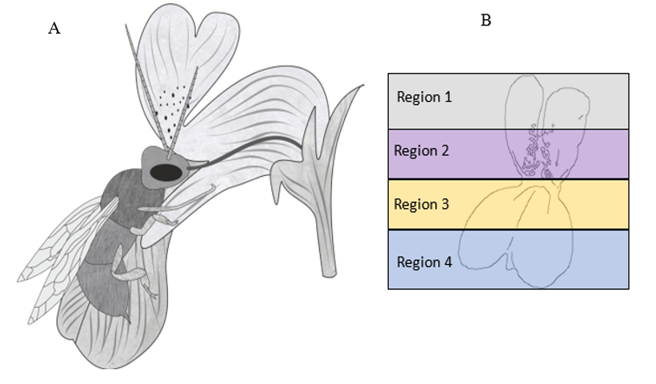
Figure 3.1 Collinsia morphology and petal regions. A) Bee foraging on a Collinsia flower. Bee claw position represents foraging position. B) Petal Regions

Methods

Study system
The genus Collinsia contains 26 winter annual species (Baldwin et al. 2011). All Collinsia flowers are bilaterally symmetrical, and are primarily pollinated by generalist and specialist bee species (Rust and Clement 1977; Armbruster 1980) that open the folded keel petal and access floral rewards (Westerkamp 1996). Collinsia species exhibit a wide range of flower sizes (Armbruster et al. 2002; Baldwin et al. 2011) and selfing rates ranging from highly-selfing, to mixed mating, and to highly outcrossing (Kalisz et al. 2004; Kalisz et al. 2012). The genus contains multiple sister species pairs in which one species is more highly selfing and the other that is more outcrossing (Kalisz et al. 2012). The shared evolutionary history of species pairs enhances the power of our study because it allows for direct comparisons of petal cell morphology and distribution. We predict shifts in petal cell micromorphology accompany shifts in mating system from outcrossing to selfing. Each selfing species within Collinsia represents an independent evolutionary transition, thus making the system ideal for studying repeated patterns that occur during evolutionary shifts. Further, the dated phylogeny for these genera (Baldwin et al. 2011) permits comparison among sister pairs of different ages.
For this study, pairs were selected because their differences in flower size correlate to their mating system (Kalisz et al. 2012): Collinsia parviflora and C. grandiflora; C. rattanii and C. linearis; C. parryi and C. concolor; C. violacea and C. verna.
Individuals were either grown in growth chambers from field-collected seed (C. rattanii, C. linearis, C. verna, C. parviflora, C. parryi, and C. concolor) or were sampled from field populations (C. violacea and C. grandiflora) for our study. On one to three flowers collected from one to three individuals/species, we performed scanning electron microscopy (SEM). Most samples were fixed in formalin–acetic acid–alcohol (FAA), except for those from C. parryi, and C. concolor, which were analyzed with fresh tissue (Table 3.1). All images were performed at 10kV-15kV of acceleration voltage with a magnification of 800x-1000x. Samples stored in FAA were prepared for SEM analysis using critical point drying. We captured SEM images for each petal surface, including scale bars, to allow qualitative and quantitative comparisons among species.
From these images, we first recorded the number of PC cells within each of the four-petal regions and measured the height and width of cells from scanning electron micrographs using ImageJ (Schneider et al. 2012). We classified petal cells following Ojeda et al. (2009) as variants of flat tabular cells or PC cell types. Finally, we coded the cuticles of all measured cells either as striated or not striated. Multiple cells (5-40) within each individual micrograph and PR were measured and pooled across individual specimens to generate a species-level sample for each PR. When samplesizes per species were greater than eight cells/region (Chernick 2008), we compared the cell height between sister species pairs. We calculated bootstrapped estimates of the mean value of each petal cell trait for the species and determined a) if the mean cell traits/species pair differed and b) if selfers had lower PC cell values relative to outcrossers overall.

Results
Following the convention of Ojeda et al. (2009) we identified five different cell types across Collinsia species: papillose conical striate (PCS), papillose-conical rugose (PCR),

Table 3.1 Species and SEM analysis type.
Species | Fixed in FAA | SEM
C. linearis | Yes | JEOL JSM-35CLV
C. rattanii | Yes | JEOL JSM-35CLV
C. parryi | No | Hitachi TM 1000
C. concolor | No | Hitachi TM 1000
C. verna | Yes | Carl Zeiss Ultra 55 FE-SEM
C. violacea | Yes | Carl Zeiss Ultra 55 FE-SEM

lobular striate, tabular striate, and tabular rugose.

Qualitative differences between sister pairs
Collinsia species exhibit a range of specific petal cell micromorphologies across both selfing and outcrossing species (Figures 3.2 and 3.3). All petal cells show evidence of cuticular striations (e.g. Kourounioti et al. 2013), regardless of micromorphology. Papillose conical striate (PCS) cells were found in nearly all species but were unequally distributed among petal regions and between outcrossers (Figure 3.2) and selfers (Figure 3.3). Within region 1, all four outcrossing species have PCS (Figure 3.2). In the same region, selfers had more diversity. C. rattanii had a cell type not recorded in Ojeda et al. (2009), which we will refer to as papillate-rugose (Figure 3.3A).
Some of selfing species had tabular rugose cells (C. parryi and C. violacea; Figure 3.3B and 3.3D) and C. parviflora had knobby rugose cells (Figure 3.3C). In region 2, all outcrossers have similarly shaped PCS or lobular striate cells, while selfers ranged from PCS (C. rattanii Figure 3.2E) to tabular (C. violacea Figure 3.3H). Similarly, in region 3 (the region associated with pollinator grip; Figure 3.1A) PCS and PCR cells are prevalent in outcrossers. Within the selfing species examined, only C. rattanii have PCS cells in region 3 (Figure 3.3I). The selfing species C. parryi, C. parviflora, and C. violacea have tabular rugose or tabular striate cells in this region. PCS are less common in region 4, with only two outcrossers, expressing this cell shape C. linearis and C. grandiflora (Figure 3.3M and O). Some PCS and PCR cells of C. linearis, C. rattanii, C. concolor, and C. parryi also have small projections at the tips (Figure 3.2 C. linearis: E, I, M; C. concolor: F and J; Figure 3.3 C. rattanii: E and M; and C. parryi: F). Collinsia concolor

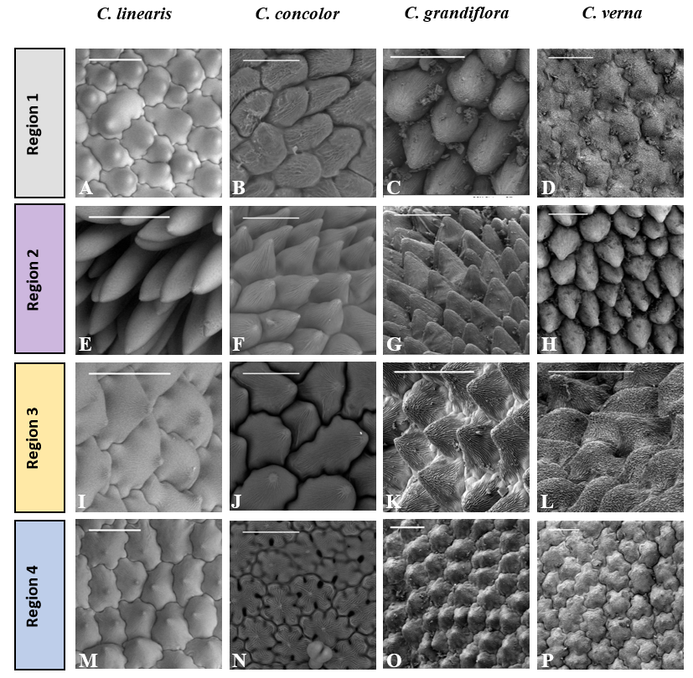
Figure 3.2 Outcrossing sister species conical cell types by region. Scalebars are all 50 µm.

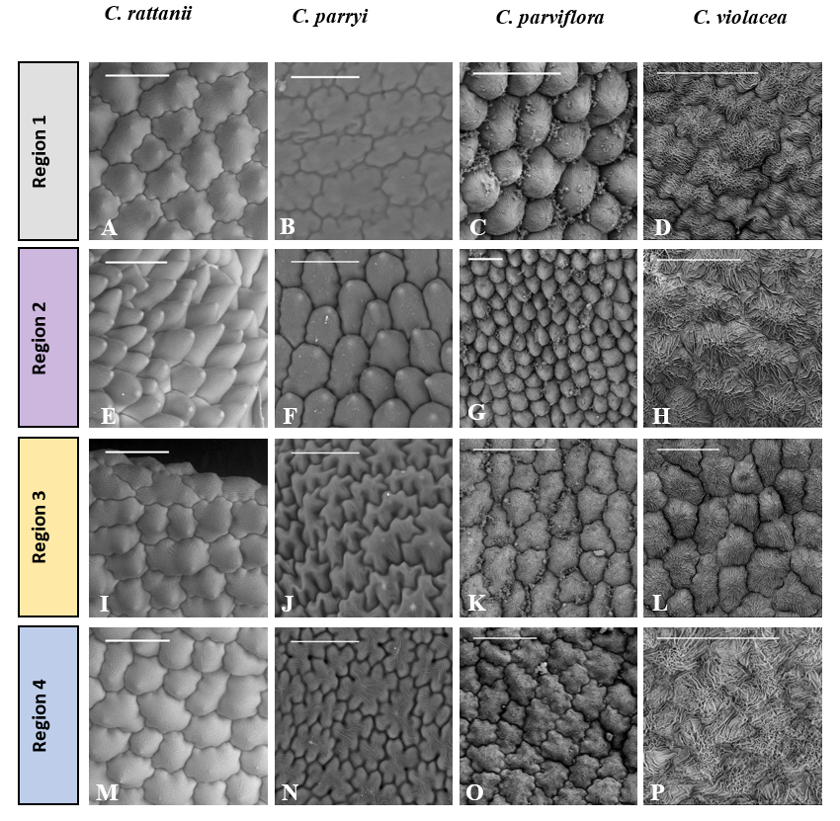
Figure 3.3 Selfing sister species conical cell types by region. Scalebars are all 50 µm.

and C. parryi also have similar projections on the surface of some flat cells (Figure 3.2N and Figure 3.3J and N).

Quantitative differences between sister pairs
In addition to diverse petal cell morphologies, Collinsia species in this study varied considerably in their cell size between petal regions. Between each species pair, the overall cell height range is greater for outcrossers (Figures 3.4A and B; Figure 3.1). The largest overall difference in cell height was between C. verna and C. violacea because C. violacea was not observed to have conical cells (Figure 3.3D, H, L, and P). In regions 2 and 3, which interface (Figure 3.1A) with foraging pollinators, we observed that outcrossers typically had greater apical cell height (Figures 3.4A and 3.4B). Outcrosser cell height was significantly greater within region 2 (Figure 3.4B) for C. linearis (p = 0.018), C. concolor (p < 0.001), and C. grandiflora (p < 0.001).
heights or flat cells. Given their role in the flower-pollinator interface, our data suggest that the loss of papillate-conical cells may be another trait defining the selfing syndrome in Collinsia.
Of the four species pairs examined, C. linearis and C. rattanii overlapped the most in PC cell expression, particularly in regions 2 and 3. While predominately selfing, some populations of C. rattanii whose mating system have been estimated have been found to have surprisingly high outcrossing rates (Kalisz et al. 2012). While, C. rattanii exhibits many traits associated with the “selfing syndrome” (Snell and Aarssen 2005), including reduced flower size and increased stigma-anther overlap (Randle et al. 2009), there is not a diminution of PC cells in the floral region most associated with pollinator grip, region 3. In the field, when the sister species co-occur, C. linearis and C. rattanii were found to both be visited by pollinators, although C. rattanii at a significantly
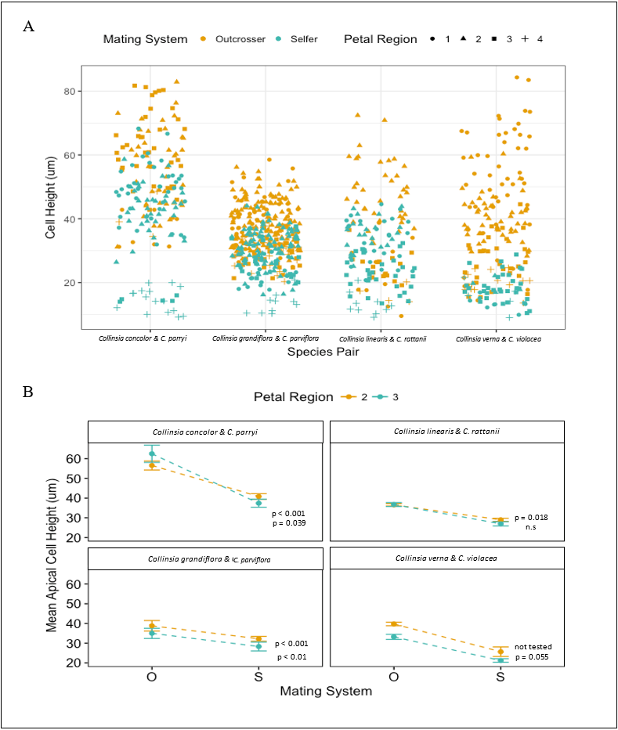
Figure 3.4 Cell height measurements by region. A) Cell height for all 4 regions. B) Cell height differences between pollinator interfacing regions 2 and 3.

lower rate (Randle et al. 2018). In context with PC cells, continued outcross pollen receipt may slow the evolution of high selfing and loss of PC cells under these ecological conditions of persistent pollinators (Spigler and Kalisz 2018).

C. verna and C. violacea were the most divergent sister pairs, since PC cells were entirely absent from the selfer, C. violacea yet prevalent in the outcrosser C. verna. In the other two pairs examined, both outcrossers also had significantly greater cell height in region 3. If PC cells are important for facilitating outcrossing, reduced PC cell height may be indicative of a loss related reducing costly floral traits (Snell and Aarssen 2005). PC cell formation may be energetically more expensive to produce and maintain relative to flat cells, much like large flower size (Schemske 1978), and may be selected against as species evolve to high selfing. Considering the potential foraging difficulties loss of PC cells can pose to bee pollinators, it stands to reason that a general absence of PC cells may act as a deterrent to bee-pollinators (Papiorek et al. 2014). Thus, the reductions and losses of PC cells observed in Collinsia may reduce likelihood of successful outcross pollen delivery and distribution.
Within region 2, PC cells were conserved in all, except one species examined, C. violacea. PC cells may have diverse functions (Whitney et al. 2011) and it is possible PC cells in region 2 evolved for different functions than region 3. Conical cells in this region may play a role in visual attraction as this area is often spotted with brown pigment or a different color from other parts of the flower. Even more curiously, C. violacea has lost PC cells in region 2 as well as all other regions. PC cells may in fact be energetically expensive and the trait is selected against. Aside from pollinator grip and color, PC cells may also moderate temperature around the flower (Whitney et al. 2011). C. violacea and C. verna are also pairs distributed in the Southwestern and Eastern portions of the United States, likely experience distinct climatic conditions from the other species pairs which are primarily distributed in the Western United States.
While present in many bee-pollinated species, PC cells are expected to be mostly absent in bird-pollinated species, as birds do not use the flower as a perch, but instead hover in front of the flower or perch on the inflorescence’s scape (Ojeda et al. 2012). For example, a study of PC cells in bee-pollinated taxa and evolutionarily closely derived bird-pollinated taxa found results similar to ours; many bird-pollinated taxa in the genus Lotus do not express PC cells in petal regions that would interact with bee pollinators (Ojeda et al. 2012). PC cell differentiation in Lotus occurs early in floral development of bee pollinated taxa while bird-pollinated taxa express Lotus japonicus CYCLOIDEA 2 (LjCYC2), the key gene involved in PC cell formation, late in development (Ojeda et al. 2017). While we do not know the timing of expression in Collinsia species, a CYCLOIDEA-like gene, CYCLOIDEA-1 (CYC1), was found in all species in the genera Collinsia and Tonella and was used to generate phylogeny because CYC1 showed significant sequence heterogeneity across taxa (Baldwin et al. 2011). Further, MIXTA genes have been identified as vital to PC cell formation in Antirrhinum (Perez-Rodriguez et al. 2005), another genus in the Plantaginaceae family with Collinsia. Thus, both CYC-like and MIXTA-like genes could provide excellent starting points to examine molecular controls of PC cell expression in Collinsia. Some selfers in our data set had PC cells only in certain petal regions (see Figures 3.2 and 3.3). This result suggests that either the molecular control of conical cells may be decoupled across different regions of the flower or that alternative selection pressure may favor another function of PC cells. Either of these could allow for the maintenance of PC cells in some petal regions of selfers. A comparative analysis of the timing of gene expression related to PC cell formation may be informative in selfing vs. outcrossing Collinsia, since, overall, selfers have accelerated anther development relative to flower size (Grant, unpublished data), early onset of dichogamy, and shorter floral lifespans than outcrossers in the genus (Kalisz et al. 2012).

In conclusion, within Collinsia petal epidermal cells varied considerably between selfing and outcrossing species with outcrossers having greater cell height in key regions associated with pollinator grip. In the same regions, reductions in cell height were documented in most selfing species. The primary exception being C. linearis and C. rattanii, which overlap considerably in PC cell height. While reductions in PC cell height or presence may not be consistent in all selfing-outcrossing species pairs, the observation of multiple independent reductions in cell size in the majority of pairs suggests there may be some underlying energetic or fitness cost associated with PC cell morphology. Additional studies that explore PC cells in selfing-outcrossing pairs beyond Collinsia, as well as gene knockout studies coupled with field assays, would provide more insight into the role of PC cells in mating system differentiation.

References
Antoniou, K. R. L., L. R. Band, J. A. Fozard, A. Hampstead, A. Lovrics, E. Moyroud, S. Vignolini, J. R. King, O. E. Jensen, and B. J. Glover. 2013. Buckling as an origin of ordered cuticular patterns in flower petals. Journal of The Royal Society Interface 10:20120847.
Armbruster, W. 1980. Pollination relationships between four sympatric species of Collinsia (Scrophulariaceae). Bot. Soc. Amer. Misc. Ser. Publ 158.
Armbruster, W. S., C. P. Mulder, B. G. Baldwin, S. Kalisz, B. Wessa, and H. Nute. 2002. Comparative analysis of late floral development and mating‐system evolution in tribe Collinsieae (Scrophulariaceae sl). American Journal of Botany 89:37-49.
Bailes, E. J. and B. J. Glover. 2018. Intraspecific variation in the petal epidermal cell morphology of Vicia faba L. (Fabaceae). Flora 244-245:29-36.
Baker, H. G. 1955. Self-compatibility and establishment after'long-distance'dispersal. Evolution 9:347-349.
Baldwin, B. G., S. Kalisz, and W. S. Armbruster. 2011. Phylogenetic perspectives on diversification, biogeography, and floral evolution of Collinsia and Tonella (Plantaginaceae). American Journal of Botany 98:731-753.
Barrett, S. C. 2002. The evolution of plant sexual diversity. Nature Reviews Genetics 3:274-284.
Barrett, S. C. 2010. Understanding plant reproductive diversity. Philosophical Transactions of the Royal Society B: Biological Sciences 365:99-109.

Callodonato, Rebecca. 2014. A new trait in the selfing syndrome? Exploring the loss of specialized petal cells in selfing Collinsia. University of Pittsburgh.
Charlesworth, D. and B. Charlesworth. 1995. Quantitative genetics in plants: the effect of the breeding system on genetic variability. Evolution 49:911-920.
Chernick, M. R. 2008. Bootstrap methods : a guide for practitioners and researchers. Hoboken, N.J. : Wiley-Interscience, Hoboken, N.J.
Darwin, C. 1876. The effects of cross and self fertilisation in the vegetable kingdom. J. Murray.
Di Stilio, V. S., C. Martin, A. F. Schulfer, and C. F. Connelly. 2009. An ortholog of MIXTA-like2 controls epidermal cell shape in flowers of Thalictrum. New Phytologist 183:718-728.
Erber, J., S. Kierzek, E. Sander, and K. Grandy. 1998. Tactile learning in the honeybee. Journal of comparative physiology A 183:737-744.
Grossenbacher, D. L., Y. Brandvain, J. R. Auld, M. Burd, P. O. Cheptou, J. K. Conner, A. G. Grant, S. M. Hovick, J. R. Pannell, and A. Pauw. 2017. Self‐compatibility is over‐represented on islands. New Phytologist 215:469-478.
Irish, V. F. 2008. The Arabidopsis petal: a model for plant organogenesis. Trends in plant science 13:430-436.
Kalisz, S., A. Randle, D. Chaiffetz, M. Faigeles, A. Butera, and C. Beight. 2012. Dichogamy correlates with outcrossing rate and defines the selfing syndrome in the mixed-mating genus Collinsia. Annals of Botany 109:571-582.
Kalisz, S., D. W. Vogler, and K. M. Hanley. 2004. Context-dependent autonomous self-fertilization yields reproductive assurance and mixed mating. Nature 430:884-887.
Katsuhara, K. R., S. Kitamura, and A. Ushimaru. 2017. Functional significance of petals as landing sites in fungus‐gnat pollinated flowers of Mitella pauciflora (Saxifragaceae). Functional Ecology 31:1193-1200.
Kay, Q. O. N., H. S. Daoud, and C. H. Stirton. 1981. Pigment distribution, light reflection and cell structure in petals. Botanical Journal of the Linnean Society 83:57-83.
Kevan, P. G. and M. A. Lane. 1985. Flower petal microtexture is a tactile cue for bees. Proceedings of the National Academy of Sciences 82:4750-4752.
Mather, K. 1941. Variation and selection of polygenic characters. J. Genet 41:159-193.
Ojeda, D. I., R. Jaén-Molina, A. Santos-Guerra, J. Caujape-Castells, and Q. Cronk. 2017. Temporal, but not spatial, changes in expression patterns of petal identity genes are associated with loss of papillate conical cells and the shift to bird pollination in Macaronesian Lotus (Leguminosae). Plant Biology 19:420-427.
Ojeda, I., J. Francisco-Ortega, and Q. C. B. Cronk. 2009. Evolution of petal epidermal micromorphology in Leguminosae and its use as a marker of petal identity. Annals of Botany 104:1099-1110.
Ojeda, I., A. Santos-Guerra, J. Caujapé-Castells, R. Jaén-Molina, A. Marrero, and Q. CB Cronk. 2012. Comparative micromorphology of petals in Macaronesian Lotus (Leguminosae) reveals a loss of papillose conical cells during the evolution of bird pollination. International Journal of Plant Sciences 173:365-374.
Papiorek, S., R. R. Junker, and K. Lunau. 2014. Gloss, colour and grip: multifunctional epidermal cell shapes in bee-and bird-pollinated flowers. PloS one 9:e112013.
Perez-Rodriguez, M., F. W. Jaffe, E. Butelli, B. J. Glover, and C. Martin. 2005. Development of three different cell types is associated with the activity of a specific MYB transcription factor in the ventral petal of Antirrhinum majus flowers. Development (Cambridge, England) 132:359-370.
Randle, A. M., J. B. Slyder, and S. Kalisz. 2009. Can differences in autonomous selfing ability explain differences in range size among sister-taxa pairs of Collinsia (Plantaginaceae)? An extension of Baker's Law. New Phytologist 183:618-629.
Rust, R. W. and S. L. Clement. 1977. Entomophilous pollination of the self-compatible species Collinsia sparsiflora Fisher and Meyer. Journal of the Kansas Entomological Society:37-48.
Schemske, D. W. 1978. Evolution of Reproductive Characteristics in Impatiens (Balsaminaceae): The Significance of Cleistogamy and Chasmogamy. Ecology 59:596-613.
Schneider, C. A., W. S. Rasband, and K. W. Eliceiri. 2012. NIH Image to ImageJ: 25 years of image analysis. Nature methods 9:671-675.
Sicard, A. and M. Lenhard. 2011. The selfing syndrome: a model for studying the genetic and evolutionary basis of morphological adaptation in plants. Annals of Botany 107:1433-1443.
Snell, R. and L. W. Aarssen. 2005. Life history traits in selfing versus outcrossing annuals: exploring the'time-limitation'hypothesis for the fitness benefit of self-pollination. BMC ecology 5:2.
Soltis, D., P. Soltis, P. Endress, M. W. Chase, S. Manchester, W. Judd, L. Majure, and E. Mavrodiev. 2018. Phylogeny and evolution of the Angiosperms: revised and updated edition. University of Chicago Press.
Stebbins, G. L. 1974. Flowering plants: evolution above the species level. London: Arnold xviii, 399p.. Illustrations. General (KR, 197500089).
Stebbins Jr, C. 1950. Variation and evolution in plants. Variation and evolution in plants.
Strauss, S. Y. and J. B. Whittall. 2006. Non-pollinator agents of selection on floral traits. Ecology and evolution of flowers:120-138.
Waser, N. M. 1983. The adaptive nature of floral traits: ideas and evidence. Pollination biology 1:241-285.
Whitney, H. M., K. M. V. Bennett, M. Dorling, L. Sandbach, D. Prince, L. Chittka, and B. J. Glover. 2011. Why do so many petals have conical epidermal cells? Annals of Botany 108:609-616.
Whitney, H. M., L. Chittka, T. J. A. Bruce, and B. J. Glover. 2009. Conical Epidermal Cells Allow Bees to Grip Flowers and Increase Foraging Efficiency. Current Biology 19:948-953.

CHAPTER IV
SUMMARY AND CONCLUSIONS

Summary and Conclusion of Chapter I and II
In Chapters I and II, I applied species distribution modeling to uncover if there is a relationship between mating system type and niche breadth using sister species pairs. In Chapter I, I applied this analytical method specifically to the genera Collinsia and Tonella, which have a well-resolved phylogeny, are sister groups to one another, and contain several selfing-outcrossing sister species pairs. For all but one pair, species distribution modeling and other analyses revealed that selfing species have significantly wider niche breadths than outcrossing species. The results suggest that selfers in these groups may have some advantage in colonizing new (non-natal) habitats. Further analysis of bioclimatic data used to develop species distribution models showed that precipitation, elevation, and temperature seasonality were the variables with the greatest difference between selfers and outcrossers. Lower precipitation and possibly lower water availability in general in the selfer’s habitats may suggest they are better adapted to such conditions compared to outcrossers. This result is especially meaningful since most Collinsia and Tonella species are found in the Mediterranean habitats of the western United States. Furthermore, selfing species in this group possess reduced flower sizes, a key trait in the selfing syndrome (Sicard and Lenhard 2011), which in addition to enhancing self-fertilization, may reduce water loss compared to larger flower sizes (Galen et al. 1999), therefore providing selfers with an advantage under water-limited habitats with short growing seasons.
While understanding the relationship between mating system and niche breadth in a small group of species provided my initial insights, exploring the general applicability of the research findings from Chapter I was a motivation for the study described in Chapter II. Addressing similar questions and applying similar methods, I expanded the analysis to 34 selfing-outcrossing species pairs across 13 plant Angiosperm families. While all pairs were closely related, they varied considerably in their likely sister relationships, with some pairs with posterior probabilities < 0.01 and others with posterior probabilities of 1.0. Pairs with high posterior probabilities likely have a closer phylogenetic relationship. After building and running the species distribution models on the data, I again found that selfers have wider niche breadths, but this relationship is driven by the pairs with higher posterior probabilities. Analyses that separated high vs. low posterior probability groups found increased support for the subset of the pairs with higher posterior probabilities. This result suggests that, in general, detecting a statistically significant signal for niche breadth/mating system relationship using species distribution models may rely on the strength of the phylogenetic relationship between the pairs analyzed.
Both sets of results are consistent with the expectations of Baker’s Law (Baker 1955, 1967). However, rather than any selfing being favored after long-distance dispersal, the outcome may be the result of short-distance dispersal episodes that resulted in range expansion. The results lend some support that selfers may be superior colonizers relative to their outcrossing sister species. Prior to reproduction, these selfing species would also have to survive climatic conditions in non-natal habitats. Selfers may arrive in non-natal habitats with pre-adaptations, exhibit phenotypic plasticity in their environmental tolerances, or develop faster than outcrosser in time-limited habitats.

Further Directions
An important next step in this research will be to determine whether selfers have distinct physiological responses from outcrossers in the same environmental conditions. Specifically, a new question I would pose is: Does selection on physiological response explain Collinsia niche breadth? Given that my analysis identified precipitation as a factor contributing to niche breadth differences and the implications for Collinsia, which lives primarily in a Mediterranean climate in western North America, physiological responses to water availability is likely the most tractable environmental variable to explore. Species adapted to habitats where water availability places strong constraints on plant growth, have drought tolerant or drought escape physiological response strategies that can indirectly select on mating system. Species that are drought tolerant are more water use efficient (WUE) in low water conditions – that is, productivity is maximized per unit water. Tolerance mechanisms include longer-lived tissues, rapid stomata closure, and reduced photosynthetic rates (Fang and Xiong 2015). Additionally, small corollas of selfing species may reduce water loss under drought stress relative to large corollas of outcrossers (sensu Galen 1999). Thus, traits that reduce water loss should favor the selfing syndrome. In contrast, drought escape strategies involve rapid development and avoidance of future drought conditions.
For species inhabiting habitats with only brief windows amenable to growth and reproduction, selection for whole-plant rapid development leads to smaller, more rapidly developing flowers that incidentally self at greater rates for developmental reasons, or directly, when selfing increases seed production in ephemeral habitats (time-limitation hypothesis sensu Aarssen 2000; Snell and Aarssen 2005). Accordingly, drought-mediated selection on mating system traits suggests that small-flowered, more selfing Collinsia species should display strong physiological signatures indicative of drought tolerance or drought escape mechanisms. In contrast, outcrossers will exhibit fewer extreme values of drought-related traits. Physiological responses could be measured with controlled growth chamber experiments where plants are stratified to a pre-determined watering regimen of high, medium, or low watering. Weekly physiological measurements taken through these annual plants’ life span to senescence could be used to measure WUE.

Summary and Conclusion of Chapter III
In my third Chapter, I used scanning electron microscopy to look for a novel selfing syndrome trait (sensu Sicard & Lenhard 2011) – the reduction of conical petal cells. For the study system, I used 4 selfing-outcrossing species pairs in the genus Collinsia, which were already known to have significant differences in floral traits related to mating system (Kalisz et al. 2012). My analyses revealed that all three pairs expressed significant differences in some metrics of cell size, with outcrossers having greater cell heights in the pollinator-interfacing floral region (region 3). However, C. linearis (outcrosser) does not have statistically greater cell heights than C. rattanii, its selfing sister species. Interestingly, in one selfing species, C. violacea, conical cells were absent on all petal regions, while they were present in the outcrossing sister, C. verna. These observed differences lend support for an association of a reduction or loss of conical cells with higher rates of selfing and further consideration of diminished conical cell production as a trait in the selfing syndrome.

Future Directions
In addition to reduced conical cell size, reduced pollen to ovule ratios, earlier seasonal flowering time, shortened floral developmental times, and reduced distance between male and female organs are also signatures of the shift to high levels of selfing. Such shifts are well documented in the literature, however, the genetic architecture and trait pathway in the evolution of self-fertilization are presently not well understood. Nonetheless, an important extension of the work presented in Chapter III is to determine the genetic and molecular underpinnings of the phenotypic differences observed between selfing and outcrossing species.
One potential research avenue is to perform detailed comparative transcriptomic work to shed light on whether patterns of gene expression between mating system types align with observed phenotypic and developmental differences. Multispecies comparisons can allow for the identification of evolutionarily conserved and variable genes and genomic regions, which can be used to test evolutionary hypotheses. By comparing transcriptomes at multiple developmental stages between these species, we can use Gene Ontology-based functional annotation to determine at approximately which developmental stages gene expression of specific classes of genes associated with plant development, floral organ development, and reproduction occurs. Comparisons between selfing/outcrossing sister-species pairs can determine if the transition to selfing is associated with the same genes or species-specific genes.
Exploration of the genetic architecture associated with self-fertilization in plant species is a fundamental question in evolutionary biology and this type of study would contribute to ongoing research on the origins of biodiversity in Angiosperms. Multispecies transcriptomic comparisons will provide much-needed molecular data to describe potential genetic and evolutionary mechanisms for the evolution of selfing.
Focusing specifically on conical cells, I could explore the underlying gene differentiation in conical cells using qRT-PCR Analysis. Since Antirrhinum and Collinsia are in the same taxonomic family (Platanaceae) and share the same conical cell phenotypes, I expect that conservation of the function of the MIXTA gene may be likely. I can use qRT-PCR (quantitative reverse transcriptase polymerase chain reaction) to quantify the expression of MIXTA homologs in Collinsia petals to determine if molecular regulation of the conical cell trait is conserved. Since selfers have reduced epidermal conical cells, I expect to find a reduction in expression of MIXTA homologs relative to outcrossers. This study would provide insight into the genetic regulation of a newly described selfing syndrome trait, loss of petal epidermal conical cells.

References
Baker, H. G. 1955. Self-compatibility and establishment after'long-distance'dispersal. Evolution 9:347-349.
Baker, H. G. 1967. Support for Baker's law-as a rule. Evolution 21:853-856.
Galen, C., R. A. Sherry, and A. B. Carroll. 1999. Are flowers physiological sinks or faucets? Costs and correlates of water use by flowers of Polemonium viscosum. Oecologia 118:461-470.
Kalisz, S., A. Randle, D. Chaiffetz, M. Faigeles, A. Butera, and C. Beight. 2012. Dichogamy correlates with outcrossing rate and defines the selfing syndrome in the mixed-mating genus Collinsia. Annals of Botany 109:571-582.
Sicard, A. and M. Lenhard. 2011. The selfing syndrome: a model for studying the genetic and evolutionary basis of morphological adaptation in plants. Annals of Botany 107:1433-1443.

VITA
Alannie-Grace Grant was born on Long Island New York. After high school, she attended New York University and majored in Environmental Studies with minors in Molecular Biology and Chemistry. Initially beginning her dissertation work at the University of Pittsburgh, she transferred to the University of Tennessee-Knoxville when her PhD advisor became the Ecology and Evolutionary Biology Department head. Her research interests are broad with in biology, including projects involving structural plant anatomy, herbarium specimens, bioinformatics, statistics, machine learning, physiology, and other topics. Her dissertation focuses on two research areas: niche breadth evolution and floral micromorphology. She plans to use her many skills to for a research or technology career. She is grateful for the support of her family as she embarks on a new career.

