Genetic Algorithm Optimization of Experiment Design for Targeted Uncertainty Reduction

A Thesis Presented for the
Master of Science
Degree
The University of Tennessee, Knoxville

Alexander Amedeo DePillis
May 2024

Copyright © 2023 by Alexander Amedeo DePillis
All rights reserved.

ACKNOWLEDGEMENTS

I would like to thank Professor Vladimir Sobes for his contributions, teaching and patience; Professor Bogetic for her code and assistance. I would also like to thank Dr. Hayward, and Dr. Hines for their help. I would like to acknowledge the contributions of Pham Ngo Gia Bao, Tram Loi Quan, Quan Thanh Tho, and Akhil Garg for their contributions to the NSGA-II code.

This material is based upon work supported in part by the Department of Energy National Nuclear Security Administration through the Nuclear Science and Security Consortium under Award Number DE-NA0003996.

DISCLAIMER

This report was prepared as an account of work sponsored by an agency of the United States Government. Neither the United States Government nor any agency thereof, nor any of their employees, makes any warranty, express or implied, or assumes any legal liability or responsibility for the accuracy, completeness, or usefulness of any information, apparatus, product, or process disclosed, or represents that its use would not infringe privately owned rights. Reference herein to any specific commercial product, process, or service by trade name, trademark, manufacturer, or otherwise does not necessarily constitute or imply its endorsement, recommendation, or favoring by the United States Government or any agency thereof. The views and opinions of authors expressed herein do not necessarily state or reflect those of the United States Government or any agency thereof.
ABSTRACT

Abstract is currently omitted due to incomplete research.
PREFACE
This thesis is an extension of work done over several years in collaboration with Dr. Sobes and Dr. Bogetic.

Table of Contents

Chapter One Introduction and Common background 1
Thesis Introduction 1
Background on Cross Sections 1
Background on Integral Experiments 1
Background on the Fast Neutron Source 1
Chapter Two Literature Review 3
System Optimization Literature Review 3
Expected Value of Integral Experiments Literature Review 3
Chapter Three Genetic algorithm optimization of experiment design 4
Introduction 4
Genetic Algorithms 4
Figures of Merit 4
GNOWEE 4
Methodology 4
MCNP Models 4
GNOWEE Modifications 4
Results 5
Chapter Four Validation 8
Chapter Five Joint Conclusions and Future Work 9
List of References 10
Appendices 11
APPENDIX A: MCNP MODEL OF MCFR 11
APPENDIX B: MCNP FNS TEMPLATE FILE 12
Vita 13

LIST OF TABLES

Table 3.1 Keyword Hyperparameters 6

LIST OF FIGURES

Figure 1.1 Diagram of FNS Design and Symmetry Patterns [1] 2
Figure 3.1. Last Pareto Front 7

Introduction and Common background

Thesis Introduction
This section is best written after the completion of the rest of the thesis and thus is not provided at this time.

Background on Cross Sections
This section will explain what a nuclear data cross section is and why they are important.

Background on Integral Experiments
This section will tell the reader what integral and differential experiments are and how each contributes to knowledge about nuclear data cross sections. There may be a bit of academic controversy in this area so careful citation and writing will be needed.

Background on the Fast Neutron Source
This section will tell the reader about the proposed Fast Neutron Source (FNS) in the basement of the Zeanah Engineering Complex (ZEC).
The FNS will be composed of 74 aluminum drawers (cassettes) arranged into three 5 by 5 layers (the middle position in Zone 3, Figure 1, is empty to allow for a deuterium-deuterium (DD) neutron generator). Each cassette has room for twenty 0.5-inch material plates. These cassettes can be filled with plates made of a variety of materials depending on the application and can be rearranged to perform different experiments. For the purposes of this thesis four different plate materials are considered: no plate (void), polyethylene, 9.75% enriched uranium, and sodium chloride.

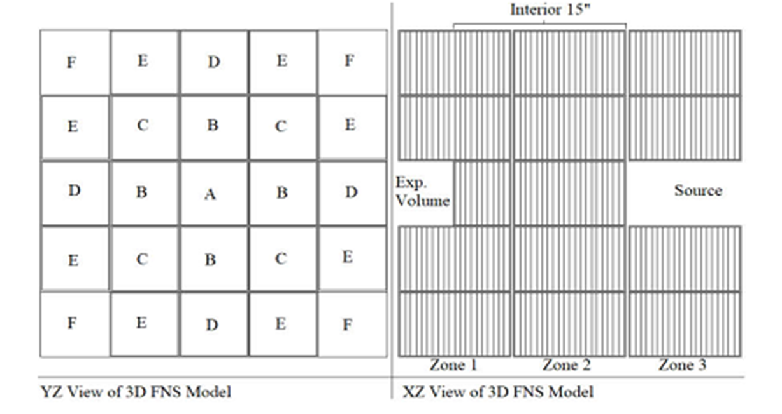
Figure 1.1 Diagram of FNS Design and Symmetry Patterns [1]

Literature Review

This chapter is not yet complete but is provided for the benefit of the reviewer to check the formatting. As such the following citation is provided so that the reviewer can asses whether it is formatted correctly [2].

System Optimization Literature Review
This is the section that will describe the literature on the optimization of nuclear systems with machine learning.

Expected Value of Integral Experiments Literature Review
This section will describe the literature on the topic of assessing the value of integral benchmark experiments to the validation and tuning of nuclear cross sections.

Changes to gnowee

Introduction
This chapter will discuss changes I made to the optimization software, Gnowee. This section can reasonably be expected to contain some figures, equations and tables. As such, an example of each will be provided to aid the formatting reviewer to check if they are correctly formatted. It is not yet decided whether equations will be numbered or not, this will be decided in concert with my advisor and committee.
$$\frac{δ_{a}^{'}}{δ_{a}}=\sqrt{1-\frac{\frac{{\left(SMG\right)}^{2}}{\left(SMS\right)\left(GMG\right)}}{1+\frac{V}{G^{T}MG}}}$$

Gnowee Structure
This sub-section will cover the existing structure of the Gnowee algorithm. I will probably not receive permission to publish my modified version of GNOWEE in an appendix although I will request the ability to do so. It is more likely that I will be granted permission to link to a GitHub page. Table 3.1 contains the information about a specific run of the modified GNOWEE.

Results Library
This sub-section will discuss the implementation of the “Results Library” system in the newly modified Gnowee. There will be additional subsections describing other types of changes I made to the code.

Table 3.1 Keyword Hyperparameters
Keyword Hyperparameter | Value
population | 20
maxGens | 400
maxFevals | 10000
fracLevy | 0.2
fracMutation | 0.1
convTol | 1E-6
stallLimit | 2000

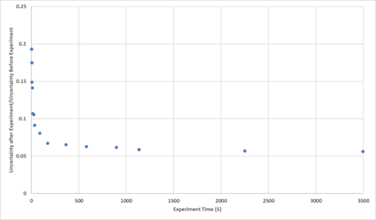
Figure 3.1. Last Pareto Front

Validation
This chapter will verify the validity of some of the methods. It will have sections for an introduction, methodology, and results. As this research in not yet complete, this chapter is currently omitted.

optimization
This chapter discusses two optimization runs that were performed, one that was multi-objective one that was single-objective. They may both have their own mini-introductions, methods, results, and conclusions.

List of References
[1] J. L. Pevey, C. Salyer, O. Chvala, V. Sobes, and J. W. Hines, “Multi-objective design optimization of a fast spectrum nuclear experiment facility using artificial intelligence,” Ann. Nucl. Energy, vol. 162, p. 108476, Nov. 2021, doi: 10.1016/j.anucene.2021.108476.
[2] K. Deb, A. Pratap, S. Agarwal, and T. Meyarivan, “A fast and elitist multiobjective genetic algorithm: NSGA-II,” IEEE Trans. Evol. Comput., vol. 6, no. 2, pp. 182–197, Apr. 2002, doi: 10.1109/4235.996017.

Appendices

APPENDIX A: MCNP MODEL OF MCFR
This appendix will include the MCNP input deck for one of several MCNP models. (If I can get permission).

APPENDIX B: MCNP FNS TEMPLATE FILE
Appendix B will include the input deck for the FNS template file I use in chapter 3 (If I can get permission). There may be additional appendices that I will label with titles formatted similarly to the two above.

Vita
Content currently omitted, but the instructions as specified in the template file and guide will be followed for this section.

