DATA-DRIVEN SOLUTIONS FOR POWER SYSTEMS
DURING ENERGY TRANSITION

A Dissertation Presented for the

Doctor of Philosophy

Degree

The University of Tennessee, Knoxville

Jingzi Liu

July 2025
Copyright © 2024 by Jingzi Liu
All rights reserved.

ACKNOWLEDGEMENTS

Standing at this pivotal moment near the end of my Ph.D. journey, I would like to express my deepest gratitude to all those who have supported and contributed to my research and the completion of this dissertation.
First and foremost, I would like to express my heartfelt gratitude to my advisor, Dr. Fangxing Fran Li, for his unwavering support, patient guidance, and constant encouragement throughout my academic life during my Ph.D. study. His easy but professional guidance has been invaluable to the completion of this dissertation in an enjoyable atmosphere. I feel very fortunate to have been his Ph.D. student.
I am also grateful to Dr. Yilu Liu, Dr. Hector Pulgar, and Dr. Hang Shuai for serving on my Ph.D. committee and providing insightful comments and suggestions on this dissertation. Their valuable input is deeply helpful and has been instrumental in completing this dissertation.
I would like to extend my appreciation to the remarkable group members in the Electric Network Laboratory for Intelligent Transactive Energy Lab (ENLITEN) family—Dr. Jin Zhao, Dr. Sufan Jiang, Dr. Qiwei Zhang, Dr. Xiaofei Wang, Dr. Buxin She, Dr., Haoyuan Sun, Jinning Wang, Vince Wilson, Chenchen Li, and Junjie Yin—for their camaraderie and collaborative support that essential to my academic journey. Special appreciation is offered to Dr. Min Xiong and Zhenping Guo for their assistance in my Ph.D. journey.
Finally, I would like to express my deepest love to my family for their tender care and support throughout my life. To my most beloved daughter Elinor, with a heart full of tender affection. Thank you for being my daughter. To my husband Hongyu Li, my mother Liping Xie, my father Fagui Liu, my father-in-law Xinbo Li, my mother-in-law Xiaomei Chen, and my brother-in-law Hangyu Li, thank you for your endless encouragement and love. This accomplishment would not have been possible without your unwavering support.

ABSTRACT

With the accelerating global energy transition, more and more emerging topics appear in power systems with complex operational environments and unprecedented uncertainties. To integrate with these emerging topics, the new operation methods should be proposed to mitigate the limitations caused by the conventional methods.
This dissertation involves four typical aspects, i.e., artificial intelligence (AI) online application, energy sustainability enhancement, energy affordability promotion, and grid benefit assessment, to introduce the proposed data-driven solutions for the implementation of these emerging topics. In the first topic, three practical correction methods are proposed to protect smooth AI online applications. In the second topic, an incentive-based demand response (I-DR) capacity assessment tool is developed to evaluate the potential of residential energy to respond to load reduction or carbon reduction activities. In the third topic, an innovative energy trading fusion market is proposed with the fully decentralized trading environment and energy-affordability-based layered dispatch structure. Finally, a grid-level benefit assessment tool is developed to evaluate the potential benefits of air-source heat pump integrated with thermal energy storage (ASHP-TES) deployment.
Although there are many emerging topics not included in this dissertation, the proposed data-driven methods are promising, especially during energy transition in power systems.

TABLE OF CONTENTS

CHAPTER One INTRODUCTION 1
1.1. Background and Motivation 1
1.1.1 Motivation for AI Online Application 1
1.1.2 Motivation for Energy Sustainability Enhancement 2
1.1.3 Motivation for Energy Affordability Promotion 3
1.1.4 Motivation for Grid Benefit Assessment via ASHP-TES Deployment 3
1.2 Contributions 4
1.2.1 Contributions to Topic of AI Online Application 4
1.2.2 Contributions to Topic of Energy Sustainability Enhancement 4
1.2.3 Contributions to Topic of Energy Affordability Promotion 5
1.2.4 Contributions to Topic of Grid Benefit Assessment via TES Deployment 6
1.3 Dissertation Structure 7
CHAPTER Two PRACTICAL METHODS OF DEFECTIVE INPUT FEATURE CORRECTION TO ENABLE MACHINE LEARNING IN POWER SYSTEMS 8
Abstract 9
2.1 Introduction 10
2.2 Research Motivation 11
2.3 Three Correction Methods 14
2.3.1 Statistical-value-based Method 14
2.3.2 Minimal-error-based Method 16
2.3.3 DNN-based Adaptive Method 18
2.4 Case Study 20
2.5 Conclusion 23
CHAPTER Three DEVELOPMENT OF AN INCENTIVE-BASED DEMAND RESPONSE CAPACITY ASSESSMENT TOOL FOR ENHANCING ENERGY FLEXIBILITY AND SUSTAINABILITY 25
Abstract 26
3.1 Introduction 26
3.2 Testing System 29
3.3 Data Preprocessing Module 30
3.3.1 Data Extraction 30
3.3.2 Statistics-based Data Cleaning Method 32
3.3.3 Data Correction 36
3.4 Incentive-based Demand Response Capacity Assessment Module 41
3.4.1 Assessment Process 42
3.4.2 Load Reduction Orientation 44
3.4.3 Carbon Reduction Orientation 46
3.4.4 Assessment Result 48
3.5 Visualization Module 51
3.5.1 Visualization Process 51
3.5.2 Validation Result 52
3.6 Conclusion 56
CHAPTER Four AN ENERGY-AFFORDABILITY-BASED PEER-TO-PEER ENERGY TRADING MARKET FEATURED BY AFFORDABLE ENERGY AND FULLY DECENTRALIZATION 59
Abstract 60
4.1 Introduction 60
4.2 Research Problem and Solution 64
4.3 Fully Decentralized P2P-based Energy Trading 67
4.3.1 Model of Fully Decentralized P2P-based Energy Trading 67
4.3.2 Fully Decentralized ADMM Algorithm 69
4.3.3 Formulation of Fully Decentralized P2P-based Energy Trading 72
4.4 Energy-affordability-based Layered Dispatch 77
4.4.1 Structure of Energy-affordability-based Layered Dispatch 77
4.4.2 Implementation of Energy-affordability-based Layered Dispatch 80
4.5 Case Study 82
4.5.1 Feasibility Analysis 82
4.5.2 Advantage Analysis 86
4.5.3 Numerical Results of the IEEE 123-bus System 88
4.6 Conclusion 90
CHAPTER Five DEVELOPMENT OF A GRID-LEVEL BENEFIT ASSESSMENT TOOL FOR THE DEPLOYMENT OF AIR-SOURCE HEAT PUMP INTEGRATED WITH THERMAL ENERGY STORAGE 92
Abstract 93
5.1 Introduction 93
5.2 Data Module 96
5.2.1 Data Source 96
5.2.2 Peak Hour Identification 96
5.3 Grid-level Benefit Assessment Module 100
5.3.1 Grid Model 100
5.3.2 Assessment Process 101
5.4 Visualization Module 105
5.4.1 Process 105
5.4.2 Visualization Map 107
5.5 Conclusion 110
REFERENCES 113
APPENDIX 117
CONCLUSION 118
VITA 121

LIST OF TABLES

Table 2.1. Comparison of computational time of each method. 22
Table 2.2. Characteristics of each method. 22
Table 4.1. Profile of buyers in the IEEE 33-bus system. 83
Table 4.2. Profile of sellers in the IEEE 33-bus system. 83
Table 4.3. The clearing results of the case without the energy trading market. 83
Table 4.4. The clearing results of the case with the energy trading market. 85

LIST OF FIGURES

Figure 2.1. Power systems measurement defective data issues. 12
Figure 2.2. The motivation of the proposed research work. 13
Figure 2.3. The idea of defective input feature correction. 15
Figure 2.4. The process of statistical-value-based method. 15
Figure 2.5. The process of minimal-error-based method. 17
Figure 2.6. The process of DNN-based adaptive method. 19
Figure 2.7. The process of DNN-based adaptive method. 19
Figure 2.8. Comparison of MER of each case. 22
Figure 3.1. Illustration of incentive-based DR program accepting (left) or rejecting options (right). 27
Figure 3.2. The specific structure of the I-DR capacity assessment tool. 28
Figure 3.3. Outlier data samples in load profiles on 04/02/2022. 31
Figure 3.4. The principle of distinguishing outlier data through boxplot analysis. 32
Figure 3.5. The specific steps of the statistics-based data cleaning method. 33
Figure 3.6. The new generated load profiles after applying data cleaning process. 35
Figure 3.7. The steps of the DNN-based adaptive data correction process. 38
Figure 3.8. The MAR between the corrected load and the real load of each known household on 01/01/2022. 39
Figure 3.9. The comparison between the corrected load and real load of several households on 01/01/2022. 40
Figure 3.10. The flowchart of the data preprocessing module. 41
Figure 3.11. The flowchart of the optimization process used in the I-DR capacity assessment module. 43
Figure 3.12. The distribution of total financial incentives under load reduction percentages or carbon reduction percentages on 01/01/2022. 50
Figure 3.13. The flowchart of the visualization module. 51
Figure 3.14. 3D figures of the total minimum financial incentives to meet load reduction goals. 54
Figure 3.15. 3D figures of the total minimum financial incentives to meet carbon reduction goals. 55
Figure 3.16. The whole step of the I-DR capacity assessment tool. 57
Figure 4.1. The comparison of implementing energy affordability in P2P energy trading mode and centralized energy trading mode. 65
Figure 4.2. The trading modes in the fully decentralized P2P-based energy trading. 67
Figure 4.3. The clearing process of the designed fully decentralized P2P-based energy trading in τ^{th} iteration. 76
Figure 4.4. The framework of the innovative energy trading fusion market. 79
Figure 4.5. The topology of the IEEE 33-bus system with seven buyers and three sellers. 82
Figure 4.6. Comparison of each buyer’s payment and sellers’ revenue between with and without the proposed energy trading fusion market. 85
Figure 4.7. The change percentage of each buyer’s payment under different test cases. 87
Figure 4.8. The topology of the IEEE 123-bus system. 89
Figure 4.9. The change percentage of payments under different test cases. 89
Figure 5.1. The specific structure of the grid-level benefit assessment tool. 95
Figure 5.2. The season time of Texas in the year of 2024. 98
Figure 5.3. The distribution figures of the hourly load data from ERCOT. 99
Figure 5.4. The flowchart of the grid-level benefit assessment module. 104
Figure 5.5. The flowchart of the visualization module. 106
Figure 5.6. The map of the line flow of the base case and the TES case. 109
Figure 5.7. The whole step of the grid-level benefit assessment tool. 111

INTRODUCTION

Background and Motivation
With the accelerating global energy transition, power systems are encountering increasingly complex operational environments and unprecedented uncertainties, driven by evolving demands from upstream regulatory bodies and downstream end-users. Within this background, some existing operation methods have shown significant limitations in handling emerging topics, such as involving artificial intelligence (AI), decarbonization, energy affordability, and air-source heat pump integrated with thermal energy storage (ASHP-TES) deployment. This dissertation works on addressing such limitations during energy transition in power systems using the proposed data-driven solutions. Detailed work is introduced respectively from the following perspective of AI online application, energy sustainability enhancement, energy affordability promotion, and ASHP-TES deployment.

Motivation for AI Online Application
Recently, more and more AI are applied in power system operation and planning due to its powerful computing, analytical, and processing capabilities. Typically, an AI tool, e.g., machine learning (ML) method, should be trained with historical data first. Then, this trained AI model can work by feeding into online-measured data. Dring this process, only inputting the normal online-measured data can enable the trained AI model work. However, measurement issues are a common challenge in the power system online-data measurement. Some measurement issues may appear during online measurement, which easily results in defective online data and further ineffective ML online applications. As such, it is worth exploring how to enable a well-trained ML model to function reliably even with defective input data. This topic currently holds particular importance in the context of AI online applications in power systems, where defects in power system online-measured data tend to arise.

Motivation for Energy Sustainability Enhancement
In the course of decarbonization development, more and more attention is paid to how to respond to carbon reduction activities or load reduction activities to enable energy and environmental sustainability. To achieve this, demand response (DR), as a powerful mechanism for balancing supply and demand, offers significant contributions to regulating carbon emissions or load amount within power system operation and planning. As such, DR is usually used to quantify the response capacity of participants to load or carbon emission regulation activities for guiding the investigation on their energy flexibility. However, many existing DR programs are implemented by utility companies, leaving users with passive participation. As a result, users are selected to respond without autonomy and a clear demonstration of their benefits, which then easily diminishes their enthusiasm for proactive and long-term engagement. To better support the development of energy and environmental sustainability, a more motivational and benefit-driven DR strategy based on voluntary participation is desired for users. Consequently, it is meaningful to design a more motivational DR program to ensure that users’ response capacities to carbon reduction or load reduction can be effectively captured under their active participation.

1.1.3 Motivation for Energy Affordability Promotion
With the process of modernization, a growing awareness of accessing affordable energy and self-controlling energy trading emerges across all segments of society. In this background, government and power system operators pay more attention to achieving energy affordability and delegating rights in energy trading. To reach this attention, the easiest way is to directly fund low-income consumers, but it is not sustainable. For sustainable energy access, energy affordability appears because of its core of delivering participants more affordable energy access. Meanwhile, with the increasing penetration of distributed energy resources (DERs), demand-side users gain more flexibility and initiative in energy trading. As a result, peer-to-peer (P2P) energy trading arises to empower these users with an autonomous trading mode. Both energy affordability and P2P energy trading play an important role in responding to government and power system operators. It is therefore worth investigating how to adopt energy affordability and P2P energy trading to truly achieve sustainable access to affordable energy and a more autonomous trading environment.

1.1.4 Motivation for Grid Benefit Assessment via ASHP-TES Deployment
With the development of thermal energy technology in power systems, ASHP integrated with TES gradually attracts attention to utility companies. However, the widespread deployment of TES remains limited, largely due to the insufficient awareness and understanding of its benefits. In addition, it is a little difficult to directly show the grid-level benefits of deploying TES because there are no related monitors installed in the power grid. With the monitoring systems, SFH-level benefits can be easily collected. As such, an ASHP-TES system is deployed to SFHs, whose benefits are collected for the following grid simulation. It is meaningful to provide a grid benefit assessment for the deployment of ASHP-TES system in a selected power grid.

1.2 Contributions
For a smoother power systems energy transition, data-driven solutions are concentrated on because of their powerful ability of processing large-scale data and intelligent decision-making to address the challenges mentioned above.

1.2.1 Contributions to Topic of AI Online Application
Although measurement issues are common when collecting data online, especially for real-world data, the impact of these issues on online-measured data could be effectively avoided using the data-driven methods. To make a well-trained AI tool work smoothly during online application, three practical correction methods are proposed in this dissertation successively from the perspective of data itself and AI. Once there is any defective online-measured data, any one of the three correction methods can be adopted to correct such defective data for the well-trained AI model. With the validation process on a reduced 179-bus model, these three methods demonstrate their effective correction performance facing the missing input data. As a result, the online application of AI in power systems is facilitated by enabling the stable and complete online-measured input data.

1.2.2 Contributions to Topic of Energy Sustainability Enhancement
Among all kinds of DR mechanisms, incentive-based demand response (I-DR) has gained increasing attention by providing financial incentives to participants to encourage their participation in demand reduction activities on a voluntary basis. Following this rule, I-DR enables participants to determine their engagement in load regulation activities by choosing whether to accept or reject financial incentives. Accordingly, I-DR not only contributes to the advancement of energy sustainability but also offers clear benefits and preserves autonomy through voluntary participation. As such, an I-DR capacity assessment tool is developed in this dissertation to systematically evaluate the potential of residential energy to respond to load reduction or carbon reduction activities in a given service territory. In this tool, the data preprocessing module is included to make it more practical. Subsequently, the I-DR capacity assessment module is designed to exhibit variations in user load or carbon emission behaviors and corresponding financial incentives. Finally, the visualization module is employed to provide a comprehensive representation of the I-DR potential capacity in the residential service territory. Under the validation on the filed energy usage data, this tool successfully shows the potential of residential load flexibility, thereby guiding demand elasticity, which then can enhance energy and environmental sustainability via guiding better allocation and management of existing energy resources.

1.2.3 Contributions to Topic of Energy Affordability Promotion
Energy affordability and P2P energy trading are gaining prominence in power system research and practice because of their benefits of providing more affordable energy access and more autonomous trading environment. As such, an innovative energy trading fusion market of energy affordability and P2P energy trading is developed to satisfy the needs of accessing affordable energy and self-regulated energy trading in power systems. In this energy trading fusion market, P2P-based energy trading is designed to ensure a fully decentralized and autonomous energy trading environment, as well as an energy-affordability-based layered dispatch structure is proposed to ensure affordable energy access to consumers. As a result, this energy trading fusion market promotes trustworthy access to affordable energy during energy trading, which effectively reduces the energy payments of low-income consumers for their basic demand. Additionally, individual data privacy during transactions is also highly protected due to the fully decentralized energy trading. To validate performance, the feasibility analysis and advantage analysis of this proposed innovative energy trading fusion market are demonstrated in both IEEE 33-bus system and IEEE 123-bus system. The former is used to conduct detailed analysis, and the latter is used to demonstrate the effectiveness in larger-scale systems. Finally, participants acquire the decision-making power of energy trading, as well as the energy burden of low-income consumers for basic demand is effectively alleviated.

1.2.4 Contributions to Topic of Grid Benefit Assessment via TES Deployment
The best way to make ASHP-TES more widespread is to effectively display the benefits of deploying ASHP-TES. As such, a grid-level benefit assessment tool is developed to enable a systematic and comprehensive assessment. In this tool, a data module is first designed to identify peak demand hours during winter, summer, and shoulder months, which provides the operational windows—scheduled charging and discharging actions—to TES. Following the identified periods, a simulation of ASHP-TES deployment is conducted for the single-family houses (SFHs) because they use heating technology in life, after which the energy consumption data of SFHs, both before and after ASHP-TES retrofitting, is collected. Based on the load data, the grid model of the TES case (with ASHP-TES deployment) can be constructed within the Texas 2k-bus synthetic system. In contrast, the base case (without ASHP-TES deployment) is built based on ERCOT load data sourced from the U.S. EIA. Subsequently, a grid-level benefit assessment module is established to perform DCOPF on both cases. The dispatch results are quantified by some metrics, so a visualization module is then provided to show the dispatch results on a Texas grid map. Finally, a clearer and more intuitive interpretation of the grid-level benefits from deploying ASHP-TES systems is enabled in this topic.

1.3 Dissertation Structure
The following content of this dissertation is structured as follows. Chapter II involves research work for facilitating AI online application, which includes the proposing process of three practical methods to correct defective input feature for enabling ML application in power systems. In Chapter III, the research work for enhancing energy sustainability is conducted where a comprehensive I-DR capacity assessment tool is developed to capture the flexibility of residential energy. The research work for promoting energy affordability is introduced in Chapter IV in which an innovative energy trading fusion market is designed for trustworthy access to affordable energy and decentralized energy trading to consumers. Chapter V provides research work for assessing the benefits of deploying the ASHP-TES system in power grid. A grid-level benefit assessment tool is developed in this chapter. Finally, the whole dissertation is concluded.

PRACTICAL METHODS OF DEFECTIVE INPUT FEATURE CORRECTION TO ENABLE MACHINE LEARNING IN POWER SYSTEMS

A version of this chapter was originally published by J. Liu, F. Li, F. Zelaya-Arrazabal, H. Pulgar-Painemal and H. Li:
J. Liu, F. Li, F. Zelaya-Arrazabal, H. Pulgar-Painemal and H. Li, “Practical Methods of Defective Input Feature Correction to Enable Machine Learning in Power Systems,” IEEE Transactions on Power Systems, vol. 39, no. 1, pp. 2369-2372, Jan. 2024, doi: 10.1109/TPWRS.2023.3328161.

Abstract
In this research work, three practical correction methods are proposed to mitigate the impact of defective input features in power system data measurement for ML applications. A well-trained ML tool may become ineffective due to defective input features, which may originate from measurement issues, such as monitor malfunction, cyberattack, communication failure, or others. It is crucial to correct defective input features to enable ML tools with desirable performances. This chapter introduces the mechanism of three correction methods, i.e., statistical-value-based method, minimal-error-based method, and DNN-based adaptive method. Then, the methods are validated via a deep neural network (DNN) case for power system stability enhancement. Validation results demonstrate that the adaptive method achieves the best performance, enabling the well-trained ML tool with a similar accuracy level to the case of no data defects. Although actual measurements may have various data issues challenging ML applications in power systems, the proposed methods show promise for addressing these challenges.

2.1 Introduction
In recent years, the potential of ML in enhancing power system operation and planning has gained significant attention due to its powerful computing, analytical, and processing capabilities [1]. Typically, an ML-based model undergoes training followed by its online application with online-measured data. Only when normal input data is fed into the trained ML model, can this process run smoothly. However, it is not easy to consistently measure normal data in power systems because there are risks of typical defects like data loss, data latency, etc., from power system data measurement [2], especially suffering from monitor malfunction, communication failure, cyberattack, etc. As such, it is worth exploring how to enable a well-trained ML tool to function reliably even with defective input data. This topic holds particular importance in the context of ML applications in power systems, where defects in power system measurement tend to arise.
The most direct solution is to correct defects. Generative adversarial network, extreme learning machine, and random vector functional link networks are cooperated to fill up phasor measurement unit (PMU) missing data [3]. PMU data is arranged in three dimensions by polyadic tensor decomposition and Tucker tensor decomposition to recover missing data [4]. Both [5] and [6] recover missing PMU data by alternative direction method of multipliers, but the work is formulated as a low-rank matrix-completion problem [5] and an estimation by decomposing events in non-dynamic and dynamic elements [6].
To provide practical methods that are straightforward, yet effective to implement, three data-driven correction methods are proposed in this chapter to enable ML in power systems.

2.2 Research Motivation
In practical applications, the data used by ML tools in power systems, whether for training or online applications, is usually from power system data measurement systems, like PMUs or Supervisory Control and Data Acquisition (SCADA) systems. Normally, measurements are complete and accurate. However, due to various issues, measured data for ML may be defective, leading to failed ML results. Figure 2.1 depicts three common PMU data defects: data loss, bad data, and data asynchronization.
To indicate the solutions for defective data, an ML-based power system stability enhancement case is introduced. Prior to the online application, this ML case is trained by historical data first. The input data employed to construct and train the model is sourced from PMUs, encompassing PMU frequency and tie-line power flow measurements. The output data is an index indicating the status of power system stability. During its online application, this well-trained ML tool can assess stability with normal input data. However, as shown in Figure 2.2, this trained ML tool may not be effective with defective input features depicted in Figure 2.1. Even if only one input feature is defective, the well-trained ML tool may become less accurate in its performance.

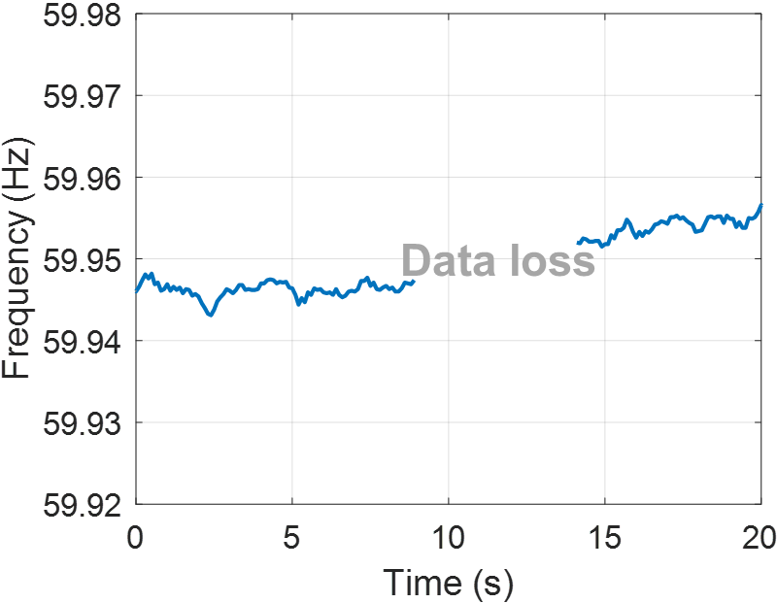
(a) PMU data loss
(b) Bad PMU data
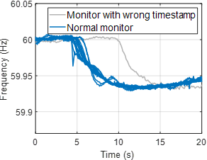
(c)PMU data asynchronization
Figure 2.1. Power systems measurement defective data issues.

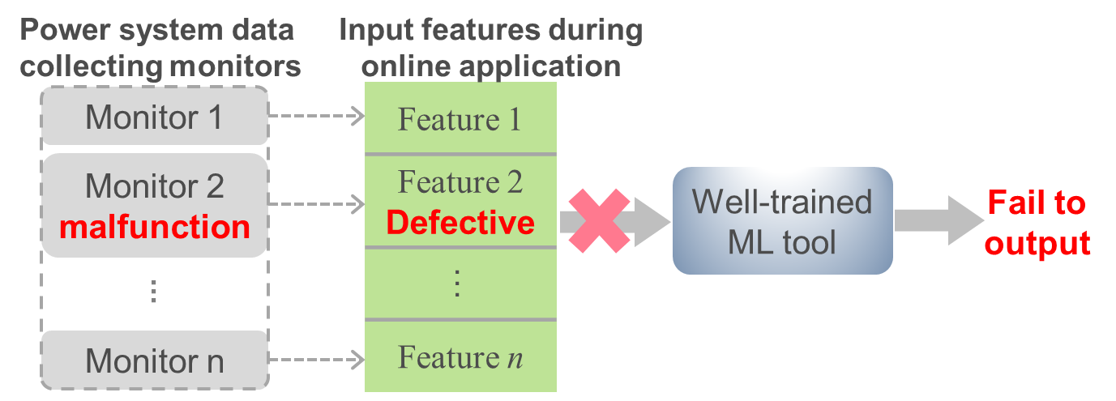
Figure 2.2. The motivation of the proposed research work.

It is crucial to correct defective input features to enable a well-trained ML tool to function with desirable performances. To address these real-world issues, this letter proposes three practical correction methods for defective input features. In essence, each correction method functions as an additional module during ML application, as the blue block shown in Figure 2.3. The detailed procedures are elaborated in the next sections.

2.3 Three Correction Methods
This section proposes three practical data-driven methods to correct defective input features in power system ML applications. Detailed descriptions of the mechanism employed by each method are elaborated.

2.3.1 Statistical-value-based Method
The first algorithm relies on statistical value to correct defective input features. Common statistical values to describe the central tendency of a dataset, such as the mean and median, are used here to correct defective input features. As illustrated in Figure 2.4, in the instance where collected values of the second input feature (i.e., Feature 2) during the online application are defective, the mean or median of the same-type input feature (i.e., also in the second position within the historical training set of b samples) {F₂₁, F₂₂, ..., F_{2b}} is used to complement defects, as shown by (2.1) or (2.2), respectively.
(2.1)
(2.2)

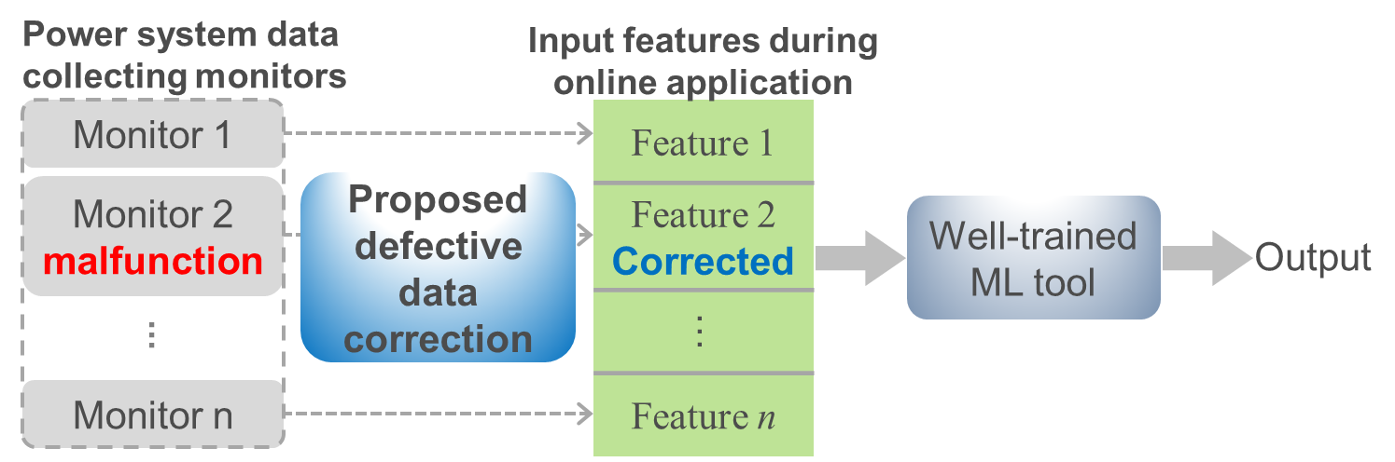
Figure 2.3. The idea of defective input feature correction.
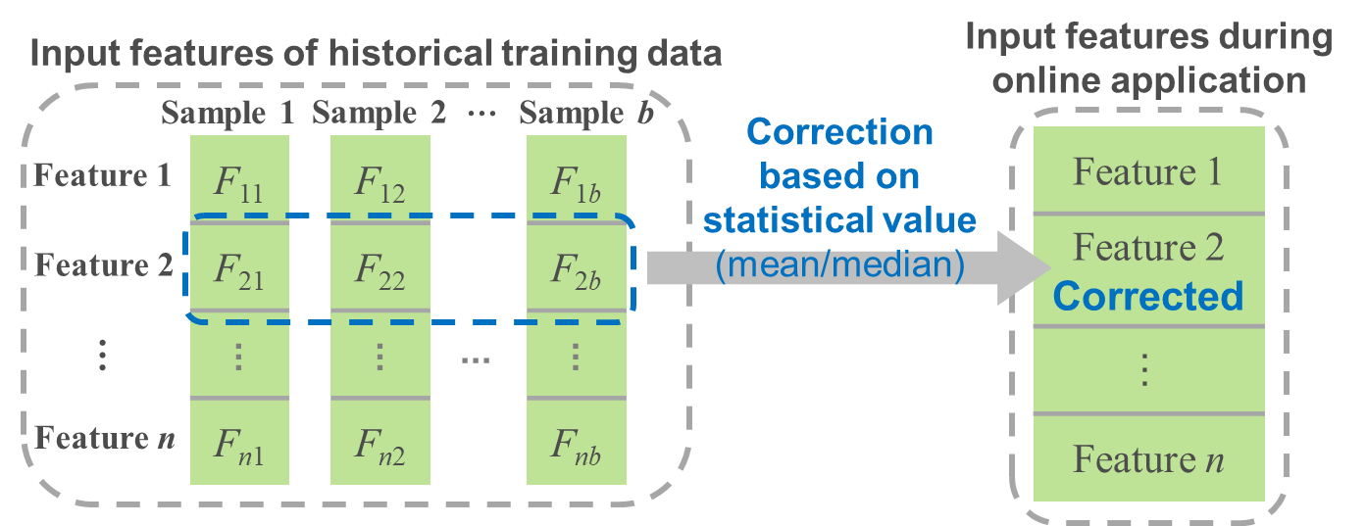
Figure 2.4. The process of statistical-value-based method.

2.3.2 Minimal-error-based Method
The second algorithm aims to derive the value with minimal prediction error from the known entries of the historical training input data and the well-trained ML tool. The essence lies in providing an initial assessment by the well-trained ML tool to yield the value with minimal prediction error, identifying it as the most suitable option for correcting defective input features. For further clarity, the entire process is introduced in Figure 2.5.
In the same data case as the previous method, the values of Feature 2 are defective for the online application. The minimum and maximum values of the same-type input feature {F₂₁, ..., F_{2b}} within the historical training set are identified first. Then, m independent and identically distributed (i.i.d.) random numbers, V₁, V₂, ..., V_{m}, are generated over the range spanning from the minimum to maximum values of uniform distribution. Subsequently, V₁ is initially chosen to replace F₂₁ to F_{2b}, thus forming a new set of input data. Following this, a prediction error of this new input dataset is evaluated by the known trained ML tool. Finally, with the adoption of a sequential substitution strategy, V₂ through V_{m} are successively employed to replace {F₂₁, ..., F_{2b}} and generate new input sets. Each new input set is assessed for its respective prediction error via the known well-trained ML tool. Upon comparison, the specific V_{i} with the minimal prediction error is selected to complement defects.

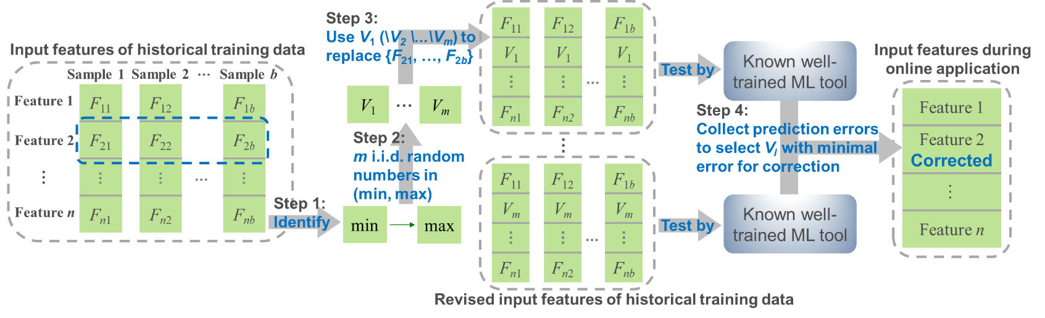
Figure 2.5. The process of minimal-error-based method.

2.3.3 DNN-based Adaptive Method
An adaptive algorithm is devised with the core of leveraging an adaptive tool to capture features among historical input data, then yielding potential values for defective input features. As depicted in Figure 2.6, DNN is chosen due to its robust capability of replicating intrinsic data characteristics in a straightforward and precise manner, under multi-hidden-layered configuration and potent fitting capability of parameters (neurons, weights, bias, etc.) in each layer, distinguishing it from alternative adaptive tools.
Similarly, in the example of a defect in Feature 2 during the online application, input features within the historical training set are retrieved first. Then, a DNN model is trained using the outputs of {F₂₁, …, F_{2b}} and the inputs of the remaining historical training set excluding {F₂₁, …, F_{2b}}. Subsequently, the recent input features from the online application excluding Feature 2 served as the input variable for the newly trained DNN model to yield potential values for the defective Feature 2. Following this step, each defective input feature can have its own dedicated DNN-based correction model. As delineated in Figure 2.7, DNN correction models can be pre-trained and stored in memory. When certain defective input features are detected during the online application, the corresponding DNN-based correction model can be quickly invoked to implement the correction.

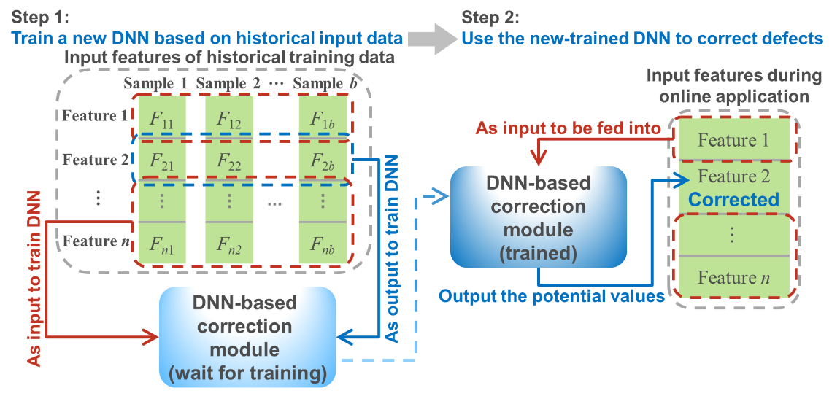
Figure 2.6. The process of DNN-based adaptive method.
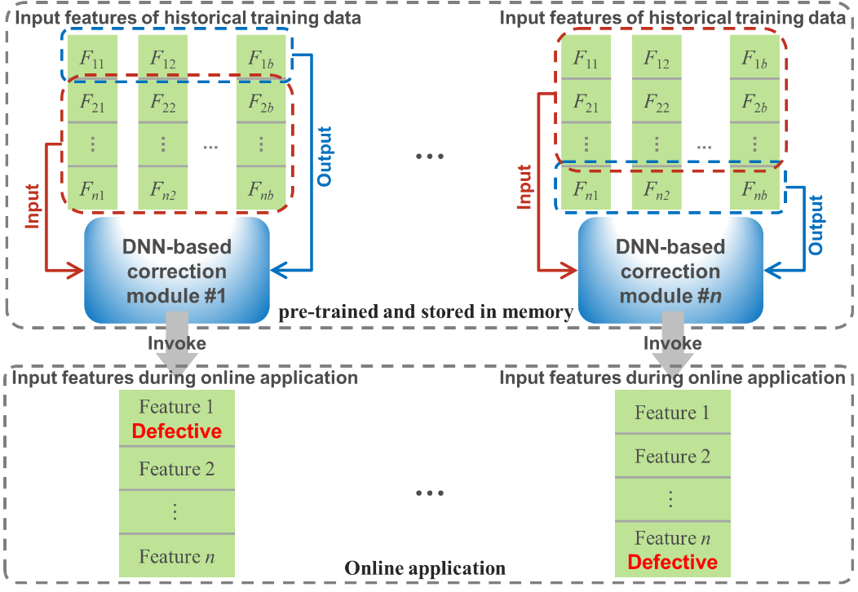
Figure 2.7. The process of DNN-based adaptive method.

2.4 Case Study
A DNN-based power system stability enhancement case is introduced as a benchmark, which also acts as the validation case of no input date issues. The data is simulated from PowerFactory on a reduced 179-bus model for Western Electricity Coordinating Council (WECC), which includes multiple snapshots of the grid situation under various operating conditions and disturbances. Gaussian noise is embedded in this dataset to better represent real-world data. More details can be found in [7]. 90% of this dataset, called as training set, is randomly selected to train the DNN case, while the remaining 10%, known as validation set, is reserved for assessing the performance of the proposed methods.
Given that the validation set contains 41 input features, each input feature among the 41 features is independently and sequentially treated as a defective case for an efficient and comprehensive validation. Consequently, each proposed method is validated by 41 test cases for the cases that assume defects in each input feature. First, three methods are successively used with the well-trained DNN case to yield 41 outputs of test cases. Subsequently, each case of output from the same method is evaluated against the ground truth (i.e., output data from the validation set with no defective issues) by the mean error rate (MER) outlined in (2.3). Finally, the MER of each method for each input defect within 41 test cases among multiple data samples in the validation set is computed to assess correction performances.
(2.3)
where Y_{corrected} denotes the output data of the trained DNN case using corrected input data; Y_{truth} is the output data of the trained DNN case using input data with no defects. N is the total number of samples in the validation set, i=1, …, N. j=1, …, 41.
In addition to the metric of accuracy, computational time is also a crucial metric. Table 2.1 presents a comparison of each method’s average computational time of 41 tests cases, as well as Figure 2.8 presents a comparison of the accuracy of all cases. Except for the 3rd, 19th, and 28th input features with a higher sensitivity for input data defects, MER values for the rest input features are all below 10%. The statistical-value-based method (orange star and green cross) shows the highest MER but offers the most straightforward and time-saving application process. The minimal-error-based method (blue triangle) has a slightly lower MER compared to the previous method and the fastest correction process. However, a significant amount of time is required during its preparation to find the suitable value with minimal error. The DNN-based adaptive method (black dot) exhibits the lowest MER and acceptable time, which even enables the well-trained ML tool to attain nearly the same accuracy level as the case of no defective data. For a more user-friendly review, Table 2.2 summarizes the characteristics of each method.

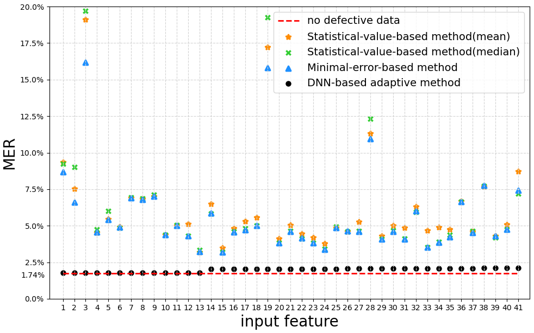
Figure 2.8. Comparison of MER of each case.
Table 2.1. Comparison of computational time of each method.
Method |  | Computational time/s
 |  | Preparation | Correction
Statistical-value-based method | Mean | N/A | 0.0009
Statistical-value-based method | Median | N/A | 0.0146
Minimal-error-based method |  | 444.7834 | 0.0001
 |  | 444.7835 (total)
DNN-based adaptive method |  | 11.0339 | 0.1222
 |  | 11.1561 (total)
Table 2.2. Characteristics of each method.
Method | Correction accuracy | Application process
Statistical-value-based method | Lowest | Most straightforward and time-saving
Minimal-error-based method | Slightly higher | Fastest correction process but longest preparation
DNN-based adaptive method | Highest (nearly same as the case of no defects) | Acceptable time

2.5 Conclusion
In power system ML applications, defective measurement data issues may arise, particularly in incidents like monitor malfunctions, cyberattacks, communication failures, etc., and thus the well-trained ML tools may fail. Hence, it is essential to correct these defective input data for the effectiveness of well-trained ML tools. This chapter proposes three easy-to-implement methods to maximize the utilization of available resources to correct defective input features in real power system scenarios.
The statistical-value-based method works only by statistical values of historical data, making correction straightforward. This results in the most time-saving application process, but it comes with low accuracy. If accuracy tolerance is not tight, the statistical-value-based method can be considered. The minimal-error-based method enhances accuracy, but the preparation process is time-consuming and complex, which also affects the overall application speed. The DNN-based adaptive method demonstrates the best correction performance in that the preparation and correction processes are comparatively less time-consuming, nearly reaching the same accuracy level compared to it from no data defects.
Given that the motivation of this research is to correct defective input features, the location information about defective features is known to the proposed methods. However, such location information is usually not available in some defects, such as bias, drift, and freeze faults [8], [9]. Thus, it might need to build a defective data detection before correction to identify and locate defects, which is worthy of future study. Furthermore, the proposed methods conduct correction based on historical training data, so the relevance between online application data and historical data plays a key role in providing the desirable performance. As such, research for the scenario of less relevance between online application data and historical data is also worth exploring in the future. Meanwhile, the impact of the data amount and locations on the correction performance is also an interesting future topic. In addition, correction methods by ML approaches beyond DNN can be investigated in the future.

DEVELOPMENT OF AN INCENTIVE-BASED DEMAND RESPONSE CAPACITY ASSESSMENT TOOL FOR ENHANCING ENERGY FLEXIBILITY AND SUSTAINABILITY

Abstract
In this research work, a comprehensive incentive-based demand response (I-DR) capacity assessment tool is developed for enhancing energy flexibility and sustainability. Under I-DR, participants response to load regulation activities based on accepting appropriate financial incentives on a voluntary basis. Accordingly, sustainability of energy and environment can be better guaranteed through more reasonable energy distribution among participants on a voluntary basis and clear financial incentives. It is therefore meaningful to conduct an assessment for I-DR potential capacity to guide the potential of energy and environmental sustainability in power systems. This chapter introduces the development of an I-DR capacity assessment tool including three modules, i.e., data preprocessing module, I-DR capacity assessment module, and visualization module, to expand the adaptability of this tool to real-world data and scenarios. A load-reduction-oriented assessment and a carbon-reduction-oriented assessment process are also provided to expand the role of the tool to utility companies or the load aggregator. Then, this tool is validated via field load data within one residential service territory of Southern Company (SOCO). Validation results demonstrate that this tool can effectively assess I-DR capacity for residential energy, which enables a user-friendly view of the quantitative relationship of the reducible load or the reducible carbon emission under the corresponding financial incentives. This tool shows promise for achieving support for decarbonization and energy sustainability.

3.1 Introduction
In recent years, there is increasing attention towards carbon reduction as part of global decarbonization effort. Within this background, DR, as a powerful mechanism for balancing supply and demand, offers significant contributions to regulating carbon emissions during power system operation and planning. As such, DR plays a promising role for promoting energy and environmental sustainability. However, many existing DR programs implemented by utility companies rely on passive participation, which can diminish user enthusiasm. Participants are selected to respond without autonomy and clear demonstration of their benefits, which then reduces motivation for proactive and long-term engagement. Furthermore, these programs frequently involve direct control over participants’ loads, which may overlook individual willingness to participate. As a result, it is not easy to sustain participation in DR programs. To better support carbon reduction goals, a more motivational and benefit-driven DR strategy based on voluntary participation is desired.
The I-DR mechanism has gained significant attention by utilizing financial incentives to encourage participation in demand reduction activities on a voluntary basis. As illustrated in Figure 3.1, participants can decide whether to reduce load based on accepting or rejecting financial incentives. Following this rule, I-DR can work better to achieve carbon reduction via better energy allocation among participants under clear financial incentives and voluntary options.
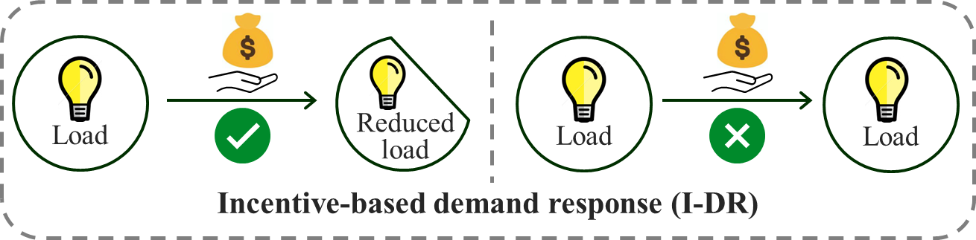
Figure 3.1. Illustration of incentive-based DR program accepting (left) or rejecting options (right).

An I-DR capacity assessment tool has been developed to systematically evaluate the potential of residential energy for carbon reduction. Usually, when quantifying carbon emissions, the perspective of a utility company or load aggregator of a residential service territory should be adopted. Along with carbon reduction, load reduction can also be investigated. Therefore, the developed I-DR capacity assessment tool can also quantify the potential of residential energy to respond to the load reduction goal. To do so, Figure 3.2 illustrates the specific structure of this I-DR capacity assessment tool.
Given that potential measurement issues may appear in real-world data, a data preprocessing module is critical to be conducted as an initial step, ensuring the conversion of raw data into a suitable format for the I-DR capacity assessment. Subsequently, the core module for I-DR capacity assessment is designed to quantify variations in user load or carbon emission behaviors and corresponding financial incentives. Finally, to enhance interpretability and decision-making, a visualization module is designed to provide a comprehensive representation of the I-DR potential capacity in the residential service territory via three-dimensional (3D) figures and statistical lists to guide demand elasticity.
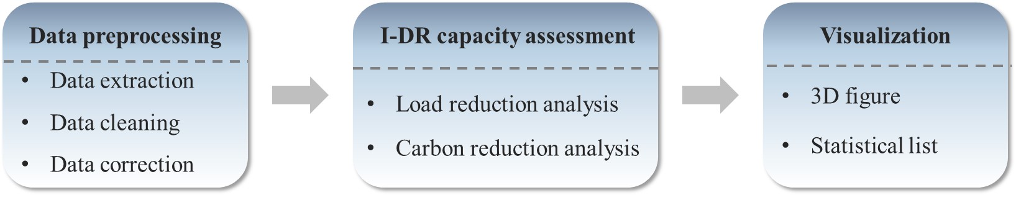
Figure 3.2. The specific structure of the I-DR capacity assessment tool.

Following I-DR, participants voluntarily reduce load based on received financial incentives, which in turn can lead to a corresponding reduction in generation, thereby reducing carbon emissions. Through this tool, the potential of residential load flexibility and decarbonization is highlighted, which could guide a utility company or load aggregator to better allocate existing energy. Accordingly, the sustainability of energy and environment can be achieved to enhance the reliability and efficiency of the future grid.
The rest of this chapter is organized as follows. Section 3.2 gives an overview of the testing system, including field data source, data format, and solving software, of the proposed -DR capacity assessment tool. The following Section 3.3, Section 3.4, and Section 3.5 respectively describe the modules of this tool, i.e., data preprocessing module, I-DR capacity assessment module, and visualization module. The effectiveness of this tool is also demonstrated in these sections via the field energy data from a SOCO residential territory. Finally, Section 3.6 concludes the whole chapter.

3.2 Testing System
To ensure the availability of the developed I-DR capacity assessment tool, a residential region within the service territory of SOCO is selected as the testing system. A smart meter was installed in each household to collect energy usage data specific to individual household metrics. These data included parameters such as rooftop photovoltaic (PV) generation, battery charging power, and power consumption of appliances (e.g., HVAC systems, refrigerators, lighting), allowing for calculation of the net load of each household. The smart meters recorded measurements at 5-minute intervals over a single day, yielding 288 (=24*12) snapshots of daily energy consumption per household. In addition, a Python 3.9.12 programming environment was utilized to facilitate the implementation of this tool.

3.3 Data Preprocessing Module
To ensure a smooth assessment process, data preparation was a critical step. Since load data from smart meters was employed, it was essential to address potential measurement issues in the real-world data. Therefore, the following data preprocessing module was designed, which serves as the foundational module of the I-DR capacity assessment tool, to extract real-world measured data and then convert the raw data into a format compatible with the subsequent analysis.

3.3.1 Data Extraction
As previously outlined, the household load data comprised rooftop PV generation power, battery charging power, and appliance power consumption, each of which was saved in distinct data files in 5-minute intervals. To derive the household net load, these individual load components needed to be extracted and processed. To do so, a script was created to extract individual load components and then to generate the net load and corresponding load profiles.
Measurement data on April 2 in 2022 was selected as an example to validate the performance of the data extraction script. Through the data extraction script, the load profiles used for the following assessment can be generated. However, outlier data was observed in some generated load profiles. Figure 3.3 depicts several samples of outlier data in the generated load profiles.
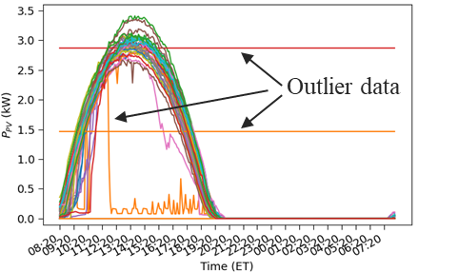
(a) rooftop PV generation power
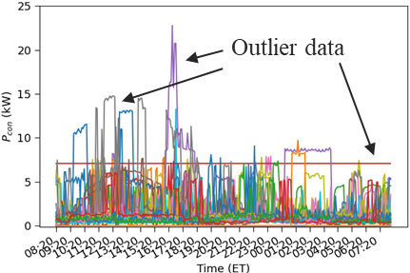
(b) appliance power consumption
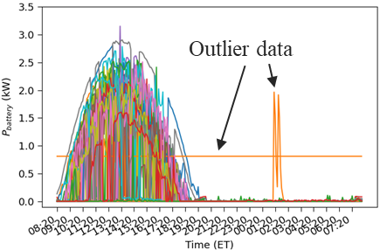
(c) battery charging power
Figure 3.3. Outlier data samples in load profiles on 04/02/2022.

Each line in Figure 3.3 presents one household from the given service territory. From Figure 3.3, the discrete field data can be accurately extracted, even including outlier data, to generate load profiles. It is well-known that some measurement issues are common in real-world examples, but the impact of the outlier data should be eliminated for the follow-up assessment. As such, a data cleaning process was incorporated prior to generating load profiles.

3.3.2 Statistics-based Data Cleaning Method
Building on outlier detect techniques from boxplot analysis and the statistical values of the median and percentile, a statistics-based data cleaning method was applied. The median value was derived from the original dataset, describing the robust central tendency of the dataset. The percentile values, including the first quartile Q1 (the 25th percentile), the second quartile Q2 (the 50th percentile), and the third quartile Q3 (the 75th percentile) were also derived from the original dataset, characterizing data distribution. Then, as visualized in Figure 3.4, boxplot analysis was used to identify the outlier data that distributed outside the range of the minimum and maximum values derived from these statistical values.
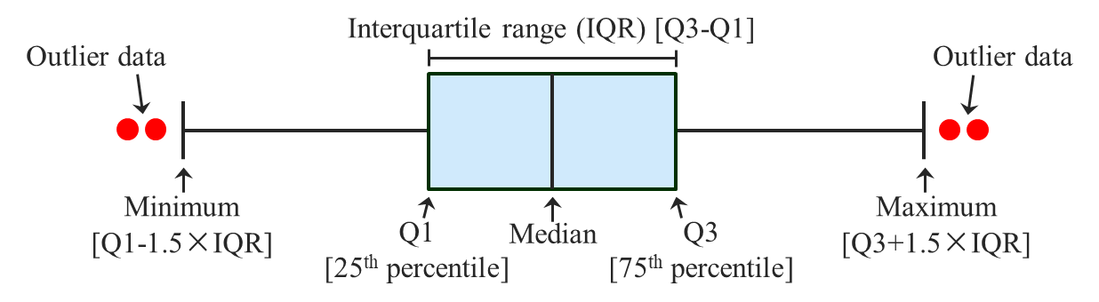
Figure 3.4. The principle of distinguishing outlier data through boxplot analysis.

Incorporating household load data, the specific steps of the statistics-based data cleaning method are delineated in Figure 3.5. As mentioned previously, there were 288 total snapshots for the load data of each household in the service territory per day. Thus, one median was derived from all load data in each snapshot, yielding a total of 288 median values of all households in a single day. Subsequently, for each household, 288 absolute distance values could be calculated between its load data and the corresponding median value under 288 snapshots in a single day. The 288 absolute distance values of one household were then summed to be a single aggregated distance value that represented the deviation of each household’s load profile from the median behavior. Next, the aggregated distance values for all households within the service territory were plotted in a boxplot. Finally, the value of the aggregated distance falling outside the acceptable range of box plot was flagged as outlier data, such that the corresponding households could be located and excluded from the dataset of all households.
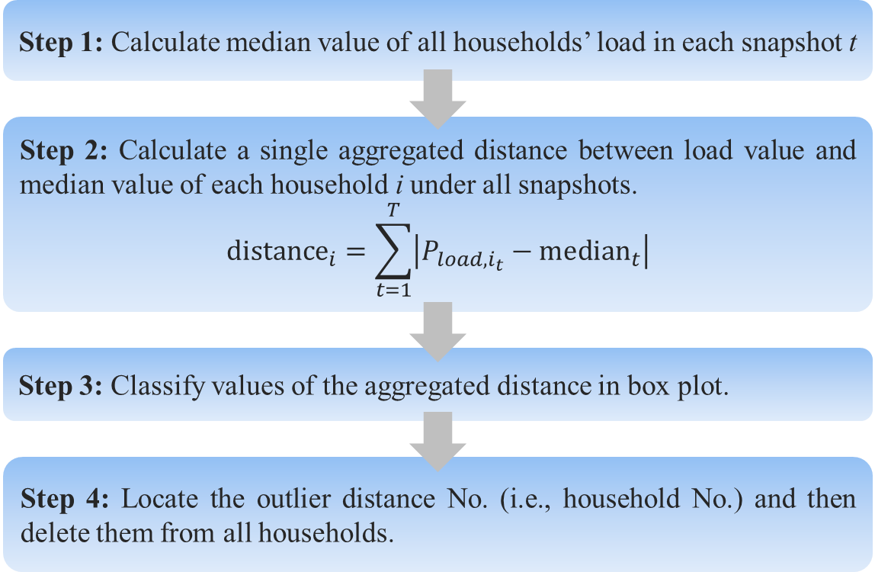
Figure 3.5. The specific steps of the statistics-based data cleaning method.
The measurement data used for Figure 3.3 was employed to validate our proposed statistics-based data cleaning method. Figure 3.6 presents the new load profiles of the measurement data used in Figure 3.3 after the data cleaning process was applied.
If Figure 3.3 and Figure 3.6 are compared, there were no longer those outlier data in the load profiles after the data cleaning process. The proposed statistics-based data cleaning approach can effectively eliminate abnormal real-world measured data caused by potential measurement issues.
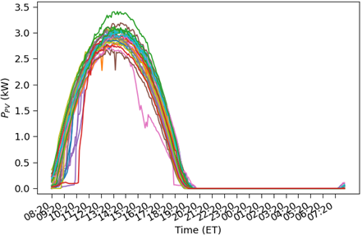
(a) rooftop PV generation power
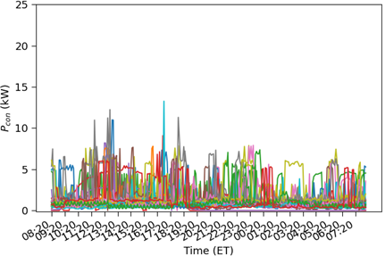
(b) appliance power consumption

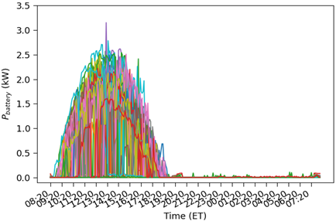
(c) battery charging power
Figure 3.6. The new generated load profiles after applying data cleaning process.

3.3.3 Data Correction
After cleaning the outlier data, a data correction process was applied to those cleaned data. Given that there should be some correlation between the energy consumption behavior of the households in the same region at the same time, an adaptive algorithm was devised to capture characteristics of household load data within the service territory and then yield potential load data for those households with outlier data. A DNN tool was chosen due to its robust capability for replicating intrinsic characteristics of data, supported by powerful fitting capability of multi-hidden-layered configurations with multi-parameters.
In Figure 3.7, the specific steps of this DNN-based adaptive data correction process were presented. To complement the outlier load data, the load data from the same service territory on the day before the target day was prepared to train the DNN model. Given correlation in the energy consumption behavior of households within the same region, the DNN model captures the correlation of energy consumption for all households in the given service territory. For example, when the smart meter of Household 1 malfunctioned on 01/01/2022 (i.e., red question mark in Figure 3.7). Then, the load data of all households on 12/31/2021 was used to train the DNN-based correction model, whose input is the load data of the households except Household 1 (i.e., blue arrow in step 1 in Figure 3.7) and the output is the load data of Household 1 (i.e., red arrow in step 1 in Figure 3.7). Then the load data on 01/01/2022 of all the households except Household 1 is input into the trained DNN model (i.e., blue arrow in step 3 in Figure 3.7) to output the potential load data for Household 1 (i.e., red arrow in step 3 in Figure 3.7) on 01/01/2022.

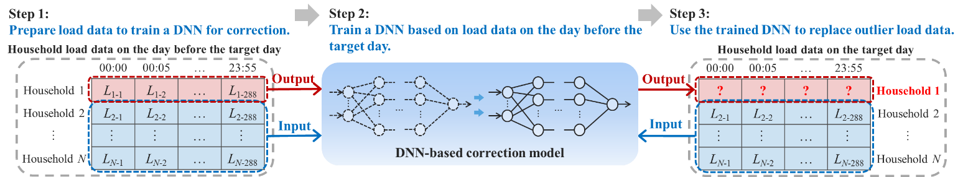
Figure 3.7. The steps of the DNN-based adaptive data correction process.

The measured load data on 01/01/2022 was selected as an example to validate the DNN-based correction model. After the previous two processes, the real measured load data on 01/01/2022 was cleaned without outlier data. Since the ground truth of the identified outlier data cannot be obtained, it has been assumed that the clean load data of a certain known household as an outlier to evaluate the performance of the DNN-based correction model. In this way, the correction of each known household was validated, and then the mean absolute error (MAR) of each case was calculated between its corrected value and the corresponding real household load to quantify the performance. Figure 3.8 shows the MAR of each validation case. To display it more intuitively, the comparison between the corrected load and the real load (i.e., ground truth) of several households is also provided in Figure 3.9. Therefore, it can be concluded that the proposed DNN-based adaptive data correction model can effectively and accurately correct the detected outlier load data.
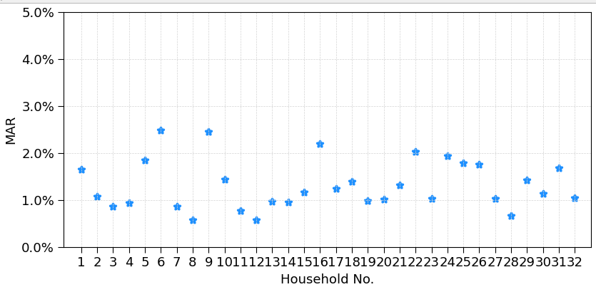
Figure 3.8. The MAR between the corrected load and the real load of each known household on 01/01/2022.

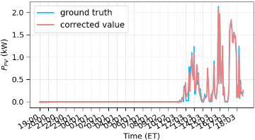
(a) Household 1
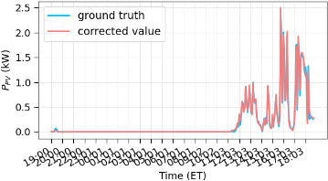
(b) Household 10
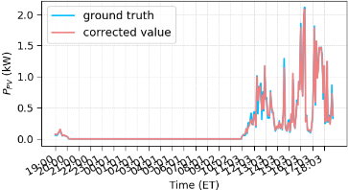
(c) Household 18
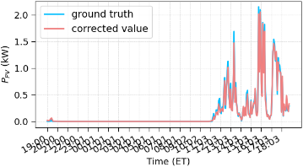
(d) Household 29
Figure 3.9. The comparison between the corrected load and real load of several households on 01/01/2022.
Overall, as Figure 3.10 shows, the data preprocessing module effectively achieves real measured load data extraction, typical measurement issues detection, and outlier load data correction through the data extraction, data cleaning, and data correction processes. Finally, a more consistent and reliable dataset can be effectively ensured for I-DR capacity assessment. Additionally, such easy-to-implement processes also ensure maximum utilization of available resources for real power system planning and operation.

3.4 Incentive-based Demand Response Capacity Assessment Module
After refining the household load profiles, the quantification of the variations in residential energy consumption behaviors and carbon emission behaviors under financial incentives can be carried out. To do so, an I-DR capacity assessment module was designed sequentially to quantify the potential reduction in household demand or household carbon emissions elicited by varying minimum levels of financial incentive to be paid to households based on their voluntary participation.
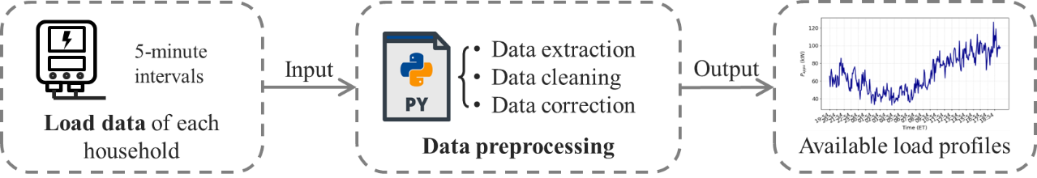
Figure 3.10. The flowchart of the data preprocessing module.

3.4.1 Assessment Process
The load dataset originates from multiple households across the SOCO service territory. Generally, each household has unique electrical usage profiles, characterized by diverse electrical activities occurring simultaneously, various energy consumption preferences, and distinct attitudes towards DR programs. Under this situation, the utility company or load aggregator plays a crucial role in coordinating load activities across multiple households under various consumption preferences and managing financial incentives. To maximize its benefits, an optimization model is implemented from the perspective of the utility company or load aggregator with the objective of minimizing the financial incentives paid to the households within the service territory for their participation in load regulation activities. The unique profiles of each household are incorporated into the model as constraints, reflecting their individual energy consumption preferences. In addition, with the aggregated goal for the whole residential service territory, the households have options to determine whether to participate in regulating their load. Based on their decision, variable financial incentive rates are applied to encourage participation in load regulation. Figure 3.11 depicts this optimization process, which can effectively quantify the relationship between residential load regulation activities and the required minimum financial incentives.

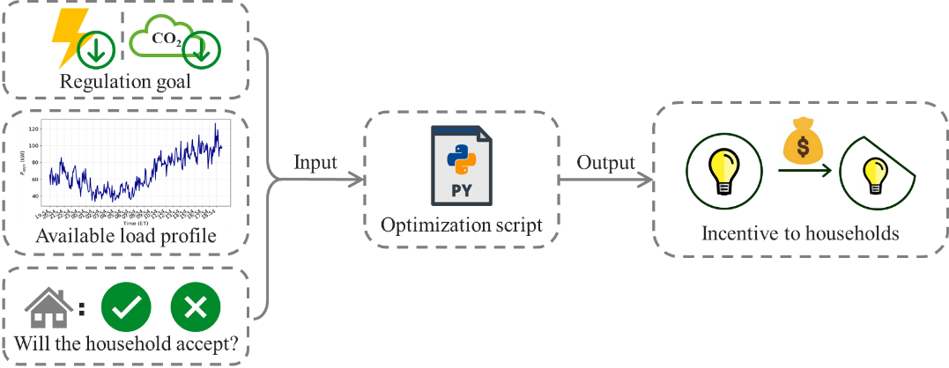
Figure 3.11. The flowchart of the optimization process used in the I-DR capacity assessment module.

3.4.2 Load Reduction Orientation
Guided by the goal of promoting sustainable energy and environmental development, the optimization model for I-DR capacity assessment can be oriented in two directions: one oriented toward load reduction, and the other focused on carbon reduction.
First, the load-reduction-oriented optimization model is implemented. Upon receiving an aggregated load reduction goal for all households within the service territory, the load aggregator engages with each household about the decision of participating in load reduction initiatives. Based on the households’ decisions, the load aggregator uses an optimization model to schedule which households will participate in load reduction based on the cost of the financial incentives paid to the households for their participation. Subsequently, the minimum financial incentives for the households are optimized to comply with the current load reduction goal for the service territory. To provide a broader analysis, the model also explores a range of the reducible load to gather the corresponding total financial incentives.
In summary, the optimization model considers variables that account for the energy consumption preferences of each household and provides options for households to decide their response. The operational strategies of this optimization model are detailed as follows.
(3.1)
(3.2)
(3.3)
(3.4)
(3.5)
where N means the total number of households in the given residential service territory and i is each household No. P_{i} denotes power rate of each household, kW. $P^{'}$ reflects the load that households can reduce, kW. P is the aggregated load reduction goal of the service territory, kW.
The objective function of the optimization model is shown in (3.1) to minimize the total financial incentives TI ($) while reaching the aggregated load reduction goal for the service territory. To accommodate diverse decisions towards load reduction, the different incentive rates I_{rate, i}, R₁ and R₂ ($/kWh·5min), are implemented in (3.2). R₁ is applicable when a household agrees to reduce its load, while R₂ works when a household opts out of participation. Following this optimization model, the utility company or load aggregator can initially query the households as to whether they consent to participate in load reduction, thereby determining the applicable incentive rate for each household. The participation status of each household is represented by a binary variable A_{i} in (3.3), where A_{i} = 1 indicates an ON status (i.e., accepting load reduction) and A_{i} = 0 signifies an OFF status (i.e., rejecting load reduction). In addition, a tolerance coefficient α is introduced in (3.4) to ensure that the reducible load from the households can meet the aggregated load reduction goal for the service territory. Ultimately, the financial incentive paid to each household TI_{i} ($) is derived from these parameters and the duration of load regulation period T in (3.5).

3.4.3 Carbon Reduction Orientation
The carbon-emission-reduction-oriented optimization model is also implemented. Like the previous model, an aggregated goal of carbon reduction is allocated by the utility company or load aggregator to the households within the service territory. Each household still has options to decide whether to respond to reduce load for the carbon reduction goal. Then, the load aggregator schedules the load activity of each household via the optimization model and the households’ decisions to match the aggregated carbon reduction goal. Similarly, the minimum financial incentives for each household to respond are optimized to ensure that the aggregated carbon reduction goal can be reached. Further, this model is also optimized within a certain range of carbon emissions to provide a reference for residential carbon reduction capabilities. The operational strategies for this carbon reduction optimization process are detailed as follows.
(3.6)
(3.7)
(3.8)
(3.9)
(3.10)
(3.11)
where N means the total number of households in the given residential service territory and i is each household No. P_{i} denotes power rate of each household, kW. $P^{'}$ reflects the load that households can reduce, kW. C_{goal} is the aggregated carbon reduction goal of the service territory, kg.
In this optimization model, the objective function (3.6) is still to minimize the financial incentives TI paid to the households within the service territory to reach the aggregated carbon reduction goal. The incentive rates R₁ and R₂ ($/kWh·5min) in (3.7) are also taken effect according to households’ decisions regarding whether consenting to respond to reduce load for carbon reduction. The tolerance coefficient β is also introduced to ensure the achievement of carbon reduction goal in (3.10). In addition to these parameters, the amount of carbon emission caused by load reduction activities should be defined. According to the Intergovernmental Panel on Climate Change (IPCC), generally, for every 1 kWh load, 0.85kg of CO₂ is released if the load comes from coal-fired power generation, while 0.45kg of CO₂ is released if the load comes from gas-fired power generation, and 0kg of CO₂ is released if the load comes from clean energy. Combined with the proportion of energy sources within the SOCO service territory from U.S. Energy Information Administration (EIA), 75% of the carbon emissions corresponding to the load can be applied (as 25% energy source is nuclear generation). Following this, the reducible carbon emission is quantified by (3.9) under the sequence of coal generation, gas generation, and generation caused by clean energy according to various amounts of reducible load.
In summary, the I-DR capacity assessment tool can effectively figure out the minimum financial incentives to the households within the service territory not only by meeting carbon reduction goal but also by meeting load reduction goal.

3.4.4 Assessment Result
A validation case study was completed to demonstrate the performance of the optimization model with several key parameters defined as follows. According to the existing research and references, the financial incentive rates R₁ and R₂ are valued to be 0.2$/kWh·5min and 0.4$/kWh·5min respectively, although it should also be noted that other customized values could be employed for R₁ and R₂. The duration for load regulation has been set to 5 minutes. Each household’s decision towards whether to participate in load regulation has been empirically assumed for the testing model. The load data used was consistent with that utilized previously. Gurobi Optimizer, running within a Python 3.9.12 programming environment, was adopted to facilitate illustrating the relationship between reducible load and financial incentives, which has also been graphically depicted by a filled contour plot.
The field data on 01/01/2022 was used to display the distribution of the total financial incentives to respond to varying load reduction percentages or carbon reduction percentages in the 5-minute interval. Figure 3.12 shows its filled contour plot. The intensity of the financial incentives is reflected through color shade, where red represents high financial incentives ($), and blue indicates low financial incentives ($).
As shown in Figure 3.12, the total financial incentives paid to the households were higher during the daytime than the nighttime, which is reasonable because daytime has higher load activities, indicating higher costs in regulating load at daytime.
In addition to the above filled contour plots, the Spearman rank correlation coefficient is also calculated to reflect the correlation between the reducible load and the reducible carbon. The coefficient shows ρ = 0.949 with a p-value < 0.001, indicating a very strong and statistically significant positive monotonic relationship between them.

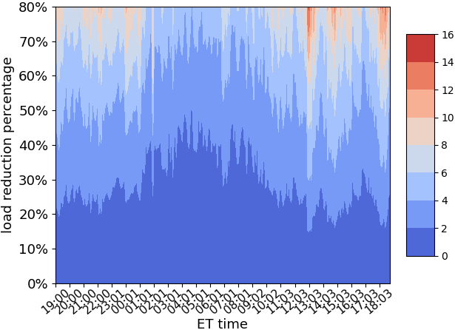
(a) by load reduction goal
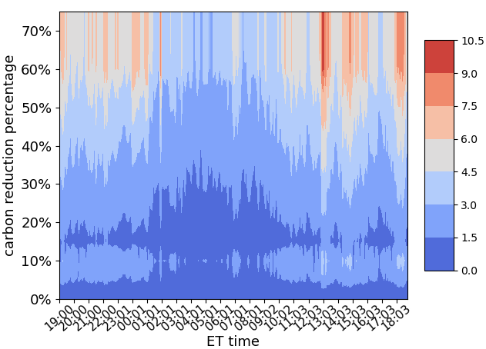
(b) by carbon reduction goal
Figure 3.12. The distribution of total financial incentives under load reduction percentages or carbon reduction percentages on 01/01/2022.

3.5 Visualization Module
To enhance the intuitive understanding of the total financial incentive distribution, a visualization module has been designed to represent the variation in financial incentive and household load reduction or carbon reduction in a 3D figure and a statistical list, facilitating a more user-friendly view of the specific required financial incentives with the corresponding specific reducible load amount or carbon emission amount.

3.5.1 Visualization Process
Figure 3.12 points out that the cost of load regulation is highly related to load activity time. Therefore, a more illustrative representation of the financial incentive distribution should highlight temporal dimensions. As such, a 3D figure was employed to provide a visual analysis of the relationship among household energy consumption behaviors, total minimum financial incentives, and time. In addition, an incentive list was also employed to facilitate a straightforward view of the specific financial incentives paid to the households in accordance with the specific load reduction amount or carbon reduction amount and time. The flowchart of this visualization module is detailed in Figure 3.13.
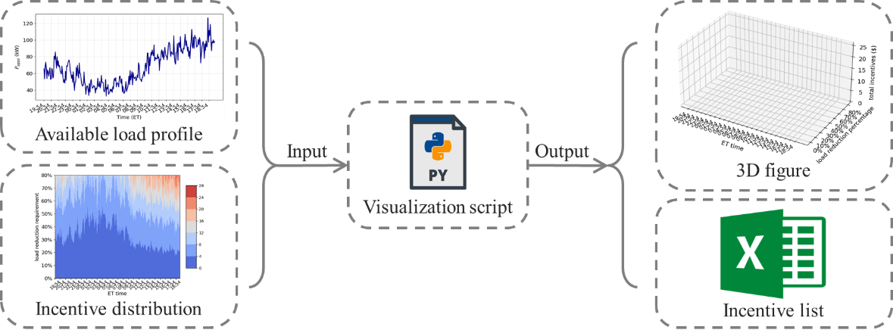
Figure 3.13. The flowchart of the visualization module.

3.5.2 Validation Result
The integration of the available load profiles and the incentive distribution were derived from the preceding modules. The generated incentive list was formatted as an Excel file. The SOCO field data on 01/01/2022 is used again to show the 3D figure. In addition, three additional days were randomly selected from the other seasons except January to show the findings of seasonal pattern. Figure 3.14 and Figure 3.15 respectively show these 3D figures of the variations in the total minimum financial incentives paid to the households to meet the aggregated load reduction goal or the aggregated carbon reduction goal in the 5-minutes interval over each single day.
As observed in Figure 3.14 and Figure 3.15, the total minimum financial incentives used to compensate households escalate with the increasing percentage of load reduction or carbon reduction. In addition, the magnitude of these financial incentives is higher during daytime hours as opposed to nighttime, indicating higher operational costs for the utility company or load aggregator in regulating load during daylight periods. A similar conclusion can be drawn from the fact that the required financial incentives in summer significantly exceed those observed in other seasons in response to the same load reduction percentage or carbon reduction percentage.

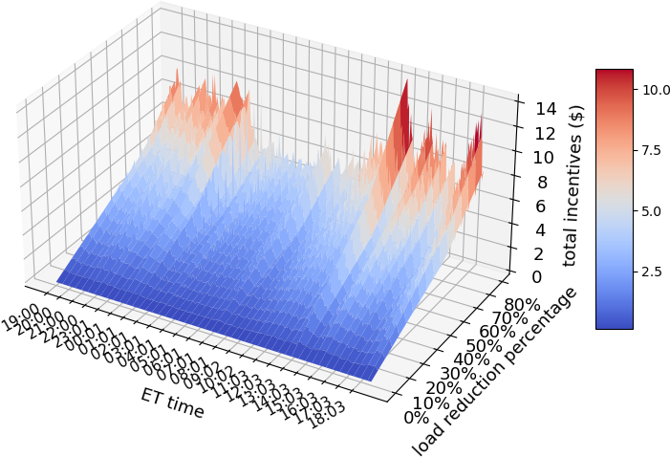
(a) 2022-01-01
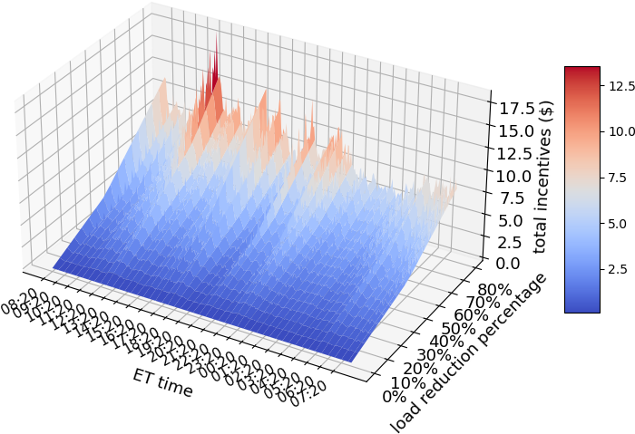
(b) 2022-04-02
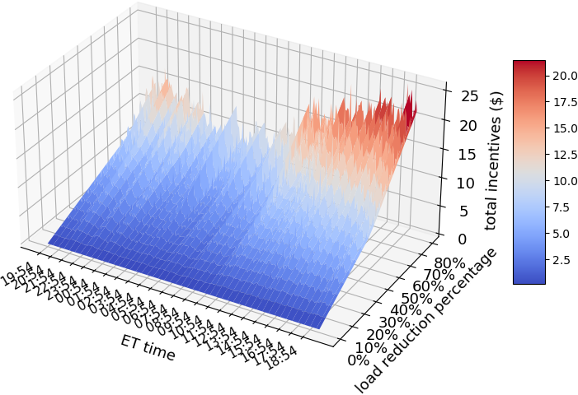
(c) 2022-07-20

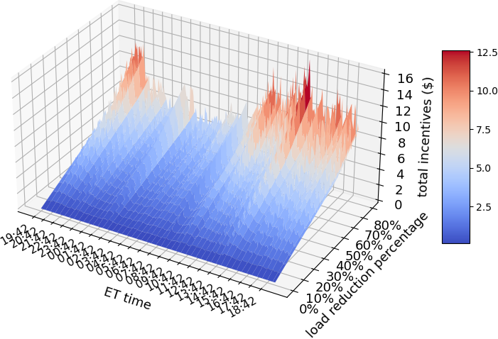
(d) 2022-10-11
Figure 3.14. 3D figures of the total minimum financial incentives to meet load reduction goals.
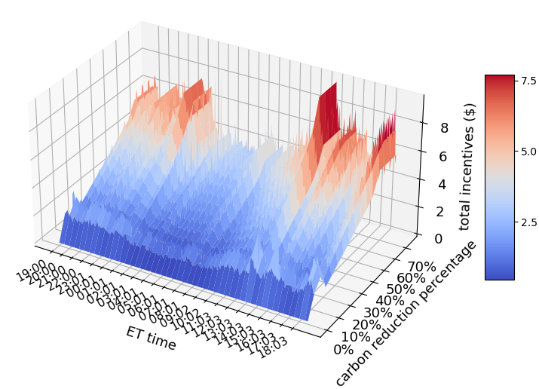
(a) 2022-01-01
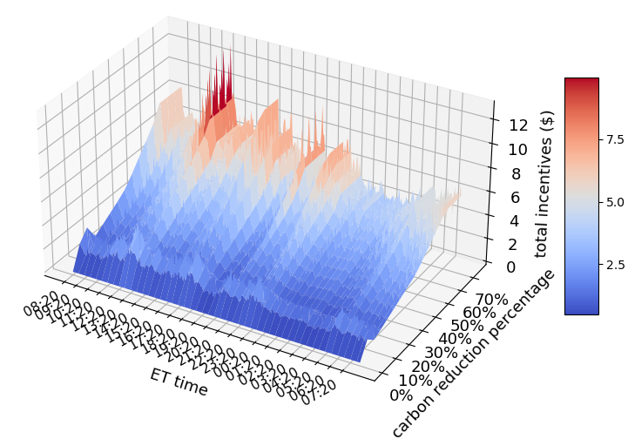
(b) 2022-04-02
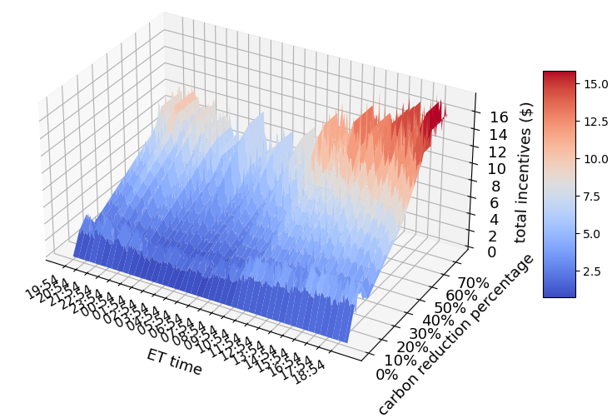
(c) 2022-07-20
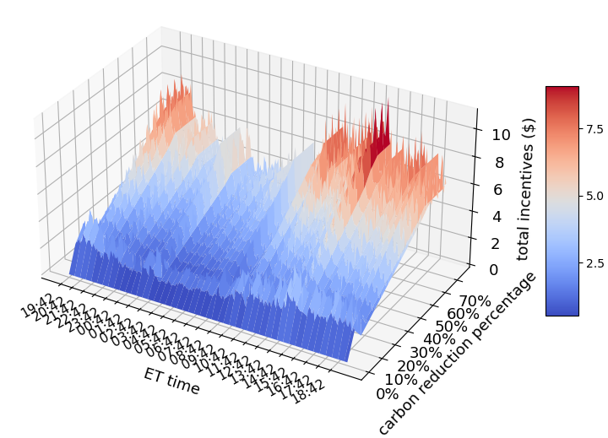
(d) 2022-10-11
Figure 3.15. 3D figures of the total minimum financial incentives to meet carbon reduction goals.

3.6 Conclusion
The I-DR programs attract users’ attention based on its benefits and voluntary participation to maintain user motivation for sustainable engagement with DR, which makes it useful for the utility company or load aggregator to support sustainable development of energy and environment. Based on this, an I-DR capacity assessment tool was developed to quantify the voluntary potential of residential energy flexibility and sustainability to respond to carbon reduction, as depicted entirely in Figure 3.16.

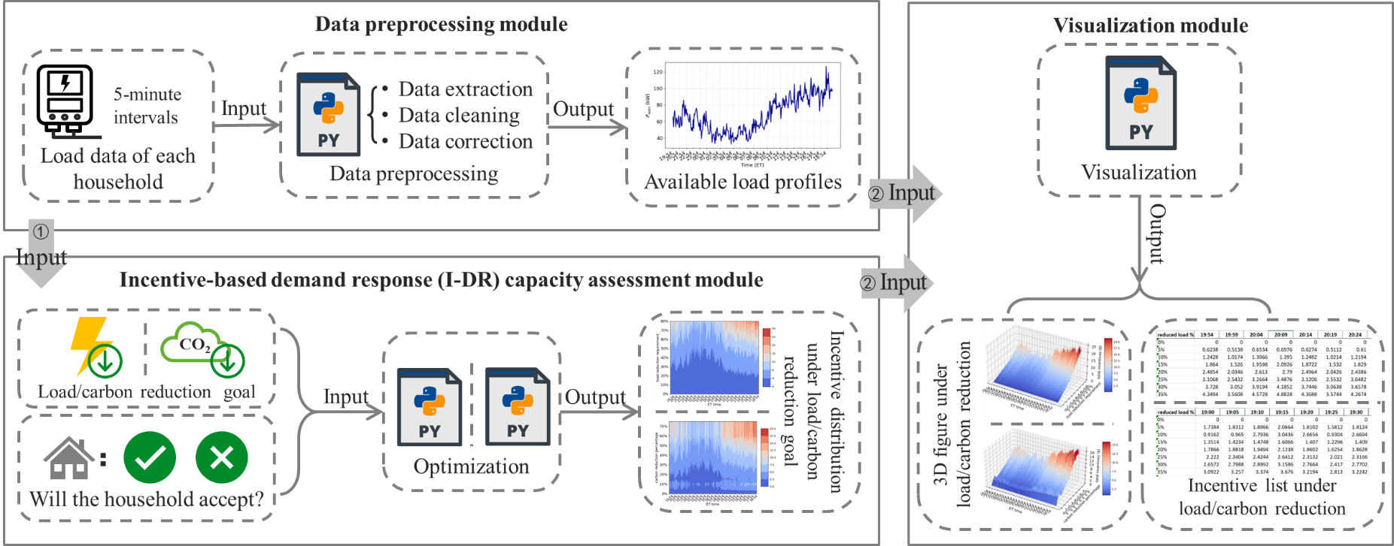
Figure 3.16. The whole step of the I-DR capacity assessment tool.

First, the data preprocessing module facilitates the adaptability of the tool to real-world data and scenarios, thereby ensuring its practical applicability. Then, the I-DR capacity assessment module empowers users with autonomy to decide their willingness to participate in load regulation and to articulate their energy consumption preferences during load regulation, which is critical in maintaining user motivation and participation in DR programs. Next, to make this assessment more promising, a load-reduction-oriented and a carbon-reduction-oriented assessment processes are sequentially conducted to support the study for energy and environmental sustainability. Finally, the utilization of 3D figures and incentive lists enhances the result presentation by providing a visual analysis and enabling a user-friendly view of the quantitative values of the reducible load or reducible carbon and the corresponding financial incentives.
This I-DR capacity assessment tool provides a precise evaluation approach of the potential for utilizing flexible load in the future, thereby enhancing the efficient allocation and management of energy resources, which then contributes to energy and environmental sustainability. Such residential capacities are helpful in advancing decarbonization and promoting energy sustainability. In addition, by quantifying the elasticity of residential energy consumption, this tool offers the utility company or load aggregator deeper insight into the regulation of their generation and load for better energy sustainability in the service territory.

AN ENERGY-AFFORDABILITY-BASED PEER-TO-PEER ENERGY TRADING MARKET FEATURED BY AFFORDABLE ENERGY AND FULLY DECENTRALIZATION

Abstract
An innovative P2P energy trading market is proposed in this chapter to feature energy-affordability-based dispatch and fully decentralization, aiming to facilitate affordable energy accessibility to low-income consumers and trustworthiness to the P2P market. Recently, there is a great need from government and power system operators to deliver affordable energy to alleviate the pressure of energy burden. P2P energy trading guarantees autonomy transactions, as well as energy affordability stresses affordable services, which is therefore essential to develop a fusion energy trading market with affordable energy access. First, fully decentralized P2P-based energy trading is designed, ensuring fully autonomous transactions among participants. Second, a dispatch featured by energy affordability is designed into the fully decentralized P2P-based energy trading, ensuring affordable energy access during transactions. Finally, the feasibility of this trustworthy energy trading market is demonstrated in the IEEE 33-bus and 123-bus systems. The proposed innovative energy trading fusion market can effectively enable affordable and autonomous energy access, which meets the needs of government and power system operators.

4.1 Introduction
With the growing needs of accessing affordable energy in recent years [15] and adopting self-regulated energy trading [16] across all segments of society, energy affordability and P2P energy trading are gaining prominence in power system research and practice. To be specific, P2P energy trading is attracting attention as its ability to provide participants with more autonomous transactions [17]. Energy affordability holds promise as its benefit of delivering participants more affordable energy access [18]. Accordingly, energy affordability and P2P energy trading can mutually benefit a more trustworthy trading environment. It is therefore worth exploring a fusion of energy affordability and P2P energy trading to satisfy the diverse needs of all society segments.
Energy affordability, in essence, advocates for a more reasonable energy distribution across all communities, with the goal of truly empowering low-income communities by ensuring affordable benefits and costs of accessing energy services. Nearly two-thirds of low-income households in the U.S. face significant challenges in accessing their basic energy demand via affordable energy [19]. Many existing energy policies often overlook energy affordability [15], leading to barriers for low-income consumers to access affordable electricity [20]. In response, government and power system operators focus on achieving energy affordability to alleviate high energy burden pressure. Several institutions have undertaken initiatives to promote more affordable energy for low-income communities [21]-[25]. A stochastic bi-level planning model is proposed in [18] to alleviate energy burden in a quantitative manner by sitting and sizing DG units in a distribution network. An optimization framework and three social indices are developed to implement by sitting renewable and storage [26]. Reference [15] proposes a multilayer framework to reflect a tradeoff considering energy burden alleviation during electricity market settlements. A quantitative measure on energy expenditure is built in [27] to ensure affordability among each income group. In [28], a bilevel optimization model is developed to find the optimal retail tariff design considering economic efficiency. Solutions based on energy storage are represented in [29] to alleviate energy burden via a storage analysis of energy access for three use-cases. In [30], a transactive power allocation mechanism is proposed to alleviate energy burden by allowing customers to trading based on preferences during the emergency. Reference [31] guides recommendations and metrics to design affordable energy in energy trading models.
P2P energy trading disrupts monopolistic trading mode by eliminating central supervision, thereby enabling participants autonomous energy transactions. With the increasing penetration of DERs, demand-side users gain more flexibility and initiative in energy trading [16]. For example, they can buy energy from DERs. However, the conventional centralized market, due to its centralized nature, inevitably often lacks transparency and autonomy in trading, which may damage the rights of participants. In contrast, P2P energy trading, with decentralized features similar to cryptocurrencies [32], empowers participants to trade energy on their own [33], which thereby fosters a trustworthy and protective trading environment on sensitive information to protect participants’ rights [17]. Owing to these obvious advantages, several pilot projects are in the field to demonstrate [34]-[38]. A decentralized transactive market based on P2P market is proposed in [39] to witness prosumer decision autonomy. There are economic and technological benefits across market entities arising from a proposed distributed P2P day-ahead trading method [40]. In [41], energy can be sold in a secure P2P manner is verified. P2P energy trading is possible through a fully decentralized market clearing mechanism [42]-[44].
P2P energy trading can support energy affordability because it provides more transaction autonomy for participants. Energy affordability, because it facilitates affordable energy to the vulnerable, incentivizes low-income vulnerable communities to participate in energy trading, which can also support the development of P2P energy trading. As such, the fusion of energy affordability and P2P energy trading can not only dispel concern from low-income consumers to access high-priced energy but also promote sustainable interaction in the energy trading. Although [45] considers a shareholding-based DER sharing allocation mechanism within a P2P platform to achieve more reasonable energy utilization, there is currently no discussion about complete market design featured by energy affordability compatible with P2P energy trading. The novelty in this chapter is to propose a fusion market including the features of energy affordability and P2P energy trading to globally implement affordable energy access to consumers through a fully decentralized energy trading market. Accordingly, the proposed fusion market enjoys the full decentralization from P2P energy trading and consumer affordable economics from energy affordability for the most effective performance.
This chapter proposes an innovative energy trading fusion market with a fully decentralized P2P-based energy trading into an energy-affordability-based layered dispatch structure, which has great benefits of accessing affordable energy to low-income consumers for their basic demand within a more autonomous and trustworthy trading environment. The main contributions of this chapter include:
1) An innovative energy trading fusion market is developed in the distribution network, which features affordable energy access and fully decentralized P2P-based energy trading. Accordingly, the final market equilibrium from this fusion market can achieve energy affordability for low-income consumers.
2) A two-layer energy-affordability-based dispatch structure is proposed, based on which the total demand of users is layered into priority load and non-priority load to settle. This settlement process ensures low-income consumers have a chance to access low-price affordable electricity, rather than being processed together with high-income consumers to result in high electricity bills.
3) The proposed energy trading fusion market achieves the benefits from both energy affordability and P2P energy trading. A considerable reduction in the electricity bill is achieved to low-income consumers using more affordable energy to meet their basic demand. Also, individual data privacy during transactions is highly protected. As such, this research can serve as a foundation for future research on designing the energy trading market compatible with energy affordability.
The rest of this chapter is organized as follows. Section 4.2 gives an overview of proposing this innovative energy trading fusion market. The fully decentralized P2P-based energy trading is introduced in Section 4.3. The energy-affordability-based layered dispatch structure is described in Section 4.4. In Section 4.5, the feasibility and advantages of this innovative energy trading fusion market are demonstrated via the IEEE 33-bus and 123-bus systems. Finally, Section 4.6 concludes the whole paper.

4.2 Research Problem and Solution
To clearly illustrate the motivation of this paper, Figure 4.1 lists the characteristics of compatible energy affordability under decentralized and centralized energy trading.
When it comes to integrating energy affordability into the traditional centralized energy trading market, concerns about whether truly achieving energy affordability are easily brought. Due to central supervision in centralized energy trading, the negotiation process of trading is a black box to participants. As a result, participants cannot learn sufficient information about global bids and offers, which leads to concern from participants about whether achieving true energy affordability. Additionally, the implementation of energy affordability targets various income communities, so participants need to disclose their income to central supervision first and then to enjoy energy affordability strategies. Such an untrustworthy environment inevitably compromises user privacy and further makes it difficult to encourage participation and sustainable development.
To create a trustworthy energy affordability implementation during transactions, this chapter proposes an innovative energy trading fusion market which adopts a fully decentralized P2P-based energy trading embedding a layered dispatch structure featured by energy affordability.
The fully decentralized P2P-based energy trading in this chapter focuses on the distribution network because low-income consumers, as the major target of energy affordability, are on the distribution network side.
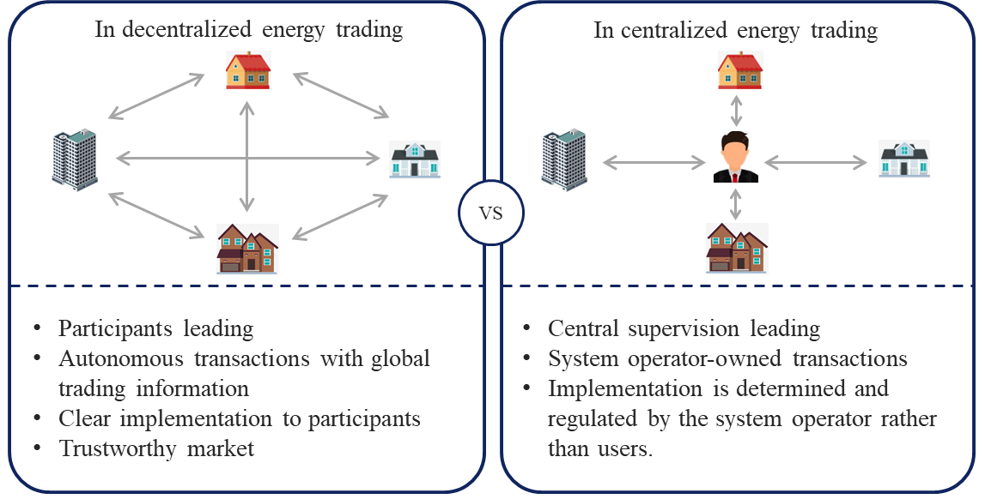
Figure 4.1. The comparison of implementing energy affordability in P2P energy trading mode and centralized energy trading mode.

To ensure accessibility to an autonomous and consensus trading environment, P2P energy trading is mainly employed in this innovative energy trading fusion market. Then, there are no central supervisors or agents during negotiation and pricing process. All participants are considered equal peers and autonomously engage in energy trading with each other.
To fulfil energy affordability, a two-layer dispatch structure is designed to facilitate affordable energy to low-income consumers during transactions. Although it seems that only low-income consumers are concentrated on, high-income communities can also benefit from this design. A reliable trading environment can benefit all communities [15]. Through this design, low-income consumers have access to affordable energy to meet their basic demand, such that more of their income can be spent on other needs, thereby improving the quality of their life. As a result, economic consumption in society is promoted, and society instability caused by income inequality is effectively reduced. Over time, a more stable and economically dynamic society is fostered which can benefit high-income communities with a more friendly social-economic environment. The details are discussed in Section 4.4.
To sum up, the advantages of the proposed energy trading fusion market comprise:
1) An innovative energy trading fusion market is developed for participants to access affordable energy within a more autonomous and fully decentralized trading environment.
2) The fully decentralized trading mode of this fusion market enables each trading decision under global information without disclosing any private information (e.g., income and identification data), thus ensuring true energy affordability under a global concept.
3) The multi-layer structure of this fusion market divides the entire trading demand, so as to improve market efficiency and enhance grid stability, reliability, and flexibility.

4.3 Fully Decentralized P2P-based Energy Trading
To perform energy affordability in a trustworthy energy trading environment, one direct and effective way is to provide an energy trading market with autonomous decision-making process, such as P2P energy trading. As such, P2P-based energy trading with full decentralization is designed for compatible with energy affordability.

4.3.1 Model of Fully Decentralized P2P-based Energy Trading
Given that not every participant is willing to be involved in P2P energy trading in a short time, another trading manner, i.e., trading with utility directly, is also considered in this model. Accordingly, participants can swiftly and flexibly choose the trading modes they want. Therefore, each participant can enjoy two trading modes: direct trading with utility and trading with other peers by P2P mode, as illustrated in Figure 4.2.
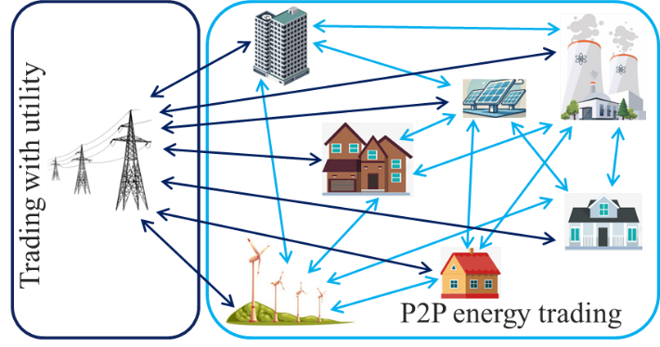
Figure 4.2. The trading modes in the fully decentralized P2P-based energy trading.

Social welfare is introduced to maximize the benefits of all participants during energy transactions [46], as shown in (4.1). Both buyer surplus and seller profit need to be optimized to maximize the social welfare. To achieve this objective, the difference on the buyer side between utility function $U_{b}\left(p_{b_{i}}^{sum}\right)$ and expense paid to the utility $c_{b}p_{b_{i}e}^{u}$ should be maximized, as well as the difference on the seller side between cost function $C_{s}\left(p_{s_{j}}^{sum}\right)$ and revenue obtained from the utility $c_{s}p_{s_{j}e}^{u}$ should be maximized.
(4.1)
where i is the indices of buyers in the system, and j is the indices of sellers in the system. B is the set of buyers, and S is the set of sellers. Meanwhile, c_{b} is the purchasing price from utility ($/MWh), and c_{s} is selling price to utility ($/MWh).
For any involved buyers and sellers, their total trading power includes the power traded with the utility and the power traded with other peers via P2P manner, as expressed by (4.2) for buyers and (4.3) for sellers.
(4.2)
(4.3)
where $p_{b_{i}}^{sum}$ denotes the total power from buyer i, including the power traded from seller j via P2P mode $p_{b_{i}s_{j}}^{P2P}$ and the power bought from utility $p_{b_{i}}^{u}$ (kW), and $p_{s_{j}}^{sum}$ denotes the total power from seller j, including the power traded to buyer i via P2P mode $p_{s_{j}b_{i}}^{P2P}$ and the power sold to utility $p_{s_{j}}^{u}$ (kW).
Each involved buyer and seller should have power limits, such that the boundary of trading amount for each one is specified by (4.4) for buyers and (4.5) for sellers, respectively. In addition, power purchased by buyers is defined as positive, whereas power sold by sellers is defined as negative.
(4.4)
(4.5)
where $P_{b_{i}}^{sum-min}$ and $P_{b_{i}}^{sum-max}$ is the minimum and maximum purchasing power of buyer i respectively (kW), and $P_{s_{j}}^{sum-min}$ and $P_{s_{j}}^{sum-max}$ is the minimum and maximum selling power of seller j (kW).
Since P2P energy trading is a bilateral transaction [47], any absolute amount of energy traded from buyer i to seller j is equal to the absolute amount of energy traded from seller j to buyer i, as represented by clearing constraint (4.6).
(4.6)

4.3.2 Fully Decentralized ADMM Algorithm
As a decentralized trading mode, the fully decentralized P2P-based energy trading requires a decentralized algorithm to settle the P2P trading process. The alternating direction method of multipliers (ADMM) algorithm, as a decentralized algorithm [48], is typically and widely adopted to settle P2P transactions [49]-[51]. However, the standard ADMM algorithm often requires a central supervisor to bidirectionally share information for updating variables with the peers [52], easily leading to concerns of low data privacy and high communication intensity. In this context, a promising ADMM variant named fully decentralized ADMM algorithm can operate without a central supervisor [43], [53], which is used in this chapter to settle the trading process for this proposed energy trading fusion market.
Eqs. (4.7) and (4.8) serve as an example of a generic primal optimization model to introduce the fully decentralized ADMM algorithm.
(4.7)
(4.8)
where Obj_{n} denotes the objective function (convex function) of local section n and c_{n} is the coefficient of x_{n}.
The core of this algorithm lies in decomposing the primal optimization model into multiple local optimization models and subsequently optimizing these local models in parallel. To perform this core, the variables, constraints, and objective function of the primal model are decoupled into local models. As such, global variables are generated to make sure that the same local variables decoupled in different local models are equal. The detailed decomposition steps are introduced as follows.
1) First, the augmented Lagrangian function of (4.7) and (4.8) is shown in (4.9).
(4.9)
where l_{n} represents the local variables in local model n, g_{n} represents the global variables in local model n, and λ_{n} represents the Lagrangian multipliers in local model n. ρ is the penalty parameter.
It is noted that some variables need to be duplicated for the decomposition into local models to be local variables. Then, global variables are generated to enable duplication. To acquire optimal solutions, the variables are iteratively updated until satisfying the criteria.
2) Second, the local variables l_{n} are updated via (4.10).
(4.10)
s.t. (4.2)-(4.6)
3) Third, the global variables g_{n} are updated by (4.11).
(4.11)
4) Fourth, the Lagrangian multipliers λ_{n} are updated via (4.12).
(4.12)
5) Finally, after iterating through (4.10)-(4.12), the final optimal results are obtained until (4.13) and (4.14) are satisfied.
(4.13)
(4.14)
where ε^{pri} is the primal residual, and ε^{dual} is the dual residual.
In addition to the decomposition, the algorithm embodies decentralization through optimizing in a decentralized communication process as well. To clearly illustrate its decentralization, the detailed clearing process of the designed fully decentralized P2P-based energy trading is provided.

4.3.3 Formulation of Fully Decentralized P2P-based Energy Trading
The designed fully decentralized P2P-based energy trading is performed via fully decentralized ADMM. For clarity, Eqs. (4.1)-(4.6) with N buyers and M sellers is employed in the following.
Following the trading rules, participants can individually determine their own transactions initially. Their transactions need to be settled simultaneously because the final settle-down contracts involve all transactions. To this end, each participant is regarded as an individual local model, which means that the primal trading model in (4.1)-(4.6) needs to be decoupled into N+M local models. Except for (4.6), the constraints in (4.1)-(4.6) can be decoupled naturally. However, the variables in (4.6) are involved in both local and external models, making it difficult to be decoupled directly and naturally into individual models. In this context, the variables from the external model need to be duplicated for local utilization, which are called local variables. In addition, global variables are introduced to ensure that the duplicated variables can maintain the same value as the primal variables from the external model. In general, local variables are the variables used in common between buyers and sellers, e.g., traded energy, based on which global variables are produced. The trading model optimizes iteratively until the stopping criteria of (4.13) and (4.14) are satisfied. Then, the clearing process of the fully decentralized P2P energy trading is implemented by the following steps.
Step 1: Each local model updates its local variables.
The local models optimize their local variables in parallel. The detailed process is depicted from the perspective of buyer i and seller j respectively.
1) Local model of buyer i:
(4.15)
(4.16)
(4.17)
(4.18)
where its local variable l_{i}, global variable g_{i}, and Lagrangian multiplier λ_{i} are:
(4.19)
As mentioned, local variables are the variables that need to be used in a local and an external model. Here, the local variables are the traded energy between buyer i and seller j in a P2P manner. More specifically, $p_{s_{j}b_{i}}^{P2P}$ is the variable of seller j’ local model that is also needed in the local model of buyer i. Therefore, $p_{s_{j}b_{i}}^{P2P}$ is duplicated to the local model of buyer i as $p_{s_{j}b_{i}}^{P2P, S_{i}}$ to be the local variable for the local model of buyer i.
2) Local model of seller j:
(4.20)
(4.21)
(4.22)
(4.23)
where its local variable l_{j+N}, global variables g_{j+N}, and Lagrangian multipliers λ_{j+N} are:
(4.24)
Similarly, $p_{b_{i}s_{j}}^{P2P}$ is the variable of buyer i’ local model that is also needed in the local model of seller j. Therefore, $p_{b_{i}s_{j}}^{P2P}$ is duplicated to the local model of seller j as $p_{b_{i}s_{j}}^{P2P, S_{j+N}}$ to be the local variable for the local model of seller j.
Step 2: Return the updated local variables to their initial models.
As mentioned previously, the local variables are duplicated from the external model for local use. This external model is the initial model of the local variables being duplicated. Thus, the elaborate process of sending back the updated local variables $l_{n}^{\left(τ+1\right)}$ to its initial local models is shown as follows:
The updated local variable $p_{s_{j}b_{i}}^{P2P, S_{i}\left(τ+1\right)}$ used in the local model of buyer i is sent to its initial model, i.e., the local model of seller j.
Step 3: Each local model updates its global variables.
As mentioned, global variables are auxiliary variables to each local model to enable the duplicated variables the same as the primal variables before it was duplicated. Then, each local model individually and locally updates the global variables using (4.25)-(4.26).
1) Local model of buyer i:
(4.25)
2) Local model of seller j:
(4.26)
Step 4: All models collect their updated global variables.
The updated global variables are used for updating Lagrangian multipliers in preparation for the next iteration. The process of sending the updated global variables $g_{n}^{\left(τ+1\right)}$ to the corresponding local model is shown as follows:
The updated global variable $p_{b_{i}s_{j}}^{P2P, glob\left(τ+1\right)}$ which is calculated in the local model of buyer i is sent to the local model of seller j.
The updated global variable $p_{s_{j}b_{i}}^{P2P, glob\left(τ+1\right)}$ which is calculated in the local model of seller j is sent to the local model of buyer i.
Step 5: Each local model updates its Lagrangian multipliers.
Each local model updates the Lagrangian multiplier by (4.27)-(4.28) to prepare for the next iteration.
1) Local model of buyer i:
(4.27)
2) Local model of seller j:
(4.28)
To clearly illustrate the full decentralization, such a process is also visualized in Figure 4.3. There is no central supervisor involved throughout the clearing process. All variables are optimized in their respective local models to achieve the global objective. Therefore, it is termed fully decentralized energy trading, by which more autonomous and trustworthy transactions can be guaranteed consequently. In addition, higher data privacy protection for participants is achieved without interactions to central supervisor.

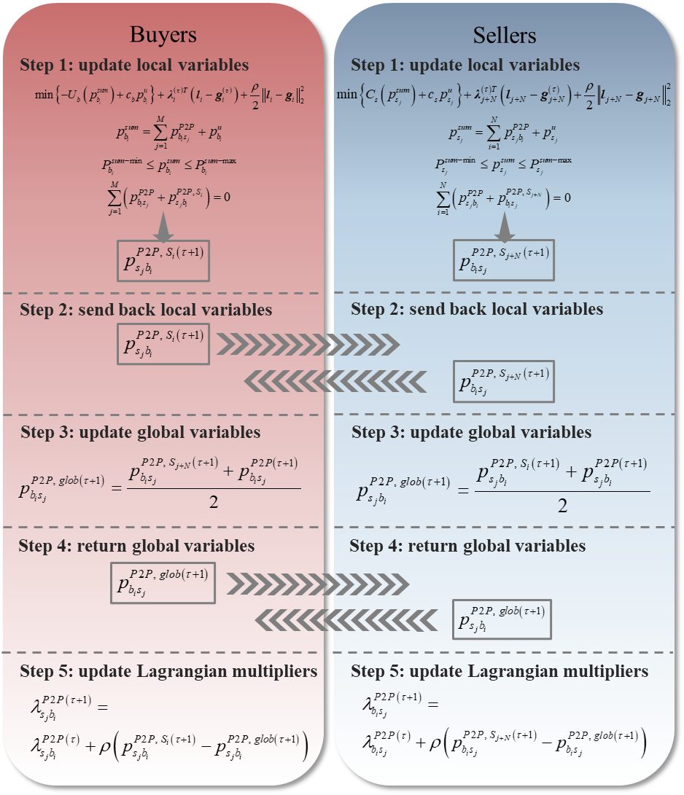
Figure 4.3. The clearing process of the designed fully decentralized P2P-based energy trading in τ^{th} iteration.

4.4 Energy-affordability-based Layered Dispatch
In response to energy affordability policies, greater attention is being paid to ensuring low-income consumers access more affordable energy utilization. To achieve this goal, the focus encompasses both adopting autonomous P2P energy trading and integrating the idea of energy affordability during energy trading. In addition to the designed fully decentralized P2P-based energy trading in Section 4.3, a layered dispatch structure featured by energy affordability is designed to be an additional promising support for the proposed energy trading fusion market compatible with energy affordability

4.4.1 Structure of Energy-affordability-based Layered Dispatch
To facilitate affordable energy to low-income consumers in the proposed innovative energy trading fusion market, a hierarchical and phased dispatch is designed into the previous fully decentralized P2P-based energy trading. Overall, more affordable energy accessibility is achieved by clearing energy transactions layer by layer with the following details.
In the proposed energy-affordability-based layered dispatch, the demand of all consumers is gradually met by priority load and non-priority load in a two-layer dispatch structure. Specifically, the priority load is used to prioritize the basic demand of users (e.g., lighting, refrigeration, and HVAC load amount for each household w.r.t. its size). The non-priority load corresponds to more advanced luxury demand which is the load amount beyond the basic demand. Then, these two types of loads will be cleared sequentially in a two-layer structure.
The first layer is for clearing priority load. In the first layer, only the priority load is allowed to trade to each buyer. That is, the first layer undertakes the basic demand of all buyers. To this end, all buyers trade for their priority load p_{prio} via the designed fully decentralized P2P-based energy trading under the operation shown in (4.29)-(4.35).
(4.29)
(4.30)
(4.31)
(4.32)
(4.33)
(4.34)
(4.35)
Then, the second layer is for clearing non-priority load. After clearing the portion of basic demand, buyers and sellers enter the second layer to settle the demand for their advanced luxury electricity activities. Therefore, the remaining buyer demand and the remaining seller generation are indicated by (4.36)-(4.37) first in the second layer. Then, the trading equilibrium is reached via the designed fully decentralized P2P-based energy trading under the operation of (4.38)-(4.43).
(4.36)
(4.37)
(4.38)
(4.39)
(4.40)
(4.41)
(4.42)
(4.43)
Overall, consumers have access to more affordable energy during more autonomous energy trading through embedding fully decentralized P2P-based energy trading into an energy-affordability-based layered dispatch structure. Figure 4.4 provides a global visualization of this proposed innovative energy trading fusion market featured by full decentralization and energy affordability.
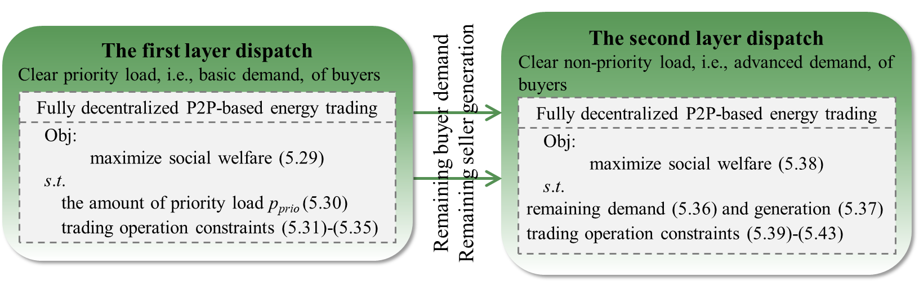
Figure 4.4. The framework of the innovative energy trading fusion market.

If there is no such innovative energy trading fusion market, the total demand of all buyers will be aggregated to be cleared uniformly. Then, this will make it difficult for low-income consumers to access affordable energy, because their market share in clearing is lower compared to consumers of other income levels. However, low-income consumers easily access affordable energy by trading in this innovative energy trading fusion market. Each buyer’s demand is categorized into priority load, i.e., basic demand, to be cleared in the first layer and non-priority load, i.e., advanced demand, to be cleared in the second layer. Therefore, only the basic demand of buyers is aggregated and cleared at first, which strongly grows the market share of low-income buyers at that time. A higher market share to low-income consumers during trading means a greater possibility of accessing affordable energy, accordingly resulting in lower electricity bills. As such, the energy burden of low-income consumers can be effectively alleviated by using affordable energy to meet basic demand, which is clearly demonstrated in the case study in Section 3.5.

4.4.2 Implementation of Energy-affordability-based Layered Dispatch
To enable affordable energy accessibility, a fully decentralized P2P-based energy trading is designed into an energy-affordability-based layered dispatch structure. In this innovative energy trading fusion market, buyers clear their demand hierarchically via the designed fully decentralized P2P-based energy trading, so that the affordable energy is enabled to consumers via a more self-regulated energy trading market. Additionally, the amount of priority load can be flexibly set, making it easy to control the degree of accessibility.
To sum up, the entire process of fulfilling the proposed energy trading fusion market is summarized as follows:
Algorithm: The energy trading fusion market featured by full decentralization and energy affordability.
Layer 1: All buyers clear the priority load.
Set the amount of priority load p_{prio} in preparation for energy trading process in (4.29)-(4.35).
Set penalty parameter ρ, primal residual ε^{pri}, and dual residual ε^{dual}.
Initialize the iteration index τ = 0, the global variables g_{i}^{(τ)} = 0 and g_{j+N}^{(τ)} = 0, and Lagrangian multipliers λ_{i}^{(τ)} = 0 and λ_{j+N}^{(τ)} = 0.
Update the iteration index: τ = τ +1.
Check if (4.13) and (4.14) are satisfied. If yes, stop iteration. If not, do then:
Update the local variables l_{i}^{(τ)} and l_{j+N}^{(τ)} in each local model in parallel by (4.15)-(4.19) and (4.20)-(4.24).
Return the updated local variables l_{i}^{(τ+1)} and l_{j+N}^{(τ+1)} to their initial models.
Update the global variables g_{i}^{(τ)} and g_{j+N}^{(τ)} in each corresponding local model by (4.25) and (4.26).
Collect the updated global variables g_{i}^{(τ+1)} and g_{j+N}^{(τ+1)} of each local model.
Update the Lagrangian multipliers λ_{i}^{(τ)} and λ_{j+N}^{(τ)} of each local model by (4.27) and (4.28).
Layer 2: The buyers clear the non-priority load.
Receive the amount of the remaining buyer demand and seller generation supply by (4.36)-(4.37) in preparation for energy trading process in (4.38)-(4.43).
The same clearing process used in Layer 1 to optimize(4.29)-(4.35).
The way to achieving affordable energy access through the proposed energy trading fusion market differs from directly enforcing low-priced energy for low-income consumers. Low-income consumers still need to participate in energy trading to access affordable energy, so they won’t stay away from the trading market and society. Moreover, with decreasing energy burden, low-income consumers can spend more money on other needs, which then will improve their life quality. Thus, social instability caused by income inequality will be reduced. Eventually, a more friendly society can be built.
In summary, this innovative energy trading fusion market not only enables affordable energy accessibility to consumers but also creates an autonomous energy trading environment for participants. Therefore, this fusion market provides better life to low-income consumers, further achieving positive impacts to the whole society.

4.5 Case Study
To fully demonstrate the benefits of the proposed energy trading fusion market, the IEEE 33-bus system is first used to conduct a detailed analysis. Then, the IEEE 123-bus system is employed to demonstrate the effectiveness of this energy trading fusion market for larger-scale systems.

4.5.1 Feasibility Analysis
Figure 4.5 shows the topology of the IEEE 33-bus system with seven buyers of different income levels and three sellers with different energy prices. The detailed parameters for these buyers and sellers are listed in Table 4.1 and Table 4.2.
Typically, low-income consumers have low total demand because they lack extra money to pay for advanced luxury-level energy consumption. Their income is usually used for basic demand. In contrast, high-income consumers usually can enjoy basic and advanced energy consumption due to high income.
If the proposed energy trading fusion market is not adopted, the demand and generation of all participants need to be cleared together at the same time. Table 4.3 lists the clearing results of the case without the energy trading fusion market.
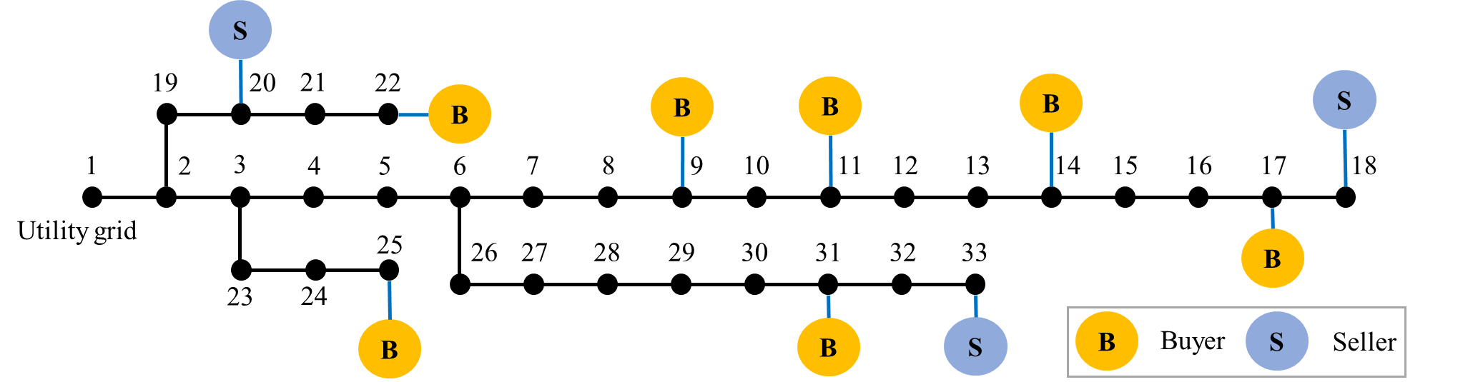
Figure 4.5. The topology of the IEEE 33-bus system with seven buyers and three sellers.

Table 4.1. Profile of buyers in the IEEE 33-bus system.
Buyers | P_{load} /kW | Role
Buyer 1 | 10 | Low-income
Buyer 2 | 10 | Low-income
Buyer 3 | 15 | Low-income
Buyer 4 | 35 | Intermediate
Buyer 5 | 40 | High-income
Buyer 6 | 50 | High-income
Buyer 7 | 40 | High-income
Table 4.2. Profile of sellers in the IEEE 33-bus system.
Sellers | P_{gen-min} /kW | P_{gen-max} /kW | Role
Seller 1 | 0 | 70 | Low-price
Seller 2 | 0 | 70 | Mid-price
Seller 3 | 0 | 80 | High-price
Table 4.3. The clearing results of the case without the energy trading market.
p_{buy} /kW | Seller 1 | Seller 2 | Seller 3 | Payment/$
Buyer 1 | 2.66 | 2.58 | 4.76 | 199.58
Buyer 2 | 2.66 | 2.58 | 4.76 | 199.58
Buyer 3 | 3.76 | 2.87 | 8.37 | 305.06
Buyer 4 | 10.57 | 13.84 | 10.58 | 669.73
Buyer 5 | 14.72 | 15.07 | 10.21 | 737.1
Buyer 6 | 20.91 | 17.97 | 11.12 | 894.84
Buyer 7 | 14.72 | 15.07 | 10.21 | 737.1

As mentioned previously, the priority load is used to cover basic demand of consumers. Given that low-income consumers mainly have basic demand, the priority load is first set to 10kW to test the performance of the proposed energy trading fusion market. Table 4.4 lists the clearing results of the case with the energy trading fusion market.
In addition to the clearing results, the payment of each buyer and the revenue of sellers settled with and without the proposed energy trading fusion market are also compared in Figure 4.6.
It is evident that the low-income buyers, i.e., Buyers 1, 2, and 3, enjoy a significant reduction in the payment for their energy demand. That is, the proposed energy trading fusion market effectively alleviates the energy burden on low-income consumers. Although the payments of low-income consumers decrease, the sellers still receive the similar revenue when the priority load is 10kW, which indicates that this energy trading fusion market can benefit the low-income consumers without compromising the interests of the sellers in some cases.
Such results can also be explained theoretically. When all buyers’ demand is cleared together, the market share of low-income buyers is naturally small. Facing the limited amount of low-priced energy, it is difficult for low-income buyers to be allocated a large amount of low-priced energy. However, each buyer initially settles only 10kW rather than its total demand via this proposed energy trading fusion market. The market share of low-income buyers rises when clearing transactions, which makes it more likely that low-income buyers have access to more low-priced energy.

Table 4.4. The clearing results of the case with the energy trading market.
 | p_{buy} /kW | Seller 1 | Seller 2 | Seller 3
Layer 1 | Buyer 1 | 10 | × | ×
Layer 1 | Buyer 2 | 10 | × | ×
Layer 1 | Buyer 3 | 10 | × | ×
Layer 1 | Buyer 4 | 10 | × | ×
Layer 1 | Buyer 5 | 10 | × | ×
Layer 1 | Buyer 6 | 10 | × | ×
Layer 1 | Buyer 7 | 10 | × | ×
Layer 2 | Buyer 1 | × | × | ×
Layer 2 | Buyer 2 | × | × | ×
Layer 2 | Buyer 3 | × | 1.95 | 3.05
Layer 2 | Buyer 4 | × | 12.6 | 12.4
Layer 2 | Buyer 5 | × | 16.31 | 13.69
Layer 2 | Buyer 6 | × | 22.82 | 17.18
Layer 2 | Buyer 7 | × | 16.31 | 13.69
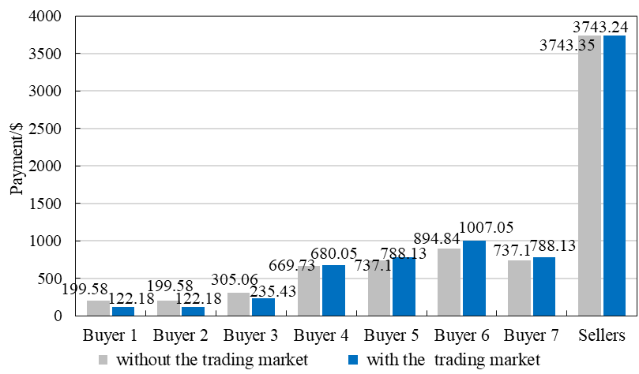
Figure 4.6. Comparison of each buyer’s payment and sellers’ revenue between with and without the proposed energy trading fusion market.

With access to affordable energy, the energy burden of low-income consumers is alleviated, leading to a better life and more favorable social environment. As a result, consumers of other income levels also benefit. Consequently, it is worthwhile settling energy consumption through this proposed innovative energy trading fusion market.

4.5.2 Advantage Analysis
In addition to feasibility analysis, how much advantage the proposed energy trading fusion market can bring is also demonstrated based on the previous IEEE 33-bus system. In this way, the priority load for the IEEE 33-bus system ranges from 0 to 20kW in the following. However, the priority load of the low-income buyers, i.e., Buyers 1, 2, and 3, ranges from 0 to their total demand, i.e., 10kW, 10kW, and 15kW, respectively. It makes no sense that priority load exceeds any buyer’s total demand. When the value of priority load is less than 10kW, each buyer trades based on that value at first through the proposed energy trading fusion market. When this value exceeds 10kW but is less than 15kW, other buyers except Buyers 1 and 2 first trade based on this value. Buyers 1 and 2 can only trade 10kW in the first layer. When this value is 15kW to 20kW, the buyers except Buyers 1, 2, and 3 follow this value to trade in the first layer, while Buyers 1, 2, and 3 follow their total demand to trade.
Under each value of the priority load, the payments of each buyer are collected to calculate the change percentage, η%, based on the case without the proposed energy trading fusion market by (4.44).
(4.44)
where x’ and x denotes each buyer payment under the cases with and without the energy trading fusion market, respectively. Figure 4.7 presents the change percentage η% of the buyers’ payments based on testing on the IEEE 33-bus system.
In Figure 4.7, all low-income buyers, i.e., Buyers 1, 2, and 3, enjoy lower payments to meet their total demand through this innovative energy trading fusion market. Buyers 1 and 2 enjoy the lowest payment when the priority load is 10kW. Also, the lowest payment of Buyer 3 occurs when the priority load is 15kW. Thus, when low-income buyers prioritize all their demand in the first layer, they enjoy the greatest market dominance and are most likely to get more low-priced energy to achieve the lowest payments. With the value of the priority load increasing to 15kW, both Buyer 1 and Buyer 2 can only settle 10kW in the first layer, while other buyers can still enjoy 15kW priority load. This lowers the market share of Buyer 1 and Buyer 2, leading to an increase in their payments and a decrease in other buyers’ payments. All in all, the payment of low-income buyers to meet their demand is effectively lowered. Hence, this innovative energy trading fusion market facilities affordable energy to low-income consumers, further effectively alleviating the energy burden of low-income consumers.
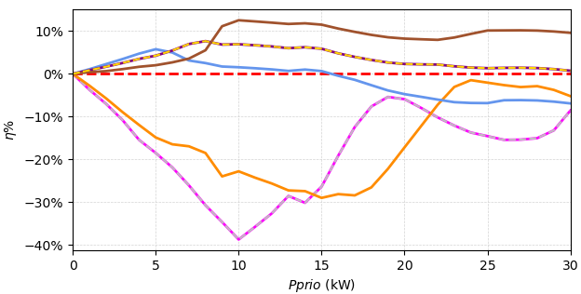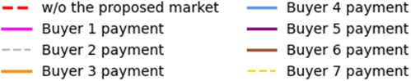
Figure 4.7. The change percentage of each buyer’s payment under different test cases.

4.5.3 Numerical Results of the IEEE 123-bus System
In addition to the above validation, the effectiveness analysis of the proposed energy trading fusion market is extended into a larger system. A case based on the IEEE 123-bus system is established with the topology shown in Figure 4.8, where Buyer 1 to Buyer 10 are low-income buyers, and Buyer 16 to Buyer 25 are high-income buyers.
The priority load still ranges from 0 to 20kW. Also, the maximum priority load of the low-income buyers still is equal to their total demand. After testing under each priority load, the payments of each buyer are collected to calculate the change percentage η% by (4.44). Figure 4.9 shows the change percentage of the payments for each buyer.
Even in a larger system, all low-income buyers, i.e., Buyer 1 to Buyer 10, exhibit lower payments for their total demand via this innovative energy trading fusion market. Also, the lowest payments for these low-income buyers occur when the priority load is equal to their total demand. Undoubtedly, the proposed market model works effectively in the larger system. This innovative energy trading fusion market which embeds fully decentralized P2P-based energy trading into energy-affordability-based layered dispatch ensures lower energy payments to low-income consumers without undermining their demand. Accordingly, this innovative energy trading fusion market further effectively alleviates the energy burden of low-income consumers.

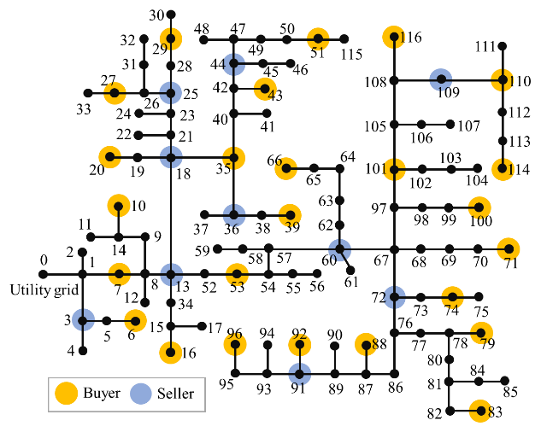
Figure 4.8. The topology of the IEEE 123-bus system.
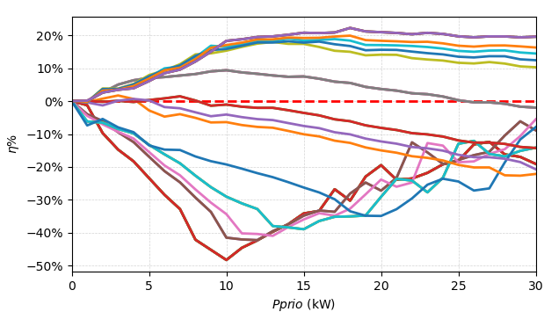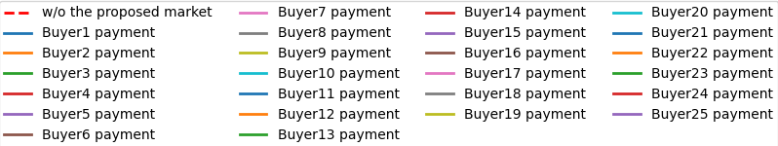
Figure 4.9. The change percentage of payments under different test cases.

4.6 Conclusion
As the voice for accessing affordable energy grows, how to be compatible with energy affordability in practice has recently become a hot topic. The most usual idea is to directly fund low-income communities to achieve energy affordability, however, which is neither sustainable nor justified. Based on this, this chapter proposes an innovative energy trading fusion market to achieve energy affordability during energy trading.
In the proposed model, fully decentralized P2P-based energy trading is designed first to support the autonomous and self-regulated energy trading to participants, which therefore enables users to have full control over their transaction decisions. Then, an energy-affordability-based layered dispatch is designed to ensure affordable energy accessibility to consumers. Finally, the fusion is proposed to foster an energy trading market to facilitate trustworthy access of affordable energy during energy transactions, which effectively achieves sustainable energy affordability for energy trading.
The feasibility and advantages of this proposed innovative energy trading fusion market are demonstrated in detail via the IEEE 33-bus system. Further, the IEEE 123-bus system is adopted to validate the effectiveness in a larger system. As a result, the payments of low-income buyers for their demand are significantly reduced via the proposed energy trading fusion market.
Low-income consumers can access affordable energy through energy trading, which enables them to enjoy low energy bills and particularly alleviates their energy burden. As a result, low-income consumers can enjoy a better life, so that the social instability caused by them can be effectively reduced. Then, all segments in society will benefit in a more favorable and stable society.
In conclusion, the proposed innovative energy trading fusion market features energy affordability and full decentralization, which effectively achieves the goal of facilitating energy affordability in practice and alleviating the energy burden on low-income consumers while benefiting the whole society.

DEVELOPMENT OF A GRID-LEVEL BENEFIT ASSESSMENT TOOL FOR THE DEPLOYMENT OF AIR-SOURCE HEAT PUMP INTEGRATED WITH THERMAL ENERGY STORAGE

Abstract
In this research work, a grid-level benefit assessment tool is developed to evaluate the benefits of deploying ASHP-TES system in Texas power grid. Without a suitable monitoring system, it is difficult to directly acquire the grid-level benefits of TES deployment at the SFHs level. The grid-level benefits are meaningful because it can provide insights to utility companies for whether to deploy an ASHP-TES system. It is therefore crucial to figure out the grid-level benefits of deploying TES. This chapter introduces the development of a grid-level benefit assessment tool, including a data module to provide the operational periods of TES through identifying peak hours of winter, summer, and shoulder months, a grid-level benefit assessment module to simulate the ASHP-TES system in the Texas 2k-bus synthetic system, and a visualization module to show the benefits onto a geographic representation. Built on the Texas 2k-bus synthetic system, the proposed grid-level benefit assessment tool can effectively evaluate the grid-level benefits of the deployment of ASHP-TES system.

5.1 Introduction
With the development of thermal energy technology in power systems, ASHP integrated with TES gradually attracts attention to utility companies. TES can effectively allocate energy under more reasonable timeline through grasping the operational windows to storage equipment with the help of the thermal energy from the heating or cooling system.
Nowadays, although the technology of deploying TES in residential areas is mature, the widespread deployment of TES remains limited. The main reason for this situation is the insufficient awareness and understanding of its benefits. It is easy to quantify the household-level benefits of deploying TES because of the feasible operation to deploy TES in SFHs and then calculate the benefit values. However, no monitors are built for collecting benefits of deploying TES facing the whole grid. It is difficult to directly show the grid-level benefits of deploying TES to utility companies to advertise it. As such, it is meaningful to give a clear and intuitive presentation of the benefits associated with TES deployment on the power grid to promote adoption and public engagement.
To enable an accurate evaluation, Texas is selected for this study as it has high heating or cooling demand. Within the Texas 2k-bus synthetic system, an assessment of integrating TES into ASHP is conducted, as Texas has high penetration of ASHP. To make it more accurate, peak hours are identified first to guide the operational periods of TES. Also, ASHP-TES systems are deployed to SFHs first to collect the SFH-level benefits. Then, the SFH-level benefits are applied into the background of the Texas 2k-bus synthetic system. To make it more user-friendly, the benefits are displayed from a geographical perspective. Figure 5.1 illustrates the specific structure of this grid-level benefit assessment tool.
The rest of this chapter is organized as follows. Section 5.2, Section 5.3, and Section 5.4 respectively describe the modules of the proposed assessment tool, i.e., data module, grid-level benefit assessment module, and visualization module. The effectiveness of this tool is also demonstrated in these sections on the Texas 2k-bus synthetic system with the load data from U.S. EIA. Finally, Section 5.5 concludes the whole chapter.

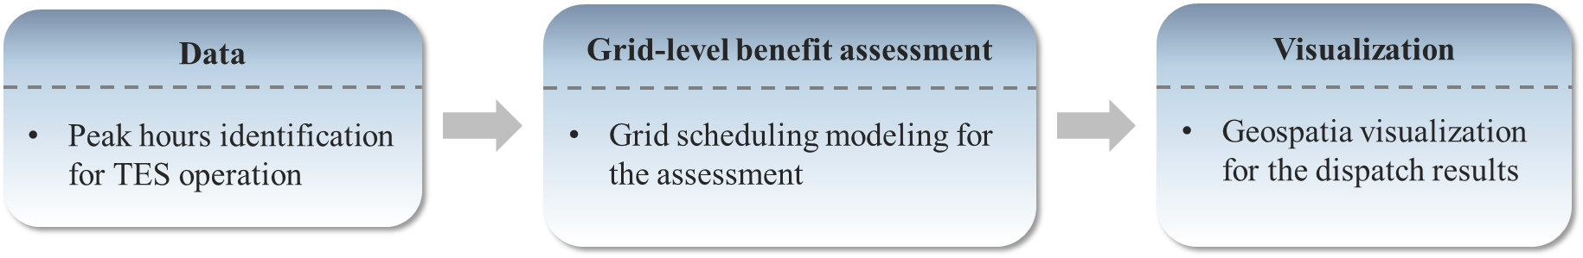
Figure 5.1. The specific structure of the grid-level benefit assessment tool.

5.2 Data Module
To facilitate an accurate assessment of the impact of deploying ASHP-TES systems on the electric power system, load data for the selected grid must be prepared initially. TES typically operates by charging during off-peak hours and discharging during peak hours. Consequently, identifying peak demand periods within the designated grid is a critical prerequisite for the effective application of TES. To this end, a dedicated data module is designed as the foundational component of the grid-level benefit assessment tool to determine peak hours during winter, summer, and shoulder months to inform TES operation strategies.

5.2.1 Data Source
Given the high penetration of ASHP and substantial heating and cooling demand in Texas, the Texas power grid is selected as the basis for developing this grid-level benefit assessment tool. Accordingly, data from the Electric reliability council of Texas (ERCOT) is utilized for the subsequent grid simulations incorporating ASHP-TES deployment. This dataset, obtainable from the U.S. EIA, provides hourly values of total electricity demand and generation across the entire power grid throughout the year.

5.2.2 Peak Hour Identification
Following the extraction of load data, it is necessary to identify the peak hours during the summer, winter, and shoulder months to inform the operation of TES strategies. For this purpose, load data from the year 2024 is employed. Additionally, seasonal periods in Texas for 2024 are referenced and illustrated in Figure 5.2. To represent each season, one representative month is selected, enabling a focused analysis of seasonal peak demand characteristics. To enhance clarity of the peak hours, the load data distribution for each season is visualized using filled contour plots, where darker shades indicate higher demand and lighter shades represent lower demand. Figure 5.3 presents the load distribution plots for the winter, summer, spring, and fall seasons, based on ERCOT data.

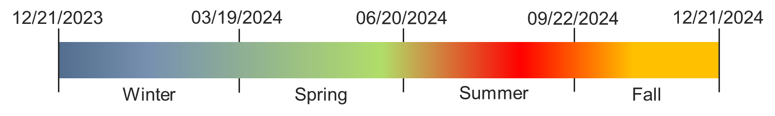
Figure 5.2. The season time of Texas in the year of 2024.
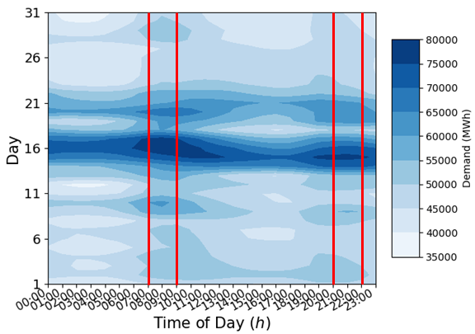
(a) Winter (2024 January)
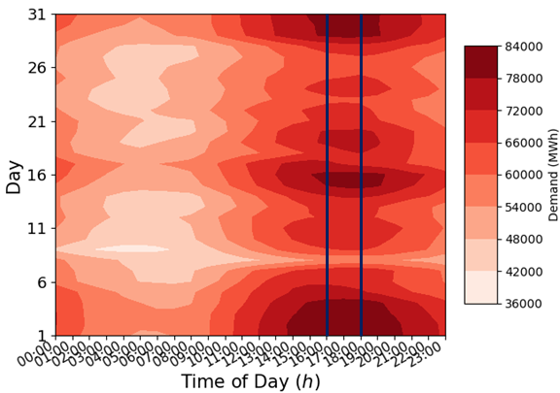
(b) Summer (2024 July)
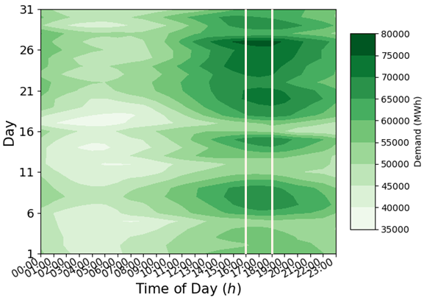
(c) Spring (2024 May)
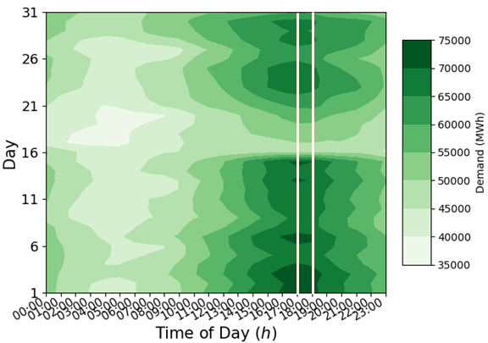
(d) Fall (2024 October)
Figure 5.3. The distribution figures of the hourly load data from ERCOT.

As illustrated in Figure 5.3, the peak load hours for each season can be clearly identified. In winter, two distinct peak periods are observed: a morning peak occurring between 7:00 a.m. and 9:00 a.m., and an evening peak between 8:00 p.m. and 10:00 p.m. During the summer, the peak demand occurs between 4:00 p.m. and 6:00 p.m., which is consistent with the peak period identified for spring. The fall season exhibits a slightly delayed peak, occurring between 5:00 p.m. and 6:00 p.m.

5.3 Grid-level Benefit Assessment Module
Based on the identified peak hours, TES is operated to bring benefits to SFHs. After quantifying the benefits at the SFH level, a grid-level benefit assessment module is designed to evaluate the aggregated impact of ASHP-TES deployment on the broader power system. To enable this assessment, it is first necessary to define an appropriate grid model, because no publicly power grid model from ERCOT currently exists.

5.3.1 Grid Model
For this assessment, the Texas 2k-bus synthetic grid model is employed. Developed by Texas A&M University (TAMU), this grid model provides a detailed representation of a large-scale power system. Although it is entirely synthetic, the grid parameters of the model are derived from public data and a statistical analysis of real power systems [54], ensuring a high degree of realism. This gird model also includes comprehensive power flow data—such as parameters for branches, buses, and generators—as well as the geographic coordinates of the buses, thereby enabling spatially informed simulations and analyses.

5.3.2 Assessment Process
Using the Texas 2k-bus synthetic system, the deployed ASHP-TES is first operated at the SFHs level. Energy consumption data before and after ASHP-TES retrofitting are utilized to quantify the benefits achieved at the SFHs level. Subsequently, the impacts of deploying ASHP-TES systems in SFHs are analyzed on the Texas 2k-bus synthetic system, enabling an evaluation of their broader grid-level implications.
As the primary objective of this assessment is to evaluate the advantages of deploying ASHP-TES, a comparative analysis between cases with and without ASHP-TES deployment is provided. To this end, two cases are constructed based on the Texas 2k-bus synthetic system: a base case and a TES case. The two cases are identical except for the load data. In the base case, load profiles are derived from ERCOT data publicly available through the U.S. EIA. In contrast, the load data used in the TES case is derived from the energy consumption profiles of SFHs observed during TES operation. As this SFH-informed load data does not represent grid-level demand, a conversion process is required to scale it appropriately for grid-level analysis. The details of this process are outlined as follows:
(5.1)
(5.2)
Energy consumption data at the SFH level is collected both before and after retrofitting ASHP-TES through monitoring. Based on this data, a deployment ratio ρ% can be calculated via (5.1) to quantify the impact and effectiveness of the ASHP-TES system. This ratio is uniformly applicable to both the SFHs and grid levels. Accordingly, the grid-level load for the TES case P_{load-TES} is obtained via (5.2) by applying the deployment ratio to the grid-level load data used in the base case P_{load-base}.
To facilitate a clear and rigorous comparison, a selection of several economic dispatch (ED) metrics, including peak demand, generation output, load payment, and transmission congestion cost, is presented to reflect the grid-level impacts of deploying ASHP-TES systems.
A converged grid model obtained through power flow analysis is a fundamental prerequisite for conducting subsequent grid simulations. To ensure temporal accuracy and comprehensiveness, simulations are conducted for the entire year of 2024. For this purpose, PSS®E is employed to generate hourly power flow scenarios, resulting in 8760 individual cases, each stored in RAW file format. These RAW files serve as the input for grid-level simulation.
The CURENT Large-scale Testbed (LTB) AMS is utilized to perform grid simulations for each power flow scenario using the DC Optimal Power Flow (DCOPF) algorithm. LTB AMS is a Python-based open-source library designed for flexible modeling of power system scheduling and co-simulation with dynamics. Within this library, DCOPF is applied to each hourly power flow scenario, with the optimization formulation detailed in(5.3)-(5.11).
(5.3)
(5.4)
(5.5)
(5.6)
(5.7)
(5.8)
(5.9)
(5.10)
(5.11)
The DCOPF formulation seeks to minimize total generation costs, as defined in (5.3), while satisfying a series of operational and physical constraints. These include the constraints of power balance (5.4), align slack bus angle (5.5), generation bounds (5.6)-(5.7), transmission line flow bounds (5.8)-(5.9), and line angle difference bounds (5.10)-(5.11). Further details regarding the formulation and its implementation can be found in [55]. Upon completion of the optimization process, the final ED metrics are exported and stored in Excel file format for further analysis and interpretation.
Overall, the assessment process is summarized in Figure 5.4. In each case, PSS®E provides the 8760 individual power flow scenarios to represent the grid situation of whole-year simulation. Then, LTB AMS works to run DCOPF for all power flow scenarios to generate the ED metrics of each scenario. Finally, all sets of ED metrics of two cases are collected for comparative analysis.
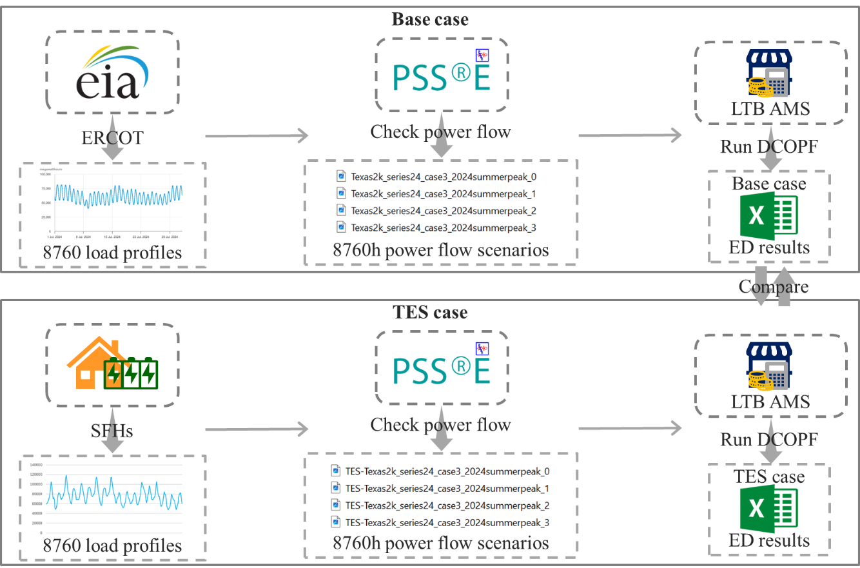
Figure 5.4. The flowchart of the grid-level benefit assessment module.

5.4 Visualization Module
Following the assessment module, the selected ED metrics from both the base case and the TES case are compiled. Subsequently, a visualization module is designed to facilitate a clear, intuitive, and user-friendly comparison of the benefits associated with deploying ASHP-TES systems within the Texas power grid.

5.4.1 Process
Given that certain ED metrics produce a substantial volume of statistical data, a more intuitive visualization approach is considered to effectively convey these massive values, which can also avoid the difficulty of drawing conclusions directly from the massive data. In addition, the ED results are distributed across the buses and branches of the power grid, thus a geospatial visualization map is developed to represent these results. As outlined in Section 5.3.1, the geographic coordinates of the buses in the Texas 2k-bus synthetic system are provided by TAMU, based on which a Python-based script is developed to map all 2000 buses onto a geographic representation of Texas. Then, some ED metrics with generating lots of data can be visualized through the color gradients of line or dot on the map. Specifically, the line flow of each branch is depicted via color shades, with darker red lines indicating higher line flow and darker blue lines signifying lower line flow. Similarly, generation output is illustrated using shaded dots, where darker red denotes higher output levels and darker blue represents lower generation levels. The overall process is summarized in the flowchart shown in Figure 5.5.

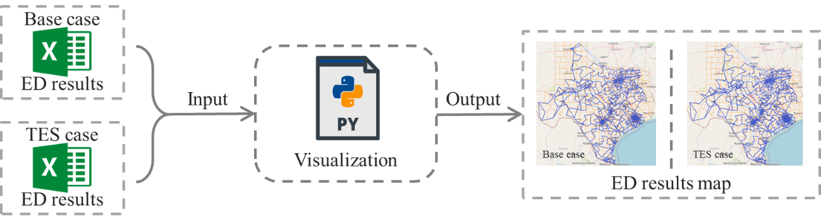
Figure 5.5. The flowchart of the visualization module.

5.4.2 Visualization Map
Following the above process, the ERCOT load data obtained from the U.S. EIA is used for the base case, while the energy consumption data collected at the SFHs level is used to derive the load profile for the TES case through a conversion process of (5.1)-(5.2). The network topology of the adopted Texas 2k-bus synthetic system is first mapped using the geographic coordinates of each bus. Subsequently, PSS®E and the LTB AMS are employed to perform DCOPF analysis for both cases, resulting ED outcomes to be recorded. Finally, through the visualization script, the line flow results are illustrated on a colored geographic map of Texas, which is provided in Figure 5.6.
As observed in Figure 5.6, it is very intuitive to distinguish the impacts in line flow of deploying ASHP-TES in power grid.

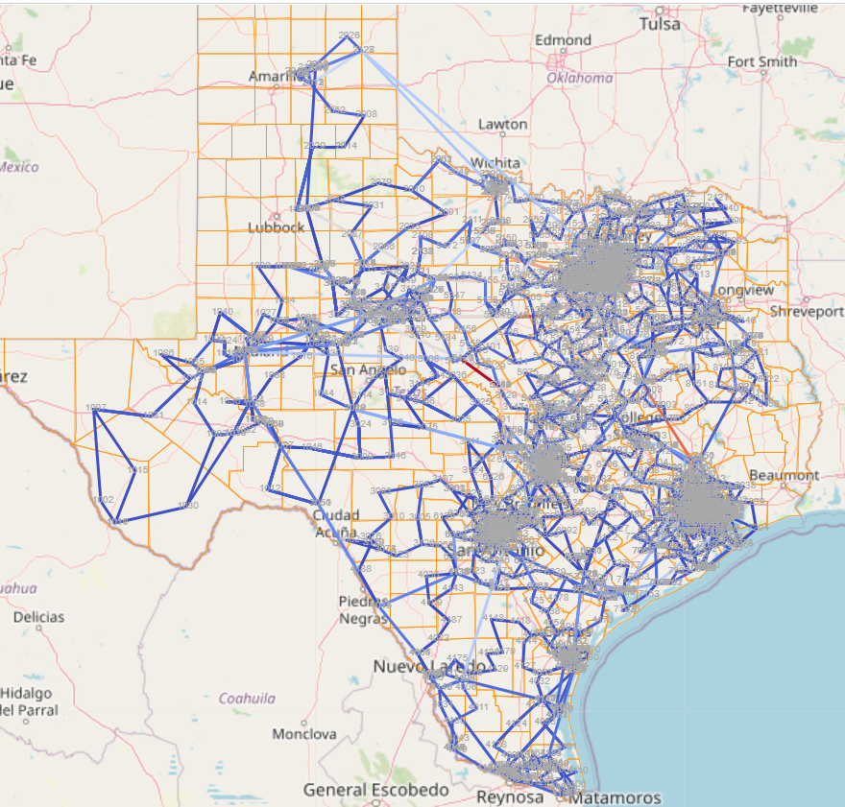
(a) base case
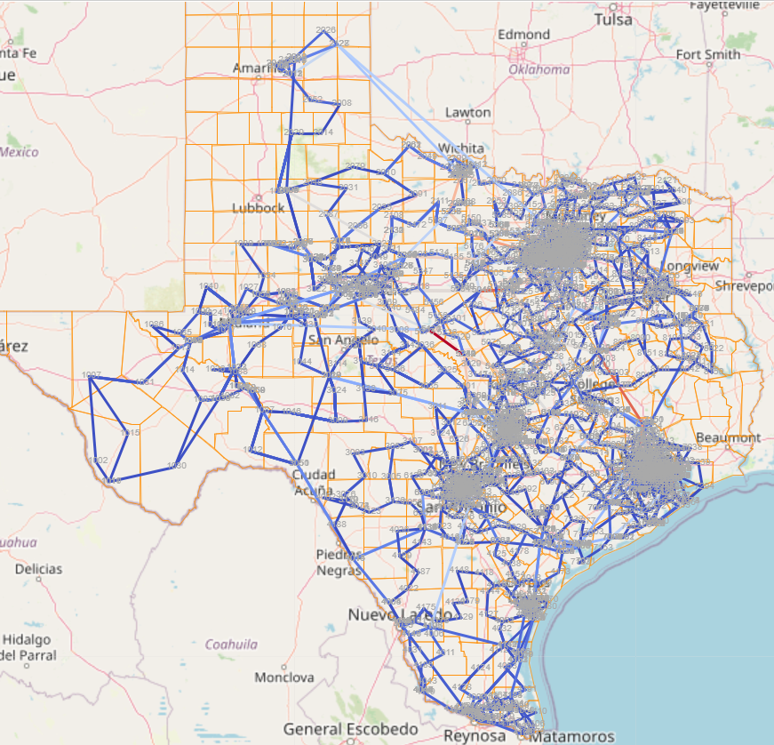
(b) TES case
Figure 5.6. The map of the line flow of the base case and the TES case.

5.5 Conclusion
It is not inherently impactful just to propose a new type of DR program, unless the benefits of the proposed DR program are effectively communicated to the public. As a powerful DR strategy, TES has demonstrated considerable potential for peak shaving, particularly in heating and cooling applications. However, the widespread deployment of ASHP-TES remains limited, largely due to insufficient awareness and understanding of its benefits. Therefore, a clear and comprehensive presentation of the advantages associated with ASHP-TES implementation is essential to promote broader adoption and public engagement.
Typically, the benefits of deploying ASHP-TES at the SFHs level can be readily quantified via monitors, enabling straightforward analysis. However, beyond SFH-level assessment, the evaluation of the ASHP-TES deployment benefits at the grid level is of greater significance, as it provides valuable insights for utility companies in designing DR strategies. As such, a grid-level benefit assessment tool is developed to facilitate a systematic evaluation of the impacts of ASHP-TES deployment on the power system. The overall framework of this tool is illustrated in Figure 5.7.

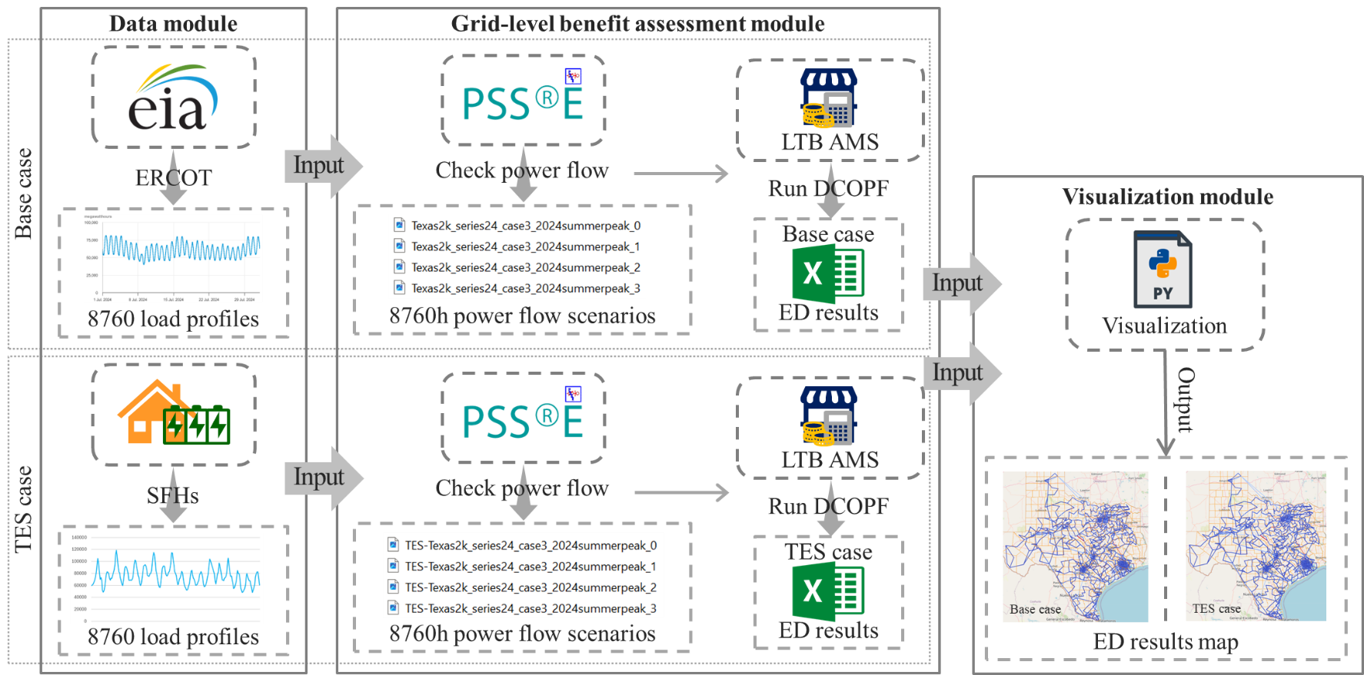
Figure 5.7. The whole step of the grid-level benefit assessment tool.

As part of the 8760-hour assessment, a data module is first designed to identify the peak hours during winter, summer, and shoulder months, which serve as the operational windows for TES. Subsequently, ASHP-TES is deployed in the designated SFHs, where charging and discharging operations are simulated to obtain energy consumption data before and after retrofitting. Based on these results, a grid-level benefit assessment module is established to perform DCOPF analysis through the software of PSS®E and LTB AMS for both the base case and the TES case, generating corresponding ED outcomes. Finally, a visualization module is constructed to generate a colored network topology map, enabling a clearer and more intuitive representation of the grid-level benefits associated with ASHP-TES deployment.
The developed grid-level benefit assessment tool enables a comprehensive evaluation of the impacts associated with deploying ASHP-TES systems on the power grid. It provides utility companies with valuable insights into both the nature and magnitude of the potential benefits resulting from ASHP-TES deployment. As such, this tool can serve as a decision-support reference, aiding utility providers in determining whether to deploy ASHP-TES within their service territories.

REFERENCES
- Q. Zhang, et a.l, “Building Marginal Pattern Library with Unbiased Training Dataset for Enhancing Model-Free Load-ED Mapping,” IEEE Open Access Journal of Power and Energy, vol. 9, pp. 88-98, 2022.
- C. Huang et al., “Data quality issues for synchrophasor applications Part II: problem formulation and potential solutions,” in Journal of Modern Power Systems and Clean Energy, vol. 4, no. 3, pp. 353-361, July 2016.
- C. Ren and Y. Xu, “A fully data-driven method based on generative adversarial networks for power system dynamic security assessment with missing data,” IEEE Trans. Power Syst., vol. 34, no. 6, pp. 5044-5052, Nov. 2019.
- D. Osipov and J. H. Chow, “PMU Missing Data Recovery Using Tensor Decomposition,” IEEE Trans. Power Syst., vol. 35, no. 6, pp. 4554-4563, Nov. 2020.
- M. Liao, et al, “An Alternating Direction Method of Multipliers Based Approach for PMU Data Recovery,” IEEE Trans. Smart Grid, vol. 10, no. 4, pp. 4554-4565, July 2019.
- B. Foggo and N. Yu, “Online PMU Missing Value Replacement Via Event-Participation Decomposition,” IEEE Trans. Power Syst., vol. 37, no. 1, pp. 488-496, Jan. 2022.
- F. Zelaya-Arrazabal, J. Liu, J. Zhao, H. Pulgar-Painemal, F. Li and H. Silva-Saravia, “Data-driven adaptive dynamic coordination of damping controllers,” 2022 North American Power Symposium (NAPS), Salt Lake City, UT, USA, 2022.
- H. Darvishi, D. Ciuonzo and P. S. Rossi, “A machine-learning architecture for sensor fault detection, isolation, and accommodation in digital twins,” IEEE Sens. J., vol. 23, no. 3, pp. 2522-2538, Feb. 2023.
- Y. Li and X. Shen, “A Novel Wind Speed-Sensing Methodology for Wind Turbines Based on Digital Twin Technology,” IEEE Trans. Instrum Meas, vol. 71, pp. 1-13, Art no. 2503213, 2022.
- Q. Hu, F. Li, X. Fang and L. Bai, “A Framework of Residential Demand Aggregation With Financial Incentives,” IEEE Trans. Smart Grid., vol. 9, no. 1, pp. 497-505, Jan. 2018, doi: 10.1109/TSG.2016.2631083.
- Q. Hu, X. Fang, F. Li, X. Xu, C.-F. Chen and H. Hu, “An approach to assess the responsive residential demand to financial incentives,” 2015 IEEE Power & Energy Society General Meeting, Denver, CO, 2015, pp. 1-5, doi: 10.1109/PESGM.2015.7286623.
- H. Zhong, L. Xie, and Q. Xia, “Coupon Incentive-Based Demand Response: Theory and Case Study,” IEEE Trans. Power Syst., vol. 28, no. 2, pp. 1266-1276, May 2013, doi: 10.1109/TPWRS.2012.2218665.
- Q. Shi, C.-F. Chen, A. Mammoli, and F. Li, “Estimating the Profile of Incentive-Based Demand Response (IBDR) by Integrating Technical Models and Social-Behavioral Factors,” IEEE Trans. Smart Grid., vol. 11, no. 1, pp. 171-183, Jan. 2020, doi: 10.1109/TSG.2019.2919601.
- P. Paudyal, P. Munankarmi, Z. Ni, and T. M. Hansen, “A Hierarchical Control Framework with a Novel Bidding Scheme for Residential Community Energy Optimization,” IEEE Trans. Smart Grid, vol. 11, no. 1, pp. 710-719, Jan. 2020, doi: 10.1109/TSG.2019.2927928.
- Q. Zhang and F. Li, “Securing Energy Equity With Multilayer Market Clearing,” IEEE Trans. Energy Markets, Policy and Regulation, doi: 10.1109/TEMPR.2024.3377210.
- W. Tushar, T. K. Saha, C. Yuen, D. Smith, and H. V. Poor, “Peer-to-peer trading in electricity networks: An overview,” IEEE Trans. Smart Grid, vol. 11, no. 4, pp. 3185-3200, Jul. 2020, doi: 10.1109/TSG.2020.2969657.
- T. Sousa et al., “Peer-to-peer and community-based markets: A comprehensive review,” Renewable and Sustainable Energy Reviews, vol. 104, pp. 367-378, 2019.
- C. Li, F. Li, S. Jiang, X. Wang and J. Wang, “Siting and Sizing of DG Units Considering Energy Equity: Model, Solution, and Guidelines,” IEEE Trans. Smart Grid, vol. 15, no. 4, pp. 3681-3693, July 2024, doi: 10.1109/TSG.2024.3350914.
- A. Bell-Pasht, “Low-Income Households Spend Nearly 20% of Income on Home Energy and Auto Fuel Costs.” 2024. [available at] https://www.aceee.org/blog-post/2024/05/low-income-households-spend-nearly-20-income-home-energy-and-auto-fuel-costs#:~:text=On%20average%2C%20low%2Dincome%20households,of%20their%20income%20on%20energy.
- S. Cong, D. Nock, Y.L. Qiu, et al., “Unveiling hidden energy poverty using the energy equity gap,” Nat. Commun, vol. 13, May. 2022.
- Bednar, D. J. & Reames, T. G. “Recognition of and response to energy poverty in the United States,” Nat. Energy, vol. 5, pp. 432–439, Jun. 2020.
- U.S. Department of Health and Human Services. Low Income Home Energy Assistance Program (LIHEAP). [available at] https://www.acf.hhs.gov/ocs/programs/liheap.
- DOE, Office of Economic Impact and Diversity, Equity in Energy, [available at] https://www.energy.gov/diversity/equity-energytm
- Pacific Northwest National Laboratory, “Energy equity” [available at] https://www.pnnl.gov/projects/energy-equity.
- The White House, Justice40 Initiative, [available at] https://www.whitehouse.gov/environmentaljustice/justice40/.
- J. Heras and M. Martín, “Social issues in the energy transition: Effect on the design of the new power system.” Appl. Energy., vol. 278, Art. 115654, Nov. 2020.
- Y. Chen, M. Tanaka, and R. Takashima, “Energy Expenditure Incidence in the Presence of Prosumers: Can a Fixed Charge Lead Us to the Promised Land?,” IEEE Trans. Power Syst., vol. 37, no. 2, pp. 1591-1600, March 2022, doi: 10.1109/TPWRS.2021.3104770.
- Y. Chen, A. L. Liu, M. Tanaka, and R. Takashima, “Optimal Retail Tariff Design With Prosumers: Pursuing Equity at the Expenses of Economic Efficiencies?,” IEEE Trans. Energy Markets, Policy and Regulation, vol. 1, no. 3, pp. 198-210, Sept. 2023, doi: 10.1109/TEMPR.2023.3293711.
- B. Tarekegne, J. Kerby, A. K. Bharati and R. O’Neil, “Assessing the Energy Equity Benefits of Energy Storage Solutions,” 2022 IEEE Electrical Energy Storage Application and Technologies Conference (EESAT), Austin, TX, USA, 2022, pp. 1-5, doi: 10.1109/EESAT55007.2022.9998019.
- M. Mukherjee, M. Maharjan, and T. Hardy, “Transactive Emergency Power Allocation,” 2023 IEEE Power & Energy Society General Meeting (PESGM), Orlando, FL, USA, 2023, pp. 1-5, doi: 10.1109/PESGM52003.2023.10252732.
- B. L. Tarufelli and S. R. Bender, “Equity in Transactive Energy Systems,” 2022 IEEE PES Transactive Energy Systems Conference (TESC), Portland, OR, USA, 2022, pp. 1-5, doi: 10.1109/TESC53336.2022.9917265.
- J. Gao, K. O. Asamoah, Q. Xia, E. B. Sifah, O. I. Amankona, and H. Xia, “A Blockchain Peer-to-Peer Energy Trading System for Microgrids,” IEEE Trans. Smart Grid, vol. 14, no. 5, pp. 3944-3960, Sept. 2023, doi: 10.1109/TSG.2023.3237624.
- E. A. Soto et al., “Peer-to-peer energy trading: A review of the literature,” Appl. Energy, vol. 283, Art. no. 116268, Feb. 2021.
- F. Li, G. Strbac, J. Jeon, M. McCulloch, B. Adebisi, and R. Li, Peer-to-peer energy trading and sharing 3M (multi-times, multi-scales, multi-qualities), [available at] https://p2pconnecting.wordpress.com/.
- European Commission, P2P-SmarTest, [available at] https://ec.europa.eu/inea/en/horizon-2020/projects/h2020-energy/grids/p2p-smartest.
- Piclo, [available at] https://www.piclo.energy/.
- Vandebron. Good price for you, good price for local energy. [available at] https://vandebron.nl, 2016
- Community First! Village Website, [available at] https://mlf.org/gridmates/.
- C. Pankhurst, C. A. Cañizares, and K. Bhattacharya, “A Decentralised Transactive Energy Market Considering Physical System Constraints,” IEEE Trans. Smart Grid, vol. 15, no. 3, pp. 3165-3177, May 2024, doi: 10.1109/TSG.2023.3331714.
- H. Liu, J. Li, S. Ge, X. He, F. Li, and C. Gu, “Distributed Day-Ahead Peer-to-Peer Trading for Multi-Microgrid Systems in Active Distribution Networks,” IEEE Access, vol. 8, pp. 66961-66976, 2020, doi: 10.1109/ACCESS.2020.2983645.
- S. S. Menon and A. N, “Ethereum Based Smart Contract For Peer-To-Peer Energy Trading Using Blockchain Technology,” 2023 IEEE International Conference on Power Electronics, Smart Grid, and Renewable Energy (PESGRE), Trivandrum, India, 2023, pp. 1-5, doi: 10.1109/PESGRE58662.2023.10405209.
- A. Paudel, L. P. M. I. Sampath, J. Yang, and H. B. Gooi, “Peer-to-Peer Energy Trading in Smart Grid Considering Power Losses and Network Fees,” IEEE Trans. Smart Grid, vol. 11, no. 6, pp. 4727-4737, Nov. 2020, doi: 10.1109/TSG.2020.2997956.
- Y. Zhou, J. Wang, Y. Zhang, J. Wei, W. Sun, and J. Wang, “A Fully-Decentralized Transactive Energy Management Under Distribution Network Constraints via Peer-to-Peer Energy Trading,” IEEE Trans. Energy Markets, Policy and Regulation, vol. 1, no. 4, pp. 297-309, Dec. 2023, doi: 10.1109/TEMPR.2023.3263685.
- M. Khorasany, Y. Mishra, and G. Ledwich, “A Decentralized Bilateral Energy Trading System for Peer-to-Peer Electricity Markets,” IEEE Trans. Industr. Electronics, vol. 67, no. 6, pp. 4646-4657, June 2020, doi: 10.1109/TIE.2019.2931229.
- J. Lei et al., “A Shareholding-Based Resource Sharing Mechanism for Promoting Energy Equity in Peer-to-Peer Energy Trading,” IEEE Trans. Power Syst., vol. 38, no. 6, pp. 5113-5127, Nov. 2023, doi: 10.1109/TPWRS.2022.3225656.
- N. Kakwani and H. H. Son, “Social welfare functions and development”, Basingstoke: Palgrave Macmillan, 2016.
- A. A. Raja and S. Grammatico, “Bilateral Peer-to-Peer Energy Trading via Coalitional Games,” IEEE Trans. Industr. Inform., vol. 19, no. 5, pp. 6814-6824, May 2023, doi: 10.1109/TII.2022.3196339.
- C. Zhang, M. Ahmad, and Y. Wang, “ADMM Based Privacy-Preserving Decentralized Optimization,” IEEE Trans. Inf Foren Sec., vol. 14, no. 3, pp. 565-580, March 2019, doi: 10.1109/TIFS.2018.2855169.
- D. H. Nguyen, “Optimal Solution Analysis and Decentralized Mechanisms for Peer-to-Peer Energy Markets,” IEEE Trans. Power Syst., vol. 36, no. 2, pp. 1470-1481, March 2021, doi: 10.1109/TPWRS.2020.3021474.
- M. H. Ullah and J. -D. Park, “Peer-to-Peer Energy Trading in Transactive Markets Considering Physical Network Constraints,” IEEE Trans. Smart Grid, vol. 12, no. 4, pp. 3390-3403, July 2021, doi: 10.1109/TSG.2021.3063960.
- L. P. M. I. Sampath, A. Paudel, H. D. Nguyen, E. Y. S. Foo, and H. B. Gooi, “Peer-to-Peer Energy Trading Enabled Optimal Decentralized Operation of Smart Distribution Grids,” IEEE Trans. Smart Grid, vol. 13, no. 1, pp. 654-666, Jan. 2022, doi: 10.1109/TSG.2021.3110889.
- S. Boyd, N. Parikh, E. Chu, B. Peleato, and J. Eckstein, “Distributed optimization and statistical learning via the alternating direction method of multipliers,” Found. Trends Mach. Learn., vol. 3, no. 1, 2011.
- Y. Wang, L. Wu and S. Wang, “A Fully-Decentralized Consensus-Based ADMM Approach for DC-OPF With Demand Response,” IEEE Trans. Smart Grid, vol. 8, no. 6, pp. 2637-2647, Nov. 2017, doi: 10.1109/TSG.2016.2532467.
- Texas2k Series25 Case, Texas A&M University, https://electricgrids.engr.tamu.edu/texas2k-series25/
- https://ltb.readthedocs.io/projects/ams/en/latest/typedoc/DCED.html#dcopf

APPENDIX

CONCLUSION

Amid the global energy transition, conventional power system operation methods have revealed limitations in handling emerging topics. To respond to these shortcomings, this dissertation successively explores four representative topics to investigate the potential solutions. The key findings and conclusions of each topic are summarized as follows.
(1) In Chapter II, the topic of AI online application in power systems is focused on. To mitigate the adverse effects of defective online-measured input data on AI model, three practical data-driven correction methods are proposed: a statistical-value-based method, a minimal-error-based method, and a DNN-based adaptive method. These methods are validated through a DNN case for power system stability enhancement on a reduced 179-bus model. The results demonstrate the effectiveness of all three methods in correcting defective input data. Overall, the proposed three data-driven methods are straightforward to implement and significantly enhance the reliability of the online-measured data, thereby supporting the robust integration of ML applications in power systems.
(2) In Chapter III, the topic of energy sustainability enhancement is involved in. An I-DR capacity assessment tool is developed to evaluate the potential of residential energy to participate in load reduction or carbon reduction initiatives. To this end, a load-reduction-oriented assessment and a carbon-reduction-oriented assessment process are integrated in this tool. To ensure adaptability in real-world scenarios, a data preprocessing module is incorporated to identify and correct outliers in online-measured data. Then, an I-DR capacity assessment module quantifies the potential flexibility of residential energy consumption. Finally, a visualization module is implemented to offer an intuitive and user-friendly view of the residential energy response capacity. The tool is validated using field load data from a residential service territory provided by SOCO. Validation results confirm the effectiveness of this tool, indicating its potential to support broader goals in decarbonization and energy sustainability.
(3) In Chapter IV, the topic of promoting energy affordability is worked on. To satisfy the needs of accessing affordable energy and self-regulated energy trading, an innovative energy trading fusion market is proposed. The core of this market design is an energy-affordability-based layered dispatch structure, which ensures affordable energy access for consumers. Within each layer of this dispatch structure, a P2P-based energy trading is incorporated to ensure a fully decentralized and autonomous energy trading environment that supports affordable energy access. As a result, this energy trading fusion market promotes privacy-preserving access to affordable energy during energy trading. The feasibility and effectiveness of the proposed energy trading fusion market are demonstrated in both the IEEE 33-bus and IEEE 123-bus systems. Finally, results indicate that the proposed energy trading fusion market successfully empowers participants with energy trading decision-making capabilities and significantly alleviates the energy burden for low-income consumers for their basic demand.
(4) In Chapter V, the topic of evaluating grid-level benefits resulting from deploying the ASHP-TES system is investigated. To enable a systematic and comprehensive assessment, a grid-level benefit assessment tool is developed. This tool begins with a data module designed to identify peak demand hours across winter, summer, and shoulder months. Following these identified periods, the TES is operated—through scheduled charging and discharging—within designated SFHs. The energy consumption data of SFHs, both before and after ASHP-TES retrofitting, is collected to construct the TES case (with ASHP-TES deployment) within the Texas 2k-bus synthetic system. In contrast, the base case (without ASHP-TES deployment) is formed using ERCOT load data sourced from the U.S. EIA. Subsequently, a grid-level benefit assessment module is established to perform DCOPF on both cases. Finally, a visualization module is integrated to render the resulting ED outcomes on a Texas grid map, enabling a clearer and more intuitive interpretation of the grid-level benefits from deploying ASHP-TES systems.
In summary, the proposed data-driven solutions demonstrate strong potential in mitigating key limitations associated with the involved emerging topics in the energy transition of power systems.

VITA

Jingzi Liu was born in China. She earned her B.S. degree in Electrical Engineering and Automation from North China University of Water Resources and Electric Power in 2017. She then completed her M.S. degree in Power System and Automation under the supervision of Dr. Ping Ju at Hohai University, Nanjing, China in 2020. Since 2021 August, she started to work towards her Ph.D. degree at the ENLITEN Lab, led by Dr. Fangxing Fran Li. in the EECS department of the University of Tennessee, Knoxville.

