Development of Iron Nanoparticles for Magnetic Particle Imaging Applications

A Dissertation Presented for the

Doctor of Philosophy

Degree

The University of Tennessee, Knoxville

Aleia G. Williams

December 2024

Copyright © 2024 by Aleia G. Williams. All rights reserved.

DEDICATION
I dedicate this work to my mother who has been a steady support throughout my life and academic career.

ACKNOWLEDGEMENTS
I would like to thank Dr. Jacqueline Johnson for her acumen in directing this research, as well as her continuous support and guidance throughout my time at UTSI. Her trust and confidence in my abilities have allowed me to experiment with new ideas and gain new experiences that I would not have otherwise gained. Her advice throughout my graduate studies has been invaluable and has allowed me to freely learn and become a well-rounded researcher.
I would like to thank the committee members of Dr. Trevor Moeller, Dr. Lino Costa, and Dr. Claudia Rawn. I greatly appreciate their time and effort in reading and offering their knowledge and insight for this dissertation.
I greatly appreciate and thank Dr. Charles Johnson for his assistance throughout this research and time at UTSI. My introduction and knowledge of Mössbauer spectroscopy would be naught without his input, expertise, and kindness. I am truly grateful to have had the privilege in working with him.
I would like to thank Dr. Lu Liu for her insight and knowledge of chemistry throughout this process. Working with her has been a joy, and I appreciate the collaborative efforts taken to assist throughout this project.
To the BEAMS group, I would like to thank for the support and friendship throughout my time at UTSI. I would also like to thank the UTSI support staff for their assistance.
This work was supported by the National Institute of Health (NIH) under grant number NIH 1R15E034962-01.

ABSTRACT
An investigation in creating highly magnetic and optimally sized iron nanoparticles for magnetic particle imaging (MPI) was performed. MPI is a noninvasive imaging technique that has gained much attention due to its high sensitivity, spatial resolution, and real time 3D imaging modality. The signal generated for MPI is highly dependent on the magnetic moment produced by magnetic nanoparticle tracers, which is related to the composition and size of the nanoparticles. Currently 25-30 nm sized iron oxide nanoparticles are the standard tracers used for MPI, however, further improvement of such tracers can be achieved by developing nanoparticles that contain pure iron. Therefore, various synthetic methods were investigated in order to determine optimal synthetic conditions for creating Fe nanoparticles around 20 nm in diameter.
Three series of iron nanoparticle syntheses were explored. Series 1 tested the effects various alkyl chained surfactant have on nanoparticle shape and size. From the first series, 20 nm sized iron core-shell structured particles were obtained. It was found that longer alkyl chained surfactants allowed for larger particle sizes due to an increase in steric hindrances to prevent agglomerations from forming during growth.
Series 2 tested a continuous injection of iron pentacarbonyl using an extended LaMer growth mechanism of nanoparticles. Different injection speeds and different surfactants were tested to determine potential changes in size and shape of the nanoparticles through this growth mechanism. From this series, it was found that lower injection speeds using hexadecylamine or octadecylamine as surfactants could produce larger iron nanoparticles.
Finally, series 3 investigated a solid-solid reduction synthesis to create iron nanoparticles. Iron oxide nanoparticles were synthesized through a thermal decomposition of iron (III) acetylacetonate and coated with silica. The uncoated and silica coated iron oxide nanoparticles were further reduced with calcium hydride to produce iron nanoparticles.
Characterization methods include Mössbauer spectroscopy, X-ray diffraction (XRD), transmission electron microscopy (TEM), vibrating sample magnetometry (VSM), cytotoxicity tests, and preliminary MPI measurements.

TABLE OF CONTENTS
INTRODUCTION 1
Magnetic Particle Imaging (MPI) 1
MPI Tracer Characteristics 7
Current MPI Tracers 8
CHAPTER I VARIATION OF ALKYL CHAINED SURFACTANTS ON IRON NANOPARTICLE SIZE AND SHAPE 12
Abstract 13
Introduction 13
Materials and Methods 15
Chemicals 15
Synthesis and Setup 15
DSPE-mPEG Coating 17
Acid Digestion for ICP-OES Measurements 17
Results 18
Transmission Electron Microscopy (TEM) 18
X-ray Diffraction (XRD) 18
Mössbauer Spectroscopy 25
Vibrating Sample Magnetometry (VSM) 26
Cytotoxicity Studies 32
MPI tests 32
Discussion 34
Conclusion 37
CHAPTER II CONTINUOUS INJECTION OF IRON PRECURSOR USING A LAMER GROWTH MECHANISM 39
Abstract 40
Introduction 40
Materials and Methods 44
Chemicals 44
Synthesis and Setup 44
DSPE-mPEG Coating 46
Acid Digestion process for ICP-OES Measurements 47
Results 47
Transmission Electron Microscopy (TEM) 47
X-ray Diffraction (XRD) 51
Mössbauer Spectroscopy 51
Vibrating Sample Magnetometry (VSM) 58
Cytotoxicity 61
Discussion 61
Conclusion 64
CHAPTER III SYNTHESIS OF ΙRON NANOPARTICLES UTILIZING A SOLID-SOLID REDUCTION METHOD 67
Abstract 68
Introduction 68
Materials and Methods 70
Chemicals 70
Synthesis 70
Results 71
Transmission Electron Microscopy (TEM) 71
X-ray Diffraction (XRD) 75
Mössbauer Spectroscopy 75
Vibrating Sample Magnetometry (VSM) 79
Discussion 83
Conclusion 84
CONCLUSION 86
REFERENCES 88
VITA 104

LIST OF TABLES
Table 1: Summary of average iron nanoparticle diameter, core and shell measurements from TEM results for each surfactant. An average of 200 nanoparticles were counted to obtain averages and standard deviations. 22
Table 2: Values of hyperfine parameters of all samples using different surfactants at 293K. B_{hf} is the hyperfine magnetic field, δ is the isomer shift, ΔE_{Q} is the quadrupole splitting, and Γ is the linewidth (FWHM). Typical errors are ± 0.4 T for B_{hf}, ± 0.04 mm/s for δ, ± 0.03 mm/s for ΔE_{Q}, and ± 0.05 mm/s for Γ and ± 3% for relative area. 28
Table 3: Values of hyperfine parameters for all samples using different surfactants at 6K. B_{hf} is the hyperfine magnetic field, δ is the isomer shift, ΔE_{Q} is the quadrupole splitting, and Γ is the linewidth (FWHM). Typical errors are ± 0.4 T for B_{hf}, ± 0.04 mm/s for δ, ± 0.03 mm/s for ΔE_{Q}, and ± 0.05 mm/s for Γ and ± 3% for relative area. 30
Table 4: Magnetic saturation values of all samples using different surfactants. 31
Table 5: Summary of diameter, core and shell measurements for OAm/OA samples at all injection rates. An average of 200 nanoparticles were counted to obtain averages and standard deviations. 50
Table 6: Values of hyperfine parameters for all samples using a continuous injection method at 293K. B_{hf} is the hyperfine magnetic field, δ is the isomer shift, ΔE_{Q} is the quadrupole splitting, and Γ is the linewidth (FWHM). Typical errors are ± 0.5 T for B_{hf}, ± 0.05 mm/s for δ, ± 0.02 mm/s for ΔE_{Q}, and ± 0.05 mm/s for Γ and ± 3% for relative area. 55
Table 7: Values of hyperfine parameters for all samples using a continuous injection method at 6K. B_{hf} is the hyperfine magnetic field, δ is the isomer shift, ΔE_{Q} is the quadrupole splitting, and Γ is the linewidth (FWHM). Typical errors are ± 0.5 T for B_{hf}, ± 0.05 mm/s for δ, ± 0.02 mm/s for ΔE_{Q}, and ± 0.05 mm/s for Γ and ± 3% for relative area. 57
Table 8: Magnetic saturation values of all samples using a continuous injection method. 60
Table 9: Values of hyperfine parameters for Fe₃O₄, Si-Fe₃O₄ and reduced Fe₃O₄ and Si-Fe₃O₄ samples at 293K. B_{hf} is the hyperfine magnetic field, δ is the isomer shift, ΔE_{Q} is the quadrupole splitting, and Γ is the linewidth (FWHM). Typical errors are ± 0.3 T for B_{hf}, ± 0.04 mm/s for δ, ± 0.01 mm/s for ΔE_{Q}, and ± 0.02 mm/s for Γ and ± 3% for relative area. 78
Table 10: Values of hyperfine parameters for Fe₃O₄, Si-Fe₃O₄ and reduced Fe₃O₄ and Si-Fe₃O₄ samples at 6K. B_{hf} is the hyperfine magnetic field, δ is the isomer shift, ΔE_{Q} is the quadrupole splitting, and Γ is the linewidth (FWHM). Typical errors are ± 0.3 T for B_{hf}, ± 0.04 mm/s for δ, ± 0.01 mm/s for ΔE_{Q}, and ± 0.02 mm/s for Γ and ± 3% for relative area. 81
Table 11: Magnetic saturation values of Fe₃O₄, Si-Fe₃O₄, Fe₃O₄ reduced, and Si-Fe₃O₄ reduced samples. 82

LIST OF FIGURES
Figure 1: Comparison of harmonic-space and x-space MPI for signal generation. 2
Figure 2: Schematic of MPI system for image and signal generation. 4
Figure 3: Abstract of alkyl chained surfactants and corresponding carbon chain lengths. 16
Figure 4: Synthesis setup. 16
Figure 5: TEM images of samples made with different surfactants at a 100 nm scale. A) DA B) DDA C) HDA D) ODA E) DODA. 19
Figure 6: TEM images of samples made with different surfactants at a 20 nm scale. A) DA B) DDA C) HDA D) ODA E) DODA. 20
Figure 7: Elemental mapping of iron core - iron oxide shell structure for all nanoparticle samples. 21
Figure 8: Comparison between carbon chain length of surfactants and average diameter size. 22
Figure 9: Comparison between carbon chain length of surfactants and average iron core size. 23
Figure 10: Stacked XRD spectra of samples from using different surfactants. 24
Figure 11: Stacked ⁵⁷Fe Mössbauer spectra of all samples using different surfactants at 293K. 27
Figure 12: Stacked ⁵⁷Fe Mössbauer spectra of all samples using different surfactants at 6K. 29
Figure 13: MH-curves of all samples using different surfactants at 300K. 31
Figure 14: Cytotoxicity results of all samples at 100, 50, 25, and 12.5 μg Fe/mL doses. 33
Figure 15: PSF and FWHM measurements from RELAX MPI tests. 35
Figure 16: a) Original LaMer mechanism b) Extended LaMer mechanism for particle growth over time [107]. 43
Figure 17: Synthesis setup for continuous injection of iron precursor. 45
Figure 18: TEM image of all samples using a continuous injection of iron precursor at a 100 nm scale. A-C) OAm/OA 100, 50, and 25 μL/min respectively. D-F) HDA 100, 50, 25 μL/min respectively. G-I) ODA 100, 50, 25 μL/min. 48
Figure 19: TEM image of all samples using a continuous injection of iron precursor at a 20 nm scale. A-C) OAm/OA 100, 50, and 25 μL/min respectively. D-F) HDA 100, 50, 25 μL/min respectively. G-I) ODA 100, 50, 25 μL/min. 49
Figure 20: Stacked XRD spectra of all samples using a continuous injection method. 52
Figure 21: Stacked ⁵⁷Fe Mössbauer spectra of all samples using a continuous injection method at 293K. 54
Figure 22: Stacked ⁵⁷Fe Mössbauer spectra of all samples using a continuous injection method at 6K. 56
Figure 23: MH-curves of all samples measured using a continuous injection method at 300K. 59
Figure 24: Cell viability results of OAm/OA 100, OAm/OA 50, and OAm/OA 25 samples at 100, 50, 25 and 12.5 μg Fe/mL doses. 62
Figure 25: TEM of images of samples at a 100 nm scale. A) Fe₃O₄ B) Si-Fe₃O₄ C) Fe₃O₄ reduced D) Si-Fe₃O₄ reduced. 72
Figure 26: TEM images of samples at a 20 nm scale A) Fe₃O₄ B) Si-Fe₃O₄ C) Fe₃O₄ reduced D) Si-Fe₃O₄ reduced. 73
Figure 27: Elemental mapping of Si-Fe₃O₄. 74
Figure 28: Stacked XRD spectra of iron oxide, silica coated iron oxide and reduced samples. 76
Figure 29: Stacked Mössbauer spectra of Fe₃O₄, Si-Fe₃O₄, Fe₃O₄ reduced and Si-Fe₃O₄ reduced samples at 293K. 77
Figure 30: Stacked Mössbauer spectra of Fe₃O₄, Si-Fe₃O₄, Fe₃O₄ reduced and Si-Fe₃O₄ reduced samples at 6K. 80
Figure 31: MH-curves of Fe₃O₄, Si-Fe₃O₄, Fe₃O₄ reduced, and Si-Fe₃O₄ reduced samples at 300K. 82

INTRODUCTION
The purpose of this research was to develop iron nanoparticles tracers for magnetic particle imaging applications. Investigation of synthetic parameters to create 20 nm iron nanoparticles were performed. A thermal decomposition of iron pentacarbonyl was primarily used to test different surfactants and iron precursor injection rates. In addition, utilization of solid-solid reduction reactions using CaH₂ was also explored.

Magnetic Particle Imaging (MPI)
Magnetic particle imaging (MPI) is a novel imaging technique that was introduced in 2005 by Gleich and Weizenecker and shows promise in medical imaging due to its noninvasive, radiation-free imaging modality [1, 2]. MPI is highly competitive in sensitivity, contrast, and spatial and temporal resolution when compared to current clinical techniques like magnetic resonance imaging (MRI), computed tomography (CT) and positron emission tomography (PET) [3, 4]. Previous studies have suggested MPI has similar sensitivity as PET, with a sensitivity around 10⁻¹¹- 10⁻¹² mole/L of contrast agent. Around 200 nanograms of iron per voxel was achievable with MPI through advances in hardware and tracer design [3, 5]. From the use of low-frequency magnetic fields, MPI’s signal attenuation is unaffected by anatomical structures or tissue depth, which allows it to have excellent contrast [1]. MPI also has a theoretical spatial resolution around 200 - 500 μm and temporal resolution of seconds to minutes [3, 6]. These high-resolution images can be obtained in real time and direct quantification of superparamagnetic iron oxide nanoparticles (SPIONs) to a targeted site in the body is possible [7]. Due to these advantageous properties mentioned, MPI has proven to be useful in a wide range of biomedical applications such as cancer detection, cell monitoring, perfusion imaging, magnetic hyperthermia, and targeted drug tracking [1, 8].
From MPI system development, two established methods for MPI include harmonic-space and x-space. Although the two techniques differ, both generate a signal from a Langevin magnetization curve of magnetic tracers for excitation and selective saturation as shown in Figure 1 [7]. The magnetization behavior for magnetic tracers is represented
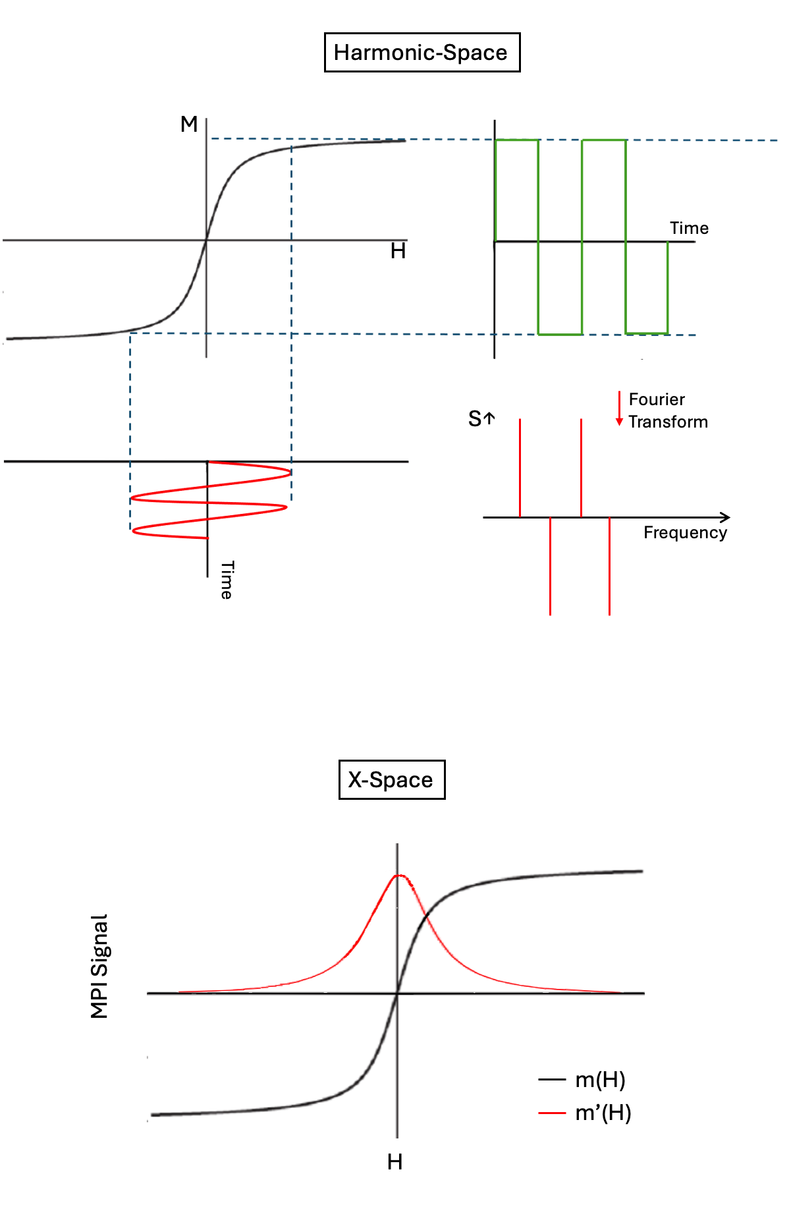
Figure 1: Comparison of harmonic-space and x-space MPI for signal generation.
as a Langevin function, which is represented in Equation 1, where the magnetization (M) is represented as a function of applied magnetic field H(t):
$$\begin{aligned}\text{M}\left(\text{H}\left(\text{t}\right)\right)\text{=}{\text{m}}_{\text{s}}\text{c}\left(\text{coth}\left(\text{α}\text{H}\left(\text{t}\right)\right)\text{-}\frac{\text{1}}{\text{α}\text{H}\left(\text{t}\right)}\right)\#\left(\text{1}\right)\end{aligned}$$
Where $\text{α}\text{=}\frac{{\text{μ}}_{\text{0}}{\text{m}}_{\text{s}}}{{\text{k}}_{\text{B}}\text{T}}$, c is tracer concentration, μ₀ is permeability, m_{s} is the magnetic saturation moment, k_{B} is the Boltzmann constant, and T is temperature. The m_{s} term gives the magnetic moment of a spherical, single domain magnetic nanoparticle and is represented as:
$${\text{m}}_{\text{s}}\text{=}\frac{{\text{πd}}_{\text{c}}^{\text{3}}{\text{M}}_{\text{s}}}{\text{6}}$$
Where d_{c} is the magnetic core diameter, and M_{s} is the magnetic saturation constant that is specific for the tracer [9, 10].
A schematic of the MPI system is shown in Figure 2. Two permanent magnets generate a magnetic field gradient to saturate all SPIONs magnetization outside a central field free point (FFP) [11]. Driving coils within the system assist in shifting this FFP across a region of interest. A signal is produced from the nonlinear magnetization response of the SPIONs when the magnetic moments change direction with the moving FFP. Receiving coils measure the voltage produced by the SPION’s and generates the raw MPI signal. Then, image reconstruction techniques are used to generate a map of the tracer concentration [8].
Early MPI images were first generated with harmonic-space reconstruction methods and was used for in vivo imaging of a beating mouse heart [2, 6]. Harmonic-space MPI uses a system matrix that is comprised of Fourier components of the temporal signal for every possible location of a point source [2, 10, 12-16]. The system matrix is obtained by measuring the spectral responses of the nanoparticles at all locations in an imaging field of view (FOV) [7]. The field free point (FFP) passes over the FOV in a Lissajous pattern. Then, matrix inversion techniques such as algebraic reconstruction or singular value decomposition are used for image reconstruction [17]. However, these matrix inversions can be complex since the system matrix can contain over a billion elements.
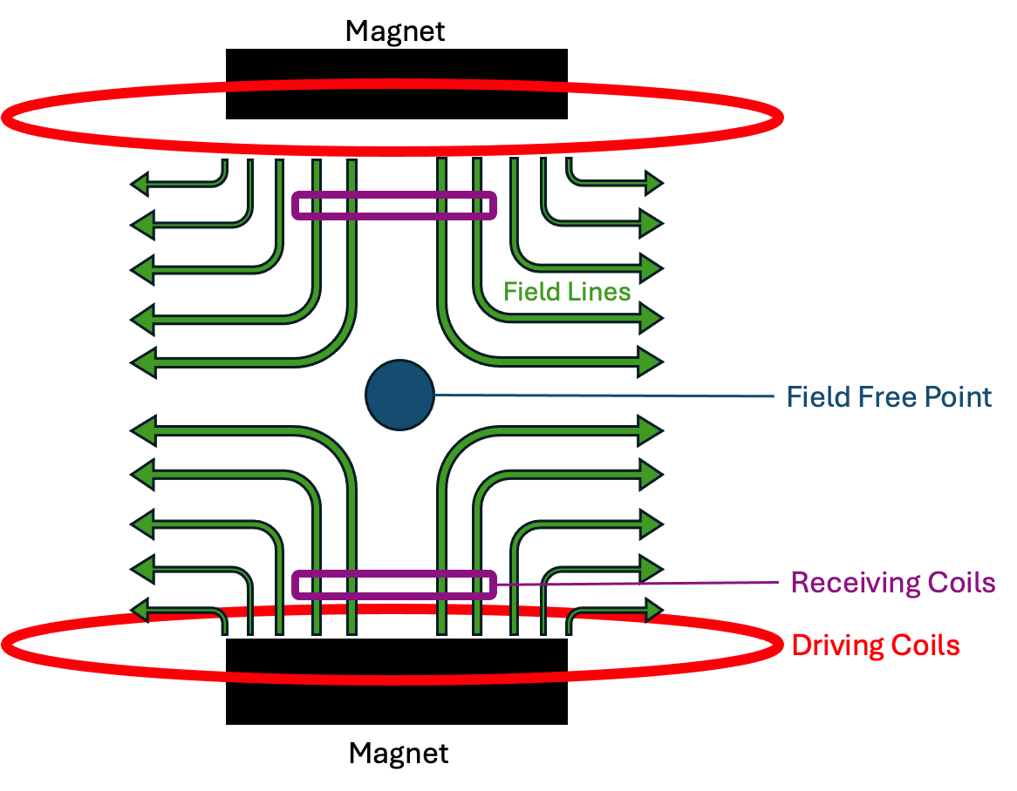
Figure 2: Schematic of MPI system for image and signal generation.

Therefore, careful analysis must be performed when regularizing solutions to achieve high resolution and low noise while inverting the system matrix [18]. In addition to the computational challenges this method poses, robustness of the system is another issue. If pre-characterization scans do not precisely reproduce the tracer’s in vivo micro-environment, artifacts can appear in the reconstructed image [18]. Viscosity variations in the body and concentration of tracers can alter MPI signal, which can contribute to modeling errors and lead to inaccurate system matrices and image reconstructions [14].
The second and more recent MPI technique is known as x-space MPI, which improves the speed and robustness of MPI image reconstruction [5, 19, 20]. X-space MPI is shift-invariant and linear and has shown to be mathematically equivalent to harmonic-space MPI’s system matrix approach [21]. Although general scanner geometry of x-space MPI and harmonic-space MPI are shared, x-space MPI signal corresponds to a temporal scan through x-space, rather than a set of harmonics [7]. Signal generation for x-space MPI is more straightforward. The magnetic field is shifted across the tracers located at a field free point, causing the magnetic moments of the nanoparticles to flip. A receiver coil detects the signal generated from this magnetic flipping. The signal shape corresponds to the derivative of the magnetization curve and is termed as the point spread function (PSF) of the x-space MPI system. Utilizing the same gradients as harmonic-space MPI, localization in space is obtained. Reconstruction of the image is achieved by gridding the raw signal to the known field free point trajectory [7]. X-space MPI is essentially the convolution of the PSF with the spatial distribution of tracer material [19, 20]. Once the PSF is obtained, image quality can be predicted. Due to the more straightforward nature of x-space MPI, it has become the more frequently implemented technique [22-24]. Therefore, this research will primarily use x-space techniques for preliminary nanoparticle tracer comparisons.
For x-space reconstruction, image quality and tracer performance are primarily described by the point spread function (PSF) [19]. Theoretically, the PSF is derived from the differential of the Langevin function for magnetization of nanoparticles. The PSF of MPI tracers is a measure of change in magnetization as a function of the applied drive field [25]. Experimentally, the PSF can be obtained from relaxometry measurements using a RELAX module system in a MOMENTUM scanner [26-29]. Two important parameters to consider when evaluating the PSF is the signal intensity and full-width-half-maximum (FWHM). The signal intensity reflects the sensitivity of the nanoparticle tracers and the FWHM is related to the spatial resolution [25, 30]. For optimized MPI tracers, high signal intensity and low FWHM is needed in order to have high sensitivity and resolution respectively. By assuming superparamagnetic behavior detailed in the Langevin function, simple relations for sensitivity and resolution can be obtained since the signal in MPI is related to the time-derivative of the particle’s magnetization response [31]. A mathematical representation for MPI sensitivity is shown in equation 2, where sensitivity is measured by the peak intensity, I, of the PSF:
$$\begin{aligned}\text{I= }\frac{\text{N}{\text{M}}_{\text{s}}\text{π}{\text{D}}^{\text{3}}}{\text{18}}\#\left(\text{2}\right)\end{aligned}$$
where N is the number density of magnetic nanoparticles (particles/m³), M_{s} is magnetic saturation, and D is the diameter of the nanoparticles.

Equation 3 shows the full-width-half-maximum (FWHM) of the PSF, which represents MPI resolution.
$$\begin{aligned}\text{FWHM=}\frac{\text{24}{\text{k}}_{\text{B}}\text{T}}{\text{π}{\text{μ}}_{\text{0}}{\text{M}}_{\text{s}}\text{G}{\text{D}}^{\text{3}}}\#\left(\text{3}\right)\end{aligned}$$
In equation 3, k_{B} is the Boltzmann constant, T is temperature, μ₀ is the vacuum permeability, M_{s} is magnetic saturation, G is the magnetic field gradient strength, D is the core diameter [7, 31]. From this equation, MPI resolution is based on a function of both nanoparticle characteristics and magnetic gradient strength. From equations 2 and 3, one would assume that increasing the nanoparticle diameter and magnetic saturation would decrease the FWHM and increase peak intensity, which would lead to improvements in peak intensity and resolution. In addition, increasing the diameters of nanoparticles from 17 to 25 nm could theoretically lead to a greater than 3-fold improvement in resolution [7]. However, as previously mentioned, these equations assume ideal superparamagnetic behavior, suggesting there are no magnetic interactions between tracers and magnetic response is instantaneous to an applied field. Therefore, when testing experimentally, enhancement in intensity and resolution are still limited by the physics of magnetic relaxation and nanoparticle composition [7].

MPI Tracer Characteristics
Since resolution and signal-noise-ratio (SNR) are governed by the MPI’s system hardware and tracer properties, tracer development has been a central area of research in the advancement of MPI [7]. Signal generation for MPI is highly dependent on the magnetic properties of magnetic nanoparticles (MNPs) and certain characteristics are needed in order to achieve optimal signals [32]. Tracers must be superparamagnetic, possess high magnetic saturation, and have a short magnetic relaxation time, which are all affected by the size and composition of MNPs [32]. Superparamagnetic properties appear in small ferro- or ferrimagnetic nanoparticles [33]. Superparamagnetic nanoparticles have high magnetic susceptibility, and their magnetic moments can randomly flip directions under the influence of temperature. They are favorable for MPI since they have negligible coercivity and magnetic remanence [34]. Coercivity is the magnetic field strength needed to demagnetize a magnetically saturated material and magnetic remanence is the residual magnetization materials possess after an external magnetic field is removed [32].
Magnetic relaxation in MNPs is another factor for consideration. Two magnetic relaxation types present in MNPs are Brownian and Néel relaxation. Brownian relaxation occurs from the rotation of the entire nanoparticle and Néel relaxation is caused by the realignment of internal magnetic spins inside the nanoparticles after an external field is removed [35, 36]. For MPI signal generation, short Néel relaxation is of high importance since MPI signals are generated from the relaxation of the magnetic spins at the field free point [32]. For sharper MPI signal generation and high image resolution, short magnetic relaxation is needed. Therefore, short magnetic relaxation found in superparamagnetic MNPs is favorable.
Finally, size of magnetic nanoparticles is an important characteristic when tailoring tracers for MPI. Nanoparticle size dictates the internal magnetic spin that determines magnetic saturation and signal intensity for MPI [3, 37-41]. Larger MNPs with high magnetic saturation assist in lowering the detection limit for MPI and a small size distribution is needed in order to obtain even signal generation and consistent image quality [32]. Du and colleagues demonstrated the importance MNP size can have on MPI performance by fabricating 8 and 18 nm magnetite nanoparticles. From their results, the magnetic saturation increased from 35.8 to 60.4 emu/g when the size increased from 8 to 18 nm respectively. When tested at the same iron concentration, the 8 and 18 nm nanoparticles had a 1.89 and 2.68 times higher MPI signal intensity when compared to Vivotrax respectively [42]. Shasha et al. studied varying sized magnetite nanoparticles and found that single crystalline magnetite nanoparticles close to critical size, around 25 nm, displayed good signal strength and resolution for MPI. However, nanoparticles larger than 25.2 nm displayed little to no enhancement in MPI signal compared to smaller magnetite nanoparticles due to ferromagnetic behavior. From their study, careful size control of nanoparticles is necessary in order to maintain superparamagnetic behavior and to achieve optimal MPI signal [43]. The critical size limit to maintain superparamagnetic properties varies for different materials and must be considered during synthesis in order to achieve optimal MPI performance.

Current MPI Tracers
With the above characteristics in mind, MPI tracer development has been predominantly focused on optimizing particle core size and composition [11]. Various types of magnetic nanoparticles have been researched for MPI applications, with many being iron based. Doping of ferrite nanoparticles with transition metals such as manganese (Mn²⁺), cobalt (Co²⁺), zinc (Zn²⁺), nickel (Ni²⁺) and gold have been performed and have shown good potential in magnetic hyperthermia and MPI applications [29, 44-46]. These ferrite nanoparticles have displayed similar or enhanced properties when compared to superparamagnetic iron oxide nanoparticles (SPIONs) [47].
Other magnetic nanoparticles for MPI include iron alloys such as FeCo, FeAu, and Fe₅C₂ [48, 49]. Song et al. synthesized 10 nm FeCo nanoparticles with a graphitic carbon and PEG coating, and these tracers exhibited around 6 times higher MPI signal intensities when compared to the commercially available tracer, VivoTrax. In addition, FeCo nanoparticles display good potential for MPI-guided cancer therapy and imaging due to their magnetothermal and photothermal properties [49]. Dhawan et al. fabricated FeAu nanostructures for medical imaging and cancer theranostic applications. These nanostructures exhibited superparamagnetic and magnetic hyperthermia behavior, and improved image contrast for magnetic resonance imaging. From their use in MRI, these nanostructures could have potential for MPI applications as well [50]. In addition, FePt and Fe₅C₂ nanoparticles have exhibited promising properties for MPI, but these particular nanoparticles have currently only been tested for MRI applications [48, 51, 52].
Despite the wide range of magnetic nanoparticles being investigated, SPIONs are still among the most researched and used for MPI applications due to ease of preparation, low toxicity, and good magnetic properties [53-55]. Among the various types of SPIONs, magnetite (Fe₃O₄) is among the most common SPION synthesized for magnetic imaging purposes since it possesses higher magnetic saturation compared to other iron oxides [56]. Synthesis of magnetite nanoparticles is commonly performed using a thermal decomposition of iron precursors such as iron pentacarbonyl, iron oleate or iron (III) acetylacetonate with organic solvents [57]. Phase-controlled synthesis of magnetite can also be achieved from controlled oxidation of wüstite nanoparticles [53]. The oxidation approach and precursor selection are highly important for size control and phase purity of magnetite nanoparticles [54, 58]. Ferguson and colleagues synthesized varying sized magnetite nanoparticles ranging from 7-17 nm in diameter and found that 15 nm was an ideal diameter when testing initial signal generation from their MPI system [59]. Khandar et al. showed the importance of different surface coatings on magnetite nanoparticles using increasing molecular weighted PEG molecules from 5 kDa to 20 kDA on 25 nm magnetite nanoparticles. From their results, they found that higher molecular weighted PEG coatings assisted in improving tracer stability and preserved MPI signal response. In addition, they found their nanoparticles exhibited a 2-fold greater signal per unit mass and 20% better spatial resolution when compared to a commercial tracer, Resovist [60].
Maghemite (γ-Fe₂O₃) is another common SPION used for MPI applications that can be formed directly in solution or by further oxidation of magnetite nanoparticles. Hyeon and colleagues formed monodispersed maghemite nanoparticles of various sizes by a thermal decomposition of Fe(CO)₅ with oleic acid and trimethylamine oxide [61]. From their study, they found that by varying the molar ratios of Fe(CO)₅ and oleic acid, different nanoparticle sizes could be achieved. In addition, larger nanoparticles could be achieved from previously formed nanoparticles by adding more precursor to the solution with subsequent aging procedures. Generally, this type of thermal decomposition method is preferred due to ease of control over particle size and good reproducibility [61]. In contrast, Herynek et al. utilized a coprecipitation method of iron salts to form 8 nm maghemite nanoparticles and coated them with poly(N-(2-hydroxypropyl)methacrylamide) (HPMA) and N-[2-(hydroxyamino)-2-oxo-ethyl]-2-methyl-prop-2-enamide (HAO). From this study, 4 samples were tested that included uncoated and HPMA/HAO coated maghemite nanoparticles that had an anionic or cationic surface charge. When comparing MPI signal-to-noise ratios and signal displacement, cationic maghemite particles had an insignificantly lower signal than Resovist. Uncoated anionic nanoparticles had a slightly higher signal-to-noise ratio, while coated anionic nanoparticles had identical signal-to-noise ratio when compared to Resovist [62].
In comparison with previous studies involving SPIONs, few studies have looked into the synthesis of pure iron nanoparticles for magnetic imaging applications. When compared to iron oxide, pure iron possesses higher magnetic saturation and susceptibility. Iron nanoparticles are typically produced through a thermal decomposition of organic iron precursors like iron pentacarbonyl, iron oleate or Fe(C₅H₅)(C₆H₇) under inert atmospheres [34, 63, 64]. Alternatively, other studies have used high temperature reduction reactions of iron oxide nanoparticles under hydrogen gas that also allow for the formation of pure iron nanoparticles where sintering of uncoated nanoparticles commonly occur. These nearly pure iron nanoparticles have shown to possess high magnetic saturation values up to 176 emu/g at sizes around 13 nm [65]. Due to the high reactivity of pure iron, these nanoparticles typically exhibit an iron core-iron oxide shell structure, whereby an iron oxide passivation layer will naturally form [66]. However, further coating with polymers or silica have shown to assist in preventing further oxidation of the nanoparticles and protect the iron core produced [67]. Previous studies by Gloag et al. reported the synthesis of 14 and 11 nm superparamagnetic iron core-iron oxide shelled nanoparticles. The iron oxide shell assisted in preventing rapid oxidation of the pure iron core, but an additional co-polymer coating increased colloidal stability in aqueous media. The 14 nm nanoparticles displayed high magnetic saturation around 166 emu/g and achieved an MPI signal intensity around 80% of the commercially available VivoTrax and had similar spatial resolution. The 11 nm nanoparticles had slightly lower magnetic saturation around 100 emu/g and displayed around 40% of MPI signal when compared to Vivotrax. Comparatively, SPIONs of similar sizes did not generate recognizable MPI signals due to having lower magnetic saturation values [34]. From this study, it is clear that utilizing pure iron for MPI tracer development could be advantageous when compared to SPIONs, since pure iron possesses enhanced magnetic properties compared to iron oxides.
With consideration of previous literature, the creation of pure iron nanoparticles with little to no iron oxide is of interest. Due to pure iron possessing high magnetic saturation and offering better magnetic properties compared to SPIONs and other variants, it could offer good potential for MPI applications. Therefore, this research will focus on various synthetic methods to achieve iron nanoparticles that are mainly composed of pure iron with a thin iron oxide shell. The nanoparticles will be polymer coated with polyethylene glycol to decrease oxidation and improve biocompatibility and dispersibility. Optimization of composition, magnetic characteristics, and size of nanoparticles for MPI applications will be investigated in this study. Further cell viability tests will be performed and synthesis methods in fabricating iron nanoparticles around 20 nm in total diameter is of primary interest for this research.

CHAPTER I
VARIATION OF ALKYL CHAINED SURFACTANTS ON IRON NANOPARTICLE SIZE AND SHAPE

Abstract
Currently, iron oxide nanoparticles around 25 - 30 nm in diameter are the standard magnetic tracers used for magnetic particle imaging (MPI) applications. Compared to iron oxide nanoparticles, less research has been performed in creating pure iron nanoparticles for MPI applications. Previous studies have created iron core - iron oxide shell nanoparticles around 15 nm in diameter, but in order to achieve optimal MPI signal similar to iron oxides, larger diameters around 20 nm are needed. However, due to strong magnetic characteristics of pure iron, synthesizing pure iron nanoparticles above 15 nm in diameter can be challenging due to the high risk of agglomeration. Therefore, an investigation in creating 20 nm sized iron nanoparticles was performed utilizing potential surfactants that might prevent agglomeration. A thermal decomposition of iron pentacarbonyl was performed with different surfactants including decylamine (DA), dodecylamine (DDA), hexadecylamine (HDA), octadecylamine (ODA), and dioctyldecylamine (DODA) to determine potential differences in size or composition. All surfactants possessed a linear structure and only varied in alkyl chain length. From the results, it was found that longer alkyl chain length surfactants assisted in creating larger iron nanoparticles.

Introduction
Magnetic nanoparticles have gained much attention in biomedical applications such as biosensing, cancer theranostics, drug delivery vehicles, and medical imaging agents [68]. Superparamagnetic iron oxide nanoparticles (SPIONs) are among the most commonly used for such biomedical applications due to their high biocompatibility and good magnetic properties [69, 70]. Currently, FDA approved SPIONs such as Resovist, Feridex and Ferumoxytol have been used as contrast agents for magnetic resonance imaging (MRI) and have become a favorable alternative for patients suffering from chronic kidney disease [71, 72]. In addition, these nanoparticles have been used for magnetic hyperthermia treatment of various cancers.

Magnetic particle imaging (MPI) is a new imaging technique that uses magnetic nanoparticles and offers high-resolution imaging of SPIONs in real-time [2]. Compared to MRI, MPI offers direct detection of SPIONs with no background signal from surrounding tissues [6, 12]. MPI uses magnetic field gradients and time varying magnetic fields to excite SPIONs to obtain a nonlinear magnetization response for signal generation [2, 19, 20]. The image resolution for MPI is determined by the full-width-half-maximum (FWHM) of the point spread function (PSF). Ideal PSFs generated by tracers should be symmetrical with a high signal-to-noise ratio (SNR) and small FWHM [73]. Although initial imaging studies of MPI used commercial MRI contrast agents mentioned previously as a “gold standard,” recent work has proven that tailoring tracers assists in generating higher image resolution [74, 75]. Therefore, in order to improve MPI’s performance, research has been focused on developing tailored MPI tracers to enhance resolution and sensitivity [10, 12, 76-78].
Currently, iron oxide nanoparticle tracers with a diameter of 26 - 27 nm have been shown to provide the best performance for MPI. Similarly, modeling studies suggest that 25 - 30 nm is the optimal diameter for magnetic nanoparticles [11]. Although iron oxide nanoparticles have been shown to provide good MPI signal, interest in creating a magnetic tracer that can provide high magnetic susceptibility and improved magnetic properties is needed. The synthesis of pure iron nanoparticles is of interest in many magnetic imaging applications due to the increased magnetization that is generated from pure iron compared to other metals or metal oxides.
Previous research from our group was conducted that involved synthesizing superparamagnetic iron core - iron oxide shelled nanoparticles around 14 nm in diameter [79]. Although the nanoparticles possessed a high magnetic saturation around 133 emu/g, it was found that the nanoparticles still theoretically required higher magnetic response to successfully provide optimal MPI signal when compared to standard tracers. Theoretically, in order to improve MPI signal and resolution, a narrow PSF and low FWHM is needed, which can be achieved by increasing the magnetic diameter of the nanoparticle tracer [32].

In order to achieve high MPI signal, the goal of this study was to investigate a simple method to achieve larger iron nanoparticles around 20 nm in total diameter. However, due to the high magnetization pure iron nanoparticles possess, susceptibility to agglomeration during synthesis is a major issue, especially when synthesizing iron nanoparticles above 15 nm in diameter. Previous studies using a thermal decomposition of iron pentacarbonyl have been investigated using long chained surfactants to assist in forming larger iron nanoparticle sizes. Long alkyl chained surfactants provide more steric hinderances in the solution during nanoparticle growth, allowing for larger nanoparticle sizes to be achieved while lowering agglomerations. Therefore, this study investigates the effects various long alkyl chained surfactants have on iron nanoparticle size, shape, and composition. We hypothesize that longer chained surfactants will yield larger nanoparticle sizes, which can provide better MPI signal and resolution.

Materials and Methods

Chemicals
Octadecylamine (ODA, 90%), dodecylamine (DDA, 99%), dioctadecylamine (DODA, 99%), decylamine (DA, 95%), hexadecylamine (HDA, 98%), iron (0) pentacarbonyl [Fe(CO)_{5,} >99.99%], 1-octadecene (90%), chloroform, hydrochloric acid (HCl, 37%), hexanes, acetone, and nitric acid (1M) were all purchased from Sigma Aldrich. Anhydrous ethanol was purchased from Decon Labs. 1,2-distearoyl-sn-glycero-3-phosphoethanolamine-N-[methoxyl-(polyethylene glycol)-2000] (ammonium salt) (DSPE-mPEG) was purchased from Avanti Lipids.

Synthesis and Setup
The chosen surfactants are shown in Figure 3 and the synthetic setup in Figure 4. In a 4-neck round bottom flask, a magnetic stir bar, 20 mL of 1-octadecene and 0.1 mmol of a chosen surfactant (DA, DDA, HDA, ODA, DODA) were added. The solution was vacuumed and purged under a Schlenk line 3 times under ultra-pure Argon before being heated to 120 °C for 30 minutes. The temperature was raised to 180 °C at a 2°C/min rate and 1.4 mL of Fe(CO)₅ was directly injected into the solution and reacted for 30 minutes.
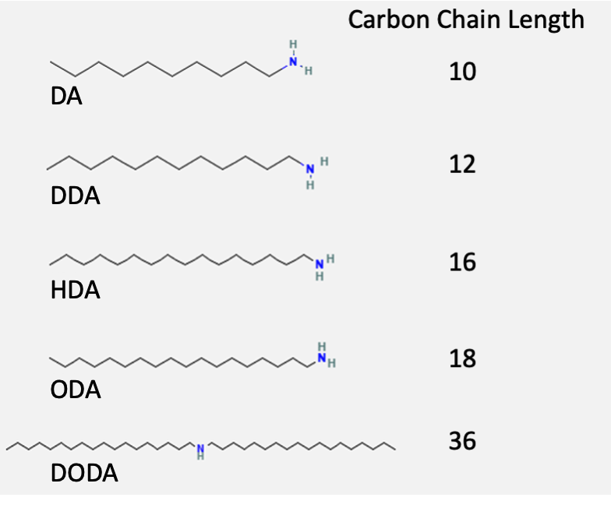
Figure 3: Abstract of alkyl chained surfactants and corresponding carbon chain lengths.

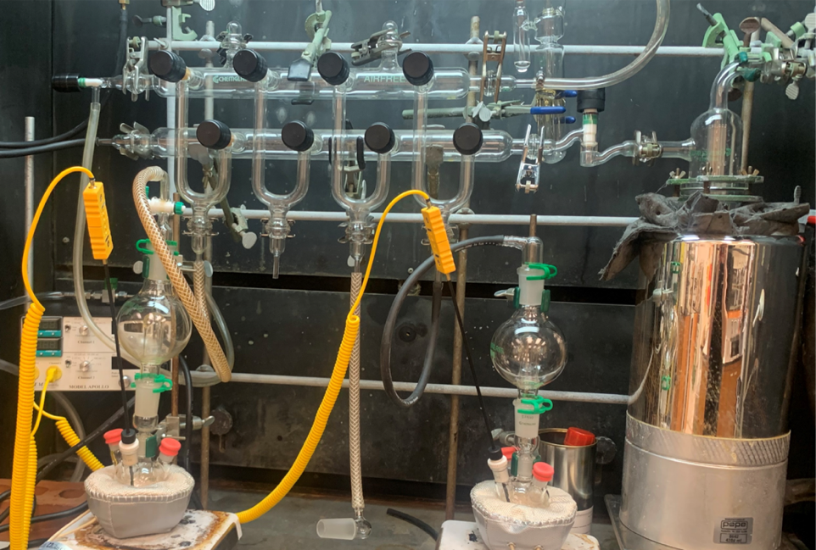
Figure 4: Synthesis setup.

Afterwards, the solution was further raised to 220 °C to react for 2 hours and allowed to cool to room temperature before washing. The particles were washed with hexanes and acetone under ambient conditions and then centrifuged with 60 mL of absolute ethanol 3 times at 8000 rpm in a Beckman Coulter C0650 fixed-angle rotor for 10 minutes. Half of the product was dried to powder and stored in an Argon atmosphere glovebox, and the remaining half was dispersed in chloroform and stored in a refrigerator for further polymer coatings and characterizations. Samples were named based on the surfactant used in their respective syntheses.

DSPE-mPEG Coating
Around 2 mL of chloroform dispersed nanoparticles were mixed with 0.4 mL of DSPE-mPEG and 9.6 mL of chloroform in a 100 mL round bottom flask and then sonicated for 10 minutes. The chloroform in the solution was evaporated under a rotary evaporator for 1 hr in a 60 °C water bath under vacuum. 4 mL of ultrapure water was added to the flask after evaporation and sonicated for 1 minute to evenly disperse particles in water and transferred to Vivaspin Turbo 15 filter tubes (Sartorius) and centrifuged for 1 hr at 5000 rpm. 1-2 mL of ultrapure water was added to the tubes to redisperse the particle. The particles were pipetted into storage vials and stored in a refrigerator for further cytotoxicity and MPI tests.

Acid Digestion for ICP-OES Measurements
Inductively coupled plasma-optical emission spectrometry (ICP-OES) was performed on coated iron nanoparticles samples prior to cytotoxicity studies and MPI measurements to accurately determine Fe concentrations. 500 μL of coated iron nanoparticles dispersed in water were mixed with 2 mL of 1 M nitric acid and 2 mL of 37% HCl in a 25 mL volumetric flask. The solution was sonicated for 5 minutes before heating in an 80 °C water bath for 1 hour. The solution was gravity filtered through 0.45 μm pore size Whatman filter paper into a 200 mL volumetric flask. The initial volumetric flasks were rinsed 3-5 times with ultrapure water and poured over the filter. The final solution was brought to the appropriate 200 mL volume with ultrapure water to obtain a 50 mg/L Fe concentration for ICP-OES measurements.

Results

Transmission Electron Microscopy (TEM)
Transmission electron microscopy (TEM) was performed at the Vanderbilt Institute of Nanoscience and Engineering (VINSE), Vanderbilt University. An FEI Tecnai Osiris TEM system was operated between 80 kV - 200 kV. Diameters were determined using ImageJ processing software. An average of 200 nanoparticles were measured to determine standard deviations for nanoparticle diameter, core and shell sizes.
TEM images of all samples including DA, DDA, HDA, ODA, and DODA are shown in Figures 5 and 6. Elemental mappings of each sample are shown in Figure 7 to better distinguish iron core - iron oxide shell structures. A summary of the average diameter, core diameter and shell thickness of each sample is shown in Table 1. A positive trend was seen when comparing the carbon chain length of the surfactants to average diameter and core size, as shown in Figures 8 and 9. The sample synthesized with the shortest chained surfactant, DA, produced the smallest nanoparticles with a diameter of 12.4 ± 1.3 nm and the sample using the longest chained surfactant, DODA, produced particle sizes around 24.9 ± 3.2 nm. In addition, all samples displayed good dispersibility.
The morphology and composition of the particles were generally similar across all samples. The DA sample displayed the most spherical shape and the DDA, HDA, ODA, and DODA samples began to form irregular, prolate-like shapes. All samples also displayed a distinct iron core - iron oxide shell structure. It was found that as the overall particle diameter increased, the iron core also increased with longer alkyl chained surfactants. However, there was little difference between the iron oxide shell thickness for each sample.

X-ray Diffraction (XRD)
XRD measurements were performed using a Rigaku SmartLab3kW X-ray Diffractometer with a Cu Kα X-ray source in a 2θ range of 20° - 90° at UTSI. Figure 10 shows the stacked XRD spectra of all samples. From the data, all samples displayed amorphous characteristics with no distinct peaks indicating α-Fe or iron oxide. From a previous report, alkyl chained surfactants that have an amine functional group have shown to
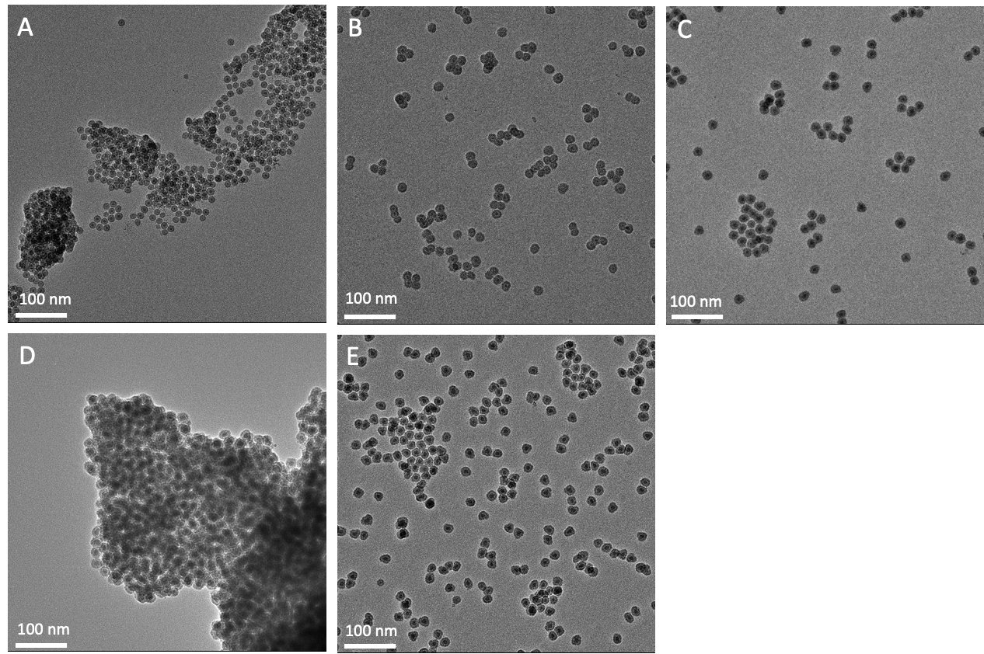
Figure 5: TEM images of samples made with different surfactants at a 100 nm scale. A) DA B) DDA C) HDA D) ODA E) DODA.

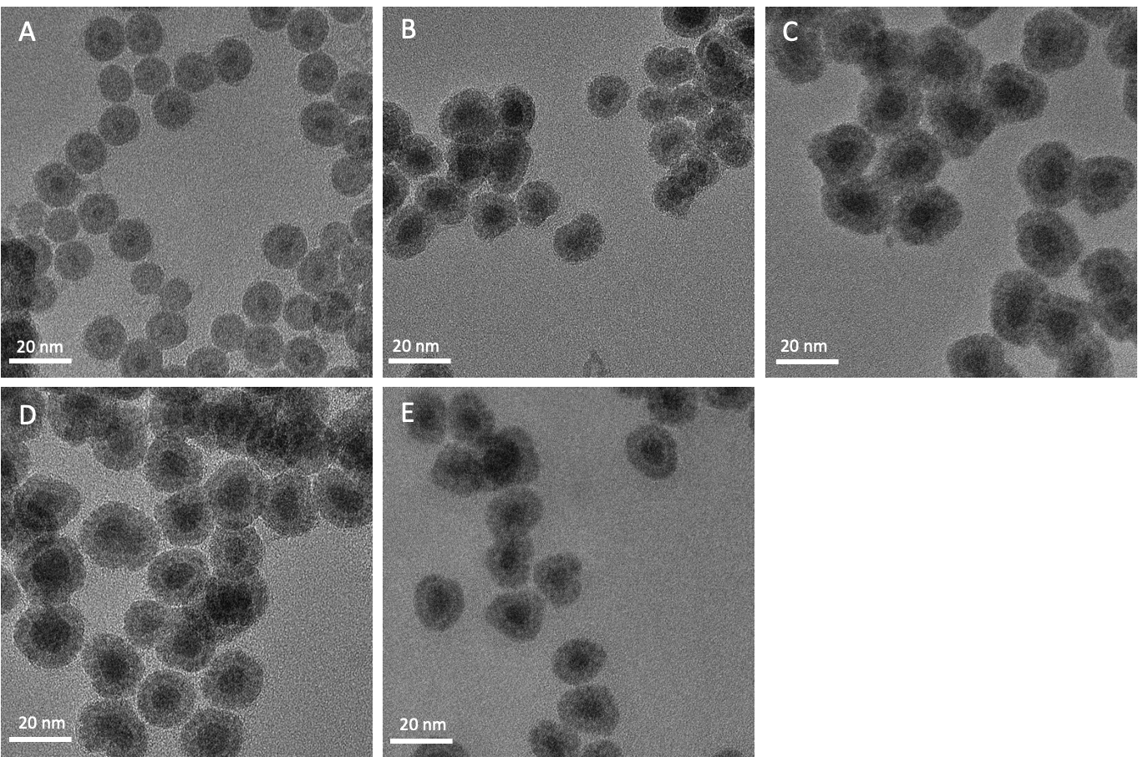
Figure 6: TEM images of samples made with different surfactants at a 20 nm scale. A) DA B) DDA C) HDA D) ODA E) DODA.

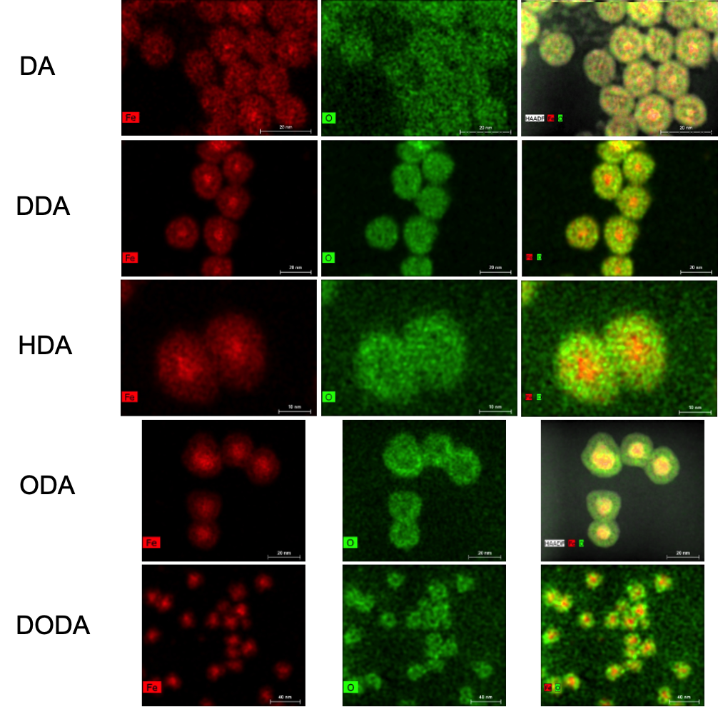
Figure 7: Elemental mapping of iron core - iron oxide shell structure for all nanoparticle samples.

Table 1: Summary of average iron nanoparticle diameter, core and shell measurements from TEM results for each surfactant. An average of 200 nanoparticles were counted to obtain averages and standard deviations.
Sample | Diameter (nm) | Core (nm) | Shell Thickness (nm)
DA | 12.4 ± 1.3 | 3.8 ± 0.7 | 4.6 ± 0.5
DDA | 18.8 ± 3.1 | 7.4 ± 2.3 | 6.7 ± 1.2
HDA | 21.2 ± 3.0 | 8.9 ± 2.0 | 6.4 ± 1.2
ODA | 22.6 ± 4.1 | 12.3 ± 3.4 | 5.6 ± 1.2
DODA | 24.9 ± 3.2 | 12.4 ± 3.2 | 7.0 ± 1.0

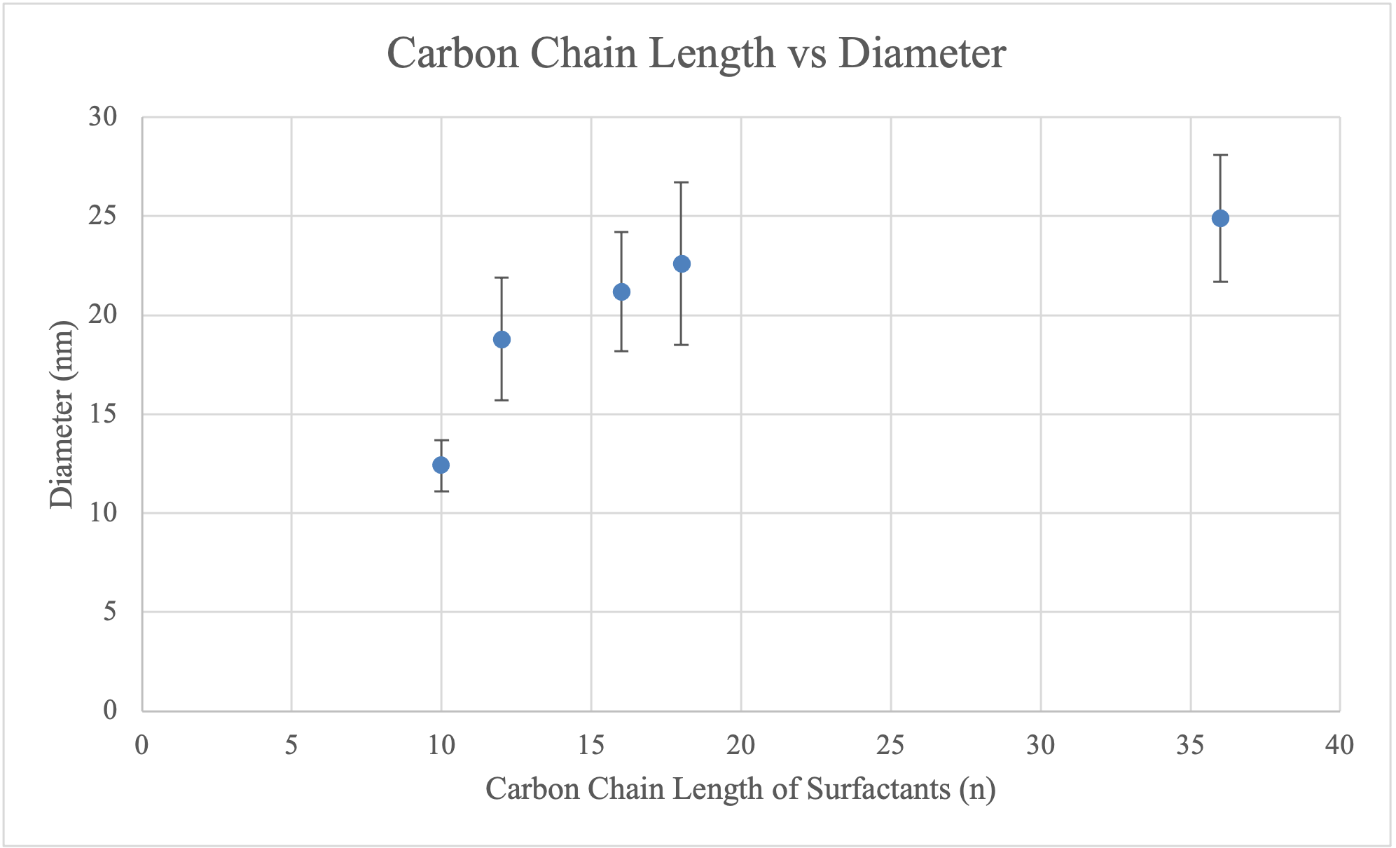
Figure 8: Comparison between carbon chain length of surfactants and average diameter size.

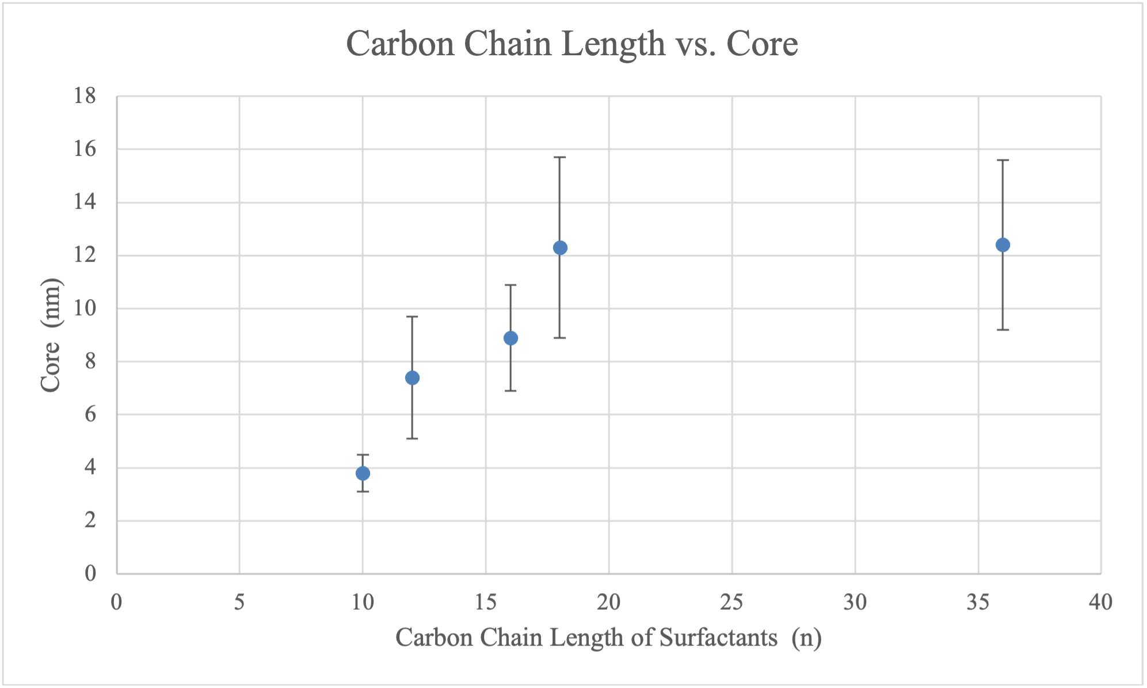
Figure 9: Comparison between carbon chain length of surfactants and average iron core size.

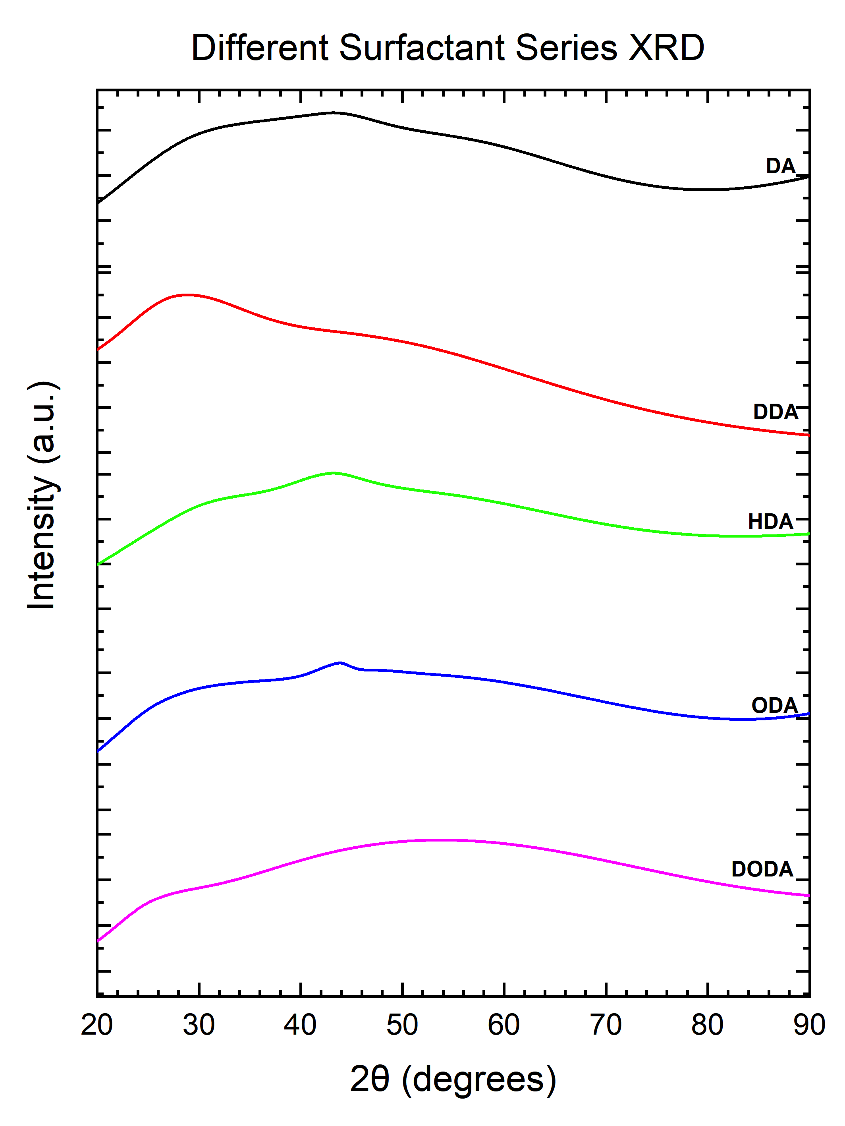
Figure 10: Stacked XRD spectra of samples from using different surfactants.

produce nanoparticles with amorphous characteristics [80]. A potential reason for the amorphous quality could be attributed to the growth kinetics when the nanoparticles are forming. The high reactivity of the Fe(CO)₅ causes rapid nucleation and growth processes. This process could result in random packing of individual Fe atoms and cause the formation of amorphous iron nanoparticles [81]. In addition, the binding affinity of
the tested surfactants could be weaker compared to other surfactants like oleic acid and oleylamine. HDA has been shown to have weaker binding to the crystal surface when compared to other surfactants like oleic acid and oleylamine due to its shorter chain length and lack of C=C bonds. Therefore, weak interactions between the surface of the growing nuclei and ligand causes reversible coordination of amine ligands to metal sites on the surface. Rapid growth of the nanoparticle occurs which enables the formation of larger sized nanoparticles from Ostwald ripening [82-84].

Mössbauer Spectroscopy
Mössbauer Spectroscopy measurements were performed with a ⁵⁷Co source, a Janis SHI-850-5 cryogen-free cryostat, and Lakeshore 325 Temperature Controller. Hyperfine interaction parameters were analyzed using a least-squared fitting model with Mössbauer GenFit Software (R. S. Preston and D. E. Brown). Powdered samples that were stored in an Argon atmosphere glovebox were loaded and sealed into Mössbauer cups for characterization at 293K and 6K.
Stacked Mössbauer spectra of all samples measured at 293K are displayed in Figure 11, and corresponding hyperfine fitting parameters are displayed in Table 2. From Mössbauer results, little differences in spectra were observed among the samples. All samples consisted of 2 components. The first component for all of the samples was a red sextet pattern consisting of a hyperfine field between 19-22.3 T, isomer shift between 0.17 - 0.27 mm/s, and quadrupole splitting of 0 - 0.02 mm/s. This component can be attributed to amorphous Fe [85, 86]. The second component for all samples was a green doublet pattern with an isomer shift between 0.27 - 0.42 mm/s and quadrupole splitting between 0.88 -1.01 mm/s, which is indicative of γ-Fe₂O₃ [87, 88].

Further low temperature measurements were performed at 6K to confirm the iron composition of the samples. Stacked Mössbauer spectra for all samples measured at 6K are displayed in Figure 12, and values from hyperfine fitting parameters are displayed in Table 3. All samples had similar spectra, consisting of 3 sextets. The first component consisted of a red sextet with a hyperfine field between 22.1 - 25 T, isomer shift between 0.34 - 0.39 mm/s, and a quadrupole splitting between 0 - 0.06 mm/s, which is indicative of amorphous Fe. The second component for all samples consisted of a green sextet with a hyperfine value between 47.8 - 49.3 T, isomer shift between 0.47 - 0.70 mm/s, and quadrupole splitting between 0.02 - 0.37 mm/s, which is attributed to the A site for γ-Fe₂O₃. The third component consisted of a blue sextet with hyperfine values between 45.8 - 47.5 T, isomer shift between 0.15 - 0.70 mm/s and quadrupole splitting between 0 - 0.27 mm/s, which is indicative of B sites for γ-Fe₂O₃.

Vibrating Sample Magnetometry (VSM)
Vibrating sample magnetometry (VSM) measurements were performed at the Institute for Advanced Materials and Manufacturing (IAMM) at the University of Tennessee Knoxville. A DynaCool Advanced VSM system using a ± 4 Tesla magnetic field at 300K was used. Magnetic hysteresis (MH) curves of all samples are shown in Figure 13. Magnetic saturation values for each sample are shown in Table 4. From magnetization tests, all samples displayed superparamagnetic qualities due to minimal hysteretic remanence. The DA, HDA, and ODA samples had similar magnetic saturation values between 34 - 42 emu/g. The DDA sample had a magnetic saturation around 60 emu/g and the DODA sample had the highest magnetic saturation value of 92 emu/g. Typically, magnetic saturation values should increase as nanoparticle size increases [89]. Although the particle size was smaller for the DA sample compared to the HDA and ODA, all three samples had relatively similar magnetic saturation values. In addition, although HDA, ODA, and DODA samples had a larger overall diameter and reached the targeted diameter around 20 nm, the magnetic saturation values were lower than typical pure iron values that can reach around 217 emu/g [90]. One reason for the lower magnetic saturation for these samples could be due to the amorphous qualities of the particles,
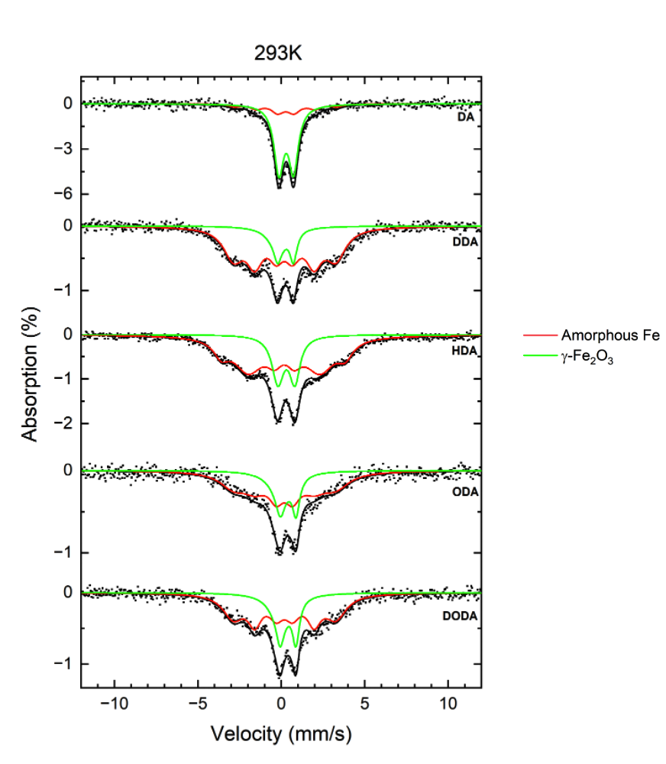
Figure 11: Stacked ⁵⁷Fe Mössbauer spectra of all samples using different surfactants at 293K.
Table 2: Values of hyperfine parameters of all samples using different surfactants at 293K. B_{hf} is the hyperfine magnetic field, δ is the isomer shift, ΔE_{Q} is the quadrupole splitting, and Γ is the linewidth (FWHM). Typical errors are ± 0.4 T for B_{hf}, ± 0.04 mm/s for δ, ± 0.03 mm/s for ΔE_{Q}, and ± 0.05 mm/s for Γ and ± 3% for relative area.
Sample | Component | B_{hf} (T) | δ (mm/s) | ΔE_{Q} (mm/s) | Γ (mm/s) | Relative area (%) | Attribution
DA | 1 | 19.0 | 0.27 | 0.00 | 0.87 | 23 | Amorphous Fe
 | 2 | 0.00 | 0.30 | 0.88 | 0.69 | 77 | γ-Fe₂O₃
DDA | 1 | 19.0 | 0.20 | 0.02 | 1.09 | 80 | Amorphous Fe
 | 2 | 0.00 | 0.27 | 0.94 | 0.50 | 20 | γ-Fe₂O₃
HDA | 1 | 22.3 | 0.17 | 0.00 | 1.04 | 75 | Amorphous Fe
 | 2 | 0.00 | 0.33 | 1.01 | 0.75 | 25 | γ-Fe₂O₃
ODA | 1 | 19.0 | 0.20 | 0.01 | 1.09 | 70 | Amorphous Fe
 | 2 | 0.00 | 0.42 | 0.94 | 0.52 | 30 | γ-Fe₂O₃
DODA | 1 | 19.0 | 0.20 | 0.01 | 1.09 | 70 | Amorphous Fe
 | 2 | 0.00 | 0.41 | 0.94 | 0.50 | 30 | γ-Fe₂O₃

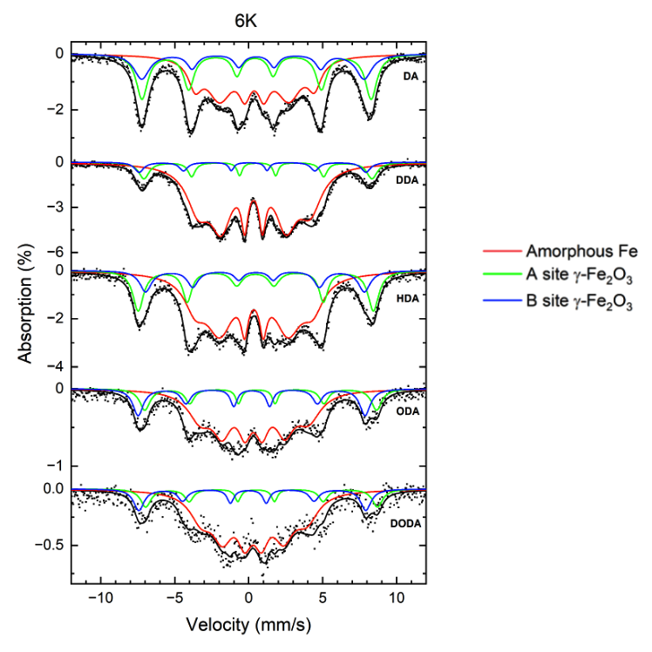
Figure 12: Stacked ⁵⁷Fe Mössbauer spectra of all samples using different surfactants at 6K.

Table 3: Values of hyperfine parameters for all samples using different surfactants at 6K. B_{hf} is the hyperfine magnetic field, δ is the isomer shift, ΔE_{Q} is the quadrupole splitting, and Γ is the linewidth (FWHM). Typical errors are ± 0.4 T for B_{hf}, ± 0.04 mm/s for δ, ± 0.03 mm/s for ΔE_{Q}, and ± 0.05 mm/s for Γ and ± 3% for relative area.
Sample | Component | B_{hf} (T) | δ (mm/s) | ΔE_{Q} (mm/s) | Γ (mm/s) | Relative area (%) | Attribution
 | 1 | 25.0 | 0.39 | 0.04 | 1.00 | 50 | Amorphous Fe
DA | 2 | 48.0 | 0.48 | 0.10 | 0.76 | 31 | A site γ-Fe₂O₃
DA | 3 | 46.5 | 0.41 | 0.23 | 0.78 | 19 | B site γ-Fe₂O₃
DA | 1 | 23.4 | 0.36 | 0.05 | 0.56 | 82 | Amorphous Fe
DA | 2 | 47.8 | 0.62 | 0.02 | 0.42 | 11 | A site γ-Fe₂O₃
DA | 3 | 47.5 | 0.15 | 0.23 | 0.42 | 7 | B site γ-Fe₂O₃
 | 1 | 24.6 | 0.36 | 0.00 | 0.60 | 64 | Amorphous Fe
HDA | 2 | 49.3 | 0.47 | 0.03 | 0.89 | 23 | A site γ-Fe₂O₃
HDA | 3 | 45.8 | 0.36 | 0.00 | 0.72 | 13 | B site γ-Fe₂O₃
ODA | 1 | 22.6 | 0.36 | 0.06 | 1.08 | 65 | Amorphous Fe
ODA | 2 | 48.5 | 0.69 | 0.26 | 0.48 | 16 | A site γ-Fe₂O₃
ODA | 3 | 47.5 | 0.21 | 0.00 | 0.57 | 19 | B site γ-Fe₂O₃
DODA | 1 | 22.1 | 0.34 | 0.06 | 1.21 | 71 | Amorphous Fe
DODA | 2 | 48.5 | 0.70 | 0.37 | 0.48 | 13 | A site γ-Fe₂O₃
DODA | 3 | 47.5 | 0.70 | 0.27 | 0.56 | 16 | B site γ-Fe₂O₃
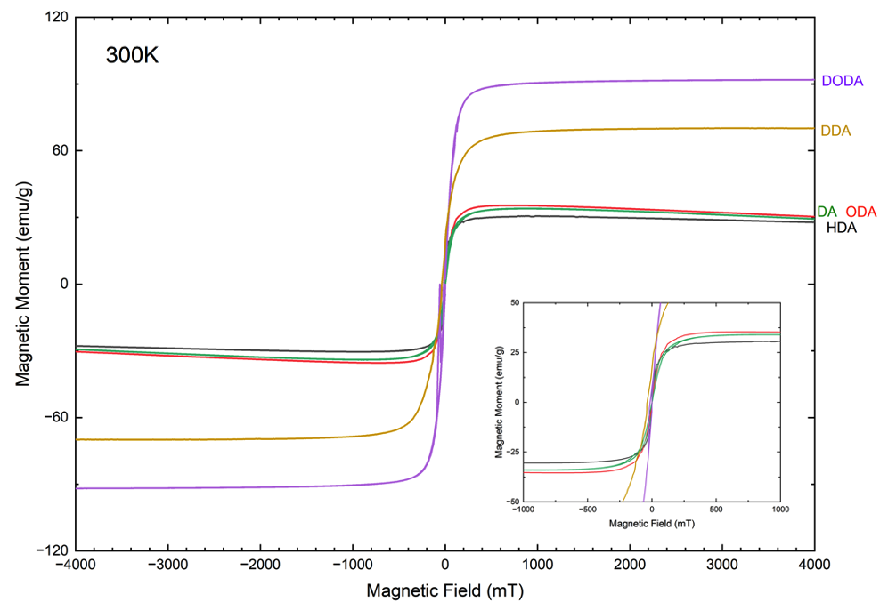
Figure 13: MH-curves of all samples using different surfactants at 300K.

Table 4: Magnetic saturation values of all samples using different surfactants.
Sample | Magnetic Saturation (emu/g)
DA | 34.0
DDA | 60.0
HDA | 42.7
ODA | 35.4
DODA | 92.0

which was confirmed through XRD. The amorphous characteristic in the samples causes disorientation as well as random coupling of magnetic moments, making it difficult to align properly when a magnetic field is applied [80].

Cytotoxicity Studies
Cytotoxicity studies were performed at Vanderbilt University. A 4T1 murine breast cancer cell line was seeded into a 96 well plate 24 hours prior to FeNP introduction. DSPE-mPEG coated iron nanoparticles in aqueous solution were serially diluted using cell media to obtain 100, 50, 25, and 12.5 μg Fe/mL doses. All samples were performed in triplicate for each dose. Each sample incubated with the cells for 24 hours and a Celltiter-Glo assay (Promega) was performed to determine cell viability. Results were compared to untreated 4T1 cells as a control.
Cell viability results of all samples at the 4 doses are shown in Figure 14. From the results, good cell viability was achieved for all samples. Generally, higher concentrations yielded slightly lower cell viability results for the DA, HDA, and ODA samples. However, all samples at all doses displayed cell viability above 100% when compared to the control. Although the DA sample exhibited slightly lower cell viability at 100 μg Fe/mL compared to the other samples, it still displayed good cell viability with an average cell viability of 86%.
In addition, cell viability was about 100% in all samples at all doses with the exception of the 100 μg/mL and 50 μg/mL doses of the DA sample when compared to the control, which suggests cell proliferation occurred. No cell growth or cell death was observed in the untreated 4T1 cells. A possible cause for cell proliferation could be attributed to the PEG coating on the nanoparticles. Previous studies have suggested that PEG-coatings on iron oxide nanoparticles can induce cell proliferation. However, dose, treatment time and cell lines must be considered when evaluating such results [91, 92]. Overall, from these initial cytotoxicity tests, all nanoparticle samples exhibited excellent cell viability.

MPI tests
Preliminary MPI performance measurements were obtained by acquiring MPI RELAX scans on a MOMENTUM scanner (Magnetic Insight, CA, USA) at the University of Florida. These measurements give the net magnetization of the samples in the presence of

Figure 14: Cytotoxicity results of all samples at 100, 50, 25, and 12.5 μg Fe/mL doses.

a varying applied magnetic field. Application of a linearly ramping bias field from -160 mT to +160 mT was used and is superimposed with a uniform excitation field of 45 kHz and 16 mT to mimic MPI imaging conditions. Full-width-half-maximum (FWHM) of the point spread function (PSF) is obtained, which is indicative of resolution. Graphed PSFs and summary table of FWHM results are shown in Figure 15. From the results, all samples had a resolution between 22 - 25 mT, with the exception of HDA which had a resolution of around 15 mT. The samples achieved around 30% - 50% of the resolution when compared to the commercial Vivotrax Plus that has a resolution around 7 mT.
Due to relaxation effects or possible aggregation of the nanoparticles, the obtained PSFs are asymmetrical, which would typically cause the FWHM values to have a level of uncertainty with manual calculations. However, the FWHM values reported here are based on automatic calculations generated from the Momentum software that fits the data to a Langevin model. Since the system’s fitted model is symmetrical, estimated errors are not calculated for the FWHM values. Optimization of testing parameters can be performed to decrease the asymmetry of the PSFs, but these tests were not performed on these samples since initial results did not produce optimal resolution values.

Discussion
Little differences in morphology and composition of the nanoparticles were observed from TEM results. All samples possessed a distinct iron core – iron oxide shell morphology. In addition, overall nanoparticle diameter and iron core size increased as alkyl-chain length of the surfactants increased. From XRD measurements, all samples displayed amorphous qualities, with no distinct diffraction peaks. No crystal lattice planes were observed under high-resolution TEM, further confirming the amorphous quality of the samples. This amorphous quality is most likely due to the binding affinity of each surfactant. The amine functionalized surfactants chosen lacked C=C bonds, which causes weaker binding to the nanoparticle’s surface. This weaker interaction causes fast growth of large nanoparticles sizes and poor crystal structure.

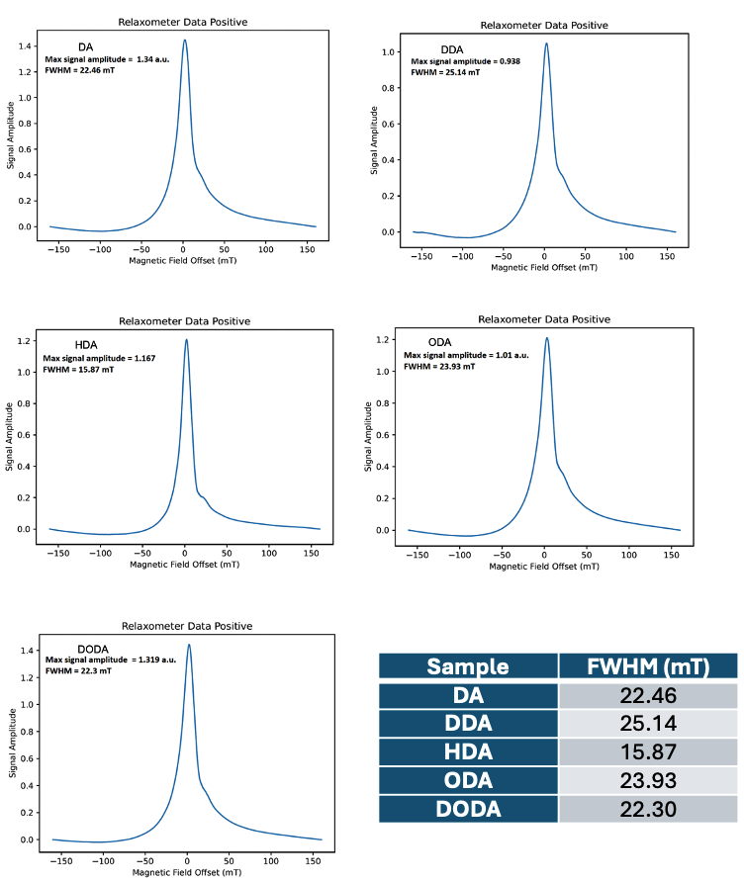
Figure 15: PSF and FWHM measurements from RELAX MPI tests.

From Mössbauer spectroscopy results, all samples from 293K and 6K measurements had similar spectra consisting of 2 and 3 components respectively. Mössbauer results agreed with TEM and XRD results, suggesting the nanoparticles consisted of an amorphous iron
core and iron oxide shell, specifically γ-Fe₂O₃. The iron oxide component from low temperature Mössbauer results displayed superparamagnetic qualities due to observations in the initial doublet pattern at room temperature splitting into sextet patterns at low temperature [79]. In addition, when compared to the 293K spectra, the first component remained relatively similar and did not fully relax into a defined sextet pattern. This could be due to the amorphous nature of the nanoparticles, or the presence of small iron species that have extremely low blocking temperatures [93].
All nanoparticle samples displayed superparamagnetic qualities from VSM magnetization measurements as well. Little to no hysteretic remanence was observed in all samples, however lower magnetic saturation values between 35 -90 emu/g were obtained when compared to the theoretical maximum of pure iron. In addition, no obvious trend was observed when comparing nanoparticle size to magnetic saturation values. The lower magnetic saturation values could be attributed to the amorphous nature of the nanoparticles, which was confirmed from previous characterization results. Due to the disorder and random coupling of the magnetic moments from amorphous iron, lower magnetic saturation can be expected. In addition, the presence of iron oxide in the shell could contribute to lower magnetic saturation since this characterization method is inherently a bulk measurement that averages general magnetic values of materials together [79].
From initial cytotoxicity studies, all nanoparticle samples displayed excellent cell viability. All samples, with the exception of the DA sample, displayed above 100% cell viability at all doses when compared to control cells, suggesting cell proliferation had occurred. Potential causes for the cell proliferation could be attributed to the PEG coating on the samples. Depending on the dose, cell type and exposure time, previous studies have shown that PEG can cause cell proliferation to occur [91, 92].

Finally, from preliminary MPI tests, the nanoparticles had a resolution between 22-25 mT, with the exception of HDA which had a resolution around 15 mT. Currently, commercial tracers like Vivotrax Plus produce a resolution of 7 mT. Therefore, the nanoparticles we tested produced around 30% - 50% resolution when compared to commercial tracers. Various contributing factors such as shape anisotropy, crystallinity, magnetic diameter and magnetic relaxation can affect MPI signal and resolution. Typically, nanoparticle tracers should have even size distributions and uniform shape to have low anisotropy. However, from TEM results, all samples, with the exception of the DA sample, had slightly irregular shapes, which would increase anisotropic values. In addition, good crystallinity in tracers is needed to produce strong magnetic signals. From XRD measurements, the samples displayed amorphous qualities. The effects of the amorphous nature can also be seen from VSM magnetization tests from lower magnetic saturation values. Although these nanoparticles had lower resolution than commercial tracers, these initial tests still suggest good potential for iron core-iron oxide shelled tracers for MPI applications. Further improvement in crystallinity is needed. One method for crystallinity improvement is annealing the samples, however, careful consideration in annealing temperature and time is needed due to risk of sintering or agglomerations [94]. Coating nanoparticles in silica could assist in decreasing sintering [95]. In addition, annealing under at least 5% H₂ gas would prevent further oxidation of nanoparticles and hopefully keep the core-shell structure intact.

Conclusion
In conclusion, an investigation in synthesizing larger iron nanoparticles by using amine functionalized surfactants of varying alkyl chain lengths was performed. From the results, a positive trend was found where longer alkyl-chained surfactants assisted in the growth of larger iron nanoparticles. The shortest surfactant, DA, produced the smallest nanoparticles around 12 nm and the longest chained surfactant, DODA, produced nanoparticles around 25 nm in total diameter. All samples possessed an iron core - iron oxide morphology and were monodisperse. However, it was found that although the targeted particle size of around 20 nm was achieved by varying the types of surfactants, the nanoparticles exhibited amorphous qualities. From Mössbauer studies, all samples were composed similarly, indicating an amorphous iron component from the core and a γ-Fe₂O₃ outer shell that displayed superparamagnetic qualities when measurements were performed at low temperatures. From magnetization tests, all samples displayed superparamagnetic qualities. However, due to the amorphous nature of the particles, all samples exhibited relatively low magnetic saturation values below 100 emu/g. In addition, polymer coated nanoparticles exhibited low cytotoxicity as well. From preliminary MPI studies, the nanoparticles produced around a 22-25 mT resolution, with the exception of HDA that had a resolution around 15 mT. From these results, we believe these particles could have good potential for MPI applications since they possessed the targeted iron composition, size, shape, and displayed low cytotoxicity. However, future work is needed in order to improve crystallinity in the nanoparticles in order to produce better resolution for MPI applications.

CHAPTER II
CONTINUOUS INJECTION OF IRON PRECURSOR USING A LAMER GROWTH MECHANISM

Abstract
Magnetic nanoparticles are a promising class of materials for various biomedical applications such as cancer theranostics, drug delivery, and medical imaging agents. For example, when utilized for magnetic particle imaging (MPI) applications, iron oxide nanoparticles around 25 - 30 nm are currently the standard. Presently, there is interest in pure iron nanoparticles to create magnetic tracers that can provide improvement in magnetic properties. However, in order to effectively tailor these nanoparticles to specific applications, reproducible size control is needed. Previous studies have managed to use a thermal decomposition of organic iron precursors to create iron nanoparticles between 5 - 15 nm in diameter, but fewer studies have successfully created iron nanoparticles of larger sizes. Therefore, an investigation in using an extended LaMer mechanism to create larger iron nanoparticle sizes for potential magnetic particle imaging applications was performed. A continuous addition of Fe(CO)₅ as the precursor using a thermal decomposition method was used. Three injection speeds of the iron precursor were tested, which included 100, 50, and 25 μL/min to test if injection rates affected the overall particle growth and size. In addition, three different surfactants including an oleylamine/ oleic acid (OAm/OA) mixture, hexadecylamine (HDA), and octadecylamine (ODA) were used in order to test if the surfactants affected the size, morphology, and composition of the nanoparticles.

Introduction
Magnetic nanoparticles (MNPs) have been heavily researched for different biomedical applications including biomedicine, biosensors, drug delivery systems and medical imaging. Currently, superparamagnetic iron oxide nanoparticles are among the most commonly studied due to ease of producibility, low toxicity and good magnetic properties [64, 96-98]. However, in order to appropriately tailor MNPs for specific biomedical applications, having reproducible control over size and composition is needed. Currently, a common method in creating iron-based nanoparticles is through a thermal decomposition of iron precursors like iron pentacarbonyl or iron oleate in organic solvents [99-102]. Although this method produces highly magnetic nanoparticles with even shape and size, it does not easily allow for size variations of nanoparticles unless changes in solvents or surfactants are performed.
Previous studies have investigated controlled synthesis methods for creating specific sizes of iron oxide nanoparticles. For example, Sharma et al created a method that allowed for fine tuning of iron oxide nanoparticle sizes between 3 to 11 nm and found that the size of the nanoparticles was dependent on the reaction time and type of solvent used [103]. Fokina and colleagues used a thermal decomposition of iron oleate complexes to form iron oxide nanoparticles between 6 - 24 nm in diameter. From testing heating rates and reaction times, they found that lower heating rates (~1.6 °C/min) compared to higher heating rates (~10 °C/min) formed slightly larger nanoparticles and less polydispersity. At lower temperatures and heating rates, nucleation and growth rate of nanoparticles is slower. Since less nucleation events occur at lower heating rates, larger nanoparticles could grow from the remaining precursor present in the solution. The group also found that reaction time at the final temperature played a large role in the nanoparticles’ synthesis. Reaction times around 30 minutes was ideal for their particular synthesis to allow for complete growth of the nanoparticles. In addition to the solvent, other factors such as type of precursor used, precursor concentration and surfactant can all contribute to variations in nanoparticle sizes [104].
Although many studies have shown results of fine-tuning iron oxide nanoparticle sizes between 5 - 30 nm, fewer studies have been performed in synthesizing pure iron nanoparticles of similar sizes. Synthesis of pure iron nanoparticles above 15 nm in diameter has proven to be a challenge due to pure iron possessing higher magnetic properties, which risks higher chance of agglomerations. Dash et al made iron core - iron oxide shelled nanoparticles of 3 different sizes including 8, 12 and 15 nm using a thermal decomposition of iron pentacarbonyl and oleylamine and oleic acid as surfactants. They found that 12 nm nanoparticles could be synthesized by adding increased amounts of oleylamine to the reaction. For the 8 nm nanoparticles, lower heating increments were employed along with higher amounts of oleylamine and oleic acid. Although different sizes of iron nanoparticles were achieved, the maximum size of the nanoparticles was only around 15 nm [105].
In order to produce larger iron nanoparticles above 15 nm, a previous study experimented with a LaMer growth mechanism [106]. By using a LaMer growth mechanism, particle sizes can be tuned based on the amount of precursor injected over an extended period of time. The original LaMer mechanism consists of 3 stages and is shown in Figure 16a. The first stage begins when the precursor is first introduced into the reaction and the concentration of monomers increases until it reaches a critical supersaturated state. Stage 2 starts when a burst nucleation occurs to partially relieve the supersaturation that causes the monomer concentrations to drop below the critical nucleation concentration. Finally, in the third stage, the growth of nuclei occurs by diffusion of the monomer to the particle surface, and the monomer concentrations approach the lower solubility limit (C_{s}) [106]. Further growth of the nanoparticles will occur through Ostwald ripening. However, from this model, large size dispersity of final nanoparticles is common. Therefore, an extended version was proposed by Vreeland et al as shown in Figure 16b, where the first and second stages are the same as the original, but the concentration of the monomer decreases in stage 3. As the concentration of monomers is consumed in stage 3, nanoparticle growth occurs. Due to a continuous addition of precursor, the production of monomers can be maintained indefinitely. Eventually, the consumption of monomers by the growing nanoparticles will become equal to the rate of production of monomers and the monomer concentration reaches a steady growth state. A fourth stage is added which allows a steady state of nanoparticle growth that will, in theory, allow for a wide range of particle sizes while maintaining low size dispersity [107].
From this proposed extended LaMer growth mechanism, an investigation in creating larger iron nanoparticles was performed. A continuous injection of iron pentacarbonyl was tested at 100, 50, and 25 μL/min injection speeds. In addition, 3 variations of surfactants were used at the varying injection speeds to determine potential differences in particle size and dispersibility. From this study, we hope to determine the effect precursor injection rates and surfactants have on nanoparticle sizes and compositions. In addition, we hope to achieve larger iron nanoparticles sizes around 20 nm for potential MPI applications.

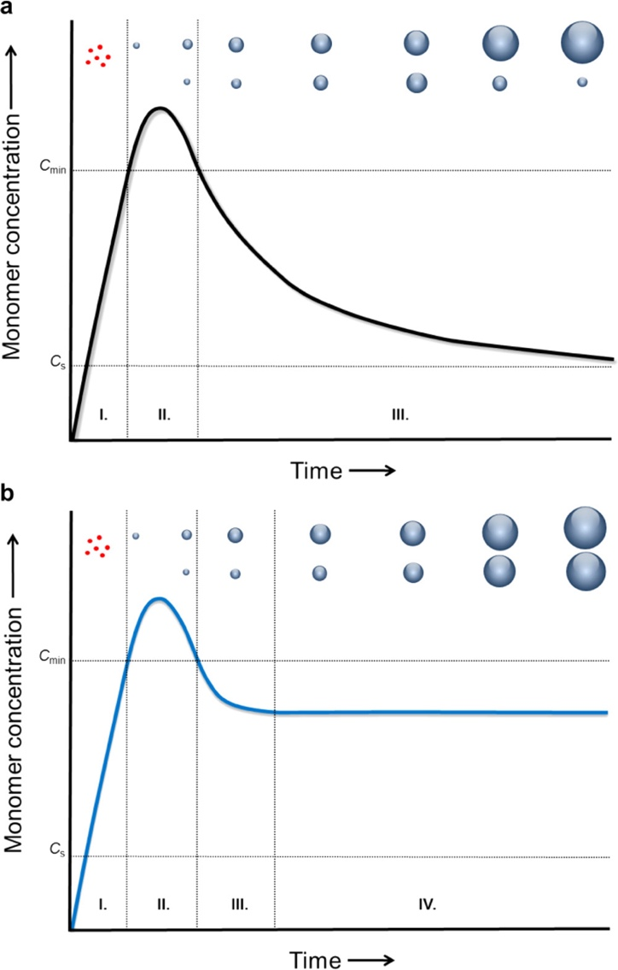
Figure 16: a) Original LaMer mechanism b) Extended LaMer mechanism for particle growth over time [107].

Materials and Methods

Chemicals
Iron (0) pentacarbonyl [Fe(CO)₅, >99.99%], hexadecylamine (HDA 90%), octadecylamine (ODA 90%), 1-octadecene (90%), oleic acid (OA) (90%), Oleylamine (OAm) (70%), pentane, diethylether, tetrahydrofuran, chloroform, hexanes, hydrochloric acid (HCl, 37%), and nitric acid (1M) were purchased from Sigma Aldrich. 1,2-distearoyl-sn-glycero-3-phosphoethanolamine-N-[methoxy-(polyethylene glycol)-2000] (ammonium salt) (DSPE-mPEG) was purchased from Avanti Lipids. Anhydrous ethanol was purchased from Decon Labs. Stainless steel 6-inch syringe needles 18 gauge and 3 mL syringes were purchased from Sigma Aldrich.

Synthesis and Setup
Synthesis of the surfactant, HDA∙HCl, was performed 24 hrs before iron nanoparticle synthesis and referenced a procedure from Dash et al [105]. In an Erlenmeyer flask, 0.488 g of HDA was dissolved in 100 mL of pentane and magnetically stirred. In a separate beaker, 250 μL HCl and 30 mL of diethylether were mixed together. The HCl and diethylether solution was slowly poured into the HDA - pentane solution and mixed at room temperature for 2 minutes. A white precipitate formed and was gravity filtered through Whatman filter paper. The white product was washed with 20 mL of tetrahydrofuran by centrifugation 3 times at 9000 rpm for 5 min in a Beckman Coulter C0650 fixed angle rotor. The product was vacuum dried over night at 30 °C.
A depiction of the synthetic setup is shown in Figure 17. In a 100 mL 4-neck round bottom flask, 20 mL of 1-octadecene, 0.277g of HDA∙HCl, 0.207 mL of oleic acid (OA) and 0.084 mL of oleylamine (OAm) were added and magnetically stirred together. The solution was vacuumed and purged with ultrapure Argon under a Schlenk line 3 times before being heated to 120 °C to react for 30 minutes. Then, the temperature was raised to 180 °C at a 2°C/min rate and 1.4 mL of Fe(CO)₅ was loaded into a 3 mL syringe with a 6 inch, 18 gauge stainless steel needle. The loaded syringe was placed onto a syringe pump and the needle was inserted directly into the reaction solution through a septum
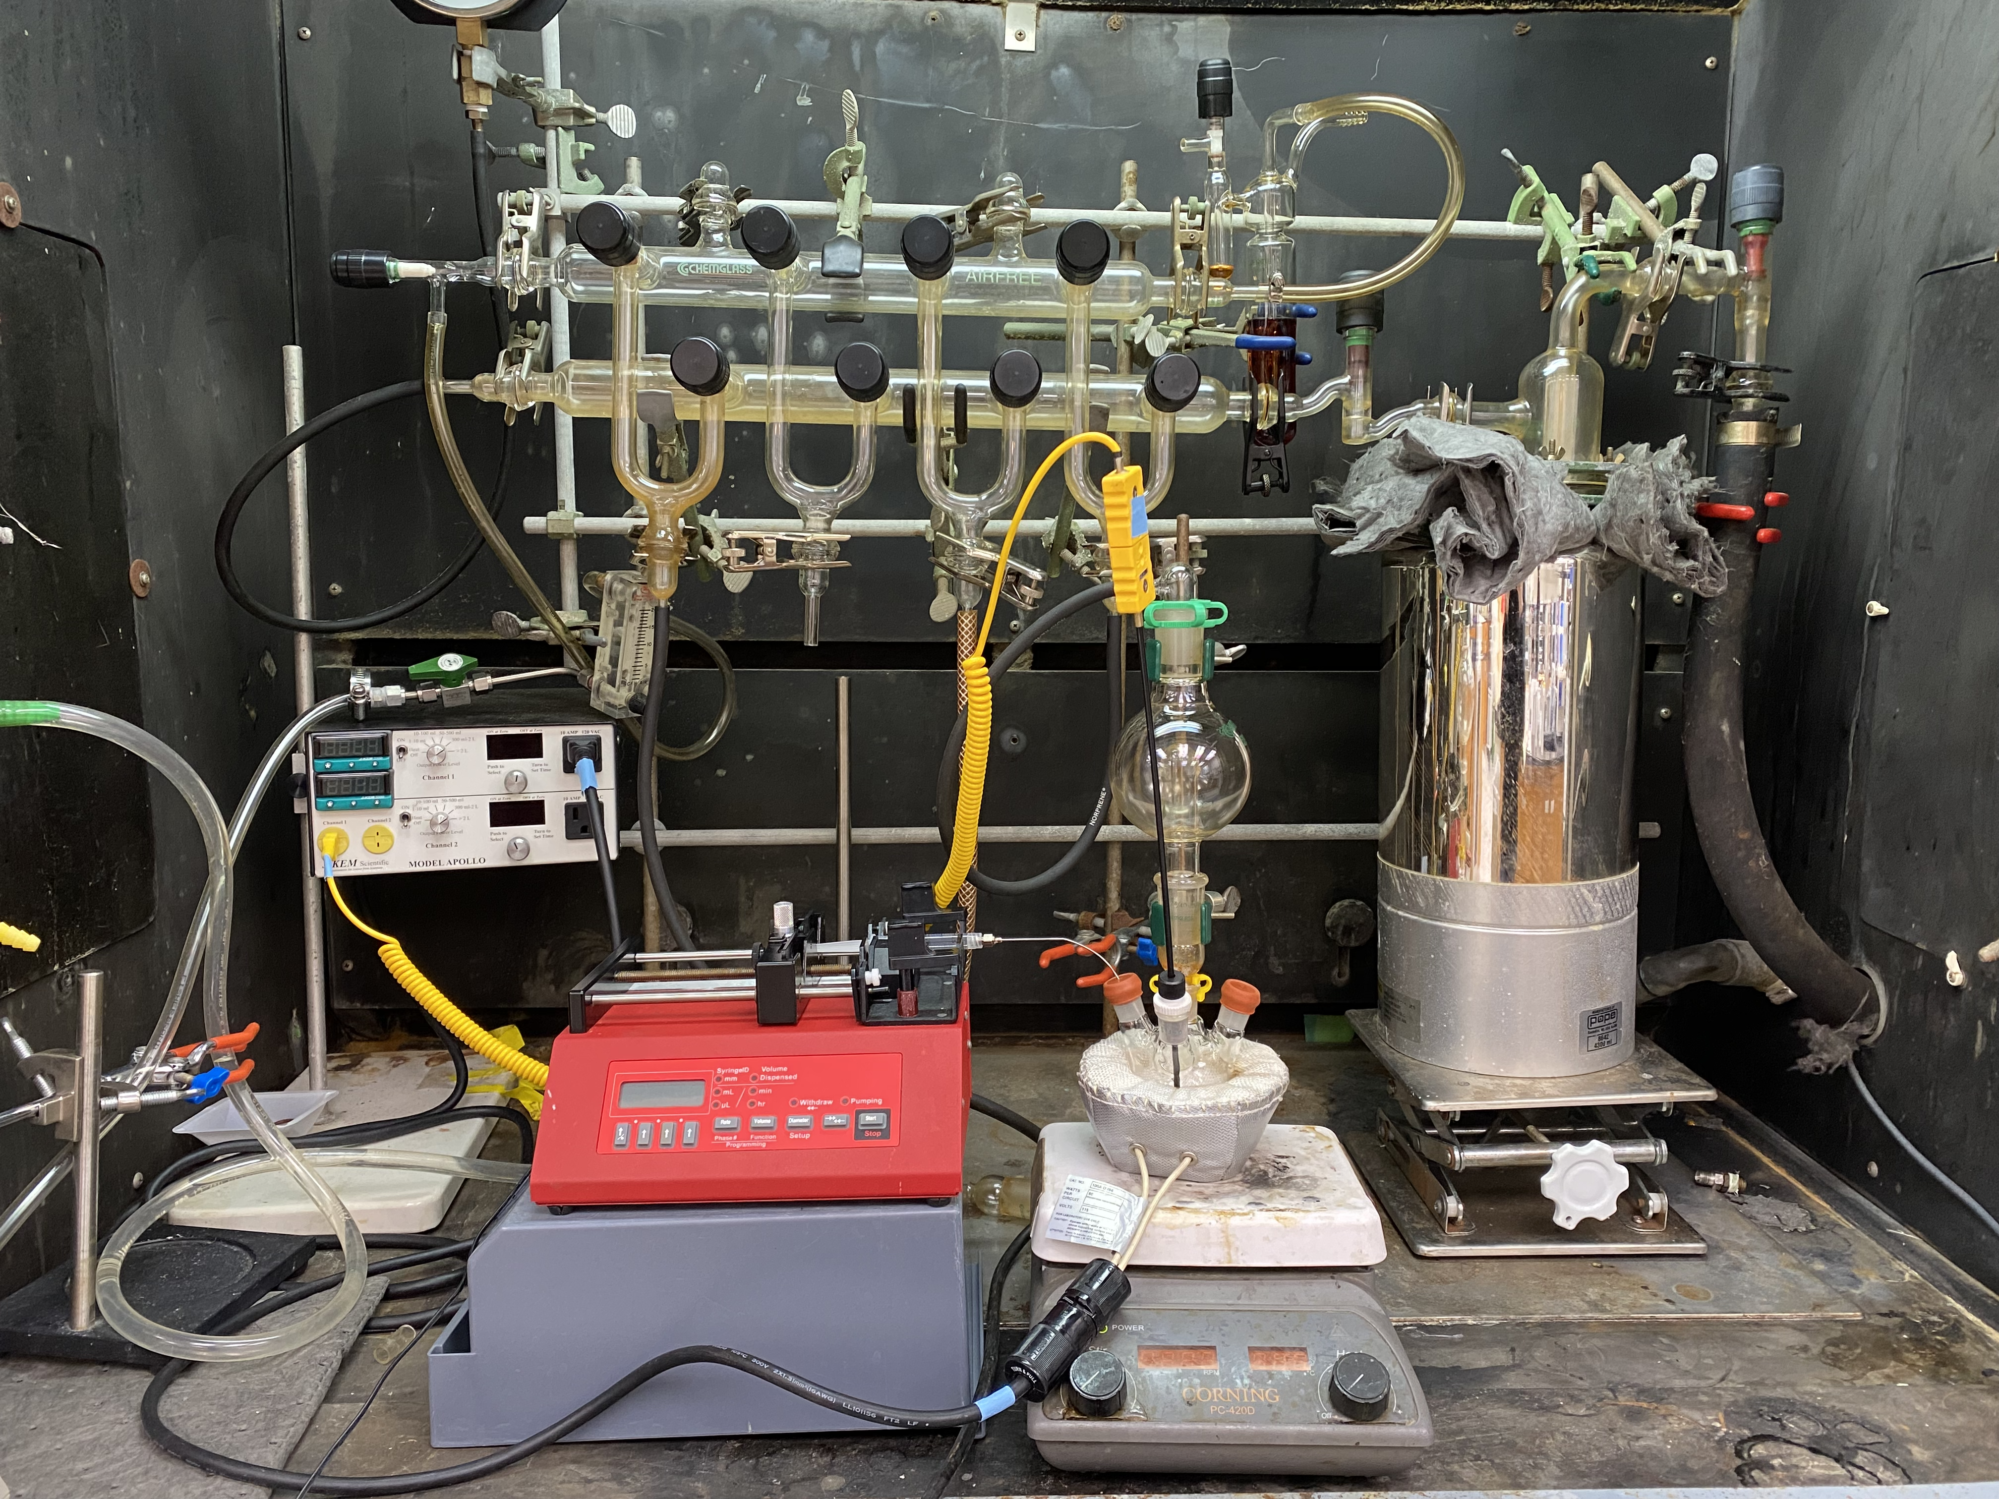
Figure 17: Synthesis setup for continuous injection of iron precursor.

stopper. The precursor was injected at a 100 μL/min rate using a syringe pump. Once all of the precursor was dispensed, the syringe and needle were removed, and the reaction continued at 180 °C for 2 hrs before being cooled to room temperature. The supernatant was decanted leaving the nanoparticles on the magnetic stir bar. Hexane was used to initially wash the particles and remove them from the magnetic stir bar. The particles were further washed 3 times by centrifugation in 60 mL of absolute ethanol at 8000 rpm for 10 min. Half of the total yield was dispersed in 5 mL of chloroform and stored in the refrigerator, and the other half was dried to powder in an Argon atmosphere glovebox for later characterization.
Variations of the above procedure were performed which included changing the injection rate of the precursor to 50 and 25 μL/min. In addition, different initial surfactants including HDA and ODA were tested in the replacement of OAm, OA and HDA∙HCl mixture at the 3 varying speeds. For the HDA sample, 0.024 g (0.1 mmol) of HDA was mixed with 20 mL of 1-octadecene and heated to 120 °C to react for 30 minutes. For the ODA sample, 0.027g (0.1mmol) of ODA was mixed with 20 mL of 1-octadecene and heated to 120 °C and reacted for 30 minutes. The subsequent steps for each sample were the exact same as mentioned previously. Each sample is named based on the surfactant used and injection rate. The first samples using oleylamine and oleic acid are named OAm/OA 100, OAm/OA 50, and OAm/OA 25. Samples that used HDA and ODA were labeled similarly.

DSPE-mPEG Coating
Around 2 mL of chloroform dispersed nanoparticles were mixed with 0.4 mL of DSPE-mPEG and 9.6 mL of chloroform in a 100 mL round bottom flask. The solution was sonicated for 10 minutes. Then, the chloroform was evaporated with a rotary evaporator for 1 hr in a 60 °C water bath under vacuum. 4 mL of ultrapure water was added to the flask after evaporation and sonicated for 1 minute to evenly disperse particles in water. The solution was transferred to Vivaspin Turbo 15 filter tubes (Sartorius) and centrifuged for 1 hr at 5000 rpm to rid excess DSPE-mPEG. The coated particles in the filter tube were pipetted into storage vials with 1 - 2 mL of ultrapure water to redisperse the particles in aqueous medium. The particles were stored in a refrigerator for further cytotoxicity testing.

Acid Digestion process for ICP-OES Measurements
Inductively coupled plasma-optical emission spectrometry (ICP-OES) was performed on coated iron nanoparticle samples prior to cytotoxicity studies to accurately determine Fe concentrations. 500 μL of coated FeNPs dispersed in water were mixed with 2 mL of 1 M nitric acid and 2 mL of 37% HCl in a 25 mL volumetric flask. The solution was sonicated for 5 minutes before heating in an 80 °C water bath for 1 hour. 0.45 μm pore sized Whatman filter paper was used to gravity filter the solution into a 200 mL volumetric flask and the initial volumetric flasks were rinsed 3-5 times with ultrapure water and poured over the filter. The final solution was brought to the appropriate 200 mL volume with ultrapure water to obtain a 50 mg/L Fe concentration for ICP-OES measurements.

Results

Transmission Electron Microscopy (TEM)
Transmission electron microscopy (TEM) was performed at the Vanderbilt Institute of Nanoscience and Engineering (VINSE), Vanderbilt University. An FEI Tecnai Osiris TEM system was operated between 80 kV - 200 kV. ImageJ processing software was used to measure nanoparticle diameter, core and shell size. An average of 200 nanoparticles were measured in order to obtain averages and standard deviations.
TEM results of all samples are shown in Figures 18 and 19 at 100 nm and 20 nm scales respectively. A summary of the diameter, core and shell for the OAm/OA samples at all injection rates is shown in Table 5. All OAm/OA samples had relatively good dispersibility at all injection rates of 100, 50 and 25 μL/min. The OAm/OA samples were spherical and consisted of an iron core and iron oxide shell. However, the iron core began to decrease as the injection speed decreased. In addition, at the lowest injection rate of 25 μL/min, a separation between the core and shell of the nanoparticles began to form. This could be due to the longer reaction time and is caused by the Kirkendall effect [108].
For the samples using HDA, as injection rate decreased, the overall size of particles began to increase. Generally, all HDA samples possessed an iron core and iron oxide shell. However, increase in polydispersity and agglomerations of the samples occurred as
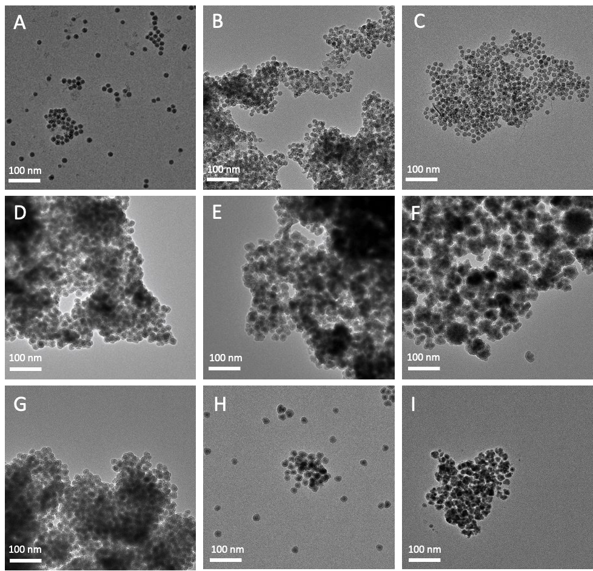
Figure 18: TEM image of all samples using a continuous injection of iron precursor at a 100 nm scale. A-C) OAm/OA 100, 50, and 25 μL/min respectively. D-F) HDA 100, 50, 25 μL/min respectively. G-I) ODA 100, 50, 25 μL/min.

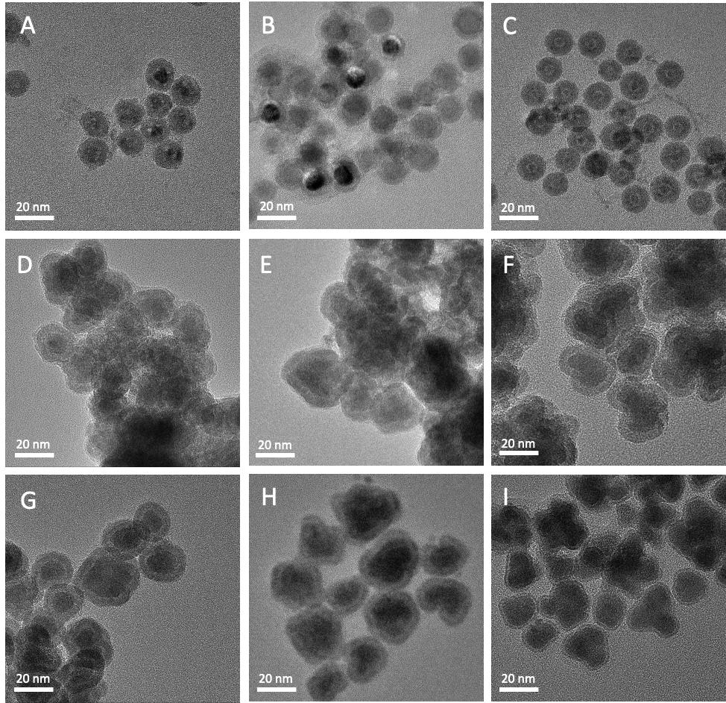
Figure 19: TEM image of all samples using a continuous injection of iron precursor at a 20 nm scale. A-C) OAm/OA 100, 50, and 25 μL/min respectively. D-F) HDA 100, 50, 25 μL/min respectively. G-I) ODA 100, 50, 25 μL/min.

Table 5: Summary of diameter, core and shell measurements for OAm/OA samples at all injection rates. An average of 200 nanoparticles were counted to obtain averages and standard deviations.
Sample | Diameter | Core | Shell
OAm/OA 100 | 15.7 ± 1.6 | 5.7 ± 1.0 | 5.4 ± 0.7
OAm/OA 50 | 15.5 ± 1.5 | 5.4 ± 0.7 | 5.0 ± 0.8
OAm/OA 25 | 14.8 ± 0.9 | 4.9 ± 0.7 | 5.1 ±0.5

injection rate decreased. The HDA 100 sample had better dispersibility, but the shape of the nanoparticles began to become more prolate shaped compared to spherical nanoparticles that were observed in the OAm/OA samples.
Similar results were observed in the ODA samples when compared to the HDA samples at all injection speeds. Generally, size increased as injection rate decreased. The ODA 100 and ODA 50 samples had relatively good dispersibility, but the nanoparticle shapes were irregular. In addition, as the injection rate decreased, polydispersity of nanoparticles began to increase. Similar to other samples, the ODA samples consisted of an iron core and iron oxide shell.

X-ray Diffraction (XRD)
XRD measurements were performed using a Rigaku SmartLab3kW X-ray Diffractometer with a Cu Kα X-ray source in a 2θ range of 20° - 90° at UTSI. Figure 20 shows the stacked XRD spectra of all samples including OAm/OA 100, 50, 25; HDA 100, 50, 25, and ODA 100, 50 and 25.
From the XRD spectra, OAm/OA 100, 50 and 25 all displayed good crystallinity and displayed peaks indicative of α-Fe at 45°, 65°, and 82°. From the HDA samples, all injection speeds except for 25 μL/min displayed broad α-Fe peak at 45° and 65°, suggesting amorphous or polycrystalline properties. From the ODA samples, the ODA 100 sample had a stronger amorphous or polycrystalline peak at 45° compared to the ODA 50 and ODA 25 samples. The ODA 50 and ODA 25 samples displayed little to no crystalline peaks, suggesting the samples were amorphous.

Mössbauer Spectroscopy
Mössbauer Spectroscopy measurements were performed with a ⁵⁷Co source, a Janis SHI-850-5 cryogen-free cryostat, and Lakeshore 325 Temperature Controller. Hyperfine interaction parameters were analyzed using a least-squared fitting model with Mössbauer GenFit Software (R. S. Preston and D. E. Brown). Powdered samples previously stored in an Ar atmosphere glovebox were loaded and sealed into Mössbauer cups for characterization under vacuum at 293K and 6K.

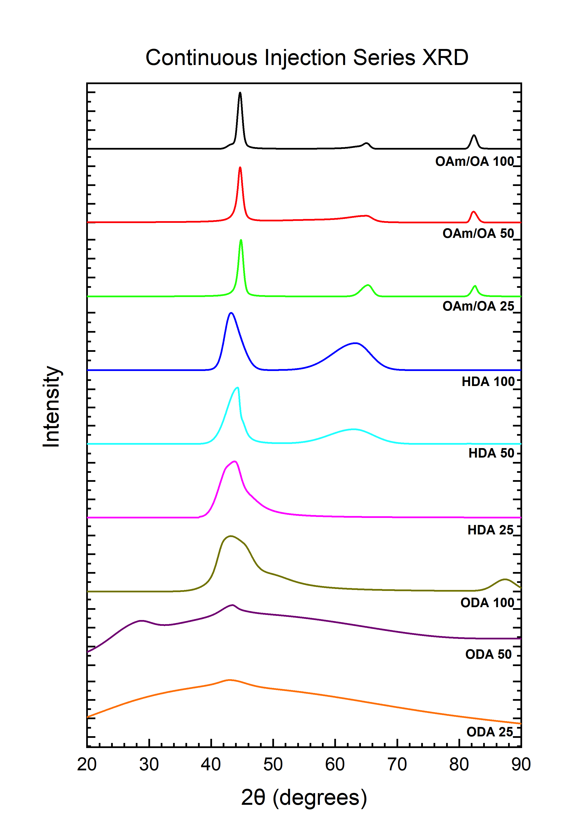
Figure 20: Stacked XRD spectra of all samples using a continuous injection method.
Stacked Mössbauer spectra of all samples measured at 293K are shown in Figure 21. Corresponding fitting results for each sample from 293K measurements are displayed in Table 6. From room temperature measurements, all samples were relatively similar by consisting of 2 components, a red sextet and a green doublet. For the OAm/OA 100, OAm/OA 50, and OAm/OA 25 samples, the first red component had a more defined red sextet pattern with a hyperfine value around 32 T, and isomer shift and quadrupole splitting of 0 mm/s. This component is attributed to α-Fe which is present in the core of the nanoparticles from TEM imaging. For all HDA and ODA samples, the first component consisted of a broad red sextet with a hyperfine value between 21.9 - 23.3 T, isomer shift between 0.13 - 0.25 mm/s, and quadrupole splitting between 0.03 - 0.12 mm/s which is indicative of amorphous iron [85]. The second component for all samples consisted of a green doublet pattern that had an isomer shift between 0.32 - 0.43 mm/s and quadrupole splitting between 0.80 - 1.01 mm/s. Upon initial fitting, this doublet pattern is indicative of γ-Fe₂O₃ [109]. However, low temperature measurements were performed to further confirm this iron oxide component.
Stacked spectra of low temperature measurements performed at 6K for all samples are displayed in Figure 22. Corresponding fitting parameters for each sample at 6K are displayed in Table 7. For the OAm/OA samples at all injection speeds, the low temperature spectra were the same. Each sample consisted of a defined red sextet pattern that had a hyperfine field around 34 T, isomer shift between 0.08 - 0.12 mm/s, and quadrupole splitting of 0 mm/s, which is indicative of α-Fe. The second component consisted of a green sextet that had a hyperfine field between 48 - 49 T, isomer shift between 0.42 - 0.54 mm/s and quadrupole splitting between 0.11 - 0.15 mm/s which is indicative of A sites for γ-Fe₂O₃. The third component consisted of a blue sextet that had a hyperfine field between 47.3 - 48.6 T, isomer shift between 0.19 - 0.54 mm/s, and quadrupole splitting between -0.16 to -0.58 mm/s, which is indicative of B sites for γ-Fe₂O₃. From the low temperature measurements, superparamagnetic characteristics were observed for the γ-Fe₂O₃ component due to it relaxing from a doublet pattern at 293K measurements to sextet patterns at 6K [79].

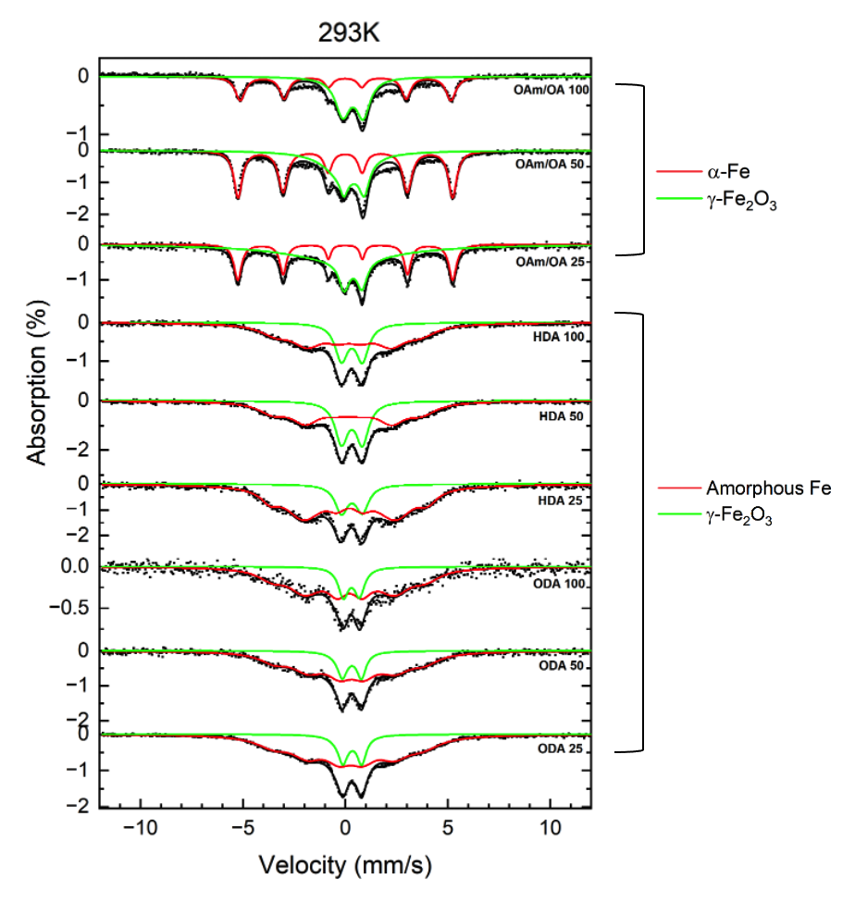
Figure 21: Stacked ⁵⁷Fe Mössbauer spectra of all samples using a continuous injection method at 293K.

Table 6: Values of hyperfine parameters for all samples using a continuous injection method at 293K. B_{hf} is the hyperfine magnetic field, δ is the isomer shift, ΔE_{Q} is the quadrupole splitting, and Γ is the linewidth (FWHM). Typical errors are ± 0.5 T for B_{hf}, ± 0.05 mm/s for δ, ± 0.02 mm/s for ΔE_{Q}, and ± 0.05 mm/s for Γ and ± 3% for relative area.
Sample | Component | B_{hf} (T) | δ (mm/s) | ΔE_{Q} (mm/s) | Γ (mm/s) | Relative area (%) | Attribution
OAm/OA 100 | 1 | 32.0 | 0.00 | 0.00 | 0.39 | 48 | α-Fe
 | 2 | 0.00 | 0.38 | 0.90 | 0.80 | 52 | γ-Fe₂O₃
OAm/OA 50 | 1 | 32.5 | 0.00 | 0.00 | 0.46 | 56 | α-Fe
 | 2 | 0.00 | 0.43 | 1.00 | 0.60 | 44 | γ-Fe₂O₃
OAm/OA 25 | 1 | 32.5 | 0.00 | 0.00 | 0.30 | 31 | α-Fe
 | 2 | 0.00 | 0.38 | 0.87 | 0.60 | 69 | γ-Fe₂O₃
HDA 100 | 1 | 21.9 | 0.17 | 0.03 | 1.58 | 71 | Amorphous Fe
 | 2 | 0.00 | 0.36 | 1.01 | 0.75 | 29 | γ-Fe₂O₃
HDA 50 | 1 | 22.5 | 0.13 | 0.05 | 1.72 | 67 | Amorphous Fe
 | 2 | 0.00 | 0.33 | 1.01 | 0.75 | 33 | γ-Fe₂O₃
HDA 25 | 1 | 23.8 | 0.20 | 0.02 | 1.13 | 82 | Amorphous Fe
 | 2 | 0.00 | 0.36 | 1.01 | 0.75 | 18 | γ-Fe₂O₃
ODA 100 | 1 | 23.3 | 0.20 | 0.03 | 1.16 | 80 | Amorphous Fe
 | 2 | 0.00 | 0.30 | 0.80 | 0.66 | 20 | γ-Fe₂O₃
ODA 50 | 1 | 22.7 | 0.25 | 0.11 | 1.51 | 82 | Amorphous Fe
 | 2 | 0.00 | 0.32 | 0.93 | 0.89 | 18 | γ-Fe₂O₃
ODA 25 | 1 | 22.6 | 0.21 | 0.12 | 1.59 | 83 | Amorphous Fe
 | 2 | 0.00 | 0.34 | 0.92 | 0.53 | 17 | γ-Fe₂O₃

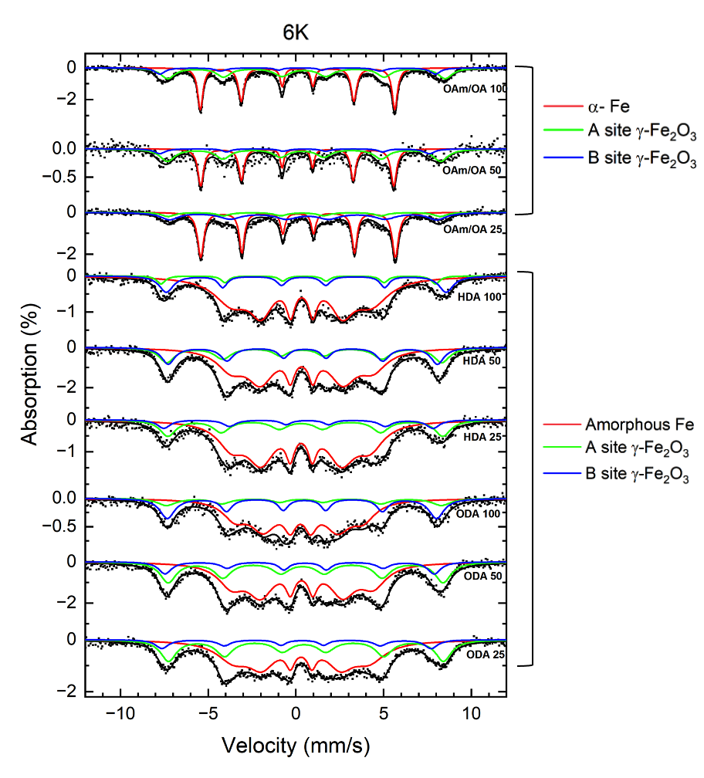
Figure 22: Stacked ⁵⁷Fe Mössbauer spectra of all samples using a continuous injection method at 6K.

Table 7: Values of hyperfine parameters for all samples using a continuous injection method at 6K. B_{hf} is the hyperfine magnetic field, δ is the isomer shift, ΔE_{Q} is the quadrupole splitting, and Γ is the linewidth (FWHM). Typical errors are ± 0.5 T for B_{hf}, ± 0.05 mm/s for δ, ± 0.02 mm/s for ΔE_{Q}, and ± 0.05 mm/s for Γ and ± 3% for relative area.
Sample | Component | B_{hf} (T) | δ (mm/s) | ΔE_{Q} (mm/s) | Γ (mm/s) | Relative area (%) | Attribution
OAm/OA 100 | 1 | 34.3 | 0.10 | 0.00 | 0.28 | 48 | α-Fe
OAm/OA 100 | 2 | 49.0 | 0.54 | 0.15 | 1.06 | 40 | A site γ-Fe₂O₃
OAm/OA 100 | 3 | 48.6 | 0.19 | -0.16 | 0.51 | 12 | B site γ-Fe₂O₃
OAm/OA 50 | 1 | 34.1 | 0.08 | 0.00 | 0.25 | 45 | α-Fe
OAm/OA 50 | 2 | 48.3 | 0.42 | 0.11 | 1.01 | 45 | A site γ-Fe₂O₃
OAm/OA 50 | 3 | 47.6 | 0.22 | -0.58 | 0.70 | 10 | B site γ-Fe₂O₃
OAm/OA 25 | 1 | 34.4 | 0.12 | 0.00 | 0.31 | 52 | α-Fe
OAm/OA 25 | 2 | 48.0 | 0.42 | 0.11 | 0.88 | 12 | A site γ-Fe₂O₃
OAm/OA 25 | 3 | 47.3 | 0.54 | -0.24 | 1.55 | 36 | B site γ-Fe₂O₃
HDA 100 | 1 | 24.6 | 0.34 | 0.00 | 0.60 | 76 | Amorphous Fe
HDA 100 | 2 | 49.4 | 0.53 | 0.15 | 0.70 | 17 | A site γ-Fe₂O₃
HDA 100 | 3 | 48.5 | 0.33 | -0.35 | 0.55 | 7 | B site γ-Fe₂O₃
HDA 50 | 1 | 25.1 | 0.35 | 0.02 | 0.60 | 61 | Amorphous Fe
HDA 50 | 2 | 48.5 | 0.43 | 0.11 | 1.00 | 20 | A site γ-Fe₂O₃
HDA 50 | 3 | 47.5 | 0.47 | -0.11 | 0.71 | 19 | B site γ-Fe₂O₃
HDA 25 | 1 | 24.5 | 0.31 | 0.00 | 0.58 | 70 | Amorphous Fe
HDA 25 | 2 | 48.5 | 0.43 | 0.25 | 1.20 | 22 | A site γ-Fe₂O₃
HDA 25 | 3 | 47.5 | 0.41 | -0.51 | 0.71 | 8 | B site γ-Fe₂O₃
ODA 100 | 1 | 22.6 | 0.23 | 0.03 | 0.85 | 63 | Amorphous Fe
ODA 100 | 2 | 48.5 | 0.39 | 0.15 | 1.00 | 13 | A site γ-Fe₂O₃
ODA 100 | 3 | 47.6 | 0.42 | -0.15 | 0.71 | 24 | B site γ-Fe₂O₃
ODA 50 | 1 | 25.0 | 0.36 | 0.05 | 0.64 | 59 | Amorphous Fe
ODA 50 | 2 | 48.5 | 0.48 | 0.18 | 1.21 | 29 | A site γ-Fe₂O₃
ODA 50 | 3 | 47.5 | 0.38 | -0.31 | 0.71 | 12 | B site γ-Fe₂O₃
ODA 25 | 1 | 24.0 | 0.31 | 0.00 | 0.63 | 58 | Amorphous Fe
ODA 25 | 2 | 48.5 | 0.53 | 0.10 | 1.21 | 32 | A site γ-Fe₂O₃
ODA 25 | 3 | 47.5 | 0.20 | -0.33 | 0.71 | 10 | B site γ-Fe₂O₃

For the HDA and ODA samples at all injection rates, all spectra looked similar at 6K. They all consisted of a red, sextet pattern with a hyperfine field between 22.6 - 25.1 T, isomer shift between 0.23 - 0.36 mm/s, and quadrupole splitting between 0 - 0.05 mm/s, which is indicative of amorphous iron. The second component consisted of a green sextet pattern that had a hyperfine field between 48.5 - 49.4 T, isomer shift between 0.39 - 0.53 mm/s, and quadrupole splitting between 0.10 - 0.25 mm/s which is indicative of A sites for γ-Fe₂O₃. The third component consisted of a blue sextet with a hyperfine field between 47.5 - 48.5 T, isomer shift between 0.20 - 0.47 mm/s, and quadrupole splitting between -0.11 to -0.51 mm/s which is indicative of B sites for γ-Fe₂O₃ [87, 110]. From the low temperature spectra, the green doublet component attributed to γ-Fe₂O₃ for the ODA and HDA samples displayed superparamagnetic characteristics due the spectrum splitting into sextet patterns at low temperatures.

Vibrating Sample Magnetometry (VSM)
Vibrating sample magnetometry (VSM) measurements were performed at the Institute for Advanced Materials and Manufacturing (IAMM) at the University of Tennessee Knoxville campus. A DynaCool- Advanced VSM system using a ± 4 T magnetic field at 300K was used. Final data was plotted in OriginLab. Magnetic hysteresis (MH) curves of all samples are shown in Figure 23. Magnetic saturation values for all samples are listed in Table 8.
From the results, all of the OAm/OA samples displayed superparamagnetic characteristics. The OAm/OA 100 sample had the highest magnetic saturation at around 138 emu/g. Magnetic saturation decreased as the injection rate decreased for the OAm/OA 50 and OAm/OA 25 samples, with OAm/OA 25 having a significant drop in magnetic saturation of 46 emu/g compared to the other OAm/OA samples being above 100 emu/g.
The HDA and ODA samples also displayed superparamagnetic characteristics and had relatively similar magnetic saturation values between 30 - 45 emu/g. The ODA 25 sample had the lowest magnetic saturation value of 12 emu/g. The low magnetic saturation of these samples is most likely attributed to the surfactants used. Previous studies that used similar surfactants with amine functional groups have reported similar magnetic

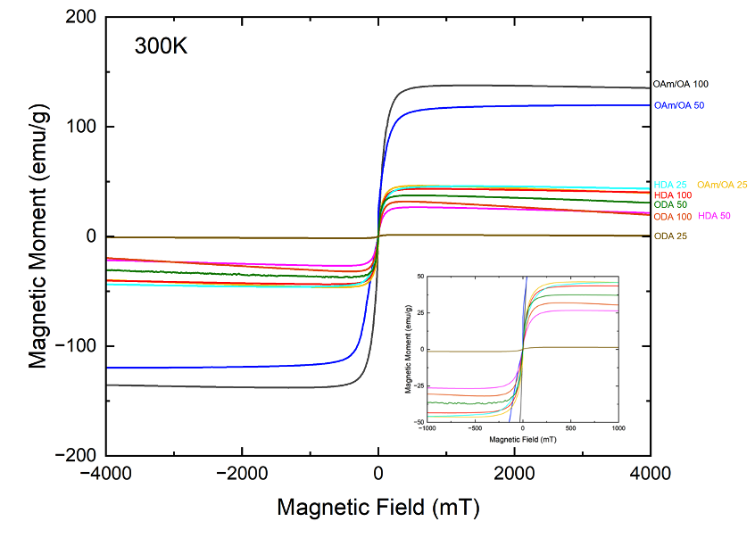
Figure 23: MH-curves of all samples measured using a continuous injection method at 300K.
Table 8: Magnetic saturation values of all samples using a continuous injection method.
Sample | Magnetic Saturation (emu/g)
OAm/OA 100 | 137.9
OAm/OA 50 | 117.0
OAm/OA 25 | 46.0
HDA 100 | 43.4
HDA 50 | 26.7
HDA 25 | 45.9
ODA 100 | 31.8
ODA 50 | 37.5
ODA 25 | 12.2

saturation values. A contributing factor to the low magnetic saturation could be due to the polycrystalline or amorphous nature of these nanoparticles, which was confirmed from previous XRD measurements. In addition, no obvious lattice fringes for crystallinity were observed with high-resolution TEM imaging. Due to the lack of structured crystallinity in these particles, the magnetic moments do not align strongly and therefore did not produce high magnetic saturation values [80].

Cytotoxicity
Cytotoxicity studies were only performed on the OAm/OA samples since the HDA and ODA samples possessed agglomerations and had low dispersibility. For all OAm/OA
samples, four doses of iron nanoparticles were tested that included 100, 50, 25 and 12.5 μg Fe/mL. Each dose incubated with 4T1 cells for 24 hours, and a Cell-Titer Glo Assay was performed to determine overall cell viability. Results of these initial tests are shown in Figure 24. All OAm/OA samples displayed good cell viability for all doses and an increase in cell viability as Fe concentration decreased. The OAm/OA 100 sample had slightly less cell viability compared to the OAm/OA 50 and OAm/OA 25 samples at all doses, with the 100 μg/mL dose being around 73% for cell viability. The 50 μg/mL and 25 μg/mL doses had around 82% cell viability and 12.5 μg/mL around 99% cell viability.

The OAm/OA 50 and OAm/OA 25 samples displayed cell viability above 100% for all doses with the exception of the 100 μg/mL dose for the OAm/OA 25 sample. A potential reason for these higher cell viability percentages could be due to the PEG coating on the sample. Previous studies have shown PEG to cause some cell proliferation effects. However, considering the OAm/OA 100 sample did not display this phenomenon, further tests would be needed to confirm the cause of this observation. In general, these initial results displayed good cell viability for all three samples.

Discussion
From testing various injection rates of iron pentacarbonyl along with different types of surfactants, overall particle size increased as the injection rate of the iron precursor decreased for samples using HDA and ODA as surfactants. Little difference in size variations for samples using OAm/OA was observed when injection rate was varied.

Figure 24: Cell viability results of OAm/OA 100, OAm/OA 50, and OAm/OA 25 samples at 100, 50, 25 and 12.5 μg Fe/mL doses.

Previous studies utilizing OAm and OA as surfactants have found that particle sizes can only reach around 14 - 15 nm in total diameter [111]. Compared to OAm and OA, surfactants like HDA and ODA lack C=C bonds to strongly bind to nanoparticles during growth, which can allow for larger variation in nanoparticles sizes. Due to this lack of C=C bonds, weak interactions between the growing nuclei surface and surfactant causes rapid growth to allow for larger sizes. However, due to this rapid growth, amorphous or polycrystalline characteristics is common for the formed nanoparticles, which was confirmed from XRD measurements [83, 84]. From TEM results, larger nanoparticle sizes were achieved with HDA and ODA surfactants as injection rates decreased. Although the nanoparticles maintained an iron core - iron oxide shell structure, the nanoparticles were polydisperse, which is common when utilizing a LaMer growth mechanism [107]. In order to prevent the polydispersity, either a higher amount of precursor or a slower injection rate of the precursor could be used to allow for a continuous growth of uniform nanoparticles. This would allow full extension of the reaction to reach a supersaturation state [107]. In addition, a higher amount of surfactant could be tested, since only 0.1 mmol of the HDA and ODA was used for their respective syntheses. Due to the low volume of surfactants used, the ligand amount in the system may be insufficient to provide proper steric hindrances as the nuclei grow, causing a higher agglomeration rate.
From Mössbauer characterization, all samples had similar spectra for room temperature measurements, consisting of 2 components indicative of iron and γ-Fe₂O₃. The OAm/OA samples at all injection speeds displayed a very distinct sextet indicative of α-Fe compared to the HDA and ODA samples, which had an amorphous Fe component at all injection speeds. From low temperature measurements, all OAm/OA samples had similar spectra indicative of α-Fe and γ-Fe₂O₃. All HDA and ODA samples had similar Mössbauer spectra from low temperature measurements consisting of 3 components indicative of amorphous Fe and A and B sites for γ-Fe₂O₃. In addition, all samples had a superparamagnetic iron oxide component due to the doublet pattern from room temperature measurements splitting into sextet patterns when measured at low temperature.
From magnetization measurements, all samples displayed superparamagnetic qualities due to the little to no presence of hysteretic remanence. The magnetic saturation for the OAm/OA samples decreased as the injection rate decreased. From TEM imaging, it was observed that a hollow or yolk-like morphology began to form as injection rate decreased for the OAm/OA samples, causing a loss of iron material between the core and the shell. This phenomenon is due to the nanoscale Kirkendall effect [108]. The Kirkendall effect is when the outward diffusion of cations through the shell is faster than the inward diffusion of anions. This variation in diffusion rate causes vacancies in the metal core that coalesce into single or multiple pores that consume the core and form hollow structures [112]. This hollowness between the core and shell could attribute to the lower magnetic saturation for these samples. In addition, a higher percent of iron oxide was present as injection rate decreased for the OAm/OA samples, which can also cause lower magnetic saturation. For all HDA and ODA samples, magnetic saturation values were similar between 20 - 40 emu/g. The ODA 25 sample had the lowest magnetic saturation out of all samples of around 12 emu/g. The low values for these samples compared to the OAm/OA samples is most likely due to the amorphous or polycrystalline nature. Due to the disordered crystal structure and randomly coupled electrons, lower magnetic properties are observed.
Finally, from cytotoxicity tests on the OAm/OA samples, all samples displayed relatively good cell viability when compared to untreated control samples. The OAm/OA 100 sample had slightly lower cell viability compared to the OAm/OA 50 and OAm/OA 25 samples, but still had good cell viability at 25 and 12.5 μg/mL doses. Some cell proliferation appeared to occur for the OAm/OA 50 and OAm/OA 25 sample, which could be attributed to the PEG coating on the sample[91, 92]. However, this phenomenon did not occur for the OAm/OA 100 sample that was also PEG coated, suggesting this could be a unique result that would require further testing.

Conclusion
In conclusion, a continuous injection of iron pentacarbonyl was investigated in order to form larger iron nanoparticles. Three injection speeds were tested that included 100, 50 and 25 μL/min. In addition, at each injection speed, three different surfactants were used to see if the surfactant type would also affect the size and composition of the nanoparticles. It was found that samples produced using OAm/OA as the surfactant, average particle size remained the same at around 14 nm regardless of injection rate. However, as the injection rate decreased, the particles began to form a yolk-like structure where a separation between the core and shell occurred due to Oswald ripening and the Kirkendall effect. Comparatively, samples using HDA and ODA produced larger particles at the highest injection speed of 100 μL/min. However, the particles had an irregular shape and were not as spherical. In addition, at the lower injection speeds of 50 and 25 μL/min, samples using HDA or ODA as the surfactants began to form more agglomerations and polydisperse nanoparticles. For the samples that did not agglomerate together, the nanoparticles consisted of an iron core and γ-Fe₂O₃ shell. The OAm/OA samples displayed good crystallinity at all injection speeds from XRD measurements. However, the HDA and ODA samples at all injection speeds show polycrystalline or amorphous characteristics. From magnetization tests, the OAm/OA 100 sample had the highest magnetic saturation of around 138 emu/g. The HDA and ODA samples at all injection rates had lower magnetic saturation values between 30 - 45 emu/g, which is attributed to the polycrystalline or amorphous nature of the nanoparticles. Furthermore, from cytotoxicity studies, samples using OAm/OA at all injection rates displayed low cytotoxicity.
From these results, this method has potential to synthesize larger nanoparticles sizes. The HDA 100 and ODA 100 samples could have potential for MPI applications due to the targeted size and composition being obtained. In order to make the nanoparticles more optimal for MPI applications, further work is needed in order to develop larger, monodisperse nanoparticles with good crystallinity. For the HDA and ODA samples, it was clear larger particles could be produced at lower injection speeds, however the particles began to agglomerate and became polydisperse. To mitigate agglomeration formation and lessen the polydispersity of these samples, slower injection rate of the precursor could be implemented, and a larger amount of a chosen surfactant could be used. This would assist in extending the LaMer growth model as well as provide more steric hindrances in the solution so that particle growth is slower and a higher presence of ligands in the system could prevent agglomeration formation.

CHAPTER III
SYNTHESIS OF ΙRON NANOPARTICLES UTILIZING A SOLID-SOLID REDUCTION METHOD

Abstract
Synthesis of pure iron nanoparticles is of interest for biomedical applications due to the high magnetic properties they possess. However, pure iron nanoparticles are highly susceptible to oxidation if they are not handled in inert atmospheres or inappropriately coated. Previous studies have used solid-gas reduction methods with 5% H₂ gas at 500 °C to reduce iron oxide nanoparticles to create pure iron nanoparticles. However, due to the high temperatures needed to fully reduce iron oxide to pure iron using only H₂, particle sintering is common. In order to decrease sintering, lower temperatures are needed. Therefore, an investigation in creating pure iron nanoparticles with a silica coating is being conducted using a solid-solid reduction method that involves CaH₂ as a reducing agent. Magnetite nanoparticles are synthesized using a thermal decomposition of iron (III) acetylacetonate and particles are subsequently coated with silica. The magnetite powder is mixed with CaH₂, sealed in a Pyrex tube and heated at 300 °C for 90 hours to allow reduction of magnetite to pure iron nanoparticles.

Introduction
Superparamagnetic iron oxide nanoparticles have attracted much interest in biomedical fields such as magnetic resonance imaging, therapeutic agents, bio separation and targeted drug delivery [67, 113, 114]. Compared to iron oxide nanoparticles, the synthesis of pure iron nanoparticles for similar applications is of interest since pure iron possesses higher magnetic properties and low coercivity. Thermal decomposition methods using organic iron precursors is often used for creating iron nanoparticles [115]. This synthesis route is favored due to its efficiency and ability to produce high-quality, monodisperse nanoparticles. By varying the amount of precursor, solvent, and types of surfactants, various sizes and shapes can be achieved through thermal decomposition methods [99, 101, 102]. Another method commonly used involves the reduction of ferric or ferrous iron salts with sodium borohydride. This method is simple and fast, but polydisperse nanoparticles are commonly obtained and at higher risk for agglomeration [116, 117].

In addition to reductive methods, previous studies have created pure iron nanoparticles by reducing iron oxide nanoparticles with H₂ gas in solid-gas reduction reactions. Generally, reduction of iron oxides to pure iron does not occur directly. Instead, a two-step reduction from Fe₂O₃ Fe₃O₄ Fe occurs at temperatures lower than 570°C or a three-step reduction of Fe₂O₃ Fe₃O₄ FeO Fe occurs at temperatures above 570°C [118]. Reduction of iron oxides to pure iron with hydrogen gas is typically performed at temperatures of at least 390 - 500°C [119-121]. Although this method will produce pure and highly crystalline iron nanoparticles, heat treatment at these temperatures can also cause particle coalescence and sintering. In order to prevent sintering, a sintering prevention layer like hydroxyapatite, carbon, or Al₂O₃ is commonly added [122-124]. In addition, higher hydrogen pressures can be used in order to decrease the reduction temperatures, but slight coalescence and sintering can still occur [125]. Therefore, alternative methods are needed to reduce iron oxide nanoparticles to pure iron with decreased sintering.
A solution to this issue is to reduce the reaction temperature by utilizing a reducing agent instead of only relying on hydrogen gas. Calcium hydride is known to be a strong reducing agent and is a commonly used drying agent in organic syntheses [126]. Its drying capacity has been shown to assist in decreasing temperatures for reductive reactions from 400°C to 300°C when reducing Fe₃O₄ to α-Fe [127, 128]. In addition, CaH₂ has attracted much attention in solid-state chemistry as an easy-to-handle solid reductant working efficiently at low temperatures [129, 130]. This lower reaction temperature makes it possible for nanoparticles to have less aggregation and coalescence while keeping the original morphology and dispersibility of particles intact [127]. Therefore, this study explores the use of CaH₂ as a reducing agent for iron oxide nanoparticles in a solid-solid reaction to form pure iron nanoparticles. Uncoated and silica coated iron oxide nanoparticles are synthesized and reduced using CaH₂ to produce pure iron nanoparticles. From this study, we hope this synthesis method could provide a basis in showing that CaH₂ can be utilized as an effective reducing agent to create highly crystalline, pure iron nanoparticles that could have potential applications in magnetic particle imaging.

Materials and Methods

Chemicals
Iron (III) acetylacetonate [Fe(acac)₃] (99.9%), oleylamine (70%), oleic acid (90%), chloroform, benzyl ether, calcium hydride (95%), ammonium hydroxide (28-30%), tetraethyl orthosilicate (TEOS), cyclohexane, polyoxyethylene (5) nonylphenyl ether (IGEPAL-CO 520), methanol, ammonium chloride (99.9%) and hexanes were purchased from Sigma Aldrich. 1,2-hexadecanediol (98%) was purchased from TCI America. Anhydrous ethanol was purchased from Decon Labs.

Synthesis
Magnetite nanoparticles were synthesized following a previous procedure by Dehsari et al [131]. In a 4-neck round bottom flask, 1 mmol of Fe(acac)₃, 3 mmol oleic acid, 3 mmol oleylamine, 5 mmol 1,2-hexadecanediol, and 20 mL of benzyl ether were added and mixed with a magnetic stir bar. The solution was purged and vacuumed under a Schlenk line 3 times before being heated to 110°C for 1 hr under vacuum. The temperature was then raised to 180°C under ultrapure N₂ at a 6.5°C/min rate to react for 2 hrs. Subsequently, the temperature was raised to 300°C at a 3.5°C/ min rate and reacted for 1 hr before being cooled to room temperature. Absolute ethanol was added to the reaction flask to precipitate the nanoparticles out of solution. The nanoparticles were magnetically separated out of the solution and washed 3 times with ethanol by centrifugation at 6000 rpm for 10 minutes in a Beckman Coulter C0650 fixed-angle rotor. Half of the product was dried to powder and stored in an Argon atmosphere glovebox, and the other half was dispersed in chloroform for later characterizations.
Powdered magnetite nanoparticles were coated with silica and reduced with CaH₂ by referencing a procedure from Yamamoto et al [127]. In a filter flask, 0.1 g of iron oxide nanoparticles, 48.75 g of cyclohexane, 3.65 g of polyoxyethylene (5) nonylphenyl ether (IGEPAL-CO 520), and 0.39 mL of 28% ammonium hydroxide were added and magnetically stirred for 30 minutes. Then, 0.4 g (1.9 mmol) of TEOS was added at 22 μL/hr at room temperature and stirred overnight. Once all of the TEOS had been added, the silica coated nanoparticles were precipitated by adding ethanol to the solution and magnetically separated. Further ethanol washings were performed, and nanoparticles were vacuum dried to powder overnight at room temperature.
Reduction of uncoated and silica coated magnetite nanoparticles was performed using CaH₂. Uncoated and silica coated magnetite nanoparticles were mixed with a 4 times weight excess of CaH₂. The powders were mixed and finely ground using a mortar and pestle and subsequently loaded into Pyrex tubes with a 7 mm inner diameter. The tubes were vacuum sealed and heated at a 1°C/min rate in a box furnace to 300°C and reacted for 90 hrs. Afterwards, the tubes were scored and broken open, and a 0.1 M NH₄Cl/methanol solution was used to wash out residual CaH₂ and CaO products from the nanoparticles. The nanoparticles were washed a few times with the NH₄Cl/ methanol solution and subsequently with methanol and magnetically separated. The final product was dry under vacuum into powder and stored in the glovebox for further characterizations. Silica coated samples are indicated with “Si.”

Results

Transmission Electron Microscopy (TEM)
Transmission electron microscopy (TEM) was performed at the Vanderbilt Institute of Nanoscience and Engineering (VINSE), Vanderbilt University. An FEI Tecnai Osiris TEM system was operated between 80 kV - 200 kV. Diameters were determined using ImageJ processing software.

Images of initial and reduced Fe₃O₄ and Si-Fe₃O₄ samples are shown in Figures 25 and 26. From measuring 200 nanoparticles, the average diameter of the initial Fe₃O₄ nanoparticles was around 7.7 ± 1.1 nm. The nanoparticles were spherical and monodispersed. After reducing the uncoated Fe₃O₄ sample, sintering of nanoparticles was present and large iron masses formed. The Si-Fe₃O₄ nanoparticles’ average diameter was around 7.5 ± 1.1 nm, suggesting little size change occurred after silica was applied to the nanoparticles. However, compared to the uncoated Fe₃O₄, the Si-Fe₃O₄ sample was not well dispersed. Elemental mapping of the Si-Fe₃O₄ nanoparticles is shown in Figure 27, which show very little silica was present on the nanoparticle surface. After reducing the Si-Fe₃O₄ nanoparticles, sintering occurred similar to the uncoated reduced Fe₃O₄
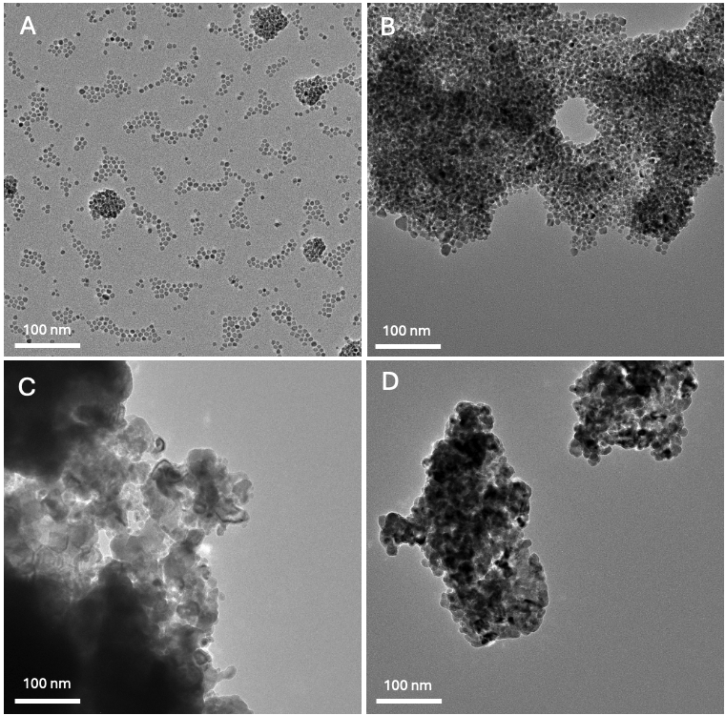
Figure 25: TEM of images of samples at a 100 nm scale. A) Fe₃O₄ B) Si-Fe₃O₄ C) Fe₃O₄ reduced D) Si-Fe₃O₄ reduced.
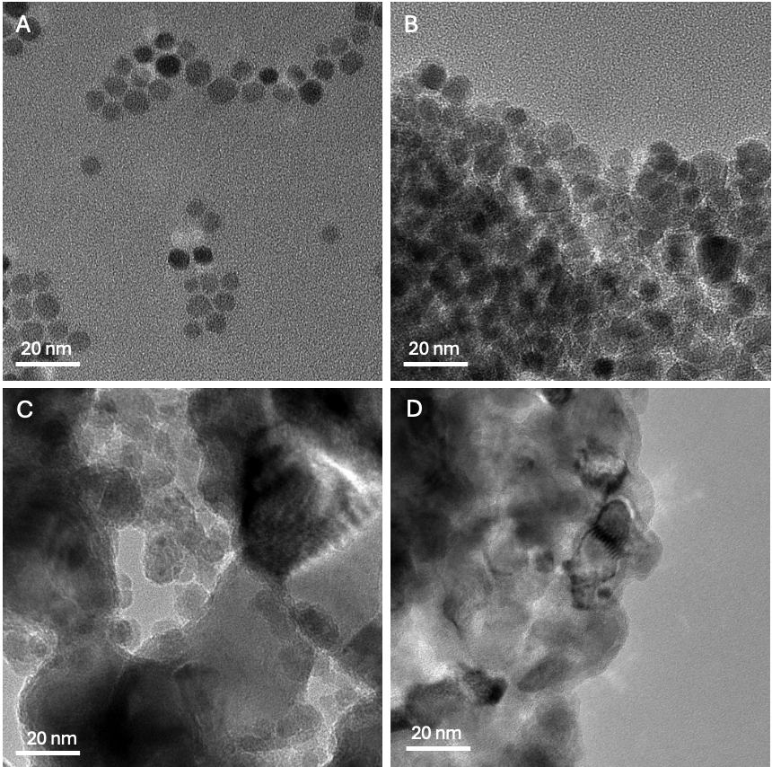
Figure 26: TEM images of samples at a 20 nm scale A) Fe₃O₄ B) Si-Fe₃O₄ C) Fe₃O₄ reduced D) Si-Fe₃O₄ reduced.

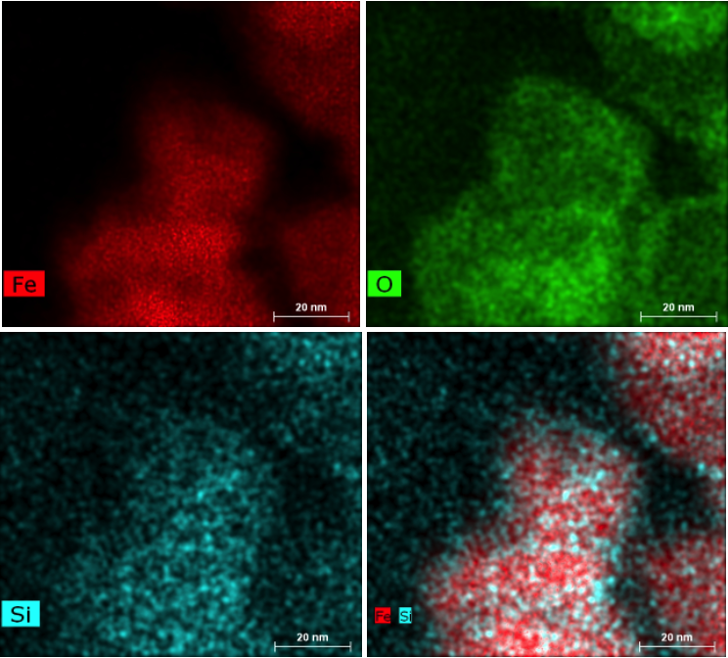
Figure 27: Elemental mapping of Si-Fe₃O₄.

nanoparticles, which is most likely due to the silica coating being too thin to act as a barrier.

X-ray Diffraction (XRD)
XRD measurements were performed using a Rigaku SmartLab3kW X-ray Diffractometer with a Cu Kα X-ray sources in a 2θ range of 20° - 80° at UTSI. A stacked plot of the Fe₃O₄, Si-Fe₃O₄, Fe₃O₄ reduced and Si-Fe₃O₄ reduced samples is shown in Figure 28. From these results, the original Fe₃O₄ and Si-Fe₃O₄ displayed good crystallinity and characteristic peaks of Fe₃O₄ at 30°, 35°, 43°, 53°, 57° and 63°. The reduced Fe₃O₄ and Si-Fe₃O₄ samples displayed characteristics peaks of α-Fe at 45°, 65°, and 82°, confirming the reduction of magnetite to pure iron was successful. From XRD measurements, it appears the addition of silica did not change the crystalline structure of the initial Fe₃O₄ nanoparticles. However, it can be difficult to determine the difference between γ-Fe₂O₃ and Fe₃O₄ from XRD alone since these oxides have the same crystal structure [132]. Therefore, Mössbauer studies were performed to further determine the composition of these samples.

Mössbauer Spectroscopy
Mössbauer Spectroscopy measurements were performed with a ⁵⁷Co source, a Janis SHI-850-5 cryogen-free cryostat, and Lakeshore 325 Temperature Controller. Hyperfine interaction parameters were analyzed using a least-squared fitting model with Mössbauer GenFit Software (R. S. Preston and D. E. Brown). Powder samples previously stored in an Ar atmosphere glovebox were loaded and sealed into Mössbauer cups for characterization under vacuum at 293K and 6K.
Stacked Mössbauer spectra of initial Fe₃O₄ and Si-Fe₃O₄ samples and reduced Fe₃O₄ and Si-Fe₃O₄ samples measured at 293K are shown in Figure 29. Hyperfine fitting parameters are displayed in Table 9. The Fe₃O₄ and Si-Fe₃O₄ samples consisted of a single component that had an isomer shift between 0.24 - 0.35 mm/s, which is indicative of Fe₃O₄. The reduced Fe₃O₄ and Si-Fe₃O₄ samples consisted of a red sextet component that had a hyperfine field around 33 T and an isomer shift and quadrupole splitting of 0 mm/s, which is indicative of α-Fe. From these results, the silica coating did not change

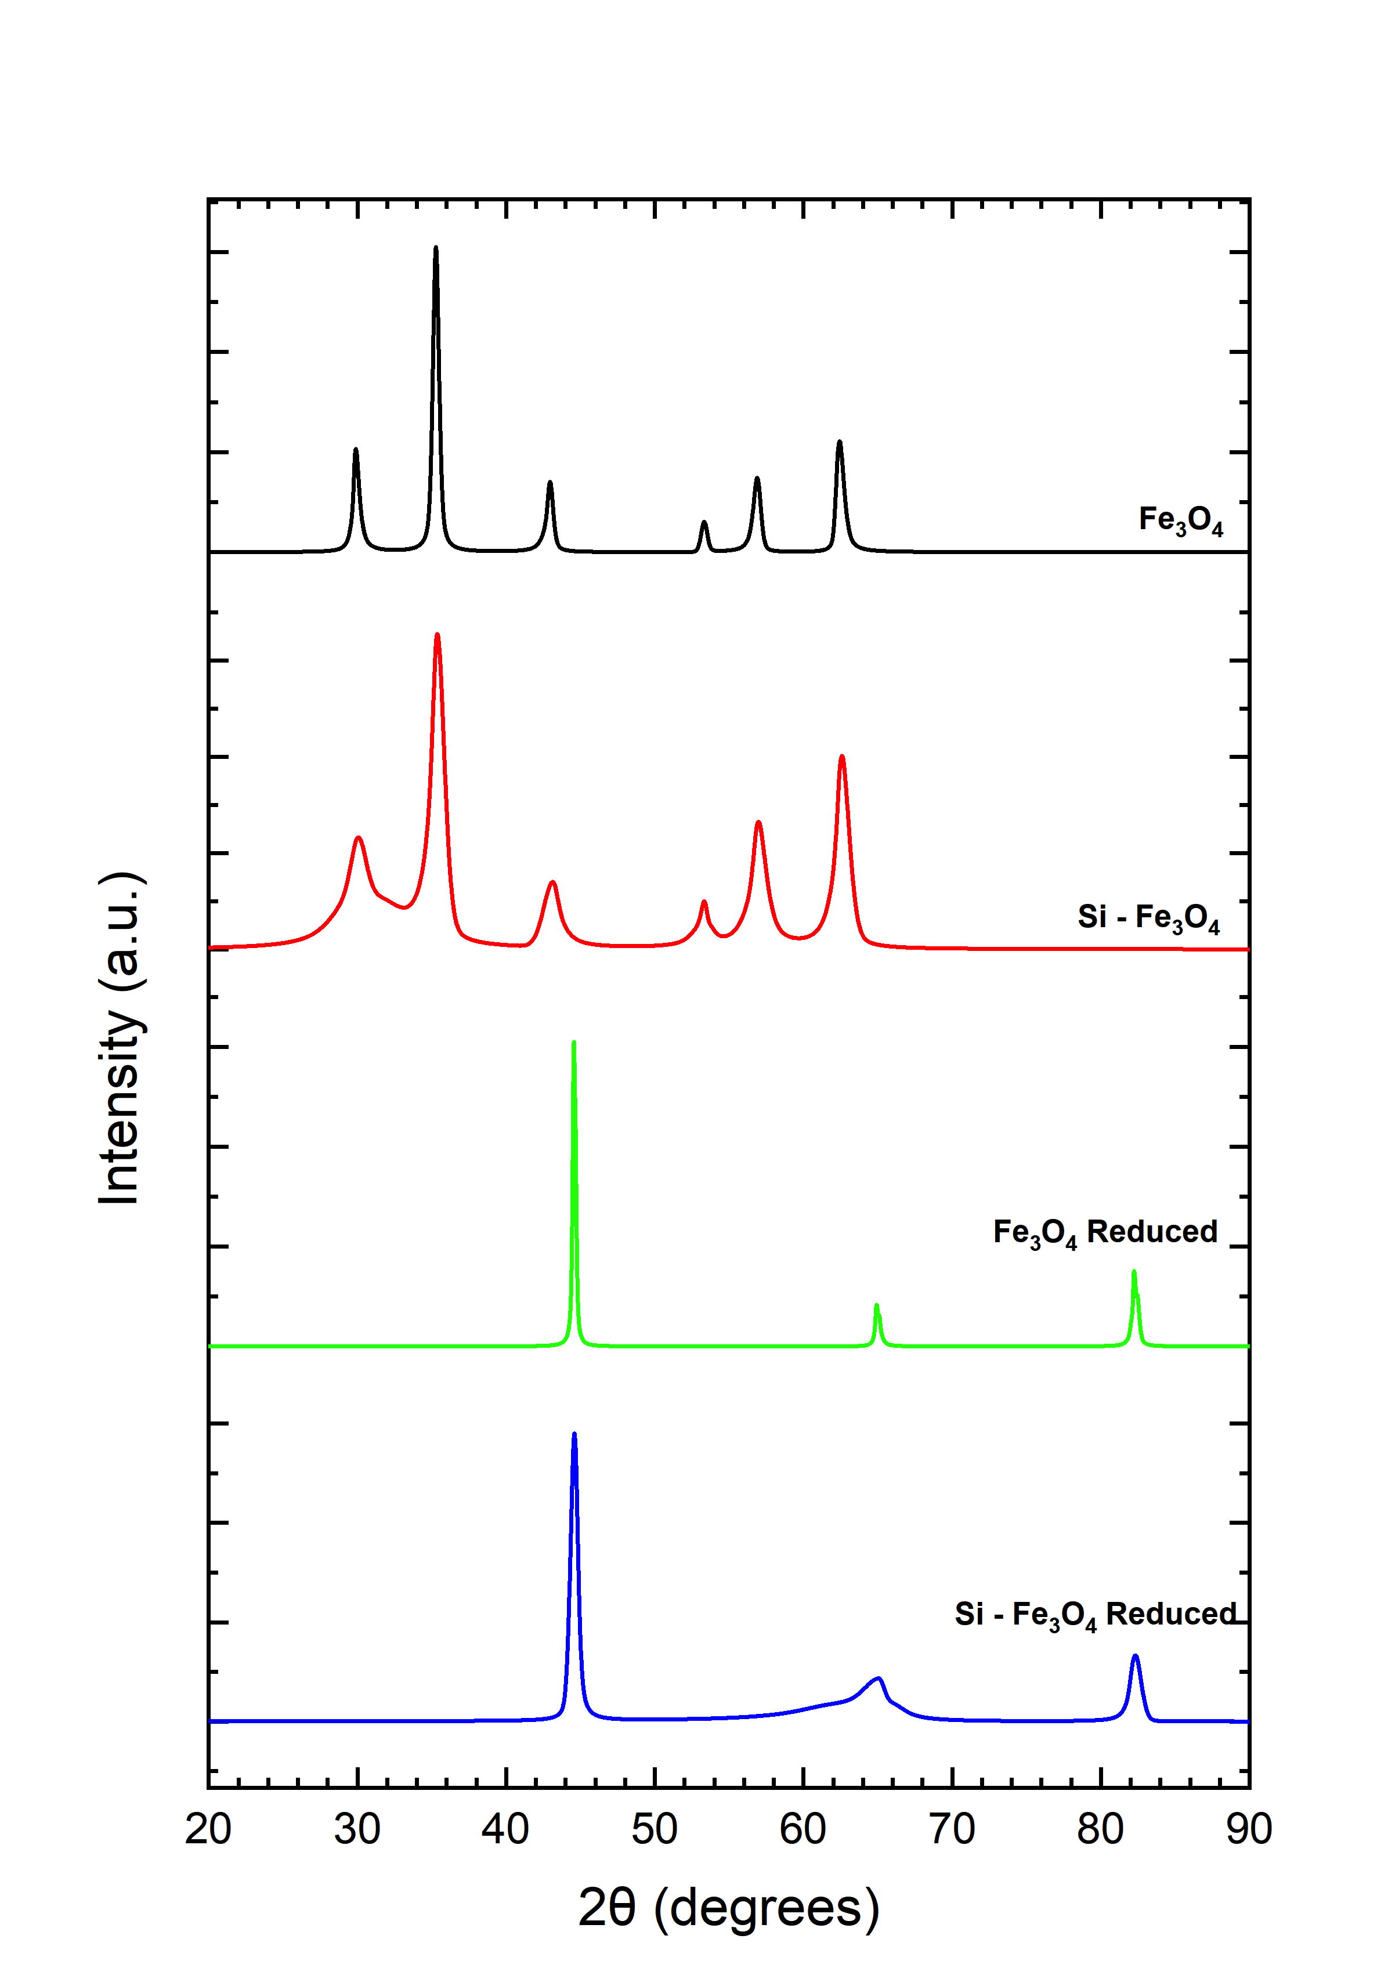
Figure 28: Stacked XRD spectra of iron oxide, silica coated iron oxide and reduced samples.

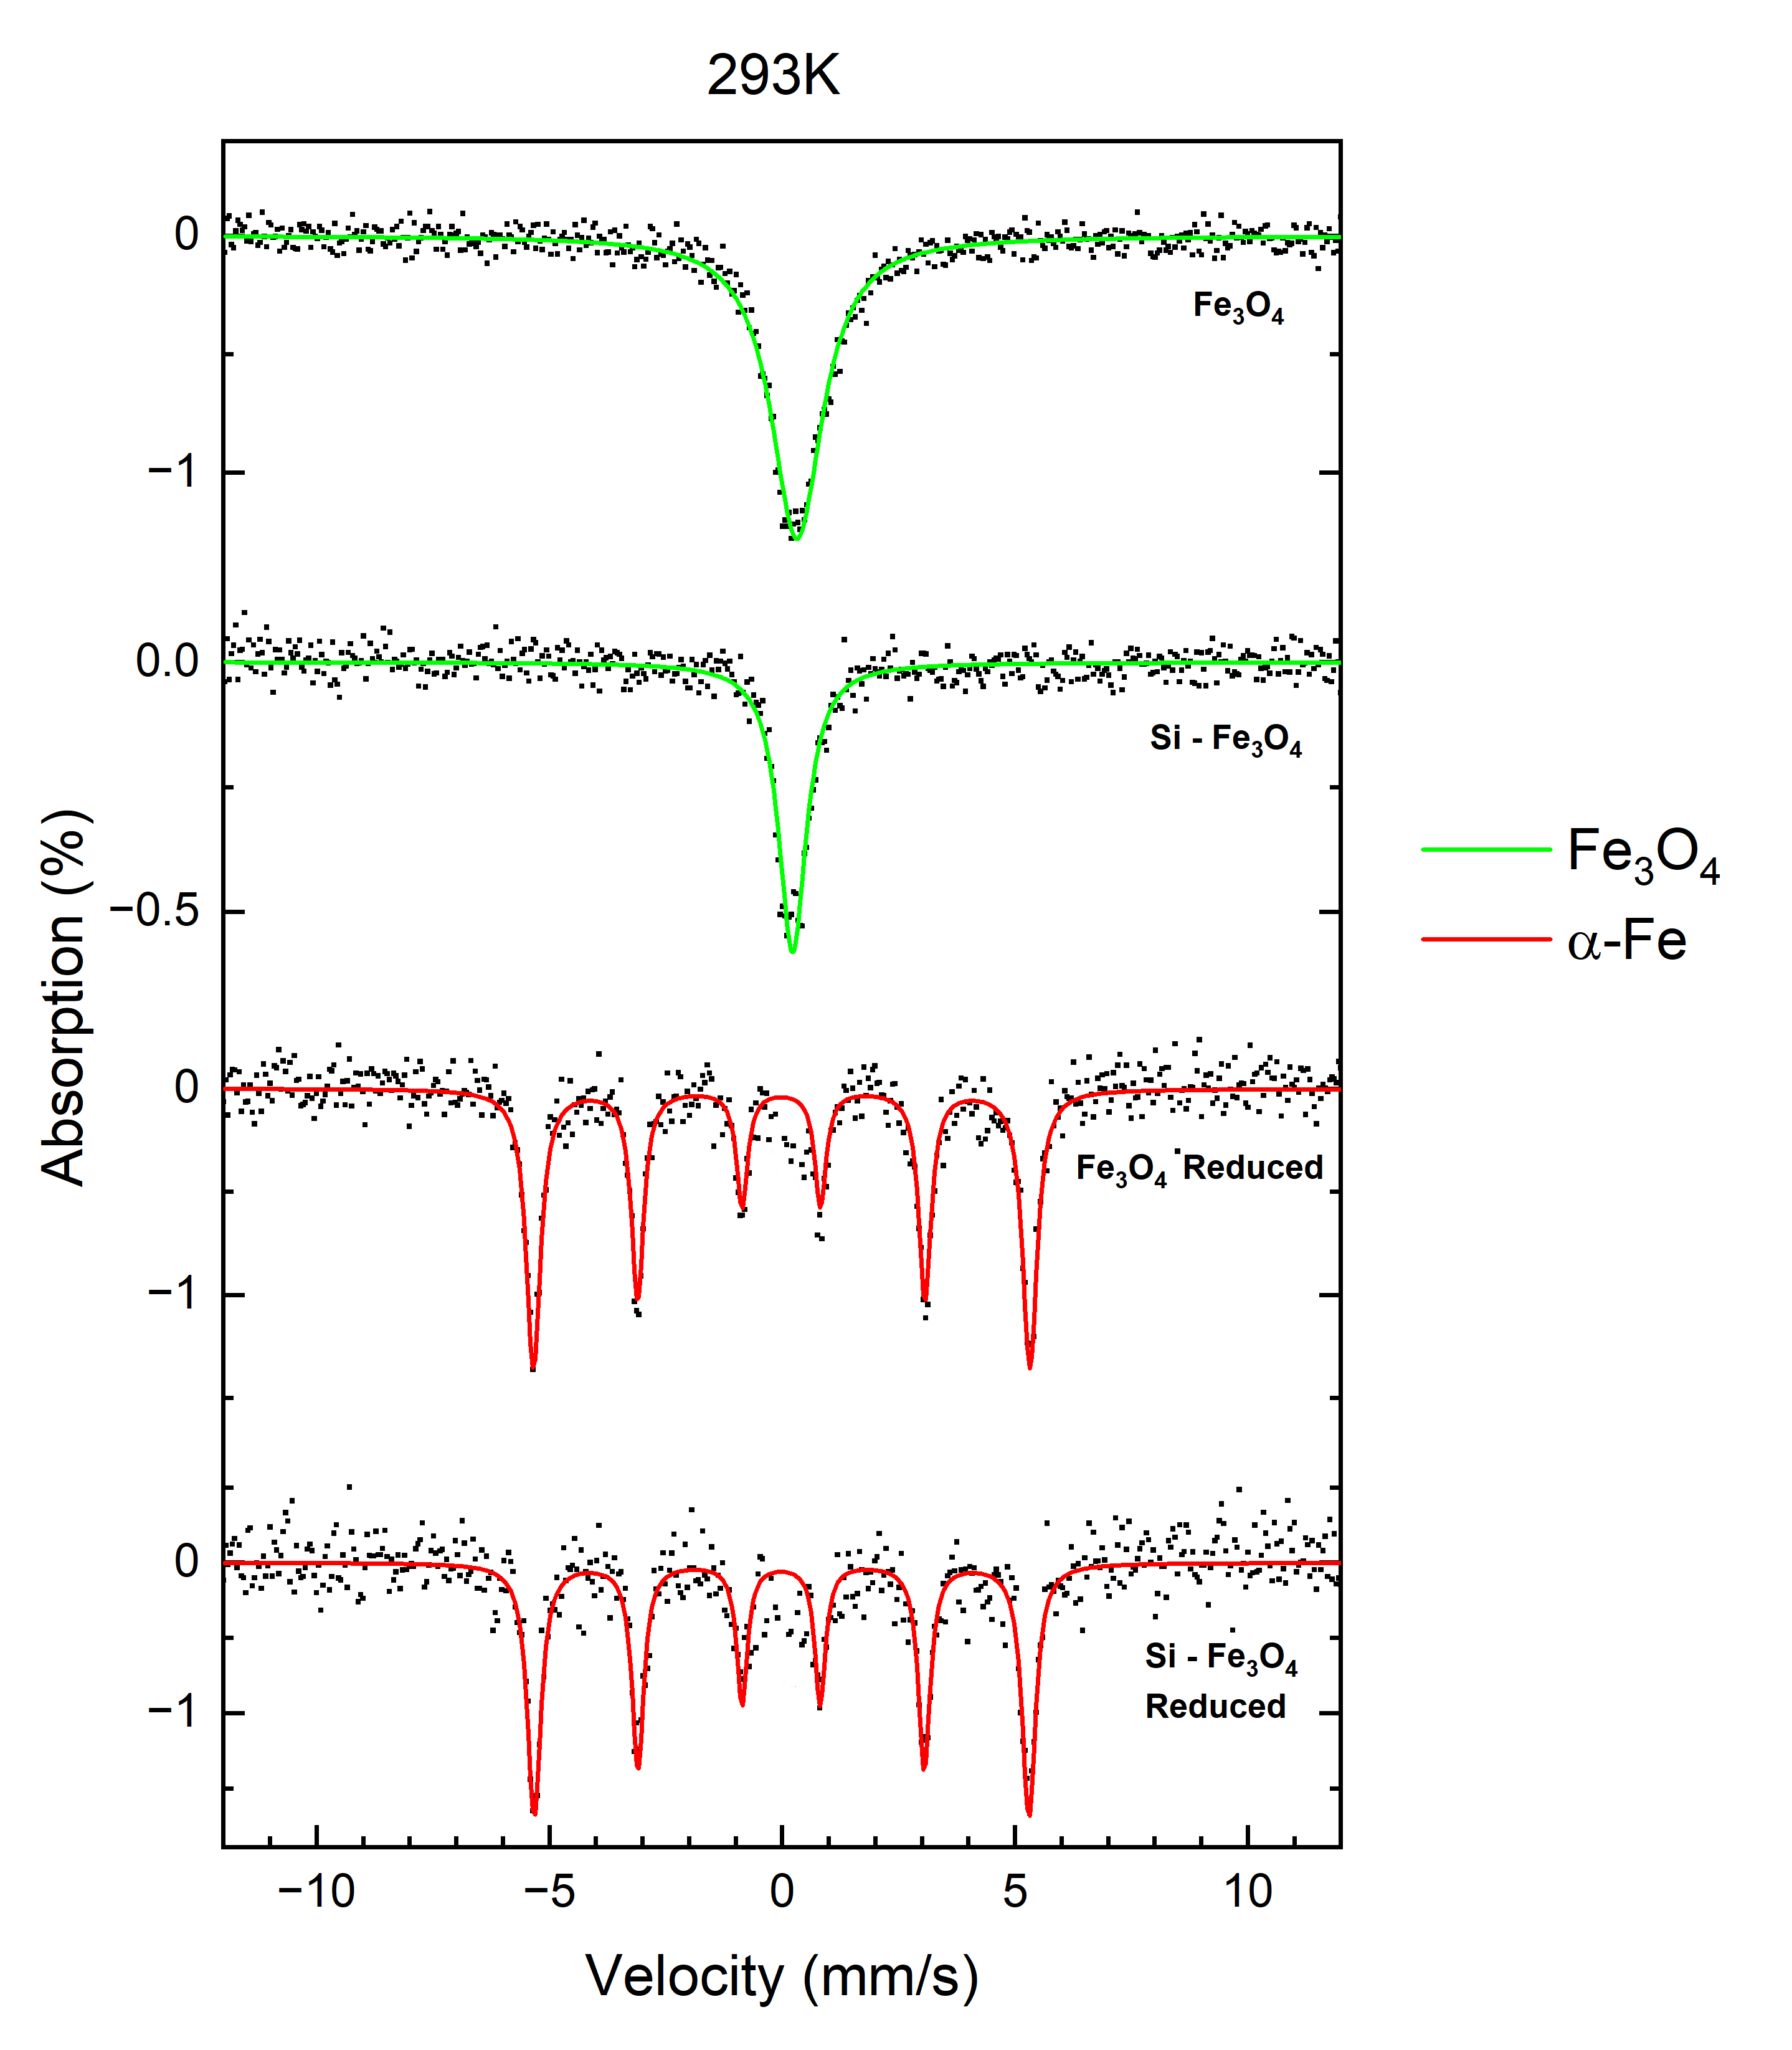
Figure 29: Stacked Mössbauer spectra of Fe₃O₄, Si-Fe₃O₄, Fe₃O₄ reduced and Si-Fe₃O₄ reduced samples at 293K.
Table 9: Values of hyperfine parameters for Fe₃O₄, Si-Fe₃O₄ and reduced Fe₃O₄ and Si-Fe₃O₄ samples at 293K. B_{hf} is the hyperfine magnetic field, δ is the isomer shift, ΔE_{Q} is the quadrupole splitting, and Γ is the linewidth (FWHM). Typical errors are ± 0.3 T for B_{hf}, ± 0.04 mm/s for δ, ± 0.01 mm/s for ΔE_{Q}, and ± 0.02 mm/s for Γ and ± 3% for relative area.
Sample | Component | B_{hf} (T) | δ (mm/s) | ΔE_{Q} (mm/s) | Γ (mm/s) | Relative area (%) | Attribution
Fe₃O₄ | 1 | 0.00 | 0.33 | 0.01 | 1.31 | 100 | Fe₃O₄
Si-Fe₃O₄ | 1 | 0.00 | 0.24 | 0.04 | 0.72 | 100 | Fe₃O₄
Fe₃O₄ Reduced | 1 | 33.7 | 0.00 | 0.00 | 0.29 | 100 | α-Fe
Si-Fe₃O₄ Reduced | 1 | 32.9 | 0.00 | 0.00 | 0.28 | 100 | α-Fe

the chemical structure of the initial Fe₃O₄ nanoparticles. In addition, successful reduction of the Fe₃O₄ and Si-Fe₃O₄ samples to pure iron was achieved.
Further low temperature measurements were performed on all samples at 6K. Stacked Mössbauer spectra from 6K measurements are shown in Figure 30 and hyperfine fitting parameters are displayed in Table 10. From the results, the Fe₃O₄ and Si-Fe₃O₄ samples had similar spectra that consisted of 2 sextets. The first component was a red sextet that had a hyperfine field between 50 - 51 T, isomer shift between 0.28 - 0.42 mm/s, and quadrupole splitting between -0.11 to -0.04 mm/s, which is indicative of A (tetrahedral) sites for Fe₃O₄. The second component consisted of a green sextet that had a hyperfine field around 52 T, isomer shift around 0.49 mm/s and quadrupole splitting of 0 mm/s, which is indicative of B (octahedral) sites for Fe₃O₄ [133, 134]. The reduced Fe₃O₄ and Si- Fe₃O₄ samples continued to have a similar sextet pattern from room temperature measurements with a hyperfine field around 33.8 T and an isomer shift and quadrupole splitting of 0 mm/s, which is indicative of α-Fe.

Vibrating Sample Magnetometry (VSM)
Vibrating Sample Magnetometry (VSM) measurements were performed at the Institute for Advanced Materials and Manufacturing (IAMM) at the University of Tennessee Knoxville campus. A DynaCool- Advanced VSM system using a ± 4 T magnetic field at300K. Final data was plotted in Origin Lab. Magnetic hysteresis (MH) curves of all samples are shown in Figure 31. Magnetic saturation values for all samples are listed in Table 11.
The Si-Fe₃O₄ sample had a slightly lower magnetic saturation value around 37 emu/g when compared to the Fe₃O₄ sample that had a magnetic saturation around 54 emu/g. The Si-Fe₃O₄ reduced sample also had a lower magnetic saturation of 97 emu/g when compared to the Fe₃O₄ reduced sample that had a magnetic saturation around 150 emu/g. However, despite the difference in magnetic saturation values between the original and reduced Fe₃O₄ and Si-Fe₃O₄ samples, both of the initial samples had an increase in magnetic saturation after reducing with CaH₂. In addition, all samples appeared to have superparamagnetic properties due to the little to no hysteretic remanence present.

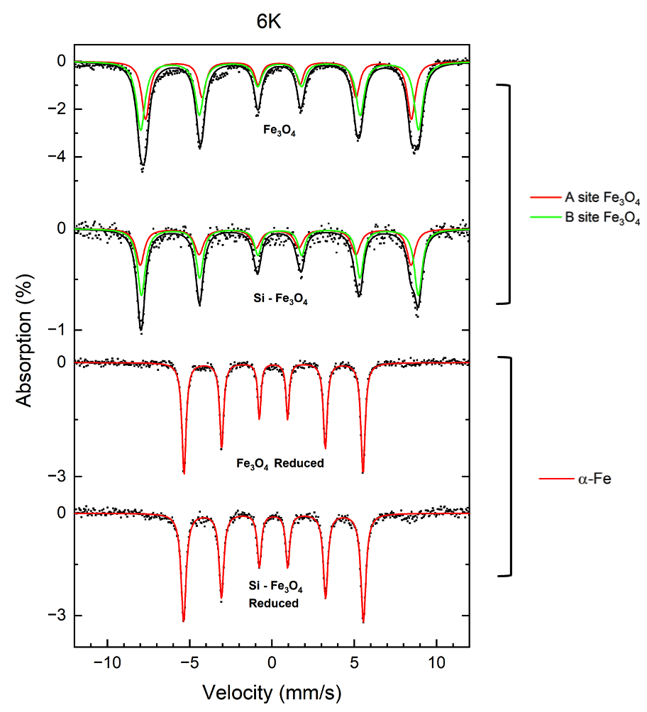
Figure 30: Stacked Mössbauer spectra of Fe₃O₄, Si-Fe₃O₄, Fe₃O₄ reduced and Si-Fe₃O₄ reduced samples at 6K.

Table 10: Values of hyperfine parameters for Fe₃O₄, Si-Fe₃O₄ and reduced Fe₃O₄ and Si-Fe₃O₄ samples at 6K. B_{hf} is the hyperfine magnetic field, δ is the isomer shift, ΔE_{Q} is the quadrupole splitting, and Γ is the linewidth (FWHM). Typical errors are ± 0.3 T for B_{hf}, ± 0.04 mm/s for δ, ± 0.01 mm/s for ΔE_{Q}, and ± 0.02 mm/s for Γ and ± 3% for relative area.
Sample | Component | B_{hf} (T) | δ (mm/s) | ΔE_{Q} (mm/s) | Γ (mm/s) | Relative area (%) | Attribution
Fe₃O₄ | 1 | 50.0 | 0.42 | -0.04 | 0.58 | 41 | A site Fe₃O₄
Fe₃O₄ | 2 | 52.4 | 0.49 | 0.00 | 0.64 | 59 | B site Fe₃O₄
Si-Fe₃O₄ | 1 | 51.0 | 0.28 | -0.11 | 0.61 | 40 | A site Fe₃O₄
Si-Fe₃O₄ | 2 | 52.1 | 0.48 | 0.00 | 0.58 | 60 | B site Fe₃O₄
Fe₃O₄ Reduced | 1 | 33.7 | 0.09 | 0.00 | 0.29 | 100 | α-Fe
Si-Fe₃O₄ Reduced | 1 | 33.8 | 0.09 | 0.00 | 0.29 | 100 | α-Fe

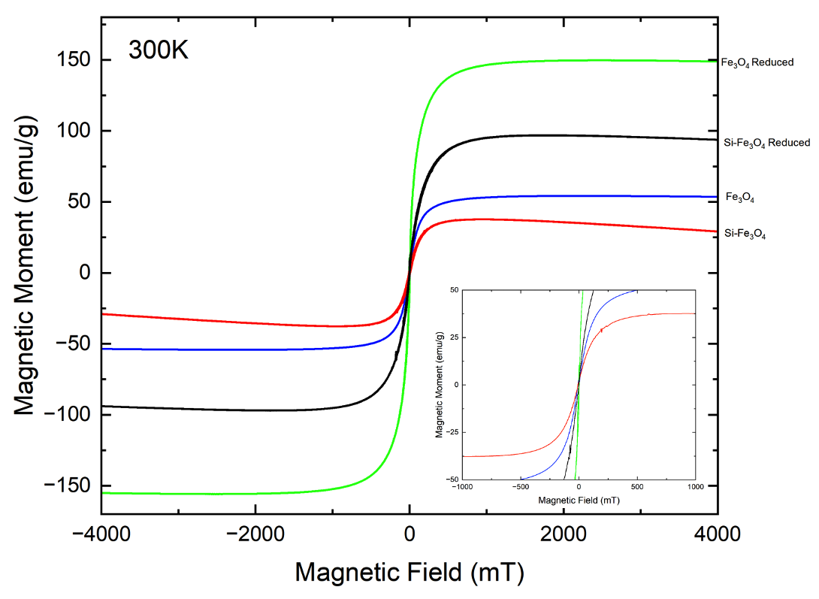
Figure 31: MH-curves of Fe₃O₄, Si-Fe₃O₄, Fe₃O₄ reduced, and Si-Fe₃O₄ reduced samples at 300K.

Table 11: Magnetic saturation values of Fe₃O₄, Si-Fe₃O₄, Fe₃O₄ reduced, and Si-Fe₃O₄ reduced samples.
Sample | Magnetic Saturation (emu/g)
Fe₃O₄ | 54.2
Si-Fe₃O₄ | 37.3
Fe₃O₄ Reduced | 149.7
Si-Fe₃O₄ Reduced | 96.9

Discussion
Magnetite nanoparticles were synthesized, silica coated, and further reduced using CaH₂. From the results, initial Fe₃O₄ and Si-Fe₃O₄ nanoparticles had similar overall diameters around 7.5 nm. However, after silica coating, the Si- Fe₃O₄ nanoparticles had lower dispersibility and little presence of silica had adsorbed onto the nanoparticle surface. Rather than an even, thick silica coating, the particles appear to have a dusting of silica on the surface. During the silica coating process, disruption of the nanoparticle’s surface chemistry and the silica not properly adsorbing onto the nanoparticle surface could have caused the decrease in dispersibility. Due to the low presence of silica, both the uncoated and silica coated Fe₃O₄ nanoparticles were sintered after reducing with CaH₂. In order to eliminate sintering, a thicker silica coating on the nanoparticles is required [135]. This could involve using a higher amount of TEOS upon coating the nanoparticles and also testing other microemulsion procedures.
From XRD results, all samples had good crystallinity. No apparent difference in crystalline structure occurred after applying silica to the nanoparticles and both Fe₃O₄ and Si-Fe₃O₄ samples displayed characteristic peaks for Fe₃O₄. From XRD and Mössbauer spectroscopy, successful reduction of the Fe₃O₄ and Si-Fe₃O₄ samples to pure iron was observed. Mössbauer spectroscopy results confirmed the initial iron oxide samples consisted of Fe₃O₄ and no change in composition of the Fe₃O₄ sample occurred after silica was applied. In addition, the Fe₃O₄ and Si- Fe₃O₄ samples both displayed superparamagnetic characteristics from low temperature Mössbauer measurements.
From magnetization measurements, the Si-Fe₃O₄ and Si-Fe₃O₄ reduced samples had lower magnetic saturation values when compared to the Fe₃O₄ and Fe₃O₄ reduced samples respectively. Although it was expected the Si-Fe₃O₄ sample would have a similar magnetic saturation to the Fe₃O₄ sample at around 54 emu/g, the Si-Fe₃O₄ sample actually had a lower magnetic saturation around 37 emu/g. A potential reason for the lower magnetic saturation for the Si-Fe₃O₄ sample could be due to the size of the nanoparticles. From Mössbauer studies at room temperature, a smaller linewidth was observed in the Si-Fe₃O₄ sample when compared to the original Fe₃O₄ sample. This smaller linewidth could suggest the Si-Fe₃O₄ nanoparticles were slightly smaller compared to the Fe₃O₄ sample due to an increase in spin relaxation rate [134]. Although initial TEM measurements suggested a very slight size decrease occurred after silica was applied, smaller nanoparticle pieces could have been present in the sample upon performing Mössbauer measurements. From TEM results, it was clear the nanoparticle surface had been disrupted due to the decrease in dispersibility. This disruption in the surface chemistry could have decreased the stability of the nanoparticles and caused them to break into smaller pieces over time, which could contribute to a slightly lower magnetic saturation when compared to the Fe₃O₄ sample [136].
Upon reducing the Fe₃O₄ and Si-Fe₃O₄ samples, both samples had an increase in magnetic saturation. Although both samples reduced fully to iron from XRD and Mössbauer spectroscopy results, the Si-Fe₃O₄ reduced sample had a lower magnetic saturation of 97 emu/g compared to the Fe₃O₄ reduced sample that had a magnetic saturation around 150 emu/g. The slightly lower magnetic saturation of the Si-Fe₃O₄ reduced sample is most likely due to the size of the nanoparticles. Although both samples appeared to have been sintered from TEM images, the Fe₃O₄ reduced sample may have created slightly larger nanoparticles to produce a higher magnetic saturation [89]. In addition, the initial Si-Fe₃O₄ nanoparticle had a lower initial magnetic saturation before the reduction when compared to the Fe₃O₄ nanoparticles.

Conclusion
From these tests, successful reduction of magnetite nanoparticles to pure iron was achieved using CaH₂ as a reduction agent. Although sintering of nanoparticles was observed after reduction, this method shows potential in using CaH₂ as a reducing agent to achieve pure crystalline iron nanoparticles at lower reaction temperatures when compared to the typical reducing temperatures needed when only utilizing H₂. From Mössbauer spectroscopy, initial Fe₃O₄ and Si-Fe₃O₄ samples displayed superparamagnetic qualities, and all samples displayed superparamagnetic properties from magnetization tests. In addition, the Fe₃O₄ reduced sample displayed high magnetic saturation around 150 emu/g. From these initial tests, further work is needed to produce a thicker silica coating around the nanoparticles to prevent sintering after reduction. Testing various silica coating thicknesses could be explored as well as lower reaction temperatures over a longer period of time. Overall, this initial study shows promise in producing crystalline iron nanoparticles with high magnetic saturation by utilizing CaH₂ as a reducing agent at lower reaction temperatures.

CONCLUSION
Various synthetic parameters were investigated to synthesize larger iron nanoparticles in order to improve MPI performance. A thermal decomposition of iron pentacarbonyl was the main method used to form iron nanoparticles and synthetic parameters involved testing types of surfactants and precursor injection rates. From testing various linear amine functionalized surfactants that differed in alkyl chain length, it was found that longer alkyl chained surfactants allowed for larger growth of iron nanoparticles. All nanoparticles possessed an iron core and iron shell morphology, but larger nanoparticles began to form more irregular shapes than smaller nanoparticles that used smaller chained surfactants. In addition, the nanoparticles possessed amorphous characteristics, most likely due to the binding affinities of the surfactants used. Due to these amorphous characteristics, magnetic saturation of the samples was lower than pure bulk iron values. The largest nanoparticles made with DODA had a magnetic saturation around 92 emu/g, and the smallest nanoparticles made with DA had a magnetic saturation around 34 emu/g. Additionally, all nanoparticle samples displayed low cytotoxicity. From initial MPI measurements, the nanoparticles displayed around 30 - 50% of the resolution when compared to commercial tracer, Vivotrax Plus.
From a continuous injection of iron pentacarbonyl, three rates of injections were used that involved 100, 50 and 25 μL/min. From these studies, 3 types of surfactants were also tested to evaluate the effects surfactant type had on particle growth. A mixture of oleylamine and oleic acid was tested together, and HDA and ODA surfactants were further tested. From the results, lower injection rates allowed for larger nanoparticles to grow when HDA or ODA was used as the surfactants. However, no change in nanoparticle size was observed with the various injection rates when an oleylamine and oleic acid mixture was used as a surfactant. Although larger nanoparticles were formed using HDA and ODA at lower injection rates, agglomerations in nanoparticles were observed. In order to mitigate this issue, further work could be performed testing higher amounts of HDA or ODA surfactants.

Finally, exploration in synthesizing iron nanoparticles by using CaH₂ as a reducing agent was performed. Iron oxide nanoparticles were synthesized using a thermal decomposition of Fe(acac)₃. The iron oxide nanoparticles were silica coated and further reduced using CaH₂. Successful reduction of iron oxide to pure iron was achieved, but further work is needed in order to properly control the silica coating thickness to eliminate sintering of nanoparticles.
Overall, targeted iron nanoparticle sizes around 20 nm were achieved, and these results show promise in utilizing iron nanoparticles for MPI applications. Major success was found with nanoparticles produced from the first synthesis series. However, due to the amorphous nature of the nanoparticles, further work is needed in order to improve crystallinity. One method could include annealing the nanoparticles under 5% H₂ gas at low temperatures. Silica coating the nanoparticles could assist in preventing sintering during annealing as well.
Future research may involve a continuous injection of iron precursor with an increased amount of surfactants along with a slower injection rate of the precursor. By decreasing the injection rate, longer reaction times can allow for a steadier and uniform growth of crystalline nanoparticles. The results from series 3 shows CaH₂ can successfully act as a reducing agent to reduce iron oxide to pure iron. Further experiments in reducing iron core - iron oxide shell nanoparticles might be performed with this method, but additional work is needed to create a more even silica shell on the nanoparticles.

REFERENCES
[1] X. Yang et al., "Applications of Magnetic Particle Imaging in Biomedicine: Advancements and Prospects," Front Physiol, vol. 13, p. 898426, 2022, doi: 10.3389/fphys.2022.898426.
[2] B. Gleich and R. Weizenecker, "Tomographic imaging using the nonlinear response of magnetic particles," (in English), Nature, vol. 435, no. 7046, pp. 1214-1217, Jun 30 2005, doi: 10.1038/nature03808.
[3] K. M. Krishnan, "Biomedical Nanomagnetics: A Spin Through Possibilities in Imaging, Diagnostics, and Therapy," IEEE Trans Magn, vol. 46, no. 7, pp. 2523-2558, Jul 1 2010, doi: 10.1109/TMAG.2010.2046907.
[4] M. H. Pablico-Lansigan, S. F. Situ, and A. C. Samia, "Magnetic particle imaging: advancements and perspectives for real-time in vivo monitoring and image-guided therapy," Nanoscale, vol. 5, no. 10, pp. 4040-55, May 21 2013, doi: 10.1039/c3nr00544e.
[5] P. W. Goodwill, K. Lu, B. Zheng, and S. M. Conolly, "An x-space magnetic particle imaging scanner," Rev Sci Instrum, vol. 83, no. 3, p. 033708, Mar 2012, doi: 10.1063/1.3694534.
[6] J. Weizenecker, B. Gleich, J. Rahmer, H. Dahnke, and J. Borgert, "Three-dimensional real-time in vivo magnetic particle imaging," (in English), Phys Med Biol, vol. 54, no. 5, pp. L1-L10, Mar 7 2009, doi: 10.1088/0031-9155/54/5/L01.
[7] L. M. Bauer, S. F. Situ, M. A. Griswold, and A. C. S. Samia, "Magnetic Particle Imaging Tracers: State-of-the-Art and Future Directions," (in English), J Phys Chem Lett, vol. 6, no. 13, pp. 2509-2517, Jul 2 2015, doi: 10.1021/acs.jpclett.5b00610.
[8] N. Talebloo, M. Gudi, N. Robertson, and P. Wang, "Magnetic Particle Imaging: Current Applications in Biomedical Research," J Magn Reson Imaging, vol. 51, no. 6, pp. 1659-1668, Jun 2020, doi: 10.1002/jmri.26875.
[9] T. M. Buzug et al., "Magnetic particle imaging: introduction to imaging and hardware realization," Z Med Phys, vol. 22, no. 4, pp. 323-34, Dec 2012, doi: 10.1016/j.zemedi.2012.07.004.
[10] J. Rahmer, J. Weizenecker, B. Gleich, and J. Borgert, "Signal encoding in magnetic particle imaging: properties of the system function," BMC Med Imaging, vol. 9, p. 4, Apr 1 2009, doi: 10.1186/1471-2342-9-4.
[11] L. C. Wu et al., "A Review of Magnetic Particle Imaging and Perspectives on Neuroimaging," AJNR Am J Neuroradiol, vol. 40, no. 2, pp. 206-212, Feb 2019, doi: 10.3174/ajnr.A5896.
[12] B. Gleich, J. Weizenecker, and J. Borgert, "Experimental results on fast 2D-encoded magnetic particle imaging," Phys Med Biol, vol. 53, no. 6, pp. N81-4, Mar 21 2008, doi: 10.1088/0031-9155/53/6/N01.
[13] J. Weizenecker, J. Borgert, and B. Gleich, "A simulation study on the resolution and sensitivity of magnetic particle imaging," Physics in Medicine & Biology, vol. 52, no. 12, p. 6363, 2007.
[14] T. Knopp et al., "Trajectory analysis for magnetic particle imaging," Phys Med Biol, vol. 54, no. 2, pp. 385-97, Jan 21 2009, doi: 10.1088/0031-9155/54/2/014.
[15] T. Knopp et al., "Model-based reconstruction for magnetic particle imaging," IEEE Trans Med Imaging, vol. 29, no. 1, pp. 12-8, Jan 2010, doi: 10.1109/TMI.2009.2021612.
[16] T. Knopp et al., "2D model-based reconstruction for magnetic particle imaging," Med Phys, vol. 37, no. 2, pp. 485-91, Feb 2010, doi: 10.1118/1.3271258.
[17] T. Knopp, T. F. Sattel, S. Biederer, and T. M. Buzug, "Field-free line formation in a magnetic field," Journal of Physics A: Mathematical and Theoretical, vol. 43, 2010, doi: 10.1088/1751-8113/43/1/012002.
[18] P. W. Goodwill, J. J. Konkle, B. Zheng, E. U. Saritas, and S. M. Conolly, "Projection x-space magnetic particle imaging," IEEE Trans Med Imaging, vol. 31, no. 5, pp. 1076-85, May 2012, doi: 10.1109/TMI.2012.2185247.
[19] P. W. Goodwill and S. M. Conolly, "The X-space formulation of the magnetic particle imaging process: 1-D signal, resolution, bandwidth, SNR, SAR, and magnetostimulation," IEEE Trans Med Imaging, vol. 29, no. 11, pp. 1851-9, Nov 2010, doi: 10.1109/TMI.2010.2052284.
[20] P. W. Goodwill and S. M. Conolly, "Multidimensional X-Space Magnetic Particle Imaging," IEEE Transactions on Medical Imaging, vol. 30, no. 9, pp. 1581-1590, 2011, doi: doi: 10.1109/TMI.2011.2125982.
[21] K. Lu, P. W. Goodwill, E. U. Saritas, B. Zheng, and S. M. Conolly, "Linearity and shift invariance for quantitative magnetic particle imaging," IEEE Trans Med Imaging, vol. 32, no. 9, pp. 1565-75, Sep 2013, doi: 10.1109/TMI.2013.2257177.
[22] M. Utkur, Y. Muslu, and E. U. Saritas, "Relaxation-based viscosity mapping for magnetic particle imaging," Phys Med Biol, vol. 62, no. 9, pp. 3422-3439, May 7 2017, doi: 10.1088/1361-6560/62/9/3422.
[23] S. Kurt, Y. Muslu, and E. U. Saritas, "Partial FOV Center Imaging (PCI): A Robust X-Space Image Reconstruction for Magnetic Particle Imaging," IEEE Trans Med Imaging, vol. 39, no. 11, pp. 3441-3450, Nov 2020, doi: 10.1109/TMI.2020.2995410.
[24] M. Weber et al., "Novel Field Geometry Using Two Halbach Cylinders for FFL-MPI," International Journal on Magnetic Particle Imaging, vol. 4, 2018, doi: https://doi.org/10.18416/IJMPI.2018.1811004.
[25] S. Harvell-Smith, L. D. Tung, and N. T. K. Thanh, "Magnetic particle imaging: tracer development and the biomedical applications of a radiation-free, sensitive, and quantitative imaging modality," Nanoscale, vol. 14, no. 10, pp. 3658-3697, Mar 10 2022, doi: 10.1039/d1nr05670k.
[26] S. Biederer et al., "Magnetization response spectroscopy of superparamagnetic nanoparticles for magnetic particle imaging," Journal of Physics D: Applied Physics, vol. 42, 2009, doi: 10.1088/0022-3727/42/20/205007.
[27] Z. W. Tay, P. W. Goodwill, D. W. Hensley, L. A. Taylor, B. Zheng, and S. M. Conolly, "A High-Throughput, Arbitrary-Waveform, MPI Spectrometer and Relaxometer for Comprehensive Magnetic Particle Optimization and Characterization," Sci Rep, vol. 6, p. 34180, Sep 30 2016, doi: 10.1038/srep34180.
[28] H. Kratz et al., "MPI Phantom Study with A High-Performing Multicore Tracer Made by Coprecipitation," Nanomaterials (Basel), vol. 9, no. 10, Oct 16 2019, doi: 10.3390/nano9101466.
[29] M. Irfan, N. Dogan, A. Bingolbali, and F. Aliew, "Synthesis and characterization of NiFe2O4 magnetic nanoparticles with different coating materials for magnetic particle imaging (MPI)," Journal of Magnetism and Magnetic Materials, vol. 537, 2021, doi: https://doi.org/10.1016/j.jmmm.2021.168150.
[30] J. Guzy et al., "Complex Relationship Between Iron Oxide Nanoparticle Degradation and Signal Intensity in Magnetic Particle Imaging," Acs Appl Nano Mater, vol. 3, no. 5, pp. 3991-3999, May 22 2020, doi: 10.1021/acsanm.0c00779.
[31] A. C. Velazquez-Albino, A. Nozka, A. Melnyk, H. J. Good, and C. M. Rinaldi-Ramos, "Post-synthesis Oxidation of Superparamagnetic Iron Oxide Nanoparticles to Enhance Magnetic Particle Imaging Performance," (in English), Acs Appl Nano Mater, vol. 7, no. 1, pp. 279-291, Dec 22 2023, doi: 10.1021/acsanm.3c04442.
[32] H. T. K. Duong, A. Abdibastami, L. Gloag, L. Barrera, J. J. Gooding, and R. D. Tilley, "A guide to the design of magnetic particle imaging tracers for biomedical applications," (in English), Nanoscale, vol. 14, no. 38, pp. 13890-13914, Oct 6 2022, doi: 10.1039/d2nr01897g.
[33] V. Marghussian, Magnetic Properties of Nano-Glass Ceramics. William Andrew Publishing, 2015.
[34] L. Gloag et al., "Zero valent iron core-iron oxide shell nanoparticles as small magnetic particle imaging tracers," Chem Commun (Camb), vol. 56, no. 24, pp. 3504-3507, Mar 25 2020, doi: 10.1039/c9cc08972a.
[35] J. Landers, S. Salamon, H. Remmer, F. Ludwig, and H. Wende, "Simultaneous Study of Brownian and Neel Relaxation Phenomena in Ferrofluids by Mossbauer Spectroscopy," Nano Lett, vol. 16, no. 2, pp. 1150-5, Feb 10 2016, doi: 10.1021/acs.nanolett.5b04409.
[36] J. P. Fortin, F. Gazeau, and C. Wilhelm, "Intracellular heating of living cells through Neel relaxation of magnetic nanoparticles," Eur Biophys J, vol. 37, no. 2, pp. 223-8, Feb 2008, doi: 10.1007/s00249-007-0197-4.
[37] D. Ni, W. Bu, E. B. Ehlerding, W. Cai, and J. Shi, "Engineering of inorganic nanoparticles as magnetic resonance imaging contrast agents," Chem Soc Rev, vol. 46, no. 23, pp. 7438-7468, Nov 27 2017, doi: 10.1039/c7cs00316a.
[38] R. M. Ferguson, K. R. Minard, and K. M. Krishnan, "Optimization of nanoparticle core size for magnetic particle imaging," (in English), Journal of Magnetism and Magnetic Materials, vol. 321, no. 10, pp. 1548-1551, May 2009, doi: 10.1016/j.jmmm.2009.02.083.
[39] M. P. Morales et al., "Surface and Internal Spin Canting in y-Fe2O3 Nanoparticles," Chem Mater, vol. 11, 1999, doi: https://doi.org/10.1021/cm991018f.
[40] Y. W. Jun et al., "Nanoscale size effect of magnetic nanocrystals and their utilization for cancer diagnosis via magnetic resonance imaging," J Am Chem Soc, vol. 127, no. 16, pp. 5732-3, Apr 27 2005, doi: 10.1021/ja0422155.
[41] Z. Zhao, N. Garraud, D. P. Arnold, and C. Rinaldi, "Effects of particle diameter and magnetocrystalline anisotropy on magnetic relaxation and magnetic particle imaging performance of magnetic nanoparticles," Phys Med Biol, vol. 65, no. 2, p. 025014, Jan 17 2020, doi: 10.1088/1361-6560/ab5b83.
[42] Y. Du, X. Liu, Q. Liang, X. J. Liang, and J. Tian, "Optimization and Design of Magnetic Ferrite Nanoparticles with Uniform Tumor Distribution for Highly Sensitive MRI/MPI Performance and Improved Magnetic Hyperthermia Therapy," Nano Lett, vol. 19, no. 6, pp. 3618-3626, Jun 12 2019, doi: 10.1021/acs.nanolett.9b00630.
[43] C. Shasha, E. Teeman, and K. M. Krishnan, "Nanoparticle core size optimization for magnetic particle imaging," Biomed Phys Eng Expr, vol. 5, 2019, doi: 10.1088/2057-1976/ab3972.
[44] Y. Q. Miao et al., "Composition-Tunable Ultrasmall Manganese Ferrite Nanoparticles: Insights into their In Vivo T-1 Contrast Efficacy," (in English), Theranostics, vol. 9, no. 6, pp. 1764-1776, 2019, doi: 10.7150/thno.31233.
[45] Z. Jiang et al., "Mixed Metal Metal-Organic Frameworks Derived Carbon Supporting ZnFe(2)O(4)/C for High-Performance Magnetic Particle Imaging," Nano Lett, vol. 21, no. 7, pp. 2730-2737, Apr 14 2021, doi: 10.1021/acs.nanolett.0c04455.
[46] M. Abdulaziz, M. Tarkistani, V. Komalla, and V. Kayser, "Recent advances in the use of iron-gold hybrid nanoparticles for biomedical applications," Nanomaterials-Basel, 2021, doi: https://doi.org/10.3390/nano11051227.
[47] B. Rezaei et al., "Magnetic nanoparticles for magnetic particle imaging (MPI): design and applications," Nanoscale, May 29 2024, doi: 10.1039/d4nr01195c.
[48] J. Yu et al., "Multifunctional Fe5C2 Nanoparticles: A Targeted Theranostic Platform for Magnetic Resonance Imaging and Photoacoustic Tomography-Guided Photothermal Therapy," Advanced Materials, vol. 26, no. 24, pp. 4114-4120, 2014, doi: https://doi.org/10.1002/adma.201305811.
[49] G. Song et al., "Carbon-coated FeCo nanoparticles as sensitive magnetic-particle-imaging tracers with photothermal and magnetothermal properties," Nat Biomed Eng, vol. 4, no. 3, pp. 325-334, Mar 2020, doi: 10.1038/s41551-019-0506-0.
[50] U. Dhawan et al., "Theranostic doxorubicin encapsulated FeAu alloy@metal-organic framework nanostructures enable magnetic hyperthermia and medical imaging in oral carcinoma," Nanomedicine, vol. 48, p. 102652, Feb 2023, doi: 10.1016/j.nano.2023.102652.
[51] Wu. L., A. Mendoza-Garcia, Q. Li, and S. Sun, "Organic Phase Syntheses of Magnetic Nanoparticles and Their Applications," Chemical Reviews, vol. 116, 2016, doi: https://doi.org/10.1021/acs.chemrev.5b00687.
[52] J. Gao et al., "Multifunctional yolk-shell nanoparticles: a potential MRI contrast and anticancer agent," J Am Chem Soc, vol. 130, no. 35, pp. 11828-33, Sep 3 2008, doi: 10.1021/ja803920b.
[53] S. J. Kemp, R. M. Ferguson, A. P. Khandhar, and K. M. Krishnan, "Monodisperse magnetite nanoparticles with nearly ideal saturation magnetization," Royal Society of Chemistry, 2016, doi: https://doi-org.utk.idm.oclc.org/10.1039/C6RA12072E.
[54] R. Hufschmid et al., "Synthesis of phase-pure and monodisperse iron oxide nanoparticles by thermal decomposition," Nanoscale, vol. 7, no. 25, pp. 11142-54, Jul 7 2015, doi: 10.1039/c5nr01651g.
[55] H. Arami et al., "In vivo multimodal magnetic particle imaging (MPI) with tailored magneto/optical contrast agents," Biomaterials, vol. 52, pp. 251-61, Jun 2015, doi: 10.1016/j.biomaterials.2015.02.040.
[56] M. D. Nguyen, H. V. Tran, S. Xu, and T. R. Lee, "Fe(3)O(4) Nanoparticles: Structures, Synthesis, Magnetic Properties, Surface Functionalization, and Emerging Applications," Appl Sci (Basel), vol. 11, no. 23, Dec 2021, doi: 10.3390/app112311301.
[57] Y. Hadadian et al., "From Low to High Saturation Magnetization in Magnetite Nanoparticles: The Crucial Role of the Molar Ratios Between the Chemicals," ACS Omega, vol. 7, no. 18, pp. 15996-16012, May 10 2022, doi: 10.1021/acsomega.2c01136.
[58] A. G. Roca, L. Gutierrez, H. Gavilan, M. E. Fortes Brollo, S. Veintemillas-Verdaguer, and M. D. P. Morales, "Design strategies for shape-controlled magnetic iron oxide nanoparticles," Adv Drug Deliv Rev, vol. 138, pp. 68-104, Jan 1 2019, doi: 10.1016/j.addr.2018.12.008.
[59] R. M. Ferguson, K. R. Minard, A. P. Khandhar, and K. M. Krishnan, "Optimizing magnetite nanoparticles for mass sensitivity in magnetic particle imaging," Med Phys, vol. 38, no. 3, pp. 1619-26, Mar 2011, doi: 10.1118/1.3554646.
[60] A. P. Khandhar, R. M. Ferguson, H. Arami, S. J. Kemp, and K. M. Krishnan, "Tuning surface coatings of optimized magnetite nanoparticle tracers for in vivo Magnetic Particle Imaging," IEEE Trans Magn, vol. 51, no. 2, Feb 2015, doi: 10.1109/TMAG.2014.2321096.
[61] T. Hyeon, S. S. Lee, J. Park, Y. Chung, and H. B. Na, "Synthesis of highly crystalline and monodisperse maghemite nanocrystallites without a size-selection process," J Am Chem Soc, vol. 123, no. 51, pp. 12798-801, Dec 26 2001, doi: 10.1021/ja016812s.
[62] V. Herynek et al., "Maghetmite nanoparticles coated by methacylamide-based polymer for magnetic particle imaging," Journal of Nanoparticle Research, vol. 23, 2021, doi: https://doi.org/10.1007/s11051-021-05164-x.
[63] S. Cheong et al., "Simple Synthesis and Functionalization of Iron Nanoparticles for Magnetic Resonance Imaging," Angewandte Chemi (International Edition), 2011, doi: DOI: 10.1002/anie.201100562.
[64] S. Cheong et al., "Synthesis and Stability of Highly Crystalline and Stable Iron/Iron Oxide Core/Shell Nanoparticles for Biomedical Applications," Chempluschem, vol. 77, 2012, doi: https://doi.org/10.1002/cplu.201100074.
[65] A. J. McGrath, S. Cheong, A. M. Henning, J. J. Gooding, and R. D. Tilley, "Size and shape evolution of highly magnetic iron nanoparticles from successive growth reactions," Chem Commun (Camb), vol. 53, no. 84, pp. 11548-11551, Oct 19 2017, doi: 10.1039/c7cc06300h.
[66] M. I. Alymov, N. M. Rubtsov, B. S. Seplyarskii, V. A. Zelensky, and A. B. Ankudinov, "Synthesis and characterization of passivated iron nanoparticles," Mendeleev Communications, vol. 26, 2016, doi: https://doi.org/10.1016/j.mencom.2016.11.031.
[67] H. L. Ding, Y. X. Zhang, S. Wang, J. M. Xu, S. C. Xu, and G. H. Li, "Fe3O4@SiO2 Core/Shell Nanoparticles: The Silica Coating Regulations with a Single Core for Different Core Sizes and Shell Thicknesses," Chem Mater, vol. 24, 2012, doi: https://doi.org/10.1021/cm302828d.
[68] A. Ali et al., "Review on Recent Progress in Magnetic Nanoparticles: Synthesis, Characterization, and Diverse Applications," Frontiers in Chemistry 2021, doi: https://doi.org/10.3389/fchem.2021.629054.
[69] F. Assa et al., "A biotechnological perspective on the application of iron oxide nanoparticles," Nano Research, vol. 9, 2016, doi: DOI 10.1007/s12274-016-1131-9.
[70] F. Farjadian, S. Moradi, and M. Hosseini, "Thin chitosan films containing super-paramagnetic nanoparticles with contrasting capability in magnetic resonance imaging," J Mater Sci Mater Med, vol. 28, no. 3, p. 47, Mar 2017, doi: 10.1007/s10856-017-5854-2.
[71] Y. X. Wang, "Superparamagnetic iron oxide based MRI contrast agents: Current status of clinical application," Quant Imaging Med Surg, vol. 1, no. 1, pp. 35-40, Dec 2011, doi: 10.3978/j.issn.2223-4292.2011.08.03.
[72] S. D. Oberdick et al., "Iron oxide nanoparticles as positive T(1) contrast agents for low-field magnetic resonance imaging at 64 mT," Sci Rep, vol. 13, no. 1, p. 11520, Jul 17 2023, doi: 10.1038/s41598-023-38222-6.
[73] L. M. Bauer, S. F. Situ, M. A. Griswold, and A. C. S. Samia, "High-performance iron oxide nanoparticles for magnetic particle imaging - guided hyperthermia (hMPI)," (in English), Nanoscale, vol. 8, no. 24, pp. 12162-12169, 2016, doi: 10.1039/c6nr01877g.
[74] T. Knopp et al., "Weighted iterative reconstruction for magnetic particle imaging," Phys Med Biol, vol. 55, no. 6, pp. 1577-89, Mar 21 2010, doi: 10.1088/0031-9155/55/6/003.
[75] J. Rahmer, J. Weizenecker, B. Gleich, and J. Borgert, "Analysis of a 3-D system function measured for magnetic particle imaging," IEEE Trans Med Imaging, vol. 31, no. 6, pp. 1289-99, Jun 2012, doi: 10.1109/TMI.2012.2188639.
[76] M. Lu, M. H. Cohen, D. Rieves, and R. Pazdur, "FDA report: Ferumoxytol for intravenous iron therapy in adult patients with chronic kidney disease," Am J Hematol, vol. 85, no. 5, pp. 315-9, May 2010, doi: 10.1002/ajh.21656.
[77] J. Haegele et al., "Toward cardiovascular interventions guided by magnetic particle imaging: first instrument characterization," Magn Reson Med, vol. 69, no. 6, pp. 1761-7, Jun 2013, doi: 10.1002/mrm.24421.
[78] D. E. Markov et al., "Human erythrocytes as nanoparticle carriers for magnetic particle imaging," Phys Med Biol, vol. 55, no. 21, pp. 6461-73, Nov 7 2010, doi: 10.1088/0031-9155/55/21/008.
[79] A. G. Williams, L. Liu, C. E. Johnson, and J. A. Johnson, "One-pot synthesis of iron core-iron oxide shell nanoparticles with potential for magnetic imaging," Journal of Nanoparticle Research, vol. 25, 2023, doi: 10.1007/s11051-023-05851-x.
[80] G. Singh et al., "Tunability in Crystallinity and Magnetic Properties of Core-Shell Fe Nanoparticles," (in English), Part Part Syst Char, vol. 31, no. 10, pp. 1054-1059, Oct 2014, doi: 10.1002/ppsc.201400032.
[81] L. M. Lacroix, N. F. Huls, D. Ho, X. Sun, K. Cheng, and S. Sun, "Stable single-crystalline body centered cubic Fe nanoparticles," Nano Lett, vol. 11, no. 4, pp. 1641-5, Apr 13 2011, doi: 10.1021/nl200110t.
[82] A. G. Roca, M. P. Morales, and C. J. Serna, "Synthesis of monodispersed magnetite particles from different organometallic precursors," Transactions on Magnetics, vol. 42, 2006, doi: 10.1109/TMAG.2006.880111.
[83] J. Cheon, N. J. Kang, S. M. Lee, J. H. Lee, J. H. Yoon, and S. J. Oh, "Shape evolution of single-crystalline iron oxide nanocrystals," J Am Chem Soc, vol. 126, no. 7, pp. 1950-1, Feb 25 2004, doi: 10.1021/ja038722o.
[84] S. Mourdikoudis and L. M. Liz-Marzán, "Oleylamine in Nanoparticle Synthesis," Chem Mater, vol. 25, 2013, doi: https://doi.org/10.1021/cm4000476.
[85] Y. H. Lv, Y. H. Zhang, J. Zhang, and B. Li, "Mössbauer spectroscopy studies on the particle size distribution effect of Fe-B-P amorphous alloy on the microwave absorption properties," Nuclear Science and Techniques, 2020, doi: https://doi.org/10.1007/s41365-020-0734-8.
[86] M. B. Miglierini, "Radiation effects in amorphous metallic alloys as revealed by Mössbauer spectrometry: Part I. neutron irradiation," Metals, 2021, doi: https://doi.org/10.3390/met11050845.
[87] S. Kamali et al., "Magnetism and Mössbauer study of formation of multi-core γ-Fe2O3 nanoparticles," Journal of Magnetism and Magnetic Materials, vol. 451, 2018, doi: https://doi.org/10.1016/j.jmmm.2017.10.102.
[88] R. Hufschmid, J. Landers, C. Shasha, S. Salmon, H. Wende, and K. Krishnan, "Nanoscale physical and chemical structure of iron oxide nanoparticles for magnetic particle imaging," Physica Status Solidi A, 2019, doi: 10.1002/pssa.201800544.
[89] E. D. Smolensky et al., "Scaling laws at the nano size: the effect of particle size and shape on the magnetism and relaxivity of iron oxide nanoparticle contrast agents," Journal of Materials Chemistry B, 2014, doi: 10.1039/C3TB00369H.
[90] L. Haim et al., "Correlation between surface chemistry and magnetism in iron nanoparticles," (in English), Nanoscale Adv, vol. 3, no. 15, pp. 4471-4481, Aug 7 2021, doi: 10.1039/d1na00258a.
[91] N. Janik-Olchawa et al., "Comparison of ultrasmall IONPs and Fe salts biocompatibility and activity in multi-cellular in vitro models," Sci Rep, vol. 10, no. 1, p. 15447, Sep 22 2020, doi: 10.1038/s41598-020-72414-8.
[92] M. A. Abakumov et al., "Toxicity of iron oxide nanoparticles: Size and coating effects," J Biochem Mol Toxicol, vol. 32, no. 12, p. e22225, Dec 2018, doi: 10.1002/jbt.22225.
[93] G. J. Long et al., "Mössbauer-effect and x-ray-absorption spectral study of sonochemically prepared amorphous iron," Phys. Rev. B, vol. 57, 1998, doi: https://doi.org/10.1103/PhysRevB.57.10716.
[94] P. S. Haddad, T. R. Rocha, E. A. Souza, T. M. Martins, M. Knobel, and D. Zanchet, "Interplay between crystallization and particle growth during the isothermal annealing of colloidal iron oxide nanoparticles," Journal of Colloid and Interface Science, vol. 339, 2009, doi: https://doi.org/10.1016/j.jcis.2009.07.068.
[95] K. H. Olsen, "Mechanism of Sintering Inhibition in Silica Treated Iron Oxide Recording Particles," Journal of Magnetism and Magnetic Materials, vol. 57, 1986, doi: doi:10.1016/0304-8853(86)90980-7.
[96] D. L. Huber, "Synthesis, Properties, and Applications of Iron Nanoparticles," Small, vol. 1, no. 5, pp. 482-501, 2005, doi: https://doi.org/10.1002/smll.200500006.
[97] D. A. Herman et al., "Hot-injection synthesis of iron/iron oxide core/shell nanoparticles for T2 contrast enhancement in magnetic resonance imaging," Chem Commun (Camb), vol. 47, no. 32, pp. 9221-3, Aug 28 2011, doi: 10.1039/c1cc13416g.
[98] S. H. Sun and H. Zeng, "Size-controlled synthesis of magnetite nanoparticles," (in English), J Am Chem Soc, vol. 124, no. 28, pp. 8204-8205, Jul 17 2002, doi: 10.1021/ja026501x.
[99] J. Park et al., "Ultra-large-scale syntheses of monodisperse nanocrystals," Nat Mater, vol. 3, no. 12, pp. 891-5, Dec 2004, doi: 10.1038/nmat1251.
[100] S. G. Kwon et al., "Kinetics of monodisperse iron oxide nanocrystal formation by "heating-up" process," J Am Chem Soc, vol. 129, no. 41, pp. 12571-84, Oct 17 2007, doi: 10.1021/ja074633q.
[101] W. W. Yu, J. C. Falkner, C. T. Yavuz, and V. L. Colvin, "Synthesis of monodisperse iron oxide nanocrystals by thermal decomposition of iron carboxylate salts," Chem Commun (Camb), no. 20, pp. 2306-7, Oct 21 2004, doi: 10.1039/b409601k.
[102] S. G. Kwon and T. Hyeon, "Formation mechanisms of uniform nanocrystals via hot-injection and heat-up methods," Small, vol. 7, no. 19, pp. 2685-702, Oct 4 2011, doi: 10.1002/smll.201002022.
[103] P. Sharma, N. Holliger, P. H. Pfromm, B. Liu, and V. Chikan, "Size-Controlled Synthesis of Iron and Iron Oxide Nanoparticles by the Rapid Inductive Heating Method," ACS Omega, vol. 5, no. 31, pp. 19853-19860, Aug 11 2020, doi: 10.1021/acsomega.0c02793.
[104] V. Fokina, M. Wilke, M. Dulle, S. Ehlert, and S. Förster, "Size Control of Iron Oxide Nanoparticles Synthesized by Thermal Decomposition Methods," (in English), J Phys Chem C, Dec 8 2022, doi: 10.1021/acs.jpcc.2c05380.
[105] A. Dash et al., "Colloidally Stable Monodisperse Fe Nanoparticles as T-2 Contrast Agents for High-Field Clinical and Preclinical Magnetic Resonance Imaging," (in English), Acs Appl Nano Mater, vol. 4, no. 2, pp. 1235-1242, Feb 26 2021, doi: 10.1021/acsanm.0c02848.
[106] G. C. Bleier, J. Watt, C. K. Simocko, J. M. Lavin, and D. L. Huber, "Reversible Magnetic Agglomeration: A Mechanism for Thermodynamic Control over Nanoparticle Size," Angew Chem Int Ed Engl, vol. 57, no. 26, pp. 7678-7681, Jun 25 2018, doi: 10.1002/anie.201800959.
[107] E. C. Vreeland et al., "Enhanced Nanoparticle Size Control by Extending LaMer's Mechanism," (in English), Chem Mater, vol. 27, no. 17, pp. 6059-6066, Sep 8 2015, doi: 10.1021/acs.chemmater.5b02510.
[108] Z. J. Yang, N. L. Yang, and M. P. Pileni, "Nano Kirkendall Effect Related to Nanocrystallinity of Metal Nanocrystals: Influence of the Outward and Inward Atomic Diffusion on the Final Nanoparticle Structure," (in English), J Phys Chem C, vol. 119, no. 39, Oct 1 2015, doi: 10.1021/acs.jpcc.5b06000.
[109] L. Häggström, S. Kamali, T. Ericsson, P. Nordblad, A. Ahniyaz, and L. Bergström, "Mössbauer and magnetization studies of iron oxide nanocrystals," Hyperfine Interact, 2008, doi: 10.1007/s10751-008-9750-5.
[110] F. Najarnia, F. Ahmadpoor, S. Sahebian, J. A. Johnson, S. Kamali, and S. A. Shojaosadati, "Thermal decomposition kinetic study of Fe5C2 nanoparticles," Journal of Physica and Chemistry of Solids, vol. 161, 2022, doi: https://doi.org/10.1016/j.jpcs.2021.110436.
[111] J. P. Mehta et al., "Advances in the Synthesis and Long-Term Protection of Zero-Valent Iron Nanoparticles," (in English), Part Part Syst Char, vol. 35, no. 8, Aug 2018, doi:10.1002/ppsc.201800120.
[112] Z. Nemati, J. Alonso, H. Khurshid, M. H. Phan, and H. Srikanth, "Core/shell iron/iron oxide nanoparticles: are they promising for magnetic hyperthermia?," (in English), Rsc Adv, vol. 6, no. 45, pp. 38697-38702, 2016, doi: 10.1039/c6ra05064f.
[113] C. Sun, J. S. H. Lee, and M. Q. Zhang, "Magnetic nanoparticles in MR imaging and drug delivery," (in English), Adv Drug Deliver Rev, vol. 60, no. 11, pp. 1252-1265, Aug 17 2008, doi: 10.1016/j.addr.2008.03.018.
[114] J. A. Barreto, W. O'Malley, M. Kubeil, B. Graham, H. Stephan, and L. Spiccia, "Nanomaterials: applications in cancer imaging and therapy," Adv Mater, vol. 23, no. 12, pp. H18-40, Mar 25 2011, doi: 10.1002/adma.201100140.
[115] A. H. Lu, E. L. Salabas, and F. Schuth, "Magnetic nanoparticles: synthesis, protection, functionalization, and application," Angew Chem Int Ed Engl, vol. 46, no. 8, pp. 1222-44, 2007, doi: 10.1002/anie.200602866.
[116] W. X. Zhang, "Nanoscale Iron Particles for Environmental Remediation: An Overview," Journal of Nanoparticle Research, vol. 5, 2003, doi: https://doi.org/10.1023/A:1025520116015.
[117] C. B. Wang and W. X. Zhang, "Synthesizing Nanoscale Iron Particles for Rapid and Complete Dechlorination of TCE and PCBs," Research Communications, vol. 31, 1997.
[118] A. Zakeri, K. S. Coley, and L. Tafaghodi, "Hydrogen-Based Direct Reduction of Iron Oxides: A Review on the Influence of Impurities," (in English), Sustainability-Basel, vol. 15, no. 17, Sep 2023, doi:10.3390/su151713047.
[119] M. Yamashita, Y. Masubuchi, Y. Nakazawa, T. Okayama, M. Tsuchiya, and S. Kikkawa, "Crystal structure and magnetic properties of a”-Fe16N2 containing residual a-Fe prepared by low-temperature ammonia nitridation," Journal of Solid State Chemistry, vol. 194, 2012, doi: DOI: 10.1016/ j.jssc.2012.07.025.
[120] M. Widenmeyer, T. C. Hansen, and R. Niewa, "Formation and decomposition of metastable a”-Fe16N2 from in situ powder neutron diffraction and thermal analysis," Z. Anorg. Allg. Chem, vol. 639, 2013, doi: 10.1002/zaac.201300379.
[121] S. Kikkawa, K. Kubota, and T. Takeda, "Particle size dependence in low temperature nitridation reaction for Fe16N2," J Alloy Compd, vol. 449, 2008, doi: 10.1016/ j.jallcom.2005.12.134.
[122] D. Nagai, Y. Kinemuchi, K. Suzuki, A. Towata, and M. Yasuoka, "Highly dispersive a’-Fe16N2 particle synthesis using hydroxyapatite coating," Journal of Solid State Chemistry, 2015, doi: 10.1016/j.jssc.2015.01.024.
[123] C. A. Bridges et al., "The impact of carbon coating on the synthesis and properties of alpha''-Fe16N2 powders," Phys Chem Chem Phys, vol. 18, no. 18, pp. 13010-7, May 14 2016, doi: 10.1039/c6cp00737f.
[124] T. Ogi, A. B. D. Nandiyanto, Y. Kisakibaru, T. Iwaki, K. Nakamura, and K. Okuyama, "Facile synthesis of single-phase sphereical a”-Fe16N/Al2O3 core-shell nanoparticles via a gas-phase method," Journal of Applied Physics, 2013, doi: https://doi.org/10.1063/1.4798959.
[125] I. Dirba, C. A. Schwobel, A. Zintler, P. Komissinskiy, L. Molina-Luna, and O. Gutfleisch, "Production of Fe nanoparticles from gamma-Fe(2)O(3) by high-pressure hydrogen reduction," Nanoscale Adv, vol. 2, no. 10, pp. 4777-4784, Oct 13 2020, doi: 10.1039/d0na00635a.
[126] S. Balakrishnan, T. D. Humphries, M. Paskevicius, and C. E. Buckley, "Thermodynamic and kinetic properties of calcium hydride," International Journal of Hydrogen Energy, vol. 48, no. 78, pp. 30479-30488, 2023, doi: https://doi.org/10.1016/j.ijhydene.2023.04.088.
[127] S. Yamamoto et al., "Transformation of Nano- to Mesosized Iron Oxide Cores to a-Fe within Organic Shells Preserved Intact " Chemisty of Materials, vol. 23, no. 6, pp. 1564-1569, 2011, doi: https://doi.org/10.1021/cm103412h.
[128] S. Yamamoto and M. Tsujimoto, "Well-defined SiO2-coated Fe2Co nanoparticles prepared by reduction of CaH2," Royal Society of Chemistry, 2015, doi: 10.1039/c5ra20306f.
[129] Y. Tsujimoto et al., "Infinite-layer iron oxide with a square-planar coordination," Nature, vol. 450, no. 7172, pp. 1062-5, Dec 13 2007, doi: 10.1038/nature06382.
[130] L. Seinberg, S. Yamamoto, M. Tsujimoto, Y. Kobayashi, M. Takano, and H. Kageyama, "CaH2-assisted low temperature synthesis of metallic magnetic nanoparticle-loaded multiwalled carbon nanotubes," Chem Commun (Camb), vol. 50, no. 52, pp. 6866-8, Jul 4 2014, doi: 10.1039/c4cc01592d.
[131] H. S. Dehsari, A. H. Ribeiro, B. Ersöz, W. Tremel, G. Jakob, and K. Asadi, "Effect of precursor concentration on size evolution of iron oxide nanoparticles," (in English), Crystengcomm, vol. 19, no. 44, pp. 6694-6702, Nov 28 2017, doi: 10.1039/c7ce01406f.
[132] J. Winsett et al., "Quantitative determination of magnetite and maghemite in iron oxide nanoparticles using Mossbauer spectroscopy," (in English), Sn Appl Sci, vol. 1, no. 12, Dec 2019, doi:10.1007/s42452-019-1699-2.
[133] A. Joos, C. Rümenapp, F. E. Wagner, and B. Gleich, "Characterisation of iron oxide nanoparticles by Mossbauer spectroscopy at ambient temperature," (in English), Journal of Magnetism and Magnetic Materials, vol. 399, pp. 123-129, Feb 1 2016, doi: 10.1016/j.jmmm.2015.09.060.
[134] H. Y. Hah et al., "Mo•ssbauer spectroscopy of superparamagnetic Fe3O4 nanoparticles," (in English), Journal of Magnetism and Magnetic Materials, vol. 539, Dec 1 2021, doi:10.1016/j.jmmm.2021.168382.
[135] C. Liu, X. W. Wu, T. Klemmer, N. Shukla, and D. Weller, "Reduction of sintering during annealing of FePt nanoparticles coated with iron oxide," (in English), Chem Mater, vol. 17, no. 3, pp. 620-625, Feb 8 2005, doi: 10.1021/cm0403457.
[136] H. T. Phan and A. J. Haes, "What does nanoparticle stability mean?," Journal of Physical Chemistry C: Nanomaterial Interfaces, vol. 123, 2019, doi: 10.1021/acs.jpcc.9b00913.

VITA
Aleia Grace Williams is from Morristown, TN, and graduated from Carson Newman University with a Bachelor of Science Degree in Biochemistry with a minor in Applied Psychology in 2019. She obtained a Master of Science in Biomedical Engineering from the University of Tennessee in 2022 and continued to pursue a Doctor of Philosophy degree in Biomedical Engineering from the same institution.

