Natural Resource Decisions: Discount Rates, Time Horizons,
and Evaluations

A Dissertation Presented for the

Doctor of Philosophy

Degree

The University of Tennessee, Knoxville

Amanda A. Hyman

May 2022

ACKNOWLEDGEMENTS

First and foremost, I would like to thank my adviser, Dr. Paul Armsworth, for his guidance and continued support. Point blank, he is one of the best teachers that I have ever had the joy of learning from. He cares and it shows, even if he might be a robot.

I would like to thank my committee, Dr. Monica Papeş, Dr. Orou Gaoue, and Dr. Charles Sims. Their questions and suggestions improved this dissertation and helped me grow as a scientist.

My labmates and collaborators have been a great source of support and fellowship throughout the past four years. I would like to thank Diane Le Bouille, Varsha Vijay, Heather Bird Jackson, Steph Courtney, and Hyun Seok for the hours they have spent discussing this work and providing feedback.

I am grateful for the financial support from the Department of Ecology and Evolutionary Biology at UTK, W.K. McClure Scholarship Fund for the Study of World Affairs at the University of Tennessee, International Chapter of the P.E.O. Sisterhood, Jimmy and Ilene Cheek, and the Southeast Climate Adaptation Science Center for funding large portions of this work.

I would like to thank my friends and family for keeping me sane and feed. In particular, I want to thank my sister, Melissa and my dearest friends, Jennifer Buelow, Kelley King Junco, Kate Morrissey, and Steph Kulesza for always being my sounding boards and for all of the laughter. Most of all, I want to thank my mother, Kathy, and grandfather, Donald, for their unconditional love and instilling curiosity in me. You’ll have to get orange and white pom poms now. Without all of you, I would have never managed to complete this degree.

ABSTRACT

As effects from climate change accelerate, there is a pressing need for research that can improve people’s lives and safeguard the environment. Billions of dollars are invested annually in such projects. To invest that money wisely, we need to understand the effects of assumptions that underpin decisions but often go unstated, such as assumptions about discount rates and time horizons. We also need to understand how project design choices affect the management of natural resources, prioritization of conservation actions, and success of climate adaptation projects. My dissertation explores these topics. I ask if and how local natural resource users and practitioners discount the future in environmental decision-making. I also look at the effects of time horizon on the choice of conservation strategies. I explore how characteristics of climate adaptation projects influence the success of such research.

I find that both natural resource users and practitioners discount financial and ecological goods. Natural resource users discount goods at much higher rates than often discussed in literature and I illustrate how such estimates of discount rates change recommendations regarding optimal management of a renewable resource. I also depict how the variation in discount rates of conservation practitioners and choice of time horizons changes conservation priorities that would be recommended across the coterminous USA and within the southern Appalachian Mountains. Results from my final chapter suggest that the steps needed for projects like these to be impactful in science are distinct from those needed to be useful to stakeholders. Specifically, I find that increased meeting frequency with stakeholders increases use of research by partners. By using systematic evaluation to assess the effectiveness of past projects, we can start to identify shared characteristics that make funded research more likely to provide accessible and usable information to natural resource managers.

As the global conservation community envisions goals for the future, they need to assess how they weigh decisions through time, enable open dialogue amongst its members, and engage natural resource users to develop locally grounded and sustainable conservation strategies.

TABLE OF CONTENTS

Chapter 1 Introduction 1
Background and motivation 1
Discount rates 1
Time horizons 2
Evaluations 2
Overview of chapters 3
Chapter 2 How pastoralists weight future environmental benefits when managing natural resources 4
Abstract 5
Introduction 5
Methods 6
Study system 6
Survey methods 8
Functional form for discounting 8
Empirical analysis 9
Optimization model 9
Results 11
Optimization model 11
Discussion 15
Acknowledgements 16
Appendix 17
Appendix S1: Additional Survey Details 17
Assumptions of survey design 18
Exemplar survey questions 20
Appendix S2: Discount rate functions 23
Appendix S3: Generalized linear mixed model 26
Model specification 26
Model outputs 27
Appendix S4: Additional optimization model details and solutions 31
Ecological model 31
Optimal control model 31
Model inputs 33
Numerical approach 35
Optimization outputs 35
Chapter 3 Variation in preferences describing how to value the future among conservation practitioners and its implications for today’s protection priorities 38
Abstract 39
Introduction 39
Methods 41
Survey methods 41
Functional form for discounting 43
Empirical analysis 44
Return on investment model 44
Results 46
Survey results 46
Return on investment results 46
Discussion 48
Acknowledgments 52
Appendix 53
Appendix S1: Additional survey details 53
Exemplar survey questions 53
Data provided by the Land Trust Alliance and GuideStar 56
Comparison of Land Trust Census to surveyed land trusts 57
Appendix SI2: Discount rate functions 61
Appendix SI3: General linear mixed model 63
Model specifications 63
Model output 64
Appendix SI4: Details on return-on-investment models 66
Methods for return-on-investment models 66
Return-on-investment Model Results 71
Chapter 4 Chosen time horizons can influence where land protection priorities emerge 79
Abstract 80
Introduction 80
Methods 81
Results 82
Discussion 86
Acknowledgements 87
Chapter 5 Distinct pathways to stakeholder use versus scientific impact in climate adaptation research 88
Abstract 89
Introduction 89
Methods 90
Data Collection 92
Statistical analysis 94
Results 94
Use factors 94
Effects on scientific innovation and use 94
Discussion 98
Acknowledgements 100
Appendix 102
Appendix S1: Additional methods details 102
Project descriptions 102
PI survey details 102
User survey details 102
Additional data collection and analysis 102
User survey questions 103
Principal investigator questions 107
Appendix S2. Statistical analysis details. 110
Exploratory Factor Analysis 110
Structural Equation Models 110
Variable Selection 110
Equations for full model 111
Equations for parsimonious model 111
Appendix S3. Additional Results 112
Comparison of leadership responses to user responses 112
Structural Equation Model outputs 114
Chapter 6 Conclusion 118
Synthesis 118
Temporal decisions 118
Engaging stakeholders 120
Future Directions 120
Bibliography 122
Vita 133

LIST OF TABLES

Table 2.1. Ecological model details 10
Table 2.2. Statistics for respondents’ discount rates in all three domains: financial, ecological, and agricultural. 13
Table S2.1. Assumptions of choice-based surveys when eliciting time preferences…….18
Table S2.2. Statistics for respondents’ discount rate in all three domains: financial, ecological, and agricultural using a traditional hyperbolic form………………………...25
Table S2.3. Generalized linear mixed model outputs for base model with 3-year delay and fodder as reference categories……………………………………………………….28
Table S2.4. Generalized linear mixed model outputs for the full model. With 3-year delay, fodder, wet region, and owning or leasing land as reference categories………….29
Table S2.5. Robustness checks for the key findings with the general linear model……..30
Table S2.6. Biological and economic parameter estimates based on K. senegalensis…...34
Table 3.1. Descriptive statistics of respondents and their respective land trust. 42
Table S3.1. Land trust demographic variables gathered from the Land Trust Alliance and GuideStar………………………………………………………………………………...56
Table S3.2. Statistics of respondents’ discount rates for each domain using a hyperbolic (non-constant) form……………………………………………………………………...62
Table S3.3. Robustness results for the relationship between discount rates and each set of explanatory variables, in addition to the base model, as determined from generalized linear mixed models……………………………………………………………………..65
Table S3.4. Estimate, standard error (SE), and p-value of the covariates in the base model……………………………………………………………………………………65
Table S3.5. Notations and associated descriptions used in land use change model….....68
Table S3.6. Overlap of top 10% of counties (i.e., counties with highest ROIs) between runs with extreme discount rates (-0.23, 0.74) for models with constant discounting with all else being equal and other model specifications kept constant with α = 0.25 and (1-γ)β = 0.5……………………………………………………………………………………...76
Table 4.1. Overlap of top 10% of counties (i.e., counties with highest ROIs) between runs with varying time horizons with all else being equal and other model specifications kept constant.. 83
Table 4.2. Correlation of log of the return on investment (ROI) for each time horizon with the other three time horizons, predicted purchasing costs, change in species richness, and amount of urban land within the county at the time horizon. 84
Table 4.3. Overlap of top 10% of counties (i.e., counties with highest ROIs) between model runs with the same time horizon. Using a model run with RCP 4.5, full dispersal, and heterogeneous purchasing costs as a base model, we compared the effects of changing one model choices at each time horizon. 86
Table 5.1. Terms, related concepts, and associated definitions. 91
Table 5.2. Factor loadings from exploratory factor analysis of types of use. 95
Table S5.1. Component results of the full structural equation model………………….115
Table S5.2. Component results of the parsimonious structural equation model……….118

LIST OF FIGURES

Figure 2.1. Map of study area with village locations. 7
Figure 2.2. Comparative rank coefficients for discount rates for three timeframes (1 month, 1 year, 3 years) over the three domains, cows, money, and trees.. 12
Figure 2.3. Optimal effort for non-timber harvest (A and D) and the respective effects on population density (B and E) and population growth rate (C and F) of K. senegalensis over a 100-year time horizon.. 14
Figure S2.1. Optimal effort for non-timber harvest and timber harvest and the respective effects on population density and population growth rate of K. senegalensis over a 100-year time horizon………………………………………………………………………...36
Figure S2.2. Optimal effort for non-timber harvest and timber harvest and the respective effects on population density and population growth rate of K. senegalensis over a 100-year time horizon………………………………………………………………………...37
Figure 3.1. Discount rates of practitioners by delay in years and domain. 47
Figure 3.2. Visualization of return-on-investment models at county scale. 49
Figure S3.1. Distribution of hectares owned and under easement by land trusts for all land trusts in the Land Trust Alliance (light blue) census and for land trusts in the survey (dark blue)……………………………………………………………………………………...57
Figure S3.2. Distribution of year founded by land trusts for all land trusts in Land Trust Alliance census (light blue) and for land trusts in the survey (dark blue)……………….58
Figure S3.3. Distribution of the number of full-time employees by land trusts for all land trusts in Land Trust Alliance census (light blue) and for land trusts in the survey (dark blue)……………………………………………………………………………………...59
Figure S3.4. Distribution of land trusts from the Land Trust Alliance census and land trusts in the survey by region in the US, as defined by the Land Trust Alliance………..60
Figure S3.5. Visualization of return-on-investment models at county scale…………….73
Figure S3.6. Visualization of return-on-investment models at county scale…………….74
Figure S3.7. Visualization of return-on-investment models at county scale…………….77
Figure S3.8. Visualization of return-on-investment models at county scale…………….78
Figure 4.1. Visualization of return-on-investment models at county scale. 85
Figure 5.1. Theory of change model with variables used for each component of the model. 93
Figure 5.2. Path diagrams displaying the pathways specified in the two models. 96
Figure 5.3. Partial effect regression plots illustrating four of the significant relationships (p-value <0.05) from the structural equation model. 99
Figure S5.1. Box plot of the average use by project comparing average responses from users by project (teal) to those of the SE CASC leadership’s perception of use by project (pink)……………………………………………………………………………………114

INTRODUCTION

Billions of dollars are invested annually in land protection and actionable science efforts for natural resource conservation (Hickey & Pimm 2011; Waldron et al. 2013; LTA 2016; USGS 2021). To invest that money wisely, there is a need to know how commonly overlooked parameters can influence management strategies and how to design projects that will successfully address the information needs of natural resource managers. Here I elicit time preferences of both natural resource users and natural resource practitioners; depict how those preferences and those of chosen time horizons influence optimal management strategies and suggested conservation priorities; and explore characteristics that allow research projects like this to results in use by end users.

Background and motivation

Sustainable management of natural resources involves making an investment for the future with the promise of long-term ecological benefits offsetting near-term opportunity costs. These benefits can include greater ecosystem services, such as increased clean drinking water, recreational opportunities, and ability to cope with natural disasters, in addition to helping reach conservation goals such as protecting biodiversity (IPBES 2019). Developing optimal conservation strategies and priorities for natural resources involves benefits and costs associated with providing ecosystem services both now and in the future because these benefits often accrue through time (World Bank 2006).

Discount rates

Discount rates are used to compare costs and benefits that accrue through time (e.g., future harvests versus income today) by converting the value of future goods into present value equivalents. A positive discount rate indicates the future good is valued less than the present (Cropper 2012; Lampert 2019). The appropriate choice of discount rates is a longstanding source of contention in public policy debates about the environment (Nordhaus 2007; Arrow et al. 2013b, 2013a; Drupp et al. 2015). The choice of discount rates is controversial because a small change in discount rates can alter estimated costs of restoration and conservation by many millions of dollars (Gren et al. 2018). For example, if the cost due to losing some good is $10 M today, then the cost of the same loss in 100 years is worth ~$0.8 M today using a constant discount rate of 2.5% or $0.05 M using a discount rate of 5%. Hence, discount rates can have major implications on proposed conservation strategies, including the optimal timing (Sjølie et al. 2013) and magnitude of restoration efforts (Verdone & Seidl 2017), and ultimately, on whether projects are undertaken (Baum & Easterling 2010; Gren et al. 2018; Grijalva et al. 2018; Polasky & Dampha 2021).

There are surprisingly few estimates of discount rates that local resource users employ when weighting benefits and costs through time or of those held by practitioners, who must choose between environmental investments. In a review of studies on elicitation of discount rates, 83% of all studies were conducted with university students or the general public (Cohen et al. 2016). The focus of discounting studies has recently begun to broaden, making heterogeneity in individual choices more apparent. Personal demographics such as age (Attema et al. 2018; Kumar & Kant 2019) and respondents’ country (Wang et al. 2016) can explain, in part, differences in individual discount rates. Elicitations conducted with other groups suggest individual discount rates vary due to their environmental beliefs (Grijalva et al. 2014) and involvement with environmental issues (Green & Richards 2018).

People also appear to discount categories of goods (e.g., health, finance, environment) differently. Such categories of goods are typically referred to as “domains” (Hardisty et al. 2013b; Ubfal 2016; Hyman et al. 2020). This means that people think about future environmental goods differently than they would future finances (Green & Richards 2018; Kumar & Kant 2019; Hyman et al. 2020). Justification for differences between domains exists within more traditional economic theory, particularly when people perceive substitutability between goods to be limited and future growth of or risks associated with different kinds of goods to be different (e.g., Baumgärtner et al., 2015; Gollier, 2010). Hence, our goals were first to understand if and how local people discount future benefits when subject to the constraints they face in situ and secondly to investigate if and how conservation practitioners discount future benefits. We sought to do so for goods that are relevant for developing effective conservation strategies.

Time horizons

Another way the timing of benefits and costs of conservation actions is factored into decision-making is through the choice of time horizon over which a particular decision is being evaluated. When assessing conservation strategies and objectives, many conservation organizations and government agencies set defined time horizons. Time horizons may be bound by organizational or management mandates or may be set by data limitations (Marescot et al. 2013). For example, the US Fish and Wildlife Agency mandates that each state develops a State Wildlife Action Plan to conserve wildlife and habitat before they become too rare. From 2005 onwards, such plans must be updated every 10 years (US FWS 2017). Meanwhile the European Environmental Commission requires member states to report environmental progress every six years (European Commission 2020). To date, the influence of these varying time horizons on conservation priorities has seen relatively little exploration in conservation research (but see Hartig & Drechsler 2008; Hauser & Possingham 2008). We sought to fill this gap, by assessing if differing time horizons affect today’s land protection priorities.

Evaluations

With the final content chapter of the dissertation, I sought to scale up by looking across multiple projects and to move further back up the pipeline of decision-making by considering both project evaluation and how environmental decision-makers get the information they need to make decisions. Evaluating the impacts of a research project can be challenging because of time lags, lack of budget for evaluation, and changing attitudes, among a variety of other factors (Nutley et al. 2007a; Reed et al. 2020). Despite these challenges, there is a growing body of research that has qualitatively evaluated the outcomes of coproduction research for conservation planning and natural resource management (Schuck-Zöller et al. 2017; Wall et al. 2017; Arnott et al. 2020). Coproduction involves the deliberate collaboration between research scientists, user groups, and other stakeholders to jointly define the scope of a research project, conduct the research, and ultimately turn scientific results into action (Meadow et al. 2015; Lemos et al. 2018). Previously suggested principles of coproduction have been derived primarily from a number of extensively studied coproduction projects, often qualitative in approach, which limit their ability to synthesize general patterns (Beier et al. 2017; Vincent et al. 2018; Norström et al. 2020). However, a quantitative assessment of coproduction that could scale across projects is lacking, making it difficult for funding agencies to prioritize and rank research proposals systematically. We sought to fill this knowledge gap by quantitatively evaluating the relative variation in both use and scientific innovation, defined here as traditional academic metrics of impact for research, including number of peer-reviewed publications, citations, and impact factors, of a suite of coproduction projects funded by the same organization. By using systematic evaluation to assess the effectiveness of past projects, we can start to identify shared characteristics that make funded research more likely to provide accessible and usable information to natural resource managers.

Overview of chapters

Conservation of natural resources cannot happen without funding and traditionally, those funds are limited. Hence, it is important to understand how people make decisions through time and how to utilize limited budgets most effectively. My doctoral research addresses such knowledge gaps. My first chapter examines how local natural resource users make tradeoffs through time and the implications of those decisions on optimal management strategies of a renewable resource. I then investigate how conservation practitioners value the future and implications of those decisions on land protection and biodiversity. Next, I explore the effects of chosen time horizons on protection of biodiversity. Lastly, I shift to focus on examining project characteristics that affect the level of use and scientific innovation of climate adaptation research.

How pastoralists weight future environmental benefits when managing natural resources
A version of this chapter was originally published by Amanda A. Hyman, Orou G. Gaoue, Charles Tamou, and Paul R. Armsworth:

Hyman, A.A., Gaoue, O.G., Tamou, C., and P.R. Armsworth. 2021. How do traditional pastoralists weight future environmental benefits when managing natural resources? Conservation Letters. https://conbio.onlinelibrary.wiley.com/doi/pdf/10.1111/conl.12770

Amanda Hyman developed the survey, conducted statistical and mathematical analysis, and was the primary author of the manuscript and SI. Orou Gaoue and Charles Tamou aided in the survey development, data collection, and editing the manuscript. Paul Armsworth aided in survey development, model development and analysis, and editing of the manuscript and SI. All authors gave final approval of manuscript.

Abstract

Natural resource management involves balancing benefits and costs that accrue through time. How individuals and local communities weight such tradeoffs can profoundly influence how they use and conserve resources. Our goal was to understand time preferences of future benefits for goods that are relevant for developing effective conservation strategies. We surveyed >500 Fulani in Benin about their time preferences regarding financial, ecological, and agricultural goods, summarizing these in the form of discount rates. In a discrete-time, constant annual form, our results were much higher (median: 150%) than values often discussed in literature. These discount rates declined through time; people valued the future more than would be assumed based on constant discounting. Discount rates were higher for financial goods than ecological or agricultural goods. We illustrate how our estimates of discount rates change recommendations for optimal management of forest resource harvesting in the tropics. While members of this grazing community discount future benefits at a high rate, they do so in ways that contrast with conventional economic theory and favor long-term use of non-timber forest products.

Introduction

Sustainable management of natural resources involves making an investment for the future with the promise of long-term ecological benefits offsetting near-term opportunity costs. These benefits can include greater ecosystem services, such as increased clean drinking water, recreational opportunities, and ability to cope with natural disasters (IPBES 2019). Developing optimal conservation strategies for natural resources involves evaluating benefits and costs associated with providing ecosystem services both now and in the future because these benefits often accrue through time (World Bank 2006).

Discount rates are used to compare costs and benefits that accrue through time (e.g., future harvests versus income today) by converting the value of future goods into present value equivalents. A positive discount rate indicates the future good is valued less than the present (Cropper 2012; Lampert 2019). Discount rates can influence conservation efforts, such as the amount of land restored or conserved (Mazziotta et al. 2016; Verdone & Seidl 2017), timing of mitigation (Sjølie et al. 2013), where to protect land for conservation (Armsworth 2018), and harvest strategies (Hernández-Barrios et al. 2015; Lundström et al. 2016). Many such conservation projects must undergo a cost-benefit analysis. These analyses are highly sensitive to chosen discount rates (Weikard & Zhu 2005). A small change in the discount rate may alter estimated costs of restoration and conservation by billions of dollars (Gren et al. 2018). Despite the influence of discount rates on project appraisals, few projects assess their sensitivity to their chosen discount rate (Bonzanigo & Kalra 2014). Using locally estimated discount rates allows a more accurate representation of the future costs and benefits as valued by local resource users and therefore more relevant analyses of how those individuals make decisions.

There are surprisingly few estimates of discount rates that local resource users employ when weighting benefits and costs through time. In a review of studies on elicitation of discount rates, 83% of all studies were conducted with university students or the general public (Cohen et al. 2016). The focus of discounting studies has recently begun to broaden, making heterogeneity in individual choices more apparent. Personal demographics such as age (Attema et al. 2018; Kumar & Kant 2019) and respondents’ country (Wang et al. 2016) can explain, in part, differences in individual discount rates. Individuals also discount different domains (e.g., health, financial, environmental) at different rates (Hardisty et al. 2013b; Ubfal 2016). Hence, our goal was to understand if and how local people discount future benefits when subject to the constraints they face in situ. We sought to do so for goods that are relevant for developing effective conservation strategies.

We studied how traditional resource users perceive benefits and costs through time. To estimate discount rates, we surveyed communities of pastoralists in West Africa, the Fulani, who rely heavily on non-timber forest products (NTFPs) for fodder for their livestock (Gaoue & Ticktin 2009). To illustrate how our findings would change management prescriptions, we integrated our estimated discount rates into a model for optimizing harvest rates of African mahogany, Khaya senegalensis, an emblematic plant species of conservation concern. This application illustrates the importance of using local discount rates while evaluating conservation strategies.

Methods

Study system

Benin has high levels of biodiversity (Miller et al. 2015). Yet, habitat and forest loss has been estimated at 50,000 ha/year (FAO 2011), largely attributed to land clearing for agriculture and illegal timber and charcoal production. (Lokonon et al. 2018). In eight villages in Benin, we conducted surveys with Fulani, traditional pastoralists (Figure 2.1). Increased droughts and extreme weather events, in addition to competition with increased agriculture and logging, are causing Fulani to live more sedentary lives (Gaoue & Ticktin 2009; Heubach et al. 2011). Despite their changing lifestyles, many Fulani do not own land. Instead, they rely on public resources, often operating inside commons-like grazing systems.

On average, NTFPs contribute 53% of Fulani’s income (Heubach et al. 2011), creating an intricate link between these communities and their natural resources. As a result, these communities face direct and tangible tradeoffs between financial and ecological costs and benefits through time. Also, perceptions about the distant future in many traditional African cultures are distinct from those in western societies (D’Exelle et al. 2012), where the majority of literature on time preferences has occurred (Cohen et al. 2016).
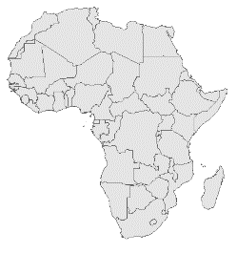
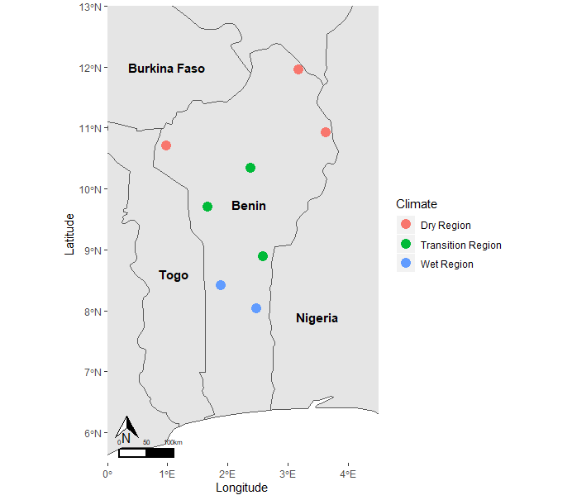
Figure 2.1. Map of study area with village locations. Villages in the drier region of Benin are in red, those in the wetter regions in Benin are in blue, and those in the transition region between the two ecological regions are in green.

We use K. senegalensis, a native, culturally important species in Benin to exemplify the impact of discount rates on conservation decisions because 1) it is listed as vulnerable by IUCN and is of high concern for conservation by local communities (Lokonon et al. 2018); 2) its high timber value causes on-going illegal harvest; 3) Fulani selectively harvest its NTFPs, especially during the dry season, for medicinal purposes, including to treat malaria, and for their livestock (Gaoue & Ticktin 2009; Houehanou et al. 2011); and 4) discount rates for slow growing species has been central to discounting debates (e.g., Clark 1973).

We conducted 503 surveys. We used 481 surveys because 22 were incomplete. We conducted 201 surveys in a drier region, 99 surveys in a wetter region, and 181 surveys in a climatic transition zone. The median age was 43 (range 18-90) with only 16 females, reflecting cultural mores within which we were working. Of our respondents, 92% had no formal education and 47% owned or leased land.

Survey methods

We used verbal choice-based surveys (Ubfal 2016; Hernuryadin et al. 2019). Subjects faced hypothetical paired choices of gains tomorrow versus gains to be received next month, next year, and in three years. We used fixed-sequence titration methods for each set of discount-rate related questions (Hardisty et al. 2013b). If the respondent always chose the near-term option, we asked at what amount, if any, would they choose the latter option (Appendix S1). Our approach, although common (e.g., Hardisty et al. 2013; Hernuryadin et al. 2019), involves many assumptions (e.g., narrow bracketing), and we recognize alternate designs are possible (Table S2.1).

We repeated our survey questions for financial, ecological, and agricultural goods. We used fodder from harvestable trees and cows, in biophysical units, to determine ecological and agricultural discount rates, respectively. Subjects were also asked demographic questions (Appendix S1).

Functional form for discounting

We calculated discount rates using an exponential specification of time preferences. A subject would be indifferent between two benefits if:
$V= F*e^{-δ_{i}t}$
$δ_{i}= -\frac{1}{t}ln(\frac{V}{F})$ Eq. 1

where V is the present value, F is the future amount, t is the time delay, and $δ_{i}$ is the individual’s discount rate for a specific good. Other choices of functional form to represent discounting are also possible (Appendix S2).

Empirical analysis

We assumed each respondent’s indifference point was the midpoint of the interval between the questions at which they switched to the delayed option (Hardisty et al. 2013b; Johnson & Saunders 2014). Once we determined indifference points for individuals at each timeframe for each good, we calculated their discount rates (Eq. 1). Some respondents said they would always choose the near-term option, implying infinite discount rates (see also Kumar & Kant 2019). Respondents having infinite discount rates is consistent with economic theory for use of common-pool resources (Hartwick & Yeung 1997). Others sometimes answered with zero or negative discount rates, again to be expected whether based on theory (Baumgärtner et al. 2015) or cultural beliefs.

We used generalized linear mixed model with a rank transformation to compare discount rates across timeframes and domains. We then incorporated effects of the climate of the respondent’s village, their age, and whether they own or lease lands. Both models incorporated two random error terms to account for heterogeneity across individuals and an individual specific error term to account for the heterogeneity within an individual’s responses (Appendix S3). We undertook robustness tests using several alternative specifications (Table S2.5).

Optimization model

To demonstrate the importance of discount rates, we integrated our results into a model that aims to identify optimal harvest rates for K. senegalensis. Specifically, we adapted a model for timber and non-timber harvesting from Gaoue et al. (2016). The model accounts for growth of populations, while assuming the intensity of non-timber harvest affects the intrinsic growth rate of the species (Table 2.1, see also Gaoue et al. 2016). The model assumes a management goal of maximizing net profits that accrue for local human populations from timber and non-timber harvesting, while also assigning a conservation value to maintaining a standing stock of K. senegalensis in an open access system. Managers are assumed to maximize the objective:

$J\left(E_{l}, E_{n}\right)=\int_{0}^{T}{e^{-δ(t)t}}\left(B_{1}E_{l}\left(t\right)x\left(t\right)+B_{2}E_{n}\left(t\right)x\left(t\right)-C_{1}E_{l}^{}\left(t\right)-C_{2}E_{n}^{}\left(t\right)- C_{3}E_{l}^{2}\left(t\right) -C_{4}E_{n}^{2}\left(t\right)+Ax\left(t\right)\right) dt$ Eq. 2

where $E_{l}$ is effort for timber harvest, $E_{n}$is effort for non-timber harvest, A is the weighted value of conservation, $B_{1}$ and $B_{2}$ are aggregate parameters that include prices from the two types of harvest, and C₁ and C₂ describe the cost (including time-cost) of each day of effort spent harvesting timber and non-timber, while C₃ and C₄ are an adjustment to this cost reflecting the fact that marginal costs of each day of harvesting effort may increase the more effort that is being deployed for both timber and non-timber harvesting respectively. We use this model to explore how assumptions about the discount rate δ(t) would change recommended optimal harvesting strategies.

Table 2.1. Ecological model. Additional details and parameter values are provided in Appendix S4.
State equations
Density of plant species $\frac{dx(t)}{dt}=r\left(t\right)x\left(t\right)\left(1- \frac{x\left(t\right)}{K}\right)- E_{l}\left(t\right)x(t)$
Intrinsic growth rate of plant $τ\frac{dr\left(t\right)}{dt}=r_{e}-r-αE_{n}-βE_{l}$
Notation | Description
$x(t)$ | Density of K. senegalensis at time t (a state variable)
$r(t)$ | Intrinsic rate of K. senegalensis at time t (a state variable)
K | Carrying capacity for K. senegalensis
$E_{n}$ | Rate of effort for non-timber harvest at time t
$E_{l}$ | Rate of effort for timber harvest at time t
$r_{e}$ | Maximum growth rate of K. senegalensis
$τ$ | Average lifespan of K. senegalensis in years
$α$ | Growth decay rate for non-timber harvest
$β$ | Growth decay rate for timber harvest

We compare optimal harvest strategies using survey results with 1) a single, constant discount rate at the median obtained for the financial domain (Gaoue et al. 2016); 2) a single, constant discount rate at the median obtained for the ecological domain; and 3) constant, dual-discount rates using the median values for the financial and ecological domains (Armsworth 2018). To implement dual-rate discounting, we apply a separate discount rate to the conservation value term (A, Eq. 2) and another for valuing harvest income (Appendix S4). Finally, we consider 4) a single discount rate that declines through time paralleling survey results in the ecological domain (Appendix S4). In equation 2, δ(t) is the single discount rate applied, which was assumed constant through time for versions 1 and 2, but declined through time for version 4. We used Pontryagin’s Maximum Principle to transform the resulting optimal control problem into a boundary value problem, which we solved numerically using forward and backward sweeps in Matlab, version R2019a (Lenhart and Workman 2007, Appendix S4).

Results

Were we to use a discrete time, annual representation of the discount rate, our median value would be 150%, much higher than the 0-20% range often discussed in the literature. These high discount values correspond to a halving of value in ~8.8 months for the financial domain, ~18.9 months for fodder (ecological domain), and ~13.6 months for cattle (agricultural domain) (Table 2.2). 168 (34.9%) respondents reported that no amount of goods in the future would make them choose the later-term option for at least one good, implying that they have infinite discount rates.

Delay, domain, and delay-domain interaction were all significant (p <0.0001; Figure 2.2; Appendix S3), something that continues to apply if the models are also run without infinite responses (Table S2.5 for robustness checks). Discount rates decreased through time for all domains, meaning that when considering events in the more distant future, individuals discount less. Moreover, when comparing across domains, respondents discounted financial amounts significantly more than they would in other domains. Respondents who leased or owned land had marginally significantly higher discount rates (p = 0.0586); older respondents had significantly lower discount rates (p < 0.001); and climatic zone was not significant (Figure 2.2, Table S2.4).

Optimization model

The optimization models make clear that the variation in discount rates we observed can profoundly affect management recommendations for timber and non-timber harvesting of tropical trees. Our first model uses a single constant discount rate at the median for financial discounting (Figure 2.3A-C, Figure S2.1). For this case, there is an initial pulse of timber harvesting and accompanying crash in population size, before timber and non-timber harvesting are abandoned (Figure S2.1, Figures 2.3A-C) i.e., with high discount rates, sustainable harvest of this slow-growing tree would not be economically efficient. In contrast, when using the lower fodder, median discount rate, non-timber harvesting effort gradually expands through time, while timber harvest is not sustained (Figure S2.1, Figure 2.3A). The expansion in non-timber harvesting results in a reduction in the growth rate of remaining trees (Figure 2.3C). Finally, with dual-rate discounting, non-timber harvesting again increases to begin with, but is abandoned as the conservation value of standing mahogany comes to dominate its harvesting value, resulting in the largest density and growth rate of trees (Figure 2.3A-C).
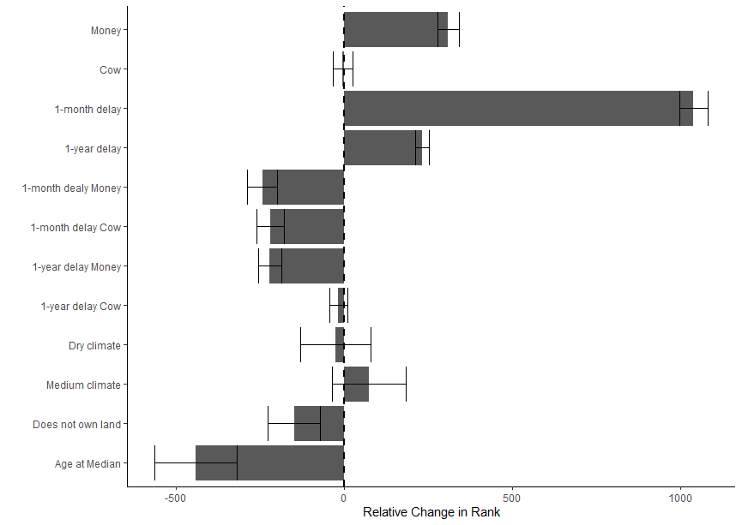
*
*
*
*
*
*
*
Figure 2.2. Comparative rank coefficients for discount rates for three timeframes (1 month, 1 year, 3 years) over the three domains, cows, money, and trees. Trees, 3-year delay, owning land, and wetter region were reference categories for the model. Age was set to 43, the median age. The bars with an asterisk are significantly different (p-value <0.05) than the respective reference category.

Table 2.2. Statistics for respondents’ discount rates in all three domains: financial, ecological, and agricultural.
Good | Number of respondents | Number of respondents with infinite discount rates for at least one timeframe | Median (IQR) | 1-month Median (IQR) | 1-year Median (IQR) | 3-year Median (IQR)
Money | 481 | 144 | 0.95 (0, 4.87) | 11.00 (0, 20.46) | 0.96 (0, 2.17) | 0.46 (0, 0.95)
Fodder | 481 | 138 | 0.44 (  -0.04, 3.91) | 4.87 (0, 18.05) | 0.32 (  -0.29, 1.48) | 0.19  (-0.04, 0.64)
Livestock | 481 | 114 | 0.61 (0, 2.67) | 2.67 (0, 9.73) | 0.41 (0, 1.5) | 0.44 (0, 0.77)

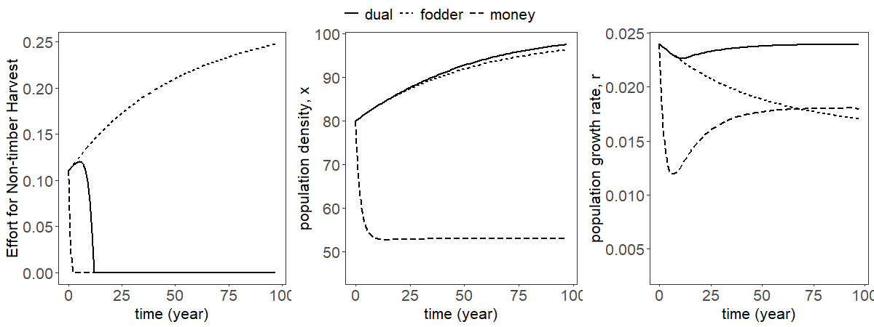
A
B
C
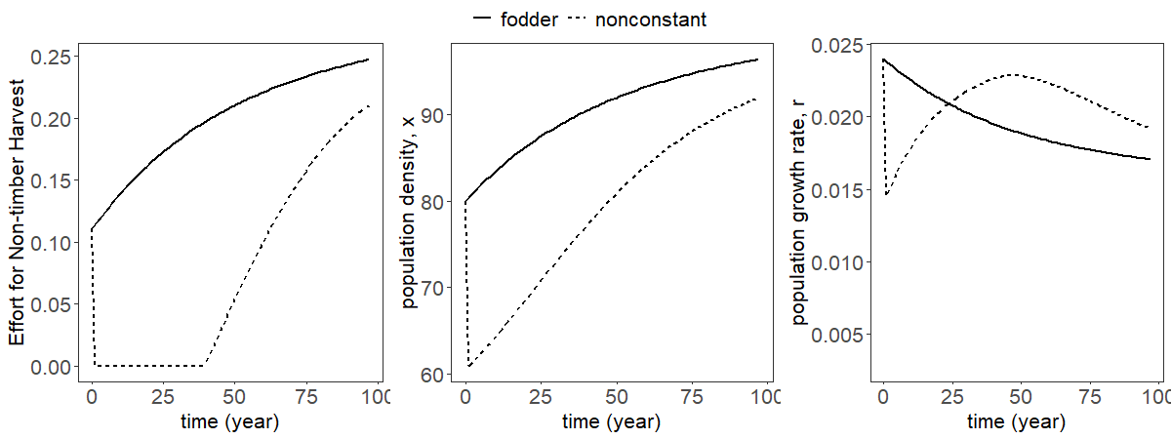
F
E
D
Figure 2.3. Optimal effort for non-timber harvest (A and D) and the respective effects on population density (B and E) and population growth rate (C and F) of K. senegalensis over a 100-year time horizon. Panels A-C compare a single rate at the median for the financial domain (long-dashed line), a single rate at the median for the ecological domain (short-dashed line), and multiple-rate discounting incorporating the medians for both the financial and ecological domains (solid line). Panels D-F compare a single constant rate at the median for the ecological domain (solid line) and a single nonconstant rate paralleling declining rates observed in the survey (dashed line).

We also compare recommendations when assuming a constant discount rate with recommendations if discount rates decline through time as observed in the survey data for the ecological domain (Figure 2.3D-F, Figure S2.2). When implementing a non-constant discount rate, the discount rate is initially very high (to arrive at the same overall median amount). Hence once again, harvesting initially does not look like an economically attractive investment and an initial pulse in timber harvesting suppresses the population before harvesting is abandoned. However, once the discount rate has declined enough, we observe increasing levels of non-timber harvest being optimal again.

Discussion

We elicited and calculated discount rates for three domains across three timeframes. Our study reveals that Fulani in Benin do discount and at a high rate on average. Yet two common discounting assumptions do not describe their preferences well: Fulani do not discount domains equally and they do not discount at a constant rate through time. We also found high variation in discount rates, but demographic covariates could explain some of the variation. We applied our survey results to an optimization model for harvest of K. senegalensis. In our study, dual-rate discounting resulted in the highest growth rates of K. senegalensis. Our work appears to be the first to empirically elicit locals’ discount rates and then depict their importance by applying them to a bioeconomic model of management.

Elicited discount rates (median: 150%) are significantly higher than found in other studies (Ubfal 2016; Kumar & Kant 2019). High discount rates for the ecological domain would align with theory for common-pooled resources (Hartwick & Yeung 1997). But high discount rates applied across domains, suggesting these may be due more to uncertainty about the future; e.g., Fulani’s lifestyles are rapidly changing from transient to sedentary due to climate change and competition for land with logging and agriculture (Gaoue & Ticktin 2009; Heubach et al. 2011). For K. senegalensis, such high discount rates imply sustainable timber harvest will not be economically competitive, putting logging interests and conservation in tension. At the same time, sustained non-timber harvest would be optimal. Currently, most plantations and restoration programs in the region focus on fast growing species, such as Gmelina arborea and Tectona grandis. Programs that seek to support reliance on NTFPs could help conservation efforts as would programs that seek to deter timber harvest, 90% of which is done illegally (Siebert & Elwert 2002), by tracing timber sales (FAO 2020) and by promoting sustainable energy sources in lieu of fuelwood and/or charcoal (World Bank 2019). For other conservation efforts with high discount rates, the question may become when to operate, in addition to focusing on the value of benefits not just to the organization, but multiple benefits, as we have shown in our model with both local economic and conservation benefits.

Aligning with other recent studies, our results showed people discount domains differently (Ubfal 2016; Green & Richards 2018). In our study, dual-rate discounting resulted in the highest growth rates of mahogany. Additionally, Fulani discount near-term benefits and costs at a higher rate than those realized further into the future. With non-constant discount rates, a waiting period is necessary before non-timber harvest would be optimal. Building upon previous work (Sumaila & Walters 2005; Armsworth 2018), our models depict the need for conservation management to account for domain-specific discount rates and non-constant rates, which can influence the timing, rate, and magnitude of optimal management strategies.

In our study there are potentially other important factors and assumptions that could be addressed. We only asked about three time periods and, hence, only calculated discount rates using one functional form. We provide a sensitivity test to the choice of functional form in Appendix S2, which shows similar patterns in discount rates across domains. Additionally, we did not ask risk-related questions, which could lower elicited rates (Andreoni & Sprenger 2012). Because Fulani rarely divulge the number of cattle they have, or amount of fodder needed for their cattle, we did not incorporate background consumption. With our illustrative modeling application, we explored parameter space relative to survey results and mahogany, leaving a wider exploration of parameter space for other work. Despite these and other assumptions, our study depicts the importance of including locally derived time preferences in conservation management.

Our study shows that discount rates are much higher for Fulani in Benin than previous literature suggests and that Fulani discount monetary amounts differently than they do some other types of good. This study depicts the nuanced nature of discount rates and the effects that discount rates can have on optimal conservation strategies and natural resource management. Discount rates for conservation decisions and natural resource management cannot be applied across all communities or user groups uniformly; instead, managers need locally-grounded estimates. Overall, natural resource management and associated models could be significantly improved with the incorporation of local time preferences.

Acknowledgements
We thank Dr. Ismail Moumouni and survey respondents. This project was funded by the Center for International Education and University of Tennessee’s Department of Ecology and Evolutionary Biology.

APPENDIX

Appendix S1: Additional Survey Details

We used choice-based surveys with KoboCollect (https://www.kobotoolbox.org/). In-country surveyors were trained on KoboCollect on how to conduct the in-person survey on their mobile phone app. We used a choice-based survey because it has proven better at predicting intertemporal choices than other methods (Hardisty et al. 2013b). As per our IRB-approved protocol, we verbally asked individually paired questions in local languages, primarily Fula and Bariba, as done in many field experiments in the Global South (Ubfal 2016; Hernuryadin et al. 2019).
Subjects faced hypothetical paired choices of gains tomorrow versus gains that would be received next month, next year, and in three years. Due to funding limitations and feasibility, we used hypothetical choices. We acknowledge that the use of real rewards may improve elicited discount rates, but many have found that hypothetical choices has no influence on elicited discount rates (e.g., Benhabib et al. 2010; Ubfal 2016).
We used fixed-sequence titration methods for each set of discount-rate related questions (Hardisty et al. 2013b). Specifically, if a respondent chose the near-term option, the delayed quantity increased until the respondent switched. If the respondent chose the latter-term option, the delayed quantity decreased until the respondent switched. If the respondent always chose the near-term options, we asked at what amount, if any, would they choose the latter option.
We repeated our survey design for financial, ecological, and agricultural domains. We used fodder from a specific number of harvestable trees and number of cows to determine ecological and agricultural discount rates respectively. All ecological and livestock questions were in biophysical units. For all domains, the ratio between near-term and future rewards was similar to minimize framing effects and order of domains was randomized to minimize ordering effects. To minimize any effects from the magnitude of initial, near-term values, we conducted ~150 pilot surveys. These surveys helped us refine both range and magnitude of initial values. In regard to access to markets, fodder is not sold, but harvested directly for livestock and/or medicinal purposes. From experts on Fulani in Benin, however, the primary time to sell cattle is during the dry season from December, after we finished our surveying, thru April. Subjects were also asked demographic questions e.g., age, education level. Exemplar questions below illustrate the nature of the survey.

Assumptions of survey design

Table S2.1. Assumptions of choice-based surveys when eliciting time preferences.
Assumption or Effect | Description | Solution | References
Magnitude Effect | The literature has found that people discount higher magnitudes at a lower rate. | We used the same values for both cows and fodder. To get an appropriate starting value for money, we ran ~150 pilot surveys and found that larger values increased the number of respondents reporting that they would never choose the later-term option. | Hardisty et al. 2013a; Berry et al. 2017
Ordering Effect | The literature has shown that ordering of questions, especially in reference to monetary values, can influence survey responses. | We randomized the order of domain questions and found no difference between versions of surveys. | Day et al. 2012
Framing Effect | Literature has shown that initial framing may influence what a respondent thinks is a “reasonable” response and in written surveys, respondents are drawn towards the middle of tables. | We conducted ~150 pilot surveys to help determine the appropriate range of possible survey responses. Additionally, we read the survey aloud so respondents could not see any potential table. | Andersen et al. 2006; Hardisty et al. 2013b
Monetary vs. Biophysical Units | Literature has shown that discount rates may vary by domain, which may be attributed to the measuring units within a survey. | We asked respondents questions in terms of biophysical units because 1) fodder is not typically traded directly at markets and 2) we wanted to test if respondents valued goods that are not traded in a market similarly to goods that are traded at market for monetary goods. Our results show that despite the monetary difference between cows and fodder, Fulani do not discount these goods differently. | Dunford 2018; Green & Richards 2018

Table S2.1 continued.
Assumption or Effect | Description | Solution | References
Hypothetical vs. Real Rewards | There is a debate whether the use of hypothetical rewards can bias responses in choice surveys. | Due to funding limitations and feasibility, we used hypothetical choices. We acknowledge that the use of real rewards may have improved elicited discount rates, but many have found that the use of hypothetical choices has no influence on elicited discount rates. While Frederick et al. 2002 also acknowledges that hypothetical rewards allows the survey to ask questions in an appropriate range rather than being limited by funding or administrative guidelines. | Frederick et al. 2002; Ubfal 2016
Narrow Bracketing | Literature has shown that narrow bracketing, i.e., choices offered in isolation from external circumstances, can influence reported discount rates. | Due to cultural norms and survey time limitations, we were not able to ask about other forces guiding elicited discount rates such as background consumption and credit availability. | Rabin & Weizsäcker 2009; Ubfal 2016

Exemplar survey questions

Below you will find exemplar survey questions for the financial domain with a one-month delay. All units are in West African Franc (CFA), where $1USD ~ 600 CFA. In addition to hypothetical choice questions, we asked respondents their age, their sex, their level of formal education, and if they owned land and if so, how many hectares.

1.1 Hypothetically, which would you prefer?





1000 CFA tomorrow

500 CFA in one month
No preference

1.2 Which would you prefer?

1000 CFA tomorrow

1000 CFA in one month

No preference

1.3 Which would you prefer?


1000 CFA tomorrow

2000 CFA in one month
No preference

1.4 Which would you prefer?
1000 CFA tomorrow

3000 CFA in one month

No preference

1.5 Which would you prefer?
1000 CFA tomorrow

4000 CFA in one month

No preference

1.6 Which would you prefer?
1000 CFA tomorrow
5000 CFA in one month
No preference

1.7 Which would you prefer?


1000 CFA tomorrow

6000 CFA in one month

No preference

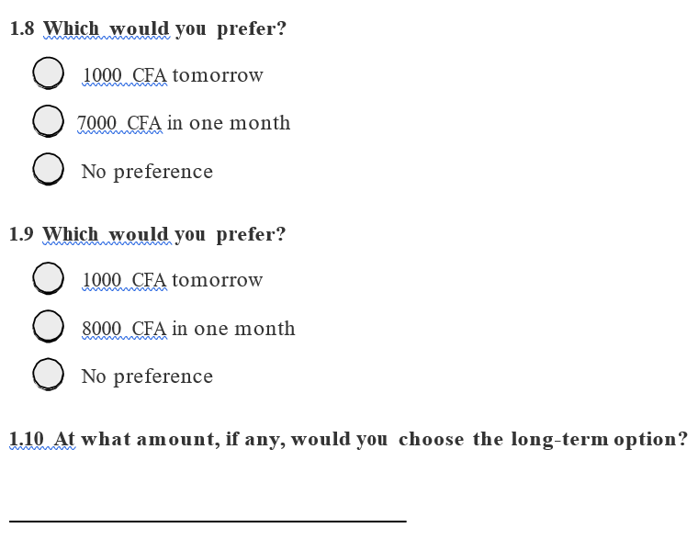

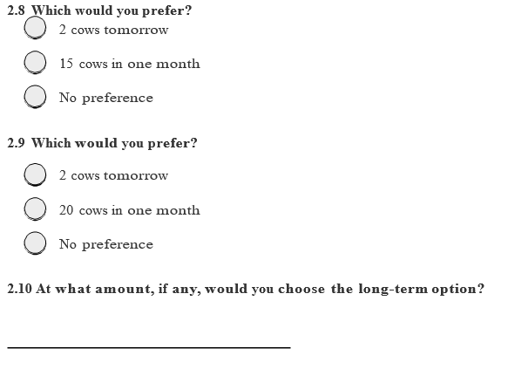
2.1 Hypothetically, which would you prefer?

2 cows tomorrow

1 cow in one month

No preference

2.2 Which would you prefer?
2 cows tomorrow
2 cows in one month
No preference

2.3 Which would you prefer?
2 cows tomorrow
3 cows in one month
No preference

2.4 Which would you prefer?
2 cows tomorrow
4 cows in one month

No preference

2.5 Which would you prefer?
2 cows tomorrow
6 cows in one month
No preference

2.6 Which would you prefer?
2 cows tomorrow
9 cows in one month
No preference

2.7 Which would you prefer?

2 cows tomorrow

12 cows in one month
No preference

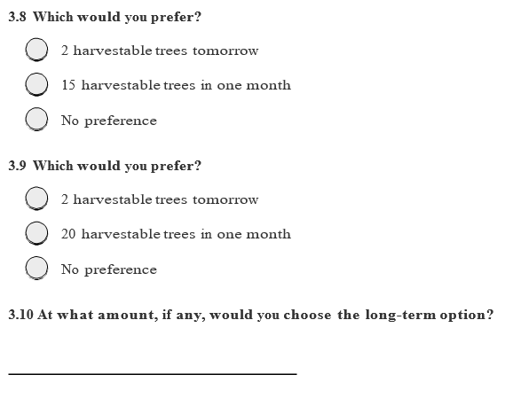
3.1 Hypothetically, which would you prefer?
2 harvestable trees tomorrow
1 harvestable trees tomorrow
No preference

3.2 Which would you prefer?
2 harvestable trees tomorrow
2 harvestable trees tomorrow
No preference

3.3 Which would you prefer?
2 harvestable trees tomorrow
3 harvestable trees tomorrow
No preference

3.4 Which would you prefer?
2 harvestable trees tomorrow
4 harvestable trees tomorrow
No preference

3.5 Which would you prefer?
2 harvestable trees tomorrow
6 harvestable trees tomorrow
No preference

3.6 Which would you prefer?
2 harvestable trees tomorrow
9 harvestable trees tomorrow
No preference

3.7 Which would you prefer?
2 harvestable trees tomorrow
12 harvestable trees tomorrow
No preference

Appendix S2: Discount rate functions

Assessment of conservation and restoration projects and strategies commonly use an exponential discounting function, assuming a constant discount rate. However, for long projects, using an exponential discounting function with a constant discount rate can reduce long-term future values such a degree that they become largely irrelevant in terms of present value. For example, $1,000 in 100 years has a present value of $6.74 with an exponential discounting function and constant discount rate of 5%, a common choice when evaluating conservation and natural resource management strategies. Hence, there has been a continuous debate regarding the ethical nature of this assumption, especially in the context of projects with environmental implications that have the possibility of lasting for decades (Heal 2009).
Hyperbolic discounting is an alternative to exponential discounting. Hyperbolic discounting uses a discount function that decreases in rate with time such that long-term costs and benefits are discounted at a lower rate than more immediate costs and benefits (Mazur 1987; Prelec 2004). This type of function allows for long-term costs and benefits to have more relevance when evaluating projects. Studies on hyperbolic discounting typically use different functional forms for discounting than the exponential form.
In the main text, we show results using an exponential discounting function to make our results as comparable as possible with wider practice in many conservation and natural resource management applications. With our statistics, we then offer an explicit test of whether assuming the discount rate is constant through time is justified and find that it is not. An alternative approach would have been just to assume a priori that discounting is hyperbolic and adopt a functional form for discounting more conventionally used in papers on hyperbolic discounting. We chose not to do this to ensure our formulation would be as familiar as possible to a broad cross-section of conservation scientists and practitioners. Below we offer a sensitivity test of whether our conclusions would have differed had we assumed one of those alternative functional forms. Specifically, following hyperbolic discount function of Mazur (1987):
$$V = \frac{F}{1+δ_{i}t}$$
$$δ_{i}=\frac{F-V}{Vt}$$
V is the present value of a good, F is the future amount, t is the time delay, and $δ_{i}$ is a discounting parameter, which in our study is specific to the individual and to the specific type of good in question (financial, fodder, cattle).
We find the same pattern in calculated discount rates when assuming this alternative functional form as we find when using the exponential version. Discount rates ($δ_{i}$), as defined in the new function this time, for the financial domain are significantly higher than the environmental and agricultural domains (Table S2.2). Also discount rates 1-month out are significantly higher than 1-year and 3-years out (Table S2.2).
Our survey was not designed to ascertain the best choice of functional form to represent time discounting. To do so, we would need to measure indifference points at additional timeframes, which was not possible due to time constraints within the survey (survey fatigue). Our focus was instead on testing whether discount rates were the same for different types of good and whether they were constant through time, results that appear robust to our choice of functional form.

Table S2.2. Statistics for respondents’ discount rate in all three domains: financial, ecological, and agricultural using a traditional hyperbolic form.
Good | N | Number of respondents with infinite discount rates for at least one response | Hyperbolic
Good | N |  | Median (IQR) | 1-month Median (IQR) | 1-year Median (IQR) | 3-year Median (IQR)
Money | 481 | 144 | 2.58 (0, 18) | 18 (0, 54) | 1.63 (0, 7.75) | 1 (0, 5.5)
Fodder | 481 | 138 | 0.92 (-0.04, 0.92) | 6 (0, 42) | 0.38 (-0.25, 3.38) | 0.25 (-0.04, 1.96)
Livestock | 481 | 114 | 1.5 (0, 6.75) | 3 (0, 15) | 0.5 (0, 3.5) | 0.92 (0, 3)

Appendix S3: Generalized linear mixed model

Model Specification

The range of discount values involved had non-normal errors and heterogenous variances. Because of this, we used generalized linear mixed model (GLMM) with a rank transformation to compare discount rates across timeframes and domains. First, we fitted a base model without additional covariates
$δ_{i,j}= β_{0}+ β_{1}Delay+β_{2}Domain+β_{3}Delay*Domain+ε_{i}+v_{ij}$ Eq. S1
where i is an individual, j is a given response for individual i, $ɛ$ is the random error term, which accounts for heterogeneity across individuals, while $ν$accounts for heterogeneity across an individual’s responses. Hence forward, the term $β_{3}Delay*Domain$ is referred to as the interaction term.
We then expanded our base model to incorporate the effects of characteristics of respondents and their villages on elicited discount rates:
$δ_{i,j}= β_{0}+ β_{1}Delay+β_{2}Domain+β_{3}Delay*Domain+ β_{4}Climate+β_{5}Age +β_{6}LandTenure+ε_{i}+ v_{ij}$ Eq. S2
where climate refers to the climate of the village of the respondent (Wet, Dry, or Transition), age refers to the age of the respondent, and LandTenure refers to the ownership or leasing of land. We did not include formal education level due to lack of variation (92% of the sample had no formal education). With only 16 female respondents, we also did not include sex into the model.
We compared the base model with this model with covariates based on their AIC values. Because it had a lower AIC score, we reported results for the model with covariates in the main text. To illustrate that our findings about delay and domain were not sensitive to this choice, we include results from both models below.
Before resorting to rank transformation, we attempted several other transformation and link functions, but ultimately rejected them based on comparing resulting model residuals to test assumptions. Additionally, we used rank transformation so that the reported infinite rates could be included in an analysis without an arbitrary numerical assignment skewing data. Because we had a particular interest in whether Fulani discounted different in different domains, we included a domain x delay interaction effect. However, we did not consider further interactions lacking reasons to prioritize some interactions from among the many that are possible with this many variables. All GLMMs were fit using SAS 9.4.

Model outputs

For this model, we used 481 complete surveys from 8 villages totaling 4329 calculated discount rates (481 surveys x 3 domains x 3 delays). Delay, domain, and delay-domain interaction were all highly significant. Discount rates decreased through time for all three domains, meaning that when considering events in the more distant future, individuals would discount less. Moreover, when comparing across domains, respondents discounted financial amounts significantly more than they would in the ecological or agricultural domains. Respondents who leased or owned land had marginally significantly higher discount rates (p = 0.0586), older respondents had significantly lower discount rates (p < 0.001), and climate of the village was not significant (Figure 2.2, Table S2.4).
We found that discount rates declined with age and increased with leasing or owning land (Table S2.4). Declining discount rates with age does not align with previous literature. Previous studies hypothesized that discount rates increase with age because they may not live to see future benefit (Read & Read 2004), may have declines in pleasure from consumption (Trostel & Taylor 2001), or that people simply become more impatient (Bauer & Chytilová 2010). Anecdotally, many older respondents stated that being patient would create luck for future endeavors. Land ownership for Fulani is a surrogate for residency. Non-land owners are typically more transient individuals. Aligning with Kumar and Kant (2019), discount rates increased with land ownership. This could be due to the respondent being more willing to take risk with their land holding as insurance, having less patience due to increased need to maintain lands (Kumar & Kant 2019), and/or the individual having greater integration of the ecological and financial domains.
People think about different domains differently (Attema et al. 2018; Green & Richards 2018). Justification for differences between domains also exist within more traditional economic theory, particularly when people perceive substitutability between goods to be limited and future growth of or risks associated with different kinds of goods to be different (e.g., Gollier 2010). We found that people discounted the financial domain higher than the other two domains. This could be due to a variety of reasons. 1) This could be due to an immediacy of need and increased temptation. Respondents could have wanted or needed other goods, and hence, had an immediate need for money. 2) These results could have been exacerbated by the lack of fiscal savings culture in Benin (communications with expert). 3) This result could be caused by an increasing knowledge of climate change and environmentally conscious actions. Anecdotally, some respondents replied that X amount of fodder would be wasteful for the number of cows they have and they would rather save the trees for future generations.

Table S2.3. Generalized linear mixed model outputs for base model with 3-year delay and fodder as reference categories.
Effect | Estimate | S.E. | p-value
Intercept | 1716.97 | 43.02 | <0.0001
Delay[1 month] | 1039.49 | 42.09 | <0.0001
Delay[1 year] | 232.01 | 20.69 | <0.0001
Domain[Cow] | -3.98 | 28.53 | 0.8890
Domain[Money] | 309.84 | 32.11 | <0.0001
[1 month][Cow] | -219.97 | 40.64 | <0.0001
[1 month][Money] | -242.74 | 43.89 | <0.0001
[1 year][Cow] | -16.34 | 25.72 | 0.5255
[1 year][Money] | -220.73 | 35.41 | <0.0001
Note: Beyond the intercept variable, all other variables are essentially dummy variables (1 if yes, 0 if no). Meaning if you are 1 month out, you cannot also be 1 year out. For example, if you want to calculate the rank for cows 1 month out, you would have the intercept + delay[1 month] + domain[Cow] + [1 month][Cow].

Table S2.4. Generalized linear mixed model outputs for the full model. With 3-year delay, fodder, wet region, and owning or leasing land as reference categories.
Effect | Estimate | S.E | p-value
Intercept | 2229.70 | 152.64 | <0.0001
Delay[1 month] | 1039.49 | 42.07 | <0.0001
Delay[1 year] | 232.01 | 20.53 | <0.0001
Domain[Cow] | -3.98 | 28.54 | 0.8890
Domain[Money] | 309.84 | 32.08 | <0.0001
[1 month][Cow] | -291.97 | 40.66 | <0.0001
[1 month][Money] | -242.74 | 43.88 | <0.0001
[1 year][Cow] | -16.34 | 25.67 | 0.5246
[1 year][Money] | -220.73 | 35.25 | <0.0001
Climate [Dry] | -25.26 | 103.7 | 0.8076
Climate [Transitional Zone] | 73.93 | 110.56 | 0.5038
LandOwnership [None] | -148.27 | 78.33 | 0.0586
Age | -10.23 | 2.85 | 0.0003
Note: Although data do not meet traditional parametric assumptions even with transformations, we did run the model with a log transformation and weighted variances by delay. The overall model trends remain the same, except for the covariate age is no longer significant (p > 0.05).
Table S2.5. Robustness checks for the key findings with the general linear model. Positive and negative represent the direction of the coefficient relative to the reference categories and asterisk denotes significant effect.
Model | Domain Significant | Delay Significant | Interaction Significant
Base model with rank transformation and with infinite rates | Cow negative, money positive * | Both positive * | All negative *
Full model with rank transformation and with infinite rates | Cow negative, money positive * | Both positive * | All negative *
Base model with rank transformation and without infinite rates | Both positive * | Both positive * | All negative *
Full model with rank transformation and without infinite rates | Both positive * | Both positive * | All negative *, except 1 year x cow
Base model with rank transformation, with infinite rates, and with clustered standard errors | Cow negative, money positive * | Both positive * | All negative *
Full model with rank transformation, with infinite rates, and with clustered standard errors | Cow negative, money positive * | Both positive * | All negative *
Base model without rank transformation, with infinite rates, and with weighted variances | Cow negative, money positive * | Both positive * | All negative *
Full model without rank transformation, with infinite rates, and with weighted variances | Cow negative, money positive * | Both positive * | All negative *

Appendix S4: Additional optimization model details and solutions

This appendix provides additional detail for our optimization model and solutions.
We included optimization model runs in the main text to illustrate how the variation in discount rates we found in the surveys could affect conservation and natural resource management decisions. Specifically, we revisited the model of Gaoue et al. (2016) examining optimal management of harvesting of K. senegalensis. For our illustration, we made changes to these models to examine the effects of our discounting assumptions (e.g., by including different discount for different types of good in one scenario), but otherwise adhered closely to the original assumptions and parameter choices. In our system, we focus on non-lethal harvest from K. senegalensis for fodder. As a form of NTFP, this non-lethal harvest is extremely important to the Fulani. Because we focus on non-lethal harvest of the same species, we represent that using tree density in the objective function. In other systems, NTFPs take more diverse forms, often relying on co-occurring species rather than with the species that is itself the main target of lethal harvesting (for broad review see Stanley et al. 2012) and for such situations richer model specifications would be required to integrate dynamics of those other species (e.g., Ticktin 2004; Potts & Vincent 2008).

Ecological model

The population dynamics (or state equations) of K. senegalensis are:
Density of plant species $\frac{dx(t)}{dt}=r\left(t\right)x\left(t\right)\left(1- \frac{x\left(t\right)}{K}\right)- E_{l}\left(t\right)x\left(t\right)$ Eq. S3
Intrinsic growth rate of plant $τ\frac{dr\left(t\right)}{dt}=r_{e}-r-αE_{n}-βE_{l}$ Eq. S4
where x(t) is the density of K. senegalensis at time t, r(t) is the intrinsic growth rate of K. senegalensis at time t, K is the carrying capacity, $E_{l}\left(t\right)$ is the effort for timber harvest at time t, $E_{n}\left(t\right)$ is the effort for non-timber harvest at time t, $r_{e}$ is the maximum growth rate, $τ$ is the average lifespan of the species, $α$ is the growth decay rate for non-timber harvest, and $β$ is the growth decay rate for timber harvest (Gaoue et al. 2016).

Optimal Control Model

We compare optimal harvest strategies using survey results with 1) a single, constant discount rate (see also Gaoue et al. (2016)), which we chose here to be the median obtained in the survey for the financial domain; 2) a single, constant discount rate set at the median rate from the survey for the ecological domain; and 3) dual-discount rates using the median values for the financial and ecological domains with constant discounting (see Armsworth 2018 for discussion on dual-rate discounting, including a review of the underlying economic theory and of how multiple discount rates are in effect being assumed in many conservation management plans). Finally, we consider 4) a single discount rate, but one that declines through time. With this version, we chose parameters and a declining function that paralleled survey results in the ecological domain.
Versions 1), 2), and 4) here each applied the same discount rate to different kinds of good. Specifically, the manager’s problem with each was assumed to be to find an optimal control pair, $E_{l}$(t) and $E_{n}$(t) that maximized the objective function J where $J\left(E_{l}, E_{n}\right)=\int_{0}^{T}{e^{-δ(t)t}}\left(B_{1}E_{l}\left(t\right)x\left(t\right)+B_{2}E_{n}\left(t\right)x\left(t\right)-C_{1}E_{l}^{}\left(t\right)-C_{2}E_{n}^{}\left(t\right)- C_{3}E_{l}^{2}\left(t\right) -C_{4}E_{n}^{2}\left(t\right)+Ax\left(t\right)\right) dt$ Eq. S5 (Eq. 3 in main text)
In this equation, $δ\left(t\right)$ is the single discount rate applied, which was assumed constant through time for versions 1) and 2) but declined through time for version 4), as we discuss below. Other notations were as follows: $E_{l}$ is the effort for timber harvest, $E_{n}$is the effort for non-timber harvest, A is the value for conservation of standing K. senegalensis per tree, which could represent cultural value, existence value, or something else, $B_{1}$ and $B_{2}$ are aggregate parameters that include prices from the two types of harvest and a rate for harvestability, and $C_{1}$and $C_{2}$ describe the cost (including time-cost) of each day of effort spent harvesting timber and non-timber, while $C_{3}$ and $C_{4}$ are an adjustment to this cost reflecting the fact that marginal costs of each day of harvesting effort may increase the more effort that is being deployed for both timber and non-timber harvesting respectively. Similar to Gaoue et al. (2016), we assumed the costs of both types of harvest were similar. Because of this, we use the same cost coefficients for both harvest types (i.e., $C_{1}= C_{2}, C_{3}= C_{4}$). We chose to model an open access system because it more closely resembles the realities of the grazing done by Fulani in Benin.
For scenario 3) that used dual-rate discounting, J became
$J\left(E_{l}, E_{n}\right)=\int_{0}^{T}{e^{-ρ(t)t}}\left(B_{1}E_{l}\left(t\right)x\left(t\right)+B_{2}E_{n}\left(t\right)x\left(t\right)-C_{1}E_{l}^{}\left(t\right)-C_{2}E_{n}^{}\left(t\right)- C_{3}E_{l}^{2}\left(t\right) -C_{4}E_{n}^{2}\left(t\right)\right)+e^{-δ(t)t}Ax\left(t\right) dt$ Eq. S6
where $ρ$ is the discount rate for the financial domain and $δ$ is the discount rate for the ecological domain. For ease, we showed the process for maximizing the objective function with one discount rate (Eq. S3), but the same methods can be use derive solutions for the dual-rate scenario.
For version 4) which had a non-constant discount function, we compared several different functional forms to align with survey results, which had used categorical variables to reveal non-constant discounting. We tried to align the function with both the range of discount rates and the rate of decline through time revealed in the coefficients applied to these categorical variables. We found the following to align adequately with survey results for the purposes of our illustration:
$δ\left(t\right)= \frac{15}{1+t}$ Eq. S7
Versions (1-4) each give rise to an optimal control problem comprising an objective function (Eqns. S5 or S6), state equation constraints (Eqns. S3 and S4), additional constraints (e.g., harvest effort must be non-negative) and a set of initial conditions. We applied Pontryagin’s Maximum Principle to transform each optimal control problem into a boundary value ordinary differential equation problem by introducing a Hamiltonian and relevant adjoint variables (Lenhart and Workman 2007, Gaoue et al. 2016). Solutions of this boundary value problem satisfy the first order necessary conditions for an optimal solution of the optimal control problem.
To construct necessary conditions that an optimal control pair must satisfy, we use the Hamiltonian H:
$H= e^{-δ(t)t}\left(B_{1}E_{l}\left(t\right)x\left(t\right)+B_{2}E_{n}\left(t\right)x\left(t\right)-C_{1}E_{l}^{}\left(t\right)-C_{2}E_{n}^{}\left(t\right)- C_{3}E_{l}^{2}\left(t\right) -C_{4}E_{n}^{2}\left(t\right)+Ax\left(t\right)\right)+λ_{x}\left(r\left(t\right)x\left(t\right)\left(1- \frac{x\left(t\right)}{K}\right)- E_{l}\left(t\right)x\left(t\right)\right)+\frac{ λ_{r}}{τ}\left(r_{e}-r-αE_{n}-βE_{l}\right).$ Eq. S8
where $λ_{x}$ and $λ_{r}$ are adjoint variables. Relying on Pontryagin’s Maximum Principle to describe the first order necessary conditions, the optimal control problem can be transformed to a boundary value, ordinary differential equation problem, one that includes the original state equations along with additional differential equations describing the time evolution of these adjoint variables:
$\frac{{dλ}_{x}^{}}{dt}= -\frac{∂H}{∂x}= {-λ}_{x}\left(r\left(t\right)-\frac{2r\left(t\right)x\left(t\right)}{K}- E_{l}\left(t\right)\right)- e^{-δ(t)t}\left(B_{1}E_{l}\left(t\right)+B_{2}E_{n}\left(t\right)+A\right)$ Eq. S9
$\frac{{dλ}_{r}^{}}{dt}= -\frac{∂H}{∂r}= {-λ}_{x}x\left(1-\frac{x}{K}\right)+ \frac{λ_{r}}{τ}$ . Eq. S10
The characterization of an optimal control pair is derived by solving $\frac{∂H}{∂E_{l}}= 0$ and $\frac{∂H}{∂E_{n}}=0$ on the interior of the control set:
$E_{l}^{*}= \frac{B_{1}x^{*}- C_{1}- e^{δ\left(t\right)t}(λ_{x}x^{*}+\frac{λ_{r}}{τ}β) }{2C_{3}}$ Eq. S11
$E_{n}^{*}= \frac{B_{2}x^{*}- C_{2}- e^{δ\left(t\right)t}(\frac{λ_{r}}{τ}α) }{2C_{4}}$. Eq. S12

Model inputs

Following Gaoue et al. (2016), parameter values for the biological model were gathered from scientific literature from a series of papers on K. senegalensis. Because there is slight variation in growth patterns of K. senegalensis due to climatic conditions and the species is notoriously slow growing, we used those inputs paralleling the Sudano-Guinean Region of Benin i.e., the wetter region of Benin where the species has slightly faster growth rates.

Table S2.6. Biological and economic parameter estimates based on K. senegalensis
Parameter | Description | Estimate | Unit | Reference
$$B_{1}$$ | Benefit parameter or price for timber harvest | 0.30 | ($*ha)/(effort*tree) | Gaoue et al. 2016
$$B_{2}$$ | Benefit parameter or price for non-timber harvest | 0.15 | ($*ha)/(effort*tree) | Gaoue et al. 2016
$$C_{1}$$ | Linear cost parameter for timber harvest | 9 | $/effort | Best estimate to align with Gaoue et al. 2016
$$C_{2}$$ | Linear cost parameter for non-timber harvest | 9 | $/effort | Best estimate to align with Gaoue et al. 2016
$$C_{3}$$ | Nonlinear cost parameter for timber harvest | 10 | $/effort² | Best estimate to align with Gaoue et al. 2016
$$C_{4}$$ | Nonlinear cost parameter for non-timber harvest | 10 | $/effort² | Best estimate to align with Gaoue et al. 2016
$$A$$ | Conservation Value | 0.1 | ($*ha)/(tree) | Gaoue et al. 2016
$$ρ$$ | Financial discount rate | Varies | 1/year | From survey
$$δ$$ | Environmental discount rate | Varies | 1/year | From survey
K | Carrying capacity for the plant | 100 | Tree/ha | Gaoue & Ticktin 2007
$$r_{e}$$ | Maximum growth rate | 0.024 | /year | Gaoue & Ticktin 2010
$$τ$$ | Average lifespan of plant in years | 20 | years | Gaoue et al. 2013
$$α$$ | Growth decay rate for non-timber harvest | 0.03 | /year | Gaoue and Ticktin 2010
$$β$$ | Growth decay rate for timber harvest | 0.7 | /year | Gaoue and Ticktin 2010

Numerical approach

We found solutions to the resulting boundary value problem numerically using a Forward-Backward sweep approach (Lenhart and Workman 2007). To implement this method, we adapted codes from Gaoue et al. (2016) that used the in Matlab version R2018a.

Optimization outputs

Below we provide the full suite of outputs for both the state variables and the controls. A subset of these results was shown in the main text. Specifically, we show results describing how the two state variables, describing the biomass and growth rate of K. senegalensis change through time, along with the optimal combination of timber and non-timber harvests through time that gives rise to this pattern. We show this contrast for versions 1) constant single rate discounting at the median financial discount rate, 2) constant single rate discounting at the median ecological discount rate and 3) dual rate discounting in Figure S2.1. We then show the same variables for the situation where the discount rate declines through time (version 4, Figure S2.2).
As a robustness check for our cost specifications, we ran each scenario with each of the cost functions individually. Generally, none of the trends changed. With only linear or only quadratic cost functions, sustainable lethal harvest was still never part of the optimal solution for a slow-growing species. With only one of the cost functions, either linear costs or quadratic costs only, non-lethal harvest became more profitable causing optimal levels of harvest to rise in all scenarios causing a slight decline in density and growth functions.

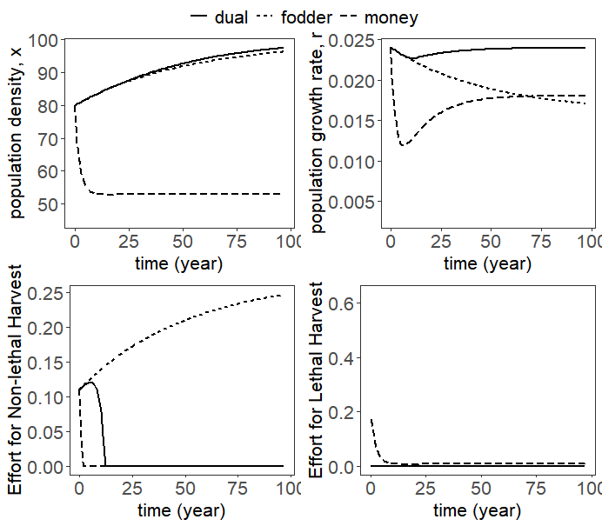
Figure S2.1. Optimal effort for non-timber harvest and timber harvest and the respective effects on population density and population growth rate of K. senegalensis over a 100-year time horizon. These panels compare a single rate at the median for the financial domain (long dashes), a single rate at the median for the ecological domain (short dashes), and multiple-rate discounting incorporating the medians for both the financial and ecological domains (solid line).
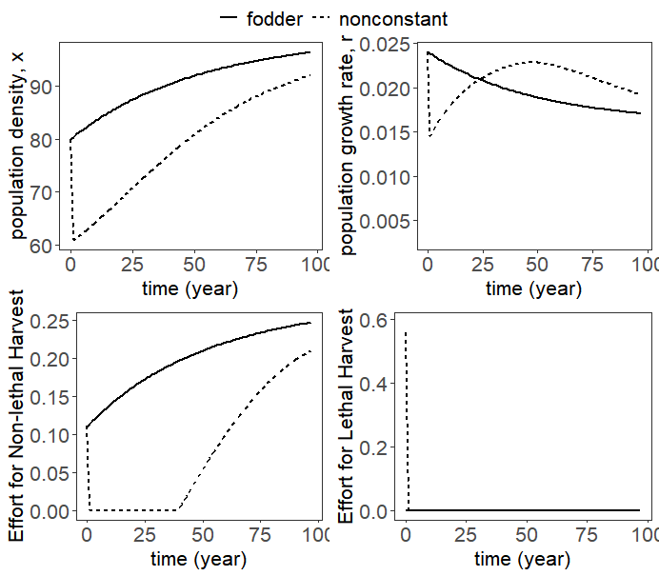
Figure S2.2. Optimal effort for non-timber harvest and timber harvest and the respective effects on population density and population growth rate of K. senegalensis over a 100-year time horizon. These panels compare a single constant rate at the median for the ecological domain (solid line) and a single nonconstant rate paralleling declining rates observed in the survey (dashed).

Variation in preferences describing how to value the future among conservation practitioners and its implications for today’s protection priorities
A version of this chapter was submitted by Amanda A. Hyman, Diane Le Bouille, Gengping Zhu, and Paul R. Armsworth:

Hyman, A.A., Le Bouille, D., Zhu, G., and P.R. Armsworth. In review. Variation in preferences describing how to value the future among conservation practitioners and its implications for today’s protection priorities. Biological Conservation.

Amanda Hyman developed the survey, conducted statistical and mathematical analysis, and was the primary author of the manuscript and SI. Le Bouille and Zhu contributed data to the analysis and edited the manuscript. Paul Armsworth aided in survey development, model development and analysis, and editing of the manuscript and SI. All authors gave final approval of manuscript.

Abstract

When seeking to protect the environment, should practitioners favor actions that will make immediate differences or those promising long-term gains? The choice depends on how individuals weight benefits and costs experienced at different future times, something temporal discount rates can be used to represent. Despite the ubiquity of inter-temporal tradeoffs in environmental decision-making, little is known about time preferences of relevant practitioners. Taking land protection decisions as an example, we use responses from experimental-choice surveys to show that practitioners at environmental NGOs display high variability in how they evaluate environmental benefits and costs through time. Survey participants had a median discount rate of 11.9%, significantly higher than values traditionally used in environmental policy. Moreover, discount rates ranged widely from 74% to negative values. When asked to compare financial amounts at two future times, practitioners used discount rates that were not significantly different. When asked about an environmental attribute (protected land), they used discount rates that declined through time. We illustrate how such differences in discounting influence conservation priorities today. Through applications to species protection within the Appalachian Mountains, we show that differences in how practitioners value the future change today’s protection priorities, with as little as 26% overlap in counties with the highest returns on investment. As the global conservation community re-envisions protection goals, how we weight environmental benefits and costs through time will determine the best paths forward.

Introduction

Land conservation decisions commonly involve balancing benefits and costs that accrue at different times. For example, land protection practitioners must choose between investing limited conservation funding today for immediate benefit vs. investing the money to earn interest with a larger benefit in the future. Discount rates are parameters used to compare such trade-offs that accrue through time by converting values of future goods to present value equivalents (Baum & Easterling 2010; Lampert 2019). We investigated discount rates implemented by conservation practitioners, people who manage natural resources and make intertemporal tradeoffs that influence the trajectory of conservation.

The appropriate choice of discount rates is a longstanding source of contention in public policy debates about the environment (Nordhaus 2007; Arrow et al. 2013b, 2013a; Drupp et al. 2015). The choice of discount rates is controversial because a small change in discount rates can alter estimated costs of restoration and conservation by many millions of dollars (Gren et al. 2018). For example, if the cost due to losing some good is $10 M today, then the cost of the same loss in 100 years is worth ~$0.8 M today using a constant discount rate of 2.5% or $0.05 M using a discount rate of 5%. Hence, discount rates can have major implications on proposed conservation strategies, including the optimal timing (Sjølie et al. 2013) and magnitude of restoration efforts (Verdone & Seidl 2017), and ultimately, on whether projects are undertaken (Baum & Easterling 2010; Gren et al. 2018; Grijalva et al. 2018; Polasky & Dampha 2021).

Despite potential impacts of discount rates on conservation, there is a dearth of information on time preferences held by practitioners. Instead, time preference elicitation efforts have tended to focus on university students or the general public (Cohen et al. 2016) rather than individuals involved in choosing between environmental investments. Elicitations conducted with other groups suggest individual discount rates vary due to personal demographics, including their environmental beliefs (Grijalva et al. 2014) and involvement with environmental issues (Green & Richards 2018). People also appear to discount categories of goods (e.g., health, finance, environment) differently. Such categories of goods are typically referred to as “domains” (Hardisty et al. 2013b; Ubfal 2016; Hyman et al. 2020). This means that people think about future environmental goods differently than they would future finances (Green & Richards 2018; Kumar & Kant 2019; Hyman et al. 2020). Justification for differences between domains exists within more traditional economic theory, particularly when people perceive substitutability between goods to be limited and future growth of or risks associated with different kinds of goods to be different (e.g., Baumgärtner et al., 2015; Gollier, 2010). Furthermore, the schedule of discount rates through time varies. People may discount events in the distant future at a lower rate than those happening over the nearer term. Declining discount rates sometimes feature in national policies e.g., France and the UK use discount rates that decline over time for policy evaluation (Arrow et al. 2014).

We focused on time preferences of practitioners working for land trusts in the USA. Land trusts are NGOs that protect land and water through ownership and easements (Brewer 2003). Land trusts have broad public support with over 6.3 million financial supporters and 16.7 million people visiting properties managed by land trusts for educational and/or recreational purposes in the USA in 2020 alone (LTA 2020). The land trust movement was a major contributor to conservation on private lands almost doubling between 2005 and 2015 in the USA (LTA 2016). This parallels a rapid growth of conservation on private lands in other countries (Nolte, 2018), often supported by land trusts and similar organizations (Slavíková et al., 2017). For example, the area of private land in conservation nearly tripled from 2007 to 2011 in Australia (Fitzsimons & Carr 2014) and increased by 35% in Brazil from 2005 to 2015 (Pegas & Castley 2016). Land trusts thus provide one major way to advance conservation and biodiversity goals.

Issues surrounding time preference are highly relevant to land trust decision-making. These organizations actively pursue land protection, a long-term environmental investment that involves weighting benefits and costs through time. Additionally, land trusts manage expenses, loans, donations, and other financial transactions that also involve intertemporal trade-offs. Furthermore, there is a rich diversity of these organizations (Merenlender et al. 2004; LTA 2020), which allows us to span gradients in operating models in our study. Land trusts range from multibillion-dollar operations to volunteer-run organizations and they have varying priorities and approaches to conservation. For example, some believe in protection for land under immediate threat of development regardless of costs (i.e., immediate benefits), while others focus efforts on buying land not under immediate threat because they are focused more on long-term benefits.

Using choice-based surveys, we estimated discount rates for conservation practitioners. We tested for differences in these rates between financial and environmental domains and between benefits experienced today and in the future. The focus of the study was to capture the variation, if any, of discount rates among land trust practitioners across the financial and environmental domains. To contextualize and illustrate the importance of such variation, we applied our survey results to a conservation prioritization model. We showed how the range of discount rates influences today’s protection priorities in terms of biodiversity within the southern Appalachian Mountains. With our prioritization model, we demonstrate that such variation in discount rates can change where conservation actions should be taken today.

Methods

Survey methods

We conducted a survey with land protection practitioners, who self-selected into the survey. We developed the survey based on a literature review, consultation with land trust experts, and piloting the survey. We used QuestionPro.com to conduct choice-based surveys using a dynamic multiple staircase method (Hardisty et al. 2013b). We conducted the survey at the primary professional conference for land trust practitioners in the USA, the 2019 National Land Trust Rally. We conducted 89 surveys, while 80 surveys were complete. 70 respondents provided the land trust that they work for (descriptive details Table 3.1), which enabled us to compare their demographics to land trusts more broadly (SI Appendix Figure S3.1-3.4). Based on this comparison, we can be confident that we had a reasonably representative sample of land trusts in the USA, even though participants must pay to attend the conference.

Table 3.1. Descriptive statistics of respondents and their respective land trust (variable descriptions in SI Appendix Table S3.1). Liquid funds are represented in terms of the number of months that an organization could operate on liquid assets without any additional income, while personnel expenditures are the proportion of the organizations’ expenses that are due to personnel salaries and associated costs (Larson et al. 2014).
Characteristic | N | Median (IQR) | Source
Respondent-specific traits
Respondent deals with financial aspects within their current role* | 80 | 70.3% | Survey
Number of years respondent has worked in conservation | 80 | 10 (4; 22) | Survey
Financial Flexibility of Organization
Land trust has a legacy program* | 80 | 79.3% | Survey
Land trust borrows money* | 80 | 47.0% | Survey
Liabilities to Assets Ratio | 68 | 0.02 (0; 0.11) | GuideStar
Liquid Funds | 68 | 32.9 (12.9; 56.5) | GuideStar
Personnel Expenditure | 68 | 0.34 (0.18; 0.56) | GuideStar
Non-financial Characteristics of the Organization
Hectares owned and under easement | 70 | 7170 (1100; 104,000) | Land Trust Alliance
Hectares owned | 70 | 238 (0; 1330) | Land Trust Alliance
Accredited* | 70 | 82.3% | Land Trust Alliance
Risk and Litigation Insurance* | 70 | 71.5% | Land Trust Alliance
*Percent responded TRUE

Noting what has been found by similar time preference elicitation studies in other settings (e.g., Green and Richards, 2018; Hyman et al., 2020), we asked hypothetical choice questions relating to both financial and environmental domains (specifically forest protection) (SI Appendix). Our goal in so doing was to explore if there were differences between the two domains in how land protection practitioners compare future benefits and costs. Due to survey length limits, we asked respondents only about two timeframes for each of the domains. Had we instead focused on only one domain (e.g., financial), we may have been able to include more timeframes. Based upon feedback during the development stage of the survey, we used scenarios one year and 10 years out because they are timeframes that most land trusts could relate to regardless of their size. We asked respondents to choose between a near-term (one-month) gain and a gain, specifically a donation, that would be received either in one year or 10 years in the future. Using a near-term delay, like our one month delay, adds uncertainty to all timeframes and has been shown to reduce present bias (Anderson & Weinhold 2008; Green & Richards 2018). For all domains, the ratio between near term and future rewards was the same to minimize framing effects and order of domains was randomized to minimize ordering effects.

Based upon feedback during survey development, we specifically used donation-based scenarios (SI Appendix), similar to willingness-to-accept experiments. We used donation-based scenarios because it is a scenario that most land trusts are familiar with regardless of their size. We decided not to frame scenarios in terms of loans or endowment management, similar to willingness-to-pay experiments, because smaller land trusts will not necessarily have had exposure or experience with such transactions.

We also asked demographic questions (SI Appendix). If the respondent supplied the name of the organization they worked for, we used data provided by the Land Trust Alliance and Guidestar.org to gather organizational demographic information (Table 3.1, SI Appendix Table S3.1).

Functional form for discounting

We estimated discount rates based on the traditional exponential model. A subject would be indifferent between two options assuming exponential discounting if:

$$V= A*exp(-δt)$$
$δ= -\frac{1}{t}ln(\frac{V}{A})$ Eq. 1

where V is the present value of a good, A is the Future Amount, t is the time delay presented in the survey (i.e., either 1 year or 10 years), and $δ$ is the individual’s discount rate for a specific good. We calculated one discount rate per scenario in the survey, resulting in four estimated discount rates per respondent. Due to limitations in our survey, we could not test the appropriate functional form for the discount rates. We did, however, estimate discount rates based on an alternate functional form to see if our results were sensitive to the choice we used (SI Appendix).

Empirical Analysis

We assumed each respondent’s indifference point was the midpoint of the interval between questions at which they switched to the delayed option (1 year or 10 year) over receiving the donation in one month for each domain (Hardisty et al. 2013b; Ubfal 2016). Once we determined individual indifference points, we calculated individual discount rates for each delay for each domain (Eq. 1). This gave us four discount rates per respondent. We used a GLMM with weighted variance to explore effects of delay and domain on calculated discount rates:

$δ_{i,j}= β_{0}+ β_{1}Delay+β_{2}Domain+β_{3}Delay*Domain+ε_{i}+v_{ij}$ Eq. 2

where i is an individual, j is a given response for individual i, $ε_{}$is the random error term that accounts for heterogeneity across individuals, and $v_{}$accounts for heterogeneity across an individual’s responses.

We then used an additional set of GLMMs to explore how robust our results were in the context of land trusts and respondent demographics (SI Appendix Table S3.1). These robustness checks included additional explanatory variables that fell into three broad classes: 1) Respondent-specific traits; 2) Financial flexibility of the organization (Tuckman & Chang 1991; Larson et al. 2014); and 3) Non-financial characteristics of the organization. Domain, delay, and the interaction between the two were of particular interest, and hence, included in each model. All possible subsets were modelled using GLMMs with unequal weights between delays. All analysis was completed in R version 3.6.3 using package nlme (Pinheiro et al. 2020).

Return on Investment Model

To illustrate the potential importance of discount rates, we applied and extrapolated our survey results to a spatial prioritization model using discrete decadal intervals from 2020 through 2050. We extrapolated our survey results to show implications of discount rates on a time scale that is relevant to conservation planning at a landscape scale. As an example of how variation in discount rates can have implications on land protection priorities today, our model illustrates how discount rates alter the flow of benefits, in terms of biodiversity, through time.

We explored return on investment (ROI) of the flow of benefits in terms of biodiversity gains offered by investments in land protection across the Appalachian Mountains. We use projected future ranges for 258 forest-dependent vertebrates of policy concern (Zhu et al. 2021) across 292 counties in the Appalachian Mountains for RCP 4.5 (moderate greenhouse gases emissions scenario) based on CCSM4 general circulation model with full dispersal (for all models run, SI Appendix). We chose to model RCP 4.5 because it is a moderate estimate of future greenhouse gas emissions; we chose CCSM4 to stay consistent with assumptions made in the land cover projection model we use (Wear 2011). We assumed persistence of the species was based on the amount of forest protected inside the species range in the future as well as the area of forest that remains unprotected but will not be converted for development (Armsworth et al. 2020). We used a piecewise linear, “hockey-stick” function to represent the persistence probability for each species as a function of the amount of protected and unprotected forest predicted to remain within its range in the future (Armsworth et al., 2020). Following past studies (Rodrigues et al., 2004), we assumed persistence of a large range species would be ensured when 10% of its range were protected, while persistence of small-range species was guaranteed if an area equivalent to their entire initial range were protected (more detail in SI Appendix). We relied on a model of subcounty targeting of any additional land protection developed in Armsworth et al., (2020). By combining this information, we asked, if a practitioner could invest an additional dollar in land protection, which counties would have the greatest ROI in terms of the number of species expected to persist through time?

We focused on areas not already protected today. To account for future conversion threat, we used projections of future land cover change (Wear 2011). We considered a situation where the conservation organization would buy land to set aside for protection, using data on recent land acquisition costs (Le Bouille et al., in review). Using upfront acquisition cost means we rely on market expectations to handle discounting of financial aspects of the land protection transaction, allowing us to focus our analyses on variations in discount rates we observed in the environmental domain itself. We assumed land was purchased by an environmental NGO in 2020 and the lands’ benefits remained at least until our terminal time of 2050, a choice we return to in the Discussion. See the SI Appendix for further model specification details.

We assumed ecological benefits from land protection would be discounted at four timesteps: 2020, 2030, 2040, and 2050. We used decadal land cover change across the USA from 2020 to 2050 (Wear 2011) and we defined currently protected areas as those with GAP status 1 or 2. To show effects of discounting on such ecological benefits, we varied the discount rate based on the range in survey responses (-0.23 to 0.74). We ran the models at the median and extreme discount rates. Following a number of prior studies (Bode et al. 2008; Armsworth et al. 2017; Triviño et al. 2018), we use the percent of overlap in counties with highest ROI between model runs as a measure of how sensitive recommendations are to each discount choice. We use an overlap metric because it focuses on best sites, those that practitioners would likely be most interested in. A high overlap score indicates two scenarios have similar priorities and respective recommendations are not particularly sensitive between those discount rates. A low overlap score indicates two scenarios have differing priorities and recommendations would be sensitive to the change in discount rates between scenarios. An alternative approach would be to calculate correlations of ROI scores across all counties. Of the two approaches, using the overlap of best sites as a metric is more relevant to conservation applications that are narrowly targeted in space, such as land acquisitions by private land trusts.

Results

Survey Results

From our choice-based surveys, the median discount rate was 11.9% with a range from -23% to 74% (Figure 3.1). The median discount rate corresponds to halving of value in ~5.75 years. Discount rates for 18 participants (22.5%) were negative. Nearly equal numbers of respondents reported negative discount rates when questions were framed in terms of environmental units (i.e., hectares of land) and when framed with financial units. These negative discount rates imply that values would increase one year or ten years out rather than decrease.

Our survey design allowed us to examine differences in how individuals discount environmental and financial goods (domains) experienced near-term or in the future (delay). We found that delay and the interaction effect between delay and domain were significant (p < 0.05, Figure 3.1, Table S3.4). These results are robust to alternative functional forms of discount rates (SI Appendix). When questions were framed in terms of financial units, practitioners discount rates were not significantly different one year and 10 years out. In contrast, discount rates for the environmental domain declined across these two time periods (Figure 3.1). This means that when respondents considered events in 10 years’ time, they discounted less. To examine the robustness of these findings, we re-estimated our statistical models while accounting for other factors that might affect how organizations weigh future benefits and costs. Despite extensive robustness checks including both land trust and respondent-specific demographics, we found no other covariates to have significant effects on discount rates. Our findings regarding effects of delay and the interaction effect between delay and domain proved robust across the different formulations we considered (SI Appendix).

Return on Investment Results

Discount rates have the potential to influence the location of priority places for conservation. Although, the degree to which discount rates impact priorities is moderated by other important factors like conservation costs.

We compared priorities that emerge when assuming the largest and smallest discount rates, in addition to the median, from our survey for our illustration across the Appalachian Mountains. We found no overlap in the top 10% of counties between models runs with the extreme discount rates, something unaffected by including or excluding cost variation. With inclusion of purchasing costs, 26% of the top 10% of
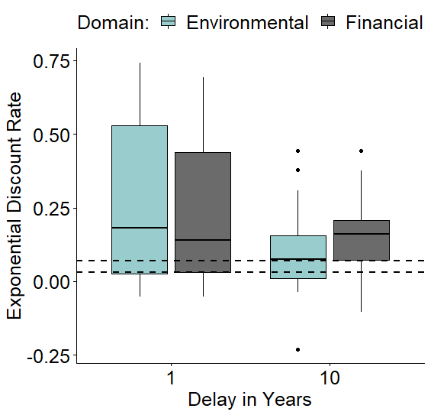
A AB
C BC
Figure 3.1. Discount rates of practitioners by delay in years and domain. The teal boxes represent discount rates for the environmental domain, while the grey boxes represent discount rates for the financial domain. The two dashed lines are the recommended values from the United States’ Office of Management and Budget (U.S. Office of Management and Budget 2003) for benefit-cost analyses for intragenerational projects. The Office of Management and Budget use two values as a sensitivity test to explore the range of outcomes due to differing discount rates. Boxes with the same letters above them are not significantly different based on outcomes from a general linear mixed model (p < 0.05, n = 80).

counties in the runs with the lowest and median discount rates overlap (Figures 3.2A and 3.2B), while 65% of the top 10% of counties overlap with model runs with the highest and median discount rates (Figures 3.2B and 3.2C). High discount rates emphasize near-term benefits. For models with high discount rates, counties with the highest ROIs tend to be ones where land is cheap (Figure 3.2C). They were also often counties that offered high returns in 2020 based on current species ranges but would provide lower returns by 2050 in light of projected range shifts. For example, Indiana County, Pennsylvania, is a high priority when using a high discount rate (Figure 3.2C). This county is in the lowest quartile for cost and the high return on investment it offers over the near-term is driven by species whose range area within the county are predicted to be greatly reduced by 2050.

Meanwhile, low discount rates emphasize longer term benefits. For models with low discount rates (Figure 3.2A), counties with the highest ROIs are again relatively cheap. High returns in this scenario often derive from species with ranges expanding into a particular county between 2020 and 2050. For example, Franklin County, Alabama is a high priority when using low discount rates (Figure 3.2A). This county is another that is in the lowest quartile for cost. The high return on investment this time, however, is driven primarily by species like the American woodcock Scolopax minor, Field sparrow Spizella pusilla, and Eastern mud turtle Kinosternon subrubrum that are predicted to expand their range area in this county by 2050.

These results are consistent across model runs with varying future assumptions (RCP 4.5 vs. RCP 8.5, full dispersal of species vs. no dispersal of species, uniform vs. present-day purchasing costs, SI Appendix ) and discount rate functions (constant vs. non-constant functions, SI Appendix ).

Discussion

Understanding variation in discount rates used by environmental practitioners is critical for conservation planning as land trusts contribute widely to land protection and augment support for conservation efforts (LTA 2016; Pinnschmidt et al. 2021). Using land protection as an example, we elicited practitioners’ discount rates for environmental and financial goods. Our study revealed that practitioners discount future benefits but do so inconsistently across domains; rates decline through time when considering environmental goods, while discount rates are not significantly different through time when considering financial goods (Figure 3.1). Our prioritization models illustrate how differences that we observed in discount rates could change today’s land protection priorities (Figure 3.2, SI Appendix Table S3.7).

Discount rates that we elicited from land trust practitioners are much higher than those codified into policies (U.S. Office of Management and Budget 2003; Arrow et al. 2014), although they are similar to those elicited from other studies including the general public

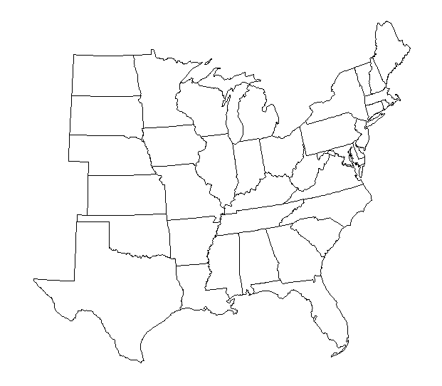
Indiana County,
Pennsylvania

Franklin County,
Alabama
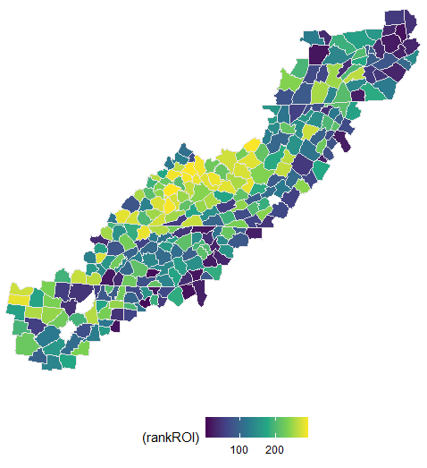  26% overlap  of counties with  highest ROI  Rank  Rank  A | 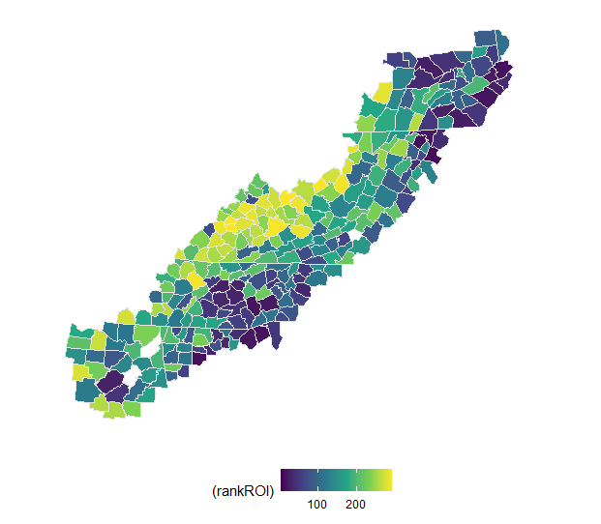  B | 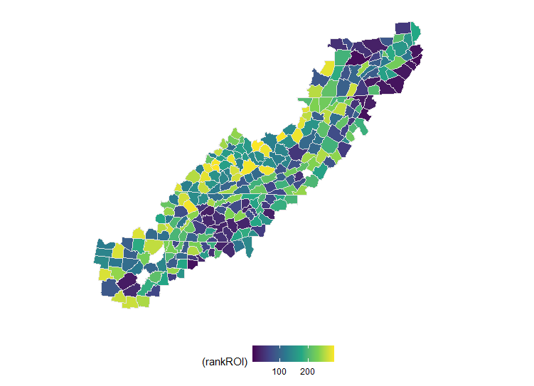  65% overlap  of counties with  highest ROI  Rank  C
Figure 3.2. Visualization of return-on-investment models at county scale. The color scale represents the rank of results with yellow being the highest rank i.e., highest return on investment from 2020 through 2050 with a decadal timestep. The left column depicts results with the lowest discount rate we observed in our surveys (-0.23), the center column represents those with the median discount rate (0.119), and the right column represents those with the highest discount rate we observed (0.74). For all model runs, all else is kept the same. Model details can be found in SI Appendix SI4.

(e.g., Andersen et al., 2008) and university students (e.g., Green and Richards, 2018). These high rates may reflect, in part, our decision to focus on conservation NGOs and stem from financial vulnerability such organizations experience (Tuckman & Chang 1991; Bakker et al. 2010). This was reflected in one respondent’s comment “…I’m not sure if my land trust will be around in 10 years.” Such insecurity is often associated with risk-averse behaviors (Cassar et al. 2017) manifested in our study with high discount rates, as depicted by a respondent’s statements that “A bird in the hand is worth two in the bush”. For conservation planning to be successful, how practitioners think about environmental benefits and financial costs through time in the context of their organizational financial insecurities must be taken into consideration.

Despite the high rates, 22.5% of our respondents reported a negative discount rate. These negative discount rates imply that values would increase in 1 year or 10 years time relative to today rather than decrease. We were one of a few studies to even allow negative discount rate options into their survey design (Loewenstein 1987; Ganiats et al. 2000; Hyman et al. 2020). Negative rates are more likely for those respondents concerned about deteriorating environmental future under changing climatic conditions (Gollier 2010). On a more practical level, some respondents said they would always choose the option further in the future because they did not have personnel capacity to process any sizeable donation in the near term.

We find that there is high variation in how practitioners value financial and environmental attributes through time. Despite that variability, clear patterns emerge across domains. The average discount rates that we found (not significantly different for financial goods, declining through time when framed in terms of protected land) indicate a presumption among these conservation practitioners that the relative value of protected land will rise in the future when compared to other goods. The discounting seen with financial attributes aligns with assumptions currently used by the US (U.S. Office of Management and Budget 2003); the declining discount rate associated with environmental goods aligns with policies used in France and the UK (Arrow et al. 2014). Our results also align with previous work (Richards & Green 2015) that found distinct patterns across domains with other focal demographics.

Our models show that variation about how to value the future among practitioners leads to contrasting priorities about where to protect today. For example, biodiversity prioritization models with high discount rates (Figure 3.2C) favored counties that may be rich in species today but experience species losses under future climates. Priorities shift as discount rates lower. Lower discount rates put more emphasis on future benefits and thus, places that will become important in a few decades take on higher priority in today’s decisions (Figure 3.2A). In the SI, we show how the choice of discount rates impacts what protection priorities emerge across a range of model scenarios (SI Appendix). These scenario comparisons indicate that discount rates moderate how important assumptions about future emissions scenarios or species dispersal behaviors are when basing conservation recommendations on climate projections. Additionally, we applied our findings to a second suite of models across the coterminous US with forest cover as our benefit (SI Appendix), where this second application does not integrate effects of climate change. We include this second example to explore the effects of discount rates in a situation where less change through time in where is most threatened is predicted. These results combined with those presented above depict that contrasting conservation priorities are most apparent when variables important to calculating ROI are characterized by spatio-temporal heterogeneity, as represented in our models by shifting patterns in potential gains from protection as climate change plays out. Our finding that the choice of discount rates determines spatial protection priorities, complements earlier work which showed that discount rates can affect optimal timing (Sjølie et al. 2013) and magnitude (Verdone & Seidl 2017) of an array of conservation efforts (e.g., invasive species control, fisheries management, timber harvest).

We made several design choices that must be kept in mind when interpreting our results. We chose to focus on land trusts, not all environmental NGOs nor public agencies. While we believe this provides an interesting context within which to explore our questions, we recognize that things may play out differently if we focused on public agencies subject to fixed policy mandates or NGOs focused on other environmental goods. Also, in our survey, we asked about two future time periods (1 year and 10 years’ time), making our survey unsuitable for estimating the best functional form for representing inter-temporal changes in discount rates. As a robustness check we re-ran our statistical analyses using an alternative, “hyperbolic” functional form for discounting (Mazur, 1987; SI Appendix).

When using a modeling approach to illustrate how the variation in discount rates that we observed could influence conservation priorities, we had to make many assumptions. For example, we chose to focus on decisions concerning what land should be prioritized for protection today, a common point of discussion for land trusts and conservation actors. However, we could also have focused on decisions regarding whether prioritizing land for protection today makes sense or whether land trusts would be better served by saving and waiting to protect land in the future (Iacona et al. 2017; Lennox et al. 2017). Doing so would have allowed an exploration of other related concepts like option value (Fisher 2000). Additionally, when examining the effect of discounting of future benefits, we considered a benefit flow starting in 2020 carried through 2050. With only two time periods included the elicitation survey, we cannot preclude the possibility that discount rates further into the future could show a more or less pronounced decline than is reflected in the two functional forms we considered. We also focused on ROI offered by different counties, which could overlook important fine-scale benefits or landscape heterogeneity. Regardless of this shortcoming, county is a relevant spatial scale because authority for land use planning typically lies at local county levels in the US (Huber et al. 2010) and the smallest land trusts surveyed function at county scale. While other choices could have been made regarding these and other aspects of the model, we believe our choices were justifiable and adequate to illustrate the basic point – that the variation in discount rates we observe could have implications for what priorities for protection are identified today.

We find that conservation practitioners discount financial and environmental domains, but differently through time and at higher rates than typically used in policy. We show that this range of values can influence conservation priorities. There are implications for our particular context. High discount rates imply insecurity among land trusts. Such insecurity has likely increased during the global pandemic and a second economic recession within two decades (Bakker et al. 2010; Elliott 2011). If we are to rely on private organizations to reach global conservation goals, we need to build resiliency into these organizations if they are to be able to plan for the long-term. In efforts to understand the financial resiliency of these organizations, a worthwhile complement to this work would be to explore preferences for near-term or long-term ecological benefits among land trust supporters and donors. Average discount rates this high suggest that practitioners are likely going to bet on near-term gains and places that are immediately threatened. However, discount rates this variable also means that the conservation community needs to have open dialogue over what future priorities should be.

Acknowledgments

We thank A. Rissman and S. Meyer for feedback on the survey, S.-H Cho for helpful comments, D. Wear for information from the U.S. Forest Service RPA assessment, and all survey respondents. This research was supported in part by USDA’s Agriculture and Food Research Initiative (No. 111216290a), the National Institute for Mathematical and Biological Synthesis (National Science Foundation, No. DBI-1300426), and Department of Ecology and Evolutionary Biology at the University of Tennessee.

APPENDIX

Appendix S1: Additional survey details

We conducted surveys at the 2019 National Land Trust Rally, a conference specifically for land trust practitioners. We used QuestionPro.com to conduct choice-based surveys, which asked respondents to choose between two options. We used this type of survey because it is easier for respondents to understand and has shown to be a better predictor of intertemporal choices than matching methods (Hardisty et al. 2013b). Specifically, we used a dynamic multiple staircase method, which funneled respondents towards their indifference point efficiently by dynamically selecting choice pairs based on respondents’ previous responses (Hardisty et al. 2013b). Respondents self-selected into the survey at the conference.

Lastly, we asked demographic questions (e.g., years working in conservation). If the respondent supplied the name of the organization they worked for, we used data provided by the Land Trust Alliance (e.g., amount of land owned and under easement) and Guidestar.org (e.g., Liability to Asset Ratio). Table S3.1 shows a full list of variables provided, while Figure S3.1 through Figure S3.4 compare demographics of the US Land Trust Census with our sample. With the hope of increasing the number of responses, respondents had the choice to opt into a lottery drawing for a donation to their respective organization (Singer & Ye 2013; Mercer et al. 2015).

Exemplar survey questions

Below you will find exemplar survey questions for the financial and environmental domains with a one-month delay (near-term) and one-year delay (long-term). For the financial scenarios, the immediate amount was always fixed at $10,000. Each scenario began with a choice of $10,000 next month or $10,000 in the future. We asked about both next year and in 10-years. Subsequent questions in each staircase were chosen dynamically based on the respondent’s choice. If the respondent chose the near-term option, the future amount would increase. If the respondent chose the delayed option, the future amount would decrease. The future amount was chosen to be 50% the between the previous amount and the maximum or minimum, as appropriate. Each staircase consisted of up to five questions.

We used the same methods for environmental attributes. The immediate amount was fixed at 50 acres next month. To avoid ordering effects, we randomized the order of the scenarios relating to the financial and environmental domains. At the end of the survey, we asked the respondent which organization they currently worked for; how long they have worked in conservation; if they worked with financial aspects of their organization; and if their organization borrows money, has a bequest program, or if it has a legacy program.

Scenario #1A donor is considering two possible formats for a gift to your organization: a one-time donation of $10,000 next month or a one-time gift in the future guaranteed with a legally binding agreement. Either way, the funds would go to your local organization, office, or chapter.

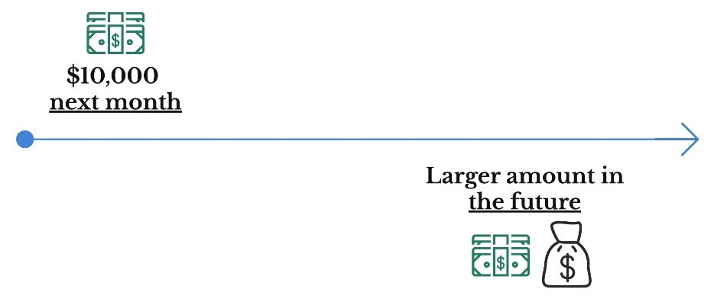
From the perspective of your current role in your organization, which option would you prefer?
- $10,000 donation next month
- $10,000 donation next year
- No preference

Now let's change the future amounts. From the perspective of your current role in your organization, which option would you prefer?
- $10,000 donation next month
- $9,000 donation next year
- No preference

Now let’s change the future amounts. From the perspective of your current role in your organization, which option would you prefer?
- $10,000 donation next month
- $15,000 donation next year
- No preference
Scenario 2 of 2 A donor is considering two possible formats for a gift to your organization: a one-time donation of 50 acres now or a parcel of land in the future guaranteed with a legally binding agreement. Beyond size, assume that the pieces of land have equal conservation value per unit area (e.g., similar access and use, similar biodiversity and abundance of native species). If you choose the future option, the land in the meantime will be used in a manner not in line with your mission. When answering these questions, please assume costs of stewardship and monitoring of the newly acquired lands will also be covered by the donor. We appreciate you sticking with us and answering these questions!

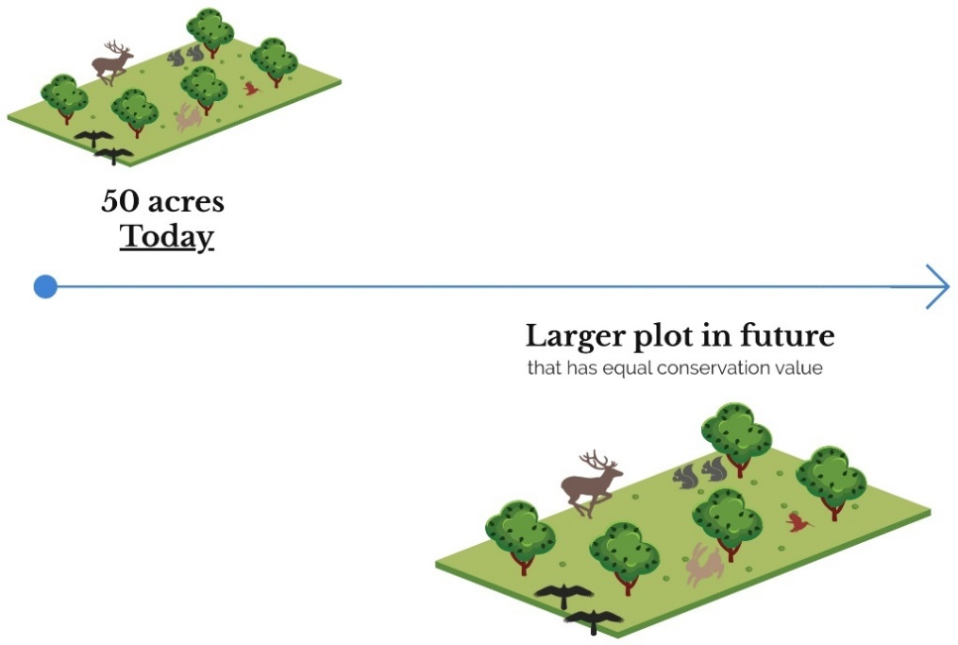

From the perspective of your current role in your organization, which option would you prefer?
- 50 acre donation next month
- 50 acre donation next year
- No preference

Now let's change the future amounts. From the perspective of your current role in your organization, which option would you prefer?
- 50 acre donation next month
- 45 acre donation next year
- No preference

From the perspective of your current role in your organization, which option would you prefer?
- 50 acre donation next month
- 90 acre donation next year
- No preference

Data provided by the Land Trust Alliance and GuideStar

Table S3.1. Land trust demographic variables gathered from the Land Trust Alliance and GuideStar.
Variable | Description
Data from Land Trust Alliance
City | City of the land trust headquarters.
State | State of the land trust headquarters.
Zip | Zip code of the land trust headquarters.
Year founded | Year the land trust was founded.
No. Full Time Employees | Number of full-time employees working at the land trust as of 2019.
No. Part Time Employees | Number of part-time employees working at the land trust as of 2019.
No. Financial Supporters | Number of financial supporters of the land trust as of 2019.
States of operation | Other states the land trust operates in.
Acres Owned | Number of acres owned by the land trust as of 2019.
Acres Under Easement | Number of acres under easement by the land trust as of 2019.
Total Acres | Total number of acres owned and under easement by the land trust as of 2019.
Accreditation Status | Accreditation demonstrates that a land trust has implemented Land Trust Standards and Practices developed by land trusts in the USA (Alliance 2021).
Terrafirma Status | Pooled risk and litigation insurance for land trust organizations in the US (LLC 2013).
Data from GuideStar
Total Revenue | Total revenue in USD$ of the land trust as of 2017.
Total Expenses | Total expenses in USD$ of the land trust as of 2017.
Total Liabilities | Total liabilities in USD$ of the land trust as of 2017.
Total Assets | Total assets in USD$ of the land trust as of 2017.
Liquid Fund Interval | The number of months an organization could operate if all incoming revenue stopped (Larson et al. 2014).
Personnel Expenditure Ratio | Ratio of costs spent on personnel to total expenditures (Larson et al. 2014).

Comparison of Land Trust Census to surveyed land trusts

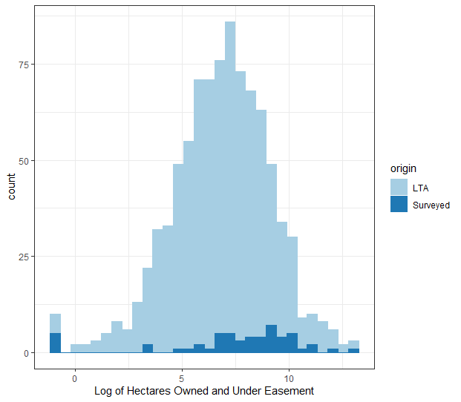
Figure S3.1. Distribution of hectares owned and under easement by land trusts for all land trusts in the Land Trust Alliance (light blue) census and for land trusts in the survey (dark blue).

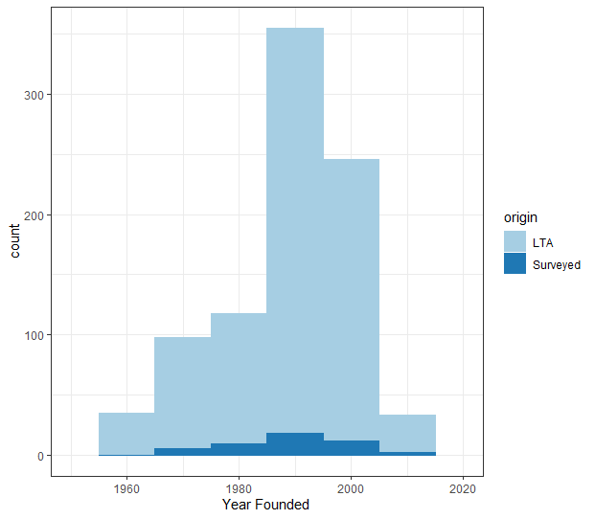
Figure S3.2. Distribution of year founded by land trusts for all land trusts in Land Trust Alliance census (light blue) and for land trusts in the survey (dark blue).

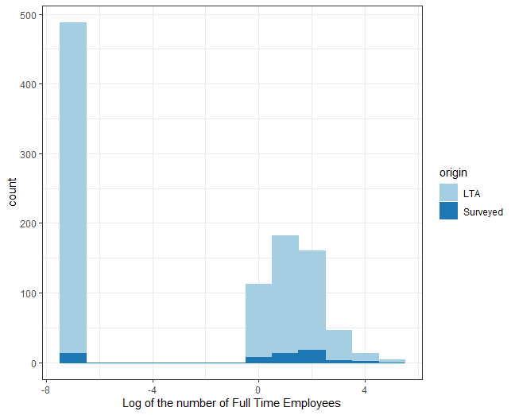
Figure S3.3. Distribution of the number of full-time employees by land trusts for all land trusts in Land Trust Alliance census (light blue) and for land trusts in the survey (dark blue).

Figure S3.4. Distribution of land trusts from the Land Trust Alliance census and land trusts in the survey by region in the US, as defined by the Land Trust Alliance.

Appendix SI2: Discount rate functions

In the main text, we estimated discount rates based on the traditional exponential model. A subject would be indifferent between two options assuming exponential discounting if:

$V= A*exp(-δt)$
$δ= -\frac{1}{t}ln(\frac{V}{A})$ Eq. S1

where V is the present value of a good, A is the Future Amount, t is the time delay, and $δ$ is the individual’s discount rate for a specific good.

We chose to use exponential discounting to make our results as comparable as possible to a wider practice in conservation and natural resource applications. With our statistics, we then offer an explicit test of whether assuming the discount rate is constant through time is justified and find that it is not for the environmental domain.

An alternative approach would have been just to assume a priori that discounting is hyperbolic, which assumes that discount rates decrease such that long-term costs and benefits are discounted at a lower rate than more immediate costs and benefits (Mazur 1987; Prelec 2004). This type of function allows for long-term costs and benefits to have more relevance when evaluating projects. We chose not to do this to ensure our formulation would be as familiar as possible to a broad cross-section of conservation scientists and practitioners. Below we offer a sensitivity test of whether our conclusions would have differed had we assumed one of those alternative functional forms. Specifically, following hyperbolic discount function (Mazur 1987):

$$V = \frac{A}{1+δ_{}t}$$
$δ_{}=\frac{A-V}{Vt}$ Eq. S2

where all variables are previously defined.

We find the same pattern in calculated discount rates when assuming this alternative functional form as we find when using the exponential version. Discount rates ($δ_{}$), as defined in the new function this time, for the financial domain are similar to the environmental domain one year out but diverge with a 10-year delay (Table S3.2).

Table S3.2. Statistics of respondents’ discount rates for each domain using a hyperbolic (non-constant) form.
 |  | 1-year Delay |  | 10-year Delay
Good | Median (IQR) | N | Median (IQR) | N | Median (IQR)
Money | 0.25 (0.06, 0.7) | 80 | 0.15 (0.03,0.54) | 71 | 0.40 (0.11, 0.7)
Land | 0.16 (0.03, 0.55) | 80 | 0.20 (0.03,0.7) | 80 | 0.11 (0.03,0.4)
*3 people missed or skipped the questions regarding land donation with the 10-year delay, while 6 people maxed out the same questions (i.e., those regarding a land donation with a 10-year delay). All 9 were not included in the analysis.

Appendix SI3: General linear mixed model

Model specifications

We used a generalized linear mixed model (GLMM) with weighted variance because data were heteroscedastic (Bartlett test). First, we fitted a base model without any covariates:

$δ_{i,j}= β_{0}+ β_{1}Delay+β_{2}Domain+β_{3}Delay*Domain+ε_{i}+v_{ij}$ Eq. S3

where i is an individual, j is a given response for individual i, $ε_{}$is the random error term, which accounts for heterogeneity across individuals, while $v_{}$accounts for heterogeneity across an individual’s responses. Hence forward, the term $β_{3}Delay*Domain$ is referred to as the interaction term. We present the results from fitting Eq. S3 as our base model case.

We then used a GLMM to explore the robustness of our results in the context of individual characteristics of land trusts and respondents on quantified discount rates (Table 3.1). We again used a GLMM with weighted variance because the data were heteroscedastic. We divided our robustness checks into three broad classes: 1) Respondent or person specific traits (Eq. S4); 2) Financial flexibility of the organization (Tuckman & Chang 1991; Larson et al. 2014) (Eq. S5); and 3) Non-financial characteristics of the organization (Eq. S6). Domain, delay, and the interaction term were of particular interest and, hence, were included in each model. Discount rate was modelled with all three sets of variables as three separate robustness checks (Dallimer et al. 2009). For the complete set of models, we calculated the AIC, the difference in AIC for that model relative to the best-fitting model and the Akaike weight (w_{i}). To explore each of the classes of explanatory variables together, variables from each with the highest k, the probability of each individual explanatory variable appearing in the best-fitting model, were included in a further model, which we call the Joint Model. All analysis was completed in R version 3.6.3 using package nlme.

$δ_{i}= β_{0}+ {β_{1}Delay+ β}_{2}Domain+β_{3}Delay*Domain+β_{4}YearsInCons+β_{5}[FinAspects] +ε_{i}+ v_{ij}$ Eq. S4

$δ_{i}= β_{0}+ {β_{1}Delay+ β}_{2}Domain+β_{3}Delay*Domain+β_{4}[TerraFirma] +β_{5}HectaresOwned+β_{6}\left[Acc\right]+β_{7}HectaresTotal+ε_{i}+ v_{ij}$ Eq. S5

$δ_{i}= β_{0}+ {β_{1}Delay+ β}_{2}Domain+β_{3}Delay*Domain+β_{4}LiabilitesToAssets+β_{5}LiquidFunds+β_{6}PersonnelExpenditures+β_{7}\left[LegacyProgam\right]+ β_{8}\left[BorrowMoney\right]+ ε_{i}+ v_{ij}$ Eq. S6

where YearsInCons is the respondents’ years working in conservation, FinAspects is if the respondent works with financial aspects of their land trust, HectaresOwned is the number of hectares owned by the land trust, Acc is if the land trust is accredited, HectaresTotal is the total number of hectares owned and under easement with the land trust, and all other variables are as written in Table 3.1. Variables in brackets represent categorical variables.

Because we had a particular interest in whether practitioners discounted differently in different domains, we included a domain x delay interaction effect. However, we did not consider further interactions lacking reasons to prioritize some interactions from among the many that are possible with this many variables.

Model output

Our survey design allowed us to examine differences in how individuals discount environmental and financial goods and benefits (domain) experienced near-term or sometime in the future (delay). We found that delay and the interaction effect between delay and domain were significant (p < 0.05, Figure 3.1).

To examine the robustness of these findings to alternative specifications of our statistical model, we re-estimated the models when accounting for other factors that might affect how organizations weigh future benefits and costs, such as land trust expenditures and the amount of land owned by the land trust. In our robustness checks, the best model with respondent specific traits included if the respondent dealt with financial aspects of the land trust; the best model with financial flexibility covariates included the amount of liquid funds the organization had; and the best model for non-financial characteristics of the land trust included Land Trust Accreditation, but the model that included Terrafirma had an AIC value close to that of the best model (Table S3.3). However, no such demographic variables had significant effects on discount rates when also considering the effects of delay and the interaction effect between delay and domain (Table S3.3). As seen in Table S3.3, the base model has the lowest AIC, implying it is the overall best model. As an additional robustness check, we ran the base model without weighted variances. Our results were robust with or without weighted variance.

Table S3.3. Robustness results for the relationship between discount rates and each set of explanatory variables, in addition to the base model, as determined from generalized linear mixed models. The AIC for the overall best model (lowest AIC) for each set of variables is shown with the number of models appearing in the ΔAIC<2 and the Akaike weight (w_{i}), which represent the relative likelihood of the model.
Explanatory variable set | AIC for best model | ΔAIC<2 | w_{i}
Base model | -186.740 | -
Respondent traits | -180.416 | 1 | 0.9732
Financial flexibility | -174.766 | 1 | 0.7507
Non-financial characteristics | -180.327 | 2 | 0.5129
Joint model | -180.416 | 2 | 0.4868

Table S3.4. Estimate, standard error (SE), and p-value of the covariates in the base model.
Covariate | Estimate | SE | p-value
Delay | -0.18 | 0.03 | <0.05
Domain | -0.05 | 0.03 | 0.1612
Delay*Domain | 0.11 | 0.04 | <0.05

Appendix SI4: Details on return-on-investment models

This appendix provides additional detail for our return-on-investment (ROI) models and solutions.

We included ROI model runs in the main text to illustrate how the variation in discount rates we found in the surveys could affect land protection strategies. Here we present further details for that model, in addition to a prioritization with forest cover as the benefit across the coterminous USA. We compared ROI in terms of a flow of benefits associated with maintaining forest cover and biodiversity using survey results with land cover change data from 2020 to 2050 (Wear 2011), projected future ranges for 258-forest dependent species (Zhu et al. 2021), and both uniform costs and predicted costs of purchasing land when functioning as a conservation organization (Le Bouille et al., in review).

For our illustration, we needed a modeling framework that describes land use changes resulting from conservation actions and how these determine ecological outcomes. We also needed a method for identifying priority strategies so we can show how these change under different discounting assumptions. There are a number of alternative modeling frameworks that would allow this (Moilanen et al. 2009; Groves & Game 2016). Here we adapt one from Armsworth et al. (2020) while recognizing other choices could also have been made. We focus our analyses here on comparing how discounting assumptions affect model outcomes. The original paper laying out the modeling framework includes detailed sensitivity testing of many other assumptions, such as the efficacy of fine-grain spatial targeting of protection efforts, the ecological value of private unprotected land and different representations of species persistence.

Methods for return-on-investment models

Discounting assumptions and scenarios

We assume all land is purchased in 2020 using present-day purchase prices. Using upfront acquisition cost, rather than focusing on fixed term rental contracts, means we are relying on market expectations to handle discounting of future financial returns from land. This allows us to focus our analyses on variations in discount rates we observed for goods in the environmental domain itself. Implicitly, we are exploring consequences of domain-specific discount rates when we consider upfront land acquisition at present day prices and explore variations in the environmental discount rate in our benefit function.

In the main text, we showed results while assuming the flow of ecological benefits is subject to exponential discounting with a constant discount rate through time (Eq. 1). We illustrated the case of a constant discount rate function to make our main text results as comparable as possible to a wider practice in conservation and natural resource applications. Specifically, we showed model results using the median value and extreme values from our survey regarding discount rates in the environmental domain in Figure 3.2 and Figure S3.5-S3.8 to illustrate how the variation in individual practitioner discount rates can influence spatial variation in conservation priorities.

We also complement the constant discount rate results in the main text by examining how priorities are affected by assuming a declining discount rate in the environmental domain, something also suggested in our surveys (Figures S5-S8). We found the hyperbolic discounting function, as defined in Appendix S2 Eq. S2 to align adequately with survey results for the purposes of this additional illustration. To be thorough, we compared declining discount rates to constant discount rates at two values. We ran declining discount rates with the average equaling that of the highest values observed (0.74) and then that with an average equaling the median (0.119) of those observed in our survey.

Land use change model

One set of ROI models focused on forest protection across the conterminous US. While a second set of ROI models focused on species conservation in the Appalachian Mountains. The second set of models rely on the same underlying land use change model, which we describe briefly below. Additional details can be found in Armsworth et al. (2020). The model focuses on land cover change in counties across the US. Within counties, we classify land use into three broad types: areas that are fully protected from habitat conversion, areas where habitat has been converted to intensive agriculture or development such that it no longer provides ecological benefits, and areas that are unprotected but still retain habitat that can provide some environmental benefit. Newly protected areas created by conservation spending in a region would change the proportions of these three land uses. When evaluating where any new protected areas should be established, we integrate threat by accounting for projected future habitat conversion if additional protected areas are not established. We also account for existing protected areas before considering the added value of investing in additional protection in a county.

Formalizing these assumptions following Armsworth et al. (2020), we let w be the area of a county (see Table S3.5 for a summary of notations used in the land use change model). We use subscripts e and o to distinguish these past and present activities. The pre-existing protected area is r_{e}; the pre-existing converted area is d_{e}; the area that would be converted in the present if no future conservation action were taken today is d_{o}; and the area that will be protected if given additional investment r_{o}. If we are to invest (x) in land protect today, the cost of protecting land (c) links the additional investment (x) to the additional land protected (r_{o}):

$r_{o}\left(x\right)=\frac{x}{c}$ Eq. S7

Hence, protected area in the focus area becomes $r_{e}+r_{o}$. When investing in land protection, however, some of that newly protected land may overlap with areas that would have otherwise been converted to intensive agriculture or development; β is a measure of such overlap. Another possibility is that the newly protected land shifts conversion threat; γ indicates what proportion of that conversion threat is displaced onto other unprotected land that would otherwise have gone unconverted. We assume focal areas are large enough that any displacement occurs within the same area. Staying consistent with Armsworth et al. (2020), we set (1-γ)β = 0.5.

Thus, the amount of habitat on unprotected land in the future is the total area of the region, minus the area protected and the area that will be converted:

$u_{t}=w-\left(r_{e}+r_{o}\right)-\left(d_{e}+d_{o}-\left(1-γ\right)β\min\left(r_{o},d_{o}\right)\right)$ Eq. 8

Table S3.5. Notations and associated descriptions used in land use change model.
γ | Indicates how much of the conversion pressure is displaced onto other unprotected sites as a result of establishing new protected areas
β | Indicates whether new protected areas target areas that would otherwise have been converted
c | Cost of protecting a hectare of land
w | Focal area
t | Time delay from 2020 through 2050, where 2020 = 0 and 2050 = 30
d_{e} | Area converted to development or intensive agriculture in the past
d_{o} | Area that would be converted in the present if no future conservation action were taken today
r_{e} | Area protected through past conservation actions
r_{o} | New area that will be protected today if given additional investment
x | Investment today

Ecological Benefit Functions

Forest Cover of the Contiguous US

For one illustration, we investigated the ROI of the flow of benefits in terms of forest cover across the contiguous US (CONUS) at county scale. We assume that fully protected areas have the greatest contribution to forest cover and/or species habitat. Thus, we assign a relative weight of 1 to 1 ha of protected land to signify its ecological value. For areas that remain unprotected, but have usable habitat, we assume intermediate quality. We represent its relative weight with α ∈ [0,1]. We assume once an area has been converted to intensive agriculture or development that is has no ecological value (weight of 0) and that such conversion is irreversible.

Although there are many model possibilities, we adhered closely to a formulation in Armsworth et al. (2020). To do so, we define our benefit as forest cover, which includes both protected areas and unprotected, unconverted lands in a county through four decadal timesteps: 2020, 2030, 2040, and 2050. We summed the benefits with investment in terms of forest cover (f) across the four decadal timesteps (t) within a given county (k)

${forest objective}_{k}=\sum_{t=0}^{3}{e^{-10δt}\left(r_{e}+r_{o}+ ∝u_{t}\right)}$ Eq. S9

where the inclusion of 10 in the exponent is to reflect the decadal time-step.

Biodiversity persistence of the Appalachian Mountains

Presented in the main text, we developed a prioritization model that focused on the Appalachian Mountains and incorporated a second spatio-temporal threat: climate change. We explored ROI in terms of a flow of benefits associated with biodiversity across the Appalachian Mountains from 2020 to 2050. We looked at predicted species ranges of 258 terrestrial forest-dependent species of conservation concern across 292 counties in the Appalachian Mountains (Zhu et al. 2021).

We use the same land use change model described in a previous section, keeping the same α values for types of land described above. With the focus on biodiversity, we include the species’ ranges within the focal area through time. We follow the pessimistic model in Armsworth et al. (2020), which assumes that protected areas cover species’ ranges proportionally to the area protected and amount of a species’ range found within each focal region. We first calculate the ecological benefit metric (b) with investment for a given species (s) within county (k) at a given timestep (t).

$b_{skt}=\frac{s_{tk}}{w}(r_{e}+r_{o}+ ∝u_{t})$ Eq. S10

We assumed the persistence of the species was based on the amount of forest protected inside the species range in the future as well as the area of forest that remains unprotected but will not be converted, while still assuming the latter is not as valuable for supporting the species’ persistence (Armsworth et al. 2020). Following past studies (Rodrigues et al. 2004; Armsworth et al. 2020), we used a piecewise linear, “hockey-stick” function to represent the persistence probability for a species (P) at each timestep. We assigned species-specific values based on the species’ landscape range size. We assumed persistence of large range species when only 10% of its range is protected, while small-range species will only be guaranteed persistence when its whole range is protected. We defined small-range species as those with ranges less than 10⁶ hectares (14.7% of species), while large-range species as those with ranges larger than 1.3x10⁷ hectares (32% of species). These choices are comparable to past applications (Rodrigues et al. 2004; Armsworth et al. 2020) and the B1 in the IUCN Red List. Additional sensitivity tests and model specifications can be found in Armsworth et al. (2020).

We then incorporated species persistence into our biodiversity objective, where we summed ecological benefits across the four timesteps (t) for all species (s) within a county (k).

$biodiversity objective= \sum_{t=0}^{3}{\sum_{s=1}^{S}{e^{-10δt}}} P(b_{skt})$ Eq. S11

Return-on-investment Models and Priority Sites

We also need a representation of conservation decision-making to be able to evaluate how priorities change when making different discounting assumptions. Here we focused on a ROI approach by considering the marginal gain in the conservation objective functions Eqs. S9 and S11 when making an initial investment into each county. We specifically asked, if a practitioner could invest an additional dollar in land protection, which counties would have the greatest returns on investment in terms of benefits from retaining forest habitats or in terms of the number of species expected to persist through time? The resulting ROI estimates integrate spatial heterogeneity in the distribution of species and forests, threats of habitat conversion, and conservation costs. These estimates also focus on additionality, by considering the value added by conservation investment into each county relative to a counter-factual model of future land conversion absent that additional investment. As well as mapping ROI for all counties (Figure 3.2, Figures S5 -S8), we also summarize agreement levels in ROI when comparing particular model scenarios using the percent overlap in counties offering the highest ROI (top 10%).

An alternative approach would have been to focus on optimizing an allocation of a fixed budget for land protection across counties. Focusing on ROI has the advantage that it allows the potential contribution of every county to be mapped and compared. In past applications of this modeling framework, investing in the highest ROI counties has proven very close to optimal (Armsworth et al. 2020). Because in this paper we focused only on the initial investment made into each county, we do not need additional measures to account for species complementarity beyond accounting for patterns of past protection.

We compare ROI per county when adopting different assumptions. We first look at ROI of the flow of benefits of forest cover across CONUS. We use both heterogeneous costs and uniform costs because the predicted costs of purchasing land for protection has high variability (Le Bouille et al., in review) and appeared to wash out other potential signals. We first ran the models with a constant discount rate to stay consistent with the wider conservation literature, but we also ran models with declining discount rates because of the trends observed in our survey results.

We then look at ROI across the Appalachian Mountains of the flow of benefits from biodiversity persistence. We do so to both incorporate a second spatio-temporal threat, climate change, and to investigate if discount rates have an effect at a smaller regional scale. The smaller scale allowed for less variation in heterogeneous costs.

Other datasets informing ROI models

To account for future conversion threat, we used projections of future land cover change (Wear 2011). We used predicted decadal land cover change across the US from 2020 to 2050 (Wear 2011) and we defined currently protected areas as those with GAP status 1 or 2.

We considered a situation where the conservation organization would buy land to set aside for protection, using data on recent land acquisition costs (Le Bouille et al., in review). To illustrate the effect of costs, we also included runs where we ignored this cost variation.

For the biodiversity prioritization model, we use projected future ranges for 258 forest-dependent species of policy concern, including 75 amphibians, 89 birds, 54 mammals, and 40 reptile species (Zhu et al. 2021) across 292 counties in Appalachia. For projected future ranges, we use RCP 4.5 (moderate greenhouse gases emissions scenario) based on the CCSM4 general circulation model with full dispersal. We exploit a previously unpublished aspect of these projected ranges – namely that projected future ranges were produced for each decade, allowing biodiversity benefits of conservation actions to be expressed as a discounted flow. We chose to model RCP 4.5 because it is a moderate estimate of future greenhouse gas emissions; we chose CCSM4 to stay consistent with assumptions made in the land cover projection model we are using (Wear 2011). We did, however, run models with RCP 8.5 (high greenhouse gas emissions) by way of a sensitivity test (Table S3.6). In the main text, we showed models run with full species dispersal, sometimes known as ‘uniform migration’. This scenario allows for species dispersal to all counties that are climatically suitable (Zhu et al. 2021). In Table S3.6 below, we also show results for a contrasting scenario with no species dispersal. For the no dispersal scenario, we assume that future ranges cannot expand from their current range; future ranges are defined by regions that will be climatically suitable in counties they currently exist (Zhu et al. 2021).

Return-on-investment Model Results

Contiguous United States ROI output

We found no influence of discount rates across CONUS with 100% overlap of the 10% of counties with highest returns when using heterogeneous costs. The highest ROI occurs in counties near the middle of the country, where counties have the cheapest purchasing price. This implies that variation in cost, represented here as a one-off (static) upfront acquisition cost, may be washing out any spatio-temporal variation in threat (i.e., land cover change) and for this first formulation it is that spatio-temporal threat variation that provides the opportunity for different discount rates in the ecological benefit function to shape solutions. To explore effects of discount rates without such high spatial variation in costs, we also used uniform costs. While using uniform costs, there was an effect of varying discount rates on returns with only 46.0% overlap of the highest 10% of counties. For runs with low discount rates, the highest ROI occurs where large amounts of unprotected, unconverted land still exist in 2050.

Lastly, we explored the effects of non-constant discounting on prioritization outcomes because environmental goods were not discounted constantly through time in our survey. Rather than compare two discount rates, we compared constant discounting to non-constant discounting. While using heterogeneous costs, there is 100% overlap of the highest 10% of counties while using both constant and non-constant discount functions for both the high discount rate and the median discount rate (Figure S3.5 A, B; Figure S3.6 A, B). While using uniform costs, however, there is 50.5% overlap between models run with constant and non-constant discounting using the high discount rate (Figure S3.5 C, D) and 39.4% overlap while using the median rate (Figure S3.6 C, D).

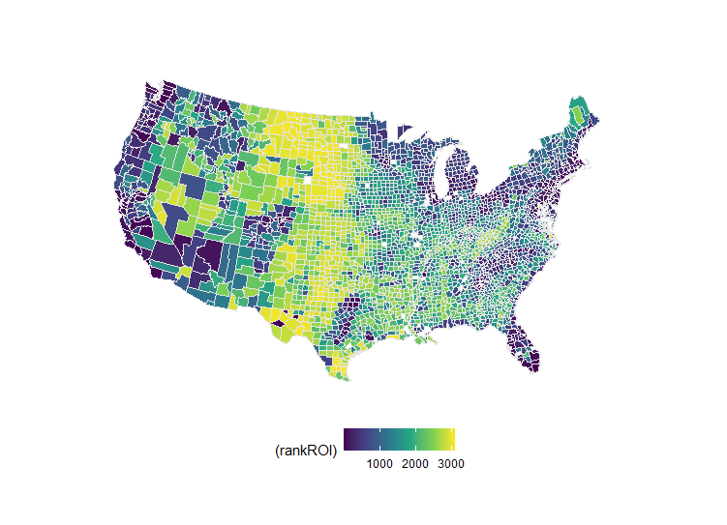  C  A  B  100% overlap  of counties with  highest ROI  Rank | Rank
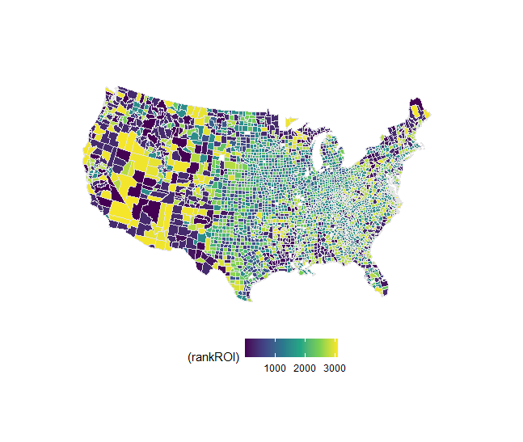  50.5% overlap  of counties with  highest ROI  Rank | 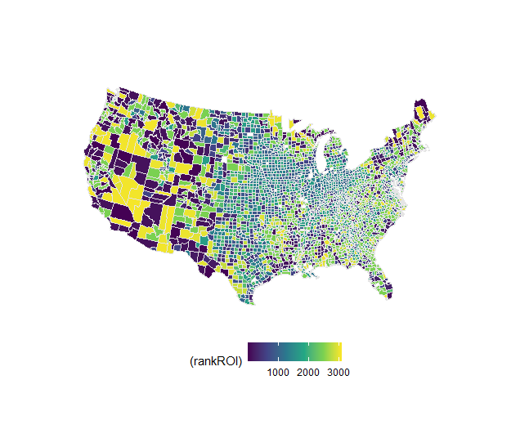  D  Rank

Figure S3.5. Visualization of return-on-investment models at county scale. The color scale represents the rank of results with yellow being the highest rank i.e., highest return on investment from 2020 thru 2050 with a decadal timestep. The left column depicts results with a non-constant discount rate with the average discount rate being 0.74, while the right column shows results with a constant discount rate of 0.74. The top row (A-B) is return on investment of forest cover using heterogeneous costs, while the second row (C-D) uses uniform costs. For all model runs, all else was kept the same with α = 0.25 and (1-γ)β = 0.5.

100% overlap  of counties with  highest ROI  Rank  A | B  Rank
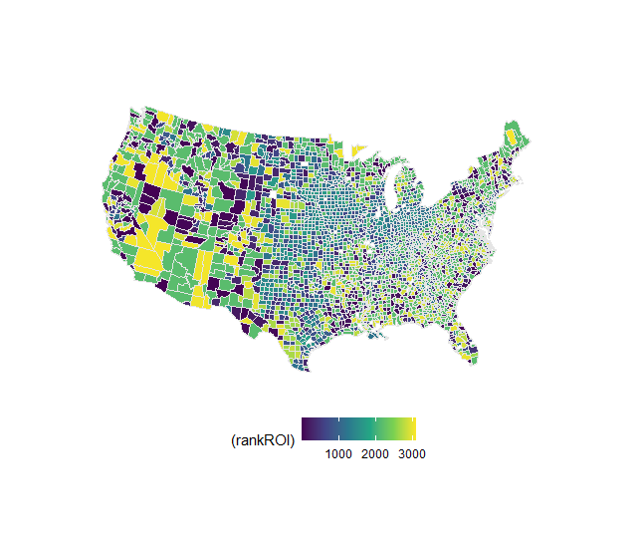  C  39.4% overlap  of counties with  highest ROI  Rank | 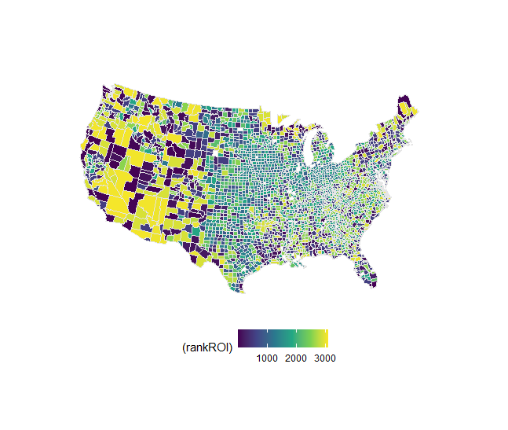  Rank  D

Figure S3.6. Visualization of return-on-investment models at county scale. The color scale represents the rank of results with yellow being the highest rank i.e., highest return on investment from 2020 thru 2050 with a decadal timestep. The left column depicts results with a non-constant discount rate with the average discount rate being 0.119, while the right column shows results with a constant discount rate of 0.119. The top row (A-B) is return on investment of forest cover using heterogeneous costs, while the second row (C-D) uses uniform costs. For all model runs, all else was kept the same with α = 0.25 and (1-γ)β = 0.5.

Appalachian ROI outputs

In Table S3.6 you can find the overlap statistics between model runs with differing discount rates for models run with full dispersal of species, no dispersal of species, RCP 4.5, RCP 8.5, uniform costs, and predicted purchasing costs of land as a conservation organization. When full dispersal of species is allowed and all else being equal, we find less overlap of the top 10% of counties between runs with varying discount rates across all model combinations than when dispersal is not allowed. This is likely because the full dispersal models allow for range expansions. With such a difference in ranges, paired with high discount rates favoring species that would otherwise be extirpated and low discount rates favoring areas that become important in the future, it is not surprising that full dispersal models have less overlap than those limiting dispersal to current 2020 ranges. When all else being equal, we find more overlap in the counties with highest returns between model runs with differing discount rates with RCP 8.5 than with RCP 4.5. This trend may be due to more heterogenous effects being predicted across the RCP 4.5 scenario, while all counties feel the effects of high emissions and subsequent climatic changes in the RCP 8.5 scenario. Lastly, we find more overlap with present day costs for purchasing land than with uniform costs with all else being equal (Table S3.6). Just as other factors moderate the effect of discount rates on conservation priorities, this table makes clear that the choice of discount rates in turn moderates how much other assumptions associated with using predicted climate change data matter in conservation planning efforts made today.

We also compare results from constant discount rate functions to non-constant discount rate functions rather than differing rates. We found no difference in results (i.e., 100% overlap of the top 10% of counties) when using a declining discount rate and a constant discount rate for both uniform costs and costs from purchasing land as an environmental organization (Figure S3.7) for extreme discount rates. We then set the average of the declining discount rate to the median discount rate (11.9%) to test how robust our results were (Figure S3.8). We found 93.5% overlap of the top 10% of counties, while using heterogeneous costs (Figure S3.8 A, B). When using uniform cost, we found no difference in results when using declining discount rates and constant discount rates set to the median survey values (Figure S3.8 C, D).

Table S3.6. Overlap of top 10% of counties (i.e., counties with highest ROIs) between runs with extreme discount rates (-0.23, 0.74) for models with constant discounting with all else being equal and other model specifications kept constant with α = 0.25 and (1-γ)β = 0.5. We ran models with both full and no dispersal of species; RCP 4.5 (moderate emissions climate change scenario) and RCP 8.5 (high emissions climate change scenario); and uniform costs (white rows) and purchasing price as if the buyer were a conservation organization (grey rows)(Le Bouille et al., in review). For model runs with non-constant discounting, the overlap measure is between models for specific discount rates with constant and non-constant discounting.
Full dispersal | No dispersal | RCP 4.5 | RCP 8.5 | Uniform Costs | Heterogeneous Costs | Constant Discounting | Non-constant Discounting | Overlap of top 10% of counties between runs with extreme discount rates
X |  | X |  |  | X | X |  | 0%
X |  | X |  | X |  | X |  | 0%
X |  |  | X |  | X | X |  | 72.4%
X |  |  | X | X |  | X |  | 20.7%
 | X | X |  |  | X | X |  | 86.6%
 | X | X |  | X |  | X |  | 55.2%
 | X |  | X |  | X | X |  | 93.1%
 | X |  | X | X |  | X |  | 62.1%
X |  | X |  |  | X |  | X | 100%
X |  | X |  | X |  |  | X | 100%

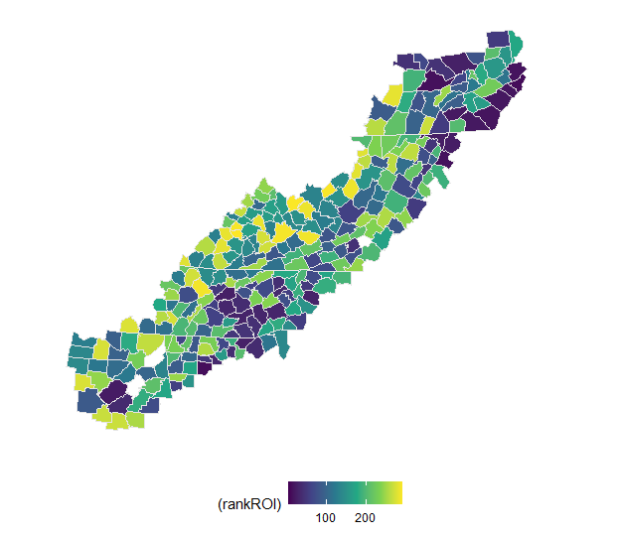  Rank  A | Rank  100% overlap  of counties with  highest ROI  B
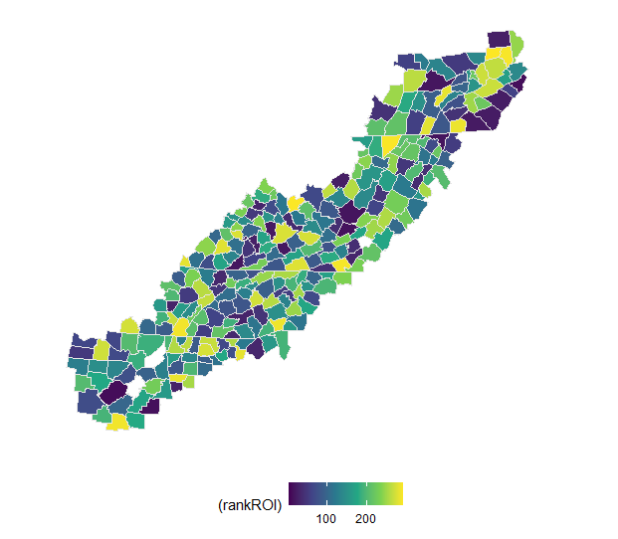  Rank  C | 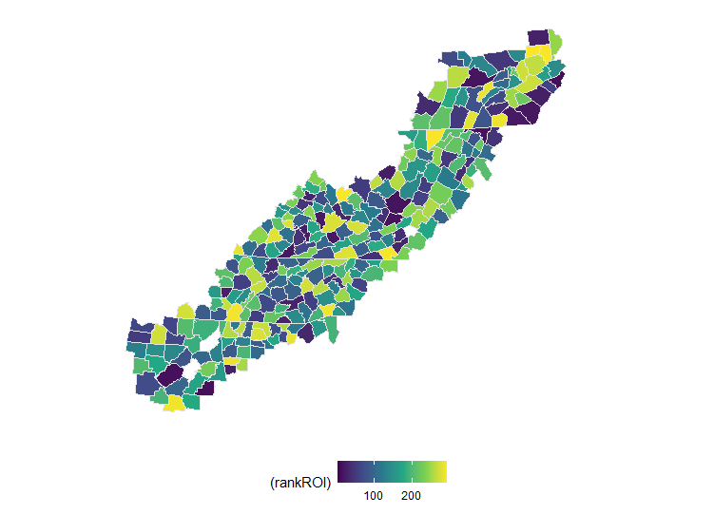  Rank  100% overlap  of counties with  highest ROI  D
Figure S3.7. Visualization of return-on-investment models at county scale. The color scale represents the rank of results with yellow being the highest rank i.e., highest return on investment from 2020 thru 2050 with a decadal timestep. The left column depicts results with a declining discount rate with the average discount rate being 0.74. The right column represents those with a constant discount rate of 0.74. The first row (A-B) is return on investment of biodiversity persistence in the Appalachians using heterogeneous costs, while the bottom row (C-D) uses uniform costs. For all model runs, all else kept the same with α = 0.25 and (1-γ)β = 0.5.

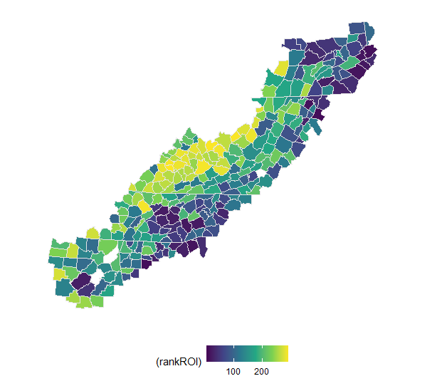  Rank  A  D | Rank  93.5% overlap  of counties with  highest ROI  B
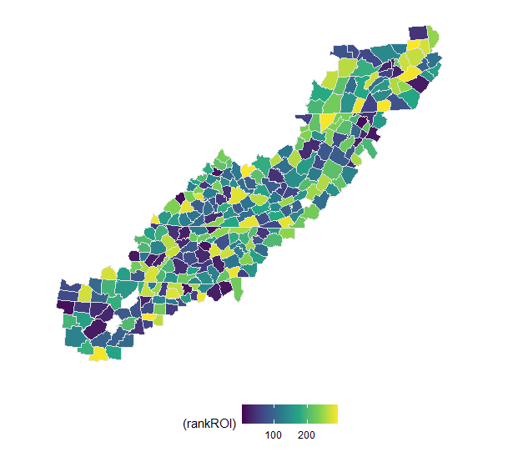  Rank  100% overlap  of counties with  highest ROI  C | 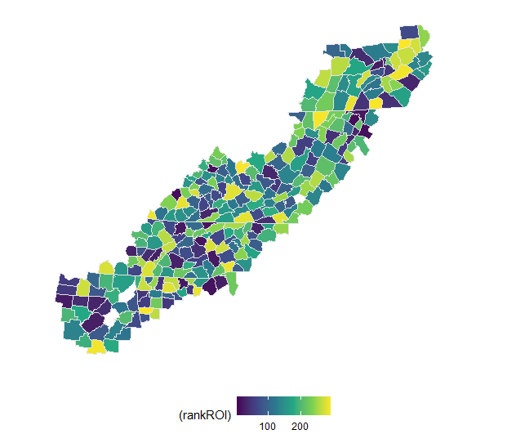  Rank
Figure S3.8. Visualization of return-on-investment models at county scale. The color scale represents the rank of results with yellow being the highest rank i.e., highest return on investment from 2020 thru 2050 with a decadal timestep. The left column depicts results with a declining discount rate with the average discount rate being 0.119. The right column represents those with a constant discount rate of 0.119. The first row (A-B) is return on investment of biodiversity persistence in the Appalachians using heterogeneous costs, while the bottom row (C-D) uses uniform costs. For all model runs, all else kept the same with α = 0.25 and (1-γ)β = 0.5.

Chosen time horizons can influence where land protection priorities Emerge

Abstract

Land practitioners are attempting to slow global biodiversity declines by increasing the amount of protected habitat. Conservation planning efforts commonly focus on where to protect given the highest return on investments (i.e., greatest ecological benefit for least financial costs) and frequently occur over predefined time horizons. Here, we explore the effects of varying time horizons on where today’s conservation priorities emerge. Using land protection for biodiversity in the southern Appalachian Mountains as an example, we show that contrasting priorities exist over four decadal time horizons when incorporating the effects of land use change and climate change into return-on-investment models. Only 13.3% of counties with the highest 10% of return on investment overlap in all of the time horizons. The general results of this paper have potential application to conservation problems, such as invasive species management or restoration efforts, with varying time horizons and long-term, downstream effects. Our example demonstrates that time horizons have implications on conservation efforts.

Introduction

With biodiversity declining globally, practitioners use land protection as a major strategy to slow losses and reach conservation goals (Gaston et al. 2008). The area of protected land has drastically increased in the last few decades (Watson et al. 2014; LTA 2016; Nolte 2018) with billions of dollars spent every year purchasing and managing such protected lands (Mansourian et al. 2008; Hickey & Pimm 2011; Waldron et al. 2013). Because funds are limited, however, practitioners must be strategic about how they spend such funding.

Conservation practitioners attempt to maximize ecological benefits through systematic conservation planning of protected lands (Margules & Pressey 2000). Spatial planning efforts have begun to incorporate land use change (e.g., Polasky et al., 2008), climate change (e.g., Lawler et al., 2020), purchasing cost (Le Bouille et al., in review.; Nolte, 2020) and other such spatial heterogeneity (Riggio et al. 2020; Schloss et al. 2022). Given such spatial heterogeneity, much work until now has focused on where to protect land based on highest return on investment (ROI) over defined time horizons (e.g., Armsworth et al., 2017; Kovacs et al., 2013; Withey et al., 2012).

When assessing conservation strategies and objectives, many researchers set defined time horizons. In conservation literature, there is wide variation in time horizons considered, ranging from 20 year horizons (Visconti et al. 2010; Wilson et al. 2011) to 100 year horizons (Fearnside 2002; Wilson et al. 2014; Lundström et al. 2016). More theoretical ecological work argues for even longer horizons (Shaffer 1981; Thompson et al. 2018). In practice, conservation organizations and government agencies, frequently use an approach called SMART (specific, measurable, achievable, relevant, and time-oriented) objectives (Bjerke & Renger 2017; Jones & Kirk 2018; Gilman et al. 2022). The time component of these objectives may be bound by organizational or management mandates (Marescot et al. 2013) or may be data limited. A focus on ecologically short time horizons could be politically favorable, but to the detriment of long-term conservation goals. A focus on longer time horizons, however, could create challenges to measure progress, especially in light of uncertainty associated with climate change. To date, the influence of these varying time horizons on conservation priorities has seen relatively little exploration in conservation research (but see Hartig & Drechsler 2008; Hauser & Possingham 2008; Dupont-Doaré & Alagador 2021). We sought to fill this gap, by assessing if differing time horizons affect today’s land protection priorities.

Using land protection as an example, we show that choice of time horizon influences today’s conservation priorities. In our return-on-investment model, we explore differences in priorities that emerge when considering an environmental benefit, specifically biodiversity, at four distinct time horizons across the southern Appalachian Mountains. Furthermore, we investigate if and how time horizons moderate the importance of other model choices, including emission scenarios, species dispersal options, and acquisition costs scenarios. Our results demonstrate that choice of time horizon changes where conservation actions should be taken today, regardless of other model choices. These results depict the need for conservation organizations and government agencies to work with similar time horizons to efficiently reach conservation goals.

Methods

To illustrate the importance of chosen time horizon on conservation actions, we developed a spatial return on investment (ROI) model using discrete decadal intervals, specifically 2020, 2030, 2040, and 2050. Our model illustrates how differing time horizons alter where suggested priorities exist for protection of biodiversity.

In this chapter, we used the same ROI model as the one described in Chapter 3 with a slight modification. Rather than focus on the influence of varying discount rates, we focused on varying time horizons. To make this shift, we removed δ, the discounting parameter, from our model. We then focused on ROI of biodiversity in the southern Appalachian Mountains at given time horizons rather than through time. Below is a brief overview of data and analysis used. For full model details, please refer to Chapter 3 in this dissertation.

As a base model in this Chapter, we used projected future ranges for 258 forest-dependent vertebrates of policy concern (Zhu et al. 2021) across 292 counties in the Appalachian Mountains for RCP 4.5 (moderate greenhouse gases emissions scenario) based on CCSM4 general circulation model with full dispersal. We chose to model RCP 4.5 because it is a moderate estimate of future greenhouse gas emissions; we chose CCSM4 to stay consistent with assumptions made in the land cover projection model we use (Wear 2011). For our ROI model, we focused on areas not already protected today. To account for future conversion threat, we used projections of future land cover change (Wear 2011). Again for the base model, we considered a situation where the conservation organization would buy land to set aside for protection, using data on recent land acquisition costs (Le Bouille et al., in review).

With the base model (RCP 4.5, full species dispersal, with predicted purchasing costs), we first compared results across all of the time horizons (Table 4.1) and then compared results between each time horizon (Table 4.2). To make such comparisons, we first present Pearson correlation coefficients. Additionally, we use the percent of overlap in counties with highest ROI between model runs as a measure of how sensitive recommendations are to each time horizon. We use this overlap metric because it focuses on best sites, those that practitioners would likely be most interested in. A high overlap score indicates the scenarios have similar priorities and respective recommendations are not particularly sensitive between those time horizons. A low overlap score indicates two scenarios have differing priorities and recommendations would be sensitive to the change time horizon. We then explored the correlations between results at each time horizon with amount of urban land use, predicted purchasing costs, and for time horizons beyond 2020, species richness, and the change in species richness. (Table 4.2). We did so to begin to investigate what is driving the variation in ROI for each time horizon.

To explore the effects of modeling choices in the context of multiple time horizons, we re-ran the ROI model with differing choices. Specifically, we ran all model combinations with regards to RCP 4.5 and RCP 8.5, full species dispersal and no species dispersal, and lastly, those with predicted purchasing costs (i.e., heterogeneous costs) and those with uniform purchasing costs. We first compared results from all four time horizons for each scenario and present the same overlap metric (Table 4.1). To dig deeper, we looked at each time horizon for each model choice. To do so, we explored the effects of changing one model choice at a time. We again present overlap metrics of the top 10% of counties with the highest ROI (Table 4.3).

Results

While using both predicted purchasing costs and uniform costs, we found 13.3% overlap of the top 10% of counties (Figure 4.1, top two rows of Table 4.1) among models runs across all four time horizons. In Table 4.2, we disaggregate this overall picture to show the correlation of log ROI and overlap metric across each pairing of time horizons. Unsurprisingly, there is the least amount of overlap between top priorities that emerge if focusing on benefits in 2020 versus when focusing on benefits in 2050.

We also sought to understand why particular counties emerged as having higher or lower ROI values and whether these reasons were stable when evaluating outcomes against the different time horizons. The counties with the highest ROIs are relatively cheap across all time horizons, having a negative correlation with ROI. Additionally, high ROIs are negatively correlated with the amount of urban land use in a given county at a given time horizon (Table 4.2). Meanwhile there was not a clear signal regarding the current species richness or change in species richness in a county. Change in overall species richness overlooks within county dynamics, however, if a species is already present. Hence, we specifically looked at species ranges that expanded within or into the county at a given time horizon. We found that the high ROIs for counties in 2050 is partially driven by species ranges that expanded within or into the county in 2050, which may not have been possible without further investment (p-value = 0.06). This means that these high benefit species would not have contributed to models if you were planning for immediate benefits.

We tested whether our results regarding the effect on priorities of the choice of time horizon was consistent across model runs with varying future assumptions (RCP 4.5 vs. RCP 8.5, full dispersal of species vs. no dispersal of species, uniform vs. present-day purchasing costs, Table 4.1). In later rows in Table 4.1 you can find the overlap statistics among the priorities that emerge across the time horizons for these alternative model specifications, analogous to the 13.3% overlap we found for the base model specification. For example, when full dispersal of species is allowed, we find much less overlap of the top 10% of counties between runs with
Table 4.1. Overlap of top 10% of counties (i.e., counties with highest ROIs) among runs with varying time horizons with all else being equal and other model specifications kept constant. We ran models with both full and no dispersal of species; RCP 4.5 (moderate emissions climate change scenario) and RCP 8.5 (high emissions climate change scenario); and uniform costs (white rows) and purchasing price as if the buyer were a conservation organization (grey rows)(Le Bouille et al., in review).
Full dispersal | No dispersal | RCP 4.5 | RCP 8.5 | Uniform Costs | Heterogeneous Costs | Overlap of top 10% of counties among varying time horizons
X |  | X |  |  | X | 13.3%
X |  | X |  | X |  | 13.3%
X |  |  | X |  | X | 16.7%
X |  |  | X | X |  | 20.0%
 | X | X |  |  | X | 43.3%
 | X | X |  | X |  | 43.3%
 | X |  | X |  | X | 43.3%
 | X |  | X | X |  | 36.7%

Table 4.2. Correlation of log of the return on investment (ROI) for each time horizon with the other three time horizons, predicted purchasing costs, species richness, change in species richness, number of species range expanded within the county, and amount of urban land within the county at the time horizon. The asterisks indicate significant correlations and those without asterisk are not significant with p>0.05. The values inside the parenthesis represents the percent overlap between the top 10% of counties at each time horizon.
 | 2020 | 2030 | 2040 | 2050
2020 | X | 0.419*** (30.0%) | 0.831*** (60.0%) | 0.161*  (13.3%)
2030 | X | X | 0.665*** (43.3%) | 0.846*** (70.0%)
2040 | X | X | X | 0.505*** (26.7%)
Cost | -0.304*** | -0.452*** | -0.277*** | -0.343***
Species richness | 0.033 | -0.018 | 0.033 | -0.021
Change in species richness | NA | -0.004 | 0.021 | -0.021
Number of species ranges expanded | NA | 0.016 | -0.013 | -0.107
Urban land | -0.207*** | -0.270*** | -0.188** | -0.206***
*** p <0.0001; ** p <0.001; * p<0.01

Table 4.3. Overlap of top 10% of counties (i.e., counties with highest ROIs) between model runs with the same time horizon with different model choices. Using a model run with RCP 4.5, full dispersal, and heterogeneous purchasing costs as a base model, we compared the effects of changing one model choice at each time horizon.
 | 2020 | 2030 | 2040 | 2050
RCP 4.5 vs. RCP 8.5 | 100% | 73.3% | 63.3% | 26.7%
Full dispersal vs. No dispersal | 100% | 83.3% | 63.3% | 33.3%
Heterogeneous costs vs. uniform costs | 53.3% | 56.7% | 56.7% | 60.0%

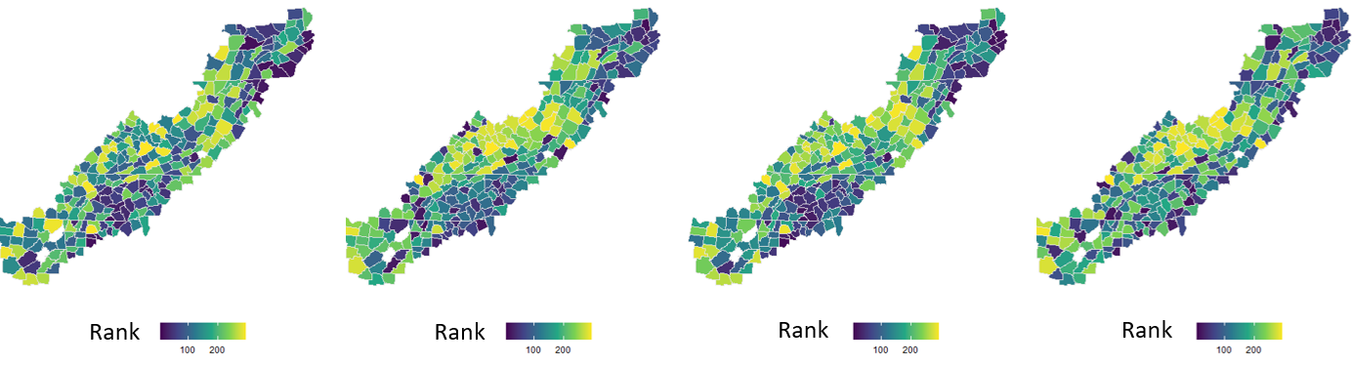
D
C
B
A

Figure 4.1. Visualization of return-on-investment models at county scale. The color scale represents the rank of results with yellow being the highest rank i.e., highest return on investment from 2020 thru 2050 with a decadal timestep. A represents the priorities that emerge if you are planning for 2020, while B represents those for 2030, C for 2040, and D for 2050. For all model runs, all else kept constant.

varying time horizons across all model combinations than when dispersal is not allowed (13.3-20% with dispersal versus 36.7-43.3% with no dispersal). Meanwhile, we find similar levels of overlap with models run with RCP 8.5 and those run with RCP 4.5 across all time horizons.

To explore sensitivity to model assumptions further, we compare priorities within time horizons but across model assumptions in Table 4.3. This additional comparison reveals for example that agreement over priorities between runs assuming full dispersal and no dispersal, or RCP 4.5 and 8.5 breaks down the longer the time horizons being considered. In contrast, agreement levels under different cost assumptions are largely consistent, likely because costs are not playing the sort of dynamic role in determining ROI that the choice of RCP scenario and dispersal scenario are. From Table 4.3, you can see that choice of time horizon moderates the level of importance other modeling assumptions have on emerging conservation priorities. Just as other factors moderate the effect of time horizon on conservation priorities, these results make clear that the choice of time horizon in turn moderates how much other assumptions associated with using predicted climate change data matter in conservation planning efforts made today.

Discussion

Meeting the conservation goals of protected area programs requires evaluating relative priorities regarding where to protect. Understanding the effects of time horizons on conservation goals is crucial for conservation organizations and governments involved in protection programs because it could affect such decisions. Using ROI models, we explored the effects of time horizons on land protection priorities. Our prioritization models show that regardless of other model assumptions, time horizon influence where land protection priorities emerge.

We find that time horizons influence where land protection priorities emerge today. Longer time horizons favor areas with future habitat, but priorities shift when shorter time horizons, similar to those mandated by federal governments, are considered. Short-term time horizons favor areas with immediate benefit without regard for long-term suitability of habitat. Such time horizons can change with political favor (Newediuk et al. 2021). With relatively short-term time horizons regularly mandated by government entities, however, they could be maximizing short-term gains at the cost and detriment of long run conservation goals. These findings about the role of time horizons in determining where should be priorities to protect are similar to those in a theoretical study by Hartig and Drechsler (2008). Those authors found that time horizons at which species survival probability are calculated has an impact on conservation decisions when survival of multiple species is considered. Similarly, Dupont-Doaré & Alagador 2021, found that time horizons at which species persistence is evaluated influences land protection priorities.

Because such uncertainty exists with longer time horizons, conservation frequently happens through an iterative process. For example, the US Fish and Wildlife Agency mandates that each state develops a State Wildlife Action Plan to conserve wildlife and habitat before they become too rare. From 2005 onwards, such plans must be updated every 10 years (US FWS 2017). Meanwhile the European Environmental Commission requires member states to report environmental progress every six years (European Commission 2020). This approach allows for adaptation of management actions to adjust for uncertainty, such as that associated with the effects of climate change. If one were to treat each iteration as a given time horizon, our results suggest that could reduce the effects of varying model choices. At the same time if an iterative policy process is envisioned, whether one based on adding new full protected areas or based on short-term contracts with landowners, a better modeling approach would embed this iteration inside a dynamic optimization.

Our results also showed that the choice of time horizon affects the level of importance of other modeling choices. For example, spatial priorities were not particularly sensitive to assumptions about species dispersal or choice of RCP scenario when focused on near-term goals (2020 or 2030). These differences only emerged when focused on conservation outcomes in 2040 or 2050, the sort of time horizons that are needed to see climatic differences start to emerge. While many studies focus on the effect of refining ecological assumptions behind climate projections, our results suggest this work may only be relevant to the subset of conservation organizations that is able to plan over longer time horizons (Armsworth et al. 2015). In a somewhat similar vein, Hauser et al. (2008) showed using a theoretical model of harvest strategies that management actions intended to enable learning about ecological systems through active adaptive management would only make sense for organizations working over long enough time horizons.

In our model design, we made several choices that should be kept in mind when interpreting our results. We modeled ecological benefits at county grain. At this spatial scale, we could have overlooked important fine-scale dynamics of benefits or more heterogeneity across the landscape. Despite this, we believe that county is still a relevant spatial scale because planning for land use frequently occurs at local county levels in the US (Huber et al. 2010). Additionally, we chose to focus on priorities for protection today. We believe our choices were justified to illustrate our point – choice of time horizons influences where land protection priorities emerge.

We find that choice of time horizon influences land protection priorities, regardless of other modeling choices, such as RCP scenario and dispersal capability of a species. Such wide differences in protection priorities at varying time horizons means that organizations and governmental agencies at both local and federal levels should deliberate carefully over what time horizons to use when setting conservation goals and developing conservation plans. These organizations also then need to make sure their activities are in line with the time horizons they choose. For land protection organizations that rely on donation, such as land trusts, this may mean there are advertisement opportunities to donors that prefer their dollars go to immediate benefits versus those that prefer their dollars go towards long-term benefits. Similarly, for organizations that work with the voting public, this may mean interacting more systematically with ballot-box conservation referenda (Crain et al. 2021) to reach conservation goals at desired time horizons. For all organizations, open dialogue across the user-practitioner spectrum to agree upon preferred time horizons is needed for conservation planning to be efficient.

Acknowledgements
We thank D. Wear for information from the U.S. Forest Service RPA assessment. This research was supported in part by USDA’s Agriculture and Food Research Initiative (No. 111216290a), the National Institute for Mathematical and Biological Synthesis (National Science Foundation, No. DBI-1300426), and Department of Ecology and Evolutionary Biology at the University of Tennessee.

Distinct pathways to stakeholder use versus scientific impact in climate adaptation research

A version of this chapter was submitted by Amanda A. Hyman, Stephanie Courtney, Karen S. McNeal, Lalasia Bialic-Murphy, Cari S. Furiness, Mitchell Eaton, and Paul R. Armsworth:

Hyman, A.A., Courtney, S., McNeal, K.S., Bialic-Murphy, L., Furiness, C.S., Eaton, M., and P.R. Armsworth. In review. Distinct pathways to stakeholder use versus scientific impact in climate adaptation research. Conservation Letters.

Amanda Hyman developed the survey, conducted statistical and mathematical analysis, and was the primary author of the manuscript and SI. SC helped develop the survey and edit the paper. KSM, LB, CSF, and ME aided in the conceptualization of the project and editing the paper. Paul Armsworth aided in survey development, model development and analysis, and editing of the manuscript and SI. All authors gave final approval of manuscript.

Abstract

The challenges and uncertainties facing societies around the globe as they plan for and adapt to climate change are so large that usable, research-driven recommendations to inform management actions are urgently needed. We sought to understand factors that influence scientific innovation and use of collaborative research on climate change. We surveyed researchers and stakeholders from projects supported by a federally funded network across the USA with the goal to deliver science that natural resource managers can use. Our results suggest that the steps needed for projects to be impactful in science are distinct from those needed to be useful to stakeholders. Our quantitative results can inform future requests for proposals and enable researchers using collaborative and transdisciplinary approaches to conduct science that is more often used by stakeholders.

Introduction

As effects from climate change accelerate (IPCC 2021), there is a pressing need for research that can improve people’s lives and safeguard the environment. Hundreds of millions of dollars of public funding are invested annually in such projects (USGS 2021). To invest that money wisely, we need to know how to design projects that will successfully address the information needs of natural resource managers. By using systematic evaluation to assess the effectiveness of past projects, we can start to identify shared characteristics that make funded research more likely to provide accessible and usable information to natural resource managers.

Coproduction is a methodological approach to produce and deliver such research that can be used to inform public policy and to develop strategic conservation plans (Beier et al. 2017; Prokopy et al. 2017). Coproduction involves the deliberate collaboration between research scientists, user groups, and other stakeholders to jointly define the scope of a research project, conduct the research, and ultimately turn scientific results into action (Meadow et al. 2015; Lemos et al. 2018; Table 5.1). Coproduction can have a variety of advantages, including increased buy-in from users (i.e., increased credibility and legitimacy) (Reyers et al. 2015; Djenontin & Meadow 2018) and higher usability of project outcomes (Arnott et al. 2020).

Evaluating the impacts of a project can be challenging because of time lags, lack of budget for evaluation, and changing attitudes, among a variety of other factors (Nutley et al. 2007a; Reed et al. 2020). Despite these challenges, there is a growing body of research that has qualitatively evaluated the outcomes of coproduction for conservation planning and natural resource management (Schuck-Zöller et al. 2017; Wall et al. 2017; Arnott et al. 2020). Principles of coproduction have been previously suggested (Beier et al. 2017; Vincent et al. 2018; Norström et al. 2020). These principles have been derived primarily from a number of extensively studied coproduction projects, often qualitative in approach, which limit their ability to synthesize general patterns (e.g., Meadow et al. 2015; VanderMolen et al. 2020). However, a quantitative assessment of coproduction that could scale across projects is lacking, making it difficult for funding agencies to prioritize and rank research proposals systematically. We sought to fill this knowledge gap by quantitatively evaluating the relative variation in both use and scientific innovation, defined here as traditional academic metrics of impact for research, including number of peer-reviewed publications, citations, and impact factors, of a suite of coproduction projects funded by the same organization.

Evaluating indicators of scientific innovation and use (definitions in Table 5.1), two common goals of coproduction projects, is crucial because they may trade off in complex ways (Stokes 1997; Stern et al. 2016). While some aspects of coproduction may maximize scientific innovation, they may also fail to convey the practical applications of the study to end users. Conversely, other components of research projects (e.g., transferring plans to users, addressing region-specific concerns) may enable use, but distract from efforts focused on scientific innovation (Dilling & Lemos 2011; Lemos et al. 2018). Such tradeoffs may occur within a project because of resource limitations (e.g., time, budget) and hence, focusing efforts on one might divert resources from the other. There is also the possibility that such limitations do not force such tradeoffs and, instead there are critical variables to achieve both innovation and use. To this end, especially under resource constraints, there is a need to identify key variables for optimizing either or both scientific innovation and use.

Here, we take the first step toward developing a quantitative assessment framework to identify variables of coproduction that optimize use and indicators of scientific innovation. Specifically, we sought to: (i) evaluate the association among project inputs (e.g., budgets), processes (e.g., involvement of end users), scientific outputs (e.g., number of publications), and outcomes (i.e., the use of project deliverables by end users) and (ii) identify factors that explain relative variation in the use of these research projects. Our results can be replicated by funders to evaluate project proposals and allocate research funding. Having such a quantitative evaluation of what does and does not increase use could reduce costs (Buxton et al. 2021) and enable successful approaches of coproduction to be scaled up (Lemos et al. 2018), while simultaneously allowing us to test previously presumed principles of coproduction. Our study highlights the need to move beyond descriptive studies to more informed evidence-based approaches when examining the link between scientific innovation and use of coproduction projects.

Methods

We quantitatively evaluated 32 projects funded by the Southeast (SE) Climate Adaptation Science Center (CASC) from 2008 to 2019. The CASC network is a federally funded network
Table 5.1. Terms, related concepts, and associated definitions.
Term  (Related concepts) | Definition | References
Coproduction  (Knowledge exchange, translational ecology, engagement) | Coproduction is the deliberate collaboration between research scientists, user groups, and stakeholders to jointly define the scope of the research, undertake the research, and ultimately turn scientific results into action | Meadow et al. 2015; Lemos et al. 2018; Cooke et al. 2020
User (partner, stakeholder, end-user) | Here user is an umbrella term to include stakeholders, partners, and more generally, anyone using research in practice.
Scientific innovation (impact, advancement) | Here scientific impact is used to describe traditional academic metrics of impact for research, including number of peer-reviewed publications, citations, and impact factors.
Input | Resources used in a research project | Thomas & Koontz 2011; Lavery et al. 2021
Process | Activities, specifically collaborative activities here, conducted and implemented by research projects | Thomas & Koontz 2011; Lavery et al. 2021
Outputs | Products, services, and general deliverables from research projects. Here we specifically focus on traditional scientific outputs. | Thomas & Koontz 2011
Outcomes | Long-term goals or end state achieved by research projects | Thomas & Koontz 2011; Thurston 2019

across the USA with the goal to deliver science and information that natural resource managers can use to inform adaptation strategies (ACCNRS 2015). The projects were all funded by the same center, ensuring all were operating under similar over-arching goals and have the added advantage of a defined population of users.

We used a logical framework for the basis of our data collection and analysis (Figure 5.1). Our logic model shows how inputs and processes are expected to influence outcomes and outputs (Thomas & Koontz 2011). It is common to use such a framework to analyze and evaluate collaborative research (Koontz et al. 2020; Lavery et al. 2021). We focused on measuring outcomes, specifically use, of these projects. Overall, we evaluated relative variation of indicators of both scientific innovation and use within the same suite of projects. We looked at relative variation across these variables because we did not seek to set standards for success, but rather identify generalizable trends to help inform future requests for proposals and funding organizations.

Data Collection

We measured inputs, processes, outputs, and outcomes from these projects. Input metrics summarize resources used in a research project (e.g., cost, duration). Process metrics probe the nature of the collaborative process implemented by projects. Such metrics included how frequently users met with Principal Investigators (PIs) and how involved users were at each stage of the research process, measured on a 5-point Likert scale. To capture outputs of the projects, we relied on traditional metrics of scientific productivity, including number of peer-reviewed publications; citations; and the impact factors of journals in which those publications appear. All three metrics were highly correlated (r > 0.69) so we chose to focus on number of peer-reviewed publications. While a metrics-based approach like this lacks the nuance possible in more time-intensive expert scoring systems, we chose to focus our research time more on obtaining estimates of use of projects, as this was the outcome of interest.

We had three sources of data (Figure 5.1, Appendix S1). For inputs and outputs, we collated data from documentary sources, including final reports and personal communication with staff for the 32 target projects. For processes, we surveyed one PI associated with each of the 32 projects on Qualtrics, with 31 project PIs responding (97% response rate). Three projects were continuations of previously funded projects, so we chose to combine those projects leaving 28 unique projects. We then surveyed potential users of the 28 remaining projects and SE CASC leadership to garner information about project use (Appendix S1). From the 28 projects, we sent surveys to 208 users, of which, 81 responded (39% response rate) from 22 projects. We conducted the survey in Qualtrics to elicit subjective evaluations of the project each respondent was familiar with. Specifically, we asked respondents how the projects were used both by themselves and their respective organizations. We developed 22 use questions, each of which were on a 5-point Likert scale. Additionally, we interviewed five current and former members of SE CASC leadership about their perception of use of the 28 projects.

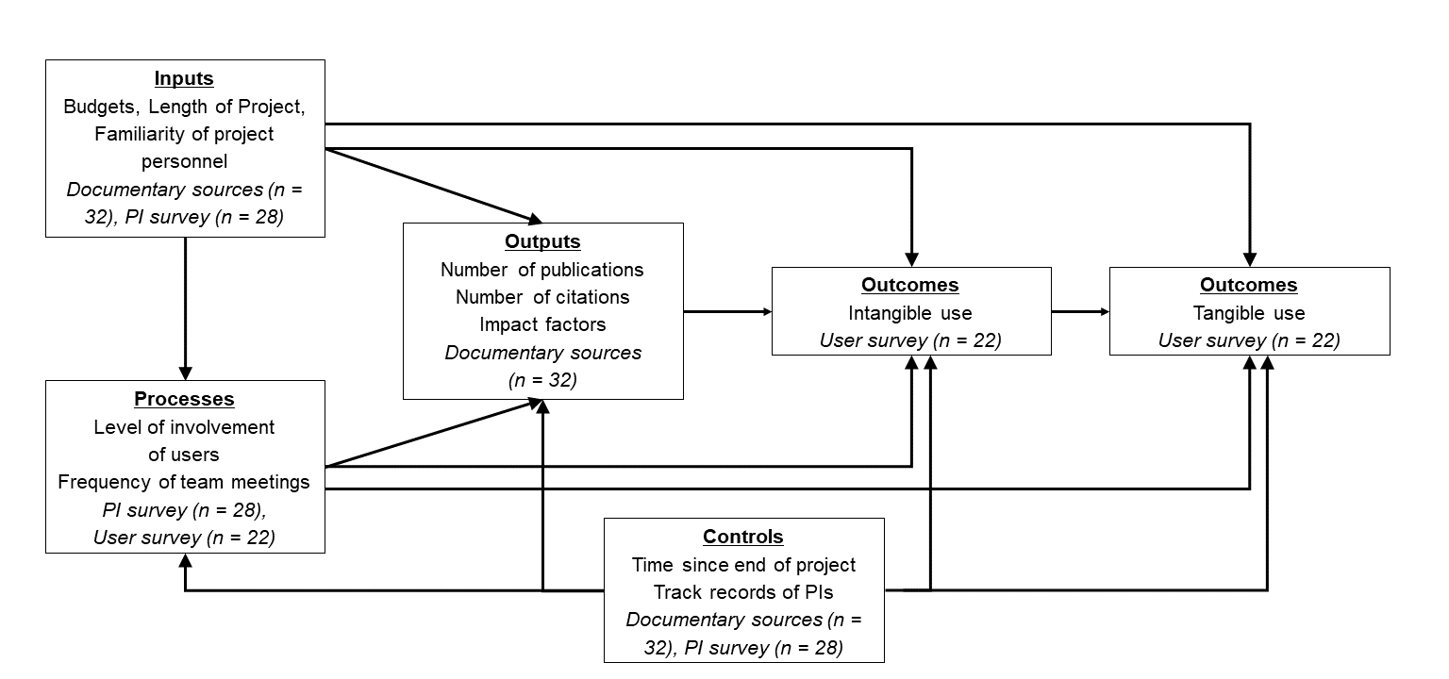
Figure 5.1. Theory of change model with variables used for each component of the model. Italicized text are the data sources with the associated number of unique projects that had data.

Statistical analysis

We used exploratory factor analysis and Cronbach’s alpha to evaluate use constructs from the user survey using the psych package (Revelle 2021). We then combined the user responses with PI responses and documentary sources to evaluate correlations among inputs, processes, outputs, and outcomes. To do so, we used Structural Equation Models (SEMs) following our logic model (Figure 5.1) using package piecewiseSEM (Lefcheck 2016). For use-related components of the model, we included a random error term to account for intra-project heterogeneity. We first ran a full model with all variables of interest. In pursuit of parsimony, we reran the SEM with only variables that had significant effects in the full model, which will be referred to as the parsimonious model. All analysis was done in R version 4.0.2.

Results

Projects had budgets ranging from $30,000 to ~$1 million and lasted from 1 to 5 years. Sixteen (52%) of the PIs had worked with at least one of the users before and 14 (45%) of the PIs reported having moderate to extensive experience working on projects with coproduction approaches. Twenty-two (71%) of the PIs reported contacting users before or during the proposal writing stage of the research and on average, users reported having met with PIs 10 times per year (±20). On average, the projects had three (±3.3) peer-reviewed publications with 109 (±252) citations (Further details in SI1). Across the 22 use questions, the average was 2.6 (±1.25) indicating “little use” to “some use” for all questions related to use. The greatest use of these projects was for affirming what the respondent already knew about environmental change, averaging 3.5 (± 0.97) indicating “some use” to “quite a bit of use”. The projects were least used to encourage support from lawmakers (1.66±1.11).

Use factors

When analyzing the responses of users via exploratory factor analysis, we eliminated use questions with more than 20% of responses missing, which left us with 18 questions. Exploratory factor analysis suggested two factors that cumulatively explained 61% of the variance in the survey responses. All types of use loaded strongly (factor loading>0.4, Table 5.2). One factor contained items representing intangible use (e.g., influenced professional network, impacted your knowledge relevant to your job) and explained 34% of the total variation. The other factor contained items representing tangible forms of use (e.g., Influenced decisions to change how time, money, or labor are spent in your organization/agency) and explained 27% of the total variation (Table 5.2).

Effects on scientific innovation and use

We first sought to explore the association among project inputs, processes, outputs, and outcomes. Results from the SEMs indicated that the full model (Fisher’s C = 4.039, p-value = 0.13, AIC = 106.039, Figure 5.2a, Table S5.1) and the parsimonious model (Fisher’s C = 34.089,
Table 5.2. Factor loadings from exploratory factor analysis of types of use. Bold-face text represents pattern coefficients >0.4, meaning that type of use loads strongly onto the given factor.
To what degree has this project… | Intangible Use | Tangible Use
Impacted any of your professional skills | 0.801
Impacted your knowledge relevant to your job | 0.718
Influenced your professional network | 0.838 | -0.102
Changed your awareness of informational resources | 0.812 | -0.104
Influenced long-term planning documents | 0.658 | 0.14
Influenced organizational/departmental objectives or priorities |  | 0.74
Influenced broad-scale or general policy | 0.215 | 0.643
Impacted public education efforts in your organization | 0.498 | 0.362
Impacted education efforts focused on resource managers or local landholders | 0.517 | 0.368
Influenced monitoring or research efforts in your organization or department | 0.228 | 0.597
Influenced decisions to change how time or labor are spent in your organization/agency |  | 0.848
Influenced decisions to change how money is allocated in your organization/agency |  | 0.875
Influenced decisions to change internal/organizational policies  or procedures |  | 0.824
Affirmed what you already know about environmental change and your job | 0.58
Used to encourage support from or collaboration with peers and/or partner organizations | 0.771
Used to encourage support or cooperation from the public or local landholders | 0.509 | 0.374
Used to encourage support from your supervisors | 0.493 | 0.251
Used to support a funding request | 0.5 | 0.267

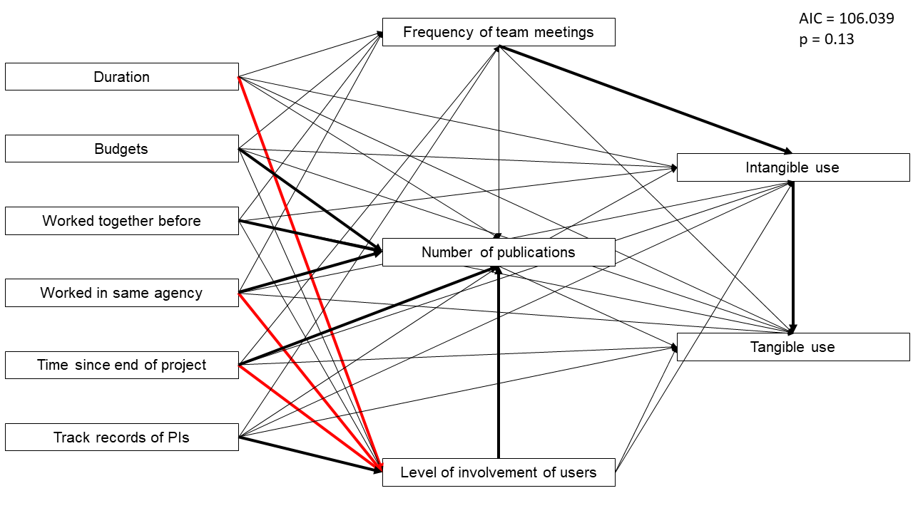
A
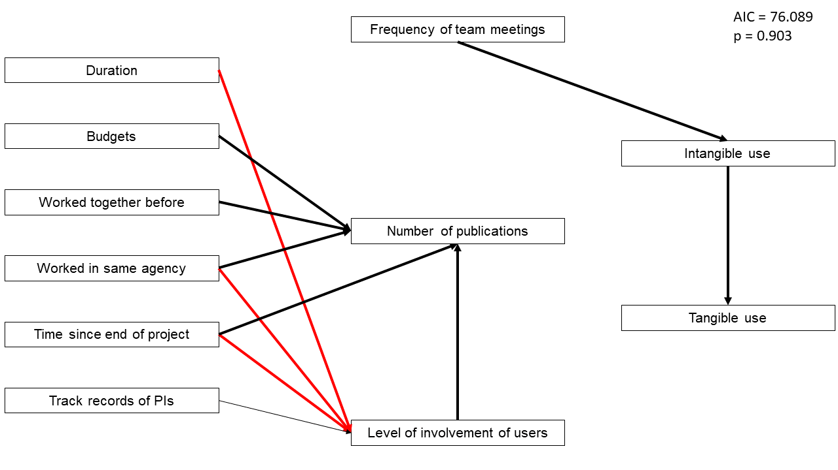
B

Figure 5.2. Path diagrams displaying the pathways specified in the two models. In the path diagrams, bold arrows represent significant positive (black) or negative (red) effects. Specified, but non-significant paths are thin grey lines. (a) Path diagram for the full structural equation model. (b) Path diagram for the parsimonious structural equation model. Duration (of funding), budget, if the PI and end-user worked together before, and if the PI and end-user worked in the same agency were all considered inputs. Frequency of team meetings and the average level of involvement of the users were considered process metrics. Number of publications represented the outputs, while both types of use were the outcomes. Time since the project ended and track record of the PIs were control variables.

p-value = 0.903, AIC = 76.089, Figure 5.2b, Table S5.2), both were good representations of such associations. The parsimonious model, however, does so better with a lower AIC score.

With the goal of identifying variables that influence scientific innovation and/or use of projects, we evaluated the paths in the SEMs. When doing so, two distinct paths emerge: one ending in scientific innovation and one ending in project use. We find that only frequency of meetings between researchers and users significantly influences intangible use in the models, and, in turn, only intangible use significantly affects tangible use (Figures 5.2, Tables S5.2 and S5.3). Interestingly, predictors of scientific innovation formed a separate path. In this path, inputs affect average involvement of users while inputs and processes affect scientific innovation. In both models, several variables (duration of funding; time since the project ended; and PI and user working in the same agency) significantly negatively influenced average user involvement rates, a process metric. Experience of the PI with coproduction research projects positively affected average user involvement rates in both models as well. Budget; time since the project ended; PI and users working together before and within the same agency; and average level of involvement of users all positively significantly influenced number of publications (Figure 5.2, Figure 5.3, Tables S2 and S3).

Discussion

To invest money efficiently in climate adaptation science, we need to know how to design research projects that will successfully meet information needs of natural resource managers. To address that need, we evaluated the relative variation in use and indicators of scientific innovation of projects to quantitatively identify which project characteristics affect levels of either variable. To do so, we surveyed the PIs and users of a set of projects. Using SEMs, two distinct paths were identified: one ending in scientific publications and a separate pathway ending in use (Figure 5.2). Only the frequency of meetings affected the level of intangible use, while only the level of intangible use directly affected the level of tangible use.

Our indicators of scientific innovation did not significantly affect use. If there was a positive correlation, this would have supported our win-win hypothesis where highly productive projects are also highly used projects. If there was a negative correlation, this would have suggested that there were tradeoffs between use and scientific innovation. Our lack of correlation paired with the two independent paths could suggest that they may not tradeoff, but instead are influenced by separate mechanisms within the research process.

The frequency of meetings between researchers and users influenced the level of use, aligning with previous research that suggests strong communication between users and PIs is key for project results and products to be used (Nutley et al. 2007b; Djenontin & Meadow 2018; Cooke et al. 2020). More meetings could also enable PIs to better understand needs of users and, therefore, craft more useful and usable end products (Lemos et al. 2018; Arnott et al. 2020). This
idea parallels several users’ comments, saying that workshops and meetings helped define a useful product and helped set community expectations. More meetings also could lead to increased transparency, i.e., improved credibility and legitimacy leading to increased buy-in and understanding from users (Reyers et al. 2015). If meetings are key for use, as our results suggest, prioritizing representatives from a broad range of organizations to attend meetings over many
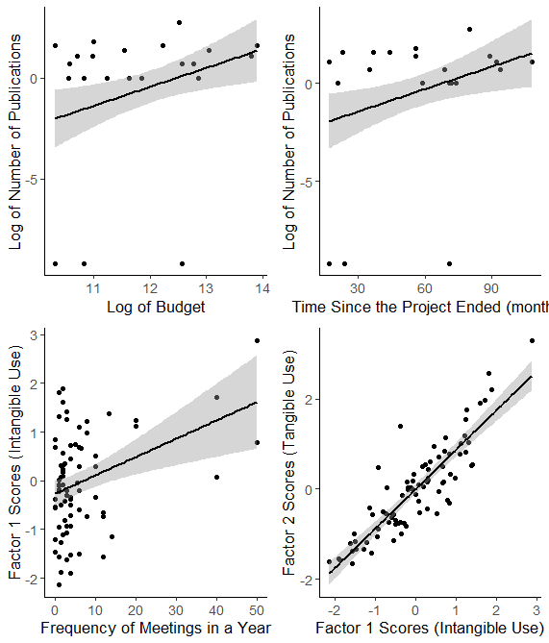
B
D
C
A
Figure 5.3. Partial effect regression plots illustrating four of the significant relationships (p-value <0.05) from the structural equation model.

users from the same organization would be one way to increase use of project results and products across organizations.

A distinct pathway formed in the model leading to increases in our indicator of scientific innovation. Our results reaffirmed several expectations, such as increased budgets leading to increased publication counts and more recent projects having fewer publications. Our results also suggest that when the PI and users worked in the same agency and/or they worked together before, they had more publications. This could be due to decreased agency burdens (e.g., reduced number of internal agency reviews, NOAA 2016; USGS 2016) and/or increased proximity (Djenontin & Meadow 2018). Lastly, the average level of involvement of users throughout the research process positively significantly influenced number of publications. This finding suggests that coproduction activities can also benefit indicators of scientific innovation.

There are limitations to our work. For example, we did not measure capacity building efforts as a form of use, an additional contribution all of these projects likely made, but one that was outside the scope of our evaluation. Additionally, although we account for the variation of project end dates in our controls, memory bias could have influenced responses from older projects more so than recent projects (Arnott & Lemos 2021). We also did not have responses from users for several projects. We tried to overcome this issue by interviewing SE CASC leadership on their perception of use for each of the projects (Appendix S3, Figure S5.1). Our hope was to use this leadership team evaluation to infer use of projects where we had missing data. We first compared leadership team members’ perceptions of use to actual user responses for those projects where both sets of data were available. The leadership responses did not align with user responses (p-value < 0.05). Because of this, we did not feel able to rely on the leadership teams’ evaluations in this way and thus dropped projects without responses with users from our analysis.

There are calls for research with not just high publication and citation outputs, but those with societal impacts and useful products (e.g., Arnott et al. 2020; Buxton et al. 2021). The CASC network is one national effort to conduct such research. Specifically, the CASC network seeks to “…provide resource managers, native communities, and other partners with scientific information and decision-making tools they need to understand and adapt to the effects of climate change…” (CASC 2022). Evaluation approaches like ours can help inform the design and implementation of projects to meet these goals to ensure there is not a misalignment between information needs and conducted research. Our results suggest through meetings and evaluations, engaging with intended users throughout the research process is key if research results are to be used. Thus, if researchers and science funders want to see research results being used by natural resource managers, they may need to prioritize time and funding to meaningfully engage with users.

Acknowledgements

We thank Aranzazu Lascurain, Lindsay Maudlin, Deja Perkins, Casey Richards, our stakeholder advisory committee, many colleagues in the research and user communities in the Southeast for their suggestions on the work, and all survey respondents. The project described in this publication was supported by Grant No G20AC00121 from the United States Geological Survey. Its contents are solely the responsibility of the authors and do not necessarily represent the views of the USGS Southeast Climate Adaptation Science Center or the USGS. This manuscript is submitted for publication with the understanding that the United States Government is authorized to reproduce and distribute reprints for Governmental purposes.

APPENDIX

Appendix S1: Additional methods details

Project descriptions

To develop a generalizable quantitative evaluation framework to assess the use of coproduction science, we used 32 projects funded by the Southeast (SE) CASC from 2008 to 2019. The CASC network is a federally funded network across the USA with the goal to deliver science and information that natural resource managers can use to inform adaptation strategies (ACCNRS 2015). The CASC projects have the same funding source with consistent goals across projects and an added advantage of a defined population of users. We did not evaluate the center as whole, but rather the variation in projects that effect the use of their funded projects. As such, these projects ranged in funding from $30 K to $983 K and lasted 1 to 6 years. These projects were distributed widely across the U.S. Southeast including Puerto Rico and the U.S. Virgin Islands. For full description of all projects, please see United States Geological Survey (2021).

PI survey details

We gathered information from at least one PI associated with each of the projects to capture process metrics. We developed the short survey based on previous evaluation efforts (personal communication with Aparna Bamzai), a literature review, and in consultation with SE CASC partners and researchers (Artino et al. 2014). Our stakeholder advisory board members and the larger CASC evaluation network reviewed the survey. We then incorporated the feedback from the advisory board and evaluation experts, modifying the survey questions as needed. Lastly, we piloted the survey with six faculty at the University of Tennessee – Knoxville and again modifying the questions as needed.

User survey details

For the use survey, we identified users in four manners: 1) we found users in final project reports; 2) within the PI survey, we asked the PIs to refer us to users of their project; 3) we met with SE CASC leadership to refer other potential users; and 4) we asked users completing the survey if they knew of other users that we should reach out to. The use survey was developed in consultation with SE CASC partners and researchers, in addition to a literature review of relevant literature. We first conducted piloted the survey with a small number of stakeholders to ensure questions we asked on the survey captured stakeholder values and priorities in regard to project usefulness to resource managers (Artino et al. 2014). A draft of the survey was then sent to our advisory board members for review. We then incorporated the feedback from the advisory board, modifying the survey questions as needed. Lastly, the survey was again piloted with relevant stakeholders and modified the questions as needed.

Additional data collection and analysis

In addition to gathering data from documentary sources and the two surveys, we interviewed five directors and members of the SE CASC leadership team. On a 5-point Likert scale, we asked questions relating to their perception of use for each of the projects. We compared the leadership’s perception of use of each project with the users’ responses using an analysis of variance (ANOVA). All analysis was done in R version 4.0.2.

User survey questions

Please answer each question about the research project you selected and how you or the organization/agency you work for may have used information from it.
To what degree has this project...

...impacted any of your professional skills?
o No impact (1)
o Little impact (2)
o Some impact (3)
o Quite a bit of impact (4)
o A great deal of impact (5)
...impacted your knowledge relevant to your job?
o No impact (1)
o Little impact (2)
o Some impact (3)
o Quite a bit of impact (4)
o A great deal of impact (5)

...influenced your professional network?
o No influence (1)
o Little influence (2)
o Some influence (3)
o Quite a bit of influence (4)
o A great deal of influence (5)

...changed your awareness of informational resources?
o No change (1)
o Little change (2)
o Some change (3)
o Quite a bit of change (4)
o A great deal of change (5)

...influenced long-term planning documents?
o No influence (1)
o Little influence (2)
o Some influence (3)
o Quite a bit of influence (4)
o A great deal of influence (5)
o N/A -- My organization doesn't do this or I don't know (6)

...influenced organizational/departmental objectives or priorities?
o No influence (1)
o Little influence (2)
o Some influence (3)
o Quite a bit of influence (4)
o A great deal of influence (5)
o N/A -- My organization doesn't do this or I don't know (6)

...influenced broad-scale or general policy?
o No influence (1)
o Little influence (2)
o Some influence (3)
o Quite a bit of influence (4)
o A great deal of influence (5)
o N/A -- My organization doesn't do this or I don't know (6)

...impacted public education efforts in your organization?
o No impact (1)
o Little impact (2)
o Some impact (3)
o Quite a bit of impact (4)
o A great deal of impact (5)
o N/A -- My organization doesn't do this or I don't know (6)

...impacted education efforts focused on resource managers or local landholders?
o No impact (1)
o Little impact (2)
o Some impact (3)
o Quite a bit of impact (4)
o A great deal of impact (5)
o N/A -- My organization doesn't do this or I don't know (6)

...influenced monitoring or research efforts in your organization or department?
o No influence (1)
o Little influence (2)
o Some influence (3)
o Quite a bit of influence (4)
o A great deal of influence (5)
o N/A -- My organization doesn't do this or I don't know (6)

...influenced decisions to change any habitat or species management practices?
o No influence (1)
o Little influence (2)
o Some influence (3)
o Quite a bit of influence (4)
o A great deal of influence (5)
o N/A -- My organization doesn't do this or I don't know (6)

...influenced decisions to change how infrastructure is managed?
o No influence (1)
o Little influence (2)
o Some influence (3)
o Quite a bit of influence (4)
o A great deal of influence (5)
o N/A -- My organization doesn't do this or I don't know (6)

...influenced decisions to change how time or labor are spent in your organization/agency?
o No influence (1)
o Little influence (2)
o Some influence (3)
o Quite a bit of influence (4)
o A great deal of influence (5)
o N/A -- My organization doesn't do this or I don't know (6)

...influenced decisions to change how money is allocated in your organization/agency?
o No influence (1)
o Little influence (2)
o Some influence (3)
o Quite a bit of influence (4)
o A great deal of influence (5)
o N/A -- My organization doesn't do this or I don't know (6)

...influenced decisions to change internal/organizational policies or procedures?
o No influence (1)
o Little influence (2)
o Some influence (3)
o Quite a bit of influence (4)
o A great deal of influence (5)
o N/A -- My organization doesn't do this or I don't know (6)

...influenced decisions to change external policies, regulations, or enforcement?
o No influence (1)
o Little influence (2)
o Some influence (3)
o Quite a bit of influence (4)
o A great deal of influence (5)
o N/A -- My organization doesn't do this or I don't know (6)

...affirmed what you already know about environmental change and your job?
o No affirmation (1)
o Little affirmation (2)
o Some affirmation (3)
o Quite a bit of affirmation (4)
o A great deal of affirmation (5)
o N/A -- My organization doesn't do this or I don't know (6)
...been used to encourage support from or collaboration with peers and/or partner organizations?
o No use (1)
o Little use (2)
o Some use (3)
o Quite a bit of use (4)
o A great deal of use (5)
o N/A -- My organization doesn't do this or I don't know (6)

...been used to encourage support or cooperation from the public or local landholders?
o No use (1)
o Little use (2)
o Some use (3)
o Quite a bit of use (4)
o A great deal of use (5)
o N/A -- My organization doesn't do this or I don't know (6)

...been used to encourage support from your supervisors?
o No use (1)
o Little use (2)
o Some use (3)
o Quite a bit of use (4)
o A great deal of use (5)
o N/A -- My organization doesn't do this or I don't know (6)

...been used to encourage support from lawmakers?
o No use (1)
o Little use (2)
o Some use (3)
o Quite a bit of use (4)
o A great deal of use (5)
o N/A -- My organization doesn't do this or I don't know (6)

...been used to support a funding request?
o No use (1)
o Little use (2)
o Some use (3)
o Quite a bit of use (4)
o A great deal of use (5)
o N/A -- My organization doesn't do this or I don't know (6)

When were you first in contact with the research team on this project?
o Prior to writing the proposal (1)
o During the proposal writing process (2)
o After the project was selected for funding (3)
o During the research efforts (4)
o After the research project was completed (5)
o Never (6)

Q20 In an average year, how many times did you have meaningful interactions with the researchers on this particular project during the lifetime of the project?

Q22 Do you know other cultural or natural resource managers who may have used these data, tools, or findings from this project? Please provide their names, organization, and/or email.

Principal investigator questions

Q1. How will partners and/or users best identify your SE CASC project? Please list up to five identifiers that could help a survey respondent recognize the project e.g., PI name (Paul Armsworth); acronym for project (CARI); product or tool developed (cost calculator); or a particular meeting or event.

Q2 Who should we contact to discuss the use of your project results or deliverables? While project reports list organizations as key stakeholders, we anticipate projects will have connected with specific individuals within those organizations and want to make sure we reach out to the most relevant individuals for your project. This can include partners and/or users you worked with on this project and/or people you know who are using the project results and deliverables. If possible, please provide their name and associated organization.

Q3 Had research team members worked together on projects before this one?

Q4 What is the average number of years you have collaborated with the research team members?

Q5 When did you first contact any partners/users regarding the project?
- Partner contacted the research team first (1)
- Prior to writing the proposal (2)
- During the proposal writing process (3)
- After the project was selected for funding (4)
- During the research efforts (5)
- After the project was completed (6)
- Never (7)

Q6 How involved were partners/users at each of the relevant phases of the project? Scroll over underlined text on column headers for examples of involvement (text window will be displayed)
 | Not involved (1) | Slightly involved (2) | Moderately involved (3) | Quite involved (4) | Extremely involved (5)
Identification of the management or research problem(s) (1)
Articulation of the research question(s) (2)
Design of the research methods (3)
Generate ideas about project products (4)
Collection of project data (5)
Analysis of project data (6)
Interpretation of results (7)
Creation of tools or other project products (8)
Dissemination of findings (9)

Q7 In an average year, how many times did you have meaningful interactions with partners/users on this particular SE CASC project during the lifetime of the project?

Q8 Did you work within the same agency as some of the partners/users for this project?

Q9 Did the user/partner or their respective organization partially fund or cost-share this project?

Q10 Prior to this project, approximately how much experience did you have as lead PI on similarly sized or larger grants?
- No experience
- Slightly experienced (1 similarly sized grant)
- Somewhat experienced (2-3 similarly sized grants)
- Moderately experienced (4-7 similarly sized grants)
- Extensively experienced (8+ similarly sized grants)

Q11 In the 5 years prior to starting this project, approximately how many externally funded projects that involved actionable or co-produced science were you lead PI on?
- None
- 1 project
- 2-3 projects
- 4-7 projects
- More than 8 projects

Q12 Did someone on your team have formal training in stakeholder engagement?

Appendix S2. Statistical analysis details.

Exploratory Factor Analysis
We used exploratory factor analysis (EFA) and Cronbach’s alpha to evaluate the use questions. We dropped any question with missing values greater than 20% of the sample. We used oblimin rotation method with polychorric imputation methods because the data were ordinal. We use a confirmatory factor analysis with comparative fit index; the robust root-mean-square error of approximation; and the robust standardized root-mean-square residual metrics to confirm our EFA. We used package psych in R.

Structural Equation Models
We then combined the survey data and documentary sources to evaluate correlations among inputs, processes, outputs, and outcomes. To do so, we used Structural Equation Models (SEMs) following our logic model (Figure 5.1) using package piecewiseSEM. We used Fischer’s C to confirm our SEM selection. For use-related components of the model, we included a random error term to account for intra-project heterogeneity. We first ran a full model with all variables of interest. In pursuit of parsimony, we reran the SEM with only variables that had significant effects, which will be referred to as the parsimonious model. We used AIC for model selection between the two models. All analysis was done in R version 4.0.2.

Variable Selection
We excluded any variable with more than 20% of responses missing (e.g., What is the average number of years you have collaborated with the research team members?). Because the number of publications, number of citations, and impact factor highly correlated, we dropped number of citations and impact factor from the analysis. Similarly, track record questions of the PI correlated, and we dropped one of those questions. Rather than include user involvement at every stage of the research process, we used an average. Including a covariate of involvement at every stage of the research process, totaling nine from our survey, would have limited what other variables of interest we could have investigated. We did not have evidence that one stage of involvement would be a better predictor of use than another; because of this, we averaged level of involvement of users throughout the research process. Averaging the level of involvement did not change the relative level of involvement among projects, and hence, we used the average in our model. We log transformed budgets and the number of publications because of the high variation across projects and skewed distribution of both covariates. To capture the full variation in the suite of projects, we decided to keep those projects without any peer-review publications. We did, however, run models without those projects to see the robustness of our results. For use-related components of the model, we included a random error term to account for heterogeneity across projects (Eq. S1-S9). All analysis was done in R version 4.0.2.

Equations for full model
$Involvement= β_{1}Budget+β_{2}Duration+ β_{3}WorkedPreviouslyTogether+ β_{4}SameAgency+ β_{5}PITrackRecord+ β_{6}TimeSinceFunded$ Eq. S1

$Meetings= β_{1}Budget+β_{2}Duration+ β_{3}WorkedPreviouslyTogether+ β_{4}SameAgency+ β_{5}PITrackRecord+ β_{6}TimeSinceFunded$ Eq. S2

$Publications= β_{1}Budget+β_{2}Duration+ β_{3}WorkedPreviouslyTogether+ β_{4}SameAgency+ β_{5}PITrackRecord+ β_{6}TimeSinceFunded+ β_{7}Involement+ β_{8}Meetings$ Eq. S3

$Intangible use= β_{1}Budget+β_{2}Duration+ β_{3}WorkedPreviouslyTogether+ β_{4}SameAgency+ β_{5}PITrackRecord+ β_{6}TimeSinceFunded+ β_{7}Involement+ β_{8}Meetings+ β_{9}Publications+ ε_{i}$ Eq. S4

$Tangible use= β_{1}Budget+β_{2}Duration+ β_{3}WorkedPreviouslyTogether+ β_{4}SameAgency+ β_{5}PITrackRecord+ β_{6}TimeSinceFunded+ β_{7}Involement+ β_{8}Meetings+ β_{9}Publications+β_{10}IntangibleUse+ ε_{i}$ Eq. S5

In the equations above,
Involvement is the average involvement of users throughout the research process;
Duration is the length of time the project was funded;
SameAgency is if the PI and users worked within the same organization;
PITrackRecord is the PI’s experience with coproduction projects;
Meetings is the average frequency of meetings in a year among the PI and users;
Publications is the total number of peer-reviewed publications attributed to the project;
Intangible use is Factor 1 from the EFA output;
Tangible use if Factor 2 from the EFA output; and
ɛ is the random error term, which accounts for heterogeneity across responses (i) for the same project.

Equations for parsimonious model
$Involvement= β_{1}Duration+ β_{2}SameAgency+ β_{3}PITrackRecord+ β_{4}TimeSinceFunded$ Eq. S6

$Publications= β_{1}Budget+ β_{2}WorkedPreviouslyTogether+ β_{3}SameAgency+ β_{4}TimeSinceFunded+ β_{5}Involement$ Eq. S7

$Intangible use= β_{1}Meetings+ε_{i}$ Eq. S8

$Tangible use= β_{1}IntangibleUse+ ε_{i}$ Eq. S9

Appendix S3. Additional Results

Comparison of leadership responses to user responses

We used a simplified version of the user survey instrument that asked leadership team members to score all projects funded during their tenure against aggregated use constructs that we exemplified using the more specific survey constructs seen by the users. We surveyed five individuals identified by SE CASC as having played important leadership roles during the course of the projects we included. Our hope was to use this leadership team evaluation to infer use of projects where we had missing data. We first compared leadership team members’ perceptions of use to actual user responses for those projects where both sets of data were available.

However, we found little association between leadership team members’ perceptions of how useful projects proved to users and users own perceptions as revealed by the user survey for those projects where both datasets were available (p-value < 0.05). Figure S5.1 shows this lack of association in aggregate, but disaggregating the leadership team data looked similar. Therefore, we did not feel we could rely on the leadership team data to infer the usefulness to users of projects for which we lacked user responses and thus, we dropped these projects from further analysis.

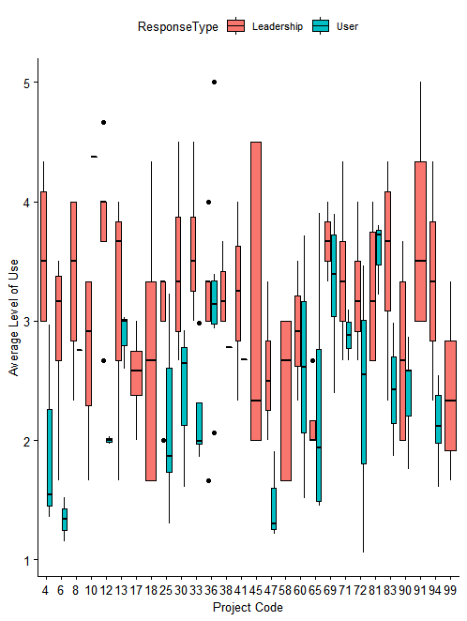
Figure S5.1. Box plot of the average use by project comparing average responses from users by project (teal) to those of the SE CASC leadership’s perception of use by project (pink). The project codes have been randomly assigned to each project for plotting purposes.

Structural Equation Model outputs
Table S5.1. Component results of the full structural equation model.
Response | Predictor | Estimate | SE | df | Crit. Value | P-value | Std. Estimate
Frequency of Meetings | Budget | -0.4663 | 2.5756 | 81 | -0.181 | 0.8568 | -0.026
Frequency of Meetings | Duration of funding | -0.1017 | 0.2442 | 81 | -0.4163 | 0.6784 | -0.0705
Frequency of Meetings | PI and User worked together before | -1.1882 | 5.0691 | 81 | -0.2344 | 0.8153 | -0.0293
Frequency of Meetings | PI and User worked in the same agency | -2.4752 | 5.6392 | 81 | -0.4389 | 0.662 | -0.0611
Frequency of Meetings | Track record of PI with coproduction | 1.0749 | 1.881 | 81 | 0.5715 | 0.5694 | 0.0825
Frequency of Meetings | Time since project ended | -0.138 | 0.1089 | 81 | -1.2668 | 0.2092 | -0.1833
Average Involvement | Budget | -0.0029 | 0.0916 | 81 | -0.0321 | 0.9744 | -0.0039
Average Involvement | Duration of funding | -0.0166 | 0.0087 | 81 | -1.9092 | 0.0601 | -0.2731
Average Involvement | PI and User worked together before | -0.0671 | 0.1802 | 81 | -0.3722 | 0.7108 | -0.0393
Average Involvement | PI and User worked in the same agency | -0.8986 | 0.2005 | 81 | -4.4821 | <0.0001 | -0.5272
Average Involvement | Track record of PI with coproduction | 0.1302 | 0.0669 | 81 | 1.9476 | 0.0553 | 0.2375
Average Involvement | Time since project ended | -0.0108 | 0.0039 | 81 | -2.7768 | 0.0069 | -0.3394
Publications | Budget | 1.2108 | 0.3408 | 81 | 3.5526 | 0.0007 | 0.3686
Publications | Duration of funding | 0.0294 | 0.0331 | 81 | 0.8874 | 0.3778 | 0.1111
Publications | PI and User worked together before | 2.3235 | 0.6714 | 81 | 3.4608 | 0.0009 | 0.3125
Publications | PI and User worked in the same agency | 3.6682 | 0.8418 | 81 | 4.3575 | <0.0001 | 0.4943

Table S5.1 continued.
Response | Predictor | Estimate | SE | df | Crit. Value | P-value | Std. Estimate
Publications | Frequency of Meetings | -0.0051 | 0.0156 | 81 | -0.3291 | 0.743 | -0.028
Publications | Average Involvement | 1.261 | 0.4394 | 81 | 2.8699 | 0.0054 | 0.2896
Publications | Time since project ended | 0.0401 | 0.0152 | 81 | 2.6405 | 0.0101 | 0.291
Publications | Track record of PI with coproduction | 0.1485 | 0.2552 | 81 | 0.5819 | 0.5625 | 0.0622
Intangible Use | Budget | 0.0644 | 0.2237 | 13 | 0.2876 | 0.7782 | 0.0716
Intangible Use | Duration of funding | -0.0095 | 0.0211 | 13 | -0.4517 | 0.6589 | -0.1319
Intangible Use | PI and User worked together before | -0.194 | 0.4641 | 13 | -0.4179 | 0.6828 | -0.0954
Intangible Use | PI and User worked in the same agency | -0.081 | 0.5454 | 13 | -0.1486 | 0.8842 | -0.0399
Intangible Use | Frequency of Meetings | 0.0196 | 0.0051 | 58 | 3.8146 | 0.0003 | 0.3917
Intangible Use | Average Involvement | -0.3293 | 0.2854 | 13 | -1.1538 | 0.2693 | -0.2765
Intangible Use | Time since project ended | -0.0028 | 0.0097 | 13 | -0.285 | 0.7801 | -0.0733
Intangible Use | Track record of PI with coproduction | 0.0883 | 0.1569 | 13 | 0.563 | 0.583 | 0.1353
Intangible Use | Publications | 0.0421 | 0.0701 | 13 | 0.6015 | 0.5578 | 0.1541
Tangible Use | Budget | -0.0004 | 0.0671 | 13 | -0.0054 | 0.9958 | -0.0004
Tangible Use | Duration of funding | 0.0007 | 0.006 | 13 | 0.109 | 0.9148 | 0.0091
Tangible Use | PI and User worked together before | -0.2446 | 0.1308 | 13 | -1.8702 | 0.0841 | -0.1206
Tangible Use | PI and User worked in the same agency | -0.1111 | 0.1702 | 13 | -0.6528 | 0.5253 | -0.0549
Tangible Use | Frequency of Meetings | -0.0038 | 0.003 | 57 | -1.2916 | 0.2017 | -0.0767
Tangible Use | Average Involvement | 0.0482 | 0.0846 | 13 | 0.5697 | 0.5786 | 0.0406
Table S5.1 continued.
Response | Predictor | Estimate | SE | df | Crit. Value | P-value | Std. Estimate
Tangible Use | Time since project ended | 0.0023 | 0.0029 | 13 | 0.8021 | 0.4369 | 0.0612
Tangible Use | Track record of PI with coproduction | 0.0119 | 0.0467 | 13 | 0.254 | 0.8035 | 0.0182
Tangible Use | Publications | 0.0184 | 0.0213 | 13 | 0.8672 | 0.4015 | 0.0676
Tangible Use | Intangible Use | 0.8966 | 0.0609 | 57 | 14.7172 | <0.0001 | 0.899

Table S5.2. Component results of the parsimonious structural equation model.
Response | Predictor | Estimate | SE | df | Crit. Value | P-value | Std. Estimate
Average Involvement | Duration of funding | -0.0162 | 0.0073 | 81 | -2.2269 | 0.0289 | -0.2666
Average Involvement | PI and User worked in the same agency | -0.887 | 0.1934 | 81 | -4.5862 | <0.0001 | -0.5205
Average Involvement | Track record of PI with coproduction | 0.1273 | 0.0651 | 81 | 1.9546 | 0.0543 | 0.2321
Average Involvement | Time since project ended | -0.0108 | 0.0038 | 81 | -2.8114 | 0.0063 | -0.3394
Publications | Budget | 1.3397 | 0.2893 | 81 | 4.6311 | <0.0001 | 0.4078
Publications | PI and User worked together before | 2.2079 | 0.6231 | 81 | 3.5437 | 0.0007 | 0.297
Publications | PI and User worked in the same agency | 3.7094 | 0.7021 | 81 | 5.2836 | <0.0001 | 0.4999
Publications | Average Involvement | 1.2061 | 0.4058 | 81 | 2.972 | 0.004 | 0.277
Publications | Time since project ended | 0.0366 | 0.013 | 81 | 2.8175 | 0.0062 | 0.2656
Intangible Use | Frequency of Meetings | 0.0178 | 0.005 | 58 | 3.5862 | 0.0007 | 0.3552
Tangible Use | Intangible Use | 0.8752 | 0.0538 | 58 | 16.2762 | <0.0001 | 0.8777

CONCLUSION

In an effort to respond to augmented effects of climate change and associated biodiversity loss, there are calls to fund research that improves the efficiency of conservation efforts with the potential for societal impacts and useful end products (e.g., Arnott et al. 2020; Buxton et al. 2021). One major mechanism to improve conservation efforts could be to incorporate decisions made by those using and those managing natural resources. In this dissertation, I explored this concept. I elicited and quantified time preferences of both natural resource users and land trust practitioners. I then illustrated implications of their decisions on natural resource management strategies and land protection prioritization. Similarly, I then explored how time horizon, a common organizational constraint, affects where priorities emerge for land protection today. A second mechanism to improve conservation efforts is to learn from previous work, to evaluate what increased scientific innovation and use of research projects. To do so, I examined project characteristics that influence the scientific innovation and use by end users.

Synthesis

Several overarching conclusions can be drawn from these four chapters. 1) I found that discount rates by both users and land trust practitioners were higher than those typically codified into environmental policy and that they discount domains differently. Such estimates affected natural resource management strategies and priorities. These results suggest that locally grounded estimates of discount rates should be incorporated in modeling efforts for sustainable management of natural resources. 2) Both discount rates and time horizons are means to incorporate temporal decisions into conservation planning. Despite differences in how they account for benefits temporally, similar patterns of land protection priorities emerge. These results imply that temporal decisions should not be overlooked, but rather agreed upon (near-term vs. long-term benefits) for the efficiency of conservation efforts. 3) There are diverse stakeholders in conservation, ranging from users to practitioners and managers, in various sectors from academia to private organizations to government agencies. In this dissertation, I worked with a wide breadth of such stakeholders. Our results show that increased meeting frequency with these diverse groups increases use of research projects, which could in turn, improve efficiency of conservation efforts by scientists developing needed and applicable projects; practitioners and managers working with updated scientific information; and various stakeholders working together towards agreed upon goals and with consistent temporal decisions.

Temporal decisions

Aligning with other recent studies, our results showed that both natural resource users and land trust practitioners discount domains differently (Ubfal 2016; Green & Richards 2018). Fulani discount near-term benefits and costs at a higher rate than those realized further into the future for all domains tested, but at significantly different rates among domains (Chapter 2). Land trust practitioners also discount domains differently (Chapter 3). In particular, such practitioners have discount rates that are not significantly different through time for the financial domain, but have declining discount rates for the environmental domain. This decline indicates a presumption among these land trust practitioners that the relative value of protected land will rise in the future when compared to other goods. The declining discount rate associated with environmental goods in both studies aligns with policies used in France and the UK (Arrow et al. 2014). Building upon previous work (Sumaila & Walters 2005; Armsworth 2018), our work depicts the need for conservation management to account for domain-specific discount rates and non-constant rates because they can influence the timing, rate, and magnitude of optimal management strategies, in addition to spatial priorities. However, discount rates this variable also means that the conservation community needs to have open dialogue over what future priorities should be.

Discount rates that we elicited are much higher than those codified into policies (U.S. Office of Management and Budget 2003; Arrow et al. 2014). High discount rates for only the ecological domain would align with theory for common-pooled resources (Hartwick & Yeung 1997). High discount rates applied across domains in both Chapter 2 and 3, however, suggest these rates may be due more to uncertainty and insecurity about the future; e.g., Fulani’s lifestyles are rapidly changing from transient to sedentary due to climate change and competition for land with logging and agriculture (Gaoue & Ticktin 2009; Heubach et al. 2011); land trusts experience financial vulnerability (Tuckman & Chang 1991; Bakker et al. 2010). Such insecurity has likely increased during the on-going global pandemic and a second economic recession within two decades (Bakker et al. 2010; Elliott 2011). For conservation efforts with high discount rates, the question may become when to harvest or protect lands, in addition to finding a balance of multiple benefits, as we have shown in our harvest model with both local financial benefits and ecological benefits. For conservation planning to be successful, how both natural resource users and practitioners think about environmental benefits and financial costs through time in the context of their personal and organizational financial insecurities must be taken into consideration. Conservation projects need to assess their sensitivity to their chosen discount rate (Bonzanigo & Kalra 2014).

Discount rates are one mechanism that allows for temporal decisions to be incorporated into conservation planning. Time horizons are another. Discount rates look at benefits through time by converting future values to present day values, while time horizon problems or goals are only concerned with benefits at a certain time. Despite the differences in accounting, similar results emerge from these two approaches when applied to land protection. High discount rates such as those observed in Chapter 2 and Chapter 3, heavily weight the present, paralleling results from Chapter 4 with short time horizons. Both of these scenarios favor counties with immediate benefits, specifically habitat for biodiversity in 2020. Despite high median rates, both Chapter 2 and Chapter 3 elicited and estimated several negative discount rates throughout domains tested. Negative discount rates heavily weight future benefits, paralleling results from Chapter 4 with long time horizons. In these scenarios, priorities emerge where species ranges expand into the county. These results imply that temporal decisions cannot be overlooked or set for political ease as they have direct implications on where conservation priorities emerge today. Knowing the nuanced differences in how discount rates and varying time horizons affect conservation priorities is important. Knowing that their effects parallel each other, however, shifts the practical importance from a debate on discount rates versus time horizons to one regarding immediate benefits versus long-term benefits.

Engaging stakeholders

Conservation management and planning include many choices. Many such decisions are overlooked, assumed, or simply mandated (Bonzanigo & Kalra 2014; US FWS 2017), but I show that they can have large impacts on today’s protection priorities. Contrasting conservation priorities emerge due to two such commonly overlooked choices, specifically at varying time horizons (Chapter 4) and with varying discount rates (Chapters 2 & 3). This finding means that stakeholders in various sectors (e.g., academia, NGOs), disciplines, and across spatial scales (e.g., county, federal) must coordinate their efforts, creating agreed upon goals and timeframes, for efficient conservation strategies and planning. To do so, Chapter 5 results suggest that increased meeting frequency can increase use of research by end users, including natural resource managers. Rather than use assumed parameter estimates, our research shows that open dialogue with stakeholders across the user spectrum could improve understanding of natural resource decisions and in turn, potentially improve natural resource management and efficiency with limited budgets for conservation efforts.

Conservation always involves multiple, and often diverse, actors. There are calls for greater engagement of such diverse stakeholders as part of the scientific process. Bamzai-Dodson et al. (2021) outlines a framework for such engagement, ranging from inform stakeholders, similar to the “loading dock” approach, to empower stakeholders, similar to co-production. Several papers (e.g., Lemos et al. 2018; Bamzai-Dodson et al. 2021) outline how the different approaches are appropriate for different scientific projects depending on the goals and available resources of the research. This dissertation explicitly worked with different approaches of stakeholder engagement across stakeholder groups, spanning the user spectrum, and various sectors, bridging the private-public spectrum. For Chapters 2-4, I utilized inform and consult approaches because I had a priori questions in an attempt to contribute to scientific innovation. For Chapter 5, however, I strived for empowerment, working closely with the funding organization; the evaluation community; and many potential users of this work. This chapter not only evaluated past coproduction projects, but was a coproduced project.

Future Directions

From this work, there are many interesting paths forward. In the context of discount rates for natural resource users (Chapter 2), to improve conservation efforts, it would be interesting to explore how time preferences differ between types of livelihoods (e.g., pastoralists vs. farmers) and how they vary with geographic distance to necessary natural resources. Additionally, it would be informative to investigate the influence of social networks on how people value goods through time to pair with the extensive studies exploring how personal demographics influence time preferences. This would be applicable to both Chapter 2 and Chapter 3. A timelier question would be to ask how pre-pandemic discount rates compare to those during the on-going pandemic and associated supply-chain issues. For Chapter 3 and Chapter 4, specifically exploring volunteer and donor time preferences could help increase donations or enable land trusts to better meet their donors wishes. Additionally, collating data regarding actual investment decisions made by land trust practitioners could confirm results in this analysis and potentially illuminate inefficiencies in land protection efforts within and across organizations.

More broadly, there are many interesting paths forward from this body of work; here, I highlight two. The first would be to evaluate and to integrate local and community knowledge into conservation planning efforts. This work exemplifies how management decisions differ when incorporating locals’ preferences (Chapters 2 & 3), while working with organizational constraints (Chapter 4). Although Chapter 5 shows that there is increased use of research projects with increased frequency of meetings between researchers and users, those meetings could provide a means for two-way communication and in-turn guide new lines of actionable research. The second path would be to assess definitions of success, in both the context of scientific research and natural resource management. It is great to set goals for research results (e.g., use by end users), but how is success defined (e.g., is use by one user success?). It is great to set goals for conservation (e.g., protect 30% of land by 2030), but would success be just that land protection or would it be increasing species richness or simply a lack of species decline? With metrics of success defined, we as a research community can better evaluate and hopefully learn how to best reach those goals of natural resource conservation.

Bibliography

ACCNRS. (2015). Report to the Secretry of the Interior - Advisory Committee on Climate Change and Natural Resource Science, 86.
Alliance, L.T. (2021). Accreditation. https://www.landtrustalliance.org/topics/accreditation.
Andersen, S., Harrison, G.W., Lau, M.I. & Rutstrom, E.E. (2006). Elicitation using multiple price list formats. Exp Econ, 9, 383–405.
Andersen, S., Harrison, G.W., Lau, M.I. & Rutström, E.E. (2008). Eliciting risk and time preferences. Econometrica, 76, 583–618.
Anderson, K. & Weinhold, D. (2008). Valuing future development rights: The costs of conservation easements. Ecol. Econ., 68, 437–446.
Andreoni, J. & Sprenger, C. (2012). Estimating Time Preferences from Convex Budgets, 102, 3333–3356.
Armsworth, P.R. (2018). Time discounting and the decision to protect areas that are near and threatened or remote and cheap to acquire. Conserv. Biol., 0, 1–11.
Armsworth, P.R., Benefield, A.E., Dilkina, B., Fovargue, R., Jackson, H.B., Le Bouille, D. & Nolte, C. (2020). Allocating resources for land protection using continuous optimization: biodiversity conservation in the United States. Ecol. Appl., 0, 1–13.
Armsworth, P.R., Jackson, H.B., Cho, S.H., Clark, M., Fargione, J.E., Iacona, G.D., Kim, T., Larson, E.R., Minney, T. & Sutton, N.A. (2017). Factoring economic costs into conservation planning may not improve agreement over priorities for protection. Nat. Commun., 8.
Armsworth, P.R., Larson, E.R., Jackson, S.T., Sax, D.F., Simonin, P., Blossey, B., Green, N., Klein, M.L., Lester, L., Ricketts, T.H., Runge, M.C. & Shaw, M.R. (2015). Are conservation organizations configured for effective adaptation to global change? Front. Ecol. Environ., 13, 163–169.
Arnott, J.C. & Lemos, M.C. (2021). Understanding knowledge use for sustainability. Environ. Sci. Policy, 120, 222–230.
Arnott, J.C., Neuenfeldt, R.J. & Lemos, M.C. (2020). Co-producing science for sustainability: Can funding change knowledge use? Glob. Environ. Chang., 60.
Arrow, K.J., Cropper, M., Gollier, C., Groom, B., Heal, G.M., Newell, R. & Nordhaus, W. (2013a). Determining Benefits and Costs for Future Generations. Science (80-. )., 349–351.
Arrow, K.J., Cropper, M.L., Gollier, C., Groom, B., Heal, G.M., Newell, R.G., Nordhaus, W.D., Pindyck, R.S., Pizer, W.A., Portney, P.R., Sterner, T., Tol, R.S.J. & Weitzman, M.L. (2013b). How Should Benefits and Costs Be Discounted in an Intergenerational Context? The Views of an Expert Panel. Ssrn.
Arrow, K.J., Cropper, M.L., Gollier, C., Groom, B., Heal, G.M., Newell, R.G., Nordhaus, W.D., Pindyck, R.S., Pizer, W.A., Portney, P.R., Sterner, T., Tol, R.S.J. & Weitzman, M.L. (2014). Should Governments Use a Declining Discount Rate in Project Analysis ?, 8, 145–163.
Artino, A.R., La Rochelle, J.S., Dezee, K.J. & Gehlbach, H. (2014). Developing questionnaires for educational research: AMEE Guide No. 87. Med. Teach., 36, 463–474.
Attema, A.E., Bleichrodt, H., L’Haridon, O., Peretti-Watel, P. & Seror, V. (2018). Discounting health and money: New evidence using a more robust method. J. Risk Uncertain., 56, 117–140.
Bakker, V.J., Baum, J.K., Brodie, J.F., Salomon, A.K., Dickson, B.G., Gibbs, H.K., Jensen, O.P. & Mcintyre, P.B. (2010). The changing landscape of conservation science funding in the United States. Conserv. Lett., 3, 435–444.
Bamzai-Dodson, A., Cravens, A.E., Wade, A. & Mcpherson, A. (2021). Engaging with stakeholders to produce actionable science: a framework and guidance. Weather. Clim. Soc., 13.
Bauer, M. & Chytilová, J. (2010). The Impact of Education on Subjective Discount Rate in Ugandan Villages. Econ. Dev. Cult. Change, 58, 643–669.
Baum, S.D. & Easterling, W.E. (2010). Space-time discounting in climate change adaptation. Mitig. Adapt. Strateg. Glob. Chang., 15, 591–609.
Baumgärtner, S., Klein, A.M., Thiel, D. & Winkler, K. (2015). Ramsey Discounting of Ecosystem Services. Environ. Resour. Econ., 61, 273–296.
Beier, P., Hansen, L.J., Helbrecht, L. & Behar, D. (2017). A How-to Guide for Coproduction of Actionable Science. Conserv. Lett., 10, 288–296.
Benhabib, J., Bisin, A. & Schotter, A. (2010). Present-bias, quasi-hyperbolic discounting, and fixed costs. Games Econ. Behav., 69, 205–223.
Berry, M., Friedel, J.E., DeHart, W.B., Mahamane, S., Jordan, K.E. & Odum, A.L. (2017). The Value of Clean Air: Comparing Discounting of Delayed Air Quality and Money Across Magnitudes. Psychol Rec, 67, 127–148.
Bjerke, M.B. & Renger, R. (2017). Being smart about writing SMART objectives. Eval. Program Plann., 61, 125–127.
Bode, M., Wilson, K.A., Brooks, T.M., Turner, W.R., Mittermeier, R.A., McBride, M.F., Underwood, E.C. & Possingham, H.P. (2008). Cost-effective global conservation spending is robust to taxonomic group. Proc. Natl. Acad. Sci. U. S. A., 105, 6498–6501.
Bonzanigo, L. & Kalra, N. (2014). Making Informed Investment Decisions in an Uncertain World: A Short Demonstration. World Bank Policy Res. Work. Pap., 1–22.
Le Bouille, Diane, Fargione, Joseph E. & Armsworth, P.R. (n.d.). The cost of buying land for protected areas in the United States.
Brewer, R. (2003). Conservancy: The land trust movement in America. UPNE.
Buxton, R.T., Nyboer, E.A., Pigeon, K.E., Raby, G.D., Rytwinski, T., Gallagher, A.J., Schuster, R., Lin, H., Fahrig, L., Bennett, J.R., Cooke, S.J. & Roche, D.G. (2021). Avoiding wasted research resources in conservation science. Conserv. Sci. Pract., 3, 1–11.
Cassar, A., Healy, A. & von Kessler, C. (2017). Trust, Risk, and Time Preferences After a Natural Disaster: Experimental Evidence from Thailand. World Dev., 94, 90–105.
Clark, C.W. (1973). The Economics of Overexploitation. Science (80-. )., 181, 630–634.
Cohen, J.D., Ericson, K.M., Laibson, D. & White, J.M. (2016). Measuring Time Preferences. NBER Work. Pap. Ser.
Commission, E. (2020). Habitats Directive reporting.
Cooke, S.J., Rytwinski, T., Taylor, J.J., Nyboer, E.A., Nguyen, V.M., Bennett, J.R., Young, N., Aitken, S., Auld, G., Lane, J.-F., Prior, K.A., Smokorowski, K.E., Smith, P.A., Jacob, A.L., Browne, D.R., Blais, J.M., Kerr, J.T., Ormeci, B., Alexander, S.M., Burn, C.R., Buxton, R.T., Orihel, D.M., Vermaire, J.C., Murray, D.L., Simon, P., Edwards, K.A., Clarke, J., Xenopoulos, M.A., Gregory-Eaves, I., Bennett, E.M. & Smol, J.P. (2020). On “success” in applied environmental research — What is it, how can it be achieved, and how does one know when it has been achieved? Environ. Rev., 16, 1–16.
Crain, B.J., Stachowiak, C., McKenzie, P.F., Sanchirico, J.N., Kroetz, K. & Armsworth, P.R. (2021). Citizens of local jurisdictions enhance plant community preservation through ballot initiatives and voter-driven conservation efforts. Ambio, 50, 1237–1247.
Cropper, M.L. (2012). How Should Benefits and Costs Be Discounted in an Intergenerational Context? Resour. Futur.
D’Exelle, B., van Campenhout, B. & Lecoutere, E. (2012). Modernisation and Time Preferences in Tanzania: Evidence from a Large-Scale Elicitation Exercise. J. Dev. Stud., 48, 564–580.
Dallimer, M., Acs, S., Hanley, N., Wilson, P., Gaston, K.J. & Armsworth, P.R. (2009). What explains property-level variation in avian diversity? An inter-disciplinary approach. J. Appl. Ecol., 46, 647–656.
Day, B., Bateman, I.J., Carson, R.T., Dupont, D., Louviere, J.J., Morimoto, S., Scarpa, R. & Wang, P. (2012). Ordering effects and choice set awareness in repeat-response stated preference studies. J. Environ. Econ. Manage., 63, 73–91.
Dilling, L. & Lemos, M.C. (2011). Creating usable science: Opportunities and constraints for climate knowledge use and their implications for science policy. Glob. Environ. Chang., 21, 680–689.
Djenontin, I.N.S. & Meadow, A.M. (2018). The art of co-production of knowledge in environmental sciences and management: lessons from international practice. Environ. Manage., 61, 885–903.
Drupp, M.A., Freeman, M.C., Groom, B. & Nesje, F. (2015). Discounting disentangled : an expert survey on the determinants of the long-term social discount rate Centre for Climate Change Economics and Policy the Environment.
Dunford, R.W. (2018). The Discount Rate for Assessing Intragenerational Natural Resource Damages. J. Nat. Resour. Policy Res., 8, 89–109.
Dupont-Doaré, C. & Alagador, D. (2021). Overlooked effects of temporal resolution choice on climate-proof spatial conservation plans for biodiversity. Biol. Conserv., 263.
Elliott, L. (2011). Shades of green in East Asia: The impact of financial crises on the environment. Contemp. Polit., 17, 167–183.
FAO. (2011). State of the World’s Forest.
FAO. (2020). Blazing a trail for timber traceability in Benin [WWW Document]. URL http://www.fao.org/in-action/blazing-a-trail-for-timber-traceability-in-benin/en/
Fearnside, P.M. (2002). WHY A 100-YEAR TIME HORIZON SHOULD BE USED FOR GLOBAL\nWARMINGMITIGATION CALCULATIONS. Mitig. Adapt. Strateg. Glob. Chang., 7, 19–30.
Fisher, A.C. (2000). Investment under uncertainty and option value in environmental economics. Resour. an, 22, 197–204.
Fitzsimons, J.A. & Carr, C. Ben. (2014). Conservation covenants on private land: Issues with measuring and achieving biodiversity outcomes in Australia. Environ. Manage., 54, 606–616.
Frederick, S., Loewenstein, G. & O’donoghue, T. (2002). Time Discounting and Time Preference: A Critical Review. J. Econ. Lit., 40, 351–401.
Ganiats, T.G., Carson, R.T., Hamm, R.M., Cantor, S.B., Sumner, W., Spann, S.J., Hagen, M.D. & Miller, C. (2000). Population-based time preferences for future health outcomes. Med. Decis. Mak., 20, 263–270.
Gaoue, O.G., Horvitz, C.C., Ticktin, T., Steiner, U.K. & Tuljapurkar, S. (2013). Defoliation and bark harvesting affect life-history traits of a tropical tree. J. Ecol., 101, 1563–1571.
Gaoue, O.G., Jiang, J., Ding, W., Agusto, F.B. & Lenhart, S.M. (2016). Optimal harvesting strategies for timber and non-timber forest products in tropical ecosystems. Theor. Ecol., 9, 287–297.
Gaoue, O.G. & Ticktin, T. (2007). Patterns of harvesting foliage and bark from the multipurpose tree Khaya senegalensis in Benin: Variation across ecological regions and its impacts on population structure. Biol. Conserv., 137, 424–436.
Gaoue, O.G. & Ticktin, T. (2009). Fulani Knowledge of the Ecological Impacts of Khaya senegalensis (Meliaceae) Foliage Harvest in Benin and its Implications for Sustainable Harvest. Econ. Bot., 63, 256–270.
Gaoue, O.G. & Ticktin, T. (2010). Effects of Harvest of Nontimber Forest Products and Ecological Differences between Sites on the Demography of African Mahogany. Conserv. Biol., 24, 605–614.
Gaston, K.J., Jackson, S.F., Cantú-Salazar, L. & Cruz-Piñón, G. (2008). The ecological performance of protected areas. Annu. Rev. Ecol. Evol. Syst., 39, 93–113.
Gilman, E., Hall, M., Booth, H., Gupta, T., Chaloupka, M., Fennell, H., Kaiser, M.J., Karnad, D. & Milner-Gulland, E.J. (2022). A decision support tool for integrated fisheries bycatch management. Rev. Fish Biol. Fish. Springer International Publishing.
Gollier, C. (2010). Ecological discounting. J. Econ. Theory, 145, 812–829.
Green, G.P. & Richards, T.J. (2018). Discounting environmental goods. J. Agric. Resour. Econ., 43, 215–232.
Gren, I.-M., Nyström Sandman, A. & Näslund, J. (2018). Aquatic invasive species and ecosystem services: Economic effects of the worm Marenzelleria spp. in the Baltic Sea. Water Resour. Econ., 1–12.
Grijalva, T.C., Lusk, J.L., Rong, R. & Shaw, W.D. (2018). Convex Time Budgets and Individual Discount Rates in the Long Run. Environ. Resour. Econ., 71, 259–277.
Grijalva, T.C., Lusk, J.L. & Shaw, W.D. (2014). Discounting the Distant Future: An Experimental Investigation. Environ. Resour. Econ., 59, 39–63.
Groves, C. & Game, E.T. (2016). Conservation planning : informed decisions for a healthier planet. Roberts and Company Publishers, Greenwood Village, Colorado.
Hardisty, D.J., Appelt, K.C. & Weber, E.U. (2013a). Good or Bad, We Want it Now: Fixed-cost Present Bias for Gains andLosses Explains Magnitude Asymmetries in Intertemporal Choice. J. Behav. Decis. Mak., 26, 348–361.
Hardisty, D.J., Thompson, K.J., Krantz, D.H. & Weber, E.U. (2013b). How to measure discount rates? An experimental comparison of three methods. J. Child Fam. Stud., 22, 1–42.
Hardisty, D.J. & Weber, E.U. (2009). Discounting Future Green: Money Versus the Environment. J. Exp. Psychol. Gen., 138, 329–340.
Hartig, F. & Drechsler, M. (2008). The time horizon and its role in multiple species conservation planning. Biol. Conserv., 141, 2625–2631.
Hartwick, J.M. & Yeung, D.W.K. (1997). The tragedy of the commons revisted, 1, 45–62.
Hauser, C.E. & Possingham, H.P. (2008). Experimental or precautionary? Adaptive management over a range of time horizons. J. Appl. Ecol., 45, 72–81.
Heal, G.M. (2009). The economics of climate change: A post-stern perspective. Clim. Change, 96, 275–297.
Hernández-Barrios, J.C., Anten, N.P.R. & Martínez-Ramos, M. (2015). Sustainable harvesting of non-timber forest products based on ecological and economic criteria. J. Appl. Ecol., 52, 389–401.
Hernuryadin, Y., Kotani, K. & Kamijo, Y. (2019). Time preferences between individuals and groups in the transition from hunter-gatherer to industrial societies. Sustain., 11.
Heubach, K., Wittig, R., Nuppenau, E.A. & Hahn, K. (2011). The economic importance of non-timber forest products ( NTFPs ) for livelihood maintenance of rural west African communities : A case study from northern Benin. Ecol. Econ., 70, 1991–2001.
Hickey, V. & Pimm, S.L. (2011). How the World Bank funds protected areas. Conserv. Lett., 4, 269–277.
Houehanou, T.D., Assogbadjo, A.E., Kakaï, R.G., Houinato, M. & Sinsin, B. (2011). Valuation of local preferred uses and traditional ecological knowledge in relation to three multipurpose tree species in Benin (West Africa). For. Policy Econ., 13, 554–562.
Huber, P.R., Greco, S.E. & Thorne, J.H. (2010). Spatial scale effects on conservation network design: Trade-offs and omissions in regional versus local scale planning. Landsc. Ecol., 25, 683–695.
Hyman, A.A., Armsworth, P.R., Gaoue, O.G. & Tamou, C. (2020). How pastoralists weight future environmental benefits when managing natural resources. Conserv. Lett.
Iacona, G.D., Possingham, H.P. & Bode, M. (2017). Waiting can be an optimal conservation strategy, even in a crisis discipline. Proc. Natl. Acad. Sci., 114, 201702111.
IPBES. (2019). The global assessment report on summury on policymakers of the IPBES global asessment report on biodiversity and ecosystem services.
Johnson, A.E. & Saunders, D.K. (2014). Time preferences and the management of coral reef fisheries. Ecol. Econ., 100, 130–139.
Jones, C. & Kirk, N. (2018). Shared visions: Can community conservation projects’ outcomes inform on their likely contributions to national biodiversity goals? N. Z. J. Ecol., 42, 116–124.
Koontz, T.M., Jager, N.W. & Newig, J. (2020). Assessing Collaborative Conservation: A Case Survey of Output, Outcome, and Impact Measures Used in the Empirical Literature. Soc. Nat. Resour., 33, 442–461.
Kovacs, K., Polasky, S., Nelson, E., Keeler, B.L., Pennington, D., Plantinga, A.J. & Taff, S.J. (2013). Evaluating the Return in Ecosystem Services from Investment in Public Land Acquisitions. PLoS One, 8.
Kumar, P. & Kant, S. (2019). Endogenous time preferences of forest goods and community-based forest management. Ecol. Econ., 163, 205–214.
Lampert, A. (2019). Over-exploitation of natural resources is followed by inevitable declines in economic growth and discount rate. Nat. Commun., 10, 1419.
Larson, E.R., Boyer, A.G. & Armsworth, P.R. (2014). A lack of response of the financial behaviors of biodiversity conservation nonprofits to changing economic conditions. Ecol. Evol., 4, 4429–4443.
Lavery, T.H., Morgain, R., Fitzsimons, J.A., Fluin, J., Macgregor, N.A., Robinson, N.M., Scheele, B.C., Selwood, K.E., Spindler, R., Vuong, H., West, S., Wintle, B.A. & Lindenmayer, D.B. (2021). Impact Indicators for Biodiversity Conservation Research: Measuring Influence within and beyond Academia. Bioscience, XX, 1–13.
Lawler, J.J., Rinnan, D.S., Michalak, J.L., Withey, J.C., Randels, C.R. & Possingham, H.P. (2020). Planning for climate change through additions to a national protected area network: Implications for cost and configuration. Philos. Trans. R. Soc. B Biol. Sci., 375.
Lefcheck, J.S. (2016). piecewiseSEM: Piecewise structural equation modelling in r for ecology, evolution, and systematics. Methods Ecol. Evol., 7, 573–579.
Lemos, M.C., Arnott, J.C., Ardoin, N.M., Baja, K., Bednarek, A.T., Dewulf, A., Fieseler, C., Goodrich, K.A., Jagannathan, K., Klenk, N., Mach, K.J., Meadow, A.M., Meyer, R., Moss, R., Nichols, L., Sjostrom, K.D., Stults, M., Turnhout, E., Vaughan, C., Wong-Parodi, G. & Wyborn, C. (2018). To co-produce or not to co-produce. Nat. Sustain., 1, 722–724.
Lennox, G.D., Fargione, J.E., Spector, S., Williams, G. & Armsworth, P.R. (2017). The value of flexibility in conservation financing. Conserv. Biol., 31, 666–674.
LLC, T. (2013). About Terrafirma Risk Retention Group [WWW Document]. https://terrafirma.org/about.
Loewenstein, G. (1987). Anticipation and the Valuation of Delayed Consumption. Econ. J., 97, 666–684.
Lokonon, B.E., Tchandao Mangamana, E., Gnonlonfoun, I., Akpona, T.J.D., Assogbadjo, A.E., Glèlè Kakaï, R. & Sinsin, B. (2018). Knowledge, valuation and prioritization of 46 woody species for conservation in agroforestry systems along Ouémé catchment in Benin (West Africa). Environ. Dev. Sustain., 1–23.
Land Trust Alliance. (2016). The 2015 National Land Trust Census Report.
Land Trust Alliance. (2020). National Land Trust Census.
Lundström, J., Öhman, K., Rönnqvist, M. & Gustafsson, L. (2016). Considering future potential regarding structural diversity in selection of forest reserves. PLoS One, 11, 1–16.
Mansourian, S., Dudley, N. & View. (2008). Public Funds to Protected Areas Written by Stephanie Mansourian and Nigel Dudley, 43.
Marescot, L., Chapron, G., Chadès, I., Fackler, P.L., Duchamp, C., Marboutin, E. & Gimenez, O. (2013). Complex decisions made simple: A primer on stochastic dynamic programming. Methods Ecol. Evol., 4, 872–884.
Margules, C.R. & Pressey, R.L. (2000). A framework for systematic conservation planning. Nature, 405, 243–253.
Masson-Delmotte, V., Zhai, P., Pirani, A., Connors, S.L., Péan, C., Berger, S., Caud, N., Chen, Y., Goldfarb, L., Gomis, M.I., Huang, M., Leitzell, K., Lonnoy, E., Matthews, J.B.R., Maycock, T.K., Waterfield, T., Yelekçi, O., Yu, R. & Zhou, B. (2021). IPCC, 2021: Climate Change 2021: The Physical Science Basis. Contribution of Working Group I to the Sixth Assessment Report of the Intergovernmental Panel on Climate Change.
Mazur, J.E. (1987). An adjusting procedure for studying delayed reinforcement. In: Commons, ML.; Maz. JE.; Nevin, JA. pp. 55–73.
Mazziotta, A., Pouzols, F.M., Mönkkönen, M., Kotiaho, J.S., Strandman, H. & Moilanen, A. (2016). Optimal conservation resource allocation under variable economic and ecological time discounting rates in boreal forest. J. Environ. Manage., 180, 366–374.
Meadow, A.M., Ferguson, D.B., Guido, Z., Horangic, A., Owen, G. & Wall, T. (2015). Moving toward the deliberate coproduction of climate science knowledge. Weather. Clim. Soc., 7, 179–191.
Mercer, A., Caporaso, A., Cantor, D. & Townsend, R. (2015). How much gets you how much? Monetary incentives and response rates in household surveys. Public Opin. Q., 79, 105–129.
Merenlender, A.M., Huntsinger, L., Guthey, G. & Fairfax, S.K. (2004). Land Trusts and Conservation Easements: Who Is Conserving What for Whom? Conserv. Biol., 18, 65–76.
Miller, D.C., Minn, M. & Sinsin, B. (2015). The importance of national political context to the impacts of international conservation aid: Evidence from the W National Parks of Benin and Niger. Environ. Res. Lett., 10.
Moilanen, A., Wilson, K.A. & Possingham, H.P. (2009). Spatial conservation prioritization : quantitative methods and computational tools. Oxford biology.
Newediuk, L., Ethier, J.P., Boyle, S.P., Aubin, J.A., Balluffi-Fry, J., Dedeban, E., Laforge, M.P., Prokopenko, C.M., Turner, J.W., Webber, Q.M.R. & Vander Wal, E. (2021). Sociopolitical factors drive conservation planning timelines: a Canadian case study with global implications. Biol. Conserv., 257, 109091.
NOAA. (2016). NOAA Framework for Internal Review and Approval of Fundamental Research Communications [WWW Document]. URL https://library.oarcloud.noaa.gov/noaa_documents.lib/NOAA_Science_Council/FRC_Guidance_Nov_8_2016.pdf
Nolte, C. (2018). Buying forests for conservation: contours of a global trend. Curr. Opin. Environ. Sustain., 32, 68–75.
Nolte, C. (2020). High-resolution land value maps reveal underestimation of conservation costs in the United States. Proc. Natl. Acad. Sci. U. S. A., 117, 29577–29583.
Nordhaus, W.D. (2007). A Review of the “Stern Review on the Economics of Climate Change.” J. Econ. Lit., 45, 703–724.
Norström, A. V., Cvitanovic, C., Löf, M.F., West, S., Wyborn, C., Balvanera, P., Bednarek, A.T., Bennett, E.M., Biggs, R., de Bremond, A., Campbell, B.M., Canadell, J.G., Carpenter, S.R., Folke, C., Fulton, E.A., Gaffney, O., Gelcich, S., Jouffray, J.B., Leach, M., Le Tissier, M., Martín-López, B., Louder, E., Loutre, M.F., Meadow, A.M., Nagendra, H., Payne, D., Peterson, G.D., Reyers, B., Scholes, R., Speranza, C.I., Spierenburg, M., Stafford-Smith, M., Tengö, M., van der Hel, S., van Putten, I. & Österblom, H. (2020). Principles for knowledge co-production in sustainability research. Nat. Sustain.
Nutley, S., Walter, I. & Davies, H. (2007a). How can we assess research use and wider research impact? In: Using Evid. How Res. Can Inf. Public Serv.
Nutley, S., Walter, I. & Davies, H. (2007b). What shapes the use of research? In: Using Evid. How Res. Can Inf. Public Serv.
Pegas, F. de V. & Castley, J.G. (2016). Private reserves in Brazil: Distribution patterns, logistical challenges, and conservation contributions. J. Nat. Conserv., 29, 14–24.
Pinheiro, J.C., Bates, D., DebRoy, S. & Sarkar, D. (2020). nlme: Linear and Nonlinear Mixed Effects Models.
Pinnschmidt, A.A., Hoogstra-Klein, M.A., Fovargue, R., Le Bouille, D., Fisher, M., Harris, J. & Armsworth, P.R. (2021). Land trust investments in land protection may increase philanthropic giving to conservation. Ecol. Econ., 185, 107040.
Polasky, S. & Dampha, N.K. (2021). Discounting and Global Environmental Change. Annu. Rev. Environ. Resour., 46, 691–717.
Polasky, S., Nelson, E., Camm, J., Csuti, B., Fackler, P., Lonsdorf, E., Montgomery, C., White, D., Arthur, J., Garber-Yonts, B., Haight, R., Kagan, J., Starfield, A. & Tobalske, C. (2008). Where to put things? Spatial land management to sustain biodiversity and economic returns. Biol. Conserv., 141, 1505–1524.
Potts, M.D. & Vincent, J.R. (2008). Harvest and extinction in multi-species ecosystems. Ecol. Econ., 65, 336–347.
Prelec, D. (2004). Decreasing Impatience : A Criterion for Non-stationary Time Preference and " Hyperbolic " Discounting. Scandanavian J. Econ., 106, 511–532.
Prokopy, L.S., Carlton, J.S., Haigh, T., Lemos, M.C., Mase, A.S. & Widhalm, M. (2017). Useful to Usable: Developing usable climate science for agriculture. Clim. Risk Manag., 15, 1–7.
Rabin, M. & Weizsäcker, G. (2009). Narrow bracketing and dominated choices. Am. Econ. Rev., 99, 1508–1543.
Read, D. & Read, N.L. (2004). Time discounting over the lifespan. Organ. Behav. Hum. Decis. Process., 94, 22–32.
Reed, M.S., Ferré, M., Martin-Ortega, J., Blanche, R., Lawford-Rolfe, R., Dallimer, M. & Holden, J. (2020). Evaluating impact from research: A methodological framework. Res. Policy.
Revelle, W. (2021). psych: Procedures for Personality and Psychological Research.
Reyers, B., Nel, J.L., O’Farrell, P.J., Sitas, N. & Nel, D.C. (2015). Navigating complexity through knowledge coproduction: Mainstreaming ecosystem services into disaster risk reduction. Proc. Natl. Acad. Sci. U. S. A., 112, 7362–7368.
Richards, T.J. & Green, G.P. (2015). Environmental Choices and Hyperbolic Discounting: An Experimental Analysis. Environ. Resour. Econ., 62, 83–103.
Riggio, J., Baillie, J.E.M., Brumby, S., Ellis, E., Kennedy, C.M., Oakleaf, J.R., Tait, A., Tepe, T., Theobald, D.M., Venter, O., Watson, J.E.M. & Jacobson, A.P. (2020). Global human influence maps reveal clear opportunities in conserving Earth’s remaining intact terrestrial ecosystems. Glob. Chang. Biol., 26, 4344–4356.
Rodrigues, A.S.L., Akçakaya, H.R., Andelman, S.J., Bakarr, M.I., Boitani, L., Brooks, T.M., Chanson, J.S., Fishpool, L.D.C., Da Fonseca, G.A.B., Gaston, K.J., Hoffmann, M., Marquet, P.A., Pilgrim, J.D., Pressey, R.L., Schipper, J., Sechrest, W., Stuart, S.N., Underhill, L.G., Waller, R.W., Watts, M.E.J. & Yan, X. (2004). Global gap analysis: Priority regions for expanding the global protected-area network. Bioscience, 54, 1092–1100.
Schloss, C.A., Cameron, D.R., McRae, B.H., Theobald, D.M. & Jones, A. (2022). “No-regrets” pathways for navigating climate change: planning for connectivity with land use, topography, and climate. Ecol. Appl., 32, 1–11.
Schuck-Zöller, S., Cortekar, J. & Jacob, D. (2017). Evaluating co-creation of knowledge: from quality criteria and indicators to methods. Adv. Sci. Res., 14, 305–312.
Shaffer, M.L. (1981). Minimum Population Sizes for Species Conservation. Bioscience, 31, 131–134.
Siebert, U. & Elwert, G. (2002). Potentials and Recommendations for Combating Corruption and Illegal Logging in the Forest Sector of Benin, West Africa. Illegal Logging Trop., 1–31.
Singer, E. & Ye, C. (2013). The Use and Effects of Incentives in Surveys. Ann. Am. Acad. Pol. Soc. Sci., 645, 112–141.
Sjølie, H.K., Latta, G.S. & Solberg, B. (2013). Dual discounting in climate change mitigation in the forest sector. J. For. Econ., 19, 416–431.
Stanley, D., Voeks, R. & Short, L. (2012). Is Non-Timber Forest Product Harvest Sustainable in the Less Developed World? A Systematic Review of the Recent Economic and Ecological Literature. Ethnobiol. Conserv., 1–39.
Stern, P.C., Sovacool, B.K. & Dietz, T. (2016). Towards a science of climate and energy choices. Nat. Clim. Chang., 6, 547–555.
Stokes, D.E. (1997). Pasteur’s Quadrant: Basic Science and Technological Innovation. Brookings Institution Press.
Sumaila, U.R. & Walters, C. (2005). Intergenerational discounting: A new intuitive approach. Ecol. Econ., 52, 135–142.
Thomas, C.W. & Koontz, T.M. (2011). Research designs for evaluating the impact of community-based management on natural resource conservation. J. Nat. Resour. Policy Res., 3, 97–111.
Thompson, G.G., Maguire, L.A. & Regan, T.J. (2018). Evaluation of Two Approaches to Defining Extinction Risk under the U.S. Endangered Species Act. Risk Anal., 38, 1009–1035.
Thurston, C.Q. (2019). Assessing the theory of change in national strategies. J. Def. Model. Simul., 16, 255–263.
Ticktin, T. (2004). The ecological implications of harvesting non-timber forest products. J. Appl. Ecol., 11–21.
Triviño, M., Kujala, H., Araújo, M.B. & Cabeza, M. (2018). Planning for the future: identifying conservation priority areas for Iberian birds under climate change. Landsc. Ecol., 33, 659–673.
Trostel, P.A. & Taylor, G.A. (2001). A theory of time preference. Econ. Inq., 39, 379–395.
Tuckman, H.P. & Chang, C.F. (1991). A Methodology for Measuring the Financial Vulnerability of Charitable Nonprofit Organizations. Nonprofit Volunt. Sect. Q., 20, 445–460.
U.S. Office of Management and Budget. (2003). Circular A-4: Regulatory Analysis.
Ubfal, D. (2016). How general are time preferences? Eliciting good-specific discount rates. J. Dev. Econ., 118, 150–170.
United States Geological Survey. (2021). Southeast Climate Adaptation Science Center [WWW Document]. URL https://www.sciencebase.gov/catalog/item/4f8c6557e4b0546c0c397b4c
USGS. (2016). Fundamental Science Practices: Peer Review.
USGS. (2021). The United States Department of the Interior Budget Justifications and Performance Information: Fiscal Year 2021.
VanderMolen, K., Meadow, A.M., Horangic, A. & Wall, T.U. (2020). Typologizing Stakeholder Information Use to Better Understand the Impacts of Collaborative Climate Science. Environ. Manage., 65, 178–189.
Verdone, M. & Seidl, A. (2017). Time, space, place, and the Bonn Challenge global forest restoration target. Restor. Ecol., 25, 903–911.
Vincent, K., Daly, M., Scannell, C. & Leathes, B. (2018). What can climate services learn from theory and practice of co-production? Clim. Serv., 12, 48–58.
Visconti, P., Pressey, R.L., Segan, D.B. & Wintle, B.A. (2010). Conservation planning with dynamic threats: The role of spatial design and priority setting for species’ persistence. Biol. Conserv., 143, 756–767.
Waldron, A., Mooers, A.O., Miller, D.C., Nibbelink, N., Redding, D., Kuhn, T.S., Roberts, J.T. & Gittleman, J.L. (2013). Targeting global conservation funding to limit immediate biodiversity declines. Proc. Natl. Acad. Sci. U. S. A., 110, 12144–12148.
Wall, T.U., Meadow, A.M. & Horganic, A. (2017). Developing evaluation indicators to improve the process of coproducing usable climate science. Weather. Clim. Soc., 9, 95–107.
Wang, M., Rieger, M.O. & Hens, T. (2016). How time preferences differ: Evidence from 53 countries. J. Econ. Psychol., 52, 115–135.
Watson, J.E.M., Dudley, N., Segan, D.B. & Hockings, M. (2014). The performance and potential of protected areas. Nature, 515, 67–73.
Wear, D.N. (2011). Forecasts of county-level land uses under three future scenarios: a technical document supporting the Forest Service 2010 RPA Assessment. Gen. Tech. Rep. SRS-141. Gen. Tech. Rep., SRS-141, 41.
Weikard, H.P. & Zhu, X. (2005). Discounting and environmental quality: When should dual rates be used? Econ. Model., 22, 868–878.
Wildlife, U.F. and & Agencies, A. of F. and W. (2017). Guidance for Wildlife Action Plan Review and Revision.
Wilson, H.B., Meijaard, E., Venter, O., Ancrenaz, M. & Possingham, H.P. (2014). Conservation strategies for orangutans: Reintroduction versus habitat preservation and the benefits of sustainably logged forest. PLoS One, 9.
Wilson, K.A., Evans, M.C., di Marco, M., Green, D.C., Boitani, L., Possingham, H.P., Chiozza, F. & Rondinini, C. (2011). Prioritizing conservation investments for mammal species globally. Philos. Trans. R. Soc. B Biol. Sci., 366, 2670–2680.
Withey, J.C., Lawler, J.J., Polasky, S., Plantinga, A.J., Nelson, E.J., Kareiva, P., Wilsey, C.B., Schloss, C.A., Nogeire, T.M., Ruesch, A., Ramos, J. & Reid, W. (2012). Maximising return on conservation investment in the conterminous USA. Ecol. Lett., 15, 1249–1256.
World Bank. (2006). The Role of Local Benefits in Global Environmental Programs. Part Two: Study Findings.
World Bank. (2019). Increased Access to Modern Energy: Benin.
Zhu, G., Papeş, M., Giam, X., Cho, S.H. & Armsworth, P.R. (2021). Are protected areas well-sited to support species in the future in a major climate refuge and corridor in the United States? Biol. Conserv., 255.

VITA

Amanda Hyman was born in Camp Pendleton, California and raised in Appleton, Wisconsin. She attended Montana State University, where she received a Bachelors of Science in Environmental Biology. After working for Americorp and other seasonal jobs, she went to the Virginia Polytechnic Institute and State University, where she earned a Masters of Science in Fish and Wildlife Conservation. She then worked for a small NGO in Tanzania and returned stateside to work for a USAID Innovation Lab. She returned to academia and joined the Department of Ecology and Evolutionary Biology at The University of Tennessee, Knoxville. She graduated with a Doctor of Philosophy in Spring 2022.

