Impact of Far-red Light Supplementation on Yield and Growth of Cannabis sativa

A Thesis Presented for the
Master of Science
Degree
The University of Tennessee, Knoxville

Thomas Benjamin Carter
May 2022

Acknowledgements
I am forever grateful to my major advisor, Dr. Neal Eash. Without his diligent work and true interest in my research, none of this would have been possible. Despite many setbacks you allowed me to continue on with my research and supported my work every step of the way. I have learned a great deal from you personally and professionally and could not imagine having a different advisor. I am extremely proud to call you a mentor and a great friend and I can’t wait to see what we will get into next.
I would like to thank my parents and family. Without their interest in science and encouragement of furthering my education, I would not be here today. They have supported me emotionally and financially through this time making it much easier to accept and balance all the responsibilities of grad school without so much stress. Thank you all so much for your support and I’m excited for you to see where this will take my career.
Thank you to my committee members: Dr. Neal Eash, Dr. John Wilkerson, and Dr. Jerome Grant. I know this has not been the easiest committee to be on, and things haven’t worked out for the best, but none of this would be possible without you all. I am very proud to have you all on my committee and know you have helped me improve my thesis and writing a great deal.
Finally, I would like to thank all my friends, new and old, who have supported me through this stressful time. The lunch breaks, after work beers, and simple conversations with you all were what kept me going through the difficult times. Just the thought of spending time with you all was enough to get me through the worst days. I would not be the person I am today without you guys, thank you so much.

Abstract

Far-red light(700-780nm) induces a shade avoidance response in many different species of plants. The shade avoidance response triggers a number of changes in the plant such as cell expansion and stem elongation. This cell expansion has shown to increase yields in leafy greens and increase flower set in tomatoes. Despite there being a void in the literature for Cannabis sativa, far-red lights are often advertised to provide several benefits. This study will evaluate the effects of far-red light supplementation on the yield and height of Cannabis sativa. Five cannabis clones were grown under white (410-730nm) light emitting diodes (LED’s) at approximately 500 µmol/m²/s photosynthetic photon flux density (PPFD). 0,20,40, and 60 µmol/m²/S PPFD of far-red light was supplemented as a control and three treatments. The plants were grown for 6 weeks under 18 hours of light and 6 hours of darkness (vegetative period) and then another 8 weeks under 12 hours of light and 12 hours of darkness (flowering period). Far-red light was supplemented only during the flowering period of this experiment. Measurements of height were recorded at the beginning of the flowering period (week 7) and right before harvest (week 14). At 14 weeks the plants are harvested, dried, and then weighed for dry weight of flower. Finally samples were sent off to a third party lab for cannabinoid and terpene analysis. Results showed a decrease in yield and an increase in height as far-red light intensity increased, these results are significant at a p-value of .05.
Key Words: Cannabis, Hemp, Marijuana, Far-red, Supplemental lighting, Cannabidiol, CBD

Table of Contents

Chapter 1: Introduction ………..…………………………………………….......1
Legal History……………………………………………….......3
Cannabis Chemistry………………………………………….....9
Taxonomy…………………………………………………......12
New Interest in Old Crop………………………………….......16
Chapter 2: Literature Review………..………………………………………….18
LED Lighting………………………………………………….18
Photosynthetically Significant Spectra………………………..19
Phytochromes………………………………………………….19
Shade Avoidance Response…………………………………...20
Chapter 3: Materials and Methods………..…………………………………….22
Vegetative Stage………………………………………………22
Flowering Stage……………………………………………….27
Measurements…………………………………………………33
Statistical Analysis………………………………………........33
Chapter 4: Results………..……………………………………………………..35
Yield……………………………………………………….......35
Height………………………………………………………….40
Chapter 6: Conclusion and Discussion..………..………………………………45
Chapter 7: Future Direction..………..………………………………………….48
References……….……………………………………………………………..49
Appendix………..………………………………………………………….......55
Vita……………..………………………………………………………………57

List of Tables
Table 1 Uses for Cannabis sativa…………………………………………………………………2
Table 2 Yield of dry flower (grams) per plant per treatment……………………………………37
Table 3 Heights of each plant for each treatment, beginning and end of 12/12 cycle…………..42
Table 4 Terpene content of dried flower………………………………………………………...55
Table 5 Cannabinoid contents of dried flower……………………………...…………………...55
Table 6 All data for control plants except terpene contents………………...…………...………55
Table 7 All data for Treatment 1 plants except terpene contents .………………………………55
Table 8 All data for Treatment 2 plants except terpene contents………………………………..56
Table 9 All data for Treatment 3 plants except terpene contents………………………………..56

List of Figures
Figure 1 Federal Bureau of Narcotics advertisement against cannabis…..………………………7
Figure 2 Advertisement for "Marijuana" movie paid for by the Federal Bureau of Narcotics..….8
Figure 3 Types of trichomes present on Cannabis sativa (A) Unicellular non-glandular trichome; (B) Cystolithic trichome; (C capitate sessile); (D) capitate-stalked trichome; (E) simple bulbous trichome; (F) complex bulbous trichome…………….…………………………………………..11
Figure 4 Fiber and seed variety of cannabis, note the minimal side branching, height and density of seeding…………………………………………………………………………………….…..14
Figure 5 Drug type cannabis……………………………………………………………….……15
Figure 6 Spectrum of Roleadro LED's…………………………………………………….…….23
Figure 7 Plants under 18 hr .of light and 6 hrs. of dark photoperiod………………..……….….24
Figure 8 Jacks 3-2-1 cannabis nutrition schedule (Jack Peter)…………………………….........28
Figure 9 Spectrum of Cree LED’s used in experiment……………………………………..…...29
Figure 10 Treatment 1 (20 µmol/m2/s) under 12/12 photoperiod………………………………30
Figure 11 (PRODUCT FAMILY DATA SHEET Cree ® XLamp ® XP-E2 LEDs PRODUCT DESCRIPTION, 2012)…………………………………………………………………………..31
Figure 12 Spectrum of CREE far-red LED's……………………………………………………32
Figure 13 Average dry weight of flower in grams vs. Far-red light intensity. Results significant at p= .05………………………………………………………………………………………….35
Figure 14 ANOVA table and box plot produced from SAS analysis of yields of dry flower weight in grams…………………………………………………………………………………..43

Figure 15 Significance of yields between treatments…………………………………………...36
Figure 16 Average plant heights vs Far-red light intensity. Results are significant at a p= .05...39
Figure 17 ANOVA table and box plot from SAS analysis of plant heights in centimeters………………………………………………………………………………….……40
Figure 18 Significance of height between treatments……..…………………………………….42

Chapter 1: Introduction
Cannabis sativa is an annual dioecious plant that grows naturally on every continent except Antarctica. Cannabis sativa has been grown for thousands of years and was a vital commodity throughout history. Earliest evidence of cultivation of cannabis dates back to approximately 8000 B.C.E (Clarke and Merlin, 2013), making cannabis one of the first domesticated crops in the world. Believed to have originated from central eastern Asia, it quickly spread throughout the world with the help of human and animal intervention (Small, 2018). Cannabis was a common crop among ancient civilizations and due to its multifunctionality it could be grown for food, medicine, or fiber, making it vital to these communities. Cannabis has been a crucial part of human history and culture ever since it was discovered, and there may not be another plant on earth that can afford as many single uses as cannabis.
Cannabis was of such importance throughout the middle ages that production was required by many country leaders. Due to its extensive utility (Table 1) it became a necessity in many areas of the world. In 1533, King Henry VIII issued a royal decree requiring farmers to grow a quarter acre of hemp for every 60 acres of land (Clarke and Merlin, 2013). In 1563, Queen Elizabeth I decreed that every land owner must grow hemp or face a five pound fine. The Jamestown colony of Virginia required everyone to grow cannabis in 1619, Massachusetts and Connecticut followed soon after (Clarke and Merlin, 2013). Cannabis became one of the most widely produced crops in the world around this time, and even in 1938 Popular Mechanics magazine hailed hemp as the next billion dollar industry, begging the question, “What happened to it?”

Table -1 Uses for Cannabis sativa (Clarke and Merlin, 2013)
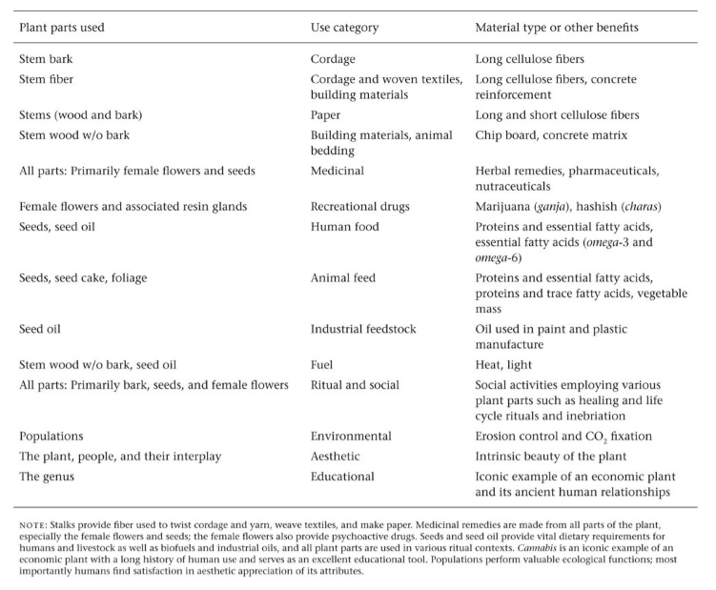

Legal History
The following three paragraphs illustrate the complicated legal history of cannabis within the U.S.. These events are important to understand if one is to fully appreciate the significance of this thesis and all cannabis research. In the 1930’s and 40’s a legal campaign was launched against the production, possession, trade, and research of cannabis. This legal campaign was at its least a remarkably unsuccessful attempt to prevent the use of cannabis, and at its most a crime against humanity leading to the death, suffering, and persecution of millions as many other countries followed suit in the United States’ crusade against cannabis. Still today thousands remain incarcerated for simple possession or use of cannabis in the U.S. and abroad; on September 3, 2021 Malaysian high courts sentenced a man to death by hanging for the trafficking of less than a pound (299 grams) of cannabis (BBC). Until reform of cannabis law happens in the U.S. the war on drugs will continue to claim victims (Blackwell, 2014; Esquivel-Suárez, F., and Kantor, R. 2018).
In 1937 the marijuana tax act was signed. This act placed a tax and many regulations on cannabis and its production, making it exceedingly expensive to work with, and even more difficult to study for medical research (Grinspoon and Bakalar, 1993; Ransom, 1999). Harry Anslinger was the first commissioner of the U.S. Federal Bureau of Narcotics (FBN). Anslinger was largely responsible for the marijuana tax act and the massive propaganda campaign that would follow it. Under his direction, the U.S. advertised that cannabis use caused permanent psychosis, violence, schizophrenia and many other serious consequences. The propaganda created by the FBN not only made false claims about health issues, but also promoted racial biases against minorities (Blackwell, 2014). Multiple films and Ads were distributed around the country by the FBN (Figure 1 and 2). All of these claims were made with little to no evidence

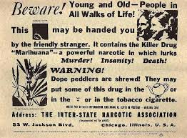
Figure 1: Federal Bureau of Narcotics ad against cannabis (1935)

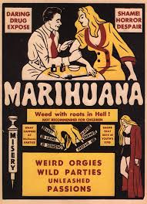
Figure 2: Ad for "Marijuana" movie paid for by the Federal Bureau of Narcotics

and were found to be untrue. Anslinger and the U.S. used these false claims to suppress minority groups, and support the illogical criminalization of an incredibly useful and helpful plant (Grinspoon and Bakalar, 1997; Grinspoon, 1996; Ransom, 1999; Lassiter, 2015). This propaganda was extremely successful at sowing false fear into many Americans by utilizing illegitimate research and false claims such as newspaper articles (Grinspoon 1996, Ransom 1999). In this way the U.S. governments gutted scientific research on cannabis as part of this illegitimate crusade which has been repeated through time. In the original hearings for the Marijuana tax act, W.C. Woodward, a physician speaking on behalf of the American Medical Association (AMA), testified in opposition to heavy restrictions on cannabis. Woodward states in his testimony that the grounds for these laws have not been backed up with scientific evidence, but with newspaper articles.

“There is a certain amount of narcotic addiction of an objectionable character no one will deny. The newspapers have called attention to it so prominently that there must be some grounds for their statements. It has surprised me, however, that the facts on which these statements have been based have not been brought before this committee by competent primary evidence. We are referred to newspaper publications concerning the prevalence of marihuana addiction. We are told the use of marihuana causes crime. But yet no one has produced from the bureau of prisons to show the number of prisoners who have been found addicted to the marihuana habit. An informal inquiry shows that the Bureau of prisons has no evidence on that point. You have been told that school children are great users of marihuana cigarettes. No one has been summoned from the children’s bureau to show the nature and extent of the habit, among children. Inquiry of the children’s bureau shows that they have had no occasion to investigate it and know nothing particularly of it. Inquiry of the office of education – and they certainly should know something of the prevalence of the habit among the school children of the country, if there is a prevalent habit- indicates that they have had no occasion to investigate and know nothing of it. … The division of mental hygiene was , in the first place, the division of narcotics …. That particular bureau has control at the present time of the narcotics farms that were created about 1929 or 1930 and came into operation a few years later …. Informal inquiry by me indicates that they have had no record of any marihuana or cannabis addicts who have ever been committed to those farms”
- Dr. Woodward, 15. U.S. Congress, House Ways and Means Committee, Hearings on H.R. 6385: Taxation of Marihuana, 75th congress., 1st sess., Apr. 27,1937.
Dr. Woodward’s testimony went on for a significant length and, regardless of his testimony and advice from other medical professionals, the committee chose to act against Dr. Woodward’s counsel. In September of 1942 the American Journal of Psychiatry published a study titled “The Psychiatric Aspects of Marihuana Intoxication”. This study was accepted by the AMA, yet by January 1943 the study had been denounced by Harry Anslinger and in a couple more years was removed by the editor of the journal after intense government pressure.
From 1840 to 1900 there were over 150 papers published on medicinal cannabis use. In 1850 cannabis was added to the U.S. Pharmacopeia and by 1960 there were a total of around 2000 literature titles on medicinal cannabis use and much fewer on cultivation (Grinspoon, 1996). Though this may seem like a large number, it is a plant that has been used for thousands of years in many different cultures. Considering how wide spread and ancient the use of cannabis is, this is a surprisingly small number of research titles. This is believed to be due to the inconsistency of cannabis as a medicine in early years. Cannabis plants can vary drastically in their chemical makeup. This paired with various mental states, social settings, and preconceptions of the patient can cause significantly different effects from one study to another (Grinspoon, 1996). In 1940 Roger Adams became one of the first to isolate Tetrahydrocannabinol (THC), Cannabinol (CBN), and Cannabidiol (CBD), often considered the main active ingredients in cannabis (Grinspoon,1996; Rogers, 1942). The ability to extract the active ingredients in cannabis gave researchers the ability to limit these inconsistencies. Despite the progress in consistent research the literature count paled compared to other drugs. In comparison there were around 12,000 literature titles on alcohol use by 1965. Despite their being fewer research titles than other drugs, there was still believed to be enough research to have made a sound conclusion on the safe and effective use of cannabis (Grinspoon, 1996). Regardless of the information available, cannabis became extremely regulated in 1937 and a large anti-cannabis campaign was launched across the nation.
Regardless of the research available, in 1970 Cannabis sativa became a schedule 1 drug in the U.S., meaning by definition it has no medical potential, and is placed in the same category as heroine. The U.S. soon directly contradicted that claim of zero medical potential by installing the “Compassionate IND” program in 1976, allowing people “in need” of medical marijuana to attain it from a government source (Ransom, 1999). Cannabis remained listed as a schedule I drug until 2018. Arguably one of the worst consequences of its listing was the difficulty to gain research permission. The Federal Bureau of Narcotics which eventually evolved into the Drug Enforcement Agency made it exceedingly difficult to obtain research permission for any type of cannabis study, and these struggles continue still today (Piomelli et al., 2019; NASEM, 2017). In 1971 President Nixon declared a “war on drugs” whereby he allocated 100 million dollars to prevent the use of drugs in the U.S. Since 1972 the number of incarcerated people has increased significantly, however the amount of drug use has not increased proportionately to support these arrests. The war on drugs has caused the US to have the highest incarceration rate per capita in the entire world at 639/100,000 and a total of over 2 million prisoners (ICPR). Over the last 50 years the United states has spent over $2.5 trillion on drug prohibition (Blackwell, 2014). From just 2001 to 2010 there were over 8 million marijuana arrests, 88% of which were for simple possession. These 8 million arrests accounted for 52% of all drug arrests in the united states; in 2010 and there was a marijuana arrest every 37 seconds (Bunting et al., 2013). States spent a combined 3.6 billion on marijuana possession arrests in 2010 alone (Bunting et al., 2013). During this same time period African-Americans are arrested at 3.73 times the rate of white Americans despite using marijuana at very similar rates (Bunting et al., 2013). Cannabis prohibition has been a long, violent, and expensive crusade that achieved very little in preventing this important medicinal plant.
Cannabis Chemistry
To date there have been 120+ phyto-cannabinoids discovered in cannabis. Cannabis flowers contain a significant amount of secondary metabolites. Among these are a number of compounds called phytocannabinoids and terpenoids. Phytocannabinoids, in cannabis, are a group of meroterpenoids produced from the alkylation of olivetollike alkyl resorcinol with a monoterpene unit(Appendino et. al., 2011). These cannabinoids interact with the human body, and most vertebrates and invertebrates, through a system of G-protein coupled receptors called the endocannabinoid system (S. Chandra, 2017). This systems’ purpose is to maintain homeostasis in the body. Homeostasis is a biological, self-regulating process employed in various ways by living organisms to maintain steady internal conditions (Rodolfo, 2000). The endocannabinoid system is one way organisms maintain this process. The two most commonly studied phytocannabinoids are THC and CBD. There are several constituents of THC, but ∆⁹ THC is the most abundant and the most studied. THC is the psychoactive cannabinoid found in cannabis. THC has shown to be therapeutic, beyond reasonable doubt, for pain, nausea, and multiple sclerosis (Carlini, 2004; Blesching, 2015). THC remains federally illegal, however other cannabinoids have recently become legal. CBD is another main cannabinoid that is now legal in the U.S.. CBD has recently proven to be a very effective anti-epileptic and anti-inflammatory (S. Lattanzi et al., 2018, B. Costa et al., 2007). Two main receptors make up the endocannabinoid system, CB1 and CB2 (Zou and Kumar, 2018). CB1 receptors are found in many places in the body, but with higher concentrations expressed in the brain and neural cells, affecting the central nervous system. CB2 receptors are also found all over the body, but predominantly expressed in the immune tissues and peripheral nerve endings (Kilaru and Chapman, 2020). THC has a relatively equal affinity for CB1 and CB2 receptors, but CBD has a greater affinity for CB2 receptors. Because of this CBD can act as an antagonist to THC while potentiating its effects in certain scenarios. More research is needed to fully understand how cannabinoids and terpenoids interact with the body.
The majority of cannabinoids and terpenes are held within a plant structure called trichomes (Kim and Mahlberg, 1997, Happyana, 2012). Trichomes are a multicellular structure that protrude from the epidermal cell layer of the plant. There are multiple types of trichomes that can be present on a single plant, a trait that is not exclusive to cannabis (Levin, 1973) (Figure 3). Capitate stalked, capitate sessile, bulbous and cystolithic trichomes all exist on the cannabis plant, however capitate stalked hold the majority of cannabinoids and terpenes.
Taxonomy
In December of 2018 the new Farm Bill was signed into law, making “hemp” a legalized commodity in the U.S.. According the United states government, “hemp” refers to any Cannabis sativa L. plant that contains less than 0.3% ∆⁹- tetrahydrocannabinol (USDA). There are other constituents of THC like ∆⁸ THC that are not yet included in this law. This definition of “hemp” is arbitrary at best because traditionally true hemp is limited to fiber and seed varieties of cannabis. The cannabis industry is littered with misnomers that cause a lack of transparency between the science community and the public. This problem must be addressed if we expect to accurately communicate the benefits of cannabis to the public.

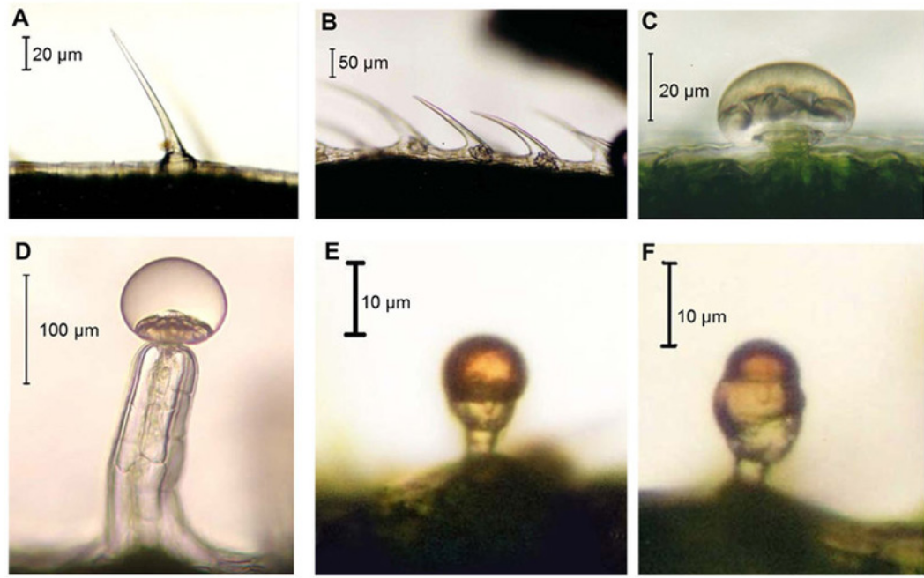
Figure -3 Types of trichomes present on Cannabis sativa (A) Unicellular non-glandular trichome; (B) Cystolithic trichome; (C capitate sessile); (D) capitate-stalked trichome; (E) simple bulbous trichome; (F) complex bulbous trichome. Images by Dr. David Potter (GW Pharmaceuticas)

Historically the words “hemp”, “Industrial hemp”, and “European hemp” all have been used to describe fiber and seed varieties of cannabis (figure 4). These varieties or species are very tall, around 2-4 meters, produce minimal lateral branching, have little cannabinoid content (<5%), and are cultivated for the purpose of harvesting seed and fiber (Clarke, 2018). This phenotype maximizes fiber production, as it has a higher bast fiber to hurd ratio compared to drug-type cannabis. Bast fiber is the fiber that encircles the core xylem of the plant, this is commonly used due to it having certain desirable characteristics. The phenotypes of cannabis mainly being grown for cannabinoid production is often referred to as drug-type cannabis (Figure 5). The main differences between these two phenotypes is their growth structure and their cannabinoid and terpenoid content. Drug-type cannabis is typically shorter and wider than fiber-type cannabis and has much more lateral branching, which allows for more flower sites. Drug-type cannabis also produces significantly more cannabinoids and terpenoids than fiber-type cannabis, at around <1% - >25% (Clarke, 2018). Drug-type cannabis is grown mainly for cannabinoid content and this is the type that was used in this experiment.
The taxonomic classification of cannabis has been widely debated for years. Several arguments have been made over time, but the main disagreement centers on whether there is one or multiple species of Cannabis. Though there may be disagreement on classification, there is little disagreement over the diversity and complexity of the cannabis genome, or whether it has distinct differing groups (Small and Cronquist, 1976; Small, 2015; Clarke and Merlin, 2013). Due to thousands of years of cultivation, translocation, and selection, the scale between true wild/feral populations and modern homogenized poly hybrids is immense, and there are several distinct groups along that scale (Small and McPartland, 2020). Many of these groups are significantly different in genotypes, phenotypes, and chemotypes (Hillig, 2005). Thanks to the
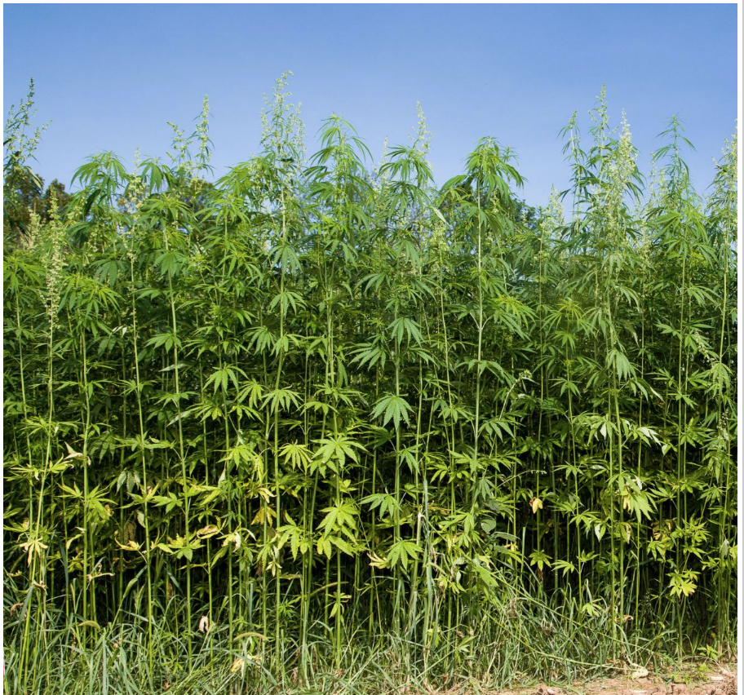
Figure 4: fiber and seed variety of cannabis, note the minimal side branching, height and density of seeding (University of Kentucky,2018)

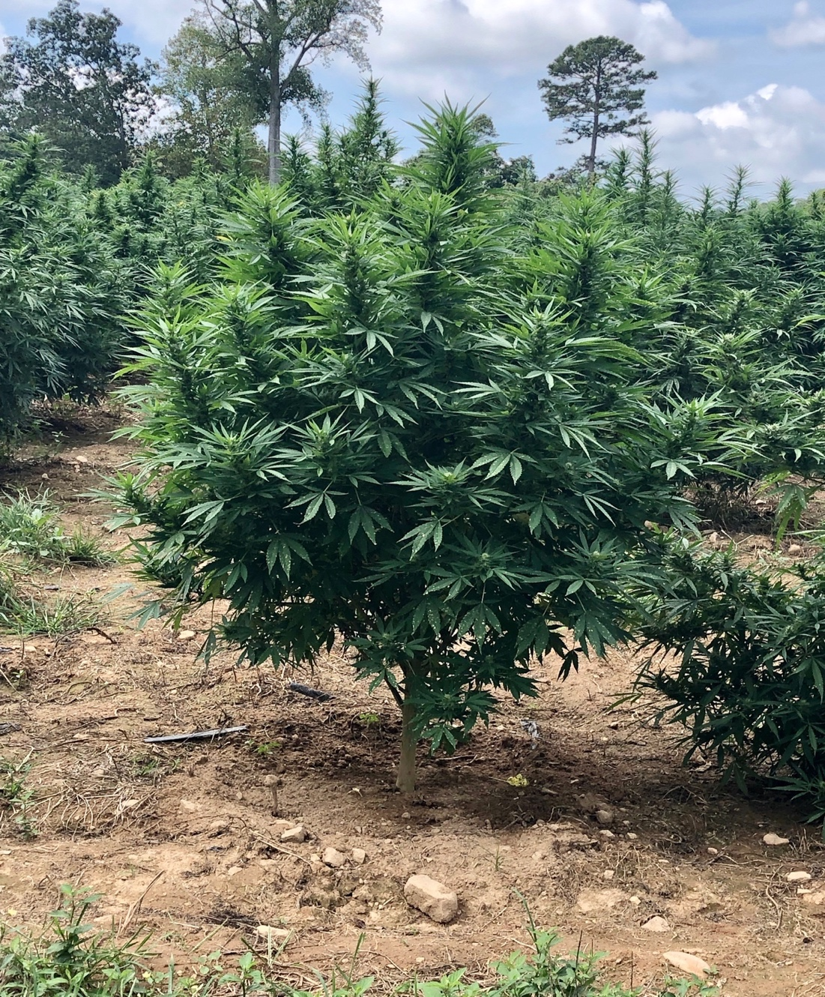
Figure 5: Drug type cannabis, photo by Ben Carter

dedicated work of several notable scientists that have been cited above, we have evidence to support a single and a multiple species model. Though perhaps the best way to describe the complexities of the cannabis genome is not by official taxonomical classification, but by simple groupings based upon their level of domestication, phenotypic, genotypic, chemotypic, geographic, and practical differences.
The author would attempt to describe these groupings to the reader, though he fears his efforts would pale in comparison to the literature and primary sources that already exist, such as the ones listed above. For the purposes of this thesis, simply understand that regardless of speciation, there are several distinctly different populations of cannabis across the globe, and classifying cannabis as “hemp” solely based on THC content is incorrect and misleading.
New Interest in Old Crop
“Hemp” legalization has caused an enormous surge of interest in its production. In Tennessee in 2020 alone, 40,000 new acres of hemp were planted (TDA, 2019). Due to its history, it has been difficult to acquire legal permission from the government to conduct research. This surge has caused a massive void in scientific literature for the cannabis plant. Many people have decided to produce cannabis yet very few have any experience with the plant, and there is little research for farmers to use as reference. The producer needs simple and practical agronomic data. Without research, the proper cultivation of cannabis is impossible, likewise Extension Agents cannot provide needed support to farmers. The lack of both basic and applied research has caused a void in the literature that must be addressed or the potentials of this crop cannot be maximized.
The needed agronomic data consist of fertilizer rates, lighting requirements, variety trials, deficiency identification, insect and pathogen prevention, and essentially every other aspect of agronomy. Limited research has been done on indoor production and container studies, and much more is required in order to make appropriate recommendations for cannabis production (D. Caplan, 2017). A significant amount of research has been performed on Fiber-type cannabis, however fiber and drug-type cannabis require vastly different production practices. (L. M. Mah, 1923; Aubin et al., 2015). For the purposes of this thesis the author will only be focusing on one of these topics, lighting requirements, and will attempt to demonstrate the effect of supplemental far-red light on yield and height of Cannabis sativa. The following objectives were developed for this experiment.
Objectives:
- To investigate the effects of increasing far-red light supplementation on dry flower, cannabinoid, and terpene yield of Cannabis sativa
- To investigate the effect of increasing far-red light supplementation on overall growth of Cannabis sativa
- To investigate the cost effectiveness of supplemental far-red light if increases in yield are realized

Based on the literature review the following hypotheses were formed. The literature suggests there will be a significant difference in yields and heights with increasing intensities of far-red light.
Hypotheses:
H₀: There is no significant difference in yields and heights with increasing intensities of far-red light.
H₁: There is a significant difference in yields and heights with increasing intensities of far-red light.
Chapter 2: Literature Review
LED Lighting
Lighting has been a hot topic of debate and research in the cannabis industry. With so many new products coming on the market, many with drastically different light spectra, it is difficult for the producer to decide what light or spectrum to utilize. Many studies have shown light emitting diodes (LED’s) to be one of, if not the most efficient lighting source available (Narukawa et al.,2007; energy.gov); however the spectrum LED’s emit and their energy use can vary drastically (Bourget, 2008). Research on the most effective and efficient light spectrums is needed. LED’s produce light via a process called electroluminescence. When a trivalent impurity such as gallium is added to an intrinsic semiconductor like silicon, it creates a deficiency of valence electrons, which is called a P-type semiconductor. When pentavalent impurities such as phosphorous are added to an intrinsic conductor, there is an excess of electrons, which is called an N-type semiconductor (Held, 2008). When these N and P-type conductors are placed in contrast to each other, a P-N junction is created. As an electric current is applied to this junction the excess electrons from the N-type move to fill the holes in the P-type conductor. The transfer of energy from this process results in the creation of photons and light or electroluminescence (Nave, 2016). These semiconductor junctions are the base of the LED diode. The spectrum of the LED is altered by changing the materials that make up the semiconductor junction and a wide variety of spectra are commercially available from 250nm to over 1000nm (Stutte 2009, Bourget 2008).

Photosynthetically Significant Spectra
The typical photosynthetic spectrum ranges from 400-700nm but recent studies have shown values outside of those ranges to be photosynthetically significant. Far-red (700-750nm), UV (200-400nm), and even green light (500-600nm) have shown to be photosynthetically and morphologically significant (Olle, 2013; Lydon,1987; Haley et. al., 2017). To what extent these spectra affect plants and especially cannabis is still being studied. More data is needed to evaluate the role of these spectra in a commercial application.
Phytochromes
Plants are able to distinguish when other plants are in their vicinity due to spectral changes in light (Kalaitzglou et al, 2019). Phytochromes are a group of proteins in plants and other organisms responsible for light detection. There are two main types of phytochromes, and each can rotate between two relevant forms, Pr (red light) and Pfr (far-red light), depending on light conditions. Pr, the biologically inactive form, has a maximum absorbance of red light at 660 nanometers. Pr is transformed into the biologically active form Pfr under certain spectral changes (Casal, 2013). These receptors are antagonists and switch on a negative feedback loop according to the ratio of red to far-red light that is detected (R:FR) (Smith et al., 1997). As the R:FR ratio detected by the plant increases, Pr switches to Pfr and remains in this form until R:FR ratio decreases or there is a period of darkness. As these receptors detect changes in light they initiate morphological changes in the plant. When a plant is shaded, the R:FR ratio received by the plant decreases due to the ability of far-red light to penetrate through leaf tissue at a far greater rate than other spectrums of light (Massa et al, 2015). The change in ratio causes a switch of the active phytochrome receptor from Pfr to Pr resulting in a shade avoidance response in the plant. When the receptor detects red light, it converts to Pfr form of the receptor, when the plant detects far-red light the receptor converts to Pr form of the receptor. The switch to Pfr as the active phytochrome induces a shade avoidance response and causes elongation of stems and petioles, leaf senescence, and other changes as the plant attempts to accommodate for low light levels (Casal, 2012; Franklin and Whitelam, 2005).
Shade Avoidance Response
The shade avoidance response is a powerful effect caused by low R:FR light ratios. One of the most dominant and important morphological changes occurring during the shade avoidance response is the elongation of cells. The cause of cell elongation has been studied for many years and recently Phytochrome Interacting Factors (PIF’s) have shown to be key part of this process. Phytochrome interacting factors (PIF’s) are basic helix-loop-helix transcription factors that interact with phytochromes (Casal, 2013). PIF’s can induce auxin production within the plant by promoting expression of hormone producing genes. Accumulation of auxin within plant cells has shown to cause phototropism, allowing plants to bend toward light (Pickard and Thimann, 1964; Goyal et. al., 2016). Under high R:FR light ratios the interaction between phyB and PIF’s causes degradation of several PIF’s. Under low R:FR light ratios the interaction between phyB and PIF’s is reduced, increasing the amount of PIF’s present. The increase in PIF concentration causes an increase in auxin accumulation. The higher auxin concentration in cells leads to the expansion of cells and the elongation of stems during the shade avoidance response (Goyal et. al., 2016).
The shade avoidance response caused by Far-red light causes increased cell expansion in plants (Olle, 2013;Bugbee, 2020), that is beneficial in leafy greens because it significantly increases yield (Bugbee, 2020); however in some other crops like tomatoes it has caused stretching and breakage of limbs. It would be reasonable to assume that cannabis would react in a similar way, as cannabis is already prone to limb breakage. Cannabis has several distinct development stages: germination and emergence, vegetation, flowering, seed development and senescence. The majority of stem elongation and growth occurs during the vegetative stage (Mediavilla et al., 1998; Mishchenko et al., 2017). If supplemented with far-red during the vegetative phase of cannabis this could cause similar stretching of internode space and increased heights as seen in tomatoes. However, if you were to apply far-red light only during the flowering stage of cannabis growth, you could potentially avoid undesirable stretching, and see cell expansion in the inflorescence. If this were true it would increase the yield of dry flower weight, potentially increasing profit. Based on the literature, a significant difference in heights and yields of Cannabis sativa should be observed with increasing far-red light intensity.

Chapter 3: Materials and Methods
Vegetative Stage
Five cuttings from the same parent plant were taken to be used as the experimental units (5 replicates) for each treatment. Once cut, the cuttings were dipped in Dip n’ Grow® liquid rooting concentrate (DIP’N GROW INC., Clackamas, OR, US), an auxin-based rooting hormone, and inserted into a peat based rooting plug for 14 days before being transplanted into 13.6383 liter pots containing “All Purpose” peat-perlite based media (Lambert©, Quebec, CA). For the first 14 days plants were rooted under an 85 watt compact florescent bulb. Once transplanted plants were illuminated with 18 hours of light and 6 hours of darkness (18/6) at ~400 µmol/m²/s photosynthetic photon flux density (PPFD) during the vegetative stage of growth. Two, 135 watt 3500k white (420nm-780nm) “Roleadro” (Shenzhen Houyi Energy Efficiency Co. Ltd, Shenzen, CN) LED units were suspended above the plants using pulleys. Light spectrum for these LED’s can be found in Figure 6. Lights were placed approximately 61 cm above the plants and were adjusted periodically as plants grew in order to maintain the desired light intensity of 400 µmol/m²/s. An Apogee Instruments© (Logan, UT, US) MQ-500 Full spectrum quantum meter was used to determine PPFD values. Five PPFD readings were taken around the top of each plant in order to check the desired intensity.

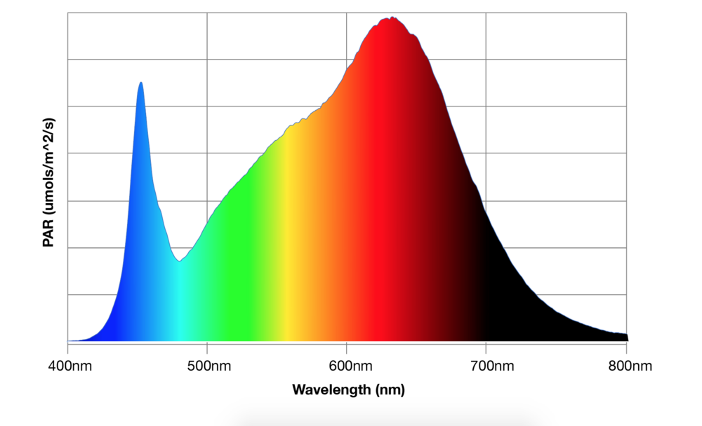
Figure 6: Spectrum of Roleadro LED's

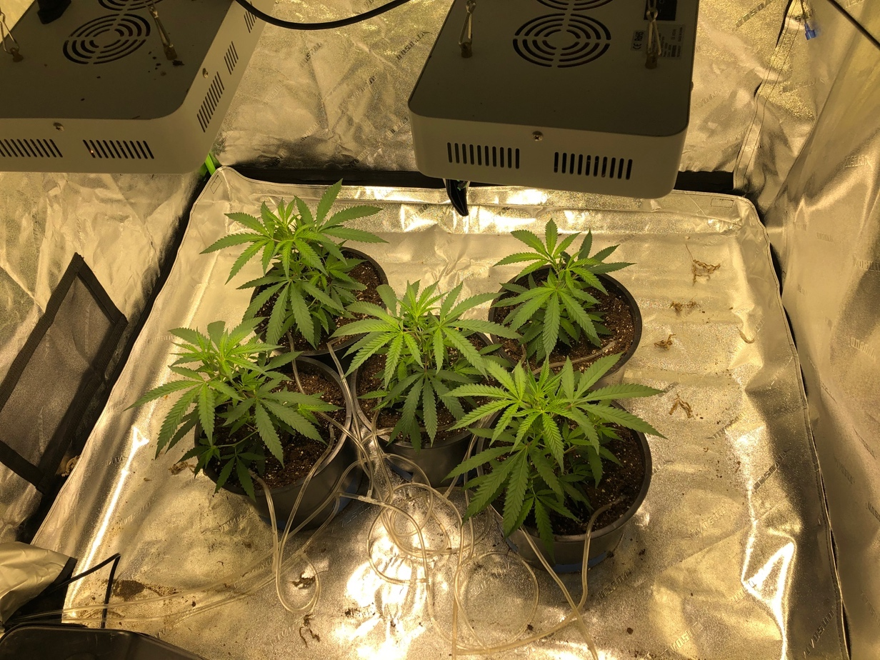
Figure 7: Plants under 18 hrs .of light and 6 hrs. of dark photoperiod

Plants were arranged in a square with one plant centered in the middle for a total of five plants per treatment (5 replicates) (Figure 7). During the vegetative stage plants were grown in a 122 centimeter (cm) x 122 cm grow tent (Vivosun©, Ontario, CA) Distilled water or fertilizer were applied at increasing amounts to plants every day. Fertilizer or distilled water alternated every day. For example: day 1 water, day 2 fertilizer, day 3 water, day 4 fertilizer etc.. Fertilizer solution EC was calculated with a “HI9813-6” pH/TDS/EC meter (Hanna Instruments©, Woonsocket, RI, US). In order to maintain consistent applications across all treatments, automatic pumps were used to administer fertilizer and water. Pumps were checked between each treatment to ensure they were administering the correct dosage. Jack Peters “3-2-1” fertilizer (Jack Peters©, Allentown, PA, US) was used according to the rates published in their fertilizer schedule for cannabis (Figure 8). Plants were given approximately 100 milliliters (ml) of alternating water and fertilizer every day for the first week, 200 ml for weeks 2-4, and 350 ml for weeks 5-6. When lights were turned on, the temperature and humidity remained consistent at ~26.7 (±3) degrees Celsius, and ~50% (±5%) relative humidity (rH) during the entirety of the 14-week growth cycle. After 6 weeks of growth, the plant heights were recorded and plants were moved to a separate 152 cm x 152 cm grow tent (Vivosun©, Ontario, CA). No far-red light was applied during the vegetative stage of growth. During the first 6 weeks of growth all treatments were kept consistent, with no variations between treatments.

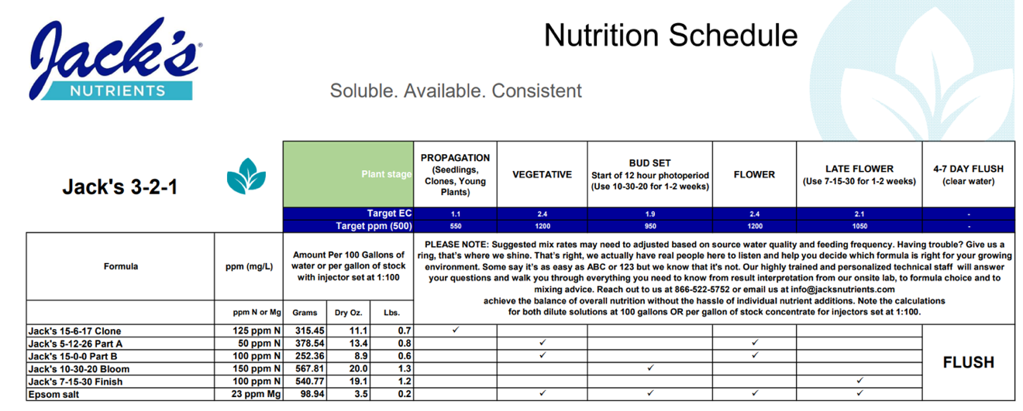
Figure 8: Jacks 3-2-1 cannabis nutrition schedule (Jack Peters)

Flowering Stage
After 6 weeks of growth in the vegetative stage (weeks 1-6) under 18 hours of light and 6 hours of darkness, plants were moved to a separate tent to induce flowering and apply the far-red treatments (Figure 10). Cannabis requires long nights to flower and 12 hours of light followed by 12 hours of darkness to initiate flowering (Shiponi and Bernstein, 2021). During the flowering stage (weeks 7-14) plants were given 12 hours of light and 12 hours of darkness (12/12). A custom frame to support the lights was built by the author. Four rows of two lights mounted to an aluminum frame, at 15.24 cm apart. This light frame was then mounted inside of the 152 cm x 152 cm grow tent (Vivosun©, Ontario, CA). Under the 12/12 light schedule, light intensity was increased to ~500 µmol/m²/s PPFD. White light during the 12/12 period of growth was provided by eight light bars with 112, 3500k white LED’s (CREE©, Durham, UT, USA);(410-780nm);(product code: JB3030AWT-00-0000-000A0UC435E). Spectra of these LED’s are illustrated in Figure 9. All treatments, during the 12/12 light schedule, were given a total light intensity of ~500 µmol/m²/s PPFD, including the far-red supplementation. Each far-red unit “initiator puck” (Rapid LED©, CA, US) contained 4 LED’s. The Individual far-red LED’s were manufactured by CREE© (Durham, UT, USA);(Product code: XPEBFR-L1-0000-00A01), the specifications are listed below in Figure 11 and the spectrum is shown in Figure 12. Each Far-red unit was installed directly above each plant in order to maximize exposure. One far-red unit at 15.24 cm provided ~20 µmol/m²/s PPFD of far-red light. In order to maintain consistency, far-red light was applied as increasing fractions of total light. Layout of the plants in the grow tent can be seen in Figure 9. The control received 0 µmol/m²/s PPFD of far-red light and ~500 µmol/m²/s PPFD. Treatment 1 received ~20 µmol/m²/s PPFDof far red light supplementation and ~ 480 µmol/m²/s PPFD of white light for a total of 500 µmol/m²/s PPFD. Treatment 2 received ~40 µmol/m²/s PPFD of Far-red light and ~460 µmol/m²/s PPFD. Treatment 3 received ~60 µmol/m²/s PPFD of Far-red light and ~440 µmol/m²/s PPFD of white light. Lights were kept ~15 cm from top of plants in order to achieve desired PPFD throughout the experiment.
“Jack’s 3-2-1” fertilizer (Jack Peters©, Allentown, PA, US) was used according to their fertilizer schedule for cannabis (Figure 8). Plants were given approximately 350ml of alternating fertilizer and water every day for weeks 7-9, 500ml for weeks 10-14. Plants were grown for an additional 8 weeks under the 12/12 schedule, then plants were harvested and recordings were taken again, this time including dry weight yield of flower and yield of cannabinoids and terpenes as well as plant heights. Dried floral material was sent to a third party for cannabinoid and terpene analysis.
Measurements

When plants were harvested after 14 weeks of growth, they were cut at the soil surface and hung to dry for 14 days at ~23 degrees Celsius and ~50% rH. Once dried, the flowers were cut off the stems and branches and analyzed for cannabinoid and terpenoid content. In order to obtain representative and unbiased samples, equal weights of dry flower were taken from the bottom, middle, and top third of each plant. This bulk sample was then homogenized and sent for third party analysis using high performance liquid chromatography (HPLC) at New Bloom Labs (Chattanooga, TN, US). Height measurements were taken at the beginning of the flowering stage (week 7) and at the end of the flowering stage (week 14). Plants were measured starting at the soil line to the highest point of the apical meristem on the plant. A tape measure was used to take measurements.

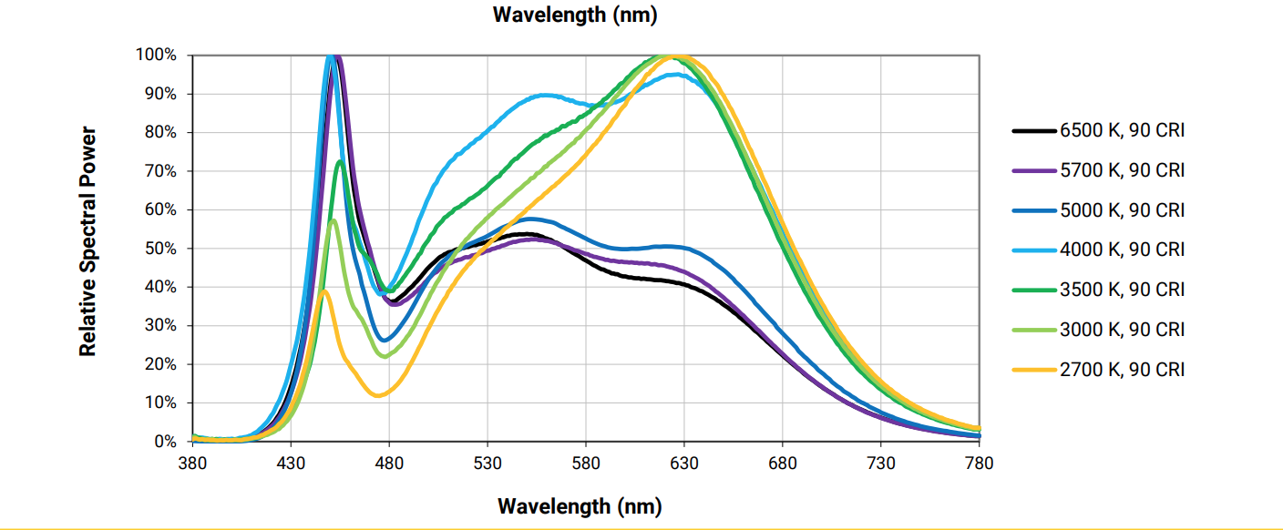
Figure 9: Spectrum of Cree LED’s used in experiment

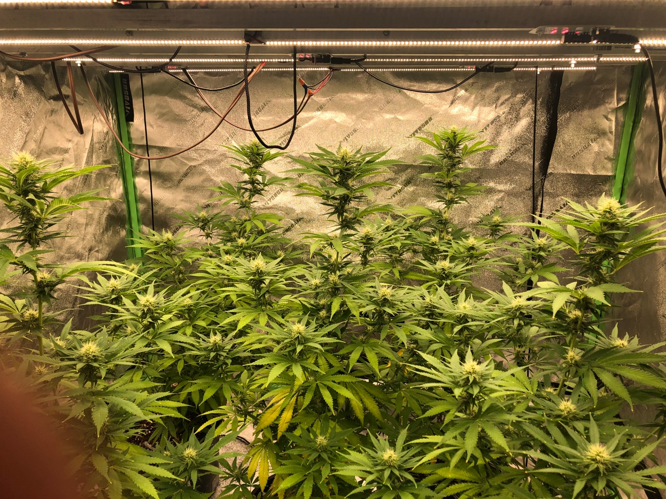
Figure 10: Treatment 1 (20 µmol/m2/s) under 12/12 photoperiod

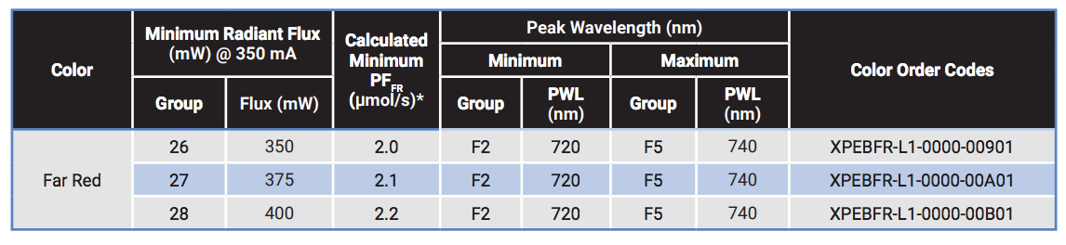
Figure 11: (PRODUCT FAMILY DATA SHEET Cree ® XLamp ® XP-E2 LEDs PRODUCT DESCRIPTION, 2012)

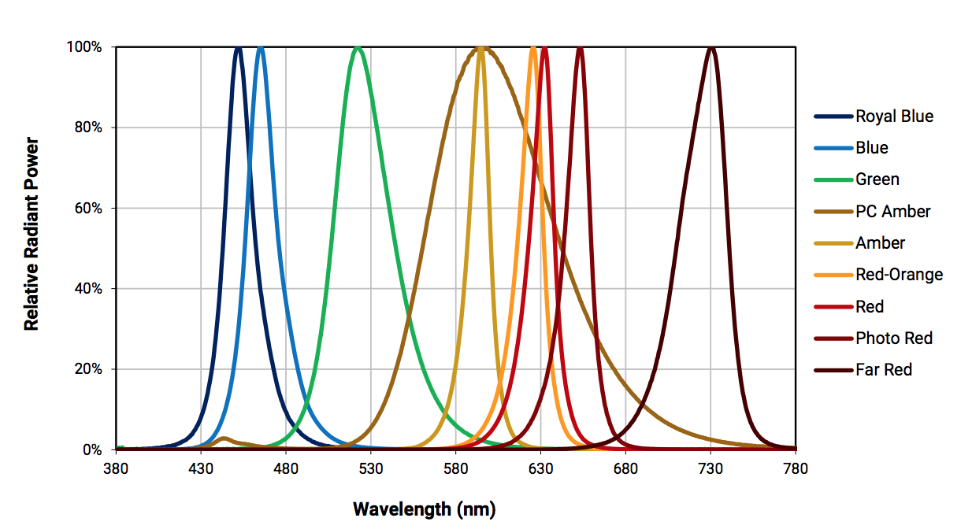
Figure 12: Spectrum of CREE far-red LED's

Statistical Analysis
All statistical analysis was performed in SAS version 9.4 (Cary, NC). Treatments were randomized but not blocked due to space and cost constraints. Each treatment had five plants (four replicates) for a total of 20 plants and four treatments (df=3) throughout the experiment (n=20). A one-way ANOVA test was performed in SAS to determine the significance of yields of dry flower and plant heights to evaluate the effect of far-red light intensity.

Chapter 4: Results
Yield
Increasing far-red light intensity on Cannabis sativa resulted in decreasing yield averages of dry flower. The yield averages of dry flower, in grams, were 80.1, 67.5, 57.5, and 46.88, for the Control (0 umol/m²/s FR), Treatment 1 (20 umol/m²/s FR), Treatment 2 (40 umol/m²/s FR), and Treatment 3 (60 umol/m²/s FR) respectively. Statistical analyses were performed in Microsoft Excel and SAS version 9.4 (Carry,NC). A bar graph comparing the effect of far-red light on yield of dry flower is presented in Figure 13. The ANOVA table and box plot for yields of dry flower can be seen in Figure 14. As these analyses suggest, there was a significant decrease (p ≤ .05) in yield of dry flower between all treatments (Figure 15). The largest decrease was between the control and treatment 3 with a 42.1% decrease in yield of dry flower. All yield data can be seen in Table 3. Due to monetary constraints only one homogenized sample was analyzed per treatment. Because of this limitation, statistical analysis on cannabinoid content or terpene content could not be conducted. Cannabinoid content is 22.5%, 20.8%, 17.6%, and 19.5% for the control, Treatment 1, Treatment 2, and Treatment 3 respectively. Terpene content is 3.3%, 3.2%, 6.1%, and 5.5% for the control, Treatment 1, Treatment 2, and Treatment 3 respectively.

Figure 13: Average dry weight of flower in grams vs. Far-red light intensity. Results significant at p ≤ 05.

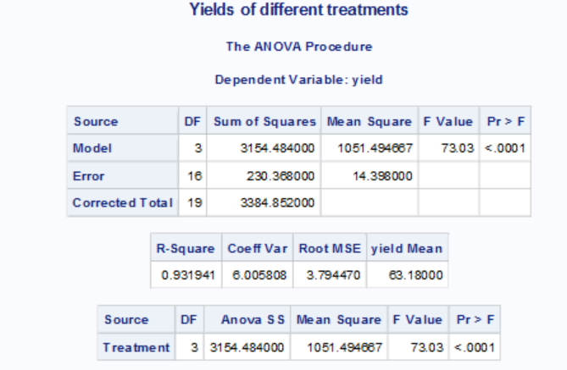
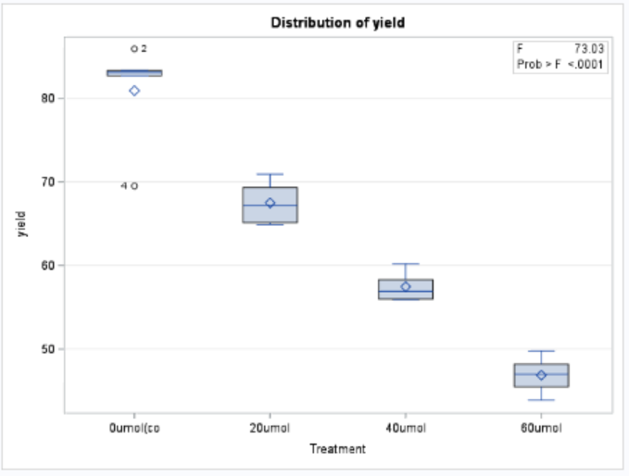
Figure 14: ANOVA table and box plot produced from SAS analysis of yields of dry flower weight in grams.

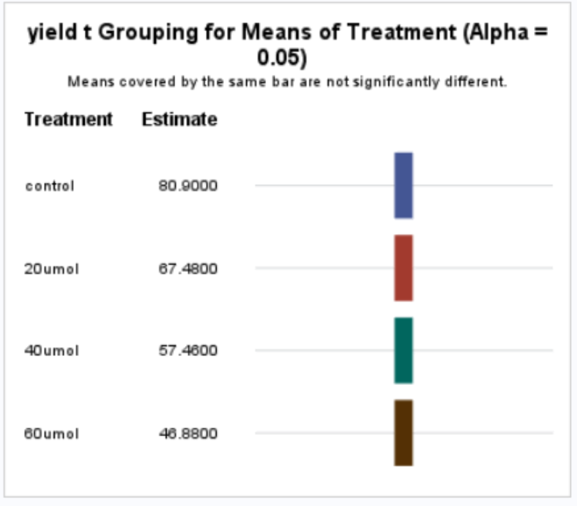
Figure 15: significance of yields between treatment. All significant, p ≤.05

Table 2: Yield of dry flower (grams) per plant per treatment

Yield of Dry flower per treatment (g) | Control | T1 | T2 | T3
Plant 1 | 82.7 | 69.3 | 55.9 | 49.8
Plant 2 | 85.9 | 70.9 | 56 | 47
Plant 3 | 83.1 | 67.2 | 56.9 | 48.2
Plant 4 | 69.5 | 65.1 | 58.3 | 45.5
Plant 5 | 83.3 | 64.9 | 60.2 | 43.9
Average | 80.9 | 67.5 | 57.46 | 46.88

Height
Increasing Far-red light intensity on Cannabis sativa resulted in increased plant height averages. The plant height averages (cm) were, 77.0, 84.1, 91.8, and 80.6 for the Control, Treatment 1, Treatment 2, and Treatment 3, respectively. A bar graph comparing the effect of far-red light intensity on average plant heights can be seen in Figure 16. The ANOVA table and box plot can be seen in Figure 17. The statistical significance of heights between treatments can be seen in Figure 18. The largest difference is seen between the control and treatment 2 with 16.1% increase in height. The rest of the data can be seen in Table 3.

Figure 16: Average plant heights vs Far-red light intensity. Results are significant at a p= .05

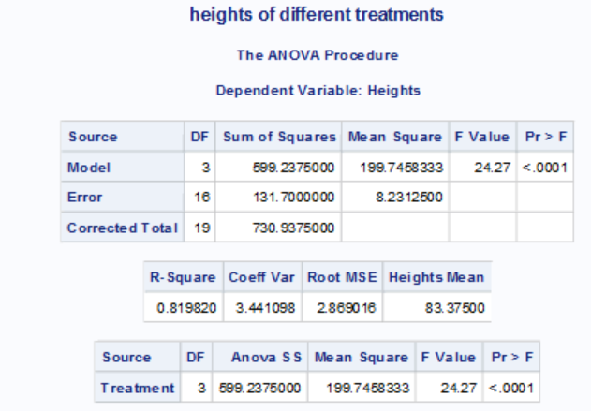

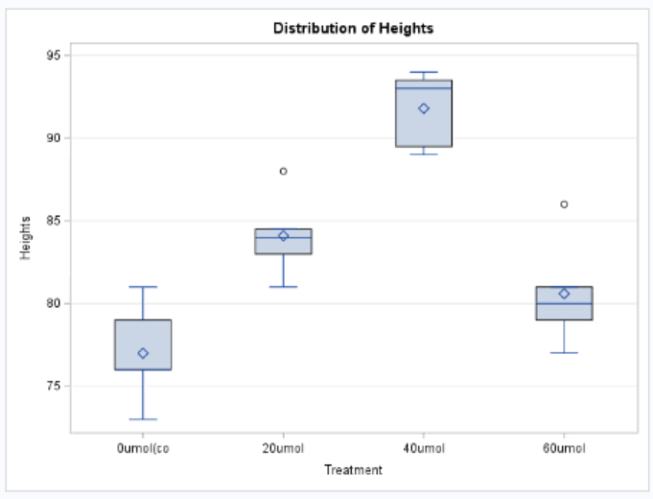
Figure 17: ANOVA table and box plot from SAS analysis of plant heights in centimeters.

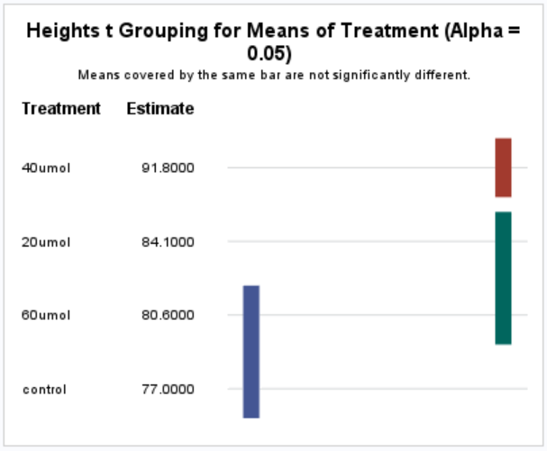
Figure 18: Significance of heights between treatments. The control is significantly different than 20µmol and 40µmol treatments. 20µmol is significantly different than the 40µmol treatment. 60µmol is significantly different than the 40 umol treatment. 20 µmol was not significantly different from 60µmol and 60µmol was not significantly different than the control.

Table 3: Heights of each plant for each treatment, beginning and end of 12/12 cycle

Heights of plants beginning and end (cm) | Control |  | T1 |  | T2 |  | T3
Heights of plants beginning and end (cm) | Bg. Ht. | End Ht. | Bg. Ht. | End Ht. | Bg. Ht. | End Ht. | Bg. Ht. | End Ht.
Plant 1 | 51 | 73 | 54 | 81 | 56 | 94 | 56 | 77
Plant 2 | 49 | 76 | 51 | 88 | 55 | 93 | 50 | 86
Plant 3 | 50 | 76 | 50 | 84 | 55 | 89.5 | 50 | 80
Plant 4 | 53 | 79 | 49 | 83 | 56 | 89 | 49 | 79
Plant 5 | 49 | 81 | 50 | 84.5 | 52 | 93.5 | 52 | 81
Averages | 50.4 | 77 | 50.8 | 84.1 | 54.8 | 91.8 | 51.4 | 80.6

Chapter 6: Conclusion and Discussion

The legalization of cannabis created a massive new market that was quickly flooded with unsubstantiated products and claims. With new surges of legal cannabis production occurring around the world, there is an overwhelming need for research on agronomic and production aspects of Cannabis sativa. With the majority of U.S. cannabis grown indoors, lighting has become an increasingly important factor of production. Far-red light (730nm) has shown to increase cell expansion and yield in some species of plants; yet there is little research to support its use or how much far-red light will increase production costs.
High demand and high profit margins have spawned new cannabis producers across the country, both indoors and out. Many of these new producers have little to no experience growing cannabis. With likely contamination of outdoor crops, most production of cannabis has moved inside to avoid that risk. As most production transitions indoors, the questions of lighting and spectra become increasingly important. Based on the data gathered from this experiment, as far-red light intensity increases, yield of dry flower significantly decreases and plant heights significantly increase.
A decrease in yield was an unexpected outcome and the cause of this is unknown. An increasing amount of leaf senescence was observed throughout each treatment. Leaf senescence has been observed as a symptom of far-red light and the shade avoidance response by several authors including Rousseaux et al., 1996; Lim et al., 2018; and Tian et al., 2020. This senescence could have caused a reduction in overall photosynthetic potential leading to a decrease in yield. Though this is only the speculation of the author based upon current literature, it would seem to explain our result. A yield reduction would obviously be a negative outcome for any producer especially considering we did not see any significant differences in cannabinoid or terpenoid content. If more samples had been sent off for analysis, the author suspects there would have been a significant reduction in cannabinoid content. Based on the samples that were analyzed and the observed leaf senescence, a reduction in cannabinoid content would be likely.
Increasing intensities of far-red light caused a significant increase in plant heights. Increase in heights caused the plants to become slender and struggle to support themselves under the weight of their own flowers. Bamboo stakes for support were required for Treatments 1, 2, and 3 due to the increase in heights. This evidence is supported by Kalaitzoglou, et al., 2019; Islam, et al., 2014; Blom and Kerec, 2003, and others who also recorded increases in plant heights with increasing intensities of far-red light, across several different plant species. This can be contributed to the increase in cell expansion and stem elongation induced by the shade avoidance response mentioned earlier in this thesis. Increase in plant heights would be a negative outcome for a producer as it requires extra materials and labor to apply supports to the plants. It also requires increased vertical space in your production area to account for the extra height. As plants grow bigger it requires lights to be moved higher so that plants do not come into contact with the lights. Tall, lanky plants become more difficult and laborious to accommodate and the average producer would not find this desirable.
Significant differences were observed, but unexpected variables may have affected our results. As mentioned above there was a notable amount of leaf senescence of varying severities occurring during the flowering stage of each treatment. Since leaf senescence is a symptom of the shade avoidance response, far-red light most likely induced the observed leaf senescence. However it is possible there was another cause such as nutrient deficiency or lack of airflow. Air was pumped into the tent at ~2.83 cubic meters per minute using an inline fan. Air was pumped out at a similar but unknown rate; however, the air inside the tent was not mixed, which could cause stagnant air to fall to the bottom of the tent and is a factor that potentially might have affected growth. Another factor that could have caused issues were the irrigation systems. The irrigation system had a tendency to fail, these failures were typically noticed and fixed the same day they occurred, but it is possible that some went unnoticed, briefly effecting the irrigation schedule of the treatments. There were approximately 5-10 1-day failures over ~36 weeks. Despite these issues the research presented is a good preliminary study that supports further research in this field.
Preliminary stages of this experiment were conducted before this in an attempt to refine the project. A russet mite infestation forced us to abandon the preliminary trials early. Russet mites were brought in with the stock plants and daily measurements and inspection of the plants led to increased transmission and eventual death of the plants. This infestation led us to the decision to take fewer measurements. The author did not want to risk re-infesting the plants with daily measurements.
The results of this experiment suggest that producers should not use far-red light to increase yields of dry flower of Cannabis sativa. Far-red light exposure at the length and intensities used in this experiment induced a decrease in yield of dry flower and an increase in plant heights. Both of these responses would be a negative for most producers. Though negative effects of far-red light were observed under these conditions, it may be possible to achieve desirable effects under different conditions and variables.

Chapter 7: Future Research

Future research in far-red light supplementation of cannabis can use the data collected here to expound on what has been shown. A more refined experiment would help smooth out some of the issues listed above like irrigation and airflow. We were not able to block our experiment as we did not have the space or resources to do so. Blocking would allow us to have a more appropriate data set for this experiment. Due to cost constraints we were not able to perform multiple analyses per treatment for cannabinoid or terpenoid content. Taking one or more samples per plant per treatment would have allowed for statistical analysis of cannabinoid and terpene content. Another relevant factor to evaluate would be the flowering duration and maturation under far-red light supplementation. This is a claim made by many manufacturers of far-red lights despite a lack of consistent literature to support such claims. Finally a greenhouse experiment would be another interesting research avenue for far-red light. Due to natural sunlight already producing a significant amount of far-red light, any artificial supplementation may be negligible. This is important to explore to see if the effects of far-red light supplementation is limited to indoor growing environments. Finally the duration of far-red light application can be adjusted. Far-red light was applied 12 hours per day, every day for 6 weeks. Some research may suggest this is too much far-red light to observe positive effects. Future research should manipulate the duration of far-red light supplementation to explore this possibility. There are still many avenues to be explored in relation to Cannabis sativa and far-red light. Hopefully this experiment has shed some more light on the subject and the relevance of far-red light in agriculture. I strongly encourage researchers and producers alike to continue working with cannabis to further the destigmatization of this crop and encourage it as a useful and necessary crop of the new age.
References
15. U.S. Congress, House Ways and Means Committee, Hearings on H.R. 6385: Taxation of Marihuana, 75th congress., 1st sess., Apr. 27,1937, 2021.
Abu-Zahra, T. R., Al-Shadaideh, A. N., Abubaker, S. M., & Qrunfleh, I. M. (2013). Influence of auxin concentrations on different ornamental plants rooting. International Journal of Botany, 9(2), 96-99.

Adams, R. (1942). Marihuana: harvey lecture, February 19, 1942. Bulletin of the New York Academy of Medicine, 18(11), 705.

Amaducci, S., Zatta, A., Pelatti, F., & Venturi, G. (2008). Influence of agronomic factors on yield and quality of hemp (Cannabis sativa L.) fibre and implication for an innovative production system. Field crops research, 107(2), 161-169.

Appendino, G., & Taglialatela-Scafati, O. (2013). Cannabinoids: Chemistry and medicine. Natural Products; Ramawat, KG, Mérillon, JM, Eds.; Springer: Berlin, Germany, 3415-3435.

Appendino, G., Chianese, G., & Taglialatela-Scafati, O. (2011). Cannabinoids: occurrence and medicinal chemistry. Current medicinal chemistry, 18(7), 1085-1099.

Kilaru, A., & Chapman, K. D. (2020). The endocannabinoid system. Essays in Biochemistry, 64(3), 485-499.

Aubin, M. P., Seguin, P., Vanasse, A., Tremblay, G. F., Mustafa, A. F., & Charron, J. B. (2015). Industrial hemp response to nitrogen, phosphorus, and potassium fertilization. Crop, Forage & Turfgrass Management, 1(1), 1-10.

Ballaré, C. L., Scopel, A. L., & Sánchez, R. A. (1991). Photocontrol of stem elongation in plant neighbourhoods: effects of photon fluence rate under natural conditions of radiation. Plant, Cell & Environment, 14(1), 57-65.

Blackwell, J. M. (2014). The costs and consequences of US drug prohibition for the peoples of developing nations. Eur. JL Reform, 16, 56.

Blom, T., & Kerec, D. (2003). Effects of far-red light/temperature DIF and far-red light/temperature pulse combinations on height of lily hybrids. The Journal of Horticultural Science and Biotechnology, 78(2), 278-282.

Bourget, C. M. (2008). An introduction to light-emitting diodes. HortScience, 43(7), 1944-1946.

Bugbee, B., & Monje, O. (1992). Validating theoretical estimates and determining the factors that limit crop yields in optimal environments. BioScience, 42(7), 494.

Bunting, W. C., Garcia, L., & Edwards, E. (2013). The war on marijuana in black and white. American Civil Liberties Union, June.

Caplan, D., Dixon, M., & Zheng, Y. (2017). Optimal rate of organic fertilizer during the vegetative-stage for cannabis grown in two coir-based substrates. HortScience, 52(9), 1307-1312.

Caplan, D., Stemeroff, J., Dixon, M., & Zheng, Y. (2018). Vegetative propagation of cannabis by stem cuttings: effects of leaf number, cutting position, rooting hormone, and leaf tip removal. Canadian Journal of Plant Science, 98(5), 1126-1132.

Carlini, E. A. (2004). The good and the bad effects of (−) trans-delta-9-tetrahydrocannabinol (Δ9-THC) on humans. Toxicon, 44(4), 461-467.

Casal, J. J. (2012). Shade avoidance. The Arabidopsis book/American Society of Plant Biologists, 10.

Casal, J. J. (2013). Photoreceptor signaling networks in plant responses to shade. Annual review of plant biology, 64, 403-427.

Chandra, S., Lata, H., & ElSohly, M. A. (Eds.). (2017). Cannabis sativa L.-botany and biotechnology. Springer.
Clarke, R. C. (1981). Marijuana Botany. Oakland, CA: Ronin publishing.
Clarke, R. C., & Merlin, M. D. (2013). Cannabis: evolution and ethnobotany. Univ of California Press.

Cline M.N., Neely D. (1983). The histology and histochemistry of wound-healing process in geranium cuttings. J. Am. Soc. Hortic. Sci. 108: 496–502

Costa, B., Trovato, A. E., Comelli, F., Giagnoni, G., & Colleoni, M. (2007). The non-psychoactive cannabis constituent cannabidiol is an orally effective therapeutic agent in rat chronic inflammatory and neuropathic pain. European journal of pharmacology, 556(1-3), 75-83.

Esquivel-Suárez, F., & Kantor, R. (2018). The Global War on Drugs. Global South Studies, a Collective Publication with the Global South, University of Virginia, August, 23.

Farag, S., & Kayser, O. (2017). The cannabis plant: botanical aspects. In Handbook of Cannabis and Related Pathologies (pp. 3-12). Academic Press.

Franklin, K. A., & Whitelam, G. C. (2005). Phytochromes and shade-avoidance responses in plants. Annals of botany, 96(2), 169-175.

Geneve, R. L. (2000). Root formation in relationship to auxin uptake in cuttings treated by the dilute soak, quick dip, and talc methods. In COMBINED PROCEEDINGS-INTERNATIONAL PLANT PROPAGATORS SOCIETY (Vol. 50, pp. 409-412). IPPS; 1998.

Grinspoon, L. (1996). Marihuana reconsidered. Apogeo Editore.

Grinspoon, L., & Bakalar, J. B. (1997). Marihuana, the forbidden medicine. Yale University Press.

Guan, H. and G.J. De Klerk. 2000. Stem segments of apple microcuttings take auxin predominantly via the cut surface and not via the epidermis. Sci. Hort. 86:23-32.

Smith, H. L., McAusland, L., & Murchie, E. H. (2017). Don’t ignore the green light: exploring diverse roles in plant processes. Journal of Experimental Botany, 68(9), 2099-2110.

Held, G. (2016). Introduction to light emitting diode technology and applications. Auerbach publications.
“Hemp.” Hemp (2018) Center for Crop Diversification, University of Kentucky, www.uky.edu/ccd/production/crop-resources/gffof/hemp.
Hillig, K. W. (2004). A chemotaxonomic analysis of terpenoid variation in Cannabis. Biochemical systematics and ecology, 32(10), 875-891.

Hillig, K. W., & Mahlberg, P. G. (2004). A chemotaxonomic analysis of cannabinoid variation in Cannabis (Cannabaceae). American journal of botany, 91(6), 966-975.

Islam, M. A., Tarkowská, D., Clarke, J. L., Blystad, D. R., Gislerød, H. R., Torre, S., & Olsen, J. E. (2014). Impact of end-of-day red and far-red light on plant morphology and hormone physiology of poinsettia. Scientia Horticulturae, 174, 77-86.

Jordan, H. V., Lang, A. L., & Enfield, G. H. (1946). Effects of Fertilizers on Yields and Breaking Strengths of American Hemp, Cannabis Sativa 1. Agronomy Journal, 38(6), 551-562.

Kalaitzoglou, P., Van Ieperen, W., Harbinson, J., van der Meer, M., Martinakos, S., Weerheim, K., ... & Marcelis, L. F. (2019). Effects of continuous or end-of-day far-red light on tomato plant growth, morphology, light absorption, and fruit production. Frontiers in plant science, 10, 322.

Kenny, G., J. Sudi and G.E. Blackman. 1969. The uptake of growth substances XIII. Differential uptake of indole-3yl-acetic acid through the epidermis and cut surfaces of etiolated stem segments. J. Expt. Bot. 20:820-840.

Kim, E. S., & Mahlberg, P. G. (1997). Immunochemical localization of tetrahydrocannabinol (THC) in cryofixed glandular trichomes of Cannabis (Cannabaceae). American Journal of botany, 84(3), 336-342.

Kromdijk, J., Głowacka, K., Leonelli, L., Gabilly, S. T., Iwai, M., Niyogi, K. K., & Long, S. P. (2016). Improving photosynthesis and crop productivity by accelerating recovery from photoprotection. Science, 354(6314), 857-861.

Lassiter, M. D. (2015). Impossible criminals: The suburban imperatives of America's war on drugs. Journal of American History, 102(1), 126-140.

Lattanzi, S., Brigo, F., Trinka, E., Zaccara, G., Cagnetti, C., Del Giovane, C., & Silvestrini, M. (2018). Efficacy and safety of cannabidiol in epilepsy: a systematic review and meta-analysis. Drugs, 78(17), 1791-1804.

Levin, D. A. (1973). The role of trichomes in plant defense. The quarterly review of biology, 48(1, Part 1), 3-15.

Li, Q., & Kubota, C. (2009). Effects of supplemental light quality on growth and phytochemicals of baby leaf lettuce. Environmental and Experimental Botany, 67(1), 59-64.

Lim, J., Park, J. H., Jung, S., Hwang, D., Nam, H. G., & Hong, S. (2018). Antagonistic roles of phyA and phyB in far-red light-dependent leaf senescence in Arabidopsis thaliana. Plant and Cell Physiology, 59(9), 1753-1764.

Lydon, J., Teramura, A. H., & Coffman, C. B. (1987). UV‐B radiation effects on photosynthesis, growth and cannabinoid production of two Cannabis sativa chemotypes. Photochemistry and Photobiology, 46(2), 201-206.

Mah, L. M. (1923). Hemp--Cannabis Sativa: An Agronomic Study. University of California. Dec. 1923..

Massa, G., Graham, T., Haire, T., Flemming, C., Newsham, G., & Wheeler, R. (2015). Light-emitting diode light transmission through leaf tissue of seven different crops. HortScience, 50(3), 501-506.

McPartland, J. M., & Small, E. (2020). A classification of endangered high-THC cannabis (Cannabis sativa subsp. indica) domesticates and their wild relatives. PhytoKeys, 144, 81.
Moher, M., Jones, M., & Zheng, Y. (2021). Photoperiodic Response of in vitro Cannabis sativa Plants. HortScience, 56(1), 108-113.

Narukawa, Y., Narita, J., Sakamoto, T., Yamada, T., Narimatsu, H., Sano, M., & Mukai, T. (2007). Recent progress of high efficiency white LEDs. physica status solidi (a), 204(6), 2087-2093.

Committee on the Health Effects of Marijuana. (2017). An Evidence Review and Research Agenda, Board on Population Health and Public Health Practice, Health and Medicine Division, National Academies of Sciences, Engineering, and Medicine. The Health Effects of Cannabis and Cannabinoids: The Current State of Evidence and Recommendations for Research.
Nave, C R. (2001). “Light Emitting Diode Structure.” Light Emitting Diodes, Georgia State University, hyperphysics.phy-astr.gsu.edu/hbase/Electronic/led.html.
Olle, M., & Viršile, A. (2013). The effects of light-emitting diode lighting on greenhouse plant growth and quality. Agricultural and food science, 22(2), 223-234.

Park, Y., & Runkle, E. S. (2017). Far-red radiation promotes growth of seedlings by increasing leaf expansion and whole-plant net assimilation. Environmental and Experimental Botany, 136, 41-49.

Piomelli, D., Solomon, R., Abrams, D., Balla, A., Grant, I., Marcotte, T., & Yoder, J. (2019). Regulatory Barriers to Research on Cannabis and Cannabinoids: A Proposed Path Forward. Cannabis and Cannabinoid Research, 4(1), 21-32.

Ransom, J. (1999). " Anslingerian" Politics: The History of Anti-Marijuana Sentiment in Federal law and How Harry Anslinger's Anti-Marijuana Politics Continue to Prevent the FDA and other Medical Experts from Studying Marijuana's Medical Utility.

Rodolfo, K. (2000). What is homeostasis. Scientific American, 11.
Rousseaux MC, Hall AJ, Sanchez R. 1996. Far-red enrichment and photosynthetically active radiation ´ level influence leaf senescence in field-grown sunflower. Physiol. Plant. 96:217–24

Rousseaux, M. C., Hall, A. J., & Sanchez, R. A. (1996). Far‐red enrichment and photosynthetically active radiation level influence leaf senescence in field‐grown sunflower. Physiologia Plantarum, 96(2), 217-224.

Shiponi, S., & Bernstein, N. (2021). Response of medical cannabis (Cannabis sativa L.) genotypes to P supply under long photoperiod: Functional phenotyping and the ionome. Industrial Crops and Products, 161, 113154.

Small, E. (2018). Dwarf germplasm: the key to giant Cannabis hempseed and cannabinoid crops. Genetic resources and crop evolution, 65(4), 1071-1107.

Small, E., & Cronquist, A. (1976). A practical and natural taxonomy for Cannabis. Taxon, 405-435.

Smith, H., Xu, Y., & Quail, P. H. (1997). Antagonistic but complementary actions of phytochromes A and B allow optimum seedling de-etiolation. Plant Physiology, 114(2), 637-641.
Sorenson, D. C., & Garland, K. (2015). Bulletin #2410, Plant propagation in Maine cooperative. EXTENSION publications - University of Maine cooperative extension. Retrieved February 12, 2021, from https://extension.umaine.edu/publications/2410e/
Steward, F. C., Mapes, M. O., & Mears, K. (1958). Growth and organized development of cultured cells. II. Organization in cultures grown from freely suspended cell. American Journal of Botany, 45(10), 705-708.

Stutte, G. W. (2009). Light-emitting diodes for manipulating the phytochrome apparatus. HortScience, 44(2), 231-234.

Tian, T., Ma, L., Liu, Y., Xu, D., Chen, Q., & Li, G. (2020). Arabidopsis FAR-RED ELONGATED HYPOCOTYL3 integrates age and light signals to negatively regulate leaf senescence. The Plant Cell, 32(5), 1574-1588.

Zhen, S., & Bugbee, B. (2020). Far‐red photons have equivalent efficiency to traditional photosynthetic photons: Implications for redefining photosynthetically active radiation. Plant, Cell & Environment, 43(5), 1259-1272.

Zhen, S., & van Iersel, M. W. (2017). Far-red light is needed for efficient photochemistry and photosynthesis. Journal of plant physiology, 209, 115-122.

Zou, S., & Kumar, U. (2018). Cannabinoid receptors and the endocannabinoid system: signaling and function in the central nervous system. International journal of molecular sciences, 19(3), 833.

Appendix

Table 4: Terpene content of dried flower

Table 5: Cannabinoid content of dried flower

Table 6: All data for control plants

Data for Control (0 umol) | Dry wt. of Flower per plant (g.) | Cannabinoid content (%) | Bg. Ht. | End Ht.
Plant 1 | 82.7 |  | 51 | 73
Plant 2 | 85.9 |  | 49 | 76
Plant 3 | 83.1 |  | 50 | 76
Plant4 | 69.5 |  | 53 | 79
Plant5 | 83.3 |  | 49 | 81
Average | 80.9 | 22.49 | 50.4 | 77

Table 7: All data for Treatment 1 plants
Data for Treatment 1 (20 umol far red) | Dry wt. of Flower per plant (g.) | Cannabinoid content (%) | Bg. Ht. | End Ht.
Plant 1 | 69.3 |  | 54 | 81
Plant 2 | 70.9 |  | 51 | 88
Plant 3 | 67.2 |  | 50 | 84
Plant 4 | 65.1 |  | 49 | 83
Plant 5 | 64.9 |  | 50 | 84.5
Average | 67.5 | 20.83 | 50.8 | 84.1

Table 8: All data for Treatment 2 plants

Data for Treatment 2 (40 umol far red) | Dry wt. of Flower per plant (g.) | Cannabinoid content (%) | Bg. Ht. | End Ht.
Plant 1 | 55.9 |  | 56 | 94
Plant 2 | 56 |  | 55 | 93
Plant 3 | 56.9 |  | 55 | 89.5
Plant 4 | 58.3 |  | 56 | 89
Plant 5 | 60.2 |  | 52 | 93.5
Average | 57.46 | 17.6 | 54.8 | 91.8

Table 9: All data for Treatment 3 plants

Data for Treatment 3 (60 umol far-red) | Dry wt. of Flower per plant (g.) | Cannabinoid content (%) | Bg. Ht. | End Ht.
Plant 1 | 49.8 |  | 56 | 77
Plant 2 | 47 |  | 50 | 86
Plant 3 | 48.2 |  | 50 | 80
Plant 4 | 45.5 |  | 49 | 79
Plant 5 | 43.9 |  | 52 | 81
Average | 46.88 | 19.5 | 51.4 | 80.6

Vita

Ben Carter attended the University of Tennessee starting in 2015 and finished with his bachelors in plant sciences in 2019. Ben Started his Master’s in soil science in 2019 and will graduate in 2022.

