Landscape Analysis of Kitchen Spaces at Thomas Jefferson’s Monticello

A Thesis Presented for the
Master of Arts
Degree
The University of Tennessee, Knoxville

Peggy Marie Humes
December 2023

Copyright © 2023 by Peggy Marie Humes
All rights reserved.

ACKNOWLEDGEMENTS

This section will be written after later drafts
ABSTRACT

The process of cooking creates more than a meal: cooking provides a glimpse into how the resource availability of wild and domesticated plants played a prominent role in peoples’ diets, medicinal regimes, and their choice of fuels. This thesis research evaluates the macrobotanical assemblage identified in soil samples from sealed stratigraphic contexts; all of which collected throughout the first-floor basement of the South Pavilion’s late eighteenth-century kitchen site (44AB089) space at Thomas Jefferson’s Monticello Plantation Estate. This research and botanical data contributes to a larger field and understanding regarding absences in foodways practices and studies; specifically, on early plantation kitchen spaces of the Mid-Atlantic region of the Eastern United States.
These working plantation kitchen sites are spaces in which enslaved African-American cooks established and maintained their cultural heritage identities and foodways practices on plantation landscapes. The primary research objectives strive to establish what types of botanical remains are represented in samples recovered from stratigraphically assigned temporal periods of the occupational kitchen space (44AB089). This analysis establishes the foodways activities and practices carried out in this early plantation kitchen space; all through the comparison of macrobotanical data recovered from flotation samples, the improvements of the architectural features in the kitchen associated with cooking activities, and historical accounts and documents of the estate. This research discusses the variety of activities performed in these food preparation areas across the plantation landscape, the roles and privileges associated with the cook’s position, and the variety of plants used in cooking by enslaved individuals for consumption by both white and enslaved groups.
Table of Contents
CHAPTER ONE: Introduction 1
Research Purpose X
Objectives and Goals X
Site Parameters X
CHAPTER TWO: Context of Research X
Landscape and Plantation Archaeology X
Foodways Studies X
Kitchens as Specialized Spaces X
Paleoethnobotanical Research on Virginia Plantation Sites X
Theoretical Canons Applied to Archaeological Methods X
CHAPTER THREE: Site and Historical Background X
Jefferson’s Enslaved Cooks X
Paleoethnobotanical Study of the South Pavilion Kitchen X
CHAPTER FOUR: Material and Methodology X
Basic Methods for Reporting Botanical Assemblages X
Ubiquity X
Ratios X
Boxplots X
CHAPTER FIVE: Macrobotanical Results X
Domesticated Crops X
Wild Plants X
Nuts X
Fruits X
Miscellaneous X
Summary of Findings X
CHAPTER SIX: Discussion X
CHAPTER SEVEN: Conclusion and Future Research X
A Comparison of Sites on the Plantation with Foodways Activities X
Avenues for Future Research X
Final Conclusions X
Bibliography X
Appendix X
Vita X
LIST OF TABLES

Table 1: This is the first table. X
Table 2: Domesticated Crops Recovered from Flotation Samples Site 44AB089. X
Table 3: This is the third table. X
Table 4: Domesticated Crops Recovered from Flotation Samples Site 44AB089. X

LIST OF FIGURES

Figure 1: Title for figure X
Figure 2: Title for figure X
Figure 3: Title for figure X
Figure 4: Title for figure X
Figure 5: Title for figure X

Introduction

Initial research conducted on late 18th- to early 19th-century colonial American plantations of the Mid-Atlantic region generally focused on locating structures and artifacts associated with the wealthy plantation owner’s household. It was not until the 1970’s and 1980’s that archaeologists began to contextualize the importance of physical structures through spatial analysis of the plantation landscape (Beaudry 1996; Deetz 1990; Neiman 1993; Orser 1990; Singleton 1996). Through these investigations, archaeologists explored how power was communicated across a plantation estate based on how buildings, people, and spaces were physically organized in relation to the main house (Singleton 1999). Studying the plantation landscape allowed archaeologists to understand what and who was meant to be visible or given more agency as opposed to those hidden on the formal landscape from view of the main plantation house (Fesler 2006; Leone 2016; Vlach 1999). These research discussions further questioned the connections between early plantation landscapes and the organization of people working on the estate. This includes comparing locations of domestic and enslaved quarters, as well as investigating the social expectations and invisible boundaries that influenced people’s movements across these landscapes (Deetz 2017; Fox-Genovese 1988; McKee 1999; Wilkins 2014).
More recently, researchers such as Kelly Deetz (2017) have recognized kitchens as particular spaces on plantation landscapes that deserve attention in their own right. Kitchens often appear in plantation inventories and insurance records, where they were given a higher monetary value compared to the surrounding structures related to domestic labor. Historically the main kitchens cooking for the main table were located either in the basement of the main house or as stand-alone structures. As individual structures, kitchens were of higher value compared to the surrounding domestic structures, as kitchens were outfitted with specialized tools and equipment required for preparation and storage of foods (Deetz 2010, 2017; O’Connor and Neiman 2022; Plante 1995:4). Beyond serving as areas assigned for resource storage and preparation, kitchens were also spaces of social interactions. The white women of the household and enslaved cooks directly interacted with each other in kitchen spaces daily. Kitchens were also specialized places where enslaved cooks exercised agency and influence among both the plantation owners and other enslaved individuals through their knowledge and execution of specialized foodways practices. Through the study of historic kitchen spaces, researchers can explore the networks and social interactions established between individuals associated with these kitchen spaces in relation to their roles in the surrounding plantation landscape.
Archaeological researchers use a variety of information beyond the physical site itself to interpret relationships and occupational activities of enslaved individuals in these domestic spaces. These sources include historical records of enslaved individuals that infer household composition and family ties in relation to quarter housing (Heath 2010; Heath and Gary 2012; Pargas 2010:142), the assigned agricultural and domestic roles of the enslaved across the plantations (Fox-Genovese 1988), networks of trade (Heath 2004) and dietary preferences or availability of resources for consumption (Covey and Eisnach 2009). But as foodways specialist and historian Kelly Deetz (2010) points out, kitchen spaces have been underrepresented in archaeological research regarding the social relations and activities of enslaved domestic individuals on colonial plantation landscapes. Kitchen structures are often either overlooked or lumped in the site analysis with surrounding exterior domestic plantation structures.
To expand our understanding of these important spaces, I have investigated the original kitchen, known as the South Pavilion (44AB089), at Monticello, Thomas Jefferson’s plantation estate near the town of Charlottesville in Albemarle County, Virginia. The South Pavilion is the oldest structure on the Monticello estate, dating back to the mid-1760s, and functioned as the original residence of Thomas and Martha Jefferson during the first construction phase of the main house. Jefferson first moved into the stand-alone two-story brick structure on November 26, 1770, and Marth Whales Jefferson accompanied him after their marriage in 1772 (Bear and Stanton 1997:212). The first, or ground, floor of the South Pavilion housed the original kitchen for the Jefferson family with the second, or top, floor established as the Jeffersons’ living space. This kitchen space is the location where enslaved cooks prepared meals for the Jefferson family, their guests, and possibly other enslaved individuals until 1809.

Research Objectives

Since this space was used as the first kitchen at Monticello, it is an influential structure that can aid our understanding of the complex social relationships that played out within this space. Primary interactions for the individuals present in the kitchen concentrated on foodways practices. Foodways practices thus provide an avenue to archaeologically connect a person’s socio-cultural background and status to tangible, material objects of study, such as food remains, cooking utensils, and food preparation, serving, and storage vessels. Foodways practices mediated many of these relationships, as enslaved cooks discussed meals of the day with the Jefferson plantation mistress, prepared food for the Jefferson household, and perhaps pocketed food. Recent excavations of the South Pavilion have produced a large sample of paleoethnobotanical remains associated with discrete areas and periods of use in the kitchen. I have analyzed these plant samples to address the following objectives.
Research Question 1
What types of botanical specimens were recovered from the kitchen space through this macrobotanical analysis, and do these change through time? Does the macrobotanical assemblage reflect the types of meals that may have been prepared in the kitchen space in relation to the ingredients for recipes of the period? Does the distribution of specific macrobotanical remains in the kitchen differ spatially?
The first objective is achieved through the analysis of the macrobotanical assemblage by period and in spatial relation to the architectural features of the kitchen. This analysis helps us better understand some of the ingredients and fuels used in late eighteenth to early nineteenth century plantation kitchens. The macrobotanical assemblage also sheds light on changes in use of the kitchen over the time span of initial construction, through renovations as Jefferson visited France, and into its height of use as Jefferson entertained guests, until the new kitchen came into use in 1809.

Research Question 2
What do early colonial plantation kitchen structures, specifically in the case of the South Pavilion site, reveal regarding social interactions and relationships between enslaved cooks and their masters in these early domestic spaces?

Analysis for the second objective is conducted through the examination of historic documents about the cooks of the space and how they interacted with Martha and the expanded Jefferson household. This also includes examining plantation farm records for the individuals assigned to roles linked to the kitchen space and the foods grown and harvested in the nearby kitchen garden. Theories in cultural anthropology and archaeology are also applied to answer these research objectives, specifically ideas adopted from Practice Theory (Bourdieu XX) and Pragmatism (Agbe-Davies 2018). Practice theory focuses on the behaviors of individuals and how these behaviors are shaped by - and shape - the social standing/status of the individual as well as the context in which they play out (Gardner 2007). The behaviors examined, particularly in this research question, are related to foodways. It is important to understand the botanical assemblage but just as important to examine the contexts in which these foodways-related deposits were cooked and created (Agbe-Davies 2018: 129). The plant remains are the "residues" of these behaviors in particular archaeological contexts; as such, it is possible to infer something about the social behaviors and interactions that produced these remains.
This pragmatic approach is a method that assists in stitching theory and archaeological techniques together to answer questions concerning the context of particular foodways-related interactions in a space (Agbe-Davies 2018:129). These questions help develop knowledge of the past to understand more of these site contexts for the future. Agbe-Davies (2018) points out that the most logical way to discover how people did things in the past was with things, so arguably archaeologists are more likely to discover how people may have performed duties using things with things (2018:131).

Use historical documents in combination with the botanical assemblage to explore how enslaved cooks may have negotiated agency through foodways practices.
how and where they may have interacted with the Marthas, how their training gave them expertise and access to places & equipment & ingredients that other enslaved did not, how some of them gained some fame.
Research Question 3
What can a comparative analysis of the macrobotanical assemblage of the South Pavilion kitchen and the botanical assemblage at Site 8 and other domestic contexts of enslaved peoples tell us with regard to differences in foodways practices between kitchen spaces and enslaved domestic spaces at Monticello?

The third objective involves a comparison with macrobotanical assemblages from contemporary enslaved quarter contexts at Monticello and the South Pavilion kitchen assemblage. The two site comparisons from the same plantation help establish the different foodways practiced by peoples in each area. This includes establishing how the meals created and plants discarded in these two areas of the plantation differ, both in terms of access to ingredients and methods of cooking and disposal. Comparing the plant data and ways of life for the domestic slaves establishes a baseline understanding of cooking spaces within contexts associated with enslaved laborers of the larger Virginia region.
All three research objectives explore the nuances of social roles on the plantation in these foodways settings to better understand spatial boundaries and social interactions among enslaved people living and using this kitchen space.

Literature Review

Context of Research

There are few sites where archaeologists have analyzed social interactions in colonial plantation kitchen spaces, especially those where macrobotanical analyses have been conducted. Instead, research has focused on broad aspects of the plantation landscape and foodways practices of the elite and their enslaved agricultural communities from the early 18th to the mid-19th centuries in the Mid-Atlantic region. The following subsections discusses previous archaeological research that provides context for understanding the connections between botanical remains and the individuals associated with these food related activities.

Landscape and Plantation Archaeology

Scholars broadly interpret historical landscape studies as encompassing more than just the physical environment, but also how the individuals on the landscape established and organized specialized places and spaces (Neiman 1993; Beaudry 1996; Orser 1996; Walsh 1997; Epperson 1999; Heath 2016). As research on early colonial landscapes and plantation social structures developed, archaeologists at first largely neglected analysis concerning the lifeways of the enslaved populations on these working plantation estates (Singleton 1996:141), but later focused on researching the lifeways of enslaved communities.
Early plantation archaeology in Virginia began similar to the general field of archaeology as antiquarians of the late nineteenth to early twentieth century excavated around large structures, specifically mansions and plantation fields in Virginia, for evidence of intact colonial structures and artifacts for display (Heath 2012:21). This work then transitioned into a larger movement for preservation and restoration of these historic estates through the support and establishment of Colonial Williamsburg Foundation, the National Park Service, and the Garden Club of Virginia. All three of these organizations

Plantation archaeology in Virginia emerged through a variety of research topics
but this transformation wherein landscape archaeology and plantation archaeology became a multifaceted research focus that was influenced by his student James Deetz (1990). Deetz’s (1990:1) work continued to expand beyond 18th-century plantations by focusing on the interrelationships between people and their environments that create these plantations as specialized spaces on the landscape (Heath 2016). But Frasier Neiman’s (1993) early research evaluating changes specifically in housing for marginalized groups on early Virginian plantation landscapes significantly broadened the scope of plantation archaeology and landscape studies.
Neiman’s work brought to light specialized archaeological research for the living spaces of enslaved individuals on the landscape. Since then, plantation landscape research has revealed significant information about these enslaved communities including: their relationships with their plantation owners and overseers (McKee 1999:239; Pargas 2010:39), housing assignments and work spaces for agricultural and enslaved domestic workers in relation to the viewshed of the plantation house (Fesler 2004b; Neiman 2008), and the spatial and social divisions of the individuals carving out their own communities and personal spaces based on their work role on the plantation (Heath 1999b; McKee 1999; Orser 2001; Delle, Mrozowski, Paynter ed. 2000). More current diaspora studies explore the laborers who maintained the backbone for the working plantation system in colonial America (Crowder 2013; Deetz 2010, 2017; Hacker 2016; Heath 2016; McKee 1999). Archaeological researchers use a variety of information beyond the physical site itself to interpret relationships and occupational activities that were once conducted by enslaved individuals in these spaces on the landscape.

Colonial Kitchens as Specialized Spaces in Foodways Studies
While analyses of plantation and landscapes in archaeological research has broadened, foodways specialist and archaeologist Kelly Deetz (2010) points out that kitchen spaces have been overlooked and underrepresented in archaeological research of plantation landscapes. Kitchens are often either lumped in the site analysis with surrounding exterior domestic plantation structures or ignored completely. Examination of kitchen spaces through plantation inventories, oral accounts, and insurance records indicates that kitchen structures were given a higher monetary value compared to the surrounding domestic structures (CITATION). The literature on plantation studies lacks an examination of the kitchen as individualized but complex space on plantation landscapes.
Through the study of historic kitchen spaces, researchers can further understand the networks and social interactions established between individuals associated within these kitchen spaces, and their roles on the surrounding plantation landscape. Domestic kitchens are important not only as centers of plantation resources, but also as a space with a variety of social interactions. The kitchen space on plantation estates were multifunctional places that housed a variety of activities and particular interactions that provided the enslaved African American cooks to have more agency regarding their daily roles.

where the white woman of the house and the enslaved cook directly interacted. Compared to other places on the plantation landscape, domestic kitchens create opportunities for intersections of individuals, namely the planter’s wife and the enslaved cooks, in irregular social dynamics. Studies of foodways in domestic kitchens thus offer more research potential than just physical interactions with food, by providing an understanding of the specialized activities and unique relationships carried out in this space (Moss 2013; McIntosh 1995).

McIntosh (1995) stresses the importance of examining kitchens as social spaces on the landscape. The relationships of the people in this space influenced the style and quality of food produced from these kitchens.
Enslaved cooks prepared meals for plantation owners as well as themselves in the same kitchen space (Deetz 2017:139). This task required a set of skills in addition to culinary talents, as cooking in plantation kitchens required an individual’s constant physical presence and heightened attention. This specialized knowledge gave enslaved cooks some influence within the kitchen in their relationship with the white woman of the house, as well as with other enslaved laborers. Enslaved cooks also gained some influence through their access to kitchen resources. This includes their controlled access to the plantation’s privileged food supplies, as well as the foods that elites discarded.
Domestic enslaved cooks were given more opportunities to move across different boundaries of the cultural landscape. Individual duties and roles assigned to domestic enslaved people reflected the levels of trust and resource availability given to these individuals by their plantation owners (SOURCE). Enslaved domestic individuals working in close proximity to the main house were given specialized access to higher quality resources, which elevated them in status compared to enslaved agricultural workers. This elevated social role was established through the enslaved domestic cook’s specialized culinary training, their physical location on the landscape, and their controlled access to the plantation’s privileged food supplies. Enslaved cooks also often had greater ability to negotiate their labor than field hands. Due to their advanced skill and specialized training with food, enslaved cooks were part of a complex social system within the plantation.
People closer living and working closer to the white enslavers have spaces and material culture that reflects higher degrees of status. This can be seen through work examining the materials found in African-American related contexts that reflects manifested European cultural influence.
Lindsey Crockran’s work examining
Foodways Studies
While foodways studies did not become a recognized area of research until the late 1960s (Talmadge 1993), archaeological foodways methodologies and research were a contemporary avenue for studying minority groups less represented on plantation landscapes (Hastorf and Popper 1988; Heath and Breen 2017). The food remains recovered from archaeological sites expands on how the physical landscape also shapes an individual’s foodways choices through cultural and seasonal resource availability. Foodways scholars pursue areas of research that examine links difficult to capture in the physical archaeological record: general foodways practices of Diaspora cultures (CITATION ;Yentsch 2009), the importance of studying mundane lifestyle tasks for enslaved plantation cooks (Deetz 2017), and kitchen organization for foodways preparation and processing spaces on plantation landscapes (Source).
Food is cooked in particular ways, with particular tools, and under particular orders. These practices are shaped by a person’s sociocultural background: the foods they grew up eating, the cooking techniques they learned at home, and the ingredients available to them or appealing to them given their socioeconomic backgrounds. Foodways thus provides an avenue to archaeologically connect a person’s socio-cultural background and status to tangible, material objects of study, such as food remains, cooking utensils, and food preparation, serving, and storage vessels. Foodways research further provides a way to interpret the particular methods and mannerisms that cooks of various cultural backgrounds used in their cooking. . A person’s diet was dictated by the foods they grew up eating, what was regularly available to them, and in the case of enslaved people, how much time they had to acquire, prepare, and store foods to provide a stable diet. Cooking is a learned behavior influenced by their cultural background and lived experiences (Hastorf 2017). Historically, enslaved people used close sensory contact while cooking as the majority of the recipes and food preparation techniques in this period were communicated through oral tradition and physical action (Whit 2009:52).

Foodways research provides a larger opportunity to understand the complexity for how the surrounding physical landscape changed in result of developing the landscape for these plantation estates, i.e. as people established new fields, workspaces, and dwellings, or reorganized old ones, providing both new crops and new edge habitats for wild plants. On a smaller scale, foodways research can also reveal how some spaces, such as kitchens, storerooms, and granaries, were designated for specialized food-related activities.
Foodways research provides an opportunity to understand not only the use of the surrounding landscape, but to understand how social and cultural interactions can be analyzed through botanical remains associated with food-related activities
Similar to the act of cooking, power dynamics were also learned through lived experiences on early historic plantations. In his regional work on historic plantation foodways of the upper South, Larry McKee (1999) equated food to power in plantation settings. Through food rationing and provisions, masters attempted to maintain authority over the enslaved, while at the same time the enslaved strategized to supplement their rations through other means (McKee 1999) including foraging in the surrounding landscape for wild resources, trading resources with other slaves from surrounding plantations, creating personal garden plots, and selling goods at local markets.
Beyond diets of the 18th - and 19th-century colonial American elite, kitchens offer a glimpse into wider understandings in dietary practices on a plantation. Enslaved Africans prepared meals for themselves and for the plantation owners and slave owners (Deetz 2017:139). These enslaved cooks were given power through their culinary expertise to produce and have access to the foods the elite consumed as well as the single pot meals or rations dispersed to the other enslaved workers from the main house. Historical researchers found that, “house servants tended to eat from the food prepared in the master’s kitchen, while field slaves lived and prepared meals in their own cabins” (McIntosh 1995:84).

Theoretical Approaches Supporting Archaeological Data
Notes from SHA presentation:
For this discussion of foodways tasks conducted in plantation kitchen spaces, I will apply the theoretical framework of scholar Pierre Bourdieu’s Practice Theory.
Practice theory is a way to help explain the particular reasons why people carry out mundane actions in a particular space. Bourdieu’s theoretical approach of practice theory can be applied to better understand social settings and structural organization that shaped and were shaped by the activities that took place in this kitchen space. The food preparation and cooking techniques provide a holistic framework in which to interpret the lifeways of cultural tasks of the plantation kitchen.
Food and power go hand in hand when determining an individual’s position in society. Food equates to more than just power in a society; an individual’s diet influences and is influenced by other categories of distinction: social class, cultural traditions, gender roles, trade networks, and political influence. Food became more than just cuisine, resulting in the sophistication of edible fare as central to the perception of wealth (Deetz 2017:100). The presentations of luxury foods at feasting events became a staple expected by the social elite in 18th-and 19th-century America. “Landscape anthropology rooted in practice theory, considers the role of space and place-making in culture, and recognizes that space is socially produced as an inherently political process (Lefebrve 1991; Smith 2003)”.
The social space of the kitchen, in relation to Bourdieu’s concept of practice theory, provided a position of elevated power for the black cooks no matter what racial classification they were assigned. The cooks were given individual agency in this workspace to create culinary superiority over the individuals consuming the dishes. The kitchen became a culturally significant space in the eighteenth-century plantation culture Deetz (2017:139) argues that “African and European material culture coexisted in the kitchen”.
In colonial contexts, food origins and practices are difficult to assign to a particular group. “Given the mass exchange of foods and food habits that occurred between early Africans, Europeans, and Native Americans it is almost impossible for one group or another to claim any recipe as original or native to their culture” (Williams-Forson 2013:113). The question of how to study and identify cultural food dishes relative to their ethnic groups lies within the soil remains from the kitchen of Monticello. In order to better understand historic dishes, archaeologists use material objects, botanical, and faunal remains to establish connections, trends, and chronological dating of sites that parallel primary source records of the period.
“Within a given social field, the individual develops a certain habitus that is typical of his position with regard to class. Bourdieu views habitus as the set of socially learned dispositions, skills, and ways of acting that are often taken for granted, and which are acquired through the activities and experiences of everyday life” (Moberg 223). Cooks exercised agency in this workspace to create meals in the styles of the required cuisine, but also how they chose to interpret the culinary dish placed in front of them. These plantation meals at Monticello were largely influenced by British and French culture and required more than just a one-course meal with a featured side. French food carried significant cultural currency and required culinary sophistication from the enslaved black cooks (Deetz 2017: 114). Ortner establishes the importance in applying practice theory through a landscape approach in archaeology in that, “Practiced-based approaches are concerned with the relationship between agency and social structure, and how this relationship produces and reproduces the world around us” (Ortner 2006: #).
Habitus is interpreted as a perception of the world as influenced by multiple aspects of human daily actions, including cooking practices (Hastorf ####). This concept of habitus extends beyond how an individual is perceived in society, as Bourdieu emphasized that habitus is “not solely composed of mental attitudes and perceptions but it is also embodied in people’s ways of standing, speaking, walking, feeling and thinking” (Bourdieu 1990: 70). The social structures and relationships established in these kitchen spaces provided enslaved individuals with more than just a physical role with foodways. This specialized kitchen created a space of intersection between any individuals entering this space; we have an opportunity to archaeologically study the social dynamics of enslaved people’s actions associated with cooking in the kitchen.

Discussion of Paleoethnobotanical Research on Virginia Plantation Sites

There are few sites where archaeologists have analyzed the interactions in colonial domestic kitchen spaces, especially those pertaining to foodways through a macrobotanical analysis. Research conducted at contemporary sites in Mid-Atlantic and Upper South region interpreting foodways practices of enslaved Africans and African-American individuals has generally been one-sided, as there tends to be more faunal analyses conducted than botanical analyses. Only a handful of 18th- and 19th-century plantation estate spaces in the greater Virginia region with associated and preserved macrobotanical remains have been assessed. These include studies at Poplar Forest (Raymer, Heath 2015, Bowes and Trigg 2012; Trigg and Henderson 2012; Henderson 2013, Lee), Montpelier (Citation; Henderson 2014), Stratford Plantation (Crowder 2013), Rich Neck Plantation (Mrozowski, Franklin, and Hunt 2008), Mount Vernon (Shick 2004, McKnight 2015), Monticello (Hacker 2016), Accotink Quarter (Gibbons 2005) and Wilton (McKnight 2000) but the analyzed contexts are primarily associated with enslaved agricultural workers rather than domestic workers.
By broadly comparing the macrobotanical assemblage from the kitchen with the assemblage from the enslaved quarter Site 8 analyzed by Stephanie Hacker (2016), we can begin to understand the foodways of the agricultural enslaved people of Monticello and the period meals most likely cooked from the plant taxa identified in their kitchen space and field sites. The analysis of these two spaces is representative of choices made by enslaved peoples regarding foodways practices on particular portions of the plantation landscape. Furthermore, the analysis can highlight differences, namely the specialized cooking activities practiced by enslaved African American peoples in a more formal European kitchen.

Chapter Three: Site Background and Foodways Analysis at Monticello

My research site is situated on the property owned by the 3rd President of the United States, Thomas Jefferson. The kitchen structure, known as the South Pavilion (44AB089), is located on the historic estate of Monticello, a 5,000-acre plantation originally established by Jefferson’s father, Peter Jefferson, in 1740. Monticello is located directly southeast of the town of Charlottesville in Albemarle County, Virginia (Figure 3.1). Charlottesville is geographically situated near a small tributary of the James River within the Piedmont uplands of the Northern Piedmont ecoregion. The Piedmont Uplands are characterized by Appalachian oak forests and the mixed mesophytic forests of the Eastern deciduous forest, composed primarily of hardwoods and variety of other taxa (Woods et al. 1996:19-20).

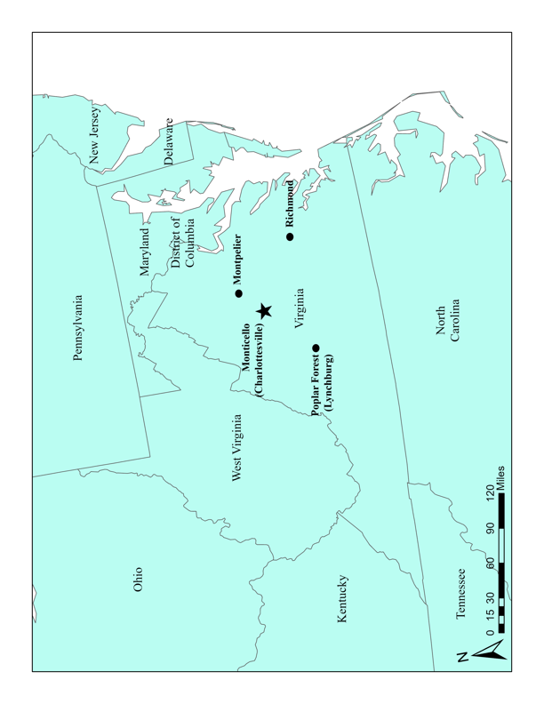
Figure 3.1 Map of site in relation to the state of Virginia. Map courtesy of Garrett Wamack 2022.
Jefferson’s 5,000-acre plantation is comprised of seven quarter farms: Montalto, Monticello, Tufton, Portobello, Shadwell, Lego, and Pantops (Figure 3.2). The original home farm was established at Shadwell, but Thomas Jefferson inherited the plantation in 1767 and began his plans to move the home farm to Monticello.

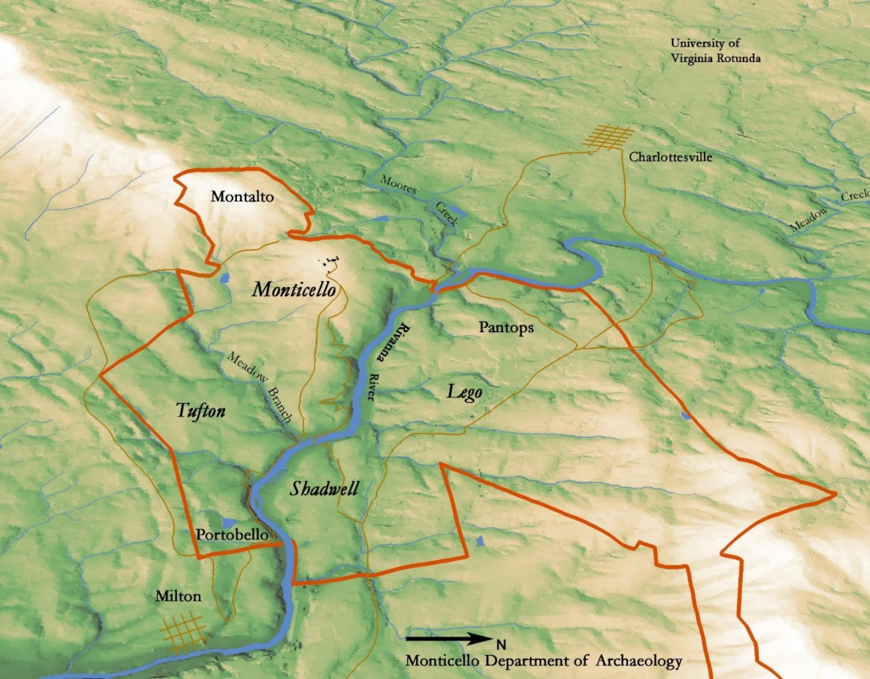
Figure 3.2 Map of plantation quarter farms (Monticello Department of Archaeology 2018).

In 1767, Jefferson began leveling the Monticello mountaintop and planned for construction of the South Pavilion and the main house of Monticello I. Figure 3.3 depicts Jefferson’s sketches turned into a scale drawing of the Monticello mountaintop with Monticello I and imagined terrace connecting the South Pavilion to an area of domestic structures and enslaved housing formally named Mulberry Row (O’Connor and Neiman 2022: 16). This figure is a composite schematic compiled Mesick Cohen Waite Architects (1991) of Jefferson’s formal building sketches of the South Pavilion (N59), the South Wing (N32), and Jefferson’s concept of the terraced mountaintop (N34) (Appendix XX).

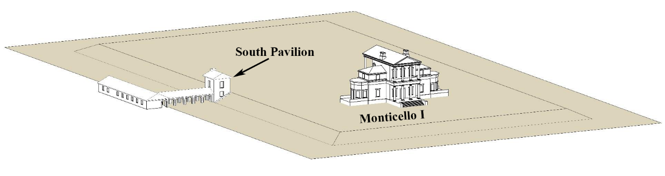
Figure 3.3 Composite schematic of N59, N32, and N34 by Mesick Cohen Waite Architects. Shows the imagined terrace, arcade, and dependency wing, connected to the South Pavilion with Monticello I (O’Connor and Neiman 2022: 16).

The South Pavilion is the oldest structure on the Monticello estate, dating back to the mid-1760s, and functioned as Jefferson’s original residence during the first construction phase of the main house. Jefferson first moved into the stand-alone, two-story brick structure on November 26, 1770, and Martha Wayles Jefferson accompanied him after their marriage in 1772 ((see Figure 3.4 for map of Monticello mountain) (Bear and Stanton 1997:212). The first, or ground, floor of the South Pavilion housed the original kitchen for the Jefferson family with the second, or top, floor used as the Jefferson household living space. This kitchen space is thus the location where enslaved cooks prepared meals for the Jefferson family, their guests, and possibly other enslaved individuals until 1809, when the new larger kitchen in the South Wing was finished.

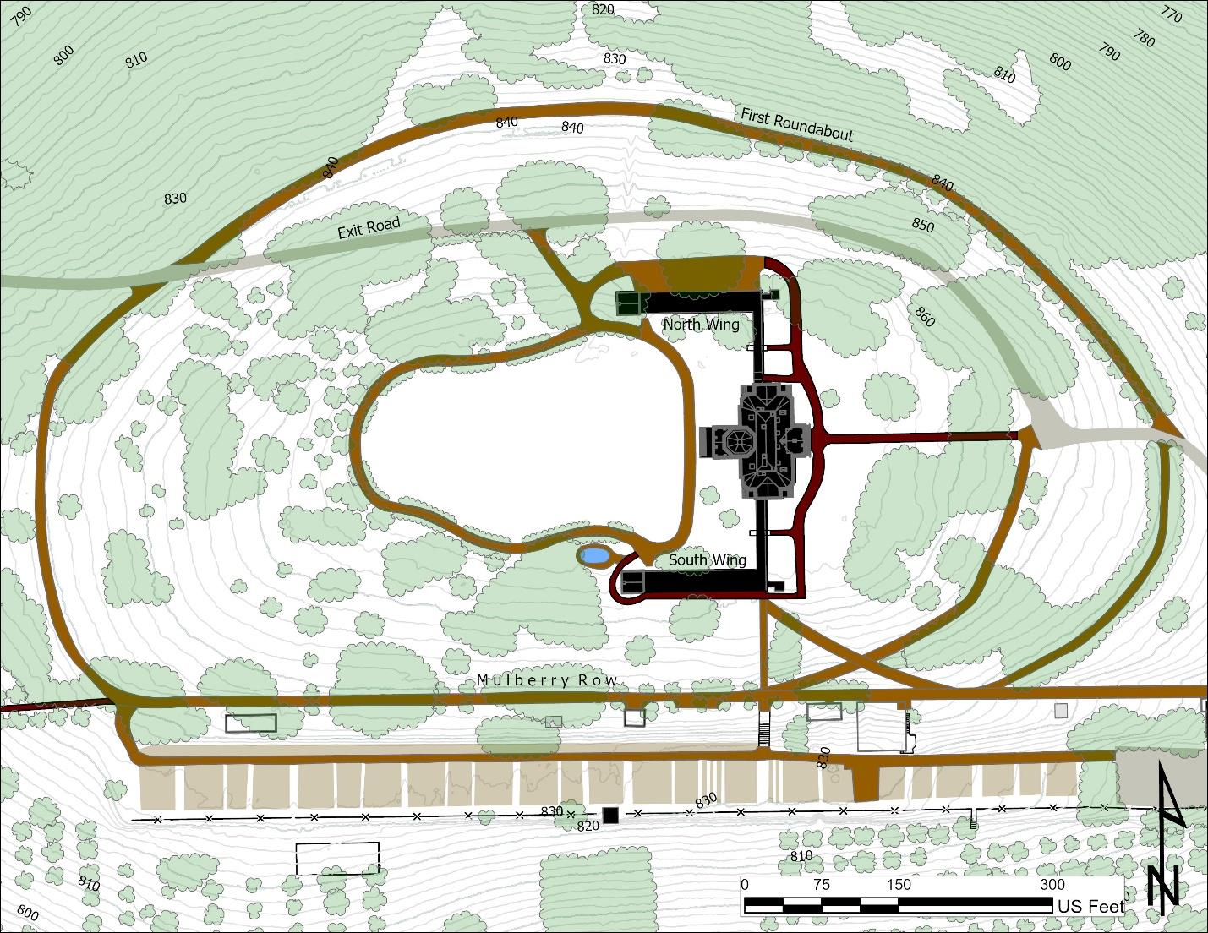
Figure 3.4 Monticello mountaintop within the first roundabout with red arrow locating the South Pavilion (O’Connor and Neiman 2022: 11).

With the finished construction of the main house in 1775 (Monticello I), Martha Wayles Jefferson assumed the larger responsibility of a plantation household, a role that she was raised to take on one day. The planter’s wife’s responsibilities for overseeing domestic life in the main house created consistent interactions between her and specific enslaved domestic workers. In the case of Monticello, Martha Wayles Jefferson, her first-born Martha Jefferson Randolph, and later the Jefferson grandchildren all interacted with the enslaved domestics in this plantation kitchen space. Martha Wayles Jefferson played a significant role in the operation of the South Pavilion kitchen until her death in 1782 (O’Connor and Neiman 2022). After her death, her daughter Martha Jefferson Randolph and Jefferson’s many grandchildren took part in controlling the duties of the later kitchen space as the Randolph family moved full time to Monticello in 1809.
Thomas Jefferson left behind numerous sketches, diary descriptions, and scale drawings for structures already constructed or those he planned to construct within his lifetime on his properties. Two examples relating to the South Pavilion include entries in 1767 and 1769 where he described the South Pavilion as, “Outhouse 18. F. sq. 10. F. to water table. 12. F. upper story” (Bear and Stanton 1997:26; Beiswanger 1972:3), and also his sketch (N59) for the basement kitchen including, “a central fireplace, corner staircase, dresser, and stew stove” (Figure 3.5; O’Connor and Neiman 2022:11). Stew stoves are equivalent to a modern-day range cooktop and were essential culinary tools when cooking traditional French-style cuisine. The dressers captured in Jefferson’s sketch were used as counter space to properly dress or plate food before the meal was presented to and consumed by the Jefferson family and house guests. Jefferson became infatuated with the French culture and cuisine during his time spent as the Minister to France (1784-1789). He was also exposed to stew stoves in his early years during his time in Williamsburg, Virginia, as a student and later as governor (Thomas Jefferson’s Monticello 2018).
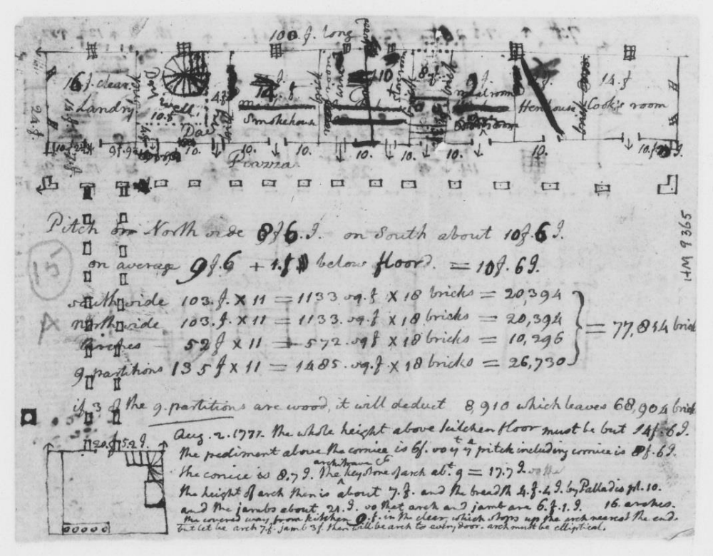
Figure 3.5 N59 (Jefferson c.1769) Jefferson’s personal sketch with the South Pavilion in the bottom left corner with a five-burner stew stove, dresser, stairs, and central fireplace. (O’Connor and Neiman 2022: 14).
Jefferson’s personal records are useful when interpreting archaeological assemblages and social interactions across the estate, especially between individuals in the kitchen space. The Jefferson household used the lower floor of the South Pavilion as the primary plantation kitchen while the main house was being constructed. This space served as the main kitchen until the South Wing, which connected the main house to the new surrounding domestic spaces, was completed and the kitchen moved in 1808 to the newly constructed kitchen at the east end of the South Wing abutting the main house. The new kitchen space designed by Jefferson was larger and closer to the holding and dining room, indirectly establishing the increasing importance of food etiquette and expectations for this social space (Figure 3.4).
Sometime between 1808 and 1809 the lower floor of the South Pavilion was filled in with three feet of fill dirt, to level the interior flooring of the building to the exterior ground surface, and converted into the wash house. Jefferson did not document where the fill dirt used for interior leveling in 1808/1809 deposit was sourced from on the nearby mountaintop. By 1809, construction of the South Wing was completed, connecting the South Pavilion to the main house.

Site Background
The first excavation of the South Pavilion was led by restoration architect Milton Grigg in the 1940s prior to the development of an exhibit in the space by the Thomas Jefferson Foundation (O’Connor and Neiman 2022:26). During excavations, an original brick floor and hearth components were discovered, briefly documented, then reburied for the development of the space (Figure 3.6). The Thomas Jefferson Foundation’s Department of Archaeology revisited this space in October of 2016, in preparation for a new exhibit and for irrigation work related to a drainage and flooding issue along the north wall of the South Pavilion. This more recent
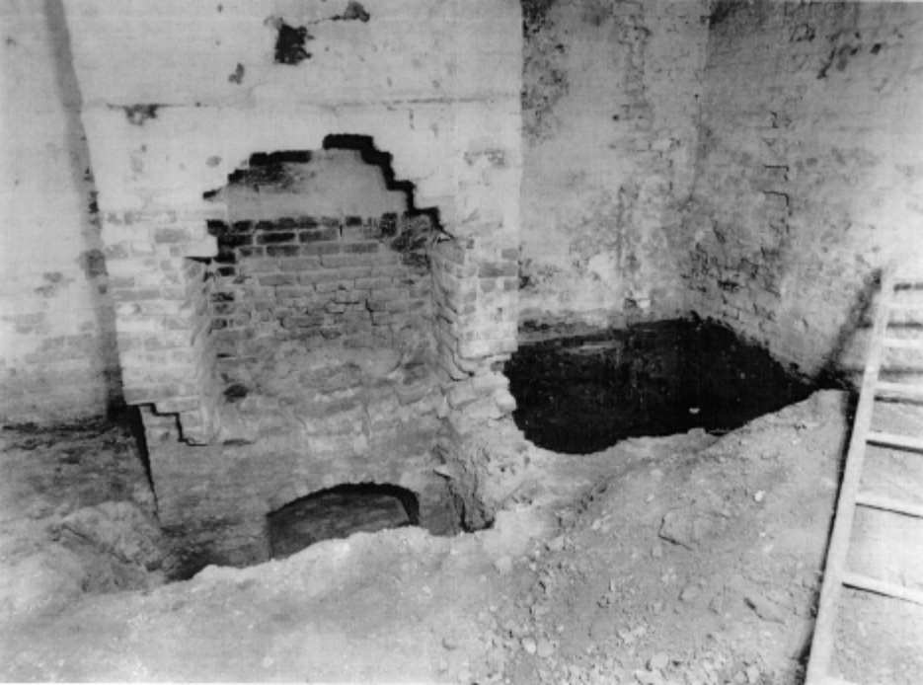
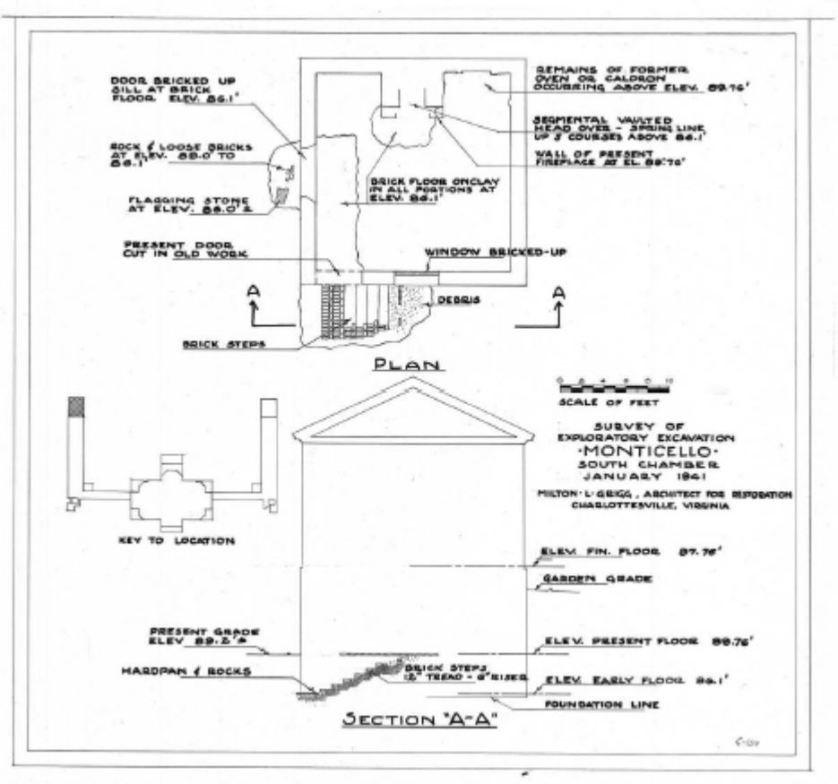

excavation, directed by Crystal O’Connor, confirmed the presence of multiple architectural features documented by Jefferson in his N59 (Figure 3.5) plan sketch of the South Pavilion kitchen. Grigg’s discoveries, specifically the brick floor and portions of the hearth, were re-exposed, and the bottom half of the deconstructed stew stoves and other architectural features related to food production were uncovered and thoroughly documented. Five zones or Periods of deposits were identified during excavation, three of which span the use of the space as a kitchen (Periods 1-3). Periods 4 and 5 will not be used in this analysis as they are outside the span of the kitchen-related deposits. These two final periods correlate with the conversion of the kitchen to a wash house (Period 4, c. 1808-1826) and all activities relating to contractor repairs and modern archaeological excavations of the 20th century (Period 5, 1826-2016).
Due to this site’s well-preserved nature and overall lack of disturbance over time, researchers can better understand use of the first kitchen space through a spatial analysis both of the architectural remains and the well-preserved macrobotanical assemblage extensively sampled from the site. It is important to note that, as we discovered through archaeological excavations, deposits associated with Period 1 through Period 3 were sealed in three feet of fill dirt when the decommissioned kitchen was converted to a wash house (Period 4) ca. 1809. These sealed deposits were generally untouched up until Grigg's excavation, but it is not entirely clear how deposits accumulated within Periods 1 through 3, other than through activities of construction/leveling and cooking-related tasks. This will be important to remember when discussing the accumulation of the recovered plant taxa in each of the sampled areas of the kitchen.

Kitchen Period 1 Occupation (1770-c.1775)
As discussed in the initial site report (O’Connor and Neiman 2022), Period 1 is associated primarily with initial construction of the South Pavilion, including the kitchen space. The construction of the South Pavilion began as early as 1767 but there is no evidence of the structure being used prior to Jefferson moving into the structure in 1770. The following timeline (Table 3.1) demonstrates events of Period 1 including architectural features that were added; information about these features in particular was uncovered through the archaeological excavations of the South Pavilion (O’Connor and Neiman 2022).

Table 3.1 Period 1 events in relation to the kitchen space.

Constructed Architectural Kitchen Features: brick pavers, Southwest corner ladder, bake oven, hearth, dresser

The earliest features of the kitchen would have been constructed once Jefferson moved into the structure from Shadwell Farm in 1770. These architectural features include the hearth in the northwest corner, a floor of brick pavers, stairs or ladder in the southwest corner, bake oven along the west wall, and a dresser along the east wall (O’Connor and Neiman 2022).
Figure 3.7 illustrates these features of the kitchen while also demonstrating the physical location of the South Pavilion as a stand-alone structure built into the hill; Figure 3.8 shows an interior view of the Period 1 kitchen that lacks the view of the dresser along the East Wall.

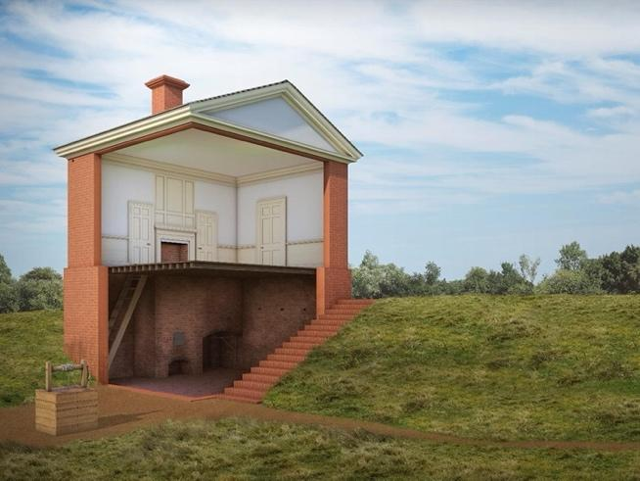
Figure 3.7 demonstrates a reconstruction for Period 1 Kitchen viewed toward the northwest as built into the Monticello hill as a standalone structure (Thomas Jefferson’s Monticello Archaeology Department 2017a).
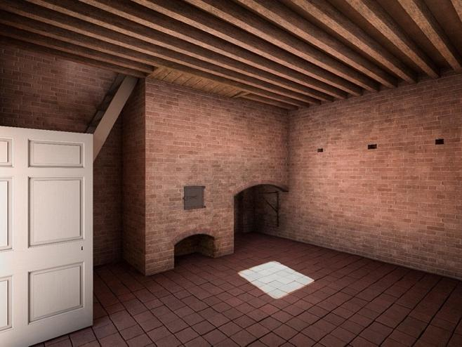
Figure 3.8 demonstrates an interior reconstruction for Period 1 Kitchen viewed toward the northwest as built into the Monticello hill as a standalone structure (Thomas Jefferson’s Monticello Archaeology Department 2017b).

Kitchen Period 2 Occupation (c. 1775-1790)
Period 2 is associated with the more regular use of the kitchen space for cooking as the Jefferson household was no longer living in the South Pavilion, having moved into the Monticello I main house in 1775. Period 2 kitchen modifications identified in the 2016 excavations include: the replacement of the southwest corner ladder with winder stair, replacement of the original brick paver floor in the north with bricks laid on end, excavation of a ditch along the north and east walls for drainage, and construction of two stew stoves. The first stew stove was constructed post 1775 and the second updated stew stove c. 1789 (O’Connor and Neiman 2022: 74). The following timeline (Table 3.3) demonstrates events of Period 2, including the addition of architectural features that were uncovered through the archaeological excavations of the South Pavilion (O’Connor and Neiman 2022), as well as important dates associated with individuals at Monticello.

Table 3.3 Occupational Kitchen Period 2 (c. 1775-1790).

Constructed Architectural Kitchen Areas:
1. Flooding event possible causing construction of Unidentified Pit and Drainage Ditch
2. 1st and 2nd Stew stove construction
3. Fill events of Kitchen debris of the Brick floor, Ditch, and Pit deposits capped with clay
The construction of the South Pavilion first stew stoves began sometime at the beginning of Period 2, but post-1775 as seen through the pearlware ceramic deposited under the stew stove and the unaligned vent holes (Figure 3.9). A piece of hand painted pearlware ceramic, c. 1775 – 1810 (Maryland Archaeological Conservation Lab 2018), was found beneath the stew stoves during profile excavations in the northeast corner of the kitchen, indicating their later construction (O’Connor and Neiman 2022).
The location of the stew stove venting holes, shown in Figure 3.8, demonstrates the original alignment of the first stew stove (c. 1775) compared to the second stew stove compartment locations (c. 1789). In addition, the drainage ditch parallel to the second (extant) stew stoves continues under their masonry foundation, proving the construction cut for the ditch predates the second stew stove. Through excavations of the drainage trench (directly south of the stew stove) and the Unidentified pit (west of stew stove), archaeologists confirmed the presence of this early stew stove through evidence from mortar and fill deposits directly on top of the brick floor. The extent of the Unidentified Pit is discussed in chapter four, but generally it is unclear whether the Unidentified Pit was present before or after the construction of the first stew stoves. This shows that the first stew stoves were constructed, then the floor was replaced. The ditch was dug sometime prior to the construction of the second stew stove. Fill was added to the Unidentified Pit and drainage Ditch, leveling the area with clay for the construction of the second stew stove (end of 1789) as noted during excavations (O’Connor and Neiman 2022: 84). This clay cap laid over the Unidentified Pit and Ditch to provide a level surface for the Period 3 stew stove allowed for the Period 2 deposits to be separated from the debris accumulated with the Period 3 stew stove. For more information on the excavation and installment of the stew stoves please reference the original site report (O’Connor and Neiman 2022:61).
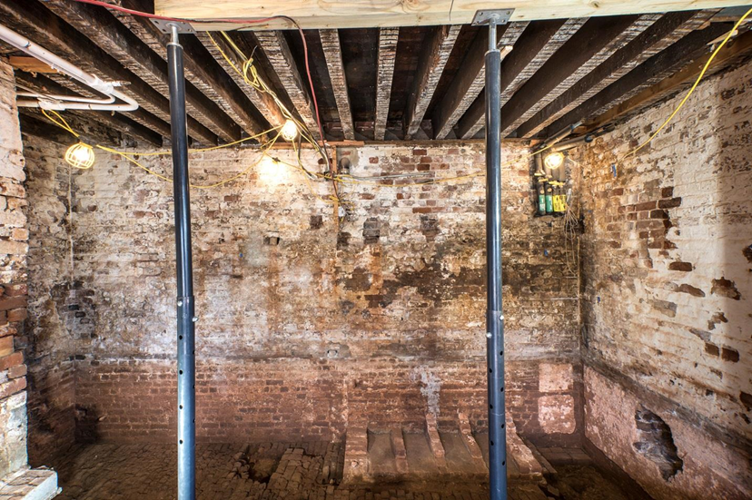
Figure 3.9 Three vent holes (circled in yellow) from the first stew stove demonstrates the second (Period 3) stew stove was shifted to the right (O’Connor and Neiman 2022:62).

Kitchen Period 3 Occupation (1790-c.1808)
Period 3 architectural modifications of the kitchen space are linked to the return of Jefferson from France in 1789 and the beginning construction (1801) of the Wing additions, known as Monticello II (Table 3.5). The Wing additions, finished in 1809, connected the South Pavilion to the main house. Please note that Jefferson only spent a portion of his time at Monticello when he returned from France, as he was also fulfilling his term as president (1801-1809) and visiting Poplar Forest, an estate acquired through inheritance from his late father in-law. Architectural upgrades in the kitchen during Period 3, as seen in Figure 3.10, include the following: replacement of the dresser, and finished construction for the four-compartment stew stove (O’Connor and Neiman 2022).

Table 3.5 Occupational Kitchen Period 3 (1790- c. 1809).

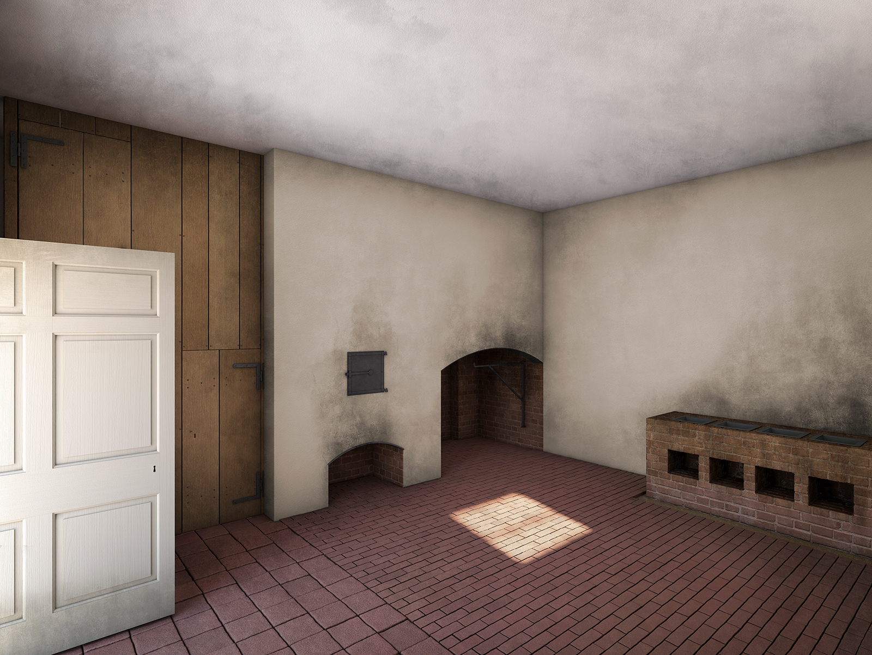
Figure 3.10 demonstrates the results from 3d scans of the kitchen and architectural rendering of the c. 1790 Period 3 kitchen (Thomas Jefferson’s Monticello Archaeology Department 2017c).

The end of Period 3 occupation was marked by the finished construction of Monticello II in c. 1809. The new L-shaped wing that extended to the South Pavilion housed domestic and workspaces for enslaved people, including a new kitchen and dairy (Figure 3.11). At this time the original kitchen space was filled with three feet of fill dirt so the ground surface in the building would be on the same level as the newly constructed wing, and was converted into the wash house (Figure 3.12).
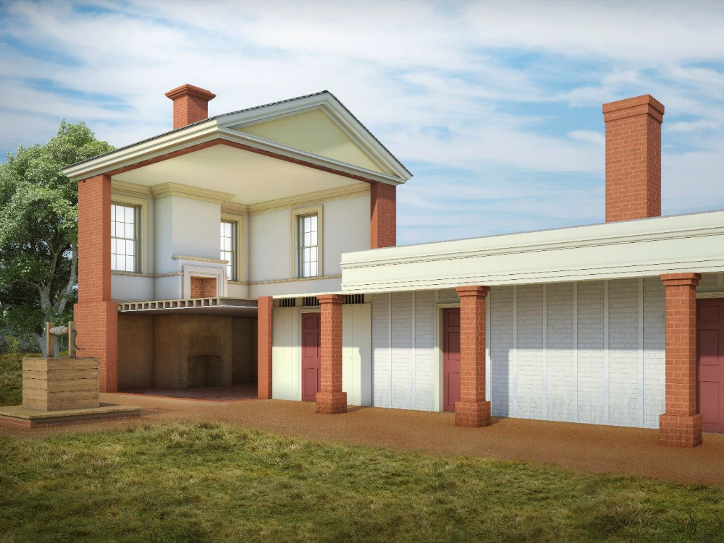
Figure 3.11 demonstrates Period 3 occupation in 1802 when the South Wing was connected to the South Pavilion (Thomas Jefferson’s Monticello Archaeology Department 2017d).

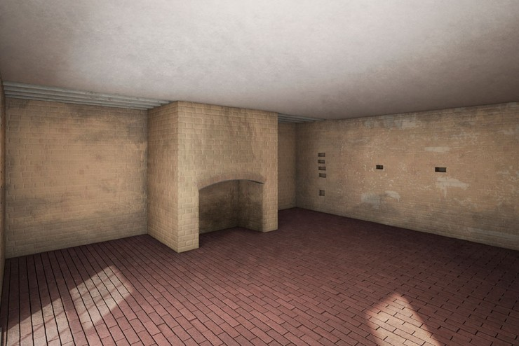
Figure 3.12 interior of South Pavilion during wash room occupation c.1809 (Thomas Jefferson’s Monticello Archaeology Department 2017e).

History of African American Cooks in the South Pavilion Kitchen
Now that I have presented the chronological review and abbreviated history of the South Pavilion structure and kitchen, it is important to establish the history of the enslaved at Monticello and the resident cooks involved in this space (Table 3.6). By defining the background and associated activities assigned to each of these individuals in this kitchen space, researchers can piece together the activities performed and quite possibly evidence of decisions made by the cooks.
A variety of enslaved people were assigned as Domestic Servant, Cook, or Brewer in Jefferson’s Farm and account books, but their tasks and roles seem to have changed depending on the events happening on the larger plantation, such as whether Jefferson and the main household members were present or away traveling, whether guests were visiting the estate, and whether additional hands were needed for harvests. Female house servants in particular had ‘little to do’ while Jefferson was in Washington or away in Richmond, Williamsburg, New York, and Philadelphia (Stanton 2003:25). It is also important to note that Jefferson’s distinction in separation of family or household at Monticello is stated as being “indoors and outdoors” (Stanton 2003:13). The following enslaved individuals are the main people who, from Jefferson’s rolls, were primarily assigned to duties in this kitchen space.
It is unclear when kitchen activities first begin in the South Pavilion, but the first known documented cook in this space is Ursula Granger, first noted in 1773. All cooking activities and any individuals working in this kitchen for Jefferson in 1770 and Martha Wayles Jefferson in 1772 are currently unknown. Further research through personal letters of Martha’s finances and Jefferson’s bachelor years may shed light on which enslaved people were cooking for Jefferson prior to Ursula’s arrival.
Table 3.6 demonstrates four occupational periods of the kitchen as assigned in the field site report in comparison to the cooks assigned in the kitchen space.

Occupational Periods and Domestic Cooks of the South Pavilion Kitchen
Period | Established Date Range | Occupational Association | Associated Cook Timeline
Period 1 | 1768ish-c. 1775 | Jefferson moves to South Pavilion 1770  Jefferson’s move from South Pavilion to Monticello I in 1775 | 1773-Ursual and Suck enslaved cooks
Period 2 | 1775-1790 | Beginning of interior kitchen modifications/ construction of first established spaces for activities in the kitchen for this period: first stew stove constructed post 1775  Jefferson absent in 1784 due to work in France as Ambassador, but returns to Monticello in 1789  Interior Architectural changes made throughout kitchen space after Jefferson returns from France examples include updated stew stove, and dresser | 1775-1789 Ursula head cook in South Pavilion  1784- James starts training as cook  1786-1789 James Cook to Jefferson in France
Period 3 | 1790 -1808/9*  * This filling event took place around 1808, but prior to Jefferson’s retirement from presidency in 1809. The kitchen was moved to the east end of the South Wing and this space was converted into a Wash House space. | Evidence of Main cooking activities and some interior architectural modifications made for changes in cooking style with Jefferson back from France in late 1789? | 1793 -1796 Peter trains as cook under James and retired head cook Ursula  1796-1809: Peter head cook of South Pavilion  1800- Ursula dies  1801 -James Dies
Period 4 | 1808/9- 1826 | Marth Jefferson Randolph and household move to Monticello fulltime in 1809 | 1809: Edy Hern Fossett head cook of new kitchen
Ursula Granger
Martha Jefferson requested the purchase of Ursula Granger, specifically sought out for her cooking skills, for the South Pavilion in 1773. Jefferson’s accounts show that he purchased Ursula from a neighboring plantation, along with her husband, George Granger, who became Jefferson’s only African American overseer (Stanton 2003:14; Monticello Website Citation). Ursula’s roles documented in Jefferson’s Farm book include cook, wet-nurse to Martha Jefferson, housemaid, laundress, dairymaid, and cider brewer (Stanton 2012). Ursula died in 1800 at the end of the cider brewing season.
Isac Jefferson Granger, their third surviving son born in 1775, is documented through an account of how Martha Wayles Jefferson would go to the South Pavilion kitchen and read from her book to Ursula about what and how things would be cooked in the kitchen (Stanton 2000:33). Ursula is documented as joining Jefferson at many residences while away from Monticello including the governor’s mansion. Jefferson’s last documentation for Ursula includes her brewing job in November of 1800, soon followed by her death in the same year. Ursula would have interacted with many of the domestic and Hemings servants including Suck, James, and Peter in this kitchen space. They also helped with the brewing, with Ursula being the main supervisor for the brewing event.

Suck
Suck was the second cook documented on the Monticello mountaintop. Very little is known about her other than she entered Jefferson’s rolls as cook in his inheritance from John Wayles in 1774 at the age of 16. Suck took on the role of ‘under cook’ to Ursula, who arrived a year earlier. Suck also married Jupiter in 1774. Jupiter was Jefferson’s most trusted slave who was born and raised alongside Jefferson at Shadwell. Suck is documented as cooking with Ursula and Elizabeth (Betty) Hemings during wheat harvests, and accompanied Ursula and Jefferson to cook at the governor’s palace in Williamsburg and Richmond in 1780 and 1781.

James Hemings
Born enslaved in 1765 as the third child and second son of Elizabeth Hemings and John Wayles, James Hemings moved to Monticello from The Forest, a plantation in Charles County, with his mother and siblings in 1774 at the age of 9. The Hemings family was given as an inheritance after John Wayles’s death in 1773 to his son-in-law Thomas Jefferson and daughter Martha Wayles Jefferson. The documentation of the period states evidence that by the age of 10 to 12, children would begin working on the Monticello plantation as either a farm hand or skilled worker (Stanton 2003). James’ early roles at Monticello are lacking in Jefferson’s documentation, but he is documented in 1781 as an enslaved valet to Jefferson in Richmond and Williamsburg when Jefferson served the role of wartime governor of Virginia. It is not until 1784 that James is connected with cooking, when the records state Jefferson sent James to France at age 19 to receive specialty training in the art of French cookery from the fall of 1784 through 1787 (Jefferson’s personal papers/roles Citation).
While in France, Jefferson’s account records and personal correspondences state James received a paid salary at the end of every month for his cooking services and lodging while in France. At that time in France slavery was abolished, and all black and mulatto individuals were free people to do as they pleased according to social laws and etiquette (Stanton 2000). James would have been given his freedoms while in Paris, but under the notion that he was still property of Mr. Thomas Jefferson and would eventually have to return to fill his role as head cook of the South Pavilion kitchen at Monticello. While in Paris, James trained under a caterer and restaurateurs in the household of the Prince de Condé. James’ talents and skill were valued by Jefferson, as James was appointed as chef de cuisine, or head chef, at the Hôtel de Langeac or the townhome and embassy of the American delegation in 1787. This position allowed him to serve as supervisor over other chefs that he trained, who were mostly white men. While in Paris, James learned a number of skills beyond his culinary training including reading and writing recipes, constructing his own will of agreement for freedom, and as referenced by Jefferson, becoming more fluent in the French language and culture than quite possibly Jefferson himself (Stanton 2000; Jefferson Personal Correspondence to Martha Jefferson).
Cooking-wise, James brought a variety of skills and recipes to Jefferson’s culinary table through his work in the South Pavilion kitchen during his time as head cook from 1789 to 1796. Recipes he was known for include gumbo, snow eggs, ash cakes, fried potatoes, waffles, beef burgundy, and macaroni and cheese. When James returned from France with Jefferson in fall of 1789 to Monticello, the contract of his freedom included stipulations to train his brother, Peter Hemings, to be an enslaved cook apprentice. Peter’s training as a cook apprentice under James began in 1793 until 1796 when James is documented as receiving his freedom. Jefferson’s documents state that James Heming’s last task as head cook in the South Pavilion was to make an inventory of the kitchen utensils and tools. Some cooking utensil items in his inventory included copper kettles, brass mortar and pestle, coffeepots, chopping knives, waffle irons, copper stew pans, copper brazing pans, and small saucepans (Figure 3:13; Hemings 1796).

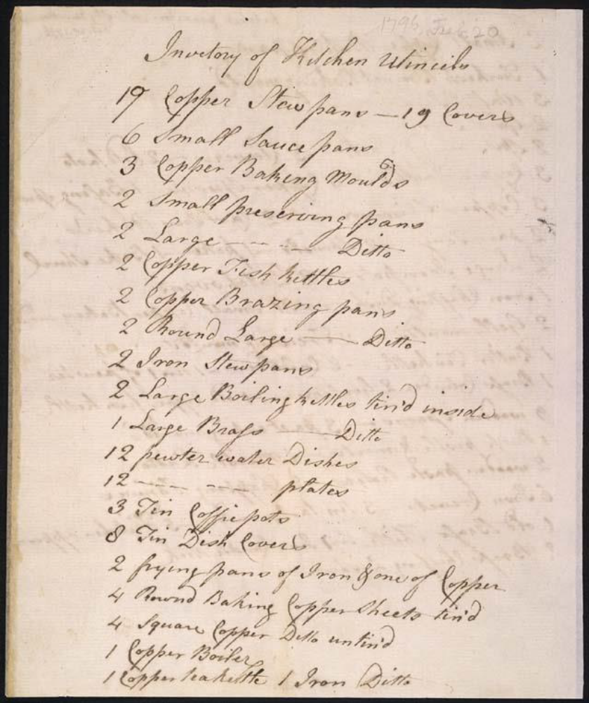
Figure 3.13 James Hemings South Pavilion kitchen inventory from 1796 (O’Connor and Neiman 2022: 27).

James received freedom papers and was released from Jefferson’s service as head cook in February 1796. During his freedom he is documented as traveling until the personal request of Jefferson for his return as a freed but paid cook at Monticello in August and September of 1801. Jefferson’s records state that James was living in Baltimore at the time that he committed suicide in late fall of 1801 at the age of 36.

Nance Hemings
Nance Hemings was born the third child in 1761 to Elizabeth (Betty) Hemings and John Wayles. Documentation concerning the roles of Nance Hemings are few and far between in Jefferson’s Farm ledgers, but she is listed as an enslaved weaver, cook, and brewer.

Peter Hemings
Peter was born as the fifth child and third son to John Wayles and Elizabeth Hemings at The Forest plantation in 1770. At the age of 4, Peter was also inherited by Jefferson and traveled to his new home of Monticello with his mother and siblings in 1774. Peter began work by age 12 at Monticello. He began his culinary training under his brother, James Hemings, for French cooking in 1793 till 1796 when he was given James’ title as head cook. Peter remained a cook and brewer, spinner, and tanner up until 1826, when he received his freedom in Jefferson’s will.

Edith (Edy) Hern Fossett
Edith Fossett held the position as head cook in Washington in 1802 while Jefferson was serving his presidency, up through the beginning of his retirement from office and return to Monticello in 1809. Edith Fossett (niece through marriage to Peter) and Peter Hemings served as cooks in the second kitchen after the South Pavilion was converted into a wash house. She remained at Monticello and was sold during Jefferson’s estate auction in 1826.
Heath (2004) noted evidence of personal foodways decisions and subsistence strategies in African American residents of Monticello through documents belonging to Jefferson’s granddaughter, Ann Cary Randolph. In the ledger Ann noted the profits made by enslaved people of the plantation through the selling of eggs, vegetables, fruits, and avian livestock to the Jefferson family (Heath 2004:23). The enslaved, especially the cooks in this space, contributed to the foodways supplies and meal production in the South Pavilion kitchen space. Through understanding the specialty talents or skills they learned and knowing what architectural tools were available to them during a particular period of the kitchen, we can use the botanical assemblage to further interpret the foodways activities that may have been practiced in this particular kitchen context.

Chapter four : Methodology
The kitchen’s main occupational periods in the South Pavilion date from the structure’s exterior construction beginning in 1770, to its renovation as a wash house in c. 1809. The macrobotanical remains from the kitchen are associated with the three different occupational periods, demonstrating that even small bits of charcoal can provide data that inform larger research questions.
Preservation and Representation of Plant Materials
What is represented and preserved in the archaeobotanical assemblage is largely affected by the form of disposal for the plant remains, methods of recovery, and the environmental factors that preserve the plant remains until excavation and recovery (Popper and Hastorf 1988:5). In the Southeast, plants generally must be carbonized to be preserved. Due to this, there is a lack of leafy greens in botanical assemblages, as they do not survive carbonization (introduction to fire). There is also a lack of fleshy fruits and higher frequencies of by-products of plants, i.e. nutshell or corn cupules, as the latter are not consumed (Yarnell 1982:2). Uncarbonized plants were considered likely contaminants, or at least cannot be distinguished from modern contaminants, and so these specimens were excluded in this analysis.
The preservation of these remains and the sources for these deposits was discussed in the previous chapter by kitchen areas per sampling area. It is important to stress that even though the kitchen was sealed in c. 1809 with three feet of fill dirt for conversion of the space to the wash house, the deposits prior to Period 3 are sometimes unclear in terms of depositional accumulation. Some samples as noted from the site excavations are associated with leveling fill, but where this leveling fill was sourced from on the mountaintop is unknown. The fill in these deposits would have also accumulated debris from cooking and construction activities, but it is important to note that these samples have the possibility of including remains from both food-related and secondary fill deposits beyond the kitchen site’s use.

Sample Biases
The preservation of the sealed deposits and documented history of the construction of the building makes the South Pavilion an excellent example for understanding activities of an early plantation kitchen space. The preservation of the botanical remains is exceptional due to the protection provided by the building and the clay deposits that sealed out environmental factors that may have caused destruction to these sampled areas, but it is important to also factor the recovery methods of the samples. During the excavation, it was unclear which areas of the kitchen still had intact architectural features worth sampling, and the timeline for how these were constructed was unknown. This in the end affects the availability of samples from particular areas and time periods.
It is also important to remember that just because an item is absent from the botanical assemblage, it does not mean it was not used in that context. The physical plants recovered from an assemblage do not reflect the full use of plants at a site. Absence of plant material can be related to biases in how samples are collected, processed, and housed, as well as whether plant materials were carbonized through human interactions. These are all examples of limitations to consider with paleoethnobotanical analysis (Crowder 2018: 45). However, those items that do survive provide valuable information about plants that people used on a regular basis (Hastorf and Popper 1988; Pearsall 2000).

The limited availability of samples by period and associated with known architectural kitchen features plays a big role in the overall assemblage of the South Pavilion kitchen. Further analysis of periods not analyzed in this research may reveal the presence of other plant remains not seen or represented in kitchen Periods 1 through 3. Even though there are multiple factors that affect the variety and quantity of plants in a botanical assemblage, the information that can be gained from the plant remains that are recovered can shed light on the activities, behaviors, and roles assigned to the inhabitants in the space (Ford 1979: 286).

Macrobotanical Sampling and Methods of Analysis
A total of 86 soil samples were collected across the South Pavilion (44AB089) kitchen site for macrobotanical analysis. From these recovered soil samples, 84 were processed using flotation and sent to the Paleoethnobotany Laboratory in the Department of Anthropology at the University of Tennessee, Knoxville for analysis. Throughout this data analysis process, all standard paleoethnobotanical procedures, steps, and protocols were followed (Pearsall 2000). Each sample was weighed and sifted through 2.0 mm, 1.4 mm, and 0.71 mm geologic sieves, followed by identification of botanical remains to the lowest taxonomic level. Anything not already represented in the 2.0 mm sieve was pulled from the smaller sieve sizes, and identified, counted, and weighed. Identifications for botanical remains were referenced to Martin and Barkley’s (1961) Seed Identification Manual and modern comparative specimen collections housed in the Paleoethnobotany Laboratory in the Department of Anthropology and at the McClung Museum of Natural History and Culture at the University of Tennessee, Knoxville. The analysis was conducted under the supervision of Dr. Kandace Hollenbach.
Each paleoethnobotanical sample collected for analysis was assigned to one of five occupational periods. These periods were established through the site’s stratigraphic Harris matrix correlations in relation to the construction and occupational ranges of the South Pavilion structure (O’Connor and Neiman 2022). Figure 4.1 presents the South Pavilion site with sampled locations that correlate to the architectural cooking appliances used in the space. Considering my research questions and focus on foodways activities, I only use the samples assigned to the structure’s first three occupational kitchen periods and also only those in the northern portion of the kitchen (Figure 4.2). These first three kitchen periods will contribute to foodways practices performed in this space. The southern area demonstrates higher foot traffic than the rest of the kitchen space, as these areas were used for entering and exiting the kitchen structure. The samples and identified macrobotanical remains for these southern quads have higher probabilities of introduction to this space as accidental or natural displacement (i.e. uncarbonized seeds brought in from people’s clothing and footwear). The southern half of the kitchen also contained less foodways-related architecture. As such, the northern units provide a pool of samples that more strictly relate to the food-related activities of the kitchen space.
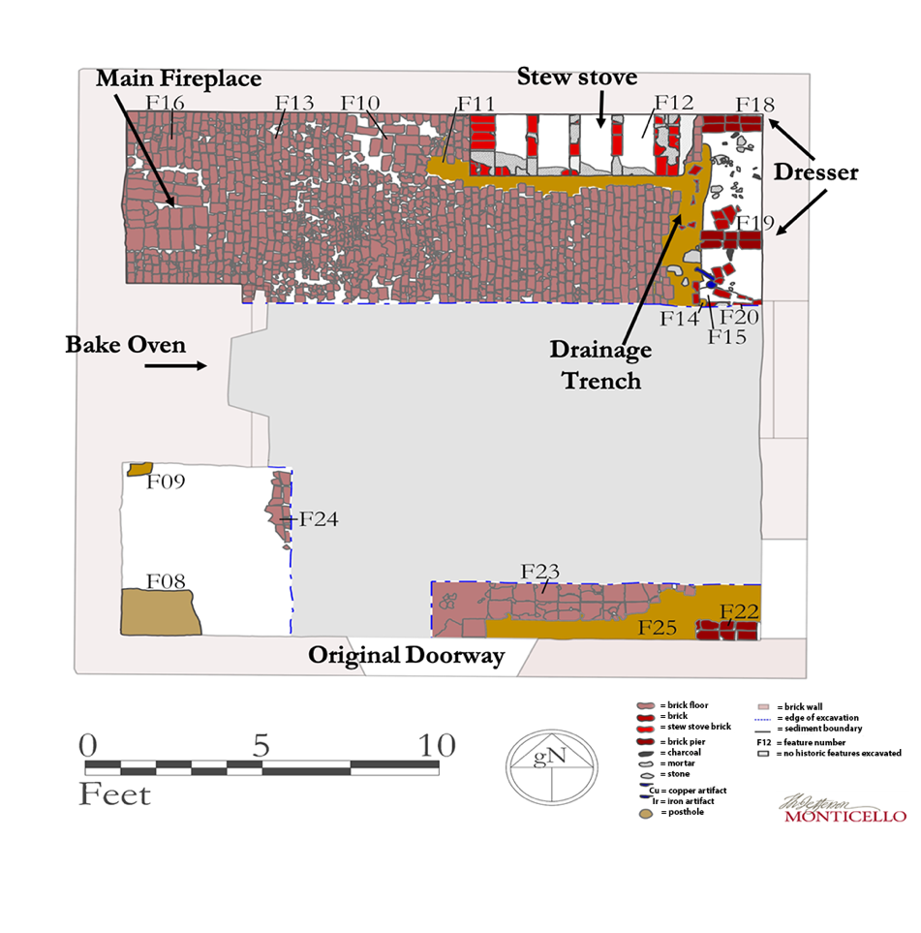
Figure 4.1 Site map of South Pavilion (O’Connor and Neiman 2022) with added references to main architectural kitchen features.

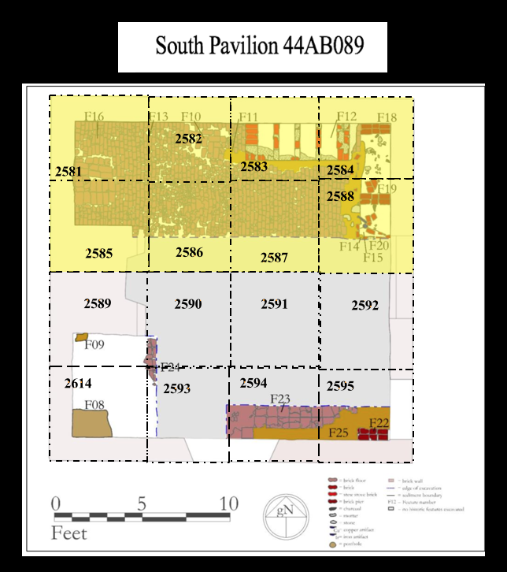
Figure 4.2 Site map of South Pavilion overlaid with historic features; northern yellow quadrats reference the location for samples included in this analysis.

Macrobotanical Assemblage Sampling
From the 84 samples sent for analysis, there are a total of 66 samples associated with these three occupational periods. Of these, I used 43 samples in my analysis reflecting the first three periods from the northern half of the kitchen that are most likely to provide information about foodways activities. Samples were assigned to period by evaluating their stratigraphic groupings and feature interpretations with relation to the established stratigraphic associations in the initial site report (O’Connor and Neiman 2022).

Assigned Sample Areas of Period 1
A total of 8 samples were processed from Period 1. These samples all include associations related to activities involving the construction of the kitchen and foodways related activities form areas of the Dresser (2), the East (3) and West (1) Brick Floor, and the East Wall (2). Table 4.1 captures the samples available for analysis and their spatial correlations by the occupational kitchen period.

Table 4.1 Stratigraphic groups assigned in site report from Period 1.

Stratigraphic Group (SG) | Sample | Description | Interpretation | Associated Kitchen Area
SG03 | 2584Y  2588R | Mortar spatter on bedrock in northeast corner of Pavilion | Mortar spatter construction of Pavilion wall | East Wall Construction
SG07 | 2584BB  2584CC  2588V | Dense red clay | Leveling fill and accumulated debris | East Brick Floor
SG07 | 2582Z | Dense red clay | Leveling fill and accumulated debris | West Brick Floor
SG11 | 2588Q | Gritty brown silty | Fill to level floor under dresser | Dresser
SG12 | 2584V | Mottled and mortar-rich deposit | Fill to level floor under dresser | Dresser

The Brick Floor is comprised of the northern portion of the South Pavilion kitchen. The northern portion is then divided into areas of the East Brick Floor (quadrats 2581, 2582, 2585, and 2586) and the West Brick Floor (quadrats 2583, 2584, 2587, and 2588). These kitchen areas were split into the East and West Brick floor due to the nearby kitchen appliances that correlate with the activities in the east or west side of the kitchen space.
The East Wall is comprised of the northeastern portion of the South Pavilion kitchen, but specifically samples that date stratigraphically to the construction of the east wall of the kitchen. These were associated with construction-related activities due to the mortar splatter found deposited on top of the bedrock where the samples were collected during excavations of this east corner of the kitchen.
The Dresser samples were not grouped with the East Wall since these stratigraphic groupings (SG11 and SG12) were associated with a leveling fill deposit found under the dresser (O’Connor and Neiman 2022). Given its distinct depositional history and the association of the dresser with foodways-related activities, it makes sense to consider this as its own area for analysis for Period 1.
As noted above, Period 1 is associated primarily with initial construction of the kitchen space (O’Connor and Neiman 2022) and has limited evidence for primary areas of activities for cooking-associated areas. It is also important to discuss the nature of these samples, which are primarily fill deposits. This leaves analysis somewhat open-ended as there is not a clear understanding of where the sediments for these fill deposits derive from and how they were initially deposited, as well as whether these deposits are related to accumulation of debris associated with activities in the kitchen space.

Assigned Sample Areas of Period 2
A total of 11 samples were processed from Period 2, with only two sample areas that correlate from this occupation of the kitchen including the Unidentified Pit (n=6) and the Drainage Ditch (n=5) (Table 4.2).

Table 4.2 Features and Stratigraphic groups assigned in site report for Period 2.
Feature Number | Stratigraphic Group (SG) | Sample* | Interpretation | Order of Deposits | Associated Kitchen Area
F10 | N/A | 2582X | Fill in Unidentified pit | 1st Pit Deposit | Unidentified Pit
F10 | N/A | 2582W | Fill in Unidentified pit | 3rd Pit Deposit | Unidentified Pit
F10 | N/A | 2582V** | Brick laid flat over fill | 4th Pit Deposit | Unidentified Pit
N/A | SG13 | 2582L | Fill to replace missing brick patch | Last Pit Deposit 2582 | Unidentified Pit
N/A | SG13 | 2583M | Fill to replace missing brick patch | Last Pit Deposit 2583 | Unidentified Pit
F11 | SG14 | 2588U | Fill in Drainage Ditch for Stew stove install | 1st Ditch Deposit | Ditch
F11 | N/A | 2588M | First sweeping event | 2nd Ditch Deposit | Ditch
F11 | N/A | 2584S | Pre-Stew stove kitchen trash; Stew stove leveling fill | 2nd Ditch Deposit | Ditch
F11 | N/A | 2584R | Pre-Stew stove fill | 3rd Ditch Deposit | Ditch
F11 | N/A | 2584Q | Pre-Stew stove kitchen trash | 4th Ditch Deposit | Ditch

*Note that for the sake of table spacing I shortened the sample numbers for this analysis. Monticello’s sample protocol establishes the Quad followed by the assigned stratigraphic level followed by S for sample with an assigned sample number taken for the context.
**Note that this sample had two samples taken from the sample level. See Appendix for exact sample numbers for these sampled contexts.
The Unidentified Pit is a sampled area assigned to Feature 10 of the report (Figure 4.3; see Figure 4.1 for location within the site). This Unidentified Pit is interpreted as being “possibly dug to mitigate a flooding event, or possible sump which may have connected to the Drainage Ditch assigned to Feature 11” (O’Connor and Neiman 2022:82). O’Connor and Neiman (2022:82) further describe it as having “Flat, irregularly laid bricks. Roughly rectangular in shape with the longer axis running east-west” with the dimensions of 2.5 x 2.8 ft with a depth of 0.72 ft.

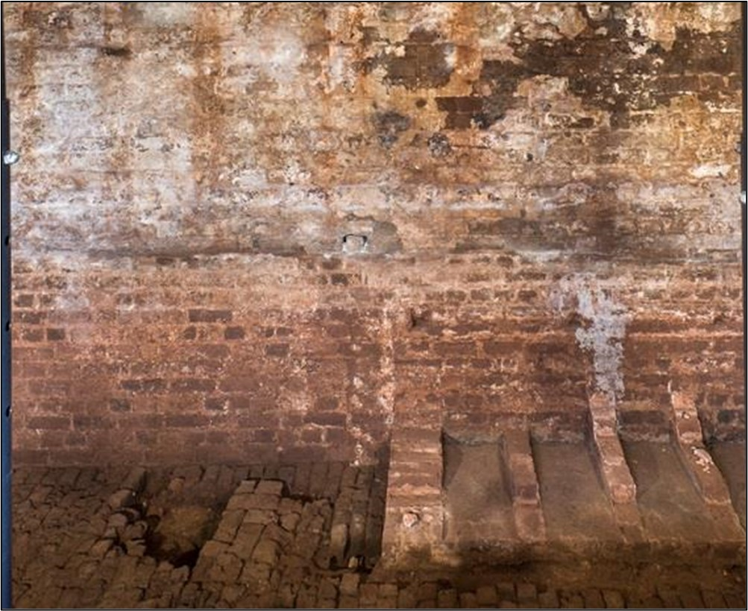
Unidentified Pit (Feature 10)

Figure 4.3. South Pavilion kitchen north wall with Unidentified Pit (Feature 10) outlined in red. View north (O’Connor and Neiman 2022:62)
The shallow drainage ditch (Feature 11) is described as a ditch dug to mitigate flooding from north, east, and south walls of the South Pavilion (Figure 4.1). The dimension for this feature includes a 12.5 x 1.1 ft area with a depth of 0.5 ft (O’Connor and Neiman 2022:82). Figure 4.4 presents the stew stoves post excavation facing north with the blue arrows outlining the exterior limits of the hypothesized drainage ditch (Feature 11). The ditch samples used in this analysis are likely associated with multiple contexts in the area, as materials may have washed into the ditch from multiple areas of the kitchen space. In the following discussion this feature is assigned as Ditch and is made up of contexts associated with either the dresser ditch or leveling fill for stew stove ditch deposits.

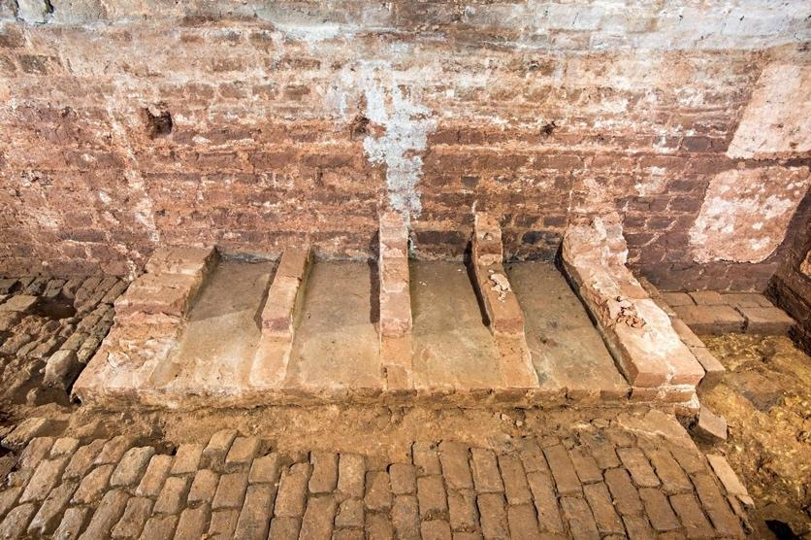
Drainage Ditch
(Feature 11)
Figure 4.4 Drainage Ditch in front of the Stew stoves with roughly outline (blue) pointing to the presence of the Period 2 Ditch (O’Connor and Neiman 2022:80).

Both sample areas from Period 2 are complex and unknown in terms of depositional accumulation. It is also important to note that the samples from the drainage ditch are a combination of two areas that could be considered separately (dresser ditch and leveling ditch), but the depositional complexity and location of the samples in relation to the architectural features blur together. In the case of this analysis these samples were grouped together as the drainage ditch deposits but are split by associated contexts in Table 4.2.

Assigned Sample Areas of Period 3
A total of 24 floatation samples were analyzed from Period 3 (Table 4.3). I assigned the flotation samples associated with Period 3 to the following six areas: Brick Floors (West [n=3] and East [n=5]), Hearth (n=4), Ditch (n=7), Stew stove (n=4), and Dresser (n=1). Figure 3.10 illustrates the Period 3 kitchen while also demonstrating its physical location with the connection of the South Wing as completed in 1809. Figure 4.5 demonstrates approximate locations of the West versus East floor boundaries.
Note that once again the deposits associated with the drainage ditch are grouped together as in Period 2, since the location of the ditch in front of both the stew stove and dresser blurs together debris from activities associated with these architectural features.

Table 4.3 Features and stratigraphic groups assigned in site report for Period 3.

Feature number | Stratigraphic Group (SG) | Sample | Description | Interpretation | Order of Deposits | Associated Kitchen Area
F11 | N/A | 2584P | Level fill for Stew stove construction | Stew stove Ditch | 1st Ditch Deposit for 2584 | Ditch
F11 | N/A | 2588L | Kitchen debris swept into ditch | Dresser Ditch | 1st Ditch Deposit for 2588 | Ditch
F11 | N/A | 2588K | Kitchen debris swept into ditch | Dresser Ditch | 2nd Ditch Deposit for 2588 | Ditch
F11 | N/A | 2588J | Kitchen debris swept into ditch | Dresser Ditch | 3rd Ditch Deposit for 2588 | Ditch
F11 | SG18 | 2584N | Top layer of kitchen debris swept into ditch | Stew stove Ditch | Last Ditch Deposit for 2584 | Ditch
F11 | SG18 | 2588I | Top layer of kitchen debris swept into ditch | Dresser Ditch | Last Ditch Deposit for 2588 | Ditch
N/A | SG19 | 2584M | Possible leveling fill for dresser leg | Dresser | N/A | Dresser
N/A | SG22 | 2582K  2582U  2586L | De-facto kitchen refuse between bricks of brick floor | West Bricks | N/A | West Floor
N/A | SG22 | 2583K  2583Q  2584K  2587G  2588H | De-facto kitchen refuse between bricks of brick floor | East Bricks | N/A | East Floor
F16 | SG21 | 2581J  2585H  2585M  2586M | Ash from hearth in fireplace | Hearth | N/A | Hearth
F12 | SG17 | 2583H  2583I  2583J  2584H | Remnants of coals from cooking on stew stove | Stew Stove | N/A | Stew Stove

*Note that for the sake of table spacing I shortened the sample numbers for this analysis. Monticello’s sample protocol establishes the Quad followed by the assigned stratigraphic level followed by S for sample with an assigned sample number taken for the context.
**Note that this sample had two samples taken from the sample level. See Appendix for exact sample numbers for these sampled contexts.
Brick Floor areas
The deposits assigned to the brick floor areas include the east and west half of the northern half of the South Pavilion. The western four quads and eastern four quads (Table 4.3) include deposits that were picked from between the bricks. Excavators collected this loose kitchen debris until they felt the solid inclusion-less clay that the bricks were dry-laid into. Figure 4.5 documents the brick area looking west toward the hearth.

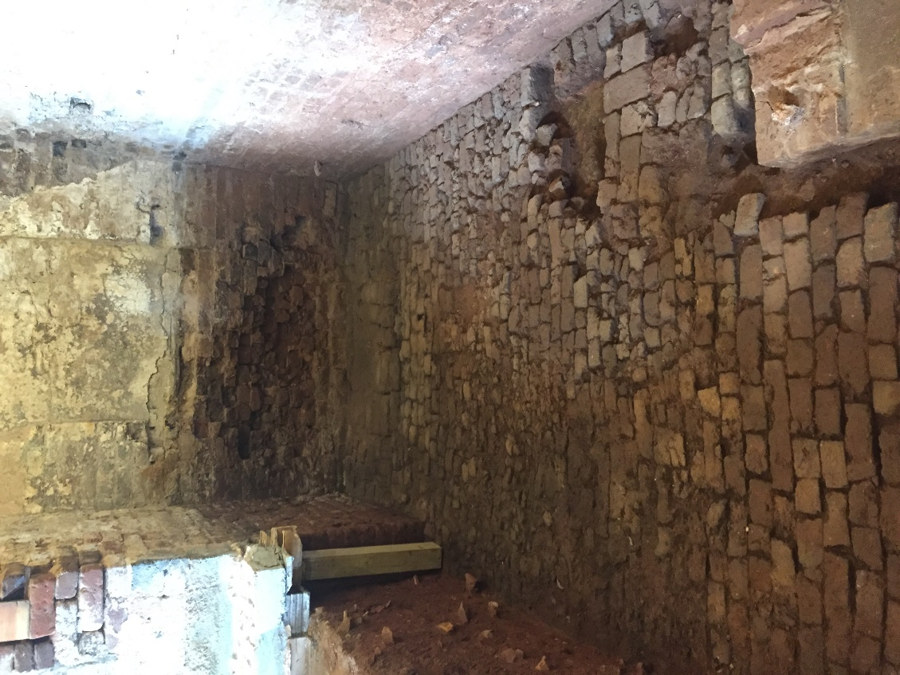
East Bricks
West Bricks
Figure 4.5 demonstrates brick floor areas of the kitchen facing west toward the hearth (personal photo).
Hearth
The deposits assigned to the hearth include four samples from the northwest portion of the kitchen within and just outside the hearth, all of which were ash- and charcoal-rich deposits (Figure 4.6 and Table 4.3).

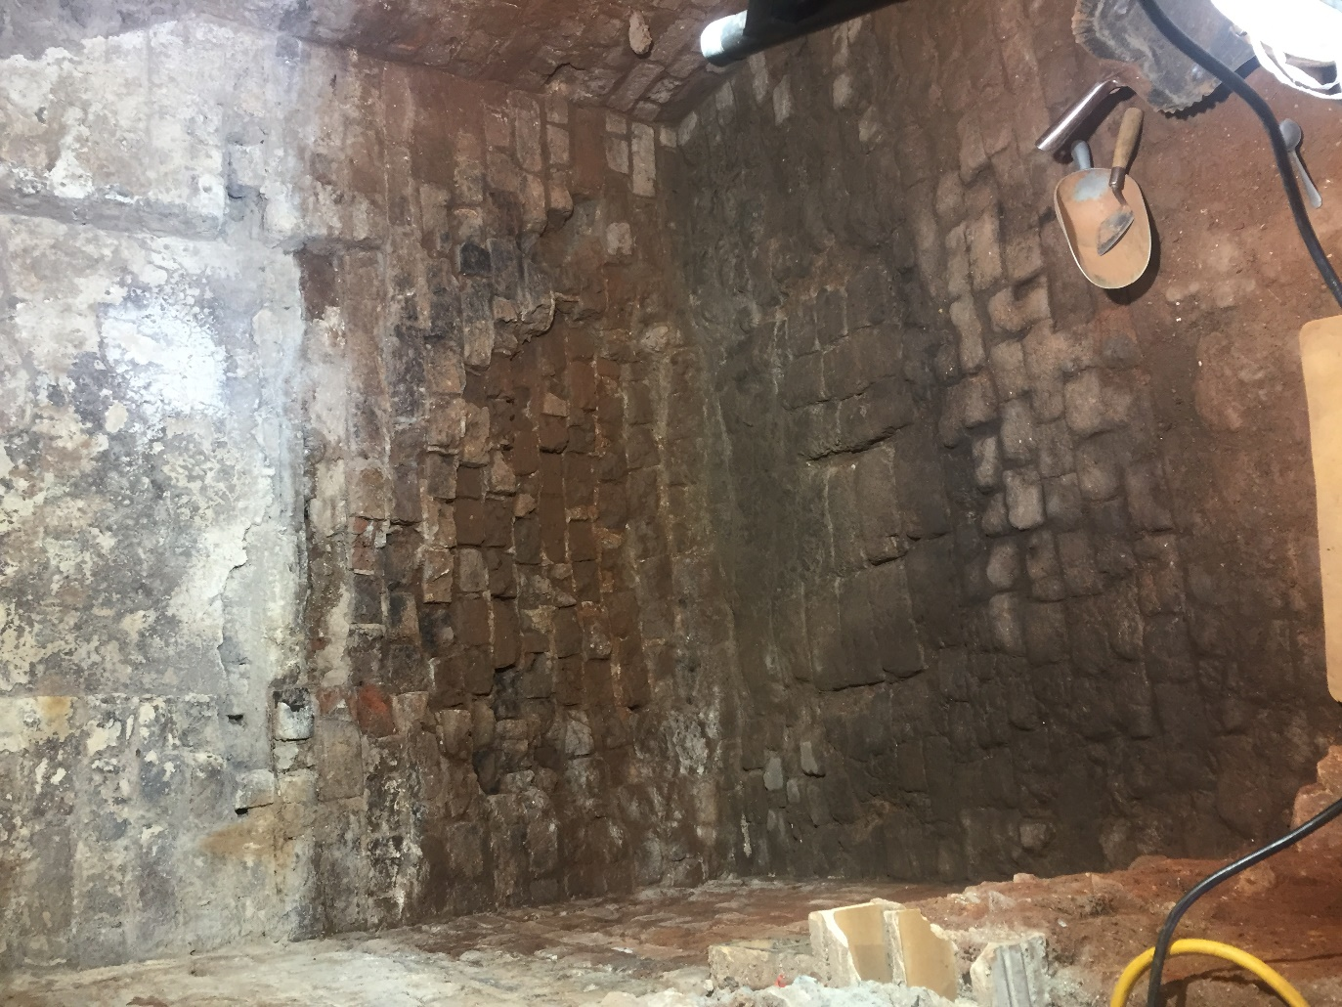
Figure 4.6 demonstrates excavated hearth area in northwest corner of the kitchen (Humes 2016).
Ditch
The seven samples assigned to this area include deposits interpreted as kitchen debris (top layer) swept into the ditch. Some samples are closer to the stew stoves or the dresser, but since they accumulated in the same ways and possibly through movement of water, they are grouped together as a Ditch area (Figure 4.7 and Table 4.3).

Dresser
The single sample assigned to this ditch area is due to its location and different depositional history. This sample was collected directly adjacent to the dresser leg, outside of the drainage ditch. The dresser ditch deposits are closer to the intersection of the stew stoves and dresser (Figure 4.7 and Table 4.3).
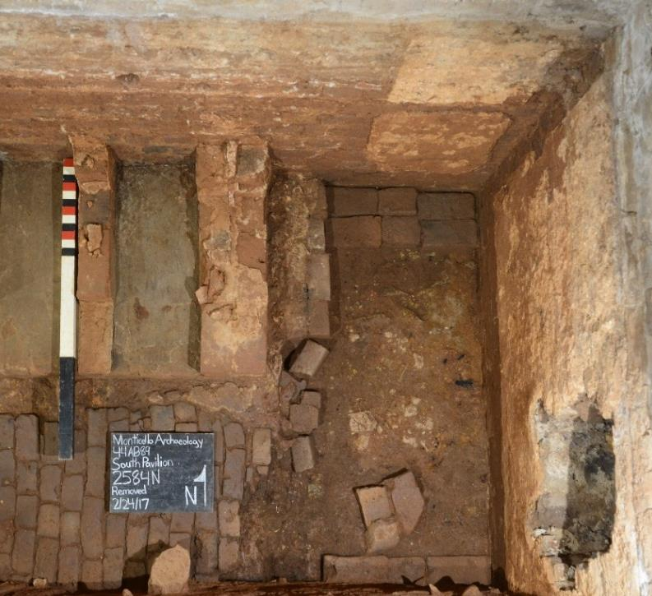
Figure 4.7 shows the northeast corner sampled areas for the Dresser (black arrows) versus the Ditch (yellow arrow) (O’Connor and Neiman 2022: 86).

Stew stove (interior deposits)
The deposits assigned to this area include four samples of charcoal, ash, and very little sediment. The samples were taken from all four compartments of the stew stoves (Figure 4.8). There were larger pieces of carbonized wood recovered from these samples, which were wrapped in foil when removed from the stew stove compartment during excavations. During analysis these larger pieces were also analyzed and added to the wood total of the sample but were rehoused separately for future fuel analysis.

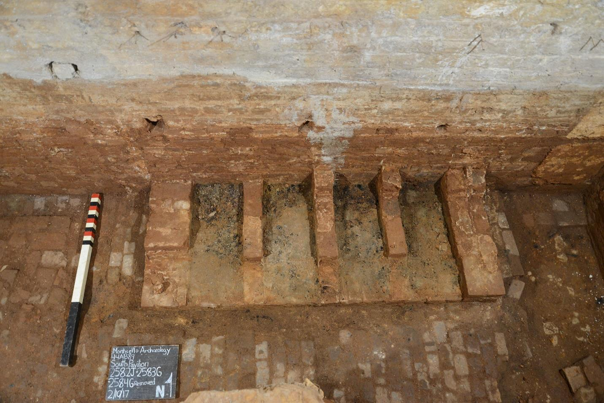
Figure 4.8 Period 3 stew stove with ash deposits pre sample collection (O’Connor and Neiman 2022:90).

Concentrating only on the kitchen periods for this structure provides an opportunity to look contextually at these macrobotanical assemblages with qualitative (i.e. presence and absence of certain taxa) and quantitative comparisons (i.e. density of plant remains recovered), and focus on changes in taxa through time relative to the kitchen’s construction and the cooks’ roles. The differences in spatial concentrations from recovered macrobotanical remains deposited near the oven, cook stoves, and dressers may also speak to the different activities in these areas.

Ubiquity
Ubiquity will be used to establish the frequency, or absence and presence, of a taxon throughout the soil samples (Popper 1988:60-61). Hollenbach (2009a:140) notes that when using ubiquity, it is important to consider the biases of a dataset that might affect the recovery and preservation of the sample. When using ubiquity, the samples must be comparable in volume and preservation (Hollenbach 2009a: 140; Hacker 2016: 44). In this methodology, absolute counts and weights for the taxon are not considered, as the ubiquity is calculated by establishing the number of samples that contain the taxon and dividing this by the total number of samples analyzed for the assigned area (Popper 1988:61). As preservation and volumes of sediment need to be comparable during the method of ubiquity, I discuss any samples that may look irregular or an outlier due to larger sample volumes or the number to samples from an area. In terms of the ubiquity some samples were excluded from the analysis as they contained less than 1 liter of soil and therefore may be too small to contain a representative sample of certain botanical remains. Please see Appendix XX for reference of the samples excluded from the analysis due to their smaller size.
Ratios
As the kitchen samples have a variety of volumes and some questions behind the preservation potential of the depositional layers, it is important to include additional quantitative methods to explore patterns within the dataset. Ratios are used by paleoethnobotanists to standardize datasets for broad comparisons both within and between sites (Hacker 2016:45). Plant density is one type of ratio used in this analysis, as it takes into account differences in the sediment sizes of the sample caused by differences in recovery and depositional layers (Miller 1988:73). Density is calculated by dividing the total weight of the plant remains by the total volume of the original sample. The second ratio used in this analysis are percentages which help by standardizing a sample so that recovery of a taxon can be compared among contexts (Miller 1988:74; Hacker 2016:45). Here I primarily use the count of a taxon divided by the total plant weight in a sample to explore whether the recovery of a taxon changes through time or differs by area in the kitchen.

Box Plots
Box plots are used to graphically display datasets. The median is shown as the “waist” of the notched box; the ends of the box mark the 25th and 75th percentiles of the data. “Whiskers” extend from the ends of the box to the lowest values within 1.5 times the “hinge spread”, or the difference between the 25th and 75th percentiles. Outliers are shown greater than 1.5 times the hinge spread whereas extreme outliers are shown greater than 3.0 times the hinge spread (Hollenbach 2009a).
The quantitative density data was statistically compared using box plots through the program MYSTAT. This program allows for statistical comparisons between and across the three kitchen periods through notching showing the 95% confidence intervals for the data for each period. This notching allows the researcher to see the range of the data, but also statistically how relatable each data set is to one another. I compare the sample data for the three kitchen periods for plant density, relative wood density, pinecone density, relative pinecone density, burnt/starchy food density, eggshell density, crop density, fruit density, and nut density. All three periods have a range in the number and size of samples available for analysis per period; therefore, it is important to point out that logbase10 was applied to the y-axis of a majority of the comparable data sets. Applying the log to the data sets provides a cleaner spread of data for observing the statistical similarities and differences between plant densities of the three kitchen periods.

Methods Applied to Historic Documents
By taking the carbonized plant remains and extending the data analysis beyond the basic list of taxa counts and weights, we can provide a cultural perspective of how these now-carbonized remains were once plants chosen for a variety of foodways practices across this kitchen space. Combining the analysis of the macrobotanical remains within particular kitchen areas with a review of historical documents allows for a clearer understanding of the types of foods people cooked and consumed in this space. These can also be compared to the foodways activities practiced by other enslaved peoples on the plantation. These historical documents include an examination of the appliances used to prepare the meals (Hemings Kitchen Inventory 1790) requested by the Jefferson’s; the particular spatial arrangement of architectural kitchen features through comparison to Jefferson early kitchen sketch plans (Figure 3.4); descriptions of the kitchen recorded by enslaved individuals (Issac J efferson account); and the types of recipes that were requested by the Jefferson household. Examples of these documents include Thomas Jefferson’s Cookbook, Jefferson’s Farm Book and other agricultural records for the property, and first-hand accounts of the foods eaten by free and enslaved residents, and visitors to the plantation.
Focusing the research on the Monticello plantation, primary source documents aid our foodways research by establishing connections, trends, and chronological dating of kitchen site. The documentary evidence, combined with the spatial analysis of the plant remains, allows for better distinctions of cooking activities within the kitchen and furthers our understanding of the specialized roles of the enslaved cooks versus the white individuals in charge of the home. These lines of data will give us insight into how the enslaved kitchen cooks used the kitchen space to maintain a sense of autonomy and cultural identity through the construction of these dishes.
When addressing questions of food consumption in this kitchen space, we cannot definitively establish which foods in this kitchen were consumed by white individuals versus the enslaved house workers and/or community of Mulberry Row. Through further analysis of the documentary records associated with the Monticello estate (Farm Book, archaeology of Monticello), we can roughly establish numbers and types of rations allocated to which types of slaves, but we cannot say that the enslaved cooks specifically consumed this food in this kitchen space. Through these datasets I establish a clearer understanding of the foodways practices and roles associated with the individuals working and living in the first kitchen space at Monticello.

Chapter 5: Macrobotanical Results and Data Analysis

The 43 samples analyzed from the South Pavilion Kitchen site (44AB089) yielded a total of 342.09 grams of plant materials, of which 324.15 grams is comprised of carbonized wood fragments and the remainder of 17.94 grams of plant material. All other plant material includes a broad range of carbonized and uncarbonized remains, depending on the sample’s depositional preservation, in categories of domesticated crops, wild plants, nuts, fruits, and miscellaneous taxa.
In this chapter I discuss my research objectives in relation to the summarized data results of the macrobotanical assemblage of the South pavilion kitchen site. One of my primary research questions investigated the types of botanical specimens recovered in the assemblage as well as primary spatial patterns for plant densities in the kitchen through time. The last part of this research question aims to discuss the types of meals that may have reflected the recipes of the period. All of this discussion is achieved throughout the entirety of chapter five where the assemblages are not only discussed by category and frequency, but also by recipes recorded as cooked in the space from personal accounts and cookbooks.
I discuss the botanical results of the South Pavilion kitchen space in a variety of ways. I begin by discussing the carbonized plant taxa by the defined categorical groups of taxa noted above. This discussion provides an overview of the plant data as related to culinary use, procurement and provisional storage, medicinal usage, and nutrition. This discussion is weighted toward taxa with larger frequencies and unusual plants not commonly recovered in the archaeological record. Second, I discuss the ubiquity or frequency of the plant remains by associated periods and spatial areas of the kitchen by categories that include the primary plant categories previously examined with the inclusion of burnt/starchy food remains, eggshell, and pinecone. This allows for a deeper understanding in foodways activities associated with spatial areas of the kitchen space through these by products and the architectural kitchen elements required to prepare the food.
The primary research objectives in this analysis aim to understand the types of food prepared in this kitchen space throughout its 28 years of use for the Jefferson family through macrobotanical remains collected throughout a variety of depositional layers of the site. I also attempt to explore the social relationships established between individuals through the physical actions and steps required to cook food in this space. This is achieved through understanding the architectural features in this kitchen space in relation to the densities and frequencies of taxa recovered in the flotation samples in relation to the interactions of the individuals involved in this evolving kitchen space in relation to the plantation household.
The historical context of chapter 4 discusses the construction and the established updates in the kitchen space to accommodate the needed architectural tools for cooking a particular style of dish or cuisine requested by Jefferson and the main household. The total plant varieties and forms in which the remains were preserved, and the concentrations for which areas they were recovered in the kitchen spacer allows for a deeper analysis of the activities or choices in food preparation conducted in this space by enslaved cooks.

The Kitchen Plant Assemblage

Domesticated Crops
The crop taxa represented in Table 5.1 include pea, bean/persimmon, unidentifiable grain, and specimens tentatively identified as corn cupule or kernel, bean, smaller legumes (similar to clover), and unidentifiable tubers (see Appendix for taxa recovered by sample). These domesticated crops represent staples used in a variety of traditional 18th to 19th-century cuisine for all social classes. Not only were these crops good for provisional storage for future use, but the crops were also typical of the dishes consumed and originally prepared in this kitchen space. Corn, beans, peas, potatoes, and a variety of starchy tubers are referenced in recipes from Jefferson’s kitchens, including potato soup, bean soup, and vegetable porridge (Kimball 1949). Peas are especially interesting as this is not something we usually see in the paleoethnobotanical record as the plant has little by-product and is usually consumed in whole. But as Jefferson had over 30 varieties grown from March through July in the kitchen garden (Hatch 2012:169), it is promising that the historical documents parallel the botanical record in this kitchen space. Historically speaking peas and corn were commonly grown together as the corn crop ripened while the pea vines matured on the corn and were utilized in a number of ways (Hilliard 1972: 177). Peas were a staple on the Monticello farm and often marked the first sign of spring through Jefferson’s legendary pea contests (Hatch 2012: 9).
Beans were another taxon favorited by Jefferson growing a variety of species alongside peas in the kitchen garden (Hatch 2012: 161) as well as being a plant taxon identified in this botanical assemblage. Beans were common foods consumed in a variety of cuisines and ethnic dishes and were dried for storage and preserved for later consumption (Covey and Eisnach 2009:78). Beans were cooked in a variety of ways at Monticello including soups, stews, baked, or as succotash, cooked with corn cut from the cob (Sumner 2004: 77-78). James Hemings referenced recipes for preserving French green beans for the winter months: “Let your snaps be green but their moisture dried out a little” (Kimball 1949:36).
The presence of tentatively identified remains, as seen through the corn in the forms of cupules and kernels, demonstrates the various by-products and stages that botanicals are recovered in this kitchen space. As the tentative corn remains were few in counts it is most likely that the corn was processed prior to entering the kitchen and was mostly corn meal used for breads. Corn kernels are the edible portion of the plant and a staple ingredient in numerous dishes including corn breads, hoe or ash cakes (Hilliard 1972:49), corn on the cob, and corn cut off the cob and mixed in stews with beans (Craughwell 2012). Other parts of the plant not recovered in the archaeological record include corn husks used as medicinal treatments for aches and the flu (Covey 2007: 93). Tentative tuber remains were also frequently present throughout the botanical assemblage as characterized by dense but spongy exterior surface with the occasion flaking of the exterior coat with a dense but bubbly interior. Tubers were grown frequently in the kitchen garden as Jefferson suggested that tubers be grown with maize (Betts 1944: 194).
Evidence of the tentative legume varieties reflects an additional avenue for understanding how unusual taxa may have arrived in the kitchen’s deposits. Some plant remains recovered in this space may have originally been carried in through hitchhiking seeds. One is likely clover, which was used as a cover crop and fodder, but was also used in times of famine for bread and tea (Fernald, Kinsey, Rollins 1958:246). Clover is also used medicinally as a salve for burns, cuts, and dry skin (Cavender 2003:98). The other is likely a weedy legume. Both were likely carried into the kitchen through foot traffic, adhering to people’s clothing, or were accidentally included with other food crops processed in this space.
Table 5.1 Domesticated Crops Recovered from the 44AB089 Flotation Samples

Common Name | Taxonomic Name | Seasonality | Period 1 |  | Period 2 |  | Period 3 |  | Totals
Common Name | Taxonomic Name | Seasonality | Ct | Wt (g) | Ct | Wt (g) | Ct | Wt (g) | Ct | Wt (g)
Bean cf. | Phaseolus  vulgaris cf. | Summer-Fall | 6 | 0.01 |  |  | 1 | 0.01 | 7 | 0.02
Bean family | Fabaceae | Summer-Fall |  |  |  |  | 1 | 0.01 | 1 | 0.01
Bean/Persimmon | Phaseolus/  Diospyros | Summer-Fall |  |  |  |  | 8 | 0.00 | 8 | 0.00
Corn cupule cf. | Zea mays | Summer-Fall |  |  |  |  | 3 | 0.01 | 3 | 0.01
Corn embryo cf. | Zea mays | Summer-Fall | 1 | 0.00 |  |  |  |  | 1 | 0.00
Corn kernel cf. | Zea mays | Summer-Fall |  |  | 1 | 0.01 | 17 | 0.04 | 18 | 0.05
Grain, unidentifiable | miscellaneous |  |  |  | 1 | 0.00 |  |  | 1 | 0.00
Legume cf.* | Fabaceae cf. | Summer-Fall |  |  |  |  | 1 | 0.01 | 1 | 0.01
Legume, weedy cf.** | Fabaceae cf. | Summer-Fall |  |  |  |  | 1 | 0.00 | 1 | 0.00
Pea | Pisum sativum |  |  |  |  |  | 1 | 0.00 | 1 | 0.00
Tuber cf. | miscellaneous |  | 6 | 0.01 | 3 | 0.00 | 44 | 0.14 | 53 | 0.15
*This is most likely a type of clover crop.  **The Legume, weedy cf. is smaller in size compared to the general Legume cf.  Total Domesticated Crops |  |  |  |  |  |  |  |  | 95 | 0.25

Nuts
The botanical assemblage shown in Table 5.2 contains a total of 53 nut specimens for a total weight of 0.15 g. The samples include acorn, acorn cf., hazelnut, hickory, hickory cf., unidentifiable nutshell, nutshell cf., and specimens identifiable only to the Walnut family. Most of the nut taxa were recovered from Period 3 as this is the primary cooking occupation for the kitchen space (see Appendix for taxa recovered by sample). These edible wild resources were usually collected in the late summer to early fall, most likely by enslaved individuals, especially children (Stanton 2000:28-29; Sorensen 2011:149). To harvest these wild nut varieties, the enslaved, most likely young children (Hacker 2016:53), would have to venture away from the main mountaintop and or to the surrounding forest margins, particularly for hazelnuts, and further into the woods. Even though few nut taxa were identified from these samples, the nuts commonly found in the Piedmont region of Virginia include hazelnut, hickory, acorn, and black walnut (Hacker 2016:51). Acorns are not usually considered edible, particularly among Euro-Americans, and may have been more of an accidental inclusion in this depositional layer compared to the higher quality nuts. The unidentifiable carbonized nutshell fragment was partially identified as nutshell or peach pit because of its dense characteristics and slightly curved shape.
Nuts are a valuable wild resource for individuals who foraged for additional food provisions, such as the enslaved, as they are high in calories, fats, and protein (Scarry 2003:60). For plantation households, nuts were more often used to provide flavor and interest than calories (Hilliard 1972:89). Jefferson aimed to be self-sufficient by growing many of his foods on site (Hatch 2012:9), but there are still some foods that were ordered and brought in for specialty dishes. As walnuts and hickory were abundant wild nut resource actively kept up on the landscape, hazelnuts were more likely grown along wood lines of the property and harvested as early as late summer (Betts 1944).
Either wild or imported, nuts are good provisional foods, as seen in enslaved contexts as a form of food security, in the sense that they can be stored for long periods of time for later processing and consumption. Acorns and black walnuts are commonly found in enslaved African American contexts due to their abundant wild resource availability and their high nutritional value (Hilliard 1972:89). Hickories and black walnut trees were also used medicinally by individuals through bark for dental health, and leaves for teas and ointments (Mrozowski et al. 2008).

Table 5.2 Nuts Recovered from the 44AB089 Flotation Samples

Common Name | Taxonomic Name | Seasonality | Period 1 |  | Period 2 |  | Period 3 |  | Totals
Common Name | Taxonomic Name | Seasonality | Ct | Wt (g) | Ct | Wt (g) | Ct | Wt (g) | Ct | Wt (g)
Acorn | Quercus sp. | Fall | 2 | 0.00 |  |  |  |  | 2 | 0.00
Acorn cf. | Quercus sp. cf. | Fall |  |  | 1 | 0.00 |  |  | 1 | 0.00
Hazelnut | Corylus sp. | Fall | 1 | 0.00 |  |  | 2 | 0.02 | 3 | 0.02
Hickory | Carya sp. | Fall |  |  | 3 | 0.00 | 3 | 0.01 | 6 | 0.01
Hickory cf. | Carya sp. cf. | Fall | 1 | 0.00 |  |  | 2 | 0.01 | 3 | 0.01
Nutshell | miscellaneous | Summer-Fall |  |  | 1 | 0.00 | 13 | 0.04 | 14 | 0.04
Nutshell cf. | miscellaneous | Summer-Fall |  |  | 4 | 0.00 | 15 | 0.07 | 19 | 0.07
Walnut family | Juglandaceae | Fall |  |  |  |  | 5 | 0.00 | 5 | 0.00
Total Nuts |  |  |  |  |  |  |  |  | 53 | 0.15

Fruits

The fruits represented (Table 5.3) in the samples include plants that were found commonly on the estate’s natural landscape or cultivated in the kitchen garden and orchards, and are primarily fruit varieties with seasonality of the summer to fall. The taxa include blackberry/raspberry, uncarbonized blueberry, grape, grape cf., plum/ cherry cf., maypop cf., peach cf., and watermelon. Eight specimens were also classified as persimmons/beans; due to the small size of these fragments and the similarity of these two seeds, they are difficult to identify specifically as either bean or persimmon.
Persimmons were a common tree growing in the region and the fruits were often consumed by enslaved individuals on the surrounding property. Persimmons are referenced as being easily harvested by shaking or picking them off the tree and were used in a variety of dishes and drinks (Willison 1964; Covey and Eisnach 2009). This fruit was used in a variety of ways and even kept on hand until bursting ripe (Sokolov 1991: 163). Persimmons are described as being used for beer or wine in multiple slave narratives and recipes used in historical cookbooks of the period (Covey and Eisnach 2009:177; Harbury 2004:400; Twitty 2017: PAGE NUMBER) and possibly brewed at Monticello, with Ursula in charge of all brewing operations.
Peaches and cherries were two additional resources found wild and cultivated in the orchards on the home farm. Peaches were grown in abundance in the South orchards at Monticello and were known to be Jefferson’s favorite fruit. Jefferson made numerous references to peaches in his farm book records and grew over 45 varieties in his orchards (Thomas Jefferson Foundation 2018). Peaches were also used by the enslaved population and referenced as having medicinal properties and were used in teas, ointments, and cold remedies (Covey and Eisnach 2009:176).
Cherries and plums were also popular fruits used for dishes prepared at Monticello. Recipes used in the South Pavilion kitchen for the main house include cherries for pastries, pies, and jams (Kimball 1949). Jefferson is referenced as having his enslaved head gardener install cherry trees alongside the kitchen garden for shade and fruits (Hatch 2012). These wild and cultivated fruits were used medicinally as well but mostly in the form of ointments and teas from the bark and leaves (Covey 2007). The grapes and raspberry/blackberries recovered in the samples were also wild and cultivated taxa in the South. Specifically, at Monticello grapes and blackberries grew in wild thickets within the wood lines as well as in the vineyards. Grapes, like most fruit, were picked by enslaved individuals and often eaten raw or sold in town (Covey and Eisnach 2009:174).
Watermelon and uncarbonized blueberry seed are two underrepresented fruit taxa. Multiple portions of the watermelon seed were recovered including the seed coats, interior seed meat, and whole seeds. Found in the context of the hearth, these watermelon seeds may have fallen into the fire when they were being burned or roasted as watermelon seeds were commonly consumed as a light snack or at group events as the fruit was too large to consume by one individual. Jefferson references growing watermelons, pumpkins, and cantaloupes along the hills of the garden in 1774 (Hatch 2012:83). A local farmer to Monticello at the Taylor Midland Plantation references gatherings of neighbors and friends in Orange, Virginia, in August of 1787 to eat watermelon and share follies of everyday life (Hatch 2012: 55). Recipes for roasted watermelon seeds include instructions to toast near or in the fire till a golden-brown seed with lightly charred edges. The uncarbonized blueberry seed is unusual for this mostly carbonized assemblage, but Jefferson’s farm books reference blueberries being harvest from mid-June through July (Hatch 2012).
Table 5.3 Fruits Recovered from the 44AB089 Flotation Samples

Common Name | Taxonomic Name | Seasonality | Period 1 |  | Period 2 |  | Period 3 |  | Totals
Common Name | Taxonomic Name | Seasonality | Ct | Wt (g) | Ct | Wt (g) | Ct | Wt (g) | Ct | Wt (g)
Blackberry/Raspberry | Rubus sp. | Summer |  |  |  |  | 1 | 0.00 | 1 | 0.00
Blueberry, uncarbonized | Vaccinium sp. | Summer |  |  |  |  | 1 | 0.00 | 1 | 0.00
Fruit cf. | miscellaneous |  |  |  |  |  | 1 | 0.04 | 1 | 0.04
Fruit/Grain cf. | miscellaneous |  |  |  |  |  | 5 | 0.01 | 5 | 0.01
Grape | Vitis sp. | Summer |  |  | 1 | 0.00 |  |  | 1 | 0.00
Grape cf. | Vitis sp. cf. | Summer |  |  | 1 | 0.00 | 2 | 0.00 | 3 | 0.00
Maypop cf. | Passiflora incarnata cf. | Summer |  |  |  |  | 1 | 0.00 | 1 | 0.00
Peach cf. | Prunus persica cf. | Summer |  |  |  |  | 1 | 0.00 | 1 | 0.00
Persimmon cf. | Diospyros virginiana cf. | Fall |  |  | 1 | 0.00 | 4 | 0.02 | 5 | 0.02
Persimmon seed coat | Diospyros virginiana | Fall |  |  |  |  | 1 | 0.00 | 1 | 0.00
Plum/cherry cf. | Prunus sp. cf. | Summer |  |  |  |  | 1 | 0.00 | 1 | 0.00
Watermelon | Citrullus vulgaris | Summer |  |  |  |  | 1 | 0.01 | 1 | 0.01
Watermelon seed meat | Citrullus vulgaris | Summer |  |  |  |  | 2 | 0.00 | 2 | 0.00
Watermelon seed coat cf. | Citrullus vulgaris cf. | Summer |  |  |  |  | 5 | 0.00 | 5 | 0.00
Total Fruits |  |  |  |  |  |  |  |  | 29 | 0.08

Miscellaneous
The miscellaneous plant category (Table 5.4) includes bark, buds from unidentifiable plants, burnt/starchy food remains, coffee, pinecone, pitch, a variety of unidentifiable seeds and plant remains from weeds and grasses, and a variety of unidentified wood specimens. Taxa of tentative identification or not mentioned above in the plant assemblage can be viewed in detail in the Appendix X.X.
Wood represented 91% of the carbonized assemblage by weight. Further identification of the wood specimens was beyond the scope of this thesis, but further research could focus on the analysis of the wood genera present, as these would indicate wood selected for fire fuels. Special note was taken of fragments of wood that had material adhering to it, as seen in specimens of wood with metal and mortar.
Out of the 43 samples from the South Pavilion, pinecone scales and pitch were the most common carbonized plant remains recovered after wood. The category “pitch” refers to amorphous vitrified materials, where the plant’s starch and/or sugars are exposed to excessive amounts of heat, causing the specimen to become glassy and unidentifiable (Hacker 2016). The possible use of pinecone is unclear, but its presence in 86% of the botanical assemblage suggests that it was used as tinder for cooking fires. General fire conventions for a stove fire include a good base of kindling to nurture and build a mature flame. Pinecones, being in plenty on the native landscape and woodlands of the Monticello mountain top, were dried and a readily available resource that could be quickly gathered with smaller kindling to add to the always necessary fires required in the kitchen space (Deetz 2017). Other parts of the pine tree could be used as well: the shoots could be used to make candy and the pine needles made into teas for medicinal aliments (Covey 2007). Another known but unlikely use for the pinecones in this context of a plantation kitchen space is that pinecones were used as an emergency food source, where premature male cones were boiled and eaten (Pinecone article). Records show Jefferson giving landscaping instructions to his trusted slave Wormley Hughes to, “…plant the Pitch pine in the woods along the new road leading from the house to the river, on both sides of the road” (Betts 1944: 355).
An additional parallel between the botanical record and the historical documents is through the presence of burnt/starchy food remains, found in the majority of the samples recovered across the 38 years of the kitchen’s occupation. These carbonized organic remains have a spongy but dense texture, denser than seen in carbonized tubers and lacking the smoother outer cambium layer seen in tubers, but airier than the texture of pitch. A kitchen space is guaranteed to have burnt debris scattered throughout the space because of cooking, but the consistency of these burnt/starchy food remains are constantly alike. Cooks often used remnants of leftover foods to make quick meals for themselves between tasks. An example of easy quick foods in historical accounts of the Monticello kitchen were the sweet potato hoe cakes made by James Hemings and given to Jefferson’s granddaughters (Kimball 1949). Hoe, ash, or Johnny cakes were a staple snack for slaves and working laborers of the period, consisting of a starchy base of flour, cornmeal or potatoes and mixed together, cooked in the ashes of a spent fire, and removed with a long-handled tool similar to farming hoes These burnt/starchy specimens could be examples of burnt starchy food remains like hoe cakes or other breads
The recovery of coffee from Period 3 deposits is also of particular interest, as well as their locational context. Period 3 is associated with James Hemings’ time as the head cook of this space. Due to his specialized training in France, James frequently cooked with luxury taxa grown on the estate as well as ordered from surrounding merchants. James Hemings’ kitchen was appointed with brass and copper equipment, specifically needed for his training in French styles of cooking, including a copper mortar and pestle used to grind spices and other plants (Hemings 1796). The base of a copper mortar was recovered during excavation in the Northwest corner of the kitchen in the same context the coffee beans were recovered from. This coffee luxury item proved to be popular among all individuals of the colonial period, especially in the European culinary scene, as Jefferson’s household was quoted as drinking at least a pound of beans a day. The coffee recovered in this space would have been reserved for the Jefferson household, but enslaved people at Monticello are referenced drinking coffee during late night fires and playing the fiddle. This coffee would have been bought through money acquired through personal labors as the Jefferson household accounts reference the enslaved and laborers on the property selling personal provisions acquired through their own kitchen gardens, fishing labors, and chicken eggs, to Martha Jefferson for use on the main table.
Another foodways-related category recovered in the assemblage is eggshell fragments. Although not plant remains, there were such high quantities of eggshell recovered from the samples that they are worth noting. Eggs are staple ingredients for the sauces and creams for which French food is known. An example of a recipe attributed to James Hemings was a type of custard named ‘snow eggs’ requiring a minimum of 10 eggs poached (Craughwell 2012: 198) The small pot sauces famous in French cuisine would have been cooked over the stew stoves in the kitchen space to make these favored family recipes.

Table 5.4 Miscellaneous Recovered from the 44AB089 Flotation Samples

Common Name | Taxonomic Name | Seasonality | Period 1 |  | Period 2 |  | Period 3 |  | Totals
Common Name | Taxonomic Name | Seasonality | Ct | Wt (g) | Ct | Wt (g) | Ct | Wt (g) | Ct | Wt (g)
Plants
Bark | Unidentified | Fuel | 32 | 0.31 | 67 | 0.32 | 545 | 9.03 | 644 | 9.66
Bark cf. | Unidentified | Fuel | 8 | 0.00 | 7 | 0.00 | 80 | 0.38 | 95 | 0.38
Buffalo bur, uncarbonized | Solanum rostratum | Miscellaneous | 0 | 0.00 | 1 | 0.00 | 0 | 0.00 | 1 | 0.00
Burnt food/Starchy | Unidentified | Foodways Activity | 83 | 0.36 | 94 | 0.32 | 452 | 1.77 | 629 | 2.45
Coffee | Coffea sp. |  | 0 | 0.00 | 0 | 0.00 | 2 | 0.01 | 2 | 0.01
Coffee seed coat | Coffea sp. |  | 0 | 0.00 | 0 | 0.00 | 2 | 0.00 | 2 | 0.00
Coffee seed coat cf. | Coffea sp. cf. |  | 0 | 0.00 | 0 | 0.00 | 7 | 0.00 | 7 | 0.00
Gall | Unidentified | Miscellaneous | 1 | 0.00 | 2 | 0.00 | 3 | 0.00 | 6 | 0.00
Goosegrass | Eleusine indica |  | 0 | 0.00 | 0 | 0.00 | 1 | 0.00 | 1 | 0.00
Grass family, uncarbonized | Poaceae |  | 0 | 0.00 | 0 | 0.00 | 2 | 0.00 | 2 | 0.00
Holly, uncarbonized | Ilex sp. |  | 0 | 0.00 | 0 | 0.00 | 1 | 0.00 | 1 | 0.00
Mallow family, seeds | Malvaceae | Miscellaneous | 0 | 0.00 | 0 | 0.00 | 2 | 0.00 | 2 | 0.00
Morning glory, uncarbonized | Ipomoea sp. | Summer-Fall | 0 | 0.00 | 0 | 0.00 | 1 | 0.00 | 1 | 0.00
Pinecone | Pinus sp. | Fuel | 43 | 0.20 | 232 | 0.44 | 539 | 2.20 | 814 | 2.84
Pinecone cf. | Pinus sp. cf. | Fuel | 0 | 0.00 | 7 | 0.01 | 79 | 0.24 | 86 | 0.25
Pitch | amorphous vitrified material | N/A | 3 | 0.00 | 21 | 0.03 | 113 | 0.34 | 137 | 0.37
Pitch cf. | amorphous vitrified material |  | 0 | 0.00 | 0 | 0.00 | 11 | 0.05 | 11 | 0.05
Purslane | Portulaca sp. | Summer-Fall | 1 | 0.00 | 0 | 0.00 | 1 | 0.00 | 2 | 0.00
Purslane, uncarbonized | Portulaca sp. | Summer-Fall | 0 | 0.00 | 0 | 0.00 | 3 | 0.00 | 3 | 0.00
Table 5.4 (continued) Miscellaneous Recovered from the 44AB089 Flotation Samples

Common Name | Taxonomic Name | Seasonality | Period 1 |  | Period 2 |  | Period 3 |  | Totals
Common Name | Taxonomic Name | Seasonality | Ct | Wt (g) | Ct | Wt (g) | Ct | Wt (g) | Ct | Wt (g)
Plants
Spore clump | Unidentifiable | Unidentifiable | 2 | 0.00 | 0 | 0.00 | 23 | 0.02 | 25 | 0.02
Stem | Unidentified | Miscellaneous | 0 | 0.00 | 3 | 0.00 | 1 | 0.00 | 4 | 0.00
Stem, monocot | Poaceae | Unidentifiable | 0 | 0.00 | 0 | 0.00 | 12 | 0.01 | 12 | 0.01
Uncarbonized Wood | Unidentified | Fuel | 0 | 0.00 | 0 | 0.00 | 2 | 0.01 | 2 | 0.01
Unidentifiable | Unidentifiable | Unidentifiable | 17 | 0.02 | 26 | 0.06 | 194 | 0.59 | 237 | 0.67
Unidentifiable seed | Unidentifiable | Unidentifiable | 8 | 0.00 | 16 | 0.01 | 70 | 0.15 | 94 | 0.16
Non-Plants
Bone/Fish scale | Unidentified | Foodways Activity | 54 | 0.51 | 166 | 0.62 | 637 | 4.53 | 857 | 5.66
Cinder | N/A | N/A | 0 | 0.00 | 0 | 0.00 | 45 | 0.30 | 45 | 0.30
Coal/slag | N/A | N/A | 0 | 0.00 | 0 | 0.00 | 7 | 0.00 | 7 | 0.00
Daub | N/A |  | 1 | 0.00 | 3 | 0.00 | 0 | 0.00 | 4 | 0.00
Eggshell | Unidentified | Foodways Activity | 7 | 0.01 | 138 | 0.32 | 1366 | 3.22 | 1511 | 3.55
Metal flakes | N/A | Utensil* | 0 | 0.00 | 0 | 0.00 | 14 | 0.12 | 14 | 0.12
Straight Pin (Copper) | N/A |  | 2 | 0.02 | 3 | 0.03 | 4 | 0.03 | 9 | 0.08
Textile Fiber | N/A | Miscellaneous | 0 | 0.00 | 1 | 0.00 | 0 | 0.00 | 1 | 0.00
Wood with Metal | Unidentifiable | Utensil* | 0 | 0.00 | 0 | 0.00 | 14 | 0.15 | 14 | 0.15
Wood with Mortar | Unidentifiable | Construction/Fuel | 0 | 0.00 | 0 | 0.00 | 7 | 0.09 | 7 | 0.09
*Metal fragments from remnants of fork with wood handle recovered in ash of Hearth.  Total Miscellaneous |  |  |  |  |  |  |  |  | 5307 | 26.84

Kitchen Comparisons by Period

Ubiquity Across the Kitchen Periods

Ubiquity allows for broad comparisons through time of the frequencies of the types of plants and foodways remains found in the assemblage. Table 5.5 demonstrates the total ubiquity by period for the foodways-related material recovered from 35 of the 43 samples in the South Pavilion kitchen space by the following categories: burnt/starchy remains, domesticated crops, eggshell, fruits, nuts, and pinecone. A total of 8 samples were dropped from the ubiquity analysis as they contained less than 1 liter of sediment. Some of the categories were specifically chosen due to the higher frequency throughout the kitchen periods, and their cultural significance in cooking techniques for cuisine constructed in this kitchen space.
The ubiquity Table 5.5 demonstrates that burnt/starchy food remains are represented in a total of 26 of the 35 samples or 74% frequency across all three periods of the kitchen space. There is an increase in the amount of burnt/starchy food remains recovered through time as Period 1 contains the least at 43% frequency being a period primarily associated with construction related activities, and Periods 2 and 3 containing the higher frequencies related to foodways activities at 78% and 84%.
Domesticated crops were recovered from 13 of 35 samples or 37%. Even though this category of food remains is one of the lower frequencies recovered from the kitchen samples, there is still an increase in the number of domesticated crops recovered from Period 1 through Period 3. Higher frequencies of domesticated crops in Period 3 suggests that more diverse dishes were being cooked during Period 3 of the kitchen space. Records of plants added to the Monticello kitchen garden and the larger Monticello mountain top during this kitchen period include sweet potato (planted 1786), over 40 varieties of beans (planted 1774-1820), and over 30 varieties of peas (planted 1773-1820) (Southern Plant List Source 2000: 26-43 and Jefferson Farm Book Citation).
Table 5.5 Ubiquity of recovered Taxa by Periods of the South Pavilion Kitchen

Taxon | Period 1 | Period 2 | Period 3 | Totals
Taxon | n= Samples per Period
Taxon | n=7 ^{A} | n=9 ^{B} | n=19 ^{C} | n=35 ^{D}
Burnt/Starchy Food | 43% | 78% | 84% | 74%
Domesticated Crops | 29% | 33% | 42% | 37%
Eggshell | 57% | 100% | 95% | 89%
Fruits | 0% | 11% | 32% | 20%
Nuts | 14% | 44% | 53% | 43%
Pinecone | 71% | 100% | 95% | 91%

A: Period 1 contains 8 samples in total, but since sample 2584CC contained less than 1 Liter it was dropped from the ubiquity analysis; therefore leaving 7 samples for Period 1.

B: Period 2 contains 11 samples in total, but since sample 2584Q and 2584R contained less than 1 Liter of soil, the 2 samples were dropped from the Period 2 ubiquity analysis This leaves 9 samples for analysis of Period 2.

C: Period 3 contains 24 samples in total but since samples 2583J, 2584H, 2584P, 2585M, and 2586M contained less than 1 liter of soil, these samples were dropped from the ubiquity analysis for Period 3. This leaves 19 samples for analysis of Period 3.

D: A total of 43 samples were processed, but 8 of these samples contained less than 1 liter of sediment and were dropped from ubiquity analysis. This leaves a total of 35 samples for analysis.

Eggshell was present in 31 of 35 samples or 89% and speaks to the type of foodways activities conducted throughout this kitchen space. The fragmentary nature and size of eggshell causes a problem for cleanup and disposal of the egg post-cooking, which may explain why eggshell is present in 89% of the samples. Small eggshell fragments can easily be swept into the cracks of the brick floor or carried in a flooding event to other areas of the space, but the higher concentrations of eggshell lean toward evidence of steps conducted when assembling a meal. Eggs were a primary ingredient used in sauces, especially French cuisine, which was the preferred style of cooking for the food prepared for the main table, as discussed earlier in this chapter with James Heming’s snow egg recipes and custards.
Fruit was recovered from 7 of 35 samples, or 20%. Fruit has the lowest frequency of the plant categories recovered from the kitchen. Period 1 contained no fruit, but there is still an increase in the taxon’s presence in Period 2 and 3 samples. Records of plants added to the Monticello kitchen garden and the larger Monticello mountain top during this 38-year period of the South Pavilion kitchen’s occupation include: cherries (planted 1769-1811), grapes (planted 1777, 1796, 1802, 1807-1822), peaches (planted 1771, 1786, 1796), and six varieties of watermelon (planted 1774-1809, 1812, 1820) (Southern Plant List Source 2000:26-43 and Jefferson Farm Book Citation).
Nuts were recovered from 15 of 35 samples, or 43%. Nuts, like the four other plant related categories, increase through periods of the kitchen space. Records of plants added to the Monticello kitchen garden and the larger Monticello Mountain top during this kitchen period include: black walnut (planted 1771), and two varieties of hazelnut trees (Corylus americana planted 1771 and Corylus avellana planted 1774) (Southern Plant List Source 2000:26-43 and Jefferson Farm Book Citation).
Pinecone was recovered from 91% of the samples, making a total of 32 of 35 samples positive for pinecone. Like the other categories, pinecone increases in ubiquity over time. This supports the statement that pinecone was not an accidental inclusion in these samples, but rather an active component in the foodways activities of the kitchen space. Due to the lack of known edible recipes, pinecone was likely used in this space for fuel related purposes.

Summary of Findings
A factor affecting the presence or absence of these plant remains is the type of features or deposits that these samples were recovered from in relation to the locations of architectural features associated with cooking activities in the space. The general trend seen in the data set shows an increase in plant density through the three periods of the kitchen space over an estimated 38 years in occupation. There seems to be a decrease in use through a decrease in the sample plant weight between Period 1 (1770-1775) to Period 2 (1775- 1790) of the kitchen. Period 1 samples yield 86.38 grams of plant weight with 85.48 grams being carbonized wood to Period 2 samples yielding 17.46 grams of plant weight with 16.25 grams of carbonized wood. There is then an extreme increase in use and plant remains from the Period 3 (1790-1808) samples with 238.25 grams of plant weight with 222.42 grams being carbonized wood. The plant remains beyond carbonized wood include 0.90 grams from Periods 1, followed by 1.21 grams of non-wood plant material for Period 2, and finally 15.83 grams of non-wood plant material from Period 3. In sum we see a constant foodways presence from Period 1 through Period 3 of the South Pavilion kitchen, a slight decrease in use for Period 2, but a primary cooking occupational span for Period 3’s time of the kitchen space.

Plant Density Data of Kitchen Periods 1-3
The following boxplot (Figure 5.1) shows the total plant density of each period of the kitchen as calculated by the total plant weight (grams) of each sample divided by the total volume (liters) of the sample. This graph ultimately shows how much carbonized plant material was recovered per volume sampled, and therefore represents the intensity of plant deposition during each period.

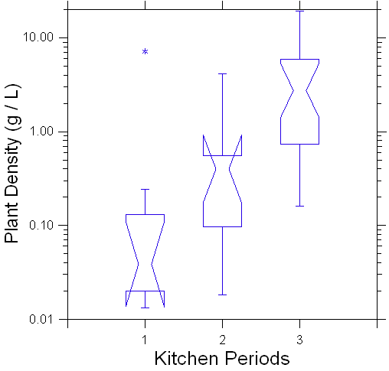

Figure 5.1. Plant Density by Kitchen Periods from the 44AB089 Macrobotanical Assemblage. Note the y-axis transformed by log10.
The box plots in Figure 5.1 demonstrate that there is a range in the data not only between the kitchen periods, but also in the size and number of samples in each kitchen period. The box plots show the increased progression of plant density from Period 1 through 3. There tends to be lower plant densities for the samples from Period 1, with a middle range in plant densities for Period 2, and the highest plant densities for the samples of Period 3. Because the notches for each boxplot do not overlap, the differences in plant density between each period are statistically significant.
The bulk of the data follows this trend, except there is a single outlier sample from Period 1 that lies closer in variability to the upper quartile range of data from Period 3. This outlier sample (2588Q-S-08) is associated with a context collected from under the Dresser assigned as leveling fill. There are a total of two samples associated with the Dresser with the second (2584V-S-19) also being assigned as leveling fill, but the second deposit’s location lies directly north of this outlier sample. It is unclear when the Dresser was constructed over the leveled brick floor during Period 1 in relation to the accumulation of this deposit, but both samples yielded a variety of plant remains beyond wood including domesticated crops, pinecone, and burnt/starchy food. Because of this diversity of plant remains, it is likely that kitchen debris from activities conducted near and associated with this context were swept under the Dresser.
This outlier sample’s overall volume was 12 liters of soil, whereas the other seven samples had much lower volumes ranging from 0.2-2.0 liters of soil. This sample has a higher plant density of 7.14 g/liter of carbonized plants, but most of this sample is comprised of wood at 84.85 g out of the total plant weight of 85.70 g. The second Dresser deposit yielded a plant density of 0.25 g/liter of carbonized plants with the total plant weight of 0.49 g with 0.45 g of that being carbonized wood. The remainder of the samples for Period 1 ranged from 0.01-0.25 g/liter of carbonized plant remains. The fact that both Dresser deposits contain higher wood weights and similar food-related plants remains suggests that this area of the kitchen has the highest potential for understanding activities related to cooking during Period 1.
In sum, the boxplots demonstrate an increase in plant deposition through time, which coincides with changes in kitchen use. This data supports the progression of kitchen use, with construction-based activities and fewer food-related activities present in Period 1 but glimpses of foodways activities are captured in deposits near the Dresser. This is followed by evidence of architectural changes associated with foodways activities in Period 2, leading to the increased plant density. Finally, the Period 3 samples yielded the highest plant density with most of the food-related activities conducted at this time, as the kitchen’s primary architectural changes came to an end and its use increased.

Relative Wood Density Data of Kitchen Periods 1-3
The following boxplot Figure 5.2 establishes the total relative wood density of each period of the kitchen as calculated by the total wood weight (grams) of each sample divided by the total plant weight (grams). This relative wood density shows how much of each sample’s carbonized plant materials is represented by wood compared to the remaining plant materials recovered.

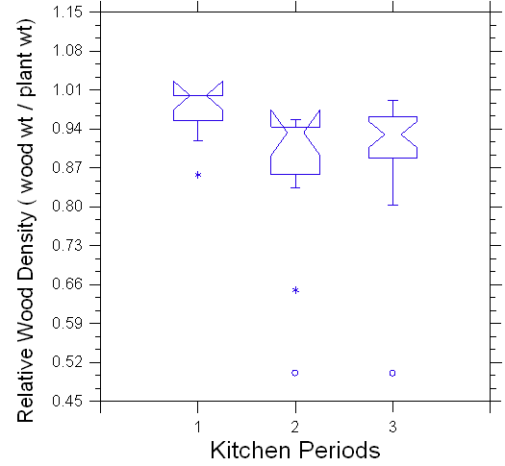

Figure 5.2 Relative Wood Density of the Kitchen Periods from the 44AB089 Macrobotanical Assemblage.
The box plots of Figure 5.2 demonstrate that the relative wood densities for the kitchen periods are closer in statistical significance than the overall plant densities. The relative wood density for Period 1 is higher than the samples from Periods 2 and 3. The notches for Period 1 may slightly overlap with the notches for Period 2 but do not overlap with Period 3, demonstrating that Periods 1 and 3 are statistically significantly different from each other. The relative wood density data for all three periods shows that most of the samples range in having 80-100% of the plant weight comprised of wood. The decrease in the relative density of wood demonstrates that more of the plant remains recovered from Period 2 and 3 samples are related to foods than fuels.
All three periods have outliers or extreme outliers in the data variability. Period 1’s outlier sample of 86% wood to plant weight, from the East Floor context 2588V-S-14, falls within the range of Period 2 and 3’s data but below the 25th percentile for Period 1. This sample has similarities in wood density that are more relatable to the kitchen activities of Period 2 and 3. This sample’s total plant weight of 0.07 g included 0.06 g of wood. The remainder of the plant weight for this sample contains pinecone, which was also likely used as a fuel source.
Period 2’s outlier sample (2584Q-S-14) is associated with a pre-stew stove 2 Ditch context that yields 65% wood to the overall plant weight density. This sample is from an area of the kitchen where fuels were used for cooking, but also in a ditch feature designed to reduce flooding but where kitchen debris could easily accumulate. The deposit contains a total of 0.20 g of carbonized plant material comprised of 0.13 g of wood and the remaining 0.07 g assigned to pinecone, burnt/starchy food remains, and fruit. This outlier is similar to the Period 1 outlier sample, in that they both contain a higher concentration of pinecone, another possible fuel source.
Period 2 and 3 each have extreme outliers of 50% for their relative wood density data sets: Period 2’s sample derives from the Unidentified Pit context (2582V-S-12) and Period 3’s from the Hearth context (2586M-S-01). Period 2’s extreme outlier sample has the highest volume of sediment at 11 liters compared to the other 10 samples, but this is not the reason for the data being an extreme outlier. The sample’s total wood weight yields 0.10 g, making up half the total plant weight for the sample at 0.20 g. This extreme outlier is just one of six samples located in the Unidentified Pit, which tended to accumulate kitchen debris. The Unidentified Pit’s proximity to the flood-prone north wall of the kitchen may have caused this debris accumulation, but it is the only sample of the six where fuel sources make up the entirety of the plant density. This sample, according to the Harris matrix of the site, this sample is the last deposit associated with assigned Feature 10, but not the last deposit of the Unidentified Pit (SG 13 sample from 2582L). The only other plant recovered from this outlier deposit was pinecone, whereas the other five contain food-related plants rather than just fuels.
Period 3’s extreme outlier sample is one of four samples associated with the Hearth, but it is the only sample located just outside the Hearth and adjacent to the Bread oven. This extreme outlier has the lowest volume of sediment at 0.25 liters with 0.02 g wood weight to the total plant weight of 0.04 g. The remainder of the sample’s plant weight is comprised of burnt/starchy food remains and is also the only Hearth-associated deposited without pinecone. The lack of pinecone may be related to its location outside the Hearth and adjacent to the Bread oven, or simply to its small size so it lacks other taxa collected in the larger samples. The three deposits located inside the Hearth also yielded the burnt/starchy food remains, as well as other food-related plants, but also held evidence of pinecone.

Pinecone Density Data of Kitchen Periods 1-3
The following boxplot (Figure 5.3) shows the total pinecone density of each period of the kitchen as calculated by the total pinecone count in each sample divided by the total carbonized plant weight (grams) of the sample. This demonstrates how much of the period’s total carbonized plant sample is made up of pinecone compared to the other plants recovered in the same sample.

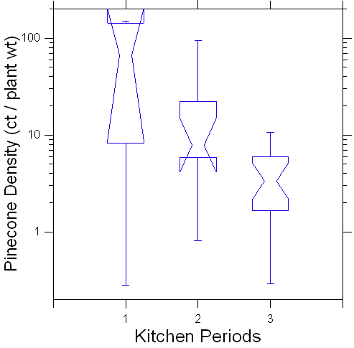

Figure 5.3 Pinecone Density of the Kitchen Periods from the 44AB089 Macrobotanical Assemblage. Note the y-axis transformed by log10.
The box plots of Figure 5.3 demonstrate the pinecone density data of the three kitchen periods and mimics the data set seen in the relative wood density graph (Figure 5.2). This supports the argument that pinecone may have been used as a fuel source. Similar to the relative wood density, the pinecone density data shows higher fuel-related activities for Period 1 and less frequent use of pinecone relative to other plants in Period 3. By Period 3, the samples contained statistically significantly fewer pinecone scales than seen in Period 1, as the notches for Period 1 and Period 3 do not overlap.
In sum, the presence of pinecone mimics the wood density of the kitchen periods, demonstrating that if the data set consistently yields a higher density pinecone there are also higher wood densities in those samples.

Burnt/Starchy Food Density Data of Kitchen Periods 1-3
The following boxplot (Figure 5.4) shows the total burnt/starchy food density of each period of the kitchen as calculated by the total burnt/starchy food count of each sample divided by the total plant weight (grams) of the sample. This demonstrates how much of the period’s total carbonized plant sample is made up of burnt/starchy food compared to the other plants recovered in the same sample.

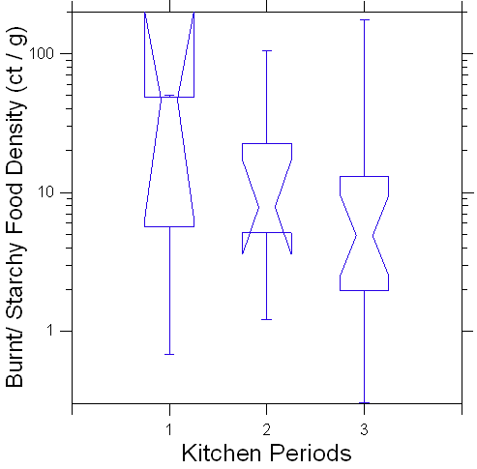

Figure 5.4. Burnt/Starchy Food Density of the Kitchen Periods from the 44AB089 Macrobotanical Assemblage. Note the y-axis transformed by log10.
The box plots of Figure 5.4 demonstrates that there is a range in the data not only between the kitchen periods, but also within each kitchen period. The data shows a gradual decrease in burnt/starchy food remains from Period 1 through 3, but these values are statistically similar with little to no differences as the notches of all three box plots overlap. The widest spread of data is seen in Period 3 with ranges of 0.31 – 175.00, which also captures the full ranges of data values for Periods 1 and 2. This supports the discussion for the ubiquity Table 5.5 demonstrating that Period 3 has the highest number of samples at 83% that contained burnt/starchy food remains. The presence of this burnt/starchy food also confirms food-related activities were conducted in some form or fashion in all three periods of the kitchen.
A more detailed discussion of the spatial distribution of these burnt/starchy food remains will be presented in the following section, but it useful to consider here the samples associated with the broad range of values in Period 3, as this is the primary cooking period of the kitchen. The highest density sample (2586M-S-01) of burnt/starchy food remains from Period 3 is associated with the Hearth, yielding from a 0.25-liter sample that contained 50% wood of the total plant density, followed by pinecone. This may be related to its small size, but the sheer amount of plant remains recovered from such a small sample suggests that foodways activities extended at least to just outside the Hearth. The lowest density sample (2588I- S-03) from Period 3 corresponds to the Drainage Ditch area of the kitchen space near the northeast corner of the Dresser. This sample contains additional evidence of food-related activities seen from the presence of eggshell, nuts, and pinecone.

Eggshell Density Data of Kitchen Periods 1-3
The following boxplot (Figure 5.5) shows the total eggshell density for the samples of all three kitchen periods, as calculated by dividing each sample’s eggshell count by the total volume (liter) of the sample. This demonstrates how much of the analyzed assemblage contains eggshell and gives an indication of cooking-related activities.

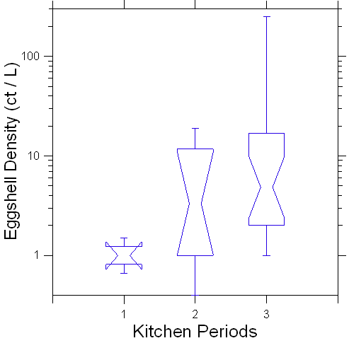

Figure 5.5 Eggshell Density of the Kitchen Periods from the 44AB089 Macrobotanical Assemblage. Note the y-axis transformed by log10.
The boxplots of Figure 5.5 demonstrate that there is a range in the data not only between the kitchen periods, but also within the samples of Periods 2 and 3. The boxplots between the three periods show that statistically there is a significant difference in the data for Period 1 compared to Period 3, as their notches do not overlap. Period 2 falls between these two. The progression of eggshell from lower densities in Period 1 to higher densities in Periods 2 through Period 3 correlates with other trends suggesting an increase in foodways-related activities in the later periods of the kitchen.

Kitchen Spatial Comparisons by Periods
In the following section, I discuss the spatial distribution of foodways materials for each kitchen period. I treat each period separately because the contexts change significantly through time as various components of the kitchen were constructed.

Ubiquity of Period 1
The ubiquity table (Table 5.6) demonstrates the samples include a broad assemblage of plant remains. From the seven samples analyzed and included in the ubiquity analysis, the highest categories present across Period 1 include pinecone (71%) and eggshell (57%) followed by less than 50% of the samples contained burnt/starchy food remains, crops, and nuts. There was no fruit recovered from the Period 1 samples. The majority of the samples were concentrated in deposits associated with the Dresser and this area captures frequencies of every category of taxon except fruit.
The Dresser area has two depositional samples that were analyzed, which contain the highest frequencies of taxon: 100% of the Burnt/ Starchy Food remains, Domesticated Crops, Pinecone, and Eggshell. Nutshell is only represented in one Dresser area sample at a 50% frequency. We can see that there is some overlap between Kitchen Areas, but looking more closely at the individual samples we see that there are differences in counts for pinecone and eggshell (Appendix X.X) in the samples with the same frequency percentages. This will be discussed in more detail later in this chapter concerning density.
Period 1 occupation (1770-1775) for the kitchen demonstrates the lowest evidence in activities related to foodways. The first two years of the structure’s use dealt with construction-related activities, as evidenced archaeologically through mortar splatter on the bedrock related to the East Wall’s construction and meals cooked for bachelor Thomas Jefferson. It is not until later
Table 5.6 demonstrates Period 1 ubiquity of taxa by spatial location in the kitchen.

Kitchen Area | Burnt/Starchy Food | Domesticated Crops | Fruit | Nuts | Pinecone | Eggshell
Kitchen Area | n=8 Samples per Period 1^{A}
Kitchen Area | n= 3 of 7  (43%) | n= 2 of 7  (29%) | n= 0 of 7  (0%) | n=1of 7  (14%) | n= 5 of 7  (71%) | n=4 of 7  (57%)
Dresser  n=2 | 100% | 100% |  | 50% | 100% | 100%*
East Wall  n=2 |  |  |  |  | 50% | 50%
East Brick Floor  n=2 |  |  |  |  | 100% | 50%
West Brick Floor  n=1 | 50% |  |  |  |  | 100%*

A: Period 1 contains 8 total samples, but 1 sample (2584CC-S-26) had less than 1 liter of sediment available for analysis. Due to this only 7 samples of the original 8 will be used for Ubiquity analysis of Period 1.

*These look to have the same frequency, but there are higher counts of eggshell found near the Dresser followed by the West Brick Floor. Please reference Appendix for counts by depositional context.
in Period 1, in the latter half of 1772 when Martha Jefferson Randolph formally moved into the second story of the South Pavilion, that foodways activities picked up in the kitchen.
The East Wall deposits date to the beginning of the South Pavilion’s construction, whereas the Dresser was constructed after the exterior walls were built. The Dresser area would have been an area of the kitchen where ingredients were prepped or finalized for dressing or plating the meal. The contexts are concentrated in the northeast spatial area of the kitchen, where the Dresser would have been the only known architectural feature used for cooking during this period. The Stew stove was not constructed until sometime after Period 1.
As the majority of this period deals with construction and fill deposits for the kitchen, there is a possibility that taxa like pinecone, nuts, and burnt/starchy food were brought in from another area of the mountain where these taxa were previously deposited in the sediment, and then used as a secondary deposit for fill dirt for leveling of the Dresser legs. It is also possible that the plant remains associated with kitchen activities were swept under the Dresser during cleaning events and incorporated into the fill dirt used for the leveling of the Dresser leg. Given the higher concentration of food-related plants only in the Dresser area, the latter seems more likely. This suggests that the botanical remains associated with the Dresser accumulated through time with a hypothesized increase in foodways-related activities during Jefferson’s married years, beginning the latter half of 1772, two years after the building’s construction.
The areas of the East and West Brick Floor are irregular in the discussion and are more difficult to interpret as the deposition of these contexts is nearly impossible to hash out. As mentioned in the general ubiquity section, in relation to the fragmentary nature of eggshell, the cracks between the bricks, presumably initially filled by debris during sweeping events and accidental droppings, are continuously disturbed contexts. Depositional layers accumulated and built up along ditches and cracks between the bricks, but were then disturbed through active foot traffic, flooding, and additional sweeping events. The primary categories recovered from these two areas include pinecone, eggshell, and burnt/starchy food. All these categories reference the use of a fuel source from carbonized remains of pinecone, hypothesized as an active choice for fire kindling, and food debris swept away from primary cooking areas.

Plant Density Kitchen Areas of Period 1 Samples
Figure 5.6 demonstrates a boxplot that supports the ubiquity analysis for Period 1. This kitchen area density analysis shows many of the plants are concentrated in northeast corner of the kitchen where the Dresser is facilitating the majority of the foodways activities during this period of the kitchen’s beginning occupation.

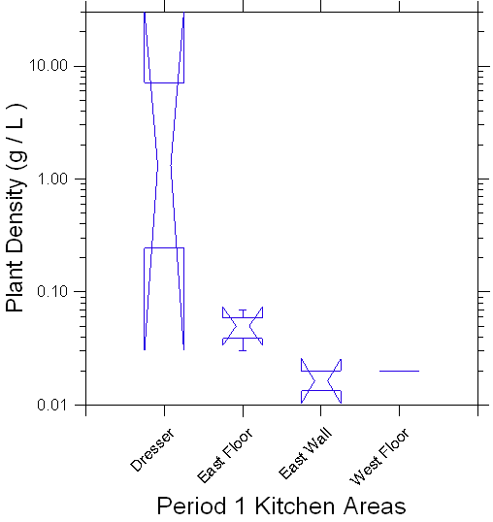

Figure 5.6. Plant Density of Kitchen Areas sampled from Period 1Macrobotanical Assemblage. Note the y-axis is transformed by log10.

Ubiquity of Period 2
The ubiquity Table 5.7 demonstrates that a variety of plant remains were recovered from Period 2 contexts of an Unidentified Pit and a multifaceted Ditch feature. Of the 11 samples analyzed, only 9 were used for the ubiquity analysis. Please reference Table 4.2 for reviewing the contexts of these sampled deposits. The lack of samples in other areas of the kitchen space associated with Period 2 decreases possible comparisons for this data assemblage, as only sampling two areas of the kitchen limits the context of the larger foodways activities in play. I attempted to organize these two kitchen areas into more categories, using quad and depositional order of the samples as recorded through the stratigraphic grouping in the original site report, but could not identify meaningful subdivisions. Therefore, I only discuss the ubiquity of Period 2 regarding only two sampled areas of the kitchen space.
Pinecone and eggshell were consistently recovered in every sample associated with Period 2, followed next in frequency by burnt/starchy food remains at 100% for the Ditch and 67% for the Unidentified Pit. Fruit, few in frequency of the samples at 18%, was recovered in 33% of the Ditch contexts. The nut taxa swayed more frequently in the Unidentified Pit samples at 50%, compared to 33% for Ditch samples. Domesticated crops, in few at a total of 33% frequency across the samples, were recovered from both the Unidentified Pit and Ditch at 33% frequency.

Table 5.7 demonstrates Period 2 ubiquity of taxa by spatial location in the kitchen.

Kitchen Area | Burnt/Starchy Food | Domesticated Crops | Fruit | Nuts | Pinecone | Eggshell
Kitchen Area | n=11 Samples per Period 2 ^{A}
Kitchen Area | n= 7 of 9  (78%) | n= 3 of 9  (33%) | n= 1 of 9  (18%) | n=4 of 9  (44%) | n= 9 of 9  (100%) | n= 9 of 9  (100%)
Ditch ^{B}  n=3 ^{C} | 100% | 33% | 33% | 33% | 100% | 100%
Unid. Pit  n=6 | 67% | 33% |  | 50% | 100% | 100%

A: Note that a total of 11 samples were taken for analysis from Period 2, but 2 of the 11 samples (2584Q-S-14 and 2584R-S-15) were dropped from the Ubiquity analysis as they contained less than 1 liter of sediment. This leaves a total of 9 from the original 11 samples available for Ubiquity analysis of Period 2.

B: Note that all associated contexts assigned with the Ditch were grouped together. Please reference Table 4.2 for deposition by context association for the Ditch samples

C: Note that 2 of the 5 samples associated with the Ditch were dropped from analysis as they contained less than 1 liter of sediment. This leaves only 3 samples associated with the Ditch for Period 2 Ubiquity analysis.

Plant Density Kitchen Areas of Period 2
Figure 5.7 demonstrates a boxplot that complements the ubiquity analysis for Period 2. As previously discussed, Period 2 only includes samples collected from two areas of the kitchen. Both areas are relatively close in proximity to each other and prove to have no statistical significance in the relation of their data sets, as the notches overlap, although minimally. Overall, the five associated Ditch samples prove to yield higher plant densities with a total plant weight of 11.01 grams with 10.37 grams of carbonized wood, than the Unidentified Pit’s six total samples with 6.45 grams of total plant weight with 5.88 grams of carbonized wood.

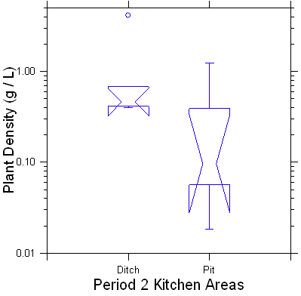

Figure 5.7. Plant Density of Kitchen Areas sampled from Period 2Macrobotanical Assemblage. Note the y-axis transformed by log10.

Ubiquity of Period 3
The ubiquity Table 5.8 captures Period 3 sample areas from six areas of the kitchen space: Hearth, Stew stoves, Dresser, Ditch, and East and West Brick Floor. Please reference Chapter 4 for definitions and contextual information concerning these areas of the kitchen. A total of 24 samples were analyzed from Period 3 with the highest categories of taxon represented by pinecone, eggshell, followed by burnt/starchy food remains. From these 24 samples a total of 5 had less than 1 liter of sediment, so only 19 were used for ubiquity analysis for Period 3.
The Dresser area has the fewest samples available for analysis with only one sample compared to the seven from the Ditch, five from the East Brick Floor, four samples in both the Hearth and Stew stove, and three from the West Brick Floor. However, given the prominence of the Dresser as an architectural feature in the kitchen and its notable contextual differences from the Ditch and East Brick Floor, I felt it was important to consider it separately.
All categories of taxa are represented in every sample area of the associated Period 3 areas, with the exception of nuts, which were not recovered from the Hearth or Dresser. Across all 19 samples from Period 3, both pinecone and eggshell are represented at 95% frequency, followed by burnt/starchy remains at 84%, and nuts, domesticated crops and fruits at 53% or less frequency. As mentioned in the beginning of this chapter, Period 3 also sees an increase in the amount of foodways remains at 238.25 g of plant weight from the previous periods 17.46 g, and larger varieties of foodways-related taxa.
The ubiquity Table 5.8 demonstrates eggshell and pinecone are represented at the highest frequencies of the food-related categories with eggshell at 100% frequency across all areas of the kitchen except the Stew stove at 50%. Pinecone tends to have a higher frequency in the east area of the kitchen space as all areas contain 100% pinecone frequency except the West Brick Floor (67%). Burnt/starchy food remains were present in the highest frequency of 100% near the Dresser, Hearth, and West Brick Floor, but decrease in frequency in samples near the Ditch (83%) and East brick Floor (80%), followed by the Stew stoves (50%). The highest nut frequency was in the Ditch at 83%, followed by the East and West Brick Floors. Nuts were not represented in the Stew stoves, Dresser, or Hearth. Fruits and Domesticated crops were relatively infrequently recovered; while the Dresser area is listed at 100%, only one sample was analyzed.
Overall, there seems to be the highest presence of foodways-related remains concentrated in the Ditch area, and perhaps the Dresser area, of Period 3. This may be due to the high number of activities concentrated in this northeast area of the kitchen, with plant remains tending to collect in the Ditch context in front of the Stew stoves and Dresser. Again, it is important to note that the Dresser frequency is skewed by the single sample analyzed. In sum, the context of the Ditch captures the broadest range of botanical materials and frequency in relation to the number of samples. Similar depressions in high-activity areas would be ideal contexts to sample in future sampling strategies for kitchen sites.
Table 5.8 demonstrates Period 3 ubiquity of taxon by spatial location in the kitchen.

Kitchen Area | Burnt/Starchy Food | Domesticated Crops | Fruit | Nuts | Pinecone | Eggshell
Kitchen Area | n=19 Samples per Period 3 ^{A}
Kitchen Area | n= 16 of 19  (84%) | n= 8 of 19  (42%) | n= 6 of 19  (32%) | n= 10 of 19  (53%) | n= 18 of 19  (95%) | n= 18 of 19  (95%)
Hearth  n= 2 ^{B} | 100% | 50% | 50% |  | 100% | 100%
West Brick Floor  n= 3 | 100% | 33% | 33% | 67% | 67% | 100%
Ditch  n= 6 ^{C} | 83% | 50% | 33% | 83% | 100% | 100%
East Brick Floor  n= 5 | 80% | 40% | 20% | 60% | 100% | 100%
Stew stove  n= 2 ^{D} | 50% |  |  |  | 100% | 50%
Dresser  n= 1 | 100% | 100% | 100% |  | 100% | 100%

A: Note that a total of 24 samples were taken for analysis from Period 3, but 5 of the 24 samples (2583J-S-16, 2584H-S-07, 2584P-S-13, 2585M-S-04, and 2586M-S-01) were dropped from the Ubiquity analysis as they contained less than 1 liter of sediment. This leaves a total of 19 of the original 24 samples available for Ubiquity analysis of Period 3.

B: Note that 2 of the 4 samples associated with the Hearth were dropped from analysis as they contained less than 1 liter of sediment. This leaves only 2 samples associated with the Hearth for Period 3 Ubiquity analysis.

C: Note that 1 of the 7 samples associated with the Ditch were dropped from analysis as they contained less than 1 liter of sediment. This leaves only 6 samples associated with the Ditch for Period 3 Ubiquity analysis.

D: Note that 2 of the 4 samples associated with the Stew stoves were dropped from analysis as they contained less than 1 liter of sediment. This leaves only 2 samples associated with the Stew stoves for Period 3 Ubiquity analysis.

Plant Density Kitchen Areas of Period 3
Figure 5.8 demonstrates a boxplot that complements the ubiquity analysis for Period 3 by establishing plant density values by areas of the kitchen. As previously discussed, a total of six areas were sampled and analyzed within the Period 3 kitchen occupation. The highest plant density values are concentrated in the Stew stove followed by the Ditch area. The Dresser’s single sample also has a plant density that is higher than the lower ranges present in the Hearth, East, and West Brick Floors, and follows trends for the other samples in the northeast portion of the kitchen. The Hearth and Brick Floor deposits are statistically similar in data sets as the notches for these areas overlap.

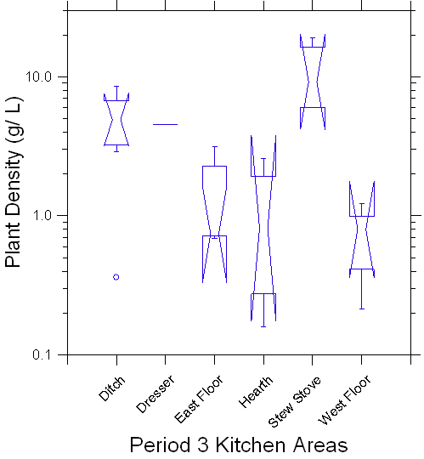

Figure 5.8. Plant Density of Kitchen Areas sampled from Period 3Macrobotanical Assemblage. Note the y-axis transformed by log10.

Relative Wood Density Kitchen Areas of Period 3
Figure 5.9 demonstrates a box plot showing the density of wood used in certain areas of the kitchen. The majority of the density data seems to range from 0.75 to 1.0, but the Hearth is an outlier with the widest range in the data set ranging from 0.50 to 0.96. The Hearth and the Stew stove tend to have higher densities for wood, but this makes sense as these are the two areas of the kitchen with an active heat source for cooking.

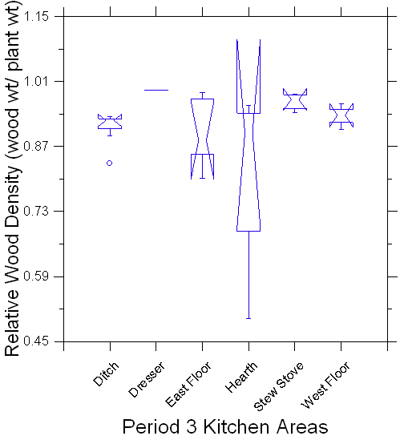

Figure 5.9. Relative Wood Density of Kitchen Areas sampled from Period 3 Macrobotanical Assemblage.
Burnt/Starchy Food Density Kitchen Areas of Period 3
Figure 5.10 demonstrates a boxplot that compares densities of Burnt/starchy food remains across the sampled kitchen areas to better understand the ubiquity data set. As the burnt/starchy food remains had the highest frequencies in the Hearth, West Brick Floor, and Dresser areas of the kitchen, the density data set shows the Hearth and West Brick Floor to be most similar in data sets. The Ditch, East Brick Floor, and Stew stoves are lower in frequency, but the East Brick Floor is more of the middle range of the density data with significantly larger fragments. Although the notches overlap and there are no statistically significant differences, we see a general decrease in overall density of burnt/starchy food remains in the eastern portion of the kitchen space. This supports the hypothesis that the burnt/starchy food remains more related to burnt bread or ash cakes, as the bread oven is located near the Hearth in the west side of the kitchen. It makes sense to still see some remains near the east as the food was hypothetically swept in this area and the widespread distribution of the burnt/ starchy for remains suggests just how much there was in this space. These hoe/ash cakes were extremely easy quick foods that provided a quick snack needed in this fast-paced labor role.
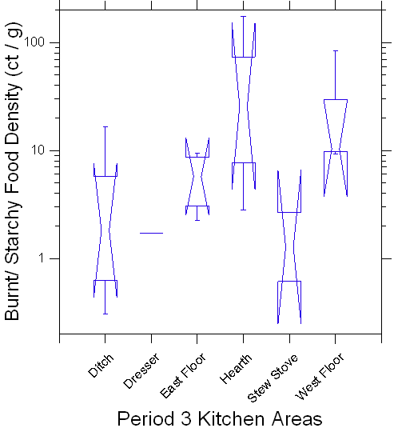

Figure 5.10. Burnt/Starchy Food Density of Kitchen Areas sampled from Period 3 Macrobotanical Assemblage. Note the y-axis transformed by log10.

Eggshell Density Kitchen Areas of Period 3
Figure 5.11 demonstrates a boxplot that compares densities of eggshell across the sampled kitchen areas to better understand their distribution beyond the ubiquity data set. Eggshell was present in all samples except two from the Stew Stove area. The highest density in eggshell is seen as outliers in the data set for the East Brick Floor and the Ditch, but the broadest data set in density was collected from the West brick Floor. The East Brick Floor, Hearth, and Stew stove are statistically similar in the range of the data set densities. The similarity between the Hearth and the eastern contexts (Stew Stove, Dresser, and East Floor) was not expected, nor the high values for the West Brick Floor. The presence of eggshell helps support areas of the kitchen where the cooks assembled recipes, or disposed of food remains. Since eggs are common ingredients in sauces and dishes associated with French cuisine, I expected that recovery of eggshell would have been greater in the eastern area near the Stew Stoves and much more limited in the western half of the kitchen.

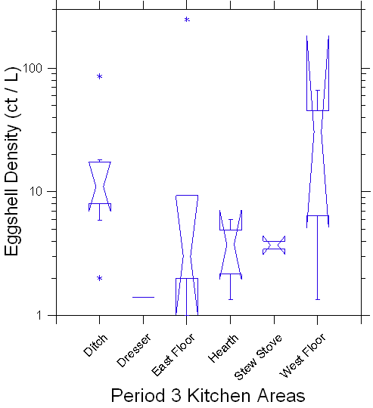

Figure 5.11. Eggshell density of Kitchen Areas sampled from Period 3 Macrobotanical Assemblage. Note the y-axis transformed by log10.

Pinecone Density Kitchen Areas of Period 3
Figure 5.12 demonstrates a boxplot that compares densities of pinecone across the sampled kitchen areas to better understand the data beyond the frequencies. Pinecone was found across all six Period 3 areas, and their densities are also generally statistically similar, as the notches of most overlap. However, the highest density area for pinecone is the Hearth, which does not overlap with the Ditch or the West Brick Floor. The Ditch, East Brick Floor, and Stew stove are generally similar, as the notches overlap. The lowest density areas are the Dresser and West Floor. The densities of pinecone may be related to where people used kindling.
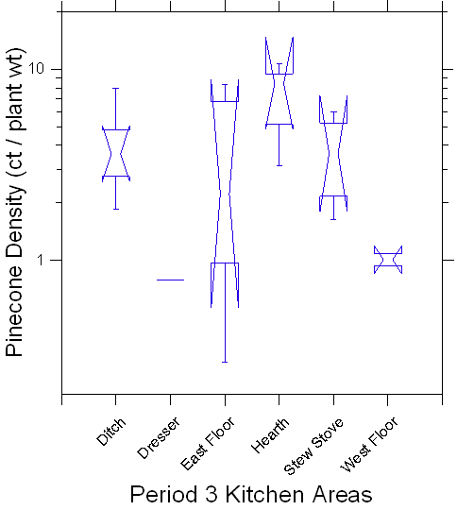

Figure 5.12. Pinecone density of Kitchen Areas sampled from Period 3 Macrobotanical Assemblage. Note the y-axis transformed by log10.

Crop, Fruit, and Nut Density of Period 3

There are too few crop, fruit, and nut taxa recovered to make meaningful comparisons between the Period 3 sample areas of the kitchen space. It is interesting to note that the highest frequency area for these three categories is the Ditch. The West and East Brick floors are statistically significant, but the West floor has a wider data set and the East Floor had larger fragments of nut remains.

Plant Assemblage Summary
While somewhat limited, the floatation sample data give a picture of plants (food and fuels) and other foods (eggshell, burnt/starchy material) used in the kitchen. Changes through time show an increase in foodways activities that follow changes in the architecture and use of the kitchen from Period 1 to Period 3. We see an increase in foodways-related architecture in correlation with an increase of plant densities from Period 1 through Period 3. The ratio of carbonized wood to other plants decreases through time; pinecone mimics this trend, supporting the hypothesis that pinecone was used as a fuel for the kitchen space. Over all three occupations, the highest categories present across the kitchen assemblage include pinecone, eggshell, and burnt/starchy food remains. There are some spatial differences that suggest higher foodways activities in the eastern half of the kitchen (Dresser, Stew Stoves, Ditch) even as early as Period 1, and higher use of fuels (wood, pinecone) near the Hearth and Stew Stoves. It is interesting to note relatively few identifiable grains or seeds were recovered, such as corn kernels or wheat berries. This may be because the plants brought into the kitchen space were ingredients that had already been processed, such as corn meal or wheat flour. The next chapter includes a comparison of this kitchen assemblage with contemporaneous sites in the larger Virginia region.
Chapter SIX: Discussion and Site Comparison

In this chapter I discuss my research questions two and three as chapter five addresses the extent of research question one summarized data results of the macrobotanical assemblage. My second research question investigated the social interactions and relationships between enslaved cooks and their Jefferson masters in these early domestic spaces. This discussion primarily leans on historical documents and theoretical paradigms, as aided by the botanical assemblages, to explore how enslaved cooks may have negotiated agency through foodways practices.
As analyzing the macrobotanical remains from the first kitchen site at Monticello helps us understand the foods present in this space archaeologically, my third research question provides a discussion of regional site comparisons of kitchen spaces with associated enslaved contexts of the Virgnia region. This final question establishes a base line comparison for kitchen contexts for early kitchen plantations sites of Virgnia.

historical documentation allows researchers to further understand what is not captured in the archaeological record that was present through the social interactions that are important to understanding the context of cooking in the kitchen space.

Discussion of Research Question Two
The second research question attempts to investigate the social interactions and relationships between the enslaved cooks and their masters in the kitchen and larger domestic spaces, but archaeologically speaking this was not possible. When addressing this question, we cannot definitively establish which foods in this kitchen were consumed by white individuals versus the enslaved house workers and/or community of Mulberry Row. Through further analysis of the documentary records associated with the Monticello estate, we can roughly establish numbers and types of rations allocated to enslaved people working in different roles/positions, but we cannot say that the enslaved cooks specifically consumed this food in this kitchen space. In attempts to still answer some part of this research question I feel it is important to reflect more on the documentary accounts and theoretical methods. Examples of these documents include Thomas Jefferson’s Cookbook, Jefferson’s Farm Book and other agricultural records for the property, and first-hand accounts of the foods eaten by free and enslaved residents and visitors to the plantation. Historians and archaeological researchers confirm that “house servants tended to eat from the food prepared in the master’s kitchen, while field slaves lived and prepared meals in their own cabins” (McIntosh 1995:84). This statement confirms the need for comparative research
Knowing the skills and specialized access that the enslaved cooks held among other enslaved individuals, we can hypothesize that the cook and assistants had access to higher quality foods from this kitchen. The cooks were also given more agency than other domestic slaves to
I approached this research question through an analysis of the kitchen contexts from where this botanical assemblage was recovered from and through historical documents about the cooks and their relationship with the Jeffersons, through contemporary cookbooks. The documentary evidence, combined with the spatial analysis of the kitchen space, allows for better distinctions of cooking activities within the kitchen to further our understanding of the specialized role of the enslaved cooks versus the white individuals in charge of the home. Agbe-Davies (2017) work for the need to understand the space in which the contexts are recovered is a method that is highly beneficial to this research. In sum as applied to my research project, it is important to know how to cook, but in order to achieve the culinary knowledge to make a meal, one must know how to use the tools to cook. Understanding the architectural tools available in the kitchen space allows archaeologists to understand the level of skill and knowledge required of those to perform these advanced culinary duties. To understand activities, actions, and relationships performed in a space we must study the structure and context of the space. Cooking in this kitchen space, especially the need of French culinary skills, are beyond the basic knowledge of what the enslaved cooks are more accustomed to cooking their usual one-pot meals. This level of skill to navigate and prepare food with specialty utensils of the space elevates the enslaved cooks and the individual interacting in this space over other enslaved people. The relationships and social interactions are nearly impossibly to archaeologically hash out in this kitchen space, but knowing this level of cooking skill and the fact that there are favored dishes recorded and cooked by the enslaved cooks of the space proves their elevated agency as privileged domestic slaves. While Thomas Jefferson required the style of French cooking to be present at his table, Martha Wayles Jefferson interacted with the head cooks on a daily basis within the kitchen and dictated to them what was requested. Historical documents provide some information on these head cooks, including Ursula, Peter, and James Hemings, and their expertise in cooking French cuisine, as well as the foods they cooked and their training.
Discussion of Research Question Three:

The third research question compares the assessed botanical assemblage from the kitchen space to other botanical assemblages from enslaved contexts in the region. I begin with a comparative analysis of the macrobotanical assemblage from a contemporary quarter site for enslaved field workers at Monticello (Hacker 2016). Both spaces, used during the last quarter of the 18th century, are sites in which enslaved laborers prepared, consumed, and discarded food refuse. Stephanie Hacker, a UT-Knoxville Master’s student, conducted the macrobotanical analysis for Site 8 (44AB442) in 2016 under the direction of Dr. Kandace Hollenbach. Site 8 housed enslaved laborers on the Monticello quarter farm between 1770 and 1800. Figure 6.1 demonstrates a property map of where the two sites are located on the Monticello mountain landscape.
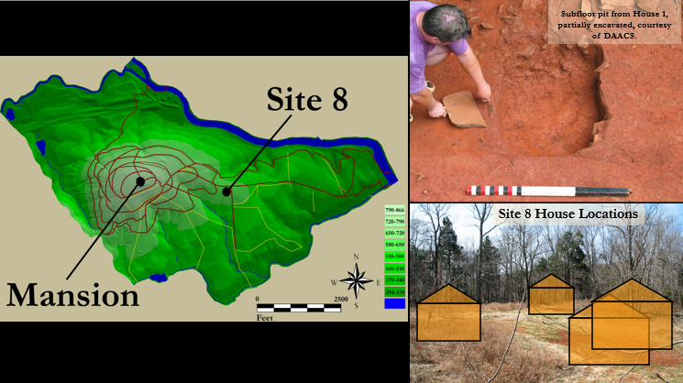
Figure 6.1 demonstrates a combination of information regarding Site 8 pulled from a past conference presentation (Humes and Ptacek 2020); DAACS 20XX)
Hacker describes in the site background that this site was plowed throughout the early 19th and 20th centuries. Archaeologists discovered evidence of four structures whose chronologies were established through correspondence analysis of ceramics excavated from the plow zone: House 1 dates between the 1770s and 80; and Houses 2, 3, and 4 date between the 1780s and 1790s. A shared yard space and nearby vegetable gardens provided spaces for growing food and communal living. Food may have been prepared and consumed in the houses as well as in the shared yard, both less formal types of cooking space than the South Pavilion kitchen. Sampled features include subfloor pits and a single cellar that were filled when the occupants abandoned these cabins around 1800. This happened soon after Jefferson switched his main crop at Monticello from tobacco to wheat in the 1790s, using more level terrain for wheat fields and relocating the residents to the sloping terrain of the plantation. Through Hacker’s botanical analysis it was concluded that the enslaved occupants of these field quarters were supplementing their diet with wild resources of the surrounding landscape.
The depositional history of the two foodways-related sites is a key component in this comparison. The nature of how these contexts were created greatly differ in that the Site 8 pit and cellar deposits were purposely filled with sediment from the surrounding area whereas the deposits sampled from the kitchen are the result of sweepings and foodways-related activities of the space. Archaeological research performed on a variety of subfloor pit features in colonial Virginia indicate that when an interior pit was put out of commission while the structure was still occupied, the occupants generally emptied the pits of all contents and filled them with refuse-free fill dirt to prevent a smell from decomposition (Samford 2007:174). When structures were no longer in use, pits were filled with soil that could contain secondary refuse since the area was no longer going to be inhabited (Samford 2007: 175). It is also important to note that Site 8 is organized as an informal quarter site where the enslaved used the yard spaces as multifunctional spaces compared to the kitchen which was methodically laid out and constructed.
With all this in mind, the macrobotanical assemblage from Site 8 showed higher numbers of wild resources (chenopods, goosegrass, pokeweed, copperleaf, and chickweed) and domesticated crops (corn, wheat, beans, grains, and oats) than the assemblages recovered from the South Pavilion Kitchen (INSERT Table X.X) This supports the idea that enslaved agricultural workers living further from the main house supplemented their diets through foraging nearby wild resources (Hacker 2016: 78). The plant types also shed light on how the enslaved used this yard space. The high frequencies of corn cupules demonstrate the disposal of byproducts through burning of waste, namely corn cobs. It is also possible that the enslaved used corn cobs for fuels. Regular recovery of crops, i.e., wheat, beans, oat, and corn kernels, suggests that the occupants may have grown these crops in their garden spaces. The provisions they received from Jefferson are more likely to have come in the form of cornmeal and flour than whole grains.

Table X.X comparative data of Monticello kitchen assemblage to Monticello Quarter Assemblage

In comparison to the South Pavilion’s crop assemblage, there is a lack of crops represented in the kitchen contexts. The scarcity of corn in the kitchen assemblage supports the notion that many ingredients came to the kitchen already processed for cooking, and accumulated in the act of cooking. There is also a lack of wild resources in the kitchen’s assemblage compared to the high presence of wild plants recovered from Site 8.
One taxon with high concentrations at both sites but not discussed in Hacker’s analysis is pinecone. In my analysis I hypothesized that the presence of pinecone, which follows the trend of carbonized wood, suggests that pinecone was used as a fuel source in the kitchen space. Pinecone is not something that would be used as a staple food ingredient for the main table and Hacker may have just passed it over in her discussion since pines are native to the surrounding landscape. Since Hacker’s site contexts, which are secondary and tertiary refuse, are likely to have pinecone in the deposits, it was not an outlier that stood out as a possible fuel source. Hacker (2016) discusses the high frequencies of pitch and the possibility of pitch being either resin from pine or starch-based plants similar to tubers. This notion parallels the findings of the kitchen as there were high concentrations throughout all deposits of pitch, burnt starchy materials, and in some instances possible tubers.
In the kitchen deposits, the highest categories of foodways material recovered from across the site were both eggshell and burnt-starchy food remains. Eggshell was not collected in Hacker’s assemblage, but it is extremely likely to be present since there are records of the enslaved, both domestic and field laborers, selling eggs from their own poultry to the South Pavilion kitchen (CITE). The two taxa identified only in the kitchen samples provide additional insight into differences between these two separate communities’ diets. Burned starchy foods and starchy tubers from the kitchen samples are hypothesized to demonstrate a variety of different foods accessible to workers in the kitchen. These burned and overcooked foods not fit for the master’s consumption, as possibly decided by the cook, were consumed by the enslaved kitchen staff.. Which foods were consumed by the enslaved in this space compared to the main house is unknown, but these starchy cooked food remains may be representations of burned crumps from breads like cornbread or hoecakes. These were staple snacks of enslaved people as meals during the day were usually eaten while working and breads were easily stored in a pocket or apron for quick consumption.
Fruits and nuts were recovered from both assemblages, but there is presence of watermelon, hazelnuts, and coffee only in the kitchen space. As the occupants of Site 8 had their own kitchen gardens, it is interesting that there were no melon taxa recovered, especially since there are also records of the enslaved also selling melons to the kitchen and the local town market (Stanton XX). The presence of hazelnuts and coffee recovered from the kitchen support the luxury ingredients available for cooking in this space. Coffee would not have been a readily available resource for Site 8 occupants as coffee was a more expensive import from the market and required higher funds for purchasing. Hazelnuts were documented as being on the natural landscape and could have been available for foraging for those in the field quarter, but gathering this nut variety required more effort, as the nuts must be picked from the shrub rather than collected from the ground (Scarry 2003). As such, hazelnuts could also be considered a higher-cost item. This supports the idea that luxury styled French cuisine was cooked in the kitchen space for the main table, as it is not as likely for the enslaved to be consuming such luxury ingredients.
Regional Plant Assemblage comparison
Archaeologically there are few sites that analyze the interactions in a colonial kitchen space for a regional site comparison, especially those pertaining to the foodways through a macrobotanical analysis, but Mrozowski et al. (2008) discuss the types of plant remains recovered from multiple enslaved contexts of Virginia. Mrozowski et al. Table 5 (2008:718-719) provides consisting of the botanical assemblage from Rich Neck Slave Quarter Site (44WB52) alongside four additional sites: Wilton Plantation quarter site on the James River in Henrico County (Higgins et al. 2000), Southall’s Quarter in James City County (Pullins et al. 2003), and the North Hill (Heath 2007a) and Quarter (Heath 2007b) sites at Thomas Jefferson’s Poplar Forest in Bedford County (Heath 2001; Raymer 1996, 2003). The foodways analysis at James Madison’s Montpelier, a neighboring plantation in Orange, Virginia, is an additional source worth comparing to Monticello’s foodways analysis even though the focus is on animal remains as currently there is no discussion concerning the botanical assemblage (Pavao-Zuckerman et al. 2020). Even though these sites are associated with field quarters and slave yards rather than a formal kitchen space, and the sampling protocols and assemblage sizes vary, the six sites still provide a broad list of typical foodways-related assemblages characteristic of enslaved contexts at Virginia plantations.
These six sites provide a broad reference to what the authors generally interpret as plantation rations supplemented by items grown in enslaved gardens and gathered from the immediate area; these assemblages are similar to Site 8 and differ from the kitchen’s assemblage. First glance of Mrozowski et al.’s table assemblages we see a broad range of wild taxa similar to Site 8, but we also see wide varieties of fruits and nuts not present at Site 8 (Mrozowski et al. 2008:Table 5).
Table X.X demonstrates the comparative data of the regional sites to kitchen site data
Fruits and garden crops at the six sites and Site 8 include high frequencies of persimmon, blackberry/raspberry, corn, little barley, wheat, and oats, but melon was recovered from Rich Neck and the South Pavilion kitchen site but not Site 8. The researchers of the South Yard site from Montpelier do not reference archaeobotanical remains but does mention kitchen gardens were prevalent source of addition rations for the enslaved (Pavao-Zuckerman et al. 2020:120). Neither coffee nor hazelnut were found from the six site assemblages: it is safe to say that these taxa are characteristic of luxury goods and not easily accessible to the larger enslaved plantation population. Coffee is referenced in documentary accounts both at Montpelier and Monticello as being prepared for the main table, but only the South Pavilion kitchen currently has evidence of this recovered luxury taxon in an assemblage.

Chapter Seven: Conclusion

-Tie up loose ends with summary of findings and what that may mean for future archaeology of foodways practices in an enslaved Plantation setting.

-What else is evident or future research, and what ideas or research is missing from this archaeological record?

The Monticello kitchen space is a well-preserved time capsule of an earl colonial kitchen on a plantation landscape. Through this preservation the structure itself holds 39 years (1770-1809) of uninterpreted history for the innerworkings of this structure. Up until 2012 or 2013 what people were eating especially individuals living on plantations especially the enslaved African American and native populations.

Research Question one:
What types of botanical specimens were recovered from the macrobotanical assemblage and does the assemblage differ spatially across the kitchen space? Does the assemblages reflect the ingredients and fuels used in recipes of the late eighteenth through early nineteenth century?
Discussion:
Archaeologically, the site’s deposits can be assigned to three periods (O’Connor and Neiman 2022), and architectural assessments of the kitchen space (Warner 2017) demonstrate uses of the space for specialized cooking techniques related to stew stoves and bread ovens. A comparison of the plant remains between the three periods for this structure provides an opportunity to look contextually at these macrobotanical assemblages with qualitative (i.e. presence/absence of certain taxa) and quantitative comparisons (i.e. density of plant remains recovered), and focus on changes in taxa through time relative to the spatial organization of the space. The differences in concentrations from recovered macrobotanical remains deposited near the oven, cook stoves, and dressers may also speak volumes to the different activities in these areas. A spatial analysis of the plant remains will establish the specialized cooking activities primarily performed in these particular spaces of the kitchen and examine how these activities may have changed through time as the kitchen became more architecturally equipped for specialized food practices.

By examining the recovered plant remains in relation to the structural changes of the cooking space involved in the processing of foods, I will have a better understanding of the cooking activities associated with these deposited taxa.
Rather than only focusing on the present counts, weights, and frequencies of the types of plant taxa categories recovered from the kitchen, this research expands the data to establish the processes and activities conducted in particular areas of the kitchen. Conducting a spatial analysis of the kitchen will allow for better distinction of cooking activities in that space to further understand the specialized role of the enslaved cooks.This includes an examination of the spatial arrangement of particular elements in the kitchen, including the oven, stew stoves, and dresser, the types of plant remains recovered near them, and their relation to the types of recipes requested by the Jefferson household, as evident , as evident in historic documents.
Research Question two:
What do early colonial plantation kitchen structures, specifically in the case of the South Pavilion site, reveal regarding social interactions and relationships between enslaved cooks and their Jefferson masters in these early domestic spaces?

Research Question three:
What can a comparative analysis of the macrobotanical assemblage of the South Pavilion kitchen and the botanical assemblage at Site 8 tell us in regard to the different foodways practiced in each area? Comparison to contemporaneous sites in the larger Virgina region.

Broader Impacts and Future Research Opportunities

Through my proposed thesis research, I will explore social relationships on the Monticello plantation through foodways. These include the social divisions between elite white plantation owners and their enslaved domestic cooks and laborers in specialized kitchen spaces, as well as those between enslaved domestic cooks and enslaved agricultural laborers on the same plantation. In this way I plan to contribute to the larger body of historical foodways research of the Virginia region.
This assemblage and kitchen space provide a variety of opportunities for further research angles that contribute to foodways studies. A major contribution to this research would be the inclusion of the faunal analysis for this kitchen space, as well as analysis of other artifacts, such as ceramics, utensils, and small finds. The addition of these would establish a well-rounded foodways interpretation of this space.
Among the plant assemblage, an additional research avenue could include the choices in fuels for cooking. Such an analysis would require further identification of the wood specimens and spatial comparisons of those taxa recovered in different areas of the kitchen. These could also be compared to wood fuels used by enslaved agricultural laborers at the quarter Site 8.

In addition, I will compare the results collected from macrobotanical remains from Jefferson’s first kitchen with the macrobotanical assemblage from the contemporary quarter site for enslaved field workers, known as Site 8, analyzed by Stephanie Hacker (2016). Both spaces, used during the last quarter of the 18th century, are sites in which enslaved laborers prepared, consumed, and discarded food refuse. I will discuss the differences and similarities in the activities performed in these food preparation areas, and the variety of plants and foods identified in enslaved and intersectional spaces.

My research will also demonstrate the value of collecting flotation samples instead of simply assuming that there is not preservation that will yield enough data for interpretation. In my experience, very few field researchers take soil samples during site excavations. My results will hopefully convince other researchers that the data and interpretations we can glean from them is worth the effort of collecting, processing, analyzing, and storing these samples.
Most significantly, my study will help researchers to further understand how enslaved African American cooks formed and maintained a sense of identity, and how these enslaved laborers were empowered through their knowledge and access to food on the landscape. The mundane actions, such as cooking and farming that maintained a successful estate are less captured in the archaeological record as little material evidence is left behind. It is important, then, to use those remains that are present to interpret the lifeways of individuals whose experiences were either silenced, or when present, were told from the prospective of the enslaver rather than by the enslaved

BIBLIOGRAPHY

Baron, Robert (editor)
1987 The Garden and Farm Books of Thomas Jefferson. Fulcrum Publishing: Golden, CO.
Bear, James A. and Lucia C. Stanton
1997 Jefferson’s memorandum Books, Accounts, with Legal Record and Miscellaneous, 1767- 1826. 2 Vols. Princeton University Press, NJ.
Bourdieu, Pierre
1989 Distinction a social critique of the judgement of taste. London: Routledge
Bowes, Jessica
2011 Provisioned, Produced, Procured: Slave Subsistence Strategies and Social Relations at Thomas Jefferson’s Poplar Forest. In Journal of Ethnobiology, 31(1):89-109.
Covey, Herbert C.
2007 African American Slave Medicine: Herbal and Non-herbal Treatments. Lanham, MD: Lexington.
Covey, Herbert C. and Dwight Eisnach
2009 What the Slave Ate: Recollections of African American Foods and Foodways from the Slave Narratives. ABC-CLIO, LLC, Santa Barbara, California.
Crowder, Alexandra
2018 Community Through Consumption: The Role of Food in African American Cultural Formation in the 18th Century Chesapeake. Master’s Thesis. Department of Anthropology, University of Massachusetts, Boston, MA.
Deetz, Kelley
2010 When Her Thousand Chimney’s Smoked: Virginia’s Enslaved Cooks and Their Kitchens. Published Ph.D. dissertation, African American Studies Department, University of California, Berkeley. Available online at
https://escholarship.org/search?q=Deetz%2C%20Kelley%202010.

2017 Bound to the Fire: How Virginia’s Enslaved Cooks Helped Invent American Cuisine. University Press of Kentucky: Lexington, KY.
Fett, Sharla M.
2002 Working Cures: Healing, Health, and Power on Southern Slave Plantations. The University of North Carolina Press, Chapel Hill, NC.
Goody, Jack
1982 “Cooking, Cuisine, and Class: A Study in Comparative Sociology. Cambridge University Press. New York, NY.

Hacker, Stephanie Nicole
2016 "Slave Subsistence Strategies at Thomas Jefferson’s Monticello Plantation: Paleoethnobotanical Analysis and Interpretation of the Site 8 (44AB442) Macrobotanical Assemblage. " Master's Thesis, University of Tennessee.
https://trace.tennessee.edu/utk_gradthes/4039, accessed November 2018.
Hacker, Stephanie and Kandace Hollenbach
2016 Plant Remains from 38CH2048, A Historic Slave Site in Charleston County, South Carolina. Submitted to Brockington and Associates, Inc., Peachtree Corners, Georgia. Archaeological Research Laboratory, University of Tennessee, Knoxville.
Hatch, Peter J.
1992 The Gardens of Thomas Jefferson’s Monticello. Thomas Jefferson Foundation, Inc., Charlottesville, VA.
Heath, Barbara J.
1999 “Your Humble Servant”: Free Artisans in the Monticello Community. In “I, Too, am American”: Archaeological Studies of African-American Life, edited by Theresa A. Singleton, pp. 193-217. The University Press of Virginia, Charlottesville, VA.
Heath, Barbara J. and Amber Bennett
2000 ‘The little spots allow’d them’: The Archaeological Study of African-American Yards. In Perspectives from Historical Archaeology: African Diaspora Archaeology, edited by Nicholas Honercamp, pp. 56-72. The Society for Historical Archaeology.
Heath, Barbara J.
2004 Engendering Choice: Slavery and Consumerism in Central Virginia. In Engendering African American Archaeology, edited by Amy Young and Jillian Galle, pp.19-38. University of Tennessee Press, Knoxville, TN.

2010a. Space and Place within Plantation Quarters in Virginia, 1700-1825. In Cabin, Quarter, Plantation: Architecture and Landscapes of North American Slavery, edited by Clifton Ellis and Rebecca Ginsburg, pp.156-176. Yale University Press, New Haven, CT.

2010b. Memory, Race, and Place. History Compass 8/12: 1352-1368.
Hemings, James
1796 Kitchen Furniture Inventory, 20 February 1796.
https://www.loc.gov/item/mtjbib008599/ Accessed 19 March 2019.
Henderson, Samantha
2013 Understanding Slave Subsistence in the Context of Changing Agricultural Practices: Paleoethnobotany at Thomas Jefferson’s Poplar Forest. Master’s Thesis, Department of Anthropology, University of Massachusetts, Boston, MA.

Jefferson, Thomas
1771 Monticello: plan for a one-story, L-shaped outbuilding. N59 recto. Huntington Library, California.
Jefferson, Thomas
1793 “Agreement with James Hemings," September 15, 1793, in PTJ, 27:119- 20. Transcription available at Founders Online.
Kelso, William M.
1968 Mulberry Row: Slave Life at Thomas Jefferson’s Monticello. Archaeological Institute of America 39 (5): 28-35.
Kimball, Marie
1949 Thomas Jefferson’s Cook Book. Garrett and Massie Publishers, Richmond, Virginia.
Lounsbury, Carl R.
1994 An Illustrated Glossary of Early Southern Architecture and Landscape. Oxford University Press: New York.
Lucas, Ann
1989 Ordering His Environment: Thomas Jefferson’s Architecture from Monticello to the University of Virginia. Master’s Thesis. School of Architecture, University of Virginia.

Martin, Alexander C. and William Barkley
1961 Seed Identification Manual. University of California, Berkeley, CA.
McKee, Larry W.
1999 Food Supply and Plantation Social Order. In I, Too, Am America, Theresa A. Singleton, editor, pp. 218–239. University of Virginia Press, Charlottesville, VA.
Miller, Naomi F.
1988 Ratios in Paleoethnobotanical Analysis. In Current Paleoethnobotany: Analytical Methods and Cultural Interpretations of Archaeological Plant Remains, edited by Christine A. Hastorf and Virginia S. Popper, pp. 72-85. The University of Chicago Press. Chicago, IL.
Neiman, Fraser D.
2008 The Lost World of Monticello: An Evolutionary Perspective. Journal of Anthropological Research 64(2): 161-193.
Pearsall, Deborah M.
2000 Paleoethnobotany: A Handbook of Procedures. Academic Press, San Diego, CA.

Popper, Virginia S. and Hastorf, Christine A.
1988 Introduction. In Current Paleoethnobotany: Analytical Methods and Cultural Interpretations of Archaeological Plant Remains, Christine A. Hastorf and Virginia S. Popper, editors, pp. 1-16. University of Chicago Press, Chicago, IL.
Ptacek, Crystal L. and Beatrix Arendt
2018 The Archaeology of Monticello’s South Pavilion and South Wing 44AB089. Submitted to the Thomas Jefferson Foundation, Charlottesville, Virginia.
Samford, Patricia M.
1996 The Archaeology of African-American Slavery and Material Culture. In The William and Mary Quarterly 53(1):87-114.
Stanton, Lucia C.
2000 Free Some Day: The African-American Families of Monticello. University of Virginia Press, Charlottesville, VA.
Stanton, Lucia C.
2012 “Those Who Labor for My Happiness:” Slavery at Thomas Jefferson’s Monticello. University of Virginia Press, Charlottesville, VA.
Struever, Stewart
1968 Flotation Techniques for the Recovery of Small-Scale Archaeological Remains. American Antiquity 33(3): 353-362.
Westmacott, Richard
1992 African American Gardens and Yards in the Rural South. The University of Tennessee Press, Knoxville, TN.
Whit, William C.
2009 “Soul Food as Cultural Creation” in African American Foodways: Explorations of History and Culture edited by Anne Bower
Whitehead, TL
1992 "In Search of Soul Food and Meaning: Culture, Food, and Health" in African Americans in the South, Hans Baer and Yvonne Jones (ed.). Athens: University Georgia Press. (pages 94 to 110) (Source being scanned by UTK library and sent through email via pdf).
Willison, George F.
1964 Native bounty. In The American Heritage Cookbook and Illustrated History of American Eating and Drinking. Simon and Schuster. New York City, NY. Pp 11-23

APPENDIX
Table A-1. Scientific Names of Taxa Recovered from 44AB089
Common Name | Taxonomic Name | Item Type | Category
Acorn | Quercus sp. | nutshell | nut
Acorn cf. | Quercus sp. | nutshell | nut
Acorn meat | Quercus sp. | nutmeat | nut
Acorn meat cf. | Quercus sp. | nutmeat | nut
Amaranth | Amaranthus sp. | seed | miscellaneous
Bark |  | bark | miscellaneous
Bean | Phaseolus vulgaris | seed | crop
Bean cf. | Phaseolus vulgaris | seed | crop
Bean family | Fabaceae | seed | miscellaneous
Bean family cf. | Fabaceae | seed | miscellaneous
Bedstraw | Galium sp. | seed | miscellaneous
Bedstraw cf. | Galium sp. | seed | miscellaneous
Black walnut | Juglans nigra | nutshell | nut
Blackberry/raspberry | Rubus sp. | seed | fruit
Blueberry | Vaccinium sp. | seed | fruit
Bud |  | not applicable | miscellaneous
Bulrush | Scirpus sp. | seed | miscellaneous
Chenopod/amaranth | Chenopodium/Amaranthus | seed | miscellaneous
Chenopod | Chenopodium berlandieri | seed | starch/oil seed
Chickweed | Stellaria | seed | miscellaneous
Copperleaf | Acalypha virginica | seed | miscellaneous
Corn cupule | Zea mays | cupule | crop
Corn kernel | Zea mays | kernel | crop
Cucurbit rind | Cucurbitaceae | rind | crop
Dock | Rumex sp. | seed | miscellaneous
Goosegrass | Eleusine indica | seed | miscellaneous
Grape | Vitis sp. | seed | fruit
Grape cf. | Vitis sp. | seed | fruit
Grass family | Poaceae | seed | miscellaneous
Hazelnut | Corylus sp. | nutshell | nut
Hickory | Carya sp. | nutshell | nut
Knotweed | Polygonum sp. | seed | miscellaneous
Monocot stem | Poaceae | non-woody stem | miscellaneous
Nutshell |  | nutshell | nut
Pea | Pisum sativum | seed | crop
Peach | Prunus persica | seed | fruit
Persimmon | Diospyros virginiana | seed | fruit

Table A-2. Taxa Count and Weight by House and Sample Number.
Sample Number | Common Name | Count | Weight
House 1
191C S07 | Acorn | 5 | 0.0
191C S07 | Blackberry/raspberry | 3 | 0.0
191C S07 | Blackberry/raspberry uncarbonized | 2 | 0.0
191C S07 | Blueberry | 1 | 0.0
191C S07 | Corn kernel | 2 | 0.03
191C S07 | Grape | 2 | 0.02
191C S07 | Nutshell cf. | 3 | 0.02
191C S07 | Persimmon | 3 | 0.08
191C S07 | Pine cone | 2 | 0.01
191C S07 | Pinecone cf. | 1 | 0.01
191C S07 | Pink family | 50 | 0.02
191C S07 | Pitch | 86 | 0.86
191C S07 | Pokeweed | 3 | 0.03
191C S07 | Unidentifiable seed | 4 | 0.01
191C S07 | Unidentified seed | 1 | 0.0
191C S07 | Wheat | 2 | 0.03
191C S07 | Wheat cf. | 1 | 0.01
Total |  | 171 | 1.13
191D S12 | Bark | 1 | 0.02
191D S12 | Black walnut/peach | 1 | 0.0
191D S12 | Blackberry/raspberry uncarbonized | 3 | 0.01
191D S12 | Chenopod/amaranth | 1 | 0.01
191D S12 | Chickweed | 41 | 0.01
191D S12 | Nutshell | 1 | 0.02
191D S12 | Persimmon | 3 | 0.06
191D S12 | Peach | 11 | 1.90
191D S12 | Pitch | 113 | 1.32
191D S12 | Pokeweed | 1 | 0.01
191D S12 | Pokeweed cf. | 1 | 0.0
191D S12 | Unidentifiable | 3 | 0.01
Total |  | 180 | 3.37
191E S18 | Bark | 2 | 0.0
191E S18 | Blackberry/raspberry uncarbonized | 21 | 0.0
191E S18 | Pitch | 24 | 0.16
191E S18 | Pokeweed | 6 | 0.02
Total |  | 53 | 0.18
191F S31 | Acorn cf. | 1 | 0.0

VITA
Peggy Marie Humes will write this section soon as she wrote a thesis. She graduated. She followed instructions and wrote her vita in third person and paragraph form (as opposed to a resume or CV), which made her thesis consultant very happy. This page is required.

