A robust soybean agroinfiltration method

A Thesis Presented for the
Master of Science
Degree
The University of Tennessee, Knoxville

Bryce N. Trull
December 2023

Copyright © 2023 by Bryce N. Trull
All rights reserved.

Acknowledgements

I would like to extend my sincerest thanks to the numerous individuals who have supported me throughout the years and guided me through opportunities which I did not yet possess the wisdom to navigate myself and who, with gracious patience, have counseled me through my many mistakes. I would like to thank Dr. Neal Stewart Jr. and Dr. Reggie Millwood who have been instrumental in shaping my scientific framework and for the many hours they invested in my progression. I would also like to thank Dr. Cristiano Piasecki for his dedication to mentoring me in my novice undergraduate days and Dr. Shamira Sultana for her diligence and incessant patience in training me despite the mountains of work she had herself. I would also like to thank Dr. Alex Pfotenhauer and the team in the Center for Agricultural Synthetic Biology for their vital technical assistance throughout my study. Certainly, thank you to my co-authors of chapter 2 for their contributions to the work, and my committee, Drs. Neal Stewart Jr., Reggie Millwood, Feng Chen, and Tarek Hewezi for their guidance.
I would also like to extend many thanks to Drs. Scott Senseman, Gary Bates, John Stier, Caula Beyl, and William Klingeman for their instrumental work in constructing the 5-year MS/BS program from an idea to the program that it is today. I never would have had this opportunity if it wasn’t for these dedicated individuals so eager to help their students.
Thank you also to my family for your constant support.
Of course, I want to thank those eccentric and hardworking residents of the Stewart lab: Jessica Stockdale, Robert Sears, Tyler Newton, Timothy Chaffin, Audrey Birdwell, Brianna Jacobs, Chandler Brown, Cassie Halvorsen, Jordan Reed, Lance Hamilton and Yaping Xu. Our many hours spent together were not wasted: even when they were.

Abstract
Stable transformation of soybean (Glycine max) is a markedly slow and laborious process. Thus, a tool that enables rapid evaluation of genetic elements in planta is critical to advance complex research and genetic engineering in soybean. To that end, a substantially robust agroinfiltration method was innovated in this work. Agroinfiltration is a technique that leverages Agrobacterium-mediated transient transformation to deliver genetic elements to the cells of whole plant tissues, usually leaves. Several factors were found to be relevant to successful soybean leaf agroinfiltration, including genotype, surfactant, developmental stage, and Agrobacterium culture medium. This research represents not only a new research tool for soybean biotechnology, but also indicates critical parameters for guided agroinfiltration optimization that could be used for other crop species.

Table of Contents

Chapter 1 Introduction 1
Background 2
Agrobacterium-mediated transformation 3
Transient expression strategies 3
Challenges 4
References 6
Chapter 2 A robust soybean agroinfiltration method 10
Abstract 11
Introduction 12
Materials and methods 13
Plant materials and growth conditions 13
Vector construction 13
Optimized Agrobacterium growth, preparation, and agroinfiltration 13
Parameters tested. 14
GUS staining, GUS/Ruby imaging, and image analysis 15
Fluorescence spectroscopy, compound microscopy, and confocal microscopy 15
qRT-PCR transcript abundance assay 16
Statistical analysis 16
Results 16
Soybean genotype 16
Wounding and surfactants 17
Agrobacterium culture media 18
Plant developmental stage 19
Genotype rescreen / Agrobacterium strain 19
Co-infiltration / RUBY reporter 20
Conclusion 20
References 23
Chapter 3 Conclusions and recommendations 28
List of References 31
Appendix 38
Vita 68

List of Tables

Table 1 Soybean genotypes tested. Most of germplasm tested are breeding lines developed at Virginia Tech (those beginning with “V”) and the University of Tennessee (those beginning with “T”). 58
Table 2 Description of variations of infiltration procedure as it relates to the infiltration medium suspension, surfactant, sonication, and time of vacuum exposure. Throughout the study, the infiltration medium, as well as antioxidant additives, baring variations in the Agrobacterium strain and/or its culturing, was consistently maintained. The initial genotype screen (Fig. 1) was conducted with sonication treatments beforehand, Tween-20 as a surfactant and two rounds of 30-minute vacuum exposure. Once we established Silwet L-77 as the surfactant of choice and ruled out sonication as a useful treatment (Fig. S1 & S2) the remainder of optimization experiments were performed without a wounding treatment, using Silwet-L77 as the surfactant and a single round of 5-minute vacuum exposure. 59
Table 3 Plant developmental stage/leaf ages and morphologies tested. Soybean leaves were infiltrated in the vegetative emergence (VE) stage and vegetative compound (VC) stage. Both VE and VC are the first true leaves of a germinated soybean plant with VE being the leaves when unexpanded immediately after germination and VC being defined as fully unfurled and expanded first true leaves. Soybean leaves were also infiltrated in the vegetative 1st-trifoliate leaf stage. Both the first unifoliate leaves and first trifoliate leaves were tested. 60
Table 4 Agrobacterium strains tested and chromosomal backgrounds. 61
Table 5 Transcript analysis primer sets. Target genes and the respective forward and reverse primers used for qRT-PCR experiments. 62

List of Figures

Figure 1 Vectors used in optimization experiments. a Vector plasmid pTF101.1 with a CaMV35Ss (35S) promoter driving a GUS reporter with an intron and a nopaline synthase terminator (NOS) 35S:GUSplus:NOS. b Vector plasmid pAGM4723 with a Glycine max ubiquitin (Gmubi) promoter driving a red fluorescent protein (turboRFP) reporter and an Agrobacterium octopine synthase terminator (OCS) Gmubi:turboRFP:OCS. c Vector plasmid pAGM4723 with a Gmubi promoter driving a green fluorescent protein (mGFP5-ER) and an OCS terminator. d Vector plasmid pAGM4723 with a Gmubi promoter driving a three-gene betalain biosynthetic pathway linked by 2A peptides: CYP76A1, DODA1 and glucosyltransferase as a single open reading frame and an OCS terminator (He et al. 2020). 39
Figure 2 Schematic of plant preparation and optimized soybean agroinfiltration process. a Sterile seeds are imbibed for 24 hours in water. b Paper towel is thoroughly moistened and cut into approximately 5 cm × 7.5 cm rectangles. Imbibed seeds are placed individually on moistened towels, rolled up, and placed upright in a beaker. c The paper towel rolled seeds are placed in a growth chamber on 16-h day/8-h night cycle (~90-120 μmol intensity) at 24 °C and grown for 10-15 days to the VC or V1 stage. d Agrobacterium cultures are streaked on a YEP plate supplemented with antibiotics 4 days prior to infiltration (PTI) and grown for two days. e A colony from the YEP plates is used to inoculate a liquid starter culture of 50 ml YEP supplemented with antibiotics 2 days PTI, and grown for 16-24 hr on a shaker at 225 rpm at 28 °C. f The evening PTI, the starter culture is centrifuged at 4100 $×$g for 15 minutes and resuspended in AB:MES induction media to an OD₆₀₀ of 0.3, supplemented with 200 μM AS and selection antibiotics, and grown for 16 hr at 225 rpm at 28 °C. g The day of infiltration, the AB:MES induction media is centrifuged at 4100 $×$g for 15 minutes and the Agrobacteria are resuspended in SIB to an OD₆₀₀ of 0.6, supplemented with 200 μM AS and incubated in the dark on a shaker at 50-75 rpm for 2 hr. h After incubation, SIB-Agrobacterium suspension is supplemented with 400 mg/L L-cysteine, 78 mg/L DTT, and 1% v/v Silwet L-77. SIB-Agrobacterium suspension beaker is placed in the vacuum chamber. Plants are then removed from the growth chamber and placed in the beaker with abaxial leaf surface facing up. i Plants are subjected to 5 minutes of vacuum at -84.65 kPa. The air intake valve is swiftly released to rapidly apply positive pressure and infiltrate leaf tissue. j Infiltrated plants are removed from the vacuum chamber, dunked in a beaker of DI water to wash off excess suspension and surfactant, patted dry with paper towel, placed back in their original growing container, lightly sprayed with water and placed under a plastic dome to maintain humidity. Finally, plants are placed in a dark cabinet for 16 hr before being placed back in the growth chamber for evaluation 72 hr post infiltration. 40
Figure 3 Initial soybean genotype screen for amenability to agroinfiltration. Soybean lines infiltrated with Agrobacterium strain EHA 105 harboring 35S:GUSplus:NOS. Mixed VE and VC stage plants were subjected to 30 seconds of sonication at 42 kHz and vacuum infiltrated at -84.65 kPa for two 30-minute intervals using SIB supplemented with 400 mg/L of L-cysteine, 78 mg/L of DTT and 1% v/v Tween-20. a Mean leaf area stained of infiltrated leaves. Each soybean line was infiltrated with 3 negative controls (SIB only) of the same line, but all negative controls were included as a single negative in the graph. Lines with differing letters considered significantly different. Error bars represent standard deviation. P<0.05, n=18, one-way ANOVA, Tukey’s HSD. b Representative images of all infiltrated soybean lines stained for GUS expression. 41
Figure 4 Soybean line ‘V17-0799DT’ infiltrated with Agrobacterium strain EHA 105 harboring 35S:GUSplus:NOS incubated in AB:MES induction media + 200 μM AS , YEP + 200 μM AS grown the day of infiltration, or YEP + 200 μM AS incubated overnight. Infiltrations were conducted with a single 5-minute round of vacuum at -84.65 kPa using 0.01% v/v. Silwet-L77. Error bars represent standard deviation. P<0.05, n=18, one-way ANOVA, Tukey’s HSD. 43
Figure 5 Assessment of plant developmental stage. a Soybean line ‘V17-0799DT’ infiltrated during various developmental stages (VE-V1) with Agrobacterium strain EHA 105 harboring 35S:GUSplus:NOS grown in AB:MES induction media and subjected to a single 5-minute round of vacuum at -84.65 kPa using 0.01% v/v. Silwet-L77. Error bars represent standard deviation. P<0.05, n=18, one-way ANOVA, Tukey’s HSD. b Examples of line ‘V17-0799DT’ in the VE, VC, and V1 stage of development. 44
Figure 6 Reassessment of soybean lines with a fully refined infiltration protocol using Agrobacterium strain EHA 105 harboring Gmubi:tRFP:OCS cultured and prepared as described in Fig. 2. VC stage plants were subjected to one 5-minute round of vacuum at -84.65 kPa in SIB supplemented 400 mg/L of L-cysteine, 78 mg/L of DTT and 1% v/v Silwet L-77. a Fluorescence spectroscopy of 26 infiltrated plant lines. Fluorescence emission intensity measured in counts per second (CPS). Excitation at 540 nm, emission measured from 560 nm-640 nm. Plants infiltrated with buffer and additives, but no Agrobacterium were used as negative controls. b Line ‘TN16-5004’ was the top performing genotype with a mean intensity of 476,296 cps. Peak emission (574 nm) was used for evaluation. Lines with differing letters considered significantly different. Error bars represent standard deviation. P<0.05, n=18, one-way ANOVA, Tukey’s HSD. c qRT-PCR of lines ‘TN16-5004’ and ‘V170799DT’ for transcript abundance of tRFP relative to soybean polyubiquitin (Gmubi3). Plants infiltrated with a Gmubi:RUBY:OCS construct as well as wild type plants were used as negative controls. Line ‘TN16-5004’ showed a relative expression level of 14.16% and line ‘V17-0799DT’ showed a level of 9.5% of the reference gene, Gmubi3. Error bars represent standard error of the mean. P<0.05, n=20, one-way ANOVA. 45
Figure 7 Agrobacterium strain screen. Fluorescence spectroscopy of line ‘TN16-5004’ infiltrated as described in Fig. 2 with Agrobacterium strains EHA 105, LBA4404, GV3101 and AGL1 harboring Gmubi:tRFP:OCS. Error bars represent standard deviation. P<0.05, n=18, one-way ANOVA, Tukey’s HSD. 47
Figure 8 VC stage soybean line ‘V17-0799DT’ co-infiltrated as described in Fig. 2 using Agrobacterium strain harboring Gmubi:tRFP:OCS and Gmubi:mGFP5-ER:OCS at a 1:1 ratio. a Compound microscopy of co-infiltrated plants. Scale bar = 500 μm. b Compound microscopy of negative control. Excitation for tRFP 540 nm, emission measured from 560 nm-580 nm. Excitation for mGFP5-ER 480nm, emission measured from 500 nm-520 nm c Confocal microscopy of co-infiltrated leaves (pseudo coloration). Scale bar =50 μm. Excitation for tRFP 553 nm and detected at peak emission of 574 nm. Excitation for mGFP5-ER at 490 nm and detected at peak emission of 509 nm. e Fluorescence spectroscopy of co-infiltrated plants. Excitation for tRFP 540 nm, emission measured from 560 nm-580 nm. Excitation for mGFP5-ER 480 nm, emission measured from 500 nm-520 nm. Error bars represent standard deviation. P<0.05, n=18, one-way ANOVA, T-test. f qRT-PCR of lines ‘TN16-5004’ and ‘V170799DT’ for transcript abundance of tRFP and mGFP5-ER relative to soybean polyubiquitin (Gmubi3). Plants infiltrated with a Gmubi:RUBY:OCS construct as well as wild type plants were used as negative controls. Line ‘TN16-5004’ showed a relative expression level of tRFP and mGFP5-ER of 7.8% and 6%, respectively. Line ‘V17-0799DT’ showed a relative expression level of tRFP and mGFP5-ER of 20.8% and 17%, respectively. Error bars represent standard error of the mean. P<0.05, n=24, one-way ANOVA 48
Figure 9 VC stage soybean line ‘V17-0799DT’ infiltrated as described in Fig. 2 using Agrobacterium strain EHA 105 harboring Gmubi:RUBY:OCS. a Images showing infiltrated soybean leaves transiently expressing betalain. b Negative control infiltrated with Agrobacterium strain EHA 105 harboring Gmubi:mGFP5-ER:OCS. c Total leaf area showing betalain pigmentation vs. negative control. Error bars represent standard deviation. P<0.05, n=18, Student’s T-test. 52
Supplementary Figure 1 a Soybean line ‘V17-0799DT’ infiltrated after sonication. b Soybean line ‘V17-0799DT’ infiltrated without sonication and 0.01% v/v Silwet L-77. 53
Supplementary Figure 2 Wounding treatments and surfactant test. a Soybean lines ‘Williams 82’ and ‘V17-0799DT’ subjected to infiltration with or without sonication using the method from Fig 2. No significant GUS expression difference between sonication and infiltration using surfactant alone was found. P<0.005, n= 18, Student’s T-test. b Comparison of surfactants Silwet L-77 and Tween-20 using soybean line ‘V17-0799DT’ subjected to one five-minute round of vacuum or 2-4 rounds, respectively. P>0.05, n=18, Student’s T-test. c Comparison of differing concentrations of Silwet L-77 in SIB. A concentration of 0.01% v/v was found to be optimal. d e f Shows examples of soybean line ‘V17-0799DT’ after two 5-minute rounds of vacuum and release at -84.65 kPa with no surfactant, 0.01% v/v Tween-20, and one 5-minute round with Silwet L-77, respectively. P<0.005, n=18, one-way ANOVA. 54
Supplementary Figure 3 Expression differences between line ‘V17-0799DT’ infiltrated with Gmubi:mGFP5-ER:NOS and Gmubi:mGFP5-ER:OCS. 57
Supplementary Notes
Supplementary Note 1 ImageJ macro code for isolation of total leaf area. 63
Supplementary Note 2 ImageJ macro code for isolation of leaf area stained. 65

Chapter 1
Introduction

Background
Soybean (Glycine max), the most widely grown genetically engineered (GE) crop in the world (ISAAA 2019), is a staple in world agriculture because of its many uses ranging from oil, fuel and feedstock to human consumption and industrial applications. Soybean was among the first crops for which genetic transformation strategies were developed, with the first reports of successful stable transformation occurring in 1988 (Hinchee et al. 1988.; McCabe at al. 1988.) In the mid-1990s the development of glyphosate resistant (Roundup Ready®) transgenic soybeans (Padgette et al. 1995) led to the overwhelming adoption of GE soybean that continues to this day (Voora et al. 2020). However, in the decades since these innovations, progress towards complex genetic manipulation and improvement in soybean has been sluggish and lackluster, especially in terms of yield improvement (Ainsworth et al. 2012; Xu et al. 2013). A significant obstacle affecting the production of GE soybeans is the frustratingly slow stable transformation pipeline which can take six months to a year to produce a stable transgenic plant suitable for evaluation (Li et al. 2017; Rech et al. 2008; Yamada et al. 2011; Yang et al. 2016). In the relative early days of plant biotechnology, when the pinnacle of applied crop improvement was single gene insertions conferring single traits such as glyphosate resistance (Padgette et al. 1995) or insecticidal proteins (Stewart et al. 1996), this slow pipeline from build to test was somewhat tolerable. However, future agronomic improvement of soybean using GE technology demands more complex strategies centered on whole metabolic pathway alterations, concurrent expression and tight control of genes of interest (GOI) and gene products, and targeted gene edits, among other intricate strategies (Kamthan et al. 2016). Clearly, the time and resource investment required for stable transformation is the most significant obstacle to studying, validating, and implementing GE soybean innovations. Thus, there is a critical need for tools that enable rapid evaluation of GOI in soybean before proceeding with the investment of producing stable engineered plant lines (Altpeter et al. 2016; Pouvreau et al. 2018). The aim of this work is to address that need through the development of a robust and repeatable transient expression assay in planta.

Agrobacterium-mediated transformation
Typically, soybean is transformed using either particle bombardment or through Agrobacterium-mediated transformation. Particle bombardment involves the coating of micro projectiles, usually gold or tungsten, with DNA, which is then shot into plant tissues at high velocity and the DNA is integrated into the cell’s genome or expressed transiently (Ozyigit & Yucebilgili Kurtoglu, 2020). Agrobacterium-mediated transformation instead utilizes “nature’s genetic engineer,” Agrobacterium tumefaciens. A. tumefaciens is the crown-gall disease pathogen, whereas hairy root disease is caused by Agrobacterium rhizogenes. These bacteria naturally deliver a single stranded T-DNA (transfer DNA) cleaved from the TI (tumor inducing) plasmid (which is usually altered to replace native Agrobacterium genes with GOI) to plant cells (Gelvin, 2003).
Transient expression strategies
There have been some significant developments in transient gene expression assays in soybean such as using protoplasts for rapid testing of promoters (Sultana et al. 2019). However, while amenable to transfection, and easy to evaluate, protoplasts still require sterile conditions, maintenance of cell cultures (in addition to all the associated reagents), and still yet, a pipeline of several weeks to months. Alternatively, a protocol utilizing the soybean mosaic virus as a gene-delivery vector delivered by aphids has been developed (Seo et al. 2016). However, it is still limited by the inability to deliver genetic elements larger than a few kilobases and is dependent upon virus-based vectors, the fidelity of which is still debated (Khakhar & Voytas, 2021). There has also been developed a transient assay utilizing soybean callus in tissue culture (Xu et al. 2017). Nevertheless, it still suffers from many of the same limitations as protoplasts; that being sterility requirements, a relatively long pipeline, maintenance of explants, and plant tissue which is physiologically much different than it would be in a field environment. Therefore, a more attractive strategy which has been utilized by plant geneticists for the study and manipulation of gene expression, regulatory elements, protein-protein interactions, gene edits, and metabolic pathways of various plant species is agroinfiltration. Agroinfiltration is a relatively simple, non-sterile, method where A. tumefaciens containing a GOI is forcibly introduced into plant tissues. Once the bacteria are in close proximity to amenable cells, they deliver T-DNA containing GOIs into the cell’s cytoplasm to either be integrated into the genome, transiently expressed, or both (Gelvin, 2003; Lee & Yang, 2006.; Zottini et al. 2008). Using this method, transient gene expression can be observed in a matter of hours and persist for days. The method is useful for researchers interested in transgene function/interactions/characteristics, promoter function, cellular/whole physiological processes, protein-protein interactions, plant-pathogen interactions, and a variety of other applications (Deguchi et al. 2020; Seo et al. 2016; Vaghchhipawala et al. 2011; Zhang et al. 2020). Agroinfiltration is regularly utilized in model species such as Nicotiana benthamiana and Arabidopsis thaliana (Norkunas et al. 2018; Wroblewski et al. 2005) as well as other non-model species (Wroblewski et al. 2005; Zhang et al. 2020). However, a robust agroinfiltration procedure in soybean has yet to be widely adopted (King et al. 2015).
Challenges
The current lack of progress in soybean agroinfiltration is a reflection of the many obstacles which have long plagued stable soybean transformation: plant recalcitrance to Agrobacterium infection, genotype dependencies, barriers to Agrobacterium delivery, such as wax and hairs on leaf surfaces, and innate plant defense (Xu et al. 2022). The difference in developing a successful agroinfiltration protocol as opposed to a stable transformation method, is that a robust agroinfiltration protocol requires the majority of plant tissue exposed to an Agrobacterium suspension to be transformed (transiently) in order to easily study the outcome over whole leaf or plant area. Whereas stable transformation, with the aid of selectable markers such as antibiotic resistance, only requires the successful transformation of a small number of cells which can be multiplied and later regenerated into a whole plant. Thus, it is imperative that the mechanical and biological factors which make a robust soybean agroinfiltration procedure so difficult be understood and overcome. The main impediments facing successful transient expression of Agrobacterium-delivered GOI is first selecting genotypes that are most amenable to Agrobacterium infection, as well as selecting tissue to be infiltrated, which is not only at the most optimal state for susceptibility to Agrobacterium but also for high expression of delivered GOI (Song et al. 2013; Villemont et al. 1997; Xu et al. 2022). Once that is established, a solution for delivering Agrobacterium suspension past the leaf epidermis/stomata into the intercellular space and saturating the entire leaf area must be determined (Li et al. 2017; Opabode 2006; Song et al. 2013). Additionally, special attention must be paid to ensure the most suitable quantity and quality (strain) of Agrobacterium are delivered, and care must be given to culturing Agrobacterium in such a way as to maximize the bacterial competence to transfection of the greatest number of cells after infiltration (Cody et al. 2023; De Saeger et al. 2021; Wu et al. 2014). Additionally, mitigations must be put in place to combat plant defense mechanisms such as reactive oxygen species as well as RNAi and gene silencing (Dan, 2008; Felippes et al. 2020; Norkunas et al. 2018).
Thus, I investigated these parameters with the goal of developing a robust and repeatable methodology for soybean agroinfiltration. Besides some preliminary experiments to determine starting points for Agrobacterium strain, infiltration buffer, and vacuum specifics, my main effort was focused on first identifying the soybean genotypes most susceptible to Agrobacterium through a screen of 26 genotypes of diverse germplasm. Once the optimal genotype was selected, I further refined the protocol to narrow down wounding and vacuum parameters, as well as optimal Agrobacterium culture conditions and leaf/plant developmental stages. Once the protocol was sufficiently refined, I tested its efficacy through co-infiltrations of fluorescent proteins as well as a pigment-based reporter: RUBY.

References

Ainsworth EA, Yendrek CR, Skoneczka JA, Long SP (2012) Accelerating yield potential in soybean: potential targets for biotechnological improvement. Plant Cell Environ 35:38–52. https://doi.org/10.1111/j.1365-3040.2011.02378.x
Altpeter F, Springer NM, Bartley LE, et al (2016) Advancing crop transformation in the era of genome editing. Plant Cell 28:1510–1520. https://doi.org/10.1105/tpc.16.00196
Cody JP, Maher MF, Nasti RA, et al (2023) Direct delivery and fast-treated Agrobacterium co-culture (Fast-TrACC) plant transformation methods for Nicotiana benthamiana. Nat Protoc 18:81–107. https://doi.org/10.1038/s41596-022-00749-9
Dan Y (2008) Biological functions of antioxidants in plant transformation. In Vitro Cell Dev Biol - Plant 44:149–161. https://doi.org/10.1007/s11627-008-9110-9
De Saeger J, Park J, Chung HS, et al (2021) Agrobacterium strains and strain improvement: Present and outlook. Biotechnol Adv 53:107877. https://doi.org/10.1016/j.biotechadv.2020.107677
Deguchi M, Bogush D, Weeden H, et al (2020) Establishment and optimization of a hemp (Cannabis sativa L.) agroinfiltration system for gene expression and silencing studies. Sci Rep 10:3504 https://doi.org/10.1038/s41598-020-60323-9
F. de Felippes F, McHale M, Doran RL, et al (2020) The key role of terminators on the expression and post-transcriptional gene silencing of transgenes. Plant J 104:96–112. https://doi.org/10.1111/tpj.14907
Gelvin SB (2003) Agrobacterium-mediated plant transformation: the biology behind the “gene-jockeying” tool. Microbiol Mol Biol Rev 67:16–37. https://doi.org/10.1128/mmbr.67.1.16-37.2003
Hinchee MAW, Connor-Ward D V, Newell CA, et al (1988) Production of transgenic soybean plants using Agrobacterium-mediated DNA transfer. Bio/Technology 6:915–922. https://doi.org/10.1038/nbt0888-915
ISAAA (2019) Global status of commercialized biotech/GM crops:2019. ISAAA brief no. 55. ISAAA, Ithaca, NY
Kamthan A, Chaudhuri A, Kamthan M, Datta A (2016) Genetically modified (GM) crops: Milestones and new advances in crop improvement. Theor Appl Genet 129:1639–1655. https://doi.org/10.1007/s00122-016-2747-6
Khakhar A, Voytas DF (2021) RNA viral vectors for accelerating plant synthetic biology. Front Plant Sci 12:668580. https://doi.org/10.3389/fpls.2021.668580
King JL, Finer JJ, McHale LK (2015) Development and optimization of agroinfiltration for soybean. Plant Cell Rep 34:133–140. https://doi.org/10.1007/s00299-014-1694-4
Lee MW, Yang Y Transient Expression Assay by Agroinfiltration of Leaves. In: Arabidopsis Protocols. Humana Press, New Jersey, pp 225–230
Li S, Cong Y, Liu Y, et al (2017) Optimization of Agrobacterium-mediated transformation in soybean. Front Plant Sci 8:246 https://doi.org/10.3389/fpls.2017.00246
McCabe DE, Swain WF, Martinell BJ, Christou P (1988) Stable transformation of soybean (Glycine max) by particle acceleration. Bio/Technology 6:923–926. https://doi.org/10.1038/nbt0888-923
Norkunas K, Harding R, Dale J, Dugdale B (2018) Improving agroinfiltration-based transient gene expression in Nicotiana benthamiana. Plant Methods 14:71. https://doi.org/10.1186/s13007-018-0343-2
Opabode JT (2006) Agrobacterium-mediated transformation of plants: Emerging factors that influence efficiency. Biotechnol Mol Biol Rev 1:12–20
Ozyigit II, Yucebilgili Kurtoglu K (2020) Particle bombardment technology and its applications in plants. Mol Biol Rep 47:9831–9847. https://doi.org/10.1007/s11033-020-06001-5
Padgette SR, Kolacz KH, Delannay X, et al (1995) Development, identification, and characterization of a glyphosate-tolerant soybean line. Crop Sci 35:1451–1461. https://doi.org/10.2135/cropsci1995.0011183X003500050032x
Pouvreau B, Vanhercke T, Singh S (2018) From plant metabolic engineering to plant synthetic biology: The evolution of the design/build/test/learn cycle. Plant Science 273:3–12. https://doi.org/10.1016/j.plantsci.2018.03.035
Rech EL, Vianna GR, Aragão FJL (2008) High-efficiency transformation by biolistics of soybean, common bean and cotton transgenic plants. 3:410-418. https://doi.org/10.1038/nprot.2008.9
Seo JK, Choi HS, Kim KH (2016) Engineering of soybean mosaic virus as a versatile tool for studying protein-protein interactions in soybean. Sci Rep 6:22436 https://doi.org/10.1038/srep22436
Shamira Sultana M, Frazier TP, Millwood RJ, et al (2019) Development and validation of a novel and robust cell culture system in soybean (Glycine max (L.) Merr.) for promoter screening. Plant Cell Rep 38:1329–1345. https://doi.org/10.1007/s00299-019-02455-5
Song Z, Tian J, Fu W, et al (2013) Screening Chinese soybean genotypes for Agrobacterium-mediated genetic transformation suitability. J Zhejiang Univ Sci B 14:289–298. https://doi.org/10.1631/jzus.B1200278
Stewart CN, Adang MJ, All JN, et al (1996) Genetic transformation, recovery, and characterization of fertile soybean transgenic for a synthetic Bacillus thuringiensis cry/Ac gene. Plant Physiol 112:121–129. https://doi.org/10.1104/pp.112.1.121
Vaghchhipawala Z, Rojas CM, Senthil-Kumar M, Mysore KS (2011) Agroinoculation and agroinfiltration: Simple tools for complex gene function analyses. Methods Mol Biol 678:65–76. https://doi.org/10.1007/978-1-60761-682-5_6
Villemont E, Dubois F, Sangwan RS, et al (1997) Role of the host cell cycle in the Agrobacterium-mediated genetic transformation of Petunia: Evidence of an S-phase control mechanism for T-DNA transfer. Planta 201:160-172. https://doi.org/10.1007/BF01007700
Wroblewski T, Tomczak A, Michelmore R (2005) Optimization of Agrobacterium-mediated transient assays of gene expression in lettuce, tomato and Arabidopsis. Plant Biotechnol J 3:259–273. https://doi.org/10.1111/j.1467-7652.2005.00123.x
Wu HY, Liu KH, Wang YC, et al (2014) AGROBEST: An efficient Agrobacterium-mediated transient expression method for versatile gene function analyses in Arabidopsis seedlings. Plant Methods 10:. https://doi.org/10.1186/1746-4811-10-19
Xu H, Guo Y, Qiu L, Ran Y (2022) Progress in soybean genetic transformation over the last decade. Front Plant Sci 13:900318. https://doi.org/10.3389/fpls.2022.900318
Xu K, Zhang X mei, Fan C ming, et al (2017) A callus transformation system for gene functional studies in soybean. J Integr Agric 16:1913–1922. https://doi.org/10.1016/S2095-3119(16)61621-0
Xu Z, Hennessy DA, Sardana K, Moschini GC (2013) The realized yield effect of genetically engineered crops: U.S. maize and soybean. Crop Sci 53:735–745. https://doi.org/10.2135/cropsci2012.06.0399
Yang X feng, Yu X qian, Zhou Z, et al (2016) A high-efficiency Agrobacterium tumefaciens mediated transformation system using cotyledonary node as explants in soybean (Glycine max L.). Acta Physiol Plant 38:1–10. https://doi.org/10.1007/s11738-016-2081-2
Zhang Y, Chen M, Siemiatkowska B, et al (2020) A highly efficient Agrobacterium-mediated method for transient gene expression and functional studies in multiple plant species. Plant Commun 1:5 https://doi.org/10.1016/j.xplc.2020.100028
Zottini M, Barizza E, Costa A, et al (2008) Agroinfiltration of grapevine leaves for fast transient assays of gene expression and for long-term production of stable transformed cells. Plant Cell Rep 27:845–853. https://doi.org/10.1007/s00299-008-0510-4
Voora V, Larrea C, Bermudez S (2020) International institute for sustainable development (IISD) global market report: soybeans. https://www.iisd.org/publications/report/global-market-report-soybeans. Accessed 13 September 2023.

Chapter 2
A robust soybean agroinfiltration method

This chapter will be submitted to the journal Plant Cell Reports for publication.
Bryce N. Trull^{1,2}, Mst Shamira Sultana¹, Alexander C. Pfotenhauer², Jessica N. Stockdale^{1,2}, Vincent Pantalone¹, Bo Zhang³, C. Neal Stewart, Jr.^{1,2}

¹Department of Plant Sciences, University of Tennessee, Knoxville, TN
²Center for Agricultural Synthetic Biology, University of Tennessee, Knoxville, TN
³School of Plant and Environmental Science, Virginia Tech, Blacksburg, VA

Key message
A robust agroinfiltration-mediated transient gene expression method for soybean leaves was developed. Plant genotype, developmental stage and leaf age, surfactant, and Agrobacterium culture conditions are critical to successful agroinfiltration.
Abstract
Agroinfiltration of Nicotiana benthamiana has emerged as a workhorse transient assay for plant biotechnology and synthetic biology to test the performance of gene constructs in dicot leaves.
While effective, it is nonetheless often desirable to assay transgene constructs directly in crop species. To that end, we innovated a substantially robust agroinfiltration method for Glycine max (soybean), the most widely grown dicot crop in the world. Several factors were found to be relevant to successful soybean leaf agroinfiltration, including genotype, surfactant, developmental stage, and Agrobacterium strain and culture medium. In young soybean leaves we show high expression of the GUS reporter gene, co-expression of two fluorescent protein genes, and nearly 100% expression production efficiency of the RUBY reporter product, betalain. The research represents not only a new research tool for soybean biotechnology, but also indicates critical parameters for guided agroinfiltration optimization that could be used for other crop species.

Introduction
Genetically engineered (GE) soybean (Glycine max) accounts for over 92 million hectares of planted farmland and is among the most widely grown crops across the globe (ISAAA 2019). Despite advances in soybean tissue culture, transformation, and regeneration, production of GE soybean still requires an abundance of time, resources, and capital; often requiring a time investment of 6-12 months to produce a stable transgenic plant suitable for evaluation (Li et al. 2017; Rech et al. 2008; Yamada et al. 2011; Yang et al. 2016). Increasingly, the pressures on modern agriculture require complex approaches focused on enhancing crop yield and resilience by altering whole metabolic pathways, tightly controlling multiple transgenes and gene products, as well as generating targeted gene edits (Altpeter et al. 2016; Anjanappa & Gruissem, 2021; Kamthan et al. 2016; Kumar et al. 2020). Certainly, fundamental molecular research of soybean and subsequent genetic improvement is hindered by the stable transformation bottleneck. Thus, it is imperative to develop high throughput techniques that enable rapid screening of transgene characteristics, native/synthetic promoters, protein-protein interactions, gene edits, and pathway alterations in soybean (Altpeter et al. 2016). To this end, agroinfiltration is a particularly useful tool for rapid transient gene expression in leaves because of its simplicity in procedure and that its results can be observed in a matter of hours and persist for days. While agroinfiltration is well established in model species such as Nicotiana benthamiana and Arabidopsis thaliana (Norkunas et al. 2018; Wroblewski et al. 2005), and has been reported in species such as tobacco, tomato, Arabidopsis and lettuce (Wroblewski et al. 2005; Zhang et al. 2020), little has been published on soybean agroinfiltration. In 2015, King et al. (2015) broke ground by demonstrating a successful soybean agroinfiltration protocol for the first time. However, while that study marked significant progress in soybean agroinfiltration, only one reporter gene was used for validation and transient expression levels were relatively low compared to model species. Moreover, few other groups (Bao et al. 2017) have reported successful use of the King et al. (2015) protocol in soybean agroinfiltration. Indeed, a well-established procedure for tobacco agroinfiltration required years of work and many contributing publications. Therefore, we sought to develop a robust soybean agroinfiltration procedure. Here, using multiple reporter genes, we detail a substantially improved soybean agroinfiltration protocol with refined parameters including genotype, surfactant, developmental stage and leaf age, and Agrobacterium culture medium.
Materials and methods
Plant material and growth conditions
Seeds obtained from the University of Tennessee, University of Kansas, and Virginia Polytechnic Institute were grown in the field for seed-bulking. Seeds from the field-grown plants were collected and lightly sprayed with 70% ethanol. Once dry, seeds were surface sterilized with chlorine gas [100 mL of commercial bleach (NaClO) + 3.5 mL of 12 N hydrochloric acid (HCl)] in a desiccator for 12 h (Paz et al. 2006). Seeds were then imbibed in non-sterile water and left in the dark overnight. Once imbibed, seeds were rolled in damp paper towel, placed in a beaker with a shallow layer of water, and put in a growth chamber under 16-h day/8-h night (~90-120 μmol intensity) at 24 °C for germination/growth.
Vector Construction
Plant transformation vectors used in the study were constructed via Golden Gate assembly. All constructs were driven by constitutive promoters driving a fluorescent, enzymatic, or pigment-based reporter gene (Fig.1).
Optimized Agrobacterium growth, preparation, and agroinfiltration
The parameters for Agrobacterium growth, preparation and the agroinfiltration procedure itself evolved with the study as variables were optimized with each experiment (Fig. 2). For clarity, the final optimized procedure is described here while factors that were tested are noted under the parameters tested sub-section.
All Agrobacterium strains utilized were transformed with constructs driven by constitutive promoters driving a fluorescent, enzymatic, or pigment-based reporter gene (Fig.1) and grown for two days on yeast extract peptone (YEP) plates (5 g/L NaCl, 10 g/L peptone and 10 g/L yeast extract) and supplemented with 50 mg/L rifampicin and kanamycin for two days.
The evening of two days prior to agroinfiltration, a streak of Agrobacterium from the YEP plates were used to inoculate a 25-50 mL YEP liquid culture supplemented with antibiotics and grown for no more than 24 hours.
Then, the evening prior to agroinfiltration, the YEP liquid culture was centrifuged at 4100 $×$g for 15 minutes and resuspended in 50-150 mL of AB:MES media to an OD₆₀₀ of 0.3, supplemented with 200 μM acetosyringone (AS) and 50 mg/L kanamycin and grown overnight as described in Cody et al. 2023.
The day of infiltration, the overnight grown AB:MES Agrobacterium cultures were centrifuged at 4100 $×$g and resuspended in soybean infiltration buffer (SIB) (10 mM MES and 10 mM MgCl2•6H2O at a pH: 5.4), diluted to an OD₆₀₀ of 0.6, supplemented with 200 μM AS and incubated in the dark on a 50-75 rpm shaker for 2 hours at room temperature (~22°C). After incubation, immediately prior to infiltration the SIB was supplemented with 400 mg/L of L-cysteine (reducer), 78 mg/L of dithiothreitol (DTT) (reducer) and 1% v/v Silwet L-77.
The plants were then submerged in ~150-200 mL of SIB Agrobacterium suspension in a beaker and subjected to a single 5 min period of vacuum at -84.65 kPa using a building-wide vacuum. After 5 minutes of negative pressure, the air intake valve was swiftly released to rapidly fill the vacuum chamber with air and push the SIB Agrobacterium suspension into the leaf tissues. The infiltrated plants were then removed from the vacuum chamber, dunked in water to wash off excess SIB/surfactant, and pat dried with paper towel. The plants were then misted with water and placed back in their original growing container, covered with a plastic dome to maintain humidity, and left in the dark overnight. The next day plants were placed in a growth chamber for an additional 56-60 hr after which the plants were evaluated for transient expression.
Parameters tested
The following variables were evaluated and modified throughout the course of the study:
- Soybean genotype (Table 1).
- Infiltration buffer, Agrobacterium culture, surfactants, and procedural alterations (Table 2).
- Plant developmental stage (Table 3).
- Agrobacterium strain (Table 4).
GUS staining, GUS/Ruby imaging, and image analysis
Leaves were excised from infiltrated plants 72 hours post-infiltration, and GUS histochemical assays were performed as described by Jefferson (1989) with modifications by Sultana et al. (2022). Plant tissue samples were harvested and soaked in GUS staining solution (2 mM X-Gluc, 50 mM potassium phosphate buffer, 5 mM potassium ferricyanide, 5 mM potassium ferrocyanide, and 0.2% Triton X-100) for 16 hr at 37°C. After staining, the leaves were soaked in 70% ethanol prior imaging to clear the leaves of chlorophyll. Stained and cleared leaves were then imaged on a standard desktop scanner (EPSON Scan V300). ImageJ thresholding and color thresholding tools (Schindelin et al. 2012) were used to isolate the total leaf area and leaf area-stained blue in pixels, respectively. The percent area stained was then calculated by dividing the area stained in pixels by the total area of the leaf and multiplying by 100 (percent area stained / total leaf area $×$ 100). To prevent bias and to facilitate large image sets, an automated ImageJ macro was used to determine the percent area stained for GUS-stained images (Supplemental Notes 1-2). Plants infiltrated with vectors carrying the RUBY reporter gene were imaged and analyzed in similar fashion by isolating red coloration with the color thresholding tool to determine leaf area producing betalain.
Fluorescence spectroscopy, compound microscopy, and confocal microscopy
Fluorescent protein production (specific ectopic fluorescence) was measured in leaves as described in Millwood et al. (2003) using a Fluorolog® spectrofluorometer (Horiba/Jobin Yvon). Excitation for mGFP5-ER was 480 nm and the emission was measured from 500 nm-520 nm with a peak of 509 nm. Excitation for tRFP was 540 nm and the emission was measured from 560 nm-640 nm with a peak of 574 nm. Compound fluorescent microscopy images were obtained using an EVOS FL auto microscope. Tissues infiltrated with vectors carrying mGFP5-ER were excited at 470 nm and observed at 510 nm. Tissues infiltrated with vectors carrying tRFP were excited at 531 nm and observed at 593 nm. Confocal microscopy images were obtained using an Olympus Fv1000 confocal microscope. Tissues infiltrated with vectors carrying mGFP5-ER were excited at 490 nm and detected at peak emission 509 nm while tissues infiltrated with vectors carrying tRFP were excited at 553 nm and detected at peak emission, 574 nm.
qRT-PCR transcript abundance assay
RNA extraction from entire soybean leaves were performed using TRI reagent (Zymo Research). Extractions were performed according to the manufacturers protocol, treated with DNase I, and cleaned with an RNA Clean & Concentrator™ kit (Zymo Research). RNA quantification was determined using a nanodrop spectrophotometer ND-1000 (Thermo Fischer Scientific). cDNA of was synthesized using 2 mg of RNA per sample with ZymoScript™ RT PreMix Kit (Zymo Research) following the manufacturers protocol. qPCR was performed using PowerUp™ SYBR™ Green 2X Master Mix (Thermo Fischer Scientific) in a 5 mL reaction, using 2.5 ng of cDNA and 0.5 mM of each forward and reverse primers. The qPCR was performed using QuantStudio™ 6 Flex qPCR System (Applied Biosystems), and the settings for all primer sets were as follows: 50°C for 2 min, 95°C for 10 min, then 40 cycles of 95°C for 15 sec, descends 1.6°C per second until 60°C, 60°C for 1 min, then ascends to 95°C at 1.6°C per second. The qRT-PCR results were analyzed by the 2^{-ΔCT} method, with GFP and RFP C_{T} values set relative to GmUbi3 C_{T} values.
Statistical analysis
All experiments were conducted using a complete randomized design with at least 9 plants (18 leaves) infiltrated per experiment. One-way analysis of variance (ANOVA) was conducted for experiments of more than two variables. Otherwise, a student’s t-test was conducted. In cases where comparisons were made between all treatments, ANOVAs were followed up with a Tukey’s HSD analysis. In cases where one or more treatments were compared exclusively to a negative control ANOVAs were followed by a Dunnett’s test. All statistical analysis was performed using the JMP pro 15 software (SAS, Cary, NC).
Results and discussion
Soybean genotype
Identifying plant genotypes most compatible with a particular strain of Agrobacterium as well as the genotype’s general amenability to agroinfiltration has been established as a critical parameter in Agrobacterium-mediated soybean transformation (Delzer et al., 1990; Donaldson & Simmonds, 2000; Van Wordragen & Dons, 1992.). Therefore, we screened 26 soybean genotypes of diverse germplasm (Table 1) using a modified infiltration protocol based on King et al. (2015) (Fig. 3). This initial adapted protocol incorporated extended vacuum exposure, supplementation with L-cysteine and DTT, utilization of Tween-20 as a surfactant, 30 seconds of sonication at 42 kHz and employed A. tumefaciens strain EHA 105 harboring the constitutively expressed GUS reporter gene (Fig. 1). Of the genotypes tested, the majority (23 out of 26), displayed minimal or negligible transient GUS expression. However, lines ‘V17-0799DT’, ‘V16-0248DI’, and ‘TN16-5004’ exhibited potential for further evaluation with total GUS expression areas of 35%, 19% and 10%, respectively. All subsequent optimization experiments were performed using line 'V17-0799DT' (Figs. 4-5).
Wounding and surfactants
A common strategy to improve Agrobacterium-mediated transient transformation efficiency has been to mechanically wound tissue through micro-wounding, most often with sonication (Acanda et al., 2021; Bakshi et al., 2011; De Oliveira et al., 2009, Deguchi et al., 2020; King et al., 2015). However, through the course of our experimentation, we frequently observed excessive necrosis in the days following infiltration, and in certain instances complete plant death (Fig. S1). Therefore, we sought to test the efficacy of vacuum infiltration with surfactant alone vs our previous method of sonication plus surfactant. A comparison between 30 seconds of sonication at 42 kHz followed by vacuum infiltration and vacuum infiltration using 0.01% v/v Tween-20 without sonication found no statistically significant difference in transient GUS expression. Though, as previously observed, the sonicated plants were visibly necrosed in the days following infiltration (Fig. S1). Therefore, we chose to proceed with surfactant alone for subsequent experiments. We determined that while in certain circumstances, wounding may increase overall transient transformation efficiency, its expression increase effect was negligible in soybean and the eventual leaf necrosis would likely be deleterious to practical research goals. Indeed, other studies have demonstrated that surfactant alone can be sufficient for the delivery of Agrobacterium suspension during vacuum infiltration (Norkunas et al., 2018; Zhang et al., 2017). Thus, to optimize vacuum infiltration without wounding, we explored various concentrations (ranging from 0% to 0.01% v/v) of the surfactants Tween-20 and Silwet L-77 added to the infiltration buffer. At a concentration of 0.01% v/v, both surfactants performed relatively the same (Fig. S2). However, we observed that to fully infiltrate soybean leaves, Tween-20 required two or more rounds of vacuum and release whereas Silwet L-77 required only a single round (Fig. S2). Therefore, we chose to proceed with Silwet L-77 as the surfactant for subsequent experiments to minimize the overall time under vacuum.
Agrobacterium culture media
To further optimize our agroinfiltration protocol, we investigated the influence of the culture media on transient transformation efficiency. In many instances, AS alone is added to standard growth media before infiltration or transformation, but culture conditions such as carbon source are also known to significantly impact Vir gene induction and subsequent transient expression efficiency (Gelvin, 2003, 2014b, 2021; Gelvin, 2006.). To understand if culture condition was a critical parameter in soybean agroinfiltration, we tested strain EHA 105 harboring 35S:GUS:NOS grown in AS-supplemented YEP media incubated for 8 hr the day of infiltration, YEP incubated for 16 hr and an Agrobacterium induction medium (AB:MES) (derived from Cody et al. 2023) incubated for 16 hr. Strikingly, a three-fold difference was observed between the vir gene-inducing medium AB:MES and the standard YEP medium regardless of incubation time. It has been reported that in Agrobacterium media supplemented with AS, T-strand transfer rises significantly between 9 and 12 hours of incubation in and peaks at 24 hours of incubation (Xi et al., 2018). However, the large difference between the YEP grown and AB:MES grown cultures points to the influence of additional factors that impact Vir gene induction and T-DNA transfer besides phenolic compounds such as AS, alone. The increased expression efficiency of the AB:MES media is likely influenced by glucose (Shimoda et al., 1990), low pH (5.7 AB:MES vs. 7 YEP) (Mantis and Winans, 1992), or more likely, a combination thereof (Gelvin, 2006). Regardless, we proceeded with AB:MES as the primary Agrobacterium culture media in all subsequent experiments.

Plant developmental stage
Over the course of the study, we used plants in the VC stage of growth (Fehr et al. 1971) as done previously by King et al. (2015). However, we noted that there is an important and easily confused distinction between VE and VC growth stages, which encompasses the expansion of the first true leaves over an approximately two-day period. Therefore, we investigated various leaf ages, including VE stage plants at emergence, VC stage plants when the leaves had fully unfurled, the first trifoliate leaves of V1 stage plants, and the older, unifoliate leaves of V1 stage plants (Fig 5). Our findings revealed a two-fold difference between VE and the late VC stage leaves and the highest expression efficiency in fully expanded 1st trifoliate leaves, which underscores the importance of maintaining consistency in leaf age throughout experiments. It has been shown that cell division/cycle plays a crucial role in a plant cells competence to Agrobacterium T-DNA transfer with more cell division usually equating to greater expression (Binns & Thomashow, 1988; Sangwan et al., 1992; Villemont et al., 1997). Although this may explain the difference in expression levels of the first true leaves of V1 plants vs. the expanded trifoliate leaves, we suspect that the expression difference shown here between VE and VC stage might be the result of differences in leaf architecture; we observed that unexpanded leaves (VE) were generally less amenable to full infiltration of the SIB Agrobacterium suspension through the entire leaf area than fully expanded VC stage leaves. Thus, it is imperative that for successful application of this protocol, plants must be infiltrated in the VC or fully expanded V1 stage of growth.
Genotype rescreen/Agrobacterium strain
When we first conducted the soybean genotype screen, we were unable to reach expression levels sufficient for efficient detection of fluorescent proteins. So, once we had established the essential parameters for efficient agroinfiltration of soybean, we rescreened 26 soybean genotypes using the final procedure outlined in Fig. 2. Plants in the VC stage of maturity were infiltrated with Agrobacterium strain EHA 105 harboring a Gmubi:tRFP:OCS construct (Fig. 6). The results were generally consistent with the original screen. However, when measured using fluorescent spectroscopy, line 'TN16-5004' surpassed line ‘V17-0799DT’ as the superior expressing germline. Our qRT-PCR assay for transcript abundance also showed a higher level of transcript abundance in ‘TN16-5004’ vs ‘V17-0799DT’ with relative expression levels compared to soybean polyubiquitin of 14.16% and 9.5%, respectively, though no statistically significant difference between the two lines were found. Regardless, our expression efficiency was sufficient to apply the protocol to screen four Agrobacterium strains for transient expression efficiency in this system (Fig. 7). Our results show that strain EHA 105 is critical to the success of the protocol with over 10× the mean fluorescence of the other strains LBA4404, AGL 1 and GV3101.
Co-infiltration/RUBY reporter
Because we were able to effectively reach high levels of transient expression with a single reporter and advanced plant biotechnology and synthetic biology demand the expression and/or perturbation of multiple genes simultaneously, we aimed to assess the protocol's effectiveness by employing multiple reporter genes concurrently through co-infiltration (Fig. 8). Using our final protocol as described in the Materials and Methods, which, among other parameters, includes selecting top performing genotypes, no wounding mechanism, utilizing 0.01% Silwet L-77, a single round of vacuum exposure, and AB:MES induction media, we successfully co-infiltrated soybean plants with equal portions of Agrobacterium strain EHA 105 harboring Gmubi:mGFP5-ER:OCS and Agrobacterium strain EHA 105 harboring Gmubi:tRFP:OCS (Fig 8). Line ‘TN16-5004’ showed a relative tRFP and mGFP5-ER expression level of 7.8% and 6.0%, respectively compared to soybean polyubiquitin. Interestingly, line ‘V17-0799DT’ showed a relative tRFP and mGFP5-ER expression level of 20.8% and 17%, respectively when compared to soybean polyubiquitin. In a first for soybean, we also used our protocol to infiltrate soybean line ‘V17-0799DT’ with the three-gene betalain biosynthetic pathway CYP76A1, DODA1 and glucosyltransferase (RUBY) (He et al. 2020) to better visualize the efficacy of the protocol (Fig. 9), and we were able to achieve over 70% of the mean leaf area showing betalain expression.
Conclusion
In this study, we have developed a robust agroinfiltration-mediated transient gene expression method for soybean leaves. This procedure offers a rapid and efficient means to evaluate transgene constructs and conduct GE experiments directly within soybean leaves. Our research yielded several key findings that contribute to efficient agroinfiltration. One of our primary findings was the identification of genotypes highly susceptible to Agrobacterium, namely lines ‘V17-0799DT’ and ‘TN16-5004.’ Another requirement for successful agroinfiltration is the selection of leaves at the precise optimal age/developmental stage: fully expanded leaves at the VC or V1 stage. Furthermore, we show that other key elements are important, namely Agrobacterium culture and surfactant used for vacuum infiltration. This technique provides a meaningful reduction in the time and resources needed for assessing transgene characteristics, evaluating native or synthetic promoters, studying protein-protein interactions, performing gene edits, or modifying metabolic pathways in soybean. Through the course of the research, we have noted inherent limitations of soybean leaf agroinfiltration. Most evident is batch-to-batch variation in agroinfiltration frequency and reporter gene expression. This variability is clearly observed in Fig. 9, where some leaves exhibited nearly 100% expression efficiency while others had significantly lower expression levels, even within the same plant. Consequently, we recommend the infiltration of a substantial number of plants in each experiment to account for this variance. Fortunately, the scalability of our protocol facilitates this approach. It is also worth emphasizing that the success of this method relies on several critical factors, leaving little room for error. Specifically, the optimal culturing of Agrobacterium and the infiltration of plants at the precise developmental stage are paramount. Therefore, we advocate not only for meticulous attention to these parameters but also the use of a comparator group, wherein a few soybean plants are infiltrated with a constitutively expressed and easily observable reporter gene. This serves as a safeguard against potential errors in the preparation process, such as infiltrating leaves outside the optimal developmental stage. Ultimately, despite these considerations, this technique presents a significantly improved and reproducible method that overcomes previous limitations which will aid in accelerating the next generation of GE crops.
Competing interests
Authors are inventors of biotechnology innovations in which the intellectual property is assigned to their employers. CNS is editor-in-chief of Plant Cell Reports and had no editorial participation in the peer review process of this submitted manuscript.

Author contributions
BNT contributed to the design, established, and conducted all experiments, analyzed data, and drafted the manuscript. MSS contributed to the design, helped establish experiments, provided valuable experimental insight, and manuscript revisions. ACP generated plasmid constructs, provided valuable suggestions, and manuscript edits. JNS conducted and analyzed qRT-PCR experiments and contributed to drafting the manuscript. VP and BZ provided germplasm and manuscript edits. CNS conceived and coordinated the study, revised and wrote the manuscript, analyzed data, and obtained funding.

References
Acanda Y, Welker S, Orbović V,Levy A (2021) A simple and efficient agroinfiltration method for transient gene expression in Citrus. Plant Cell Rep 40:1171-1179. https://doi.org/10.1007/s00299-021-02700-w
Altpeter F, Springer NM, Bartley LE, et al (2016) Advancing crop transformation in the era of genome editing. Plant Cell 28:1510–1520. https://doi.org/10.1105/tpc.16.00196
Anjanappa RB, Gruissem W (2021) Current progress and challenges in crop genetic transformation. J Plant Physiol 261:153411. https://doi.org/10.1016/j.jplph.2021.153411
Bakshi S, Sadhukhan A, Mishra S, Sahoo L (2011) Improved Agrobacterium-mediated transformation of cowpea via sonication and vacuum infiltration. Plant Cell Rep 30:2281-2292. https://doi.org/10.1007/s00299-011-1133-8
Binns AN, Thomashow MF (1988) Cell biology of Agrobacterium infection and transformation of plants. Annu Rev Microbiol 42:575-606. https://doi.org/10.1146/annurev.mi.42.100188.003043
Cody JP, Maher MF, Nasti RA, et al (2023) Direct delivery and fast-treated Agrobacterium co-culture (Fast-TrACC) plant transformation methods for Nicotiana benthamiana. Nat Protoc 18:81–107. https://doi.org/10.1038/s41596-022-00749-9
De Oliveira MLP, Febres VJ, Costa, MGC, et al (2009) High-efficiency Agrobacterium-mediated transformation of citrus via sonication and vacuum infiltration. Plant Cell Rep 28:387-395. https://doi.org/10.1007/s00299-008-0646-2
Deguchi M, Bogush D, Weeden H, et al (2020) Establishment and optimization of a hemp (Cannabis sativa L.) agroinfiltration system for gene expression and silencing studies. Sci Rep 10:1. https://doi.org/10.1038/s41598-020-60323-9
Delzer BW, Somers DA, Orf JH (1990) Agrobacterium tumefaciens Susceptibility and Plant Regeneration of 10 Soybean Genotypes in Maturity Groups 00 to II. Crop Sci 30:320-322. https://doi.org/10.2135/cropsci1990.0011183X003000020015x
Donaldson PA, Simmonds DH (2000) Susceptibility to Agrobacterium tumefaciens and cotyledonary node transformation in short-season soybean. Plant Cell Rep 19:478-484. https://doi.org/10.1007/s002990050759
Fehr WR, Caviness CE, Burmood DT, Pennington JS (1971) stage of development descriptions for soybeans, Glycine max (L.) Merrill 1. Crop Sci 11:929–931. https://doi.org/10.2135/cropsci1971.0011183x001100060051x
Gelvin SB (2003) Agrobacterium-mediated plant transformation: The biology behind the “gene-jockeying” tool. Microbiol Mol Biol Rev 67:16-37. https://doi.org/10.1128/mmbr.67.1.16-37.2003
Gelvin SB (2006) Agrobacterium virulence gene induction. In: Wang K (ed) Agrobacterium Protocols. Methods Mol Biol 343:77-85. https://doi.org/10.1385/1-59745-130-4:77
Gelvin SB (2014a) Plant DNA repair and Agrobacterium T-DNA integration. Int J Mol Sci 22:8458 https://doi.org/10.3390/ijms22168458
Gelvin SB (2014b) Traversing the cell: Agrobacterium T-DNA’s journey to the host genome. Front Plant 3:52. https://doi.org/10.3389/fpls.2012.00052
He Y, Zhang T, Sun H, et al (2020) A reporter for noninvasively monitoring gene expression and plant transformation. Hortic Res 7:152 https://doi.org/10.1038/s41438-020-00390-1
Hood EE, Gelvin SB, Melchers LS, Hoekema A (1993). New Agrobacterium helper plasmids for gene transfer to plants. Transgenic Res 2:208-218. https://doi.org/10.1007/BF01977351
ISAAA (2019) Global status of commercialized biotech/GM crops:2019. ISAAA brief no. 55. ISAAA, Ithaca, NY
Kamthan A, Chaudhuri A, Kamthan M, Datta A (2016) Genetically modified (GM) crops: milestones and new advances in crop improvement. Theor Appl Genet 129:1639–1655. https://doi.org/10.1007/s00122-016-2747-6
King JL, Finer JJ, McHale LK (2015) Development and optimization of agroinfiltration for soybean. Plant Cell Rep 34:133–140. https://doi.org/10.1007/s00299-014-1694-4
Koncz C, Schell J (1986) The promoter of TL-DNA gene 5 controls the tissue-specific expression of chimaeric genes carried by a novel type of Agrobacterium binary vector. Molec Gen Genet 204:383-396. https://doi.org/10.1007/BF00331014
Kumar K, Gambhir G, Dass A, et al (2020) Genetically modified crops: current status and future prospects. Planta 251:91. https://doi.org/10.1007/s00425-020-03372-8
Lazo G, Stein P, Ludwig R (1991) A DNA transformation–competent Arabidopsis genomic library in Agrobacterium. Nat Biotechnol 9:963–967. https://doi.org/10.1038/nbt1091-963
Li S, Cong Y, Liu Y, et al (2017) Optimization of Agrobacterium-mediated transformation in soybean. Front Plant Sci 8:246 https://doi.org/10.3389/fpls.2017.00246
Mantis NJ, Winans SC (1992) The Agrobacterium tumefaciens vir gene transcriptional activator virG is transcriptionally induced by acid pH and other stress stimuli. J Bacteriol 174:1189-1196. https://doi.org/10.1128/jb.174.4.1189-1196.1992
Millwood RJ, Halfhill MD, Harkins D, et al (2003) Instrumentation and methodology for quantifying GFP fluorescence in intact plant organs. Biotechniques 34:638–643. https://doi.org/10.2144/03343pf02
Norkunas K, Harding R, Dale J, Dugdale B (2018) Improving agroinfiltration-based transient gene expression in Nicotiana benthamiana. Plant Methods 14:71. https://doi.org/10.1186/s13007-018-0343-2
Ooms G, Hooykaas PJ, Van Veen RJ, et al (1982) Octopine Ti-plasmid deletion mutants of Agrobacterium tumefaciens with emphasis on the right side of the T-region. Plasmid 7:15-29. https://doi.org/10.1016/0147-619X(82)90023-3
Paz MM, Martinez JC, Kalvig AB, et al (2006) Improved cotyledonary node method using an alternative explant derived from mature seed for efficient Agrobacterium-mediated soybean transformation. Plant Cell Rep 25:206–213. https://doi.org/10.1007/s00299-005-0048-7
Rech EL, Vianna GR, Aragão FJL (2008) High-efficiency transformation by biolistics of soybean, common bean and cotton transgenic plants. 3:410-418. https://doi.org/10.1038/nprot.2008.9
Sangwan RS, Bourgeois Y, Brown S, et al (1992) Characterization of competent cells and early events of Agrobacterium-mediated genetic transformation in Arabidopsis thaliana. Planta 188:439-456. https://doi.org/10.1007/BF00192812
Schindelin J, Arganda-Carreras I, Frise E, et al (2012) Fiji: An open-source platform for biological-image analysis. Nat Methods 9:676–682. https://doi.org/10.1038/nmeth.2019
Shimoda N, Toyoda-Yamamoto A, Nagamine J, et al (1990) Control of expression of Agrobacterium vir genes by synergistic actions of phenolic signal molecules and monosaccharides. Proc Natl Acad Sci 87:6684-6688. https://doi.org/10.1073/pnas.87.17.6684
Simmons CW, Vandergheynst JS, Nitin N (2014) Attachment of Agrobacterium tumefaciens to leaf tissue in response to infiltration conditions. Biotechnol Prog 30:1137-1144. https://doi.org/10.1002/btpr.1899
Sultana MS, Mazarei M, Millwood RJ, et al (2022) Functional analysis of soybean cyst nematode-inducible synthetic promoters and their regulation by biotic and abiotic stimuli in transgenic soybean (Glycine max). Front Plant Sci 13:988048 https://doi.org/10.3389/fpls.2022.988048
Van Wordragen MF, Dons HJM (1992) Agrobacterium tumefaciens-mediated transformation of recalcitrant crops. Plant Mol Biol Rep 10:12-36. https://doi.org/10.1007/BF02669262
Villemont E, Dubois F, Sangwan RS, et al (1997) Role of the host cell cycle in the Agrobacterium-mediated genetic transformation of Petunia: Evidence of an S-phase control mechanism for T-DNA transfer. Planta 201:160-172. https://doi.org/10.1007/BF01007700
Wroblewski T, Tomczak A, Michelmore R (2005) Optimization of Agrobacterium-mediated transient assays of gene expression in lettuce, tomato and Arabidopsis. Plant Biotechnol J 3:259–273. https://doi.org/10.1111/j.1467-7652.2005.00123.x
Xi J, Patel M, Dong S, et al (2018). Acetosyringone treatment duration affects large T-DNA molecule transfer to rice callus. BMC Biotechnol 18:48. https://doi.org/10.1186/s12896-018-0459-5
Yang X, Yu X, Zhou Z, et al (2016) A high-efficiency Agrobacterium tumefaciens mediated transformation system using cotyledonary node as explants in soybean (Glycine max L.). Acta Physiol Plant 38:1–10. https://doi.org/10.1007/s11738-016-2081-2
Zhang J, Yu D, Zhang Y, et al (2017) Vacuum and co-cultivation agroinfiltration of (germinated) seeds results in tobacco rattle virus (TRV) mediated whole-plant virus-induced gene silencing (VIGS) in wheat and maize. Front Plant Sci 8:393. https://doi.org/10.3389/fpls.2017.00393
Zhang Y, Chen M, Siemiatkowska B, et al (2020) A highly efficient Agrobacterium-mediated method for transient gene expression and functional studies in multiple plant species. Plant Commun 1:5 https://doi.org/10.1016/j.xplc.2020.100028

Chapter 3
Conclusions and recommendations

Plant biotechnology and GE crops have had a profound impact on world agriculture, but the field has also struggled to fully live up to the many lofty goals that scientists have envisioned for decades, such as drastically improved yields, extreme weather adaptability, and precise crop metabolic engineering. It is not unreasonable to predict that these goals will eventually be accomplished and implemented in GE crops, but it is unreasonable to expect it to be accomplished with the currently available tools and methodologies alone. As the field of plant biotechnology (and increasingly, synthetic biology) evolves, faster and more reliable tools must be deployed in order to implement increasingly complex GE research goals. A small, but nevertheless important contribution to solving this need is the agroinfiltration protocol we developed. It presents a significantly improved and reproducible method that overcomes previous limitations and provides a framework for further optimization of both stable transformation and transient transformation in soybean and other crops. We have identified critical parameters, including genotype selection, infiltration method, surfactant choice, Agrobacterium culture conditions, and developmental stage/leaf age, that collectively contribute to the success of the method.
While we have innovated a robust agroinfiltration procedure for soybean, it is not without its limitations. There is large GOI expression variation within experiments (Figs. 3-9). This is easily seen in Fig. 9 with some leaves showing near 100% expression efficiency and others much lower expression levels, even on the same plant. Thus, it is recommended that a large number of plants be infiltrated per experiment to account for this. Luckily, this is easily facilitated because of the innate scalability of the protocol. The method also relies on several factors that leave little room for margin of error, particularly, optimally culturing Agrobacterium and infiltrating plants at the precise optimal age/developmental stage. Therefore, it is recommended that not only should special attention be paid to the parameters, but a comparator (i.e., a few soybean plants infiltrated with a constitutively expressed, easy-to-observe reporter) should be utilized as a check against mistakes in the preparation process (e.g., technical errors such as infiltrating leaves outside of the optimal age). Negative controls should also be included. It is important to note that 5’ and 3’ UTRs will affect the transient transformation efficiency as certain sequences can trigger post transcriptional gene silencing after infiltration or otherwise affect transcript stability (Pfotenhauer et al. 2022) (Fig S4). So researchers must also validate constructs they plan on using by fusing them to a reporter gene and comparing the expression levels with a known value (e.g., Gmubi:mGFP5-ER:OCS) after infiltration. If carefully performed, this soybean agroinfiltration method enables a plethora of applications previously only possible in model species used as proxies and will serve to enable future research which will aid in advancing the future of GE crops.

List of References
Acanda Y, Welker S, Orbović V,Levy A (2021) A simple and efficient agroinfiltration method for transient gene expression in Citrus. Plant Cell Rep 40:1171-1179. https://doi.org/10.1007/s00299-021-02700-w
Ainsworth EA, Yendrek CR, Skoneczka JA, Long SP (2012) Accelerating yield potential in soybean: potential targets for biotechnological improvement. Plant Cell Environ 35:38–52. https://doi.org/10.1111/j.1365-3040.2011.02378.x
Altpeter F, Springer NM, Bartley LE, et al (2016) Advancing crop transformation in the era of genome editing. Plant Cell 28:1510–1520. https://doi.org/10.1105/tpc.16.00196
Anjanappa RB, Gruissem W (2021) Current progress and challenges in crop genetic transformation. J Plant Physiol 261:153411. https://doi.org/10.1016/j.jplph.2021.153411
Bakshi S, Sadhukhan A, Mishra S, Sahoo L (2011) Improved Agrobacterium-mediated transformation of cowpea via sonication and vacuum infiltration. Plant Cell Rep 30:2281-2292. https://doi.org/10.1007/s00299-011-1133-8
Binns AN, Thomashow MF (1988) Cell biology of Agrobacterium infection and transformation of plants. Annu Rev Microbiol 42:575-606. https://doi.org/10.1146/annurev.mi.42.100188.003043
Cody JP, Maher MF, Nasti RA, et al (2023) Direct delivery and fast-treated Agrobacterium co-culture (Fast-TrACC) plant transformation methods for Nicotiana benthamiana. Nat Protoc 18:81–107. https://doi.org/10.1038/s41596-022-00749-9
Dan Y (2008) Biological functions of antioxidants in plant transformation. In Vitro Cell Dev Biol - Plant 44:149–161. https://doi.org/10.1007/s11627-008-9110-9
De Oliveira MLP, Febres VJ, Costa, MGC, et al (2009) High-efficiency Agrobacterium-mediated transformation of citrus via sonication and vacuum infiltration. Plant Cell Rep 28:387-395. https://doi.org/10.1007/s00299-008-0646-2
De Saeger J, Park J, Chung HS, et al (2021) Agrobacterium strains and strain improvement: Present and outlook. Biotechnol Adv 53:107877. https://doi.org/10.1016/j.biotechadv.2020.107677
Delzer BW, Somers DA, Orf JH (1990) Agrobacterium tumefaciens Susceptibility and Plant Regeneration of 10 Soybean Genotypes in Maturity Groups 00 to II. Crop Sci 30:320-322. https://doi.org/10.2135/cropsci1990.0011183X003000020015x
Deguchi M, Bogush D, Weeden H, et al (2020) Establishment and optimization of a hemp (Cannabis sativa L.) agroinfiltration system for gene expression and silencing studies. Sci Rep 10:3504 https://doi.org/10.1038/s41598-020-60323-9
Donaldson PA, Simmonds DH (2000) Susceptibility to Agrobacterium tumefaciens and cotyledonary node transformation in short-season soybean. Plant Cell Rep 19:478-484. https://doi.org/10.1007/s002990050759
F. de Felippes F, McHale M, Doran RL, et al (2020) The key role of terminators on the expression and post-transcriptional gene silencing of transgenes. Plant J 104:96–112. https://doi.org/10.1111/tpj.14907
Fehr WR, Caviness CE, Burmood DT, Pennington JS (1971) Stage of development descriptions for soybeans, Glycine max (L.) Merrill 1. Crop Sci 11:929–931. https://doi.org/10.2135/cropsci1971.0011183x001100060051x
Gelvin SB (2003) Agrobacterium-mediated plant transformation: the biology behind the “gene-jockeying” tool. Microbiol Mol Biol Rev 67:16–37. https://doi.org/10.1128/mmbr.67.1.16-37.2003
Gelvin SB (2006) Agrobacterium virulence gene induction. In: Wang K (eds) Agrobacterium Protocols. Methods Mol Biol 343:77-85. https://doi.org/10.1385/1-59745-130-4:77
Gelvin SB (2014a) Plant DNA repair and Agrobacterium T-DNA integration. Int J Mol Sci 22:8458 https://doi.org/10.3390/ijms22168458
Gelvin SB (2014b) Traversing the cell: Agrobacterium T-DNA’s journey to the host genome. Front Plant 3:52. https://doi.org/10.3389/fpls.2012.00052
He Y, Zhang T, Sun H, et al (2020) A reporter for noninvasively monitoring gene expression and plant transformation. Hortic Res 7:152 https://doi.org/10.1038/s41438-020-00390-1
Hinchee MAW, Connor-Ward D V, Newell CA, et al (1988) Production of transgenic soybean plants using Agrobacterium-mediated DNA transfer. Bio/Technology 6:915–922. https://doi.org/10.1038/nbt0888-915
Hood EE, Gelvin SB, Melchers LS, Hoekema A (1993). New Agrobacterium helper plasmids for gene transfer to plants. Transgenic Res 2:208-218. https://doi.org/10.1007/BF01977351
ISAAA (2019) Global status of commercialized biotech/GM crops:2019. ISAAA brief no. 55. ISAAA, Ithaca, NY
Kamthan A, Chaudhuri A, Kamthan M, Datta A (2016) Genetically modified (GM) crops: milestones and new advances in crop improvement. Theor Appl Genet 129:1639–1655. https://doi.org/10.1007/s00122-016-2747-6
Khakhar A, Voytas DF (2021) RNA viral vectors for accelerating plant synthetic biology. Front Plant Sci 12:668580. https://doi.org/10.3389/fpls.2021.668580
King JL, Finer JJ, McHale LK (2015) Development and optimization of agroinfiltration for soybean. Plant Cell Rep 34:133–140. https://doi.org/10.1007/s00299-014-1694-4
Koncz C, Schell J (1986) The promoter of TL-DNA gene 5 controls the tissue-specific expression of chimaeric genes carried by a novel type of Agrobacterium binary vector. Molec Gen Genet 204:383-396. https://doi.org/10.1007/BF00331014
Kumar K, Gambhir G, Dass A, et al (2020) Genetically modified crops: current status and future prospects. Planta 251:91. https://doi.org/10.1007/s00425-020-03372-8
Lazo G, Stein P, Ludwig R (1991) A DNA transformation–competent Arabidopsis genomic library in Agrobacterium. Nat Biotechnol 9:963–967. https://doi.org/10.1038/nbt1091-963
Lee MW, Yang Y (2006) Transient Expression Assay by Agroinfiltration of Leaves. In: Arabidopsis Protocols. Humana Press, New Jersey, pp 225–230
Li S, Cong Y, Liu Y, et al (2017) Optimization of Agrobacterium-mediated transformation in soybean. Front Plant Sci 8:246 https://doi.org/10.3389/fpls.2017.00246
Mantis NJ, Winans SC (1992) The Agrobacterium tumefaciens vir gene transcriptional activator virG is transcriptionally induced by acid pH and other stress stimuli. J Bacteriol 174:1189-1196. https://doi.org/10.1128/jb.174.4.1189-1196.1992
McCabe DE, Swain WF, Martinell BJ, Christou P (1988) Stable transformation of soybean (Glycine max) by particle acceleration. Bio/Technology 6:923–926. https://doi.org/10.1038/nbt0888-923
Millwood RJ, Halfhill MD, Harkins D, et al (2003) Instrumentation and methodology for quantifying GFP fluorescence in intact plant organs. Biotechniques 34:638–643. https://doi.org/10.2144/03343pf02
Norkunas K, Harding R, Dale J, Dugdale B (2018) Improving agroinfiltration-based transient gene expression in Nicotiana benthamiana. Plant Methods 14:71. https://doi.org/10.1186/s13007-018-0343-2
Ooms G, Hooykaas PJ, Van Veen RJ, et al (1982) Octopine Ti-plasmid deletion mutants of Agrobacterium tumefaciens with emphasis on the right side of the T-region. Plasmid 7:15-29. https://doi.org/10.1016/0147-619X(82)90023-3
Opabode JT (2006) Agrobacterium-mediated transformation of plants: Emerging factors that influence efficiency. Biotechnol Mol Biol Rev 1:12–20
Ozyigit II, Yucebilgili Kurtoglu K (2020) Particle bombardment technology and its applications in plants. Mol Biol Rep 47:9831–9847. https://doi.org/10.1007/s11033-020-06001-5
Padgette SR, Kolacz KH, Delannay X, et al (1995) Development, identification, and characterization of a glyphosate-tolerant soybean line. Crop Sci 35:1451–1461. https://doi.org/10.2135/cropsci1995.0011183X003500050032x
Paz MM, Martinez JC, Kalvig AB, et al (2006) Improved cotyledonary node method using an alternative explant derived from mature seed for efficient Agrobacterium-mediated soybean transformation. Plant Cell Rep 25:206–213. https://doi.org/10.1007/s00299-005-0048-7
Pfotenhauer AC, Occhialini A, Nguyen MA, et al (2022) Building the plant synbio toolbox through combinatorial analysis of DNA regulatory elements. ACS Synth Biol 11:2741–2755. https://doi.org/10.1021/acssynbio.2c00147
Pouvreau B, Vanhercke T, Singh S (2018) From plant metabolic engineering to plant synthetic biology: The evolution of the design/build/test/learn cycle. Plant Science 273:3–12. https://doi.org/10.1016/j.plantsci.2018.03.035
Rech EL, Vianna GR, Aragão FJL (2008) High-efficiency transformation by biolistics of soybean, common bean and cotton transgenic plants. 3:410-418. https://doi.org/10.1038/nprot.2008.9
Sangwan RS, Bourgeois Y, Brown S, et al (1992) Characterization of competent cells and early events of Agrobacterium-mediated genetic transformation in Arabidopsis thaliana. Planta 188:439-456. https://doi.org/10.1007/BF00192812
Schindelin J, Arganda-Carreras I, Frise E, et al (2012) Fiji: An open-source platform for biological-image analysis. Nat Methods 9:676–682. https://doi.org/10.1038/nmeth.2019
Seo JK, Choi HS, Kim KH (2016) Engineering of soybean mosaic virus as a versatile tool for studying protein-protein interactions in soybean. Sci Rep 6:22436 https://doi.org/10.1038/srep22436
Shimoda N, Toyoda-Yamamoto A, Nagamine J, et al (1990) Control of expression of Agrobacterium vir genes by synergistic actions of phenolic signal molecules and monosaccharides. Proc Natl Acad Sci 87:6684-6688. https://doi.org/10.1073/pnas.87.17.6684
Simmons CW, Vandergheynst JS, Nitin N (2014) Attachment of Agrobacterium tumefaciens to leaf tissue in response to infiltration conditions. Biotechnol Prog 30:1137-1144. https://doi.org/10.1002/btpr.1899
Song Z, Tian J, Fu W, et al (2013) Screening Chinese soybean genotypes for Agrobacterium-mediated genetic transformation suitability. J Zhejiang Univ Sci B 14:289–298. https://doi.org/10.1631/jzus.B1200278
Stewart CN, Adang MJ, All JN, et al (1996) Genetic transformation, recovery, and characterization of fertile soybean transgenic for a synthetic Bacillus thuringiensis cry/Ac gene. Plant Physiol 112:121–129. https://doi.org/10.1104/pp.112.1.121
Sultana MS, Frazier TP, Millwood RJ, et al (2019) Development and validation of a novel and robust cell culture system in soybean (Glycine max (L.) Merr.) for promoter screening. Plant Cell Rep 38:1329–1345. https://doi.org/10.1007/s00299-019-02455-5
Sultana MS, Mazarei M, Millwood RJ, et al (2022) Functional analysis of soybean cyst nematode-inducible synthetic promoters and their regulation by biotic and abiotic stimuli in transgenic soybean (Glycine max). Front Plant Sci 13:988048 https://doi.org/10.3389/fpls.2022.988048
Vaghchhipawala Z, Rojas CM, Senthil-Kumar M, Mysore KS (2011) Agroinoculation and agroinfiltration: Simple tools for complex gene function analyses. Methods Mol Biol 678:65–76. https://doi.org/10.1007/978-1-60761-682-5_6
Villemont E, Dubois F, Sangwan RS, et al (1997) Role of the host cell cycle in the Agrobacterium-mediated genetic transformation of Petunia: Evidence of an S-phase control mechanism for T-DNA transfer. Planta 201:160-172. https://doi.org/10.1007/BF01007700
Voora V, Larrea C, Bermudez S (2020) International institute for sustainable development (IISD) global market report: soybeans. https://www.iisd.org/publications/report/global-market-report-soybeans. Accessed 13 September 2023.
Wroblewski T, Tomczak A, Michelmore R (2005) Optimization of Agrobacterium-mediated transient assays of gene expression in lettuce, tomato and Arabidopsis. Plant Biotechnol J 3:259–273. https://doi.org/10.1111/j.1467-7652.2005.00123.x
Wu HY, Liu KH, Wang YC, et al (2014) AGROBEST: An efficient Agrobacterium-mediated transient expression method for versatile gene function analyses in Arabidopsis seedlings. Plant Methods 10:. https://doi.org/10.1186/1746-4811-10-19
Xi J, Patel M, Dong S, et al (2018). Acetosyringone treatment duration affects large T-DNA molecule transfer to rice callus. BMC Biotechnol 18:48. https://doi.org/10.1186/s12896-018-0459-5
Xu H, Guo Y, Qiu L, Ran Y (2022) Progress in soybean genetic transformation over the last decade. Front Plant Sci 13:900318. https://doi.org/10.3389/fpls.2022.900318
Xu K, Zhang X mei, Fan C ming, et al (2017) A callus transformation system for gene functional studies in soybean. J Integr Agric 16:1913–1922. https://doi.org/10.1016/S2095-3119(16)61621-0
Xu Z, Hennessy DA, Sardana K, Moschini GC (2013) The realized yield effect of genetically engineered crops: U.S. maize and soybean. Crop Sci 53:735–745. https://doi.org/10.2135/cropsci2012.06.0399
Yang X, Yu X, Zhou Z, et al (2016) A high-efficiency Agrobacterium tumefaciens mediated transformation system using cotyledonary node as explants in soybean (Glycine max L.). Acta Physiol Plant 38:1–10. https://doi.org/10.1007/s11738-016-2081-2
Zhang J, Yu D, Zhang Y, et al (2017) Vacuum and co-cultivation agroinfiltration of (germinated) seeds results in tobacco rattle virus (TRV) mediated whole-plant virus-induced gene silencing (VIGS) in wheat and maize. Front Plant Sci 8:393. https://doi.org/10.3389/fpls.2017.00393
Zhang Y, Chen M, Siemiatkowska B, et al (2020) A highly efficient Agrobacterium-mediated method for transient gene expression and functional studies in multiple plant species. Plant Commun 1:5 https://doi.org/10.1016/j.xplc.2020.100028
Zottini M, Barizza E, Costa A, et al (2008) Agroinfiltration of grapevine leaves for fast transient assays of gene expression and for long-term production of stable transformed cells. Plant Cell Rep 27:845–853. https://doi.org/10.1007/s00299-008-0510-4

Appendix

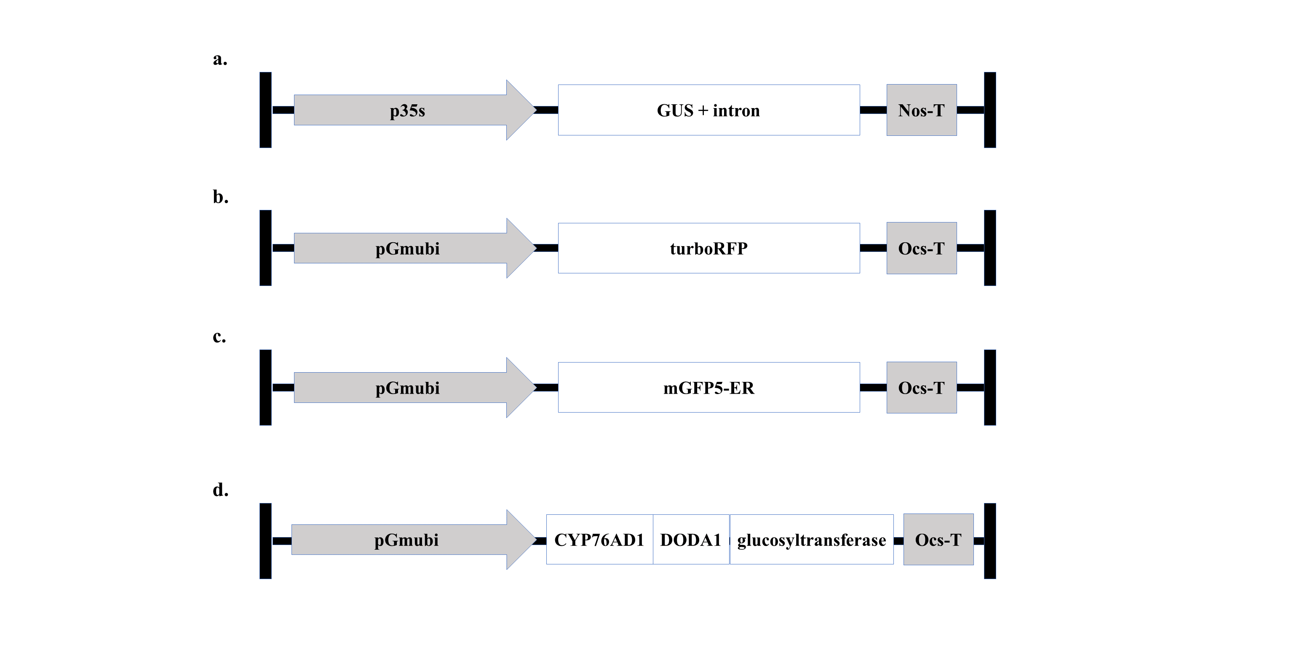
Fig. 1 Vectors used in optimization experiments. a Vector plasmid pTF101.1 with a CaMV35Ss (35S) promoter driving a GUS reporter with an intron and a nopaline synthase terminator (NOS) 35S:GUSplus:NOS. b Vector plasmid pAGM4723 with a Glycine max ubiquitin (Gmubi) promoter driving a red fluorescent protein (turboRFP) reporter and an Agrobacterium octopine synthase terminator (OCS) Gmubi:turboRFP:OCS. c Vector plasmid pAGM4723 with a Gmubi promoter driving a green fluorescent protein (mGFP5-ER) and an OCS terminator. d Vector plasmid pAGM4723 with a Gmubi promoter driving a three-gene betalain biosynthetic pathway linked by 2A peptides: CYP76A1, DODA1 and glucosyltransferase as a single open reading frame and an OCS terminator (He et al. 2020).

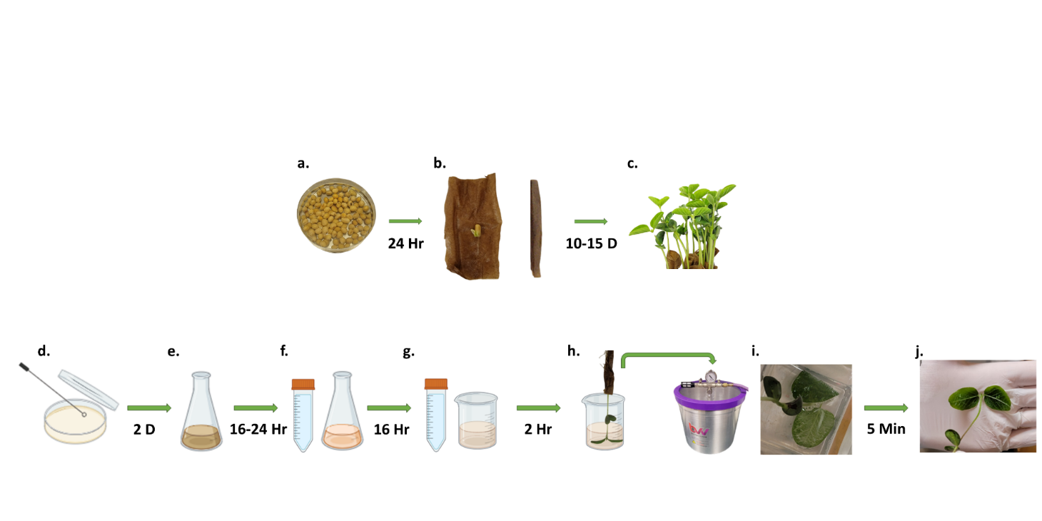
Fig. 2 Schematic of plant preparation and optimized soybean agroinfiltration process. a Sterile seeds were imbibed for 24 hours in water. b Paper towels were thoroughly moistened and cut into approximately 5 cm × 7.5 cm rectangles. Imbibed seeds were placed individually on moistened towels, rolled up, and placed upright in a beaker. c The paper towel-rolled seeds were placed in a growth chamber on 16-h day/8-h night cycle (~90-120 μmol intensity) at 24 °C and grown for 10-15 days to the VC or V1 stage. d Agrobacterium cultures were streaked on a YEP plate supplemented with antibiotics 4 days prior to infiltration (PTI) and grown for two days. e A colony from the YEP plates was used to inoculate a liquid starter culture of 50 ml YEP supplemented with antibiotics 2 days PTI, and grown for 16-24 hr on a shaker at 225 rpm at 28 °C. f The evening PTI, the starter culture was centrifuged at 4100 $×$g for 15 minutes and resuspended in AB:MES induction media to an OD₆₀₀ of 0.3, supplemented with 200 μM AS and selection antibiotics, and grown for 16 hr at 225 rpm at 28 °C. g The day of infiltration, the AB:MES induction media was centrifuged at 4100 $×$g for 15 minutes and Agrobacterium was resuspended in SIB to an OD₆₀₀ of 0.6, supplemented with 200 μM AS and incubated in the dark on a shaker at 50-75 rpm for 2 hr. h After incubation, SIB-Agrobacterium suspension was supplemented with 400 mg/L L-cysteine, 78 mg/L DTT, and 1% v/v Silwet L-77. SIB-Agrobacterium suspension beaker was placed in the vacuum chamber. Plants are then removed from the growth chamber and placed in the beaker with abaxial leaf surface facing up. i Plants were subjected to 5 minutes of vacuum at -84.65 kPa. The air intake valve was swiftly released to rapidly apply positive pressure and infiltrate leaf tissue. j Infiltrated plants were removed from the vacuum chamber, dunked in a beaker of DI water to wash off excess suspension and surfactant, patted dry with paper towel, placed back in their original growing container, lightly sprayed with water and placed under a plastic dome to maintain humidity. Finally, plants were placed in a dark cabinet for 16 hr before being placed back in the growth chamber for evaluation 72 hr post infiltration.
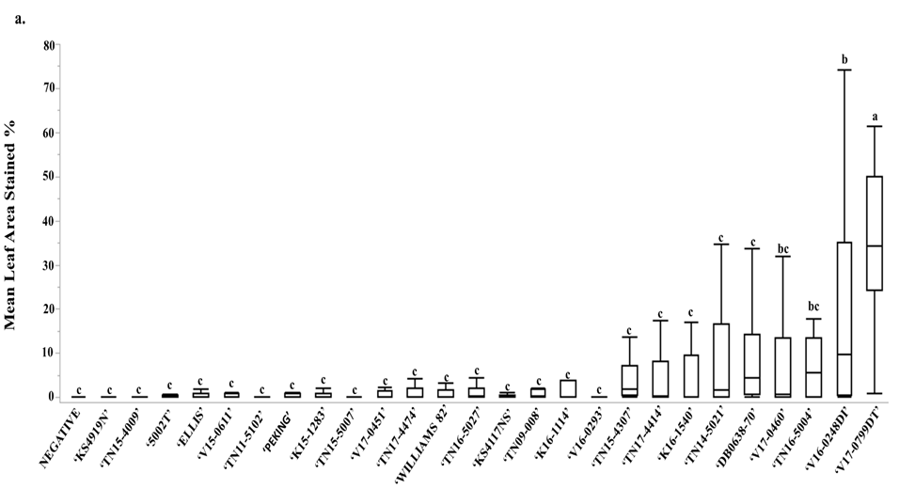
Fig. 3 Initial soybean genotype screen for amenability to agroinfiltration. Soybean lines infiltrated with Agrobacterium strain EHA 105 harboring 35S:GUSplus:NOS. Mixed VE and VC stage plants were subjected to 30 seconds of sonication at 42 kHz and vacuum infiltrated at -84.65 kPa for two 30-minute intervals using SIB supplemented with 400 mg/L of L-cysteine, 78 mg/L of DTT and 1% v/v Tween-20. a Mean leaf area stained of infiltrated leaves. Each soybean line was infiltrated with 3 negative controls (SIB only) of the same line, but all negative controls were included as a single negative in the graph. Lines with differing letters considered significantly different. Error bars represent standard deviation. P<0.05, n=18, one-way ANOVA, Tukey’s HSD. b Representative images of all infiltrated soybean lines stained for GUS expression.

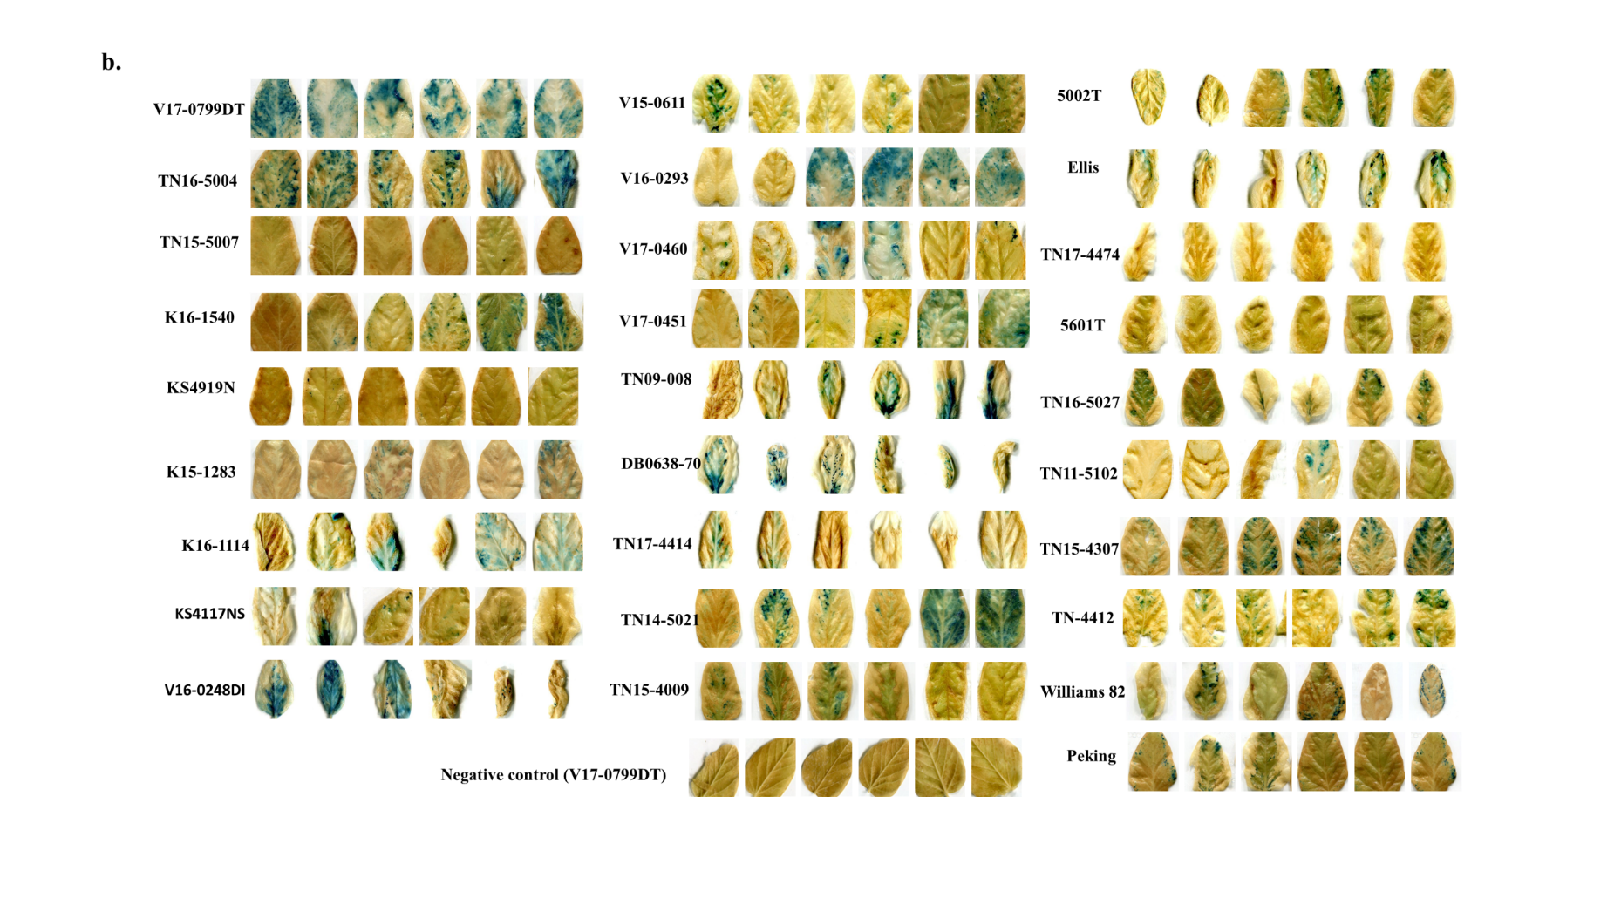

Fig. 3 continued.

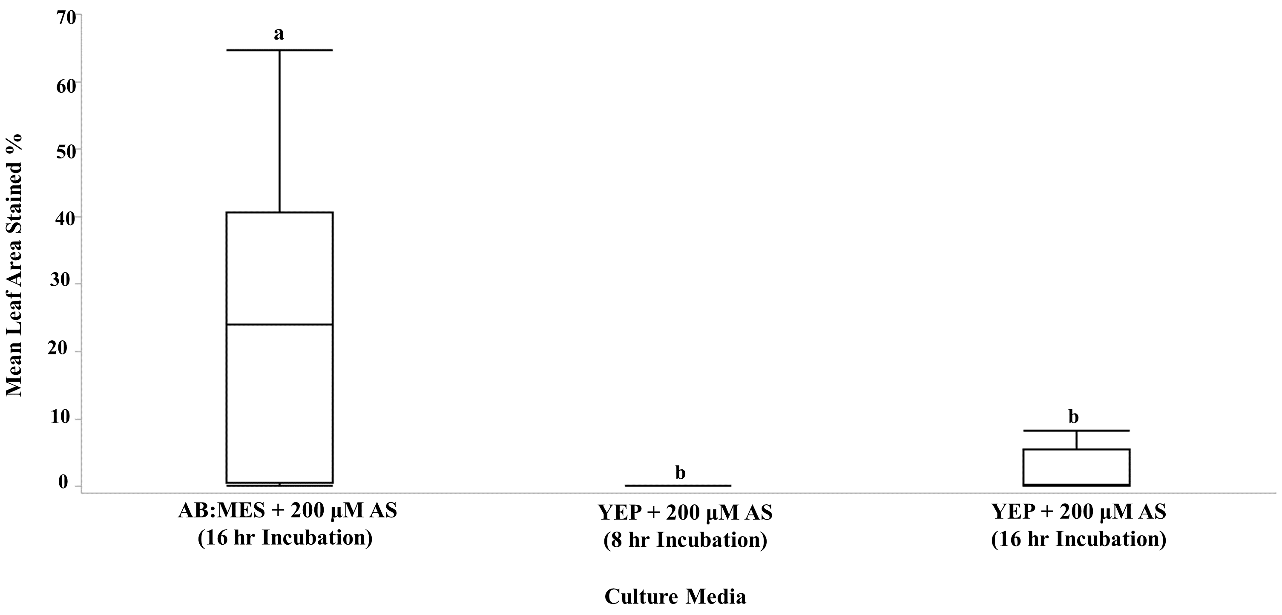
Fig. 4 Soybean line ‘V17-0799DT’ infiltrated with Agrobacterium strain EHA 105 harboring 35S:GUSplus:NOS incubated in AB:MES induction media + 200 μM AS , YEP + 200 μM AS grown the day of infiltration, or YEP + 200 μM AS incubated overnight. Infiltrations were conducted with a single 5-minute round of vacuum at -84.65 kPa using 0.01% v/v. Silwet-L77. Error bars represent standard deviation. P<0.05, n=18, one-way ANOVA, Tukey’s HSD.

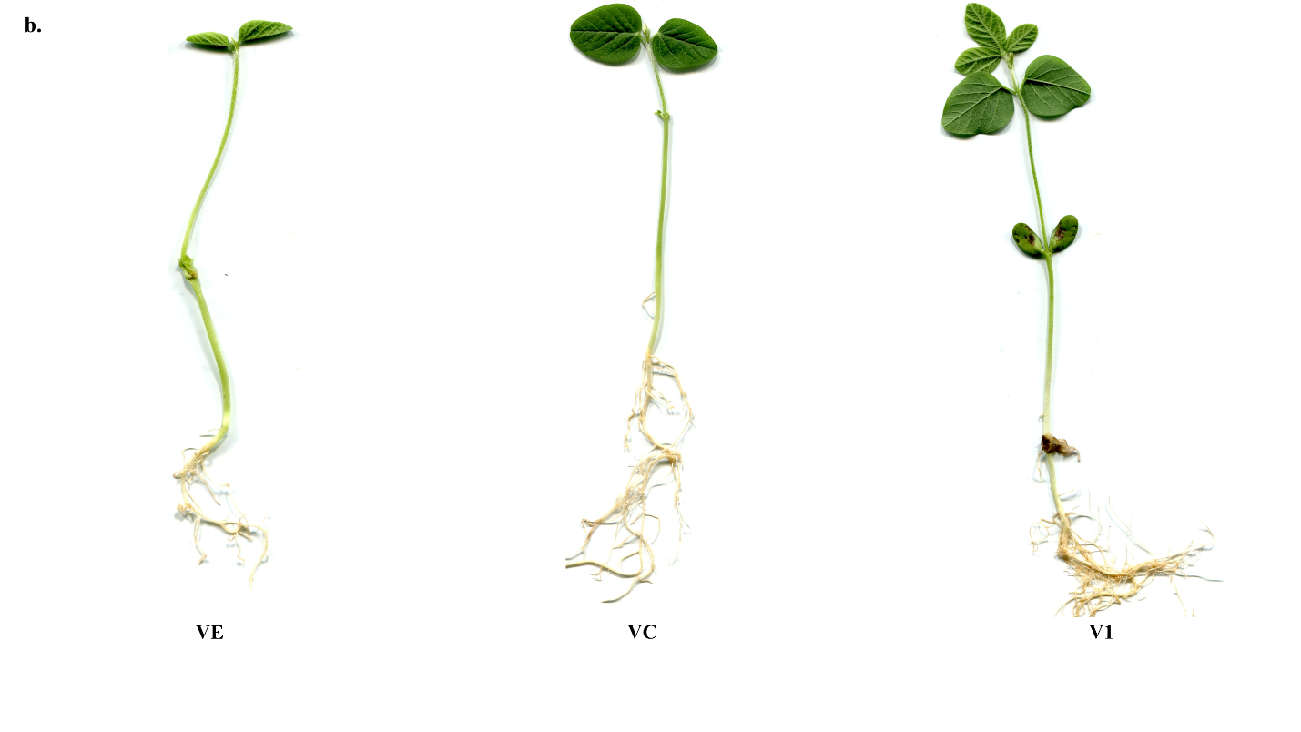
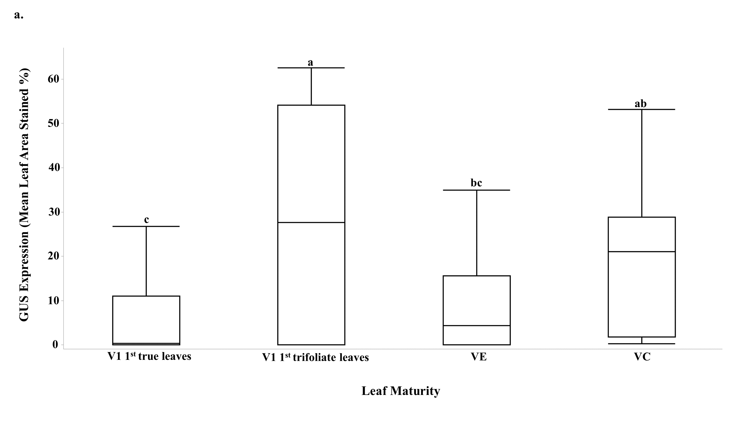
Fig. 5 Assessment of plant developmental stage. a Soybean line ‘V17-0799DT’ infiltrated during various developmental stages (VE-V1) with Agrobacterium strain EHA 105 harboring 35S:GUSplus:NOS grown in AB:MES induction media and subjected to a single 5-minute round of vacuum at -84.65 kPa using 0.01% v/v. Silwet-L77. Error bars represent standard deviation. P<0.05, n=18, one-way ANOVA, Tukey’s HSD. b Examples of line ‘V17-0799DT’ in the VE, VC, and V1 stage of development.

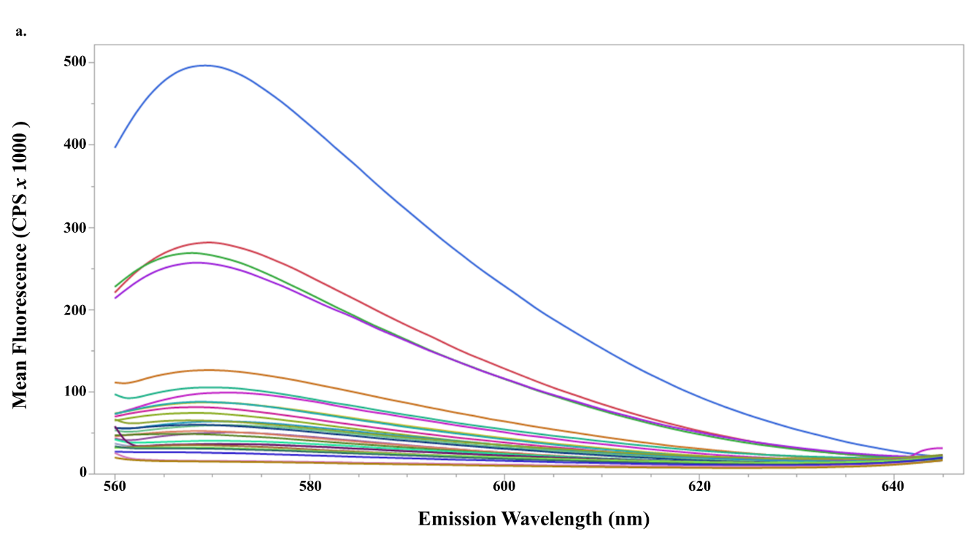

Fig. 6 Reassessment of soybean lines with a fully refined infiltration protocol using Agrobacterium strain EHA 105 harboring Gmubi:tRFP:OCS cultured and prepared as described in Fig. 2. VC stage plants were subjected to one 5-minute round of vacuum at -84.65 kPa in SIB supplemented 400 mg/L of L-cysteine, 78 mg/L of DTT and 1% v/v Silwet L-77. a Fluorescence spectroscopy of 26 infiltrated plant lines. Fluorescence emission intensity measured in counts per second (CPS). Excitation at 540 nm, emission measured from 560 nm-640 nm. Plants infiltrated with buffer and additives, but no Agrobacterium were used as negative controls. b Line ‘TN16-5004’ was the top performing genotype with a mean intensity of 476,296 cps. Peak emission (574 nm) was used for evaluation. Lines with differing letters considered significantly different. Error bars represent standard deviation. P<0.05, n=18, one-way ANOVA, Tukey’s HSD. c qRT-PCR of lines ‘TN16-5004’ and ‘V170799DT’ for transcript abundance of tRFP relative to soybean polyubiquitin (Gmubi3). Plants infiltrated with a Gmubi:RUBY:OCS construct as well as wild type plants were used as negative controls. Line ‘TN16-5004’ showed a relative expression level of 14.16% and line ‘V17-0799DT’ showed a level of 9.5% of the reference gene, Gmubi3. Error bars represent standard error of the mean. P<0.05, n=20, one-way ANOVA.

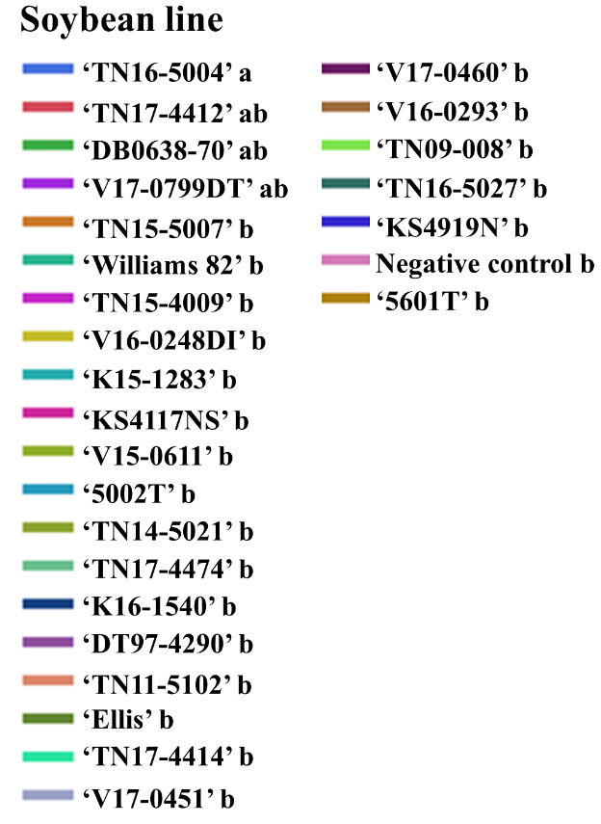
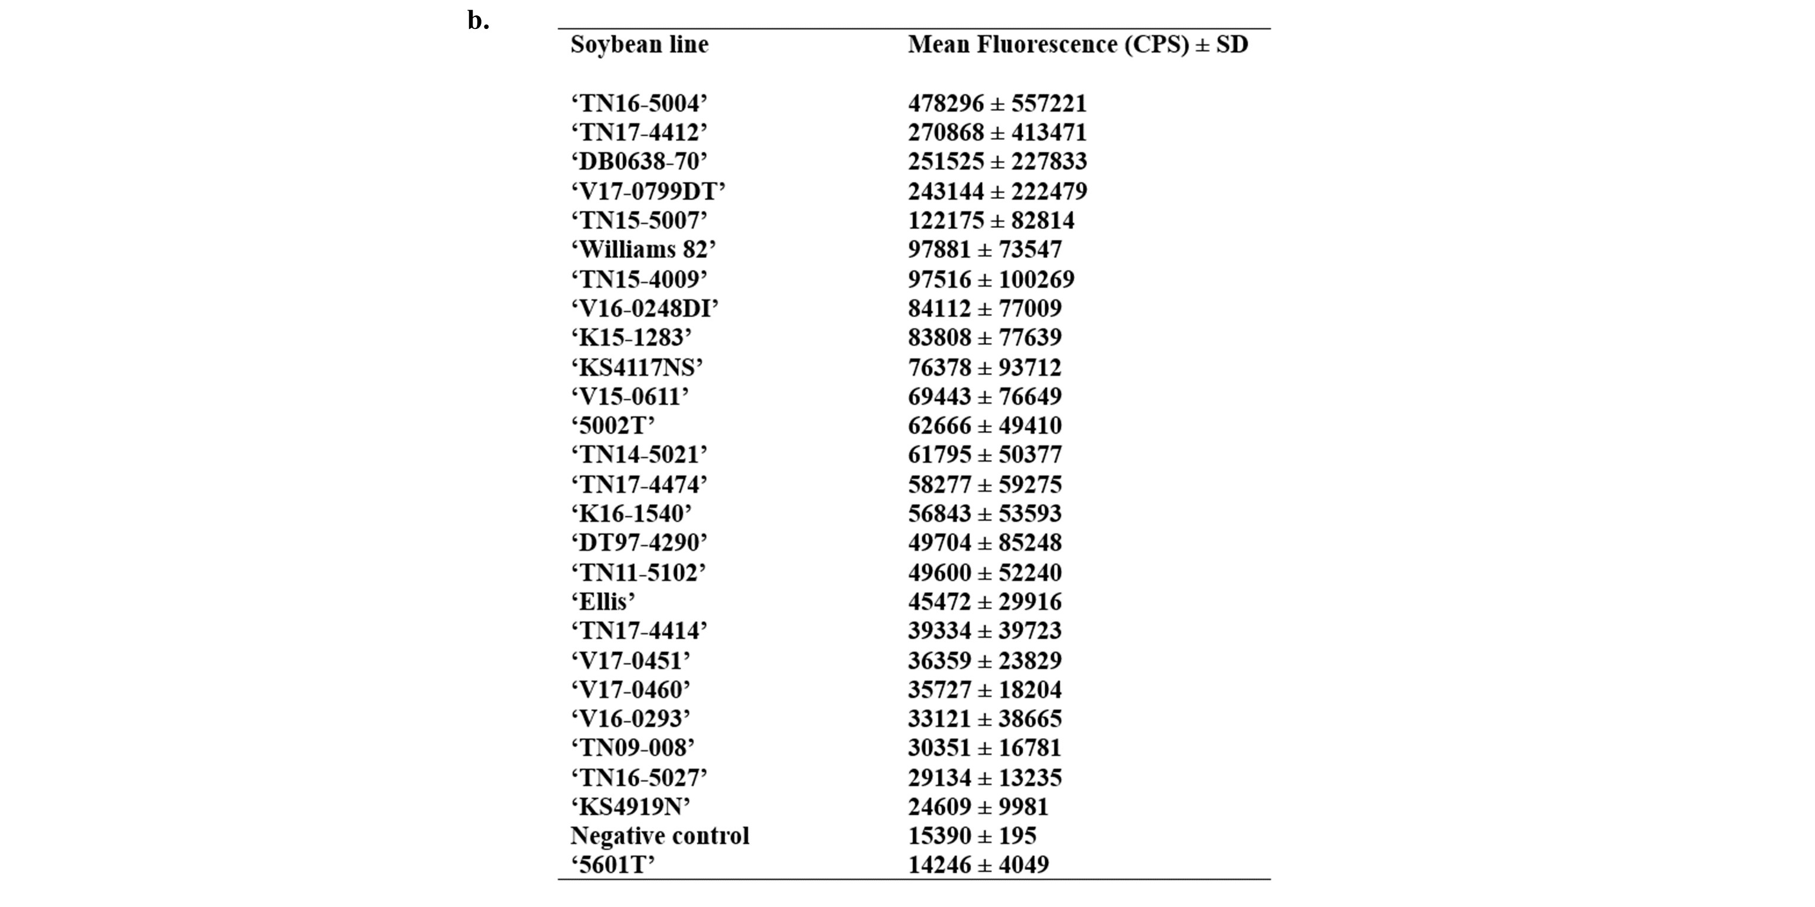
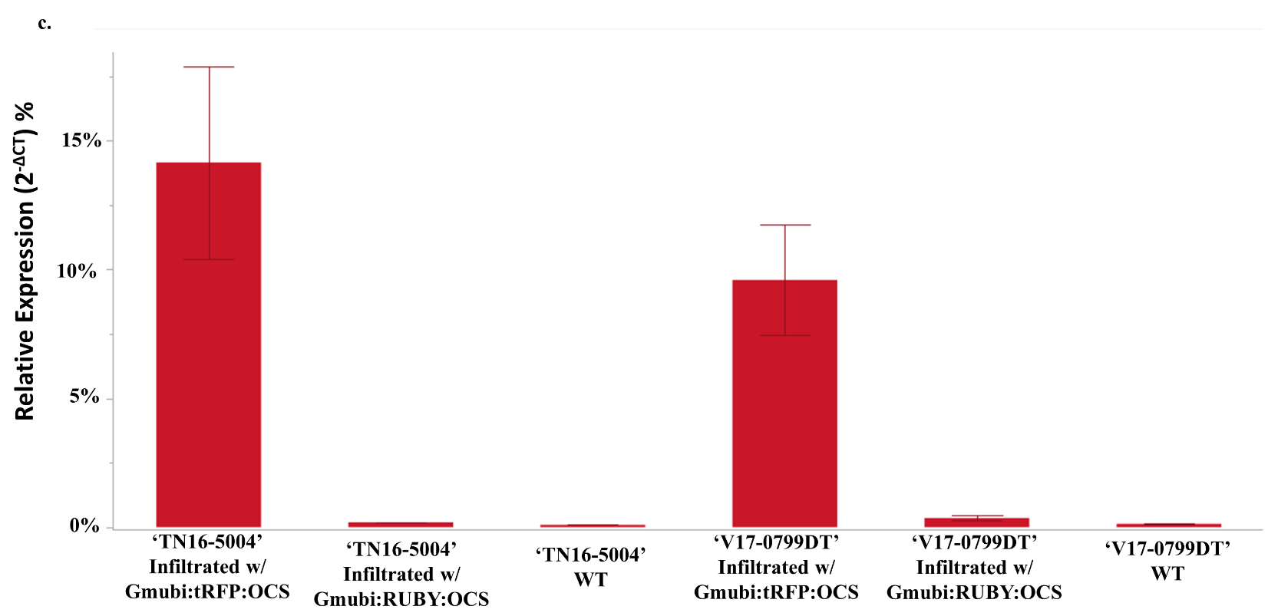

Fig. 6 continued.

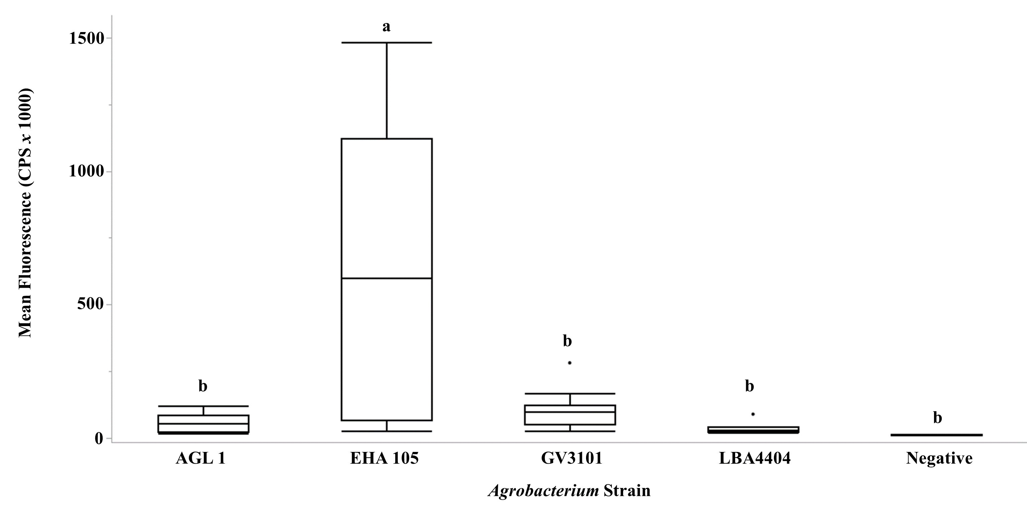
Fig. 7 Agrobacterium strain screen. Fluorescence spectroscopy of line ‘TN16-5004’ infiltrated as described in Fig. 2 with Agrobacterium strains EHA 105, LBA4404, GV3101 and AGL1 harboring Gmubi:tRFP:OCS. Error bars represent standard deviation. P<0.05, n=18, one-way ANOVA, Tukey’s HSD.

Fig. 8 VC stage soybean line ‘V17-0799DT’ co-infiltrated as described in Fig. 2 using Agrobacterium strain harboring Gmubi:tRFP:OCS and Gmubi:mGFP5-ER:OCS at a 1:1 ratio. a Compound microscopy of co-infiltrated plants. Scale bar = 500 μm. b Compound microscopy of negative control. Excitation for tRFP 540 nm, emission measured from 560 nm-580 nm. Excitation for mGFP5-ER 480nm, emission measured from 500 nm-520 nm c Confocal microscopy of co-infiltrated leaves (pseudo coloration). Scale bar =50 μm. Excitation for tRFP 553 nm and detected at peak emission of 574 nm. Excitation for mGFP5-ER at 490 nm and detected at peak emission of 509 nm. e Fluorescence spectroscopy of co-infiltrated plants. Excitation for tRFP 540 nm, emission measured from 560 nm-580 nm. Excitation for mGFP5-ER 480 nm, emission measured from 500 nm-520 nm. Error bars represent standard deviation. P<0.05, n=18, one-way ANOVA, T-test. f qRT-PCR of lines ‘TN16-5004’ and ‘V170799DT’ for transcript abundance of tRFP and mGFP5-ER relative to soybean polyubiquitin (Gmubi3). Plants infiltrated with a Gmubi:RUBY:OCS construct as well as wild type plants were used as negative controls. Line ‘TN16-5004’ showed a relative expression level of tRFP and mGFP5-ER of 7.8% and 6%, respectively. Line ‘V17-0799DT’ showed a relative expression level of tRFP and mGFP5-ER of 20.8% and 17%, respectively. Error bars represent standard error of the mean. P<0.05, n=24, one-way ANOVA.

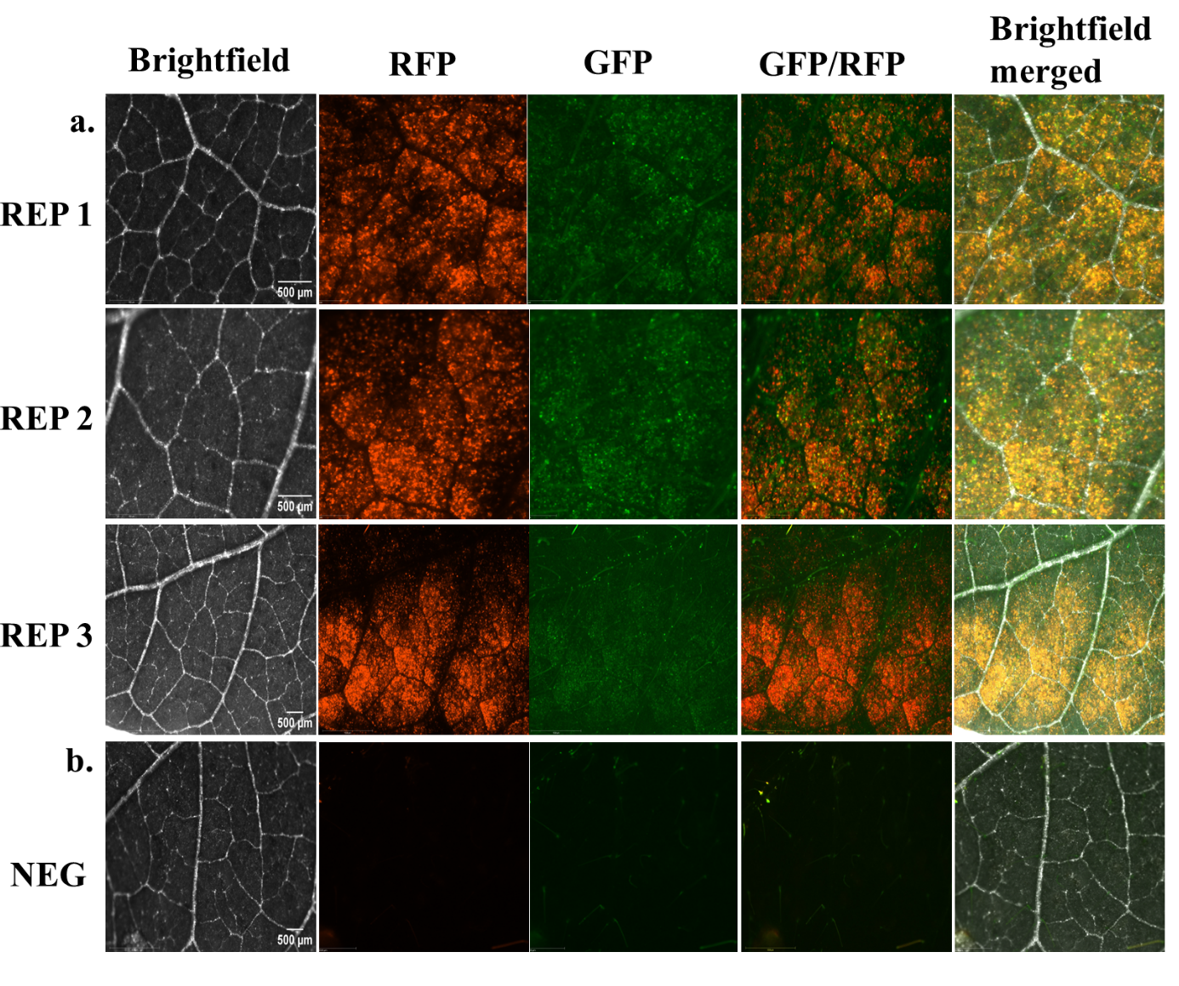
Fig. 8 continued.

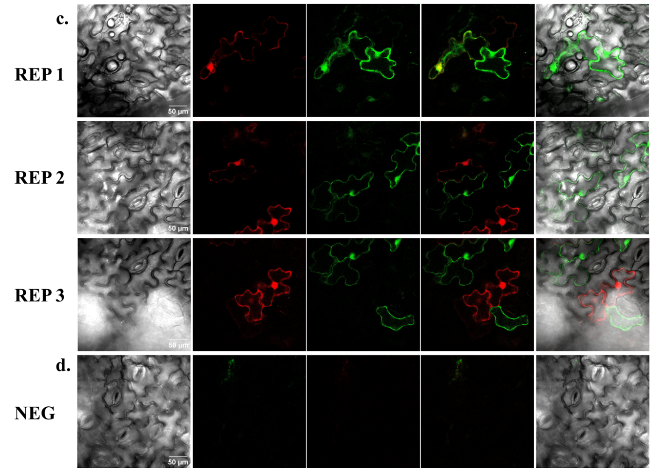

Fig. 8 continued.

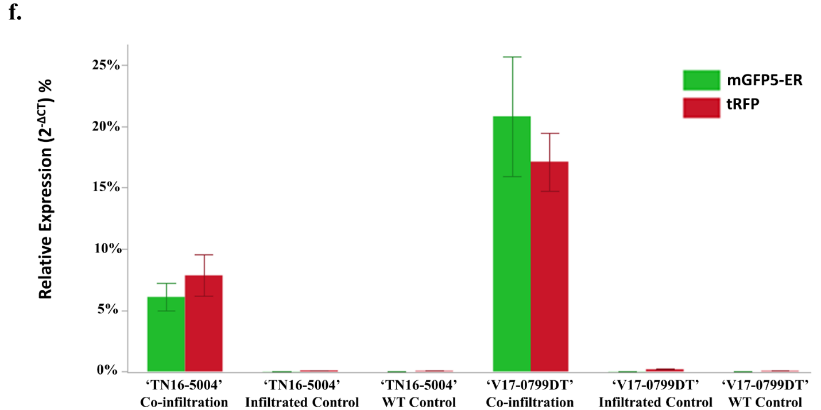
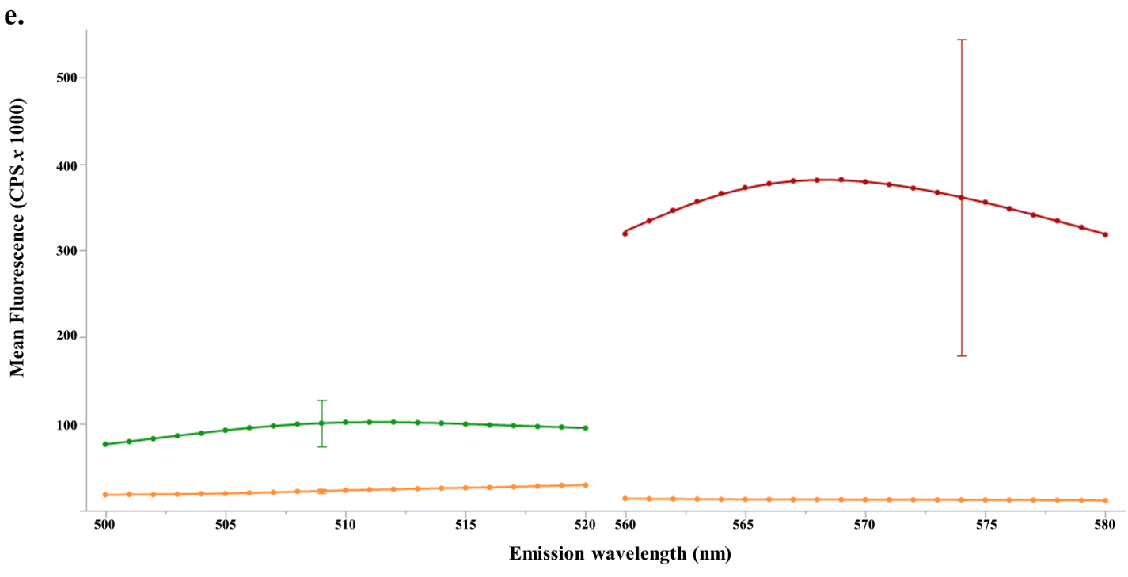

Fig. 8 continued.

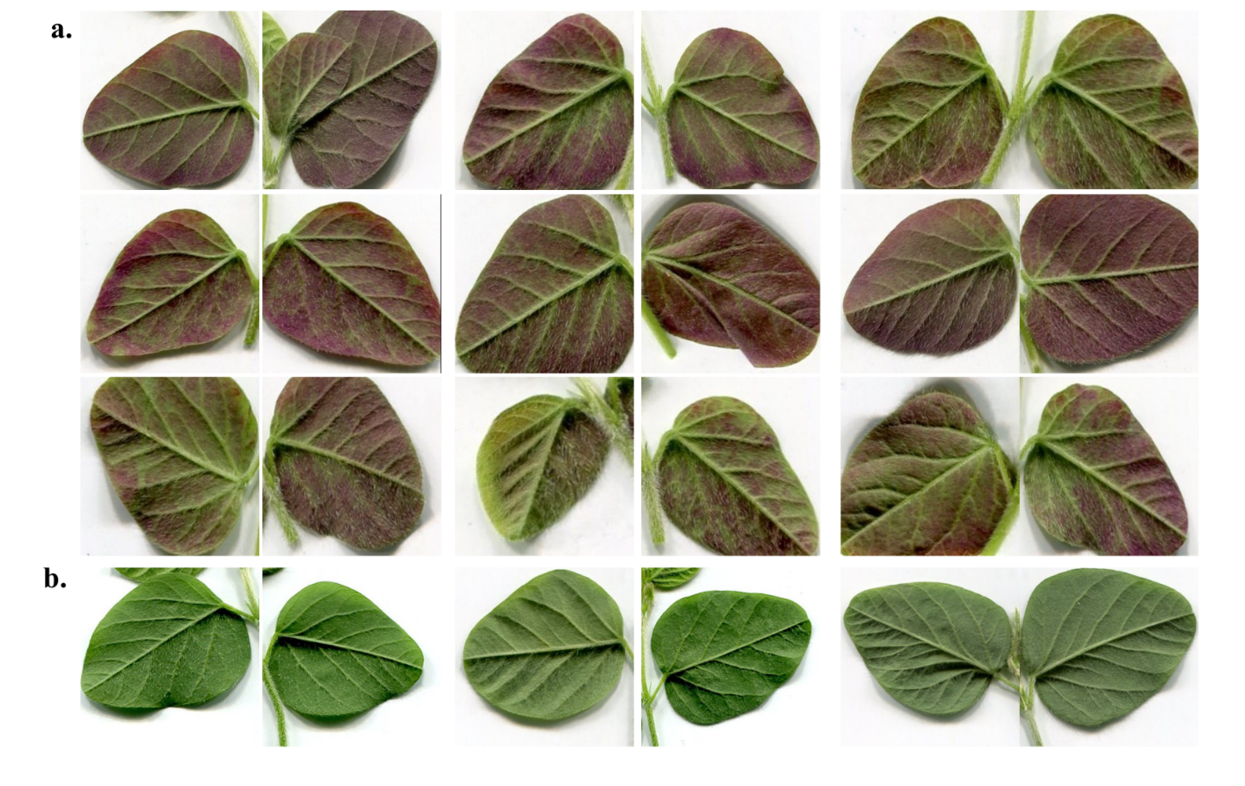
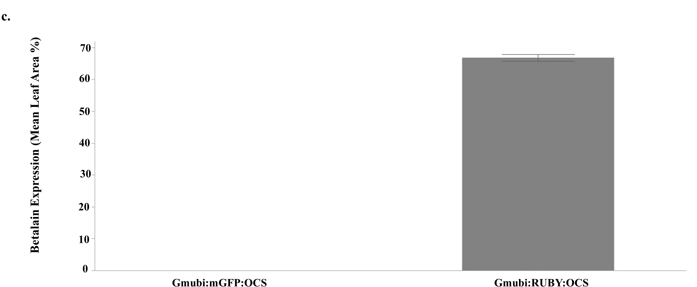
Fig. 9 VC stage soybean line ‘V17-0799DT’ infiltrated as described in Fig. 2 using Agrobacterium strain EHA 105 harboring Gmubi:RUBY:OCS. a Images showing infiltrated soybean leaves transiently expressing betalain. b Negative control infiltrated with Agrobacterium strain EHA 105 harboring Gmubi:mGFP5-ER:OCS. c Total leaf area showing betalain pigmentation vs. negative control. Error bars represent standard deviation. P<0.05, n=18, Student’s T-test.
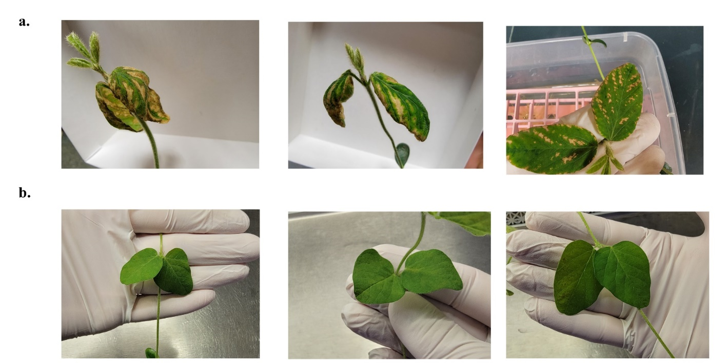
Fig. S1 a Soybean line ‘V17-0799DT’ infiltrated after sonication 2 days post infiltration. b Soybean line ‘V17-0799DT’ infiltrated without sonication and 0.01% v/v Silwet L-77 2 days post infiltration.

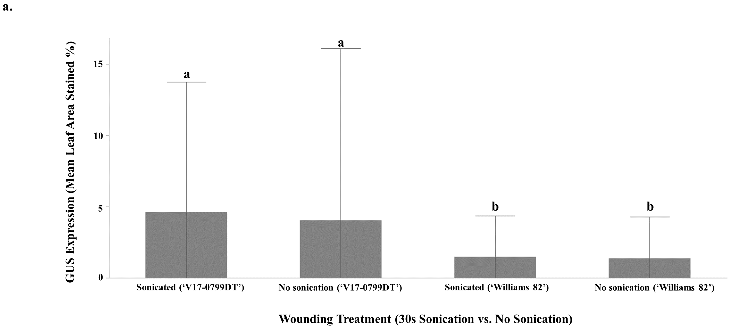
Fig. S2 Wounding treatments and surfactant test. a Soybean lines ‘Williams 82’ and ‘V17-0799DT’ subjected to infiltration with or without sonication using the method from Fig 2. No significant GUS expression difference between sonication and infiltration using surfactant alone was found. P<0.005, n= 18, Student’s T-test. b Comparison of surfactants Silwet L-77 and Tween-20 using soybean line ‘V17-0799DT’ subjected to one five-minute round of vacuum or 2-4 rounds, respectively. P>0.05, n=18, Student’s T-test. c Comparison of differing concentrations of Silwet L-77 in SIB. A concentration of 0.01% v/v was found to be optimal. d e f Shows examples of soybean line ‘V17-0799DT’ after two 5-minute rounds of vacuum and release at -84.65 kPa with no surfactant, 0.01% v/v Tween-20, and one 5-minute round with Silwet L-77, respectively. P<0.005, n=18, one-way ANOVA.

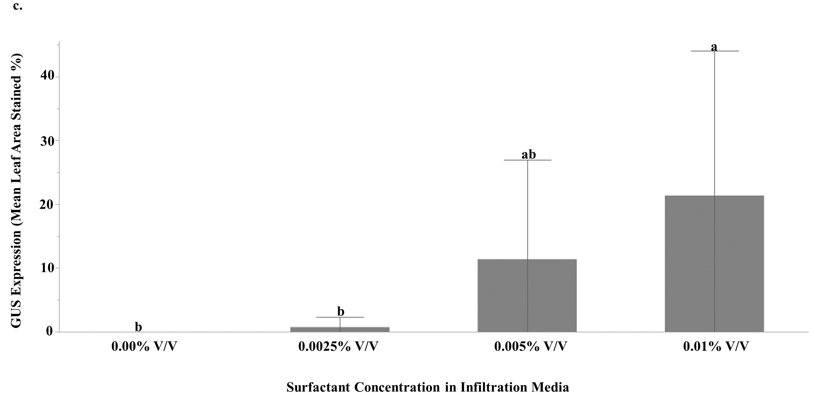
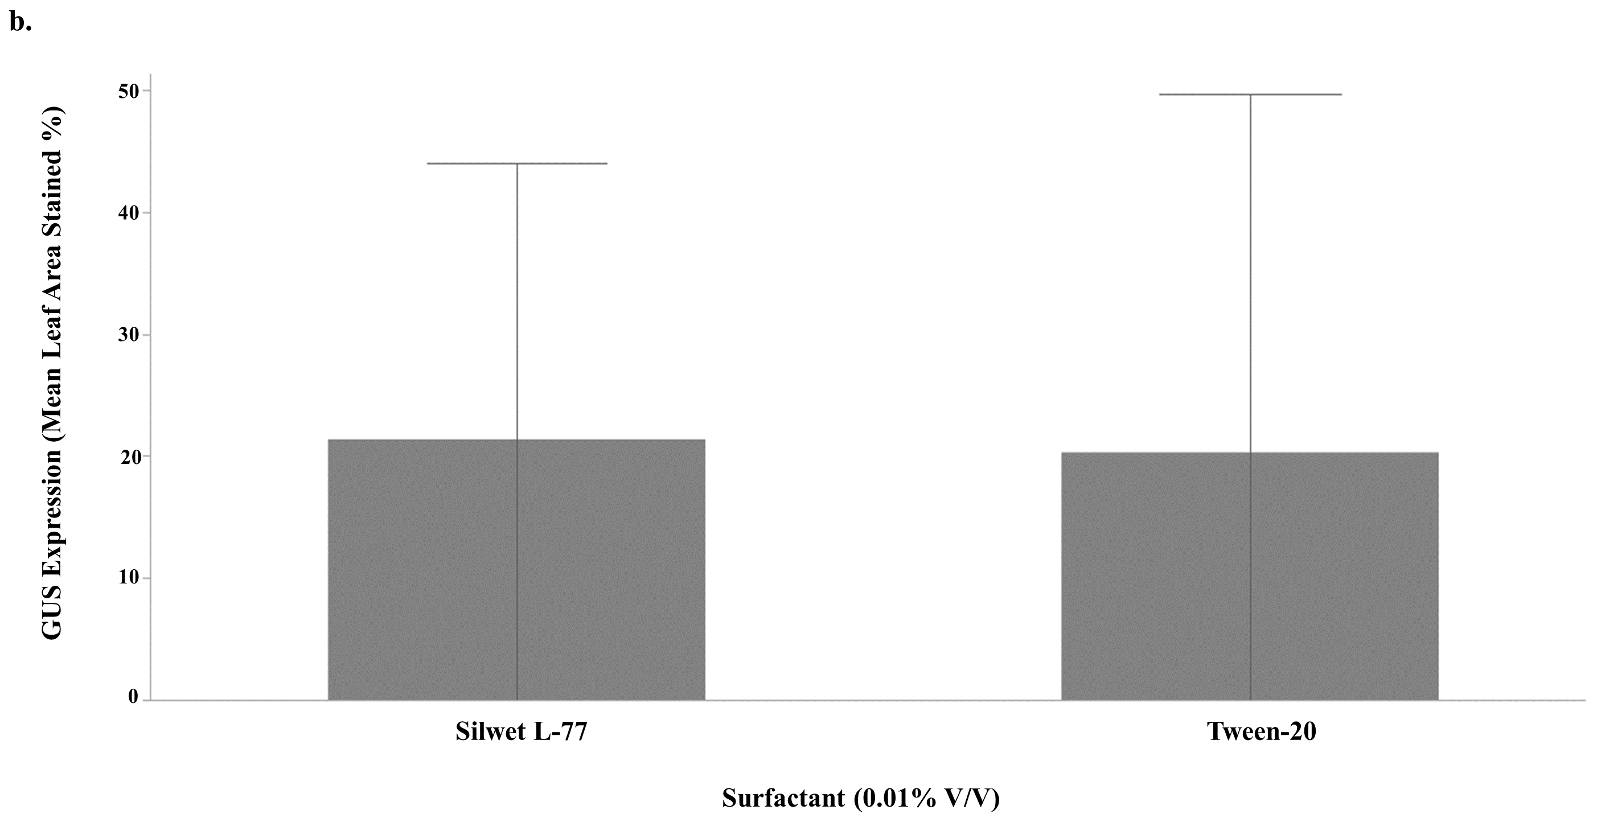

Fig. S2 continued.

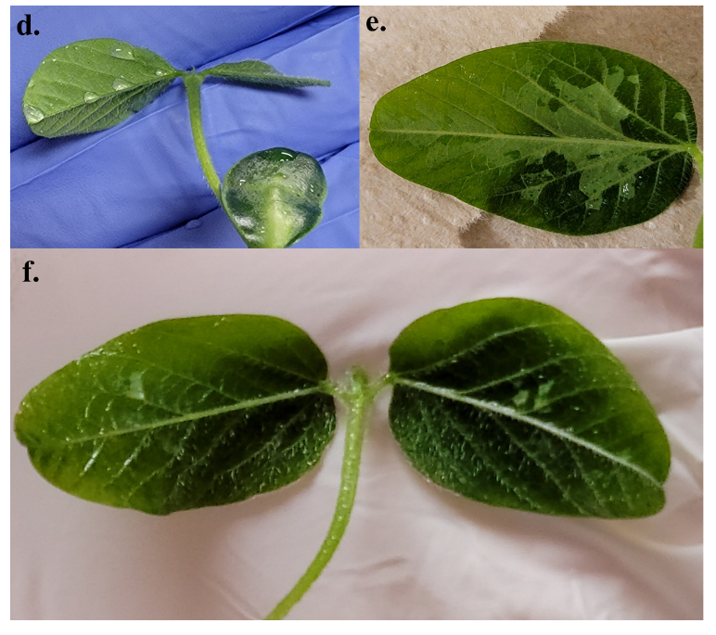

Fig. S2 continued.

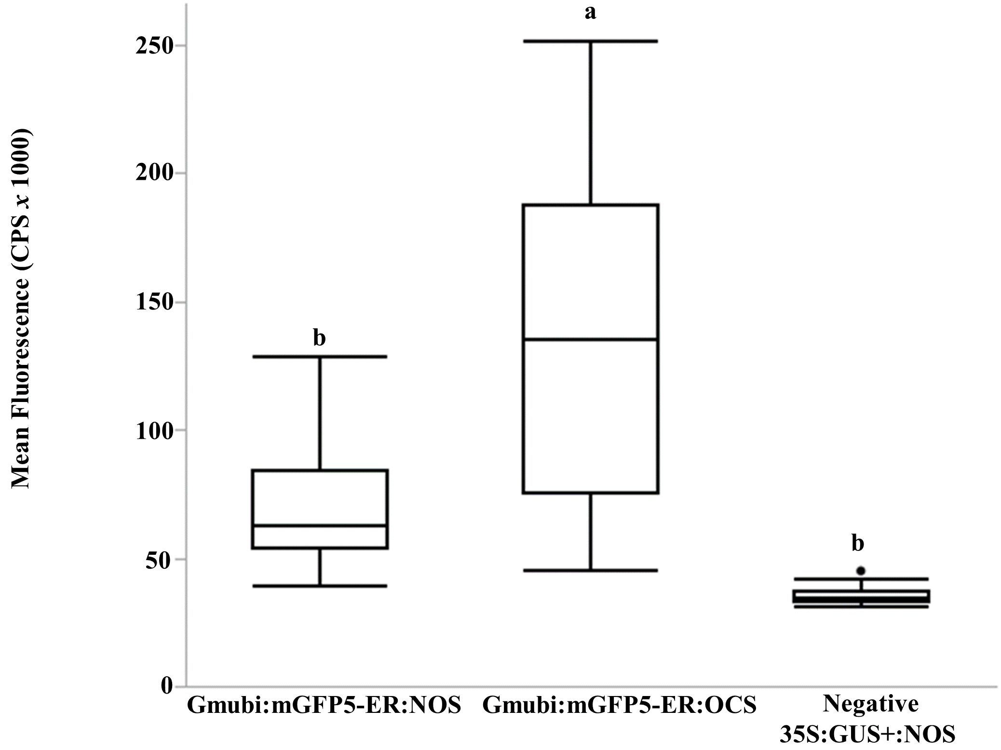
Fig. S3 Expression differences between line ‘V17-0799DT’ infiltrated with Gmubi:mGFP5-ER:NOS and Gmubi:mGFP5-ER:OCS

Table 1 Soybean genotypes tested. Most of germplasm tested were breeding lines developed at Virginia Tech (those beginning with “V”) and the University of Tennessee (those beginning with “T”).

Soybean line | Maturity group | Notes
5002T | 4
DB0638-70 | 4
DT97-4290 | 4 | Not tested in Fig. 3 (seed became available at later date)
‘Ellis’ | 4
K15-1283 | 4
K16-1114 | 4 | Not tested in Fig. 3 (poor germination)
K16-1540 | 4
KS4117NS | 4
KS4919N | 4
Peking PI 297543 | Unknown | Not tested Fig. 3 (poor germination)
TN17-4412 | 4
TN09-008 | 4
TN11-5102 | 4
TN14-5021 | 4
TN15-4009 | 4
TN15-4307 | 4
TN15-5007 | 4
TN16-5004 | 4
TN16-5027 | 4
TN17-4414 | 4
TN17-4474 | 4
V15-0611 | 4
V16-0248DI | 4
V16-0293 | 4
V17-0451 | 4 | Not tested Fig. 3 (seed became available at later date)
V17-0460 | 4
V17-0799DT | 4
‘Williams 82’ | 3

Table 2 Description of variations of infiltration procedure as it relates to the infiltration medium suspension, surfactant, sonication, and time of vacuum exposure. Throughout the study, the infiltration medium, as well as antioxidant additives, baring variations in the Agrobacterium strain and/or its culturing, was consistently maintained. The initial genotype screen (Fig. 1) was conducted with sonication treatments beforehand, Tween-20 as a surfactant and two rounds of 30-minute vacuum exposure. Once we established Silwet L-77 as the surfactant of choice and ruled out sonication as a useful treatment (Fig. S1 & S2) the remainder of optimization experiments were performed without a wounding treatment, using Silwet-L77 as the surfactant and a single round of 5-minute vacuum exposure.

Agroinfiltration Medium |  | Composition |  | Additives
Soybean infiltration buffer (SIB) |  | 10 mM MES, 10 mM MgCl₂.6H₂O, 1L DI water at pH: 5.4 |  | 200 μM acetosyringone, 400 mg/L L-cysteine, 78 mg/L dithiothreitol (DTT), 0.01% v/v Tween-20 or 0.01% v/v Silwet L-77
AB:MES Agrobacterium induction media  Cody et al. 2023 |  | Per 1L  3 g (K₂HPO₄), 1 g Na₂HPO₄, 1 g NH₄Cl, 0.31 g MgSO₄·7H₂O, 10.66 g MES, 20 g glucose, 1 ml 2M KCl, 100 µl 1 M CaCl_{2,} 1 ml 10 mM FeSO₄ stock  pH 5.7 |  | 200 μM acetosyringone  50 mg/L kanamycin
Yeast enhanced peptone (YEP) |  | 5 g/L NaCl, 10 g/L peptone and 10 g/L yeast extract |  | 50 mg/L kanamycin  50 mg/L rifampicin

Table 3 Plant developmental stage/leaf ages and morphologies tested. Soybean leaves were infiltrated in the vegetative emergence (VE) stage and vegetative compound (VC) stage. Both VE and VC are the first true leaves of a germinated soybean plant with VE being the leaves when unexpanded immediately after germination and VC being defined as fully unfurled and expanded first true leaves. Soybean leaves were also infiltrated in the vegetative 1st-trifoliate leaf stage. Both the first unifoliate leaves and first trifoliate leaves were tested.
Developmental stage | Leaf type infiltrated | Description | Approximate days post imbibition
VE | First unifoliate leaves | First unifoliate leaves have emerged but are not fully unfurled or expanded. | ~7-10 days
VC | First unifoliate leaves | First unifoliate leaves have emerged and fully unfurled and expanded. The meristem of the first set of trifoliate leaves is small but visible | ~11-13 days
V1 | First unifoliate leaves & first trifoliate leaves | First trifoliate leaves have emerged and fully unfurled | ~15-20 days

Table 4 Agrobacterium strains tested and chromosomal backgrounds.
Agrobacterium strain |  | Chromosomal background | Reference
EHA 105 |  | C58 | (Hood et al. 1993)
LBA4404 |  | ACH5 | (Ooms et al. 1982)
GV3101 |  | C58 | (Koncz & Schell 1986)
AGL 1 |  | C58 | (Lazo et al. 1991)

Table 5 Transcript analysis primer sets. Target genes and the respective forward and reverse primers used for qRT-PCR experiments.
Gene | Primer sequence (5’ to 3’)
Gmubi3 (reference) | F: GTGTAATGTTGGATGTGTTCCC  R: ACACAATTGAGTTCAACACAAACCG
tRFP | F: ACCACCACTTCAAGTGCACA  R: CGAAAGCGAAAGGGAGAGGT
mGFP5-ER | F: CCTGTTCCATGGCCAACACT  R: GCATGGCGCTCTTGAAGAAG

Supplementary Note 1. ImageJ macro code for isolation of total leaf area
Adapted from Viskol Inc. https://visikol.com/blog/2019/02/16/building-an-imagej-macro-for-batch-processing-of-images-from-imaging-well-plates/.
// Macro to measure Area, Intensity, Perimeter, and Shape of directory of images
run("Clear Results"); // clear the results table of any previous measurements
// The next line prevents ImageJ from showing the processing steps during
// processing of a large number of images, speeding up the macro
setBatchMode(true);
// Show the user a dialog to select a directory of images
inputDirectory = getDirectory("Choose a Directory of Images");
// Get the list of files from that directory
// NOTE: if there are non-image files in this directory, it may cause the macro to crash
fileList = getFileList(inputDirectory);
for (i = 0; i < fileList.length; i++)
{
processImage(fileList[i]);
}
updateResults(); // Update the results table so it shows the filenames
setBatchMode(false); // Now disable BatchMode since we are finished
// Show a dialog to allow user to save the results file
outputFile = File.openDialog("Save results file");
// Save the results data
saveAs("results",outputFile);
function processImage(imageFile)
{
// store the number of results before executing the commands, so we can add the filename just to the new results
prevNumResults = nResults;

open(imageFile);
// Get the filename from the title of the image that's open for adding to the results table
// We do this instead of using the imageFile parameter so that the directory path is not included on the table
filename = getTitle();
run("8-bit");
setAutoThreshold("Huang");
run("Set Measurements...", "area mean perimeter shape limit redirect=None decimal=4");
// You should adjust the size input according to the sizes of nuclei in your images
run("Analyze Particles...", "size=1-Infinity circularity=0-1.00 display");

// Now loop through each of the new results, and add the filename to the "Filename" column
for (row = prevNumResults; row < nResults; row++)
{
setResult("Filename", row, filename);
}

close("*"); // Closes all images
}

Supplementary Note 2. ImageJ macro code for isolation of leaf area stained
run("Clear Results"); // clear the results table of any previous measurements
setBatchMode(true);
inputDirectory = getDirectory("Choose a Directory of Images");
fileList = getFileList(inputDirectory);
for (i = 0; i < fileList.length; i++)
{
processImage(fileList[i]);
}
updateResults();
setBatchMode(false);
outputFile = File.openDialog("Save results file");
saveAs("results",outputFile);
function processImage(imageFile)
{
prevNumResults = nResults;
open(imageFile);
filename = getTitle();
run("Color Threshold...");
min=newArray(3);
max=newArray(3);
filter=newArray(3);
a=getTitle();
run("HSB Stack");
run("Convert Stack to Images");
selectWindow("Hue");
rename("0");
selectWindow("Saturation");
rename("1");
selectWindow("Brightness");
rename("2");
min[0]=90;
max[0]=255;
filter[0]="pass";
min[1]=20;
max[1]=255;
filter[1]="pass";
min[2]=0;
max[2]=240;
filter[2]="pass";
for (i=0;i<3;i++){
selectWindow(""+i);
setThreshold(min[i], max[i]);
run("Convert to Mask");
if (filter[i]=="stop") run("Invert");
}
imageCalculator("AND create", "0","1");
imageCalculator("AND create", "Result of 0","2");
for (i=0;i<3;i++){
selectWindow(""+i);
close();
}
selectWindow("Result of 0");
close();
selectWindow("Result of Result of 0");
rename(a);
////run("Copy");
////newImage("Untitled", "RGB white", 600, 800, 1);
////run("Paste");
run("Make Binary");
run("Create Selection");
run("Measure");
for (row = prevNumResults; row < nResults; row++)
{
setResult("Filename", row, filename);
}

close("*"); // Closes all images
}

Vita
Bryce N. Trull was born in Plantation, Florida. He received a B.S in Plant Science from the University of Tennessee in 2022. From 2021-present Bryce is pursuing a Master of Science degree in plant molecular genetics in the Stewart lab through a newly created 5-year MS/BS program which he helped develop for the plant science program and of which he is the first participant. His research is focused on developing an agroinfiltration method for soybean.

