Testing the Temporal Stability of the Climate Response of Tree Species at
Norris Dam State Park, Tennessee, U.S.A.

A Thesis Presented for the
Master of Science
Degree
The University of Tennessee, Knoxville

Allison Elizabeth Ingram
August 2016

Copyright © Allison Elizabeth Ingram
All rights reserved

Acknowledgements

This thesis would not have been possible without the guidance and support of my advisor, Dr. Henri Grissino-Mayer. I am extremely grateful for his patience and encouragement and the time he took to make thesis edits and revisions. His invaluable feedback helped me produce a thesis I can be proud of and I cannot thank him enough. I appreciate the time and effort my committee members, Dr. Sally Horn and Dr. Kelsey Ellis, took in helping me revise my thesis and providing me with feedback and assistance. Mark Morgan, from Norris Dam State Park, where I conducted my research, was very helpful and welcoming. I thank him for allowing me and my field team to collect samples for my thesis and I appreciate his enthusiasm for this research. I would not have been able to collect my samples without my field team, Dr. Henri Grissino-Mayer, Mathew Boehm, Kyle Landolt, Brooke Pearson, Dhara Naik, Hudson Kelley, Katy Caudle, Michael Hazelton, and Kyle McMeans, or process my samples without my laboratory assistants, Brooke Pearson, Dhara Naik, and Isaac Taylor, and I am extremely thankful for their assistance. I would also like to thank my family for their continued support and encouragement from New Jersey.

Abstract

Temporal stability of the climate-tree growth relationship means that over time, tree species were responding to a specific climate variable and continue to respond to that variable into the present. The stability of this response is important to test prior to attempting to reconstruct past climate. In this study, I sampled oaks (white oak = Quercus alba L. and chestnut oak = Quercus montana Willd.) and pines (Virginia pine = Pinus virginiana Mill. and shortleaf pine = Pinus echinata Mill.) growing in Norris Dam State Park in eastern Tennessee and tested the temporal stability of these species and their potential for reconstructing past climate. The cores were mounted and sanded, and the tree rings were crossdated and measured. I created chronologies in ARSTAN and analyzed my tree-ring data with DENDROCLIM2002 using regional climate data, which with the use of response and correlation functions and forward and backward evolutionary intervals, tested the temporal stability of the climate-tree growth relationship. Oak was positively correlated with late spring (June) precipitation and pine was positively correlated with spring (May-June) precipitation. Both species were positively correlated with growing season Palmer Drought Severity Index (PDSI), oak with late growing season (June-October) PDSI and pine with early growing season (May-July) PDSI. Oak had a negative relationship with temperature in late spring (June). These relationships are consistent from 1895 to 2015 in correspondence with the instrumental record. The chronologies formed can be used to reconstruct these past climate variables. In the southeast, both stable and unstable relationship between climate and tree growth have been found, which confirms the need to assess temporal stability on a site by site and chronology by chronology basis before reconstructions are attempted.
Table of Contents
1. Introduction 1
1.1 Background 1
1.2 Reconstructing Past Climate 1
1.3 The Divergence Problem 3
1.4 Research Questions 5
2. Literature Review 6
2.1 Mitigating the divergence problem 6
2.2 Possible factors causing divergence in the Northern Hemisphere 6
2.3 Statistical methods for testing temporal stability 7
2.4 Research on temporal stability in the Northern Hemisphere 9
2.5 Climate Oscillations 13
2.6 The Norris Dam chronology as a master chronology 16
3. Testing the Temporal Stability of the Climate Response in Tree Species
at Norris Dam State Park, Tennessee, U.S.A. 18
Abstract 18
3.1 Introduction 19
3.2 Study Site 22
3.3 Methods 23
3.3.1 Field Methods 23
3.3.2 Laboratory Methods 25
3.3.2.1 Assessing crossdating accuracy 27
3.3.2.2 Standardization 28
3.3.2.3 Climate Response 30
3.3.2.4 Tests for Temporal Stability 30
3.4 Results 31
3.4.1 Crossdating 32
3.4.2 Standardization 33
3.4.3 Climate-Tree Growth Relationships 41
3.4.3.1 Oaks 41
3.4.3.2 Pines 42
3.5 Discussion 55
3.5.1 Oak 55
3.5.2 Pine 60
3.5.3 Implications of climate reconstructions 62
4. Conclusions and Future Research 65
4.1 Major Conclusions 65
4.1.1 To which climate variables are oak and pine species responding? 65
4.1.2 Were the climate-tree growth relationships temporally stable? 66
4.1.3 Can the oak and pine chronologies be used to reconstruct past climate? 66
4.1.4 What implications come of this research? 67
4.2 Future Research 68
References 70
Appendices 76
Vita 109

List of Tables

Table 3.1 Significant correlations between climate data and oak 35
Table 3.2 Significant correlations between climate data and pine 36
Table 3.3 rbar and EPS for the oak chronology 37
Table 3.4 rbar and EPS for the pine chronology 37

List of Figures

Figure 1.1 GIS map showing location of NDSP 2
Figure 3.1 Partial map of NDSP showing sampling area 23
Figure 3.2 NDSP field site 24
Figure 3.3 Use of a tow strap and rope 25
Figure 3.4 GPS points of sampled trees at NDSP 26
Figure 3.5 30-year spline applied to oak core 34
Figure 3.6 20-year spline applied to pine core 34
Figure 3.7 Tree-ring indices for oak measurement series 38
Figure 3.8 Tree-ring indices for pine measurement series 38
Figure 3.9 Final tree-ring chronology developed from oak 39
Figure 3.10 Final tree-ring chronology developed from pine 40
Figure 3.11 Oak correlation coefficients–precipitation, PDSI, and temperature 43
Figure 3.12 Oak correlation coefficients–NAO, PDO, SOI, and AMO 43
Figure 3.13 Oak forward and backward evolutionary interval analyses–precipitation 44
Figure 3.14 Oak forward and backward evolutionary interval analyses–PDSI 45
Figure 3.15 Oak forward and backward evolutionary interval analyses–temperature 46
Figure 3.16 Oak forward and backward evolutionary interval analyses–NAO 47
Figure 3.17 Oak forward and backward evolutionary interval analyses–PDO 48
Figure 3.18 Pine correlation coefficients–precipitation, PDSI, and temperature 49
Figure 3.19 Pine correlation coefficients–NAO, PDO, SOI, and AMO 49
Figure 3.20 Pine forward and backward evolutionary interval analyses–precipitation 50
Figure 3.21 Pine forward and backward evolutionary interval analyses–PDSI 51
Figure 3.22 Pine forward and backward evolutionary interval analyses–temperature 52
Figure 3.23 Pine forward and backward evolutionary interval analyses–NAO 53
Figure 3.24 Pine forward and backward evolutionary interval analyses–SOI 54
Chapter One

Introduction
1.1 Background
Norris Dam State Park (NDSP) in eastern Tennessee consists of over 1,600 ha of old-growth and secondary-growth Appalachian oak-pine forest and is situated on the shores of Norris Lake (Figure 1.1). The park features over 1,280 km of shoreline, a marina, 15 hiking trails, 19 historic rustic cabins built by the Civilian Conservation Corps (CCC) in the 1930s, and 10 deluxe cabins along with two campgrounds (Maher 2008). The construction of Norris Dam began in 1933 and was completed in 1936 by the Tennessee Valley Authority (TVA). The purpose of this dam was to control flooding and bring electricity through hydroelectric power and economic development to the Tennessee Valley. The city of Norris was developed as a planned city along with the creation of the dam. The original purpose of Norris was for housing the workers on the dam (McDonald and Muldowny 1982). NDSP was built by the CCC in the 1930s (Maher 2008) and named for Nebraska senator George William Norris, the “father of the TVA” (McDonald and Muldowny 1982). Today, NDSP is managed by the Tennessee Department of Environment and Conservation and contains trees with old-growth traits that could be used by tree-ring scientists to better understand past climate.
1.2 Reconstructing Past Climate

Proxy reconstructions of past climate are important because the instrumental record becomes sparser and less reliable the further back in time you go (Wilson et al. 2007). For example, climate data available from the National Oceanic and Atmospheric Administration’s National Centers for Environmental Information, such as precipitation, temperature, and Palmer
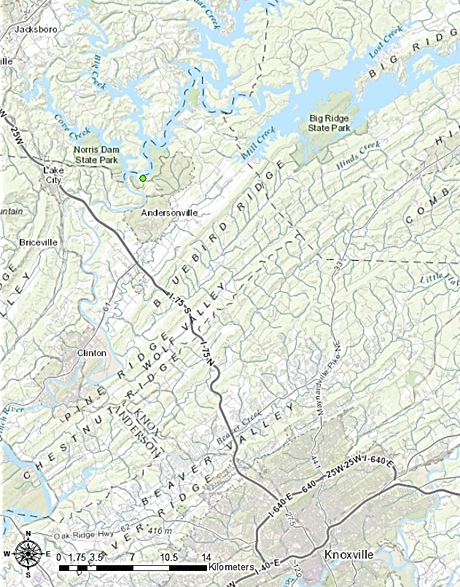
Figure 1.1. Map showing the location of Norris Dam State Park (84°5’24’’W, 36°13’12’’N), created using ArcMap.

Drought Severity Index (PDSI), only go back to 1895. To understand climate prior to 1895, we can use proxies for past climate, such as tree rings. The variability of tree-ring widths and the sensitivity to changes in year-to-year climate make it possible to identify to which climate variable the tree species are most responsive and which climate factor most drives tree growth. To reconstruct past climate, we need long-term tree-ring data to better understand both high- and low-frequency climate episodes across multiple time scales (Jacoby and D’Arrigo 1997). Tree rings are ideal because they have a resolution from the sub-annual to seasonal to century time scales (Biondi and Waikul 2004) and can be collected from sites where climate may be particularly limiting to tree growth (Coppola et al. 2012).
A principle that has become common in dendroclimatology is the uniformitarian principle, which states that the way trees are responding to climate during the present is how they responded to climate in the past. For this principle to hold, the tree species must be found to have a temporally stable response to climate. Testing for temporal stability has therefore become an important and necessary step in reconstructing past climate because it is also a test for the reconstruction potential of the tree species. If the tree species is unstable at site level and does not respond to the same climate variable over time, the climate reconstruction developed from this species would not be representative of past climate (D’Arrigo et al. 2008). Prior to developing a reconstruction of some climatic variable, we must first verify that the climate-tree growth relationship has remained stable over at least the modern period, i.e. 1895 to present.

1.3 The Divergence Problem

In recent studies, dendroclimatologists have identified a phenomenon termed the divergence problem that could put the uniformitarian principle in doubt. Divergence is the tendency for tree growth at climate-limited sites (i.e., sites where a specific climate variable limits tree growth) to reflect a weakening in response to climate over time, causing a divergence in trend where a climate variable (such as temperature) increases over time, but tree growth decreases over time (Wilson et al. 2007). Ideally, both variables should track similarly over time. A loss in temperature sensitivity means that trees are not responding as strongly or at all to seasonal temperature changes in recent decades (Briffa et al. 1998). This has mainly been observed with trees that grow at high latitudes and elevations (Lebourgeois et al. 2012). Mid- and low-latitude sites and trees do not experience divergence as much or at all; however, these forests also are more sensitive to drought rather than temperature (Lebourgeois et al. 2012). The influence of divergence in the mid- and lower latitudes cannot be determined based only on what has been observed occurring in the higher latitudes (D’Arrigo et al. 2008). Divergence could be due to another climate variable becoming the main driver of tree growth at the site or regional level (Lebourgeois et al. 2012, D’Arrigo et al. 2008). Divergence has been observed since only the mid-20th century and is likely anthropogenic in origin (Briffa et al. 1998, D’Arrigo et al. 2008), but divergence is not present in all temperature-sensitive sites (Wilson et al. 2007).
The divergence problem is the primary reason why testing for temporal stability between climate and tree-growth is important. If a site and tree species show divergence, the climate-tree growth relationship is unstable over time and the tree-ring data cannot be used to reconstruct past climate. A temporally unstable relationship calls into question the reliability of using tree rings to determine earlier warm and cold periods (Wilson et al. 2007). We need to verify that chronologies are free from divergence and temporally stable before we can reconstruct climate (Wilson et al. 2007).

1.4 Research Questions

I will examine the climate response of white oaks and yellow pines growing in Norris Dam State Park in eastern Tennessee and test the temporal stability between climate and tree growth during the 20th and 21st centuries. My hypotheses are:
H_{o} = The climate-tree growth relationships in these tree species are temporally stable over the past 120 years (1895 to 2015).
H_{A} = The climate-tree growth relationships in these tree species are not temporally stable over the past 120 years.
To evaluate my null hypothesis, I will address the following research questions:
- To which climate variables are oak and pine species responding?
- Were the climate-tree growth relationships temporally stable?
- Can the oak and pine chronologies be used to reconstruct past climate?
- What are the implications of the results for past and future climate reconstructions?
If the climate-tree growth relationships are temporally stable, reconstructions of past climate can be developed from these chronologies at NDSP in eastern Tennessee in the southeastern United States. If the climate-tree growth relationship is not temporally stable, a basic assumption in dendroclimatology is violated and any reconstructions from these species would be inaccurate.

Chapter Two
Literature Review

2.1 Mitigating the Divergence Problem

In addition to or instead of ring widths, other properties of tree-ring data (such as maximum latewood density or isotopic composition) can be helpful in reconstructing climate (Büntgen et al. 2012). Creating a successful proxy that can be used to reconstruct climate is important and has many requirements. These requirements are: (1) a stable relationship with climate; (2) being comprised of long-lived species that will not affect the segment length and restrict the reconstruction; (3) not being affected by statistical divergence due to detrending and standardization; and (4) not being affected by calibration methods that cause variance loss, which underestimates climate variability (Anchukaitis et al. 2013). The choice of detrending method is a major concern with tree-ring reconstructions and may have inadvertently contributed to creating tree-ring data that would be prone to the divergence issue. To detrend tree-ring data, dendrochronologists use lines or curves mathematically fit to the original raw data. These lines or curves can artificially introduce divergence if the fits greatly over-estimate or under-estimate tree growth, which happens occasionally towards the end of longer tree-ring sequences (D’Arrigo et al. 2008). This causes reconstructed temperatures to be over- or under-estimated (Briffa et al. 1998).

2.2 Possible factors that cause divergence in the Northern Hemisphere

Researchers are attempting to understand the factors that determine how tree species respond to divergence; however, the possible causes are uncertain and could be climatic, non-climatic, anthropogenic, or a combination. These causes could be: (1) increasing moisture stress (i.e. “overtaking” the temperature response); (2) threshold responses (i.e., trees respond to temperature only up to a certain level); (3) delayed snow melt (which would impact the temperature response); (4) changes in the seasonal response to climate (i.e., a shift from spring to summer responses); (5) local pollution (masking the temperature response); (6) responses to minimum and maximum temperatures (rather than the commonly-used mean temperature); (7) detrending effects (i.e., applying curves to tree-ring data that actually cause an underestimation of temperature); and (8) human factors (again, masking the natural climate response) (D’Arrigo et al. 2008).
Divergence could be a function of changes on the hemispheric scale, not the local or regional scale, such as higher UV-B levels and lower solar radiation, increased CO₂, increased acid deposition, or increased ozone and climate variability (Briffa et al. 1998). For example, global dimming is a large-scale process and occurs when the amount of solar radiation received at ground level for photosynthesis and plant growth is reduced, possibly due to increasing pollutants. An increase in ozone affects photosynthesis and decreases productivity (D’Arrigo et al. 2008). Finally, the number of proxy data sets used, low replication, limited recording stations and data that result in an unreliable instrumental record could also be contributing factors (Wilson et al. 2007).

2.3 Statistical methods for testing temporal stability

Calibration identifies climatic factors (such as precipitation and temperature) that affect tree growth, and is a prerequisite for reconstructing climate from tree rings (Biondi 1997). In addition, trees integrate responses from climate conditions outside the growing season and dendroclimatologists calibrate climate with tree growth by including climate data from the previous growing season and dormant season rather than using monthly climate data from just the growing season (Wilson et al. 2007). In the calibration process, we conduct correlation analyses for a single calibration interval, e.g. 1895 to 1950. Moving and evolutionary response function analyses, however, use multiple calibration intervals. Moving response functions (MRF) have a fixed number of years (e.g., 35 years) advanced across time by one year (either forward or backward) to calculate the correlation coefficients between tree growth and climate for moving intervals. For example, the most recent period would be 1981–2015; the next would be 1980–2014, then 1979–2013, and so on, in a MRF analysis backward in time. Evolutionary response function (ERF) analysis uses a longer number of years to calculate the response coefficients and also allows for both forward and backward calculations, having either a fixed start year or fixed end year, and adding one year additionally to the period forward or backward and calculating a new correlation coefficient. These techniques are useful for examining non-linear climate-tree growth relationships in which multiple climate predictors may exist. Moving and evolutionary response functions are an improvement on standard linear response function analyses (Biondi 1997).
DENDROCLIM2002 is a Windows-based program developed by dendroclimatologists that calibrates tree-ring chronologies against instrumental data over the historical period and estimates the significance of the response and correlation coefficients (Biondi and Waikul 2004). DENDROCLIM2002 uses bootstrapped confidence intervals and evolutionary and moving intervals to test for temporal changes in climate-tree growth relationships. To compute response and correlation coefficients, DENDROCLIM2002 uses 1000 bootstrapped samples to compute confidence intervals and tests significance at p < 0.05. To be deemed significant, median correlation and response coefficients must be greater than half the difference between the 97.5th and 2.5th quantiles (Biondi and Waikul 2004).
This software has been used in many recent climate analyses to determine which climate variables are most important for tree growth and for evaluating whether climate and tree growth relationships have been stable over the 20th–21st centuries. For example, Levanič and Eggertsson (2008) used DENDROCLIM2002 for testing the temporal stability of the climate response of birch in northern Iceland. They used both response functions and forward evolutionary intervals and found that above average temperatures in both June and July had a positive effect on tree growth and that this was a stable relationship over time. Koprowski et al. (2010) investigated climate-tree growth relationships of Scots pine in northern Poland with the use of DENDROCLIM2002. They investigated both temperature and precipitation and reconstructed past climate with the use of February-March temperature, which was stable over time. Maxwell et al. (2012) used correlation function analysis in DENDROCLIM2002 to identify a period for reconstructing precipitation from eastern red cedar in the mid-Atlantic region of the U.S. They used previous May to current October as the time frame to examine the lag effect of climate on tree growth. The researchers found that May precipitation was suitable for reconstruction through moving evolutionary analysis. May precipitation was stable with tree growth over time. Roibu et al. (2011) assessed dying beech stands on the Dragomirna plateau in Suceava county in Romania. The researchers tested the influence of precipitation and temperature on tree growth and used DENDROCLIM2002 to assess climate-tree growth relationships using the previous June to current August as the time frame. The researchers found that current May precipitation was positively correlated with tree growth. The relationship between May precipitation and tree growth was stable over time.

2.4 Research on temporal stability in the Northern Hemisphere

Many researchers have studied temporal stability and the ability of certain tree species to be used to reconstruct past climate. For example, Biondi (1997) found that Torrey pines (Pinus torreyana Parry) growing in California were temporally stable, but Douglas-fir trees (Pseudotsuga menziessii (Mirb.) Franco) growing in Idaho were not. Douglas-firs showed a negative response to July temperature and a positive response to April to June precipitation, especially May precipitation. Over time, though, the precipitation signal shifted from a June response to a May response and eventually to just an April response. Douglas-fir growth is most affected by moisture stress based on the negative response to summer temperature and positive response to spring/summer precipitation, which could be due to lack of soil and steep slopes found where these trees were collected. As the signal shifted in recent decades, the onset of this moisture stress in Douglas-fir occurred earlier in the growing season. This study again demonstrates that some tree species can show the effects of divergence while others may not.
Wilson et al. (2007) used tree-ring and local and regional temperature data that did not show any effects of divergence to develop a new, independent reconstruction of extratropical Northern Hemisphere annual temperature from 1750 to 2000. This reconstruction fared well in tracking trends in the instrumental data, even through the recent period, although it still slightly under-predicted temperatures. Choosing divergence-free sites can reduce the effects of divergence in the reconstruction; however, it is not something that can be done prior to field sampling, and can only be conducted on a tree-by-tree basis in the laboratory.
Kipfmueller (2008) conducted research in the northern Rocky Mountains and found that whitebark pine (Pinus albicaulis Engelm.) has a weak summer temperature signal and is showing divergence to temperature and not responding proportionally. This species is widespread in the northern Rockies and should be able to be used to reconstruct past climate because it is found at the upper treeline and should be sensitive to climatic fluctuations. Subalpine larch (Larix lyallii Nutt.), however, is a species found in the same region, but does not show divergence (Kipfmueller 2008). This research demonstrates that not all species in a site may show divergence and more studies are needed to better understand why.
Biermann (2009) found that the growth of yellow pines in Great Smoky Mountains National Park (GSMNP) is influenced by both precipitation and temperature, but is mainly moisture sensitive, with the strongest response to spring precipitation. However, she also found that winter mean minimum temperature influenced the growth of yellow pines. Biermann found temporally unstable climate-tree growth relationships at GSMNP in which the response of yellow pine to moisture conditions during the growing season weakened and the response to mean minimum temperatures in winter strengthened. This makes yellow pine growing in GSMNP unsuitable for climate reconstructions.
Fish et al. (2010) investigated whether Scots pines (Pinus sylvestris L.) growing in Glen Affric, Scotland were reaching a senescent stage in which they would no longer respond to the dominant climate signal. They found a positive response to mean summer temperature and also a positive response to winter temperature, but a stronger response was found for summer temperature. Surprisingly, the strongest response to mean temperature was observed for trees in the older age groups. However, this group also showed the greatest weakening in the climate signal, suggesting that senescence had a strong effect on the strength of the climate response as well as the level of divergence that was occurring.
Trindade et al. (2011) investigated air temperature and precipitation during the growing season and the growth of two spruce species (Picea mariana B.S.P. and P. glauca (Moench) Voss) at four sites across central Labrador in eastern Canada and tested for temporal stability. They found that the climate-tree growth relationships were unstable over time, likely due to changes in moisture availability, precipitation, temperature, or other site-specific factors. Moist sites often had less stable climate-tree growth relationships, while those at drier sites were more stable. Insect outbreaks have been recorded at times corresponding to insensitivity in the climate-tree growth relationship; however, these climate sensitivity shifts and reversals do not always correspond to lower tree growth. The shifts and reversals have more to do with changes in precipitation, and therefore moisture availability. Therefore, high moisture levels, caused by an increase in precipitation, can reduce climate sensitivity.
Li (2011) also found that pines in the southeastern U.S. responded both to precipitation and temperature. In her study site from eastern North Carolina to eastern Tennessee, she found that winter temperature was the limiting factor for pines on the western mountain site and moisture was the limiting factor for pines on the eastern mountain and coastal sites. Winter North Atlantic Oscillation (NAO) had positive correlations with tree growth. However, she found that tree growth and climate exhibited an unstable relationship, shown by a shift from a precipitation signal to a temperature signal in the mid-20th century.
Coppola et al. (2012) found that temperature influenced growth of European larch more than precipitation in the Italian Central Alps. The influence of temperature also depended on elevation, with stronger climate signals found at higher elevations. June temperature had the greatest influence on larch growth, but the relationship was somewhat unstable and variable. Since the 1960s, a loss in the June temperature signal was observed in these larch chronologies, especially at lower altitude sites. An emerging and increasing trend between August temperature and tree growth indicated a prolonged growing season. This phenomenon was mainly observed at high elevations where temperature was the strongest driving factor. At lower-elevation sites, precipitation was more important for tree growth, especially during late spring to early summer, but Coppola et al. (2012) found a negative influence of June precipitation at higher elevations. Although they found that high altitude chronologies were valuable in the study of climate, the responses to climate varied over time and temporal instability was apparent in the climate-tree growth relationships.
Büntgen et al. (2012) extended a one-thousand-year long European larch (Larix decidua Mill.) chronology from the French Alps out to 2007 (it previously ended in 1974) for calibration and verification because the original chronology showed only weak correlations with summer temperature. Comparing the new, updated data set with temperature, precipitation, and drought, they found weak and temporarily inconsistent climate responses. They found that temperature sensitivity decreased with decreasing latitude. These findings call into question the reliability of temperature reconstructions based on tree-ring widths in the Mediterranean region overall. They stressed the need to create chronologies instead from maximum latewood density and stable isotope ratios, which are not as affected by divergence. They also stressed the need to collect data from lower latitudes and evaluate site conditions before compiling the local data into a regional network.
2.5 Climate Oscillations

In this study, we will not only be analyzing climate variables such as temperature, precipitation and PDSI, but also climate oscillations, which may also have an effect on tree growth. The Atlantic Multidecadal Oscillation (AMO) is a climate oscillation of sea surface temperature (SST) between Greenland and the equator. It has warm and cool phases lasting around 20–40 years with a range of 0.4 °C and operates across a 65 to 80 year cycle (Enfield et al. 2001). Over the instrumental period, from 1856 to the present (Gray et al. 2004), warm phases have occurred from around 1860 to 1880 and 1940 to 1960 and cool phases have occurred from around 1905 to 1925 and 1970 to 1990. Warm or positive phases of the AMO are characterized by increased rainfall over Florida and the Pacific Northwest and decreased rainfall over the rest of the U.S. Cool or negative phases are characterized by increased drought in Florida and the Pacific Northwest, causing an increase in wildfires and an increase in rainfall over the rest of the U.S. (Enfield et al. 2001). Since the mid-1990s, we have been in another warm phase (Gray et al. 2004).
The El Niño-Southern Oscillation (ENSO) operates on a 2 to 10 year cycle of shifting pressure and SST in the Pacific Ocean (Philander 1983). ENSO alternates between warm phases (El Niño) and cold phases (La Niña). The Southern Oscillation index (SOI) is an index of pressure across the tropical Pacific used to monitor ENSO conditions (Mccabe and Dettinger 1999), and is the difference in sea level pressure (SLP) between Tahiti and Darwin. ENSO events persist for 6 to 18 months (Mantua and Hare 2002). During a warm El Niño phase, sea level pressure is higher at Darwin and lower at Tahiti, making the SOI negative (Stenseth et al. 2003). This would be reversed during La Niña (McCabe and Dettinger 1999). El Niño causes warm surface waters in the central and eastern Pacific and cold waters in the western Pacific. The west coast of South America experiences warm, wet winters during an El Niño event (Wu et al. 2004), while the American Midwest and Northwest experience warmer winters and the American Southwest experiences wetter winters (Ropelewski and Halpert 1986). La Niña is the cool phase consisting of high sea level pressure and cold sea surface temperatures in the eastern Pacific (Philander 1983). La Niña causes the opposite effects of El Niño.
The North Atlantic Oscillation (NAO) is an oscillation of atmospheric mass between the Azores high and the Icelandic low and is most pronounced in the winter (Hurrel and van Loon 1997). It was first identified as the seesaw in winter temperature between Greenland and northern Europe (van Loon and Rogers 1978). The NAO consists of positive and negative phases (Stenseth et al. 2003) and is associated with pressure over the Northern Hemisphere (van Loon and Rogers 1978). The positive phase is associated with low pressure over the Icelandic low and high pressure over the Azores high (Rogers 1984). Since the 1980s, the NAO has been in a positive phase, which shifts storms northward and brings warm, wet conditions over northern Europe and Eurasia, cool conditions to the North Atlantic and dry conditions to southern Europe and the Mediterranean (Hurrel and van Loon 1997). Negative phases of the NAO have a reduced pressure difference between the Azores high and Icelandic low and are characterized by weaker storms on a southerly track. Northern Europe experiences much colder winters, the Mediterranean and northern Canada experience moist and mild winters, and the eastern U.S. experiences cold and snowy conditions (Rogers and van Loon 1979, Hurrell and van Loon 1997, van Loon and Rogers 1978, Hurrell 1996).
The Pacific Decadal Oscillation (PDO) operates on 20 to 30 year cycles with alternating warm and cool phases with abrupt transitions. It is similar to the El Niño pattern (Mantua and Hare 2002); however, the PDO alone does not have a great effect on the Southeastern U.S, unless combined with another climate oscillation, such as the AMO. When a positive phase of the PDO is combined with a positive phase of the AMO, major drought occurs in the U.S. (McCabe et al. 2004). In a warm or positive phase of the PDO, cool sea surface temperatures (SST) are found in the central north pacific and warm SST on the west coast of North and South America. Warm or positive phases are characterized by cooler temperatures in the eastern U.S. and Midwest and warmer temperatures in the western U.S. and Canada. Warm or positive phases also include increased precipitation in the American Southwest and Mexico and decreased precipitation in the Pacific Northwest, Midwest, Great Lakes and Southeastern U.S. Cool or negative phases of the PDO are the reverse of the warm or positive phases with regards to SST, temperature, and rainfall. Since 1998, we are believed to have entered a cool phase of the PDO (Mantua and Hare 2002).
2.6 The Norris Dam chronology as a master chronology

The Norris Dam white oak chronology, developed by Dr. Daniel Duvick of Oak Ridge National Laboratory in 1981 (Duvick 1981), has been used as a master chronology for many dendroarchaelogical studies in the Southeast (Mann 2002, Reding 2002, Blankenship et al. 2009, Grissino-Mayer et al. 2009, Slayton et al. 2009), due to the geographical proximity of Norris Dam State Park to the study sites. In these cases, the chronologies shared a similar climate signal because they were comprised of white oak species, or trees that correlated well with the white oak chronology. For example, the Norris Dam white oak chronology was used for dating the year of harvest for trees used to build the Swaggerty Blockhouse located in Cocke County, Tennessee. The same climate responses were present at both the Norris Dam site and the site from where the trees grew used in the blockhouse. The two chronologies had a correlation of 0.56 and the blockhouse was dated to 1860 (Mann 2002). The NDSP chronology was also used to date log structures to evaluate settlement patterns in Grainger, Jefferson, Hamblen, and Union counties in Tennessee (Reding 2002). Although none of the buildings sampled were made of oak, the Norris Dam chronology was still suitable for dating. To determine when saltpeter (used to make gunpowder) was mined at Cagle Saltpetre Cave, timbers from abandoned wooden leaching vats were sampled (Blankenship et al. 2009). The researchers used the Piney Creek Pocket Wilderness and Norris Dam chronologies as reference chronologies because of their close proximity to the saltpeter cave. The final chronology was highly correlated with the Norris Dam chronology with a correlation of 0.49 (Blankenship et al. 2009). To date undated samples from the Rocky Mount Historic Site in Piney Flats, Tennessee, Grissino-Mayer et al. (2009) used five white oak chronologies from the International Tree-Ring Data Bank (ITRDB), one of which was the Norris Dam chronology, to create a regional composite chronology. Two structures at the Marble Springs Historic Site in Knox County, Tennessee, were dated using the Piney Creek Pocket Wilderness and Norris Dam chronologies, but only the Norris Dam chronology was used to anchor the series in time with a correlation of 0.61 (Slayton et al. 2009).

Chapter Three

Testing the Temporal Stability of the Climate Response in Tree Species at
Norris Dam State Park, Tennessee, U.S.A.

This chapter is intended for publication in a peer reviewed journal. This research topic was originally developed by me and my advisor, Dr. Henri Grissino-Mayer. The use of “we” throughout the text refers to me, Dr. Grissino-Mayer, who assisted with site selection, field work, guidance of project development, and editing, and my field and lab assistants, who assisted with field work, sample preparation and processing. My contributions to this chapter include field work, processing and dating of samples, data analysis, interpretation and graphic displays of results, and writing.
Abstract
Temporal stability of the climate-tree growth relationship means that over time, tree species were responding to a specific climate variable and continue to respond to that variable into the present. The stability of this response is important to test prior to attempting to reconstruct past climate. In this study, I sampled oaks (white oak = Quercus alba L. and chestnut oak = Quercus montana Willd.) and pines (Virginia pine = Pinus virginiana Mill. and shortleaf pine = Pinus echinata Mill.) growing in Norris Dam State Park in eastern Tennessee and tested the temporal stability of these species and their potential for reconstructing past climate. The cores were mounted and sanded, and the tree rings were crossdated and measured. I created chronologies in ARSTAN and analyzed my tree-ring data with DENDROCLIM2002 using regional climate data, which with the use of response and correlation functions and forward and backward evolutionary intervals, tested the temporal stability of the climate-tree growth relationship. Oak was positively correlated with late spring (June) precipitation and pine was positively correlated with spring (May-June) precipitation. Both species were positively correlated with growing season Palmer Drought Severity Index (PDSI), oak with late growing season (June-October) PDSI and pine with early growing season (May-July) PDSI. Oak had a negative relationship with temperature in late spring (June). These relationships are consistent from 1895 to 2015 in correspondence with the instrumental record. The chronologies formed can be used to reconstruct these past climate variables. In the southeast, both stable and unstable relationship between climate and tree growth have been found, which confirms the need to assess temporal stability on a site by site and chronology by chronology basis before reconstructions are attempted.

3.1 Introduction
Proxy reconstructions of past climate are important because the instrumental record becomes sparser and less reliable the further back in time you go (Wilson et al. 2007). For example, climate data, available from the National Oceanic and Atmospheric Administration’s National Centers for Environmental Information, go back only to 1895. To understand climate prior to 1895, we can use tree rings, which are good proxies of past climate. The variability of tree-ring widths and the sensitivity to changes in year-to-year climate make it possible to identify to which climate variable the tree species is most responsive and which factor most drives tree growth. Tree-ring chronologies are usually collected from climate-limited sites, such as high elevations and high latitudes, which are usually temperature sensitive (Trindade et al. 2011, Büntgen et al. 2012, Lebourgeois et al. 2012, D’Arrigo et al. 2008, Kipfmueller et al. 2008, Briffa et al. 1998, Coppola et al. 2012). Chronologies can also be collected from mid-latitude sites or low elevation sites, which would be more sensitive to drought (Lebourgeois et al. 2012), Even moist sites are possible for tree-ring analyses because these sites could be more sensitive to drought (Stahle and Cleaveland 1992, Briffa et al. 1998, Friedrichs et al. 2009).
An underlying principle in dendroclimatology is the uniformitarian principle, which states that the way trees are responding to climate during the present is how they responded to climate in the past. For this principle to hold, the relationship between tree growth and climate must be found to be temporally stable over the 20th and 21st centuries. Testing for temporal stability has, therefore, become an important and necessary step for reconstructing past climate because it is also a test for the reconstruction potential of the tree species. If the relationship is temporally unstable at the site level and does not respond to the same climate variable over time, the climate reconstruction developed from the species may not be representative of past climate (D’Arrigo et al. 2008). Because tree-ring data have been used in hundreds of reconstructions of past climate, it is important that these reconstructions be re-evaluated to determine whether or not the climate-tree growth relationship has been stable over time.
In recent years, a phenomenon termed divergence has been identified which describes the tendency for tree growth at climate-limited sites to show a weakening in response to climate in recent years, essentially a loss in climate sensitivity. This causes a divergence in trends where a climate variable (such as temperature) increases while tree growth decreases (Wilson et al. 2007). This loss in temperature sensitivity indicates that trees did not respond as much or at all to changes in temperature in the most recent decades of the 20th century (Briffa et al. 1998). This has mainly been observed with trees that grow at high latitudes and elevations (Lebourgeois et al. 2012). Mid- and low-latitude sites and trees do not experience divergence as much or at all; however, these forests also are more sensitive to drought than to temperature (Briffa et al. 1998, Pederson et al. 2001, Peng et al. 2011, Lebourgeois et al. 2012). Divergence could be due to another climate variable becoming the main driver of tree growth at the site or regional level (D’Arrigo et al. 2008, Lebourgeois et al. 2012) because divergence has been observed only since the mid-20th century, some speculate the cause to be anthropogenic in origin (Briffa et al. 1998, D’Arrigo et al. 2008).
The divergence problem is one reason testing for temporal stability is important. If a site and tree species show divergence, the climate-tree growth relationship is unstable over time and the tree-ring data cannot be used to reconstruct past climate. If a tree species shows a weakening in the correlation between tree rings and temperature over time, but once showed a strong correlation, the trees are likely responding to a different climate variable (Biondi 1997). A temporally unstable relationship calls into question the reliability of using tree rings to determine earlier warm and cold periods (Wilson et al. 2007). We need site chronologies to be free from divergence and to be temporally stable before we can reconstruct climate (Wilson et al. 2007).
In 1981, Dr. Daniel Duvick of Oak Ridge National Laboratory sampled white oak species at Norris Dam State Park and developed an oak chronology spanning from 1633 to 1980 from 71 crossdated series (Grissino-Mayer et al. 2009). This Norris Dam white oak chronology has been used as the master reference chronology for many dendroarchaeological studies in eastern Tennessee because of the close proximity of the historic structures to Norris Dam State Park and because the tree rings found in these structures came from trees that share a similar climate response (Mann 2002, Reding 2002, Blankenship et al. 2009, Grissino-Mayer et al. 2009, Slayton et al. 2009). I will examine the climate response of white oaks and yellow pines growing in Norris Dam State Park (NDSP) in eastern Tennessee and test the temporal stability of these tree species with climate over the 20th and 21st centuries. Another objective of my study is to extend Dr. Daniel Duvick’s white oak chronology out to 2014 by sampling oaks from the same study site that he sampled in 1981. I will determine if the resultant chronology is temporally stable and can continue to be confidently used as a proxy for past climate. My null and alternative hypotheses are:
H_{o} = The climate-tree growth relationship in these tree species is temporally stable over the past 120 years (1895 to 2015).

H_{A} = The climate-tree growth relationship in these tree species is not temporally stable over the past 120 years.

If the climate-tree growth relationship is temporally stable, reconstructions of past climate can be developed from these chronologies. If the climate-tree growth relationship is not temporally stable, a basic assumption in dendroclimatology is violated and any reconstructions from these species would be inaccurate.
3.2 Study Site
Norris Dam State Park consists of over 1,600 ha of old-growth and secondary-growth Appalachian oak-pine forest situated on the shores of Norris Lake. The park consists of 15 hiking trails and 19 historic rustic cabins built by the Civilian Conservation Corps (CCC) in the 1930s, and 10 deluxe cabins along with two campgrounds. The trail my field assistants and I used, Lake View Trail, has its trailhead behind the rustic cabins (Figure 3.1). The site was on either side of the trail (Figure 3.2). We were specifically searching for old-growth white oaks and were initially wishing to focus on analyzing only one hardwood species. We were not looking for pines, but found very large pine trees in NDSP that appeared to be of considerable age and decided to include conifers as well. The study site was selected by Dr. Henri Grissino-Mayer. He cored oaks at NDSP along this trail in October 2014 along with Dr. Daniel Duvick, currently of Iowa State University.
3.3 Methods
3.3.1 Field Methods
The trees we cored were selected based upon species identification, location, size and presence of large lower limbs and other physical attributes that indicated great age (Schulman 1937). Because we initially sampled in March before the trees had broken winter dormancy, we identified the white oaks based on the bark and leaves on the ground around the tree. Pines were easily identified as these were the only tree species easily visible because of its green foliage in the stark winter landscape. We cored the trees with Haglof increment borers. WD-40 was sprayed on the inside and outside of the shaft of the borer. We started with the oaks and found that they were extremely hard to core. On almost every tree, the borer could not be extracted.
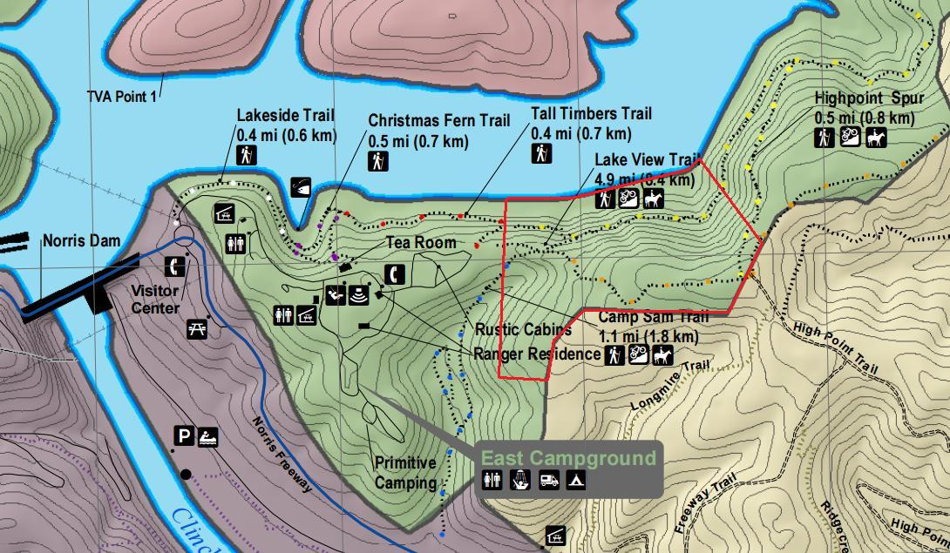
Figure 3.1. Partial map of Norris Dam State Park including the sampling area (red outline) and surrounding topography (taken from the Tennessee State Parks website, http://tnstateparks.com/parks/about/norris-dam).
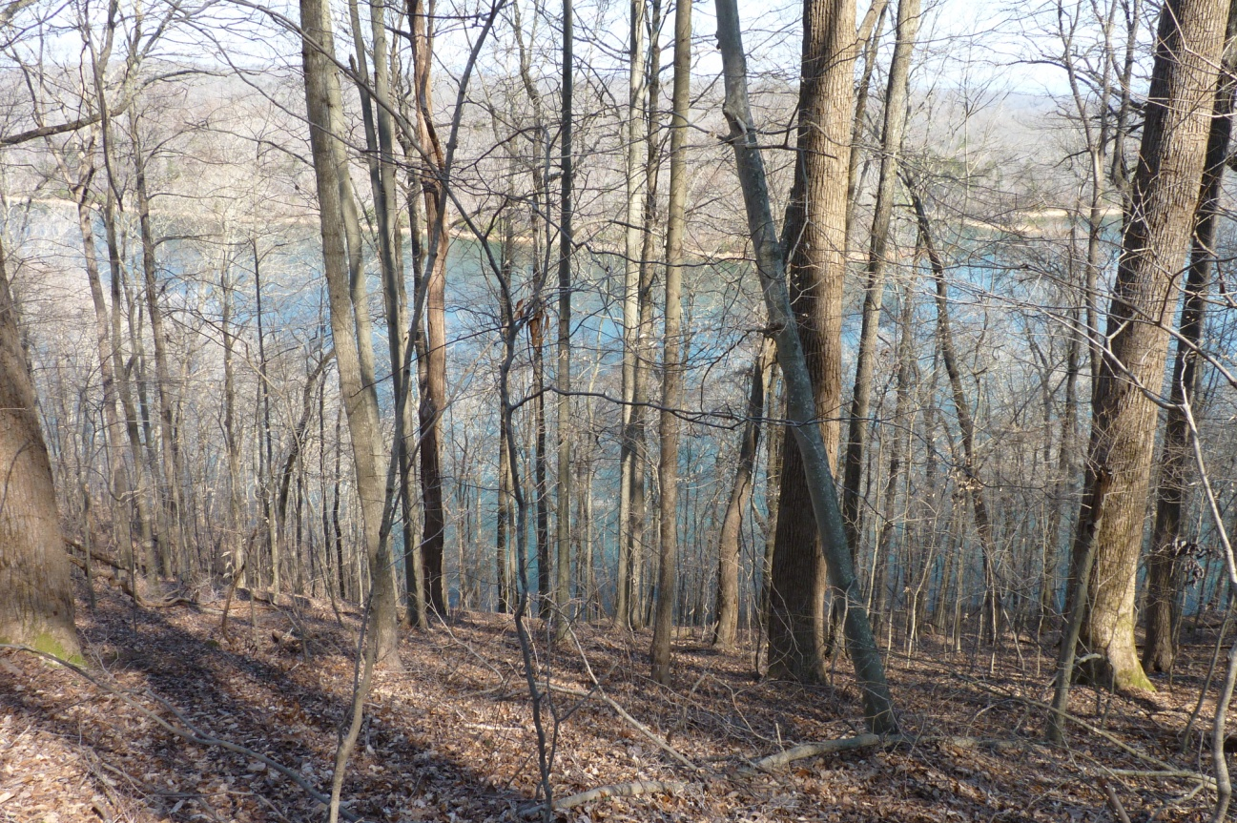
Figure 3.2. Site on slope at Norris Dam State Park and view of Norris Lake (Photograph by Kyle Landolt).

This required we wrap a tow strap around the shaft of the borer and tie the tow strap to the rope and the rope around a nearby tree directly in line with the stuck borer (Figure 3.3). We then backed the borer out until the borer threads caught in the wood, which then allowed us to undo the rope and tow strap and back the borer out normally. Once extracted from the tree, each core was placed in a paper straw with the ID number written on it. The straws were placed in a map tube for protection and transportation. A GPS point was recorded at every tree and written in a field notebook to create a digital map showing locations of all sampled trees (Figure 3.4). Diameter at breast height was taken for each tree using a DBH tape. I sampled 30 oaks and 32 pines for a total of 62 trees.
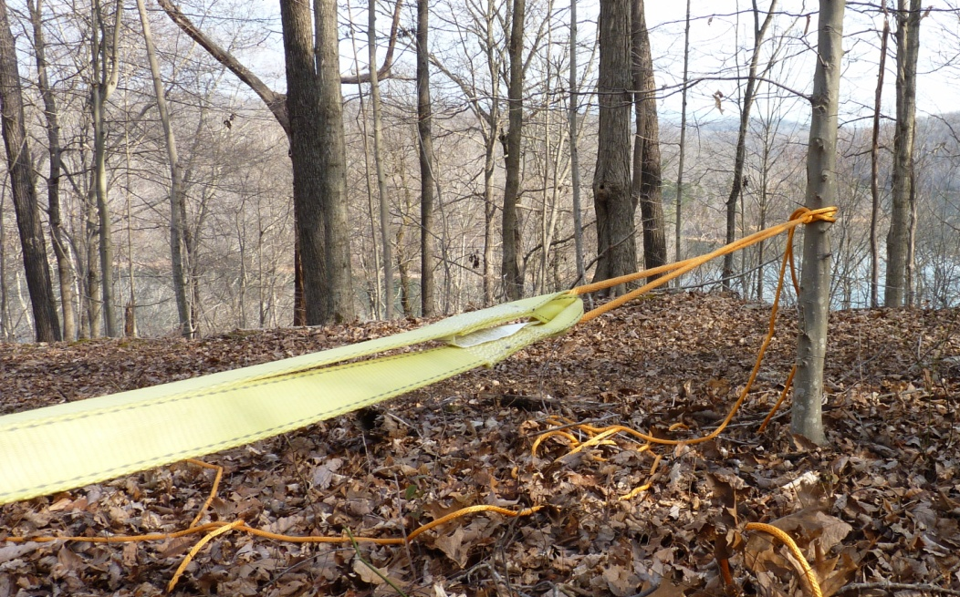
Figure 3.3. Use of a tow strap and rope to remove a stuck borer from a tree (Photograph
by Kyle Landolt).

3.3.2 Laboratory Methods

The cores were dried in the laboratory for five days, then mounted onto wooden core mounts using wood glue and held in place with masking tape. Once dry, the cores were sanded with progressively finer sandpaper (ANSI 80, 120, 220, 320 and 400 grit) until a smooth surface was achieved and the cell boundaries were clearly visible (Orvis and Grissino-Mayer 2002). The rings on the cores were crossdated using the list method (Yamaguchi 1991) then measured to 0.001 mm accuracy with the use of a dissecting scope and Measure J2X measuring software interfaced with a Velmex measuring stage.

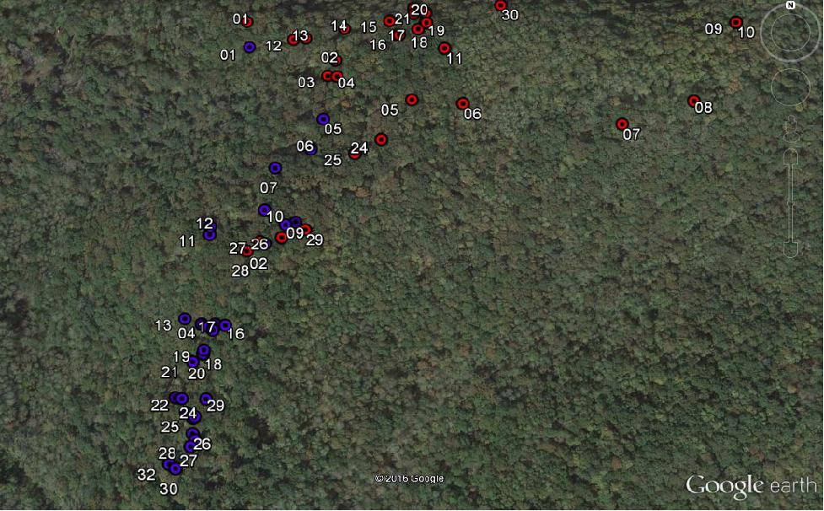
Figure 3.4. Close up of study area with sampled oaks (red) and pines (blue). Points show every sampled tree, totalling 62 trees (30 oaks and 32 pines).
3.3.2.1 Assessing Crossdating Accuracy
I used COFECHA to ensure proper crossdating and measuring (Holmes 1983; Grissino-Mayer 2001). COFECHA first produces a master chronology and then checks each measured series against it once the series being tested has been removed. I used 40-year segments with 20- year overlaps to test the correlation between a measured series and the master chronology created from all other series. COFECHA flagged potential crossdating errors below the critical threshold of 0.3665 which is the 99% confidence interval (p < 0.01) and identified, if possible, a position (i.e. shifting the segment by ±10 years) yielding a higher correlation. This allowed for visual rechecking and remeasuring, if necessary. Flagged samples with low correlation values (p > 0.01) that were rechecked, but could not be corrected, were removed from further analyses to ensure a strong climate signal. These trees were not responding to the macroclimate signal, but to some other disturbance or microclimate signal (such as crown or trunk damage from windthrow).
To evaluate crossdating quality, I used the interseries correlation, which is the correlation coefficient calculated for each series when compared to the chronology calculated from all other series in the dataset. A correlation coefficient of 0.40 and above is desired both for every individual core and the master chronology and indicates a strong regional climate signal (Grissino-Mayer 2001). I also evaluated the strength of the climate signal using mean sensitivity, which is a measure of the strength of the year-to-year variability in the ring widths (Grissino-Mayer 2001). Average values for tree-ring data from the Southeast may be as low as 0.15 to 0.2, with values of 0.25 to 0.35 being exceptional and best for crossdating and climate analyses (Biermann 2009).

3.3.2.2 Standardization
To remove possible non-climatic effects that may have affected tree growth, detrending by standardization is first conducted. Using ARSTAN, detrending was performed by first choosing a negative exponential or linear regression if the negative exponential curve does not fit the measurement data for each series (Cook and Holmes 1986). The detrending curves were visually inspected with the interactive detrending option in ARSTAN to determine which class of detrending option best fit the raw tree-ring data (Cook and Holmes 1986) and to remove trends unrelated to climate. If this class did not fit the data, then another class was chosen, such as different cubic smoothing spline lengths ranging from 10 to 100 years (Speer 2010). A spline length of 10 is very flexible, while a spline length of 100 is very rigid and smooth. Other detrending classes that I inspected were the Friedman Variable Span Smoother and the Hugershoff Growth Curve. In each detrending option, ARSTAN fits a line or curve to the ring-width data. The ring widths were then converted to unitless indices, which were generated based on the predicted versus actual growth. This removed the noise and isolated the desired signal and allowed all trees to contribute equally to the final chronology (Cook 1985, Cook et al. 1990). When converted to unitless indices, the chronology fluctuated around a mean of 1.0. A final chronology was developed once all the measurements had been converted to unitless indices, and then averaged together across all series by year.
Three chronologies are produced in ARSTAN: standard, residual, and ARSTAN. The standard chronology has major autocorrelation retained that is thought to be climatic in origin, but has biological autocorrelation as well. The residual chronology has no autocorrelation and all low frequency trends have been removed, even trends that could have been climatic in origin. Reincorporating the pooled model of autocorrelation back into the residual chronology produces the ARSTAN chronology. The pooled model of autocorrelation contains persistence both common and synchronous across the site that is attributed to climate (Cook 1985). The ARSTAN chronology is ideal to use in dendroclimatological analyses because this chronology has the climate signal built back in (Cook 1985) and is intended to have the strongest climate signal out of all the chronology types (Cook and Holmes 1986).
I detrended both tree species in ARSTAN using cubic smoothing spline lengths of 10, 15, 20, 25, 30, 35, 40, 45, 50, 75, and 100 years, as well as using the Friedman Variable Span Smoother and the Hugershoff Growth Curve. I ran ARSTAN for each detrending method and obtained an ARSTAN chronology for each one. By visually inspecting the resulting graphed tree-ring indices and by comparing the rbar and EPS, I was able to narrow down the best detrending techniques for each species to four each. I chose the detrending classes that displayed the highest rbar and EPS values back in time. The rbar is a measure of the strength of the common signal in the chronology and a measure of chronology reliability. The critical threshold for southeastern trees is at least 0.40 for a strong signal (ITRDB 2016). The EPS estimates the desired forcing signal, which should be common in all chronologies, and uncorrelated noise within and between individual trees (Mäkinen and Vanninen 1999) and is based on a correlation matrix of all the tree-ring series. The EPS should be > 0.85 for an acceptable level of chronology confidence (Wigley et al. 1984).
For oaks, I determined that a 30-year spline, 40-year spline, 50-year spline, and the Friedman Variable Span Smoother best reduced the high-frequency trends in the data, while maintaining the low-frequency (and hopefully climatic) trends. For pines, I determined that a 20-year spline, 25-year spline, 30-year spline, and the Friedman Variable Span Smoother best reduced the high-frequency trends in the data, while maintaining the low-frequency trends.

3.3.2.3 Climate Response
After narrowing down the possible detrending techniques to four for each species, I ran standardization trials in DENDROCLIM2002 to ensure the best detrending class was chosen, i.e. the class that retained the strongest climate signal. I tested a 20-year spline, a 25-year spline, a 30-year spline, a 40-year spline, a 50-year spline and the Friedman Variable Span Smoother for my standardization trials. This analysis also served to determine to which climate variables the oaks and pines at NDSP were responding most significantly. I downloaded climate data (climate division 01 for East Tennessee) from the National Oceanic and Atmospheric Administration’s National Centers for Environmental Information (NCEI, formerly the National Climatic Data Center). I conducted the analysis spanning July of the previous year to October of the current year and from the year 1896 to 2014. I used a lagged effect to include influences from the previous year on current growth (Rochner 2014) because trees may integrate responses from climate conditions outside of the growing season (Wilson et al. 2007). I analyzed precipitation, Palmer Drought Severity Index (PDSI), and temperature data, as well as North Atlantic Oscillation (NAO), Pacific Decadal Oscillation (PDO), Southern Oscillation Index (SOI), and Atlantic Multidecadal Oscillation (AMO) data for each of the detrended chronologies to determine (1) which chronology had statistically significant (p < 0.05) correlations with climate and (2) which climate variables were most significant to tree growth. The final chronology for each species was chosen based on the statistically significant (p < 0.05) correlations with climate variables.
3.3.2.4 Tests for Temporal Stability
After the final detrended chronology was chosen for each species, I tested the temporal stability of the climate response. While the chronologies were chosen based on significant (p < 0.05) correlations, this first test is required to determine whether the correlations were stable over time. DENDROCLIM2002 uses evolutionary interval analysis to test for temporal changes in the climate-tree growths relationships over time (Biondi and Waikul 2004). I used both forward evolutionary analysis, which fixes the first year of growth and adds one year forward each time, and backward evolutionary analysis, which fixes the last year of growth and adds one year back in time. I ran DENDROCLIM2002 twice for each climate variable, once for forward evolutionary analysis and once for backward evolutionary analysis using an initial base length of 32 years, and then compared the results from the forward and backward evolutionary analyses. If the correlations were significant over time in both the forward and backward evolutionary analyses, then climate and tree growth have a temporally stable relationship.

3.4 Results
I collected a total of 124 cores from 62 trees across the site, but used only 95 measured ring-width series from 50 trees to develop the chronologies. Some cores were omitted due to breaks in the core or lost bark and/or rings, while I was unable to date the tree rings on some cores due to severe growth suppression. Once the series were measured, they were only removed from subsequent analyses if they displayed very low correlations with the other series in the dataset and could not be corrected. In these cases, the trees were responding to something other than the overarching climate signal, such as some disturbance process or competition (Grissino-Mayer 2001). The final oak chronology consisted of 55 series from 28 out of the original 30 trees collected and the pine chronology consisted of 40 series from 22 out of the original 32 trees collected.

3.4.1 Crossdating
The final tree-ring chronology for oak spanned the years 1840 to 2014. The series retained for chronology development were significantly correlated with an average interseries correlation of 0.62 and an average mean sensitivity of 0.19. In the southeastern U.S., a mean sensitivity of 0.15 to 0.20 is common, with a mean sensitivity of 0.25 to 0.30 being exceptional (ITRDB 2016). The 0.19 value suggests the ring widths are sensitive to changes in year-to-year climate. Five percent of the segments were flagged (15 segments out of 324).
The chronology for pine spanned the years 1781 to 2014. The series retained for chronology development were significantly correlated with an average interseries correlation of 0.60 and an average mean sensitivity of 0.27. This value falls within the exceptional category for this region and suggests that yellow pines have a high sensitivity to changes in year-to-year climate (ITRDB 2016). Four percent of the segments tested by COFECHA were flagged (12 segments out of 275). All flagged segments for both oak and pine were re-evaluated under the microscope. The flagged segments occurred mostly in the inner or outer portions of the core, where the tree could have been responding more to internal stand dynamics than to climate. This causes tree rings in these flagged segments to contain some noise unrelated to the common climate signal. The flagged segments had lower correlations than the rest of the core, but occasionally a higher correlation could be found shifting the segment to an alternate temporal position. If a higher correlation was found, it was only slightly higher than the original position and shifting the segment was not possible without also shifting the remaining segments that were not flagged (Grissino-Mayer 2001). I therefore deemed these segments to be correctly placed in time.

3.4.2 Standardization
I determined that a 30-year spline was the best detrending option for oak species (Figure 3.5) and a 20-year spline was best for pine species (Figure 3.6) because these spline options retained the strongest climate signal based on the number of significant relationships and the higher correlations compared to the other detrending options (Tables 3.1 and 3.2) and had high rbar and EPS values (Tables 3.3 and 3.4). Once the chronologies were detrended with a 30- and 20-year spline, both high frequency and low frequency trends in the data unrelated to climate were mostly removed both at the individual core level and in the final chronology consisting of all cores (Figures 3.7 and 3.8). The running rbar and EPS statistics further substantiated using the 30- and 20-year splines to develop the final chronologies. The running rbar was above 0.40, which is the critical threshold for a strong signal in the southeastern United States (ITRDB 2016) for most of the oak chronology length and the expressed population signal (EPS) was above 0.85, which is the acceptable level of chronology confidence (Wigley et al. 1984) for all of the chronology length (Table 3.3). These statistics give confidence in using the 30-year spline and the oak chronology because they show that a strong climate signal is retained.
The rbar for the pine chronology was above 0.40 for most of the chronology length (the critical threshold) (ITRDB 2016) and the EPS was above 0.85 (the level of chronology confidence) (Wigley et al. 1984) (Table 3.4). These statistics give confidence in using the 20-year spline and the pine chronology because they show that a strong climate signal is retained. The pine chronology had a stronger climate signal than the oak chronology and had more significant relationships with climate (Table 3.2). Both ARSTAN chronologies were graphed to show trends in tree growth over time (Figures 3.9 and 3.10).

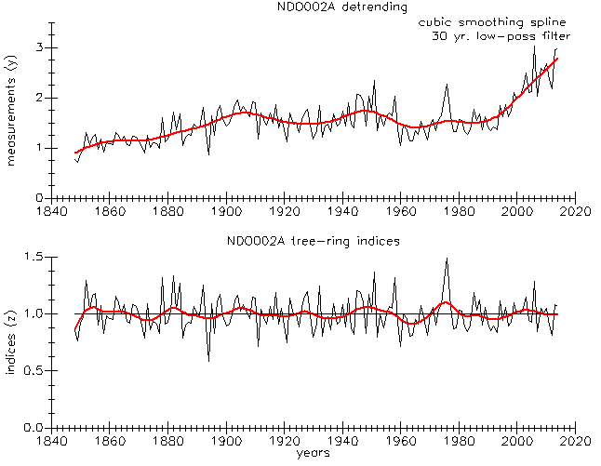
B
A
Figure 3.5. An example of a 30-year spline applied to oak core
NDO002A. (A) shows the 30-year spline applied to the measurement
series and (B) the resulting tree-ring indices.

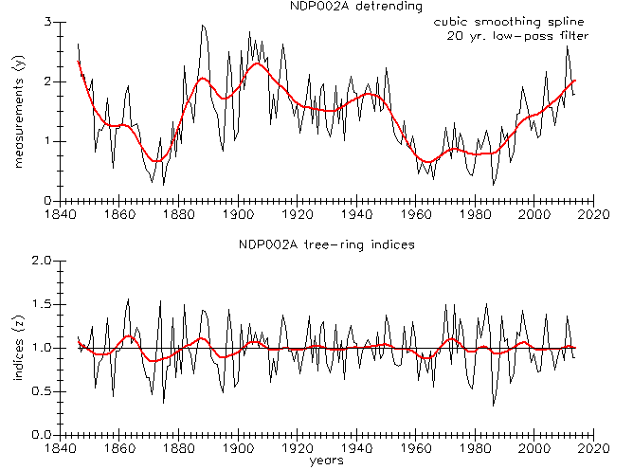
B
A
Figure 3.6. An example of a 20-year spline applied to yellow pine core
NDP002A. (A) shows the 20-year spline applied to the measurement
series and (B) the resulting tree-ring indices.

Table 3.1. Significant (p ≤ 0.05) correlations found in the detrending tests between climate data and the oak measurement data. Months listed in all capital letters represent the previous year while lower case letters are the current year. Highlighted cells indicate the highest correlation per monthly variable for each of the detrending methods. The 30-year and 40-year splines were very similar. The correlations were the same or different by 0.01. The 40-year spline had a March precipitation variable that was not present in the 30-year spline, however, the 30-year spline was chosen based on the number of significant relationships and the high correlations.
Climate Variable | 30-year spline | 40-year spline | 50-year spline | Friedman
May Temp | –0.28 | –0.27 | –0.27 | –0.27
Jun Temp | –0.33 | –0.32 | –0.32 | –0.31
Jul Temp | –0.17 | –0.17 | 0.23 | –
Sep Temp | –0.20 | –0.20 | – | –0.20
DEC Precip | 0.20 | 0.19 | 0.18 | 0.18
Mar Precip | – | 0.20 | 0.19 | –
May Precip | 0.30 | 0.30 | 0.29 | 0.29
Jun Precip | 0.38 | 0.37 | 0.37 | 0.37
DEC PDSI | 0.20 | 0.20 | 0.19 | 0.19
Jan PDSI | 0.19 | 0.19 | 0.19 | 0.18
Feb PDSI | 0.19 | 0.20 | 0.20 | 0.19
Mar PDSI | 0.25 | 0.25 | 0.25 | 0.23
May PDSI | 0.37 | 0.37 | 0.37 | 0.36
Jun PDSI | 0.43 | 0.44 | 0.43 | 0.42
Jul PDSI | 0.46 | 0.47 | 0.46 | 0.45
Aug PDSI | 0.49 | 0.49 | 0.49 | 0.48
Sep PDSI | 0.44 | 0.45 | 0.44 | 0.43
Oct PDSI | 0.38 | 0.38 | 0.38 | 0.37
Aug NAO | 0.28 | 0.29 | 0.29 | 0.27
DEC PDO | –0.18 | –0.17 | –0.17 | –0.17
Jan PDO | –0.18 | –0.18 | –0.17 | –0.17
Feb PDO | –0.16 | –0.16 | –0.16 | –0.16

Table 3.2. Significant (p ≤ 0.05) correlations found in the detrending tests between climate data and the pine measurement data. Months listed in all capital letters represent the previous year while lower case letters are the current year. Highlighted cells indicate the highest correlation per monthly variable for each of the detrending methods. The 20-year spline was chosen based on the number of significant relationships and the higher correlations.
Climate Variable | 20-year spline | 25-year spline | 30-year spline | Friedman
NOV Temp | – | –0.22 | –0.23 | –0.23
Apr Temp | –0.20 | –0.19 | –0.19 | –0.19
Jul Temp | –0.19 | – | – | –
Sep Temp | –0.20 | –0.18 | – | –
DEC Precip | – | 0.21 | 0.22 | 0.20
May Precip | 0.38 | 0.35 | 0.35 | 0.33
Jun Precip | 0.31 | 0.31 | 0.30 | 0.30
Oct Precip | –0.18 | – | –0.17 | –0.19
JUL PDSI | 0.18 | 0.17 | 0.18 | –
SEP PDSI | 0.17 | – | – | –
OCT PDSI | 0.18 | 0.17 | 0.18 | –
NOV PDSI | 0.18 | – | 0.17 | –
DEC PDSI | 0.24 | 0.23 | 0.23 | 0.22
Feb PDSI | 0.22 | 0.17 | 0.18 | 0.18
Mar PDSI | 0.23 | 0.19 | 0.20 | 0.20
Apr PDSI | 0.24 | 0.22 | 0.22 | 0.21
May PDSI | 0.38 | 0.37 | 0.37 | 0.34
Jun PDSI | 0.42 | 0.41 | 0.41 | 0.39
Jul PDSI | 0.40 | 0.39 | 0.39 | 0.37
Aug PDSI | 0.31 | 0.31 | 0.31 | 0.29
Sep PDSI | 0.33 | 0.31 | 0.31 | 0.30
Oct PDSI | 0.25 | 0.24 | 0.24 | 0.22
OCT NAO | –0.24 | – | – | –
NOV NAO | –0.26 | –0.31 | –0.32 | –0.33
Feb NAO | 0.23 | – | – | –
Jun NAO | –0.32 | –0.32 | –0.32 | –0.35
Aug NAO | – | 0.23 | 0.23
JUL SOI | 0.26 | 0.23 | 0.23 | 0.24
DEC SOI | 0.27 | 0.24 | 0.24 | 0.25
May SOI | 0.39 | 0.36 | 0.35 | 0.33
Jul SOI | 0.26 | – | – | –

Table 3.3. rbar and EPS
values for the oak chronology
detrended with a 30-year spline.
Year | rbar | EPS
1865 | 0.43 | 0.89
1900 | 0.41 | 0.96
1925 | 0.43 | 0.97
1950 | 0.39 | 0.97
1975 | 0.33 | 0.96

Table 3.4. rbar and EPS
values for the pine chronology
detrended with a 20-year spline.
Year | rbar | EPS
1806 | 0.68 | 0.84
1840 | 0.47 | 0.89
1865 | 0.32 | 0.91
1890 | 0.41 | 0.96
1915 | 0.51 | 0.97
1940 | 0.47 | 0.97
1965 | 0.40 | 0.96
1990 | 0.37 | 0.96

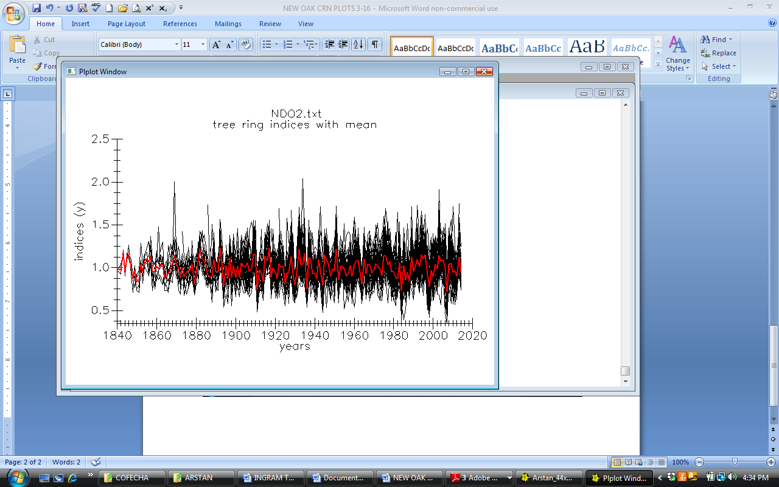
Figure 3.7. Tree-ring indices calculated for all oak measurement series once the
30-year spline was applied. The darker red curve is the average of all indices by year.

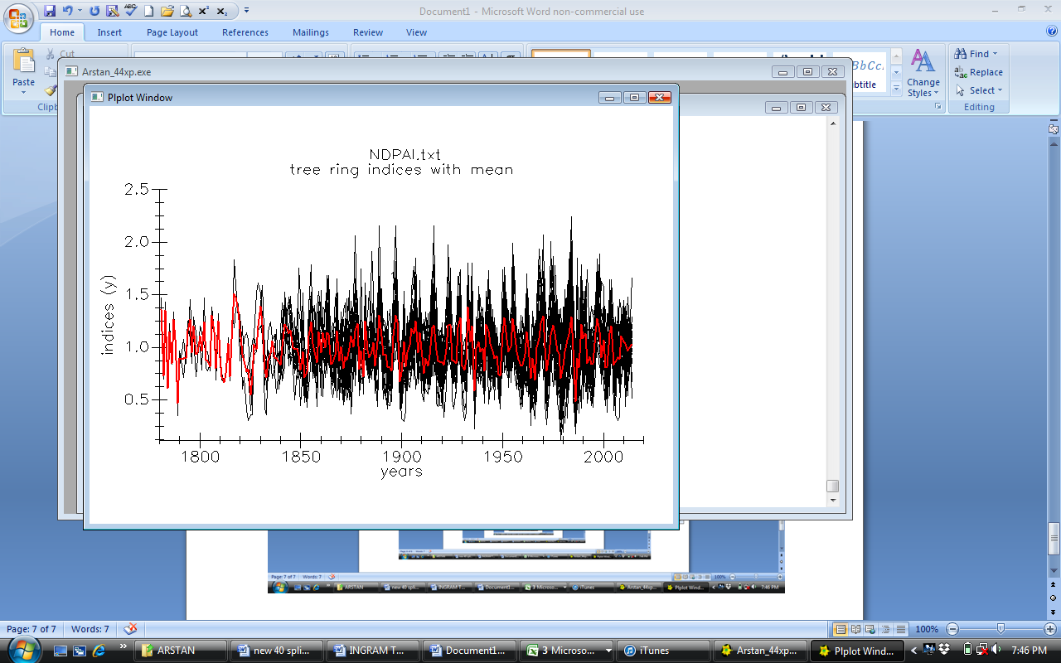
Figure 3.8. Tree-ring indices calculated for all pine measurement series once the
20-year spline was applied. The darker red curve is the average of all indices by year.

Figure 3.9. The tree-ring chronology developed from 28 oak trees growing in Norris Dam State Park.

Figure 3.10. The tree-ring chronology developed from 22 pine trees growing in Norris Dam State Park.
3.4.3 Climate-Tree Growth Relationships
3.4.3.1 Oaks
I found that precipitation in December of the previous year (r = 0.20), and May (r = 0.30), and June (r = 0.38) of the current year were statistically significant (p < 0.05) with oak growth (Figure 3.11). PDSI in the consecutive months of previous December through October, with the exception of April, was statistically significant with tree growth with coefficients ranging from 0.19 to 0.49 (Figure 3.11). May (r = –0.28), June (r = –0.33), July (r = –0.17), and September (r = –0.20) temperature were negatively correlated with tree growth. August NAO (r = 0.28) was statistically significant with tree growth (Figure 3.12). Previous December (r = –0.18) and current January (r = –0.18) and February (r = –0.16) PDO were negatively correlated with tree growth (Figure 3.12).
The precipitation signal for oaks shifted from May-June to only June. The forward evolutionary interval (Figure 3.13A) shows a May precipitation signal, but a stronger and more consistent June signal. The backward evolutionary interval (Figure 3.13B), also shows a strong June signal, but the May signal drops off. For both forward and backward evolutionary intervals, the June precipitation signal was the same (Figure 3.13A, B). The PDSI signal for the growing season is strong (Figure 3.14A), although May PDSI drops off some in the backward evolutionary interval (Figure 3.14B). The June through October PDSI signal was the same for both forward and backward evolutionary intervals (Figure 3.14A, B). I also found a late spring temperature signal for oak species, which shifted from a May-June signal to just a June signal (Figure 3.15A, B). The June temperature signal was the same for both forward and backward evolutionary intervals. When I investigated the longer-term ocean-atmosphere climate oscillations, I found a shift in the NAO signal from an August signal to a June signal, but this was not consistent over time in both the forward and backward evolutionary intervals (Figure 3.16A, B). Lastly, I found that previous December to current February PDO was not consistent over time in both the forward and backward evolutionary intervals (Figure 3.17A, B).
3.4.3.2 Pines
I found that precipitation in May (r = 0.38), June (r = 0.31), and October (r = –0.18) were statistically significant (p < 0.05) with tree growth (Figure 3.18). PDSI in the consecutive months from previous July through current October (with the exception of previous August and current January) was statistically significant (p < 0.05) with tree growth with coefficients ranging from 0.17 to 0.42 (Figure 3.18). April (r = –0.20), July (r = –0.19), and September (r = –0.20) temperature were statistically significant (p < 0.05) with tree growth. February (r = 0.23) NAO was positively correlated with tree growth and June (r = –0.32), previous October (r = –0.24) and previous November (r = -0.26) NAO was negatively correlated with tree growth (Figure 3.19). May (r = 0.39), July (r = 0.26), previous December (r = 0.27) and previous July (r = 0.26) SOI were statistically significant (p < 0.05) with tree growth (Figure 3.19).
The May precipitation signal was strong and consistent in both the forward and backward evolutionary intervals, but the June precipitation signal picked up and became strong in the backward evolutionary interval (Figure 3.20A, B). A May through July PDSI signal was consistently strong in both the forward and backward evolutionary intervals (Figure 3.21A, B). I found no temporally stable relationship for monthly temperature in either the forward or backward evolutionary intervals (Figure 3.22A, B). The April and previous November temperature signals become strongly negative in the backward interval (Figure 3.22B). June NAO is consistent in both the forward and backward evolutionary intervals (Figure 3.23). Previous October NAO is also consistent, but drops off some in the backward evolutionary interval (Figure 3.23B). May SOI is consistent in the forward and backward evolutionary intervals, but drops off some in the backward evolutionary interval (Figure 3.24B).
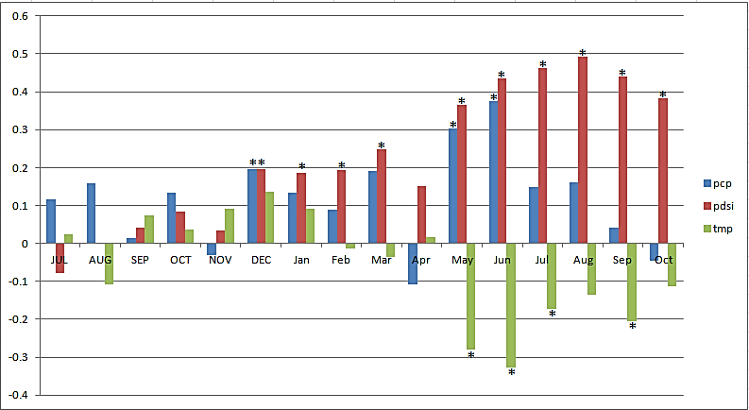
Figure 3.11. Correlation coefficients between precipitation (pcp), PDSI, and temperature (tmp) and the oak tree-ring chronology. Asterisks indicate a significant relationship (p < 0.05).
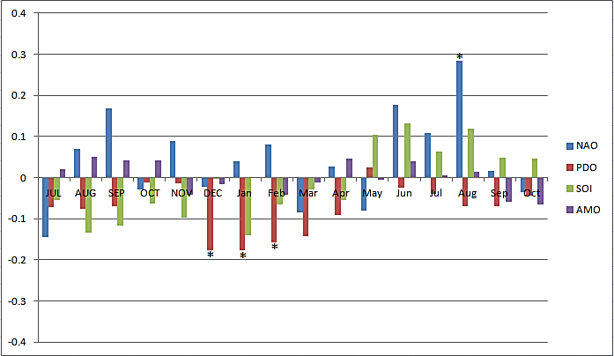
Figure 3.12 Correlation coefficients between climate oscillations NAO, PDO, SOI, and AMO and the oak tree-ring chronology. Asterisks indicate a significant relationship (p < 0.05).
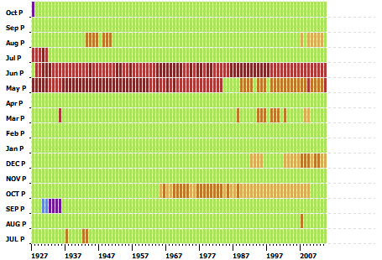
A

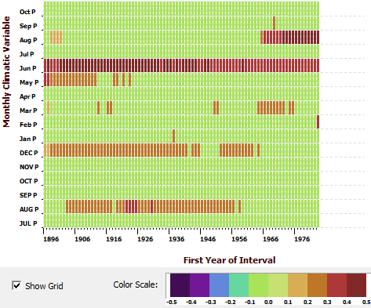
B

Figure 3.13. Forward (A) and backward (B) evolutionary interval analyses between precipitation and oak. The color scale indicates a significant positive or negative relationship. Green signifies no statistically significant (p < 0.05) relationship. The June precipitation signal is positive in both the forward and backward evolutionary intervals and a shift occurred from a May-June signal to just a June signal.
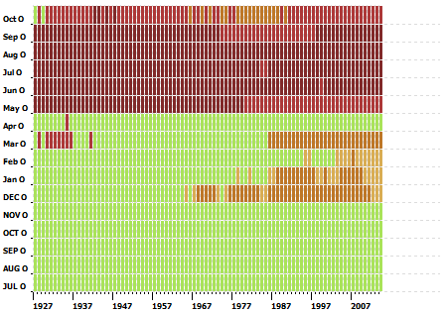
A

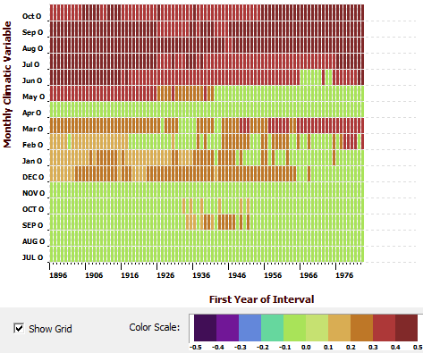
B

Figure 3.14. Forward (A) and backward (B) evolutionary interval analyses between PDSI and oak. The color scale indicates a significant positive or negative relationship. Green signifies no statistically significant (p < 0.05) relationship. The growing season PDSI signal is strongly positive in both the forward and backward evolutionary intervals. May and June drop off from forward to backward analyses, but current July through October remain strong in both analyses.
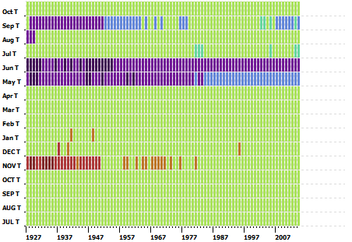
A

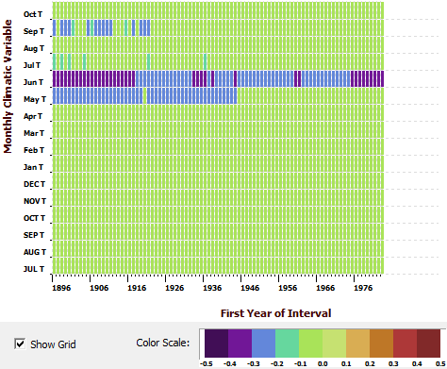
B

Figure 3.15. Forward (A) and backward (B) evolutionary interval analyses between temperature and oak. The color scale indicates a significant positive or negative relationship. Green signifies no statistically significant (p < 0.05) relationship. The June temperature signal is strongly negative in both the forward and backward evolutionary intervals and there was a shift from a May to June signal.
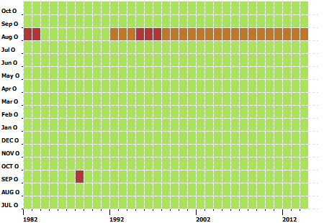
A

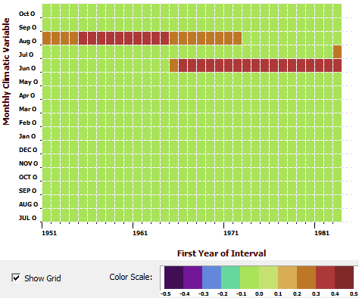
B

Figure 3.16. Forward (A) and backward (B) evolutionary interval analyses between NAO and oak. The color scale indicates a significant positive or negative relationship. Green signifies no statistically significant (p < 0.05) relationship. The August NAO signal is positive in both the forward and backward evolutionary intervals, but was not stable over time.
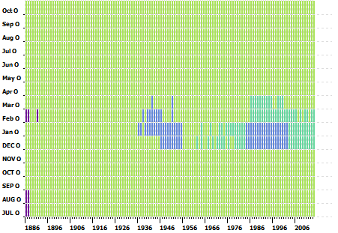
A

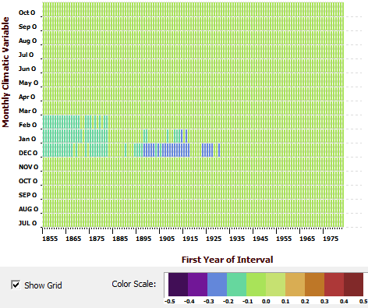
B

Figure 3.17. Forward (A) and backward (B) evolutionary interval analyses between PDO and oak. The color scale indicates a significant positive or negative relationship. Green signifies no statistically significant (p < 0.05) relationship. The previous December, January and February PDO signals are negative in both the forward and backward evolutionary intervals, but were not stable over time.

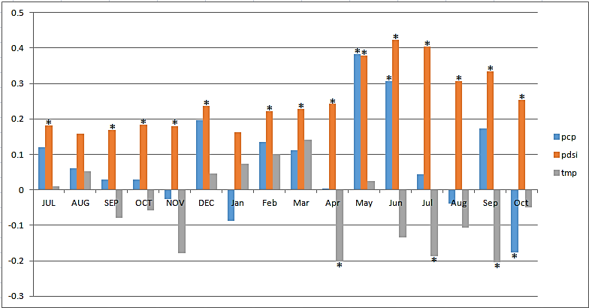Figure 3.18. Correlation coefficients between precipitation (pcp), PDSI, and temperature (tmp) and the pine tree-ring chronology. Asterisks indicate a significant relationship (p < 0.05).

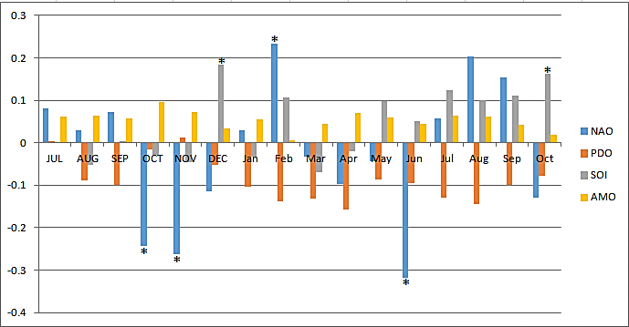
Figure 3.19. Correlation coefficients between climate oscillations NAO, PDO, SOI and AMO and the pine tree-ring chronology. Asterisks indicate a significant relationship (p < 0.05).

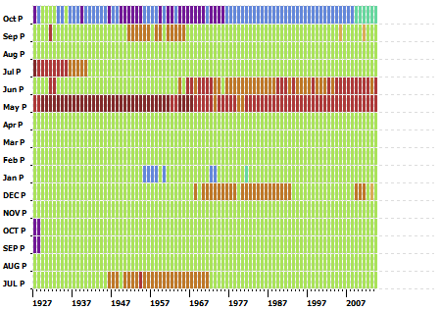
A

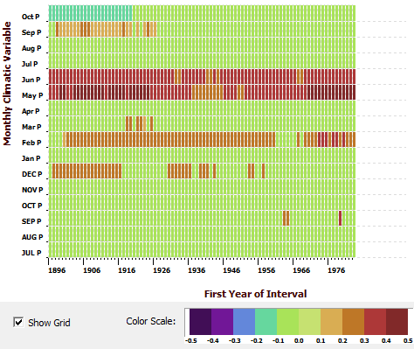
B

Figure 3.20. Forward (A) and backward (B) evolutionary interval analyses between precipitation and pine. The color scale indicates a significant positive or negative relationship. Green signifies no statistically significant (p > 0.05) relationship. The May precipitation signal is positive in both the forward and backward evolutionary intervals. A shift occurred from a May to a May-June signal.
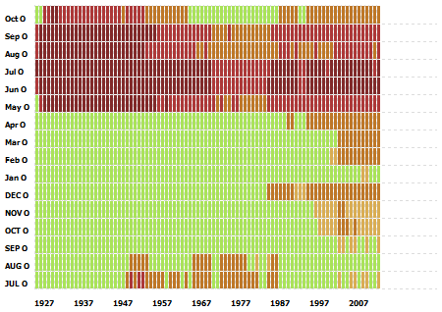
A

B
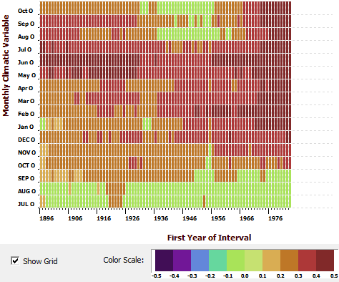

Figure 3.21. Forward (A) and backward (B) evolutionary interval analyses between PDSI and pine. The color scale indicates a significant positive or negative relationship. Green signifies no statistically significant (p > 0.05) relationship. The PDSI signal for May through July is positive in both the forward and backward evolutionary intervals.
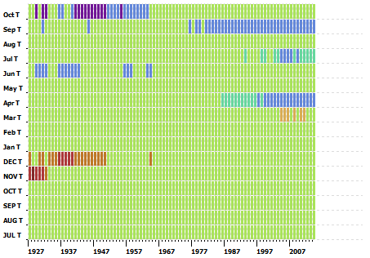
A

B
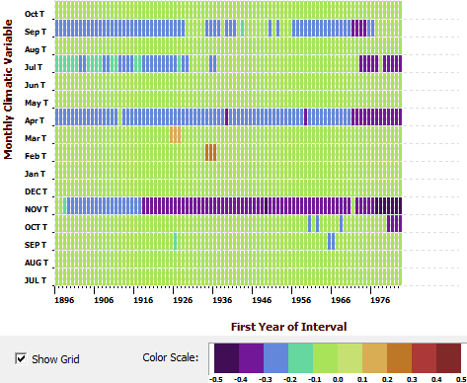

Figure 3.22. Forward (A) and backward (B) evolutionary interval analyses between temperature and pine. The color scale indicates a significant positive or negative relationship. Green signifies no statistically significant (p > 0.05) relationship. The temperature signals for previous November and April are negative in the backward evolutionary interval.
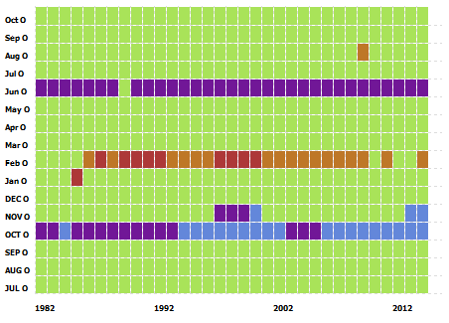
A

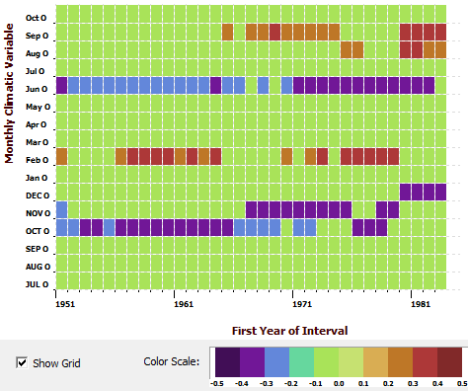
B

Figure 3.23. Forward (A) and backward (B) evolutionary interval analyses between NAO and pine. The color scale indicates a significant positive or negative relationship. Green signifies no statistically significant (p > 0.05) relationship. The NAO signals for previous October and June are negative in both the forward and backward evolutionary intervals.
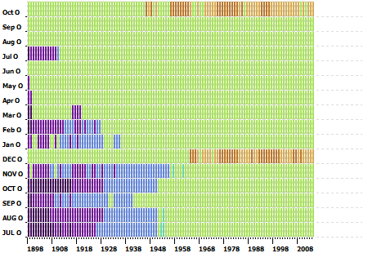
A

B
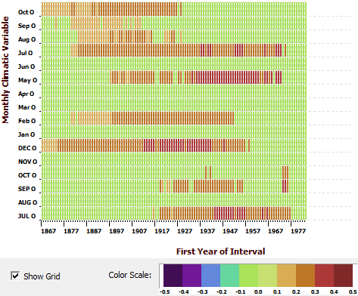

Figure 3.24. Forward (A) and backward (B) evolutionary interval analyses between SOI and pine. The color scale indicates a significant positive or negative relationship. Green signifies no statistically significant (p > 0.05) relationship. The SOI signals for previous December and current October are positive in both the forward and backward evolutionary intervals.
3.5 Discussion
3.5.1 Oak

I failed to reject my null hypothesis that the climate-tree growth relationships in oak species are temporally stable over the past 120 years (1895 to 2015), but only for some of the climate variables. Oak at NDSP responded most to June precipitation, late growing season (June-October) PDSI, and June temperature. These climate variables were all temporally stable with tree growth because oak tree growth responded similarly to these climate variables in both the forward and backward evolutionary interval analyses. Although I found a shift from a May-June to only a June precipitation signal, the June precipitation signal was strong in both the forward and backward evolutionary analyses. The June signal was already present when the May signal was dropping off, which shows the dominance of June precipitation. The June precipitation signal for oak has reconstruction potential because it was both statistically significant (p < 0.05) and temporally stable with tree growth.
I also found a shift from a current May-October to June-October PDSI signal. May PDSI was significant in the forward evolutionary interval, but was not significant in the backward evolutionary interval. Because the May PDSI signal was not significant in both the forward and backward evolutionary intervals, May PDSI was not temporally stable; however, current June through October PDSI signals were significant in both the forward and backward evolutionary intervals. The current June through October PDSI signal has reconstruction potential because it was both statistically significant (p < 0.05) and temporally stable with tree growth.
June temperature was consistently negative and most significant for oak in both the forward and backward evolutionary interval analyses. I found a shift from a May-June to only June temperature signal. The May temperature signal was significant in the forward evolutionary interval, but the June signal was stronger. In the backward evolutionary interval, the June signal remains significant, but the May signal drops off. The June temperature signal has reconstruction potential because it was both statistically significant (p < 0.05) and temporally stable with tree growth.
No climate oscillations (NAO, AMO, PDO, or SOI) showed temporally stable relationships between climate and tree growth for oak. The NAO signal for August was statistically significant (p < 0.05), but was not temporally stable. August NAO was positive in both the forward and backward evolutionary intervals, but was not consistent over time. In the backward evolutionary interval, the August NAO signal drops off and the June NAO signal picks up, but this signal was not statistically significant (p > 0.05). A shift may have occurred from an August to June signal, but the June signal did not become significant. Because the August signal dropped off in the backward evolutionary interval and the June signal picked up, neither the August NAO signal nor the June NAO signal is temporally stable. They were not the same in both the forward and backward intervals and neither has reconstruction potential.
The previous December to current February PDO signals were statistically significant (p < 0.05), but were not temporally stable because they were not consistent in both the forward and backward evolutionary interval analyses. In both the forward and backward analyses, these months fluctuate and drop off. March PDO picks up some, but this climate variable is not statistically significant (p > 0.05). Because of the fluctuations of these climate variables, previous December to current February PDO are not temporally stable and therefore do not have reconstruction potential. Neither AMO nor SOI showed any statistically significant relationships with tree growth for oak species.
For the climate oscillation analyses, longer timescales for data may be necessary to pick up a strong and temporally consistent signal. My timeframe for the oscillations was not consistent as it was for the other climate variables (precipitation, temperature, and PDSI), which ran from 1895 to 2014. PDO was longest, spanning 1854 to 2015 and this oscillation also showed the most significant correlations out of all four oscillations. This could suggest that I need longer climate data to pick up more statistically significant values; however, even though PDO was statistically significant, it was not temporally stable. My AMO data span 1856 to 2015, my SOI data span 1866 to 2014, and my NAO data only span 1950 to 2015. I might be able to find a stronger and consistent NAO signal with a longer dataset, but the relationship may or may not be temporally stable. AMO and SOI appear not to affect oak growth in the Southeast and their longer datasets had no effect on whether or not I found statistically significant relationships. Datasets extending into the mid- to late 1800s for all climate oscillations (NAO, AMO, PDO, or SOI) would make my datasets more consistent with the other climate variables (precipitation, temperature, and PDSI) and could possibly aid in identifying more statistically significant relationships, whether those relationships would be temporally stable or not.
Additional analyses may help identify more statistically significant relationships in the climate oscillations. Many studies have used wavelet analyses (Larocque and Smith 2004, MacDonald and Case 2005, Biermann 2009), which can be used to identify changing periodicities over time in my chronologies, which can then be compared to potential changes in periodicities in the climate oscillations to evaluate if they correspond and if they are stable over time (Torrence and Compo 1998). Wavelet analyses would complement the evolutionary interval analyses I already conducted and could be conducted on the longer datasets for testing the climate-tree growth relationship for climate oscillations. The few statistically significant relationships I found indicated that relationships between tree growth and NAO and PDO are present in oak, but these relationships need to be investigated further. Further investigation would also be able to rule out any relationships between NAO, AMO and tree growth for oak species.
For example, Larocque and Smith (2004) used wavelet analyses on high elevation tree species from the southern British Columbia Coast Mountains, Canada, including yellow cedar, Douglas-fir, whitebark pine, subalpine fir, and mountain hemlock, that shared a common growth response. Chronologies were created for each species that showed the regional signal. Wavelet analyses were used on the reconstructions to determine the dominant frequencies in these species over time. All the reconstructions showed high frequency variability at less than 8 years and medium frequency variability at 23–25 years, which correspond to ENSO and PDO signals, respectively. MacDonald and Case (2005) performed wavelet analyses on the reconstruction of two moisture sensitive limber pine chronologies from California and Alberta. Both chronologies were significantly correlated with the PDO. They used 1940–1998 as the period for calibration and verification and produced a reconstruction of annual PDO from January to December extending from AD 993 to 1996. They used wavelet analyses on the detrended reconstruction to examine PDO variability in multidecadal spectral bands. They found significant 50–70 year variability corresponding to the PDO and weakly significant 4–7 year variability corresponding to ENSO.
Biermann (2009) also performed wavelet analyses on yellow pine tree-ring data from Great Smoky Mountains National Park (GSMNP) to determine the dominant frequencies in the pine chronologies over time. She then compared the results to the periodicities of the climate oscillations (AMO, PDO, ENSO, and NAO) to determine if they matched up and if they were stable over time. Wavelet analysis was used as an additional technique along with correlation, response function, and moving correlation analyses, to identify climate oscillation signals present in the chronology. Biermann found low frequency 55–90 year oscillations in most of her chronologies, which could be associated with the AMO, which operates on a 65–80 year cycle.
In all of the temporally stable climate variables for oak (June precipitation, June-October PDSI, and June temperature), I found a shift from a May-June to only a June signal. This was interesting because the June signal in each case was temporally stable in both the forward and backward evolutionary interval analyses, but the May signal was only consistent in the forward evolutionary analyses and dropped off in the backward evolutionary analyses. The June signal was stronger than the May signal in the forward evolutionary analyses in each case. The shifting of the signal does not seem to have affected the temporal stability of the June signal, which is consistent. For the shift to have occurred in all three climate variables, suggests that June is the critical month to which oak trees most respond. Temperature, precipitation, and PDSI may be more important in June because of the higher temperatures oaks experience in the middle part of the growing season. Tree growth was negatively correlated with temperature for June, meaning that lower temperatures meant more growth. In the middle of the growing season, lower temperatures would not stress the tree that higher temperatures would. In addition, oak growth was positively correlated with June precipitation. Higher amounts of precipitation mean more growth. Increased soil moisture would allow the tree to grow more during this month. Tree growth was positively correlated with June to October PDSI. Lower instances of drought due to lower temperatures and higher amounts of precipitation would limit the stress on the trees and allow for more growth. June must be the time in the growing season at which oaks reach a threshold and respond most strongly to temperature, precipitation, and PDSI.

3.5.2 Pine
Temperature was statistically significant (p < 0.05) for pine growth in April, June, and September of the current year, which indicates that lower temperatures in the growing season mean more growth for pines. Lower temperatures suggest the tree is not under stress and can grow more because moisture can remain in the soil longer and be used by the pines to form new wood. In the forward and backward evolutionary interval analyses, however, none of the relationships with monthly temperature were temporally consistent. Although the relationships in the monthly and seasonal temperature were not temporally stable, the relationship is ecologically tenable.
Pine responded most strongly to the PDSI signal in the early growing season (May-July) and this climate variable was temporally stable with tree growth because pines responded similarly to May-July PDSI in both the forward and backward evolutionary interval analyses. In the forward evolutionary analyses, May-September was significant, but in the backward evolutionary analyses, only May-July was found to be significant. The PDSI signal for May through July was temporally stable with tree growth and has reconstruction potential. The statistically significant PDSI signal in the growing season (May-September) and the temporally stable PDSI signal in the early growing season (May-July) indicate that very wet conditions are important for pine growth. Higher PDSI values signify periods of exceeding moisture and enhanced pine growth. Drought during the growing season, however, would put stress on pines.
The precipitation signal for pines shifted from a May precipitation signal to a May-June precipitation signal. The May precipitation signal was dominant in the forward evolutionary interval, with the positive June and negative October signals present. In the backward evolutionary interval, the October signal drops off, the May signal is still dominant, the June signal becomes dominant, and the February signal picks up. The May precipitation signal was the same in both the forward and backward evolutionary interval analyses, but the June signal became dominant in the backward evolutionary interval. For reconstruction purposes, we could possibly use a May-June precipitation signal because of the possible shift from a May to a May-June signal, but because the May signal is consistent in both the forward and backward evolutionary interval analyses, the May precipitation signal is temporally stable for pine species and has the best reconstruction potential.
Previous October and current June NAO were consistently negative in the forward evolutionary interval but dropped off in the backward evolutionary interval. February was positive in the forward evolutionary interval but dropped off in the backward evolutionary interval. Previous July, previous December, current May, and current July SOI were all statistically significant (p < 0.05) with pine growth, but none were the same in both the forward and backward evolutionary interval analyses.
Neither AMO nor PDO was statistically significant (p < 0.05) with pine growth. Neither of these oscillations could affect pine species in the Southeast or perhaps we did not have a long enough dataset for the oscillations and a signal was not picked up. Other analyses could be used to attempt to pick up a signal, such as wavelet analyses. I found more statistically significant relationships between climate oscillations and tree growth for the pine species than for oak species. This could occur because pine species have a higher mean sensitivity and are more likely sensitive to changes in climate than the oaks. There was also an elevation difference in the location of the sampled oaks and pines. The oaks were at higher elevations on the slope and the pines were lower in the valley.

3.5.3 Implications of Climate Reconstructions
Many researchers have conducted dendroclimatological studies and have reconstructed past climate, but many earlier studies did not focus on testing the temporal stability of the climate-tree growth relationship because this was not an issue in dendroclimatology until the last 10 years. Stahle and Cleaveland (1992) reconstructed spring rainfall for the past 1000 years using bald cypress tree-ring chronologies from North Carolina, South Carolina, and Georgia. The April-June precipitation signal from North Carolina and the March-June precipitation signal from South Carolina and Georgia were combined to form a spring precipitation signal. I found that my oak and pine chronologies from NDSP in Tennessee were temporally stable with spring precipitation. This finding gives confidence in the usage of this variable for climate reconstruction, but tests should be conducted on the bald cypress chronologies to determine if they have a stable relationship with climate. My data, while temporally stable with spring precipitation, were from oak and pine species in eastern Tennessee, not bald cypress in North Carolina, South Carolina, or Georgia.
Cook et al. (1999) used a network of 425 climate sensitive tree ring chronologies and PDSI data to reconstruct past summer drought from 1700 to 1978. Summer PDSI, from June to August, related better to tree rings. Dr. Duvick’s NDSP white oak chronology was included in this network. For my white oak chronology, I found that summer PDSI from June to October was temporally stable. This gives confidence to the inclusion of Dr. Duvick’s NDSP white oak chronology in the network, however, Cook et al.’s reconstruction was for the entire 48 states. A total of 424 other chronologies were used in addition to Dr. Duvick’s, which were not tested for temporally stable climate-tree growth relationships. The other chronologies should be tested for temporally stable climate-tree growth relationships to ensure that this reconstruction is still valid and able to be used.
Druckenbrod et al. (2003) used senesced white oak trees from James Madison’s Montpelier plantation to create two reconstructions of monthly precipitation, one from early summer (June) precipitation, using latewood ring widths, and one from prior fall (prior September) precipitation, by removing the measured latewood from the annual growth rings. The researchers compared the reconstructions with precipitation records and meteorological diaries kept by James Madison. I found oak growth at Norris Dam State Park to be temporally stable with June precipitation. My results give confidence in the summer reconstruction by Druckenbrod et al. of early summer precipitation, but I did not find a prior fall precipitation signal. James Madison’s Montpelier plantation is in Virginia and my research was done in eastern Tennessee; therefore, different sites and topography could affect climate signals.
Pederson et al. (2012) reconstructed April to August PDSI from 1665 to 2010 based on the common response of the multispecies tree-ring network from the headwaters of the Apalachicola-Chattahoochee-Flint river basin. This network was geographically dense and diverse and consisted of chronologies spanning AD 929–2009. My oak chronology was temporally stable with June to October PDSI and my pine chronology was temporally stable with May to July PDSI. Based on varying species response and location, my findings do support the use of a reconstruction of summer PDSI, but the temporal stability of summer PDSI for oak and pine in eastern Tennessee does not support a reconstruction from Alabama, Georgia, and Florida.
In eastern Tennessee alone, studies have found both temporally stable and temporally unstable relationships with climate. In my study, I found some temporally stable relationships at NDSP for oak and pine species that could be used to reconstruct past climate, but others have found temporally unstable climate-tree growth relationships from eastern North Carolina to eastern Tennessee (Biermann 2009, Li 2011). This confirms that we need to assess temporal stability on a site by site and chronology by chronology basis before reconstructions are attempted. Reconstructions that have already been created should be tested for temporally stable climate-tree growth relationships in order to be confidently used. In the case of large networks used to create a reconstruction, if unstable climate-tree growth relationships are found, those chronologies could be removed and the reconstruction redone to ensure the temporal stability of the climate response.

Chapter Four

Conclusions and Future Research
4.1 Major Conclusions
I found that both oak and pine species crossdate well and are sensitive to changes in climate. Oak species crossdated with a correlation coefficient of 0.62, which is above the accepted threshold of 0.40, and displayed a mean sensitivity of 0.19, which is in the common range for oaks in the Southeast. Pine species crossdated with a correlation coefficient of 0.60 and a mean sensitivity of 0.27, both values being exceptional for pines in the Southeast. Both oak and pine species were correlated with climate and respond to specific climate variables.

4.1.1 To which climate variables are oak and pine species responding?

Oaks respond positively to June precipitation, negatively to June temperature, and positively to June-October PDSI. Increased precipitation in the growing season contributes to enhanced tree growth for oaks because of the increased soil moisture. Lower temperatures in the middle of the growing season meant higher growth for oaks because of decreased stress. Lower temperatures mean less soil moisture is evaporated, keeping more moisture in the soil for tree growth. Higher PDSI values mean fewer droughts and fewer droughts mean increased oak growth.
Pine species respond positively to May-June precipitation, positively to May-July PDSI, negatively to previous October and current June NAO, and positively to May SOI. Positive relationships with precipitation in the growing season suggest that increased precipitation during the growing season leads to enhanced growth in pines due to an increase in soil moisture. Higher PDSI values mean fewer droughts. Fewer droughts during the growing season lead to increased growth in pines, due to less stress and less evaporation of soil moisture. Lower temperatures and increased precipitation contribute to higher PDSI values. Negative phases of the NAO indicate cold air and colder winters. In years when the NAO was negative, cold air in the early winter causes decreased growth in pines in the following growing season. Positive phases of the SOI index indicate a cool phase or La Niña. This causes decreased rainfall in the south and warmer winters in the southeast. In years when the SOI was positive, warmer winters and less rainfall caused increased growth during the following growing season for pines.

4.1.2 Were the climate-tree growth relationships temporally stable?

I fail to reject my null hypothesis that oak and pine species are temporally stable with climate for some of the climate variables. Oak species are temporally stable with June precipitation, June temperature, and June-October PDSI. Pine species are temporally stable with May-June precipitation, May-July PDSI, previous October and current June NAO, and May SOI. These climate variables showed statistically significant and temporally consistent responses in both the forward and backward evolutionary analyses. Using both forward and backward evolutionary analyses to determine if oak and pine species were temporally stable with climate is better than using just forward or backward evolutionary analyses. Some climate variables were only temporally stable in the forward evolutionary interval, but not in the backward. In the backward evolutionary interval, they dropped off some or completely, even if that variable was statistically significant, it was found not to be temporally stable because it was not consistent in both the forward and backward evolutionary analyses.

4.1.3 Can the oak and pine chronologies be used to reconstruct past climate?

The oak and pine chronologies can be used to reconstruct past climate for the climate variables that showed temporally stable relationships. Because the relationships between oak and pine species and these climate variables were found to be stable over the 20th and 21st centuries, we can assume they have been stable over longer periods of time. The oak chronology can be used to reconstruct June precipitation, June to October PDSI, and June temperature. The pine chronology can be used to reconstruct May-June precipitation, May to July PDSI, previous October and current June NAO, and May SOI for Norris Dam State Park. These climate-tree growth relationships are not transferrable to another region or to another tree species from this region.
4.1.4 What implications come of this research?
The oak chronology I created was an extension of the research first performed by Dr. Daniel Duvick. His oak chronology extended to 1980. By coring trees at his original field site and creating my own oak chronology, I both replicated his research and extended his chronology out to 2014. His chronology has been used as the master chronology in many studies and has been used in climate reconstructions. By testing the temporal stability of my oak chronology, we can confirm that the oaks at NDSP are temporally stable for some climate variables. My oak chronology validates the use of his oak chronology in climate reconstructions for certain climate variables.
The pine chronology I created is a new chronology for this region and is the first pine chronology from NDSP. This chronology can be used in future reconstructions of climate because the pines were found to be temporally stable for some climate variables at NDSP. In addition, the pine chronology is useful because pine trees responded to different climate variables than the oaks. The pines responded more to climate variables earlier in the growing season and showed temporally stable relationships with the climate oscillations, while the oaks responded more to climate variables later in the growing season. The pine chronology was highly sensitive to changes in climate, much more so than the oak chronology, which could have contributed to the different climate response. The pine chronology was comprised of pine trees located in the valley. Differences in topography and elevation could have contributed to the pines response to climate.

4.2 Future Research
This study revealed the importance of testing the temporal stability of the climate response before reconstructions are created. Some climate-tree growth relationships were stable over time, however, some were unstable. The ITRDB includes many chronologies used in reconstructions whose temporal stability has not been tested. These existing chronologies and future chronologies should have their temporal stability examined prior to use in any future reconstruction to ensure their validity. Previous dendroclimatic studies should be redone and include tests for temporal stability.
More research should be conducted at NDSP on both oak and pine species. These species are both sensitive to changes in climate and are correlated with many climate variables including the climate oscillations. More data could be collected including developing chronologies that extend further back in time and using climate oscillation data that extend back to the mid-1800s; however, NAO data are only available from 1950 onward. Future research should include more and different analyses, such as wavelet analysis. This technique would be used in addition to forward and backward evolutionary interval analyses and would be especially helpful in identifying trends related to climate oscillations.
My oak and pine chronologies could also be extended back further in time with more sampling. I measured one oak core that extended back to 1674, but I had no other cores to check it against; therefore, the early years were not included in any further analyses. A longer chronology would allow for further investigation into climate responses back in time, although the instrumental climate record only goes back to the mid-1800s. Investigation into other tree species might also be insightful since oaks and pines were found to respond to different climate variables, some of which were temporally stable. Depending on the responses of other tree species, a multispecies climate response could be determined.

References

Anchukaitis, K. J., D’Arrigo, R. D., and Andreu-Hayles, L., 2013. Tree-ring-reconstructed summer temperatures from northwestern North America during the last nine centuries. Journal of Climate 26, 3001–3012.
Biermann, C., 2009. Twentieth Century Changes in the Climate Response of Yellow Pines in Great Smoky Mountains National Park, Tennessee, U.S.A. M.S. Thesis, The University of Tennessee, Knoxville. 171 pp.
Biondi, F., 1997. Evolutionary and moving response functions in dendroclimatology. Dendrochronologia 15, 139–150.
Biondi, F. and Waikul, K., 2004. DENDROCLIM2002: A C++ program for statistical calibration of climate signals in tree-ring chronologies. Computers & Geosciences 30, 303–311.

Blankenship, S. A., Pike, M.G., Deweese, G.G., Van De Gevel, S.L., and Grissino-Mayer, H. D., 2009. The dendroarchaeology of Cagle Saltpetre Cave: A 19th century saltpeter mining site in Van Buren County, Tennessee, U.S.A. Tree-Ring Research 65(1), 11–22.
Briffa, K. R., Schweingruber, F. H., Jones, P. D., Osborn, T. J., Shiyatov, S. G., and Vaganov, E. A., 1998. Reduced sensitivity of recent tree-growth to temperature at high northern latitudes. Nature 391, 678–682.
Büntgen, U., Neuschwander, T., Frank, D., and Esper, J., 2012. Fading temperature sensitivity of Alpine tree growth at its Mediterranean margin and associated effects on large-scale climate reconstructions. Climatic Change 114, 651–666.
Cook, E. R., 1985. A Time Series Analysis Approach to Tree Ring Standardization. Ph.D. dissertation, University of Arizona, Tucson. 171 pp.
Cook, E. R., and Holmes, R. L., 1986. Guide for computer program ARSTAN. Adapted from User's manual for program ARSTAN. Pages 50–65 in R. L. Holmes, R. K. Adams, and H. C. Fritts, editors. Publication of Laboratory of Tree-Ring Research, University of Arizona, Tucson, Chronology Series VI.
Cook, E. R., Meko, D. M., Stahle, D. W., and Cleveland, M. K., 1999. Drought reconstructions for the continental United States. Journal of Climate 4, 1145–1162.
Coppola, A., Leonelli, G., Salvatore, M.C., Pelfini, M., and Baroni, C., 2012. Weakening climatic signal since mid-20th century in European larch tree-ring chronologies at different altitudes from the Adamello-Presanella Massif (Italian Alps). Quaternary Research 77, 344–354.
D’Arrigo, R., Wilson, R., Liepert, B., and Cherubini, P., 2008. On the ‘Divergence Problem’ in northern forests: A review of the tree-ring evidence and possible causes. Global and Planetary Change 60, 289–305.
Druckenbrod, D. L., Mann, M. E., Stahle, D. W., Cleaveland, M. K., Therrell, M. D, and Shugart, H. H., 2003. Late-eighteenth-century precipitation reconstructions from James Madison’s Montpelier plantation. Bulletin of the American Meteorological Society, 84(1), 57–71.
Duvick, D. N., 1981. Norris Dam State Park. IGBP PAGES/World Data Center for Paleoclimatology Data Contribution Series 03613-08405. NOAA/NGDC Paleoclimatology Program, Asheville, North Carolina.
Enfield, D.B., Mestas-Nuñez, A.M., and Trimble, P.J., 2001. The Atlantic Multidecadal Oscillation and its relation to rainfall and river flows in the continental U.S. Geophysical Research Letters 28(10), 2077–2080.
Fish, T., Wilson, R., Edwards, C., Mills, C., Crone, A., Kirchhefer, A. J., Linderholm, H. W., Loader, N.J., and Woodley, E., 2010. Exploring for senescence signals in native Scots pine (Pinus sylvestris L.) in the Scottish Highlands. Forest Ecology and Management 260, 321–330.
Friedrichs, D. A., Trouet, V., Büntgen, U., Frank, D. C., Esper, J., Neuwirth, B., Lӧffler, J., 2009. Species-specific climate sensitivity of tree growth in Central-West Germany. Trees 23, 729–739.
Gray, S.T., Graumlich, L.J., Betancourt, J.L., and Pederson, G.T., 2004. A tree-ring based reconstruction of the Atlantic Multidecadal Oscillation since 1567 A.D. Geophysical Research Letters 31, L12205, doi: 10.1029/2004GL019932.
Grissino-Mayer, H. D., 2001. Evaluating cross-dating accuracy: a manual and tutorial for the computer program COFECHA. Tree-Ring Research 57, 205–221.
Grissino-Mayer, H. D., LaForest L. B., and van de Gevel, S. L., 2009. Construction history of the Rocky Mount Historic Site (40SL386), Piney Flats, Tennessee from tree-ring and documentary evidence. Southeastern Archaeology 28(1), 64–77.
Holmes, R. L., 1983 Computer-assisted quality control in tree-ring dating and measurement. Tree-Ring Bulletin 43, 69–78.
Hurrell, J. W. 1996. Influence of variations in extratropical wintertime teleconnections on Northern Hemisphere temperatures. Geophysical Research Letters 23, 665–668.
Hurrell, J. W. and Van Loon, H., 1997. Decadal Variations in Climate Associated with the North Atlantic Oscillation. Climate Change 36, 301–326.
International Tree-Ring Data Bank (ITRDB), (2016). User Guide to COFECHA Output Files. http://www.ncdc.noaa.gov/paleo/treering/cofecha/userguide.html.

Jacoby, G. C., and D’Arrigo, R. D., 1997. Tree rings, carbon dioxide, and climatic change. Proceedings of the National Academy of Sciences of the United States of America 94(16), 8350–8353.
Kipfmueller, K. F., 2008. Reconstructed summer temperature in the northern Rocky Mountains wilderness, USA. Quaternary Research 70, 173–187.
Koprowski, M., Przybylak, A. Z., and Pospieszyńska, A., 2010. Tree rings of Scots pine (Pinus sylvestris L.) as a source of information about past climate in northern Poland. International Journal of Biometeorology 56(1), 1–10.
Lebourgeois, F., Mérian, P., Courdier, F., Ladier, J., and Dreyfus, P., 2012. Instability of climate signal in tree-ring width in Mediterranean mountains: a multi-species analysis. Trees 26, 715–729.
Levanič, T. and Eggertsson, O., 2008. Climatic effects on birch (Betula pubescens Ehrh.) growth in Fnjoskadalur valley, northern Iceland. Dendrochronologia 25, 135–143.
Li, Y., 2011. Dendroclimatic Analysis of Climate Oscillations for the Southeastern United States from Tree-Ring Network Data. M.S. Thesis, The University of Tennessee, Knoxville. 190 pp.
Maher, N. M. 2008. Nature’s New Deal: the Civilian Conservation Corps and the roots of the American environmental movement. New York: Oxford University Press. 316 pp.
Mäkinen, H., Vanninen, P., 1999. Effect of sample selection on the environmental signal derived from tree-ring series. Forest Ecology and Management 113, 83–89.
Mann, D. F., 2002. The Dendroarchaeology of the Swaggerty Blockhouse, Cocke County, Tennessee. M.S. Thesis, The University of Tennessee, Knoxville. 139 pp.
Mantua, N. J., and Hare, S. R., 2002. The Pacific Decadal Oscillation. Journal of Oceanography 58, 35–44.
Maxwell, R. S., Hessl, A. E., Cook, E. R., and Buckley, B. M., 2012. A multicentury reconstruction of May precipitation for the Mid-Atlantic region using Juniperus virginiana tree rings. Journal of Climate 25, 1045–1056.
McCabe, G. J., and Dettinger, M. D., 1999. Decadal Variations in the Strength of ENSO Teleconnections with Precipitation in the Western United States. International Journal of Climatology 19, 1399–1410.
McCabe, G. J., Palecki, M. A., and Betancourt, J. L. 2004. Pacific and Atlantic Ocean influences on multidecadal drought frequency in the United States. Proceedings of the National Academy of Sciences 101(12), 4136–4141.
McDonald, M. J. and Muldowny, J. 1982. TVA and the Dispossessed: the Resettlement of Population in the Norris Dam Area. Knoxville: The University of Tennessee Press. 334 pp.
Orvis, K. H. and Grissino-Mayer, H. D., 2002. Standardizing the reporting of abrasive papers used to surface tree-ring samples. Tree-Ring Research 58, 47–50.
Pederson, N., Jacoby, G. C., D’Arrigo, R. D., Cook, E. R., Buckley, B. M., Dugarjav, C., and Mijiddorj, R. 2001. Hydrometeorological reconstructions for northeastern Mongolia derived from tree rings: 1651–1995. Journal of Climate 14, 872–881.
Pederson N., Bell A. R., Knight T. A., Leland, C., Malcomb, N., Anchukaitis, K. J., Tackett, K., Scheff, J., Brice, A., Catron, B., Blozan, W., and Riddle, J., 2012. Long-term perspective on a modern drought in the American Southeast. Environmental Research Letters, 7(1), 014034.
Peng, C., Ma, Z., Lei, X., Zhu, Q., Chen, H., Wang, W., Liu, S., Li, W., Fang, X., and Zhou, X. 2011. A drought-induced pervasive increase in tree mortality across Canada's boreal forests. Nature Climate Change 1: 467–471.
Philander, S. G. H. 1983. El Niño-Southern Oscillation phenomena. Nature 302, 295–301.
Reding, W. M., 2002. Assessment of Spatial and Temporal Patterns of Log Structures in East Tennessee. M.S. Thesis, The University of Tennessee, Knoxville. 67 pp.
Rochner, M. L., 2014. Dendrogeomorphic Analysis of Debris Slides on Mt. Le Conte, Great Smoky Mountains National Park, Tennessee U.S.A. M.S. Thesis, The University of Tennessee, Knoxville. 280 pp.
Rogers, J. C., and van Loon, H. 1979. The seesaw in winter temperatures between Greenland and Northern Europe. Part II: Some oceanic and atmospheric effects in middle and high latitudes. Monthly Weather Review 107, 509–519.
Rogers, J. C. 1984. The association between the North Atlantic Oscillation and the Southern Oscillation in the Northern Hemisphere. Monthly Weather Review 112, 1999–2015.
Roibu, C-C., Savin, A., Negrea, B. M. and Barbir, F. C. 2011. Dendroecological research in beech (Fagus sylvatica L.) stands affected by abnormal decline phenomena from Dragomirna Plateau, Suceava County, Romania. AAB Bioflux 3(2), 139–150.
Ropelewski, C. F., and Halpert, M. S. 1986. North American precipitation and temperature patterns associated with the El Niño/Southern Oscillation (ENSO). Monthly Weather Review 114, 2352–2362.
Schulman, E. 1937. Selection of trees for climatic study. Tree-Ring Bulletin 3(3), 22–23.
Slayton, J. D., Stevens, M. R., Grissino-Mayer, H. D., and Faulkner, C. H., 2009. The historical dendroarchaeology of two log structures at the Marble Springs Historic Site, Knox County, Tennessee, U.S.A. Tree-Ring Research 65(1), 23–36.
Speer, J. H. 2010. Fundamentals of Tree-Ring Research. Tucson: University of Arizona, 333 pp.
Stahle, D. W. and Cleaveland, M. K., 1992. Reconstruction and analysis of spring rainfall over the Southeastern US for the past 1000 years. Bulletin of the American Meteorological Society 73, 1947–1961.
Stenseth, N. C., Ottersen, G., Hurrell, J. W., Mysterud, A., Lima, M., Chan, K-S., Yoccoz, N.G. and Ådlandsvik, B., 2003. Studying climate effects on ecology through the use of climate indices: the North Atlantic Oscillation, El Niño-Southern Oscillation and beyond. Proceedings of the Royal Society of London B 270, 2087–2096.
Torrence, C., and Compo, G. P., 1998. A practical guide to wavelet analysis. Bulletin of the American Meteorological Society 79(1), 61–78.

Trindade, M., Bell, T., and Laroque, C., 2011. Changing climatic sensitivities of two spruce species across a moisture gradient in Northeastern Canada. Dendrochronologia 29, 25–30.
van Loon, H. and Rogers, J. C., 1978. The seesaw in winter temperatures between Greenland and northern Europe, Part I: General description. Monthly Weather Review 106, 296–310.
Wigley, T. M. L., Briffa, K. R., and Jones. P. D. 1984. Average value of correlated time series, with applications in dendroclimatology and hydrometeorology. Journal of Applied Meteorology 23(2), 201–234.
Wilson, R., D’Arrigo, R., Buckley, B., Büntgen, U., Esper, J., Frank, D., Luckman, B., Payette, S., Vose, R., and Youngblut, D., 2007. A matter of divergence: Tracking recent warming at hemispheric scales using tree ring data. Journal of Geophysical Research-Atmospheres 112(D17), Article D17103, doi: 10.1029/2006JD008318.
Wu, M-C., Chang, W-L., and Leung, W-M. 2004. Impacts of El Niño-Southern Oscillation events on tropical cyclone landfalling activity in the western North Pacific. Journal of Climate 17, 1419–1428.
Yamaguchi, D. K., 1991. A simple method for cross-dating increment cores from living trees. Canadian Journal of Forest Research 21, 414–416.

Appendices

Appendix 1. Oak COFECHA Output Summary Statistics
[] Dendrochronology Program Library Run NDOAI Program COF 17:37 Mon 27 Jul 2015 Page 1
[]
[] P R O G R A M C O F E C H A Version 6.06P 29429
------------------------------------------------------------------------------------------------------------------------------------

QUALITY CONTROL AND DATING CHECK OF TREE-RING MEASUREMENTS

File of DATED series: NDOAI.txt

CONTENTS:

Part 1: Title page, options selected, summary, absent rings by series
Part 2: Histogram of time spans
Part 3: Master series with sample depth and absent rings by year
Part 4: Bar plot of Master Dating Series
Part 5: Correlation by segment of each series with Master
Part 6: Potential problems: low correlation, divergent year-to-year changes, absent rings, outliers
Part 7: Descriptive statistics

RUN CONTROL OPTIONS SELECTED VALUE

1 Cubic smoothing spline 50% wavelength cutoff for filtering
32 years
2 Segments examined are 40 years lagged successively by 20 years
3 Autoregressive model applied A Residuals are used in master dating series and testing
4 Series transformed to logarithms Y Each series log-transformed for master dating series and testing
5 CORRELATION is Pearson (parametric, quantitative)
Critical correlation, 99% confidence level .3665
6 Master dating series saved N
7 Ring measurements listed N
8 Parts printed 1234567
9 Absent rings are omitted from master series and segment correlations (Y)

Time span of Master dating series is 1674 to 2014 341 years
Continuous time span is 1674 to 2014 341 years
Portion with two or more series is 1781 to 2014 234 years

****************************************
*C* Number of dated series 56 *C*
*O* Master series 1674 2014 341 yrs *O*
*F* Total rings in all series 8333 *F*
*E* Total dated rings checked 8226 *E*
*C* Series intercorrelation .590 *C*
*H* Average mean sensitivity .184 *H*
*A* Segments, possible problems 28 *A*
*** Mean length of series 148.8 ***
****************************************

ABSENT RINGS listed by SERIES: (See Master Dating Series for absent rings listed by year)

No ring measurements of zero value
PART 2: TIME PLOT OF TREE-RING SERIES: 17:37 Mon 27 Jul 2015 Page 2
------------------------------------------------------------------------------------------------------------------------------------
1050 1100 1150 1200 1250 1300 1350 1400 1450 1500 1550 1600 1650 1700 1750 1800 1850 1900 1950 2000 2050 Ident Seq Time-span Yrs
: : : : : : : : : : : : : : : : : : : : : -------- --- ---- ---- ----
. . . . . . . . . . . . . . . . . <============> . NDO001B 1 1887 2014 128
. . . . . . . . . . . . . . . . <================> . NDO002A 2 1840 2014 175
. . . . . . . . . . . . . <=================================> . NDO002B 3 1674 2014 341
. . . . . . . . . . . . . . . . . <============> . NDO003A 4 1888 2014 127
. . . . . . . . . . . . . . . <====================> . NDO003B 5 1806 2014 209
. . . . . . . . . . . . . . . . .<==============> . NDO003C 6 1862 2014 153
. . . . . . . . . . . . . . . <======================> . NDO004A 7 1781 2014 234
. . . . . . . . . . . . . . . . . <===========> . NDO004B 8 1893 2014 122
. . . . . . . . . . . . . . . . <===============> . NDO005A 9 1853 2014 162
. . . . . . . . . . . . . . . . . . <========> . NDO005B 10 1927 2014 88
. . . . . . . . . . . . . . . . . <==========> . NDO006A 11 1908 2014 107
. . . . . . . . . . . . . . . . . .<=========> . NDO006B 12 1913 2013 101
. . . . . . . . . . . . . . . . . <=============> . NDO007A 13 1875 2014 140
. . . . . . . . . . . . . . . . . . <========> . NDO007B 14 1928 2014 87
. . . . . . . . . . . . . . . . <=================> . NDO009A 15 1835 2014 180
. . . . . . . . . . . . . . . . . . <======> . NDO009B 16 1946 2014 69
. . . . . . . . . . . . . . . . . <============> . NDO010A 17 1880 2014 135
. . . . . . . . . . . . . . . . . <=============> . NDO010B 18 1870 2014 145
. . . . . . . . . . . . . . . <====================> . NDO011A 19 1805 2014 210
. . . . . . . . . . . . . . . . . <============> . NDO011B 20 1888 2014 127
. . . . . . . . . . . . . . . . . . <=======> . NDO012A 21 1939 2014 76
. . . . . . . . . . . . . . . . . <===========> . NDO012B 22 1898 2014 117
. . . . . . . . . . . . . . . . <================> . NDO013A 23 1843 2014 172
. . . . . . . . . . . . . . . . . . <========> . NDO013B 24 1920 2014 95
. . . . . . . . . . . . . . . . <================> . NDO013C 25 1847 2014 168
. . . . . . . . . . . . . . . . .<==============> . NDO014A 26 1860 2014 155
. . . . . . . . . . . . . . . . .<==============> . NDO014B 27 1867 2014 148
. . . . . . . . . . . . . . . . . <=============> . NDO015A 28 1872 2014 143
. . . . . . . . . . . . . . . . .<==============> . NDO016B 29 1860 2014 155
. . . . . . . . . . . . . . . . <=================> . NDO017A 30 1839 2014 176
. . . . . . . . . . . . . . . . <==================> . NDO017B 31 1820 2014 195
. . . . . . . . . . . . . . . . . <===========> . NDO018A 32 1895 2014 120
. . . . . . . . . . . . . . . . . <============> . NDO018B 33 1880 2014 135
. . . . . . . . . . . . . . . . . <============> . NDO019A 34 1886 2014 129
. . . . . . . . . . . . . . . . . <===========> . NDO019B 35 1896 2014 119
. . . . . . . . . . . . . . . . .<==============> . NDO021A 36 1864 2014 151
. . . . . . . . . . . . . . . . <===============> . NDO021B 37 1851 2014 164
. . . . . . . . . . . . . . . .<===================> . NDO022A 38 1815 2014 200
. . . . . . . . . . . . . . . <=====================> . NDO022B 39 1796 2014 219
. . . . . . . . . . . . . . . .<===================> . NDO023A 40 1816 2014 199
. . . . . . . . . . . . . . . . <===============> . NDO023B 41 1852 2014 163
. . . . . . . . . . . . . . . . . <===========> . NDO024A 42 1895 2014 120
. . . . . . . . . . . . . . . . . .<=========> . NDO024B 43 1913 2014 102
. . . . . . . . . . . . . . . . . <===========> . NDO025A 44 1897 2014 118
. . . . . . . . . . . . . . . . . <===========> . NDO025B 45 1894 2014 121
. . . . . . . . . . . . . . . . . <===========> . NDO026A 46 1895 2014 120
. . . . . . . . . . . . . . . . <===============> . NDO026B 47 1858 2014 157
. . . . . . . . . . . . . . . . <===============> . NDO027A 48 1858 2014 157
. . . . . . . . . . . . . . . . <=================> . NDO027B 49 1832 2014 183
. . . . . . . . . . . . . . . . <=================> . NDO028A 50 1835 2014 180
: : : : : : : : : : : : : : : : : : : : :
1050 1100 1150 1200 1250 1300 1350 1400 1450 1500 1550 1600 1650 1700 1750 1800 1850 1900 1950 2000 2050
PART 2: TIME PLOT OF TREE-RING SERIES: 17:37 Mon 27 Jul 2015 Page 3
------------------------------------------------------------------------------------------------------------------------------------
1050 1100 1150 1200 1250 1300 1350 1400 1450 1500 1550 1600 1650 1700 1750 1800 1850 1900 1950 2000 2050 Ident Seq Time-span Yrs
: : : : : : : : : : : : : : : : : : : : : -------- --- ---- ---- ----
. . . . . . . . . . . . . . . . <==================> . NDO028B 51 1820 2014 195
. . . . . . . . . . . . . . . . . <===========> . NDO029A 52 1894 2014 121
. . . . . . . . . . . . . . . . . . <======> . NDO029B 53 1941 2014 74
. . . . . . . . . . . . . . . . . <==========> . NDO029C 54 1909 2014 106
. . . . . . . . . . . . . . . . .<==============> . NDO030A 55 1860 2014 155
. . . . . . . . . . . . . . . . <=================> . NDO030B 56 1830 2014 185
: : : : : : : : : : : : : : : : : : : : :
1050 1100 1150 1200 1250 1300 1350 1400 1450 1500 1550 1600 1650 1700 1750 1800 1850 1900 1950 2000 2050

PART 3: Master Dating Series: 17:37 Mon 27 Jul 2015 Page 4
------------------------------------------------------------------------------------------------------------------------------------
Year Value No Ab Year Value No Ab Year Value No Ab Year Value No Ab Year Value No Ab Year Value No Ab
------------------ ------------------ ------------------ ------------------ ------------------ ------------------
1700 -.600 1 1750 -1.376 1 1800 -.180 3 1850 -.892 17 1900 -.954 46
1701 -.029 1 1751 -.440 1 1801 .441 3 1851 -1.731 18 1901 .180 46
1702 -.440 1 1752 -.485 1 1802 1.198 3 1852 .245 19 1902 -.687 46
1703 -1.102 1 1753 -3.715 1 1803 1.608 3 1853 -.507 20 1903 .642 46
1704 .084 1 1754 -.795 1 1804 -1.501 3 1854 .026 20 1904 .318 46
1705 1.032 1 1755 -1.013 1 1805 -.183 4 1855 .222 20 1905 .162 46
1706 -.587 1 1756 .584 1 1806 -.688 5 1856 .031 20 1906 .573 46
1707 .860 1 1757 1.173 1 1807 -.536 5 1857 .741 20 1907 -.303 46
1708 -.330 1 1758 .532 1 1808 .831 5 1858 -.265 22 1908 .064 47
1709 2.845 1 1759 .498 1 1809 -.118 5 1859 -.818 22 1909 1.168 48

1710 2.107 1 1760 .782 1 1810 -.108 5 1860 .563 25 1910 1.058 48
1711 1.103 1 1761 1.148 1 1811 -.174 5 1861 .364 25 1911 -1.947 48
1712 -.244 1 1762 -3.754 1 1812 .703 5 1862 .690 26 1912 .069 48
1713 -1.499 1 1763 1.267 1 1813 -1.501 5 1863 .376 26 1913 -.231 50
1714 .486 1 1764 -.523 1 1814 -1.416 5 1864 -.734 27 1914 -1.172 50
1715 -.973 1 1765 -1.389 1 1815 .460 6 1865 -.562 27 1915 1.100 50
1716 -.854 1 1766 -.686 1 1816 -.703 7 1866 -.318 27 1916 .591 50
1717 -.156 1 1767 1.379 1 1817 .596 7 1867 .513 28 1917 1.502 50
1718 -1.416 1 1768 .636 1 1818 .747 7 1868 .179 28 1918 -.762 50
1719 -1.446 1 1769 .833 1 1819 .531 7 1869 1.266 28 1919 .102 50

1720 -2.056 1 1770 .706 1 1820 1.577 9 1870 .776 29 1920 -.294 51
1721 -.575 1 1771 1.627 1 1821 -.566 9 1871 -.108 29 1921 -.924 51
1722 -.340 1 1772 1.500 1 1822 .385 9 1872 -1.072 30 1922 .451 51
1723 -1.275 1 1773 .366 1 1823 .917 9 1873 -.183 30 1923 .227 51
1674 -.058 1 1724 .115 1 1774 -1.630 1 1824 .792 9 1874 -.867 30 1924 .113 51
1675 1.461 1 1725 1.350 1 1775 -.232 1 1825 -.227 9 1875 -.345 31 1925 -1.393 51
1676 -1.522 1 1726 1.511 1 1776 -.488 1 1826 -2.001 9 1876 -.171 31 1926 -.259 51
1677 1.615 1 1727 1.422 1 1777 .454 1 1827 -.536 9 1877 -.099 31 1927 -.231 52
1678 .988 1 1728 .726 1 1778 1.522 1 1828 -1.367 9 1878 .289 31 1928 .966 53
1679 .325 1 1729 1.021 1 1779 -2.658 1 1829 -.075 9 1879 -1.327 31 1929 -.356 53

1680 1.511 1 1730 1.083 1 1780 -1.195 1 1830 -.008 10 1880 -.313 33 1930 -1.408 53
1681 -.531 1 1731 .564 1 1781 -.433 2 1831 .055 10 1881 .598 33 1931 -.293 53
1682 -3.173 1 1732 -.251 1 1782 1.348 2 1832 -.210 11 1882 1.497 33 1932 1.521 53
1683 .088 1 1733 .833 1 1783 1.756 2 1833 -.550 11 1883 1.077 33 1933 .361 53
1684 .326 1 1734 .273 1 1784 .189 2 1834 .112 11 1884 .664 33 1934 .468 53
1685 -1.070 1 1735 -.707 1 1785 .140 2 1835 .475 13 1885 .014 33 1935 1.056 53
1686 -.472 1 1736 -3.866 1 1786 .626 2 1836 .653 13 1886 -.469 34 1936 -1.804 53
1687 -2.258 1 1737 -.142 1 1787 -.337 2 1837 .092 13 1887 -.630 35 1937 .865 53
1688 -.909 1 1738 -.522 1 1788 -.819 2 1838 -.090 13 1888 -.353 37 1938 .659 53
1689 -.201 1 1739 1.722 1 1789 -1.053 2 1839 -1.519 14 1889 .790 37 1939 -.266 54

1690 -1.135 1 1740 1.846 1 1790 -2.013 2 1840 .267 15 1890 -.340 37 1940 -.362 54
1691 -.198 1 1741 1.172 1 1791 -.964 2 1841 .088 15 1891 .028 37 1941 -.797 55
1692 1.417 1 1742 1.529 1 1792 -1.175 2 1842 .584 15 1892 1.449 37 1942 .775 55
1693 -.358 1 1743 -.614 1 1793 1.189 2 1843 1.024 16 1893 .581 38 1943 .042 55
1694 2.326 1 1744 -.587 1 1794 .023 2 1844 -.206 16 1894 -1.691 40 1944 -1.591 55
1695 1.781 1 1745 1.850 1 1795 .652 2 1845 1.052 16 1895 .150 43 1945 1.223 55
1696 .861 1 1746 -.266 1 1796 .235 3 1846 1.174 16 1896 -1.010 44 1946 .753 56
1697 .908 1 1747 -.016 1 1797 1.043 3 1847 .112 17 1897 .859 45 1947 .400 56
1698 .103 1 1748 .604 1 1798 .837 3 1848 -.764 17 1898 -.979 46 1948 -.728 56
1699 -2.839 1 1749 -.959 1 1799 -.019 3 1849 -.049 17 1899 .204 46 1949 .024 56

PART 3: Master Dating Series: 17:37 Mon 27 Jul 2015 Page 5
------------------------------------------------------------------------------------------------------------------------------------
Year Value No Ab Year Value No Ab Year Value No Ab Year Value No Ab Year Value No Ab Year Value No Ab
------------------ ------------------ ------------------ ------------------ ------------------ ------------------
1950 -.240 56 2000 -.563 56
1951 1.634 56 2001 .385 56
1952 -1.187 56 2002 .027 56
1953 .152 56 2003 1.112 56
1954 .272 56 2004 .585 56
1955 -.014 56 2005 .700 56
1956 -.741 56 2006 .040 56
1957 -.487 56 2007 -2.275 56
1958 .313 56 2008 .370 56
1959 -.868 56 2009 .415 56

1960 .370 56 2010 -.305 56
1961 .701 56 2011 -.112 56
1962 .769 56 2012 -.557 56
1963 -.339 56 2013 .911 56
1964 -1.789 56 2014 -.245 55
1965 .880 56
1966 -.497 56
1967 .444 56
1968 .371 56
1969 -.420 56

1970 .010 56
1971 .633 56
1972 .285 56
1973 .000 56
1974 -.563 56
1975 1.149 56
1976 1.153 56
1977 .361 56
1978 .759 56
1979 -.286 56

1980 -.230 56
1981 -.760 56
1982 -.824 56
1983 .524 56
1984 -2.014 56
1985 .246 56
1986 -.945 56
1987 -.243 56
1988 -1.116 56
1989 .809 56

1990 -.147 56
1991 .145 56
1992 .795 56
1993 .133 56
1994 1.092 56
1995 .721 56
1996 1.037 56
1997 -.326 56
1998 -1.585 56
1999 -.033 56
------------------------------------------------------------------------------------------------------------------------------------

PART 4: Master Bar Plot: 17:37 Mon 27 Jul 2015 Page 6
------------------------------------------------------------------------------------------------------------------------------------
Year Rel value Year Rel value Year Rel value Year Rel value Year Rel value Year Rel value Year Rel value Year Rel value
1700--b 1750f 1800----a 1850-d 1900-d 1950----a 2000--b
1701-----@ 1751---b 1801-------B 1851g 1901------A 1951----------G 2001------B
1702---b 1752--b 1802---------E 1852------A 1902--c 1952-e 2002-----@
1703-d 1753o 1803----------F 1853--b 1903--------C 1953------A 2003---------D
1704-----@ 1754--c 1804f 1854-----@ 1904------A 1954------A 2004-------B
1705---------D 1755-d 1805----a 1855------A 1905------A 1955-----@ 2005--------C
1706--b 1756-------B 1806--c 1856-----@ 1906-------B 1956--c 2006-----@
1707--------C 1757---------E 1807--b 1857--------C 1907---a 1957--b 2007i
1708---a 1758-------B 1808--------C 1858---a 1908-----@ 1958------A 2008------A
1709----------K 1759-------B 1809----@ 1859-c 1909---------E 1959-c 2009-------B
1710----------H 1760--------C 1810----@ 1860-------B 1910---------D 1960------A 2010---a
1711---------D 1761---------E 1811----a 1861------A 1911h 1961--------C 2011----@
1712----a 1762o 1812--------C 1862--------C 1912-----@ 1962--------C 2012--b
1713f 1763---------E 1813f 1863------B 1913----a 1963---a 2013---------D
1714-------B 1764--b 1814f 1864--c 1914-e 1964g 2014----a
1715-d 1765f 1815-------B 1865--b 1915---------D 1965--------D
1716-c 1766--c 1816--c 1866---a 1916-------B 1966--b
1717----a 1767----------F 1817-------B 1867-------B 1917----------F 1967-------B
1718f 1768-------C 1818--------C 1868------A 1918--c 1968------A
1719f 1769--------C 1819-------B 1869---------E 1919-----@ 1969---b
1720h 1770--------C 1820----------F 1870--------C 1920---a 1970-----@
1721--b 1771----------G 1821--b 1871----@ 1921-d 1971-------C
1722---a 1772----------F 1822------B 1872-d 1922-------B 1972------A
1723-e 1773------A 1823---------D 1873----a 1923------A 1973-----@
1674-----@ 1724-----@ 1774g 1824--------C 1874-c 1924-----@ 1974--b
1675----------F 1725----------E 1775----a 1825----a 1875---a 1925f 1975---------E
1676f 1726----------F 1776--b 1826h 1876----a 1926----a 1976---------E
1677----------F 1727----------F 1777-------B 1827--b 1877----@ 1927----a 1977------A
1678---------D 1728--------C 1778----------F 1828-e 1878------A 1928---------D 1978--------C
1679------A 1729---------D 1779k 1829-----@ 1879-e 1929---a 1979---a
1680----------F 1730---------D 1780-e 1830-----@ 1880---a 1930f 1980----a
1681--b 1731-------B 1781---b 1831-----@ 1881-------B 1931---a 1981--c
1682m 1732----a 1782----------E 1832----a 1882----------F 1932----------F 1982-c
1683-----@ 1733--------C 1783----------G 1833--b 1883---------D 1933------A 1983-------B
1684------A 1734------A 1784------A 1834-----@ 1884--------C 1934-------B 1984h
1685-d 1735--c 1785-----A 1835-------B 1885-----@ 1935---------D 1985------A
1686--b 1736o 1786-------C 1836--------C 1886---b 1936g 1986-d
1687i 1737----a 1787---a 1837-----@ 1887--c 1937--------C 1987----a
1688-d 1738--b 1788-c 1838----@ 1888---a 1938--------C 1988-d
1689----a 1739----------G 1789-d 1839f 1889--------C 1939---a 1989--------C
1690-e 1740----------G 1790h 1840------A 1890---a 1940---a 1990----a
1691----a 1741---------E 1791-d 1841-----@ 1891-----@ 1941--c 1991-----A
1692----------F 1742----------F 1792-e 1842-------B 1892----------F 1942--------C 1992--------C
1693---a 1743--b 1793---------E 1843---------D 1893-------B 1943-----@ 1993-----A
1694----------I 1744--b 1794-----@ 1844----a 1894g 1944f 1994---------D
1695----------G 1745----------G 1795--------C 1845---------D 1895------A 1945---------E 1995--------C
1696--------C 1746---a 1796------A 1846---------E 1896-d 1946--------C 1996---------D
1697---------D 1747-----@ 1797---------D 1847-----@ 1897--------C 1947-------B 1997---a
1698-----@ 1748-------B 1798--------C 1848--c 1898-d 1948--c 1998f
1699k 1749-d 1799-----@ 1849-----@ 1899------A 1949-----@ 1999-----@

PART 5: CORRELATION OF SERIES BY SEGMENTS: 17:37 Mon 27 Jul 2015 Page 5
------------------------------------------------------------------------------------------------------------------------------------
Correlations of 40-year dated segments, lagged 20 years
Flags: A = correlation under .3665 but highest as dated; B = correlation higher at other than dated position

Seq Series Time_span 1780 1800 1820 1840 1860 1880 1900 1920 1940 1960 1980
1819 1839 1859 1879 1899 1919 1939 1959 1979 1999 2019
--- -------- --------- ---- ---- ---- ---- ---- ---- ---- ---- ---- ---- ---- ---- ---- ---- ---- ---- ---- ---- ---- ----
1 NDO001B 1887 2014 .45 .39 .53 .49 .48 .67
2 NDO002A 1840 2014 .39 .62 .77 .75 .66 .54 .34A .42
3 NDO002B 1674 2014 .58 .58 .44 .28A .44 .77 .74 .73 .54 .19A .17A
4 NDO003A 1888 2014 .73 .74 .70 .62 .51 .61
5 NDO003B 1806 2014 .33A .30A .44 .66 .70 .74 .67 .50 .51B .54
6 NDO003C 1862 2014 .75 .83 .64 .33A .37 .35A .38
7 NDO004A 1781 2014 .30A .41 .60 .60 .65 .69 .71 .70 .62 .50 .49
8 NDO004B 1893 2014 .53 .67 .65 .54 .61 .60
9 NDO005A 1853 2014 .59 .67 .84 .74 .70 .67 .71 .77
10 NDO005B 1927 2014 .76 .71 .67 .72
11 NDO006A 1908 2014 .79 .62 .49 .73 .67
12 NDO006B 1913 2013 .82 .74 .71 .86 .83
13 NDO007A 1875 2014 .42 .47 .70 .67 .45 .47 .56
14 NDO007B 1928 2014 .57 .46 .46 .46
15 NDO009A 1835 2014 .52 .42 .46 .48 .44 .56 .42 .39 .55
16 NDO009B 1946 2014 .39 .56 .66
17 NDO010A 1880 2014 .69 .56 .41 .45 .69 .66
18 NDO010B 1870 2014 .65 .71 .64 .35B .19B .52 .63
19 NDO011A 1805 2014 .49 .52 .28A .35A .54 .67 .73 .72 .85 .85
20 NDO011B 1888 2014 .75 .74 .67 .66 .81 .85
21 NDO012A 1939 2014 .66 .69 .86 .75
22 NDO012B 1898 2014 .69 .75 .58 .55 .64 .73
23 NDO013A 1843 2014 .46 .46 .65 .65 .59 .64 .52 .43
24 NDO013B 1920 2014 .62 .54 .67 .78
25 NDO013C 1847 2014 .37 .37 .66 .77 .72 .71 .82 .76
26 NDO014A 1860 2014 .46 .61 .49 .55 .60 .61 .76
27 NDO014B 1867 2014 .58 .72 .68 .64 .59 .65 .72
28 NDO015A 1872 2014 .68 .66 .67 .66 .63 .69 .78
29 NDO016B 1860 2014 .39 .49 .62 .65 .60 .55 .64
30 NDO017A 1839 2014 .58 .60 .51 .63 .68 .73 .63 .50 .51
31 NDO017B 1820 2014 .47 .37 .52 .49 .61 .74 .72 .48 .52
32 NDO018A 1895 2014 .36A .41 .59 .60 .47 .35B
33 NDO018B 1880 2014 .60 .71 .67 .63 .54 .53
34 NDO019A 1886 2014 .57 .60 .51 .58 .74 .66
35 NDO019B 1896 2014 .70 .74 .48 .29A .56 .58
36 NDO021A 1864 2014 .67 .69 .76 .68 .57 .60 .56
37 NDO021B 1851 2014 .38 .44 .57 .62 .57 .56 .47 .46
38 NDO022A 1815 2014 .29B .33A .49 .52 .37 .40 .62 .60 .58 .59
39 NDO022B 1796 2014 .59 .66 .61 .53 .51 .51 .46 .60 .43 .45 .68
40 NDO023A 1816 2014 .54 .55 .52 .65 .46 .32B .52 .46 .71 .64
41 NDO023B 1852 2014 .38B .64 .83 .75 .47 .40 .57 .46
42 NDO024A 1895 2014 .60 .80 .76 .59 .59 .61
43 NDO024B 1913 2014 .76 .72 .67 .53 .62
44 NDO025A 1897 2014 .87 .84 .68 .64 .68 .72
45 NDO025B 1894 2014 .51 .66 .72 .78 .66 .59
46 NDO026A 1895 2014 .29B .35B .64 .65 .73 .80
47 NDO026B 1858 2014 .63 .64 .71 .78 .76 .76 .78 .77
48 NDO027A 1858 2014 .39 .43 .52 .68 .72 .67 .68 .66
49 NDO027B 1832 2014 .56 .41 .58 .62 .57 .63 .65 .76 .68
50 NDO028A 1835 2014 .42B .45B .61 .77 .80 .76 .61 .49 .53
51 NDO028B 1820 2014 .61 .41 .61 .75 .75 .70 .60 .34B .52
52 NDO029A 1894 2014 .74 .78 .76 .70 .43 .39
53 NDO029B 1941 2014 .67 .50 .41
54 NDO029C 1909 2014 .74 .66 .62 .44 .36A
55 NDO030A 1860 2014 .67 .71 .65 .58 .62 .72 .74
56 NDO030B 1830 2014 .25A .48 .58 .73 .82 .79 .79 .78 .70
Av segment correlation .49 .47 .48 .45 .55 .63 .66 .64 .58 .59 .61

PART 6: POTENTIAL PROBLEMS: 17:37 Mon 27 Jul 2015 Page 7
------------------------------------------------------------------------------------------------------------------------------------

For each series with potential problems the following diagnostics may appear:

[A] Correlations with master dating series of flagged 40-year segments of series filtered with 32-year spline,
at every point from ten years earlier (-10) to ten years later (+10) than dated

[B] Effect of those data values which most lower or raise correlation with master series
Symbol following year indicates value in series is greater (>) or lesser (<) than master series value

[C] Year-to-year changes very different from the mean change in other series

[D] Absent rings (zero values)

[E] Values which are statistical outliers from mean for the year
====================================================================================================================================

NDO001B 1887 to 2014 128 years Series 1

[B] Entire series, effect on correlation ( .513) is:
Lower 1964> -.022 1907< -.021 1960< -.009 1890> -.007 1932< -.006 1943< -.005 Higher 2007 .016 1975 .008

[E] Outliers 4 3.0 SD above or -4.5 SD below mean for year
1890 +3.1 SD; 1922 +5.0 SD; 1964 +3.5 SD; 1968 +4.2 SD
====================================================================================================================================

NDO002A 1840 to 2014 175 years Series 2

[A] Segment High -10 -9 -8 -7 -6 -5 -4 -3 -2 -1 +0 +1 +2 +3 +4 +5 +6 +7 +8 +9 +10
--------- ---- --- --- --- --- --- --- --- --- --- --- --- --- --- --- --- --- --- --- --- --- ---
1960 1999 0 .04 .13 .08 .09 -.04 .21 .12 -.10 -.05 -.15 .34*-.01 .01 -.07 .06 .05 -.04 .00 -.29 .05 -.02

[B] Entire series, effect on correlation ( .558) is:
Lower 1960< -.020 1898> -.015 1847< -.008 1984> -.008 1983< -.008 1992< -.007 Higher 1911 .031 1894 .023
1960 to 1999 segment:
Lower 1960< -.078 1983< -.026 1992< -.024 1986> -.023 1974> -.019 1984> -.017 Higher 1964 .053 1975 .042

[E] Outliers 6 3.0 SD above or -4.5 SD below mean for year
1878 +3.1 SD; 1898 +3.7 SD; 1958 +3.1 SD; 1960 -4.7 SD; 1976 +3.4 SD; 2006 +4.3 SD
====================================================================================================================================

NDO002B 1674 to 2014 341 years Series 3

[*] Early part of series cannot be checked from 1674 to 1780 -- not matched by another series

[A] Segment High -10 -9 -8 -7 -6 -5 -4 -3 -2 -1 +0 +1 +2 +3 +4 +5 +6 +7 +8 +9 +10
--------- ---- --- --- --- --- --- --- --- --- --- --- --- --- --- --- --- --- --- --- --- --- ---
1840 1879 0 -.02 .03 .06 .03 -.10 -.10 .00 -.25 -.24 -.16 .28* .09 .23 .19 -.05 .15 -.19 -.02 -.01 -.02 -.26
- - - - - - - - - - - - - - - - - - - - - - - - - - - - - - - - - - - - - - - - - - - - - - - - - - - - - - - - - - - - -
1960 1999 0 .08 -.02 -.25 .11 -.16 .05 .17 -.03 .05 -.11 .19* .10 .00 .11 .02 .11 -.28 -.11 -.40 -.24 .16
1975 2014 0 -.07 .02 -.32 .13 -.17 .06 .13 .04 .07 -.20 .17* - - - - - - - - - -

[B] Entire series, effect on correlation ( .465) is:
Lower 1863< -.049 1983< -.016 1984> -.013 1995< -.010 2007> -.009 1781> -.007 Higher 1936 .018 1804 .017
1840 to 1879 segment:
Lower 1863< -.220 1864> -.026 1845< -.025 1858> -.015 1871> -.010 1843< -.006 Higher 1872 .077 1879 .031
1960 to 1999 segment:
Lower 1983< -.075 1984> -.053 1995< -.045 1982> -.028 1967< -.023 1990> -.018 Higher 1988 .063 1989 .025
1975 to 2014 segment:
Lower 1983< -.077 1995< -.047 1984> -.040 2003< -.031 1982> -.025 2001< -.021 Higher 1988 .064 1989 .025

[E] Outliers 9 3.0 SD above or -4.5 SD below mean for year
1852 +3.6 SD; 1863 -7.7 SD; 1926 +4.6 SD; 1969 -5.1 SD; 1982 +3.2 SD; 1983 -4.6 SD; 1990 +3.3 SD;
2007 +3.2 SD; 2008 +3.0 SD
====================================================================================================================================

NDO003A 1888 to 2014 127 years Series 4

[B] Entire series, effect on correlation ( .664) is:
Lower 1965< -.019 1998> -.019 1922< -.017 1993< -.011 1992< -.008 1959> -.007 Higher 1984 .030 1936 .024

[E] Outliers 1 3.0 SD above or -4.5 SD below mean for year
1998 +3.1 SD
====================================================================================================================================

NDO003B 1806 to 2014 209 years Series 5

[A] Segment High -10 -9 -8 -7 -6 -5 -4 -3 -2 -1 +0 +1 +2 +3 +4 +5 +6 +7 +8 +9 +10
--------- ---- --- --- --- --- --- --- --- --- --- --- --- --- --- --- --- --- --- --- --- --- ---
1806 1845 0 .07 .20 -.13 .28 -.11 -.08 -.17 -.02 .18 -.10 .33*-.15 -.21 -.09 -.23 .22 -.04 .01 .03 -.13 .09
1820 1859 0 -.14 .04 .14 .25 -.01 -.05 -.12 .09 .08 -.14 .30*-.15 -.21 -.22 -.10 .22 -.05 .01 -.17 -.04 -.09
- - - - - - - - - - - - - - - - - - - - - - - - - - - - - - - - - - - - - - - - - - - - - - - - - - - - - - - - - - - - -
1960 1999 -7 .06 -.04 -.21 .52*-.19 .03 .03 .04 .08 -.15 .51|-.27 -.04 -.12 -.06 -.08 -.10 .19 -.13 .28 .02

[B] Entire series, effect on correlation ( .554) is:
Lower 1826> -.020 1991< -.015 1812> -.014 1942< -.011 1976< -.008 1892< -.008 Higher 1911 .024 2007 .020
1806 to 1845 segment:
Lower 1826> -.079 1812> -.067 1844> -.026 1840< -.024 1820< -.012 1842< -.011 Higher 1839 .040 1828 .030
1820 to 1859 segment:
Lower 1826> -.080 1844> -.028 1840< -.025 1855< -.016 1850> -.016 1854< -.013 Higher 1839 .044 1843 .035
1960 to 1999 segment:
Lower 1991< -.075 1976< -.042 1982> -.028 1974> -.024 1975< -.020 1994< -.015 Higher 1984 .083 1988 .032

[E] Outliers 6 3.0 SD above or -4.5 SD below mean for year
1812 +7.6 SD; 1826 +3.1 SD; 1843 +3.3 SD; 1849 +3.6 SD; 1870 +3.4 SD; 1915 +3.2 SD
====================================================================================================================================

NDO003C 1862 to 2014 153 years Series 6

[A] Segment High -10 -9 -8 -7 -6 -5 -4 -3 -2 -1 +0 +1 +2 +3 +4 +5 +6 +7 +8 +9 +10
--------- ---- --- --- --- --- --- --- --- --- --- --- --- --- --- --- --- --- --- --- --- --- ---
1920 1959 0 -.14 -.11 .24 .15 -.35 .10 .14 .32 -.27 -.45 .33* .23 .07 -.18 -.16 .06 -.05 -.06 .10 .06 -.07
- - - - - - - - - - - - - - - - - - - - - - - - - - - - - - - - - - - - - - - - - - - - - - - - - - - - - - - - - - - - -
1960 1999 0 -.21 -.10 -.13 -.02 -.33 .11 .11 -.04 .07 -.16 .35* .26 .13 .26 -.10 .02 -.11 -.25 -.21 -.05 .11

[B] Entire series, effect on correlation ( .534) is:
Lower 1984> -.024 1951< -.014 1928< -.013 1870< -.012 2007> -.011 1974> -.010 Higher 1911 .041 1894 .019
1920 to 1959 segment:
Lower 1928< -.054 1951< -.052 1934< -.039 1959> -.032 1943< -.020 1921> -.018 Higher 1945 .065 1932 .054
1960 to 1999 segment:
Lower 1984> -.082 1974> -.046 1978< -.033 1996< -.033 1968< -.030 1990> -.014 Higher 1975 .044 1965 .042

[E] Outliers 3 3.0 SD above or -4.5 SD below mean for year
1911 -4.7 SD; 1974 +3.9 SD; 1984 +3.3 SD
====================================================================================================================================

NDO004A 1781 to 2014 234 years Series 7

[A] Segment High -10 -9 -8 -7 -6 -5 -4 -3 -2 -1 +0 +1 +2 +3 +4 +5 +6 +7 +8 +9 +10
--------- ---- --- --- --- --- --- --- --- --- --- --- --- --- --- --- --- --- --- --- --- --- ---
1781 1820 0 -.11 -.14 -.03 -.18 -.16 .07 -.22 -.04 .11 .17 .30* .22 .19 .10 .02 .01 -.34 -.15 -.29 .05 -.06

[B] Entire series, effect on correlation ( .522) is:
Lower 1804> -.012 1803< -.011 1998> -.011 1796> -.008 1812< -.008 2007> -.006 Higher 1951 .007 1911 .006
1781 to 1820 segment:
Lower 1803< -.046 1796> -.041 1812< -.040 1781< -.030 1799> -.029 1816> -.022 Higher 1813 .041 1790 .039

[E] Outliers 9 3.0 SD above or -4.5 SD below mean for year
1796 +3.4 SD; 1799 +3.3 SD; 1800 +3.1 SD; 1803 -4.8 SD; 1839 -6.1 SD; 1857 +3.4 SD; 1970 +3.6 SD;
1998 +3.6 SD; 2008 +3.3 SD
====================================================================================================================================

NDO004B 1893 to 2014 122 years Series 8

[B] Entire series, effect on correlation ( .577) is:
Lower 1906< -.027 1940< -.027 1894> -.018 1964> -.011 1962< -.011 1896> -.010 Higher 1984 .026 1911 .017

[E] Outliers 1 3.0 SD above or -4.5 SD below mean for year
1895 +4.5 SD
====================================================================================================================================

NDO005A 1853 to 2014 162 years Series 9

[B] Entire series, effect on correlation ( .712) is:
Lower 1929> -.009 1983< -.008 1871> -.008 1868< -.006 1925> -.005 2002> -.005 Higher 2007 .022 1984 .018

[E] Outliers 5 3.0 SD above or -4.5 SD below mean for year
1871 +3.1 SD; 1899 +3.3 SD; 1929 +3.1 SD; 1978 +3.0 SD; 2002 +3.2 SD
====================================================================================================================================

NDO005B 1927 to 2014 88 years Series 10

[B] Entire series, effect on correlation ( .721) is:
Lower 1964> -.014 1941> -.011 1932< -.010 1985< -.010 1970< -.007 1979> -.007 Higher 2007 .023 1944 .008

[E] Outliers 1 3.0 SD above or -4.5 SD below mean for year
2007 -5.1 SD
====================================================================================================================================

NDO006A 1908 to 2014 107 years Series 11

[B] Entire series, effect on correlation ( .641) is:
Lower 2007> -.016 1959> -.014 2010< -.014 1957> -.011 2004< -.009 1956> -.008 Higher 1984 .021 1952 .011

[E] Outliers 3 3.0 SD above or -4.5 SD below mean for year
1955 +3.1 SD; 1957 +4.0 SD; 1998 -4.8 SD
====================================================================================================================================

NDO006B 1913 to 2013 101 years Series 12

[B] Entire series, effect on correlation ( .787) is:
Lower 1954< -.012 1936> -.009 1988> -.007 1963< -.006 1941> -.005 1950> -.005 Higher 1984 .022 1964 .010

====================================================================================================================================

NDO007A 1875 to 2014 140 years Series 13

[B] Entire series, effect on correlation ( .537) is:
Lower 1894> -.015 1906< -.014 1885< -.012 1896> -.011 1964> -.011 1984> -.010 Higher 1936 .035 1911 .019

[E] Outliers 5 3.0 SD above or -4.5 SD below mean for year
1875 +3.7 SD; 1896 +3.2 SD; 1913 +3.2 SD; 1966 +3.0 SD; 2006 +3.2 SD
====================================================================================================================================

NDO007B 1928 to 2014 87 years Series 14

[B] Entire series, effect on correlation ( .512) is:
Lower 1947< -.041 1998> -.028 1995< -.019 1956> -.019 2010> -.017 1984> -.011 Higher 1936 .055 2007 .026

[E] Outliers 4 3.0 SD above or -4.5 SD below mean for year
1956 +4.0 SD; 1957 +3.9 SD; 1998 +3.8 SD; 2010 +4.2 SD
====================================================================================================================================

NDO009A 1835 to 2014 180 years Series 15

[B] Entire series, effect on correlation ( .482) is:
Lower 1964> -.013 1920< -.013 1963< -.012 1911> -.010 1864> -.009 1873< -.009 Higher 1936 .021 1894 .021

[E] Outliers 2 3.0 SD above or -4.5 SD below mean for year
1861 +3.0 SD; 1941 +3.1 SD
====================================================================================================================================

NDO009B 1946 to 2014 69 years Series 16

[B] Entire series, effect on correlation ( .528) is:
Lower 1960< -.040 1979< -.027 1952> -.025 1964> -.024 2003< -.023 1948> -.011 Higher 1998 .041 2007 .018

[E] Outliers 1 3.0 SD above or -4.5 SD below mean for year
1960 -4.7 SD
====================================================================================================================================

NDO010A 1880 to 2014 135 years Series 17

[B] Entire series, effect on correlation ( .578) is:
Lower 1927< -.026 1938< -.017 2007> -.015 1944> -.014 2009< -.011 1964> -.008 Higher 1984 .039 1894 .026

[E] Outliers 2 3.0 SD above or -4.5 SD below mean for year
1915 +3.4 SD; 1927 -4.7 SD
====================================================================================================================================

NDO010B 1870 to 2014 145 years Series 18

[A] Segment High -10 -9 -8 -7 -6 -5 -4 -3 -2 -1 +0 +1 +2 +3 +4 +5 +6 +7 +8 +9 +10
--------- ---- --- --- --- --- --- --- --- --- --- --- --- --- --- --- --- --- --- --- --- --- ---
1920 1959 -9 -.15 .36*-.12 -.10 .15 .13 .22 -.33 -.11 -.22 .35|-.07 -.10 -.14 .15 .08 -.11 .01 .09 -.16 .19
1940 1979 4 .05 -.02 .08 .10 -.06 -.11 .11 -.03 -.02 -.18 .19|-.02 -.11 .21 .31*-.18 -.08 .16 .06 -.20 -.09

[B] Entire series, effect on correlation ( .526) is:
Lower 1944> -.018 1946< -.012 1945< -.012 1921> -.011 1911> -.009 1974> -.009 Higher 1984 .044 1894 .029
1920 to 1959 segment:
Lower 1944> -.063 1946< -.055 1945< -.049 1921> -.038 1941> -.022 1934< -.021 Higher 1936 .129 1937 .040
1940 to 1979 segment:
Lower 1944> -.058 1945< -.038 1946< -.038 1974> -.029 1941> -.021 1976< -.020 Higher 1966 .043 1948 .032

[E] Outliers 3 3.0 SD above or -4.5 SD below mean for year
1944 +4.2 SD; 1946 -5.2 SD; 1974 +3.6 SD
====================================================================================================================================

NDO011A 1805 to 2014 210 years Series 19

[A] Segment High -10 -9 -8 -7 -6 -5 -4 -3 -2 -1 +0 +1 +2 +3 +4 +5 +6 +7 +8 +9 +10
--------- ---- --- --- --- --- --- --- --- --- --- --- --- --- --- --- --- --- --- --- --- --- ---
1840 1879 0 -.06 -.19 -.05 -.05 -.02 .05 .05 -.06 .26 .08 .28* .00 -.14 .01 .03 -.11 -.14 -.02 -.37 -.21 .15
1860 1899 0 .12 .14 .20 -.16 -.11 -.01 .07 -.05 .31 .07 .35*-.42 -.12 -.27 -.20 -.27 -.02 .10 -.20 .02 .14

[B] Entire series, effect on correlation ( .620) is:
Lower 1871> -.023 1944> -.015 1894> -.013 1900< -.009 1816> -.008 1842> -.006 Higher 1984 .019 2007 .015
1840 to 1879 segment:
Lower 1871> -.145 1872> -.026 1859> -.016 1855< -.015 1861< -.014 1854< -.013 Higher 1879 .058 1851 .041
1860 to 1899 segment:
Lower 1871> -.159 1894> -.053 1881< -.026 1872> -.023 1890> -.016 1861< -.013 Higher 1892 .076 1879 .050

[E] Outliers 9 3.0 SD above or -4.5 SD below mean for year
1815 +3.3 SD; 1816 +3.5 SD; 1842 +5.2 SD; 1871 +6.5 SD; 1872 +3.6 SD; 1894 +3.2 SD; 1900 -5.7 SD;
1914 -6.0 SD; 1944 +3.8 SD
====================================================================================================================================

NDO011B 1888 to 2014 127 years Series 20

[B] Entire series, effect on correlation ( .763) is:
Lower 1959< -.022 1927< -.009 1934< -.006 1903< -.006 1975< -.005 1952> -.005 Higher 1984 .018 2007 .013

====================================================================================================================================

NDO012A 1939 to 2014 76 years Series 21

[B] Entire series, effect on correlation ( .709) is:
Lower 2006< -.037 1948> -.015 1962< -.014 1945< -.013 1950> -.010 1939> -.010 Higher 1984 .048 1964 .020

[E] Outliers 1 3.0 SD above or -4.5 SD below mean for year
1989 +3.3 SD
====================================================================================================================================

NDO012B 1898 to 2014 117 years Series 22

[B] Entire series, effect on correlation ( .650) is:
Lower 1898> -.018 1956> -.017 1929> -.016 1940< -.013 1961< -.013 1996< -.012 Higher 1911 .030 2007 .029

[E] Outliers 4 3.0 SD above or -4.5 SD below mean for year
1898 +3.2 SD; 1929 +4.2 SD; 1956 +4.0 SD; 2005 +3.1 SD
====================================================================================================================================

NDO013A 1843 to 2014 172 years Series 23

[B] Entire series, effect on correlation ( .532) is:
Lower 1952> -.011 1981> -.011 1989< -.011 1907< -.010 1876< -.009 1850> -.008 Higher 1911 .032 1964 .014

[E] Outliers 7 3.0 SD above or -4.5 SD below mean for year
1849 +4.0 SD; 1850 +3.0 SD; 1861 +4.4 SD; 1907 -4.6 SD; 1981 +4.1 SD; 1983 +3.2 SD; 2000 +3.3 SD
====================================================================================================================================

NDO013B 1920 to 2014 95 years Series 24

[B] Entire series, effect on correlation ( .673) is:
Lower 1921< -.027 1979> -.013 1974< -.013 1954< -.009 1975< -.009 1966> -.009 Higher 1984 .036 2007 .030

[E] Outliers 1 3.0 SD above or -4.5 SD below mean for year
1979 +3.5 SD
====================================================================================================================================

NDO013C 1847 to 2014 168 years Series 25

[B] Entire series, effect on correlation ( .664) is:
Lower 1861< -.016 2013< -.012 2012> -.010 1847> -.008 1894> -.007 1864> -.007 Higher 2007 .024 1984 .021

[E] Outliers 2 3.0 SD above or -4.5 SD below mean for year
2007 -8.1 SD; 2012 +3.4 SD
====================================================================================================================================

NDO014A 1860 to 2014 155 years Series 26

[B] Entire series, effect on correlation ( .586) is:
Lower 1921> -.043 1864> -.011 1962< -.011 1932< -.010 1894> -.009 1915< -.007 Higher 2007 .038 1984 .015

[E] Outliers 4 3.0 SD above or -4.5 SD below mean for year
1864 +3.0 SD; 1882 +3.1 SD; 1891 +3.2 SD; 1921 +7.5 SD
====================================================================================================================================

NDO014B 1867 to 2014 148 years Series 27

[B] Entire series, effect on correlation ( .655) is:
Lower 1879> -.015 1977< -.010 1872> -.009 1915< -.009 1948> -.008 1873< -.006 Higher 2007 .029 1911 .014

[E] Outliers 2 3.0 SD above or -4.5 SD below mean for year
1891 +3.2 SD; 1994 +3.0 SD
====================================================================================================================================

NDO015A 1872 to 2014 143 years Series 28

[B] Entire series, effect on correlation ( .688) is:
Lower 1896> -.013 1924< -.011 1881< -.009 1965< -.009 1914> -.009 1967< -.007 Higher 2007 .027 1984 .016

[E] Outliers 2 3.0 SD above or -4.5 SD below mean for year
1972 +3.2 SD; 1983 +3.3 SD
====================================================================================================================================

NDO016B 1860 to 2014 155 years Series 29

[B] Entire series, effect on correlation ( .544) is:
Lower 1982> -.015 1896< -.013 1894> -.012 1872> -.009 1861< -.009 1936> -.008 Higher 2007 .025 1984 .024

[E] Outliers 3 3.0 SD above or -4.5 SD below mean for year
1896 -5.7 SD; 1907 +3.0 SD; 1982 +4.6 SD
====================================================================================================================================

NDO017A 1839 to 2014 176 years Series 30

[B] Entire series, effect on correlation ( .599) is:
Lower 1980< -.011 2003< -.010 2004< -.009 1984> -.008 1894> -.008 1961< -.008 Higher 1936 .024 2007 .013

[E] Outliers 2 3.0 SD above or -4.5 SD below mean for year
1893 +4.4 SD; 1919 +3.7 SD
====================================================================================================================================

NDO017B 1820 to 2014 195 years Series 31

[B] Entire series, effect on correlation ( .551) is:
Lower 1984> -.014 1911> -.009 1847> -.008 1828> -.008 1851> -.007 1885> -.006 Higher 1826 .013 1936 .013

[E] Outliers 5 3.0 SD above or -4.5 SD below mean for year
1826 -6.1 SD; 1847 +4.1 SD; 1885 +4.0 SD; 1886 +3.5 SD; 1984 +3.5 SD
====================================================================================================================================

NDO018A 1895 to 2014 120 years Series 32

[A] Segment High -10 -9 -8 -7 -6 -5 -4 -3 -2 -1 +0 +1 +2 +3 +4 +5 +6 +7 +8 +9 +10
--------- ---- --- --- --- --- --- --- --- --- --- --- --- --- --- --- --- --- --- --- --- --- ---
1895 1934 0 .03 .03 -.14 -.14 -.10 .09 -.01 .19 -.29 -.28 .36* .15 -.11 -.06 .18 -.07 .18 .01 -.22 -.01 -.33
- - - - - - - - - - - - - - - - - - - - - - - - - - - - - - - - - - - - - - - - - - - - - - - - - - - - - - - - - - - - -
1975 2014 -3 .07 -.14 .13 -.02 -.11 -.05 -.06 .38* .11 -.03 .35| - - - - - - - - - -

[B] Entire series, effect on correlation ( .412) is:
Lower 2007> -.020 1910< -.016 1997> -.013 1911> -.013 1982< -.010 1955< -.010 Higher 1964 .017 1998 .016
1895 to 1934 segment:
Lower 1910< -.054 1911> -.039 1896> -.028 1899< -.027 1917< -.020 1902> -.015 Higher 1932 .055 1930 .049
1975 to 2014 segment:
Lower 2007> -.054 1997> -.031 1984> -.020 1989< -.018 2012> -.016 1986> -.014 Higher 1998 .049 1975 .025

[E] Outliers 3 3.0 SD above or -4.5 SD below mean for year
1904 +3.1 SD; 1997 +3.7 SD; 2007 +3.5 SD
====================================================================================================================================

NDO018B 1880 to 2014 135 years Series 33

[B] Entire series, effect on correlation ( .581) is:
Lower 1981< -.032 1903< -.010 1936> -.010 1966> -.009 1958< -.009 1988> -.008 Higher 1998 .016 1911 .014

[E] Outliers 6 3.0 SD above or -4.5 SD below mean for year
1880 +3.5 SD; 1893 +3.6 SD; 1899 +3.9 SD; 1967 +3.3 SD; 1981 -4.5 SD; 1993 +3.2 SD
====================================================================================================================================

NDO019A 1886 to 2014 129 years Series 34

[B] Entire series, effect on correlation ( .609) is:
Lower 1958< -.017 1886> -.013 2000> -.012 1921> -.011 1900> -.010 1989< -.009 Higher 1984 .036 1894 .019

[E] Outliers 6 3.0 SD above or -4.5 SD below mean for year
1886 +3.7 SD; 1900 +3.1 SD; 1901 +3.5 SD; 1921 +3.2 SD; 1958 -5.1 SD; 2000 +3.2 SD
====================================================================================================================================

NDO019B 1896 to 2014 119 years Series 35

[A] Segment High -10 -9 -8 -7 -6 -5 -4 -3 -2 -1 +0 +1 +2 +3 +4 +5 +6 +7 +8 +9 +10
--------- ---- --- --- --- --- --- --- --- --- --- --- --- --- --- --- --- --- --- --- --- --- ---
1940 1979 0 .19 .02 .16 -.15 -.01 .03 -.22 -.01 .20 -.22 .29*-.36 .13 -.07 -.15 -.14 .11 .23 .05 .08 -.07

[B] Entire series, effect on correlation ( .551) is:
Lower 1959> -.022 2000> -.015 1950< -.015 1946< -.010 1949< -.010 1964> -.009 Higher 1998 .019 1911 .019
1940 to 1979 segment:
Lower 1959> -.069 1963> -.028 1969> -.026 1946< -.026 1964> -.022 1949< -.020 Higher 1944 .067 1966 .028

[E] Outliers 3 3.0 SD above or -4.5 SD below mean for year
1959 +3.9 SD; 1960 +4.0 SD; 2000 +4.0 SD
====================================================================================================================================

NDO021A 1864 to 2014 151 years Series 36

[B] Entire series, effect on correlation ( .618) is:
Lower 2007> -.020 1989< -.009 1964> -.009 1973< -.009 2011< -.009 1872> -.008 Higher 1984 .031 1952 .009

[E] Outliers 1 3.0 SD above or -4.5 SD below mean for year
1910 +3.6 SD
====================================================================================================================================

NDO021B 1851 to 2014 164 years Series 37

[B] Entire series, effect on correlation ( .491) is:
Lower 1865< -.013 1997< -.011 1888< -.008 1962< -.008 1893< -.006 1866< -.006 Higher 1984 .017 1952 .009

[E] Outliers 2 3.0 SD above or -4.5 SD below mean for year
1870 +4.3 SD; 1950 +3.6 SD
====================================================================================================================================

NDO022A 1815 to 2014 200 years Series 38

[A] Segment High -10 -9 -8 -7 -6 -5 -4 -3 -2 -1 +0 +1 +2 +3 +4 +5 +6 +7 +8 +9 +10
--------- ---- --- --- --- --- --- --- --- --- --- --- --- --- --- --- --- --- --- --- --- --- ---
1815 1854 -3 -.06 -.26 -.21 -.18 -.12 .20 -.03 .34* .09 -.03 .29| .00 -.11 -.03 -.09 -.18 -.12 .12 -.06 .18 -.03
1820 1859 0 -.08 -.20 -.08 -.18 -.10 .23 -.06 .31 .05 -.03 .33*-.03 -.13 -.02 -.13 -.16 -.09 .17 -.06 .15 -.14

[B] Entire series, effect on correlation ( .485) is:
Lower 1911> -.022 1935< -.019 1826> -.017 1979< -.015 1844< -.011 1887> -.008 Higher 1936 .021 1894 .019
1815 to 1854 segment:
Lower 1826> -.060 1844< -.030 1817< -.028 1847< -.018 1839> -.015 1827< -.015 Higher 1851 .081 1846 .032
1820 to 1859 segment:
Lower 1826> -.075 1844< -.036 1839> -.021 1847< -.021 1827< -.017 1848> -.016 Higher 1851 .071 1846 .033

[E] Outliers 6 3.0 SD above or -4.5 SD below mean for year
1822 +4.9 SD; 1826 +3.2 SD; 1887 +3.8 SD; 1902 +3.5 SD; 1911 +4.1 SD; 1953 +3.6 SD
====================================================================================================================================

NDO022B 1796 to 2014 219 years Series 39

[B] Entire series, effect on correlation ( .523) is:
Lower 1796< -.019 1961< -.018 1911> -.012 1973< -.008 1906< -.007 1966> -.006 Higher 2007 .018 1804 .017

[E] Outliers 4 3.0 SD above or -4.5 SD below mean for year
1796 -4.8 SD; 1808 +3.1 SD; 1860 +3.2 SD; 1961 -5.4 SD
====================================================================================================================================

NDO023A 1816 to 2014 199 years Series 40

[A] Segment High -10 -9 -8 -7 -6 -5 -4 -3 -2 -1 +0 +1 +2 +3 +4 +5 +6 +7 +8 +9 +10
--------- ---- --- --- --- --- --- --- --- --- --- --- --- --- --- --- --- --- --- --- --- --- ---
1900 1939 -6 .28 -.18 -.11 -.06 .41*-.29 -.18 -.03 .04 -.11 .32| .10 -.18 .16 .04 -.04 .05 .01 .02 -.13 -.13

[B] Entire series, effect on correlation ( .528) is:
Lower 1911> -.015 1917< -.015 1828> -.014 1849< -.012 1946< -.010 1874> -.009 Higher 1894 .023 1984 .023
1900 to 1939 segment:
Lower 1917< -.079 1911> -.039 1902> -.022 1907> -.020 1928< -.018 1904< -.016 Higher 1936 .073 1921 .033

[E] Outliers 9 3.0 SD above or -4.5 SD below mean for year
1825 +3.8 SD; 1828 +3.6 SD; 1849 -5.3 SD; 1874 +3.7 SD; 1903 +3.3 SD; 1907 +3.0 SD; 1911 +3.1 SD;
1934 +4.4 SD; 2009 -4.6 SD
====================================================================================================================================

NDO023B 1852 to 2014 163 years Series 41

[A] Segment High -10 -9 -8 -7 -6 -5 -4 -3 -2 -1 +0 +1 +2 +3 +4 +5 +6 +7 +8 +9 +10
--------- ---- --- --- --- --- --- --- --- --- --- --- --- --- --- --- --- --- --- --- --- --- ---
1852 1891 8 -.20 -.14 -.02 .41 .15 .16 -.06 -.21 -.29 -.20 .38| .26 -.13 -.01 .05 -.11 .19 -.09 .43* .04 -.12

[B] Entire series, effect on correlation ( .564) is:
Lower 2007> -.013 1955< -.012 1995< -.012 2009< -.009 1938< -.008 1864> -.008 Higher 1911 .033 1894 .026
1852 to 1891 segment:
Lower 1864> -.050 1857< -.026 1871< -.022 1887> -.022 1855< -.019 1869< -.017 Higher 1879 .106 1883 .025

[E] Outliers 7 3.0 SD above or -4.5 SD below mean for year
1864 +3.3 SD; 1903 +3.1 SD; 1934 +3.0 SD; 1943 +4.4 SD; 1987 +3.8 SD; 2006 +3.9 SD; 2007 +3.7 SD
====================================================================================================================================

NDO024A 1895 to 2014 120 years Series 42

[B] Entire series, effect on correlation ( .626) is:
Lower 1895< -.038 1968< -.016 1984> -.015 1896> -.010 1904< -.008 2007> -.006 Higher 1911 .035 1936 .028

====================================================================================================================================

NDO024B 1913 to 2014 102 years Series 43

[B] Entire series, effect on correlation ( .664) is:
Lower 1984> -.043 1968< -.015 1940< -.014 1967< -.007 1923< -.007 2011< -.005 Higher 1964 .016 1951 .012

[E] Outliers 1 3.0 SD above or -4.5 SD below mean for year
1984 +4.0 SD
====================================================================================================================================

NDO025A 1897 to 2014 118 years Series 44

[B] Entire series, effect on correlation ( .750) is:
Lower 1989< -.016 1955> -.013 1950< -.012 1951< -.010 1990< -.008 1959> -.007 Higher 1911 .023 2007 .018

[E] Outliers 1 3.0 SD above or -4.5 SD below mean for year
1955 +4.3 SD
====================================================================================================================================

NDO025B 1894 to 2014 121 years Series 45

[B] Entire series, effect on correlation ( .640) is:
Lower 1894> -.035 1908< -.013 1982> -.010 1929> -.009 1994< -.008 2000> -.008 Higher 1936 .026 1964 .015

[E] Outliers 3 3.0 SD above or -4.5 SD below mean for year
1894 +3.8 SD; 1901 +3.0 SD; 1910 +3.2 SD
====================================================================================================================================

NDO026A 1895 to 2014 120 years Series 46

[A] Segment High -10 -9 -8 -7 -6 -5 -4 -3 -2 -1 +0 +1 +2 +3 +4 +5 +6 +7 +8 +9 +10
--------- ---- --- --- --- --- --- --- --- --- --- --- --- --- --- --- --- --- --- --- --- --- ---
1895 1934 -5 -.21 -.02 -.11 -.08 -.11 .39*-.17 -.03 .18 -.16 .29|-.30 .05 .02 .07 .11 .07 -.17 -.23 .24 .08
1900 1939 -5 -.23 .01 -.18 -.04 -.07 .36*-.18 .09 .06 -.16 .35|-.35 .03 .03 .04 .17 -.06 -.12 -.14 .16 .13

[B] Entire series, effect on correlation ( .567) is:
Lower 1916< -.134 1958< -.014 1929> -.010 1998> -.009 1901< -.008 1911> -.006 Higher 2007 .042 1984 .027
1895 to 1934 segment:
Lower 1916< -.324 1929> -.025 1901< -.015 1907> -.004 1899< -.004 1919< -.002 Higher 1896 .023 1909 .023
1900 to 1939 segment:
Lower 1916< -.321 1929> -.022 1901< -.015 1907> -.003 1919< -.003 1934< -.003 Higher 1935 .022 1936 .020

[E] Outliers 2 3.0 SD above or -4.5 SD below mean for year
1916 -9.0 SD; 1929 +3.1 SD
====================================================================================================================================

NDO026B 1858 to 2014 157 years Series 47

[B] Entire series, effect on correlation ( .723) is:
Lower 1907> -.009 1871< -.008 2011< -.008 1962< -.007 1933< -.006 1858> -.006 Higher 1911 .020 1936 .015

[E] Outliers 1 3.0 SD above or -4.5 SD below mean for year
1907 +3.4 SD
====================================================================================================================================

NDO027A 1858 to 2014 157 years Series 48

[B] Entire series, effect on correlation ( .593) is:
Lower 1874< -.021 1894> -.015 1985< -.014 1865> -.010 1889< -.010 1953< -.008 Higher 1964 .015 1936 .014

[E] Outliers 3 3.0 SD above or -4.5 SD below mean for year
1865 +3.3 SD; 1874 -4.9 SD; 1977 +3.2 SD
====================================================================================================================================

NDO027B 1832 to 2014 183 years Series 49

[B] Entire series, effect on correlation ( .606) is:
Lower 1879> -.015 1845< -.014 1953< -.010 1844> -.009 1985< -.009 1893< -.008 Higher 1984 .025 1894 .014

[E] Outliers 5 3.0 SD above or -4.5 SD below mean for year
1844 +3.4 SD; 1876 +3.4 SD; 1879 +3.8 SD; 1899 +3.3 SD; 1946 +3.5 SD
====================================================================================================================================

NDO028A 1835 to 2014 180 years Series 50

[A] Segment High -10 -9 -8 -7 -6 -5 -4 -3 -2 -1 +0 +1 +2 +3 +4 +5 +6 +7 +8 +9 +10
--------- ---- --- --- --- --- --- --- --- --- --- --- --- --- --- --- --- --- --- --- --- --- ---
1835 1874 1 .15 .02 -.04 .16 -.13 -.30 -.29 -.20 .16 .11 .42| .52*-.11 -.25 -.25 -.18 .05 -.18 -.16 -.07 -.11
1840 1879 1 .10 .08 .08 .32 -.14 -.31 -.23 -.14 .23 .05 .45| .47*-.13 -.29 -.24 -.17 .05 .02 -.01 -.15 -.35

[B] Entire series, effect on correlation ( .615) is:
Lower 1984> -.020 1838< -.015 1888> -.011 1968< -.008 1858< -.008 1974> -.007 Higher 1911 .021 1894 .017
1835 to 1874 segment:
Lower 1838< -.064 1848> -.027 1860< -.027 1864> -.026 1858< -.025 1844> -.023 Higher 1839 .059 1869 .057
1840 to 1879 segment:
Lower 1858< -.039 1860< -.034 1848> -.029 1864> -.028 1862< -.026 1844> -.024 Higher 1879 .070 1869 .062

[E] Outliers 5 3.0 SD above or -4.5 SD below mean for year
1856 +3.0 SD; 1869 +4.8 SD; 1888 +5.4 SD; 1958 +4.1 SD; 1974 +3.4 SD
====================================================================================================================================

NDO028B 1820 to 2014 195 years Series 51

[A] Segment High -10 -9 -8 -7 -6 -5 -4 -3 -2 -1 +0 +1 +2 +3 +4 +5 +6 +7 +8 +9 +10
--------- ---- --- --- --- --- --- --- --- --- --- --- --- --- --- --- --- --- --- --- --- --- ---
1960 1999 -5 .04 .14 -.08 .10 -.10 .38* .02 .24 .11 -.08 .34|-.17 .08 -.28 -.14 -.08 -.20 -.31 -.19 -.10 .02

[B] Entire series, effect on correlation ( .605) is:
Lower 1984> -.030 1968< -.012 1879> -.011 1821> -.009 1981> -.009 1987< -.006 Higher 2007 .026 1894 .014
1960 to 1999 segment:
Lower 1984> -.138 1968< -.056 1981> -.042 1967< -.025 1963> -.024 1987< -.021 Higher 1964 .089 1975 .032

[E] Outliers 5 3.0 SD above or -4.5 SD below mean for year
1870 +4.2 SD; 1879 +3.0 SD; 1894 -4.6 SD; 1981 +3.7 SD; 1984 +4.5 SD
====================================================================================================================================

NDO029A 1894 to 2014 121 years Series 52

[B] Entire series, effect on correlation ( .636) is:
Lower 2008< -.022 1998> -.021 1984> -.020 1997> -.013 1978< -.012 1919< -.010 Higher 1911 .028 1936 .024

[E] Outliers 3 3.0 SD above or -4.5 SD below mean for year
1929 +3.2 SD; 1997 +4.1 SD; 1998 +3.9 SD
====================================================================================================================================

NDO029B 1941 to 2014 74 years Series 53

[B] Entire series, effect on correlation ( .520) is:
Lower 1984> -.028 1966< -.019 1981> -.013 2007> -.011 1998> -.011 2005< -.010 Higher 1944 .031 1951 .021

====================================================================================================================================

NDO029C 1909 to 2014 106 years Series 54

[A] Segment High -10 -9 -8 -7 -6 -5 -4 -3 -2 -1 +0 +1 +2 +3 +4 +5 +6 +7 +8 +9 +10
--------- ---- --- --- --- --- --- --- --- --- --- --- --- --- --- --- --- --- --- --- --- --- ---
1975 2014 0 .02 .25 -.05 .06 .08 .07 .27 .10 .30 .08 .36* - - - - - - - - - -

[B] Entire series, effect on correlation ( .553) is:
Lower 1998> -.016 2008< -.016 1997> -.014 1993< -.012 2002< -.009 1984> -.009 Higher 1911 .027 1936 .023
1975 to 2014 segment:
Lower 2008< -.035 1998> -.034 1997> -.030 1993< -.020 2014> -.019 2002< -.016 Higher 1988 .043 1975 .028

[E] Outliers 2 3.0 SD above or -4.5 SD below mean for year
1997 +3.6 SD; 2014 +3.1 SD
====================================================================================================================================

NDO030A 1860 to 2014 155 years Series 55

[B] Entire series, effect on correlation ( .667) is:
Lower 1922< -.016 1914> -.009 1946< -.008 1860< -.008 1918> -.008 2009< -.007 Higher 2007 .028 1911 .024

[E] Outliers 1 3.0 SD above or -4.5 SD below mean for year
1904 +3.2 SD
====================================================================================================================================

NDO030B 1830 to 2014 185 years Series 56

[A] Segment High -10 -9 -8 -7 -6 -5 -4 -3 -2 -1 +0 +1 +2 +3 +4 +5 +6 +7 +8 +9 +10
--------- ---- --- --- --- --- --- --- --- --- --- --- --- --- --- --- --- --- --- --- --- --- ---
1830 1869 0 -.10 .12 -.20 -.13 -.02 .09 .04 .00 .05 -.08 .25*-.06 -.01 -.05 -.26 .21 .04 .22 .21 .02 -.19

[B] Entire series, effect on correlation ( .665) is:
Lower 1839> -.013 1981> -.012 1896> -.011 1843< -.008 1838> -.007 1901< -.007 Higher 1984 .021 1911 .020
1830 to 1869 segment:
Lower 1843< -.048 1839> -.045 1838> -.038 1831< -.038 1847> -.030 1846< -.022 Higher 1851 .067 1869 .039

[E] Outliers 5 3.0 SD above or -4.5 SD below mean for year
1838 +3.9 SD; 1839 +3.4 SD; 1855 +3.2 SD; 1896 +3.2 SD; 1981 +4.2 SD
====================================================================================================================================

PART 7: DESCRIPTIVE STATISTICS: 17:37 Mon 27 Jul 2015 Page 8
------------------------------------------------------------------------------------------------------------------------------------

Corr //-------- Unfiltered --------\\ //---- Filtered -----\\
No. No. No. with Mean Max Std Auto Mean Max Std Auto AR
Seq Series Interval Years Segmt Flags Master msmt msmt dev corr sens value dev corr ()
--- -------- --------- ----- ----- ----- ------ ----- ----- ----- ----- ----- ----- ----- ----- --
1 NDO001B 1887 2014 128 6 0 .513 1.76 4.05 .611 .793 .158 2.86 .448 -.026 2
2 NDO002A 1840 2014 175 8 1 .558 1.51 3.03 .428 .720 .161 2.64 .362 -.011 1
3 NDO002B 1674 2014 341 11 3 .465 1.12 3.00 .451 .808 .177 2.61 .348 -.050 1
4 NDO003A 1888 2014 127 6 0 .664 1.14 2.02 .288 .535 .193 2.55 .420 -.040 1
5 NDO003B 1806 2014 209 10 3 .554 1.59 5.36 .554 .620 .165 3.18 .508 -.043 1
6 NDO003C 1862 2014 153 7 2 .534 1.37 3.05 .419 .693 .167 2.53 .315 -.029 1
7 NDO004A 1781 2014 234 11 1 .522 1.61 2.94 .394 .519 .182 2.61 .337 .004 1
8 NDO004B 1893 2014 122 6 0 .577 1.21 2.20 .279 .562 .165 2.77 .516 -.004 1
9 NDO005A 1853 2014 162 8 0 .712 2.24 3.93 .451 .427 .174 2.53 .371 -.022 1
10 NDO005B 1927 2014 88 4 0 .721 2.54 4.73 .611 .460 .192 2.55 .338 .013 1
11 NDO006A 1908 2014 107 5 0 .641 2.93 7.41 1.114 .717 .178 2.53 .370 -.050 1
12 NDO006B 1913 2013 101 5 0 .787 2.86 6.45 .996 .784 .180 2.61 .447 -.018 1
13 NDO007A 1875 2014 140 7 0 .537 1.94 3.80 .655 .694 .203 2.47 .361 -.025 1
14 NDO007B 1928 2014 87 4 0 .512 2.61 6.98 .893 .638 .202 2.70 .545 .011 1
15 NDO009A 1835 2014 180 9 0 .482 1.01 2.03 .291 .772 .153 2.63 .476 -.006 2
16 NDO009B 1946 2014 69 3 0 .528 1.25 2.33 .408 .584 .254 2.59 .556 .045 1
17 NDO010A 1880 2014 135 6 0 .578 1.45 2.34 .277 .299 .179 2.72 .421 .009 1
18 NDO010B 1870 2014 145 7 2 .526 1.45 2.76 .429 .629 .211 2.56 .378 -.059 3
19 NDO011A 1805 2014 210 10 2 .620 1.81 5.71 .997 .719 .212 3.25 .454 -.070 1
20 NDO011B 1888 2014 127 6 0 .763 2.56 6.11 .913 .539 .260 2.67 .439 -.044 1
21 NDO012A 1939 2014 76 4 0 .709 2.43 4.96 .811 .572 .219 2.77 .503 .012 1
22 NDO012B 1898 2014 117 6 0 .650 2.55 4.08 .556 .415 .191 2.60 .431 -.025 1
23 NDO013A 1843 2014 172 8 0 .532 1.56 4.05 .563 .790 .169 2.61 .360 -.012 1
24 NDO013B 1920 2014 95 4 0 .673 1.59 2.52 .367 .725 .134 2.47 .452 -.092 1
25 NDO013C 1847 2014 168 8 0 .664 1.62 12.46 1.085 .657 .163 2.73 .337 -.040 1
26 NDO014A 1860 2014 155 7 0 .586 2.31 5.30 .842 .716 .174 2.93 .367 -.031 1
27 NDO014B 1867 2014 148 7 0 .655 2.57 5.53 1.016 .819 .178 2.58 .353 -.020 1
28 NDO015A 1872 2014 143 7 0 .688 2.40 4.14 .615 .500 .200 2.59 .394 .023 1
29 NDO016B 1860 2014 155 7 0 .544 2.17 3.88 .508 .399 .201 2.61 .376 -.007 1
30 NDO017A 1839 2014 176 9 0 .599 1.66 3.34 .558 .526 .250 2.82 .431 .010 1
31 NDO017B 1820 2014 195 9 0 .551 1.45 3.80 .555 .639 .237 2.54 .324 -.025 1
32 NDO018A 1895 2014 120 6 2 .412 1.29 2.98 .458 .802 .163 2.62 .429 -.021 3
33 NDO018B 1880 2014 135 6 0 .581 1.51 2.88 .337 .531 .162 2.65 .389 -.028 1
34 NDO019A 1886 2014 129 6 0 .609 2.61 5.98 1.045 .699 .201 2.59 .419 .024 4
35 NDO019B 1896 2014 119 6 1 .551 2.59 5.61 .843 .449 .247 2.75 .480 -.005 1
36 NDO021A 1864 2014 151 7 0 .618 1.93 3.59 .545 .666 .180 2.69 .402 -.032 1
37 NDO021B 1851 2014 164 8 0 .491 1.76 3.00 .411 .533 .170 2.83 .488 .022 1
38 NDO022A 1815 2014 200 10 2 .485 1.67 3.61 .436 .676 .152 2.83 .442 -.033 2
39 NDO022B 1796 2014 219 11 0 .523 1.49 2.68 .333 .708 .132 2.70 .452 .009 2
40 NDO023A 1816 2014 199 10 1 .528 1.74 6.20 .716 .779 .182 2.68 .364 -.032 1
41 NDO023B 1852 2014 163 8 1 .564 2.22 6.17 .841 .754 .200 2.71 .476 -.049 3
42 NDO024A 1895 2014 120 6 0 .626 2.29 4.03 .551 .469 .201 2.63 .524 -.085 2
43 NDO024B 1913 2014 102 5 0 .664 3.09 6.11 .843 .485 .214 2.82 .481 -.022 1
44 NDO025A 1897 2014 118 6 0 .750 2.67 4.74 .603 .373 .209 2.63 .430 -.057 1
45 NDO025B 1894 2014 121 6 0 .640 2.68 4.57 .599 .422 .192 2.79 .538 -.062 1
46 NDO026A 1895 2014 120 6 2 .567 2.10 4.12 .673 .625 .211 2.51 .340 -.020 1
47 NDO026B 1858 2014 157 8 0 .723 1.90 2.87 .377 .610 .146 2.40 .390 -.031 1
48 NDO027A 1858 2014 157 8 0 .593 1.41 3.22 .583 .717 .207 2.60 .421 -.010 1

PART 7: DESCRIPTIVE STATISTICS: 17:37 Mon 27 Jul 2015 Page 9
------------------------------------------------------------------------------------------------------------------------------------

Corr //-------- Unfiltered --------\\ //---- Filtered -----\\
No. No. No. with Mean Max Std Auto Mean Max Std Auto AR
Seq Series Interval Years Segmt Flags Master msmt msmt dev corr sens value dev corr ()
--- -------- --------- ----- ----- ----- ------ ----- ----- ----- ----- ----- ----- ----- ----- --
49 NDO027B 1832 2014 183 9 0 .606 1.37 2.76 .439 .782 .164 2.81 .515 .039 1
50 NDO028A 1835 2014 180 9 2 .615 1.22 2.34 .320 .608 .167 3.12 .545 -.021 1
51 NDO028B 1820 2014 195 9 1 .605 1.15 2.34 .311 .701 .165 2.66 .348 .000 1
52 NDO029A 1894 2014 121 6 0 .636 2.23 3.76 .653 .698 .180 2.82 .611 -.036 1
53 NDO029B 1941 2014 74 3 0 .520 1.79 3.32 .548 .692 .165 2.80 .513 -.056 1
54 NDO029C 1909 2014 106 5 1 .553 2.17 3.74 .588 .616 .173 2.65 .499 -.004 2
55 NDO030A 1860 2014 155 7 0 .667 1.52 2.54 .360 .653 .162 2.55 .394 -.072 1
56 NDO030B 1830 2014 185 9 1 .665 1.98 3.90 .737 .772 .190 2.65 .415 -.079 1
--- -------- --------- ----- ----- ----- ------ ----- ----- ----- ----- ----- ----- ----- ----- --
Total or mean: 8333 395 28 .590 1.82 12.46 .575 .639 .184 3.25 .422 -.024

- = [ COFECHA NDOAICOF ] = -

Appendix 2. Pine COFECHA Output Summary Statistics
[] Dendrochronology Program Library Run NDPAI Program COF 18:48 Sun 20 Mar 2011 Page 1
[]
[] P R O G R A M C O F E C H A Version 6.06P 27839
------------------------------------------------------------------------------------------------------------------------------------

QUALITY CONTROL AND DATING CHECK OF TREE-RING MEASUREMENTS

File of DATED series: NDPAI.txt

CONTENTS:

Part 1: Title page, options selected, summary, absent rings by series
Part 2: Histogram of time spans
Part 3: Master series with sample depth and absent rings by year
Part 4: Bar plot of Master Dating Series
Part 5: Correlation by segment of each series with Master
Part 6: Potential problems: low correlation, divergent year-to-year changes, absent rings, outliers
Part 7: Descriptive statistics

RUN CONTROL OPTIONS SELECTED VALUE

1 Cubic smoothing spline 50% wavelength cutoff for filtering
32 years
2 Segments examined are 40 years lagged successively by 20 years
3 Autoregressive model applied A Residuals are used in master dating series and testing
4 Series transformed to logarithms Y Each series log-transformed for master dating series and testing
5 CORRELATION is Pearson (parametric, quantitative)
Critical correlation, 99% confidence level .3665
6 Master dating series saved N
7 Ring measurements listed N
8 Parts printed 1234567
9 Absent rings are omitted from master series and segment correlations (Y)

Time span of Master dating series is 1781 to 2014 234 years
Continuous time span is 1781 to 2014 234 years
Portion with two or more series is 1781 to 2014 234 years

****************************************
*C* Number of dated series 40 *C*
*O* Master series 1781 2014 234 yrs *O*
*F* Total rings in all series 5863 *F*
*E* Total dated rings checked 5863 *E*
*C* Series intercorrelation .597 *C*
*H* Average mean sensitivity .272 *H*
*A* Segments, possible problems 12 *A*
*** Mean length of series 146.6 ***
****************************************

ABSENT RINGS listed by SERIES: (See Master Dating Series for absent rings listed by year)

No ring measurements of zero value
PART 2: TIME PLOT OF TREE-RING SERIES: 18:48 Sun 20 Mar 2011 Page 2
------------------------------------------------------------------------------------------------------------------------------------
1050 1100 1150 1200 1250 1300 1350 1400 1450 1500 1550 1600 1650 1700 1750 1800 1850 1900 1950 2000 2050 Ident Seq Time-span Yrs
: : : : : : : : : : : : : : : : : : : : : -------- --- ---- ---- ----
. . . . . . . . . . . . . . . . . <===========> . NDP001A 1 1895 2014 120
. . . . . . . . . . . . . . . . <================> . NDP002A 2 1846 2014 169
. . . . . . . . . . . . . . . . . <==========> . NDP002B 3 1908 2014 107
. . . . . . . . . . . . . . . . <================> . NDP003A 4 1846 2014 169
. . . . . . . . . . . . . . . . .<==============> . NDP003B 5 1862 2014 153
. . . . . . . . . . . . . . . . .<==============> . NDP004A 6 1860 2014 155
. . . . . . . . . . . . . . . . <================> . NDP004B 7 1840 2014 175
. . . . . . . . . . . . . . . . .<==============> . NDP005A 8 1867 2014 148
. . . . . . . . . . . . . . . . .<==============> . NDP005B 9 1867 2014 148
. . . . . . . . . . . . . . . . <===========> . . NDP006A 10 1847 1969 123
. . . . . . . . . . . . . . . . <===============> . NDP006B 11 1858 2014 157
. . . . . . . . . . . . . . . . <================> . NDP007A 12 1844 2014 171
. . . . . . . . . . . . . . . . <===============> . NDP007B 13 1855 2014 160
. . . . . . . . . . . . . . . . <================> . NDP008A 14 1848 2014 167
. . . . . . . . . . . . . . . . <================> . NDP008B 15 1848 2014 167
. . . . . . . . . . . . . . . <=====================> . NDP011A 16 1781 2005 225
. . . . . . . . . . . . . . . <======================> . NDP011B 17 1781 2014 234
. . . . . . . . . . . . . . . . . . . <===> . NDP012B 18 1970 2014 45
. . . . . . . . . . . . . . . . . . . <===> . NDP013A 19 1970 2014 45
. . . . . . . . . . . . . . . . .<==============> . NDP014A 20 1860 2014 155
. . . . . . . . . . . . . . . . <==============>. . NDP014B 21 1840 1998 159
. . . . . . . . . . . . . . . . <==================> . NDP015A 22 1820 2014 195
. . . . . . . . . . . . . . . . <================> . NDP015B 23 1840 2014 175
. . . . . . . . . . . . . . . . . <========> . . NDP016A 24 1880 1979 100
. . . . . . . . . . . . . . . . <==================> . NDP016B 25 1820 2014 195
. . . . . . . . . . . . . . . . . <==========> . NDP017A 26 1902 2014 113
. . . . . . . . . . . . . . . . . <=============> . NDP017B 27 1870 2014 145
. . . . . . . . . . . . . . . . . <=============> . NDP019A 28 1875 2014 140
. . . . . . . . . . . . . . . . <================> . NDP022B 29 1840 2014 175
. . . . . . . . . . . . . . . . <===============> . NDP023A 30 1851 2014 164
. . . . . . . . . . . . . . . . .<==============> . NDP023B 31 1869 2014 146
. . . . . . . . . . . . . . . . <===============> . NDP024A 32 1852 2014 163
. . . . . . . . . . . . . . . . <================> . NDP024B 33 1848 2014 167
. . . . . . . . . . . . . . . . . <=========> . . NDP29A1 34 1873 1973 101
. . . . . . . . . . . . . . . . . . . <===> . NDP29A2 35 1976 2014 39
. . . . . . . . . . . . . . . . . <============> . NDP029B 36 1882 2014 133
. . . . . . . . . . . . . . . . . <============> . NDP031A 37 1881 2014 134
. . . . . . . . . . . . . . . . . <=============> . NDP031B 38 1875 2014 140
. . . . . . . . . . . . . . . . .<==============> . NDP032A 39 1862 2014 153
. . . . . . . . . . . . . . . . . <============> . NDP032B 40 1882 2014 133
: : : : : : : : : : : : : : : : : : : : :
1050 1100 1150 1200 1250 1300 1350 1400 1450 1500 1550 1600 1650 1700 1750 1800 1850 1900 1950 2000 2050
PART 3: Master Dating Series: 18:48 Sun 20 Mar 2011 Page 3
------------------------------------------------------------------------------------------------------------------------------------
Year Value No Ab Year Value No Ab Year Value No Ab Year Value No Ab Year Value No Ab Year Value No Ab
------------------ ------------------ ------------------ ------------------ ------------------ ------------------
1800 1.237 2 1850 -1.104 15 1900 -1.237 35 1950 .830 37 2000 .575 36
1801 .347 2 1851 -.113 16 1901 .344 35 1951 1.556 37 2001 -.903 36
1802 1.642 2 1852 -1.696 17 1902 -.822 36 1952 .688 37 2002 -.952 36
1803 -.192 2 1853 -1.472 17 1903 .016 36 1953 .126 37 2003 .714 36
1804 -.337 2 1854 .556 17 1904 .408 36 1954 .337 37 2004 1.078 36
1805 -.726 2 1855 1.151 18 1905 1.167 36 1955 1.578 37 2005 -1.067 36
1806 1.637 2 1856 .032 18 1906 1.072 36 1956 .995 37 2006 -.826 35
1807 .931 2 1857 .099 18 1907 1.548 36 1957 -.040 37 2007 -.617 35
1808 -.880 2 1858 -.458 19 1908 .131 37 1958 -.471 37 2008 -.663 35
1809 1.160 2 1859 1.133 19 1909 1.017 37 1959 -.881 37 2009 .618 35

1810 -.376 2 1860 .125 21 1910 .203 37 1960 -.891 37 2010 .419 35
1811 -1.240 2 1861 1.037 21 1911 -1.272 37 1961 -.450 37 2011 .159 35
1812 -1.481 2 1862 .358 23 1912 -.402 37 1962 .450 37 2012 -.239 35
1813 -.877 2 1863 .858 23 1913 -1.040 37 1963 -.154 37 2013 -.011 35
1814 .404 2 1864 .824 23 1914 -.573 37 1964 -1.765 37 2014 .342 35
1815 -.748 2 1865 -.861 23 1915 .731 37 1965 -.583 37
1816 1.233 2 1866 -.846 23 1916 .968 37 1966 -1.779 37
1817 1.678 2 1867 -.525 25 1917 -.212 37 1967 -.076 37
1818 1.746 2 1868 .649 25 1918 -.863 37 1968 .487 37
1819 1.462 2 1869 -.968 26 1919 -.942 37 1969 1.127 37

1820 1.244 4 1870 -.019 27 1920 -.994 37 1970 1.473 38
1821 .081 4 1871 -1.366 27 1921 -1.239 37 1971 .325 38
1822 -.137 4 1872 -.594 27 1922 -.146 37 1972 -.750 38
1823 -.852 4 1873 -.975 28 1923 .971 37 1973 .049 38
1824 -.997 4 1874 -.069 28 1924 .983 37 1974 .806 37
1825 -2.302 4 1875 .464 30 1925 -.595 37 1975 1.108 37
1826 -1.322 4 1876 .094 30 1926 -.494 37 1976 .817 38
1827 -.112 4 1877 1.037 30 1927 -.597 37 1977 .090 38
1828 -.024 4 1878 1.354 30 1928 1.122 37 1978 -.069 38
1829 .865 4 1879 -1.009 30 1929 1.471 37 1979 -1.299 38

1830 1.232 4 1880 .189 31 1930 -.671 37 1980 -.773 37
1781 1.604 2 1831 .877 4 1881 -1.504 32 1931 -.887 37 1981 -.161 37
1782 -.677 2 1832 -1.715 4 1882 1.624 34 1932 -.431 37 1982 .146 37
1783 1.390 2 1833 -2.071 4 1883 .181 34 1933 1.848 37 1983 .303 37
1784 -1.823 2 1834 -.666 4 1884 -.178 34 1934 .483 37 1984 1.056 37
1785 .515 2 1835 .027 4 1885 .121 34 1935 1.126 37 1985 -.116 37
1786 -.806 2 1836 -.057 4 1886 .569 34 1936 -2.415 37 1986 -2.823 37
1787 .893 2 1837 -.316 4 1887 -.751 34 1937 .157 37 1987 -.539 37
1788 .151 2 1838 -.487 4 1888 .425 34 1938 .282 37 1988 -.913 37
1789 -5.103 2 1839 -.628 4 1889 1.673 34 1939 -.138 37 1989 .791 37

1790 -.712 2 1840 -.319 8 1890 .733 34 1940 .083 37 1990 .191 37
1791 -.663 2 1841 .461 8 1891 -.331 34 1941 -1.286 37 1991 .583 37
1792 -.679 2 1842 1.379 8 1892 -.329 34 1942 1.063 37 1992 -.525 37
1793 -.324 2 1843 1.232 8 1893 -1.096 34 1943 .776 37 1993 -.180 37
1794 1.212 2 1844 .916 9 1894 -1.107 34 1944 .122 37 1994 -.481 37
1795 1.721 2 1845 .923 9 1895 -1.242 35 1945 -.097 37 1995 -.456 37
1796 .301 2 1846 .449 11 1896 .332 35 1946 -.637 37 1996 .985 37
1797 1.703 2 1847 .148 12 1897 1.319 35 1947 -.329 37 1997 1.552 37
1798 .055 2 1848 .143 15 1898 1.006 35 1948 -1.345 37 1998 1.185 37
1799 .392 2 1849 -.103 15 1899 -1.965 35 1949 -1.433 37 1999 -.090 36
------------------------------------------------------------------------------------------------------------------------------------
PART 4: Master Bar Plot: 18:48 Sun 20 Mar 2011 Page 4
------------------------------------------------------------------------------------------------------------------------------------
Year Rel value Year Rel value Year Rel value Year Rel value Year Rel value Year Rel value Year Rel value Year Rel value
1800---------E 1850-d 1900-e 1950--------C 2000-------B
1801-------A 1851----@ 1901-------A 1951----------F 2001-d
1802----------G 1852g 1902--c 1952-------C 2002-d
1803----a 1853f 1903-----@ 1953------A 2003--------C
1804---a 1854-------B 1904-------B 1954------A 2004---------D
1805--c 1855---------E 1905---------E 1955----------F 2005-d
1806----------G 1856-----@ 1906---------D 1956--------D 2006--c
1807--------D 1857-----@ 1907----------F 1957-----@ 2007---b
1808-d 1858---b 1908------A 1958---b 2008--c
1809---------E 1859---------E 1909---------D 1959-d 2009-------B
1810---b 1860------A 1910------A 1960-d 2010-------B
1811-e 1861---------D 1911e 1961---b 2011------A
1812f 1862-------A 1912---b 1962-------B 2012----a
1813-d 1863--------C 1913-d 1963----a 2013-----@
1814-------B 1864--------C 1914---b 1964g 2014-------A
1815--c 1865--c 1915--------C 1965---b
1816---------E 1866--c 1916--------D 1966g
1817----------G 1867---b 1917----a 1967----@
1818----------G 1868-------C 1918--c 1968-------B
1819----------F 1869-d 1919-d 1969---------E
1820---------E 1870-----@ 1920-d 1970----------F
1821-----@ 1871e 1921-e 1971------A
1822----a 1872---b 1922----a 1972--c
1823--c 1873-d 1923--------D 1973-----@
1824-d 1874----@ 1924--------D 1974--------C
1825i 1875-------B 1925---b 1975---------D
1826e 1876-----@ 1926---b 1976--------C
1827----@ 1877---------D 1927---b 1977-----@
1828-----@ 1878---------E 1928---------D 1978----@
1829--------C 1879-d 1929----------F 1979e
1830---------E 1880------A 1930--c 1980--c
1781----------F 1831--------D 1881f 1931-d 1981----a
1782--c 1832g 1882----------F 1932---b 1982------A
1783----------F 1833h 1883------A 1933----------G 1983------A
1784g 1834--c 1884----a 1934-------B 1984---------D
1785-------B 1835-----@ 1885------@ 1935---------E 1985----@
1786--c 1836-----@ 1886-------B 1936j 1986k
1787--------D 1837----a 1887--c 1937------A 1987---b
1788------A 1838---b 1888-------B 1938------A 1988-d
1789t 1839--c 1889----------G 1939----a 1989--------C
1790--c 1840----a 1890--------C 1940-----@ 1990------A
1791--c 1841-------B 1891---a 1941e 1991-------B
1792--c 1842----------F 1892---a 1942---------D 1992---b
1793----a 1843---------E 1893-d 1943--------C 1993----a
1794---------E 1844--------D 1894-d 1944------@ 1994---b
1795----------G 1845--------D 1895-e 1945----@ 1995---b
1796------A 1846-------B 1896------A 1946--c 1996--------D
1797----------G 1847------A 1897---------E 1947---a 1997----------F
1798-----@ 1848------A 1898--------D 1948e 1998---------E
1799-------B 1849----@ 1899h 1949f 1999----@
PART 5: CORRELATION OF SERIES BY SEGMENTS: 18:48 Sun 20 Mar 2011 Page 5
------------------------------------------------------------------------------------------------------------------------------------
Correlations of 40-year dated segments, lagged 20 years
Flags: A = correlation under .3665 but highest as dated; B = correlation higher at other than dated position

Seq Series Time_span 1780 1800 1820 1840 1860 1880 1900 1920 1940 1960 1980
1819 1839 1859 1879 1899 1919 1939 1959 1979 1999 2019
--- -------- --------- ---- ---- ---- ---- ---- ---- ---- ---- ---- ---- ---- ---- ---- ---- ---- ---- ---- ---- ---- ----
1 NDP001A 1895 2014 .39 .55 .76 .40 .58 .60
2 NDP002A 1846 2014 .37B .53 .75 .79 .68 .54 .72 .65
3 NDP002B 1908 2014 .64 .67 .58 .71 .77
4 NDP003A 1846 2014 .52 .42 .44 .57 .64 .58 .54 .50
5 NDP003B 1862 2014 .48 .30A .40 .56 .61 .71 .72
6 NDP004A 1860 2014 .67 .61 .49 .49 .68 .68 .54
7 NDP004B 1840 2014 .61 .52 .51 .61 .59 .68 .73 .60
8 NDP005A 1867 2014 .52 .73 .72 .64 .45 .55 .52
9 NDP005B 1867 2014 .75 .76 .74 .64 .53 .61 .57
10 NDP006A 1847 1969 .64 .72 .78 .66 .64 .55
11 NDP006B 1858 2014 .62 .66 .73 .75 .75 .66 .49 .41
12 NDP007A 1844 2014 .59 .68 .72 .72 .74 .64 .63 .52
13 NDP007B 1855 2014 .67 .73 .64 .58 .73 .73 .68 .59
14 NDP008A 1848 2014 .71 .78 .75 .77 .49 .40 .61 .45
15 NDP008B 1848 2014 .71 .68 .57 .62 .68 .57 .62 .48
16 NDP011A 1781 2005 .69 .51 .45B .20B .50 .77 .62 .48 .29B .44 .51
17 NDP011B 1781 2014 .71 .58 .67 .64 .51 .49 .65 .59 .52 .76 .65
18 NDP012B 1970 2014 .47 .48
19 NDP013A 1970 2014 .61 .58
20 NDP014A 1860 2014 .67 .67 .68 .70 .57 .49 .57
21 NDP014B 1840 1998 .52 .64 .51 .33A .46 .59 .57
22 NDP015A 1820 2014 .59 .53 .60 .67 .73 .77 .66 .70 .62
23 NDP015B 1840 2014 .61 .64 .58 .60 .72 .66 .68 .73
24 NDP016A 1880 1979 .70 .76 .71 .69
25 NDP016B 1820 2014 .52 .62 .60 .67 .76 .62 .65 .81 .45B
26 NDP017A 1902 2014 .38 .51 .73 .61 .42
27 NDP017B 1870 2014 .68 .56 .59 .55 .54 .61 .54
28 NDP019A 1875 2014 .60 .58 .58 .56 .44 .42 .45
29 NDP022B 1840 2014 .35A .57 .61 .65 .62 .46 .49 .53
30 NDP023A 1851 2014 .56 .67 .70 .48 .51 .55 .36A .32A
31 NDP023B 1869 2014 .84 .85 .86 .85 .57 .59 .60
32 NDP024A 1852 2014 .59 .73 .83 .83 .79 .63 .40 .35A
33 NDP024B 1848 2014 .64 .72 .68 .56 .63 .67 .61 .58
34 NDP29A1 1873 1973 .61 .69 .68 .67 .74
35 NDP29A2 1976 2014 .54
36 NDP029B 1882 2014 .57 .72 .79 .59 .48 .50
37 NDP031A 1881 2014 .66 .58 .65 .58 .68 .68
38 NDP031B 1875 2014 .64 .63 .72 .79 .63 .64 .63
39 NDP032A 1862 2014 .65 .66 .80 .87 .72 .50 .18B
40 NDP032B 1882 2014 .63 .56 .62 .71 .70 .60
Av segment correlation .70 .54 .56 .56 .63 .64 .64 .65 .59 .59 .54
PART 6: POTENTIAL PROBLEMS: 18:48 Sun 20 Mar 2011 Page 5
------------------------------------------------------------------------------------------------------------------------------------

For each series with potential problems the following diagnostics may appear:

[A] Correlations with master dating series of flagged 40-year segments of series filtered with 32-year spline,
at every point from ten years earlier (-10) to ten years later (+10) than dated

[B] Effect of those data values which most lower or raise correlation with master series
Symbol following year indicates value in series is greater (>) or lesser (<) than master series value

[C] Year-to-year changes very different from the mean change in other series

[D] Absent rings (zero values)

[E] Values which are statistical outliers from mean for the year
====================================================================================================================================

NDP001A 1895 to 2014 120 years Series 1

[B] Entire series, effect on correlation ( .544) is:
Lower 1916< -.040 1977< -.024 1979> -.018 1962< -.017 1895> -.011 1901< -.010 Higher 1986 .055 1936 .041

====================================================================================================================================

NDP002A 1846 to 2014 169 years Series 2

[A] Segment High -10 -9 -8 -7 -6 -5 -4 -3 -2 -1 +0 +1 +2 +3 +4 +5 +6 +7 +8 +9 +10
--------- ---- --- --- --- --- --- --- --- --- --- --- --- --- --- --- --- --- --- --- --- --- ---
1846 1885 -2 -.16 -.28 .07 -.17 .27 .14 .22 -.04 .39*-.05 .37| .02 -.08 -.29 .12 -.19 -.05 -.34 .16 -.15 -.12

[B] Entire series, effect on correlation ( .597) is:
Lower 1875< -.027 1955< -.011 1887> -.008 1865> -.007 2011> -.006 1858< -.006 Higher 1986 .023 1936 .022
1846 to 1885 segment:
Lower 1875< -.080 1865> -.028 1850> -.023 1856> -.018 1877< -.017 1873> -.014 Higher 1852 .123 1882 .045

====================================================================================================================================

NDP002B 1908 to 2014 107 years Series 3

[B] Entire series, effect on correlation ( .661) is:
Lower 1966> -.019 1920> -.015 1969< -.011 1961< -.009 1933< -.009 1954< -.009 Higher 1986 .048 1964 .016

====================================================================================================================================

NDP003A 1846 to 2014 169 years Series 4

[B] Entire series, effect on correlation ( .520) is:
Lower 1913> -.018 1868< -.017 2002< -.014 1893> -.012 1871> -.010 1938< -.010 Higher 1852 .015 1933 .011

[E] Outliers 3 3.0 SD above or -4.5 SD below mean for year
1851 +3.2 SD; 1880 +3.5 SD; 1913 +3.4 SD
====================================================================================================================================

NDP003B 1862 to 2014 153 years Series 5

[A] Segment High -10 -9 -8 -7 -6 -5 -4 -3 -2 -1 +0 +1 +2 +3 +4 +5 +6 +7 +8 +9 +10
--------- ---- --- --- --- --- --- --- --- --- --- --- --- --- --- --- --- --- --- --- --- --- ---
1880 1919 0 .13 -.01 .02 .00 -.10 -.01 .26 -.28 -.07 .00 .30* .01 .05 -.06 -.06 -.05 -.18 -.01 .05 .28 .03

[B] Entire series, effect on correlation ( .540) is:
Lower 1912< -.021 1911> -.019 1879> -.016 1946< -.010 1913> -.010 1960> -.008 Higher 1966 .015 2005 .013
1880 to 1919 segment:
Lower 1911> -.072 1912< -.053 1913> -.038 1893> -.031 1919> -.020 1904< -.015 Higher 1881 .070 1907 .040

[E] Outliers 1 3.0 SD above or -4.5 SD below mean for year
1911 +3.4 SD
====================================================================================================================================

NDP004A 1860 to 2014 155 years Series 6

[B] Entire series, effect on correlation ( .579) is:
Lower 1932< -.017 1899> -.009 1925< -.008 2007> -.008 1938< -.008 1918> -.007 Higher 1986 .018 1966 .016

====================================================================================================================================

NDP004B 1840 to 2014 175 years Series 7

[B] Entire series, effect on correlation ( .601) is:
Lower 1892< -.014 1869> -.013 1938< -.011 1893> -.009 1948> -.007 1917> -.007 Higher 1852 .012 1966 .010

====================================================================================================================================

NDP005A 1867 to 2014 148 years Series 8

[B] Entire series, effect on correlation ( .562) is:
Lower 2003< -.015 1876< -.013 1966> -.009 2014< -.009 1895> -.008 1979> -.007 Higher 1986 .028 2005 .012

====================================================================================================================================

NDP005B 1867 to 2014 148 years Series 9

[B] Entire series, effect on correlation ( .646) is:
Lower 1943< -.026 1982< -.016 1992> -.014 2013< -.009 1876< -.008 2012> -.008 Higher 1986 .033 1936 .016

[E] Outliers 1 3.0 SD above or -4.5 SD below mean for year
1992 +3.4 SD
====================================================================================================================================

NDP006A 1847 to 1969 123 years Series 10

[B] Entire series, effect on correlation ( .643) is:
Lower 1966> -.023 1964> -.011 1950< -.010 1920> -.009 1919> -.008 1941> -.007 Higher 1899 .029 1879 .009

====================================================================================================================================

NDP006B 1858 to 2014 157 years Series 11

[B] Entire series, effect on correlation ( .629) is:
Lower 1980< -.022 1990< -.015 1873> -.008 1882< -.008 1988> -.007 2012> -.007 Higher 1936 .024 1899 .013

====================================================================================================================================

NDP007A 1844 to 2014 171 years Series 12

[B] Entire series, effect on correlation ( .639) is:
Lower 1873> -.014 1856< -.011 2006> -.010 1871< -.009 1944< -.008 1964> -.007 Higher 1936 .027 1899 .015

====================================================================================================================================

NDP007B 1855 to 2014 160 years Series 13

[B] Entire series, effect on correlation ( .644) is:
Lower 1915< -.026 1925> -.012 2012< -.012 1879> -.010 1856< -.007 1917> -.007 Higher 1936 .039 1899 .012

====================================================================================================================================

NDP008A 1848 to 2014 167 years Series 14

[B] Entire series, effect on correlation ( .598) is:
Lower 1954< -.029 1979> -.013 1949> -.011 1946> -.011 2000< -.007 1935< -.006 Higher 1899 .021 1986 .015

====================================================================================================================================

NDP008B 1848 to 2014 167 years Series 15

[B] Entire series, effect on correlation ( .606) is:
Lower 1907< -.025 1925> -.013 2013< -.013 1966> -.012 1899> -.012 1999> -.008 Higher 1936 .037 1964 .011

====================================================================================================================================

NDP011A 1781 to 2005 225 years Series 16

[A] Segment High -10 -9 -8 -7 -6 -5 -4 -3 -2 -1 +0 +1 +2 +3 +4 +5 +6 +7 +8 +9 +10
--------- ---- --- --- --- --- --- --- --- --- --- --- --- --- --- --- --- --- --- --- --- --- ---
1820 1859 -1 -.25 -.27 -.20 .04 -.27 -.15 .05 -.02 .22 .60* .45| .14 -.18 -.22 -.27 -.07 -.01 .15 .02 -.01 -.16
1840 1879 -1 -.21 .18 .20 -.07 -.15 .28 -.02 .17 -.12 .30* .20|-.04 -.10 -.23 .05 .21 -.04 -.09 -.04 -.23 -.19
- - - - - - - - - - - - - - - - - - - - - - - - - - - - - - - - - - - - - - - - - - - - - - - - - - - - - - - - - - - - -
1940 1979 6 -.13 -.40 .04 .12 -.15 -.09 -.22 .00 .11 -.06 .29| .06 -.07 -.12 -.01 .06 .29* .10 -.02 -.16 -.11

[B] Entire series, effect on correlation ( .523) is:
Lower 1951< -.021 1861< -.019 1798> -.010 1871> -.009 1960< -.008 2002< -.008 Higher 1789 .034 1986 .015
1820 to 1859 segment:
Lower 1850> -.045 1839< -.043 1838> -.027 1821> -.026 1820< -.026 1849> -.015 Higher 1825 .107 1842 .037
1840 to 1879 segment:
Lower 1861< -.127 1871> -.060 1874< -.033 1850> -.032 1869> -.023 1860> -.015 Higher 1879 .077 1852 .055
1940 to 1979 segment:
Lower 1951< -.140 1966> -.056 1965> -.011 1943< -.011 1959> -.009 1973< -.008 Higher 1955 .053 1979 .028

[E] Outliers 1 3.0 SD above or -4.5 SD below mean for year
1789 +3.4 SD
====================================================================================================================================

NDP011B 1781 to 2014 234 years Series 17

[B] Entire series, effect on correlation ( .622) is:
Lower 1944< -.017 1792> -.011 1798< -.010 1878< -.008 1802< -.007 1803> -.006 Higher 1789 .044 1986 .010

====================================================================================================================================

NDP012B 1970 to 2014 45 years Series 18

[B] Entire series, effect on correlation ( .457) is:
Lower 2003< -.061 1979> -.037 1970< -.035 2002> -.012 1977< -.009 2007> -.009 Higher 2005 .089 1986 .023

====================================================================================================================================

NDP013A 1970 to 2014 45 years Series 19

[B] Entire series, effect on correlation ( .575) is:
Lower 2005> -.037 2008> -.031 2011< -.031 1988> -.025 1997< -.017 2001> -.016 Higher 1986 .207 1979 .023

====================================================================================================================================

NDP014A 1860 to 2014 155 years Series 20

[B] Entire series, effect on correlation ( .610) is:
Lower 1982< -.049 1967< -.019 1956< -.009 1871> -.008 1864< -.007 1964> -.007 Higher 1986 .020 1899 .014

[E] Outliers 1 3.0 SD above or -4.5 SD below mean for year
1982 -4.7 SD
====================================================================================================================================

NDP014B 1840 to 1998 159 years Series 21

[A] Segment High -10 -9 -8 -7 -6 -5 -4 -3 -2 -1 +0 +1 +2 +3 +4 +5 +6 +7 +8 +9 +10
--------- ---- --- --- --- --- --- --- --- --- --- --- --- --- --- --- --- --- --- --- --- --- ---
1900 1939 0 -.14 .06 -.06 .04 .09 -.19 -.14 .08 .12 -.02 .33*-.22 -.19 -.03 .17 .17 -.01 -.09 -.20 .12 .01

[B] Entire series, effect on correlation ( .505) is:
Lower 1936> -.032 1914< -.023 1873> -.020 1979> -.008 1919> -.006 1851< -.006 Higher 1881 .012 1986 .011
1900 to 1939 segment:
Lower 1936> -.109 1914< -.043 1919> -.020 1930> -.017 1911> -.010 1921> -.009 Higher 1933 .050 1902 .039

[E] Outliers 1 3.0 SD above or -4.5 SD below mean for year
1873 +4.0 SD
====================================================================================================================================

NDP015A 1820 to 2014 195 years Series 22

[B] Entire series, effect on correlation ( .635) is:
Lower 1873< -.022 2004< -.011 1896< -.009 1823> -.008 1864< -.007 1869> -.007 Higher 1936 .028 1899 .016

[E] Outliers 2 3.0 SD above or -4.5 SD below mean for year
1823 +3.1 SD; 1873 -5.0 SD
====================================================================================================================================

NDP015B 1840 to 2014 175 years Series 23

[B] Entire series, effect on correlation ( .637) is:
Lower 1895> -.012 1917> -.012 1896< -.010 1871> -.009 1856> -.008 1970< -.008 Higher 1899 .020 1936 .020

====================================================================================================================================

NDP016A 1880 to 1979 100 years Series 24

[B] Entire series, effect on correlation ( .713) is:
Lower 1906< -.022 1921> -.016 1899> -.012 1880< -.010 1945< -.009 1941> -.007 Higher 1936 .016 1966 .013

====================================================================================================================================

NDP016B 1820 to 2014 195 years Series 25

[A] Segment High -10 -9 -8 -7 -6 -5 -4 -3 -2 -1 +0 +1 +2 +3 +4 +5 +6 +7 +8 +9 +10
--------- ---- --- --- --- --- --- --- --- --- --- --- --- --- --- --- --- --- --- --- --- --- ---
1975 2014 -6 -.13 .09 -.03 .21 .49*-.02 -.14 -.05 -.16 -.07 .45| - - - - - - - - - -

[B] Entire series, effect on correlation ( .585) is:
Lower 2011< -.032 2005> -.021 1958< -.011 1825> -.011 1897< -.010 1873> -.008 Higher 1986 .025 1966 .011
1975 to 2014 segment:
Lower 2011< -.130 2005> -.103 1997< -.023 2006> -.017 2000< -.015 2004< -.010 Higher 1986 .196 1979 .023

[E] Outliers 1 3.0 SD above or -4.5 SD below mean for year
2005 +3.1 SD
====================================================================================================================================

NDP017A 1902 to 2014 113 years Series 26

[B] Entire series, effect on correlation ( .484) is:
Lower 2011< -.029 1936> -.018 1928< -.016 1932< -.014 1911> -.012 1923< -.011 Higher 1964 .018 1948 .015

[E] Outliers 1 3.0 SD above or -4.5 SD below mean for year
2011 -5.8 SD
====================================================================================================================================

NDP017B 1870 to 2014 145 years Series 27

[B] Entire series, effect on correlation ( .571) is:
Lower 1968< -.014 2001> -.012 1950< -.011 1948> -.009 1949> -.008 1925> -.007 Higher 1986 .017 1966 .014

====================================================================================================================================

NDP019A 1875 to 2014 140 years Series 28

[B] Entire series, effect on correlation ( .537) is:
Lower 1989< -.021 1986> -.017 1881> -.011 1946< -.009 1887> -.009 1920> -.008 Higher 1899 .019 1936 .019

====================================================================================================================================

NDP022B 1840 to 2014 175 years Series 29

[A] Segment High -10 -9 -8 -7 -6 -5 -4 -3 -2 -1 +0 +1 +2 +3 +4 +5 +6 +7 +8 +9 +10
--------- ---- --- --- --- --- --- --- --- --- --- --- --- --- --- --- --- --- --- --- --- --- ---
1840 1879 0 -.27 -.13 -.24 -.22 -.15 -.14 .07 -.01 .17 .33 .35* .05 .07 .01 -.07 .13 -.11 -.09 -.20 .01 .04

[B] Entire series, effect on correlation ( .530) is:
Lower 1975< -.012 2012< -.011 1985> -.010 1888< -.009 1849> -.007 1841< -.007 Higher 1986 .041 1933 .012
1840 to 1879 segment:
Lower 1849> -.038 1841< -.034 1850> -.029 1854< -.028 1858> -.025 1873> -.020 Higher 1871 .061 1853 .035

[C] Year-to-year changes diverging by over 4.0 std deviations:
1986 1987 -4.5 SD

[E] Outliers 1 3.0 SD above or -4.5 SD below mean for year
1987 -4.6 SD
====================================================================================================================================

NDP023A 1851 to 2014 164 years Series 30

[A] Segment High -10 -9 -8 -7 -6 -5 -4 -3 -2 -1 +0 +1 +2 +3 +4 +5 +6 +7 +8 +9 +10
--------- ---- --- --- --- --- --- --- --- --- --- --- --- --- --- --- --- --- --- --- --- --- ---
1960 1999 0 -.08 -.03 .19 .29 .11 .00 -.25 -.26 .03 .00 .36* .10 -.16 -.28 -.35 .04 -.05 .33 .07 -.09 -.26
1975 2014 0 -.20 -.10 .26 .24 .18 -.05 -.08 -.12 -.02 .04 .32* - - - - - - - - - -

[B] Entire series, effect on correlation ( .518) is:
Lower 1867< -.017 1923< -.009 1952< -.009 1986> -.008 1988> -.008 1974< -.008 Higher 1899 .034 1966 .017
1960 to 1999 segment:
Lower 1974< -.034 1988> -.032 1980> -.025 1991< -.025 1973< -.020 1964> -.019 Higher 1966 .124 1970 .040
1975 to 2014 segment:
Lower 1988> -.034 1980> -.026 1991< -.026 2013< -.026 2005> -.025 2006> -.015 Higher 1979 .046 2003 .030

====================================================================================================================================

NDP023B 1869 to 2014 146 years Series 31

[B] Entire series, effect on correlation ( .721) is:
Lower 2013< -.010 1978< -.008 1966> -.007 2006> -.007 1877< -.006 1992< -.006 Higher 1936 .030 1986 .024

====================================================================================================================================

NDP024A 1852 to 2014 163 years Series 32

[A] Segment High -10 -9 -8 -7 -6 -5 -4 -3 -2 -1 +0 +1 +2 +3 +4 +5 +6 +7 +8 +9 +10
--------- ---- --- --- --- --- --- --- --- --- --- --- --- --- --- --- --- --- --- --- --- --- ---
1975 2014 0 -.20 -.16 .01 .12 -.23 .19 .24 -.04 .11 .01 .35* - - - - - - - - - -

[B] Entire series, effect on correlation ( .632) is:
Lower 1986> -.029 1990< -.023 1852> -.016 1964> -.011 1991< -.010 1976< -.006 Higher 1936 .020 1899 .017
1975 to 2014 segment:
Lower 1986> -.109 1990< -.064 1991< -.037 1976< -.022 2012> -.013 1993< -.011 Higher 2005 .072 1979 .042

====================================================================================================================================

NDP024B 1848 to 2014 167 years Series 33

[B] Entire series, effect on correlation ( .632) is:
Lower 1921< -.016 1976< -.009 1887> -.008 1973< -.007 1980> -.007 1888< -.006 Higher 1899 .017 1986 .013

====================================================================================================================================

NDP29A1 1873 to 1973 101 years Series 34

[B] Entire series, effect on correlation ( .613) is:
Lower 1877< -.023 1929< -.020 1921> -.020 1879> -.010 1892< -.010 1884> -.008 Higher 1936 .065 1942 .009

====================================================================================================================================

NDP29A2 1976 to 2014 39 years Series 35

[B] Entire series, effect on correlation ( .536) is:
Lower 1979> -.062 1977< -.035 2000< -.020 1982< -.016 1985> -.015 1992> -.009 Higher 2005 .071 1986 .045

====================================================================================================================================

NDP029B 1882 to 2014 133 years Series 36

[B] Entire series, effect on correlation ( .614) is:
Lower 1917< -.023 1986> -.016 1966> -.011 2002> -.010 1899> -.010 1983< -.008 Higher 1936 .047 2005 .013

====================================================================================================================================

NDP031A 1881 to 2014 134 years Series 37

[B] Entire series, effect on correlation ( .627) is:
Lower 1970< -.022 1905< -.008 1924< -.008 1914> -.008 2000< -.007 1923< -.007 Higher 1986 .040 1881 .010

====================================================================================================================================

NDP031B 1875 to 2014 140 years Series 38

[B] Entire series, effect on correlation ( .663) is:
Lower 1966> -.013 1979> -.011 1896< -.010 1989< -.009 2012> -.009 2014< -.008 Higher 1986 .036 1936 .013

====================================================================================================================================

NDP032A 1862 to 2014 153 years Series 39

[A] Segment High -10 -9 -8 -7 -6 -5 -4 -3 -2 -1 +0 +1 +2 +3 +4 +5 +6 +7 +8 +9 +10
--------- ---- --- --- --- --- --- --- --- --- --- --- --- --- --- --- --- --- --- --- --- --- ---
1975 2014 -7 -.15 .32 .15 .34* .26 .10 -.17 -.19 -.02 -.19 .18| - - - - - - - - - -

[B] Entire series, effect on correlation ( .627) is:
Lower 2005> -.023 2002> -.014 1997< -.011 1971< -.009 1867> -.007 2000< -.007 Higher 1936 .043 1933 .010
1975 to 2014 segment:
Lower 2005> -.079 2002> -.051 1997< -.036 2000< -.026 1976< -.025 2010< -.021 Higher 1986 .079 1979 .057

[E] Outliers 1 3.0 SD above or -4.5 SD below mean for year
2005 +3.0 SD
====================================================================================================================================

NDP032B 1882 to 2014 133 years Series 40

[B] Entire series, effect on correlation ( .628) is:
Lower 1929< -.042 1939< -.011 1905< -.010 1921> -.009 1995< -.009 2005> -.008 Higher 1936 .038 1986 .031

====================================================================================================================================

PART 7: DESCRIPTIVE STATISTICS: 18:48 Sun 20 Mar 2011 Page 6
------------------------------------------------------------------------------------------------------------------------------------

Corr //-------- Unfiltered --------\\ //---- Filtered -----\\
No. No. No. with Mean Max Std Auto Mean Max Std Auto AR
Seq Series Interval Years Segmt Flags Master msmt msmt dev corr sens value dev corr ()
--- -------- --------- ----- ----- ----- ------ ----- ----- ----- ----- ----- ----- ----- ----- --
1 NDP001A 1895 2014 120 6 0 .544 .92 2.68 .508 .696 .325 2.71 .471 -.050 2
2 NDP002A 1846 2014 169 8 1 .597 1.42 2.94 .616 .727 .284 2.57 .378 -.016 1
3 NDP002B 1908 2014 107 5 0 .661 2.21 4.57 .678 .629 .206 2.76 .477 .057 1
4 NDP003A 1846 2014 169 8 0 .520 .50 1.20 .216 .651 .281 2.92 .448 .017 4
5 NDP003B 1862 2014 153 7 1 .540 .61 2.16 .293 .681 .287 2.73 .533 -.036 1
6 NDP004A 1860 2014 155 7 0 .579 .61 1.64 .223 .645 .259 2.85 .462 -.001 1
7 NDP004B 1840 2014 175 8 0 .601 .88 2.28 .459 .785 .278 2.67 .449 -.028 1
8 NDP005A 1867 2014 148 7 0 .562 1.21 3.64 .721 .843 .271 2.61 .500 -.044 4
9 NDP005B 1867 2014 148 7 0 .646 1.14 3.28 .678 .808 .286 2.69 .493 .004 1
10 NDP006A 1847 1969 123 6 0 .643 1.83 5.36 1.193 .846 .278 2.57 .444 -.013 1
11 NDP006B 1858 2014 157 8 0 .629 1.38 4.80 1.080 .884 .269 2.89 .490 -.068 1
12 NDP007A 1844 2014 171 8 0 .639 1.30 2.76 .660 .821 .240 2.59 .406 .033 1
13 NDP007B 1855 2014 160 8 0 .644 1.29 2.92 .629 .805 .245 2.58 .390 .003 1
14 NDP008A 1848 2014 167 8 0 .598 1.20 3.53 .786 .855 .284 2.65 .459 -.048 1
15 NDP008B 1848 2014 167 8 0 .606 1.42 3.95 .931 .841 .316 2.58 .454 -.033 1
16 NDP011A 1781 2005 225 11 3 .523 .81 3.24 .481 .699 .314 2.82 .503 .012 3
17 NDP011B 1781 2014 234 11 0 .622 .87 2.72 .556 .785 .327 2.61 .352 -.018 3
18 NDP012B 1970 2014 45 2 0 .457 .53 1.15 .202 .472 .332 2.57 .470 -.069 1
19 NDP013A 1970 2014 45 2 0 .575 .22 .45 .084 .392 .353 2.44 .485 -.120 1
20 NDP014A 1860 2014 155 7 0 .610 .66 1.62 .277 .753 .208 2.69 .429 -.024 2
21 NDP014B 1840 1998 159 7 1 .505 .73 1.89 .443 .889 .230 2.74 .446 -.006 3
22 NDP015A 1820 2014 195 9 0 .635 .68 1.82 .410 .893 .251 2.64 .385 -.032 1
23 NDP015B 1840 2014 175 8 0 .637 .90 2.87 .494 .856 .241 2.56 .369 -.004 1
24 NDP016A 1880 1979 100 4 0 .713 .99 2.42 .420 .666 .250 2.84 .543 .021 1
25 NDP016B 1820 2014 195 9 1 .585 1.09 2.48 .523 .734 .274 2.83 .459 .003 3
26 NDP017A 1902 2014 113 5 0 .484 .82 1.85 .265 .495 .249 2.80 .515 .013 4
27 NDP017B 1870 2014 145 7 0 .571 1.24 3.03 .473 .650 .258 2.66 .436 -.075 1
28 NDP019A 1875 2014 140 7 0 .537 1.15 3.13 .650 .857 .266 2.65 .520 -.032 1
29 NDP022B 1840 2014 175 8 1 .530 .78 2.42 .372 .715 .267 2.87 .437 -.022 2
30 NDP023A 1851 2014 164 8 2 .518 1.03 2.89 .650 .865 .211 2.55 .380 -.025 1
31 NDP023B 1869 2014 146 7 0 .721 1.68 4.17 .593 .643 .229 2.72 .420 -.029 1
32 NDP024A 1852 2014 163 8 1 .632 1.14 3.42 .658 .798 .254 2.67 .468 .001 3
33 NDP024B 1848 2014 167 8 0 .632 1.27 3.35 .607 .743 .288 2.61 .397 .029 2
34 NDP29A1 1873 1973 101 5 0 .613 .79 2.06 .454 .717 .338 2.64 .414 -.020 1
35 NDP29A2 1976 2014 39 1 0 .536 .69 1.34 .293 .662 .309 2.58 .531 .006 1
36 NDP029B 1882 2014 133 6 0 .614 1.15 2.90 .530 .555 .334 2.61 .452 -.120 2
37 NDP031A 1881 2014 134 6 0 .627 1.32 2.69 .556 .625 .293 2.49 .374 -.021 4
38 NDP031B 1875 2014 140 7 0 .663 1.05 2.38 .443 .678 .281 2.59 .430 -.042 3
39 NDP032A 1862 2014 153 7 1 .627 1.25 4.21 .779 .829 .259 2.59 .370 -.062 2
40 NDP032B 1882 2014 133 6 0 .628 1.52 3.53 .603 .672 .258 2.69 .525 -.044 3
--- -------- --------- ----- ----- ----- ------ ----- ----- ----- ----- ----- ----- ----- ----- --
Total or mean: 5863 275 12 .597 1.07 5.36 .555 .749 .272 2.92 .443 -.020

- = [ COFECHA NDPAICOF ] = -

Vita

Allison Elizabeth Ingram grew up in Somerset, NJ. She is the daughter of James and Rhonda Ingram and has an older sister, Jennifer. She graduated in 2009 from Franklin High School, after which she attended Rider University in Lawrenceville, NJ. She became interested in dendrochronology after taking an Introduction to Environmental Science class with her undergraduate advisor, Dr. Daniel Druckenbrod, as a Rider freshman. She worked in his dendrochronology lab as a research assistant for her four years at Rider and graduated with a Bachelor of Science in Environmental Sciences in May 2013. She worked as a summer research intern at Princeton University for the summer of 2013 in Dr. Kelly Caylor’s Ecohydrology lab under Dr. Adam Wolf. She analyzed impacts of the 2012 drought on forest growth and mortality in sites across North America by measuring the ring widths of tree cores. This work was extended for the 2013/2014 school year and Allison stayed on at Princeton to complete the project. In the fall of 2014, Allison began working towards a Master of Science in Geography at the University of Tennessee (UT) with a concentration in dendrochronology, dendroclimatology, and physical geography with Dr. Henri Grissino-Mayer as her advisor. At UT, Allison worked as a Graduate Teaching Assistant in Fall 2014-Spring 2016.

