To the Graduate Council:

I am submitting herewith a thesis written by Robert M. Lawton entitled “Spatiotemporal Dynamics in a Lower Montane Tropical Rainforest” I have examined the final electronic copy of this thesis for form and content and recommend that it be accepted in partial fulfillment of the requirements for the degree of Doctor of Philosophy, with a major in Ecology and Evolutionary Biology.

James Drake , Major Professor

We have read this dissertation
and recommend its acceptance:

Loius Gross

Nathan Sanders

Taylor Feild

Accepted for the Council:

Carolyn R. Hodges
Vice Provost and Dean of the Graduate School

(Original signatures are on file with official student records.)

Spatiotemporal Dynamics in a Lower Montane Tropical Rainforest

A Dissertation Presented for the
Doctor of Philosophy
Degree
The University of Tennessee, Knoxville

Robert M. Lawton
June 2010

Copyright © 2010 by Robert M. Lawton
All rights reserved.

ACKNOWLEDGEMENTS

I would like to thank my major professor James Drake for his untiring help and guidance as well as my committee (Louis Gross, Nathan Sanders, and Taylor Field). Lou was particularly kind and encouraging and deserves some extra thanks. The department of Ecology and Evolutionary Biology and the department of Mathematics provided support through Teaching Assistantships. The department of Ecology and Evolutionary Biology also supported some of this work through a Summer Research Grant and through the DeSelm Fund for plant ecology.
I would also like to thank my friends and family who are too numerous to name, Maggie for bearing with me, Nick for editorial assistance, and my parents, especially my father without whom none of this would have been possible and to whom this dissertation is dedicated.

ABSTRACT

Disturbance in a forest’s canopy, whether caused by treefall, limbfall, landslide, or fire determines not only the distribution of well-lit patches at any given time, but also the ways in which the forest changes over time. In this dissertation, I use a 25 year record of treefall gap formation find a novel and highly patterned process of forest disturbance and regeneration, providing a local mechanism by examining the factors that influence the likelihood of treefall. I then develop a stochastic cellular automaton for disturbance and regeneration based on the analysis of this long term data set and illustrate the potential of this model for the prediction and detection of patterned forest dynamics in general. Finally, I investigate the spatial structure of a population of one of the most common gap colonist species in this forest, Didymopanax pittieri, and illustrate the effect of local aggregation of treefalls and on the population dynamics of D. pittieri in the process.
TABLE OF CONTENTS

Chapter Page

INTRODUCTION 1
CHAPTER 1 6
Waves in the jungle: Directionally biased canopy disturbance in a windswept montane rainforest. 6
Introduction: 6
Spatial Contagion and Aggregation of Canopy Disturbance 7
Ecological Impact of Gap Size 8
This Study 9
Methods 10
Study area 10
Field Methods 11
Spatial Analysis 13
Logistic Regression Analysis 14
Results: 16
Spatial Analysis 17
Logistic Regression Analysis 18
Discussion: 19
Spatial Contagion: Observed Pattern and Process 19
Ecological Consequences of Structured Gap Dynamics 21
A Gradient in Gap Area 22
CHAPTER 2 25
The Flow of the Forest: Watersheds of Destruction. 25
Introduction: 25
Stochastic Lattice Models of Gap Dynamics 26
Methods: 27
Detection of Spatiotemporal Pattern 27
Scaling Laws 28
A Stochastic Cellular Automaton 29
Results: 32
Observed Pattern 32
Model Output 33
Discussion: 33
CHAPTER 3 37
Complex spatial structure in a population of Didymopanax pittieri, a tree of wind-exposed lower montane rain forest. 37
Introduction: 37
Methods: 39
Study Area 39
Field Methods 40
Analytical Methods 42
Results: 44
Discussion: 46
Large scale trend in density 46
Small scale pattern 47
CHAPTER 4 51
Broader Impacts and Future Directions 52
LIST OF REFERENCES 55
APPENDIces 67
APPENDIx a 68
Tables and Figures 68
APPENDIx B 87
R code for Gap Model 87
Vita 98

LIST OF TABLES

Table Page

No table of figures entries found.

LIST OF FIGURES

Figure Page

No table of figures entries found.

INTRODUCTION

“The smallest sprout shows there really is no death,
And if ever there was it lead forward life, and does not wait
at the end to arrest it,
And ceased the moment life appeared.

All goes onward and outward, nothing collapses,
And to die is different from what any one supposed, and
luckier.”

-Walt Whitman, Song of Myself vi

Forest floors are dark, inhospitable places for many plants. Disturbance in a forest’s canopy, whether caused by treefall, limbfall, landslide, or fire determines not only the distribution of well-lit patches at any given time, but also the ways in which the forest changes over time. Plants depend on such disturbance in a variety of ways and this dependence can cascade into higher trophic levels. In this respect, the tropical montane cloudforest considered in this dissertation is like many other ecosystems: Disturbance plays a key role in the spatiotemporal dynamics of many communities ranging from creatures clinging to rocks in intertidal zones (Paine? Connell?) to fire dependent grasslands (citations) and has been widely implicated in community assembly (cite) and the creation and maintenance of biodiversity (cite). Using a 25 year record of canopy gap formation, I find a novel and highly patterned process of forest disturbance and regeneration, providing a local mechanism by examining the factors that influence the likelihood of treefall. I then develop a stochastic cellular automaton for disturbance and subsequent regeneration based on the analysis of this long-term data set and illustrate the potential of this model for the prediction of forest dynamics. Finally, I investigate the spatial structure of one of the most common gap colonist species in this forest, Didymopanax pittieri, and illustrate the effect of local aggregation of treefalls on its spatial population dynamics.
Populations and communities are not, of course, static in space or time. The local density of a species may shift with changing seasons, predator-prey dynamics may drive oscillations in populations, and species may invade new habitats. Changes such as these and myriad others with widely ranging magnitudes are common in ecological systems. Particularly interesting are ordered patterns of distributions of species across the landscape (Levin 1992). Patterns in the distribution or population density of species can lend insight into the fundamental ecological processes at work in a system (Watt 1947, Reiners & Lang 1979, Seabloom et al. 2005). Moreover, such patterns can influence underlying ecological processes in complex feedbacks.
Spatial pattern can play a significant role in ecological processes including competitive coexistence (Lavorel et al. 1994), transmission of disease (Brown & Bolker 2004), and can have impacts that scale up to ecosystem-level processes (Moorcroft et al. 2001, Pacala & Deutschman 1995). Spatial structure within populations may result from dispersal (Okubo and Levin 1989, Clark et al. 1998), ecological interactions such as those involving symbiotes (Diez 2007) or pathogens (Janzen 1970), recruitment opportunities (Dovciak et al. 2001), or resource availability (Russo et al. 2005). Moreover, many of these environmental processes are themselves spatially non-random (e.g., Lagos et al. 2008). Two ecological processes which have been shown to be strongly influenced by natural disturbance are recruitment opportunities and resource availability. (Bazzaz & Pickett 1980, Denslow 1980, Seabloom et al. 2005).
In many contexts, disturbance is known to play a key role in the spatiotemporal dynamics of populations and communities (Watt 1947, Sherman et al. 2000, Svenning 2000, Trexler et al. 2005) and community assembly (Fukami 2001 et al. 2005, Trexler et al. 2005) and has been implicated in the creation and maintenance of species diversity (Grubb 1977, Connell 1978, Denslow 1987, Schnitzer & Carson 2001). The population dynamics, demography, and spatiotemporal distributions of many species are strongly driven by disturbance (Dayton 1971, Connell 1978, Hubbell et al. 1999, Schlicht & Iwasa 2007).
Forest ecosystems provide the preeminent example of the importance of disturbance in natural communities. Disturbance plays a major role in determining the physical structure and species composition of forests. The gaps in a forest canopy created by the fall of a individual tree or several trees together have been implicated in the creation and maintenance of plant diversity in tropical forests (Grubb 1977, Denslow 1980, Denslow 1987, Levin 1992, Rees et al. 2001; Schnitzer & Carson 2001) and in shaping the spatial distributions of various plant species (Watt 1923, Watt 1947; Williamson 1975, Sherman et al. 2000, Svenning 2000, Dovciak et al. 2001).
The standard conceptual framework for considering the dynamics of the deterioration and regeneration of forests in space and time is that of patch dynamics. In this framework, forests are thought of as consisting of mosaics of patches in varying successional states (Pickett & White 1985). The primary driving force behind forest patch dynamics is disturbance through natural forces such as windthrow, fire, or landslides. The constituent plant species of a forest tend to sort out along a continuum of shade tolerance strategies (Bazzaz & Pickett 1980, Agyeman et al. 1999), and thus a given species will tend to occupy (or at least thrive in) patches of forest in particular states. Consequently, heterogeneity of habitat quality due to variation in the successional status of patches is thought to drive species coexistence (see citations above).
In many forests, one of the most important and common sources of patch heterogeneity is treefall gap disturbance. However, despite the evident importance of gaps in forest processes, few long-term studies have tracked their formation and role in determining spatiotemporal structure in forest communities and the populations of their constituent species. While treefall gaps have been implicated in shaping the spatial distributions of many plant species, it is how the dynamics of gap formation interplay with other “forcing functions” that ultimately shapes their spatial patterns.
It is unclear how spatial structure in the gap regime shapes the distribution of individual trees within a population or of species in a forest. Previous studies have demonstrated that many forests display a pattern of treefalls with significant spatial structure. It has been noted that treefall gaps tend to aggregate in some forests (Hubbell & Foster 1986, Lawton & Putz 1988, Young & Hubbell 1991, Tanaka & Nakashizuka 1997, Schlicht & Iwasa 2007). Moreover, several computational models that capture this aggregation have been fit to disturbance regimes in tropical forests (Kubo et al. 1996, Alonso & Sole 2000, Satake et al. 2004). However, few studies have been of large temporal scope (but see Kenderes et al. 2008) or conducted in montane forests that are exposed to strong consistent windstress (Rebertus et al. 1997). The conclusions drawn from most of these studies may only be appropriate for lowland forests. Young and Hubbell (1991) found that in some lowland forests asymmetry in the crowns of trees on gap edges increases the probability of additional treefalls near previously existing gaps. However, aggregation of treefalls has also been found in a windswept tropical montane forest in which windstress may play a larger role in gap aggregation than crown asymmetry (Lawton & Putz 1988).
Strong windstress gradients in montane forests may yield a more strongly patterned forest than those seen in the lowlands because consistent directional airflow may produce more structure in the dynamic spatial pattern of community regeneration. Waves of disturbance and regeneration have been noted in such windy environments as Japanese Subalpine Fir forests (Schlicht & Iwasa 2007) and in the Balsam Fir zone of the Northern Appalachians (Reiners & Lang 1979), and in coastal Pine forests in New Zealand (Campbell 1998). However, these systems are all simple, in the sense that they are relatively low diversity forests, occupied mostly by a small set of dominant tree species.
Are there high diversity forests that exhibit waves or other strong emergent patterns? This is an important question because strongly patterned forest dynamics may play an important role in shaping plant communities and the selective regime that drives the evolution of plant shade tolerance strategies. For example, plants in tropical forests (as well as in almost all other forests) employ a continuum of shade tolerance strategies that involves both physiology and life-history strategies. Shade intolerant species tend to possess traits that favor colonization of disturbed sites rather than long term competition. Thus, shade intolerant species that live in a forest with a strongly patterned disturbance regime should have similarly patterned population dynamics. In this dissertation, I use a 25 year record of treefall gap formation find a novel and highly patterned process of forest disturbance and regeneration, providing a local mechanism by examining the factors that influence the likelihood of treefall. I then develop a stochastic cellular automaton for disturbance and regeneration based on the analysis of this long term data set and illustrate the potential of this model for the prediction and detection of patterned forest dynamics in general. Finally, I investigate the spatial structure of a population of one of the most common gap colonist species in this forest, Didymopanax pittieri, and illustrate the effect of local aggregation of treefalls and on the population dynamics of D. pittieri in the process.

CHAPTER 1

Waves in the jungle: Directionally biased canopy disturbance in a windswept montane rainforest.

Introduction:
Disturbances, or gaps, in forest canopies are important for establishment and growth of many plants. These disturbances provide a large, albeit ephemeral, pulse of otherwise very dilute resources, leading many to suggest that disturbance plays an important role in the development of local species composition and overall forest structure (Grubb 1977, Bazzaz and Pickett 1980, Brokaw 1985, Hubbell and Foster 1986, 1987, Hubbell et al. 1999). The heterogeneity in resources provided by disturbance is thought to induce a spatial mosaic of species composition (Levin and Paine 1974), which may ultimately contribute to the maintenance of plant diversity in many forests (Grubb 1977, Connell 1978, Denslow 1987, Brokaw and Busing 2000, Schnitzer and Carson 2001), and influence both plant and animal community structure and patterns of local abundance (Shelly 1988, Alvarez and Willig 1993, Jokimaki et al. 1998, Svenning 2000, Richards and Coley 2007).
Some forests canopy disturbances seem to be distributed non-randomly in space (Hubbell and Foster 1986, Lawton and Putz 1988, Young and Hubbell 1991, Jansen et al. 2008). The most commonly reported departure from randomness is that gaps simply tend to aggregate (e.g., Hubbell and Foster 1987, Lawton and Putz 1988, Young and Hubbell 1991, Tanaka and Nakashizuka 1997, Schlicht and Iwasa 2007), though some forests experience more elaborate spatial dynamics, such as the waves of disturbance and regeneration that have been noted in Japanese Subalpine Fir forests (Schlicht and Iwasa 2007), in the Balsam Fir zone of the Northern Appalachians (Reiners and Lang 1979), and in coastal Pine forests in New Zealand (Campbell 1998).

Spatial Contagion and Aggregation of Canopy Disturbance
One thing that remains unclear about treefall disturbances is the precise nature of their spatial non-randomness. The spatial distributions of disturbances associated with local catastrophes that have physically understood methods of development and propagation, such as landslides (Zhou et al. 2002), hurricanes (Foster and Boose 1992, Cooper-Ellis et al. 1999), and fire (He and Mladenoff 1999), may be explained by the spatial scale of the disturbing agent and interactions with geographic factors such as topography, soil moisture, among others. The mechanisms producing spatial pattern among canopy gaps created by the fall of one or several trees are less clear (Lin et al. 2004, Pagnutti et al. 2007, Jansen et al. 2008). One explanation of spatial structure among canopy disturbances may be that nonrandom exposure to stress results in clumping of otherwise non-interacting disturbances. A second possibility is that an existing gap might increase the likelihood of subsequent gap formation in its vicinity. This second possibility, termed “spatial contagion”, appears to have an important role in some temperate forests (Runkle 1984, Foster and Reiners 1986, Lin et al. 2004, Worrall et al. 2005). Recently, Jansen et al. (2008) provided a thoughtful analysis of spatial contagion in a lowland rainforest in French Guiana and concluded that risk of canopy disturbance was not elevated near existing gaps in their study area. Moreover, they provided compelling arguments against a number of potential mechanisms for spatial contagion in tropical forests.
Despite the arguments of Jansen et al. (2008), it is not be appropriate to let lowland forest speak for all tropical forests. Montane forests in general are subject to very different environmental stresses than their lowland counterparts (Coutts and Grace 1995, Worrall et al. 2005), and tropical montane forests are no exception (Brokaw and Grear 1991). Steep slopes and strong winds can be dangers for trees in any forest (Coutts and Grace 1995, Rebertus et al. 1997, Worrall et al. 2005, James et al. 2006). Winds in some montane rainforests can hurtle over the canopy with speeds in excess of 100 kph, and some of these trees sit on steep slopes, leaning out over their neighbors. Elevated, often unidirectional, wind stress in these forests has important implications for patterns of disturbance. Trees that are members of intact canopies benefit from a collective boundary layer that can mitigate wind stress, while trees neighboring a canopy disturbance lack this protection (Panferov and Sogachev 2008). Thus, it seems likely that if spatial contagion in canopy disturbance exists in tropical forests, it will exist in these montane rainforests.

Ecological Impact of Gap Size
Although the spatial pattern of gaps may be very important to the patch dynamic composition of a forest, plants as individuals respond to conditions far more local than the scale of a whole forest, or even a patch of forest. Rather, plants are largely tethered to their microclimates; so, the characteristics of the gaps that offer many plants opportunities for recruitment are very important (Bazzaz and Pickett 1980, Brokaw 1985, Lawton and Putz 1988, Lawton 1990, Denslow et al. 1998, Kneeshaw and Bergeron 1998, Chambers et al. 2009). Thus we should consider not only the spatial structure of treefall gaps, and not only the characteristics of individual gaps, but also the spatial distribution of kinds of gaps (Brokaw 1985, Lawton and Putz 1988, Kneeshaw and Bergeron 1998). For example, gaps in one area may be larger on average than gaps in another, or gaps on a slope may receive more low-angle light than gaps on level ground.
Gap size, which can be measured in a number of ways, may affect germination and the subsequent growth and mortality of plants across a broad range of successional strategies (Bazzaz and Pickett 1980, Brokaw 1985, Lawton and Putz 1988, Kneeshaw and Bergeron 1998). Larger gaps tend to allow more light to penetrate to the usually shaded forest floor, whereas small gaps provide relatively little light and may close up quickly (Bazzaz and Pickett 1980, Lawton 1990). While gradients in gap size across a landscape might affect the patch dynamic structure and local community composition of forests, there is no clear reason to believe that most forests should contain spatial gradients in gap size. However, many tropical montane rainforests have strong environmental forcing, such as chronic, unidirectional windstress that can stunt trees on ridgecrests (Lawton 1980, 1982, Cordero, Fetcher & Voltzow 2007, Garcia-Verdugo et al. 2009) and result in sharp gradients in forest stature. Such gradients in forest stature may induce spatial gradients in gap size, and thus may provide an important source of heterogeneity in recruitment opportunities for plants occupying a wide range of the continuum of shade-tolerance strategies.

This Study
In this study, we analyze a ~30 year record of gap formation in a windswept lower montane rainforest in Costa Rica where gaps are known to aggregate (Lawton & Putz 1988). We examine the following three issues: whether treefall disturbances are spatially contagious; how large scale environmental factors may influence the risk of gap formation; and whether there exist gradients in gap size that could shape community structure and composition. In addressing the first question, we hope to show that while spatial contagion may not appear to occur commonly in lowland rainforest (Jansen et al 2008), it may well occur in montane rainforests. Questions such as these, which examine structure in small scale disturbance in natural communities, are important because they can reveal some of the dynamic processes that drive community structure (Moloney and Levin 1996, Tanaka and Nakashizuka 1997, Seabloom et al. 2005) and that may contribute to the mitigation of competitive exclusion (Lavorel et al. 1994). A better understanding of the local causal mechanisms of treefall disturbance may reveal heretofore hidden pattern in larger-scale forest processes.

Methods

Study area
This study was conducted in the Monteverde Cloud Forest Reserve in a very wet lower montane rain forest (sensu Holdridge, 1967) along the crest of the central Cordillera de Tilarán of northern Costa Rica. The vegetation along the crest of the Cordillera is a complex mosaic, the character of which is largely dictated by the patterns of exposure to the flow of the north-easterly trade winds through the mountains (Lawton and Dryer 1980, Clark et al. 2000). Dwarfed forest formations (elfin forests sensu Beard (1955) occupying wind-swept ridge crests are interdigitated among taller cloud forest stands found in protected ravines and on lee slopes. Elfin forest stands in the central Cordillera de Tilarán were mapped using 1:40,000 scale aerial photographs, and an approximately 12 ha watershed (Fig. 1.1) on the south-eastern side of the summit of Cerro Centinelas (1580 m a.s.l.) was chosen as providing an accessible and representative example. Forest structure changes dramatically with exposure in the watershed. Elfin forest with canopy trees 5 – 10 m tall occupies the boundary ridge crests and upper windward slopes of the watershed, and grades into taller cloud forest with canopy trees 15 – 27 m tall along the creek and on the lee slope (Lawton, 1982, 1984; Lawton & Dryer, 1980). Dwarfed forest stature is not the only impact of windstress on this forest. Disturbance in the form of treefall gaps, the largest of which in this forest are generally 100 -300 m², strongly influences forest structure, creating a landscape mosaic of intact forest, newly formed gaps, and vegetation in various stages of regeneration (Lawton and Putz 1988; Lawton, 1990). On exposed ridge crests and windward slopes in this study are individual treefall gaps are aggregated into patches 35 - 40m across, or of about 0.12 ha (Lawton and Putz 1988). This clumping results in disturbed patches of forest containing gaps whose ages differ by about 1-5 years. Regrowth in gaps in these patches is similar, so the regenerating patch is a recognizable unit of forest structure occurring at a scale larger, by five- or ten-fold, than that of an individual treefall. Thus this forest experiences a two tiered forest dynamics consisting of the formation and subsequent regeneration of individual gaps and patches of gaps.

Field Methods
Annual monitoring of gap formation began in June of 1982, when one of us (R.O.L.) surveyed a ~12 ha primary watershed on the southeastern side of the summit of Cerro Centinelas in the central Cordillera de Tilaran of northern Costa Rica. Using a transit, stadia rods and drag tapes a 10.8 ha grid of contiguous 20 x 20 m plots marked with labeled permanent corner stakes was established within the watershed (Fig. 1.1). The x-axis of the grid coordinate system, scaled in meters, provides distance south of an arbitrary initial survey point in the northwestern corner of the watershed; the y-axis is distance east of the initial point. During the initial survey all canopy gaps >4 m² were located, and classified as being created in the past year (June 1981-May 1982), the year before that (June 1980-May 1981), or earlier, depending upon the the extent of sprouting from damaged plants and the sizes of seedlings and saplings of shade intolerant species. In each subsequent year the study area has been searched in the early rainy season (mid-May – June) and newly formed gaps located by revisiting each grid corner stake. From June 1987 to May 1988 the study area was searched monthly for new gaps. By 1988 we had decided gaps <12 m² did not afford regeneration opportunity to the shade intolerant tree species of the study area, and subsequently only gaps >= 12 m² were included in the study. We follow Brokaw (1984) in defining gaps on the basis of canopy topography. Gaps are areas opened by fallen trees, fallen limbs or hemiepiphytes, or understanding dead trees, in which the tallest living plants are <3 m tall and <50% of the height of the surrounding canopy trees. Gap margins are determined by vertical projection of the crowns of the surrounding trees. Drawings of some gap cross-sections are presented in Lawton (1990).
Each gap was tagged with a numbered aluminum tag placed on a sapling or sprout near the gap center. The location of the approximate gap center was determined by measuring the distance and direction to the nearest plot corner using a compass and optical rangefinder. Gap area was determined by mapping gaps to scale. The distances from gap center to gap margin were measured along the longest gap dimension and then at 45º intervals around the gap. We then sketched the approximate gap margins between the measured points onto a scale drawing.

Spatial Analysis
Before addressing the causes and nature of gap aggregation, we examined the point pattern given by the centers of gaps observed in our censuses. To test whether gaps in the whole watershed aggregate we analyzed the point pattern given by the centers of gaps that formed between 1995 and 2005, using the pair correlation function g(r)=K’(r)/2πr, where K’(r) indicates the derivative of Ripley’s K(r) (see Law et al. 2009 and citations therein for a lucid description of g(r)). For a homogeneous Poisson process, or complete spatial randomness, g(r) = 1. Deviation from g(r)=1 indicates regularity or, alternatively, aggregation in a point pattern. However, as with other commonly used spatial statistics such as Ripley’s K(r) this use of g(r) rests on the assumption that the pattern being analyzed is homogeneous, that is, that there are no larger scale trends in the density of points. This sort of spatial homogeneity rarely holds in nature, but there are several ways to address this difficulty. In this study we visually examined a surface estimate of gap density (number of gaps per m²), and broke the study area into three regions within which density appeared roughly homogeneous (lee slope, watershed bottom, and windward slope). We then examined g(r) along with simulation envelopes from 99 simulations of complete spatial randomness in these regions of roughly homogeneous density. To account for edge effects we used Ripley’s edge correction (Ripley 1976).
If gap formation in this forest is spatially contagious, it is reasonable to expect that there should be additional spatial structure beyond simple aggregation in the pattern of gaps. Rather, one might suspect that small gaps might form next to large gaps as large gaps represent more severe disturbance and, therefore, could increase the risk to neighboring trees more than smaller gaps. We categorized gaps as small (15-30m²), medium (30-60m²), and large (>60m²). We examined the resulting pattern of small, medium, and large gaps with g_{ij}(r), the generalization of g(r) to patterns with points of multiple types. g_{ij}(r) yields information about the average number of points of type i within r m of points of type j (Law et al. 2009 and citations therein). We calculated the observed g_{ij}(r) along with 99 simulations of a multitype Poisson process with no interaction between types. As in the simple g(r) analysis, we corrected for edge effects using Ripley’s edge correction.
We used a density surface estimate of the point pattern of gaps and variograms to check for anisotropy in the spatial pattern of gaps. We formed the gap density surface for the study area with kernel smoothing density estimation (Diggle 2003) using a Gaussian smoothing kernel with a standard deviation of 5m, which is roughly the radius of an average gap. We visually examined directional variograms of this surface in order to detect any anisotropy, or directional trends in the pattern of gaps (Cressie 1993). In general, if a pattern is substantially anisotropic one expects that the variance between points should increase sharply perpendicular to the direction of anisotropy and more gently in the direction of anisotropy. As it is generally advisable to construct variograms only for data that do not contain large scale trends (Cressie 1993), we only conducted the variogram analysis for the windward slope, a region in which the density of gaps was roughly homogeneous.

Logistic Regression Analysis
We examined the factors that affect the likelihood of gap formation by logistic regression. Since the gaps were only recorded when they formed and we did not conduct a tree-by-tree census, the data only contain information about gap occurrence, and do not explicitly contain information about where gaps did not form. This poses a problem as the response variable in a logistic regression must be binary. We solved this problem by forming a grid with a 10m mesh (Fig. 1.2a) over the study area and calling a given grid point a “gap” in a given year if there was a gap center within 5m of the grid point that year. For each year between 1980 and 2005 this yielded a grid of 1127 points each of which was classified as either a gap or not a gap yielding the binary dependent variable GAP.
We smoothed measured vegetation heights from 686 spatially stratified random locations in the study area to form a surface variable (Fig. 1.2a), This variable serves as a measure of wind stress, since canopy height in this forest decreases with increasing exposure to wind (Lawton 1982). We also included slope, measured as the magnitude of the gradient vector of the topographic surface. (Fig. 1.2b). As an alternative measure of local topography and wind exposure we used a categorical variable in which each location in the study area was assigned to one of “windward slope”, “lee slope”, or “watershed bottom”.
In order to address our hypothesis that treefall disturbance in this forest is spatially contagious we summed the area of the gaps that formed in each of 8 subcardinal directions and within 20 meters of a given grid point in the previous ten years. These sums when regarded separately (N, NE, E, SE, S, SW, W, and NW) give a directional measure of disturbance history. The choice of 20 m was informed by examination of the results of the spatial analysis. We corrected for the potential influence of gaps that formed prior to 1980 and for edge effects by only considering gaps that occurred in the last 15 years and 20 m away from the study area boundary. We used a backwards stepwise AIC-informed model selection procedure to choose among combinations of the 8 directional counts, SLOPE, VEGHT, and LOCATION, and second order interactions as predictors in order to select a logistic regression model describing the etiology of treefall gap formation. We examined correlation matrices, standard residual based diagnostics, and sample variograms of Pearson’s residuals to check for violations of model assumptions and unexplained spatial structure in the model residuals.

Results:
In the 26 years from 1980 to 2005, we observed the formation of 786 gaps in the forest canopy. The total area opened in canopy gaps during this period was roughly 3.6 ha, around 30% of the study area. There was substantial year-to-year variation in the severity of disturbance in the study area (mean+/- s.d. = 1377.53±969.1 m²). We estimate forest turnover time in this study area, calculated from the mean annual proportion of the study area in gaps, to be 73.62 years. Most gaps are small, though variation in gap area was substantial (Fig. 1.3b). We observed one small landslide which disturbed 692 m², but we omit this from our analysis as it represents a qualitatively different sort of disturbance from those we are investigating. Gap area is strongly dependent on location in the study area (ANOVA Log(Gap Area) ~ Location, df=2, F=4.15, p=.016, see Fig. 1.3a). On average, gaps were larger on the lee slope than in the sheltered bottom or the windward slope, and gaps in the sheltered bottom were larger than those on the windward slope.

Spatial Analysis
Our spatial analysis of the locations of gaps that formed between 1995 and 2005 revealed nonrandom spatial structure. Although gaps, when treated independently of their size, appear randomly distributed on the lee slope and watershed bottom, those on the windward slope have more neighboring gaps between ~5-17 m than expected at random (Fig. 1.4). However, this analysis treats all gaps as equals, neglecting substantial differences in gap size. On the windward slope there are more small gaps (i.e., gaps with area 15-30 m²) within 5-10 m of large gaps (those with area >60 m²) than expected at random (Fig. 1.5), but there is no further spatial structure discernible from g_{ij}(r). Gaps 30-60 m2 and larger gaps are both just as common around larger gaps as would be expected from a random process.
While g(r) and g_{ij}(r) indicate aggregation among gaps on the windward slope, they cannot easily distinguish between isotropic (i.e., radially symmetrical) and anisotropic (i.e., directionally biased) clustering. Variogram analysis of gap density on the windward slope, however, indicates anisotropy in the pattern of gaps (Fig. 1.6). The ranges of the variograms of gap density in the direction of the prevailing northeasterly trade wind are larger than those of the variograms in the directions orthogonal to the prevailing wind. Thus, not only are gaps on the windward slope aggregated, they are aggregated in a directionally biased fashion in the direction of prevailing wind.

Logistic Regression Analysis
After excluding gaps with centers within 20 m of the study area boundary, and after the discretization of gap location to our grid, we had 513 gaps available for logistic regression. As we termed a location on our grid a “gap” in a given year if there was an observed gap center within 5 m, a number of separate gaps, each within 5 m of a given grid point, were counted as single gaps in the logistic regression analysis. While this represents some loss of information, it should, at worst, make our analysis less prone to type II error.
. The AIC-informed backwards model selection procedure suggests that the likelihood of gap formation is influenced by both forest stature and prior upwind damage to the forest canopy (Table 1). In particular, each 1m increase in forest canopy height results in ~3.5% decrease in the likelihood of gap formation. Surprisingly, adding one average sized treefall (~45 m²) treefall within twenty meters to the East increases the likelihood of gap formation by nearly 9%. These impacts on risk of gap formation are substantial in light of the local variation in the predictors. In the study watershed, vegetation height varies from ~5 m on exposed ridgecrests to ~25 m in sheltered hollows (Fig. 1.2a) and the area of a single gap can range from 15-350 m². The logistic regression analysis indicates that this change in forest stature can result in a 70% decrease in risk, while previous disturbance to the east can result in a 70% increase in risk (see Fig 1.3c). These are large effects and have large roles in determining the character of this forest.

Discussion:
We have used an unusually long record of canopy disturbance to provide evidence for a pattern and process of gap dynamics, which has been the subject of speculation (Foster & Reiners 1986, Lawton & Putz 1988, Young & Hubbell 1991) but which has not, to the best of our knowledge, been observed in tropical forests. This work shows not only that disturbance may be spatially contagious in montane forests, but also that tropical montane forests show an exciting similarity to the strongly structured gap dynamics seen in many temperate forests.

Spatial Contagion: Observed Pattern and Process
In our study area, we see a spatial pattern that appears to be caused by processes consistent with spatial contagion of canopy disturbance. Acting at both local scales and at the scale of the whole study watershed, these processes provide evidence of structured gap dynamics in which disturbed areas tend to grow by accumulating gaps downwind of an initial disturbance. Our spatial analysis shows a large scale trend in the density of gaps, which corresponds to exposure to windstress, and the logistic regression analysis corroborates this observation, showing that gaps are more likely to form on windswept ridgecrests. Within this large scale trend in gap density, we see a detailed picture of gap aggregation that argues for the existence of spatial contagion in this forest. Gaps on the high-risk, exposed windward slope of our study area are aggregated into patches that appear to have diameters of roughly 30 m. Interestingly, this scale of aggregation is similar to previous findings in a portion of our study watershed (Lawton and Putz 1988), indicating that this scale of aggregation has remained roughly constant for two decades. However, the directional variograms provided in Fig. 1.6 indicate that these clusters are actually anisotropic and spread in the direction of the prevailing winds. The results of our logistic regression, which indicate that locations downwind of existing gaps are at greater risk of disturbance (Table 1), provide a likely mechanism for both this aggregation and its anisotropy. Moreover, our g_{ij}(r) analysis shows that small gaps tend to be clustered around larger gaps (Fig. 1.5), which agrees with the fact that locations downwind of larger gaps are more at risk that locations downwind of smaller gaps (Table 1.1). This leads us to the conclusion that, in this watershed, disturbed areas tend to grow by accumulating gaps downwind of an initial disturbance.
Because our study watershed is typical of the ridgecrests of windswept lower montane tropical rain forests, the picture of gap dynamics that emerges from our analysis argues strongly for the existence of spatial contagion of canopy disturbance in similar montane tropical rainforests. Spatial contagion of this sort has been reported in temperate forests, but has only been speculated about in tropical forests. In fact, Jansen et al. (2008) found no evidence for spatial contagion of gap formation in lowland tropical forests. Thus, our study illustrates an important distinction between lowland and montane disturbance regimes. A number of mechanisms for spatial contagiousness of canopy disturbance have been put forth. Damage due to previous disturbance (Putz and Chan 1986), physical instability due to canopy asymmetry caused by trees filling in a gap (Young and Hubbell 1991, Muth and Bazzaz 2002), and increased exposure to windstress (Runkle 1984, Foster and Reiners 1986, Lawton and Putz 1988, Young and Hubbell 1991) have all been considered as mechanisms for this phenomenon. In this study, we show that previous disturbance upwind has a large effect on the risk of treefall. While this does not rule out the first two proposed mechanisms, it does provide support for the last. Jansen et al. (2008) point out that canopy gaps in the tropics tend to be smaller than those in the temperate zone and should thus present a smaller increase in windstress on neighboring trees, thus arguing against the influence of increased windstress on spatial contagion in tropical forests. While this seems likely for lowland forest, it neglects the magnitude of windstress in montane forests where the canopies of neighboring trees seem to lock together to make a sort of aerodynamic armor. Even a small gap in these windswept forests may make a chink in this armor, enormously elevating risk for neighboring trees. Moreover, gaps forming on these forests’ steep slopes may present a larger profile to oncoming wind than similarly sized gaps on level terrain, like that of many lowland forests, which may greatly magnifying the influence of relatively small gaps on surrounding forest.

Ecological Consequences of Structured Gap Dynamics
The standard conceptual model for forest dynamics is that forests sit somewhere along a continuum of disturbance regimes, ranging from frequent small disturbances, such as treefall gaps, to infrequent catastrophic disturbances, such as hurricanes . On the former end of this continuum, we expect gap-phase dynamics to be near some equilibrium at which patterns of community composition and relative abundance remain roughly constant when integrating over a large enough area (Pickett and White 1985). The picture we provide of montane gap dynamics should fit into this picture on a large scale, but local dynamics in these forests should be far more structured than in lowland forest. Our analysis indicates that there is substantial spatial variation in risk of treefall in montane rainforests. Elevated windstress on ridgecrests appears to make life in these forests a risky business as is the case in some temperate forests (Rebertus et al. 1997, Worrall et al. 2005). However, the magnitude of the variation in this sort of exposure in montane forests deserves some serious consideration. In this study, we have shown that trees in sheltered hollows can be up to 70% percent less likely to collapse than those exposed to the wind. Thus, in montane rainforests treefall is much more likely to occur in some parts of the forest than in others, implying a cascade of spatial heterogeneity from the environment (in the form of exposure to windstress) down to local species composition. This implies that the patches in the mosaic of disturbance and regeneration in these forests are not randomly placed. Rather, there will be pockets of rapid turnover and regeneration on steep, windswept slopes. Moreover, as previous disturbance upwind also increases risk of treefall, these patches of regenerating forest will grow across the landscape in the direction of windflow, resulting in a striated or banded pattern in the mosaic of disturbance and regeneration. This banded pattern should be visible in the local distributions of all the ecological players involved in regeneration, including gap-colonizing tree species, insect herbivores and the vertebrates that feed upon them, and various above- and below-ground saprophytes.

A Gradient in Gap Area
A final intriguing finding of our study is that while risk of gap formation may be higher in dwarfed forest on ridgecrests, gaps in our study area tend to be substantially larger in sheltered hollows (Fig. 1.3a). This result is not surprising as trees in these hollows can grow much larger than those on the ridgecrests (Fig. 1.2a) and so can create much larger holes in the canopy when they come crashing down. However, it is very interesting that while the gaps that provide important recruitment and establishment opportunities for a guild of gap colonists are more frequent on ridgecrests, these gaps are on average smaller than those in hollows. This juxtaposition of increased opportunity versus higher quality gaps (in that larger gaps admit more light into the understory) should drive interesting gradients in gap colonist populations. In fact, we have noticed that some gap colonists in this forest appear to sort out into bands along this spatial gradient from frequent small gaps to infrequent large gaps. In future work, we plan to examine this gradient in community composition.

CHAPTER 2

The Flow of the Forest: Watersheds of Destruction.

Introduction:

The spatiotemporal dynamics of many ecosystems and their constituent populations are intimately tied to the dynamics of gap formation and closure (Pickett & White and others). For example, plants from a continuum of shade tolerance are strongly influenced by the presence or absence of canopy gaps (Pickett & White, Bazzaz & Pickett, etc…). Moreover, a wide variety of non-plant taxa are strongly affected by gaps: bird activity in gaps is increased (Schemske & Brokaw?), perhaps due to the increased abundance of insect herbivores, and saprophyte activity appears to be increased simply due to the amount of biomass in the wreckage of a treefall (Denslow et al. 1998). Thus, pattern in disturbance could impose spatial pattern on many aspects of forest function across a wide range of scales and trophic levels. In this chapter, I investigate the large scale spatiotemporal pattern of treefall disturbance that emerges from the local scale causal dynamics observed in the first chapter.
If the Monteverde, Costa Rica study area is regarded as a grid in which each location is classified as either “gap” or “intact” in each year from 1980-2005, then the data used for the logistic regression in Chapter 1 is essentially a time series of this binary grid. Viewed this way, these data are amenable to space-time analysis techniques developed for stochastic lattice models. One such technique was derived explicitly for the analysis of detection of waves in binary stochastic lattice models of gap formation and propagation (Schlicht & Iwasa 2007). In this chapter, I will briefly describe the models for which this technique was developed and then go on to describe the technique itself. I will then state the results of applying this technique to the Monteverde gap data and discuss the implications of those results.

Stochastic Lattice Models of Gap Dynamics
In the last couple of decades a number of models for gap dynamics have been constructed and analyzed by both ecologists and statistical physicists. These models are generally use a two dimensional lattice to describe space, though there is no particular reason, prima facie, that continuous methods could not or should not be used. Generally speaking, these models describe the formation and propagation of gaps using either discrete or continuous (e.g., Kubo et al. 1996) time Markov processes on the lattice. A number of interesting results have come out of these approaches. One such result is that these models seem to be able to replicate the observed scaling relationships of gap cluster size using forest structure data collected from the Barro Colorado 50 ha plot (Hubbell and Foster etc…). Moreover, Katori et al. (1998) showed that the equilibrium distribution of the continuous time Markov model developed by Kubo et al. is identical to the Gibbs state of the Ising model of ferromagnetism which is extremely well studied in the statistical physics literature (see Reichl 2009 for a lucid description of the Ising model and other nearest neighbor based stochastic lattice models). These stochastic lattice models for gap dynamics bring the study of treefalls into the province of statistical physics which should enable a variety of interesting investigations of ecological phenomena associated with the cycle of disturbance and regeneration. However, it should be noted that these models have been developed largely in the absence of real long-term timeseries data. Most of these models have been tested and parametrized using only a handful of years worth of information about gap formation. For example, several studies developing and analyzing these models use the ~3 censuses available for the BCI 50 ha plot .
Schlicht & Iwasa (2007) have developed a simple and easily implemented method for detecting and describing waves and other patterns in the output of lattice models of propagation of gaps in time and space. Using the Monteverde gap data and Schlicht & Iwasa’s technique I investigate the long-term spatiotemporal dynamics of treefall gap formation, aggregation, and propagation in wind-stressed montane tropical rainforest. Furthermore, using the logistic regression model presented in the previous chapter, I will construct a stochastic cellular automaton to examine the patterns of disturbance that can develop for a range of landscapes. I do this with an eye towards the future development of a simple, low-dimensional model of gap dynamics that can span the apparent divide (discussed in Chapter 1) between the process of disturbance and regeneration in tropical montane forests and tropical lowland forests.

Methods:

Detection of Spatiotemporal Pattern
In this study I detect spatial propagation of disturbance following the method developed by Schlicht and Iwasa (2006) for detecting regeneration waves in lattice models of canopy disturbance. I created a 10m x 10m grid for our study area and labeled a location i a “gap” in year t (where t is a year between 1980-2005) if a gap whose center was within 5m of i formed in year t. Schlicht and Iwasa’s method creates a vector 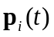which is a function of the 8 neighbors j of i and indicates the direction that disturbance is propagating at location i at time t : 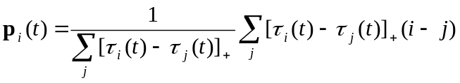, (1)
where 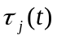 is the time since location j was last disturbed before time t, both sums are over all neighbors j of i, and []₊ indicates the positive part (which sets the weight to zero if 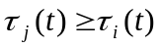). If all weights are zero, then the fraction in Eq. 1 is undefined and we set 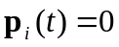. remains unchanged until a new gap occurs at location i. The result of this analysis is a vector field describing the direction of gap propagation for each time t. In order to aid visualization of the resulting vector fields I construct streamlines, curves locally tangent to the vector field which give the path a point will follow in the flow described by the vector field. I will term the collection of locations that share a point downstream in the pattern of streamlines a “watershed”. In this dissertation

Scaling Laws
I determine the statistical relationship between the length and areas of watersheds via standard methods from image analysis. I first create a binary image of the map of streamlines and then examine the length and width of the connected components of the binary image. In order to eliminate any fragments of watershed that may have resulted from poor sampling or the coarseness of the method for determining direction of gap propagation, I only consider connected components of the binary image that are greater than 200 pixels in size. This only discards very small pieces of the image, so it should not affect subsequent analyses. I then calculate the length, D_{l} and width, D_{w}, of each connected component (defined as the differences of x & y maxima and minima). As I am concerned with the allometric scaling properties of watershed length and area, I consider and estimate a and H via linear regression. Finally, I compare the scaling exponent H seen in the pattern of propagating disturbance to that of natural river networks and to the Scheidegger model of river formation, one of the simplest models for river network formation (Scheidegger 1967).
This scaling analysis involves one important simplifying assumption. I am assuming that small watersheds that are disjoint from larger watersheds are representative of the small tributary watersheds that comprise large watersheds. This is a standard assumption in the calculation of scaling laws for river drainage networks (Dodds and Rothman 1999).

A Stochastic Cellular Automaton
In order to examine the patterns in disturbance and regeneration that can result from changes in the factors seen to influence the formation of gaps in the last chapter, I construct a stochastic cellular automaton of gap formation and closure. I include as parameters directional forcing by wind, topography, the background rate of gap formation, and the degree to which previous disturbance increases the likelihood of gap formation nearby.
The model of gap formation, aggregation, and propagation is a stochastic cellular automaton meaning that space is represented by a rectangular grid each cell of which can either be intact or a gap. While most cellular automata are binary (i.e., each cell can be in only one of two states), this model allows for integer-values in each cell. Each cell is occupied by either a zero, in the case of an intact site, or if the cell is a gap, by a positive integer indicating the age of the gap. I use discrete time intervals representing one year (largely because the gap data were censused at yearly intervals).
The model proceeds as follows. There is some initial distribution of gaps and intact sites and at each time step gaps that are older than a certain threshold “close” to become intact sites. Then new gaps form in cell i with probability p that is a function of the states of the neighboring cells, the cells location on the landscape, and a background risk of gap formation. The functional form of this dependence is essentially that of the logistic regression of the last chapter:
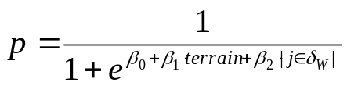, (1)
where terrain can be regarded as elevation (or vegetation height in the context of the last chapter), δ_{W} is a neighborhood determined by a spatial weighting matrix W and indicates the number of gap sites j in the neighborhood δ_{W}. The β’s which were parameters to be estimated in the logistic regression of the last chapter are now treated as parameters of the model. Notice that in this formulation, one can regard gap formation as essentially resulting from the flip of a biased-coin whose bias is dictated by a cell’s context and the choice of the model parameters.
The spatial weighting matrix W dictates the neighboring cells which are considered when determining the probability of gap formation at cell i. For example, in the results of the logistic regression of the last chapter indicate that in the Monteverde study watershed the probability of gap formation is influenced by the amount of previous disturbance to the East. A reasonable first guess for a spatial weighting matrix in this context might be
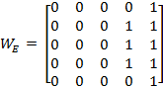
centered on cell i in the (3,3) position of W_{E}. This choice of W would make a neighborhood δ_{W} centered at cell i and corresponding to the non-zero entries of W_{E}.
As the goal of the current investigation is mainly to develop this model and indicate its potential future utility, I do not attempt to thoroughly explore its parameter space. However, in order to hint at the potential this model has for simulating patterns of disturbance and regeneration, I will consider three simple landscapes (Fig. 2.1): one flat, one consisting of a simple gradient, and one a simple gradient with orthogonal periodic variations to simulate ridges on a larger slope. I run simulations with absorbing boundary conditions for each of these landscapes using two different spatial weighting matrices, W_{E} and W_{I}, where
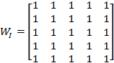
and W_{E} is as defined above. These choices of spatial weighting matrices allow for symmetric dependence of cell i’s state on its neighbors, in the case of W_{I}, and directional bias in this dependence in the case of W_{E}. Each of the six scanarios was run for 20 time steps on a 50 by 50 grid. By applying the same analytical techniques that I applied to the Monteverde data I can examine scaling relationships of patches of disturbance in output of these six scenarios.

All calculations and simulations were carried out these calculations using the R statistical package, the R packages ‘spatstat’ (Baddeley & Turner 2005) and ‘simecol’ (Petzoldt & Rinke 2007), and the Matlab® Image Processing Toolbox (vR2010a, Mathworks©) .

Results:

Observed Pattern
Many treefall gap disturbances in the Monteverde study watershed tend to act as seeds for patches of disturbance that extend in the direction of the tradewinds. The pattern of streamlines associated with the growth of these disturbed patches over the course of years resembles the fractal geometries seen in the formation of river drainage systems (Fig. 2.2). Interestingly, not all gaps initiate propagating patches of disturbance. Gaps in the sheltered bottom of the study area, while large, do not tend to propagate in a discernable fashion. Thus, the process driving these patterns results from an interaction of aerodynamics and topography.
While the “watersheds” that constitute the pattern in Figure 2.2 appear similar to natural drainage networks, their width scales somewhat more slowly with their length than in natural river networks (H ≈ 0.667 for the “watersheds” of gap propagation; H ≈ 0.75-0.8 for natural river networks (Dodds & Rothman 1999)) but more quickly than predicted by the Scheidegger model of river formation for which H = 0.5 . Thus, the scaling for the “watersheds” of gap propagation falls nicely within the range usually considered in river geomorphology with the scaling exponents of the Scheidegger model and real river networks providing lower and upper bounds, respectively.

Model Output
This model is functionally quite simple, though its parameter space is exceedingly large. If we were to restrict our attention to a single landscape and a single spatial weighting matrix W, then the dimension of the parameter space is relatively manageable: each of the β_{i}’s contributes a single dimension resulting in essentially a three dimensional parameter space. However, to consider the role of different topographies or weighting matrices is to open a Pandora’s Box of possibilities.
Despite the sharply restricted scope of my investigation of this model, the six simple scenarios analyzed in this study provide some interesting and compelling results. In each scenario, I find strong allometric relationships between the lengths and widths of disturbed areas (Fig. 2.4). Moreover, the scaling relationships in the scenarios with directional bias in the risk of gap formation roughly match that of the Monteverde data (Fig 2.3), particularly in the case of anisotropic risk and flat terrain (Fig. 2.4d). This indicates that this simple model is capable of reproducing similar patterns of disturbance and regeneration as those seen in a real montane cloudforest.

Discussion:
The presence of such a structured spatial process in gap dynamics in the Monteverde study area raises several interesting ecological questions. First, are forms of this process driving disturbance and regeneration and, thus, large components of community dynamics in other forests? It is reasonable to suppose that wind-stressed forests on other tropical mountaintops experience similar gap dynamics, though with features dependent on topography and magnitude and degree of directionality in windstress. It seems likely, therefore, that the sort of process revealed in this chapter and in the first chapter of this dissertation is operating in many montane forests and that many ecological implications of this process should extend to a much larger scale than explicitly considered in this study.
A second question that arises from the pattern and process revealed in this study is that of the impact of this process on plant community and population dynamics. As gaps in this forest aggregate and propagate across the landscape, the plant populations dependent on gaps for recruitment should respond accordingly. Very young plants should cluster at the scale of individual gaps, but the pattern of somewhat older plants should begin to display clustering at the scale of a cluster of gaps. Moreover, as disturbance in this forest flows across the landscape, germination of gap colonists should be concentrated at the “heads” of these patches of disturbance, while older individuals occupy the trailing ends. It is difficult to see how this process should play out over time, but a model of gap colonist population dynamics coupled to the model for gap formation and propagation constructed in this chapter should allow investigation of the long term spatial dynamics of gap colonists in wind-stressed montane forests
Another interesting feature of the gap dynamics in this forest is the interplay between topography and windflow in the process of gap formation and subsequent propagation. Both the logistic regression in Chapter 1 and the vector field of gap propagation constructed in this chapter indicate that gap propagation is similar to a fluid flow across the landscape. “Watersheds” of gap propagation are longer and narrower than dendritic rivers( with H = 0.677 for gap propagation, as compared to H ≈ .75-.8 for rivers); still, the resemblance is close enough to present interesting questions. For example, topography often forces airflow into eddies at a wide array of scales – do patterns of disturbance and regeneration also display eddies or vortices? This is a fascinating question as vortices in gap dynamics would set up similar vortices in populations of a wide variety of organisms. This problem can likely be approached both analytically and empirically. One potential analytical framework could be provided by transitioning from a stochastic cellular automaton to a partial differential equation framework and examining conditions under which various patterns can occur.
The patterns of gap formation, aggregation, and propagation seen in this study must surely be important for the function of wind-stressed montane forests, and so a theoretical descriptive framework is clearly highly desirable. The stochastic cellular automaton constructed in this chapter seems to be a very promising first step for constructing such a framework. It is a relatively simple model that incorporates the factors known to influence gap formation and aggregation and that can be relatively efficiently simulated. The results of simulations of this model should be able to provide testable hypotheses about the nature of gap dynamics in real forests. A combination of this stochastic cellular automaton and regional atmospheric models that can generate airflow over real topography given by Digital Elevation Models may be able to predict the gap dynamics of most lowland and highland forests. The outputs of such a model could be readily compared with high-resolution, remotely-sensed canopy imagery.

CHAPTER 3

Complex spatial structure in a population of Didymopanax pittieri, a tree of wind-exposed lower montane rain forest.

Introduction:
Examination of the spatial structure of ecological systems at various levels of organization can lead to important insight into the fundamental processes experienced by individuals, populations, metapopulations, and communities (Levin, 1992). Moreover, spatial pattern can play a significant role in ecological processes including competitive coexistence (Lavorel et al., 1994) and transmission of disease (Brown & Bolker, 2004), and can have impacts that scale up to ecosystem-level processes (Moorcroft et al., 2001; Pacala & Deutschman, 1995). Spatial structure within populations may result from dispersal (Okubo and Levin 1989, Clark et al. 1998), ecological interactions such as those involving symbiotes (Diez 2007) or pathogens (Janzen 1970), recruitment opportunities (Dovciak et al. 2001), or resource availability (Russo et al. 2005). The last two of these factors are influenced by natural disturbance (Bazzaz and Pickett 1980, Denslow 1980, Picket and White 1985, Seabloom et al. 2005).
The fall of individual trees affects the spatial structure of plant populations in forests (Watt 1923, 1947, Williamson 1975, Sherman et al. 2000, Svenning 2000, Dovciak et al. 2001). The forest floor typically receives very little light, but following treefall light can penetrate to the forest floor (Bazzaz and Pickett 1980, Lawton 1990). The resulting spatiotemporal heterogeneity in available light may contribute to forest diversity (Grubb 1977, Denslow 1980, 1987, Levin 1992, Rees et al. 2001, Schnitzer and Carson 2001), since the ephemeral pulse of resources caused by treefall gaps allows for a shade intolerant gap colonist niche (Grubb 1977, Bazzaz and Pickett 1980). As a result the availability, quality, and spatial structure of treefall gaps should strongly influence the spatial patterns of these populations.
In the last thirty years spatial statistical methods that investigate point patterns, as discussed in (Ripley, 1981) and (Diggle, 2003), have been widely applied to plant populations (Atkinson et al., 2007, Getzin et al., 2006, Kenkel, 1988, Lawton & Putz, 1988; Seidler & Plotkin, 2006, Law et al. 2009) to detect aggregation or regularity of individuals’ positions as well as interspecific pattern. Ripley’s K, its linearization L, and its derivative, the pair correlation function g, are among the most commonly used spatial statistics, providing insight into second-order properties of spatial point patterns. However, these functions are only appropriate for the analysis of spatially homogeneous point patterns (that is, those in which there are no large scale trends in density) (Ripley 1981, Baddeley et al., 2000, Diggle, 2003, Law et al. 2009). This is unfortunate as inhomogeneity in population density is most likely the rule, not the exception, in natural populations. Fortunately, recent work (Baddeley et al 2000, Law et al. 2009) has yielded tools such as K_{I}, the extension of Ripley’s K to inhomogeneous point patterns, and the inhomogeneous form of the pair correlation function.
Here we use the inhomogeneous form of the pair correlation function, g(r), to examine the spatial pattern of mapped locations of a population of the lower montane tropical cloud forest tree Didymopanax pittieri in a Costa Rican cloud forest. We investigate the spatial patterns of four size classes of D. pittieri and use g to (1) test the null hypotheses that the locations of individuals in the four size classes are spatially random within the large scale trend in the population density of D. pittieri resulting from specialization to windswept elfin forest ridgecrests, and (2) determine whether observed patterns are consistent with scales expected from the known patterns of natural disturbance.

Methods:

Study Area
This study was conducted in the Monteverde Cloud Forest Reserve in very wet lower montane rain forest (sensu Holdridge, 1967) along the crest of the central Cordillera de Tilarán of northern Costa Rica. The vegetation along the crest of the Cordillera is a complex mosaic, the character of which is largely dictated by the patterns of exposure to flow of the north-easterly trade winds through the mountains (Lawton and Dryer 1980, Clark et al. 2000). Dwarfed forest formations (elfin forests sensu Beard (1955) occupying wind-swept ridge crests are interdigitated among taller cloud forest stands found in protected ravines and on lee slopes. Elfin forest stands in the central Cordillera de Tilarán were mapped using 1:40,000 scale aerial photographs, and an approximately 12 ha watershed (Fig. 3.1) on the south-eastern side of the summit of Cerro Centinelas (1580 m a.s.l.) was chosen as providing an accessible and representative example. Forest structure changes dramatically with exposure in the watershed. Elfin forest with canopy trees 5 – 10 m tall occupies the boundary ridge crests and upper windward slopes of the watershed, and grades into taller cloud forest with canopy trees 15 – 27 m tall along the creek and on the lee slope (Lawton, 1982, 1984; Lawton & Dryer, 1980). Dwarfed forest stature is not the only impact of windstress on this forest. Disturbance in the form of treefall gaps, the largest of which in this forest are 100 -200 m², strongly influences forest structure, creating a varied landscape of intact forest, newly formed gaps, and vegetation in various stages of regeneration (Lawton and Putz 1988; Lawton, 1990). Individual treefall gaps in this study area are aggregated into patches 35 - 40m across, or of about 0.12 ha (Lawton and Putz 1988). This clumping results in disturbed patches of forest containing gaps whose ages differ by about 1-5 years. The gaps in these patches regenerate together, and the regenerating patch is a recognizable unit of forest structure occurring at a scale larger, by five- or ten-fold, than that of an individual treefall. Thus this forest experiences a two tiered forest dynamics consisting of the formation and subsequent regeneration of individual gaps and patches of gaps.

Field Methods
In 1977 one of us (R.O.L.) mapped the distribution of all individuals of the Didymopanax pitteri taller than 0.5 m on the crest and windward slope of the ridge forming the southwestern boundary of the watershed. D. pittieri is a shade intolerant tree of montane rain forests in Costa Rica and western Panama (Holdridge and Poveda 1975). In the Cordillera de Tilarán, D. pittieri is a common canopy tree in the elfin forests on wind-swept ridge crests (Lawton & Dryer 1980, Lawton 1982, 1984), but also occurs more widely at elevations above ~1500 m as an occasional hemiepiphyte (~2 mature individuals ha⁻¹) in the taller cloud forests of more protected areas (Williams-Linera & Lawton, 1995). Regeneration of D. pittieri depends on gaps in the forest canopy (Lawton, 1980; Lawton and Putz, 1988). Seedlings and small saplings of D. pittieri are most commonly found in epiphytic mats of bryophytes growing on upper trunks and limbs of canopy trees, but D. pittieri grow to maturity after saplings become established on nurse logs in treefall gaps by surviving the collapse of their hosts (Lawton and Putz 1988, Williams-Linera and Lawton 1995).
The primary ridge crest of the study site was first surveyed with compass, clinometer, optical rangefinder, and tape measure, and the ridge line was marked at 10 m intervals and at each vertex with labeled flagging. Then the secondary ridge crests on the windward side of the primary ridge were similarly surveyed and marked, as were the incised drainage lines in the intervening secondary valleys. The ridge crest and windward slope were then thoroughly searched and each D. pittieri >0.5 m tall was located by distance and direction from a point on the network of surveyed lines, and measured for stem diameter and tree height. Subsequently, in 1983-1984, the watershed was surveyed and gridded into contiguous 20x20m plots using a transit, stadium rod and optical rangefinders. The D. pittieri locations were then transferred to the new coordinate system (Fig. 3.1), with field checks for accuracy. Repeated measurements suggest that tree locations are accurate to within 1 or 2 m.
On windward slopes in rugged terrain windspeed generally increases with proximity to ridgecrests and summits (Finnegan & Brunet, 1995; Hannah et al., 1995); this study site is no exception (Lawton 1982). We examine this topographic influence on exposure to wind by using the topographic map of the study area to determine the vertical distances from 1070 points in the study area to lines running 60º east of north across the study watershed (facing into the trade wind airflow) from the crest of the southwestern (lee) boundary ridge to the crest of the northeastern (windward) boundary ridge. These are, in essence, the vertical distances below a “roof” on the study watershed. Since these distances are small on the ridgecrest where D. pittieri are abundant and large downslope where D. pittieri is scarce, we use the inverse of this vertical distance, here termed RELEV, as the measure of topographic exposure to wind. For computational reasons RELEV is multiplied by 0.002 to make the number of points generated in the simulations described below reasonably match the number of D. pittieri within our study area.

Analytical Methods
The examination of spatial point patterns is often carried out using the second moment function K to test the null hypothesis that a point pattern is spatially random (Ripley 1977, Diggle 1983). In particular this tests if the empirical pattern is a realization of a Poisson point pattern with constant intensity given by the overall population density. The cross K function, K_{ij}, a generalization of K to patterns in which there are several classes of points, is also used to investigate spatial pattern by examining interactions between points of different types. However, use of K and K_{ij} both rely on the assumption that the point patterns in question are spatially homogeneous. When a pattern has non-constant intensity, i.e., when there are large scale trends in density within the population, use of these functions is inappropriate and will yield misleading results. D. pittieri are clearly most abundant on the wind-exposed ridgecrest and upper windward slopes and less abundant on lower slopes more protected from wind (Figs. 3.1 and 3.2). In order to account for this inhomogeneity and to avoid the potential pitfalls of cumulative spatial statistics such as K (Loosmore and Ford 2004, Law et al. 2009) we used the inhomogeneous pair correlation function g (Law et al. 2009) and its generalization g_{ij} to multitype point patterns used to examine placement of D. pittieri saplings (<5 cm stem diameter), poles (5 – 10 cm dbh), adults (10 -20 cm dbh), and large adults (>20 cm dbh). The point patterns under examination were assumed to be second-order intensity-reweighted stationary and isotropic. This is a much less restrictive assumption than spatial homogeneity, and allows the first moment, or density, of the point patterns to vary in space (Baddeley et al. 2000).
. For a spatially inhomogeneous point pattern, values of r such that g(r) > 1 indicate that points have, on average, more neighbors within distance r than would be expected for an inhomogeneous Poisson process with the same intensity. That is, they are aggregated, or clumped, in a manner beyond that dictated by the large scale inhomogeneity. Similarly, values of r for which g(r) < 1 are indicative of repulsion between points, or evenness of distribution. g_{ij}(r) > 1 indicates that type i individuals have more neighbors within r of type j than expected at random, having taken into account large scale trends in population density. The converse interpretation holds when g_{ij} (r) < 1.
As with other non-parametric spatial methods, use of g and g_{ij} are prone to edge effects dependent on the geometry of the observation window (Diggle, 2003). We implemented the “border” edge correction provided in the R package Spatstat (Baddeley & Turner 2005).
To avoid the problem of using the same point pattern data for both estimating the first order intensities and estimating g, we first describe large scale inhomogeneity by using a Gaussian smoothing kernel with bandwidth σ = 30m to create a surface from the RELEV data. We then evaluate that surface at the locations of the D. pittieri for each size class. Then we use the same smoothing process to create an inhomogeneous (RELEV-weighted) D. pittieri density surface for each size class. These surfaces thus account for the large scale trend in the D. pittieri population driven by topography and wind stress. Figure 3.2 and 3.3 suggest that this use of RELEV provides a reasonable description of the large scale spatial trends in the D. pittieri population.
We calculated g_{ij} for each of the sixteen combinations of the four D. pittieri size classes. Confidence envelopes were derived from 99 simulations of the inhomogeneous Poisson process with four types of points with first-order intensities given by RELEV. All analyses were carried out using the R package Spatstat (Baddeley & Turner 2005).

Results:
Within the 5.2 ha study area there were 515 D. pittieri – 145 saplings, 66 poles, 121 adults, and 183 large trees. Topography and wind exposure drive a large scale trend in D. pittieri density. Simple visual examination of the mapped positions of D. pittieri individuals (Fig. 3.1) shows, for each size class, an increase in density going up the windward slope of the study area. Dividing the landscape into 2.5 m wide relative elevation (RELEV) classes and calculating the D. pittieri density in each, yields the regression of density against RELEV shown in Figure 3.2 ((number/100m²) = -0.1603 log(midpoint of RELEV class (m) + 1.0217; F=22.8, df=6, p=0.003, R²=0.79).
This large scale pattern in the D. pittieri population is clearly related to the specialization of D. pittieri to elfin forest conditions (Lawton 1982, 1984).
In order to examine the local pattern of this D. pittieri population within the large scale trend shown in Figure 3.2 we examine the null hypothesis that the observed pattern is a realization of an inhomogeneous Poisson process with four classes of points, given by the D. pittieri size classes, and inhomogeneity as described by the wind-exposure variable RELEV. That is, that D. pittieri are randomly distributed within the large scale trend dictated by wind exposure.
g_{ij} reveals a variety of interesting spatial patterns within the population level trend driven by exposure to wind. Each of the four size classes depart from the random expectation in these analyses, but the nature of the departure varies markedly among size classes.
Use of the inhomogeneous g_{ij} reveals nonrandom spatial structure in D. pittieri saplings within the large-scale population level trend. g_{ij} exceeds the envelope of 99 simulations, indicating that D. pittieri saplings are clumped, in the sense that they have more neighboring saplings within 10 m than expected from the inhomogeneous Poisson process in which D. pittieri density increases with wind exposure (Fig. 3.4). Note that gis a function of radial distance, but environmental patchiness is often most easily thought of in terms of patch area. In this case the g_{ij} imply clusters of saplings ~ 20 m across, that is, patches of ~300 m². This in turn implies a patchiness in the conditions required for sapling establishment.
In addition, saplings have fewer D. pittieri poles within ~2m, but more poles within 3-10 (Figure 3.4b), and fewer large trees within 25-35 m (Figure 3.4d) than expected from the inhomogeneous Poisson process.
D. pittieri 5– 10 cm dbh (poles) have, on average, the number of neighboring poles expected from the inhomogeneous Poisson process (Figure 3.5b). That is, within the large scale trend dictated by topography and wind exposure, poles appear randomly dispersed. The numbers of neighboring D. pittieri 10-20 cm dbh, and >20 cm dbh are also roughly as expected though there are more large trees within 25-35m of poles than expected. (Figures 3.5c, 3.5d). However, poles do have on average fewer neighboring saplings within 2m and more saplings within 3-7 m than expected (Figure 3.5a).
D. pittieri 10-20cm dbh have in general the number of neighbors of all size classes expected by chance within the large scale population trend (Figure 3.6a-d), though, as with the other size classes, D. pittieri 10-20cm dbh have fewer large trees within 25-35m than expected . Large adults with dbh >20cm have the number of neighboring saplings expected given the large scale population trend (Figure 3.7a), but fewer neighbors of all other size classes within ~30m (Figures 3.7b-d). Large trees then are more regularly distributed than expected given the large scale population trend in density.

Discussion:

Large scale trend in density
Wind stress and treefall produce the large scale trend in D. pittieri density, as well as the more local population structure superimposed on that trend. There are two possible reasons for the large scale, ridge-ravine trend in D. pittieri density shown in Figure 3.2.
First, the likelihood of D. pittieri successfully colonizing gaps may decline in the transition from ridgecrest elfin forest to the taller cloud forest on the more sheltered slopes below. When the short and sturdy trees of the elfin forest fall, their crowns are only partially crushed, so gaps contain more-or-less intact, but on edge crowns (Lawton 1990). As a result many hemiepiphytes, including D. pittieri seedlings and saplings, commonly survive the fall of their elfin forest hosts (Lawton & Putz 1988). In contrast, when taller trees lower on the slope fall, their crowns hit the ground hard, shattering into a pile of debris 1-2 m thick in which hemiepiphytes seldom survive (Lawton 1990). So the peculiar manner in which D. pittieri colonizes treefall gaps may limit establishment of juvenile D. pittieri on the lower slope of the study area.
Second, D. pittieri saplings in gaps that are not exposed to high winds may be overtopped in early gap-phase forest regeneration by saplings of faster growing shade intolerant species. D. pittieri saplings with a wood density of 0.5-0.7 gm/cm³ appear to be better suited for windy ridge crests than shade-intolerant species with less dense, and thus probably weaker, wood, such as Cecropia polyphlebia and Guettarda poasana (Lawton 1984). Although present as saplings in many elfin forest treefall gaps, these latter two species seldom survive to become members of mature-phase elfin forest. On the other hand, due to trade-offs in investments in wood strength and growth rate, D. pittieri may be competitively excluded by shade-intolerant species such as C. polyphlebia and G. poasana in gap-phase regeneration of the taller, more sheltered forest lower on the slopes of the study watershed.

Small scale pattern
The local spatial pattern observed within the large scale trend in D. pittieri population density appears to be related to the spatial distribution of treefall gaps, to colonization of the gaps, and to competitive thinning in the course of gap-phase regeneration. Clumping of D. pittieri saplings reflects both the nature of gap formation and gap colonization, while the distribution of larger individuals reflects subsequent winnowing as some trees die and others grow to maturity.
The small end of this clumping of saplings is at the scale of elfin forest treefall gaps. Since D. pittieri is shade intolerant, the establishment of saplings occurs in canopy gaps, which in this forest are largely due to the snapping or uprooting of trees (Lawton and Putz 1988). Although most gaps are small (75% < 30 m² ) more than 45% of gap area is contributed by those gaps > 100 m2 (Lawton and Putz 1988). In these larger gaps several D. pittieri saplings are commonly seen on nurse logs, having survived the fall of the tree in which they were hemiepiphytes. However, that can only explain a surfeit of neighbors within at most 6-10m. But no elfin forest gaps are >250 m², so the fact that D. pittieri saplings also have more neighbors than expected within 12m, that is, in a ~450 m2 area, (Fig. 3.4) may not be explained entirely by clustering within individual gaps. However, gaps in this elfin forest are themselves aggregated in that they have more neighboring gaps of similar age (within 3-5 years) with centers within 17-20 m than expected (Lawton & Putz, 1988). So the clumping of saplings at a spatial scale beyond that of individual gaps probably reflects this patchiness of forest dynamics due to clumping of individual treefalls.
Saplings also have more neighboring poles within 3-10m than expected, though less than expected within ~2m. Since gaps of similar, but varying age occur in patches, as described above, it is not surprising that some D. pittieri in the older gaps in a cluster should have grown to pole size, while saplings occupy the younger gaps in the same patch of gaps, Moreover, saplings within 2m of poles may be in danger of mortality due to competition from the larger poles, thus potentially accounting for the smaller number of saplings within 2m of poles. These patterns are consistent with the rapid regeneration within elfin forest gaps. Within 5 years of formation, gaps are filled by a regenerating thicket 2-4m tall and leaf area index has recovered to roughly that of mature forest (Lawton and Putz 1988). In 5 years, 63% of saplings die, 23% remain saplings, and 14% grow to become poles (Lawton, 1980), so the excess number of poles near saplings, relative to that expected from the large-scale trend in density, probably results from the processes of gap-phase regeneration and small scale competition in clumps of gaps.
Similarly the aggregation of saplings within 3 -7 m of poles (Fig. 3.5) and the unexpectedly small number of poles within 2m of saplings reflects the early stages of competition in which the most fortunate saplings in a cluster outgrow their neighbors. Subsequent mortality during gap-phase regeneration of the least fortunate saplings within individual gaps results in loss of aggregation at the gap scale among surviving poles.
Saplings have fewer neighboring adult and large D. pittieri within ~25-35m than expected from the relationship of their density to the gradient of topography and wind exposure. There are two plausible reasons for this paucity of large neighbors. First, D. pittieri >20 cm dbh tend to regular distribution at these scales (Figs. 3.6, 3.7; discussed below). Second, and more importantly, clusters of gaps imply that a patch of forest is being winnowed by the fall of canopy trees. Other things being equal, this should reduce the number of large D. pittieri in the areas in which D. pittieri saplings are becoming established.
So why are poles not aggregated, like saplings, at the scale gaps are? There are three factors to consider. First, the clustering of gaps that formed in a 3-5 year time window appears to be due to an initial gap increasing the likelihood of subsequent fall of neighboring trees (Young & Hubbell, 1991). Second, once a patch of forest has deteriorated due to such sets of neighboring treefalls, subsequent treefalls in the now regenerating patch are unlikely. The result is spatial displacement of these patches of regenerating gaps. The pole size class includes trees 4-15 years old (Lawton 1980), so several episodes of non-overlapping regenerating patches are included in the time-frame of the point pattern of poles. Due to gap aggregation, the pattern of poles at the 10-40m scale may be well described by a Neyman-Scott or Matérn-like cluster process in which gap cluster centers are inhibited from occurring 30-40m from other gap cluster centers. If so, the poles occupying these gap clusters would necessarily exhibit regularity at this scale.
This reasoning extends to the patterns of trees in the two larger size classes.
Aggregation of saplings along with regular dispersion of larger or older trees seems to be common to many forests (see e.g., Dovciak et al., 2001; Sterner et al., 1986). The discordance of fine scale spatial pattern for different size classes observed in this study is consistent with previous work in that the aggregation of saplings diminishes in larger size classes. While the thinning of sapling clusters may in general be due to competition, disease, or herbivory, a random thinning alone would not result in regularity (Pielou 1968), although density dependent mortality might. In the case of D. pittieri in Costa Rica elfin forests, it appears that patch dynamics also contributes to the regularity seen in the distribution of poles and larger trees. This is an important point as it highlights the role of pattern of disturbance, in addition to colonization of disturbance and subsequent regeneration, in the formation of spatial pattern within tree populations. Moreover, this sort of patch dynamics differs from those typically discussed in that the patches consist not of a single regenerating gap, but rather a cluster of gaps forming a larger regenerating patch.

CHAPTER 4

Forests shape much of our environment. They are home to many of the planet’s creatures and play an important role in regulating the planet’s hydrological processes (McCulloch & Robinson 1993), nutrient cycling (Whittaker et al. 1979), and surface energy budget (Quattrochi & Luvall 1999, Pielke et al. 2002). Moreover, forests are involved in complex feedbacks with the atmosphere and are thus critical elements of global climate change (Bonan 2008), influencing the cycling of atmospheric carbon ( Clark 2004) and local patterns of evapotranspiration and cloud formation (Lawton 2001, Ray et al. 2006, Bonan 2008 and citations therein). Tropical forests are particularly important for global processes as they contain roughly a quarter of terrestrially bound carbon and account for roughly a third of the planet’s net primary productivity (Bonan 2008). Forest ecosystems are home to a huge proportion of global biodiversity and many of the planet’s biodiversity hotspots are located in tropical forests (Myers et al. 2000, Bonan 2008).
Because forests play such vital roles in global processes, it is important to understand their structure and function. Treefalls are one of the most important players in the cycles of disturbance and regeneration that shape forests and their constituent species, and as such it is critical to understand the dynamics of treefall gap formation and regeneration. In this dissertation I have investigated the organization of treefall gaps in space and time. In the first chapter, I developed a local causal story for spatial structure in gaps in montane tropical forests. In Chapter 2 I found an emergent fractal pattern in the long term spatial dynamics of gap formation and regeneration; I also developed a stochastic cellular automaton for prediction and simulation of gap dynamics across a wide array of landscapes and windstress regimes, which can be coupled with regional and global scale climate models and local scale vegetation models to predict local forest dynamics as a function of global and regional climates and local species composition. Finally, in Chapter 3 I investigated the spatial structure of a population of the treefall gap colonist tree species Didymopanax pittieri and I showed that the spatial population dynamics of this representative gap colonist species are strongly influenced by the spatial structure among the gaps that they occupy.
The picture of montane tropical forest dynamics that emerges from the three chapters of this dissertation is one of large scale pattern emerging from relatively simple local scale processes. On windswept ridgecrests the formation of a single gap strongly increases the likelihood of future gap formation downwind. That one tree falling may make its neighbors more vulnerable is a simple observation though it is hard to detect in data with small temporal scope. However, this fact stands out clearly in the 25 year timeseries of gap formation in my study area. This simple increase in risk of treefall downwind of extant gaps leads to very interesting forest dynamics: gaps aggregate into disturbed patches that grow and flow across the landscape leading to an emergent fractal pattern (Fig. 2.2 c) of disturbance and regeneration.

Broader Impacts and Future Directions
The work presented in this dissertation indicates that a general theory of gap driven forest dynamics is possible. The Ising model of ferromagnetism (Reichl 2009) has been used with some success in previous work toward developing a theoretical framework for the understanding this sort of forest dynamics. However, most of this work has used relatively short time series and has concentrated on lowland tropical forest (Hubbell & Foster 1987, Kubo et al. 1996, Katori 1998) in which extant treefall gaps appear not to increase the risk of subsequent disturbance (Jansen et al. 2008). The model described in Chapter 2 of this dissertation shares several important characteristics with the Ising model, perhaps most importantly the role of neighbors in determining a site’s state. Still, the model presented in Chapter 2 may be more appropriate for forests in general as forest dynamics do not have an analogue of temperature, a critical parameter in the Ising model.
The model presented in Chapter 2 was developed using data from a quarter of a century and provides a flexible and computationally tractable framework for the development of a general theory of gap driven forest dynamics by informing both computational and analytical insights. It can provide the gap dynamics layer for computational models of shade tolerant and intolerant plant species but can also provide the starting point for generalization into analytically tractable models such as partial differential equations or Spatial Moment Equations (Bolker and Pacala 1999). In either a computational or analytical framework, this model is likely to provide important insights into many aspects of forest ecology. For example, some locations in the Eastern portion of the Monteverde study area are likely to see more repeated disturbance than locations in the Western component (Fig. 2.2 c) and thus locations not very distant in space may have substantially different species composition and rates of plant growth. Moreover, abundance and activity levels of insects, decomposers, and birds will be increased in the propagating patches of disturbance revealed in Chapters 1 and 2. Thus, much of a forest’s ecological dynamics will display fractal patterns such as that shown in Figure 2.2.
The Monteverde study watershed is typical of mountaintops in the Cordillera de Tilarán and is similar to locations in many windswept tropical mountaintops across the world. It is likely, therefore, that gap dynamics similar to those seen in this dissertation are present in many of the world’s tropical mountains. It may be possible to detect such patterns by using high-resolution canopy images and image processing techniques and therefore it may be possible to produce maps of locations that display similar forest dynamics. Moreover, once such areas are located, the model constructed in Chapter 2 if supplied with a Digital Elevation Model for the area could simulate that area’s disturbance regime, making predictions about species composition, turnover rates, and potential response to global climate change.

LIST OF REFERENCES

Alvarez, J. & M. R. Willig. 1993. Effects of treefall gaps on the density of land snails in the Luquillo-experimental-forest of Puerto Rico. Biotropica 25:100-110.
Atkinson, P.M. et al. 2007. Investigating spatial structure in specific tree species in ancient semi-natural woodland using remote sensing and marked point pattern analysis. Ecography 30: 88-104.
Baddeley, A. & Turner, R. 2005. Spatstat: An R package for analyzing spatial point patterns. Journal of Statistical Software 12: 1-42.
Baddeley, A.J. et al. 2000. Non- and semi-parametric estimation of interaction in inhomogeneous point patterns. Statistica Neerlandica 54: 329-350.
Bazzaz, F. A. & S. T. A. Pickett. 1980. Physiological Ecology of Tropical Succession -a Comparative Review. Annual Review of Ecology and Systematics 11:287-310.
Beard, J.S. 1955. The classification of tropical American vegetation-types. Ecology 36: 89-100.
Bolker, B. M. & S. W. Pacala. 1999. Spatial moment equations for plant competition: Understanding spatial strategies and the advantages of short dispersal. American Naturalist 153:575-602.
Bonan, G. B. 2008. Forests and climate change: Forcings, feedbacks, and the climate benefits of forests. Science 320:1444-1449.
Brokaw, N. & R. T. Busing. 2000. Niche versus chance and tree diversity in forest gaps. Trends in Ecology & Evolution 15:183-188.
Brokaw, N. V. L. 1985. Gap-phase regeneration in a tropical forest. Ecology 66:682-687.
Brokaw, N. V. L. and J. S. Grear. 1991. Forest structure before and after hurricane Hugo at 3 elevations in the Luquillo mountains, Puerto Rico. Biotropica 23:386-392.
Brown, D.H. & Bolker, B.M. 2004. The effects of disease dispersal and host clustering on the epidemic threshold in plants. Bulletin of Mathematical Biology 66: 341-371.
Campbell, D. J. 1998. Salt-wind induced wave regeneration in coastal pine forests in New Zealand. Journal of Forest Research-Revue Canadienne De Recherche Forestiere 28:953-960.
Chambers, J. Q., A. L. Robertson, V. M. C. Carneiro, A. J. N. Lima, M. L. Smith, L. C. Plourde, and N. Higuchi. 2009. Hyperspectral remote detection of niche partitioning among canopy trees driven by blowdown gap disturbances in the Central Amazon. Oecologia 160:107-117.
Clark, D. A. 2004. Sources or sinks? The responses of tropical forests to current and future climate and atmospheric composition. Philosophical Transactions of the Royal Society of London Series B-Biological Sciences 359:477-491.
Clark, J.S., Macklin, E., & Wood, L. 1998. Stages and spatial scales of recruitment limitation in southern Appalachian forests. Ecological Monographs 68: 213-235.
Connell, J. H. 1978. Diversity in tropical rain forests and coral reefs - high diversity of trees and corals is maintained only in a non-equilibrium state. Science 199:1302-1310.
Cooper-Ellis, S., D. R. Foster, G. Carlton, and A. Lezberg. 1999. Forest response to catastrophic wind: Results from an experimental hurricane. Ecology 80:2683-2696.
Cordero, R. A., N. Fetcher, and J. Voltzow. 2007. Effects of wind on the allometry of two species of plants in an elfin cloud forest. Biotropica 39: 177-185.
Coutts, M. & J. Grace, editors. 1995. Wind and Trees. Cambridge University Press, New York.
Cressie, N. 1993. Statistics for Spatial Data, revised edition. Wiley, New York.
Denslow, J. S. 1980. Gap Partitioning among Tropical Rainforest Trees. Biotropica 12:47-55.
Denslow, J. S. 1987. Tropical rain-forest gaps and tree species-diversity. Annual Review of Ecology and Systematics 18:431-451.
Denslow, J. S., A. M. Ellison, and R. E. Sanford. 1998. Treefall gap size effects on above- and below-ground processes in a tropical wet forest. Journal of Ecology 86:597-609.
Dieckmann, U., Law, R., & Metz, A. (eds). 2000. The geometry of ecological interactions: simplifying spatial complexity. Cambridge University Press,
Diez, J.M. 2007. Hierarchical patterns of symbiotic orchid germination linked to adult proximity and environmental gradients. Journal of Ecology 95: 159-170.
Diggle, P. J. 2003. Statistical Analysis of Spatial Point Patterns. 2nd edition. Arnold, New York.
Diggle, P.J. et al. 2006. Second-Order Analysis of Inhomogeneous Spatial Point Processes Using Case-Control Data doi:10.1111/j.1541-0420.2006.00683. -Biometrics OnlineEarly.
Dovciak, M. et al. 2001. Discordance in spatial patterns of white pine (Pinus strobus) size-classes in a patchy near-boreal forest. Journal of Ecology 89: 280-291.
Finnegan, J. & Brunet, Y. 1995.. Turbulent airflow in forests on flat and hilly terrain. -In Coutts, M. and Grace, J. (eds.), Wind and Trees. Pp. 3-40.
Foster, D. R. & E. R. Boose. 1992. Patterns of forest damage resulting from catastrophic wind in central New England, Usa. Journal of Ecology 80:79-98.
Foster, J. R. and W. A. Reiners. 1986. Size distribution and expansion of canopy gaps in a northern Appalachian Spruce-Fir forest. Vegetatio 68:109-114.
Garcia-Verdugo, C., C. Granado-Yela, E. Manrique, R. R. de Casas, and L. Balaguer. 2009. Phenotypic plasticity and integration across the canopy of Olea europaea subsp guanchica (Oleaceae) in populations with different wind exposures. American Journal of Botany 96:1454-1461.
Getzin, S. et al. 2006. Spatial patterns and competition of tree species in a Douglas-fir chronosequence on Vancouver Island. Ecography 29: 671-682.
Grubb, P. J. 1977. Maintenance of species-richness in plant communities - importance of regeneration niche. Biological Reviews of the Cambridge Philosophical Society 52:107-145.
Hannah, P., J. P. Palutikof and C. P. Quine. 1995. Predicting windspeeds for forest areas in complex terrain. -In Coutts, M. and Grace, J. (eds.), Wind and Trees. Pp. 113-129.
He, H. S. and D. J. Mladenoff. 1999. Spatially explicit and stochastic simulation of forest-landscape fire disturbance and succession. Ecology 80:81-99.
Holdridge, L.R. 1967. Life Zone Ecology. Tropical Science Center. San Jose, CR.
Holdridge, L.R. & Poveda, L.J. 1975. Arboles de Costa Rica. Tropical Science Center. San Jose, CR.
Hubbell, S. P. and R. B. Foster. 1986. Canopy gaps and the dynamics of a neotropical forest. Pages 77-96 in M. J. Crawley, editor. Plant Ecology. Blackwell Scientific Publications, Oxford, UK.
Hubbell, S. P. and R. B. Foster. 1987. Large-scale spatial structure of a neotropical forest. Revista De Biologia Tropical 35:7-22.
Hubbell, S. P., R. B. Foster, S. T. O'Brien, K. E. Harms, R. Condit, B. Wechsler, S. J. Wright, and S. L. de Lao. 1999. Light-gap disturbances, recruitment limitation, and tree diversity in a neotropical forest. Science 283:554-557.
James, K. R., N. Haritos, and P. K. Ades. 2006. Mechanical stability of trees under dynamic loads. American Journal of Botany 93:1522-1530.
Jansen, P. A., P. J. Van Der Meer, and F. Bongers. 2008. Spatial contagiousness of canopy disturbance in tropical rain forest: an individual-tree-based test. Ecology 89:3490-3502.
Janzen, D.H. 1970. Herbivores and Number of Tree Species in Tropical Forests. American Naturalist 104: 501-528.

Jokimaki, J., E. Huhta, J. Itamies, and P. Rahko. 1998. Distribution of arthropods in relation to forest patch size, edge, and stand characteristics. Canadian Journal of Forest Research-Revue Canadienne De Recherche Forestiere 28:1068-1072.
Kenkel, N.C. 1988. Pattern of Self-Thinning in Jack-Pine - Testing the Random Mortality Hypothesis. Ecology 69: 1017-1024.
Kneeshaw, D. D. & Y. Bergeron. 1998. Canopy gap characteristics and tree replacement in the southeastern boreal forest. Ecology 79:783-794.
Lavorel, S. et al. 1994. Spatiotemporal Dispersal Strategies and Annual Plant-Species Coexistence in a Structured Landscape. Oikos 71: 75-88.
Lavorel, S., J. Lepart, M. Debussche, J. D. Lebreton, and J. L. Beffy. 1994. Small-Scale Disturbances and the Maintenance of Species-Diversity in Mediterranean Old Fields. Oikos 70:455-473.
Law R. et al. 2009. Ecological information from spatial patterns of plants: insights from point process theory. Journal of Ecology 97:616-628.
Lawton, R. O. 1980. Wind and the ontogeny of elfin stature in a Costa Rican lower montane rainforest. Ph.D. diss. University of Chicago, Chicago, IL.
Lawton, R. O. 1982. Wind Stress and Elfin Stature in a Montane Rain-Forest Tree - an Adaptive Explanation. American Journal of Botany 69:1224-1230.
Lawton, R.O. 1984. Ecological Constraints on Wood Density in a Tropical Montane Rain-Forest. American Journal of Botany 71: 261-267.

Lawton, R. O. 1990. Canopy gaps and light penetration into a wind-exposed tropical lower montane rain-forest. Canadian Journal of Forest Research-Revue Canadienne De Recherche Forestiere 20:659-667.
Lawton, R.O. and Dryer, V. 1980. The vegetation of the Monteverde Cloud Forest Reserve. Brenesia 18: 101-116.
Lawton, R. O., U. S. Nair, R. A. Pielke, and R. M. Welch. 2001. Climatic impact of tropical lowland deforestation on nearby montane cloud forests. Science 294:584-587.
Lawton, R. O. & F. E. Putz. 1988. Natural disturbance and gap-phase regeneration in a wind-exposed tropical cloud forest. Ecology 69:764-777.
Levin, S.A. 1992. The Problem of Pattern and Scale in Ecology. Ecology 73: 1943-1967.
Levin, S. A. & R. T. Paine. 1974. Disturbance, patch formation, and community structure. Proceedings of the National Academy of Sciences 71(7): 2744-2747.
Lin, Y., M. L. Hulting, and C. K. Augspurger. 2004. Causes of spatial patterns of dead trees in forest fragments in Illinois. Plant Ecology 170:15-27.
Loosmore, N.B. & Ford, E.D. 2006. Statistical inference using the G or K point pattern spatial statistics. Ecology 87: 1925-1931
McCulloch, J. S. G. & M. Robinson. 1993. HISTORY OF FOREST HYDROLOGY. Journal of Hydrology 150:189-216.
Moloney, K. A. & S. A. Levin. 1996. The effects of disturbance architecture on landscape-level population dynamics. Ecology 77:375-394.
Moorcroft, P.R. et al. 2001. A method for scaling vegetation dynamics: The ecosystem demography model (ED). Ecological Monographs 71: 557-585.
Muth, C. C. and F. A. Bazzaz. 2002. Tree canopy displacement at forest gap edges. Canadian Journal of Forest Research-Revue Canadienne De Recherche Forestiere 32:247-254.
Myers, N., R. A. Mittermeier, C. G. Mittermeier, G. A. B. da Fonseca, and J. Kent. 2000. Biodiversity hotspots for conservation priorities. Nature 403:853-858.
Okubo, A. & Levin, S.A. 1989. A Theoretical Framework for Data-Analysis of Wind Dispersal of Seeds and Pollen. Ecology 70: 329-338.
Pacala, S.W. & Deutschman, D.H. 1995. Details that matter: The spatial distribution of individual trees maintains forest ecosystem function. Oikos 74: 357-365.
Pielou, E. C. 1968. Mathematical Ecology. John Wiley & Sons, New York.
Pagnutti, C., M. Azzouz, and M. Anand. 2007. Propagation of local interactions create global gap structure and dynamics in a tropical rainforest. Journal of Theoretical Biology 247:168-181.
Panferov, O. & A. Sogachev. 2008. Influence of gap size on wind damage variables in a forest. Agricultural and Forest Meteorology 148:1869-1881.
Perry, G.L.W. et al. 2006. A comparison of methods for the statistical analysis of spatial point patterns in plant ecology. Plant Ecology 187: 59-82.
Petzoldt, T. & K. Rinke. 2007. Simecol: An object-oriented framework for ecological modeling in R. Journal of Statistical Software 22: 1-31
Pickett, S.T.A. & P.S. White. 1985. The Ecology of Natural Disturbance and Patch Dynamics. Academic Press Inc. New York.
Pielke, R. A., G. Marland, R. A. Betts, T. N. Chase, J. L. Eastman, J. O. Niles, D. D. S. Niyogi, and S. W. Running. 2002. The influence of land-use change and landscape dynamics on the climate system: relevance to climate-change policy beyond the radiative effect of greenhouse gases. Philosophical Transactions of the Royal Society of London Series a-Mathematical Physical and Engineering Sciences 360:1705-1719.
Putz, F. E. & H. T. Chan. 1986. Tree growth, dynamics, and productivity in a mature mangrove forest in Malaysia. Forest Ecology and Management 17:211-230.
Quattrochi, D. A. & J. C. Luvall. 1999. Thermal infrared remote sensing for analysis of landscape ecological processes: methods and applications. Landscape Ecology 14:577-598.
Ray, D. K., U. S. Nair, R. O. Lawton, R. M. Welch, and R. A. Pielke. 2006. Impact of land use on Costa Rican tropical montane cloud forests: Sensitivity of orographic cloud formation to deforestation in the plains. Journal of Geophysical Research-Atmospheres 111:16.
Rebertus, A. J., T. Kitzberger, T. T. Veblen, and L. M. Roovers. 1997. Blowdown history and landscape patterns in the Andes of Tierra del Fuego, Argentina. Ecology 78:678-692.
Reiners, W. A. & G. E. Lang. 1979. Vegetational patterns and processes in the balsam fir zone, white mountains, New Hampshire. Ecology 60:403-417.
Richards, L. A. & P. D. Coley. 2007. Seasonal and habitat differences affect the impact of food and predation on herbivores: a comparison between gaps and understory of a tropical forest. Oikos 116:31-40.
Ripley, B. D. 1976. The second-order analysis of stationary point processes. Journal of Applied Probability 13:255–266.
Ripley, B.D. 1981. Spatial Statistics. John Wiley & Sons, Inc. Hoboken.
Runkle, J. R. 1984. Development of woody vegetation in treefall gaps in a beech-sugar maple forest. Holarctic Ecology 7:157-164.
Russo, S.E. et al. 2005. Soil-related performance variation and distributions of tree species in a Bornean rain forest. Journal of Ecology 93: 879-889.
Schlicht, R. & Y. Iwasa. 2007. Spatial pattern analysis in forest dynamics: deviation from power law and direction of regeneration waves. Ecological Research 22:197-203.
Schnitzer, S. A. & W. P. Carson. 2001. Treefall gaps and the maintenance of species diversity in a tropical forest. Ecology 82:913-919.
Seabloom, E.W. et al. 2005. Spatial signature of environmental heterogeneity, dispersal, and competition in successional grasslands. Ecological Monographs 75: 199-214.
Seidler, T.G. & Plotkin, J.B. 2006. Seed dispersal and spatial pattern in tropical trees. Plos Biology 4: 2132-2137.
Shelly, T. E. 1988. Relative abundance of day-flying insects in treefall gaps vs shaded understory in a neotropical forest. Biotropica 20:114-119.
Sherman, R. E., T. J. Fahey, and J. J. Battles. 2000. Small-scale disturbance and regeneration dynamics in a neotropical mangrove forest. Journal of Ecology 88:165-178.
Silander, J.A. & Pacala, S.W. 1985. Neighborhood Predictors of Plant Performance. Oecologia 66: 256-263.
Sterner, R.W. et al. 1986. Testing for Life Historical Changes in Spatial Patterns of 4 Tropical Tree Species. -Journal of Ecology 74: 621-633.
Svenning, J. C. 2000. Small canopy gaps influence plant distributions in the rain forest understory. Biotropica 32:252-261.
Tanaka, H. and T. Nakashizuka. 1997. Fifteen years of canopy dynamics analyzed by aerial photographs in a temperate deciduous forest, Japan. Ecology 78:612-620.
Tilman, D. Kareiva, P. (eds.). 1997. Spatial Ecology: the role of space in population dynamics and interspecific interactions. Princeton University Press.
Watt, A. S. 1923. On the ecology of British beechwoods with special reference to their regeneration. Journal of Ecology 11:1-48.
Watt, A. S. 1947. Pattern and Process in the Plant Community. Journal of Ecology 35:1-22.
Whittaker, R. H., G. E. Likens, F. H. Bormann, J. S. Eaton, and T. G. Siccama. 1979. Hubbard Brook Ecosystem Study - Forest nutrient cycling and element behavior. Ecology 60:203-220.

Williams-Linera, G. and Lawton, R.O. 1995. The ecology of hemiepiphytes in forest canopies. -In M.D. Lowman and N.M. Nadkarni (eds.). Forest Canopies, pp. 255-283. Academic Press, Inc.
Williamson, G. B. 1975. Pattern and Seral Composition in an Old-Growth Beech-Maple Forest. Ecology 56:727-731.
Worrall, J. J., T. D. Lee, and T. C. Harrington. 2005. Forest dynamics and agents that initiate and expand canopy gaps in Picea-Abies forests of Crawford Notch, New Hampshire, USA. Journal of Ecology 93:178-190.
Young, T. P. and S. P. Hubbell. 1991. Crown asymmetry, treefalls, and repeat disturbance of broad-leaved forest gaps. Ecology 72:1464-1471.
Zhou, C. H., C. F. Lee, J. Li, and Z. W. Xu. 2002. On the spatial relationship between landslides and causative factors on Lantau Island, Hong Kong. Geomorphology 43:197

APPENDIces

APPENDIx a

Tables and Figures

Summary of Logistic Regression Analysis for Variables Predicting Treefall Gap Formation
Model χ² = 8.29 df =2 p=.007
Risk Factor |  | e^{β} | 95% CI | Z | Pr(>|z|)
Intercept |  | 0.0254 | 0.0206- 0.0312 | -17.71 | <.0001***
VEGHT |  | 0.9631 | 0.9461- 0.9804 | -2.11 | 0.03*
Earea |  | 1.0029 | 1.0015- 1.0043 | 2.07 | 0.03*
Note: *p<.05, **p<.01, ***p<.001
Table 1.1. Logistic regression analysis of factors influencing risk of treefall in the Monteverde, Costa Rica study watershed indicate that vegetation height, local disturbance history, as measured by number of gaps within 20 m in the previous 3 years, and slope predict the likelihood of gap formation. In particular, risk of gap formation decreases with increasing vegetation height and increases with increasing slope and local intensity of disturbance in the previous 3 years. Interestingly, it is not aggregate local disturbance history (NEARGAPS) that predicts the risk of treefall, but rather previous disturbance to the East. This directional bias in risk appears to reflect the direction of the prevailing winds in the study area.

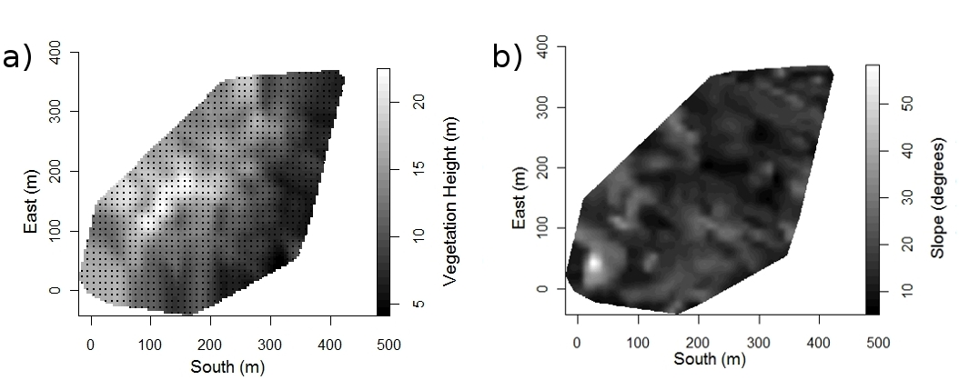
Figure 1.2. (a) vegetation height (m) with the 10m grid used in the logistic regression analysis of gap formation and (b) Slope (degrees) in the Monteverde, Costa Rica study watershed and Axes indicate position in the study area coordinate system. Smoothing of vegetation height and slope was carried out with a Gaussian smoothing kernel with radius r=10 m for display.
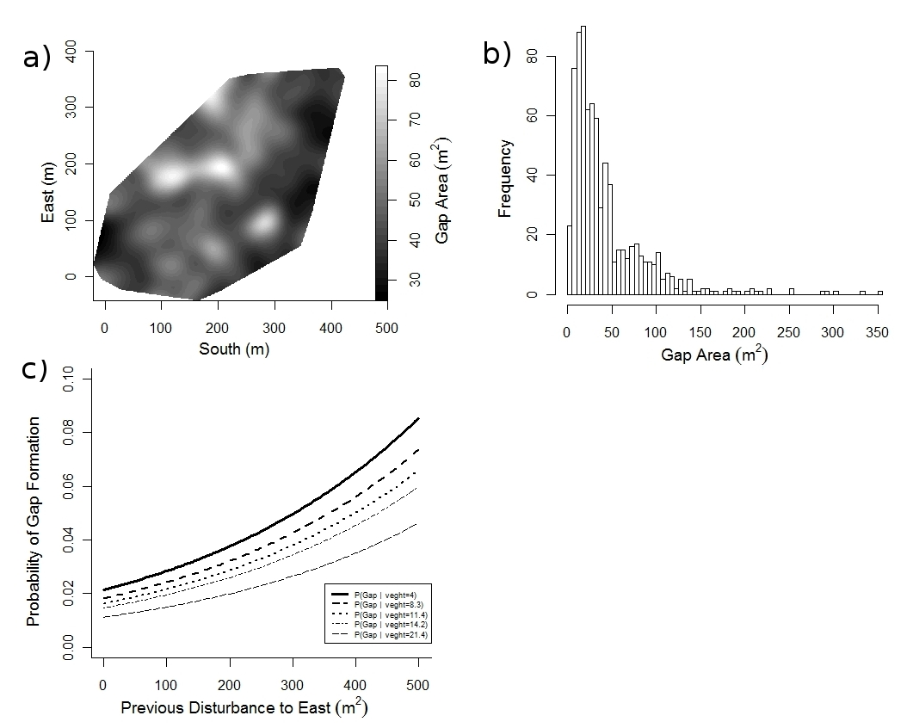
Figure 1.3. (a) Smoothed gap area in the Monteverde, Costa Rica study watershed. Gap area differs significantly between the study area’s leeward slope, ravine bottom, and windward slope (ANOVA, df=2, F=20.047, p<.001). A strong gradient in gap area in this watershed may contribute to this forest’s community structure. Gap area was smoothed using Gaussian kernel smoothing with a kernel radius of 20 m for display. Most observed gaps were small (mean 47.15±55.14 m²) though variation in gap size was substantial and some gaps were as small as 5 m² or as large as ~350m² (b). Risk of gap formation is strongly influenced by both vegetation height and the amount of previous disturbance to the East. (c) Illustrates this relationship for quintiles of vegetation height.
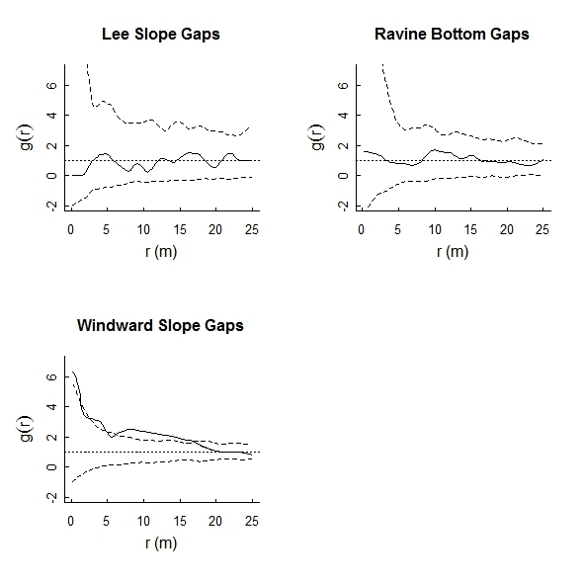
Figure 1.4. Plots of g(r) (solid lines) for gaps on the lee slope, the windward slope, and in the protected bottom of the Monteverde study watershed along with simulation envelopes of 99 simulations of complete spatial randomness (dashed lines). Gaps on the lee slope and in the watershed bottom are randomly dispersed but those on the windward slope have significantly more neighbors within ~17m than expected at random.
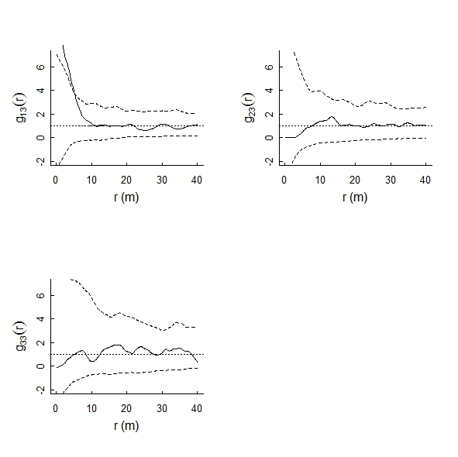
Figure 1.5. Plots of g_{i3}(r) (solid lines) for the windward slope of the Monteverde study watershed along with simulation envelopes of 99 simulations of multitype complete spatial randomness with no interactions among types (dashed lines). g_{i3}(r) yields information about the number of gaps of size class i (i=1 for small gaps and i=2 for intermediate sized gaps) within r meters of gaps of the largest size class (i=3). Large gaps have more neighboring small gaps within ~5m than expected at random. Thus, small gaps in this watershed tend to aggregate around larger gaps.
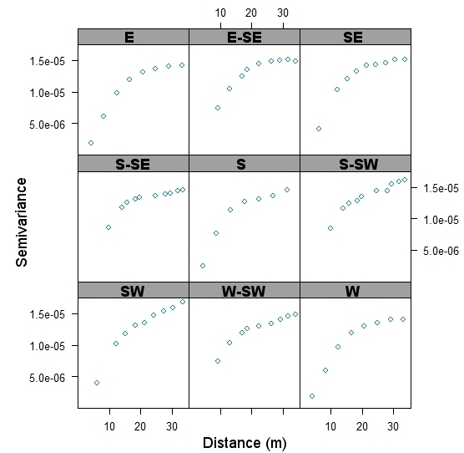
Figure 1.6. Directional variograms of gap density (i.e., number of gaps per m²) in the directions SW and S-SW (which include NE and N-NE respectively by symmetry) do not saturate within 30m whereas those for all other directions have reached their sill within this distance. This indicates that clusters of gaps in the Monteverde study watershed tend to be spread out in the direction of the prevailing winds which come from the NE/N-NE.

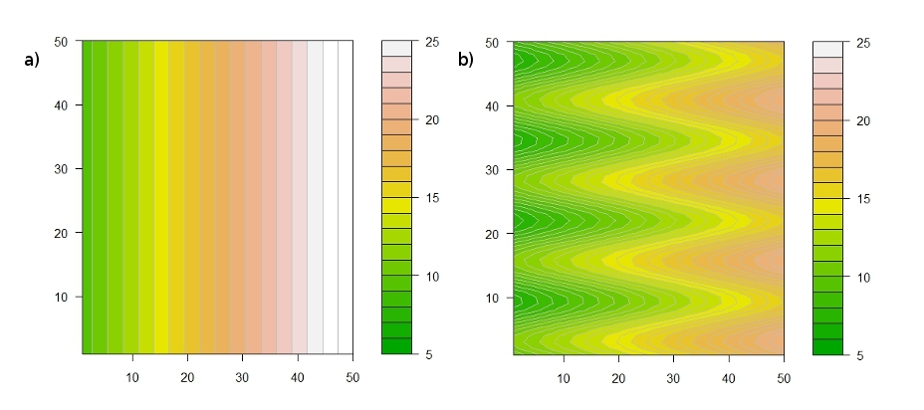
Figure 2.1. The simple gradient (a) and periodic gradient (b) used as terrain for the stochastic cellular automaton simulations. In the model forumlation, locations with smaller terrain values are at greater risk of being disturbed, corresponding to the increased exposure to wind with decreased distance below a mountain’s peak. The periodicity of (b) was introduced to emulate secondary ridges laying orthogonal to a primary ridge.
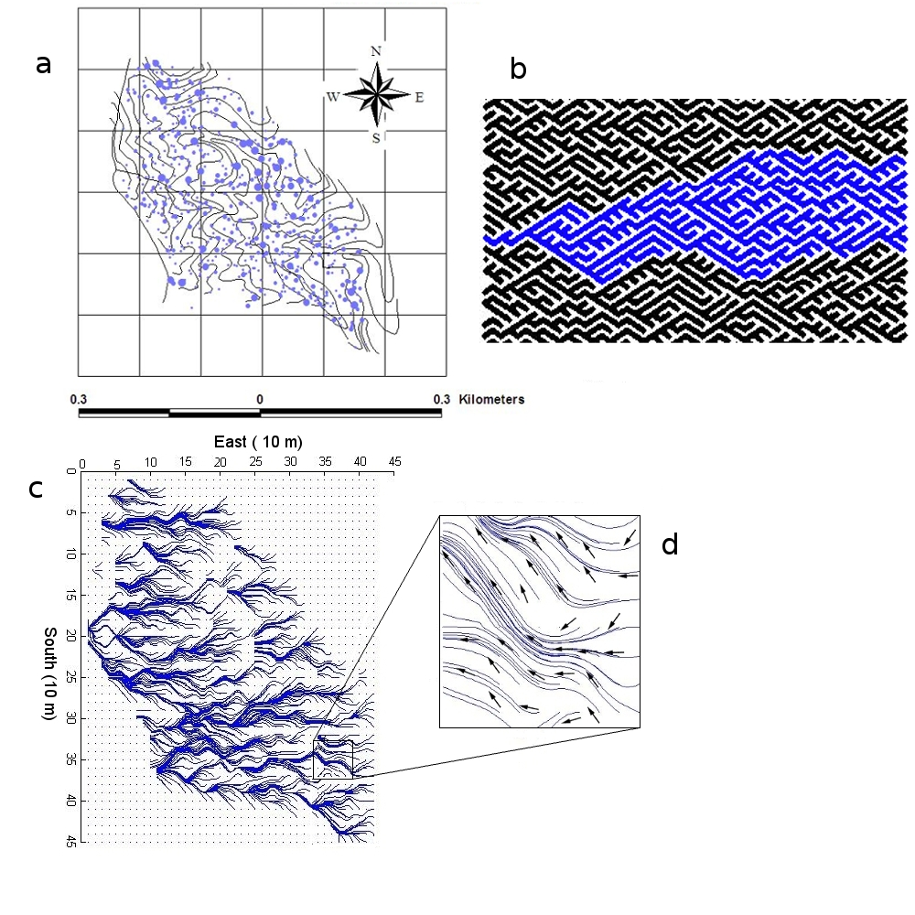
Figure 2.2. (a) The Monteverde, Costa Rica study area with locations of some representative gaps (marker size is a scale from ~12m² – 300m²) and a 1ha grid. Topography is shown by 5 m contour intervals. (b) A simulation of the Scheidegger model of river formation with one river basin highlighted in blue for display. (c) Streamlines of the vector field of gap propagation along with an up-close inset (d) showing some of the vectors in the vector field.
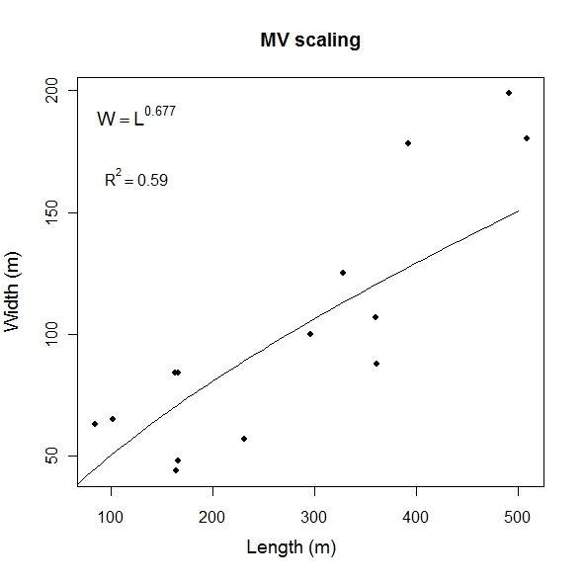
Figure 2.3. The length and width of the “watersheds” of propagating disturbance scales show a strong power law relationship. The scaling exponent of this power law relationship is H = 0.677 which lies between the exponent for the Scheidegger model of river formation (H = 0.5) and those seen in real river networks (H ≈ 0.75-0.8).
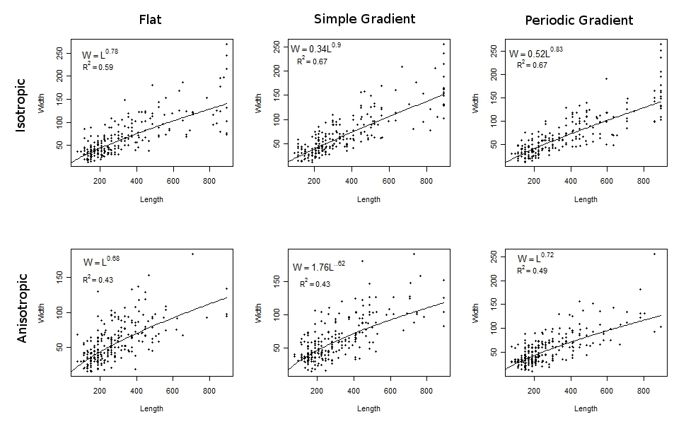
Figure 2.4. In each of the six simulations, width and length of simulated “watersheds” of propagating disturbance display power law relationships. Interestingly, the scaling relationship closest to that observed in the Monteverde study area was occurred in the simulation that incorporated uniform terrain and anisotropic risk of propagation. Simulations such as these should be able to predict the long term pattern of gap propagation for a wide variety of landscapes and degrees of directionally biased stress.
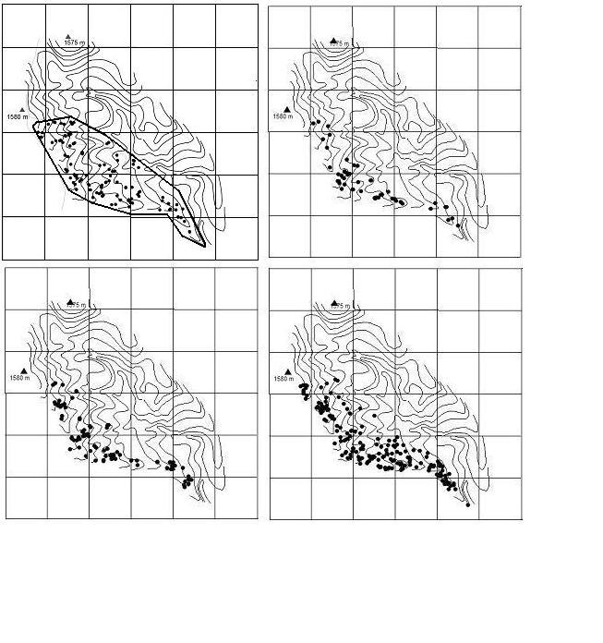
Figure 3.1. Maps of the study area in Monteverde, Costa Rica showing the distributions of D. pittieri saplings (≤5 cm diameter), poles (5 – 10 cm diameter), adults (10 – 20 cm diameter), and large adults (> 20 cm diameter) clockwise from top left. The observation window for spatial analyses is outlined on the map of sapling distribution. Topography is shown by 5 m contour intervals. The grid is 100 m.

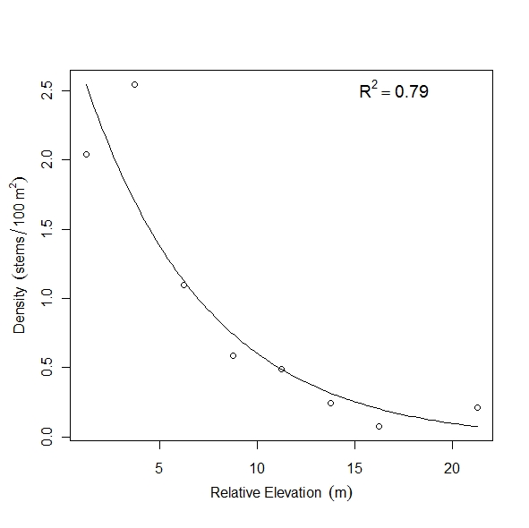
Figure 3.2. D. pittieri in the Monteverde, Costa Rica study watershed display a large scale trend in population density in which density increases with increasing wind exposure. This pattern is born out by a regression of overall D. pittieri density in relative elevation bands on relative elevation (distance below a “roof” over the watershed) describing 79% of the variance in D. pittieri density (F=22.8, df=6, p=.003, R²=.79).
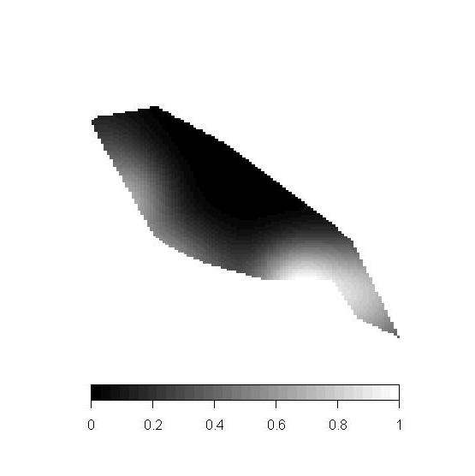
Figure 3.3. The topographic measure of wind exposure RELEV smoothed with a 30m Gaussian smoothing kernel and normalized to have maximum intensity 1 for display purposes. The general trend corresponds to those of the empirical patterns of the D. pittieri size classes in the Monteverde, Costa Rica study watershed.

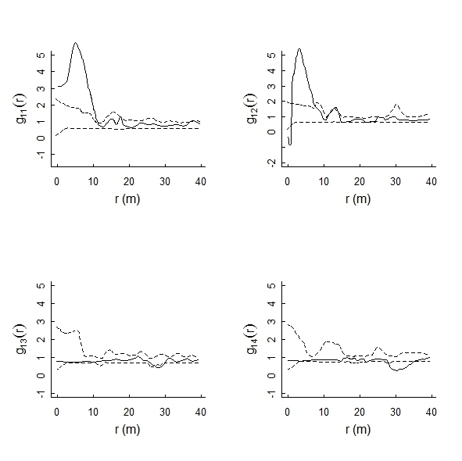
Figure 3.4 g_{1i}(r) showing the departure from expectation in average number of D. pittieri saplings (top left), poles (top right), adults (bottom left), and large trees (bottom right) within r m of any given sapling once the large scale population trend has been taken into account. Dashed lines indicate boundaries of the simulation envelope constructed from 99 simulations of an inhomogeneous Poisson process with inhomogeneity given by RELEV.
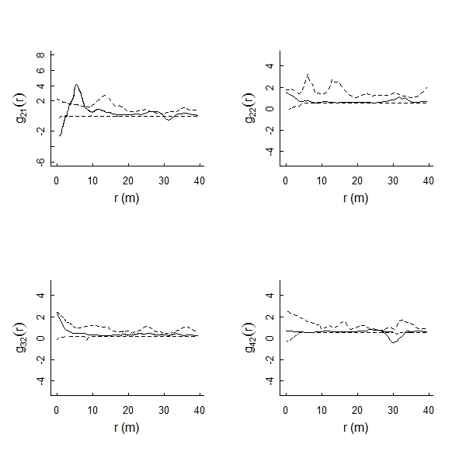
Figure 3.5. g_{2i}(r) showing the departure from expectation in average number of D. pittieri saplings (top left), poles (top right), adults (bottom left), and large trees (bottom right) within r m of any given sapling once the large scale population trend has been taken into account. Dashed lines indicate boundaries of the simulation envelope constructed from 99 simulations of an inhomogeneous Poisson process with inhomogeneity given by RELEV.
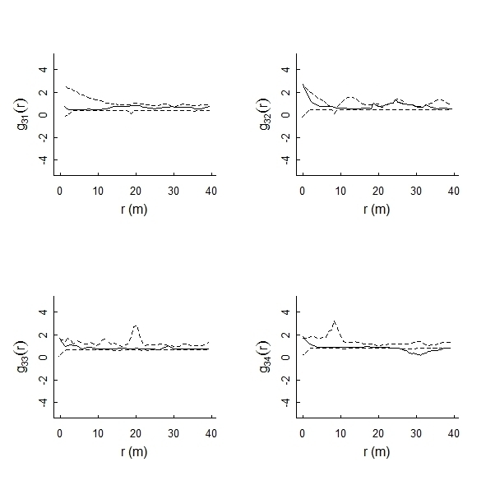
Figure 3.6. g_{3i}(r) showing the departure from expectation in average number of D. pittieri saplings (top left), poles (top right), adults (bottom left), and large trees (bottom right) within r m of any given sapling once the large scale population trend has been taken into account. Dashed lines indicate boundaries of the simulation envelope constructed from 99 simulations of an inhomogeneous Poisson process with inhomogeneity given by RELEV.

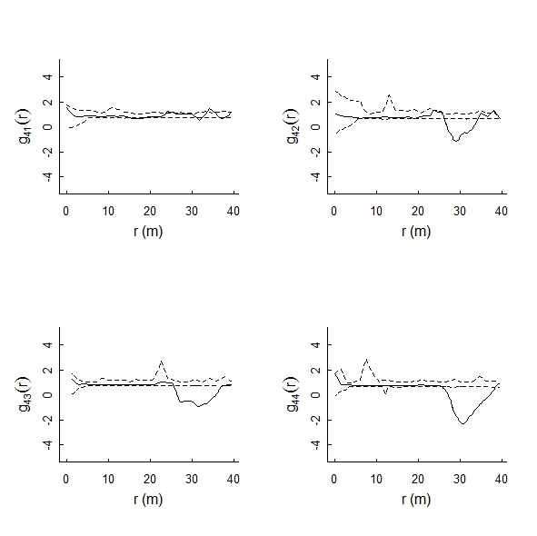
Figure 3.7. g_{4i}(r) showing the departure from expectation in average number of D. pittieri saplings (top left), poles (top right), adults (bottom left), and large trees (bottom right) within r m of any given sapling once the large scale population trend has been taken into account. Dashed lines indicate boundaries of the simulation envelope constructed from 99 simulations of an inhomogeneous Poisson process with inhomogeneity given by RELEV.

APPENDIx B

R code for Gap Model

#Gap CA Script for implementation in R package simecol#
###############################################

#Make the new class from simecol base object

setClass("gridriskModel",
representation(
parms = "list",
init = "list" #init is a list of 4 matrices "gaps", "tau", "dir.matx", and "dir.maty" as well as a point pattern of cell centers
),
contains = "simObj"
)

#Define the model object

gapCA<-new("gridriskModel",
main = function(time, init, parms) {
init<-closure(init,parms)
init<-newgaps(init,parms)
init #sim gives matrix with integers 0<i<closure.age, where 0 = intact site
},
equations = list(
euclid<-function(x){
sqrt(x[1]^2+x[2]^2)
},
mat.euclid<-function(X,Y){ #make matrix of norms of vectors with x & y coords given in matrices X & Y
A<-X
for (i in 1:dim(A)[1]){
for (j in 1:dim(A)[2]){
A[i,j]<-euclid(c(X[i,j],Y[i,j]))
}
}
A
},
is.wholenumber <-function(x, tol = .Machine$double.eps^0.5){
abs(x - round(x)) < tol
},
pos.part<-function(x){
if (x>=0) {tmp<-x}
else tmp<-0
tmp
},
closure<-function(X,parms){
with(parms,{
m<-nrow(X$gaps)
n<-ncol(X$gaps)
X$gaps<-ifelse(X$gaps>=closure.age,0,X$gaps)
dim(X$gaps)<-c(m,n)
X$gaps<-as.matrix(X$gaps)
X
})
},
newgaps<-function(X,parms){
with(parms,{
m<-nrow(X$gaps)
n<-ncol(X$gaps)
tmp1<-ifelse(X$gaps>0,X$gaps+1,X$gaps)
tmp2<-ifelse(X$gaps>0,1,0)
dim(tmp2)<-c(m,n)
tmp2<-as.matrix(tmp2)
nb<-neighbors(tmp2,wdist=parms$W)
nb<-ifelse(X$gaps>0,0,nb)
dim(nb)<-c(m,n)
nb<-50*nb
tmp<-b0*matrix(1,nrow=m,ncol=n)+b1*terrain+b2*nb #linear combo
f<-function(x){1/(1+exp(-x))} #The function
P<-apply(tmp,c(1,2),f) #Changing the P into matrix of p_ij

for (i in 1:m){
for (j in 1:n){
P[i,j]<-rbinom(size=1,n=1,prob=P[i,j])
}
} #P is binary after coin flips 1=newgap 0=nochange
dim(P)<-c(m,n)

X$gaps<-tmp1+P
X$tau<-ifelse(X$gaps==1,0,X$tau+1) #Tau updated to tell time since last disturbed
dim(X$tau)=c(m,n)

#############Calculating the direction vector weightings

for (i in 2:(m-1)){
for (j in 2:(n-1)){
tmp[i,j]<- pos.part((X$tau[i,j]-X$tau[i-1,j-1])) + pos.part((X$tau[i,j]-X$tau[i-1,j]))+ pos.part((X$tau[i,j]-X$tau[i-1,j+1]))
+ pos.part((X$tau[i,j]-X$tau[i,j-1])) + pos.part((X$tau[i,j]-X$tau[i,j+1])) + pos.part((X$tau[i,j]-X$tau[i+1,j-1]))
+ pos.part((X$tau[i,j]-X$tau[i+1,j])) + pos.part((X$tau[i,j]-X$tau[i+1,j+1]))
}
}
for (i in 2:(m-1)){
tmp[i,1]<- pos.part((X$tau[i,1]-X$tau[i-1,1]))+ pos.part((X$tau[i,j]-X$tau[i-1,2]))+ pos.part((X$tau[i,j]-X$tau[i,2]))
+ pos.part((X$tau[i,j]-X$tau[i+1,1]))+ pos.part((X$tau[i,j]-X$tau[i+1,2]))
}

for (i in 2:(m-1)){
tmp[i,n]<- pos.part((X$tau[i,n]-X$tau[i-1,n-1])) + pos.part((X$tau[i,n]-X$tau[i-1,n]))+ pos.part((X$tau[i,n]-X$tau[i,n-1]))
+ pos.part((X$tau[i,n]-X$tau[i+1,n-1])) + pos.part((X$tau[i,n]-X$tau[i+1,n]))
}
for (j in 2:(n-1)){
tmp[1,j]<-pos.part((X$tau[1,j]-X$tau[1,j-1])) + pos.part((X$tau[1,j]-X$tau[1,j+1])) + pos.part((X$tau[1,j]-X$tau[2,j-1]))
+ pos.part((X$tau[1,j]-X$tau[2,j])) + pos.part((X$tau[1,j]-X$tau[2,j+1]))
}
for (j in 2:(n-1)){
tmp[m,j]<-pos.part((X$tau[m,j]-X$tau[m-1,j-1])) + pos.part((X$tau[m,j]-X$tau[m-1,j])) + pos.part((X$tau[m,j]-X$tau[m-1,j+1]))
+ pos.part((X$tau[m,j]-X$tau[m,j-1])) + pos.part((X$tau[m,j]-X$tau[m,j+1]))
}
tmp[1,1]<-pos.part((X$tau[1,1]-X$tau[1,2]))+pos.part((X$tau[1,1]-X$tau[2,1]))+pos.part((X$tau[1,1]-X$tau[2,2]))
tmp[m,1]<-pos.part((X$tau[m,1]-X$tau[m-1,1]))+pos.part((X$tau[m,1]-X$tau[m-1,2]))+pos.part((X$tau[m,1]-X$tau[m,2]))
tmp[1,n]<-pos.part((X$tau[1,n]-X$tau[1,n-1]))+pos.part((X$tau[1,n]-X$tau[2,n-1]))+pos.part((X$tau[1,n]-X$tau[2,n]))
tmp[m,n]<-pos.part((X$tau[m,n]-X$tau[m-1,n-1]))+pos.part((X$tau[m,n]-X$tau[m-1,n]))+pos.part((X$tau[m,n]-X$tau[m,n-1]))

tmp<-ifelse(tmp>0,1/tmp,0)
dim(tmp)<-c(m,n)

#############Calculating the direction vectors
for (i in 2:(m-1)){
for (j in 2:(n-1)){
X$dir.matx[i,j]<- pos.part((X$tau[i,j]-X$tau[i-1,j-1]))*(i-i-1) + pos.part((X$tau[i,j]-X$tau[i-1,j]))*(i-i-1)+ pos.part((X$tau[i,j]-X$tau[i-1,j+1]))*(i-i-1)
+ pos.part((X$tau[i,j]-X$tau[i,j-1]))*(i-i) + pos.part((X$tau[i,j]-X$tau[i,j+1]))*(i-i) + pos.part((X$tau[i,j]-X$tau[i+1,j-1]))*(i-i+1)
+ pos.part((X$tau[i,j]-X$tau[i+1,j]))*(i-i+1) + pos.part((X$tau[i,j]-X$tau[i+1,j+1]))*(i-i+1)

X$dir.maty[i,j]<- pos.part((X$tau[i,j]-X$tau[i-1,j-1]))*(j-j-1) + pos.part((X$tau[i,j]-X$tau[i-1,j]))*(j-j)+ pos.part((X$tau[i,j]-X$tau[i-1,j+1]))*(j-j+1)
+ (X$tau[i,j]-X$tau[i,j-1])*(j-j-1) + (X$tau[i,j]-X$tau[i,j+1])*(j-j+1) + (X$tau[i,j]-X$tau[i+1,j-1])*(j-j-1)
+ pos.part((X$tau[i,j]-X$tau[i+1,j]))*(j-j) + pos.part((X$tau[i,j]-X$tau[i+1,j+1])*(j-j+1))
}
}

for (i in 2:(m-1)){
X$dir.matx[i,1]<- pos.part((X$tau[i,1]-X$tau[i-1,1]))*(i-i-1) + pos.part((X$tau[i,j]-X$tau[i-1,2]))*(i-i-1)+ pos.part((X$tau[i,j]-X$tau[i,2]))*(i-i)
+ pos.part((X$tau[i,j]-X$tau[i+1,1]))*(i-i+1) + pos.part((X$tau[i,j]-X$tau[i+1,2]))*(i-i+1)
X$dir.maty[i,1]<- pos.part(X$tau[i,1]-X$tau[i-1,1])*(1-1) + pos.part((X$tau[i,j]-X$tau[i-1,2]))*(1-2)+ pos.part((X$tau[i,j]-X$tau[i,2]))*(1-2)
+ pos.part((X$tau[i,j]-X$tau[i+1,1]))*(1-1) + pos.part((X$tau[i,j]-X$tau[i+1,2]))*(1-2)
}

for (i in 2:(m-1)){
X$dir.matx[i,n]<- pos.part((X$tau[i,n]-X$tau[i-1,n-1]))*(i-i-1) + pos.part((X$tau[i,n]-X$tau[i-1,n]))*(i-i-1)+ pos.part((X$tau[i,n]-X$tau[i,n-1]))*(i-i)
+ pos.part((X$tau[i,n]-X$tau[i+1,n-1]))*(i-i+1) + pos.part((X$tau[i,n]-X$tau[i+1,n]))*(i-i+1)
X$dir.maty[i,n]<- pos.part((X$tau[i,n]-X$tau[i-1,n-1]))*(n-n-1) + pos.part((X$tau[i,n]-X$tau[i-1,n]))*(n-n)+ pos.part((X$tau[i,n]-X$tau[i,n-1]))*(n-n-1)
+ pos.part(X$tau[i,n]-X$tau[i+1,n-1])*(n-n-1) + pos.part((X$tau[i,n]-X$tau[i+1,n]))*(n-n)
}
for (i in 2:(m-1)){
X$dir.matx[i,n]<- pos.part((X$tau[i,n]-X$tau[i-1,n-1]))*(i-i-1) + pos.part((X$tau[i,n]-X$tau[i-1,n]))*(i-i-1)+ pos.part((X$tau[i,n]-X$tau[i,n-1]))*(i-i)
+ pos.part((X$tau[i,n]-X$tau[i+1,n-1]))*(i-i+1) + pos.part((X$tau[i,n]-X$tau[i+1,n]))*(i-i+1)
X$dir.maty[i,n]<- pos.part((X$tau[i,n]-X$tau[i-1,n-1]))*(n-n-1) + pos.part((X$tau[i,n]-X$tau[i-1,n]))*(n-n)+pos.part((X$tau[i,n]-X$tau[i,n-1]))*(n-n-1)
+ pos.part((X$tau[i,n]-X$tau[i+1,n-1]))*(n-n-1) + pos.part((X$tau[i,n]-X$tau[i+1,n]))*(n-n)
}
for (j in 2:(n-1)){
X$dir.matx[1,j]<-pos.part((X$tau[1,j]-X$tau[1,j-1]))*(1-1) + pos.part((X$tau[1,j]-X$tau[1,j+1]))*(1-1)+pos.part((X$tau[1,j]-X$tau[2,j-1]))*(1-2)
+ pos.part((X$tau[1,j]-X$tau[2,j]))*(1-2) + pos.part((X$tau[1,j]-X$tau[2,j+1]))*(1-2)
X$dir.maty[1,j]<-pos.part((X$tau[1,j]-X$tau[1,j-1]))*(j-j-1) + pos.part((X$tau[1,j]-X$tau[1,j+1]))*(j-j+1)+pos.part((X$tau[1,j]-X$tau[2,j-1]))*(j-j-1)
+ pos.part((X$tau[1,j]-X$tau[2,j]))*(j-j) + pos.part((X$tau[1,j]-X$tau[2,j+1]))*(j-j+1)
}
for (j in 2:(n-1)){
X$dir.matx[m,j]<-pos.part((X$tau[m,j]-X$tau[m-1,j-1]))*(m-m-1) + pos.part((X$tau[m,j]-X$tau[m-1,j]))*(m-m-1)+pos.part((X$tau[m,j]-X$tau[m-1,j+1]))*(m-m-1)
+ pos.part((X$tau[m,j]-X$tau[m,j-1]))*(m-m) + pos.part((X$tau[m,j]-X$tau[m,j+1]))*(m-m)
X$dir.maty[m,j]<-pos.part((X$tau[m,j]-X$tau[m-1,j-1]))*(j-j-1) + pos.part((X$tau[m,j]-X$tau[m-1,j]))*(j-j)+pos.part((X$tau[m,j]-X$tau[m-1,j+1]))*(j-j+1)
+ pos.part((X$tau[m,j]-X$tau[m,j-1]))*(j-j-1) + pos.part((X$tau[m,j]-X$tau[m,j+1]))*(j-j+1)
}
X$dir.matx[1,1]<-pos.part((X$tau[1,1]-X$tau[1,2]))*(1-1)+pos.part((X$tau[1,1]-X$tau[2,1]))*(1-2)+pos.part((X$tau[1,1]-X$tau[2,2]))*(1-2)
X$dir.maty[1,1]<-pos.part((X$tau[1,1]-X$tau[1,2]))*(1-2)+pos.part((X$tau[1,1]-X$tau[2,1]))*(1-1)+pos.part((X$tau[1,1]-X$tau[2,2]))*(1-2)
X$dir.matx[m,1]<-pos.part((X$tau[m,1]-X$tau[m-1,1]))*(m-m-1)+pos.part((X$tau[m,1]-X$tau[m-1,2]))*(m-m-1)+pos.part((X$tau[m,1]-X$tau[m,2]))*(m-m)
X$dir.maty[m,1]<-pos.part((X$tau[m,1]-X$tau[m-1,1]))*(1-1)+pos.part((X$tau[m,1]-X$tau[m-1,2]))*(1-2)+pos.part((X$tau[m,1]-X$tau[m,2]))*(1-2)
X$dir.matx[1,n]<-pos.part((X$tau[1,n]-X$tau[1,n-1]))*(1-1)+pos.part((X$tau[1,n]-X$tau[2,n-1]))*(1-2)+pos.part((X$tau[1,n]-X$tau[2,n]))*(1-2)
X$dir.maty[1,n]<-pos.part((X$tau[1,n]-X$tau[1,n-1]))*(n-n-1)+pos.part((X$tau[1,n]-X$tau[2,n-1]))*(n-n-1)+pos.part((X$tau[1,n]-X$tau[2,n]))*(n-n)
X$dir.matx[m,n]<-pos.part((X$tau[m,n]-X$tau[m-1,n-1]))*(m-m-1)+pos.part((X$tau[m,n]-X$tau[m-1,n]))*(m-m-1)+pos.part((X$tau[m,n]-X$tau[m,n-1]))*(m-m)
X$dir.maty[m,n]<-pos.part((X$tau[m,n]-X$tau[m-1,n-1]))*(n-n-1)+pos.part((X$tau[m,n]-X$tau[m-1,n]))*(n-n)+pos.part((X$tau[m,n]-X$tau[m,n-1]))*(n-n-1)

X$dir.matx<-tmp*X$dir.matx
X$dir.maty<-tmp*X$dir.maty

X #output gaps should have ages of gaps updated

})
}
),
parms = list(
closure.age = 10,
b0 = -3.6718, #model intercept
b1 = -0.0375, #strength of terrain influence on risk
b2 = 0.0029 , #strength of influence of previous disturbance on risk
W = matrix(c(1,0,0,0,0,
1,1,0,0,0,
1,1,1,0,0,
1,1,0,0,0,
1,0,0,0,0),nrow=5,byrow=T),

terrain=matrix(15,nrow=50,ncol=50)
),
init = vector("list",4),
times = c(from=0,to=100,by=1),
solver = "iteration",
observer = function(X){
require(spatstat)
Sys.sleep(.5)
#layout(matrix(c(1,2,3,0),nrow=2,ncol=2,byrow=T))
m<-dim(X$gaps)[1]
n<-dim(X$gaps)[2]

image(X$gaps, col = heat.colors(100), axes = FALSE,new=T,main="" )

gridpts<-gridcentres(nx=dim(X$gaps)[1],ny=dim(X$gaps)[2],window=owin(c(0,1),c(0,1)))
#points(gridpts,cex=.5,pch=19)
write.csv(t(X$dir.matx),file="dirmatx.csv")
write.csv(t(X$dir.maty),file="dirmaty.csv")
#Plotting the arrows

x0<-gridpts$x
y0<-gridpts$y

x1<-as.vector(X$dir.matx)
y1<-as.vector(X$dir.maty)

#maxlen <- min(diff(x1), diff(y1)) * .9
#x1<-x1/max(x1)*maxlen
#y1<-y1/max(y1)*maxlen

x1<-x0+x1
y1<-y0+y1
lens<-X$dir.matx
for (i in 1:m){
for (j in 1:n){
lens[i,j]<-euclid(c(X$dir.matx[i,j],X$dir.maty[i,j]))
}
}
par.uin <- function(){
# determine scale of inches/userunits in x and y
u <- par("usr")
p <- par("pin")
c(p[1]/(u[2] - u[1]), p[2]/(u[4] - u[3]))
}
s<-seq(from=1,to=length(x0)-1,by=5)

if (m==n){
divs<-c(1:m)
for (i in 1:m){
divs[i]<-m/(2*i+1)
}
divs<-2*(which(is.wholenumber(divs)))+1
ndiv<-length(divs)
An<-vector("list",ndiv+1)

An[[ndiv+1]]<-divs
for (i in 1:length(divs)){
nn<-divs[i]
WW<-matrix(1,nrow=nn,ncol=nn)
tmpx<-neighbors(X$dir.matx,wdist=WW)
tmpy<-neighbors(X$dir.maty,wdist=WW) #The Sum_(i in An) [P_i(t)]'s
dim(tmpx)<-c(m,m)
dim(tmpy)<-c(m,m)
tmpx<-(1/nn^2)*(mat.euclid(tmpx,tmpy))^2 #The weighted and squared norms
An[[i]]<-mean(tmpx)

}
}
print(An)
}

)

#Observer Funcitons
#only the movie
obs.mov = function(X){
Sys.sleep(.5)
image(X$gaps, col = heat.colors(100), axes = FALSE,new=T,main="" )
}

#the movie and the An's
obs.An = function(X){
m<-dim(X$gaps)[1]
n<-dim(X$gaps)[2]
Sys.sleep(.5)
image(X$gaps, col = heat.colors(100), axes = FALSE,new=T,main=""
if (m==n){
divs<-c(1:m)
for (i in 1:m){
divs[i]<-m/(2*i+1)
}
divs<-2*(which(is.wholenumber(divs)))+1
ndiv<-length(divs)
An<-vector("list",ndiv+1)

An[[ndiv+1]]<-divs
for (i in 1:length(divs)){
nn<-divs[i]
WW<-matrix(1,nrow=nn,ncol=nn)
tmpx<-neighbors(X$dir.matx,wdist=WW)
tmpy<-neighbors(X$dir.maty,wdist=WW) #The Sum_(i in An) [P_i(t)]'s
dim(tmpx)<-c(m,m)
dim(tmpy)<-c(m,m)
tmpx<-(1/nn^2)*(mat.euclid(tmpx,tmpy))^2 #The weighted and squared norms
An[[i]]<-mean(tmpx)

}
}
print(An)
}

#only the arrows
obs.dirs = function(X){
Sys.sleep(.5)
#layout(matrix(c(1,2,3,0),nrow=2,ncol=2,byrow=T))
m<-dim(X$gaps)[1]
n<-dim(X$gaps)[2]

#image(X$gaps, col = heat.colors(100), axes = FALSE,new=T,main="" )

tmp<-matrix(1,nrow=m,ncol=n)
tmp<-as.owin(im(tmp))
tmpx<-as.vector(raster.x(tmp))
tmpy<-as.vector(raster.y(tmp))

x0<-tmpx
y0<-tmpy

x1<-as.vector(X$dir.matx)
y1<-as.vector(X$dir.maty)

lens<-X$dir.matx
for (i in 1:m){
for (j in 1:n){
lens[i,j]<-euclid(c(X$dir.matx[i,j],X$dir.maty[i,j]))
}
}

x1<-x1/max(lens)
y1<-y1/max(lens)

x1<-x0+x1
y1<-y0+y1

par.uin <- function(){
# determine scale of inches/userunits in x and y
u <- par("usr")
p <- par("pin")
c(p[1]/(u[2] - u[1]), p[2]/(u[4] - u[3]))
}
s<-seq(from=1,to=length(x0)-1,by=2)

# hist(lens,20,main="Distribution of ||p(t)||")

write.csv(t(X$dir.matx),file="dirmatx.csv")
write.csv(t(X$dir.maty),file="dirmaty.csv")

plot(1, type="n", axes=T,xlim=c(0,50),ylim=c(0,50), xlab="", ylab="",main=expression(The~p[i](t)))
arrows(
x0 = x1[s],
x1 = x0[s],
y0 = y1[s],
y1 = y0[s],
length = .05)
}

obs.matlab<-function(X,time){
if (time==50){
write.csv(t(X$dir.matx),file="dirmatx.csv")
write.csv(t(X$dir.maty),file="dirmaty.csv")
}
}
Vita

Robert M. Lawton was born in Chicago, IL on July 20, 1980 but was raised in Huntsville, AL and Monteverde, Costa Rica. He graduated from Auburn University in 2002 as a University Honors Scholar with a Bachelor of Science in Mathematics. He received a Master of Science in Mathematics from Tulane University in 2005. After a brief stint at the University of Alabama at Birmingham studying the dynamics of iterated maps on complex manifolds he remembered that he liked forests. He then started his doctoral work at the University of Tennessee, Knoxville in 2006 where he worked in James Drake’s lab. In the summer of 2010 he received his PhD in Ecology and Evolutionary biology with a concentration in mathematical ecology.

