Examining if a candidate’s presence on Facebook and Twitter creates favorable public opinion and is a predictor of vote share in city council elections

A Thesis Presented for the
Master of Science
Degree
The University of Tennessee, Knoxville

Pranaav Jadhav
May 2023

Copyright © 2022 by Pranaav Jadhav.
All rights reserved.

DEDICATION
I would like to dedicate this thesis to Late Shrimati Aasharani Vasantrao Jadhav, my grandmother who fought and won local elections, served as an elected member of Zilla Parishad (District Council) and made use of the local legislative process for the benefit of her people in Dudhondi and surrounding villages in Maharashtra, India.

ACKNOWLEDGEMENTS
Sashtaanga namaskar to my life’s gurus and places of worship: Chhatrapati Shivaji Maharaj, Swantantryaveer Vinayak Damodar Savarkar, the holy river Narmada and Shree Sant Gajanan Maharaj.
I would like to thank the UTK School of Journalism and Electronic Media, Prof Stuart Brotman for serving as my research guru through my time at UTK and Dr Beth Foster for her graciousness in agreeing to serve on my committee. Dr Nick Geidner has been a rock of support and I thank him for the invaluable, once-in-a-lifetime opportunities, and trust he’s shown in me since August 2021. Thank you Adam Brimer for hiring me as a Graduate Teaching Assistant, and Dan Nugent for making Knoxville feel like home.
I'm eternally grateful to Aparna, my wife, whose love and support were instrumental in this post-graduate journey. Thank you Aparna for shouldering the bigger share of responsibilities and adjusting to a place far away from home with a unique set of challenges. I promise we'll settle down soon in the second-best city in the world: Mumbai. My deepest gratitude to my parents, Shailaja and Vikas who prioritize education over everything else, my maternal grandfather (Vasant Jagdale) for his blessings and Chavans, my in-laws (Anandrao, Meenakshi and Deepak) for their unconditional love and gracious support. I'd also like to thank my uncle Pradip Jadhav for his blessings and my uncle Prafullakumar Jadhav for nurturing political curiosity in me and serving as a mentor of Civics. Thank you, Bruno, my 2.5-year-old Labrador for making the biggest sacrifice of living without me. I miss you every day!

ABSTRACT
Although a considerable amount of research has proved that the use of social media by candidates fighting national elections has resulted in success, like the Obama campaign of 2008 (Hughes et al., 2010) and the Trump campaign of 2016 (Williams et al., 2018) it is still unclear whether the use of social media by candidates has any impact on local city council elections in the U.S. Focusing on the 2021 Knoxville City Council election, this study investigates whether candidates that had a social media presence, posted on social media more frequently than their opponent in the four weeks before Election Day and allocated more funds to running campaign ads on social media ended up winning the race. Furthermore, it also examines public opinion about political ads on social media, social media effectiveness and candidate interaction through social media.
The results from secondary data accessed from the Knox County Election Commission office and social media showed that candidates with social media profiles on Facebook and Twitter, a higher number of social media followers and more frequent posts on Facebook and Twitter were successful in the 2021 Knoxville city council elections. However, higher spending on social media ads wasn't necessarily correlated to electoral success. Two candidates with lesser followers and lesser social media posts who spent more on running ads lost the election.
The survey findings (n=14) also indicated that voters felt “very fatigued” after consuming political social media ads and the general perception was negative. However, respondents were positive when it came to using social media as a tool to share information and solve civic issues in the city. Previous research (Krebs 1998) has stated that incumbency, party support and campaign spending were determinants in city council elections; this study extended those findings to add social media usage by candidates as an important element in predicting electoral success at the city council level.

Keywords: social media and city council elections, local elections campaigning, political campaigns on Facebook, city council research

TABLE OF CONTENTS

CHAPTER ONE INTRODUCTION AND RESEARCH AIM………………………..1

CHAPTER TWO LITERATURE REVIEW………………………………………………5

Second most social media obsessed state…………………………………….6
Traditional determinants in city council elections……………………….10
Four weeks before Election Day…………………………………………………11
City Council elections and social media around the world…………….13
Research Gap…………………………………………………………………………..14

CHAPTER THREE METHODOLOGY…………………………………………………..16

Rationale…………………………………………………………………………………19

CHAPTER FOUR RESULTS AND DISCUSSION……………………………………21

Election and social media data………………………………………………….21
Secondary data research outcomes……………………………………………36
Survey findings data………………………………………………………………..43
Survey data research outcomes…………………………………………………54

CHAPTER FIVE CONCLUSION, LIMITATIONS, RECOMMENDATIONS..57

Discussion and Conclusion……………………………………………………………….57
Limitations……………………………………………………………………………………..60
Future research recommendations……………………………………………………61

APPENDIX………………………………………………………………………………………73

Appendix A……………………………………………………………………………..73
Appendix B……………………………………………………………………………..74
Appendix C……………………………………………………………………………..77

VITA……………………………………………………………………………………………….78

LIST OF TABLES
Table 1.1: The 2021 City of Knoxville Regular Election result obtained from the Knox County Election Commission………………………………………………18

Table 2.1 District 1 result and social media details of candidates………….24

Table 2.2 District 2 result and social media details of candidates………….27
Table 2.3 District 3 result and social media details of candidates…………30
Table 2.4 District 4 result and social media details of candidates………….33
Table 2.5 District 6 result and social media details of candidates………….3s

LIST OF FIGURES
Figure 3.1 Public opinion about a city council candidate who has a social media profile…………………………………………………………………………………...46
Figure 3.2 Most effective social media website that a city council candidate must make use of during his election campaign…………………………………..47
Figure 3.3 Public opinion about a city council candidate who interacts with constituents using social media………………………………………………………….48
Figure 3.4 Do you agree or disagree? Local governance can be improved with citizen input using social media…………………………………………………..49
Figure 3.5 Public opinion about social media activeness……………………….50
Figure 3.6 Public opinion about political ads on social media………………..51
Figure 3.7 Measuring fatigue level after consuming political ads……………52
Figure 3.8 Public opinion about social media’s use to stimulate attendance for a city council meeting……………………………………………………………………5

CHAPTER ONE

INTRODUCTION AND RESEARCH AIM

The first social media platform was launched in May 1996, called SixDegrees with a few hundred users in the first year. (Ngak, 2011). Today, there are around 4.96 billion social media users around the world, and the number is set to grow to almost six billion in 2027 (Statista, 2022). As a result of this growth, social media is widely used as an important communication tool for persuasion in advertising, and politics. In 2020, despite the pandemic, a total of $40 billion were spent on buying ads on social media (Statista, 2021). Despite their talk of citizen engagement, most politicians use social media as means of distributing information (one-way flow) and to make themselves both visible and ‘hip’ to the public (Ross, Burger et al. 2014). Since social media is generating enormous revenue, it becomes imperative to study the effects and adversities of the medium through the lens of social science. Scholars should not only study how platforms function for political actors; but should also study how platforms function as political actors (Bossetta, 2020). In recent election outcomes across the world, social media buzz has positively helped candidates succeed and win elections (Saifullah et al. 2017), this study aims to examine the existence of a correlation between social media usage of candidates in the four weeks before Election Day and the vote share they received in the 2021 Knoxville’s city council race.
For this research, five city council races in Knoxville have been selected from the last election cycle (November 2021) where 10 candidates were in a political fray. Because of its history, culture, demographic composition and population (~200,000), Knoxville is a resourceful place to study city council races. The Knoxville City Council is composed of nine members of which six are elected from the districts and three are elected “at-large” representing the entire city. The vice mayor is selected by the city council among them for a two-year term while each council member is elected to serve a four-year term ( City of Knoxville, 2023).
In a study conducted by Hennessey Digital in April 2022, it was found that Tennessee is the second most social media-obsessed state in the country. In addition to that, the agency also found in its research that Facebook and Twitter are the most popular social media websites in Tennessee (Flessner, 2022). The purposeful choice of selecting the last election over others in the past are factors including recency and availability of data on social media and at the Knox County Election Commission office. A Pew research center survey conducted in 2019 found that 18% of Americans get their political news from social media, and 48% of those are under the age of 30. The last extensive research conducted on city council elections was done by Krebs in 1998, who used regression models to determine whether incumbency, number of opponents, newspaper endorsements and campaign spending are significant predictors of a candidate’s vote share (Krebs, 1998). Today, city council races have retained these traditional methods of campaigning but have also largely relied on social media, particularly Facebook and Twitter to get the word out, and that is why it is important to analyze the effectiveness of these tools and examine whether they have a positive correlation with a candidate’s vote share. Facebook and Twitter have contributed to changing media ecologies and opened new ways and forms of communication between citizens and their representatives (Krumsvik et al., 2014). This study looks at candidates who adopted digital communication strategies using Facebook and Twitter to engage with their followers in the month before Election Day.
The study will analyze social media posts from four weeks before Election Day because eight per cent of registered voters in the United States tend to change their minds in the month preceding an election and the number drops to four per cent by Election Day (Blais, 2004). The margin of victory in the past three presidential elections has been less than five per cent, (Biden vs Trump) 4.5%, (Trump vs Hillary) 2.1%, (Obama vs Romney) 3.9%. Therefore, the last month before Election Day is significant for any election campaign, national or local. In local races, the margin of victories is sometimes only a few hundred to a few thousand votes (See Table 1.1). Overall, the margin of victories in the 2021 Knoxville City Council was less than 3137 votes.
In summation, this study aims to examine the importance of using social media as a tool for persuasion and election campaigning at the local city council level. There is extensive literature available studying social media and its correlation with election outcomes, however, they are designed more towards national elections, particularly the presidential races. This study aims to add to the existing literature, however, with a focus on local government and city council races finding whether candidates who use social media four weeks before Election Day have an advantage over those who don't, in addition to seeking public opinion on the topic through a Qualtrics-based survey. On a national level, candidates have the financial freedom and team to handle their social media accounts and build a strategy, however, this study will help local candidates with limited spending capacity to determine and derive an effective social media strategy for their local races. But, the primary aim is to investigate whether social media is associated with electoral votes and the probability of election success.
The archival data made available through the Knox County Election Commission office (e.g. campaign financial disclosures) will provide insight into how much candidates spent through the election cycle in sponsoring ads on social media and whether more spending leads to higher chances of winning the local city council race.

CHAPTER TWO

LITERATURE REVIEW

Social Media as a tool for campaigns
The late 90s saw the invention of social media, however, it was for the first time used as a tool to spread political messages and develop ground-based support and gather volunteers for the presidential campaign in 2007-2008 by Senator Barack Obama (Hughes et al., 2010). The study discussed some of the numbers and strategies used by the Obama campaign in their 2009 paper titled, "Obama and the power of social media and technology."
“Obama’s campaign was able to garner 5 million supporters on 15 different social networks ranging from Facebook to MySpace. By November 2008, Obama had approximately 2.5 million (some sources say as much as 3.2 million) Facebook supporters, outperforming Republican opponent John McCain by nearly four times. In terms of Twitter, Obama had over 115,000 followers, more than 23 times those of John McCain. In terms of YouTube followers and clips, people spent 14 million hours watching campaign-related Obama videos on YouTube with 50 million viewers total. That was four times McCain’s YouTube viewers (Hughes et al., 2010).”
The Obama campaign made a difference in 2007-08 when the total number of users on Facebook was 200 million (TechCrunch) and 25 per cent of all American adults were using at least one social networking site. The result of that election is a testimony of a successfully-run campaign where Senator Obama won the popular vote for the presidency by 7 percent at 52.9% and also won 365 electoral college votes to be elected president. Members of the largest political party in Norway, the Labour Party, visited Obama 2008 campaign staffers for training and skill development regarding social media (Karlsen, 2013). Today, American adults who say they use at least one social networking site have shot up to 72 per cent (Pew Research, 2021) making this study focused on local elections extremely relevant. Due to this, social media has become an important tool for interpersonal communication - the mobile phone has created a social situation whereby people are getting used to avoiding person-to-person communication by switching over to mobile (Subramanian, 2017). One of the biggest advantages of social media for a candidate seeking public office is the dispersion of his messages instantly and to a large audience.
The 2016 U.S. presidential race between Hillary Clinton and Donald Trump introduced two new strategies to use social media for political campaigns.
“While the Clinton campaign’s strategy confirms theories regarding the professionalization of election campaigns, the Trump campaign’s more amateurish yet authentic style in social media points towards de-professionalization and even amateurism as a counter-trend in political communication (Enli, 2017).”

Second most social media-obsessed state
The state of Tennessee is an ideal place to study social media since it ranked second among the most social media-obsessed states in the United States (Hennessey, 2022). The agency that conducted the research also found that Facebook and Twitter were the most popular websites in Tennessee (Flessner, 2021). Therefore, it is important to study the impact these two social media websites have on city council elections in Tennessee. A Pew research study conducted in 2016 found that 62% of adults get their news from social media which was a 13% increase since the previous study conducted in 2013. The study also found that most of the news is consumed through Reddit, Facebook and Twitter (Gottfried and Shearer, 2016). However, an analysis to study if the same percentage of U.S. adults consume campaign information through social media for local elections has not been conducted yet.

Media Ecology Theory (MET)
In relevance to this study, it is important to assess the Media Ecology Theory (MET) developed by Marshall McLuhan in 1964 and updated by Neil Postman in 1979. McLuhan introduced the theory to understand the social impact of technology and communication.
“The influence of media technology on society is the main concept of MET, upheld by three main assumptions: media is infused into every act and action in society, media fixes our perceptions and organizes our experiences, and media ties the world together. We cannot escape the media presence in our lives as it is ubiquitous in our realities of day-to-day life (Moreno and Koff, 2016).”
The three assumptions of the theory in turn suggest that you cannot ignore the media and that it is omnipresent. The media is powerful and helps develop our perception of certain events, people and things. Lastly, the media has connected the world and turned it into a global village - this especially relates to social media conclusively where researchers found that social media tools have been used in the process of democratization and globalization ( Tarman and Yigit, 2013). In the early days of social media, researchers looked at whether using social media features such as chat had a positive impact on social ties and they found a significant correlation (Zhao, 2006).
"Different groups of Internet users have different sizes of network connections. Compared to nonusers, social users of the Internet have more social ties, and nonsocial users of the Internet have fewer social ties. Among social users, chat users have more social ties than email users do (Zhao, 2006)."
Research has shown that concepts of media ecology, proposed by Postman and McLuhan in 1979 are still the observation line to understand new forms of media such as social media and the mediatic contemporary society (Velásquez, 2018).

Benefits of using social media for campaigns
Research has shown that Twitter has become an effective tool of persuasion in election campaigns (Jungherr, 2015) and politicians with urban constituencies appear to be more likely to use Twitter than those with rural ones (Straus et al., 2013). In the 111th Congress, a total of 313 Congressmen and 62 Senators had a Twitter account (Straus et al., 2013), however, that number has now jumped to 440 Congressmen and 100 Senators (Libguides, 2013). Therefore, it is safe to assume that politicians at a national level use Twitter and social media to communicate with the media or constituents.
“Social media provides a new avenue for members of Congress who want to control their public message, reach a national audience, or develop routine contact with an attentive public (Straus et al., 2013).”
City Council elections often see lesser turnout if the mayoral race is not on the ballot, or if the election is standalone and not coupled with the presidential election or national primaries. According to research presented by the National Civic League, a person above 65 is seven times more likely to vote in local city council elections than someone between the ages of 18-34. The median age of local election voters is in the 60s, with the average in cities such as Miami, Las Vegas and Fort Worth as high as 66-68 years old (Brennan, 2020). A study however revealed a positive relation between particular forms of political internet use (PIU) on the one hand and voter turnout and political interest on the other hand (Kruikemeier, 2013).
Those who are more interested in politics, who are younger, and who use online news more often are more likely to be politically active online (Kruikemeier, 2013).”
Even though city council elections attract older age groups to the ballot box and more young voters use social media, the results of this study will provide some interesting trends. Another important benefit of social media is that it can be used as a tool to humanize candidates and build a connection with voters that goes beyond politics and gives insight into the personal lives of candidates.
Democratic presidential contender Pete Buttigieg introduced his shelter dogs to his 2 million Twitter followers, while U.S. Sen. Elizabeth Warren used her Instagram account to chat live with supporters who made small contributions to her presidential campaign (Yildrim, 2020)

Traditional determinants of vote share in local elections
In a study conducted in 1998 studying the "Determinants of candidates' vote share in city council elections," it was found that incumbency, campaign spending, and party organization support were the most important predictors of candidates' vote share. (Krebs, 1998).
In addition to those three factors, endorsements from local newspapers and the race or ethnicity of candidates also influenced the elections.
“Incumbency status exerts a significant and positive effect on candidates' share of the vote. In each election year, incumbency produces an increase in these candidates' vote share of over 20 per- centage points, significant at the .001 level (Krebs, 1998).”
Krebs’ conclusion was based on a regression analysis of 631 candidates in the Chicago City Council elections between 1979 and 1995. The determinants Krebs (1998) found in his study are still relevant today, however, with an important and effective addition of the social media factor which was successfully used by Obama's campaign in 2008 (Hughes et al., 2010). According to research presented by the National Civic League, a person above 65 is seven times more likely to vote in local city council elections than someone between the ages of 18-34. The median age of local election voters is in the 60s, with the average in cities such as Miami, Las Vegas and Fort Worth as high as 66-68 years old (Brennan, 2020). Research has shown in the past that there is a high chance of incumbents retaining their office (Krebs, 1998) (Prewitt, 1970), however, in today’s times that cannot be the standalone reason for retaining the seat in today’s political climate.
"Indeed, in 20 of the 82 cities studied, over ten years not one single incumbent seeking another term failed to be re-elected (Prewitt, 1970)."
Prewitt's study was conducted in 1970 - when digital campaigns did not exist but incumbents continue to dominate elections even today. While it is true that incumbency has shown to be an advantage (Krebs 1998) (Prewitt, 1970), it might not be a causal effect but a result of pre-existing qualities (Trounstine, 2011).
“Although we know that local incumbents tend to win reelection at high rates (Krebs 1998), we still do not know whether or not the effect is causal. It is difficult to discriminate between these possibilities because of the endogenous nature of the relationships. We should expect that the strongest candidates will also benefit from the best resources in the office and future campaigns. So while representatives may earn their advantage while in office, the results might be nonetheless driven by preexisting qualities (Trounstine, 2011)."
This study will add to this body of knowledge and the findings will suggest whether social media presence in addition to incumbency and other traditional factors plays an X factor in winning local city council elections.
RQ1: Does a Knoxville city council candidate’s social media presence put them at an advantage over their opponent?

Four weeks before Election Day
This study will analyze social media posts four weeks before the election and the rationale to do so is that research has shown a total of 8 percent of American voters tend to change their electoral choice in the four weeks before the election (Blais, 2004). This study is crucial to this analysis because it provides an estimate of the proportion of voters who vote differently than what they originally intended. This also determines why using social media as a tool of persuasion in the four weeks before an election can be beneficial to the candidate.
According to this estimation, the probability of changing one’s mind in the month preceding an American presidential election moved from (slightly above) 6% in 1960 to (slightly above) 8% in 2000. In short, about one voter out of six typically changes her mind during the month preceding the election (Blais, 2004).”
In other studies conducted around the world, this trend was also observed, in New Zealand around 30 percent of voters changed their minds in the last four weeks before the election (Blais, 2004). In Canada, over half of the citizens say they made their voting decision during the campaign (Fournier et al., 2004).,
"They (voters who make decisions during the campaign) form a relatively interested, attentive, informed, and less committed group which is more likely to be reached by, to be receptive to, and to be responsive to campaign stimuli (Fournier et al., 2004)."
The studies conducted around the world point out the importance of having an effective campaign strategy in the last four weeks but also give us a premise to observe if candidates in the 2021 Knoxville City Council elections who posted more frequently on social media won the race. In addition to stating how many individuals are persuaded in the four weeks before Election Day, previous research (Fournier et al., 2004) also states the importance of campaign stimuli as a tool for changing or influencing voter behavior.

RQ2: Does having an effective social media strategy in the last four weeks before the election prove effective?

City Council Elections and social media around the world
In a study focused on the Spanish mayoral elections in 2011, Twitter was found to have strengthened and deepened campaigns. (Criado et al., 2012) This was determined after an analysis of all incumbent mayors in cities with over 100,000 inhabitants. In contrast, Yannas et al., (2011) explored the use of social media by candidates during the October 2010 Greek local elections and found that all candidates used web-based tools but it did not have a significant impact on the election. In 2010, Twitter played a peripheral role in the municipal elections in Ottawa, Ontario, Canada (Raynauld and Greenberg, 2014). In Turkey, mayoral candidates in 2014 used Twitter for mainly location and activity sharing during election times (Ikiz et al., 2014). A study was conducted in Israel studying local engagement by municipalities-initiated posts on Facebook, the results revealed it received higher engagement than user-initiated posts (Lev-on et al., 2015). In 2011, Segaard and Nielsen (2013) found that politicians in 12 Norwegian municipalities used election blogs for one-way information dissemination with little actual exchange of information.
Digital Political Advertising
The Obama campaign used social media to build a grassroots-level campaign in 2008, however, it also effectively used it to target ads to specific groups in 2016. Research has shown that Donald Trump spent 31% of his total campaign expenditure on running digital ads on various social media sites. Hillary Clinton spent only 6% of her total expenditure on running digital ads. Experts believe this could be a deciding factor in why Donald Trump won the 2016 race.
"Almost 50% of Mr Trump's media expenditures were for digital, only 8% of Secretary Clinton's media expenditures were for digital. So although Secretary Clinton outspent Mr Trump by US$75 million on media, it is quite possible that Mr Trump's heavy reliance on digital media allowed for a more efficient and targeted ad campaign that escaped the eye of both the media and the Clinton campaign (Williams et al., 2018).”

RQ3: Do the candidates’ campaign budget allocation in city council elections reflect the changing trends and reliance on social media?

Research Gap
A review of the literature shows that social media has been an effective tool in campaigning since 2008, it has been successfully tried and tested nationally by the Obama campaign (Hughes et al., 2010) and the Trump campaign (Williams et al., 2018). Internationally, it was also successfully used in Norway in their general elections (Karlsen, 2013). This study uncovers whether social media usage by local candidates is a determinant in city council elections. The latest available research on determinants in city council elections is from 1998 which was before social media became a popular tool (Krebs, 1998), and with Tennessee being the second most social-media-obsessed state in the country (Hennessey, 2022), it is important to study whether social media has a role in the outcome of city council elections. The city council is a non-partisan body and usually the first umbrella of government in the U.S., it encourages citizens who are interested in governance to serve their communities without any political interests. However, in recent times, the Knoxville City Council elections have become nasty and partisan (Whetstone, 2021) and the lack of literature on the tools of persuasion in these communities adds to the vacuum. In addition to the secondary data analysis and finding the correlation between social media posts and election outcomes, this study will also assess public opinion on social media ads run by local candidates, election participation in the city council, and communication channels used by constituents to contact or learn about candidates. Across the world, researchers have studied the impact of social media on local elections, in Spain (Criado et al., 2012), Greece (Yannas et al., 2013), Canada (Raynauld and Greenberg, 2014), Turkey (Ikiz et al., 2014), in Israel (Lev-on et al., 2015) and in Norway (Segaard and Nielsen, 2013). However, this type of study focused on local elections and social media is yet to be conducted in the U.S.
In summation, this study intends to examine the candidate's use of social media, the frequency of their posts in the last four weeks before the election and their vote share in the 2021 Knoxville City Council election. In addition to this, this study will also assess public opinion on the role of social media at a local government level.

RQ4: Surveying public opinion: is social media an effective communication channel, a persuasive election tool and relevant at a local level?

CHAPTER THREE

METHODOLOGY

This study is divided into three parts, a data analysis of whether the number of social media posts four weeks before the election is a determinant of vote share; a candidate's fiscal spending on running social media ads throughout the election cycle; and an assessment of public opinion in the Knoxville area on various topics related to social media and local elections. The effectiveness of social media on local elections has been examined at various places in the world, however, not in the U.S. Therefore, for this research, the 2021 election cycle in Knoxville was considered when five districts of the city council were up for election. The 2021 election cycle was also chosen due to the recency factor. The 2021 election cycle was the last and most recent city council elections to have been held in the city of Knoxville at the time of presenting this study. The secondary data required for this research which included the full 2021 election result, vote share, and campaign finance disclosures were obtained from the Knox County Election Commission office. The social media data of 10 candidates running for city council which included Facebook posts and tweets were recorded from their individual social media accounts. Since posts made only four weeks before Election Day (Nov 2, 2021) were considered for this research, no posts before October 2, 2021, were recorded. The posts were recorded from the social media accounts of candidates that were set to public, and open to access without being a friend of the candidate on Facebook or following the candidate in the case of Twitter. For Twitter, no protected tweets were recorded for this research and the analysis was done before the company's acquisition by Elon Musk.
This secondary data will provide a comparative insight into social media usage by local candidates and the vote share they obtained in November 2021, suggesting trends and data analysis. The first part of this research is based on a quantitative comparative analysis of the number of social media posts, and election results. It also provides insight into campaign allocations for running social media ads, however, the second part of this study assesses public opinion on local city council elections.
After a detailed review and approval from the Institutional Review Board (IRB), a survey containing 30 questions was sent out to residents of Knoxville, predominantly the full-time employees of the University of Tennessee, Knoxville. All 30 questions had a "prefer not to answer" option for uniformity, and participants were allowed to leave the survey at any point. No identifiable information was collected from the survey, and no identifiable data ( e.g. IP address) was retained. The participants were given options to respond using the Likert scale for a better understanding of attitudes and opinions and not just synthesize the stance of the participants (Joshi et al., 2015). The following themes were addressed in the questionnaire - the importance and impact of the city council, communication with and from the city council, role of social media in city council communication, perception of social media ads, the effectiveness of using social media for local campaigns, and candidate's social media profiles.

Table 1.1: The City of Knoxville Regular Election result published on November 2, 2021, obtained from the Knox County Election Commission website where five city council districts (1,2,3,4,6) were on the ballot.
Name of the candidate | Number of votes secured | Vote share (in percentage)
City Council District 1
Elizabeth Murphy | 8,886 | 43.09%
Tommy Smith | 11,736 | 56.91%
City Council District 2
Andrew Roberto | 11,443 | 55.53%
Kim Smith | 9,165 | 44.47%
City Council District 3
Nicholas Ciparro | 9,128 | 44.35%
Seema Singh | 11,455 | 55.65%
City Council District 4
Jim Klonaris | 9,257 | 44.32%
Lauren Rider | 11,628 | 55.68%
City Council District 6
Garrett Holt | 8,847 | 42.47%
Gwen McKenzie | 11,982 | 57.53%

According to the American Association of Public Opinion Research, fewer people respond to polls and the costs of polls have gone up, so researchers have turned to non-probability-based sampling methods. Therefore, this study used the voluntary-response sampling method to collect data. Non-probability samples have produced comparable results or, in some cases, more accurate in predicting election outcomes than probability-based surveys (Baker et al., 2013).
The reason for choosing Qualtrics to conduct the survey is that it meets Institutional Review Board (IRB) requirements and is a powerful and flexible tool. The Office of Information Technology at the University of Tennessee recommends the use of Qualtrics for web surveys. The UTK-OIT also conducted workshops to help the researcher create and distribute surveys to record responses.

Rationale
This study examines whether social media is an effective tool in local city council elections using secondary data to analyze whether candidates who rely on digital campaigns in the four weeks before the election have an edge over their opponents. The research provides insight into whether urban voters residing in Knoxville, Tennessee are persuaded by social media posts. The study establishes a baseline for future research on city council elections in the U.S. and also contributes to existing literature internationally revolving around social media and local elections and finding whether social media is a determinant in local elections. Krebs (1998) has revealed that incumbency, party support, newspaper endorsements, campaign spending and the number of opponents are predictors in local city council elections - this paper examines whether social media usage by candidates is a new determinant that can be added to that list. Using the research on the Trump vs Hillary campaigns' expenditure on digital political advertising by Williams et al., (2018) this study examines and provides a comparative analysis of city council candidates' campaign expenditure on social media ads. It establishes a pattern if higher social media ad spending is correlated to city council election success. Lastly, the public opinion analysis addresses various themes and adds to the existing literature on whether social media is used as a tool for persuasion, is trustworthy and is relied upon at the local government level for various forms of communication.

CHAPTER FOUR

RESULTS AND DISCUSSION

Results
This section lists the data related to elections acquired from the Knox County Election Commission office and social media data acquired from candidates’ social media profiles. In the following Section B, the data acquired through survey responses via Qualtrics will be listed.

Section A: Election outcomes and social media data

District 1 result
Tommy Smith won the race by 2850 votes or +13.82% vote share over his opponent Elizabeth Murphy. Smith was the incumbent in District 1 and Murphy was the challenger in the 2021 race.

District 1 Social Media comparisons
i) Either Elizabeth Murphy does not have social media accounts or the accounts she owns have been configured to block public access.
ii) Between October 2, 2021, to November 2, 2021, Smith made 38 posts on his Facebook account to his 1.3k followers which also included sharing posts made by others. On Twitter, Smith has 194 followers and only tweeted thrice which also included retweets in the four weeks before Election Day in 2021.
District 1 Campaign expenditure on social media
i) In the last two campaign finance disclosures made to the Knox County Election Commission before Election Day, Tommy Smith reported Facebook advertising receipts totalling $1193.88. The details are as follows -
Tommy Smith October 11, 2021 declaration
Facebook Advertising - (08/31/2021) - $175.00
Facebook Advertising - (09/01/2021) - $59.14
Facebook Advertising - (09/13/2021) - $250.00
Facebook Advertising - (09/18/2021) - $128.60
Facebook Advertising - (09/21/2021) - $22.40

Total expenditure on social media: $635.14
Total expenditure: $19, 536.48

Tommy Smith October 26, 2021 declaration
Facebook Advertising - (10/14/2021) - $400.00
Facebook Advertising - (10/21/2021) - $158.74

Total expenditure on social media: $558.74
Total expenditure: $21,416

Total expenditure on social media: $1193.88
Total expenditure: $40,952
% spent on social media: 2.9

ii) Elizabeth Murphy had no receipts showing she ran a campaign on social media. The details are as follows -
Elizabeth Murphy October 11, 2021 declaration
Total expenditure: $7457.09
Total expenditure on social media: $0

Elizabeth Murphy October 26, 2021 declaration
Total expenditure: $1981.01
Total expenditure on social media: $0

Total expenditure: $9438.1
Total expenditure on social media: $0
% spent on social media: 0

Table 2.1 The 2021 Knoxville City Council District 1 result and social media details of candidates
Name of candidate | Number of votes secured | Vote share (in percentage) | Facebook (No. of followers) | Twitter (No. of followers)
Elizabeth Murphy | 8,886 | 43.09% | No account found | No account found
Tommy Smith | 11,736 | 56.91% | 1.3k followers | 194 followers

District 2 result
Andrew Roberto won the District 2 race in 2021 Knoxville City Council by 2278 votes or by a +11.06% vote share difference, while his challenger Kim Smith lost the election. Andrew Roberto was the incumbent in the race in District 2, while Smith was the challenger.
District 2 social media comparisons
i) Andrew Roberto made 15 posts on his Facebook account to his 897 followers which included shared posts and tweeted 13 times which included retweets between October 2, 2021, to November 2, 2021.
ii) Either Kim Smith does not own a Facebook or a Twitter account or the accounts she owns have been configured to block public access.
District 2 campaign expenditure on social media
i) The specifics for Andrew Roberto's campaign expenditure on social media were not available in the last two campaign finance disclosures he made to the Knox County Election Commission; however, he spent over $19189 towards a marketing firm.
The details are as follows -
Andrew Roberto October 11, 2021 declaration
Targeted Strategy - Marketing - $12046.11 (social media breakup unavailable)
Total expenditure: $14,709

Andrew Roberto October 26, 2021 declaration
Targeted Strategy - Marketing - $7143.10

Total expenditure on marketing: $7143.10 (social media breakup unavailable)
Total expenditure: $8737.79

Total expenditure on marketing: $19189 (social media breakup unavailable)
Total expenditure: $23,446.79
% spent on social media: N/A (social media breakup unavailable)

ii) Kim Smith had no receipts showing she ran a campaign on social media. The details are as follows -
Kim Smith October 11, 2021 declaration
Total expenditure: $792.86
Total expenditure on social media: $0
Kim Smith October 26, 2021 declaration
Total expenditure: $6430.83
Total expenditure on social media: $0

Total expenditure: $7223.69
Total expenditure on social media: $0
% spent on social media: 0

Table 2.2 The 2021 Knoxville City Council District 2 result and social media details of candidates

Name of candidate | Number of votes secured | Vote share (in percentage) | Facebook (No. of followers) | Twitter (No. of followers)
Andrew Roberto | 11,443 | 55.53% | 897 followers | 639 followers
Kim Smith | 9,165 | 44.47% | No account found | No account found

District 3 result
Seema Singh won the race from Knoxville City Council District 3 in the 2021 election cycle by 2137 votes or by a vote share difference of +11.3%. Seema Singh was the incumbent from District 3 while Ciparro was her challenger.
District 3 social media comparisons
i) Nicholas Ciparro aka Nick Ciparro made eight posts between October 2, 2021, to November 2, 2021, on his Facebook account to his 130 followers and did not have a Twitter account. This includes posts made by others shared by him.
ii) Seema Singh made 31 posts between October 2, 2021, to November 2, 2021, on her Facebook account to 883 followers. On Twitter, Singh sent out 36 tweets between October 2, 2021, to November 2, 2021. This includes retweets.
District 3 campaign expenditure on social media
i) Nicholas Ciparro had no receipts showing he ran a campaign on social media.
Nicholas Ciparro October 11, 2021 declaration
Total expenditure on social media: $0
Total expenditure: $0
Nicholas Ciparro October 26, 2021 declaration
Total expenditure on social media: $0
Total expenditure: $9426.48

ii) In the last two campaign finance disclosures made to the Knox County Election Commission before Election Day, Seema Singh reported Facebook advertising receipts totaling $20. The details are as follows -
Seema Singh October 11, 2021 declaration
Total expenditure on social media: $0
Total expenditure: $10,875

Seema Singh October 26, 2021 declaration
Facebook advertising - $20
Total expenditure on social media: $20
Total expenditure: $3923

Total expenditure on social media: $20
Total expenditure: $14,798
% spent on social media: 0.13

District 4 result
Lauren Rider won the race from Knoxville city council district 4 by 2371 votes or by a vote share difference of +11.36%. Rider was the incumbent in the race while Jim Klonaris was her challenger.

District 4 social media comparisons
i) Jim Klonaris made eight posts on his Facebook account that has 692 followers which included shared posts made by others. His Twitter account is inactive.

Table 2.3 The 2021 Knoxville City Council District 3 result and social media details of candidates

Name of candidate | Number of votes secured | Vote share (in percentage) | Facebook (No. of followers) | Twitter (No. of followers)
Nicholas Ciparro | 9,128 | 44.35% | 130 followers | No account found
Seema Singh | 11,455 | 55.65% | 883 followers | 155 followers

ii) Lauren Rider made 14 posts on her Facebook account has 999 followers and tweeted four times which includes retweets.
District 4 campaign expenditure on social media ads
i) In the last two campaign finance disclosures made to the Knox County Election Commission before Election Day, Jim Klonaris reported social media advertising receipts totalling $524.80. The details are as follows -

Jim Klonaris October 11, 2021 declaration
No receipts found
Total expenditure on social media: $0
Total expenditure: $15439.21

Jim Klonaris October 26, 2021 declaration
10/1/21 - Jessica Boniface, Utah - Social Media campaign - $514.80
10/10/21 - Facebook Advertising - $10

Total expenditure on social media: $524.80
Total expenditure: $19789.79

Total expenditure on social media: $524.80
Total expenditure: $35,229
% spent on social media: 1.48

In the campaign disclosure, Klonaris has not specified on which social media websites the money was spent or how much of $514.80 was spent on Facebook or Twitter.

ii) In the last two campaign finance disclosures made to the Knox County Election Commission before Election Day, Lauren Rider reported Facebook advertising receipts totalling $125. The details are as follows -

Lauren Rider October 11, 2021 declaration
08/26/2021 - Facebook Advertising - $50
08/30/2021 - Facebook Advertising - $75

Total expenditure on social media: $125
Total expenditure: $17,823.77

Lauren Rider October 26, 2021 declaration
No receipts found

Total expenditure on social media: $0
Total expenditure: $14762.40

Total expenditure on social media: $125
Total expenditure: $32,586.17
% spent on social media: 0.003
Table 2.4 The 2021 Knoxville City Council District 4 result and social media details of candidates

Name of candidate | Number of votes secured | Vote share (in percentage) | Facebook (No. of followers) | Twitter (No. of followers)
Jim Klonaris | 9,257 | 44.32% | 692 followers | Inactive
Lauren Rider | 11,628 | 55.68% | 999 followers | 667 followers

District 6 result
Gwen McKenzie won the race from Knoxville district 6 by 3137 votes or by a vote share difference of +15.06%. McKenzie was the incumbent in the race and Holt was her challenger.
District 6 social media comparisons
i) Gwen McKenzie made eight posts on her Facebook that has 882 followers from October 2, 2021, to November 2, 2021, which included shared posts made by others. McKenzie sent out 27 tweets from her Twitter account that has 297 followers from October 2, 2021, to November 2, 2021, which included retweets.
ii) Garrett Holt made just one post on his Facebook account has 283 followers, and no account on Twitter was found. However, Holt also used his Facebook account for campaigning has 3500+ friends, and he made 17 posts on that account from October 2, 2021, to November 2, 2021.
District 6 campaign expenditure on social media
i) In the last two campaign finance disclosures made to the Knox County Election Commission before Election Day, Garrett Holt reported Facebook advertising receipts totaling $399.99. The details are as follows -
Garrett Holt October 11, 2021 declaration
9/7/21 - Facebook Advertising - $274.99

Total expenditure on social media: $274.99
Total expenditure: $6816.95

Garrett Holt October 26, 2021 declaration
10/18/2021 - Facebook Advertising - $125.00

Total expenditure on social media: $125
Total expenditure: $14977.66

Total expenditure on social media: $399.99
Total expenditure: $21,794.61
% spent on social media: 0.018

ii) Gwen McKenzie had no receipts showing she ran a campaign on social media. The details are as follows -

Gwen McKenzie October 11, 2021 declaration

Total expenditure on social media: $0
Total expenditure: $6418.20

Gwen McKenzie October 26, 2021 declaration
Total expenditure on social media: $0
Total expenditure: $2931.60

Total expenditure on social media: $0
Total expenditure: $9349.8
% spent on social media: 0

SECONDARY DATA RESEARCH OUTCOMES
Each of the four main areas of findings is described and analyzed below to assess the hypotheses and research questions.

Research Outcome 1: The candidate's social media presence important
To assess if social media presence had an advantage, a search was conducted on Facebook and Twitter to locate the social media profiles of all 10 candidates used in this study from the 2021 regular Knoxville City Council Elections.
It was found that candidates with a social media profile set to access by the public won the races in five districts. Two candidates did not have a social media profile on either Facebook or Twitter (1) Elizabeth Murphy from District 1 and (2) Kim Smith from District 2. Both candidates lost their races by over 11%.

In District 1, the winner Tommy Smith had active public profiles on both Facebook and Twitter with 1.3k followers on Facebook and 194 followers on Twitter. His opponent Elizabeth Murphy did not have a Facebook or a Twitter account.

Tommy Smith won the race by 2850 votes or a 13.82% vote share difference.

Table 2.5 The 2021 Knoxville City Council District 6 result and social media details of candidates

Name of candidate | Number of votes secured | Vote share (in percentage) | Facebook (No. of followers) | Twitter (No. of followers)
Garrett Holt | 8,847 | 42.47% | 283 followers | No account found
Gwen McKenzie | 11,982 | 57.53% | 882 followers | 297 followers

In District 2, the winner Andrew Roberto had active public profiles on both Facebook and Twitter with 897 followers on Facebook and 639 followers on Twitter. His opponent Kim Smith did not have a Facebook or a Twitter account.

Roberto won the race by 2278 votes or an 11.06% vote share difference.

In District 3, the winner Seema Singh had active public profiles on both Facebook and Twitter with 883 followers on Facebook and 155 followers on Twitter. Her opponent Nicholas Ciparro had an active Facebook profile with 130 followers and no Twitter profile.

Seema Singh won the race by 2137 votes or a vote share difference of 11.3%.

In District 4, the winner Lauren Rider had active public profiles on both Facebook and Twitter with 999 followers on Facebook and 667 followers on Twitter. Her opponent Jim Klonaris had an active Facebook profile with 692 followers and no Twitter profile.

Rider won the race by 2371 votes or a vote share difference of 11.36%

In District 6, the winner Gwen McKenzie had active public profiles on both Facebook and Twitter with 882 followers on Facebook and 297 followers on Twitter. Her opponent Garrett Holt had an active Facebook profile but did not have a Twitter account.
McKenzie won the race by 3137 votes or a vote share difference of 15.06%.

In summation of the findings above, the following trends were discovered during this study -

Winning candidates had higher social media followers
The findings above indicate that having a higher number of social media followers on Facebook and Twitter may be at an advantage among other factors affecting an election. In a city council district where both candidates had a Facebook profile, the candidate with a higher number of followers than his opponent on Facebook won. This is exclusive of other factors but indicates that social media can provide the organic boost in outreach necessary during an election.

Winning candidates had an active Facebook and Twitter account
Candidates who had a Facebook account and did not have a Twitter account or had an inactive Twitter account also lost their race among other factors. (1) Nicholas Ciparro and (2) Jim Klonaris and (3) Garrett Holt lost the races respectively in Districts 3, 4 and 6 and none of them had an active Twitter account. This does not suggest a causal relationship between existence of social media accounts but is indicative of factors that might have dampened the campaigns of the challengers. On the contrary, Seema Singh and Gwen McKenzie winners from Districts 3 and 6 made equal use of both their Facebook and Twitter profiles with 36 and 27 tweets respectively. All candidates that won in the 2021 races had an active Twitter profile.
Candidates reported higher Facebook followers than Twitter
All candidates that won the race in the 2021 Knoxville City Council election had an existing social media profile on both Facebook and Twitter. However, every single candidate had more followers on Facebook than on Twitter. This indicated that voters in Knoxville are more likely to connect with a city council candidate's Facebook account over their Twitter account. Winning candidates Tommy Smith (District 1), Andrew Roberto (District 2), and Lauren Rider (District 4) posted more frequently on Facebook over their Twitter accounts.

Research Outcome 2: Social Media usage four weeks before the election
Around 8 percent of Americans change their mind about who they will vote for four weeks before Election Day (Fournier et al., 2004). Therefore, social media posts on Facebook and Twitter in the four weeks before Election Day in our case the time frame between October 2, 2021, to November 2, 2021, were analyzed.

In District 1, Tommy Smith who won the race made 46 posts on his Facebook account and sent out three tweets between October 2, 2021, to November 2, 2021. His opponent, Elizabeth Murphy did not have a Facebook or a Twitter account, therefore made zero posts.

In District 2, Andrew Roberto who won the race made 15 posts on his Facebook account and sent out 15 tweets between October 2, 2021, to November 2, 2021. His opponent Kim Smith did not have a Facebook or a Twitter account, therefore made zero posts.

In District 3, Seema Singh who won the race made 31 posts on her Facebook account and sent out 36 tweets between October 2, 2021, to November 2, 2021. Her opponent Nick Ciparro made eight posts on Facebook and did not have a Twitter account.

In District 4, Lauren Rider who won the race made 14 posts on her Facebook account and sent out four tweets between October 2, 2021, to November 2, 2021. Her opponent Jim Klonaris made eight posts on his Facebook account and did not have a Twitter account.

In District 6, Gwen McKenzie who won the race made eight posts on her Facebook account and sent out 27 tweets between October 2, 2021, to November 2, 2021. Her opponent Garrett Holt made just one post on his Facebook page, however, he also used his account and made 17 posts. Holt did not have a Twitter account.

Winning candidates had higher post frequency
All winning candidates posted more frequently in the four weeks before Election Day. All winning candidates had reported more posts on Facebook and more tweets on Twitter than their challengers. In District 6, Holt posted more than the winning candidate on his personal account but only made one post on his public page dedicated to the election race.

Research Outcome 3: Campaign budget allocation: Key takeaways
Research has shown that nationally, candidates that spent more on digital ads performed well in the presidential elections (Williams et al., 2018). However, does that trend hold in local city council elections?
In District 1, the social media expenditure of Tommy Smith who won the race was $1193.88, his opponent Elizabeth Murphy who did not have a Facebook or Twitter account had $0 in social media expenditure.
In District 2, the social media expenditure of Andrew Roberto who won the race was not available, however, he spent $19,189 on a marketing firm. The exact amount spent on social media was not available to Roberto. His opponent who lost the race did not have a Facebook or Twitter account and therefore had $0 in social media expenditure.
In District 3, the social media expenditure of Seema Singh who won the race was $20, and her opponent Nick Ciparro had $0 in social media expenditure.
In District 4, the social media expenditure of Lauren Rider who won the race was $125, while her opponent Jim Klonaris spent $524.80 on social media ads.
In District 6, the social media expenditure of Gwen McKenzie who won the race was $0 and her opponent Garrett Holt spent $399.99 on social media ads.

Higher digital ad spending did not correlate with election success
The analysis of the social media expenditures of each candidate in the 2021 Knoxville City Council election showed that spending on digital ads did not have a correlation with election success. In District 4 and District 6, the losing candidate spent more on digital ads but still lost the race. However, this should not be confused with social media presence, frequency of posts and having more followers. In both District 4 and 6, the winning candidates had a Facebook and a Twitter account with more followers than their opponents and posted more frequently in the last four weeks before Election Day.

Organic reach is the key
As seen in the District 6 race, Garrett Holt spent over 400 times more than his opponent Gwen McKenzie on digital ads, however still lost the race. Holt’s posts were split between his personal account and a page dedicated to the election race while McKenzie used her personal account to post all information regarding the campaign. In District 4, Jim Klonaris spent $524.80 on digital ads while his opponent Lauren Rider who won the race only spent $125, however, Rider made 14 Facebook posts in the four weeks before Election Day and four tweets while Klonaris only made 8 Facebook posts. Again, this shows that more number of posts with organic reach is key in receiving engagement over boosted likes and comments.
Section B: Survey findings data
A total of 45 people were invited to participate in the survey by e-mail and a few others by other methods (e.g. Facebook posts and messaging ) of which 21 started the survey, seven of them did not meet the eligibility requirement and a total of n=14 completed the survey. The following themes emerged from the survey responses.
In a question surveying public opinion (Figure 3.1) on a city council candidate who has a social media profile - the majority of the respondents had neither a favorable nor an unfavorable opinion. However, the second most popular options were “Extremely favorable” and "Somewhat favorable” shifting the overall trend positively towards the existence of a social media profile.
On a question surveying public opinion (Figure 3.2) on the most effective social media website a city council candidate must use for their election campaign - Facebook was the clear winner with 64.29% of respondents choosing the Meta-owned entity. Twitter stood second among other social media websites with 21.43%.
On the question of the city council candidate's interaction with constituents (Figure 3.3), the majority of the respondents seemed to have a favorable opinion with 42.86% responding as "Somewhat favorable" and 14.29% responding as "Extremely favorable." No respondent selected "Extremely unfavorable" or "Somewhat unfavorable" for this question. It is important to note that the question did not mention campaign or political interaction and the question was framed to assess public opinion on general interaction by the candidate on social media.
On a question surveying public opinion on whether social media can be used for citizen input to improve local governance (Figure 3.4), the majority (57.14%) responded as “Somewhat agree.” Another 7.14% of the respondents chose “Strongly agree” to the question while a total of 21.43% either strongly disagreed or somewhat disagreed.
On a question surveying public opinion on whether the activeness of a city council member on social media who provides timely updates and responds to messages is a factor likely to make them vote for the member again (Figure 3.5), the majority responded positively.
A total of 71.43% either somewhat agreed or strongly agreed to the statement while 21.43 neither agreed nor disagreed. Only a total of 7.14% disagreed with the statement.
On the question surveying public opinion on political campaign ads on social media (Figure 3.6), the majority responded to have an unfavorable opinion with 50% responding "Somewhat unfavorable" and 42.86% responding "Extremely unfavorable." Therefore, a total of 92.86% of respondents have an unfavorable opinion of political ads on social media, often seen on Facebook, YouTube and Twitter in the weeks before Election Day.
The majority of respondents (Figure 3.7) stated that they felt extremely fatigued after consuming political ads in the weeks before Election Day. A total of 85.71% of respondents stated they felt "Very fatigued" or "Somewhat fatigued" while only 7.14% responded as feeling "Not Fatigued."
On the question of whether citizens would attend a city council regular session after hearing on social media (Figure 3.8) that an issue they care deeply about is going to be addressed - the majority responded that they are "Slightly Likely" to attend the meeting. A total of 71.43% of respondents stated they are "Slightly Likely" or "Extremely Likely" to attend the city council meeting.

SURVEY DATA RESEARCH OUTCOMES
Research Outcome 4: Surveying public opinion on social media
Social media profile and interaction encouraged
The majority of the respondents to the survey conducted among registered Knoxville voters using the voluntary sampling method registered a neutral opinion of a candidate if they did or did not have a social media profile. However, the trend shifted towards the existence of a social media profile when asked if they have a favorable opinion of

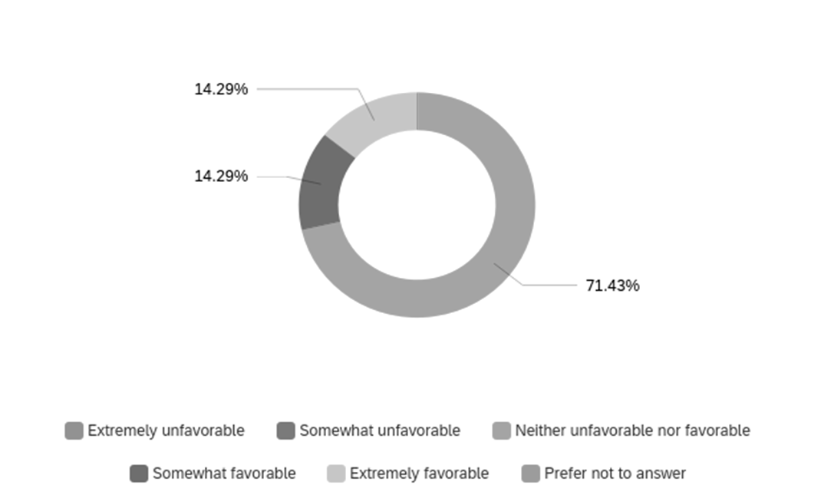

Figure 3.1 Do you tend to have a favorable, unfavorable or neutral opinion of a city council candidate who has a social media profile?

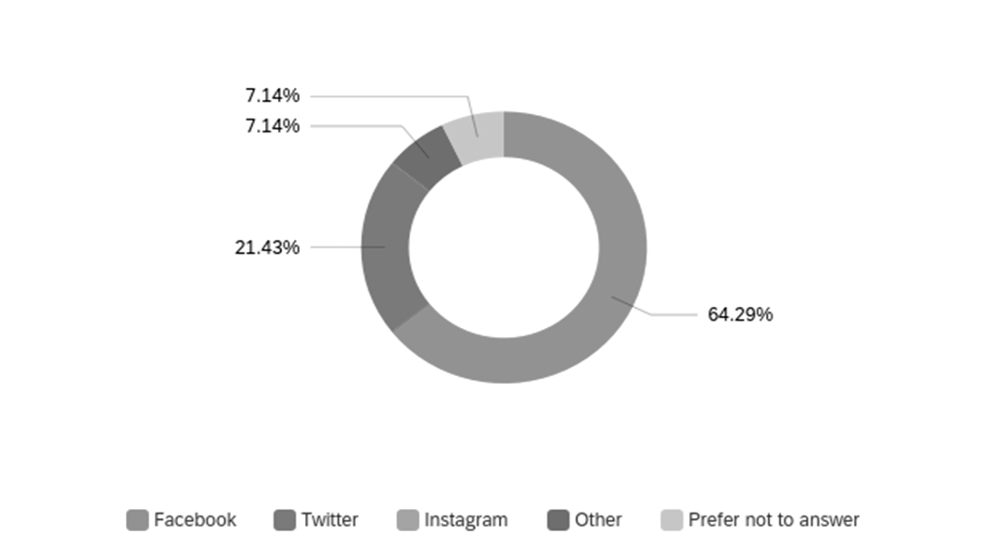

Figure 3.2 According to you, which is the most effective social media website that a city council candidate must make use of during his election campaign?

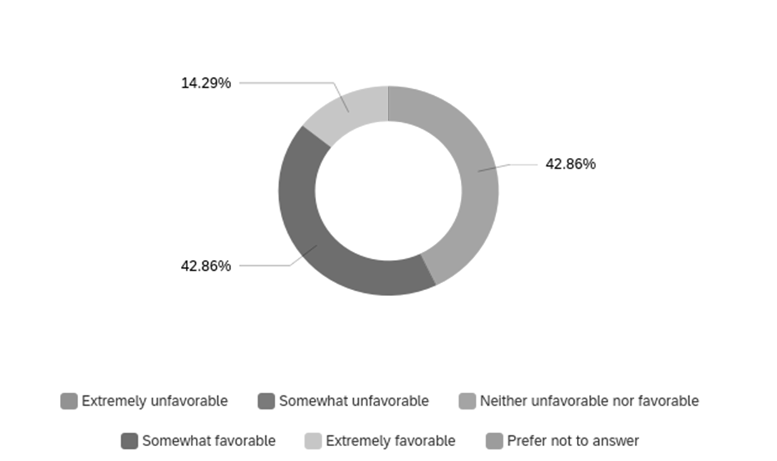

Figure 3.3 Do you tend to have a favorable, unfavorable or neutral opinion of a city council candidate who interacts with their constituents using social media?

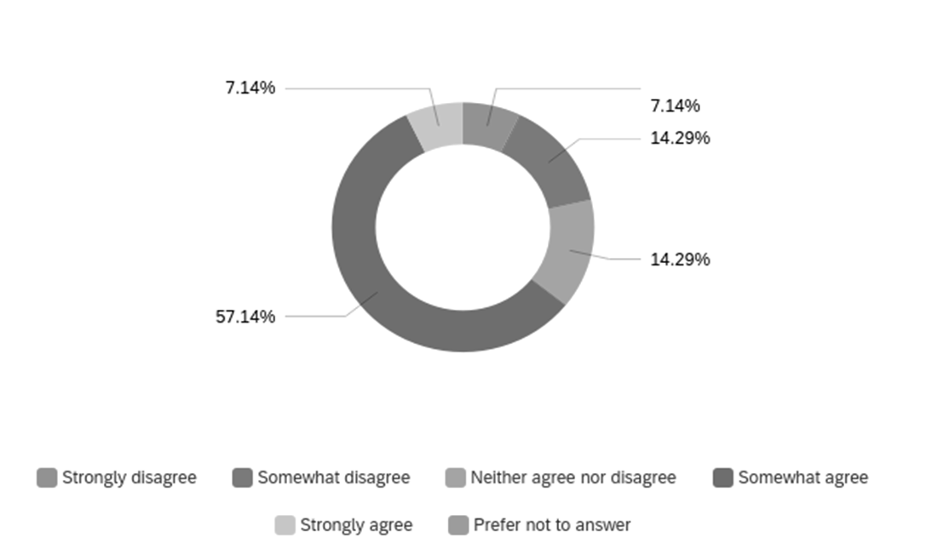

Figure 3.4 Do you agree or disagree with this statement? Local governance can be
improved with citizen input using social media.

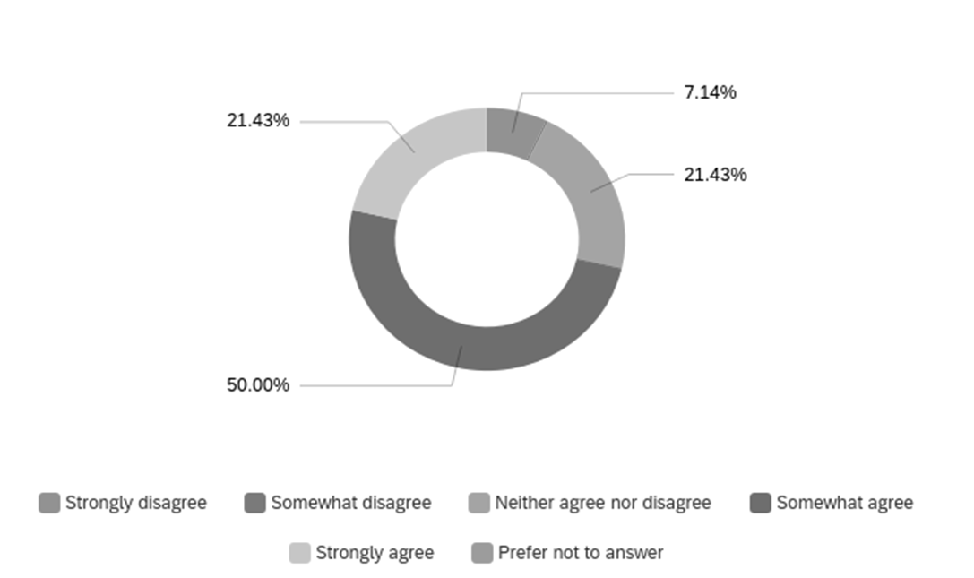

Figure 3.5 Do you agree or disagree with this statement? If a city council member is active on social media, provides timely updates, and responds to my messages, I’m more likely to vote for them again.

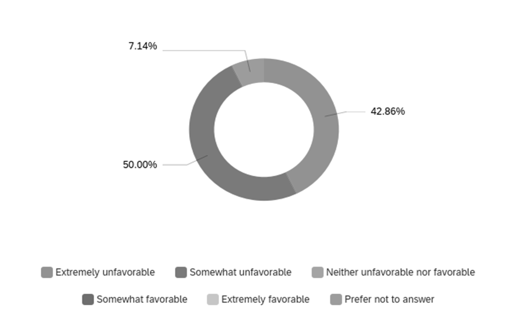

Figure 3.6 Do you have a favorable or an unfavorable opinion of political ads on social media?

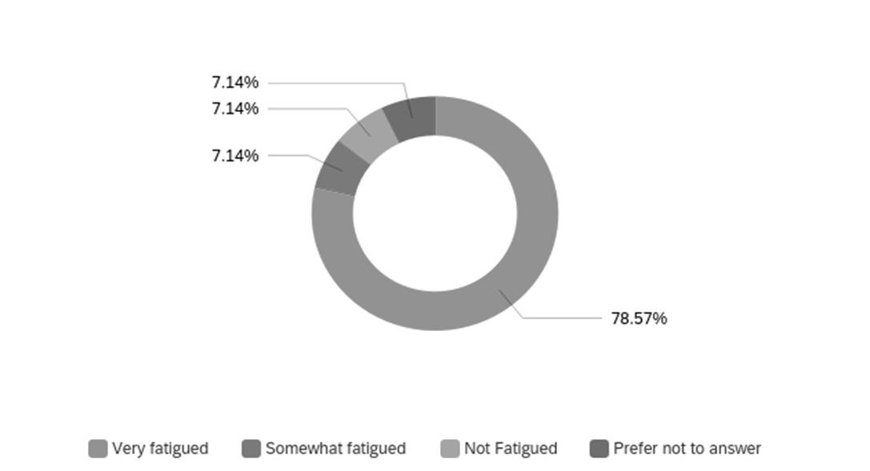

Figure 3.7 In the weeks before the election describe how you felt after consuming political ads.

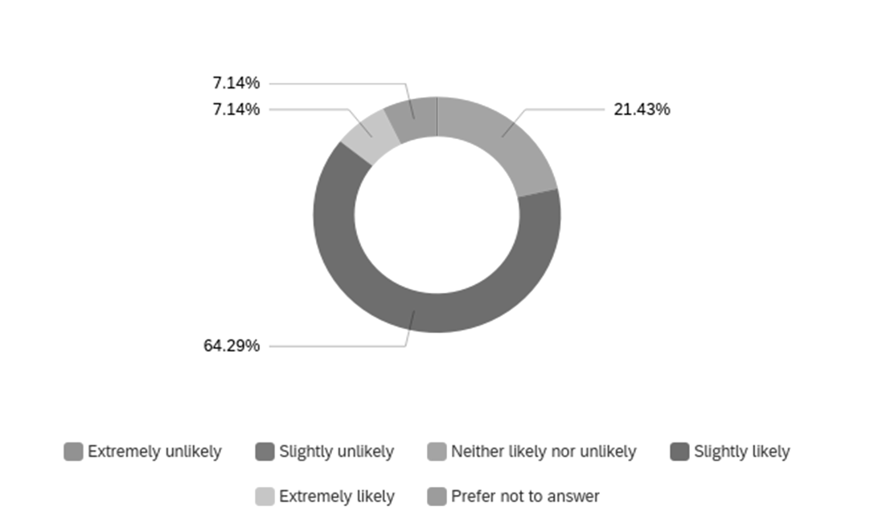

Figure 3.8 How likely are you to attend a city council meeting that is scheduled to address an issue you deeply care about after hearing about it on social media?

candidates who interacted with their constituents or voters on social media. The majority of the respondents seemed to have a favorable opinion with 42.86% responding as "Somewhat favorable" and 14.29% responding as "Extremely favorable" to a question on council candidate's interaction with constituents. To have an interaction, the existence of a social media profile is a prerequisite. Therefore, these trends show that voters in Knoxville welcome and encourage interaction by candidates on social media. A total of 71.43% either somewhat agreed or strongly agreed that they are likely to vote for a candidate who provides timely updates and responds to messages on social media while 21.43 neither agreed nor disagreed.

Social Media for the citizenry and civic issues
A total of 71.43% of respondents stated they are "Slightly Likely" or "Extremely Likely" to attend the city council meeting if they learn on social media that an issue they care about is going to be discussed. This shows that if a candidate uses social media to spread important information about events around the city, encourage public participation in the civic process, gain citizen input and as a tool to inform citizens and spread awareness, it has a positive outcome over running ads only during election season. On a question surveying public opinion on whether social media can be used for citizen input to improve local governance - the majority (57.14%) responded as "Somewhat agree." Another 7.14% of the respondents chose "Strongly agree."

Facebook wins the popularity race
In a survey question on which social media website must candidates use for the campaign, an overwhelming 64.29% of respondents selected Facebook. This trend also held in the secondary data analysis which showed all winning candidates except Gwen McKenzie posted more often on Facebook than Twitter. In the social media expenditure analysis of all candidates, none of the winning candidates was found to have spent money from their budget on buying ads on Twitter.

Sponsored messaging discouraged
An overwhelming majority of the respondents (85.71%) reported feeling "Very fatigued" by social media ads before Election Day. On another question on their opinion about campaign social media ads, the majority responded to have an unfavorable opinion with 50% responding "Somewhat unfavorable" and 42.86% responding "Extremely unfavorable." On Facebook, the most popular website among respondents, a political campaign ad is easily identifiable with the word "sponsored" and therefore, citizens do not have favorable opinions of "sponsored" political messaging during election season. However, as seen above, social media activity in general to gain public input spread awareness and use social media as a tool for improving local governance was encouraged by the respondents.

CHAPTER FIVE

CONCLUSION, LIMITATIONS AND RECOMMENDATIONS
Discussion and Conclusion
The data obtained from the Knox County Election Commission and social media showed candidates who had a presence on social media had a positive outcome in the 2021 Knoxville City Council Elections. The study also revealed that city council candidates that posted more frequently in four weeks before Election Day had an advantage in each district. This study was done at a local level and also backed up previous research done nationally by Hughes et al., (2010) that stated how social media had been an effective tool in building a successful campaign for President Obama in 2008. Candidates that used social media to build an effective campaign at a local level in Knoxville were successful. This study reinforced previous research by Krebs (1998) that revealed the most important traditional determinant in city council elections: incumbency. In the 2021 Knoxville City Council races, incumbents kept their seat in all districts. The study by Hughes et al., (2010) revealed that the winning candidate (Obama) had more followers than his opponent (McCain) and more post frequency than his opponent also held at the local level in Knoxville. Candidates that had a higher post frequency four weeks before Election Day and had higher followers than their opponents won in all five districts, exclusive of other factors affecting the election. This also highlights research by Jungherr (2015) that social media has become an effective tool of persuasion in election campaigns. All winning candidates posted more than their opponents in the last four weeks before the election, this reinforces a previous study by Blais (2004) that stated that Americans tend to change their electoral choice in the last four weeks before the election. This does not indicate a causal relationship of social media and election outcomes; however, effective social media usage by candidates can be as one of the many factors in an election outcome. The findings are indicative that posting more frequently when the voters are most likely to make their voting decision or change it can be effective. Since one in six voters typically changes their mind in the month preceding the election (Blais 2004), candidates must make use of the voter volatility and post more frequently during this time. All races that were studied had a vote share difference between 11-15.06%, therefore, reinforcing how crucial the last four weeks before Election Day are concerning the outcome of the race. The highest difference of votes in all races was seen in District 6, where Gwen McKenzie won the race by 3137 votes. She spent less than her opponent on social media ads. Therefore, a caveat to these findings was that two candidates who spent less than their opponents also won the election. Overall, all candidates spent less than 2.9% of their total campaign budget on running social media ads.
In the last two financial disclosures before Election Day, the highest social media expenditure was seen in District 1 where Tommy Smith spent 2.9% of his total expenditure on running digital ads. These findings are in contrast to previous research conducted nationally where the candidate who relied heavily on digital ads won the election (Williams et al., 2018). Findings in this study suggest that spending on social media ads had no significant impact on the outcome of the race, in Districts 4 and 6, the losing candidates spent more on digital ads but lost by the highest vote share margins.
Therefore, two themes emerge from these findings - candidates who spend more do not necessarily win local city council elections, and therefore, candidates do not necessarily allocate more money of their total budget to running social media ads.
As the Media Ecology Theory (MET) states, media is infused into every act and action in society, media fixes our perceptions and organizes our experiences and media ties the world together - the study confirmed these assumptions as candidates that infused social media into their campaign were successful. This backs up previous research on the topic by Moreno and Koff (2016) and Velasquez (2018) who found that the concepts of media ecology proposed by McLuhan and Postman are still the observation line to understand new forms of media such as social media and the mediatic contemporary society. The study gives an insight into how Facebook and Twitter have contributed to changing media ecologies and has opened ways and forms of communication between citizens and their representatives, backing up research conducted by Krumsvik et al., (2014).
Overall, social media as a tool for the campaign is effective in city council elections, and candidates without active Facebook and Twitter accounts, lesser followers and lesser frequency in posting on their accounts lose out in the political campaigning stages. However, over-reliance in terms of fiscal spending is also not encouraged and organic reach is key.
The sample size of the survey conducted among registered voters in Knoxville was (n=14), however, it is important to note that the survey was only a sub-part of the study and the themes found in the research are also based on election results from the 2021 Knoxville City Council regular election with (n=20,622) in District 1, (n=20,608) in District 2, (n= 20,583) in District 3, (n=20,885) in District 4 and (n=20,829) in District 6. Survey findings show that respondents encourage the existence of a social media profile by candidates, however, are "very fatigued" by sponsored political messaging. If candidates avoid the usage of social media only to run ads, but instead use it to encourage citizen input on local issues, inform, spread awareness and voice opinion on civic needs - it could bring positive outcomes during election season. Overall, it also was seen in the secondary-data analysis that organic reach is more effective and Facebook over Twitter is a more popular social media website in the local setting. In conclusion, it is important to note that these social media findings are exclusive of other factors affecting the election, for example incumbents’ performance as a city council member, past voting history on zoning ordinances, access with constituents and political values. The study does not intend to prove a causal relationship between social media and election outcomes; however, it indicates how social media usage can be an effective strategy for campaigns.

Limitations
The primary limitation of this study is that it does not examine other factors excluding social media that may have led to the election outcomes, such as partisanship, the past voting history of incumbents, the demographic composition of the city council districts, newspaper endorsements, number of in-person campaign events, and party organization support if any. The study was conducted in Tennessee which is predominantly controlled by Republicans – who are in a majority in the state’s senate and legislature. The Republican Party also has the most Congressional seats from the state. However, parts of Knoxville are dominated by Democrats, and that is continuing to intensify (Arora et al., 2022). The study also does not factor external influences, like mailers attacking incumbents sent to voters in Knoxville, paid for by the conservative Middle Tennessee-based Roving Patriots PAC. References were also made by both parties against national positions of each other on various issues (Whetstone, 2021). Since the survey responses were collected using a voluntary-based sampling method, using personal and professional connections of the researcher it did not expand to all districts and had a relatively low sample size. Most of the respondents to this study were college graduates, or pursuing higher education, however, a survey conducted in low-income areas where there is limited access to broadband could result in a broad understanding of the topic. While this study heavily focused on secondary data analysis from the Election Commission office and social media, conducting qualitative interviews with the candidates and members of the community would have provided deeper insight and valuable data.

Future Research Recommendations
In the future, researchers could expand the data analysis to include video, reels, snaps, and other sub-platforms emerging from the big players in social media. Since social media is evolving, it will be important for future researchers to capture the innovation and quantify it. For example, a video posted by a candidate was counted as a post for this study, however, counting views and impressions of every post could result in a better quantified data. Researchers could perform a comparative analysis between multiple cities in a particular state or cities with the same demographic composition. It would be interesting to see whether the trend of social media effectiveness in local city council elections holds in a comparative analysis. Expanding the research to add more social media platforms, like Instagram and Snapchat that are popular in age groups 18-39 to perform a secondary-data analysis of candidates could help in producing deeper research. Conducting qualitative interviews with candidates may provide better insight, such as specifications of the financial allocations and other challenges and benefits of social media from an insider perspective. Qualitative interviews with members of the community could help better understand survey findings. If a similar survey is conducted in the future to the one in this study, interesting trends can be found if it is expanded to include members who do not have a high school or a college degree.

LIST OF REFERENCES
Areena, A. (2022). The last three midterms in Knox County show blue creeping in. Check out the maps. Knoxville News Sentinel.
https://www.knoxnews.com/story/news/politics/elections/2022/11/14/knox-county-election-maps-show-more-democrats-year-by-year/69640296007/

Baker, R., Brick, J. M., Bates, N. A., Battaglia, M., Couper, M. P., Dever, J. A., ... & Tourangeau, R. (2013). Summary report of the AAPOR task force on non-probability sampling. Journal of survey statistics
and methodology, 1(2), 90-143.
https://academic.oup.com/jssam/article/1/2/90/941418

Blais, A. (2004). How Many Voters Change Their Minds in the Month Preceding an Election? PS: Political
Science and Politics, 37(4), 801–803. https://www.jstor.org/stable/4488912

Bossetta, M. (2020). Scandalous Design: How Social Media Platforms’ Responses to Scandal Impacts Campaigns and Elections. Social Media + Society, 6(2), 205630512092477.
https://doi.org/10.1177/2056305120924777

Brennan, J. (2020). Increasing Voter Turnout in Local Elections. National Civic League
https://www.nationalcivicleague.org/ncr-article/increasing-voter-turnout-in-local-elections/

Census Bureau, U. S. (2020). U.S. Census Bureau QuickFacts: Knoxville city, Tennessee.
https://www.census.gov/quickfacts/fact/table/knoxvillecitytennessee/POP060210

Chang, V. (n.d.). Obama and the Power of Social Media and Technology. Stanford Graduate School of Business.
https://www.gsb.stanford.edu/faculty-research/case-studies/obama-power-social-media-technology

Clement, J. (2020, November 23). U.S. social reach by age 2019. Statista. https://www.statista.com/statistics/471370/us-adults-who-use-social-networks-age/

Dwivedi, Y. K., Kapoor, K. K., & Chen, H. (2015). Social media marketing and advertising. The Marketing Review, 15(3), 289–309. https://doi.org/10.1362/146934715x14441363377999

Enli, G. (2017). Twitter as an arena for the authentic outsider: Exploring the social media campaigns of Trump and Clinton in the 2016 US presidential election. European journal of communication, 32(1), 50-61. https://journals.sagepub.com/doi/pdf/10.1177/0267323116682802

Falasca, K., Dymek, M., & Grandien, C. (2017). Social media election campaigning: who is working for whom? A conceptual exploration of digital political labour. Contemporary
Social Science, 14(1), 89–101. https://doi.org/10.1080/21582041.2017.1400089

Flessner, D. (2022, April 12). Tennessee among the most social media-obsessed states
Chattanooga Times Free Press. https://tinyurl.com/mbbehfce

Fournier, P., Nadeau, R., Blais, A., Gidengil, E., & Nevitte, N. (2004). Time-of-voting decision and susceptibility to campaign effects. Electoral
Studies, 23(4), 661-681.
https://www.sciencedirect.com/science/article/pii/S0261379403000751

Fujiwara, T., Müller, K., & Schwarz, C. (2020). The Effect of Social Media on Elections: Evidence from the United States. SSRN Electronic Journal. Published. https://doi.org/10.2139/ssrn.3719998

Gottfried, J., Shearer, E., & Gottfried, J. (2020, August 27). News Use Across Social
Media Platforms 2016. Pew Research Center’s Journalism Project.
https://tinyurl.com/ywd4229z

Gordillo Rodríguez, M. T., & Bellido-Pérez, E. (2021). Politicians self-representation on Instagram: the professional and the humanized candidate during 2019 Spanish elections. Observatorio (OBS*), 15 (1), 109-136.
https://idus.us.es/handle/11441/108644

Hughes, S. G. F., Allbright-Hannah, K., Goodstein, S., Grove, S., Zuckerberg, R., Sladden, C., & Bohnet, B. (2010). Obama and the power of social media and technology. The European Business Review, 16, 21. https://gsbfaculty.stanford.edu/jenniferaaker/files/2022/05/obamaandthepowerofsocialmediafinal2009.pdf

Ignacio Criado, J., Martínez-Fuentes, G., & Silván, A. (2012). Social media for political
campaigning. The use of Twitter by Spanish mayors in 2011 local elections. Web 2.0
technologies and democratic governance: Political, policy and management
implications, 219-232.
https://link.springer.com/chapter/10.1007/978-1-4614-1448-3_14

İkiz, O. O., Sobaci, M. Z., Yavuz, N., & Karkin, N. (2014, October). Political use of
Twitter: The case of metropolitan mayor candidates in 2014 local elections in Turkey.
In Proceedings of the 8th international conference on theory and practice of electronic
governance (pp. 41-50).
https://dl.acm.org/doi/abs/10.1145/2691195.2691219

Johansson, A. C., & Zhu, Z. (2021). Reputational Assets and Social Media Marketing Activeness: Empirical Insights from China. SSRN Electronic Journal. Published. https://doi.org/10.2139/ssrn.3908415
Joshi, A., Kale, S., Chandel, S., & Pal, D. K. (2015). Likert scale: Explored and explained. British journal of applied science & technology, 7(4), 396.
https://tinyurl.com/wsmpmana

Jungherr, A. (2016). Twitter use in election campaigns: A systematic literature review. Journal of information technology & politics, 13(1), 72-91.
https://www.tandfonline.com/doi/full/10.1080/19331681.2015.1132401

Karlsen, R. (2013). Obama's online success and European party organizations: Adoption and adaptation of US online practices in the Norwegian Labor Party. Journal of Information Technology & Politics, 10(2), 158-170.
https://www.tandfonline.com/doi/full/10.1080/19331681.2012.749822

Krebs, T. B. (1998). The Determinants of Candidates’ Vote Share
and the Advantages of Incumbency in City Council
Elections. American Journal of Political Science, 42(3),
921. https://doi.org/10.2307/2991735

Lev-On, A., & Steinfeld, N. (2015). Local engagement online: Municipal Facebook pages as hubs of interaction. Government information quarterly, 32(3), 299-307.
https://www.sciencedirect.com/science/article/pii/S0740624X15000672

Mochon, D., Johnson, K. C., Schwartz, J., & Ariely, D. (2017). What Are Likes Worth? A Facebook Page Field Experiment. Journal of Marketing Research, 54(2), 306–317.
https://doi.org/10.1509/jmr.15.0409

Moreno, M. A., & Koff, R. (2016). 11 Media Theories and the Facebook Influence Model. The Psychology of Social Networking, 130.
https://tinyurl.com/2apetava

NW, 1615 L. St, et al. “Demographics of Americans Who Get Most of
Their Political News from Social Media.” Pew Research Center’s Journalism
Project, 30 July 2020, www.pewresearch.org/journalism/2020/07/30/demographics-of-americans-who-get-most-of-their-political-news-from-social-media/

Pelling, E. L., & White, K. M. (2009). The Theory of Planned Behavior Applied to Young People’s Use of Social Networking Web Sites. CyberPsychology & Behavior, 12(6), 755–759. https://doi.org/10.1089/cpb.2009.0109

Prewitt, K. (1970). Political Ambitions, Volunteerism, and Electoral Accountability. American Political Science Review, 64(1), 5-17. doi:10.2307/1955609
https://tinyurl.com/yn94x8zm

“Qualtrics Recommended for Web Surveys | Office of Information Technology.” University of Tennessee - Office of Information Technology, 22 Mar. 2022,
https://oit.utk.edu/news/qualtrics-recommended-for-web-surveys/

Raynauld, V., & Greenberg, J. (2014). Tweet, click, vote: Twitter and the 2010 Ottawa municipal election. Journal of Information Technology & Politics, 11(4), 412-434.
https://www.tandfonline.com/doi/full/10.1080/19331681.2014.935840

Ross, K., & Bürger, T. (2014). Face to face(book). Political Science, 66(1), 46–62. https://doi.org/10.1177/0032318714534106

Safiullah, M., Pathak, P., Singh, S., & Anshul, A. (2017). Social media as an upcoming tool for political marketing effectiveness. Asia Pacific Management Review, 22(1),
10–15. https://doi.org/10.1016/j.apmrv.2016.10.007

Saravanakumar, M. (2012). Social Media Marketing. Life Science Journal. Published. https://www.lifesciencesite.com/lsj/life0904/670_13061life0904_4444_4451.pdf

Statista. (2021, January 18). Social network ad spend in the U.S. 2016–2022. https://www.statista.com/statistics/736971/social-media-ad-spend-usa/

Segaard, S. B., & Nielsen, J. A. (2013). Lokalt nybrott? Sosiale medier som arena for lokal valgkamp. Scandinavian Journal of Public Administration, 16(4), 3-26.
https://ojs.ub.gu.se/index.php/sjpa/article/view/2026

Skogerbø, Eli, and Arne H. Krumsvik. “Newspapers, Facebook and Twitter.” Journalism Practice, vol. 9, no. 3, 2 Sept. 2014, pp. 350–366,
10.1080/17512786.2014.950471.
https://www.tandfonline.com/doi/full/10.1080/17512786.2014.950471

Sampling Methods for Political Polling - AAPOR. (n.d.).
https://www.archive.aapor.org/Education-Resources/Election-Polling-Resources/Sampling-

Methods-for-Political-Polling.aspx Social Media Fact Sheet. (2023, March 2). Pew Research Center: Internet, Science & Tech. https://www.pewresearch.org/internet/fact-sheet/social-media/

Straus, J. R., Glassman, M. E., Shogan, C. J., & Smelcer, S. N. (2013). Communicating in 140 characters or less: Congressional adoption of Twitter in the 111th Congress. PS: Political Science & Politics, 46(1), 60-66.
https://tinyurl.com/ypcm77nn

Subramanian, K. R. (2017). Influence of social media in interpersonal communication. International Journal of Scientific Progress and Research, 38(2), 70-75. https://tinyurl.com/4ek2stwf

Tarman, B., & Yigit, M. F. (2013). The impact of social media on globalization,
democratization and participative citizenship. JSSE-Journal of Social Science Education.
https://www.jsse.org/index.php/jsse/article/view/637

TechCrunch is part of the Yahoo family of brands. (2008, December 31).
https://tinyurl.com/2udyxcrs

Trounstine, J. (2011). Evidence of a local incumbency
advantage. Legislative Studies Quarterly, 36(2), 255-280.
https://onlinelibrary.wiley.com/doi/full/10.1111/j.1939-9162.2011.00013.x

Tyler Whetstone, Knoxville News Sentinel (2021, October 29). Once nonpartisan and low-key, Knoxville City Council elections turn nasty. Knoxville News Sentinel.
https://tinyurl.com/4xus6y9b

Williams, C. B. (2017). Introduction: Social Media, Political Marketing and the 2016 U.S. Election. Journal of Political Marketing, 16(3–4), 207–211.
https://doi.org/10.1080/15377857.2017.134582s

Williams, C. B., & Gulati, G. J. J. (2018). Digital advertising expenditures in the 2016 presidential election. Social Science Computer Review, 36(4), 406-421.
https://dl.acm.org/doi/abs/10.1177/0894439317726751

Yannas, P., Kleftodimos, A., & Lappas, G. (2011). Online political marketing in 2010
Greek local elections: The shift from web to web 2.0 campaigns. In 16th
International Conference on Corporate Marketing Communications (pp. 38-50).
https://tinyurl.com/yc78cx9s

Yildirim P. (2020). How Social Media Is Shaping Political Campaigns - Knowledge at
Wharton. (2020b, August 17). Knowledge at Wharton.
https://tinyurl.com/yc2sxxj8

Zhao, S. (2006). Do Internet users have more social ties? A
call for differentiated analyses of Internet use. Journal of Computer-Mediated Communication, 11(3), 844-862. https://academic.oup.com/jcmc/article/11/3/844/4617716

APPENDIX

APPENDIX A
Recruitment Script
Hello! My name is Pranaav Jadhav, I am a graduate student at the University of Tennessee in the Journalism and Electronic Media Department and I’m examining the effects of social media usage of candidates on the Knoxville city council election results.

I would like to invite you to participate if you are a registered voter in the city of Knoxville. Participation in this research includes completing a web-based survey, which will take approximately 10-12 minutes.

There are no known risks involved in this research. Please let me or Prof Stuart Brotman know if you have any questions.

The survey can be found here https://utk.co1.qualtrics.com/jfe/form/SV_788Jlf6bheDv6f4 You can reach me at pjadhav@vols.utk.edu or Prof Stuart Brotman at sbrotman@utk.edu.

Thank you in advance for considering my request.
Pranaav Jadhav
Graduate Student at the University of Tennessee, Knoxville

APPENDIX B
Survey Questions
Q1 Are you a registered voter in the city of Knoxville?
Q2 What is your age?
Q3 To which gender identity do you most identify?
Q4 Which race or ethnicity best describes you?
Q5 Generally speaking, do you consider yourself a Republican, a Democrat, an Independent, or what?
Q6 Did you vote in the November 2021 Knoxville City Council General Election?
Q7 In which Knoxville City Council district do you reside in?
Q8 Do you think choosing the right city council candidate is very important, somewhat important, slightly unimportant or not at all important?
Q9 Do you think a decision made by an elected city council member of your district can affect your day-to-day life?
Q10 Do you tend to have a favorable, unfavorable or a neutral opinion of a city council candidate who has a social media profile?
Q11 Do you tend to have a favorable, unfavorable or a neutral opinion of a city council candidate who interacts with their constituents using social media?
Q12 Do you think it is reasonable or unreasonable for city council candidates using social media as a tool for a campaign?
Q13 Do you think social media is a great resource for election campaigns?
Q14 Are you more likely to connect with a candidate, and read the issues they care about if they are posted on social media, particularly Facebook or Twitter?
Q15 Do you think a candidate’s Twitter profile and tweets bring spontaneity to their thoughts and can be a tool to assess their true personality?
Q16 Do you think the existence of a social media profile by a city council candidate adds more value to their candidacy?
Q17 How often do you search for a city council candidate's social media profile before deciding to vote for them?
Q18 According to you, which is the most effective social media website that a city council candidate must make use of during his election campaign?
Q19 In general, would you say that you are optimistic or pessimistic about the use of social media to help solve local issues in your area?
Q20 In the past, have you interacted with your elected city council person through their social media profiles?
Q21 If a need arises, how do you think you’ll contact your elected city council person?
Q22 Do you agree or disagree with this statement? Social Media has helped me connect with other Knoxville residents with similar interests and hobbies. ( religious, sports, adventure, education)
Q23 Do you agree or disagree with this statement? Local governance can be improved with citizen input using social media.
Q24 Do you agree or disagree with this statement? If a city council member is active on social media, provides timely updates, and responds to my messages, I’m more likely to vote for them again.
Q25 Around election time, are you more than likely, somewhat likely or unlikely to skip a political advertisement on social media?
Q26 Do you have a favorable or an unfavorable opinion of political ads on social media?
Q27 In the weeks before the election describe how you felt after consuming political ads?
Q28 Is your opinion of the city council member in your district favorable or unfavorable?
Q29 How likely are you to attend a city council meeting that is scheduled to address an issue you deeply care about after hearing about it on social media?
Q30 Do you agree or disagree with this statement? Social Media is a great tool to publicize information regarding events happening around the city?

APPENDIX C
The social media analysis of candidates' profiles which included social media posts between October 2, 2021, to November 2, 2021, on Facebook and Twitter; the number of followers; and links to their profiles totalled 37 pages of data. All can be requested if desired. The detailed survey results (.CSV file) with responses to all 30 questions can be requested if desired.

VITA
Pranaav Jadhav is a native of Maharashtra, India. He graduated in 2014 with a bachelor’s degree in journalism from Mississippi State University. He later worked at the Leaf-Chronicle in Clarksville, Tennessee, and the Tennessean in Nashville. After returning home in 2017, Pranaav worked for Republic TV as a correspondent and for Hindustan Times as a senior correspondent before moving back to the U.S. in 2021 for graduate coursework. He's won awards from the Associated Press and the Mississippi Press Association for his past work. His research interests include political campaigns on social media, political persuasion, the impact of local news and elections.

