Linking physiology and biogeography:

Disentangling the constraints on the distributions

of ant species

A Dissertation Presented for the

Doctor of Philosophy

Degree

The University of Tennessee, Knoxville

Lacy Danikas Chick

December 2015

Copyright © 2011 by Lacy Chick
All rights reserved.

To Sullivan – Never give up

ACKNOWLEDGEMENTS

The journey through academia is not one that can be traveled alone. It takes a team of collaborators, mentors, friends, and loved ones to achieve the end goal: a degree. My PhD was no different. Throughout my tenure at UT I have met some of the most inspiring people I know and I am incredibly humbled to have worked and lived alongside them.

My advisor, Nathan Sanders, has been the keystone that has held my academic career together. Looking back, I truly am in awe of how much he has inspired me, both in academia and in life. His ability to cater to every student’s individual needs is astounding. One of the best things about having Nate as an advisor and friend is that I know it will not end with graduation. Having him as an advisor has made me the ecologist I am today, but more important, has given me the confidence I need to tackle the big questions in science without losing sight of my naturalist background.

Aimee Classen has been a fantastic committee member and mentor. She is the embodiment of a strong academic woman and I only hope one day I can accomplish half of what she has. She is the flesh and blood Wonder Woman!

Many faculty members in EEB have given mentoring advice as well as friendship. Alison Boyer started out as a post-doctoral fellow in our lab and ended up as a committee member, mentor, and friend who has been a great go-to person for making the transition from a naïve first-year student to an early career ecologist. Dan Simberloff has been instrumental in keeping me grounded while simultaneously convincing me that my work is groundbreaking. He is the ecologist we all aspire to be. For countless scientific and non-scientific discussions over beverages, I want to thank Jim Fordyce, Jen Schweitzer, Joe Bailey, and Zach Marion. You have all in one way or another helped tremendously with my work-life balance.

I would also like to thank a friend and collaborator, Rob Dunn at NCSU, for his continued enthusiasm that has kept me going through the several “writing funks” towards the end of my dissertation.

My official (and unofficial) labmates, Katie Stuble, Mariano Rodriguez-Cabal, Sara Kuebbing, Melissa Burt, Quentin Read, and Leigh Moorhead are fully responsible for keeping me sane during the last 5 years. For help with R, countless manuscript reviews, advice, coffee breaks, and just acting as sounding boards, I thank all of you from the bottom of my heart. Without such great colleagues, I would’ve crashed and burned.

The EEB staff, specifically Jaime Call, Janice Harper, Cheryl Lynn, and Marva Anderson, has been integral to my degree. EEB graduate students would not achieve our highest honors without their tireless efforts. Collectively, the office staff truly is the backbone of the department.

Most significant in this journey has been my family. My husband and partner, Brendan, and son, Sullivan, have kept me motivated through the best and worst aspects of my PhD. Without Brendan to help with almost every part of my research, I would not have been able to finish this significant milestone. He is an amazingly patient person who has sacrificed so much for me to achieve my dreams. My parents, Nick and Karen, and sister, Sarah, have been beyond supportive and have molded me into the person I am today. Without their help this would not have happened. The love, support, and encouragement of my family have been crucial in keeping balanced throughout this stressful time in my life.

ABSTRACT

Understanding the factors that limit the distribution of species is at the core of ecological and biogeographical research, and is critical if we are to predict the responses of key ecosystem components to ongoing climatic changes. My doctoral research seeks to provide an understanding of how thermal physiology influences species’ distributions and better define the mechanisms underlying geographic variation in biodiversity. By using natural temperature gradients (both elevational and latitudinal) and coupling controlled laboratory experiments with field observations and null modeling approaches, I was able to document the role of inter-specific variation in thermal physiology and, more interesting, inter-population variation in thermal physiology, in shaping the distribution of diversity on a warming planet. I determined that species’ density and distributions are shaped by both biotic and abiotic factors, but that the influence of these factors is geographically-dependent. I further examined the role of temperature by determining how different rates of warming affect thermal physiology and might provide insight into separate aspects of an organism’s life history and its accompanying coping mechanisms. Finally, I used a common garden experiment and phylogenetic analyses to determine to what extent ecological and evolutionary forces play a role in shaping the thermal niche. I found patterns suggestive of local adaptation and no evidence for lab acclimation, suggesting that some species may have limited acclimation ability and therefore will be more susceptible to climate warming. This dissertation suggests that variation in thermal physiology within and among species is important in understanding the factors that shape diversity and how species will be distributed now, and in the future.

TABLE OF CONTENTS

INTRODUCTION 1
References 3
CHAPTERS 5
I. The geography of ecological processes: the interplay between biotic and abiotic factors on the distribution and density of species 5
II. Ecology and evolution shape the thermal niche 5
III. Timing matters: how ramping speed affects heat stress responses 6
CHAPTER I The geography of ecological processes: the interplay between biotic and abiotic factors on the distribution and density of species 8
Abstract 10
Introduction 11
Methods 14
Sampling 14
Estimating thermal tolerance 16
Are community size and species density correlated with environmental temperature? 17
Does thermal tolerance predict elevational range size and species density as would be the case if temperature were the sole driver of species occurrence? 18
Do species co-occur less among assemblages than would be expected if interspecific competition limits membership? 20
Does competition by dominant species affect species density among assemblages? 21
Results 23
Are community size and species density correlated with environmental temperature? 23
Does thermal tolerance predict range size and species density as would be the case if temperature were the sole driver of species occurrence? 23
Do species co-occur less among assemblages than would be expected if interspecific competition limits membership? 24
Does competition by dominant species affect species density among assemblages? 24
Discussion 25
Conclusions 28
Acknowledgements 29
References 30
Appendix 36
CHAPTER II Ecology and Evolution shape the thermal niche 41
Abstract 43
Introduction 44
Methods 46
Field collections 46
Common garden 46
Thermal tolerance 47
Library preparation 47
Bioinformatics 48
Results 49
Discussion 50
References 53
Appendix 56
CHAPTER III TIMING MATTERS: HOW RAMPING SPEED AFFECTS HEAT STRESS RESPONSES 62
References 73
Appendix 76
CONCLUSION 81
VITA 82

LIST OF TABLES

No table of figures entries found.
In your document, select the words to include in the table of contents, and then on the Home tab, under Styles, click a heading style. Repeat for each heading that you want to include, and then insert the table of contents in your document. To manually create a table of contents, on the Document Elements tab, under Table of Contents, point to a style and then click the down arrow button. Click one of the styles under Manual Table of Contents, and then type the entries manually.

LIST OF FIGURES

No table of figures entries found.
In your document, select the words to include in the table of contents, and then on the Home tab, under Styles, click a heading style. Repeat for each heading that you want to include, and then insert the table of contents in your document. To manually create a table of contents, on the Document Elements tab, under Table of Contents, point to a style and then click the down arrow button. Click one of the styles under Manual Table of Contents, and then type the entries manually.

INTRODUCTION

Global climate change has altered communities through range shifts of particular species (Root et al., 2003; Chen et al., 2011; Crimmins et al., 2011), phenological changes (Parmesan and Yohe, 2003; Warren et al. 2011), and local extinctions (Sinervo et al., 2010). Few studies, however, have examined the physiological mechanisms underlying these changes or the impact they might have on community structure (but see Buckley et al. 2010). For ectotherms, temperature is one of the most important abiotic factors affecting the distribution and abundance of species (Andrewartha and Birch, 1954; Hawkins et al., 2007; Currie et al., 2004) and spatial variation in climate can increase the potential for high inter-population variability across the range of a species (Mizera and Meszéna, 2003).
Thermal environments often covary with latitude and elevation, frequently creating extensive thermal gradients. However, climatic warming will likely not be consistent along contemporary environmental gradients. Temperature has been considered a key factor in limiting range shifts of organisms because of regional adaption to thermal regimes. Ectotherms living in warmer climates experience temperatures closer to their upper thermal limits and therefore are considered to be more vulnerable to rapid warming (Deutsch et al., 2008; Kingsolver et al., 2013). Thus, if warming is not consistent along environmental gradients, climate change could result in sub-optimal environmental temperatures for longer periods at extreme elevations and latitudes, thereby influencing physiological processes and behavioral interactions for a suite of organisms (van Damme et al., 1989; Huey and Kingsolver, 1993).

Variation in the physiology and behavior of key species along environmental gradients can have cascading effects on community membership and interspecific interactions. Examining trait variation and local adaptation is especially important for understanding how environmental change will affect communities. By assuming all populations of a species respond identically to climatic variables, most models and previous studies have disregarded a fundamental premise of evolution by natural selection — variation. It is expected that the magnitude of warming will be heavily dependent on geographic location (IPCC, 2013). Still, few studies relate the physiological factors mediating organismal performance to range size and distribution with respect to climate change and population dynamics (but see, Addo-Bediako et al., 2000; Buckley et al., 2010; Sunday et al., 2011). As communities are altered by global change, variation among populations will likely lead to novel communities in some areas, while other areas might see reductions in species richness due to range shifts and/or local extinctions (biotic attrition) (Colwell et al., 2008). Documenting the mechanisms that link physiological traits to geographic distributions will likely aid in predicting potential changes in community structure by taking into account organismal performance and future environmental factors.

References
Addo-Bediako, A., Chown, S.L. & Gaston, K.J. (2000) Thermal tolerance, climatic variability and latitude. Proceedings of the Royal Society of London. Series B: Biological Sciences, 267: 739–745.
Andrewartha, H.G. & Birch, L.C. (1954) The distribution and abundance of animals. University of Chicago Press, Chicago.
Buckley, L.B., Urban, M.C., Angilletta, M.J., Crozier, L.G., Rissler, L.J. & Sears, M.W. (2010) Can mechanism inform species’ distribution models? Ecology Letters, 13: 1041-1054.
Chen, I-C., Hill, J.K., Ohlemuller, R., Roy, D.B. & Thomas, C.D. (2011) Rapid range shifts of species associated with high levels of climate warming. Science, 333, 1024-1026.
Chown, S.L. & Terblanche, J.S. (2007) Physiological diversity in insects: ecological and evolutionary contexts. Advances in Insect Physiology (33), (ed. S.J. Simpson) 50-152. Academic Press, Elsevier Ltd., London.
Colwell, R.K., Brehm, G., Cardelús, C.L., Gilman, A.C., Longino, J.T. (2008) Global warming, elevational range shifts, and lowland biotic attrition in the wet tropics. Science, 322, 258-261.
Crimmins, S.M., Dobrowski, S.Z., Greenberg, J.A., Abatzoglou, J.T., & Mynsberge, A.R. (2011) Changes in climatic water balance drive downhill shifts in plant species’ optimum elevations. Science, 331, 324-327.
Currie, D.J., Mittelbach, G.G., Cornell, H.V., Field, R., Guégan, J.-F., Hawkins, B.A., Kaufman, D.M., Kerr, J.T., Oberdorff, T., O’Brien, E.M., & Turner, J.R.G. (2004) Predictions and tests of climate-based hypotheses of broad-scale variaition in taxonomic richness. Ecology Letters, 7: 1121-1134.
Deutsch, C.A., Tewksbury, J.J., Huey, R.B., Sheldon, K.S., Ghalambor, C.K., Haak, D.C. & Martin, P.R. (2008) Impacts of climate warming on terrestrial ectotherms across latitude. Proceedings of the National Academy of Sciences United States of America, 105: 6668–6672.
Kingsolver, J. G., Diamond, S. E., & Buckley, L. B. (2013). Heat stress and the fitness consequences of climate change for terrestrial ectotherms. Functional Ecology, 27(6): 1415-1423.
Hawkins, B.A., Albuquerque, F.S., Araújo, M.B., Beck, J., Bini, L.M., Cabrero-Saǹudo, F.J., Castro-Parga, I., Diniz-Filho, J.A.F., Ferrer-Castán, D., Field, R., Gómez, J.F., Hortal, J., Kerr, J.T., Kitching, I.J., León-Cortés, J.L., Lobo, J.M., Montoya, D., Moreno, J.C., Olalla-Tárraga, M.Á., Pausas, J.G., Qian, H., Rahbeck, C., Rodríguez, M.Á., Sanders, N.J., & Williams, P. (2007) A global evaluation of metabolic theory as an explanation for terrestrial species richness gradients. Ecology, 88: 1877-1888.
Huey, R.B. & Kingsolver, J.G. (1993) Evolution of resistance to high temperature in ectotherms American Naturalist, 142: S21-S46.
IPCC (2013) Summary for policymakers. Working Group I contribution to the IPCC Fifth Assessment Report. In Climate change 2013: the physical science basis, pp. 3–29. Cambridge: Cambridge University Press. Mizera, J. & Meszéna, G. (2003) Spatial niche packaging, character displacement and adaptive selection along an environmental gradient. Evolutionary Ecology Research, 5: 363-382.Parmesan, C. & Yohe, G. (2003) A globally coherent fingerprint of climate impacts across natural systems. Nature, 421: 37-42.
Root, T.L., Price, J.T., Hall, K.R., Schneider, S.H., Rosenzweig, C., & Pounds, J.A. (2003) Fingerprints of global warming on wild animals and plants. Nature, 421: 57-60.
Sinervo, B., Méndez-de-la-Cruz, F., Miles, D., Heulin, B., Bastiaans, E., Villagrán-Santa Cruz, M. Lara-Resendiz, R., Martínez-Méndez, N., Calderón-Espinosa, M.L., Meza-Lázaro, R.N., Gadsden, Héctor, Avila, L.J., Morando, M., De la Riva, I.J., Sepulveda, P.V., Rocha, C.F. D., Ibargüengoytía, N., Puntriano, C.A., Massot, M., Lepetz, V., Oksanen, T.A., Chapple, D.G., Bauer, A.M., Branch, W.R., Clobert, J., & Sites Jr., J.W., (2010) Erosion of lizard diversity by climate change and altered thermal niches. Science, 328: 894-899.
Sunday, J.M., Bates, A.E., & Dulvy, N.K. (2011) Global analysis of thermal tolerance and latitude in ectotherms. Proceedings of the Royal Society, B 278: 1823-1830.
van Damme, R., Bauwens, D., Castilla, A.M. & Verheyen, R.F. (1989) Altitudinal variation of the thermal biology and running performance in the lizard Podarcis tiliguerta. Oecologia, 80: 516-524.
Warren II, R.J., Bahn, V., & Bradford, M.A. (2011) Temperature cues phenological synchrony in ant-mediated seed dispersal. Global Change Biology, 17: 2444-2454.

CHAPTERS

I. The geography of ecological processes: the interplay between biotic and abiotic factors on the distribution and density of species

Scientists often attempt to determine what structures communities using species occurrences and environmental factors, and often take a phylogenetic approach when examining differences among communities. While these methods provide much insight into species occurrences and current community structure, they are still considered to be indirect measurements and are not ideal for predicting community structure.

In my first chapter, I examined density, abundance, and thermal physiology across a suite of ant species along a 1500m-elevation gradient in Great Smoky Mountains National Park. I performed thermal tolerance tests to examine how thermal limits change along an extensive environmental gradient. I have linked density, abundance, physiological data, and biological interactions across a large spatial scale to estimate the probability of occurrence for a suite of species. I found that species abundance, density, and thermal limits are related to environmental temperatures. Additionally, I have found that environmental filtering may limit community membership at higher elevations, but that biotic interactions is likely the limiting factor for communities at lower, more benign elevations.

This chapter is currently in review at Journal of Animal Ecology

II. Ecology and evolution shape the thermal niche

The prevalence of intra-specific variation throughout the gradient followed the pattern of environmental temperatures, with physiological thermal range increasing with an increasing thermal range of the environment. Populations that encounter less environmental variability (and have more narrow thermal breadths) may respond less favorably to climate change than populations adapted to areas with more variability, yet climate change is expected to have greater impacts at higher elevations and latitudes where thermal ranges are broader, therefore it is important to examine the underlying causes of population differences in thermal physiology. Geographic differences in the magnitude of warming and organismal responses will be important variables for predicting community structure and the persistence of populations at vulnerable sites and at the peripheries of species’ ranges.
If scientists are to predict range shifts and population extinctions based on physiological mechanism, it is first necessary to disentangle genetic variation from acclimation. In this chapter I extended my research on environmental gradients from the elevational gradient in Great Smoky Mountains National Park to a latitudinal gradient in the eastern U.S. I collected ants from 24 sites along a latitudinal gradient from Gainesville, FL to Millinocket, ME, which spans just over 16 degrees in latitude and performed the same thermal tolerance tests as previously described. My collaborators and I maintained the colonies collected from the field in the lab under temperatures of 20° and 26°C and tested their thermal limits after 4 weeks of lab acclimation. I then compared the thermal physiology of lab acclimated ants to those collected from the field. I found that, regardless of rearing temperature, ants maintained the geographic variation in thermal physiology seen in field-collections and showed no evidence of acclimation to test temperatures. Along with my collaborators, we also performed phylogenetic analyses and used sequencing techniques on the common garden and field-collected ants to examine species differentiation. When accounting for the relationships in our phylogenetic analyses, we found patterns in thermal limits that are suggestive of local adaptation. This finding further solidifies the notion that populations are locally adapted to environmental conditions and validates the need for population-level data. This work was done in collaboration with researchers at North Carolina State University, the University of Vermont, and Harvard Forest.

III. Timing matters: how ramping speed affects heat stress responses

Critical thermal limits (CT_{max} and CT_{min}) are ecologically-relevant measures of the ability of an organism to endure exposure to high and low temperatures, respectively. These measures (specifically CT_{max}) have been used to predict and extrapolate the diversity and distributions of species in light of climate change. There are multiple techniques used to measure thermal limits, each often yielding different results. Thus, there is debate about which techniques are the most ecologically relevant. An alternative explanation is that different methods provide insight into separate aspects of an organism’s life history and its accompanying coping mechanisms. In such a scenario, different measurements of critical thermal maxima (CT_{max}) could identify unique thermal challenges for species that inhabit complex thermal environments.

In my final chapter, I collaborated with postdoctoral researchers from North Carolina State University, and conducted thermal tests using 2 different ramping speeds, a slow ramp of 1ºC every five minutes and a fast ramp of 1ºC per minute. For each of the 14 ant species we examined, fast- and slow-ramp methods yielded different CTmax values based on ramp rate that are only loosely correlated, suggesting that different life histories could lead to differences in thermal adaptive responses. An organism’s ability to tolerate warming might result from selective forces acting on physiological processes to produce adaptive coping mechanisms.

CHAPTER I
The geography of ecological processes: the interplay between biotic and abiotic factors on the distribution and density of species

This chapter is currently in review at Journal of Animal Ecology

Co-authored by Jean-Philippe Lessard, Robert R. Dunn, and Nathan J. Sanders

Author contributions: All authors made substantial contributions to the concept and experimental design of this study and contributed to data analysis and writing of this manuscript. JPL and NJS collected abundance, density, and dominance data and LDC carried out field collections and all thermal physiological work. NJS and RRD conceived and coordinated the study. All authors gave final approval for publication and inclusion in the dissertation.

Abstract

Both biotic and abiotic factors shape the distribution of life on Earth, but their relative influences likely vary spatially. Here, we couple field based observations, null model analyses, and laboratory-measured physiological thermal limits to examine the interplay of climate and species interactions in structuring ant communities along an extensive abiotic gradient. We found that both temperature and species interactions shape the abundance, distributions, and density of ant species. However, the strength of the influences of the biotic and abiotic factors was context-dependent. Environmental conditions tended to be more important in colder, more stressful environments, where physiology was the most important constraint on the distribution and density of ant species. Conversely, the influence of species interactions was highest in warmer, more benign conditions. Such a pattern, first suggested by Fischer in 1960, but then largely ignored empirically, suggests that the response of species to climate change, whether historic or future, is likely to be context-dependent and more specifically, geographically dependent. In temperate regions, where most experimental studies of climate change are done, responses may be far easier to predict than in tropical regions where they will depend not only on the physiology of organisms but also on their interactions.

Introduction

One of the most striking patterns in nature is that the number of species varies, often systematically, along environmental gradients. Explaining this pattern has attracted the attention of ecologists and biogeographers for decades (MacArthur et al., 1972), if not longer (Humboldt, 1849) and has inspired empirical studies in fields ranging from physiological ecology to macroecology and global change biology (Diez et al., 2012). But why does the number of species that coexist in a particular assemblage vary? One possibility is that, broadly speaking, species differ in how they respond to biotic and abiotic factors along environmental gradients, and these differences among species, in turn, influence abundance, distribution, community composition, and broad-scale patterns of diversity. For instance, temperature tends to decrease systematically with elevation and latitude (Fridley, 2009; McCain & Colwell, 2011) and as a result, the abiotic environment at high-elevation and high-latitude sites might be more physiologically stressful for potential colonizers than at low-elevation and low-latitude sites. In such a model, temperature acts as a filter, permitting the occurrence of only those species with traits that allow them to persist at low temperatures (Addo-Bediako et al., 2000; Sunday et al., 2011).
Of course, multiple factors can and do simultaneously operate to shape communities, and different factors might be more important in different locations (Sundqvist et al., 2013) Wallace (1878), Dobzhansky (1950), and Fischer (1960) all suggested that negative interspecific interactions (competition, predation, parasitism) might be more intense or important in benign, stable environments. Indeed, a growing number of investigators have begun to explore the geography of biotic interactions (Schemske et al., 2009) with recent studies suggesting that negative interactions might limit the distributions of species and pose a cap to the number of species that can coexist in benign environments, (Jankowski et al., 2010; Kozak & Wiens, 2012). Two recent studies along elevational gradients hint at such a scenario: in hummingbird assemblages in the Andes (Graham et al., 2009) and in ant assemblages in the U.S. and Europe (Machac et al., 2011) there is some evidence that interspecific interactions shape community membership at low elevations, but that more stressful environmental conditions (e.g., cold temperatures) shape communities at high elevations. Such studies are important because they suggest a mechanism, but, they do so based on community phylogenetic approaches, which rely on numerous underlying assumptions and can give misleading answers about the processes that actually structure communities (Losos, 2008; HilleRisLambers et al., 2012).
More compelling evidence for geographic variation in the relative influence of climate and biotic interactions on the species in assemblages might come from field-based measurements of physiological tolerances (e.g., (Helmuth et al., 2002; Sinclair et al., 2006; Buckley et al., 2008) and/or detailed studies of the outcomes of interactions among species, i.e., actual measurements of individual-level functional traits and observations of interactions in the field (Albrecht & Gotelli, 2001; Parr, 2008; Stuble et al., 2013; Violle et al., 2012). Such studies, however, are rare because they are time consuming and impossible for many of the groups of organisms on which studies of geographic gradients tend to focus. Additionally, many traits that are often measured do not directly relate to tolerance of the abiotic environment.
Like other ectotherms, ants exhibit thermal sensitivity, and species differ in their thermal tolerances (i.e., the ability to tolerate either extreme temperatures or a broad range of temperatures; (Cerdá et al., 1997; Diamond et al., 2012; Kaspari et al., 2015). Thermal tolerance in ants may be related to total abundance and range size (Geraghty et al., 2007; Warren & Chick, 2013) foraging activity (Cerdá et al., 1998; Lessard et al., 2009; Stuble et al., 2013) and broad-scale patterns of diversity (Kaspari, 2000; Sanders et al., 2007). If a species occurs at all locations with suitable environmental conditions, then the environment alone would be the sole driver of its distribution. However, if the observed range of a species is smaller than its expected range based on environmental tolerance alone, then some other factor, such as competitive interactions or dispersal limitations, acts to shape the distribution of species among local communities along the gradient (Guisan & Rahbek, 2011; Fordham et al., 2013). If the same suite of factors affects the distribution of many species, then such factors are expected to also influence the distribution of diversity, and diversity is simply an emergent property.
Competitive interactions are widely thought to influence the structure and dynamics of some local assemblages, and might shape broad-scale patterns in the distribution of species as well. Competition likely structures local ant assemblages (Cerdá et al., 2013), yet its effects are mediated by temperature altering interactions between dominant and subordinate species (Bestelmeyer, 2000; Cerdá et al., 1997; Cerdá & Retana, 1998; Lessard et al., 2009) and the activities of particular species (Lessard et al., 2009; Stuble et al., 2013). Here, we examine non-random co-occurrence patterns among ant species along the environmental gradient to assess whether species occur less than expected by chance as would be expected if competition structures communities (Gotelli & McCabe, 2002). Additionally, we examine how the abundance of competitively dominant species affects species density in a local assemblage. Species density (the observed number of species in a defined area) may be negatively related to the abundance of dominant species, such that as the abundance of dominant species increases, subordinate species are competitively excluded and species density declines. Such a pattern is common, at least when ant assemblages are invaded by competitively dominant non-native species (Holway et al., 2002). Alternatively, the relationship between the abundance of dominant species and density in the rest of the assemblage may be unimodal (Andersen, 1992; Parr et al., 2005; Parr, 2008). Such a pattern might occur in response to environmentally stressful conditions, which limit both dominant and subordinate species. But as conditions improve, the abundance of dominant species and species density of subordinate species increases until the abundance of the dominant species becomes so high that the dominant species begin to limit subordinate species (Andersen, 1992; Parr et al., 2005; Parr, 2008).
In this study, we ask a series of inter-related questions about the factors that govern the distribution, abundance, and density of ant species along an extensive and well-studied elevational gradient in Great Smoky Mountains National Park, USA. In particular, we ask (1) Are community size and species density correlated with environmental temperature? (2) Does thermal tolerance predict elevational range size and species density as would be the case if temperature were the sole driver of species distributions? (3) Do species co-occur less among assemblages than would be expected if interspecific competition limits membership? (4) Does competition by dominant species affect species density among assemblages? Based on the suspicions of early biogeographic pioneers (e.g., (Fischer, 1960; Wallace, 1878; Dobzhansky, 1950), we predicted that physiological constraints would limit community membership at high-elevation sites, filtering species that have the physiological capacity to withstand more extreme temperatures, but that interspecific interactions shape assemblages at lower elevation sites that are more environmentally benign. We further predicted that thermal tolerance would be the best predictor of the occurrence and number of species in high elevation communities where environmental filtering predominates, but not at low elevation where biotic interactions are most frequent and intense.

Methods

Sampling
We did this work in Great Smoky Mountains National Park at sites that were situated in mixed hardwood forests and were located in areas away from roads, heavily visited trails, or other recent human disturbances. We systematically sampled 29 sites (from 379 to 1828m) in June-August 2004 – 2007. These sites had a temperature range of -8.0 – 29.7°C (mean annual temperatures ranged from 7.7 – 13.3°C) and ranged from 1308 – 1928 mm in annual precipitation. We used Winkler samplers to extract ants from the leaf litter in 16 1-m² quadrats at each site in a haphazardly placed 50 × 50 m quadrat. At each site, species density is the observed number of species collected in the 50 × 50 m quadrat, and community size is the number of 1-m² quadrats in which any species was detected. This estimate of community size (which is actually “occurrence” (Kaspari et al., 2000; Longino et al., 2002; Sundqvist et al., 2013; Gotelli & Colwell, 2010; Gotelli et al., 2011)) is preferable to a count of worker number because ants are social, and because counts of colonies is challenging when species have multiple nests per colony and occur in the leaf litter. We differentiate “community size” from “occurrence” because our measure of community size combines all species whereas “occurrence” implies the presence of only a single species. At eight of the sites, we also collected ants using an array of 10 pitfall traps over 2 years (Lessard et al., 2007). The number of species collected by pitfall traps did not differ from the number collected by the Winkler samplers (paired t = 1.88, n = 8, P = 0.11). Similarly, the fauna sampled by the pitfall traps was similar to the fauna sampled by the Winkler samplers (Lessard et al., 2007) At most of the sites, an asymptotic species richness estimator (Chao2 in this case) plateaued, suggesting that sampling within sites approached completeness (Sanders et al., 2007). Moreover, a Chao2 estimate of richness among all sites suggests, at least using these sampling techniques at similar sites, that there would be approximately 45 species in total, and we captured 38 species in our systematic sampling. Therefore, these communities are adequately sampled.
In July 2011 and 2012, we visited 31 sites (from 375-1825m; 17 of which were in the previously sampled sites in 2004-2007) in order to collect live individual ants for physiological tolerance estimates. At each of these 31 sites, we used the same Winkler extraction methods as in the previous sampling to extract ants from the leaf litter. However, we collected litter from only 10 1-m² quadrats per site instead of 16, and we extracted live ants from the leaf litter by sifting through the litter in the field rather than returning them to the lab to use Winkler extractors, as is typically the case with Winkler sampling methods. We made these modifications because we were not aiming to sample the entire community and because we needed live specimens. Finally, we also baited for ants by placing laminated index cards stocked with ~5 g of tuna in oil and hand collected individuals at the site. For any species we detected either at the bait, the Winkler extraction method, or in general hand collecting, we obtained 10 live individuals and returned them to the lab (~1-2 hours from the field site) to estimate thermal tolerance.

Estimating thermal tolerance
We used critical thermal minima (CT_{min}) and maxima (CT_{max}) to examine the physiological constraints imposed on species across the environmental gradient. For each species collected at each site, heat and cold tolerance experiments were performed on 5 individuals for CT_{min} and 5 individuals for CT_{max}, which were estimated by documenting the temperature at which individuals lost the ability of righting response. Loss of righting response is measured as the point in which an organism is flipped on its dorsum and can no longer independently right itself. This measure is considered an ecologically relevant endpoint for physiological tolerance (Lutterschmidt & Hutchison, 1997) because as an organism becomes incapacitated, it can no longer forage or escape predation. We used methods described in Warren & Chick (2013) to estimate thermal tolerance for each species at each of the 31 sampled sites. Individuals were transferred to 16mm glass test tubes, plugged with cotton to reduce thermal refuges, and were placed in an Ac-150-A40 refrigerated water bath (NesLab, ThermoScientific). Water bath temperatures were raised or lowered at a rate of 1°min⁻¹ until thermal tolerance was reached. We characterized thermal tolerance as the highest and lowest temperatures at which an individual could no longer retain locomotor ability, respectively. One vial contained only a copper-constantan Type-T thermocouple (Model HH200A, Omega, Connecticut, USA) and was used to monitor temperature inside the tubes and to ensure accurate readings. We performed all tolerance tests within 5 hours of field collection to reduce potential acclimation to the lab thermal environment; however, a subsequent common garden experiment indicated no effects of acclimation on thermal limits. A mean temperature of the loss of righting response served as the index for thermal tolerance for each species at each site. We preserved all ants individually in 2.0-mL vials containing 95% ethanol, and placed them in NJS’s private collection at the University of Tennessee.

Are community size and species density correlated with environmental temperature?
We extrapolated current (~1950-2000) mean temperatures for each site from the WorldClim database (Hijmans et al., 2005) at a resolution of 30 arc-seconds. Previous work in this region (Fridley, 2009) modeled climate based on empirical data collected from a 120-sensor temperature logger network. While data from the 120-sensor network are more fine-scaled, they were not used in this study because they were collected for a shorter time period (2005-2006) and because temperature measured in the data loggers is correlated with elevation in much the same way as WorldClim data. Similarly, data from weather stations arrayed in the region indicate that temperature declines in a manner comparable to the model used by WorldClim. For these reasons, we used the WorldClim dataset here so that our findings may be more comparable to studies along other gradients where fine-scale resolution may not exist.
We plotted total abundance (or “community size”; the total number of 1-m² quadrats in which a species was detected, combined for all species) and species density (the number of species in the 50 × 50 m quadrat) against mean annual temperature (MAT; we note that MAT was strongly correlated with both January minimum and July maximum). We used least squares regressions to examine the relationship between temperature and total abundance as well as the relationship between temperature and species density. If temperature is an important determinant of species density and abundance, and colder temperatures filter species from the regional species pool, we would expect to find a linear relationship in which both species density and abundance declined with decreasing temperature.

Does thermal tolerance predict elevational range size and species density as would be the case if temperature were the sole driver of species occurrence?
To test whether physiological tolerance of environmental temperature influences spatial variation in species density, we examined the relationship between the thermal ranges of species (i.e., CT_{max} – CT_{min}) and the environmental conditions across the gradient. We first asked whether species with broader thermal tolerances had broader elevational ranges and higher elevational midpoints. For each species we combined the sampling data and plotted the highest elevation at which it was collected minus the lowest elevation at which it was collected and determined the elevational range of each species. To calculate elevational midpoints, we calculated the mean of the highest elevation and lowest elevation at which each species was collected (Rohde et al., 1993). We then related these values to the thermal range of each species. We predicted that if temperature were an important determinant of the range sizes of species, then species at higher elevations that are able to withstand colder temperatures (i.e. high-elevation species) would have broader thermal ranges than species at lower elevations that may be confined by their physiological temperature tolerances. Species with broader thermal ranges typically have broader geographic ranges and thereby also have higher elevational midpoints (Sanders, 2002).
Many species likely overlap in the range of temperatures at which they can occur based on their physiological thermal ranges. Yet if species do not occupy the same environmental conditions as would be predicted by their thermal tolerances alone, then some other factor accounts for at least some of the variation in species density and occurrence. To determine whether thermal tolerance influenced species density, we asked whether the species occurring in a particular community were simply the collection of those species whose thermal tolerances overlapped the annual range of temperatures of that particular place. To do this, we extracted the annual range of temperatures (maximum temperature of the warmest month - minimum temperature of the coldest month) for each of the 27 of the 29 sites for which we had estimates of species density and calculated the mean maximum and minimum thermal limits of each of the 18 species across the 27 sites for which we had thermal tolerance data (two sites were omitted because species found at these sites did not have thermal tolerance data and therefore we could not estimate expected densities). We then calculated the extent of overlap between physiological ranges of the ants and environmental temperatures of the sites (henceforth, thermal overlap). For any given species × site combination, this is simply the range of shared temperatures for both the species and the site. We then used these values to estimate a probability of occurrence for each species at each site using logistic regression models.
In the logistic regression models, the probability of occurrence of one species was determined based on its thermal overlap, as well as the thermal overlaps and recorded presences of the other 17 species in the regional species pool. This approach allowed us to determine a probability of occurrence for each species at each site based on overlapping physiological and environmental conditions (thereby incorporating variation in physiological thermal ranges and environmental thermal ranges between sites), as well as actual occurrences of other species (thereby incorporating the possibility for species co-occurrences). So as not to bias the models, we did not include presence data for the focal species when estimating the probability of occurrence of that species, as including the actual occurrence of a species would inherently increase its probability of occurring in a given area.
Finally, to estimate expected species density based on thermal overlap alone, we simply summed the independent probabilities of occurrence for each species at each site. This expected species density would then be the number of species that could occur at a particular place along the gradient if temperature and temperature alone limited community membership. We then plotted observed species density against the expected species density based on thermal limits alone. If the slope of the line of expected species density plotted against observed species equals 1, then temperature would be the sole predictor of species density. Both presences and absences of species are evident in the site × species matrix. One possibility is that the absences were not true absences. So, as a test whether the potential pseudo-absences in the site × species matrix could influence the result, we filled in the matrix so that all sites between the highest and lowest elevation at which a species was recorded were filled and counted as presences. We then compared the expected species density if each species occurred at every site within its range to the predicted range based on thermal tolerance alone.

Do species co-occur less among assemblages than would be expected if interspecific competition limits membership?
We used null model analyses to ask whether species co-occur non-randomly (some species pair combinations being less frequent than expected by chance alone) among sites, as would be predicted if competitive interactions influenced the distribution of ants. In particular, we used the C-score of Stone and Roberts (Stone & Roberts, 1990) to quantify co-occurrence patterns. The C-score quantifies the number of “checkerboard units” for each species pair, where a checkerboard unit is a 2 × 2 submatrix of the form 01 10 or 10 01. For each species pair, the number of checkerboard units is (R_{i} - S)(R_{j} - S), where R_{i} is the number of occurrences (equal to the row total) for species i, R_{j} is the number of occurrences for species j, and S is the number of sample plots in which both species occur. The C-score is the average number of checkerboard units for each unique species pair. If this index is unusually large compared with a null distribution, there is less pairwise species co-occurrence (segregation) than expected by chance. If the index is unusually small, there is more species co-occurrence (aggregation) than expected. We compared the observed C-scores to those generated from 5000 randomly constructed assemblages (using null models in EcoSim version 7.72, (Gotelli & Entsminger, 2005)). C-scores that are not significantly larger than expected by chance indicate random species distributions among sites, and C-scores that are smaller than expected by chance indicate species aggregation.
We used fixed-fixed null model (Gotelli, 2000) for which both row totals and column totals are fixed within sites and among species, which maintains differences in species density among sites and total occurrences among species. Gotelli (2000) suggests that SIM9 is appropriate for analyzing co-occurrence patterns of species from “island lists” and has a low probability of Type I errors. We conducted this analysis for all 29 sites to determine a general pattern, and then for the 12 communities at high (>1000m) and 17 communities at low (<1000m) elevations separately to examine whether the signature of competition varied along the environmental gradient.

Does competition by dominant species affect species density among assemblages?
The relationship between the abundance of dominant species and species density in the rest of the assemblage is predicted from competition theory to be either linearly decreasing or unimodal. There are many ways to quantify dominance in ant and other assemblages (e.g., (Stuble et al., 2013); see (Cerdá et al., 2013) for a review). Here, we used data from observations at bait stations to identify dominant species based on the outcomes of direct interference interactions and the ability to monopolize bait stations.
We combined data from two separate studies conducted in this system to maximize the number of observations upon which we based our rankings. In a first study, we randomly selected a subsample of 15 sites from the original 29 sites surveyed in 2004-2007. At each of 15 selected sites, we haphazardly positioned two white laminated index cards stocked with honey water and two more cards stocked with tuna baits on the ground. Tuna baits consisted of a teaspoon of canned tuna whereas honey baits were cotton balls dipped into a 5% honey solution. Every 15 minutes for an hour, we visited each bait station and recorded the outcome of behavioral interactions. We repeated this procedure 4 times at each site from June to September 2007. In a second study, carried out in June-July 2008 and 2009, we randomly selected 10 sites in a lowland mixed hardwood forests. At each site we positioned 12 bait stations, 5-m apart, in a 15m × 20m grid. Each bait station consisted of a teaspoon of cat food positioned at the center of a white laminated index card. We visited bait stations and recorded the outcome of behavioral interactions every 15 minutes for a period of three hours. For this study, we visited each site only once.
To determine which species were competitively dominant, we calculated the proportion of interactions won by each species at baits based on a total of 1920 observations at bait stations. For each observation, we recorded the outcome of the first inter-specific interaction observed. A “win” consisted of a species attacking another one and leading to the submissive species leaving the bait station (which we then counted as a loss for that species). We then used the bias-free Colley ranking method (Colley, 2002) to rank species from most dominant to most submissive (Feener et al., 2008; Lebrun & Feener, Jr. , 2007; Stuble et al., 2013). The Colley method estimates the dominance hierarchy based on (i) the proportion of “win” interactions, and (ii) the relative strength of the opponents in inter-specific interactions. Thus, winning an interaction against a dominant species is worth more than winning against a submissive species. The Colley method was designed to rank American college football teams; it does not require that every species interact with one another to obtain an accurate ranking. Therefore, the Colley method is more robust than previously used methods (Andersen, 1992; Sanders & Gordon, 2003). We then ranked each species based on the Colley ranking and on the ability of species to m onopolize baits. Four species were identified as behaviorally dominant species: Formica subsericea, Prenolepis imparis, Lasius alienus, and two species that were virtually indistinguishable in the field - Camponotus pennsylvanicus and C. chromaiodes.
Finally, we examined the relationship between the relative abundance of dominant species and species density in the rest of the assemblage by plotting species density of the non-dominant species against the relative abundance of dominant species, where relative abundance was calculated by dividing the total number of occurrences of the dominant species in the 1-m² quadrats by the total number of occurrences for all species at the site. If more than one dominant species occurred at a site, then we took the cumulative abundance of those species. We then considered whether this relationship was best described a linear least squares regression or a polynomial regression by comparing the adjusted r² values for each fit.

Results

Are community size and species density correlated with environmental temperature?
Species density (the number of species per site) ranged from 1-22 (mean = 9.44), and community size (the total number of occurrences) per site ranged from 2-140 (mean = 49.5). Community size (r² = 0.34, P < 0.001; Fig. 1a) (all tables and figures are located in the appendix) and species density (r² = 0.47, P < 0.0001; Fig. 1b) both declined as mean annual temperature (MAT) declined.

Does thermal tolerance predict range size and species density as would be the case if temperature were the sole driver of species occurrence?
We first asked whether species with broader thermal ranges had broader elevational ranges and higher elevational midpoints, as would be predicted if temperature were an important factor determining range sizes of species. We found a positive relationship between elevational ranges and thermal ranges (r² = 0.48, P = 0.001, Fig. 2a) as well as a positive relationship between elevational midpoints and thermal ranges (r² = 0.38, P = 0.004, Fig. 2b). Species with broader thermal ranges occurred at more elevations and tended to have higher elevational midpoints. We stress that these were lab-measured thermal tolerances and not simply the temperatures of sites at which species where collected.
To determine if physiological thermal limits of species alone could predict species density, we examined the relationship between the environmental conditions at each site and the composite thermal ranges of species found at that site. In comparing sites, the thermal limits of species within sites declined with mean annual temperature (CT_{max} = r² = 0.66, P < 0.0001, Fig. 3a; CT_{min} = r² = 0.67, P < 0.0001, Fig. 3b). So, species occurring at the warmest sites had, on average, the highest CT_{max} values (Fig. 3a) and species occurring at the coldest sites had, on average, the lowest CT_{min} values (Fig. 3b).
It is common to interpolate the sites at which a species could occur based on its upper and lower elevations. Here we do something similar; we interpolate the sites at which a species could occur based on its thermal limits. We assume a species can occur at all sites along the gradient within its physiological thermal range (where MAT of the site is higher than its CT_{min} but lower than its CT_{max}). When we performed this interpolation, we found that at lower temperatures, observed richness more closely matched expected richness based on thermal constraints alone; however, at warmer temperatures, there was more deviation in observed richness from the null expectation (Fig. 4), indicating that at low elevations, temperature is not the sole driver of species density.

Do species co-occur less among assemblages than would be expected if interspecific competition limits membership?
When all 29 sites along the gradient were considered, species co-occurred much less than expected by chance (i.e., they were strongly segregated; observed C-score = 12.66; simulated C-score = 10.92; SES = 7.81; P < 0.0001). However, when we examined co-occurrence patterns at the warm, low-elevation sites (<1000m) and cold, high-elevation sites (>1000m) separately, we found that species in low-elevation sites were significantly segregated among assemblages (SES = 2.06; P = 0.02), but species in high-elevation sites showed no significant deviation from randomness with respect to one another (SES = 0.94; P = 0.17).

Does competition by dominant species affect species density among assemblages?
The relationship between species density and relative abundance of dominant ants across all 29 sites was best described by a unimodal (quadratic) regression (r²_{adjusted} = 0.49, P < 0.0001 for quadratic fit vs. r²_{adjusted} = 0.21, P = 0.0007 for linear fit; Fig. 5) and was independent of a single data point (r²_{adjusted} = 0.49, P < 0.0001 for quadratic fit vs. r²_{adjusted} = 0.42, P = 0.0001 for linear fit).

Discussion
Biotic and abiotic factors interact to shape spatial variation in the distribution, abundance, and diversity of ants along this extensive environmental gradient. Importantly, the influence of biotic interactions relative to abiotic factors shifts with elevation and environmental conditions. Such a finding supports the notion that the processes shaping community structure are context-dependent, and that both biotic and abiotic factors interact to determine the distribution and density of species among assemblages.
Temperature is correlated with total abundance and species density, and temperature (especially cold temperature) likely limits the ranges of species as well. Species with broad elevational ranges also have broad thermal ranges. But, we need to elucidate why temperature matters. In this case we can rule out some temperature-dependent mechanisms as an influence on patterns of diversity. One such influence includes the Metabolic Theory of Ecology, which depends on temperature-dependent activation energies (Brown et al., 2004), as previous work with this system (Sundqvist et al., 2013)and others (Hawkins et al., 2007; McCain & Sanders, 2010) has demonstrated. Similarly, the pattern of ant diversity here probably does not arise because of variation in in situ temperature-dependent speciation rates, since none of the studied species are endemic to the study region. In addition, temperature and net primary productivity (NPP) are not correlated in space in this system, and NPP is weakly and negatively, rather than positively, correlated with ant diversity (Sundqvist et al., 2013). Finally, although it has been suggested that one effect of temperature on ant diversity is via the effects of temperature on ant foraging and access to resources, recent experimental manipulation in this same ant study system found that changes in temperature did not limit access to resources by ants (Lessard et al., 2011).
We argue that stressfully low temperatures limit abundance, and in turn, species density at high-elevation sites. Specifically, underlying physiological constraints exert a filter on community membership by allowing only certain cold-tolerant taxa to establish and persist at high elevations, as low temperatures limit both overwintering success as well as slow the rate of brood development. Previous work in this system (Machac et al., 2011) found that assemblages at high-elevation sites are characterized by the presence of fewer and clustered lineages, as might be expected if only the species of the restricted subset lineages with the ability to tolerate cold climates persist at high elevations. Our measurements of physiological tolerance lend support to the conclusions from previous community phylogenetics approaches. On average, populations at high-elevation sites tended to have lower CT_{min} temperatures than did populations at warmer low-elevation sites. In fact, thermal breadth also increased with elevation, suggesting that communities at higher elevations consist of individuals that can withstand a wider range of environmental temperatures than low-elevation species.
We found that observed species density varied more from the densities predicted by physiological-environmental matching alone at warmer, but observed densities in colder and more stressful conditions approximated expected densities. Populations at higher elevations (and latitudes) often persist in areas that are colder than would be expected based on their CT_{min} (Sunday et al., 2012) and low-elevation (and low-latitude) populations can persist in regions that are much warmer than their CT_{max} would suggest. Here, we found that populations in high elevation assemblages occur at temperatures that are colder than would be expected given their thermal tolerances; this has been referred to as “overfilling” the thermal niche space (Sunday et al., 2012). In contrast, populations at low elevations do not occur in all of the places they might, based on their thermal tolerances alone, which has been dubbed “underfilling” of thermal niche space. It has been suggested that overfilling of niche space is due to winter survival mechanisms of physiological cold tolerance and behavioral avoidance strategies (e.g. diapause) (Diamond et al., 2012). That seems likely in our case, though we did not specifically examine any potential overwintering mechanisms.
Underfilling of thermal niche space in warm sites might be due to interspecific interactions, as has often been suggested in the literature (Sunday et al., 2012). Here, our null model approach lends support to the idea that interspecific interactions, especially in warm sites, limit community membership. The idea that interactions structure ant assemblages is not new (Andersen, 1992; Cerdá et al., 1997; Cerdá & Retana, 1998; Bestelmeyer, 1997; Lessard et al., 2009; Parr & Gibb, 2010). In fact, the strongest evidence for the effects of competition on ant assemblages comes from the collapse of many ant assemblages in the face of competitively dominant invasive species (Holway et al., 2002), non-random patterns of co-occurrence among assemblages (Gotelli & Arnett, 2000; Sanders et al., 2003), temporal, spatial, and resource partitioning within assemblages (Cros et al., 1997; Albrecht & Gotelli, 2001; Sanders & Gordon, 2003) and the influence of competitively dominant native species (Parr et al., 2005; Parr, 2008). Here, we focused on the co-occurrence of native species, and used observed interactions as well as the C-score of Stone and Roberts (Stone & Roberts, 1990) and null model analyses to show evidence of the role of biotic interactions within communities. When we examined the warmer sites (those below <1000m elevation) and the colder sites (those above >1000m in elevation) separately, we found evidence for the signature of interspecific interaction in low-elevation sites, but not high-elevation sites. That is, species co-occurred less than expected at low-elevation sites, as would be predicted if competitive exclusion structured communities (Gotelli et al., 2010) at high-elevation sites, species co-occurred randomly with respect to one another. These null models alone do not directly implicate interactions, but they are in agreement with three other independent lines of evidence. First, community phylogenetic evidence points to the role of interspecific competition in shaping low-elevation but not high-elevation sites (Machac et al., 2011). Second, the relative abundance of competitively dominant species is highest in warmest, low elevation sites; not incidentally, those are the assemblages that dominant species influence most. Lastly, there is more deviation from the null expectation in low-elevation assemblages based on physiology-environment associations alone.

Conclusions
One of the fundamental tenets of biogeography is that abiotic and biotic factors interact to shape the distributions of species and the organization of communities, with interactions being more important in benign environments, and environmental filtering more important in physiologically stressful environments (MacArthur & Levins, 1967; Weiher & Keddy, 1995). Null models and community phylogenetic studies at large spatial scales, and manipulative experiments at small spatial scales, have hinted at such a scenario (Graham et al., 2009). Taken together, our results, using a combination of observational data, null models, and physiological measurements, provide a strong test that interspecific interactions drive the distributions and density of species in warm climates, but that physiologically driven environmental filtering predominates at high-elevation sites.
Our results also have implications for predicting the responses of biodiversity to ongoing climate change. Recent forecasts of biodiversity change in response to climate change rely on matching the thermal tolerances of species to thermal environments in the future, and most show that species in the warmest places are the most susceptible to ongoing warming because species are operating close to their thermal maxima, so any increase in temperature essentially pushes these species over the thermal edge (Deutsch et al., 2008). While some studies have pointed out that organisms in the warmest places can modulate their behavior to escape stressfully high temperatures, they have generally overlooked the fact that these warm places are also where organisms are likely to face the most negative consequences of interspecific interactions. For instance, our thermal constraints models showed that diversity varied most from our expectation in the warmest places, because that is also where biotic interactions among species are the most important in limiting community membership. So, while positive interactions among species might buffer species in the face of climate change, negative interactions such as competition, might exacerbate the effects of climate change on biodiversity in warm environments. Models that focus on the future of biodiversity in warm environments, where most of biodiversity is, should also examine the combined and relative effects of biotic interactions and abiotic constraints and how these processes scale up to influence patterns of diversity.

Acknowledgements
We are grateful to Quentin Read, Nicholas Gotelli, Carsten Rahbek, and Michael Borregaard for their comments and computational expertise on the null models. We also thank Kathryn Stuble, Courtney Patterson, and David Fowler for field assistance. We acknowledge the National Park Service for collection permits for Great Smoky Mountains National Park (GRSM-2011-SCI-0050, GRSM-2013-SCI-1071).

References
Addo-Bediako, A., Chown, S.L. & Gaston, K.J. (2000) Thermal tolerance, climatic variability and latitude. Proceedings of the Royal Society of London. Series B: Biological Sciences, 267, 739–745.
Albrecht, M. & Gotelli, N.J. (2001) Spatial and temporal niche partitioning in grassland ants. Oecologia, 126, 134–141.
Andersen, A.N. (1992) Regulation of “momentary” diversity by dominant species in exceptionally rich ant communities of the Australian seasonal tropics. The American Naturalist, 140, 401–20.
Bestelmeyer, BT (2000) The trade‐off between thermal tolerance and behavioural dominance in a subtropical South American ant community. 69, 998–1009.
Bestelmeyer, B.T. (1997) Stress tolerance in some Chacoan dolichoderine ants: implications for community organization and distribution. Journal of Arid Environments, 35, 297–310.
Brown, J.H., Gillooly, J.F., Allen, A.P., Savage, V.M. & West, G.B. (2004) Toward a metabolic theory of ecology. Ecology, 85, 1771–1789.
Buckley, L.B., Rodda, G.H. & Jetz, W.W. (2008) Thermal and energetic constraints on ectotherm abundance: a global test using lizards. Ecology, 89, 48–55.
Cerdá, X., Arnan, X. & Retana, J. (2013) Is competition a significant hallmark of ant (Hymenoptera: Formicidae) ecology. Myrmecological News, 18, 131–147.
Cerdá, X. & Retana, J. (1998) Interference interactions and nest usurpation between two subordinate ant species. Oecologia, 113, 577–583.
Cerdá, X., Retana, J. & Cros, S. (1997) Thermal disruption of transitive hierarchies in Mediterranean ant communities. Journal of Animal Ecology, 66, 363–374.
Cerdá, X., Retana, J. & Manzaneda, A. (1998) The role of competition by dominants and temperature in the foraging of subordinate species in Mediterranean ant communities. Oecologia, 117, 404–412.
Colley, W (2002) Colley’s bias free college football ranking method.
Cros, S., Cerdá, X. & Retana, J. (1997) Spatial and temporal variations in the activity patterns of Mediterranean ant communities. Ecoscience, 4, 269–278.
Deutsch, C.A., Tewksbury, J.J., Huey, R.B., Sheldon, K.S., Ghalambor, C.K., Haak, D.C. & Martin, P.R. (2008) Impacts of climate warming on terrestrial ectotherms across latitude. Proceedings of the National Academy of Sciences of the United States of America, 105, 6668–72.
Diamond, S.E., Sorger, D., Hulcr, J., Pelini, S., Toro, I., Hirsch, C., Oberg, E. & Dunn, R.R. (2012) Who likes it hot? A global analysis of the climatic, ecological, and evolutionary determinants of warming tolerance in ants. Global Change Biology, 18, 448–456.
Diez, J.M., Ibáñez, I, Miller‐Rushing, A.J., Mazer, S.J., Crimmins, T.M., Crimmins, M.A., Bertelsen, C.D. & Inouye, D.W. (2012) Forecasting phenology: from species variability to community patterns. Ecology Letters, 15, 545–553.
Dobzhansky, T. (1950) Evolution in the tropics. American Scientist, 38, 209–21.
Feener, D.H., Orr, M.R., Wackford, K.M., Longo, J.M., Benson, W.W. & Gilbert, L.E. (2008) Geographic variation in resource dominance-discovery in Brazilian ant communities. Ecology, 89, 1824–36.
Fischer, A.G. (1960) Latitudinal Variations in Organic Diversity. Evolution, 14, 64–81.
Fordham, D.A., Mellin, C., Russell, B.D., Akçakaya, R.H., Bradshaw, C.J., Aiello-Lammens, Fridley, J.D. (2009) Downscaling Climate over Complex Terrain: High Finescale (<1000 m) Spatial Variation of Near-Ground Temperatures in a Montane Forested Landscape (Great Smoky Mountains)*. Journal of Applied Meteorology and Climatology, 48, 1033–1049.
Geraghty, M.J., Dunn, R.R. & Sanders, N.J. (2007) Body size, colony size, and range size in ants (Hymenoptera: Formicidae): are patterns along elevational and latitudinal gradients consistent with Bergmann’s Rule? Myrmecological News, 10, 51–58.
Gotelli, NJ & Entsminger, GL (2005) EcoSim: Null models software for ecology.
Gotelli, N.J. (2000) Null model analysis of species co-occurrence patterns. Ecology, 81, 2606–2621.
Gotelli, N.J. & Arnett, A.E. (2000) Biogeographic effects of red fire ant invasion. Ecology Letters, 3, 257–261.
Gotelli, N.J. & Colwell, R.K. (2010) Estimating species richness. pp. 39–54. Oxford University Press.
Gotelli, N.J., Ellison, A.M., Dunn, R.R. & Sanders, N.J. (2011) Counting ants (Hymenoptera: Formicidae): Biodiversity sampling and statistical analysis for myrmecologists. Myrmecological News, 15, 13–19.
Gotelli, N.J., Graves, G.R. & Rahbek, C. (2010) Macroecological signals of species interactions in the Danish avifauna. Proceedings of the National Academy of Sciences of the United States of America, 107, 5030–5035.
Gotelli, N.J. & McCabe, D.J. (2002) Species co-occurrence: a meta-analysis of JM Diamond’s assembly rules model. 83, 2091–2096.
Graham, CH, Parra, JL & Rahbek, C (2009) Phylogenetic structure in tropical hummingbird communities. Proceedings of the National Academy of Sciences of the United States of America, 106, 19673–19678.
Guisan, A. & Rahbek, C. (2011) SESAM – a new framework integrating macroecological and species distribution models for predicting spatio‐temporal patterns of species assemblages. Journal of Biogeography, 38, 1433–1444.
Hawkins, B.A., Albuquerque, F.S., Araújo, M.B., Beck, J, Bini, L.M., Cabrero-Sañudo, F.J., Castro-Parga, I., Alexandre Felizola Diniz-Filho, J., Ferrer-Castán, D., Field, R., Gómez, J.F., Hortal, J., Kerr, J.T., Kitching, i J., Léon-Cortés, J.L., Lobo, J.M., Montoya, D., Carlos Moreno, J., Olalla-Tárraga, M.Á., Pausas, J.G., Qian, H., Rahbek, C., Rodríguez, M.Á., Sanders, N.J. & Williams, P. (2007) A global evaluation of metabolic theory as an explanation for terrestrial species richness gradients. Ecology, 88, 1877–1888.
Helmuth, B., Harley, C.D., Halpin, P.M., O’Donnell, M., Hofmann, G.E. & Blanchette, C.A. (2002) Climate change and latitudinal patterns of intertidal thermal stress. Science, 298, 1015–1017.
Hijmans, R.J., Cameron, S.E., Parra, J.L., Jones, P.G. & Jarvis, A. (2005) Very high resolution interpolated climate surfaces for global land areas. International Journal of Climatology, 25, 1965–1978.
Holway, D.A., Lach, L., Suarez, A.V., Tsutsui, N.D. & Case, T.J. (2002) The causes and consequences of ant invasions. Annual Review of Ecology and Systematics, 33, 181–233.
Humboldt, A.V. (1849) Aspects of nature, in different lands and different climates; with scientific elucidations, Ulan Press.
Jankowski, J.E., Robinson, S.K. & Levey, D.J. (2010) Squeezed at the top: interspecific aggression may constrain elevational ranges in tropical birds. Ecology, 91, 1877–1884.
Kaspari, M (2000) A primer on ant ecology,.
Kaspari, M., Clay, N.A., Lucas, J., Yanoviak, S.P. & Kay, A. (2015) Thermal adaptation generates a diversity of thermal limits in a rainforest ant community. Global Change Biology, 21, 1092–1102.
Kaspari, M., O’Donnell, S. & Kercher, J.R. (2000) Energy, density, and constraints to species richness: ant assemblages along a productivity gradient. The American Naturalist, 155, 280–293.
Kozak, K. & Wiens, J. (2012) Phylogeny, ecology, and the origins of climate–richness relationships. Ecology, 93, S167–S181.
Lebrun, E.G. & Feener, Jr. , D.H. (2007) When trade-offs interact: balance of terror enforces dominance discovery trade-off in a local ant assemblage. Journal of Animal Ecology, 76, 58–64.
Lessard, J-P, Dunn, R.R., Parker, C.R. & Sanders, N.J. (2007) Rarity and diversity in forest ant assemblages of Great Smoky Mountains National Park. Southeastern Naturalist, 6, 215–228.
Lessard, J-P, Fordyce, J.A., Gotelli, N.J. & Sanders, N.J. (2009) Invasive ants alter the phylogenetic structure of ant communities. Ecology, 90, 2664–2669.
Lessard, J.-P., Sackett, T., Reynolds, W., Fowler, D. & Sanders, N. (2011) Determinants of the detrital arthropod community structure: the effects of temperature and resources along an environmental gradient. Oikos, 120.
Longino, J.T., Coddington, J. & Colwell, r K. (2002) The ant fauna of a tropical rain forest: estimating species richness three different ways. Ecology, 83, 689–702.
Losos, J.B. (2008) Phylogenetic niche conservatism, phylogenetic signal and the relationship between phylogenetic relatedness and ecological similarity among species. Ecology Letters, 11, 995–1003.
Lutterschmidt, W.I. & Hutchison, V.H. (1997) The critical thermal maximum: history and critique. Canadian Journal of Zoology, 75, 1561–1574.
MacArthur, R. & Levins, R. (1967) The limiting similarity, convergence, and divergence of coexisting species. The American Naturalist, 101, 377–385.
MacArthur, R.H., Diamond, J.M. & Karr, J.R. (1972) Density compensation in island faunas. Ecology, 53, 330–342.
Machac, A, Janda, M, Dunn, R.R. & Sanders, N.J. (2011) Elevational gradients in phylogenetic structure of ant communities reveal the interplay of biotic and abiotic constraints on diversity. Ecography, 34, 364–371.
McCain, C.M. & Colwell, R.K. (2011) Assessing the threat to montane biodiversity from discordant shifts in temperature and precipitation in a changing climate. Ecology Letters, 14, 1236–1245.
McCain, C.M. & Sanders, N.J. (2010) Metabolic theory and elevational diversity of vertebrate ectotherms. Ecology, 91, 601–609.
Parr, CL (2008) Dominant ants can control assemblage species richness in a South African savanna. Journal of Animal Ecology, 77, 1191–1198.
Parr, C.L. & Gibb, H. (2010) Competition and the role of dominant ants. Oxford University Press.
Parr, C.L., Sinclair, B.J., Andersen, A.N., Gaston, K.J. & Chown, S.L. (2005) Constraint and competition in assemblages: a cross-continental and modeling approach for ants. The American Naturalist, 165, 481–94.
Rohde, K., Heap, M. & Heap, D. (1993) Rapoport’s Rule Does Not Apply to Marine Teleosts and Cannot Explain Latitudinal Gradients in Species Richness. The American Naturalist, 142, 1–16.
Sanders, N.J. (2002) Elevational gradients in ant species richness: area, geometry, and Rapoport’s rule. Ecography, 25, 25–32.
Sanders, N.J. & Gordon, D.M. (2003) Resource-dependent interactions and the organization of desert ant communities. Ecology, 84, 1024–1031.
Sanders, N.J., Gotelli, N.J., Heller, N.E. & Gordon, D.E. (2003) Community disassembly by an invasive species. Proceedings of the National Academy of Sciences of the United States of America, 100, 2474–2477.
Sanders, N.J., Lessard, J., Fitzpatrick, M.C. & Dunn, R.R. (2007) Temperature, but not productivity or geometry, predicts elevational diversity gradients in ants across spatial grains. Global Ecology and Biogeography, 16, 640–649.
Schemske, D.W., Mittelbach, G.G., Cornell, H.V., Sobel, J.M. & Roy, K. (2009) Is there a latitudinal gradient in the importance of biotic interactions? Annual Review of Ecology, Evolution, and Systematics, 40, 245–269.
Sinclair, B.J., Scott, M.B. & Klok, C.J. (2006) Determinants of terrestrial arthropod community composition at Cape Hallett, Antarctica. Antarctic Science, 18, 303–312.
Stone, L & Roberts, A (1990) The checkerboard score and species distributions. Oecologia, 85, 74–79.
Stuble, K.L., Rodriguez-Cabal, M.A., McCormick, G.L., Jurić, I., Dunn, R.R. & Sanders, N.J. (2013) Tradeoffs, competition, and coexistence in eastern deciduous forest ant communities. Oecologia, 171, 981–92.
Sunday, J., Bates, A. & Dulvy, N. (2012) Thermal tolerance and the global redistribution of animals. Nature Climate Change, 2, 686–690.
Sunday, J.M., Bates, A.E. & Dulvy, N.K. (2011) Global analysis of thermal tolerance and latitude in ectotherms. Proceedings of the Royal Society B, 278, 1823–1830.
Sundqvist, M.K., Sanders, N.J. & Wardle, D.A. (2013) Community and Ecosystem Responses to Elevational Gradients: Processes, Mechanisms, and Insights for Global Change. Annual Review of Ecology, Evolution, and Systematics, 44, 261–280.
Violle, C., Enquist, B.J., McGill, B.J., Jiang, L., Albert, C.H., Hulshof, C., Jung, V. & Messier, J. (2012) The return of the variance: intraspecific variability in community ecology. Trends in Ecology and Evolution, 27, 244–252.
Wallace, A.R. (1878) Tropical nature and other essays.
Warren, RJ & Chick, L (2013) Upward ant distribution shift corresponds with minimum, not maximum, temperature tolerance. Global Change Biology, 19, 2082–2088.
Weiher, E. & Keddy, P.A. (1995) Assembly rules, null models, and trait dispersion: new questions from old patterns. Oikos, 74, 159–164.

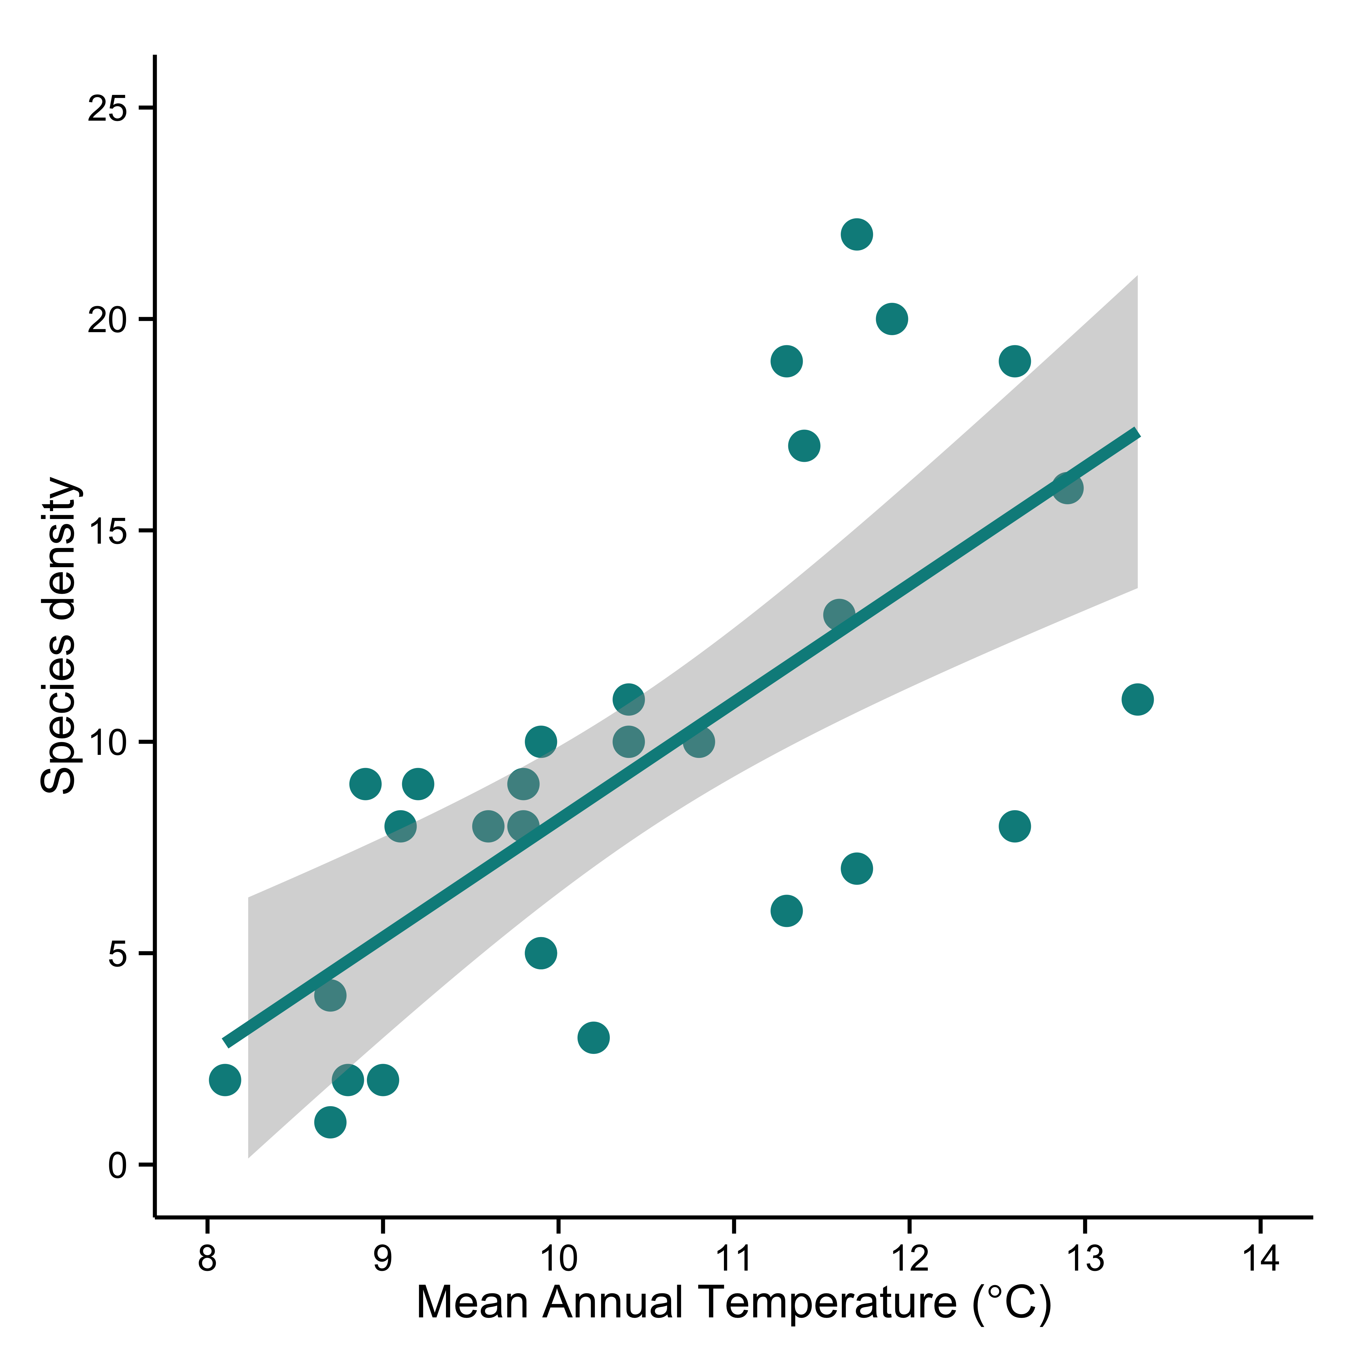
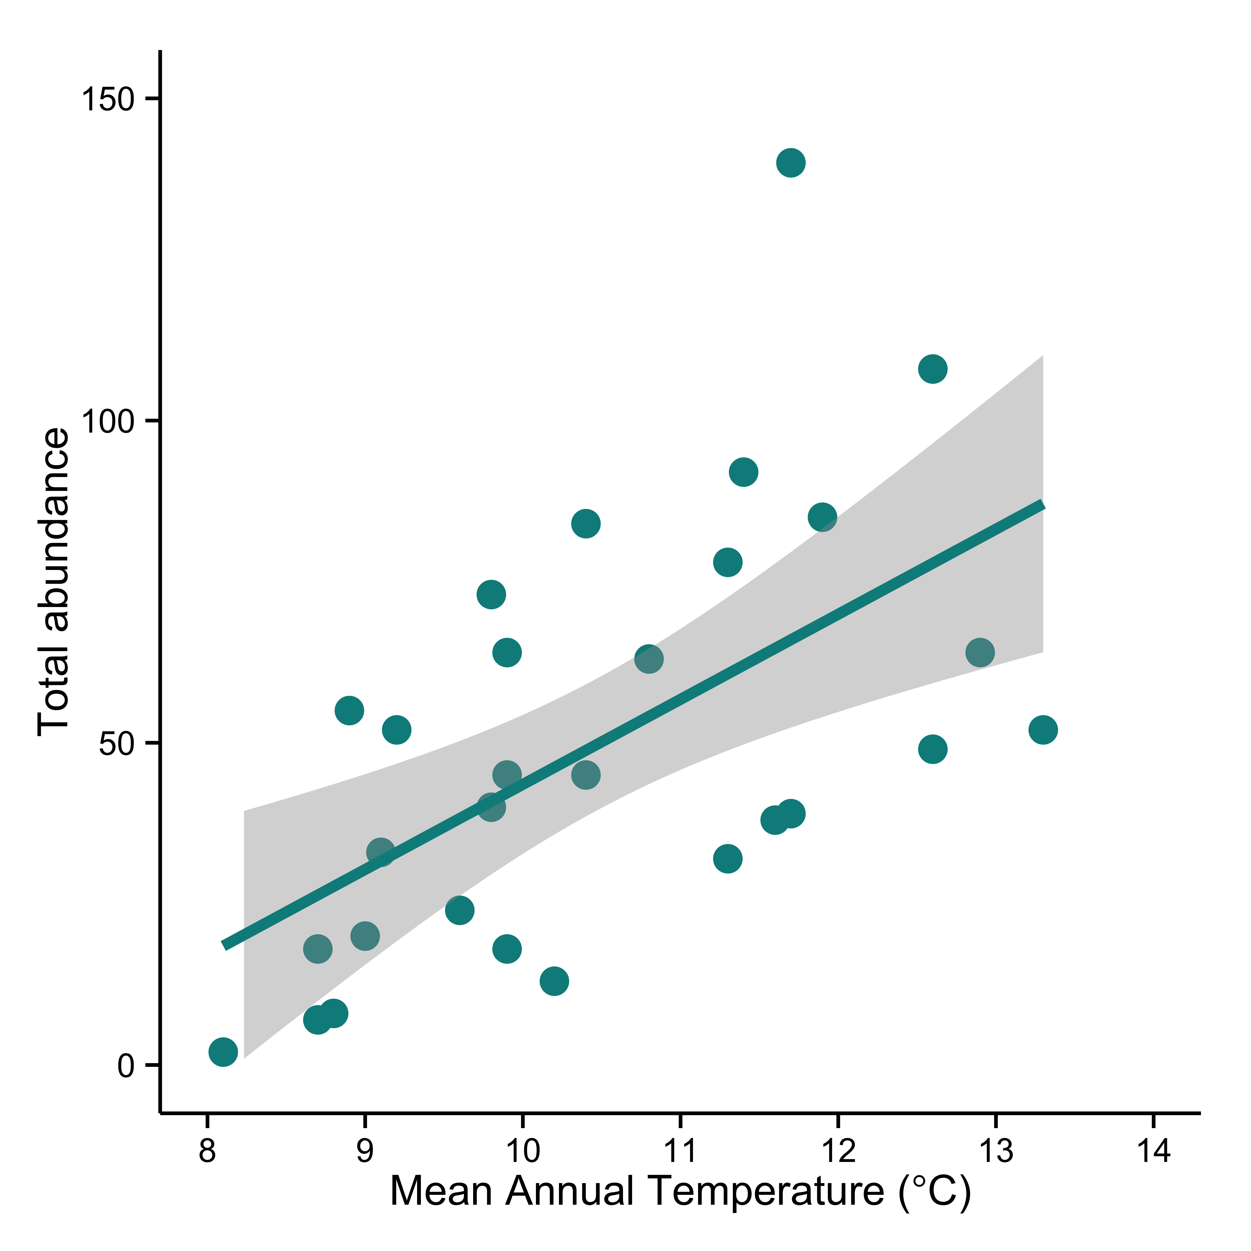
Appendix
b.
r² = 0.47
P < 0.001
r² = 0.34
P < 0.001
a.

Figure 1. The relationship between (a) total abundance and temperature and (b) species density and temperature shows increasing abundance and density with increasing mean annual temperatures. Temperatures are current (~1950-2000) mean temperatures for each site extrapolated from the WorldClim database (Hijmans et al., 2005) at a resolution of 30 arc-seconds. The line in each figure is the best-fit linear regression and the shaded area is the 95% Confidence Intervals.

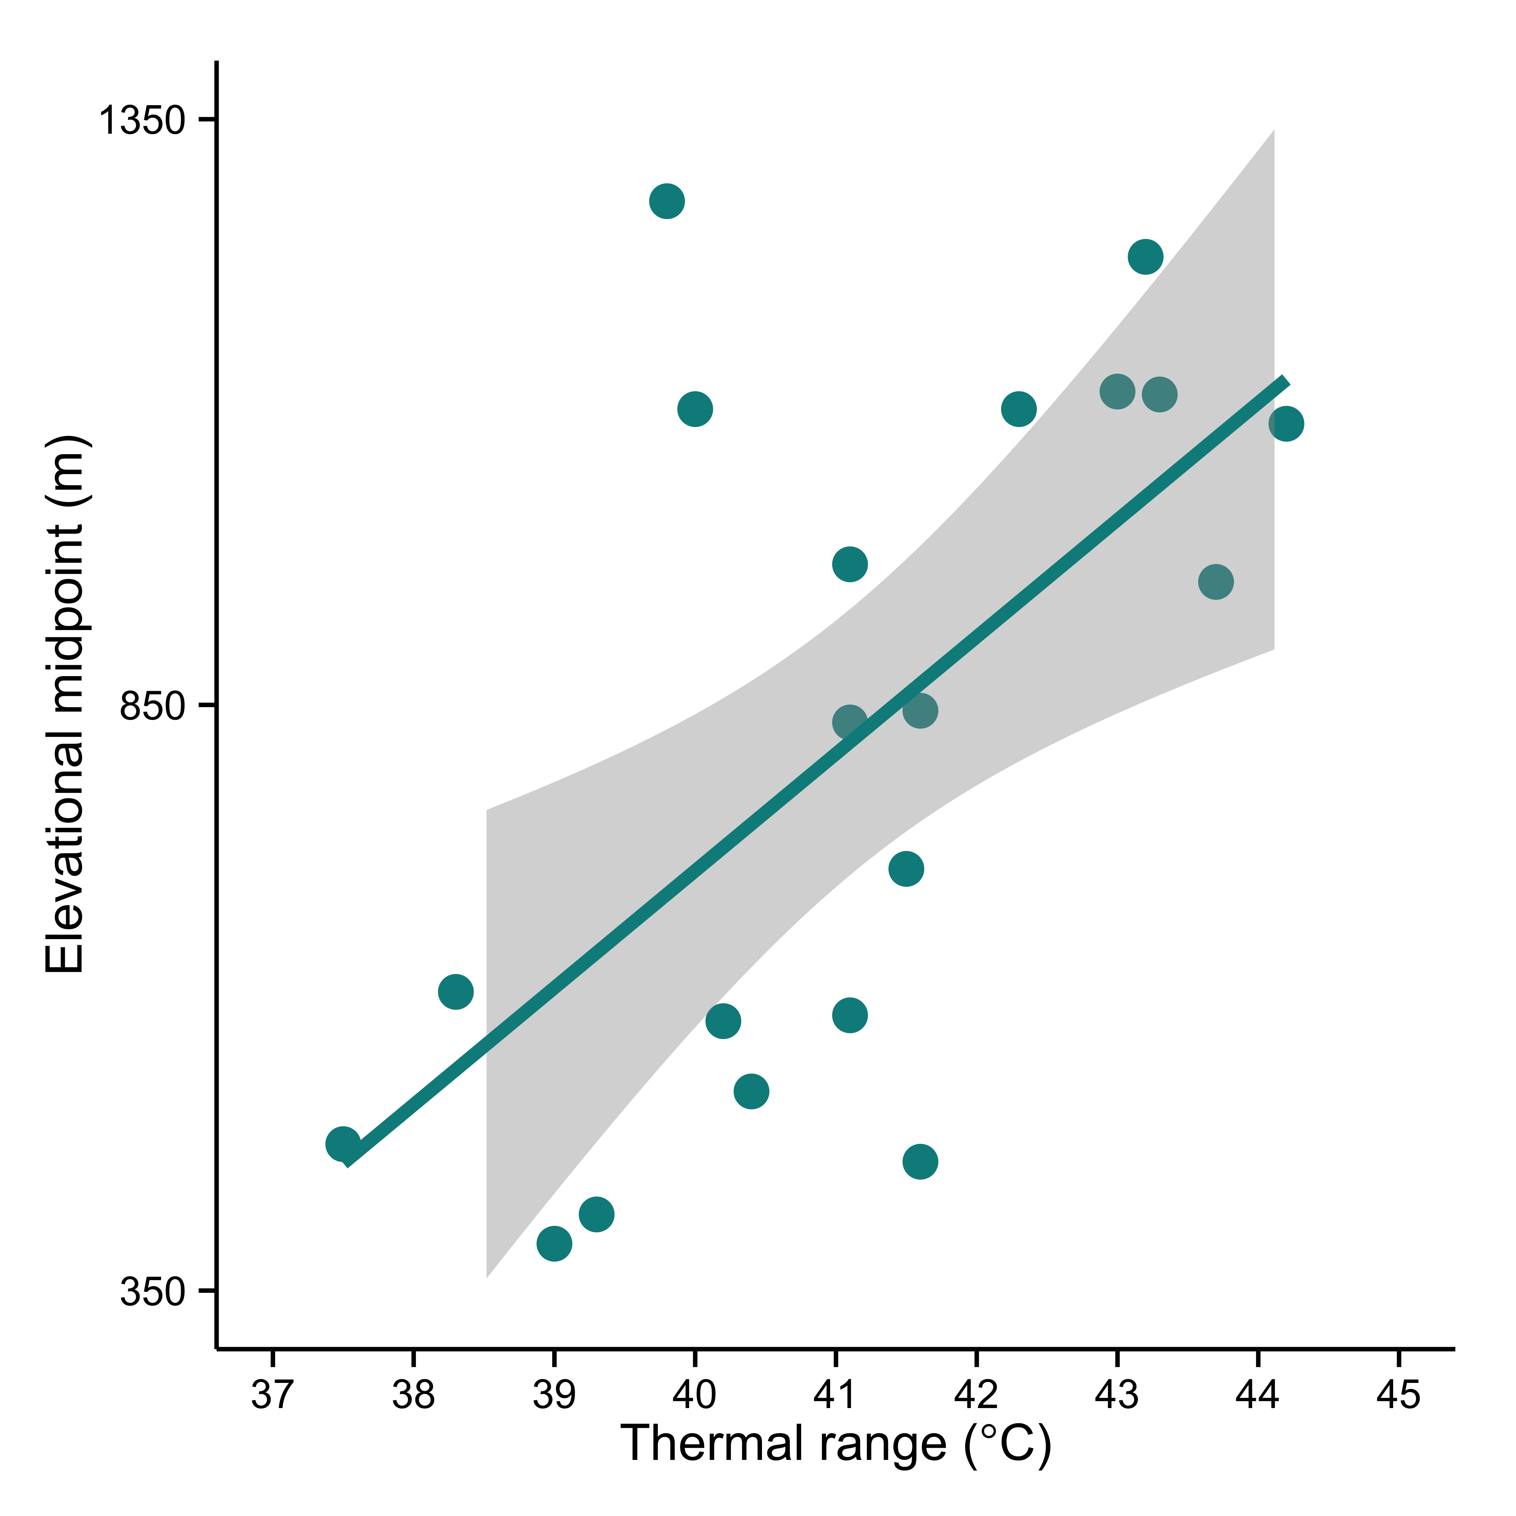
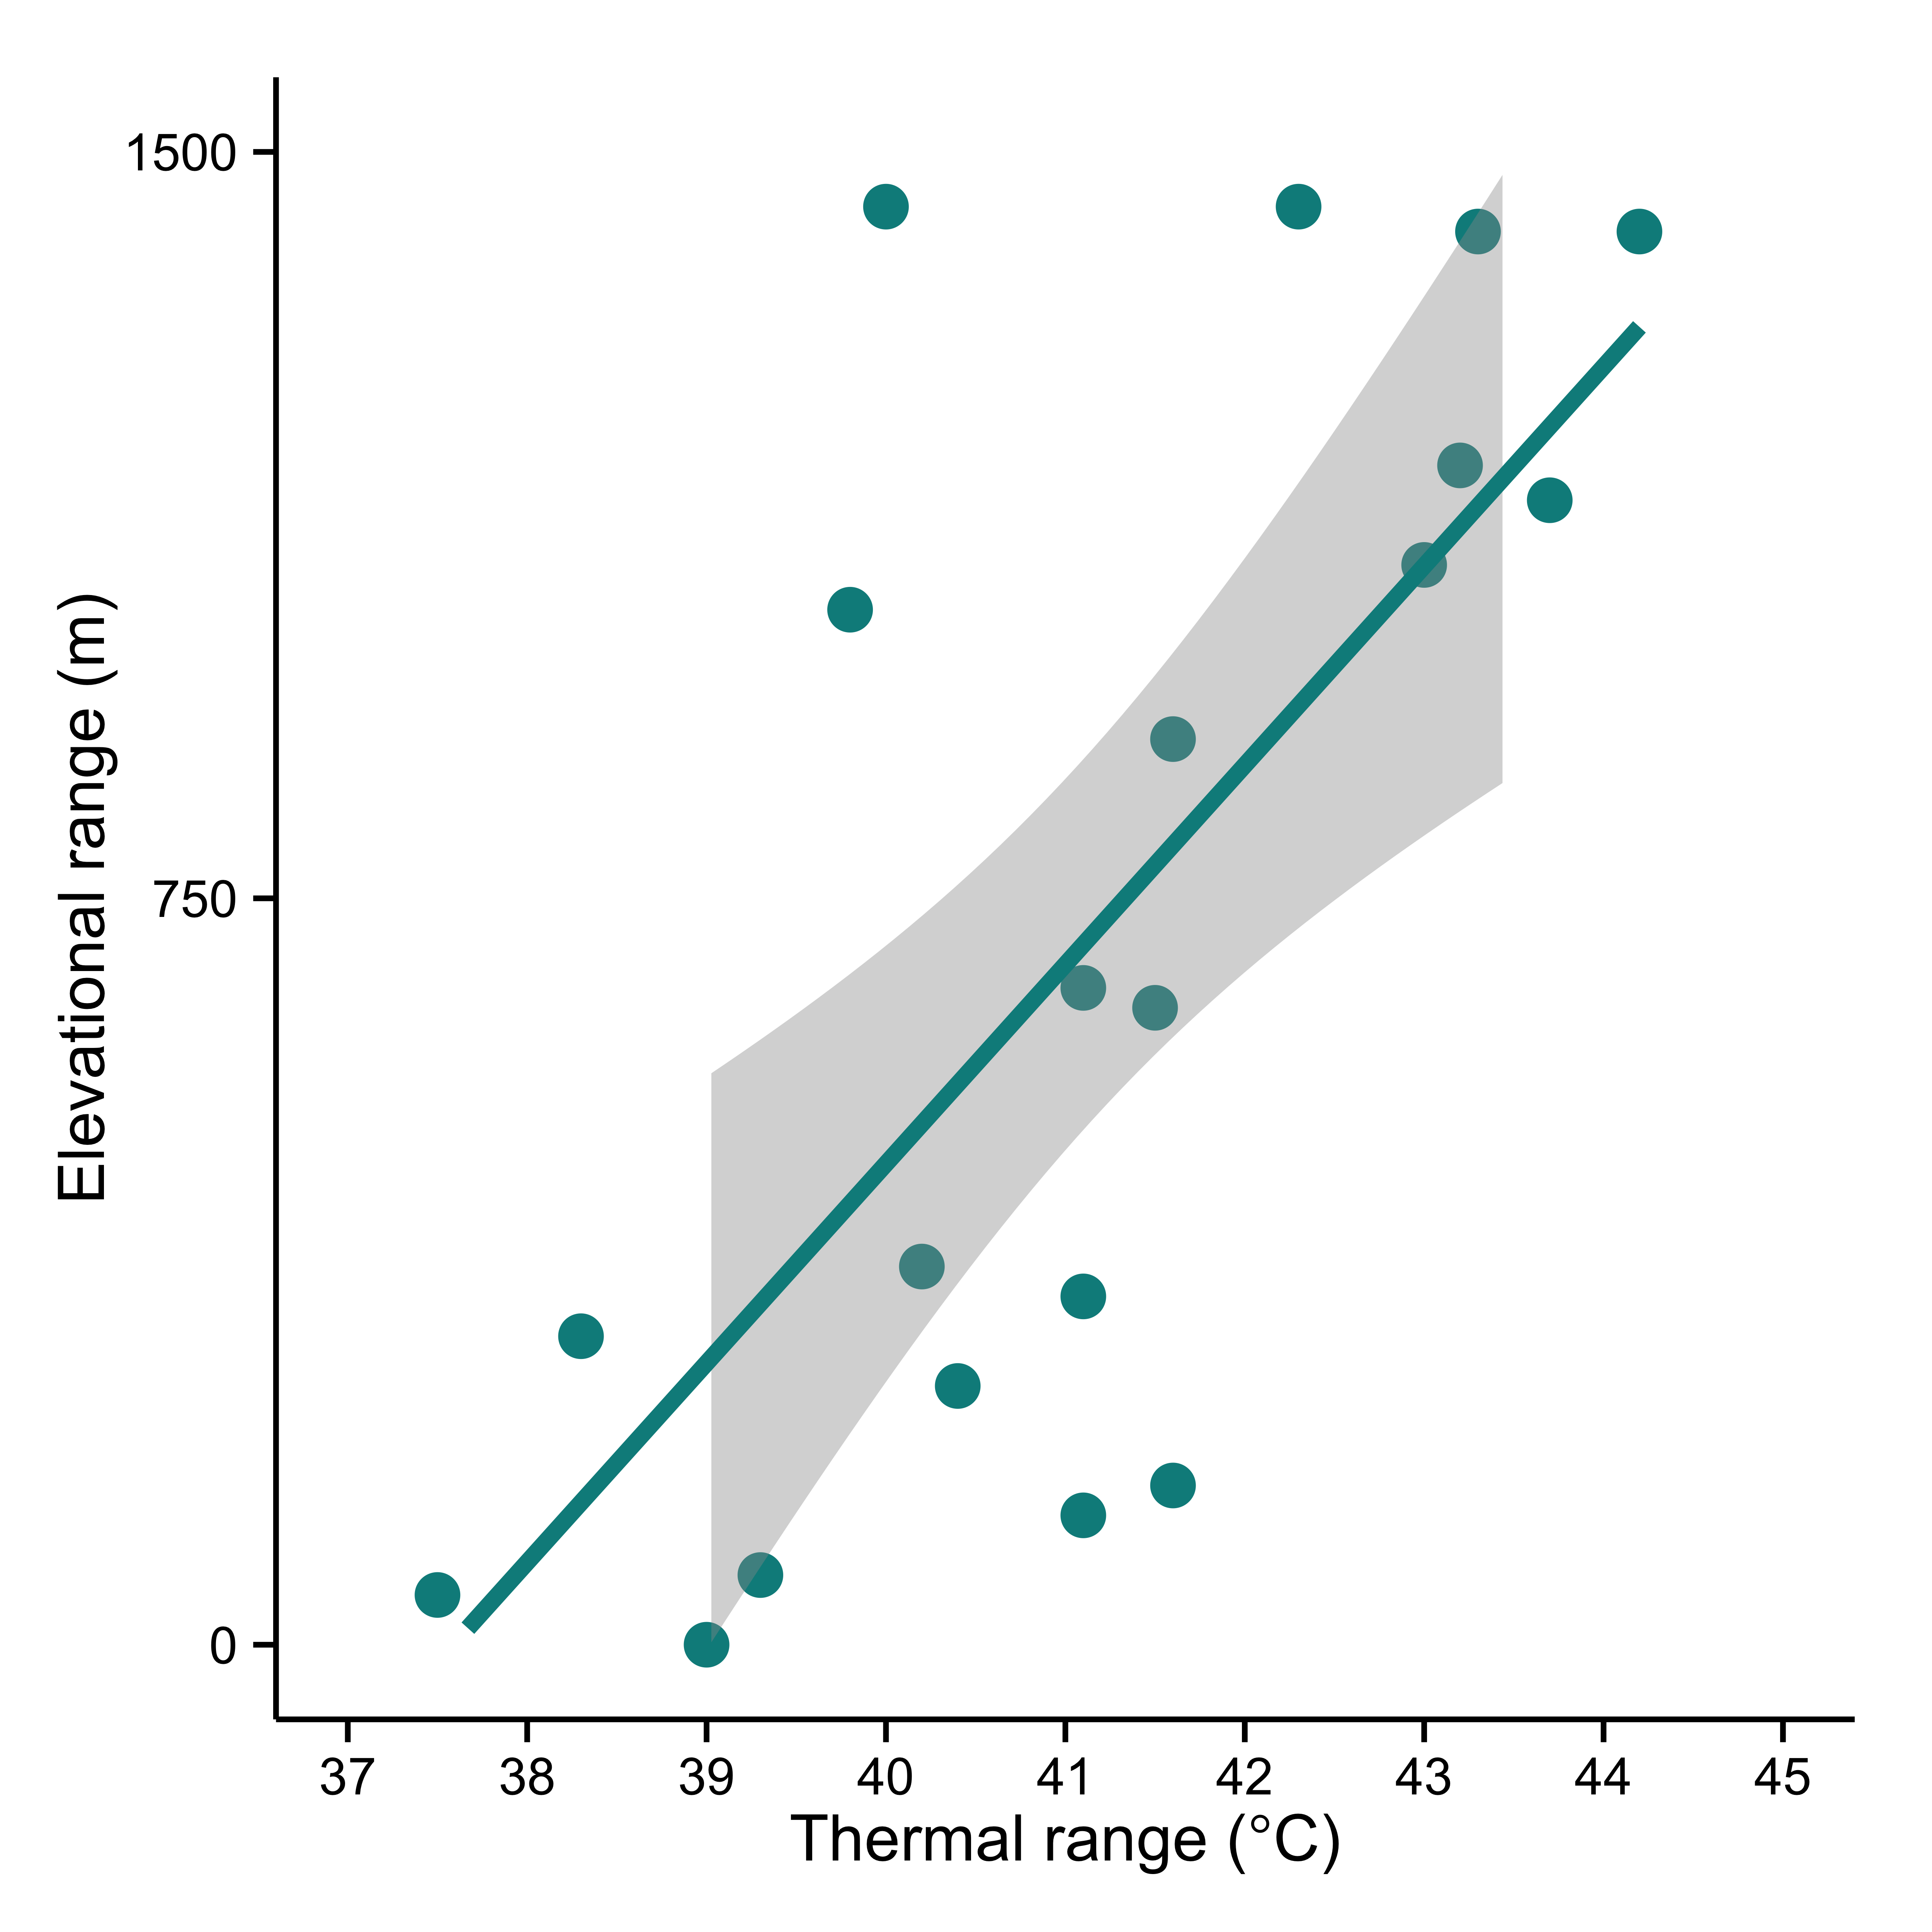
a.
b.
r² = 0.48
P < 0.001
r² = 0.38
P < 0.004

Figure 2. Thermal ranges (CT_{max} – CT_{min}) with 95% Confidence Intervals show a positive relationship with (a) elevational ranges (r² = 0.48, P = 0.001) and (b) elevational midpoints (r² = 0.38, P = 0.004) of 20 species for which we obtained both physiological and distributional data. Elevational ranges were calculated as the highest elevation at which a species was recorded minus the lowest elevation at which a species was recorded.

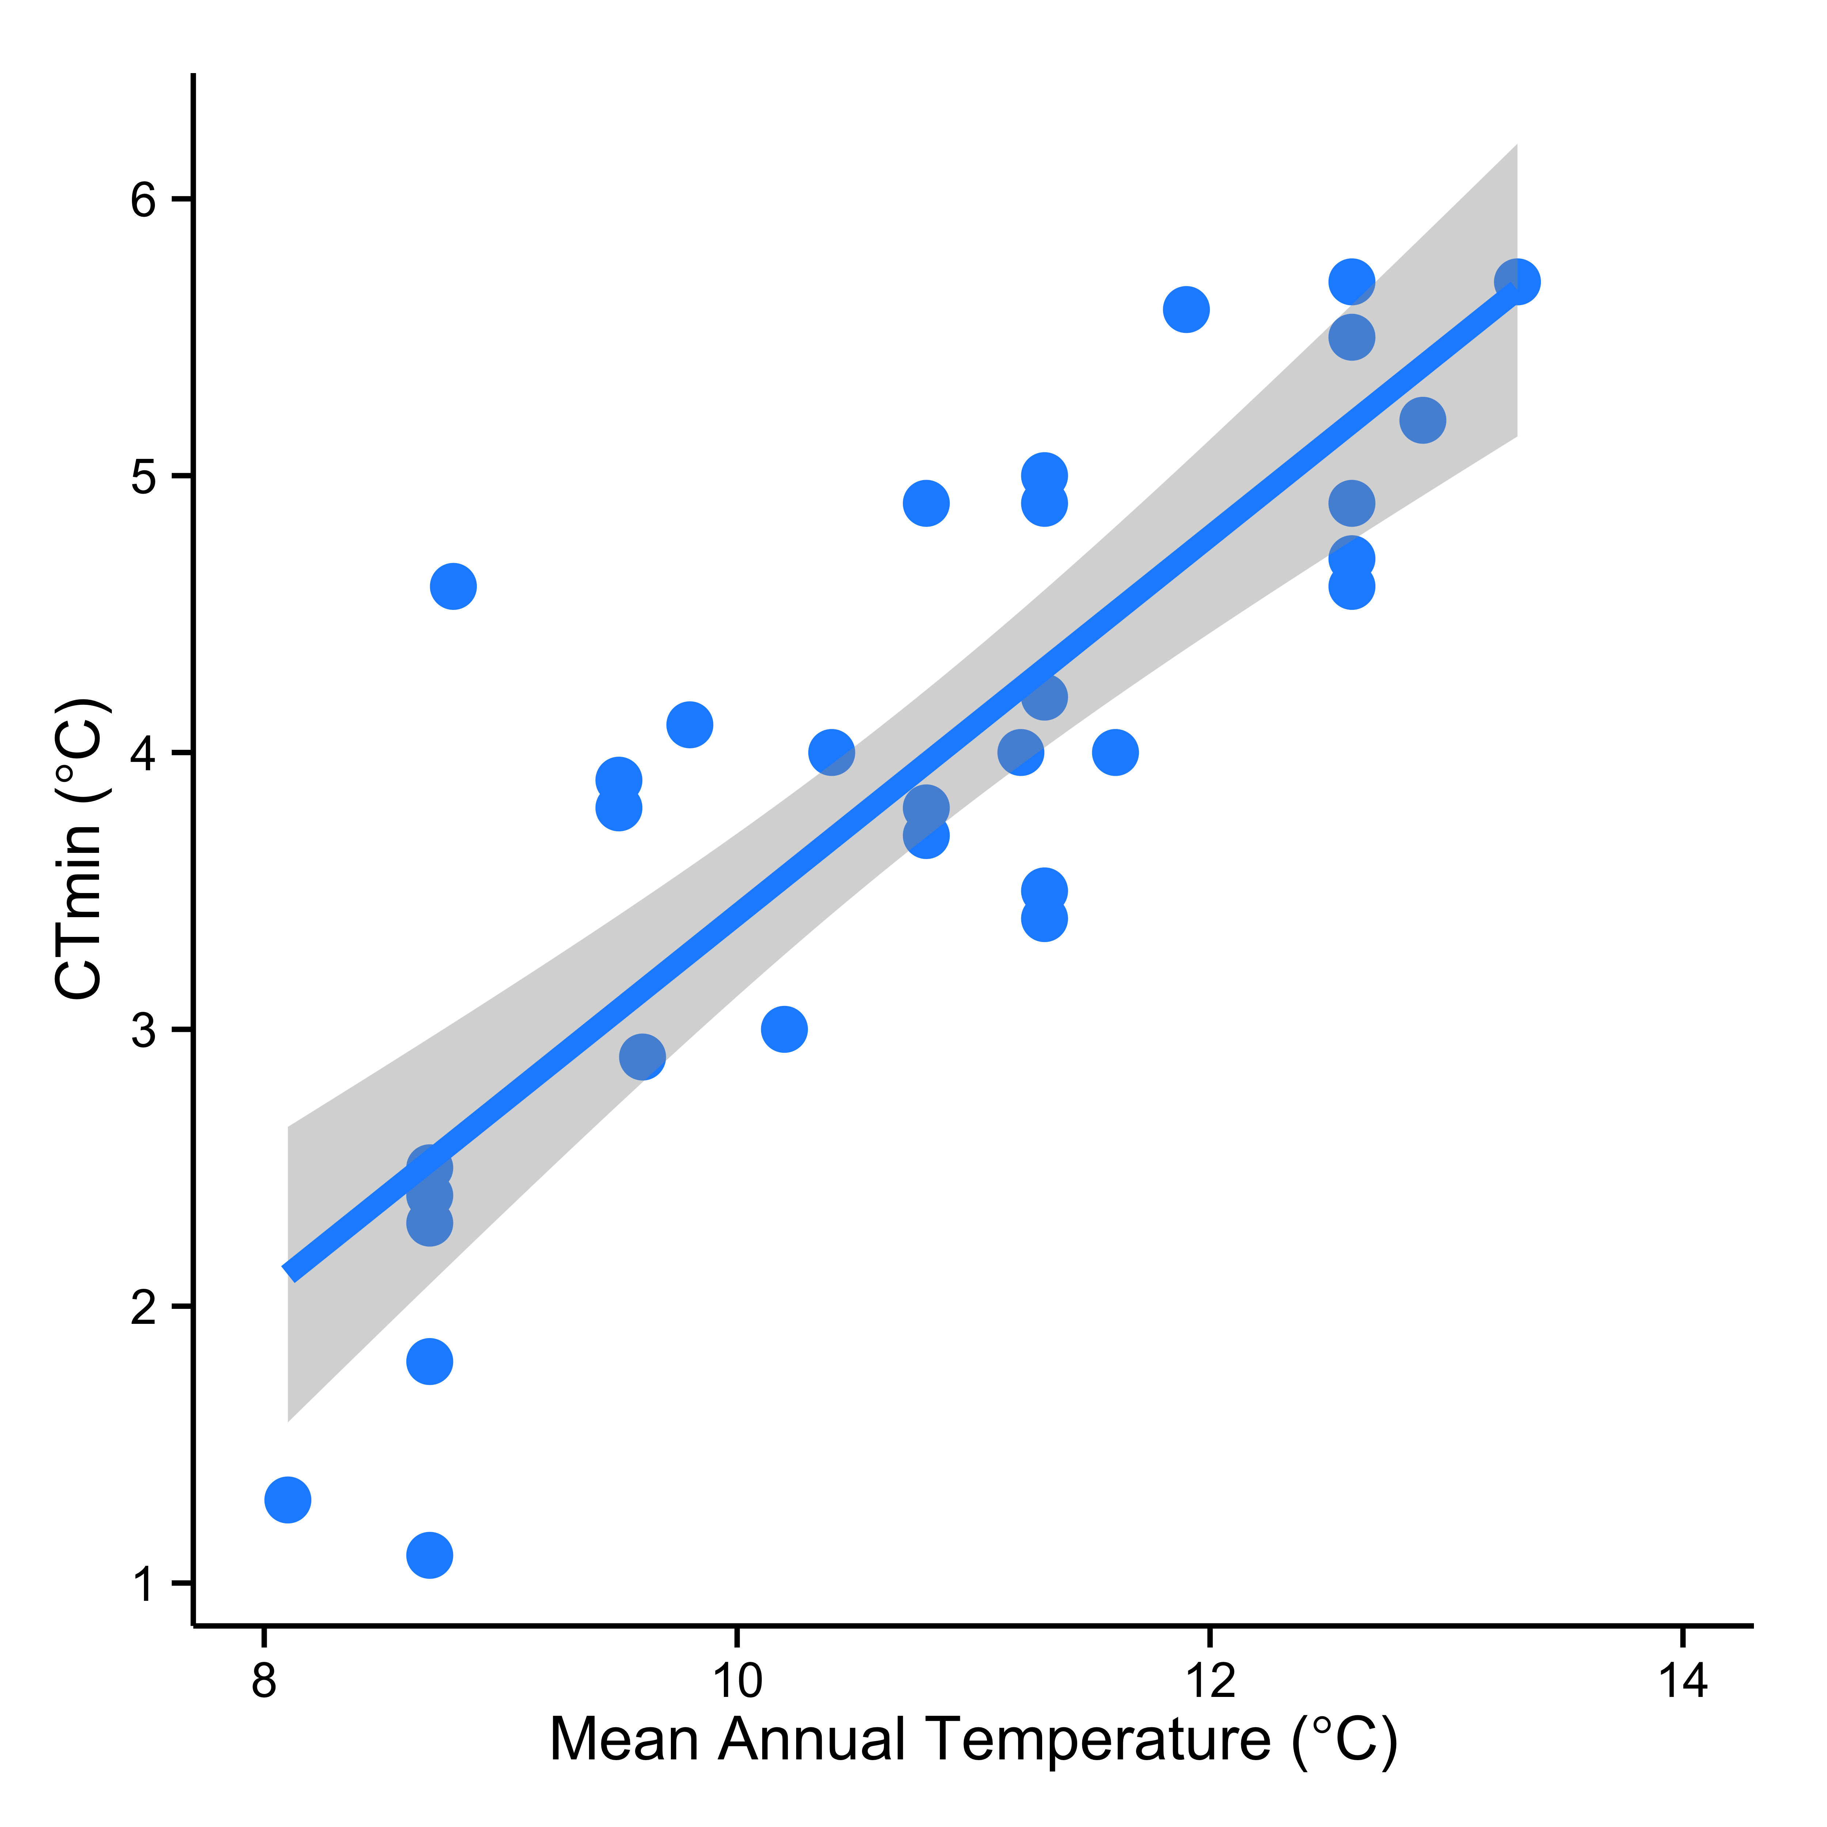
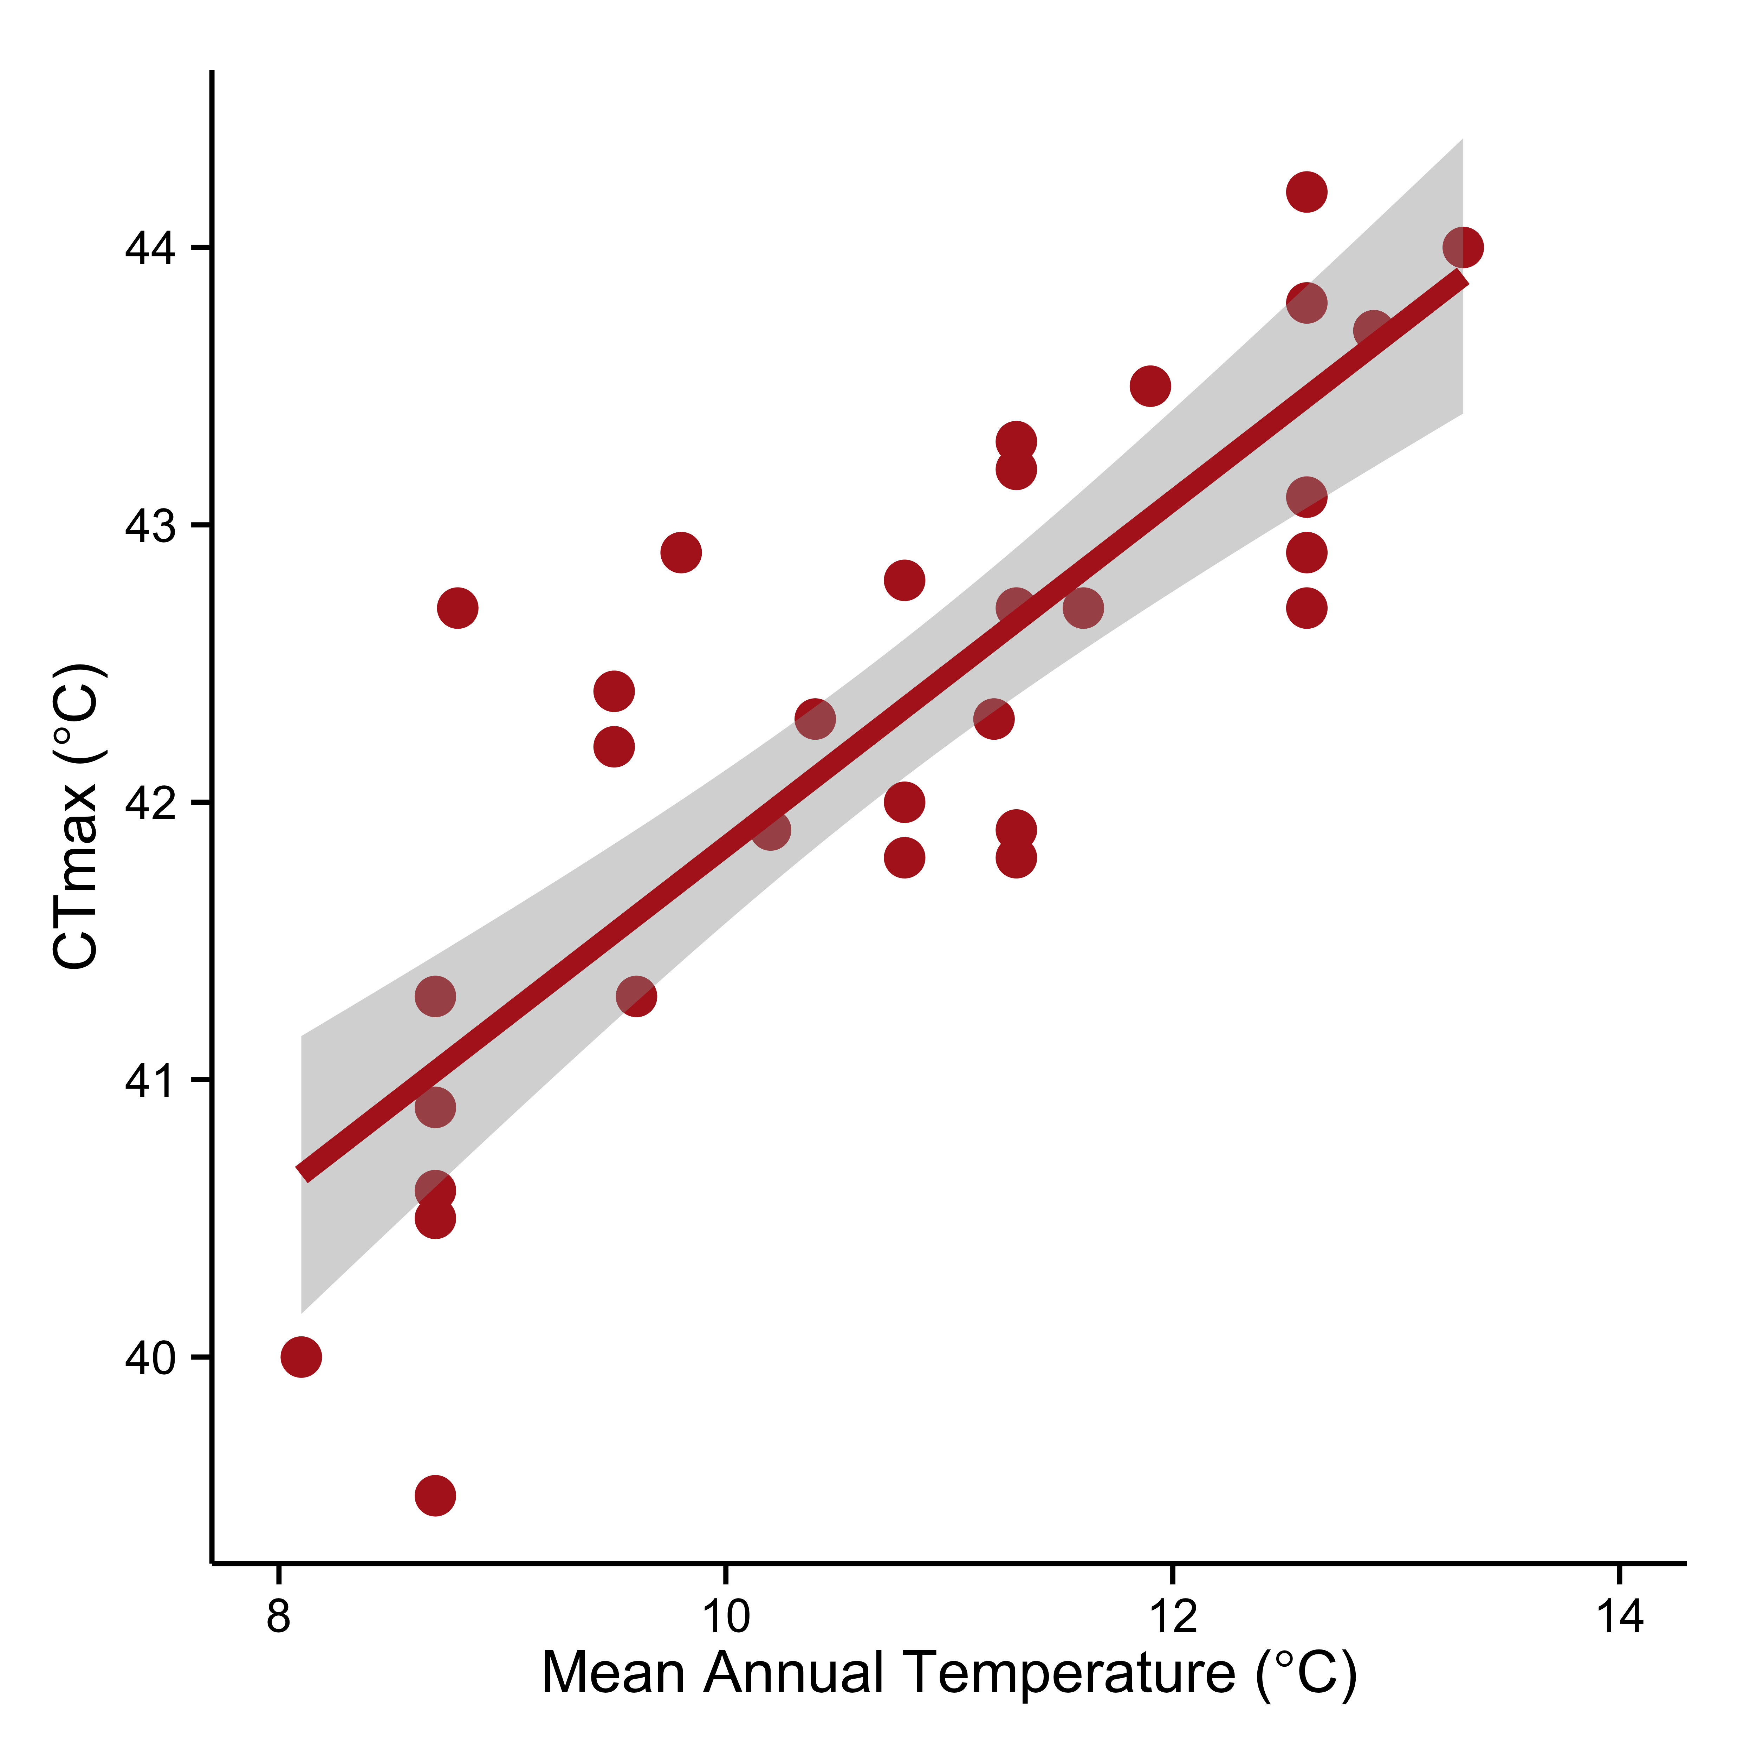
r² = 0.66
P < 0.001
r² = 0.67
P < 0.0001
a.
b.

Figure 3. Species that occur at the warmest sites have, on average, (a) the highest critical thermal maxima (CT_{max}) values and (b) those that occur at the coldest sites have, on average, the lowest critical thermal minima (CT_{min}) values. Each point is the mean of the thermal limits for all species averaged for each site. The line and shaded area in each figure is the best-fit linear regression and 95% Confidence Intervals, respectively. Temperatures were extrapolated from WorldClim (Hijmans et al., 2005) at a resolution of 30 arc-seconds and represent mean temperatures from ~1950-2000.

Figure 4. Residuals of the observed and expected species density based on thermal overlap in physiological limits and environmental temperatures. At lower temperatures, observed richness more closely matches expected richness; however, at warmer temperatures, there is more deviation in observed richness from the null expectation.
r² = 0.53
y = -463.91x² + 128.9x + 3.8916

Figure 5. The relationship between the number of species in an assemblage (not including the dominant species, if present) and the abundance of one of the competitively dominant species. The abundance of both dominant and subordinate species increases until the dominant species begin to limit the abundance of subordinate species.

CHAPTER II
Ecology and Evolution shape the thermal niche

Coauthored by Andrew D. Nguyen, Clint Penick, Lauren Nichols, John Stanton-Geddes, Sarah E. Diamond Robert R. Dunn, Aaron M. Ellison, Nicholas J. Gotelli, Sarah Helms Cahan, and Nathan J. Sanders

Abstract

Introduction
Climate change is altering and will alter species distributions through rapid increases in both the mean temperature and increased variability in temperatures. How species respond to these changes depends in large part on their physiology, which also determines their current distributions. Species with wide-ranging distributions tend to be able to tolerate broad temperature ranges, which may make them less susceptible to the effects of warming than small-ranged species, which typically cannot tolerate broad temperature ranges (Deutsch, et al. 2008).

Range size relates to the degree of environmental temperature variation that species experience and should match a species’ physiological traits. For example, greater environmental temperature variation selects for species that have larger thermal breadths, (i.e. a greater range between their upper (CT_{max}) and lower (CT_{min}) thermal limits) (van Berkum, 1988). However, species can deviate from this prediction if selection does not operate on these traits equally, or at all (Huey and Kingsolver, 1993). Physiological traits are not static, but rather can change within a generation (acclimation) and across generations (adaptation), which together may temper the effects of warming. In order to improve predictinos about how biodiversity will respond to ongoing warming, it is important to understand whether the responses of particular populations arise from acclimation or selection.

Most of the work to date that links physiology, range dynamics and climate change has focused on the differences among species. Species respond in diverse ways to warming, but we know little about variation among populations of the same species, or intraspecific variation, in response, or the responses of sister taxa. Recent innovations in sequencing allow for population level analyses of thermal traits. Variation in the responses of populations to warming is required if there is to be an evolutionary response, yet organisms living close to their thermal limits (specifically, CT_{max}) will have limited acclimation ability in relation to climate change (Stillman, 2003; Deutsch et al., 2008) and previous studies have shown that extending upper thermal limits has low adaptive potential (Kellermann et al., 2012). In fact, CT_{min} has more additive genetic variation than CT_{max}. Additionally, behavioral thermoregulation may play a large role in determining acclamatory or evolutionary effects. Organisms that are effective thermoregulators can ameliorate detrimental effects of climate warming and may, over time, shift their thermal performance (Angilletta, 2009). However, patterns of thermoregulatory behavior and thermal acclimation are variable and can lead to lasting changes in thermal sensitivity (Bayne et al., 1977; Niehaus et al., 2012), as well as induce energetic tradeoffs (Angilletta, 2009). To estimate evolutionary and acclamatory responses to warming, a biogeographical approach is needed that examines not only the variation among species, but also accounting for the variation within species.

This study combines field-collected and common garden assessments of physiological limits to examine the geographic variation in response to warming in ants. First, we determined the degree to which local environmental conditions matched physiological limits (CT_{max} or CT_{min}) by assessing intra-specific (e.g., population-level) variation in thermal tolerance on field-collected samples across a latitudinal gradient. Second, we tested the effect of acclimation on CT_{max} and CT_{min} by rearing whole colonies collected from the same latitudinal gradient under two temperature regimes in a common garden experiment. Finally, we used recent innovations in sequencing techniques to examine population-level variation in thermal traits. Ants are a good model taxon to examine local adaptation and geographic clines in response to warming, as they are a ubiquitous and ecologically important taxon. Specifically, ants within the genus Aphaenogaster are an ideal study system for measuring local adaptation, as they have a large geographic distribution and has therefore experienced historical climatic shifts. Additionally, Aphaenogaster ants have been shown to exhibit thermal sensitivity (Diamond et al., 2012a), as well as temperature-dependent species differences in phenology (Warren et al., 2011), activity (Stuble et al., 2013), foraging and seed dispersal (Pelini et al., 2011a; Warren et al., 2011; Warren & Bradford, 2013; Stuble et al., 2014), and physiology (Warren & Chick, 2013).

Methods

Field collections
Between May and July 2012, we collected individual workers of the widespread genus Aphaenogaster along a latitudinal gradient in the eastern United States extending from Florida (29.6557 N, -82.2765 W) to Maine (45.8935 N, -69.0491 W) (Fig. 1) (all tables and figures are located in the appendix). Collection was conducted across an extensive thermal gradient to encompass a considerable amount of the latitudinal range of the taxa. We excluded sites outside the range of those collected the following year to maintain a similar sampling area as the common garden. Workers collected in 2012 were not included in the common garden experiment, but rather were subjected to physiological tests (described below) within 6 hours of field collection to minimize any potential acclamatory response.

Common garden
The following year (April through July 2013), we collected queen-right colonies along a similar geographic gradient from Georgia (32.8807, -81.9572) to Maine (44.9818, -68.5174) (Fig. 1) by sampling deciduous and mixed-hardwood forests. We acclimated colonies to laboratory conditions (~25°C and standard long-days photoperiod) for two weeks prior to beginning two different temperature treatments at North Carolina State University. We haphazardly selected colonies from different sites and assigned them to a temperature treatment of either 20±2°C (24 colonies) or 26±2°C (19 colonies) and maintained on a 14h:10h light-dark cycle and fed an ant specific artificial diet (Bhatkar and Whitcomb 1970) for 6-8 weeks. For full common garden experimental design, see Penick et al. (in prep).

Thermal tolerance
In both field-collected and lab-reared ants, we used the loss of righting response as the measure of thermal tolerance and conducted physiological testing using glass test tubes housing individual ants in a refrigerated water bath (Ac-150-A40, NesLab, ThermoScientific). We increased (or decreased for CT_{min}) temperatures by 1°min⁻¹ until thermal limits were reached as described in Warren and Chick (2013). We tested 10 individuals from each colony from each site (5 workers for CT_{max} and 5 workers for CT_{min}) and report the thermal limits as the means of the 5 individuals tested, respectively. In total, we tested 1040 Aphaenogaster ants combined from 49 sites (field-collected ants) and 43 colonies (common garden ants). Voucher specimens from each colony are deposited at North Carolina State University.

To determine whether local environmental conditions shape thermal traits, we extracted mean annual temperature (MAT) and seasonality from the publically available Worldclim (Hijmans et al. 2005) at a resolution of 30 arc-seconds.

Library preparation
We preserved whole ants at either -20°C or in 95% ethanol at room temperature. We then extracted genomic DNA from tissue from a single worker from each colony (100 individuals total) with the Qiagen DNAeasy kit according to the manufacturer's instructions. We homogenized ant tissue prior to extraction with ~20 1.4mm zirconium silicate beads in 200ul chilled ATL buffer for three minutes in a Next Advance Bullet blender at maximum speed. The 39 experimental colonies were genotyped as part of a set of 48 individually-barcoded ddRADseq libraries constructed from 100-200ng of genomic DNA per individual. Briefly, samples were double-digested with the restriction enzymes NlaIII and MluCl at 37°C for three hours, purified using a 1.5X concentration of AMPure purification beads, and quantified with a Qubit analyzer. We ligated the purified samples to barcoded P1 and universal P2 adaptors, and normalized sample concentrations by pooling 40ng of each sample. We purified three hundred microliters of the pooled library with a 1X AMPure bead purification eluted into 30ul of Qiagen AE buffer. The ligated fragments were amplified in seven 20ul PCR reactions containing approximately 20ng of DNA with the Phusion Taq PCR kit. We empirically determined the appropriate number of PCR cycles by comparing amplification intensities of 11, 13 and 15 cycles; the final library was constructed using 13 cycles. The combined PCR reactions were pooled and purified with 1.5X AMPure beads into a final volume of 30ul. We size-selected fragments 300-400bp in total length from a 1.5% agarose gel and extracted with the QIEX II gel extraction kit. We verified library size range and quality on a Bioanalyzer and with kapa qPCR. The library was single-end sequenced in a single HiSeq 2000 rapid-run lane at the University of Vermont Advanced Genome Technologies Core facility, yielding approximately 2.5 million reads per sample.

Bioinformatics
Sequences were demultiplexed using the program sabre (https://github.com/najoshi/sabre), allowing for up to a single base pair mismatch, and the restriction site sequence was trimmed. We trimmed the total length of all sequences to 90bp and completely excluded low-quality reads, defined as those whose quality score dropped below 10 at any point along the sequence, from downstream analysis.

Because there is no sequenced genome available for the genus Aphaenogaster or closely related ant genera, we used a subset of five samples from across the geographic extent of the transect (Table 1) to identify a repeatable subset of loci showing Mendelian inheritance patterns, which was then used as a reference against which the complete sample set was mapped and genotyped. The reference sample sequences were assembled into homologous tags using the denovo.pl pipeline in STACKS, and those tags for which a) there were from zero to three SNPs present across the five samples, b) all five samples contained one or more reads at the tag, c) all SNPs were biallelic, and d) all samples contained no more than two alternate haplotypes, were retained. We assembled the consensus sequences of the 61,518 retained tags into a fasta reference file and the filtered sequence reads of all samples, including the reference samples, were mapped against the reference with Bowtie. We identified SNP genotypes by assembling the mapped reads into stacks using the ref_map.pl pipeline in STACKS. For each sample, we concatenated the SNP genotypes across tags into a single pseudo-sequence that was used for all downstream biogeographic analyses.

Results
Along the latitudinal cline, sister species of Aphaenogaster responded differently to temperature. CT_{max} of A. picea did not vary with MAT (r² = 0.05, P = 0.13), yet CT_{min} declined more rapidly with decreasing MAT (r² = 0.89, P < 0.001; Fig. 2). This results in A. picea having a broader thermal breadth at higher latitudes and elevations (i.e. lower MAT). Interestingly, this pattern is reversed for A. rudis (CT_{max}: r² = 0.84, P < 0.001, CT_{min}: r² = 0.74, P = 0.003; Fig. 2).

Both PGLS and Eigen function analyses found significant effects of phylogeny and ecology for CT_{max}, but not for CT_{min}. In the PGLS analysis for CT_{max}, MAT was a significant predictor, even in the presence of a large phylogenetic signal (lambda= 0.83). For CT_{max}, there was also a significant effect of MAT and no evidence of phylogenetic signal (lambda=0). Eigen function analysis produced four principle components, which capture 77.7% of the variation within the phylogeny, and identifies different nodes of the phylogeny. PC1 explains 56.28% of the variation and represents the split between A. picea and A. rudis. PC2 represents the split between two clades within A. rudis and explains 13.37% of the variation in the phylogeny.

In the full model for CT_{max} responses, there were no significant main effects, but there was an interaction between PC1 (representing A. rudis/A. picea split) and MAT (B=1.535, p<0.01). In the full model for CT_{min} as the response, there was a significant main effect of MAT (p<0.001) and PC1 (p<0.001), and a significant interaction between them (B=-1.78, z value = 3.96, p<0.0001). Due to the interaction between MAT and PC1 (phylogeny), we performed additional regressions to determine the relationship between thermal traits (CT_{max} and CT_{min}) and MAT for each species. For A. picea, there was no significant effect of MAT, rearing temperature, or phylogeny on CT_{max}, but there was a significant positive effect of MAT on CT_{min} (B = 0.885, z value= 14.542, p<0.0001). For A. rudis, there was a positive effect of MAT on both CT_{max} (0.410, z value = 4.71, p<0.0001) and CT_{min} (0.280, z value = 3.58, p<0.001).

There was no effect of lab acclimation on thermal limits (Fig. 3). Aphaenogaster ants in the common garden exhibited similar intra-specific variation in thermal limits as documented in the field, regardless of lab rearing temperature. Ants collected and tested directly from the field exhibited more variability in CT_{max} than those reared in the common garden.

We recovered highly supported relationships among colonies that follow a southern to northern split in their geographic range. A. rudis is secluded to the southern end of the U.S., while A. picea occupies the northern end and both represent monophyletic clades and A. fulva is sister to A. picea and A. rudis (Fig 4).

Discussion
We reconstructed phylogenetic relationships reflecting the geographic distributions of a southern (A. rudis) and northern (A. picea) clade of ants with some range overlap. When accounting for these relationships in our phylogenetic analyses, we found patterns in thermal limits that suggest local adaptation. The northern clade, A. picea, exhibited more variation in CT_{min} than the southern clade of A. rudis, but the A. rudis clade exhibited more variation in CT_{max}. In fact, there was no clinal variation in CT_{max} for A. picea, suggesting little or no selection pressure on this physiological trait. This response could be due to differing selective pressures facing these two sister species. Aphaenogaster picea is considered to be a cold-adapted species, as it has earlier spring emergence and a lower CT_{max} and CT_{min} as compared to the A. rudis clade (Warren et al., 2011; Warren & Chick 2013). Additionally, A. picea occurs in cooler habitats than the A. rudis clade and may rarely (or never) experience temperatures close to its CT_{max}, whereas species within the A. rudis clade occur and forage at temperatures closer to its CT_{max} and would therefore have a more narrow estimate of warming tolerance (the difference between CT_{max} and mean environmental temperature) (Deutsch et al., 2008). The differences in how selection shaped these thermal limits is somewhat consistent with the concept known as Rapoport’s Rule. Rapoport’s Rule posits that the ranges of species are larger at higher latitudes than at lower latitudes due to more variation in the thermal environment. Aphaenogaster picea follows the rule because the thermal niche breadth increased with latitude; however, A. rudis had a larger thermal breadth at lower latitudes, reversing the rule.

There was no effect of rearing temperature on the thermal tolerance of Aphaenogaster ants; however, ants collected and tested directly from the field have more variability in thermal limits than those reared in the common garden. This could be due to the physical condition of the ants. Ants collected from the field were workers that were actively foraging at the time of collection, while those tested from the common garden were provided with a constant food source and did not need to forage great distances or for long periods of time. Common garden ants therefore could have been in better physical condition than some of those collected from the field. Regardless of this variation, there was no effect of acclimation on Aphaenogaster ants. This lack of evidence for lab acclimation may indicate that thermal limits are more genetically constrained than previously thought and that Aphaenogaster may have limited acclimation ability in relation to climatic warming. Additionally, cold tolerance seemed to be less constrained than warm tolerance. The slope for CT_{min} for A. picea is greater than the slope in CT_{max} for A. rudis, but we cannot rule out greater selection pressure for CT_{min}.

Through our amalgam of techniques and analyses using field lab experiments as well as phylogenetic components and genetic sequencing, we can propose that both ecology and evolution shape thermal traits in this widespread genus of ant. Species within the genus Aphaenogaster are susceptible to warming, but for different reasons. Aphaenogaster picea may be susceptible to rapid warming because there is little variation in CT_{max}, whereas ants in the A. rudis clade may be more susceptible because they operate closer to their thermal limits (Deutsch et al., 2008; Diamond et al., 2012b). Both species lack acclimation ability which may also result in greater climate warming susceptibility overall. Aphaenogaster ants are keystone mutualists that disperse approximately 90% of understory plants, many of which are eliaosome-containing seeds (Zelikova et al., 2008; Ness et al., 2009). Climatic warming will not be uniform across the landscape; therefore populations will experience varying degrees of warming. Populations that are unable to acclimate or adapt to a rapidly changing thermal environment may face decreases in colony sizes and overall local abundance. Thus, local extirpations or range shifts of a key seed disperser will likely cause mismatches in ant-plant mutualisms and have negative cascading effects on deciduous and mix-hardwood ecosystems.

References
Angilletta, M.J. (2009) Thermal adaptation: a theoretical and empirical synthesis. Oxford University Press Inc., New York.
Bayne, B.L., Widdows, J., & Newell, R.I.E. (1977) Physiological measurements on estuarine bivalve molluscs in the field. in: Keegan, B.F. et al. (Ed.) (1977). Biology of Benthic Organisms: 11th European Symposium on Marine Biology, Galway, October 1976. pp. 57-68
Bhatkar A, Whitcomb WH (1970) Artificial diet for rearing various species of ants. The Florida Entomologist 53:229-232
Deutsch, C.A., Tewksbury, J.J., Huey, R.B., Sheldon, K.S., Ghalambor, C.K., Haak, D.C. & Martin, P.R. (2008) Impacts of climate warming on terrestrial ectotherms across latitude. Proceedings of the National Academy of Sciences USA, 105, 6668–6672.Kingsolver, J. G., Diamond, S. E., & Buckley, L. B. (2013). Heat stress and the fitness consequences of climate change for terrestrial ectotherms. Functional Ecology, 27(6): 1415-1423.
Diamond, S.E., Sorger, D., Hulcr, J., Pelini, S., Toro, I., Hirsch, C., Oberg, E. & Dunn, R.R. (2012) Who likes it hot? A global analysis of the climatic, ecological, and evolutionary determinants of warming tolerance in ants. Global Change Biology, 18: 448–456.
Diamond, S. E., L. M. Nichols, N. McCoy, C. Hirsch, S. L. Pelini, N. J. Sanders, A. M. Ellison, N. J. Gotelli, and R. R. Dunn. (2012) A physiological trait-based approach to predicting the responses of species to experimental climatic warming. Ecology 93: 2305-2312
Hijmans, R.J., Cameron, S.E., Parra, J.L., Jones, P.G. & Jarvis, A. (2005) Very high resolution interpolated climate surfaces for global land areas. International Journal of Climatology, 25, 1965–1978.
Huey, R.B. & Kingsolver, J.G. (1993) Evolution of resistance to high temperature in ectotherms American Naturalist, 142: S21-S46.
Kellerman, V., Overgaard, J., Hoffmann, A.A., Fløjgaard2, C. Svenning, J-C, & Loeschcke, V. (2012) Upper thermal limits of Drosophila are linked to species distributions and strongly constrained phylogenetically. Proceedings of the National Academy of Sciences of the United States of America. 109 (40): 16228-16233.
Ness, J.H. Morin, D.F., & Giladi, I. (2009) Uncommon specialization in a mutualism between a temperate herbaceous plant guild and an ant: are Aphaenogaster ants keystone mutualists? Oikos, 118: 1793-1804.
Niehaus, A.C., Angilletta, M.J., Sears, M.W., Franklin, C.E., Wilson, R.S. (2012) Predicting the physiological performance of ectotherms in fluctuating thermal environments. Journal of Experimental Biology, 215: 694-701.
Pelini, S.L., Bowles, F.P., Ellison, A.M., Gotelli, N.J., Sanders, N.J., & Dunn, R.R. (2011) Heating up the forest: open-top chamber warming manipulation of arthropod communities at Harvard and Duke Forests. Methods in Ecology and Evolution. 2 (5): 534-540.
Pelini, S.L., Boudreau, M., McCoy, N., Ellison, A.M., Gotellis, N.J., Sanders, N.J. & Dunn., R.R. (2011) Effects of short-term warming on low and high latitude forest ant communities. Ecosphere, 2 (5): art62.
Penick CA, Diamond SE, Sanders NJ, Dunn RR (in prep) Comprehensive metrics of performance identify key axes of thermal adaptation in social insects.
Peterson BK, Weber JN, Kay EH, Fisher HS, Hoekstra HE. (2012) Double Digest RADseq: An Inexpensive Method for De Novo SNP Discovery and Genotyping in Model and Non-Model Species. PLoS ONE 7:e37135.
Stamatakis A. 2014. RAxML version 8: a tool for phylogenetic analysis and post-analysis of large phylogenies. Bioinformatics 30:1312–1313.
Stillman, J.H. (2003) Acclimation capacity underlies susceptibility to climate change. Science. 301 (5629): 65.
Stuble, K.L., Rodriguez-Cabal, M.A., McCormick, G.L., Jurić, I., Dunn, R.R. & Sanders, N.J. (2013) Tradeoffs, competition, and coexistence in eastern deciduous forest ant communities. Oecologia, 171: 981–92.
Stuble, K. L., Patterson, C. M., Rodriguez-Cabal, M. A., Ribbons, R. R., Dunn, R. R., & Sanders, N. J. (2014) Ant-mediated seed dispersal in a warmed world. PeerJ, 2: e286.
van Berkum, F.H. (1988). Latitudinal Patterns of the Thermal Sensitivity of Sprint Speed in Lizards. The American Naturalist, 132 (3): 327-343.
Warren II, R.J., Bahn, V., & Bradford, M.A. (2011) Temperature cues phenological synchrony in ant mediated seed dispersal. Global Change Biology, 17: 2444-2454.
Warren, RJ & Chick, L (2013) Upward ant distribution shift corresponds with minimum, not maximum, temperature tolerance. Global Change Biology, 19: 2082–2088.
Zelikova, T.J., Dunn, R.R., & Sanders, N.J. (2008) Variation in seed dispersal along an elevational gradient in Great Smoky Mountains National Park. Acta Oecologia, 34: 155-162.

Appendix
Table 1. Samples collected in the summer of 2013 in a latitudinal transect from Georgia to Maine for a common garden experiment.
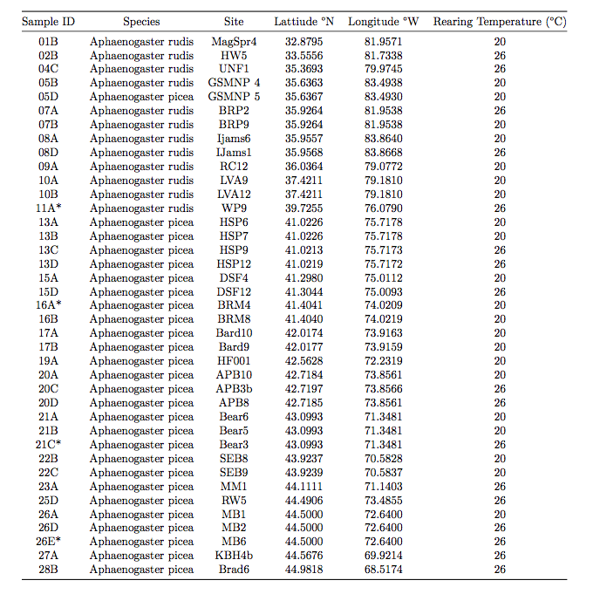

* Denotes samples used as a reference for calling SNPs
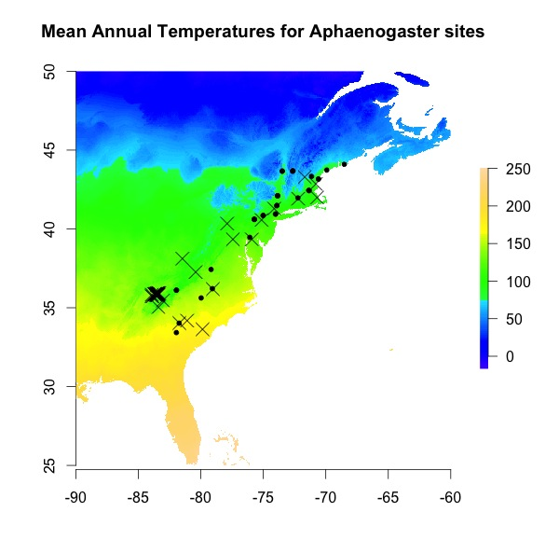
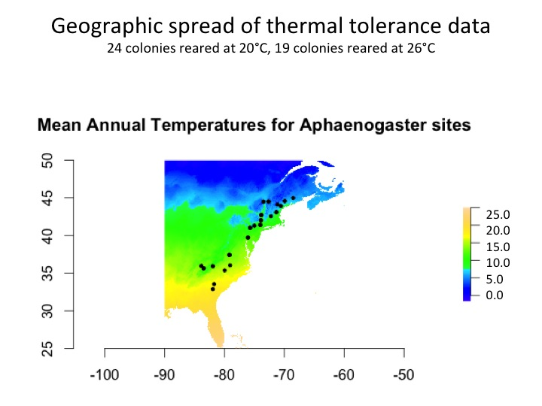
Mean annual temperatures (C°)
25
20
15
10
5
0
- Common garden sites
- Field collected sites

Figure 1. Site collections of Aphaenogaster ants. Each point represents a sampling site for the common garden experiment (circles) and field-collected thermal limits (). Sites ranged from approximately 32.88°N to 44.98°N. Colors represent mean annual temperatures extrapolated from WorldClim (Hijmans et al., 2005) at a resolution of 30 arc-seconds ranging from ~1950-2000.

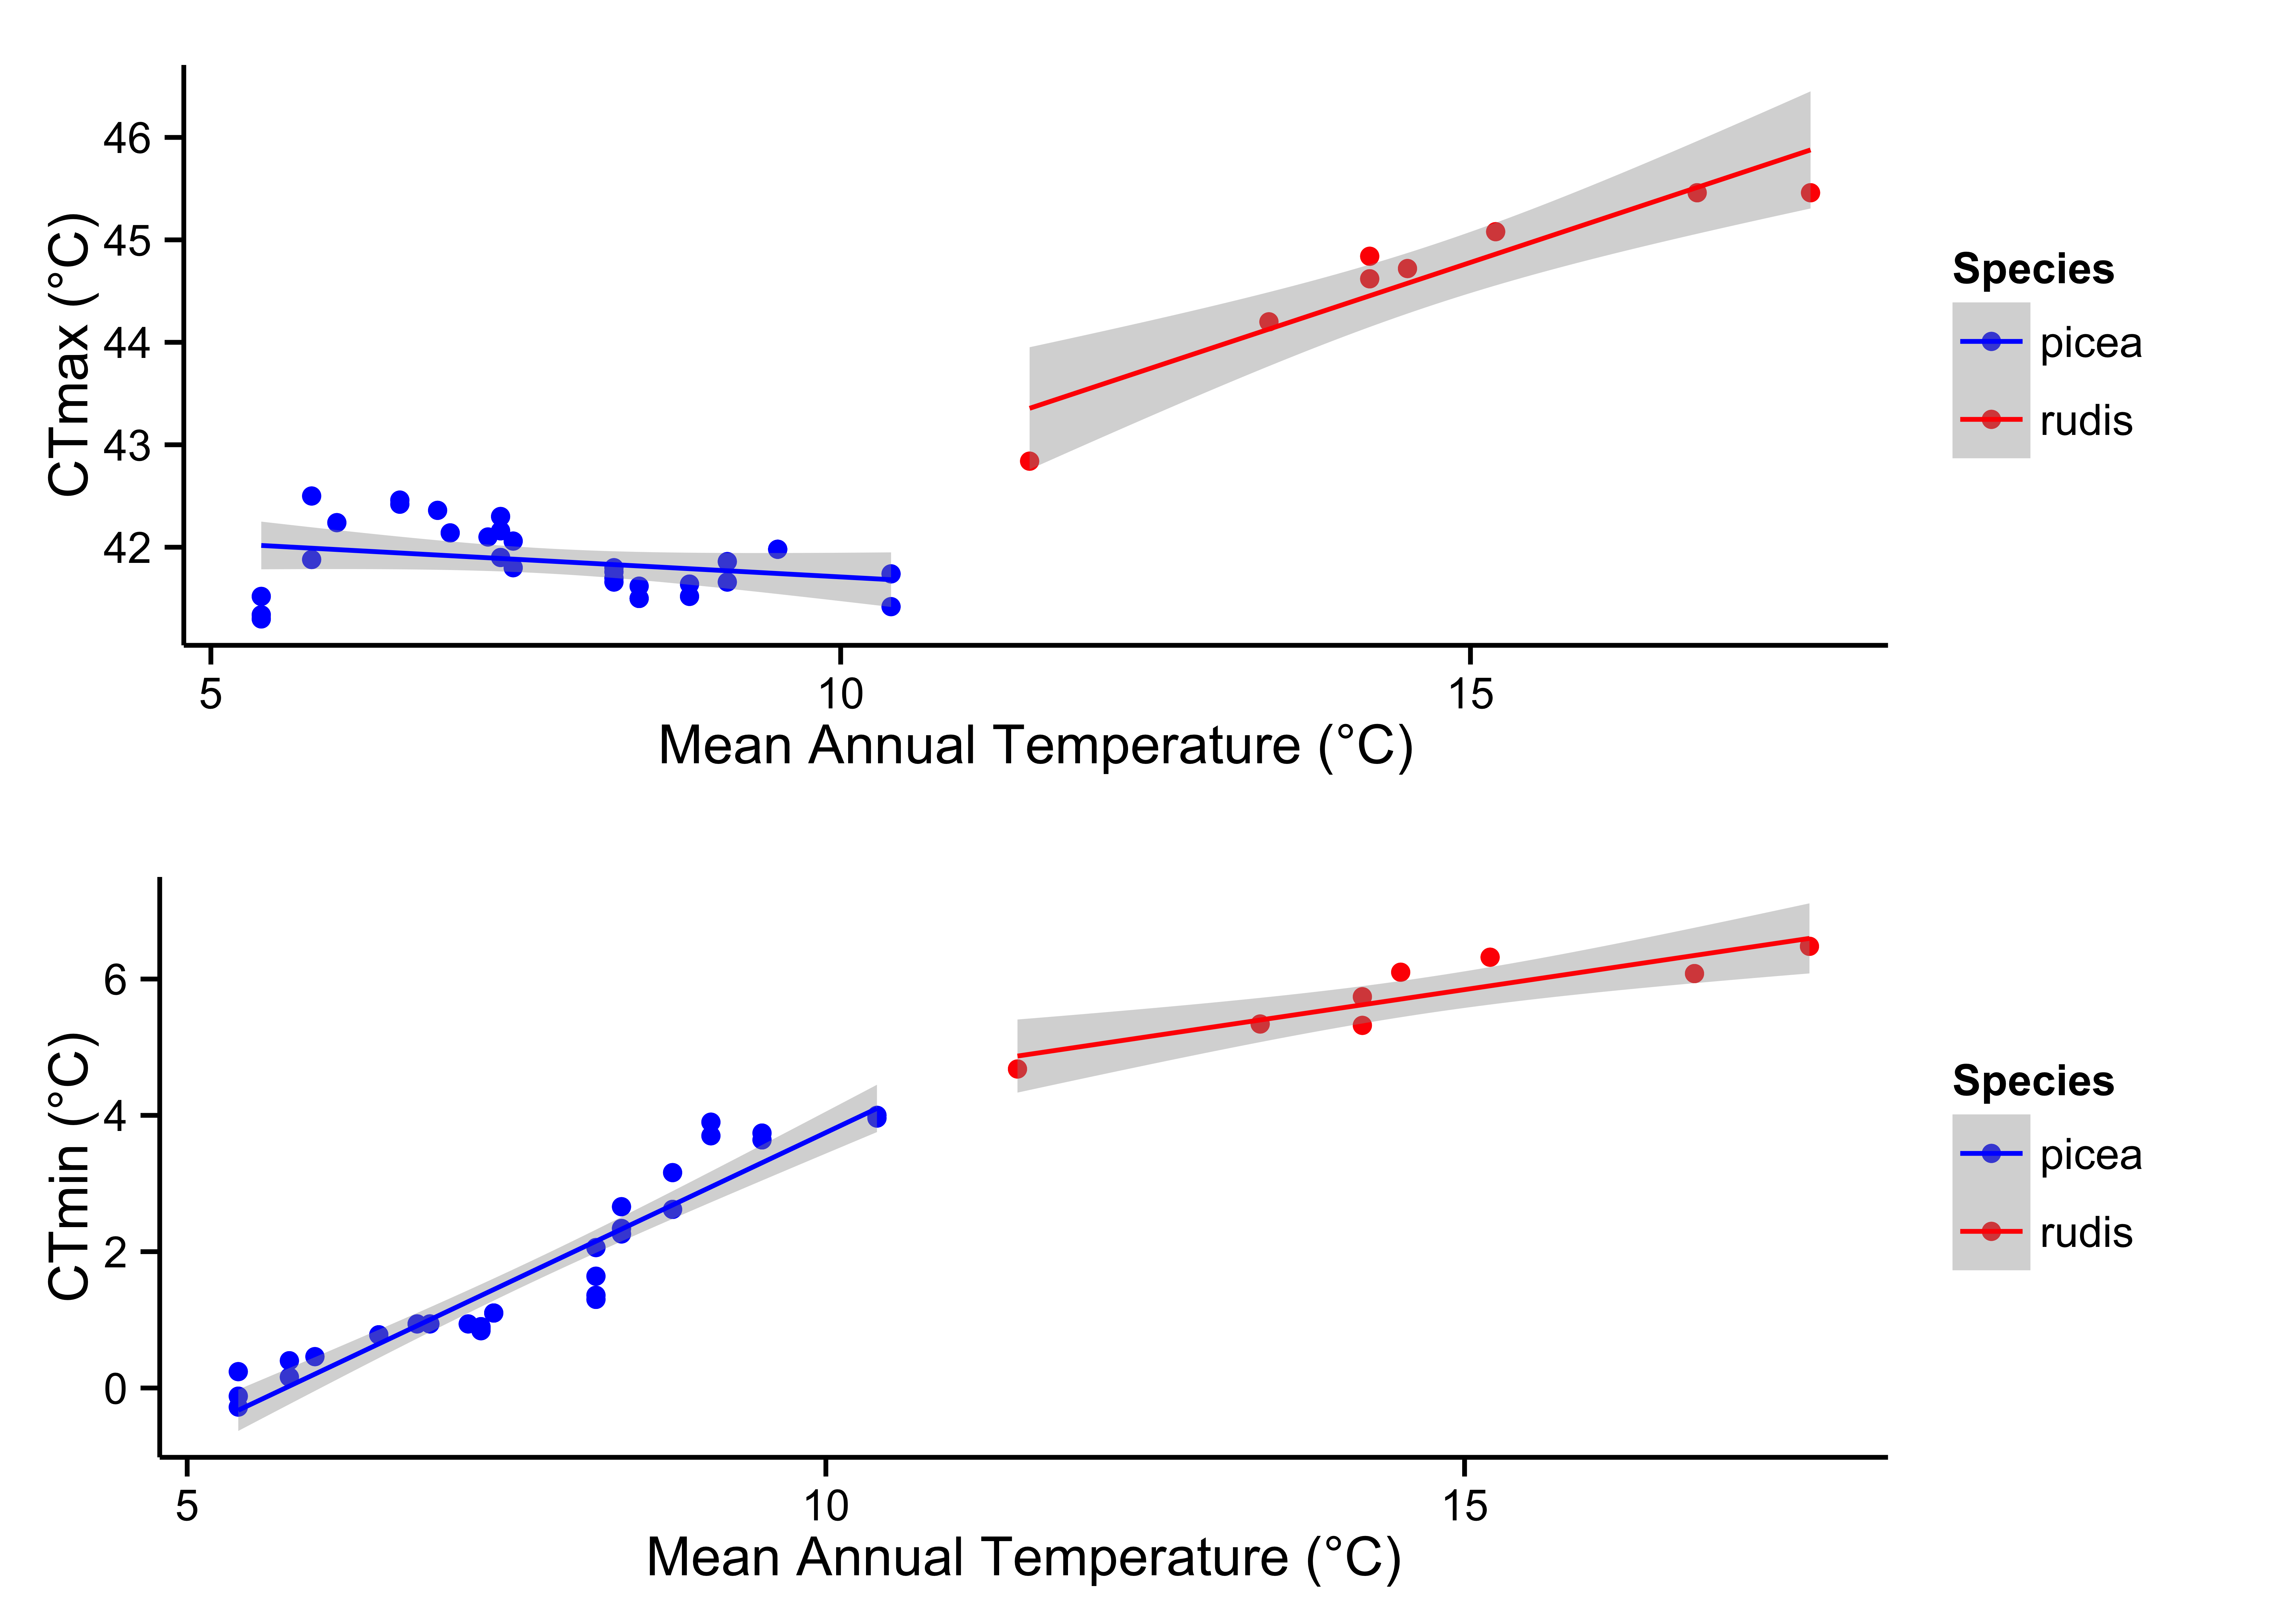

A. picea r² = 0.05
P = 0.13
A. rudis r² = 0.84
P < 0.001
A. picea r² = 0.89
P < 0.001
A. rudis r² = 0.74
P = 0.003

Figure 2. Thermal limits plotted against mean annual temperature (MAT) indicate differing responses to temperature among sister species of Aphaenogaster. There is little variation in CT_{max} with MAT for A. picea (r² = 0.05, P = 0.13), yet CT_{min} declines more rapidly with decreasing MAT (r² = 0.89, P < 0.001). This pattern is reversed for A. rudis (CT_{max}: r² = 0.84, P < 0.001, CT_{min}: r² = 0.74 , P = 0.003 ).
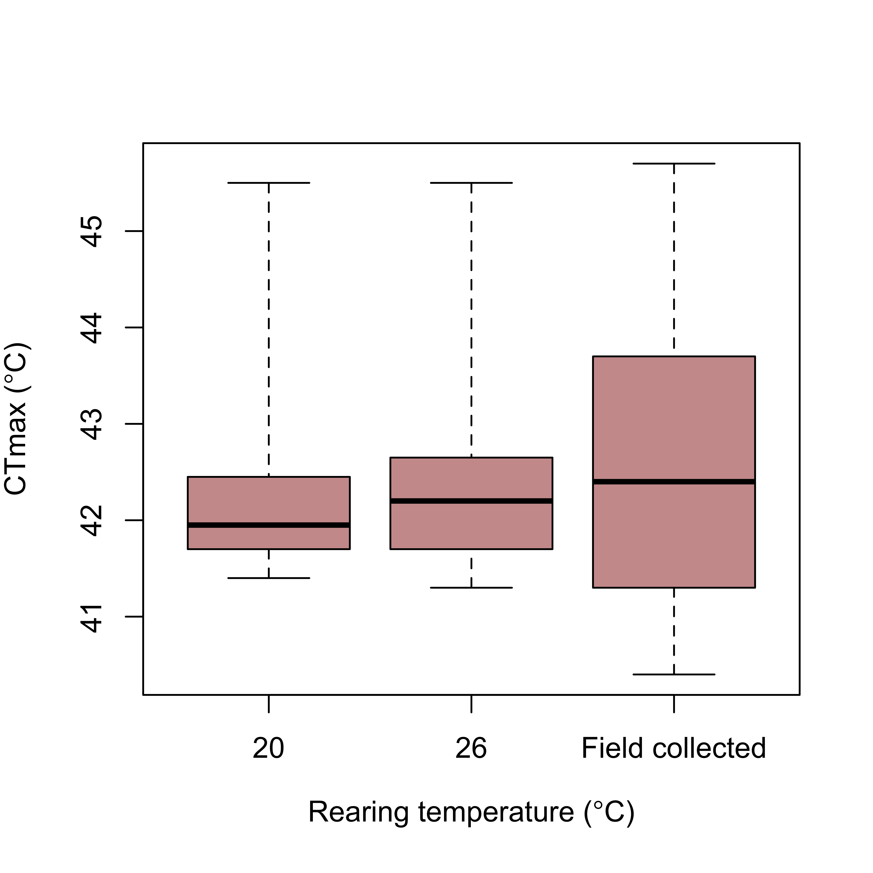
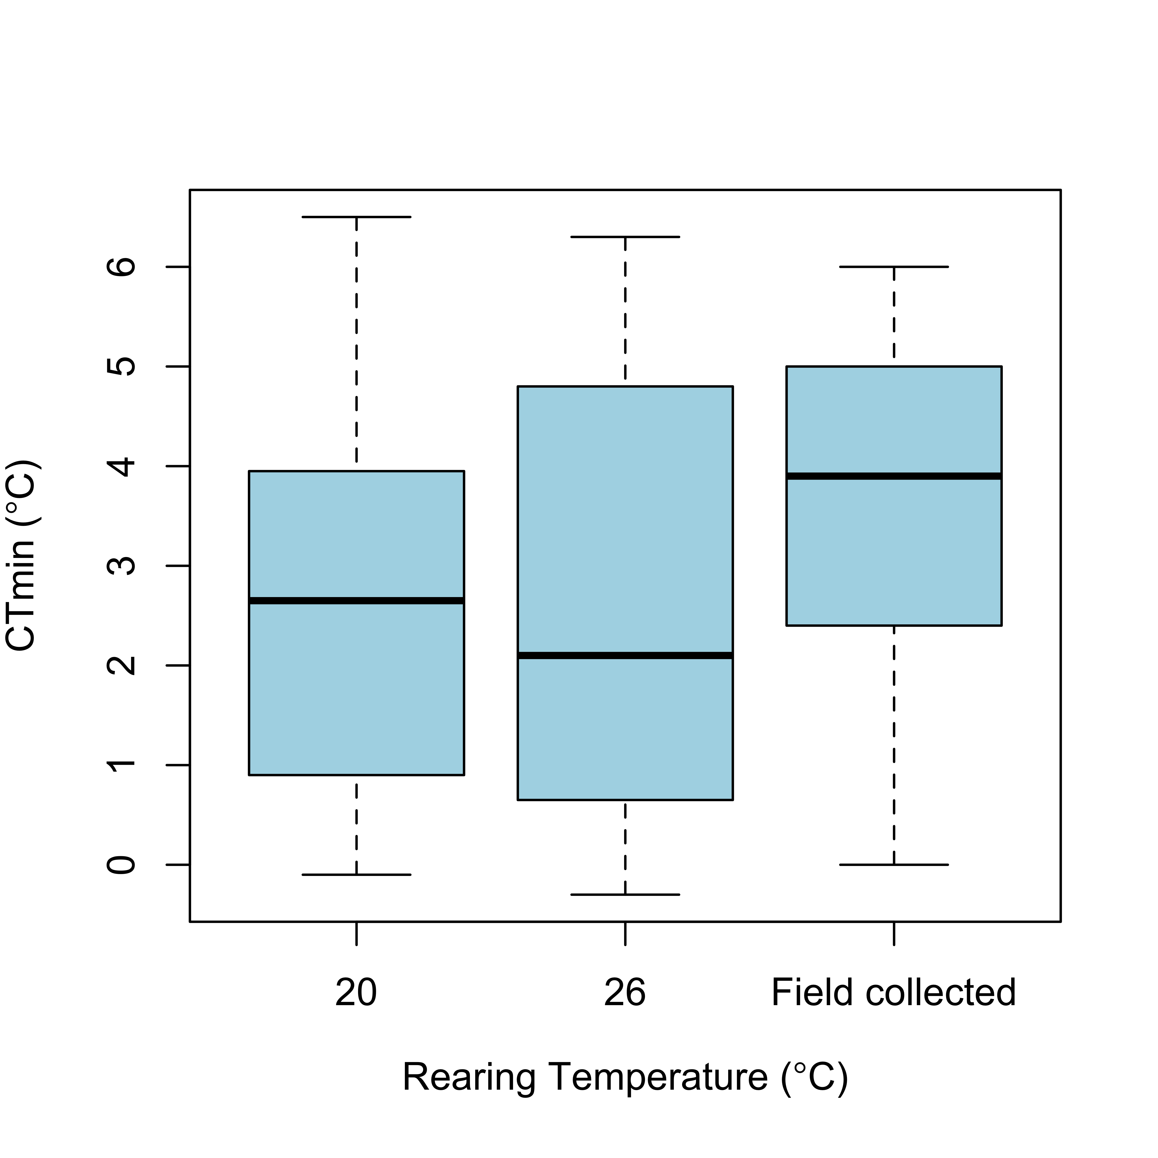

Figure 3. There is no effect of rearing temperature on the thermal tolerance of Aphaenogaster ants. Ants collected and tested directly from the field have more variability in thermal limits than those reared in the common garden.

Figure 4. Relationships of populations of two different species (A. picea, A. rudis clade). To reconstruct phylogenetic relationships, we first assembled a 78,079 SNP matrix generated from double restriction enzyme assisted digestion-sequencing (ddRAD-seq; Peterson et al. 2012). This matrix was analyzed in a maximum likelihood framework in RAxML 8 (Stamatakis 2014) and group support was evaluated with 100 fast bootstrap replicates.

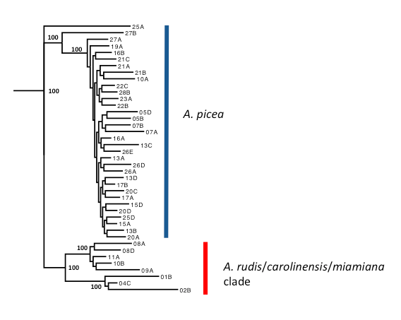

CHAPTER III
TIMING MATTERS: HOW RAMPING SPEED AFFECTS HEAT STRESS RESPONSES

Co-authored by Clint A. Penick, Andrew D. Nguyen, Katharine L. Stuble, and Sarah E. Diamond

Abstract

Critical thermal limits (CT_{max} and CT_{min}) define the maximum and minimum temperatures an organism can withstand. Using simple techniques, thermal limits have been measured for many taxa and are increasingly used to predict the responses of species to climate change. Yet there are multiple techniques used to measure thermal limits, and each potentially yielding different results. Thus, there is debate about which techniques reveal an organism’s “true” thermal limit, and which methods are the most ecologically relevant. An alternative explanation is that different methods for measuring thermal limits provide insight into separate aspects of an organism’s life-history. In such a scenario, different measurements of thermal limits could identify unique thermal challenges for species that inhabit complex thermal environments. We used ants, a widespread and ecologically important taxon, to test how two measurements of CT_{max} (acclimated response and fast response) correlate with distinct aspects of the life histories of suites of species. The acclimated response is a slow ramping speed of 1°C every 5 minutes and indicates the ability of an organism to gradually adjust to warming. The fast response is a ramping rate of 1°C every one minute and indicates how thermal accumulation may limit CT_{max}. We found that the acclimated CT_{max} correlated with traits associated with the nest environment of species and varied little among populations within a species. In contrast, the fast response did not correlate with nest-based traits, but showed strong signatures of selection along a climate gradient. These results suggest something about how we quantify thermal maxima and what it means for dealing with climate change.

Introduction

Determining the impacts of climatic warming on individual taxa or collections of species has mainly focused on quantifying the ability of individuals to withstand a uniform change in the thermal environment. Despite the obvious fact that temperature is one of the primary factors impacting the performance and fitness of ectotherms (Andrewartha and Birch, 1954; Hawkins et al., 2003; Currie et al, 2004), and that temperature change rarely occurs at the same rate, we know little about how different rates of temperature increase vary among species or ontogeny. Because temperature changes as a result of ongoing climate change, it is increasingly important to understand these relationships, yet few studies have.

Critical thermal limits (CT_{max} and CT_{min}) are ecologically-relevant measures of the ability of an organism to endure exposure to high and low temperatures, respectively. These measures (specifically CT_{max}) have been used to predict and extrapolate the diversity and distributions of species in light of climate change (Kearney et al., 2009; Deutsch et al., 2008; Diamond et al., 2012). However, there are almost as many ways to measure CT_{max} as there are organisms on which to measure it, and these different techniques can lead to different estimates of CT_{max}, leaving us with different data in the literature and therefore, different predictions about the future (Rezende et al. 2011; Terblanche et al., 2011).

One possible solution would be to simply settle on the best method for measuring CT_{max}. But what is the best method? And which method provides the most accurate estimate of thermal performance (Lutterschmidt & Hutchison, 1997; Terblanche et al., 2011)? Different ramp styles (e.g., dynamic vs. static) and rates (fast vs. slow) can yield different estimates of CT_{max} (Terblanche et al., 2011; Castañeda et al., 2012) and may indicate different coping mechanisms for different life stages. Comparing different methods for measuring CT_{max} may provide insight into distinct coping mechanisms associated with thermal performance and address evolutionary implications for differences between thermal performance metrics under various warming scenarios. Alternatively, different ramping methods may provide insight into separate aspects of an organism’s life history. For instance, if an organism’s CT_{max} is higher using a faster ramp rate, this suggests that accumulation of thermal damage limits an organism’s CT_{max}. However, if CT_{max} is higher using a slow ramp technique, acclimation may be important for achieving higher CT_{max}. Thus, each of these approaches can provide different kinds of information about how organisms deal with their thermal environment, and how they might respond to increasing global temperatures. Moreover, it might also be the case that temperature has different effects on different life history stages of organisms: 2°C of warming affects a tadpole differently than an adult frog (Murray et al., 2011; Garcia et al., 2014). Life history characteristics are also likely to play a significant role in how responsive certain species are to extreme events which are contingent on magnitude (Jentsch et al., 2007) and timing (Jackson et al., 2009) in relation to life-history. Thus, understanding how different kinds of ramping styles and rates of ramping are used to estimate CT_{max}, and how those different kinds of ramping interact with life history, is critical to increasing our mechanistic understanding of how organisms deal with temperature and changing environments.

In social insects, environmental conditions vary throughout ontogeny. For example, in most ant species, brood stay in the nest throughout their development, and some workers spend substantial portions of their lives inside the nest (Anderson & Munger, 2003; Penick & Tschinkel, 2008). Other workers experience two distinct environments: inside the nest, and outside the nest when foraging or performing other tasks. Ground nesting is the ancestral and most common form of habitat (Lucky et al., 2013), but whether above or below ground, temperatures inside the nest are buffered by nest properties and social thermoregulation, whereas foragers are exposed to greater thermal extremes that vary with latitude (Dunn et al., 2010), elevation (Sanders et al., 2007), or microhabitat (Diamond et al., 2013; Kaspari et al., 2014). Thus, understanding how ants deal with these rising temperatures, across their life history stages, can enable more accurate predictions about the consequences of warming on ants and the functions and services they provide. Here, we explore the relationship between fast and slow ramp speeds as a way to assess CT_{max} among 14 ant species and consider links between ramping rate and developmental traits. Furthermore, we examine intra-specific variation in ramping rates of CT_{max} for populations of the widespread genus Aphaenogaster to determine if selective forces are acting on physiology along a climatic gradient.

Methods
Sampling
We collected queen-right colonies of 14 ant species from deciduous forests around Durham, North Carolina, USA (36.03° N, -78.87° W) and the Blue Ridge Parkway (35.926° N, -81.953° W). In addition, we collected colonies belonging to the widespread Aphaenogaster rudis complex along a latitudinal gradient in the eastern United States extending from Georgia (32.88° N, -81.95° W) to Maine (44.98° N, -68.51° W). Species in the A. rudis complex are abundant in deciduous forests (King et al., 2013) and nest in a variety of habitats across extensive thermal gradients, making it a good focal group for clinal studies. We chose sites that cover a considerable amount of the geographic range of A. rudis encompassing a large climatic range. Colonies of all species were acclimated to laboratory conditions for two weeks prior to beginning a common garden treatment at North Carolina State University. We then reared colonies at a temperature of 23±2°C for 4 weeks before beginning physiological testing. Voucher specimens from each colony are deposited at North Carolina State University.

Determining thermal limits
We measured the critical thermal maximum (CT_{max}) on 145 worker ants. We used two different ramping speeds to capture their acclimated response (slow ramp) and fast response (fast ramp) to increasing temperatures. The slow ramp increased at 1ºC every five minutes, while the fast ramp began at 30ºC and increased 1º per minute. CT_{max} was defined as the temperature at which a worker lost muscle coordination (i.e. inability to right itself after being flipped on its dorsum). The time required to reach CT_{max} using the fast ramp was less than 10 minutes in most cases, while CT_{max} was reached after 10-45 minutes using the slow ramp method. Comparisons between thermal limits were analyzed with linear regression models using mean thermal limits from 5 workers from each colony of each species.

Finally, we also compared the relationship between slow-ramp and fast-ramp CT_{max} with species-specific differences in pupal development time at 20°C. Pupal development time was calculated for each species by dividing larvae among colonies. Larvae were held at one of four temperatures (20°, 23°, 26°, 29°C). Pupal development time was quantified as the number of days between the first appearance of pupae and the date when new workers eclosed (full methods described in Penick et al. in prep). We tested whether there was a significant relationship between acclimated CT_{max} and fast CT_{max} with pupal development time (at 20°C) using linear regression. We used a one-tailed test due to a priori expectations that species with a low CT_{max} have faster development at cool temperatures than species with a high CT_{max} (Penick et al. in prep).

Results and discussion
Species vary in their ability to withstand extreme temperatures (Diamond et al., 2012b) and this variation depends on geography (Chick et al., in review). Thermal limits may depend on different physiological mechanisms, which could differ by species, and vary between ramping speeds. While CT_{max} is among the most common metrics used to characterize differences in how species respond to temperature, we found little to no correlation between a species’ CT_{max} calculated using two distinct methods (Fig. 1) (all tables and figures are located in the appendix). In some cases, species exhibited a higher CT_{max} when given time to acclimate (slow-ramp), while in other cases species exhibited a higher CT_{max} when increases in temperature were more abrupt (fast-ramp; Fig. 2). In the past, discrepancies in CT_{max} calculated for a species using distinct methods have led to debate over which method(s) are the most ecologically relevant (Terblanche et al., 2011; Rezende et al. 2014). Our results suggest that multiple methods can provide insight into different aspects of a species’ life-history. With respect to the slow-ramp and fast-ramp methods used here, we found evidence that slow-ramp CT_{max} was correlated with nest-specific traits of a species (thermal dependence of brood), while fast-ramp was not (Fig. 3). In contrast, fast-ramp CT_{max} showed strong signatures of selection among populations of the A. rudis complex across a latitudinal cline, while slow-ramp CT_{max} did not. Therefore, both measurements of CT_{max} are ecologically relevant, but they are relevant in unique contexts.

Here, fast- and slow-ramp CT_{max} varied among species (Fig. 2), suggesting that different life histories could lead to differences in thermal adaptive responses. This difference among species is particularly large for species in the A. rudis complex, which have a higher relative CT_{max} with the fast-ramp compared to the slow-ramp. Species in the genus Aphaenogaster are considered to be more cold-adapted than some of the more thermophilic co-occurring species, such as Crematogaster lineolata. Such differences among species might provide insight into how these species will respond to climatic warming. For instance, if a species like C. lineolata can deal with longer periods of high temperatures by slowly acclimating to achieve a higher CT_{max}, selection might favor this response if mean temperatures steadily increase. Mean increases and increased duration of higher temperatures may lead to increased activity of thermophilic species that can outcompete species that forage at a lower or more narrow temperature ranges. This in turn, could lead to shifts in abundance and community dynamics (Chick et al., In review; Warren and Chick, 2013). Alternatively, if over the long-term there is an increase in mean temperatures as well as an increase in the number of extreme heating events, species that are unable to forage in warmer conditions for longer periods of time might need to seek refuge inside the nest, leading to decreases in foraging time and subsequently, decreases in colony size and growth (Penick et al., in prep).

A species’ thermal performance does not depend only on CT_{max} but also on other thermal dependent traits that vary among species. In ants, we found that differences in development rate at cool temperatures can also mediate how different species are affected by temperature change (Penick et al., in prep). Slow-ramp CT_{max} correlated with thermal requirements for pupal development, a nest specific trait, while fast-ramp CT_{max} did not (Fig. 3), suggesting a connection between slow-ramp CT_{max} and the nest environment, whereas fast-ramp CT_{max} may be more tightly linked to foraging, as social insect workers experience a different thermal environment when they leave the nest to forage. In this case, individuals may experience more dramatic and faster changes in temperature than they did when they were buffered inside the nest. Here it may benefit a worker to be able to withstand abrupt changes in temperature that also correlate with latitude. We find evidence that fast-ramp CT_{max} is under stronger selection across a latitudinal temperature cline, while slow-ramp stays constant. This makes sense, as species that are able to thermoregulate may maintain relatively similar nest temperatures in regions where outside temperature varies to a much greater degree. In these cases there would be little selection on slow-ramp CT_{max}, but fast-ramp CT_{max} may need to increase in regions where workers face higher temperatures outside the nest. Previous research with some of these same species showed that cool, rather than warm, temperatures are the constraining factors of brood production and colony growth by slowing development and shortening the length of the growing season (Penick et al., in prep). Since ground-nesting species can avoid excessive heat and optimize brood development by moving deeper into the soil column to find a thermal optimum, dealing with high temperatures and rapid increases in temperatures may not have a negative impact on the development of brood, even in cold-adapted species. Colony size and growth may actually be more constrained by the high temperatures outside the nest, as they may decrease foraging times and limit resource acquisition, especially in cold-adapted species. In a related study, we used active warming chambers (see Pelini et al. 2011a for experimental design) to monitor 24-hour activity cycles and found that with only 1°C of warming, Aphaenogaster spp. decreased its foraging time by approximately 5 hours (from 7 to 2 hrs) while Crematogaster lineolata increased its activity time threefold (from 8 hours of foraging to 24 hrs (Fig. 4)). Since behavioral thermoregulation can be a coping mechanism to allow the colony to have the highest development possible, there may be tradeoffs of optimal temperatures for development and optimal temperatures for foraging.

Many of these same patterns exist within species as well. When examined within-species variation in CT_{max} in the genus Aphaenogaster in the eastern US, we found that fast-ramp CT_{max} is correlated with mean annual temperature (MAT) of source population (r²=0.74, P<0.001; Fig. 5a), but slow-ramp CT_{max} is not related to MAT (r²=0.02, P=0.28; Fig. 5b). These differential responses suggest that selection may act on these thermal traits independently. The underlying coping mechanisms responsible for the fast-ramp CT_{max} have been under selection among populations while mechanisms involved with slow-ramp CT_{max} appear to remain stable within Aphaenogaster ants. One explanation for this is that thermoregulatory behaviors inside the nest may buffer environmental selection on slow-ramp CT_{max}, but fast-ramp CT_{max} changes among populations because these populations experience a larger variation in mean annual temperatures.

Differences in thermal limits calculated using distinct ramping speeds suggests the responses we measured depend on different physiological mechanisms. For example, heat shock proteins may contribute to the response at slow ramping speeds, where genes require more than 10 minutes to begin upregulation. In contrast, the short duration of fast-ramp trials may reach CT_{max} before heat shock proteins are upregulated. In contrast, heat shock proteins may contribute to the response of an organism at slow ramping speeds, but the short duration of fast-ramp trials may reach CT_{max} before heat shock proteins are upregulated. For each of the 14 ant species we examined, fast- and slow-ramp methods yielded different CT_{max} values based on ramp rate that are only loosely correlated (Fig. 1). An organism’s ability to tolerate warming might result from selective forces acting on physiological processes to produce adaptive coping mechanisms. If this is the case, we might expect this to produce differences among populations as well as species.

References
Anderson, K. E., & Munger, J. C. (2003). Effect of temperature on brood relocation in Pogonomyrmex salinus (Hymenoptera: Formicidae). Western North American Naturalist, 122-128.
Andrewartha, H.G. & Birch, L.C. (1954) The distribution and abundance of animals. University of Chicago Press, Chicago.
Castañeda, L. E., Calabria, G., Betancourt, L. A., Rezende, E. L., & Santos, M. (2012). Measurement error in heat tolerance assays. Journal of Thermal Biology, 37(6), 432-437.
Currie, D.J., Mittelbach, G.G., Cornell, H.V., Field, R., Guégan, J.-F., Hawkins, B.A., Kaufman, D.M., Kerr, J.T., Oberdorff, T., O’Brien, E.M., & Turner, J.R.G. (2004) Predictions and tests of climate-based hypotheses of broad-scale variaition in taxonomic richness. Ecology Letters, 7: 1121-1134.
Deutsch, C.A., Tewksbury, J.J., Huey, R.B., Sheldon, K.S., Ghalambor, C.K., Haak, D.C. & Martin, P.R. (2008) Impacts of climate warming on terrestrial ectotherms across latitude. Proceedings of the National Academy of Sciences USA, 105, 6668–6672.
Kingsolver, J. G., Diamond, S. E., & Buckley, L. B. (2013). Heat stress and the fitness consequences of climate change for terrestrial ectotherms. Functional Ecology, 27(6): 1415-1423.
Diamond, S. E., L. M. Nichols, N. McCoy, C. Hirsch, S. L. Pelini, N. J. Sanders, A. M. Ellison, N. J. Gotelli, and R. R. Dunn. (2012) A physiological trait-based approach to predicting the responses of species to experimental climatic warming. Ecology 93: 2305-2312.
Diamond SE, Penick CA, Pelini SL, Ellison AM, Gotelli NJ, Sanders NJ, Dunn RR (2013) Using physiology to predict the responses of ants to climatic warming. Integrative and Comparative Biology 53:965-974.
Dunn RR, Guenard B, Weiser MD, Sanders NJ. (2010). Global ant diversity and conservation: geographic gradients. In: Lach L, Parr CL, Abbott KL, editors. Ant ecology. Oxford: Oxford University Press.
Garcia, R. A. et al. 2014a. Multiple dimensions of climate change and their implications for biodiversity. - Science 244: 1247579.
Hawkins, B.A., Albuquerque, F.S., Araújo, M.B., Beck, J, Bini, L.M., Cabrero-Sañudo, F.J., Castro-Parga, I., Alexandre Felizola Diniz-Filho, J., Ferrer-Castán, D., Field, R., Gómez, J.F., Hortal, J., Kerr, J.T., Kitching, i J., Léon-Cortés, J.L., Lobo, J.M., Montoya, D., Carlos Moreno, J., Olalla-Tárraga, M.Á., Pausas, J.G., Qian, H., Rahbek, C., Rodríguez, M.Á., Sanders, N.J. & Williams, P. (2007) A global evaluation of metabolic theory as an explanation for terrestrial species richness gradients. Ecology, 88, 1877–1888.
Jackson, S. T. et al. 2009. Ecology and the ratchet of events: Climate variability, niche dimensions, and species distributions. - Proceedings of the National Academy of Sciences of the United States of America, 106: 19685–19692.
Jentsch, A. et al. 2007. A new generation of climate-change experiments: events, not trends. - Frontiers in Ecology and the Environment 5: 365–374.
Kaspari, M., Clay, N. A., Lucas, J., Yanoviak, S. P., & Kay, A. (2015). Thermal adaptation generates a diversity of thermal limits in a rainforest ant community. Global Change Biology, 21(3): 1092-1102.
Kearney, M. & Porter, W. (2009) Mechanistic niche modelling: combining physiological and spatial data to predict species’ ranges. Ecology Letters, 12: 334–350.
King JR, Warren RJ, Bradford MA (2013) Social insects dominate eastern US temperate hardwood forest macroinvertebrate communities in warmer regions. PloS ONE, 8:e75843.
Lucky A, Trautwein MD, Guénard BS, Weiser MD, Dunn RR (2013) Tracing the Rise of Ants - Out of the Ground. PLoS ONE, 8(12): e84012.
Lutterschmidt WI, Hutchison VH (1997) The critical thermal maximum: data to support the onset of spasms as the definitive end point. Canadian Journal of Zoology, 75:1553-1560.
Murray, K. A., Rosauer, D., McCallum, H., & Skerratt, L. F. (2011) Integrating species traits with extrinsic threats: closing the gap between predicting and preventing species declines. Proceedings of the Royal Society of London B: Biological Sciences, 278 (1711): 1515-1523.
Pelini, S.L., Bowles, F.P., Ellison, A.M., Gotelli, N.J., Sanders, N.J., & Dunn, R.R. (2011) Heating up the forest: open-top chamber warming manipulation of arthropod communities at Harvard and Duke Forests. Methods in Ecology and Evolution. 2 (5): 534-540.

Penick CA, Tschinkel WR (2008) Thermoregulatory brood transport in the fire ant, Solenopsis invicta. Insect Soceaux, 55:176-182
Rezende, E. L., Tejedo, M., & Santos, M. (2011). Estimating the adaptive potential of critical thermal limits: methodological problems and evolutionary implications. Functional Ecology, 25(1), 111-121.
Rezende, E. L., Castaneda, L. E., & Santos, M. (2014). Tolerance landscapes in thermal ecology. Functional Ecology, 28 (4): 799-809.
Sanders, N.J., Lessard, J., Fitzpatrick, M.C. & Dunn, R.R. (2007) Temperature, but not productivity or geometry, predicts elevational diversity gradients in ants across spatial grains. Global Ecology and Biogeography, 16, 640–649.
Terblanche, J. S., Hoffmann, A. A., Mitchell, K. A., Rako, L., le Roux, P. C., & Chown, S. L. (2011). Ecologically relevant measures of tolerance to potentially lethal temperatures. The Journal of Experimental Biology, 214 (22): 3713-3725.

Appendix
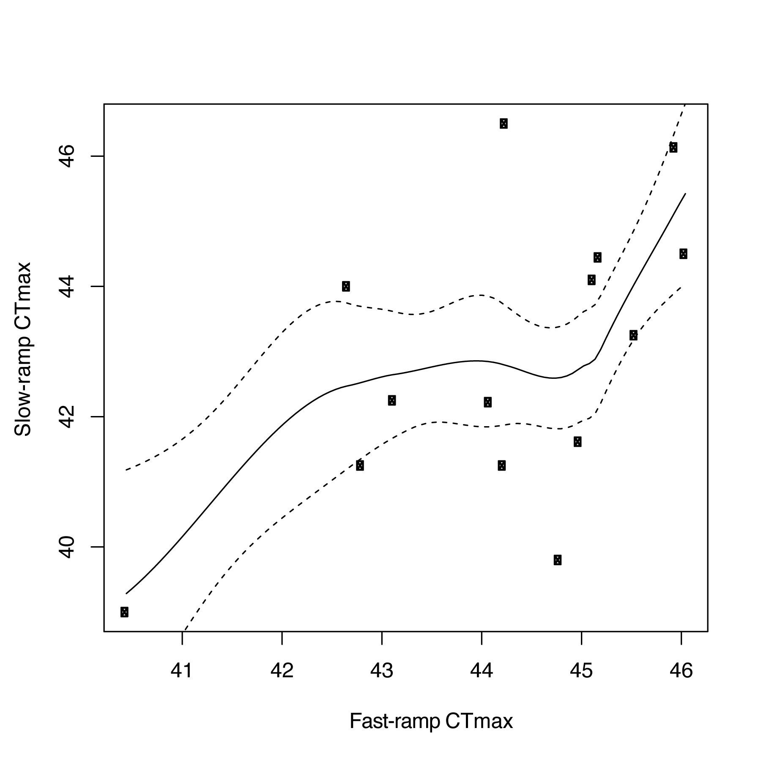

Figure 1. Fast- and slow-ramp methods yield different CT_{max} values for each species (points) that are only loosely correlated.

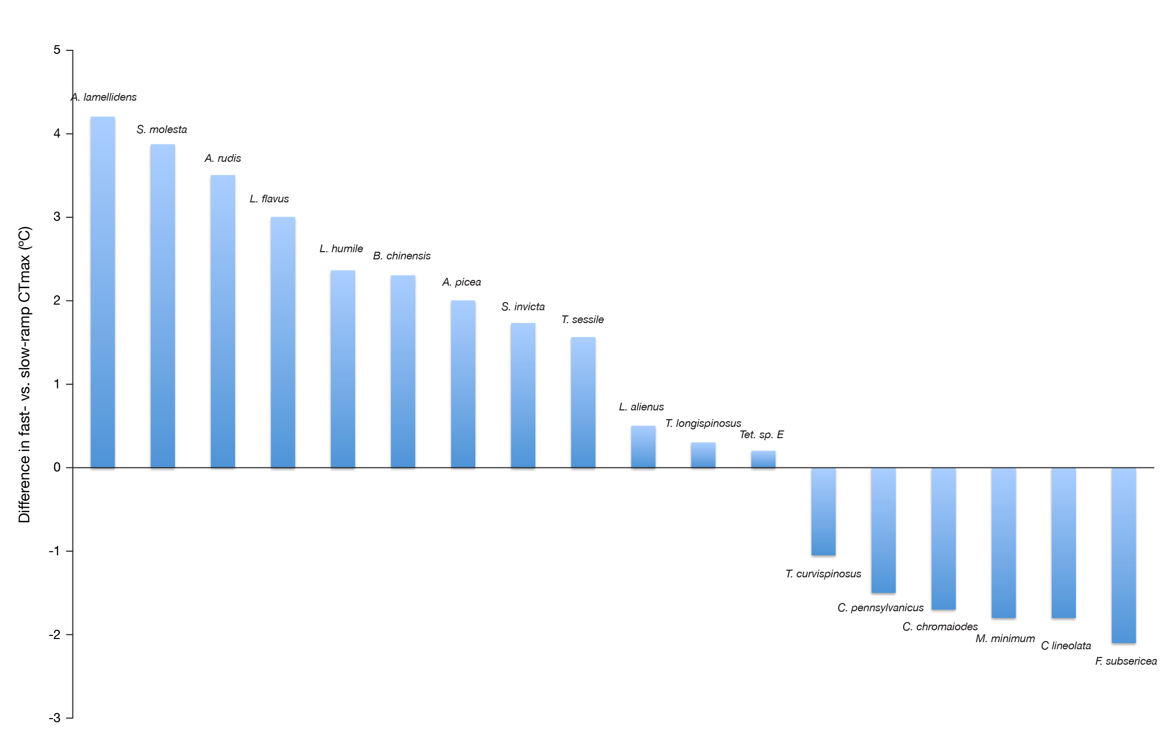

Figure 2. The difference between fast-ramp vs. slow-ramp CT_{max} varies among species. The difference is particularly large for Aphaenogaster spp., which have a higher relative CT_{max} with the fast ramp compared to the slow.

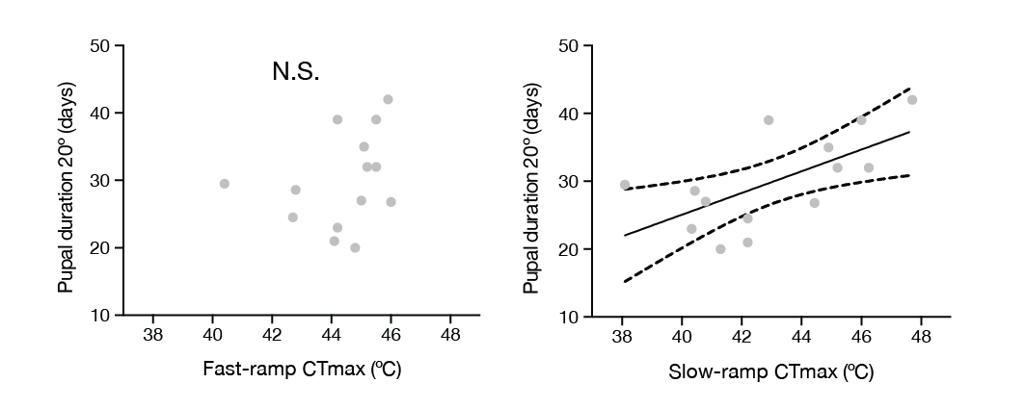
Figure 3. (a) Fast-ramp CT_{max} did not correlate with thermal requirements for pupal development (r²=0.09, P=0.31), a nest specific trait, while (b) slow-ramp CT_{max} did (r²=0.26, P=0.032). This suggests a connection between slow-ramp CT_{max} and the nest environment, whereas fast-ramp CT_{max} may be more associated with foraging.
r²=0.26
P=0.032
r²=0.09 P=0.31
a.
b.

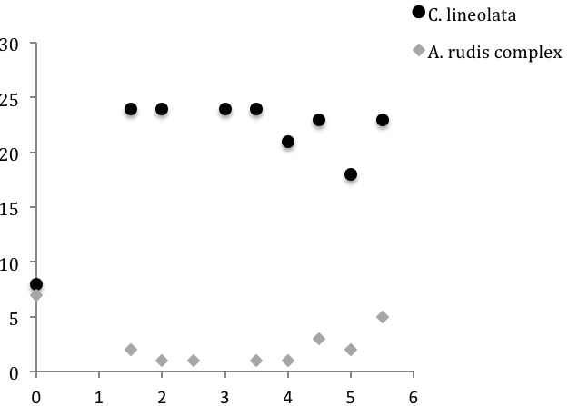
Figure 4. Foraging time decreased by 5 hours with 1°C of warming in Aphaenogaster spp. but increased threefold in Crematogaster lineolata, increasing from 8 hours to 24 hours. Changes in foraging duration with warming may lead to cascading effects of decreased colony size, growth rate, or abundance.

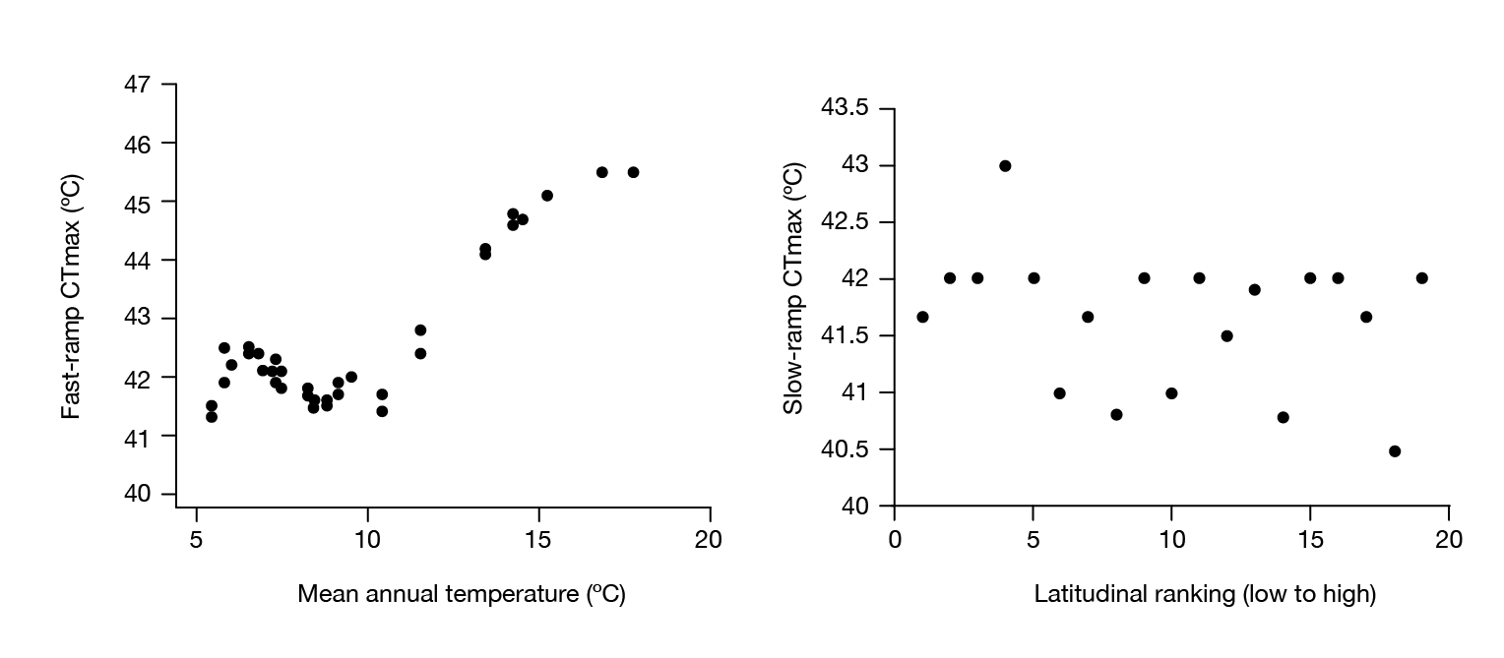
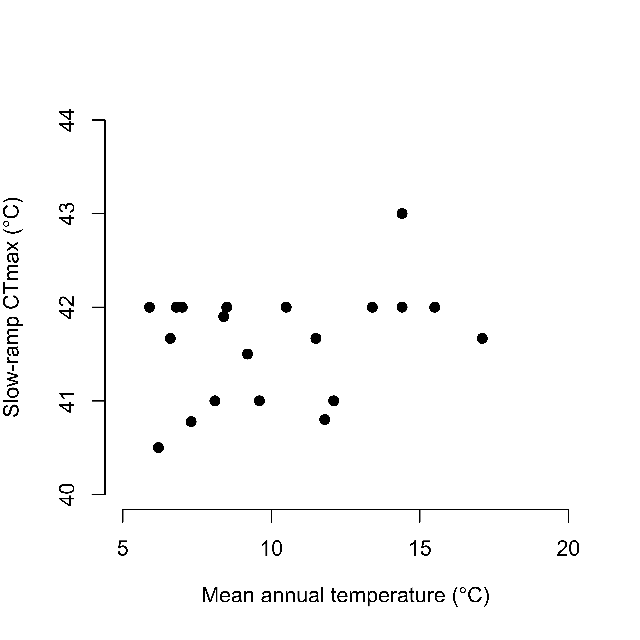
Figure 5. Within Aphaenogaster ants, (a) fast-ramp CT_{max} was correlated with mean annual temperature of source population (r²=0.74, P<0.001), but (b) slow-ramp CTmax showed no relationship among populations (r²=0.02, P=0.28). This suggests fast-ramp CT_{max} has been under selection among populations while slow-ramp CT_{max} appears to remain stable within the A. rudis complex
b
a
r²=0.74
P<0.001
r²=0.74
P<0.001

CONCLUSION

VITA

Lacy Danikas was born in Myrtle Beach, SC. She graduated from Socastee High School in May 2002 and went on to pursue a Bachelor’s Degree in Biology at Francis Marion University from 2002-2006. While taking science courses at FMU, her love of biology grew and she traveled to exotic places learning about natural history. While at FMU she met Brendan Chick and the two were married while Lacy was earning her Master’s Degree in Zoology from Middle Tennessee State University. After graduating from MTSU, Lacy came to the University of Tennessee in August 2010 to begin her doctoral degree researching ants in the Great Smoky Mountains.

