Conversion of Glycerol to Lactic Acid under Low Corrosive Conditions with Homogeneous and Heterogeneous Catalysts

A Thesis Presented for the

Master of Science

Degree

The University of Tennessee, Knoxville

Lu Chen

August 2011

Copyright © 2011 by Lu Chen
All rights reserved.

DEDICATION

This Thesis is dedicated to my family.

ACKNOWLEDGEMENTS

I would like to thank my major professor Dr. X. Philip Ye, for giving me this great opportunity in this project, and teaching me how to be a good researcher. I appreciate all the advice and support from my committee members: Dr. Douglas G. Hayes and Dr. Qixin Zhong. Thank you all for serving on my committee.
I cannot forget to express appreciation to all my colleagues, Dr. Leming Cheng, Shirley Liu, Yaohua Huang, Dr. Guodong Wen, and Dr. Quansheng Chen, for their consistent assistance, guidance and making my study and stay in University of Tennessee a great experience. Thanks to the undergraduate student Erick Foster for his assistance in some repetitions of the experiments.
I wish to thank my best friends both at University of Tennessee (Ran Ye’s family, Ziliang Zhao, Hongtai Yang and Jie Ma), and all over the world (Zifei Yan, Tong Liu, Nan Liu, Tan Su, Erli Zhang, Jilong Ma, Su Tang, Chunyang Li, Xingmin Zhang, and Lingfei Cui), for helping me get through the difficult times, and for all the emotional support, entertainment, and caring they provided.
Last, and most importantly, I feel a great appreciation to my parents. They bore me, raised me, supported me, taught me, and loved me.

ABSTRACT

With the increasing demand for biodiesel, the accumulation of byproduct, crude glycerol has become a problem which needs to solve. Lactic acid is one of the value-added chemical which can be produced from glycerol that has wide uses in food and chemical industry. Although glycerol can be converted to lactic acid with an alkali as the catalyst and the reaction had high conversion (100 mol%) and yield (around 90 mol%), the high alkalinity would cause severe corrosiveness to a stainless steel reactor. In this study two tasks were performed to convert glycerol to lactic acid with satisfactory conversion and selectivity, and to reduce the corrosiveness of reaction medium.
First, CaO was used as solid base catalyst. The highest yield of lactic acid achieved was 40.8 mol% with a 97.8 mol% glycerol conversion, when operating at 290°C after 150 min reaction with molar ratio of CaO: glycerol=0.3. Also CaO has advantages such as high lactic acid productivity (3.35 g/(min·L)), reusability. Also, CaO can be used as the catalyst for both biodiesel production and the following crude glycerol conversion to lactic acid. Second, for glycerol conversion with NaOH as catalyst, a fed-batch reactor was applied to continuously supply the NaOH during the reaction process, compensating the OH⁻ neutralized by newly formed lactic acid. The optimal lactic acid yield of 80.5 mol%, with 92.8% glycerol conversion were obtained at 300 °C for 220min, with 1.1M glycerol initial concentration. A first-order kinetic model for glycerol concentration versus time was developed and verified experimentally under conditions with different initial glycerol concentration and reaction temperature. Both methods, solid base and fed-batch, were applied successfully to three samples of crude glycerol samples provided by biodiesel manufacturers.
In the end, the corrosion issue of different methods was compared based on the Fe³⁺ concentration (analyzed with atomic-absorption spectroscopy) in the products. Both methods of glycerol conversions, with solid base catalyst and fed-batch reactor, can reduce the corrosiveness of glycerol conversion with an alkali as the catalyst.

TABLE OF CONTENTS

Chapter 1 1
Introduction and Objectives 1
1.1 Biodiesel industry and its excessive co-product - crude glycerol 1
1.2 The exploitation of crude glycerol 3
1.3 Lactic acid production processes and their drawbacks 6
Objectives 9
Chapter 2 10
Literature review 10
2.1 Properties of crude glycerol 10
2.2 Conversion of glycerol to lactic acid with homogeneous catalyst 11
2.2.1 Predicted pathway 11
2.2.2 The function of metal ions and OH- group 12
2.2.3 Disadvantages of the glycerol conversion on homogeneous catalyst 13
2.2.4 Modifications of the glycerol conversion with homogeneous catalyst 14
2.3 Feasibility of fed-batch process with homogeneous catalyst 19
2.4 Solid base catalysts and the advantages 20
2.4.1 Advantages comparing with homogeneous catalysts 21
2.4.2 Types of solid base catalysts 21
2.5 Conclusion 24
Chapter 3 25
Conversion of glycerol to lactic acid using calcium oxide as solid base catalyst 25
Abstract 25
3.1 Introduction 26
Objectives 28
3.2 Materials and methods 28
3.2.1 Materials and catalyst preparation 28
3.2.2 Reactors 28
3.2.3 Reaction procedures 30
3.2.4 Experimental design 33
3.3 Results and discussion 35
3.3.1 Conversion of glycerol solution with different solid base catalysts 35
3.3.2 Glycerol (without water) conversion with CaO 36
3.3.3 Effect of reaction temperature on lactic acid yield 37
3.3.4 Effect of molar ratio of CaO to glycerol on lactic acid yield 38
3.3.5 Evaluation of mass balance 40
3.3.6 Activation energy of glycerol conversion with CaO as catalyst 41
3.3.7 Effect of regeneration and reuse 41
3.3.8 Effect of water content on the lactic acid yield 43
3.3.9 Application of CaO in crude glycerol (different sources) conversion to lactic acid 44
3.3.10 Structure-function of the CaO on the lactic acid yield 45
3.3.11 Production of biodiesel and lactic acid from soybean oil over CaO 48
3.4 Conclusions 50
Chapter 4 51
Glycerol conversion in fed-batch system with NaOH as homogenous catalyst 51
Abstract 51
4.1 Introduction 51
Objectives 53
4.2 Materials and methods 54
4.2.1 Materials 54
4.2.2 Reactor and operation 54
4.2.4 Product pretreatment and analysis 56
4.2.5 Kinetic modeling 56
4.2.6 Experimental design 59
4.3 Results and discussion 61
4.3.1 Activation energy of glycerol conversion with NaOH as catalyst 61
4.3.3 Glycerol conversion with NaOH as catalyst in fed-batch reactor 62
4.3.4 Model verification 63
4.3.5 Model validation 65
4.4 Conclusions 73
Chapter 5 74
Summary and prospective 74
5.1 Summary 74
5.2 Future prospective 77
Appendix I Activation energy calculations 79
Appendix II Experimental data 84
Appendix III HPLC Calibration curves 87
LIST OF REFERENCES 89
VITA 97

LIST OF TABLES

Chapter Page

Table 1- 1 Chemical conversion of glycerol into useful chemicals 5

Table 2- 1 Analysis results of macro elements, carbon and nitrogen in crude glycerol 10
Table 2- 2 Summary of lactic acid synthesis pathways 18
Table 2- 3 Types of heterogeneous basic catalysts 22

Table 3- 1 Results of glycerol conversion using different solid base 35
Table 3- 2 Application of CaO as catalyst in conversion of different types of crude glycerol 44
Table 3- 3 Results comparison of four types of CaO in glycerol conversion (at 290°C for 150 min) 45
Table 3- 4 Biodiesel production and lactic acid production using CaO as the catalyst 49

Table 4- 1 Experimental conditions of the development and validation of kinetic model for glycerol concentration (The concentration of NaOH in the coil=10M) 60
Table 4- 2 Evaluation of the model for glycerol concentrations 64
Table 4- 3 Comparison of corrosion effects of batch and fed-batch reaction at 300°C for 220 min 71
Table 4- 4 Application of fed-batch system in conversion of different types of crude glycerol 72

Table 5- 1 Comparison of different methods of glycerol alkaline conversion 77

LIST OF FIGURES

Chapter Page

Figure 1- 1 Biodiesel production from vegetable oils and animal fats and the relation with the co-product- glycerol 2
Figure 1- 2 Potential derivatives of lactic acid 7

Figure 2- 1 Proposed reaction pathway for conversion glycerol to lactic acid 12
Figure 2- 2 Proposed pathway of glycerol conversion on Au-Pt/TiO2 15
Figure 2- 3 Oxidative cleavage of lactate (a) and lactate dehydration (b) process 16
Figure 2- 4 Strength of Solid Base Catalysts 23

Figure 3- 1 Schematic diagrams of salt bath reactor (a) and high pressure Parr® reactor (Parr Instrument Company, IL, USA) (b) 29
Figure 3- 2 Scheme of experimental procedures for the conversion of glycerol to lactic acid with CaO as the catalyst 32
Figure 3- 3 HPLC chromatogram of glycerol conversion product with CaO as catalyst 37
Figure 3- 4 Yield of lactic acid of the reaction at different temperature with the molar ratio of 0.2 (CaO: Glycerol) 38
Figure 3- 5 Highest glycerol conversion and lactic acid yield with different molar ratio of CaO: Glycerol 39
Figure 3- 6 Glycerol conversion and lactic acid yield with regenerated catalysts 42
Figure 3- 7 HPLC chromatogram of glycerol conversion product with regenerated CaO as catalyst 42
Figure 3- 8 Lactic acid yield and glycerol conversion under conditions with different water content at 290°C for 150 min, with CaO:glycerol=0.3 (molar ratio) 43
Figure 3- 9 X-ray diffraction patterns of four types of CaO 46
Figure 3- 10 Scanning electron micrographs (SEM) of four types of CaO 47
Figure 3- 11 FTIR result of biodiesel product and original soybean 48

Figure 4- 1 Schematic diagram of fed-batch reactor 55
Figure 4- 2 Concentration of glycerol, lactic acid, and OH⁻ during glycerol conversion in fed-batch reactor 63
Figure 4- 3 Concentration of glycerol, lactic acid, and OH⁻ during glycerol conversion in fed-batch reactor 65
Figure 4- 4 Concentration of glycerol, lactic acid, and OH⁻ during glycerol conversion in fed-batch reactor 66
Figure 4- 5 Plot of predicted vs. actual concentrations of glycerol during the reaction with NaOH as catalyst in fed-batch reactor 67
Figure 4- 6 Lactic acid concentration in fed-batch conversion of glycerol, together with model predicting (in dash lines) using average selectivity at each condition 69
Figure 4- 7 Plot of lactic acid selectivity and OH⁻ concentration during reactions 70

Chapter 1

Introduction and Objectives

1.1 Biodiesel industry and its excessive co-product - crude glycerol
The current energy production is almost totally dependent on crude oil (Arzamendi, Arguinarena et al. 2008). With the shrinking of petroleum reserves, renewable energy is becoming increasingly significant. Biodiesel is an alternative fuel for diesel, which is derived from vegetable oil, algae, or animal fat. It can be produced using different materials as feedstocks, like mustard seed, rapeseed, canola, crambe, soybean, algae, and waste cooking oils (Ma and Hanna 1999; Thompson and He 2006; Demirbas and Demirbas 2011).The biodiesel industry has developed rapidly over the past few decades, and has attracted considerable attention as a renewable, biodegradable and non-toxic fuel (Xu, Du et al. 2003; Mu, Teng et al. 2006), and is supposed to be one of the best choices of alternative fuels to petroleum (Johnson and Taconi 2007).
Crude glycerol is a main co-product of biodiesel, which is formed during the transesterification process of the triacylglycerols. Yazdani and Gonzalez (2007) have made a summary on overall processing of fats or oils to prepare biodiesel (Figure 1-1). During the biodiesel production, for every one pound of oil converted, there will be approximately 0.1 pounds of crude glycerol are produced as well (Dasari, Kiatsimkul et al. 2005). The U.S. production of biodiesel is 30-40 million gallons, with a target of 400 million gallons of production by the year 2012 (Johnson and Taconi 2007). At the same time, in U.S. alone, about 340,000 tons of crude glycerol goes to market every year, which has created a glut in the glycerol market and therefore a following significant price decrease for glycerol (Johnson and Taconi 2007).
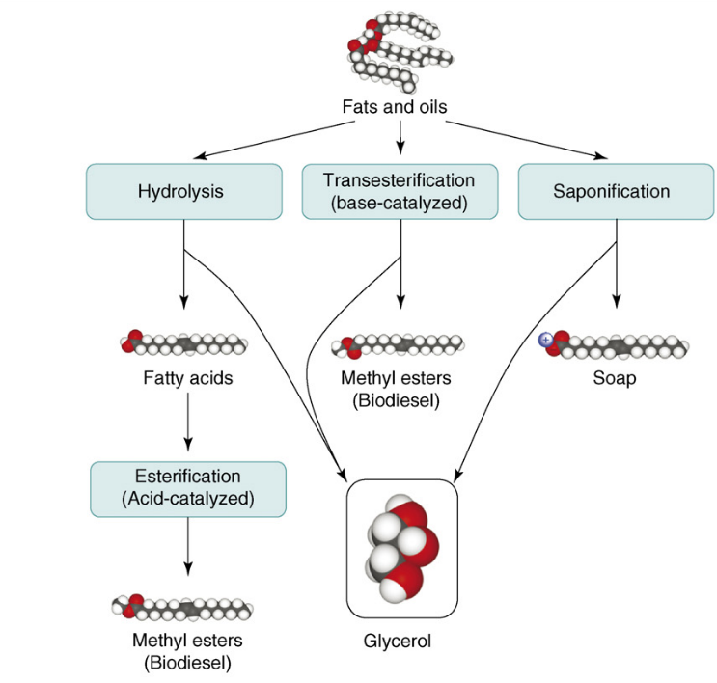

Figure 1- 1 Biodiesel production from vegetable oils and animal fats and the relation with the co-product- glycerol
(Yazdani and Gonzalez 2007)

Crude glycerol has a very low economic value, due to its impurities and its excessive amount. The general treatment of crude glycerol is through a set of refining processes, such as filtration, chemical additions, and fractional vacuum distillation in order to obtain different grades of pure glycerol (Thompson and He, 2006). However, the refining costs are beyond the affordability of most small and moderate scale biodiesel producers.

1.2 The exploitation of crude glycerol
In the long term, as supplies continue to increase, glycerol from the production of biodiesel will become an affordable and versatile building block chemical (Johnson and Taconi 2007). The innovation of new disposal and utilizing processes are needed for the crude glycerol.
It is reported that crude glycerol could be used as a carbon source for some kinds of microorganisms. Cameron and Koutsky (1994) developed a fermentation process for the production of 1, 3-propanediol from the crude glycerol stream of a biodiesel facility. By using a strain of K. pneumoniae, they have achieved a 63% yield of 1, 3-propanediol from the crude glycerol. Also, Taconi et al. (2009) found that C. pasteurianum could utilize crude glycerol as a carbon source to produce butanol, with a yield of 0.30 g/g. In addition to producing 1,3-propanediol and 1-butanol, other publications have shown that erythritol (Rymowicz, Rywinska et al. 2009), citric acid (Rywinska, Rymowicz et al. 2009) and ethanol (Yazdani and Gonzalez 2008) can be produced as well during the anaerobic fermentation of glycerol.
The conversion of glycerol through fermentation procedure is an efficient route of crude glycerol utilization, and the conditions are mild. However, in fermentation process, only a few kinds of microorganism can use crude glycerol without pretreatment (Mu, Teng et al. 2006), unless pretreatment is applied, such as adjusting pH, dilution, etc. Pretreatment usually requires a relatively long time and calls for costly purification processes, which become the main impediment for the promotion of biological conversion.
In addition, other approaches based on chemical conversion are used in the crude glycerol utilization. The conversions of glycerol to other useful chemicals are summarized in Table 1-1. Generally, there are two routes of chemical conversion of glycerol (Johnson and Taconi 2007). One is oxidation or reduction of the glycerol into other compounds, such as lactic acid (Kishida, Jin et al. 2005), hydroxyacetone (Goncalves, Pinto et al. 2008), propylene glycol (Dasari, Kiatsimkul et al. 2005), acrolein (Yan and Suppes 2009), ketomalonic acid, etc. The other is reaction of glycerol with other molecules to form new chemicals, for example, glycerol carbonate, which is a kind of new solvent and polymer precursor (Aresta, Dibenedetto et al. 2006; Johnson and Taconi 2007), and other polymers formed by the condensation of glycerol and other chemicals. Chemical conversion usually has a high reaction rate and is a relatively simple solution to the glycerol surplus. However, some of the conversions meet the bottle-neck of low selectivity and low yield and demanding new and efficient catalysts (Johnson and Taconi 2007).

Table 1- 1 Chemical conversion of glycerol into useful chemicals
Reaction type |  | Product | Catalyst | References
Oxidation /  Reduction | Oxidation | Lactic acid | KOH | (Shen, Jin et al. 2009)
Oxidation /  Reduction | Oxidation | Dihydroxyacetone | Pt−Bi/C | (Hu, Knight et al. 2010)
Oxidation /  Reduction | Oxidation | Glyceraldehydes | Pd/C | (Carrettin, McMorn et al. 2003)
Oxidation /  Reduction | Oxidation | Glyceric acid | Au/C | (Carrettin, McMorn et al. 2002)
Oxidation /  Reduction | Oxidation | Hydroxypyruvic acid | AlPO-n | (McMorn, Roberts et al. 1999)
Oxidation /  Reduction | Oxidation | Mesoxalic acid | Pt/C | (Ciriminna and Pagliaro 2003)
Oxidation /  Reduction | Oxidation | Oxalic acid | Pd/C | (Garcia, Besson et al. 1995)
Oxidation /  Reduction | Hydrogenolysis | 1,2-propanediol | Cu-ZnO | (Balaraju, Rekha et al. 2008)
Oxidation /  Reduction | Hydrogenolysis | 1,3-propanediol | Pt/WO₃/ZrO₂ | (Kurosaka, Maruyama et al. 2008)
Oxidation /  Reduction | Hydrogenolysis | Ethylene glycol | CuO/ZnO | (Chaminand, Djakovitch et al. 2004)
Oxidation /  Reduction | Dehydration | Acetol | copper-chromite | (Chin, Dasari et al. 2006)
Oxidation /  Reduction | Dehydration | Acrolein | H₄SiW on alumina | (Cheng and Ye 2009)
Oxidation /  Reduction | Pyrolysis, gasification | Alkane | Pt–Re/C | (Kunkes, Simonetti et al. 2008)
Oxidation /  Reduction | Pyrolysis, gasification | Olefin | Cu on ZSM-5 | (Zakaria, Mohamad et al. 2010)
Oxidation /  Reduction | Pyrolysis, gasification | Syngas Carbon+ hydrogen | Ru/Y₂O₃ | (Hirai, Ikenaga et al. 2005)
Reaction of glycerol with other molecules | Transterification, esterification | monoglycides | Amberlyst | (Pouilloux, Abro et al. 1999)
Reaction of glycerol with other molecules | Transterification, esterification | α-monobenzoyl glycerol | benzoic | (Xu, Kato et al. 2001)
Reaction of glycerol with other molecules | Etherification | monoethers | Pd/C | (Shi, Dayoub et al. 2009)
Reaction of glycerol with other molecules | Etherification | diethers | Pd/C | (Shi, Dayoub et al. 2009)
Reaction of glycerol with other molecules | Etherification | triether | Pt | (Morgan and Hofmann 1970)
Reaction of glycerol with other molecules | Oligomerization, polymerization | glycerol  1-monoethers | KOH | (Queste, Bauduin et al. 2006)
Reaction of glycerol with other molecules | carboxylation | glycerol carbonate | Sn-catalysts | (Aresta, Dibenedetto et al. 2006)

Among those methods, production of lactic acid from glycerol at 300°C appears very attractive, which has an high yield, 90% (mol%) with 90% selectivity (Kishida, Jin et al. 2005; Shen, Jin et al. 2009). Moreover, new applications of lactic acid have recently made it a more and more attractive chemical recently.

1.3 Lactic acid production processes and their drawbacks
Pure lactic acid is a syrupy liquid with a slight acrid odor. The boiling point of lactic acid is 122°C at 2 KPa. However, it is not stable when heated at atmospheric pressure and readily decomposes into carbon dioxide and carbon monoxide.
Since ancient times, lactic acid has been widely used in everyday life, from food and medicine, to industry and agriculture. Right now the major use of lactic acid is still in food and food related applications which accounts for around 85% of its demand (Datta and Tsai 1997). On the other hand, new derivatives of lactic acid are found in producing other useful chemicals, such as pyruvic acid and acrylic acid (as summarized by Paster and Pellegrino et al. (2003), which is shown in Figure 1-2). Also, the polymer of lactic acid--polylactic acid (PLA) is known to be one of the best materials for biodegradable plastic (Drumright, Gruber et al. 2000), which increase the potential need of lactic acid in the future.
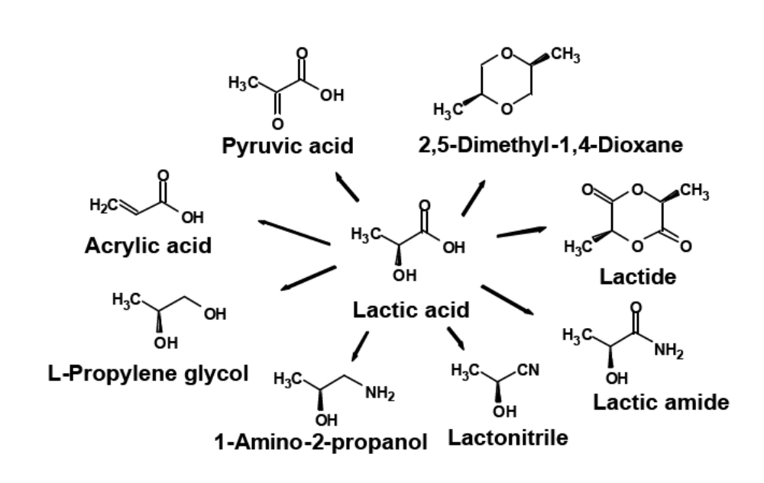
Figure 1- 2 Potential derivatives of lactic acid
(Paster, Pellegrino et al. 2003)

Current commercial production of lactic acid is mainly by anaerobic fermentation of carbohydrates, such as glucose, sucrose, or lactose (John, Nampoothiri et al. 2007), and also chemical synthesis (Datta and Tsai 1997).
In the fermentation process, many types of microorganisms can be used as the lactic acid production strains, such as Lactobacillus delbrueckii, L. bulgaricus, and L. leichmanii. Accordingly, a wide variety of carbon sources was utilized in the fermentation process, from starch to whey or even agro wastes. The fermentation technology can provide a desired stereoisomer of lactic acid (Datta and Tsai 1997), and only L-lactic acid can be used in food. Although through the fermentation process, a high yield (90%) of lactic acid can be achieved, several problems are associated with the process, such as the high cost of culture media due to the specific requirements of the lactic acid-producing bacteria (Oh, Wee et al. 2003), product inhibition (Singh, Ahmed et al. 2006), and the uneconomical and non-environmentally friendly purification process (Datta and Tsai 1997).
Current chemical synthesis routes are based on the conversion of lactonitrile, a byproduct from acrylonitrile synthesis, and can only produce the racemic lactic acid. Nevertheless, due to the restriction of raw materials and the processing costs, chemical conversion is only on a small scale (Datta and Henry 2006). In recent years, Kishida et al. (2005) provided a new method of lactic acid production from glycerol. Glycerol can be converted to lactic acid with high concentration of alkali such as NaOH or KOH as homogeneous catalyst in water at around 300°C. During a 90 min reaction, the yield of lactic acid can reach as high as 90 % (mol %) with 100% glycerol conversion, when the reaction takes place at 300°C with 1.25 M NaOH or KOH and 0.33 M glycerol present initially. Theoretically, the only mass lost during the reaction is the release of one molecule of H₂ from each molecule of glycerol.
Though it’s an efficient reaction, the application is restricted by the corrosiveness of the catalysts. At 300°C, high concentration of OH⁻ from NaOH or KOH will cause severe corrosion to the stainless steel reactors. The application of lactic acid synthesis method from glycerol requires techniques that can reduce the harshness of the reaction condition. There might be two possible ways to overcome the problems caused by the alkali in the conversion of glycerol. The first solution is to change the reaction procedure- adding alkali in small batch increments. The other method is to replace the catalyst with a less corrosive one, such as the solid base (heterogeneous) catalyst, which will largely reduce the concentration of OH⁻, and consequently will diminish the corrosion issue.

Objectives
Therefore, the overall objective of this thesis is to convert crude glycerol to lactic acid with good conversion and selectivity, and to improve the reaction conditions by reducing the corrosiveness.
In order to achieve the goal, two approaches were investigated,

1. Reducing the corrosiveness by introducing solid base catalysts;
2. Utilizing fed-batch system with NaOH as homogeneous catalyst.

For both tasks, pure glycerol was used for process development, and the developed process was applied to crude glycerol.

Chapter 2

Literature review

2.1 Properties of crude glycerol
The term “crude glycerol” refers to an aqueous mixture separated from the biodiesel production, enriched in glycerol. Thompson and He (2006) have tested some characteristics of crude glycerol from different oleochemical raw materials, and the results are shown in Table 2-1. Commercial crude glycerol contains 80-85% glycerol, and less than 10% of water, salts, as well as residual substances from the production process. The metals Ca, K, Mg, Na, P, and S are present in small quantities. However, due to the sodium or potassium methylate catalyst used in the biodiesel production sodium or potassium hydroxide has a concentration over 1% by weight.

Table 2- 1 Analysis results of macro elements, carbon and nitrogen in crude glycerol
(Thompson and He 2006)
Feed stock | IdaGold Mustard | PacGold Mustard |  | Rapeseed | Canola | Soybean | Crambe
Measurements on crude glycerol
Calcium×10⁴(wt.%) | 11.7±2.9 |  | 23.0±1.0 | 24.0±1.7 | 19.7±1.5 | 11.0±0.0 | 163.3±11.6
Potassium×10⁴(wt.%) | BDL¹ |  | BDL | BDL | BDL | BDL | 216.3±15.3
Magnesium×10⁴(wt.%) | 3.9±1.0 |  | 6.6±0.4 | 4.0±0.3 | 5.4±0.4 | 6.8±0.2 | 126.7±5.8
Phosphorus×10⁴(wt.%) | 25.3±1.2 |  | 48.0±2.0 | 65.0±2.0 | 58.7±6.8 | 53.0±4.6 | 136.7±57.7
Sulfur×10⁴(%wt) | 21.0±2.9 |  | 16.0±1.4 | 21.0±1.0 | 14.0±1.5 | BDL | 128.0±7.6
Sodium(%wt) | 1.17±0.15 |  | 1.23±0.12 | 1.06±0.07 | 1.07±0.12 | 1.20±0.10 | 1.10±0.10
Carbon(%wt) | 24.0±0.00 |  | 24.3±0.58 | 25.3±0.58 | 26.3±0.58 | 26.0±1.00 | 24.0±0.00
Nitrogen(%wt) | 0.04±0.02 |  | 0.04±0.01 | 0.05±0.01 | 0.05±0.01 | 0.04±0.03 | 0.06±0.02
Note 1. BDL=Below detection limit for corresponding analytical method

As there contains alkali in crude glycerol, it is more suitable to be converted with an alkali as catalyst than an acidic catalyst. Otherwise, the OH⁻ in crude glycerol will cause the deactivation or neutralization of the acidic catalyst. Recent research on the glycerol conversion to lactic acid was done with alkali metal hydroxides or alkaline earth metal hydroxides as homogeneous catalysts (Kishida, Jin et al. 2005; Shen, Jin et al. 2009; Ramirez-Lopez, Ochoa-Gomez et al. 2010; Shen, Zhang et al. 2010).

2.2 Conversion of glycerol to lactic acid with homogeneous catalyst
It is reported that glycerol can be converted to lactic acid with high yield and selectivity using alkali metal hydroxide as the catalysts (Kishida, Jin et al. 2005). At 300°C and with 1.25M NaOH or KOH, the yield of lactic acid can reach around 90% after a 90 min reaction.

2.2.1 Predicted pathway
Based on the product analysis, Kishida, Jin et al. (2005) inferred that during the glycerol conversion, glycerol was first converted into 2-hydroxypropenal and a molecule of hydrogen was eliminated, which was catalyzed by OH⁻. Then through keto-enol tautomerization, 2-hydroxypropenal formed pyruvaldehyde. In the end, lactic acid was formed from pyruvaldehyde by benzilic acid rearrangement, as shown in Figure 2-1.
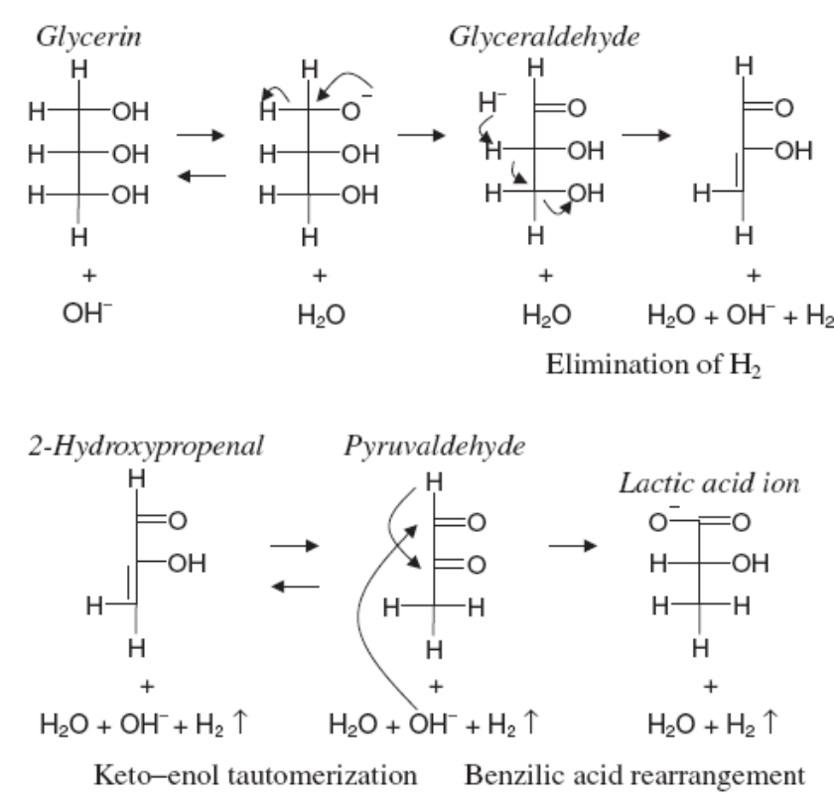

Figure 2- 1 Proposed reaction pathway for conversion glycerol to lactic acid
(Kishida, Jin et al. 2005)

Lux et al. (2009) hypothesized that the conversion of glycerol has two steps. First glycerol is converted into dihydroxyacetone, and then dihydroxyacetone to lactic acid. The second step can be carried out under either alkaline or acidic conditions. However, this theory does not contain an analysis of the chemical intermediates.

2.2.2 The function of metal ions and OH- group
After the formation of lactic acid, the product will react instantly with the base in the solution, forming lactate. This process protects lactic acid from decomposition or polymerization under the harsh conditions. The overall reaction was summarized by Kishida, Jin et al. (2005) as follows (Equation 2-1),

C₃H₈O₃ +NaOH$→$CH₃CHOHCOO.Na +H₂$↑$+H₂O Equation 2-1
Glycerol Sodium lactate

In this way, OH⁻ group works not only as a catalyst, but also a reactant. The concentration of the OH⁻ is crucial for the reaction. This result can be found in another study (Shen, Jin et al. 2009), where different metal hydroxides with the same initial concentration were used in the conversion as the catalysts and neutralizer. It was shown that the conversion with KOH as the catalyst would result in the highest yield of lactic acid and highest conversion of glycerol. The catalytic activity of the reaction followed the sequence NaOH> LiOH>Ba (OH) ₂ > Sr (OH) ₂ > Ca (OH) ₂ >Mg (OH) ₂, which is consistent with their relative solubility of the alkali in water.
Moreover, for alkaline earth metal hydroxides of Mg, Ca, Ba, Sr, there was less lactic acid but more formic and acetic acids produced than using alkaline-metal (Li, Na, K), which indicated a decomposition of lactic acid. Ba (OH) ₂ and Sr (OH) ₂ resulted in more amounts of the decomposition products than Ca (OH) ₂ and Mg (OH) _{2.} It is supposed that the process is due to the increase of the ionic radius (Shen, Jin et al. 2009), which makes it easier for the alkaline earth-based hydroxides to form a five-membered ring salt with lactic acid. This ring structure promotes the decomposition of lactic acid.

2.2.3 Disadvantages of the glycerol conversion on homogeneous catalyst
The consumption of base requires a high concentration of OH⁻ in order catalyze conversion of a high concentration of glycerol, which raises another issue to the reaction-- corrosiveness. Based on preliminary research and the study of Ramirez-Lopez, Ochoa-Gomez et al. (2010), the high concentration of OH⁻ (over 1M) will cause severe corrosion to the stainless steel container. High temperature as well as high pressure will largely increase corrosion, which makes it difficult to be used in industrial production. Also, the demands of high alkali concentration limit the initial concentration of glycerol, restraining the productivity of the lactic acid (amount of lactic acid produced in unit time and unit volume).

2.2.4 Modifications of the glycerol conversion with homogeneous catalyst
Because of the drawbacks of the reaction, recent work in this field concentrates mainly on reducing the reaction temperature to reduce the corrosiveness. Shen et al. (2010) applied Au–Pt/TiO₂ catalysts and oxygen in glycerol conversion to lactic acid reaction. They proposed that the first step of the reaction, glycerol oxidation to glyceraldehyde (or dihydroxyacetone), is the rate limiting step. In order to reduce the reaction temperature, Au-Pt/TiO₂ catalyst and O₂ is needed. The rest of the steps from glyceraldehyde or dihydroxyacetone to lactic acid require alkaline conditions; otherwise the products from glycerol oxidation would be further oxidized into glyceric acid as shown in Figure 2-2.
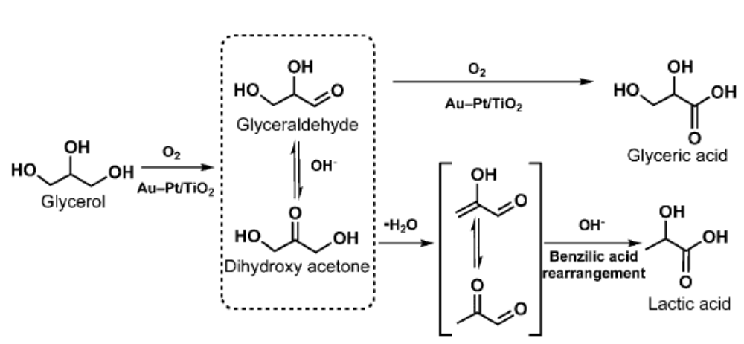

Figure 2- 2 Proposed pathway of glycerol conversion on Au-Pt/TiO2
(Shen, Zhang et al. 2010)

The reaction of glycerol with Au-Pt/TiO₂ and O₂ was carried out at 363K (90°C) with NaOH/glycerol=4:1 (molar ratio). Although the reaction can achieve high conversion of glycerol (up to 100%) and lactic acid selectivity (85%) at lower temperature, the initial glycerol concentration was only 0.22M (2%), which caused a low productivity of lactic acid. Also the cost of the Au–Pt/TiO₂ catalysts would be an obstacle for the industrialization of the process.
Ramirez-Lopez et al. (2010) found that the molar ratio of NaOH: glycerol can be reduced to 1.1~1.75 at higher initial concentration of glycerol (2.5-3.5M). The highest yield of lactic acid was 89.9%, which was obtained at 280°C and 90 min, with 1.33 of initial NaOH/glycerol molar ratio, and 1 M substrate concentration. They found that with high concentration of NaOH, the decomposition of the product, lactate, would be largely increased when the temperature is above 280°C, resulting in a decrease of lactic acid yield. They mentioned two pathways for the decomposition process, oxidative cleavage of lactate and lactate dehydration in alkaline medium as shown in Figure 2-3.

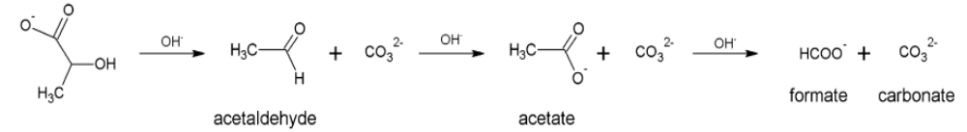
(a)
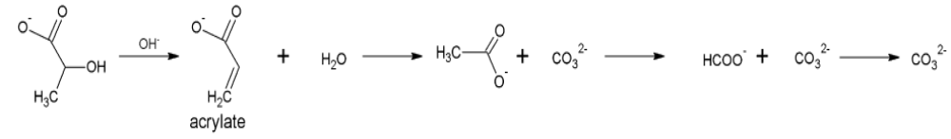
(b)

Figure 2- 3 Reaction pathways for oxidative cleavage of lactate (a) and lactate dehydration (b) process

(Ramirez-Lopez, Ochoa-Gomez et al. 2010)

Nevertheless, the corrosion effect on stainless steel at high NaOH concentration is noticeable during the experiment and is not suitable for the industrial production without protection.
Yuksel et al. (2009) discussed the feasibility of using electrolysis to allow for a lower NaOH concentration (50 mM). Although the conversion of glycerol can reach 60% and the yield of lactic acid, around 35%, was closely related to the concentration of the alkaline. The initial glycerol concentration was also reduced to 0.1M, which is particularly low for the chemical production process. Also electrolysis can also cause corrosion of stainless steel reactors (Van Berkel 1998).
Roy et al. (2011) observed that the Cu based catalysts decrease the reaction temperature of glycerol conversion to lactic acid with NaOH as the catalyst. They utilized Cu₂O as cocatalyst with NaOH in the glycerol conversion reaction, and the reaction temperature was deceased to 240°C. However, the reaction time was as long as 6h, which resulted in a very low productivity of lactic acid in this research.
Long et al.(2011) have tried to conduct both conversions of oil to biodiesel and glycerol to lactic acid using sodium silicate as the catalyst. For the biodiesel production process, the yield of biodiesel reached as high as 99.6%, with 3% (w/w) sodium silicate and a 9/1 molar ratio of methanol/oil. The pure glycerol conversion was then carried out at 300°C, with 0.3 M glycerol and 0.625 M sodium silicate. The maximum yield of lactic acid was 90.7%, and the conversion of glycerol was nearly 100%. In the end, the researchers tried to utilize sodium silicate (1.5M) as the catalyst to convert 3M crude glycerol. After 90 min reaction at 300°C, the lactic acid yield reached around 89%. They also tried the reuse of sodium silicate in the biodiesel production, and there was no significant decrease in the biodiesel yield after six successive reuses. Although the catalyst used in the study can be applied to both biodiesel production and lactic acid production, the catalyst cannot be collected and regenerated after the reaction of glycerol to lactic acid, because the sodium silicate would react irreversibly with lactic acid forming sodium lactate and silicic acid. Moreover, sodium silicate has a higher basicity than sodium carbonate. It is reported that even the solution of sodium carbonate and sodium bicarbonate would cause corrosion to the steel, when the concentration was high enough (Pilkey, Lambert et al. 1995; Wang and Stack 1998). Table 2-2 shows a summary of the lactic acid synthesis pathways, including biological and chemical methods.

Table 2- 2 Summary of lactic acid synthesis pathways
Biological (Fermentation)
Raw materials | Microorganism | time  (days) | Tª  (°C) | Y_{Lac}^{b}  (wt.%) | X_{(raw material)} ^{c}  (wt.%) | P_{Lac} ^{d}  $$g/(min∙L)$$ | References | Advantages | Disadvantages
Agro wastes | Lactobacillus delbrueckii | 5 | 37 | 99 | 99 | -- | (John, Nampoothiri et al. 2006) | Mild conditions;  Large scale production; | Long time;  pH control;  Compete food;  High cost of product purification
Whey | S. lactis | 4-6 | 48 | 83 | 80-90 | -- | (Whittier and Rogers 1931) | Mild conditions;  Large scale production;
Lignocellulosic hydrolyzates | Lactobacillus sp. RKY2 | contin-  uous | 36 | 90 | 95 | -- | (Wee and Ryu 2009) | Mild conditions;  Large scale production;
Corn | Lactobacillus amylophilus | 4 | 30 | 67.5 | 100 | -- | (Mercier, Yerushalmi et al. 1992) | Mild conditions;  Large scale production;
Chemical
Raw material | Catalysts | time  (min) | T  (°C) | Y_{Lac}  (mol%) | X_{gly}^{e}  (mol%) | P_{Lac}  $$g/(min∙L)$$ | Reference | Advantages | Disadvantages
Lactonitrile | H₂SO4 |  | 100 | Industrial production |  |  | (Narayanan, Roychoudhury et al. 2004) | Industrial production | Limited raw material
0.33M glycerol | 1.25M KOH | 90 | 300 | 90 | 100 | 0.297 | (Shen, Jin et al. 2009) | High yield  and conversion | High corrosive Low productivity
2.5M glycerol | 3.75M NaOH | 90 | 280 | 84.5 | 100 | 2.112 | (Ramirez-Lopez, Ochoa-Gomez et al. 2010) | High productivity | High corrosive
0.22M glycerol | 0.88M NaOH with Au/Pt-TiO2 | 90 | 90 | 85 | 100 | 0.187 | (Shen, Zhang et al. 2010) | Low corrosive  Low temperature | Low productivity
1.09M glycerol | 1.63M NaOH with Cu₂O | 360 | 200 | 80.3 | 95.1 | 0.2188 | (Roy, Subramaniam et al. 2011) | Low corrosive  Low temperature | Low productivity
3M crude glycerol | 1.5M Na₂SiO₃ | 90 | 300 | 80.5 | 100 | 2.415 | (Long, Guo et al. 2011) | High productivity | High corrosive
a- temperature, b-lactic acid yield, c-conversion of raw material, d-productivity of lactic acid, e-conversion of glycerol

2.3 Feasibility of fed-batch process with homogeneous catalyst
The concept of a fed-batch reactor comes from the fermentation industry, in which the growth-limiting nutrient is fed continuously during fermentation (Wlaschin and Hu 2006). In this way, cells or the products can accumulate to a higher concentration. The first time a fed-batch reactor was applied in an industrial process was in the 1910s, when it was used for baker’s yeast production (Grady 1985). There are many advantages when utilizing fed-batch system instead of batch reactor in fermentation process. In a fed-batch reactor, the limiting substrate can be supplied during the process. In this way, the microorganism can grows for a longer time at a relatively high growth rate, and overcome the inhibition effects (Liden 2002). Major advantage of fed-batch reactor comparing with batch reactor is the lower production cost due to high productivity. The best condition for a fed-batch reactor is maintaining an optimum environment in which microorganism can have a maximum growth rate (Riesenberg and Guthke 1999). There are two types of strategies for the optimization of fed-batch reactor condition. One is using empirical or semi-empirical models based on the growth rate or production formation rate curve, like Monod kinetic equation (Immer and Lamb 2010). The other strategy is based on physiological properties (Knobe, Weiss et al. 1993), which requires the concentration of substrates below certain values.
Similarly, fed-batch reactor has also been utilized in chemical reactions, such as deoxygenation of free fatty acids (Immer and Lamb 2010). However, in chemical processing, fed-batch reactors are not so widely used. The main reason is that unlike fermentation, chemical reaction usually can be conducted in harsher conditions. So the fed-batch reactor is more often utilized in lab stage for the research of specific substrate concentration.
Obviously, by imitating the fed-batch reactor in fermentation, a similar system could be used in the conversion of glycerol. As the alkali catalyst is consumed during the reaction process, the reaction could be continued if alkali was replenished into the reactor. In this way, the approach could also be applied for high-concentration glycerol conversion, under a low alkali concentration condition that reduces the corrosion effect.

2.4 Solid base catalysts and the advantages
A solid base is a solid on which the color of an acidic indicator changes or on which an acid is chemically adsorbed (Tanabe, Misono et al. 1989). More precisely, from the Brønsted and Lewis definitions, a solid base is a substance that has the tendency to accept protons (Brønsted base) or donate electron pairs (Lewis base). That’s why solid base catalyst can work as a base without being ionized in the solution. For the conversion of glycerol to lactic acid, recent research has been conducted using an alkaline solution as the catalyst, such as NaOH in water. Though it can be mixed well with the reactant, the catalyst was consumed during the reaction and moreover, the reaction solution becomes very corrosive due to the high concentration (up to 1.25M) of alkali. From our preliminary experiments, this high concentration of alkaline solution at 300°C is extremely corrosive to the stainless steel reactor, and similar results can also be found from the research of Ramirez-Lopez et al. (2010), who did a detailed work on reactor corrosion in converting glycerol to lactic acid under the condition of 2.75M sodium hydroxide (initial concentration). The reaction at 250°C for 90 min will dissolve 1.1 ppm of iron into the product, which will lead to the corrosion of 0.49 mm/year if the reaction runs for 8000 hours per year. The problem will be more severe if the reaction is carried out at a higher temperature. If a solid base catalyst can be used in this conversion of glycerol, the corrosion would be reduced significantly.

2.4.1 Advantages comparing with homogeneous catalysts
Along with the development of the chemical industry, pollution control and waste treatment have become issues that call for increased attention. Unlike the homogeneous catalysts, which required a considerable amount of energy for the purification of products and catalyst separation, solid catalysts, or heterogeneous ones, serve in a reusable, environmentally friendly way that will save energy by lowing reaction temperature, provide possibility of continuous operation of the reactor, and reduce the chemical waste production (Mallat and Baiker 2000; Hara 2009).

2.4.2 Types of solid base catalysts
In contrast to the detailed research on solid acid catalysts, fewer efforts have been given to the study of solid base catalysts (Yamaguchi, Zhu et al. 1997; Hattori 2001). However, solid bases, (especially strong solid bases) are expected to have an increasing importance in the fine chemical industries.
According to their composition solid base catalysts can be classified into the following groups: single component metal oxides, zeolites, supported alkali metal ions, clay minerals, and non-oxide (Hattori 2001), as shown in Table 2-3. Taking the temperature and base properties into consideration, in all the groups of solid base catalysts there are several types of solid base which might be suitable for the reaction of converting glycerol to lactic acid, including single component metal oxides, and hydrotalcite.

Table 2- 3 Types of heterogeneous basic catalysts
(Hattori 2001)

Category | Examples
Single component metal oxides | Alkaline earth oxides
 | Alkali metal oxides
 | Rare earth oxides
 | ThO₂, ZrO₂, ZnO, TiO₂
Supported alkali metal ions | Alkali metal ions on alumina
 | Alkali metal ions on silica
 | Alkali metal on alkaline earth oxide
 | Alkali metals and alkali metal hydroxides on alumina
Clay minerals | Hydrotalcite
 | Chrysotile
 | Sepiolite
Non-oxide | KF supported on alumina
 | Lanthanide imide and nitride on zeolite

The strength of solid base catalysts in the strong base group is shown in Figure 2-4. Some of the super solid bases such as Al₂O₃/NaOH/Na are not suitable for the reaction of glycerol conversion to lactic acid when water exists, because the coated ion or alkali is dissolved into water and cannot be reused as a catalyst.

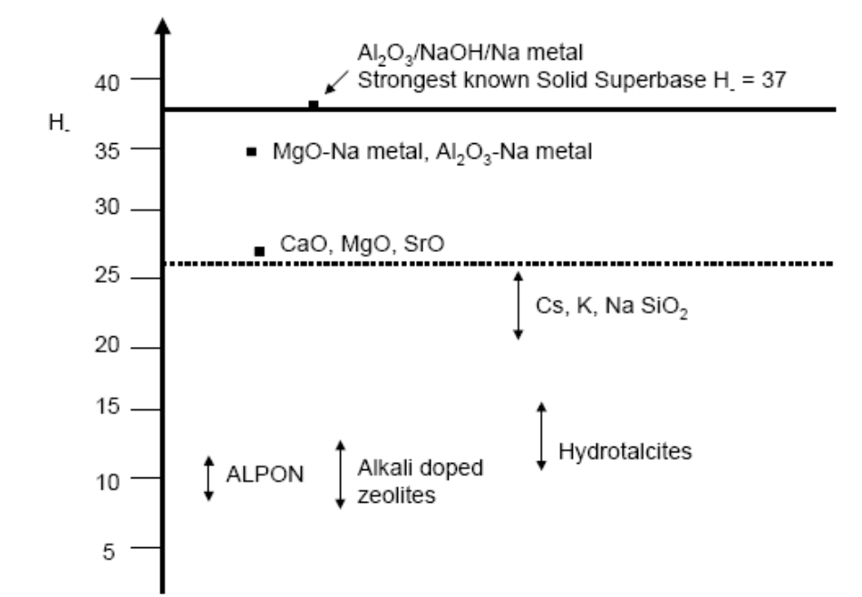
Basic strength of the solid bases (H_)*

Figure 2- 4 Strength of Solid Base Catalysts
(Kelly and King 2002)

*Basic strength were determined by Hammett indicator

Single component metal oxides, the earliest studied solid base catalysts, include Na₂O, K₂O, CaO, MgO, and BaO. The compounds in this group usually act as a Brønsted base for reactions, such as the methanolysis of plant oil (Yan, DiMaggio et al. 2010). The Brønsted site of the compounds is generated by the strong attraction of the oxygen ion.
However, this group of solid bases is vulnerable to CO₂ or H₂O contamination, and this feature largely restricts their application in aqueous media. For conversion of glycerol to lactic acid, one must isolate the catalyst from CO₂ or H₂O by employing anhydrous glycerol.

2.5 Conclusion
Glycerol can be converted to lactic acid with an alkali as the catalyst. However, the use of alkali will cause severe corrosion to reactor and lactic acid productivity is low. Many methods were developed to reduced corrosiveness or increase lactic acid productivity, but no efficient method could improve the reaction from both aspects. Research that can work in both reducing corrosiveness and increasing lactic acid productivity might be a necessity for the future application of glycerol conversion to lactic acid in industrial scale.

Chapter 3

Conversion of glycerol to lactic acid using calcium oxide as solid base catalyst

Abstract
Conversion of glycerol to lactic acid was performed at 280~300°C with calcium oxide as the solid base catalyst. Different factors, including reaction time and temperature, molar ratio of CaO: glycerol and water content were studied. The best conditions were obtained at 290°C, with a reaction time of 150 min and a CaO: glycerol molar ratio of 0.3:1. The highest yield of lactic acid obtained was 40.8 mol%, with a glycerol conversion of 97.8 mol%. High water content in reactant would affect the yield of lactic acid. CaO maintained its original activity in three cycles of regeneration and reuse processes, and the lactic acid yield was not affected much in the repeated runs. The utilization of CaO in conversion of crude glycerol was also investigated. In crude glycerol conversion, there is no significant influence to CaO catalytical ability when water content in crude glycerol sample was low. Also, a preliminary study on the feasibility of CaO used as catalyst for both biodiesel production and following crude glycerol conversion was conducted. Two reported biodiesel production methods with CaO as catalyst were tried, and lactic acid was successfully produced from crude glycerol, byproduct of biodiesel production.

3.1 Introduction

Biodiesel which is derived from vegetable oil or animal fat is an alternative fuel for diesel. It can be produced using different materials as feedstocks, such as oil from mustard seed, rapeseed, canola, crambe, and soybean; algae, and waste cooking oils (Ma and Hanna 1999; Thompson and He 2006; Demirbas and Demirbas 2011). Commercial crude glycerol contains 80-85% glycerol, and water, salts, as well as residual substances from the production process, such as sodium or potassium hydroxide (2006). During the biodiesel production, there will be approximately10% by weight of crude glycerol byproduct (Dasari, Kiatsimkul et al. 2005). The large amount of crude glycerol has created a glut in the glycerol market, resulting in a price decrease for glycerol (Johnson and Taconi 2007).
Lactic acid is a wildly used chemical that can be derived from glycerol (Kishida, Jin et al. 2005; Shen, Jin et al. 2009; Ramirez-Lopez, Ochoa-Gomez et al. 2010). It can be used in food and food related industry (Datta and Tsai 1997), as well as chemical industry to form other useful chemicals, such as pyruvic acid (Werpy 2002; Mark Paster 2003), acrylic acid (Werpy 2002; Mark Paster 2003), and the polymer of lactic acid--polylactic acid (PLA), which is known to be one of the best materials for biodegradable plastic (Drumright, Gruber et al. 2000).
Current commercial production of lactic acid is mainly by fermentation of carbohydrates, such as glucose, sucrose, or lactose (John, Nampoothiri et al. 2007), and the rest is by chemical synthesis as well. Although through fermentation processes, high yield (90%, molar percent) of lactic acid can be achieved, several problems are associated with fermentation, such as high cost of culture media due to the specific requirement of the lactic acid producing bacteria (Oh, Wee et al. 2003), product inhibition (Singh, Ahmed et al. 2006), and the uneconomical and environmentally-unfriendly purification of the products and waste gypsum (Datta and Tsai 1997). Recently, Kishida et al. (2005) provided a new method of lactic acid production from glycerol (0.33 M) using a high concentration of alkali (1.25 M) such as NaOH or KOH as a homogeneous catalyst at approximately 300°C. During 90 min of reaction, the yield of lactic acid reached as high as 90 mol% and the glycerol conversion was100 mol%. Though it’s an efficient reaction, the application is restricted by the corrosiveness of the catalysts. In the preliminary study, it was noticed that at 300°C, high concentration of OH⁻ from NaOH or KOH caused severe corrosiveness to the stainless steel reactor. Lactic acid synthesis from glycerol requires more robust techniques that can reduce the harshness of the reaction condition. To make the glycerol derived lactic acid more practical for industrial applications, it is necessary to develop some techniques to reduce the corrosiveness and increase the productivity of the reaction.
Solid base catalyst can provide base site without dissociated in the water. So the concentration of OH⁻ group would be largely decreased, if a solid base catalyst can be used in the reaction. Among solid base catalysts, CaO has a strong basicity. Also, the separation of CaO from the mixture of CaO and lactic acid is fully developed in fermentation process. So in this chapter, CaO was chosen as the solid base catalyst for glycerol conversion to lactic acid.

Objectives
The objective of this chapter is to improve the reaction condition of glycerol conversion to lactic acid using solid base catalyst. The specific tasks of this part are (1) to investigate the effects of molar ratio of CaO:glycerol, reaction temperature, reaction time ,and water content on glycerol conversion; (2) to study the structure-function of different forms of CaO; (3) to convert crude glycerol samples with CaO as catalyst; (4) to utilize CaO as the catalyst for both conversions of soybean oil to biodiesel and the following crude glycerol to lactic acid.

3.2 Materials and methods

3.2.1 Materials and catalyst preparation
Pure glycerol (99.5%) was used as the starting material. Alkaline catalysts or other solid materials used in this study were: calcium oxide (100%), calcium carbonate (>97%), and calcium hydroxide (98%). Other standard chemicals used are lactic acid (90% solution in water), sulfuric acid (94%-98%). All the reagents were purchased from Thermo Fisher Scientific Inc. Waltham, MA, USA.
Three samples of crude glycerol (named CG1 to CG3) were obtained from different biodiesel manufacturers, with different glycerol concentrations ranging from 20% to 90%, and different water content ranging from 4.3 wt.% to 12.0 wt.%.

3.2.2 Reactors
Conversions of glycerol with solid base catalysts were carried out in a salt bath reactor, shown in Figure 3-1 (a), the biodiesel synthesis reaction was conducted in a high pressure Parr® reactor (Parr Instrument Company, IL, USA), shown in Figure 3-1 (b).
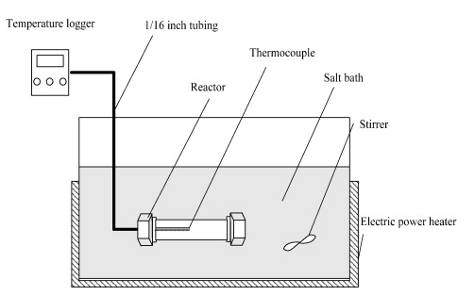
- Salt bath reactor (Cheng, Ye et al. 2009)
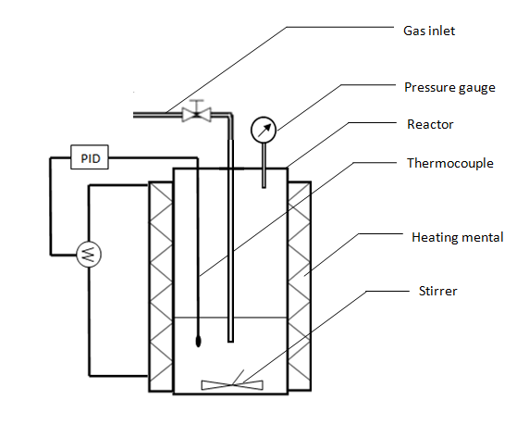
(b) Parr reactor
Figure 3- 1 Schematic diagrams of salt bath reactor (a) and high pressure Parr® reactor (Parr Instrument Company, IL, USA) (b)

The salt bath reactor, which was made of stainless steel SS316 (OD 16.0 mm, ID 11.4 mm, length 105 mm, Swagelok Caps), had a volume of 10mL. The salt bath reactor had a small volume, so the temperature rising inside the reactor was fast, taking about 90 seconds for the temperature rising from room temperature to 300°C.
Compared to the salt bath reactor, the Parr reactor had a larger volume (around 400 ml) and a slower response to an increased set point temperature (around 2h for temperature in the reactor to rise from room temperature to 300°C) than salt bath reactor, but the pressure gauge and the thermocouple could give a better monitor on the reaction process.

3.2.3 Reaction procedures
The reactant was firstly well mixed in a beaker and then filled into the salt bath reactor. Each time, 5 g of well-mixed glycerol and CaO (with a certain molar ratio based on experimental design) was added into the salt bath reactor. Before sealing the cap, the reactant was degassed by purging with nitrogen. Then the reactor was put into the preheated salt bath (with the mixed salt of 50% KNO₃ and 50% NaNO₃ (w/w)) at the objective temperature. After the reaction, the reactor was quenched immediately, and the product sample was collected for analyses or regeneration.
As the HPLC column used in this research is vulnerable to the OH⁻ or metal ions, in order to protect the column, the pH of products should be adjusted to around 3, and metal ions should be removed in a pretreatment process. Sulfuric acid was used first to adjust product pH to 3~ 4 (tested by pH paper). Then the sample was centrifuged at 10⁵ rpm for 15 min and filtered to remove the sediment. Then the sample was diluted and treated through a cation exchange column to remove the metal ions. At first, we used commercial ion exchange columns, HyperSep (Thermo Scientific). Later, the ion exchange columns were fabricated with resin (DOWEX 50WX8-400, Sigma Aldrich). In the end, the sample was analyzed by high-performance liquid chromatography (HPLC, Waters 410®, Waters Corporation). The column used in the experiment was Shodex SH1011 and the guard column was Shodex SH-G, with a refractive index detector. The column temperature was 60.0°C. Samples (25μl) were injected manually. The mobile phase was 5mM H₂SO₄ in deionized water with a flow rate of 0.6mL/min.
In catalyst regeneration process, NaOH was added into the products, in order to convert the calcium lactate to calcium hydroxide and let most of the calcium ion precipitate out in the form of Ca(OH)₂ from the products. Then the products went through filtration and wash process to remove the soluble molecules. After that, the depositions were washed off from the filter paper into a crucible. The water in the crucible was evaporated at around 50°C for 6h, and then the slurry was dried in a convective oven at 110°C overnight. In the end, the collected solids was calcinated at 910°C in a muffle furnace for 3h, in order to convert the Ca(OH)₂ back to CaO and burn off any deposited organic molecules.
The quantitative analysis of each component after reaction is based on the relation between the weight percentage of the component in the product and the peak area in the HPLC chromatograms. External calibration was used for calibration. The calibration curves of lactic acid and glycerol are obtained by testing pure samples of lactic acid and glycerol of different concentrations.
The scheme of experimental procedures of the reaction is shown in Figure 3-2.

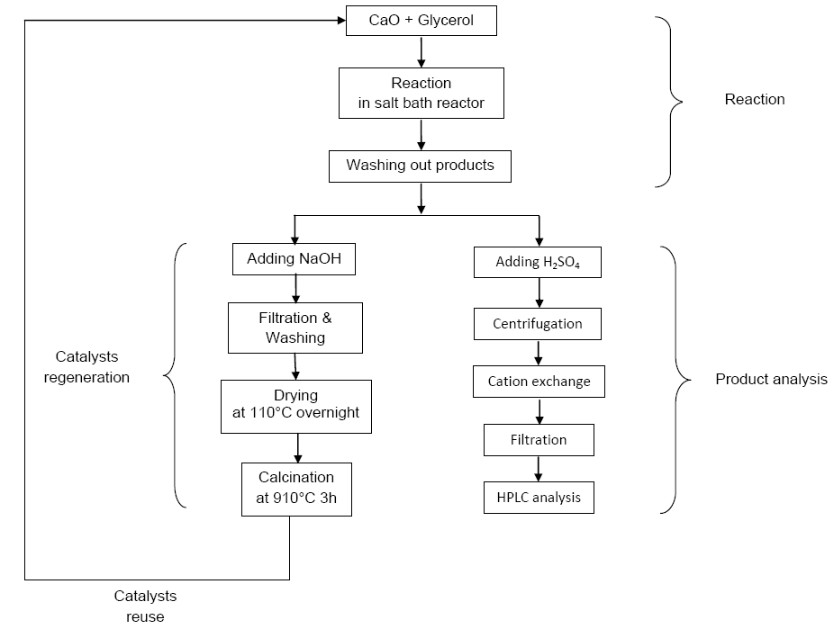
Figure 3- 2 Scheme of experimental procedures for the conversion of glycerol to lactic acid with CaO as the catalyst

Glycerol conversion, lactic acid yield, lactic acid selectivity, lactic acid productivity, and yield of biodiesel, which were calculated by the following equations (Equation 3-1~5), were used to evaluate the reactions:
Conversion of glycerol in mol% X_{gly}=$\frac{Initial glycerol-glycerol in product }{Initial glycerol (mole)}×100\%$(Equation 3-1)
Yield of lactic acid in mol% Y_{Lac /gly}=$\frac{Lactic acid produced (mole)}{Initial glycerol (mole)}×100\%$ (Equation 3-2)

Lactic acid selectivity in mol%
S_{Lac /gly}=$\frac{Lactic acid produced (mole)}{Initial glycerol-glycerol in product (mole)}×100\%$(Equation 3-3)
Productivity of lactic acid in $g/(min∙L)$ P_{Lac}=$\frac{Lactic acid produced in mass}{Reaction time × Total volume}$ (Equation 3-4)
Yield of Biodiesel in wt.% Y_{FAME} = $\frac{Mass of biodiesel product}{Theoretical maximum biodiesel mass}$ $×100$% (Equation 3-5)

3.2.4 Experimental design
In this section, the effect of temperature, reaction time, molar ratio of CaO: glycerol, water content, catalyst reuse, and catalyst surface and structure were studied.
The reaction of glycerol conversion to lactic acid with alkali as catalysts required a high temperature (Ramirez-Lopez, Ochoa-Gomez et al. 2010). The experiments were firstly carried out with the condition that molar ratio of CaO: glycerol equaled to 0.2, and reaction time ranged from 45 min to 205 min, with temperature in 280°C, 290°C and 300°C. After the reaction the products were collected and analyzed, and the reaction time and temperature effects on the lactic acid yield were studied.
Based on the results on the temperature effect, the molar ratio (CaO: glycerol) was increased, in order to find out a better reaction condition. The experiments with a higher molar ratio in 0.3, 0.4 and 0.5 were conducted.
The examining of water content effect was carried out under the best conditions found from the previous experiments. The water content levels chosen in the experiments were 0, 2, 5, 10, 20 and 30 wt.%.
After the reactions, the catalysts were collected and regenerated in the muffle furnace. The regeneration and reuse of the catalyst were also studied under the best condition, with molar ratio (CaO: glycerol) of 0.3 at 290°C, and 150 min reaction time.
During the research, different types of catalysts were used in the experiment, including the CaO purchased from Fisher Sci, regenerated CaO, CaO calcinated from CaCO₃, and CaO nano powder (Strem Chemicals, Inc.). The surface and structure of the catalysts were studied using X-ray diffraction (XRD) and scanning electron microscope (SEM).
The production of lactic acid from crude glycerol over calcium oxide can be combined with the upstream production of biodiesel, as it was reported that CaO can also be used as the solid base catalyst for the transesterification of triglycerides to biodiesel (Liu, He et al. 2008; Granados, Alonso et al. 2009; Vujicic, Comic et al. 2010). Two possible methods of biodiesel production were utilized and the reactions were carried out in high pressure Parr® reactor (Parr Instrument Company, IL, USA). The first method was reported by Liu et al. (2008), in which the reaction was carried out at 65°C for 3h, with a 12:1 molar ratio of methanol to oil, 8 wt.% CaO as catalyst based on oil weight, and 2.03 wt.% (based on oil weight) water. In the other method, CaO was first modified in trimethylchlorosilane (TMCS) (Tang, Chen et al. 2011). The mixture of methanol/oil (with 15:1 molar ratios) and 5 wt.% modified CaO, was heated to 65°C and kept for 3h.
After biodiesel production reaction, the excess methanol was distilled off under vacuum, and the rest products formed three layers after centrifugation: from top to bottom are biodiesel, glycerol, and mixture of solid CaO and a small amount of glycerol respectively (Liu, He et al. 2008). The byproduct of crude glycerol together with CaO was separated by separatory funnel, and the mixture was used as the materials for the following lactic acid production which was directly heated up to 290°C for 150 min.
Calcium oxide was also used in the conversion of crude glycerol to lactic acid. Three types of crude glycerol from different manufacturers with different glycerol and water contents were utilized as the starting materials. The reactions were carried out at 290°C for 150 min with a 0.3:1 molar ratio of CaO:glycerol.

3.3 Results and discussion

3.3.1 Conversion of glycerol solution with different solid base catalysts
Different solid base catalysts that have Brønsted sites were tried in the glycerol (0.33M water solution) conversion. The results were shown in Table 3-1.

Table 3- 1 Results of glycerol conversion using different solid base*
Description of the Solid base | Lactic acid yield | Glycerol conversion
CaO (Fisher Scientific, 100%) | 7.5% | 78.54%
Ca(OH)₂ (Fisher Scientific, 98%) | 4.6% | 27.55%
Hydrotalcite (Sigma- Aldrich)  (Mg₆Al₂(CO₃)(OH)16·4(H₂O) | -- | 19.32%
Hydrotalcite (home fabricated)  (dehydrated at 450℃ with N₂ flow for 4h) | -- | 25.12%
Alumina loaded with KNO₃  (home fabricated) | 3.83% | 83.06%

*All the reactions were conducted at 300°C for 90 min, with 0.33M glycerol

The low yield of lactic acid is mainly due to the fact that water would react with most of the solid base catalyst. In the following experiments, calcium oxide, the catalyst showing relatively better performance, was used in the conversion of glycerol in the condition without water.

3.3.2 Glycerol (without water) conversion with CaO
When using CaO to convert glycerol (without water) the results were better than in water solution. That might be because when water exists, CaO would first react with water forming Ca(OH)₂, which has a low catalytical ability than CaO.
A typical HPLC chromatogram of the product is shown in Figure 3-3. In the previous study, the peaks of lactic acid and glycerol were not well separated. In order to obtain a better separation of the chemicals in the products, deionized water with different concentrations of H₂SO₄ were used as the mobile phase. If in the HPLC analysis with high H₂SO₄ (5mM) there was no peak before lactic acid, then we would use a lower concentration H₂SO₄ (0.5mM) as the mobile phase and a new set of calibration curves. In this way, the retention time of lactic acid would be shortened and the peak of lactic acid would be separated from glycerol. The calibration curves of lactic acid and glycerol are shown in Appendix 3.

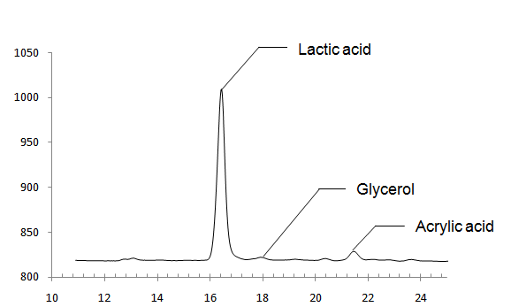
Retention time (min)

Figure 3- 3 HPLC chromatogram of glycerol conversion product with CaO as catalyst

3.3.3 Effect of reaction temperature on lactic acid yield
Temperature effects were studied and the result was shown in Figure 3-4.
The result in Figure 3-4 showed that with time goes on, the lactic acid yield increases to a summit and then decreases. The peak of the curve moves to the left when the reaction temperature increases, which indicates that the reaction rate was increased when temperature increased. When temperature was above 290°C and reaction time was longer, there formed coke in the products. That’s why lactic acid yield drops quickly after a certain reaction time.

Figure 3- 4 Yield of lactic acid of the reaction at different temperature with the molar ratio of 0.2 (CaO: Glycerol)
(Error bar shows the standard deviation of four samples in two runs. Detailed data is shown in Appendix II, Table II-1)

3.3.4 Effect of molar ratio of CaO to glycerol on lactic acid yield
The effects of CaO molar ratio in the reactant is shown in Figure 3-4. With the increase in the molar ratio of CaO:glycerol from 0.2 to 0.3, the maximum yield of lactic acid increased from 28 mol% to 42 mol%. Also, CaO might has a function to prevent the pyrolysis of the organic molecule, because even the reaction time is as long as 205 min, no coke was observed when CaO:glycerol is higher than 0.3. However, when the content of CaO was increased further, there is not obvious change in lactic acid yield. Meanwhile, when sulfuric acid was added to the products of the reactions with CaO: glycerol molar ratio above 0.3, there were bubbles came out from the product, which we believe was the indication of carbon dioxide formation.
When the molar ratio of CaO:glycerol in the reactant is higher than 0.3, the reactant is rather sticky at low temperature. So we selected reaction with CaO:glycerol = 0.3 (molar ratio), at 290°C for 150 min as the best condition

Figure 3- 5 Highest glycerol conversion and lactic acid yield with different molar ratio of CaO: Glycerol
(Error bar shows the standard deviation of four samples in two runs. Detailed data is shown in Appendix II, Table II-2)

3.3.5 Evaluation of mass balance
In the reaction with CaO:glycerol molar ratio of 0.3, for each gram of reactant mixture, there was 0.154g CaO and 0.846g glycerol. After the reaction the gas samples was analyzed by Gas Chromatography (GC), 82% of which was H₂. Based on the ideal gas law, there was 4.8×10 ⁻⁵mol H₂, which had a very small amount of weight. The rest of the product was washed out by deionized water. For each gram of reactant mixture, the product washed out had a weight of 0.961g in average. The mass balance on average was 96.1%.
For one gram of reactant mixture, after reaction the total amount of lactic acid and unconverted glycerol was about 0.38g. Besides the small amount of soluble organic molecules in the HPLC result, large amount of insoluble carbon was found in the calcination of catalyst regeneration process. The insoluble mixture was first filtered and washed with deionized water. The weight loss during the calcination at 910°C was 0.411g. When subtract the loss of one molecule of H₂O for the conversion of Ca(OH)₂ back to CaO, the rest should be insoluble organic molecules, which had a weight of 0.365g.
The results of very limited amount of hydrogen and large amount of insoluble carbon indicated that there might be other pathways of the reaction. We believed maybe glycerol was first polymerized with CaO as the catalyst (Garti, Aserin et al. 1981), and then the poly glycerol was converted to lactic acid.

3.3.6 Activation energy of glycerol conversion with CaO as catalyst
Three sets of reactions at 280 °C, 290 °C, and 300 °C were conducted and glycerol conversions were detected, in order to obtain the reaction rate constants. The detailed results were shown in Appendix 1. The pre-exponential factor and activation energy obtained (based on Arrhenius equation) in the study are as follows.
A=4.022×10⁸ ± 30.4 min⁻¹
Ea=103.0 ±16.0kJ/mol
The reported activation energy for the glycerol to lactic acid with NaOH as catalyst was 174kJ/mol (Kishida, Jin et al. 2006). The lower activation energy for glycerol conversion with CaO as catalyst indicates that it requires a lower temperature, which will help to reduce the energy cost of the glycerol conversion.

3.3.7 Effect of regeneration and reuse
The regenerated CaO was used in the glycerol conversion. The results of lactic acid yield and glycerol conversion of 3 successive runs were compared in Figure 3-6. The results showed that the catalysts sustained activity after regeneration process. However, in the conversion of glycerol with regenerated CaO, more peaks were detected in HPLC (shown in Figure 3-7), which indicated an increase of side reactions. On average, 92.7 wt.% catalysts can be recovered after the reaction and catalyst regeneration process. The rest was lost during the washing and transferring process.

Figure 3- 6 Glycerol conversion and lactic acid yield with regenerated catalysts
(Error bar shows the standard deviation of four samples in two runs. Detailed data is shown in Appendix II, Table II-3)

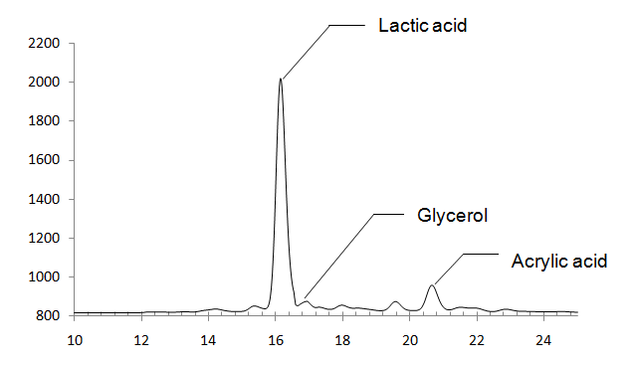
Retention time (min)

Figure 3- 7 HPLC chromatogram of glycerol conversion product with regenerated CaO as catalyst

3.3.8 Effect of water content on the lactic acid yield
In crude glycerol, water is the major impurity that will react with calcium oxide. Figure 3-9 shows the effect of water content on the lactic acid yield. From the results, the increase of water content will cause the decrease of lactic acid yield and glycerol conversion. When water content was lower or equal to 5%, lactic acid yield was not affected by water (p>0.05 for 0, 2%, and 5% water contents, Tukey test). But when water concentration was10% or larger, lactic acid yield decreased much compared with the reactions with low water content (p<0.05, Tukey test). When water exists in the system, each molecule of CaO will react with one molecule of H₂O forming Ca(OH)₂. When the reactants content more than 5% of water, CaO will be totally converted into Ca(OH)₂, which might increase the decomposition of organic molecules, and decrease the lactic acid yield. In this situation, the organic molecule finally be converted into carbon dioxide, which would subsequently react with Ca(OH)₂, forming CaCO₃.

Figure 3- 8 Lactic acid yield and glycerol conversion under conditions with different water content at 290°C for 150 min, with CaO:glycerol=0.3 (molar ratio)
(Error bar shows the standard deviation of four samples in two runs. Detailed data is shown in Appendix II, Table II-4)

3.3.9 Application of CaO in crude glycerol (different sources) conversion to lactic acid
The results of three different types of crude glycerol conversion with CaO as catalyst were shown in Table 3-2. From the results, it can be seen that CaO has a high catalytical ability when water content is low. The high yield of lactic acid in the conversion of CG2 might due to some organic impurity such as ester which might be converted to glycerol and finally to lactic acid when CaO was used as catalyst. However, although CG3 also has high impurity content, the high water content in CG3 caused the deactivation of CaO. OH⁻ concentrations in the samples were very low, which had limited effect on the glycerol conversion.

Table 3- 2 Application of CaO as catalyst in conversion of different sources of crude glycerol⁺
 | Glycerol concentration  (wt.%) | Water concentration  (wt.%) | Soap content  (wt. %) | OH⁻  concentration  (M) | Lactic acid yield  (mol %) | Glycerol conversion  (mol %)
CG1ª | 90.5±1.18 | 7.37 | 2.2 | 10^{-7 b} | 40.3*±2.36** | 93.7±2.21
CG2 | 32.1±2.00 | 4.36 | 62.9 | 0.010 | 52.3±3.17 | 87.9±1.21
CG3 | 20.4±0.93 | 12.04 | 55.4 | 0.017 | 18.4±1.15 | 79.5±1.08
+-Glycerol and lactic acid concentrations were measured by HPLC, water content was measured by Karl Fischer titration (Yperman, Smets et al. 2011); Soap content was measured by phase separation in acidic condition using separation funnel
a-CG1 was from Alabama state biodiesel plant, CG2 and CG3 were from Tennessee Biodiesel plant
b- alkali in the sample might be consumed by the impurities in crude glycerol
*- average of four samples in two separate runs,
**- standard deviation of four samples in two separate runs

3.3.10 Structure-function of the CaO on the lactic acid yield
Different preparation methods, such as calcination, might result in different catalytical ability of the catalysts. During the study, four sources of CaO were used as the solid base catalyst in the conversion of glycerol to lactic acid, including CaO (Fisher Scientific, Inc.), CaO calcinated from CaCO₃, regenerated CaO, and CaO nano powder (Strem Chemicals, Inc.). The results were listed in Table 3-3. From the table, the reaction with CaO nano powder resulted in the lowest lactic acid yield. However, glycerol conversion and lactic acid selectivity showed no difference among the reactions with different types of CaO as catalysts.
Table 3- 3 Results comparison of four types of CaO in glycerol conversion (at 290°C for 150 min)
 | Lactic acid selectivity  (mol%) | Lactic acid yield  (mol%) | Glycerol conversion  (mol%)
CaO (Fisher Scientific, Inc.) | 41.7*±3.26** | 40.8±2.36ª | 97.8±2.22
Calcinated from CaCO₃ | 38.5±1.40 | 37.2±0.28^{ab} | 96.7±2.83
Regenerated CaO | 40.6±2.01 | 38.7±1.95ª | 95.2±2.85
CaO nano powder  (Strem Chemicals, Inc.) | 38.0±1.17 | 35.8±1.56^{b} | 94.1±6.92
*-average of four samples in two separate runs,
**-standard deviation of four samples in two separate runs
a&b- indicates different groups in Tukey test

The crystalline phases and structure difference were studied by X-ray diffraction (XRD) and scanning electron micrographs (SEM). In the XRD spectrum (Figure 3-9), the peaks at 2θ=33°, 37°, 54°, 65°, and 67° were the characteristic peaks for CaO. At these positions above, the intensity of the characteristic peaks for CaO calcinated from CaCO₃, regenerated CaO, and CaO nano powder (Strem Chemicals, Inc.) were lower than commercial one, which indicated that commercial CaO had a highest crystalline proportion among the four types. The peak at around 20° (2θ) indicated the amorphous content of the material. The CaO calcinated from CaCO₃ and regenerated CaO had a wider peak at this position, which showed that the CaO calcinated from CaCO₃had higher amorphous proportion. The signature peak of CaO calcinated from CaCO₃at low angles (<5°) was likely due to the mesoporous structure. In summary, the CaO (Fisher Scientific, Inc.) had the highest crystalline proportion, which followed by CaO calcinated from CaCO₃ and regenerated CaO. The CaO nano powder had the lowest crystalline proportion.
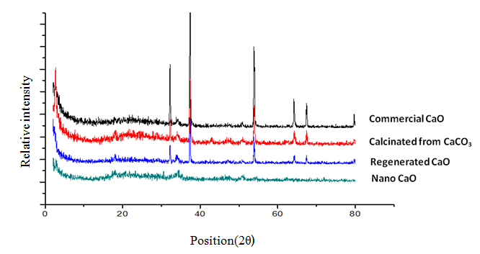
Figure 3- 9 X-ray diffraction patterns of four types of CaO
(commercial, calcinated from CaCO₃, regenerated, and nano powder)

From the Scanning electron micrographs (Figure 3-10), the structures of the four types of CaO were clearly different. The commercial CaO showed aggregates of small crystals with a size around 1μm. The CaO particles calcinated from CaCO₃ (b) and regenerated CaO (c) had an interparticle-pore structure. The regenerated ones had larger pores than the particles calcinated from CaCO₃. The nano powder CaO (d) had the largest aggregated particle size. However, on the particles, small layer and pore structures can be observed.

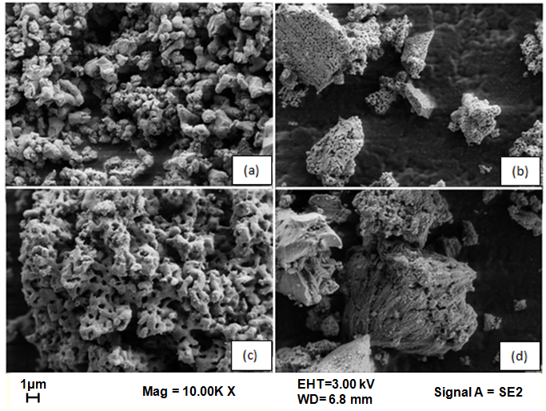

Figure 3- 10 Scanning electron micrographs (SEM) of four types of CaO
(commercial (Fisher Scientific, Inc.) (a), calcinated from CaCO₃ (b), regenerated (c), and nano powder (d))

3.3.11 Production of biodiesel and lactic acid from soybean oil over CaO
The biodiesel products were verified by FTIR, and the result was shown in (Figure 3-11). The FTIR spectrum of the biodiesel matched the standard FTIR result well, which means that the biodiesel produced had a high purity. The concentration of biodiesel was calculated based on glycerol concentration in the product, as from chemical equation the molar ratio of biodiesel:glycerol= 3:1. The yield of biodiesel and lactic acid were shown in Table 3-4. The modified CaO had a better catalytic ability in biodiesel production than the CaO (Fisher Scientific, Inc.) without modification, but would cause a decrease in the following yield of lactic acid in glycerol conversion.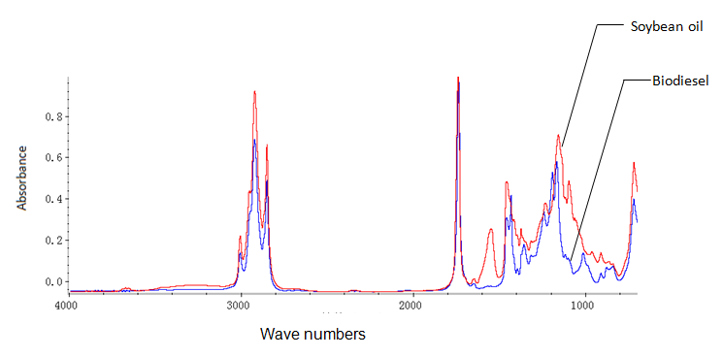
Figure 3- 11 FTIR result of biodiesel product and original soybean

Table 3- 4 Biodiesel production and lactic acid production using CaO as the catalyst

Biodiesel production |  |  |  |  | Lactic acid production
MeOH: oil | Catalyst | Temperature | Time (min) | Biodiesel yield | Temperature | Time  (min) | Lactic acid yield | Glycerol conversion
12:1 | CaO (unmodified) | 62°C | 180 | 78.30% | 290°C | 150 | 49.70% | 100%
15:1 | Modified CaO using(TMCS) | 62°C | 180 | 86.50% | 290°C | 150 | 15.00% | 90.50%

3.4 Conclusions
The conversion of glycerol to lactic acid can be carried out with CaO as the solid base catalyst. Lactic acid yield and glycerol conversion would be affected by the molar ratio of CaO:glycerol, water content in the reactant, reaction temperature and time. The best yield was obtained at 290°C, 150 min with CaO:glycerol =0.3 (molar ratio), and the lactic acid yield is 40.8%.When water content was above 5 wt.%, CaO catalytic ability would decrease, because water would react with CaO forming Ca(OH)₂.
Different samples of crude glycerol were used as the starting material for the lactic acid production. When water content in the crude glycerol was low, CaO performed well in both glycerol conversion and lactic acid production. But high water content would cause CaO loss activity.
Structure-function of different types of CaO was studied using SEM and XRD. The results indicated that crystalline structure of CaO is more preferred in the lactic acid production process.
In the end, the feasibility of combination of biodiesel production from soybean oil and the following crude glycerol conversion to lactic acid was studied. CaO was used as the catalyst for both processes. Soybean oil was first converted to biodiesel, and its byproduct, crude glycerol mixed with CaO was used directly as the starting material of the glycerol conversion step. Lactic acid was produced after the reaction. However, this combination requires more research in the future.

Chapter 4

Glycerol conversion in fed-batch system with NaOH as homogenous catalyst

Abstract
Although NaOH can be used as a catalyst for glycerol conversion, leading to high yield of lactic acid (around 90 mol%) and glycerol conversion (around 100 mol%), a high initial concentration of NaOH will cause severe corrosion to the stainless steel reactor. In order to reduce the corrosiveness of the reaction, a fed-batch reactor was used in this study which can continuously feed NaOH to the reaction midium. The yield of lactic acid reached 80 mol%, with a 92 mol% of glycerol conversion achieved. Based on the experiment data, a first-order kinetic model for the time course of glycerol consumption was developed and evaluated. During the reactions with fed-batch reactor, the OH⁻ concentration was kept in the range of 0.15M to 0.25M, which reduced the corrosiveness of the conversion of the reaction medium during glycerol to lactic acid with an alkali as the catalyst to 1/5 of that using batch reactor. Finally, the fed-batch reactor and model was applied in three sources of crude glycerol conversion, and a maximum 72.9 mol% lactic acid yield was obtained with 92.4 mol% glycerol conversion.

4.1 Introduction

Biodiesel is known to be a good renewable energy that will partially replace fossil fuels and reduce the energy crisis in the future. However, the accumulation of biodiesel byproduct, crude glycerol, has become a barrier for the development of biodiesel industry, due to the high cost of purification or conversion process of crude glycerol. Many studies have been conducted on crude glycerol conversion, among which the conversion of glycerol to lactic acid with alkali as the catalyst is one of the attractive pathways. Still the conversion of glycerol with an alkali as the catalyst has some disadvantages, for example the high NaOH concentration in the reaction will cause severe corrosion to the stainless steel reactor.
With catalysis of alkali, glycerol will be first converted to lactic acid. Then the lactic acid will neutralize the alkali catalyst, producing lactate. Taking NaOH as an example, when NaOH is utilized as the catalyst, one molecule of the newly formed lactic acid will react with one molecule of NaOH, generating sodium lactate. Although, this mechanism of neutralization and formation of lactate will help to prevent the decomposition of lactic acid at such high temperature (around 300°C), the consumption of catalyst requires high initial concentration of the NaOH in batch reaction, which will increase the corrosion to the stainless steel reactor during the high temperature reaction process. Stoichiometrically, the initial molar ratio of NaOH:glycerol should be at least above 1:1. According to the research of Ramirez-Lopez et al. (2010), the minimum molar ratio of NaOH: glycerol should be greater or equal to 1.1 was required for the total conversion of glycerol.
In batch reaction, high initial concentration of alkali is required for the total conversion of glycerol, which will cause a severe corrosion to the reactor. If the alkali can be supplied during the reaction process, the corrosiveness of the conversion could be reduced. Fed-batch reactor is such kind of reactor that can supplement substrates during the reaction process. The conception of fed-batch reactor comes from the fermentation industry, in which the growth-limiting nutrient is fed continuously during the fermentation (Wlaschin and Hu 2006). In this way cells or the products can be accumulated to a higher concentration, so the productivity will be higher. The major advantage of the fed-batch reactor comparing with batch reactor is the lower production cost due to the high productivity. The best condition for the fed-batch reactor is maintaining a optimum environment in which the growth rate of microorganism can have a maximum growth rate (Riesenberg and Guthke 1999). In the conversion of glycerol to lactic acid, alkali can be considered as the limiting substrate, which can be added during the reaction process by fed-batch reactor.
The conversion of glycerol in alkaline condition was reported following the first order kinetic (Shen, Jin et al. 2009). A kinetic model for the concentration of glycerol during the reaction can be derived from. Combining with Arrhenius equation, the model can be developed with the following parameters: reaction temperature, and reaction time.

Objectives

This study was designed to convert glycerol to lactic acid with NaOH as homogeneous catalyst in fed-batch reactor. Based on the experimental data, kinetic model for glycerol conversion was developed. The specific tasks of this part were (1) to apply the fed-batch reactor in the conversion of glycerol to lactic acid with NaOH as homogenous catalyst with the goal to reduce reaction harshness; (2) to develop kinetic model for glycerol concentration incorporating key reaction; (3) to comparatively analyze reaction corrosiveness; and (4) to apply the fed-batch system in the conversion of crude glycerol to lactic acid and to test whether the impurity of crude glycerol would affect the glycerol conversion to lactic acid.

4.2 Materials and methods

4.2.1 Materials
Pure glycerol (99.5%) was used as the starting material. Sodium hydroxide (97%) was used as the catalyst. Other standard chemicals used are lactic acid (90% solution in water), Acetic acid (98%), and sulfuric acid (94%-98%). All the reagents were purchased from Thermo Fisher Scientific Inc. MA, USA.
Three types of crude glycerol (named CG1 to CG3) were obtained from different biodiesel manufactories, with different glycerol concentration ranging from 20 wt.% to 90 wt.%.

4.2.2 Reactor and operation
The high pressure Parr® reactor (Parr Instrument Company, IL, USA) had a volume of approximately 400ml) and a slow temperature rising rate (around 2h for temperature in the reactor to rise from room temperature to 300°C). The pressure gauge equipped on the Parr reactor could give a better monitor on the reaction process. In this study, the Parr reactor was rebuilt into a fed-batch reactor (in Figure 4-1).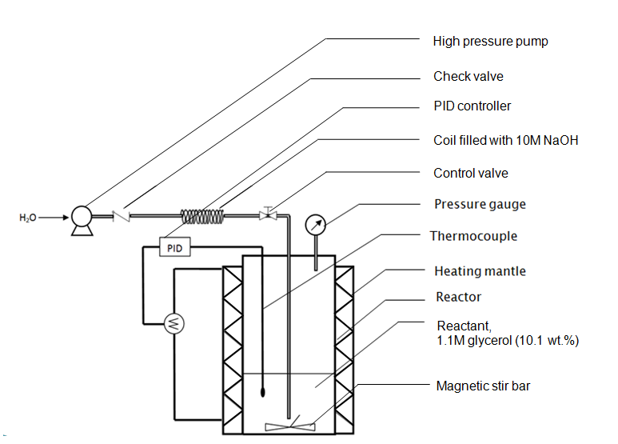
Figure 4- 1 Schematic diagram of fed-batch reactor
The conversion of glycerol with NaOH as the homogenous catalyst was carried out in the fed-batch reactor. First, 100ml certain concentration of glycerol solution (1.1M or 2.2M) was heated up to the objective temperature (290°C or 300°C). The coil filled with high concentration of NaOH solution (10M) was then connected to the reactor. With pumping water into the coil, pressure was accumulated between the reactor and the pump. When the pump pressure was equal to the reactor pressure reading from the pressure gauge, the control valve was opened. NaOH (10M) (2mL) was quickly injected into the reactor in 24 seconds (with a injection rate of 5mL/min), in order to quickly raise the alkali concentration in the reactor to 0.2M. At this point the counting of reaction time was started and the NaOH injection rate was reduced to a proper level in order to keep the alkali concentration around 0.2M during the entire reaction process, at which level the reactor corrosion would be reduced.
After the reaction, the reactor was taken out from the heating mantle and cooled in air with forced convection. The product was collected for the following analysis.

4.2.4 Product pretreatment and analysis
Three samples were obtained after each run. The samples were first diluted with deionized water, and went through pretreatment and analysis similar to those described in Section 3.2.4. Besides the determination of lactic acid and glycerol, OH⁻ concentration was calculated based on the measurement of pH after reaction. Samples were diluted with deionized water, and pH was measured by pH meter (Extech 407228, Extech Instruments Corporation).

4.2.5 Kinetic modeling
Model description

According to the previous studies, the conversion of glycerol with alkali as the catalyst follows first order kinetics (Kishida, Jin et al. 2006). Kinetic model for glycerol concentration was developed based on the first order kinetics, incorporating glycerol concentration, reaction time, initial glycerol concentration, and reaction temperature. The kinetic parameters were estimated based on the activation energy and Arrhenius equation.

Determination of kinetic parameters

From the curve of glycerol conversion with different reaction time and the kinetic research (Kishida, Jin et al. 2006), the overall reaction from glycerol to lactic acid follows the pattern of first order reaction. The following is the reaction rate equation of the first order reaction (Equation 4-1) and its integral form (Equation 4-2).
$-\frac{dC}{dt}=kc$ Equation 4-1
$-kt=log⁡(\frac{C}{c_{0}})$ Equation 4-2
Where, k is the first order reaction rate constant (1/min);
t is the reaction time (min);
c₀ is the initial concentration of glycerol (mol/L);
c is the concentration of glycerol at time t (mol/L).

Based on the first order kinetic equation, the reaction rates at different temperatures were obtained through a set of experiments with reaction temperature at 280°C, 290°C, and 300°C, respectively. At each temperature the reaction time was varied from 30 min, 45 min, and 60 min. Absolute values of the slops of log(c/c₀) vs. time in the plots at each temperature indicated the glycerol conversion rate constant at that temperature.

Based on Arrhenius equation as follows (Equation 4-3), the activation energy of the glycerol conversion with NaOH as homogenous catalyst can be determined by the plot of reaction rate constants vs. 1/T in logarithmic scale.

$k=Ae^{-Ea/RT}$ Equation 4-3
where,
k is the reaction rate constant (1/min);
Ea is the activation energy of the reaction (kJ/mol);
A is the pre-exponential factor (1/min);
R is the gas constant (kJ/ (mol·K)).

The reaction rate constant can be substituted using the Arrhenius equation (Equation 4-2), resulting in Equation 4-4.
$C_{gly}=C_{0 gly}exp⁡(-A exp\left(-\frac{Ea}{RT}\right)t)$ Equation 4-4
where,
C_{gly} is the glycerol concentration at time t (mol/L);
C₀ _{gly} is the initial glycerol concentration (mol/L);
t is reaction time (min).

Model verification
The model for glycerol concentration was plotted in the same chart with the experimental data of the concentration of glycerol. The fitness of the model was tested root mean square error (RMSE), and coefficient of determination (R²).

Model validation
The model was validated by two set of conditions, including the change of reaction temperature to 290°C from 300°C, and the initial glycerol concentration to 2.2M.
The first set of validation was carried out with 1.1M initial glycerol concentration and 290°C. Under this condition (lower temperature), the reaction rate was decreased, compared to that at 300°C. Experiments with reaction time of 90 min, 180 min, and etc. were conducted until 95 mol% glycerol conversion was obtained.
The second set of validation experiments was carried out with 2.2M glycerol initial concentration at 300°C. With a higher glycerol initial concentration (2.2M), the conversion rate of glycerol at the beginning was faster than that with 1.1M initial glycerol concentration. Experiments with reaction time of 60 min, 120 min, and etc. were conducted until 95 mol% glycerol conversion was obtained.

4.2.6 Experimental design

The overall procedures in this research included (1) determining the kinetic parameters for the model; (2) obtaining experimental data of the glycerol and lactic acid concentrations under typical conditions; and (3) validating the model for glycerol concentration at different temperatures and initial glycerol concentration conditions. Table 4-1 shows the detailed experimental conditions.

Table 4- 1 Experimental conditions of the development and validation of kinetic model for glycerol concentration (The concentration of NaOH in the coil=10M)*

Model development |  |  | Model validation
(glycerol initial concentration=1.1M,  reaction temperature=300°C) |  |  | glycerol initial concentration=1.1M,  reaction temperature=290°C
Injection rate of NaOH  (ml/min) | Reaction time  (min) |  | Injection rate of NaOH  (ml/min) | Reaction time  (min)
0.117  (for 0-60 min)  0.021  (for 60-220 min) | 20 min |  | 0.078 (for 0-90 min)  0.022 (for 90-180 min)  0.005(for180-360 min) | 90 min
0.117  (for 0-60 min)  0.021  (for 60-220 min) | 40 min |  |  | 180 min
0.117  (for 0-60 min)  0.021  (for 60-220 min) | 60 min |  |  | 270 min
0.117  (for 0-60 min)  0.021  (for 60-220 min) | 80 min |  |  | 360 min
0.117  (for 0-60 min)  0.021  (for 60-220 min) | 100 min |  | glycerol initial concentration=2.2M,  reaction temperature=300°C
0.117  (for 0-60 min)  0.021  (for 60-220 min) | 120 min
0.117  (for 0-60 min)  0.021  (for 60-220 min) | 140 min |  | Injection rate of NaOH  (ml/min) | Reaction time  (min)
0.117  (for 0-60 min)  0.021  (for 60-220 min) | 160 min |  | 0.167 (for 0-60 min)  0.083 (for 60-120 min)  0.033(for120-180 min)  0.017(for180-240 min) | 60 min
0.117  (for 0-60 min)  0.021  (for 60-220 min) | 180 min |  |  | 120 min
0.117  (for 0-60 min)  0.021  (for 60-220 min) | 200 min |  |  | 180 min
0.117  (for 0-60 min)  0.021  (for 60-220 min) | 220 min |  |  | 240 min
*- 3 samples were used for each experiment
The concentration of OH⁻ in the fed-batch reactor was influenced by the injection rate and the consumption rate in the neutralization process. In order to keep OH⁻ concentration at a level of 0.2M, the feeding rate of NaOH was set based on the reaction rate of glycerol conversion to lactic acid stoichiometrically. With the injection rate set as those shown in Table 4-1, OH⁻ concentration would be kept in a range from 0.15M to 0.25M. In our study, OH⁻ concentration in that range would not significantly affect the reaction rate of glycerol to lactic acid.

Evaluation of reactor corrosion
Different from the batch reactor (Chapter 3), NaOH can be continuously supplied in a fed-batch reactor so the consumption of alkali can be replenished. In this way, the concentration of OH⁻ can be kept at a certain level, which will help to reduce the corrosiveness of the reaction. In order to determine the corrosiveness, Fe³⁺ ion concentration after the reaction was chosen as an indicator (Ramirez-Lopez, Ochoa-Gomez et al. 2010) and the concentration was measured by atomic-absorption spectroscopy (AAnalyst™ 700, PerkinElmer, Inc.). FeCl₃ standard solution with the concentration of 1 ppm, 2 ppm, 4 ppm, and 5 ppm was used as external standards for calibration.

Application of fed-batch reactor in the conversion of crude glycerol to lactic acid
The fed-batch system was applied to the crude glycerol conversion reaction. The crude glycerol samples used in this section were the same as those described in Section 3.4.7. Each time, crude glycerol was diluted to 1.1M with deionized water. The reactions were conducted at 300°C for 220 min.

4.3 Results and discussion

4.3.1 Activation energy of glycerol conversion with NaOH as catalyst
It is reported that below 280 °C, very small amount of glycerol would be converted during a 90 min reaction (Ramirez-Lopez, Ochoa-Gomez et al. 2010). When determining the reaction rate constants, three sets of reactions at 280 °C, 290 °C, and 300 °C were conducted and glycerol conversions were determined. The detailed results are shown in Appendix 1.
The pre-exponential factor and activation energy obtained in the study are the following.
A=6.154×10⁸ ±1.4 min⁻¹
Ea=114.0 ±1.6 kJ/mol
The reported activation energy for the glycerol conversion to lactic acid with NaOH as catalyst was 174 kJ/mol (Kishida, Jin et al. 2006). The difference between the reported data and ours might be caused by the different reactors, which had a different temperature rising time. However, in the following study on the glycerol conversion using fed-batch reactor, the activation energy obtained from this research was verified by the experimental data.

4.3.3 Glycerol conversion with NaOH as catalyst in fed-batch reactor
The conversion of 1.1 M glycerol to lactic acid with NaOH as catalyst was conducted with fed-batch reactor. The initial OH⁻ concentration was 0.2 M, and during the reaction, NaOH was fed into the reactor to compensate the alkali neutralized by lactic acid produced. After 220 min of reaction, 0.89 M lactic acid was obtained, with a lactic acid yield of 81.4 mol%. Glycerol conversion was 92.8 mol% after 220 min reaction. The results are shown in Figure 4-2. Data were obtained at the end of separate runs experiments with different reaction time to avoid potential errors caused by in situ sampling in the middle of a reaction. Only the last time point was repeated due to the large experiment number.
Results about lactic acid and NaOH concentrations will be discussed later.

Figure 4- 2 Concentration of glycerol, lactic acid, and OH⁻ during glycerol conversion in fed-batch reactor
Reaction condition: 300 °C, 1.1 M glycerol initial concentration
Injection rate of NaOH: 0.117 ml/min for 0-60 min, 0.021 ml/min for 60-220 min
(Detailed data is shown in Appendix II, Table II-5)

4.3.4 Model verification
With the parameters obtained from the previous section, the model for glycerol concentration can be written as follows (Equation 4-5).
$C_{gly}=C_{0 gly}exp⁡(-6.154×{10}^{8}\min^{-1}exp\left(-\frac{114.0kJ/mol}{8.314kJ/(mol∙K)×T}\right)t)$ Equation 4-5
The model was plotted in Figure 4-2 (dash line). Then the following statistics were used to evaluate the model, including root mean square error (RMSE), sum of squares of residuals (SSE), total sum of squares (SST), and coefficient of determination (R²). The formulas for the statistics are as follows (Equation 4-6~9) (Draper and Smith 1998).
$RMSE=\sqrt{\frac{Σ{(observed-predicted)}^{2}}{n-1}}$ Equation 4-6
$SSE=Σ{(observed-predicted)}^{2}$ Equation 4-7
$SST=Σ{(observed-observed mean)}^{2}$ Equation 4-8
$R^{2}=1-SSE/SST$ Equation 4-9
RMSE is a sum of the residuals which will show how precise the model prediction is. SSE indicates how tight the model fits the data. SST is defined as the sum of the differences of each observation from the overall mean. R² can be considered as an indication about how well future prediction about the model (Everitt 2002).

Table 4-2 shows the results of the evaluation.

Table 4- 2 Evaluation of the model for glycerol concentrations
 | Model for glycerol concentration
RMSE | 0.06070
SSE | 0.04421
SST | 1.232
R² | 0.9641

From the results, it can be inferred that 96.4% of the variance of the glycerol concentration can be explained with the model.

4.3.5 Model validation
The model prediction is first tested with a higher initial glycerol concentration (2.2 M). The results are shown in Figure 4-3. The fitting of glycerol concentration was good (with R²=0.9985, and RMSE=0.043), because the model for glycerol concentration is based on first order kinetics which has been proven in the previous studies.
Results about lactic acid and NaOH concentrations will be discussed below.

Figure 4- 3 Concentration of glycerol, lactic acid, and OH⁻ during glycerol conversion in fed-batch reactor at 300 °C with 2.2M glycerol initial concentration
Injection rate of NaOH: 0.078 ml/min for 0-90 min, 0.022 ml/min for 90-180 min, and 0.005 for 180-360 min
(Detailed data is shown in Appendix II, Table II-5)
The results of another validation set conducted at 290 ºC with 1.1 M glycerol initial concentration are shown in Figure 4-4. Also, the fitting of glycerol concentration was good (with R²=0.9828, and RMSE=0.067).
The results under different reaction conditions indicate that glycerol conversion with NaOH as catalyst in fed-batch reactor follows first order kinetics, and that the equation can be used to provide information such as the consumption rate of NaOH (based on 1:1 molar ratio of glycerol:NaOH).
Results about lactic acid and NaOH concentrations will be discussed below.

Figure 4- 4 Concentration of glycerol, lactic acid, and OH⁻ during glycerol conversion in fed-batch reactor at 290 °C, with 1.1M glycerol initial concentration
Injection rate of NaOH: 0.167ml/min for 0-60min, 0.083ml/min for 60-120min,
0.033 ml/min for 120-180 min, and 0.017ml/min for 180-240min
(Detailed data is shown in Appendix II, Table II-5)
The predicted values for glycerol concentration were plotted against actual values in Figure 4-5. The results indicate that the model predictions of glycerol concentrations were close to actual data obtained from experiments, with R² ranging from 0.96 to 0.99. Root mean square errors for each condition (1.1 M glycerol initial concentration at 300°C, 2.2 M glycerol initial concentration at 300°C, and 1.1M glycerol initial concentration at 290°C) are 0.06 0.04, and 0.07 respectively.

Figure 4- 5 Plot of predicted vs. actual concentrations of glycerol during the reaction with NaOH as catalyst in fed-batch reactor
(Dash line is 1:1 line of predicted vs. actual)

4.3.6 Lactic acid production in fed-batch reactor
Based on kinetic model for glycerol concentration (Equation 4-5), the concentration of lactic acid can be described using the following equation (4-6),
$C_{Lac}=s×C_{0 gly}(1-\exp\left(-Aexp\left(-\frac{Ea}{RT}\right)t\right))$ Equation 4-6
where,
C_{0gly} is the initial concentration of glycerol in M
C_{Lac} is the Lactic acid concentration in M at time t
s is the average selectivity of lactic acid in the glycerol conversion in mol%
Although, right now we cannot use this equation (4-6) to predict lactic acid, unless lactic acid selectivity can be modeled and predicted based on some parameters, the equation can provide some information about lactic acid production in fed-batch reactor. The calculated lactic acid concentrations based on glycerol conversion and average lactic acid selectivity of each condition (from top to bottom in Figure 4-6: 56.9mol%, 80.8mol% and 58.2mol%) were plotted in Figure 4-6, together with experimental data.

Figure 4- 6 Lactic acid concentration in fed-batch conversion of glycerol, together with calculated values (in dash lines) using average selectivity at each condition

The results shown in Figure 4-6 indicate that if the selectivity of lactic acid can be predicted at a given NaOH catalyst concentration, then lactic acid concentration may be obtained based on the kinetic model for glycerol conversion.
Many factors may affect lactic acid selectivity, such as temperature, time, and catalyst concentration. Based on our experiments, we could only provide some preliminary information about the effect of catalyst concentration. The concentrations of OH⁻ and lactic acid selectivity during the reactions are plotted in Figure 4-7. There might be a relation between the OH⁻ concentration and lactic acid selectivity, as on average, both the lactic acid selectivity and OH⁻ concentration in the reaction with 1.1M glycerol initial concentration at 300°C are the highest among the reactions.

Figure 4- 7 Plot of lactic acid selectivity and OH⁻ concentration during reactions

4.3.7 Evaluation of reactor corrosion
The corrosion effect was studied by the measurement of Fe³⁺ content in the products with atomic-absorption spectroscopy (AAnalyst™ 700, PerkinElmer, Inc.). First, a blank was conducted at 300°C for 220 min, with 1.1M glycerol and no NaOH. Then the reaction with fed-batch system was carried out at 300°C for 220 min, with 1.1M glycerol initial concentration and 0.2M NaOH initial concentration. In the end a batch conversion of 1.1M glycerol with 1.25M NaOH at 300°C for 220 min was conducted for comparison. The products were analyzed and results are shown in Table 4-3.
From the results, batch reaction caused the highest corrosion to the reactor. After the batch reaction there was as high as 9.545 ppm Fe³⁺ in the product. Fed-batch reaction can significantly reduce the corrosion of reactor.

Table 4- 3 Comparison of corrosion effects of batch and fed-batch reaction at 300°C for 220 min
 | Initial OH⁻ concentration  (M) | Lactic acid yield  (mol %) | Glycerol conversion  (mol %) | OH⁻ after reaction  (M) | Fe³⁺ concentration  (ppm)
Blank (no NaOH) | 0 | 0 | 1.0 | 10⁻⁷ | 0.072
Batch reaction | 1.25 | 90.3 | 93.7 | 0.026 | 9.545
Fed-batch reaction | 0.2 | 81.4ª±1.6^{b} | 92.8±0.76 | 0.225±0.009 | 1.540±0.085

a- average of four samples in two separate runs;
b- standard deviation of four samples in two separate runs

4.3.8 Application in the crude glycerol conversion
Fed-batch system was applied in the conversion of three types of crude glycerol. The reactions were conducted at 300°C for 220 min, with 1.1M glycerol and 0.2M NaOH initial concentration. The inject rate of NaOH was 0.117mL/min for first 60 min and 0.021 mL/min for 60-220 min. Results were shown in Table 4-4.
According to the results, the yield of lactic acid and glycerol conversion were affected by soap content in the crude glycerol sample. In CG2 and CG3, high soap content resulted in flocky products during the fed batch reaction, which might cause a bad mix of the feeding NaOH and reactant. OH⁻ concentrations in the samples were very low, which had limited effect on the glycerol conversion.

Table 4- 4 Application of fed-batch system in conversion of different types of crude glycerol
 | Glycerol  concentration  (wt. %) | Water content  (wt. %) | Soap content  (wt. %) | OH⁻  concentration  (M) | Lactic acid yield  (mol %) | Glycerol conversion  (mol %)
CG1 | 90.5ª±1.18^{b} | 7.37 | 2.2 | 10⁻⁷ | 72.7^{c}±2.25^{d} | 91.6±1.07
CG2 | 32.1±2.00 | 4.36 | 62.9 | 0.010 | 68.3±2.46 | 84.2±1.23
CG3 | 20.4±0.93 | 12.04 | 55.4 | 0.017 | 66.5±1.48 | 83.0±1.44
a-average of four tests, b-standard deviation of four tests
c- average of four samples in two separate runs;
d- standard deviation of four samples in two separate runs

4.4 Conclusions
Glycerol can be efficiently converted to lactic acid in a fed-batch reactor with an alkali as homogenous catalyst, while reaction corrosiveness can be significantly reduced. In this study, a fed-batch reactor was built and utilized in the conversion of glycerol to lactic acid with the continuous feeding of NaOH as the catalyst. The best result of glycerol conversion was achieved with 1.1 M initial glycerol concentration and 220 min at 300 °C. The yield of lactic acid reached 82 mol%, with 93% of glycerol conversion achieved. During the reactions, the OH⁻ concentration was maintained around 0.2M, which was much lower than that in the batch reaction (1.25 M).
A kinetic model about glycerol concentration in the fed-batch conversion was developed. The parameters were obtained from the kinetic study of the glycerol conversion. The model showed high fidelity in predicting glycerol concentration, and it was validated under different initial glycerol concentration (2.2M) and different reaction temperature (290°C). During the reactions with fed-batch reactor, OH⁻ concentration was kept in a range from 0.15 M to 0.25 M, which reduced the corrosiveness of the reaction. Fed-batch reactor and model for glycerol concentration can serve as a good tool for the conversion of glycerol to lactic acid with NaOH as the homogenous catalyst. In addition, fed-batch reactor was applied in the crude glycerol conversion to lactic acid. The maximum yield was 72.9 mol% lactic acid with 92.4 mol% glycerol conversion.

Chapter 5

Summary and prospective

5.1 Summary
The conversion of glycerol to lactic acid under alkaline condition is a robust way of glycerol utilization. However, the high corrosion of the current catalyst and method has become a problem for the further application of the reaction. In this study, two methods were conducted to improve the conversion of glycerol to lactic acid in alkaline condition. The first method is to use a solid base catalyst (CaO) instead of the homogeneous one (NaOH). The second method is the application of fed-batch system in the conversion of glycerol, with continuous feeding of the homogeneous catalyst (NaOH).
Compared to the homogeneous catalyst, a solid base catalyst has the advantages such as easy separation and reuse. The conversion of pure glycerol to lactic acid with CaO as the catalyst was carried out in a salt bath reactor. Reaction temperature, reaction time, and CaO:glycerol molar ratio were first studied to determine the best reaction condition. The best results were obtained at 290°C for 150 min, with molar ratio of CaO: glycerol equaling to 0.3. The yield of lactic acid reached around 40% (mol %), and the conversion of glycerol was about 98% (mol %). Then to study catalyst reuse, the results indicated that CaO had a good reusability up to three times. There was no significant decrease in the yield of lactic acid in the third time reuse (from 40.8% to 38.1%). The effect of water content was also studied, as water in the reactant can react with CaO and cause its deactivation. When the water content was above 10%, lactic acid yield would be decreased to around 20% or less. Also, structure issues of different types of CaO were studied using SEM and XRD. A CaO enriched in crystalline structure of the CaO led to the highest yield of lactic acid. CaO worked well in conversion of three sources of crude glycerol provided by commericial biodiesel manufacturers with less water content, and the yield of lactic acid reached about 40% (mol%). But when water content of the crude glycerol was increased, the catalytical ability of CaO was reduced, and lactic acid yield decreased. Another advantage of application of CaO as the catalyst in the glycerol conversion is that CaO can be utilized as the catalyst for both biodiesel production and the following crude glycerol conversion. The combination of the biodiesel production and lactic acid production were conducted. Soybean oil was first converted into biodiesel with CaO as the catalyst. Then the deposit after biodiesel production (mixture of crude glycerol and CaO) was collected and used as the reactant for the lactic acid production.
The second improvement of glycerol conversion to lactic acid with NaOH as the catalyst was the application of fed-batch reactor instead of the batch reactor. NaOH was supplied continuously during the reaction, so that alkali concentration was controlled under a lower level than the batch reaction, especially for the high concentration glycerol conversion. Based on the batch reaction, the fed-batch reaction was conducted at 300°C, with 1.1 M glycerol and 0.2 M NaOH initial concentration. After 220 min reaction, lactic acid yield reached about 80 mol %, with 92 mol % glycerol conversion achieved. From the activation energy study, first-order kinetics, and the results of fed-batch reaction, a kinetic model for glycerol concentration was developed, and verified based on the experimental data. The model was then validated in different reaction conditions by changing the initial glycerol concentration and the reaction temperature. The model for glycerol concentration fitted well in both validation conditions.
Three methods, including batch reaction, conversion with solid base, and fed-batch reaction, are compared in Table 5-1. The batch reaction had the highest yield. However, the high OH⁻ concentration caused high corrosion to the reactor. Solid base conversion led to a higher productivity; but, the yield of lactic acid was lower. Also from the activation energy result, CaO reduced the activation energy of the conversion by 10 kJ/mol. The fed-batch reaction controlled the corrosion of the reactor well without interfering much of the lactic acid yield.
The parameters used to evaluate the reaction were glycerol conversion, lactic acid yield and lactic acid productivity, which were calculated by the following equations (Equation 5-1 to 5-3):
Conversion of glycerol in mol% X_{gly}=$\frac{Initial glycerol-glycerol in product (mole)}{Initial glycerol in mole}×100\%$
(Equation 5-1)
Yield of lactic acid in mol% Y_{Lac /gly}=$\frac{Lactic acid produced in mole}{Initial glycerol in mole}×100\%$
(Equation 5-2)
Productivity of lactic acid in $g/(min∙L)$ P_{Lac}=$\frac{Lactic acid produced in weight}{Reaction time × Total volume}$ (Equation 5-3)

Table 5- 1 Comparison of different methods of glycerol alkaline conversion
 | Methods
 | Conversion with batch reactor | Conversion with solid base catalyst | Conversion in fed-batch reactor
Catalyst | NaOH | CaO | NaOH
Catalyst concentration | 1.25 M | 0.3 (M/M)  (CaO: Glycerol) | 0.2 M
Glycerol concentration | 1.1 M | Pure without water | 1.1 M
Temperature | 300 | 290 | 300
Reaction time (min) | 220 | 150 | 220
Lactic acid yield (mol %) | 90.3 | 40.8 | 81.4
Glycerol conversion (mol %) | 93.7 | 97.8 | 92.8
Lactic acid productivity (g/(min·L)) | 0.405 | 3.35 | 0.366
Fe³⁺ concentration after reaction (ppm) | 9.55 | 3.06 | 1.54
Activation energy (kJ/mol) | 114 | 103 | 114
Application in crude glycerol conversion | Yes | Yes | Yes
Comments | High yield; corrosive | High productivity;  low yield | High yield;  low corrosive

5.2 Future prospective
Conversion of glycerol with solid base catalyst
Compared with homogeneous conversion using alkali hydroxide as catalyst such as NaOH, the solid base catalyst of CaO has a higher productivity and a lower corrosiveness. However, there’s one problem that the thickness of the CaO and glycerol mixture will increase the power required for the stirring. This issue can be solved by utilizing the slurry bed reactor, which was designed for the fine solids suspension in a high molecular weight liquid reaction (O'Shea, Alvarez-Galvan et al. 2007). By pumping high pressure gas, the reactant can be well mixed with the solid catalysts (Bukur, Patel et al. 1990).

Conversion of glycerol with fed-batch system
In this research, the fed-batch system was built based on Parr reactor with a volume around 450 ml. In the future, the system can be scaled up for the larger amount of glycerol conversion. Also, pH sensors can be equipped onto the system, which can provide OH⁻ concentration change during the whole process. In this way, NaOH concentration can be further decreased.
In the future, if a model for lactic acid selectivity can be developed based on some parameters such as OH⁻ concentration, temperature and reaction time, then lactic acid concentration model can be derived based on glycerol concentration model. The model for lactic acid concentration will be very useful for the future production of lactic acid from glycerol.

Appendix I Activation energy calculations

I.1 Activation energy calculations for glycerol conversion to lactic acid with CaO as catalyst
The reaction rate constants of different temperatures were obtained first by detecting the glycerol conversion at 280 °C, 290 °C, and 300 °C. The results were shown in Figure I-1.

Figure I- 1 First order kinetic plots of glycerol conversion with CaO as catalyst at 280 °C, 290 °C, and 300 °C

The logarithms of reaction constants obtained from each set of experiments were plotted against 1/T in Figure I-2. Based on Arrhenius equation, the activation energy of glycerol conversion with NaOH as the catalyst can be obtained from the slop of the line in Figure I-2.

Figure I- 2 The plot of log (k) versus 1/T
From Figure I-2, the activation energy and pre-exponential factor can be obtained.
A=4.022×10⁸min⁻¹
Ea=103.0kJ/mol

I.2 Activation energy calculations for glycerol conversion to lactic acid with NaOH as catalyst
The reaction rate constants of different temperatures were obtained first by detecting the glycerol conversion at 280 °C, 290 °C, and 300 °C. The results were shown in Figure I-3.

Figure I- 3 First order kinetic plots of glycerol conversion with NaOH as catalyst at 280 °C, 290 °C, and 300 °C

The logarithms of reaction constants obtained from each set of experiments were plotted against 1/T in Figure I-4. Based on Arrhenius equation, the activation energy of glycerol conversion with NaOH as the catalyst can be obtained from the slop of the line in Figure I-4.
From Figure I-4, activation energy and pre-exponential factor can be obtained.
A=6.154×10⁸min⁻¹
Ea=114.0kJ/mol

Figure I- 4 The plot of log (k) versus 1/T

Appendix II Experimental data

Table II- 1 Yield of lactic acid of the reaction at different temperature with the molar ratio of 0.2 (CaO: Glycerol)

Temperature  (°C) | Reaction time (min) | Lactic acid yield  (mol%) | Glycerol conversion  (mol%) | Lactic acid selectivity  (mol%)
280 | 45 | 3.6ª±1.7^{b} | 28.7±4.9 | 12.5±3.6
280 | 60 | 5.4±0.9 | 31.4±8.9 | 17.3±4.5
280 | 90 | 14.1±2.7 | 50.8±4.6 | 27.7±0.3
280 | 135 | 19.2±1.8 | 54.8±1.7 | 35.0±1.5
280 | 180 | 25.7±0.7 | 72.8±4.1 | 35. 3±0.9
280 | 205 | 27.1±1.4 | 71.3±1.7 | 38.0±1.8
280 | 240 | 25.9±0.7 | 72.9±9.4 | 35.6±5.3
290 | 45 | 15.9±0.4 | 38.2±1.2 | 41.6±0.1
290 | 60 | 25.7±1.0 | 48.6±1.9 | 52.9±3.2
290 | 90 | 28.4±2.4 | 69.4±8.0 | 40.9±3.6
290 | 135 | 24.3±0.6 | 85.6±4.5 | 28.4±2.4
290 | 180 | 21.7±0.5 | 93.6±2.2 | 23.2±0.3
290 | 205 | 20.2±0.9 | 97.8±2.5 | 20.6±0.2
300 | 45 | 13.1±1.9 | 48.7±10.1 | 26.9±6.5
300 | 60 | 22.2±0.5 | 61.2±4.6 | 36.3±5.1
300 | 90 | 27.5±0.6 | 79.5±7.9 | 34.6±4.5
300 | 135 | 25.6±0.5 | 90.1±8.7 | 28.4±1.9
300 | 180 | 17.4±0.5 | 93.2±3.1 | 18.7±0.5
300 | 205 | 2.6±0.8 | 98.0±2.0 | 2.7±0.8

- average of four samples in two separate runs,
- standard deviation of four samples in two separate runs

Table II- 2 Highest glycerol conversion and lactic acid yield with different molar ratio of CaO: Glycerol

Molar ratio | Lactic acid yield  (mol%) | Glycerol conversion  (mol%) | Lactic acid selectivity  （mol%）
0.2 | 29.4ª±0.9^{b} | 81.0±3.5 | 36.3±2.5
0.3 | 40.8±2.4 | 97.8±2.2 | 41.7 ±3.3
0.4 | 38.3±0.6 | 97.4±0.6 | 39.4 ±0.8
0.5 | 40.2±0.4 | 95.6±2.0 | 42.1 ±0.4
- average of four samples in two separate runs,
- standard deviation of four samples in two separate runs

Table II- 3 Glycerol conversion and lactic acid yield with regenerated catalysts

 | Lactic acid yield  (mol%) | Glycerol conversion  (mol%) | Lactic acid selectivity  （mol%）
First use | 40.8ª±2.4^{b} | 97.8±2.2 | 41.7 ±3.3
Second use | 39.1±0.6 | 98.4±1.1 | 39.7±1.4
Third use | 38.1±0.9 | 93.6±1.3 | 40.7±1.2
- average of four samples in two separate runs,
- standard deviation of four samples in two separate runs

Table II- 4 Lactic acid yield and glycerol conversion under conditions with different water content at 290°C for 150 min, with CaO:glycerol=0.3 (molar ratio)

Water content  (wt. %) | Lactic acid yield  (mol%) | Glycerol conversion  (mol%) | Lactic acid selectivity  （mol%）
0 | 40.8ª±2.4^{b} | 97.8±2.2 | 41.7 ±3.3
2 | 38.6±1.8 | 89.8±2.8 | 43.0 ±0.8
5 | 38.3±1.7 | 89.1±1.0 | 43.0 ±1.8
10 | 29.2±1.6 | 84.7±1.2 | 34.5 ±1.5
20 | 21.5±6.1 | 93.2±4.9 | 23.0 ±8.4
30 | 15.9±0.5 | 86.2±6.2 | 18.4 ±2.1
- average of four samples in two separate runs,
- standard deviation of four samples in two separate runs

Table II- 5 Experimental data of glycerol conversion in Fed-batch reactor with NaOH as catalyst
Reaction condition | time  (min) | Lactic acid yield （mol%） | Glycerol conversion  （mol%） | Lactic acid selectivity  （mol%） | Lactic acid concentration  (mol/L) | Glycerol concentration  (mol/L) | OH⁻ concentration  (mol/L)
1.1M initial glycerol concentration  300°C | 0 | 0.0 | 0.0 | -- | 0.000 | 1.100 | 0.200
1.1M initial glycerol concentration  300°C | 20 | 23.3ª±0.2^{b} | 27.7±0.1 | 84.1±0.8 | 0.256±0.002 | 0.795±0.001 | 0.189
1.1M initial glycerol concentration  300°C | 40 | 32.6±0.2 | 40.2±0.2 | 81.1±0.8 | 0.359±0.002 | 0.658±0.002 | 0.156
1.1M initial glycerol concentration  300°C | 60 | 45.3±0.2 | 53.8±0.3 | 84.2±0.4 | 0.498±0.002 | 0.509±0.003 | 0.165
1.1M initial glycerol concentration  300°C | 80 | 52.4±0.2 | 59.9±0.1 | 87.5±0.1 | 0.576±0.002 | 0.441±0.001 | 0.174
1.1M initial glycerol concentration  300°C | 100 | 59.6±0.1 | 73.1±0.3 | 81.5±0.2 | 0.656±0.001 | 0.296±0.003 | 0.182
1.1M initial glycerol concentration  300°C | 120 | 62.3±0.2 | 86.6±0.2 | 71.9±0.2 | 0.685±0.002 | 0.147±0.002 | 0.177
1.1M initial glycerol concentration  300°C | 140 | 66.4±0.1 | 88.4±0.3 | 75.1±0.4 | 0.730±0.001 | 0.128±0.003 | 0.192
1.1M initial glycerol concentration  300°C | 160 | 69.0±0.3 | 94.4±0.2 | 73.1±0.3 | 0.759±0.003 | 0.062±0.002 | 0.173
1.1M initial glycerol concentration  300°C | 180 | 72.3±0.3 | 91.2±0.2 | 79.3±0.6 | 0.795±0.003 | 0.097±0.002 | 0.174
1.1M initial glycerol concentration  300°C | 200 | 78.0±0.2 | 93.5±0.1 | 83.4±0.4 | 0.857±0.002 | 0.072±0.001 | 0.228
1.1M initial glycerol concentration  300°C | 220 | 80.5^{c}±1.7^{d} | 92.8±0.7 | 86.8±1.4 | 0.885±0.019 | 0.079±0.008 | 0.225
2.2M initial glycerol concentration  300°C | 0 | 0.0 | 0.0 | -- | 0.000 | 2.200 | 0.200
2.2M initial glycerol concentration  300°C | 60 | 31.1±0.1 | 63.8±0.2 | 48.8±0.1 | 0.684±0.002 | 0.796±0.004 | 0.167
2.2M initial glycerol concentration  300°C | 120 | 49.3±0.1 | 85.8±0.2 | 57.5±0.1 | 1.085±0.002 | 0.312±0.004 | 0.166
2.2M initial glycerol concentration  300°C | 180 | 57.0±0.1 | 95.0±0.1 | 60.0±0.1 | 1.254±0.002 | 0.110±0.002 | 0.154
2.2M initial glycerol concentration  300°C | 240 | 61.2±3.0 | 99.2±0.4 | 61.7±3.2 | 1.346±0.067 | 0.018±0.008 | 0.172
1.1M initial glycerol concentration  290°C | 0 | 0.0 | 0.0 | -- | 0.000 | 1.100 | 0.200
1.1M initial glycerol concentration  290°C | 90 | 37.6±0.1 | 73.0±0.2 | 51.5±0.2 | 0.413±0.001 | 0.297±0.002 | 0.155
1.1M initial glycerol concentration  290°C | 180 | 55.2±0.1 | 91.3±0.1 | 60.5±0.1 | 0.607±0.001 | 0.096±0.001 | 0.178
1.1M initial glycerol concentration  290°C | 270 | 58.1±0.2 | 93.5±0.2 | 62.1±0.3 | 0.639±0.002 | 0.072±0.002 | 0.167
1.1M initial glycerol concentration  290°C | 360 | 56.6±2.1 | 96.3±0.6 | 58.8±1.6 | 0.622±0.024 | 0.041±0.006 | 0.210
- average of three samples in one run;
- standard deviation of three samples in one run;
- average of six samples in two separate runs;
- standard deviation of six samples in two separate runs.
(six samples in two runs for the last data point of each condition, and three samples in one run for the rest)

Appendix III HPLC Calibration curves

Figure III- 1 Calibration curves of lactic acid and glycerol

The equations in each calibration plot (Figure III-1) are used to calculate the unknown concentration of the lactic acid and glycerol in the products. In the beginning, racemic lactic acid was used as the standard chemicals and later changed to L-(+)-lactic acid for a higher purity. There is no difference in the calibrations and the results, as our column is non-chiral.

LIST OF REFERENCES
LIST OF REFERENCES

Aresta, M., A. Dibenedetto, et al. (2006). "A study on the carboxylation of glycerol to glycerol carbonate with carbon dioxide: The role of the catalyst, solvent and reaction conditions." Journal of Molecular Catalysis a-Chemical 257(1-2): 149-153.
Arzamendi, G., E. Arguinarena, et al. (2008). "Alkaline and alkaline-earth metals compounds as catalysts for the methanolysis of sunflower oil." Catalysis Today 133: 305-313.
Balaraju, M., V. Rekha, et al. (2008). "Selective Hydrogenolysis of Glycerol to 1, 2 Propanediol Over Cu-ZnO Catalysts." Catalysis Letters 126(1-2): 119-124.
Bukur, D. B., S. A. Patel, et al. (1990). "Fixed-Bed and Slurry Reactor Studies of Fischer-Tropsch Synthesis on Precipitated Iron Catalyst." Applied Catalysis 61(2): 329-349.
Carrettin, S., P. McMorn, et al. (2002). "Selective oxidation of glycerol to glyceric acid using a gold catalyst in aqueous sodium hydroxide." Chemical Communications(7): 696-697.
Carrettin, S., P. McMorn, et al. (2003). "Oxidation of glycerol using supported Pt, Pd and Au catalysts." Physical Chemistry Chemical Physics 5(6): 1329-1336.
Chaminand, J., L. Djakovitch, et al. (2004). "Glycerol hydrogenolysis on heterogeneous catalysts." Green Chemistry 6(8): 359-361.
Cheng, L. M. and X. P. Ye (2009). "A DRIFTS Study of Catalyzed Dehydration of Alcohols by Alumina-supported Heteropoly Acid." Catalysis Letters 130(1-2): 100-107.
Cheng, L. M., X. P. Ye, et al. (2009). "Investigation of rapid conversion of switchgrass in subcritical water." Fuel Processing Technology 90(2): 301-311.
Chin, C. W., M. A. Dasari, et al. (2006). "Dehydration of glycerol to acetol via catalytic reactive distillation." Aiche Journal 52(10): 3543-3548.
Ciriminna, R. and M. Pagliaro (2003). "One-pot homogeneous and heterogeneous oxidation of glycerol to ketomalonic acid mediated by TEMPO." Advanced Synthesis & Catalysis 345(3): 383-388.
Dasari, M. A., P. P. Kiatsimkul, et al. (2005). "Low-pressure hydrogenolysis of glycerol to propylene glycol." Applied Catalysis a-General 281(1-2): 225-231.
Datta, R. and M. Henry (2006). "Lactic acid: recent advances in products, processes and technologies - a review." Journal of Chemical Technology and Biotechnology 81(7): 1119-1129.
Datta, R. and S. P. Tsai (1997). "Lactic acid production and potential uses: A technology and economics assessment." Fuels and Chemicals from Biomass 666: 224-236.
Demirbas, A. and M. F. Demirbas (2011). "Importance of algae oil as a source of biodiesel." Energy Conversion and Management 52(1): 163-170.
Draper, N. R. and H. Smith (1998). Applied Regression Analysis, Wiley-Interscience.
Drumright, R. E., P. R. Gruber, et al. (2000). "Polylactic acid technology." Advanced Materials 12(23): 1841-1846.
Everitt, B. S. (2002). The Cambridge Dictionary of Statistics, CUP.
Garcia, R., M. Besson, et al. (1995). "Chemoselective Catalytic-Oxidation of Glycerol with Air on Platinum Metals." Applied Catalysis a-General 127(1-2): 165-176.
Garti, N., A. Aserin, et al. (1981). "Polyglycerol Esters - Optimization and Techno-Economic Evaluation." Journal of the American Oil Chemists Society 58(9): 878-883.
Goncalves, V. L. C., B. P. Pinto, et al. (2008). "Acetylation of glycerol catalyzed by different solid acids." Catalysis Today 133: 673-677.
Grady, C. P. L. (1985). "Biodegradation - Its Measurement and Microbiological Basis." Biotechnology and Bioengineering 27(5): 660-674.
Granados, M. L., D. M. Alonso, et al. (2009). "Transesterification of Triglycerides by CaO: Increase of the Reaction Rate by Biodiesel Addition." Energy & Fuels 23: 2259-2263.
Hara, M. (2009). "Environmentally Benign Production of Biodiesel Using Heterogeneous Catalysts." Chemsuschem 2(2): 129-135.
Hattori, H. (2001). "Solid base catalysts: generation of basic sites and application to organic synthesis." Applied Catalysis a-General 222(1-2): 247-259.
Hirai, T., N. Ikenaga, et al. (2005). "Production of hydrogen by steam reforming of glycerin on ruthenium catalyst." Energy & Fuels 19(4): 1761-1762.
Hu, W. B., D. Knight, et al. (2010). "Selective Oxidation of Glycerol to Dihydroxyacetone over Pt-Bi/C Catalyst: Optimization of Catalyst and Reaction Conditions." Industrial & Engineering Chemistry Research 49(21): 10876-10882.
Immer, J. G. and H. H. Lamb (2010). "Fed-Batch Catalytic Deoxygenation of Free Fatty Acids." Energy & Fuels 24: 5291-5299.
John, R. P., K. M. Nampoothiri, et al. (2006). "Solid-state fermentation for L-lactic acid production from agro wastes using Lactobacillus delbrueckii." Process Biochemistry 41(4): 759-763.
John, R. P., K. M. Nampoothiri, et al. (2007). "Fermentative production of lactic acid from biomass: an overview on process developments and future perspectives." Applied Microbiology and Biotechnology 74(3): 524-534.
Johnson, D. T. and K. A. Taconi (2007). "The glycerin glut: Options for the value-added conversion of crude glycerol resulting from biodiesel production." Environmental Progress 26(4): 338-348.
Kelly, G. J. and F. King (2002). "Aldol Condensation of Aldehydes and Ketones over Solid Base Catalysts." Green Chemistry.
Kishida, H., F. M. Jin, et al. (2006). "Kinetic study on conversion of glycerin to lactic acid by alkaline hydrothermal reaction." Kagaku Kogaku Ronbunshu 32(6): 535-541.
Kishida, H., F. M. Jin, et al. (2005). "Conversion of glycerin into lactic acid by alkaline hydrothermal reaction." Chemistry Letters 34(11): 1560-1561.
Knobe, K., M. Weiss, et al. (1993). "Optimization Techniques for Simd Fortran Compilers." Concurrency-Practice and Experience 5(7): 527-552.
Kunkes, E. L., D. A. Simonetti, et al. (2008). "The role of rhenium in the conversion of glycerol to synthesis gas over carbon supported platinum-rhenium catalysts." Journal of Catalysis 260(1): 164-177.
Kurosaka, T., H. Maruyama, et al. (2008). "Production of 1,3-propanediol by hydrogenolysis of glycerol catalyzed by Pt/WO3/ZrO2." Catalysis Communications 9(6): 1360-1363.
Liden, G. (2002). "Understanding the bioreactor." Bioprocess and Biosystems Engineering 24(5): 273-279.
Liu, X. J., H. Y. He, et al. (2008). "Transesterification of soybean oil to biodiesel using CaO as a solid base catalyst." Fuel 87(2): 216-221.
Long, Y. D., F. Guo, et al. (2011). "Production of biodiesel and lactic acid from rapeseed oil using sodium silicate as catalyst." Bioresour.Technol. 102(13).
Ma, F. R. and M. A. Hanna (1999). "Biodiesel production: a review." Bioresource Technology 70(1): 1-15.
Mallat, T. and A. Baiker (2000). "Selectivity enhancement in heterogeneous catalysis induced by reaction modifiers." Applied Catalysis a-General 200(1-2): 3-22.
Mark Paster, J. L. P., Tracy M. Carole, (2003) "Industrial Bioproducts: Today and Tomorrow."
McMorn, P., G. Roberts, et al. (1999). "Oxidation of glycerol with hydrogen peroxide using silicalite and aluminophosphate catalysts." Catalysis Letters 63(3-4): 193-197.
Mercier, P., L. Yerushalmi, et al. (1992). "Kinetics of Lactic-Acid Fermentation on Glucose and Corn by Lactobacillus-Amylophilus." Journal of Chemical Technology and Biotechnology 55(2): 111-121.
Morgan, R. G. H. and A. F. Hofmann (1970). "Synthesis and Metabolism of Glycerol H-3 Triether, a Nonabsorbable Oil-Phase Marker for Lipid Absorption Studies." Journal of Lipid Research 11(3): 223-&.
Mu, Y., H. Teng, et al. (2006). "Microbial production of 1,3-propanediol by Klebsiella pneumoniae using crude glycerol from biodiesel preparations." Biotechnology Letters 28(21): 1755-1759.
Narayanan, N., P. K. Roychoudhury, et al. (2004). "L (+)lactic acid fermentation and its product polymerization." Electronic Journal of Biotechnology 7(2): 167-U162.
O'Shea, V. A. D., M. C. Alvarez-Galvan, et al. (2007). "Fischer-Tropsch synthesis on mono- and bimetallic Co and Fe catalysts in fixed-bed and slurry reactors." Applied Catalysis a-General 326(1): 65-73.
Oh, H., Y. J. Wee, et al. (2003). "Lactic acid production through cell-recycle repeated-batch bioreactor." Applied Biochemistry and Biotechnology 105: 603-613.
Paster, M., J. L. Pellegrino, et al. (2003) "Industrial Bioproducts: Today and Tomorrow."
Pilkey, A. K., S. B. Lambert, et al. (1995). "Stress-Corrosion Cracking of X-60 Line Pipe Steel in a Carbonate-Bicarbonate Solution." Corrosion 51(2): 91-96.
Pouilloux, Y., S. Abro, et al. (1999). "Reaction of glycerol with fatty acids in the presence of ion-exchange resins - Preparation of monoglycerides." Journal of Molecular Catalysis a-Chemical 149(1-2): 243-254.
Queste, S., P. Bauduin, et al. (2006). "Short chain glycerol 1-monoethers - a new class of green solvo-surfactants." Green Chemistry 8(9): 822-830.
Ramirez-Lopez, C. A., J. R. Ochoa-Gomez, et al. (2010). "Synthesis of Lactic Acid by Alkaline Hydrothermal Conversion of Glycerol at High Glycerol Concentration." Industrial & Engineering Chemistry Research 49(14): 6270-6278.
Riesenberg, D. and R. Guthke (1999). "High-cell-density cultivation of microorganisms." Applied Microbiology and Biotechnology 51(4): 422-430.
Roy, D., B. Subramaniam, et al. (2011). "Cu-Based Catalysts Show Low Temperature Activity for Glycerol Conversion to Lactic Acid." Acs Catalysis 1(5): 548-551.
Rymowicz, W., A. Rywinska, et al. (2009). "High-yield production of erythritol from raw glycerol in fed-batch cultures of Yarrowia lipolytica." Biotechnology Letters 31(3): 377-380.
Rywinska, A., W. Rymowicz, et al. (2009). "Biosynthesis of Citric Acid from Glycerol by Acetate Mutants of Yarrowia lipolytica in Fed-Batch Fermentation." Food Technology and Biotechnology 47(1): 1-6.
S. Lux, e. a. (2009). "Glycerol as a new feedstock for lactic acid production." ACHEMA.
Shen, Y. H., S. H. Zhang, et al. (2010). "Efficient Synthesis of Lactic Acid by Aerobic Oxidation of Glycerol on Au-Pt/TiO2 Catalysts." Chemistry-a European Journal 16(25): 7368-7371.
Shen, Z., F. M. Jin, et al. (2009). "Effect of Alkaline Catalysts on Hydrothermal Conversion of Glycerin into Lactic Acid." Industrial & Engineering Chemistry Research 48(19): 8920-8925.
Shi, Y., W. Dayoub, et al. (2009). "Straightforward selective synthesis of linear 1-O-alkyl glycerol and di-glycerol monoethers." Tetrahedron Letters 50(49): 6891-6893.
Singh, S. K., S. U. Ahmed, et al. (2006). "Metabolic engineering approaches for lactic acid production." Process Biochemistry 41(5): 991-1000.
Taconi, K. A., K. P. Venkataramanan, et al. (2009). "Growth and Solvent Production by Clostridium pasteurianum ATCC (R) 6013 (TM) Utilizing Biodiesel-Derived Crude Glycerol as the Sole Carbon Source." Environmental Progress & Sustainable Energy 28(1): 100-110.
Tanabe, K., M. Misono, et al. (1989). New Solid Acids and Bases.
Tang, Y., G. Chen, et al. (2011). "Highly Active CaO for the Transesterification to Biodiesel Production from Rapeseed Oil." Bull. Chem. Soc. Ethiop. 25(1): 37-42.
Thompson, J. C. and B. B. He (2006). "Characterization of crude glycerol from biodiesel production from multiple feedstocks." Applied Engineering in Agriculture 22(2): 261-265.
Van Berkel, G. J. (1998). "Electrolytic corrosion of a stainless-steel electrospray emitter monitored using an electrospray-photodiode array system." Journal of Analytical Atomic Spectrometry 13(7): 603-607.
Vujicic, D., D. Comic, et al. (2010). "Kinetics of biodiesel synthesis from sunflower oil over CaO heterogeneous catalyst." Fuel 89(8): 2054-2061.
Wang, H. W. and M. M. Stack (1998). "Corrosion of PVD TiN coatings under simultaneous erosion in sodium carbonate bicarbonate buffered slurries." Surface & Coatings Technology 105(1-2): 141-146.
Wee, Y. J. and H. W. Ryu (2009). "Lactic acid production by Lactobacillus sp RKY2 in a cell-recycle continuous fermentation using lignocellulosic hydrolyzates as inexpensive raw materials." Bioresource Technology 100(18): 4262-4270.
Werpy, T. (2002). Value Added Products from Glucose via Thermal Conversion. Biomass Office Program Review.
Whittier, E. O. and L. A. Rogers (1931). "Continuous fermentation in the production of lactic acid." Industrial and Engineering Chemistry 23: 532-534.
Wlaschin, K. F. and W. S. Hu (2006). "Fedbatch culture and dynamic nutrient feeding." Cell Culture Engineering 101: 43-74.
Xu, J. H., Y. Kato, et al. (2001). "Efficient preparation of (R)-alpha-monobenzoyl glycerol by lipase catalyzed asymmetric esterification: Optimization and operation in packed bed reactor." Biotechnology and Bioengineering 73(6): 493-499.
Xu, Y. Y., W. Du, et al. (2003). "A novel enzymatic route for biodiesel production from renewable oils in a solvent-free medium." Biotechnology Letters 25(15): 1239-1241.
Yamaguchi, T., J. H. Zhu, et al. (1997). "Supported K-salts as a new solid base catalyst." Chemistry Letters(10): 989-990.
Yan, S. L., C. DiMaggio, et al. (2010). "Advancements in Heterogeneous Catalysis for Biodiesel Synthesis." Topics in Catalysis 53(11-12): 721-736.
Yan, W. and G. J. Suppes (2009). "Low-Pressure Packed-Bed Gas-Phase Dehydration of Glycerol to Acrolein." Industrial & Engineering Chemistry Research 48(7): 3279-3283.
Yazdani, S. S. and R. Gonzalez (2007). "Anaerobic fermentation of glycerol: a path to economic viability for the biofuels industry." Current Opinion in Biotechnology 18(3): 213-219.
Yazdani, S. S. and R. Gonzalez (2008). "Engineering Escherichia coli for the efficient conversion of glycerol to ethanol and co-products." Metabolic Engineering 10(6): 340-351.
Yperman, J., K. Smets, et al. (2011). "Water content of pyrolysis oil: Comparison between Karl Fischer titration, GC/MS-corrected azeotropic distillation and (1)H NMR spectroscopy." Journal of Analytical and Applied Pyrolysis 90(2): 100-105.
Yuksel, A., H. Koga, et al. (2009). "Electrolysis of glycerol in subcritical water." Journal of Renewable and Sustainable Energy 1(3): -.
Zakaria, Z. Y., N. F. Mohamad, et al. (2010). "Catalysts Screening for Catalytic Conversion of Glycerol to Olefins." Journal of Applied Sciences 10(12): 1166-1170.

VITA

Lu Chen was born in Jinan, Shandong, China. In 2005, he entered Shandong University, where he received his Bachelor’s degree in Biotechnology, from Shandong University in 2009. Afterwards he started his graduate study in Biosystems Engineering at University of Tennessee, with a concentration on bioprocess engineering. He is anticipated to receive his Master’s degree in August, 2011.

