Thesis Title

A Thesis Presented for the
Master of Science
Degree
The University of Tennessee, Knoxville

Mary Smith
December 2011

Copyright © 2011 by Mary “This Page is Optional” Smith
All rights reserved.

Dedication

Even though this dedication page is optional
I dedicate this page to you.

Acknowledgements

Thank you all for your help. However, this page is optional.
Abstract

This is a sample Word document that can be used as a template in formatting your thesis/dissertation. Your abstract must be 350 words or fewer. If you are using special characters, you’ll want to spell them out between square brackets after each time you use them (this is in the abstract only. It’s not necessary elsewhere in the document, although use of special characters in the title is prohibited.)
For our purposes a special character is any character which cannot be found on your typical English language keyboard. Because of how your abstract is used in the cataloging process, you will want to tell people how to interpret your special character in case the character itself gets garbled. So, if I wanted to use the µ [micro] character in my abstract, I would have to tell people how to interpret it. Since you’re the expert, you decide how to best interpret that character. It could be µ [micro] or µ [mu], whichever would make the most sense if the symbol itself cannot be replicated.
Preface

This page is optional.
Table of Contents

Chapter 1 Introduction and General Information 1
Heading 2 1
Heading 2 1
Heading 3. 1
Heading 3. 2
Heading 2 2
Chapter 2 Literature Review 3
Chapter 3 Theory and Equations 5
External Flow 5
Conservation of Mass 5
Conservation of Momentum 5
Conservation of Energy 6
Porous Medium 6
Porous Medium Conservation of Mass 8
Diffusion 8
Bound Water 8
Porous Medium Conservation of Momentum 11
Porous Medium Conservation of Energy 11
Chapter 4 Test Cases 13
Diffusion 13
Steady State Convection and Diffusion 15
Cylinder in Crossflow 21
Vapor Absorption 24
Chapter 5 Conclusions and Recommendations 27
List of References 28
Appendix 31
Vita 33

List of Tables

Table 1. Data 3

List of Figures

Figure 1. Shapes 6

Chapter 1
Introduction and General Information

Chapter 2
Literature Review
De Bonis & Ruocco 2008 used a finite element model (COMSOL) to study drying of food with an Arrhenius-type evaporative kinetics. They made use of COMSOL’s conjugate heat and mass transfer modules thereby eliminating the need to know heat transfer coefficients a priori. Masmoudi & Prat 1991 and Defraeye et al. 2012(1,2) looked at convective drying of unsaturated porous plates with an emphasis on comparing conjugate heat transfer modeling and constant heat transfer coefficient modeling. They reported that conjugate modeling results in a true two dimensional problem due to the spatial variation of the transfer coefficients as well as temporal variation from the material surface drying. This approach provides a more accurate model and can give better results for more complex geometries or systems. The downside of this approach is that during certain drying periods of porous media additional modeling effort is required. In spite of this added effort, significantly more accurate results cannot be obtained since the transfer rates depend on the porous medium properties rather than the external flow. Gibson & Charmchi 1997(1) investigated modeling of convective heat and mass transfer of hygroscopic fabrics and compared their results to experimental data. The main question they tried to answer was how the material fibers swell causing a decrease in porosity with an increase in relative humidity? Using a relation between relative humidity and material permeability, they were able to more accurately model convective heat and mass transfer through the fabric. Gibson & Charmchi 1997(2) also presented a model for one dimensional diffusive heat and mass transfer in textile fibrous materials with a human thermal model to provide boundary conditions. Hygroscopic and non-hygroscopic fabrics were investigated (as well as multilayered fabrics) revealing that hygroscopic materials have a dynamic response due to vapor absorption. Fan et al. 2000, 2004, Li & Zhu 2003, Canuto & Cimolin 2011, Zhang et al. 2011, and Hang et al. 2012 all presented models for heat and mass transfer taking into consideration phase change and vapor absorption. It must be noted that all of these models use the Hertz-Knudsen equation, or a variation thereof, to model evaporation/condensation in the material. Rogers & Kaviany 1991 and Prommas 2011 studied convective drying of packed beds through numerical modeling and experiments. They show that capillary action and particle size are significant to drying and that two drying phases are present.

Chapter 3
Theory and Equations

External Flow

Conservation of Mass
Since this work aims to investigate convective heat and mass transfer to (and from) a porous medium (PM), there is flow external to the PM. Therefore, one must consider conservation of mass, momentum, and energy.
In this work, dry air and water vapor are both accounted for in the external flow. The basic conservation of mass principle states that: the rate of increase of mass in the control volume (CV) plus the mass transported by the flow is equal to the rate of transfer by diffusion, sources and sinks. Since there are no sources or sinks in the external flow the resulting equations for dry air and water vapor are
$$\frac{{∂ρ}_{a}}{∂t}+∇∙\left(-D_{va}ρ_{g}∇\frac{ρ_{a}}{ρ_{g}}\right)+u_{g}∙∇ρ_{a}=0$$
$$\frac{{∂ρ}_{v}}{∂t}+∇∙\left(-D_{va}ρ_{g}∇\frac{ρ_{v}}{ρ_{g}}\right)+u_{g}∙∇ρ_{v}=0$$

Conservation of Momentum
Proceeding similarly to conservation of mass, conservation of momentum states that: the rate of increase of momentum in the CV plus the momentum transported by the flow is equal to the rate of transfer of momentum by molecular transport and external forces. Neglecting body forces on the fluid the momentum equation can be written
$$ρ_{g}\frac{∂u_{g}}{∂t}+ρ_{g}\left(u∙∇\right)u_{g}= -∇p+μ∇^{2}u_{g}$$
$$\frac{∂ρ_{g}}{∂t}+∇∙\left(ρ_{g}u_{g}\right)=0$$

Conservation of Energy
Conservation of energy states that: the rate of increase of the total internal energy in the CV plus the internal energy transported by the flow is equal to the rate of heat transfer by conduction, mass diffusion, work done by surface and body forces and the contribution of sources or sinks. Neglecting sources and viscous heating and dissipation the resulting energy equation is given by
$$\left(ρ_{a}c_{p,a}+ρ_{v}c_{p,v}\right)\frac{∂T}{∂t}+\left[c_{p,a}\left(ρ_{a}u_{g}-D_{va}ρ_{g}∇\frac{ρ_{a}}{ρ_{g}}\right)+c_{p,v}\left(ρ_{v}u_{g}-D_{va}ρ_{g}∇\frac{ρ_{v}}{ρ_{g}}\right)\right]∙∇T=∇∙\left(k_{eff}∇T\right)$$
where
$$k_{eff}= \frac{ρ_{a}k_{a}+ρ_{v}k_{v}}{ρ_{a}+ρ_{v}}$$

Porous Medium
In general porous materials consist of three different phases: (1) the solid phase (subscript s), which accounts for the solid matrix of the porous material such fibers of a fabric; (2) the liquid phase (subscript l), or liquid water; and (3) the gaseous phase (subscript g), namely moist air. Here, the gaseous phase is considered to be a perfect mixture of two ideal gases as in the external flow. Also, the water vapor has the ability to penetrate into the solid porous matrix in the case of hygroscopic material like cotton. Such physics are considered in this thesis and will be referred to as bound water and denoted by subscript bw.
Porous media can be analyzed in a number of ways, which are listed below. (1) Thes microscopic scale, which differentiates between the micro-pores and grains for each material component; (2) the mesoscopic scale where each material component is viewed as homogeneous but are clearly distinguished from each other and (3) the macroscopic scale where components are no longer differentiated and the material appears homogeneous. In this thesis the macroscopic scale is used with the continuum approach.
All porous materials are assumed to have a porosity, $ε$, which is defined as the ratio of the volume of the pores, $V_{pore}$, to the total volume of the PM, $V$. Therefore,
$$ε= \frac{V_{pore}}{V}$$
When a liquid phase is present, it will be defined as a saturation of the open porosity - that is the ratio of the volume fraction of liquid in the pores to the volume fraction of the open pores
$$s_{l}=\frac{ε_{l}}{ε}$$
The dry solid matrix is defined as
$$θ_{s}=1-ε$$
Since water vapor can be absorbed into the material, this results in a volume change of the material. This volume change will be constrained to just the fibers of the material and not the total volume of the PM. Thus the total volume of the PM will not change, instead the absorbed water will result in the swelling of the fibers, which in turn reduces the open porosity. Therefore, the bound water will have a volume fraction ($ε_{bw}$) and the following constraint can be imposed
$$ε_{g}+ε_{bw}+s_{l}+θ_{s}=1$$
It can be seen that, as the fibers swell the volume fraction of the gaseous phase will decrease.

Porous Medium Conservation of Mass

Diffusion
Within the PM there is convection and diffusion of dry air and water vapor. The diffusive flux in the PM is modeled using Fick’s Law, which is given for a binary mixture as part the conservation of mass in the external flow. For diffusion in a PM the binary diffusion coefficient becomes the effective (or apparent) diffusion coefficient. Such factors as tortuosity ($τ$) of the material pores, liquid saturation, and porosity influence the rate of diffusion and result in an effective diffusion coefficient defined by
$$D_{eff}=\frac{D_{va}ε_{g}}{τ}$$

Bound Water
When water vapor comes in contact with a fiber it can adsorb to the surface. In general there are two stages to adsorption. The first stage is when the vapor molecules cover the surface of the material and the second stage is when additional molecules stack on top of the first layer. Once the molecules cover the surface they can begin to permeate into the fiber. The resulting change in moisture content of the fiber is associated with the liberation or absorption of the heat of sorption. Thus, accounting for moisture absorption not only affects the fiber structure but also the total energy of the process.
In order to know the amount of moisture absorb by the fibers the sorption isotherm is needed. Le & Ly 1992 generated a semi empirical equation for sorption isotherms based on four parameters. The parameters are found by curve fitting to experimental data. The equation for the moisture absorption, or regain, as a function of relative humidity $ϕ$ is given by
$$R=R_{0}\frac{cϕ}{1+cϕ}\left[\frac{1-αϕ^{n}-\left(1-α\right)ϕ^{p}}{1-ϕ}\right]$$
where $R$ is the regain or mass of moisture per mass of fiber, $R_{0}$ is the regain in the fiber for monolayer coverage, $α$ is the fraction of the surface with $n$ layers while other parts of the surface will have $p$ layers. Parameter $c$ is related to the adsorption energy exponentially through
$$c=e^{\frac{QM}{RT}}$$
where $Q$ is the heat of adsorption and $M$ is the molecular weight.
It is assumed that the diffusion into the fiber is a quasi-steady state process (Le & Ly 1992). Also, it is assumed that the fiber surface immediately comes into equilibrium with the surrounding humidity. This equilibrium is characterized by the equilibrium regain given by equation (). Therefore, there is a moisture potential present from the outside of the fiber to the inside or vice versa. With this potential, the mass flow in and out the fiber can be calculated as a difference in regains as
$$\dot{m}=\frac{D_{s}ρ_{s}}{d_{f}^{2}}\left(R_{e}-R_{t}\right)$$
where $D_{s}$ is the diffusion coefficient for water vapor and the solid fiber, $ρ_{s}$ is the solid matrix density, $d_{f}$ is the fiber diameter and
$$R_{t}=\frac{ρ_{w}ε_{bw}}{ρ_{s}}$$

The resulting continuity equation for the bound water is

$$ρ_{w}\frac{∂ε_{bw}}{∂t}+\dot{m}=ρ_{w}\frac{∂ε_{bw}}{∂t}+ \frac{D_{s}ρ_{s}}{d_{f}^{2}}\left(R_{e}-\frac{ρ_{w}ε_{bw}}{ρ_{s}}\right)=0$$

Putting the above physics together (without liquid water) and noting the constraint on volume fraction $ε_{g}+ε_{bw}+θ_{s}=1$, we get for any phase $i$
$$\frac{∂}{∂t}\left(ε_{g}ρ_{i}\right)=ε_{g}\frac{∂ρ_{i}}{∂t}-ρ_{i}\frac{∂ε_{bw}}{∂t}$$
which leads to conservation of mass for the system

$$ρ_{w}\frac{∂ε_{bw}}{∂t}+\dot{m}=0$$

$$ε_{g}\frac{{∂ρ}_{a}}{∂t}+∇∙\left(-D_{eff}ρ_{g}∇\frac{ρ_{a}}{ρ_{g}}\right)+u_{g}∙∇ρ_{a}-ρ_{a}\frac{∂ε_{bw}}{∂t}=0$$
$$ε_{g}\frac{∂ρ_{v}}{∂t}+∇∙\left(-D_{eff}ρ_{g}∇\frac{ρ_{v}}{ρ_{g}}\right)+u_{g}∙∇ρ_{v}-ρ_{v}\frac{∂ε_{bw}}{∂t}= -\dot{m}$$

Porous Medium Conservation of Momentum
To determine the velocity field, the Brinkman equation was chosen since the same velocity and pressure fields are solved for both inside and outside the PM. It is presented below in the for COMSOL uses.
$$\frac{ρ_{g}}{ε_{g}}\left(\frac{∂u_{g}}{∂t}+\left(u_{g}∙∇\right)\frac{u_{g}}{ε_{g}}\right)=-∇p+∇∙\left\{\frac{1}{ε_{g}}\left[μ\left(∇u_{g}+{\left(∇u_{g}\right)}^{T}\right)-\frac{2}{3}μ\left(∇∙u_{g}\right)I\right]\right\}-\frac{μ}{κ}u_{g}$$
$$\frac{∂ρ_{g}}{∂t}+∇∙\left(ρ_{g}u_{g}\right)=0$$
where $κ$ is the intrinsic permeability of the PM and $I$ is the identity matrix.

Porous Medium Conservation of Energy
The equations for the effective thermal properties are shown below
$$k_{s}= \frac{k_{w}ρ_{w}ε_{bw}+k_{ds}ρ_{s}θ_{s}}{ρ_{w}ε_{bw}+ρ_{s}θ_{s}}$$
$$k_{g}= \frac{k_{v}ρ_{v}+k_{a}ρ_{a}}{ρ_{v}+ρ_{a}}$$
$$k_{eff}= k_{g}\frac{\left(1+ε_{bw}+θ_{s}\right)k_{s}+ε_{g}k_{g}}{ε_{g}k_{s}+\left(1+ε_{bw}+θ_{s}\right)k_{g}}$$
$$ρ=ε_{bw}ρ_{w}+θ_{s}ρ_{s}+ε_{g}\left(ρ_{v}+ρ_{a}\right)$$
$$c_{p}= \frac{ε_{bw}ρ_{w}c_{p,w}+θ_{s}ρ_{s}c_{p,s}+ε_{g}\left(ρ_{v}c_{p,v}+ρ_{a}c_{p,a}\right)}{ρ}$$
$$ρc_{p}\frac{∂T}{∂t}+\left[c_{p,a}\left(ρ_{a}u_{g}-D_{eff}ρ_{g}∇\frac{ρ_{a}}{ρ_{g}}\right)+c_{p,v}\left(ρ_{v}u_{g}-D_{eff}ρ_{g}∇\frac{ρ_{v}}{ρ_{g}}\right)\right]∙∇T=∇∙\left(k_{eff}∇T\right)+(Q+L)\dot{m}$$
where $Q$ is the heat of absorption and $L$is the heat of vaporization given as
$$Q=1.95*{10}^{5}\left(1-ϕ\right)\left(\frac{1}{0.2+ϕ}+\frac{1}{1.05-ϕ}\right)$$
$$L=2.792*{10}^{6}-160T-3.43T^{2}$$

Chapter 4
Test Cases

Diffusion
This simulation (Davarzani et al. 2010) models free diffusion and porous medium diffusion in a capillary tube fixed between two bulbs. The computations were performed in three dimensions. The geometry (drawn in 2D) and the boundary conditions are given in the sketch below. In the middle of the tube is the valve in the experimental setup. For the model developed herein, the valve is simply a line that divides the tube in half.
Initial Conditions: Each gas is given a concentration equal to 100 [mol/m^3] which reflects that 100% of that gas occupies its respective bulb. It must be noted that, we assume 100% concentration of the gas up to the valve. That is, there is 100% helium in the top half of the tube and 100% nitrogen in the bottom half of the tube. The binary diffusion coefficient used for He and N₂ is 0.70 [m^2/s], which is the value determined from the experimental data. When the PM is inserted, it is placed in the bottom 4 [cm] of the tube, just above the N₂ bulb. Even with the PM inserted the initial conditions of gas concentration were unchanged, which means that the PM is initially saturated with N₂.
He
N₂
Impermeable to ambient
Results
For the plot below, all x’s are from the present simulations. The free diffusion data matches very well but our results for diffusion in the PM are not as well matched. The concentration percentage calculated is about 1.5 – 2% less than the experiments. It must be noted that, there is error associated with the bulb volume calculation and tube length correction in the experiment as well.
In the experiments of Davarzani et al. 2010, an effective diffusion coefficient is calculated for the system based on curve fitting. The same was done here and the table presents those results.

Effective Diffusion Coefficient for System
Porosity | Exp. | Present | % Difference
0.4522 | 0.438 | 0.49 | 11.87
0.2852 | 0.355 | 0.395 | 11.27

Steady State Convection and Diffusion
This is the simulation of a PM in a parallel flow channel, modeled after the work of Gibson & Charmchi 1997. The purpose of the simulation was to compare the results for moisture diffusion and convection through a fabric, namely polyester. Polyester is the fabric of choice because it is a typical sports apparel fabric and the fibers themselves do not absorb moisture only the fabric does. (I can also do a simulation for cotton now)
Below is a sketch the geometry and boundary conditions used (not to scale). It consists of an upper and lower flow channel with the PM sandwiched in between. In the middle of the channels on the bottom and top walls, respectively, there is a gap for the PM surface to be placed. This arrangement allows the air to pass through the PM. If the pressure across the PM is zero then there is no convective flow through the PM due to symmetry. If a pressure difference is created then a net flow either down or up through the medium will occur. A pressure difference is used to do precisely that. If we let the pressure difference $∆p=p_{top}-p_{bottom}$ where $p_{top}$ and $p_{bottom}$ are the average pressures along the top and bottom surface of the PM, respectively, then a positive pressure difference is a higher pressure on the top and vice versa. This higher pressure is created by an orifice at the exit of the channel which is regulated by a parameter for the size of the opening. For high pressure on the bottom the same orifice is used at the bottom exit while the top exit is kept fully open. Note that the actual experiments were set up in three dimensions where the channel exits are a surface. Also the orifice geometry is unknown. It is modeled here as a rectangular opening at the exit surface.
Impermeable & No slip

Orifice for Pressure change

Oulet, p = 0

100% RH
0% RH
Uniform Inlet Velocity

All simulations are performed using steady state flow physics. By varying the orifice opening, a parametric study can be performed to change the geometry in order the get a pressure difference. Also, an unstructured mesh was used because of this geometry change.
Results
Below are the plots for dimensionless velocity magnitude at the inlet and porous medium with pressure below those where the orifice is completely open, that is zero pressure difference.
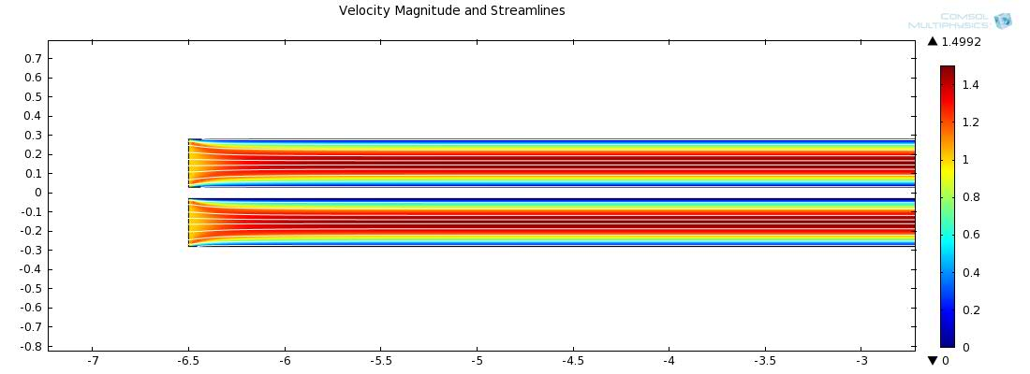
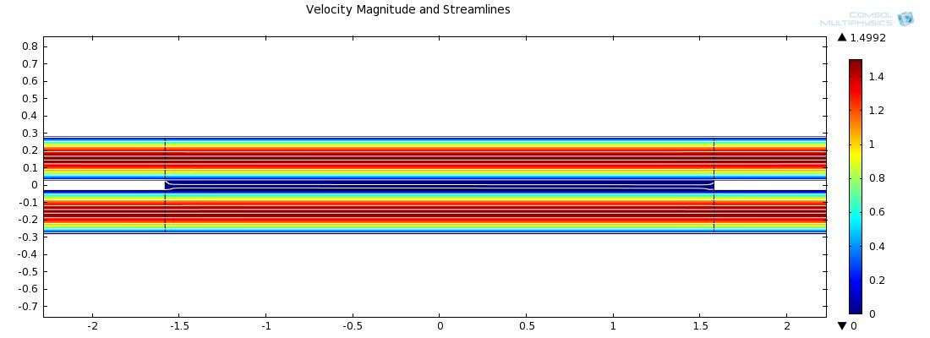
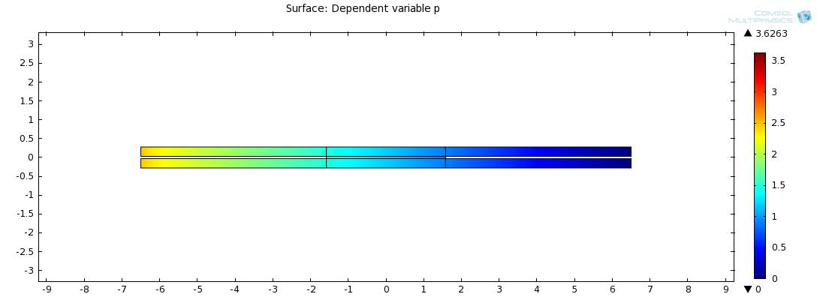
From the relative humidity plot below one can see that the diffusion of water vapor is present. Even though there is essentially no convective flow normal to the PM water vapor still passes through it.
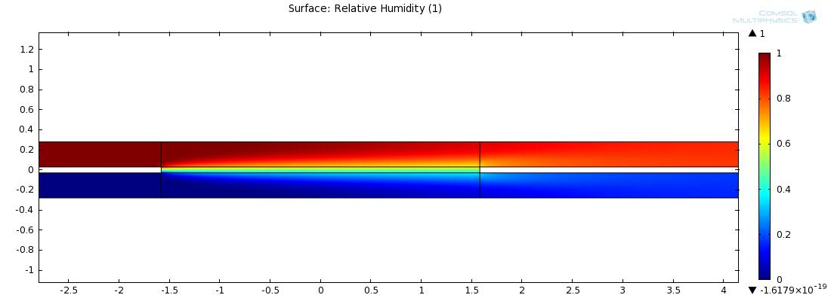
The plot below shows the total convection, as streamlines, which is the combination of diffusion and advection and just the diffusive flux, shown with the arrows. Since the normal component of the velocity is zero in the PM, convection is dominated by diffusion there.
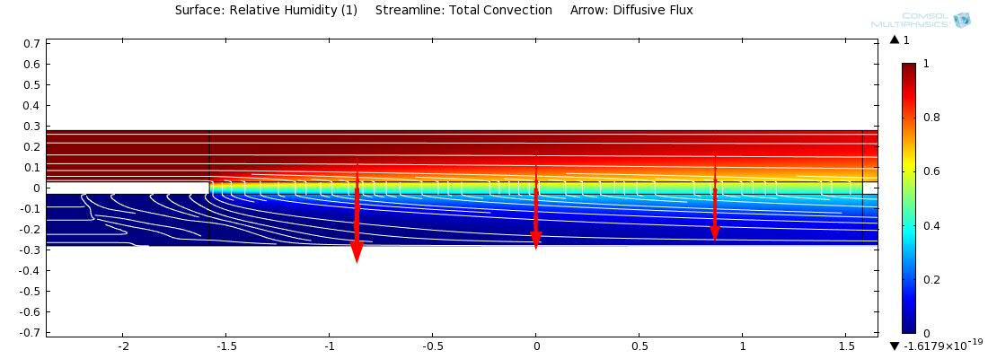

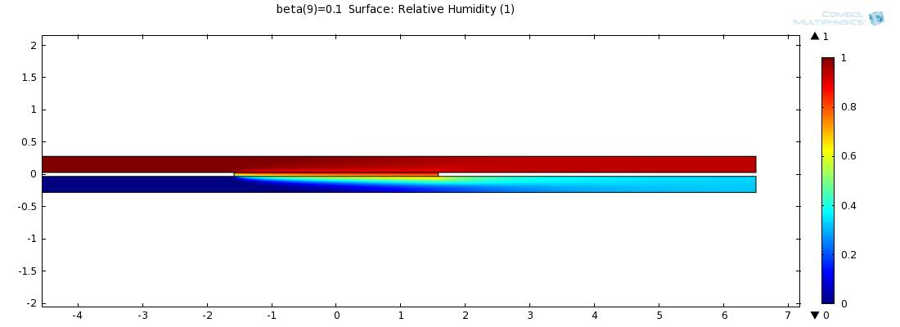
At the other extreme, when the orifice is small and higher pressures exist in the upper channel, water vapor is advected through the PM along with the diffusion as shown below. The bottom average humidity is higher as expected. 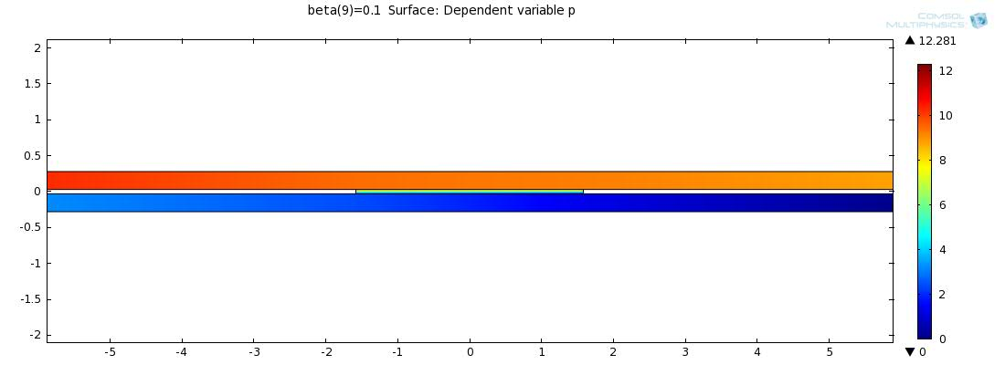
To see the velocity increase in the PM and changes in velocity in the channels, velocity at the center of the PM is plotted with each change in the orifice and velocity profiles are given at mid-length. The x-axis is the orifice parameter where a small value corresponds to a small orifice.
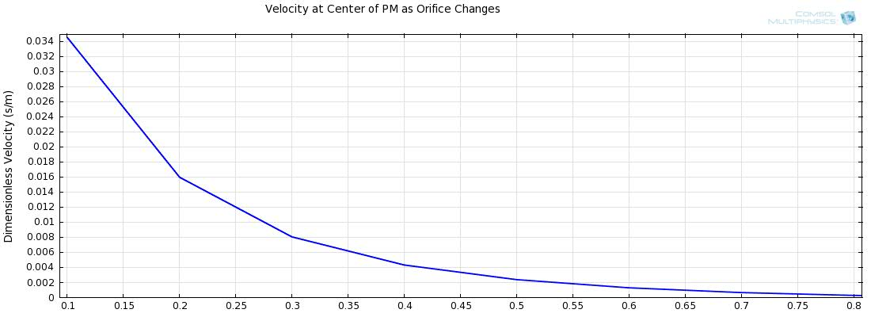
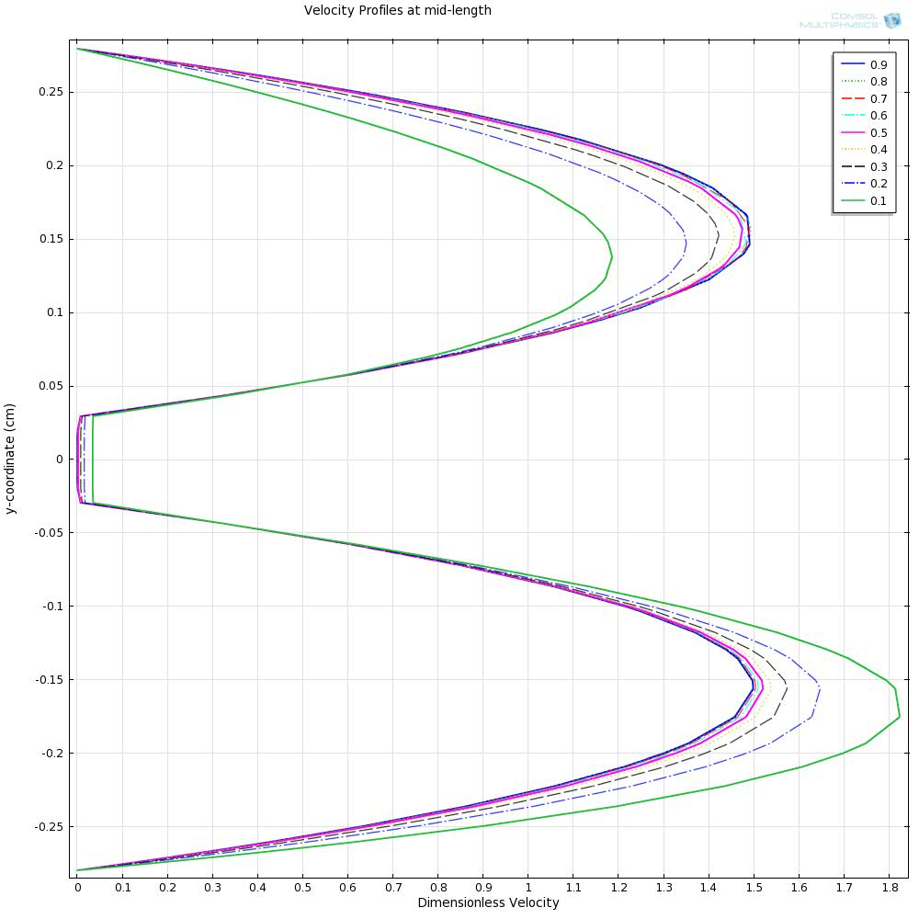
The data of humidity at the bottom exit versus pressure difference across the PM from the simulation compares well with that of Gibson & Charmchi 1997. The results are very similar for zero pressure difference with deviations as the pressure increases.

Cylinder in Crossflow
In order to see if such a formulation gives accurate time dependent solutions, flow over a cylinder is modeled. Lift coefficient and pressure coefficient is found for both the equation-based model and COMSOL’s laminar physics. Both are solved with the same mesh, element discretization, time-dependent solver, and no numerical stabilization.
Inlet Condition: laminar parabolic velocity profile with mean velocity of 0.3 [m/s], Re_D = 120
Outlet Condition: no viscous stress, zero pressure
Initial Condition: Zero velocity everywhere
Time Dependent Solver: BDF with maximum order 2 (for shorter solution time), minimum order of 1. Strict time stepping with maximum time step of 0.1s (the maximum time step was never achieved)
Results: The lift coefficient at the start is out of phase and the PDE (equation-based) has higher amplitude.
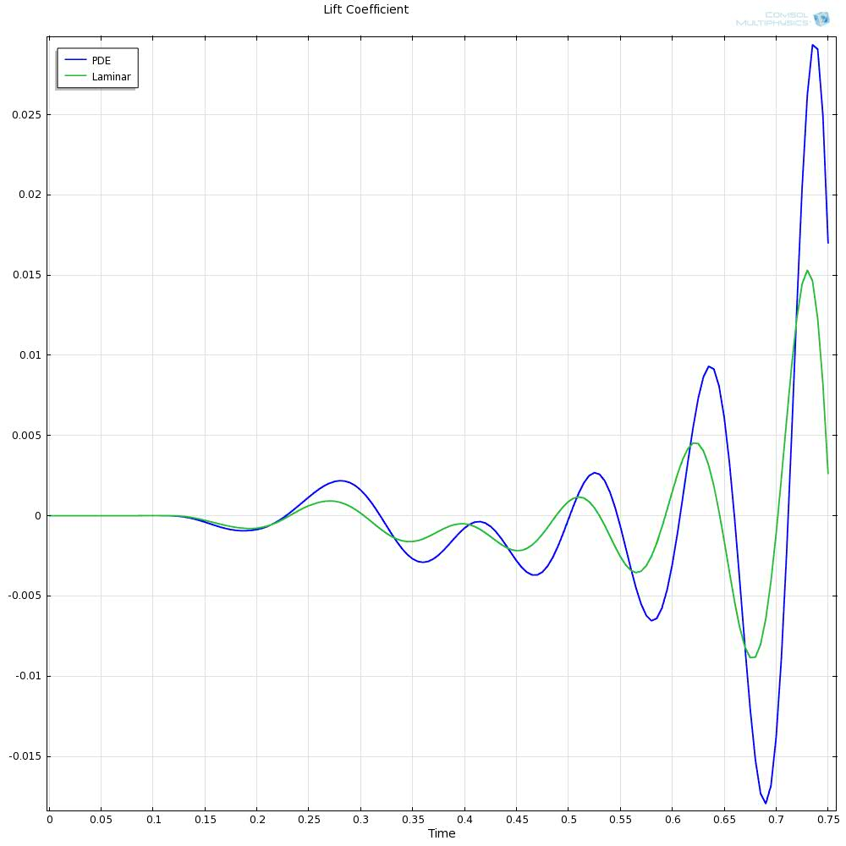
When the oscillation amplitude becomes constant we can see that the two solutions are out of phase but of the same amplitude, as show below.
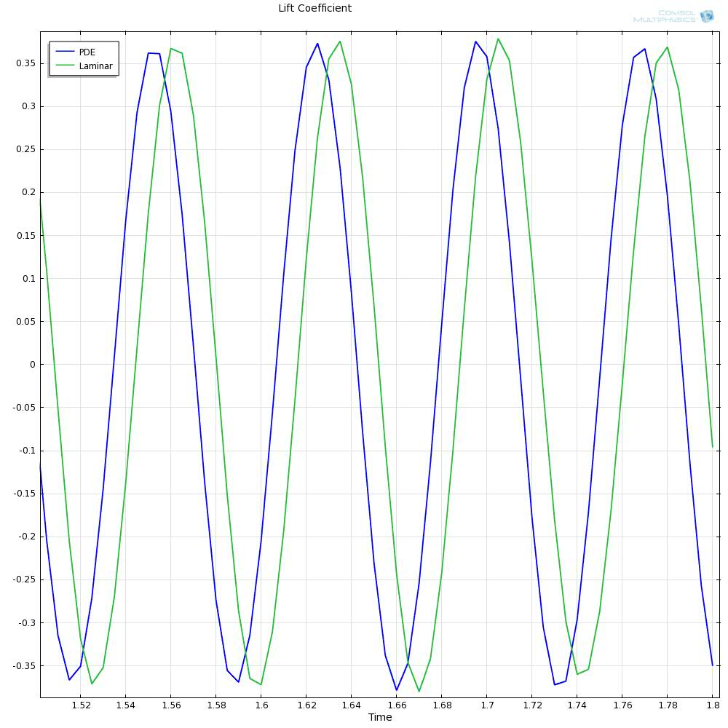
Pressure coefficient at 3 seconds is shown below.
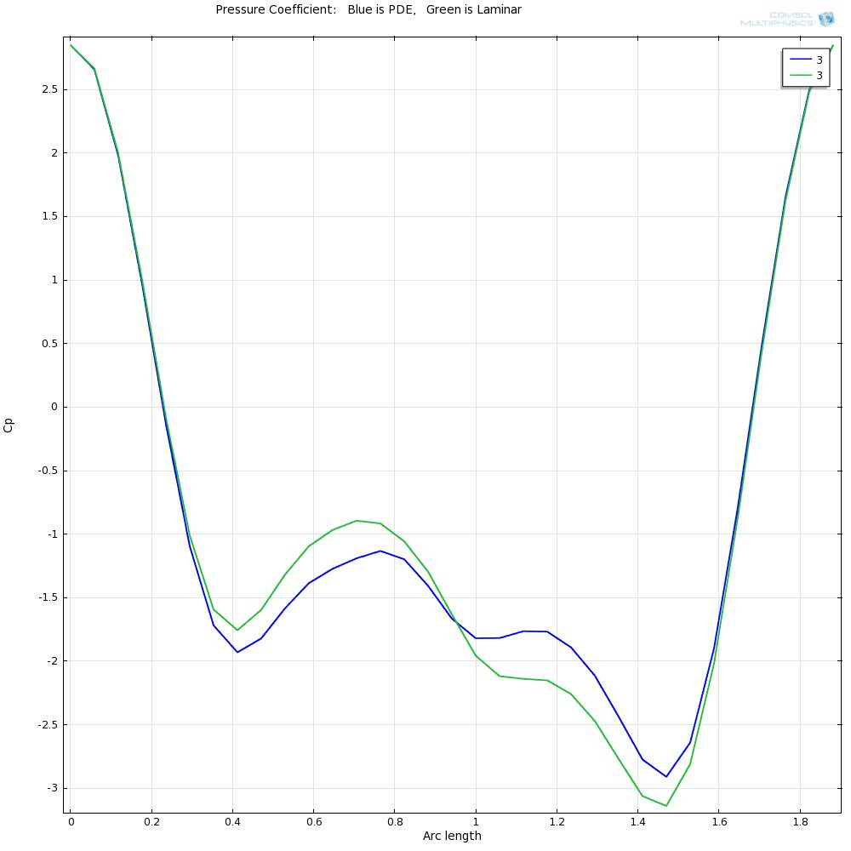
By setting the PDE solution back by 0.01s the two plots are very similar.
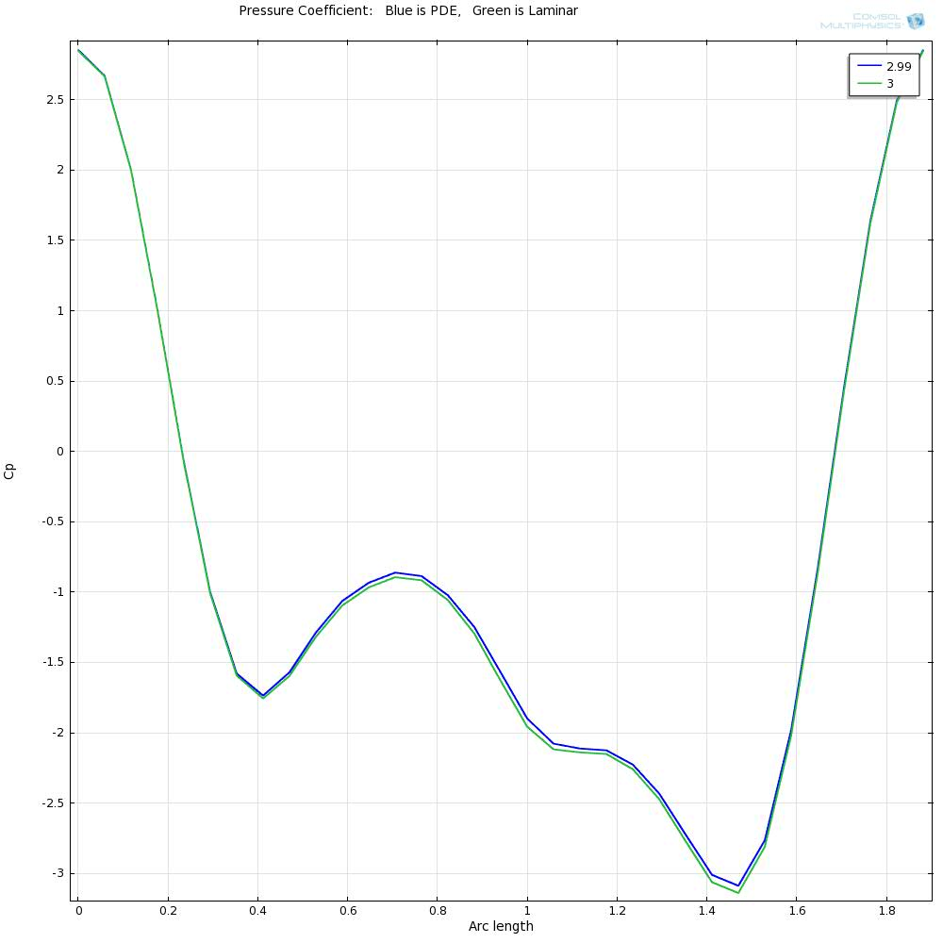

Vapor Absorption
Since a time accurate solution can be obtained the following time dependent test case is used to see if all the physics are working correctly. Comparison is made with Gibson & Charmchi 1997 (same as the first test case) where the temperature in the PM will be the focus. A dry specimen will be suddenly subject to a one hundred percent humidity air flow. As the moist air comes in contact with the material it will be absorbed and energy will be released resulting in a temperature increase. As the mass flow into the fabric decreases and since convective heat transfer is present, the temperature will decrease to the ambient temperature. Conditions for the simulation are given below.
Initial Temperature: 293K everywhere
Initial Velocity: zero everywhere
Initial Humidity: zero everywhere
Temperature inlet: Initial Temperature of 293K
Humidity inlet: 100% for both the top and bottom channels
Velocity inlet: uniform flow
Results
This is the temperature evolution for this formulation. It shows $T-T_{in}$. Gibson and Charmchi 1997 reported a maximum of 12 degrees above inlet temperature and temperatures at 1000s of approximately 0.5 to 1.5 degrees above inlet. These results show higher temperatures and the rate of temperature drop is less as well.
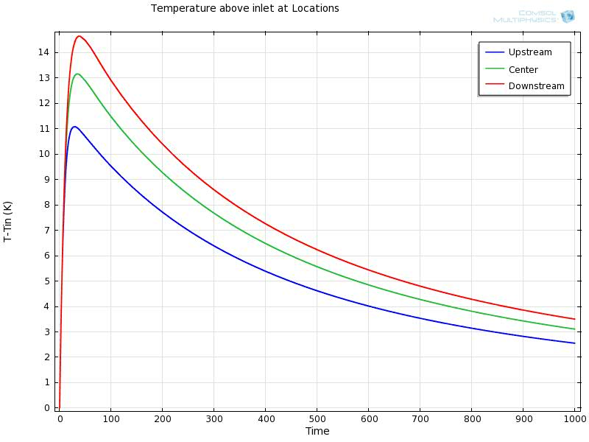
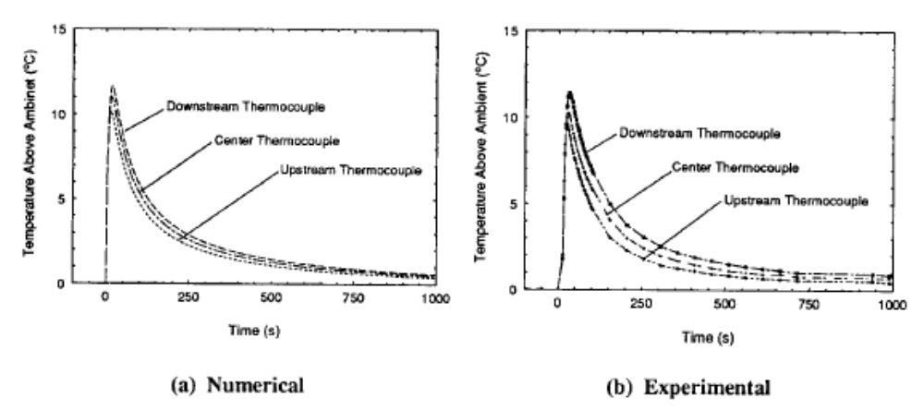

Chapter 5
Conclusions and Recommendations
See, you could do it after all.

List of References

Canuto, C., & Cimolin, F. (2011). A sweating model for the internal ventilation of a motorcycle helmet. Computers and Fluids, 43, 29-37.
Charmchi, P. W. (1997). Modeling Convection/Diffusion Processes in Porous Textiles with Includion of Humidity-Dependent Air Permeability. International Communications in Heat and Mass Transfer, 24(5), 709-724.
Davarzani, H., Marcoux, M., Costeseque, P., & Quintard, M. (2010). Experimental measurement of the effective diffusion and thermodiffusion coefficients for binary gas mixture in porous media. Chemical Engineering Science, 65, 5092-5104.
De Bonis, M. V., & Ruocco, G. (2008). A generalized conjugate model for forced convection drying based on an evaporative kinetics. Journal of Food Engineering, 89, 232-240.
Defraeye, T., Blocken, B., & Carmeliet, J. (2012). Analysis of convective heat and mass transfer coefficients for convective drying of a porous flat plate by conjugate modeling. International Journal of Heat and Mass Transfer, 55, 112-124.
Defraeye, T., Blocken, B., Derome, D., Nicolai, B., & Carmeliet, J. (2012). Convective heat and mass transfer modeling at air-porous material interfaces: Overview of existing methods and relevance. Chemical Engineering Science, 74, 49-58.
Fan, J., Cheng, X., Wen, X., & Sun, W. (2004). An improved model of heat and moisture transfer with phase change and mobile condensates in fibrous insulation and comparison with experimental results. International Journal of Heat and Mass Transfer, 47, 2343-2352.
Fan, J., Luo, Z., & Li, Y. (2000). Heat and moisture transfer with sorption and condensation in porous clothing assemblies and numerical simulation. International Journal of Heat and Mass Transfer, 43, 2989-3000.
Gibson, P. W., & Charmchi, M. (1997). Coupled Heat and Mass Transfer Through Hygroscopic Porous Materials-Application to Clothing Layers. 53(5), 183-194.
Gibson, P. W., & Charmchi, M. (1997). Modeling convection/diffusion processes in porous textiles with inclusion of humidity-dependent air permeability. International Communications in Heat and Mass Transfer, 24(5), 709-724.
Hang, X. D., Sun, W., & Ye, C. (2012). Finite volume solution of heat and moisture transfer trough three-dimensional textile materials. Computer and Fluids, 57, 25-39.
Li, Y., & Zhu, Q. (2003). Simultaneous heat and moiosture transfer with moisture sorption, condensation, and capillary liquid diffusion in porous textiles. Textile Research Journal, 73, 515-524.
Masmoudi, W., & Prat, M. (1991). Heat and mass transfer between a porous medium and a parallel external flow. Application to drying of capillary porous materials. International Journal of Heat and Mass Transfer, 34(8), 1975-1989.
Prommas, R. (2011). Theoretical and experimental study of heat and mass transfer mechanism during convective drying of multi-layered porous packed bed. International Communications in Heat and Mass Transfer, 38, 900-905.
Rogers, J. A., & Kaviany, M. (1992). Funicular and evaporative-front regimes in convective drying of granular beds. International Journal of Heat and Mass Transfer, 35(2), 469-480.
Zhang, Q., Li, B., & Sun, W. (2011). Heat and sweat transport through clothing assemies with phase changes, condensation/evaporation and absorption. Proceedings of the Royal Society A, 467, 3469-3489.
Zhang, Z., & Nemcik, J. (2013). Fluid flow regimes and nonlinear flow characteristics in deformable rock fractures. Journal of Hydrology, 477, 139-151.

Citations and stuff…Notice your citations begin on the page after the title page.

Appendix
You’ll put appendix material here. This section is optional as well. You can place tables and figures in the appendix if you like, which is what many journals prefer. If you choose this option, you should indicate that tables and figures are in the appendix after the first mention in the text. You can place some tables/figures in the text and others in the appendix.
You might also use the appendix for including raw data, research instruments, additional material, etc.

Vita
Mary Smith was born. She went to school. She wrote a thesis. She graduated. This page really is required.

