Natural, Experimental, and Educational Explorations of the Interiors of Terrestrial Planetary Bodies

A Dissertation Presented for the

Doctor of Philosophy

Degree

The University of Tennessee, Knoxville

Nadine Lynne Grambling

August 2022

Copyright © 2022 by Nadine Lynne Grambling

All rights reserved.

DEDICATION

This is dedicated to my feline army, Rock, Boston, Mickey, Marshmallow, Linus, Albert, Voltaire and Watson, my brother, Max, my husband, Tyler, and my parents, Jim and Lisa. Thank you all for your love and support.

ACKNOWLEDGEMENTS

I owe a great deal of gratitude to many members of the geology community outside of my home institution, including Greg Hirth, Yan Liang, Cameron Meyers, Leif Tokle, Eric Burdette, and Ningli Zhao at the Brown University Rock Deformation Lab for assistance with Griggs Apparatus experiments and endless encouragement, good spirits, and conversations on rock mechanics, John Wakabayashi, who provided a wealth of knowledge on ophiolite formation and brewing processes, my science party cohort on the Chikyu D/V during core description and sampling for Chapter 1, Peter Kelemen, who has been instrumental in my work on fast-spreading ridges, Ruth Aronoff, for inspiration and guidance in surviving the process, Karl Karlstrom, my thesis advisor at UNM, for teaching me how to disagree in the sciences through the great battle over the Grand Canyon, and Julio Betancourt, for his support and encouragement of my early scientific research potential.

On the home front I would like to thank my advisor, Nick Dygert for facilitating this work through external funding and grants, my committee members for their insight and guidance, especially Emily Chin for hosting me during my visit to Scripps and assistance collecting EBSD data and Bill Dunne for his flexibility as a late-stage addition to my committee, Micah Jessup, for allowing me to tag along on international field campaigns in the high Andes, and his contributions to my growth as a structural geologist. I have benefited a great deal from the mentorship of two fantastic educators within my department, Stephanie Drumheller and Robert Jacobsen, who have encouraged my development as teacher and human. To the administrative staff of EPS, Diane Pealor, Melody Branch, Teresa Parrott, Marie Ballard and Angie Staley for all of their support and assistance.

And where would I be without my peers during this process? I want to thank Beau Boring for her assistance in collecting microprobe data and helping maintain my sanity throughout my time in Tennessee (and Providence). I would especially like to acknowledge Claire Mondro, Sam Gwizd, Helle Skjetne, Kaitlyn Gauvey and Kristan Watkins for their friendships over the past 4+ years. To Allison Rogers and Rhianna Moore, thank you for 2 great years of GeoClub e-board. Jesse Scholpp, Megan Mouser, Dian Ji and Mike Lucas have provided great insight as group members of the EMPG.

To the coaches, SAs, and fellow 7:10AM-ers of OTFBearden, I may not have kept my sanity without the orange lights, Satan’s Skateboard, and sprints to the finish.

A warm shout out to the Warnekes, née Warnekes, Parras and Gramblings near and far, especially Steven, and Madeline, for providing distraction and a place to stay during multiple deployments to New England. I cannot thank my parents enough for their endless support, even though they had to visit the South, and my brother Max for serving as our ward during the COVID-19 pandemic.

Finally, I would like to thank my husband, Tyler, for his over-confidence in my ability to survive this ordeal, for watching the cats as I spent months traveling domestically and internationally for research, for his acceptance of my “quirks” both diagnosed and otherwise and for dragging me to the home of the Wigsphere to experience 5 years of humidity beyond our wildest imagination.

ABSTRACT

Planetary interiors are enigmatic, inaccessible, and vital to the processes that have formed the rocks we see on the surface of bodies in the inner Solar System today. Based on geophysical explorations of the Moon and Earth, along with information gleaned from rocks at the surface today, there is understanding of the basic structure and processes at depth. Using a combination of natural samples and experimental studies, we attempt to learn more about the physical conditions beneath the surface, and their effect on material properties and tectonics processes in the mantle.
On Earth, mid-ocean ridge processes have long been debated, and there has been little consensus on the magmatic plumbing and extent of ocean-water circulation at depth, leaving a debate between two end-member models of crustal accretion. Using geothermometry and geospedometry of lower-crustal and upper-mantle rocks from a paleo-ridge in the Samail Ophiolte, alongside a similar suite of rocks from the actively spreading East Pacific Rise at Hess Deep, we compare the thermal structure of the crust-mantle transition zone and implications for the on-axis processes that form much of the Earth’s crust.
Past work has constrained the crystallization sequence of the moon through time and determined one of the last layers to crystallize was highly dense, containing a significant fraction of the mineral ilmenite, and initially formed above the less-dense mantle cumulate pile, composed mainly of mafic minerals. To study the possible interactions of these two layers due to the density instability, I completed shear deformation experiments on ilmenite and olivine aggregates, in equilibrium, to compare to aggregate flow laws proposed for phase mixing and determine the system rheology.
To introduce high school students in East Tennessee to the concept of mantle materials and conditions versus crustal materials and their formation conditions, I have created an activity and corresponding lesson plan for use in secondary school Chemistry classrooms. This activity combines phase diagrams, physical models of chemical bonds, and a comparison of two native minerals with the same chemical formula to help students think about the effects of pressure and temperature on Earth materials.

TABLE OF CONTENTS

Introduction 1
Chapter 1: Thermal history of lithosphere formed beneath fast spreading ridges: Constraints from the Mantle Transition Zone of the East Pacific Rise at Hess Deep and Oman Drilling Project, Wadi Zeeb, Samail ophiolite 3
Abstract 4
1. Introduction 5
1.0.1 Crustal Accretion models 7
1.0.2 Results from previous investigations that constrained cooling rate variations in oceanic lithosphere 9
1.1 Study Areas 11
1.1.1 Wadi Zeeb, Oman ophiolite, as sampled by the Oman Drilling Project 11
1.1.2 Hess Deep 12
2. Sample Description 13
2.1 Samples 13
3. Analytical Methods 14
3.1 Major Element Analysis 14
3.2 Trace Element Analysis 17
4. Analytical and Thermometric Results 18
4.1 Major elements 18
4.1.1 Major element zonation 20
4.2 Trace elements 22
4.2.2 Trace element zoning 25
4.3 Temperatures 25
5. Discussion 29
5.1 Significance of temperatures 29
5.1.1 Hess Deep gabbros may not record meaningful cooling rates 35
5.1.2 Some peridotites may not provide a record of cooling from peak temperatures 36
5.2 Cooling Rates 39
5.2.1 Rates from Ca-in-olivine temperatures 40
5.2.2 Rates from REE-in-two-pyroxene temperatures and pyroxene solvus temperatures 40
5.2.3 Rates from REE-in-clinopyroxene-plagioclase temperatures and Mg-in-plagioclase temperatures 41
5.3 Implications for cooling and crustal accretion mechanisms 42
5.4 Comparison with previous thermometric investigations 44
6. Summary and Conclusions 47
7. Acknowledgments, Samples, and Data 49
References 50
Appendix 59
Appendix 1. Supplemental Figures 59
Appendix 1 References 62
Chapter 2: Microstructural Investigation of Ilmenite-Olivine Aggregates Deformed in Shear 63
Abstract 64
1. Introduction 64
1.1 Flow Laws 65
1.1.1 Olivine Flow Laws 65
1.1.2 Ilmenite Flow Laws 66
2. Experimental Design and Methods 66
2.1 Starting Materials 66
2.2 Experimental Conditions 68
3. Analytical Methods 69
3.1 Electron Backscatter Diffraction 69
4. Mechanical Data and Analytical Results 72
4.1 Mechanical Data 72
4.1.1 Dormant Rig complications in runs from July 2021 and January 2022 72
4.1.2 Correcting for fast run-ins 72
4.2 Microstructures 74
5. Discussion 74
5.1 Stress and strain comparisons to published flow laws 74
5.1.1 Uncertainty in water content of experimental materials 79
5.1.2 Anomalous strength/weakness in 25% ilm40:75% SCO samples not reproducible 80
5.2 Post-deformation fabrics 80
5.2.1 Olivine trends 80
5.2.2 Ilmenite trends 81
6. Summary and Conclusions 81
7. Acknowledgments, Samples, and Data 82
References 83
Appendix 86
Appendix 1. Supplemental Figure 86
Chapter 3: Building Carbon minerals: Application of geoscience learning materials to the Tennessee Academic Standards for Science for Chemistry I for use in public school classrooms 87
Abstract 88
1. Introduction 88
2. Background 89
3. Layering the Earth 92
4. Carbon: Phases with Relation to Earth 94
5. Hands On: Molecular Models of Solid Phases of Elemental Carbon 101
6. Lesson Wrap-Up: Same Element, Same Phase, Different Structure 101
References 105
Conclusions 106
Vita 107

LIST OF TABLES
Table 1.1. Samples and sampling locations. 14
Table 1.2. Temperatures. 27
Table 2.1. Sample information by experiment in order of first run to last run. 71
Table 2.2. Notes on variations in experimental run conditions. 72
Table 2.3. Sample results from mechanical data and EBSD analysis data processing. 77
Table 3.1. Standards relevant to "Building Carbon Minerals" lesson plan 93
Table 3.2. Layers of the Earth, depths from the surface, and their major mineralogy. 96

LIST OF FIGURES
Figure 1.1. Schematic illustrating end-member crustal accretion models. (a) The Gabbro Glacier model (e.g. Henstock et al., 1993; Phipps Morgan & Chen, 1993; Quick & Denlinger, 1993; Sinton & Detrick, 1992; Sleep, 1975); (b) the Sheeted Sills model (e.g. Kelemen, Hirth, et al., 1997; Kelemen, Koga, et al., 1997; Korenaga & Kelemen, 1997; VanTongeren et al., 2008, 2015). The Gabbro Glacier model posits that the lower section of crust is formed accretion of by a large zone of crystalline mush, which accumulates beneath an axial magma lens at the base of the upper crustal dikes. In this model, cooling of the entire lower crustal section and underlying mantle is purely conductive, through heat lost to the hydrothermally cooled extrusive section (basalts and dikes). (b) The Sheeted Sills model assumes similar crustal accretion in the extrusive section (basalts and dikes) but diverges from the gabbro glacier model in the lower crust. In this model, the lower crust is formed from the injection of a multitude of magmatic sills at a range of depths beneath an axial magma lens at the base of the extrusive section. Deep and vigorous hydrothermal circulation through the entire crustal section (through networks of fractures) is required to accommodate heat released by solidification of the sills, which necessarily produces fast cooling rates in the entire lower crustal section and uppermost part of the mantle section. 6
Figure 1.2. Representative cross polarized light and backscatter electron photomicrographs of samples from Hess Deep and Oman Drilling Project (left and right columns, respectively). (a) is a crustal gabbro from site 1415G, IODP Expedition 345 and (b) and (c) are upper mantle peridotites from hole 895D of ODP Leg 147. (d) is a crustal gabbro from hole CM1 and (e) and (f) are peridotites from the crust-mantle transition of hole CM2. Red spots in (a) correspond to LA-ICP-MS spot numbers shown in Figure 1.5. According to petrographic observation and modal mineralogy (Table 1.3), clinopyroxenes interpreted to be residual are shown in the middle row; the bottom row (c), (f) shows samples with minor clinopyroxene that may have exsolved at subsolidus temperatures, and/or crystallized from melt present during cooling. 16
Figure 1.3. Variations in major element compositions of minerals in samples from this study (averages) and the literature. Gabbros are shown in the first row (a, b) and peridotites are shown in the second and third rows (c-f). Samples from this study are shown as orange diamonds (Hess Deep) and purple squares (OmanDP). Ophiolitic gabbros and peridotites from petDB and Dygert et al., 2017, are shown as gray and blue dots, respectively, and abyssal peridotites from Warren, 2016, are shown as gray dots. MgO in plagioclase data shown in (a) and used in thermometric interpretations (this study) were collected by LA-ICP-MS. We note MgO concentrations in the literature data shown in (a) may not have been collected under optimized analytical conditions, perhaps accounting for some of the scatter. 19
Figure 1.4. Chondrite normalized REE+Y abundances in minerals from the crust and mantle sections of Oman Drilling Project (a) and Hess Deep (b). Individual spot analyses are shown in gray in the background, and sample averages are shown as thicker colored lines, error bars are 1σ standard deviations of replicate analyses for each sample. Minerals in crustal samples are green (plagioclase) and red (clinopyroxene), minerals in peridotites are magenta (clinopyroxene) and blue (orthopyroxene). 23
Figure 1.5. Ce and Nd concentrations in paired plagioclase and clinopyroxene grains measured by LA-ICP-MS. Analytical uncertainty (relative) is estimated at 10% of the concentration. Trace element abundances vary beyond the analytical uncertainty in the plagioclase grain on the left and in the clinopyroxene. These variations are representative of Hess Deep gabbros in general, and the variations are interpreted to reflect magmatic processes. See Section 5.1.1 and Lissenberg et al., 2013, and Lissenberg & Macleod, 2016. 25
Figure 1.6. Temperature comparison for samples from the Oman Drilling Project (a) and Hess Deep (b) above and below the petrologic Moho, which is indicated by the horizontal red line. In order to compare trends between drilling sites, samples are shown in relational depth, not absolute distance, as Hess Deep peridotites and gabbros cannot be directly related in stratigraphic depth owing to uncertainty in the local structure. For all samples, depths within the holes are reported in Table 1.1. Structural depths of the Oman Drilling Project samples are reported in Table 1.1 and are presented graphically in Figures 1.9 & 1.10. Hess Deep samples are schematically plotted relative to the Moho in Figures 1.9 & 1.10. 28
Figure 1.7. Temperatures obtained in this study compared to other localities in Oman, previous work on Hess Deep and the global distribution of ophiolites and abyssal peridotites. (a) T_{REE-in-Plag-Cpx} vs. T_{Mg-in-Plag} (gabbros), (b) T_{REE-in-two-Pyroxene} vs. T_{BKN} (peridotites); (c) T_{Ca-in-Ol} vs. T_{Ol-Sp} (peridotites). Temperatures obtained for gabbros are consistent with but at the high temperature end of previous work on Hess Deep (a). Note that samples from this study have high T_{REE} and T_{BKN}, consistent with abyssal peridotites and some samples from Oman (b). Peridotite temperatures obtained using fast-resetting thermometers (Ca-in-Olivine and Olivine-Spinel) are at the high end of the global distribution of ophiolites (c), perhaps owing to the close proximity of the samples from this study to the transition zone compared to other ophiolitic peridotites. Data sources are the following: Wadi Tayin, Dygert et al., 2017; Elsewhere Oman (Wadi Fizh, Wadi Thuqbah, Wadi Rajmi, and Wadi Sarami in central and northern Oman; Akizawa et al., 2012, 2016); Other ophiolites, Dygert et al., 2015; Abyssal peridotites, Dygert et al., 2017; Hess Deep, Sun and Lissenberg, 2018. 30
Figure 1.8. Temperatures for Hess Deep and Oman Drilling Project (OmanDP) peridotites compared to models for closure temperature calculated as a function of cooling rate (grid composed of black and magenta lines). (a) Shows samples from this study with colored symbols are interpreted to have retained residual clinopyroxene throughout partial melting, those with gray symbols are interpreted to have exsolved from orthopyroxene under subsolidus conditions, or crystallized from melt during cooling, and thus may not record cooling rates from peak temperatures. The cooling rate grid was calculated utilizing a modified form of the Dodson equation assuming a radius of 0.5 mm (Ganguly & Tirone, 1999, see Dygert & Liang, 2015, for details). The 1:1 line, shown in blue, represents equal temperatures for the two thermometers. Initial temperatures (T₀) represent the peak temperatures from which samples cooled, the paths samples take in this temperature space are indicated by the magenta lines extending from initial temperatures along the blue 1:1 line. The near-vertical black lines represent cooling rates in °C/year. Assuming an effective grain radius of 0.5 mm, all samples in this study cooled at rates of 0.3°C/year or faster. Cooling rates calculated using the measured, sample specific grain sizes from samples with residual clinopyroxene are reported in Table 1.3 and shown in Figure 1.9 (blue symbols). (b) Shows samples from (a) with residual clinopyroxene from this study, alongside published samples from Dygert et al., 2017, with structural depths of samples beneath the crust-mantle transition indicated (meters). The question mark indicates that the structural depth of Hess Deep peridotites relative to crust-mantle transition is unknown. 32
Figure 1.9. Comparison between cooling rates obtained from samples in this study (green, magenta and blue diamonds and squares) and modeled conductive cooling rates for three temperature intervals (red, blue and green lines, 1200-900°C, 1000-700°C, and 750-600°C, respectively). Insets show cartoons reflecting the relevant crustal accretion mechanism and cooling regime assumed for each panel. A Gabbro Glacier scenario is shown in (a), with conductive cooling starting at the dike-gabbro transition, beneath which hydrothermal circulation does not extend. A hydrothermal model from Maclennan et al., 2005, is shown for comparison, which assumes a thinner extrusive section and lower thermal diffusivity compared to models from this study. A Sheeted Sills scenario is shown in (b), which assumes convective cooling by hydrothermal circulation throughout the entire crustal column, and conductive cooling beneath the Moho. The sample-based cooling rates obtained in this study are shown at their approximate depths relative to the Moho, and are the same in both panels. Note the sample-based cooling rates obtained from three independent thermometric and geospeedometric methods (Dodson, 1973; Dygert & Liang, 2015; Sun & Lissenberg, 2018a) are in agreement, and that the rates are consistent for samples above and below the Moho at both localities. The rates obtained in this study are significantly higher than rates predicted in a Gabbro Glacier scenario (a), but consistent with deep hydrothermal circulation and convective cooling throughout the gabbroic section, as in a Sheeted Sills scenario (b). A model of hydrothermal cooling of the crust is shown as a vertical purple line in (b) for a reference permeability (k₀) of 2×10⁻¹⁴ (Cherkaoui et al., 2003), the black arrow indicates that as crustal permeability increases, the cooling rate in the crust would correspondingly increase. Predicted cooling rates from published conductive-hydrothermal hybrid scenarios and a gabbro glacier scenario with concomitant off-axis hydrothermal circulation (blue field, Maclennan et al., 2005) are ~1 order of magnitude slower than rates obtained from our samples, implying that hydrothermal cooling efficiency exceeded ~80 kW/m. 38
Figure 1.10. Cooling rates from this study (Hess Deep, diamonds, OmanDP, squares) compared to rates gathered from the literature that were calculated using the methods we employed (Dygert et al., 2017; Sun and Lissenberg, 2018a, VanTongeren et al., 2008), or recalculated using those methods (Coogan et al., 2002; Coogan et al., 2007; Faak and Gillis, 2016) (smaller symbols), plotted against structural depth. Symbol color corresponds to speedometric method (see legend). Conductive cooling models are also shown (see Section 5.3 and caption to Figure 1.9 for details). All samples originate from oceanic spreading centers or ophiolites with mid-ocean ridge tectonic affinity. Samples from localities with “normal” 6km thick crust are shown in (a), samples with thinner crust are shown in (b). Data from Faak and Gillis (2016) and the Atlantis Bank (Coogan et al., 2007) are placed at an arbitrary depth in the lower crustal section. The observations support hydrothermal cooling of oceanic lower crust at Hess Deep, Wadi Zeeb (OmanDP), Wadi Tayin, and the SWIR (Atlantis Bank). Samples from Wadi Abyad (Coogan et al., 2002) support conductive cooling of the lower oceanic crust. The gray lines in the background correspond to thermal scenarios lacking convective cooling beneath the extrusive section in (a) and with convective cooling extending to the crust-mantle boundary in (b). 45
Figure 2.1. Diagram of components for molten salt cell and Griggs apparatus used in this study. Panel A shows the assembly for the sample in shear. Panel B shows the interior schematic for the force ram portion of the Griggs apparatus and panel C shows the full Griggs apparatus. Figure modified from Holyoke and Kronenberg, 2010 for Rig 2 at the Brown University Rock Deformation lab. 69
Figure 2.2. Mechanical data plots for deformed experiments from this study. Samples are color coded based on the spectrum at right, with pink representing ilm40 and green representing SCO. For samples with the same proportions of ilm40:SCO, sample hue is lighter for low total strain and darker for high accumulated strain. Mechanical data is cropped to begin at the hit point as calculated in MATLAB and end at initial pressure decrease at time of thermocouple failure and/or experiment completion. 75
Figure 2.3. Ilmenite (0001) CPOs and Forsterite (001), (010) and (100) CPOs for samples LMO-001, - 002, -003, -004, & -005, with ilm40:SCO ratios and total accumulated shear strain and axial equivalent strain. All sample MUD scales are set to the color scale at the bottom of the figure. 77
Figure 2.4. Histograms of aspect ratio for samples analyzed with EBSD. The top row of histograms show both minerals in aggregate samples, with comparison of total grains. Individual mineral aspect ratio histograms are shown the combined plot for each sample, with pink histogram bars representing ilmenite and green bars representing olivine. Grains were defined using an angle of 10 degrees. 79
Figure 2.5. (A) Percent olivine on the x-axis versus logarithmic scale of viscosity on the y-axis. This plot shows the predicted viscosities for samples of 100% ilm40 on the left and 100% SCO on the right edges of the plot based on published flow laws (Hirth & Kohlstedt, 2003; Tokle et al., 2021). The black line shows the mixing model of the two phases as calculated by Tullis et al. 1991. Any sample data that plots in the pink region of the graph has a rheology controlled by the weak phase, ilmenite. If data plots in the green region of the graph, its rheology is controlled by the strong phase, olivine. (B) Sample data from this study added as colored dots. All samples are weaker than the predicted viscosities from published flow laws. The dotted line in plot B represents the approximation of the Tullis et al. 1991 mixing model line to connect the two endmember-most experiments with similar accumulated strains, LMO-001 and LMO-003. 80
Figure 3.1. Depth into the Earth in kilometers (km) versus Temperature in Kelvin (A) and Pressure in gigapascals (GPa) (B). The average boundary thickness of the Upper Mantle, Mantle Transition Zone, Lower Mantle, D double prime (D”) layer, Outer Core and Inner Core are shown by dashed lines. 96
Figure 3.2. Carbon phase diagram for Earth-relevant conditions. Plot A shows just the phase diagram while plot B has an overlay of the pressure-temperature path through the Earth based on Table 3.1. 99
Figure 3.3. Based on figure 4.6 from Deep Carbon chapter 4 “Carbon-Bearing Phases throughout Earth’s Interior”, showing simplified distribution and forms of carbon inside the Earth. The thickness of the oceanic crust and subducting slab are vertically exaggerated for clarity in comparison to values in Table 3.3. 103
Figure 3.4. Guidance for building atomic structures of graphite (A) and diamond (B) based on materials from indigoinstruments.com. 106

List of Attachments

Attachment Chapter_1_Data_Tables.xlsx contains analytical data related to the contents of Chapter 1 in Tables 1.3 and 1.5 to 1.11.

Introduction

The interiors of terrestrial planets provide a wealth of opportunities for scientific research, on Earth, satellites, and other planets in the inner Solar System. Advancements in technology have allowed for refinement of early views, but our inability to retrieve samples directly from the mantles of planetary bodies leads to constraints from geophysical surveying, tectonically exhumed samples, and experimental work on analogs to interior systems. This dissertation will take three separate approaches to our knowledge and understanding of planetary interiors, through natural samples, deformation of analogous materials, and secondary school curriculum integrating state standards for the physical sciences with mineral formation processes.
Chapter 1 focuses on the comparison of lithospheric samples of the crust and mantle from an ophiolite, formed at a fast-spreading ridge then obducted onto the continental crust of what is now Oman, to dredge and core samples from Hess Deep, where the tectonic window formed by a ridge-ridge-ridge triple junction has exhumed lower crustal and upper mantle rocks to surface and near-surface locations in a very short geologic time frame. Through geochemical analysis of minerals and mineral pairs in samples from both location, we have shown similar cooling trends in both localities that suggest the requirement of ocean water circulation to depths at or below the petrologic Moho. This study has not only aided in further constraining the formation conditions of the Samail Ophiolite in Oman, but it has also refined the long-debated models for crustal emplacement at depth along fast-spreading ridge axes.
Chapter 2 uses deformation experiments on a Griggs apparatus to investigate the strength contrast between cumulate mantle-analog rocks, similar to those crystallized early in the Lunar magma ocean sequence, and overlying ilmenite-bearing cumulates, crystallized at the end stages of magma ocean solidification and cooling. Due to the known density contrast between the two layers, it is presumed that Rayleigh-Taylor instabilities formed between the ilmenite-bearing cumulates and the cumulate mantle, leading to the ultimate overturn of the Lunar mantle. To constrain the geometry of these instabilities, the viscosity contrast and aggregate material behavior is needed. Mechanical data interpretations and microstructural analysis from this study provide insights into properties which could aid in future geodynamic modeling of the lunar interior.
Chapter 3 is an exploration of mineralogy in the context of state science standards set by Tennessee as of 2018. Lack of Earth Science requirements beyond grade 8 means that geoscience-related education as a supplement to Biology, Chemistry or Physics is more likely to reach high school students. This chapter details a lesson on comparing native minerals of carbon, diamond and graphite, with formation conditions and structural properties, through a hands-on activity and pre- and post-activity lessons. This lesson plan was created as part of a grant provided to multiple researchers at the University of Tennessee, to create Lessons-in-a-Box for distribution through the Knox County Library, so that secondary science educators can borrow the materials at no cost for use in their classroom.

Chapter 1: Thermal history of lithosphere formed beneath fast spreading ridges: Constraints from the Mantle Transition Zone of the East Pacific Rise at Hess Deep and Oman Drilling Project, Wadi Zeeb, Samail ophiolite

A version of this chapter was originally published by Nadine L. Grambling, Nicholas Dygert, Beau Boring, Marlon M. Jean, and Peter B. Kelemen:
Grambling, N.L., Dygert, N., Boring, B., Jean, M.M., and Kelemen, P.B. “Thermal history of lithosphere formed beneath fast spreading ridges: Constraints from the Mantle Transition Zone of the East Pacific Rise at Hess Deep and Oman Drilling Project, Wadi Zeeb, Samail ophiolite.” JGR Solid Earth (2022): v. 127, no. 1, pp. 1-27.
Nadine Lynne Grambling led the data analysis, conceptualization, writing, and development of this article and assisted in sample collection and preparation. Nicholas Dygert supervised the direction of the article and led revisions. He also assisted with sample collection. Beau Boring assisted in data collection and with revisions. Marlon M. Jean assisted with sample collection and preparation and revisions. Peter B. Kelemen assisted with sample collection and content revisions.

Abstract

We investigate the cooling histories of peridotites and gabbros from localities that expose oceanic lithosphere formed beneath two fast seafloor spreading centers: Hess Deep as recovered from IODP Expedition 345 and ODP Leg 147, and the Oman Ophiolite as sampled by the Oman Drilling Project, ICDP Expedition 5057 (OmanDP). At these locations, relict crust-mantle transition zones are directly sampled, enabling characterization of the thermal history of the crust-mantle transition, and by inference, the depth extent of hydrothermal circulation beneath spreading centers. We measured major and trace element abundances in crustal gabbros and mantle peridotites from Hess Deep and OmanDP and applied major and trace element-based thermometers. Geospeedometric interpretation of the temperatures suggests similar cooling histories at both locations; cooling rates ranged from 0.02 to 2.6 °C/y from peak temperatures up to 1350°C. The rates are consistent on either side of the paleo-Moho (i.e., in the crust and mantle). Models for conductive cooling of the lower oceanic crust predict rates more than two orders of magnitude slower at the crust-mantle transition zone, while thermal models that invoke deep and efficient hydrothermal circulation throughout the entire crustal section predict rates consistent with our observations. We infer that hydrothermal cooling extended to or near the petrologic Moho beneath the East Pacific Rise and the OmanDP paleo-spreading center, consistent with the Sheeted Sills model for crustal accretion. Comparison with previously published rates recalculated using the methods we employed suggests the oceanic lower crust is cooled hydrothermally in some places and by conduction at others.

1. Introduction

Investigation of the thermal histories of oceanic crust and mantle at ophiolites and samples from abyssal environments have been undertaken to elucidate the geologic mechanisms that form lithosphere beneath spreading centers (e.g., Canil et al., 2019; Coogan et al., 2002, 2007; Dygert et al., 2017; Dygert & Liang, 2015; Faak et al., 2015; Faak & Gillis, 2016; Garrido et al., 2001; Mock et al., 2021; Sun & Lissenberg, 2018a; VanTongeren et al., 2008). These studies have fueled debate over crustal formation mechanisms and the thermal structure of the lower crust and mantle beneath intermediate to fast-spreading centers (Purdy et al., 1992). At the crux of this debate is an argument over mechanisms that form the gabbroic lower crust beneath mid-ocean ridge axes, which is intimately related to thermal structure and thermal evolution beneath spreading centers.
Two end-member models are often invoked to explain the formation of oceanic crust. In the Gabbro Glacier model, crust accretes from solidification of a large axial magma lens which migrates downward and outward from the ridge axis in a "gabbro glacier" as seafloor spreading progresses (Fig. 1.1a). In the Sheeted Sills model, oceanic crust accretes from continuous solidification of sills at a range of depths beneath ridge axes (Fig. 1.1b). These models make fundamentally different predictions for lithospheric cooling: the former invokes conductive (slow) cooling of the crust and underlying mantle, while the latter requires deep and efficient hydrothermal circulation beneath spreading centers to quickly solidify sills shortly after emplacement (see Section 1.0.1 for a more detailed description and evaluation of the evidence for and against the crustal accretion models).
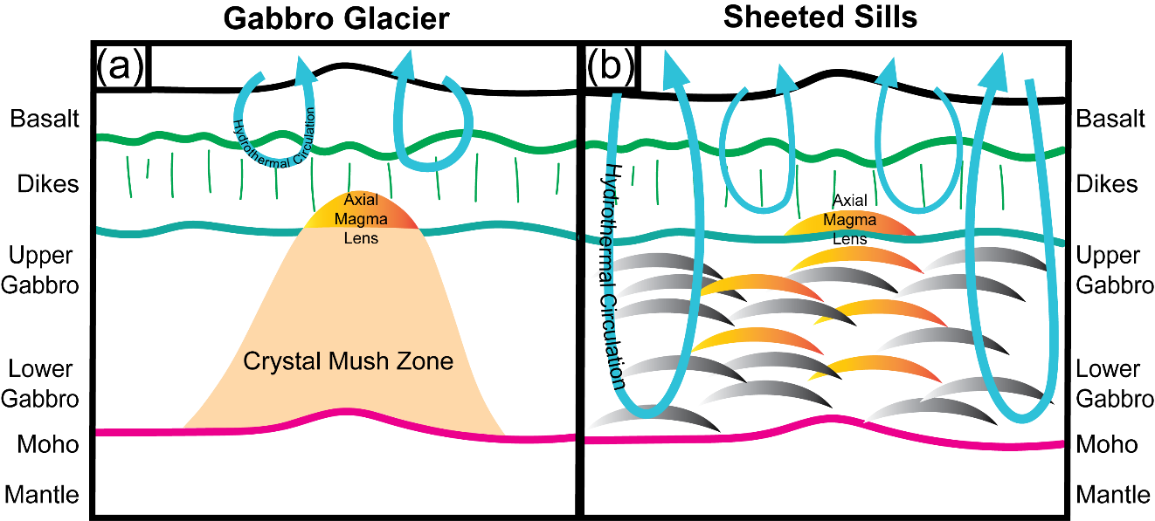
Figure 1.1. Schematic illustrating end-member crustal accretion models. (a) The Gabbro Glacier model (e.g. Henstock et al., 1993; Phipps Morgan & Chen, 1993; Quick & Denlinger, 1993; Sinton & Detrick, 1992; Sleep, 1975); (b) the Sheeted Sills model (e.g. Kelemen, Hirth, et al., 1997; Kelemen, Koga, et al., 1997; Korenaga & Kelemen, 1997; VanTongeren et al., 2008, 2015). The Gabbro Glacier model posits that the lower section of crust is formed accretion of by a large zone of crystalline mush, which accumulates beneath an axial magma lens at the base of the upper crustal dikes. In this model, cooling of the entire lower crustal section and underlying mantle is purely conductive, through heat lost to the hydrothermally cooled extrusive section (basalts and dikes). (b) The Sheeted Sills model assumes similar crustal accretion in the extrusive section (basalts and dikes) but diverges from the gabbro glacier model in the lower crust. In this model, the lower crust is formed from the injection of a multitude of magmatic sills at a range of depths beneath an axial magma lens at the base of the extrusive section. Deep and vigorous hydrothermal circulation through the entire crustal section (through networks of fractures) is required to accommodate heat released by solidification of the sills, which necessarily produces fast cooling rates in the entire lower crustal section and uppermost part of the mantle section.
Divergent thermal histories for the lower crust and uppermost mantle invoked by the Sheeted Sills and Gabbro Glacier models are testable by application of geothermometry and geospeedometry to oceanic gabbros and peridotites. These techniques rely on diffusively moderated temperature sensitive exchange of elements or mineral components among a phase assemblage, e.g., partitioning of the diopside component around the two-pyroxene solvus (e.g. Brey & Köhler, 1990), exchange of Ca and Fe-Mg between olivine and clinopyroxene (Köhler & Brey, 1990), Fe-Mg and Ca exchange between coexisting plagioclase and clinopyroxene (e.g. Faak et al., 2013; Sun & Liang, 2017; Sun & Lissenberg, 2018a), and exchange of rare earth elements (REEs) between coexisting pyroxenes (Dygert & Liang, 2015; Liang et al., 2013) and plagioclase and clinopyroxene (Sun & Liang, 2017). Application of geothermometers and geospeedometers (hereafter thermometers and speedometers) to oceanic lithosphere from ophiolites and drilled and dredged samples from mid-ocean ridges has produced inconsistent results, which have been used to invoke both end-member models for crustal accretion, see Section 1.0.2 below for a summary (e.g. Coogan et al., 2002, 2007; Dygert et al., 2017; Faak et al., 2015; Faak & Gillis, 2016; Garrido et al., 2001; Sun & Lissenberg, 2018a; VanTongeren et al., 2008). These inconsistent conclusions may be related to the disparate methods used to constrain cooling rates, and/or local geologic history, as many studies investigated different localities (Hess Deep gabbros being a prominent exception, Faak et al., 2015; Faak & Gillis, 2016; Sun & Lissenberg, 2018a).
Here, we apply the aforementioned thermometers and speedometers to gabbros and mantle harzburgites from the Hess Deep rift (East Pacific Rise, EPR) and the Oman Drilling Project (Wadi Zeeb, Samail ophiolite, OmanDP). These localities present a unique opportunity to explore the coupled thermal history of crust and mantle lithosphere formed beneath intermediate-fast spreading centers, direct comparison with studies that used alternative speedometric methods to constrain thermal histories (Faak et al., 2015; Faak & Gillis, 2016; Sun & Lissenberg, 2018a), and the opportunity to apply a variety of independently calibrated speedometric methods to a continuous section of core drilled through the crust-mantle transition zone. Additionally, we compare our new speedometric results to cooling rates calculated from previously published data, recalculated using the same methods. Our objective is to advance the debate beyond arguments about the strengths and weaknesses of alternative speedometric approaches, which involve obtaining cooling rates from averaged mineral compositions or grain-scale mineral traverses, as well as differing thermometric calibrations and kinetic models (cf., Coogan et al., 2007; Sun & Lissenberg, 2018a, and the comment by Faak et al. (2018) and Sun & Lissenberg (2018b)), to a focus on establishing whether cooling mechanisms do or do not differ among localities, and providing data for future studies to evaluate why cooling mechanisms might be different in different places. Additionally, our study enables direct comparison of the thermal history of oceanic mantle lithosphere that formed beneath a mid-ocean ridge spreading center with a typical crustal section, to lithosphere from a mid ocean ridge-like ophiolitic setting using consistent methods.

1.0.1 Crustal Accretion models
Early models for crustal formation beneath oceanic spreading centers called for a large magma chamber beneath the ridge axis, extending from the base of the extrusive section of oceanic crust to the petrologic Moho (e.g., Pallister & Hopson, 1981; Smewing, 1981). These models explain mineral stratification observed in lower crustal gabbros as a product of crystal settling, often observed in layered intrusions, but are not supported by seismic studies, which failed to reveal extensive low velocity zones (LVZ) beneath mid ocean ridge spreading centers (e.g., Detrick et al., 1987, 1993; Dunn & Toomey, 2000). The Gabbro Glacier model is a next-generation permutation, invoking the presence of a relatively thin and narrow magma lens immediately beneath the extrusive section of oceanic crust, from which the entire lower crust solidifies (e.g., Dewey & Kidd, 1977; Henstock et al., 1993; Nicolas et al., 1988; Phipps Morgan & Chen, 1993; Quick & Denlinger, 1993; Sinton & Detrick, 1992; Sleep, 1975). In this model, as hydrothermal cooling of the uppermost part of the magma lens occurs and as seafloor spreading continues, viscously deforming solid material at the base of the lens sinks downward and outward to form the gabbroic section of the crust as in a deforming glacier (Fig. 1.1a). In the Gabbro Glacier model, hydrothermal cooling is necessarily restricted to the pillow basalts and dikes of the upper crust, because the gabbro glacier must deform as a viscous solid. In this scenario, the gabbro cools conductively, leading to a rapid and systematic decrease in cooling rates in the lower crust with depth (e.g. Coogan et al., 2002; Faak et al., 2015; Faak & Gillis, 2016; Gillis et al., 2014; Quick & Denlinger, 1993).
The alternative end-member Sheeted Sills model invokes lower crustal emplacement by crystallization of many thin magmatic sills at a range of depths beneath the ridge axis, which are cooled convectively by hydrothermal circulation that extends to the crust-mantle boundary during seafloor spreading (Kelemen, Hirth, et al., 1997; Kelemen, Koga, et al., 1997; Korenaga & Kelemen, 1997; VanTongeren et al., 2008, 2015). In this scenario, deep and efficient hydrothermal circulation is required to accommodate the latent and specific heat released by crystallization of sills at a range of depths beneath the ridge axis, beneath an axial magma lens. The Sheeted Sills model is supported by rhythmic, meter-scale geochemical variations observed within lower oceanic crust (e.g., Korenaga & Kelemen, 1997), hydrothermal (fast) cooling rates in lower crustal gabbros and peridotites directly beneath the crust-mantle transition zone (Dygert & Liang, 2015; VanTongeren et al., 2008), and systematic spatial variations in cooling rate deeper in the mantle section suggesting hydrothermal cooling above the crust-mantle transition and conductive cooling below (Dygert et al., 2017). A Sheeted Sills scenario is also supported by the observation of plagioclase a-axis girdles in crustal gabbros reflecting compaction-related shape preferred orientations (VanTongeren et al., 2015), inconsistent with crystallographic alignments associated with high strains, as required in a Gabbro Glacier scenario (e.g. Quick & Denlinger, 1993), and geochemical evidence for hydrothermal interaction between seawater and oceanic lithosphere under high temperature conditions (e.g. Gregory & Taylor, 1981; Nielsen et al., 2000).

1.0.2 Results from previous investigations that constrained cooling rate variations in oceanic lithosphere
Here we briefly summarize results from previous speedometric studies of oceanic lithosphere. Garrido et al. (2001), applied crystal size distribution analysis to plagioclase in gabbros from Wadi Khafifah in the southern Oman ophiolite, obtaining cooling rates in the shallow intrusive crust that decreased with depth, and were interpreted to be most consistent with hydrothermal cooling and solidification of the intrusive oceanic crust in sheeted sills. Coogan et al. (2002) applied a Ca-in-olivine thermometer to samples from a thin (3km thick) crustal section in the northern Oman ophiolite (Wadi Abyad) and interpreted the data using a 1-D grain scale model for diffusive exchange between olivine and clinopyroxene. The same data were reanalyzed by Coogan et al. (2007) using a revised Ca in olivine diffusion coefficient (Coogan et al., 2005), producing a smooth, systematic decrease in cooling rate with depth in the crustal section (rates of 10⁻¹ °C/y near the sheeted dikes to 10⁻⁶ °C/y near the crust-mantle transition), consistent with conductive cooling of the crust. Coogan et al. (2007) additionally investigated samples from an ultra-slow spreading segment of the Southwest Indian Ridge (SWIR). They found moderately fast, uniform cooling with depth (10⁻³ to 10⁻² °C/y). Van Tongeren et al. (2008) applied a Ca-in-olivine thermometer and Dodson (1973) closure temperature model to gabbros from Wadi Khafifah, southern Oman ophiolite, obtaining fast and uniform cooling rates with depth throughout the gabbroic section (10⁻² to 1 °C/y).
At Hess Deep, Faak & Gillis (2016) investigated olivine gabbros and troctolites inferred to originate from the shallow crust, as well as deeper plutonics, and found a spatially varying gradient in cooling rate of ~0.3 °C/y in the shallow crust to 10⁻⁴ °C/y in the deeper crust using a Mg-in-plagioclase thermometer and a speedometric method based on inversion of grain-scale chemical variations (or lack thereof, Faak et al., 2014). Faak et al. (2015) investigated the same Hess Deep samples as well as several gabbros from Pito Deep (along the margin of the Easter microplate) and IODP hole 1256D, reaching similar conclusions. Dygert et al. (2017) applied Ca-in-olivine and REE-in-two-pyroxene-based speedometric methods (Dygert & Liang, 2015) to mantle peridotites from Wadi Tayin, southern Oman ophiolite, and observed a smooth and systematic decrease of cooling rate with depth moving deeper into the mantle section beneath the crust (~0.1 °C/y near the crust-mantle transition and 10⁻³ °C/y 4km beneath it). Sun & Lissenberg (2018a) developed a coupled Mg-in-plagioclase and REE-in-clinopyroxene-plagioclase speedometer based on averaged mineral compositions and applied it to Hess Deep gabbros inferred to come from structural depths greater than those investigated by Faak et al. (2015; 2016). They determined fast and near uniform cooling rates with depth (~1 to 10⁻² °C/y), and inferred that hydrothermal circulation cooled the entire Hess Deep lithosphere, which accreted from solidification of periodically replenished magma bodies (sills). Mock et al. (2020) investigated gabbros from the mid-plutonic and lowermost crust at the southern Oman ophiolite (Samail and Wadi Tayin massifs, respectively), recovering cooling rates of ~10⁻² °C/y and ~10⁻¹ °C/y through Ca-in-olivine and Mg-in-plagioclase closure temperatures, and demonstrating efficient heat loss from the lowermost crust, perhaps by deep hydrothermal circulation.

1.1 Study Areas
Samples investigated in this study were drilled in ophiolitic and abyssal settings. The lithosphere recovered from ophiolites and abyssal environments provides insights into the architecture and thermal history of intermediate to fast-spreading mid-ocean ridges, however, these environments represent imperfect analogs for the oceanic lithosphere most common in the ocean basins. Ophiolite sequences are well exposed but interpreted to represent spreading centers from trench-proximal settings that differ geochemically and tectonically from mid-ocean ridges (e.g., MacLeod et al., 2013; Pearce et al., 1981; Rioux et al., 2016). On the other hand, oceanic lithosphere drilled and dredged from the seafloor lacks geologic context, and typically comes from magma starved spreading centers, which are not thermally or structurally representative of oceanic lithosphere with a typical 6-km thick crustal section (e.g. Cannat et al., 2004; Chen, 1992; Dick et al., 2003). By obtaining new geochemical data and thermal histories from the Samail ophiolite and a tectonic window in the East Pacific Rise, we overcome these potential sampling biases, thus enabling direct comparison between ophiolitic lithosphere and oceanic lithosphere formed beneath a normal mid-ocean ridge.

1.1.1 Wadi Zeeb, Oman ophiolite, as sampled by the Oman Drilling Project
The Samail ophiolite in the Sultanate of Oman and the United Arab Emirates, exposes 5-6 km of oceanic crust and in places, underlying mantle peridotite representing >10km of structural depth obducted onto the Arabian margin (Boudier & Coleman, 1981; Hanghøj et al., 2010; Nicolas, 1989). Though the tectonic setting during formation is debated, geochemical and geologic evidence suggests the southern part of the ophiolite formed in a setting similar to modern fast-spreading ridges such as the East Pacific Rise (e.g. Braun, 2004; Garrido et al., 2001; Godard et al., 2000; Hanghøj et al., 2010; Kelemen et al., 1995; Kelemen, et al., 1997a; Kelemen, et al., 1997b; Nicolas, 1989; Pallister & Knight, 1981). See Mock et al. (2021) for a concise summary. Samples in the present study were drilled as part of Phase 2 of the international Oman Drilling Project at Wadi Zeeb, Northern Sharqiyah, a location near an axis of a paleo-spreading center as mapped in previous petrologic and structural studies, (Nicolas, 1989; Nicolas & Boudier, 2015; Python & Ceuleneer, 2003). The inferred tectonic setting of the sampling area is shown in Figure 1.11 (in Appendix 1).
Phase 2 of the Oman Drilling Project sampled two continuous sections of rock that encompass the crust, crust-mantle transition zone (CMTZ) and uppermost mantle at holes CM1A and CM2B from November 2017 to January 2018. Hole CM1A, drilled at 30° from vertical to correct for the southwestward dip of the ophiolitic strata, began in the gabbroic lower crust, coring 150 m before reaching the CMTZ (as defined by the onset of dunites) and another 150 m through the CMTZ until reaching upper mantle harzburgites. The upper mantle harzburgites were cored for 100 m, producing a total of 400 m of core at CM1A. Hole CM2B was drilled vertically relative to the surface (i.e., at an angle of 60° relative to the ophiolitic strata) and began in the CMTZ, coring 110 m of CMTZ, followed by 180 m of mantle peridotites. The samples investigated here include gabbros, a troctolite, and peridotites collected above and below the crust-mantle transition. These samples originate from both holes. The structural depth relationships among the samples are well established by the locations and orientations of the holes, sampling depths, and a common lithological horizon marked by the onset of continuous dunites (Kelemen et al., 2021a, 2021b).

1.1.2 Hess Deep
Hess Deep provides a globally unique exposure of lithosphere initiated within the last ~1.5 Ma (Lonsdale, 1988). The Hess Deep tectonic window emerged from the instability of ridge-ridge-ridge spreading between the Pacific, Cocos and Nazca plates at the Galapagos Triple Junction (e.g. Klein et al., 2005; Lonsdale et al., 1992). Despite the tectonic complexity of the Galapagos microplate region, the EPR origin of the rocks at Hess Deep is well established and provides exposures of rock that represent the full suite of crust and upper mantle lithologies from a contemporary fast spreading mid-ocean ridge (e.g. Girardeau & Francheteau, 1993; Hekinian et al., 1993; Karson et al., 2002; Lissenberg et al., 2013; Natland & Dick, 2009). The samples used in this study are gabbros and peridotites from Ocean Drilling Project (ODP) Leg 147 (1992-1993) and International Ocean Drilling Project (IODP) Expedition 345, Site 1415 (2012-2013) (Gillis et al., 2014; Mevel et al., 1996). Site 1415 is located along the southern slope of the intrarift ridge between 4675 and 4850 m below sea level and is covered with approximately 10–30 m of gabbroic rubble overlain by a few meters of pelagic sediment mixed with lithic debris (Gillis et al., 2014). The samples investigated were recovered from holes 1415G and 1415J. Collectively, the holes sampled three units of note: Unit 1 – surficial rubble zone, Unit 2 – oikocryst-bearing layered gabbro series, and Unit 3 – troctolite series. Hole G penetrated Unit 1, while Hole J penetrated all three units (c.f. Mevel et al., 1996 for site 894 and 895 characterizations from ODP Leg 147). The sampling locations and their relation to the inferred local geology is shown in Figure 1.11.

2. Sample Description

2.1 Samples
Sample names and locations, lithologies, leg and expedition number, and drill site information are reported in Table 1.1. Six gabbros (three each from Hess Deep and OmanDP), one troctolite (OmanDP), and eight harzburgitic peridotites (four from each locality) were investigated here. Representative cross-polarized light and backscatter

Table 1.1. Samples and sampling locations.
Sample | Location | Lithology | Latitude (°N) | Longitude (°) | Leg/Expedition Number | Site | Hole | Depth in hole (m) |  | Structural depth* (m)
345_1415G_1R1_0-4 | HD | Gabbro | 2°15.1’90' | 101°32.6’63' W | IODP Exp 345 | 1415 | G | 0 |  | --
345_1415J_4R1_2-6 | HD | Gabbro | 2°15.1’04' | 101°32.6’22' W | IODP Exp 345 | 1415 | J | 22.2 |  | --
147_894G_9R4_60-67 | HD | Gabbro | 2°17.’77' | 101°31.’55' W | ODP Leg 147 | 894 | G | 79.1 |  | --
5057_5707A_009z_03_059-063 | OmanDP | Troctolite | 22°54.’35' | 58°20.’49' E | ICDP Exp 5057 | CM1 | A | 16.1 |  | 296.9
5057_5707A_032z_02_053-056 | OmanDP | Gabbro | 22°54.’35' | 58°20.’49' E | ICDP Exp 5057 | CM1 | A | 72 |  | 241
5057_5707A_059z_04_004-008 | OmanDP | Gabbro | 22°54.’35' | 58°20.’49' E | ICDP Exp 5057 | CM1 | A | 148 |  | 165
5057_5707A_113z_03_036-040 | OmanDP | Gabbro | 22°54.’35' | 58°20.’49' E | ICDP Exp 5057 | CM1 | A | 259 |  | 54
147_895D_3R1_22-27 | HD | Harzburgite | 2°16.’35' | 101°26’77' W | ODP Leg 147 | 895 | D | 26.2 |  | --
147_895D_3R1_66-69 | HD | Harzburgite | 2°16.’35' | 101°26’77' W | ODP Leg 147 | 895 | D | 26.6 |  | --
147_895D_5R1_70-76 | HD | Harzburgite | 2°16.’35' | 101°26’77' W | ODP Leg 147 | 895 | D | 44 |  | --
147_895D_5R1_140-144 | HD | Harzburgite | 2°16.’35' | 101°26’77' W | ODP Leg 147 | 895 | D | 44.7 |  | --
5057_5708B_100z_03_035-040 | OmanDP | Harzburgite | 22°54.’60' | 58°20.’49' E | ICDP Exp 5057 | CM2 | B | 223 |  | -71.9
5057_5708B_114z_02_030-034 | OmanDP | Harzburgite | 22°54.’60' | 58°20.’49' E | ICDP Exp 5057 | CM2 | B | 261 |  | -104.8
5057_5708B_119z_03_006-009 | OmanDP | Harzburgite | 22°54.’60' | 58°20.’49' E | ICDP Exp 5057 | CM2 | B | 274 |  | -116
5057_5708B_124z_02_076-081 | OmanDP | Harzburgite | 22°54.’60' | 58°20.’49' E | ICDP Exp 5057 | CM2 | B | 286 |  | -126
*Relative to base of crust-mantle transition zone as defined by the onset of dunitic units. (HD = Hess Deep, OmanDP = Oman Drilling Project).

electron micrographs are shown in Figure 1.2. To first order, sample characteristics are similar for the two localities.
Gabbros are poikilitic, medium grained (0.25-1 mm) and granular consisting of euhedral to subhedral plagioclase and anhedral clinopyroxene (e.g., Figure 1.2a, d) and olivine. Clinopyroxenes in Hess Deep gabbros occasionally host exsolution lamellae and are often oikocrystic with plagioclase chadacrysts. OmanDP gabbros have fewer clinopyroxene oikocrysts and exsolution lamellae are largely absent. One pyroxene-free
troctolite was analyzed in this study (OmanDP). This sample contains subhedral olivine, with grain sizes of 0.5-1 mm and 0.5-1 mm euhedral to subhedral plagioclase. Olivines in the troctolite are relatively fresh, but olivine grain rims and fractured interiors are serpentinized.
Olivines in the gabbros (both localities) are interstitial and fractured but remain fresh relative to olivines in the peridotites. Based on visual inspection of the thin sections and the core descriptions, we estimate that total gabbro alteration ranges from ~5 to 20% and is mostly concentrated among olivines and clinopyroxene rims. Hess Deep gabbros are altered homogeneously across the thin sections while OmanDP gabbros are altered in ~1mm thick anastomosing veins of variable spacing, decorated by magnetites, and occasional patches of alteration several mm across. Sample 147_894G_9R4_60-67 (Hess Deep) and 5057_5707A_059z_04_004-008 (OmanDP), show higher degrees of alteration (60-70% total; e.g., Mevel et al., 1996, Table 1.3), but in all cases, fresh mineral grains are present for analysis.
Peridotites (all clinopyroxene-poor harzburgites) are porphyroclastic and extensively altered (~75-95% Table 1.3). Olivines are almost completely seprentinized, however, dispersed remnants of olivine grain interiors are present in all peridotites (Figure 1.2b, c, e, f). Original olivine grain size was estimated by finding the average radius across unaltered relics of matched birefringence, and/or using magnetite decorations that indicate original grain boundaries. Most clinopyroxenes in peridotite samples are small (~100μm), subhedral to euhedral, and interstitial (e.g., Figure 1.2c, f), but in some cases larger grains up to several mm are present (Figure 1.2b). Orthopyroxene porphyroclasts

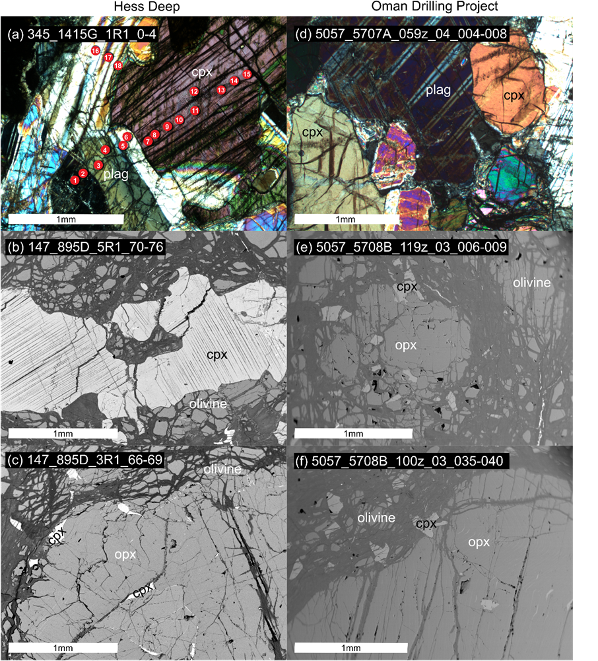
Figure 1.2. Representative cross polarized light and backscatter electron photomicrographs of samples from Hess Deep and Oman Drilling Project (left and right columns, respectively). (a) is a crustal gabbro from site 1415G, IODP Expedition 345 and (b) and (c) are upper mantle peridotites from hole 895D of ODP Leg 147. (d) is a crustal gabbro from hole CM1 and (e) and (f) are peridotites from the crust-mantle transition of hole CM2. Red spots in (a) correspond to LA-ICP-MS spot numbers shown in Figure 1.5. According to petrographic observation and modal mineralogy (Table 1.3), clinopyroxenes interpreted to be residual are shown in the middle row; the bottom row (c), (f) shows samples with minor clinopyroxene that may have exsolved at subsolidus temperatures, and/or crystallized from melt present during cooling.
are typically fresh, one to several mm in diameter, and anhedral to subhedral, with minor or absent exsolution lamellae (e.g., Figure 1.2e, c, f).

3. Analytical Methods

3.1 Major Element Analysis
Analytical work was conducted at the University of Texas at Austin and the University of Tennessee, Knoxville on thin sections of standard or double thickness. Major elements were analyzed in Hess Deep samples at the University of Texas; major elements were analyzed in OmanDP samples at the University of Tennessee. Analyses at the University of Texas were conducted using a focused beam on a JEOL JXA-8200 electron microprobe. Olivine, orthopyroxene, clinopyroxene, chromite, and plagioclase were analyzed at 15kV and 30nA beam current. Na signal intensity was monitored as a function of time during plagioclase analysis and did not exhibit statistically significant decay or merit application of a Time Dependent Intensity correction (Donovan et al., 2016). Counting intervals were typically 30 seconds on peak and 15 seconds on background; for Ca in olivine, they were 40 seconds on peak and 20 seconds on background. Based on counting statistics, we estimate CaO detection limits of ~0.014 wt% for olivine. Natural and synthetic reference materials were employed and data were processed using a ZAF matrix correction procedure.
Analyses at the University of Tennessee were conducted using a Cameca SX-100 electron microprobe. Olivine, orthopyroxene, clinopyroxene, and chromite were analyzed using a 1μm beam at 15kV and 30nA. Counting intervals were generally 30 seconds on peak and 15 seconds on background; for Al and Ca in olivine, they were 100 seconds on peak and 50 seconds on background. Based on counting statistics, we estimate detection limits for CaO and Al₂O₃ in olivine of 0.012 and 0.009 wt%, respectively. Plagioclase was analyzed using a 5μm beam at 15kV and 10nA with counting intervals of 30 seconds on peak and 15 seconds on background. Natural and synthetic reference materials were employed and data were processed using a ZAF correction applied using the Cameca PAP procedure.

3.2 Trace Element Analysis
Mg, Si, Li, Sc, Ti, Sr, Zr, Nb, Pb, Y, and REEs were analyzed in orthopyroxene, clinopyroxene and plagioclase at the University of Texas using a New Wave UP193FX laser with a dual-volume sample chamber coupled to an Agilent 7500ce Quadrupole Inductively Coupled Plasma Mass Spectrometer (ICP-MS). Samples were analyzed in three separate analytical sessions, at a laser frequency of 10 hertz, with fluences of 2.6, 2.9, and 1.4 J/cm². The different fluences were selected according to count returns and ablation signal time for analytes of interest in preliminary analyses of the unknowns. Optimal conditions varied according to thin section thickness and the phases to be analyzed, and ensured introduction of measurable quantities of REEs into the ICP-MS with 60 second ablations that penetrated through the samples completely. Synthetic NIST glasses (610 and 612) and a natural basalt (BCR-2G) were used as reference materials. Data were processed in LasyBoy (Sparks, 2011) with Si as the reference analyte. Spot sizes ranged from 40-100µm. The largest spots possible were used (up to 100µm) while avoiding cracks or alteration. Reference materials were analyzed twice or in triplicate before and after the unknowns using the same or similar spot sizes as the unknowns. REE detection limits vary depending on ICP-MS background counts, ranging from a few to tens of ppb for each analysis. Replicate analyses of BCR-2G are reported in Table 1.4 (Attachment Chapter_1_Data_Tables.xlsx) for the analytical sessions in which trace element data were obtained, and demonstrate good reproducibility (≤6%) and recovery within ~10% of GeoReM accepted values (Jochum et al., 2005).

4. Analytical and Thermometric Results

4.1 Major elements
Major elements in clinopyroxene, orthopyroxene, plagioclase, olivine, and spinel are presented in Tables 1.5-11 (Attachment Chapter_1_Data_Tables.xlsx) respectively, as averages, with 1σ standard deviations of replicate analyses for each thin section (see Section 4.1.1 for a description of major element zoning). Averaged major element variations in plagioclase, clinopyroxene, olivine and spinel are plotted in Figure 1.3. Samples from Hess Deep are shown as orange diamonds, OmanDP samples are
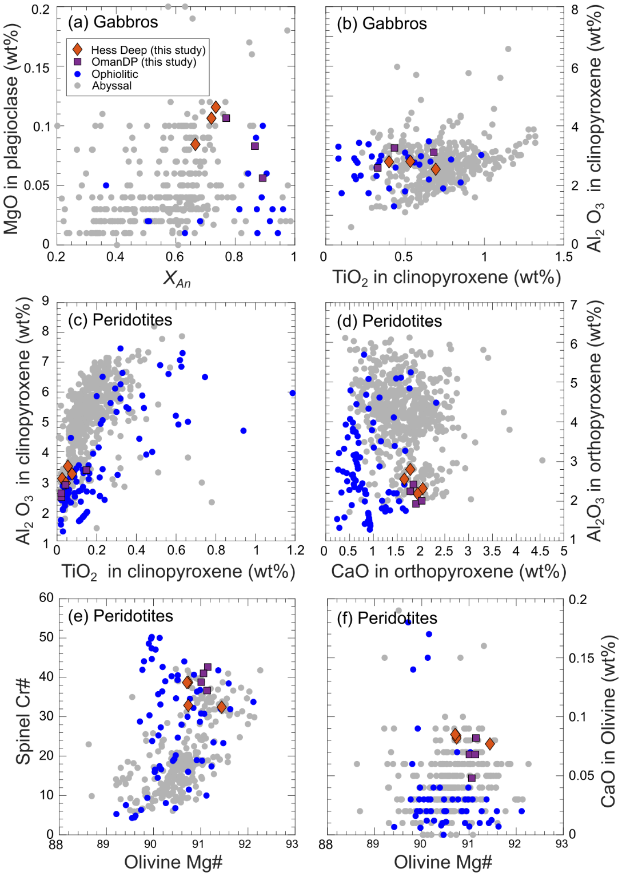
Figure 1.3. Variations in major element compositions of minerals in samples from this study (averages) and the literature. Gabbros are shown in the first row (a, b) and peridotites are shown in the second and third rows (c-f). Samples from this study are shown as orange diamonds (Hess Deep) and purple squares (OmanDP). Ophiolitic gabbros and peridotites from petDB and Dygert et al., 2017, are shown as gray and blue dots, respectively, and abyssal peridotites from Warren, 2016, are shown as gray dots. MgO in plagioclase data shown in (a) and used in thermometric interpretations (this study) were collected by LA-ICP-MS. We note MgO concentrations in the literature data shown in (a) may not have been collected under optimized analytical conditions, perhaps accounting for some of the scatter.
shown as purple squares, and are compared to ophiolitic and abyssal data from the literature (blue and gray circles, respectively). In general, among both gabbros (Figures 1.3a, b) and peridotites (Figures 1.3c-f), mineral compositions for the two localities cluster tightly compared to the global distribution of abyssal and ophiolitic data. In gabbroic plagioclase, X_{An} (Ca/(Ca+Na), in moles) ranges from ~0.65 to 0.9 (Figure 1.3a), while plagioclase MgO abundances plot near the upper end of the global distribution (~0.5-0.12 wt%). In clinopyroxene-saturated systems, partitioning of Mg in plagioclase is known to be temperature dependent, with higher temperatures favoring higher Mg concentrations (Faak et al., 2013; Sun & Lissenberg, 2018a). Slow cooling from magmatic temperatures would promote temperature-dependent exchange (loss) of
Mg in plagioclase for Ca with clinopyroxene, while fast cooling from magmatic temperatures would lock in the elevated Mg concentrations associated with magmatic temperatures. Thus, the high MgO abundances observed here may be consistent with relatively fast cooling of the gabbros from high initial temperatures. Gabbroic clinopyroxenes demonstrate a broad range of TiO₂ (0-0.2 wt%) and fall in the middle of the global Al₂O₃ distribution (2-4 wt%, Figure 1.3b). Gabbroic olivines (Table 1.8, not shown in Figure 1.3) have Mg#s (Mg/(Mg+Fe)*100, in moles) of 74-89 which decrease downsection; all have CaO abundances of ~0.04 wt%.
In peridotitic clinopyroxenes, Al₂O₃ and TiO₂ from both localities cluster at the lower end of the ranges exhibited by ophiolites and abyssal peridotites globally (Figure 1.3c); orthopyroxenes are similarly depleted in Al₂O₃ (Figure 1.3d). Low concentrations of these incompatible minor elements may be attributed to the high extents of melting experienced by these melting residues. CaO in orthopyroxenes is high compared to many other ophiolitic rocks but in the middle of the range of abyssal peridotites (1.5-2.5 wt%, Figure 1.3d). As exchange of CaO between orthopyroxene and clinopyroxene around the pyroxene solvus is temperature dependent, the elevated CaO abundances suggest relatively fast cooling of the Hess Deep and OmanDP peridotites from high initial temperatures (e.g. Brey & Köhler, 1990).
In Figure 1.3e, the Mg# of the peridotitic olivines is compared to the Cr# (Cr/(Cr+Al)*100) in spinel. The Mg#s of olivines are consistent with normal values for peridotitic residues of partial melting (90.7-91.4). The Cr# in spinels (32-43) are near the high end of our compilation, but fall within the distribution of samples from abyssal environments (Cr#s <60), consistent with adiabatic decompression melting in anhydrous settings (e.g. Arai, 1987; Dick & Bullen, 1984). CaO in olivines is approximately 0.05-0.1 wt%, elevated compared to most ophiolitic peridotites but consistent with many abyssal peridotites (Figure 1.3f). (e.g. Köhler & Brey, 1990)

4.1.1 Major element zonation
Characterization and scrutiny of major element zoning is critical for evaluating the significance of temperatures determined using thermometers (e.g., see Section 5.1), and is described below for gabbros (Hess Deep and then OmanDP), and peridotites (again, Hess Deep and then OmanDP). Major element mineral zonation was evaluated by electron microprobe traverses across representative grains, and/or using representative core and rim analyses.
In all Hess Deep gabbros, significant grain-scale compositional variations in clinopyroxenes and plagioclase are observed. Single plagioclase grains record X_{An} variations of up to ~0.1. Some clinopyroxenes are zoned in Fe-Mg-Ca, exhibiting near constant Mg#s but significant CaO depletions (up to 10 wt%) in grain rims. These observations are consistent with carefully documented zoning reported in Lissenberg et al. (2013) and Lissenberg & MacLeod (2016) for Hess Deep gabbros, which was attributed to reactive porous flow (we refer the reader to those publications for graphical representations of the zoning patterns described here). In all Hess Deep gabbros, Al₂O₃ is enriched in clinopyroxene rims relative to cores, by up to 4 wt%. In contrast, Hess Deep gabbroic olivines are uniform in composition within analytical uncertainty.
Oman Drilling Project troctolite plagioclase and gabbroic plagioclase and clinopyroxene exhibit little to no zonation. In three samples, major element variations across grains are within analytical uncertainty. In gabbro 5057_5707A_032z_02_053-056, minor core-rim zonation is observed in clinopyroxenes, with Al₂O₃ variation of 2.8-3.5 wt% from rim to core, and rim-core FeO variations of similar magnitude. Within analytical uncertainty, OmanDP gabbroic olivines are uniform in composition across the grains.
For Hess Deep peridotites, olivines and spinels in all samples are unzoned, within analytical uncertainty. The large clinopyroxene grain in 147_895D_3R1_66-69 (Figure 1.2b), exhibits minor Cr₂O₃ variations ranging from 1.1 wt% at the rim to 1.4 wt% in the core, clinopyroxenes are otherwise not zoned. Orthopyroxenes are also unzoned, except in sample 47_895D_3R1_22-27, which exhibits minor core-rim CaO zoning, (1.4 wt% at rims to 1.7 wt% in cores). No zoning beyond analytical uncertainty was observed in olivines or spinels.
Oman Drilling Project peridotites exhibit more significant but still minor grain-scale variations. Clinopyroxenes are generally unzoned, but sample 5057_5708B_119z_03_006-009 exhibits relatively Al₂O₃ enriched cores (2.9 wt%) trending toward rims depleted by up to 0.5 wt%. All orthopyroxenes exhibit minor Al₂O₃ and Cr₂O₃ zoning, with relatively enriched cores (1.9-2.4 wt% Al₂O₃ and 0.7-0.8 wt% Cr₂O₃), and rims depleted by up to 0.5 wt% in Al₂O₃ and up to 0.3 wt% in Cr₂O₃. Two samples (5057_5708B_114z_02_030-034 and 5057_5708B_119z_03_006-009) exhibit relatively enriched CaO abundances in grain cores (1.8-2.0 wt%) and depletions of up to 0.5 wt% at rims. Olivines do not exhibit CaO abundance variations beyond analytical uncertainty.

4.2 Trace elements
Average trace element abundances from LA-ICP-MS analysis of clinopyroxenes, orthopyroxenes and plagioclase are reported in Tables 1.9, 1.10, and 1.11 (Attachment Chapter_1_Data_Tables.xlsx) respectively. Chondrite normalized spider diagrams are plotted for mineral averages from all samples in Figure 1.4. Colored lines represent sample averages, while light gray lines represent individual spot analyses. Error bars represent 1σ standard deviations of replicate analyses for each thin section. Here we briefly describe the REE patterns, starting with the gabbros.
Plagioclase from both localities exhibit a positive Eu anomaly (Eu/Eu*, 10.8 to 14.2 in Hess Deep gabbros and 11.3 to 16.7 in OmanDP gabbros) and steeply dipping light-heavy REE patterns. Heavy REEs (HREEs) are below detection limit in all plagioclase. Some coexisting clinopyroxenes have small negative Eu anomalies in Hess Deep samples (Eu/Eu* = 0.66 to 1.00), Eu anomalies in OmanDP gabbros are minor or
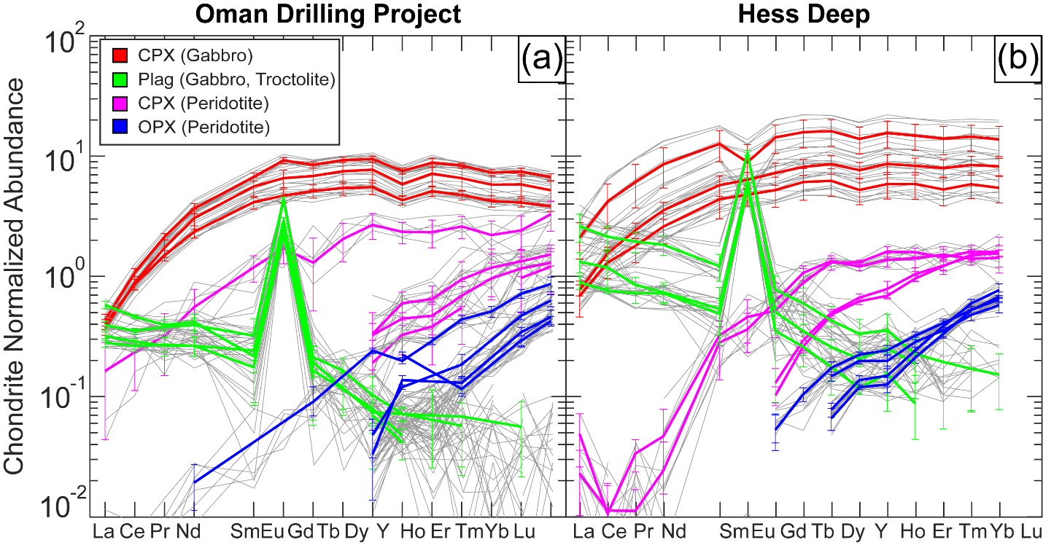
Figure 1.4. Chondrite normalized REE+Y abundances in minerals from the crust and mantle sections of Oman Drilling Project (a) and Hess Deep (b). Individual spot analyses are shown in gray in the background, and sample averages are shown as thicker colored lines, error bars are 1σ standard deviations of replicate analyses for each sample. Minerals in crustal samples are green (plagioclase) and red (clinopyroxene), minerals in peridotites are magenta (clinopyroxene) and blue (orthopyroxene).

unresolvable, within analytical uncertainty (Eu/Eu* = 0.87 to 1.12). Gabbroic clinopyroxenes from both localities have flat mid- to heavy-REE patterns and are strongly light-REE (LREE) depleted. Gabbroic clinopyroxenes from Hess Deep exhibit relatively large standard deviations and trace element variations among spots in individual samples which reflect grain-scale zoning (Figure 1.5), while OmanDP gabbroic clinopyroxenes are homogeneous within analytical uncertainty.
In the peridotites, REE patterns are steeply LREE depleted and below analytical detection limit for many clinopyroxenes and all orthopyroxenes; two Hess Deep samples with resolvable LREEs have spoon-shaped patterns defined by slight enrichments in La relative to Ce. Rare earth element abundances in clinopyroxenes from both localities fall near the depleted end of the global distribution of abyssal harzburgites (e.g. Johnson et
al., 1990; Warren, 2016), in agreement with previous analyses of Hess Deep and southern Samail ophiolite peridotites (e.g. Dygert et al., 2017; Hesse et al., 2015). In orthopyroxenes, the REE patterns are sub-parallel to the clinopyroxenes, with abundances ~0.5-1 order of magnitude lower.

4.2.2 Trace element zoning
Hess Deep gabbros exhibit zoning in plagioclase and especially clinopyroxene. We plot concentration variations across paired mineral grains from a representative sample in Figure 1.5 (spot locations are shown in Figure 1.2a). Elemental abundances vary across grains well beyond analytical uncertainty, as previously documented by Lissenberg et al. (2013) and Lissenberg & Maclennan, 2016. The minor intrasample trace element abundance variations exhibited by Hess Deep peridotites and OmanDP gabbros and peridotites (Figure 1.4) establishes that zoning in those phases and samples is within analytical uncertainty, as representative data were collected from mineral cores and rims whenever possible.

4.3 Temperatures
Thermometers were applied to the crustal gabbros and mantle peridotites according to mineral assemblages present. Gabbros were investigated using a Ca-in-olivine thermometer (Köhler & Brey, 1990) (T_{Ca-in-Ol}), REE-in-clinopyroxene thermometer (Sun
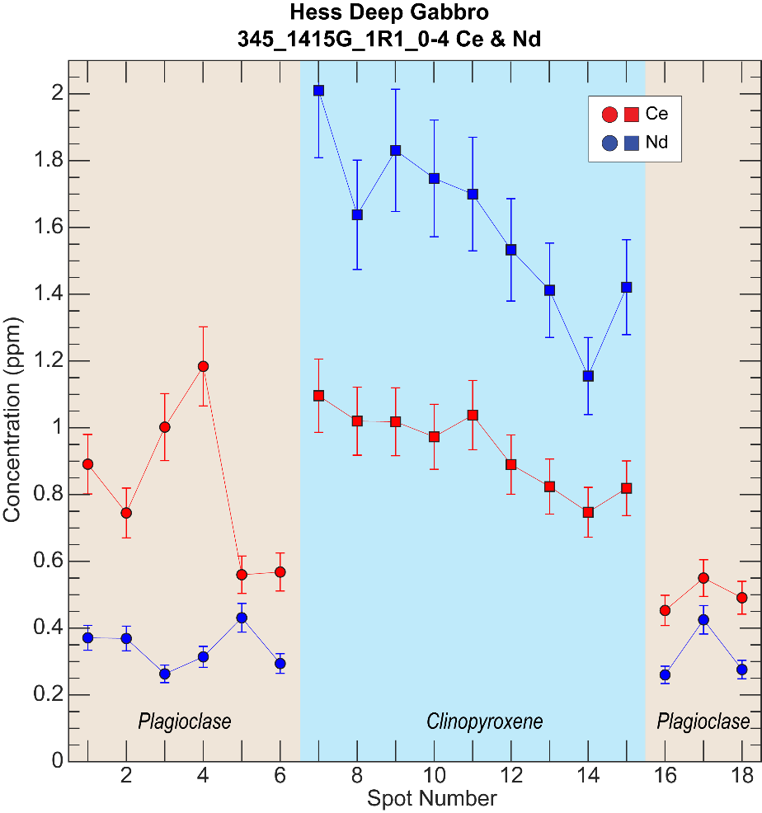
Figure 1.5. Ce and Nd concentrations in paired plagioclase and clinopyroxene grains measured by LA-ICP-MS. Analytical uncertainty (relative) is estimated at 10% of the concentration. Trace element abundances vary beyond the analytical uncertainty in the plagioclase grain on the left and in the clinopyroxene. These variations are representative of Hess Deep gabbros in general, and the variations are interpreted to reflect magmatic processes. See Section 5.1.1 and Lissenberg et al., 2013, and Lissenberg & Macleod, 2016.

& Liang, 2017) (T_{REE-in-Cpx-Plag}), and a magnesium-in-plagioclase thermometer (Faak et al., 2014; Sun & Lissenberg, 2018a) (T_{Mg-in-Plag}). Peridotites were investigated using the Köhler & Brey, 1990 Ca-in-olivine thermometer and several two-pyroxene solvus thermometers; Brey & Köhler, 1990 (T_{BKN}), Wells, 1977 (T_{Wells}), Putirka, 1997 (T_{Putirka}), a Ca-in-opx solvus-based thermometer, Köhler & Brey, 1990 (T_{Ca-in-Opx}), a REE-in-two-pyroxene thermometer (Liang et al., 2013) (T_{REE-in-two-Pyroxene}), a thermometer based on exchange of Al and Cr between orthopyroxene and spinel (Witt-Eickschen & Seck, 1991) (T_{Al-in-Opx}), and an olivine-spinel thermometer based on Fe-Mg exchange (Fabriès, 1979) (T_{Ol-Sp}). Results are presented in Table 1.2 and representative data are shown in Figure 1.6 with samples arranged by proximity to the crust-mantle transition, i.e., the present-day petrologic Moho. Note the sample placement in the figure does not represent absolute or relative distance, but simply a relational proximity to the Moho.
Error bars are estimated 1σ uncertainties from scatter in the temperature inversions (T_{REE-in-Cpx-Plag}; T_{REE-in-two-Pyroxene}), or based on propagation of major element data uncertainty through the thermometers (T_{Mg-in-Plag}; T_{BKN}; T_{Ca-in-Olivine}; T_{Al-in-Opx}) (Dygert et al., 2017). Hess Deep gabbros have a T_{Ca-in-Ol} range of 885-896°C, a T_{Mg-in-Plag} range of 1046-1071°C (calculated using LA-ICP-MS data) and a T_{REE-in-Cpx-Plag} range of 1185-1224°C. Oman Drilling Project gabbros have a T_{Ca-in-Ol} range of 891-893°C , a T_{Mg-in-Plag} range of 963-1066°C and a T_{REE-in-Cpx-Plag} range of 1194-1269°C.
Hess Deep peridotites have a T_{BKN} range of 1048-1141°C, a T_{Al-in-OPX} range of 978-1041°C, a T_{Ca-in-Ol} range of 1023-1038°C, a T_{Ol-Sp} range of 751-787°C, and a T_{REE-in-two-Pyroxene} range of 1222-1403°C. Oman Drilling Project peridotites have a T_{BKN} range of 1001-1023°C, a T_{Al-in-OPX} range of 960-1004°C, T_{Ca-in-Ol} range of 957-1027°C, a T_{Ol-Sp} range of 707-775°C, and a T_{REE-in-two-Pyroxene} range of 1140-1299°C. The T_{BKN} temperatures are corroborated by similar temperatures obtained using the Wells (1977) and Putirka (1997) two pyroxene-solvus thermometers (Table 1.2). Note that for both localities, for samples from the crust and the mantle, temperatures determined using thermometers based on subsolidus exchange of slower diffusing trivalent elements (T_{REE-in-Cpx-Plag}; T_{REE-in-two-Pyroxene}) are higher than temperatures determined using thermometers based on exchange of faster diffusing divalent elements (T_{Mg-in-Plag}; T_{BKN};

Table 1.2. Temperatures.
Sample |  | Rock Type | Location | T_{REE-in-two-Pyroxene} | 1σ | T_{REE-in-CPX-Plag} | 1σ | T_{Mg-in-Plag} | T_{BKN} | T_{Wells} | T_{Putirka} | T_{Ca-in-OPX} | T_{Al-in-OPX} | T_{Ca-in-Ol} | T_{Ol-Sp}
345_1415G_1R1_0-4 |  | Gabbro | Hess Deep | -- | -- | 1224* | 4 | 1071* | -- | -- | -- | -- | -- | 885 | --
345_1415J_4R1_2-6 |  | Gabbro | Hess Deep | -- | -- | 1220* | 6 | 1063* | -- | -- | -- | -- | -- | -- | --
147_894G_9R4_60-67 |  | Gabbro | Hess Deep | -- | -- | 1185* | 3 | 1046* | -- | -- | -- | -- | -- | 896 | --
5057_5707A_032z_02_053-056 |  | Gabbro | OmanDP | -- | -- | 1194 | 5 | 1066 | -- | -- | -- | -- | -- | 893 | --
5057_5707A_059z_04_004-008 |  | Gabbro | OmanDP | -- | -- | 1238 | 4 | 1016 | -- | -- | -- | -- | -- | 891 | --
5057_5707A_113z_03_036-040 |  | Gabbro | OmanDP | -- | -- | 1269† | 10 | 963† | -- | -- | -- | -- | -- | 893 | --
147_895D_3R1_22-27 |  | Peridotite | Hess Deep | 1287‡ | 23 | -- | -- | -- | 1048‡ | 1041‡ | 1040‡ | 1167 | 1020 | 1034 | 754
147_895D_3R1_66-69 |  | Peridotite | Hess Deep | 1222‡ | 53 | -- | -- | -- | 1069‡ | 1064‡ | 1063‡ | 1188 | 1041 | 1023 | 751
147_895D_5R1_70-76 |  | Peridotite | Hess Deep | 1357 | 53 | -- | -- | -- | 1141 | 1133 | 1126 | 1234 | 996 | 1036 | 787
147_895D_5R1_140-144 |  | Peridotite | Hess Deep | 1403‡ | 55 | -- | -- | -- | 1115‡ | 1109‡ | 1103‡ | 1216 | 978 | 1038 | 760
5057_5708B_100z_03_035-040 |  | Peridotite | OmanDP | 1211‡ | 27 | -- | -- | -- | 1023‡ | 1033‡ | 1038‡ | 1211 | 960 | 1001 | 707
5057_5708B_114z_02_030-034 |  | Peridotite | OmanDP | 1144 | 30 | -- | -- | -- | 1001 | 1002 | 1023 | 1203 | 1004 | 1027 | 727
5057_5708B_119z_03_006-009 |  | Peridotite | OmanDP | 1299 | 49 | -- | -- | -- | 1040 | 1045 | 1053 | 1191 | 996 | 1002 | 764
5057_5708B_124z_02_076-081 |  | Peridotite | OmanDP | 1140 | 18 | -- | -- | -- | 1023 | 1031 | 1041 | 1232 | 973 | 957 | 775
Peridotite temperatures calculated at 1GPa for consistency among datasets (only affects major element thermometer temperatures, except T_{Wells}, which are pressure insensitive), gabbros at 2kb.
*Pyroxenes and plagioclase in Hess Deep gabbros are affected by complex zoning and temperatures may not be meaningful (see Section 5.1.1).
†This sample has a temperature distribution beyond Dodson limits for cooling (cf. Sun & Lissenberg, 2018a), suggesting one or more of the temperatures may not be physically meaningful (see Section 5.2.3).
‡Rather than being a residual phase, minor clinopyroxene may originate by exsolution from orthopyroxene under subsolidus conditions or crystallization from trapped melt (see Section 5.1.2).

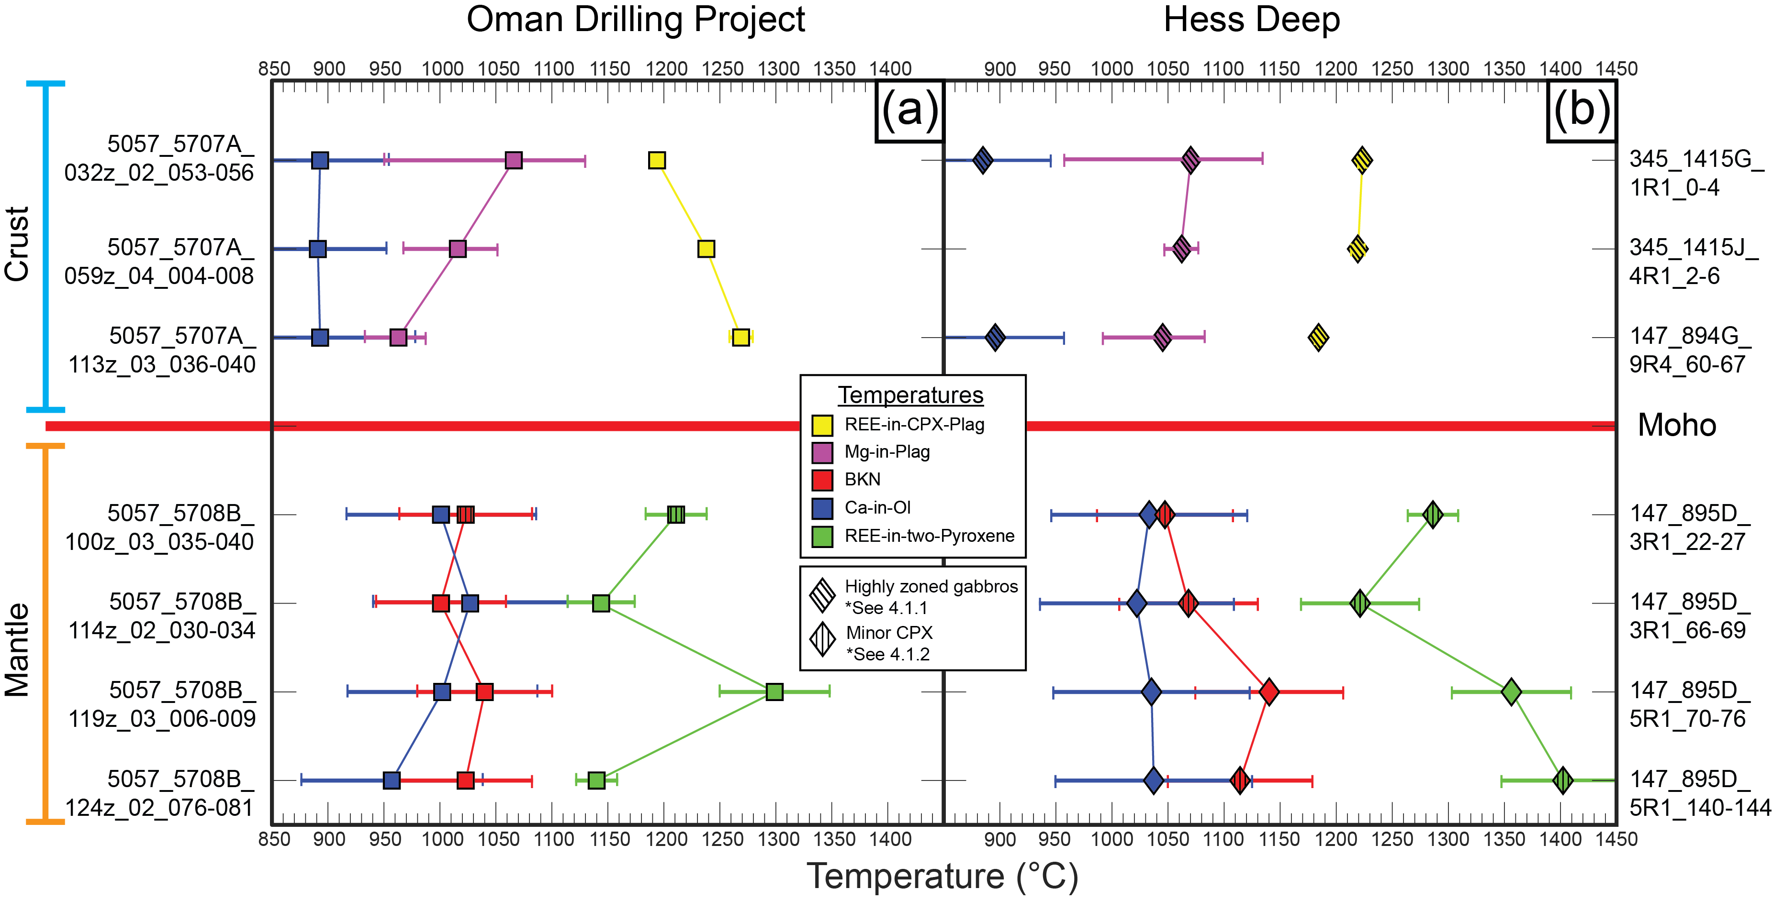
Figure 1.6. Temperature comparison for samples from the Oman Drilling Project (a) and Hess Deep (b) above and below the petrologic Moho, which is indicated by the horizontal red line. In order to compare trends between drilling sites, samples are shown in relational depth, not absolute distance, as Hess Deep peridotites and gabbros cannot be directly related in stratigraphic depth owing to uncertainty in the local structure. For all samples, depths within the holes are reported in Table 1.1. Structural depths of the Oman Drilling Project samples are reported in Table 1.1 and are presented graphically in Figures 1.9 & 1.10. Hess Deep samples are schematically plotted relative to the Moho in Figures 1.9 & 1.10.

T_{Ca-in-Ol}; T_{Ol-Sp}) (an exception being T_{Al-in-Opx}, which are similar to divalent element-based thermometer temperatures). We note the peridotites investigated here fall outside the calibration dataset of the T_{Al-in-Opx} thermometer (Witt-Eickschen & Seck, 1991), which was parameterized using peridotites with elevated Al abundances relative to many residual peridotites.
Here we briefly describe the “downhole” trends in the temperature data. T_{Ca-in-Ol} are higher in peridotites than gabbros, perhaps because of the larger olivine grain sizes (Table 1.3 in Attachment Chapter_1_Data_Tables) and/or higher initial temperatures in the latter. T_{REE-in-Cpx-Plag} slightly increase with depth at Oman and decrease with depth in the samples from Hess Deep. Within error, T_{Mg-in-Plag} do not vary with depth. At both localities, peridotite samples show narrowly scattered T_{REE-in-two-Pyroxene}, T_{BKN}, T_{Ca-in-Ol}, T_{Al-in-Opx}, with no systematic variability with depth for any thermometer. The lack of systematic variability among the samples may reflect their spatial proximity to each other relative to the scale of spatial variations in cooling rate within oceanic lithosphere (Dygert et al., 2017).
The new Hess Deep and OmanDP temperatures are plotted in comparison to other ophiolitic and abyssal peridotites and gabbros in Figure 1.7. T_{REE-in-Cpx-Plag} are compared to T_{Mg-in-Plag} in (a); literature data are limited, but the OmanDP and Hess Deep data are similar to temperatures previously recovered from Hess Deep gabbroic lithosphere (Sun & Lissenberg, 2018a). T_{REE-in-two-Pyroxene} are compared to T_{BKN} in (b), in all cases, samples from this study have T_{REE-in-two-Pyroxene} > T_{BKN}, in agreement with temperature distributions previously interpreted to suggest fast cooling for many ophiolitic peridotites (≳0.01 °C/y, Dygert & Liang, 2015). Samples from this study plot among the abyssal peridotites, at the high end of the distributions exhibited by ophiolitic peridotites from southern Oman (uppermost Wadi Tayin massif), which cooled at rates >0.1 °C/y (Dygert et al., 2017, also see Figure 1.8b). In (c), T_{Ca-in-Ol} are compared to T_{Ol-Sp}. The new Hess Deep and OmanDP data fall at or above temperatures determined previously for ophiolites. As noted by Dygert et al., 2017, in general, abyssal peridotite temperatures are systematically higher than ophiolitic peridotite temperatures for these thermometers, suggesting faster cooling for abyssal peridotites than ophiolites through closure
Figure 1.7. Temperatures obtained in this study compared to other localities in Oman, previous work on Hess Deep and the global distribution of ophiolites and abyssal peridotites. (a) T_{REE-in-Plag-Cpx} vs. T_{Mg-in-Plag} (gabbros), (b) T_{REE-in-two-Pyroxene} vs. T_{BKN} (peridotites); (c) T_{Ca-in-Ol} vs. T_{Ol-Sp} (peridotites). Temperatures obtained for gabbros are consistent with but at the high temperature end of previous work on Hess Deep (a). Note that samples from this study have high T_{REE} and T_{BKN}, consistent with abyssal peridotites and some samples from Oman (b). Peridotite temperatures obtained using fast-resetting thermometers (Ca-in-Olivine and Olivine-Spinel) are at the high end of the global distribution of ophiolites (c), perhaps owing to the close proximity of the samples from this study to the transition zone compared to other ophiolitic peridotites. Data sources are the following: Wadi Tayin, Dygert et al., 2017; Elsewhere Oman (Wadi Fizh, Wadi Thuqbah, Wadi Rajmi, and Wadi Sarami in central and northern Oman; Akizawa et al., 2012, 2016); Other ophiolites, Dygert et al., 2015; Abyssal peridotites, Dygert et al., 2017; Hess Deep, Sun and Lissenberg, 2018.

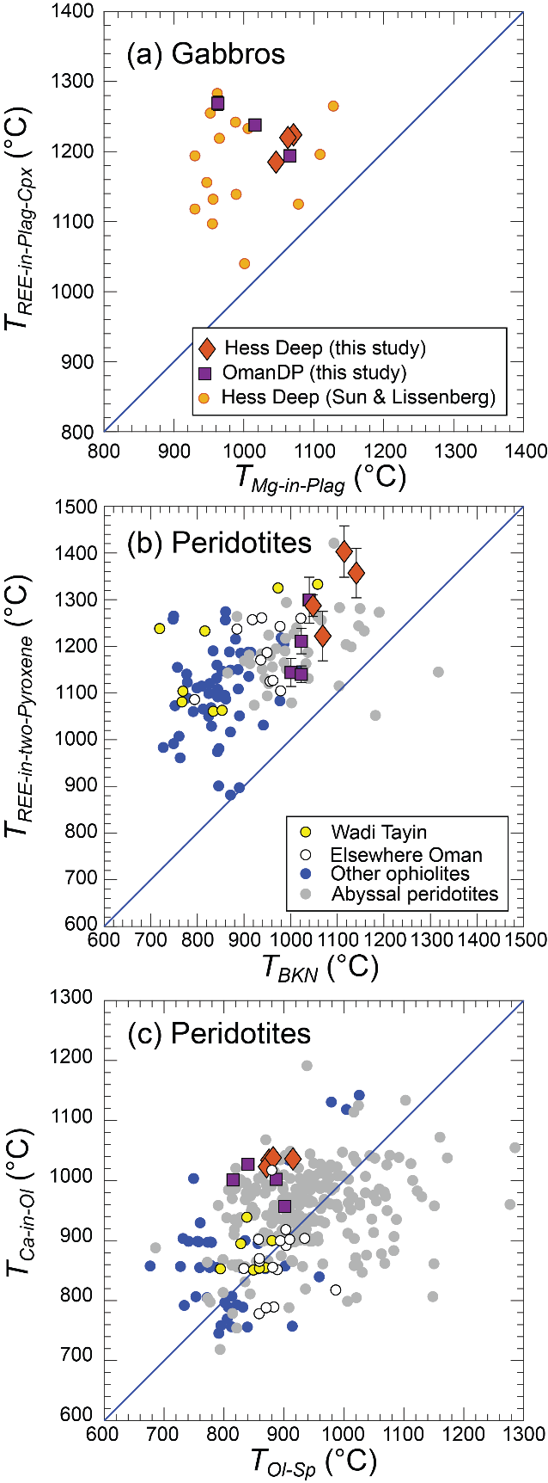
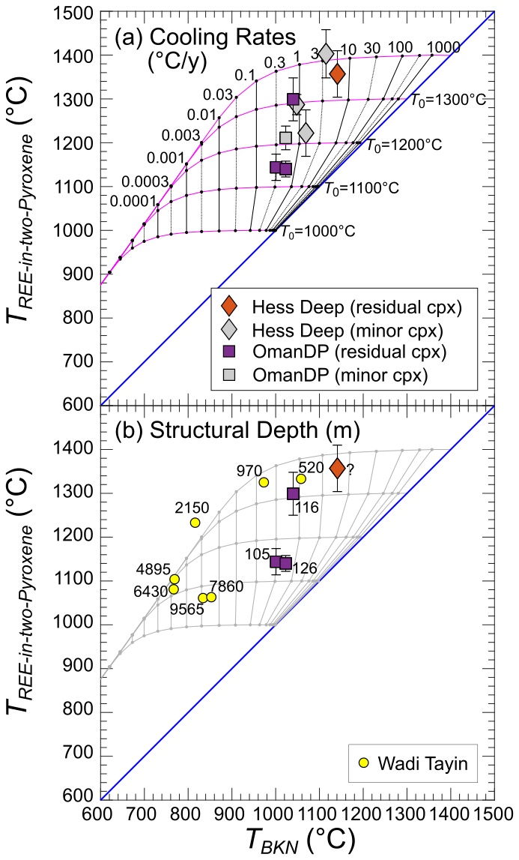
Figure 1.8. Temperatures for Hess Deep and Oman Drilling Project (OmanDP) peridotites compared to models for closure temperature calculated as a function of cooling rate (grid composed of black and magenta lines). (a) Shows samples from this study with colored symbols are interpreted to have retained residual clinopyroxene throughout partial melting, those with gray symbols are interpreted to have exsolved from orthopyroxene under subsolidus conditions, or crystallized from melt during cooling, and thus may not record cooling rates from peak temperatures. The cooling rate grid was calculated utilizing a modified form of the Dodson equation assuming a radius of 0.5 mm (Ganguly & Tirone, 1999, see Dygert & Liang, 2015, for details). The 1:1 line, shown in blue, represents equal temperatures for the two thermometers. Initial temperatures (T₀) represent the peak temperatures from which samples cooled, the paths samples take in this temperature space are indicated by the magenta lines extending from initial temperatures along the blue 1:1 line. The near-vertical black lines represent cooling rates in °C/year. Assuming an effective grain radius of 0.5 mm, all samples in this study cooled at rates of 0.3°C/year or faster. Cooling rates calculated using the measured, sample specific grain sizes from samples with residual clinopyroxene are reported in Table 1.3 and shown in Figure 1.9 (blue symbols). (b) Shows samples from (a) with residual clinopyroxene from this study, alongside published samples from Dygert et al., 2017, with structural depths of samples beneath the crust-mantle transition indicated (meters). The question mark indicates that the structural depth of Hess Deep peridotites relative to crust-mantle transition is unknown.
temperature intervals relevant to the thermometers. The proximity of samples investigated in this study to the crust-mantle transition may explain the systematically higher temperatures compared to the overall distribution of the ophiolitic data, which are from a range of structural depths in ophiolites that evolved in a variety of tectonic settings.

5. Discussion

5.1 Significance of temperatures
Thermometers are empirical, semithermodynamic, or thermodynamic models describing temperature-sensitive elemental exchange among a mineral assemblage in a sample. Three types of thermometers applied here are based on (1) exchange of a minor element for major element(s), e.g., Ca-in-olivine and Mg-in-plagioclase thermometers (Köhler & Brey, 1990; Sun & Lissenberg, 2018a); (2) temperature sensitive Ca-Mg-Fe partitioning around the orthopyroxene-clinopyroxene solvus, as in two-pyroxene thermometers (e.g., Brey & Köhler, 1990); and (3) temperature-sensitive REE partitioning between coexisting phases, as in the REE-in-two pyroxene and REE-plagioclase-clinopyroxene thermometers (Liang et al., 2013; Sun & Liang, 2017). The applicability of each thermometer depends on the mineralogy and composition of the sample and the calibration range of the thermometer. To obtain meaningful temperatures, analytical data must be accurate and representative, and the sample must have achieved chemical equilibrium before cooling, and not have been chemically disturbed by metasomatic, melt-rock reaction or other geologic processes that produce disequilibrium at the grain or thin section scales.
With the exception of the Hess Deep gabbros (see Section 5.1.1 below), our new geochemical data meet the aforementioned criteria. The data are accurate (e.g., as demonstrated by replicate analyses of reference material BCR as an unknown, Table 1.4) reproducible (as demonstrated by small standard deviations of replicate analyses, Tables 1.5-1.8), and representative, as major and trace element data were collected across multiple grains in each sample (in many cases, in core-rim traverses). Minerals in peridotites from Hess Deep and OmanDP are minimally zoned, and the slight depletions in Al₂O₃, Cr₂O₃ and CaO in pyroxene rims are consistent with subsolidus exchange between pyroxenes and with spinel during cooling (e.g. Dygert et al., 2016; Takazawa et al., 1996). The OmanDP gabbros are also largely unzoned (see Sections 4.1.1 and 4.2.2). In all samples, REE abundances and LREE depletion are consistent with adiabatic decompression melting rather than metasomatic interactions that could perturb REE-based temperatures (e.g. Johnson et al., 1990; Navon & Stolper, 1987). We note that the slightly elevated La abundances in two Hess Deep peridotites (Figure 1.4) are excluded from temperature determinations (a summary of the inversion diagrams used to obtain T_{REE-in-two-Pyroxene} and T_{REE-in-CPX-Plag} temperatures is presented in Figure 1.12 in Appendix 1; see Liang et al., 2013 and Sun & Liang, 2017, for a description of the methods). These observations all support interpretation of the Hess Deep and OmanDP peridotite and OmanDP gabbro temperatures as bulk (mineral average) closure temperatures, i.e., temperatures locked in by the effective cessation of an exchange reaction during cooling (see Section 5.2).

5.1.1 Hess Deep gabbros may not record meaningful cooling rates
Previously, workers interpreted chemical variations in Hess Deep gabbros as reflecting reactive transport of melts through crystal mushes in the lower oceanic crust (e.g. Lissenberg et al., 2013; Lissenberg & MacLeod, 2016), and suggested that averaged mineral compositions reflect “bulk closure,” such that their thermal histories could be quantified (Sun & Lissenberg, 2018a). Hess Deep gabbros exhibit complex grain-scale elemental heterogeneity beyond analytical uncertainty, inconsistent with subsolidus exchange during monotonic cooling (e.g., Section 4.1.1; Figure 1.5). While the cooling rates obtained in Sun & Lissenberg (2018a) are consistent with previous investigations into cooling of oceanic lithosphere (e.g., Dygert et al., 2017; Dygert & Liang, 2015; VanTongeren et al., 2008), many of the temperatures (up to ~1300°C) are higher than clinopyroxene and plagioclase cosaturation temperatures for dry, primitive, mid-ocean ridge basalts (e.g., Grove and Bryan, 1983; Villiger et al., 2004). The proposition that chemical variations in unequilibrated pyroxene and plagioclase in a reacting, open system can be interpreted as recording a thermal history is questionable. Faak et al. (2015) and Faak & Gillis (2016) used chemical variations across minerals obtained in line traverses and applied Ca-in-olivine and Mg-in-plagioclase thermometers and speedometers to compositional profiles. The latter approach would similarly produce misleading apparent thermal histories from samples that failed to attain equilibrium after fractional crystallization and melt-rock reaction, and also in samples where grains are chemically disturbed by alteration. Because the grain-scale heterogeneity in major and trace elements in plagioclase and clinopyroxene in our Hess Deep gabbro samples demonstrates that they failed to attain chemical equilibrium, we report apparent T_{Mg-in-Plag}, T_{REE-in-CPX-Plag} and T_{Ca-in-Ol} obtained from these data in Tables 1.2 and 1.3 and Figures 1.6 and 1.7, but refrain from presenting the apparent (0.02-0.44 °C/y) gabbroic cooling rates calculated using the temperatures in Figures 1.9 and 1.10. As lithospheric cooling at Hess Deep is constrained by the peridotites underlying the gabbros, this has little effect on our conclusions.

5.1.2 Some peridotites may not provide a record of cooling from peak temperatures
To obtain information on a sample’s thermal history after achieving a peak temperature, stability of the phases the thermometer is based on throughout the cooling history is required. This requirement may be violated for highly depleted peridotites, where clinopyroxene is exhausted by extensive partial melting (e.g. Pirard et al., 2013). In such cases, small clinopyroxene grains may exsolve from orthopyroxene at subsolidus temperatures owing to orthopyroxene unmixing along the solvus. Alternatively, minor clinopyroxenes may crystallize from small pools of silicate melt during cooling (e.g., Hanghøj et al., 2010). Application of two-pyroxene thermometers to such samples may produce temperatures that reflect subsolidus cooling (e.g., Dygert et al., 2017), or spurious thermal histories, rather than cooling from peak temperatures. Here, we considered the potential for clinopyroxene exhaustion by visual inspection (e.g., Figure 1.2; c; e; f), and using the mineral modes reported in core descriptions, which are summarized in Table 1.3. In cases where the clinopyroxene are small and scarce, and the clinopyroxene/orthopyroxene mode ratio is less than 0.05 (cf. Dygert et al., 2017), we infer that the minor clinopyroxene present may not be representative of cooling from peak temperature. We report the T_{BKN} and other solvus thermometer temperatures and T_{REE-in-two-Pyroxene} temperatures obtained from these samples (flagged using gray symbols in Figure 1.8a), and report the apparent cooling rates in Table 1.3, but exclude presentation of the rates determined using these data from Figures 1.9 and 1.10. After this exercise, cooling rates from peak temperature for four peridotites remain (three OmanDP samples and one Hess Deep sample). We infer that thermal histories provided by the Köhler & Brey (1990) Ca-in-olivine thermometer are not afflicted by this issue, as Ca exchange between clinopyroxene and olivine is rapid (Coogan et al., 2005), such that the Ca-in-olivine thermometer records thermal conditions at low subsolidus temperatures (e.g., Figure 1.7c) where the clinopyroxene in the samples was present.

5.2 Cooling Rates
Temperatures recorded by thermometers reflect rate-limited, time-dependent exchange reactions that occur during cooling. For samples that cool at rates relevant to geologic processes such as tectonic exhumation, thermometers based on relatively rapid exchange of divalent elements (e.g., the Ca-in-olivine thermometer of Köhler & Brey, 1990) record lower, subsolidus temperatures than thermometers based on trivalent elements (e.g., the REE-based thermometers, Liang et al., 2013; Sun & Liang, 2017), explaining the range of temperatures exhibited by our samples (Figure 1.6). The faster a rock cools, less spread in temperature will be seen among thermometers that respond to cooling at different rates (and vice versa). If exchange rates relevant to a given thermometer are known, closure temperature models can be applied to quantify the rate at which diffusive exchange of the element(s) the thermometer relies on effectively ceased. A widely used closure temperature model is described by the Dodson equation (Dodson, 1973):
$\frac{-ART_{c}^{2}D_{0}}{E\exp\left(\frac{E}{RT_{C}}\right)a^{2}}=\frac{ⅆT}{ⅆt}$ (1),
where T_{c} is the temperature provided by the thermometer (which must be established as a closure temperature, see Section 5.1), E and D₀, are the activation energy and pre-exponential factors for the element of interest, respectively; R is the gas constant, A is a geometric constant (in this study we assumed spherical geometry (A=55)), and a is an effective grain size. The Dodson equation makes simplifying assumptions that may or may not be justified depending on the exchange reaction considered and the geologic history of a sample, among them, continuous cooling from peak temperature at a constant rate, diffusive exchange between a mineral grain and a semi-infinite reservoir, and the lack of any grain growth (or resporption) during cooling. These assumptions may be justified for simple exchange reactions, e.g., the Köhler & Brey (1990) Ca-in-olivine thermometer, where the Ca-Fe-Mg exchange reaction between olivine and clinopyroxene is well understood, and the kinetics are constrained (e.g. Coogan et al., 2005; Jurewicz & Watson, 1988).

5.2.1 Rates from Ca-in-olivine temperatures
Using Equation 1 and olivine grain sizes measured petrographically (see Section 2.1), we calculated cooling rates from the T_{Ca-in-Ol} data, which range from 0.06 to 0.12 °C/y for the OmanDP gabbros, and 0.03 to 0.25 °C/y for the Hess Deep and OmanDP peridotites (Table 1.3, green symbols, Figure 1.9). Serpentinization of olivine rims could inflate these rates by removing the portion of the grain exhibiting Ca depletion after exchange with clinopyroxene during cooling. Underestimating grain size would also inflate the cooling rates, because the rates scale with the square of grain size (Equation 1). Grain sizes a factor of two larger than the values we measured would produce cooling rates a factor of four slower, which is still ~2 orders of magnitude faster than rates anticipated in a scenario where the lower crust and underlying mantle cooled conductively (e.g. Dygert et al., 2017; Faak & Gillis, 2016).

5.2.2 Rates from REE-in-two-pyroxene temperatures and pyroxene solvus temperatures
Application of Equation 1 to T_{REE-in-two-Pyroxene} is less straightforward, as the thermometer relies on exchange of multiple elements with differing diffusion rates between phases. Yao & Liang (2015) explored this problem numerically; Liang (2015) developed a generalized closure temperature equation for bimineralic systems. The studies found that unless the clinopyroxene mode is less than 5% that of orthopyroxene, clinopyroxene can be treated as an effectively infinite reservoir for REEs, and diffusion in orthopyroxene rate limits REE exchange between two pyroxenes (see Table 1.3 for
Figure 1.9. Comparison between cooling rates obtained from samples in this study (green, magenta and blue diamonds and squares) and modeled conductive cooling rates for three temperature intervals (red, blue and green lines, 1200-900°C, 1000-700°C, and 750-600°C, respectively). Insets show cartoons reflecting the relevant crustal accretion mechanism and cooling regime assumed for each panel. A Gabbro Glacier scenario is shown in (a), with conductive cooling starting at the dike-gabbro transition, beneath which hydrothermal circulation does not extend. A hydrothermal model from Maclennan et al., 2005, is shown for comparison, which assumes a thinner extrusive section and lower thermal diffusivity compared to models from this study. A Sheeted Sills scenario is shown in (b), which assumes convective cooling by hydrothermal circulation throughout the entire crustal column, and conductive cooling beneath the Moho. The sample-based cooling rates obtained in this study are shown at their approximate depths relative to the Moho, and are the same in both panels. Note the sample-based cooling rates obtained from three independent thermometric and geospeedometric methods (Dodson, 1973; Dygert & Liang, 2015; Sun & Lissenberg, 2018a) are in agreement, and that the rates are consistent for samples above and below the Moho at both localities. The rates obtained in this study are significantly higher than rates predicted in a Gabbro Glacier scenario (a), but consistent with deep hydrothermal circulation and convective cooling throughout the gabbroic section, as in a Sheeted Sills scenario (b). A model of hydrothermal cooling of the crust is shown as a vertical purple line in (b) for a reference permeability (k₀) of 2×10⁻¹⁴ (Cherkaoui et al., 2003), the black arrow indicates that as crustal permeability increases, the cooling rate in the crust would correspondingly increase. Predicted cooling rates from published conductive-hydrothermal hybrid scenarios and a gabbro glacier scenario with concomitant off-axis hydrothermal circulation (blue field, Maclennan et al., 2005) are ~1 order of magnitude slower than rates obtained from our samples, implying that hydrothermal cooling efficiency exceeded ~80 kW/m.

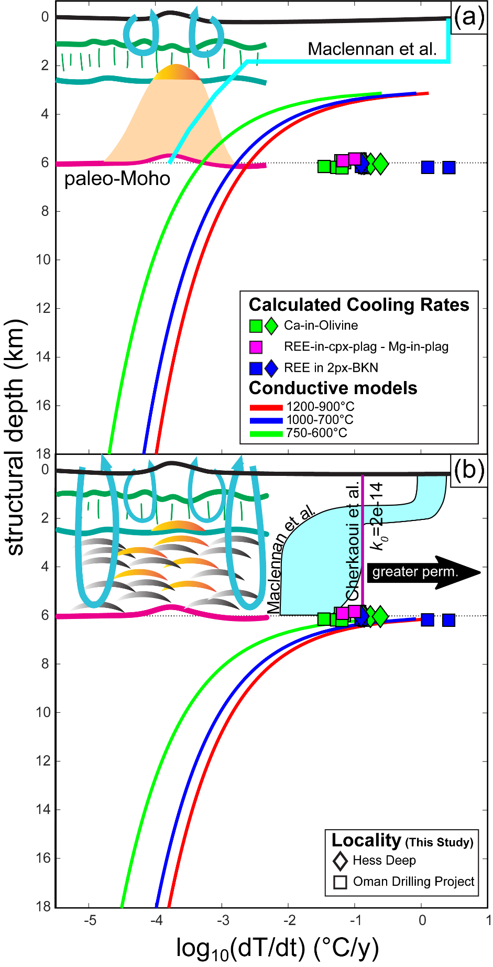

relative pyroxene modes in rocks from this study). Experimental work has demonstrated that within analytical uncertainty, diffusion rates are uniform among REEs in orthopyroxene (Cherniak & Liang, 2007). Dygert & Liang (2015) developed a method to extract rates from T_{REE-in-two-Pyroxene}–T_{BKN} using a modified form of Equation 1 (Ganguly & Tirone, 1999). This method assumes T_{BKN} are effectively modeled using diffusivities for Fe-Mg interdiffusion in diopside (Dimanov & Wiedenbeck, 2006), and provides an average cooling rate through the temperature interval recorded by the two thermometers. The initial or peak temperature the sample cooled from can also be constrained.
Using the aforementioned methods, and assuming an average grain radius for the peridotite samples of 0.5 mm (Figure 1.2; Mevel et al., 1996), we produced a net of cooling-rate dependent closure temperatures overlaid on the T_{BKN} and T_{REE-in-two-Pyroxene} data (Figure 1.8). Samples potentially affected by low pyroxene modes (see Section 5.1.2) are shown in gray, samples with clinopyroxene interpreted to be residual after partial melting and cooling from peak temperatures are shown with colored symbols. Cooling rates scaled to the measured grain sizes are reported in Table 1.3, and range from 0.13 to 2.6 °C/y, from apparent peak or initial temperatures of ~1150 to ~1350°C. Interestingly, the OmanDP samples have similar or lower initial temperatures than the Hess Deep sample. The rates are highly consistent with those determined from T_{Ca-in-Ol}, previous determinations for samples from the oceanic crust and uppermost mantle lithosphere (e.g., Canil et al., 2019; Dygert et al., 2017; Mock et al., 2021; Sun & Lissenberg, 2018a; VanTongeren et al., 2008), and are 2-3 orders of magnitude faster than a scenario where the overlying lower crustal section is cooled conductively. The rates are plotted as blue squares in Figure 1.9.

5.2.3 Rates from REE-in-clinopyroxene-plagioclase temperatures and Mg-in-plagioclase temperatures
Cooling rates for the gabbros were calculated using the coupled T_{Mg-in-Plag} – T_{REE-in-Cpx-Plag} speedometer of Sun & Lissenberg, 2018a, which leverages numerical solutions to a bimineralic formulation of the diffusion equation, in order to determine a cooling rate and initial temperature (assuming spherical geometry). The speedometer takes mineral composition, grain size, and mineral modes into account, and is applicable to average mineral compositions as provided by our dataset. The model of Sun & Lissenberg (2018a) was parameterized using a larger calibration dataset and leverages a more generalized silica activity model than that of Faak et al. (2013; 2014). Additionally, it does not rely on the presence of exchange-related grain-scale concentration gradients which may be absent depending on kinetics, grain size and cooling rate, making it more broadly applicable to oceanic gabbros. We refrain from commenting further on other respective advantages and disadvantages of the Faak et al., (2014) and Sun & Lissenberg, (2018a) speedometers for oceanic gabbros, as they are thoroughly described in the commentary of Faak et al., 2018 and reply of Sun & Lissenberg, 2018b. (However, see Section 5.1.1, for a brief discussion of potential issues associated with determining temperatures and cooling rates from samples with complex open-system geologic histories, which would afflict both speedometers).
Cooling rate inversion diagrams are presented in the electronic supplement (Figure 1.12), and cooling rates (for the OmanDP samples only, see Section 5.1.1) are reported in Table 1.3. Perhaps owing to analytical scatter or the sample’s geologic history, one of the three OmanDP gabbros (5057_5707A_113z_03_036-040) has a T_{REE-in-Cpx-Plag} and T_{Mg-in-Plag} temperature distribution beyond the physically reasonable Dodson limit (cf., Sun & Lissenberg, 2018a); for this sample no rate can be determined. Rates for the other OmanDP gabbros are 0.1 and 0.07 °C/y, consistent with rates determined using the T_{REE-in-two-Pyroxene} – T_{BKN} and T_{Ca-in-Ol}-based methods described in Sections 5.2.1 and 5.2.2. The T_{REE-in-Cpx-Plag} – T_{Mg-in-Plag} rates are plotted as magenta squares in Figure 1.9.

5.3 Implications for cooling and crustal accretion mechanisms
In Figure 1.9, cooling rates obtained from thermometric data are compared to conductive cooling models relevant to Gabbro Glacier and Sheeted Sills scenarios. Only the cooling rate data we interpret as most physically meaningful are compared to the models (see Sections 5.1 and 5.2), however, we note that the apparent rates from samples flagged because of grain scale heterogeneity or minor clinopyroxene mode are consistent with our general observations (Table 1.3). Despite the fact that reliable cooling rates cannot be recovered from Hess Deep gabbros, because their thermal histories must be intimately related to underlying peridotites, the peridotites place important constraints on cooling of the oceanic crust beneath the East Pacific Rise.
Our cooling models assume conductive cooling of the lithosphere into a cold thermal boundary layer and are constructed using a half-space solution to the one-dimensional heat conduction equation (Equation 4-125, Turcotte and Schubert, 2002):
$T=\left(T_{1}-T_{0}\right)×\operatorname{erf}\left(\frac{z}{2\sqrt{κt}}\right)+T_{0}$ (2).
where T₁ is the uniform initial temperature of the lithosphere and T₀ is the temperature at the rock–seawater interface; z is the depth into the conductive profile; t is time; and κ is thermal diffusivity (10⁻⁶ m²/s). Here we assume an initial temperature of 1250°C, close to (but slightly higher than) plagioclase and clinopyroxene cosaturation temperatures for dry MORBs (e.g., Grove & Bryan, 1983; Villiger et al., 2004), and between the REE-based temperatures obtained from the peridotites and gabbros (Table 1.2). Figure 1.9 shows average cooling rates calculated using Equation 2 through temperature intervals relevant to the thermometers applied in this study. In the Gabbro Glacier scenario (Figure 1.9a) and the Sheeted Sills scenario (Figure 1.9b), the lithosphere starts with a uniform initial temperature at all depths but the conductive cooling regime underlying the hydrothermal section of the lithosphere is shallower or deeper depending on the vertical extent of hydrothermal cooling due to sea-water circulation. In a Gabbro Glacier scenario, the extrusive section of the crust is hydrothermally cooled, and the gabbroic section of the crust and underlying peridotites cool conductively (Figure 1.9a). In a Sheeted Sills scenario, the peridotites underlying the crustal section are conductively cooled, and the entire overlying crustal section is hydrothermally cooled.
A Gabbro Glacier scenario would produce a dramatic decrease in cooling rate with depth starting immediately beneath the extrusive section. A Sheeted Sills scenario produces the same rates at greater depth, with cooling above the Moho dominated by convection (Figure 1.9b). For reference, Figure 1.9b also shows a convective cooling model for the entire crust assuming a reference permeability of 2x10⁻¹⁴ (Cherkaoui et al., 2003); higher permeabilities would produce faster cooling rates in the crustal section. Conductive-hydrothermal hybrid models from Maclennan et al., (2005) , based on the model formulation of Maclennan et al., (2004), are also shown in Figure 1.9b, and in Figure 1.9a, their model assuming conductive cooling for a lower thermal diffusivity and thinner extrusive crust than our model is shown.
At a given depth, the measured peridotitic and gabbroic cooling rates are much faster than the predicted cooling rates in the Gabbro Glacier scenario while in a Sheeted Sills scenario, the predicted cooling rates agree with rates from the geochemical data obtained in this study (0.02 - 2.6 °C/y), for temperature intervals relevant to the thermometers. We note these rates are consistent among three independent geospeedometric methods based on five independent thermometers. We conclude that the new geospeedometric results are inconsistent with a Gabbro Glacier-type scenario, and instead support hydrothermal cooling of the entire crustal section beneath the ridge axis for rocks recovered at Hess Deep and Wadi Zeeb, Oman, consistent with a Sheeted Sills scenario for accretion of oceanic crust. The ~1 order of magnitude discrepancy between models of Maclennan et al. (2005) and our results suggests that hydrothermal cooling efficiency exceeded ~80 kW/m throughout the crust at Hess Deep and Wadi Zeeb.

5.4 Comparison with previous thermometric investigations
Our new cooling rates were calculated using methods that rely on closure temperatures determined from averaged mineral compositions (Dodson, 1973; Dygert and Liang, 2015; Sun and Lissenberg, 2018a). Several authors took an alternative approach and applied diffusion models to geochemical profiles obtained from grain-scale electron microprobe traverses, to invert rates from spatial variations (or lack thereof) in concentration (e.g., Coogan et al., 2002; Coogan et al., 2007; Faak and Gillis, 2016; Mock et al., 2021). To facilitate direct comparison with our new results, we recalculated Ca-in-olivine rates using data from Coogan et al., 2002, Coogan et al., 2007, and Faak and Gillis, 2016, using the average-based methods we employed to evaluate our own data. Redetermining rates from Mg-in-plagioclase data was not possible, as the mineral average-based Sun and Lissenberg, 2018a speedometer takes mineral modes and grain size information into consideration, and requires knowledge of coexisting clinopyroxene composition, information that was not reported in the studies of Faak et al., 2015 or Faak and Gillis, 2016. The recalculated Ca-in-olivine rates are similar to, but in some cases, faster than the rates determined in the data sources (Figure 1.13 in Appendix 1), on average, 1.4 and 1.6 log units faster than the published rates (for the data of Coogan et al., 2002, and Faak & Gillis, 2016, respectively).
The recalculated Ca-in-olivine rates, our new results, and previously published cooling rates from mid-ocean ridge type spreading centers (Dygert et al., 2017; Sun and Lissenberg, 2018a; VanTongeren et al., 2008) are compared in Figure 1.10 (data from mid-ocean ridge spreading centers, or ophiolites with mid-ocean ridge tectonic affinity only). Samples from spreading centers with typical 6 km thick crust are shown in (a) (OmanDP crust and mantle, Wadi Tayin, Samail ophiolite crust and mantle sections, and Hess Deep crust and mantle, Dygert et al., 2017; Faak and Gillis, 2016; Sun and Lissenberg, 2018a; VanTongeren et al., 2008), samples from localities with thinner crustal sections are shown in (b) (Wadi Abyad, Samail ophiolite and the Atlantis Bank of the Southwest Indian Ridge (SWIR), Coogan et al., 2002; Coogan et al., 2007). Also shown are conductive and hydrothermal cooling models described in Section 5.3, in a Sheeted Sills scenario in (a) and a Gabbro Glacier scenario in (b) (the corresponding alternative cooling profiles are shown in gray in both panels).
Cooling rates from the three localities represented in (a) are fast and uniform with depth in the crustal section and across the transition zone, and at Wadi Tayin, systematically decrease with depth moving into the mantle section, consistent with hydrothermal cooling of the crust and conductive cooling of the mantle, as in a Sheeted Sills scenario. A similar systematic decrease in cooling rate with increasing depth beneath the paleo-Moho was also observed by Canil et al., 2019, at an ophiolite with probable supra-subduction zone tectonic affinity.
We note that a systematic decrease in cooling rate in Hess Deep and Pito Deep gabbros directly beneath the dike-gabbro transition (i.e., in rocks formed in an axial magma lens, Figure 1.1) was observed by Faak et al. (2015) according to application of Mg-in-plagioclase speedometry (Faak et al., 2014). For reasons mentioned previously we could not recalculate the cooling rates using the Sun and Lissenberg (2018a) speedometer. The gradient in cooling rate observed by Faak et al. (2015) may reflect conductive cooling of the axial magma lens immediately beneath the dikes, while the

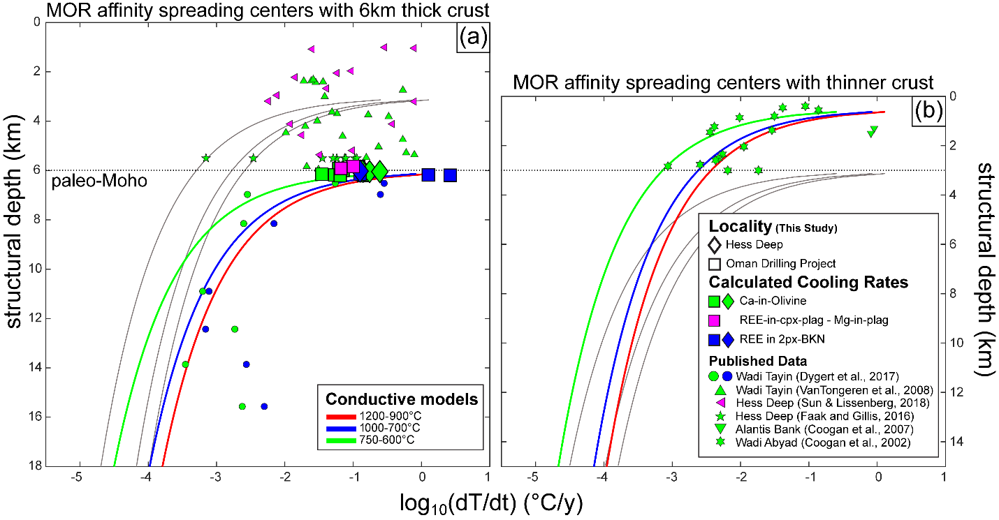
Figure 1.10. Cooling rates from this study (Hess Deep, diamonds, OmanDP, squares) compared to rates gathered from the literature that were calculated using the methods we employed (Dygert et al., 2017; Sun and Lissenberg, 2018a, VanTongeren et al., 2008), or recalculated using those methods (Coogan et al., 2002; Coogan et al., 2007; Faak and Gillis, 2016) (smaller symbols), plotted against structural depth. Symbol color corresponds to speedometric method (see legend). Conductive cooling models are also shown (see Section 5.3 and caption to Figure 1.9 for details). All samples originate from oceanic spreading centers or ophiolites with mid-ocean ridge tectonic affinity. Samples from localities with “normal” 6km thick crust are shown in (a), samples with thinner crust are shown in (b). Data from Faak and Gillis (2016) and the Atlantis Bank (Coogan et al., 2007) are placed at an arbitrary depth in the lower crustal section. The observations support hydrothermal cooling of oceanic lower crust at Hess Deep, Wadi Zeeb (OmanDP), Wadi Tayin, and the SWIR (Atlantis Bank). Samples from Wadi Abyad (Coogan et al., 2002) support conductive cooling of the lower oceanic crust. The gray lines in the background correspond to thermal scenarios lacking convective cooling beneath the extrusive section in (a) and with convective cooling extending to the crust-mantle boundary in (b).

underlying gabbros were cooled hydrothermally by a fracture network that drew in cold seawater from off axis (Figure 1.1b, also see cartoons in Garrido et al., 2001 and Sun and Lissenberg, 2018a).
In Figure 1.10b, data from Wadi Abyad data are shown, which exhibit a continuous and systematic decrease in cooling rate with depth. These data are well matched by models that assume conductive cooling of the entire lower oceanic crust, as in a Gabbro Glacier scenario. The two data points from the SWIR (placed at an arbitrary depth within the lower crust) are in better agreement with hydrothermal cooling throughout the SWIR lower crustal section.
Cooling rates from four of the five localities (including our new Hess Deep and OmanDP data) are consistent with hydrothermal cooling of the oceanic lower crust. In contrast, the results from Wadi Abyad demonstrate that at least in some places, oceanic lower crust is cooled conductively. This observation implies that controls on hydrothermal vs. conductive cooling (and by implication, crustal accretion mechanisms) could be related to crustal thickness, melt productivity, spreading rate, and/or location along a ridge segment. Cooling rate constraints from other spreading centers are needed to further characterize global variability in lithospheric cooling rates, and to elucidate geologic controls on cooling mechanisms. These constraints would promote a deeper understanding of the conditions under which interactions between the oceans and Solid Earth occur, and the implications for global geochemical cycling across a major interface between the oceans and Earth’s interior.

6. Summary and Conclusions
We analyzed three gabbros and four harzburgites from IODP Expedition 345 and ODP Leg 147 to Hess Deep, and three gabbros, one troctolite and four harzburgites from ICDP Expedition 5057, the Oman Drilling Project (OmanDP), from Wadi Zeeb in the southern Samail ophiolite. After consideration of textural information and grain-scale elemental variations (which are prevalent in Hess Deep gabbros but minor or absent in other samples), we applied thermometers to the gabbros and peridotites using sample averaged compositions. Gabbros were investigated using thermometers based on exchange of REEs (T_{REE-in-Cpx-Plag}, Sun & Liang, 2017) and Mg (T_{Mg-in-Plag}, Sun & Lissenberg, 2018a) between coexisting clinopyroxene and plagioclase, and Ca between olivine and clinopyroxene (T_{Ca-in-Ol}). For individual thermometers temperatures were similar between the two localities, and in all cases T_{Ca-in-Ol} < T_{Mg-in-Plag} < T_{REE-in-Cpx-Plag} (T_{Ca-in-Ol} are 885-893°C, T_{Mg-in-Plag} are 963-1071°C; T_{REE-in-Cpx-Plag} are 1185-1269°C). Peridotites were investigated using thermometers based on exchange of REEs between two pyroxenes (T_{REE-in-two-Pyroxene}; Liang et al., 2013), exchange of the diopside component around the two-pyroxene solvus (T_{BKN}; Brey & Köhler, 1990), and exchange of Ca for Fe and Mg between olivine and coexisting clinopyroxene (T_{Ca-in-Ol}; Köhler & Brey, 1990). Again, for each thermometer, the temperatures are comparable between the two localities, and T_{Ca-in-Ol} ≲ T_{BKN} < T_{REE-in-two-Pyroxene} (T_{Ca-in-Ol} are 957-1038°C; T_{BKN} are 1001-1141°C; T_{REE-in-two-Pyroxene} are 1140-1403°C). The magmatic or near-magmatic REE-based thermometer temperatures are interpreted to reflect near-peak temperatures owing to the slow diffusive exchange of trivalent REEs between coexisting phases during cooling, while the lower temperatures recorded by thermometers based on divalent major elements reflect the relatively fast exchange of those elements under subsolidus conditions.
We applied three independent speedometers to the new temperature data. Cooling rates are fast (~0.01 to several °C/y) and consistent among all the Hess Deep and OmanDP samples. A coupled two-pyroxene solvus – REE-in-two-pyroxene speedometer (Dygert & Liang, 2015) recovers rates of 0.1-2.6 °C/y from peak or near-peak temperatures in mantle harzburgites. Application of the Dodson (1973) closure temperature model to T_{Ca-in-Ol} from the peridotites recovers cooling rates of 0.03-0.81 °C/y, and 0.06-0.12 °C/y from OmanDP gabbros in the crustal section. A coupled Mg-in plagioclase – REE-in-clinopyroxene-plagioclase speedometer (Sun & Lissenberg, 2018a) recovers rates of 0.07 and 0.1 °C/y from gabbros in the OmanDP crustal section. The similar, fast cooling rates recorded by samples from across the crust-mantle transition zone at the two localities provide insights into the mode of lower crustal accretion beneath fast-spreading mid-ocean ridges, and a window into the thermal histories of an ophiolitic paleo-ridge environment (the Samail ophiolite) and modern mid-ocean ridge environments (Hess Deep). The consistent thermal histories suggest shared processes of lithosphere formation. The cooling rates were compared to convective and conductive cooling models expected in Gabbro Glacier and Sheeted Sills scenarios for crustal accretion, which invoke shallower and deeper convective (hydrothermal) cooling regimes, respectively. Fast cooling (~0.01 to several °C/y) from magmatic or near-magmatic temperatures at the crust-mantle boundary suggests a network of deeply circulating ocean water extended from the seafloor to the crust-mantle boundary beneath the spreading centers, as expected in a Sheeted Sills-type scenario.
We compared the new cooling rates to those recalculated from previously published data using self-consistent methods, which enables direct comparison among studies. Oceanic lithosphere from four of five localities exhibits cooling rates consistent with hydrothermal cooling of the oceanic lower crust from peak or near-peak temperatures, while one locality is consistent with conductive cooling of the lower crust. We conclude that cooling and crustal accretion mechanisms differ among ridges or locations along ridge segments. New constraints from other spreading centers are needed to further characterize the variability in lithospheric cooling rates, to elucidate geologic controls on cooling mechanisms, and to realize the implications for geochemical cycling between the oceans and Solid Earth.

7. Acknowledgments, Samples, and Data
This work was partly supported by awards to BB from the University of Tennessee NASA Space Grant Consortium, an Alexander Von Humboldt Stiftung to MMJ, and a Postdoctoral Fellowship to ND by the University of Texas at Austin. The authors acknowledge the assistance of Allan Patchen and Nathaniel Miller in collecting major and trace element data. This work would not have been possible without the support and encouragement of the Oman Drilling Project Phase 2 core description party. Measured compositions used to calculate temperatures and replicate analyses of reference material BCR-2G are archived in a Mendeley Data repository at https://dx.doi.org/10.17632/7rbj8x89th.1.

References
Akizawa, N., Arai, S., & Tamura, A. (2012). Behavior of MORB magmas at uppermost mantle beneath a fast-spreading axis: An example from Wadi Fizh of the northern Oman ophiolite. Contributions to Mineralogy and Petrology, 164(4), 601–625. https://doi.org/10.1007/s00410-012-0762-4
Akizawa, N., Tamura, A., Fukushi, K., Yamamoto, J., Mizukami, T., Python, M., & Arai, S. (2016). High-temperature hydrothermal activities around suboceanic Moho: An example from diopsidite and anorthosite in Wadi Fizh, Oman ophiolite. Lithos, 263, 66–87. https://doi.org/10.1016/j.lithos.2016.07.012
Arai, S. (1987). An estimation of the least depleted spinel peridotite on the basis of olivine-spinel mantle array. Neues Jahrbuch Fur Mineralogie, Monatshefte, (January 1987), 347–354.
Boudier, F., & Coleman, R. G. (1981). Cross section through the peridotite in the Samail Ophiolite, southeastern Oman Mountains. Journal of Geophysical Research: Solid Earth, 86(B4), 2573–2592. https://doi.org/10.1029/JB086iB04p02573
Braun, M. G. (2004). Petrologic and microstructural constraints on focused melt transport in dunites and the rheology of the shallow mantle. Massachusetts Institute of Technology and the Woods Hole Oceanographic Institution. Retrieved from http://hdl.handle.net/1721.1/29538
Brey, G. P., & Köhler, T. P. (1990). Geothermobarometry in Four-phase Lherzolites II . New Thermobarometers , and Practical Assessment of Existing Thermobarometers. Journal of Petrology, 31(6), 1353–1378. https://doi.org/https://doi.org/10.1093/petrology/31.6.1353
Canil, D., Grundy, R., & Johnston, S. T. (2019). Thermal history of the Donjek harzburgite massif in ophiolite from Yukon, Canada with implications for the cooling of oceanic mantle lithosphere. Lithos, 328–329, 33–42. https://doi.org/10.1016/j.lithos.2019.01.001
Cannat, M., Cann, J., & Maclennan, J. (2004). Some hard rock constraints on the supply of heat to mid-ocean ridges. Geophysical Monograph Series, 148, 111–149. https://doi.org/10.1029/148GM05
Chen, Y. J. (1992). Oceanic crustal thickness versus spreading rate. Geophysical Research Letters, 19(8), 753–756. https://doi.org/10.1029/92GL00161
Cherkaoui, A. S. M., Wilcock, W. S. D., Dunn, R. A., & Toomey, D. R. (2003). A numerical model of hydrothermal cooling and crustal accretion at a fast spreading mid-ocean ridge. Geochemistry, Geophysics, Geosystems, 4(9). https://doi.org/10.1029/2001GC000215
Cherniak, D. J., & Liang, Y. (2007). Rare earth element diffusion in natural enstatite. Geochimica et Cosmochimica Acta, 71(5), 1324–1340. https://doi.org/10.1016/j.gca.2006.12.001
Coogan, L. A., Jenkin, G. R. T., & Wilson, R. N. (2002). Constraining the cooling rate of the lower oceanic crust: A new approach applied to the Oman ophiolite. Earth and Planetary Science Letters, 199(1–2), 127–146. https://doi.org/10.1016/S0012-821X(02)00554-X
Coogan, L. A., Hain, A., Stahl, S., & Chakraborty, S. (2005). Experimental determination of the diffusion coefficient for calcium in olivine between 900°C and 1500°C. Geochimica et Cosmochimica Acta, 69(14), 3683–3694. https://doi.org/10.1016/j.gca.2005.03.002
Coogan, L. A., Jenkin, G. R. T., & Wilson, R. N. (2007). Contrasting cooling rates in the lower oceanic crust at fast- and slow-spreading ridges revealed by geospeedometry. Journal of Petrology, 48(11), 2211–2231. https://doi.org/10.1093/petrology/egm057
Detrick, R. S., Buhl P, Vera E, Mutter J, Orcutt J, Madsen J, & Brocher T. (1987). Multi-channel seismic imaging of a crustal magma chamber along the East Pacific Rise. Nature, 326(5), 35–41.
Detrick, R. S., Harding, A. J., Kent, G. M., Orcutt, J. A., Mutter, J. C., & Buhl, P. (1993). Seismic Structure of the Southern East Pacific Rise, 259(5094), 499–503.
Dewey, J. F., & Kidd, W. S. F. (1977). Geometry of plate accretion. Bulletin of the Geological Society of America, 88(7), 960–968. https://doi.org/10.1130/0016-7606(1977)88<960:GOPA>2.0.CO;2
Dick, H. J. B., & Bullen, T. (1984). Chromian spinel as a petrogenetic indicator in abyssal and alpine-type peridotites and spatially associated lavas. Contributions to Mineralogy and Petrology, 86(1), 54–76. https://doi.org/10.1007/BF00373711
Dick, H. J. B., Lin, J., & Schouten, H. (2003). An ultraslow-spreading class of ocean ridge. Nature, 426, 405–412.
Dimanov, A., & Wiedenbeck, M. (2006). (Fe,Mn)-Mg interdiffusion in natural diopside: effect of pO2. European Journal of Mineralogy, 18(6), 705–718. https://doi.org/10.1127/0935-1221/2006/0018-0705
Dodson, M. H. (1973). Closure temperature in cooling geochronological and petrological systems. Contributions to Mineralogy and Petrology, 40(3), 259–274.
Donovan, J. J., Kremser, D., Fournelle, J., & Karsten, G. (2016). Probe for EPMA User’s Guide and Reference. Probe Software, Inc.
Dunn, R. A., & Toomey, D. R. (2000). Three-dimensional seismic structure and physical properties of the crust and shallow mantle beneath the East Pacific Rise at 9°30’N. Journal of Geophysical Research, 105, 23537–23555. https://doi.org/10.1029/2000JB900210
Dygert, N., & Liang, Y. (2015). Temperatures and cooling rates recorded in REE in coexisting pyroxenes in ophiolitic and abyssal peridotites. Earth and Planetary Science Letters, 420, 151–161. https://doi.org/10.1016/j.epsl.2015.02.042
Dygert, N., Liang, Y., & Kelemen, P. B. (2016). Formation of plagioclase lherzolite and associated dunite-harzburgite-lherzolite sequences by multiple episodes of melt percolation and melt-rock reaction: An example from the trinity ophiolite, California, USA. Journal of Petrology, 57(4), 815–838. https://doi.org/10.1093/petrology/egw018
Dygert, N., Kelemen, P. B., & Liang, Y. (2017). Spatial variations in cooling rate in the mantle section of the Samail ophiolite in Oman: Implications for formation of lithosphere at mid-ocean ridges. Earth and Planetary Science Letters, 465, 134–144. https://doi.org/10.1016/j.epsl.2017.02.038
Faak, K., & Gillis, K. M. (2016). Slow cooling of the lowermost oceanic crust at the fast-spreading East Pacific Rise. Geology, 44(2), 115–118. https://doi.org/10.1130/G37353.1
Faak, K., Chakraborty, S., & Coogan, L. A. (2013). Mg in plagioclase: Experimental calibration of a new geothermometer and diffusion coefficients. Geochimica et Cosmochimica Acta, 123, 195–217. https://doi.org/10.1016/j.gca.2013.05.009
Faak, K., Coogan, L. A., & Chakraborty, S. (2014). A new Mg-in-plagioclase geospeedometer for the determination of cooling rates of mafic rocks. Geochimica et Cosmochimica Acta, 140, 691–707. https://doi.org/10.1016/j.gca.2014.06.005
Faak, K., Coogan, L. A., & Chakraborty, S. (2015). Near conductive cooling rates in the upper-plutonic section of crust formed at the East Pacific Rise. Earth and Planetary Science Letters, 423, 36–47. https://doi.org/10.1016/j.epsl.2015.04.025
Faak, K., Chakraborty, S., Coogan, L. A., & Dohmen, R. (2018). Comment on ‘Formation of fast-spreading lower oceanic crust as revealed by a new Mg–REE coupled geospeedometer’ by Sun and Lissenberg. Earth and Planetary Science Letters, 502, 284–286. https://doi.org/10.1016/j.epsl.2018.08.036
Fabriès, J. (1979). Spinel-olivine geothermometry in peridotites from ultramafic complexes. Contributions to Mineralogy and Petrology, 69(4), 329–336. https://doi.org/10.1007/BF00372258
Ganguly, J., & Tirone, M. (1999). Diffusion closure temperature and age of a mineral with arbitrary extent of diffusion: Theoretical formulation and applications. Earth and Planetary Science Letters, 170(1–2), 131–140. https://doi.org/10.1016/S0012-821X(99)00089-8
Garrido, C. J., Kelemen, P. B., & Hirth, G. (2001). Variation of cooling rate with depth in lower crust formed at an oceanic spreading ridge: Plagioclase crystal size distributions in gabbros from the Oman ophiolite. Geochemistry, Geophysics, Geosystems, 2(10). https://doi.org/10.1029/2000GC000136
Gillis, K. M., Snow, J. E., Klaus, A., Guerin, G., Abe, N., Akizawa, N., et al. (2014). Expedition 345 summary, 345. https://doi.org/10.2204/iodp.proc.345.101.2014
Gillis, K. M., Snow, J. E., Klaus, A., Abe, N., Adrião, Á. B., Akizawa, N., et al. (2014). Primitive layered gabbros from fast-spreading lower oceanic crust. Nature, 505(7482), 204–207. https://doi.org/10.1038/nature12778
Girardeau, J., & Francheteau, J. (1993). Plagioclase-wehrlites and peridotites on the East Pacific Rise (Hess Deep) and the Mid-Atlantic Ridge (DSDP Site 334): evidence for magma percolation in the oceanic upper mantle. Earth and Planetary Science Letters, 115(1–4), 137–149. https://doi.org/10.1016/0012-821X(93)90218-X
Godard, M., Jousselin, D., & Bodinier, J. L. (2000). Relationships between geochemistry and structure beneath a palaeo-spreading centre: A study of the mantle section in the Oman ophiolite. Earth and Planetary Science Letters, 180(1–2), 133–148. https://doi.org/10.1016/S0012-821X(00)00149-7
Gregory, R. T., & Taylor, H. P. (1981). An oxygen isotope profile in a section of Cretaceous oceanic crust, Samail Ophiolite, Oman: Evidence for δ ¹⁸ O buffering of the oceans by deep (&gt;5 km) seawater-hydrothermal circulation at mid-ocean ridges. Journal of Geophysical Research: Solid Earth, 86(B4), 2737–2755. https://doi.org/10.1029/JB086iB04p02737
Grove, T. L., & Bryan, W. B. (1983). Fractionation of pyroxene-phyric MORB at low pressure: An experimental study. Contributions to Mineralogy and Petrology, 84(4), 293–309. https://doi.org/10.1007/BF01160283
Hanghøj, K., Kelemen, P. B., Hassler, D., & Godard, M. (2010). Composition and genesis of depleted mantle peridotites from the Wadi Tayin massif, Oman ophiolite; Major and trace element geochemistry, and Os isotope and PGE systematics. Journal of Petrology, 51(1–2), 201–227. https://doi.org/10.1093/petrology/egp077
Hekinian, R., Bideau, D., Francheteau, J., Cheminee, J. L., Armijo, R., Lonsdale, P., & Blum, N. (1993). Petrology of the East Pacific Rise Crust and Upper Mantle Exposed in Hess Deep ( Eastern Equatorial Pacific ) were zone 85øW a volcanically starved segment of the Cocos-Nazca ridge in the Hess Deep Upper levels and Kashintsev , Fe-oxyhydroxide, 98(92), 8069–8094.
Henstock, T. J., Woods, A. W., & White, R. S. (1993). The accretion of oceanic crust by episodic sill intrusion. Journal of Geophysical Research, 98(B3), 4143–4161. https://doi.org/10.1029/92JB02661
Hesse, K. T., Gose, J., Stalder, R., & Schmädicke, E. (2015). Water in orthopyroxene from abyssal spinel peridotites of the East Pacific Rise (ODP Leg 147: Hess Deep). Lithos, 232, 23–34. https://doi.org/10.1016/j.lithos.2015.06.011
Jochum, K. P., Nohl, U., Herwig, K., Lammel, E., Stoll, B., & Hofmann, A. W. (2005). GeoReM: A new geochemical database for reference materials and isotopic standards. Geostandards and Geoanalytical Research, 29(3), 333–338. https://doi.org/10.1111/j.1751-908x.2005.tb00904.x
Johnson, K. T. M., Dick, H. J. B., & Shimizu, N. (1990). Melting in the Oceanic Upper Mantle’ An Ion Microprobe Study of Diopsides in Abyssal Peridotites. Journal of Geophysical Research, 95(10), 2661–2678. https://doi.org/10.1029/JB095iB03p02661
Jurewicz, A. J. G., & Watson, E. B. (1988). Cations in olivine, Part 2: Diffusion in olivine xenocrysts, with applications to petrology and mineral physics. Contributions to Mineralogy and Petrology, 99(2), 186–201. https://doi.org/10.1007/BF00371460
Karson, J. A., Klein, E. M., Hurst, S. D., Lee, C. E., Rivizzigno, P. A., Curewitz, D., et al. (2002). Structure of uppermost fast-spread oceanic crust exposed at the Hess Deep Rift: Implications for subaxial processes at the East Pacific Rise. Geochemistry, Geophysics, Geosystems, 3(1), n/a-n/a. https://doi.org/10.1029/2001GC000155
Kelemen, Peter B., Shimizu, N., & Salters, V. J. M. (1995). Extraction of mid-ocean-ridge basalt from the upwelling mantle by focused flow of melt in dunite channels. Nature. https://doi.org/10.1038/375747a0
Kelemen, Peter B., Hirth, G., Shimizu, N., Spiegelman, M., & Dick, H. J. B. (1997a). A review of melt migration processes in the adiabatically upwelling mantle beneath oceanic spreading ridges. Philosophical Transactions of the Royal Society of London. Series A: Mathematical, Physical and Engineering Sciences, 355(1723), 283–318. https://doi.org/10.1098/rsta.1997.0010
Kelemen, Peter B., Koga, K., & Shimizu, N. (1997b). Geochemistry of gabbro sills in the crust-mantle transition zone of the Oman ophiolite: implications for the origin of the oceanic lower crust. Earth and Planetary Science Letters, 146(3–4), 475–488. https://doi.org/10.1016/S0012-821X(96)00235-X
Kelemen, Peter B., Matter, J. M., Teagle, D. A. H., Coggon, J. A., & Team, T. O. D. P. S. (2021a). Site CM1: layered gabbros, crustal ultramafic rocks, and mantle harzburgite. In P.B. Kelemen, J. M. Matter, D. A. H. Teagle, & J. A. Coggon (Eds.). College Station, TX: International Ocean Discovery Program. https://doi.org/10.14379/OmanDP.proc.2020
Kelemen, Peter B., Matter, J. M., Teagle, D. A. H., Coggon, J. A., & Team, T. O. D. P. S. (2021b). Site CM2: Crust–Mantle Transition Zone and into upper mantle. In P.B. Kelemen, J. M. Matter, D. A. H. Teagle, & J. A. Coggon (Eds.). College Station, TX: International Ocean Discovery Program. https://doi.org/10.14379/OmanDP.proc.2020
Klein, E. M., Smith, D. K., Williams, C. M., & Schouten, H. (2005). Counter-rotating microplates at the Galpagos triple junction. Nature, 433(1986), 855–858.
Köhler, T. P., & Brey, G. P. (1990). Calcium exchange between olivine and clinopyroxene calibrated as a geothermobarometer for natural peridotites from 2 to 60 kb with applications. Geochimica et Cosmochimica Acta, 54(9), 2375–2388. https://doi.org/10.1016/0016-7037(90)90226-B
Korenaga, J., & Kelemen, P. B. (1997). Origin of gabbro sills in the Moho transition zone of the Oman ophiolite: Implications for magma transport in the oceanic lower crust. Journal of Geophysical Research: Solid Earth, 102(B12), 27729–27749. https://doi.org/10.1029/97jb02604
Liang, Y. (2015). A simple model for closure temperature of a trace element in cooling bi-mineralic systems. Geochimica et Cosmochimica Acta, 165, 35–43. https://doi.org/10.1016/j.gca.2015.05.028
Liang, Y., Sun, C., & Yao, L. (2013). A REE-in-two-pyroxene thermometer for mafic and ultramafic rocks. Geochimica et Cosmochimica Acta, 102, 246–260. https://doi.org/10.1016/j.gca.2012.10.035
Lissenberg, C. J., & MacLeod, C. J. (2016). A reactive porous flow control on mid-ocean ridge magmatic evolution. Journal of Petrology, 57(11–12), 2195–2220. https://doi.org/10.1093/petrology/egw074
Lissenberg, C. J., MacLeod, C. J., Howard, K. A., & Godard, M. (2013). Pervasive reactive melt migration through fast-spreading lower oceanic crust (Hess Deep, equatorial Pacific Ocean). Earth and Planetary Science Letters, 361, 436–447. https://doi.org/10.1016/j.epsl.2012.11.012
Lonsdale, P. (1988). Structural Pattern of the Galapagos Microplate and Evolution of the galapagos Triple Junction. Journal of Geophysical Research, 93(B11), 13551–13574. https://doi.org/10.1029/JB093iB11p13551
Lonsdale, P., Blum, N., & Puchelt, H. (1992). The RRR triple junction at the southern end of the Pacific-Cocos East Pacific Rise, 109, 73–85.
Maclennan, J., Hulme, T., & Singh, S. C. (2004). Thermal models of oceanic crustal accretion: Linking geophysical, geological and petrological observations. Geochemistry, Geophysics, Geosystems, 5(2). https://doi.org/10.1029/2003GC000605
Maclennan, John, Hulme, T., & Singh, S. C. (2005). Cooling of the lower oceanic crust. Geology, 33(5), 357–360. https://doi.org/10.1130/G21207.1
MacLeod, C. J., Johan Lissenberg, C., & Bibby, L. E. (2013). “Moist MORB” axial magmatism in the Oman ophiolite: The evidence against a mid-ocean ridge origin. Geology, 41(4), 459–462. https://doi.org/10.1130/G33904.1
Mevel, C., Gillis, K. M., Allan, J. F., & Meyer, P. S. (Eds.). (1996). Proceedings of the Ocean Drilling Program, 147 Scientific Results, 147. https://doi.org/10.2973/odp.proc.sr.147.1996
Mock, D., Neave, D. A., Müller, S., Garbe-Schönberg, D., Namur, O., Ildefonse, B., & Koepke, J. (2021). Formation of Igneous Layering in the Lower Oceanic Crust From the Samail Ophiolite, Sultanate of Oman. Journal of Geophysical Research: Solid Earth, 126(1). https://doi.org/10.1029/2020JB019573
Natland, J. H., & Dick, H. J. B. (2009). Paired melt lenses at the East Pacific Rise and the pattern of melt flow through the gabbroic layer at a fast-spreading ridge. Lithos, 112(1–2), 73–86. https://doi.org/10.1016/j.lithos.2009.06.017
Navon, O., & Stolper, E. (1987). Geochemical Consequences of Melt Percolation: The Upper Mantle as a Chromatographic Column. The Journal of Geology, 95(3), 285–307. https://doi.org/10.1086/629131
Nicolas, A. (1989). Structures of Ophiolites and Dynamics of Oceanic Lithosphere (Vol. 4). Dordrecht: Springer Netherlands. https://doi.org/10.1007/978-94-009-2374-4
Nicolas, A., & Boudier, F. (2015). Structural contribution from the Oman ophiolite to processes of crustal accretion at the East Pacific Rise. Terra Nova, 27(2), 77–96. https://doi.org/10.1111/ter.12137
Nicolas, A., Reuber, I., & Benn, K. (1988). A new magma chamber model based on structural studies in the Oman ophiolite. Tectonophysics, 151(1–4), 87–105. https://doi.org/10.1016/0040-1951(88)90242-9
Nielsen, R. L., Sours-Page, R. E., & Harpp, K. S. (2000). Role of a Cl-bearing flux in the origin of depleted ocean floor magmas. Geochemistry, Geophysics, Geosystems, 1(5). https://doi.org/10.1029/1999gc000017
Pallister, J. S., & Hopson, C. A. (1981). Samail ophiolite plutonic suite: field relations, phase variation, cryptic variation and layering, and a model of a spreading ridge magma chamber. Journal of Geophysical Research, 86(B4), 2593–2644. https://doi.org/10.1029/JB086iB04p02593
Pallister, J. S., & Knight, R. J. (1981). Rare-earth element geochemistry of the Samail Ophiolite near Ibra, Oman. Journal of Geophysical Research: Solid Earth, 86(B4), 2673–2697. https://doi.org/10.1029/JB086iB04p02673
Pearce, J. A., Alabaster, T., Shelton, A. W., & Searle, M. P. (1981). The Oman ophiolite as a Cretaceous arc-basin complex: evidence and implications. Philosophical Transactions of the Royal Society of London. Series A, Mathematical and Physical Sciences, 300(1454), 299–317. https://doi.org/10.1098/rsta.1981.0066
Phipps Morgan, J., & Chen, Y. J. (1993). The genesis of oceanic crust: Magma injection, hydrothermal circulation, and crustal flow. Journal of Geophysical Research: Solid Earth, 98(B4), 6283–6297. https://doi.org/10.1029/92JB02650
Pirard, C., Hermann, J., & O’neill, H. S. C. (2013). Petrology and geochemistry of the crust-mantle boundary in a Nascent Arc, Massif du Sud Ophiolite, New Caledonia, SW Pacific. Journal of Petrology, 54(9), 1759–1792. https://doi.org/10.1093/petrology/egt030
Purdy, G. M., Kong, L. S. L., Christeson, G. L., & Solomon, S. C. (1992). Relationship between spreading rate and the seismic structure of mid-ocean ridges. Nature, 355(6363), 815–817. https://doi.org/10.1038/355815a0
Putirka, K. (1997). Magma transport at Hawaii: Inferences based on igneous thermobarometry. Geology, 25(1), 69–72. https://doi.org/10.1130/0091-7613(1997)025<0069:MTAHIB>2.3.CO;2
Python, M., & Ceuleneer, G. (2003). Nature and distribution of dykes and related melt migration structures in the mantle section of the Oman ophiolite. Geochemistry, Geophysics, Geosystems, 4(7), 1–34. https://doi.org/10.1029/2002GC000354
Quick, J. E., & Denlinger, R. P. (1993). Ductile deformation and the origin of layered gabbro in ophiolites. Journal of Geophysical Research: Solid Earth, 98(B8), 14015–14027. https://doi.org/10.1029/93jb00698
Rioux, M., Garber, J., Bauer, A., Bowring, S., Searle, M., Kelemen, P. B., & Hacker, B. (2016). Synchronous formation of the metamorphic sole and igneous crust of the Semail ophiolite: New constraints on the tectonic evolution during ophiolite formation from high-precision U–Pb zircon geochronology. Earth and Planetary Science Letters, 451, 185–195. https://doi.org/10.1016/j.epsl.2016.06.051
Sinton, J. M., & Detrick, R. S. (1992). Mid-ocean ridge magma chambers. Journal of Geophysical Research, 97(B1), 197–216. https://doi.org/10.1029/91JB02508
Sleep, N. H. (1975). Formation of oceanic crust: Some thermal constraints. Journal of Geophysical Research, 80(29), 4037–4042. https://doi.org/10.1029/JB080i029p04037
Smewing, J. D. (1981). Mixing characteristics and compositional differences in mantle-derived melts beneath spreading axes: Evidence from cyclically layered rocks in the ophiolite of North Oman. Journal of Geophysical Research: Solid Earth, 86(B4), 2645–2659. https://doi.org/10.1029/jb086ib04p02645
Sparks, J. (2011). LasyBoy. Boston University, U.S.A.
Sun, C., & Liang, Y. (2017). A REE-in-plagioclase–clinopyroxene thermometer for crustal rocks. Contributions to Mineralogy and Petrology, 172(4), 1–20. https://doi.org/10.1007/s00410-016-1326-9
Sun, C., & Lissenberg, C. J. (2018a). Formation of fast-spreading lower oceanic crust as revealed by a new Mg–REE coupled geospeedometer. Earth and Planetary Science Letters, 487, 165–178. https://doi.org/10.1016/j.epsl.2018.01.032
Sun, C., & Lissenberg, C. J. (2018b). Caveats and challenges in geospeedometry: A reply to Faak et al.’s critique of the Mg–REE coupled geospeedometry. Earth and Planetary Science Letters, 502, 287–290. https://doi.org/10.1016/j.epsl.2018.08.044
Takazawa, E., Frey, F., Shimizu, N., & Obata, M. (1996). Evolution of the Horoman Peridotite (Hokkaido, Japan): Implications from pyroxene compositions. Chemical Geology, 134(1–3), 3–26. https://doi.org/10.1016/S0009-2541(96)00083-6
Turcotte, D. L., & Schubert, G. (2002). Geodynamics - 2nd edition. https://doi.org/10.2277/0521661862
VanTongeren, J. A., Kelemen, P. B., & Hanghøj, K. (2008). Cooling rates in the lower crust of the Oman ophiolite: Ca in olivine, revisited. Earth and Planetary Science Letters, 267(1–2), 69–82. https://doi.org/10.1016/j.epsl.2007.11.034
VanTongeren, J. A., Hirth, G., & Kelemen, P. B. (2015). Constraints on the accretion of the gabbroic lower oceanic crust from plagioclase lattice preferred orientation in the Samail ophiolite. Earth and Planetary Science Letters, 427, 249–261. https://doi.org/10.1016/j.epsl.2015.07.001
Villiger, S., Ulmer, P., Müntener, O., & Thompson, A. B. (2004). The liquid line of descent of anhydrous, mantle-derived, tholeiitic liquids by fractional and equilibrium crystallization - An experimental study at 1·0 GPa. Journal of Petrology, 45(12), 2369–2388. https://doi.org/10.1093/petrology/egh042
Warren, J. M. (2016). Global variations in abyssal peridotite compositions. Lithos, 248–251, 193–219. https://doi.org/10.1016/j.lithos.2015.12.023
Wells, P. R. A. (1977). Pyroxene thermometry in simple and complex systems. Contributions to Mineralogy and Petrology, 62(2), 129–139. https://doi.org/10.1007/BF00372872
Witt-Eickschen, G., & Seck, H. A. (1991). Solubility of Ca and Al in orthopyroxene from spinel peridotite: an improved version of an empirical geothermometer. Contributions to Mineralogy and Petrology, 106(4), 431–439. https://doi.org/10.1007/BF00321986
Yao, L., & Liang, Y. (2015). Closure temperature in cooling bi-mineralic systems: I. Definition and with application to REE-in-two-pyroxene thermometer. Geochimica et Cosmochimica Acta, 162, 137–150. https://doi.org/10.1016/j.gca.2015.03.041

Appendix

Appendix 1. Supplemental Figures
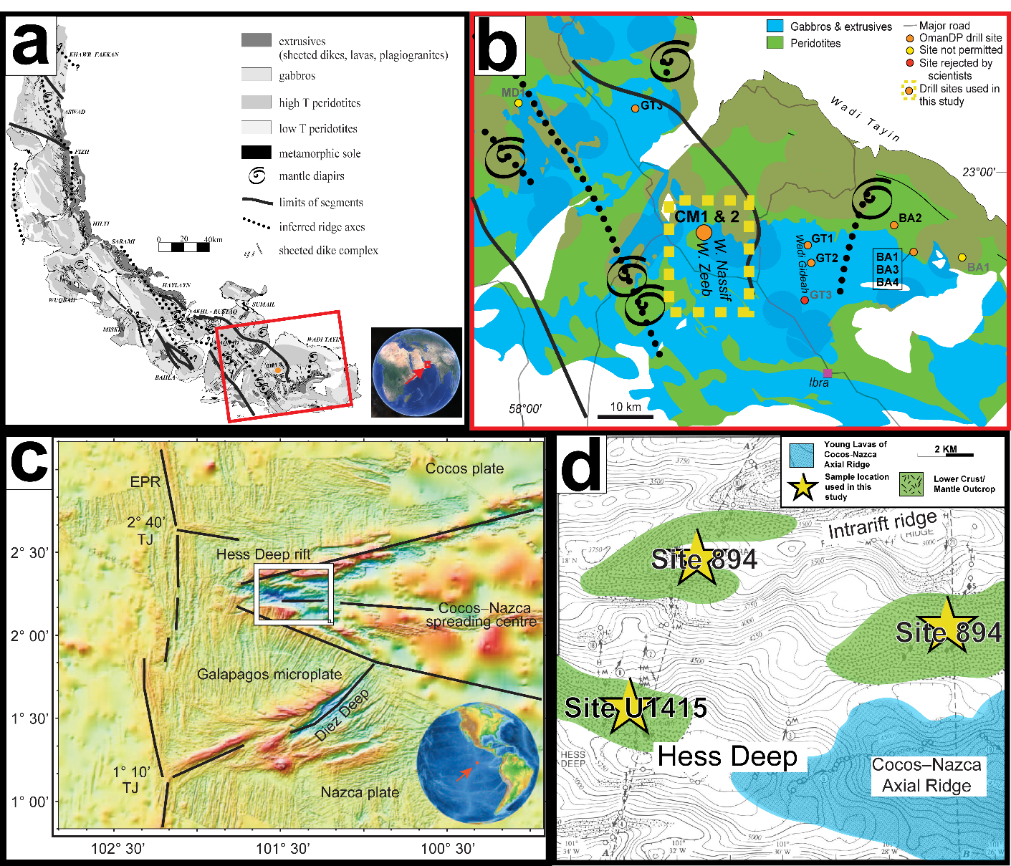

Figure 1.11. Sampling locations for new Oman Drilling Project and Hess Deep samples used in this study. (a) Geologic units and ridge-related structures across the Oman and United Arab Emirates ophiolitic suite with the area shown in (b) highlighted with a red box (modified from Nicolas et al., (2000)). (b) Shows geologic units and sample sites from the Oman Drilling Project with drill site locations analyzed in this study highlighted by a dashed line yellow box (modified from Kelemen et al., (2020). (c) Map of the regional location of Hess Deep in the Eastern Pacific and the spreading center geometry modified from Faak & Gillis, (2016). The central white box highlights the area shown in panel (d). Panel (d) shows a simplified geologic map of Hess Deep with major features and sampling locations labeled (modified from MacLeod et al., (1996)). Sites used in this study are represented by yellow five-point stars.
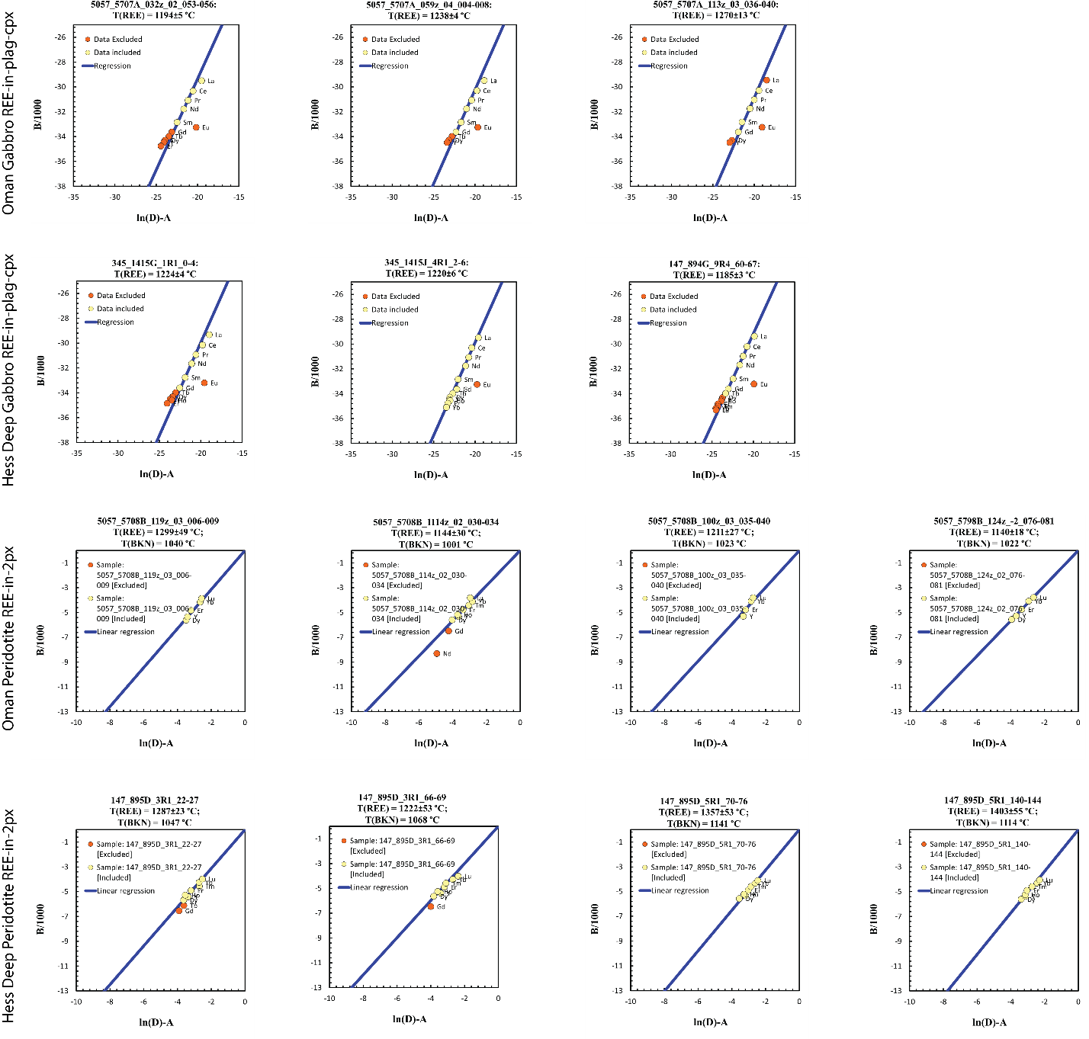
Figure 1.12. Inversion diagrams from application of REE-in-two-pyroxene (Liang et al., 2013) and REE-in-plag-cpx (Sun & Liang, 2017) thermometers to peridotite and gabbro samples from Hess Deep and the Oman Drilling Project. All reported trace element data are shown, with data excluded from the temperature inversions indicated using orange symbols. Data used in the temperature determinations are indicated in yellow. Inversion diagrams were produced using Excel spreadsheets available publicly on the web at http://earth-sun.weebly.com.

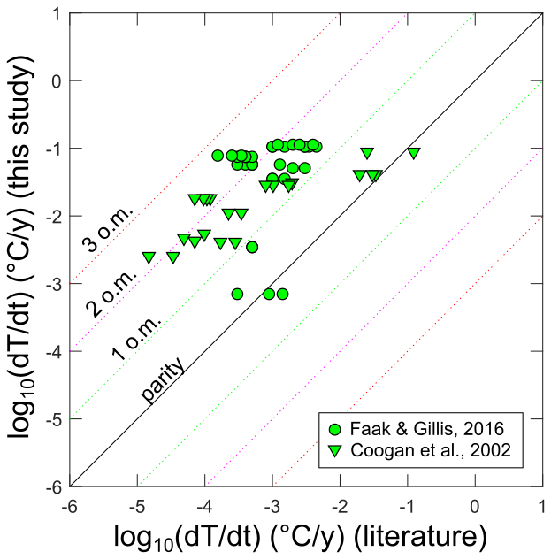
Figure 1.13. A comparison of Ca-in-olivine cooling rates determined for Hess Deep gabbros (Faak & Gillis, 2016, circles) and gabbros from the Wadi Abyad section of the Samail ophiolite (Coogan et al., 2002, triangles) to rates recalculated using the methods we employed in this study. For consistency, literature rates for the Wadi Abyad data were gathered from Coogan et al., 2007, as they were calculated using the Ca-in-olivine diffusivity of Coogan et al., 2005, as employed in the main text and in other studies. The black line is the 1:1 line, green, magenta and red dotted lines show order of magnitude deviations of the literature rates from recalculated rates. Recalculated rates are mostly somewhat higher; average deviations of the recalculated rates from the literature rates are 1.4 and 1.6 orders of magnitude for Coogan et al. (2002; 2007) and Faak and Gillis (2016) respectively. In the case of the Faak & Gillis (2016) dataset, samples with slower rates agree better with the recalculated rates. In the case of the Coogan et al. (2002; 2007) data, samples with faster rates better agree with the recalculated rates.

Appendix 1 References
MacLeod, C. J., Celerier, B., Fruh-Green, G. L., & Manning, C. E. (1996). Tectonics of Hess Deep: A Synthesis of Drilling Results from Leg 147. Proceedings of the Ocean Drilling Program, 147 Scientific Results, 147(1990). https://doi.org/10.2973/odp.proc.sr.147.032.1996
Nicolas, A., Bouldier, F., Ildefonse, B., & Ball, E. (2000). Accretion of Oman and United Arab Emirates ophiolite - Discussion of a new structural map. Marine Geophysical Research, 21(3–4), 147–180. https://doi.org/10.1023/A:1026769727917

Chapter 2: Microstructural Investigation of Ilmenite-Olivine Aggregates Deformed in Shear

Abstract
To examine the development of fabrics in different phase percentages of aggregate rocks, general shear molten salt cell experiments were conducted on varying proportions of ilmenite and olivine in a Griggs-style apparatus with confining pressures of 1 GPa and 1100°C, and a nominal axial compression rate of 10⁻⁶ s⁻¹. Data from 5 samples with 4 different aggregate ratios show the weaker phase, ilmenite, taking up deformation, even at volume fractions of 25%, as seen in photomicrograph and electron back scatter diffraction analysis. This data provides a starting point for the use of established aggregate flow law models such as Tullis et al. (1991) and the isostress (Reuss) model as end members for future development and refinement of an aggregate ilmenite-olivine flow law.

1. Introduction
Flow laws for a range of individual minerals have been established through field and laboratory observations and refined through experimental methods throughout the years, in efforts to explain the deformation behaviors of rocks on Earth and across the solar system (e.g., Dygert et al., 2016; Goetze & Poirier, 1978; Hansen et al., 2011; Hirth & Kohlstedt, 2003; Kohlstedt & Goetze, 1974; Stipp et al., 2002; J. Till & Moskowitz, 2013; Tokle et al., 2019, 2021; Y. H. Zhao et al., 2009). While some minerals, such as olivine and quartz, have been of high geologic interest and are well studied. Minerals that are less abundant in terrestrial geologic systems, such as ilmenite, have only recently been characterized in flow laws. Employing monomineralic flow laws established for two mantle-relevant minerals, ilmenite and olivine (Hirth & Kohlstedt, 2003; Tokle et al., 2021), we have investigated the flow law mixing behavior via aggregate deformation experiments with differing proportions of ilmenite40 (ilm40) and San Carlos olivine (SCO), which are in chemical equilibrium at mantle-relevant experimental conditions.
The strength and viscosity of polymineralic rocks depends on the partitioning of deformation into the different phases and can be relatively independent of phase proportions depending on deformation mechanisms and individual grain behaviors. Theoretical aggregate flow laws have been constrained through numerical modeling (e.g., Bevillard et al., 2019; Huet et al., 2014; T. E. Tullis et al., 1991) and from examination of experimental and natural samples (e.g., Faul et al., 2016; Gonçalves et al., 2015; Handy, 1990, 1994; Herwegh et al., 2011; Jordan, 1987; Platt, 2015; J. Tullis & Wenk, 1994; T. E. Tullis et al., 1991), but are unique to the minerals in the system and the conditions of deformation.
In this study, we investigate the effect of ilm40 on the strength of SCO in different volume fractions of ilm40:SCO in order to estimate the first-order aggregate behavior of these mantle-relevant materials. We conducted general shear experiments on samples of natural SCO and synthesized ilm40 to examine the effect of weak phase and strong phase on the overall rock behavior during deformation and to compare the resulting microstructures at different phase proportions and total strain.

1.1 Flow Laws
The rheological behavior of the individual phases used in this study are both best described by a power law dependence of strain rate ($\dot{ε}$) on differential stress (σ). The power law form
$\dot{ε}=A*σ^{n}\exp\left(-\frac{E+PV}{RT}\right)$ (1)
is applied to both materials, with the addition of a variable for water content in the olivine flow law (Hirth & Kohlstedt, 2003; Tokle et al., 2021).

1.1.1 Olivine Flow Laws
Based on the experimental conditions and materials employed, we apply the olivine flow law of Hirth & Kohlstedt (2003) for wet dislocation creep with a constant water content (C_{OH}):
$\dot{ε}=A*C_{OH}^{r}*σ^{n}\exp\left(-\frac{E+PV}{RT}\right)$ (2)
where constant (A) = 90 MPa^{−n}s⁻¹, the water fugacity exponent (r) = 1.2, the stress exponent (n) = 3.5, the strain rate ($\dot{ε}$) = 1.3x10⁻⁵/s, activation energy (E) = 480 kJ/mol, pressure for all experiments (P) = 1x10⁹ MPa, activation volume (V) =11x10⁻⁶ m³/mol, the gas constant (R) =8.3145 J∙mol⁻¹∙K⁻¹, and the temperature for all experiments (T) = 1373 Kelvin. The starting C_{OH} of SCO cannot be measured as samples were conditioned in their sealed assembly at reducing conditions. Therefore, to initially calculate predicted viscosities of 100% SCO from published flow laws, we use a lower bound estimate of 50 H/10⁶Si and an upper bound estimate of 600 H/10⁶Si based on FTIR measurements of SCO pre- and post-deformation in other Griggs-style apparatus studies from the same lab (Holyoke-III, 2005; N. Zhao et al., 2019).
The calculated effective viscosity is:
$μ_{eff}= \frac{σ}{\dot{ε}}$ (3)
at experimental conditions for a low-water (C_{OH}=50 ppm H/Si) olivine estimate sample is 4.87x10¹³ Pa*s and 2.08x10¹³ Pa*s for high-water (C_{OH}=600 ppm H/Si) olivine estimates.

1.1.2 Ilmenite Flow Laws
Tokle et al. (2021) used Griggs apparatus and deformation-DIA apparatus experiments on varying Mg-content ilmenites to recalibrate the flow law for ilmenite 100 (ilm100) previously developed by Dygert et al. (2016), and to establish a pressure-dependent flow law for ilm40. Using equation 1, the flow law for ilm40, the species used in this study, has the following parameters: A = 3.936x10⁻⁷ MPa^{−n}s⁻¹, n = 5.7, E = 283 kJ/mol and V = 26x10⁻⁶ m³/mol. With ε̇, P, R, and T as defined for the olivine flow law, the bounding flow-law values can be calculated for a sample of 100% ilm40. The calculated effective viscosity at experimental conditions for a 100% ilm40 sample is $μ_{eff}$=1.24 x10¹³ Pa*s.

2. Experimental Design and Methods
General shear experiments were conducted in a Griggs-type apparatus using molten salt assemblies (Figure 2.1a) at confining pressures of 1 GPa and temperatures of 1100°C. Molten salt cells are ideal for use at high temperatures and pressures, and have very low friction, allowing for accurate measurements on Griggs-type apparatus (Holyoke-III, 2005).

2.1 Starting Materials
Initial investigation of aggregate ilmenite:olivine rheology in shear used end-member ilmenite (FeTiO₃) and San Carlos olivine ((Mg_{0.9}Fe_{0.1})₂SiO₄), which are not in
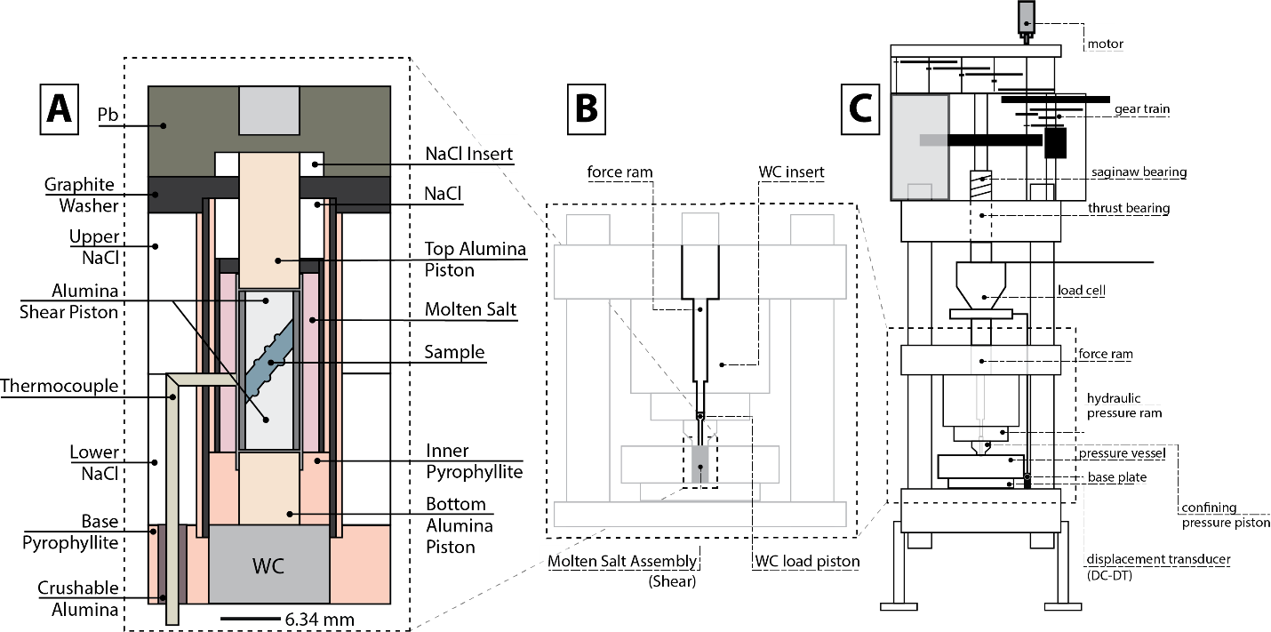
Figure 2.1. Diagram of components for molten salt cell and Griggs apparatus used in this study. Panel A shows the assembly for the sample in shear. Panel B shows the interior schematic for the force ram portion of the Griggs apparatus and panel C shows the full Griggs apparatus. Figure modified from Holyoke and Kronenberg, 2010 for Rig 2 at the Brown University Rock Deformation lab.

equilibrium at the experimental conditions (Andersen & Lindsley, 1979; Thacker et al., 2009). For this study, ilm40 ((Mg₆₀Fe₄₀)TiO₃) synthesized by L. Tokle for Tokle et al. (2021), was used. This composition of 40% ilmenite and 60% giekielite (MgTiO₃) is in equilibrium with SCO at the experimental conditions of 1 GPa confining pressure and 1100°C, as experimentally determined in previous studies (Andersen & Lindsley, 1979; Thacker et al., 2009; Tokle et al., 2021).
Starting powders of SCO and ilm40 were ground and sieved to a minimum grain size of 20-30 μm. As per the steps outlined in Appendix B of Holyoke, (2005), experimental powders and shear pistons were cold pressed into a thick Ni jacket and conditioned in a horizontal gas mixing furnace at 900°C at an oxygen fugacity approximating the Ni/NiO buffer for 9 hours. The conditioned samples were then inserted into thinner Pt and Ni outer jackets with Ni and Pt disks covering the top and bottom of the jacketed sample (Figure 2.1a). The Pt sleeve was mechanically folded over the disks to seal the jacketed sample. The jacketed samples were then annealed overnight at run conditions prior to deformation. A hydrostatic experiment, LMO-007, demonstrates vertical shortening of the powders by approximately 3% prior to and during annealing.

2.2 Experimental Conditions
Experiments were conducted at 1100°C and at a confining pressure of 1.0 +/- 0.1 GPa at a nominal axial compression rate of 10⁻⁶ s⁻¹. Individual sample data related to each run is listed in Table 2.1. To preserve the microstructures, at the end of the experiment the temperature was lowered at a rate of 3°C/s to 300°C whenever possible, though due to thermocouple failures, samples LMO-001, LMO-003, and LMO-004 were quenched from 1100°C, and specific reasons are noted in Table 2.2. During the temperature decrease, the confining pressure decreases slightly and once the sample temperature decreases to 300°C the confining pressure is decreased manually over 1 hour to prevent decompression cracking.
Applied force and deformation piston displacement during experimental runs are measured through an external load cell and displacement transducer (resolution = 1 μm) labeled on a schematic of the Brown University Rock Deformation lab Rig 2 Griggs

Table 2.1. Sample information by experiment in order of first run to last run.
* Shear strain rate calculated for end of experiment.
Run Number | Sample Name | Proportion  ilm40 | Proportion  SCO | Temperature | Axial compression rate | Post-run thickness | Post-run height | Shear strain rate* | Axial equivalent strain rate*
W2384 | LMO-001 | 100 | 0 | 1100°C | 1*10^-6 | 1.0851 | 1.5346 | 3.86E-06 | 7.72E-06
W2387 | LMO-002 | 10 | 90 | 1100°C | 1*10^-6 | 1.0200 | 1.4425 | 4.26E-06 | 8.52E-06
W2389 | LMO-003 | 10 | 90 | 1100°C | 1*10^-6 | 0.9100 | 1.2869 | 1.77E-06 | 3.53E-06
W2393 | LMO-004 | 50 | 50 | 1100°C | 1*10^-6 | 0.9369 | 1.3250 | 3.50E-06 | 7.00E-06
W2395 | LMO-005 | 25 | 75 | 1100°C | 1*10^-6 | 1.0869 | 1.5370 | 6.42E-07 | 1.28E-06
W2546 | LMO-006 | 5 | 95 | 1100°C | 1*10^-6 | .. | .. | .. | ..
W2544 | LMO-007 | 10 | 90 | 1100°C | Hydrostatic | 1.0912 | 1.5432 | .. | ..
W2549 | LMO-008 | 5 | 95 | 1100°C | 1*10^-6 | .. | .. | .. | ..
W2562 | LMO-009 | 5 | 95 | 1100°C | 1*10^-6 | .. | .. | 9.77E-06 | 1.95E-05
W2559 | LMO-010 | 25 | 75 | 1100°C | 1*10^-6 | 1.2000 | 1.6971 | 8.23E-07 | 1.65E-06
W2560 | LMO-011 | 25 | 75 | 1100°C | 1*10^-6 | 1.4498 | 2.0503 | 2.86E-06 | 5.73E-06

Table 2.2. Notes on variations in experimental run conditions.
Run Number | Sample name | Notes
W2384 | LMO-001 | Failsafe tripped, motor ran in ~ 1.5 hours post trip
W2387 | LMO-002 | Turned failsafe off and watched output until quench. Shows excessive T swings, likely thermocouple issue.
W2389 | LMO-003 | Failsafe tripped, motor turned off immediately
W2393 | LMO-004 | Failsafe tripped in middle of night, motor may have ran in 4+ hours
W2395 | LMO-005 | Quenched Sample
W2546 | LMO-006 | No hit, thermocouple failure and ran on output until it was unstable
W2544 | LMO-007 | Thermocouple failure before motor was turned on. Sat at temperature for ~4 hours
W2549 | LMO-008 | Failed thermocouple, motor ran in while cold.
W2558/W2562 | LMO-009 | Initially ran as W2558, thermocouple failure at 700*C. Removed and rerun as W2562.  Thermocouple failure/extreme T flux for final 6 hours of experiment, can not cofirm thickness/lack of salt leak
W2559 | LMO-010 | Ran in fast (1*10-5), ran stress loops at end of experiment which induced a pressure leak
W2560 | LMO-011 | Ran in fast (1*10-5)

apparatus in Figure 2.1c. Experimental run data is recorded at a sampling rate of 2 Hz digitally. Saved files were processed using a modification of the RIG program for MATLAB (Peč, 2010), to work with Rig 2 at Brown University.
Notes on experimental runs, including experimental conditions, thermocouple failures and changes to motor speeds pre-deformation are noted in Table 2.2, with the run number for the Brown University cataloging system and the sample number assigned for this study.

3. Analytical Methods
Post-deformation, samples were prepared for microanalysis by carefully extracting the jacketed sample from the molten salt assembly and marking relevant directions, such as top and bottom, and indicating the position of the thermocouple, when possible. Samples were then cut in half perpendicular to the strike direction of the shear pistons, along the dip of the deformed sample. One-half of the sample was then mounted in 1-inch clear epoxy pucks for photomicrograph and electron beam microanalysis.
Samples were analyzed under reflected light to check for potential salt leaks and to measure the post-deformation height and thickness of the sample. Backscatter electron (BSE) images were taken of samples to do a visual assessment of the mineral ratio and distribution of grains.
After preliminary analysis at the University of Tennessee – Knoxville, all samples ran in 2019, LMO-001, LMO-002, LMO-003, LMO-004 & LMO-005, were taken to Scripps Institution of Oceanography, to run electron backscatter diffraction (EBSD) analysis for microstructural data.

3.1 Electron Backscatter Diffraction
EBSD analyses were completed using an Oxford Instruments Symmetry EBSD detector on a FEI Apreo LoVac Field Emission Gun SEM at the University of California – San Diego/Scripps Institution of Oceanography. All samples were analyzed at a 1 µm step size, across the entire polished surface of the sample at a working distance between 26 to 28 mm, and voltage of 20 kV. Sample LMO-001 was indexed for only ilmenite because it was prepared as a 100% ilmenite experiment. Samples LMO-002, LMO-003, LMO-004 and LMO-005 were indexed for both ilmenite and forsterite.
Data processing was completed using the open source MTEX software (version 5.7.0) (Bachmann et al., 2011). The program was used to correct for rotation of the epoxy mount so that all samples plotted with the shear pistons in the same orientation, then used to generate EBSD maps, pole figures, and statistical data such as aspect ratio histograms and misorientation index (M-index) (Skemer et al., 2005). Grain boundaries for indexed minerals were defined with an angle of 10°.

4. Mechanical Data and Analytical Results

4.1 Mechanical Data
Mechanical data was downloaded from the Rig 2 computer as .tdms files and processed in MATLAB using code based on RIG (Peč, 2010). Figure 2.2 shows strain versus stress plots of the processed mechanical data for experiments LMO-001, LMO-002, LMO-003, LMO-004, LMO-005, LMO-010, LMO-011.

4.1.1 Dormant Rig complications in runs from July 2021 and January 2022
Samples LMO-006, LMO-007, LMO-008 and the first run of LMO-009, experienced power failures during the pressurization and heating process of the experiment and were therefore undeformed. Troubleshooting of the sample assembly revealed minor microstructural differences in mullite composition between manufacturers that caused shearing in the small arm of the thermocouple, near the outer salt-graphite can interface and highlighted the sensitivity of the experimental design to all assembly components. Sample LMO-007 was used to determine compression of sample materials pre-deformation, as it was able to dwell at the same pressure and temperature conditions as deformed samples for approximately 4 hours prior to failure. This hydrostatic experiment provided the data used to calculate percent compaction during pressurization and temperature increases.

4.1.2 Correcting for fast run-ins
Experimental runs in which the motor speed at time of sample hit was faster than the experimental conditions (W2559 (LMO-010), W2560 (LMO-011), W2562 (LMO-009)) were corrected in MATLAB by shifting the accelerated compression portion by the
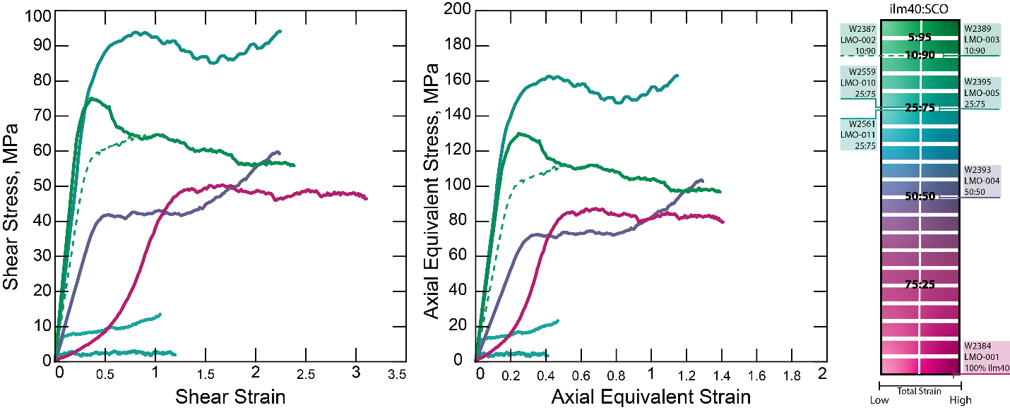
Figure 2.2. Mechanical data plots for deformed experiments from this study. Samples are color coded based on the spectrum at right, with pink representing ilm40 and green representing SCO. For samples with the same proportions of ilm40:SCO, sample hue is lighter for low total strain and darker for high accumulated strain. Mechanical data is cropped to begin at the hit point as calculated in MATLAB and end at initial pressure decrease at time of thermocouple failure and/or experiment completion.

load change at acceleration and load change at deceleration, averaged over the entire higher rate portion. The change in load seen at different motor speeds can be attributed to friction in the rig that varies with axial compression rates. The portions of the record where the run in was stabilizing were then removed and replaced by a linear regression of the values at the starting and ending times of the segment removed. This allowed for calculation of a corrected hit point.

4.2 Microstructures
Crystallographic preferred orientation (CPO) for ilmenite (0001) are shown in the left-hand column of Figure 2.3 for LMO-001, LMO-002, LMO-003, LMO-004 and LMO-005 (top to bottom). In the 3 right-hand columns of Figure 2.3, CPOs for Forsterite (olivine) (100), (010), and (001) are shown for LMO-002, LMO-003, LMO-004, and LMO-005. M-index values for ilmenite and olivine are provided in Table 2.3 based on the orientation distribution function generated by MTEX.
Grain area and aspect ratio maps for each indexed phase are shown in the supplement, Supplemental Figure 2.6, for LMO-001, LMO-002, LMO-003, LMO-004 and LMO-005. The aspect ratio data attained from building these maps is plotted as histograms in Figure 2.4 for all samples analyzed by EBSD.

5. Discussion

5.1 Stress and strain comparisons to published flow laws
Figure 2.5a shows the predicted range of viscosities from the published ilm40 and olivine flow laws, as triangles on the left and right y-axes of the plot, respectively. From published numerical models of aggregate flow laws, the Tullis et al. (1991) two-phase mixing model represents an aggregate flow law that is influenced by the relative phase percentage of the aggregate during deformation. For that reason, we show the Tullis et al. (1991) mixing model as the split on the graph between viscosity predictions in cases where the strength of the aggregate is controlled by the stronger material, olivine in this case, which would fall above the Tullis et al. (1991) line in the green region, and viscosities predicted if the strength of the aggregate is controlled by the weaker phase of the two, ilmenite in this case, which would plot beneath the Tullis et al. (1991) line, in the pink field. By comparing calculated viscosities of samples in this study to the wet
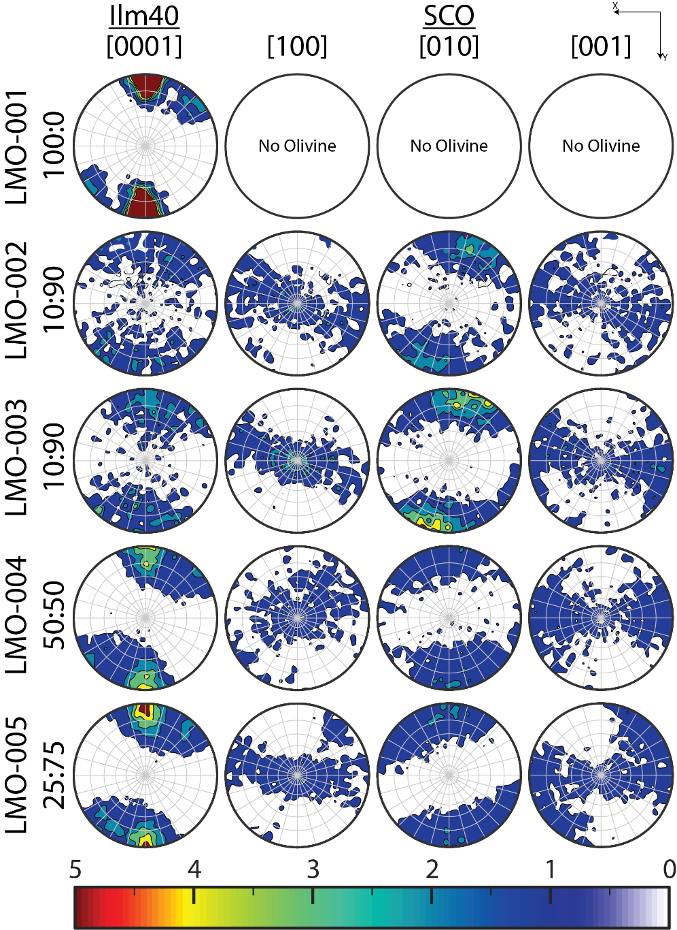
Figure 2.3. Ilmenite (0001) CPOs and Forsterite (001), (010) and (100) CPOs for samples LMO-001, - 002, -003, -004, & -005, with ilm40:SCO ratios and total accumulated shear strain and axial equivalent strain. All sample MUD scales are set to the color scale at the bottom of the figure.

Table 2.3. Sample results from mechanical data and EBSD analysis data processing.
Sample Name | γ | σ_{shear}  (MPa) | ε | σ_{axial equivalent}  (MPa) | Viscosity | Multiples of Uniform Distribution (MUD) range |  |  |  |  |  |  |  | M-Index Ilm40 | M-Index SCO
 |  |  |  |  |  | Ilm40 (0001) |  | SCO (100) |  | SCO (010) |  | SCO (001) |  | M-Index Ilm40 | M-Index SCO
LMO-001 | 3.11 | 45.91 | 1.41 | 79.52 | 6.08E+12 | 19 | 0.0055 | -- | -- | -- | -- | -- | -- | 0.3386 | --
LMO-002 | 0.9 | 64.55 | 0.53 | 111.81 | 8.62E+12 | 2.1 | 0.35 | 2.2 | 0.38 | 2.9 | 0.4 | 1.6 | 0.4 | 0.0128 | 0.0208
LMO-003 | 2.38 | 55.87 | 1.39 | 96.77 | 7.38E+12 | 2.6 | 0.25 | 3.2 | 0.2 | 4.3 | 0.17 | 1.9 | 0.33 | 0.031 | 0.0551
LMO-004 | 2.24 | 59.32 | 1.29 | 102.75 | 7.85E+12 | 4.1 | 0.28 | 1.8 | 0.61 | 2 | 0.54 | 1.5 | 0.52 | 0.0623 | 0.01
LMO-005 | 2.24 | 94.11 | 1.15 | 163 | 1.25E+13 | 5 | 0.21 | 2 | 0.5 | 2 | 0.48 | 1.5 | 0.57 | 0.0865 | 0.0162
LMO-010 | 1.05 | 13.45 | 0.47 | 23.3 | 1.77E+12 | -- | -- | -- | -- | -- | -- | -- | -- | -- | --
LMO-011 | 1.2 | 1.98 | 0.41 | 3.34 | 2.31E+11 | -- | -- | -- | -- | -- | -- | -- | -- | -- | --

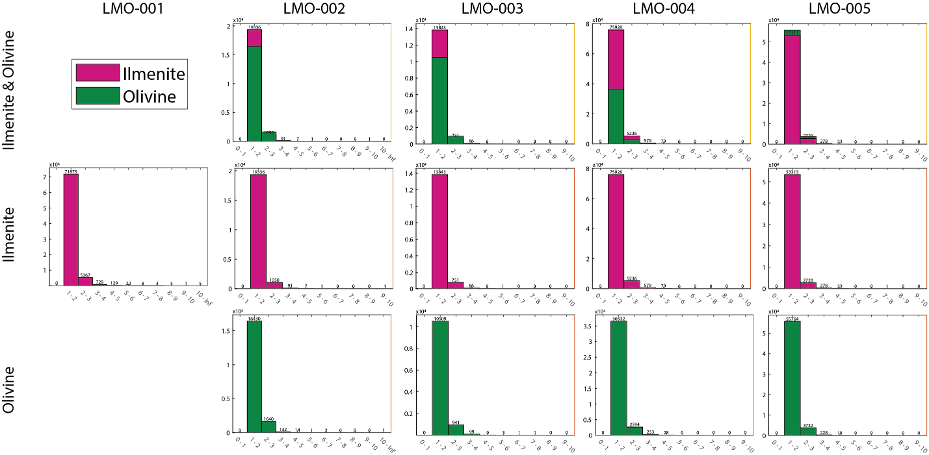
Figure 2.4. Histograms of aspect ratio for samples analyzed with EBSD. The top row of histograms show both minerals in aggregate samples, with comparison of total grains. Individual mineral aspect ratio histograms are shown the combined plot for each sample, with pink histogram bars representing ilmenite and green bars representing olivine. Grains were defined using an angle of 10 degrees.

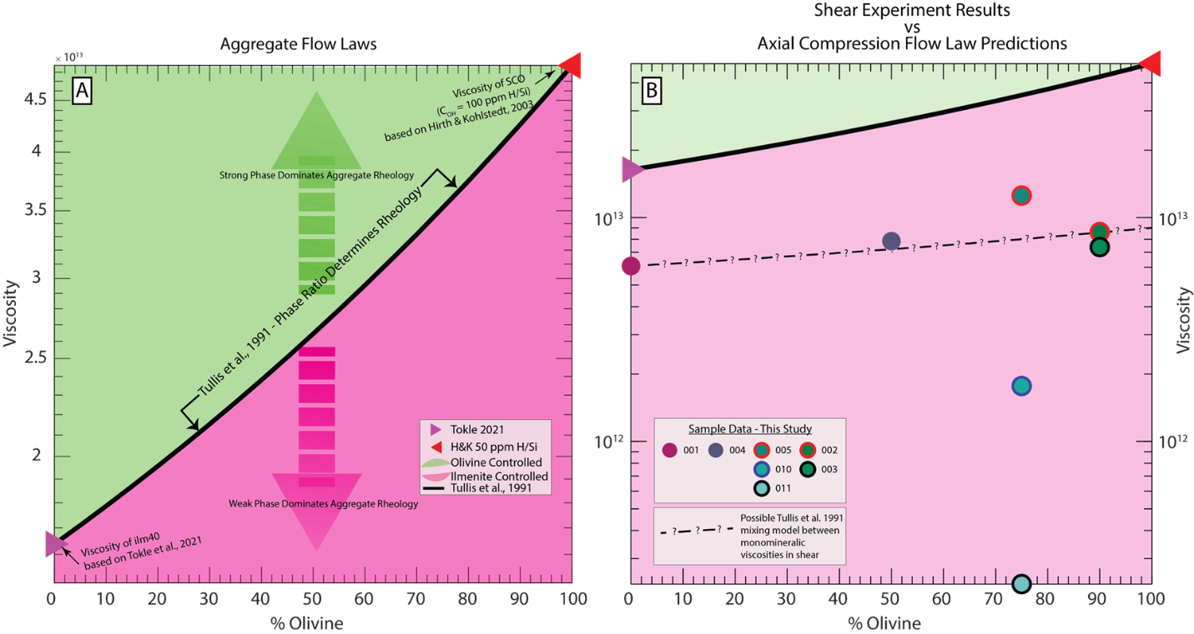
Figure 2.5. (A) Percent olivine on the x-axis versus logarithmic scale of viscosity on the y-axis. This plot shows the predicted viscosities for samples of 100% ilm40 on the left and 100% SCO on the right edges of the plot based on published flow laws (Hirth & Kohlstedt, 2003; Tokle et al., 2021). The black line shows the mixing model of the two phases as calculated by Tullis et al. 1991. Any sample data that plots in the pink region of the graph has a rheology controlled by the weak phase, ilmenite. If data plots in the green region of the graph, its rheology is controlled by the strong phase, olivine. (B) Sample data from this study added as colored dots. All samples are weaker than the predicted viscosities from published flow laws. The dotted line in plot B represents the approximation of the Tullis et al. 1991 mixing model line to connect the two endmember-most experiments with similar accumulated strains, LMO-001 and LMO-003.

olivine flow law (Hirth & Kohlstedt (2003), C_{OH} =50 ppm H/Si) and ilm40 (Tokle et al., 2021) flow law in Figure 2.5b, we see decreased viscosities in all samples run for this study. When interpreting these results, it is important to consider that the flow laws are
calibrated from axial compression experiments in all individual mineral cases, whereas samples in this study were ran in general shear. Previous studies on olivine in general shear, performed on Griggs-type apparatus have shown decreased differential stresses, especially in cases of high strain (Holyoke-III, 2005; Post, 1977). While this weakening has been observed and published in experimental data, no flow law exists for olivine or ilmenite in shear. Using the two end-member experiments of this study, LMO-001 and LMO-003, which had similar ε values, a line has been schematically added to Figure 2.5b, showing what a Tullis et al. (1991) mixing curve might be given the data for ilm40 and SCO aggregates in shear. Addition of a 100% SCO experiment, at the same conditions used in this study, would help to anchor the calculation of a Tullis et al. (1991) mixing model line.

5.1.1 Uncertainty in water content of experimental materials
All samples were prepared and conditioned at reducing conditions and stored in a low temperature (~100°C) vacuum oven between packing and experimental assembly. While best efforts were made to keep samples free of absorbed water, C_{OH} values are unknown, and therefore could alter the resulting viscosity calculations. To account for the uncertainty in these values, aggregate flow laws were calculated for a range of C_{OH} in olivine between 50 H/10⁶ Si and 600 H/10⁶Si. These values are an expanded range from the values measured in SCO using FTIR in other studies from the Brown University Rock Deformation Lab (Holyoke-III, 2005; N. Zhao et al., 2019). Using the EBSD data from olivine, water contents were also estimated from Bernard et al. (2019), which employs a water content correction from previously preferred calibrations made by Bell et al. (2003), and the proposed olivine fabric-type transitions from Jung & Karato (2001). At highest total accumulated strain, CPOs appear to follow a B-type pattern. While this type covers a wide range of possible ppm H/Si, lower stress samples appear to show some A-type behavior, leading to us to estimate C_{OH} values no higher than 1000, although CPOs do not match A-type for all three planes. Because of the preparation in reducing conditions and lack of any external hydrating materials, 1000 ppm H/Si can be considered in excess of experimental values.

5.1.2 Anomalous strength/weakness in 25% ilm40:75% SCO samples not reproducible
The 25:75 sample, LMO-005, showed anomalously high differential stresses in comparison to all other shear experiments run in the same session. Nearly two years later, repeat attempts to measure the same ratio in samples LMO-010 and LMO-011 returned anomalously low stress and viscosity values, all shown by blue dots in Figure 2.5b. There is no indication that the strength variations in this specific phase proportion are scientifically significant, but because of the variation, especially in comparison to the values from other experiments, this ratio of ilm40:SCO should continue to be examined in future studies.

5.2 Post-deformation fabrics
Post-deformation analysis of samples in photomicrograph and via BSE from SEM data collection show changes in fabric strength with increased total strain. Total strain (γ/ε) and stress (σ) for all experiments is in Table 2.3, along with the calculated viscosity based on the axial equivalent differential stresses and strain rates (Paterson & Olgaard, 2000), the multiples of uniform distribution (MUD) range for each pole figure shown in Figure 2.3, and M-index values relevant to each experiment that was analyzed with EBSD.

5.2.1 Olivine trends
Olivine CPOs for (100), (010), and (001) were used to compare to the fabric-types outlined in Figure 1 of Bernard et al. (2019). In the low strain 10:90 ilm40:SCO sample, LMO-002, fabric development is weak in all planes, but most pronounced in the (010). In the high strain 10:90 ilm40:SCO sample, LMO-003, fabric development is strongest in the (010) plane parallel to the shear direction and is also evident in (100) normal to the shear direction. The grain geometry of both 10:90 samples is shown in grain area and aspect ratio maps in Supplemental Figure 2.6, with ilmenite and olivine in separate maps. The higher strain sample appears to show higher grain elongation in the direction of shear for ilmenite, while grain shape is less elongate in the low strain sample. This visual interpretation is not seen between histograms of the two samples aspect ratios. Based on the M-index for both 10:90 samples, fabric development is stronger in SCO with higher accumulated strain, and in samples with higher percentages of SCO.
Based on total accumulated strain (γ/ε), the olivine containing samples run on EBSD show increasingly defined CPOs especially in the [010] axes. Girdling can also be seen in the [100] and [001] axes CPO, as shown in Figure 2.3. Between the 10:90 ilm40:SCO and lower proportion SCO samples, the (010) plane rotates around the C-axis by approximately 45° to 90°.

5.2.2 Ilmenite trends
To compare the orientation trends of ilmenite, c-axis, basal-plane was plotted in CPOs based on recent studies of ilmenite inclusions and single crystals (Griffiths et al., 2016; J. L. Till & Rybacki, 2020). Comparison of the basal plane orientation (0001) of ilmenite in all samples that were analyzed with EBSD shows CPO strengthening for the samples with 25% - 100% ilmenite. As seen in column one of Figure 2.3, sample LMO-001 shows well defined poles in the (0001) plane. For comparison between samples, the same multiples of uniform distribution (MUD) color scale was used between 0 and 5, but the maximum for LMO-001 was much greater than all other samples when plotted individually, at 19, and the MUD range for all sample pole figures can be found in Table 2.3. While some fabric development occurs in ilmenite (0001) between the low- and high-strain samples of 10:90 ilm40:SCO, the CPO is significantly less pronounced than in similar total strain samples with higher ilm40 contents, as seen in the M-index values listed in Table 2.3.
The transition in M-index values for ilmenite between 25:72 and 10:90 could signify a shift in dominant rheology of the system from ilm40 to SCO between those values. With decreasing volume percentages of ilmenite, below 25%, the deformation may be rapidly taken up in the stronger phase. This observation necessitates more experiments in the volume fraction ilm40 range of 25% to 0% in order to quantify the transition between ilm40 to SCO dominated aggregate rheology.

6. Summary and Conclusions
Based on the mechanical data results of samples LMO-001, LMO-002, LMO-003, LMO-004, LMO-005, LMO-010, and LMO-011, combined with the EBSD data from LMO-001, LMO-002, LMO-003, LMO-004 and LMO-005, there is no clear preference to point to for refining an ilm40:SCO aggregate flow law to represent the rheology of the system. With an increased density of mechanical data at ilm40:SCO ratios between 50:50 and 0:100, it should be possible to move towards determining the dominant phase controlling deformation, and possibly parameterizing an aggregate flow law. Future work, including analyses the C_{OH} of SCO used in these experiments using FTIR and refinement of the experimental setup to allow for longer deformation without thermocouple failure, would give better resolution in the trend of the mixing rheology.
Based on the EBSD analyses of the spectrum of aggregate ratios, the development of strong CPOs in ilmenite appears to decay at an ilmenite content less than 25%. This is seen in the ilmenite (0001) CPOs for both 10:90 experiments, where, despite significant differences between total accumulated strain, there is only a small change in the M-index values, compared to the samples with higher volume fractions of ilmenite.
The results of the Griggs-apparatus experiments and corresponding microstructural analysis of select samples in this study lead us to the following conclusions:
- the aggregate flow law model of Tullis et al., (1991) could be a good first order approximation of the strength of ilm40 and SCO aggregate rocks in shear, given more refinement on the end-member flow laws;
- shear deformation of samples causes weakening compared to axial compression constrained flow laws in both ilm40 and SCO, as had been observed by previous studies.
Further experiments in the aggregate ratios of 50:50 to 0:100 could help to constrain a robust aggregate flow law and inform future work on material strength in mantle-relevant conditions.

7. Acknowledgments, Samples, and Data
This project was funded by a Solar Systems Workings NASA Grant 80NSSC18K0249 to GH (PI), ND (Co-PI) & YL (Co-PI). We would like to acknowledge the invaluable assistance of Eric Burdette and Ningli Zhao during experimental work at Brown University.

References
Andersen, D. J., & Lindsley, D. H. (1979). The olivine-ilmenite thermometer. Lunar Planetary Science Conference, 10, 493–507. https://doi.org/1979LPSC...10..493A
Bachmann, F., Hielscher, R., & Schaeben, H. (2011). Grain detection from 2d and 3d EBSD data-Specification of the MTEX algorithm. Ultramicroscopy, 111(12), 1720–1733. https://doi.org/10.1016/j.ultramic.2011.08.002
Bell, D. R., Rossman, G. R., Maldener, J., Endisch, D., & Rauch, F. (2003). Hydroxide in olivine: A quantitative determination of the absolute amount and calibration of the IR spectrum. Journal of Geophysical Research: Solid Earth, 108(B2), 1–9. https://doi.org/10.1029/2001jb000679
Bernard, R. E., Behr, W. M., Becker, T. W., & Young, D. J. (2019). Relationships Between Olivine CPO and Deformation Parameters in Naturally Deformed Rocks and Implications for Mantle Seismic Anisotropy. Geochemistry, Geophysics, Geosystems. https://doi.org/10.1029/2019gc008289
Bevillard, B., Richard, G., & Raimbourg, H. (2019). Rock Strength and Texture Evolution During Deformation in the Earth’s Ductile Lithosphere: A Two-Phase Thermodynamics Model. Geochemistry, Geophysics, Geosystems, 20(2), 1095–1137. https://doi.org/10.1029/2018GC007881
Dygert, N., Hirth, G., & Liang, Y. (2016). A flow law for ilmenite in dislocation creep: Implications for lunar cumulate mantle overturn. Geophysical Research Letters, 43(2), 532–540. https://doi.org/10.1002/2015GL066546
Faul, U. H., Cline, C. J., David, E. C., Berry, A. J., & Jackson, I. (2016). Titanium-hydroxyl defect-controlled rheology of the Earth’s upper mantle. Earth and Planetary Science Letters, 452, 227–237. https://doi.org/10.1016/j.epsl.2016.07.016
Goetze, C., & Poirier, J. P. (1978). The mechanisms of creep in olivine. Philosophical Transactions of the Royal Society of London. Series A, Mathematical and Physical Sciences, 288(1350), 99–119. https://doi.org/10.1098/rsta.1978.0008
Gonçalves, C. C., Gonçalves, L., & Hirth, G. (2015). The effects of quartz recrystallization and reaction on weak phase interconnection, strain localization and evolution of microstructure. Journal of Structural Geology, 71, 24–40. https://doi.org/10.1016/j.jsg.2014.11.010
Griffiths, T. A., Habler, G., & Abart, R. (2016). Crystallographic orientation relationships in host-inclusion systems: New insights from large EBSD data sets. American Mineralogist, 101(3), 690–705. https://doi.org/10.2138/am-2016-5442
Handy, M. R. (1990). The solid-state flow of polymineralic rocks. Journal of Geophysical Research, 95(B6), 8647. https://doi.org/10.1029/JB095iB06p08647
Handy, M. R. (1994). Flow laws for rocks containing two non-linear viscous phases: A phenomenological approach. Journal of Structural Geology, 16(3), 287–301. https://doi.org/10.1016/0191-8141(94)90035-3
Hansen, L. N., Zimmerman, M. E., & Kohlstedt, D. L. (2011). Grain boundary sliding in San Carlos olivine: Flow law parameters and crystallographic-preferred orientation. Journal of Geophysical Research: Solid Earth, 116(8), 1–16. https://doi.org/10.1029/2011JB008220
Herwegh, M., Linckens, J., Ebert, A., Berger, A., & Brodhag, S. H. (2011). The role of second phases for controlling microstructural evolution in polymineralic rocks: A review. Journal of Structural Geology, 33(12), 1728–1750. https://doi.org/10.1016/j.jsg.2011.08.011
Hirth, G., & Kohlstedt, D. L. (2003). Rheology of the upper mantle and the mantle wedge: A view from the experimentalists. In J. M. Eiler (Ed.), Inside the Subduction Factory, Volume 138 (pp. 83–105). American Geophysical Union. https://doi.org/10.1029/138GM06
Holyoke-III, C. W. (2005). Strain weakening in crustal and upper mantle lithologies: processes and consequences. Ph.D. Dissertation, (May), 1–243. Retrieved from http://proquest.umi.com/pdf/ed318d8c64123dcc26a142066ba3e138/1314663180//share4/pqimage/pqirs101v/201108291942/40887/26838/out.pdf%5Cnpapers3://publication/uuid/CBCF8467-87D4-4C90-A046-0B6521715B07
Huet, B., Yamato, P., & Grasemann, B. (2014). The Minimized Power Geometric model: An analytical mixing model for calculating polyphase rock viscosities consistent with experimental data. Journal of Geophysical Research: Solid Earth, 119(4), 3897–3924. https://doi.org/10.1002/2013JB010453
Jordan, P. G. (1987). The deformational behaviour of bimineralic limestone-halite aggregates. Tectonophysics, 135(1–3), 185–197. https://doi.org/10.1016/0040-1951(87)90160-0
Jung, H., & Karato S. (2001). Water-Induced Fabric Transitions in Olivine. Science, 293(5534), 1460–1463. https://doi.org/10.1126/science.1062235
Kohlstedt, D. L., & Goetze, C. (1974). Low-stress high-temperature creep in olivine single crystals. Journal of Geophysical Research, 79(14), 2045–2051. https://doi.org/10.1029/jb079i014p02045
Paterson, M. S., & Olgaard, D. L. (2000). Rock deformation tests to large shear strains in torsion. Journal of Structural Geology, 22(9), 1341–1358. https://doi.org/10.1016/S0191-8141(00)00042-0
Peč, M. (2010). RIG : a MATLAB TM program for evaluation of mechanical data from experimental apparatuses.
Platt, J. P. (2015). Rheology of two-phase systems: A microphysical and observational approach. Journal of Structural Geology, 77, 213–227. https://doi.org/10.1016/j.jsg.2015.05.003
Post, R. L. (1977). High-temperature creep of Mt. Burnet Dunite. Tectonophysics, 42(2–4), 75–110. https://doi.org/10.1016/0040-1951(77)90162-7
Skemer, P., Katayama, I., Jiang, Z., & Karato, S. I. (2005). The misorientation index: Development of a new method for calculating the strength of lattice-preferred orientation. Tectonophysics, 411(1–4), 157–167. https://doi.org/10.1016/j.tecto.2005.08.023
Stipp, M., Stünitz, H., Heilbronner, R., & Schmid, S. M. (2002). Dynamic recrystallization of quartz: Correlation between natural and experimental conditions. Geological Society Special Publication, 200(October 2002), 171–190. https://doi.org/10.1144/GSL.SP.2001.200.01.11
Thacker, C., Liang, Y., Peng, Q., & Hess, P. (2009). The stability and major element partitioning of ilmenite and armalcolite during lunar cumulate mantle overturn. Geochimica et Cosmochimica Acta, 73(3), 820–836. https://doi.org/10.1016/j.gca.2008.10.038
Till, J., & Moskowitz, B. (2013). Magnetite deformation mechanism maps for better prediction of strain partitioning. Geophysical Research Letters, 40(4), 697–702. https://doi.org/10.1002/grl.50170
Till, J. L., & Rybacki, E. (2020). High-temperature creep of magnetite and ilmenite single crystals. Physics and Chemistry of Minerals, 47(12), 1–16. https://doi.org/10.1007/s00269-020-01122-6
Tokle, L., Hirth, G., & Behr, W. M. (2019). Flow laws and fabric transitions in wet quartzite. Earth and Planetary Science Letters, 505, 152–161. https://doi.org/10.1016/j.epsl.2018.10.017
Tokle, L., Hirth, G., Liang, Y., Raterron, P., & Dygert, N. (2021). The Effect of Pressure and Mg‐Content on Ilmenite Rheology: Implications for Lunar Cumulate Mantle Overturn. Journal of Geophysical Research: Planets, 126(1), 1–21. https://doi.org/10.1029/2020JE006494
Tullis, J., & Wenk, H. R. (1994). Effect of muscovite on the strength and lattice preferred orientations of experimentally deformed quartz aggregates. Materials Science and Engineering A, 175(1–2), 209–220. https://doi.org/10.1016/0921-5093(94)91060-X
Tullis, T. E., Horowitz, F. G., & Tullis, J. (1991). Flow laws of polyphase aggregates from end-member flow laws. Journal of Geophysical Research, 96(B5), 8081–8096. https://doi.org/10.1029/90JB02491
Zhao, N., Hirth, G., Cooper, R. F., Kruckenberg, S. C., & Cukjati, J. (2019). Low viscosity of mantle rocks linked to phase boundary sliding. Earth and Planetary Science Letters, 517, 83–94. https://doi.org/10.1016/j.epsl.2019.04.019
Zhao, Y. H., Zimmerman, M. E., & Kohlstedt, D. L. (2009). Effect of iron content on the creep behavior of olivine: 1. Anhydrous conditions. Earth and Planetary Science Letters, 287(1–2), 229–240. https://doi.org/10.1016/j.epsl.2009.08.006

Appendix

Appendix 1. Supplemental Figure
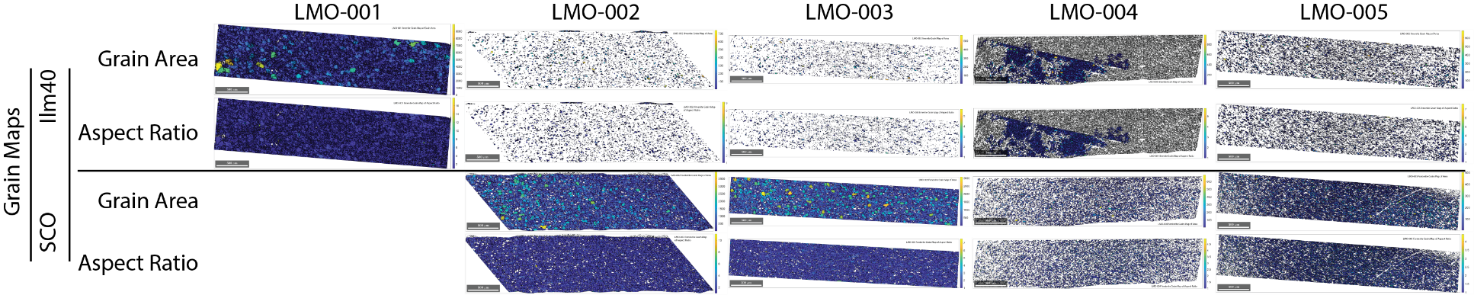
Figure 2.6. Grain maps for ilm40 and SCO for samples LMO-001, LMO-002, LMO-003, LMO-004, & LMO-005, with color scaling for grain area (top) and aspect ratio (bottom) based on a 10-degree misorientation in grain data from EBSD.

Chapter 3: Building Carbon minerals: Application of geoscience learning materials to the Tennessee Academic Standards for Science for Chemistry I for use in public school classrooms
A version of this chapter is in the final stages of preparation for submission to the journal The Science Teacher by Nadine Lynne Grambling, Stephanie K. Drumheller, and Kristin T. Rearden.
Nadine Lynne Grambling led conceptualization, writing, and development of this article. Stephanie K. Drumheller supervised the direction of this article and led revisions. Kristin T. Rearden assured the content aligned with State of Tennessee education standards and assisted in revisions.

Abstract
Native minerals refer to natural materials that form repeating crystalline structures from a single element of the periodic table. One element with two widely known native minerals is carbon, forming the mineral graphite at relatively low temperatures and pressures, and diamond at much higher temperatures and pressures, such as those seen deep in the Earth. Most secondary school students will be aware of both minerals, which provides a fantastic opportunity to discuss the relationships between crystal structure, atomic bonds, phase changes, physical properties of materials and the interior structure of the Earth.

1. Introduction
The Tennessee Academic Standards for Science (referred to henceforth as “the standards”) were published in 2018, based on the Next Generation Science Standards (NGSS) which integrate the concepts set forth in A Framework for K-12 Science Education from the National Research Council (“A Framework for K-12 Science Education: Practices, Crosscutting Concepts, and Core Ideas,” 2012; NGSS Lead States, 2017; Tennessee Department of Education, 2018). The Tennessee standards are split in to four disciplinary core ides (DCIs): Physical Sciences (PS), Life Sciences (LS), Earth and Space Sciences (ESS) and Engineering, Technology, and Applications of Science (ETS). They also integrate seven crosscutting concepts of: patterns; cause and effect; scale, proportion, and quantity; systems and system models; energy and matter; structure and function of systems; and stability and change of systems. These crosscutting relationships are written to connect between the sciences across all grade levels.
At the high school level, students are required to take three years of science courses: 1 biology credit, 1 physics or chemistry credit, and 1 additional credit of lab science from LS, PS, or ESS. The final required ESS coursework in the standards is in grade 8, with eight total across ESS1, ESS2, & ESS3. While students have the option to choose ESS classes in high school, this depends on course availability, and teaching expertise of educators. To integrate ESS concepts into the high school curriculum, a group of investigators at the University of Tennessee Knoxville have been awarded funds to create lesson plans with materials for distribution, “Lessons-In-A-Box”, through the Knox County Public Library System. These lesson plans use the standards for physics, chemistry and/or biology to aid educators in teaching Earth sciences concepts as they relate to their courses specific DCIs.
The following lesson plan write up is aimed at CHEM1 or CHEM2 classrooms, covering the standards listed in Table 3.1. CHEM1.PS3.2 and CHEM2.PS1.3 are highlighted with bold and italic formatting in Table 3.1 to signify that they are the two most relevant standards covered in the lesson.

2. Background
When asked where diamonds come from, most of the population will think of coal being buried deep in the Earth to become the gems that are popular in jewelry and industrial applications. While the idea of dinosaurs becoming diamonds can be fun in concept, the youngest diamonds we see on Earth’s surface today are almost 1 billion years old, an age older than the appearance of terrestrial plants and animals in the fossil record (Harris, 1993). It is much more likely that diamonds originate from carbon that has spent its entire history deep within the Earth, first seeing the surface in the form we see now (Harris, 1993). The more likely product of coal being heated and confined is another well known mineral: graphite.
This activity asks students to think about what happens to materials as they move through the layers of the Earth, from the surface to the core. Students will compare the

Table 3.1. Standards relevant to "Building Carbon Minerals" lesson plan
Course | DCI | Standard
CHEM1 | PS1 | 12 | Explain the origin and organization of the Periodic Table. Predict chemical and physical properties of main group elements (reactivity, number of subatomic particles, ion charge, ionization energy, atomic radius, and electronegativity) based on location on the periodic table. Construct an argument to describe how the quantum mechanical model of the atom (e.g., patterns of valence and inner electrons) defines periodic properties. Use the periodic table to draw Lewis dot structures and show understanding of orbital notations through drawing and interpreting graphical representations (i.e., arrows representing electrons in an orbital).
CHEM1 | PS2 | 2 | Understand that intermolecular forces created by the unequal distribution of charge result in varying degrees of attraction between molecules. Compare and contrast the intermolecular forces (hydrogen bonding, dipole-dipole bonding, and London dispersion forces) within different types of simple substances (only those following the octet rule) and predict and explain their effect on chemical and physical properties of those substances using models or graphical representations.
CHEM1 | PS3 | 1 | Contrast the concepts of temperature and heat in macroscopic and microscopic terms. Understand that thermal energy is a form of energy and temperature is a measure of average kinetic energy of a group of particles.
CHEM1 | PS3 | 2 | Draw and interpret heating and cooling curves and phase diagrams. Analyze the energy changes involved in calorimetry by using the law of conservation of energy quantitatively (use of q = mcΔT) and qualitatively.
CHEM2 | PS1 | 3 | Compare and contrast crystalline and amorphous solids with respect to particle arrangement, strength of bonds, melting and boiling points, bulk density, and conductivity; provide examples of each type. 10. Obtain, evaluate, and communicate information about how carbon’s structure and function are used and have influenced society.
 | PS2 | 1 | Plan and conduct an investigation to compare the properties of the different types of intermolecular forces in pure substances and in components of a mixture.
 |  | 2 | Make predictions regarding the relative magnitudes of the forces acting within collections of interacting molecules based on the distribution of electrons within the molecules and types of intermolecular forces through which the molecules interact.

pressures and temperatures seen at different depths below Earth’s surface to a phase diagram for carbon, which shows solid-solid phase transitions. After making conceptual assessments of available data, students can use materials to build 3-dimensional representations of the crystal lattices for graphite and diamond. These models allow students to visualize the changes in bond angles between the two minerals, helping to physically connect the nanoscopic effects of pressure and temperature on atomic arrangements and geometries in crystal lattices.

3. Layering the Earth
Start the lesson by discussing the interior structure of the Earth. Depending on their backgrounds, students may know the layers based on the chemical structure [Crust > Mantle > Outer Core > Inner Core] or physical structure [Lithosphere > Asthenosphere > Mantle > Outer Core > Inner Core] but their familiarity with the names of layers may range widely depending on the interpretation of the middle school Earth’s Systems Performance Expectation Code (MS-ESS2-1, MS-ESS2-2 & MS-ESS2-3, (NGSS Lead States, 2017)). For this lesson, I have written materials using the chemical structure [Crust > Mantle > Outer Core > Inner Core] with the aim of distribution of materials to secondary chemistry classrooms where physical properties are not the focus.
Scientists can estimate the pressure and temperature values deep in the Earth based on many previous studies, such as changes in seismic waves from earthquakes through different layers (e.g. Herak & Herak, 2007), attempts at deep drilling into the crust (e.g. Bascom, 1959) and lab experiments on rocks and minerals (e.g. Sarafian et al., 2017). Table 3.1 provides useful numerical values to view in comparison to visual relationships in Figure 3.1, which plots ranges of temperatures and pressures with depth from the surface (based on Carlson et al., 2010).
After discussing Earth’s layers and their range of physical parameters, you can discuss the major chemical composition of each layer using Table 3.2. This compares the major minerals and materials of each layer of the Earth, including the chemical
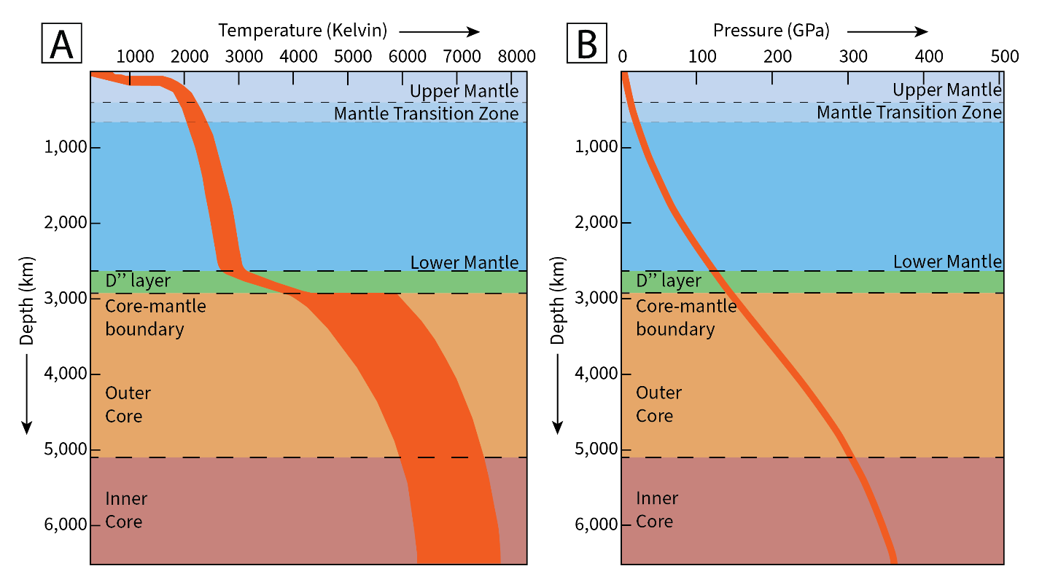
Figure 3.1. Depth into the Earth in kilometers (km) versus Temperature in Kelvin (A) and Pressure in gigapascals (GPa) (B). The average boundary thickness of the Upper Mantle, Mantle Transition Zone, Lower Mantle, D double prime (D”) layer, Outer Core and Inner Core are shown by dashed lines.

Table 3.2. Layers of the Earth, depths from the surface, and their major mineralogy.
Region (depths) | Mineralogy
Crust (average depth 40 km) | - Feldspar [KAlSi₃O₈ – NaAlSi₃O₈ – CaAl₂Si₂O₈],
Crust (average depth 40 km) | - Quartz [SiO₂]
Upper mantle (410-40 km) | - Olivine [Fe₂SiO₄],
Upper mantle (410-40 km) | - Pyroxene [(Ca,Na,Fe,Mg)(Cr,Al,Fe,Mg,Co,Mn,Sc,Ti,V,Fe)(Si,Al)₂O₆],
Upper mantle (410-40 km) | - Garnet [Fe₃Al₂Si₃O₁₂],
Upper mantle (410-40 km) | - Spinel [MgAl₂O₄]
Transition zone (670-410 km) | - Structures with both SiO₄ and SiO₆ groups,
Transition zone (670-410 km) | - e.g., majorite garnet [Mg₃(MgSi)(SiO₄)₃]
Lower mantle (2891-670 km) | - Magnesio-wüstite [(Mg,Fe)O],
Lower mantle (2891-670 km) | - Magnesium silicate perovskite [(Mg,Fe)SiO₃],
Lower mantle (2891-670 km) | - Stishovite [(SiO₂)]
Outer core (5150- 2891 km) | - Liquid iron
Inner core (6371-5150 km) | - Hexagonal Close-Packed (HCP) iron

formulas and phase information when relevant. One interesting point that might be brought up by students is that Carbon is not a major element in any layer within the
Earth, and this is true, but it is also very important to the history of the Earth and the existence of life!

4. Carbon: Phases with Relation to Earth
Now is a great time to introduce the carbon phase diagram (Figure 3.2). I have included two versions here, one with an overlay of relevant pressure and temperature values of different depths into the Earth, as given in Table 3.3. If students have a copy of Table 3.3 available to them, providing Figure 3.2a can give them the chance to think through the change of physical properties with depth. If Table 3.3 is not simultaneously available, such as being used in a slideshow presentation when handouts are unavailable, Figure 3.2b will be helpful for group discussion. It may be important to note that the Y axis of the plot is in logarithmic scale, which makes the depth points seem to get closer and closer together as you get closer to the core of the Earth.
Either as small groups, or a whole class, ask students to name which phases of elemental carbon we should find in the Earth. Have them predict, in combination with Figure 3.1, which layers of the Earth would contain which phases, based solely on the pressures and temperatures at those depths.
Now you can reintroduce Table 3.2, which shows the major phases present in the different layers of the Earth. While we have already acknowledged that carbon is not a constituent element in any of the layers, we can consider the properties of the other phases to rule out the presence of elemental carbon minerals, specifically in the inner and outer core. While the pressures and temperatures predicted for those layers of the Earth fall within the phase diagram for carbon, the composition of the inner and outer core are unlikely to provide a hospitable environment to a crystalline carbon phase.
Some relevant information on Earth System’s concepts, along with their prompting questions are contained in the Pre-Activity rows of Table 3.4. It is important to review the qualifications of a mineral and native mineral with students when thinking about the chemical layers of the Earth in relation to diamond and graphite. Figure 3.3, based on Figure 4.6 from Deep Carbon, shows different areas of diamond formation, along with
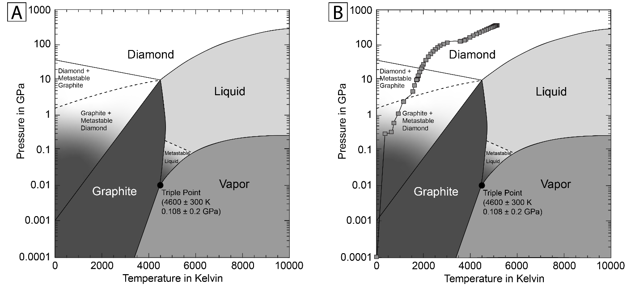
Figure 3.2. Carbon phase diagram for Earth-relevant conditions. Plot A shows just the phase diagram while plot B has an overlay of the pressure-temperature path through the Earth based on Table 3.1.

Table 3.3. Pressure and temperature at different locations within the Earth with distance from the center of Earth and distance from the surface of Earth.
The Geotherm
Distance from the center of the Earth (km) | Distance from the surface of the Earth (km) | Pressure (GPa) | Temperature (K)
6371 | 0 | 0.0 | 300
6368 | 3 | 0.3 | 366
6356 | 15 | 0.3 | 630
6347 | 24 | 0.6 | 743
6331 | 40 | 1.1 | 930
6291 | 80 | 2.5 | 1155
6221 | 150 | 4.8 | 1550
6151 | 220 | 7.1 | 1622
6061 | 310 | 10.2 | 1714
6016 | 355 | 10.8 | 1750
5971 | 400 | 13.4 | 1779
5871 | 500 | 17.1 | 1842
5771 | 600 | 21.0 | 1906
5701 | 670 | 23.8 | 1950
5600 | 771 | 28.3 | 2003
5400 | 971 | 37.3 | 2109
5200 | 1171 | 46.5 | 2211
5000 | 1371 | 55.9 | 2313
4800 | 1571 | 65.5 | 2411
4600 | 1771 | 75.4 | 2509
4400 | 1971 | 85.4 | 2610
4200 | 2171 | 95.8 | 2712
4000 | 2371 | 106.4 | 2865
3800 | 2571 | 117.4 | 3018
3630 | 2741 | 127.0 | 3564
3600 | 2771 | 128.7 | 3601
3480 | 2891 | 135.8 | 3750
3400 | 2971 | 144.2 | 3816
3200 | 3171 | 165.1 | 3981
3000 | 3371 | 185.6 | 4123
2800 | 3571 | 205.6 | 4265
2600 | 3771 | 224.9 | 4383
2400 | 3971 | 243.3 | 4501
2200 | 4171 | 260.7 | 4597
2000 | 4371 | 277.0 | 4693
Table 3.3 Continued
Distance from the center of the Earth (km) | Distance from the surface of the Earth (km) | Pressure (GPa) | Temperature (K)
1800 | 4571 | 292.2 | 4769
1600 | 4771 | 306.2 | 4846
1400 | 4971 | 318.8 | 4907
1222 | 5150 | 328.9 | 4961
1200 | 5171 | 330.1 | 4965
1000 | 5371 | 340.2 | 5003
800 | 5571 | 348.7 | 5041
600 | 5771 | 355.3 | 5064
400 | 5971 | 360.0 | 5087
200 | 6171 | 362.9 | 5119
0 | 6371 | 363.9 | 5151

Table 3.4. Possible discussion questions for different portions of classroom activity, with important discussion points listed in the right column.
Step | Question | Possible discussion points
Pre-Activity | What is a mineral? | Minerals are materials that meet five requirements. They are: 1) naturally occurring, 2) inorganic, 3) solids, 4) with a definite chemical composition, and 5) an ordered internal structure.
Pre-Activity | What is a native mineral? | A mineral composed of a single element
Pre-Activity | What happens when solids experience a change in pressures and temperatures from those they formed at? | The solid reorders to a different solid. Bond lengths and geometry of the element(s) change.
Group hypotheses | Discuss with your team which phases of carbon you would expect to form in the Earth (below the surface) based on Figure 2 and the pressures and temperatures listed in Table 3.1 or shown in Figure 3.1? | Figure 3.2b shows the P-T path of the Earth overlain on the phase diagram, which can aid in visualizing the phases of carbon that could be found in Earth.
Group hypotheses | Would you expect carbon minerals, graphite or diamond, to form in the inner or outer core? | Use Table 3.2 to discuss the phases present there and whether it would make sense to see any minerals in those layers.
Group hypotheses | Which layer(s) of Earth would you expect to find graphite forming in? | Using Figures 3.1 & 3.2 combined with Table 3.1, students should predict surface to the transition zone in the mantle, but most stable in the upper mantle.
Group hypotheses | Which layer(s) of Earth would you expect to find diamond forming in? | Using Figures 3.1 & 3.2 combined with Table 3.1, students should predict anywhere in the mantle, but more stable deeper.
Follow up | Do you see any similarities between the molecular model for graphite and the molecular model for diamond? | When you rotate the diamond model around you should see that it also forms hexagons when viewed in 2 dimensions
Follow up | Which carbon mineral would you expect to be stronger against outside forces? | If time permits, you can talk about Moh's Hardness Scale and the relative strength of the minerals.
Follow up | What are some uses for each carbon mineral? How does their strength relate to their use in that application? | Graphite: Pencil cores ('leads') because it is softer than paper and the hexagons (graphenes) will flake off and be left on the paper because the vertical bonds are weak. Lubricants because they can form a thin film and withstand very high temperatures without changing chemically.  Diamond: Abrasives such as precision sandpapers and files for polishing because it is one of the strongest materials available. Jewelry because it holds up against the elements and will last for a lifetime even when worn every day.

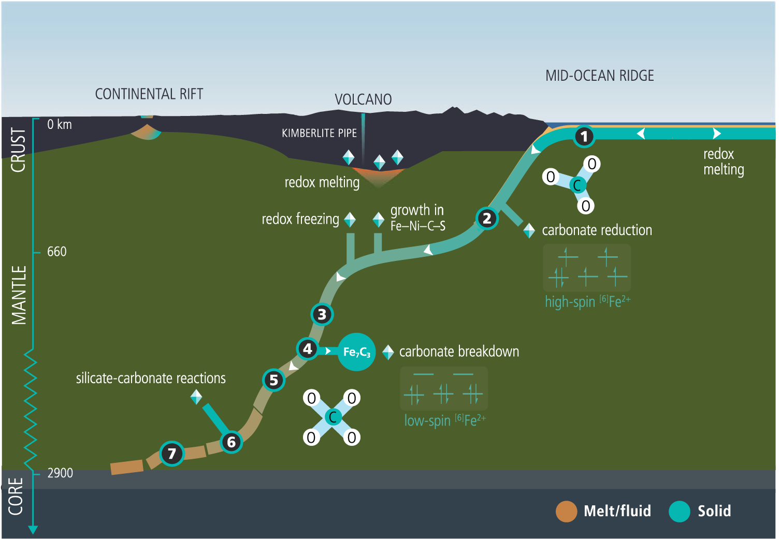
Figure 3.3. Based on figure 4.6 from Deep Carbon chapter 4 “Carbon-Bearing Phases throughout Earth’s Interior”, showing simplified distribution and forms of carbon inside the Earth. The thickness of the oceanic crust and subducting slab are vertically exaggerated for clarity in comparison to values in Table 3.3.

the reaction type that occurs in order to crystallize diamonds in those regions (Orcutt et al., 2019).

5. Hands On: Molecular Models of Solid Phases of Elemental Carbon
For the activity portion of this lesson, students work in groups to build molecular models of graphite and diamond to compare the geometries of the molecular structure between the two minerals. Classroom kits distributed through our program to local public libraries contain molecular model sets as outlined in Table 3.5 based on the components from Indigo Instruments (Indigo Instruments, 2022). With time constraints in mind, student groups can be directed on constructing models in two different ways: with or without visual instruction prompts shown as Figure 3.4. If students are not provided cues, the goal is to encourage them to think about bond angles and overall geometry of structure, while keeping in mind that minerals are repetitive. It is worth noting that in the diamond structure, the carbon atoms alternate orientation to efficiently form the repetitive structure.

6. Lesson Wrap-Up: Same Element, Same Phase, Different Structure
After students have had time to construct their models, check groups for correct construction if no cues were provided, or completion, before reconvening a class discussion. Thanks to the nature of minerals as repeating patterns, each group’s individual model can be compiled into one large whole-class mineral model during the class summary discussion.
Some recommendations for follow-up questions can be found in Table 3.2 if students are unsure of where to begin. Some different classifications of conversations can be visual differences in the two forms of native carbon minerals, how the minerals might react to different things, such as forces and other elements, and how the structure might relate to the industrial applications of the mineral.
For further information on mineral properties, each mineral can be found on mindat.org. If specimens of each mineral are available, discussion on the Moh’s hardness scale can be combined with the molecular models. Moh’s hardness is a relative (qualitative) scale based on common minerals where 1 is the softest material

Table 3.5. Information on parts per set for group classroom activity based on Indigo Instruments molecular models.
Mineral | Piece | Number of pieces per set | Indigo® Instruments SKU | Indigo® Instruments name
Diamond | Black K atoms | 30 | 68244C | Black Tetrahedral sp3 Atom
Diamond | 35 mm bonds | 40 | 68186-35 | 117 pm Wobbly Bond
Graphite | Black M atoms | 26 | 68259C | Black 5 Prong dsp3 Atom
Graphite | 30 mm bonds | 30 | 68186-30 | 100 pm Wobbly Bond
Graphite | 50 mm bonds | 4 | 68186-50 | 167 pm Wobbly Bond

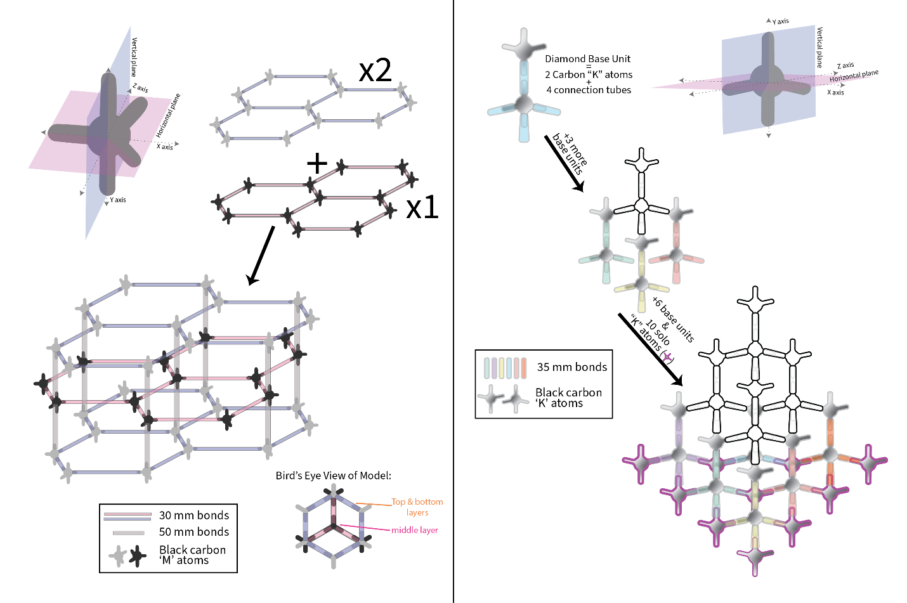
Figure 3.4. Guidance for building atomic structures of graphite (A) and diamond (B) based on materials from indigoinstruments.com.
and 10 is the hardest. On this scale, graphite has a hardness of 1-2 and diamond has a hardness of 10. Ask students to consider the difference in bond angles and how that might affect the strength of the material. How might the conditions that each is formed in affect the bond angles?

References
Bascom, W. (1959). The Mohole. Scientific American, 200(4), 41–49. https://doi.org/10.1038/scientificamerican0459-41
Carlson, D. H., Plummer, C. C., & Hammersley, L. (2010). Physical Geology Earth Revealed (14th ed.). McGraw-Hill.
Harris, J. W. (1993). The geology of diamond: Time and depth profiles from inclusions. Diamond and Related Materials, 2(2–4), 75–79. https://doi.org/10.1016/0925-9635(93)90034-Y
Herak, D., & Herak, M. (2007). Andrija Mohorovicic (1857-1936)--On the occasion of the 150th anniversary of his birth. Seismological Research Letters, 78(6), 671–674. https://doi.org/10.1785/gssrl.78.6.671
Indigo Instruments. (2022). indigoinstruments.com
NGSS Lead States. (2017). DCI Arrangements of the Next Generation Science Standards Table of Contents. September, 1–103.
Orcutt, B. N., Daniel, I., & Dasgupta, R. (Eds.). (2019). Deep Carbon (Issue 8.5.2017). Cambridge University Press. https://doi.org/10.1017/9781108677950
Sarafian, E., Gaetani, G. A., Hauri, E. H., & Sarafian, A. R. (2017). Experimental constraints on the damp peridotite solidus and oceanic mantle potential temperature. Science, 355(6328), 942–945. https://doi.org/10.1126/science.aaj2165

Conclusions

Through natural samples from Earth’s oceanic lithosphere and experimental analogs of the Moon, we can model the behavior of rocks at depth to develop four-dimensional models of geologic systems in terrestrial mantles.
Geothermometry and geospedometry of samples at fast-spreading mid-ocean ridges lends credence to the Sheeted Sill model of crustal accretion, with fast cooling rates calculated near the crust-mantle transition zone that would require deep circulation of cold ocean water, a process incompatible with the Gabbro Glacier model.
Mechanical data and microstructural analysis of experimentally deformed analogs to portions of the lunar mantle suggest that aggregate rheology would be controlled by ilmenite at ratios greater than 25:75 ilm:ol, with more work needed to constrain the transition to olivine dominated between 25:75 and 10:90 ilm:ol. The contrast in material strength with changing volume percentages in the constituent phases needs to be compared to future shear experiments in monomineralic compositions to determine which theoretical aggregate flow law would best explain the system.
Based on state and national standards for science in secondary education settings, lesson plans integrating Earth science concepts can bring the depths of the Earth to the hands of high school students, while relieving the lesson planning burden and needed expertise of classroom educators through partnerships such as the one outlined in Chapter 3.

Vita

Nadine was born to Dr. James A. Warneke, MD, FACS and Lisa F. Warneke, MS, in Buffalo, NY. At a young age she moved to Tucson, AZ, where she attended primary and secondary school before continuing to her Bachelor of Science at the University of Arizona. While at the University of Arizona, she participated in in Tau Beta Sigma – Omega, Pride of Arizona, Honor Choir, Symphonic Band, World Music Gang, and the Society of Earth Sciences Students, finishing with a BS in Geology and a minor in Music. During her time at the University of Arizona, she was a member of the Arizona Accelerator Mass Spectrometry Lab, preparing C¹⁴ samples for analysis, then later joined the USGS Water Resources Division, working with Dr. Julio Betancourt on digitizing over 100 years of paleo-rodent midden data to examine climatic changes in the American Southwest. After graduating from UArizona, she began her Master of Science at the University of New Mexico in Albuquerque, working with Dr. Karl Karlstrom on the incisional history of the Eastern Grand Canyon and Vermillion Cliffs using low-temperature AHe thermochronology. After defending her thesis, she worked in the environmental industry on contaminant remediation at Fort Wingate, Gallup, NM, before switching paths to work in K-12 education, teaching in informal settings and managing grant funds for a non-profit childcare program. Her desire to continue with laboratory studies led her to her work at the University of Tennessee where she has combined hands-on research with her interests in teaching and education. After UTK, Nadine plans on accepting a postdoctoral position investigating type-E olivine through Griggs-type deformation experiments.

