Evaluation of Treatment Options and Investigation of Pathogenesis of Chytridiomycosis in North American Salamanders

A Dissertation Presented for the
Doctor of Philosophy
Degree
The University of Tennessee, Knoxville

Anastasia Elaine Towe
May 2023
Copyright © 2023 by Anastasia E. Towe.
All rights reserved.

Dedication
I dedicate this work to my little brother Justin, who encouraged me to chase my dreams.
I miss you more than words can say.
Don’t pause too long.

Acknowledgements
I would like to thank my advisor Dr. Debra Miller for her support throughout my veterinary and graduate school endeavors, and for helping my career grow in ways I never imagined when I took on my first research project six years ago. The passion that she has for wildlife health, research, and the success of her students is something I will carry with me and hope to emulate. A special thank you also to Dr. Matthew Gray for his guidance throughout the work presented here and the projects that came before – though he did not serve on my committee he has been an integral part of my research work from the beginning. I was so fortunate to find such wonderful mentors so early in my research career and to have the opportunity to continue to work with them for several years. I would also like to thank my committee for taking the time out of their busy schedules to support me and my work and to provide so much guidance along the way – Drs. Rebecca Hardman, Sree Rajeev, and Mark Wilber have been so patient and kind as I grew and learned through this process. None of this work would have been possible without the other members of the Gray-Miller lab, who have been my friends and coworkers through many long days of animal care and sample collection. Dr. Wesley Sheley, Joe DeMarchi, and Adri Tompros – I could not have hoped to work with a better and more supportive group of peers, and I am so fortunate to be able to call you friends as well. In particular, I want to thank Dr. Davis Carter, who has been a mentor to me in his own right as a fellow graduate student and now as a post-doc, and who serves as an inspiration to everyone who has worked in the lab. Thank you to the undergraduate students who were involved in these projects as well, particularly Carmen Merolle, Merrie Urban, and Megan Wilson, for their tireless work in the lab. As this chapter of my life comes to a close and I move on to the next adventure, I know I will think back on the years I spent as a part of the Gray-Miller lab with fondness. I would not have survived this process without the love and support of my husband, Tyler Bailey, and my mother and sister, Andrea and Haley Laperriere, who are and will always be my favorite people. Thank you for always believing in me. There are many other family members and friends who supported me along the way whose names I do not have space to list here but are nonetheless responsible for maintaining my sanity over the last several years.
And finally, I want to thank the animals that served as the subjects of this research. I hope that the work presented here honors their lives, and I challenge anyone to work with amphibians and not become as passionate about them as I have.
Abstract
Chytridiomycosis, a cutaneous fungal disease caused by two related fungi, Batrachochytrium dendrobatidis (Bd) and Batrachochytrium salamandrivorans (Bsal), is a major cause of amphibian population declines worldwide. Bd has a broad distribution, covering every continent except for Antarctica. Meanwhile, Bsal is currently restricted to Europe and Asia. Treatment options for both Bd and Bsal remain a major area of concern for wild populations. Recently, implants for long-term, parenteral antifungal drug administration have shown some promise in fungal diseases in wildlife. We investigated the safety and efficacy of an intracoelomic implant of the antifungal drug terbinafine in greater sirens exposed to Bd. While the efficacy results were inconclusive, the implants did not cause harm and led to detectable levels of terbinafine in plasma. The use of such implants in amphibians remains an important area for further investigation. In a separate study, we explored the use of a probiotic bacteria and addition of a known secondary bacterial pathogen in Bsal-infected animals. The objectives of this study were to determine the safety and efficacy of using probiotic bacteria to prevent and treat Bsal chytridiomycosis, and to evaluate bacteremia and septicemia as components of morbidity and mortality in animals that succumb to disease. While the probiotic treatment did not impact mortality rates, there was evidence of bacterial infiltration into the blood and organs in Bsal-exposed animals. Finally, while there is an ever-growing body of research elucidating the acute impacts of Bsal, sublethal effects on population dynamics must be considered as well. We used a two-part study design to investigate the impacts of Bsal exposure on individual reproductive potential, and on reproductive success under breeding conditions. This study provided evidence for terminal investment, increased reproductive effort in the face of pathogen exposure, in eastern newts exposed to Bsal. Overall, the findings of this research provide more information about new avenues for treatment for chytridiomycosis and their potential drawbacks, and expand on the existing knowledge of Bsal pathogenesis. These findings will provide a foundation for future amphibian disease research, informing mitigation efforts for this disease in managed and free-ranging amphibian populations.

Table of Contents
Introduction 1
References 4
Chapter I: Evaluation of intracoelomic implants for terbinafine administration for prevention of chytridiomycosis in greater sirens (Siren lacertina) 7
Abstract 8
Introduction 9
Materials and Methods 10
Results 13
Discussion 14
References 17
Appendices 20
Chapter II: Risk of Bacteremia Associated with Probiotic Treatment of Batrachochytrium salamandrivorans 26
Abstract 27
Introduction 28
Materials and Methods 30
Results 34
Discussion 39
References 42
Appendices 45
Chapter III: Impact of Bactrachochytrium salamandrivorans Exposure on Eastern Newt Reproductive Fitness 56
Abstract 57
Introduction 58
Materials and Methods 61
Results 64
Discussion 66
References 70
Appendices 74
Conclusion 87
References 89
Vita 91

List of Tables
Table 1.1: Plasma terbinafine levels determined by HPLC in 9 adult greater sirens at 4 time points over the course of 128 days post-injection of intracoelomic implants 20
Table 3.1: Sample sizes of each of the treatment groups in Experiment 1: Individual Reproductive Fitness. 74
Table 3.2: Sample sizes of each of the treatment groups in Experiment 2: Breeding Study 74
Table 3.3: Overview of the statistical analyses performed for female gonadal characteristics and oogenesis 75
Table 3.4: Overview of the statistical analyses performed for male gonadal characteristics and spermatogenesis 76
Table 3.5: Overview of the statistical analyses performed for female gonadal characteristics and oogenesis in animals in the breeding study 77
Table 3.6: Overview of the statistical analyses performed for male gonadal characteristics and spermatogenesis in animals in the breeding study 78

List of Figures

Figure 1.1: Image of healed implant site on the ventral caudal aspect of a greater siren, 35 days post-injection. 20
Figure 1.2: Line graph displaying plasma terbinafine concentrations determined by HPLC in four adult greater sirens 21
Figure 1.3: Individual Batrachochytrium dendrobatidis (Bd) load trajectories over time on adult greater siren skin 22
Figure 1.4: Image of terbinafine-impregnated implant (black arrow) in the coelomic cavity of a greater siren at necropsy 23
Figure 1.5: Bd organisms present in the superficial epidermis of a section of the toes of a greater siren 24
Figure 2.1: Timeline of study events 45
Figure 2.2: Kaplan-Meier survival curves representing the mortality rate of Notophthalmus viridescens exposed to one of four combinations of Bsal and P. fluorescens 46
Figure 2.3: Kaplan-Meier survival curves representing the mortality rate of Notophthalmus viridescens exposed to one of four combinations of Bsal and A. hydrophila 47
Figure 2.4: Mean Bsal load at postmortem examination on eastern newt collected from swabs and estimated with qPCR (Pseudomonas groups) 48
Figure 2.5: Mean Bsal load at postmortem examination on eastern newt skin collected from swabs and estimated with qPCR (Aeromonas groups) 49
Figure 2.6: Mean Pseudomonas load at postmortem examination on eastern newt liver samples estimated with qPCR. 50
Figure 2.7: Mean Pseudomonas fluorescens colony counts at postmortem examination on eastern newt blood cultures. 51
Figure 2.8: Mean Bsal lesion counts per mm at histopathologic examination on eastern newts (Pseudomonas groups) 52
Figure 2.9: Mean Bsal lesion counts per mm at histopathologic examination on eastern newts (Aeromonas groups) 53
Figure 2.10: Plot of the average lesion density per unit of cross section for each lesion grade at histopathologic examination on eastern newts (Pseudomonas groups) 54
Figure 2.11: Plot of the average lesion density per unit of cross section for each lesion grade at histopathologic examination on eastern newts (Aeromonas groups) 55
Figure 3.1: Stages of spermatogenesis 79
Figure 3.2: Proportions of eggs with yolk development in female eastern newts housed individually 80
Figure 3.3: Ovary mass relative to body mass in female newts housed individually… 81
Figure 3.4: Testicular mass relative to body mass in male eastern newts housed individually 82
Figure 3.5: Germinal epithelial depth in male eastern newts housed individually 83
Figure 3.6: Proportions of eggs with yolk development in female eastern newts housed in breeding pairs 84
Figure 3.7: Testicular area relative to body mass in male eastern newts housed in breeding pairs 85
Figure 3.8: Proportion of spermatogonia cell clusters in male eastern newts housed in breeding pairs 86

Introduction
Numerous wildlife are currently in decline, and amphibians are among the most threatened, with nearly 60% of species in danger of extinction over the last 40 years (García-Rodríguez et al., 2022). There are many contributors to amphibian population declines, including habitat loss, environmental toxins, and infectious disease. One such disease is chytridiomycosis, a cutaneous fungal disease caused by two related fungi, Batrachochytrium dendrobatidis (Bd) and Batrachochytrium salamandrivorans (Bsal). Chytridiomycosis has led to an amphibian panzootic that represents the greatest recorded disease-related loss of biodiversity, with Bd contributing to population declines in over 500 amphibian species (Scheele et al., 2019). While Bsal’s population impacts are currently more limited in scale, the risk of exposure to naïve, susceptible species is of great concern.
Bd has a broad distribution worldwide, with over 1000 confirmed host species in 86 countries, covering every continent except for Antarctica. (Castro Monzon et al., 2020). Meanwhile, Bsal is not yet known to occur in North America, with its current distribution restricted to Europe and Asia (Lötters et al., 2020; Waddle et al., 2020). In Western Europe, Bsal has contributed to the near extirpation of fire salamander (Salamandra salamandra) populations (Martel et al., 2013). Bd’s emergence as a global pathogen has been linked to the expansion of the commercial trade in amphibians (O’Hanlon et al., 2018), and there is a high likelihood that Bsal could be spread the same way. Bsal has been detected in the pet trade, and there are concerns that this could be the introduction point for the pathogen to currently naïve populations (Nguyen et al., 2017). With continued global movement of amphibians, Bsal poses a significant threat to North American amphibian biodiversity, and many species have been shown to be susceptible through laboratory trials (Carter et al., 2020; Friday et al., 2020; North American Bsal Task Force, 2020).
Whether caused by Bd or Bsal, chytridiomycosis disrupts the integrity of the skin. Immature sporangia infect cells in the superficial epidermis a few layers deep, maturing at the same rate that the host cells move outwards as they mature and keratinize. As the host cell dies, the sporangia develop discharge tubes that open to the surface of the skin (Berger, Hyatt, et al., 2005, Martel; et al., 2013). In Bd infections, hyperkeratosis is caused by an increase in epidermal cell turnover and the swelling of epidermal cells near the site of infection along with sporangia causing premature death and keratinization Berger, Hyatt, et al., 2005). Meanwhile, Bsal infections tend to cause more rapid destruction of keratinocytes as the zoospores encyst on the skin, causing erosive lesions that develop into deep ulcers (Martel et al., 2013) .The disruption of normal cell architecture leads to systemic disease through detrimental effects on hydration, ion exchange, and cutaneous respiration. Excessive water loss leads to dehydration and electrolyte imbalances, and in Bd this has been shown to lead to cardiac arrest and death (Salla et al., 2018; Voyles et al., 2009; Wu et al., 2019). While similar studies on Bsal pathogenesis are still underway (Sheley et al., 2023), it is expected that the deep ulceration and necrosis of the skin caused by the pathogen has similar effects on electrolyte balance. It has also been shown that this skin erosion and ulceration promotes secondary bacterial overgrowth that may result in lethal septicemia (Bletz et al., 2018).
Treatment options for both Bd and Bsal remain a major area of concern, particularly for wild populations. Various topical treatment options have been explored for both fungi, but the necessity of repeat dosing for individual animals makes many of these regimens impractical for free-ranging animals. The use of chemical antifungals in natural environments is also concerning, as there may be unintended negative consequences for other organisms in the community. Recently, implants for long-term, parenteral antifungal drug administration have shown some promise in other fungal diseases in wildlife (Hardman et al., 2021; Kane et al., 2017). In Chapter I, we investigate the safety and efficacy of an intracoelomic implant of the antifungal drug terbinafine in greater sirens exposed to Bd.
Probiotics are another treatment avenue that has been explored in various disease processes, including fungal diseases in wildlife. Under laboratory conditions, the use of probiotic bacteria to augment the natural microbiome has led to decreased Bd load and increased survival rates in frogs (Harris et al., 2009). However, the ulcerative effect of Bsal on the skin barrier creates a potential pathway for secondary bacterial infiltration, raising the concern that probiotic treatment may in fact be detrimental in the face of existing Bsal lesions and a weakened immune system. In Chapter II we explore both the use of a probiotic bacteria and addition of a known secondary bacterial pathogen in Bsal-infected animals. The objectives of this study were to determine the safety and efficacy of using probiotic bacteria to prevent and treat Bsal chytridiomycosis, and to evaluate bacteremia and septicemia as components of morbidity and mortality in animals that succumb to disease.
Finally, while there is an ever-growing body of research elucidating the individual, acute impacts of Bsal, adult morbidity and mortality are only part of the story when it comes to predicting population declines; sublethal effects on recruitment of the next generation must be considered as well. In the case of Bd, previous studies have investigated these effects, including gross and histologic changes to gonads in infected animals (Brannelly et al., 2021), long-term impacts on body fat and gonad size in susceptible species (Campbell et al., 2019), and impacts on mating behaviors even after the infection has been cleared (An & Waldman, 2016). Field studies on Bd have also been incorporated into population level modeling to explain the extinction of some and persistence of other populations in the face of chytridiomycosis outbreaks (Briggs et al., 2005). This is an area that has not previously been explored in Bsal pathophysiology and epidemiology. In Chapter III, we use a two-part study design to investigate the impacts of Bsal exposure on individual reproductive potential, and on reproductive success under breeding conditions.

References
An, D., & Waldman, B. (2016). Enhanced call effort in Japanese tree frogs infected by amphibian chytrid fungus. Biology Letters, 12(3). https://doi.org/10.1098/rsbl.2016.0018
Berger, L., Hyatt, A., Speare, R., & Longcore, J. (2005). Life cycle stages of the amphibian chytrid Batrachochytrium dendrobatidis. Diseases of Aquatic Organisms, 68, 51–63. https://doi.org/10.3354/dao068051
Bletz, M. C., Kelly, M., Sabino-Pinto, J., Bales, E., van Praet, S., Bert, W., Boyen, F., Vences, M., Steinfartz, S., Pasmans, F., & Martel, A. (2018). Disruption of skin microbiota contributes to salamander disease. Proceedings of the Royal Society B: Biological Sciences, 285(1885). https://doi.org/10.1098/rspb.2018.0758
Brannelly, L. A., Webb, R. J., Jiang, Z., Berger, L., Skerratt, L. F., & Grogan, L. F. (2021). Declining amphibians might be evolving increased reproductive effort in the face of devastating disease. Evolution, 75(10), 2555–2567. https://doi.org/10.1111/EVO.14327
Briggs, C. J., Vredenburg, V. T., Knapp, R. A., & Rachowicz, L. J. (2005). INVESTIGATING THE POPULATION-LEVEL EFFECTS OF CHYTRIDIOMYCOSIS: AN EMERGING INFECTIOUS DISEASE OF AMPHIBIANS. Ecology, 86(12), 3149–3159. https://doi.org/10.1890/04-1428
Campbell, L., Bower, D. S., Clulow, S., Stockwell, M., Clulow, J., & Mahony, M. (2019). Interaction between temperature and sublethal infection with the amphibian chytrid fungus impacts a susceptible frog species. Scientific Reports, 9(1). https://doi.org/10.1038/s41598-018-35874-7
Carter, E. D., Miller, D. L., Peterson, A. C., Sutton, W. B., Cusaac, J. P. W., Spatz, J. A., Rollins‐Smith, L., Reinert, L., Bohanon, M., Williams, L. A., Upchurch, A., & Gray, M. J. (2020). Conservation risk of Batrachochytrium salamandrivorans to endemic lungless salamanders. Conservation Letters, 13(1). https://doi.org/10.1111/conl.12675
Castro Monzon, F., Rödel, M. O., & Jeschke, J. M. (2020). Tracking Batrachochytrium dendrobatidis Infection Across the Globe. EcoHealth, 17(3), 270–279. https://doi.org/10.1007/S10393-020-01504-W/FIGURES/3
Friday, B., Holzheuser, C., Lips, K. R., & Longo, A. V. (2020). Preparing for invasion: Assessing risk of infection by chytrid fungi in southeastern plethodontid salamanders. Journal of Experimental Zoology Part A: Ecological and Integrative Physiology, 333(10), 829–840. https://doi.org/10.1002/JEZ.2427
García-Rodríguez, A., Basanta, M. D., García-Castillo, M. G., Zumbado-Ulate, H., Neam, K., Rovito, S., Searle, C. L., & Parra-Olea, G. (2022). Anticipating the potential impacts of Batrachochytrium salamandrivorans on Neotropical salamander diversity. Biotropica, 54(1), 157–169. https://doi.org/10.1111/BTP.13042
Hardman, R. H., Cox, S., Reinsch, S. D., Schwartz, H. C., Skeba, S., McGinnity, D., Souza, M. J., & Miller, D. L. (2021). Efficacy of subcutaneous implants to provide continuous plasma terbinafine in hellbenders (Cryptobranchus alleganiensi) for future prophylactic use against chytridiomycosis. Journal of Zoo and Wildlife Medicine, 52(1), 300–305. https://doi.org/10.1638/2020-0158
Harris, R. N., Brucker, R. M., Walke, J. B., Becker, M. H., Schwantes, C. R., Flaherty, D. C., Lam, B. A., Woodhams, D. C., Briggs, C. J., Vredenburg, V. T., & Minbiole, K. P. C. (2009). Skin microbes on frogs prevent morbidity and mortality caused by a lethal skin fungus. The ISME Journal, 3(7), 818–824. https://doi.org/10.1038/ismej.2009.27
Kane, L. P., Allender, M. C., Archer, G., Leister, K., Rzadkowska, M., Boers, K., Souza, M., & Cox, S. (2017). Pharmacokinetics of nebulized and subcutaneously implanted terbinafine in cottonmouths (Agkistrodon piscivorus). Journal of Veterinary Pharmacology and Therapeutics, 40(5), 575–579. https://doi.org/10.1111/JVP.12406
Lötters, S., Wagner, N., Albaladejo, G., & Böning, P. (2020). The amphibian pathogen Batrachochytrium salamandrivorans in the hotspot of its European invasive range: past-present-future. http://www.salamandra-journal.com
Martel, A., Spitzen-Van Der Sluijs, A., Blooi, M., Bert, W., Ducatelle, R., Fisher, M. C., Woeltjes, A., Bosman, W., Chiers, K., Bossuyt, F., & Pasmans, F. (2013). Batrachochytrium salamandrivorans sp. nov. causes lethal chytridiomycosis in amphibians. Proceedings of the National Academy of Sciences of the United States of America, 110(38), 15325–15329. https://doi.org/10.1073/pnas.1307356110
Nguyen, T. T., Nguyen, T. Van, Ziegler, T., Pasmans, F., & Martel, A. (2017). Trade in wild anurans vectors the urodelan pathogen Batrachochytrium salamandrivorans into Europe. Amphibia-Reptilia, 38(4), 554–556. https://doi.org/10.1163/15685381-00003125
North American Bsal Task Force. (2020). A North American Strategic Plan to Control Invasions of the Lethal Salamander Pathogen Batrachochytrium salamandrivorans.
O’Hanlon, S. J., Rieux, A., Farrer, R. A., Rosa, G. M., Waldman, B., Bataille, A., Kosch, T. A., Murray, K. A., Brankovics, B., Fumagalli, M., Martin, M. D., Wales, N., Alvarado-Rybak, M., Bates, K. A., Berger, L., Böll, S., Brookes, L., Clare, F., Courtois, E. A., … Fisher, M. C. (2018). Recent Asian origin of chytrid fungi causing global amphibian declines. Science, 360(6389), 621–627. https://doi.org/10.1126/SCIENCE.AAR1965/SUPPL_FILE/AAR1965_OHANLON_SM.PDF
Salla, R. F., Rizzi-Possignolo, G. M., Oliveira, C. R., Lambertini, C., Franco-Belussi, L., Leite, D. S., Silva-Zacarin, E. C. M., Abdalla, F. C., Jenkinson, T. S., Toledo, L. F., & Jones-Costa, M. (2018). Novel findings on the impact of chytridiomycosis on the cardiac function of anurans: Sensitive vs. tolerant species. PeerJ, 2018(11). https://doi.org/10.7717/PEERJ.5891/SUPP-2
Scheele, B. C., Pasmans, F., Skerratt, L. F., Berger, L., Martel, A., Beukema, W., Acevedo, A. A., Burrowes, P. A., Carvalho, T., Catenazzi, A., De La Riva, I., Fisher, M. C., Flechas, S. V., Foster, C. N., Frías-Álvarez, P., Garner, T. W. J., Gratwicke, B., Guayasamin, J. M., Hirschfeld, M., … Canessa, S. (2019). Amphibian fungal panzootic causes catastrophic and ongoing loss of biodiversity. Science, 363(6434), 1459–1463. https://doi.org/10.1126/science.aav0379
Sheley, W. C., Gray, M. J., Wilber, M. Q., Cray, C., Davis Carter, E., & Miller, D. L. (2023). Electrolyte imbalances and dehydration play a key role in Batrachochytrium salamandrivorans chytridiomycosis.
Voyles, J., Young, S., Berger, L., Campbell, C., Voyles, W. F., Dinudom, A., Cook, D., Webb, R., Alford, R. A., Skerratt, L. F., & Speare, R. (2009). Pathogenesis of chytridiomycosis, a cause of catastrophic amphibian declines. Science (New York, N.Y.), 326(5952), 582–585. https://doi.org/10.1126/SCIENCE.1176765
Waddle, J. H., Grear, D. A., Mosher, B. A., Grant, E. H. C., Adams, M. J., Backlin, A. R., Barichivich, W. J., Brand, A. B., Bucciarelli, G. M., Calhoun, D. L., Chestnut, T., Davenport, J. M., Dietrich, A. E., Fisher, R. N., Glorioso, B. M., Halstead, B. J., Hayes, M. P., Honeycutt, R. K., Hossack, B. R., … Winzeler, M. E. (2020). Batrachochytrium salamandrivorans (Bsal) not detected in an intensive survey of wild North American amphibians. Scientific Reports 2020 10:1, 10(1), 1–7. https://doi.org/10.1038/s41598-020-69486-x
Wu, N. C., Cramp, R. L., Ohmer, M. E. B., & Franklin, C. E. (2019). Epidermal epidemic: Unravelling the pathogenesis of chytridiomycosis. Journal of Experimental Biology, 222(2). https://doi.org/10.1242/JEB.191817/259567/AM/EPIDERMAL-EPIDEMIC-UNRAVELLING-THE-PATHOGENESIS-OF

Chapter I: Evaluation of intracoelomic implants for terbinafine administration for prevention of chytridiomycosis in greater sirens (Siren lacertina)

Abstract
Chytridiomycosis caused by Batrachochytrium dendrobatidis (Bd) has been documented in greater sirens (Siren lacertina) in the wild and in the pet trade. This study evaluated the use of terbinafine-impregnated implants, in prevention of Bd infection in greater sirens. Implants were placed intracoelomically in both control (blank implant, n=4) and treatment (terbinafine implant, n=4) groups. Sirens were exposed to Bd zoospores at one- and two-months post-implant placement. Blood was collected monthly for plasma terbinafine levels, and skin swabs were collected weekly for Bd qPCR. Animals with terbinafine implants had detectable concentrations of plasma terbinafine ranging from 17-102 ng/mL. Only one animal had a peak concentration above the published minimum inhibitory concentration for terbinafine against Bd zoospores (63 ng/mL). Terbinafine implants did not prevent infection or affect Bd clearance rate, but no adverse effects from implants were observed. These findings indicate using intracoelomic drug implants for drug delivery in amphibians is safe; however, terbinafine efficacy in preventing Bd infections in sirens remains unclear. Further investigation of the use of intracoelomic implants and identification of effective drugs and doses in other amphibian species is warranted, as this may provide a practical method for long-term drug delivery in wildlife.

Introduction
Batrachochytrium dendrobatidis (Bd) is a fungal pathogen that causes severe, often lethal disease in amphibians (Scheele et al., 2019). Bd infects keratinized skin, leading to hyperkeratosis, epidermal hyperplasia, disorganization of the epidermal cell layers, and skin sloughing (Berger, Speare, et al., 2005)(Berger, Speare, et al., 2005). This impacts water uptake and ion exchange in affected animals, and death is thought to occur due to asystolic cardiac arrest caused by severe electrolyte imbalances (Voyles et al., 2009). Chytridiomycosis caused by Bd has led to the decline of over 500 amphibian species worldwide and 90 presumed extinctions (Scheele et al., 2019).
The greater siren (Siren lacertina) is a large, fully aquatic salamander that can be found in the Atlantic and Gulf coastal plains of the southern and eastern United States (Hendricks, 2005)(Hendricks, 2005). It is categorized by the International Union for Conservation of Nature as Least Concern and is common throughout the central regions of its range. However, population status is variable and even rare in the peripheral regions of the range, and in Maryland it is considered state endangered (IUCN SSC Amphibian Specialist Group, 2022). The aquatic lifestyle of sirens makes their populations difficult to monitor (Hendricks, 2005). Previous studies have found Bd-infected greater sirens in the pet trade (Tamukai et al., 2014) and both greater and lesser sirens (Siren intermedia) in the wild (Chatfield et al., 2012; Talley et al., 2011), but the overall population impacts of Bd are unknown.
Application of topical antifungals is effective at reducing Bd loads, however treatment courses tend to require multiple dosing events and fail to prevent infection long-term in some cases (Geiger et al., 2017). Therefore, topical treatments are most practical in managed care settings where animals can be handled daily and maintained in pathogen-free environments, and less practical in the wild. Terbinafine is a lipophilic antifungal agent that is commonly used to treat superficial fungal infections(Newland & Abdel-Rahman, 2009). It has been used topically in the treatment of chytridiomycosis with no reports of toxicity, but as with other topical treatments, repeated dosing has been necessary to clear infection (Guzman et al., 2022), and clearance has not been 100% successful (Roberts et al., 2019). Subcutaneous implants impregnated with terbinafine have previously been used in pharmacokinetic studies in cottonmouths (Kane et al., 2017) and hellbenders (Hardman et al., 2021), with the goal of using them for treatment of snake fungal disease and chytridiomycosis, respectively. These implants are produced commercially for melatonin administration in dogs and ferrets(Murray, 2005; Verschuuren et al., 2022) and are approximately the size of typical Passive Integrated Transponders (PIT) tags, or a grain of rice. Subcutaneous terbinafine implants in hellbenders provided plasma concentrations at or above the minimum inhibitory concentration (MIC) for Bd zoospores for 2 to 15 weeks consecutively (Hardman et al., 2021). An attempt to place the implants subcutaneously in sirens failed, as the implants were rejected and expulsed (unpublished study). Therefore, the route was changed to intracoelomic for this study.
The objectives of this study were to 1) evaluate the safety of intracoelomic terbinafine implant placement, 2) quantify blood levels of terbinafine in intracoelomic implanted animals, and 3) evaluate the efficacy of terbinafine delivered through an intracoelomic implant in preventing Bd infection.
Methods
Animal Intake and Husbandry
This study was conducted at the University of Tennessee, Knoxville and all procedures were approved by the University of Tennessee Institutional Animal Care and Use Committee Protocol no. 2723. Greater Sirens (n=9) were collected from the wild and skin swabs were performed for Bd testing via PCR. Animals were handled with nets and moistened towels and were swabbed five times each on the ventrum, head, and feet(Chatfield et al., 2012; Clare et al., n.d.). Swabs were placed in sterile microcentrifuge tubes and stored at -80C. A standard Bd qPCR protocol was followed as in Boyle et al (2004). Reactions were run in duplicate; positive controls and standard curves were constructed using serial dilutions of cultured Bd zoospores, and samples with a CT below 40 were considered positive. Animals initially tested positive for Bd at low levels. Fungal cultures were performed on the swab samples and an isolate from one animal was submitted to the Rosenblum Lab at UC Berkley for sequencing, which identified the isolate as Bd-GPL1. The sirens were heat-treated to clear Bd infections approximately 16 months prior to the start of this study and confirmed negative via Bd PCR performed on two consecutive skin swabs. Sirens were kept individually in 30-gallon plastic tanks connected with a flow-through water system that kept the tanks ¾ filled with dechlorinated water at 22C. Each siren was fed bloodworms (4-6% of body weight at study onset) once every 3 days. Leftover worms and waste were removed from the tank every 3 days. During the study, animals were monitored twice daily (approximately every 12 hours +/- 2 hours) for signs of clinical disease including skin lesions (skin sloughing, ulcerations, proliferations) and behavioral changes (aberrant swimming, excessive hiding or failure to hide, hyporexia, etc).
Implant Placement
A total of eight sirens received implants, with four (Sirens 3, 5, 7, and 9) receiving terbinafine impregnated implants (24.5mg implant, Melatek LLC, Prairie du Sac, WI 53578 USA) and four (Sirens 2, 4, 6, and 8) receiving the base silicone elastomer implant with no terbinafine. A ninth animal (Siren 1) received no implant. Sirens were anesthetized with an immersion bath of benzocaine (200-400 mg/L). Appropriate anesthetic plane was determined by the loss of righting reflex and lack of response to stimuli. Because sirens are fully aquatic, they were placed in dorsal recumbency on a moistened towel and water was intermittently pipetted over their gills. A #15 scalpel blade was used to make a small stab incision in the ventrocaudal coelom, 3 centimeters cranial to the vent and just lateral to midline. The needle of the implant device was directed caudally into the coelomic cavity through the stab incision, and the implant was injected. After confirming the implant had been injected, the body wall was closed with 4-0 PDS in a single cruciate suture. The skin was dried, and cyanoacrylate tissue glue applied for apposition. Each animal received an intramuscular injection of Meloxicam (0.4-1.0mg/kg) for pain control. The animal was then transferred to its regular housing tank and monitored for recovery and the total time anesthetized was recorded.
Terbinafine assay
Animals were anesthetized as above monthly for blood collection to monitor plasma terbinafine levels. Blood was collected from the ventral tail vein using a 25 g needle on a 1 mL syringe, at a maximum volume equal to 1% of body weight. After collection, blood was immediately transferred to lithium heparin tubes and placed on ice for processing. Within 3 hours, tubes were centrifuged and plasma stored at –80°C. Frozen samples were stored until all samples for the study had been collected (37-165 days) and then transported to the University of Tennessee Pharmacology Laboratory, where plasma terbinafine concentrations were measured by high-pressure liquid chromatography (HPLC) (Cox et al., 2015).
Bd exposure and diagnostics
All sirens tested negative for Bd immediately prior to exposure. Bd exposures for the eight animals that had implants occurred on day 35 following implant placement, using the isolate that was cultured from the positive sirens at intake (Bd-GPL1). The ninth animal was not exposed to Bd. After recovery from anesthesia for blood collection, each animal was transferred to a 3L container of water and 5x10⁶ Bd zoospores were pipetted directly onto the dorsal skin. The sirens were held for 24 hours in these inoculation tubs, and then released back into their tanks. Since all sirens tested PCR negative for Bd in the month following initial exposure, a second inoculation following the same procedure was performed on day 60 post-implant placement. Skin swabs were performed every 6 days and Bd PCR run as previously described.
Necropsy
Animals were anesthetized with the previously described method for final blood collection and skin swab on day 128 post-implant placement. Euthanasia was performed for all Bd-exposed (n = 8) animals using concentrated benzocaine to provide a ten-fold overdose. Exsanguination via cardiac puncture was used secondarily. After euthanasia, all animals were examined externally for lesions, and then a complete necropsy was performed, including visual identification of the implant in the coelomic cavity. Animals were then fixed in 10% neutral buffered formalin for histopathology. Trimmed sections of head, mid-body, feet, and tail were placed in tissue cassettes and processed. Histology slides were stained with H&E and examined under 400x magnification for evidence of Bd organisms and associated lesions.

Results
Animal health
Animals recovered well from each anesthetic event. All animals maintained normal appetites throughout the study and had no changes in activity levels. There were no gross skin lesions visible at any time point. However, all animals did experience weight loss over the study period, with an average of 10.7% loss (range 7-19%).
Two animals (siren 5 and 6) had surgical site dehiscence occur at days 11 and 12 post-implant placement. These individuals were anesthetized, and incisions were closed again as previously described. Recovery was without incident and no additional complications of implant placement occurred. Incision sites on all animals healed well, with minimal scarring visible at examination on day 35 postimplant placement (Figure 1, all tables and figures are shown in an appendix at the end of the chapter).
Plasma terbinafine
Terbinafine analysis required a minimum of 0.1 mL of plasma, therefore values were not determined for all animals at every time point due to difficulties in blood collection. All four of the terbinafine-implanted sirens had detectable concentrations of terbinafine in the plasma, while the blank-implanted sirens and the siren without any implant remained at zero (Table 1 and Figure 2). Only one animal (Siren 9) reached plasma terbinafine levels above the previously published MIC for Bd zoospores (63 ng/mL) (Woodward et al., 2014). Siren 9 had plasma levels above this benchmark at two sampling points – 102ng/mL at day 68 postimplant placement and 78ng/mL at day 98.
Bd PCR
All animals tested negative for Bd via qPCR in the month following the first exposure. Following the second exposure, low positive loads were detected in both the blank and terbinafine-impregnated implant groups (Figure 2). One animal (Siren 2) in the blank implant group had no positive swabs. Peak loads occurred 18-30 days following the second exposure, with two animals in each treatment group showing significant peaks. Sirens 3 and 7 in the terbinafine-treated group had peak Bd loads of 49.9 copies/µL and 44.5 copies/µL respectively. Sirens 6 and 8 in the blank group had peak Bd loads of 64.27 copies/µL and 28.95 copies/µL. By day 60, all animals with blank implants tested negative, whereas all animals with terbinafine implants were either negative or had loads below 10 copies/µL.
Necropsy and Histopathology
No gross lesions were detected on necropsy and all animals appeared to be in good health. Implants were found in the caudal coelomic cavity, with no associated fibrous material, adhesions, or inflammation (Figure 4). Histopathology revealed no chytrid-associated lesions. Only one animal had Bd organisms present on histology (Siren 7, terbinafine group), with solitary organisms found on sections of the toes and mouth, without any associated inflammation or changes to the epidermis (Figure 5).
Discussion
The intracoelomic route for drug-impregnated implants was more successful than the subcutaneous route in this species, as the implants remained in place for all animals. Other than the two incidents of surgical site dehiscence, there were no detectable adverse effects from the implants. The terbinafine implants did not appear to greatly impact the development or clearance of Bd infection in the sirens. While the animal with the highest plasma terbinafine levels (Siren 9) had the lowest peak Bd load among the terbinafine-treated animals, there were two animals in the blank implant group that never developed significant Bd loads (Sirens 2 and 4). Bd loads overall were very low, no animals developed gross lesions of chytridiomycosis, and all animals cleared their infections at approximately the same rate, regardless of implant type. Why these animals were resistant to Bd infection is unclear. There are no formal studies in the literature on Bd susceptibility in this species, and individual reports of Bd infections are sparse, so it is possible that this species has low susceptibility. These animals were wild-caught and tested positive for Bd upon arrival at the lab, prior to heat treatment, and so may have maintained some level of immunity from prior infection, especially considering that the strain used for exposures was cultured from these same animals at intake.
The single animal with Bd organisms present on histology (Siren 7) was in the terbinafine-treated group. This animal was one of the two in the terbinafine-treated group that had a detectable spike in Bd load at day 18 post-second Bd exposure (day 86 post-implant placement) and had the highest Bd load at necropsy of any of the animals (9.7 copies/µL). Terbinafine levels in the plasma at the time of the peak Bd load in this animal would have been between 39 and 54 ng/mL, below the suggested MIC for terbinafine against Bd zoospores. The combination of waning terbinafine levels and a lower individual immunity to Bd than other animals in the study may explain the presence of organisms on this animal. Still, despite the presence of organisms, there were no clinical signs of chytridiomycosis and no associated microscopic lesions.
Great variability in plasma terbinafine concentrations were seen in this study, consistent with previous reports of terbinafine administration via implants in other species (Hardman et al., 2021; Kane et al., 2017). The mechanism behind this variability is unknown. While the plasma concentrations of terbinafine only went above the MIC for Bd zoospores in one animal, it is unknown what the concentrations were in the skin, where infection would be found, and where terbinafine has been shown to accumulate in other amphibians (Roberts et al., 2019). Additionally, for 3 of the 4 sirens with terbinafine implants, there was not enough blood collected at the first post-implantation timepoint (35 days) to run the terbinafine analysis, and for one individual this was also the case at the second blood collection (68 days). Since the peak terbinafine level in the animal that did have a sample for all four timepoints (Siren 5) occurred at 35 days, it is possible that terbinafine levels were higher at this time in the other animals as well. Overall, terbinafine levels detected in this study were lower than those found in hellbenders with the same implants injected subcutaneously (Hardman et al., 2021). This may be related to the route of administration, or to species differences in drug absorption. As the implants are intended as prophylaxis, lower concentrations may be sufficient to impede the growth of zoospores and prevent progression to disease. Future studies are recommended to investigate terbinafine levels in the skin, as well as different doses of terbinafine in the implants, and how this affects systemic absorption.
Animals lost an average of 10.7% of their body weight during the study, including Siren 1 (10.6% decrease in weight), which had neither received an implant nor been exposed to Bd. Therefore, weight loss in most of the animals is likely attributable to stress or inadequate diet. In the wild, these animals would be eating a wide variety of invertebrates, and so the diet of bloodworms alone in the lab may not have met their nutritional needs. The single animal that did lose more weight than the others, Siren 6 (19.4% weight loss) in the blank implant group, was also the individual with the highest peak Bd load (64.3 copies/µL). This may be evidence that this animal did develop clinical chytridiomycosis but was able to clear the infection without specific treatment, as by the end of the study it had 3 consecutive negative swabs, and no organisms present on histopathology.
While the efficacy of using intracoelomic terbinafine implants to prevent Bd chytridiomycosis remains unclear, the implants themselves appear to be a safe method of drug delivery using intracoelomic injection. Future studies investigating the use of intracoelomic implants in other large amphibian species, with different drugs, and aimed at identifying effective doses, are warranted. The use of these implants may provide a practical method for long-term drug delivery in free-ranging wildlife and in headstart programs where naïve animals are released into the wild.

References
Berger, L., Speare, R., & Skerratt, L. F. (2005). Distribution of Batrachochytrium dendrobatidis and pathology in the skin of green tree frogs Litoria caerulea with severe chytridiomycosis. Diseases of Aquatic Organisms, 68(1), 65–70. https://doi.org/10.3354/DAO068065
Boyle, D. G., Boyle, D. B., Olsen, V., Morgan, J. A. T., & Hyatt, A. D. (2004). Rapid quantitative detection of chytridiomycosis (Batrachochytrium dendrobatidis) in amphibian samples using real-time Taqman PCR assay. Diseases of Aquatic Organisms, 60(2), 141–148. https://doi.org/10.3354/DAO060141
Chatfield, M. W. H., Moler, P., & Richards-Zawacki, C. L. (2012). The Amphibian Chytrid Fungus, Batrachochytrium dendrobatidis, in Fully Aquatic Salamanders from Southeastern North America. PLoS ONE, 7(9), 44821. https://doi.org/10.1371/JOURNAL.PONE.0044821
Clare, F., Daniel, O., Garner, T., & Fisher, M. (n.d.). Assessing the ability of swab data to determine the true burden of infection for the amphibian pathogen Batra-chochytrium dendrobatidis. https://doi.org/10.1007/s10393-016-1114-z
Cox, S., Hayes, J., Hamill, M., Martin, A., Pistole, N., Yarbrough, J., & Souza, M. (2015). Determining Terbinafine in Plasma and Saline Using HPLC. Journal of Liquid Chromatography & Related Technologies, 38(5), 607–612. https://doi.org/10.1080/10826076.2014.922479
Geiger, C. C., Bregnard, C., Maluenda, E., Voordouw, M. J., & Schmidt, B. R. (2017). Antifungal treatment of wild amphibian populations caused a transient reduction in the prevalence of the fungal pathogen, Batrachochytrium dendrobatidis. Scientific Reports, 7(1), 1–12. https://doi.org/10.1038/s41598-017-05798-9
Guzman, D., Spear, S. F., & Joyner, P. H. (2022). Successful treatment of batrachochytrium dendrobatidis in eastern hellbenders (cryptobranchus alleganiensis alleganiensis) with terbinafine. Journal of Zoo and Wildlife Medicine , 53(1), 228–231. https://doi.org/10.1638/2020-0146
Hardman, R. H., Cox, S., Reinsch, S. D., Schwartz, H. C., Skeba, S., McGinnity, D., Souza, M. J., & Miller, D. L. (2021). Efficacy of subcutaneous implants to provide continuous plasma terbinafine in hellbenders (Cryptobranchus alleganiensi) for future prophylactic use against chytridiomycosis. Journal of Zoo and Wildlife Medicine, 52(1), 300–305. https://doi.org/10.1638/2020-0158
Hendricks, R. (2005). Siren lacertina Linnaeus, Greater Siren. In M. Lannoo (Ed.), Amphibian Declines: The Conservation Status of United States Species. (pp. 911–914). University of California Press.
IUCN SSC Amphibian Specialist Group. (2022). Siren lacertina (Greater Siren). The IUCN Red List of Threatened Species. https://www.iucnredlist.org/species/59492/53988286
Kane, L. P., Allender, M. C., Archer, G., Leister, K., Rzadkowska, M., Boers, K., Souza, M., & Cox, S. (2017). Pharmacokinetics of nebulized and subcutaneously implanted terbinafine in cottonmouths (Agkistrodon piscivorus). Journal of Veterinary Pharmacology and Therapeutics, 40(5), 575–579. https://doi.org/10.1111/JVP.12406
Murray, J. (2005). Melatonin implants: an option for use in the treatment of adrenal disease in ferrets. Journal of Exotic Mammal Medicine and Surgery, 3(1), 1–6.
Newland, J. G., & Abdel-Rahman, S. M. (2009). Update on terbinafine with a focus on dermatophytoses. Clinical, Cosmetic and Investigational Dermatology, 2, 49–63.
Roberts, A. A., Berger, L., Robertson, S. G., Webb, R. J., Kosch, T. A., Mcfadden, M., Skerratt, L. F., Glass, B. D., Motti, C. A., & Brannelly, L. A. (2019). The efficacy and pharmacokinetics of terbinafine against the frog-killing fungus (Batrachochytrium dendrobatidis). Medical Mycology, 57(2), 204–214. https://doi.org/10.1093/MMY/MYY010
Scheele, B. C., Pasmans, F., Skerratt, L. F., Berger, L., Martel, A., Beukema, W., Acevedo, A. A., Burrowes, P. A., Carvalho, T., Catenazzi, A., De la Riva, I., Fisher, M. C., Flechas, S. V., Foster, C. N., Frías-Álvarez, P., Garner, T. W. J., Gratwicke, B., Guayasamin, J. M., Hirschfeld, M., … Canessa, S. (2019). Amphibian fungal panzootic causes catastrophic and ongoing loss of biodiversity. Science, 363(6434), 1459–1463. https://doi.org/10.1126/science.aav0379
Talley, B., Lips, K., & Ballard, S. (2011). Batrachochytrium dendrobatidis in Siren intermedia in Illinois, USA. Herpetelogical Review, 42(2), 216–217.
Tamukai, K., Une, Y., Tominaga, A., Suzuki, K., & Goka, K. (2014). Batrachochytrium dendrobatidis prevalence and haplotypes in domestic and imported pet amphibians in Japan. Diseases of Aquatic Organisms, 109(2), 165–175. https://doi.org/10.3354/DAO02732
Verschuuren, M. U. M. Y., Schlotter, Y. M., van Geijlswijk, I. M., van der Lugt, J. J., & Gehring, R. (2022). The efficacy of subcutaneous slow-release melatonin implants in the prevention of canine flank alopecia recurrence is uncertain: A double-blind, randomized, placebo-controlled study. Veterinary Dermatology, 33(6), 553–558. https://doi.org/10.1111/VDE.13122
Voyles, J., Young, S., Berger, L., Campbell, C., Voyles, W. F., Dinudom, A., Cook, D., Webb, R., Alford, R. A., Skerratt, L. F., & Speare, R. (2009). Pathogenesis of chytridiomycosis, a cause of catastrophic amphibian declines. Science, 326(5952), 582–585. https://doi.org/10.1126/SCIENCE.1176765/SUPPL_FILE/VOYLES.SOM.PDF
Woodward, A., Berger, L., & Skerratt, L. F. (2014). In vitro sensitivity of the amphibian pathogen Batrachochytrium dendrobatidis to antifungal therapeutics. Research in Veterinary Science, 97(2), 365–367. https://doi.org/10.1016/J.RVSC.2014.06.013

Appendices
Appendix A: Tables

Table 1.1 Plasma terbinafine levels determined by HPLC in 9 adult greater sirens at 4 time points over the course of 128 days post-injection of intracoelomic implants. Siren 1 received no implant, Sirens 2, 4, 6, and 8 received blank implants, and Sirens 3, 5, 7, and 9 received terbinafine-impregnated implants. Dashes indicate that insufficient plasma was available for terbinafine analysis at that timepoint.
 |  | Plasma Terbinafine (ng/mL)
 | Siren 1 | Siren 2 | Siren 4 | Siren 6 | Siren 8 | Siren 3 | Siren 5 | Siren 7 | Siren 9
Days Post-Implant | No Implant | Blank Implant | Blank Implant | Blank Implant | Blank Implant | Terbinafine Implant | Terbinafine Implant | Terbinafine Implant | Terbinafine Implant
35 | 0 | 0 | - | - | - | - | 59 | - | -
68 | 0 | 0 | - | - | 0 | - | 31 | 54 | 102
98 | 0 | 0 | 0 | 0 | 0 | 17 | 17 | 39 | 78
128 | 0 | - | 0 | 0 | 0 | 28 | 13 | 22 | 46

Appendix B: Figures

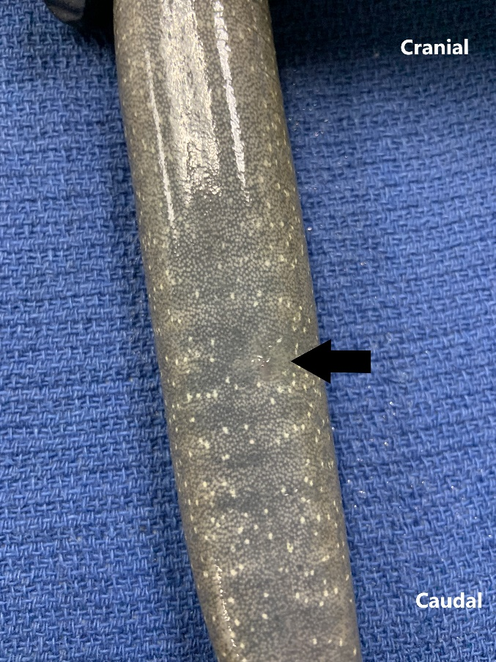
Figure 1.1 Image of healed implant site (black arrow) on the ventral caudal aspect of a greater siren, 35 days post-injection.

Figure 1.2 Line graph displaying plasma terbinafine concentrations determined by HPLC in four adult greater sirens over the course of 128 days postinjection of intracoelomic terbinafine-impregnated implants. Each line represents plasma concentrations for a single individual over time.

Figure 1.3 Individual Batrachochytrium dendrobatidis (Bd) load trajectories over time on adult greater siren skin collected from swabs and estimated with quantitative PCR after exposure to Bd zoospores. Two exposure events (5x10⁶ zoospores at each event) occurred 30 days apart, with the graphs representing the swabs taken after the 2nd exposure. The top graph represents individuals that received blank implants 30 days prior to the first Bd exposure, while the bottom graph represents individuals that received terbinafine implants.

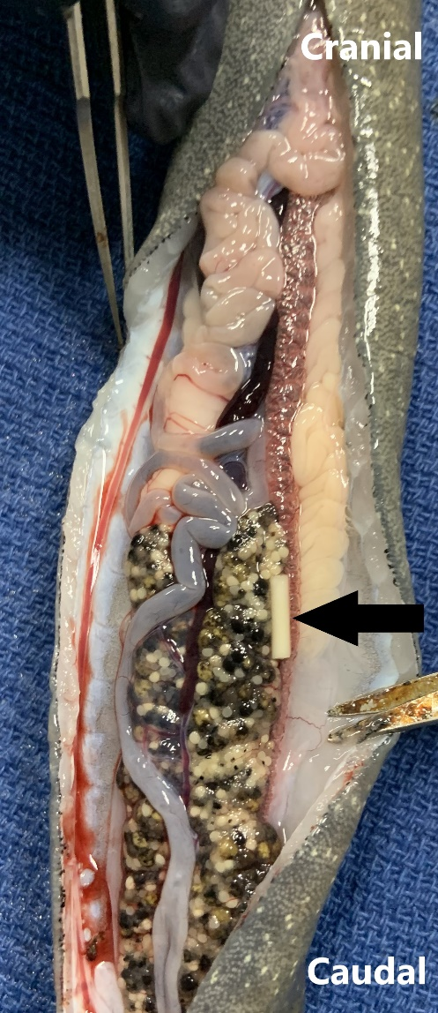
Figure 1.4 Image of terbinafine-impregnated implant (black arrow) in the coelomic cavity of a greater siren at necropsy, 128 days post-implant placement.

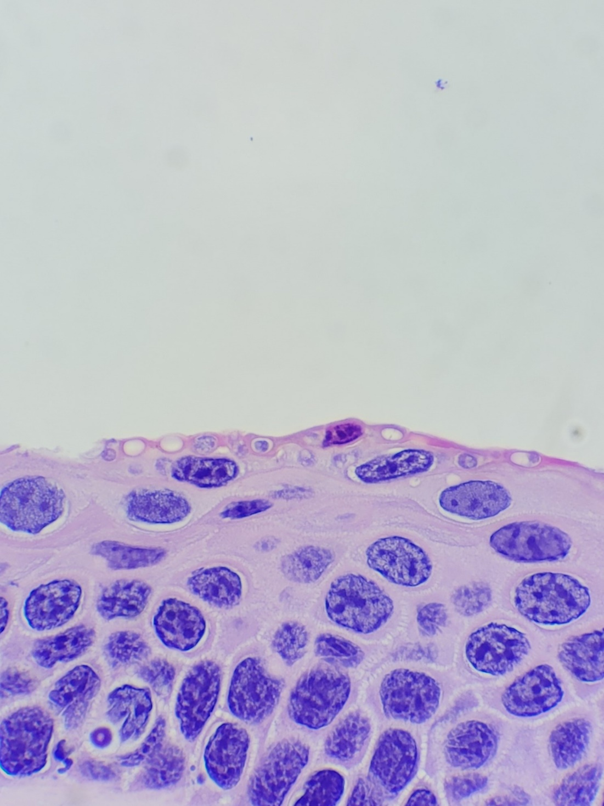
Figure 1.5 Bd organisms present in the superficial epidermis of a section of the toes of a greater siren (Siren 7), 128 days post-injection of a terbinafine-impregnated implant, and 60 days post-Bd exposure.

Chapter II: Risk of Bacteremia Associated with Probiotic Treatment of Batrachochytrium salamandrivorans

Abstract
Batrachochytrium salamandrivorans (Bsal) is a recently described fungal pathogen that has caused declines of wild fire salamanders (Salamandra salamandra) and been detected in captive populations in Europe. One potential preventative and treatment option for Bsal infection and the subsequent disease chytridiomycosis is the use of probiotic bacteria. While previous studies have shown that certain bacteria present on amphibian skin have anti-fungal properties, whether these bacteria have a significant positive or negative effect on host health and Bsal infection remains largely unknown. In this study, we had two objectives. First, we aimed to determine the safety and efficacy of the usage of probiotic bacteria (Pseudomonas fluorescens) isolated from the skin of newts to prevent and treat chytridiomycosis. Second, we tested whether bacteremia plays a role in the pathogenesis of chytridiomycosis. Eastern newts (Notophthalmus viridescens) were exposed to Bsal, probiotic bacteria, pathogenic bacteria (Aeromonas hydrophila), or a combination of Bsal and one of the bacterial species. For the latter, animals were either exposed to bacteria a week prior to or at one of two timepoints after Bsal exposure. Newts were monitored throughout the course of disease development and samples were collected for Bsal and bacterial PCR, blood cultures, and histopathology. Our results indicated that Bsal loads on the skin measured by PCR were lower in some groups exposed to probiotic bacteria, but the difference was not statistically significant among probiotic treatment groups. Among the low dose Bsal groups, only the group exposed to A. hydrophila prior to Bsal exhibited a difference in survival, with a mortality rate of 67%. Histopathologic lesion counts and lesion grades did not differ among groups that were exposed to Bsal. We also found evidence of bacterial infiltration into the blood and organs in animals that were exposed to Bsal in probiotic-exposed and -unexposed newts, with increased P. fluorescens loads in the blood and organs of probiotic-exposed newts. Neither blood cultures nor PCR detected A. hydrophila in the blood or organs of the pathogen-exposed newts. Our results suggest that the probiotic bacteria, P. fluorescens, was not able to prevent or treat Bsal infection. Future studies should further examine the potential for probiotics to contribute to bacteremia and Bsal pathogenesis.

Introduction
Batrachochytrium salamandrivorans (Bsal) is a relatively recently discovered chytrid fungus that infects amphibians (Martel et al., 2013) and is related to the more well-known chytrid fungus B. dendrobatidis (Bd). The first detected cases of Bsal chytridiomycosis were in fire salamanders in the Netherlands, where populations experienced 96% mortality rate from 2010 to 2013 (Spitzen-Van Der Sluijs et al., 2013). Bsal may have been responsible for a die-off in Germany as early as 2004 (Lötters, Veith, et al., 2020).
The current hypothesis is that Bsal originally co-evolved with salamanders in East Asia, and was introduced to Europe through the pet trade (Stegen et al., 2017). Thereafter, it rapidly spread through Europe, now present in 80 sites in 4 countries (Lötters, Wagner, et al., 2020). It is not known to occur in North America (Waddle et al., 2020), but some North American species are susceptible, including the widely distributed and abundant eastern newt (Notophthalmus viridescens) (Martel et al., 2014). The US, especially the southeast, is a global biodiversity hotspot for salamander species. Vulnerability models based on habitat suitability, species richness, and major ports for salamander import have predicted serious consequences for North American salamander biodiversity if Bsal arrives (Yap et al., 2015)
Bsal causes lesions that involve degrading the integrity of the skin. This leads to erythema, skin sloughing, ulcers that often form characteristic circular “target” lesions, hemorrhage, and even the loss of toes and tail tip (Martel et al., 2013). These lesions interrupt the major functions of the skin: osmoregulation and respiration. As most salamander species rely to some extent on cutaneous respiration, these impacts can be deadly. Bsal infects the upper layers of the epidermis, causing necrotic lesions that can infiltrate through to the dermis. This creates a potential pathway for secondary infection. One current theory is that septicemia from these secondary infections is a major contributor to cause of death (Bletz et al., 2018).
Potential treatment options are a major area of Bsal investigation. Environmental fungicides have been used for other pathogens, such as Bd. These include chemical compounds like Virkon, as well as plant-derived compounds like curcumin, calendula, oregano, and cloves. Several of these compounds have shown promising inhibitory and fungicidal effects against Bsal zoospores in vitro as well (Tompros, Wilber, et al., 2022), but the use of these compounds in the environment and for treating infected individuals is still being explored. Individual host treatment protocols have also been developed. For example, Bsal infected fire salamanders treated with topical polymyxin E and voriconazole at 20°C for 10 days successfully cleared Bsal infections (Blooi et al., 2015). While both environmental and individual fungicidal treatments show promise, there are also downsides to these options when considering treatment of wild populations. The impact of fungicides on the health of the ecosystem must be considered, and there may be unintended negative impacts on other organisms in the environment. Meanwhile, individual repeated dosing of fungicides for infected hosts may not be practical for free-ranging animals.
A more recent area of study is the use of probiotics, using organisms that already contribute to the salamanders’ innate immune defenses to prevent and treat diseases like chytridiomycosis. Salamanders naturally have a low abundance of microbiota on their skin, including some Bsal-inhibitory members (Woodhams et al., 2007). Bsal infection disrupts this microbial community, leading to an increase in opportunistic bacteria; this may potentiate septicemic events, as bacteria have previously been cultured from the livers of Bsal infected animals, and not from uninfected controls (Bletz et al., 2018; Latorre et al., 2019). Probiotic treatment may have the benefit of restoring the natural balance of the microbial community, as well as augmenting members of this community that produce antifungal compounds. This method has been successful in the treatment of Bd in the lab. Augmenting the naturally occurring Janthinobacterium lividum bacterium on the skin of mountain yellow-legged frogs (Rana mucosa) with a J. lividum isolate known to produce anti-Bd metabolites prevented the lethal effects of disease after Bd exposure (Harris et al., 2009). Though all frogs in this study had the bacterium on their skin, the metabolite produced by J. lividum, violacein, was found only on the frogs bathed in the J. lividum solution, whereas frogs not treated had no detectable violacein on their skin. This result suggests that bioaugmentation with suitable anti-Bd bacteria can be used to prevent Bd infection.. However, it should be noted that in situ, a single probiotic treatment did not have a protective effect against Bd (Knapp et al., 2022). While probiotics have shown variable promise in treating Bd, their ability mitigate Bsal infection remains largely unexplored.
In this study, Pseudomonas fluorescens was selected as our candidate probiotic. P. fluorescens is a common gram-negative bacterium consisting of a relaxed species group of organisms that are found in soil, water, and in the natural skin microbiota of amphibians (Lam et al., 2010; Nikolaidis et al., 2020). Isolates of P. fluorescens cultured from R. muscosa skin showed a synergistic effect with antimicrobial peptides produced by the frog in their activity against Bd in vitro (Myers et al., 2012) and Pseudomonas isolated from eastern red-backed salamanders (Plethodon cinereus) have also shown antifungal activity (Lauer et al., 2007). An isolate of P. fluorescens from newt skin was therefore chosen as a potential probiotic in this study. For our pathogenic bacteria, we used the gram-negative bacteria Aeromonas hydrophila, which is found in healthy amphibians (Hird et al., 1981) and can cause opportunistic infections (Hubbard, 1981). It is the most common species of Aeromonas that causes infections in animals such as amphibians, reptiles, and fish, usually causing hemorrhagic septicemia (Huang et al., 2015). A. hydrophila served as a representative of the members of the newt microbiota that might opportunistically contribute to disease in the immunocompromised state caused by Bsal chytridiomycosis.
We had two objectives in this study. The first objective was to determine the safety and efficacy of using probiotic bacteria to prevent and treat Bsal chytridiomycosis on N. viridescens. The second objective was to evaluate bacteremia and septicemia as components of morbidity and mortality caused by Bsal chytridiomycosis in N. viridescens. Ultimately, our goal was to use clinical signs, mortality rates, Bsal infection intensities, histopathology, and blood and organ cultures to comprehensively test the capacity of bacteria to affect (improve or reduce) the health of animals suffering from Bsal infection.
Methods
Animal Husbandry
One hundred forty Notophthalmus viridescens (eastern newt, NOVI) adults were captured in the wild in Tennessee, USA and transported to the Johnson Animal Research and Teaching Unit at University of Tennessee, Knoxville. They were housed individually in 1L containers filled with approximately 300mL of dechlorinated water and a PVC cover object. We fed animals bloodworms (2% of their body mass every 3 days) and replaced each animal’s container, cover object, and water every 3 d. Animals were kept in environmental chambers on a 12-h light, 12-h dark cycle, at >90% humidity. Temperature was gradually raised by 2°C per day from ambient temperature to 30°C and then held for 10 d to clear any pre-existing Bd infections (Chatfield & Richards-Zawacki, 2011). The temperature was then lowered by 2°C per day to 14°C, the approximate optimal growth temperature Bsal (Martel et al., 2013), and the animals were acclimated to this temperature for 2 weeks.
Bacterial and Bsal Growth
An isolate of Pseudomonas fluorescens cultured from the skin of wild NOVI was provided by the Woodhams lab at University of Massachusetts (Boston, MA). A Kwik-StikTM pack of Aeromonas hydrophila derived from ATCC® 7966™ was purchased from Microbiologics. Growth curves were performed for A. hydrophila and P. fluorescens at 14C to correspond to the temperature that the animals used in the study would be kept at during bacterial exposure. Optical density measurements were recorded hourly until 0.5 OD600 was reached, and then continued every 2-4 hours. Serial dilution and plating were performed once 1 OD600 was reached and time to this growth point was recorded. Plates were incubated at 14°C and colony counts performed once visible colonies arose. Inoculation cultures were grown for the appropriate time to reach 1 OD600 (22 hours for P. fluorescens and 8 hours for A. hydrophila), confirmation optical density measurements were performed, and the cultures were diluted to 10⁸ CFU/mL. Serial dilution and plating were also performed on the inoculation cultures for colony count confirmation.
Bsal (isolate AMFP13/1) used in this study was obtained from the Netherlands (Martel et al., 2013). The cultures were maintained at the University of Tennessee Center for Wildlife Health laboratory. Bsal zoospores used for exposure were harvested from tryptone gelatin hydrolysate (TGhL) agar plates after 6 d of growth. Plates were flooded with 7 mL of autoclaved dechlorinated water and filtered with a 20-µm sieve to isolate zoospores. Zoospores were enumerated using a hemocytometer and verified using flow cytometry (Carter et al., 2020).

Bacteria and Bsal Exposure
Animals were randomly assigned to twelve treatment group. Treatment groups were as follows: (1) Negative Controls (n=13); (2) Bsal Controls (n=11); (3) Pseudomonas controls (n=9); (4) Aeromonas Controls (n=9); (5) Pseudomonas Pre- Bsal Exposure (n=9); (6) Aeromonas Pre-Bsal Exposure (n=9); (7) Pseudomonas Post-Bsal Exposure (n=16); (8) Pseudomonas Post- High Dose Bsal Exposure (n=9); (9) Aeromonas Post-Bsal Exposure (n=16); (10) Aeromonas Post- High Dose Bsal Exposure (n=9); (11) Pseudomonas Post-Bsal Lesions (n=16); (12) Aeromonas Post-Bsal Lesions (n=14). Two animals originally included in group 12 died prior to Aeromonas exposure, and were therefore recategorized as group 2.
We exposed animals per their treatment group in 100-mL plastic cylindrical containers with 9 mL of autoclaved dechlorinated water and 1 mL of the randomly assigned Bsal zoospore dose. All Bsal exposures occurred on the same day. Groups 2, 5-7, 9, 11, and 12 were all exposed to the “low” dose of Bsal (5x10³ zoospores) while groups 8 and 10 were exposed to the “high” dose of Bsal (5x10⁵ zoospores). The high dose groups were included to determine whether there was an effect of Bsal dose on the efficacy of probiotic treatment or development of secondary infections. Control animals were treated identically but exposed to 10 mL of autoclaved dechlorinated water. The bacterial control groups (3 and 4) were exposed only to their respective bacteria on the same day that Bsal exposures occurred for the other treatment groups and were transferred to autoclaved dechlorinated water after 3 hours of bacterial exposure. After 24 h, we removed newts from the inoculation tubes and placed them back into their tubs.
All bacterial exposures were approximately 10⁸ CFU for 3 hours in 100-mL plastic cylindrical containers with 9mL of autoclaved dechlorinated water and 1 mL of the assigned bacterial broth. As noted, the bacterial control groups (3 and 4) were exposed the same day that Bsal exposures occurred for the other treatment groups. The pre-exposure groups (5 and 6) were exposed to their respective bacteria 6 days prior to Bsal exposure. The post-Bsal exposure groups (7-10) were exposed to their respective bacteria 6 days after Bsal exposure. The post-Bsal lesions groups (11 and 12) were exposed to their respective bacteria after animals in those groups started to develop gross signs of chytridiomycosis, at day 20 post-Bsal exposure. After the bacterial exposure, we removed newts from the inoculation tubes and housed them individually as previously described. The timeline of study events is presented in Figure 1 (all tables and figures are shown in an appendix at the end of each chapter).
Monitoring, Necropsy, and Diagnostic Procedures
We monitored twice daily for signs of Bsal chytridiomycosis, including lethargy, focal lesions, ulcerations, increased skin sloughing, hemorrhage, anorexia, and loss of righting response (Carter et al., 2020; Martel et al., 2013). Animals were humanely euthanized when they lost righting ability, and recorded as a mortality event for data analyses. We swabbed each animal every 6 d starting 4 d post-exposure to Bsal, using standardized swabbing protocols for Bd and Bsal (Blooi et al., 2013).
A subset of groups 7 and 9 (n=7 from each group) were euthanized 6 days after bacterial exposure to allow for examination for transient bacteremia that may not have been detectable by the time the animals reached Bsal disease endpoints. The same procedure was planned for group 11 and 12, however 7 animals from each group had already died or been euthanized prior to the scheduled euthanasia date. At necropsy, animals were designated for culture (n=93) or histopathology (n=47). Animals in the culture diagnostic group were necropsied and blood was collected from the heart for culture, and the liver, spleen, and heart were collected for bacterial PCR. A necropsy swab of the skin as well as a skin and toe sample were also collected for Bsal PCR. The body was then preserved in an individual whirl-Pak bag in 10% neutral buffered formalin. Animals in the histopathology diagnostic group were necropsied and a swab, skin sample, and toe sample were collected for Bsal PCR. The animals were preserved in individual whirl-Pakbags in formalin and transferred to 70% ethanol after 24 hours.
Quantitative PCR (qPCR) for Bsal was run on each necropsy swab and other selected swabs following methods described in Carter et al (2020). Quantitative PCR for Pseudomonas and Aeromonas were also run on liver samples from animals in the culture diagnostic group, as initial runs of Pseudomonas PCR were most consistent on liver samples. Blood cultures were performed within 12 hours on all blood samples collected from the animals in the culture diagnostic group. Histological cross-sections of epidermal tissues stained with hematoxylin and eosin were examined for Bsal lesions in the animals from the histopathology diagnostic group. Lesions were counted and graded using the following scale for depth and extent: (1) stratum corneum; (2) mid-epidermis; (3) full thickness epidermis; (4) full thickness, coalescing/large lesion less than or equal to 1mm in length, and (5) full thickness coalescing/large lesion greater than 1mm in length. Perimeter of each section was measured using Excelis Accu-Scope software to standardize measures of lesion counts to total perimeter of all sections for each animal.
Statistical Analyses
All statistical analyses were performed in RStudio version 2022.12.0. Survival data was analyzed by performing Kaplan-Meier survival analysis and Cox proportional hazard models with the survival package (v3.5-5; Therneau 2023). We performed an analysis of variance (ANOVA) comparing log-transformed Bsal zoospore copies per microliter postmortem among treatment groups. Assumptions of normality and homoscedasticity were evaluated with diagnostic plots. When the analysis of variance was significant (α = 0.05), post hoc Tukey Honestly Significant Difference (Tukey HSD) tests were performed to evaluate pairwise differences among treatment groups. For bacterial load analysis by PCR and culture, we fitted a binomial regression to predict the presence or absence of bacteria based on treatment group. We then performed an ANOVA conditional on presence to compare bacterial loads between treatment groups. Lesion counts and grades were modeled as count data with treatment group as the fixed effect and section perimeter as the offset term, and p-values were computed using a Wald z-distribution approximation.
Results
Survival Analysis
Mortalities occurred in all Bsal-exposed groups independent of bacterial treatment (Pseudomonas, Aeromonas), and no mortality was observed in the Bsal-unexposed groups. There were low numbers of survivors (range 11-33%) in all groups exposed to low-dose Bsal and bacteria, but survival did not significantly differ from the low-dose Bsal control group in any of the Pseudomonas treated groups (Chisq= 1.8 on 3 degrees of freedom, p= 0.6, Figure 2.2). However, the group that was treated with Aeromonas 6 days prior to Bsal exposure had a 67% mortality rate (Figure 2.3), which was significantly less than the 100% mortality rate in the Bsal control group (Chisq= 8.1 on 3 degrees of freedom, p= 0.04). Median survival time among all groups exposed to low-dose Bsal was in the 22-25 day range with the exception of the group exposed to Aeromonas prior to Bsal exposure, where median survival time was 31 days. Rapid mortalities occurred in both groups exposed to high-dose Bsal, with all animals reaching euthanasia endpoints or dying by 10 days post-Bsal exposure.
Comparison of Bsal Loads by PCR
Bsal loads by qPCR performed on necropsy swabs in the Bsal control group were used as a comparison point for all groups exposed to Bsal and bacteria (Figure 2.3 and 2.4). Within each group, there was wide variation in Bsal loads at necropsy. Among the Pseudomonas groups, the highest Bsal loads were in the group exposed to P. fluorescens prior to Bsal exposure (mean = 12.99, sd = 1.3 log(Copies/uL +1)) and in the group that received the higher dose of Bsal (mean = 12.02, sd = 2.75 log(Copies/uL +1)). The lowest loads were in the groups that were exposed to Pseudomonas six days after low-dose Bsal exposure (mean = 8.68, sd = 3.4 log(Copies/uL +1)) and after the development of Bsal lesions (mean = 8.59, sd = 5.31 log(Copies/uL +1)). The Bsal loads among the Aeromonas groups were overall similar to each other. Despite apparent trends in the Pseudomonas groups, the ANOVA revealed no significant differences in Bsal loads between groups in either the Pseudomonas (F= 2.13, df = 4, p =0.090) or Aeromonas (F = 0.94, df = 4, p = 0.449) study.
Pseudomonas Loads by qPCR and Blood Culture
Estimates of Pseudomonas loads in liver tissue and P. fluorescens in blood from the Pseudomonas-exposed groups were provided by qPCR and culture, respectively, and compared to loads in the three control groups (Figure 2.6 and 2.7). Based on qPCR, there was one positive animal in the negative control group, and otherwise, positive results were only found in groups with both Bsal and P. fluorescens exposure. The binomial GLM for presence of Pseudomonas on qPCR by treatment group showed substantial explanatory power (Tjur's R2 = 0.31), however there was not a significant difference in presence of Pseudomonas between any of the treatment groups and the negative control group. The model's intercept, corresponding to the negative control group, is at -1.61. Within this model: the effect of low dose Bsal only is statistically non-significant and negative (beta = -16.96, p = 0.995), the effect of Pseudomonas treatment only is statistically non-significant and negative (beta =-16.96, p = 0.995), the effect of Pseudomonas treatment prior to Bsal is statistically non-significant and positive (beta = 1.61, p = 0.278), the effect of Pseudomonas treatment after Bsal is statistically non-significant and positive (beta = 0.76, p = 0.556;), the effect of Pseudomonas treatment after high-dose Bsal is statistically non-significant and positive (beta = 3.00, p = 0.056), and the effect of Pseudomonas treatment after the development of Bsal lesions is statistically non-significant and positive (beta = 2.01, p = 0.113). The ANOVA for PCR load in Pseudomonas-positive animals suggested that the effect of treatment group was not statistically significant (F = 0.67, df = 4, p = 0.624).
Blood culture results for P. fluorescens were highly variable within treatment groups (Figure 2.7). One animal in the Bsal control group had a positive blood culture. Otherwise, positive cultures were only found in groups with both Bsal and P. fluorescens exposure. The binomial GLM for the presence of a positive culture based on treatment group had substantial explanatory power (Tjur's R2 = 0.44). The model's intercept, corresponding to the Bsal control group, is -1.39. Within this model: the effect of Pseudomonas treatment after the development of Bsal lesions is statistically significant and positive (beta = 2.77, p = 0.043), the effect of Pseudomonas treatment after high-dose Bsal is statistically non-significant and positive (beta = 2.77, p = 0.080), the effect of Pseudomonas treatment after Bsal is statistically non-significant and positive (beta = 1.79, p = 0.165), the effect of Pseudomonas treatment prior to Bsal is statistically non-significant and positive (beta = 2.48, p = 0.122), the effect of Pseudomonas treatment only is statistically non-significant and negative (beta =-17.18, p = 0.995), and the effect of no exposure or treatment (negative control) is statistically non-significant and negative (beta = -17.18, p = 0.995). The highest loads were in the group that was exposed to Pseudomonas fluorescens after the development of Bsal lesions (mean = 4.54 x10⁴, sd = 3.696 x10⁴ CFU/mL), though this was not significantly different from the other groups that had animals with positive blood cultures (F = 0.792, df = 4, p = 0.546).
There was no evidence of transient bacteremia in the subset of group 7 animals that were euthanized 6 days after bacterial exposure. PCR and blood culture values were lower on average in this subset (2.83 copies/uL and 2.0x10³ CFU/mL) than in the animals in the same treatment group that died or were euthanized because of disease (6.96 copies/uL and 3.1x10⁴ CFU/mL).
Aeromonas hydrophila load analysis was not performed for the Aeromonas-exposed groups because both culture and PCR failed to detect the organism.
Histopathology
Lesion Counts
All treatment groups exposed to Bsal had lesions present on histologic examination, while those not exposed to Bsal had no lesions. Lesion counts among groups exposed to Bsal are presented in Figure 2.8 and 2.9. The Bsal control group had the highest overall lesion counts per mm (mean = 0.96, sd = 0.62). Among the Pseudomonas-exposed groups, those exposed to Pseudomonas after low-dose Bsal had the lowest lesion count per mm (mean = 0.48, sd = 0.5) while the group exposed to Pseudomonas prior to Bsal had the highest (mean = 0.94, sd = 0.39). The Poisson model of lesion counts by treatment group was overdispersed, therefore a negative binomial model was used, with the treatment group as the predictor variable and the section perimeter in micrometers as the offset term. The model's intercept, corresponding to the Bsal control group at a section perimeter of 0µm, is at 2.78. Within this model: the effect of Pseudomonas treatment prior to Bsal is statistically non-significant and negative (beta = -0.12, p = 0.821), the effect of Pseudomonas treatment after Bsal is statistically non-significant and negative (beta = -0.97, p = 0.059), the effect of Pseudomonas treatment after high-dose Bsal is statistically non-significant and negative (beta = -0.14, p = 0.780), and the effect of Pseudomonas treatment after Bsal lesions is statistically non-significant and negative (beta = -0.32, p = 0.483).
Two animals in group 9 (exposed to Aeromonas 6 days following low-dose Bsal exposure) had minimal lesions – one had zero and one had a single lesion. Among the Aeromonas exposed groups, this was the group with the lowest lesion counts per mm (mean = 0.416, sd = 0.4). The group that was exposed to Aeromonas prior to Bsal exposure had the highest lesion count per mm of the Aeromonas groups (mean = 0.81, sd = 0.145). Due to overdispersion in the Poisson model, a negative binomial model was fit to the lesion counts with treatment group as the predictor variable and section perimeter in µm as the offset term. The model's intercept, corresponding to Bsal control and section perimeter= 0, is at 2.79. Within this model: the effect of Aeromonas prior to Bsal exposure is statistically non-significant and negative (beta = -0.44, p = 0.580), the effect of Aeromonas after Bsal exposure is statistically non-significant and negative (beta = -1.12, p = 0.115), the effect of Aeromonas after high-dose Bsal is statistically non-significant and negative (beta = -1.12, p = 0.162), and the effect of Aeromonas following the appearance of Bsal lesions is statistically non-significant and negative (beta = -0.82, p = 0.306).
Lesion Grade
Lesion grades were evaluated as density (count per total cross section perimeter for each animal) of each grade (Figures 2.9 and 2.10) . Grade 1 lesions were most common in the Bsal control group. Grade 2 lesions were most common in the Bsal control group, the group exposed to Pseudomonas prior to Bsal exposure, and the group exposed to Pseudomonas after Bsal lesions developed. Grade 3 lesions were most common in the groups that were exposed to bacteria prior to Bsal exposure, regardless of which bacteria they were exposed to. Grade 4 and 5 lesions were the least common of all lesion grades and were found in approximately equivalent density across treatment groups. When pairwise comparisons were made between treatment groups that were exposed to the same species of bacteria, and between each Bsal-exposed group and the Bsal control group, treatment group did not have a significant effect on lesion grade.
Organ Analysis
Select slides from individuals exposed to bacteria were Gram stained for examination of blood vessels and internal organs for infiltration of Gram-negative rods, however no organisms were consistently visible. One animal in group 11 (Pseudomonas exposure following development of Bsal lesions) had parasitic cysts in the liver, corresponding with multifocal white nodules observed on gross necropsy.

Discussion
The main objectives of this study were to determine the safety and efficacy of using probiotic bacteria to prevent or treat chytridiomycosis, and to evaluate bacteremia and septicemia as components of morbidity and mortality caused by chytridiomycosis. Probiotic treatment with Pseudomonas fluorescens did not confer significant protection from morbidity and mortality caused by Bsal chytridiomycosis. While there were individuals within the probiotic-treated groups that survived for the duration of the study, and a few of these individuals cleared their infections, this has been seen in previous studies with NOVI exposed to 10³ zoospores of Bsal at 14C (Carter et al., 2021). Interestingly, the only low-dose Bsal-exposed group with significantly different survival was the group exposed to our pathogenic bacteria, A. hydrophila, prior to Bsal exposure. This same effect was not seen in groups that were exposed to A. hydrophila after Bsal exposure. Prior studies have shown that A. hydrophila produces several bioactive compounds, some of which have antifungal activity (Kamal et al., 2017). It is possible that A. hydrophila had some inhibitory effect on Bsal pathogenesis in these individuals, though overall Bsal loads and lesion counts were not different from the other groups. The median survival time of newts exposed to high-dose Bsal was shorter (10 days) than has been seen previously (16 days in Carter et al., 2021). Bacterial exposure shortly after Bsal exposure may have contributed to more rapid mortalities in this case, as conditions were otherwise the same as in the prior study. Neither Bsal loads at necropsy, nor total lesion density or density by grade showed any difference among the various Bsal-treated groups.
The most significant finding in evaluation for bacteremia and septicemia among the probiotic-treated groups was the increased prevalence of P. fluorescens found by blood culture in the animals that were treated after developing Bsal lesions. This indicates that the lesions did provide a pathway for bacteria to infiltrate into the blood and organs. Despite a lack of statistical significance between groups, positive PCR and blood culture were rare in the three control groups (1 animal positive for each), compared to the groups that were exposed to both the P. fluorescens and Bsal. This trend could indicate that the combination of exposures led to bacteremia and septicemia in those individuals. Pseudomonas loads by PCR and culture did not always seem to agree on the same animal. This is likely because the PCR assay was for the broader Pseudomonas genus, while blood cultures were able to detect the P. fluorescens species group. There were some cases where blood cultures were positive and PCR was negative, which could be due to bacteria not yet colonizing the liver, or the section of liver that was tested, at detectable levels. There is a possibility that Pseudomonas infection may have originated from salamander microbial flora. Determining whether the P. fluorescens found in the blood was the same strain as the one that was used for probiotic treatment was not within the scope of this study and was not pursued.
There were two significant limitations in this study that prevent stronger conclusions about the contribution of bacteremia and septicemia to Bsal pathogenesis. One is the failure of the diagnostic tests for A. hydrophila. It is unclear if the organism was truly absent from the blood and organs of the animals that were exposed to it, or if the liver PCR and blood cultures were just unable to detect it. Also, while the initial A. hydrophila exposure dose was known for these animals, later testing for bacterial loads on the skin was not performed. It is therefore difficult to fully evaluateA. hydrophila and Bsal exposure interaction in these groups. Despite the significant increase in survival in animals exposed to A. hydrophila prior to Bsal exposure, the extent to which this can be attributed to the bacterial treatment remains unclear. The other major limitation is that increased bacterial infiltration in the blood and liver, as seen in the group 11 animals, could not be correlated with a difference in survival. More specific histopathologic staining would be useful to aid in visualizing P. fluorescens and A. hydrophila in the blood vessels and tissues, and determining whether there are any associated microscopic signs of disease.
Overall, the findings from this study suggest that Pseudomonas fluorescens as administered in this study is not an effective probiotic against Bsal chytridiomycosis, regardless of the timing of treatment. While Bsal loads tended to be lower in animals exposed to P. fluorescens after low-dose Bsal exposure, this was neither statistically significant, nor did it seem to affect mortality rate or Bsal lesions. Based on the liver PCR and blood culture results, exposure to P. fluorescens either before or after Bsal exposure may lead to increased infiltration of bacteria in the blood and organs, with the greatest increase occurring when skin lesions are already present. There may indeed be a push and pull mechanism of P. fluorescens causing a mild decrease in Bsal load, but also contributing to immunocompromise and illness in the animal, and therefore contributing to overall mortality. There still remain many candidate members of the salamander microbiome that could be used for probiotic treatment, and future studies should explore the use of different organisms or even a combination of organisms. Currently, probiotics seem most useful in captive animals where the microbiome can be controlled and have proven more difficult to use in free-ranging settings. As these protocols continue to be explored and refined, the findings in this study indicate that some caution should be exercised when exposing immunocompromised animals, especially those with skin lesions, to bacteria that may opportunistically exhibit pathogenic activity.

References
Bletz, M. C., Kelly, M., Sabino-Pinto, J., Bales, E., van Praet, S., Bert, W., Boyen, F., Vences, M., Steinfartz, S., Pasmans, F., & Martel, A. (2018). Disruption of skin microbiota contributes to salamander disease. Proceedings of the Royal Society B: Biological Sciences, 285(1885). https://doi.org/10.1098/rspb.2018.0758
Blooi, M., Pasmans, F., Longcore, J. E., Spitzen-Van Der Sluijs, A., Vercammen, F., & Martel, A. (2013). Duplex real-Time PCR for rapid simultaneous detection of Batrachochytrium dendrobatidis and Batrachochytrium salamandrivorans in amphibian samples. Journal of Clinical Microbiology, 51(12), 4173–4177. https://doi.org/10.1128/JCM.02313-13
Blooi, M., Pasmans, F., Rouffaer, L., Haesebrouck, F., Vercammen, F., & Martel, A. (2015). Successful treatment of Batrachochytrium salamandrivorans infections in salamanders requires synergy between voriconazole, polymyxin E and temperature. Scientific Reports, 5(1), 11788. https://doi.org/10.1038/srep11788
Carter, E. D., Bletz, M. C., le Sage, M., LaBumbard, B., Rollins-Smith, L. A., Woodhams, D. C., Miller, D. L., & Gray, M. J. (2021). Winter is coming-Temperature affects immune defenses and susceptibility to Batrachochytrium salamandrivorans. PLoS Pathogens, 17(2). https://doi.org/10.1371/JOURNAL.PPAT.1009234
Carter, E. D., Miller, D. L., Peterson, A. C., Sutton, W. B., Cusaac, J. P. W., Spatz, J. A., Rollins‐Smith, L., Reinert, L., Bohanon, M., Williams, L. A., Upchurch, A., & Gray, M. J. (2020). Conservation risk of Batrachochytrium salamandrivorans to endemic lungless salamanders. Conservation Letters, 13(1). https://doi.org/10.1111/conl.12675
Chatfield, M. W. H., & Richards-Zawacki, C. L. (2011). Elevated temperature as a treatment for Batrachochytrium dendrobatidis infection in captive frogs. Diseases of Aquatic Organisms, 94(3), 235–238. https://doi.org/10.3354/dao02337
Harris, R. N., Brucker, R. M., Walke, J. B., Becker, M. H., Schwantes, C. R., Flaherty, D. C., Lam, B. A., Woodhams, D. C., Briggs, C. J., Vredenburg, V. T., & Minbiole, K. P. C. (2009). Skin microbes on frogs prevent morbidity and mortality caused by a lethal skin fungus. The ISME Journal, 3(7), 818–824. https://doi.org/10.1038/ismej.2009.27
Hird, D. W., Diesch, S. L., Mckinnell, R. G., Gorham, E., Martin, F. B., Kurtz, S. W., & Dubrovolny, C. (1981). Aeromonas hydrophila in Wild-Caught Frogs and Tadpoles (Rana pipiens) in Minnesota 1 • 2 • 3.
Huang, L., Qin, Y., Yan, Q., Lin, G., Huang, L., Huang, B., & Huang, W. (2015). MinD plays an important role in Aeromonas hydrophila adherence to Anguilla japonica mucus. Gene, 565(2), 275–281. https://doi.org/10.1016/J.GENE.2015.04.031
Hubbard, G. B. (1981). Aeromonas hydrophila infection in Xenopus laevis. Laboratory Animal Science, 31(3), 297–300. https://europepmc.org/article/med/7265911
Kamal, S. A., Hamza, L. F., & Ibraheam, I. A. (2017). Characterization of Antifungal Metabolites Produced by Aeromonas Hydrophila and Analysis of its Chemical Compounds Using GC-MS. Research Journal of Pharmacy and Technology, 10(11), 3845. https://doi.org/10.5958/0974-360X.2017.00697.7
Knapp, R. A., Joseph, M. B., Smith, T. C., Hegeman, E. E., Vredenburg, V. T., Erdman, J. E., Boiano, D. M., Jani, A. J., & Briggs, C. J. (2022). Effectiveness of antifungal treatments during chytridiomycosis epizootics in populations of an endangered frog. PeerJ, 9, e12712. https://doi.org/10.7717/PEERJ.12712/SUPP-1
Lam, B. A., Walke, J. B., Vredenburg, V. T., & Harris, R. N. (2010). Proportion of individuals with anti-Batrachochytrium dendrobatidis skin bacteria is associated with population persistence in the frog Rana muscosa. Biological Conservation, 143(2), 529–531. https://doi.org/10.1016/J.BIOCON.2009.11.015
Latorre, A., Yildirim, S., Cabrera-Rubio, R., Bates, K. A., G Shelton, J. M., Mercier, V. L., Hopkins, K. P., Harrison, X. A., Petrovan, S. O., & Fisher, M. C. (2019). Captivity and Infection by the Fungal Pathogen Batrachochytrium salamandrivorans Perturb the Amphibian Skin Microbiome. Frontiers in Microbiology | Www.Frontiersin.Org, 1, 1834. https://doi.org/10.3389/fmicb.2019.01834
Lauer, A., Simon, M. A., Banning, J. L., André, E., Duncan, K., & Harris, R. N. (2007). Common Cutaneous Bacteria from the Eastern Red-Backed Salamander Can Inhibit Pathogenic Fungi. Copeia, 2007(3), 630–640. https://doi.org/10.1643/0045-8511(2007)2007[630:CCBFTE]2.0.CO;2
Lötters, S., Veith, M., Wagner, N., Martel, A., & Pasmans, F. (2020). Bsal-driven salamander mortality pre-dates the European index outbreak. Salamandra, 56(3), 239–242.
Lötters, S., Wagner, N., Albaladejo, G., & Böning, P. (2020). The amphibian pathogen Batrachochytrium salamandrivorans in the hotspot of its European invasive range: past-present-future. http://www.salamandra-journal.com
Martel, A., Blooi, M., Adriaensen, C., van Rooij, P., Beukema, W., Fisher, M. C., Farrer, R. A., Schmidt, B. R., Tobler, U., Goka, K., Lips, K. R., Muletz, C., Zamudio, K. R., Bosch, J., Lötters, S., Wombwell, E., Garner, T. W. J., Cunningham, A. A., Spitzen-Van Der Sluijs, A., … Pasmans, F. (2014). Recent introduction of a chytrid fungus endangers Western Palearctic salamanders. Science, 346(6209), 630–631. https://doi.org/10.1126/science.1258268
Martel, A., Spitzen-Van Der Sluijs, A., Blooi, M., Bert, W., Ducatelle, R., Fisher, M. C., Woeltjes, A., Bosman, W., Chiers, K., Bossuyt, F., & Pasmans, F. (2013). Batrachochytrium salamandrivorans sp. nov. causes lethal chytridiomycosis in amphibians. Proceedings of the National Academy of Sciences of the United States of America, 110(38), 15325–15329. https://doi.org/10.1073/pnas.1307356110
Myers, J. M., Ramsey, J. P., Blackman, A. L., Nichols, A. E., Minbiole, K. P. C., & Harris, R. N. (2012). Synergistic inhibition of the lethal fungal pathogen batrachochytrium dendrobatidis: The combined effect of symbiotic bacterial metabolites and antimicrobial peptides of the frog rana muscosa. Journal of Chemical Ecology, 38(8), 958–965. https://doi.org/10.1007/S10886-012-0170-2/FIGURES/4
Nikolaidis, M., Mossialos, D., Oliver, S. G., & Amoutzias, G. D. (2020). Comparative Analysis of the Core Proteomes among the Pseudomonas Major Evolutionary Groups Reveals Species-Specific Adaptations for Pseudomonas aeruginosa and Pseudomonas chlororaphis. Diversity 2020, Vol. 12, Page 289, 12(8), 289. https://doi.org/10.3390/D12080289
Spitzen-Van Der Sluijs, A., Bosman, W., Pasmans, F., Goverse, E., Martel, A., de Zeeuw, M., Spikmans, F., van der Meij, T., & Kik, M. (2013). Rapid enigmatic decline drives the fire salamander (Salamandra salamandra) to the edge of extinction in the Netherlands. Amphibia-Reptilia, 34(2), 233–239. https://doi.org/10.1163/15685381-00002891
Stegen, G., Pasmans, F., Schmidt, B. R., Rouffaer, L. O., van Praet, S., Schaub, M., Canessa, S., Laudelout, A., Kinet, T., Adriaensen, C., Haesebrouck, F., Bert, W., Bossuyt, F., & Martel, A. (2017). Drivers of salamander extirpation mediated by Batrachochytrium salamandrivorans. Nature, 544(7650), 353–356. https://doi.org/10.1038/nature22059
Tompros, A., Wilber, M. Q., Fenton, A., Carter, E. D., & Gray, M. J. (2022). Efficacy of Plant-Derived Fungicides at Inhibiting Batrachochytrium salamandrivorans Growth. Journal of Fungi, 8(10), 1025. https://doi.org/10.3390/JOF8101025/S1
Waddle, J. H., Grear, D. A., Mosher, B. A., Grant, E. H. C., Adams, M. J., Backlin, A. R., Barichivich, W. J., Brand, A. B., Bucciarelli, G. M., Calhoun, D. L., Chestnut, T., Davenport, J. M., Dietrich, A. E., Fisher, R. N., Glorioso, B. M., Halstead, B. J., Hayes, M. P., Honeycutt, R. K., Hossack, B. R., … Winzeler, M. E. (2020). Batrachochytrium salamandrivorans (Bsal) not detected in an intensive survey of wild North American amphibians. Scientific Reports 2020 10:1, 10(1), 1–7. https://doi.org/10.1038/s41598-020-69486-x
Woodhams, D. C., Vredenburg, V. T., Simon, M.-A., Shyr, Y., Briggs, C. J., Rollins-Smith, L. A., & Harris, R. N. (2007). Symbiotic bacteria contribute to innate immune defenses of the threatened mountain yellow-legged frog, Rana muscosa. https://doi.org/10.1016/j.biocon.2007.05.004
Yap, T. A., Koo, M. S., Ambrose, R. F., Wake, D. B., & Vredenburg, V. T. (2015). Averting a North American biodiversity crisis. Science, 349(6247), 481 LP – 482. https://doi.org/10.1126/science.aab1052
Appendix
Appendix A: Figures

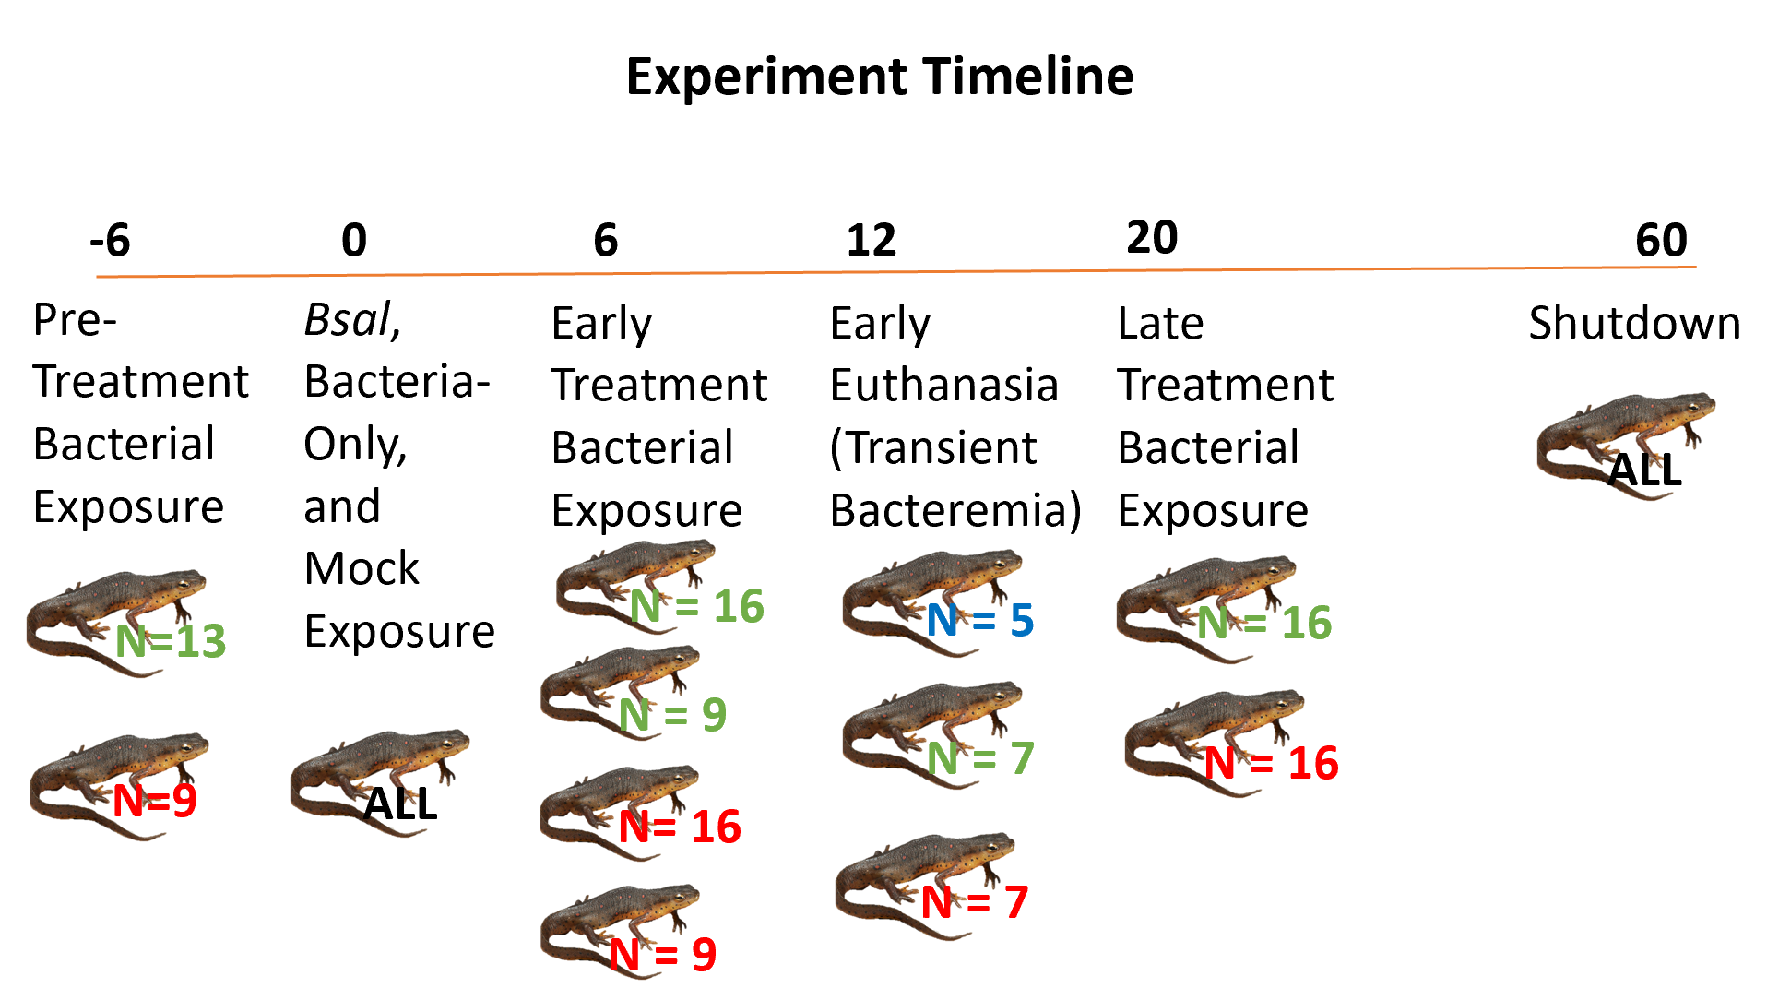

Figure 2.1 Timeline of study events, with the day of Bsal exposure designated at Day 0. Numbers in blue represent negative controls, green represent groups exposed to Pseudomonas fluorescens, and red represent groups exposed to Aeromonas hydrophila.

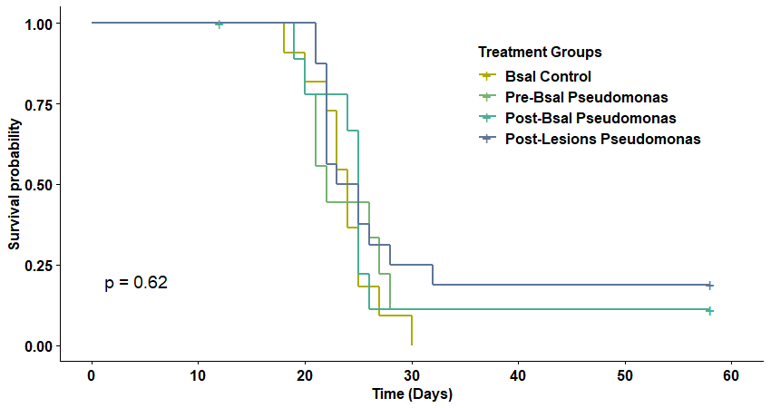
Figure 2.2 Kaplan-Meier survival curves representing the mortality rate of Notophthalmus viridescens exposed to one of four combinations of Bsal and P. fluorescens (Bsal only, P. fluorescens prior to Bsal, P. fluorescens after Bsal, and P. fluorescens after the development of Bsal lesions). The p value of the log-rank Kaplan-Meier test was 0.62, indicating no significant difference in survival between treatment groups.

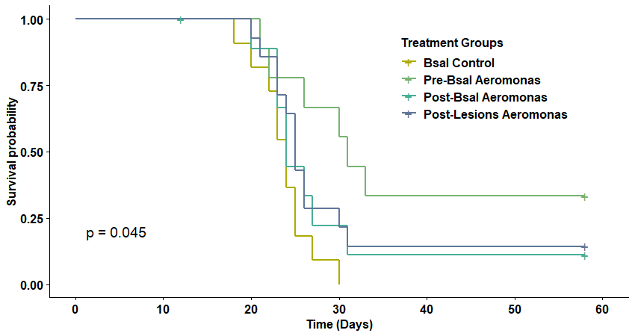
Figure 2.3 Kaplan-Meier survival curves representing the mortality rate of Notophthalmus viridescens exposed to one of four combinations of Bsal and A. hydrophila (Bsal only, A. hydrophila prior to Bsal, A. hydrophila after Bsal, and A. hydrophila after the development of Bsal lesions). The p value of the log-rank Kaplan-Meier test was 0.045, indicating a significant difference in survival between groups, with the group exposed to A. hydrophila prior to Bsal exposure exhibiting the highest survival probability.

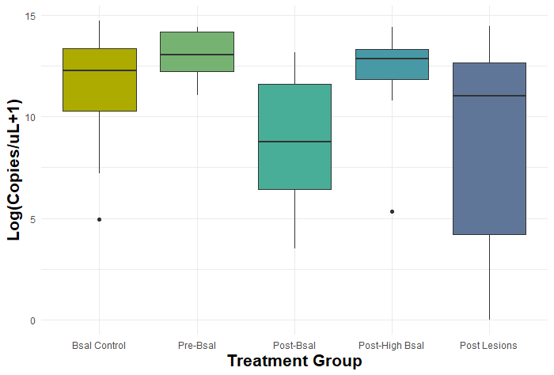
Figure 2.4 Mean Bsal load (copies/uL) at postmortem examination on eastern newt (Notophthalmus viridescens) skin collected from swabs and estimated with quantitative PCR. Treatment groups represent one of five combinations of Bsal and Pseudomonas fluorescens exposure (Bsal only, P. fluorescens prior to Bsal, P. fluorescens after Bsal, P. fluorescens after high dose Bsal, and P. fluorescens after the development of Bsal lesions).

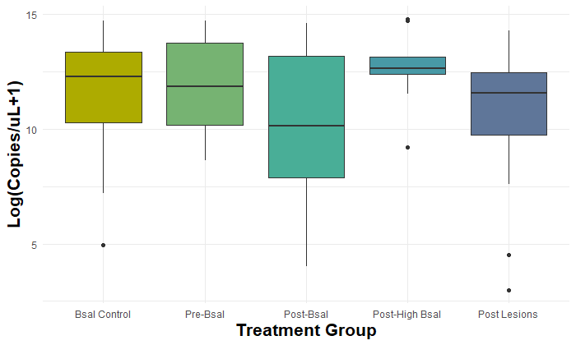
Figure 2.5 Mean Bsal load (copies/uL) at postmortem examination on eastern newt (Notophthalmus viridescens) skin collected from swabs and estimated with quantitative PCR. Treatment groups represent one of five combinations of Bsal and Aeromonas hydrophila exposure (Bsal only, A. hydrophila prior to Bsal, A. hydrophila after Bsal, A. hydrophila after high dose Bsal and A. hydrophila after the development of Bsal lesions).

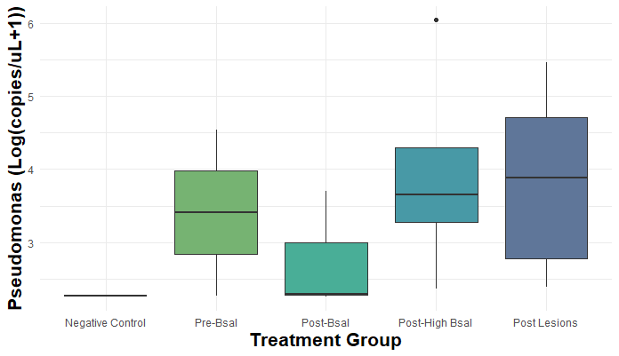
Figure 2.6 Mean Pseudomonas load (copies/uL) at postmortem examination on eastern newt (Notophthalmus viridescens) liver samples estimated with quantitative PCR. Only treatment groups with PCR-positive animals are represented. Treatment groups represent one of five combinations of Bsal and Pseudomonas fluorescens exposure (No exposure, P. fluorescens prior to Bsal, P. fluorescens after Bsal, P. fluorescens after high dose Bsal, and P. fluorescens after the development of Bsal lesions). There were no PCR-positive animals in the Bsal control or Pseudomonas control groups.

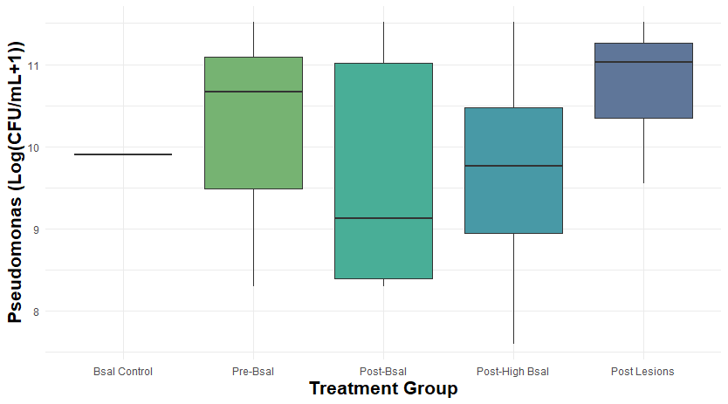
Figure 2.7 Mean Pseudomonas fluorescens colony counts (CFU/mL) at postmortem examination on eastern newt (Notophthalmus viridescens) blood cultures. Only treatment groups with culture-positive animals are represented. Treatment groups represent one of five combinations of Bsal and Pseudomonas fluorescens exposure (Bsal only, P. fluorescens prior to Bsal, P. fluorescens after Bsal, P. fluorescens after high dose Bsal, and P. fluorescens after the development of Bsal lesions). There were no culture-positive animals in the negative control or Pseudomonas control groups.

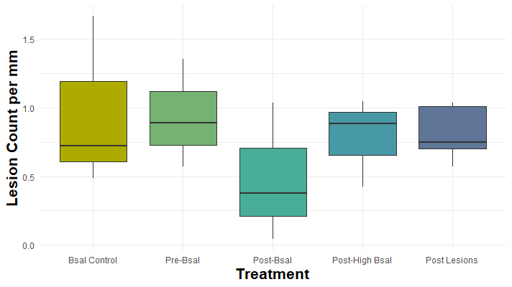
Figure 2.8 Mean Bsal lesion counts per mm at histopathologic examination on eastern newts (Notophthalmus viridescens). Treatment groups represent one of five combinations of Bsal and Pseudomonas fluorescens exposure (Bsal only, P. fluorescens prior to Bsal, P. fluorescens after Bsal, P. fluorescens after high dose Bsal, and P. fluorescens after the development of Bsal lesions).

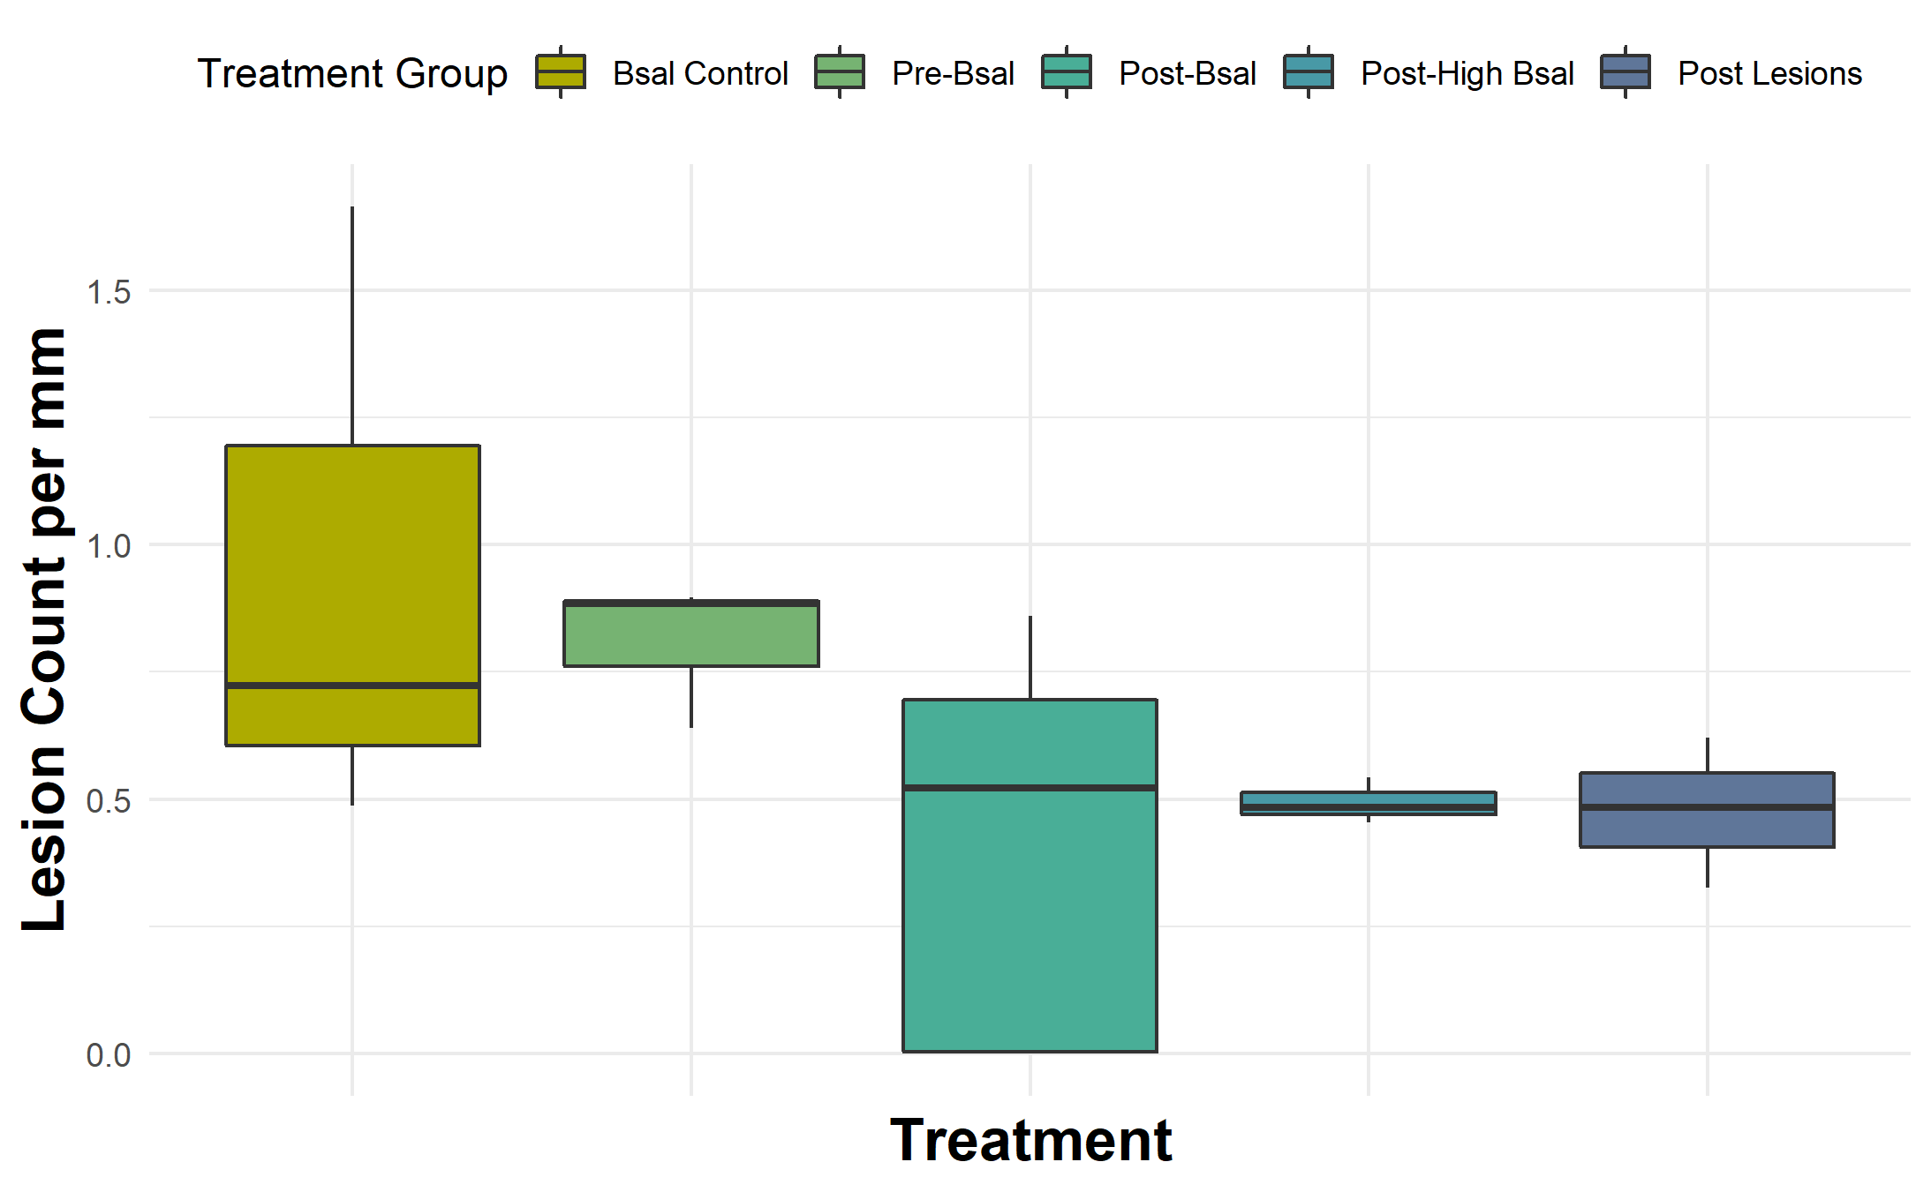
Figure 2.9 Mean Bsal lesion counts per mm at histopathologic examination on eastern newts (Notophthalmus viridescens). Treatment groups represent one of five combinations of Bsal and Aeromonas hydrophila exposure (Bsal only, A. hydrophila prior to Bsal, A. hydrophila after Bsal, A. hydrophila after high dose Bsal and A. hydrophila after the development of Bsal lesions).

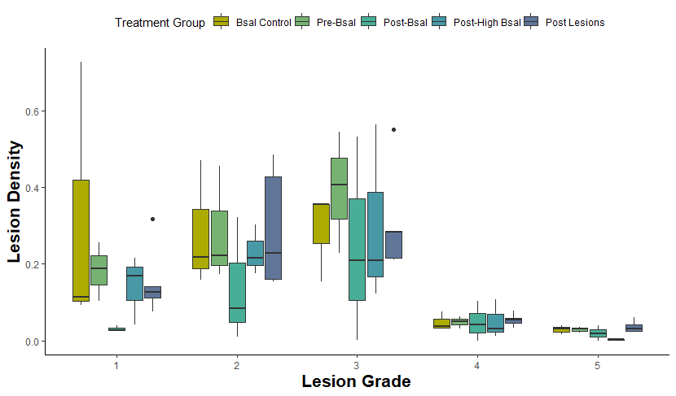

Figure 2.10 Plot of the average lesion density per unit of cross section (y-axis) for each lesion grade (x-axis) at histopathologic examination on eastern newts (Notophthalmus viridescens). Treatment groups represent one of five combinations of Bsal and Pseudomonas fluorescens exposure (Bsal only, P. fluorescens prior to Bsal, P. fluorescens after Bsal, P. fluorescens after high dose Bsal, and P. fluorescens after the development of Bsal lesions).

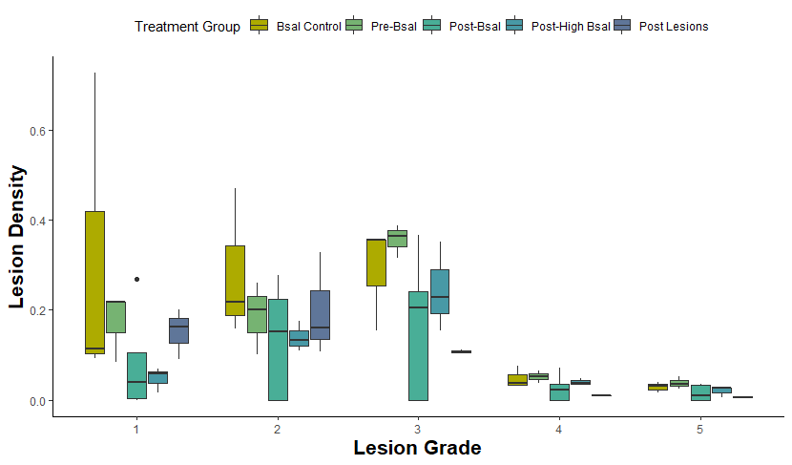
Figure 2.11 Plot of the average lesion density per unit of cross section (y-axis) for each lesion grade (x-axis) at histopathologic examination on eastern newts (Notophthalmus viridescens). Treatment groups represent one of five combinations of Bsal and Aeromonas hydrophila exposure (Bsal only, A. hydrophila prior to Bsal, A. hydrophila after Bsal, A. hydrophila after high dose Bsal, and A. hydrophila after the development of Bsal lesions).

Chapter III: Impact of Bactrachochytrium salamandrivorans Exposure on Eastern Newt Reproductive Fitness

Abstract
Emerging fungal pathogens have become an increasing threat to wildlife over the past several years. Batrachochytrium salamandrivorans (Bsal) is one such pathogen of amphibians and has led to species declines in several areas in Europe. Though it is not yet known to be present in North America, it does pose a substantial threat to vulnerable salamander populations and overall amphibian diversity. In the case of the eastern newt (Notophthalmus viridescens), the high risk of morbidity and mortality in the acute infection period is known, but there is little information yet on what sublethal effects Bsal exposure would have on a population. Understanding the effects of exposure on individuals that avoid mortality is important for targeted surveillance and mitigation efforts in North America.
The goal of this project was to expose eastern newts to Bsal and compare their reproductive fitness to unexposed controls through objective measures of reproductive quality and output, obtained through necropsy and histopathology. Individuals were either unexposed, exposed once, or exposed twice and were also euthanized at two different time points – during the “acute” time period, 30 days after their latest exposure, or during the “chronic” time period, 60 days after that exposure. A subset of individuals placed in male-female pairs was observed for breeding behaviors. We documented a decrease in ovary mass relative to body mass and an increase in testicular mass relative to body mass over time, though this trend did not significantly differ between exposure groups. The proportion of eggs with yolk development was greater in females that were exposed to Bsal, and in those that lived longer, with the greatest effect seen in the double-exposure group at 90 days post-exposure. Germinal epithelial depth in the males was also greatest in the double-exposure group. These parameters are potential indicators of terminal investment in this species with multiple Bsal exposures. This could have important implications for population dynamics in the face of Bsal invasion.

Introduction
While many wildlife groups are currently in decline, amphibians are among the most threatened, with nearly 60% of species in danger of extinction over the last 40 years (García-Rodríguez et al., 2022). There are multiple contributors to amphibian population declines, including habitat loss, environmental toxins, and infectious disease. Chytridiomycosis is a cutaneous fungal disease caused by two related fungi, Batrachochytrium dendrobatidis (Bd) and Batrachochytrium salamandrivorans (Bsal). Whether caused by Bsal or Bd, chytridiomycosis disrupts the integrity of the skin, leading to systemic disease through the detrimental effects on hydration, ion exchange, and cutaneous respiration. Excessive water loss leads to dehydration and electrolyte imbalances, and, in Bd chytridiomycosis, this has been shown to lead to cardiac arrest and death (Salla et al., 2018; Voyles et al., 2009a; Wu et al., 2019). The same may be true for Bsal cytridiomycosis as a recent study reported similar detrimental effects on electrolyte balance in salamanders having deep ulceration and necrosis of the skin caused by Bsal (Sheley et al., 2023). It has also been shown that this skin erosion and ulceration promotes secondary bacterial overgrowth that may result in lethal septicemia (Bletz et al., 2018).
Chytridiomycosis has led to an amphibian panzootic that represents the greatest recorded disease-related loss of biodiversity, affecting over 500 amphibian species (Scheele, Pasmans, Skerratt, Berger, Martel, Beukema, Acevedo, Burrowes, Carvalho, Catenazzi, De La Riva, et al., 2019). While Bd is present in many areas around the world, Bsal is not yet known to occur in North America, with its current distribution restricted to Europe and Asia (Waddle et al., 2020). In Western Europe, Bsal has contributed to the near extirpation of Salamandra salamandra populations (Martel et al., 2013). Bd’s emergence as a global pathogen has been linked to the expansion of the commercial trade in amphibians (O’Hanlon et al., 2018) and there is a high likelihood that Bsal could be spread the same way. Bsal has been detected in the pet trade, and there are concerns that this could be the introduction point for the pathogen to currently naïve populations (Nguyen et al., 2017). With continued global movement of amphibians, Bsal poses a significant threat to North American amphibian biodiversity, and many species have been shown to be susceptible through laboratory trials (Carter et al., 2020; Friday et al., 2020; North American Bsal Task Force, 2020).

Research over the last decade has focused on a wide variety of aspects of Bsal pathogenesis and epidemiology, in a joint effort to address the devastation it has already caused in Europe and prevent these same results when it arrives in North America (Carter et al., 2020; Lötters, Wagner, et al., 2020; Martel et al., 2013; Stegen et al., 2017; Thomas et al., 2018). Part of these efforts includes modeling the potential distribution of Bsal in new areas and conducting studies that predict regions of particular susceptibility (Katz & Zellmer, 2018; Yap et al., 2017). However, adult morbidity and mortality are only part of the story when it comes to predicting population declines; sublethal effects that include recruitment of the next generation must be considered as well. In the case of Bd, previous studies have investigated these effects, including gross and histologic changes to gonads in infected animals (Brannelly et al., 2021), long-term impacts on body fat and gonad size in susceptible species (Campbell et al., 2019), and impacts on mating behaviors even after the infection has been cleared (An & Waldman, 2016). Field studies on Bd have also been incorporated into population level modeling to explain the extinction of some and persistence of other populations in the face of chytridiomycosis outbreaks (Briggs et al., 2005).
Whether related to disease status or not, stress is known to negatively impact reproductive hormone levels in amphibians (Kindermann et al., 2017; Moore & Zoeller, 1985). However, a direct relationship between these hormonal changes and changes in courtship, mating, and reproductive success has not been elucidated. While it stands to reason that the energy costs of disease and a decrease in reproductive hormones would lead to a decrease in reproductive fitness, studies in Bd have often revealed the opposite. These have demonstrated an increase in mating call effort in the Japanese tree frog (Hyla japonica) (An & Waldman, 2016) and an increase in testes width in the northern leopard frog (Lithobates pipiens) (Chatfield et al., 2013). These studies support what is known as the terminal investment hypothesis, when resources are reallocated from infection clearance and survival to reproductive output, thought to occur mainly in iteroparous animals (Clutton-Brock, 1984). Meanwhile, in the common mistfrog (Litoria rheocola), there was an increase in mating call effort during Bd infection when paired with good body condition, whereas poor body condition in the face of infection led to a decrease in mating call effort (Roznik et al., 2015). Rather than supporting terminal investment across the board, this study suggested a more complex selection pressure, where individuals that were infected but still clinically healthy showed more reproductive effort even than uninfected individuals, while the more severely affected individuals perhaps had less energy to spend on reproduction. The story is also complex in studies that included females, which showed larger ovaries and oviducts with more cells present in infected Litoria verreauxii alpina (Brannelly et al., 2016), but a decrease in mature egg size and number in infected females of the same species (Brannelly et al., 2021). The differences in female reproductive response in these two studies were likely related to female age – young animals in the 2021 study may have prioritized pathogen defense, whereas the older animals used in the 2016 study may have been more sexually mature and therefore able to prioritize reproduction. Whether Bsal exhibits similar effects on reproductive fitness is not known. To date, no studies have examined reproduction and recruitment in salamanders in the face of Bsal exposure.
In this study, we explored gametogenesis and reproductive behaviors in the eastern newt (Notophthalmus viridescens) in response to Bsal exposure. The eastern newt was chosen for this study because it is abundant, and has been shown in previous experiments to reliably contract Bsal infection and survive at low exposure doses (Carter et al., 2021; Tompros, Dean, et al., 2022). Males and females can be distinguished visually during the breeding season, and mating behavior has been observed previously in laboratory environments. We measured reproductive potential and effort in newts exposed to Bsal, compared to unexposed controls. In males, we measured testicular size relative to body mass, seminiferous tubule density, germinal epithelial depth, and proportion of spermatogenesis stages as a proxy for reproductive effort. In females we measured mass of the gonads, size of the largest eggs, and proportion of developed eggs. We also paired males and females for observations of breeding behavior and to document any successful reproduction. Based on previous studies, we hypothesized that Bsal-exposed newts would exhibit terminal investment, evidenced by increased measures of gametogenesis and increased offspring production compared to unexposed newts. The effects of disease on reproduction are not often studied in amphibians, and this is the first to examine these effects in male and female salamanders.
Methods
Animal Husbandry
One hundred forty Notophthalmus viridescens (eastern newt, NOVI) adults were captured in the wild in Tennessee, US and transported to the Johnson Animal Research and Teaching Unit at University of Tennessee, Knoxville. Collection occurred early in the breeding season (mid-February) to ensure that animals were reproductively active, and they were sexed based on external characteristics. Males were identified by their keeled tails, wider back legs, prominent cloaca, and the presence of nuptial pads (Rucker et al., 2021). They were housed individually in 1L containers filled with approximately 300mL of dechlorinated water and a PVC cover object. We fed animals bloodworms (2% of their body mass every 3 days) and replaced each animal’s container, cover object, and water every 3 d. Animals were kept in environmental chambers on a 12-h light, 12-h dark cycle, at >90% humidity. Temperature was gradually raised by 2C per day from ambient temperature to 30C and then held for 10 d to clear any pre-existing Bd infections (Chatfield & Richards-Zawacki, 2011). The temperature was then lowered by 2C per day to 14C, the approximate optimal growth temperature of Bsal (Martel et al., 2013), and the animals were acclimated to this temperature for 2 weeks.
Bsal Growth and Exposure
Bsal was isolated from a fire salamander (Salamandra salamandra) in the Netherlands (isolate AMFP13/1,(Martel et al., 2013)) and cultures were maintained at the University of Tennessee Center for Wildlife Health laboratory. Bsal zoospores used for exposure were harvested from tryptone gelatin hydrolysate (TGhL) agar plates after 6 d of growth. Plates were flooded with 7 mL of autoclaved dechlorinated water and filtered with a 20-µm sieve to isolate zoospores. Zoospores were enumerated using a hemocytometer and verified using flow cytometry (Carter et al., 2020).
Animals were randomly assigned to either Experiment 1 (Individual) or Experiment 2 (Breeding). All animals were also randomly assigned to one of 3 exposure groups: 1) none 2) single or 3) double. Those in the unexposed group were given a mock exposure at days 0 and 30, those in the single exposure group were exposed to Bsal at day 0 and a mock exposure at day 30, and those in the double exposure group were exposed to Bsal at day 0 and 30. Animals were exposed in 100-mL plastic cylindrical containers with 9 mL of autoclaved dechlorinated water and 1 mL of the Bsal zoospore dose (5000 zoospores). Mock exposures were identical but consisted of 10 mL of autoclaved dechlorinated water. After 24 h, we removed newts from the inoculation tubes and placed them back into their tubs.
Experiment 1: Individual Reproductive Fitness
Animals within each exposure group were randomly assigned to either an “acute” or “chronic” infection group, where members of the acute group were euthanized 30 d following last Bsal exposure, and members of the chronic group were euthanized 60 d following last Bsal exposure. Unexposed animals were also assigned to these euthanasia dates. Treatment groups and euthanasia timing are presented in Table 3.1 (all tables and figures are shown in an appendix at the end of each chapter).
Starting on day 4 following Bsal exposure, animals were swabbed for Bsal qPCR every 6 d, using standardized swabbing protocols for Bd and Bsal (Blooi et al., 2013). Quantitative PCR for Bsal was run on each necropsy swab and other selected swabs following methods described in Carter et al (2020). Swabs continued on this schedule until each animal had three consecutive negative swabs. We monitored twice daily for signs of Bsal chytridiomycosis, including lethargy, focal lesions, ulcerations, increased skin sloughing, hemorrhage, anorexia, and loss of righting response (Carter et al., 2020; Martel et al., 2013).
On the prescribed euthanasia date, animals were euthanized using benzocaine solution. The whole body was then preserved in an individual whirl pak bag in 10% neutral buffered formalin. Following formalin fixation, whole body measurements were acquired, and gonads were dissected and weighed, then placed in individual cassettes for histology processing. Both left and right gonads were examined for each animal. Samples were embedded in paraffin and 5mm sections at mid-gonad depth were affixed to glass slides and stained with hematoxylin and eosin. All measurements were made using Excelis Accu-Scope software.
In males, the total area of the histological sections, the density of seminiferous tubules, the maximum germinal epithelium depth in the three largest seminiferous tubules per gonad were measured. Each field of view containing the largest seminiferous tubules was used to quantify spermatogenesis stages (Figure 3.1). In amphibians, cells occur in spermatic cysts and each cyst only has one spermatogenesis stage, thus counts were by cyst rather than by individual cell.
In females, the size of the three largest eggs within each ovary were measured, and the proportion of eggs in each stage of development were counted. These were recorded as pre-vitellogenesis, vitellogenesis, and post-vitellogenesis, with guidance from Pewhorn et al. (2016) and Rodgveller (2018).
Experiment 2: Breeding Pairs
Animals in the breeding study were randomly assigned to pairs so that there were five of each pair type as follows: 1) Unexposed male/unexposed female 2) Unexposed male/single exposure female 3) Unexposed male/double exposure female 4) Single exposure male/unexposed female 5) double exposure male/unexposed female 6) single exposure male/single exposure female 7) double exposure male/double exposure female (Table 3.2). Following the second round of Bsal exposures, each male and female pair was housed in a 1L container filled with approximately 600mL of dechlorinated water and a plastic aquarium plant. Monitoring, swabbing, feeding, and cleaning procedures were the same as previously stated. Containers were also checked twice daily for spermatophores and eggs. Pairs were housed together for a total of 60 days, at which point the males were removed and euthanized. Females were euthanized 30 days later, after continued monitoring for egg-laying. The same necropsy and histopathology procedures were followed as for the individual study.
Statistical Analysis
All statistical analyses were performed in RStudio version 2022.12.0. For each gonad/gametogenesis measure, we conducted a two-way analysis of variance (ANOVA) for continuous dependent variables, where the independent variables were number of exposures, euthanasia date, and the interaction between number of exposures and euthanasia date. When the ANOVA was significant (α = 0.1), Tukey Honestly Significant Difference tests were performed to evaluate pairwise differences in gonadal measurements. To assess oogenesis stages of the cells, we compared the proportion of total eggs counted that showed egg development (vitellogenic and post-vitellogenic) per individual using a generalized linear model (GLM) with a binomial distribution, where the fixed effects were number of exposures, survival time, and the interaction of the two. As the overwhelming majority of spermatogenesis cell clusters in the males were spermatogonia, statistical analysis was only performed on these counts. Cell clusters were standardized to the total spermatogonia cluster count per 100 clusters, and were compared using a GLM with a negative binomial distribution, where the fixed effects were number of exposures, survival time, and the interaction term. In the breeding study, the same analyses were performed, where the independent variables were the exposure status of the female, the exposure status of the male, and the interaction between the exposures.
Results
Bsal Infection
All unexposed control animals remained Bsal negative throughout the study. None of the exposed animals in the individual study were Bsal positive for more than one swab following exposure. One double exposure female and control male in the breeding study that were paired together developed clinical chytridiomycosis and died, on day 73 and day 82 respectively.
Oogenesis
Statistical analyses of oogenesis measures are summarized in Table 3.3. Histologic examination of the ovaries revealed that the proportion of eggs with yolk development (Figure 3.2) was low overall in these animals (mean = 0.12, median = 0.10), with most eggs in the pre-vitellogenic stage. We fit a generalized linear model with binomial distribution to predict the proportion of eggs with yolk development based on Bsal exposure and euthanasia day. The model including the interaction between exposure and euthanasia day was a better fit than the model without the interaction term, based on a likelihood ratio test (p < 0.001). This model’s intercept, corresponding to no Bsal exposure and death at day 30, is at -3.28. The proportion of eggs with yolk development was significantly higher overall in females that were exposed to Bsal once (beta = 0.90, p = 0.007) and in those that were exposed twice (beta = 1.62, p < 0.001). However, since the interaction term was significant at all levels, the effect of Bsal exposure on yolk development was different depending on how long the animal was alive post-exposure. Yolk development was actually decreased at 60 days in both the single-exposure (beta = -1.39, p < 0.001) and double-exposure animals (beta = -1.69, p < 0.001). At 90 days, yolk development was greater in the double-exposure group (beta = 1.70, p < 0.001). Neither number of exposures nor survival time had a significant effect on the size of the largest eggs.
There was a trend towards lower relative ovary mass in animals that lived longer – ovaries of animals that were euthanized on day 30 were on average 1.17 times larger than those euthanized on day 60, and 1.48 times larger than those euthanized on day 90 (Figure 3.3). This was significant based on the ANOVA (p = 0.02). Tukey HSD revealed a significant difference in mass at day 90 compared to day 30 (diff = -0.01, p = 0.047), but no significant difference between day 60 and day 30 ( diff = -0.005, p = 0.46) or day 90 and day 60 (diff = -0.006, p = 0.28). This effect was not different between exposure groups.
Spermatogenesis
Statistical analyses of spermatogenesis measures are summarized in Table 3.4. Testicular mass relative to body mass was higher in animals that lived 60 days (mean = 0.031, sd = 0.008) and 90 days (mean = 0.025, sd = 0.009) than those that lived 30 days (mean = 0.022, sd = 0.006) Based on the ANOVA, the effect of later euthanasia day on relative testicular mass was statistically significant overall (p = 0.043), whereas the effect of exposure was not (p = 0.286). Tukey HSD revealed that only the difference between animals that lived 60 days and those that lived 30 days was significant (p = 0.089)
Histologic examination revealed that the testes were dense and quiescent in most cases, with few animals exhibiting active spermatogenesis beyond spermatocyte formation, and only one animal (in the double exposure group, euthanized day 90) had mature spermatozoa. Germinal epithelial depth in millimeters was higher overall in the double-exposure animals (mean = 0.147, sd = 0.023) compared to the single exposure (mean = 0.11, sd = 0.04) and unexposed (mean = 0.12, sd = 0.04) animals (Figure 3.5). This effect was not dependent on survival time, as the interaction term was not significant and was therefore excluded from the model. The effect of exposure on germinal epithelial depth was significant in the ANOVA (p = 0.088) and Tukey HSD revealed that the difference in germinal epithelial depth between the single and double exposure males was significant (p = 0.089) while the differences between the controls and the single-exposed animals (p = 0.79) and the control and the double-exposed animals (p = 0.19) were not. There was no significant effect of either number of exposures or survival time on testicular area, density of seminiferous tubules, or proportion of spermatogonia cell clusters.
Breeding Study
No spermatophores or eggs were found in the breeding animal containers during the study period. Statistical analyses of oogenesis in the breeding females are summarized in Table 3.5. Females that were exposed to Bsal twice and paired with a male that was also exposed twice had a lower proportion of eggs with yolk development compared to the females in the control/control pairs (Figure 3.6). This effect was significant at α = 0.1 (z = -1.702, p = 0.089). Statistical analyses of spermatogenesis in the breeding males are summarized in Table 3.6. Total testicular area was lower in males exposed to Bsal once than in the control males (Tukey HSD p-value = 0.03), regardless of the number of exposures of the female of the pair (Figure 3.7), but this difference was not seen in the double-exposed males. Proportion of spermatogonia cells was lower in males paired with double-exposed females (z = -1.893, p = 0.058), indicating higher sperm maturation regardless of the exposure status of the male (Figure 3.8). Similar to the results seen in the individual study, most animals had minimal active gametogenesis.
Discussion
Our study suggests that Bsal exposure does affect gametogenesis in both male and female eastern newts. The measure that indicated the greatest effect of exposure was yolk development in the females. A tendency towards higher proportions of developed eggs in Bd infected females has been seen previously (Brannelly et al., 2016) in sexually mature animals. Here, this effect was greatest in animals that were exposed to Bsal twice and lived to 90 days. This suggests that additional Bsal exposures may induce greater reproductive output over time, which has biological significance as animals are unlikely to only be exposed to the pathogen once in the wild.
There was also evidence of terminal investment seen in the males, which exhibited greater germinal epithelial depth overall in the double-exposure group. A similar effect was seen on the germinal epithelium in male Pseudophryne corroboree (Brannelly et al., 2016) and has been suggested as an indicator of increased reproductive effort. This may indicate that additional Bsal exposures had a small positive effect on testicular growth. We did not detect exposure-based differences on the most direct measures of spermatogenesis – seminiferous tubule size and spermatogenesis stage of the cell clusters. However, testes overall were quiescent, and detecting differences between groups was difficult due to so few animals exhibiting active spermatogenesis.
The overall trends that were seen based solely on euthanasia timing may reflect natural progressions in gonad development and gametogenesis over time during the breeding season, rather than any effect of the study. Notably the females had a decrease in relative ovary size over time, but an increase in proportion of mature oocytes. This would seem to indicate that while oocyte development continued over time, initiation of oogenesis may have been halted. Additionally, there was some evidence of atresia and absorption of mature oocytes seen in animals where these were present, perhaps due to a lack of available males to initiate the fertilization and egg-laying process. Meanwhile males exhibited testicular growth over time, regardless of exposure status. These parameters are important to note as it may indicate that a longer study period may have provided a greater opportunity to evaluate gametogenesis metrics across exposure groups, as the animals became more reproductively active later into the breeding season.
The results from the breeding study in some ways contradict what was seen in the individually-housed animals. While double-exposed females housed individually had higher proportions of eggs with yolk development, the opposite effect was seen when they were housed with double-exposed males. Meanwhile the double-exposed males in the breeding study were actually more reproductively active than the control males, with a lower proportion of cells in the earliest stages of spermatogenesis. It is possible that behaviors were missed since the containers were not monitored 24/7, and females may in fact have laid eggs and then consumed them. The latter would perhaps explain the lower proportion of eggs with yolk development in the double-exposed females, as they may have laid the developed eggs. In addition to the male exposure variable, the females in the breeding study were kept alive longer after exposure than those in the individual study, so direct comparisons between the two groups cannot be made. The lack of reproductive behaviors and reproductive output in the control groups makes it difficult to draw any conclusions from the breeding study, and future studies on the effect of Bsal exposure on breeding should follow a study design that more closely resembles conditions in the wild, ideally with animals in groups instead of pairs and in a more natural environment.
Overall, the animals in this study appeared to be reproductively quiescent. Neither males nor females were producing significant numbers of mature gametes, which is in contrast to previous passing observations of mature oocytes and spermatozoa on histopathology of numerous individuals of this species during other studies (see Chapter 2) where they were kept under similar environmental conditions. Since these animals were wild-caught, sexual maturity was assumed based on size and appearance, as their ages were unknown. At the time of collection, these animals were preparing for the breeding season and were distinguishable based on physical characteristics, and thus were assumed to be reproductively active. However, the amount of time spent under laboratory conditions may have dampened reproductive activity. In particular, heat treatment to clear any existing Bd infection would have brought their body temperatures above the ideal temperature for breeding, which may have altered reproductive status. This was seen externally as well, as the males and females became more difficult to distinguish from each other late in the study period.
An additional limitation of the study in evaluating the effect of Bsal on reproductive fitness is that the animals cleared their infections early on in the course of the study, whereas animals in previous studies were infected for a longer period of time (Brannelly et al., 2016, 2021; Chatfield et al., 2013). The Bsal dose used in this study was intentionally low to prevent death, as this species is highly susceptible and we were interested in outcomes for survivors, but this may have led to minimal effort required to resist infection. A Bsal dose that causes infection in eastern newts without leading to significant mortalities has not been established. Notably, the two animals that did maintain infections during the study did also succumb to disease.
Our study demonstrated the trend towards terminal investment that has been seen in other species in response to chytrid exposure. While an increase in reproductive output in the face of disease is beneficial in the short term for the individual and for population maintenance, it could also dampen the selection pressure for animals that are disease-resistant, therefore minimizing the development of population-level resistance to disease. Therefore, terminal investment should not be assumed to be of long-term benefit for the species, though it may bolster populations in the short term. We have shown that eastern newts that are exposed to Bsal even without developing severe infections experience some impacts on their reproductive potential, using gonadal characteristics and gametogenesis as a proxy. However, additional measures such as gamete viability, embryo development, and offspring survival are also vital contributors to the overall reproductive success of a population and remain as further avenues for exploration in understanding the overall impacts that Bsal has on susceptible species populations.

References
An, D., & Waldman, B. (2016). Enhanced call effort in Japanese tree frogs infected by amphibian chytrid fungus. Biology Letters, 12(3). https://doi.org/10.1098/rsbl.2016.0018
Bletz, M. C., Kelly, M., Sabino-Pinto, J., Bales, E., van Praet, S., Bert, W., Boyen, F., Vences, M., Steinfartz, S., Pasmans, F., & Martel, A. (2018). Disruption of skin microbiota contributes to salamander disease. Proceedings of the Royal Society B: Biological Sciences, 285(1885). https://doi.org/10.1098/rspb.2018.0758
Blooi, M., Pasmans, F., Longcore, J. E., Spitzen-Van Der Sluijs, A., Vercammen, F., & Martel, A. (2013). Duplex real-Time PCR for rapid simultaneous detection of Batrachochytrium dendrobatidis and Batrachochytrium salamandrivorans in amphibian samples. Journal of Clinical Microbiology, 51(12), 4173–4177. https://doi.org/10.1128/JCM.02313-13
Brannelly, L. A., Webb, R. J., Jiang, Z., Berger, L., Skerratt, L. F., & Grogan, L. F. (2021). Declining amphibians might be evolving increased reproductive effort in the face of devastating disease. Evolution, 75(10), 2555–2567. https://doi.org/10.1111/EVO.14327
Brannelly, L. A., Webb, R., Skerratt, L. F., & Berger, L. (2016). Amphibians with infectious disease increase their reproductive effort: evidence for the terminal investment hypothesis. Open Biology, 6(6). https://doi.org/10.1098/RSOB.150251
Briggs, C. J., Vredenburg, V. T., Knapp, R. A., & Rachowicz, L. J. (2005). INVESTIGATING THE POPULATION-LEVEL EFFECTS OF CHYTRIDIOMYCOSIS: AN EMERGING INFECTIOUS DISEASE OF AMPHIBIANS. Ecology, 86(12), 3149–3159. https://doi.org/10.1890/04-1428
Campbell, L., Bower, D. S., Clulow, S., Stockwell, M., Clulow, J., & Mahony, M. (2019). Interaction between temperature and sublethal infection with the amphibian chytrid fungus impacts a susceptible frog species. Scientific Reports, 9(1). https://doi.org/10.1038/s41598-018-35874-7
Carter, E. D., Bletz, M. C., le Sage, M., LaBumbard, B., Rollins-Smith, L. A., Woodhams, D. C., Miller, D. L., & Gray, M. J. (2021). Winter is coming-Temperature affects immune defenses and susceptibility to Batrachochytrium salamandrivorans. PLoS Pathogens, 17(2). https://doi.org/10.1371/JOURNAL.PPAT.1009234
Carter, E. D., Miller, D. L., Peterson, A. C., Sutton, W. B., Cusaac, J. P. W., Spatz, J. A., Rollins‐Smith, L., Reinert, L., Bohanon, M., Williams, L. A., Upchurch, A., & Gray, M. J. (2020). Conservation risk of Batrachochytrium salamandrivorans to endemic lungless salamanders. Conservation Letters, 13(1). https://doi.org/10.1111/conl.12675
Chatfield, M. W. H., Brannelly, L. A., Robak, M. J., Freeborn, L., Lailvaux, S. P., & Richards-Zawacki, C. L. (2013). Fitness Consequences of Infection by Batrachochytrium dendrobatidis in Northern Leopard Frogs (Lithobates pipiens). EcoHealth 2013 10:1, 10(1), 90–98. https://doi.org/10.1007/S10393-013-0833-7
Clutton-Brock, T. H. (1984). Reproductive Effort and Terminal Investment in Iteroparous Animals. The American Naturalist, 123(2), 212–229. http://www.jstor.org/stable/2461034
Friday, B., Holzheuser, C., Lips, K. R., & Longo, A. V. (2020). Preparing for invasion: Assessing risk of infection by chytrid fungi in southeastern plethodontid salamanders. Journal of Experimental Zoology Part A: Ecological and Integrative Physiology, 333(10), 829–840. https://doi.org/10.1002/JEZ.2427
García-Rodríguez, A., Basanta, M. D., García-Castillo, M. G., Zumbado-Ulate, H., Neam, K., Rovito, S., Searle, C. L., & Parra-Olea, G. (2022). Anticipating the potential impacts of Batrachochytrium salamandrivorans on Neotropical salamander diversity. Biotropica, 54(1), 157–169. https://doi.org/10.1111/BTP.13042
Katz, T. S., & Zellmer, A. J. (2018). Comparison of model selection technique performance in predicting the spread of newly invasive species: a case study with Batrachochytrium salamandrivorans. Biological Invasions 2018 20:8, 20(8), 2107–2119. https://doi.org/10.1007/S10530-018-1690-7
Kindermann, C., Narayan, E. J., & Hero, J. M. (2017). Does physiological response to disease incur cost to reproductive ecology in a sexually dichromatic amphibian species? Comparative Biochemistry and Physiology Part A: Molecular & Integrative Physiology, 203, 220–226. https://doi.org/10.1016/J.CBPA.2016.09.019
Lötters, S., Wagner, N., Albaladejo, G., & Böning, P. (2020). The amphibian pathogen Batrachochytrium salamandrivorans in the hotspot of its European invasive range: past-present-future. http://www.salamandra-journal.com
Martel, A., Spitzen-Van Der Sluijs, A., Blooi, M., Bert, W., Ducatelle, R., Fisher, M. C., Woeltjes, A., Bosman, W., Chiers, K., Bossuyt, F., & Pasmans, F. (2013). Batrachochytrium salamandrivorans sp. nov. causes lethal chytridiomycosis in amphibians. Proceedings of the National Academy of Sciences of the United States of America, 110(38), 15325–15329. https://doi.org/10.1073/pnas.1307356110
Moore, F. L., & Zoeller, R. T. (1985). Stress-induced inhibition of reproduction: Evidence of suppressed secretion of LH-RH in an amphibian. General and Comparative Endocrinology, 60(2), 252–258. https://doi.org/10.1016/0016-6480(85)90321-1
Nguyen, T. T., Nguyen, T. Van, Ziegler, T., Pasmans, F., & Martel, A. (2017). Trade in wild anurans vectors the urodelan pathogen Batrachochytrium salamandrivorans into Europe. Amphibia-Reptilia, 38(4), 554–556. https://doi.org/10.1163/15685381-00003125
North American Bsal Task Force. (2020). A North American Strategic Plan to Control Invasions of the Lethal Salamander Pathogen Batrachochytrium salamandrivorans.
O’Hanlon, S. J., Rieux, A., Farrer, R. A., Rosa, G. M., Waldman, B., Bataille, A., Kosch, T. A., Murray, K. A., Brankovics, B., Fumagalli, M., Martin, M. D., Wales, N., Alvarado-Rybak, M., Bates, K. A., Berger, L., Böll, S., Brookes, L., Clare, F., Courtois, E. A., … Fisher, M. C. (2018). Recent Asian origin of chytrid fungi causing global amphibian declines. Science, 360(6389), 621–627. https://doi.org/10.1126/SCIENCE.AAR1965/SUPPL_FILE/AAR1965_OHANLON_SM.PDF
Pewhom, A., Chumnanpuen, P., Muikham, I., Chatchavalvanich, K., & Srakaew, N. (2016). Microscopic structures of the ovary and female genital ducts of Supachai’s caecilian, Ichthyophis supachaii Taylor, 1960 (Amphibia: Gymnophiona). Acta Zoologica, 97(4), 454–463. https://doi.org/https://doi.org/10.1111/azo.12139
Rodgveller, C. J. (2018). A Comparison of Methods for Classifying Female Sablefish Maturity and Skip Spawning Outside the Spawning Season. Dynamics, Management, and Ecosystem Science, 10, 563–576. https://doi.org/10.1002/mcf2.10053
Roznik, E. A., Sapsford, S. J., Pike, D. A., Schwarzkopf, L., & Alford, R. A. (2015). Condition-dependent reproductive effort in frogs infected by a widespread pathogen. Proceedings of The Royal Society B, 282. https://doi.org/10.1098/rspb.2015.0694
Rucker, L. E., Brown, D. J., Jacobsen, C. D., Messenger, K. R., Wild, E. R., & Pauley, T. K. (2021). A Guide to Sexing Salamanders in Central Appalachia, United States. Journal of Fish and Wildlife Management, 12(2), 585–603. https://doi.org/10.3996/jfwm-20-042
Salla, R. F., Rizzi-Possignolo, G. M., Oliveira, C. R., Lambertini, C., Franco-Belussi, L., Leite, D. S., Silva-Zacarin, E. C. M., Abdalla, F. C., Jenkinson, T. S., Toledo, L. F., & Jones-Costa, M. (2018). Novel findings on the impact of chytridiomycosis on the cardiac function of anurans: Sensitive vs. tolerant species. PeerJ, 2018(11). https://doi.org/10.7717/PEERJ.5891/SUPP-2
Scheele, B. C., Pasmans, F., Skerratt, L. F., Berger, L., Martel, A., Beukema, W., Acevedo, A. A., Burrowes, P. A., Carvalho, T., Catenazzi, A., De La Riva, I., Fisher, M. C., Flechas, S. V., Foster, C. N., Frías-Álvarez, P., Garner, T. W. J., Gratwicke, B., Guayasamin, J. M., Hirschfeld, M., … Canessa, S. (2019). Amphibian fungal panzootic causes catastrophic and ongoing loss of biodiversity. Science, 363(6434), 1459–1463. https://doi.org/10.1126/science.aav0379
Sheley, W. C., Gray, M. J., Wilber, M. Q., Cray, C., Davis Carter, E., & Miller, D. L. (2023). Electrolyte imbalances and dehydration play a key role in Batrachochytrium salamandrivorans chytridiomycosis.
Stegen, G., Pasmans, F., Schmidt, B. R., Rouffaer, L. O., van Praet, S., Schaub, M., Canessa, S., Laudelout, A., Kinet, T., Adriaensen, C., Haesebrouck, F., Bert, W., Bossuyt, F., & Martel, A. (2017). Drivers of salamander extirpation mediated by Batrachochytrium salamandrivorans. Nature, 544(7650), 353–356. https://doi.org/10.1038/nature22059
Thomas, V., Blooi, M., Van Rooij, P., Van Praet, S., Verbrugghe, E., Grasselli, E., Lukac, M., Smith, S., Pasmans, F., & Martel, A. (2018). Recommendations on diagnostic tools for Batrachochytrium salamandrivorans. Transboundary and Emerging Diseases, 65(2), e478–e488. https://doi.org/10.1111/tbed.12787
Tompros, A., Dean, A. D., Fenton, A., Wilber, M. Q., Carter, E. D., & Gray, M. J. (2022). Frequency-dependent transmission of Batrachochytrium salamandrivorans in eastern newts. Transboundary and Emerging Diseases, 69(2), 731–741. https://doi.org/10.1111/TBED.14043
Voyles, J., Young, S., Berger, L., Campbell, C., Voyles, W. F., Dinudom, A., Cook, D., Webb, R., Alford, R. A., Skerratt, L. F., & Speare, R. (2009). Pathogenesis of chytridiomycosis, a cause of catastrophic amphibian declines. Science (New York, N.Y.), 326(5952), 582–585. https://doi.org/10.1126/SCIENCE.1176765
Waddle, J. H., Grear, D. A., Mosher, B. A., Grant, E. H. C., Adams, M. J., Backlin, A. R., Barichivich, W. J., Brand, A. B., Bucciarelli, G. M., Calhoun, D. L., Chestnut, T., Davenport, J. M., Dietrich, A. E., Fisher, R. N., Glorioso, B. M., Halstead, B. J., Hayes, M. P., Honeycutt, R. K., Hossack, B. R., … Winzeler, M. E. (2020). Batrachochytrium salamandrivorans (Bsal) not detected in an intensive survey of wild North American amphibians. Scientific Reports 2020 10:1, 10(1), 1–7. https://doi.org/10.1038/s41598-020-69486-x
Wu, N. C., Cramp, R. L., Ohmer, M. E. B., & Franklin, C. E. (2019). Epidermal epidemic: Unravelling the pathogenesis of chytridiomycosis. Journal of Experimental Biology, 222(2). https://doi.org/10.1242/JEB.191817/259567/AM/EPIDERMAL-EPIDEMIC-UNRAVELLING-THE-PATHOGENESIS-OF
Yap, T. A., Nguyen, N. T., Serr, M., Shepack, A., & Vredenburg, V. T. (2017). Batrachochytrium salamandrivorans and the Risk of a Second Amphibian Pandemic. EcoHealth, 14(4), 851–864. https://doi.org/10.1007/S10393-017-1278-1/FIGURES/1

Appendices
Appendix A: Tables

Table 3.1 Sample sizes of each of the treatment groups in Experiment 1: Individual Reproductive Fitness. Animals were randomly assigned to an exposure group and a euthanasia timepoint group.
 | 30 Days | 60 Days | 90 Days
Unexposed | 5 male  5 female | 5 male  5 female | 5 male  5 female
Single Exposure | 5 male  5 female | 5 male  5 female
Double Exposure |  | 5 male  5 female | 5 male  5 female

Table 3.2 Sample sizes of each of the treatment groups in Experiment 2: Breeding Study. Animals were randomly assigned to an exposure group, and then to a pair. The single exposure x single exposure group has one fewer pair than the others because one male was misidentified as a female.
 | Males
Females | Unexposed | Single Exposure | Double Exposure
Unexposed | 5 pairs | 5 pairs | 5 pairs
Single Exposure | 5 pairs | 4 pairs
Double Exposure | 5 pairs |  | 5 pairs

Table 3.3 Overview of the statistical analyses performed for female gonadal characteristics and oogenesis, summarizing the results and indicating how the dependent variable was affected by number of exposures and/or survival time. Bolded numbers indicate p-values <0.1.
Dependent variable | Statistical Model | Predictors | Test statistic | p-value | Effect Direction
Female gonadal characteristics: significant effects
Proportion of eggs with yolk development
 | GLM | Exposure | Z = 2.704  (single)  Z = 4.345  (double) | 0.007  <0.001 | Higher in animals that were exposed once.  Higher in animals exposed twice
 |  | Survival Time | Z = 5.545 (60 d)  Z = 0.400  (90 d) | <0.001  0.689 | Higher overall in animals that lived 60 days.
 |  | Exposure * Survival Time | Z = - 3.419  (single * 60d)  Z = -3.884  (double* 60d) | <0.001  <0.001 | Lower in animals that were exposed once and lived 60 days.  Lower in animals that were exposed twice and lived 60 days
Ovary mass relative to body mass | two-way ANOVA | Exposure | F = 0.203 | 0.818
 |  | Survival Time | F = 4.391 | 0.023 | Lower relative ovary mass in animals that lived longer, not affected by exposure.
Female gonadal characteristics: no significant effects
Size of largest eggs | two-way ANOVA | Exposure | F = 0.4560 | 0.639
 |  | Survival Time | F = 0.168 | 0.846

Table 3.4 Overview of the statistical analyses performed for male gonadal characteristics and spermatogenesis, summarizing the results and indicating how the dependent variable was affected by number of exposures and/or survival time. Bolded numbers indicate p-values <0.1.
Dependent variable | Statistical Model | Predictors | Test statistic | p-value | Effect Direction
Male gonadal characteristics: significant effects
Testicular mass relative to body mass | Two-way ANOVA | Exposure | F =  1.266 | 0.303
 |  | Survival Time | F = 3.643 | 0.043 | Higher in animals that lived longer, regardless of exposure.
 |  | Exposure * Survival | F = 1.214 | 0.283
Germinal epithelial depth | Two-way ANOVA | Exposure | F = 2.472 | 0.088 | Germinal epithelial depth was greatest in the double-exposure males overall.
 |  | Survival | F = 0.288 | 0.752
Male gonadal characteristics: no significant effects
Testicular area relative to body mass | Two-way ANOVA | Exposure | F = 2.052 | 0.153
 |  | Survival | F = 1.191 | 0.324
Density of seminiferous tubules | Two-way ANOVA | Exposure | F = 1.989 | 0.162
 |  | Survival | F = 0.345 | 0.712
Proportion of spermatogonia cell clusters | GLM (negative binomial) | Exposure:  Single  Double | Z =  0.187 0.096 | 0.851  0.923
 |  | Survival:  60 d  90 d | -0.303  -0.456 | 0.742  0.648

Table 3.5 Overview of the statistical analyses performed for female gonadal characteristics and oogenesis in animals in the breeding study, summarizing the results and indicating how the dependent variable was affected by number of exposures of the female and/or of the male they were paired with. Bolded numbers indicate p-values <0.1.
Dependent variable | Statistical Model | Predictors | Test statistic | p-value | Effect Direction
Breeding female gonadal characteristics: significant effects
Proportion of eggs with yolk development | Negative binomial | Exposure  Single  Double | z= -0.820  z = 0.061 | 0.412  0.951
 |  | Male Exposure  Single  Double | z = -0.040  z = 0.341 | 0.968  0.733
 |  | Exposure:Male Exposure  Single:Single  Double:Double | z = 0.204  z = -1.702 | 0.838  0.089 | Females that were exposed to Bsal twice and paired with a male that was also exposed twice had a lower proportion of eggs with yolk development compared to controls.
Breeding female gonadal characteristics: no significant effects
Ovary mass relative to body mass | Two-way ANOVA | Exposure | F = 0.274 | 0.762
 |  | Male exposure | F = 1.236 | 0.307
Size of largest eggs | Two-way ANOVA | Exposure | F = 0.638 | 0.536
 |  | Male exposure | F = 0.166 | 0.848

Table 3.6 Overview of the statistical analyses performed for male gonadal characteristics and spermatogenesis in animals in the breeding study, summarizing the results and indicating how the dependent variable was affected by number of exposures of the male and/or of the female they were paired with. Bolded numbers indicate p-values <0.1.
Dependent variable | Statistical Model | Predictors | Test statistic | p-value | Effect Direction
Breeding male gonadal characteristics: significant effects
Testicular area relative to body mass | Two-way ANOVA | Male exposure | F = 3.42 | 0.049 | Total testicular area was lower in males exposed to Bsal once than in the control males (Tukey HSD p-value = 0.03).
 |  | Female Exposure | F = 0.88 | 0.426
Proportion of spermatogonia cell clusters | Negative binomial | Male exposure  Single  Double | z = 0.093  z = -0.30 | 0.926  0.764
 |  | Female exposure  Single  Double | z = 0.341  z = -1.893 | 0.733  0.058 | Proportion of spermatogonia cells was lower in males paired with double-exposed females, indicating higher sperm maturation.
Breeding male gonadal characteristics: no significant effects
Testicular mass relative to body mass | Two-way  ANOVA | Male exposure | F = 0.130 | 0.878
 |  | Female exposure | F = 0.917 | 0.412
Germinal epithelial depth | Two-way ANOVA | Male exposure | F = 1.880 | 0.173
 |  | Female exposure | F = 0.921 | 0.411

Appendix B: Figures

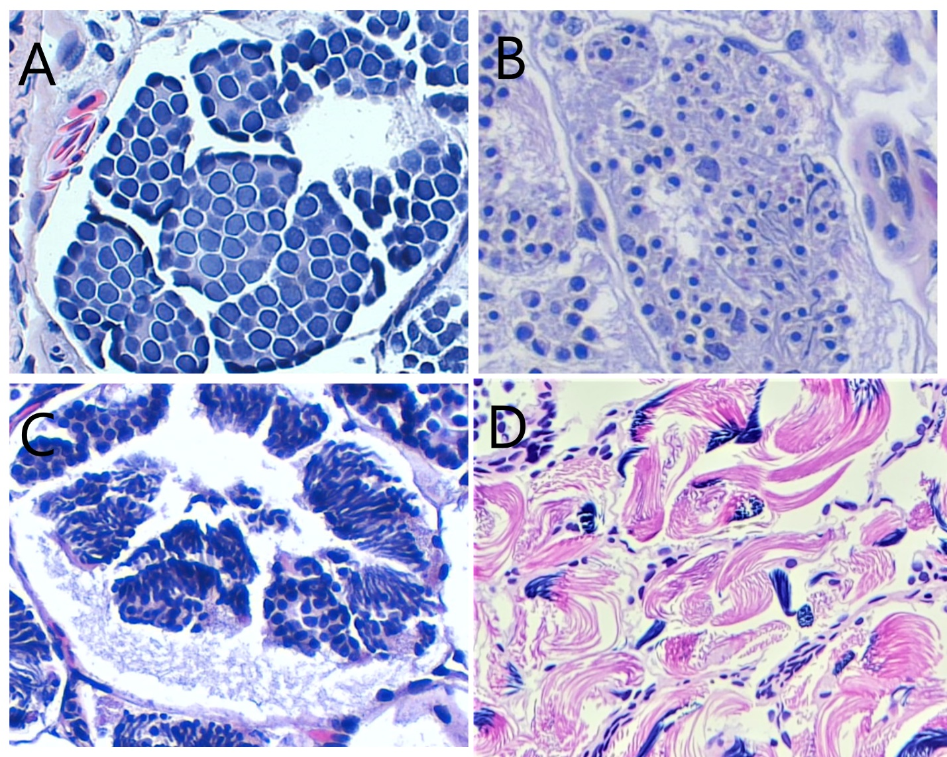
Figure 3.1 Stages of spermatogenesis. A) Spermatogonia B) Spermatocysts C) Spermatids D) Spermatozoa. All images are at 10x magnification.

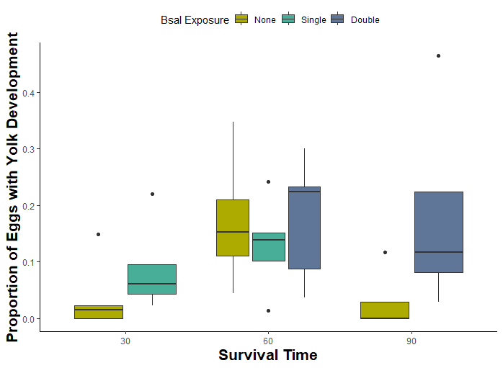

Figure 3.2 Oogenesis comparisons between Bsal-unexposed, single exposed, and double exposed female Notophthalmus viridescens, that were euthanized at 30, 60, or 90 days after the first exposure day. Oogenesis stage is presented as eggs with yolk development (vitellogenic and mature stages) as a proportion of the total eggs counted for each individual.

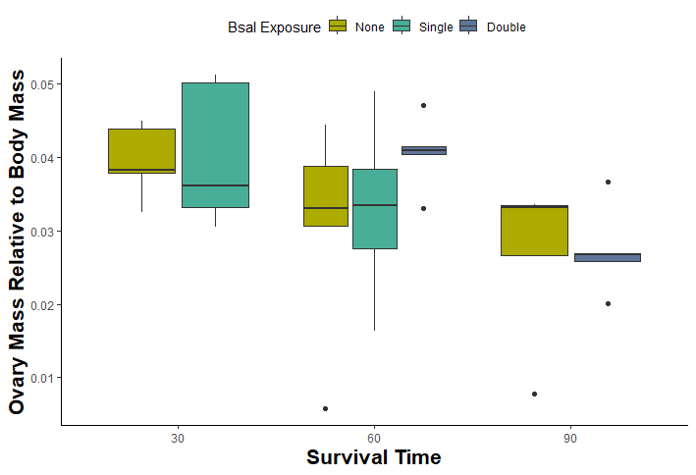

Figure 3.3 Gonad comparison between Bsal-unexposed, single exposed, and double exposed female Notophthalmus viridescens, that were euthanized at 30, 60, or 90 days after the first exposure day. Ovary mass is presented as a proportion of the body mass of the individual.

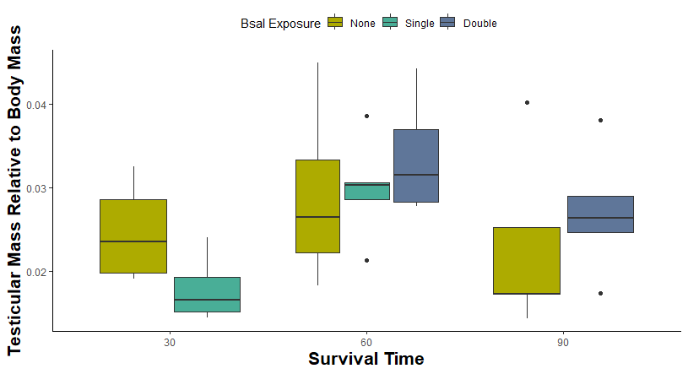

Figure 3.4 Gonad comparison between Bsal-unexposed, single exposed, and double exposed male Notophthalmus viridescens, that were euthanized at 30, 60, or 90 days after the first exposure day. Testicular mass is presented as a proportion of the body mass of the individual.

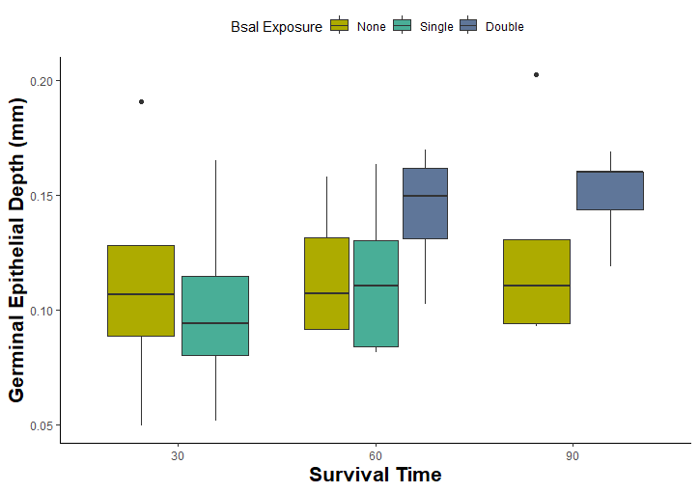

Figure 3.5 Gonad comparison between Bsal-unexposed, single exposed, and double exposed male Notophthalmus viridescens, that were euthanized at 30, 60, or 90 days after the first exposure day. Germinal epithelial depth was averaged across the six largest seminiferous tubules for each individual.

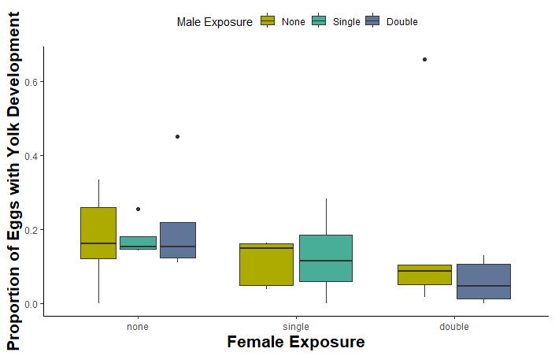

Figure 3.6 Oogenesis comparisons between Bsal-unexposed, single exposed, and double exposed female Notophthalmus viridescens, that were paired with unexposed, single exposed, or double exposed males for 60 days. Oogenesis stage is presented as eggs with yolk development (vitellogenic and mature stages) as a proportion of the total eggs counted for each individual.

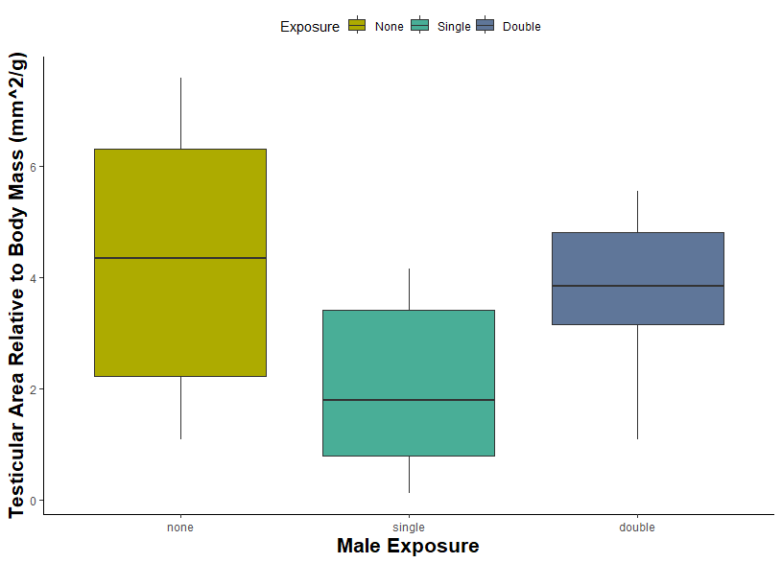

Figure 3.7 Gonad comparison between Bsal-unexposed, single exposed, and double exposed male Notophthalmus viridescens, that were paired with unexposed, single exposed, or double exposed females. Testicular area on histologic examination is presented relative to overall body mass.

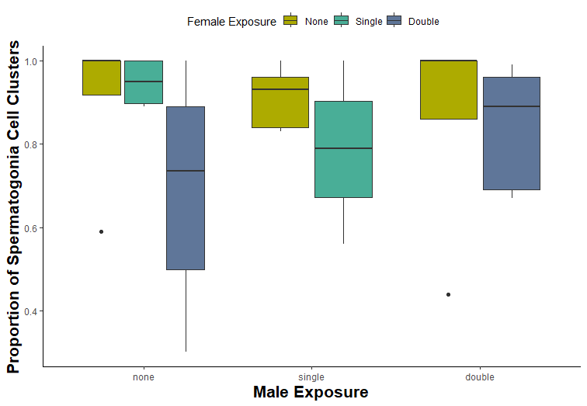
Figure 3.8 Spermatogenesis comparisons between Bsal-unexposed, single exposed, and double exposed male Notophthalmus viridescens, that were paired with unexposed, single exposed, or double exposed females for 60 days. Spermatogenesis stage is presented as spermatogonia (the earliest stage) cell clusters as proportion of the total cell clusters.

Conclusion
Chytridiomycosis is a devastating disease for amphibian populations worldwide, and has the potential to cause more population declines and even extinctions as it spreads (Scheele et al., 2019). Both fungal pathogens that cause chytridiomycosis, Batrachochytrium dendrobatidis (Bd) and B. salamandrivorans (Bsal), have been the subjects of intensive research to inform mitigation efforts around the globe. The goals of the studies presented here were to evaluate potential treatment options for chytridiomycosis, and to investigate aspects of the pathogenesis of Bsal in particular that were less well-understood – namely the role of secondary bacterial infiltration in morbidity and mortality, and the impact of exposure on reproductive fitness.
Terbinafine has been used as a topical treatment for chytridiomycosis (Guzman et al., 2022), however the requirement for multiple doses is problematic when considering the treatment of wildlife. Subcutaneous implants impregnated with the drug have been used in pharmacokinetic studies in cottonmouths and hellbenders (Hardman et al., 2021; Kane et al., 2017), and we were interested in exploring the use of these implants through an intracoelomic route to treat Bd in greater sirens. While the efficacy of this treatment for Bd remains unclear, the intracoelomic injection route appears to be a safe method for administering the implants. Future studies investigating the use of intracoelomic implants in other amphibian species, with different drugs, and aimed at identifying effective doses, are warranted. The use of these implants may provide a practical method for long-term drug delivery in free-ranging wildlife and in headstart programs, even outside of the chytridiomycosis disease system.
Our next goal was to investigate the use of probiotic treatments to combat Bsal chytridiomycosis, and to evaluate the contribution of bacterial infections to morbidity and mortality in the course of the disease. Probiotics have shown promise in laboratory settings in the treatment of Bd (Harris et al., 2009), but there is also evidence of septicemia contributing to Bsal pathogenesis (Bletz et al., 2018). Despite a trend towards lower Bsal loads in animals exposed to Pseudomonas fluorescens after low-dose Bsal exposure, P. fluorescens as administered in this study was not an effective probiotic against Bsal chytridiomycosis. Conversely, exposure to P. fluorescens may lead to increased infiltration of bacteria in the blood and organs in Bsal-exposed animals, with the greatest increase occurring when skin lesions are already present. Future studies should explore the use of different organisms or even a combination of organisms as probiotic treatments, keeping in mind their usage may be restricted to captive settings, where dosing and administration frequency can be more strictly controlled. Meanwhile, the findings in this study indicate that some caution should be exercised when exposing immunocompromised animals, especially those with skin lesions, to bacteria.
Finally, we investigated the impact that Bsal exposure has on reproductive fitness in eastern newts during the breeding season. Previous studies involving Bd infection have shown an overall trend towards terminal investment (An & Waldman, 2016; Brannelly et al., 2016; Chatfield et al., 2013; Roznik et al., 2015) , particularly in animals that are otherwise healthy and have reached peak sexual maturity. Our study demonstrated a similar impact of Bsal exposure in eastern newts, even when they did not develop significant infections. Males and females both showed evidence of increased reproductive effort (increased germinal epithelial depth and increased egg yolk development, respectively) with Bsal exposure, particularly with multiple exposure events. Additional measures related to successful breeding and offspring viability remain as further avenues for exploration in understanding the overall impacts that Bsal has on susceptible species populations, beyond the acute infection phase.
Overall, treatment options for chytridiomycosis remain an area of necessary research, and the findings of these studies serve as a foundation for further efforts to optimize treatment methods, particularly for free-ranging wild amphibians. A deeper understanding of the acute pathogenesis of the disease is important not only for developing those treatments, but also for mitigating unintended consequences, as we saw in the use of P. fluorescens as a probiotic. Meanwhile, lasting impacts of the disease at the individual level will continue to have population-level implications if, as demonstrated here, exposed animals tend towards increased reproductive effort in an attempt to produce offspring before succumbing to disease. Whether this effect will serve to select for animals that are disease-resistant is beyond the scope of our investigation, but is an important factor to explore in understanding overall disease impacts on a population.

References
An, D., & Waldman, B. (2016). Enhanced call effort in Japanese tree frogs infected by amphibian chytrid fungus. Biology Letters, 12(3). https://doi.org/10.1098/rsbl.2016.0018
Bletz, M. C., Kelly, M., Sabino-Pinto, J., Bales, E., van Praet, S., Bert, W., Boyen, F., Vences, M., Steinfartz, S., Pasmans, F., & Martel, A. (2018). Disruption of skin microbiota contributes to salamander disease. Proceedings of the Royal Society B: Biological Sciences, 285(1885). https://doi.org/10.1098/rspb.2018.0758
Brannelly, L. A., Webb, R., Skerratt, L. F., & Berger, L. (2016). Amphibians with infectious disease increase their reproductive effort: evidence for the terminal investment hypothesis. Open Biology, 6(6). https://doi.org/10.1098/RSOB.150251
Chatfield, M. W. H., Brannelly, L. A., Robak, M. J., Freeborn, L., Lailvaux, S. P., & Richards-Zawacki, C. L. (2013). Fitness Consequences of Infection by Batrachochytrium dendrobatidis in Northern Leopard Frogs (Lithobates pipiens). EcoHealth 2013 10:1, 10(1), 90–98. https://doi.org/10.1007/S10393-013-0833-7
Guzman, D., Spear, S. F., & Joyner, P. H. (2022). Successful treatment of batrachochytrium dendrobatidis in eastern hellbenders (cryptobranchus alleganiensis alleganiensis) with terbinafine. Journal of Zoo and Wildlife Medicine , 53(1), 228–231. https://doi.org/10.1638/2020-0146
Hardman, R. H., Cox, S., Reinsch, S. D., Schwartz, H. C., Skeba, S., McGinnity, D., Souza, M. J., & Miller, D. L. (2021). Efficacy of subcutaneous implants to provide continuous plasma terbinafine in hellbenders (Cryptobranchus alleganiensi) for future prophylactic use against chytridiomycosis. Journal of Zoo and Wildlife Medicine, 52(1), 300–305. https://doi.org/10.1638/2020-0158
Harris, R. N., Brucker, R. M., Walke, J. B., Becker, M. H., Schwantes, C. R., Flaherty, D. C., Lam, B. A., Woodhams, D. C., Briggs, C. J., Vredenburg, V. T., & Minbiole, K. P. C. (2009). Skin microbes on frogs prevent morbidity and mortality caused by a lethal skin fungus. The ISME Journal, 3(7), 818–824. https://doi.org/10.1038/ismej.2009.27
Kane, L. P., Allender, M. C., Archer, G., Leister, K., Rzadkowska, M., Boers, K., Souza, M., & Cox, S. (2017). Pharmacokinetics of nebulized and subcutaneously implanted terbinafine in cottonmouths (Agkistrodon piscivorus). Journal of Veterinary Pharmacology and Therapeutics, 40(5), 575–579. https://doi.org/10.1111/JVP.12406
Roznik, E. A., Sapsford, S. J., Pike, D. A., Schwarzkopf, L., & Alford, R. A. (2015). Condition-dependent reproductive effort in frogs infected by a widespread pathogen. Proceedings of The Royal Society B, 282. https://doi.org/10.1098/rspb.2015.0694
Scheele, B. C., Pasmans, F., Skerratt, L. F., Berger, L., Martel, A., Beukema, W., Acevedo, A. A., Burrowes, P. A., Carvalho, T., Catenazzi, A., De La Riva, I., Fisher, M. C., Flechas, S. V., Foster, C. N., Frías-Álvarez, P., Garner, T. W. J., Gratwicke, B., Guayasamin, J. M., Hirschfeld, M., … Canessa, S. (2019). Amphibian fungal panzootic causes catastrophic and ongoing loss of biodiversity. Science, 363(6434), 1459–1463. https://doi.org/10.1126/science.aav0379

Vita
Anastasia Towe moved from her hometown of Jacksonville, Florida in 2011 to attend the University of Pittsburgh, graduating with a Bachelor of Science in Biology and a Bachelor of Arts in English Writing in 2015. She worked as a small animal veterinary assistant before starting the Doctor of Veterinary Medicine degree program in 2016 at the University of Tennessee College of Veterinary Medicine. She began working in the Gray-Miller Amphibian Disease lab in 2017 and joined the Comparative and Experimental Medicine dual-degree program under the mentorship of Dr. Debra Miller in 2018. She completed her DVM in 2020 and continued to pursue her Doctor of Philosophy degree. Her research interests include the pathogenesis and treatment of emerging wildlife diseases, and particularly their impacts on reproductive health in wild populations. After graduation, she will begin her new position as an exotics and zoological medicine intern at Kansas State University.

