Peer Mentorship in R.O.T.C.

A Dissertation Presented for the
Doctor of Philosophy
Degree
University of Tennessee, Knoxville

Katrina L. Benson
May 2025
Acknowledgments
To Dr. Patrick Biddix, whose unwavering dedication to higher education and exemplary character have been a beacon of inspiration. Your guidance has shaped not only my academic journey but also my aspirations for the kind of person I strive to be.
To my dear husband, your boundless love, support, and encouragement have been the cornerstone of my strength. Without you, this journey would have been unimaginable. Thank you for believing in me even when I faltered.

Abstract
This study is a qualitative exploration of how cadets experience mentorship in an R.O.T.C. program at a public, R1, land-grant university in the South. This study investigates the relationship between these experiences and Kram’s (1985) conceptual model of mentorship in the workplace. The research design involves conducting semi-structured interviews with 12 cadets over a school semester. These interviews aimed to understand the cadets perceptions of their mentorship relationships and the aspects they find most valuable. The findings contribute to the literature on military mentorship and provide insights into best practices for officials.
The interviews revealed that crafting a successful mentorship program is intricate and complex. The most effective mentorship arrangements, which integrated professional and psychosocial aspects, emerged organically and were initiated by the cadets rather than being mandated. Additionally, R.O.T.C. mentorship prioritized professional development, often relegating psychosocial aspects to secondary importance, despite cadets expressing a preference for organically developed relationships. Time constraints, hierarchical concerns, and structural challenges further hindered meaningful mentorship interactions, underscoring the need for a more holistic and adaptable approach to mentorship in R.O.T.C. programs.

Table of Contents
Chapter 1: Introduction to the Study 1
R.O.T.C Programs and Professional Aspects 1
Current Military Efforts 2
Statement of the Problem 4
Purpose of the Study 4
Research Question 5
Conceptual Framework 5
Research Design and Methodology 6
Significance of the Study 8
Terminology 8
Delimitations 10
Organization of the Study 11
Chapter 2: Literature Review 12
The Search Process 12
Application of Kram’s Model in Peer-Reviewed Studies 13
Types of Mentorships 16
Traditional Mentorship 16
Peer to Peer 17
Reverse Mentorship 18
Transformational 19
Informal 20
Formal 22
Cadet Mentorships 25
Military’s Definition of Mentorship 27
Summary 29
Chapter 3: Methods 30
Research Design 30
Research Site 31
Participants 31
Data Collection 32
Participant Recruitment 33
Interview Protocol 33
Data Analysis 34
Trustworthiness 34
Positionality Statement 35
Worldview 36
Summary 36
Chapter 4: Results 37
Method and Analysis 37
Context 38
Participants 38
Findings 40
Initiation and Cultivation 41
Professional Aspects 41
Psychosocial Aspects 46
Emergent Themes 48
Limitations 51
Summary of the Findings 52
Summary 53
Chapter 5: Discussion and Recommendations 54
Summary of the Problem and Purpose 54
Summary of the Methods and Findings 55
Discussion 57
Answering the Research Question 57
Recommendations for Advising in Higher Education 60
Student-athletes and R.O.T.C. Cadets 60
Higher Education Community and R.O.T.C. 62
Recommendations for Mentoring in R.O.T.C. Programs 63
Integration 63
Second Lieutenant Mentorship 65
Recommendations for Future Research 67
Exploration of Formal and Informal Mentorship 68
Longitudinal Studies on Mentorship Impact 68
Incorporating Diverse Cadet Experiences 69
Integration of University and Military Resources 69
Policy and Implementation Strategies 70
Conclusion 70
References 73
Appendices 84
Vita 95

List of Tables
Table 2.1 Mentorship Definitions………………………………………………………………..28

List of Figures
Figure 1.1 Phase of Mentorship…………………………………………………………………7

Chapter 1: Introduction to the Study
The word “mentor” originates from Greek mythology in Homer’s “The Odyssey.” In the story, a man named Mentor advises and counsels Odysseus’s son, Telemachus, in the form of the goddess of wisdom, Athena. Athena, now called Mentor, shares wisdom and advice with Telemachus throughout the tale, leading to Telemachus evading attacks, reuniting with his long-lost father, and defending his mother and childhood home against an invasion of unwanted would-be suitors. Since then, various entities have tried to replicate the spirit of Athena’s mentorship in “The Odyssey.” As demonstrated through the example of Telemachus and Athena, mentoring can bring about positive outcomes for individuals and large organizations. Reserve Officer Training Corps (R.O.T.C.) programs do not differ in this desire.

R.O.T.C Programs and Professional Aspects
R.O.T.C. programs developed formalized mentorship practices to replicate the success of large institutions that have recognized the substantial benefits of mentorship. However, mentorship models in R.O.T.C. programs could be focused on only a portion of a holistic mentorship model (Raabe et al., 2021). They thus may need to maximize the full potential of these programs. For example, when cadets in an Air Force R.O.T.C. program receive mentoring, they may be advised to improve or maintain their grade point average, improve their physical fitness, or perform their military drills and ceremonies more precisely (Cline, 2021). When cadets in an R.O.T.C. program receive mentoring, they may be advised whether they shoot well or poorly based on a score from a marksmanship test, whether they can find items on a topographical map correctly or not, and where they rank against their peers based on the above assessments. In both cases, the actual mentorship part primarily focuses on improving measurable skills, and there is little discussion regarding psychosocial development. Developmental concerns such as how the cadets feel they are doing collectively, if they feel accepted in the R.O.T.C. program and university community, how their social life is, and how these factors impact their perspective on themselves often fail to occur (Hu et al., 2008).

Current Military Efforts
The U.S. Army has revised and re-examined its policy and doctrine on mentorship at least three times in the last twenty years (see Field Manual 6-22, Army Directive Policy 600-100, Army Regulation 600-100, and Air Force Manual 36-2643). The U.S. Air Force has done the same, changing strategies multiple times since 1996. Interestingly, these revised strategies do not appear centered on well-being but on performance. The mentorship policy changes aimed to address contentious issues of the day, such as mitigating racism in 1996 and sexual harassment prevention in the early 2000s (Stevens, 2021). The U.S. Navy has also implemented several mentoring policy changes that have not yielded the desirable results (Johnson et al., 2015). While these programs are focused on active military personnel, they are often implemented into the cadet’s training curriculum to prepare them for the experience of an active military member. Thus, if active military members are not receiving relevant and quality mentorship, nor are the cadets.
Despite evolving mentorship reformation efforts by the U.S. military, there is a lack of substantiated evidence that suggests mentorship methods in the military and R.O.T.C. units are providing the desired results. Hu et al. (2008) acknowledged this lack of information and called for more empirical research into mentorship programs in the military to discover effective programs and practices. The researchers highlighted the paradox that mentorship is often referred to in the military, yet little information exists explaining what successful mentorship means and looks like in a military context (Hu et al., 2008). More recently, Grosjean (2021) found that while the military believes it is practicing robust mentoring methods, there is little unified understanding among the military personnel of what being a good mentor means, what it looks like, and how it is practiced most effectively. While Grojean (2021) found a lack of consistency in meaning, it should also be noted how difficult it is to find military mentorship sources that acknowledge shortcomings.
When attempting to research where the U.S. military may be lacking, like in mentorship practices, it is challenging to find empirical research that does not exhibit a one-sided message of positivity. Most of the literature surrounding any program concerning the military primarily discusses how the program is helping service members or the military improve, with little or no acknowledgment of how past programs failed or where potential problems may arise. As a result, it is challenging to locate unbiased reports or studies that acknowledge pitfalls and how these factors may have lingering undesirable effects. For example, Hartig and Doherty (2021) found that even after two decades since 9/11 and American pressure for more transparency from the military, a culture of secrecy still prevents disclosure of its failures to the American public. Grossman (2011) previously expounded on this culture of secrecy, limiting the ability of researchers in her observations to understand the military’s influence and control of what information is disseminated and who has access to it.
Limited information combined with controlled messaging to the public and the inconsistent mentorship methods noted by Grojean (2021) makes deciphering the practices and effectiveness of mentorship programs in a military context more challenging. The present study attempts to address this challenge by adding transparent literature to the context of mentorship in the military and identifying what may or may not be effective.

Statement of the Problem
Kram (1985), a leading researcher in workplace mentorship, found that the ideal mentorship model involves professional and psychosocial aspects and the continued development of these aspects throughout various stages of the mentoring relationship. Kram (1985) and others (e.g., Allen & Eby, 2003, Day et al., 2004; Ragins & Cotton, 1999) found that individuals and organizations improve performance during mentoring relationships when coaching, acceptance, friendship, and other psychosocial factors are considered simultaneously with professional factors such as visibility, protection, and challenge. The existing mentorship program in the observed R.O.T.C. program in this study appears to focus on only professional aspects. In an R.O.T.C. context, this means mentorship centers on measurable items like map reading, marksmanship, and physical fitness, even though professional and psychosocial aspects are equally important in the development and making of a military officer (Hu et al., 2008). Additionally, technical professional skills, such as shooting and map reading, become less applicable to officers as they progress in their military careers (Grojean, 2021).
While physical skills are essential for all service members, it is also vital that service members are well-rounded and mentored in a way that allows them to examine their cognitive and social well-being. Just as in the corporate world, this leads to more successful and rational thinkers, attributes necessary for service members, especially given their work’s significance and dangerous nature (Heimann & Pittenger, 1996).

Purpose of the Study
The purpose of this study is to explore how cadets experience mentorship. The knowledge and the skill of being a good mentor and receiving good mentorship are irreplaceable in today’s workforce (Ma et al., 2020). Considering the U.S. military’s strong drive to excel as a high-performing organization globally, ensuring effective mentorship across all ranks, particularly for officers, becomes crucial. I will assess how cadets experience mentorship in an R.O.T.C. context in this study. I will use Kram’s (1985) mentorship model as the framework to explore the extent to which the cadets in the observed R.O.T.C. program experience professional and psychosocial aspects in their mentorship relationship and if that experience is positive or negative. This study and its findings could assist the military by adding information about mentorship in a military context and expanding for further consideration of the least and most effective models.

Research Question
The following question will guide this study:
How do cadets experience professional and psychosocial aspects in their R.O.T.C. mentorship program R1 university in the Southern U.S.?

Conceptual Framework
I will frame the study using Kram’s (1985) conceptual model of mentorship. Kram’s model aims to show that optimal mentorship occurs when professional and psychosocial aspects are present and given equal importance in a mentoring relationship. Kram described effective mentorship as having four phases: initiating, cultivating, separating, and redefining. These phases are not linear, and each needs professional and psychosocial aspects to succeed (Kram, 1985). Kram’s model is optimal for this study, as it organizes mentorship into clear stages and provides evidence that psychosocial and professional aspects of mentorship are equally important. The use of Kram's (1985) model for this study is further supported by a recent study in which Kram’s approach was used to show how the incorporation of psychosocial and professional aspects in mentorship models helped educators provide more holistic mentorship to their students (Mullen et al., 2022). Furthermore, Kram’s model allows one to pinpoint where the professional or psychosocial aspects need attention and in which phase. This allows for simple identification of when and where the mentor and mentee relationship starts to wander or succeed in a mentorship model. In keeping with Kram’s (1985) model, I will attempt to examine if the cadets experience the phases of mentorship prescribed by Kram (1985). These phases are initiation, cultivating, separating, and the final stage of redefining (see figure 1.1).

Research Design and Methodology
One-on-one interviews will explored how cadets experience mentorship in their R.O.T.C. unit. These interviews will examined if Kram’s (1985) model is present by asking questions about professional and psychosocial experiences. Further questioning examined how cadets personally experienced their mentorship, how they described their experience with others and their mentor, and how the mentorship can affect them as future mentors. A total of 12 cadets will participate in this study.
All 12 cadets were interviewed individually at the start of the fall semester to establish a baseline for how the cadets experience mentorship in R.O.T.C. Conducting a baseline interview allowed for additional insight into how to ask and revise the second interview questions to help gain more insight. The interviews were approximately 30 minutes long, as with all the interviews in this study. All 12 cadets were asked questions regarding their experience as either a mentor or mentee or both. Questions included if they felt they were effectively mentored, whether they would change the approach to mentorship in the R.O.T.C. program, how they describe their relationship with their past mentors, how they feel about the mentorship strategies they have used in the past and how they feel they are taught to mentor best. After baseline interviews, the
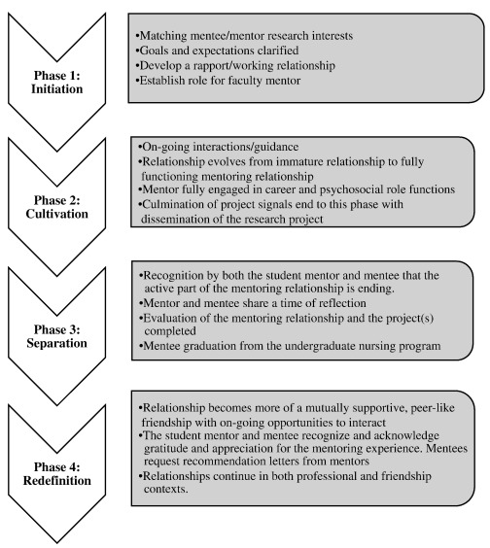
Figure 1.1. Phases of Mentorship
Note. Phases of mentorship incorporate psychosocial and professional aspects. From Abbott-Anderson, K., Gilmore-Bykovskyi, A., & Lyles, A. A. (2016). The value of preparing PhD students as research mentors: Application of Kram's temporal mentoring model. Journal of Professional Nursing, 32(6), p. 429.

responses from the cadets was transcribed word for word and coded for key terms and phrases. At the end of the fall semester, ideally during the redefining phase of Kram’s (1985) mentorship model, I interviewed the 12 cadets again to see how the mentorship experience has developed over one semester. Questions asked attempted to evaluate if the cadets noticed a difference in approach from their mentor over time, if their approach as mentors was more productive, and if they would do anything differently in the future. Once the later fall semester interviews were concluded, responses were coded for themes such as professional and psychosocial, and conclusions will be drawn based on both sets of interviews.

Significance of the Study
The findings of this study will assist R.O.T.C. programs and other military entities by adding to what is known and not known about effective mentorship models in a military context to help identify ways to enhance these types of programs. Findings could suggest positive changes to R.O.T.C. mentorship models, making cadets better prepared for their lives as military officers. Conversely, the study could suggest that other avenues should be examined, such as more deliberate methods of implementing psychosocial and professional aspects into mentorship models. Furthermore, this study would help further define what mentorship should mean in a corporate context and potentially assist in concentrating mentorship research. Additionally, this study will add to the lack of literature regarding effective mentorship models within the military by examining how cadets experience mentorship in an R.O.T.C. program and if Kram’s (1985) conceptual mentorship model is present.

Terminology
For the purposes of this study, the following terms are defined and clarified:
- Cadet: a young trainee enrolled in R.O.T.C. at an institution of higher education. In this study, cadets do not refer to students in law enforcement academies or high schools (Department of Defense, 2017).
- Commission: when a cadet in R.O.T.C. has completed the requirements of their military training and has graduated into the status of an official armed forces member (Department of Defense, 2017).
- Psychosocial: functions that enhance the mentees' sense of competence, identity, and effectiveness, such as role modeling, acceptance, confirmation, counseling, and friendship. Psychosocial functions rely on the quality of emotional bonds and psychological attachments in the relationships, and they can positively affect the mentee's self-esteem, self-confidence, and career satisfaction (Kram, 1985).
- Professional: functions that enhance the mentees' advancement in the organizations, such as sponsorship, exposure, coaching, protection, and challenging assignments. These functions rely on the mentor’s positions, influence, and technical expertise and can positively affect the mentees' career outcomes, such as salary, promotion, and mobility (Kram, 1985).
- Mentorship: a relationship between two individuals of differing levels of experience and expertise who have agreed to work together to achieve mutually defined goals that will contribute to the professional development of the protégé and, ideally, the mentor (Kram, 1985)
- Mentor: a senior employee who is committed to enhancing the career development of a junior employee (mentee) beyond the normal expectations associated with the senior person’s organizational role (Kram, 1985).
- Mentor according to the D.O.D: A trusted counselor or guide who actively participates in the development and support of an individual who is less experienced. (Department of Defense Mentoring Portal, 2005)
- Mentee according to the D.O.D: a junior employee who is being encouraged and supported by a senior employee (mentor) to achieve mutually defined goals that will contribute to the professional development of the mentee and, ideally, the mentor (Kram, 1985)
- Mentee: The more junior person being mentored who seeks guidance, learns from the mentor’s experiences, and benefits from their insights and support. (Department of Defense Mentoring Portal, 2005)

Delimitations
Qualitative methods are used in this study to capture the human experience and explore a topic that is too complex to fit within the boundaries of surveys and other assessment methods (Merriam & Tisdell, 2016). Thus, this study is delimited by several factors. This study only examines students in higher education enrolled in R.O.T.C. programs in the U.S. at a public R1 institution. Additionally, since this study uses qualitative research, the findings may only consider the few discoveries and conclusions that could result from a broader analysis. Interview responses were the measurement mode during this study; thus, I did not evaluate further input that could stem from assessment methods such as surveys. Also, in this study, I examined only one R.O.T.C. program and 12 cadets from that program for their mentorship experience in their R.O.T.C. program. Therefore, the findings in this study may only be transferable to some R.O.T.C. programs, and the impacts of different methodologies should be considered.

Organization of the Study
I organized this study into five chapters. Chapter one identifies the need for the research and expands the problem to the lack of literature regarding mentorship in R.O.T.C. programs and how further research can contribute to refining mentorship programs for the R.O.T.C. programs, institutions of Higher Education, and the Department of Defense (D.O.D). Additionally, Kram’s (1985) mentorship model was introduced as a framework for exploring professional and psychosocial aspects of mentorship in R.O.T.C. After this introduction was the discussion of the problem statement, the purpose of the study, research questions, and terminology. In Chapter two, through a comprehensive examination of the literature, I provide more insight into Kram’s (1985) conceptual mentorship model and why it is a sufficient and practical lens to examine R.O.T.C. mentorship programs. Chapter two’s literature review will also focus on formal and informal mentorship in a military context. In chapter three, I will explain the qualitative methods used in the study and how I will use interviews to explore how cadets describe mentorship at the start of a school semester and then at the end of the same semester. In chapter four, I will examine and explain the findings by comparing the start-of-semester interview responses with the end-of-semester interview responses. Additionally, in chapter five, I will suggest areas of improvement for mentorship in R.O.T.C. programs based on the data collected and provide recommendations for further research. Finally, in chapter five, I will discuss what the findings of this study mean and how they can contribute to further research.

Chapter 2: Literature Review
Chapter two explores mentorship in general and mentorship for cadets by looking at different types of mentorship, how Kram’s (1985) method of mentorship has been applied in other studies, how the military defines mentorship, and how informal and formal mentorship relates to the psychosocial and professional aspects of Kram’s (1985) mentorship model. I will accomplish this by reviewing the literature surrounding and informing mentorship in and outside of a military context. The literature overview will also conceptualize the U.S. military’s process, stance, and understanding of mentorship. The following research question will guide this study and the literature review: How do cadets experience professional and psychosocial aspects in their R.O.T.C. mentorship program at an R1 university in the Southern U.S.?

The Search Process
The review began with a keyword search of the terms military, R.O.T.C., cadet, mentorship, mentor, professional, psychosocial, formal, and informal mentorship. Keywords were selected based on the research question, Kram’s usage of these words in her research (The Handbook for Mentorship at Work, (Ragins & Kram, 2007) and Mentoring at Work: Developmental Relationships in Organizational Life, 1985), and due to a saturation of these words found in brief searches regarding mentorship. With a further examination of mentorship in conjunction with my research question, I discovered that the professional and psychosocial aspects of mentoring are significant and have substantial connections to various types of mentorship, such as traditional, peer-to-peer, reverse, transformational, informal, and formal.
Upon entering my keywords into the One Search Database, a database built by the University of Tennessee that can compile peer-reviewed sources, I received over 400 results. These sources were then skimmed by title and abstract and eliminated per my inclusion and exclusion criteria. Exclusion criteria consisted of any studies centered on a single individual and how that individual was mentored or conducted mentoring, any studies over 30 years old, any medical-oriented mentorship sources, any non-peer-reviewed sources that were not from accredited academic journals, and any sources that spoke to militaries outside of the U.S. Implementing exclusion criteria yielded a significantly smaller pool of sources at 72.
The aforementioned 72 sources were skimmed for additional inclusion criteria, which consisted of phrases and words such as “mentorship in the military,” “professional aspects and psychosocial aspects,” “peer to peer,” “reverse,” and “transformational mentorship.” After thoroughly analyzing these sources using the key phrases, 65 sources informed the research question. These sources either referred to or discussed different types of mentorships, such as formal, informal, peer-to-peer, reverse, and transformational mentorship, as well as professional and psychosocial aspects. I then examined the sources for references to mentorship in the U.S. military and cadets. This yielded 45 sources of value and relevance to my research question.
The following sections will synthesize the 45 relevant information sources by discussing Kram’s (1985) mentorship model and in what context it has been applied in other studies. Then, the literature review will discuss the different types of mentorships, their pros and cons, and the relevance of informal and formal mentorships in a cadet mentorship model. Finally, the review will conclude with how the military defines mentorship, the implications of that definition to cadet mentorship, and a summary of what will be discussed in chapter three.

Application of Kram’s Model in Peer-Reviewed Studies
Various peer-reviewed studies have utilized Kram’s model to explore mentorship and its outcomes. Allen and Eby (2003) examined the relationship between mentorship quality, learning, and job outcomes, drawing on Kram’s distinction between professional and psychosocial support. Findings suggested that mentorship relationships are associated with better work performance when both psychosocial and professional aspects are used simultaneously. Additionally, findings indicated that informal mentorships were perceived as the higher quality relationship that led to more mentee-perceived success.
Eby et al. (2000) investigated the impact of mentoring functions on a mentee’s career success, utilizing Kram’s model (1985) to identify specific mentoring behaviors and their effects on mentee outcomes. The study found that mentoring was connected to a wide range of favorable outcomes, such as higher motivation and persistence, and that the effect size of mentorship practices that utilized Kram’s (1985) model was smaller in the workplace and higher in academic institutions. This finding suggests that the impact of mentorship in academia is of more value and influential to student success, a critical point when examining cadet experiences. Furthermore, Ragins and Cotton (1999) used Kram’s mentorship model to compare the functions and outcomes of formal and informal mentoring relationships, highlighting the differential effects of mentorship structures on mentee development. Key findings included that mentees found relationships with their informal mentors more effective and that the informal mentor generally gave better career advancement advice than the formal mentor. These findings suggest that informal mentorships may be of more significance to cadet mentorships and result in overall student success if implemented.
Other studies, such as those by Higgins and Kram (2001) and Day et al. (2004), have applied Kram’s model to explore the role of developmental networks and leader-member exchange in shaping mentorship experiences and outcomes. Both studies suggest that one’s community plays a more important role in mentorship than what may be perceived. This is significant for this study as it reveals an area of mentorship that is difficult to pinpoint and an aspect that will need to be considered when gathering data.
Uniquely, in a study regarding Kram’s mentorship model and service learning, Fitzpatrick (2013) found that service-oriented students could quickly absorb Kram’s (1985) mentorship model and use it in practice when mentoring others in social work. Kram (1985) would say that the value of good mentorship is that it helps proteges face the demands of their particular profession or workplace. Fitzpatrick (2013) found this uniquely applicable in higher education, calling on instructors to utilize the professional and psychosocial approach when mentoring their students, allowing them to do their jobs better and, in turn, teach their students how to do their future jobs best.
Graham et al., 2022 also found Kram’s (1985) mentorship model beneficial for higher-education students. In the mixed methods study, class leaders participating in a peer-to-peer mentor program were monitored via their grade point averages (G.P.As) and time spent studying in addition to interviews. At the end of the first term and post-intervention of Kram’s (1985) mentorship model, the class leaders showed an increased level of persistence, spending 10% more their time studying and an increase in G.P.As by an average of .4. The qualitative side of the study spoke to the class leaders’ feelings of increased belonging, success, and desire to continue in their higher education journey. This study, along with the aforementioned others, appears to further solidify the clear advantages for students when using mentorship methods that adhere to Kram’s (1985) mentorship model and thus use both professional and psychosocial aspects.
While all the above studies used Kram’s (1985) mentorship model, each study had different parameters, population sites, and data-gathering methods. Nonetheless, referencing these studies is helpful for the creation and execution of this study as they not only provide foundations for implementing Kram’s (1985) method but also suggest aspects of the model that are tried and true forms of success. As noted above, informal mentorships that incorporate Kram’s (1985) model have positively impacted society's perception of mentorship in academia. Ideally, this study will help identify or reinforce these successful attributes.

Types of Mentorships

Traditional Mentorship
According to Kram (1985), traditional mentorship requires that an experienced individual act as the mentor and guide the mentee through personal and professional development. Traditional mentorship is also noted by its length, often requiring long-term commitment and usually prescribed check-ins with the mentee (Eby et al., 2008). Traditional mentorship allows for knowledge transfer, career advancement, and overall support. However, traditional mentorship is complicated by a power imbalance where the mentor is often in a role superior to the mentee. This power imbalance can frequently lead to resistance or hesitation when divulging personal information, thus making the mentorship relationship less beneficial than it could be (Allen et al., 2004). Given the military structure of an R.O.T.C. program, traditional mentorship methods are most likely the go-to method for mentorship models. However, Kram’s (1985) work emphasizes the importance of reciprocity in a mentorship relationship and states that power imbalances can lead to relationships that turn transactional rather than meaningful. Naturally, this could negatively affect individual cadets and the reputation of mentorship in the R.O.T.C. program. Should a traditional mentorship morph into a relationship without reciprocity within an R.O.T.C. program, it is likely that the consensus will deem mentorship unnecessary or a waste of time. Kram (1985) states that these sentiments can be mitigated when tools such as feedback and assessment are actively sought and when mentors have a dual focus on both professional and psychosocial growth.

Peer to Peer
Peer mentorship is distinguishable because it is mentorship by those of similar status who support each other’s learning and development (Eby & McManus, 2004). Peer mentorship has benefits because there are more relatable experiences, more easily accessed communities, and more mentors. Subsequently, in a peer-to-peer mentorship model, it is easier to understand one another and find points where mentorship can be most beneficial (Ragins & Cotton, 1999). Peer mentorship also fosters a sense of belonging and community among the mentor and mentees by blurring the line between the mentor and the mentee and making it often interchangeable (Eby & Lockwood, 2005). The drawbacks of peer mentorship are in the expertise levels. Since those of similar experience levels achieve peer mentorship, it is difficult for both relationship members to look to the other for an example of advancement. (Eby et al., 2008).
While the expertise level is lacking in peer-to-peer mentorship, there is still much to be gained from this method from a military and higher education standpoint. Seery et al. (2021) found that peer-to-peer mentorship fostered higher levels of student engagement, leading to more satisfying learning experiences for higher education students. Furthermore, Seery et al. (2021) found that peer-to-peer mentorship led to more creativity and outside-the-box thinking than traditional methods of mentorship. Notably, this is a sought-after attribute for the military as recruitment of future officers tends to focus on those who can think outside the box (Allen, 2009). Peer-to-peer mentorship is also advantageous for retention in the military and higher education communities. Pelkey (2021) found that peer-to-peer mentorship among first-year students in an Airforce R.O.T.C. program directly correlated to persistence. Utilizing surveys, Pelkey found that 80% of the first-year students in peer-to-peer mentorship models stayed enrolled in the R.O.T.C. program the following school year. This is a significant finding, as peer-to-peer mentorships can be assumed to be the primary mentorship method among students of higher education (Seery et al., 2021).

Reverse Mentorship
Reverse mentorship is perhaps most notable in today’s world of technology, where one often can find a younger person teaching an older person about the latest technology, how it works, and how it can improve quality of life. Reverse mentorship is notable since it challenges traditional mentorship methods where the older, more experienced person assumes the mentor role and the younger, less experienced person assumes the mentee role (Nagi, 2020). Nonetheless, the relationship is still reciprocal in reverse mentorship as the mentor and mentee gain value through exchanging experience and knowledge (Fagenson-Eland et al., 1997). While reverse mentorship promotes a nontraditional method of mentorship as well as understanding and innovation, reverse mentorship does not go without its challenges (Hunt et al., 2019). Reverse mentorship has significant hurdles to overcome when those of a later generation are resistant to changing established stereotypes. (Fowler & Reynolds, 2009).
Reverse Mentorship may not be overwhelming in an R.O.T.C. program, but it is essential to acknowledge due to potential unknown influences. Due to initiatives like the student loan repayment plan and the Montgomery and Post 9/11 G.I. Bills, it is not uncommon for an adult to enroll in college and R.O.T.C. who is significantly older than most of the other cadets (U.S. Government Accountability Office. 2023). These cadets rely heavily on those younger them to instruct and help them understand the new environment the older cadets have found themselves in. Reverse mentorship and its practice could provide a successful model for cadets who fall out of the average age range. However, it seems unlikely that an R.O.T.C. program can successfully monitor multiple kinds of mentorship and still accomplish the goal of encouraging and enhancing the development of all cadet participants. This fact not only brings into question which mentorship model may best fit in the R.O.T.C. context but also if it is realistic to try and find just one method.

Transformational
Transformational mentorship is notable for its structured approach to mentorship as it can often be compared to more of a therapist-and-client relationship in its formalities. The significant difference is that a transformational mentorship relationship relies on the mentor actively pursuing the role and adopting a role model identity that actively listens and provides constructive feedback (Bennett et al., 2018). Transformational mentorship is also noticeable because it takes significant training on the part of the mentor for it to be executed correctly (Avolio et al., 2004). Additionally, transformational mentorship strongly advocates for holistic mentorship that encompasses both professional and psychosocial development, making it the most beneficial form of mentorship to Kram (Kram, 1985; Parker et al., 2008). Nonetheless, transformational mentorship has its drawbacks. Due to the significant amount of diligence and emotional labor needed by the mentor, transformational mentorships can often suffer from over-dependency by the mentee and burnout from the mentor (Eby et al., 2008)
Due to the extensive nature of the transformational mentorship model, this method could not be practically adopted by cadets navigating traditional student obligations. However, due to the attentiveness of the method, lessons learned from this technique could be impactful for R.O.T.C. units to adopt. For example, Nour (2022) found that transformation mentorship was most effective when the relationship was very personal and dedicated. R.O.T.C. units could apply this information by stepping away from assigned mentorship relationships due to rank and position and instead find more meaningful mentorship when cadets are free to find and use their own mentors.

Informal
According to Kram (1985), informal mentorship is notable for a spontaneous relationship that develops naturally without input or intervention from an outside organization. The relationship is built of mutual identification, personal compatibility, and often outside formal organizational structures. Kram (1985) states that these relationships are more enduring and flexible and cover a broader range of professional and personal development areas.
Ragins and Kram (2007) asserted that informal mentoring encourages protégés to learn and develop naturally with aid from the mentor. Kram (1985) implied that psychosocial aspects play the most crucial role in the informal mentorship relationship as this type of mentorship occurs more naturally. Kram stated, “A primary role of mentors is to provide psychosocial support to protégés, helping them to diagnose their prior actions, cast those actions in a positive light, and serve as a source of validation for the protégé” (1985, p. 413). Furthermore, Kram and Higgins (2001) stated that a mentee must pick their mentor as this allows for a more trusting, feedback-seeking-oriented relationship between mentor and mentee. All of the above sources thus imply that the informal mentorship relationship must be chosen and sufficient psychosocial support must be provided.
Throughout the research (Kram, 1985; Kram & Higgins, 2001; Ragins & Kram, 2007), the act of mutually choosing a mentor and mentee is a predominant feature of informal mentorship and incorporating a more psychosocial-oriented approach. Smith et al. (2005) and Payne and Huffman (2005) further acknowledged this conclusion and show that these facts apply to the military. In Smith et al. (2005) study of over 1,162 formal and informal mentorship programs in the military, these researchers discovered that formal mentors provided lower levels of career development than informal mentors due to a lack of psychosocial aspects in the relationship. Additionally, Payne and Huffman (2005) found that U.S. Army officers’ retention rates directly corresponded to psychosocial aspects of mentorship. Officers tended to stay in the military for ten years or more when the mentor and protégé relationship was organically created and incorporated psychosocial elements into the relationship.
Throughout the review, similar results showed that informal mentorship has had high success rates at both the mentee and mentor levels. Gleiman and Gleiman (2020) and Johnson and Anderson (2010) found that job satisfaction within the Army increased when an organization in the U.S. Army abandoned formalized mandatory mentorship programs. Johnson and Anderson (2010) attributed the success of informal mentorship programs to the ability to choose mentors, the length of the relationship, and the psychosocial aspects to include and leave out. This freedom of choice seems to be the dominant trait that draws personnel to informal mentorship, and it appears to relate directly to commitment levels in organizations like the military. According to Herrbach et al. (2011) and Holt et al. (2016), informal mentorships produced better relationships between mentor and mentee. They fostered a more substantial commitment to an organization for the mentor and the mentee. This is due to both mentee and mentor having a mutual choice in the relationship.
Overall, mentorship research appears to be leaning toward an understanding that informal mentorship may be the most beneficial (James et al., 2015), and it appears the military is also. Johnson and Anderson (2015) asked a U.S. Navy sailor their preference for informal and informal mentorships. They responded, “Mentoring is good, but mandating mentoring is a crutch for commands with weak cultures of development… In my last command, we scrapped formal mentorship programs and made it the responsibility of the chiefs and division officers to get the deck plate leadership done” (p. 86). Again, formal mentorship appears to be evolving into a more prefered option for mentorship programs in the military.
Extensive evidence shows the multiple benefits of informal mentorship programs in the U.S. military (Gleiman & Gleiman, 2020; James et al., 2015; Johnson & Anderson, 2015; Harrison, 2016). This preference toward informal mentorship appears to be related to the following reasons: informal mentorship relationships are more naturally occurring, and they allow the mentor and mentee to have more choices in the relationship, such as the length of the relationship. Informal mentorship fosters better commitment on both sides of the relationship, and more psychosocial aspects are incorporated in informal mentorship. However, formal mentorship also has benefits that can be useful in a military context. The following section will discuss these benefits and the potential drawbacks of informal mentorships.

Formal
Kram did not extensively divulge into formal mentorships in her research in 1985, as her focus was predominantly on the dynamics of informal relationships and how they can be understood in opposition to formal relationships. Nonetheless, it appears to Kram that formal mentorship involves structured programs stated by an organization where the outside organizational entity pairs mentors and mentees; these formal relationships appear to have specific goals, timelines, and focus on achieving a particular orientation towards career progression. The organization plays a significant role in the mentee and mentor relationship in formal mentorship.
In 2001, Scandura and Viator studied formal and informal mentorship's positive and negative effects. These researchers found a negative relationship associated with formal mentorship and a positive relationship regarding informal relationships. However, Kram (1985) implied that there is a place for both types of mentorships and even environments where one will work better than the other. Nonetheless, much evidence suggests formal mentorships may be more suited for particular environments than others. One of those environments may be the military.
Ragin and Kram (2007) stated that the critical characteristics of formal mentoring are that the protégé and mentor work together with the support of an organization. Thus, in a formal mentorship relationship, the mentees and the mentor’s organization play a critical role in the relationship's success. In many regards, this makes formal mentorship the most suitable for those in the military because the military can be seen as more involved in individual growth than other corporate entities. Heimann and Pittenger (1996) found that formal mentorship programs positively affected newcomers to an organization, making the newcomers feel more committed to the organization. This fact is attractive to the military due to the requirement and need for committed individuals and the fact that it is newcomers, eighteen-year-olds out of high school, who comprise most of the U.S. military (Demographics of the U.S. Military, 2020).
Formal mentorship is such an appealing option to the military that in 2004, Harrison found that the chief of naval operations, Admiral Vern Clark (one of the highest-ranking individuals in the Navy at the time), began promoting the benefits of formal mentorship in his annual guide to his subordinates. The guide reinforced his direction by adding formal mentorship curricula to all levels of the organization, a strenuous and time-consuming endeavor. This trend and endorsement from senior leaders in the military for formal mentorship is continued today in most military branches. Military branches and their leaders continue to maintain a virtual mandated mentorship system. The Air Force has a program called MyVector, and the Army has the Army Career Tracker (Wardynski et al., 2010). Cadets have a virtual mentorship method called the Talent Based Assessment Battery, which attempts to guide them to commissioning in the military (Cline, 2021). While these systems are web-based, it is arguable that they provide the same feedback that could be found in a formal mentorship relationship. In fact, most of the military considers these systems a primary source of mentorship within their organization (Tan, 2016) since they are regularly checked and managed at very high ranks. These programs require regular check-ins from the mentee and annual completion of certain documents that track their military careers in quantifiable data. These check-ins and data are then reviewed by high-ranking individuals who identify trends and attempt to implement change.
The tracking of data and regular check-ins seem to be consistent characteristics and somewhat unique aspects of formal mentorship relationships (Knouse, 2000). As noticed in informal mentorship, it could be argued that check-ins and mandated requirements are disadvantages of a formal mentorship program. However, these tasks do not seem to deter service members as monitoring every individual at a highly tedious and detailed level is a consistent theme throughout various programs in the military. For example, the military regularly tracks physical fitness levels, body fat percentages, and military occupational knowledge. It is evident that detailed-oriented processes that apply to all are regular concepts in military ranks. This is further solidified among other researchers.
Johnson and Anderson (2015) studied how Navy shipmen felt about formal and informal mentorship. Many sailors felt optimistic about the formal mentorship approach due to its all-inclusiveness. One sailor stated, “A formal program could ensure that others receive the same benefit that I received. I can honestly say that I would not be where I am today without the mentorship I received” (p. 83). This statement has profound implications and is a sentiment similar to that expressed in much of the literature regarding mentorship in the military. However, there is also significant evidence that states otherwise.
Smith et al. (2005) found that in informal mentorship programs, mentors can be biased, often choosing mentees who will be successful and, therefore, do not need as much mentoring and invested time as others. This has significant impacts as, according to general perceptions of mentorship, those who need mentoring are generally those struggling with some aspect of their life, career, etc. Consequently, most informal mentorship programs could be missing the mark altogether by not providing mentoring to those who need it the most.
Overall, it appears the military’s strong inclination towards formalized mentorship is due to the need to ensure every soldier, sailor, airman, and marine is afforded the same opportunity to be mentored as any other servicemember. This is an understandable requirement that R.O.T.C. programs experience even more acutely as cadets navigate the requirements to become service members and higher education students.

Cadet Mentorships
A review of what the literature specifically regarding cadets and what is currently known about the dominant ways in which they experience mentorship is needed in this review. This was a difficult task, as little literature specifically addresses cadet mentorship. However, there has been a recent movement towards advocating for more informal programs due to the significant benefits that informal programs provide.
According to Hu et al. (2008), cadets across the U.S. are mentored mainly by formal means with a strong focus on easily measured professional aspects. As stated previously, formal mentorship programs appeal to military organizations because of their easily accessible quantifiable data and because they can be used as a forcing function that ensures all cadets have an opportunity to be mentored. However, according to Gleiman and Gleiman (2020), most formal mentorship programs are a one-size-fits-all concept and thus do not provide quality and tailored mentorship, therefore defeating the purpose of mentorship altogether. Lester et al. (2011) also found that the U.S. Military Academy’s formal mentorship programs hindered cadet leader efficacy development. Mentorship policies at the academy neglected to force cadets to mentor outside of basic requirements, leaving mentees with little satisfaction from their mentorship experience and leaving mentors with significant knowledge gaps about their mentees.
Formal mentorship programs may not only be hindering cadet self-efficacy but also retention rates at military academies and R.O.T.C. programs. Wardynski et al. (2010) found that cadets engaged in informal mentorships indicated a stronger desire to stay enrolled in the R.O.T.C. program than those in informal mentorships. With recent compounding evidence indicating a need to move towards informal mentorship programs in corporations and academia, it is not easy to understand why informal mentorships are not explicitly called the official mentorship method in R.O.T.C. programs. Xu and Hickey (2022) addressed this fact, acknowledging that it has been challenging to implement informal mentorship programs in military academies and R.O.T.C. programs due to busy cadet schedules. Xu and Hickey, therefore, advocate for an optional mentorship program for cadets to partake in instead of mandated formal methods. However, an optional program would not be able to ensure or direct that all cadets attempt mentorship in some shape and fashion.

Military’s Definition of Mentorship
A review of the literature showed that the U.S. military does not have a set definition of mentorship but that each branch perceives, defines, and conducts mentorship differently depending on its needs. Johnson and Anderson (2010) stated that “Operationally defining the term ‘Mentoring’ even a cursory review of the formal mentoring–-program research reveals that researchers and program administrators employ a heterogeneous collection of mentoring definitions or, worse, fail to define the term altogether” (p. 6).
Throughout this review, ten sources provided wide ranges in the definition of mentorship in the military (see Table 1). To add to the ambiguity of the meaning of mentorship, Johnson and Anderson (2010) found that not only are there multiple evolving definitions of mentorship within a single branch of the U.S. military, but there are little to no set definitions of mentorship from one branch of the U.S. military to another (Johnson & Anderson, 2015). In other words, the U.S. Air Force views mentorship differently from the U.S. Army, but the view changes entirely and frequently within the organization. Haggard et al. (2011) stated that there appears only to have been four years, from 2005 to 2009, when the research community attempted to make the singular definition of mentorship and what it encompasses.
With the extensive and frequently changing definition of mentorship in the military, not only within U.S. military branches but across branches, there is little evidence that can concisely summarize how the military defines mentorship, nor is there evidence that can concretely state the definition of mentorship for the military in any said time frame. Nonetheless, most entities, from corporate companies to the U.S. military, can agree on the positive outcomes of meaningful mentorship, even with varying definitions (Johnson & Anderson, 2015; Johnson & Anderson, 2010; Haggard et al., 2011; Kram, 1985)
Table 2.1. Mentorship Definitions
Source | Definition
Baker et al. (2003) | Relationships are essential for the effective career development of junior professionals in various fields.
Blass et al. (2007) | A contextual learning experience, which, in turn, affects the flexibility needed for making favorable impressions on others, adaptation, and fit.
Johnson & Anderson (2015) | The voluntary developmental relationship between a person of more significant experience and a person of lesser experience is characterized by mutual trust and respect.
Haggard et al. (2011) | A one-on-one relationship between a more experienced senior person and a new entrant or less experienced person in the organizational setup.
Lester et al. (2011). | Ability to enhance leader efficacy.
Lyle et al. (2014). | A process that positively affects early junior officer promotion.
Oglensky (2008) | An attachment to another is rooted in a protective, devoted, affectionate side of loyalty that results in positive progression.
Russel & Adams (1997) | An intense interpersonal exchange between a senior experienced colleague (mentor) and a less experienced junior colleague (protégé’) in which the mentor provides support, direction, and feedback regarding career plans and personal development
Smith et al. (2005) | An interpersonal relationship in which a senior or more experienced person helps a junior or inexperienced person to succeed in the organization
Vidic et al. (2011). | The process of enabling another to develop.

Summary
Due to the preponderance of evidence found in this literature review, it could be broadly stated that informal mentorship programs may have more success in terms of mentorship. However, formalized mentorship models may be unavoidable and necessary due to the U.S. military's unique rank and uniform structured environment. Therefore, this study seeks to make mentorship in a military context more widely understood by assessing how cadets experience mentorship in R.O.T.C. However, just like the U.S. military at large, this experience may be limited due to the restraints inherent in the organization itself.
The various studies examined in the literature review suggest that how cadets experience mentorship within their R.O.T.C. programs will be vastly dependent on the specific organization’s definition of mentorship and how the program implements mentorship between formal and informal means, as well as what mentorship method, such as peer to peer, transformational, etc. is most prevalent within the program. Experiences will also be highly influenced by the values of the program and the cadet community. Therefore, it will be necessary for this study to articulate the interviewee's and program’s values clearly, whether formal and professionally centered or informal and psychosocial centered.
In chapter three, I will provide all the information necessary to ensure this study can be replicated and further researched. I will thoroughly discuss my research design and describe how this study was conducted logically. Topics will include the population and sample size, data analysis such as coding and rationale, how I established creditability and trustworthiness during the study, and lastly, my positionality on the study and why it is important.

Chapter 3: Methods
This study aimed to contribute the research and practice knowledge about mentorship programs and add to the lack of literature surrounding mentorship in a military context. The study focused on cadet mentoring experiences at an R1 Southern university. The following question guided the study:
How do cadets experience professional and psychosocial aspects in their R.O.T.C. mentorship program at an R1 university in the Southern U.S.?

Research Design
Qualitative research is a way of conducting research that aims to understand the meaning and context of the human experience. It is often used to explore under-researched topics (Merriam & Tisdell, 2016). Qualitative research can use various data collection procedures to build this understanding, such as interviews, observations, and focus groups. This study used interviews to obtain information about the human experience, specifically how cadets experience mentorship. I interviewed cadets at the research site using questions designed to gauge how they experienced mentorship in their R.O.T.C. program and if that mentorship was meeting Kram’s (1985) mentorship model. Kram’s (1985) mentorship model and a constructivist worldview framed the study. Kram’s work is significant in the scholarship on mentorship and is frequently cited and used as a litmus test for a sound mentorship model in the workplace, as noted by Herandez et al. (2017), Mullen et al. (2022), and Ivey et al. (2020). The mentorship model requires that both psychosocial and professional aspects be present in a mentorship relationship (Kram, 1985). The interview questions for this study aimed to address whether professional and psychosocial aspects were present among the mentorship relationships, if one was more prevalent than the other, and how this affected the cadet's mentorship experience within their R.O.T.C. program.

Research Site
The research site for this study was a Research 1 (R1), Southern, land-grant, public university comprised of two R.O.T.C. programs, one Army and one Airforce. Only the Airforce R.O.T.C. cadets are interviewed in this study. The university has over 30,000 students and over 10,000 faculty and staff. The larger size of the university makes the site ideal for the study as it was more likely to yield a diverse sample set and, thus, aid the transferability of the findings. The university’s R.O.T.C. programs have grown every year since 2020. This is significant, considering the nation was experiencing a decline in enrollment rates at higher education institutions during the COVID-19 pandemic (National Student Clearinghouse Research Center, 2021.) The research site for this study experienced the opposite. Due to the enrollment success of the R.O.T.C. programs and the growth of the university overall, this site was chosen for this study. I believed interviewing cadets at a site with a thriving R.O.T.C. program and university would yield more reliable data.

Participants
After obtaining permission to conduct the study from the military science department head, 12 presently enrolled cadets from the university’s Air Force R.O.T.C. program were selected to participate in the study. These cadets were asked for their participation via email. The email asked for volunteers who fit the parameters of the consent form and who had spent at least one full academic year in the R.O.T.C. program. 12 cadets make up an Army squad or an Air Force squadron. The squad/squadron made up 6% of the R.O.T.C. population at the site institution.
In qualitative research, the literature varies in detail as to what specifically qualifies as a sufficient data sample. Creswell (2018) stated, “The idea behind qualitative research is to purposefully select participants and sites that will best help the researcher understand the problem and the research question” (p. 185). For this study and due to research constraints (such as maintaining minimal impact on the R.O.T.C. programs day to day), 12 cadets were sufficient to gather themes and allowed for a more in-depth analysis during each interview. Instead of an overabundant number of interviews, I focused strictly on the 12 participants, asking them to extrapolate meaning and thus add more depth to their described experiences. Doing so allowed for an understanding of the cadet’s worldview and more analysis of additional emerging themes. Additionally, by limiting the sample size to 12, I could account for other aspects that may have unintentionally altered the results.

Data Collection
Interviewing was the data collection technique for this study and the primary data source. One-on-one interviews were conducted with mentors and the mentees to understand how the cadets experienced mentorship in their program. Questions were designed to explore if cadets experienced psychosocial and professional aspects in their mentorship and if either aspect had more of an effect than the other. Additionally, questions were designed to determine if both aspects contributed to a more meaningful mentorship experience, as suggested by Kram’s (1985) mentorship model for successful mentorship in the workplace.
Data was collected at two points via one-on-one interviews. The study was limited in duration to one school semester. The first round of one-on-one interviews took place during the second month of the fall semester, September, to allow ample time for cadets to get to know their mentor or mentee, establish their school routines, and have initial and follow-up meetings with each other. The second set of interviews took place during the second to last month of the fall semester, November, so as not to interfere with final examinations and holiday travel and also to explore how cadets believe their mentorship experience changed with time. Once both sets of interviews were complete, responses were synthesized for themes and overarching points. This process is described in more detail in the following sections.

Participant Recruitment
To recruit participants for this study, I first gained permission from one of the R.O.T.C. department’s head and professor of military science to interview the program’s cadets (Appendix A). I then obtained a mass email distribution list for the cadets in the R.O.T.C. program. In the email (Appendix B), I communicated the participation parameters and the approximate date of interview windows and attached the consent form (Appendix C) to the email. The first 12 cadets who responded to the email were selected. The first 12 were then contacted via email to set times for the first interviews that were convenient for them.

Interview Protocol
My research question and Kram’s (1985) mentorship model informed the development of the interview protocol (Appendix D & E). The questions were designed to start the conversation but also to allow flexibility for the interview to go where needed to obtain an understanding of how the cadets experienced mentorship in their program. While the pre-designed questions were helpful for the interviews in terms of developing themes and common issues, their ultimate purpose was to guide the interview and not dictate it, thus allowing each interview to be unique within a semi-structured format (Seidman, 2006).

Data Analysis
Before each interview, I obtained permission to record the cadet’s responses. I then transcribed each recording verbatim to the best of my ability and reviewed keywords and phrases in reference to Kram’s (1985) professional and psychosocial aspects. These procedures were followed in both the baseline interview conducted at the beginning of the fall semester and the second interview conducted at the end of the fall semester. As the interviews were intended to be open-ended, I used inductive coding to organize my data for all the interviews. Inductive coding allowed me to organize my data into three categories: the first two themes were professional and psychosocial aspects, and the third was miscellaneous emergent themes (Miles et al., 2014). I then used open coding to synthesize my data from the first set of interviews compared to the second. Open coding allowed me to draw conclusions about how cadets experience mentorship in R.O.T.C. at their university and if those experiences have common ground with Kram’s (1985) mentorship model. The goal was to obtain data saturation, which was achieved when multiple interviews yielded comparable conclusions (Merriam & Tisdell, 2015).

Trustworthiness
Qualitative research is intended to generate knowledge grounded in human experiences (Sandelowski, 2004). This knowledge gathered from human experience must be obtained according to ethical and dependable guidelines that assure others of the information's credibility. Trustworthiness can be verified by preliminary visits, elective participation, participant validation, an explicit acknowledgment of bias confirmation, audit trails during coding and interviews, and distinct coding protocols (Shenton, 2004). Before conducting the study, I informed the military science instructors of my research and what I wished to accomplish and asked them for feedback and input. As mentioned in data collection, participation in the study was elective, and only cadets who responded with a wish to participate were selected. During and after the study, cadets were asked to verify that their statements were taken honestly once transcribed as a form of member checking. This process of participant validation ensured the credibility of the data. My positionality was acknowledged in several sections of the study, including delimitations and the positionality statement. These partialities were mitigated through the peer review process and various milestones in the dissertation process, such as committee and ethical review board approvals. As described in the data collection section, a clear coding protocol was developed for this study and maintained as well as an audit trail.

Positionality Statement
As a former active-duty captain in the Army and a former cadet instructor at an Army R.O.T.C program, I have certain predispositions about mentorship in the military and even more so in terms of mentorship for cadets. Not only did I consider myself a mentor to my student cadets, but I also experienced life as an Army R.O.T.C. cadet at a university while earning my bachelor’s degree. While this lived experience gives me an advantage in research, it can also present a challenge, given that I have preconceived notions of what “right” military mentorship is and what it is not. Additionally, it has been over 14 years since I was a cadet. Vast aspects of the military and higher education have changed since then, making the dynamics of what I experienced as a cadet completely different than that of the cadet in 2024. I am also limited in my understanding as my perspective only comes from the U.S. Army and how this organization's views have instilled mentorship in me. However, my views and experiences are mitigated through the peer review process and participant validation. My perspective as a woman in the military, which currently only makes up 19% of the American Armed Forces (Demographics of the U.S. Military, 2020), brings a unique and diverse outlook to mentorship in a military context. Analyzing mentorship from my standpoint as a former cadet, having finished their military career, and as a woman will expand the current male-dominated understanding of mentorship in the military and hopefully encourage more research on broader aspects of leadership and mentorship in this context.

Worldview
This case study examines mentorship in R.O.T.C. from a constructivist worldview, which aligns with qualitative exploration. The epistemological foundation of a constructivist worldview is that knowledge is actively constructed by individuals through their interactions with the world. The constructivist lens invites researchers to explore mentorship in R.O.T.C. as a dynamic, socially constructed process, recognizing the richness of individual perspectives.

Summary
In this chapter, I provided the details of my research design, discussed the research site, study participation and recruitment, and data collection and analysis. I also discussed how I established trustworthiness and related my worldview and positionality. The last two chapters (chapters 4 and 5) will detail the results from data analysis, provide a summary of the results, interpret and discuss the results, and describe future opportunities for research.

Chapter 4: Results
Chapter Four summarizes the data from interviews with the cadets, detailing their professional and psychosocial mentorship experiences and emergent themes. Additionally, this chapter addresses the observed limitations within the study.

Method and Analysis
This qualitative study, grounded in a constructivist perspective, aimed to explore the mentorship experiences of R.O.T.C. cadets. Utilizing Kram’s (1985) mentorship methodology as the framework, the study conducted 24 semi-structured, open-ended interviews, each lasting 30 minutes or less, with 12 cadets at an R1 university in the South. The objective was to understand how these cadets experience both the professional and psychosocial aspects of mentorship within their R.O.T.C. program. Below is the research question that guided this study.
How do cadets experience professional and psychosocial aspects in their R.O.T.C. mentorship program at an R1 university in the Southern U.S.?
The study was initiated by conducting 12 interviews in September of the school year and concluded with 12 more interviews with the same cadets in November. By the final interview, no new information was discovered, and responses to interview questions were repetitive, indicating data saturation was reached (Creswell & Creswell, 2018). The analysis focused on both professional and psychosocial aspects of mentorship, as outlined by Kram (1985). The final themes identified from the interviews provided a deeper understanding of how these cadets experience mentorship in their program. These themes were considered emergent along with the professional and personal aspects. Krams (1985) method suggests that good mentorship should balance professional and psychosocial aspects. This study aimed to see if the cadets' mentorship experiences matched this ideal balance and, thus, professional, psychosocial, and emergent themes were appropriate categories for the inducive coding process.

Context
Upon seeking authorization to conduct this study, the R.O.T.C. Professor of Military Science (PMS) emphasized that the military could improve its mentorship of cadets. When I inquired about the current mentorship practices within the program, the PMS revealed that while cadet leadership (cadets appointed by the cadre to lead their peers for the academic year) had been encouraged and he had attempted to establish peer-to-peer mentor-mentee pairings based on academic majors, such initiatives had not been sustained during his two-year tenure as PMS. He further noted that the mentorship observed typically emerged from cadet-initiated efforts and developed organically. Interviews with cadets substantiated these observations, indicating that mentorship within the R.O.T.C. program was neither prioritized nor mandated in the curriculum and often yielded to the myriad demands of higher education. Furthermore, cadet interviews corroborated that existing mentorship largely manifests at the individual level, is informal, and occurs on an as-needed basis.

Participants
12 cadets from an R1 university in the South, all active participants in the university’s Air Force R.O.T.C. program with approximately 200 enrolled cadets, were interviewed over digital platforms. Each interview lasted no longer than 30 minutes, with most averaging fifteen minutes. The cadets voluntarily participated in the study after responding to requests for volunteers. The only criteria for participation were that cadets had to have completed at least one year in the program and were willing to commit to two interviews, one at the start and one at the end of the semester, for a total of 24 interviews.
Due to the elective nature of participation in this study, a set number of mentors and mentees for perfect pairings was not obtainable. Through the interview process, however, I learned that all 12 cadets reported acting as mentors and mentees during the school semester. Some cadets reported having as many as three mentees under them while also stating they had a mentor for themselves, perhaps a senior or junior in the program. In other words, everyone interviewed had various dynamics to their mentor and mentee experiences, but they all felt they had mentors in the program and felt they were mentors themselves. Unfortunately, no pair by happenstance participated in the study, meaning I could not interview a pair who felt that one was the mentor and the mentee. Interview questions addressed cadets in both capacities to capture their experiences of the professional and psychosocial aspects of mentorship. The demographics of the interviewed cadets included eight sophomores, three juniors, and one senior. Among them were eleven male cadets and one female, who was a sophomore. Additionally, only one male participant identified as non-Caucasian, indicating Asian descent.
These demographic details are noteworthy when examining the findings of researchers like Hernandez et al. (2017), who highlighted the impact of demographic congruence on mentorship. Hernandez et al. (2017) found that mentor-mentee relationships characterized by demographic alignment tend to be more effective due to shared backgrounds and challenges specific to certain ethnic groups, genders, and other demographic factors. These commonalities create a sense of common ground that fosters a more personalized and engaging mentorship experience. When asked about the demographics of their mentor and mentee pairs, the majority of cadets mentioned that the predominant demographic in the program is Caucasian, resulting in mostly Caucasian pairings. The exception was the Asian cadet, whose mentors and mentees were also Caucasian. Although this study did not delve into the specifics of demographic matches and their influence on mentorship, these demographic facts are presented to provide a transparent picture and potential insights for further research.
Cadet confidentiality was crucial to ensure active participation, and as such, the study does not refer to cadets by any pseudonyms. Instead, cadets are referred to in comprehensive terms to maintain their anonymity. In the findings section, cadets mentioned a mentorship program initiated by cadets themselves, which pairs cadets with academic majors. While all 12 interviewed cadets participated in this program, it is important to note that the program does not extend beyond the first three weeks of the school semester and there is mandated requirement by the R.O.T.C. program instructors to participate in the mentorship program. Consequently, the second set of interviews revealed limited information about the cadet-initiated mentorship program.

Findings
The study’s findings shed light on the dynamics of the peer mentorship model within R.O.T.C. programs, particularly during the early stages. Initially, cadets exhibited a strong enthusiasm for mentorship at the beginning of the semester, but this enthusiasm waned due to the increasing academic and extracurricular demands. When evaluating mentorship's professional and psychosocial dimensions, the findings suggested the necessity for a balanced approach that incorporates career guidance and personal development. Key challenges identified include the disparity in mentor availability and the distinct needs of R.O.T.C. cadets. Moreover, the below findings highlight the critical importance of fostering a supportive yet professional mentorship environment that is in harmony with the stringent demands of military training.

Initiation and Cultivation
Although Krams (1985) mentorship model does not require a linear progression, she asserted that there are four distinct phases in which quality mentorship transpires. These phases included: initiation (within 0–4 weeks), cultivation (within 4–8 weeks), separation (within 8–15 weeks), and the final stage of redefinition, which remains indeterminate. Given the temporal constraints of this study, it was anticipated that only the initial two phases would be observable. However, due to the rapid decline in participation for mentorship as the academic year advanced, the initiation phase emerged as the sole substantial segment observed.
Cadets expressed a keen eagerness to forge and nurture relationships with their mentors and mentees at the commencement of the school semester, suggesting that the initiation phase proceeded effectively within the framework established by Kram (1985). According to Kram, the initiation phase involves the mentee and mentor becoming acquainted, setting expectations, and establishing a foundational level of trust. Initially, many cadets reported plans to convene regularly, engaging in activities such as meeting for coffee and getting to know each other. Unfortunately, as reported by most of the cadets, these interactions primarily occurred within the first four weeks and subsequently diminished, making the cultivation stage unobtainable.

Professional Aspects
During the initial interviews, cadets appeared to be apathetic toward mentorship and gave very surface-level insight into their mentorship experiences in the program. As the interviews progressed, strategic questioning efforts were employed to encourage more personal, reflective responses. This approach led to a deeper understanding of the cadets' professional growth and their personal thoughts and opinions on cadet development via mentorship. For example, one cadet shared their experience with mentorship on the path to becoming a pilot, stating, “I have enjoyed the program. We meet every couple of weeks, and it has been very helpful in discussing my pilot path and my needs as an independent adult.”
Despite being asked more personal questions about their mentorship experiences, cadets often reverted to discussing professional aspects of mentorship, even when the conversation touched on psychosocial factors. For instance, when asked about personal topics during mentorship meetings, one cadet replied, “We often talk about R.O.T.C. and why dating in the program is a bad idea.” This response illustrates how cadets frame psychosocial discussions within a professional context, highlighting their tendency to view mentorship primarily through a career-oriented lens. Another cadet expressed similar sentiments when asked how mentors advise on dating and other personal matters: “When I was a freshman, my mentor told me not to date in R.O.T.C. because it can cause problems if one of you is ever in charge of the other.”
At the beginning of the interviews, it was challenging to gather authentic personal experiences and opinions rather than what felt like rehearsed, military-approved responses. Most cadets tended to speak about the mentorship program designed by the R.O.T.C. unit rather than their personal experiences of mentorship. For example, one cadet reflected on the mentorship structure, stating, “The R.O.T.C. program does a good job of assigning us mentors according to our majors. I think that is the best they can do.” Similarly, another cadet added, “We have mentors based on our academic majors, and I think that works well.” Over time, cadets began to address both the professional aspects of mentorship and the complexities of assigning mentors. One cadet critiqued assigned mentorship programs, explaining,
At least last year, it seemed like people were assigned it [a mentor], and they weren’t that focused on it or didn’t really want to do it...I feel like I kind of more organically found my mentors, and that’s worked better for me.
Another cadet described how their relationship with a mentor evolved:
With me being in my sophomore year, it was more like I didn’t know that many people...when I found out that my assigned mentor was a nuclear engineer, I went up to him and talked to him and asked him about that. And that’s kind of how that started. I sought him out more. We would try to structure meetings by going on a run or something together and doing something active, and then we’ll talk about ROTC and stuff. Any question that comes up, I’ll go up to him.
Cadets also highlighted the delicate balance between fostering personal connections and maintaining professionalism. This tension is particularly evident in their interactions with peers who were a few years older. One cadet remarked, “It’s hard not to gravitate towards making friendships, but with the other cadets that are a couple of years older, it’s important to be more professional.” This sentiment underscores the challenge of navigating social dynamics within the military environment, where the lines between personal and professional relationships can easily blur.
Many cadets expressed concerns that mentorships resembling friendships could complicate task performance and adherence to orders. For instance, they worried that personal bonds might lead to favoritism or difficulties in maintaining authority and discipline. This is particularly critical in a military setting where clear hierarchies and command structures are essential for operational efficiency and effectiveness. As one cadet explained, “When you’re too close to someone, it becomes harder to give or take orders without personal feelings getting in the way.”
Moreover, the cadets emphasized that while personal connections can provide emotional support and camaraderie, they must be carefully managed to avoid compromising the professional standards expected within the R.O.T.C. program. This balancing act was a recurring theme in their mentorship experiences, reflecting the broader challenge of integrating personal growth with the rigorous demands of military training and service.
The cadets emphasized the importance of mentors balancing approachability with professionalism, a critical need in the close-knit environment of R.O.T.C. One cadet acknowledged the blurred lines between friendship and mentorship, noting, “You should seek the advice of friends outside of R.O.T.C. for personal stuff. Asking within R.O.T.C. could be trouble, but sometimes your only friends are in R.O.T.C., so you have to be able to draw the line.” They also stressed that mentors involved in training or evaluation should maintain a professional demeanor to avoid undermining authority or creating conflicts of interest.
This dynamic was especially delicate for mentors who were only slightly senior but hold formal authority. Cadets recognized that good mentorship involves explicit, professional conduct where mentors guide without crossing into overly personal territory. One cadet articulated this balance when asking about personal versus professional mentorship: “It’s nice to get to know them [the mentee] as a person as well...but I do think there is a line there somewhere.”
Overall, cadets, both from a mentor and mentee perspective, highlighted that effective mentorship in R.O.T.C. requires creating an environment of support while reinforcing the importance of the military chain of command and respect for rank. They noted that mentors must inspire confidence while preserving the professionalism inherent to the program, while mentees must learn to appreciate and accept the distinction between mentor and superior.
During the second round of interviews, cadets reported that their efforts toward mentorship, both as mentors and mentees, diminished over time despite initial intentions to seek or provide mentorship at the start of the semester. One cadet stated, “I only met in person with my mentor once and did not talk at all after the first few weeks. I really liked the idea of it [mentorship programs], and the few conversations I had felt helpful.” While another cadet stated, “It seemed we started out strong with mentorship, but as we got busy, it just fell off.” Only two of the 12 cadets interviewed successfully maintained mentorship relationships as mentors throughout the semester, although they were no longer receiving mentorship for themselves. However, even the remaining two stated that their efforts towards providing good mentorship to their mentees were not as in-depth as initially planned, citing aspects such as not conducting regular check-ins due to other demands but trying to at least text them here and there. One of those two stated, “Whenever I could, I’d seek to help my mentee, but there became a point where it was not worth my time per se.” This cadet elaborated that the prioritization of mentorship diminished as the academic year progressed, particularly as exams and coursework demands increased. The cadet also expressed that although it was arguably their duty as a mentor to sustain the relationship, the lack of proactive outreach from the mentee made it challenging to find the motivation to maintain the mentorship amidst the numerous responsibilities of being a higher education student.
The two cadets who kept in touch with their mentees reported infrequent check-ins but stated these brief check-ins primarily focused on ensuring that the mentee's professional aspects aligned with the R.O.T.C. programs’ requirements, such as maintaining a certain grade point average and an adequate physical fitness score. Overall, the findings from the second round of interviews reinforced the notion that a professionally oriented mentorship style was most prevalent and that this is the primary form of mentorship experienced by cadets when such mentorship occurs.

Psychosocial Aspects
Despite the challenges of encouraging cadets to break from their professional personas during initial interviews, many eventually shared insights into the psychosocial aspects of mentorship. Several cadets highlighted the need for a whole-person approach, emphasizing that effective mentorship extended beyond professional guidance to address practical life skills and personal development. For example, one cadet noted how knowing a mentee in every way, down to seemingly minor skills like doing laundry, can make a significant difference. They explained that while tasks like laundry might appear trivial, the implications can be profound in a program like R.O.T.C., where disciplined appearance is critical. The cadet shared:
Imagine being a cadet in R.O.T.C., where your disciplined looks and appearance often determine your success in the program. If a mentee has not learned how to do laundry, their whole perception of how they are doing as a student, cadet, and adult can suffer.
This perspective underscores how mentorship in R.O.T.C. went beyond leadership or career advice; it was also important to foster self-sufficiency and confidence in mentees. Cadets expressed appreciation for mentors who advised on broader life skills, such as cooking, managing life off-campus, and balancing social life with academic and military obligations. This holistic mentorship approach helped cadets adapt to university life and thrive in various aspects of adulthood. One cadet reflected on the qualities that define strong mentorship:
Good characteristics...be actually passionate about watching other people grow and not just trying to put on face so they can get promoted pretty much. But like actually genuinely caring about the cadets, not being afraid to say the unpopular opinion, you know, say, 'Hey, you need to fix this.' And...you can kind of sense like a genuine care versus the people that are just trying to check a box.
However, cadets also identified areas for improvement in R.O.T.C.’s current mentorship structure. Many suggested a more selective and thoughtful approach to assigning mentors, advocating for fewer but more dedicated mentors. They expressed a desire for a mentorship system that incorporated shared activities and personal interests, creating a more meaningful and less rigid relationship. When asked to envision an ideal mentorship program, one cadet commented:
If I were to make a mentorship program, it would incorporate everything like meal planning, dating advice, and academics…a whole person concept, but I would also make sure my mentees knew to stay professional. I feel like mentorship, as it is right now, lacks the substance that matters.
This sentiment reflected a growing aspiration among cadets for mentorship that balances professional guidance with attention to psychosocial development. During the second round of interviews, cadets frequently expressed their intention to engage in mentorship activities in a more in-depth manner. However, as the semester progressed, many struggled to find the time. When mentorship did occur, it remained predominantly focused on professional aspects, such as career planning and program-related tasks. However, despite noting the in-depth demands of involved mentorship, cadets still often reiterated that they envisioned mentorship as a comprehensive process, encompassing professional and psychosocial elements and other resources such as friendships in other clubs and activities. For example, one cadet reflected on their mentorship experience:
I like to find my mentorship organically and think keeping R.O.T.C. things within R.O.T.C. and personal things with personal friends. Mixing the two is just not for me right now. Maybe down the road, when I am in the program longer, and I have had more time to develop friendships, this will change.
Another cadet emphasized the value of personalized mentorship:
As a sophomore I think I know people in the program a little better and so it's easier for me to ask for their advice on my own. It's even easier if I know the other cadet has the same major or wants to have the same career as me in the Air Force when we commission. There's one guy I end up asking for advice from a lot during PT, like when we run, but I can't say I go out of my way to get their advice. It has to be convenient for both of us and it has to be when I am open to it.
Despite the desire for a holistic mentorship approach, most of the cadets acknowledged significant barriers, including a lack of time and insufficient resources to support such comprehensive mentoring relationships. While psychosocial elements were seen as essential, cadets noted that these aspects were more time-consuming and challenging to address. The reflections collectively highlight a need for a mentorship programs that integrate professional development with personal growth while providing adequate support to mentors and mentees alike

Emergent Themes
Interviews with cadets highlighted several challenges in establishing effective mentorship within R.O.T.C. programs. Several subthemes emerged beyond those aligned within the theoretical framework. A major issue was the imbalance in available mentors, with lower-class cadets outnumbering upper-level students, leading to an excessive workload on senior cadets during their most academically demanding years. Cadets also recognized the difficulties of balancing psychosocial mentorship with personal obligations. One cadet captured these challenges with the following statement:
Doing it all is difficult. Finding a way to be a good mentor who also cares about the whole person while also balancing my own school obligations is just time-consuming. There are only so many of us who want to do the mentorship thing, and there are a whole lot more needs than there are us.
Cadets also expressed a sense of separation from the university community, feeling that their unique needs as R.O.T.C. members were not adequately addressed by available resources. Furthermore, many cadets reported that conflicting commitments, such as academics, employment, and other activities, often overshadowed mentorship efforts. Additional insight into these findings follow.
During interviews, numerous cadets identified the primary challenge in establishing an effective mentorship program was the disparity in available mentors across different levels. A significant proportion expressed a preference for one-on-one mentorship with a cadet at least one level senior to them. However, due to the recruitment structure of R.O.T.C. programs and universities as a whole, freshman and sophomore classes naturally have larger populations than junior and senior classes. This imbalance complicates the formation of one-on-one mentorship relationships and often imposes an additional workload on upper-level students, which is particularly burdensome during their more academically demanding years. One cadet noted, “There are so many of us in the lower classes and not enough seniors to go around. It’s hard to get meaningful one-on-one time.”
During both rounds of interviews, cadets articulated a sense of separation or otherness from the university. Although they did not explicitly state feelings of isolation, they conveyed an impression that their association with the military resulted in differential treatment compared to other students. In discussions regarding mentorship resources available within the university, many cadets either lacked awareness of these resources or believed that such resources were inadequate in addressing their unique needs as R.O.T.C. cadets. Specific challenges included early morning physical training and its impact on academic performance, military ceremonies, and training requirements, and the significant time commitments associated with these events. For example, one cadet stated, “We don’t have the same schedule as other students, and that makes it hard to access campus resources.” Additionally, cadets mentioned that mentorship outside of the R.O.T.C. sphere would not adequately address their questions regarding their future careers. One cadet stated, “going to my advisor is a waste of time. They do not understand what I am trying to do once I graduate and how I get there.” This cadet is reinforcing that non-R.O.T.C. mentors who do not have military experience lack insight into the progression from cadet to career military service and its associated challenges. While this does not mean these mentors could not have other valuable advice, cadets seem to dismiss these kinds of mentors if they cannot provide the full spectrum of professional and psychosocial advice as needed.
During the second round of interviews, many cadets reported that other priorities, such as academic commitments, employment, and extracurricular activities often overshadowed well-intentioned mentorship efforts. Consequently, mentorship initiatives were frequently neglected. One cadet noted, “I like R.O.T.C. but I am there mostly for a future career. I have other clubs and activities I want to participate in, too. Focusing only on R.O.T.C. related activities is not for me.” Conversely, the minority of cadets who successfully maintained mentorship engagements indicated that such activities had to be either meticulously planned and scheduled in advance or were characterized by informal relationships in which mentorship was not the primary focus. One cadet stated, “I would say I do have a mentor, but she also became my roommate before she graduated, so we are more like friends.” In both circumstances, the time dedication needed for quality mentorship appeared to be too much. One participant observed: “Mentorship is great in theory, but when you are juggling everything else, it’s hard to make time for it.”

Limitations
Due to the time restrictions for this study and the academic timelines surrounding it, this study took place in one semester of a school year. Cadets have conflicting requirements as students and potential members of the armed forces; thus, it was prudent for the study to have as little impact on a cadet’s daily life as possible to allow adequate feedback during interviews. Limiting contact with cadets to one semester achieved this desired state. Additionally, although the research site has two R.O.T.C. programs at the university, one Army and one Air Force, only the Air Force program cadets were interviewed for this study. The PMS for the Army program declined participation. This limited the sample size but also allowed for a more focused examination of one program versus two. Additionally, despite all efforts to maintain anonymity, there is always the possibility that cadets hesitated to express their true feelings about mentorship during interviews. They might have feared negative connotations or repercussions if their comments were perceived unfavorably by their instructors or the military at large. Furthermore, although Kram’s (1985) mentorship model is not required to occur linearly, time restraints implied an estimated window to observe when mentored cadets may be within Kram’s (1985) phases of mentorship. These windows are initiated within 0–4 weeks, cultivating within 4–8 weeks, separating within 8–15 weeks, and the final stage of redefining remaining indeterminate. Lastly, as the author of this study, I acknowledge subjectivity as a former military member and a former R.O.T.C. instructor. In chapter three, I include a reflexivity statement to provide additional context about how aspects of my identity and experiences influence this study.

Summary of the Findings
Mentorship in R.O.T.C. predominantly prioritizes professional development, often relegating psychosocial aspects to a secondary role. Initially, cadets shared only surface-level insights into their mentorship experiences, frequently framing discussions within a career-oriented context rather than offering personal reflections. Despite efforts to encourage more personal responses, cadets routinely redirected conversations back to professional topics, highlighting their focus on career alignment and structured mentorship programs. While structured mentorships based on academic or career alignment were generally well-received, many cadets preferred organically developed relationships, as assigned mentorships often lacked depth and connection.
Although the psychosocial aspects of mentorship were acknowledged, they were less emphasized due to time constraints and conflicting priorities. Some cadets stressed the importance of addressing life skills, such as time management, cooking, and laundry, which contribute to self-sufficiency and confidence. However, maintaining a balance between professional mentorship and personal connections proved challenging, as cadets expressed concerns about blurring the lines between mentorship and friendship in a hierarchical setting. Good mentors were described as those who genuinely cared about their mentees’ growth and provided honest feedback while maintaining professionalism.
Several structural challenges emerged, including disparities in class sizes, with fewer upper-level cadets available to mentor larger groups of underclassmen, and the demanding schedules of senior cadets. Additionally, cadets often felt a sense of separation from the broader university community, limiting their desire to access general campus resources and emphasizing the need for mentors who understood the unique challenges of military service. Time constraints due to academic, military, and extracurricular commitments further hindered meaningful mentorship efforts, with most mentorship interactions being either informal or sporadically scheduled. Overall, while cadets aspired to a mentorship model that integrated professional guidance with psychosocial support, the lack of time and resources often led to a primarily professional focus, underscoring the need for a more holistic and adaptable approach to mentorship in R.O.T.C. programs.

Summary
In this chapter, I discussed how data was analyzed and what key aspects emerged from interviews with cadets regarding the professional and psychosocial aspects of mentorship within R.O.T.C. I also identified and included serval emergent themes that did not fit with these two major categories. The next chapter will discuss findings, answer the research question, and make recommendations for higher education, R.O.T.C. programs, and the U.S. Department of Defense (D.O.D), on how mentorship may be better implemented. Lastly, the next chapter will discuss recommendations for future research.

Chapter 5: Discussion and Recommendations
Chapter Five answers the research question that guided this study and makes recommendations regarding mentorship for higher education and R.O.T.C. programs. The chapter begins with a restatement of the problem and purpose of this study. A concise summary of the methods and findings follows. The discussion directly addresses the research question, with citations to relevant literature in chapters one and two. Next are recommendations for future practices in higher education and R.O.T.C. programs based on the study findings. The chapter closes with recommendations for future research.

Summary of the Problem and Purpose
Kram (1985), a leading researcher in workplace mentorship, found that the ideal mentorship model involves professional and psychosocial aspects and the continued development of these aspects throughout various stages of the mentoring relationship. Kram (1985) and others (e.g., Allen & Eby, 2003, Day et al., 2004; Ragins & Cotton, 1999) found that individuals and organizations improve performance during mentoring relationships when coaching, acceptance, friendship, and other psychosocial factors are considered simultaneously with professional factors such as visibility, protection, and challenge. The existing mentorship program in this study's observed R.O.T.C. program appears to focus primarily on professional aspects. In an R.O.T.C. context, this means mentorship centers on measurable items like map reading, marksmanship, and physical fitness, even though professional and psychosocial aspects are equally important in the development and making of a military officer (Hu et al., 2008). Additionally, technical professional skills, such as shooting and map reading, become less applicable to officers as they progress in their military careers (Grojean, 2021).
While physical skills are essential for all service members, it is also vital that service members are well-rounded and mentored in a way that allows them to examine their cognitive and social well-being. Just as in the corporate world, this leads to more successful and rational thinkers, attributes necessary for service members, especially given their work’s significance and dangerous nature (Heimann & Pittenger, 1996).
The purpose of this study is to explore how cadets experience mentorship in their peer to peer model. The knowledge and the skill of being a good mentor and receiving good mentorship are irreplaceable in today’s workforce (Ma et al., 2020). Considering the U.S. military’s strong drive to excel as a high-performing organization globally, ensuring effective mentorship across all ranks, particularly for officers, becomes crucial. In this study I assessed how cadets experience mentorship in an R.O.T.C. context. I used Kram’s (1985) mentorship model as the framework to explore the extent to which the cadets in the observed R.O.T.C. program experience professional and psychosocial aspects in their mentorship relationship and if that experience is positive or negative. This study and its findings could assist the military by adding information about mentorship in a military context and expanding for further consideration of the least and most effective models.

Summary of the Methods and Findings
One-on-one interviews were conducted to explore the mentorship experiences of cadets within their R.O.T.C. unit. The purpose of these interviews was to examine participants' professional and psychosocial experiences to explore the applicability of Kram's (1985) model. Further inquiries focused on how cadets personally experienced mentorship, how they described their interactions with mentors and peers, and how mentorship influenced their potential as future mentors. A total of 12 cadets participated in this study.
Each cadet was individually interviewed at the beginning of the fall semester to establish a baseline understanding of their mentorship experiences within R.O.T.C. These initial interviews provided insights for refining subsequent interview questions to gain a deeper understanding. Each session lasted approximately 30 minutes, during which cadets were asked about their experiences as mentors, mentees, or both. Questions addressed the effectiveness of mentorship, potential changes to the R.O.T.C. mentorship approach, relationships with past mentors, evaluation of past mentorship strategies, and perceptions of best mentorship practices. Responses were transcribed and coded for key terms and themes.
At the end of the fall semester, the cadets were re-interviewed to assess developments in their mentorship experiences over the semester. Questions focused on changes in mentors’ approaches, productivity as mentors, and future mentorship strategies. Post-interview analyses involved coding responses for professional and psychosocial themes to draw conclusions from both sets of interviews.
The interviews revealed that R.O.T.C. mentorship prioritized professional development, often relegating psychosocial aspects to secondary importance. Initially, cadets provided surface-level insights, framing discussions within career-oriented contexts rather than offering personal reflections. Despite efforts to elicit more personal responses, cadets consistently, and perhaps unknowingly, redirected conversations to professional topics, emphasizing career alignment and structured mentorship programs. While structured mentorships were generally well-received, cadets expressed a preference for organically developed relationships, as assigned mentorships often lacked depth and connection.
Though the psychosocial aspects of mentorship were acknowledged, they were underemphasized due to time constraints and conflicting priorities. Some cadets highlighted the importance of life skills such as time management, cooking, and laundry, which contribute to self-sufficiency and confidence. Balancing professional mentorship and personal connections proved challenging, as cadets were concerned about blurring the lines between mentorship and friendship in a hierarchical setting. Effective mentors were described as those who genuinely cared about mentees’ growth and provided honest feedback while maintaining professionalism.
Structural challenges included disparities in class sizes, with fewer upper-level cadets available to mentor larger groups of underclassmen, and the demanding schedules of senior cadets. Additionally, cadets often felt separated from the broader university community, limiting their engagement with general campus resources and underscoring the need for mentors who understood the unique challenges of military service. Time constraints due to academic, military, and extracurricular commitments further hindered meaningful mentorship interactions, which were often overly formal or sporadically scheduled. Overall, while cadets aspired to a mentorship model that integrated professional guidance with psychosocial support, the lack of time and resources often resulted in primarily professional focus, highlighting the need for a more holistic and adaptable approach to mentorship in R.O.T.C. programs.

Discussion

Answering the Research Question
The following question guided the study:
How do cadets experience professional and psychosocial aspects in their R.O.T.C. mentorship program at an R1 university in the Southern U.S.?
The straightforward yet potentially unsatisfactory answer to this inquiry is that cadets at the observed research site experience these aspects in various ways, but not consistently or uniformly. While most cadets encountered both psychosocial and professional elements of mentorship within their R.O.T.C. program through formal and informal channels, these benefits required considerable effort. Ultimately, the interviews revealed that while there were genuine intentions and aspirations to incorporate professional and psychosocial methods into mentorship, the current R.O.T.C. program structure makes it incredibly challenging. Cadets are simply too overwhelmed with their numerous responsibilities for such an initiative to be effectively implemented. This is a troublesome finding when considering studies such as Higgins and Kram (2001) and Day et al. (2004) who discovered that one’s community plays a more important role in mentorship than may be perceived. This suggests significant consequences if R.O.T.C. programs are not able to support mentorship among its community in meaningful ways. A substantial number of interviewed cadets proactively pursued additional mentorship relationships that aligned with their specific needs for success. Despite their efforts, cadets often found themselves preoccupied with other priorities, ultimately deprioritizing mentorship altogether.
Cadets who solely relied on the structured mentorship framework provided by the R.O.T.C. program often found it less productive, perceiving it as overly forced. This perception inhibited their engagement with the psychosocial components of mentorship that most cadets deemed essential. This discovery aligns with Lester et al. (2011), who also found that the U.S. Military Academy’s formal mentorship programs hindered cadet leader efficacy development. Mentorship policies at the academy appeared to lack incentives for cadets to mentor outside of basic requirements, leaving mentees with little satisfaction from their mentorship experience and leaving mentors with significant knowledge gaps about their mentees.
A minority of cadets interviewed for this study expressed concerns that integrating psychosocial elements into mentorship could blur the lines of authority and complicate the execution of R.O.T.C. duties. Nevertheless, it is important to note that the majority of cadets did not share this view. Most reported that they could effortlessly transition between adhering to strict authority and engaging in more personal interactions as appropriate. In fact, most stated something to the effect that the ability to balance professional and personal aspects of mentorship was seen as a valuable skill that enhanced their overall leadership capabilities. Furthermore, it highlighted the importance of adaptable and context-sensitive mentorship approaches within the R.O.T.C. framework, qualities also found beneficial by Smith and Johnson (2021) in their work regarding mentorship in higher education.
Interestingly, despite cadets initially expressing a strong desire to incorporate both professional and psychosocial aspects into the peer-to-peer mentorship model, a majority found it easier to focus solely on professional aspects as their academic demands increased over time. This suggests that, while research advocates for holistic mentorship approaches, the multitude of requirements faced by cadets and students as a whole makes it impractical to mandate or request peer-to-peer mentorship encompassing Kram’s (1985) methodology.
At the inception of this study, one objective was to conceptualize a streamlined and effective system to address the multifaceted nature of cadet mentorship experiences. This objective was not fully realized. The interviews revealed that crafting a successful mentorship program is intricate and complex. The most effective mentorship arrangements, which integrated both professional and psychosocial aspects, emerged organically and were initiated by the cadets themselves rather than being mandated. This finding contrasts sharply with traditional military doctrines such as the Army Field Manual 6-22 or the Air Force Manual, DAFMAN 36-2643, which emphasize discipline and structured processes for all aspects of duty, rendering this outcome particularly unexpected. Nonetheless, this finding aligns with other mentorship research, such as Ragins and Cotton (1999) and Fu (2024), who advocate that mentees in an informal mentorship relationship receive better career advancement advice than from a formal mentor.

Recommendations for Advising in Higher Education
An emergent theme revealed during the interviews was the cadets' pronounced sense of separation from their university environment. Cadets indicated that their ability to conduct certain activities and procedures was attributed more to their association with the military rather than their connection to the university (Raabe et al., 2021). This sense of otherness extends into the realm of mentorship, potentially creating an environment where cadets feel less support compared to their non-cadet peers.
Although this feeling of separation are potentially unique to the observed research site, it is important to note that any perception of being distinct from the general student body may engender feelings of isolation among cadets, subsequently impacting their overall university experience and personal development (Bayawa, 2023). This sense of separation can impede the effectiveness of mentorship programs, as cadets might perceive that their unique challenges and needs are neither fully comprehended nor adequately addressed within the broader university context, such as in academic advising and counseling. As a result, this environment may fail to provide comprehensive support, thereby adversely affecting cadet performance and retention (Raabe et al., 2021).

Student-athletes and R.O.T.C. Cadets
Although these challenges may appear unique to R.O.T.C. programs and cadets, they are analogous to issues faced by student-athletes, given their travel and commitment to training and schedules. However, given the attention and funding generally available to student-athletes, it is more likely that their need for quality advising and mentorship is better known and, therefore, better resourced (Brecht & Burnett, 2019). Additionally, knowledge about athletic expertise is more widespread. Thus, it is more likely that university advisors and mentors are more aware and educated on how to support student-athletes in their progression (Buntin, 2015). It is plausible that the strategies and solutions needed to help student-athletes feel more integrated into the university community could similarly benefit cadets (Butin, 2015). Educating student advisors on military career progression could equip them with the necessary knowledge to support cadets in the same effective manner as student-athletes, thereby enhancing their overall university experience and personal development for both groups.
In universities, no group should receive exceptional prioritization over another in terms of student development, equity for all students is essential. However, like student-athletes, R.O.T.C. cadets contribute significantly to institutions financially, with about 67% of cadets entering the R.O.T.C. program with Department of Defense (D.O.D) funded scholarships (Air Force R.O.T.C., n.d.). The Air Force allocates roughly $376 million annually in R.O.T.C. scholarships across various universities (Air Force R.O.T.C, n.d.). This substantial amount represents a significant financial incentive a university should try to attract. Providing exceptional services to cadets, such as through university integration, knowledge, and advising, is one way this is obtainable.
It is recommended that universities make concerted efforts to understand R.O.T.C. programs better and become more actively involved in the development of cadet students on a similar plane to that of student-athletes. One approach could be promoting and leveraging cadet needs and requirements in university administrative actions, ensuring that the expectations for cadets align with those for the general student population. For example, cadet promotions and demotions could be tracked by the university administration and R.O.T.C. officials to determine the time restraints and commitments required of that cadet during a specific time in their R.O.T.C. career. This integration would ideally lead university officials and those involved in student development to comprehend the unique requirements of cadets better, thereby recognizing the need for additional resources. By providing tailored support systems, universities can ease the transition for cadets from parental dependence to independent adulthood while also managing their serious commitment to military service. Such resources might include specialized counseling, academic advising, and career services tailored to the needs of cadets.

Higher Education Community and R.O.T.C.
Implementing comprehensive mentorship programs that encompass both regular student life and cadet life is crucial in bridging the gap between the higher education community and the R.O.T.C. programs. Mentorship programs should be designed to address the dual identities of cadet students, offering guidance and support that acknowledges their unique experiences and challenges. Mentorship initiatives could include mentoring models, where senior cadets or recent graduates provide insights and support to newer cadets, as well as professional mentorship from faculty and external military personnel, such as those who are member of organizations that support veterans at universities . Graham et al.’s (2022) research that incorporated Kram’s (1985) mentorship model in a peer-to-peer mentorship program among students and faculty in higher education reinforces this suggestion. By the end of the study, students showed increased persistence, spending 10% more of their time studying and an increase in G.P.As by an average of .4.
Such integration of cadet and regular student life would foster better understanding and collaboration at both levels—university officials and cadet students. University officials would gain a deeper appreciation of the cadet experience, enabling them to design and implement policies and programs that better support cadet needs. Simultaneously, cadets would benefit from a more inclusive and supportive university environment, enhancing their overall educational experience and personal development.
Addressing the sense of separation between R.O.T.C. programs and universities requires a multi-faceted approach. By better integrating cadets and universities' administrative efforts, educating advisors on military career progression, and implementing comprehensive mentorship programs, universities can create a more supportive and inclusive environment for cadets. This approach not only benefits the cadets by providing them with the necessary resources and support but also enriches the university community by fostering a culture of understanding and collaboration.

Recommendations for Mentoring in R.O.T.C. Programs

Integration
Interviews from this study suggest that R.O.T.C. programs and their host universities may operate in disjunctions, resulting in inefficiencies and a sense of isolation among cadet students. The current potential sense of separation between R.O.T.C. programs and their respective universities disadvantages both parties by creating isolated resources and distinct demands on students. This segregation results in inefficiencies, such as wasted time and effort, and fosters a sense of detachment among cadet students from the broader student body (Bayawa, 2023). This disjunction not only hampers the holistic development of cadets but also impedes the efficient utilization of resources that could be mutually beneficial.
From a cadet’s perspective, feeling isolated from the general student population can lead to a diminished university experience (Bayawa, 2023). Cadets, who are already tasked with the rigorous demands of R.O.T.C. training and academics, may find it challenging to fully integrate into campus life, thereby missing opportunities for broader social and academic interactions. This separation can detract from their overall university experience and hinder their personal and professional development (Raabe et al, 2021). To address these challenges, it is proposed that the D.O.D. establish regulations requiring R.O.T.C. programs to incorporate university assets when able. By better leveraging these resources, R.O.T.C. programs can enhance their training regimens, provide more comprehensive support to cadets, and ensure that the educational experiences of cadets are on par with those of their non-R.O.T.C. peers. Integrating R.O.T.C. programs with university resources could significantly improve efficiency and resource utilization. Educating and leveraging existing university facilities, such as counseling and advising services early in the cadet's higher education experience, can be employed to support cadet development, thereby reducing redundancy and optimizing the use of available assets. This integration could also alleviate some of the financial burdens on R.O.T.C. programs by utilizing university funding and resources, which are often more substantial and up-to-date.
One of the most critical benefits of such integration is the potential for enhancing cadet retention within R.O.T.C. programs. Tinto (2023) emphasized the importance of early student engagement and stated that students are more likely to stay in an institution if they feel more connected to the community. Therefore, when cadets have access to comprehensive support systems that address their academic and personal needs, they are more likely to remain engaged and committed to their training. Utilizing existing university resources to support cadet development could serve as a cost-effective strategy for the D.O.D. to improve retention rates as well as universities. Moreover, this integration would promote better communication and collaboration among R.O.T.C. programs, the D.O.D., and universities. Enhanced communication channels can lead to more coordinated cadet training and support efforts, ensuring that all parties are aligned in their goals and strategies. This collaborative approach can also facilitate the sharing of best practices and innovations, further strengthening R.O.T.C. programs. Additionally, providing incentive measures, such as ceremonial recognition for exemplary mentorship programs, could motivate cadets, parents, and students. These small rewards would support cadets and attract more students to these programs, ultimately benefiting the universities, R.O.T.C. programs, and the individual cadets.
The lack of integration between universities and their respective R.O.T.C. programs presents significant challenges that can be mitigated through strategic alignment and utilization of university assets. By incorporating these resources, the D.O.D. can enhance the efficiency, effectiveness, and overall experience of R.O.T.C. cadets. This approach promises to improve cadet retention and development and foster a more cohesive and supportive environment for future military leaders.

Second Lieutenant Mentorship
The role of mentorship within R.O.T.C. is indispensable for the holistic development of cadets, encompassing both professional and psychosocial dimensions. During the series of interviews, cadets consistently emphasized the superior benefits of receiving guidance from senior personnel instead of peer-to-peer mentorship. The findings of the interviews propose the implementation of a vertical mentorship model involving newly commissioned officers, specifically second lieutenants, within the R.O.T.C. framework. A vertical mentorship model is further supported in a study done by Xu and Hicky (2022), who found that among 149 Coast Guard cadets, 92.4% believed a mentorship relationship with a current commissioned officer was more supportive and beneficial to their progression as students and military professionals.
In this study, cadets repeatedly articulated that mentorship from individuals who have traversed the full spectrum of R.O.T.C. experiences provides substantial advantages. Having undergone similar training and challenges, these mentors are uniquely positioned to offer relevant insights and guidance. The shared experiences foster a deeper understanding and trust, facilitating more effective mentorship dynamics (Hernandez et al., 2017). In contrast, same-level peer-to-peer mentorship lacks this depth of expertise and often fails to address the comprehensive needs of the mentees.
Given these observations, it is recommended that the D.O.D. consider establishing structured mentorship programs that utilize newly commissioned/graduated cadets who are perhaps alumni of the university and R.O.T.C. program, particularly second lieutenants, as mentors for current R.O.T.C. participants and that R.O.T.C. units are mandated to support this initiative by providing times for meetings with their mentor by whatever means are available. This strategy leverages the second lieutenants' recent yet comprehensive experience, ensuring they can relate closely to the cadets' current challenges while providing forward-looking career guidance.
The effectiveness of this mentorship model could be further enhanced by aligning mentors with the specific career fields that cadets aspire to join post-commissioning. Baker et al. (2003) found that mentorship relationships are essential for the effective career development of junior professionals. Thus, such alignment would enable cadets to receive tailored advice and insights pertinent to their chosen paths. However, it is also critical to maintain flexibility within the program, allowing cadets the opportunity to seek new mentors if their career interests evolve. This adaptability ensures that mentorship remains relevant and supportive throughout the cadets' developmental journey.
To maximize the potential of this mentorship approach, the D.O.D. should invest in comprehensive training programs for second lieutenant mentors that educate on the importance of mentoring from a professional and psychosocial lens. These programs would focus on effective mentorship methodologies and best practices, particularly emphasizing integrating psychosocial support as the professional aspects appear to come more naturally (Higgins & Kram, 2001). By equipping mentors with these skills, the D.O.D. can ensure cadets receive well-rounded guidance that addresses their professional and personal development needs.
Furthermore, the significance of counseling and mentorship in military officership cannot be overstated. Seery et al. (2021) found that successful mentorship led to more creative thinking than traditional mentorship methods. Notably, this is a sought-after attribute for the military as recruitment of future officers tends to focus on those who can think outside the box (Allen, 2009). Effective mentorship could not only aid cadets' immediate development but also cultivate essential leadership skills in the mentors themselves. By engaging in mentorship, second lieutenants enhance their own counseling abilities, preparing them for future leadership roles within the military (Lyle et al., 2014). By implementing a structured mentorship model involving second lieutenants aligned with career aspirations and supported by targeted educational programs, the D.O.D. can significantly enhance the developmental experience of cadets. This approach promises to foster a more holistic, adaptable, and effective mentorship environment, ultimately contributing to future military officers' professional and personal growth.

Recommendations for Future Research
Future research should encompass a broader examination of R.O.T.C. programs and their mentorship initiatives across various universities and military institutions. Given this study's population and time limitations, similar studies with a broader scope must be conducted to provide a comprehensive understanding of mentorship practices and the specific needs of cadets and students. Such studies would contribute significantly to the existing body of knowledge on mentorship, enabling the development of more effective strategies and programs tailored to the diverse experiences of cadets. Additionally, future research should explore the specific mechanisms and frameworks through which such integration can be achieved, including potential policy changes, administrative adjustments, and the development of collaborative programs. Additionally, empirical studies examining the impact of integrated resources on cadet performance and retention would provide valuable insights into the effectiveness of these strategies.

Exploration of Formal and Informal Mentorship
Moreover, future research should delve into formal and informal mentorship aspects and their long-term impacts. Formal mentorship programs are often structured with specific goals and guidelines, while informal mentorship develops organically and can be equally influential (Inzer, & Crawford, 2005). Understanding the dynamics and effectiveness of these different mentorship approaches is essential for creating a holistic framework that supports cadet development in a multifaceted manner. Comparative studies on the outcomes of formal versus informal mentorship would provide valuable insights into the strengths and limitations of each approach.

Longitudinal Studies on Mentorship Impact
Understanding the most effective mentorship practices is challenging when research is confined to the duration of a cadet's academic career. Therefore, longitudinal studies that track cadets through their military careers, potentially until retirement or reaching certain ranks, would be instrumental in identifying best practices for mentorship within R.O.T.C. programs. Such studies would allow researchers to observe the long-term effects of various mentorship strategies on career progression, leadership development, and overall personal growth. Additionally, longitudinal research could reveal cadets' evolving needs and preferences as they transition from students to military professionals, providing a more dynamic understanding of mentorship requirements.

Incorporating Diverse Cadet Experiences
Future research should also strive to incorporate the diverse experiences of cadets from different backgrounds, including variations in gender, race, socioeconomic status, and academic disciplines. These efforts would add significantly to mentorship knowledge and address the concerns reported by Hernandez et al. (2017), whose research shows the significant impact of demographic factors on successful mentorship. By examining how these factors influence mentorship experiences and outcomes, researchers can identify potential disparities and develop more inclusive and equitable mentorship programs. This approach would ensure that all cadets receive the support they need to succeed, regardless of their personal circumstances.

Integration of University and Military Resources
Another critical area for future research is the integration of university and military resources to enhance the mentorship experience for R.O.T.C. cadets. Studies could explore how existing university assets, such as counseling services, academic support, and extracurricular activities, can be leveraged to complement R.O.T.C. training. Raabe et al. (2021) work suggests that university resources can play a critical role in creating optimal learning environments for cadets. Building on the work of Raabe et al. (2021) by examining how integrated support systems influence cadet retention, performance, and overall well-being could offer valuable insights into the advantages of a more unified approach to mentorship.

Policy and Implementation Strategies
Finally, future research should focus on developing and implementing policies that promote effective mentorship within R.O.T.C. programs in higher education. Zografou and McDermott (2022), in their research regarding effective mentorship in higher education, state, “Effective mentorship programs within higher education require structured policies to ensure their sustainability and success. Without clear guidelines and institutional support, the potential benefits of mentorship may not be fully realized.” (p.75). Evaluating the current mentorship frameworks, identifying gaps and areas for improvement, and proposing evidence-based recommendations for policy changes are a few small ways policy research could change mentorship in higher education and, subsequently, R.O.T.C. cadet mentorship for the better. Collaboration between academic institutions, military organizations, and policymakers would be essential to ensure that these recommendations are practical, sustainable, and aligned with the goals of both educational and military entities.
A comprehensive and multi-faceted approach to future research on R.O.T.C. mentorship is necessary to fully understand and optimize the mentorship experiences of cadets. By addressing the aforementioned areas, researchers can contribute to the creation of robust mentorship programs that support the professional and personal development of future military leaders.

Conclusion
At the outset of this study, one of the primary objectives was to identify the best practices in mentorship by examining how cadets experience both the professional and psychological aspects of mentorship. The initial hypothesis posited that the professional aspects of mentorship would significantly outweigh the psychosocial aspects, thereby creating a disadvantageous scenario for effective mentorship. However, this hypothesis and objective proved to be overly simplistic and limiting. Through detailed interviews with cadets, it quickly became apparent that a one-size-fits-all approach to effective mentorship within R.O.T.C. programs is unattainable, even when using established frameworks such as Kram’s (1985) seminal methodology. A key finding from this study is the highly individualized nature of mentorship as a facet of personal development. No universal method applies uniformly, even within the relatively homogeneous group of R.O.T.C. cadets. Each cadet interviewed during this study demonstrated unique needs for mentorship, requiring varied types of involvement from their mentors at different times and in distinct ways. This variability underscores the complexity and necessity of a tailored approach to mentorship.
Cadets' preferences for seeking mentorship and guidance were deeply rooted in their subjective experiences within the program. For instance, while some cadets valued a formalized and structured approach to mentorship orchestrated by R.O.T.C. leadership, others found such rigidity stifling, particularly when they needed more psychosocial support as opposed to strictly professional guidance. This dichotomy highlights the need for flexibility and adaptability in mentorship structures within R.O.T.C. programs.
Ultimately, it became clear that requiring cadets to engage in multifaceted peer-to-peer mentorship is impractical and overly demanding, given their competing obligations. To address this issue, it is recommended that additional efforts be allocated to R.O.T.C. programs across universities to facilitate the engagement of highly educated external entities who could serve as mentors for cadets; for example, the previously mentioned second lieutenant mentorship initiative could be a cost-effective method to address this concern. Furthermore, this approach would mitigate the burden on cadets and ensure that they receive high-quality mentorship that addresses both their professional and psychosocial needs.
Considering the findings from this study, the involvement of external mentors may represent the most practical solution. Alternatively, unless universities assume a more active role in their R.O.T.C. programs, the current mentorship approach is unlikely to effectively meet the comprehensive developmental needs of cadets. Universities could play a pivotal role by integrating their resources and support systems with R.O.T.C. programs, enhancing cadets' overall mentorship experience.
In conclusion, the study reveals that effective mentorship within R.O.T.C. programs is a highly individualized process that requires a flexible and adaptive approach. By leveraging external mentors or integrating university resources, R.O.T.C. programs can better support the holistic development of cadets, ensuring that they are well-prepared for both their military careers and personal lives.

References
Abbott-Anderson, K., Gilmore-Bykovskyi, A., & Lyles, A. A. (2016). The value of preparing PhD students as research mentors: Application of Kram’s temporal mentoring model. Journal of Professional Nursing, 32(6), 421–429. https://doi.org/https://doi.org/10.1016/j.profnurs.2016.02.004
Air Force ROTC. (n.d.). ASCP and SOAR scholarships for enlisted members. Retrieved from https://www.afrotc.com/scholarships/enlisted/ascp-soar/?form=MG0AV3
Allen, J. (2009). Creative thinking for individuals and teams. U.S. Army War College. https://ssl.armywarcollege.edu/dclm/pubs/AY10%20Creative%20Thinking%20Allen.pdf
Allen, T. D., & Eby, L. T. (2003). Relationship effectiveness for mentors: Factors associated with learning and quality. Journal of Management, 29(4), 469-486.
Allen, T. D., Eby, L. T., Poteet, M. L., Lentz, E., & Lima, L. (2004). Career benefits associated with mentoring for protégés: A meta-analysis. Journal of Applied Psychology, 89(1), 127–136.
Avolio, B. J., Bass, B. M., & Jung, D. I. (1999). Re‐examining the components of transformational and transactional leadership using the multifactor leadership. Journal of Occupational and Organizational Psychology, 72(4), 441-462.
Baker, B. T., Hocevar, S. P., & Johnson, W. B. (2003). The prevalence and nature of service academy mentoring: A study of Navy midshipmen. Military Psychology, 15(4), 273-283. https://doi.org/10.1207/S15327876MP1504_2
Bayawa, C. P. (2023). Reserve Officers’ Training Corps: A case study on the aspiring advance officers. Mediterranean Journal of Basic and Applied Sciences. Retrieved from https://www.academia.edu/104756317/Reserve_Officers_Training_Corps_A_Case_Study_on_The_Aspiring_Advance_Officers
Bennett, D. A., Burke, M. J., & Kay, J. (2018). Transformational mentoring: Leadership perspectives. Industrial and Organizational Psychology, 11(1), 80–82.
Blass, F. R., & Ferris, G. R. (2007). Leader reputation: The role of mentoring, political skill, contextual learning, and adaptation. Human Resource Management, 46(1), 5-19. https://doi.org/10.1002/hrm.20142
Brecht, A. A., & Burnett, D. D. (2019). Advising student-athletes for success: Predicting the academic success and persistence of collegiate student-athletes. NACADA Journal, 39(1), 49-59. https://doi.org/10.12930/nacada-17-044
Buntin, C. B. II. (2015). "Leadership through ROTC: A comparison of ROTC leader development with NCAA intercollegiate athletics and the traditional college experience." Middle Tennessee State University. Retrieved from https://jewlscholar.mtsu.edu/server/api/core/bitstreams/a2bc3afa-e92c-42fb-af32-1246ac069c7e/content
Department of the Air Force. (2022). Mentoring Program (DAFMAN 36-2643). https://static.e-publishing.af.mil/production/1/af_a1/publication/dafman36-2643/dafman36-2643.pdf
D.O.D. Dictionary of Military and Associated Terms (AD1029823). https://www.tradoc.army.mil/wp-content/uploads/2020/10/AD1029823-DOD-Dictionary-of-Military-and-Associated-Terms-2017.pdf
D.O.D. Mentoring Portal (2005). Mentoring Process.
https://www.tradoc.army.mil/wp-content/uploads/2020/10/AD1029823-DOD-Dictionary-of-Military-and-Associated-Terms-2017.pdf
Cline, J. (2021). Air Force R.O.T.C. [Mentorship Interview].
Creswell, J.W., & Creswell, J. D. (2018). Research design: Qualitative, quantitative and
mixed methods approaches (5th ed.). Thousand Oaks, CA: Sage.
Day, D. V., Harrison, M. M., & Halpin, S. M. (2004). An integrative approach to leader development: Connecting adult development, identity, and expertise. Routledge.
Demographics of the U.S. Military. (2020, July 13). Retrieved from Council on Foreign Relations: https://www.cfr.org/backgrounder/demographics-us-military. Department of Defense. (2017)
Eby, L. T., Allen, T. D., Evans, S. C., Ng, T., & Dubois, D. (2000). Does mentorship matter? A multidisciplinary meta-analysis comparing mentored and non-mentored individuals. Journal of Vocational Behavior, 72(2), 254–267.
Eby, L. T., & Lockwood, A. (2005). Protégés' and mentors' reactions to participating in formal mentoring programs: A qualitative investigation. Journal of Vocational Behavior, 67(3), 441–458. https://doi.org/10.1016/j.jvb.2004.08.002
Eby, L. T., & McManus, S. E. (2004). The protégé's perspective regarding negative mentoring experiences: The development of a taxonomy. Journal of Vocational Behavior, 65(3), 255–275.
Eby, L. T., Rhodes, J. E., & Allen, T. D. (2008). Definition and evolution of mentoring. In T. D. Allen & L. T. Eby (Eds.), The Blackwell handbook of mentoring: A multiple perspectives approach (7–20). Blackwell Publishing Ltd.
Fagenson-Eland, E. A., Marks, M. A., & Amendola, K. L. (1997). Perceptions of mentoring relationships. Journal of Vocational Behavior, 51(1), 29–42.
Fitzpatrick, J. (2013). The application of Kram’s mentorship functions to a service learning assignment. Journal of College and Character, 14(2), 185-192. https://doi.org/10.1515/jcc-2013-0024
Fowler, S. W., & Reynolds, R. (2009). Professional mentoring: A study of the perceptions of new teachers. Mentoring & Tutoring: Partnership in Learning, 17(1), 5–20.
Fu, V. (2024). "From mentee to mentor: Growing along the way." Virginia Libraries, 68(1), 1-3. https://doi.org/10.21061/valib.v68i1.677
Gleiman, A., & Gleiman, J. K. (2020). Mentoring in the military [Article]. New Directions for Adult & Continuing Education, 2020(167/168), 59-69. https://doi.org/10.1002/ace.20398
Graham, M., Wayne, I., Persutte-Manning, S., Pergantis, S., & Vaughan, A. (2022). Enhancing student outcomes: Peer mentors and student transition. International Journal of Teaching and Learning in Higher Education, 34(1), 1-6. http://www.isetl.org/ijtlhe/ ISSN 1812-91291
Grojean, M. (2021). Cadet Mentorship [Interview].
Grossman, L. (2011). Sanctioning Iran’s military-industrial complex. The Middle East Institute.
Haggard, D. L., Dougherty, T. W., Turban, D. B., & Wilbanks, J. E. (2011). Who is a mentor? A review of evolving definitions and implications for research. Journal of Management, 37(1), 280–304. https://doi.org/10.1177/0149206310386227
Harrison, M. (2004). True mentorship is never scripted (pp. 62–63). Annapolis, MD: United States Naval Institute
Hartig, H., & Doherty, C. (2021). Two decades later, the enduring legacy of 9/11. Pew Research Center.
Heimann, B., & Pittenger, K. K. S. (1996). The impact of formal mentorship on socialization and commitment of newcomers. Journal of Managerial Issues, 8(1), 108-117.
Hernandez, P. M. S., Woodcock, Anna, & Schultz Wesley (2017). Protégé perceptions of high mentorship quality depend on shared values more than on demographic match. The Journal of Experimental Education 85, 450–468.
Herrbach, Olivier, Mignonac, K., and Richebe, N. (2011). “Undesired side effect? The promotion of non-commitment in formal Vs. informal mentorships.” International Journal of Human Resource Management 22.7 (2011): 1554–1569. Web.
Higgins, M. C., & Kram, K. E. (2001). Reconceptualizing mentoring at work: A developmental network perspective. The Academy of Management Review, 26(2), 264-288. https://doi.org/10.5465/AMR.2001.4378023
Holt, D. T., Markova, G., Dhaenens, A. J., Marler, L. E., & Heilmann, S. G. (2016). Formal or informal mentoring: What drives employees to seek informal mentors? Journal of Managerial Issues, 28(1/2), 67-82.
Hu, C., Wang, Jan-Chuen, Sun, and Chen, Hsin-Hung (2008). Formal mentoring in military academies. Military Psychology, 20(3), 171-185.
Hunt, S. D., Dodge, H. R., & McDaniel, C. (2019). The effects of reverse mentoring on perceptions of diversity. Equality, Diversity, and Inclusion: An International Journal, 38(5), 524–541.
Inzer, L. D., & Crawford, C. B. (2005). A review of formal and informal mentoring: Processes, problems, and design. Journal of Leadership Education, 4(1), 31-50. https://doi.org/10.12806/V4/I1/TF1
Ivey, G. W., Dupre, K. E. (2020). Workplace mentorship: A critical review. Journal of Career Development, 16, 1–19.
James, J. M., Rayner, A., & Bruno, J. (2015). Are you my mentor? New perspectives and research on informal mentorship. The Journal of Academic Librarianship, 41(5), 532–539. https://doi.org/10.1016/j.acalib.2015.07.009
Johnson, W. B., & Andersen, G. R. (2010). Formal mentoring in the United States Navy [Article]. Naval War College Review, 63(2), 113-126. https://utk.idm.oclc.org/login?url=https://search.ebscohost.com/login.aspx?direct=true&db=a9h&AN=51197432&scope=site
Johnson, W. B., & Andersen, G. R. (2015). Mentoring in the United States Navy [Article]. Naval War College Review, 68(3), 76-90. https://utk.idm.oclc.org/login?url=https://search.ebscohost.com/login.aspx?direct=true&db=a9h&AN=103069517&scope=site
Knouse, S. B., Smith, A., Smith, P., & Webb, S. C. (2000). Unique types of mentoring for diverse groups in the military. Review of Business, 21(1), 48.
Kram, K. (1985). Mentoring at work: Developmental relationships in organizational life. Administrative Science Quarterly, p. 30. https://doi.org/10.2307/2392687
Lester, P. B., Hannah, S. T., Harms, P. D., Vogelgesang, G. R., & Avolio, B. J. (2011). Mentoring impact on leader efficacy development: A field experiment. Academy of Management Learning & Education, 10(3), 409-429. https://doi.org/10.5465/amle.2010.0047
Lyle, D. S., & Smith, J. Z. (2014). The effect of high-performing mentors on junior officer promotion in the U.S. Army. Journal of Labor Economics, 32(2), 229–258. https://doi.org/10.1086/673372
Ma, Y., Mukherjee, S., & Uzzi, B. (2020). Mentorship and protégé success in STEM fields. Proceedings of the National Academy of Sciences, 117(25), 14077–14083. https://doi.org/10.1073/pnas.1915516117
Merriam, S. B., & Tisdell, E. J. (2015). Qualitative research: A guide to design and implementation. John Wiley & Sons.
Miles, M. B., Huberman, A. M., & Saldana, J. (2014). Qualitative data analysis: A methods sourcebook. SAGE Publications Ltd (CA).
Mullen, C. A., Fitzhugh II, G., & Hobson, A. J. (2022). District-wide mentoring: Using Kram’s model to support educators. Kappa Delta Pi Record, 58(1), 26–31. https://doi.org/10.1080/00228958.2022.2005431
Nagi, M. (2020). Reverse Mentoring: A tool to develop future leaders for organizations. Journal of Advanced Research in Dynamical and Control Systems, 12(1), 605–608. https://doi.org/10.5373/JARDCS/V12SP7/20202148
National Student Clearinghouse Research Center. (2021). Current Term Enrollment Estimates: Fall 2021 [PDF]. https://nscresearchcenter.org/wp-content/uploads/CTEE_Report_Fall_2021.pdf
Nour, D. (2022, January 5). The best mentorships help both people grow. Ascend. Retrieved from the Harvard Business Review website: https://hbr.org/2022/01/the-best-mentorships-help-both-people-grow
Tan, M. (2016, June 9). Redesigned army career tracker helps soldiers more easily map/manage careers. Retrieved from https://www.armytimes.com/news/your-army/2016/06/09/ redesigned-army-career-tracker-helps-soldiers-more-easily-map-manage-their-careers/
Oglensky, B. D. (2008). The ambivalent dynamics of loyalty in mentorship. Human Relations (New York), 61(3), 419-448. https://doi.org/10.1177/0018726708089000
Parker, P., Hall, D., & Kram, K. (2008). Peer coaching: A relational process for accelerating career learning. Academy of Management Learning & Education, 7. https://doi.org/10.5465/AMLE.2008.35882189
Payne, S. C., & Huffman, A. H. (2005). A longitudinal examination of the influence of mentoring on organizational commitment and turnover. Academy of Management Journal, 48(1), 158–168. https://doi.org/10.5465/AMJ.2005.15993166
Pelkey, T. (2021). Solving the persistence problem: Application of peer mentorship in the R.O.T.C. community. Mahurin Honors College. (913)1. Retrieved from https://digitalcommons.wku.edu/stu_hon_theses/913/
Raabe, J., Zakrajsek, R. A., Eckenrod, M. R., & Gilson, T. A. (2021). The influence of social factors in U.S. Army R.O.T.C.: A qualitative exploration. Journal of Military Learning, 5(2), 22–42. U.S. Army University Press.
Ragins, B. R., & Kram, K. E. (2007). The handbook of mentoring at work: Theory, research, and practice (1st ed. ed.). SAGE Publications.
Ragins, B. R., & Cotton, J. L. (1999). Mentor functions and outcomes: A comparison of men and women in formal and informal mentoring relationships. Journal of Applied Psychology, 84(4), 529–550.
Russell, J. E. A., & Adams, D. M. (1997). The changing nature of mentoring in organizations: An introduction to the special issue on mentoring in organizations. Journal of Vocational Behavior, 51(1), 1–14. https://doi.org/10.1006/jvbe.1997.1602
Sandelowski, M. (2004). Using qualitative research. Qualitative Health Research, 14, 1366–1386. http://dx.doi.org/0.1177/1049732304269672
Scandura, T. A. (1998). Dysfunctional mentoring relationships and outcomes. Journal of Management 24(3), 449-467.
Scandura, T. A., & Viator, R. E. (1994). Mentoring in public accounting firms: An analysis of mentor-protégé relationships, mentorship functions, and protégé turnover intentions. Accounting, Organizations and Society, 19(8), 717-734. https://doi.org/10.1016/0361-3682(94)90031-0 (Accounting, Organizations, and Society)
Seidman, I. (2006). Interviewing as qualitative research: A guide for researchers in education and the social sciences. Teacher's College Press.
Shenton, A. K. (2004). Strategies for ensuring trustworthiness in qualitative research projects. Education for Information, 22(2), 63-75.
Seery, C., Andres, A., Moore-Cherry, N., & O’Sullivan, S. (2021). Students as partners in peer mentoring: Expectations, experiences and emotions. Innovative Higher Education, 46, 663–681. https://doi.org/10.1007/s10755-021-09556-8
Smith, W. J., Howard, J. T., & Harrington, K. V. (2005). Essential formal mentor characteristics and functions in governmental and non-governmental organizations from the program administrator’s and the mentor’s perspective. Public Personnel Management, 34(1), 31-58. https://doi.org/10.1177/009102600503400103
Smith, J. A., & Johnson, L. M. (2021). "Adaptable mentorship in higher education: A framework for success." Journal of Educational Leadership, 15(3), 45-59. https://doi.org/10.1016/j.jel.2021.03.004
Splitt, F. G. (2010). Collegiate athletics reform: It’s a long and lonely journey. The Drake Group, Inc. Retrieved from https://www.thedrakegroup.org/wp-content/uploads/2019/07/splitt_journey.pdf
Stevens, T. D. (2021, May 22). Whatever happened to the Air Force mentoring program? Air Force Times. https://www.airforcetimes.com/opinion/commentary/2021/05/22/whatever-happened-to-the-air-force-mentoring-program/
Stewart, Jessica, and Tatum Harrison. “Top 3 advantages of mentorship in the workplace.” The Armed Forces Comptroller 61.4 (2016): 14–. Print.
Tan, M. (2016, June 9). Redesigned army career tracker helps soldiers more easily map/manage careers. Retrieved from https://www.armytimes.com/news/your-army/2016/06/09/ redesigned-army-career-tracker-helps-soldiers-more-easily-map-manage-their-careers/
Tinto, V. (2023). Reflections: Rethinking engagement and student persistence. Student Success, 14, 1-7. https://doi.org/10.5204/ssj.3016
Tong, P. K., Payne, L. A., Bond, C. A., Meadows, S. O., Lewis, J. L., Friedman, E. M., & Maksabedian Hernandez, E. J. (2018). Enhancing family stability during a permanent change of station: A review of disruptions and policies. RAND Corporation. https://doi.org/10.7249/RR2304
U.S. Government Accountability Office. (2023). Senior reserve officers training corps: Actions needed to better monitor diversity progress. GAO-23-105857. https://www.gao.gov/assets/gao-23-105857.pdf
Vidic, Z., & Burton, D. (2011). Developing effective leaders: Motivational correlates of leadership styles. Journal of Applied Sport Psychology, 23(3), 277–291. https://doi.org/10.1080/10413200.2010.546827
Wardynski, C., Lyle, D. S., & Colarusso, M. J. (2010). Towards a United States Army officer corps strategy for success in retaining talent. Strategic Studies Institute, United States Army War College.
Xu, Yang & Hickey, Anna W. (2022). Cadet mentoring program: Best practices for success, Military Psychology, 34:1, 23–32, DOI: 10.1080/08995605.2021.1965443
Zografou, A., & McDermott, L. (2022). Mentorship in Higher Education: The keys to unlocking meaningful mentoring relationships. GILE Journal of Skills Development, 2(1), 71-78. https://doi.org/10.52398/gjsd.2022.v2.i1.pp71-78

Appendices

Appendix A: Professor of Military Science Email
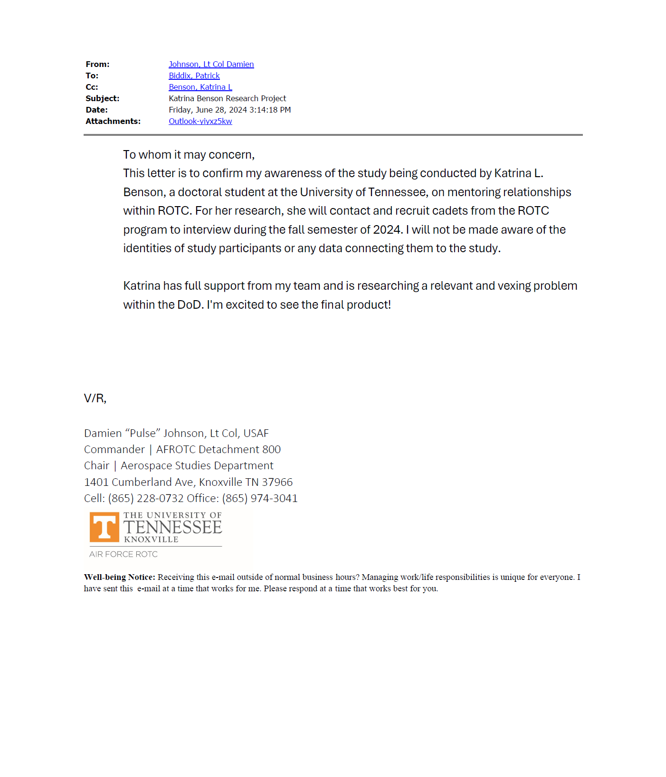

Appendix B: Letter to Cadets
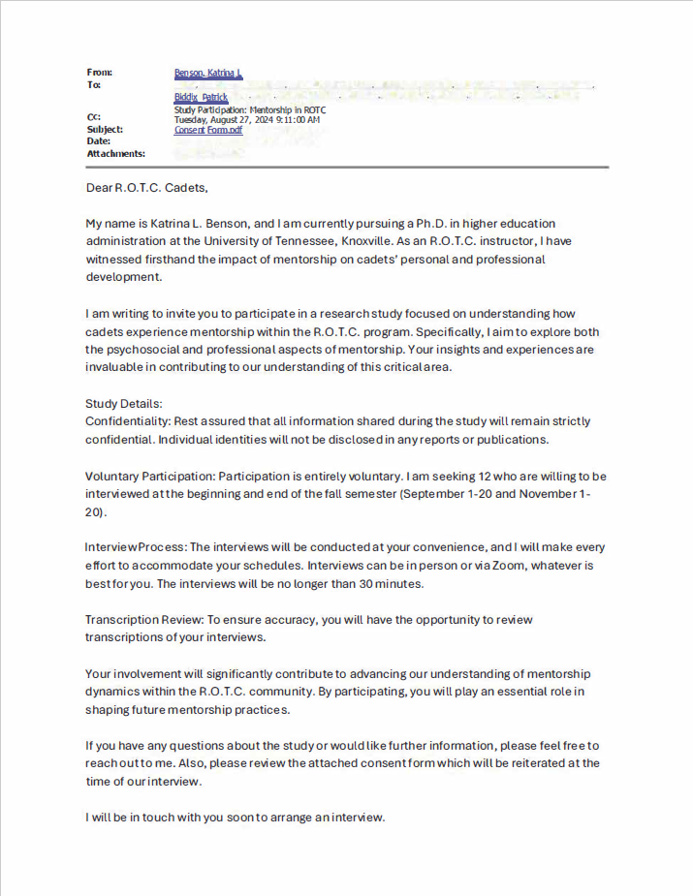

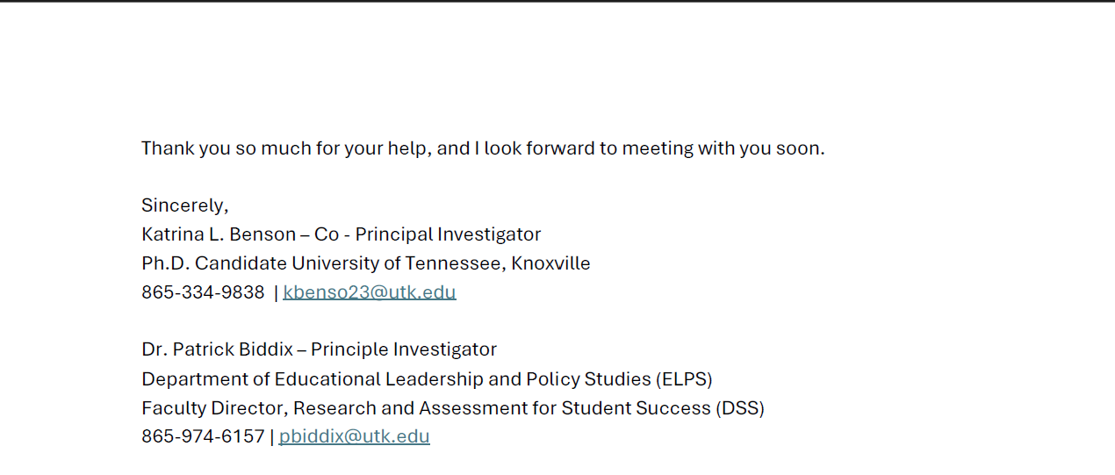

Appendix C: Informed Consent
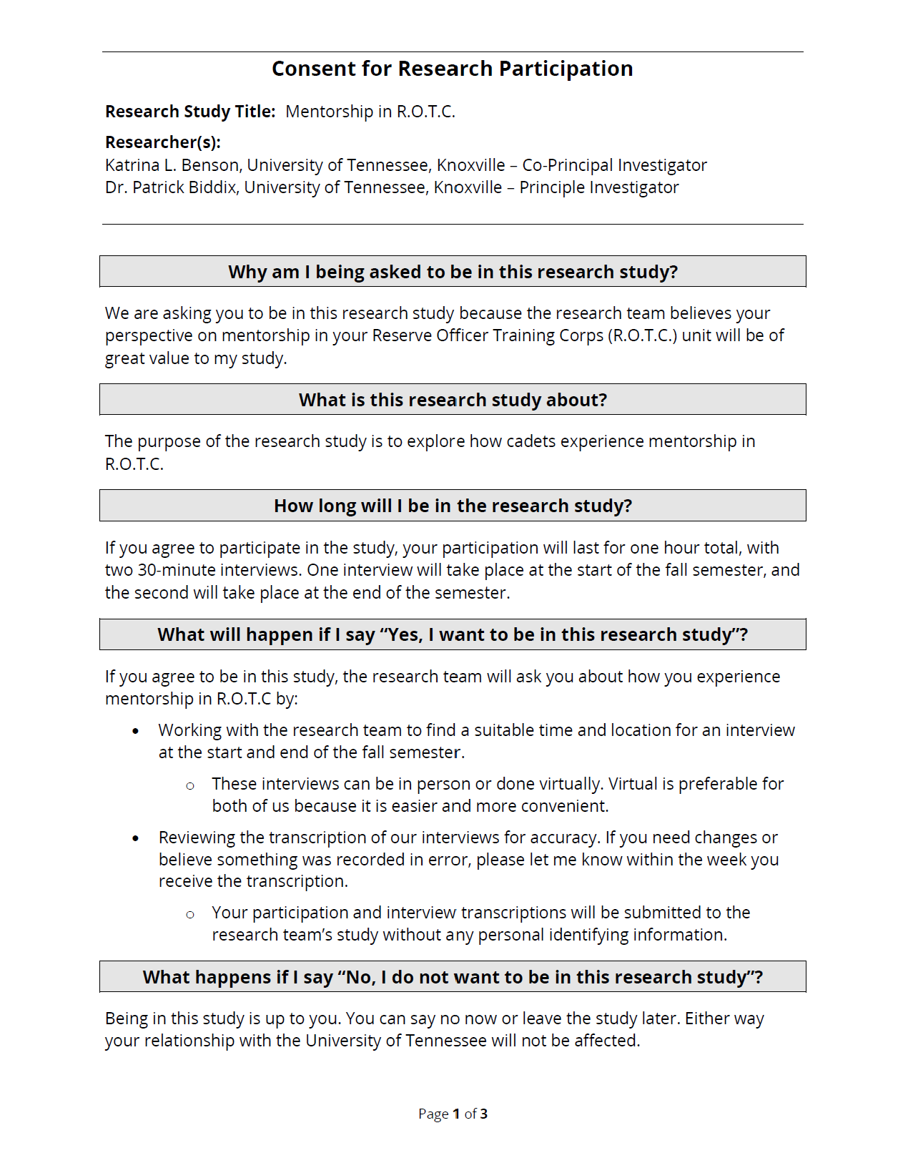
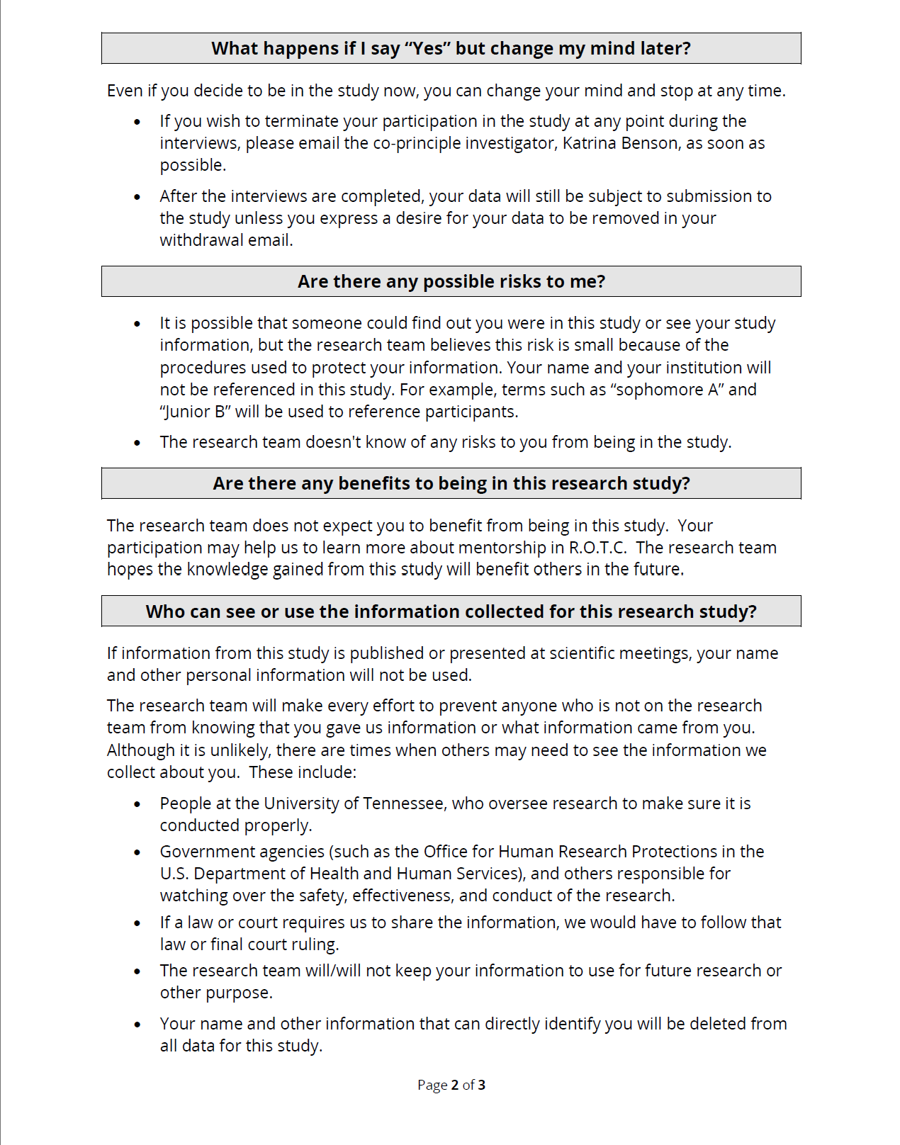

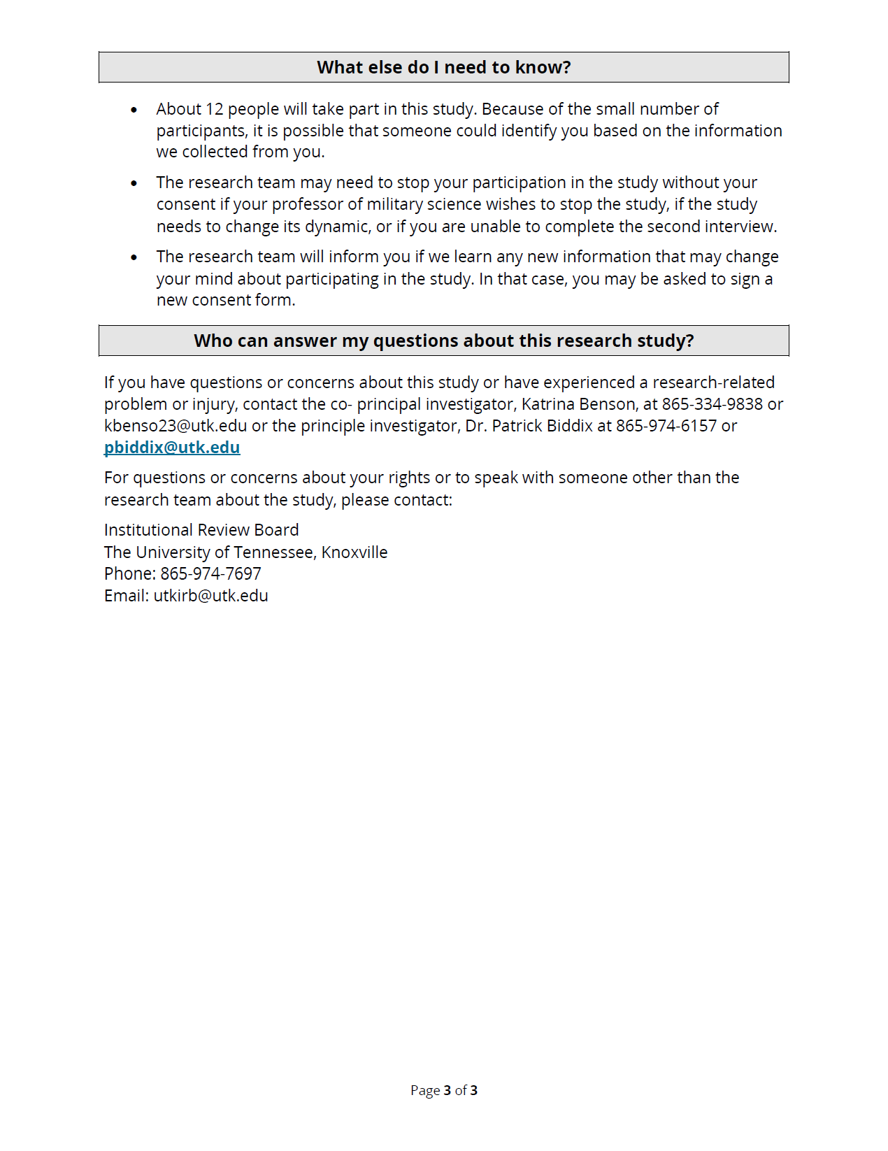

Appendix D Interview 1 Questions
What is your current academic standing at the university (i.e. sophomore, junior, senior)
Are you currently a mentor or mentee in the program or both?
How long have you been participating in the R.O.T.C. program?
How would you describe your performance and standing in the R.O.T.C. program?
Did you get to pick your mentee and/or mentor?
How long have you had a mentorship relationship with your current mentee/mentor?
What do your typical mentorship meetings look like and feel like?
How do you determine the needs of your mentee?
Do you think your relationship is mostly positive or negative?
Why do you think the relationship is positive or negative?
Do you feel you are being effectively mentored?
Do you feel you are an effective mentor?
How do you describe your relationship with your past mentors?
How do you feel about previous mentorship strategies you have experienced or implemented?
How do you feel one is best taught how to mentor?
What attributes do you think make a good mentor?
Why do you think those attributes make a good mentor?
What would you say makes a bad mentor?
What kind of advice would you give your mentee if they were going through a challenging time in their life?
What do you think are the most important aspects of a successful mentorship relationship?
What would you change about the mentorship program in R.O.T.C.?
How would you describe your experience as a mentor in the R.O.T.C. program?

Appendix E Interview 2 Questions
Do you think your performance and standing in the R.O.T.C. program changed over the semester?
Why do you think it changed or did not?
Did anything change about how you mentored or received mentorship this semester? (Tone, environment, Places, Topics)
Did your relationship with your mentor improve or decline over the semester?
Did your relationship with your mentee improve or decline over the semester?
What factors influenced that change?
Did you find yourself changing your approach to mentorship this semester?
What were the changes?
Why did you feel they were appropriate or not?
Considering your experience of being a mentor this semester, what would you improve on?
What kind of advice would you give future mentors?
Considering what you learned this semester, what do you think are the most important aspects of a successful mentorship relationship?
Considering what you learned this semester, what would you change about the mentorship program in R.O.T.C.?
How do you describe your mentorship experiences now?
How big of a role do you think community plays in mentorship?

Appendix F IRB Approval 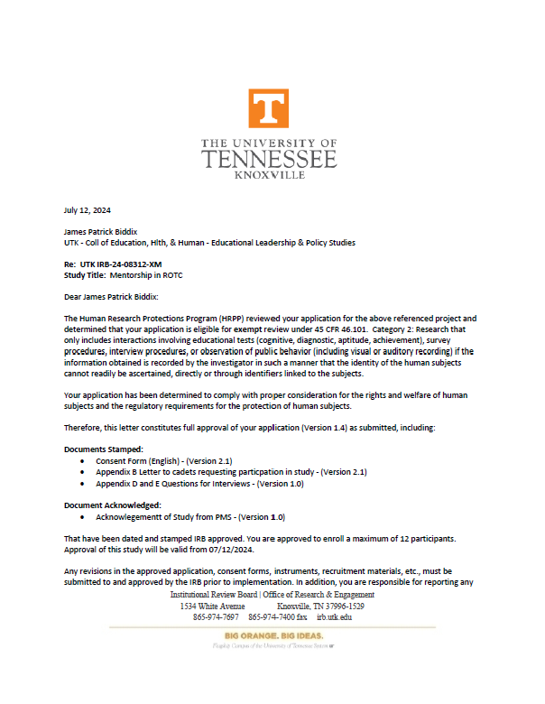
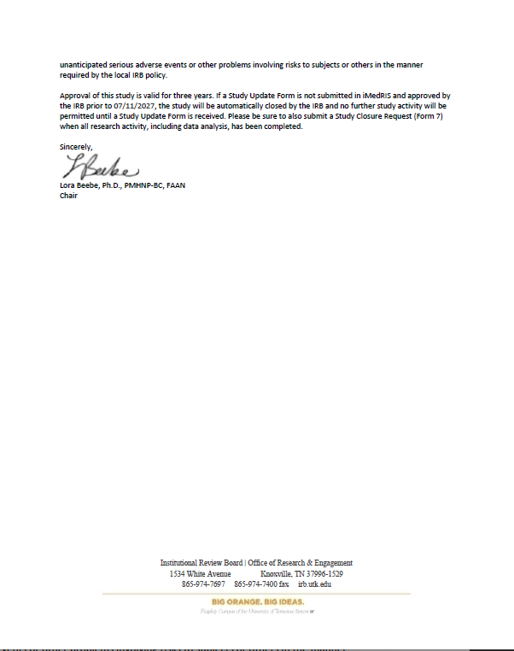

Vita
Katrina Benson, originally from Anchorage, Alaska, earned her Bachelor of Arts in Liberal Studies at Seattle University. Shortly after graduating, she joined the U.S. Army as a military police officer. During her service, she rose to the rank of captain and obtained her Master’s Degree in Business and Organizational Security Management from Webster University in Missouri. Her final duty assignment in the military was teaching Army R.O.T.C. at the University of Tennessee, Knoxville. There, she met her husband, which influenced her decision to leave the Army, settle in Knoxville, and pursue a career in higher education by earning a degree in Higher Education Administration. Katrina's military career lasted 12 years, and she is passionate about lifelong learning, travel, and raising a family.

