Advanced Catalyst Solutions Senior Design Project



Presented by: Sami Hijer, Kalese Howse, Kristen Miranda, Megan Peck, Gerald Thornton

Table of Contents
1. Problem Definition 3
1.1 Program Requirement 3
1.2 Functional Analysis 5
1.3 Technical Performance Measures 7
1.3.1 Definition of Measures 7
1.3.2 Description of how measurement is taken or where data comes from 8
1.3.3 Baseline Measurements of System 8
1.3.4 Matrix 10
1.4 Project Checklist 10
2. Design 11
2.1 Design Requirements 11
2.2 Design Alternatives 12
2.2.1 Feasibility Analysis of Alternatives 12
2.2.2 Comparison of Alternatives 13
2.2.3 Develop Design of Alternative 14
2.3 Final Design 16
3. Implementation 18
3.1 User Manual 18
Safety Requirements 19
Safety Recommendations 20
How to Use the AC Press 21
3.2 Test Plan 22
Experiment Criteria 22
Potential Issues 22
Recommended Countermeasures 22
Data Entry 23
R Code for the Experiment…………………………………………………………………………………………………………….24
3.3 Issues and Details of Implementation 25
4.Evaluation 26
4.1 Final Measurements of System 26
4.2 Cost Benefit Analysis 27
4.3 Evaluation of Implemented Solution 30
5. Recommendations 31
5.1 Future Projects 31
Benefits of Inventory management 31
Overstocking 32
Growth Opportunities 32
6. REFERENCE 34

1. Problem Definition

1.1 Program Requirement
Our senior design project for Fall 2016 and Spring 2017 is with Advanced Catalyst Systems, a catalyst manufacturing company in Maryville, TN. In the manufacturing process, there is a “stacking” process where layers of substrate are stacked into the frame of the convert before being sent to the welding process. This is the primary problem in the system. There is no standard method of stacking the substrate resulting in a lack of quality control. In fact, there was an incident were more than 10 frames were welded without enough substrate layers, thus having to be re-welded. This accounted for a loss of 8 hours of work.
In Fall 2016, our group studied the system and analyzed it using systems engineering tools. In a requirements analysis, we determined the goal of the project was to create a system that meets the following requirements:
• The system shall interface with the workers who stack substrate in the frame
• The system shall provide stackers with the ability to stack the optimal number of substrate layers for each part produced
• The system shall eliminate the need for welders to do a quality check on the part before welding
• The system shall provide a mechanical solution as well as training to go with it to assist the stackers
• The system shall eliminate wasted substrate layers
We did a feasibility analysis of alternatives to come up with the best possible solution. We found three solutions and compared them in a matrix against performance, effectiveness, maintenance and logistic support, and economic criteria. We landed upon a mechanical solution.
The issue was the inconsistency in the amount of substrate that was loaded into the frame, and this led to the initial machine concept. The first design would have allowed for substrate to be stacked to a measured level, and then loaded directly into the frame. This was determined to be infeasible because the substrate could not be cut in a consistent way to load into the machine.
When designing the second mechanical device, we first considered the physics aspects of the design required to accomplish our goal. This device would need to apply a uniform pressure to the lid of the frame after stacking is complete to confirm the correct amount of substrate was used.
This design is entitled the AC press. The AC press allows us to incorporate the existing station, and it allows for a number of benefits which made it the optimal choice.
· It allows for reduced costs that would be associated with removing the current station.
· It also does not require additional material handling as is the case with other alternatives.
· It incorporates components that can be purchased instead of designed and fabricated and any components that did require this were easy to design and build, using advanced catalysts current equipment.
With this design, a torque wrench is used as a mechanical actuator triggering a rack and pinion system to apply pressure to the lid.
This process of developing and choosing machine design has revealed that a machine must meet a set of standards before construction can commence.
1. A design must be financially sound
2. The machine must be able to be constructed with the tools available
3. The design must be simple to operate and construct
4. The machine must be safe and reliable

1.2 Functional Analysis
With the problem statement in mind, we were able to analyze the system and create a list of questions to describe the problems and possible solutions. The questions are as follows:
What is required of the system in “functional” terms?
The system must allow stacking operators to perform with no error to alleviate the quality check welders are currently performing and to save time and material.
What functions must the system perform?
The system must provide a way for stackers to know exactly how many sheet of substrate are required for every size frame. The system must be ergonomic and efficient, with little impact on the stackers’ jobs.
What are the “primary” functions?
To provide the stackers with a way to do their jobs without error
What are the secondary functions?
To be comfortable and intuitive to use
What must be accomplished to alleviate the stated deficiency?
There must be a way to measure the pressure on each frame, because this metric is directly related to how many sheets of substrate are in the frame
When must this be accomplished?
After stacking and before welding
Where is it to be accomplished?
At each stackers station. The stackers will place the empty frame within the AC Press and stack as normal. When they have stacked the substrate, they will use a torque wrench to measure the pressure on the frame. If it slips when it is pulled, they are finished stacking and may send the part to welding.
How many times or at what frequency should this be accomplished?
For each frame that moves through the stacking process.

This functional analysis diagram reviews the program requirement of “The system shall provide stackers with the ability to stack the optimal number of substrate layers for each part produced.”

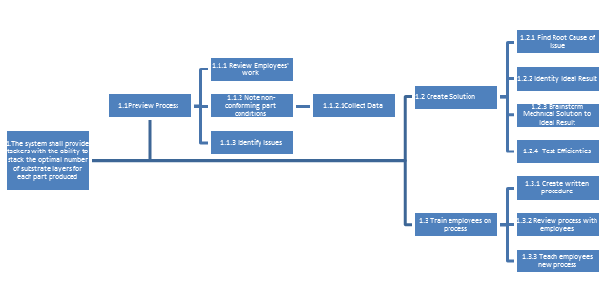

Figure 1: Functional Analysis Diagram

1.3 Technical Performance Measures
At the beginning of the project with Advanced Catalyst, there were no methods of measuring the performance of the system. Advanced Catalyst’s justification was the lack of defective products and reworked goods. Now that the system needs a quality control program, these technical performance measures were re-evaluated and developed.

1.3.1 Definition of Measures
For the purposes of this project, system performance measures will be determined based on the number of quality products are produced, the amount of time saved in cycle time, and adaptability in comparison to the old system.
The operator, after pulling the torque wrench, will simultaneously press their thumb up against the crimp inside to test how snug the stack inside the frame is, when the lid is flush to the two vertical portions of the frame. If the crimp inside bows out and or the press torque slips before the frame lid is flush, then crimp must be removed, and any excess crimp can be reused on the next frame. However, if the operator notices that the crimp inside is not snug, while the are moving their thumb across the stack, or the lid begins to bow inward while force is applied, then there is an inadequate amount of crimp in the frame. This is not qualified as a quality product. If there is not a quality part then it most be reworked.
To measure the amount of time saved in rework, we would compare the times to create the product. The hope is that our solution will eliminate the need to rework the frames prior to the welding process. The adaptability will solely be a subjective measure. This will be determined by the interviewing the employees of ACS. We will ask for each employee’s level of comfort on a scale of one to ten.

1.3.2 Description of how measurement is taken or where data comes from
This data is collected by noting the number of parts that are not quality in a batch. This is any product that required rework. There was also data collected by timing the “stacking” process. This is used to identify the potential time that can be saved with our product.

1.3.3 Baseline Measurements of System
As seen in the data collection sheet below, Advanced Catalyst did not populate the time started or time ended fields. Based on our observations onsite, we are making a very conservative educated estimate of 5 minutes of rework per part that required removal of substrate layers. This translates to a wasted time cost in terms of welder labor of $1.77 per part reworked (based on the average welder salary of $42,500 per year assuming 50 weeks in a year and 40 hours of labor a week). Based on the data collected, 57.6% of the parts studied required rework. The data collected also shows that over a two (2) week period 34 parts needed rework which means that when multiplied by the cost of reworking a part it costs $1504.50 per year of welder’s time without yet including the cost of materials wasted.

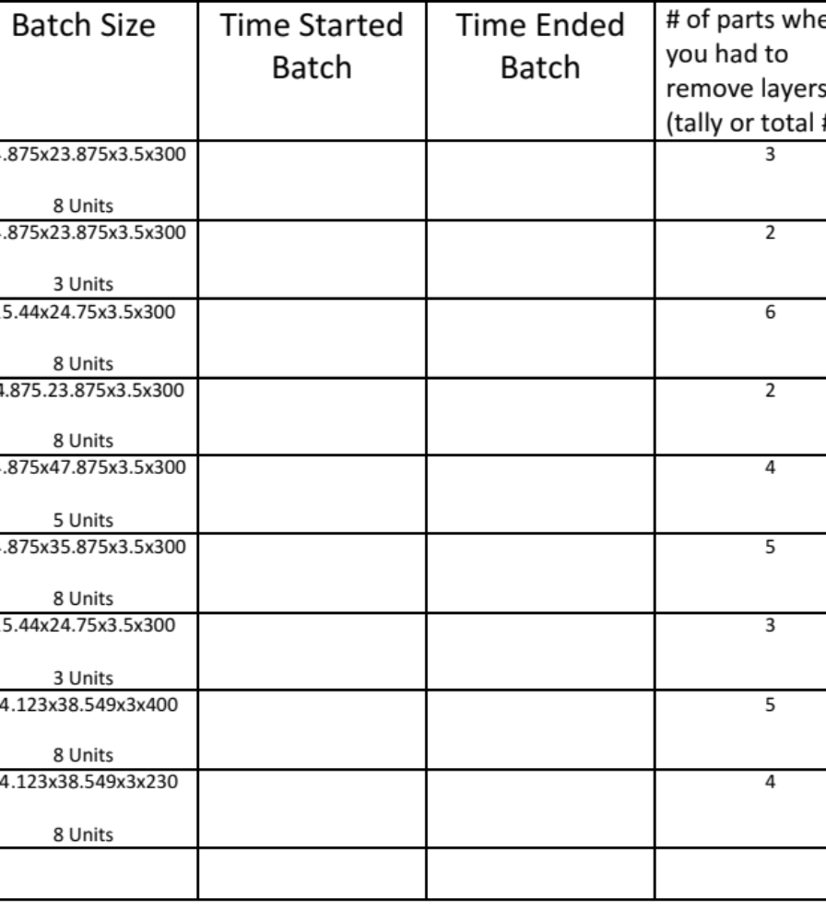
Figure 2: Data collection sheet

1.3.4 Matrix
Performance Measure | Baseline Data (Original Method) | End Result (New Method) | Impact (Negative / Positive)
Number of Defective Parts | 66.67% | 13% | Positive
Adaptability | 60% | 95% | Positive
Cycle Time | 100% | 100% | Neutral
Table 1: TPMs

1.4 Project Checklist
We used a project checklist as our guide when considering constraints, standards, and the engineering tools we wanted to apply. We had a limited budget, so an economic constraint was one we had to plan for. We also wanted to consider sustainability in terms of our device being easy to use for future employees, and manufacturability in terms of the parts coming out of our device being to specification. Our device had to be safe for use, which we addressed by building it to OSHA standards. Our device also met standards of producing high quality product and not impacting process time negatively. We employed the principles of machine design when consulting about and designing the device, used our work standards knowledge to conduct time studies of the process, and designed an experiment to test its effectiveness.
Project Title: Advanced Catalyst
Sponsor: Ben Abbott | Term: Sp 17
 | Planned | Implemented
Constraints
Economic | x | x
Environmental
Sustainability
Manufacturability | x | x
Ethical
Health and Safety | x | x
Social
Political
Other ( )
Standards
OSHA Standard Number 1910.217 | x | x
OSHA Standard Number 1910.212 | x | x
OSHA Standard Number 1926.300
IE/Engineering Tools
Machine Design | x | x
Time Studies | x | x
Design of Experiments | x | x
Figure 3: Performance Checklist

2. Design

2.1 Design Requirements
Our process will require the stackers to stack the substrate in our new frame so that the frames will be verified before they continue through the process to the welding station. The operator will then determine if the frame is stacked appropriately and send the frame to the welding station. The amount of substrate removed from over stacked frames will be saved as it can be reused whereas if it was removed at the welding station it would be scrapped. In this case the customer is Advanced Catalyst Systems. To effectively complete this project, we must synthesize our customer’s needs. The functions of our solution need to match their needs and requirements. The need of ACS was to reduce the amount of waste and rework. As part of the course, we have put together a design team to accomplish this goal composed of five Industrial Engineering undergraduate students. Next, we had to establish the design ideas and adjust the solutions proposed to match all the needs and requirements of our customer. After collecting data on the current process, it is possible to provide our customer with an estimation of how much this solution will cost and how it could potentially help the company. Once the solution has been put into place it is possible to evaluate the effectiveness of the solution and compare it to our predictions. With the data on hand, we see that we needed a solution to increase cycle time and increase the level of quality in “stacking” process.
2.2 Design Alternatives When brainstorming potential solutions to accomplish our project goals and meet the needs of our customer, we came across a few alternatives. With these solutions, we needed to be sure it was the best fit for ACS, so a feasibility analysis was conducted to find the most appropriate system-level design approach. We found three solutions and compared them in a matrix against performance, effectiveness, maintenance and logistic support, and economic criteria.

2.2.1 Feasibility Analysis of Alternatives
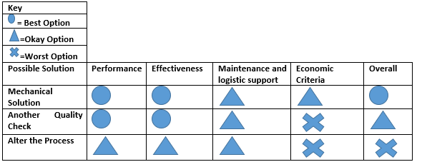
Figure 4: Feasibility Analysis

2.2.2 Comparison of Alternatives
As you can see from the figure above, the best option we came across was the mechanical solution. The solution to add another quality check was a good idea for performance and effectiveness but it could waste time and cost a lot of money in support. Altering the process could be an okay option in performances, effectiveness, and support but the worst option for the life-cycle cost. The mechanical solution provided to be the best because it is the best option in performance and effectiveness. It is the okay option for support and economic criteria depending on the desired direction of the customer. We decided to create a mechanical solution as an additional quality check and to retrain the employees on the process.
The different design alternatives stemmed from the way in which the catalytic converters were assembled. The issue was the inconsistency in the amount of substrate that was loaded into the frame, and this led to the initial machine concept. The first design would have allowed for substrate to be stacked to a measured level, and then loaded directly into the frame. This was determined to be infeasible because the substrate could not be cut in a consistent way to load into the machine.
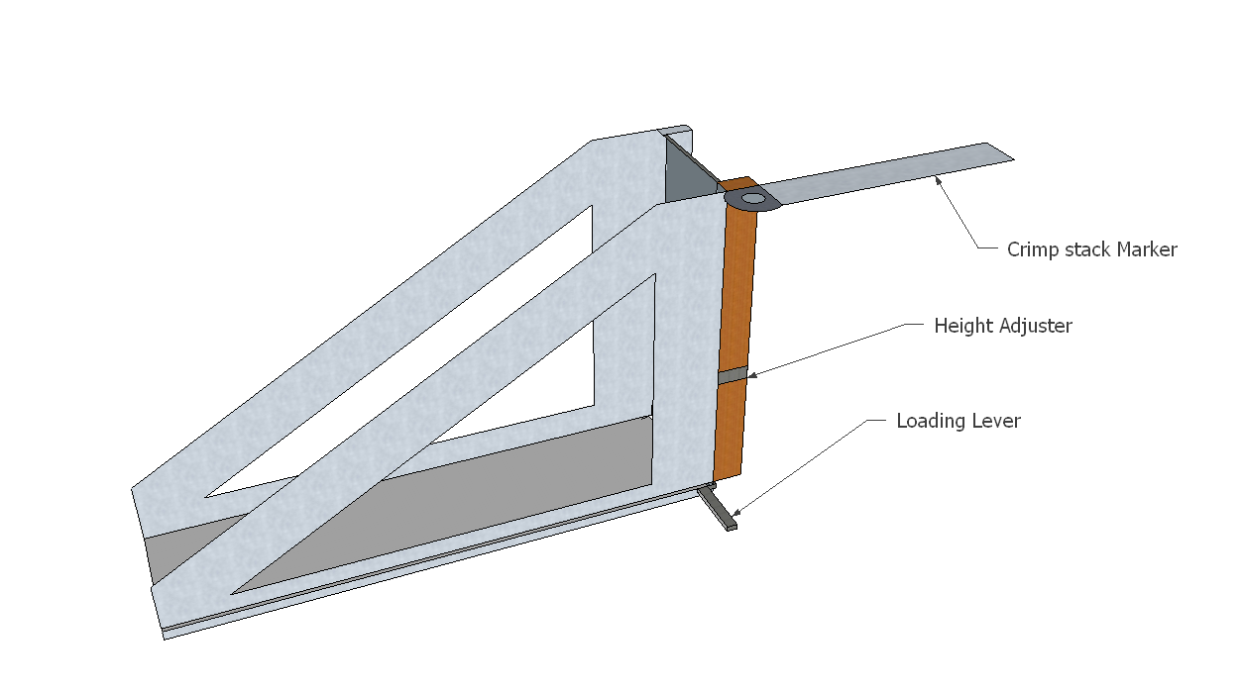
Figure 5: First Design

When designing the second mechanical device, we first considered the physics aspects of the design required to accomplish our goal. This device would need to apply a uniform pressure to the lid of the frame after stacking is complete to confirm the correct amount of substrate was used. Originally, we wished to associate this pressure with the formula below:
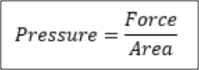
Equation 1
The area value would easily be determined by the dimensions of the size frame being created. The force value would be systematic applied by the device.
2.2.3 Develop Design of Alternative This idea led to the initial design pictured below. This design would utilize air pressure to gauge the quality of the catalytic converter being produced. It would require the use of compressed air to apply pressure. This need for a constant supply of air would then be a perpetual additive cost. Furthermore, it would be extremely costly to build a frame which did not allow for air to seep through the structure. Any attempt to build this would most likely be unreliable and or extremely difficult to maintain. It also did not allow us to utilize the existing station which would require us to incur costs of disassembly.
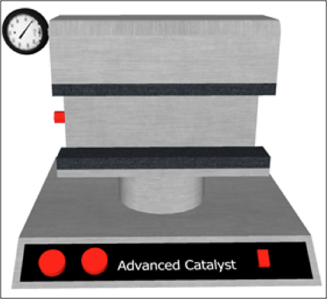
Figure 6: Second Design
Our next design was created with the same principles, but needed to be simpler in nature. This was important increase feasibility, minimize cost, and to be a re-creatable device. This design is entitled the AC press as illustrated below. The AC press allows us to incorporate the existing station, and it allows for several benefits which made it the optimal choice.
· It allows for reduced costs that would be associated with removing the current station.
· It also does not require additional material handling as is the case with other alternatives.
· It incorporates components that can be purchased instead of designed and fabricated and any components that did require this were easy to design and build, using advanced catalysts current equipment.
With this design, a torque wrench is used as a mechanical actuator triggering a rack and pinion system to apply pressure to the lid.
This process of developing and choosing machine design has revealed that a machine must meet a set of standards before construction can commence.
- A design must be financially sound
- The machine must be able to be constructed with the tools available
- The design must be simple to operate and construct
- The machine must be safe and reliable

2.3 Final Design
The final design accomplishes the goal of allowing for consistent quality checks, while meeting the above criteria. It utilizes the existing station and recycled material for the metallic frame and height adjustors. A torque wrench is then pulled on a fully loaded frame with the lid on top of the frame. The wrench is connected to a rod with, welded pinions, which force the racks to apply downward force onto the press. The wrench then slips when the lid is flush, which indicates that the frame is adequately loaded.
Actual construction forced reliance on wood material for the positioning plate and height adjustment. Construction began with the actual frame, which was cut from scrap metal, using a CNC water saw, and the pieces were welded together. The rack, pinions, torque wrench, and rod, were ordered, and the wooden components where all recycled. The internal components, including the positioning plate racks and pinions with rod, where attached to the frame and metal components were welded together. The wrench was then welded to the rod and the press was attached to the racks. The press was then attached to the current station, without the need for height adjustment.
In the future, improvements to the rack and pinion system should be adjusted to allow for a greater range of motion.

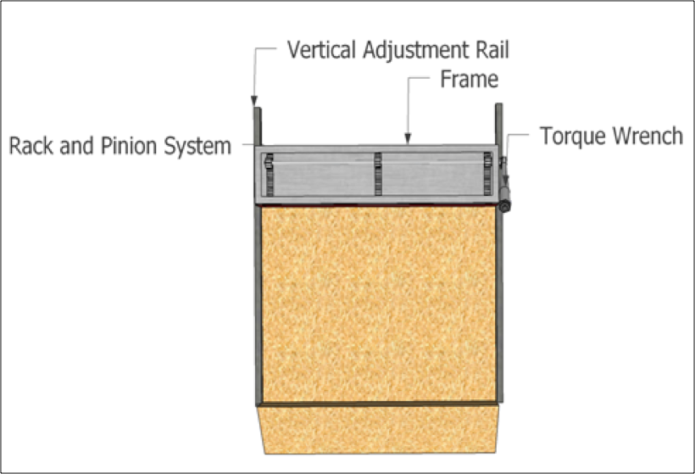
Figure 7: Final Design

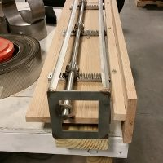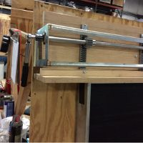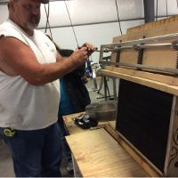
Figure 8: Final Design in Use

Next, our group worked to create an implementation plan in the Spring 2017 semester.

3. Implementation
The implementation of the AC Press began once construction was completed. One of our team members met with all the stackers who would be using the device and explained how to use it properly and safely. We also produced a user manual with important safety precautions as well as instructions for assembly and use so new operators can quickly gain an understanding of the device and process. Next is the safety and instructions for use sections of the user manual:

3.1 User Manual
Important Precautions
WARNING: To reduce the risk of injury, read the following precautions before using the AC Press.
- It is the responsibility of the Advanced Catalyst to ensure that every user of the AC Press is properly trained on all safety measures and requirements.
- Read all instructions in this manual before operating the AC Press.
- When operating the AC Press, refrain from touching any part of the device other than the torque wrench and the stabilization handle.
- When adjusting the elevation of the AC Press, refrain from touching any part of the frame or internal component other than the stabilization handle.
- Perform routine and proactive maintenance on the AC Press and replace any worn out or damaged parts immediately.
- If you feel uncomfortable at any time while using the AC Press, stop immediately and refer to the manual or a train operator.
- The AC Press is to be used on only pre-determined frames.

Safety Requirements
Currently, the only standards to set forth by the customer are the OSHA, or the Occupational Safety and Health Administration, standards for safety. To determine which of the OSHA guidelines applied to the AC Press research was conducted on regulations for a devices similar to those being considered, namely manually powered presses. OSHA has a number of standards that could apply to such a device, including regulations concerning machine guards.
Mechanical Power Presses – Standard Number 1910.217 and 1910.212
Danger from broken or falling machinery should be minimized to maximize operator safety. Safety hazards from mechanical energy release (i.e. – broken springs) should also be minimized by the addition of covers/guards. Friction brakes, where required, should be sufficient to stop the machine motion at any point. Hand-lever-operated power presses shall be equipped with a spring latch on the operating lever to prevent premature or accidental tripping. Two handed lever-operated presses can also be utilized to minimize danger to operators. Control system should incorporate an anti-repeat feature.
Machinery Guarding – Standard Number 1910.217 App A
General requirements for machine guards. Guards shall be affixed to the machine where possible and secured elsewhere if for any reason attachment to the machine is not possible. The guard shall be such that it does not offer an accident hazard in itself. The point of operation of machines whose operation exposes an employee to injury, shall be guarded. The guarding device shall be in conformity with any appropriate standards therefor, or, in the absence of applicable specific standards, shall be so designed and constructed as to prevent the operator from having any part of his body in the danger zone during the operating cycle.
Tools – Standard Number 1926.300
Belts, gears, shafts, pulleys, sprockets, spindles, drums, fly wheels, chains, or other reciprocating, rotating or moving parts of equipment shall be guarded if such parts are exposed to contact by employees or otherwise create a hazard.

Safety Recommendations
- Pinch points - Potential pinch points must be labeled on the AC Press before put into use in assembly process.
- Safety glasses - Safety glasses must be worn when operating AC Press.
- Operating AC Press - The AC Press must be operated with the use of two hands at all times. This is a precaution to prevent hand injuries while operating the AC Press.
- Guarding - The AC Press should be guarded according to OSHA Standard Number 1910.217.

How to Use the AC Press
- Load frame into the press by adjusting the vertical rail so the frame sits directly beneath the press
- Load the frame with stacked pieces of substrate
- When there seems to be enough substrate stacked in the frame, pull down the torque wrench
- If the torque wrench slips, the top of the frame is flush with the bottom of the press, and the substrate in the frame is not loose to the touch, the amount of stacked substrate is within specifications.
- Release the torque wrench to the starting position and remove the frame from the press
It is not a complex device for the end user, as it only involves setting the catalytic converter frame underneath the press and pulling the torque wrench in a downward motion once the substrate layers have been stacked to ensure the top of the frame is flush with the press. This lets the operator know that the frame has not be over or under stacked, without having to take any measurements and without adding more than 5 seconds to the process (which typically takes over half an hour). After the brief training session, the implementation of the device went smoothly. It is currently in use and has been for 3 weeks. The stacking operators as well as the management at Advanced Catalyst are very pleased so far with its results, as overstacking the frames has been proven to negatively impact the converter coating process, which involved highly expensive precious metals. However, we do have a more objective test plan in place to evaluate the device’s effectiveness, which will be covered in the next section.

3.2 Test Plan

Experiment Criteria
The experiment to be run will compare the new system to the original system. Operators will use both methods, and data will be gathered on total process time, number of defects, and an ordinal measure from a scale of 1-7 of the amount of effort the processes require (Likert Scale). Wasted material will not be considered as the updated system requires that no material be thrown away. This experiment fits the criteria of a Paired-samples t-test, and the criteria is summarized, as follows.
- Subjects – the operators of the system

- Factors – the only factor is the system

- Levels – there are two levels of the factors, the updated and original system

- This is a within subjects test because each subject will use each system
*Note* utilizing within subjects test eliminate noise and natural variation

Potential Issues
There is the potential for confounding variables within the experiment. Operators have prior knowledge of the existing system and, since this is a relatively long process, boredom and fatigue may occur.

Recommended Countermeasures
Because there are only two levels, a full counterbalance scheme will be applied in the form of Figure 9.
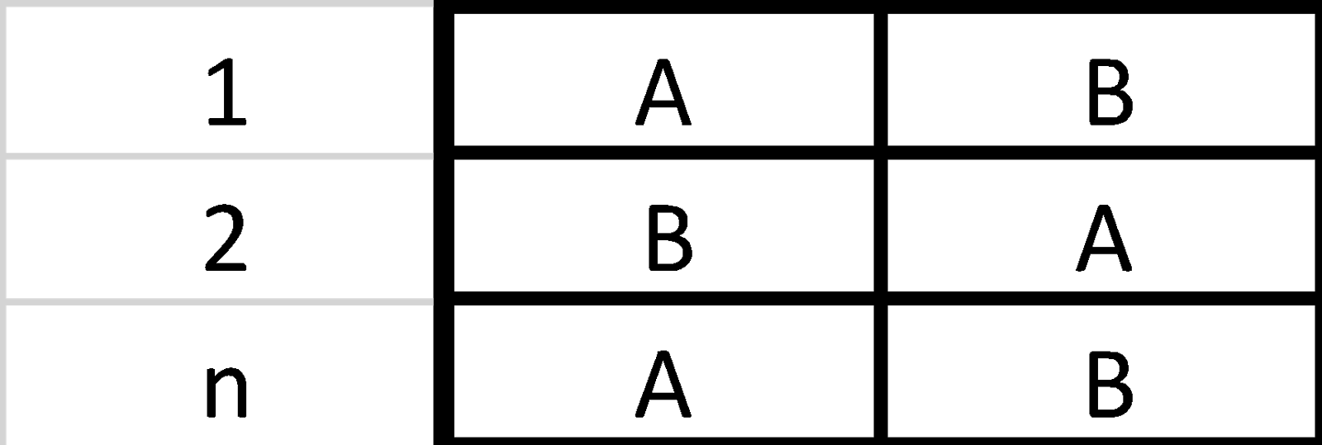
Figure 9: Experiement Levels
The height of the columns depends on the number of subject (n) and the length of the columns is determined by the number of levels. A variable (Order) will also be listed to depict which order the Factor levels were tested in.

Data Entry
An example of the data collection sheet is as shown, in Figure 10. (Note) The excel document should be named “ACPress.csv”

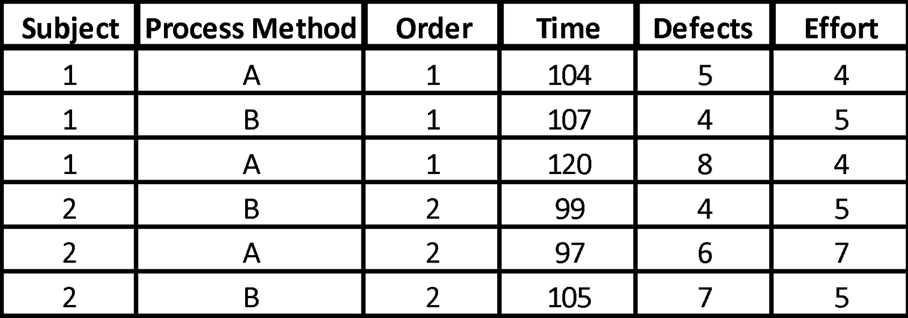
Figure 10: Data Collection

R Code for the Experiment

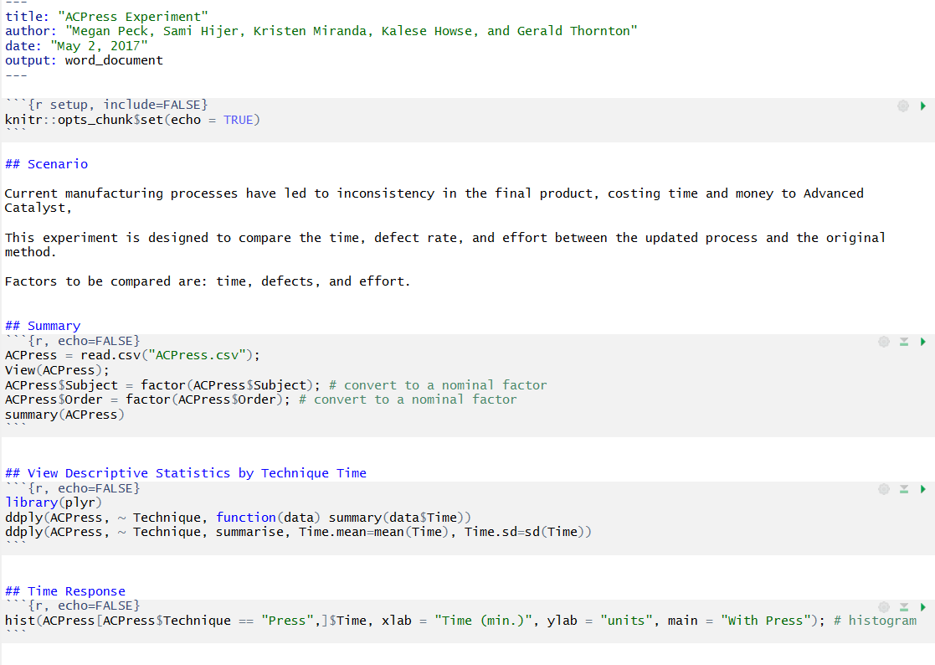
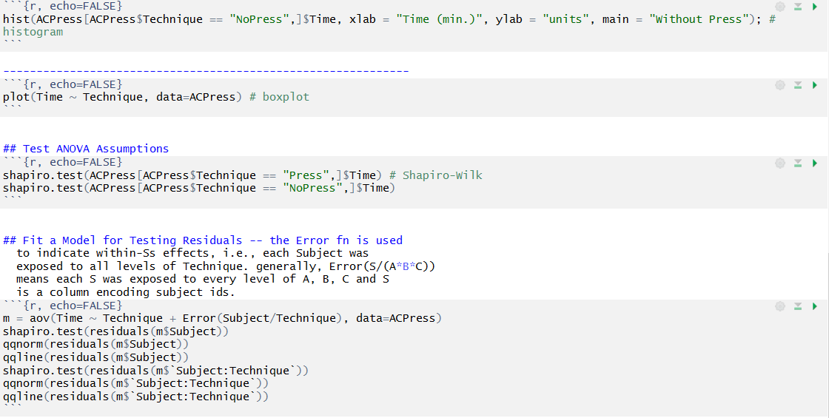
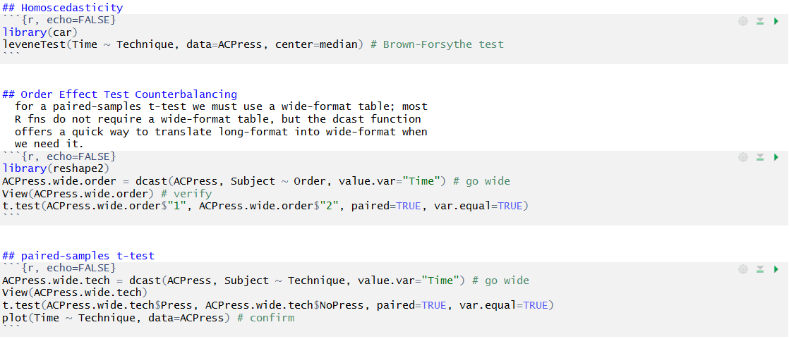

3.3 Issues and Details of Implementation Implementing the AC Press prototype required coordination and collaboration with management and operators at Advanced Catalyst Solutions. Between our efforts and those of ACS we could develop a working prototype of our AC Press device. In the implementation phase of this process, there were minor issues that developed; however, we could overcome these issues. Our team was also able to ensure continuity and sustainment of this device through the involvement of stakeholders in the construction and implementation process.
There were several minor issues that arose while implementing the AC Press. One of which was the placement of our bolted screws. The original placement of the screws did not allow for the needed movement of the press. Therefore, we adjusted the size of the pilot hole to allow for press movement. Another mechanical adjustment that had to be implemented for stabilization of the press on the stacking frame. An additional piece of wood was added to stabilize the press between the edge of the stacking frame and the press. Originally without this piece of wood the AC press would move and not disperse pressure consistently. Although pressure is currently not applied in the center of the tested frames, it is consistent. Representatives of Advanced Catalyst are interested in resolving this issue with some of their own ideas in the future.
Overall, the implementation process was a smooth process with very few errors. Our sponsor was very pleased with the outcome and looks forward to making improvements as needed. The success of this prototype may be attributed to the communication and involvement with our company stakeholders. This involvement allowed for a strong understanding of system requirements as well as a strong interest and desire to see it succeed.

4.Evaluation
4.1 Final Measurements of System While we did take time studies to determine the average process time of stacking the metal substrate (shown below), our solution did not add or subtract any time from the stacking process. The only change to the stacking process is loading the frame into the device instead of onto a plain wooden backboard, and pulling a lever when stacking is finished to assure the frame is flush with the bottom of the press and the substrate is not loose when touched.
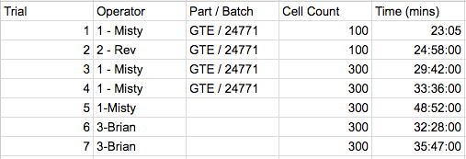
Figure 11: Time Studies
Rather, the way the success of our solution is measured in materials savings and rework costs. The device has only been implemented for 3 weeks, but feedback from our sponsor has indicated substantial potential savings as a result. Recently, it was discovered that overstacking the frame caused issues during the coating process. The overpacked frames meant that the coating material did not dry properly within the cells. This is the most expensive step in production, as it involves coating the frame with precious metals like palladium, platinum, or rhodium. Each of these particular frames are sold to the final customer for $1,400 and 4 out of the batch of 30 had to be completely scrapped. Our device will prevent this from happening again.
In the short term, we will be saving rework time for the welding operators (approximately 5 minutes per out of spec part, which translates roughly to $1.44/part assuming the average welding wage of $17.35/hour). These parts also accrue a value of $175 in materials and labor by the time they reach the welding process, so if they are not found to be out of spec until after the welds are completed, they must be scrapped, which amounts to $175 plus the welders time (approximately 20 min/part or $4.62). So, every part that our device prevents from coming to welding out of spec will save $179.62. This is significant, as at least one part a day is observed by the welders to be over or understacked. Assuming ACS has 260 working days per year, this translates to a savings of $46,701.20/year in welding material and time costs alone.
Advanced Catalyst was not able to give us any sales or historical defect rate data, so the next statement is an assumption based on what we do know from previous defective batches. If 100 batches of 30 parts/batch are produced each year, and on average 4 are defective per batch with an average market cost of $1400 each, with the implementation of our device, we can save Advanced Catalyst $560,000/year in rework costs for parts that are found to be defective after the coating stage.
4.2 Cost Benefit Analysis A detailed analysis of the cost to construct the AC Press may be found in Figure 1 below. The final cost to construct the AC Press was $371.17. This cost encompasses the amount to procure materials as well as the labor of ACS employees used to construct the press. Most components procured were off-the-shelf commercial products which can be easily replaced at a relatively low cost. We constructed this press in such a manner to ease the maintainability of the machine for better sustainment. We estimate the cost of maintaining the machine to be less than $50.00 per year on average. We expect commercial components to last between 3-5 years based on reviews.
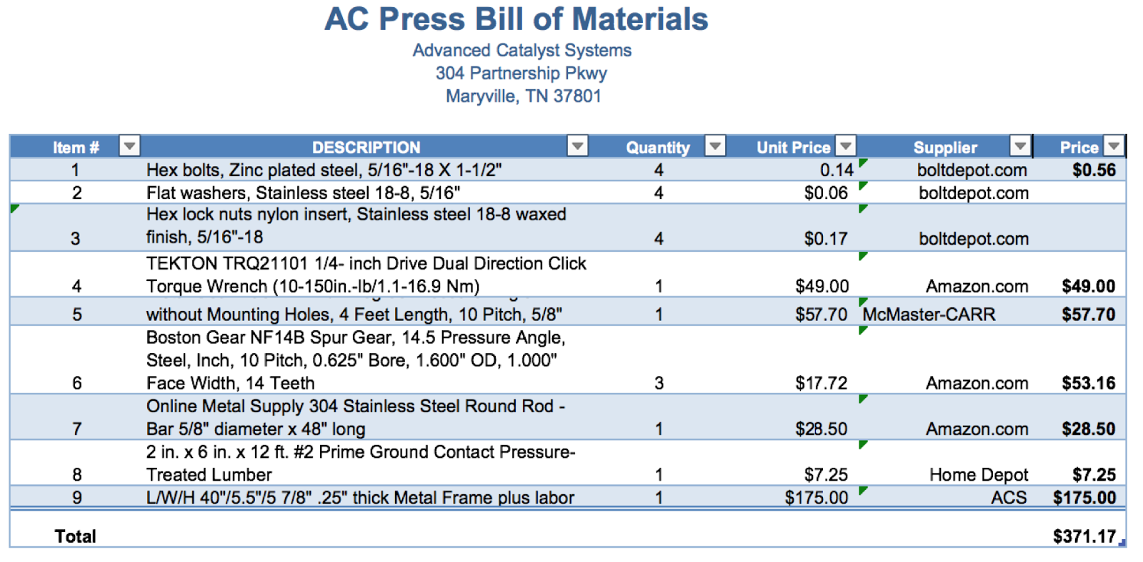
Figure 12: BOM

The benefits of the of the AC Press far outweigh the cost of the AC Press. Short term value derived from the press are a decrease in wasted welder time walking back and forth to assembly if there is too much or too little substrate in a frame. This time savings may be relatively small, but also in the short term it will immediately help with process standardization. By having a formal method of ensuring that products are made consistently, we are enhancing the quality of products and easing some of the stress placed on the operator. The long term is where significant monetary impact is made. This project was devised to mitigate the significant quality incidents that have occurred on multiple occasions due to the fact too much or too little substrate present in a given frame. An example of this occurred recently where 4 out of 30 parts were rejected. The sales price to customers was $1,404.91 per part, so for four parts that would be equivalent to losing $5,619.64 in total opportunity cost.
The units were differing in weights as much as .5 kg, which indicated a quality issue is rooted in the fact that they coated catalyst units with too much catalyst substrate (crimp and flat) material in them. This over-packing caused serious issues with the coating material drying properly within the cells. Once ACS’s catalysts are coated in catalyst material, whether it be platinum, palladium or rhodium, the cost per unit can go from low hundreds to thousands. These particular parts made it through our entire process and were coated with precious metal. The faulty parts were caught in the final inspection before shipment. Consequently, not only did the faulty parts cost ACS the time and labor to get there, but also the cost of the precious metals. Ultimately the parts were rejected and they are now scrap. The long term benefits include avoiding quality breakdowns throughout the whole process resulting in several thousands of dollars, potential late shipments, and potential angry or unsatisfied customers. Overall, the value of the benefit of the AC Press far outweighs the cost.
In a present value analysis of the costs and benefits, we evaluated the costs incurred as compared to the benefits received by implementing the AC Press in terms of today’s dollars.
$$P=A[\frac{{\left(1+i\right)}^{n}-1}{i{\left(1+i\right)}^{n}}]$$
Equation 2
i = Interest rate per interest period*.
n = Number of interest periods.
A = An end-of-period cash receipt or disbursement in a uniform series continuing for n periods
We also used the present value of the costs and benefits to analyze the device’s value in today’s dollars. For the present value of cost calculation, we used an interest rate of 5%, a time horizon of 10 years, and an annual cost of $50, plus the initial investment of $371.17. This calculation resulted in a total cost of $757.26 over a ten-year period. In a present value analysis of the frame benefits, we used an interest rate of 5%, a time horizon of 10 years, and an annual benefit of $22,400 (estimated 4 major quality events per year). This comes to a present value of $172,966.86. The mechanism will thus pay for itself if there is just one less quality event per year. From this analysis, we see that the benefits will far outweigh the cost of the AC Press.
4.3 Evaluation of Implemented Solution To evaluate the effectiveness of this solution, our group conducted a simple oral survey with our main stakeholder, ACS. Although this is a project for a class, one of the most important factors is the opinion or level of satisfaction of the ACS. We asked the facility’s engineers and stackers the following questions:
1. What do you think about the AC Press?
2. What would you change about the design?
3. On a scale from 1 to 10, how would you rate the adaptability of the current method? (10 is the highest)
4. On a scale from 1 to 10, how would you rate the adaptability of this solution? (10 is the highest)
5. Do you think this will be helpful in the future? Why?
From the survey’s answers, the consensus was clear. (Question 1) ACS was very impressed with the AC Press. (Question 2) After a couple of trials with the AC Press, there was an opportunity for improvement suggested by one of the stackers. There was the idea to lengthen the three slots in the press to allow for more compression by the device. (Question 3) On average, everyone felt the effectiveness of the current method was a 6. There was not consistency as to what was enough substrate. (Question 4) On average, everyone felt that the effectiveness of the press was an 9.5. The only issue with the press is it was not understandable to first glance. The device told a bit of training to understand and use properly. (Question 5) Everyone saw this as a helpful device. They commented that is a great “rough draft” to permanent solution. Because we supplied them with an instruction manual and construction guide, they had all the tools to create a repeatable solution.

5. Recommendations

5.1 Future Projects
Through our project with Advanced Catalyst Systems we were able to learn a lot of valuable information about their processes. This has led us to see more areas of potential growth that Advanced Catalyst can focus on in the future to reap further benefits. At the moment Advanced Catalyst is running their operation profitably and is not necessarily in need of major overhaul and thus we have suggested a few projects that will benefit the company over a longer period of time. The projects we think that Advanced Catalyst Systems should potentially invest in the future are improving their inventory management, adopting new innovative inventory control methods, and adding existing methods of visual management.

Benefits of Inventory management
When considering improving the way Advanced Catalyst Systems handles their inventory it is important to understand the benefits and uses of inventory management in general. By improving ACS’ inventory management we can prevent stockouts. This will improve customer satisfaction, which is an extremely important component for a company who has a business structure similar to Advanced Catalyst. Advanced Catalyst’s business culture is such that a majority of their customers are purchasing on a regular basis. It is important for a company in this situation to reduce the amount of missed sales, improve on-time delivery, level their flow to avoid stockouts. Stockouts cost a company money from missed sales, they can also damage the goodwill a company has earned with particular customers as people decide to take their business somewhere that can satisfy their needs in a timely manner. An efficient inventory control system should also track how much product a company has in stock and forecast how long their supplies will last based on sales activity. This allows a company to be more accurate with their ordering behaviour to avoid stock outs.

Overstocking
Overstocking is another issue that improved inventory management can help to prevent. The longer an item sits in inventory it lowers its value and the chance that it will be sold at all. Advanced Catalyst has products that are very expensive once they are finished so sitting on inventory would not be ideal for them at all.

Growth Opportunities
Advanced Catalyst could potentially benefit from adopting RF technology (using smart phones) as the company grows larger. The size of the company at which this becomes a reasonable growth opportunity is much lower because of the reduced cost of implementing RF scans with the increases of mobile technology. Prior to the usage of smartphones for RF abilities, companies would be required to purchase extremely expensive proprietary hardware and would have long lead times while waiting for the devices to be modified each time the company needed more capabilities from the machine. Now, these modifications are able to be added over wi-fi.
Redesigning the flow of the workspaces at Advanced Catalyst is another growth opportunity they can take advantage of for moderate but longer term gains. This can increase efficiencies and shorten the time it takes to move parts in and out of the facility. At the moment there are some pieces that are in-transit as they are expanding the number of machines and will eventually place them in more optimal locations so this is an opportunity they will be able to implement once they have reached the next plateau in their expansion. The last growth opportunity that Advanced Catalyst could utilize is using more visual management in their processes. There are a lot of department that do not have operator aides of signage to designate which cell sizes go in which spots. This is helpful in a sense as they can repurpose locations when they need to, however it is not the most optimal for finding items and adds wasted time in the process.

6. REFERENCE

Blanchard, Benjamin S., and W. J. Fabrycky. Systems Engineering and Analysis. 5th ed. Englewood Cliffs, NJ: Prentice-Hall, 1981. Print.

Newnan, Donald G., Ted G. Eschenbach, Jerome P. Lavelle, and Ed Wheeler. Engineering economic analysis. 9th ed. New York, NY: Oxford U Press, 2004. Print.

