Towards Focused Electron Beam Induced Processing as a Versatile Nanofabrication Tool

A Thesis Presented for the

Doctorate of Philosophy

Degree

The University of Tennessee, Knoxville

Brett B. Lewis

June 2017

Copyright © 2017 by Brett B. Lewis
All rights reserved.

DEDICATION

Great are the works of the LORD, pondered by all who delight in them.
Psalm 111:2

ACKNOWLEDGEMENTS

Thank you all for your help. However, this page is optional.

ABSTRACT

This is a sample Word document that can be used as a template in formatting your thesis/dissertation. It cannot exceed 350 words.

If you use any special characters (including superscripts and subscripts) in your abstract, you must write out the term in plain English in square brackets immediately following the first use of the character. For example: H2O [water] and µ [micron]. This has nothing to do with how common the term is in your field of study-- our catalogers have to enter the abstract in our records using a plain text format that cannot accommodate the special characters, but has no problem with word substitutes.

PREFACE

This page is optional.

TABLE OF CONTENTS

INTRODUCTION 1
Motivation 7
CHAPTER I: Low Temperature Purification 8
Abstract 9
Introduction and Literature Review 9
Results and Discussion 11
Purification Rates 11
Top Down Reaction Process 13
Beam Parameter Studies 14
Enhanced Resolution 17
Microstructure 20
Modeling 22
Experimental 27
Conclusion 28
CHAPTER II Direct-Write 3D Architectures 30
Introduction and Literature Review 31
CHAPTER III In Situ Purification 34
Abstract 35
Introduction 35
Experimental 37
Electron Beam Induced Deposition 37
Laser Delivery System 38
Gas Injection System 38
STEM Imaging and EELS Analysis 38
Electrical Device Fabrication and Measurements 39
Results and Discussion 40
Growth Rates 40
STEM Imaging and EELS 43
Electrical Measurements 46
Thermal Simulations 49
Conclusion 52
Appendix 52
Fidelity 52
Bridge Patterning 53
Temperature Simulations 54
HAADF STEM Images 57
Elemental Mapping 57
CHAPTER IV Nanomechanical Characterization 58
CONCLUSION 59
Heading 2 59
VITA 60

LIST OF TABLES

Table 1: The relevant derived variables used in the simulation to obtain the correct experimentally determined purification rates. 28
Table 2: Simulation Parameters 57

LIST OF FIGURES

Figure 1: Schematic illustrating the basic steps in FEBID: Molecules adsorb, desorb, and diffuse at the surface and are dissociated under electron impact. The nonvolatile dissociation products form the deposit growing coaxially into the beam. Volatile fragments are then pumped away. 2
Figure 2: HRTEM images of a platinum nanodeposit by FEBID, grown at 30kV beam energy on top of a TEM copper grid covered with a thin supporting holey carbon membrane. One Pt grain has been selected for magnification and clear observation of the corresponding atomic planes. The Fast-Fourier-Transform of the full image gives diffraction spots that correspond to the (200), (111), (222), and (202) atomic planes of FCC platinum. Reprinted with permission from ref. ⁵ 4
Figure 3: Cross-sectional TEM images and corresponding SAD patterns of platinum EBID deposits grown from Pt(PF3)4 showing the morphological changes under postgrowth electron irradiation of varying lengths. a) shows the as deposited structure, b) after 2 minutes of irradiation, and c) after 10 minutes of irradiation. A 20 keV, 7.2 nA electron beam was used for irradiation in a high vacuum environment. 5
Figure 4: Illustration of surface interaction. Reprinted with permission from ref. {Scheuer, 1986 #765} 7
Figure 5: In situ EDS spectra of deposits purified using an electron beam with an energy of 5 keV, a current of 1.6 nA, a dwell time of 100 ns, and a pixel spacing of roughly 0.65 nm plotted for different purification times for the (a) 25 and (b) 78ºC O₂ flow studies. (c) shows the normalized integrated Pt/C ratios as a function of purification time (top axis) and estimated received dose (bottom axis). (d) Shows the final EDS spectra after 20 minutes of purification. 14
Figure 6: a) Cross-section SEM images of 400 nm thick Pt-C deposits that were purified for 1, 2, 4, 6, 8, and 12 minutes (reading from right to left) demonstrating the linear, top-down nature of the purification process. b) is a plot of the purified layer thickness on the top of the pad against the total purification time. 16
Figure 7: Normalized carbon peak area plotted as a function of a) curing time for the indicated pixel resolutions (note higher pixel resolution resulted in longer frame time) and b) dose for indicated beam currents. The inset depicts the same normalized carbon peak area as a function of time. The 1024 x 884 pixel resolution corresponds to ~0.65 nm point pitch while the 512 x 442 resolution corresponds to a point pitch of ~1.2 nm. 17
Figure 8: a) Normalized carbon peak area plotted as a function of dose for the beam energies shown. b) Monte Carlo simulation data depicting the electron energy loss over a 100 nm PtC₅ film on top of 100 nm SiO₂ as a function of z height (thickness) at different beam energies. The gray vertical lines represent the Si-SiO₂ and SiO₂-PtC₅ interfaces. c) Comparison of the empirical purification rate to the simulated surface electron energy loss as normalized to the values at 5 keV. 19
Figure 9: a) Images of line deposits with different initial thicknesses (lines 1-4) purified at 1 minute intervals for 6 minutes (inset on image). b) Estimated line width as a function of purification time for lines. c) EDS measurements of the purified and as-deposited part of the line pattern. 21
Figure 10: a) EDS measurements of the samples deposited and purified on the TEM membranes. TEM images of an b) as-deposited, and samples purified for c) 6 minutes and d) 12 minutes. The images reveal an increase in Pt grain size that occurs with increasing purification time. 23
Figure 11: Selected area electron diffraction (SAED) patterns for O₂ E-beam uncured (left) and cured (right) deposit. Diffraction peaks become more pronounced after curing. 24
Figure 12: Bar graph comparing the simulated and experimental purification rates for varying beam parameters. 29
Figure 13: Examples of 3D shapes constructed in the past. Reading from top left to bottom right: Arch,⁴⁰ gap,³⁸ pillar,¹⁶ suspended wire,³⁹ and chiral helices.⁴¹ 33
Figure 14: (a) Schematics of the experimental set-up and example of writing sequence. (b) SEM micrographs, tilted views of the resulting structures, at three different scan speeds as shown. Left: front-views; right: side-views. Reprinted with permission from ref. ⁴² 34
Figure 15: 3D nanohelices realized by FEBID with constant dose (300 pC/μm), 10 μm aperture diameter but variable step size and electron energy. Contrary to FIBID process, at low energies the nanohelix vertical pitch increases, while at higher energies it decreases and the step size threshold gradually moves toward smaller values. Reprinted from⁴¹ 35
Figure 16: Schematic illustrating the experimental system which includes a laser delivery system, precursor and co-reactant gas delivery systems and the electron beam all coincident to the same region. The schematic also illustrates the deposition of the 3D suspended bridge structures grown for the electrical measurements. 42
Figure 17: Segment angle plotted as a function of dwell time per pixel grown under six different conditions: 1) FEBID with standard precursor temp at 45ºC and a resultant chamber pressure of 1.2x10⁻⁵ mbar (gray) 2) FEBID standard Pt precursor conditions with an argon-oxygen co-flow at 1.83x10⁻⁵ mbar (blue) 3) FEBID with standard Pt precursor conditions with laser irradiation at a pulse width and frequency of 10 µs and 100 Hz, respectively (red) 4) FEBID with standard Pt precursor conditions with a retracted nozzle and lower precursor flux (purple) 5) and 6) FEBID with the precursor temperature raised or lowered, respectively, as indicated (black and orange). SEM images of the resulting pillar and segment, for each growth condition, are provided, where a common dwell time of 40 ms was used for each FEBID condition. The SEM images were acquired at a tilt angle of 52° with respect to the plane containing the pillar and segment. 44
Figure 18: BF STEM images of a) an as-deposited FEBID segment with a 10.4 ms dwell time per pixel and in situ LAEBID performed at various dwell times per point including b) 10.4 ms, c) 13.0 ms and d) 17.0 ms. e) EELS spectra obtained from as-deposited and laser-treated segments grown with a dwell time of 17 ms per point. f) Plot of segment width as a function of dwell time for both standard FEBID segments and laser-treated FEBID segments. The segment angles for both conditions are plotted on a secondary axis. The alphabetic labels highlight the points corresponding to the BF STEM images in parts a) – d). 48
Figure 19: SEM images (scale bar length is 100 nm) of suspended nanowires grown across a ~500 nm gap using a dwell time per point of 100 ms a) without laser treatment or a reactive co-flow and b) with both a reactive gas co-flow and laser assist. 10-sided polygons constructed c) without laser-assist and d) with laser-assist using a 10 µs pulse width with a pulse frequency of 100 Hz. e) is a plot of the resistivity of suspended nanowires as a function of beam dwell time under different growth conditions (see legend). The white arrows in part b highlight the morphological transition from standard FEBID-like (darker) to higher purity (bright). 50
Figure 20: COMSOL™ simulation results showing the preferential heating at of the FEBID deposit. a) is a plot of the maximum temperatures of both the top and bottom of the pillar at varying growth heights. The radius for the pillars was kept constant at 50 nm. b) shows the spatially resolved simulated temperatures in the system. Reading from right to left, the insets show a representative time-temperature plot for a single pillar grown to a height of 200 nm and a zoom-in on the pillar. 53
Figure 21: Cross-sectional SEM images demonstrating the utility of in situ laser purification compared to ex situ laser purification. a) shows a complex 10-sided polygon as-deposited without any laser annealing. b) shows the same polygon purified with laser annealing ex situ and c) shows the same polygon purified in situ. The insets show the top down SEM images corresponding to each cross-sectional image. This illustrates the importance of in situ purification strategies when dealing with complex 3D structures. The deformation is much larger with ex situ annealing than the in situ annealing. The scale bar is 100 nm. 55
Figure 22: Schematic illustrating the alternating pattern of the nanobridges spanning the gap in the two-point probe contact pads. The arrow represents the electron beam location and the silver circles represent a deposit created during the beam dwell at the particular point. The patterning of the beam progresses from 1 to 4 and beyond bridging the gap by an alternating patterning strategy.⁹⁸ 56
Figure 23: a) Time-Temperature simulation results of a nanopillar segment with constant length (600 nm) and various segment thicknesses (δ) as denoted in the legend. The pillar is placed at the edge of a solid silicon block directly horizontal from the substrate and perpendicular to the direction of the laser. The peak temperature slightly decreases as the thickness of the pillar grows due to enhanced coupling with the substrate. The temperature profiles are taken from the top of the pillar; the farthest point away from the substrate, illustrated by an orange dot in the schematic. b) A schematic illustrating the simulation geometry. 58
Figure 24: a) Time-temperature simulation results a nanopillar segments grown at the various lengths and widths. These lengths correspond to the experimental values of the pillars grown and analyzed using STEM and EELS. The values in the legend are of the following format: dwell time, length x diameter. The temperature was sampled at the center of the segment to correspond with the STEM images shown in Figure 3 of the article. The maximum values for the temperature show that the segment attains a higher heat for the longer segments. This confirms the observation that higher temperatures produce purer structures with larger Pt grain sizes. b) Spatially resolved temperature profile of the smallest pillar corresponding to the green curve in part a. The inset is a zoom-in of the pillar and the arrow depicts the point from which the temperature profiles are sample from in part a. 58
Figure 25: High angle annular dark field (HAADF) STEM images of as deposited segments showing the grain size coarsening as a function of increasing dwell time. 59
Figure 26: STEM EELS maps showing the distribution of Pt (red) and C (green) in laser treated FEBID segments. a) Near the tip (far from the substrate surface) of a 55°, 17.0 ms segment grown off a silicon wafer edge. b) Near the bottom (closer to the substrate surface) of a 55°, 17.0 ms segment grown off the silicon wafer edge. The compositional difference highlights significant effect thermal transport has on the extent of purification. 59

INTRODUCTION

Nanoscale processing has become increasingly important with the constant demand for smaller electronic devices and the push to understand fundamental physics, chemistry, and biology. Nanoscale systems tend to display phenomena that are different from that at the micro- or macro-scale. At extremely small dimensions (>100 nm), quantum mechanical effects can dominate allowing us to observe novel physical processes and more closely understand the interaction of atoms and molecules.¹ Additionally, recent technological demands dictate the constant miniaturization of electronic devices and components. These interesting effects and compelling technological needs require the innovation of unconventional processing techniques capable of reliably fabricating systems on the nanoscale. One such promising technique is Focused Electron Beam Induced Deposition (FEBID). FEBID is a direct write nanoscale fabrication technique that incorporates a high level of flexibility and precision. FEBID uses a focused electron beam to induce a dissociation reaction on physisorbed precursor molecules (typically organometallics) resulting in the deposition of typically metal-carbon composite nanostructures. Figure 1 is a schematic illustrating the basic mechanisms operative during FEBID, reprinted from Utke et al.²
Figure 1: Schematic illustrating the basic steps in FEBID: Molecules adsorb, desorb, and diffuse at the surface and are dissociated under electron impact. The nonvolatile dissociation products form the deposit growing coaxially into the beam. Volatile fragments are then pumped away.
FEBID holds significant promise for future applications in standard semiconductor fabrication processes because of its very high resolution capabilities. Also, in contrast to ion beam induced deposition (IBID), FEBID is a more “gentle” technique with greater potential for creating pure deposits without ion implantation or ion induced substrate damage. Despite its promise as a next generation nanofabrication tool, FEBID faces some major obstacles before it is suitable for widespread application. Two major drawbacks of the technique are the impurity of the resulting structures and the lack of full spatial control of the final geometries. Both problems must be addressed if FEBID is to be used as a more ubiquitous nanoscale processing tool.
The impurities of FEBID structures come from three main sources, namely contamination from adsorbed contaminants, residual gases and molecules inside the SEM chamber, and more prominently, incomplete precursor dissociation/desorption during electron irradiation. Typically, the material property requirements for FEBID precursors are similar to that of chemical vapor deposition (CVD) precursors. Like a CVD process, FEBID precursors must have a relatively low vapor pressure for easy gaseous transport to the substrate surface and must be stable under ambient conditions. This similarity in requirements has resulted in the widespread use of CVD precursors in FEBID process. Unfortunately, CVD precursors are typically composed of large organometallic molecules that contain very high carbon or oxygen content relative to the metal content. Thus, incomplete dissociation due to the low temperature results in severely impure deposits. These impurities change the intended material parameters, for instance causing deposits to have significantly higher resistivity’s than that of bulk metals.³
Beam parameters during deposition such as beam energy, current, dwell time, point of pitch, and focus can be optimized for producing higher purity when using precursors that do not readily decompose. One such example of a common precursor is trimethyl(methylcyclopentadienyl)platinum(IV) (MeCpPt(IV)Me₃). Typically, incomplete volitization of MeCpPt(IV)Me₃ results in the inclusion of carbon rich ligands in the final deposit. In fact, the carbon inclusion is relatively high, estimated to have a Pt/C ratio ranging from 8<Pt:C<4 for standard FEBID processes.⁴
This ratio can be improved upon. For example, De Teresa et. al. demonstrated that increasing the beam energy during deposition resulted in an increase in the purity of the resulting platinum structure⁵. Figure 2 shows a TEM micrograph the typical FEBID deposition morphology of platinum grown from the MeCpPt(IV)Me₃ precursor gas. The dark nanocrystalline platinum grains can be clearly discerned amid the white amorphous carbon matrix. Plotted beneath the micrograph is the platinum content of the deposit as a function of the incident electron beam energy. The micrograph depicts the deposit growth using a beam energy of 30 keV.
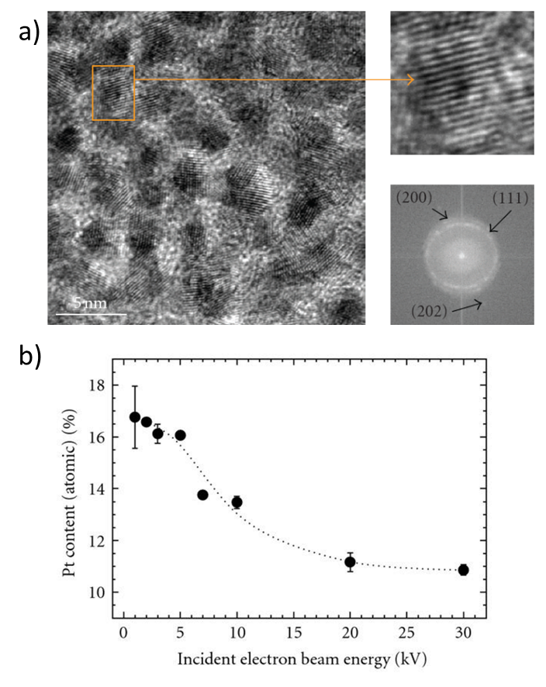
Figure 2: HRTEM images of a platinum nanodeposit by FEBID, grown at 30kV beam energy on top of a TEM copper grid covered with a thin supporting holey carbon membrane. One Pt grain has been selected for magnification and clear observation of the corresponding atomic planes. The Fast-Fourier-Transform of the full image gives diffraction spots that correspond to the (200), (111), (222), and (202) atomic planes of FCC platinum. Reprinted with permission from ref. ⁵
Another approach is to add thermal energy in the form of substrate heating⁶ or pulsed laser heating^{7,8} to the system during or after deposition. This approach can be very successful, but it is prohibited in applications or substrates that require low temperatures. In situ heating can be resolution-limiting due to the thermal drift induced during any such process. This can be especially deleterious when attempting to pattern nanoscale sized features. On the other hand, thermal post annealing has the tendency to change the deposit’s morphology, inducing porosity which can negatively affect the electrical properties of the specimen.⁹
Ex situ strategies for purification utilize post deposition electron irradiation in the absence of precursor gas. In 2009, Botman et. al. showed that electron postgrowth irradiation causes changes in the microstructure of as-deposited platinum¹⁰. Figure 3 shows how the mean particle size increases with increasing irradiation. The selected area diffraction (SAD) patterns corroborate an increase in the crystalline grain size of the deposited platinum. Additionally, the resistivity of the deposits were found to decrease with higher irradiation times, indicating higher purity levels.
Figure 3: Cross-sectional TEM images and corresponding SAD patterns of platinum EBID deposits grown from Pt(PF3)4 showing the morphological changes under postgrowth electron irradiation of varying lengths. a) shows the as deposited structure, b) after 2 minutes of irradiation, and c) after 10 minutes of irradiation. A 20 keV, 7.2 nA electron beam was used for irradiation in a high vacuum environment.
Many ex situ schemes make use of a reactive gas at elevated temperatures combined with electron irradiation to induce a reaction liberating unwanted contaminants from the as-deposited nanostructures¹⁰⁻¹⁴. Recent work by Plank et. al.¹⁵ indicates that an post-growth electron beam dose combined with a heated oxygen reactive gas flowing at relatively high partial pressures can achieve high fidelity, nearly pure, platinum nanostructures. The purification process is envisaged to be an electron induced carbon etching process. In this case the removal of carbon is attributed to two basic mechanisms: (1) the electron stimulated reaction between adsorbed oxygen gas (O₂) and amorphous carbon matrix and (2) the activation of the carbon sites by the electron beam promoting greater O₂ adsorption. Chapter 1 of this dissertation seeks to delve deeper into this electron initiated ex situ purification process.
Besides the problem of purity, the other issue is one of spatial control and resolution. FEBID is a direct write method, meaning that the scanning pattern of the beam controls the morphology/pattern of the final structure. Ideally, the resolution of the deposition, i.e. the smallest feature dimensions, would mimic the resolution of the electron beam itself. In practice, this idealized situation is not achieved because of the abundance of interactions that occur during deposition. First, the precursor molecules adsorb onto the surface of the substrate with a residence time dependent on factors such as the sticking coefficient and temperature of the system. Then, there is an electron-precursor interaction leading to the cleavage of one or more of the precursor ligands followed by subsequent deposition. Finally, interactions between the substrate and the electron beam are important as they lead to the generation of secondary electrons.
These secondary interactions often play an important role in determining the final structure. In fact, the reaction cross section is larger for low energy electrons¹⁶⁻¹⁷; this means that secondary electrons (SE) from the substrate and deposit can have a disproportionate effect on the final growth morphology, in some cases producing significant proximal deposition.
With these basic interactions and large parameter space in mind, it is helpful to review a simple phenomenological model of the deposition process as a starting point. One of the first of such models was demonstrated in 1986 by Volker Scheuer, Hans Koops, and Theo Tschudi¹⁸. In their model, it is assumed that only molecules adsorbed onto the substrate surface will contribute to deposition; gas phase reactions are ignored and justified by the localized deposit. The adsorption rate (dN/dt) is given by:
$$\frac{dN}{dt}= δΦ\left(1-\frac{N}{η{}_{0}}\right)-\frac{N}{τ}-σNJ$$
with the first term corresponding to surface adsorption, the second term referring to desorption, and the third term representing molecular dissociation by the electron beam. The symbols represent: δ the sticking coefficient of the precursor gas, Ф the precursor gas flux (cm⁻²s⁻¹), N the density of adsorbed molecules (cm⁻²), η₀ the molecule density in monolayer (cm⁻²), τ the residence time of the precursor (s), σ the disassociation cross-section of the molecule as a function of beam energy (cm²), and J the electron flux (cm⁻²s⁻¹). A schematic of the phenomena involved is shown in Figure 4.
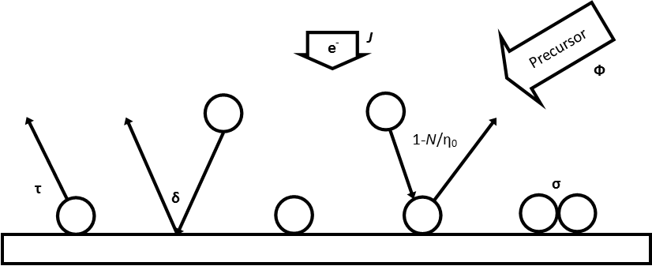
Figure 4: Illustration of surface interaction. Reprinted with permission from ref. ¹⁸
The growth rate (R) is then defined as:
$$R=VNσJ$$
with V as the molecular volume (cm³). At steady state (dN/dt = 0), therefore, the growth rate is given by:
$$R=Vη_{0}\frac{\left(\frac{Φδ}{η_{0}}\right)σJ}{\left(\frac{δΦ}{η_{0}}+\frac{1}{τ}+σJ\right)}$$
from which two extreme growth regimes can be considered, ignoring the effect of desorption (which is a valid assumption at long residence times). One, in which the precursor gas terms dominate e.g. (Φδ/η₀) >> σJ, and the growth occurs independent of the beam current density, and another in which the electron flux and dissociation dominates ((Φδ/η₀) << σJ) and the growth is limited by the precursor coverage in the beam interaction region. The first regime is known as the reaction rate limited (RRL) or electron limited regime and the second is known as the mass transport limited (MTL) or precursor limited regime. These two regimes are very important concepts for precise nanofabrication by FEBID.
At high temperatures, the residence time of the molecule decreases according to:
$$τ=\frac{1}{ν}exp⁡(\frac{E_{a}}{kT})$$
with ν as the vibrational frequency of the adsorbed molecule (s⁻¹), E_{a} as the activation energy for desorption (J), k is the Boltzmann constant (m² kg s⁻² K⁻¹), and T is the system temperature.
Clearly, interplay between these interactions results in a very complex system which is difficult to control. To complicate matters, the situation changes as deposit growth moves from simple lines and planar structures to more complex 3D objects. Near the substrate, electrons originating from substrate-beam interactions limit the resolution as compared to deposits grown higher away from the substrate where deposit-beam interactions dominate ¹⁹.
Thus, accurately building highly defined features is a difficult problem, involving many different parameters other than the beam scanning pattern. Beam parameters such as spot size, beam energy, dwell time, and point of pitch must be delicately balanced by gas parameters such as flux in the beam interaction region, surface diffusion, and decomposition reaction rate. The complex interplay between these parameters ultimately determines the geometric shape and morphology of the final deposit.

Motivation
The driving force motivating this work is to improve the viability of FEBID as a nanoscale fabrication tool. To accomplish this, the dissertation is laid out in four separate chapters. Chapter 1 describes the investigation low-temperature purification of FEBID platinum through a post process involving an electron stimulated reaction of O2 and the carbon contaminates. Chapter 2 is an analysis of the critical parameters involved in three dimensional FEBID, along with demonstrated control over those parameters to produce predicable shapes with high precision. Chapter 3 presents a study of the in situ purification of 3D FEBID structures via a laser-assisted photothermal processs. Finally, Chapter 4 explores the nanomechanical characterization of 3D FEBID structures and atomic layer deposition coated 3d FEBID structures.

CHAPTER I:
Low Temperature Electron stimulated Purification

A version of this chapter was originally published by Brett B. Lewis, Michael G. Stanford, Jason D. Fowlkes, Kevin Lester, Harald Plank, and Philip D. Rack:
Lewis, B. B.; Stanford, M. G.; Fowlkes, J. D.; Lester, K.; Plank, H.; Rack, P. D., “Electron-stimulated purification of platinum nanostructures grown via focused electron beam induced deposition.” Beilstein Journal of Nanotechnology 2015, 6, 907-918.

The student must add a brief explanatory statement at the beginning of each article, stating how the article was revised and/or detailing the student’s involvement in the article. Any co-researchers should be identified and their role clarified as part of this statement.

Brett B. Lewis conducted all the experiments and subsequent characterization and analysis and wrote the manuscript. The co-authors contributed to elucidating the relevant mechanisms and helped revise the manuscript. (Brett to add brief description of how (if at all) the manuscript is different)

Abstract

Platinum–carbon nanostructures deposited via electron beam induced deposition from MeCpPt(IV)Me3 are purified during a post-deposition electron exposure treatment in a localized oxygen ambient at room temperature. Time-dependent studies demonstrate that the process occurs from the top–down. Electron beam energy and current studies demonstrate that the process is controlled by a confluence of the electron energy loss and oxygen concentration. Furthermore, the experimental results are modeled as a 2nd order reaction which is dependent on both the electron energy loss density and the oxygen concentration. In addition to purification, the post-deposition electron stimulated oxygen purification process enhances the resolution of the FEBID process due to the isotropic carbon removal from the as-deposited materials which produces high-fidelity shape retention.

Introduction and Literature Review

Focused Electron Beam Induced Deposition (FEBID) is an attractive nanotechnology application because of its unique processing latitude and high precision resolution. FEBID uses an electron beam scanned in a specific pattern to dissociate and condense precursor material onto a substrate with high shape fidelity and a high degree of flexibility in the final form of the structure ^{2, 20-21}. Additionally, FEBID is a gentler technique as compared to similar techniques (e.g. Ion beam induced deposition) which is beneficial for many applications. The major drawback to FEBID is the purity of the final deposits which results from unwanted precursor fragments left after dissociation. The immediate potential for high impact applications makes the purification strategies for FEBID an important area of study. Several strategies have been investigated for purifying FEBID deposits (see Botman et al.²⁰ for review). In-situ purification strategies include: 1) precursors which easily decompose – for instance: WF₆,²² Co₂(CO)₈,²³ and AuClPF₃²⁴ 2) mixed gas chemistries which react with the typically organic fragments^{14, 25}, and 3) in-situ substrate²⁶⁻²⁷ or pulsed laser heating^{7-8, 28}. Additionally, several ex-situ strategies have also been explored. Post annealing treatments in various ambients have been shown to improve the purity in PtC_{x} deposits from the MeCpPt(IV)Me3 precursor and AuC_{x} deposits from the Me2Au(acac) precursor²⁹. Recently, pulsed laser annealing of PtC_{x} deposits in O₂ was also successful photo-thermally inducing a C-O reaction to remove the carbon matrix and densify the Platinum³⁰. Electron stimulated carbon reduction in vacuum was also demonstrated for PtC_{x} deposits^{15, 31}. Newly, Huth et al. explored a pulsed heating process in O₂ which accelerates the carbon removal relative to a constant heat source and is suggested to be facilitated via a catalytic Pt-O³². Finally, Mackus et al. has demonstrated that FEBID deposited seed layers can be used as catalyst sites for selective area atomic layer deposition growth of Pt layers³³.
To this end, we have recently studied the post-deposition purification of platinum–carbon nanostructures deposited from MeCpPt(IV)Me3 via an electron stimulated reaction with oxygen gas¹⁵ and water vapor¹³. Additionally we have investigated the purification of ruthenium-carbon nanostructures deposited from the bis(ethylcyclopentyldienyl) ruthenium(II) precursor via electron stimulated reaction with O₂³⁴. The electron stimulated H₂O study was performed in a variable pressure scanning electron microscope (SEM) with a much higher pressure range of (10 - 100 Pa). In this regime, the purification appears to be reaction rate limited as various processing conditions could be reduced to a linear change in carbon content versus electron dose. Interestingly cross-sectional TEM studies revealed that the process occurred bottom-up where the purification rate is fastest at the end of the electron beam range in the PtC_{x} deposit and eventually propagates to the surface. Our previous electron stimulated purification study in O₂ was performed in a standard high-vacuum SEM and the O₂ was injected with a localized gas injection system. In the previous study we examined the purification rate as a function of deposit thickness, localized oxygen pressure and oxygen temperature. The results suggested that the rate-limiting mechanism is the electron stimulated reaction of oxygen molecules adsorbed/permeated into the PtC_{x} matrix. In this contribution we have expanded our initial study of the electron stimulated purification in O₂, namely we have: 1) extended our temperature study to room temperature; 2) demonstrated that the process propagates top-down; 3) studied variable current and scanning parameters; 4) compared the purification rate as a function of beam energy; 5) compared the purification of pseudo-1-dimensional lines; and 6) introduced an adsorption/permeation and reaction model which can mimic the purification rates observed in the different regimes studied.

Results and Discussion

Purification Rates
In a previous work¹⁵ it was demonstrated that both the purification rate and final purity increased with decreasing temperature as the oxygen gas temperature decreased between 78 and 50°C. It was speculated that this trend could be extended to room temperature due to the increased residence time of O₂ on the surface of the deposit, however, at temperatures below 50°C, competitive MeCpPt(IV)Me3 adsorption arrested the purification process. For this study, the GIS was cleaned of all trace MeCpPt(IV)Me3 to mitigate the precursor contamination.
Thus, extending the study to room temperature, we re-examined the temperature dependence of the purification. Figure 4 illustrates in situ EDS spectra as a function of the purification time for the a) 25°C and b) 78°C studies, respectively. Figure 2c shows the integrated Pt/C ratios as a function of purification time and 2d the ex situ EDS spectra for the purified deposits compared to the as-deposited spectra. Figure 4 clearly illustrates that the purification extent and rate is increased down to room temperature. This is consistent with our proposed mass-transport limited regime where the O₂ residence time increases the available O₂ on the surface (and ultimately diffused to the Pt-C matrix) so subsequent electron stimulated reactions and CO_{x} removal can proceed.
While the initial purification rates appear to be comparable, non-intuitively, the reaction rate at longer purification times and ultimately the final purity are both higher using a lower temperature reactive gas. Since higher temperature is expected to enhance oxygen diffusion, we speculate that the observed purification enhancement is due to an enhanced residence time for O2 at lower temperature; subsequently setting up a larger concentration gradient to enhance the diffusive transport necessary for the reaction front to propagate. It is also worth commenting on the slight peak that appears in the EDS spectra of the fully purified deposit. This peak is present because the Pt-N peak overlaps with the C-K peak. For pure platinum, the N peak to M peak ratio is about 0.09.
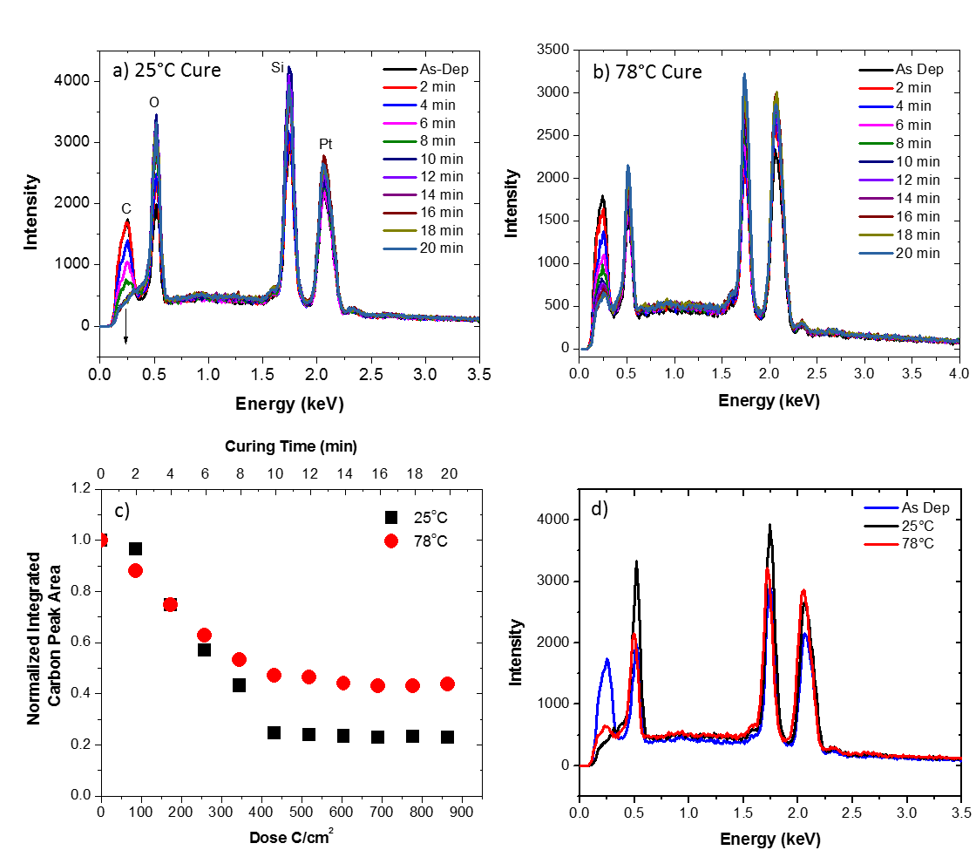
Figure 5: In situ EDS spectra of deposits purified using an electron beam with an energy of 5 keV, a current of 1.6 nA, a dwell time of 100 ns, and a pixel spacing of roughly 0.65 nm plotted for different purification times for the (a) 25 and (b) 78ºC O₂ flow studies. (c) shows the normalized integrated Pt/C ratios as a function of purification time (top axis) and estimated received dose (bottom axis). (d) Shows the final EDS spectra after 20 minutes of purification.

Top Down Reaction Process
Figure 5 shows a series of relatively thick PtC_{x} pads that were originally grown to a thickness of ~ 360 nm and subsequently purified at 25°C at various times from 1 to 12 minutes. After curing, the pads were sectioned using gallium focused ion beam milling to reveal the Pt layer thickness as a function of purification time. The SEM micrographs in Figure 5 depict the bright purified platinum on top of the darker un-purified PtC_{x} at the various purification time increments. As demonstrated , the electron stimulated O₂ purification process appears to be occurring in a top-down manner which is distinctly different from what is observed for higher pressure H₂O purification¹³. Consistent with the EDS measurements, the measured thickness versus time (Figure 5b) reveals an approximately linear purification rate (R² value of 0.97). The thickness of the pad after 2 and 4 minutes of purification shown on the plot is included for completeness, but the error bars based on multiple measurements are quite large because the purified layer is very thin. This suggests the O₂ reactant surface concentration is relatively constant at the growth front. Based on amorphous carbon O₂ etching studies by Hopf et al.³⁵ we previously suggested that two types of O₂ species could be contributing to the process – namely: 1) O₂ adsorbing simultaneous with the electron flux and 2) O₂ adsorbed to high-binding energy carbon sites which result from electron irradiation. As the process is now revealed to occur top-down, we suggest that the process is likely facilitated via a catalytic O₂-Pt dissociative adsorption process^{32, 36}; specifically, whereas O₂ has a very low adsorption energy (and thus short residence time) on amorphous carbon the Pt surface promotes a dissociative adsorption process with a higher binding energy with consequently higher equilibrium surface coverage.
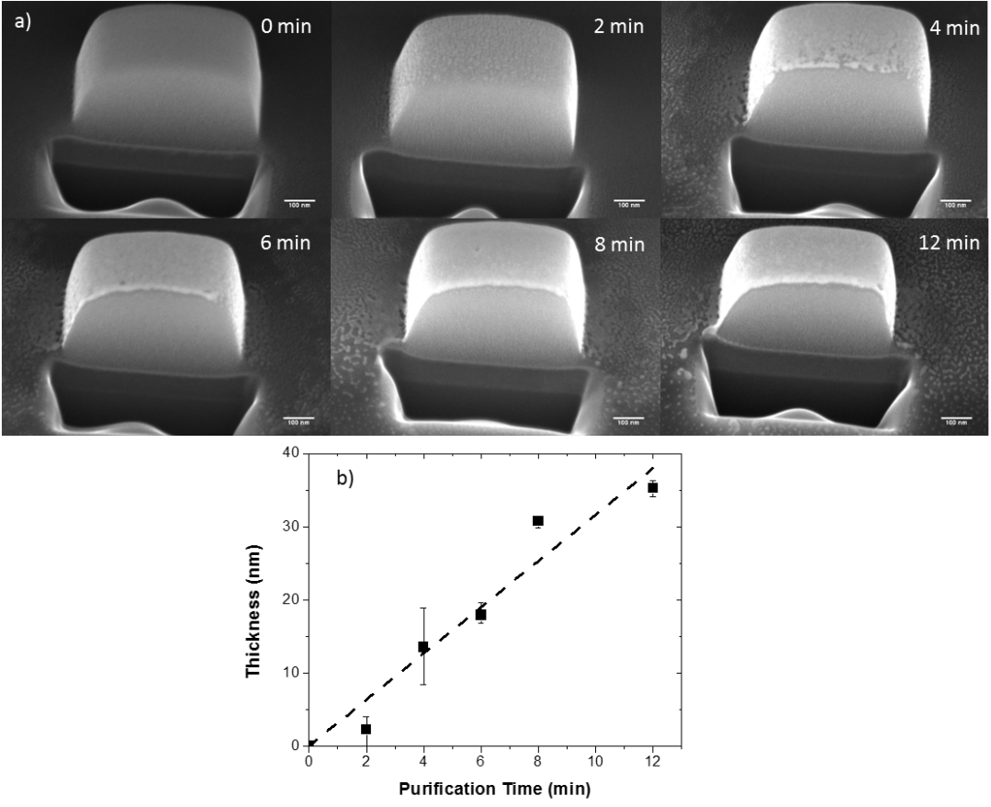
Figure 6: a) Cross-section SEM images of 400 nm thick Pt-C deposits that were purified for 1, 2, 4, 6, 8, and 12 minutes (reading from right to left) demonstrating the linear, top-down nature of the purification process. b) is a plot of the purified layer thickness on the top of the pad against the total purification time.

Beam Parameter Studies
To explore this growth mechanism further we performed two additional studies: 1) increased pixel spacing on the live scan imaging during purification by a factor of 1.85, and 2) reduced the current to ~0.5 nA (~3.6x reduction). Figure 6a compares the integrated carbon peak as a function of exposure time for the different scanning conditions. Clearly changing the pixel spacing does not affect the purification process. The effect of increasing the pixel spacing has the effect of reducing the loop or frame time by a factor of ~ 3.5 (from 79 to 22 ms) and thus increasing the total number of loops by the same factor for a constant purification time. Therefore, if the process is limited by the oxygen concentration as we suspect, the local oxygen concentration in the reaction zone appears to scale with the loop time and is not saturating. This is consistent with the estimated O₂ flux¹⁵ of ~1x10¹⁶ O₂/(cm²-s) and sticking probability of 0.05 approximating a monolayer coverage time on the order of 100 ms. In the second study the current was decreased with the other scanning parameters held constant. Figure 6b is a plot of the integrated carbon peak as a function of effective dose (with an inset plotted versus time). Interestingly, while the current was decreased a factor of ~3.6, the purification rate only decreased a factor of approximately two (see inset). This result implies that, at lower current, purification is more efficient (note that low current purifies at lower dose). This is consistent with a 2nd order reaction in which the reaction is a function of the electron flux (or as we will demonstrate the electron energy loss density) and the concentration of the O₂ reactant. At the beginning of the beam dwell the per-electron purification reaction probability is highest since the O₂ interfacial concentration is the highest. As the dwell time persists, O₂ is consumed and the reaction probability dynamically decreases. The lower current study indicates that the integrated efficiency during the entire pixel dwell time is approximately twice as high at low current as at high current due to the dynamic consumption of the O₂.

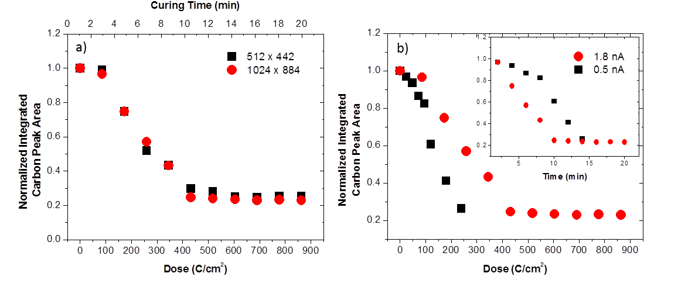
Figure 7: Normalized carbon peak area plotted as a function of a) curing time for the indicated pixel resolutions (note higher pixel resolution resulted in longer frame time) and b) dose for indicated beam currents. The inset depicts the same normalized carbon peak area as a function of time. The 1024 x 884 pixel resolution corresponds to ~0.65 nm point pitch while the 512 x 442 resolution corresponds to a point pitch of ~1.2 nm.
To investigate the effect of the purification rate with beam energy, twenty-one identical 500 x 500 nm, ~ 80 nm thick pads were grown. The beam energies studied (and associated beam current as measured in a Faraday cup) were: 5 (1.8 nA), 7.5 (2.7 nA), 10 (3.1 nA), 15 (3.1 nA) and 20 keV (2.7 nA). The temporal evolution of the purification process was investigated with purification exposure times of 5, 7, 10 and 15 minutes for each beam energy. Figure 7a is a plot of the integrated EDS carbon intensity as a function of exposure dose (time x current) for the different beam energies. Consistent with electron stimulated reactions, the apparent reaction cross-section decreases with increasing beam energy¹⁷. Because the reaction cross section is envisioned to scale with the electron energy loss in the PtC_{x} layer, the electron energy loss was simulated at the various beam energies in 100 nm PtC₅ films on a 100 nm SiO₂ layer on a silicon substrate (Figure 7b). As shown, the Monte Carlo energy loss simulations in the PtC₅ layer decreases with increasing beam energy. Since the O₂ concentration is believed to be localized near the Pt/PtC_{x} interface due to limited diffusion and trapping at Pt nanoparticles and the purification front, we compare in Figure 7c the normalized purification rate (normalized to 5 keV and adjusted for different currents) from Figure 7a and the near surface energy loss from in the PtC₅ layer in Figure 7b as a function of beam energy. Also shown is the normalized purification rate from our adsorption/permeation and electron stimulated reaction model as will be overviewed below. As demonstrated, good agreement between the experimental and simulated plots is observed, supporting the top-down purification model.
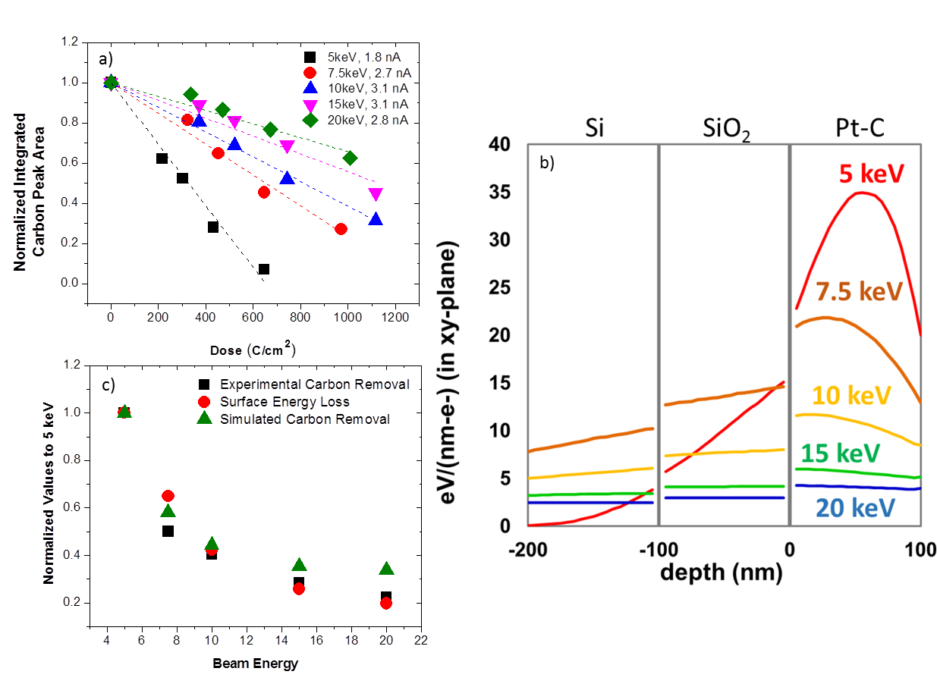
b)
a)
c)
Figure 8: a) Normalized carbon peak area plotted as a function of dose for the beam energies shown. b) Monte Carlo simulation data depicting the electron energy loss over a 100 nm PtC₅ film on top of 100 nm SiO₂ as a function of z height (thickness) at different beam energies. The gray vertical lines represent the Si-SiO₂ and SiO₂-PtC₅ interfaces. c) Comparison of the empirical purification rate to the simulated surface electron energy loss as normalized to the values at 5 keV.

Enhanced Resolution
The volumetric reduction in the Pt-C deposits is proportional to the removal of carbonaceous by-product and as demonstrated previously, purification of PtC₅ to pure Pt results in an ~ 70% volumetric reduction¹⁵. Volumetric reduction in a typical 3-dimensional deposit varies in magnitude depending on the length scale in each direction. For instance, the pseudo 2-dimensional pads have asymmetric length scales as the height (~ 100 nm) is much smaller than the lateral dimensions (500 nm); so the volume loss is dominated in the z-dimension with very little lateral contraction. To compare, we deposited line patterns that were grown with progressively higher number of electron passes to investigate the purification direction and volumetric shrinkage of lines that are nearly symmetric in height and width. Figure 8a illustrates the purification progression of the deposits as a function of purification time; for convenience and easy comparison, we only purified half of the lines. Figure 8b summarizes the reduction in line-width as a function of purification time for the lines grown with progressively more passes and result in different initial thicknesses (~ 55, 90, 110, and 160 nm) and due to proximity effects¹⁹ also increased widths (~ 60, 75, 100, and 115 nm), respectively. Once fully purified, the line-width reduction ceases with further irradiation time. For the line purification of the smallest two lines one can envision an almost semi-circular cross section where each line has a similar purification rate (slope of the line-width versus time). The tilted image reveals that the purification is occurring in a nearly isotropic manner (both lateral and vertical contraction) and thus the complete purification time is dependent on the initial line thickness/width. For the first and second lines there is greater than 50% line width reduction after a short purification time. Assuming a semi-circular cross-sectional shape and negligible relative shrinkage along the long axis, the volumetric reduction was found to be ~75% for lines one and two. For the thicker lines (three and four) the line symmetry was different and thus the volumetric contraction was distributed differently across the width of the lines and the thickness of the lines. For these, volumetric reduction can be approximated more accurately by assuming a rectangular cross-section. Assuming this geometry and the final line widths, the volumetric reduction for both lines three and four was estimated to be 71%. This result indicates that the final shape of the deposition after purification can be predicted analytically. The overall contraction is proportional to the volumetric reduction resulting from the carbon removal from the deposit (~70%) and therefore the final shape will shrink in proportion to the original dimensions.
Finally, it is worth noting the slight asymmetry or shift in the line center for the purified lines and the residual deposition that is visible after purification. This shift is attributed to the directionality of the O₂ gas flux; the position of the gas nozzle relative to the SEM image is noted in Figure 8a. The preferential purification is due to a slightly higher gas flux on the left side of the lines as discussed in detail elsewhere³⁷. Importantly, because the O₂-assisted electron beam purification is isotropic, one can predict the shape change due to the volumetric contraction and which fortuitously can increase the FEBID spatial resolution while simultaneously purifying the deposit. The residue that becomes visible near the purified lines is a result of peripheral or proximal deposition from the electron beam tail and backscattered, type II secondary electrons and in some cases forward scattered electrons during the initial deposition³⁸. This proximal deposition can be avoided with careful selection of the beam parameters during deposition. As the layer is extremely thin (a few monolayers) it can also be easily removed ex-situ by with a brief focused ion beam etch.
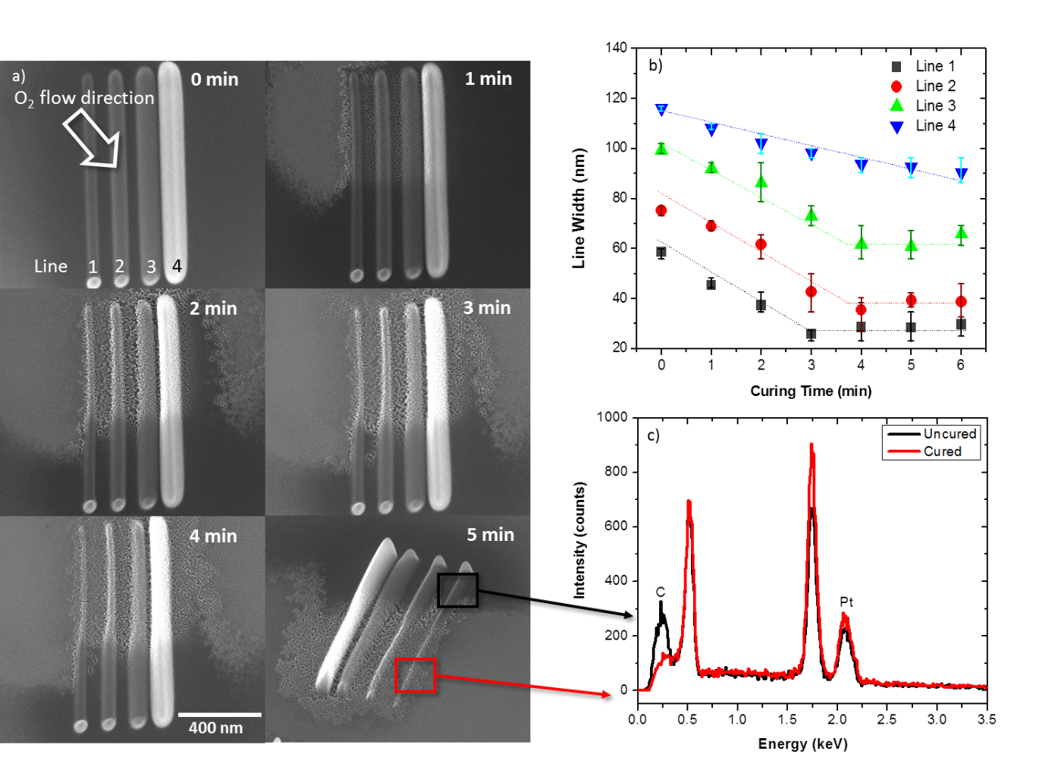
Figure 9: a) Images of line deposits with different initial thicknesses (lines 1-4) purified at 1 minute intervals for 6 minutes (inset on image). b) Estimated line width as a function of purification time for lines. c) EDS measurements of the purified and as-deposited part of the line pattern.

Microstructure
Transmission electron microscopy (TEM) images of the as-deposited and cured Pt-C FEBID patterns were taken to compare the microstructure with progressive carbon reduction. Figure 7a illustrates initial EDS measurements of ~30 nm thick Pt-C₅ samples that were grown on SiN_{x} membranes confirming the decrease in carbon with increasing purification time. Interestingly, the carbon reduction is not as severe as compared to samples done on bulk substrates. While not conclusive, this could be due to two reasons: 1) an overall decrease in the energy loss in the deposits during purification due to limited backscattering from the thin membrane; 2) possible carbon deposition on the backside of the membrane due to slight outgassing from the copper tape adhesive. Figure 9b-d shows plane-view TEM images of the FEBID structures at different purification times. A comparison of the TEM images reveals that the platinum grains coarsen and densify with increasing purification time. The estimated grain sizes were 1.97 nm (± 0.34 nm), 3.36 nm (± 0.69 nm), and 5.06 nm (± 0.80 nm) for as-deposited, 6 minute, and 12 minute purification patterns, respectively. In order to further characterize the microstructure development during purification, selected area electron diffraction patterns (SAED) were taken for an as-deposited and purified Pt-C deposit as shown in Figure 10a. Figure 10b compares the radially averaged diffraction patterns which clearly illustrates that the electron-beam assisted O₂ purification successfully causes Pt grain densification and coarsening as indicated by the increased diffraction peak intensity and narrowing of the peak widths. The as-deposited diffraction pattern exhibits broad diffraction rings characteristic of small grain size and possibly disorder due to high carbon content. The diffraction peaks narrow as grain size increases after curing. Grain coarsening is commonly associated with an increase in electrical conductivity of the Pt-C deposit as the tunnel coupling strengths increase for percolating networks³¹. For fully purified materials, our previous work¹⁵ demonstrated a purely metallic material and thus low resistivity only one order of magnitude higher than bulk Pt. Future work will correlate purification time to the resultant percolating network and ultimately their temperature dependent electrical behavior which can reveal the granular properties of the evolving nanostructure as well as the insulator to metal transition.
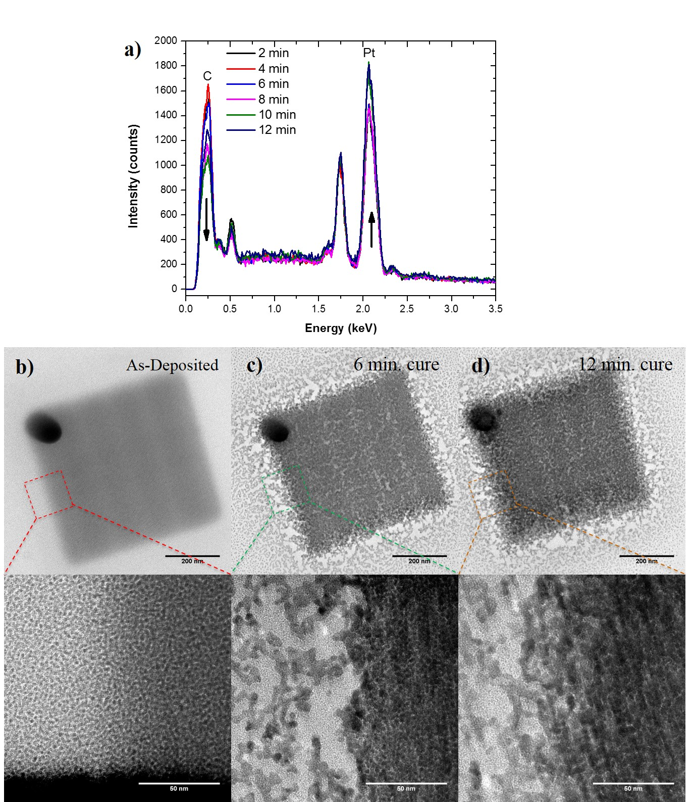
Figure 10: a) EDS measurements of the samples deposited and purified on the TEM membranes. TEM images of an b) as-deposited, and samples purified for c) 6 minutes and d) 12 minutes. The images reveal an increase in Pt grain size that occurs with increasing purification time.

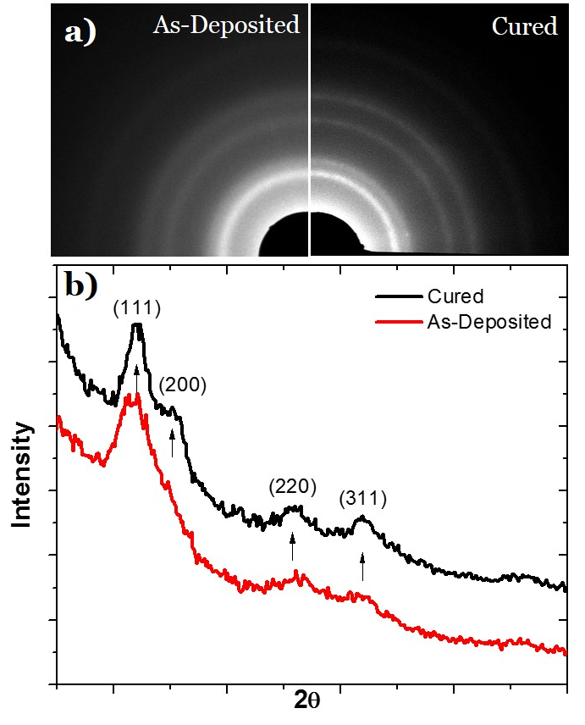
Figure 11: Selected area electron diffraction (SAED) patterns for O₂ E-beam uncured (left) and cured (right) deposit. Diffraction peaks become more pronounced after curing.

Modeling
Finally, to emulate the purification reaction we have developed a model which incorporates the O₂ 1) surface adsorption, 2) permeation/diffusion, 3) preferential O₂-Pt adsorption, 4) electron stimulated reaction, and 5) subsequent CO_{x} out-diffusion. Purification experiments were simulated using a hybrid numerical approximation consisting of (1) a Monte Carlo electron scattering simulation coupled with (2) an explicit finite difference treatment of oxygen diffusion and the (3) Huen-Euler method to approximate the dissociative chemisorption of atomic oxygen on metal nanoparticle surfaces internal to the deposited solid. Electron energy loss converts bound oxygen into an activated form that is assumed to instantaneously oxidize amorphous carbon. The resulting CO_{x} is liberated from the deposit via subsequent diffusion to the surface. The details of the simulation will be provided in a future publication and only a brief summary is provided here.
The Monte Carlo simulation is executed in order to accumulate the 3D spatial profile of the inelastic energy deposited in a semi–infinite thin film stack consisting of a PtC_{x(z)} deposit of thickness (h_{film}) resting on a substrate. The 3D inelastic energy profile is then scanned through the deposit surface (to mimic the experimental beam scanning procedure) and the energy is accumulated at the center of the scanning pattern (x=0, y=0) in order to emulate the transiently evolving inelastic energy profile with depth (z–coordinate) during real experiments at the pad center. Thus, the critical parameter in the Monte Carlo simulation is the rate of electron energy loss, per unit length scattering, to the film [1-3];
$$\frac{dE(z)}{dS}=-78,500\frac{ρ\left(z\right)Z\left(z\right)}{A\left(z\right)}\frac{1}{E\left(z\right)}log\left(\frac{1.166∙E\left(z\right)}{J\left(z\right)}+1\right) [1]$$
where E is the electron beam energy, S is the spatial path length for the scattering electron in the current voxel, ρ is the material density, Z is the atomic number, A is the atomic weight and J is the mean ionization potential. This value is converted into a deposited energy “concentration” with units of, e.g., [eV/nm³-s] for input into the transport simulation. Lastly, the semi–infinite deposit composition in the depth dimension is updated based on the transport calculations (described below) in order to account for the experimentally observed deposit densification – ρ(z), Z(z) and A(z) are recalculated by volume averaging based on PtC_{x(z)} for the next Monte Carlo simulation iteration.
In the transport simulation, O₂ is introduced into the deposit based on a surface impingement rate derived from the input pressure P. Dissolution at the surface is treated according to Henry’s law S = K_{eq}P where S is the solubility of oxygen and K_{eq} is the solubility constant. The use of this approximation requires a description of the deposit composition model. The model deposit consists of metal nanoparticles with a defined density ρ_{np} and a radius r_{np} distributed in an amorphous carbon matrix (aC) which was constructed based on TEM images of real structures. Further, the aC was modeled as “polymer–like” in the simulation. O₂ dissolved and diffused within a partitioned pixel fraction based on the mean pixel composition PtC_{x(z)}.
The transport equation treating the diffusion of the mobile O₂ concentration (C_{O2}^{m}) is shown in equation [2] as the first term on the right hand side with the remaining terms describing the interaction of mobile oxygen gas with Pt nanoparticles. An explicit finite differencing scheme is used to calculate the diffusion term in equation [2]. Importantly, the numerical approximation was derived including a variable pixel size which made it possible to “contract” the deposit based on the amount of carbon lost.
$$\frac{∂C_{O_{2}}^{m}(z,t)}{∂t}=D_{O_{2}}\frac{∂^{2}C_{O_{2}}^{m}(z,t)}{{∂z}^{2}}-δΦ_{O_{2}}\left(C_{O_{2}}^{m},r_{np},z,t\right)\left[4πr_{np}^{2}(z,t)ρ_{np}\left(z\right)- \frac{C_{O}^{im}\left(z,t\right)}{s_{d}}\right]+\frac{C_{O}^{im}\left(z,t\right)}{2τ} [2]$$
The second term in equation [2] describes the chemisorption of mobile oxygen gas as adsorbed atomic oxygen at nanoparticle surfaces. Ф_{O2} is the impingement rate of mobile O₂ on the nanoparticle surface (this parameter is derived from Monte Carlo simulations of a diffusing test particle impinging on a spherical nanoparticle and will be discussed in detail in the future publication) and depends on the concentration of mobile oxygen, the nanoparticle radius, depth into the deposit and time. Also important to the adsorption interaction is the sticking parameter (δ), the number of binding sites per unit nanoparticle area (s_{d}) and the mean residence time of atomic oxygen on the nanoparticles (τ). The later appears in the third term which describes the associative desorption of atomic oxygen to form dissolved, mobile molecular oxygen. Terms 2 and 3 are combined and solved using the improved Euler, or Heun–Euler method, applicable for a first–order differential equation which is a predictor–corrector method and is second order accurate with a cubed truncation error.
Adsorbed, immobile atomic oxygen C_{O}^{im} is available for electron–induced dissociation as represented by equation [3] and provides the coupling between the Monte Carlo electron scattering simulation and the transport calculations. Specifically, term 1 treats the electron–driven activation of atomic oxygen using the law of mass action and treats the reaction as 2nd order (1st order in each concentration) where the units of the reaction constant are, e.g., [nm³/eV-s], and C_{eV} is the “concentration” of electron energy loss.
$$\frac{∂C_{O}^{im}(z,t)}{∂t}=-kC_{eV}{\left(z,t\right)C}_{O}^{im}(z,t)+2δΦ_{O_{2}}\left(C_{O_{2}}^{m},r_{np},z,t\right)\left[4πr_{np}^{2}(z,t)ρ_{np}\left(z\right)- \frac{C_{O}^{im}\left(z,t\right)}{s_{d}}\right]-\frac{C_{O}^{im}\left(z,t\right)}{τ} [3]$$
Importantly, once the oxygen is chemically “activated” the assumption is made that this species (O*) instantly reacts with aC yielding CO_{1.5} (without actual knowledge of the ratio of CO and CO₂ by–product yields, parity was assumed);
$$\frac{2}{3}aC+O^{*}→\frac{2}{3}{CO}_{1.5} [4]$$
$$\frac{∂{CO}_{1.5}}{∂t}=-\frac{∂aC(z,t)}{∂t}=\frac{2}{3}kC_{eV}{\left(z,t\right)C}_{O}^{im}\left(z,t\right) [5]$$
Subsequently, the liberated CO_{1.5} diffuses within the aC matrix and is vaporized at the deposit surface. Pixels shrink according to the amount of aC liberated. Conversely, the flow of both O₂ and CO_{1.5} are prohibited at the buried deposit/substrate interface under a no–flow boundary condition. It is important to note that the spontaneous oxidation of carbon by chemisorbed atomic oxygen is neglected in the current model. As a result, the simulation results reported are expected to overestimate the rate of beam induced oxidation.
The summarized simulation flow above represents one loop of purification. Following the completion of a single loop, the PtC_{x(z)} composition for each xy-planar slice in the 3D spatial domain for the Monte Carlo simulation is updated based on the contraction of the spatial nodes in the transport simulation due to the loss of aC. This procedure accounts for both (1) the motion of the deposit surface as well as (2) the deposit densification.
Table 1: The relevant derived variables used in the simulation to obtain the correct experimentally determined purification rates.
O₂ purification
Electron beam energy |  |  |  |  | 5 | keV
Electron beam current |  |  |  |  | 1800 | pA
Beam scanning pixel size |  |  |  |  | 0.65 | nm
Beam scanning region |  |  |  |  | 620 | nm
Beam dwell time per pixel |  |  |  |  | 100 | ns
Pad thickness |  |  |  |  | 100 | nm
Initial pad composition (PtC_{x}) |  |  |  |  | 5 | [ ]
Rate constant |  |  |  |  | 4000 | nm³/(eV*s)
Diffusion coefficient |  |  |  |  | 4 | µm²/s
Solid dissolution constant |  |  |  |  | 0.03 | atoms/(nm³*Torr)
Mean residence time (reactant on metal np) |  |  |  |  | 12.5 | ms
Sticking probability |  |  |  |  | 0.05 | [%]
Pressure (reactant gas) |  |  |  |  | 2 | mTorr

Table 1 summarizes of the relevant variables derived to match the 5 keV purification rate illustrated in Figure 4. Based on these variables, the different beam parameter studies were simulated. Figure 11 is a normalized (to 5 keV) bar graph of the experimental and simulated purification rates for the different beam parameters. As can be seen the purification model accurately mimics the experimental trends presented here. We will elaborate on the model and compare the O₂ and H₂O purification mechanisms in a near future publication.
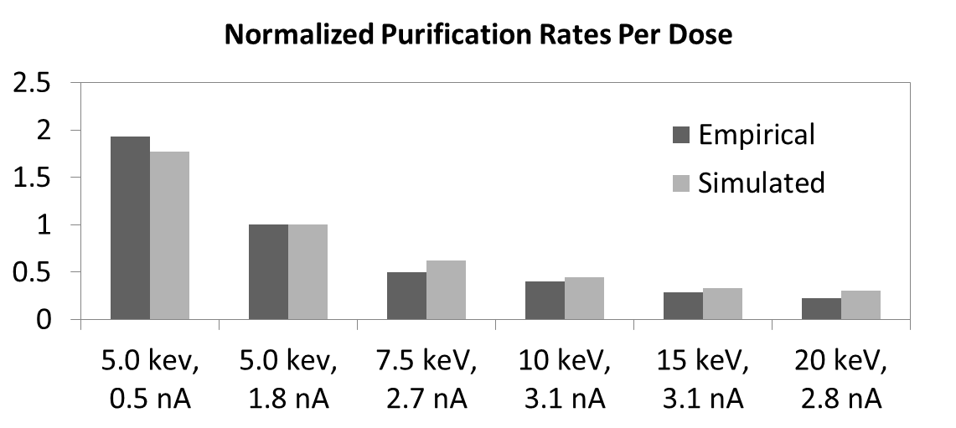
Figure 12: Bar graph comparing the simulated and experimental purification rates for varying beam parameters.

Experimental
Platinum boxes were deposited onto a pre-cleaned 100 nm thermal SiO₂ on Si substrate and then purified. The deposition and subsequent purification was performed using a FEI NOVA 600 dual-beam system equipped with FEI and Omniprobe gas injection systems. Prior to deposition, the substrate was sonicated in isopropanol for 5 min and annealed at 900°C in an Ar-H₂ atmosphere. The sample was then transferred to the SEM chamber and cleaned using an XEI Scientic plasma cleaner for 30min at a pressure of 5.34x10⁻¹ mbar. Subsequent to cleaning, the system was pumped to a base pressure of less than 3x10⁻⁶ mbar. Platinum deposition was performed using the FEI GIS and MeCpPt(IV)Me3 precursor which raised the chamber pressure to ~$1.5×{10}^{-5}$ mbar. 500 x 500 nm boxes were synthesized at this elevated pressure using the NOVA patterning software with a beam energy of 5 keV, beam current of 120 pA, point pitch of 13.55 nm, a pixel dwell time of 10 µs, and 1000 loops in order to create a pad with a thickness of ~100 nm. After deposition and pumpdown back to <3x10⁻⁶ mbar, the pads were purified using an O₂ flow during electron beam irradiation. The oxygen flow and temperature were controlled using the Omni GIS system which was inserted to the same position as our previous work: an angle 52°C with respect to the substrate surface and the lower end of the GIS nozzle at a straight line distance of 120 µm from the substrate surface. The oxygen gas line was heated to 78°C and 25°C though some cooling likely occurs before delivery from the nozzle. After the target oxygen temperature was reached, the oxygen was injected into the SEM chamber at a pressure of ~$1.4x{10}^{-5}$mbar which was determined by controlling the valve sequence in the OmniGIS. At this point, the electron beam was used to irradiate the deposit with the simultaneous flow of O₂. Typical purification parameters were: a beam energy and current of 5keV and 1.8nA, respectively, a ~0.65 nm point pitch with a field of view of 1024x884 pixels (665*575 nm), a dwell time of 100 ns, and a typical curing time of 20 minutes.
To characterize the reduction in Pt-C deposit size with purification, four FEBID lines were deposited on a SiO₂ substrate and purified using the same parameters as with the pads. The line patterns were deposited with 5 keV, 28 pA beam conditions and a varying number (10,000, 15,000, 20,000 and 50,000) of FEBID passes to achieve heights of 48, 70, 95, and 150 nm and widths of approximately 55 nm, 75 nm, 95 nm, and 115 nm, respectively. Half of the line pattern’s length was purified and the other half was left in as-deposited conditions to provide a dimensional comparison to reveal shrinkage associated with purification.
To compare the resultant microstructure and grain size of progressively purified material, 6 samples were prepared on 30 nm thick SiN_{x} substrates for transmission electron microscopy (TEM) imaging. The samples were deposited and purified using similar parameters reported above. The samples were purified to different times (and doses) of 2 min (51.2 C/cm²), 4 min (102.3 C/cm²), 6 min (153.5 C/cm²), 8 (204.7 C/cm²), 10 min (255.8 C/cm²), and 12 min (307.0 C/cm²). Selected area electron diffraction was also performed to obtain diffraction patterns. These experiments were conducted in a Zeiss Libra 200 HT FE MC at 120 keV and minimal beam current to prevent morphological changes.

Conclusion
We have studied the electron stimulated O₂ purification of PtC_{x} FEBID deposits and have shown that the process can be extended to room temperature. Electron beam current and energy studies suggest the process is governed by a dynamic process which is a function of both the electron energy loss and oxygen concentration. Importantly, the purification front propagates from the top-down which suggests a preferential trapping or limited permeation of the O2 reactive gas. A model based on a 2nd order reaction rate was also demonstrated, which accurately reproduces the experimental trends. Finally, purification of pseudo-1-dimensional lines illustrate that the purification process is isotropic and conveniently the carbon reduction leads to higher resolution lines.

CHAPTER II
Direct-Write 3D Architectures

Introduction and Literature Review
One of the most exciting and oft-toted advantages of FEBID is that it can produce complex, free-standing, 3-dimensional nanostructures in a single step on virtually any substrate. While this ability is often lauded as supremely possible, in practice the construction of geometries with higher degrees of complexity is very arduous and typically done using an Edisonian, trial and error approach. Despite the difficulty in creating 3D structures, there have been many examples of simple shapes including suspended gaps³⁹ and wires,⁴⁰ pillars,¹⁶ arches,⁴¹ and, recently, chiral helices.⁴² These shapes are either very simple or made up of repeating units (as in the case of the chiral helices). Figure 12 shows some examples of shapes that were constructed using the trial and error approach.
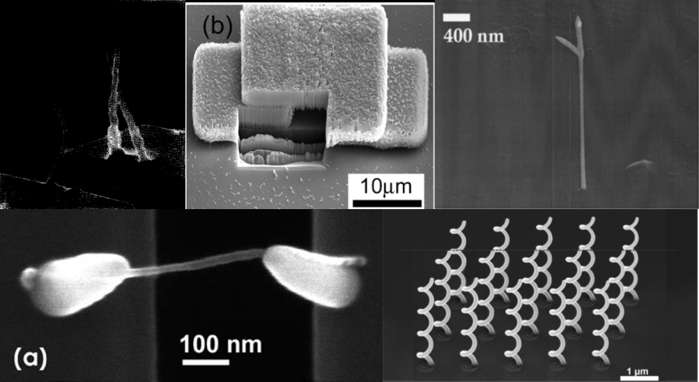
Figure 13: Examples of 3D shapes constructed in the past. Reading from top left to bottom right: Arch,⁴¹ gap,³⁹ pillar,¹⁶ suspended wire,⁴⁰ and chiral helices.⁴²
The parameter space for creating a systematic, repeatable geometry using FEBID is very large. For example, Hoffman et. al.⁴³ demonstrated that the precursor gas flux vector relative to the scanning direction can have a profound effect on the growth rate of the deposit in certain pressure regimes (Figure 13).⁴³
Figure 14: (a) Schematics of the experimental set-up and example of writing sequence. (b) SEM micrographs, tilted views of the resulting structures, at three different scan speeds as shown. Left: front-views; right: side-views. Reprinted with permission from ref. ⁴³
More intuitively, beam parameters such as electron energy, current, and step size have a significant effect on the possible shapes using FEBID. These parameters are important because they are directly related to the beam size and beam interaction with the adsorbed precursor. Figure 14 illustrates a study ⁴² showing how at higher beam energies, the structure “falls off” at a smaller point of pitch. This is due to the statistical, Gaussian nature of the beam changing at different acceleration voltages.
Electron Energy (keV)
Figure 15: 3D nanohelices realized by FEBID with constant dose (300 pC/μm), 10 μm aperture diameter but variable step size and electron energy. Contrary to FIBID process, at low energies the nanohelix vertical pitch increases, while at higher energies it decreases and the step size threshold gradually moves toward smaller values. Reprinted from⁴²
The nuances of creating 3 dimensional nanostructures using FEBID are still relatively unquantified. The need for more systematic parameter studies is essential for the progression and integration of FEBID as a 3d nanomanufacturing technique.

CHAPTER III
In Situ Purification

A version of this chapter was originally published by Brett B. Lewis, Robert Winkler, Xiahan Sang, Pushpa R. Pudasaini, Michael G. Stanford, Harald Plank, Raymond R. Unocic, Jason D. Fowlkes, and Philip D. Rack
Place reference here
Brett B. Lewis conducted all the experiments and subsequent characterization and analysis and wrote the manuscript. Robert Winkler, Michael Stanford, Harald Plank, Jason Fowlkes and Philip Rack contributed to elucidating the relevant mechanisms. Xiahuan Sang and Ray Unocic performed the TEM and EELS experiments and Pushpa Pudasaini helped with patterning and testing the electrical test structures. All co-authors helped revise the manuscript. (Brett to add brief description of how (if at all) the manuscript is different)

Abstract
We investigate the growth, purity, grain structure/morphology, and electrical resistivity of 3D platinum nanowires synthesized via electron beam induced deposition with and without an in situ pulsed laser assist process which photothermally couples to the growing Pt-C deposits. Notably, we demonstrate: 1) higher platinum concentration and a coalescence of the otherwise Pt-C nanogranular material, 2) a slight enhancement in the deposit resolution and 3) a 100-fold improvement in the conductivity of suspended nanowires grown with the in situ photothermal assist process, while retaining a high degree of shape fidelity.

Introduction
The first fully incorporated 3D transistor logic⁴⁴ was reported in 2012. Further 3D device concepts and architectures will require the development of new 3D nanoscale fabrication techniques which will inevitably enhance performance and add functionality to nanoscale devices. Emerging applications include, but are not limited to, high strength nanolattices⁴⁵, optical metamaterials⁴², accurate molecular detection⁴⁶, the study of biological systems important in determining cancer treatment options⁴⁷, and reliable, low cost, high performance magnetic hard disk drives⁴⁸. A variety of fabrication techniques have been used to construct multi-dimensional nanostructures⁴⁹⁻⁵² with differing degrees of success.
Recently, FEBID was extended to 3D nanoscale mesh geometries.⁵³ Deposition occurs during FEBID as the nanoscale focused electron beam dissociates adsorbed precursor molecules. A condensed byproduct accumulates by prolonged electron exposure with the shape and composition of the resulting deposit dictated by both the electron beam scanning parameters and the properties of the precursor. The resolution/size of the deposit is determined by the electron probe size and the interaction between the electron beam, substrate, and dynamic growth front which generates subsequent back-scattered (BSE), forward-scattered (FSE), and secondary electrons (SE). Conveniently, FEBID has the advantage of being compatible with a wide range of precursor and substrate materials⁵⁴, Several applications have been explored with FEBID and focused electron beam induced etching including: sensors⁵⁵⁻⁵⁷, field emission cathodes⁵⁸⁻⁵⁹, plasmonic elements^{42, 60}, lithographic mask repair^{34, 61-62}, scanning probe tips⁶³⁻⁶⁶, photonic materials⁶⁷, magnetic materials⁶⁸⁻⁶⁹, nanoparticle separations⁷⁰, and lithographic techniques⁷¹⁻⁷² to name a few. While standard patterning of the electron beam has resulted in complex 2D deposits of arbitrary shape, care must be taken as subtle proximity effects can be minimized or exacerbated in some electron beam¹⁹, gas flux and patterning³⁷, and temperature regimes⁷³. Moreover, while several examples of 3D growth have been demonstrated^{41, 43, 74-75} beyond simple 1D nanowires, controlled growth of complex geometries using FEBID has only recently been achieved based on a combined simulation and computer aided design approach⁵³. This approach has also been used with Ga⁺ ion beam induced deposition (IBID) with a great degree of success, albeit at slightly larger dimensions⁷⁶.
A well-known disadvantage of FEBID is the incorporation of carbonaceous by-products due to the use of organometallic precursors with relatively large carbon atomic fractions. The resulting deposit typically consists of metallic nanocrystals suspended in a non-metallic (often carbonaceous) matrix. There are, however, a few documented examples of precursors that produce relatively pure deposits without additional purification steps^{22-23, 77-78}, and there has been a recent thrust to design and evaluate precursors tailor-made for electron stimulated reactions⁷⁹⁻⁸⁰, but options for obtaining pure FEBID nanostructures are still very limited.
More immediately promising, various methods have been developed to purify FEBID deposits. For instance, methods have been developed which involve post-growth electron-stimulated impurity removal with and without a co-reactant (ex situ)^{13, 15, 81-82} and/or facilitated by a reactive gas co-flow during deposition (in situ)^{11, 83-84}. A third purification method employs thermal energy either by substrate heating⁸⁵ or locally heating the substrate using a pulsed laser system^{7, 28, 86}. For 3-dimensional objects, in situ purification methods are critical in applications requiring high fidelity shape retention due to the significant volumetric contraction associated with impurity removal⁸⁷.
In situ purification of complex 3D nanostructures is a significant challenge due to the large parameter space and multiple interactions that are involved. The removal of impurities during the purification process competes with the simultaneous deposition of the desired material. Additionally, the deposition rate is related to the surface coverage of the precursor on the substrate³⁷ and therefore an additional co-reactant can compete for surface sites changing the growth rate⁸⁸. Higher temperatures can reduce the precursor residence time further complicating the growth rate⁷³.
In this work, we investigate the laser and reactive gas assisted in situ purification of 3-dimensional features synthesized using FEBID from the commonly employed precursor MeCpPt(IV)Me3. We explore the critical electron, precursor, and laser parameters necessary to maintain high fidelity and promote high purity and lower electrical resistivity.

Experimental

Electron Beam Induced Deposition
Platinum nanostructures were grown onto a silicon substrate from the MeCpPt(IV)Me3 precursor gas using an FEI NOVA 600 dual-beam system equipped with multiple gas injection systems (GIS). Before loading the Si substrate, it was cleaned via sonication in acetone for 5 minutes and rinsed in isopropanol before drying. The precursor gas was injected using a FEI GIS and the temperature was held at 45ºC for the standard conditions and varied as discussed to control the precursor flux. 3-dimensional structures were patterned by controlling the spatial coordinates of the electron beam as well as the dwell time at each point via a text file read by the microscope software. For all patterns, a pixel point pitch of 1 nm was used while varying dwell times per pixel. A previously developed computer aided design program was used to determine the dwell times per pixel necessary to construct complex shapes.

Laser Delivery System
A 915 nm wavelength 25 W multichip diode laser made by Oclaro Inc. was used as the source for laser irradiation. A PCX-7410 laser diode driver (DEI®) was used to control the pulse width, frequency, and power. Laser pulses are delivered to the sample with an optical working distance of 9 mm using a multi-mode 100 µm diameter fiber optic cable housed within a stainless steel shaft with automated axial translation. An objective lens located at the shaft tip projects the 100 µm diameter laser spot with a Gaussian distribution at the coincidence point between the focused electron beam and the gas injection systems. The laser delivery system is a prototype under development by Waviks, Inc. This system was mounted on an FEI Novalab 600 chamber port oriented at 52º with respect to the silicon substrate plane. Additional information on the laser system can be found in Ref. ⁸.

Gas Injection System
An FEI gas injector was used to deliver the MeCpPt(IV)Me3 precursor close to the substrate surface. The bottom of the gas nozzle was located 100 µm above the silicon surface. In the substrate plane, the nozzle was located 250 µm from the beam impact point; this distance was measured from the top of the nozzle provided in a secondary electron image acquired at normal incidence with respect to the substrate. A uniform chamber pressure of ~1x10⁻⁵ mbar was established prior to FEBID by continuous precursor flow. The base chamber pressure of the microscope is roughly 2x10⁻⁶ mbar.
An OmniGIS I was used to introduce a reactive gas co-flow of Ar-O₂ (80-20 at. %) to the system during deposition. The gas nozzle was located 150 µm above the silicon surface and 350 µm laterally and the chamber pressure during co-flow was ~1.8x10⁻⁵ mbar. The temperature of the Ar-O₂ gas was room temperature (23ºC) and the OmniGIS I was mounted on a separate high angle (52º) port on the SEM chamber located roughly 45º relative to the FEI GIS. Figure 11 is a schematic illustrating the geometry of the gas and laser delivery systems relative to the substrate and electron beam impact point.

STEM Imaging and EELS Analysis
Scanning transmission electron microscopy (STEM) imaging and electron energy loss spectroscopy (EELS) were performed using a Nion UltraSTEM 100 which is equipped with aberration correction of the probe forming lens. Beam-induced damage and contamination were minimized by using an accelerating voltage of 60 kV and a 40 pA beam current. High angle annular dark field (HAADF) and bright field (BF) STEM imaging was used to analyze the structure of the nanoscale deposits before and after laser annealing. EELS was performed in order to determine the structure of carbon through analysis of the carbon K-edge.

Electrical Device Fabrication and Measurements
A two-contact electrical test structure was created using conventional nanofabrication methods in order to measure the electrical resistivity of freestanding nanoscale bridges. A combination of photolithography and electron beam lithography (EBL) were used to produce the two-contact pads with a spacing of 500 nm. An initial set of gold electrical contacts were patterned using photolithography and deposited with a thickness of 100 nm. A 3 nm titanium adhesion layer was deposited, prior to gold sputtering, to promote adhesion between the gold contacts and the underlying, insulating SiO₂ film (290 nm). The original photolithographically defined spacing between electrical contacts was 20 µm. EBL was performed using a Raith ELPHY Quantum patterning engine equipped on the FEI NovaLab 600 dual beam. The contact spacing was reduced to 500 nm using EBL. The EBL contact extensions were 20 nm thick gold with a 3 nm titanium adhesion layer. FEBID was then used to construct a 3D bridge across the 500 nm gap. Figure 15 shows a schematic of the location of the bridge in relation to the contact pads.
Electrical measurements were made using an Agilent Technologies B1500 semiconductor parameter analyzer in a two-point probe configuration. The source voltage was swept from -1V to 1V in 0.01 volt increments and the current was measured as a function of voltage. Wire resistance was taken as the slope of the best linear fit of the I-V curve. High resolution SEM images of each wire were used to estimate the length and cross-sectional area to calculate the resistivity of each wire.
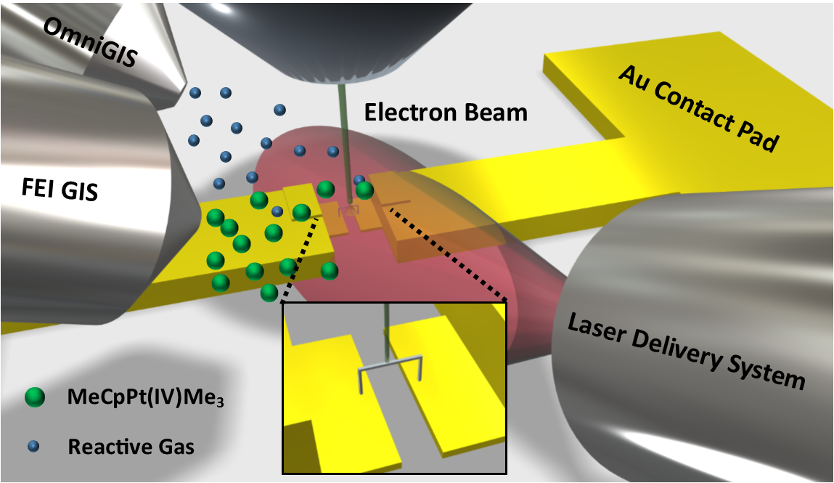
Figure 16: Schematic illustrating the experimental system which includes a laser delivery system, precursor and co-reactant gas delivery systems and the electron beam all coincident to the same region. The schematic also illustrates the deposition of the 3D suspended bridge structures grown for the electrical measurements.

Results and Discussion

Growth Rates
The relation between the vertical and lateral growth rates is a critical parameter required to accurately and reproducibly construct 3D nanostructures. Once this relation is known, the beam dwell time and pitch can be adjusted as necessary to construct more complex shapes⁸⁹. A simple unit demonstrating this relationship is the angle between a grown vertical post and a cantilever arm, depicted as θ in Figure 16. This angle will be termed “segment angle” hereafter. The vertical pillar is grown by parking the electron beam at a particular spot for 8 seconds, and the segment is grown off the pillar by stepping the electron beam in 1 nm increments for a given dwell time per point. The segment angle was determined for the following FEBID conditions: 1) standard FEBID (45°C precursor and standard precursor nozzle position), 2) FEBID with co-reactant Ar-O₂ flow, 3) FEBID with in situ laser assist, 4) FEBID with a retracted nozzle, and FEBID with 5) higher and 6) lower gas flux as modified by the precursor temperature (34°C and 50°C). Carbon content and growth rate is strongly affected by the particular FEBID condition used.
The best purity that can be achieved using an optimized beam voltage and current during FEBID is PtC₅⁴. Ex situ thermal annealing has been used to remove carbon in the past⁸¹ but causes severe structural distortions due to the large quantity of carbon removed. Thus, in situ purification is necessary for all but the simplest geometries because of severe volumetric reduction. More details on this effect can be found in the Appendix of this chapter in Figure 20.
Pulsed laser irradiation and gas pressure both affect the growth rate and morphology of the FEBID structures. A useful way to characterize this change is by fabricating a pillar + cantilever, or ‘segment’, using FEBID. Figure 16 depicts the changes in segment angle versus dwell time for several different growth conditions.
Figure 17: Segment angle plotted as a function of dwell time per pixel grown under six different conditions: 1) FEBID with standard precursor temp at 45ºC and a resultant chamber pressure of 1.2x10⁻⁵ mbar (gray) 2) FEBID standard Pt precursor conditions with an argon-oxygen co-flow at 1.83x10⁻⁵ mbar (blue) 3) FEBID with standard Pt precursor conditions with laser irradiation at a pulse width and frequency of 10 µs and 100 Hz, respectively (red) 4) FEBID with standard Pt precursor conditions with a retracted nozzle and lower precursor flux (purple) 5) and 6) FEBID with the precursor temperature raised or lowered, respectively, as indicated (black and orange). SEM images of the resulting pillar and segment, for each growth condition, are provided, where a common dwell time of 40 ms was used for each FEBID condition. The SEM images were acquired at a tilt angle of 52° with respect to the plane containing the pillar and segment.
The co-reactant flow (Figure 16, case #2) FEBID studied here affects neither growth rate nor segment angle, relative to standard FEBID (Figure 16, case #1). Relatively weak O₂-C binding is thought to govern this behavior even though the localized partial pressure of the co-reactant oxygen gas is estimated to be on the order of 1.5x higher. The O₂-C residence time is short (20 ns⁹⁰) relative to the MeCpPt(IV)Me3 precursor residence time (reported values ranging from 29 µs⁹¹ to 30 ms⁹²). The result is a negligible O₂ surface coverage which inhibits the purification reaction. As will be demonstrated below, the resultant 3D composition at these lower beam currents is not appreciably affected, contrary to growth conditions at higher beam currents and much higher partial pressures⁸³.
Laser-assisted FEBID (LAEBID) clearly impacts the final deposit growth and morphology (Figure 16, case #3). In this case, the segment angle decreases reflecting a decrease in the vertical growth rate per pixel dwell. The reduced growth rate is a result of two contributing factors, namely: 1) densification and carbon reduction⁷ and 2) reduced average precursor coverage due to the periodic laser heating. Segment volume per unit length is clearly less for the laser-assist case. Comparing the segment grown with and without the laser-assist, it is clear that the width of the segment with the laser-assist is narrower, indicative of a reduced growth rate and densification (discussed in more detail below).
The effective precursor surface coverage was decreased using two different FEBID configurations. In one case (#4), the precursor delivery nozzle was retracted and in another (#6) the precursor reservoir temperature was lowered from 45°C to 34°C. Both approaches yield a comparable segment angle to the laser-assisted FEBID – thus it is opined that the photothermal heating must produce an equilibrium precursor surface coverage comparable with the lower precursor flux growth. As expected, the higher Pt precursor temperature (#5) has a higher growth rate and higher segment angle for comparable dwell times.

STEM Imaging and EELS
STEM was used to investigate the morphology of the as-deposited and laser treated structures. In addition, the chemical nature of the carbon was characterized for different FEBID configurations using EELS. Figure 17 provides insight into the purification mechanisms during LAEBID. Figure 17a shows a high resolution STEM image of a standard FEBID segment grown off a silicon wafer edge in order to avoid substrate interactions during beam transmission. The electron beam dwell time per pixel was 10.4 ms (see the appendix for HAADF STEM images of the standard FEBID deposits in Figure 22). In total, five segments extending 600 nm in lateral displacement beyond the wafer edge were grown using dwell times: 6.78, 8.44, 10.4, 13.0, and 17.0 ms per point. The associated take-off angles for these deposits were 15°, 25°, 41°, 49°, and 53°, respectively. Note that the dwell times here are shorter because the precursor source was re-filled after running the calibration curves in section on growth rates. Five segments were also grown with the same dwell time range while simultaneously irradiating with the laser at a pulse width of 500 ns and a frequency of 20 Hz. The gentler laser conditions were necessary because the edge of the wafer acted as a thermal boundary, effectively increasing the rate of heating as compared to structures grown on a bulk substrate. Figure 17 shows the segments corresponding to dwell times of b) 10.4, c) 13.0, and d) 17.0 ms per point, with take-off angles 9°, 20°, and 42°, respectively. The lower dwell time segments had growth rates that were insufficiently high for continuous lateral growth, therefore “falling off” the edge.
Comparing Figure 17a with parts b, c, and d shows the stark difference between as-deposited FEBID structures and the laser treated structures. Here, Pt-rich regions are the relatively dark regions in the BF STEM images. Most notably, laser exposure induces platinum particle consolidation and growth while simultaneously driving a reduction in segment volume associated with the removal of carbon as well as carbon densification/graphitization. Figure 17f shows a plot of the segment widths as a function of dwell time per point for both the standard FEBID and the laser-assisted FEBID structures. For both FEBID and LAEBID the segment widths increase as a function of increasing dwell time, which is consistent with standard FEBID and IBID growth models; longer dwell times shift the growth to a mass transport limited regime at the growth apex and subsequently enhances competitive lateral growth from the transmitted beam³⁸. Temperature-dependent diffusion drives grain growth favoring a reduction in platinum surface area⁹³⁻⁹⁴. Comparing Figure 17b and Figure 17d, it is clear that the longer dwell time segments experience more grain coarsening and thus must realize a higher temperature. While higher absorption for the wider deposits grown at longer dwell time was initially suspected to cause the increased grain coarsening, thermal simulations (see below) reveal that the longer total length of the pillars at higher dwell times is the dominant factor.
EELS was performed to determine the influence of the laser annealing treatment on the evolution of the carbon structure contained within the deposited pillar. The carbon K-edge provides information on the electronic structure of carbon and analysis of characteristic features contained within the energy loss near edge structure (ELNES) indicates whether carbon is amorphous, graphitic or diamond. Figure 13e shows the corresponding background subtracted carbon K-edge EEL spectra from the as-deposited (black) pillar and the laser-treated (red) pillar. Each spectra contains the π* and σ* that peaks at ∼285 eV and ∼291.5 eV, respectively. The carbon K-edge from the as-deposited samples shows diffuse π* peak and σ* peak which closely resemble that of amorphous carbon⁹⁵. Following the laser treatment, the characteristic π* and σ* peaks have sharper spectral features, indicating that the carbon has been transformed from amorphous to graphitic. The laser treatment thus induces C phase transformation from amorphous to graphite, which is consistent with other higher temperature studies⁹⁶⁻⁹⁷ involving FEBID carbon.
Figure 18: BF STEM images of a) an as-deposited FEBID segment with a 10.4 ms dwell time per pixel and in situ LAEBID performed at various dwell times per point including b) 10.4 ms, c) 13.0 ms and d) 17.0 ms. e) EELS spectra obtained from as-deposited and laser-treated segments grown with a dwell time of 17 ms per point. f) Plot of segment width as a function of dwell time for both standard FEBID segments and laser-treated FEBID segments. The segment angles for both conditions are plotted on a secondary axis. The alphabetic labels highlight the points corresponding to the BF STEM images in parts a) – d).

Electrical Measurements
The resistivity of patterned nanobridges was measured to correlate the standard FEBID growth conditions as well as the observed Pt grain coarsening and carbon reduction/transformation for the LAEBID growth conditions. For reference, bulk platinum has a resistivity on the order of 11 µΩ-cm. As shown in Figure 17a deposits grown using the MeCpPt(IV)Me3 precursor have a microstructure that consists of nanocrystalline platinum grains embedded in an amorphous carbon matrix which is consistent with many previous reports^{4-5, 98}. The nanogranular nature leads to intergranular tunneling and resistivities tunable over orders of magnitudes, all much higher than bulk platinum³¹. Figure 18a and b show SEM images of nanobridges grown with and without laser assist, respectively, and Figure 18e is a plot of the resultant calculated resistivity versus electron beam dwell time for various FEBID conditions.
Purification of the nanobridges can be qualitatively indicated by their resistivity. Lower resistivity corresponds to a higher platinum concentration as well as graphitization of the amorphous carbon matrix. Figure 18 compares two nanobridges: a) grown under standard FEBID and b) LAEBID with the laser driven at a frequency of 100 Hz with a 10 us pulse width. Both bridges were grown using the same electron beam scanning parameters, namely a 4 second spot dwell to grow a short vertical pillar followed by a 100 us dwell per nm for the segment spanning the gap, where each half of the bridge was grown in parallel with the other half by alternating the beam from side to side (see the Appendix, Figure 21 for more details). The SEM images show increased contrast on the bridge that was grown with the laser assist, especially near the center and higher-up on the pillars away from the substrate.
Figure 18e reveals several trends in the resistivity of the 3D FEBID and laser-assisted FEBID structures. First, for the standard FEBID growths, the resistivity decreases almost 4 orders of magnitude with increasing dwell time over the range measured. This is consistent with previous work illustrating that the C/Pt ratio (and consequently the resistivity) decreases from nearly 8/1 to 5/1 with increasing current⁵. HAADF STEM images of the standard FEBID segments grown with different dwell time are shown in the appendix in Figure 24. Secondly, the laser-assisted FEBID growths also follow a similar trend, albeit a narrower range, in that the resistivity decreases as a function of increasing dwell time which is consistent with the TEM observations. Thirdly, and as-expected, the resistivity for the laser-assisted FEBID reduces approximately two orders of magnitude relative to the standard FEBID conditions. Finally, the effect of the O₂ co-flow is negligible for both the standard FEBID and LAEBID which is consistent with the fact that the observed segment angle versus dwell time plots were not affected.
One of the side effects of purification is necessarily the volume reduction associated with the impurity removal from the deposit. This volumetric reduction can be detrimental to the fidelity of complex shapes when purified ex situ – especially complex shapes that contain many vertices⁹⁹ (see Supplement for images). Figure 18c and d show 10-sided polygons grown without and with laser-assist, respectively, which illustrates that the in situ laser assisted process can preserve the shape fidelity with higher resolution due to isotropic volumetric reduction.
Figure 19: SEM images (scale bar length is 100 nm) of suspended nanowires grown across a ~500 nm gap using a dwell time per point of 100 ms a) without laser treatment or a reactive co-flow and b) with both a reactive gas co-flow and laser assist. 10-sided polygons constructed c) without laser-assist and d) with laser-assist using a 10 µs pulse width with a pulse frequency of 100 Hz. e) is a plot of the resistivity of suspended nanowires as a function of beam dwell time under different growth conditions (see legend). The white arrows in part b highlight the morphological transition from standard FEBID-like (darker) to higher purity (bright).

Thermal Simulations
Thermal simulations were performed in order to approximate thermal profile of the laser exposure during deposition and its impact on the resultant grain structure and carbon removal. In standard FEBID using the MeCpPt(IV)Me3 precursor, the initial reaction leading to condensation occurs with the cleavage of a single bond between a methyl group and the platinum atom, surmised to occur primarily through dissociative electron attachment (DEA) along with smaller contributions from other reaction pathways⁷⁹. After this initial cleavage event, subsequent electron exposure enables further decomposition of the precursor, ultimately allowing the removal of more methyl groups, though still falling short of complete removal.
At elevated temperatures, the situation is different. MeCpPt(IV)Me3 was originally developed for use as a thermal chemical vapor deposition (CVD) precursor¹⁰⁰; the thermal decomposition temperature on the order of 120ºC in the presence of H₂ results in pure Pt films. Thus, with LAEBID we leverage the pulsed thermal energy of the laser to aid the removal carbon impurities from the FEBID platinum where the process is likely facilitated by residual water vapor in the chamber^{86, 101}.
As is shown in Figure 17b – d there appears to be enhanced coarsening of the grains with increasing dwell time. Notably, these wires were grown in parallel, and thus all of the wires were exposed to the same number of laser pulses. If run in series (and separated beyond the laser spot size) the longer dwell time would experience more laser pulses. Initially, we suspected that wider nanopillars grown with longer dwell times per pixel would heat to a greater extent because they are optically thin, and wider pillars would experience more absorption. However, thermal simulations do not bear this out as larger radius simulations actually have slightly lower peak temperature, due to enhanced thermal transport to the substrate. Still, the length of the nanopillars changes with increasing dwell time, which effectively thermally isolates the pillar from the substrate enabling an increase in temperature (see the Temperature Simulation and Elemental Mapping section of the appendix in this chapter for more details). We thus attribute the enhanced coarsening at higher dwell times to the increase in temperature from the pulsed laser during deposition.
Visual inspection of the scanning electron micrograph in Figure 18b reveals two regimes for the LAEBID bridge; one with lower and one with higher SE yields. Indeed, STEM imaging corroborates that the bright areas correspond to higher purity and the lower SE yield corresponds to microstructure more closely related to as-deposited morphology. The variation in composition is caused by changes in the temperature profile within the segment as segment length increases: thermal transport to the substrate is limited by the pseudo 1-dimensional geometry of the segment. Figure 19a plots the simulated temperature at the top of an FEBID Pt-C pillar and the substrate immediately beneath the base of the pillar (see the Temperature Simulation section of the appendix in this chapter). The radius of the pillar is 50 nm and the pillar height varies from 20 to 640 nm. The experimental laser conditions are estimated to heat the silicon substrate to ~510 K. As the aspect ratio of the pillar increases, the temperature at the top of the pillar increases, whereas the silicon substrate remains constant. Experimentally, when the pillar grows to roughly 250 nm, the temperature from the laser reaches a point at which significant purification is evident. According to simulation, this height corresponds to a temperature of ~ 550 K.
Figure 20: COMSOL™ simulation results showing the preferential heating at of the FEBID deposit. a) is a plot of the maximum temperatures of both the top and bottom of the pillar at varying growth heights. The radius for the pillars was kept constant at 50 nm. b) shows the spatially resolved simulated temperatures in the system. Reading from right to left, the insets show a representative time-temperature plot for a single pillar grown to a height of 200 nm and a zoom-in on the pillar.

Conclusion
High fidelity 3-dimensional structures were fabricated using pulsed laser-assisted electron beam induced deposition with MeCpPt(IV)Me3 as a precursor gas. We investigated the internal morphology of freestanding structures grown using both standard FEBID and LAEBID with STEM and EELS. Standard 3D FEBID structures exhibit a grain size and resistivity dependence on electron beam dwell time. In the laser-treated deposits, Pt grain coarsening and a decrease in resistivity are observed at higher dwell times/higher segment angles. The 3D nanostructures maintain high fidelity during laser irradiation and realize a 100-fold decrease in resistivity when compared to standard FEBID. This improvement in electron transport is attributed to carbon removal, graphitization, and Pt grain growth – all of which occur as a result of thermal energy from the pulsed laser system. Thermal simulations corroborate experimental data, showing that a temperature of >280ºC is required to catalyze the purification process. Importantly, this work was done in the context of maintaining a high degree of spatial control when constructing complex 3D mesh geometries. To this end, we demonstrated a method for calibrating the relationship between vertical and lateral growth. This method can be used in virtually any FEBID system for a variety of different growth conditions.

Appendix

Fidelity
One of the more difficult considerations in purifying complex 3 dimensional structures is the fact that most purification processes are isotropic in nature. This is beneficial when one considers a simple planar structure, but presents a problem for multi-dimensional nodular structures. In the simple case, ex situ purification schemes are acceptable and will not compromise the integrity of the final structure, but this is simply not the case when using complex structures as shown in Figure 20. For high fidelity to be reliably achieved, in situ purification methods must be employed.

Figure 21: Cross-sectional SEM images demonstrating the utility of in situ laser purification compared to ex situ laser purification. a) shows a complex 10-sided polygon as-deposited without any laser annealing. b) shows the same polygon purified with laser annealing ex situ and c) shows the same polygon purified in situ. The insets show the top down SEM images corresponding to each cross-sectional image. This illustrates the importance of in situ purification strategies when dealing with complex 3D structures. The deformation is much larger with ex situ annealing than the in situ annealing. The scale bar is 100 nm.

Bridge Patterning
An alternating pattern was used to create the suspended bridges spanning the gap between the gold electrodes. This strategy was implemented in order to eliminate drift artifacts thermal, mechanical, and electronic in nature.
Figure 22: Schematic illustrating the alternating pattern of the nanobridges spanning the gap in the two-point probe contact pads. The arrow represents the electron beam location and the silver circles represent a deposit created during the beam dwell at the particular point. The patterning of the beam progresses from 1 to 4 and beyond bridging the gap by an alternating patterning strategy.⁹⁹

Temperature Simulations
COMSOL™ Multiphysics 5.0, a commercial finite element method software package, was used to simulate the thermal profile of a single laser pulse on the different geometries. The expression for heat delivered to the substrate from the laser is derived from the Beer-Lambert law:
$Q_{in}\left(x,y,z\right)=Q{}_{0}\left(1-R_{c}\right)×\frac{A_{c}}{πσ_{x}σ_{y}}×G\left(x,y\right)×f(t)×exp⁡(-A_{c}z)$;
where Q₀ is the optical power of the laser, R_{c} is the reflectivity, A_{c} is the absorption coefficient, G(x,y) is the 2-dimensional Gaussian laser profile, σ_{x} and σ_{y} are the 1/e radii of the Gaussian laser profile, f(t) is the laser on time, and z is the depth from the surface. The reflectivity and absorption coefficient are given by:
$R_{c}=\frac{{\left(n-1\right)}^{2}+k^{2}}{{\left(n+1\right)}^{2}+k^{2}}$;
$A_{c}=\frac{4πk}{λ}$;
where the values for n, k, and lambda are given in Table S1 for both silicon and FEBID platinum. The laser on time, f(t), was approximated as a rectangular pulse with a 10 ns ramp time and a pulse width of 10 µs. The following time dependent heat equation was used to simulate the heat transfer throughout the silicon substrate:
$ρC_{p}\frac{∂T}{∂t}+ ρC_{p}u∙∇T=∇∙\left(κ∇T\right)+Q_{in}\left(x,y,z\right)$;
where ρ is the material density, C_{p} is the heat capacity at constant pressure, u is the velocity vector for thermal transport, and κ is the thermal conductivity. Convective heat transfer to the surrounding atmosphere was neglected since irradiation conditions were under high vacuum. T₀ was defined as 293.15 K. A backward differentiation formula time-stepping method with strict time steps of 10 ns was used to generate the temporal temperature evolution for system during laser irradiation. The asymmetry of the Gaussian beam profile accounts for the angle of the laser with respect to the substrate during pillar growth (52º). Table 2 shows the important material parameters used in this simulation. For more information concerning the FEBID platinum material values consult ref. ³⁰.
Table 2: Simulation Parameters
Symbol | Name | Value Silicon | value PtC_{x}
n | Real index of refraction | 3.63 | 1.87
k | Imaginary index of refraction | 0.0023 | 0.311
λ | Laser wavelength | 915 nm | 915 nm
ρ | Material Density | 2.329 g/cm³ | 4.550 g/cm³
C_{p} | Heat capacity at constant Pressure | 700 J/(kg-K) | 360 J/(kg-K)
κ | Thermal Conductivity | 130 W/(m-K) | 8.6 W/(m-K)
Q₀ | Optical Laser Power | 20 W | 20 W
σ_{x} | 1/e radius in the x direction | 50 µm | 50 µm
σ_{y} | 1/e radius in the y direction | 35.35 µm | 35.35 µm
R_{p} | Pillar Radius | n/a | 50 nm
Figure 23: a) Time-Temperature simulation results of a nanopillar segment with constant length (600 nm) and various segment thicknesses (δ) as denoted in the legend. The pillar is placed at the edge of a solid silicon block directly horizontal from the substrate and perpendicular to the direction of the laser. The peak temperature slightly decreases as the thickness of the pillar grows due to enhanced coupling with the substrate. The temperature profiles are taken from the top of the pillar; the farthest point away from the substrate, illustrated by an orange dot in the schematic. b) A schematic illustrating the simulation geometry.
Figure 24: a) Time-temperature simulation results a nanopillar segments grown at the various lengths and widths. These lengths correspond to the experimental values of the pillars grown and analyzed using STEM and EELS. The values in the legend are of the following format: dwell time, length x diameter. The temperature was sampled at the center of the segment to correspond with the STEM images shown in Figure 3 of the article. The maximum values for the temperature show that the segment attains a higher heat for the longer segments. This confirms the observation that higher temperatures produce purer structures with larger Pt grain sizes. b) Spatially resolved temperature profile of the smallest pillar corresponding to the green curve in part a. The inset is a zoom-in of the pillar and the arrow depicts the point from which the temperature profiles are sample from in part a.

HAADF STEM Images
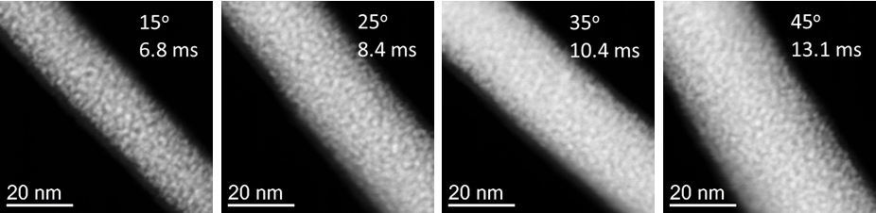
Figure 25: High angle annular dark field (HAADF) STEM images of as deposited segments showing the grain size coarsening as a function of increasing dwell time.

Elemental Mapping
Figure 26: STEM EELS maps showing the distribution of Pt (red) and C (green) in laser treated FEBID segments. a) Near the tip (far from the substrate surface) of a 55°, 17.0 ms segment grown off a silicon wafer edge. b) Near the bottom (closer to the substrate surface) of a 55°, 17.0 ms segment grown off the silicon wafer edge. The compositional difference highlights significant effect thermal transport has on the extent of purification.

CHAPTER IV
Nanomechanical Characterization

CONCLUSION

This is the conclusion for the entire document. It can be a numbered chapter or it can stand alone. If you did not make your introduction a chapter and give it a number, you should not make the conclusion a numbered chapter. If you DID call your Introduction “Chapter 1”, you should give your conclusion a chapter number.

Heading 2
Write here.

VITA

Jane X. Doe was born. She wrote a thesis. She graduated. She followed instructions and wrote her vita in third person and paragraph form (as opposed to a resume or CV), which made her thesis consultant very happy. This page is required.

1. Xia, Y.; Rogers, J. A.; Paul, K. E.; Whitesides, G. M., Unconventional methods for fabricating and patterning nanostructures. Chemical reviews 1999, 99 (7), 1823-1848.
2. Utke, I.; Moshkalev, S.; Russell, P., Nanofabrication Using Focused Ion and Electron Beams: Principles and Applications. Oxford University Press: Oxford, U.K., 2012.
3. Mulders, J. J. L., Purity and resistivity improvements for electron-beam-induced deposition of Pt. Appl. Phys. A 2014, 117 (4), 1697-1704.
4. Botman, A.; Hesselberth, M.; Mulders, J. J. L., Improving the conductivity of platinum-containing nano-structures created by electron-beam-induced deposition. Microelectronic Engineering 2008, 85 (5–6), 1139-1142.
5. De Teresa, J. M.; Córdoba, R.; Fernández-Pacheco, A.; Montero, O.; Strichovanec, P.; Ibarra, M. R., Origin of the Difference in the Resistivity of As-Grown Focused-Ion- and Focused-Electron-Beam-Induced Pt Nanodeposits. Journal of Nanomaterials 2009, 2009, 11.
6. Rosenberg, S. G.; Landheer, K.; Hagen, C. W.; Fairbrother, D. H., Substrate temperature and electron fluence effects on metallic films created by electron beam induced deposition. Journal of Vacuum Science & Technology B 2012, 30 (5), 051805.
7. Roberts, N. A.; Fowlkes, J. D.; Magel, G. A.; Rack, P. D., Enhanced material purity and resolution via synchronized laser assisted electron beam induced deposition of platinum. Nanoscale 2013, 5 (1), 408-415.
8. Roberts, N. A.; Magel, G. A.; Hartfield, C. D.; Moore, T. M.; Fowlkes, J. D.; Rack, P. D., In situ laser processing in a scanning electron microscope. Journal of Vacuum Science & Technology A: Vacuum, Surfaces, and Films 2012, 30 (4), 041404.
9. Riazanova, A. V.; Rikers, Y. G. M.; Mulders, J. J. L.; Belova, L. M., Pattern Shape Control for Heat Treatment Purification of Electron-Beam-Induced Deposition of Gold from the Me2Au(acac) Precursor. Langmuir 2012, 28 (14), 6185-6191.
10. Botman, A.; Hagen, C. W.; Li, J.; Thiel, B. L.; Dunn, K. A.; Mulders, J. J. L.; Randolph, S.; Toth, M., Electron postgrowth irradiation of platinum-containing nanostructures grown by electron-beam-induced deposition from Pt(PF3)4. Journal of Vacuum Science & Technology B 2009, 27 (6), 2759-2763.
11. Folch, A.; Tejada, J.; Peters, C. H.; Wrighton, M. S., Electron beam deposition of gold nanostructures in a reactive environment. Applied physics letters 1995, 66 (16), 2080-2082.
12. Mølhave, K.; Madsen, D. N.; Rasmussen, A. M.; Carlsson, A.; Appel, C. C.; Brorson, M.; Jacobsen, C. J.; Bøggild, P., Solid gold nanostructures fabricated by electron beam deposition. Nano Letters 2003, 3 (11), 1499-1503.
13. Geier, B.; Gspan, C.; Winkler, R.; Schmied, R.; Fowlkes, J. D.; Fitzek, H.; Rauch, S.; Rattenberger, J.; Rack, P. D.; Plank, H., Rapid and Highly Compact Purification for Focused Electron Beam Induced Deposits: A Low Temperature Approach Using Electron Stimulated H2O Reactions. The Journal of Physical Chemistry C 2014, 118 (25), 14009-14016.
14. Riazanova, A. V.; Costanzi, B. N.; Aristov, A.; Rikers, Y. G.; Strom, V.; Mulders, J. J.; Kabashin, A. V.; Dahlberg, E. D.; Belova, L. M., Gas-assisted electron-beam-induced nanopatterning of high-quality Si-based insulator. Nanotechnology 2014, 25 (15), 155301.
15. Plank, H.; Noh, J. H.; Fowlkes, J. D.; Lester, K.; Lewis, B. B.; Rack, P. D., Electron-beam-assisted oxygen purification at low temperatures for electron-beam-induced pt deposits: towards pure and high-fidelity nanostructures. ACS Appl Mater Interfaces 2014, 6 (2), 1018-24.
16. Fowlkes, J. D.; Randolph, S. J.; Rack, P. D., Growth and simulation of high-aspect ratio nanopillars by primary and secondary electron-induced deposition. Journal of Vacuum Science &amp; Technology B 2005, 23 (6), 2825-2832.
17. van Dorp, W. F.; Wnuk, J. D.; Gorham, J. M.; Fairbrother, D. H.; Madey, T. E.; Hagen, C. W., Electron induced dissociation of trimethyl (methylcyclopentadienyl) platinum (IV): Total cross section as a function of incident electron energy. Journal of Applied Physics 2009, 106 (7), 074903.
18. Scheuer, V.; Koops, H.; Tschudi, T., Electron beam decomposition of carbonyls on silicon. Microelectronic Engineering 1986, 5 (1–4), 423-430.
19. Arnold, G.; Timilsina, R.; Fowlkes, J.; Orthacker, A.; Kothleitner, G.; Rack, P. D.; Plank, H., Fundamental Resolution Limits during Electron-Induced Direct-Write Synthesis. ACS Applied Materials & Interfaces 2014, 6 (10), 7380-7387.
20. Botman, A.; Mulders, J. J. L.; Hagen, C. W., Creating pure nanostructures from electron-beam-induced deposition using purification techniques: a technology perspective. Nanotechnology 2009, 20 (37), 372001.
21. Huth, M.; Porrati, F.; Schwalb, C.; Winhold, M.; Sachser, R.; Dukic, M.; Adams, J.; Fantner, G., Focused electron beam induced deposition: A perspective. Beilstein journal of nanotechnology 2012, 3, 597-619.
22. Klein, K. L.; Randolph, S. J.; Fowlkes, J. D.; Allard, L. F.; H. M. Meyer, I.; Simpson, M. L.; Rack, P. D., Single-crystal nanowires grown via electron-beam-induced deposition. Nanotechnology 2008, 19 (34), 345705.
23. Fernández-Pacheco, A.; Teresa, J. M. D.; Córdoba, R.; Ibarra, M. R., Magnetotransport properties of high-quality cobalt nanowires grown by focused-electron-beam-induced deposition. Journal of Physics D: Applied Physics 2009, 42 (5), 055005.
24. Brintlinger, T.; Fuhrer, M. S.; Melngailis, J.; Utke, I.; Bret, T.; Perentes, A.; Hoffmann, P.; Abourida, M.; Doppelt, P., Electrodes for carbon nanotube devices by focused electron beam induced deposition of gold. Journal of Vacuum Science & Technology B: Microelectronics and Nanometer Structures 2005, 23 (6), 3174.
25. Rykaczewski, K.; White, W. B.; Fedorov, A. G., Analysis of electron beam induced deposition (EBID) of residual hydrocarbons in electron microscopy. Journal of Applied Physics 2007, 101 (5), 054307.
26. Mehendale, S.; Mulders, J. J.; Trompenaars, P. H., A new sequential EBID process for the creation of pure Pt structures from MeCpPtMe3. Nanotechnology 2013, 24 (14), 145303.
27. Toth, M.; Lobo, C. J.; Hartigan, G.; Ralph Knowles, W., Electron flux controlled switching between electron beam induced etching and deposition. Journal of Applied Physics 2007, 101 (5), 054309.
28. Nicholas, A. R.; Carlos, M. G.; Jason, D. F.; Philip, D. R., Enhanced by-product desorption via laser assisted electron beam induced deposition of W(CO) 6 with improved conductivity and resolution. Nanotechnology 2013, 24 (41), 415301.
29. Graells, S.; Alcubilla, R.; Badenes, G.; Quidant, R., Growth of plasmonic gold nanostructures by electron beam induced deposition. Applied Physics Letters 2007, 91 (12), 121112.
30. Stanford, M. G.; Lewis, B. B.; Noh, J. H.; Fowlkes, J. D.; Roberts, N. A.; Plank, H.; Rack, P. D., Purification of Nanoscale Electron-Beam-Induced Platinum Deposits via a Pulsed Laser-Induced Oxidation Reaction. ACS Appl Mater Interfaces 2014, 6 (23), 21256-21263.
31. Porrati, F.; Sachser, R.; Schwalb, C. H.; Frangakis, A. S.; Huth, M., Tuning the electrical conductivity of Pt-containing granular metals by postgrowth electron irradiation. Journal of Applied Physics 2011, 109 (6), 063715.
32. Sachser, R.; Reith, H.; Huzel, D.; Winhold, M.; Huth, M., Catalytic purification of directly written nanostructured Pt microelectrodes. ACS Appl Mater Interfaces 2014, 6 (18), 15868-74.
33. Mackus, A. J. M.; Thissen, N. F. W.; Mulders, J. J. L.; Trompenaars, P. H. F.; Verheijen, M. A.; Bol, A. A.; Kessels, W. M. M., Direct-Write Atomic Layer Deposition of High-Quality Pt Nanostructures: Selective Growth Conditions and Seed Layer Requirements. The Journal of Physical Chemistry C 2013, 117 (20), 10788-10798.
34. Noh, J. H.; Stanford, M. G.; Lewis, B. B.; Fowlkes, J. D.; Plank, H.; Rack, P. D., Nanoscale electron beam-induced deposition and purification of ruthenium for extreme ultraviolet lithography mask repair. Appl. Phys. A 2014, 117 (4), 1705-1713.
35. Hopf, C.; Schlüter, M.; Schwarz-Selinger, T.; von Toussaint, U.; Jacob, W., Chemical sputtering of carbon films by simultaneous irradiation with argon ions and molecular oxygen. New Journal of Physics 2008, 10 (9), 093022.
36. Mackus, A. J. M.; Leick, N.; Baker, L.; Kessels, W. M. M., Catalytic Combustion and Dehydrogenation Reactions during Atomic Layer Deposition of Platinum. Chemistry of Materials 2012, 24 (10), 1752-1761.
37. Winkler, R.; Fowlkes, J.; Szkudlarek, A.; Utke, I.; Rack, P. D.; Plank, H., The Nanoscale Implications of a Molecular Gas Beam during Electron Beam Induced Deposition. ACS Applied Materials & Interfaces 2014, 6 (4), 2987-2995.
38. Smith, D. A.; Fowlkes, J. D.; Rack, P. D., Simulating the effects of surface diffusion on electron beam induced deposition via a three-dimensional Monte Carlo simulation. Nanotechnology 2008, 19 (41), 415704.
39. Bresin, M.; Toth, M.; Dunn, K. A., Direct-write 3D nanolithography at cryogenic temperatures. Nanotechnology 2013, 24 (3), 035301.
40. Frabboni, S.; Gazzadi, G. C.; Felisari, L.; Spessot, A., Fabrication by electron beam induced deposition and transmission electron microscopic characterization of sub-10-nm freestanding Pt nanowires. Applied Physics Letters 2006, 88 (21), 213116.
41. Kretz, J.; Rudolph, M.; Weber, M.; Koops, H., Three-dimensional structurization by additive lithography, analysis of deposits using TEM and EDX, and application to field-emitter tips. Microelectronic Engineering 1994, 23 (1), 477-481.
42. Esposito, M.; Tasco, V.; Cuscunà, M.; Todisco, F.; Benedetti, A.; Tarantini, I.; Giorgi, M. D.; Sanvitto, D.; Passaseo, A., Nanoscale 3D Chiral Plasmonic Helices with Circular Dichroism at Visible Frequencies. ACS Photonics 2015, 2 (1), 105-114.
43. Bret, T.; Utke, I.; Hoffmann, P., Influence of the beam scan direction during focused electron beam induced deposition of 3D nanostructures. Microelectronic Engineering 2005, 78–79, 307-313.
44. Auth, C.; Allen, C.; Blattner, A.; Bergstrom, D.; Brazier, M.; Bost, M.; Buehler, M.; Chikarmane, V.; Ghani, T.; Glassman, T.; Grover, R.; Han, W.; Hanken, D.; Hattendorf, M.; Hentges, P.; Heussner, R.; Hicks, J.; Ingerly, D.; Jain, P.; Jaloviar, S.; James, R.; Jones, D.; Jopling, J.; Joshi, S.; Kenyon, C.; Liu, H.; McFadden, R.; McIntyre, B.; Neirynck, J.; Parker, C.; Pipes, L.; Post, I.; Pradhan, S.; Prince, M.; Ramey, S.; Reynolds, T.; Roesler, J.; Sandford, J.; Seiple, J.; Smith, P.; Thomas, C.; Towner, D.; Troeger, T.; Weber, C.; Yashar, P.; Zawadzki, K.; Mistry, K. In A 22nm high performance and low-power CMOS technology featuring fully-depleted tri-gate transistors, self-aligned contacts and high density MIM capacitors, VLSI Technology (VLSIT), 2012 Symposium on, 12-14 June 2012; 2012; pp 131-132.
45. Bauer, J.; Schroer, A.; Schwaiger, R.; Kraft, O., Approaching theoretical strength in glassy carbon nanolattices. Nat Mater 2016, 15 (4), 438-443.
46. Li, C.; He, H.; Bogozi, A.; Bunch, J.; Tao, N., Molecular detection based on conductance quantization of nanowires. Applied Physics Letters 2000, 76 (10), 1333-1335.
47. Panagiotakopoulou, M.; Bergert, M.; Taubenberger, A.; Guck, J.; Poulikakos, D.; Ferrari, A., A Nanoprinted Model of Interstitial Cancer Migration Reveals a Link between Cell Deformability and Proliferation. ACS Nano 2016.
48. Parkin, S. S.; Hayashi, M.; Thomas, L., Magnetic domain-wall racetrack memory. Science 2008, 320 (5873), 190-194.
49. Zhang, Y.; Yan, Z.; Nan, K.; Xiao, D.; Liu, Y.; Luan, H.; Fu, H.; Wang, X.; Yang, Q.; Wang, J.; Ren, W.; Si, H.; Liu, F.; Yang, L.; Li, H.; Wang, J.; Guo, X.; Luo, H.; Wang, L.; Huang, Y.; Rogers, J. A., A mechanically driven form of Kirigami as a route to 3D mesostructures in micro/nanomembranes. Proceedings of the National Academy of Sciences 2015, 112 (38), 11757-11764.
50. Zaumseil, J.; Meitl, M. A.; Hsu, J. W. P.; Acharya, B. R.; Baldwin, K. W.; Loo, Y.-L.; Rogers, J. A., Three-Dimensional and Multilayer Nanostructures Formed by Nanotransfer Printing. Nano Letters 2003, 3 (9), 1223-1227.
51. Meyyappan, M.; Delzeit, L.; Cassell, A.; Hash, D., Carbon nanotube growth by PECVD: a review. Plasma Sources Science and Technology 2003, 12 (2), 205.
52. Javier, P.-N.; César, M.; José María de, T., Three-dimensional core–shell ferromagnetic nanowires grown by focused electron beam induced deposition. Nanotechnology 2016, 27 (28), 285302.
53. Fowlkes, J. D.; Winkler, R.; Lewis, B. B.; Stanford, M. G.; Plank, H.; Rack, P. D., Simulation-Guided 3D Nanomanufacturing via Focused Electron Beam Induced Deposition. ACS Nano 2016, 10 (6), 6163-6172.
54. Peinado, P.; Sangiao, S.; De Teresa, J. M., Focused electron and ion beam induced deposition on flexible and transparent polycarbonate substrates. ACS nano 2015, 9 (6), 6139-6146.
55. Boero, G.; Utke, I.; Bret, T.; Quack, N.; Todorova, M.; Mouaziz, S.; Kejik, P.; Brugger, J.; Popovic, R.; Hoffmann, P., Submicrometer Hall devices fabricated by focused electron-beam-induced deposition. Applied Physics Letters 2005, 86 (LMIS1-ARTICLE-2005-002), 042503 (3 pages).
56. Schwalb, C. H.; Grimm, C.; Baranowski, M.; Sachser, R.; Porrati, F.; Reith, H.; Das, P.; Müller, J.; Völklein, F.; Kaya, A.; Huth, M., A Tunable Strain Sensor Using Nanogranular Metals. Sensors 2010, 10 (11), 9847.
57. Dukic, M.; Winhold, M.; Schwalb, C. H.; Adams, J. D.; Stavrov, V.; Huth, M.; Fantner, G. E., Direct-write nanoscale printing of nanogranular tunnelling strain sensors for sub-micrometre cantilevers. Nature Communications 2016, 7, 12487.
58. Yang, X.; Simpson, M.; Randolph, S.; Rack, P.; Baylor, L.; Cui, H.; Gardner, W., Integrated tungsten nanofiber field emission cathodes selectively grown by nanoscale electron beam-induced deposition. Applied Physics Letters 2005, 86 (18), 183106.
59. Koops, H.; Schössler, C.; Kaya, A.; Weber, M., Conductive dots, wires, and supertips for field electron emitters produced by electron‐beam induced deposition on samples having increased temperature. Journal of Vacuum Science & Technology B 1996, 14 (6), 4105-4109.
60. Choo, H.; Kim, M.-K.; Staffaroni, M.; Seok, T. J.; Bokor, J.; Cabrini, S.; Schuck, P. J.; Wu, M. C.; Yablonovitch, E., Nanofocusing in a metal-insulator-metal gap plasmon waveguide with a three-dimensional linear taper. Nature Photonics 2012, 6 (12), 838-844.
61. Waiblinger, M.; Kornilov, K.; Hofmann, T.; Edinger, K. In e-beam induced EUV photomask repair: a perfect match, 2010; pp 75450P-75450P-8.
62. Lassiter, M. G.; Liang, T.; Rack, P. D., Inhibiting spontaneous etching of nanoscale electron beam induced etching features: Solutions for nanoscale repair of extreme ultraviolet lithography masks. Journal of Vacuum Science & Technology B 2008, 26 (3), 963-967.
63. Rodriguez, B. J.; Jesse, S.; Seal, K.; Baddorf, A. P.; Kalinin, S. V.; Rack, P. D., Fabrication, dynamics, and electrical properties of insulated scanning probe microscopy probes for electrical and electromechanical imaging in liquids. Applied Physics Letters 2007, 91 (9), 093130.
64. Brown, J.; Kocher, P.; Ramanujan, C. S.; Sharp, D. N.; Torimitsu, K.; Ryan, J. F., Electrically conducting, ultra-sharp, high aspect-ratio probes for AFM fabricated by electron-beam-induced deposition of platinum. Ultramicroscopy 2013, 133, 62-66.
65. Chen, I. C.; Li-Han, C.; Christine, O.; Arjan, Q.; Ratnesh, L.; Sungho, J., Fabrication of high-aspect-ratio carbon nanocone probes by electron beam induced deposition patterning. Nanotechnology 2006, 17 (17), 4322.
66. Utke, I.; Hoffmann, P.; Berger, R.; Scandella, L., High-resolution magnetic Co supertips grown by a focused electron beam. Applied physics letters 2002, 80 (25), 4792-4794.
67. Kianinia, M.; Schell, A. W.; Shimoni, O.; Randolph, S. J.; Toth, M.; Aharonovich, I.; Lobo, C. J., Robust, directed assembly of fluorescent nanodiamonds. arXiv preprint arXiv:1605.05016 2016.
68. Teresa, J. M. D.; Fernández-Pacheco, A.; Córdoba, R.; Serrano-Ramón, L.; Sangiao, S.; Ibarra, M. R., Review of magnetic nanostructures grown by focused electron beam induced deposition (FEBID). Journal of Physics D: Applied Physics 2016, 49 (24), 243003.
69. Gavagnin, M.; Wanzenboeck, H. D.; Belic, D.; Bertagnolli, E., Synthesis of individually tuned nanomagnets for nanomagnet logic by direct write focused electron beam induced deposition. ACS nano 2012, 7 (1), 777-784.
70. Fowlkes, J. D.; Doktycz, M. J.; Rack, P. D., An optimized nanoparticle separator enabled by electron beam induced deposition. Nanotechnology 2010, 21 (16), 165303.
71. Yingfeng, G.; Jason, D. F.; Scott, T. R.; Michael, L. S.; Philip, D. R., Nanoscale lithography via electron beam induced deposition. Nanotechnology 2008, 19 (50), 505302.
72. Weppelman, I. G. C.; Post, P. C.; Heerkens, C. T. H.; Hagen, C. W.; Hoogenboom, J. P., Fabrication of narrow-gap nanostructures using electron-beam induced deposition etch masks. Microelectronic Engineering 2016, 153, 77-82.
73. Mulders, J. J. L.; Belova, L. M.; Riazanova, A., Electron beam induced deposition at elevated temperatures: compositional changes and purity improvement. Nanotechnology 2011, 22 (5), 055302.
74. Gazzadi, G. C.; Frabboni, S.; Menozzi, C., Suspended nanostructures grown by electron beam-induced deposition of Pt and TEOS precursors. Nanotechnology 2007, 18 (44), 445709.
75. Höflich, K.; Yang, R. B.; Berger, A.; Leuchs, G.; Christiansen, S., The Direct Writing of Plasmonic Gold Nanostructures by Electron-Beam-Induced Deposition. Advanced Materials 2011, 23 (22-23), 2657-2661.
76. Matsui, S., Three-dimensional nanostructure fabrication by focused ion beam chemical vapor deposition. In Springer Handbook of Nanotechnology, Springer: 2010; pp 211-229.
77. Lukasczyk, T.; Schirmer, M.; Steinrück, H.-P.; Marbach, H., Electron-Beam-Induced Deposition in Ultrahigh Vacuum: Lithographic Fabrication of Clean Iron Nanostructures. Small 2008, 4 (6), 841-846.
78. Bell, D. A.; Falconer, J. L.; Lü, Z.; McConica, C. M., Electron beam‐induced deposition of tungsten. Journal of Vacuum Science & Technology B 1994, 12 (5), 2976-2979.
79. Wnuk, J. D.; Rosenberg, S. G.; Gorham, J. M.; van Dorp, W. F.; Hagen, C. W.; Fairbrother, D. H., Electron beam deposition for nanofabrication: Insights from surface science. Surface Science 2011, 605 (3–4), 257-266.
80. Warneke, J.; Rohdenburg, M.; Zhang, Y.; Orszagh, J.; Vaz, A.; Utke, I.; De Hosson, J. T. M.; van Dorp, W. F.; Swiderek, P., Role of NH3 in the Electron-Induced Reactions of Adsorbed and Solid Cisplatin. The Journal of Physical Chemistry C 2016, 120 (7), 4112-4120.
81. Botman, A.; Mulders, J.; Weemaes, R.; Mentink, S., Purification of platinum and gold structures after electron-beam-induced deposition. Nanotechnology 2006, 17 (15), 3779.
82. Szkudlarek, A.; Rodrigues Vaz, A.; Zhang, Y.; Rudkowski, A.; Kapusta, C.; Erni, R.; Moshkalev, S.; Utke, I., Formation of pure Cu nanocrystals upon post-growth annealing of Cu–C material obtained from focused electron beam induced deposition: comparison of different methods. Beilstein journal of nanotechnology 2015, 6, 1508-1517.
83. Villamor, E.; Casanova, F.; Trompenaars, P. H. F.; Mulders, J. J. L., Embedded purification for electron beam induced Pt deposition using MeCpPtMe 3. Nanotechnology 2015, 26 (9), 095303.
84. Shawrav, M. M.; Taus, P.; Wanzenboeck, H. D.; Schinnerl, M.; Stöger-Pollach, M.; Schwarz, S.; Steiger-Thirsfeld, A.; Bertagnolli, E., Highly conductive and pure gold nanostructures grown by electron beam induced deposition. Scientific Reports 2016, 6, 34003.
85. Belova, L. M.; Dahlberg, E. D.; Riazanova, A.; Mulders, J.; Christophersen, C.; Eckert, J., Rapid electron beam assisted patterning of pure cobalt at elevated temperatures via seeded growth. Nanotechnology 2011, 22 (14), 145305.
86. Stanford, M. G.; Lewis, B. B.; Noh, J. H.; Fowlkes, J. D.; Rack, P. D., Inert Gas Enhanced Laser-Assisted Purification of Platinum Electron-Beam-Induced Deposits. ACS Applied Materials & Interfaces 2015, 7 (35), 19579-19588.
87. Lewis, B. B.; Stanford, M. G.; Fowlkes, J. D.; Lester, K.; Plank, H.; Rack, P. D., Electron-stimulated purification of platinum nanostructures grown via focused electron beam induced deposition. Beilstein journal of nanotechnology 2015, 6, 907-918.
88. Winhold, M.; Schwalb, C. H.; Porrati, F.; Sachser, R.; Frangakis, A. S.; Kämpken, B.; Terfort, A.; Auner, N.; Huth, M., Binary Pt–Si Nanostructures Prepared by Focused Electron-Beam-Induced Deposition. ACS Nano 2011, 5 (12), 9675-9681.
89. Esposito, M.; Tasco, V.; Todisco, F.; Benedetti, A.; Sanvitto, D.; Passaseo, A., Three Dimensional Chiral Metamaterial Nanospirals in the Visible Range by Vertically Compensated Focused Ion Beam Induced-Deposition. Advanced Optical Materials 2014, 2 (2), 154-161.
90. de Torre, L. E. C.; Flores, E. S.; Llanos, J. L.; Bottani, E. J., Gas-Solid Potentials for N2, O2, and CO2 Adsorbed on Graphite, Amorphous Carbons, Al2O3, and TiO2. Langmuir 1995, 11 (12), 4742-4747.
91. Friedli, V.; Santschi, C.; Michler, J.; Hoffmann, P.; Utke, I., Mass sensor for in situ monitoring of focused ion and electron beam induced processes. Applied physics letters 2007, 90 (5), 053106.
92. Cullen, J.; Bahm, A.; Lobo, C. J.; Ford, M. J.; Toth, M., Localized Probing of Gas Molecule Adsorption Energies and Desorption Attempt Frequencies. The Journal of Physical Chemistry C 2015, 119 (28), 15948-15953.
93. Thompson, C. V., Solid-State Dewetting of Thin Films. Annual Review of Materials Research 2012, 42 (1), 399-434.
94. Mizsei, J.; Lantto, V., In situ AFM, XRD and Resistivity Studies of the Agglomeration of Sputtered Silver Nanolayers. Journal of Nanoparticle Research 2001, 3 (4), 271-278.
95. Van Havenbergh, K.; Turner, S.; Driesen, K.; Bridel, J.-S.; Van Tendeloo, G., Solid–Electrolyte Interphase Evolution of Carbon-Coated Silicon Nanoparticles for Lithium-Ion Batteries Monitored by Transmission Electron Microscopy and Impedance Spectroscopy. Energy Technology 2015, 3 (7), 699-708.
96. Kim, S.; Kulkarni, D. D.; Rykaczewski, K.; Henry, M.; Tsukruk, V. V.; Fedorov, A. G., Fabrication of an UltraLow-Resistance Ohmic Contact to MWCNT&#x2013;Metal Interconnect Using Graphitic Carbon by Electron Beam-Induced Deposition (EBID). IEEE Transactions on Nanotechnology 2012, 11 (6), 1223-1230.
97. Gazzadi, G. C.; Frabboni, S., Structural evolution and graphitization of metallorganic-Pt suspended nanowires under high-current-density electrical test. Applied Physics Letters 2009, 94 (17), 173112.
98. Plank, H.; Kothleitner, G.; Hofer, F.; Michelitsch, S. G.; Gspan, C.; Hohenau, A.; Krenn, J., Optimization of postgrowth electron-beam curing for focused electron-beam-induced Pt deposits. Journal of Vacuum Science & Technology B 2011, 29 (5), 051801.
99. Winkler, R.; Schmidt, F.-P.; Haselmann, U.; Fowlkes, J. D.; Lewis, B. B.; Kothleitner, G.; Rack, P. D.; Plank, H., Direct-Write 3D-Nanoprinting of Plasmonic Structures. ACS Applied Materials & Interfaces submitted.
100. Xue, Z.; Strouse, M. J.; Shuh, D. K.; Knobler, C. B.; Kaesz, H. D.; Hicks, R. F.; Williams, R. S., Characterization of (methylcyclopentadienyl)trimethylplatinum and low-temperature organometallic chemical vapor deposition of platinum metal. Journal of the American Chemical Society 1989, 111 (24), 8779-8784.
101. Martin, A. A.; McCredie, G.; Toth, M., Electron beam induced etching of carbon. Applied Physics Letters 2015, 107 (4), 041603.

