The spatial, temporal, and ecological constraints of plant-host associated microbial communities

A Dissertation Presented for the
Doctor of Philosophy
Degree
The University of Tennessee, Knoxville

Jonathan Ray Dickey
May 2022

Copyright © 2022 by Jonathan Ray Dickey
All rights reserved.

ACKNOWLEDGEMENTS

I would like to first thank my principal advisor, Dr. James A. Fordyce, as well as my Ph.D. committee, Drs. Jennifer Schweizer, Susan Kalisz, and Sarah Lebeis. This work could not be completed without their general support. I further would like to acknowledge Drs. Stephanie Kivlin, Elizabeth Derryberry, and other members of the UTK Departments of Ecology and Evolutionary Biology and Microbiology for aiding in the intellectual development and writing discussion centered around topics outlined throughout my dissertation. I would like to thank Dr. Dan Warren (Okinawa Institute of Science and Technology) for aiding in the development of hypothesis testing for ecological niche overlap using species distribution modeling. I would also like to acknowledge the Tennessee Wildlife Resource Agency, The U.S. Forest Service Douglas Ranger District (U.S. Department of Agriculture), The Southwest Research Station (American Museum of Natural History), The Arnold Lab at the University of Arizona, School of Plant Sciences, The National Science Foundation (DEB1638922 to J.A.F. and S.L.L.), The TENN Herbarium, and the Association for Environmental Health and Science Foundation.
ABSTRACT

With the development of next generation sequencing technology, ecologists have recently been able to describe microbial communities across a wide array of niches at an accelerated pace. De-novo-based patterns in richness and relative abundance have been described for bacterial and fungal communities in terrestrial, aquatic, and host-associated microhabitats. A recent synthesis has shown that these communities exhibit similar geographical patterns that have been traditionally described for plant and animals. Yet, there is a lack of hypothesis-based research for host-associated microbial communities. Throughout this dissertation, I will address how spatial scale, sequencing resolution, and manipulative rainfall exclusion govern host-associated microbial communities in the rhizosphere microhabitat. Further, I will show how ecological niche modeling predicts the most important climatic variables that circumscribe the distribution of an obligate ectomycorrhizal (EM) fungus and its host. First, rhizosphere bacterial communities are spatially distinct in terms of composition and alpha diversity along the root length. In this microhabitat, the data shows a positive Species-Area Relationship. Second, combining discrete, fine grain samples in silico can capture greater richness estimates across a spatial scale within a host specific environment. Third, dominant and rare bacterial taxa respond to both rainfall exclusion and the log of phosphorous and ammonium throughout the monsoon season in the Sonoran Desert. Dominant bacterial taxa might be responsible for observed variation in beta diversity among rainfall exclusion treatments. Arbuscular mycorrhizal fungal communities are temporally dependent and respond to rainfall exclusion throughout the monsoon season. Moderate rainfall exclusion hosts more ecologically diverse communities than no exclusion or extreme exclusion to rainfall. Lastly, in current climate conditions, I showed that like plants and animals, temperature and precipitation can be the most important predictors of fungal distributions. Across all future climate scenarios, predicted habitat of EM fungi was seen to decrease more than that of its host. Results shown throughout these studies illustrate the importance spatial scale, sequencing grain, and abiotic conditions have on microbial community richness, as well as microbial persistence under changing soil moisture and future climate scenarios.
Table of Contents
INTRODUCTION 1
CHAPTER ONE: BACTERIAL COMMUNITIES OF THE SALVIA LYRATA RHIZOSPHERE EXPLAINED BY SPATIAL STRUCTURE AND SAMPLING GRAIN 6
Abstract 7
Introduction 7
Materials and Methods 11
Study System 11
Rhizosphere microbiome sampling 11
Sampling grain: pooling in vitro versus in silico 12
16S rRNA gene library preparation for Illumina MiSeq 12
Bioinformatics 14
Hypothesis testing and statistical analyses 15
Results 17
The Salvia lyrata rhizosphere microbiome 17
Microbiomes are spatially structured by depth within the rhizosphere 17
Rarefied richness is greater when rhizosphere depths are pooled in silico 25
Discussion 25
Summary 25
Bacterial communities are spatial structured across rhizosphere depths 28
Sampling grain affects rarefied bacterial richness and relative abundance 30
CHAPTER TWO: BACTERIAL COMMUNITIES RESPOND TO CHANGES IN SOIL MOISTURE THROUGHOUT THE SONORAN DESERT MONSOON SEASON 32
Abstract 33
Introduction 33
Methods 36
Experimental design 36
Soil abiotic factor data collection 36
Bacterial community collection 38
Bioinformatics 40
Hypothesis testing and statistical methods 41
Results 44
Community structure and phylogenetic membership were influenced by rainfall exclusion 44
Alpha diversity, rainfall exclusion treatments, and soil abiotic factors 46
Bacterial community dispersion and pairwise turnover from q=0 to q=2 49
Rainfall exclusion treatments harbor unique indicator ASVs 52
Discussion 54
Summary 54
Conclusions and future directions 57
CHAPTER THREE: ARBUSCULAR MYCORRHIZAL FUNGAL COMMUNITIES VARY AS A RESPONSE TO SHORT-TERM RAINFALL EXCLUSION 59
Abstract 60
Introduction 60
Materials and Methods 62
Experimental design 62
Sampling soil abiotic factors 63
Sampling AM fungal communities 65
Bioinformatics 66
Statistical analyses 67
Results 69
Summary 69
AM fungal community composition is influenced by rainfall exclusion 71
Richness and community turnover from q=0 to q=2 71
Discussion 77
CHAPTER FOUR: SUITABLE HABITAT DECLINES FOR AN ECTOMYCORRHIZAL FUNGUS (SUILLUS SPRAGUEI) UNDER FUTURE CLIMATE SCENARIOS 83
Abstract 84
Introduction 84
Methods 86
Results 88
Discussion 95
CONCLUSION 99
LIST OF REFERENCES 102
APPENDIX 117
VITA 128

LIST OF TABLES
Table 1. Summary of the Type II Wald’s Χ2 test performed on alpha diversity across depths within the rhizosphere at q=0 to 5. 21
Table 2. Paired results comparing alpha diversity, or the effective number of species, between samples pooled in vitro and in silico at q=0 to 5. 27
Table 3. An analysis of variance summary table showing the main effects on bacterial communities at the end of the monsoon season (Date B). 47
Table 4. Results from hypothesis testing on ∆ AM fungal richness. Hypotheses are listed per value of q with the estimated median and 95% highest density interval (HDI). 76
Table 5. Hypothesis testing on pairwise AM fungal community turnover for each rainfall exclusion treatment and value of q. 79
Table 6. Climate variables applied to the current climate model for tree and fungal species. The most informative climate variables used for modeling (a). Pinus strobus and (b). Suillus spraguei, ranked by percent contribution. 89
Table 7. A cumulative table of empirical Schoener’s D and ENMTool’s I metrics from niche identity tests for the species pair per climate scenario. 94
Appendix Table 1. For the phylogenetically informed q=1, the median point estimates for ∆ AM fungal richness, the lower bound and the higher bound of the 95% highest density interval per treatment, evidence ratios, and posterior probabilities. 123
Appendix Table 2. For each value of Diversity (q), the median rarefied pairwise AM fungal community turnover, the lower bound and the higher bound of the 95% highest density interval per treatment. 125
Appendix Table 3. Independent, noncorrelated climate variables included in each MaxEnt model per climate scenario based on a multicollinear test at a 0.7 threshold. 126
Appendix Table 4. PCA axes and the proportion of variance each axes explains in multivariate space given the output of all ecological niche models for the species pair. 127
LIST OF FIGURES
Figure 1. Conceptual diagram outlining the influence sequencing resolution, spatial grain, abiotic conditions, and biotic interactions have on the characterization of microbial communities and their recent utility and incorporation into predictive climate models. 4
Figure 2. A conceptual outline describing the spatial structure and sample pooling of the S. lyrata rhizosphere microbiome outlined by three depths within the rhizosphere. 10
Figure 3. Bacterial phyla that associate with Salvia lyrata for samples pooled in vitro. On average, Proteobacteria represent 30% of all bacteria recovered. 18
Figure 4. Principal coordinate analysis on the reduced dimensional analysis based on a quantitative Jaccard distance with rhizosphere depth as a predictor variable. abundance between depths varied based on the quantitative Jaccard distance matrix provided in our permutational analysis of variance (p<0.001). 19
Figure 5. Alpha diversity profile plot showing intercepts from each fitted linear model a function of q. 22
Figure 6. Indicator species analysis visualized at the family level for each rhizosphere depth. Each depth is illustrated here as sample A (0–1cm), sample B (1–2.5 cm), and sample C (2.5–4 cm). 24
Figure 7. Total relative abundance of reads for samples in silico and in vitro. a) The total relative abundance of reads is greater for samples that were pooled in vitro compared with those in silico. b) Alpha diversity at q=1 for pooled samples in silico and in vitro. 26
Figure 8. Visual representation of rainfall exclusion treatments set up near Rustler Park in the Chiricahua Mountain Range. 37
Figure 9. A principal coordinate analysis from the dbRDA describing dissimilarity of bacterial community structure as a function of rainfall exclusion treatment and the log of phosphorous. 45
Figure 10. Bacterial alpha diversity from q=0 to q=2, where the control, moderate rainfall exclusion treatment, and the high rainfall exclusion treatment are represented from left to right as black, teal, and pink. 48
Figure 11. Beta diversity, or distance to the centroid in multivariate space at q=0, where significant differences in beta diversity were detected across the monsoon season. 50
Figure 12. Principal coordinate analysis at q=0 for pairwise community turnover. 51
Figure 13. An indicator species analysis based on rainfall exclusion treatments. Colors represent different bacterial families grouped at the class level for Actinobacteria, Alphaproteobacteria, Bacteroidia, Deltaproteobacteria, Gammaproteobacteria, and Verrucomicrobiae. 53
Figure 14. Rainfall exclusion treatment designs to manipulate monsoon rainfall on AM fungal communities of the rhizosphere with 60% (moderate) exclusion, 80% (high) exclusion, and no shelter (control treatment). 64
Figure 15. Heat map tree illustrating the AM Fungal variants recovered from Illumina MiSeq run from this study. 70
Figure 16. Stacked bar chart for the orders Archaeosporales, Diversisporales, and Paraglomerales, and Glomerales. 72
Figure 17. Principal coordinate analysis for AM fungal community composition from the dbRDA using the mean quantitative Jaccard dissimilarity matrix of 1000 rarefied communities. 73
Figure 18. ∆ AM fungal richness and the 95% highest density interval around the median change in alpha diversity between the two time points. 75
Figure 19. AM fungal community turnover between time points and the 95% highest density interval around the median between the two time points. 78
Figure 20. Projected distributions of Pinus strobus (left) and Suillus spraguei (right) in eastern North America under current baseline conditions. Dark green areas are more likely to be suitable habitat for either Pinus strobus or Suillus spraguei. 91
Figure 21. Predicted distributions of Pinus strobus (left) and Suillus spraguei (right) in eastern North America the future climate scenarios (a) RCP4.5 INM-CM4 2055 and (b) RCP8.5 CCSM4 2085. Dark green areas are more likely to be suitable habitat for either Pinus strobus or Suillus spraguei. 92
Figure 22. Principal Components Analysis for the current baseline and future climate MaxEnt models in multivariate space where the center of the ellipses represents model averages for each species. 93
Figure 23. Suitable habitat (km²) for Pinus strobus and Suillus spraguei in Eastern North America under the current baseline model and the two best fit future climate models, RCP4.5 INM-CM4 2055 and RCP8.5 CCSM4 2055. 96
Appendix Figure 1. Principal Coordinates Analysis based on a weighted UniFrac distance with rhizosphere depth as a predictor variable. 118
Appendix Figure 2. Principal coordinate analysis on bacterial communities using constrained axes from the db-RDA that utilized a weighted UniFrac distance to describe bacterial phylogenetic membership among rainfall exclusion treatments. 119
Appendix Figure 3. Principal coordinate analysis at q=1 from the db-RDA that utilized a pairwise beta diversity distance to describe bacterial community turnover among rainfall exclusion treatments. 120
Appendix Figure 4. Principal coordinate analysis at q=2 from the db-RDA that utilized a pairwise beta diversity distance to describe bacterial community turnover among rainfall exclusion treatments. 121
Appendix Figure 5. Rarefied ∆ AM fungal richness and the 95% highest density interval around the median change in alpha diversity between the two time points. 122
Appendix Figure 6. Rarefied AM fungal community turnover and the 95% highest density interval around the median between the two time points. 124

LIST OF ATTACHMENTS
Resource1.xslx - Nextera XT primer combinations for samples analyzed in Chapter One.
Resource2.xslx - Additional model summaries and analysis of variance for Chapter One.
Resource3.xslx - Indicator species analysis output for soil depth in Chapter One.
Resource4.docx - Interaction plots for bacterial alpha diversity and soil edaphic factors.
Resource5.csv - Indicator species analysis output for rainfall exclusion in Chapter Two.
Resource6.xslx - Suitable niche habitat per species and climate scenario in Chapter Four.

INTRODUCTION
Ecological units are organized hierarchically: scaling from an individual organism, to populations, communities, and to the ecosystem level and beyond. Clements (1920) described ecological communities as a distinct unit, or type, with little to no observed overlap in geographic space. However, communities can be described as artifacts of partially overlapping species distributions at any given point in space and time by occupying available ecological conditions, or niches. This definition reflects the prevailing perception of ecological communities developed by Gleason (1926), paving the way for ecologists to test hypotheses regarding the maintenance of species diversity at multiple spatial scales. Yet, microbial ecologist often describe communities in a Clementsian way, where “types” of communities are predictable and deterministic given ecological conditions. Robust advancements in sequencing technologies have allowed for a deeper evaluation of how spatially dependent abiotic conditions might pertain to microbial community richness (Knight et al., 2018). For example, rhizosphere (i.e. the soil that is influenced by plant roots) microbial communities are dependent on spatiotemporal soil conditions, such as pH (Fierer & Jackson, 2006). Further, biotic interactions, such as herbivory, can modify available microbial niches and community assembly by transferring microbial endosymbionts throughout the interaction (Pickett and White, 2013). Thus, small-scale biotic interactions might buffer host responses to changing regional or global environmental conditions. By synthesizing empirical microbiome data with global modeling techniques, such as ecological niche modeling, we can further understand how changing abiotic conditions and biotic interactions might influence plant host-microbiome coexistence.
Spatial laws and theory have only recently been applied to community ecology in general (Brown et al., 2000; Leibold et al., 2004). Plant microbiome richness has been described across the full spatial extent of plant hosts illustrating that host-associated microbial taxa coexist via niche preemption and differentiation (Beckers et al., 2017; Amend et al., 2018; Cregger et al., 2018). These studies examine microbial richness at the scale of the host organism yet fail to capture the spatial heterogeneity of microbial richness within single tissue types or within the rhizosphere niche itself. For example, rhizosphere richness is dependent on host and environmental components and plays a large role in mediating plant productivity (e.g. survival, growth, and fecundity), plant community richness, and ecosystem functioning (Bever et al., 1997; Maherali and Klironomos, 2007; Van Der Heijden et al., 2008; Philippot et al., 2013). With further investigations into the appropriate spatial scale at which to examine complex rhizosphere soil associated microbes, the impact of key microbial taxa on plant productivity could be further illuminated. In addition, the resolution, or the size of the sequencing unit can also impact our interpretations of microbial communities. Thus, there is a much-needed shift in ideology towards describing microbial communities as those that gradually shift regarding spatial gradients.
Abiotic conditions, biogeography, and seasonality also have been shown to influence soil and rhizosphere microbial communities as the plant develops (De Ridder-Duine et al., 2005; Fierer and Jackson, 2006b; Philippot et al., 2013). For example, realized niches within rhizosphere microhabitats can change temporally, or with seasons, having effects on microbial richness and abundance (Shi et al., 2015). Seasonal disturbance events, such as dry/wet cycles or fire seasons, can also alter spatial heterogeneity in soil habitats, with various effects on species richness and relative abundance that depend on the historical contingency of the region (Pickett and White, 2013). Further, variation in the composition of rhizosphere microbiomes is often explained by host effects, for example plants species that coexist in the same environment have been shown to have species specific microbial associations (Marschner et al., 2001; Kowalchuk et al., 2002; Berg and Smalla, 2009). Root exudates and rhizo-deposition are substances that attract particular microbes to the rhizosphere, and often the variation in substance quality contributes to within plant species heterogeneity of rhizosphere microbial composition (Yang and Crowley, 2000; Rengel, 2002). This contributes to the delicate balance between persistent and labile mineralized forms of C and N concentrations, effectively pulling resource-dependent microbes towards these sources at the root (Yao and Allen, 2006). However, there is a strong consensus that rhizosphere microbiomes are host filtered from bulk soil regional species pools (De Ridder-Duine et al., 2005). Thus, soil properties such as pH, organic C quality and quantity, and concentration of oxygen should also directly drive similar patterns in rhizosphere microbiomes (Fierer, 2017). While there is extensive knowledge on how abiotic and host conditions alter rhizosphere microbial richness, there is a large need to understand the temporal effects in this host microhabitat as a response to seasonal disturbances. With increased climate variation potentially modifying both abiotic conditions in the rhizosphere and host population dynamics, it remains imperative to tease apart the direct and indirect effects of abiotic conditions on alternative stable states of microbiomes.
Researchers apply long term climate projections to organism’s occurrence records to understand how population distributions and niche utilization respond to varying climate scenarios on large biogeographic or regional scales. Ecological niche modeling has been applied to a variety of macroorganisms and are used to predicting species distributions, with studies often converging towards mean annual temperature and precipitation as strong indicators for niche breadth (Bradie and Leung, 2017). In general, there is a loose consensus on which climate variables best predict microbial distributions, particularly for those species that form tight mutualisms with plant hosts, such as ectomycorrhizal fungi. Given that most fungal occurrences are recorded as presence-only data, Maximum Entropy (MaxEnt) serves as the best predictive tool for future studies investigating the distribution of fungi. So far, the MaxEnt algorithm has been on parasitic fungi (Kriticos et al., 2013) and economically-valuable fungi (Yuan et al., 2015). Additionally, MaxEnt modeling has been used to estimate important climate variables in circumscribing the subphylum Glomeromycotina (arbuscular mycorrhizal fungi; Kivlin, Muscarella, Hawkes, & Treseder, 2017). Despite fungi as key players in decomposition and nutrient recycling, it remains unclear how fungal distributions are forecast under future climate scenarios, especially in comparison to how plant hosts respond to climate change (Rodriguez et al., 2004; Singh et al., 2011; Guo et al., 2017).
Ecological communities have been described amongst many systems; however, it has only been until recently that the temporal and spatial patterns of microbial communities are beginning to be clarified. Throughout my dissertation, I investigate how microbial community richness and community turnover respond to sequencing grain, spatial scale, and modified microbial niches by altered short term weather. Further, I illustrate how plant-microbe interactions at fine scales can influence the conclusions we derive from models at larger geographic and temporal scales. Thus, the predictions generated here will show how variation in climate and scale can modify our interpretations of host-microbe interactions (Figure 1). To understand how plant-microbe interactions respond to changing ecological conditions, it is imperative to first describe how microbial richness spatially varies amongst host provided niches. I address these concepts in four chapters. In Chapter 1, I catalogue biodiversity that pertains to the rhizosphere of Salvia lyrata in an eastern Tennessee landscape, describe the spatial heterogeneity of bacterial richness in this rhizosphere system, and investigate the impact sampling grain (i.e., the defined individual unit of sampling) has on our understanding of
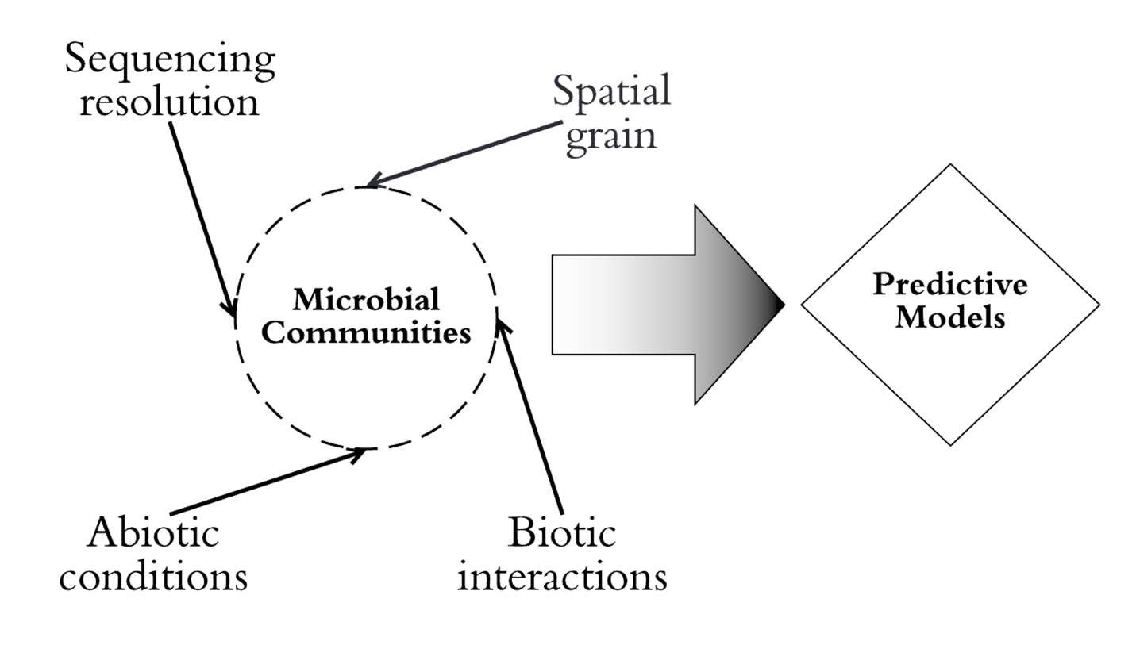
Figure 1. Conceptual diagram outlining the influence sequencing resolution, spatial grain, abiotic conditions, and biotic interactions have on the characterization of microbial communities and their recent utility and incorporation into predictive climate models.

microbial community richness within a host specific system. In Chapter 2, I address how short-term rainfall exclusion directly alters rhizosphere bacterial community richness of the Sonoran Desert native Lupinus neomexicanus. In Chapter 3, I investigate how short-term rainfall exclusion effects arbuscular mycorrhizal fungal communities of Lupinus neomexicanus. Chapters 2 and 3 additionally address the impact soil edaphic factors have on structuring microbial community composition. Lastly, in Chapter 4, I use MaxEnt as a tool to describe the niche breadth and illuminate the primary climate variables of Suillus spraguei, a beneficial microbe, and its host Pinus strobus. This chapter aims to illustrate how niche space of an obligate symbiont follows that of its host over future long-term climate scenarios.

CHAPTER ONE:
BACTERIAL COMMUNITIES OF THE SALVIA LYRATA RHIZOSPHERE EXPLAINED BY SPATIAL STRUCTURE AND SAMPLING GRAIN

Abstract
Advancements in molecular technology have reduced the constraints that the grain of observation, or the spatial resolution and volume of the sampling unit, has on the characterization of plant-associated microbiomes. With discrete ecological sampling and massive parallel sequencing, we can more precisely portray microbiome community assembly and microbial recruitment to host tissue over space and time. Here, we differentiate rarefied community richness and relative abundance in bacterial microbiomes of Salvia lyrata dependent on three spatial depths, which are discrete physical distances from the soil surface within the rhizosphere microhabitat as a proxy for the root system zones. To assess the impact of sampling grain on rarefied community richness and relative abundance, we evaluated the variation of these metrics between samples pooled prior to DNA extraction and samples pooled after sequencing. A distance-based redundancy analysis with the quantitative Jaccard distance revealed that rhizosphere microbiomes vary in richness between rhizosphere soil depths. At all orders of diversity, rarefied microbial richness was consistently lowest at the deepest samples taken (approximately 4 cm from soil surface) in comparison with other rhizo- sphere soil depths. We additionally show that finer grain sampling (i.e., three samples of equal volume pooled after sequencing) recovers greater microbial richness when using 16S rRNA gene sequencing to describe microbial communities found within the rhizosphere system. In summary, to further elucidate the extent host-specific microbiomes assemble within the rhizosphere, the grain at which bacterial communities are sampled should reflect and encompass fine-scale heterogeneity of the system.

Introduction
Plants transform the soil that surrounds their roots (i.e. the rhizosphere) with primary metabolites like amino acids, secondary metabolites like alkaloids, and macronutrients through litter deposition (Hu et al., 2018). Rhizosphere modifications by plants influence critical relationships with microorganisms, such as fungi and bacteria, that utilize the rhizosphere niche (Wardle et al., 2004). Plant-microbe interactions exist over multiple plant and microbial generations, establishing complex plant-soil feedbacks (PSF; Bever et al., 1997). Microbiota mediate available carbon and nitrogen directly in the rhizosphere, in turn affecting plant defense strategies, productivity, and fitness (Van Der Heijden et al., 2008; Lau and Lennon, 2011; Van Nuland et al., 2016; Hu et al., 2018). Measuring microbial community richness and abundance of rhizosphere microbes through massive parallel sequencing illuminates intricacies of how microbes moderate nutrient cycling and interact with plants (Hobbie, 1992; Creer et al., 2016). Further, the grain, or the defined individual microbiome sampling unit amongst rhizosphere studies, is often variable and may not consistently capture spatial variation of bacterial communities found within the rhizosphere. Yet within the rhizosphere, spatial heterogeneity of microbial communities is poorly understood (Žifčáková et al., 2016) necessitating a field-wide standard of resolution for comparison among disparate studies. By incorporating spatial structure into sampling protocols, microbiome richness in the rhizosphere can be captured as a transitional gradient of species distributions responding to root maturity and exudates across plant taxa.
Variation in community richness and abundance of rhizosphere microbiomes can be partially explained by numerous biotic interactions and abiotic conditions. For example, plant species receive microbes from bulk soil, forming distinct rhizosphere communities over time (Marschner et al., 2001; Berg and Smalla, 2009). Plant genotypes may regulate rhizodeposition and decomposition rates of plant derived organic matter and can serve as strong drivers of rhizosphere microbial richness (Schweitzer et al., 2005; Hénault et al., 2006; Philippot et al., 2013). Plant derived organic matter affects soil properties such as pH, organic carbon (C) content, moisture, and nitrogen (N) availability, which directly shape how microorganisms colonize unique microhabitats within soils across large geographic scales (Fierer and Jackson, 2006b; Fierer, 2017). Further, N-cycling is considerably more specialized within the rhizosphere than in bulk soils lending to their unique species composition (Nielsen et al., 1998). This contributes to the delicate balance between persistent and labile mineralized forms of C and N concentrations within the rhizosphere, effectively pulling resource-dependent, microbes towards these sources at the root (Yao and Allen, 2006).
A contributing factor in the structure of microbial communities of the rhizosphere may be the spatial relationship with root developmental age. The root can be divided into several spatial components based on developmental maturity, also known as root zones. Yang and Crowley (Yang and Crowley, 2000) showed that eubacterial communities vary in respect to developmental zones along the root by measuring community structure with a PCR-denaturing gel electrophoresis. They also discovered that community richness within each zone is dependent upon differences among soil types. Therefore, an amalgam of host effects and abiotic conditions in the rhizosphere environment are strong determinants of microbial survival and assemblages (Dean et al., 2015). With a firm understanding of how host associated microbial communities respond to these selective agents, it is imperative to further investigate how spatial sampling within the rhizosphere contributes to heterogeneity in bacterial richness recovered with high resolution 16S rRNA gene sequencing.
Developmental root zones can serve as a means to understand the spatial structure and maintenance of community level heterogeneity in the context of plant rhizosphere-microbiome interactions (Borcard et al., 1992; Legendre et al., 2005; Agrawal et al., 2007). The development of root tissue is regulated by plant or bacterial produced auxins and environmental factors like soil aggregates (Smucker, 1993; Perilli et al., 2012). Each root zone harbors unique microbial reservoirs due to favorable plant compounds, soil nutrients, and limited competition among other microbes (Lugtenberg, 2015; Zhalnina et al., 2018). Most studies using a pooled, coarse sampling resolution to characterize plant associated microbiomes fail to capture this heterogeneity across root zones, or corresponding rhizosphere microhabitats. Thus, combining multiple, fine grain samples from different root zones, or from multiple depths within the rhizosphere might explain scale dependent variation of the rhizosphere microbiome.
In this study, we sampled from three depths, or distances from the soil surface, within the rhizosphere microhabitat of Salvia lyrata to ask: How does rarefied bacterial richness and relative abundance compare between discrete rhizosphere depths and a combined rhizosphere sample from the same plant? Further, we ask how does rarefied bacterial richness, the raw number of reads, and relative abundance in reads compare between differences in sampling grain? To achieve this, we utilized two types of pooling methods to examine the impact of sampling resolution. These were pooling rhizosphere samples from each depth prior to DNA extraction (in vitro) and combining community data tables post sequencing and processing (in silico, Figure 2). Our overarching hypothesis is that rhizosphere bacterial richness and relative abundance correlates with spatially dependent sampling conditions that exist along root depth in the rhizosphere environment. We predict that microbiomes from each rhizosphere depth capture more information on rare species (i.e., rare across all samples) than a single coarse grain representative sample from the same rhizosphere. Additionally, we predict that sampling resolution will impact the characterization of rarefied bacterial community richness via differences in 16S rRNA gene capture, where coarse resolutions favor predominant groups of
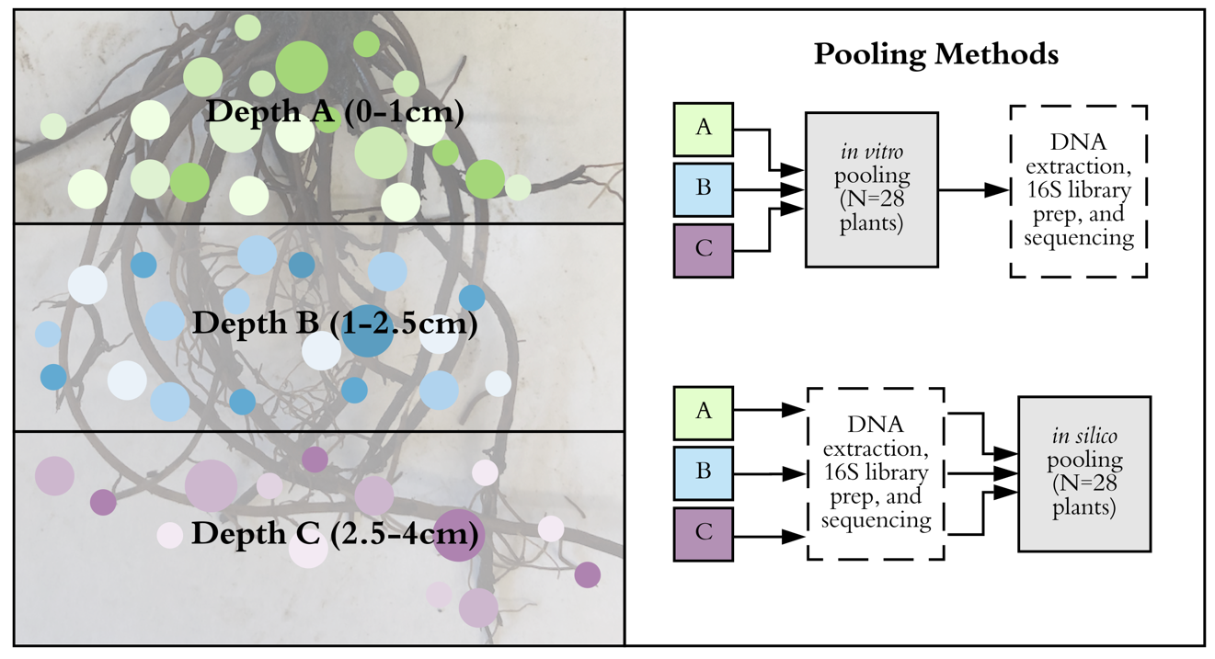
Figure 2. A conceptual outline describing the spatial structure and sample pooling of the S. lyrata rhizosphere microbiome outlined by three depths within the rhizosphere.
bacteria found in highly diverse samples. Finally, the following analyses provide a needed spatial characterization of rhizosphere microbiota that associate with the genus Salvia, which contains many species utilized for medicinal purposes.

Materials and Methods

Study System
Salvia lyrata L., or Lyreleaf Sage, is a flowering, biennial mint with a shallow fibrous root ball consisting of roughly 8-12 individual primary roots, and pinnately lobed basal rosette leaves. In general, microbiomes associated with the genus Salvia have been underexplored. Recent research efforts have characterized seed and foliar microbiomes associated with the genus Salvia. However, little to no attention has been given to rhizosphere microbiomes (Chen et al., 2018; Huang et al., 2018). Field sampling occurred at Forks of the River Wildlife Management Area (35°56'30.6" N, 83°50'43.3" W) in Knox County, Tennessee during July 1st- July 5th, 2018. The plant community at this site has been historically disturbed and consists primarily of perennial grasses and mixed hardwoods along the edge of trails where S. lyrata is often found. The soil material found here is characterized as both highly weathered, acidic red clay and brown silty clay loam. Three 25 meter transects were drawn and 30 plants were flagged based on occurrence within one meter of this line. Plant individuals (N=10) were chosen per transect for rhizosphere microbiome sampling by using a random number generator. All microbial rhizosphere samples were collected from juvenile plant individuals of S. lyrata to control for phenological and temporal, effects on the colonization of host specific microbiomes. Juvenile individuals were identified by the absence of a racemose scape.

Rhizosphere microbiome sampling
Here we defined the rhizosphere of S. lyrata as the narrow region of soil spanning from the root epidermis to soil that is influenced by root exudates (~3mm from epidermal tissue) within the same root system (Micallef et al., 2009; Hafner et al., 2014). All plant rhizospheres were sampled in the field at three different depths as a proxy for the root system zones. Sample depths in the rhizosphere were from 0-1cm (Depth A), 1-2.5cm (Depth B), 2.5-4 cm (Depth C) aimed to represent developmental root zones within the root system, account for variation in root length, and root density across individuals (Figure 2). For each sampling depth, the entire root system was exposed, and rhizosphere soil was scrapped from the root epidermis to 3-5mm away from the surface of the root into sterile Nasco Whirl Paks across all visible roots (Nasco, Fort Atkinson, WI, USA). This occurred first at Depth A and then at each subsequent sampling soil depth using a sterilized spatula. Sampling tools were sterilized between sample units to avoid contamination. Rhizosphere soils were stored on ice immediately after the sterile Nasco Whirl Paks were sealed throughout the daily sampling period. Rhizosphere microbiome samples were stored at -80°C at the University of Tennessee, Knoxville until further processing. Short term storage of dry soil microbiome samples in -80°C does not affect the microbial community structure (Lauber et al., 2010).

Sampling grain: pooling in vitro versus in silico
We used two different pooling methods to compare how sampling grain, or the spatial resolution and volume that defines a microbiome sampling unit, affects the microbial community recovered through 16S rRNA gene amplicon sequencing (Figure 2). The first method combined an equal portion of soil from each rhizosphere depth samples (A, B, and C) into a single sample to represent the whole rhizosphere microbiome of each plant (in vitro). To do so, samples were removed from deep freeze and set on ice for an hour to thaw. One gram from each of the three sampling depths were combined into a new sterile Nasco Whirl Pak. Prior to subsampling 0.25g for DNA extraction, we mixed the pooled samples together by vigorously shaking the samples by hand for 30 seconds and leaving them at room temperature for an hour. The second pooling method occurred after sequencing and combined read counts for the same amplicon sequence variants (ASVs) for each rhizosphere depth per individual plant. These samples represent the pooled microbiome in silico. Prior to sample rarefaction, we accounted for differences in sampling effort between pooling methods by dividing read count tables by three for samples pooled in silico. Pooling methods were compared and used to describe the composite microbiome found within the rhizosphere of S. lyrata.

16S rRNA gene library preparation for Illumina MiSeq
DNA was extracted from 0.25g per sample using the DNeasy PowerSoil Kit (MoBio Laboratories, Inc., Carlsbad, CA, USA) with a modification at Step 16 using 50µL of Solution C6 and an elution time of 5 minutes before the final centrifuge step. This extraction kit successfully removes all non-DNA organic and inorganic material, such as humic acids at Step 10 and Step 11. PCR reagents were sourced through the KAPA HiFi HotStart Ready Kit (KAPA Biosystems, Wilmington, MA, USA). Within the amplification PCR, the bacterial-specific primer pair 341F and 785R (5µL at 1µM each) were used to target the V3-V4 region of the 16S rRNA gene and to prepare our DNA samples for the second index PCR. The sequences for 341F and 785R are 5’-CCTACGGGNGGCWGCAG-3’and 5’-GACTACHVGGGTATCTAATCC-3’ respectively (Klindworth et al., 2013; Thijs et al., 2017). DNA extractions were thawed on ice and 2.5µL of each sample was used for this PCR. For each plate, a PCR negative blanks was used to check for PCR contamination. Plates ran under the following PCR program: an initial denaturing step of 95ºC for 3 minutes, 25 cycles of 95ºC for 30 seconds, 55ºC for 30 seconds, and 72ºC for 30 seconds, a final elongation cycle of 72ºC for 5 minutes, and then held at 4ºC. This PCR produced 25µL of the 16S rRNA amplicon for each sample that was stored at -20ºC until further use. Samples were then run on a 2% agarose gel with Ethidium Bromide and Tris-Acetate-EDTA (TAE) buffer to confirm amplicon length and purity. All PCR products (25µL for each sample) were purified with 20µL of Agencourt AMPure XP magnetic beads (Beckman Coulter, Brea, CA, USA) and two 200µL washes of freshly prepared 80% ethanol. Purified 16S rRNA gene amplicons for all samples were then resuspended with 50µL of Tris-HCl and stored at -20ºC.
The second index PCR attached forward and reverse index primers that are designed specifically for the multiplexing samples and sequencing with the MiSeq instrument (Illumina Corporation, San Diego, CA, USA). Each sample in the library was provided with its own unique primer combination for sample identification in downstream quantitative analyses (Resource1.xslx). These primers were from the i5/i7 Nextera XT Index Kit A and D with 5µL combinations of 8 bases long forward and reverse segments. Further, 25µL of KAPA HiFi HotStart Ready Mix was used per reaction. 5µL of purified PCR product from the first reaction was used to reach sufficient concentration of the bacterial 16S rRNA V3-V4 gene region at this step. For this index PCR, 10µL of PCR grade water was added per sample, bringing the total volume to 50µL. The index PCR performed had an initial cycle of 95ºC for 3 minutes followed by an 8-cycle sequence of 95ºC for 3 seconds, 55ºC for 30 seconds, and 72ºC for 30 seconds. The last elongation cycle was held at 72ºC for 5 minutes.
Following the standard index PCR clean up provided by Illumina, index PCR products (50µL for each sample) were purified using 56µL of Agencourt AMPure XP magnetic beads and two 200µL washes of freshly prepared 80% ethanol. The final 16S rRNA gene amplicon products were then combined with 25µL of Tris-HCl and stored at -20 ºC until further use. Post two step PCR, all 16S amplicon products were quantified using a NanoDrop spectrophotometer (NanoDrop Products, Wilmington, DE, USA) and pooled in equal concentrations. Next, a Bioanalyzer was used to determine molarity and appropriate adapter ligation by examining product length (Agilent Technologies, Santa Clara, CA, USA). This step behaves as the final quality control step before sequencing. Pooled samples were diluted to 4pM with Tris and loaded into the MiSeq instrument with 20% PhiX on a V3 flow cell set to read a 2x275, or paired end, cycle at the University of Tennessee Genomics Core, Knoxville, Tennessee, USA.

Bioinformatics
Processing of the 16S amplicon data were completed with the open-source pipeline DADA2 version 1.8 (https://github.com/benjjneb/dada2). With DADA2, we detected sequence anomalies at a single-nucleotide resolution known as ASVs (Callahan et al., 2016). Amplification primers 341F and 785R were removed from each read by trimming according to their length. Then all forward and reverse reads were quality filtered and trimmed to 248 and 220 nucleotides in length, respectively. Sequences with sequencing errors were then removed and forward and reverse reads were merged if there was sufficient overlap for each ASV in each sample. Chimeras were detected within each merged read and removed. Lastly, all merged sequences were matched to SILVA version 132, a taxonomic reference database for 16S rRNA genes (Quast et al., 2013; Yilmaz et al., 2014). This pipeline was implemented in R version 3.5.2 (https://www.r-project.org/). All nucleotide sequence data was made publicly available in GenBank database under the accession number: PRJNA575901.
The package phyloseq was then used to combine community data, assigned taxonomy, and metadata into a single, flexible R object (McMurdie and Holmes, 2013). Eukaryotes, chloroplasts, and mitochondria were removed from our data set. If no assignment was made at the Kingdom level these ASVs were similarly removed. Lastly, rhizosphere samples that failed during sequencing and contained no ASVs were dropped (n=2). Mean sample abundances were obtained by rarefying to the lowest number of reads (7,739 reads) 5,000 times with the rrarefy function in the vegan package when we investigate the difference between ASV richness and relative abundance amongst rhizosphere depths (Oksanen et al., 2019). To address the difference in relative abundance between pooling methods (i.e., sampling grain), pairwise rarefaction to the same number of reads was used per plant.

Hypothesis testing and statistical analyses
An indicator species analysis (R package indicspecies) using the group equalized point biserial correlation index for each group was then conducted with 50,000 permutations to elucidate ASVs highly associated with each rhizosphere depth (De Caceres and Legendre, 2009). Two distance-based redundancy analyses (db-RDA) were implemented for hypothesis testing to quantify community variation explained by the sampling depth within the rhizosphere. In these models, we partial out variation explained by individual plants (sample ID) before hypothesis testing to account for the non-independence of rhizosphere samples associated with a single plant. Prior to modeling, all sequences were aligned using MAFFT version 7.0 (Katoh and Standley, 2013). Next, a phylogenetic tree was built using the Randomized Axelerated Maximum Likelihood (RAxML) program and the General Time Reversable CAT model of rate heterogeneity for phylogenetic approximation (Stamatakis, 2014). This tree was made ultrametric using the software treePL, which transformed branch lengths to correspond with relative divergence time using penalized likelihood (Smith and O’Meara, 2012). This ultrametric tree was then used to create a weighted UniFrac distance matrix. The quantitative Jaccard (Ružička) and the weighted UniFrac distance were then used as response variables in our db-RDAs (n=87 samples). We then evaluated the statistical significance of rhizosphere depth as a predictor of community dissimilarity via 10,000 permutations of our data using the anova.cca function in the R package vegan 2.5-5 (Oksanen et al., 2019).
The effective number of bacterial species (^{q}D) associated with each rhizosphere depth and each pooled sample was described using a Hill numbers approach with the R package vegetarian 1.2 (Hill, 1973; Jost, 2007; Charney and Record, 2012). Since the numbers equivalent of ASVs (D) is sensitive to the order of diversity (q), or the balance between rare and common ASVs, we chose to assess alpha and beta diversity from q=0 to 5. There are many frequently used diversity indices that are analogous to ^{q}D. For example, at q=0, rare and common ASVs are weighted equally and therefore represent an incident-based measure of species richness. When q=1 ASVs are weighted by their proportional abundance, which is congruent to the exponential of Shannon’s entropy index, and at q=2 rare species are down weighted and correspond to the inverse of Simpson’s index. As q increases beyond this, rare ASV are further down weighted from the analyses of alpha and beta diversity.
To understand if alpha diversity significantly varies based on depth within the rhizosphere, fitted linear-mixed effects models with sample ID, or the individual plant itself, as a random effect were constructed at each Hill number using the lme4 package (Bates et al., 2015). A Type II Wald Χ² test of variance was used for hypothesis testing on main effects. For significant results, a Tukey’s Honest Significant Difference (HSD) multiple comparisons test was implemented for all pairwise comparisons of rhizosphere depths to investigate where differences in alpha diversity lie.
Two different methods were used to assess beta diversity measures at each Hill number. The first method is similar to a Levene’s test in multivariate space, which analyzed the homogeneity of dispersion in community composition between groups and can be used as a proxy for beta diversity (Anderson et al., 2006). A pairwise distance matrix using the distance from each observation to the group centroid was then fed into a fitted linear-mixed effects models with sample ID as a random effect. Secondly, to address if community variation within rhizosphere depths is similar to one another, a db-RDA on the pairwise distance matrix while conditioning for variation among plants was implemented. A permutational anova was then used to compare this variation between groups (10,000 permutations).
We evaluated the difference in the standardized number of raw reads between samples pooled in vitro and samples pooled in silico through a paired t-test for each plant (N=28 plants). Standardization here means that we controlled for differences in sampling effort between the two pooling methods by dividing the read abundances by three, the number of rhizosphere depths sampled, for each sample pooled in silico. Additionally, all samples sequenced held the same fraction of size throughout library preparation. This paired t-test used raw read counts that were summed across rows, or plants, in our ASV table. To observe differences in the relative abundance of reads between pooling methods, a paired t-test was also conducted using pairwise rarefied data (n=28 plants). Since two rhizosphere depth samples failed during sequencing and equal comparisons across all plants and pooling methods cannot be applied, two plants were excluded from these analyses. For each plant replicate, alpha diversity for q=0-5 was calculated on the mean rarefied community data from 5,000 permutations. Then, a paired t-test (n=28) was preformed to show differences in ASV richness between pooling methods. To evaluate if dispersion between pooling methods is similar for the number of raw reads, relative abundance in reads, and for alpha diversity a paired Brown-Forsythe test was implemented.

Results

The Salvia lyrata rhizosphere microbiome
From the 118 samples sequenced and analyzed, 27,314,720 raw sequence reads were generated from the Illumina MiSeq run. Dereplicated sequences numbered at 3,758,012 reads attributing to 25,123 ASVs with associated abundances for Bacteria and Archaea. For samples that were pooled in vitro and represent a homogenous characterization of S. lyrata’s rhizosphere, a total of 1,322,876 reads were recovered. These reads correspond to 20 bacterial phyla. The predominant (i.e., more frequent detected, abundant) phyla of Bacteria that associate with this rhizosphere system are Proteobacteria (30%), Actinobacteria (24%), Planctomycetes (13%), Verrucomicrobia (9%), Bacteroidetes (8%) and Acidobacteria (7%) (Figure 3). Firmicutes characterized 0.9% of the bacterial microbiome from samples that were pooled in vitro. On a finer taxonomic level, the family WD2101_soil_group, a Planctomycete, was a highly abundant family, containing 7% of all sequenced reads from pooled samples in vitro. The next two predominant bacterial families within this rhizosphere system were Xanthobacteraceae (6%) and Burkholderiaceae (2%), both in the phylum Proteobacteria. On the species level, the most abundant taxon was Candidatus-Xiphinematobacter, a verrucomicrobial endosymbiont commonly found in rhizosphere environments.

Microbiomes are spatially structured by depth within the rhizosphere
We used two community distance matrices in our multivariate models to evaluate the spatial complexity of bacterial microbiomes as predicted by the rhizosphere sampling depths described in Figure 2. These models used rarefied and standardized community data to test the strength of depth within the rhizosphere as a predictor variable. With the quantitative Jaccard distance matrix as a response variable, rhizosphere depth explained 3.65% of total variation in bacterial community dissimilarity. The conditioned variable, sample ID, explained 52.7% of total variation in community dissimilarity. After removing the effect of sample ID, the proportion of remaining variance explained by rhizosphere depth is 7.71% (Figure 4). Distinctive clustering around the respective centroid occurred within each group on both axes. Richness and relative
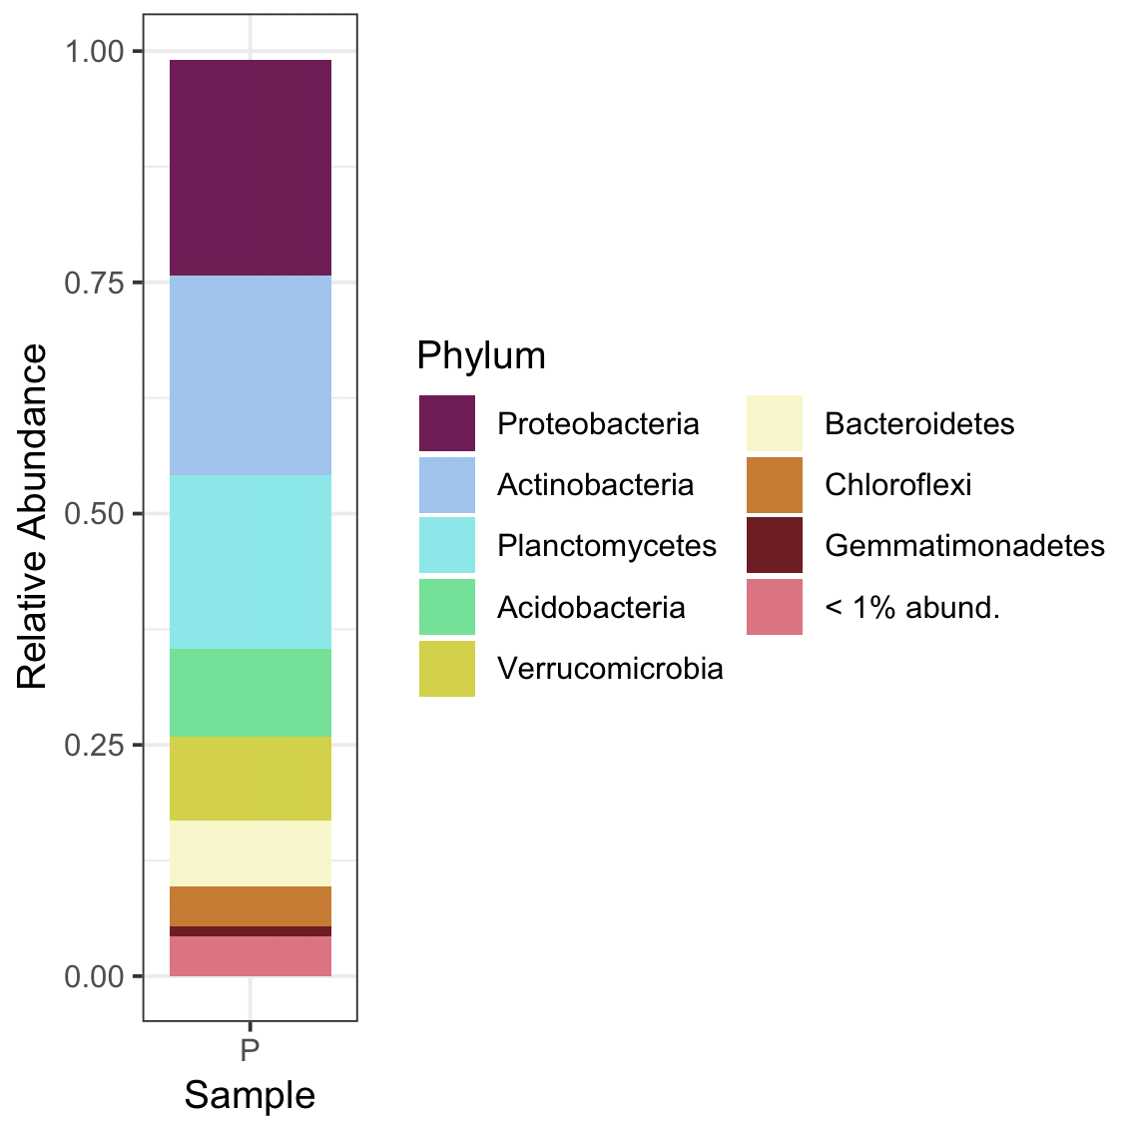
Figure 3. Bacterial phyla that associate with Salvia lyrata for samples pooled in vitro. On average, Proteobacteria represent 30% of all bacteria recovered.
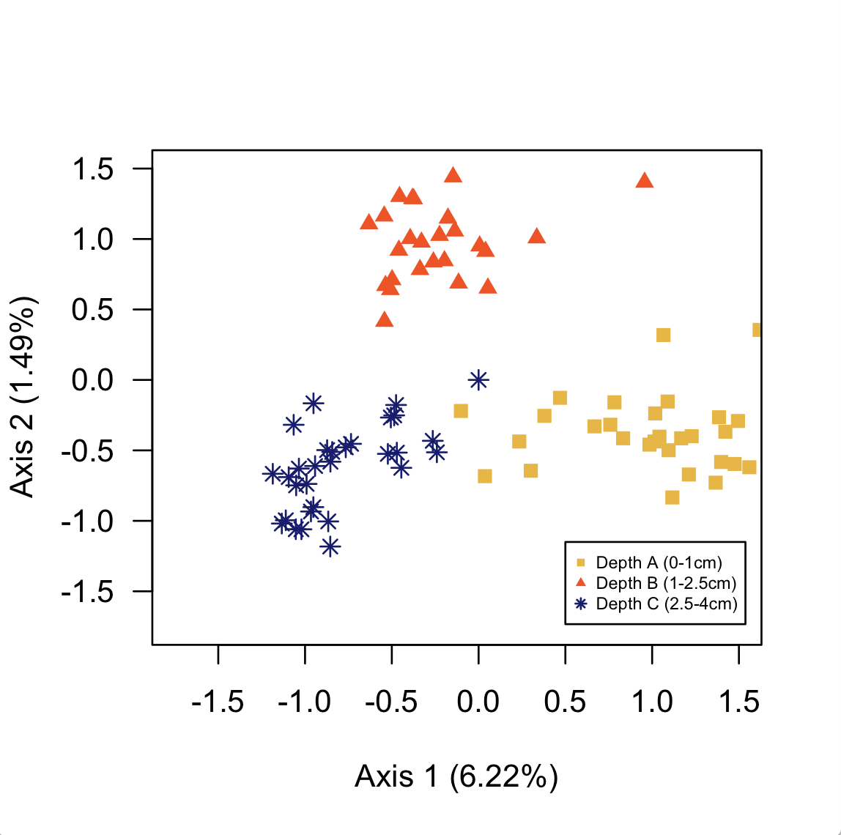
Figure 4. Principal coordinate analysis on the reduced dimensional analysis based on a quantitative Jaccard distance with rhizosphere depth as a predictor variable.
abundance between depths varied based on the quantitative Jaccard distance matrix provided in our permutational analysis of variance (p<0.001).
Our second distance-based redundancy analysis considered phylogenetic autocorrelation by using a weighted UniFrac distance as the response variable. This model showed rhizosphere depth to explain 5.51% of the total variation in bacterial microbiome dissimilarity. Sample ID in this model explained 12.2% of total variation in community dissimilarity. Like our previous model, we also partial out this effect before hypothesis testing, and rhizosphere depth then explained 6.29% of the remaining variation in community dissimilarity. The permutational anova on our model with a weighted UniFrac distance showed that each rhizosphere depth is significantly different from one another in terms of rarefied bacterial richness (Appendix Figure 1; p<0.001). Additional information on these model summaries and subsequent anovas are shown in Resource2.xslx.
Alpha diversity was examined using a Hill numbers approach to gather and compare the effective number of ‘types’ or ASVs between each rhizosphere depth. A Type II Wald’s Χ² test on fitted linear-mixed effects model at q=4 to 5 showed that alpha diversity was distinct and varied across rhizosphere depth (q=4: Χ²=6.04, p=0.0487, df=2; q=5: Χ²=6.84, p=0.0327, df=2). Table 1 shows a full summary of each analysis of variance on all orders of alpha diversity. Tukey’s HSD revealed that at these orders, Depth B and C are driving the differential pattern over other comparisons between rhizosphere depths. Further, alpha diversity across q=0 to 3 on average is greatest at Depth A (Figure 5). At q=4 to 5, Depth B has the greatest alpha diversity out of all rhizosphere depths. Samples pooled in vitro contain on average the greatest effective number of ASVs when at q=0 to 3, however while continually down-weighting rare species from our analysis pooled samples lie between Depths B and C. Figure 5 also shows that Depth C consistently has the least effective number of ASVs than any other group.
Analysis of multivariate dispersion showed greater heterogeneity in rarefied community richness and relative abundance between Depths A, B, C at q=0 (F₂=3.29, p<0.05). As rare species are down weighted across increasing q, multivariate dispersion, or the average distance from each individual point to the multivariate centroid (median) were not different between rhizosphere depths. Thus, at lower orders of diversity, rare ASVs contributed more to the differences in community turnover between rhizosphere depths than common ASVs. Similarly, a db-RDA on community variation within groups while accounting for the effect of individual
Table 1. Summary of the Type II Wald’s Χ2 test performed on alpha diversity across depths within the rhizosphere at q=0 to 5.
Order of Diversity (q) | Chisq | Pr(>Chisq)
0 | 1.4384 | 0.4871
1 | 2.303 | 0.3162
2 | 3.9319 | 0.14
3 | 5.1613 | 0.07573
4 | 6.0449 | 0.04868*
5 | 6.8364 | 0.03277*

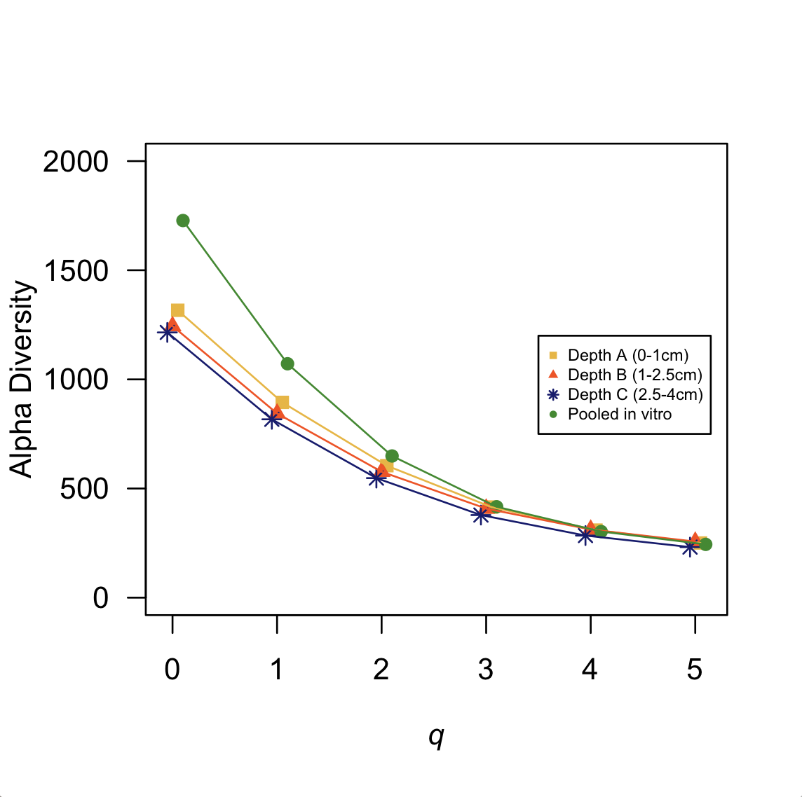
Figure 5. Alpha diversity profile plot showing intercepts from each fitted linear model a function of q.
plants showed that each rhizosphere depth is significantly different in terms of turnover at q=0 (F_{2,55}=3.25, p<0.05). Lastly, these analyses illuminated that Depth A is the richest in ASVs while Depth C is consistently the least rich.
An indicator species analysis was performed across our data set to characterize which taxa are more strongly associated with the communities at each spatial depth within the rhizosphere of a plant root system described by Figure 2. Depth A harbors the most diverse and numerous indicator taxa with 311 indicator ASVs. Commonly detected phyla that were represented as indicators for Depth A are Acidobacteria, Actinobacteria, Bacteroides, Chloroflexi, Gemmatimonadetes, Planctomycetes, Proteobacteria, and Verrucomicrobia. As seen in Figure 6, the most represented known families in this indicator analysis for Depth A were Gemmataceae and WD2101_soil_group both with an abundance of 17 in this analysis. Depth A has numerous rare families that are distinct indicators, with Phycisphaeraceae and Xiphinematobacteraceae identified as significant indicators (p<0.001). Species identified as indicators for this rhizosphere depth are Agromyces ramosus (Actinobacteria), Lechevalieria aerocolonigenes (Actinobacteria), and Arenimonas daejeonensis (Proteobacteria). At the ASV level, 61 unique taxa were associated with Depth B. Associated with this rhizosphere depth there are 10 known phyla, with Bacteroidetes, Planctomycetes, and Proteobacteria as the most abundant. The most common and known family as an indicator for Depth B was Hyphomicrobiaceae (Figure 6). Rare phyla uncovered as indicators for Depth B are Cyanobacteria, Latescibacteria, and Patescilbacteria. The strongest correlated indicator ASV for Depth B came from the family Desulfarculaceae, a Deltaproteobacteria (r.g. corr=0.242, p<0.01). Depth C had 14 phyla as indicators representing 152 ASVs. Common phyla identified as indictors were Actinobacteria and Proteobacteria. The family Xanthobacteraceae (Alphaproteobacteria) was the most abundant family as an indicator representing 4.6% of all indicator ASVs for Depth C. Additionally Depth C has many significant indicators at the Genus level. No indicator ASVs were identifiable to the species level for Depth B or C. Resource3.xslx further depicts r.g. correlations and relative significance for all indicator taxa that came from this analysis. This analysis shows that strong indicators for Depth A come from the phylum Planctomycetes, while Depth B and Depth C are best predicted by the presence of Deltaproteobacteria and Alphaproteobacteria respectively.
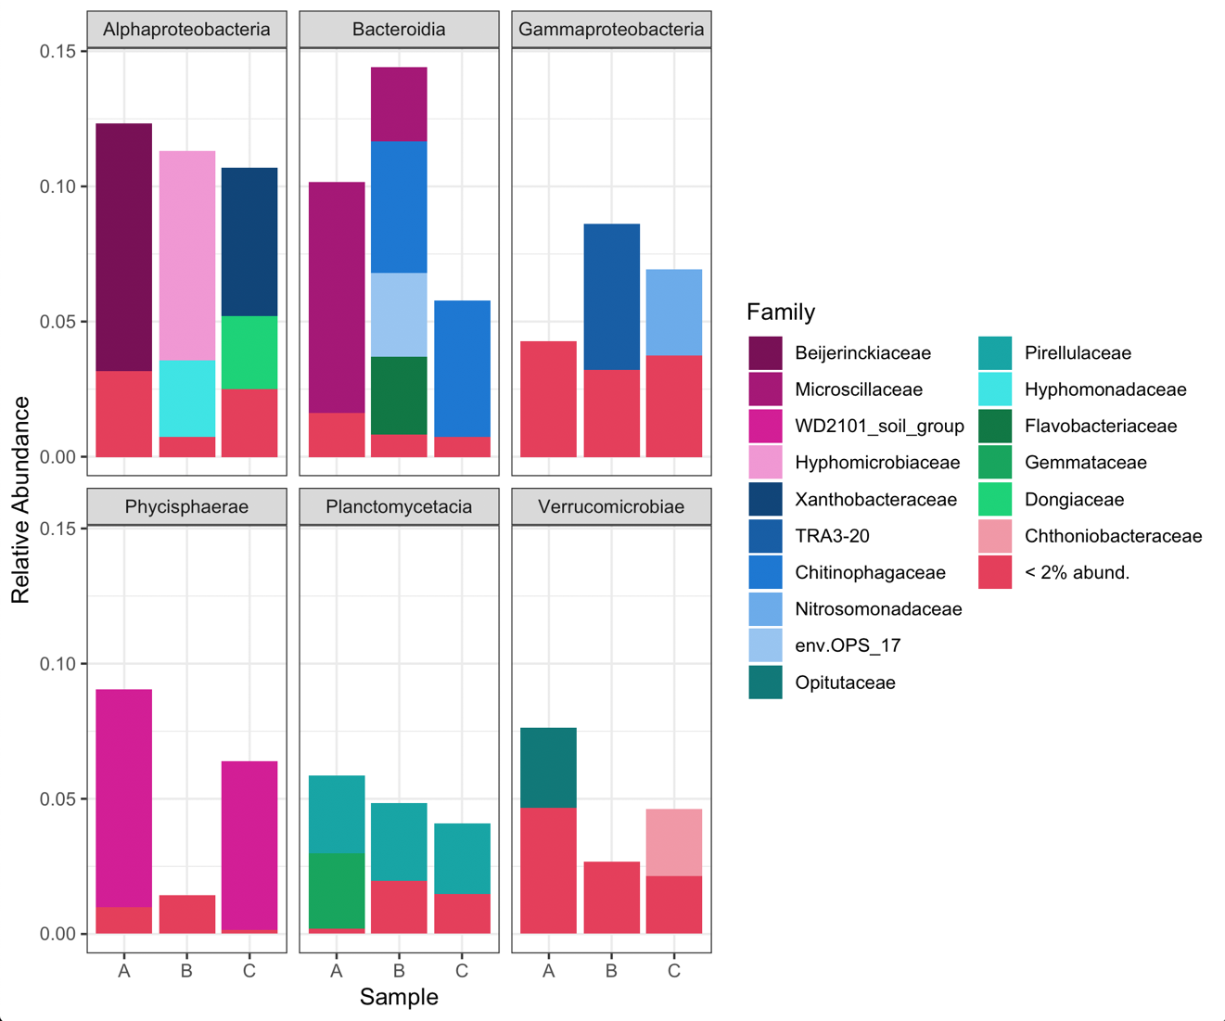
Figure 6. Indicator species analysis visualized at the family level for each rhizosphere depth. Each depth is illustrated here as sample A (0–1cm), sample B (1–2.5 cm), and sample C (2.5–4 cm).

Rarefied richness is greater when rhizosphere depths are pooled in silico
Pooling samples across rhizosphere depths per individual plant after sequencing, captured a larger, more comprehensive image of bacterial community composition and diversity in comparison to pooling physical samples prior to DNA extraction. To illuminate if there were differences in the rarefied richness and relative abundance of reads between the two pooling methods, paired t-tests were implemented on the standardized number of raw reads, rarefied and standardized number of reads, and alpha diversity (Figure 7). On average, the standardized raw number of reads for each rhizosphere in vitro on average were 17,353.8 reads greater than samples pooled in silico (t=3.46, df=27, p<0.001). A paired Brown-Forsythe test confirmed that dispersion around the median between the two pooling methods was significantly different for the raw number of reads (t=6.65, df=27, p<0.001). Similarly, the pairwise rarefied abundance in total reads was greater on average by 9073.23 for samples pooled in vitro (t=4.59, df=27, p<0.001). Pairwise Brown-Forsythe tests illustrated that there was heterogeneity in dispersion of rarefied abundances in reads between pooling methods (t=9.27, df=27, p<0.001). For q=0 and q=4 to 5, paired t-tests showed significant differences (α=0.05) in the effective number of ASVs between pooling methods with samples pooled in silico having the greatest alpha diversity. The largest difference in alpha diversity between pooling methods occurred at q=0, with a mean difference of 679.85 effective number of ASVs (Table 2). Figure 7b shows the relationship between alpha diversity at q=0 and each pooling method, where samples that were pooled in silico have on average a greater alpha diversity than samples pooled in vitro. Paired Brown Forsythe tests on the dispersion of the effective number of ASVs (alpha diversity) were significantly different for q=0 to 2 between the two pooling methods (Table 2). As rare species are further down weighted beyond q=2, we failed to detect a difference in the dispersion between sampling grains.

Discussion

Summary
In this study, we demonstrate that: (1) rarefied bacterial richness and relative abundance varies with rhizosphere depths. Alpha diversity among rhizosphere depths differs the most when rare ASVs are down weighted. Depth C is characterized as the least diverse amongst rhizosphere depths, while Depth A is shown to be the richest. (2) By evaluating the spatial structure of
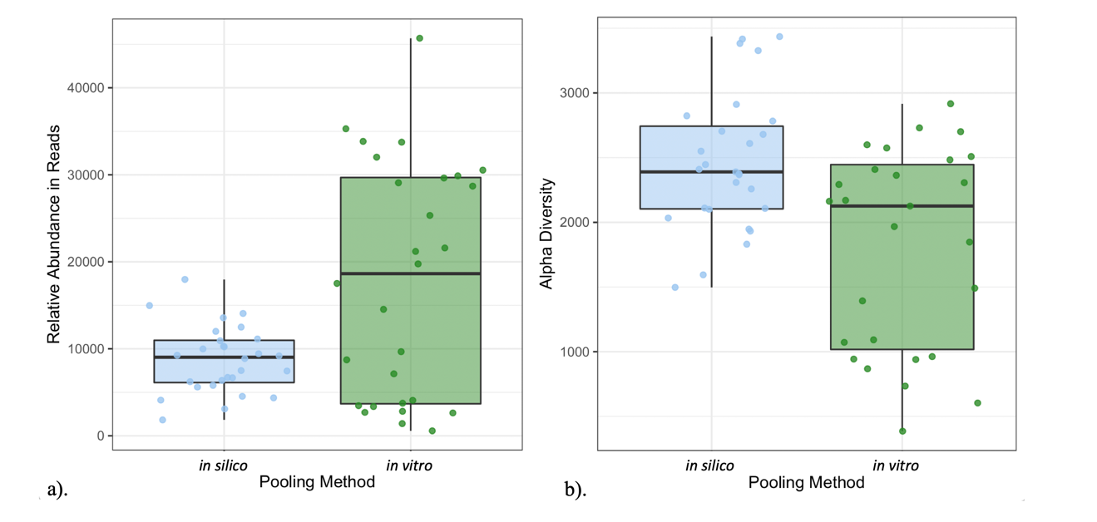
Figure 7. Total relative abundance of reads for samples in silico and in vitro. a) The total relative abundance of reads is greater for samples that were pooled in vitro compared with those in silico. b) Alpha diversity at q=1 for pooled samples in silico and in vitro.

Table 2. Paired results comparing alpha diversity, or the effective number of species, between samples pooled in vitro and in silico at q=0 to 5.
 | Paired t-tests |  | Paired Brown-Forsythe Test
Order of Diversity (q) | t-stat | p-value | F-stat | p-value
0 | -3.4266 | 0.002** | 4.8314 | 0.032*
1 | -1.7288 | 0.095 | 10.82 | 0.001**
2 | -1.2332 | 0.228 | 8.0142 | 0.006**
3 | -1.9203 | 0.065 | 2.1882 | 0.145
4 | -2.3941 | 0.024* | 0.4312 | 0.514
5 | -2.4718 | 0.020* | 0.1216 | 0.728

bacterial communities within the rhizosphere of Salvia lyrata, we were able to obtain a more holistic characterization of the rhizosphere microbiome and show that samples from a coarser grain (pooled samples in vitro) have higher rarefied abundance in reads than samples from individual rhizosphere depths. (3) With increased fine grain sampling (i.e., pooling in silico) more rare ASVs are captured and thus a greater amount of spatial heterogeneity in microbial richness is observed. Lastly, samples pooled in silico have less dispersion in rarefied ASV richness and relative abundance in the number of reads than pooling in vitro.

Bacterial communities are spatial structured across rhizosphere depths
The rhizosphere is a highly context dependent microhabitat with transient, diurnal cycles of rhizosphere soil temperature and moisture driving microbial community composition (Bobille et al., 2019; Liang et al., 2019). Further, the structure of bacterial communities within the rhizosphere is partially explained by plant species, genotype, and developmental age (Schweitzer et al., 2005; Berg and Smalla, 2009; Fierer, 2017). Previous studies characterized spatial differences in microbial community along the root length based on bacterial growth strategies and soil niche occupancy in nutrient limited environments (De Leij et al., 1994; Bever et al., 2012). We can similarly infer that bacterial community richness and abundance are spatially distinct at our three tested rhizosphere depths (Figure 4). We see each of the three rhizosphere depths grouping apart from one another, illustrating their unique microbial composition. Further on Axis 2, Depth B is grouped away from the other two depths, indicating that some microbiota within Depth B might experience more or less diurnal habitat fluctuations within the rhizosphere environment than the other two spatial depths which. For example, Depth A harbors the greatest heterogeneity in community structure in comparisons to other rhizosphere depths possibly due to increased contact with ambient oxygen and then influence of temperatures near the surface of rhizosphere soil (Philippot et al., 2013). Once phylogenetic relatedness was accounted for, the percent of total variation in bacterial richness and abundance explained increased 1.86%. Since weighted UniFrac calculates the proportion of unique branches in our phylogeny against the total number of branches, we were able to interpret this as each rhizosphere depth containing phylogenetically distinct microbial communities (p<0.001). However, our multivariate models show a large amount of variation in rhizosphere community structure explained by the plant itself (52.7% and 82.2% for models using the quantitative Jaccard and weighted UniFrac distances respectively). Since bacterial communities were sampled from plants of the same developmental age, it is possible that this variation could be explained by genotypic variation within S. lyrata and heterogeneity of abiotic conditions (Andreote et al., 2010).
Complex organic root exudates directly affect microbial community structure within the rhizosphere and can indirectly mediate plant growth through elaborate plant-soil feedbacks (Kozdrój and Van Elsas, 2000; Hu et al., 2018). Carbon released through rhizodeposition can be beneficial or antagonistic towards groups of bacteria dependent on a myriad of abiotic conditions like rhizosphere temperature, moisture, pH, and oxygen availability (Grayston and Campbell, 1996; Aulakh et al., 2001; Philippot et al., 2013). Survival in this heterogenous environment is maintained through many different mechanisms. For example, chemotaxis, or the preferential motility of bacteria away from harmful substances and towards beneficial conditions may be largely responsible for the spatial structure we see in rhizosphere microbiomes (Wadhams and Armitage, 2004; O’Banion et al., 2019). Microbe-microbe competition facilitates the predominance of bacterial groups at specific depths within the rhizosphere, primarily in locations with increased carbon-based resources (Walker et al., 2003; Fierer and Jackson, 2006b). Thus, interspecific competition might lead to lower alpha diversity like we see in Depth C in comparison to other rhizosphere depths. However, given our sampling methods, we can only illustrate the spatial structure of bacterial communities as it varies with rhizosphere depth and cannot tease apart the effects of host-associated processes and environmental conditions that might shape these communities.
Our indicator species analysis revealed which ASVs are more strongly associated with each depth within the rhizosphere microhabitat. However, due to high microbial diversity found in the rhizosphere and the high throughput sequencing resolution of this study, more meaningful interpretations are given at higher taxonomic levels that encompass known ecological factors. In terms of possible indicators, Depth A contains the most numerous and diverse indicator ASVs, which might be due to increased heterogeneity in abiotic and biotic conditions. For example, Xiphinematobacteraceae, a Verrucomicrobia, is strongly correlated with Depth A and might be predicted as an indicator at this rhizosphere depth due to the presence of other microbiota like arbuscular mycorrhizal fungi (AMF), which have a larger impact on carbon cycling than bacteria in zones of maturing root hairs (Hamel, 2004) present in our system at Depth A, although no AMF data were observed in this study. AMF presence can have positive or negative effects for certain bacterial groups. AMF can be growth promoting for Xiphinematobacteraceae due to increased exuded carbon and phosphorous content (Zhang et al., 2016; Chiang et al., 2018). Agromyces ramosus is a common predatory bacteria of gram-negative bacteria in soil, and utilizes the rhizosphere niche because of high microbial richness and abundance of gram-negative prey (Korp et al., 2016). This might explain the presence of A. ramosus as a strong indicator in Depth A. Hyphomicrobiaceae, the most abundant indicator of Depth B (Figure 6), are chemoheterotrophs in the class Alphaproteobacteria and therefore heavily rely on carbon provided by other organisms (Rosenberg et al., 2014). Xanthobacteraceae (Alphaproteobacteria) was consistently associated within Depth C as an indicator species and are known as chemolithoautotrophs that utilize inorganic compounds from external sources, such as sulfur from bedrock or soil particulate (Oren, 2014). The identified indicator ASVs in this analysis and the defined spatial structure of this study illustrates how microbial communities are environmentally filtered in heterogeneous habitats like the rhizosphere (Horner-Devine et al., 2004; Fierer and Jackson, 2006b).

Sampling grain affects rarefied bacterial richness and relative abundance
High resolution molecular techniques and a comparable sampling grain are both integral components towards understanding the spatial structure of bacterial microbiomes within rhizosphere systems. By definition, the grain size during sampling procedures can impact one’s ability to detect macroecological patterns regarding species richness (Hortal et al., 2006; Wiens, 2016). This similarly holds true when investigating plant-microbiome interactions within the rhizosphere. After standardization, comparisons between sequencing resolutions demonstrated that pooled samples in vitro contain on average more raw reads. Similarly, after pairwise rarefaction, samples that were pooled in vitro not only have on average a greater relative abundance in reads, but they also have greater dispersion around the median in comparison to samples pooled in silico (Figure 7a). This illustrates that pooling prior to DNA extraction captures larger variance in the richness of 16S genes recovered from rhizosphere microbiomes. Samples pooled in silico, captured a larger quantity of rare, or less common across all samples, ASVs after sequencing than coarse grain samples from the same rhizosphere (Figure 7b). This pattern is the clearest at q=1, however, is still relevant when rare ASVs are down weighted from our analyses suggesting that pooling post sequencing can reduce the bias effects of library preparation and sequencing on richness estimates. At several steps throughout the gene sequencing procedure, selective and stochastic biases can affect the ratio of 16S genes from a complex, unknown microbiome. For instance, DNA extractions can be incomplete for soil microbiomes, where mechanical lysis and other purification steps favor groups of bacteria. Additionally, PCR amplification can cause biases during the annealing stage by selecting for templates that separate into single strand molecules with minimal effectiveness (Suzuki and Giovannoni, 1996; Kennedy et al., 2014). Pooling rhizosphere samples prior to DNA sequencing has been previously proposed as one method to reduce variation in richness estimates (Cahill et al., 2016). However, by combining multiple samples after sequencing, it is possible to illustrate the spatial dependence of rhizosphere associated microbiota while also reducing variation around richness estimates. Thus, the sampling grain chosen during library preparation and sequencing can influence our interpretations of rarefied richness of microbiomes.
In summary, we conclude that sampling method contributes to differences in the relative abundance of reads and richness of rhizosphere associated bacteria, where higher sampling resolution captures more reliable estimates of relative abundance while also recovering higher alpha diversity estimates (i.e., more rare ASVs) on average than a bulk sampling approach. Our study explicitly shows the spatial organization of bacterial communities within the rhizosphere environment; however, given our sampling design, we cannot tease apart host effects from environmental effects or the interaction between the two. Yet, this information proves useful when developing future rhizosphere microbiome related questions with the aim of having reproducible and comparable experimental designs in field settings. For example, to address how root-associated microbial communities change in response to applied drought treatments, taking multiple fine grain samples from different points within the rhizosphere, pooling these in silico, and testing against an indicator analysis can likely clarify which ASVs distinctly correlate to drought conditions. Better understanding how bacterial communities are spatially structured along plant host tissue and which grain size is appropriate for sampling will allow us to infer which abiotic and biotic conditions shape and maintain rhizosphere microbiomes with more precision.

CHAPTER TWO:
BACTERIAL COMMUNITIES RESPOND TO CHANGES IN SOIL MOISTURE THROUGHOUT THE SONORAN DESERT MONSOON SEASON

Abstract
As dry climates begin to experience greater extremes in seasonal rainfall and warming, interactions between plants and belowground microbial communities may decouple. Rhizosphere microhabitats are temporally dynamic and covary with abiotic conditions, such as soil moisture. While there is extensive knowledge on how abiotic conditions alter rhizosphere microbial richness, more knowledge is needed to understand how temporal effects interact with these conditions and effect community composition. Here, we used Lupinus neomexicanus and the seasonal North American Monsoon season to test the following question: to what degree does rainfall exclusion treatments affect rhizosphere bacterial community composition across the monsoon season? To do so, monsoon rainfall exclusion treatments were added to remove 60% (moderate exclusion), and 80% (high exclusion) of rainfall on the rhizosphere microhabitat. Soil abiotic factors were also measured at the beginning and at the end of the monsoon season. Our results illustrate that bacterial communities varied in community structure and phylogenetic membership among rainfall exclusion treatments. Bacterial richness by the end of the monsoon season was predicted by rainfall exclusion treatment as well as ammonium. In addition, a shift in the main abiotic predictor of bacterial richness was observed from nitrate to ammonium. Bacterial community turnover can be partially explained by rainfall exclusion treatments and ammonium content. When rare species are weighted equally with abundant species, sampling date, and rainfall exclusion treatments affect community turnover. These results might indicate that bacterial taxa are influenced by soil abiotic factors and regional rainfall intra-annually.

Introduction
As ecosystems experience changes in temperature, precipitation, and intensifying weather patterns, interactions between organisms and their environment can become strained and decoupled through phenological shifts (see Van Der Putten et al. 2010). The western North American Monsoon (NAM) region circumscribes southeastern Arizona and western New Mexico in the United States (Comrie and Glenn, 1999). This region experiences increased precipitation from July-September that provides ~40% of the region’s mean annual precipitation (Mitchell et al., 2002). Throughout the NAM region, plant life history traits (e.g., photosynthetic growth, belowground growth, flowering, fruiting, etc.) are notably influenced by seasonal rainfall, and thus interactions between plants and other organisms are more strongly linked during this season (Ness, 2020). Additionally, macroecological rules have attempted to predict patterns in species richness and abundance across spatiotemporal extents, but have lacked a concise lexicon that unites the field, particularly when linking mechanisms at both a macro and microscale (Whittaker et al., 2001; Dickey et al., 2021). Vellend (2010) synthesized community level patterns in richness and abundance as driven by mechanisms such as selection, drift, dispersal, and speciation providing groundwork for studies in microbial community ecology. While the effects of varying precipitation regimes are more understood for plant-animal and plant-plant interactions, there is little information on how these changing ecological conditions affect plant-microbial interactions.
There has been recent discussion that supports the idea that free-living microbial communities might be structured by similar ecological mechanisms as plants and animals (Xu et al., 2020; Dickey et al., 2021). For example, microbial communities have been observed to follow similar macroecological patterns, such as species-area, or taxa-area relationships (Arrhenius, 1921), such that microbial richness increases as spatial scale increases (Green and Bohannan, 2006). This pattern has been detected in multiple free-living microbial groups, ranging from marsh bacteria (Horner-Devine et al., 2004), soil fungi (Green et al., 2004), soil bacteria (Noguez et al., 2005), freshwater aquatic bacteria (Reche et al., 2005), and even bacterial communities found in tree holes (Bell et al., 2005). With changing climate, it is important to understand the direction and magnitude of change in microbial richness patterns. Rousk, Smith and Jones (2013) concluded that 30% rainfall removal had no long-term effect on microbial composition or relative abundance. However, Hernandez et al. (2021) recently showed that environmental stress can disrupt these patterns in microbial biodiversity by reducing richness and destabilizing microbial networks on a much shorter time scale. Free-living bacterial communities have also been shown to respond to changes in soil moisture brought on by short-term rainfall perturbations in wet tropical climates by Waring & Hawkes (2015). Yet, observed diversity patterns for host-associated microorganisms might contradict patterns of free-living microorganisms as hosts may contribute to dispersal limitation and function as a buffer from environmental changes.
Plant host-associated bacterial communities are hierarchically structured across a vertical spatial extent, from belowground plant tissue to aboveground plant tissue (Amend et al., 2018; Dickey et al., 2020). As indicated by Walsh et al. (2021), plant host-associated bacterial communities are both vertically transmitted and influenced by bulk soil microbiomes as seeds germinate, indicating that plant host-associated microbiome assembly is dynamic. Additionally, in the rhizosphere microhabitat, or the region of soil adjacent to the epidermis (~3mm), soil abiotic factors (e.g., pH, moisture, C:N, P, etc.) play a large role in determining bacterial community and composition (Fierer and Jackson, 2006a; Micallef et al., 2009; Hafner et al., 2014). There have been several studies that investigate how rhizospheric bacterial communities respond to pulses in soil abiotic factors, such as soil drying-rewetting cycles. For example, Aslam et al. (2016) demonstrated that rhizosphere bacterial communities respond to simulated rainfall and co-limited soil abiotic factors in desert ecosystems. Their results suggest that abundant taxa in these communities withstand pulses in water with little to no species turnover. On the other hand, Štovíček et al. (2017) showed that microbial communities decrease in richness under extreme moisture (anoxic) conditions soils favor anerobic bacteria. To gain further insight on how plant host-associated bacterial communities respond to changing environmental pressures, the aim of this study is to assess the relative importance seasonal rainfall and soil abiotic factors have on structuring bacterial communities in the rhizosphere.
While there is some understanding of how free-living microorganisms respond to environmental filters in the light of macroecological theory, much more research is needed to comprehend the complexities of how plant-host associated microbial communities respond to environmental change. Here, we used Lupinus neomexicanus Greene and three rainfall exclusion treatments: 0% exclusion (control), 60% (moderate exclusion), and 80% (high exclusion) to address to what extent does bacterial community composition in the rhizosphere respond to manipulated rainfall and soil abiotic factors across the NAM season in the Sonoran Desert? Three possible alternative predictions arise from manipulating rhizosphere soil moisture with rainfall exclusion treatments across the NAM season. First, there could be no net gain or loss in bacterial taxa based on rainfall exclusion treatments. Second, rainfall exclusion could homogenize the rhizosphere microhabitat, favoring drier, more anoxic conditions, and lead to reduced bacterial richness and a change in bacterial community composition. Lastly, we might expect there to be an increase in bacterial richness and a change in community composition as bacterial groups persist over a short time scale and compete for a single limiting resource, soil moisture (Tilman, 1994).

Methods

Experimental design
The genus Lupinus provides an important system for plant-microbiome studies due to its large fleshy root system and long flowering period. L. neomexicanus Greene is an endemic species native to the Madrean Archipelago ecoregion in Southern Arizona where it can be found at mid-level elevation plant communities of the Chiricahua Mountains (e.g., 31°53'50.3"N 109°16'38.5"W). This region experiences seasonal monsoons in the late summer months, which act as a natural experiment to test the impact of reduced precipitation on plant-microbe interactions. Since the mid 1970s, long-term data suggests a general intensification of rainfall in the North American Monsoon region, yet this pattern still remains difficult to predict annually (Demaria et al., 2019).
To directly test to what extent rhizospheric bacterial community composition changes due to varying monsoon rain intensity across the season, monsoon rainfall was manipulated by adding rainfall exclusion shelters following guidelines provided by Beier et al. (2012). Short-term rainfall exclusion shelters were constructed before the onset of the North American monsoon season to obtain baseline estimates for bacterial communities of the rhizosphere, soil moisture, ammonium, nitrate, and phosphorous. To observe the response of bacterial communities, rainfall exclusion treatments were designed to effectively remove 60% (moderate exclusion), or 80% (high exclusion) of seasonal rainfall on the rhizosphere microhabitat (n=22 each treatment, Figure 8). Exclusion treatments were constructed using 1m² 6mil heavy-duty clear plastic sheeting with either 20% or 40% of its area removed, two 12” and 24” wooden landscape stakes, and wooden dowels to provide structure. This design made certain that rainfall moved off and away from the plot. Each 1m² exclusion treatment was centered and placed over a focal plant for rhizosphere sampling. The control received no rainfall exclusion treatment.

Soil abiotic factor data collection
Since rhizosphere bacterial communities influence the concentrations of nitrogen, phosphorous (and vice versa), several soil abiotic factors were measured in addition to changes in precipitation. Gravimetric moisture content of rhizosphere soil was measured as the difference in soil moisture between soil and oven dried soil divided by oven dried soil. Rhizosphere soil was dried at 54°C for 48 hours in a laboratory oven (Australia, 1977). Across the monsoon
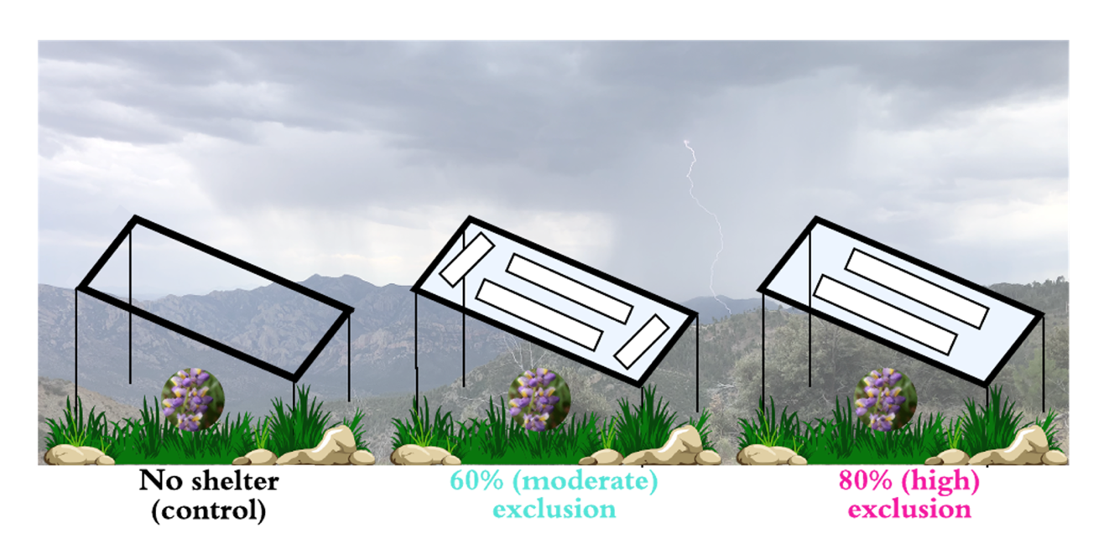
Figure 8. Visual representation of rainfall exclusion treatments set up near Rustler Park in the Chiricahua Mountain Range.

season, plants that underwent high rainfall exclusion were on average 1.66 grams of water per gram soil drier than plants the received moderate rainfall exclusion treatment. Further, plants that underwent high rainfall exclusion were observed to be 2.64 grams of water per gram soil drier than the control treatment (0% rainfall exclusion).
Rhizosphere chemical properties were measured by estimating each factor as a fixed ratio in the soil after fumigated with chloroform and extracted with potassium sulfate (K₂SO₄; Brookes et al. 1985; Vance et al. 1987; Wu et al. 1990). Each rhizosphere soil sample was subsampled twice (2 grams of soil per subsample) and placed into 50 mL falcon tubes. One subsample received 10 mL of 0.5M K₂SO₄ and was placed on a shaker plate for one hour. The soil mixture was then filtered with Whatman Grade 1 filter paper and acid washed funnels, where the filtered supernatant was stored in 15mL falcon tubes at -20°C. The other subsample received 800 µL of chloroform and incubated for 24 hours at room temperature prior to extraction with K₂SO₄. After 24 hours, the fumigated subsamples were opened to allow the chloroform to evaporate for 30 minutes. Fumigated subsamples then received 10 mL of 0.5M K₂SO₄ and were similarly extracted, filtered, and stored as described above. Four chemical assays were conducted on each K₂SO₄ sample in triplicate to estimate ammonium (NH₄⁺), nitrate (NO₃⁻), and phosphorous (P) content in the rhizosphere microhabitat. Ammonium content was estimated using the indophenol-blue colormetric change Berthelot method (Weatherburn, 1967; Verdouw et al., 1978). Nitrate for each rhizosphere sample were captured through a reaction with the K₂SO₄ extraction, a vanadium (III) chloride (VCl₃) acid solution, and Griess reagents (Mulvaney, 1996; Doane and Horwáth, 2003). Lastly, phosphorous was measured by the reaction with ammonium para-molybdate and sulfuric acid and a malachite green solution (Lajtha et al., 1999). Color absorbance was measured on a BioTek Synergy H1 microplate reader (BioTek Instruments Inc., Winooski, VT, USA) set at a wavelength (λ) = 667 nm for ammonium, λ = 540 nm for nitrate, and λ = 630 nm for phosphorous. All color absorbance values were converted to concentrations per gram of rhizosphere soil.

Bacterial community collection
Bacterial communities were sampled using sterilized, handheld soil cores and stored in sterile Nasco Whirl-Paks (Nasco, Fort Atkinson, WI, USA). Detritus and other debris were removed around the base of each plant and the sterilized soil core placed near the base and pushed down approximately 5-7 cm. Field equipment was wiped clean of any remaining soil particulate and surface sterilized with 70% ethanol between each replicate. Rhizosphere microbiomes were sampled once prior to monsoon onset (June 2019) and once near the end of the season (August 2019). Baseline estimates of bacterial richness and rhizospheric soil abiotic data are correspond to the first sampling period prior to treatment installation. After field collection, rhizosphere samples were stored at -80°C until DNA isolation.
Rhizosphere samples were thawed from -80°C storage for an hour, weighed to 250 mg, and placed into a 96 well plate for DNA isolation using the DNeasy PowerSoil HTP 96 Kit (MoBio Laboratories, Inc., Carlsbad, CA, USA). At Step 30 in this protocol, the final elution volume was modified to 50 µL of Solution C6, which sat on the membrane at room temperature for 5 minutes before the final centrifuge step. All isolated DNA was then transferred into sterile 1.5 mL tubes and stored at -80°C until 16S PCR amplification. DNA concentrations for each sample were verified using a NanoDrop 2000 Spectrophotometer (NanoDrop Products, Wilmington, DE, USA). For bacterial communities, the V3-V4 region of the 16S rRNA gene was targeted using the primer pair 341F and 785R during the initial amplification PCR step. The sequences for 341F and 785R are 5’-CCTACGGGNGGCWGCAG-3’and 5’-GACTACHVGGGTATCTAATCC-3’ respectively (Klindworth et al., 2013; Thijs et al., 2017). 5 µL at 1µM of the forward and reverse primers and 12.5 µL of the KAPA HiFi HotStart Ready Mix (KAPA Biosystems, Wilmington, MA, USA) were combined with 2.5 µL of DNA template per reaction. PCR conditions were set for 95°C for 3 minutes, followed by 25 cycles of 95°C for 30 seconds, 55°C for 30 seconds, and 72°C for 30 seconds with a final elongation step of 72°C for 5 minutes. This protocol produced 25 µL of 16S rRNA amplicon per sample. All PCR products were then cleaned with 20 µL Agencourt AMPure XP magnetic beads (Beckman Coulter, Brea, CA, USA) followed by two 200 µL washes of freshly prepared 80% ethanol. Remaining ethanol was then removed, and PCR products were allowed to dry for 10 minutes before they were resuspended in 50 µL of Tris-HCl. Purified PCR products were then stored in -20°C until multiplexing steps.
Samples were multiplexed with specifically designed index primers that allow for bridge amplification and cluster generation on the Illumina MiSeq flow cell (Illumina Corporation, San Diego, CA, USA). Each sample was multiplexed with a unique combination of forward and reverse index primers for sample identification in downstream bioinformatics and hypothesis testing. These primers were sourced from the i5/i7 Nextera XT Index Kit. This index PCR used a total volume of 50 µL that consisted of 5 µL of purified PCR product from the previous reactions, 5 µL of forward and reverse index primers, 25 µL of KAPA HiFi HotStart Ready Mix, and 10 µL of sterile nuclease free water. This PCR was performed on the following conditions: an initial cycle of 95ºC for 3 minutes followed by an 8-cycle sequence of 95ºC for 3 seconds, 55ºC for 30 seconds, and 72ºC for 30 seconds with a final elongation period held at 72ºC for 5 minutes. Index PCR products (50 µL per rhizosphere sample) were purified using 56 µL of Agencourt AMPure XP magnetic beads and two washes of 220 µL of freshly prepared 80% ethanol. Cleaned product was then resuspended in 25 µL Tris-HCl after all remaining ethanol was allowed to evaporate. After multiplexing and purification, all DNA libraries were quantified using a NanoDrop spectrophotometer (NanoDrop Products, Wilmington, DE, USA) and then pooled in equal concentrations. Lastly, a Bioanalyzer (Agilent Technologies, Santa Clara, CA, USA) was used to verify product length. The pooled mixture was then diluted to 4pM with Tris and was placed onto the Illumina MiSeq V3 flow cell with 20% PhiX. The MiSeq instrument at the University of Tennessee Genomics Core, Knoxville, Tennessee, USA was set to read a 2x300 paired end cycle.

Bioinformatics
All 16S amplicon sequence data was processed with the open-source DADA2 pipeline version 1.8 (https://github.com/benjjneb/dada2). This pipeline recognized sequence anomalies at a single nucleotide resolution, or at 99% dissimilarity (Callahan et al., 2016). All bioinformatics and data handling were conducted in RStudio version 1.2.5033. Read quality was examined prior to trimming and sequence reads with low quality scores below Q=30 were filtered out. Amplification primers were trimmed at the 5’ end according to the length of the primer (341F: 17, 785R: 21). All 16S forward reads and reverse reads were then truncated at 270 and 265, respectively. Next, amplicons were dereplicated for every sample using derepFastq within DADA2. This function grouped together and counted all unique sequences found in each sample. Paired sequence reads were then merged and unique amplicon sequence variants (ASVs) inferred. Chimeras were identified across all sample and removed using the removeBimeraDenovo function. A unified ASV table was created for bacterial communities, where rows are samples and columns are unique ASVs.
Rarefaction occurred by rarifying to the lowest number of reads (2,367) 1,000 times using the rrarefy function in the vegan package (Oksanen et al., 2019). Bacterial ASV abundances were proportionally standardized across each row with the decostand function in vegan. The standardized ASV table was then fed into vegan’s vegdist function to create quantitative Jaccard (Ružička) dissimilarity indices, which notably has been used throughout ecology to describe community dissimilarity along gradients (e.g., pH and elevation; Faith et al. 1987). 16S rRNA data was assigned to bacterial taxonomy by rank (e.g., Kingdom, Phylum, Class, etc.) using a naïve Bayesian taxonomic classifier developed by Wang et al. (2007). Here, ASVs were compared to known reference sequences using the open-source database SILVA version 132 (Quast et al., 2013; Yilmaz et al., 2014). Taxa that correspond to NA or Eukaryota at the kingdom level were removed from the data set. Similarly, all taxa that correspond to chloroplast and mitochondria were removed.
The program PASTA (Practical Alignment using Saté and TrAnsitivity; Mirarab et al. 2015) was used to carry out multiple sequence alignment using the external aligner software, MAFFT (Katoh and Standley, 2013). PASTA took the aligned 16S rRNA gene data and inferred a Maximum Likelihood phylogenetic tree using the FastTree-2 (Price et al., 2010). FastTree-2 utilized a generalized time-reversible CAT model of rate heterogeneity to estimate 16S rRNA gene phylogeny. Lastly, treePL, a phylogenetic penalized likelihood software, was used to create an ultrametric tree by transforming each branch length to be consistent with divergence time (Smith and O’Meara, 2012). The 16S gene tree was then merged into a single phyloseq object with the corresponding rarefied and standardized ASV table. To assess differences in the phylogenetic structure of microbial communities a weighted UniFrac distance matrix was created (Lozupone and Knight, 2005).

Hypothesis testing and statistical methods
Two distance-based redundancy analysis (dbRDA) were utilized to assess bacterial community dissimilarity (R package vegan, Oksanen et al. 2019). The first used the quantitative Jaccard distance (bacterial community structure) and the second the weighted UniFrac distance (bacterial phylogenetic membership) built from rarefied, standardized 16S rRNA data. Model selection was conducted with the ordiR2step function in vegan (permutations=1000). The full scope of the model included the following covariates: sampling date, rainfall exclusion treatment, log of phosphorous, log of ammonium, square root of nitrate, the interactions terms between date and all soil abiotic factors, and the interaction terms between rainfall exclusion treatments and all soil abiotic factors. The final dbRDA model used to examine differences in bacterial community structure was the quantitative Jaccard distance matrix predicted by rainfall exclusion treatment and the log of phosphorous. The same model scope during model selection was used for the weighted UniFrac dbRDA. This final dbRDA model was the weighted UniFrac distance matrix predicted by rainfall exclusion. For each dbRDA, we then conducted a permutational analysis on variance (5,000X).
A Hill number approach to estimate alpha and beta diversity was used to understand the effects of rainfall exclusion treatments, sampling date, and soil abiotic factors on bacterial communities. The effective number of species, from here on referred to as the effective number of ASVs, was calculated for alpha diversity using the d() function in the R package vegetarian (version 1.2; Hill 1973; Jost 2007; Charney & Record 2012). Here, the balance between rare and common ASVs in the calculation of ^{q}D is represented by the order of diversity (q). Alpha and beta diversity were each examined at q=0, 1, and 2. Each value of q is represented by a commonly used diversity index used to calculate ^{q}D. For example, at q=0, where rare and common ASVs are weighted equally, therefore ASV richness at this order is calculated in an incidence-based manner. At q=1, rare and common ASVs are weighted in proportional abundance, which is the exponential of Shannon’s entropy index. Further, at q=2 rare ASVs have been down weighted even further from ^{q}D, which corresponds to the inverse of the Simpson’s index.
Alpha diversity was examined in three ways, first at “Date A” prior to the onset of monsoon rainfall, second at “Date B” after rainfall treatments had been installed for the season, and third the difference in bacterial alpha diversity across the monsoon season (Δ Richness). Backward model selection was carried out at q=0 using the step() function in the stats package. The full scope for model selection on alpha diversity at Date A includes phosphorous, ammonium, nitrate, rainfall exclusion treatment and all continuous interactions with rainfall exclusion treatment. Rainfall exclusion treatment was included in model selection to investigate if treatment influenced alpha diversity at Date A by random chance. All continuous variables in this model selection correspond to those taken at Date A. The final model for alpha diversity at Date A was bacterial alpha diversity predicted by ammonium and nitrate. Model selection for Date B had the same full scope as Date, except all continuous variables included were measured at Date B. The final model was alpha diversity at Date B predicted by rainfall exclusion treatment, phosphorous, ammonium, and the interaction between rainfall exclusion treatment and phosphorous. Lastly, model selection for Δ Richness included the following covariates: the difference in ammonium, the difference in nitrate, the difference in phosphorous, rainfall exclusion treatment, and all continuous interaction terms between the measured soil abiotic factors and treatment. The final model selected at q=0 was Δ Richness predicted by the intercept.
Beta diversity was analyzed in two approaches for each value of q. The first approach used betadisper, which is a multivariate approach to a Levene’s Test. Betadisper analyzed the variation in sample dispersion from the group centroid (the median) among groups. This method has been described as a proxy for beta diversity (Anderson et al., 2006). The homogeneity of group dispersion was analyzed for rainfall exclusion treatments and seasonality independently. Distances to the group centroid were created using betadisper and then fed into a linear model where they were predicted by either rainfall exclusion treatment or sampling date. An analysis of variance was conducted on the distances to the centroid to determine if there were any significant differences in variance among treatments or dates. The second method used dbRDAs to test the effects of rainfall exclusion treatments and soil abiotic factors on pairwise community turnover. Proportional change in community turnover was calculated as 1 – pairwise (Between Date A and Date B) beta diversity for each rhizosphere sample. These were then represented as pairwise distance matrices pre order of diversity. Model selection was conducted at q=0 with ordiR2step (permutations=1000), and the full scope of the model was the same as that of the dbRDAs conducted on the quantitative Jaccard and weighted UniFrac distances. The final model was pairwise community turnover predicted by rainfall exclusion treatments, the log of phosphorous, and sampling date. A permutational analysis of variance (5000X) was conducted on each dbRDA per value of q.
An indicator species analysis was conducted using a group equalized point biserial correlation index. This was permuted 50,000 times with the function multipatt in the indicspecies R package (De Caceres and Legendre, 2009). An indicator species analysis will show which groups of bacteria are more strongly associated with the different rainfall exclusion treatments represented in Figure 8. The rainfall exclusion treatment indicator analysis was performed on data only associated with Date B, since Date A was used as a baseline estimate for communities and rhizosphere properties.

Results
After running the DADA2 customized pipeline as described above, a total of 48,166 ASVs were generated for the bacterial community dataset. The most frequently detected bacterial phyla were Proteobacteria (40%), Actinobacteria (25%), Acidobacteria (11%), Bacteroidetes (6%), and Verrucomicrobiae (5%) prior to the implementation of rainfall exclusion treatments. Planctomycetes and Firmicutes represented 7% and 1% of phyla recovered via the MiSeq run. The most highly abundant bacterial family recovered is, Xanthobacteraceae, an Alphaproteobacteria, making up 15% of all 16S rRNA sequencing reads. The next most abundant bacterial families are Burkholdieraceae (4%), Beijerincklaceae (3%), and Micromonosporaceae (3%). Lastly, at a finer taxonomic level, the most enriched genus is Nitrobacter comprising of 10% of total reads.

Community structure and phylogenetic membership were influenced by rainfall exclusion
To address how bacterial community structure and phylogenetical membership differed among rainfall exclusion treatments, sampling date, and soil abiotic factors two dbRDAs were conducted. The final model was the quantitative Jaccard predicted by rainfall exclusion treatment and the log of phosphorous. The constrained axes explained 3.14% of total variation in bacterial community structure. The two most explanatory constrained axes accounted for 42.42% and 30.68% of the 3.14% in total variation explained by the model. The permutational ANOVA ran on this model showed that bacterial community structure significantly varied among rainfall exclusion treatments (p<0.001) and the log of phosphorous (p<0.01). A principal coordinate analysis showed distinctive clustering among rainfall exclusion treatments on axes 1 and 2 (Figure 9). Per treatment, bacterial communities by the end of the monsoon season differ relative to initial community estimates. To test the differences in phylogenetic membership among rainfall exclusion treatments, we ran a dbRDA with a weighted UniFrac distance matrix as the response variable. Constrained axes explained 4.24% of total variation in bacterial phylogenetic membership. Axes 1 and axes 2 explained 83.26% and 16.74% of the 4.24% in total variation of bacterial phylogenetic membership. There was an observed difference in bacterial phylogenetic membership among rainfall treatments (p<0.05) with moderate and high rainfall exclusions
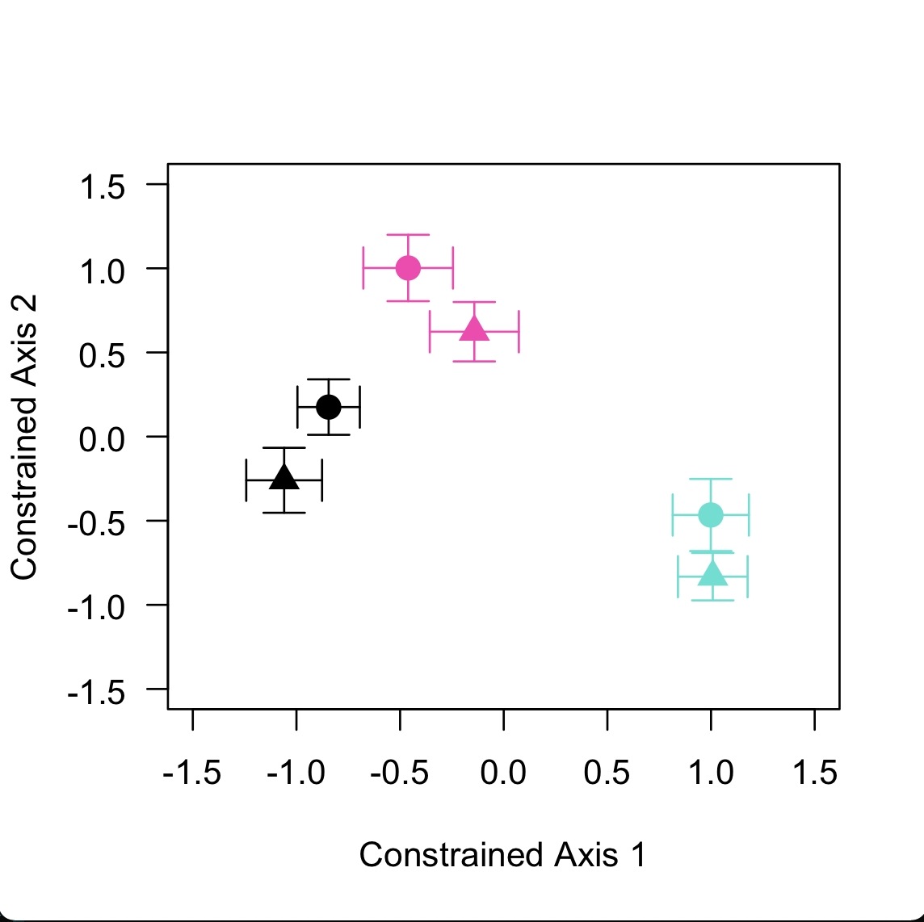
Figure 9. A principal coordinate analysis from the dbRDA describing dissimilarity of bacterial community structure as a function of rainfall exclusion treatment and the log of phosphorous.
Figure 9 footnote. Colors here represent the median centroid of each treatment in multivariate space whereby black, teal, and pink correspond to the control, moderate rainfall exclusion, and high rainfall exclusion respectively. Shapes represent sampling date, where triangles are Date A and circles Date B. Bars are ± one standard error.

diverging away from one another and the control (Appendix Figure 2). However, a principal coordinate analysis on the constrained axes from this model showed no distinguishing clustering among treatments or sampling date.

Alpha diversity, rainfall exclusion treatments, and soil abiotic factors
Prior to rainfall exclusion, each rhizosphere microhabitat was sampled for bacterial communities to examine the importance soil abiotic factors have on alpha diversity from q=0 to q=2. An analysis of variance from q=0 to q=2 shows that nitrate is an important predictor for bacterial alpha diversity at Date A (q=0: F_{1,63}=4.98, p=0.029; q=1: F_{1,63}=7.67 p=0.007; q=2: F_{1,63}=8.49, p=0.005) From q=1 to q=2, ammonium was shown as an important predictor in bacterial alpha diversity at Date A (q=1: F_{1,63}=4.47, p=0.039; q=2: F_{1,63}=5.46, p=0.023). These results suggest that more abundant, in comparison to rare, bacterial taxa respond to nitrate prior to the onset of rainfall exclusion treatments. Whereas rare taxa are influenced by both nitrate and ammonium prior to the onset of rainfall exclusion. Our results here further confirm that bacterial alpha diversity in the rhizosphere microhabitat is dependent on multiple soil abiotic factors.
Alpha diversity was also analyzed at Date B from q=0 to q=2 to test for the effects of rainfall exclusion treatments and soil abiotic factors. An analysis of variance illustrated that rainfall exclusion treatments influenced bacterial communities from q=0 (F_{2,59}=5.58, p=0.006) to q=1 (F_{2,59}=4.23, p=0.019), which illustrates that rainfall exclusion effects more common bacterial taxa than rare ones. Ammonium content in the rhizosphere was also shown to be a main effect for bacterial alpha diversity at the end of the monsoon season from q=0 to q=2 (Table 3). Additionally, Table 3 depicts a full summary of the analysis of variance for all covariates included in our model for bacterial alpha diversity at Date B. While bacterial alpha diversity at Date B was governed by different variables as rare species were down weighted, the same hump shaped pattern in alpha diversity among rainfall exclusion treatments was observed for each order of diversity (Figure 10). These results illustrate that rainfall exclusion and ammonium affects estimates in bacterial alpha diversity. Δ Richness was measured as the difference in the effective number of bacterial ASVs between the two sampling dates. The final model was Δ Richness, for each value of q, predicted by the intercept. Therefore, rainfall exclusion treatments, sampling date, and soil abiotic factors did not influence our estimates of Δ Richness for bacterial communities.
Table 3. An analysis of variance summary table showing the main effects on bacterial communities at the end of the monsoon season (Date B).
 | Order of Diversity (q)
 | 0 | 1 | 2
Rainfall exclusion treatment | F_{2, 59}=5.58, p=0.006 | F_{2, 59}=4.23, p=0.019 | F_{2, 59}=2.77, p=0.070
Phosphorous | F_{1, 59}=0.72, p=0.400 | F_{1, 59}=0.78, p=0.380 | F_{1, 59}=0.92, p=0.340
Ammonium | F_{1, 59}=8.53, p=0.049 | F_{1, 59}=7.84, p=0.007 | F_{1, 59}=5.18, p=0.026
Rainfall exclusion treatment*phosphorous | F_{2, 59}=1.86, p=0.165 | F_{2, 59}=2.34, p=0.105 | F_{2, 59}=2.96, p=0.059
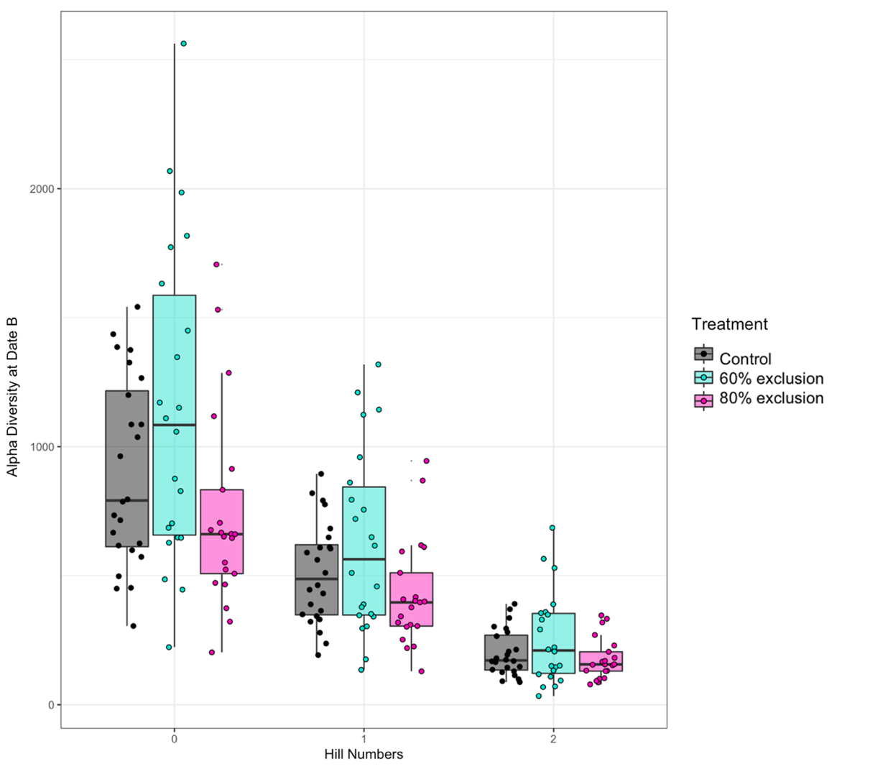
Figure 10. Bacterial alpha diversity from q=0 to q=2, where the control, moderate rainfall exclusion treatment, and the high rainfall exclusion treatment are represented from left to right as black, teal, and pink.

Bacterial community dispersion and pairwise turnover from q=0 to q=2
The first approach to test beta diversity between rainfall exclusion treatments was an analysis of multivariate homogeneity between groups and their respective centroids. This method allowed us to examine the variation in abundance data among treatments in multivariate space. From q=0 to q=2, there was a significant difference in multivariate group dispersion in bacterial communities between sampling dates (q=0: F_{1,130}=5.38, p<0.05; q=1: F_{1,130}=5.23, p<0.05; q=2: F_{1,130}=4.25, p<0.05). This indicated variability in community abundance data between the two sampling dates. Bacterial communities collected at the end of the monsoon season, on average, had a larger spread in community abundance data than samples collected at the beginning (Figure 11). In addition, the dispersion around the median centroid from each rainfall exclusion treatment differed only at q=2 (q=2: F_{2,129}=5.75, p<0.01), when rare ASVs are down weighted from the estimation of bacterial dispersion. Thus, rare taxa contributed less to the variability in community data among rainfall exclusion treatment than more abundant bacterial ASVs had. The second method examined the effects of soil abiotic factors and rainfall exclusion treatments had on pairwise community turnover. We utilized a dbRDA for each order of diversity with a pairwise distance matrix as the response variable. At q=0, 1, and 2, constrained axes from the models built explained 4.46%, 5.26%, and 4.84%, respectively. At q=0, constrained axes 1 and 2 explain 36.89% and 24.23% of the 4.46% total variation of pairwise community turnover explained. Figure 12 illustrates that, on average, pairwise turnover at q=0 changes within treatment and in the same direction across treatments by the end of the monsoon season. Principal coordinate plots for q=1 to q=2 regarding pairwise community turnover can be found in Appendix Figure 4 and Appendix Figure 5. According to a permutational analysis of variance, rainfall exclusion treatments were an important predictor of pairwise community turnover from q=0 to q=2 (q=0: p<0.001; q=1: p<0.001; q=2: p<0.01). Additionally, our permutational analysis of variance showed that the log of phosphorous was an important predictor in pairwise community turnover (q=0: p<0.01; q=1: p<0.01; q=2: p<0.05), influencing changes in more common and rare bacterial taxa alike. Sampling date influenced pairwise community turnover at q=0 (p<0.05). This suggests that across the monsoon season phenological shifts in bacterial community composition can occur due to variation in rainfall intensity and phosphorous.
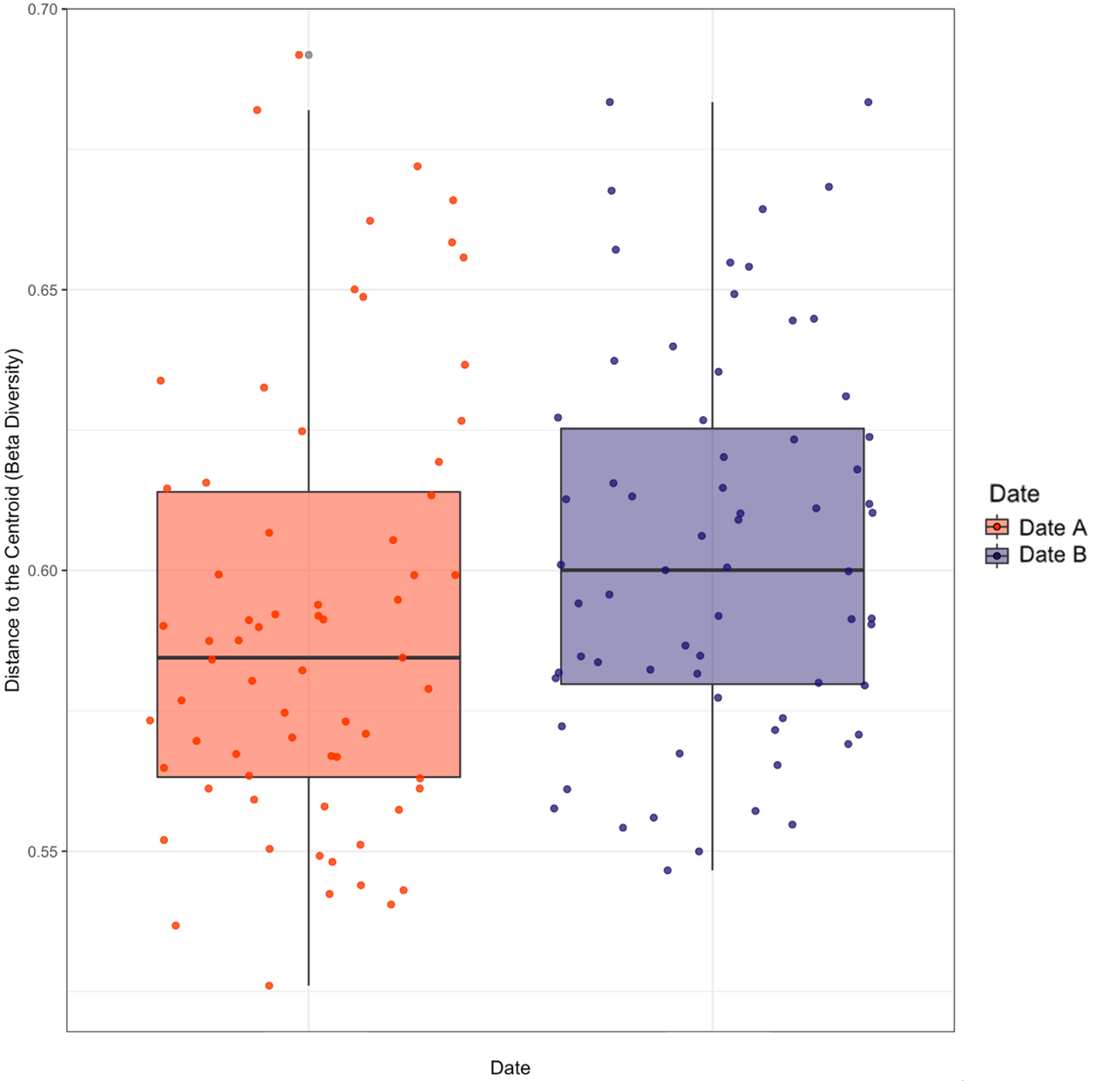
Figure 11. Beta diversity, or distance to the centroid in multivariate space at q=0, where significant differences in beta diversity were detected across the monsoon season.
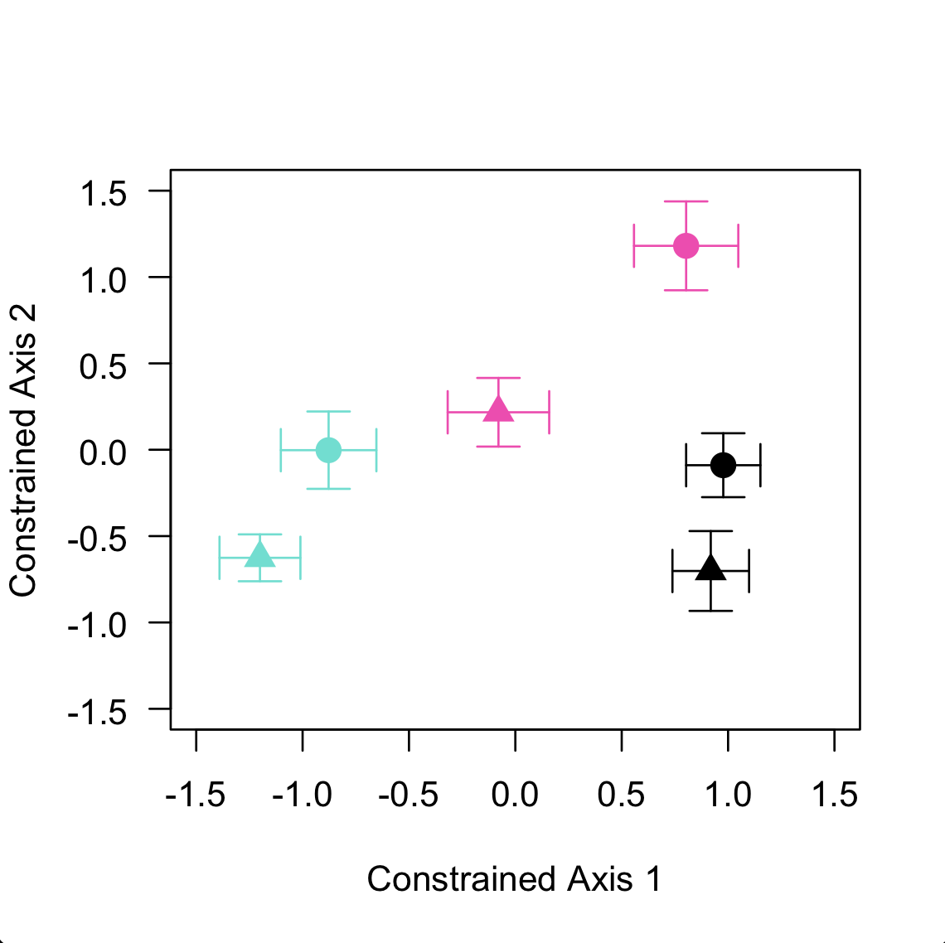
Figure 12. Principal coordinate analysis at q=0 for pairwise community turnover.
Figure 12 footnote. Where triangles represent communities at the beginning of the monsoon (Date A) and circles are communities at the end of the monsoon season after rainfall exclusion (Date B). From left to right, teal corresponds to moderate rainfall exclusion (60%), pink to high rainfall exclusion (80%), and black the control treatment (0%). Bars are ± one standard error around the median.

Rainfall exclusion treatments harbor unique indicator ASVs
An indicator species analysis was completed on community data from Date B to determine which ASVs are unique to each rainfall exclusion treatment as depicted in Figure 8. The control treatment had 61 unique indicator ASVs representing 7 bacterial phyla (Acidobacteria, Actinobacteria, Bacteroidetes, Chloroflexi, Planctomycetes, Proteobacteria, and Verrucomicrobia), with Actinobacteria being the most common indicator phylum. There were 14 ASVs that were assigned to unknown (NA) bacterial families in the control treatment. Figure 13 highlights the six most abundant bacterial classes (Actinobacteria, Alphaproteobacteria, Bacteroidia, Deltaproteobacteria, Gammaproteobacteria, and Verrucomicrobiae) that have been assigned as indicators across all rainfall exclusion treatments. Here, bacterial families are represented by color and the most relatively abundant bacterial family for the control treatment is Micrococcaceae (Figure 13). There were numerous bacterial ASVs that had significant indicator values with the control treatment. The largest indicator value for the control treatment is r=0.48 (p<0.001) and corresponds to the bacterium Williamsia sp. (phylum Actinobacteria). The second most correlated bacterial ASV for the control treatment is Segetibacter spp., which belongs to the phylum Bacteroidetes and the family Chitinophagaceae. (r=0.43, p<0.001). In comparison, the moderate rainfall exclusion treatment had the most abundant and diverse set of bacterial indicators, which spans 12 bacterial phyla and 51 bacterial families. The most uncovered bacterial phyla as indicators for this treatment were Proteobacteria (28 ASVs), Actinobacteria (21 ASVs), Bacteroidetes (18), Acidobacteria (11), and Verrucomicrobia (11). Figure 13 shows the two most relatively abundant bacterial families for the moderate rainfall exclusion treatment were Chitinophagaceae and Nitrosomonadaceae. For the moderate rainfall exclusion treatment, the bacterial ASV corresponding to the genus Acidibacter, a Proteobacteria, had the largest significant correlation (r=0.41, p<0.001). Based on taxonomic assignment to the SILVA (v. 138) database, this ASV did not have a previously assigned family or species. Additionally, the second most correlated (r=0.36, p<0.01) bacterium for the moderate rainfall exclusion treatment corresponds to an ASV in the order Frankiales (phylum Actinobacteria). In the high rainfall exclusion treatment, the same 7 bacterial phyla were recovered as indicators as in the control treatment, however the most common indicator phyla were Proteobacteria with 13 ASVs. There were 21 bacterial indicators families in the high rainfall exclusion treatment, with Micromonosporaceae and Devosiaceae as the most common indicators. Lastly, bacteria
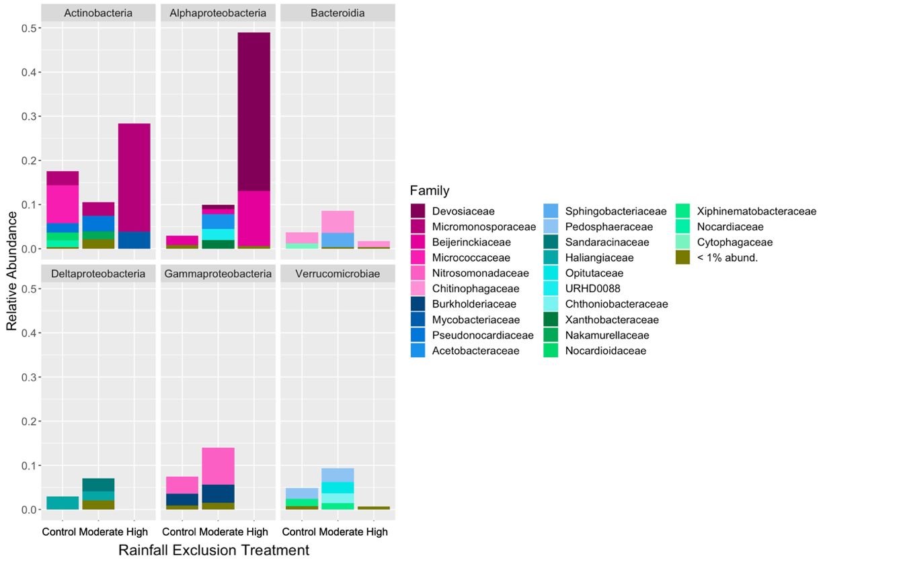
Figure 13. An indicator species analysis based on rainfall exclusion treatments. Colors represent different bacterial families grouped at the class level for Actinobacteria, Alphaproteobacteria, Bacteroidia, Deltaproteobacteria, Gammaproteobacteria, and Verrucomicrobiae.

belonging to the order RBG-13-54-9 (phylum Actinobacteria) and the genus Actinoplanes (phylum Actinobacteria) were significant indicators for the high rainfall exclusion treatment and had correlation values of 0.38 (p<0.01) and 0.35 (p<0.01) respectively. Full sequences, correlation values, and associated p-values can be found in Resource5.csv.

Discussion

Summary
We have demonstrated that bacterial community composition responds to the manipulation of seasonal rainfall in the Sonoran Desert. Each rainfall exclusion treatment hosted phylogenetically distinct bacterial communities. Results from this study support our third predictive hypothesis, that moderate rainfall exclusion favored greater coexistence in bacterial taxa than other treatments. For example, rhizosphere microhabitats that underwent moderate rainfall exclusion (60%) had on average the highest estimates of bacterial alpha diversity, while rhizosphere microhabitats that experienced high rainfall exclusion (80%) had the least. This pattern was observed across all orders of diversity. Before rainfall exclusion, common bacterial taxa were influenced by nitrate in comparison to rare taxa which were influenced by ammonium and nitrate. After rainfall exclusion, ammonium and rainfall exclusion treatment were important predictors of bacterial alpha diversity. This indicates a shift in the relative importance abiotic factors have in a seasonal time scale. Pairwise community turnover in bacterial community composition was shown to be dependent on rainfall exclusion and phosphorous across all values of diversity. Thus, more common bacterial ASVs might become at risk in short term temporal scales as future climates in arid ecosystems become more extreme.
Free-living bacterial communities are ephemeral, particularly outside of symbiosis, and are thus susceptible to environmental change, such as wet/dry seasonality (Waring and Hawkes, 2015), temperature (Martiny et al., 2011), and changes in labile macronutrients (Horner-Devine et al., 2004; Fierer and Jackson, 2006a). Plant host-associated bacterial communities also experience deterministic and stochastic processes, yet the direction and magnitude in response to changes in seasonal rainfall is variable and can be taxa specific. In this study, bacterial community composition in the rhizosphere of L. neomexicanus have been shown to be sensitive to variation in monsoon rainfall intensity throughout the season. This result is in congruence with Nessner Kavamura et al. (2013), as they similarly observed a response in rhizosphere bacterial communities to seasonal variation in soil water content. Additionally, rhizosphere bacterial microbial communities have been shown to contain phylogenetically distinct groups between rainy and dry seasons, however there lacks a clear consensus on if other abiotic factors affect this response (Taketani et al. 2017). Our results are similar in that we show variation in bacterial community structure and unique phylogenetic membership among rainfall exclusion treatments. We also have illustrated that phosphorous influences the bacterial community structure of L. neomexicanus rhizospheres. Our models demonstrate that bacterial alpha diversity during the monsoon season is contingent on multiple soil abiotic factors, such as rainfall and ammonium. Persistence of common and rare bacterial taxa are governed by available ammonium and rainfall exclusion alike, while more rare taxa may be more sensitive to variation in ammonium. While these soil abiotic factors have been shown to be primary drivers of bacterial community structure and membership, they are context dependent in that they are unique to L. neomexicanus and the Sonoran Desert.
We observed that under moderate rainfall exclusion during the monsoon season, bacterial alpha diversity estimates are the greatest in comparison to the control and high rainfall exclusion treatments. This pattern is in congruence with our third predictive hypothesis that coexistence among rhizospheric bacterial taxa is moderated in a spatial structured microhabitat when resources are utilized such that competition for them is low (Tilman, 1977, 1994). In the context of soil microbial ecology, competitive exclusion can occur among multiple populations that are limited by the same resource (e.g., soil moisture), where one taxon is a stronger competitor. Competitive exclusion could be one possible interpretation of observing lower estimates of richness during dry conditions as desiccation tolerance can act as a more favorable strategy for some populations than others (Kavamura et al. 2018). Our results illustrate that plant-host associated bacterial communities maintained increased estimates of richness under moderate rainfall exclusion, whereby a threshold in soil moisture exclusion could contribute to the loss of many taxa in the high exclusion treatment. This hump shaped pattern in bacterial richness could suggest that a stable tradeoff exists between dispersal (ruderal persistence) and competition among bacterial taxa in stressful environment. To the best of our knowledge, this pattern in host-associated microbial richness as a result of rainfall exclusion has only been previously shown by Deveautour et al. (2020). This study illustrated that communities of arbuscular mycorrhizal fungi have greater estimates of alpha diversity in reduced rainfall treatments in comparison to the control or severe drought in semiarid grasslands. If we turn to Zhang et al. (2018), free-living soil bacterial and fungal communities similarly show higher estimates of community richness under moderate stress when there are sufficient soil resources available. Our results, in corroboration with studies on free-living microbes, might further suggest that free-living and host-associated microbial communities respond to increased environmental stress in a similar direction and magnitude.
Wet and dry seasons in semiarid ecosystems have been shown to contribute to variation in plant host-associated bacterial beta diversity (Taketani et al. 2017). The data presented within our study further indicates the sensitivity to turnover in bacterial community composition due to variability in soil moisture conditions. For instance, the homogeneity of group variance differed by sampling date at q=0 to q=2, while rainfall exclusion had an effect at q=2. This could suggest that the change in bacterial taxa among rainfall exclusion treatments occur with more common bacteria. Changes in pairwise community turnover could be explained by the treatment itself, whereby it favors specific bacterial taxa that are resistant to desiccation under drier conditions (Taketani et al., 2017). The dissimilarity in pairwise community turnover detected among rainfall exclusion treatments can also be credited to the changes in rhizosphere soil abiotic factors that covary with soil moisture contradictory to Armstrong et al. (2016). This is confirmed by our evidence that shows rainfall exclusion treatments host distinct bacterial groups, which covary with soil moisture and phosphorous.
Indicator species analyses provide correlative evidence for which taxa are strongly associated with each rainfall exclusion treatment, in order to predict which taxa may be present in similar ecological niches in future studies (De Caceres and Legendre, 2009). Since the rhizosphere microhabitat hosts a highly diverse bacterial community, investigating each correlated ASV at higher taxonomic levels may be more useful, particularly when information about specific ASVs is unavailable or limited. The control treatment which had no rainfall exclusion treatment throughout the duration of the monsoon season, served as a baseline estimate for bacterial communities. The rhizosphere microhabitats in the control treatment were highly enriched with Actinobacteria, which interact with plant hosts as either pathogenic, commensal, or beneficial as plant growth promoting bacteria (Loria et al., 2006; Bulgarelli et al., 2013). This could be an important association in nutrient poor, desert ecosystems for pioneer plant species like L. neomexicanus (Sellstedt and Richau, 2013). The most strongly associated bacterial ASV with the control treatment belonged to the novel genus Williamsia. When associated with higher concentrations of nitrogen, Williamsia spp. can colonize and become a dominant, more abundant, member in the rhizosphere community (Moccia et al., 2020).
Rhizosphere microhabitats that underwent moderate rainfall exclusion had the most abundant, significant indicator ASVs in the phyla Proteobacteria and Bacteroidetes. In concordance with Liang et al. (2019) these phyla can respond to changes in rhizosphere soil moisture and phosphorous from Spring to Summer months, similarly demonstrating that rhizosphere host-associated bacteria are sensitive to variation in seasonal soil abiotic factors. The family Chitinophagaceae (phylum Bacteroidetes) was strongly correlated with the moderate rainfall exclusion treatment, where Mickan et al. (2019) reported a decrease in relative abundance under low water conditions. Although, this mismatch in results may be a direct result of assigning taxonomy to Silva v. 106 versus the most current version, Silva v. 138. In similarity with the moderate rainfall exclusion treatment, rhizosphere microhabitats that underwent high rainfall exclusion had Proteobacteria indicator ASVs. At the family taxonomic level, both Micromonosporaceae (phylum Actinobacteria) and Devosiaceae (class Alphaproteobacteria) were indicators of high rainfall exclusion during the monsoon season. Taketani et al. (2017) illustrates that rhizosphere soil throughout dry seasons are enriched with Actinobacteria, as these taxa are spore forming and therefore possibly could be more resistant to desiccation than other bacterial groups (Zenova et al., 2007). This pattern has been observed by free-living soil bacterial groups as well (Barnard et al., 2013; Kavamura et al., 2018).

Conclusions and future directions
In conclusion, rhizosphere bacterial communities in the Sonoran Desert turnover and are susceptible to short term changes in richness due to seasonal rainfall exclusion. Bacterial communities were unique in structure and phylogenetic membership among rainfall exclusion treatments. Alpha diversity was estimated as the greatest in the moderate rainfall exclusion treatment, illustrating a hump-shaped pattern in richness after the rainy season similar in direction and magnitude by free-living bacterial and fungal communities. This study specifically highlights that plant host-associated bacterial communities are dependent upon different ecological conditions prior to and after rainfall exclusion treatment. Further, this study elucidates an enrichment in Actinobacteria as a response to drying soil conditions, which might be due to their distinctive spore structures that can alleviate cellular dehydration. This information proves beneficial as drier climates during historically wet seasons may breakdown valuable interactions between plants and microbes, which can change rates of nutrient cycling and acquisition by the plant.
There remains a large need to coalesce and synthesize studies regarding bacterial responses to altered precipitation regimes among a wider array of ecological conditions and spatial and temporal scales. For example, what is the appropriate geographic scale to investigate changes in precipitation and microbial response? Could the captured variation in bacterial richness presented within this study be non-detectable at larger spatial extents? As next generation sequencing technology becomes more widely available and cost effective, studies in the future could benefit from more repeated community measures to investigate short-term fluctuations in community composition over time. This may also help elucidate if short-term changes in community structure and membership have any long-term effect on the development and stability of plant host-associated bacterial communities. Lastly, as more studies begin to focus on the microbial response to changing climate conditions, standardizing bioinformatic and analytical approaches may serve useful when drawing conclusions among ecological contexts to make meaningful interpretations.

CHAPTER THREE:
ARBUSCULAR MYCORRHIZAL FUNGAL COMMUNITIES VARY AS A RESPONSE TO SHORT-TERM RAINFALL EXCLUSION

Abstract
Arid ecosystems around the world are projected to experience reduced and more infrequent precipitation events. The effects of reduced rainfall are well understood for plants and aboveground interactions, however the effect of rainfall on belowground microbial interactions remains understudied. Here, we use Bayesian inference to illustrate the strength and direction of change short term manipulative rainfall exclusion treatments have on the composition and relative abundance of Arbuscular Mycorrhizal (AM) fungal communities throughout the monsoon season in the Sonoran Desert. Additionally, we use these rainfall exclusion treatments to further understand the impact of soil moisture on labile forms of nitrogen and phosphorous in a natural environment. Rainfall exclusion treatments were installed to remove 0% (control), 60% (moderate exclusion), and 80% (high exclusion) of rainfall over a single wet season. AM fungal community composition varied among rainfall treatments and across the monsoon season, where change was dependent on initial conditions within treatments. Phosphorous content was also a strong predictor of AM fungal composition and relative abundance. By the end of the season, the difference in AM fungal richness was influenced by rainfall exclusion, with the greatest positive change in richness in the moderate removal treatments. Lastly, AM fungal community turnover was predicted by rainfall exclusion treatments where rainfall contributed to greater turnover in the control treatment in comparison to other treatments. This study further illustrates the complex association between soil abiotic factors, how they are influenced by environmental stress, and how in turn cause shifts in AM fungal communities.

Introduction
As climate change alters seasonal weather patterns, interactions among mutualistic organisms can become decoupled through range shifts or changing phenology (Van Der Putten et al., 2010). Arid regions around the world are predicted to experience stark reductions in seasonal precipitation while global temperatures begin to rise (Diffenbaugh and Giorgi, 2012). The North American Monsoon season, present in Southeastern Arizona and Western New Mexico, provides roughly 40% of the regions mean annual precipitation. This seasonal effect has been shifting spatiotemporally and becoming difficult to predict under future climate conditions (Comrie and Glenn 1999; Mitchell et al. 2002; Demaria et al. 2019). Climate models have illustrated the importance seasonal precipitation and temperature have on plants, animals, and, thus, the interactions among them (Bradie and Leung, 2017). Plants also have numerous belowground interactions with microorganisms, such as bacteria and fungi, whereby mutualistic associations provide vital access to nutrients, water, as well as resistance to pathogens (Newsham et al., 1995). For example, these associations promote plant productivity, affect plant defense strategies, and influence overall health (Van Der Heijden et al., 2008; Lau and Lennon, 2011). Yet, there remains a need to understand how changing seasonal precipitation regimes in dry, arid climates might affect plant-fungal interactions.
Arbuscular Mycorrhizal (AM) fungi are a clade of plant host-associated microorganisms (Glomeromycotina) that form associations with over 70% of terrestrial plant species (Soudzilovskaia et al., 2020). AM fungi are highly abundant in soils and have a wide distribution globally, extending from tropical forests to grasslands (Hayman, 1982). Communities of AM fungi are key components of soil nutrient cycles, exchanging phosphorous with plant derived carbon (Allen, 1991). At a regional scale, AM fungal communities and the type of symbiosis are often more strongly predicted by environmental factors than plant hosts or dispersal limitation (Johnson et al., 2010; Kivlin et al., 2014). These environmental factors could be one or more of the following: soil fertility (soil organic matter content; Anderson, Liberta and Dickman 1984), soil moisture (Miller, 2000; Gao et al., 2016), soil pH (Green et al., 1976), soil texture (e.g., silt, sand, etc.; Johnson, Tilman and Wedin 1992), and soil nutrients (Johnson et al., 2010). Changes in soil moisture or H₂O saturation can also influence the labile nature of soil abiotic factors of the rhizosphere (Deepika and Kothamasi, 2015; Kanwal et al., 2015; Bobille et al., 2019). Therefore, it is important to investigate the relative importance environmental perturbations have on AM fungal communities through both direct and indirect pathways.
Environmental stress can also have large direct consequences on AM fungal community composition and relative abundance Hernandez et al. (2021). For example, in greenhouse experiments, seasonal drought can be induced through water pulsing where irregular water regimes have a positive effect on AM fungal colonization and persistence in comparison to treatments with a continuous supply of water (Birhane et al., 2012). However in natural environments, some studies have shown that AM fungal communities may be predisposed to tolerate drought conditions based on prior rainfall history (Kuehn et al., 1991). While others have shown that the response of AM fungal community composition to altered precipitation may be gradual, becoming more distinct from season to season (Deveautour et al. 2020). Thus, there lacks a consensus regarding the direction and magnitude of change in composition as soil moisture varies among ecosystem types and temporal scales.
In this study, we examine the relative importance manipulative rainfall exclusion, local soil abiotic factors, and sampling date have on AM fungal communities within a single monsoon season. We first ask, what is the strength and direction of change in AM fungal communities (i.e., composition, richness, and turnover) in response to the manipulation of seasonal rainfall in the Sonoran Desert? And secondly, what is the relative influence soil abiotic factors and sampling date have on these communities? To answer these questions, experimental rainfall exclusion treatments were set up over the course of the monsoon season to remove 0% (control), 60% (moderate exclusion) and 80% (high exclusion) of seasonal rainfall. Soil abiotic factors and AM fungal communities were sampled at the beginning and end of the monsoon season. Due to the complex ecological communities found in the rhizosphere microhabitat, there are two predictive hypotheses that were derived from our questions. First, with reduced rainfall, AM fungal communities could show no observed net gain or loss in taxa among rainfall exclusion across the monsoon season, as AM fungi have been noted to have higher desiccation tolerance than other fungal clades, such as ectomycorrhizal fungi. Alternatively, AM fungal communities could differ among rainfall exclusion treatments as AM clades might start root colonization in response to changes in soil moisture and other abiotic factors. Understanding the response of plant-host associated fungal communities to drier microhabitats could shed light on how they might associate with hosts in future, more extreme climate conditions.

Materials and Methods

Experimental design
Lupinus neomexicanus Greene (Fabaceae) was chosen as an experimental system because of an elongated flowering time allowing for consistent identification throughout the monsoon season. This allowed us to make sure that all plants sampled were within the same life stage and had similar aboveground biomass. This species is endemic to mid-range elevations (1,600-2,000m) in Southern Arizona (e.g., 31°53'50.3"N 109°16'38.5"W). Monsoon rainfall occurs in the Sonoran Desert ecoregion of the United States around late June-mid August. This rainfall often influences how organisms interact and can help maintain population level persistence throughout the remaining portion of the year. This season can function as a natural experiment to manipulate seasonal rainfall intensity on a stable plant population and their interactions with arbuscular mycorrhizas. Monsoon rainfall exclusion shelters were established following guidelines outlined in Beier et al. (2012). Short-term rainfall exclusion shelters were constructed of 6mil heavy-duty clear plastic sheeting with 60% (moderate exclusion) or 80% (high exclusion) of a 1m² surface area removed (n=22). Rainfall exclusion shelters were supported by two 12” and two 24” wooden landscape stakes and four 1m wooden dowels along each edge. This design raised one edge of the shelter to allow rainfall water to run off plot to ensure soil moisture manipulation (Figure 14). The control had no rainfall exclusion treatment.

Sampling soil abiotic factors
The rhizosphere microhabitat was sampled twice, once prior to the monsoon season (Date A; June 2019) and once at the tail end of the rhizosphere (Date B; August 2019). Baseline estimates for AM fungal community structure, soil moisture, and other soil abiotic factors are from the first sampling period prior to monsoon shelter establishment. Soil was dried in a laboratory oven for 48 hours at 54°C. Soil moisture content was measured as the difference in soil weight between field wet soil and oven dried soil divided by the weight of oven dried soil (Australia, 1977). By the end of the monsoon season, the high rainfall exclusion treatment was on average 1.66 g water/g soil drier than the moderate rainfall exclusion treatment and 2.64 g water/g soil drier than the control treatment. To estimate soil abiotic factors (e.g., ammonium, nitrate, and phosphorous) in the rhizosphere environment, all rhizosphere samples were subsampled twice (2 grams of rhizosphere soil per subsample) and extracted with potassium sulfate and then analyzed in triplicate (K₂SO₄; Brookes et al. 1985; Vance, Brookes and Jenkinson 1987; Wu et al. 1990). Since AM fungi play a pivotal role in nitrogen cycling, nitrogen was measured in two ways (ammonium and nitrate). Ammonium was measured using the indophenol-blue Berthelot method (Weatherburn, 1967; Verdouw et al., 1978) and a vanadium (III) chloride acid solution and Griess reagents (Mulvaney, 1996) were used to extract nitrate from the K₂SO₄ samples. Phosphorous content for each rhizosphere sample was measured by a reaction between the K₂SO₄ extractions, ammonium para-molybdate (AMP), concentrated sulfuric acid, and a malachite green solution (Lajtha et al., 1999).

Figure 14. Rainfall exclusion treatment designs to manipulate monsoon rainfall on AM fungal communities of the rhizosphere with 60% (moderate) exclusion, 80% (high) exclusion, and no shelter (control treatment).

Sampling AM fungal communities
AM fungal communities were sampled using sterilized, handheld soil cores and stored in Nasco Whirl-Paks (Nasco, Fort Atkinson, WI, USA). All field equipment was surface sterilized with 70% ethanol and soil particulates were removed in-between sampling. To collect AM fungal communities, the sterilized soil core was pushed approximately 5-7cm into the rhizosphere microhabitat along the root base where the plant stem meets the soil. All rhizosphere samples were stored on dry ice until temporary storage (-80°C) at the Southwest Research Station in Portal, Arizona, USA. Samples were then shipped on dry ice to the University of Tennessee, Knoxville and immediately stored at -80°C upon arrival. Prior to DNA isolation, all rhizosphere soil samples were thawed for one hour at room temperature. DNA isolation proceeded with 250 mg of rhizosphere soil per sample and the DNeasy PowerSoil HTP 96 Kit (MoBio Laboratories, Inc., Carlsbad, CA, USA). The final elution volume was modified so that 50 µL of Solution C6 was used. Additionally, the solutions sat on the DNA membrane for 5 minutes at room temperature prior to centrifuging the concentrated DNA down into a sterile 96 well collection plate.
Libraries of the 18S rRNA gene for AM fungal communities were amplified using a nested PCR protocol. The first reaction utilized the primer pair NS1/NS4, which amplified approximately a 1200 bp product (White et al., 1990; Raja et al., 2017). The forward NS1 primer sequence was 5’-GTAGTCATATGCTTGTCTC-3’ and the reverse NS4 primer sequence was 5’- CTTCCGTCAATTCCTTTAAG-3’. Each reaction used 2.5 µL of the DNA template, 5 µL of both the forward and reverse primers, and 12.5 µL of KAPA HiFi HotStart Ready Mix (KAPA Biosystems, Wilmington, MA, USA). This reaction ran at 95°C for 3 minutes, followed by 30 cycles of: 95°C for 30 seconds, 40°C for 1 minute, and 72°C for 1 minute with a final elongation step of 72°C for 10 minutes. These reactions produced 25 µL of PCR product. The following nested reaction amplified ~400 bp with the mixed primer pair, NS31 (Simon et al., 1992) and AML2 (Lee et al., 2008), which contain the sequences 5’-TTGGAGGGCAAGTCTGGTGCC-3’ and 5’-GAACCCAAACACTTTGGTTTC-3’, respectively. These reactions required 2.5 µL of product from the first reactions, 5 µL of NS31 and AML2, and 12.5 µL of KAPA HiFi HotStart Ready Mix. These reactions began with 95°C for 5 minutes followed by 40 cycles of: 95°C for 45 seconds, 63.1°C for 1 minute, 72°C for 1.5 minutes with a final elongation step of 72°C for 10 minutes. This nested PCR produced 25 µL of AM fungal specific 18S rRNA gene product per sample. All 18S PCR products were then stored at -20°C until further use.
PCR products were combined with 20 µL of Agencourt AMPure XP magnetic beads, placed on a plate magnet, and rinsed twice with 200 µL of 80% ethanol for product purification. The remaining ethanol was allowed to evaporate before purified product was resuspended in 50 µL of Tris-HCl. Purified products were stored at -20°C until 18S rRNA communities per sample were multiplexed. Each sample was multiplexed with a forward and reverse index primer, which are specifically designed for cluster generation on an Illumina MiSeq flow cell (Illumina Corporation, San Diego, CA, USA). These primers were obtained from the i5/i7 Nextera XT Index Kit. For the indexing PCR, 5 µL of purified PCR product from the previous reaction is required, along with 5 µL of the uniquely combined forward and reverse Nextera index primers, 25 µL of KAPA HiFi HotStart Ready Mix, and 10 µL of sterile nuclease free water. These reactions ran for an initial cycle of 95ºC for 3 minutes followed by an 8-cycle sequence of 95ºC for 3 seconds, 55ºC for 30 seconds, and 72ºC for 30 seconds and held at 72ºC for 5 minutes. These reactions yielded 50 µL of product, that was purified with 56 µL of Agencourt AMPure XP magnetic beads, and two washes of 220 µL freshly prepared 80% ethanol. Cleaned and purified product was then resuspended in 25 µL of Tris-HCl. All DNA libraries were then pooled by equal concentrations. The pooled solution was diluted to 4 pM with Tris and loaded onto a V3 flow cell with a 20% PhiX spike. This flow cell was run on an Illumina MiSeq instrument at the University of Tennessee Genomics Core, Knoxville, Tennessee, USA set to a 2x300 paired end cycle.

Bioinformatics
Demultiplexing was completed by the Illumina MiSeq instrument prior to all other processing. 18S rRNA gene amplicon sequencing data was processed with the open-source DADA2 pipeline version 1.8 (https://github.com/benjjneb/dada2) and R version 3.5.2. Amplification primers for reads corresponding to 18S rRNA genes were trimmed at the 5’ end according to the length of the primer (NS31: 21, AML2: 21). For 18S, all forward and reverse reads were truncated at 275 and 270 base pairs and filtered to remove reads below Q=30. Error rates for the forward and reverse reads were generated by performing sample inference and error estimations repeatedly until congruence was met. Next, the derepFastq function was used in the DADA2 package to dereplicate amplicons for every sample. Here, sequences with 99% similarity were grouped, creating unique amplicon sequence variants (ASVs) and read abundance was totaled (Callahan et al., 2016). Forward and reverse sequence reads were concatenated, instead of merged, since the amplicon length for the AM fungal specific target region within the 18S rRNA gene is too long such that, sufficient overlap in reads were negligible or non-existent between pairs. Chimeras were detected across all samples and were tossed from the data set using the removeBimeraDenovo function. Across all rhizosphere samples, fungal ASVs with less that 12 reads were filtered out of the data set.
The decostand function in vegan was then used to proportionally standardize all AM fungal ASVs across each row (within sample). Next, all AM fungal ASVs were matched against the MaarjAM database, an AM fungal sequence repository for the NS31/AML2 primer pair, using BLAST, the Basic Local Alignment Search Tool (Öpik et al., 2010). The program PASTA (Practical Alignment using Saté and TrAnsitivity; Mirarab et al. 2015) was used to conduct multiple sequence alignment with MAFFT software (Katoh and Standley, 2013). Then, the aligned fasta file was used to infer a Maximum Likelihood phylogenetic tree using FastTree-2 (Price et al., 2010). FastTree-2 created a generalized time-reversible CAT model of rate heterogeneity to estimate 18S rRNA phylogeny. Lastly, the treePL program was utilized to correct for differences in divergence time among branch lengths using a penalized likelihood approach (Smith and O’Meara, 2012). Differences in sampling effort were normalized by rarifying to the lowest number of reads among samples (1,768) for 1,000 iterations using the vegan package v.2.5-6 (Oksanen et al., 2019), creating 1,000 rarefied AM fungal communities per sample.

Statistical analyses
To address the question, to what extent does AM fungal community composition respond to monsoon rainfall exclusion, sampling date and soil abiotic factors, a distance-based redundancy analysis (dbRDA) was utilized (R package vegan, Oksanen et al. 2019). The quantitative Jaccard distance (also known as the Ružička distance) was used to test community dissimilarity in composition among rainfall exclusion treatments, sampling date, and soil abiotic factors. A distance matrix was calculated for each of the 1,000 rarefied communities and a mean distance matrix was calculated for incorporation into model selection. Forward stepwise model selection on the dbRDA analysis was completed using the function ordiR2step in the vegan package (permutations=1000). The full scope incorporated into model selection had the following variables as main effects: rainfall exclusion treatment, sampling date, log of phosphorous, log of ammonium, and the square root of nitrate. Model selection on the dbRDA using the mean quantitative Jaccard distance from 1000 rarefied communities determined rainfall exclusion treatment and log of phosphorous as main effects. For hypothesis testing, an analysis of variation (permutations = 9,999) was conducted on this dbRDA. A constrained ordination was made from this model using the two most predictive axes and their associated species scores.
Hill numbers were used to examine the effective number of AM fungal ASVs (^{q}D) associated with each treatment and date (Hill, 1973). The effective number of AM fungal ASVs (D) is sensitive to the order of diversity (q), the importance of rare ASVs is reduced when calculating alpha and beta diversity as the value of q increases. For instance, q=0 represents species richness, where rare and common ASVs are weighted equally. At q=1 (exponential Shannon’s entropy), ASVs are weighted by their proportional abundance. Lastly, q=2 represents the inverse of the Simpson’s index, where rare ASVs are downweighted when calculating the effective number of AM fungal ASVs.
We fitted Bayesian linear models to assess ∆ AM fungal richness and community turnover associated with rainfall exclusion treatment at q = 0, 1, and 2. This was accomplished using the brms package (Bürkner 2017), which calls the probabilistic programming language Stan (Carpenter et al., 2017). ∆ AM fungal richness was calculated as the difference in the effective number of AM fungal ASVs across the monsoon season (Date A- Date B) for each rhizosphere sample. Community turnover was calculated as 1 – the pairwise beta diversity for each rhizosphere, thus providing the proportional change in community composition between Date A and Date B. Each model used four Markov chain Monte Carlo (MCMC) chains, each with 2,000 iterations with a starting warmup period made up of 1,000 iterations and 1,000 post-warm up draws. Chain convergence was confirmed using the Gelman-Rubin convergence statistic (R hat = 1 for all models). Effective sample size for all models were > 3000. Inferences were based on examining the 95% highest density interval of model parameters calculated using the hdi function in the HDInterval package (v. 0.2.2) (Meredith and Kruschke 2020). Further, directional hypotheses were examined using the joint probability distribution for the parameters with the hypothesis function in brms, which provides a posterior probability where the value is simply the proportion of samples from the posterior that are either greater than or less than zero. ∆ AM fungal richness and AM fungal community turnover were analyzed using standardized abundance ASV data and rarefied data to confirm that Bayesian inference is consistent with both normalization techniques.
To assess phylogenetic relatedness among rainfall exclusion treatments we utilized a phylogenetically informed Hill number approach at q=1 for alpha diversity, which is analogous to a phylo-Horn N-assemblage overlap measure (Chao et al., 2010). This measure considers phylogenetic relationships by calculating the effective number of AM fungal ASVs (richness) given relative abundance and a phylogenetic tree. At q=1, we used the hill_div function in the hilldiv package v.1.5.1 for proportional abundance data and all rarefied community data (Alberdi and Gilbert, 2019). We calculated the phylogenetically informed ∆ AM fungal richness across the monsoon season for each sample and modeled it as a fitted Bayesian linear model as described above. The same one-sided hypothesis was used to test significant patterns in phylogenetically informed ∆ AM fungal richness among treatments.

Results

Summary
After running the DADA2 customized pipeline as described above, a total of 34,011 ASVs were generated. Based on best practices for sequencing and analyzing AM fungal communities, ASVs with less than 10-12 reads (for this study <12 was chosen as the threshold), were omitted from the dataset. This resulted in a total of 5,012 ASVs that correspond to the 18S rRNA gene region. After ASVs were confirmed to be AM fungi in the MaarjAM database, 5,011 ASVs remained in the final data set. One ASV did not match any taxa from the MaarjAM database and was removed. All other reads were assigned to the subphylum Glomeromycotina (Figure 15). AM fungal communities from Date A, prior to the onset of rainfall exclusion treatment, were utilized as a baseline understanding of AM fungal diversity and relative abundance present in the L. neomexicanus rhizosphere. Of the four orders within Glomeromycotina, Glomerales, Diversisporales, Paraglomerales, and Archaeosporales represented 80%, 10%, 6%, and 4% of reads recovered. The genus Glomus was the most abundant genus recovered from the rhizosphere microhabitat, representing ~67% of all total reads at Date A. Further, the second most abundant genus recovered was Claroideoglomus with
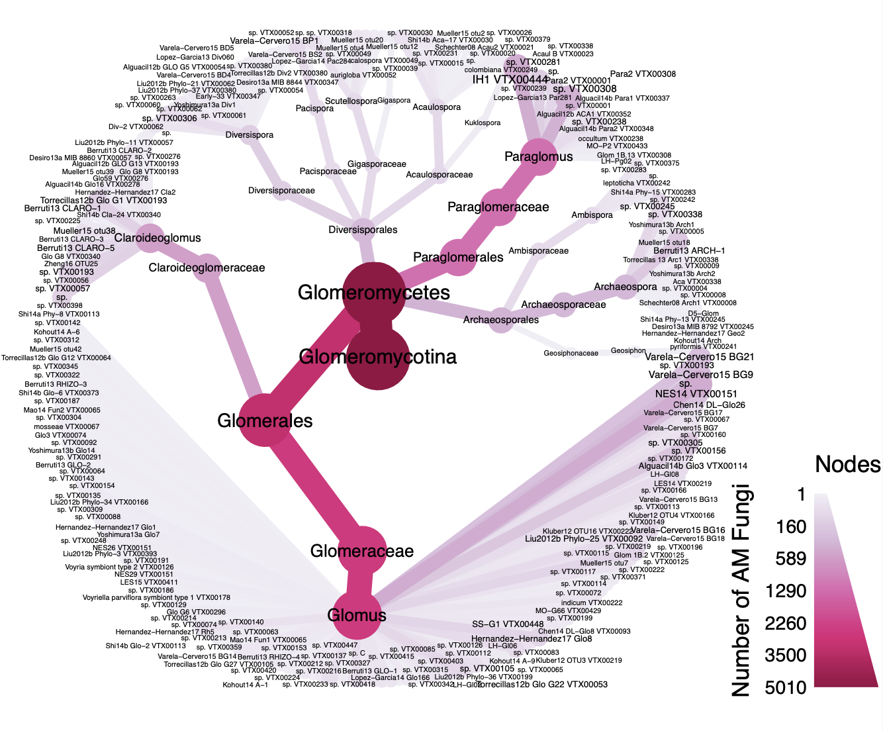
Figure 15. Heat map tree illustrating the AM Fungal variants recovered from Illumina MiSeq run from this study.
Figure 15 footnote. Number of AM Fungal variants are represented here as presence/absence where darker pink colors and larger circles show higher abundance.

approximately 12% of total reads sampled at Date A. Lastly, the third most abundant genus was Paraglomus (Paraglomerales) comprising ~7% of reads in Glomeromycotina. The most abundant AM fungal variant recovered was Glomus Valera-Cervero15 BG21 representing 14% of all total reads recovered at Date A in this study.

AM fungal community composition is influenced by rainfall exclusion
AM fungal community composition was characterized by assigning taxonomy and documenting change in relative read abundance among treatments before and after the monsoon season (Figure 16). Across all treatments, Diversisporaceae decreased in relative abundance across the monsoon season with the largest observed difference in the high rainfall exclusion treatment. On the other hand, Figure 16 illustrates an increase in Paraglomeraceae in response to monsoon rainfall, with the most extreme observed change in the control treatment. Glomeraceae, was observed to be the most common AM fungal family recovered, and relative abundance decreased over time. Claroideoglomerales decreased in relative abundance among all treatments, but most notably in the control treatment.
We used the mean quantitative Jaccard distance matrix from 1,000 rarefactions to test the strength of rainfall exclusion treatments and the log of phosphorous on AM fungal community composition and relative abundance. This model’s constrained variables explained 3.55% of total variation in multivariate space. Additionally, axes 1 and 2 explained 47.14% and 34.04% of the 3.55% of total variation, respectively. Figure 17 shows distinctive clustering of AM fungal communities by rainfall exclusion treatment on axis 2, while clustering based on sampling date is prominent on axis 1 (Figure 17). Points here represent the median centroid in multivariate space with ± 1 standard error for each treatment and sampling date. A permutational analysis of variance showed that rainfall exclusion treatments were a significant predictor for AM fungal community structure and composition (p<0.05). Based on this model, the log of phosphorous was also a significant predictor of AM fungal community composition in multivariate space (p<0.001).

Richness and community turnover from q=0 to q=2
The differences in alpha diversity between Date A and Date B, or ∆ AM fungal richness, was analyzed from q=0 to 2 using Bayesian inference. From q=0 to q=2, the greatest observed gain in the effective number of AM fungal ASVs was in the moderate rainfall exclusion
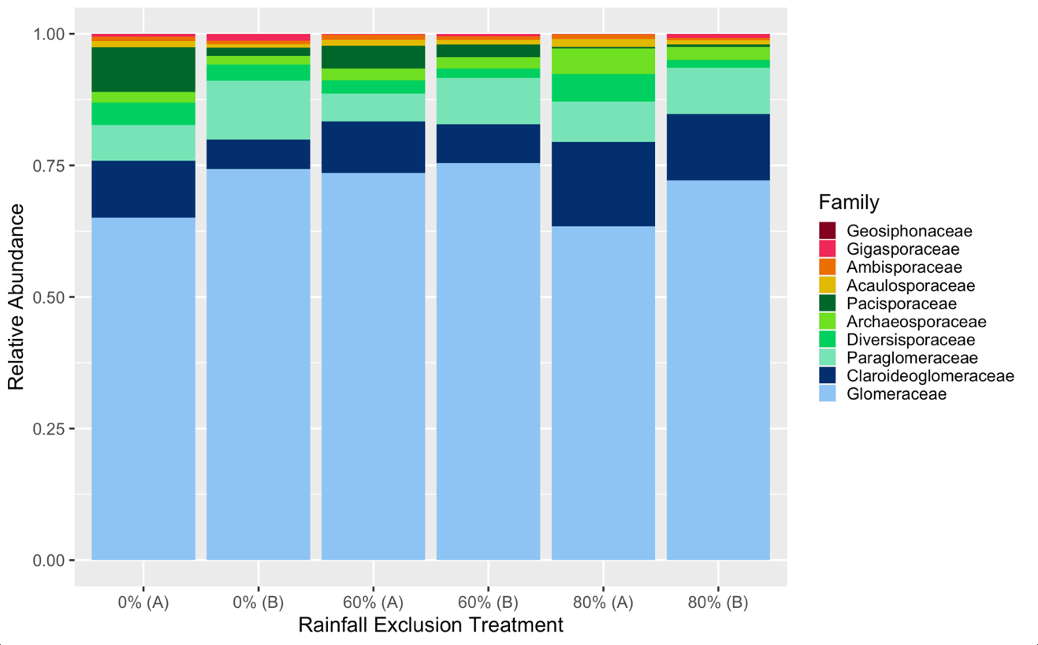
Figure 16. Stacked bar chart for the orders Archaeosporales, Diversisporales, and Paraglomerales, and Glomerales.
Figure 16 footnote. Here, each treatment is broken up by Date (A or B) to show changes within AM fungal families across the monsoon season. Here, 0% represents the control treatment, 60% the moderate rainfall exclusion treatment, and 80% the high rainfall exclusion treatment.

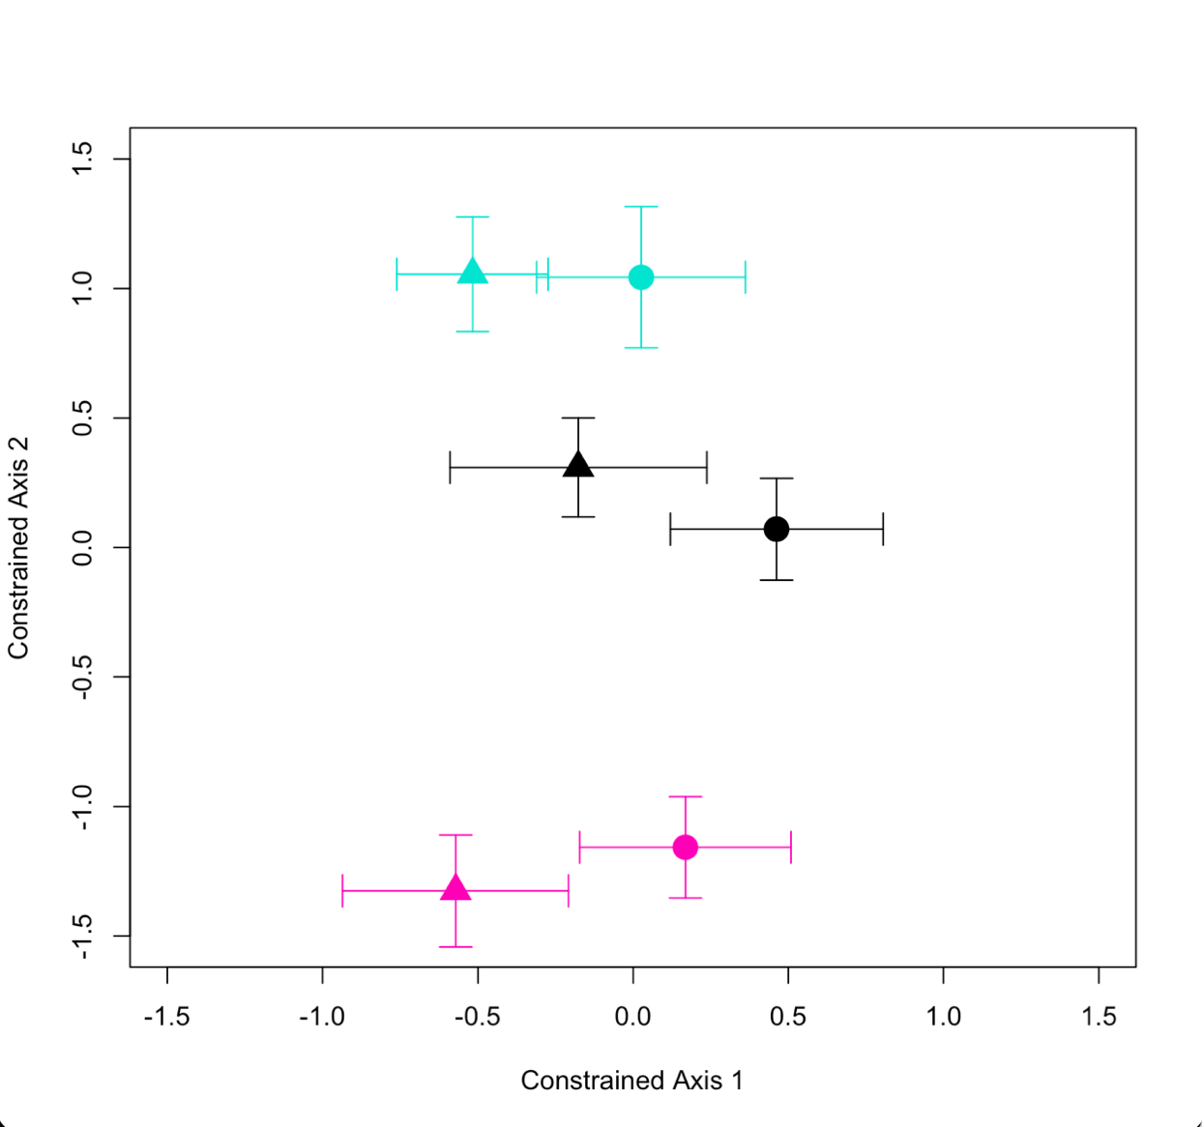
Figure 17. Principal coordinate analysis for AM fungal community composition from the dbRDA using the mean quantitative Jaccard dissimilarity matrix of 1000 rarefied communities.
Figure 17 footnote. Axes 1 and 2 explain 47.14% and 34.04% of the 3.55% of total variation explained by this model. Colors represent the median centroid of the control treatment (black), the moderate rainfall exclusion treatment (teal), and the high rainfall exclusion treatment (pink). Date A and Date B are represented by triangles and circles, respectively. Bars are ± one standard error.

treatment (Figure 18). On the contrary, the control treatment on average lost AM fungal ASVs throughout the monsoon season. As q increases, the 95% highest density intervals decrease around the median change in AM fungal richness across the monsoon season. The control treatment was observed to have an estimated median change of -15.13, -4.85, and -2.96 in AM fungal richness across the monsoon season for q=0, 1, and 2, respectively. We can infer that rainfall had a negative effect on ∆ AM fungal richness of rhizospheres. This hypothesis was observed to be true in our posterior samples 77%, 89%, 96% of the time for q=0, 1, and 2 (Table 4). The median estimated ∆ AM fungal richness for the moderate rainfall exclusion treatment was 4.68, 6.10, and 3.10 at q=0, 1, and 2. For the moderate rainfall exclusion treatment, we can infer positive change in richness throughout the monsoon season for each value of q. For q=0, 1, and 2 this hypothesis was observed 76%, 97%, and 99% of the time of the posterior samples. In the high rainfall exclusion treatment, we can infer that minimal, positive change in AM fungal richness was observed 73%, 78%, and 83% of the time of the posterior samples. The patterns here illustrate that rainfall exclusion had a positive effect on ∆ AM fungal richness and that as rare AM fungal taxa are removed from our analysis (q=2), the likelihood of this to be truer increased. These inferences in ∆ AM fungal richness are consistent with inferences generated from the 1,000 rarefied samples (Appendix Figure 5).
Phylogenetic relatedness among rainfall exclusion treatments were measured as ∆ AM fungal richness across the monsoon season using the phylo-Horn N-assemblage overlap measure (q=1 when informed by phylogeny). Median change in phylogenetic relatedness was -1.05, 1.21, and 0.41 for the control treatment, moderate rainfall exclusion treatment, and the high rainfall exclusion treatment, respectively. For the control treatment we can infer negative change in phylogenetic relatedness 85% of the time throughout the monsoon season. The moderate and the high rainfall exclusion treatments differ in inference from the control treatment showing positive change in phylogenetic relatedness 94% and 83% of the time, respectively. A full summary of hypothesis testing for each treatment including the 95% highest density intervals and associated posterior probabilities can be found in Appendix Table 1. Additionally, inferences per treatment for rarefied communities mirror that of inferences uncovered through this Bayesian analyses applied to proportional abundance data.
From q=0 to q=2, AM fungal community turnover was measured as 1 – pairwise beta diversity for each sample, which represents proportional change in AM fungal community
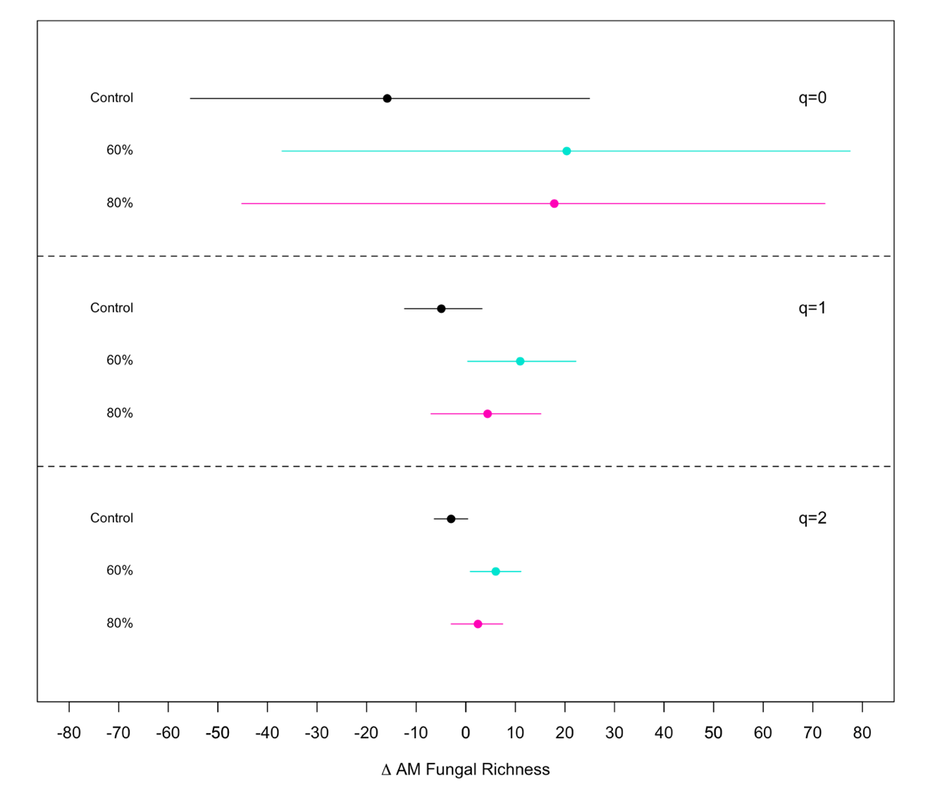
Figure 18. ∆ AM fungal richness and the 95% highest density interval around the median change in alpha diversity between the two time points.
Figure 18 footnote. Bayesian inference was determined using linear models where the difference in AM fungal alpha diversity was predicted by rainfall exclusion treatment. This was conducted for q=0, 1, and 2. Black represents the control treatment, teal the moderate (60%) rainfall exclusion treatment, and pink the high (80%) rainfall exclusion treatment. Across all values of q, the moderate rainfall exclusion treatment, on average, had the largest change in AM fungal richness compared to other treatments.
Table 4. Results from hypothesis testing on ∆ AM fungal richness. Hypotheses are listed per value of q with the estimated median and 95% highest density interval (HDI).
Value of q |  | Hypothesis | Lower 95% HDI | Median | Higher 95% HDI | Posterior Probability
0 | Control < 0 |  | -55.55 | -15.13 | 24.95 | 0.77
1 | Control < 0 |  | -12.34 | -4.85 | 3.27 | 0.89
2 | Control < 0 |  | -6.36 | -2.96 | 0.41 | 0.96
0 | Moderate > 0 |  | -35.83 | 4.68 | 45.53 | 0.76
1 | Moderate > 0 |  | -1.44 | 6.1 | 14.02 | 0.97
2 | Moderate > 0 |  | -0.57 | 3.1 | 6.75 | 0.99
0 | High > 0 |  | -43.01 | 2.15 | 42.06 | 0.73
1 | High > 0 |  | -8.40 | -0.42 | 7.62 | 0.78
2 | High > 0 |  | -4.66 | -0.56 | 2.89 | 0.83

Table 4 footnote. Here, posterior probability represents the proportion of times the given hypothesis was true throughout the MCMC chains.

composition across the monsoon season (between Date A and Date B). Across all values of q, the control treatment had the greatest AM fungal community turnover in comparison to other treatments (Figure 19). At q=0, 1, and 2, the median estimate for AM fungal turnover for the control treatment was estimated as 0.72, 0.57, and 0.60 and was greater than zero 100% of the time for each value of q (Table 5). This indicates that there were some community turnover in the control treatment due to rainfall. Median community turnover estimates for the moderate and high rainfall exclusion treatments were more similar to each other and differed from the control treatment. From q=0 to q=2, rhizospheres that underwent moderate rainfall exclusion were shown to have lower estimates of turnover in comparison to the control treatment 96%, 93%, and 78% of the posterior samples were less than zero, respectively. This suggests that rainfall exclusion treatments influenced AM fungal community composition across the monsoon season (Figure 19). Further, rhizosphere microhabitats that experienced high rainfall exclusion across the monsoon season had the least AM fungal community turnover out of all treatments and differed from the control treatment where 99%, 99%, and 96% of the posterior samples were less than zero for q=0, 1, and 2. As rare species were down weighted from calculating AM fungal community turnover, the proportion of times our hypotheses were observed in the MCMC chains decreases. Figure 19 also illustrates that as the value of q increases from 0 to 2, so does the highest density intervals around estimated values of AM fungal community turnover. Inferences made for AM fungal community turnover using proportional abundance data is in concordance with inferences made from 1,000 rarefied samples (Appendix Figure 6). Lastly, median point estimates for rarefied AM fungal community turnover can be found in the Appendix Table 2. Here, one can see that the 95% highest density intervals around the median are less than the highest density intervals seen around the median point estimates calculated using proportional abundance data.

Discussion
In this study, we explicitly show the importance rainfall exclusion has on AM fungal richness and community turnover in rhizosphere microhabitats of a dry, arid ecosystem during the monsoon season. Our results illustrate that variation in AM fungal community structure may be partially predicted by phosphorous and short-term rainfall exclusion. As soils get drier, AM fungal communities have been shown to have less seasonal community turnover and may be
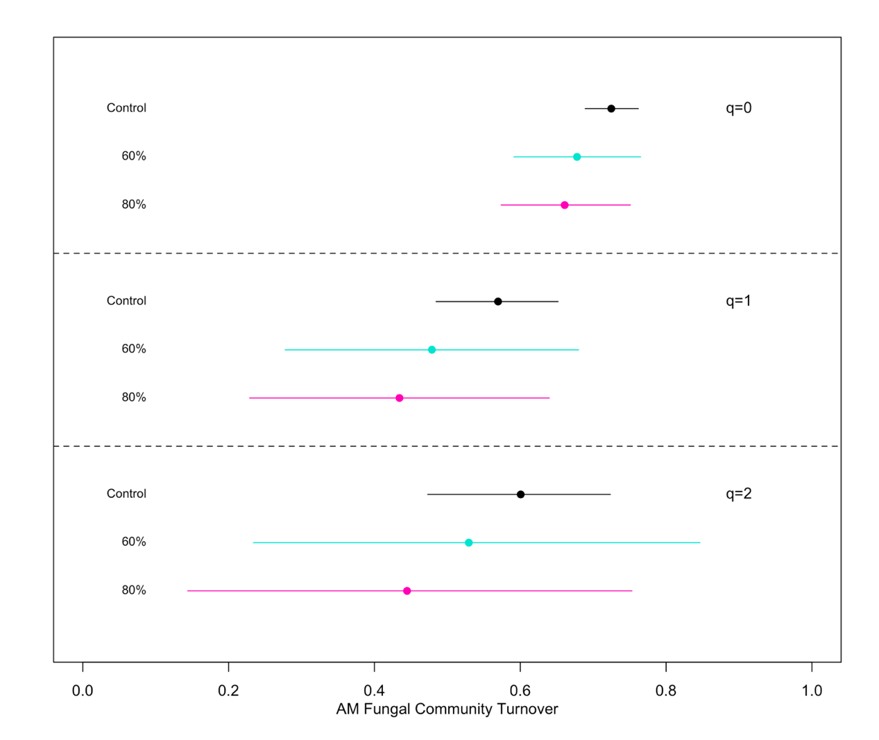
Figure 19. AM fungal community turnover between time points and the 95% highest density interval around the median between the two time points.
Figure 19 footnote. Bayesian inference was determined using linear models where AM fungal community turnover was predicted by rainfall exclusion. This was conducted for q=0, 1, and 2. Here, the color black represents the control treatment whereas teal and pink represent moderate (60%) and high (80%) rainfall exclusion treatments respectively. Across all values of q, the control treatment, on average, had the largest observed AM fungal community turnover compared to other treatments.
Table 5. Hypothesis testing on pairwise AM fungal community turnover for each rainfall exclusion treatment and value of q.
Value of q | Hypothesis | Lower 95% HDI | Median | Higher 95% HDI | Posterior Probability
0 | Control > 0 | 0.69 | 0.72 | 0.76 | 1
1 | Control > 0 | 0.48 | 0.57 | 0.65 | 1
2 | Control > 0 | 0.47 | 0.6 | 0.72 | 1
0 | Moderate < 0 | 0.59 | 0.67 | 0.77 | 0.96
1 | Moderate < 0 | 0.27 | 0.48 | 0.68 | 0.93
2 | Moderate < 0 | 0.23 | 0.69 | 0.85 | 0.78
0 | High < 0 | 0.57 | 0.66 | 0.75 | 0.99
1 | High < 0 | 0.23 | 0.44 | 0.64 | 0.99
2 | High < 0 | 0.14 | 0.44 | 0.75 | 0.96

Table 5 footnote. For each hypothesis, the parameter estimates and the lower and upper bounds of the 95% highest density intervals are included. The probability for each hypothesis represents the proportion of times that the hypothesis was true throughout the MCMC chains.

more influenced by phosphorous. Based on model selection, all other soil abiotic factors failed to explain significant variation in AM fungal community composition and richness. By the end of the monsoon season, ∆ AM fungal richness at q=0, 1 and 2 responded to rainfall exclusion treatments, however the response differed among rainfall exclusion treatments where the control treatment showed a loss in taxa due to rainfall and the moderate and high rainfall exclusion treatments showed increase in fungal ASVs. Rainfall exclusion also contributes to differences in phylogenetic relatedness among rhizosphere microhabitats in the Sonoran Desert, with rainfall contributing to a decrease in phylogenetic community composition. Lastly, AM fungal community turnover across the monsoon season was dependent on rainfall exclusion treatments, whereby the greatest turnover across all values of q was observed in the control treatment. Here, moderate rainfall exclusion could be a threshold that favors the coexistence of different AM fungal taxa by the end of the monsoon season (Tilman, 1977). These results support our second prediction that AM fungal composition responds to short term rainfall exclusion treatments, and more importantly, emphasizes the relationship between rainfall perturbations and soil abiotic factors like phosphorous content in the soil.
Environmental changes on a regional scale can feedback onto soil properties at a local scale, in turn leading to possible positive or negative effects between plant hosts and belowground microbial communities (Bickel et al., 2019). Small environmental perturbations that affect microbial communities can range from increased seasonal temperatures (Zhou et al., 2016) to changes in precipitation regimes (Waring and Hawkes, 2015). AM fungi have been shown to be exist in a wider range of annual precipitation than other mycorrhizal fungi (Tedersoo et al., 2014), and thus AM fungi have been regarded as key regulators of plant stress brought on by drought (Birhane et al., 2012). Deveautour et al. (2020) concluded that under reduced rainfall, estimated AM fungal alpha diversity is larger in comparison to the control treatment (ambient rainfall). On the other hand, plants that experienced total rainfall removal, or higher environmental stress, showed lower alpha diversity estimates than the control and the reduced rainfall treatment.
Our results for ∆ AM fungal richness across the monsoon season are consistent Deveautour et al. (2020) as our moderate exclusion treatment showed an increase in AM fungal ASVs from q=0 to q=2 relative to the control treatment. Further, more extreme rainfall removal resulted in lesser changes in alpha diversity, which may be a result of taxa specific requirements for population level persistence throughout decreased soil moisture and warmer Summer temperatures (Tilman, 1977). In comparison to other ecological factors, precipitation and soil water availability more strongly influences AM fungal composition in semiarid ecosystems (Gao et al. 2016). In a study by Xiao et al. (2019), AM fungal diversity was influenced by phosphorous limitation while total nitrogen affected the relative abundance of AM fungi. We show that in the context of naturally occurring AM fungal communities in the Sonoran Desert, that phosphorous content in the rhizosphere microhabitat plays a substantial role in structuring the compositional spread of AM fungal communities and that nitrate content did not contribute to the variation in the effective number of AM fungal ASVs based on model selection. This suggests that as precipitation becomes more infrequent, that AM fungal communities may be more dependent on specific, limiting soil abiotic factors in dry, arid climates.
The effects of sampling date on plant communities have been well studied and supported, providing some foundation to examine temporal aspects of microbial communities (Smith and Huston, 1990; Guo and Brown, 1996). Temporal effects on the maintenance of AM fungal communities have been studied in a variety of ecological contexts ranging from volcanic ash fields (Higo et al., 2015), mixed hardwood forests (Davison et al., 2012), to grasslands (Deveautour et al., 2020). There is mixed evidence showing that AM fungal community composition is temporally dynamic. For example, in mixed hardwood forests, AM fungal communities have been shown to be spatially distinct but temporally stable across the growing season, perhaps due to the heterogenous plant community and a consistent AM fungal species pool over their two-year sampling scheme (Davison et al., 2012). Yet, on the same time scale, Higo et al. (2015) states that differences in AM fungal composition are dependent on plant cover from the previous year, thus contributing to fungal community turnover year to year. Temporal effects have also been observed on much smaller time scales, such as over one season in a wet tropical forest (Waring and Hawkes, 2015). Our multivariate models show distinct clustering for the composition of AM fungal communities over the North American Monsoon season and by rainfall exclusion treatment. Additionally, we show that AM fungal community turnover responds to rainfall exclusion treatments from q=0 to q=2. The effect seen here may illustrate the contribution available soil moisture has on the number of ASVs throughout the monsoon season and on the relative abundance of each ASV in a dry, arid ecosystem. Our results further highlight the interconnected relationships between regional climate and local soil abiotic factors that could hinder a generalizable pattern consensus for the temporal or seasonal response of AM fungal community composition.
Here, we demonstrate that rainfall exclusion affects variation in AM fungal composition and the difference in the effective number of AM fungal ASVs, where moderate rainfall exclusion led to increased estimates in alpha diversity. Additionally, we show that AM fungal community turnover is dependent on rainfall exclusion when common and rare ASVs are weighted equally and when rare ASVs are down weighted. The work outlined in this study leaves several forward directions for AM fungal ecology. Specifically, what are the relative temporal scales needed to observe AM fungal responses to manipulative field experiments? How does temporal turnover in AM fungal communities differ between within year and among year exposure to environmental stress? AM fungi can be somewhat ubiquitous at local scales (Davison et al., 2015) and have been shown to be heterokaryotic (i.e., multinucleate with genetically distinct nuclei; (Bruns et al., 2018)). This could lead to lack of agreement in empirical biodiversity studies, as species richness estimates might be dependent on spatial scale, temporal scale, and the weight of rare ASVs. Therefore, while we did find that AM fungal communities respond to changes in seasonal monsoon precipitation, more studies across a wider range of ecological contexts could further uncover the direction and magnitude of changing climate conditions on plant-host AM fungal interactions.

CHAPTER FOUR:
SUITABLE HABITAT DECLINES FOR AN ECTOMYCORRHIZAL FUNGUS (SUILLUS SPRAGUEI) UNDER FUTURE CLIMATE SCENARIOS

Abstract
Ecological niche models rely on abiotic (e.g., climatic and soil) and biotic (e.g., species occurrence) data to estimate suitable environmental space that is likely to sustain members of a given species. Niche modeling of fungi can clarify species distributions and predict suitable habitat under present and future climate. We applied maximum entropy niche modeling (MaxEnt) to an ectomycorrhizal fungus, Suillus spraguei, and its tree symbiont, Pinus strobus, under current and future climate scenarios to determine which climate variables best predict these distributions, and whether species ranges and niche overlap change for these symbionts across current and future climate. The most important climate variables for the fungal species niche are related to precipitation and temperature, which is similar to most plant and animal distributions. The most important climate variables remained largely the same between fungus and tree symbiont in each climate scenario. Niche overlap for the species pair did not change significantly between current and future climates except in one extreme warming scenario, suggesting the two species will continue to rely on similar environmental variables. However, we found a 36.3% mean decrease in suitable habitat area for the fungal species and a 9.59% mean decrease for the tree under future climate conditions compared to current climate conditions, indicating that Suillus spraguei is at greater risk of habitat loss due to increased carbon emissions and climate warming.

Introduction
Ecological niche models, also known as species distribution models, are a common method for incorporating occurrence data and climate variables to predict the potential distribution of a species (Peterson, 2003; Phillips et al., 2006). Due to the growing amount of biological and climatic data available through open source databases (e.g., GBIF (http://www.gbif.org), WorldClim (http://www.worldclim.org)), ecological niche models incorporating presence-only occurrence data have become more popular (Peterson, 2001). So far, ecological niche models have largely been used to circumscribe plant and animal species distributions, with temperature and precipitation being the primary abiotic drivers of these distributions (Bradie and Leung, 2017). However, little modeling has been done to elucidate which climatic variables presently restrict fungal distributions. Additionally, despite understanding the role fungi play in varying forest ecosystems, it remains unknown how fungal distributions are expected to change under future climate scenarios, especially in the context of mutualisms (Rodriguez et al., 2004; Singh et al., 2011; Guo et al., 2017).
Herbarium records for plants are a commonly used source for occurrence data used in ecological niche models (Wollan et al., 2008; Li et al., 2014). Similarly, upwards of seven million fungal herbarium records are currently accessible through MycoPortal (http://mycoportal.org). Given that most fungal occurrences can only be recorded as presence-only data, MaxEnt has served as the best predictive tool for fungi to date. The MaxEnt algorithm has been used to model distributions of parasitic fungi (Kriticos et al., 2013) and medicinal fungi (Yuan et al., 2015). Additionally, MaxEnt modeling has also been used to understand which climate variables shape global distributions of arbuscular mycorrhizal fungal taxa (Kivlin et al., 2017).
Fungal mutualisms provide an interesting opportunity to examine the benefits and limits of incorporating fine scale biotic interactions into the context of ecological niche modeling. For example, ectomycorrhizal fungi (EMF), which comprise at least 20,000-25,000 species worldwide, are obligate mutualists of many economically important forest trees (Rinaldi et al., 2008; Tedersoo et al., 2010). These relationships are often host-specific and asymmetrical in that the tree partner can coexist with many EMF symbionts. Only a handful of studies to date have focused on niche modeling EMF species (see Wolfe, Richard, Cross, & Pringle, 2010; Sánchez-Ramírez et al., 2015; Guo et al., 2017; Pietras, Litkowiec, & Gołębiewska, 2018; Pietras, 2019). Despite the growing interest in using ecological niche models as a tool for fungi (Hao et al., 2020), there is no consensus on which climate variables best predict EMF distributions.
Suillus is perhaps the most well-studied genus of EMF with species displaying clear host specificity (Kretzer et al., 1996; Liao et al., 2016; Nguyen et al., 2016). Herbarium collections of Painted Suillus (Suillus spraguei; S. pictus is a synonym) from the eastern United States and Canada form a well-supported monophyletic clade (Kretzer et al., 1996; Nguyen et al., 2016). Recent phylogenetic and transcriptomic studies indicate S. spraguei only grows in association with the North American tree species Eastern White Pine (Pinus strobus; Liao et al., 2016; Nguyen et al., 2016). P. strobus was historically sought for its timber and remains of high economic importance (Buchert, 1994). Forested ecosystems threatened by changing abiotic and biotic interactions can have ongoing effects on the colonization and persistence of mycorrhizal populations (Sapsford et al., 2020). Hence, ecological niche modeling serves as a unique opportunity to address which climatic drivers shape EMF ecology and distributions in current climate conditions. Further, modeling both species across future climate scenarios will illuminate how the geographic range of an obligate, single-host mutualist will respond in light of climate change.
Here we apply the MaxEnt algorithm to S. spraguei and its tree symbiont, P. strobus, to ask: (1) which climate variables are the best predictors for each symbiont under climate normal (current baseline) and future climate conditions? (2) to what extent does niche overlap change in future climate scenarios in comparison to the current baseline model? (3) How much does the suitable habitat for each species change under future climate scenarios? Since these two symbionts share a tight mutualism, we predict they will share similar climatic variables predicting their distributions in current baseline scenarios, such as mean annual temperature and precipitation. Since S. spraguei is an obligant symbiont of P. strobus, we expect to see high niche overlap in our current baseline model due to existing co-occurring species records. If this is the case, then we anticipate similar niche overlap between the species pair under more conservative, moderate change future climate scenarios. Under more extreme future climate scenarios we predict that these symbionts will rely on fewer shared climate variables than our current baseline and therefore have less predicted overlap. We also expect that suitable habitat will decline for both species under the most extreme climate scenarios.

Methods
All occurrence data available for S. spraguei from eastern North America were compiled from herbarium records on MyCoPortal (http://mycoportal.org/portal/index.php) and occurrence records (n=50) were randomly selected for incorporation into our MaxEnt models. Similarly, occurrence records of P. strobus were downloaded from SERNEC (http://sernecportal.org/portal/) and 50 were randomly sampled (n=50). For both species, random sampling and data analysis was performed in R. Climate rasters for North America were sourced from AdaptWest at 1km resolution (https://adaptwest.databasin.org/pages/adaptwest-climatena; Wang, Hamann, Spittlehouse, & Carroll, 2016). We selected the 1961-1990 time period to represent the current baseline scenario. For future model projections, we chose both a moderate, stabilizing (RCP4.5) and an extreme, rising (RCP8.5) representative climate pathway to integrate possible model outcomes for the years 2055 and 2085 (van Vuuren et al., 2011). For each representative climate pathway and year, we selected three General Circulation Models (GCMs) to represent conservative, moderate, and extreme future climate scenarios for Eastern North America (INM-CM4, CCSM4, and GFDL-CM3, respectively).
The coordinate system for all downloaded raster layers was defined to Lambert Conformal Conic with a central meridian at -95.0° with two standard parallels at 49.0° and 77.0° and a latitude of origin at 0.0°. The datum associated with these files remained at WGS 1984 throughout the analyses. We limited our study to the eastern US and Canada by clipping the extent using the crop function in the raster package (Hijmans et al., 2019). To test for collinearity between soil and climatic layers we used the vif and vifstep functions of the usdm package (Naimi et al., 2014); layers that were strongly correlated above a 0.7 threshold were subsequently discarded.
We ran MaxEnt models individually for both Suillus spraguei and Pinus strobus using R version 3.5.2 (https://www.r-project.org/) using MaxEnt version 3.3.3k in the dismo package version 1.1-4 (Hijmans et al., 2017; Phillips et al., 2017). We used similar test and training techniques for each species in order to avoid biases unique to each species occurrence records following suggestions by Elith et al. (2011). For each species and climate scenario, MaxEnt models were designed to use all the occurrence data to train n=50 points for 500 iterations with roughly 10,000 background points. We evaluated model accuracy using the R package ENMeval version 0.2.0 (https://github.com/bobmuscarella/ENMeval) and compared niches between EMF and tree species following Mandle et al. (2010) (Muscarella et al., 2014). To calculate suitable habitat in km², we filtered out all raster cells under 0.7 in suitable habitat and then multiplied by our cell resolution. In order to obtain the best fit model, we evaluated our models by running four MaxEnt parametrization scenarios using the feature classes L (linear), LQ (linear-quadratic) and regularization multipliers of 1 and 2 (Phillips and Dudík, 2008; Muscarella et al., 2014). The best fit models were chosen by lowest corrected Akaike Information Criteria (AICc) score. The P. strobus and S. spraguei models were evaluated with the 'checkerboard 2' argument in the ENMevaluate function and area under the curve (AUC) was used to assess model performance, with a score of 0.5 indicating poor performance and 1.0 perfect model performance. We performed a Principal Component Analysis (PCA) to reduce dimensionality via a correlation matrix and compared variance between models using the prcomp function in the vegan package (Oksanen et al., 2019) with MaxEnt output metrics as variables. We also tested niche identity under the null hypothesis that two species occur in space given random draws from a similar distribution of environmental variables using the ENMtools package (https://github.com/danlwarren/ENMTools). This test estimated niche overlap with Schoener’s D statistic and the similarity statistic I outlined by Warren, Glor, & Turelli (2008) in order to compare fungal-tree niche overlap across current and future climates.

Results
At a threshold of 0.7, multicollinearity tests against all 27 climate variables removed on average 22 variables from each climate scenario. For each climate scenario, this left 5-6 unique and independent combinations of climate variables for testing (Appendix Table 3). The most informative climate variables for P. strobus under the current baseline scenario was the amount (mm) of winter precipitation at 42.37%, the amount (mm) of precipitation as snow at 33.10%, and the difference between the mean temperature (°C) of the warmest and coldest months as a measure of continentality (TD) at 18.29%. Similarly, for S. spraguei in current baseline models the top three predicting variables are: winter precipitation at 37.64%, precipitation as snow at 33.76%, and TD at 22.08%. Table 6 outlines all climate variables included in the predicted habitat range under the selected current baseline scenario for S. spraguei and P. strobus.
Across all future climate scenarios, MaxEnt models for P. strobus suggest precipitation as snow (mean contribution=45.59%) and winter precipitation (mean contribution=35.46%) as the most informative variables for predicting its distributions across eastern North America. Similarly, in our future climate models for S. spraguei, precipitation as snow and winter precipitation contributed on average a combined 73.21% to the predicted distributions with snow contributing the most at 41.26%. The next two contributors for each model were TD and relative humidity (RH). However, for the years 2055 and 2085 under the most extreme representative pathway (RCP8.5) with a conservative GCM (INM-CM4), TD contributed on average 10.67% more than winter precipitation in predicting suitable habitat of S. spraguei. Interestingly this trend differs for P. strobus, as winter precipitation and snow still remain the best predictors for suitable habitat and species distribution.
We found that models tuned under the LQ feature class with a multiplier of 1 had the lowest AICc scores for both species in the current baseline and future scenarios. The future climate scenario that best predicts suitable habitat for S. spraguei is RCP4.5 INM-CM4 2055, a
Table 6. Climate variables applied to the current climate model for tree and fungal species. The most informative climate variables used for modeling (a). Pinus strobus and (b). Suillus spraguei, ranked by percent contribution.
a).
Pinus strobus
Variable | Percent Contribution
PPT_wt | 42.3687
PAS | 33.102
TD | 18.2914
RH | 3.1873
CMD | 3.0506

b).
Suillus spraguei
Variable | Percent Contribution
PPT_wt | 37.6432
PAS | 33.7642
TD | 22.0785
RH | 5.5549
CMD | 0.9592

Table 6 footnote. Abbreviations are as follows: winter (Dec-Feb) precipitation in mm (PPT_wt), precipitation as snow in mm (PAS), the difference between mean temperature of the warmest month (°C) and the coldest month (°C) (TD), mean annual relative humidity (%) (RH), Hargreave's climatic moisture index (CMD).

moderate warming scenario. In comparison, the most accurate (least overfit) predictive model amongst future climate scenarios for P. strobus was RCP8.5 CCSM4 2055, a more extreme warming scenario. When evaluating model goodness-of fit, training AUC scores under the current baseline scenario yielded 0.9199 and 0.9437 for Pinus strobus and Suillus spraguei, respectively, indicating very high model performance. For P. strobus, the current baseline model (Figure 20) depended primarily on precipitation of snow with a permutation importance of 36.37% in estimating training AUC. Conversely, in the current baseline model for S. spraguei (Figure 20), TD contributes the most permutation importance (56.466%) for predicting suitable habitat. The mean AUC value across all future models were 0.8087588 and 0.803731 for P. strobus and S. spraguei, respectively. Like percent contribution in the future scenario models, precipitation as snow has the greatest permutation importance for both species in estimating training AUC value. In the best fit future climate models, suitable habitat is much greater for P. strobus in comparison to S. spraguei with few notable changes from predicted habitat in the current climate model (Figure 21). The PCA revealed that PC1 explained 38.5% of the variation between models, while PC2 explained 14.3% of the variation found within our models (Appendix Table 4). When all models are compared in dimensional space, we see that niche models cluster largely by species (Figure 22). Out of our best tuned models, RCP4.5 INM-CM4 2055 is relatively close to each current baseline model per species in multivariate space.
Under the current climate and moderate warming scenarios, the same set of environmental variables drive the distribution of these species. However, in models produced under more extreme future climate scenarios (GFDL-CM3), other climatic variables (e.g., the number of days under 0°C) begin affecting suitable niche space for both the fungus and tree (Appendix Table 3). In these scenarios, changes in climate variables and the magnitude of contribution disparately impact model similarity for each symbiont relative to current baseline predictions of niche space (Figure 22). Niche overlap and identity calculations showed high niche overlap between P. strobus and S. spraguei that is unlikely to change under a future climate. Niche overlap did not differ significantly from the current climate model except under one high emissions scenario, RCP8.5 INM-CM4 2085. Further, niche identity tests based on Schoener’s D and the similarity statistic I did not show a significant difference between the niche of each species except under the most extreme warming and emissions scenarios (RCP8.5 INM-CM4 2055 and RCP8.5 CCSM4 2085, Table 7). The predicted changes in suitable niche space
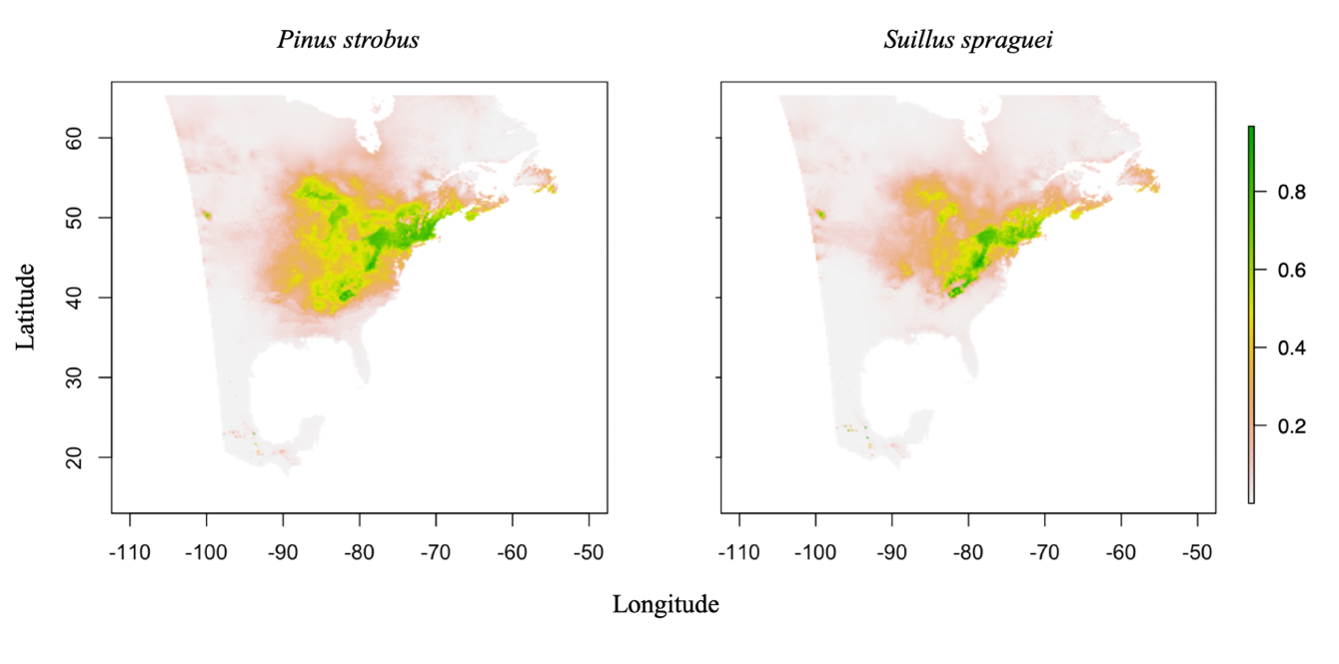
Figure 20. Projected distributions of Pinus strobus (left) and Suillus spraguei (right) in eastern North America under current baseline conditions. Dark green areas are more likely to be suitable habitat for either Pinus strobus or Suillus spraguei.
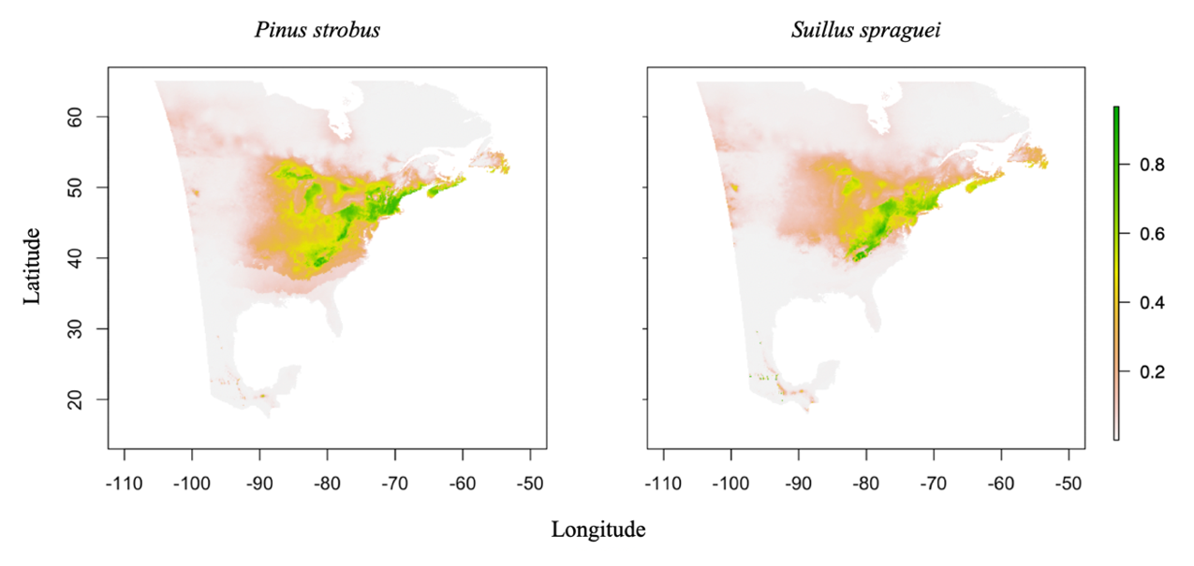
(a).
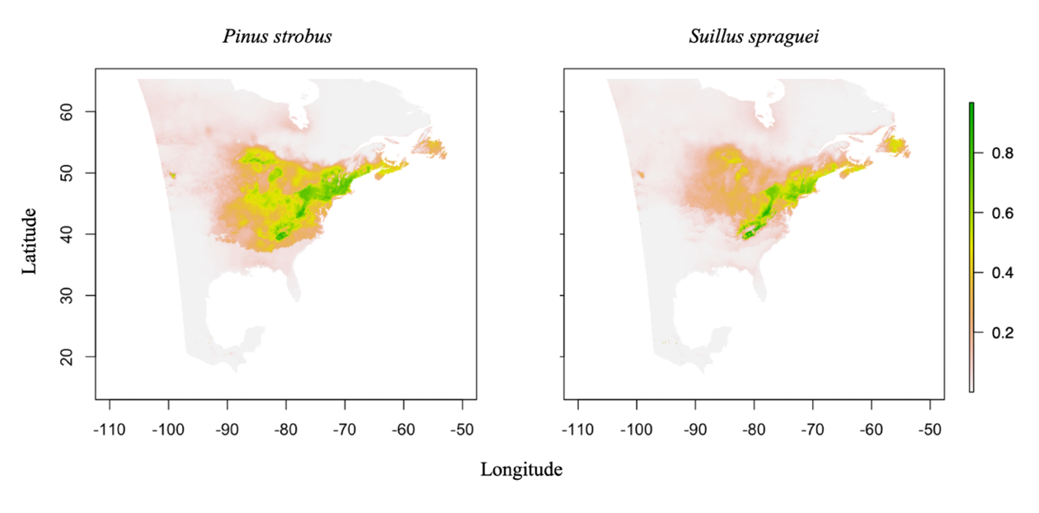
(b).
Figure 21. Predicted distributions of Pinus strobus (left) and Suillus spraguei (right) in eastern North America the future climate scenarios (a) RCP4.5 INM-CM4 2055 and (b) RCP8.5 CCSM4 2085. Dark green areas are more likely to be suitable habitat for either Pinus strobus or Suillus spraguei.
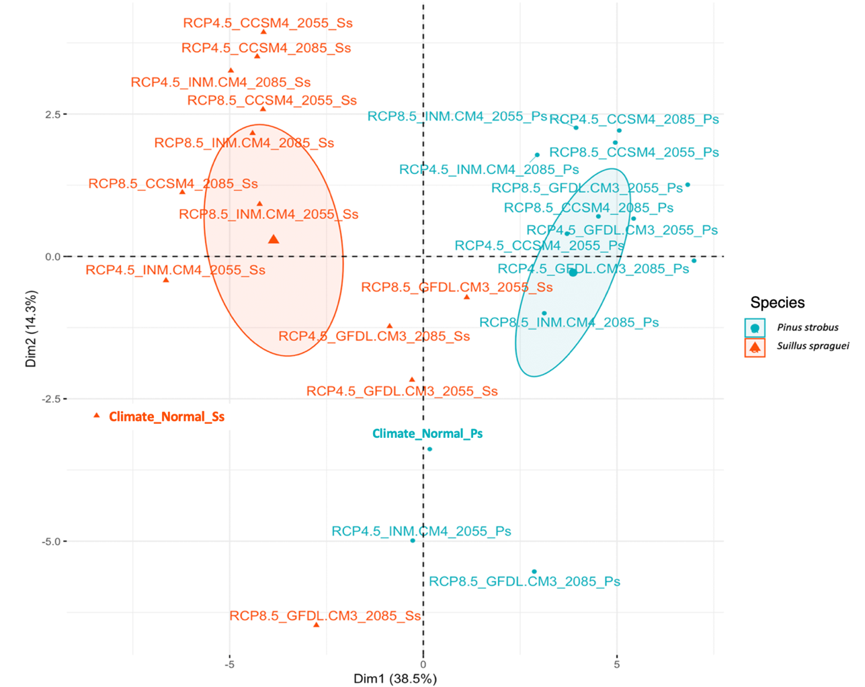
Figure 22. Principal Components Analysis for the current baseline and future climate MaxEnt models in multivariate space where the center of the ellipses represents model averages for each species.
Table 7. A cumulative table of empirical Schoener’s D and ENMTool’s I metrics from niche identity tests for the species pair per climate scenario.
 | Identity Test
 | D | I | env. D | env. I
Current baseline | 0.844104 | 0.9731099 | 0.5250143 | 0.7348693
RCP4.5 INMCM4 2055 | 0.8446792 | 0.9722222 | 0.8684133 | 0.9682271
RCP8.5 INMCM4 2055 | 0.7760885 | 0.9398241* | 0.6356656 | 0.8533245
RCP4.5 INMCM4 2085 | 0.81616143 | 0.9605713 | 0.6218967 | 0.8353966
RCP8.5 INMCM4 2085 | 0.8010363 | 0.9470622 | 0.5777418* | 0.8094146*
RCP4.5 CCSM4 2055 | 0.8398038 | 0.9703137 | 0.7718848 | 0.9268115
RCP8.5 CCSM4 2055 | 0.8268658 | 0.9614404 | 0.7371011 | 0.9030061
RCP4.5 CCSM4 2085 | 0.8456417 | 0.9691333 | 0.7421008 | 0.9162758
RCP8.5 CCSM4 2085 | 0.8313712 | 0.9658213 | 0.705309 | 0.8787653
RCP4.5 GFDLCM3 2055 | 0.8677373 | 0.9751551 | 0.591226 | 0.8106839
RCP8.5 GFDLCM3 2055 | 0.8716823 | 0.9766772 | 0.7563458 | 0.9424063
RCP4.5 GFDLCM3 2085 | 0.8756829 | 0.9809714 | 0.8875251 | 0.98414
RCP8.5 GFDLCM3 2085 | 0.8237087 | 0.9627313 | 0.847305 | 0.9618527

Table 7 footnote. Asterisks (*) denotes p<0.05.

varied dramatically between the two species. Under most future scenarios, including the best-fit models, the available niche space for Pinus strobus may contract up to 18% or even expand slightly from its current climate niche (mean change=-9.59%; Resource6.xslx). Suillus spraguei, however, loses suitable niche space under every future climate model (mean change = -36.33%; Resource6.xslx). Under the most extreme future climate scenarios, P. strobus loses up to 45% of its suitable niche when compared to the current climate, while suitable niche space for S. spraguei contracts upwards of 60-70%. Suitable habitat (km²) from our best fit future climate models (RCP4.5 INM-CM4 2055 and RCP8.5 CCSM4 2005) show that S. spraguei has notably less suitable habitat in comparison to P. strobus and it decreases as climate scenarios become more extreme (Figure 23). Under our current baseline model, P. strobus has 207,058km² in suitable habitat while S. spraguei has 146,751km².

Discussion
Niche modeling provides valuable information about ecological requirements while identifying the potential geographic extent of a species’ range. Modeling EMF extends this framework to lesser-studied organisms with important ecological roles that mediate ecosystem function and stability (Schwartz et al., 2000). Using Suillus spraguei and Pinus strobus as a case study, we found a clear convergence in the composition of climate predictors and magnitude of contribution in predicting each symbiont’s niche space under current climate conditions. The most important climate predictors for Pinus strobus are dependent on temperature and precipitation, which is consistent with previous studies of plant distributions (Bradie and Leung, 2017). Under current climate conditions in eastern North America, the distribution of EMF Suillus spraguei is largely predicted by winter precipitation (Dec. to Feb. precipitation in mm; Table 6). The second-most predictive variable for P. strobus, precipitation as snow (PAS; Table 6), was also the second most predictive variable for the distribution of S. spraguei under current baseline conditions. Thus, precipitation is a key factor in estimating this fungal species distribution, similar to results from plant and animal distribution models (Bradie & Leung, 2017) and other EMF niche modeling studies (Wolfe et al., 2010; Guo et al., 2017). In contrast to those studies, however, we used climate rasters at a finer 1km resolution and found that seasonal precipitation, rather than mean annual precipitation or seasonal temperature, is most important in determining this EMF distribution.
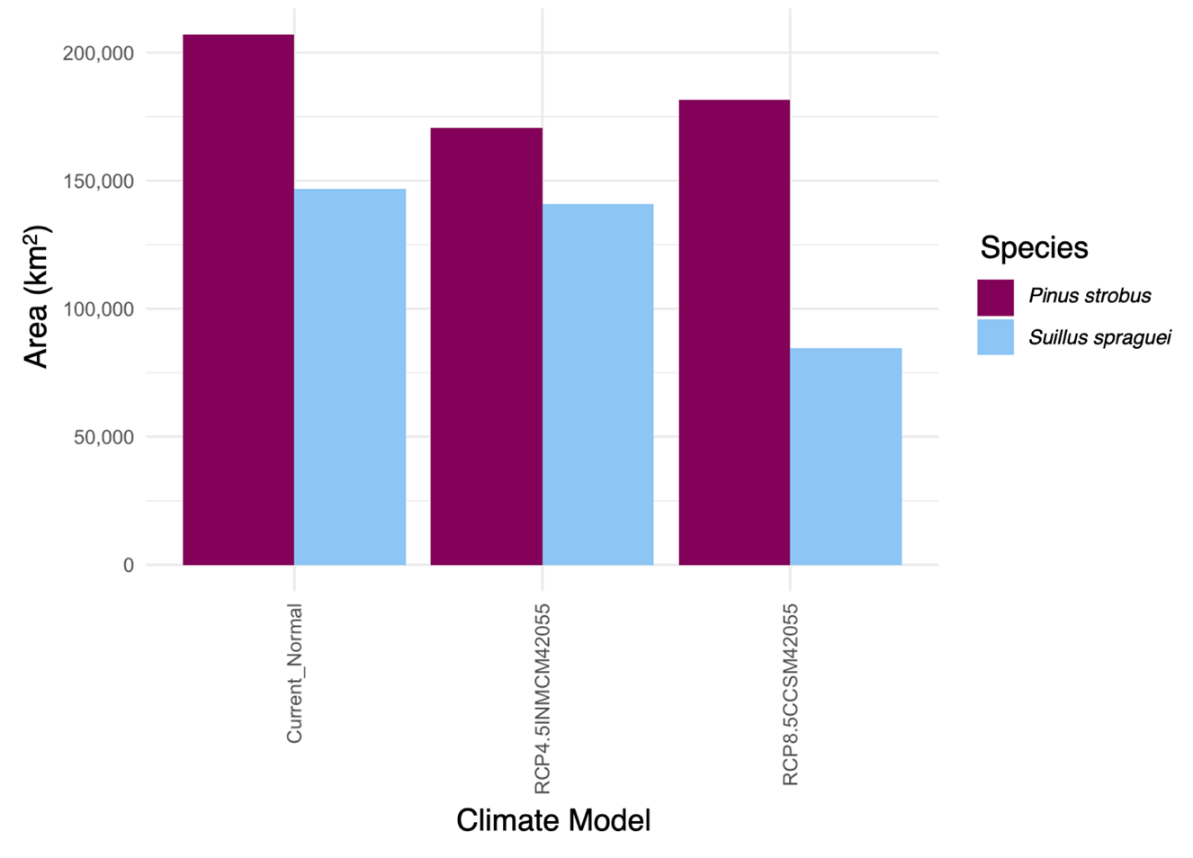
Figure 23. Suitable habitat (km²) for Pinus strobus and Suillus spraguei in Eastern North America under the current baseline model and the two best fit future climate models, RCP4.5 INM-CM4 2055 and RCP8.5 CCSM4 2055.

The niches of P. strobus and S. spraguei each change between current and future climate scenarios, but overall suitable habitat for S. spraguei is expected to disappear at a much higher rate than its tree symbiont. Suitable habitat declines for S. spraguei in all future climate scenarios, whereas suitable habitat declines to a lesser degree for P. strobus, and in a few scenarios even expands (Resource6.xslx). Yet even the average loss of 9.6% of suitable habitat across all future models represents nearly 20,000 km² of lost area due to changes in abiotic climate variables alone and does not include any potential impacts due to human land change use or biotic threats such as white pine blister rust (see Munck et al., 2015). Across all future climate models, the predicted suitable niche contracts much more drastically for S. spraguei, an average of 53,309 km². While the realized niche of S. spraguei may be smaller than that of P. strobus since S. spraguei is an obligate symbiont of P. strobus while P. strobus associates with multiple other EMF species (Nguyen et al., 2016), it appears S. spraguei will be disproportionately affected by increased carbon emissions and climate warming compared to P. strobus.
Niche modeling can inform conservation management strategies by assessing how climate fluctuations will affect endemic populations and how species’ ranges might shift in response (Sinclair et al., 2010). Fungi have traditionally been excluded from conservation agendas due to a lack of understanding of fungal species distributions (Heilmann-Clausen et al., 2015). Yet many soil fungi, including most EMF lineages, appear to be endemic at a regional scale (Talbot et al., 2014; Peay and Matheny, 2016) increasing their vulnerability to extinction due to climate change. Niche modeling can aid fungal conservation by identifying sites that will continue to support fungal diversity under future climate conditions as targets for land management efforts. As EMF are key regulators in net primary productivity and plant biomass (Wardle et al., 2004), preserving EMF diversity is critical to the preservation of highly productive forests.
One limitation in applying niche modeling techniques to fungal species remains the lack of deep sampling of georeferenced, vouchered herbarium collections with DNA sequences to verify species identity. We encourage continued efforts to link fungal herbarium specimens with public repositories of corresponding DNA sequences, such as GenBank and UNITE. Not only will this enable agencies and individuals without taxonomic expertise to more easily and accurately model EMF species distributions, but it will also expand the capacity to model more fungal species. Here, we chose a well-known fungal species with stable morphology to avoid this pitfall.
We urge greater use of empirical models that explore climatic niche overlap for aboveground-belowground mutualists under present and future climate conditions. Since few niche modeling efforts have been directed at well-studied, host-specific fungal mutualisms, the present investigation serves as a case study in applying niche models towards this type of system. Further modeling of other host-specific EMF will allow investigation into the efficacy and accuracy of EMF niche modeling in its application towards biogeography and conservation.

CONCLUSION
To conclude, in Chapter One we have shown that the spatial depth along plant roots can affect rarefied richness and the relative abundance of rhizospheric bacteria. We observed greater alpha diversity estimates in Depth A, closer to the surface, than other depths along the root. Further, we have shown that bacterial communities in the rhizosphere environment follow the species area relationship, where the greater area sampled in the rhizosphere, the greater estimates of bacterial richness (alpha diversity). We have additionally shown that sampling grain contributes to differences in the relative abundance of reads and richness of rhizosphere associated bacteria. Where finer grain sampling captures more precise estimates of relative abundance in reads while also recovering higher alpha diversity estimates (i.e., rarer ASVs) on average than a coarse grain sampling effort. This information proves useful when developing future rhizosphere microbiome related questions with the aim of being reproducible and comparable experimental designs in field settings.
In the Sonoran Desert, rhizosphere bacterial community richness responds to the manipulation of seasonal rainfall in structure and phylogenetic membership, where moderate rainfall exclusion (60%) contributed to an increased bacterial community richness by the tail end of the North American Monsoon season. This pattern was observed even as rare species were down weighted from our richness estimates. Throughout Chapter Two, we have also shown the relative importance soil edaphic factors can have on structuring bacterial communities during times of drought. For example, phosphorous and ammonium were significant predictors of bacterial community structure in the rhizosphere of L. neomexicanus. On the other hand, during reduced rainfall, nitrate and nitrite were shown to be a predictor of bacterial phylogenetic membership. Further, our indicator species analysis revealed an enrichment of Actinobacteria in drier soil conditions, which may be due to their natural ability to resist cell desiccation. As climates become hotter and drier, more knowledge is needed to understand how species interactions, particularly bacteria-host interactions, can decouple, potentially leading to changes in nutrient cycling rates and acquisition by plant hosts.
Arbuscular Mycorrhizal (AM) fungal associations have been shown to increase drought tolerance of plants, as the mycelium extends from the rhizosphere, accessing, acquiring, and trading phosphorous for plant derived carbon. Chapter Three addressed the community level response to short-term rainfall exclusion in the North American Monsoon season. We observed an increase in Paraglomeraceae abundance in response to monsoon rainfall, and a decrease in Diversisporaceae during extreme rainfall exclusion. Additionally, we illustrate that rainfall exclusion and phosphorous content in the soil are significant predictors of AM fungal community structure. We can infer greater phylogenetic change in the moderate (60%) rainfall exclusion group than any other group, which is similar to what we observed for bacterial communities. This possibly suggests that under a moderate reduction in soil moisture that a more diverse community coexists in comparison to more extreme nutrient limitations or availability. Results presented in this chapter leads to several future directions for the field of fungal ecology, including a need to resolve the appropriate temporal scales to observe changes in plant-fungal interactions. 18S rRNA data presented here could have the potential to be scaled to larger temporal and spatial scales to predict AM fungal persistence under future climate scenarios.
Lastly, in Chapter Four, we have shown how spatial modeling algorithms are useful for visualizing niche overlap between a tree species and an ectomycorrhizal (EM) fungal partner under current and future climate scenarios. Here, we uncovered the most predictive climate variables for a host-associated ectomycorrhizal fungal species under current climate conditions. Winter precipitation and specifically precipitation as snow may be key regulators in EM fungal associations with tree hosts. Suitable habitat for S. spraguei was shown to decrease at a larger scale relative to its host tree species, where little to no change was observed given noncorrelated climatic variables. This method can serve the nascent field of fungal conservation by providing land management agencies with targeted sites for management efforts. Where there is a predicted change in the range of the tree species, conservation protections can be enabled to protect host-specific ectomycorrhizal fungal species like S. spraguei.
This body of research addressed the spatial and temporal aspects of microbial ecology, while additionally incorporating occurrence based fungal data into predictive ecological niche models (Figure 1). I detected a spatial structure that governed bacterial community richness in a host-specific microhabitat and illustrated that variation in DNA sequencing resolution can affect the way researchers define ecological communities. With smaller, more fine grain pooling resulting in microbial richness estimates that are greater than more coarse grain pooling techniques. This further illustrates that, in certain contexts, macroecological richness patterns such as the species area relationship can be applied to microorganisms. Further, I have illustrated that seasonal rainfall exclusion affects microbial community richness and turnover over short time scales. Lastly, conclusions made in my final chapter suggest that microbial niche space and persistence can be affected by moderate to extreme changes in regional climate. Thus, the predictions made here can inform future conservation and ecological strategies to maintain context dependent microbial-plant host interactions across both short- and long-term changes in climate.

                - LIST OF REFERENCES

Agrawal, A. A., Ackerly, D. D., Adler, F., Arnold, A. E., Cáceres, C., Doak, D. F., et al. (2007). Filling key gaps in population and community ecology. Front. Ecol. 5, 145–152.
Alberdi, A., and Gilbert, M. T. P. (2019). hilldiv: an R package for the integral analysis of diversity based on Hill numbers. Biorxiv, 545665.
Allen, M. F. (1991). The ecology of mycorrhizae. Cambridge University Press.
Amend, A. S., Cobian, G. M., Laruson, A. J., Remple, K., Tucker, S. J., Kirsten, E., et al. (2018). Phytobiomes are compositionally nested from the ground up Phytobiomes are compositionally nested from the ground up. PeerJPreprints, 1–18. doi:10.7287/peerj.preprints.27393v1.
Anderson, M. J., Ellingsen, K. E., and McArdle, B. H. (2006). Multivariate dispersion as a measure of beta diversity. Ecol. Lett. 9, 683–693. doi:10.1111/j.1461-0248.2006.00926.x.
Anderson, R. C., Liberta, A. E., and Dickman, L. A. (1984). Interaction of vascular plants and vesicular-arbuscular mycorrhizal fungi across a soil moisture-nutrient gradient. Oecologia 64, 111–117. doi:10.1007/BF00377552.
Andreote, F. D., Rocha, U. N. Da, Araújo, W. L., Azevedo, J. L., and Van Overbeek, L. S. (2010). Effect of bacterial inoculation, plant genotype and developmental stage on root-associated and endophytic bacterial communities in potato (Solanum tuberosum). Antonie van Leeuwenhoek, Int. J. Gen. Mol. Microbiol. 97, 389–399. doi:10.1007/s10482-010-9421-9.
Armstrong, A., Valverde, A., Ramond, J. B., Makhalanyane, T. P., Jansson, J. K., Hopkins, D. W., et al. (2016). Temporal dynamics of hot desert microbial communities reveal structural and functional responses to water input. Sci. Rep. 6, 1–8. doi:10.1038/srep34434.
Arrhenius, O. (1921). Species and Area. Br. Ecol. Soc. 9, 95–99.
Aslam, S. N., Dumbrell, A. J., Sabir, J. S., Mutwakil, M. H. Z., Baeshen, M. M. N., Abo-Aba, S. E. M., et al. (2016). Soil compartment is a major determinant of the impact of simulated rainfall on desert microbiota. Environ. Microbiol. 18, 5048–5062. doi:10.1111/1462-2920.13474.
Aulakh, M. S., Wassmann, R., Bueno, C., and Rennenberg, H. (2001). Impact of root exudates of different cultivars and plant development stages of rice (Oryza sativa L.) on methane production in a paddy soil. Plant Soil 230, 77–86. doi:10.1023/A:1004817212321.
Australia, S. A. of (1977). Methods of testing soils for engineering purposes. North Sydney, N.S.W: The Association.
Barnard, R. L., Osborne, C. A., and Firestone, M. K. (2013). Responses of soil bacterial and fungal communities to extreme desiccation and rewetting. ISME J. 7, 2229–2241. doi:10.1038/ismej.2013.104.
Bates, D., Mächler, M., Bolker, B. M., and Walker, S. C. (2015). Fitting linear mixed-effects models using lme4. J. Stat. Softw. 67. doi:10.18637/jss.v067.i01.
Beckers, B., De Beeck, M. O., Weyens, N., Boerjan, W., and Vangronsveld, J. (2017). Structural variability and niche differentiation in the rhizosphere and endosphere bacterial microbiome of field-grown poplar trees. Microbiome 5, 1–17. doi:10.1186/s40168-017-0241-2.
Beier, C., Beierkuhnlein, C., Wohlgemuth, T., Penuelas, J., Emmett, B., Körner, C., et al. (2012). Precipitation manipulation experiments - challenges and recommendations for the future. Ecol. Lett. 15, 899–911. doi:10.1111/j.1461-0248.2012.01793.x.
Bell, T., Ager, D., Song, J. I., Newman, J. A., Thompson, I. P., Lilley, A. K., et al. (2005). Ecology: Larger islands house more bacterial taxa. Science (80-. ). 308, 1884. doi:10.1126/science.1111318.
Berg, G., and Smalla, K. (2009). Plant species and soil type cooperatively shape the structure and function of microbial communities in the rhizosphere. FEMS Microbiol. Ecol. 68, 1–13. doi:10.1111/j.1574-6941.2009.00654.x.
Bever, J. D., Platt, T. G., and Morton, E. R. (2012). Microbial Population and Community Dynamics on Plant Roots and Their Feedbacks on Plant Communities. Annu. Rev. Microbiol. 66, 265–283. doi:10.1146/annurev-micro-092611-150107.
Bever, J. D., Westover, K. M., and Antonovics, J. (1997). Incorporating the Soil Community into Plant Population Dynamics : The Utility of the Feedback Approach. J. Ecol. 85, 561–573.
Bickel, S., Chen, X., Papritz, A., and Or, D. (2019). A hierarchy of environmental covariates control the global biogeography of soil bacterial richness. Sci. Rep. 9, 1–10.
Birhane, E., Sterck, F. J., Fetene, M., Bongers, F., and Kuyper, T. W. (2012). Arbuscular mycorrhizal fungi enhance photosynthesis, water use efficiency, and growth of frankincense seedlings under pulsed water availability conditions. Oecologia 169, 895–904. doi:10.1007/s00442-012-2258-3.
Bobille, H., Fustec, J., Robins, R. J., Cukier, C., and Limami, A. M. (2019). Effect of water availability on changes in root amino acids and associated rhizosphere on root exudation of amino acids in Pisum sativum L. Phytochemistry 161, 75–85. doi:10.1016/j.phytochem.2019.01.015.
Borcard, D., Legendre, P., and Drapeau, P. (1992). Partialling out the Spatial Component of Ecological Variation. Ecology 73, 1045–1055.
Bradie, J., and Leung, B. (2017). A quantitative synthesis of the importance of variables used in MaxEnt species distribution models. J. Biogeogr. 44, 1344–1361. doi:10.1111/jbi.12894.
Brookes, P. C., Landman, A., Pruden, G., and Jenkinson, D. S. (1985). Chloroform fumigation and the release of soil nitrogen: A rapid direct extraction method to measure microbial biomass nitrogen in soil. Soil Biol. Biochem. 17, 837–842. doi:10.1016/0038-0717(85)90144-0.
Brown, J. H., Fox, B. J., and Kelt, D. A. (2000). Assembly rules: Desert rodent communities are structured at scales from local to continental. Am. Nat. 156, 314–321. doi:10.1086/303385.
Bruns, T. D., Corradi, N., Redecker, D., Taylor, J. W., and Öpik, M. (2018). Glomeromycotina: what is a species and why should we care? New Phytol. 220, 963–967. doi:10.1111/nph.14913.
Buchert, G. P. (1994). Genetics of white pine and implications for management and conservation. For. Chron. 70, 427–434. doi:10.5558/tfc70427-4.
Bulgarelli, D., Schlaeppi, K., Spaepen, S., Van Themaat, E. V. L., and Schulze-Lefert, P. (2013). Structure and functions of the bacterial microbiota of plants. Annu. Rev. Plant Biol. 64, 807–838. doi:10.1146/annurev-arplant-050312-120106.
Cahill, J. F., Cale, J. A., Karst, J., Bao, T., Pec, G. J., and Erbilgin, N. (2016). No silver bullet: Different soil handling techniques are useful for different research questions, exhibit differential type I and II error rates, and are sensitive to sampling intensity. New Phytol., 11–14. doi:10.1111/nph.14141.
Callahan, B. J., McMurdie, P. J., Rosen, M. J., Han, A. W., Johnson, A. J. A., and Holmes, S. P. (2016). DADA2: High-resolution sample inference from Illumina amplicon data. Nat. Methods 13, 581–583. doi:10.1038/nmeth.3869.
Carpenter, B., Gelman, A., Hoffman, M. D., Lee, D., Goodrich, B., Betancourt, M., et al. (2017). Stan: A probabilistic programming language. J. Stat. Softw. 76, 1–32.
Chao, A., Chiu, C. H., and Jost, L. (2010). Phylogenetic diversity measures based on Hill numbers. Philos. Trans. R. Soc. B Biol. Sci. 365, 3599–3609. doi:10.1098/rstb.2010.0272.
Charney, N., and Record, S. (2012). vegetarian: Jost Diversity Measures for Community Data, version 1.2. Available at: https://cran.r-project.org/web/packages/vegetarian/vegetarian.pdf.
Chen, H., Wu, H., Yan, B., Zhao, H., Liu, F., Zhang, H., et al. (2018). Core microbiome of medicinal plant Salvia miltiorrhiza seed: A rich reservoir of beneficial microbes for secondary metabolism? Int. J. Mol. Sci. 19. doi:10.3390/ijms19030672.
Chiang, E., Schmidt, M. L., Berry, M. A., Biddanda, B. A., Burtner, A., Johengen, T. H., et al. (2018). Verrucomicrobia are prevalent in north-temperate freshwater lakes and display class-level preferences between lake habitats. PLoS One 13, 1–20. doi:10.1371/journal.pone.0195112.
Clements, F. E. (1920). Plant indicators: the relation of plant communities to process and practice. Carnegie Institution of Washington.
Comrie, A. C., and Glenn, E. C. (1999). Principal components-based regionalization of precipitation regimes across the southwest United States and northern Mexico, with an application to monsoon precipitation variability. Clim. Res. 10, 201–215. doi:10.3354/cr010201.
Creer, S., Deiner, K., Frey, S., Porazinska, D., Taberlet, P., Thomas, W. K., et al. (2016). The ecologist’s field guide to sequence-based identification of biodiversity. Methods Ecol. Evol. 7, 1008–1018. doi:10.1111/2041-210X.12574.
Cregger, M. A., Veach, A. M., Yang, Z. K., Crouch, M. J., Vilgalys, R., Tuskan, G. A., et al. (2018). The Populus holobiont: Dissecting the effects of plant niches and genotype on the microbiome. Microbiome 6, 1–14. doi:10.1186/s40168-018-0413-8.
Davison, J., Moora, M., Öpik, M., Adholeya, A., Ainsaar, L., Bâ, A., et al. (2015). Global assessment of arbuscular mycorrhizal fungus diversity reveals very low endemism. Science (80-. ). 349, 970–973.
Davison, J., Öpik, M., Zobel, M., Vasar, M., Metsis, M., and Moora, M. (2012). Communities of arbuscular mycorrhizal fungi detected in forest soil are spatially heterogeneous but do not vary throughout the growing season. PLoS One 7. doi:10.1371/journal.pone.0041938.
De Caceres, M., and Legendre, P. (2009). Associations between species and groups of sites: indices and statistical inference. Ecology, URL http://sites.google.com/site/miqueldecaceres/. Ecology 90, 3566–3574.
De Leij, F. A. A. M., Whipps, J. M., and Lynch, J. M. (1994). The Use of Colony Development for the Characterization of Bacterial Communities in Soil and on Roots. Microb. Ecol. 27, 81–97.
De Ridder-Duine, A. S., Kowalchuk, G. A., Klein Gunnewiek, P. J. A., Smant, W., Van Veen, J. A., and De Boer, W. (2005). Rhizosphere bacterial community composition in natural stands of Carex arenaria (sand sedge) is determined by bulk soil community composition. Soil Biol. Biochem. 37, 349–357. doi:10.1016/j.soilbio.2004.08.005.
Dean, S. L., Farrer, E. C., Porras-Alfaro, A., Suding, K. N., and Sinsabaugh, R. L. (2015). Assembly of root-associated bacteria communities: Interactions between abiotic and biotic factors. Environ. Microbiol. Rep. 7, 102–110. doi:10.1111/1758-2229.12194.
Deepika, S., and Kothamasi, D. (2015). Soil moisture—a regulator of arbuscular mycorrhizal fungal community assembly and symbiotic phosphorus uptake. Mycorrhiza 25, 67–75. doi:10.1007/s00572-014-0596-1.
Demaria, E. M. C., Hazenberg, P., Scott, R. L., Meles, M. B., Nichols, M., and Goodrich, D. (2019). Intensification of the North American Monsoon Rainfall as Observed From a Long-Term High-Density Gauge Network. Geophys. Res. Lett. doi:10.1029/2019GL082461.
Deveautour, C., Power, S. A., Barnett, K. L., Ochoa-Hueso, R., Donn, S., Bennett, A. E., et al. (2020). Temporal dynamics of mycorrhizal fungal communities and co-associations with grassland plant communities following experimental manipulation of rainfall. J. Ecol. 108, 515–527. doi:10.1111/1365-2745.13267.
Dickey, J. R., Fordyce, J. A., and Lebeis, S. L. (2020). Bacterial communities of the Salvia lyrata rhizosphere explained by spatial structure and sampling grain. Microb. Ecol. 80, 846–858.
Dickey, J. R., Swenie, R. A., Turner, S. C., Winfrey, C. C., Yaffar, D., Padukone, A., et al. (2021). The Utility of Macroecological Rules for Microbial Biogeography. Front. Ecol. Evol. 9. doi:10.3389/fevo.2021.633155.
Diffenbaugh, N. S., and Giorgi, F. (2012). Climate change hotspots in the CMIP5 global climate model ensemble. Clim. Change 114, 813–822. doi:10.1007/s10584-012-0570-x.
Doane, T. A., and Horwáth, W. R. (2003). Spectrophotometric determination of nitrate with a single reagent. Anal. Lett. 36, 2713–2722. doi:10.1081/AL-120024647.
Elith, J., Phillips, S. J., Hastie, T., Dudík, M., Chee, Y. E., and Yates, C. J. (2011). A statistical explanation of MaxEnt for ecologists. Divers. Distrib. 17, 43–57. doi:10.1111/j.1472-4642.2010.00725.x.
Faith, D. P., Minchin, P. R., and Belbin, L. (1987). Compositional dissimilarity as a robust measure of ecological distance. Vegetatio 69, 57–68. doi:10.1007/BF00038687.
Fierer, N. (2017). Embracing the unknown: Disentangling the complexities of the soil microbiome. Nat. Rev. Microbiol. 15, 579–590. doi:10.1038/nrmicro.2017.87.
Fierer, N., and Jackson, R. B. (2006a). The diversity and biogeography of soil bacterial communities. Proc. Natl. Acad. Sci. U. S. A. 103, 626–631. doi:10.1073/pnas.0507535103.
Fierer, N., and Jackson, R. B. (2006b). The diversity and biogeography of soil bacterial communities. Proc. Natl. Acad. Sci. U. S. A. 103, 626–31. doi:10.1073/pnas.0507535103.
Gao, C., Kim, Y. C., Zheng, Y., Yang, W., Chen, L., Ji, N. N., et al. (2016). Increased precipitation, rather than warming, exerts a strong influence on arbuscular mycorrhizal fungal community in a semiarid steppe ecosystem. Botany 94, 459–469. doi:10.1139/cjb-2015-0210.
Gleason, H. (1926). The Individualistic Concept of the Plant Association Author ( s ): H . A . Gleason Source : Bulletin of the Torrey Botanical Club , Vol . 53 , No . 1 , ( Jan ., 1926 ), pp . 7-26 Published by : Torrey Botanical Society Stable URL : http://www.jstor.org/st. Society 53, 7–26. doi:10.1007/s.
Grayston, S. J., and Campbell, C. D. (1996). Functional biodiversity of microbial communities in the rhizospheres of hybrid larch (Larix eurolepis) and Sitka spruce (Picea sitchensis). Tree Physiol. 16, 1031–1038.
Green, J., and Bohannan, B. J. M. (2006). Spatial scaling of microbial biodiversity. Trends Ecol. Evol. 21, 501–507. doi:10.1016/j.tree.2006.06.012.
Green, J., Holmes, A., Westoby, M., Oliver, I., Briscoe, D., Dangerfield, M., et al. (2004). Spatial scaling of microbial eukaryote diversity. Nature 432, 747–750.
Green, N. E., Graham, S. O., and Schenck, N. C. (1976). The influence of pH on the germination of vesicular-arbuscular mycorrhizal spores. Mycologia 68, 929–934.
Guo, Q., and Brown, J. H. (1996). Temporal fluctuations and experimental effects in desert plant communities. Oecologia 107, 568–577. doi:10.1007/BF00333950.
Guo, Y., Li, X., Zhao, Z., Wei, H., Gao, B., and Gu, W. (2017). Prediction of the potential geographic distribution of the ectomycorrhizal mushroom Tricholoma matsutake under multiple climate change scenarios. Sci. Rep. 7, 1–11. doi:10.1038/srep46221.
Hafner, S., Wiesenberg, G. L. B., Stolnikova, E., Merz, K., and Kuzyakov, Y. (2014). Spatial distribution and turnover of root-derived carbon in alfalfa rhizosphere depending on top- and subsoil properties and mycorrhization. Plant Soil 380, 101–115. doi:10.1007/s11104-014-2059-z.
Hamel, C. (2004). Impact of arbuscular mycorrhizal fungi on N and P cycling in the root zone. Can. J. Soil Sci. 84, 383–395. doi:10.4141/s04-004.
Hao, T., Guillera-Arroita, G., May, T. W., Lahoz-Monfort, J. J., and Elith, J. (2020). Using Species Distribution Models For Fungi. Fungal Biol. Rev. 34, 74–88. doi:10.1016/j.fbr.2020.01.002.
Hayman, D. S. (1982). Influence of soils and fertility on activity and survival of vesicular-arbuscular mycorrhizal fungi. Phytopathology, 1119–1125.
Heilmann-Clausen, J., Barron, E. S., Boddy, L., Dahlberg, A., Griffith, G. W., Nordén, J., et al. (2015). A fungal perspective on conservation biology. Conserv. Biol. 29, 61–68. doi:10.1111/cobi.12388.
Hénault, C., English, L. C., Halpin, C., Andreux, F., and Hopkins, D. W. (2006). Microbial community structure in soils with decomposing residues from plants with genetic modifications to lignin biosynthesis. FEMS Microbiol. Lett. 263, 68–75. doi:10.1111/j.1574-6968.2006.00416.x.
Hernandez, D. J., David, A. S., Menges, E. S., Searcy, C. A., and Afkhami, M. E. (2021). Environmental stress destabilizes microbial networks. ISME J. 15, 1722–1734. doi:10.1038/s41396-020-00882-x.
Higo, M., Isobe, K., Kondo, T., Yamaguchi, M., Takeyama, S., Drijber, R. A., et al. (2015). Temporal variation of the molecular diversity of arbuscular mycorrhizal communities in three different winter cover crop rotational systems. Biol. Fertil. Soils 51, 21–32. doi:10.1007/s00374-014-0945-4.
Hijmans, R. J., Etten, J. Van, Sumner, M., Cheng, J., Bevan, A., Bivand, R., et al. (2019). Package ‘ raster .’ CRAN 3.0-7. Available at: https://cran.r-project.org/web/packages/raster/raster.pdf.
Hijmans, R. J., Phillips, S., Leathwick, J. R., and Elith, J. (2017). Package “dismo.” CRAN 1.1-4. doi:10.1016/j.jhydrol.2011.07.022.
Hill, M. O. (1973). Diversity and Evenness: A Unifying Notation and Its Consequences. Ecology 54, 427–432. doi:10.2307/1934352.
Hobbie, S. E. (1992). Effects of Plant Species Nutrient Cycling. TREE 7, 336–339.
Horner-Devine, M. C., Lage, M., Hughes, J. B., and Bohannan, B. J. M. (2004). A taxa-area relationship for bacteria. Nature 432, 750–753. doi:10.1038/nature03073.
Hortal, J., Borges, P. A. V, and Gaspar, C. (2006). Evaluating the performance of species richness estimators: Sensitivity to sample grain size. J. Anim. Ecol. 75, 274–287. doi:10.1111/j.1365-2656.2006.01048.x.
Hu, L., Robert, C. A. M., Cadot, S., Zhang, X., Ye, M., Li, B., et al. (2018). Root exudate metabolites drive plant-soil feedbacks on growth and defense by shaping the rhizosphere microbiota. Nat. Commun. 9, 1–13. doi:10.1038/s41467-018-05122-7.
Huang, W., Long, C., and Lam, E. (2018). Roles of Plant-Associated Microbiota in Traditional Herbal Medicine. Trends Plant Sci. 23, 559–562. doi:10.1016/j.tplants.2018.05.003.
Johnson, N. C., Tilman, D., and Wedin, D. (1992). Plant and soil controls on mycorrhizal fungal communities. Ecology 73, 2034–2042. doi:10.2307/1941453.
Johnson, N. C., Wilson, G. W. T., Bowker, M. A., Wilson, J. A., and Miller, R. M. (2010). Resource limitation is a driver of local adaptation in mycorrhizal symbioses. Proc. Natl. Acad. Sci. U. S. A. 107, 2093–2098. doi:10.1073/pnas.0906710107.
Jost, L. (2007). Partitioning diversity into independent alpha and beta components. Ecology 88, 2427–2439. doi:10.1002/ecy.2446.
Kanwal, S., Bano, A., and Malik, R. N. (2015). Effects of Arbuscular Mycorrhizal Fungi on Metals Uptake, Physiological and Biochemical Response of Medicago Sativa L. with Increasing Zn and Cd Concentrations in Soil. Am. J. Plant Sci. 06, 2906–2923. doi:10.4236/ajps.2015.618287.
Katoh, K., and Standley, D. M. (2013). MAFFT multiple sequence alignment software version 7: improvements in performance and usability. Mol. Biol. Evol. 30, 772–80. doi:10.1093/molbev/mst010.
Kavamura, V. N., Taketani, R. G., Ferreira, C., de Melo, I. S., and Mendes, R. (2018). The role of species turnover in structuring bacterial communities in a local scale in the cactus rhizosphere. Plant Soil 425, 101–112. doi:10.1007/s11104-018-3570-4.
Kennedy, K., Hall, M. W., Lynch, M. D. J., Moreno-Hagelsieb, G., and Neufeld, J. D. (2014). Evaluating bias of Illumina-based bacterial 16S rRNA gene profiles. Appl. Environ. Microbiol. 80, 5717–5722. doi:10.1128/AEM.01451-14.
Kivlin, S. N., Muscarella, R., Hawkes, C. V., and Treseder, K. K. (2017). The Predictive Power of Ecological Niche Modeling for Global Arbuscular Mycorrhizal Fungal Biogeography. Ecol. Stud. 230, 143–158. doi:10.1007/978-3-319-56363-3.
Kivlin, S. N., Winston, G. C., Goulden, M. L., and Treseder, K. K. (2014). Environmental filtering affects soil fungal community composition more than dispersal limitation at regional scales. Fungal Ecol. 12, 14–25. doi:10.1016/j.funeco.2014.04.004.
Klindworth, A., Pruesse, E., Schweer, T., Peplies, J., Quast, C., Horn, M., et al. (2013). Evaluation of general 16S ribosomal RNA gene PCR primers for classical and next-generation sequencing-based diversity studies. Nucleic Acids Res. 41, 1–11. doi:10.1093/nar/gks808.
Knight, R., Vrbanac, A., Taylor, B. C., Aksenov, A., Callewaert, C., Debelius, J., et al. (2018). Best practices for analysing microbiomes. Nat. Rev. Microbiol. 16, 410–422. doi:10.1038/s41579-018-0029-9.
Korp, J., Vela Gurovic, M. S., and Nett, M. (2016). Antibiotics from predatory bacteria. Beilstein J. Org. Chem. 12, 594–607. doi:10.3762/bjoc.12.58.
Kowalchuk, G. A., Buma, D. S., De Boer, W., Klinkhamer, P. G. L., and Van Veen, J. A. (2002). Effects of above-ground plant species composition and diversity on the diversity of soil-borne microorganisms. Antonie van Leeuwenhoek, Int. J. Gen. Mol. Microbiol. 81, 509–520. doi:10.1023/A:1020565523615.
Kozdrój, J., and Van Elsas, J. D. (2000). Response of the bacterial community to root exudates in soil polluted with heavy metals assessed by molecular and cultural approaches. Soil Biol. Biochem. 32, 1405–1417. doi:10.1016/S0038-0717(00)00058-4.
Kretzer, A., Li, Y., Szaro, T., and Bruns, T. D. (1996). Internal Transcribed Spacer Sequences from 38 Recognized Species of Suillus sensu lato : Phylogenetic and Taxonomic Implications. Mycologia 88, 776–785.
Kriticos, D. J., Morin, L., Leriche, A., Anderson, R. C., and Caley, P. (2013). Combining a Climatic Niche Model of an Invasive Fungus with Its Host Species Distributions to Identify Risks to Natural Assets: Puccinia psidii Sensu Lato in Australia. PLoS One 8. doi:10.1371/journal.pone.0064479.
Kuehn, K.-D., Weber, H.-C., Dehne, H.-W., and Gworgwor, N. A. (1991). Distribution of vesicular-arbuscular mycorrhizal fungi on a fallow agriculture site, pt. 1: Dry habitat. Angew. Bot.
Lajtha, K., Driscoll, C. T., Jarrell, W. M., and Elliott, E. T. (1999). Chapter 7. Soil P characterization and total element analysis. Stand. soil methods long-term Ecol. Res. Ed. by GP Robertson, DC Coleman, CS Bledsoe, P. Sollins. Oxford Univ. Press. Oxford, UK.
Lau, J. A., and Lennon, J. T. (2011). Evolutionary ecology of plant-microbe interactions: soil microbial structure alters selection on plant traits. New Phytol. 192, 215–224. doi:10.1111/j.1469-8137.2011.03790.x.
Lauber, C. L., Zhou, N., Gordon, J. I., Knight, R., and Fierer, N. (2010). Effect of storage conditions on the assessment of bacterial community structure in soil and human-associated samples. FEMS Microbiol. Lett. 307, 80–86. doi:10.1111/j.1574-6968.2010.01965.x.
Lee, J., Lee, S., and Young, J. P. W. (2008). Improved PCR primers for the detection and identification of arbuscular mycorrhizal fungi. FEMS Microbiol. Ecol. 65, 339–349. doi:10.1111/j.1574-6941.2008.00531.x.
Legendre, P., Borcard, D., and Peres-Neto, P. R. (2005). Analyzing beta diversity: Partioning the spatial variation of community composition data. Ecol. Monogr. 75, 435–450.
Leibold, M. A., Holyoak, M., Mouquet, N., Amarasekare, P., Chase, J. M., Hoopes, M. F., et al. (2004). The metacommunity concept: A framework for multi-scale community ecology. Ecol. Lett. 7, 601–613. doi:10.1111/j.1461-0248.2004.00608.x.
Li, G., Xu, G., Guo, K., and Du, S. (2014). Mapping the global potential geographical distribution of black locust (Robinia Pseudoacacia L.) using herbarium data and a maximum entropy model. Forests 5, 2773–2792. doi:10.3390/f5112773.
Liang, T., Yang, G., Ma, Y., Yao, Q., Ma, Y., Ma, H., et al. (2019). Seasonal dynamics of microbial diversity in the rhizosphere of Ulmus pumila L. var. sabulosa in a steppe desert area of Northern China . PeerJ 7, e7526. doi:10.7717/peerj.7526.
Liao, H. L., Chen, Y., and Vilgalys, R. (2016). Metatranscriptomic Study of Common and Host-Specific Patterns of Gene Expression between Pines and Their Symbiotic Ectomycorrhizal Fungi in the Genus Suillus. PLoS Genet. 12, 1–24. doi:10.1371/journal.pgen.1006348.
Loria, R., Kers, J., and Joshi, M. (2006). Evolution of plant pathogenicity in Streptomyces. Annu. Rev. Phytopathol. 44, 469–487. doi:10.1146/annurev.phyto.44.032905.091147.
Lozupone, C. A., and Knight, R. (2005). UniFrac : a New Phylogenetic Method for Comparing Microbial Communities UniFrac : a New Phylogenetic Method for Comparing Microbial Communities [see notes, compare to Bray-Curtis]. Appl. Environ. Microbiol. 71, 8228–8235. doi:10.1128/AEM.71.12.8228.
Lugtenberg, B. (2015). Life of Microbes in the Rhizosphere. doi:10.1007/978-3-319-08575-3.
Maherali, H., and Klironomos, J. N. (2007). Influence of phylogeny on fungal community assembly and ecosystem functioning. Science (80-. ). 316, 1746–1748. doi:10.1126/science.1143082.
Mandle, L., Warren, D. L., Hoffmann, M. H., Peterson, A. T., Schmitt, J., and von Wettberg, E. J. (2010). Conclusions about niche expansion in introduced Impatiens walleriana populations depend on method of analysis. PLoS One 5. doi:10.1371/journal.pone.0015297.
Marschner, P., Yang, C.-H., Lieberei, R., and Crowley, D. E. (2001). Soil and plant species effects on bacterial community composition in the rhizosphere. Soil Biol. Biochem. 33, 1437–1445. doi:10.1016/S0038-0717(01)00052-9.
Martiny, J. B. H., Eisen, J. A., Penn, K., Allison, S. D., and Horner-Devine, M. C. (2011). Drivers of bacterial β-diversity depend on spatial scale. Proc. Natl. Acad. Sci. 108, 7850–7854.
McMurdie, P. J., and Holmes, S. (2013). Phyloseq: An R Package for Reproducible Interactive Analysis and Graphics of Microbiome Census Data. PLoS One 8. doi:10.1371/journal.pone.0061217.
Micallef, S. A., Shiaris, M. P., and Colón-Carmona, A. (2009). Influence of Arabidopsis thaliana accessions on rhizobacterial communities and natural variation in root exudates. J. Exp. Bot. 60, 1729–1742. doi:10.1093/jxb/erp053.
Mickan, B. S., Abbott, L. K., Solaiman, Z. M., Mathes, F., Siddique, K. H. M., and Jenkins, S. N. (2019). Soil disturbance and water stress interact to influence arbuscular mycorrhizal fungi, rhizosphere bacteria and potential for N and C cycling in an agricultural soil. Biol. Fertil. Soils 55, 53–66. doi:10.1007/s00374-018-1328-z.
Miller, S. P. (2000). Arbuscular mycorrhizal colonization of semi-aquatic grasses along a wide hydrologic gradient. New Phytol. 145, 145–155. doi:10.1046/j.1469-8137.2000.00566.x.
Mirarab, S., Nguyen, N., Guo, S., Wang, L. S., Kim, J., and Warnow, T. (2015). PASTA: Ultra-large multiple sequence alignment for nucleotide and amino-acid sequences. J. Comput. Biol. 22, 377–386. doi:10.1089/cmb.2014.0156.
Mitchell, D. L., Ivanova, D., Rabin, R., Brown, T. J., and Redmond, K. (2002). Gulf of California sea surface temperatures and the North American Monsoon: Mechanistic implications from observations. J. Clim. 15, 2261–2281. doi:10.1175/1520-0442(2002)015<2261:GOCSST>2.0.CO;2.
Moccia, K., Willems, A., Papoulis, S., Flores, A., Forister, M. L., Fordyce, J. A., et al. (2020). Distinguishing nutrient-dependent plant driven bacterial colonization patterns in alfalfa. Environ. Microbiol. Rep. 12, 70–77. doi:10.1111/1758-2229.12815.
Mulvaney, R. L. (1996). Nitrogen—inorganic forms. Methods soil Anal. part 3 Chem. methods 5, 1123–1184.
Munck, I. A., Livingston, W., Lombard, K., Luther, T., Ostrofsky, W. D., Weimer, J., et al. (2015). Extent and Severity of Caliciopsis canker in New England, USA: An emerging disease of Eastern White Pine (Pinus strobus L.). Forests 6, 4360–4373. doi:10.3390/f6114360.
Muscarella, R., Galante, P. J., Soley-Guardia, M., Boria, R. A., Kass, J. M., Uriarte, M., et al. (2014). ENMeval: An R package for conducting spatially independent evaluations and estimating optimal model complexity for Maxent ecological niche models . Methods Ecol. Evol. 5, 1198–1205. doi:10.1111/2041-210x.12261.
Naimi, B., Hamm, N. A. S., Groen, T. A., Skidmore, A. K., and Toxopeus, A. G. (2014). Where is positional uncertainty a problem for species distribution modelling? Ecography (Cop.). 37, 191–203. doi:10.1111/j.1600-0587.2013.00205.x.
Ness, J. H. (2020). Hot spots and hot moments for on-plant foraging by ants within the flora of warm north american deserts. Am. Midl. Nat. 183, 145–163. doi:10.1637/0003-0031-183.2.145.
Nessner Kavamura, V., Taketani, R. G., Lançoni, M. D., Andreote, F. D., Mendes, R., and Soares de Melo, I. (2013). Water Regime Influences Bulk Soil and Rhizosphere of Cereus jamacaru Bacterial Communities in the Brazilian Caatinga Biome. PLoS One 8. doi:10.1371/journal.pone.0073606.
Newsham, K. K., Fitter, A. H., and Watkinson, A. R. (1995). Multi-functionality and biodiversity in arbuscular mycorrhizas. Trends Ecol. Evol. 10, 407–411. doi:10.1016/S0169-5347(00)89157-0.
Nguyen, N. H., Vellinga, E. C., Bruns, T. D., and Kennedy, P. G. (2016). Phylogenetic assessment of global Suillus ITS sequences supports morphologically defined species and reveals synonymous and undescribed taxa. Mycologia 108, 1216–1228. doi:10.3852/16-106.
Nielsen, T. H., Bonde, T. A., and Sørensen, J. (1998). Significance of microbial urea turnover in N cycling of three Danish agricultural soils. FEMS Microbiol. Ecol. 25, 147–157. doi:10.1016/S0168-6496(97)00091-3.
Noguez, A. M., Arita, H. T., Escalante, A. E., Forney, L. J., García‐Oliva, F., and Souza, V. (2005). Microbial macroecology: highly structured prokaryotic soil assemblages in a tropical deciduous forest. Glob. Ecol. Biogeogr. 14, 241–248.
O’Banion, B. S., O’Neal, L., Alexandre, G., and Lebeis, S. L. (2019). Bridging the Gap Between Single-Strain and Community-Level Plant-Microbe Chemical Interactions. Mol. Plant-Microbe Interact. 33, MPMI-04-19-0115. doi:10.1094/mpmi-04-19-0115-cr.
Oksanen, A. J., Blanchet, F. G., Friendly, M., Kindt, R., Legendre, P., Mcglinn, D., et al. (2019). Package ‘ vegan .’ https://cran.r-project.org, https://github.com/veg.
Öpik, M., Vanatoa, A., Vanatoa, E., Moora, M., Davison, J., Kalwij, J. M., et al. (2010). The online database MaarjAM reveals global and ecosystemic distribution patterns in arbuscular mycorrhizal fungi (Glomeromycota). New Phytol. 188, 223–241. doi:10.1111/j.1469-8137.2010.03334.x.
Oren, A. (2014). “The Family Xanthobacteraceae BT - The Prokaryotes: Alphaproteobacteria and Betaproteobacteria,” in, eds. E. Rosenberg, E. F. DeLong, S. Lory, E. Stackebrandt, and F. Thompson (Berlin, Heidelberg: Springer Berlin Heidelberg), 709–726. doi:10.1007/978-3-642-30197-1_258.
Peay, K. G., and Matheny, P. B. (2016). The biogeography of ectomycorrhizal fungi–a history of life in the subterranean. Mol. mycorrhizal symbiosis, 341–361.
Perilli, S., Di Mambro, R., and Sabatini, S. (2012). Growth and development of the root apical meristem. Curr. Opin. Plant Biol. 15, 17–23. doi:10.1016/j.pbi.2011.10.006.
Peterson, A. T. (2001). Predicting Species’ Geographic Distributions Based on Ecological Niche Modeling. Condor 103, 599–605. doi:10.1093/condor/103.3.599.
Peterson, A. T. (2003). Predicting the geography of species’ invasions via ecological niche modeling. Q. Rev. Biol. 78, 419–433. doi:10.1086/378926.
Philippot, L., Raaijmakers, J. M., Lemanceau, P., and van der Putten, W. H. (2013). Going back to the roots: the microbial ecology of the rhizosphere. Nat. Rev. Microbiol. 11, 789–99. doi:10.1038/nrmicro3109.
Phillips, S. B., Aneja, V. P., Kang, D., and Arya, S. P. (2006). Modelling and analysis of the atmospheric nitrogen deposition in North Carolina. Int. J. Glob. Environ. Issues 6, 231–252. doi:10.1016/j.ecolmodel.2005.03.026.
Phillips, S. J., Anderson, R. P., Dudík, M., Schapire, R. E., and Blair, M. E. (2017). Opening the black box: an open-source release of Maxent. Ecography (Cop.). 40, 887–893. doi:10.1111/ecog.03049.
Phillips, S. J., and Dudík, M. (2008). Modeling of Species Distributions with Maxent : New Extensions and a Comprehensive Evaluation. Ecography (Cop.). 31, 161–175. doi:10.1111/j.2007.0906-7590.05203.x.
Pickett, S. T. A., and White, P. S. (2013). The ecology of natural disturbance and patch dynamics. Elsevier.
Pietras, M. (2019). First record of North American fungus Rhizopogon pseudoroseolus in Australia and prediction of its occurrence based on climatic niche and symbiotic partner preferences. Mycorrhiza 29, 397–401. doi:10.1007/s00572-019-00899-x.
Pietras, M., Litkowiec, M., and Gołębiewska, J. (2018). Current and potential distribution of the ectomycorrhizal fungus Suillus lakei ((Murrill) A.H. Sm. & Thiers) in its invasion range. Mycorrhiza 28, 467–475. doi:10.1007/s00572-018-0836-x.
Price, M. N., Dehal, P. S., and Arkin, A. P. (2010). FastTree 2 - Approximately maximum-likelihood trees for large alignments. PLoS One 5. doi:10.1371/journal.pone.0009490.
Quast, C., Pruesse, E., Yilmaz, P., Gerken, J., Schweer, T., Yarza, P., et al. (2013). The SILVA ribosomal RNA gene database project: Improved data processing and web-based tools. Nucleic Acids Res. 41, 590–596. doi:10.1093/nar/gks1219.
Raja, H. A., Miller, A. N., Pearce, C. J., and Oberlies, N. H. (2017). Fungal Identification Using Molecular Tools: A Primer for the Natural Products Research Community. J. Nat. Prod. 80, 756–770. doi:10.1021/acs.jnatprod.6b01085.
Reche, I., Pulido-Villena, E., Morales-Baquero, R., and Casamayor, E. O. (2005). Does ecosystem size determine aquatic bacterial richness? Ecology 86, 1715–1722.
Rengel, Z. (2002). Genetic control of root exudation. Plant Soil 245, 59–70. doi:10.1023/A:1020646011229.
Rinaldi, A. C., Comandini, O., and Kuyper, T. W. (2008). Ectomycorrhizal fungal diversity: seperating the wheat from the chaff. Fungal Divers. 66, 37–39.
Rodriguez, R. J., Redman, R. S., and Henson, J. M. (2004). The role of fungal symbioses in the adaptation of plants to high stress environments. Mitig. Adapt. Strateg. Glob. Chang. 9, 261–272. doi:10.1023/B:MITI.0000029922.31110.97.
Rosenberg, E., DeLong, E. F., Lory, S., Stackebrandt, E., and Thompson, F. (2014). The prokaryotes: Actinobacteria. doi:10.1007/978-3-642-30138-4.
Rousk, J., Smith, A. R., and Jones, D. L. (2013). Investigating the long-term legacy of drought and warming on the soil microbial community across five European shrubland ecosystems. Glob. Chang. Biol. 19, 3872–3884. doi:10.1111/gcb.12338.
Sánchez-Ramírez, S., Tulloss, R. E., Guzmán-Dávalos, L., Cifuentes-Blanco, J., Valenzuela, R., Estrada-Torres, A., et al. (2015). In and out of refugia: Historical patterns of diversity and demography in the North American Caesar’s mushroom species complex. Mol. Ecol. 24, 5938–5956. doi:10.1111/mec.13413.
Sapsford, S. J., Paap, T., Hopkins, A. J. M., Hardy, G. E. S. J., and Burgess, T. I. (2020). Habitat fragmentation in a Mediterranean-type forest alters resident and propagule mycorrhizal fungal communities. Pedobiologia (Jena). 78, 150611. doi:10.1016/j.pedobi.2019.150611.
Schwartz, M. W., Brigham, C. A., Hoeksema, J. D., Lyons, K. G., Mills, M. H., and Van Mantgem, P. J. (2000). Linking biodiversity to ecosystem function: Implications for conservation ecology. Oecologia 122, 297–305. doi:10.1007/s004420050035.
Schweitzer, J. A., Bailey, J. K., Hart, S. C., Wimp, G. M., Chapman, S. K., and Whitham, T. G. (2005). The interaction of plant genotype and herbivory decelerate leaf litter decomposition and alter nutrient dynamics. Oikos 110, 133–145. doi:10.1111/j.0030-1299.2005.13650.x.
Sellstedt, A., and Richau, K. H. (2013). Aspects of nitrogen-fixing actinobacteria, in particular free-living and symbiotic frankia. FEMS Microbiol. Lett. 342, 179–186. doi:10.1111/1574-6968.12116.
Shi, S., Nuccio, E., Herman, D. J., Rijkers, R., Estera, K., Li, J., et al. (2015). Successional trajectories of rhizosphere bacterial communities over consecutive seasons. MBio 6, 13–20. doi:10.1128/mBio.00746-15.
Simon, L., Lalonde, M., and Bruns, T. D. (1992). Specific amplification of 18S fungal ribosomal genes from vesicular-arbuscular mycorrhizal fungal communities. Appl. Environ. Microbiol. 58, 291–295.
Sinclair, S. J., White, M. D., and Newell, G. R. (2010). How useful are species distribution models for managing biodiversity under future climates? Ecol. Soc. 15. doi:10.5751/ES-03089-150108.
Singh, L. P., Gill, S. S., and Tuteja, N. (2011). Unraveling the role of fungal symbionts in plant abiotic stress tolerance. Plant Signal. Behav. 6, 175–191. doi:10.4161/psb.6.2.14146.
Smith, S. A., and O’Meara, B. C. (2012). TreePL: Divergence time estimation using penalized likelihood for large phylogenies. Bioinformatics 28, 2689–2690. doi:10.1093/bioinformatics/bts492.
Smith, T., and Huston, M. (1990). “A theory of the spatial and temporal dynamics of plant communities,” in Progress in theoretical vegetation science (Springer), 49–69.
Smucker, A. J. M. (1993). Soil enviornmental modifications of root dynamics and measurment. Annu. Rev. Phytopathol. 31, 191–216.
Soudzilovskaia, N. A., Vaessen, S., Barcelo, M., He, J., Rahimlou, S., Abarenkov, K., et al. (2020). FungalRoot: global online database of plant mycorrhizal associations. New Phytol. 227, 955–966. doi:10.1111/nph.16569.
Stamatakis, A. (2014). RAxML version 8: A tool for phylogenetic analysis and post-analysis of large phylogenies. Bioinformatics 30, 1312–1313. doi:10.1093/bioinformatics/btu033.
Štovíček, A., Kim, M., Or, D., and Gillor, O. (2017). Microbial community response to hydration-desiccation cycles in desert soil. Sci. Rep. 7, 1–9. doi:10.1038/srep45735.
Suzuki, M. T., and Giovannoni, S. J. (1996). Bias caused by template annealing in the amplification of mixtures of 16S rRNA genes by PCR. Appl. Environ. Microbiol. 62, 625–630. doi:10.1128/aem.62.2.625-630.1996.
Taketani, R. G., Lançoni, M. D., Kavamura, V. N., Durrer, A., Andreote, F. D., and Melo, I. S. (2017). Dry Season Constrains Bacterial Phylogenetic Diversity in a Semi-Arid Rhizosphere System. Microb. Ecol. 73, 153–161. doi:10.1007/s00248-016-0835-4.
Talbot, J. M., Bruns, T. D., Taylor, J. W., Smith, D. P., Branco, S., Glassman, S. I., et al. (2014). Endemism and functional convergence across the North American soil mycobiome. Proc. Natl. Acad. Sci. 111, 6341–6346.
Tedersoo, L., Bahram, M., Põlme, S., Kõljalg, U., Yorou, N. S., Wijesundera, R., et al. (2014). Global diversity and geography of soil fungi. Science (80-. ). 346. doi:10.1126/science.1256688.
Tedersoo, L., May, T. W., and Smith, M. E. (2010). Ectomycorrhizal lifestyle in fungi: Global diversity, distribution, and evolution of phylogenetic lineages. Mycorrhiza 20, 217–263. doi:10.1007/s00572-009-0274-x.
Thijs, S., De Beeck, M. O., Beckers, B., Truyens, S., Stevens, V., Van Hamme, J. D., et al. (2017). Comparative evaluation of four bacteria-specific primer pairs for 16S rRNA gene surveys. Front. Microbiol. 8, 1–15. doi:10.3389/fmicb.2017.00494.
Tilman, D. (1977). Resource Competition between Plankton Algae : An Experimental and Theoretical Approach. Ecology 58, 338–348.
Tilman, D. (1994). Competition and biodiversity in spatially structured habitats. Ecology 75, 2–16.
Van Der Heijden, M. G. A., Bardgett, R. D., and Van Straalen, N. M. (2008). The unseen majority: Soil microbes as drivers of plant diversity and productivity in terrestrial ecosystems. Ecol. Lett. 11, 296–310. doi:10.1111/j.1461-0248.2007.01139.x.
Van Der Putten, W. H., Macel, M., and Visser, M. E. (2010). Predicting species distribution and abundance responses to climate change: Why it is essential to include biotic interactions across trophic levels. Philos. Trans. R. Soc. B Biol. Sci. 365, 2025–2034. doi:10.1098/rstb.2010.0037.
Van Nuland, M. E., Wooliver, R. C., Pfennigwerth, A. A., Read, Q. D., Ware, I. M., Mueller, L., et al. (2016). Plant–soil feedbacks: connecting ecosystem ecology and evolution. Funct. Ecol. 30, 1032–1042. doi:10.1111/1365-2435.12690.
van Vuuren, D. P., Edmonds, J., Kainuma, M., Riahi, K., Thomson, A., Hibbard, K., et al. (2011). The representative concentration pathways: An overview. Clim. Change 109, 5–31. doi:10.1007/s10584-011-0148-z.
Vance, E. D., Brookes, P. C., and Jenkinson, D. S. (1987). An extraction method for measuring soil microbial biomass C. Soil Biol. Biochem. 19, 1–5. Available at: papers://c153aa6a-674a-4d9c-be67-ab5f6be3d6cb/Paper/p4.
Vellend, M. (2010). Conceptual synthesis in community ecology. Q. Rev. Biol. 85, 183–206.
Verdouw, H., Van Echteld, C. J. A., and Dekkers, E. M. J. (1978). Ammonia determination based on indophenol formation with sodium salicylate. Water Res. 12, 399–402. doi:10.1016/0043-1354(78)90107-0.
Wadhams, G. H., and Armitage, J. P. (2004). Making sense of it all: bacterial chemotaxis. Nat. Rev. Mol. Cell Biol. 5, 1024–1037. doi:10.1038/nrm1524.
Walker, T. S., Bais, H. P., Grotewold, E., and Vivanco, J. M. (2003). Root Exudation and Rhizosphere Biology. Plant Physiol. 132, 44–51. doi:10.1104/pp.102.019661.Although.
Walsh, C. M., Becker-Uncapher, I., Carlson, M., and Fierer, N. (2021). Variable influences of soil and seed-associated bacterial communities on the assembly of seedling microbiomes. ISME J., 10–15. doi:10.1038/s41396-021-00967-1.
Wang, Q., Garrity, G. M., Tiedje, J. M., and Cole, J. R. (2007). Naïve Bayesian classifier for rapid assignment of rRNA sequences into the new bacterial taxonomy. Appl. Environ. Microbiol. 73, 5261–5267. doi:10.1128/AEM.00062-07.
Wang, T., Hamann, A., Spittlehouse, D., and Carroll, C. (2016). Locally downscaled and spatially customizable climate data for historical and future periods for North America. PLoS One 11, 1–17. doi:10.1371/journal.pone.0156720.
Wardle, D. A., Bardgett, R. D., Klironomos, J. N., Setala, H., Putten, W. H. van der, and Wall, D. H. (2004). Ecological Linkages Between Aboveground and Belowground Biota. Science (80-. ). 304, 1629–1633. doi:10.1126/science.1094875.
Waring, B. G., and Hawkes, C. V. (2015). Short-Term Precipitation Exclusion Alters Microbial Responses to Soil Moisture in a Wet Tropical Forest. Microb. Ecol. 69, 843–854. doi:10.1007/s00248-014-0436-z.
Warren, D. L., Glor, R. E., and Turelli, M. (2008). Environmental niche equivalency versus conservatism: Quantitative approaches to niche evolution. Evolution (N. Y). 62, 2868–2883. doi:10.1111/j.1558-5646.2008.00482.x.
Weatherburn, M. W. (1967). Phenol-Hypochlorite Reaction for Determination of Ammonia. Anal. Chem. 39, 971–974. doi:10.1021/ac60252a045.
White, T. J., Bruns, T., Lee, S., and Taylor, J. (1990). Amplification and direct sequencing of fungal ribosomal RNA genes for phylogenetics In: Innis MA, Gelfand DH, Sninsky JJ, White TJ, editors. PCR protocols: a guide to methods and applications. PCR Protoc. A Guid. to methods Appl., 315–322.
Whittaker, R. J., Willis, K. J., and Field, R. (2001). Scale and species richness: Towards a general, hierarchical theory of species diversity. J. Biogeogr. 28, 453–470. doi:10.1046/j.1365-2699.2001.00563.x.
Wiens, J. A. (2016). Spatial Scaling in Ecology. Br. Ecol. Soc. 3, 385–397.
Wolfe, B. E., Richard, F., Cross, H. B., and Pringle, A. (2010). Distribution and abundance of the introduced ectomycorrhizal fungus Amanita phalloides in North America. New Phytol. 185, 803–816. doi:10.1111/j.1469-8137.2009.03097.x.
Wollan, A. K., Bakkestuen, V., Kauserud, H., Gulden, G., and Halvorsen, R. (2008). Modelling and predicting fungal distribution patterns using herbarium data. J. Biogeogr. 35, 2298–2310. doi:10.1111/j.1365-2699.2008.01965.x.
Wu, J., Joergensen, R. G., Pommerening, B., Chaussod, R., and Brookes, P. C. (1990). Measurement of soil microbial biomass C by fumigation-extraction-an automated procedure. Soil Biol. Biochem. 22, 1167–1169.
Xiao, D., Che, R., Liu, X., Tan, Y., Yang, R., Zhang, W., et al. (2019). Arbuscular mycorrhizal fungi abundance was sensitive to nitrogen addition but diversity was sensitive to phosphorus addition in karst ecosystems. Biol. Fertil. Soils 55, 457–469. doi:10.1007/s00374-019-01362-x.
Xu, X., Wang, N., Lipson, D., Sinsabaugh, R., Schimel, J., He, L., et al. (2020). Microbial macroecology: In search of mechanisms governing microbial biogeographic patterns. Glob. Ecol. Biogeogr. 29, 1870–1886. doi:10.1111/geb.13162.
Yang, C., and Crowley, D. E. (2000). Rhizosphere Microbial Community Structure in Relation to Root Location and Plant Iron Nutritional Status Downloaded from http://aem.asm.org/ on January 11 , 2018 by NATIONAL CENTRE FOR CELL SCIENCE ( NCCS ). Appl. Environ. Microbiol. 66, 345–351. doi:10.1128/AEM.66.1.345-351.2000.Updated.
Yao, J., and Allen, C. (2006). Chemotaxis is required for virulence and competitive fitness of the bacterial wilt pathogen Ralstonia solanacearum. J. Bacteriol. 188, 3697–708. doi:10.1128/JB.188.10.3697-3708.2006.
Yilmaz, P., Parfrey, L. W., Yarza, P., Gerken, J., Pruesse, E., Quast, C., et al. (2014). The SILVA and “all-species Living Tree Project (LTP)” taxonomic frameworks. Nucleic Acids Res. 42, 643–648. doi:10.1093/nar/gkt1209.
Yuan, H. S., Wei, Y. L., and Wang, X. G. (2015). Maxent modeling for predicting the potential distribution of Sanghuang, an important group of medicinal fungi in China. Fungal Ecol. 17, 140–145. doi:10.1016/j.funeco.2015.06.001.
Zenova, G. M., Gryadunova, A. A., Doroshenko, E. A., Likhacheva, A. A., Sudnitsyn, I. I., Pochatkova, T. N., et al. (2007). Influence of moisture on the vital activity of actinomycetes in a cultivated low-moor peat soil. Eurasian Soil Sci. 40, 560–564. doi:10.1134/S1064229307050110.
Zhalnina, K., Louie, K. B., Hao, Z., Mansoori, N., Da Rocha, U. N., Shi, S., et al. (2018). Dynamic root exudate chemistry and microbial substrate preferences drive patterns in rhizosphere microbial community assembly. Nat. Microbiol. 3, 470–480. doi:10.1038/s41564-018-0129-3.
Zhang, L., Xu, M., Liu, Y., Hodge, A., Zhang, F., and Feng, G. (2016). Carbon and phosphorus exchange may enable cooperation between an arbuscular mycorrhizal fungus and a phosphate-solubilizing bacterium. New Phytol. 210, 1022–1032. doi:10.1111/nph.13838.
Zhou, J., Deng, Y., Shen, L., Wen, C., Yan, Q., Ning, D., et al. (2016). Temperature mediates continental-scale diversity of microbes in forest soils. Nat. Commun. 7. doi:10.1038/ncomms12083.
Žifčáková, L., Větrovský, T., Howe, A., and Baldrian, P. (2016). Microbial activity in forest soil reflects the changes in ecosystem properties between summer and winter. Environ. Microbiol. 18, 288–301. doi:10.1111/1462-2920.13026.

                - APPENDIX

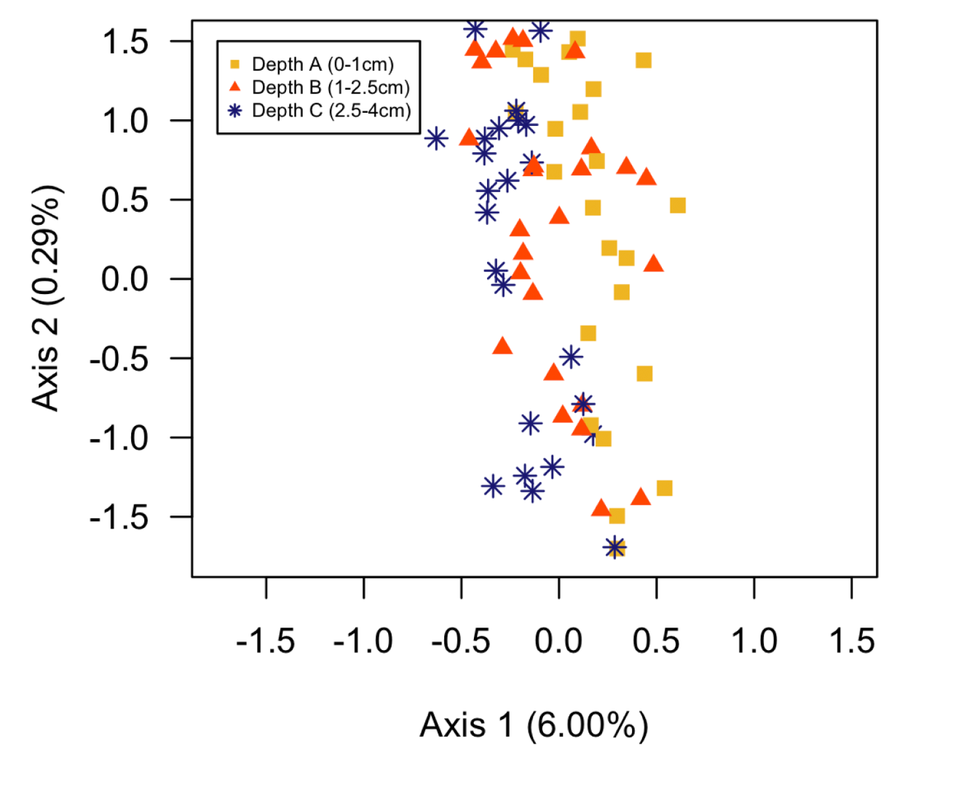
Appendix Figure 1. Principal Coordinates Analysis based on a weighted UniFrac distance with rhizosphere depth as a predictor variable.

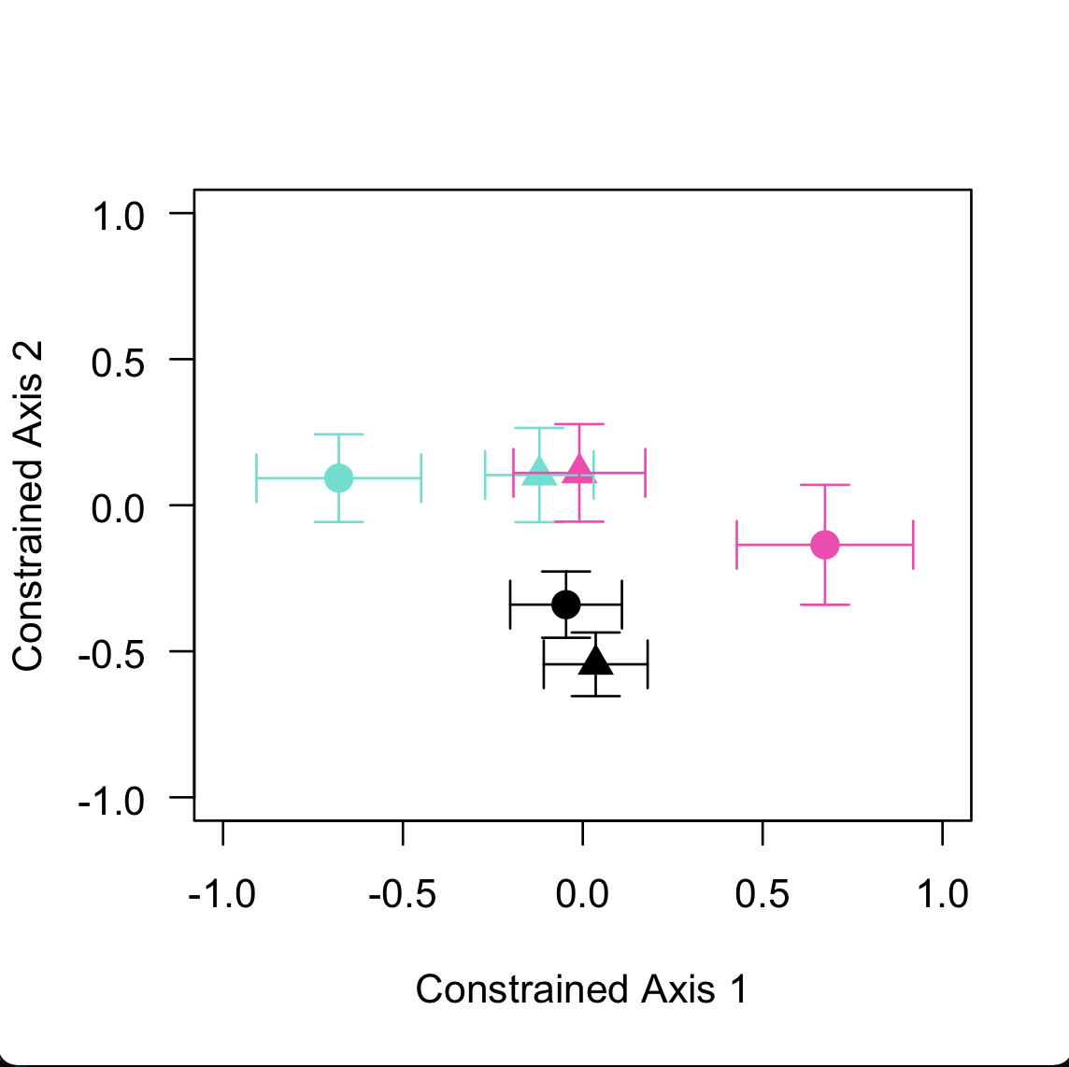
Appendix Figure 2. Principal coordinate analysis on bacterial communities using constrained axes from the db-RDA that utilized a weighted UniFrac distance to describe bacterial phylogenetic membership among rainfall exclusion treatments.
Appendix Figure 2 footnote. Black, teal, and pink represent the control, the moderate rainfall exclusion, and the high rainfall exclusion treatments. Shapes indicate sampling date, where triangles correspond to Date A and circles correspond to Date B. Bars are ± one standard error around the median.

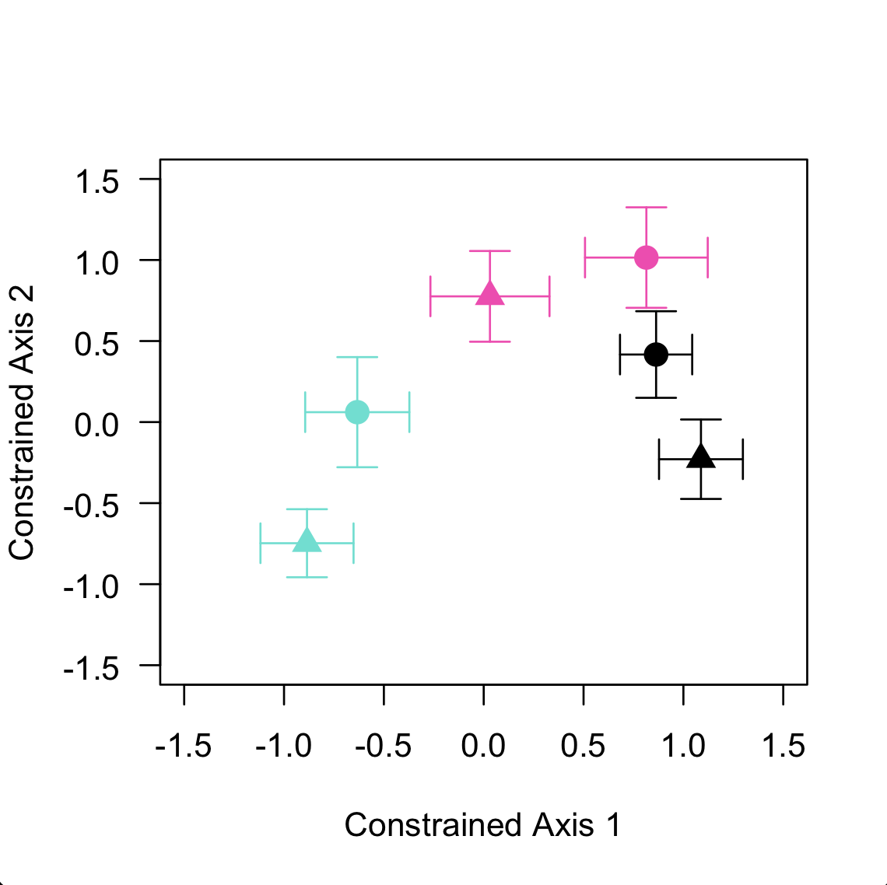
Appendix Figure 3. Principal coordinate analysis at q=1 from the db-RDA that utilized a pairwise beta diversity distance to describe bacterial community turnover among rainfall exclusion treatments.
Appendix Figure 3 footnote. Constrained axis 1 and 2 explain 45.06% and 24.73% of the 5.26% in total variation explained by our model. Triangles and circles represent Date A and Date B, respectively. Teal, pink, and black correspond to moderate exclusion (60%), high exclusion (80%), and the control treatment. Bars represent ± one standard error around the median point estimate per group.

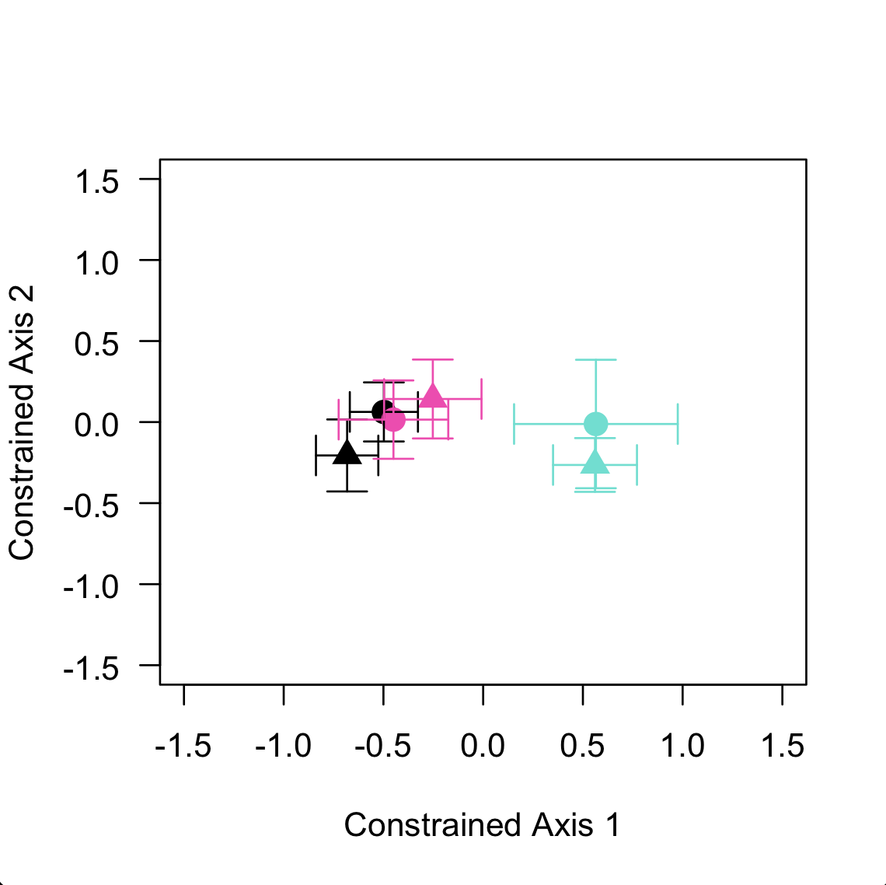
Appendix Figure 4. Principal coordinate analysis at q=2 from the db-RDA that utilized a pairwise beta diversity distance to describe bacterial community turnover among rainfall exclusion treatments.
Appendix Figure 4 footnote. Constrained axes 1 and 2 explain 54.55% and 25.81% of the 4.84% of total variation explained by our model. Triangles and circles represent Date A and Date B, respectively. Teal, pink, and black correspond to moderate exclusion (60%), high exclusion (80%), and the control treatment. Bars represent ± one standard error around the median point estimate per group.

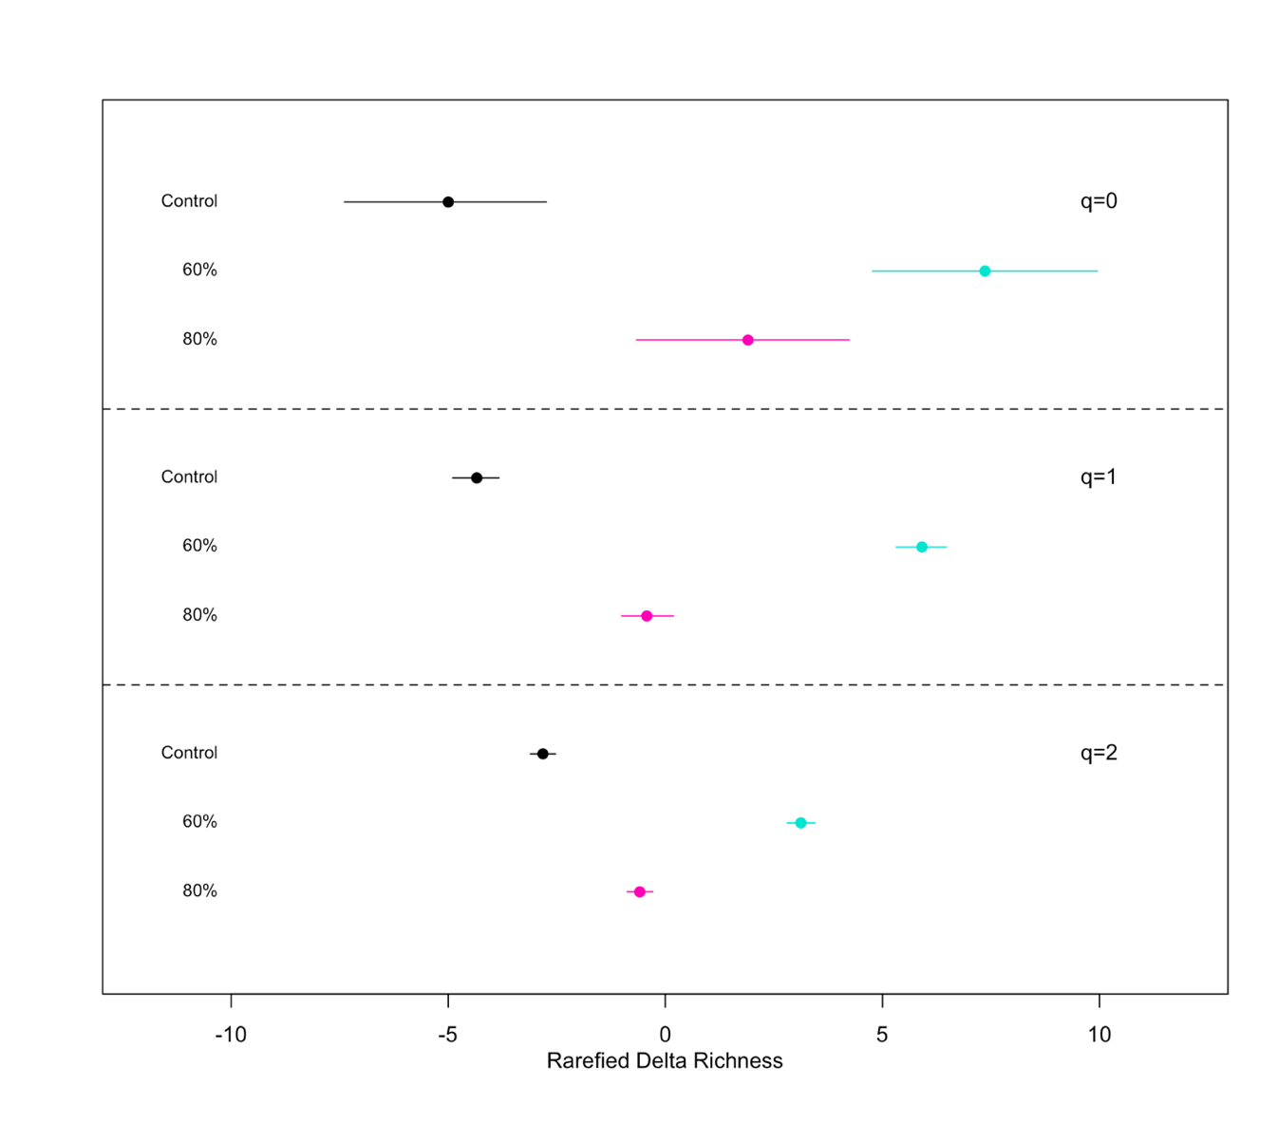
Appendix Figure 5. Rarefied ∆ AM fungal richness and the 95% highest density interval around the median change in alpha diversity between the two time points.
Appendix Figure 5 footnote. Bayesian inference was determined using linear models where the difference in AM fungal alpha diversity was predicted by rainfall exclusion treatment for each of the 1,000 rarefied communities. This was conducted for q=0, 1, and 2. Across all values of q, the 60% rainfall exclusion group, on average, had the largest change in AM fungal richness compared to other treatments.

Appendix Table 1. For the phylogenetically informed q=1, the median point estimates for ∆ AM fungal richness, the lower bound and the higher bound of the 95% highest density interval per treatment, evidence ratios, and posterior probabilities.
Hypothesis | Lower 95% HDI | Parameter Estimate | Higher 95% HDI | Posterior Probability
Control > 0 | -3.02861 | -1.05 | 1.018721 | 0.15
60% < 0 | -3.5933071 | 1.21 | 6.3120001 | 0.06
80% < 0 | -4.442419 | 0.41 | 5.480288 | 0.17

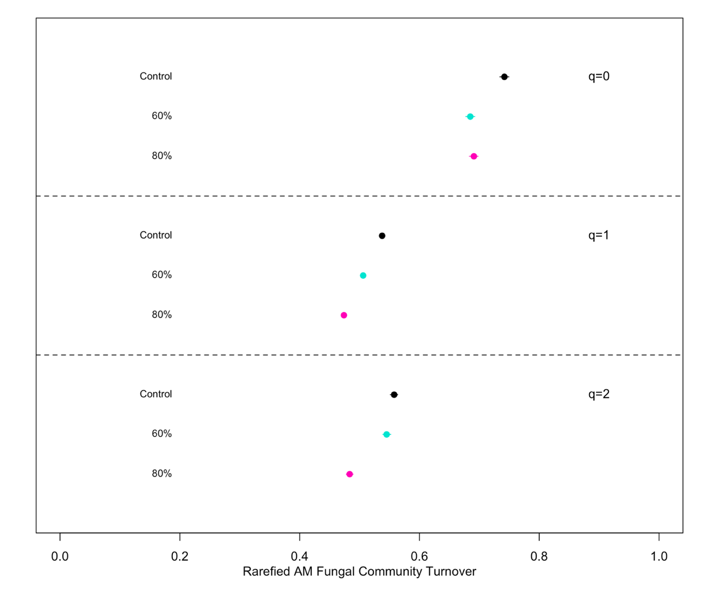
Appendix Figure 6. Rarefied AM fungal community turnover and the 95% highest density interval around the median between the two time points.
Appendix Figure 6 footnote. Bayesian inference was determined using linear models where AM fungal community turnover was predicted by rainfall exclusion treatment for each of the 1,000 rarefied communities. This was conducted for q=0, 1, and 2. Across all values of q, the control group, on average, had the largest observed AM fungal community turnover compared to other treatments.

Appendix Table 2. For each value of Diversity (q), the median rarefied pairwise AM fungal community turnover, the lower bound and the higher bound of the 95% highest density interval per treatment.
Treatment | q | 2.50% | Median | 97.50%
Control | 0 | 0.73413911 | 0.74177243 | 0.74939447
60% Rainfall Exclusion | 0 | 0.67722938 | 0.68486038 | 0.69255037
80% Rainfall Exclusion | 0 | 0.68325694 | 0.69088057 | 0.69794064
Control | 1 | 0.53320301 | 0.53766625 | 0.54172487
60% Rainfall Exclusion | 1 | 0.50138506 | 0.50599399 | 0.51035388
80% Rainfall Exclusion | 1 | 0.46977598 | 0.47385852 | 0.47839153
Control | 2 | 0.55119761 | 0.55774974 | 0.56370942
60% Rainfall Exclusion | 2 | 0.53881832 | 0.54517096 | 0.55213499
80% Rainfall Exclusion | 2 | 0.47776426 | 0.48345965 | 0.48921868

Appendix Table 3. Independent, noncorrelated climate variables included in each MaxEnt model per climate scenario based on a multicollinear test at a 0.7 threshold.
Climate baseline | CMD | PAS | PPT_wt | RH | TD | --
INM.CM4_rcp45_2055 | PAS | PPT_wt | RH | SHM | TD | --
INM.CM4_rcp45_2085 | PAS | PPT_sm | PPT_wt | RH | TD | --
INM.CM4_rcp85_2055 | PAS | PPT_sm | PPT_wt | RH | TD | --
INM.CM4_rcp85_2085 | PAS | PPT_sm | PPT_wt | RH | TD | --
CCSM4_rcp45_2055 | PAS | PPT_wt | RH | SHM | TD | --
CCSM4_rcp45_2085 | PAS | PPT_wt | RH | SHM | TD | --
CCSM4_rcp85_2055 | PAS | PPT_wt | RH | SHM | TD | --
CCSM4_rcp85_2085 | CMD | PAS | PPT_wt | RH | TD | --
GFDL.CM3_rcp45_2055 | PAS | PPT_sm | PPT_wt | RH | DD_0 | --
GFDL.CM3_rcp45_2085 | AHM | DD_0 | PAS | PPT_sm | PPT_wt | RH
GFDL.CM3_rcp85_2055 | AHM | DD_0 | PAS | PPT_sm | PPT_wt | RH
GFDL.CM3_rcp85_2085 | CMD | DD_0 | PAS | PPT_sm | PPT_wt | TD

Appendix Table 3 footnote. Abbreviations are as follows: annual heat moisture index (AHM), Hargreave's climatic moisture index (CMD), degree-days below 0°C (DD_0), precipitation as snow in mm (PAS), summer (Jun-Aug) precipitation in mm (PPT_sm), winter (Dec-Feb) precipitation in mm (PPT_wt), mean annual relative humidity (%) (RH), summer heat moisture index (SHM), the difference between mean temperature of the warmest month (°C) and the coldest month (°C) (TD).

Appendix Table 4. PCA axes and the proportion of variance each axes explains in multivariate space given the output of all ecological niche models for the species pair.
Axis | Standard Deviation | Proportion of Variance | Cumulative Proportion
PC1 | 4.6037 | 0.3854 | 0.3854
PC2 | 2.8028 | 0.1428 | 0.5282
PC3 | 2.5336 | 0.1167 | 0.6449
PC4 | 1.96103 | 0.06992 | 0.71481
PC5 | 1.69368 | 0.05216 | 0.76696
PC6 | 1.5306 | 0.0426 | 0.8096
PC7 | 1.4057 | 0.03593 | 0.84549
PC8 | 1.37139 | 0.03419 | 0.87968
PC9 | 1.1656 | 0.0247 | 0.9044
PC10 | 1.0563 | 0.02029 | 0.92467
PC11 | 1.01918 | 0.01889 | 0.94356
PC12 | 0.79055 | 0.01136 | 0.95492
PC13 | 0.77511 | 0.01092 | 0.96584
PC14 | 0.65739 | 0.00786 | 0.9737
PC15 | 0.60339 | 0.00662 | 0.98032
PC16 | 0.52382 | 0.00499 | 0.98531
PC17 | 0.49916 | 0.00453 | 0.98984
PC18 | 0.40303 | 0.00295 | 0.99279
PC19 | 0.33813 | 0.00208 | 0.99487
PC20 | 0.31055 | 0.00175 | 0.99662
PC21 | 0.2968 | 0.0016 | 0.9982
PC22 | 0.20686 | 0.00078 | 0.999
PC23 | 0.1652 | 0.0005 | 0.9995
PC24 | 0.13297 | 0.00032 | 0.99982
PC25 | 0.0991 | 0.00018 | 1
PC26 | 5.73E-15 | 0.00E+00 | 1

VITA
Jonathan R. Dickey, originally from Oxnard, California, spent most of his childhood in Southern Alaska, Southern California, and the suburbs of Dallas, Texas. After high school, Jonathan attended university at The University of Texas at Austin where he completed a Bachelor of Science in Ecology, Evolution, and Behavior. Throughout a brief field internship with the National Forest Service, Bureau of Land Management, and the National Park Service, Jonathan applied to graduate school and began his journey in pursuit of a PhD at The University of Tennessee, Knoxville in the Department of Ecology and Evolutionary Biology. His major research interests investigate the small-scale distribution of plant-host associated microorganisms and the ecological factors that govern these distributions. Further, he takes this information and links it to ecological modeling where large-scale biogeographical patterns can be predicted in future climate scenarios. After graduation, he will continue to investigate plant-microbial interactions and focus on using novel statistical and bioinformatic methods to characterized microbial communities. He is filled with gratitude for the continual support his mentors, friends, and family have provided throughout this process and as he takes the next step in his career.

