THE USE OF ULTRASONICS FOR THE DETECTION OF SOLID HOLDUP IN GASEOUS PIPE SYSTEMS

A Thesis Presented for the Master of Science
Degree

The University of Tennessee, Knoxville

Chilson J. Whittum August 2025

The information or opinions expressed herein by the author are solely those of the author.
Neither the U.S. Government, Consolidated Nuclear Security, LLC, nor any of their employees warrant, or assume any legal liability for, the accuracy, completeness or usefulness of any information contained herein.
This document has been authored by Consolidated Nuclear Security, LLC, under Contract DE-NA-0001942 with the U.S. Department of Energy/National Nuclear Security Administration, or a subcontractor thereof. The United States Government retains and the publisher, by accepting the document for publication, acknowledges that the United States Government retains a nonexclusive, paid-up, irrevocable, world-wide license to publish or reproduce the published form of this document, prepare derivative works, distribute copies of the public, and perform publicly and display publicly, or allow others to do so, for United States Government purposes.

ACKNOWLEDGEMENTS

Thank you to Y-12 for allowing me to pursue this research, and additional thanks to Michael Orick, Sebastian Vittardi, and the rest of Y-12 for mentoring me and welcoming me to the Y-12 community. I would also like to thank my advisor, Dr. Jamie Coble, for mentoring me and keeping my head on straight through my graduate program.

ABSTRACT

Ultrasonic detection methods are often used for non-destructive monitoring and visualization. These applications range from weld inspection to thickness measuring to structural monitoring. One of these applications is the monitoring of multi-phase pipe systems, such as a liquid with solid particulates or gaseous voids, the purpose of which is to monitor any holdup or blockages that may occur within the pipe system. The purpose of this research is to explore the usage of ultrasonic detection methods for monitoring solid holdup generation within a gaseous pipe system. Gaseous systems differ from the more common liquidus and multi-phase systems in that due to the low density of gaseous systems, the travelling gases cannot be characterized with standard ultrasonic monitoring techniques. Gaseous systems also deposit holdup along the walls of its pipe system, whereas liquidus and multi-phase systems are more likely to carry their holdup along through the pipe. This research found that when surrogate holdup with a volume of 0.2 cm³ and a height of 0.1 cm is present in a gaseous system, it can cause ultrasonic waves traveling through the pipe to drop in amplitude by as much as 21%. This is a large enough change in amplitude to be detected by automated computer systems. This work lays the foundation for more specific use cases for non-destructive assay of gaseous systems, such as uranium hexafluoride (UF6) systems.

TABLE OF CONTENTS
CHAPTER ONE INTRODUCTION AND GENERAL INFORMATION 1
Applications of Study 1
CHAPTER TWO LITERATURE REVIEW 3
The Basics of Ultrasonics 3
Current Holdup Research 6
Corrosion Mapping 8
Flaw Detection 8
CHAPTER THREE MATERIALS AND METHODS 11
Pipe and Holdup Selection 11
Pipe Testing 12
Surrogate Holdup Materials 12
Ultrasonic Equipment 14
Testing Configuration 14
Testing Methodology 16
CHAPTER FOUR RESULTS AND DISCUSSION 19
CHAPTER FIVE CONCLUSIONS AND RECOMMENDATIONS 22
LIST OF REFERENCES 24
VITA 26

LIST OF TABLES
Table 3.1. Test Pipe Catalogue 13

LIST OF FIGURES

Figure 2.1. Holdup Theoretical Wave Reflections 5
Figure 2.2. Single Element Transducer 5
Figure 2.3. Dual Element Transducer 6
Figure 2.4. Liquidus System Holdup Detection 7
Figure 2.5. Corrosion Detection and Mapping Example 9
Figure 2.6. Flaw Detection Example……………………………………………………. 10
Figure 3.1. Test Set-Up side view 15
Figure 3.2. Test Set-Up cross section view 15
Figure 3.3. Experiment Step 1 17
Figure 3.4. Experiment Step 2 17
Figure 3.5. T-Intersection Additional Test Locations 18
Figure 4.1. Straight Pipe Graph Data. Left: No Holdup; Right: Directly on Holdup 20
Figure 4.2. T-Section Graph Data. Left: No Holdup; Right: Directly on Holdup. 20
Figure 4.3. Relative Amplitude vs. Distance from Holdup in a 32-Inch Straight Pipe 21

CHAPTER ONE INTRODUCTION AND GENERAL INFORMATION

Applications of Study

Ultrasonic detection methods are commonly used in a wide variety of industrial settings, including non-destructive assay of materials. This assay includes holdup detection in liquidus and multi-phase systems, but currently not gaseous systems. This research was originally inspired by gaseous UF6 (Uranium Hexafluoride) systems although the approach is broadly applicable to any gaseous pipe systems in which the gaseous material can react and form solid holdup along the pipe walls. This holdup is created when the UF6 reacts with water vapor within the system to create gaseous HF (hydrogen flouride) and solid UO2F2 as shown below (Hu et al. (2014)).

𝑈𝐹₆(𝑔) + 𝐻₂𝑂(𝑔) → 𝑈𝑂𝐹₄(𝑠) + 2𝐻𝐹(𝑔) | 1.1
𝑈𝑂𝐹₄(𝑔) + 𝐻₂𝑂(𝑔) → 𝑈𝑂₂𝐹₂(𝑠) + 2𝐻𝐹(𝑔) | 1.2

Ultrasonic methods that can detect, monitor, and potentially image this buildup can assist in accounting for material. The amount of holdup expected in these systems is very small, down to only a few micrograms. While this may not seem concerning, these systems are typically small and the release of gaseous HF in the system can lead to system damage.
Detecting and determining the amount of holdup in these systems can be used to determine how much HF may be in the system. In non-UF6 systems, the holdup material can cause a blockage or limitation in the pipe system. While this would be detected by other means, it is both cheaper and easier to fix when the amount of holdup is low.

Gaseous systems differ from the much more common liquidus and multi-phase systems in a few ways. In liquidus and multi-phase systems, holdup is often expected to also be natural contaminates or gas bubbles within the system. This could be in the form of a solid slurry or particulates, which alters the needs of their systems. When gaseous systems have holdup, it is caused by unexpected chemical reactions, which can cause damage to the system in addition to forming holdup. Further, in liquid systems, ultrasonic waves can travel through the liquid media to the other side of the pipe whereas gaseous media do not conserve enough of the wave’s energy enough to be detectable.
This research explores an early proof of principle concept and application of ultrasonic detection methods in gaseous systems. The existing and relevant literature on existing holdup monitoring is explored in Chapter two. Due to the nature of gaseous systems, corrosion mapping and flaw detection are also explored, as these may share a unique insight into detecting solid holdup in gaseous systems. Chapter three goes over the materials used for testing, including the pipes, surrogate holdup material, and the ultrasonic testing equipment. Also contained in this chapter are the methods used to test the viability for holdup detection across different types of pipes. The results of these tests are discussed in Chapter four and followed by future work recommendations in Chapter five.

CHAPTER TWO LITERATURE REVIEW
This research started by looking into the basics of ultrasonics before considering how they may be used to detect holdup in gaseous systems. Current research into ultrasonic detection methods for solid holdup are primarily focused around liquidus and multi-phase systems. Corrosion mapping and flaw detection also use similar detection methods and are designed to detect exceptionally small permutations within and on the interior surface of pipe walls. When combined, these three areas of preexisting research provide a starting point for the research focus of this paper.

The Basics of Ultrasonics

Ultrasonics are a form of acoustic testing that utilizes frequencies too high for the human ear to hear. These waves can be very penetrating, especially with certain media, such as metal and water. Measurements are taken by emitting a sound wave with a given frequency and amplitude though a media. The waveform is then received by either a separate receiver on the other side of the media or by the same transmitter after it has been reflected within the detecting media. As discussed by Sinha et al. (1995) and shown in Figure 2.1, the waveform data can be used to detect holdup on the opposite side of a plate by measuring changes in the amplitude and time-of-flight (TOF) of the wave. This is the same method used to measure the thickness of a material using ultrasonics. The TOF is multiplied by the speed of sound in the material, giving the thickness of the material. The speed of sound changes depending on the material it is travelling through, which is what allows for such calculations. Equation 2.1 shows a simple example of this

calculation for Figure 2.1, where 𝑥 is the thickness of the material, 𝑡 is the amount of time it takes for the signal to bounce back to the transducer, and 𝑣 is the speed of sound in the medium.
𝑡  𝑥 = ∗ 𝑣 2 | 2.1
For holdup on the inside of a pipe, the TOF of the first reflection of the interior pipe wall can be compared to the TOF of the reflection of the inner-most edge of the holdup.
There are numerous different types of ultrasonic detection tools and methods, with each one having their own merits and use cases. This research focuses on two specific types of transducers: single-element and dual-element transducers, as shown in Figures 2.2 and 2.3. In these figures, the blue represents the piezo element while the red represents the housing surface of the transducer. Single-element transducers have a single sound emitting element that emits a waveform normal to the surface of the transducer. This creates a focused, very penetrating waveform. However, in thin media, this can create a large echo that can cause a significant amount of noise in the received data. A dual-element transducer has two emitting elements that are slightly angled towards from each other. This increases the sensitivity and resolution for measurements closer to the transducer, such as in thin-walled pipes. The angled emitters also cause a reduction in detected echo from both the two signals diminishing one another and the reflected waves being mostly angled away from the detected area. Unfortunately, due to the two signals interfering with one another, it does lose some of the range that a single-element transducer has (Turcotte et al. (2016)).

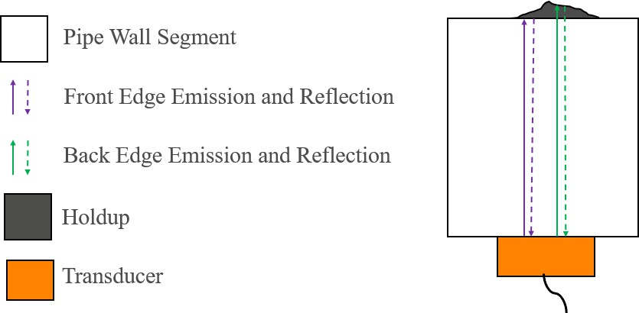

Figure 2.1. Holdup Theoretical Wave Reflections
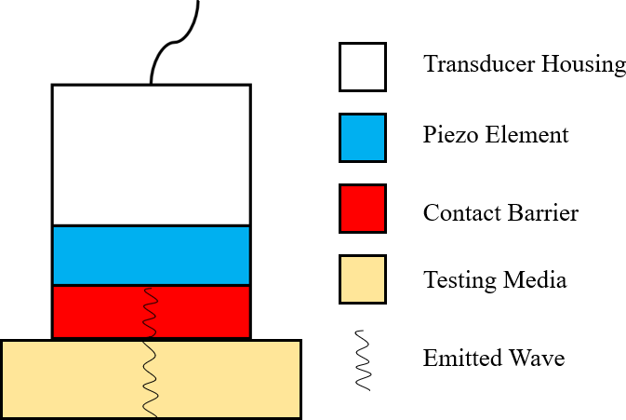

Figure 2.2. Single Element Transducer

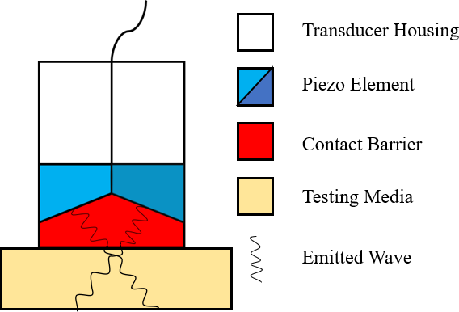

Figure 2.3. Dual Element Transducer

Current Holdup Research

The use of ultrasonics for holdup detection and characterization is not a new field of research. Most of this research focuses on the TOF, also called transmission time, and average acoustic attenuation characteristics of the waveform after it has passed through the detected media. Much of this research focuses on detecting gaseous holdup, most commonly in the form of bubble columns; however, the research that includes solid holdup show similar methods can be applied. The primary differences between former research and this is that most liquidus detection methods use a separate 5 MHz transmitter and receiver on opposite sides of the pipe (as shown in Figure 2.4), whereas this uses a single transducer that detects the reflected signal. The ultrasonic methods utilized by Zheng et al. (2004) uses TOF and attenuation data from the reflected waves to determine the characteristics of the holdup. This same theory should be applied to the research of this paper, as the solid holdup is fixed to the interior walls of the pipe. In this research, the lack of liquid in the gaseous system could be beneficial, as it would mean.
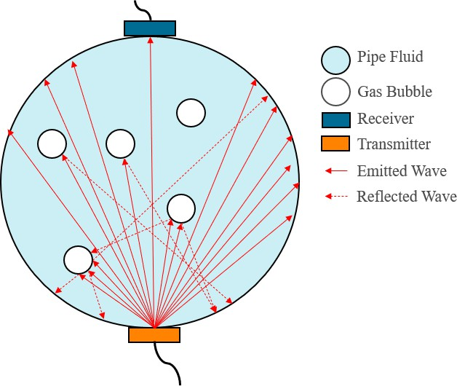
Figure 2.4. Liquidus System Holdup Detection

the waveform has less attenuating material to travel through. This should make any deviations in the waveform caused by the solid holdup easier to detect.

Corrosion Mapping
Corrosion is a gradual removal of material over time, which makes it the opposite of holdup. However, the methods for detecting the two are very similar. Both can be done using simple TOF measurements. That TOF data can then be used to find the thickness of each lateral section of the material, which can be used to find any abnormalities in the material, as shown in Figure 2.5. Tai et al. (2023) performed research on detecting corrosion and pitting in high temperature environments, which is also common in gaseous pipe systems. High temperatures can cause the piezo-element of ultrasonic transducers to degrade and potentially fail. This degradation leads to a lack of signal reception, which reduces the accuracy of the ultrasonic measurements taken by the transducer. Their research showed that the data collected by piezo-element transducers start to lose definition at approximately 170 degrees Celsius, and data loss begins at 220 degrees Celsius. This was not considered for the proof of principle, but should be considered for any future work since many industrial gas systems operate at high temperatures.

Flaw Detection
Ultrasonic testing has a long history of being used to detect flaws in the microstructure of materials. The reflection of a wave from a crack or void will reach the transducer and have a shorter TOF than the reflection from the opposite side of the material. With a high enough accuracy, the size and shape of the flaw can be found as well by comparing the multiple distinct reflections caused by the different boundaries of the flaw, as shown by Kechida at al. (2011). An example of this is also shown in
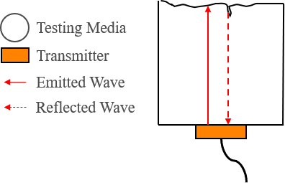
Figure 2.5. Corrosion Detection and Mapping Example
Figure 2.6. This same idea can be applied to holdup measurement, but in reverse. The first reflection will be the interior wall of the pipe, with every subsequent reflection being due to the definition and boundaries of the holdup material, as shown in Figure 2.1. However, in a small-diameter pipe, these signals may be difficult to find through the signal noise of the waveform bouncing throughout the entire wall of the pipe. This is important to bear in mind since the goal of this research is to show how viable the use of ultrasonics is for monitoring holdup in small pipes, as is common in gaseous systems.

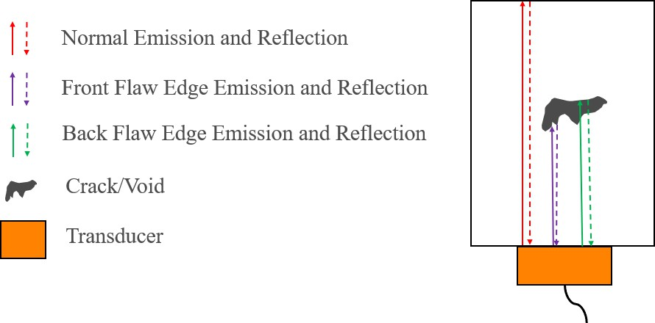

Figure 2.6. Flaw Detection Example

CHAPTER THREE MATERIALS AND METHODS
This research is to show that ultrasonic testing can be used for monitoring gaseous pipe systems, such as UF6 systems. For ultrasonics to be applicable, a detectable and
consistent change in the wave’s characteristics must be present. To test this, holdup material will be placed within the pipes and ultrasonic measurements will be taken at different locations. These measurements will be compared with baseline measurements taken earlier. There should be an observed, consistent change in the wave characteristics due to the holdup.

Pipe and Holdup Selection
Holdup can be deposited in any area of a pipe system and in variable amounts. This means that for testing, different configurations of pipes must be tested along with differing locations and amounts of holdup. Since actual processing holdup cannot be used due to safety and procurement concerns, a surrogate was selected. These pipes would be placed in different configurations to test how the waveform would change when different pipe segments were attached. These readings could affect how the holdup would be detected. The O-rings used in the pipe joinery would likely absorb excess noise from other pipe segments, but that could also lead to holdup on the joints being more difficult to detect. The holdup would also be placed in different locations in pipes, especially in intersections, to find how the holdup might be best characterized in different locations.
Holdup most commonly forms in certain locations, such as against ridges and in turns or intersections, so these locations also had to be tested.

Pipe Testing
Due to the variety of pipes used in industrial settings, there were a variety of pipes and pipe configurations utilized in this experiment. Among these were straight line pipes, t- intersections, conical and straight reducers, and corrugated flex pipes. The pipes are made of stainless steel and have a thickness of 0.065 ± 0.001 inches. The speed of sound in steel is approximately 5,960 meters per second. Each pipe segment has an assigned number for ease of reference, which are shown in Table 3.1.

Surrogate Holdup Materials
Due to the difficulty in testing with actual industrial holdup, surrogate materials had to be selected for testing. UF6 holdup is nuclear material, and as such is difficult to get a hold of and safely use. It is also not expected to form in large amounts and can’t be reliable induced to form in specific locations for testing. Holdup can take many forms depending on where it collects on a pipe, such as in a corner or on the edge of an intersection. This forms a strong bond between the pipe and the holdup, which enables ultrasonic waves to travel through them. Due to this, the surrogate had to be something that could be placed in a variety of shapes and adhere to the pipe. The first material attempted was different salts, however the crystals were too large and did not have enough surface area in contact with the pipe wall to accurately represent expected holdup conditions. The second was baking soda, which solved the surface area issue, however it was very difficult to be consistent with the placement and location, as whenever the pipe was shifted, the baking soda would change location and spread, something that is not expected to occur in industrial settings. With these limitations, a paste was created out of salt and dish soap, with a ratio of 2-1 salt to dish soap by volume. This gave the desired properties of being
Table 3.1. Test Pipe Catalogue

Pipe ID Number | Pipe Description | Length (cm) | Quantity
1.1 | K25 Straight Pipe | 32.25 | 1
1.2 | K16 Straight Pipe | 8.00 | 1
2.1 | K25 Flex Pipe | 25.5 | 1
2.2 | K40 Flex Pipe | 12.0 | 1
3.1 | K25 T-Intersection | 10.16 | 1
4.1 | K40 to K25 Straight Reducer | 1.6 | 1
4.2 | K40 to K16 Straight Reducer | 1.6 | 1
5.1 | K25 to K16 Conical Reducer | 3.8 | 1
5.2 | K40 to K16 Conical Reducer | 3.8 | 1
6.1 | K16 O-Ring | --- | 4
6.2 | K25 O-Ring | --- | 2
6.3 | K40 O-Ring | --- | 3
7.1 | K16 Clasp | --- | 4
7.2 | K25 Clasp | --- | 3
7.3 | K40 Clasp | --- | 3
8.1 | K16 Pipe Cap | 0.3 | 2
8.2 | K25 Pipe Cap | 0.3 | 2
8.3 | K40 Pipe Cap | 0.3 | 5
8.4 | K25 Thick Pipe Cap | 1.9 | 1

able to adhere to the pipe geometry and have flush contact with the pipe.

Ultrasonic Equipment
After reaching out to multiple companies, the ultrasonic equipment was purchased through Olympus. With their help, the 39DL Plus testing device was selected due to its precision in collecting thickness measurements. This facet of the device was focused due to the research done in flaw detection and corrosion mapping. Since the media being
detected would be on the interior wall of the pipe, that does add to the thickness of the pipe where the holdup is. In addition to the 39DL Plus, a single-element transducer (Part number M109) and a dual-element transducer (part number DEF-D790/791) were acquired to compare the quality of their results and find which detection method worked best, if either. Both transducers operate at 5 MHz and emit standard longitudinal waves, which is the same operating frequency and methodology used in much of the research featured in the literature review.

Testing Configuration
For these tests, the surrogate material was applied to a small section of the pipe as shown in Figures 3.1 and 3.2 respectively. The orange represents the ultrasonic transducer, and the blue represents the holdup placement. The amount of surrogate holdup applied was approximately 2 mm in height, 1 cm in width, and 2 cm in depth, as viewed from the pipe cross section. While this is a large amount of holdup for standard UF6 systems, this was performed as an initial proof of principle demonstration. Using separate transmitters and receivers on opposite sides of the pipe was considered, however it was not deemed necessary at this stage in testing. Based on the literature review, it was also deemed to be not as applicable as a single transducer due to the lack of wave-propagating material

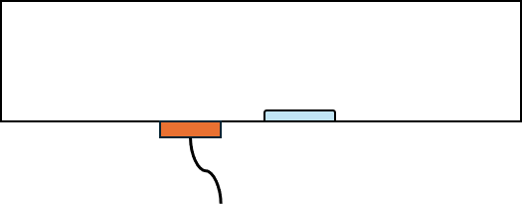

Figure 3.1. Test Set-Up side view

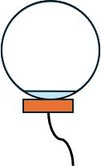

Figure 3.2. Test Set-Up cross section view

inside the pipe. This is due to the primary detection method being thickness measurements, which only use a single dual-element transducer.

Testing Methodology
The testing methodology followed three steps for each test conducted, which are shown visually in Figure 3.3. In step one, the transducer was manually moved across the exterior of the pipe in a straight line, with measurements taken every half inch (Figure 3.2). Once the transducer reached the end of the pipe, for step two the pipe was rotated 45 degrees, and the transducer would be placed back at the beginning end of the pipe (Figure 3.4).
The decision to rotate the pipe as opposed to just move the transducer was made because it was easier to get consistent transducer placement when the pipe was rotated and the transducer stayed fixed on a flat stable surface. Steps one and two would then be repeated until the pipe had completed one full revolution and measurements had been taken across
the entire surface. Additional places around the joinery of the T-intersections were measured as well, and examples of this are shown in Figure 3.5. The manual moving of both the pipe and transducer does introduce errors and uncertainty, as the transducer has to be at the same placement on the exterior of the pipe for consistent measurements.
Construction of a rig could help with this issue.

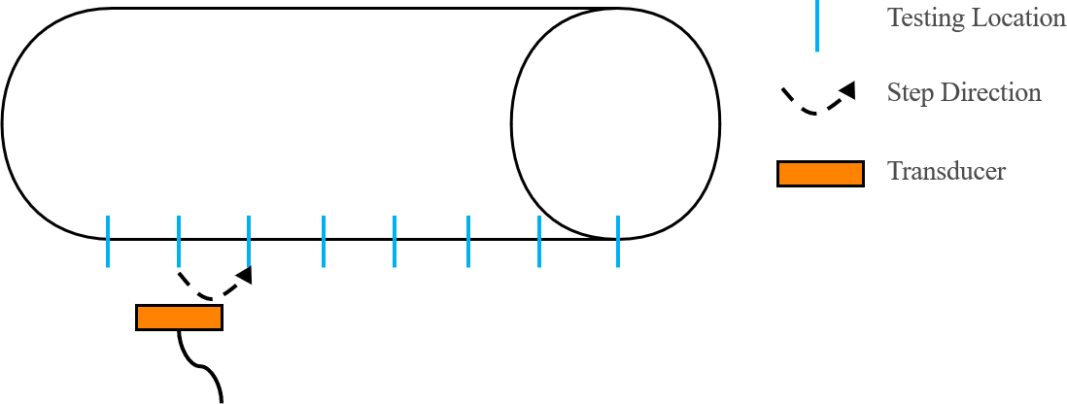

Figure 3.3. Experiment Step 1

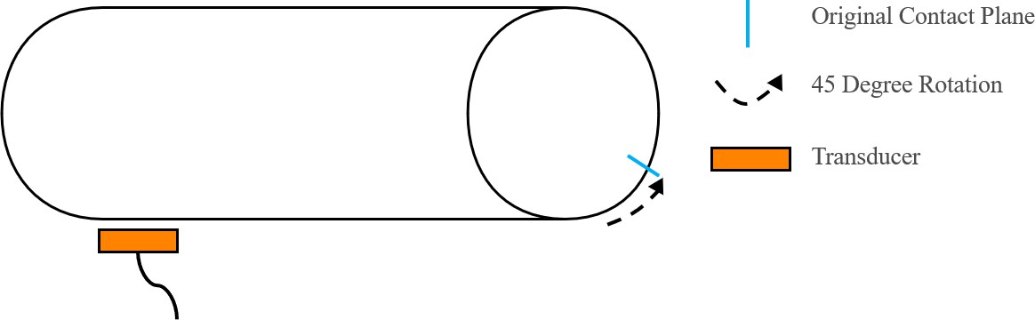

Figure 3.4. Experiment Step 2

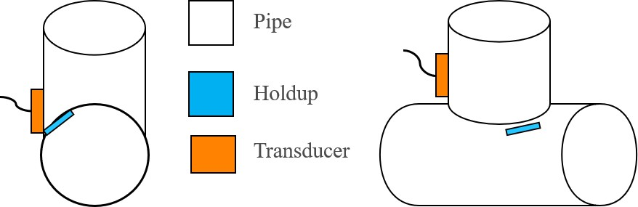

Figure 3.5. T-Intersection Additional Test Locations

CHAPTER FOUR RESULTS AND DISCUSSION
When the single element transducer was used, unfortunately the pipe walls were too thin for it, causing significant echoes and surface waves to circle around the outside wall of the pipe. This caused the data to be almost completely obfuscated. The dual element transducer had significantly better data acquisition due to its angled wave emissions. The amplitude of the waveform decreased slightly by the presence of holdup on the inside of wall of the pipe near the testing location. The decrease was only observed when the dual element transducer approached within half an inch of the holdup. The first test used pipe 1.1, the long K25 straight pipe, the data for which is shown in Figure 4.1. The first measurement shown is a clean measurement, where the waveform and its reflections are clearly shown. The data for the other straight pipes showed the same trend regarding holdup material. The second measurement shown is when the transducer was directly on the opposite side from where the holdup was placed. The holdup caused an initial approximate 21 ± 3% diminishment of the amplitude of the first reflection group of the waveform. As shown, the holdup also caused the wave to die out by the third echo. This decay rate is much quicker than the non-holdup wave decay rate since without holdup, the wave can freely travel around the pipe with no extra material to dampen the wave more quickly than normal. Figure 4.3 shows how the relative amplitude changes relative to distance from holdup in pipe number 1.1 with measurements taken every half inch.
The next test was on pipe 3.1, the k25 t-intersection. As shown in figure 4.2, there is a similar phenomenon as with the straight pipe, but more pronounced. This is likely due to

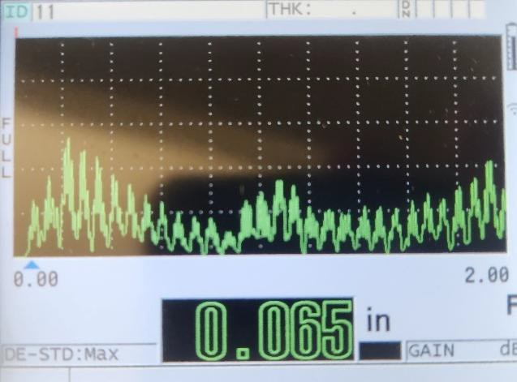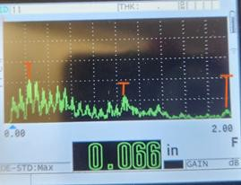
Figure 4.1. Straight Pipe Graph Data. Left: No Holdup; Right: Directly on Holdup

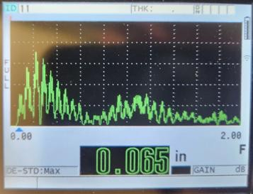
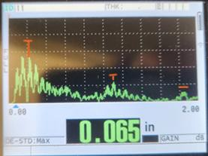
Figure 4.2. T-Section Graph Data. Left: No Holdup; Right: Directly on Holdup.

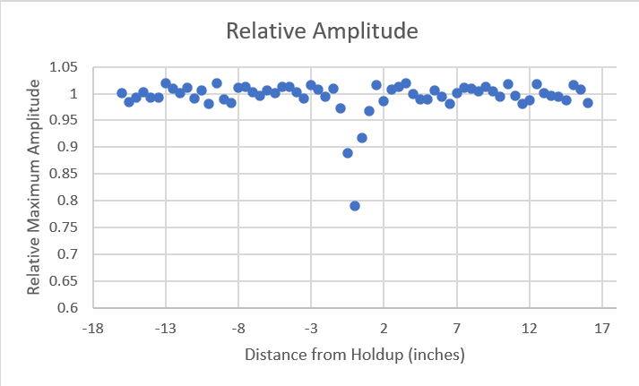
Figure 4.3. Relative Amplitude vs. Distance from Holdup in a 32-Inch Straight Pipe

the unique shape of the t-intersection. The good news is that this indicates that despite its form, holdup can still be detected in it. Due to how close the transducer had to get to detect holdup, the seals were untested, as the transducer could not get close enough to get a clear reading through both the clamp and the O-ring.

CHAPTER FIVE CONCLUSIONS AND RECOMMENDATIONS
Transducers can and do work to detect solid holdup in a gaseous system. An observable decrease in amplitude was observed when holdup was introduced into the system. For areas where holdup is likely or suspected to form, a computer system could be used to compare constant measurements of the location to a baseline measurement. For the rest of the pipe system, depending on how much holdup is expected, an ultrasonic assessment could be conducted on a similar schedule to other standard maintenance. Intersections and pipe joinery were found to be more challenging to measure, as there are some locations where either the resolution is low or the probe cannot get close enough to the material to detect it. The amount of holdup for this experiment was fixed, so this research was unable to determine if there is a mathematical correlation between the amount of holdup and the total change in amplitude. This was expected, since any holdup on the pipe would cause a dampening effect on the wave travelling through the pipe. Both the difficult locations and holdup amounts are highly recommended for future research.
Some applications, such as UF6 systems, only generate micrograms of holdup, so using precision equipment to test the monitoring capabilities of very small amounts of holdup is advisable. Other holdup types and piping material could also be tested to capture a wide variety of industrial gaseous pipe environments. In addition, operating at higher temperatures and using surrogate holdup material with a higher density would also be good future tests. The surrogate holdup material has a density of 1.78 grams per cubic centimeter while UF6 has a density of 5.09 grams per cubic centimeter. On the equipment

side, using different ultrasonic devices, such as ones specifically designed for flaw detection, could be useful. Flaw detection devices could produce information on the dimensions of the holdup by providing more precise data on the reflected waves.
Alongside this, varying the transducer type, frequency, and size could obtain better results depending on the characteristics of the tested or monitored systems. These future research avenues would enable the research to more accurately cover a wider range of industrial procedures, including UF6 systems.

LIST OF REFERENCES
Abbaszadeh, Javad, Herlina Binti Abdul Rahim, Ruzairi Bin Abdul Rahim, and Sahar Sarafi. "Frequency analysis of ultrasonic wave propagation on metal pipe in ultrasonic tomography system." Sensor Review 34, no. 1 (2014): 13-23.
Gong, Zheng, An Zhao, Lu-Sheng Zhai, Ying-Yu Ren, and Ning-De Jin. "Ultrasonic method for measuring the gas holdup of gas-liquid bubbly flow in a small-diameter pipe." Korean Journal of Chemical Engineering 33 (2016): 1170-1180.
Hu, Shao-Wen, Hao Lin, Xiang-Yun Wang, and Tai-Wei Chu. "Effect of H2O on the hydrolysis of UF6 in the gas phase." Journal of Molecular Structure 1062 (2014): 29-34.
Huysmans, M. C. D. N. J. M., and J. M. Thijssen. "Ultrasonic measurement of enamel thickness: a tool for monitoring dental erosion?." Journal of dentistry 28, no. 3 (2000): 187-191.
Kechida, Ahmed, Redouane Drai, and Abderrezak Guessoum. "Texture analysis for flaw detection in ultrasonic images." Journal of Nondestructive Evaluation 31 (2012): 108- 116.
Lissenden, Cliff J., Yang Liu, and Joseph L. Rose. "Use of non-linear ultrasonic guided waves for early damage detection." Insight-Non-Destructive Testing and Condition Monitoring 57, no. 4 (2015): 206-211.
Sinha, Dipen N., and Chad T. Olinger. Ultrasonic methods for locating hold-up. No. LA- UR-95-2197; CONF-950787-49. Los Alamos National Lab.(LANL), Los Alamos, NM (United States), 1995.
Tai, Jan Lean, Rafał Grzejda, Mohamed Thariq Hameed Sultan, Andrzej Łukaszewicz, Farah Syazwani Shahar, Wojciech Tarasiuk, and Arkadiusz Rychlik. "Experimental investigation on the corrosion detectability of A36 low carbon steel by the method of phased array corrosion mapping." Materials 16, no. 15 (2023): 5297.
Turcotte, Jonathan, Philippe Rioux, and J. Lavoie. "Comparison corrosion mapping solutions using phased array, conventional UT and 3D scanners." In Proceedings of the 19th World Conference on Non-Destructive Testing, pp. 1-10. 2016.
Xiao, Xiang, Bin Gao, and Gui yun Tian. "Investigation of ultrasonic NDT for small diameter and thin-wall tube." In 2019 IEEE International Instrumentation and Measurement Technology Conference (I2MTC), pp. 1-5. IEEE, 2019.
Zheng, Ying, and Qikai Zhang. "Simultaneous measurement of gas and solid holdups in multiphase systems using ultrasonic technique." Chemical Engineering Science 59, no. 17 (2004): 3505-3514.

VITA

Chilson Whittum entered the University of Tennessee in August 2019 and in May 2023, they received the Bachelor of Science Degree in Nuclear Engineering. They remained at the University of Tennessee for graduate school and conducted research with Y-12 through the Technology Accelerator Program. They received a Master of Science Degree in Nuclear Engineering with a concentration in Nuclear Safety in August 2025.

