Comparing Models of Demographic Sub Populations

A Thesis Presented for the

Master of Science

Degree

The University of Tennessee, Knoxville

Jessica J. Moehl

August 2014

Copyright © 2011 by John X. “This Page is Optional” Doe
All rights reserved.

DEDICATION

Amy Rose is awesome, no not that one.
.

ACKNOWLEDGEMENTS

Great advising panel.

ABSTRACT

Understanding specific multi-dimensional demographics of populations in the United States at high resolutions is made difficult by the restriction of data released by the Census Bureau because of privacy concerns. Efforts to model these sub populations have been increasing in recent years. These modeled populations have applications in decision making at all levels of government as well as in academia and the private sector. Two models have shown promising techniques for incorporating multiple levels of data to model sub populations in a meaningful way. These models, the copula approach by Kao et al (2012) and the Penalized Maximum Entropy Method by Nagle et al (2013), have been applied in different study areas using different attributes. This paper provides a direct comparison which is needed to understand the strengths and weakness of each model as well as to assess the possibility of expanding their application nationally.

PREFACE

This page is optional.

TABLE OF CONTENTS

INTRODUCTION 1
Chapter 1 1
CHAPTER I Comparing Demographic Population Modeling Techniques 2
Abstract 3
Introduction 3
Previous Works 4
Current Study 6
Data Collection 8
Results 9
References 10
CONCLUSION 12
VITA 13

LIST OF TABLES

Table 1. Known joint distributions (PUMA) are distributed to smaller regions (Block Group 1 and Block group 2) with the aid of summary tables (marginal data) from those sub-regions. 5

LIST OF FIGURES
Figure 1. PUMAs have different areal coverage. 5
Figure 2. Tract level income category proportions. Bottom to top is low to high. 7
Figure 3.Tracts 007100 and 005300 overlap both PUMA 01701 and 01705. 8

INTRODUCTION

Chapter 1

This thesis compares two population modeling techniques and gives an overview of the ways in which one would be able to expand the methods to larger data areas.

CHAPTER I
Comparing Demographic Population Modeling Techniques

(Beyond the title, this page should be blank. The publication statement, abstract, and the rest of the chapter should begin on the next page.)

A version of this chapter was originally published by John X. Doe and Juanita Q. Vera:
John X. Doe, Juanita Q. Vera. “Towards A Theory of Page Rage.” Journal of Infomatic Bloat 221 (2009): 102-105.

The student must add a brief explanatory statement at the beginning of each article, stating how the article was revised and/or detailing the student’s involvement in the article. Any co-researchers should be identified and their role clarified as part of this statement.

Abstract

Understanding specific multi-dimensional demographics of populations in the United States at high resolutions is made difficult by the restriction of data released by the Census Bureau because of privacy concerns. Efforts to model these sub populations have been increasing in recent years. These modeled populations have applications in decision making at all levels of government as well as in academia and the private sector. Two models have shown promising techniques for incorporating multiple levels of data to model sub populations in a meaningful way. These models, the copula approach by Kao et al (2012) and the Penalized Maximum Entropy Method by Nagle et al (2013), have been applied in different study areas using different attributes. This paper provides a direct comparison which is needed to understand the strengths and weakness of each model as well as to assess the possibility of expanding their application nationally.

Introduction

The Census Bureau is charged with counting the population of the country. It does this primarily through a decennial enumeration of the entire population. Until recently, the enumeration was a basic form given to all households with one of six households receiving a longer, more detailed form (Census SF3, 2002). This provided a detailed demographic sub-sample as well as a wider reaching basic count. However, a more frequent survey was needed in order to better serve the users of their data. The American Community Survey (ACS) was developed to replace the long form survey and full implementation of the new surveys began in 2005 (Census ACS, 2006). Like the decennial long form, the ACS also represents a sub-sample of the population; however, the ACS sampling cycle is conducted with much greater frequency and demographic detail. These surveys are post processed prior to public release. Specifically, post processed data products range from low demographic resolution summary files at fine spatial scales (small area) to the high demographic resolution Public Use Microdata Samples (PUMS) at coarse spatial scales (large area). Producing datasets at either end of the resolution spectrum is meant to provide a balance between individual privacy and the complex and specific needs of governments and researchers. The survey is continually conducted and data are aggregated across time and/or space to produce summaries. For example, the Census single year summaries are only available for areas with 65,000 or more people (i.e. large areas), and three year summaries are available for areas with 20,000 or more people (medium sized areas). Five year aggregations of ACS data tables are comparable in spatial resolution to census long form summary files (small areas). However, continual surveying enables new tables to be released yearly with new data being added and old data removed (Census ACS, 2006).

Previous Works

Tables Consumers of census data including public health researchers, emergency response planners, transportation, and public policy makers often require both a high demographic and high spatial resolution. As a result, there has been an increase in demand for datasets that bridge this gap and provide high resolution demographic representation of the underlying populations at very fine spatial scales. In response, geographers and demographers have made important steps in developing data that meet this demand, at least for population count. Examples include LandScan Global (Dobson et al, 2000), AfriPop (Linard et al, 2012), and AsiaPop (Gaughan et al, 2013) with international coverage and LandScan USA (Bhaduri et al, 2007) with very high spatial and diurnal coverage in the US. Improvements to the LandScan USA model have previously focused on improving the temporal resolution by modeling transitional populations, such as those in airports and cruise ports (Jochem et al, 2012). While these represent important steps, demand exists for mapping of other demographic variables at the same high resolution spatial scales.

Dasymetric models use ancillary datasets with higher spatial resolutions, such as land cover, to increase the spatial resolution of the primary data, such as population counts. The relationship between the primary data and the ancillary data is determined so that the primary data can be apportioned to the sub zones in a reasonable manner (Zandbergen and Ignizio, 2010). The approaches to modeling sub populations using demographic data essentially rely on distributing a known population in a large zone to sub-regions within that zone with the help of ancillary information, such as summary tables, describing population distribution in these smaller zones. An example is shown in Table 1, adapted from Nagle et al, (2013). Using summary tables to disaggregate demographic variables is similar to the manner in which land cover is used to disaggregate counts in dasymetric modeling (Mennis, 2006).

Table 1. Known joint distributions (PUMA) are distributed to smaller regions (Block Group 1 and Block group 2) with the aid of summary tables (marginal data) from those sub-regions.
 | Block Group 1 |  |  | Block Group 2 |  |  |  | Region (PUMA)
 | Own | Rent | Total | Own | Rent | Total |  | Own | Rent | Total
Black | ? | ? | 12 | ? | ? | 8 |  | 15 | 5 | 20
White | ? | ? | 40 | ? | ? | 25 |  | 35 | 30 | 65
Total | 19 | 33 | 52 | 31 | 2 | 33 |  | 50 | 35 | 85

Modeling demographic sub populations is non-trivial. Even when data sources such as microdata and summary files are created in the same way and provided by the same source, the differences in the underlying geography make expansion beyond test areas difficult. This occurs in part because areas and populations of data zones, such as counties and states, are not uniform. The five year microdata have their own geography, called Public Use Micro Areas (PUMAs), which are created by dividing states into regions of approximately 100,000 people. Figure 1 shows an illustration of the relative areal difference between two types of PUMA areas. PUMA 1 likely covers a dense portion of a single county while PUMA 2 likely covers several sparsely populated counties. Tracts and block groups are shown to contextualize them within PUMA areas. Similar areal differences can also be seen in tracts and block groups. These areal differences have been shown to impact the performance of dasymetic techniques (Zandbergen & Ignizio, 2010).

Figure 1. PUMAs have different areal coverage.

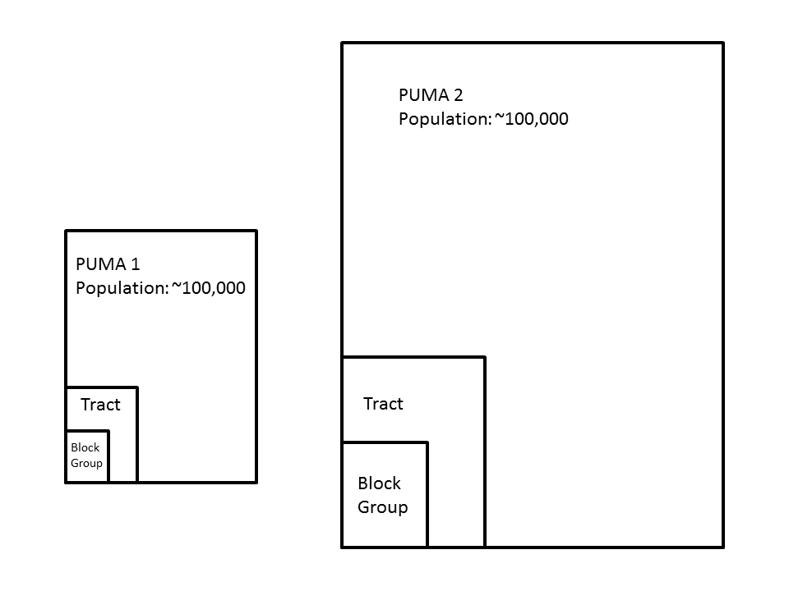
There have been some notable efforts to model demographic subpopulations. Simpson and Tranmer (2005) used Iterative Proprtional Fitting (IPF) as did Wong (1992). Johnston (1993) provides a useful examination of past efforts to use IPF and Entropy Maximizing procedures in geography. The IPF procedure has also been used in the transportation planning community by others such as Beckman et al (1996), as part of the TRANSIMS model.

Recently, Nagle et al (2013) introduced a penalized maximum entropy approach (P-MEDM) that incorporates the ACS error estimates provided by the Census Bureau. This approach is similar to IPF but with uncertainties in the input data incorporated. This approach proportionally distributes microdata samples to sub zones using summary files, which means the households distributed to the sub zones are replicas of the microdata households and do not represent any other potential household types. If a relationship between variables doe s not exist in the microdata, it will not be present in the model estimates. This is not an issue for many applications of modeled estimates because these data are often used to create summaries at small geographies, such as block group estimates of the number of unmarried female heads of household with an income of less than $25,000, which are not released by the Census (Nagle et al, 2013; Leyk et al, 2013).

Another recent method by Kao et al (2012) uses statistical copulas to model high resolution demographic data. Copulas allow for household types with different compositions than those found in the microdata. This property is desirable in certain applications such as transportation modeling. For example a copula might allow for the occasional 8 or 10 person household without the presence of such a household in the microdata sample.

Current Study
Motivation

The two methods are well positioned to advance the next generation of high resolution population datasets. However, previously these models had only been applied to small, non-overlapping areas and no explicit comparison has been conducted. A full comparison of their differences and similarities as well as their strengths and weaknesses is a necessary first step toward the expansion of these methods to a national level product, which is a resource intensive investment. In order to compare these models, a common set of attributes needed to be implemented as did a common study area. Both of these methods are flexible in that they can be used to model different selections of demographic attributes, and are therefore conducive to comparison. This by comparing the two models over a common geographic study area where data differences can be eliminated and a more direct comparison carried out. The results of this research are expected to be of high value to geographers interested in scaling one or more of these models to a national dataset.

Approach

In order to compare these models, common variables and a representative common geography were identified and applied. This process represents the necessary aligning of models while extending the study areas to which these techniques have been applied
.
Site Selection:
The location of the study is Jefferson County, Kentucky. This county encapsulates Louisville. There are 5 Public Use Micro Areas (PUMAs) within the county. This county offers a mix of landscapes with primarily urban PUMAs, as well as PUMAs with a mix of urban and rural. This allowed for the evaluation of the models with different types of geographic boundariesPreliminary research shown in Figure 2 identifies variability in the structure of household income, which is one of the chosen variables to be modeled, among the PUMAs in Jefferson County, Kentucky. The colors in these charts represent income categories by tract within each PUMA. The categories are ordered with the low income classes at the bottom of each chart and the high income classes at the top. PUMA 1701 has a much greater proportion of the population in the lower income classes than the rest of the PUMAs. This indicates that Jefferson County is a site capable of offering the spatial variability necessary to vigorously test robustness of the models.

Figure 2. Tract level income category proportions. Bottom to top is low to high.
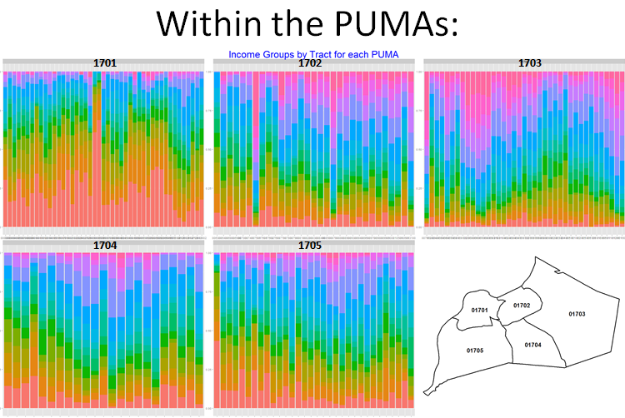

Data Collection
Both models will use Census ACS PUMS microdata samples and ACS five year summary files. The microdata for the 5 year interval represent a 5% sample which is much more desirable than the single year, 1% microdata samples because of the increased sample size and spatial resolution of input tables. The ACS five year summary tables are used to align with the temporal period represented by the microdata. The 2005 – 2009 data were used in by Nagle et al (2013). This study will follow this because of geographic boundary alignment issues between Public Use Microdata Area (PUMA) boundaries from the 2000 vintage and the block group and tract boundaries, especially those from the 2010 census. Figure 3 illustrates this problem. PUMA boundaries are shown in black and tract boundaries are shown in blue. Two tracts are present in both PUMA 01701 and 01705. This misalignment is a problem created by the process of PUMA boundary creation which, prior to 2010, did not require the nesting of other Census geographies. This “boundary incongruity” (Voss et al, 1999) and methods for handling these issues are discussed by Zanbergen and Ignizio (2010). This issue affects all releases of ACS data; however, the upcoming 2012 release will not have this issue thus eliminating a significant barrier to model expansion in the near future. Because this thesis is primarily focused on comparison, additional data challenges such as boundary incongruity will be avoided, allowing the results to be interpreted in a more straightforward manner.

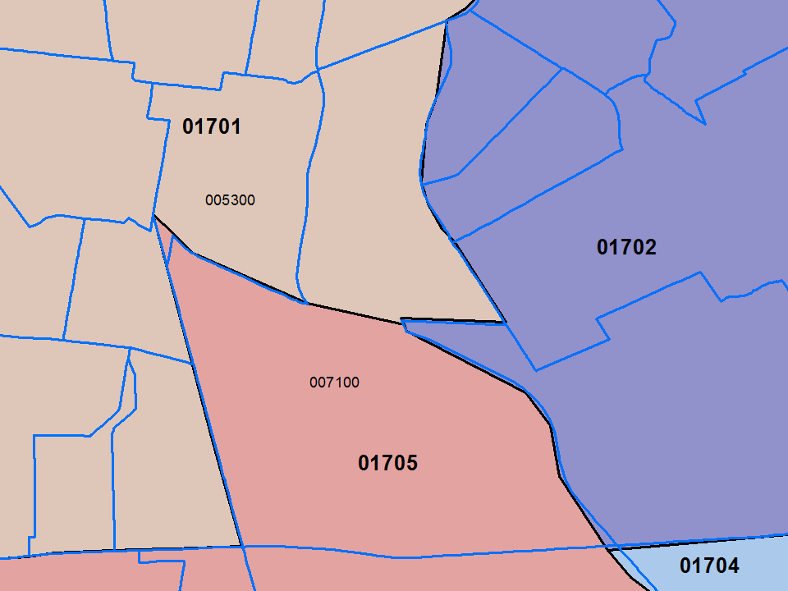
Figure 3.Tracts 007100 and 005300 overlap both PUMA 01701 and 01705.

The demographic variables I will consider are: total household income, household size, number of vehicles, highest educational attainment, and household total travel time to work. The ACS summary files used to fit these locally will also follow those used in the copula model, namely the household size and household income variables (Kao et al, 2012). Levels of constraint may need to be adjusted and compared; in this case summary variables for number of workers in the household or number of vehicles can be used.

Results

I’m sure this will be awesomeness.

More awesomeness.

References

Beckman, R. J., Baggerly, K. A., & McKay, M. D. (1996). Creating synthetic baseline populations. Transportation Research Part A: Policy and Practice, 30(6), 415-429. doi: http://dx.doi.org/10.1016/0965-8564(96)00004-3
Bhaduri, B., Bright, E., Coleman, P., Urban, M. “LandScan USA: A High Resolution Geospatial and Temporal Modeling Approach for Population Distribution and Dynamics” GeoJournal. 2007. 69: 103-117.
Dobson, J. E., E. A. Bright, P. R. Coleman, R. C. Durfee, B. A. Worley. 2000. “A Global Population database for Estimating Populations at Risk”, Photogrammetric Engineering & Remote Sensing Vol. 66, No. 7, July, 2000.
Gaughan, A. E., Stevens, F. R., Linard, C., Jia, P., & Tatem, A. J. (2013). High resolution population distribution maps for Southeast Asia in 2010 and 2015. [Research Support, N.I.H., Extramural Research Support, Non-U.S. Gov't Research Support, U.S. Gov't, Non-P.H.S.]. PLoS ONE, 8(2), e55882. doi: 10.1371/journal.pone.0055882
Johnston, R. J. (1993). Entropy- maximizing and the iterative proportional fitting procedure. Professional Geographer, 45(3), 317.
Jochem, W., Sims, K., Bright, E., Urban, M., Rose, A., Coleman, P., & Bhaduri, B. (2013). Estimating traveler populations at airport and cruise terminals for population distribution and dynamics. Natural Hazards, 68(3), 1325-1342. doi: 10.1007/s11069-012-0441-9
Kao, S.-C., Kim, H. K., Liu, C., Cui, X., & Bhaduri, B. L. (2012). Dependence-Preserving Approach to Synthesizing Household Characteristics. Transportation Research Record: Journal of the Transportation Research Board, 2302(-1), 192-200. doi: 10.3141/2302-21

Leyk, S., Buttenfield, B. P., & Nagle, N. N. (2013). Modeling Ambiguity in Census Microdata Allocations to Improve Demographic Small Area Estimates. Transactions in GIS, 17(3), 406-425. doi: 10.1111/j.1467-9671.2012.01366.x
Linard, C., Gilbert, M., Snow, R. W., Noor, A. M., & Tatem, A. J. (2012). Population Distribution, Settlement Patterns and Accessibility across Africa in 2010. PLoS ONE, 7(2), e31743. doi: 10.1371/journal.pone.0031743
Mennis, J., & Hultgren, T. (2006). Intelligent Dasymetric Mapping and Its Application to Areal Interpolation. Cartography and Geographic Information Science, 33(3), 179-194. doi: 10.1559/152304006779077309
Nagle, N. N., Buttenfield, B. P., Leyk, S., & Spielman, S. (2013). Dasymetric modeling and uncertainty. Annals of the Association of American Geographers(ahead-of-print).
Panagiotelis, A., et al. (2011). Pair Copula Constructions for Discrete Data.
Ruther, M., Maclaurin, G., Leyk, S., Buttenfield, B., & Nagle, N. (2013). DEMOGRAPHIC RESEARCH VOLUME 29, ARTICLE 22, PAGES 579-616 PUBLISHED 26 SEPTEMBER 2013.
Simpson, L., & Tranmer, M. (2005). Combining Sample and Census Data in Small Area Estimates: Iterative Proportional Fitting with Standard Software*. The Professional Geographer, 57(2), 222-234. doi: 10.1111/j.0033-0124.2005.00474.x
Wong, D.W.S. 1992. The Reliability of Using Iterative Proportional Fitting Procedures. The Professional Geographer, 44: 340-348.
U.S. Census Bureau.2006. Design and Methodology American Community Survey U.S. Government Printing Oﬃce, Washington, DC. Accessed 14 November 2013. https://www.census.gov/history/pdf/ACSHistory.pdf
Census puma 2000.
U.S. Census Bureau, 2002. Technical Documentation: Census 2000 Summary File 3. Accessed on 14 November, 2013. http://www.census.gov/prod/cen2000/doc/sf3.pdf
Zandbergen, P. A., & Ignizio, D. A. (2010). Comparison of Dasymetric Mapping Techniques for Small-Area Population Estimates. Cartography and Geographic Information Science, 37(3), 199-214. doi: 10.1559/152304010792194985
Voss, P.R., D.D. Long, and R.B. Hammer. 1999. When census geography doesn’t work: Using ancillary information to improve the spatial interpolation of demographic data. Center for Demography and Ecology, University of Wisconsin – Madison, Working Paper No. 99-26.

CONCLUSION

This whole grad school thing was fun, and I’m glad it is over now.

VITA

John X. Doe was born. He wrote a thesis. He graduated. This page really is required, but was completed in a later draft.

