Disruptions of the Supratemporal Canal in the Snubnose Darter (Etheostoma
simoterum)

A Thesis Presented for the
Master of Science
Degree
The University of Tennessee, Knoxville

Chauntelle Bryauna Williams
May 2017

Copyright © 2016 by Chauntelle Williams
All rights reserved.

Acknowledgements
I wish to give thanks to both family and friends for giving me encouragement as I worked through my thesis. Thank you for letting me get excited about the most random facts about wildlife and fisheries that I discovered every day and giving me motivation at times that I had greatly needed it. I want to give a special thank you to Travis Hargis. You were there when I needed you most on those long nights of working on research and trying to make since of raw data.
My utmost gratitude goes to my advisor Dr. Brian Alford with his knowledge and support through this project. It has been an honor to see how practices are applied to the field when I came from a background of proposed methods in conservation and management in the Ecology and Evolutionary Biology undergraduate program. I am honored to be one the first of many graduate students that you will mold for the future of our wonderful field.
I would like to give thanks to the people at TVA that tracked all over the state and collected specimens from different bodies of water so that I could perform my project. I would also like to extended my gratitude towards Dr. Etnier for his expertise with the biology of fish that he graciously offered to me for my research, and his contributions towards the field of Ichthyology.
I provided great thanks to both of my committee members Dr. Deborah Miller and Dr. Benjamin Keck. I appreciate the knowledge I have gained from both of you in the fields of ecology and pathology. The new knowledge has increased by spectrum of what questions I should be asking when something occurs abnormally within an ecosystem.

Abstract

It has been hypothesized that environmental degradation, specifically from chemical pollution, may cause darters of the subgenus Ulocentra (Family Percidae) to develop interrupted supratemporal canals (part of the cephalic sensory system) as individuals mature. Preserved museum specimens of Etheostoma simoterum exhibit uninterrupted and interrupted supratemporal canals. The objectives of my study were to observe the Etheostoma simoterum and their supratemporal canal, document if the supratemporal canals are interrupted or uninterrupted, and to determine whether frequency of canal interruptions s vary based on geographical location and source of aquatic impairment.
The specimens (N ~720) were collected by the Tennessee Valley Authority and the UTIA Fisheries Research Lab across the state of Tennessee and from Virginia and Alabama. The specimens were examined by light microscopy while a jet of air was blown over them to aid in visualizing the canal and associated sensory pores.
During the study, it was discovered that there were interruptions that were occurring in several sample sites. Along with these interruptions, it was discovered that there was a pore that disappeared in some of the canals that were complete. Through statistical analysis it was determined that there was no correlation between the locations of the sample sites and the ratio of interruptions and non-interruptions, and no correlation between the locations of the sample sites and the ratio of non-interruptions with no pores and non-interruptions with pores. Thus, frequency of the interrupted supratemporal canal condition in Snubnose Darters appears to be a random occurrence.

Table of Contents
Chapter 1: Introduction
Background 1
Chapter 2: Study Area 3
Chapter 3: Materials and Methods 7
Chapter 4: Results and Discussion
Results 10
Discussion 16
Chapter 5: Summary and Suggestions 20
Works Cited 26
Appendix 22
Vita 28

List of Tables

Table 1. Table of which sample sites were located in each state that was in study area.

List of Figures
Figure 1A. Ecoregion Map of Study Area. 5
Figure 1B. The major watersheds in the study area 6
Figure 2. Description of the Supratemporal Canal along with pores. 8
Figure 3. Frequencies of canal categories. 12
Figure 4. Box-and-whisker plots showing the distribution of interrupted:uninterrupted supratemporal canal ratio(bottom) and ratio of fish with no sensory pore to fish with uninterrupted canals (top) in Snubnose Darters collected throughout the species’ range in different HUC-6 watersheds delineated by the U.S.G.S. 16
Figure 5. Box-and-whisker plots showing the distribution of interrupted:uninterrupted supratemporal canal ratio(bottom) and ratio of fish with no sensory pore to fish with uninterrupted canals (top) in Snubnose Darters collected throughout the species’ range in different ecoregions. 17
Figure 6. Box-and-whisker plots showing the distribution of interrupted:uninterrupted supratemporal canal ratio(bottom) and ratio of fish with no sensory pore to fish with uninterrupted canals (top) in Snubnose Darters collected throughout the species’ range. Impairment sources are derived from state 303(d) impaired stream lists. 18
Figure 7. Simple linear regression trendline and R² showing the lack of association between river mile where fish were collected in its stream segment and interrupted condition of supratemporal sensory canals in Snubnose Darters collected across its range. 2

List of Tables

Table 1. Table of which sample sites were located in each state that was in study area. 7
Chapter 1
Introduction
Background
Tennessee has the most diverse community of freshwater fish in North America with at least 315 species, and of those species, about 280 are considered native only to Tennessee. The non-native species have been either introduced intentionally and non-intentionally (Tennessee Wildlife Resource Agency 2012). Tennessee owes this large aquatic fauna to the region’s geologic and hydrographic diversity. There are 29 families and 18 orders that are represented in Tennessee. The largest family that is represented in Tennessee is the Percidae with 93 species, and 90 of those species are darters (Etnier and Starnes 1993).
Etheostoma simoterum is characterized by small red dots in short rows on the upper side, a bright red spot on the front first dorsal fin, and a red border on their whole first dorsal fin. The species’ typical geographic range includes the upper Holston River system of east Tennessee and western Virginia, the McClure River and Russell Fork of western Virginia, and extreme southeastern Kentucky. Their preferable habitat is current–swept rocky pools and/or adjacent riffles of creeks and small rivers (Page and Burr 2011). The principal diet of this species includes crustaceans and immature aquatic insects (Page and Mayden 1981).
The spawning season is typically between April and early May for E. simoterum. Sexual maturity is reached at approximately one year. Males are larger and more colorful than the females. The sex ratio of females to males is estimated at 1.8:1. In addition, the longevity of the species is about 18 months (Page and Mayden1981).
The lateral-line sensory system in fishes develops from ectodermal thickenings which are known as dorso-lateral placodes. The lateral-line system remains superficial compared to the developed inner ear. The “pore-canal system” which consists of a network of mesh canals lying just below the surface of the dermis is considered a clue to the origin of the lateral-line system. The relationship of the lateral-lines to the pore-canal system was first recognized in the Osteostraci (Denison 1966). The lateral-line is defined as nerve endings along a row of pores on either side of the fish from gills to tail. These lines are used as a radar to detect shapes, size, direction and speed of objects (Tennessee Wildlife Resource Agency 2012).
Much about the E. simoterum is still not known. According to Page and Mayden (1981), all of the species in Ulocentra are poorly described ecologically. However, recent taxonomic advances have been made (see Harrington and Near 2012). Although taxonomic delineations among the “snubnose” darter complex has been improved, some characteristics have yet to be examined in E. simoterum. For example, the core of my research: the interruptions of the supratemporal canal in the E. simoterum. At the time of discovery of the species, the head canals were described as uninterrupted; whereas the lateral lines were described as incomplete or complete (Page 1977).
It has been hypothesized by Bauer et al. (1995) that environmental variability, specifically from pollution, may cause individuals of Etheostoma scotti (and other members of the subgenus Ulocentra) to develop interrupted supratemporal canals as a result of exposure to toxic chemicals in habitats where the fish spawn and develop from juveniles to adults. This is the basis for my research, to test this hypothesis regarding the possible environmental associations of the interrupted condition of the supratemporal canals in E. simoterum.

Chapter 2
Study Area
Many specimens were collected between the time periods of May-September 2014 by the Tennessee Valley Authority (TVA) as part of their ongoing biological monitoring program, and by the UTIA Fisheries Research Lab, using back-pack electroshocking and seine sampling gear. The collection sites varied much across Tennessee watersheds so that there was an array of natural physiographic and environmental quality conditions to include with the data set. In addition, some connected watersheds in the Virginia and Alabama areas were included to widen the range of the fishes’ native habitat.
These locations totaled into 26 survey sites. There were a total of four sites in Virginia, two sites in Alabama, and 20 sites in Tennessee. Some sites in Tennessee had more than one location that were examined. Each of the sites are listed in Table 1. Of these locations the watersheds that were included in the study area were the Holston, Clinche, Elk, Duck, Watts Bar, G’Ville, French Broad, Pickwick and the connection between the Wltl and Elk watersheds. Figure 1A.
Along with the watersheds, there were five different level III ecoregions throughout the three states. These ecoregions were the Blue Ridge, the Ridge and Valley, the Southwestern Appalachian, the Central Appalachians, and the Interior Plateau. An ecoregion describes areas of general similarity in ecosystems and the type, quality and quantity of the environmental resources (2016). Each region is different with what it holds within its boundaries and the species that benefit most from the area. Figure 1B.
The Blue Ridge is comprised of narrow ridges, massive mountains and hilly plateaus. It has forested slopes along with high-gradient, cool, clear streams. The Blue Ridge is one of the richest centers of biodiversity in the Eastern US. The Ridge and Valley is an ecoregion that is wedged between the high rugged mountains with greater forest cover. This ecoregion has a diversity of aquatic habitats and species of fish. The Southwestern Appalachians are comprised of low mountains that contain some forests and woodlands with some land for crops and pastures. The ecoregion on the east side in Tennessee has small eastern flowing streams. Central Appalachians are cool in climate and rugged in terrain which limit the lands to agricultural practices. The area has bituminous coal mines which has caused siltation and acidification of streams in the region. Lastly, the Interior Plateau consists of rock type lands and has a diverse fish population. The natural vegetation is primarily Oak (Quercus spp.) and Hickory (Carya spp.) forest (2000).

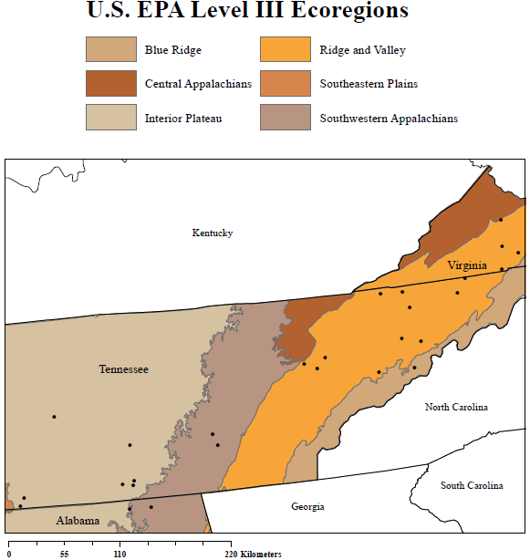

Figure 1A. Ecoregion Map of Study Area.

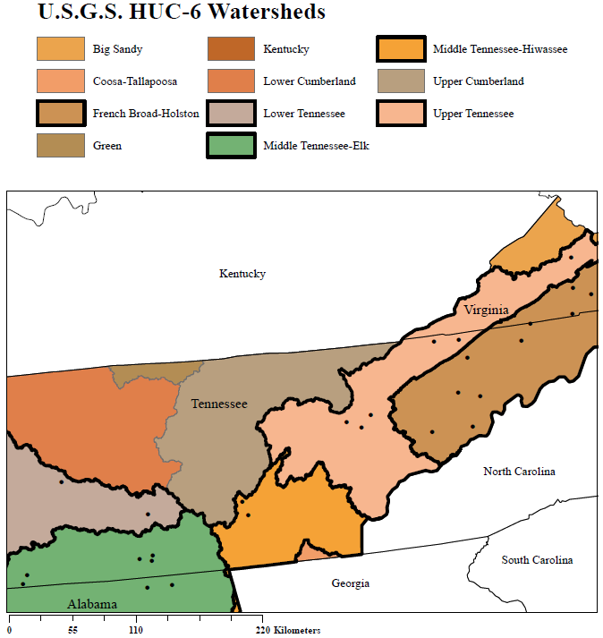Figure 1B. The major watersheds in the study area.

Table 1. Table of sample sites by state included in the in study area.
Virginia | ALAbama | Tennessee
N. Fork Holston River | Mountain Fork Creek | Sequatchie River
S. Fork Holston River | Hurricane Creek | Laney Creek
Swords Creek |  | Nolichucky River
Wolf Creek |  | Richard Creek
 |  | Factory Creek
 |  | Duck River
 |  | Holly Creek
 |  | Boozy Creek
 |  | Mulberry Creek
 |  | Poplar Creek
 |  | Leipers Creek
 |  | Bull Run Creek
 |  | Beaver Creek
 |  | Golf Fort Big Creek
 |  | Elk River
 |  | East Fork Little Pigeon
 |  | Kendrick Creek

Chapter 3
Materials and Methods
The specimens were fixed initially in 10% formalin and were stored in the Fisheries Research lab on the UTIA campus within McCord Hall. Prior to handling the specimens, they were rinsed and soaked in tap water for several days and then transferred into a 40-50% isopropanol solution for long-term preservation. To make sure they were preserved correctly, they remained in the solution for seven days before being handled. Each container was labeled with information that was collected by the surveyors at each site: the name of the water system, the date collected, the location/address of the site, the county and state of the collection, the collector’s name, the watershed, and the RM location within the watershed. After 7 days in the alcohol solution, the supratemporal canal of each fish was viewed under light microscopy supplemented with an external LED light. A gentle stream of air from a generator was blown across the surface of the fish to highlight the canal. As the air enters the pores of the canal, uninterrupted canals will inflate, whereas interrupted canals will not (Figure 2).
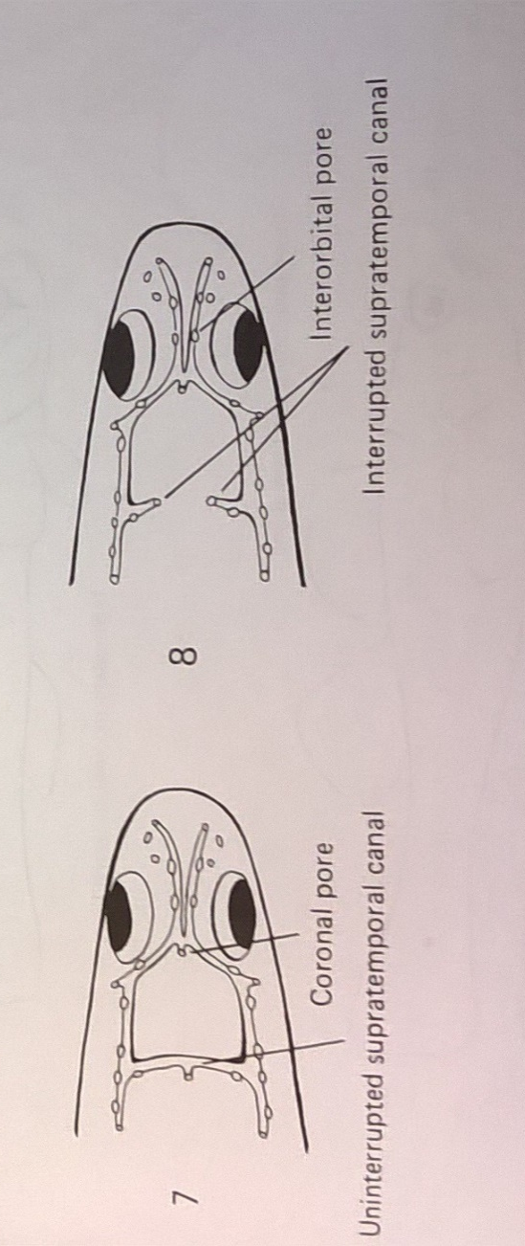
Figure 2. Description of the Supratemporal Canal along with pores.
Given that it is possible that the canal could collapse due to extensive handling within the field by the collectors (i.e., resulting in a false reading of interrupted), I also documented the position of the canal pores. Pores of uninterrupted canals should be in close proximity to one another, whereas pores from interrupted canals will be farther apart from one another. The distance of the pores will be used as conformation for canals that do not inflate.
To distinguish between the three categories that may be present (interrupted, uninterrupted, and unknown, which is when a 100% identification of it being interrupted and uninterrupted could not be named) a color system (red, green and white, respectively) was implemented by tying the corresponding color of thread to the tail of the fish. This was done to calculate the frequencies of each category from each tested location. If an abnormality (i.e. a canal with no pore or the canal not being a straight line) was noticed for the specimen under the microscope it was noted with an additional white sting attached to the tail.
Data were entered into a Microsoft® Excel spreadsheet. Data for each site included stream name, the county and state location, site latitude and longitude, U.S. Geological Survey HUC-6 watersheds, U.S. Environmental Protection Agency Level III ecoregions, source of impairment based on the states’ Clean Water Act 303(d) impaired stream lists, number of fish collected with interrupted supratemporal canals, number of fish with uninterrupted canals, number of fish categorized as unknown status, and number of fish with uninterrupted canals that had no sensory pores within the canal. The covariate river mile was included to test for trends in interrupted status as a result of natural stream position in the river continuum, whereby sites located at higher elevations in the watershed (e.g., headwaters) tend to have lower levels of -human-related pollution. Response variables were calculated to reflect the relative degree of interrupted supratemporal canal condition. An interrupted:uninterrupted ratio (I/U ratio) was calculated as the number of fish with interrupted canals divided by the number of fish with uninterrupted canals. A ratio describing the “no pore” condition was calculated as the number of fish that had no sensory pore divided by the number of fish with uninterrupted canals. The independent variables for univariate statistical analyses were HUC-6 watershed, Ecoregion, and Impairment. Each of these variables were considered treatments in a nonparametric, Kruskal-Wallis one-way ANOVA (α=0.05; in IBM SPSS software, version 24) to see if the distribution of interrupted or no sensory pore status differed statistically as a result of natural geographic limits to dispersal (e.g., watersheds), physiographic variation (e.g., ecoregion), or by anthropogenic influences (e.g., impairment). Finally, river mile of each site (number of miles upstream from confluence with larger main stream) was used as an independent predictor variable in a simple linear regression (α=0.05; in Excel) with each of the response variables.

Chapter 4

Results and Discussion

Each test site ranged widely in the frequency of the interrupted supratemporal canal condition. North Fork Holston River had 10 uninterrupted canals with the abnormality of three having no pore (Figure 2) and one unknown. Mulberry Creek had nine uninterrupted canals with no abnormalities and one unknown. Elk River located at Old Dam Ford had one interrupted canal, 11 uninterrupted canals with two having no pore and zero unknown. Elk River located below Dickey Bridge had two interrupted canals, seven uninterrupted with two having no pore pore, and zero unknown. Elk River located at Farris Creek Bridge had two interrupted canals, seven uninterrupted canals with one having no pore and one unknown. Duck River had one interrupted, six uninterrupted with four having no pore, and one unknown. Sequatchie River located at HWY 111 had 11 uninterrupted canals with six of them having no pore, and zero unknown. Sequatchie River located at a copper mill had one interrupted, 11 uninterrupted with four having no pore and one unknown. Swords Creek had one interrupted, 10 uninterrupted with four having no pore, and four unknowns. South Fork Holston River had two interrupted, nine uninterrupted with four having no pore, and one unknown. Wolf Creek had two interrupted canals, six uninterrupted canals with three having no pore and one unknown. Beaver Creek had one interrupted canal, four uninterrupted with no abnormalities and zero unknown. Poplar Creek had two interrupted canals, two uninterrupted canals with no abnormalities, and zero unknown. Little Pigeon had two interrupted canals, 10 uninterrupted canals with three having no pore, and two unknowns. Caney Creek had one interrupted canal, two uninterrupted canals with no abnormalities, and zero unknown. Nolichucky River located at Thomas Island zero interrupted, 11 uninterrupted with 7 having a pore and zero unknown. Nolichucky River located at Whittenburg Bridge had zero interrupted, two uninterrupted with one having no pore, and zero unknown. Kendrick Creek had zero interrupted, eight uninterrupted with three having no pore, and zero unknown. Gulf Fork Big Creek zero interrupted, 5 uninterrupted without any abnormalities, and zero unknown. Holly Creek had three interrupted canals, 20 uninterrupted canals with 12 having no pore, and one unknown. Bull Run Creek had one interrupted, eight uninterrupted with one having no pore, and one unknown. Leipers Creek had one interrupted, eight uninterrupted with three having no pore, and one unknown, Richardson Creek had zero interrupted, 10 uninterrupted with four having no pore, and zero unknown. Mountain Fork Creek had five interrupted canals, eight uninterrupted canals with three having no pore, and two unknowns. Hurricane Creek had one interrupted canal, and nine uninterrupted canals with four having no pore and one unknown. Factory Creek had one interrupted canal, 11 uninterrupted canals with six having no pore, and one unknown. Boozy Creek had zero interrupted canals, 12 uninterrupted canals with four having no pore, and zero unknown. (Figure 3 and Appendix A).

Figure 3. Frequencies of canal categories.

Humans impact our environment. The speed at which species (known and unknown) are decreasing and approaching extinction has outdated previous extinction events (Zakon 2014). Humans negatively impact aquatic species in ways that are often overlooked, such as acoustic noise (ergo ship sounds), visual noise (ergo pollution influencing water turbidity), thermal changes and chemical pollution. Some species are impacted more than others. For example, fish naturally redistribute based on water turbidity (Zakon 2014). If water becomes more turbid, then species that use sight to hunt will be impacted, while others that use lateral lines to detect prey may be less impacted.
The sensory canals of fish are very important to their perception of their environment. Klein and Bleckmann (2015) found that, through their lateral lines, fish perceive water motions and pressure gradients, and the information is used for prey detection, spatial orientation, avoiding predators, intraspecific communication and station holding within the streams. They also investigated the influence that pores have on the responses of the CN (canal neurromasts), and found that the change in the diameter of a pore can influence a certain canal region, and that a simple canal with small pores has a low sensitivity due to a large hydrodynamic resistance. Thus, an interrupted canal will result in interrupted functions, including spatial orientation given that the canal is located at the dorsal surface of their head and they live in non-steady streams.
Considering that sensory perception is very important to the functions of fish within their environment I investigated many aspects of the environments where Snubnose Darters occur, including river drainage, ecoregion, and types of impairment which included biological, chemical, sediment and no impairment. Each of these different factors can have a different impact on an individual, and it may be compounded when there is more than one factor impacting a system.
However, I found that there were no significant differences (Kruskal-Wallis test; P > 0.05 for all comparisons; see Figures 4-6) with regard to river drainage, ecoregion, or impairment source in the I:U ratio or the ratio of fish with no sensory pores to those with sensory pores. These results suggest that variation in the supratemporal canal connection in Snubnose Darters is random, or that there is not enough data to show a correlation. Thus, environmental quality and natural geomorphic and physiographic barriers do not appear to influence whether or not Snubnose Darters will develop uninterrupted (the most prevalent) or interrupted sensory canal systems.
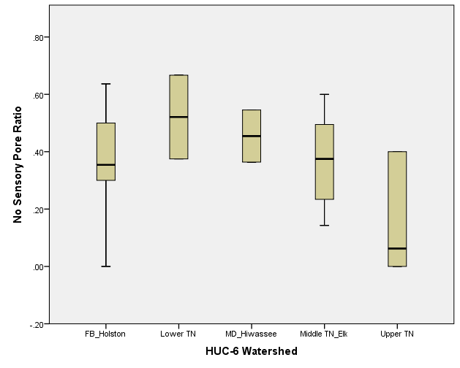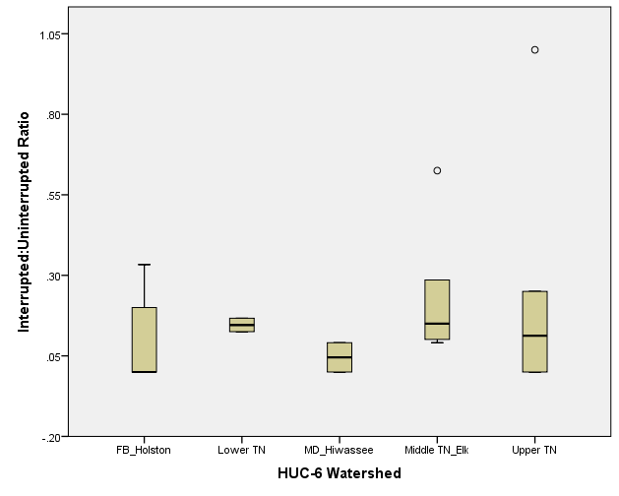

Figure 4. Box-and-whisker plots showing the distribution of interrupted:uninterrupted supratemporal canal ratio(bottom) and ratio of fish with no sensory pore to fish with uninterrupted canals (top) in Snubnose Darters collected throughout the species’ range in different HUC-6 watersheds delineated by the U.S.G.S.
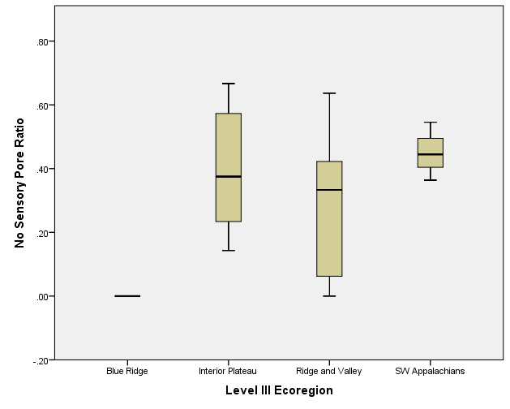
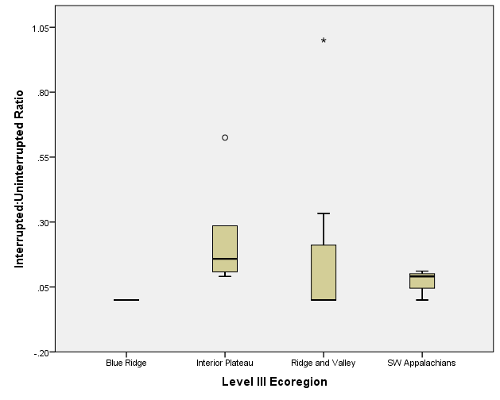
Figure 5. Box-and-whisker plots showing the distribution of interrupted:uninterrupted supratemporal canal ratio(bottom) and ratio of fish with no sensory pore to fish with uninterrupted canals (top) in Snubnose Darters collected throughout the species’ range in different ecoregions.
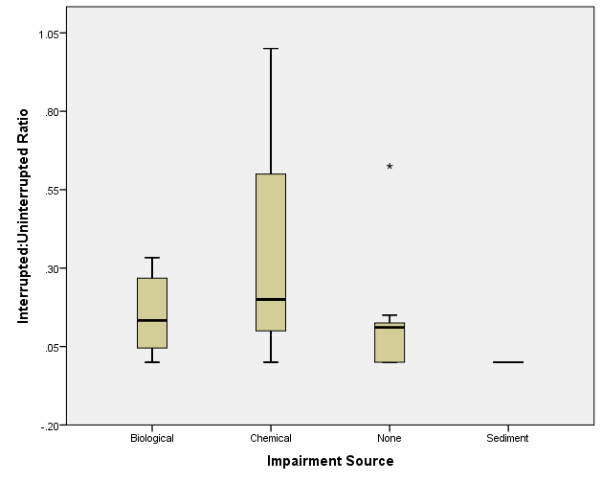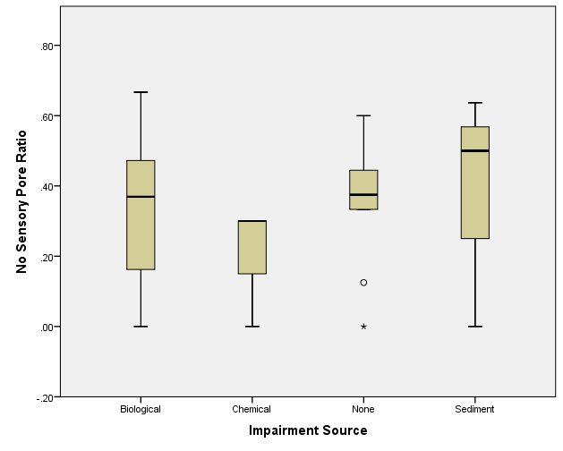
Figure 6. Box-and-whisker plots showing the distribution of interrupted:uninterrupted supratemporal canal ratio(bottom) and ratio of fish with no sensory pore to fish with uninterrupted canals (top) in Snubnose Darters collected throughout the species’ range. Impairment sources are derived from state 303(d) impaired stream lists.
Anthropogenic pollution of fresh water bodies can lead to a direct structural change in the local fish populations, which can manifest themselves in proportions of individuals highly adapted to the new conditions of the environment (Kotegov 2011). This response is observed by using comparative analysis ratios between the numbers of individuals with a morphological change and those with none in both clean and polluted waters. The percentage of interrupted canals in Snubnose Darters by site were very small, with the highest being 33% and the lowest being 0%. The simple linear regressions the ratios against river mile had very low precision (R² < 0.04) (Figure 7), indicating that there is no significant correlation between the prevalence of supratemporal canal interruption or lack of sensory pores and position in the watershed. Thus, it made no difference whether fish were collected from far upstream in that stream’s longitudinal continuum or if the fish were collected farther downstream, where there tends to be more land disturbance and pollutant inputs.
For any relationship between the interrupted canal condition and environmental pollution to be observed, this study would have to be extended to include more sample sites with greater variation in environmental quality. Experimental assays should also be conducted with appropriate controls (e.g., fish reared in tanks not exposed to chemicals) to determine a true cause and effect (e.g., dose response) between supratemporal canal development and chemical pollution.

Figure 7. Simple linear regression trendline and R² showing the lack of association between river mile where fish were collected in its stream segment and interrupted condition of supratemporal sensory canals in Snubnose Darters collected across its range.

Chapter 5

Conclusions and Recommendations
In conclusion, this study demonstrated that interruptions are occurring in the Etheostoma subgenra, contradictory to Page (1977). However, Page did state that advanced darters have interruptions like those depicted in Figure 2, thus it is possible that this condition is an evolutionary trend. Our data did not show any significant correlations between the environment and distributions in the supratemporal canals. Based on the data that was collected the interruptions and the loss of the pores did not correlate with the environmental factors we chose.
This study was a first step in understanding what may be happening to the supratemporal canals within the Etheostoma simoterum species. Literature research has shown that very little is mentioned about the supratemporal canal of this species especially in regards to how an interruption occurs. Is it a heritable trait, a mutation, or a structural changing during the developmental stage?
There are several recommendations for the future of this study. One is that the study needs to be extended into more study sites that have greater variations for the environment. Two is that at each site more water factors need to be tested including, temperature, pH level, chemical levels and the electro-conductivity. Three is extending the study into at least a five-year study rather than sampling for one year. Increasing the sample locations and time may help us to confirm our findings or elucidate patterns in condition occurrence related to environmental factors.
Additionally, a controlled laboratory investigation might be instituted. This would include a control group of darters that were hatched in a laboratory. These controls would be hatched in an environment which simulates the natural habitat of the specimens with normal conditions of the water system. The controls would be then compared to specimens that were hatched in various levels of contaminates. These contaminates will include sediment levels, biological contaminants like fecal coliforms, and chemical contaminants. The levels of each containment would be tested to see if there is a threshold that the specimens could be subjected to before an interruption would occur to the supratemporal canal.
Another experiment would be to test if the interruption is a heritable trait from the parents. Ideally one parent would have an interrupted canal and the other uninterrupted canal, and the offspring would be then tested if the for interruptions. Two trial runs would be run with the parents: one with the male with the interruption and the female with no interruption and the other would be the male with no interruption and the female with the interruption. These two tests are important in the aspect of heritability to see if the interruption could be linked to the females or males.
However, there has been no test that allows us to observe the interruptions in live fish. That has been something that has been hypothesized but has not been tested yet. I recommend that an experiment should be conducted where live fish are collected and subjected to the same testing in the lab to see if the canal can be observed in live specimens as they mature compared to preserved ones.
Much has been discovered with this study and much more knowledge is still not yet obtained. New doors have been opened with this study and many directions can be taken with the data that was collected. Only with more studies will we ever have a better understand of these supratemporal canals and what is happening to them within the E. simoterum.
APPENDIX A
Independent and response variables used for analyses
Stream | HUC-6 WS | Ecoregion | Impairment | River Mile
Duck River | Lower TN | Interior Plateau | Biological | 240
Elk River | Middle TN_Elk | Interior Plateau | Biological | 119.1
Elk River | Middle TN_Elk | Interior Plateau | Biological | n/a
Elk River | Middle TN_Elk | Interior Plateau | Biological | 124.3
S. Fork Holston River | FB_Holston | Ridge and Valley | Biological | 93.07
Wolf Creek | FB_Holston | Ridge and Valley | Biological | 0.7
Kendrick Creek | FB_Holston | Ridge and Valley | Biological | 1.2
Mulberry Creek | Upper TN | Ridge and Valley | Biological | 1
Swords Creek | Upper TN | Ridge and Valley | Biological | 1.3
Beaver Creek | Upper TN | Ridge and Valley | Biological | 5.46
Sequatchie River | MD_Hiwassee | SW Appalachians | Biological | 48.7
Sequatchie River | MD_Hiwassee | SW Appalachians | Biological | 85.5
N. Fork Holston River | FB_Holston | Ridge and Valley | Chemical | 62.5
East Fork Little Pigeon | FB_Holston | Ridge and Valley | Chemical | n/a
Poplar Creek | Upper TN | Ridge and Valley | Chemical | 18
Gulf Fork Big Creek | FB_Holston | Blue Ridge | None | 1.15
Leipers Creek | Lower TN | Interior Plateau | None | n/a
Mountain Fork Creek | Middle TN_Elk | Interior Plateau | None | 18
Holly Creek | Middle TN_Elk | Interior Plateau | None | 0.5
Factory Creek | Middle TN_Elk | Interior Plateau | None | 1.2
Boozy Creek | FB_Holston | Ridge and Valley | None | 1.9
Bull Run Creek | Upper TN | Ridge and Valley | None | 7.2
Richardson Creek | Upper TN | Ridge and Valley | None | 0.5
Hurricane Creek | Middle TN_Elk | SW Appalachians | None | 2.7
Nolichucky River | FB_Holston | Ridge and Valley | Sediment | n/a
Nolichucky River | FB_Holston | Ridge and Valley | Sediment | 8.5
Caney Creek | FB_Holston | Ridge and Valley | Sediment | 3

APPENDIX A (continued)
Stream | # Inter | # Unint | # Unknown | #UI no pore | I:U ratio | No pore ratio
Duck River | 1 | 6 | 1 | 4 | 0.167 | 0.667
Elk River | 1 | 11 | 0 | 2 | 0.091 | 0.182
Elk River | 2 | 7 | 0 | 2 | 0.286 | 0.286
Elk River | 2 | 7 | 1 | 1 | 0.286 | 0.143
S. Fork Holston River | 2 | 9 | 1 | 4 | 0.222 | 0.444
Wolf Creek | 2 | 6 | 1 | 3 | 0.333 | 0.500
Kendrick Creek | 0 | 8 | 0 | 3 | 0.000 | 0.375
Mulberry Creek | 0 | 9 | 1 | 0 | 0.000 | 0.000
Swords Creek | 1 | 10 | 4 | 4 | 0.100 | 0.400
Beaver Creek | 1 | 4 | 0 | 0 | 0.250 | 0.000
Sequatchie River | 0 | 11 | 0 | 6 | 0.000 | 0.545
Sequatchie River | 1 | 11 | 1 | 4 | 0.091 | 0.364
N. Fork Holston River | 0 | 10 | 1 | 3 | 0.000 | 0.300
East Fork Little Pigeon | 2 | 10 | 2 | 3 | 0.200 | 0.300
Poplar Creek | 2 | 2 | 1 | 0 | 1.000 | 0.000
Gulf Fork Big Creek | 0 | 5 | 0 | 0 | 0.000 | 0.000
Leipers Creek | 1 | 8 | 1 | 3 | 0.125 | 0.375
Mountain Fork Creek | 5 | 8 | 2 | 3 | 0.625 | 0.375
Holly Creek | 3 | 20 | 1 | 12 | 0.150 | 0.600
Factory Creek | 1 | 11 | 1 | 6 | 0.091 | 0.545
Boozy Creek | 0 | 12 | 0 | 4 | 0.000 | 0.333
Bull Run Creek | 1 | 8 | 1 | 1 | 0.125 | 0.125
Richardson Creek | 0 | 10 | 0 | 4 | 0.000 | 0.400
Hurricane Creek | 1 | 9 | 1 | 4 | 0.111 | 0.444
Nolichucky River | 0 | 2 | 0 | 1 | 0.000 | 0.500
Nolichucky River | 0 | 11 | 0 | 7 | 0.000 | 0.636
Caney Creek | 0 | 2 | 0 | 0 | 0.000 | 0.000

APPENDIX A (continued)
Stream | In_uni | in/umi_rm | np/ui_rm
Duck River | 0.167 | 0.001 | 0.003
Elk River | 0.091 | 0.001 | 0.002
Elk River | 0.286 | n/a | n/a
Elk River | 0.286 | 0.002 | 0.001
S. Fork Holston River | 0.222 | 0.002 | 0.005
Wolf Creek | 0.333 | 0.476 | 0.714
Kendrick Creek | 0.000 | 0.000 | 0.313
Mulberry Creek | 0.000 | 0.000 | 0.000
Swords Creek | 0.100 | 0.077 | 0.308
Beaver Creek | 0.250 | 0.046 | 0.000
Sequatchie River | 0.000 | 0.000 | 0.011
Sequatchie River | 0.091 | 0.001 | 0.004
N. Fork Holston River | 0.000 | 0.000 | 0.005
East Fork Little Pigeon | 0.200 | n/a | n/a
Poplar Creek | 1.000 | 0.056 | 0.000
Gulf Fork Big Creek | 0.000 | 0.000 | 0.000
Leipers Creek | 0.125 | n/a | n/a
Mountain Fork Creek | 0.625 | 0.035 | 0.021
Holly Creek | 0.150 | 0.300 | 1.200
Factory Creek | 0.091 | 0.076 | 0.455
Boozy Creek | 0.000 | 0.000 | 0.175
Bull Run Creek | 0.125 | 0.017 | 0.017
Richardson Creek | 0.000 | 0.000 | 0.800
Hurricane Creek | 0.111 | 0.041 | 0.165
Nolichucky River | 0.000 | n/a | n/a
Nolichucky River | 0.000 | 0.000 | 0.075
Caney Creek | 0.000 | 0.000 | 0.000

Figure of the lengths of each fish that was tested. 1 is interrupted, 2 is uninterrupted, 3 is unknown, and 4 is uninterrupted having no pore present. Vertical axis is the length of the specimen in cm.
References

Bauer, BH, DA Etnier, and NM Burkhead. 1995. Etheostoma (Ulocentra) scotti (Osteichthyes: Percidae), a new darter from the Etowah River system in Georgia. Bulletin of the Alabama Museum of Natural History 17:1-16.
Denison, RH 1966. The Origin of the Lateral-Line Sensory System. Am. Zoologist 6:369-370.
Etnier, DA and WC Starnes. 1993. The Fishes of Tennessee. The University of Tennessee Press/ Knoxville.
Harrington, RC and TJ Near. 2012. Phylogenetic and coalescent strategies of species delimitation in snubnose darters (Percidae: Etheostoma). Systematic Biology 61:63-79.
Kotegov, BG. 2011. Trends of Interpopulation Variation in Meristic Characters of Seismosensory Canals on the Head of Roach, Rutilus rutilus (L.), in Anthropogenically Polluted Environments. Russian Journal of Ecology. 43:169-173.
Leve III Ecoregions of EPA Region 10. 2016. https://catalog.data.gov/dataset/level-iii-ecoregions-of-epa-region-10
Level III Ecoregions of Tennessee. 2000. https://hort.purdue.edu/newcrop/cropmap/tennessee/
maps/TNeco3.html
Page, LM. and Mayden, RL. 1981. The Life History of the Tennessee Snubnose Darter,
Etheostoma simoterum in Brush Creek, Tennessee. Biological Notes No. 117.
Page, LM. 1977. The lateralis system of darters (Ethostomatini). Copeia.3:472-475.

Page, LM and Burr, BM. 2011. Peterson Field Guide to Freshwater Fishes of North America
North of Mexico, Second Edition:552.
Tennessee Wildlife Resource Agency. 2012. The Angler’s Guide to Tennessee Fish Including
Aquatic Nuisance Species.
Zakon, HH. 2014. Human impact on fish sensory systems in the long term: An evolutionary
perspective. Integrative Zoology.

Vita
Chauntelle Williams is a lifelong student of nature and the outdoors. She has worked with many species from the common pets to exotic reptiles. She has spent most of her free time learning new things about our environment and hiking in the Great Smokey Mountains. She resides in East Tennessee with her parents and brother.

