To the Graduate Council:

I am submitting herewith a dissertation written by Sunshine L. Brosi entitled “Steps Toward Butternut (Juglans cinerea L.) Restoration”. I have examined the final electronic copy of this dissertation for form and content and recommend that it be accepted in partial fulfillment of the requirements for the degree of Doctor of Philosophy, with a major in Natural Resources.

Scott E. Schlarbaum

Major Professor

We have read this dissertation and recommend its acceptance:

Frank T. van Manen

David S. Buckley

Nathan J. Sanders

Accepted for the Council:

Carolyn R. Hodges

Vice Provost and
Dean of the Graduate School

(Original signatures are on file with official student records.)

Steps Toward
Butternut (Juglans cinerea L.) Restoration

A Dissertation Presented for
The Doctor of Philosophy
Degree
The University of Tennessee, Knoxville

Sunshine L. Brosi
May 2010

Copyright © 2010 Sunshine Liberty Brosi
All rights reserved.
DEDICATION

I dedicate my dissertation to Summer Ela Shaper, my daughter, my heart, and my inspiration to preserve species for the future. Summer, this dissertation was written for you and includes so much of you. You stood in the rain with your umbrella, avoided the copperheads, drew pictures while I collected data, and read to me as I typed. This journey has been your entire life and was only possible with you on my back, in the truck, walking along side in the woods, and always on my mind. May you live life knowing that you are as strong as the mightiest trees in the forest.
ACKNOWLEDGMENTS

E. Lucy Braun was on my mind throughout this journey, imagining her in the same woods with her model T many decades before, inspired me tremendously. My sincerest gratitude goes to Dr. Scott E. Schlarbaum, for serving as my major professor and mentor for many years. This dissertation would not have been possible without his support, guidance, friendship, patience and kindness. I thank him for seeing my potential and pushing me to meet goals. I also thank the other members of my committee, Dr. Frank van Manen, Dr. David Buckley, and Dr. Nathan Sanders. I am greatly indebted to Dr. Arnold Saxton for his support with statistical analysis. The University of Tennessee Tree Improvement Program (UT-TIP) personnel have been invaluable in their assistance, especially support from David Griffin. I would like to thank the late Gene Johnston for giving perspective, purpose, and being an invaluable mentor in my life; his advice will stay with me forever. Thanks to Allison Mains, Tracy Binder, Allison Houser, Shinara Taylor, Laura Beth Jones, Laura Thompson, and Wes Tilley. I express my appreciation to my fellow past and present graduate students in Annex B for friendship and support, especially Dr. Stacy Clark, Belinda Esham, and Ami Sharp.
I would like to thank Dr. Sandra Anagnostakis and Dr. Jeanne Romero-Severson for advice and support. My appreciation is given to several current and retired employees of the USDA Forest Service. Edwin Manchester has been a teacher, an inspiration and a friend. Dr. Robert L. Anderson taught me a great deal about butternut and answered many questions along the way. I would also like to thank the following for their valuable assistance with technical advice and field work: Paula Spaine, Carol Young, John Knighten, Dr. Paul Kormanik, Tim Dalton, Ted Oprean, Dave Casey, Jessica Beir, Jeff Lewis, John Brooks, Bill Jones, Robyn Taylor, and Clay Logan. Thanks to Tom Tibbs for inadvertently introducing me to the Tree Improvement Program. I would also like to thank the land managers at planting sites including John Perry, Scott Friedhoff, George Bullard, Bobby McCormick, Stephen Beason, Jonathan Wild, Ron Myers, David Cozzo, John Brittan, Brice Leech, and Mark DePoy.
Funds for this project have been secured from grants through the USDA Forest Service State and Private Forestry, The National Park Service, and The Revitalization of Traditional Cherokee Artisan Resources a subsidiary of the Cherokee Preservation Foundation. Cooperators for this project include: U.S. Geological Survey (Southern Appalachian Field Laboratory), USDA Forest Service (Southern Region, Forest Health Protection and Genetic Resources Program, Daniel Boone, Jefferson, Pisgah, Nantahala and Cherokee National Forests, Bent Creek Experiment Forest), National Park Service (Mammoth Cave National Park), CT Agricultural Experiment Station, The Nature Conservancy (Kentucky Chapter), Healing Stones Foundation, TN Division of Forestry, US Army Corps of Engineers (Nashville District), NC Division of Forest Resources, NC Department of Environmental and Natural Resources, CT Department of Environmental Protection, KY Department of Fish and Wildlife Resources, TN Department of Environment and Conservation and Notre Dame University.
Thanks to Dr. William C. Davis, my first forestry professor, and the 4-H Forestry Camp in Jabez, KY for inspiring my love of being in the woods. I would like to thank the support of my entire extended family, for field assistance, childcare, and advice. Thanks for being such a large part of my life’s journey and helping me reach many of my goals. I would especially like to thank Brook Brosi, Dr. Berry Brosi, Blossom Brosi, Sky Marietta, Glade Brosi, Eagle Brosi and my parents George and Connie Brosi. My sincerest thanks go to Steven Shaper, for financial and emotional support along my college career and for help with fieldwork. Thanks to my friends, for babysitting, being tough, teaching, rousing, and studying with me for comprehensive exams, for proofreading drafts, and for my absence at so many social events. I thank Annie’s Natural Foods for healthy options on those long research days.
Special thanks to people who have shared many aspects of this professional and personal journey including old and new chapters from my transition from forester to naturalist. This dissertation would not have been written without the persistent encouragement and support of my husband and fellow scholar, Daniel J. Feller. I look forward to many more years of research collaboration with him by my side. My greatest thanks are also given to my stepson, Caeman Feller, for letting me hog the computer and for cooking so many great lunches on snow days. I wish him success in school and beyond.
ABSTRACT

Butternut (Juglans cinerea L.), a lesser-known relative of black walnut (Juglans nigra L.), is a native tree species beneficial for wildlife, valuable for timber, and part of the great diversity of species in the eastern forests of North America, is another . Populations of butternut are being devastated by butternut canker disease, caused by the fungus Sirococcus clavigignenti-juglandacearum (V.M.G. Nair, Kostichka, & Kuntz), which is thought to be introduced to North America. The disease causes multiple branch and stem cankers that eventually girdle trees. Lack of sprouting and shade intolerance exacerbates the disease and results in permanent losses of butternut across the native range. Fortunately, healthy, canker-free butternut trees have been found proximal to diseased trees, indicating that a breeding approach could be a feasible strategy for producing and reintroducing resistant butternuts. A successful restoration program will require an understanding of genetic variation in open-pollinated seedlings, disease resistance, seedling establishment procedures, site requirements, a greater understanding of disease development over time and levels at various populations.
This dissertation is divided into six parts, with the overall goal of insight into butternut ecology and management techniques which could be used to guide restoration decisions for this important species. The first two parts are an introduction and a literature review. In the third section, butternut seedlings were propagated in nursery progeny plantings to determine the genetic and phenotypic variability among one-year-old seedlings in a controlled environment. Part four outlines the disease development of butternut seedlings across progeny in resistance screening plantings at various locations. Part five aims at aiding restoration techniques by determining the impact of phenotypic and genetic variables on establishment success across various planting sites. Part six describes the dynamics of large populations of healthy and diseased butternut trees including comparisons of tree conditions and health. The information gained from this research will be directly used in gene conservation strategies, the construction of disease resistant breeding orchards, determining appropriate restoration techniques, and prioritizing populations at greatest threats to losses.
TABLE OF CONTENTS

Chapter Page

PART I. INTRODUCTION, GOALS, AND OBJECTIVES 1
Introduction 2
Objectives 8
Literature Cited 9
PART II. LITERATURE REVIEW 19
Butternut 20
Species description 20
Taxonomy 20
Natural range and abundance 22
Historical distribution and abundance of butternut 22
Ecological significance 24
Anthropogenic uses 25
Regeneration of butternut 26
Riparian site butternuts 27
Dry site butternuts 28
Successional role of butternut 29
Challenges to Butternut 30
Loss of species identity through hybridization 30
Historical progression of butternut canker disease 32
Sirococcus biology 34
Pathogen transmission and spread 35
Plant hosts 36
Butternut Population Impacts 37
Butternut canker disease resistance 39
Additional challenges to butternut presence 41
Butternut Conservation 43
Conservation status 44
Genetic diversity 44
Literature Cited 48
Tables and Figures 70
PART III. SEEDLING DIFFERENCES IN BUTTERNUT FAMILIES FROM SOUTHERN APPALACHIAN PROVENANCES 73
Introduction 75
Methods 79
Seed collection and handling 79
Nursery protocols 81
Seedling characteristics 81
Statistical analyses 82
Results 84
Annual effects 84
Species effects 84
Provenance and family effects 85
Phenotypic and genetic correlations 87
Germination 88
Heritabilities 89
Discussion 90
Annual seedling production 90
Species variation 90
Provenance and family impacts 91
Correlations 92
Germination concerns 92
Heritability estimates 94
Conclusions 95
Practical applications 95
Biological findings 95
Literature Cited 96
Appendix: Tables and Figures 104
PART IV. SURVIVAL, GROWTH, AND DISEASE OF BUTTERNUT PROGENY IN RESISTANCE SCREENING PLANTINGS 144
Abstract Error! Bookmark not defined.
Introduction Error! Bookmark not defined.
Methods Error! Bookmark not defined.
Evaluation of plantings Error! Bookmark not defined.
Statistical analyses Error! Bookmark not defined.
Results Error! Bookmark not defined.
Plantation survival Error! Bookmark not defined.
Overall disease development Error! Bookmark not defined.
Species effects Error! Bookmark not defined.
Site effects Error! Bookmark not defined.
Provenance and family effects Error! Bookmark not defined.
Initial planting size effects Error! Bookmark not defined.
Discussion Error! Bookmark not defined.
Resistance testing Error! Bookmark not defined.
Species Error! Bookmark not defined.
Plantation mortality Error! Bookmark not defined.
Families and provenances Error! Bookmark not defined.
Initial seedling characteristics Error! Bookmark not defined.
Conclusions Error! Bookmark not defined.
Literature Cited 162
Appendix: Tables and Figures 168
PART V. BUTTERNUT PROGENY SURVIVAL AND GROWTH ACROSS VARIOUS PLANTING SITES 198
Abstract 199
Introduction 200
Artificial regeneration of butternut 200
Site selection 201
Seedling origin 202
Seedling characteristics 202
Objectives 203
Methods 204
Progeny collection 204
Planting sites 205
Statistical analyses 206
Results 207
Seedling production 207
Overall growth and survival 208
Objective 1: Planting sites 208
Objective 2: Families 210
Objective 3: Seedling variables 210
Discussion 210
Site conditions 210
Families 213
Seedling characteristics 214
Conclusions 216
Literature Cited 217
Appendix: Tables and Figures 225
PART VI. CLASSIFICATIONS OF SIZEABLE BUTTERNUT POPULATIONS IN TENNESSEE, MISSOURI, AND ARKANSAS 245
Abstract 246
Introduction 247
Temporal classification 248
Population comparisons 249
Tree classifications 249
Objectives 250
Methods 250
Study locations 250
Species classification 252
Canker classification system 252
Tree classification 253
Statistical analysis 254
Results 255
Temporal classification 255
Population comparisons 257
Phenotypic classification 258
Discussion 258
Literature Cited 261
Appendix: Tables and Figures 265
PART VII. CONCLUSIONS 293
Summary of Conclusions 294
Research Needs 295
PART VIII. APPENDICES 297
Appendix A: Butternut Field Data Sheet 298
Appendix B: Butternut Canker Classification System 299
Background 299
Methods 299
Appendix B: Tables and Figures 302
VITA 305
LIST OF TABLES

Table Page
Table II-1. Global and state ranking system for rare, threatened, and endangered species (NatureServe and State Heritage Programs) 70
Table II-2. Butternut conservation status in states within the native range of the species (State Natural Heritage Programs, 2009) 71
Table III-1. Nursery Trials Total: Trial Number and number of seedlings produced from each nut crop. 104
Table III-2. Butternut seedlings across provenances, families of origin, and species. 105
Table III-3. Nursery Trials Total: Average nursery stock (1-0) butternut seedling characteristics, including height, root collar diameter and first order lateral root number. 106
Table III-4. Nursery Trials Total: Annual nursery stock (1-0) butternut seedling characteristics including heights, root collar diameters, and first-order lateral root numbers. 107
Table III-5. Nursery Trials Total: Analysis of variance of species differences between nursery stock (1-0) butternut seedling characteristics including heights, root collar diameters, and first-order lateral root numbers. 108
Table III-6. Nursery Trials Total: Analysis of variance of provenance, family, and annual differences between nursery stock (1-0) butternut seedling characteristics including heights, root collar diameters, and first-order lateral root numbers. 109
Table III-7. Nursery Trials Total: Phenotypic and genetic correlations between nursery stock (1-0) butternut seedling characteristics including heights, root collar diameters, and first-order lateral root numbers. 109
Table III-8. Nursery Trials Individually: Phenotypic and genetic correlations between nursery stock (1-0) butternut seedling characteristics including heights, root collar diameters, and first-order lateral root numbers. 110
Table III-9. Nursery Trial 2: Percent germination of butternut seeds across provenances and families of origin, bold indicates values above the mean of all families. 111
Table III-10. Nursery Trial 2: Average nursery stock (1-0) butternut seedling characteristics, including height, root collar diameter and first order lateral root number. 112
Table III-11. Nursery Trial 2: Average nursery stock (1-0) butternut seedling characteristics, including height, root collar diameter and first order lateral root number, across provenance of origin. 112
Table III-12. Nursery Trial 2: Average nursery stock (1-0) butternut seedling characteristics, including height, root collar diameter and first order lateral root number, across family of origin. 113
Table III-13. Nursery Trial 2: Genetic heritabilities of nursery stock (1-0) butternut seedling characteristics, including height, root collar diameter and first order lateral root number, across family of origin and individual seedlings. 114
Table III-14. Nursery Trial 2: Phenotypic and genetic correlations between nursery stock (1-0) butternut seedling characteristics including heights, root collar diameters, first-order lateral root numbers, and root volume. 114
Table IV-1. Experimental designs of butternut resistance screening plantings. 168
Table IV-2. Average annual mortality and height for individual and combined butternut plantings from 2002 until 2004. 169
Table IV-3. Status and average annual mortality and height for individual and combined butternut plantings until 2005. 170
Table IV-4. Survival for individual sites and combined butternut plantings until 2005. 171
Table IV-5. Average initial seedling variables and annual mortality and height for 2005 across provenance and genetic family. 172
Table IV-6. Analysis of variance of provenance, family, and planting sites between nursery stock (1-0) butternut seedling characteristics including heights, root collar diameters, and first-order lateral root numbers. 173
Table IV-7. Survival in 2004 and 2005 of butternut seedlings across initial characteristics, including height, root collar diameter and first order lateral root number. 174
Table IV-8. Survival and size in 2005 of butternut seedlings across initial characteristics categories, including height, root collar diameter and first order lateral root number. 175
Table IV-9. Phenotypic correlations between nursery stock (1-0) butternut seedling characteristics including heights, root collar diameters, and first-order lateral root numbers n=2,043. 176
Table IV-10 .Phenotypic correlations between seedling growth and survival and nursery stock (1-0) butternut seedling characteristics including heights, root collar diameters, and first-order lateral root numbers. 177
Table V-1. 2005 Butternut planting distribution and experimental design. 225
Table V-2. 2005 Butternut planting survival and growth across all sites. 226
Table V-3. 2005 Butternut planting survival and growth across planting types. 227
Table V-4. Analysis of variance of provenance, family, and planting sites between nursery stock (1-0) butternut seedling characteristics including heights and root collar diameters. 228
Table V-5. Phenotypic and genetic correlations between seedling growth and survival and nursery stock (1-0) butternut seedling characteristics including heights, root collar diameters, and first-order lateral root numbers. 229
Table V-6. Survival and size of butternut seedlings across initial characteristics categories, including height and root collar diameter. 230
Table VI-1. Disease conditions of three butternut populations using the numerical canker classification rating system. 265
Table VI-2. Variation between sites with butternut tree characteristics. 266
Table VI-3. Butternut tree characteristics at three southern populations using the numerical canker classification rating system. 267
Table VI-4. Butternut characteristics relationships. 268

LIST OF FIGURES

Figure Page
Figure II-1. Range of butternut in the United States (Little, E.L. 1971). 72
Figure III-1. Nursery Trial Totals: Annual variation in initial height. 115
Figure III-2. Nursery Trial Totals: Annual variation in initial root collar diameters. 116
Figure III-3. Nursery Trial Totals: Annual variation in initial first order lateral root number. 117
Figure III-4. Nursery Trial Totals: Species variation in heights. 118
Figure III-5. Nursery Trial Totals: Species variation in root collar diameter. 119
Figure III-6. Nursery Trial Totals: Species variation in initial first order lateral root number. 120
Figure III-7. Nursery Trial Totals: Provenance variation in initial height. 121
Figure III-8. Nursery Trial Totals: Provenance variation in initial root collar diameters. 122
Figure III-9. Nursery Trial Totals: Annual variation in initial first order lateral root number. 123
Figure III-10. Nursery Trial Totals: Family variation in initial height. 124
Figure III-11. Nursery Trial Totals: Family variation in initial root collar diameters. 125
Figure III-12. Nursery Trial Totals: Family variation in initial first order lateral roots. 126
Figure III-13. Height of 1-0 butternut seedlings from across family of origin for Nursery Trial 1. 127
Figure III-14. Root collar diameters of 1-0 butternut seedlings from across family of origin for Nursery Trial 1. 128
Figure III-15. First-order lateral root number of 1-0 butternut seedlings from across family of origin for Nursery Trial 1. 129
Figure III-16. Height of 1-0 butternut seedlings from across family of origin for Nursery Trial 2. 130
Figure III-17. Root collar diameter of 1-0 butternut seedlings from across family of origin for Nursery Trial 2. 131
Figure III-18. First-order lateral root number of 1-0 butternut seedlings from across family of origin for Nursery Trial 2. 132
Figure III-19. Height of 1-0 butternut seedlings from across family of origin for Nursery Trial 3. 133
Figure III-20. Root collar diameter of 1-0 butternut seedlings from across family of origin for Nursery Trial 3. 134
Figure III-21. Height of 1-0 butternut seedlings from across family of origin for Nursery Trial 4. 135
Figure III-22. Root collar diameter of 1-0 butternut seedlings from across family of origin for Nursery Trial 4. 136
Figure III-23. Nursery Trial Totals: Variation in initial heights across initial root collar diameters. 137
Figure III-24. Nursery Trial Totals: Variation in initial heights across initial first order lateral root numbers. 138
Figure III-25. Nursery Trial Totals: Variation in initial root collar diameters across initial first order lateral root numbers. 139
Figure III-26. Nursery Trial Totals: Distribution of initial characteristics of height, root collar diameter and first order lateral root number. 140
Figure III-27. Nursery Trial 2, origins of provenances for the 42 parent trees where butternut seeds were collected delineated by Bailey’s Ecoregions (Bailey 1995) in the Southern Appalachians. 141
Figure III-28. Nursery Trial 2, percent germination of butternut seed across numbers of seed collected. R² = 0.1592 142
Figure III-29. Nursery Trial 2, percent germination of butternut seed across provenance and family of origin. 143
Figure IV-1. Locations of butternut resistance screening plantings established in 2002. 180
Figure IV-2. Annual heights of butternut seedlings established in 2002. 181
Figure IV-3. Average height of butternut seedlings across surviving planting sites from 2001 until 2005. 182
Figure IV-4. Percent of butternut seedlings surviving in 2005 across remaining planting sites. 183
Figure IV-5. Height of butternut seedlings across provenances of origin from 2001 until 2005. 184
Figure IV-6. Percent of seedlings surviving in 2005 across provenance of origin. 185
Figure IV-7. Height of butternut seedlings in 2003 across provenance and family of origin. 186
Figure IV-8. Height of butternut seedlings in 2005 across provenance and family of origin. 187
Figure IV-9. Survival of butternut seedlings in 2005 across provenance and families of origin. 188
Figure IV-10. Cankering of butternut seedlings in 2004 across provenance and families of origin. 189
Figure IV-11. Cankering of butternut seedlings in 2005 across provenance and families of origin. 190
Figure IV-12. Height of butternut seedlings in 2005 across initial height for seedlings prior to planting. 191
Figure IV-13. Height of butternut seedlings in 2005 across initial root collar diameter for seedlings prior to planting. 192
Figure IV-14. Height of butternut seedlings in 2005 across initial number of first-order-lateral root number for seedlings prior to planting. 193
Figure IV-15. Height of butternut seedlings from 2001 until 2005 across initial height categories for seedlings prior to planting. 194
Figure IV-16. Height of butternut seedlings from 2001 until 2005 across initial root collar diameter for seedlings prior to planting. 195
Figure IV-17. Height of butternut seedlings from 2001 until 2005 across initial first-order lateral root number for seedlings prior to planting. 196
Figure IV-18. Survival of butternut seedlings from 2002 until 2005 across first-order lateral root number for seedlings prior to planting. 197
Figure V-1. Origins of provenances for the 10 parent trees, delineated by Bailey’s Ecoregions (Bailey 1995) in the Southern Appalachians. 231
Figure V-2. Locations of 2005 butternut plantings delineated by Bailey’s major physiographic provenances (Bailey 1995) in the Southern Appalachians. 232
Figure V-3. Average annual heights of butternut seedling established in 2005. 233
Figure V-4. Distribution of annual heights of butternut seedling established in 2005. 234
Figure V-5 . Average height of butternut seedlings across planting sites from 2004 until 2006. 235
Figure V-6 . Average survival of butternut seedlings across planting sites from 2005 until 2006. 236
Figure V-7 . Average height of butternut seedlings across planting sites from 2004 until 2006. 237
Figure V-8. Height of butternut seedlings at the three sites on surface mines in 2005 and 2006. 238
Figure V-9 . Average mortality of butternut seedlings across planting sites from 2005 until 2006. 239
Figure V-10. Height of butternut seedlings across families of origin from 2004 until 2006. 240
Figure V-11. Height of butternut seedlings across families of origin in 2006. 241
Figure V-12. Average mortality of butternut seedlings across families of origin in 2006. 242
Figure V-13. Height of butternut seedlings in 2006 across initial seedling heights. 243
Figure V-14. Height of butternut seedlings in 2006 across initial seedling root collar diameter. 244
FigureVI-1. Location of Butternut Valley in DeKalb County, TN. 270
Figure VI-2. Locations of butternut trees along Dry Creek in DeKalb County, TN. 271
Figure VI-3. Study areas on range of butternut in southern United States, as adapted from Rink (1990). 269
Figure VI-4. Number of individual butternut trees in each tree height and diameter class in initial survey at Butternut Valley. 272
Figure VI-5. Percentages of individual butternut trees with levels of disease on main boles and tree limbs in initial survey at Butternut Valley. 273
FigureVI-6. Average tree height and diameter across level of disease on limbs in initial survey at Butternut Valley. 274
Figure VI-7. Average butternut tree height and diameter across level of disease on main boles in initial survey at Butternut Valley. 275
Figure VI-8. Average butternut tree height and diameter at breast height across overall level of disease in initial survey at Butternut Valley. 276
Figure VI-9. Number of individual butternut trees in overall levels of disease in initial survey at Butternut Valley. 277
Figure VI-10: Average overall level of disease in initial survey of butternut trees across survival condition in resurvey at Butternut Valley. 278
Figure VI-11: Average levels of disease on main boles and limbs of butternut trees across survival condition in resurvey at Butternut Valley. 279
FigureVI-12: Average mean heights and diameter at breast heights of butternut trees across survival condition in resurvey at Butternut Valley. 280
Figure VI-13: Relationship between crown density and foliage transparency. 281
Figure VI-14: Relationship between crown dieback and foliage transparency. 282
Figure VI-15: Relationship between crown dieback and crown density. 283
FigureVI-16: Canker score across populations. 284
Figure VI-17: Number of main bole cankers across populations. 285
Figure VI-18: Diameter of butternut trees across populations. 286
Figure VI-19: Height of butternut trees across populations. 287
Figure VI-20: Relationship between canker score and butternut tree height. 288
Figure VI-21: Relationship between canker score and butternut tree diameter. 289
Figure VI-22: Relationship between canker score and butternut tree crown position. 290
Figure VI-23: Relationship between canker score and butternut crown light exposure. 291
Figure VI-24: Relationship between canker score and butternut bark fissure depth. 292

INTRODUCTION, GOALS, AND OBJECTIVES

Introduction

The introduction and establishment of invasive exotic (nonnative, non-indigenous, or alien) organisms, including plants, pathogens, insects, and nematodes, has resulted in dramatic changes in North American forests (Ayres and Lombardero 2000, Campbell and Schlarbaum 2002). Exotic species displace and disturb native species and exotic pests decimate native hosts with the overall effect of degrading diversity, structure and function of entire forest ecosystems (Campbell and Schlarbaum 2002, Simberloff et al. 2005, Clavero and Garcia-Berthou 2005). Specifically in United States forests, more than twenty exotic pathogens attack woody plants resulting in dramatic impacts on diversity and ecosystem function (Liebold et al. 1995). The economic loss of forest products attributed to introduced forest pests in the United States is estimated to exceed $2.1 billion per year (Pimentel et al. 2000). However, the environmental and social impacts of exotic pathogens over time are incalculable and ultimate ramifications are unknown.
One of the greatest ecological disasters to eastern North American forests was caused by an introduced pathogen, Cryphonectria parasitica (Murrill) M.E. Barr, causing chestnut blight disease on American chestnut, Castanea dentata (Marsh.) Borkh.. The disease reduced a once dominant forest tree to an occasional sprouting remnant (Paillet 1982). Chestnut blight is one of several exotic diseases that are modifying eastern North American forest ecosystems. In addition, sudden oak death, is a new disease impacting a number of woody species in California resulting from an introduced species of Phytophthora (P. ramorum S. Werres, A.W.A.M. de Cock) (Rizzo et al. 2002). This disease has the potential to cause major changes to multiple trees and shrubs in eastern forests where it has been recently introduced (Cohen et al. 2003, Stokstad 2004).
For many species affected by exotic organisms, research is needed on species abundance, population biology, habitat requirements, habitat availability, soil-plant interactions, disease impacts and restoration biology. There is also a need to develop strategies for maintaining genetic diversity of extant tree population (Ayres and Lombardedo 2000). Exotic pests can spread rapidly and decades of research are often needed to understand and successfully manage the introduced pest and to reintroduce a host species into an altered environment.
Single species restoration, however, may be possible for some tree species impacted by exotic diseases (Schlarbaum et al. 1997). For example, the restoration of American chestnut appears possible as multiple approaches have been developed to combat the disease. The American Chestnut Foundation’s (TACF) breeding program has used` a backcross breeding method has reached their final stage of producing resistant nursery stock (Burnham 1981, Hebard 2002, 2005). Other methods are also being investigated including intercrossing of pure American trees (Griffin et al. 2005), inoculation with hypervirulent strains (Anagnostakis 1982, 2001, MacDonald and Double 2005) including transgenic strains (Root et al. 2005), and transgenic resistance (Powell et al. 2005). In addition, research to understand the silvics of the species and reintroduction methods are being explored (Brosi 2001, Rhoades et al. 2003, Schlarbaum et al. 2006, McCament and McCarthy 2005, Clark et al. 2009) resulting in the probable successful reintroduction in the species within the coming decades.
Another probable introduced fungus, (Sirococcus clavigignenti-juglandacearum (Nair, Kostichka, & Kuntz)), causes butternut canker disease and is devastating populations of butternut, (Juglans cinerea L.), across eastern North America (Ostry 1996, Schlarbaum et al. 1997). Butternut, also called white walnut, is native to the eastern forests of North America and a close relative of eastern black walnut (Juglans nigra L.). Butternut is fast-growing, shade-intolerant, and relatively short-lived tree (Rink 1990, Ostry et al. 1994). Though a minor component of many ecosystems, butternut adds to landscape level diversity and is one of a few large nut bearing trees important to various wildlife species. The fungus causes multiple cankers that girdle and eventually kill trees (Ostry et al. 1994). Butternut canker disease infects all sizes and ages classes of trees on a variety of sites (Anderson and LaMadeleine 1978, Ostry et al. 1994). Loss of butternut populations range-wide has been attributed to butternut canker disease (Tisserat and Kuntz 1984, Cummings Carlson and Guthmiller 1993, Ostry et al. 1998, Nair 1999).
The first report of widespread dying of butternut was in 1967 in southwestern Wisconsin (Renlund 1971) and was attributed to Melanconis juglandis (Ell. et Ev.), a weak parasite that primarily causes branch dieback and rarely cankers on the main stem. In 1979, the responsible pathogen was identified as a new species of Sirococcus, S. clavigignenti-juglandacearum (Nair et al. 1979). The fungus is believed to be an introduced species due to the lack of genetic variation, highly aggressive qualities, and rapid spread (Furnier et al. 1999, Ostry et al. 2003). Variation in disease resistance among Juglans L. species, with Japanese walnut (J. ailantifolia Carr. synonyms: J. cordiformis Maxim., J. sieboldiana Maxim) appearing the most resistant. Heartnut, (J. ailantifolia var. cordiformis (Maxim.) Rehd.) is a nut cultivar of Japanese walnut that has been imported for over 130 years, indicating that the disease may have been introduced from Japan through the nursery trade (Orchard 1984).
The initial report on butternut canker disease in Wisconsin by Nair et al. (1979) has misled some to believe that the fungus was first introduced in northern populations. However, the disease was probably introduced in the southeastern portion of butternut’s natural range in the 1920s (Anderson and LaMadeleine 1978), more specifically in southeastern Virginia (pers. comm., R.L. Anderson, 2002), and spread west and north. In 1976, cankers on butternuts in Wisconsin were aged, and the disease was determined to be present since 1965 (Kuntz et al. 1979). In 1978, butternut canker was not reported in Vermont or New Hampshire (Anderson and La Madeleine 1978), but in 1994 was observed throughout the northeastern states (Ostry et al. 1994). Butternut canker disease is still spreading northward in Canada (Carter 2004, Harrison et al. 2004). The first report of butternut canker disease in Quebec was in 1990 and 1992 in Ontario. The disease was noted in New Brunswick in 1997, and was believed to have been present at least seven years (Harrison et al. 1998, Ostry et al. 2003). In November 2003, butternut was added to the federal endangered species list in Canada (COSEWIC 2005). In 2004, Harrison et al. (2004) reported that butternut canker had spread to near the northern limit of the native range of butternut.
Nonlethal infections are produced through inoculation of S. clavigignenti-juglandacearum on many Juglandaceae species that occur in sympatry with butternut including black walnut (J. nigra L.), bitternut hickory (Carya cordiformis (Wangenh.) K.Koch), pecan (Carya illinoinensis (Wangenh.) K. Koch) and shagbark hickory (Carya ovata (P.Mill.) K. Koch). Sirococcus clavigignenti-juglandacearum has also been recovered three- to five-months post inoculation in oaks and chestnuts, although the trees showed no signs of infection (Ostry and Moore 2007).
The disease attacks butternut trees at all ages and, unlike chestnut blight, the fungus attacks below-ground portions of the tree. Therefore, sprouts may not survive resulting in the eventual extirpation of populations (Ostry 1998). Poor vigor of individual trees is probably augmenting the disease , as butternut is being eliminated from forests due to anecosystems as a result of natural forest succession and limited harvesting in riparian areas (Ostry and Pijut 2000, Schultz 2003). There are many unknown families about the current status of butternut populations due to limited study prior to and after infection and because specific butternut information has not been collected at most locations by USDA Forest Service Forest Inventory and Analysis.
Butternut populations were thought to be particularly threatened in the southern portions of the range where there are historically fewer trees and higher infection rates. In 1996, Ostry concluded from reports of infection that “viable populations of butternut are probably no longer present in the southern portions of its range.” However, in some areas of the south, butternut has been commonly found (personal observation). Additionally, genetic analysis of populations throughout the species range (Hoban et al. 2010) found reduced genetic diversity in the northern section of the range with lower disease pressure as a product of range shifts.
Over three decades ago, Anderson and LaMadeleine (1978) stressed the need for a response to butternut canker disease. Hope for restoration of the species lies in speculation that genetic resistance to the disease may exist, as healthy trees have been found in close proximity to dead or dying trees (Ostry et al. 1994). If resistance is genetically-based, a breeding approach could be a feasible strategy to produce trees that are resistant to butternut canker disease (Ostry et al. 1994, Schlarbaum et al. 1997, 2006). However, the relationship between punitively resistant trees in the field and actual genetic-based resistance has yet to be confirmed (Millikan et al. 1990, Ostry et al. 1994, Davis and Meyer 1997, McIlwrick et al. 2000, Ostry and Moore 2007). Anagnostakis (pers. comm.) has detected differences in specific individual butternuts to inoculations with S. clavigignenti-juglandacearum, similar to differential response among chestnut seedlings inoculated with chestnut blight fungus (Anagnostakis 1992). However, additional tests are needed to determine if these results indicate resistance in the field as differences among chestnuts were not consistent in field conditions.
Surviving butternut trees could have escaped from the disease as a result of natural resistance within butternut, tree vigor and/or site conditions. Survival may also be the result of hybridization with the closely related heartnut cultivars. Introgression of exotic genes due to the lack of reproductive barriers may have occurred as early as 1870, when heartnut was readily available in the nursery trade (Neilson 1930). Indication of Japanese heartnut origin can be determined using nuclear microsatellites and chloroplast markers (Hoban et al. 2009). Hybridization alone, however, may not result in disease resistance as Japanese walnuts may have various levels of disease resistance (Orchard 1984) similar to the variation in resistance to chestnut blight that has been found in American and Chinese (C. mollissima Blume) chestnuts (Anagnostakis 1992).
Restoration of butternut will not depend on disease resistance alone. A restoration program for the species should incorporate an understanding of the ecology and silvics of butternut and factors involved in seedling establishment and subsequent growth. Butternut is found in deep, moist, loamy areas and is most commonly associated with cove hardwood and riparian sites (Clark 1958, Rink 1990). In southeastern North America, butternut has mainly been found on floodplains in valleys with streams or rivers (van Manen et al. 2002, Thompson et al. 2006). Butternut relies on periodic disturbances to promote regeneration and maintain dominance in a stand, and young trees can tolerate shade from the side, but do not survive when shaded from above (Rink 1990). Therefore, butternut is often found in disturbed areas along streams, roads, and bordering agricultural fields (Schultz 2003). Artificial regeneration of butternut through seeds and seedlings can be adversely affected from shading from competing hardwood spouts and heavy shrubs (Ostry et al. 2003). Additional challenges, in more recent years, will significantly increase the difficulty of planting butternut seedlings. Fast-growing invasive exotic species, e.g., Japanese honeysuckle (Lonicera japonica Thunb.), oriental bittersweet (Celastrus orbiculatus Thunb.), Japanese stilt grass (Microstegium vimineum (Trin.) A. Camus), and tree-of-heaven (Ailanthus altissima (Mill.) Swingle) are aggressive competitors in light-saturated environments. Increasing white-tailed deer (Odocoileus virginianus (Boddaert)) populations are impacting seedling establishment and plant species composition in many eastern forests (Rossell et al. 2005, Augustine and McNaughton 1998, Stromayer and Warren 1997). Hardwood seedling establishment has been negatively impacted by these factors, resulting in planting failures on multiple locations (Gottschalk and Marquis 1983, Gordon et al. 1995, Buckley et al. 1998, Oswalt et al. 2004). Success of planted seedlings could be aided by using larger seedlings with more advance root systems that will compete vigorously with surrounding competition and rapidly grow above deer browse level.
Seedling establishment success increases with the quality of the nursery stock for northern red oak (Quercus rubra L.) (Zaczek et al. 1997, Dey and Parker 1997, Ward et al. 2000, Jacobs et al. 2004). Over the past decade, nursery practices have adjusted density of plantings and fertilization and irrigation applications in order to produce large hardwood species with robust root systems (Kormanik et al. 1994a, 1994b). Out-planting large material shifts the competitive advantage toward the seedlings and reduces losses due to herbivory (Ward et al. 2000, Oswalt et al. 2006). Large nursery stock can quickly become established in the field and can be produced by adjusting nursery practices (Kormanik et al.1994a). Selecting large seedlings with robust root systems has increased establishment success for a variety of hardwood species including oak species Quercus alba, Q. falcata, Q. michauxii, Q. pagoda, and Q. rubra (Kormanik et al. 1994a,1994b, Schlarbaum 1993). Ostry et al. (1994) observed that vigorously growing butternut saplings may have outgrown the girdling effects of the canker. Therefore, a strong relationship may exist between seedling height and survival and the detrimental impact of the butternut canker disease. However, aspects of production and establishment of butternut seedlings have yet to be scientifically explored.

Objectives
The focus of this dissertation is multidimensional in nature, reflecting the need to understand butternut ecology, seedling biology and the silvics of early plantation establishment and disease development. This research has been directed toward yielding information that will provide the foundations for a resistance breeding program and to define establishment protocols for butternut restoration efforts. Specific objectives are:

- Evaluation of seedling characteristics and genetic and phenotypic variability among one-year-old seedlings in a commercial nursery environment;
- Determine impacts of seedling characteristics and genetic variation in disease development on pedigreed butternut seedlings at various locations;
- Determine the impact of seedling size and genetic variables on initial establishment success across various planting sites; and
- Examine the dynamics of large populations of healthy and diseased butternut trees including disease development across phenotypic, temporal, and spatial scales.
Literature Cited

Anderson, R.L. and L.A. LaMadeleine. 1978. The distribution of butternut decline in the eastern United States. Forest Insect and Disease Management Survey Report S-3-78. Broomall, PA: U.S. Department of Agriculture, Forest Service, Northeastern Area, State and Private Forestry Report: 4, 5p.
Anderson, R.L., retired USFS, personal communication, 2002.
Anagnostakis, S.L. 1982. Biological control of chestnut blight. Science. 215: 466-71.
Anagnostakis, S.L. 1992. Measuring resistance of chestnut trees to chestnut blight. Canadian Journal of Forestry. 22:568-571.
Anagnostakis, S.L. 2001. American chestnut sprout survival with biological control of the chestnut blight fungus population. Forest Ecology and Management. 152: 225-33.
Augustine, D.J. and S.J. McNaughton. 1998. Ungulate effects on the functional species composition of plant communities: herbivore selectivity and plant tolerance. Journal of Wildlife Management. 62: 1165-1182.
Ayres, M.P., and M.J. Lombardero. 2000. Assessing the consequences of climate change for forest herbivore and pathogens. The Science of the Total Environment. 262:263-286.
Brosi, S.L. 2001. American chestnut seedling establishment in the Knobs and Eastern Coalfields regions of Kentucky. M.S. thesis, University of Kentucky, Lexington, KY.
Buckley, D.S., T.L. Sharik, and J.B. Isebrands. 1998. Regeneration of northern red oak: Positive and negative effects of competitor removal. Ecology. 79: 65-78.
Burnham, C.R. 1981. Blight-resistant American chestnut: There's hope, Plant Diseases, 65: 459-460.
Campbell, F. T. and S.E. Schlarbaum. 2002. Fading Forests II: Trading Away North America's Natural Heritage. Healing Stones Foundation, Nashville, TN.
Carter. N.E. 2004. Status of Forest Pests in New Brunswick in 2004. New Brunswick Department of Natural Resources and Canadian Wildlife Service, Forest Pest Management Section.
Clark, F.B. 1958. Silvical characteristics of butternut. Misc. Rel. 28. Columbus, OH: USDA Forest service, Central States Forest Experiment Station. 9 p.
Clark, S.L., C.J. Schweitzer, S.E. Schlarbaum, L.D. Dimov, and F.V. Hebard. 2009. Nursery quality and first-year response of American chestnut (Castanea dentata) seedlings planted in the southeastern United States. Tree Planter’s Notes: 53 (2): 13-21.
Clavero, M. and E. Garcia-Berthou. 2005. Invasive species are a leading cause of animal extinctions. Trends in Ecology and Evolution. 20: 110.
Cohen, S.D., C.G. Shaw III, J. Juzwik, eds. 2003. Sudden Oak Death online symposium: April 21-May 12, 2003; St. Paul, MN. Gen. Tech. Rep. NC-238. St. Paul, MN. U.S.D.A., Forest Service, North Central Research Station: 108 p. www.apsnet.org/online/SOD.
Cummings Carlson, J. and M. Guthmiller. 1993. Incidence and severity of butternut canker in Wisconsin in 1976 and 1992. Phytopathology. 83 (12): 1352.
Davis, C. and T. Meyer. 1997. Field guide to tree diseases of Ontario. Noda/NFP Technical Report TR-46. Can. For.Serv. 135 p.
Dey, D.C. and W.C. Parker. 1997. Morphological indicators of stock quality and field performance of red oak (Quercus rubra L.) seedlings underplanted in a central Ontario shelterwood. New Forests. 14: 145-156.

Furnier, G.R. A.M. Stolz, R.M. Mustaphi, and M.E. Ostry. 1999. Genetic evidence that butternut canker was recently introduced into North America. Canadian Journal of Botany. 77: 783-785.
Gordon, A.M, J.A. Simpson, and P.A. Williams. 1995. Six-year response of red oak seedlings planted under a shelterwood in central Ontario. Canadian Journal of Forest Research. 25: 603-613.
Gottschalk, K.W. and D.A. Marquis. 1983. Survival and growth of planted red oak and white ash as affected by residual overstory density, stock size, and deer browsing. In: R.N. Muller (Ed.), Fourth Central Hardwood Forest Conference, Lexington, KY.
Griffin, G.J, J.R. Elkins, D. McCurdy, S.L. Griffin. 2005. Integrated use of resistance, hypovirulence, and forest management to control blight on American chestnut. In: Steiner, K.C., J.E. Carlson (Eds). Restoration of American Chestnut to forest lands—proceedings of a conference and workshop. Natural Resources Report NRS/NCR/CUE/NRR—2006/001, National Park Service. Washington, DC, pp. 97-108.
Harrison, K.J.; Hurley, J.E.; Ostry, M.E. 1998. First report of butternut canker caused by Sirococcus clavigignenti-juglandacearum in New Brunswick, Canada. Plant Disease. 82: 71.
Harrison, K.J., J.E. Hurley, A.W. MacKay, and D.L. Sabine. 2004. Butternut canker in New Brunswick – 2004, New Brunswick Department of Natural Resources, Natural Resources Canada, Canadian Forest Service.
Hebard, F.V. 2002. Meadowview notes 2001-2002. Journal of the American Chestnut Foundation 16, 7-18.
Hebard, F.V. 2005. The backcross breeding program of The American Chestnut Foundation. In: Steiner, K.C., J.E. Carlson (Eds). Restoration of American Chestnut to forest lands—proceedings of a conference and workshop. Natural Resources Report NRS/NCR/CUE/NRR—2006/001, National Park Service. Washington, DC, pp. 61-78.
Hoban, S., T. McCleary, S. Schlarbaum, and J. Romero-Severson. 2009. Geographically extensive hybridization between the forest trees American butternut and Japanese walnut. Biological Letters, 5:324-327.
Hoban, S.M., D.S. Borkowski, S.L. Brosi, T.S. McCleary, L.M. Thompson, J.S. McLachlan, M.A. Pereira, S.E. Schlarbuam, and J.R. Severson. 2010. Range –wide distributions of genetic diversity in the North American tree Juglans cinerea: a product of range shifts, not ecological marginality or recent population decline. Submitted: In Review.
Jacobs, D.F., A.L. Ross-Davis, and A.S. Davis. 2004. Establishment success of conservation tree plantations in relation to silvicultural practices in Indiana. New Forests. 28: 23-36.

Kormanik P.P., S.S. Sung, and T.L. Kormanik. 1994a. Irrigating and fertilizing to grow better nursery seedlings. p. 115-121 IN Ed. T.D.Landis. Proceedings of the Northeast and Intermountain Forest and Conservation Nursery Association. U.S. Department of Agriculture, Forest Service, General Technical Report RM-243.

Kormanik, P.P., S.S. Sung, and T.L. Kormanik. 1994b. Toward a single nursery protocol of oak seedlings. p.89-98. IN Eds.CW. Lantz and D.J. Moorhead. Proceedings of the 22nd Southern Forest Tree Improvement Conference. June 14-17, 1993. Atlanta, GA.

Kuntz, J.E., A.Prey, and V. Nair. 1979. The etiology, distribution, epidemiology, histology, and impact of butternut canker in Wisconsin. In Proceeding of the Symposium on Walnut Insects and Diseases. Gen. Tech. Rept. NC-52. USDA For. Serv., North Cent. For. Exp. Stn., p. 69-72.
Liebold, A.M, W.L. MacDonald, D. Bergdahl, and V.C. Mastro. 1995. Invasion by exotic forest pests: a threat to forest ecosystems. Forest Science. 41:1-49.
MacDonald, W.L. and M.L. Double. 2005. Hypovirulence: use and limitations as a chestnut blight biological control. In: Steiner, K.C., J.E. Carlson (Eds). Restoration of American Chestnut to forest lands—proceedings of a conference and workshop. Natural Resources Report NRS/NCR/CUE/NRR—2006/001, National Park Service. Washington, DC, pp. 87-96.
Manchester, Edwin, retired USFS, personal communication, 2003.
McCament, C.I. and B.C. McCarthy. 2005. Two-year response of American chestnut (Castanea dentata) seedlings to shelterwood harvesting and fire in a mixed-oak forest ecosystem. Canadian Journal of Forest Research. 35: 740-749.
McIlwrick, K., S. Wetzel, T. Beardmore, and K. Forbes. 2000. Ex situ conservation of American chestnut (Castanea dentata (Marsh.) Borkh.) and butternut (Juglans cinerea L.), a review. The Forestry Chronicle. 76(5): 765-774.
Millikan, D. F., S.J. Stefan, and K.S. Rigert. 1990. Selection and Preservation of Butternut, Juglans cinerea L. Lincoln, NE, 81st Annual Report Northern Nut Growers Association: 22-25.
Nair, V.M.G., C.J. Kostichka, and J.E. Kuntz. 1979. Sirococcus clavigignenti-juglandacearum: an undescribed species causing canker on butternut. Mycologia. 71: 641-646.
Nair, V.M.G. 1999. Butternut canker - an international concern. In: Raychaudhuri, S.P.; Maramorosch, Karl, eds. Biotechnology and plant protection in forestry science. New Delhi and Calcutta: Oxford & IBH Publishing Co. Pvt. Ltd.:239-252.
Neilson, J. A. 1930. Some note on the Japanese Walnut in North America. Northern Nut Growers Report of the Proceedings of the 21st Annual Meeting. Cedar Rapids, Iowa: 39- 46.

Orchard, L.P., J.E. Kuntz, and K.J. Kessler, Jr. 1982. Reaction of Juglans species to butternut canker and implications for disease resistance. In: Black walnut for the future. Gen. Tech. Rep. NC-74. St. Paul, MN: U.S. Department of Agriculture, Forest Service, North Central Forest Experiment Station. 27-31.
Orchard, L.P. 1984. Butternut canker: host range, disease resistance, seedling-disease reactions, and seed-borne transmission. Ph.D. dissertation, University of Wisconsin, Madison, WI. 145 p.
Ostry, M.E. 1996. Conservation of butternut in the eastern forests. In: McVey, G.; Nielson C., eds. Forest gene conservation--principles to practice workshop proceedings, 1996 March 20-22. Ottawa, Ontario: 47-49.
Ostry, M.E. 1998. Butternut canker in North America 1967-1997. In: Laflamme, G., Berube, J.A., and Hamelin, R.C. eds. Foliage, shoot and stem diseases of trees. Proceedings of the IUFRO Meeting May 25-31, 1997, Quebec City. Information Report LAU-X-122. Natural Resources Canada, Canadian Forest Service, Laurentian Forestry Center: 121-128.
Ostry, M.E., M.E. Mielke, and D.D. Skilling. 1994. Butternut—strategies for managing a threatened tree. Gen. Tech. Rep. NC-165. St. Paul, MN: USDA Forest Service, North Central Forest Experiment Station and Northeastern Area State and Private Forestry. 7 p
Ostry, M. E. and M. Moore. 2007. Natural and Experimental Host Range of Sirococcus clavigigenti-juglandacearum. Plant Disease 94(5): 581-584.

Ostry, M.E. and P.M. Pijut. 2000. Butternut: an under-utilized resource in North America. HortTech. 10:302-306.
Ostry, M.E., B. Ellingston, D. Seekins, and W. Ruckheim. 2003. The need for silvicultural practices in collection of butternut germplasm for species conservation. In: Proceedings of the 13th Central Hardwood Forest Conference, Eds. J.W. Van Sambeek, J.O. Dawson, F. Ponder, Jr., E.F. Lowenstein, and J.S. Fralish. USDA Forest Service North Central Research Station. General Technical Report. NC-234, St. Paul, MN. pp. 551-555.
Oswalt, C.M., W.K. Clatterbuck, S.N. Oswalt, A.E. Houston, and S.E. Schlarbaum. 2004. First-year effects of Microstegium vimineum and early growing season herbivory on planted high-quality oak (Quercus spp.) seedlings in Tennessee. In: D.A. Yaussy, D.M. Hix, R.P. Long, and P.C. (Eds.), Proceedings of the 14th Central Hardwood Forest Conference. General Technical Report-NE-316. Newton Square, PA. USDA Forest Service, Northeaster Research Station, Wooster, OH, pp. 1-9.
Oswalt, C.M., W.K. Clatterbuck, A.E. Houston. 2006. Impacts of deer herbivory and visual grading on the early performance of high-quality planting stock in Tennessee, USA. Forest Ecology and Management. 229: 128-135.
Paillet, F.L. 1982. The ecological significance of American chestnut and Allegheny and Ozark chinquapin at various North American sites. Bulletin of the Torrey Botanical Club, 109 (4): 457-473.
Pimentel, D., L. Lach, R. Zuniga, and D. Morrison. 2000. Environmental and economic costs of nonindigenous species in the United States. BioScience. 50(1): 53-65.
Powell, W.A., S.A. Merke, K. Liang, and C.A. Maynard. 2005. Blight resistance technology: transgenic approaches. In: Steiner, K.C., J.E. Carlson (Eds). Restoration of American Chestnut to forest lands—proceedings of a conference and workshop. Natural Resources Report NRS/NCR/CUE/NRR—2006/001, National Park Service. Washington, DC, pp. 79-86.
Renlund, D. W., comp.,ed. 1971. Forest pest conditions in Wisconsin, annual report 1971. Wisconsin Department of Natural Resources, Madison, WI. p. 26-28.
Rhoades, C.C. S.L. Brosi, A. J. Dattilo and P. Vincelli. 2003. Effect of soil compaction and moisture on incidence of Phytophthora root rot on American chestnut (Castanea dentata) seedlings. Forest Ecology and Management: 184 (1-3): 47-54.
Rink, G. 1990. Juglans cinerea L. Butternut. In: Burns, R.M.; Honkala, B.H., tech. cords. Silvics of North America. Washington, DC: U.S. Department of Agriculture, Forest Service. P. 386-390.
Rizzo, D.M., M. Garbelotto, J.M. Davidson, G.W. Slaughter, and S.T. Koike. 2002. Phytophthora ramorum as the cause of extensive mortality of Quercus spp. And Lithocarpus densiflorus in California. Plant Disease. 86 (3): 205-214.

Romero-Severson, Jeanne, University of Notre Dame, personal communication, 2007.
Root, C., C. Balbalian, R. Bierman, L.M. Geletka, S. Anagnostakis, M. Double, W. MacDonald, and D.L. Nuss. 2005. Multi-seasonal field release and spermatization trials of transgenic hypovirulent strains of Cryphonectria parasitica containing cDNA copies of hypovius CHV1-EP713. Forest Pathology. 35: 277-297.

Rossell, C.R. Jr, B. Gorsira, and S. Patch. 2005. Effects of white-tailed deer on vegetation structure and woody seedling composition in three forest types on the Piedmont Plateau. Forest Ecology and Management. 210: 415-424.
Schlarbaum, S.E., F. Hebard, P.C. Spaine, and J.C. Kamalay. 1997. Three American tragedies: chestnut blight, butternut canker, and Dutch elm disease. Pages 45-54 in K.O. Britton, ed. Proceedings, Exotic pests of eastern forests; 1997 April 8-10; Nashville, TN. Tennessee Exotic Pest Plant Council.
Schlarbaum, S.E., S.L. Brosi, and S.L. Anagnostakis. 2006. Feasibility of large-scale reintroduction of chestnut to National Park Service lands: some thoughts. In Steiner, K.C. and J.E. Carlson, eds. Restoration of American Chestnut to Forest Lands – Proceedings of a Conference and Workshop. May 4-6 2004, The North Carolina Arboretum. Natural Resources Report, National Park Service, Washington, DC, http://chestnut.cas.psu.edu/Meetings/NPS/proceedings/contents.pdf.
Schlarbaum, S.E. 1993. Growth trends and geographic variation in a Quercus alba progeny test. Ann. Sci. For. 50 (Suppl. 1): 425-429.

Schultz, J. 2003 Conservation Assessment for Butternut or White Walnut (Juglans cinerea) L. USDA Forest Service, Eastern Region, Milwaukee, Wisconsin, USA. http://www.fs.fed.us/r9/wildlife/tes/ca-overview/docs/plant_juglans_cinerea-Butternut2003.pdf.
Simberloff, D., I.M. Parker, and P.N. Windle. 2005. Introduced species policy, management, and future research needs. Frontiers in Ecology and the Environment. 3: 12-20.
Stokstad, E. 2004. Nurseries may have shipped sudden oak death pathogen nationwide. Science. Mar 26; 303(5666):1959.
Stomayer, K.A.K. and R.J. Warren. 1997. Are overabundant deer herds in the eastern United States creating alternate stable states in forest plant communities? Wildlife Society Bulletin. 25: 227-234.
Thompson, L.M., F.T. vanManen, S.E. Schlarbaum, and M. DePoy. 2006. A spatial modeling approach to identify potential butternut restoration sites in Mammoth Cave National Park. Restoration Ecology 14(2):289–296.

Tisserat, N. and J.E. Kuntz. 1984. Butternut canker: development on individual trees and increase within a plantation. Plant Disease. 68(7): 613-616.
Ward, J.S., M.P.N Gent, and G.R. Stephens. 2000. Effects of planting stock quality and browse protection type on height of northern red oak and eastern white pine. Forest Ecology and Management. 127: 205-216.

van Manen, F. T., J.D. Clark, S.E. Schlarbaum, K. Johnson, and G. Taylor. 2002. A Model to Predict the Occurrences of Surviving Butternut Trees in the Southern Blue Ridge Mountains. Pages 491-498 in J.M. Scott, P.J. Heglund, M.L. Morrison, J.B. Haufler, M.G. Raphael, W.A. Wall, and F.B. Samson, eds. Predicting Species Occurrences: Issues of Accuracy and Scale. Washington, D.C., Island Press.
Zaczek, J.J, K.C. Steiner, and T.W. Bowersox. 1997. Northern red oak planting stock: 6-year results. New Forests. 13: 177-191.

LITERATURE REVIEW

Butternut

Species description
Butternut, Juglans cinerea L., is a native tree species across much of eastern North America (Rink 1990, Little 1971). The tree is also called white walnut due to the light-colored wood and bark (Clark 1958) or oilnut, referring to the kernel of the nut from which oil can be extracted (Ashworth 1965). The botanical name ‘cinerea’ refers to the ashy-gray bark color that discriminates the butternut from the darker-bark of the related species black walnut (Juglans nigra L.) (Clark 1958). Butternut trees average around 30m tall and 90cm in diameter (Rink 1990). Butternut differs from black walnut in reaching reproductive maturity at a younger age and having a shorter life span, ca. 70-90 years (Samuelson and Hogan 2003).
Butternut is easily distinguished by foresters and taxonomists from black walnut by four main phenotypic characteristics including 1) bark that is usually light-gray, closely furrowed with flat ridges, 2) oblong-sticky fruits, 3) twigs with thick pith chambers nearly black in color; and 4) leaf scars with hairy upper margins (Rink 1990, Harlow and Harrar 1996). Field observations, however, indicate that there are different bark color/furrow combinations within the butternut species (Ostry et al. 2003). Four different types are distinguished: 1) light gray and lightly furrowed; 2) light gray with deeper, more compressed furrows; 3) gray with light furrows; and 4) gray with deeper, more compressed furrows (Ostry et al. 2003).

Taxonomy
Butternut belongs to the Juglandaceae L. family with many species of economic and ecological significance. Other members of the Juglandaceae in forests of the eastern United States include hickories and pecans (Carya Nutt.). Butternut is a member of the walnut genus Juglans L. Twenty-one distinct known species of Juglans exists throughout the world growing in North, Central, and South America, the West Indies, southern Europe, and Asia (Manning 1978). The four generic sections of the walnuts are based on morphological characteristics and include Cardiocaryon Dode, Dioscaryon Dode, Rhysocaryon Dode, and Trachycaryon Dode (Mann) (Manning 1978, Stanford et al. 2000). Section Trachycaryon only includes butternut (Manning 1978), however, nuclear RFLP (restriction fragment length polymorphism) placed the section Trachycaryon in a monophyletic group of the Cardiocaryon (Fjellstrom and Parfitt 1995, Stanford et al. 2000). Cardiocaryon, the Asian butternut clade, also includes species native to northeastern Asia: Japanese walnut (J. ailantifolia Carr; synonyms: J. cordiformis Maxim, J. sieboldiana Maxim) and Chinese or Manchurian walnut (J. mandschurica Maxim. synonyms: J. cathayensis Dode, J. hopeiensis Dode, J. stenocarpa Maxim.) (Manning 1978, USDA, ARS, National Genetic Resources Program 2001). Recent genetic research using microsatellite technology found butternut clustering nearer to Rhysocaryon than Cardiocaryon (Ross-Davis and Woeste 2008). However, this analysis is inconsistent with incompatibilities among species in each group.
Section Dioscaryon includes English (Carpathian) or Persian walnut (J. regia L.), a species native to southern Europe and western Asia and iron walnut, J. sigillata Dode, which is indigenous to China (Orel et al. 2003). Rhysocaryon section (black walnut clade) includes sixteen species and two subclades including the temperate and tropical walnuts of North, Central, and South America. Eleven species are native to South and Central America: J. australis Griseb, J. brasiliensis Dode, J. mollis Engelm, J. neotropica Diels, J. olanchana Standl. & L.O.Williams, J. hirsuta Manning, J. peruviana Dode, J. steyermarki Manningi, J. jamaicensis C.DC, J. soratensis Manning, J. venezuelenis Manning, and J. major (Torrey) Heller. Six species of Juglans are native to the Great Plains and western North America: J. californica S. Wats., J. hindsii (Jepson) R.E.Smith, J. microcarpa Belandier, and J. major (Torrey) Heller. The section is represented in eastern North America by only black walnut, which also extends into the Great Plains.
Section Rhysocaryon is thought to have diverged from the Dioscaryon (Eurasian butternut clade), approximately 50 mya based on DNA analysis techniques (Stanford et al. 2000). The lineage of J .cinerea is more closely related to the Eurasian butternuts, including, J. regia and J. ailantifolia, as the subgroup Dioscaryon is thought to have originally evolved in North America, and then migrated along the Beringian land bridge 30 mya to Europe and Asia (Stanford et al. 2000).
Due to their economic importance, black walnut and Persian walnut are cultivated across a wide geographic range (Jaynes 1969, Woodruff 1979). Hinds’ walnut, J. hindsii [(Jepson) R.E. Smith], and Juglans x paradox Burbank (hybrid of J. hindsii x J. regia) are of economic importance as rootstocks for nut cultivars of J. regia and producer of high-quality burl wood (USDA, ARS, National Genetic Resources Program 2001). Butternut and most Latin American walnut species are sparsely collected and rarely propagated (USDA, ARS, National Genetic Resources Program 2001).

Natural range and abundance

Butternut is native to eastern North America and is one of the most winter hardy Juglans species. The natural range extends north from southern Ontario and Québec to New Brunswick; west to southeast Minnesota; and south to western South Carolina and Georgia, including northern Mississippi and Arkansas (Graves 1913, Clark 1965, Brown 1975, Rink 1990, Majcen 1995 viz. Ostry et al. 2003, Little 1971, Figure II-1). The species is found farther north and not as far south or west as black walnut (Rink 1990). The current range and abundance of butternut may not reflect the historical range due to changes in land use and the impact of butternut canker disease, as discussed below.

Historical distribution and abundance of butternut
Research on relative pollen abundance after the Wisconsinan glaciations for North American forests has resulted in conflicting evidence of abundance and has often failed to distinguish black walnut and butternut at the species level (Finkelstein et al. 2006). Pollen records for abundance and distribution from black walnut cannot be applied to butternut because individual species of Juglans have been shown to follow different trends of increasing and decreasing abundance over time. For example, canopy openings 500 years ago in southern Ontario forests showed increases in black walnut pollen and decreases in butternut pollen percentages (Finkelstein et al. 2006). However, some studies have differentiated to the species level. Pollen records from southeastern Kentucky 7300-4800 years before present, account that butternut constituted 1-2 percent of the forest (Ison 2000). Butternut populations were highest during this time period, than from any other period from 9500 years ago to present, and butternut was more frequent than black walnut (Ison 2000). Pollen records for western North Carolina include butternut as abundant prior to the early 20th century (Delcourt and Delcourt 1997). Birks (2003) found butternut pollen in percentages equivalent to black walnut and most other non-dominant forest species in Minnesota. Butternut was found in the southern margins of boreal forest with low expansion rates with climatic warming (Birks 2003).
Limited and contradictory information also exists within the more recent historical documentations of forest composition. From the time of European settlement and expansion westward limited documentation is available on the abundance of butternut. Individual sources of historical data may be biased and therefore not accurate indications of historical occurrences (Whitney and DeCant 2001). However, a collection of multiple sources of data can indicate the presence of a species at a particular location, and give some insight into potential relative abundance compared with other similar species (Rhoades and Park 2001). Historical records indicate species abundance at a particular time and butternut abundance could be higher in certain time periods after heavy cutting, similar to other early-succession species, due to butternut’s ability to colonize.
Clark (1958) indicates butternut was a sparse component of the forest and seldom found in pure stands. However, in specific locations, butternut can be very abundant (Harlow et al. 1978, Braun 1950, Cambell 1989, Ison 2000, Ostry and Pijut 2000, COSEWIC 2006). In the United States, Braun (1950) noted bottomland locations in western Kentucky where ten percent of the forest was butternut. In a review of early historical accounts and data of the forests of the Bluegrass Region of Kentucky from 1750 to 1919, Campbell (1989) found that butternut was mentioned with the same frequency as black walnut, Juglans nigra L. in fertile areas, and more frequency on less fertile areas, when the species were differentiated in the records. Short (1828) noted that around Lexington, KY butternut was even more abundant than black walnut (viz. Campbell 1989). An evaluation of witness trees from land deeds in Edmonson County, KY from 1824-1877 found butternuts listed less often than black walnuts and a minor component of the forest; mentioned with equal frequency as sassafras and ironwood (McEwan et al. 2005). Bearing-tree data from land survey records from 1847-1850 in south-central Minnesota show butternut to be three times as common as black walnut and more common than black cherry (Grimm 1984). However, butternut made up less than one percent of the large variety of tree species mentioned (Grimm 1984). It has been suggested that southern states had historically less butternut than northern states, however, in the 1940s Tennessee was in top four states in the production of butternut wood (Betts 1945).

Ecological significance
Butternut is an important source of hard mast for wildlife, particularly in the northern sections of its range where black walnut is not present (Rink 1990). Protein content in butternut is 29.2 percent, 7.09 calories per gram and 64.1 percent lipids (Talalay et al. 1984). When comparing butternut to fourteen other abundant nut crops, butternut and black walnut have the highest amounts of calories per gram and percent protein (Abrams and Nowacki 2008). Values for protein are twice as high as hazelnuts (Corylus americana Walter) and hickories (Carya glabra (Mill.) Sweet, Carya laciniosa (Michx. f.) G. Don, and C. ovata (Mill.) K.Koch, Carya alba (L.) Nutt.) and five times the content found in American chestnut (Abrams and Nowacki 2008). Butternuts were only slightly lower in lipid content than hickories, pecan (C. illinoinensis (Wangenh.) K. Koch), and hazelnuts (Abrams and Nowacki 2008).
The high-quality of butternuts as a food source may be extremely important for overwintering for a number of animals, as whitebark pine (Pinus albicaulis Engelm.) seeds are for grizzly bears (Ursus arctos Ord). Eastern gray squirrels, Sciurus carolinensis Gmelin have been documented to eat butternut (Davison 1964). Northern flying squirrels, Glaucomys sabrinus Shaw, nests were situated near particular mast producing tree species as a food source including butternut (Muul 1974). Butternuts have commonly been found in caches of the Allegheny woodrat (Neotoma magister Baird), a species which is extirpated, endangered, and threatened in the northern parts of its range (pers. comm. Daniel J. Feller, MD Department of Natural Resources).
These high-quality wildlife nuts produced during particular mast year periods are thought to be a coevolution with scatterhoarding animals (Stapanian and Smith 1978). Production of nuts in varying annual abundance results in squirrels burying more than they can eat in high mast years resulting in seed stock. Successive low mast year help reduce populations of scatterhording animal lowering losses to herbivory.
Butternut is one of several host species to the luna moth (Actias luna L.), which has adapted specific detoxification enzymes that are tolerant of juglone (Lindroth 1989). Another species of insect that use butternut as a host include the two-marked tree hopper, Enchenopa binotata Say (Guttman et al. 1981). Eubulus parochus (Herbst), a weevil whose host tree is the butternut, may be solely dependent on butternut (Halik 2006).

Anthropogenic uses
Butternut was historically used by Native Americans in the United States and Canada as a food source, for dye, for medicinal purposes, and as building materials (Krochmal and Krochmal 1982). In the southern Appalachians, the Cherokee tribe used the sweet oil from butternuts extensively according to William Bartram in 1789 (teste Williams 1928). Butternut was one of 46 traditional foods served at Cherokee traditional feasts (Ulmer and Beck 1951). The Cherokee also used butternut for dye accents for white oak baskets and as a cathartic and for toothaches (Hamel and Chiltoskey 1975, Hill 1997). Northern tribes in the United States and Canada around the Great Lakes, including the Chippewa, Menomina, Meskwaki, Ojibwe, and Potawatomi Indians used butternut bark to make a brown dye, syrup, and as a cathartic and laxative (Gilmore 1933, Smith 1923, 1928, 1932, 1933). The Iroquois used butternut for multiple medical purposes and as a dye (Herrick 1977). Maritime Indians in eastern Canada used butternut as an herbal remedy for stomach ailments (Chandler et al. 1979). Historical accounts as a medicine are supported by laboratory studies where extracts of butternut bark produced antimicrobial activity against multiple bacteria and fungi (Omar et al. 2000).
The palatable nuts were considered by Burbank (1915) to be the best tasting of the walnuts, and cultivars have been selected for orchard production (Jaynes 1969). The sap of butternut has high sugar content and has been tapped to create syrup and was used in confections (Hough 1884, Clark 1958, Lauriault 1989, Harlow and Harrar 1996, Cirelli et al. 2008). Butternut sap, however, could not be made into granulated sugar like sap from sugar maple (Acer saccharum Marsh.) (Hough 1884). Maple sugar candy, embedded with butternut kernels, was popular in New England (Rink 1990). Pioneers extracted a dye from the husks for clothing and during the Civil War, Confederate troops were called “butternuts” referring to the butternut dye used on their uniforms (Clark 1958). Butternut dye was used in colonial America to create various colors and one bushel of butternut bark was used to create an olive brown color or black on wool (Bronson and Bronson 1977:1817).
Butternut can be a valuable source of lumber (Watts 1941, Clark 1958). High-quality butternut wood commands a high market price and is used for veneer, furniture, cabinets, specialty products and carving (Peattie 1950). In the 1970s, veneer butternut lumber was second only to black walnut in economic value (Peterson 1977). Butternut is becoming increasingly valuable due to the increasing scarcity of the wood and increased demand for specialty products such as carving (Ostry et al. 2003).

Regeneration of butternut
It is reported that butternut reaches reproductive maturity by twenty years of age, (Brinkman 1974, McIlwrick et al. 2000, Ostry and Pijut 2000), although seed production has been observed in trees less than 10 years old (personal observation). Butternut is monoecious and produces inconspicuous flowers between April and June (Clark 1958, Rink 1990). Most nut crop trees, including butternut, are dichogamous; having wind-pollinated pistils and stamens that mature at different times, thus promoting cross-pollination rather than self-pollination (McDaniel 1956). As a result, different varieties are needed for cross-pollination (McDaniel 1956). Unlike many forest trees, production of self-fertilized nuts is possible for most walnut species.
Butternut flowers from April to June, depending upon location. Male pollen is produced on slender catkins that develop from auxiliary buds and female flowers are short terminal spikes borne on current year's shoots. Flowers of both sexes do not usually mature simultaneously on any individual tree. Yellow-green catkins are single-stemmed, six to 14 inches long, and often produced in midsummer. Female green-yellow flowers appear on a short spike near the end of the twig in mid to late summer.
The nut develops in one year and is oblong with an indehiscent husk or hull covering, usually 5cm in length, occurring in clusters from 2 to 5 and maturing in September and October (Clark 1958). The husk usually remains on the tree until after leaf fall and is glandular pubescence on the surface, lemon-shaped, and a citrus-like odor. The kernel or seed of the nut is sweet, oily, and edible. The species has seed years, with good crops occurring every two to three years (Ostry and Pijut 2000). The large nuts are dispersed by gravity, rodents and water (Rink 1990).
Though less common than reproduction by seed, butternut can reproduce asexual by sprouting from dormant buds on the root collar, an important reproductive and competitive strategy that allows seedlings the ability to withstand periodic disturbances. Butternut can be propagated asexually through grafting (Kaeiser and Funk 1971, Ostry and Pijut 2000, Pijut 2004), rooted cuttings (Pijut and Barker 1999, Pijut and Moore 2002) and in-vitro culture (Pijut 1997, Beardmore and Vong 1998).

Riparian site butternuts
Many reports describe butternut in deep, moist, loamy areas and is most commonly associated with cove hardwood and riparian sites (Clark 1958, Smith 1952, Larsen 1942, Peattie 1950, Clark 1965, Schroeder 1972, and Strode 1977). Butternut is generally considered a floodplain species, found with cottonwood (Populus deltoides Bartr. ex Marsh.) and sycamore (Platanus occidentalis L) (Conard 1952). The species also can be associated with other mesic cove hardwood species including: black walnut, white ash (Fraxinus americana L.), American beech (Fagus grandifolia Ehrh.), American elm (Ulmus americana L.), basswood (Tilia americana L.), black cherry (Prunus serotina Ehrh.), common hackberry (Celtis occidentalis L.), red and white oaks (Quercus spp.), and sugar maple (Acer saccharum Marsh.) (Rink 1990, Schultz 2003).
Verry et al. (2000) report butternut as being associated with the second bottom of the outwash plain, which is normally a well-drained ridge with sugar maple, northern red oak (Quercus rubra L.), and swamp white oak (Quercus bicolor Willd.). Butternut is generally found on streambanks and well-drained gravelly soils (Krochmal and Krochmal 1982). Butternut grows on loam and sandy loam soils, but does not tolerate soils with over 30 percent moisture (Cogliastro et al. 1997). Butternut has been associated with wetter sites than black walnut (Krochmal and Krochmal 1982). Butternut plantings in southwest Quebec had the greatest mortality in plantations in where water availability was lowest (Cogliastro et al. 1993).
Butternut can be found on a pH range from 5.9 to 7.6 (Cogliastro et al. 1997). When compared to other hardwood species, butternut was the most responsive to nitrogen and had the highest level of nitrate reductase activity (Lambert et al. 1994). Butternut has also shown to respond poorly to mulching and have the highest foliar concentration of nitrogen when compared with other hardwoods (Truax and Gagnon 1993). Associated species with high nutrient requirements include elm and sugar maple (Rink 1990). Samuelson and Hogan (2003) report black walnut grows on fertile soils with sugar maple, ash, hickory and persimmon and butternut on moist sites with red maple, a less nutrient demanding species. In depth evaluation of nutrient and site requirements are unknown.

Dry site butternuts
Reports of butternut on dry, rocky soils (Rink 1990, Harlow et al. 1996) indicate that butternut may be capable of growing on non-riparian sites. This claim has been repeated in the modern literature (Harlow et al. 1996), but is generally lacking in older, i.e., pre 1900, literature. One exception is in a review of early historical accounts and data from 1750 to 1919, Campbell (1989) found that butternut was mentioned more frequency on less fertile areas, then black walnut. Dry site butternuts may be an artifact of forest disturbance, or differences across the range of the species. A more recent description of butternut in southern areas of its range indicate that it is a riparian species found on moist slopes and coves (Samuelson and Hogan 2003). Butternuts can often be found at the base of talus or outcroppings in areas that superficially appear dry but have high soil moisture.

Successional role of butternut
Butternut is fast growing, shade intolerant, and a relatively short-lived tree with an average maturity of 75 years (Rink 1990). Butternut is considered early successional due to low plasticity of leaf absorbance and establishment dynamics in forest stands (Doyon et al. 1998). The species relies on periodic disturbances to promote regeneration and maintain dominance in a stand, and young trees can tolerate shade from the sides but do not survive when shaded from above (Rink 1990). Butternut is often found along streams, roads, and agricultural fields with higher levels of periodic disturbance (Schultz 2003). In the absence of disturbance, butternut trees are replaced over time with shade-tolerant species through autogenic successional processes (Ostry et al. 2003). In mesic forests, the order of canopy stratification by species is closely linked to the number and intensity of disturbance events (Oliver and Stephens 1977). Shade-intolerant species, such as butternut, are able to move further into the canopy with each new disturbance, while shade-tolerant species are restricted to lower canopy strata (Oliver and Stephens 1977, Foster 1988). Increasing forest age and lack of cutting, particularly in riparian areas, has been reported to reduce the ability of butternut to naturally regenerate (Ostry et al. 2003). Pollen records from Upper Michigan showed butternut reappearing after other species declines created canopy openings (Solomon and Bartlein 1992). Lack of regeneration of butternut is problematic for the species and has been noted throughout the southern United States (pers. comm. E. Manchester, R.L. Anderson; UT Tree Improvement Program, date on file).
Even age forests stands, resulting from management, may result in areas where there are no small light gaps as in old growth forests to allow for natural regeneration. Pollen records for western North Carolina include butternut along with hemlock, beech, and sugar maple prior to the early 20th century (Delcourt and Delcourt 1997). This association with climax species may indicate the importance of colonization of butternut in light gaps of mature forests. Butternut may be adapted to regenerating in late-successional forests in riparian areas prone to single tree disturbances. Due to requirements for light, planted butternut seedlings are very responsive to herbicide application of competing vegetation (Cogliastro et al. 1993, Lambert et al. 1994).
In riparian areas, flooding causes an increase in fertility in the form of deposited organic and inorganic materials resulting in relatively productive areas (Verry et al. 2000). Large-seeded species are often dispersed relatively close (10-30m) to the parent tree where the soil-site characteristics and conditions are likely to be similar to where the parent became established (Barnes et al. 1998). The adaptation of butternut with large seeds may indicate the importance of site conditions for growth and survival and this may be a function of requirement for high moisture or high nutrient content or both. The importance of dispersal to appropriate sites overrides the importance of other adaptations to allow them to compete with the plants and animals of these sites (Barnes et al. 1998).

Challenges to Butternut

Loss of species identity through hybridization
The species integrity of butternut may be at risk from hybridization with nonnative walnut species. Butternut readily hybridizes with Japanese walnut and a nut cultivar of Japanese walnut, heartnut (J. ailantifolia var. cordiformis (Maxim.) Rehd.) to produce buartnut, J. x bixbyi Rehd. (Bixby 1919, Woodworth 1930, Clark 1958, McGranaham and Catlin 1987). Nut growers in the eastern United States have planted heartnut since the 1870s (Neilson 1930), and buartnut since at least 1919 (Bixby 1919). Heartnut hybridization with butternut has been document for over half a century (Reed 1936, McDaniel 1956, Jaynes 1969).
Butternut is difficult to distinguish and may often be confused with hybrids (Ross-Davis and Woeste 2008, Woeste et al. 2009). Some subtle differences are evident with direct comparison of butternut, Japanese walnut, and hybrids including pith color on young trees and leaf scar shape (Woeste et al. 2009). Phenotypic characteristics, including tree form, bark color, pith structure and color, and nut shape, are sometimes used to diagnostic features to differentiate J. cinerea, J. ailantifolia, and first generation hybrids (Ross-Davis et al. 2008). Some studies, however, have demonstrated considerable plasticity in these traits among Juglans species (Busov et al. 1997). In addition, some traits have overlapping characteristics; ie. nut clusters: 1-5 in butternut, 3-7 in hybrids (Woeste et al. 2009). Other traits are evident when the various species are present for comparison, which is not always possible in field taxonomy, i.e. pith color dark brown in butternut, dark brown, medium brown or light brown in hybrids (Woeste et al. 2009). In addition, nuts are present only during certain years, and the positive identification of a parent tree does not indicate if the seedlings would be hybrids.
It has been speculated that much of the host resistance to butternut canker disease is from integration with heartnut, as discussed below (Michler et al. 2006, Woeste et al. 2009). Allozyme variation has been used to distinguish between butternut, heartnut and hybrids (Busov et al. 1997), but was unable to distinguish beyond the F₁ generation. Isoenzyme polymorphisms found distinct banding in butternut and bands similar to Cardiocaryon walnuts (Germain et al. 1993). Preliminary results using polymorphisms in the internal transcribed spacer (ITS) regions of nuclear ribosomal DNA were reported by Michler et al. (2006) to detect hybrids.
In addition to determining the presence of private alleles, maternal parentage can be determined through evaluation of markers from the chloroplast genomes (cpDNA). In Juglans, cpDNA is maternally inherited providing the opportunity to detect hybrids, even in the event that complete homogenization of sequencing has occurred, of the maternal parent (Potter et al. 2002). With other Juglans species (J. california, J. hindsii, J.nigra and J. microcarpa), unique chloroplast genome sequencing markers have been found for each species. J. cinerea and J. ailantifolia individuals as well the hybrids formed between them may lie within the normal range of phenotypic variance for one or another of the parent species (Ashworth 1965, Ross-Davis et al. 2008). To detect genetic ancestry reliably, a test kit consisting of 12 butternut nuclear microsatellites was developed (Hoban et al. 2008) that amplify and have high information content in both species and a microsatellite marker originally developed for black walnut (Robichaud et al. 2006). Cleaved amplifiable polymorphic sequence (CAPS) markers have also been developed, each of which definitively distinguishes the J. ailantifolia from the J. cinerea chloroplast (McCleary et al. 2008).
Extensive hybridization between the two species has recently been documented using chloroplast and nuclear DNA markers (Hoban et al. 2009). F₁ and F₂ and backcrosses with J. cinerea were extensive in all seven distinct populations evaluated (Hoban et al. 2009). Hybridization occurred at proportions from 0.05 to 0.92 and most maternal parents were J. ailantifolia (Hoban et al. 2009). Results from Hoban et al. (2009) concluded that hybrids persist and interbreed with native species in natural settings. The general term used to describe butternut trees may actually describe trees that include hybrids with heartnut as discussed below.
Other walnut species can hybridize with butternut, but none are an introgression threat. Butternut hybridizes with Persian walnut producing J. x quadrangulata (Carr.) Rehd. (Woodworth 1930, McGranaham and Catlin 1987), and hybridization with Manchurian walnut (J. mandschurica Maxim.) has also been reported (Funk 1979). Butternut can hybridize with the native little walnut or Texas walnut (J. microcarpa Berland var. microcarpa; synonym J. rupestris), although the natural range of the two species does not overlap. A hybrid of butternut and black walnut was reported from Germany by Gervais (1963), but natural or controlled pollinated hybrids have never been substantiated or found in the United States in forest or orchard settings (Rink 1990).

Historical progression of butternut canker disease
Widespread mortality of butternut trees has been attributed to butternut canker disease, caused by the fungus Sirococcus clavigignenti-juglandacearum (Orchard et al. 1982, Tisserat and Kuntz 1984, Cummings Carlson and Guthmiller 1993, Ostry et al. 1997, Ostry 1998, Nair 1999). The fungus causes multiple branch and stem cankers that eventually girdle infected trees (Ostry et al. 1994).
Symptoms of butternut canker disease, actually caused by S. clavigignenti-juglandacearum may have been mistaking attributed to a native fungus, Melanconis juglandis (Ellis & Everh.) A.H. Graves, delaying the detection of the primary disease agent for many years. Melanconis is usually a secondary pathogen that often rapidly invades dying portions of the tree (Nicholls et al. 1978), although Anderson and Schlarbaum (unpublished) observed severe Melanconis damage in a young butternut plantation. Infection of butternut by Melanconis was first reported in 1923 and was considered not a serious threat to the tree (Graves 1923). Significant decline and mortality of butternut were mentioned in literature as early as 1958 (Clark), which may have actually been caused by S. clavigignenti-juglandacearum. Clark (1958, 1965) noted cankers caused by Nectria spp., and M. juglandis resulted in dead branches which could be used to distinguish the butternut species. In addition, Peattie (1950) noted symptoms of a disease on butternut “leaves are often sparse . . . and . . . many dead branches detract from its appearance.” Ashworth, 1965, mentions a “dead limb disease” on butternut. These types of descriptions, however, could have been describing Melanconis damage prior to identification of S. clavigignenti-juglandacearum as the causal agent.
Widespread dying of butternut was in southwestern Wisconsin during 1967 (Renlund 1971), was also attributed to M. juglandis. In 1979 the pathogen was identified as a new species of Sirococcus, based on examination of the asexual stage (Nair et al. 1979). The fungus is believed to be an introduced species, though there is no known date of introduction (Ostry et al. 2003). The lack of genetic variation, highly-aggressive qualities and rapid spread of the disease, offer support that S. clavigignenti-juglandacearum was recently introduced to North America (Ostry et al. 1994; Ostry 1997, Furnier et al.1999). However, the species has not been found on any other continent (Nair et al. 1979, Nair 1999). Inoculation tests with butternut and heartnut have found that heartnut is more resistant than butternut to the fungus (Orchard et al. 1982). Therefore it has been speculated that the fungus was introduced on heartnut trees sometime in the 1900s, even though the fungus was not isolated on heartnut until 1997 (Ostry 1996).
There is debate about the point of origin of butternut canker disease. The first identification of S. clavigignenti-juglandacearum was in Wisconsin, and therefore confusion exists between the diagnosis location with the point(s) of entry into the United States. Though the first reports of butternut canker disease were from Wisconsin, the disease is believed to have been introduced on the east coast in the southern section of butternut’s natural range (Anderson and LaMadeleine 1978). Butternut canker disease has infected populations throughout most of the species range, with the greatest impacts on southern populations (Ostry 1996). Double-stranded RNA analysis of S. clavigignenti-juglandacearum isolates found that dsRNA occurs more often in isolates from southern states than northern states (Spaine et al. 2001).
Butternut canker disease is believed to have impacted trees in the south since at least the 1920s. Investigations using stem analysis of dead butternut trees also support this assumption (non-published data UT-Tree Improvement Progam and personal investigations of R.L. Anderson). This evidence suggest that S. clavigignenti-juglandacearum was introduced on an eastern port in the southern sections butternut’s range 80-90 years ago, perhaps in Virginia, and spread north and south. The first report of butternut canker disease in Quebec was in 1990, Ontario in 1992 and New Brunswick in 1997, where it was believed to have been present at least seven years (Harrison et al. 1998, Harrison et al. 2004).

Sirococcus biology
Sirococcus clavigignenti-juglandacearum belongs to the division Deuteromycotina and the class Coelomycetesis (Nair 1999). It is only known in the asexual stage and the perfect stage of the fungus has not yet been reported (Nair et al. 1979, Nair 1999). In 1979, the pathogen was isolated in pure culture and proven to be the causal agent of butternut canker disease through Koch’s postulates by repeated inoculations of seedlings, saplings, and mature butternut trees (Nair et al. 1979, Nair 1999). Spores produced throughout the growing season can be spread by rainsplash (Tisserat and Kuntz 1984), insects (Stewart et al. 2004), and on seed husks (Orchard 1984). The fungus is thought to infect trees through open wounds and bud and leaf scars like other Ascomycota (Davis et al. 1997, Davis and Meyer 1997). The obvious symptom of the disease is elongated, sunken cankers, which exude inky-black fluid in the spring (Orchard et al. 1981). Peeling of the bark reveals the dead, black cambium underneath (Ostry et al. 1994). S. clavigignenti-juglandacearum is active during the tree’s dormant season and is dependent upon abundant moisture for growth. Butternut canker disease can cause current year annual cankers to form during the winter months, which actively grow in the early spring and late fall (Orchard et al. 1982). On many small branches the canker then is infected by secondary pathogens and therefore S. clavigignenti-juglandacearum is hard to isolate and may not be present or a main source of future injury to the tree (Nicholls et al. 1978) However, butternut canker can be a perennial canker as well (Nair 1999, Cummings Carlson 2004). Through annual growth ring counts, older stem cankers have been shown to persist for up to 13 years (Nair 1999). Often cankers form in the upper sections of the tree and are spread by rainsplash to lower sections of the stem. Cankers commonly occur on the branches, bole, and on exposed roots (Ostry et al. 1994). Butternut canker infects all sizes and ages of trees, including sprouts on all sites (Ostry et al. 1994, Ostry 1996).
Sirococcus clavigignenti-juglandacearum is very difficult to raise in culture (Harrison and Hurley 2004). This difficulty has often resulted in evaluation of sunken cankers without the verification of isolation of S. clavigignenti-juglandacearum. However, new cankers on stems, in which cultures could be collected, can be concealed by bark fissures and difficult to distinguish from other wounds. Older cankers may be more obvious but are often colonized by secondary fungi, making isolation difficult. Melanconis juglandis cankers are also common on small branches of the tree and difficult to distinguish from S. clavigignenti-juglandacearum in the field (Cummings Carlson 2004). Armillaria root rot also causes dieback on trees and, like Melanconis, is associated with trees experiencing stress conditions (Cummings Carlson 2004).

Pathogen transmission and spread
Initially, the pathogen usually attacks in the crown of the tree, spreads throughout the branches, and finally down the main stem, causing numerous cankers which eventually girdle the tree (Ostry et al. 1994). Black lesions rupturing the outer bark on branches or stems are from hyphal pegs, or stromatal columns, which expose the pycnidia of the fungus and causing necrosis and results in canker formation (Tisserat and Kuntz 1983). Conidia are released from pycnidia during periods of rain or high humidity (Cree 1995) and are spread from the infected crown down the stem by rain wash (Anderson 1996, Ostry et al. 1994). Spore survival is favored by cool temperatures (13°C) (Cummings Carlson 2004).
The spores infect trees through lenticels, open wounds, bud and leaf scars. At least seventeen beetle species have been found to be vectors of the pathogen (Halik and Bergdahl 2002). Conidia have been proven to travel far, ca. 40 m, from the nearest inoculum source and infections have been found over 100 m from the nearest infected tree (Tisserat and Kuntz 1983). A relationship between disease incidence and spatial measures exists within a 40 m radius of an infected tree, but not beyond (unpublished data, D. Bergdahl, University of Vermont, viz. Cummings Carlson 2004). The fungus continues to sporulate for 20 months following the death of a tree (Tisserat and Kuntz 1984). Over 35 insects families associated with butternut trees could be potential vectors for the disease (Katovich and Ostry 1998). Stewart et al. (2004) found three insect species carried viable conidia up to 16 days with numbers substantially decreasing with time. Tisserat and Kuntz found that conidia can survive in the airborne environment on a spider web in field conditions for at least eight hours (1983). Potentially becoming dormant, at 35 percent relative humidity and 13° C, conidia were found to remain viable for 32 hours (Tisserat and Kuntz 1983). In a laboratory setting conidia remained viable on insect exoskeleton for up to 384 hours (Stewart et al. 2004).
Butternut canker disease has spread rapidly and covered a significant part of the range. In 1978, butternut canker was found in 14 of 16 states in a region-wide survey in eastern states (Anderson and LaMedeleine, 1978). Range-wide population impacts are not known due to the lack of surveys and because butternut canker disease is still spreading into the northernmost sections of the range (Harrison and Hurley 2004). Once the disease is present in a butternut population, there is a danger to extirpation and permanent loss of a particular gene pool.

Plant hosts
Inoculation trials have found pecans (Carya illinoinensis (Wangenh.) K. Koch), hickories (Carya spp. Nutt), and Persian walnut to be susceptible (Orchard et al. 1982). In inoculation trials, of 10- to 20-year old trees English walnut was the most susceptible and heartnut was the least (Orchard et al. 1982). Additional inoculation trials of black walnut, Japanese walnut, heartnut, Persian walnut, and their hybrids resulted in infection (Nair 1999). Seedlings of these species were susceptible to the disease (Federspiel and Nair 1982). It is unknown if the pathogen is present on other species which have been inoculated and show limited disease development. The disease could have devastating impacts on other species as well and could threaten walnut plantations in the western United States if introduced (USDA, ARS, National Genetic Resources Program 2001).
Two alternate hosts have been found infected with limited disease development, include the native black walnut (Juglans nigra L.) and the introduced heartnut variety of Japanese walnut (Ostry 1997; Ostry 1996). Although infection by butternut canker in natural stands has been limited, artificial inoculation of black walnut with S. clavigignenti-juglandacearum has caused infections (Ostry et al. 1997). Butternut and black walnut nurseries in Quebec have been infected by butternut canker, but the disease has less of an impact on black walnut (Innes and Rainville 1996, Innes and Rainville 1998). Black walnut and heartnut have been found infected in plantings in the United States and the fungus causes a twig blight but not stem cankers (Ostry 1997; Ostry et al. 1997). Sirococcus clavigignenti-juglandacearum was isolated from the fruits of both butternut and black walnut (Innes 1997). Butternut canker disease also is of international concern due to a potential impact on other Juglandaceae species occurring worldwide (Nair 1999).

Butternut Population Impacts

The overall impact of butternut canker on original butternut populations appears to be significant, but specific details on the progression of the disease remain fragmentary. Since the determination of S. clavigignenti-juglandacearum as the causal agent of the fungus in 1979, the United States Department of Agriculture (USDA) Forest Service and other federal, state, and private entities have indicated dramatic decreases in the number of healthy live butternut trees (Nair 1999). Reports from these agencies on the loss of butternut are not systematic due to many factors, including the lack of ability to identify the less common tree. In addition Forest Service FIA (Forest Inventory and Analysis) data only took specific butternut data in certain areas. Considering the length of time since S. clavigignenti-juglandacearum was identified and the range of the species; very little has been evaluations have occurred into the impacts of butternut .
USDA inventory data indicate that in a 15 year period from 1984 to 1999, there was a decrease of living butternut trees in all size classes of 58 percent in Michigan and 84 percent in Wisconsin (Nair 1999). In 1976, butternut canker was found on 89 percent of trees examined in southwestern Wisconsin (Prey and Kuntz 1982). In 1993, 91 percent of all living butternut trees of all age classes were diseased or cankered throughout Wisconsin (Cummings Carlson 1993). U.S. Forest Service Forest Inventory and Analysis (FIA) plot data for the eastern states, albeit fragmented across the range, showed significant differences in number of butternuts by ecoregion province and section in some northern states (Gottschalk et al. 2002).
Surveys in Vermont and Wisconsin have shown greater than 90 percent infection rates with less than 30 percent mortality (Bergdahl et al. 1996, Cummings Carlson and Guthmiller 1993). Extensive surveys have taken place in Wisconsin, of butternuts occurring within and outside USDA Forest Service Forest Inventory and Analysis plots (Cummings Carlson and Guthmiller 1993, Cummings Carlson 2004). In 1976, 2882 butternut trees were surveyed and butternut canker was found in 18 counties, 30 percent of the trees were cankered, and 8.5 percent of the trees were dead. In 1992, 1394 butternut trees were surveyed and butternut canker was in 45 counties, 91 percent of the trees were cankered and 30 percent of the trees were dead (Cummings Carlson 2004). In Vermont, Bergdahl et al. (1996) examined 1317 trees and found 94 percent cankered and 4 percent were non-cankered. From 1993 until 1996 mortality was 12 percent and infection rates were 96 percent (Schmalz and Bergdahl 2006). In 2001-2002, mortality increase to 41 percent and infections increased to 96 percent (Schmalz and Bergdahl 2006). In 1999, USDA Forest Service Forest Inventory and Analysis data indicated that 92 percent of the butternuts in CT were infected and up to 84 percent of the butternuts in Michigan were killed in a fifteen year period (USDA Forest Service 1999, Schultz 2003).
Butternut populations are particularly threatened in the southern portions of the range where there are fewer trees. In 1995, Ostry concluded from reports of infection that “viable populations of butternut are probably no longer present in the southern portions of its range”. Forest Inventory and Analysis (1995) data for North Carolina and Virginia show a 77 percent reduction in butternut population, over a 30-year period (USDA Forest Service 1995). Tainter and Baker (1996) found that in Virginia and North Carolina the butternut population was reduced from 7.5 million in 1966 to 2.5 million in 1986. Over a 74-year period in West Virginia, Schuler (1997) found significant reductions in various hardwood species including butternut. These reductions in butternut cannot be attributed solely to disease and may be a result of land use changes over time. Butternut has been extirpated from some of the disjunct populations in southern portion of the range and present in small populations, ca. < 10 trees, in other locations at the southern border of the continuous range (unpublished surveys, UT-Tree Improvement Program, data on file). In 1999, butternut canker disease was believed to have been in the southeastern states at least 40 years, and is believed to have killed 75 percent of the butternuts in North Carolina and Virginia (USDA Forest Service 2003).
In the Bluegrass Region, butternut was said to be more abundant than black walnut in 1828, however, butternut today comprises less than 0.1 percent of the overstory (Campbell 1989). Survey work by Braun in western Kentucky at Mammoth Cave National Park revealed that butternut comprised ten percent of the forest bottomland canopy (1950). Butternut surveys conducted at Mammoth Cave National Park from 2001 through 2003 revealed less than 100 surviving butternuts indicating that population declines due to disease and succession have reduced butternut populations by as much as 98 percent (Thompson et al. 2006). Surveys of an uneven aged stand in central Tennessee showed population with only 8 percent new mortality six years after extensive cankers were reported on over half of the butternut trees (see Chapter VI, data on file, UT TIP). Overall, the reports collective show progression from the southern Atlantic coast westward and northward.

Butternut canker disease resistance
Inoculation experiments of Juglans species including butternut, heartnut, Japanese walnut, black walnut, and Persian walnut, show that no species are immune to S. clavigignenti-juglandacearum (Nair 1999). Heartnut and Japanese walnut are more resistant to attack by the pathogen exhibiting smaller cankers (Nair 1999) and the restriction of canker development by sealing with callus tissue (Orchard et al.1982). The thick periderm and heavy deposits of cellulose on their walls of Japanese walnut and heartnut are thought to be a physical barrier to pathogen penetration (Nair 1999). Other mechanism of resistance include the production of phenolics upon wounding which degrade the fungus and the restriction of the pathogen through gums and tyloses produced in xylem vessels (Nair 1999). Periderm thickness is 35-45 cells thick in Japanese walnut, 10-12 cells thick in black walnut, 8-9 cells thick in butternut, and 6-7 cells thick in Persian walnut (Nair 1999). Black walnut appears to produce phenolics and tyloses upon wounding; resulting in a hypersensitive response to inoculation and infrequently disease in natural stands (Nair 1999). Butternut and Persian walnut have highly susceptible reactions with infected tissues exhibiting cell maceration and mycelial penetration of phloem and xylem tissues (Nair 1999). However butternut does produce tyloses and gums in infected areas (Nair 1999). Artificial inoculation has shown variation in date of inoculation but with limited effect of accession on susceptibility during times of ideal inoculation (Ostry and Moore 2007). In addition, accessions showing fewer number of cankers also had longer canker lengths (Ostry and Moore 2007).
Presently, there is no known control for butternut canker. Fungicides are not practical for forestry use due to the economic costs and feasibility of application. Antagonistic agents to the fungus, such as hypovirulent fungal strains debilitated by a virus are not known (pers. comm., S.L. Anagnostakis).

Resistance to butternut canker

Ostry et al. (1994) first reported the presence of healthy, putative resistant butternut trees growing near diseased trees in the northern sections of the range. Subsequently, putatively resistant trees have been located in southern sections of the range as well and in 19 states (Anderson 1996, Thompson et al. 2006, Schmalz and Bergdahl 2006, Schlarbaum et al. 2004). Surveys to locate surviving butternut trees in the south began at The University Tennessee’s (UT), Tree Improvement Program in 1993. Preliminary work began with surveying for surviving trees, since little information was known about the number of surviving butternuts. Since then putatively resistant trees have been located in Tennessee, North Carolina, Virginia, and Kentucky (Schlabaum et al. 2004).
Putative resistance in the field may be somewhat misleading, as certain environmental conditions, either abiotic or biotic, may predispose a tree to infection by butternut canker disease. Butternut canker is one of many factors, including shading and maturity, which may result in decline and death. The presence of living, heavily infected trees in the forest indicate that butternut canker may not be the primary agent in tree mortality. Butternut may be able to survive for long periods after initial and intensive infection by butternut canker disease, and open-grown trees in general often appear healthier, even when infected. Infection and mortality estimates vary by location.
A proven methodology for increasing the ability to locate surviving butternuts is through the use of a geographic information system (GIS)-based predictive model, e.g, van Manen et al. 2002, Thompson et al. 2006. A GIS-based approach to locate extant butternut trees has been implemented on various land bases in the southeastern United States. Under this project, predictive habitat models have been developed for the Great Smoky Mountains National Park and expanded to the Southern Blue Ridge Mountains, Mammoth Cave National Park and the St. Francis National Forest (van Manen et al. 2002, Thompson et al. 2006, UT-Tree Improvement Program, unpublished data). Habitat models for butternut have focused on specific public lands and have been successful at finding new trees and restoration locations based on habitat characteristics such as elevation, aspect, and indices that help determine site moisture availability. Using genetically resistant trees, a backcross breeding approach could be a feasible strategy to produce resistant butternut trees (Schlarbaum et al. 1997, 2004).

Additional challenges to butternut presence
Butternut is threatened by changing land use, seed predation, and lack of suitable conditions for reproduction (Ostry et al. 2003). Consequences of previous land management can resulting in changes to natural autogentic succession resulting in the loss of butternut from the forest. Lesser abiotic and biotic threats can have a cumulative impact on butternut trees already debilitated by butternut canker disease. Damming and channeling of riparian areas where butternut typically grows has resulted in a massive loss of habitat during the 20th century, particularly in the Tennessee River Valley.
One potential significant impact to streams and rivers within the eastern United States has been the creation of small dams to make lakes and grist mills, and later larger dams by the Tennessee Valley Authority (TVA) to provide power and flood control. The TVA was established in 1933 and manages 54 owned dams that impact 105,930km² of the Tennessee River Basin in seven southern states (Miller et al. 1998). Richter et al. (1997) found that dams and impoundments are one of the three leading threats to aquatic systems, along with agricultural non-point source pollution and exotic species. Water control was one of the primary causes of impacts, fourth behind collecting, grazing, and development for 98 plant species listed as endangered or threatened in the US (Schemske et al. 1994). Butternut populations may have already been fragmented with much of their historical habitat destroyed. The impacts of butternut canker disease, therefore, are acting on already impacted populations.
Butternut, like many hardwood trees is attacked by many insects, fungi, and bacterial pests which could have significant impacts in certain locations. However, the three main pests that significantly impact butternut are: Phytophthora root rot, bunch disease, and Melanconis. Root and crown rot disease caused by Phytophthora spp. are of concern for many species, including most walnuts (Olson and Buchner 2002, Matheron and Mircetich 1985). Butternut is susceptible to bunch diseases, including walnut witches broom (phytoplasma rrnB AF190227, phytoplasma rrnA AF190226) (Hutchins and Wester 1947, Seliskar 1976, Hiruki 1988). Xanthomonas campestris also causes black rot in butternut (Belisario et al. 1999) and butternut is susceptible to anthracnose (Black and Neely 1978, McLaughlin 2000). The butternut curculio, Conotrachelus juglandis LeConte, is also a pest of the tree (Corneil and Wilson 1979). Disease caused by Melanconis disease is common on butternut. Melanconis is a common secondary pathogen that usually does not have a significant impact on the trees health (Hepting 1971), although plantings of butternut have seen serious impacts due to Melanconis (UT TIP, data on file).
There are additional fungi that can adversely affect butternut, but are poorly understood. Cultures of samples taken from small, dark lesions were found on the twigs and stems of living seedlings revealed the presence of Phomopsis sp. Lokoyae and Diaporthe eres Nitschke, Pyren. Germ. (Anagnostakis 2007). Diaporthe eres is an exotic pathogen of Juglans ailantifolia and J. regia var. orientes in Japan (Kobayashi 1970). but this was the first report on J. cinerea. Schmalz and Bergdahl (2006) found infections by Armillaria gallica Marxmuller &Romagn. root rot and a variety of other root rots and heart/trunk rots. Occurrence of butternut canker increases infections with secondary pathogens (Schmalz and Bergdahl 2006).

Butternut Conservation

In 2001, the Juglans Crop Germplasm Committee of the National Plant Germplasm System recommended several actions for conservation research for butternut (USDA, ARS, National Genetic Resources Program 2001). The committee recommended: 1) identifying the most threatened populations and determining conservation strategies for these populations; 2) germplasm collection and evaluation of potential resistance or tolerance to butternut canker through disease screens; 3) genetic and phenotypic characterization of the germplasm with the long-term strategy of introduction of canker resistant genotypes into state and private nurseries and seed orchards (USDA, ARS, National Genetic Resources Program 2001). Trees exhibiting putative resistance have been found in Arkansas, North Carolina, Tennessee, Kentucky and Virginia (USDA 2003).
Preservation of butternut germplasm has been suggested by Millikan and Stefan (1989) and McIlwrick et al. (2000). Clonal archives of potential resistant trees have been made of a limited number of trees in the northern United States (Ostry 1998). Entire remaining populations of butternut have been grafted from populations at the Mammoth Cave National Park in Kentucky and the St. Francis National Forest in Arkansas (Hoban et al. 2009). Clonal archives, however, are impeded by complications with vegetative propagation of this species. Graft failures with butternut are common and have resulted in significant losses (Kaeiser and Funk 1971). One method of genetic preservation is with cryogenic preservation of embryos, which has been successful for butternut (Beardmore and Vong 1998). Accessions of butternut are housed at the USDA National Plant Germplasm System repositories (Postman et al. 2006).

Conservation status
Loo (1998) developed the following criteria for need to conserve a species: 1) is naturally rare, 2) has an uncertain viable seed source, 3) is impacted by loss of habitat, 4) has poor regeneration after forestry practices, 5) is threatened by hybridization, 6) is in demand for special purposes, and 7) is threatened by a serious disease. Butternut meets many of the above criteria. Butternut has a global ranking of apparently secure, G4, according to NatureServe (2009, Table II-1). In the United States, butternut has been listed by the U.S. Fish and Wildlife Service under the Endangered Species Act of 1973 due to significant ongoing population decline. Butternut was previously been as a Category 2 species under the Federal Endangered Species Act and is currently listed as a “species of special concern” under the revised nomenclature. In over half of the states where butternut is a common tree, it is listed through State Natural Heritage Programs (Table II-2). Butternut is listed as an endangered species by Indiana, Missouri, North Carolina, and Tennessee, and as an extremely rare in Alabama, rare in Arkansas, Georgia, Maryland, Mississippi, and West Virginia. Butternut is classified as potentially threatened in Ohio and as a species of special concern by the states of South Carolina and Minnesota. Eight of the 27 states within the range of butternut, however, have no state listing for the species. The status of butternut is unknown in New York and there is no listing in Connecticut, Delaware, Illinois, Iowa, Kentucky, Massachusetts, and Michigan. In 1992, Minnesota banned harvesting healthy butternuts on state lands. The USDA Forest Service restricted harvesting healthy butternut on national forests in 1993 (Ostry et al. 2003) and has classified butternut as a “Regional Forester Sensitive Species” for 13 of the 16 National Forests in the eastern region. In November of 2003, butternut was listed in Canada as a federal endangered species (Carter 2004).

Genetic diversity
Signs that indicate vulnerability in rare plants include population size, degree of isolation, and fitness (Ellstrand and Elam 1993). Butternut is often found in small populations and increased mortality due to butternut canker disease may have dire genetic consequences. Factors that impact genetic diversity and fitness in rare plants include genetic drift, inbreeding, and gene flow (Ellstrand and Elam 1993). Loss of individuals or populations due to disease can increase the risk of genetic isolation and thereby, lower diversity. Butternut canker disease is reducing neighborhood size, which could result in increased risk of reproductive failure and genetic isolation.
Distance to seed source appears to be a key determinant of patch colonization of Juglans species, including butternut (Hewitt and Kellman 2002). Hewitt and Kellman (2002) found that butternut shows a high positive correlation (0.73) between seedling densities in openings and tree densities in connected areas. Due to the large seed of butternut, openings unconnected to seed sources are rarely colonized and distances as little as 50 m appear to be isolating (Hewitt and Kellman 2002). Human disturbances have caused fragmentation that can increase genetic isolation and decrease local population size (Ledig 1988, 1992, Ellstrad and Elam 1993, Sork et al., 2002). The remaining population can be in put in jeopardy based on the pollen distances and the number of effective pollinators in a general area (Ledig 1988, 1992, Ellstrad and Elam 1993). Other species of Juglans are declining due to fragmentation and small local populations. In the United States, local and regional extensions of eastern black walnut (black walnut) have been reported (Curtis 1956, DeAngelis et al. 1979) and could be a result of increased fragmentation of systems (Hewitt and Kellman 2002). West Indian walnut, Juglans jamaicensis (C. DC.), from the islands of Hispaniola, Cuba, and Puerto Rico is federal listed as an endangered species. West Indian walnut populations are at risk due to habitat loss and the status of most of the Juglans species in Central and South America is unknown (USDA, ARS, National Genetic Resources Program 2001). Due to value for timber and limited geographic distributions, at least three species are probably endangered: J. pyriformis, J. olanchana, and J. mollis (USDA, ARS, National Genetic Resources Program 2001).
Pollen travel distance is inversely proportional to pollen grain size. In the genus Juglans, pollen is distinct scabrate sculpture with pollen grain size ranging from 30.3-42.6 μm depending on species (Crepet et al. 1975). Juglans species are anemophilous, wind-pollinated, and pollen grain size is relatively large compared with oak species. Eastern black walnut pollen size is 32.6μm. The surface of butternut pollen is also sculpted, and therefore pollen may not travel as far.
It is unknown if the effective population size is close to the census for butternut populations. There is a need to determine if a handful of super parents are producing the majority of the population. For example, land use changes in California have jeopardized the endemic species California Valley oak (Quercus lobata Née). In a population with a good census of 60 trees, the effective number of pollen donors was less than 4 and average effective pollen movement was 65 m (Sork et al. 2002). For this species there are fewer effective fathers than elsewhere observed for a wind-pollinated species (Sork et al. 2002, Dutech et al. 2005). Estimates of pollen dispersal suggest a small reproductive neighborhood size and the historical gene flow for the species was a larger than the current distance (Dutech et al, 2005).
A number of studies on the genetic diversity of butternut have produced inconsistent or limited results. Evaluations of genetic diversity present in wild populations of butternut through the use of isozymes found estimates much lower than other species of Juglans in Quebec, New Brunswick and Vermont (Morin et al. 2000). They hypothesized that the loss of genetic diversity in northern populations could be an indication of low diversity throughout the range or the impact of postglacial colonization. Variation is accumulated more rapidly in DNA than in proteins.
An evaluation of butternut genetic diversity in the center of the range using J. nigra microsatellites found high diversity and low structure (Ross-Davis et al. 2008). However, this evaluation did not test for hybridization with J. ailantifolia which could result in impacts on diversity and structure composition. The use of microsatellites developed from a species within a different section of the genus, may lead to departures from expected allele distributions. Hoban et al. (2008) developed the first set of microsatellites specific to butternut applied them to population samples from different portions of the range (Hoban et al. 2009). Hoban et al. (2008) investigated a wild population of 63 individual trees in central Kentucky and found four loci with fewer heterozygotes than expected under Hardy-Weinberg equilibrium . McCleary et al. (2008) identified unique chloroplast for heartnut and butternut that allows for identification of first and advanced generation hybrids. A range-wide evaluation of genetic diversity in North America found reduced genetic diversity in the northern sections of butternuts range (Hoban et al. 2010). Hoban et al. (2010) discarded hybrids in order to accurately evaluate genetic diversity. The overall impact of butternut canker disease on diversity was less than the bottleneck that occurred during postglacial colonization (Hoban et al. 2010). Diversity was greatest in locations where population declines due to disease were highest, showing resilience due to overlapping generations and surviving individual trees (Hoban et al. 2010). Diversity was reduced in northern populations, and high diversity was present at the southern and eastern perimeters o the range indicating the historical range shift hypothesis (Hoban et al. 2010). Northern populations may have increased vulnerability to mortality due to the additive impact of snow and ice on cankered limbs and may be less able to adapt to changing climate.

Literature Cited
Abrams, M.D. and G.J. Nowacki 2008. Native Americans as active and passive promoters of mast and fruit trees in the eastern USA. The Holocene 18 (7); 1123-1137.

Anagnostakis, Sandra L., Connecticut Agriculture Experiment Station, 06/2009.

Anagnostakis, S.L. 2007. Diaporthe eres (Phomopsis oblonga) as a Pathogen of Butternut (Juglans cinerea) in Connecticut. Plant Disease: Notes. 91 (9):1198.
Anderson, R.L., retired USFS, personal communication, 2002.
Anderson, R.L. 1996. Butternut canker. In: Proceedings, Southern Appalachian biological control initiative workshop; 1996 September 26-27; Asheville, NC. South East Regional Association of Medical and Biological Organizations (SERAMBO): 4 p.
Anderson, R.L. and L.A. LaMadeleine 1978. The distribution of butternut decline in the eastern United States. For. Insect and Dis. Manage. Surv. Rep. S-3-78. Broomall, PA: U.S. Department of Agriculture, Forest Service, Northeastern Area, State and Private Forestry Report: 4, 5p.
Ashworth, F.L. 1965. Is the butternut our most promising undeveloped nut? Annual Report of the Northern Nut Growers Association. 56: 114-116.
Barnes, B.V., D.R. Zak, S.R. Denton, S.H. Spurr. 1998. Forest Ecology: 4th Edition, John Wiley & Sons, Inc, New York, 774 pp.

Beardmore, T. and W. Vong. 1998. Role of the cotyledonary tissue in improving low and ultralow temperature tolerance of butternut (Juglans cinerea) embryonic axes. Canadian Journal of Forestry Research. 28: 903-910.

Belisario, A.; Zoina, A.; Pezza, L.; Luongo, L. 1999. Susceptibility of species of Juglans to pathovars of Xanthomonas campestris. European Journal of Forest Pathology. 29: 75-80.

Bergdahl, D.R.; Landis, J.N.; Bergdahl, A.D.; Teillon, H.B. 1996. Status of butternut canker in northwestern Vermont [abstract]. Supplement to Phytopathology. 86(11): S119.

Betts, H.S. 1945. American woods. USDA Forest Service, American Woods. Washington, DC.1942-44.

Black, W.M., D. Neely. 1978. Relative resistance of Juglans species and hybrids to walnut anthracnose. Plant Disease Reporter. 62(6): 497-499.

Birks, H.H. 2003. The importance of plant macrofossils in the reconstruction of Lateglacial vegetation and climate: examples from Scotland, western Norway, and Minnesota, USA. Quartenary Science Reviews. 22: 453-473.
Bixby, W.G. 1919. The butternut and the Japan walnut. American Nut Journal. 10(6): 76-83.
Braun, E.L. 1950. Deciduous forests of eastern North America. The Free Press, Macmillan Publishing Company, New York. 595 p.
Bronson, J. and R. Bronson, 1977. Early American Weaving and Dyeing. Dover Publications, 204 p. Originally published in 1817 under the title: The domestic manufacturer's assistant and family directory in the arts of weaving and dyeing.
Brown, J.L. 1975. Extension de l’aire de distribution de Juglans cinerea L. au Quebec: Extension of the area of distribution of Juglans cinerea L. in Quebec. Le Naturaliste Canadien. 102: 371-372.
Burbank, L. 1915. On nut growing. In: hitson, J.: R. John, H. Smith Willias, eds. Luther Burbank – his methods and discoveries and their practical application. New York, NY: Luther Burbank Press: 11: 30-33.
Busov, V.B., G. Rink, S.E. Schlarbaum, and J. Zoe. 1996. Allozyme variation within and among several Juglans L. species and their hybrids. In Van Sambeek, J.W., ed. Knowledge for the future of black walnut: Proceedings of the 5th black walnut symposium; 1996 July 28-31; Springfield MO. Gen. Tech. Rep. NC-191. St. Paul, MN: U.S. Department of Agriculture, Forest Service, North Central Forest Experiment Station. p. 69.
Busov, V.B., G. Rink, S.E. Schlarbaum, and J. Zuo. 1997. Allozyme variation within and among several Juglans L. species and their hybrids. Pp 69 In J.W. Van Sambeek, ed. Proceedings of the Fifth Black Walnut Symposium,Knowledge for the Future of Black Walnut, July 28-31, 1996, Springfield, Missouri, Ed., p. 69.Campbell, F. T. and S.E. Schlarbaum 2002. Fading Forests II: Trading Away North America's Natural Heritage. Healing Stones Foundation, Nashville, TN.
Campbell, J.J.N. 1989. Historical evidence of forest composition in the Bluegrass Region of Kentucky. 231-246 In: Rink, G. ; C.A. Budelsky, eds. Proceedings of the 7th Central Hardwood Forest Conference; 1989 March 5-8; Carbondale, IL. Gen. Tech. Rep. NC-135. St. Paul, MN: U.S. Department of Agriculture, Forest Service, North Central Forest Experiment Station.
Carter. N.E. 2004. Status of Forest Pests in New Brunswick in 2004. New Brunswick Department of Natural Resources and Canadian Wildlife Service, Forest Pest Management Section.
Chandler, R.F., L. Freeman, S.N. Hooper. 1979. Herbal remedies of the maritime Indians. Journal of Ethnopharmacology. 1: 49-68.
Clark, F.B. 1958. Silvical characteristics of butternut. Misc. Rel. 28. Columbus, OH: USDA Forest service, Central States Forest Experiment Station. 9 p.
Clark, F.B. 1965. Butternut (Juglans cinerea L.) In: H.A. Fowells, comp. Silvics of forest trees of the United States. Washington, DC: USDA Forest Service: 208-210.
Cirelli, D. R. Jagels, and M.T. Tyree. 2008. Toward a improved model of maple sap exudation: the location and role of osmotic barriers in sugar maple, butternut, and white birch. Tree Physiology. 28: 1145-1155.
Cogliastro, A., D. Gagnon, and A. Bouchard. 1993. Effet des sites et des traitements sylvicoles sur la croissance, l'allocation en biomasse et l'utilisation de l'azote de semis de quatre espèces feuillues en plantations dans le sud-ouest du Quebec: Effect of site and silvicultural treatment on growth, biomass allocation, and nitrogen utilization of seedlings of four broadleaf species in plantations in southwest Québec. Canadian Journal of Forestry Research. 23: 199-209.
Cogliastro, A., D. Gagnon, and A. Bouchard. 1997. Experimental determination of soil characteristics optimal for the growth of ten hardwoods planted on abandoned farmland. Forest Ecology and Management. 96: 49-63.
Conard, H.S. 1952. The vegetation of Iowa. State University of Iowa Studies in Natural History. 19 (4): 1-166.
Corneil, J.A. and L.F. Wilson. 1979. Life history of the butternut curculio, Conotrachelus juglandis (Coleoptera: Curculionidae), in Michigan. The Great Lakes Entomologist. 14(1): 13-15.
COSEWIC. 2006. Butternut. Canadian Species at Risk. Committee on the Status of Endangered Wildlife in Canada. http://www.speciesatrisk.gc.ca/search/speciesDetails_e.cfm?SpeciesID=793
Cree, L. 1995. Plant Health Risk Assessment: Sirococcus clavigignenti-juglandacearum Butternut Canker. Agricuture and Agri-food Canada, Plant Health Risk Assessment Unit, Nepean, Ontario.
Cummings Carlson, J. 1993. Butternut: are there any healthy trees left? Woodland Management. Spring 1993, pp.11-12.
Cummings Carlson, J. and M. Guthmiller. 1993. Incidence and severity of butternut canker in Wisconsin in 1976 and 1992. Phytopathology. 83 (12): 1352.
Cummings Carlson, J. 2004. Butternut in Wisconsin: Ecology, History, Surveys. IN: Butternut Canker in New Brunswick: Workshop Minutes. New Brunswick Department of Natural Resources and Canadian Wildlife Service, Environment Canada, February 27, 2004. Fredericton, New Brunswick.
Davis, C. and T. Meyer. 1997. Field guide to tree diseases of Ontario. Noda/NFP Technical Report TR-46. Can. For.Serv. Pp. 135.
Davis, D.D., Torsello, M.L., McClenahen, J.R. 1997. Influence of Cryphonectria parasitica basal cankers on radial growth of scarlet oak in Pennsylvania, Plant Disease, 81 (4): 369-373.
Davison, V.E. 1964. Selection of Foods by Gray Squirrels. The Journal of Wildlife Management, Vol. 28, No. 2: 346-352.

Delcourt, H.R. and P.A. Delcourt. 1997. Pre-Columbian Native American use of fire on Southern Appalachian landscapes. Conservation Biology. 11(4): 1010-1014.

Doyon, F., A. Bouchard, and D. Gagnon. 1998. Tree productivity and successional status in Québec northern hardwoods. Ecoscience. 5(2): 222-231.
Ellstrand, N.C. and D.R. Elam. 1993. Population genetic consequences of small population size: implications for plant conservation. Annual Rewiew of Ecological Systems. 24: 217-242.

Federspiel, M.C. and V.M.C. Nair. 1982. Infection processes and host-parasite interactions in butternut canker caused by Sirococcus clavigignenti-juglandacearum. The Bulletin Botanical Club of Wisconsin. Wisconsin Academy of Sciences. 14:3, 33-34.
Feller, Daniel J. Western Region Biologist. Maryland Department of Natural Resources. Personal Communication. 02/20/2010.
Fjellstrom, R. G., and D. E. Parfitt. 1995 Phylogenetic analysis and evolution of the genus Juglans (Juglandaceae) as determined from nuclear genome RFLPs. Plant Systematics and Evolution 197: 19–32.
Foster, D.R. 1988. Disturbance history, vegetation dynamics, and community organization of the old-growth Pisgah Forest, southwestern New Hampshire, USA. Journal of Ecology. 76:105-134.
Funk, D. T. 1979. Eastern black walnuts for nuts and timber. in R.A. Jaynes, ed. Nut tree culture in North America. p. 51-73. The Northern Nut Growers Association, Inc., Hamden, CT. 466 p.
Furnier, G.R. A.M. Stolz, R.M. Mustaphi, and M.E. Ostry. 1999. Genetic evidence that butternut canker was recently introduced into North America. Canadian Journal of Botany. 77: 783-785.
Germain, E. I. Hanquier, and R. Monet. 1993. Identification of eight Juglans spp. and their interspecific hbrids by isoenzymatic electrophoresis. Acta Horticulturae. 311:73-85.
Gervais, C. 1963. Un nouval hybride naturel chez Juglans: A new natural hybrid in Juglans. Annales ACFAS. 29: 45.
Gilmore, M.R. 1933. Come Chippewa uses of plants. Ann Arbor, MI: University of Michigan Press. 119-143.
Gottschalk, K.W, M.E. Ostry, R. S. Morin, and A.M. Liebhold. 2002. Butternut (Juglans cinerea L.) distribution for estimating butternut canker mortality impacts and potential reintroduction of resistant trees. In: 87th Annual meeting of the Ecological Society of America and the 14th Annual international conference of the Society for Ecological Restoration; 2002 August 4-9; Tucson, AZ.
Graves, H.S. 1913. Butternut Juglans cinerea Linnaeus. In: Forest atlas of the national forests of the United States. Washington, DC: USDA, Forest Service: n.p.
Graves, A.H. 1923. The Melanconis disease of the butternut (Juglans cinerea L.). Phytopathology. 13(Oct.): 411-435.
Grimm, E.C. 1984. Fire and other factors controlling the Big Woods vegetation of Minnesota in the mid-nineteenth century. Ecological Monographs. 54(3): 291-311.
Guttman, S.I, T.K. Wood and A.A. Karlin. 1981. Genetic differentiation along host plant lines in the sympatric Enchenopa binotata Say Complex (Homoptera: Membracidae). Evolution, 35 (2): 205-217.

Halik, S. 2006. Observations on the natural history, development, range, and future of Eubulus parochus (Herbst) (Coleoptera : Curculionidae). Coleopterists Bulletin. 60 (4): 325-332.

Halik, S. and D.R. Bergdahl. 2002. Potential beetle vectors of Sirococcus clavigignenti-juglandacearum on butternut. Plant Disease 86: 521-527.

Hamel, P.B and M.U. Chiltoskey. 1975. Cherokee plants and their uses—a 400 year history. Herald Publishing Co. Sylva, NC. 65 p.
Harlow, W.M., E.S. Harrar, and F.M. White. 1978. Textbook of dendrology, 6th ed. McGraw-Hill, Inc., (244-246) 510 pp.
Harlow, W.M. and E.S. Harrar 1996. Juglans cinerea L. - butternut. In: Textbook of dendrology - covering the important forest trees of the United States and Canada. 5th ed. New York, St. Louis, San Francisco, Toronto, London, Sydney: McGraw-Hill Book Company: 243-245.
Harrison, K.J.; Hurley, J.E.; Ostry, M.E. 1998. First report of butternut canker caused by Sirococcus clavigignenti-juglandacearum in New Brunswick, Canada. Plant Disease. 82: 71.
Harrison, K.J., J.E. Hurley, A.W. MacKay, and D.L. Sabine. 2004. Butternut canker in New Brunswick – 2004, New Brunswick Department of Natural Resources, Natural Resources Canada, Canadian Forest Service.
Harrison, K.J. and J.E. Hurley. 2004. Butternut Canker in New Brunswick. IN: Butternut Canker in New Brunswick: Workshop Minutes. New Brunswick Department of Natural Resources and Canadian Wildlife Service, Environment Canada, February 27, 2004. Fredericton, New Brunswick.
Hepting, George H. 1971. Butternut - Juglans cinerea. In: Diseases of forest and shade trees of the United States. Agric. Handb. 386. Washington, D.C.: U.S. Department of Agriculture, Forest Service: 187-195.
Herrick, J.W. 1977. Iroquois Medical Botany. Univ. Microfilms Int'l., Ann Arbor, Mich.
Hewitt, N. and M. Kellman. 2002. Tree seed dispersal among forest fragments: II. Dispersal abilities and biogeographical controls. Journal of Biogeography. 29: 351-363.

Hill, S.H. 1997. Weaving New Worlds, Southeastern Cherokee Women and Their Basketry. The University of North Carolina Press, Chapel Hill, NC. 414 p.
Hiruki, C. 1988. Tree mycoplasma and mycoplasma diseases. University of Alberta Press. 245 p.
Hoban, S, R. Anderson, T. McCleary, S. Schlarbaum, and J. Romero-Severson. 2008. Thirteen nuclear microsatellite loci for butternut (Juglans cinerea L.). Molecular Ecology Resources. 8(3): 643 – 646.
Hoban, S., T. McCleary, S. Schlarbaum, and J. Romero-Severson. 2009. Geographically extensive hybridization between the forest trees American butternut and Japanese walnut. Biological Letters. 5:324-327.
Hoban, S.M., D.S. Borkowski, S.L. Brosi, T.S. McCleary, L.M. Thompson, J.S. McLachlan, M.A. Pereira, S.E. Schlarbuam, and J.R. Severson. 2010. Range –wide distributions of genetic diversity in the North American tree Juglans cinerea: a product of range shifts, not ecological marginality or recent population decline. Submitted: In Review
Hough, Franklin B. 1884. Report on the production of maple sugar in the United States and Canada. In: Egleston, Nathaniel H., Report on Forestry. Volume IV – 1884; 1884, Washington: Government Printing Office, p. 394-414.
Hutchins, L.M. and H.V. Wester. 1947. Graft-transmissible brooming disease of walnut [abstract]. Phytopathology. 37: 11.
Innes, L. 1997. Sirococcus clavigignenti-juglandacearum on butternut and black walnut fruit. In: Laflamme, G.; Bérubé, J.A.; Hamelin, R.C., eds. Foliage, shoot and stem diseases of trees: Proceedings of the IUFRO WP 7.02.02 meeting;; 1997 May 25-31; Québec City, Québec, Canada. Information Report LAU-X-122. Sainte-Foy, Québec, Canada: Natural Resources Canada, Canadian Forest Service, Laurentian Forestry Centre: 129-132.
Innes, L. and A. Rainville. 1996. Distribution et détection du Sirococcus clavigignenti-juglandacearum au Québec: Distribution and detection of Sirococcus clavigignenti-juglandacearum in Quebec. Phytoprotection. 77(2): 75-78.
Innes, L. and A. Rainville. 1998. Distribution and detection of the Sirococcus canker of butternut in Quebec. In: Carter, N.E., comp. Proceedings, Northeastern Forest Pest Council annual meeting; 1998 March 9-11; Fredericton, New Brunswick, Canada. Fredericton, New Brunswick, Canada: Department of Natural Resources and Energy: 37-39.
Ison, C. 2000. Fire on the Edge: Prehistoric fire along the escarpment
Zone of the Cumberland Plateau. In: Proc: Workshop on Fire, People, and the
Central Hardwoods Landscape. USDA Forest Service. GTR-NE 274.
42 p.
Jaynes, R. A. 1969. Handbook of North American nut trees. The Northern Nut Growers Association, Knoxville, Tennessee, USA. 466 p.
Kaeiser, M. and D. T. Funk. 1971. Structural changes in walnut grafts. Northern Nut Growers Association Annual Report 62: 90-94.
Katovich, A. and M.E. Ostry. 1998. Insects associated with butternut and butternut canker in Minnesota and Wisconsin. Great Lakes Entomologist. 31: 98-108.
Kobayashi, T. 1970. Bulletin of the Government Forest Experimental Station. No. 226.

Krochmal, A. and C. Krochmal. 1982. Genus Juglans L. - Walnut. In: Uncultivated nuts of the United States. Agric. Info. Bull. 450. Washington, D.C.: United States Department of Agriculture, Forest Service. 51-58.
Larsen, E.L. 1942. Pehr Kalm’s observations on black walnut and butternut trees. Agricultural History. 16: 149-157.
Lambert, F., B. Truax, D. Gagnon, and N. Chevrier. 1994. Growth and N nutrition, monitored by enzyme assays, in a hardwood plantation: effects of mulching materials and glyphosate application. Forest Ecology and Management. 70: 231-244.
Lauriault, J. 1989. Identification guide to the trees of Canada. Fitzheny & Whiteside. 479 p.
Lindroth, R.L. 1989. Chemical ecology of the luna moth: Effects of host plant on detoxification enzyme activity. Journal of Chemical Ecology. 15 (7): 2019-2029.

Little, E.L. 1971. Atlas of United States Trees. Volume 1. Conifers and Important Hardwoods, U.S. Department of Agriculture, Forest Service, Miscellaneous Publication-1146: Map 133-E.

Majcen, Z. 1995. Le noyer cendré au lac Tapani: The butternuts of Lake Tapani. Note de Recherche Forestiére n ° 64. Sainte-Foy, Quebec, Canada: Direction de la Recherche Forestiére. 5 p.
Manchester, Edwin. Retired USDA Forest Service, Murphy, NC.
Manning, W.E. 1978. The classification within the Juglandaceae. Annals of the Missouri Botanical Garden. 65:1058-1087.
Matheron, M.E. and S.M. Mircetich. 1985. Relative resistance of different rootstocks of English walnut to six Phytophthora spp. that cause root and crown rot in orchard trees. Plant Disease. 69: 1039-1041.
McCleary, T.S., R.L. Robichaud, S. Nuanes, S.L. Anagnostakis, S.E. Schlarbaum, and J. Romero-Severson. 2008. Four cleaved amplified polymorphic sequence (CAPS) markers for the detection of the Juglans ailantifolia chloroplast in putatively native J. cinerea populations. Molecular Ecology Resources: 9 (2): 525-527.
McDaniel, J.C. 1956. The pollination of Juglandaceae varieties - Illinois observations and review of earlier studies. Annual Report of the Northern Nut Growers Association. 47: 118-132.
McEwan, R.W., C.C. Rhoades and S. Beiting. 2005. American chestnut (Castanea dentata) in the pre-settlement forests of Mammoth Cave, west-central Kentucky. Natural Areas Journal 25: 275-281.
McGranaham. G.H. and P.B. Catlin. 1987. Juglans rootstocks. In: R.C. Rom, R.F. Carlson, eds. Rootstocks for fruit crops. New York, NY: John Wiley and Sons, Inc.; 411-450.
McIlwrick, K., S. Wetzel, T. Beardmore, and K. Forbes. 2000. Ex situ conservation of American chestnut (Castanea dentata (Marsh.) Borkh.) and butternut (Juglans cinerea L.), a review. The Forestry Chronicle. 76(5): 765-774.
McLaughlin, J.A. 2001. Distribution, hosts and site relationships of Armillaria spp. in central and southern Ontario. Can. J. For. Res. 31:1481-1490.
Michler, C.H., P.M. Pijut, D.F. Jacobs, R. Meilan, K.E. Woeste, and M.E. Ostry. 2006. Improving disease resistance of butternut (Juglans cinerea), a threatened fine hardwood: a case for single-tree selection through genetic improvement and deployment. Tree Physiology. 26: 121-128.
Miller, B.A. and R.B. Reidinger (ed). 1998. Comprehensive river basin development: The Tennessee Valley Authority. World Bank Technical Paper v. 416, Washington, D.C., 86 pp.
Millikan, D.F. and S.J. Stefan. 1989. Current status of the butternut, Juglans cinerea L. Annual Report of the Northern Nut Growers Association. 80: 52-54.
Morin, R.J. Beaulieu, M. Deslauriers, G. Daoust, and J. Bousquet. 2000. Low genetic diversity at allozyme loci in Juglans cinerea. Canadian Journal of Botany 78: 1238-1243.
Muul, I. 1974. Geographic Variation in the Nesting Habits of Glaucomys volans. Journal of Mammalogy, 55 (4): 840-844.

Nair, V.M.G. 1999. Butternut canker - an international concern. In: Raychaudhuri, S.P.; Maramorosch, Karl, eds. Biotechnology and plant protection in forestry science. New Delhi and Calcutta: Oxford & IBH Publishing Co. Pvt. Ltd.:239-252.

Nair, V.M.G., C.J. Kostichka, and J.E. Kuntz. 1979. Sirococcus clavigignenti-juglandacearum: an undescribed species causing canker on butternut. Mycologia. 71: 641-646.

Neilson, J.A. 1930. Some Note on the Japanese Walnut In North America. Northern Nut Growers Report of the Proceedings of the 21st Annual Meeting. Cedar Rapids, Iowa: 39- 46.

Nicholls, T.H., K.J. Kessler, and J.E. Kuntz. 1978. How to identify butternut canker. USDA Forest Service. North Central Forest Experiment Station. HT-36. 4pp.
Oliver, C.D. and E.P. Stephens. 1977. Reconstruction of a mixed-species forest in central New England. Ecology. 58 (3): 562-572.
Olson, W. H. and R. P. Buchner. 2002. Leading edge of plant protection for walnuts. Horttechnology 12(4): 615-618.
Omar, S. B. Lemonnier, N. Jones, C. Ficker, M.L. Smith, C. Neema, G.H.N. Towers, K. Goel, and J.T. Arnason. 2000. Antimicrobial activity of extracts of eastern North American hardwood trees and relation to traditional medicine. Journal of Ethnopharmacology. 73: 161-170.
Orchard, L.P. 1984. Butternut canker: host range, disease resistance, seedling-disease reactions, and seed-borne transmission. Ph.D. dissertation, University of Wisconsin, Madison, WI. 145 p.
Orchard, L.P., R.P. Guries, and J.E. Kuntz. 1981. Butternut canker: screening seedlings for disease resistance. Phytopathology. 71(2): 247.
Orchard, L.P., J.E. Kuntz, and K.J. Kessler, Jr. 1982. Reaction of Juglans species to butternut canker and implications for disease resistance. In: Black walnut for the future. Gen. Tech. Rep. NC-74. St. Paul, MN: U.S. Department of Agriculture, Forest Service, North Central Forest Experiment Station. 27-31.
Orel, G., A.D. Marchant, J.A. McLeod, and G.D. Richards. 2003. Characterization of 11 Juglandaceae genotypes based on morphology, cpDNA, and RAPD. HortScience. 38(6): 1178-1183.
Ostry, M.E. 1996. Conservation of butternut in the eastern forests. In: McVey, G.; Nielson C., eds. Forest gene conservation--principles to practice workshop proceedings, 1996 March 20-22. Ottawa, Ontario: 47-49.
Ostry, M.E. 1997. Sirococcus clavigignenti-juglandacearum on heartnut (Juglans ailantifolia var. cordiformis). Plant Disease. 81(12): 1461.
Ostry, M., M.Mielke and D. Skilling. 1994. Butternut - Strategies for managing a threatened tree. General. Tech. Rpt. NC-165. USDA For. Serv., North Central. For. Expt. Sta., St. Paul Minnesota. 7 p.
Ostry, M.E. 1998. Butternut canker in North America 1967-1997. In: Laflamme, G., J.A. Berube, and R.C. Hamelin, eds. Foliage, shoot and stem diseases of trees. Proceedings of the IUFRO Meeting May 25-31, 1997, Quebec City. Information Report LAU-X-122. Natural Resources Canada, Canadian Forest Service, Laurentian Forestry Center: 121-128.
Ostry, M.E., S. Katovich and R.L. Anderson. 1997. First report of Sirococcus clavigignenti-juglandacearum on black walnut. Plant Disease. 81(7): 830.

Ostry, M.E. and P.M. Pijut. 2000. Butternut: an under-utilized resource in North America. HortTech. 10:302-306.

Ostry, M.E., B. Ellingston, D. Seekins, and W. Ruckheim. 2003. The need for silvicultural practices in collection of butternut germplasm for species conservation. In: Proceedings of the 13th Central Hardwood Forest Conference, Eds. J.W. Van Sambeek, J.O. Dawson, F. Ponder, Jr., E.F. Lowenstein, and J.S. Fralish. USDA Forest Service North Central Research Station. General Technical Report. NC-234, St. Paul, MN. pp. 551-555.

Ostry, M. E. and M. Moore. 2007. Natural and Experimental Host Range of Sirococcus clavigigenti-juglandacearum. Plant Disease 94(5): 581-584.

Peattie, D.C. 1950. Butternut – Juglans cinerea Linnaeus. In: A natural history of trees of eastern and central North America. Boston, MA: Houghton Mifflin: 119-121.

Peterson, H.D. 1977. Wisconsin Forest Products Price Review, December 1977. Lumber Edition. University of Wisconsin Extension Publication. 4 pages.
Pijut, P.M. 1997. Micropropagation of Juglans cinerea L. (Butternut). In: Bajaj, Y.P.S., ed. Biotechnology in agriculture and forestry - high-tech and micropropagation V. Berlin and Heidelberg: Springer-Verlag: 345-357.
Pijut, P.M. and M.J. Barker. 1999. Propagation of Juglans cinerea L. (Butternut). Hortscience. 34(3): 458-459.
Pijut, P.M. and M.J. Moore. 2002. Early season softwood cuttings effective for vegetative propagation of Juglans cinerea. HortScience. 37(4): 697-700.
Pijut, P.M. 2004. Vegetative propagation of butternut (Juglans cinerea) – field results. In: Michler, C.H., P.M. Pijut, J. Van Sambeek, M. Coggeshall, J. Seifert, K. Woeste, R. Overton, eds. Black walnut in a new century. Proceedings of the 6 th Walnut Council research symposium, 2004 July 25-28, Lafayette , IN. Gen. Tech. Rep. NC-243. St. Paul , MN : U.S. Department of Agriculture, Forest Service, North Central Research Station. 188 p.
Postman, J., K. Hummer, E. Stover, R. Krueger, P. Forsline, L.J. Grauke, F. Zee, T. Ayala-Silva, B. Irish. 2006. Fruit and nut genebanks in the U.S. National Plant Germplasm System. HortScience. 41 (5): 1188-1194.
Potter, D., F. Gao, S. Baggett, J.R. McKenna, and G.H. McGranahan. 2002. Defining the source of paradox: DNA sequence markers for North American walnut (Juglans L.) species and hybrids. Scientia Horticulturae. 94:157-170.
Reed, C.A. 1936. Natural walnut hybrids in the East. Annual report of the Northern Nut Growers association. 27: 30-40.
Rhoades, C.C. and C. Park 2001. Pre-blight abundance of American Chestnut in Kentucky. Journal of the American chestnut foundation. 15 (1): 36-44.
Richter B.D., J.V. Baumgartner, R. Wigington, and D.P. Braun. 1997. How much water does a river need? Freshwater Biology 37: 231-249.
Rink, G. 1990. Juglans cinerea L. Butternut. Pages 386-390 in Burns, R.M., B.H. Honkala, tech. cords. Silvics of North America. Washington, DC: U.S. Department of Agriculture, Forest Service.
Robichaud, R.L, J.C. Glaubitz, O.E. Rhoades, Jr., and K. Woeste. 2006. A robust set of black walnut microsatellites for parentage and clonal identification. New Forests: 32:179-196.

Ross-Davis, A., Z. Huang, J. McKenna, M. Ostry, and K. Woeste. 2008. Morphological and molecular methods to identify butternut (Juglans cinerea) and butternut hybrids: relevance to butternut conservation. Tree Physiology: 28: 1127–1133.

Ross-Davis, A. and K. Woeste. 2008. Morphological and molecular methods to identify butternut (Juglans cinerea) and butternut hybrids: relevance to butternut conservation. Conservation Genetics: 9: 465-469.

Samuelson, L.J. and M.E. Hogan. 2003. Forest Trees, A Guide to the Southeastern and Mid-Atlantic Regions of the United States. Pearson Education, Inc., New Jersey, 429 pp.

Schemske, D.W., B.C. Husband, M.H. Ruckelshaus, C. Goodwillie, I.M. Parker, J.G. Bishop. 1994. Evaluating Approaches to the Conservation of Rare and Endangered Plants. Ecology: 75 (3): 584-606.

Schlarbaum, S.E., F. Hebard, P.C. Spaine, J.C. Kamalay. 1997. Three American tragedies: chestnut blight, butternut canker, and Dutch elm disease. Pages 45-54 in K.O. Britton, ed. Proceedings, Exotic pests of eastern forests; 1997 April 8-10; Nashville, TN. Tennessee Exotic Pest Plant Council.

Schlarbaum, S.E., R.L. Anderson, M.E. Ostry, S.L. Brosi, LM. Thompson, S.L. Clark, F.T. van Manen, P.C. Spaine, C. Young, S.A. Anagnostakis, and E.A. Brantley. 2004. An integrated approach for restoring butternut to Eastern North American forests. P. 156-158 In Li, Bailian and S. McKeand, eds. Forest Genetics and Tree Breeding in the Age of Genomics: Progress and Future, IUFRO Joint Conference of Division 2 Conference Proceedings: http://www.ncsu.edu/feop/iufro_genetics2004/proceedings.pdf

Schmalz, T. and D.R. Bergdahl. 2006. Impact of Sirococcus clavigignenti-juglandacearum on the health of butternut. Phytopathology. 96 (6): S182.

Schroeder, J.G. 1972. Butternut . . . an American wood. Athens, GA: USDA Forest Service. Southeastern Forest Experiment Station. FS-223. 6 pp.
Schuler, T.M. 1997. Temporal variation in woody species composition from 1922 to 1996 in a second-growth Appalachian forest [abstract]. In: Pallardy, S.G., R.A. Cecich, H.E. Garrett, and P.S. Johnson, eds. Proceedings of the 11th central hardwood forest conference; 1997 March 23-26; University of Missouri, Columbia. Gen. Tech. Rep. NC-188. St. Paul, MN: U.S. Department of Agriculture, Forest Service, North Central Forest Experiment Station: 352.
Schultz, J. 2003. Conservation Assessment for Butternut or White Walnut (Juglans cinerea) L. USDA Forest Service, Eastern Region, Milwaukee, Wisconsin, USA. http://www.fs.fed.us/r9/wildlife/tes/ca-overview/docs/plant_juglans_cinerea-Butternut2003.pdf
Seliskar, C.E. 1976. Mycoplasmalike organism found in the phloem of bunch-diseased walnuts. Forest Science. 22: 144-148.
Smith, H.H. 1923. Ethnobotany of the Menomini Indians. Bulletin of the Public Museum of Milwaukee. 4(1): 1-174.
Smith, H.H. 1928. Ethnobotany of the Meskwaki Indians. Bulletin of the Public Museum of Milwaukee. 4(2): 175-326.
Smith, H.H. 1932. Ethnobotany of the Ojibwe Indians. Bulletin of the Public Museum of Milwaukee. 431): 327-525.
Smith, H.H. 1933. Ethnobotany of the Forest Potawatomi Indians. Bulletin of the Public Museum of Milwaukee. 7(1): 1-230.
Smith, N.F. 1952. Butternut . . . Juglans cinerea, L. Michigan Conservation. September-October: 23-24.
Solomon, A.M. and P.J Bartlein. 1992. Past and future climate change: response by mixed deciduous-coniferous forest ecosystems in northern Michigan. Canadian Journal of Forest Research. 22: 1727-1738.
Spaine, P., S. McElreath, and L. Jolley. 2001.Double-stranded RNA analysis of Sirococcus isolates from butternut cankers. Supplement to Phytopathology. 91(6): S83. [Abstract].
Stanford, A. M, R. Harden, and C.R. Parks. 2000. Phylogeny and biogeography of Juglans (Juglandaceae) based on matK and ITS sequence data. America Journal of Botany. 87(6): 872-882.
Stapanian, M.A. and C.C. Smith. 1978. A Model for seed scatterhoarding: coevolution of fox squirrels and black walnuts Ecology, 59 (5): 884-896.

Stewart, J.E., S. Halik, and D.R. Bergdahl. 2004. Viability of Sirococcus clavigignenti-juglandacearum conidia on exoskeletons of three coleopteran species. Plant Disease. 88(10):10-1085-1091.

Strode, D.D. 1977. Butternut/Juglans cinerea L. In: Halls, L.K., ed. Southern fruit producing woody plants used by wildlife. USDA Forest Service. Southern Forest Experiment Station, Gen. Tech. Rep. SO-16: 149-150.
Talalay, L., D.R. Keller, and P.J. Munson. 1984: Hickory nuts, walnuts, butternuts, and hazelnuts: observations and experiments relevant to their aboriginal exploitation in eastern North America. In Munson, P.J., editor, Experiments and observations in Aboriginal wild food utilization in eastern North America. Prehistoric Research Series Vol. 6, No. 2. Indiana Historical Society, 338–59.

Tainter, F.H. and F.A. Baker, 1996. Principles of Forest Pathology. John Wiley and Sons, Inc. New York, USA., 805 p.

Thompson, L.M., S.E. Schlarbaum, and F.T. van Manen. 2004. A Habitat Model to Predict Butternut Occurrences and Identify Potential Restoration Sites in Mammoth Cave National Park. The University of Tennessee, Knoxville, TN.
Thompson, L.M., F.T. vanManen, S.E. Schlarbaum, and M. DePoy. 2006. A spatial modeling approach to identify potential butternut restoration sites in Mammoth Cave National Park. Restoration Ecology 14(2):289–296.

Tisserat, N. and J.E. Kuntz, 1981. The etiology and epidemiology of butternut canker. Pp.30-36. Annual Report (72nd) of the Northern Nut Growers Association. Hamden.
Tisserat, N. and J.E. Kuntz. 1983. Longevity of conidia of Sirococcus clavigignenti-juglandacearum in a simulated airborne state. Phytopathology. 73: 1628-1631.
Tisserat, N. and J.E. Kuntz. 1984. Butternut canker: development on individual trees and increase within a plantation. Plant Disease. 68(7): 613-616.
Truax, B. and D. Gagnon. 1993. Effects of straw and black plastic mulching on the initial growth and nutrition of butternut, white ash and bur oak. Forest Ecology and Management. 57: 17-27
Ulmer, M. and S.E. Beck. 1951. Cherokee Cooklore. Mary and Goingback Chiltoskey, pub.: Cherokee, NC. 72 p.
USDA, ARS, National Genetic Resources Program. 2001. Germplasm Resources Information Network - (GRIN). [Online Database] National Germplasm Resources Laboratory, 2001 Juglans Crop Germplasm Committee Report. Beltsville, Maryland. Available: http://www.ars-grin.gov/npgs/cgc_reports/juglans2001.pdf
USDA, Forest Service, 1995. Forest Insect and Disease Conditions in the United States 1994. Forest Pest Management. Washington, DC, 74 p.
USDA, Forest Service, 1999. Forest Insect and Disease Conditions for the Southern Region. Washington, DC, http://www.fs.fed.us/r8/foresthealth/1999conditions/.
USDA, Forest Service, 2003. Forest Insect and Disease Conditions for the Southern Region. Washington, DC, http://www.fs.fed.us/r8/foresthealth/2003conditions/.
van Manen, F. T., J.D. Clark, S.E. Schlarbaum, K. Johnson, and G. Taylor. 2002. A Model to Predict the Occurrences of Surviving Butternut Trees in the Southern Blue Ridge Mountains. Pages 491-498 in J.M. Scott, P.J. Heglund, M.L. Morrison, J.B. Haufler, M.G. Raphael, W.A. Wall, and F.B. Samson, eds. Predicting Species Occurrences: Issues of Accuracy and Scale. Washington, D.C., Island Press.
Verry, E.S., J.W. Hornbeck, and C.A. Dolloff. 2000. Riparian Management in Forests of the Continental Eastern United States. Lewis Publishers, Washington, D.C. 402 pp.
Watts, R.L. 1941. The place of the butternut in northern nut culture. Annual Report of the Northern Nut Growers Association. 32: 89-91.
Whitney, G.G. and J.P. DeCant. 2001. Government land office surveys and other early land surveys. Pages 147-175 in D. Egan and E.A. Howell, eds. The Historical Ecology Handbook. Island Press, Washington, D.C.
Williams, S.C. ed. 1928. Bartram, Travels, Early Travels in the Tennessee Country 1540-1800. Watauga Press. Johnson City, TN. 261 p.
Woeste, K., L. Farlee, M. Ostry, J. McKenna, and S. Weeks. 2009. A Forest Manager’s Guide to Butternut. Northern Journal of Applied Forestry. 26(1): 9-14.

Woodruff, J. G. 1979 Tree nuts: production, processing, products. AVI Publishing, Westport, Connecticut, USA.
Woodworth, R.H. 1930. Meiosis of microsporogenesis in the Juglandaceae. American Journal of Botany. Vol. XVII (9): 863-869.

Tables and Figures
Table II-1. Global and state ranking system for rare, threatened, and endangered species (NatureServe and State Heritage Programs)

Ranking Abbreviation | Description
S1  S2  S3  S4  S5  G1  G2  G3  G4  G5  ? | Critically imperiled in state because of extreme rarity (5 or fewer occurrences).  Imperiled in state because of rarity (6 to 20 occurrences).  Rare or uncommon in state (on the order of 21 to 100 occurrences).  Apparently secure in state (of no immediate conservation concern).  Demonstrably secure in state.  Critically imperiled globally because of extreme rarity (5 or fewer occurrences).  Imperiled globally because of rarity (6 to 20 occurrences).  Rare and local throughout range or in a special habitat or narrowly endemic (on the order of 21 to 100 occurrences).  Apparently secure globally (of no immediate conservation concern).  Demonstrably secure globally.  uncertainty with rank

Table II-2. Butternut conservation status in states within the native range of the species (State Natural Heritage Programs, 2009)
State | Status Description | Status Abbreviation
Alabama  Arkansas  Connecticut  Delaware  Georgia  Illinois  Indiana  Iowa  Kentucky  Maryland  Massachusetts  Michigan  Minnesota  Mississippi  Missouri  New Hampshire  New Jersey  New York  North Carolina  Ohio  Pennsylvania  South Carolina  Tennessee  Vermont  Virginia  West Virginia  Wisconsin | Extremely Rare  Rare  None  None  Rare  None  Endangered  None  None  Rare  None  None  Special Concern  Rare  Endangered  None  None  Unknown  Endangered  Potentially Threatened  None  Special Concern  Endangered  None  None  Rare  None | S1  S3  SNR  S3  S2  S2  S3  SU  S3  S3  S4?  S3  S3  S2  S2  S3  S3S4  S4  S2S3  S4  S4  S3  S3  S3  S2  S3  S3?
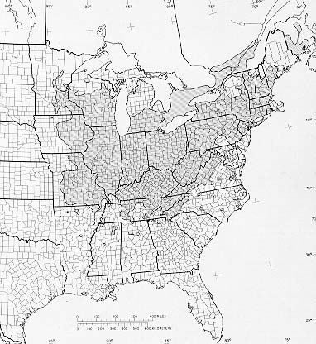

Figure II-1. Range of butternut in the United States (Little, E.L. 1971).

SEEDLING DIFFERENCES IN BUTTERNUT FAMILIES FROM SOUTHERN APPALACHIAN PROVENANCES

Abstract

Butternut, Juglans cinerea L, is a primarily riparian tree growing in eastern North America; providing hard mast for wildlife. Butternut canker disease, caused by an introduced pathogen, Sirococcus clavigignenti-juglandacearum (Nair, Kostichka & Kuntz), is devastating populations of butternut. Ecological restoration of the species is dependent upon determining factors in butternut nursery production and seedling establishment. Nuts were collected from butternut trees originating in southern Appalachian provenances in Tennessee and surrounding states and were grown into large seedlings at the Georgia Forestry Commission’s Flint River Nursery. Over 7,700 seedlings were grown for one year in a nursery across four different growing seasons or nursery trials. Annual differences in butternut sizes were apparent due to both seasonal variation and placement within the nursery in respect to irrigation risers. Overall seedling height (HT) was quite large at 78.95 cm and varied annually (112, 67, 58, 104). Placement within the nursery away from irrigation risers allowed for production of plantable seedlings with less damage during lifting. Seedlings from known parents of either pure J. cinerea, pure J. ailantifolia, F₁ hybrids (J. X bixbyi), and unknown families were significantly different each year and across multiple years for all seedling variables including HT, root collar diameter (RCD), and first-order lateral root number (FOLR). Annually, open-pollinated seedlings families, excluding known non- J. cinerea families, had significant differences across provenances and families in initial seedling size after one year of nursery. This genetic influence was apparent for all individual years. Excluding known non- J. cinerea families, strong phenotypic and genetic correlations persisted across individual years for HT and RCD, including very similar relationships with samples from under 350 seedlings to over 4800. For all seedlings in all years HT and RCD had the strongest relationships phenotypically (0.65) and slightly lower genetically (0.36). RCD and FOLR had weaker phenotypic correlations (0.52) but stronger genetically (0.39). HT was more weakly correlated both phenotypially and genetically with FOLR number (0.28, -0.16 respectively).
In the largest nursery trial (#2) producing 4,834 seedlings, germination rate was around 60%. Family heritabilities were calculated by removing known J. ailantifolia and F₁ hybrids (J. X bixbyi). Heritabilities were strong for RCD (0.56), FOLR (0.52), VOL (0.47) and HT (0.36). Characteristics proven in other species to influence establishment success, including HT, RCD, and FOLR, are heritable for butternut across many years with potential gains from selection. RCD should be considered as a visual indicator of seedling quality and a two-way selection approach is most appropriate for improvement of seedling quality. This is the first application of large seedling production techniques and seedling characterization for this species.

Keywords: butternut, Juglans cinerea, seedlings, nursery production, genetics

Introduction

Butternut or white walnut, Juglans cinerea L, is an important hardwood species usually inhabiting riparian zones in eastern North America, although occasionally occurring on drier limestone shelves. The species is related to black walnut, J. nigra L., but is in a taxonomically distinct section of Juglans L. (Stanford et al. 2000). Butternut is utilized for veneer, cabinets, and carving and is an important source of hard mast for wildlife. Populations of butternut have been declining due to an introduced pathogen, Sirococcus clavigignenti-juglandacearum (Nair, Kostichka & Kuntz), which is the causal agent for butternut canker disease. The disease causes multiple stem and branch cankers that girdle and kill trees of all ages and size classes (Ostry et al. 1994). Once a butternut population of is infected; lack of sprouting can result in permanent loss of a particular gene pool. Low genetic diversity has been found in parts of butternut’s range (Busov et al. 1997, Fjellstrom and Parfitt 1995, Morin et al. 2000; Hoban et al. 2010) and other locations have shown high diversity (Hoban et al. 2010).
- Prior to potential extirpation of the species, efforts can be made to begin to conserve genetic diversity of sensitive populations and begin the restoration process. Restoration of the species may rely in genetic resistance to the disease, as healthy trees have been found in close proximity to dead or dying trees (Ostry et al. 1994). If resistance is genetically-based, a breeding approach could be a feasible strategy to produce resistant butternut trees for restoration of the species into habitats where it has been extirpated (Schlarbaum et al. 1997).
Overcoming the crippling effects of butternut canker disease is just one challenge to restoring the species. Hardwood seedlings face many challenges including browse and rubbing by white-tailed deer (Odocoileus virginianus Boddaert) and other herbivores (Marquis 1974; Martin and Baltzinger 2002) and herbaceous and hardwood competition, which overtop artificial regeneration planted in open areas (Cogliastro et al. 1990, Kolb et al. 1990, Willoughby and McDonald 1999). Variability in planting stock quality of hardwood seedlings often results in planting failures and low vigor of seedlings during the initial stages of establishment (Johnson 1981, Johnson et al. 1986, Wendel 1980). Traditionally, nurseries have grown hardwood seedlings in dense spacing and infrequent fertilization regimes (Dey and Buchanan 1995), which generally produced small, uniform size seedlings to facilitate shipping and planting (Johnson 1981, Kormanik and Ruehle 1987). Establishment success of northern red oak (Quercus rubra L.) seedlings increased with height and caliper of nursery stock (Zaczek et al. 1997, Dey and Parker 1997, Ward et al. 2000, Jacobs et al. 2004, Kormanik et al. 1994a, 1994b, Schlarbaum 1993).
Artificial regeneration using large seedlings with highly developed root systems shifts the competitive advantage toward seedlings and reduces losses due to herbivory as the terminal buds are above the height of deer browse (Ward et al. 2000). Large nursery stock can be produced by adjusting nursery practices and can quickly become established in the field (Kormanik et al.1994a). Selecting large seedlings has increased establishment success for a variety of hardwood species including oak species Quercus alba L., Q. falcata Michx., Q. michauxii Nutt., Q. pagoda Raf., and Q. rubra L. (Kormanik et al. 1995, Kormanik et al. 1997, Schlarbaum 1993). With multiple other hardwood species, including black walnut, seedling genetic and phenotypic characteristics prior to outplanting have been used to determine certain seedling attributes that can predict the chance of survival in various hardwood species (Thompson and Schutz 1995). The production of high-quality stock for black walnut seedling production has been investigated through seed selection and nursery techniques since at least 1947 and has continued for decades (Chase 1947, Beineke 1989, Schlutz and Thompson 1990). Over the past decade, nursery practices have adjusted seed density and fertilization and irrigation applications in order to produce large hardwood seedlings (Kormanik et al. 1994a, Kormanik et al. 1994b). This approach may be especially useful for butternut, where nuts are limited due to extirpation of natural populations from butternut canker disease and a lack of seed orchards. Family and seedling quality are important qualities to consider along with resistance in a breeding program (Schlarbaum et al. 2004).
Seedling height (HT), root collar diameter (RCD), and/or number of first-order lateral roots (FOLR) have been used as an indicator of seedling quality (Russell and Kormanik 1986, Kormanik 1994a, Thompson and Schultz 1995). First-order lateral roots have been shown to endure after planting (Thompson and Schultz 1995) and are a heritable trait of many hardwood species associated with seedling competitiveness (Schutz and Thompson 1997, Kormanik et al. 1997). Nursery-grown hardwood seedlings with larger RCDs prior to outplanting have been shown to result in better survival and growth after outplanting than smaller stock (Olson and Hopper 1972, Zaczek et al. 1997).
Production of high-quality seedlings in the nursery and selecting seedlings with specific characteristics may alone increase establishment success in the field. The feasibility of hardwood genetic improvement has been well-documented by research in the 1970s (Bey 1973, Funk 1973), however, application of tree improvement programs has lagged behind (Rink and Stelzer 1982). Many of the above characteristics, as well as establishment success, are strongly controlled by genetics for several species, including black walnut (Bresnan et al. 1994).
Butternut has been cultivated since 1633; a half-century before black walnut and other North American Juglans species (cf. Brinkman 1974). Artificial regeneration of butternut, however, has never been widely practiced in the United States, due to abundant natural regeneration in some areas and biased selection of black walnuts for timber and nut production (Ostry and Pijut 2000). Butternut has been noted to have a quickly developing root system that requires transplanting early in seedling development (Rink 1990), although information on specific seedling characteristics has not been published. Visual comparisons of nusery-grown, high-quality butternut and black walnut bare-root seedlings (personal observation) indicate that both species have very different root systems than oak (Quercus L.) species. Black walnut’s root system is dominated by a relatively large, thick deep-growing tap root with comparatively short lateral roots. Butternut has a relatively smaller and shorter tap root, but has very large (ca. > 1 cm diameter) lateral roots that often approach 1 m in length and in combination with shorter lateral roots.
If resistance to butternut canker disease has a genetic basis, pedigree will be vital to restoration efforts. In addition, understanding genetic variability and potential gains in growth from selecting specific genetic families, and the impact of seedling quality and seedling characteristics on establishment will greatly enhance restoration efforts. Studies on heritability of these characteristics and the impacts on establishment success have yet to be completed for butternut.
The Georgia Forestry Commission’s Flint River Nursery consistently produces high-quality seedlings of various hardwood species including butternut (Clark et al. 2000, Brosi et al. 2007). In the autumns of 1999, 2000, 2002, and 2004, there were crops of butternuts produced throughout the southern Appalachian region, and open-pollinated progenies were collected from many trees. This seed formed the basis of four nursery trials; Trial 1 (1999 crop), Trial 2 (2000 crop), Trial 3 (2002 crop), and Trial 4 (2004 crop). Each year the seed was planted by genetic family at the Flint River Nursery in December, 2000 and grown for one season to: achieve the following objectives:
- Objective a) compare annual variation in seedling characteristics grown over four years (all trials);
- Objective b) compare species variation in seedling characteristics for all years combined and on individual years with known species differences (Trials 2, 3, and 4);
- Objective c) determine provenance and family variation in various seedling characteristics (all trials);
- Objective d) calculate phenotypic and genetic correlations for all seedling variables (all trials);
- Objective e) determine seed germination for provenances and families and seed lot sizes (Trial 2); and
- Objective f) calculate individual tree and family heritabilities for seedling characteristics (Trial 2).
This study presents the first application of high-quality seedling production techniques for this species.

Methods

Seed collection and handling
Throughout this manuscript butternut, J. cinerea, is defined by whole-tree silvic characters for identification. For each tree overall phenotype was evaluated based on dendrological characters and nut characters that tend to distinguish the species. It is unknown if the whole-tree silvic can distinguish between pure butternut or hybrids of butternut and heartnut of various generations. Trees classified as butternut (sensu lato) could actually be the result of hybridization between J. cinerea and J. ailantifolia Carr or J. ailantifolia var. cordiformis (Maxim.) Rehd.) or hybridization with advanced generation hybrids, J. x bixbyi Rehd. Progeny of all parent trees could also be hybrids, depending on the presence of a heartnut or hybrid as the pollen source(s) (see Chapter II). A limited number of specific maternal parent trees used in this study were DNA genotyped using 12 microsatellite loci and specific chloroplast markers to determine recent maternal ancestry (Hoban et al. 2009). Parent trees consisted of J. cinerea, J. ailantifolia and F₁ hybrids J. x bixbyi. No offspring were genetically tested. Not all parent trees were tested, so they were labeled as unknown families.
Seedlings were produced in a set of four nursery trials. The first nursery trial was of nuts collected in the fall of 1999, grown in the summer of 2000, lifted in early spring 2001 and seedling characteristics were measured. In addition, butternuts were also collected in the fall of 2000, 2002, and 2005 with resulting seedlings measured in 2002, 2004, and 2007 (Table III-1, note tables and figures appear in appendixes). Evaluations including all five years resulted in a total of 7,732 1-0 seedlings.
Open-pollinated nuts were collected by individual trees, in the southern Appalachian region during the autumn season. Provenances were distinguished using Bailey’s Ecoregions (1995, Table III-2). The nuts were gathered from the ground under fruiting trees, regardless of disease condition. The parent trees were found in a variety of sites and had large variation in nut production. Parent trees from the same provenance were often collected within a 25km square of each other with some families from concentrations of neighboring trees. Trees in all provenances were in areas where butternuts were occasionally found in forest stands. However, trees in forest stands have small crowns and produce fewer nuts, so often nuts were collected from trees on the edge of forests and in yards adjacent to forests. All nuts were collected by hand and placed in mesh bags, labeled by family name and collection date. Nuts were stored under refrigeration (5.56º C) and temporarily removed in early November to be dehusked by a commercial machine (Brinkman 1974). The machine was run empty and cleaned between families to ensure family separation. Following dehusking, the nuts were returned to cold storage for approximately one month until planting.
For Nursery Trial 1, nuts were collected in 1999 from one region in central Tennessee from 18 different genetic families; all parent trees collected were verified to be pure J. cinerea. For Nursery Trial 2, nuts were collected in 2000 from six general provenances: east Tennessee, central Tennessee, southwest Virginia, western North Carolina, northwestern North Carolina, and northern Georgia. Nuts from up to 11 trees per location from a total of 41 parents were kept separate by family of origin. In Nursery Trial 2, from one location in western North Carolina maternal parent trees were determined to be of species J. cinerea and F₁ J. X bixbyi. Three parent trees from east Tennessee were identified as J. ailantifolia through whole-tree silvics. To determine germination rates all seedlings from this trial were retained and measured. For other years, seedlings with signs of disease were not counted and therefore germination percentages could not be calculated. This trial was replicated in the nursery.
For Nursery Trial 3, nuts were collected in 2002 from one location in western North Carolina from 6 families, one maternal parent trees was determined to be a J. ailathifolia and one was and F₁ J. X bixbyi . For Nursery Trail 4, nuts were collected in 2005 from four locations, with a total of 15 families, one maternal parent trees was determined to be a J. ailathifolia and one was J. cinerea. Provenances were from eastern Kentucky, central Tennessee, western North Carolina, and northwestern North Carolina.

Nursery protocols
The nuts were sown by hand in early December at the Georgia Forestry Commission’s Flint River Nursery, located near Byromville, GA at a spacing of approximately six per linear foot or 24 per running foot of nursery bed. The seedlings were grown according to fertilization and irrigation protocols developed by the USDA Forest Service’s Institute for Tree Root Biology (Kormanik et al. 1994a). Nursery beds were treated with methyl bromide and fertilized prior to planting. The Georgia Nursery is designed to have six nursery beds between irrigation riser, with beds 1 and 6 next to a riser. In Nursery Trials 1 and 4, 2001 and 2007 seedlings, butternuts were planted in bed 1, immediately next to the irrigation risers. For Nursery Trial 3, seedlings were sown in row 4. For Nursery Trial 2, the families were sown in two replications in an incomplete block design, with three feet of empty bed space between each family to facilitate retention of pedigree during lifting. The replications for trial 2 were sown in the same middle row (row 3) in adjacent nursery compartments, each containing a total of six rows between irrigation risers.
Seedlings were grown for one growing season in the nursery. In late January, the seedlings were undercut to 30 cm in length and machine lifted. The seedlings were bundled by family and transported to Knoxville, TN and placed in cold storage. Lateral roots were pruned to 15 cm in length to assist in planting and inspected the stems for disease. The seedlings were observed to be disease-free with no evidence of butternut canker or root rot disease.

Seedling characteristics
Measurements were taken on the following two parameters annually: stem height (HT) and root-collar diameter (RCD) (all trials). Height was measured from the root collar to the terminal bud to the nearest 0.5 cm using a meter stick and RCD was measure at 1.3 mm above the root collar using digital calipers. In addition, first-order lateral root number (FOLR) (Trials 1, 3, and 5) and root system volume (VOL) were also measured (Trail 2). A FOLR was defined as a lateral root at least 1 mm in diameter at the point of junction from the main taproot (sensu Kormanik 1994b). Due to the large seedling size and extensive root systems, some FOLR were broken off at the tap root in the lifting process in some seedlings, leaving a scar. For these seedlings, an ‘absent’ FOLR number was also recorded (Trail 2). Root system volume was measured by water displacement in specially constructed graduated cylinders. Root system volume was measured to provide a better approximation root system size than FOLR due to the large size differences in lateral roots, i.e., 1 mm to 1+ cm. There were 5,387 seedlings with FOLR measurements during Nursery Trials 1 and 2 and 4,834 seedlings with VOL in Nursery Trial 2.

Statistical analyses
Statistical analyses were conducted using SAS version 9.1 (for Windows, © 2005 SAS Institute Inc., SAS Campus Drive, Cary, North Carolina 27513, USA). Additional macro program codes to maximize programming efficiency were developed by Saxton (1998, 2004) were used for means separation, heritability analysis and genetic correlations. Macros included pdmix800 for means separation using multiple range tests (Saxton 1998), Mixed Model Analysis of Variance Macro (mmaov) uses Fisher's Least Significant Difference (LSD) test was conducted at the 5% significance level, determines if standard deviations are within five fold of each other, calculates Levene P values to determine equality of variances, and a Shapero-Wilk W test for normality (Saxton ©2002). The additional macro (herit) was used for genetic correlations (Saxton 1998). Percentage data underwent arc sign transformations. For all analysis seedling characteristics of HT, RCD, and FOLR were treated as independent variables. Years, species, species*year, provenance, provenance*family, and family were considered fixed effects. Mixed model analysis was conducted using (PROC MIXED).
Objective a). A mixed model analysis using a randomized complete block design was conducted for annual effects on seedling characteristics. Objective b). A mixed model analysis using a randomized complete block design was conducted for species effects on seedling characteristics. Analysis was conducted on all years combined and then on individual years with known species differences (Trial 2, 3, and 4). Objective c). A mixed model analysis using a randomized complete block design was conducted for provenance and family effects on seedling characteristics for individual years. All known heartnut and hybrid parent families were removed from the sample prior to analysis. Analysis on provenance effects was conducted when families were collected from multiple provenances (Trail 2 and 4). Family effects only were included in years with just one provenance collected (Trial 1 and 3).
Objective d). For seedling variables, phenotypic and genetic correlations were determined for all years individually and combined. All known heartnut and hybrid parent families were removed from the sample prior to analysis. Phenotypic correlations among all growth variables were generated using Pearson’s correlation coefficients (PROC CORR). Genetic correlations were calculated to indicate the degree in which one trait will change as a result of another trait and help determine how selecting for a specific trait will impact other traits (Zobel and Talbert 1984).
Objective e). For Nursery Trial 2, percent seed germination was calculated for each family and summed across provenances. Percent germination underwent inverse trigonometric sine transformations for homogeneity of error variance, which reduces deviations from additivity on the transformed scale (Bogyo and Becker 1965, Snedecor and Cochran 1998). A Chi-squared test was used for provenance and family effects. Regression values between the number of seeds and germination rate were calculated.
Objective f). For Nursery Trial 2, analyses were conducted to determine individual tree and family heritabilities on specific traits and are used to determine potential gains from genetic selection. All known heartnut and hybrid parent families were removed from the sample prior to analysis. Individual-tree heritability and family heritability calculations were based on the assumption that the butternut seedlings from one genetic family are half-siblings (Zobel and Talbert 1984). The least square difference (LSD) values of the family means were averaged to produce a single value for the mean separation test. Tukey-Kramer multiple comparisons of the family means was used due to determine specific differences due to unequal sample sizes. Values for heritabilites were calculated for the additive genetic variance using y_{ij} = µ + F_{i} + T(F) _{ij}, means squared values were calculated between families for: G²_{E} + nG²_{F} and within families for: G²_{E,} Genetic values were calculated using: (G²_{F = ¼} G²_{A}) + (G²_{E} = ¾ G²_{A}+ G²_{E}) / G²_{p}, h²=G²_{A} / G²_{A} + G²_{E} with r_{p} = r_{A} + r_{E} (Saxton 2004).

Results

Annual effects
Objective a). For all years combined HT, RCD, and FOLR were 66, 13.5, and 14.9 respectively (Table III-3). Nursery Trial 1 resulted in 553 seedlings averaging 16 mm in diameter and 112 cm in height with the largest seedling over 2 meters tall (Table III-4). Nursery Trial 4 resulted in 1,995 seedlings also averaging over 1 meter tall in height and over 15 mm in diameter. In Nursery trial 2, 4,834 seedlings were produced with an average height of 66.8 cm and diameters of 14 mm. Average seedling heights in trial 3, with 350 seedlings, was 58 cm and 13mm in diameter. Root collar diameters followed the same trend with height with largest averages produced in Trials 1 and 4 followed by Trials 2 and 3 (Table III-4). Trial 1 had only one seedling over 2 meters (0.18%) and trial 4 had over eight seedlings over 2 m (0.35%). All trials, except for trial 3, had seedlings over 175 cm in height. These large seedlings were 5.28% of seedlings in trial 1, 4.05% in trial 4, but only 0.12% of seedlings in trial 2. Analysis of variance on the combined data revealed significant annual variation in HT, RCD, but not FOLR (Table III-5). HT was significantly different in all years (Figure III-1). RCD was significantly larger in trials 1 and 4 then trials 2 and 3 (Figure III-2). Though height in Trial 2 averaged 40% shorter than in Trial 1, FOLR number did not varied significantly across these two nursery trials (Figure III-3).

Species effects
Objective b) For all years, the combined seedlings showed significant variation in seedling attributes across species of origin of maternal parent (Table III-5). For HT, J. cinerea offspring were significantly taller than all others (n=27), J. ailantifolia (n=4), and F₁ J. X bixbyi (n=2) were not significantly different from each other, and unknown families were smaller than all other groupings except for F₁ s (Figure III-4, p<0.0001). For RCD, F₁ J. X bixbyi was significantly larger than all other groups, followed by J. cinerea families. J. ailantifolia and unknown families were not significantly different (Figure III-5, p<0.0001). FOLR number was largest for F₁ J. X bixbyi and smallest for J. cinerea families. There was no significant difference between J. ailantifolia and unknown families (Figure III-6, p<0.0001).
For Nursery Trial 1, all seedlings were from maternal parents of J. cinerea and therefore species effects were not evaluated. For Nursery Trail 2, HT was significantly shorter for unknown families (n=24) than known J. ailantifolia (n=3), F₁ J. X bixbyi (n=2), and J. cinerea (n=11) families. Each group was significantly different in RCD with F₁ J. X bixbyi the largest followed by J. ailantifolia, J. cinerea, and unknown families. Values for FOLR followed the same order from smallest to largest with no significant difference between unknown families and J. ailantifolia. For Nursery Trial 3, seedlings from the unknown families (n=4) were significantly taller (62.01) than both the F₁ (n=1, 51.84) and J. ailantifolia (n=1, 54.46) families (p=0.0007). The same was true for RCD (p<0.0001), and FOLR (p<0.0001). For Nursery Trial 4, the seedlings with maternal parent J. cinerea (n=1) were significantly shorter than both the unknown families but not the J. ailantifolia offspring. RCD followed the same statistical outcome with the largest values for unknown families followed by J. ailantifolia then J. cinerea.

Provenance and family effects
Objective c) All known heartnut and hybrid parent families were removed from the samples prior to analysis. Across all years, seedling characteristics were significantly different across both provenance and family of origin (Table III-6). Provenances varied in HT (Figure III-7, RCD (Figure III-8), and FOLR (Figure III-9). Analysis for years combined showed significance family effects on HT (Figure III-10), RCD (Figure III-11), and FOLR (Figure III-12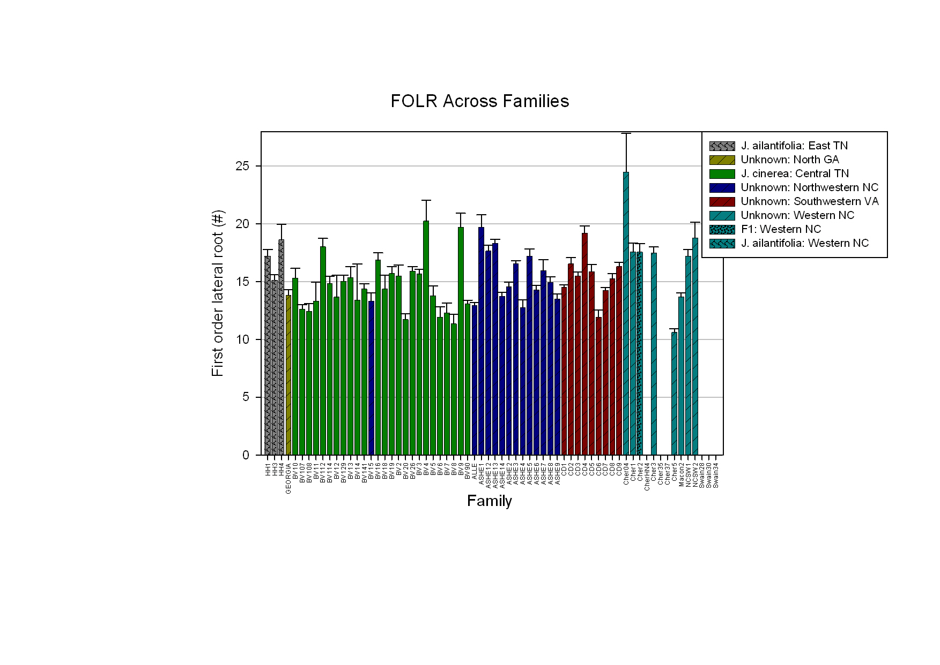

Figure III-12). Large variation existed in these variables with a number of very large seedlings (Figure III-26). Analysis for each year showed significance provenance and family effects on all seedling variables for each individual year (p<0.05). Families BV9, BV10 and Cher30 were consistently larger in both HT and RCD. However, more often families were either tall with lower RCD values (BV19, CherLP) or shorter with large RCD values (Ashe13, Ashe7, Cher7).
For Trial 1, family effects were significant for all seedlings characteristics (p<0.0001, Table III-12). Thre were no provenance effects as all families were collected from the same location. Average HT ranged from over 140 cm for the tallest family (BV9) to under 50 cm for the shortest family (BV14) (Figure III-13). RCD was greatest in the tallest family (BV9) but the shortest family (BV14) had larger RCD averages than many other families (Figure III-14). Some families (BV9, BV10, and BV13) were both tall and had large RCD values. Other families were tall with smaller RCD values (BV5, BV19) or short with larger RCD values (BV3, BV8). Other families were both short and small diameter (BV2, BV7). FOLR was greatest in a family with lower than average values for HT and RCD (BV4). The tallest and largest diameter family had the second largest FOLR value (Figure III-15).
Nursery Trial 2 was the largest trial with 4,834 seedlings. Overall height ranged from 14-185 cm with a mean of 66.7 cm. Mean root collar diameter was 13.5 mm with a range of 1.2-38.7 mm. The average number of first-order lateral roots was 15 with a maximum of 37 (Table III-10). Less than half of the seedlings were greater than the mean for the characteristics of HT and RCD, but just over half were larger for FOLR (Table III-10). The percentage of seedlings above the mean was 43 for HT, 41 for RCD, and 52 for FOLR number (Table III-10). Provenances varied significantly for all variables (p<0.0001, Table III-11). Provenance of origin significantly impacted HT (range 59.6-84.6 cm), RCD (range 12.8-15.2 mm), and FOLR number (range 13.8-16.3), though the differences in provenance were less pronounced than family differences. Family differences were significant for all four seedling parameters (p<0.0001, Table III-12); HT (Figure III-16), RCD (Figure III-17), FOLR number (Figure III-18), and VOL. Significant differences existed among families in HT (range 42-110 cm), RCD (range 11-20 mm), and FOLR number (range 11-19). The largest genetic family (CD4) was over twice the size of the smallest in terms of height (CD2). The same trend was present for RCD and FOLR.
For Nursery Trial 3, all families were collected from one provenance in western North Carolina. Family differences were significant for both HT and RCD (p<0.0001). One family was (Swain28) significantly larger than all other families in height (Figure III-19). Multiple families varied significantly in RCD (Figure III-20). Two families (Swain28, Swain30) were over 15 mm in RCD with the smallest family less than 12 mm (Cher24).
For Nursery Trial 4, families varied significantly in both HT and RCD (p<0.0001). Two families from western NC were significantly larger than all other families (Cher30, CherLP, Figure III-21). RCD averaged over 20 mm for the largest family (Cher30) and under 12 mm for the smallest (CHLake) (Figure III-22).

Phenotypic and genetic correlations
Objective d). For all years combined, phenotypic correlations were strongest for RCD’s relationship with HT (0. 65, p<0.0001, Figure III-23) and relationship with FOLR number (0.52, p<0.0001, Figure III-25). Over half of the variation expressed in height and FOLR number could be accounted for in variation of root collar diameter variation. A significant relationship also existed between height and FOLR number (0.28, p<0.0001,
Figure III-24, Table III-7). Genetic correlations showed the strongest relationship between root collar diameter and FOLR (r_{rcd.folr}=0.39). RCD and HT also had significant genetic relationship (r_{rcd.ht}=0.36). The genetic correlation between HT and FOLR number was weakly negative (r_{ht.folr}=-0.16) (Table III-7).
Analysis of phenotypic and genetic correlations within each individual year showed very similar annual trends (Table III-8). Trial 1 with 553 seedlings had very similar phenotypic and genetic correlations as Trial 2 with 4,834 seedlings. The largest value for genetic correlations was found in trial 3 with the smallest number of observations and families evaluated. Nursery Trial 1 had phenotypic relationships between 0.42 for HT-FOLR and 0.61 for HT-RCD with genetic correlations all 0.35 or under.
Within Nursery Trial 2: all seedling characteristics were significantly correlated with each other (p<0.0001) (Table III-14). Phenotypic correlations were strong for all relationships with RCD: VOL (0.77), HT (0.66), and FOLR (0.45). Phenotypic correlations were pronounced for HT with VOL (0.50) and less so with FOLR (0.28). The phenotypic correlation for FOLR and VOL were also relatively weak (0.45). Genetic correlations were strong only for VOL and RCD (0.68), RCD and FOLR (0.45); and less so for HT and RCD (0.26) (Table III-14). Within Nursery Trial 3, RCD had strong correlations with HT phenotypically (0.49, p<0.0001) and genetically (0.82). Within Nursery Trial 4, RCD had stronger significant correlations with HT phenotypically (0.62, p<0.0001) and genetically (0.55).

Germination
Objective e) For Nursery Trial 2, the average germination percentage was 59% (Table III-9). Provenances ranged in germination percentage from 46.32 to 79.55 and were significantly different (Figure III-27, p<0.05). Families ranged from 13.06 to 94.30% and were significantly different (Table III-9, p<0.05). Only three provenances had families all with over 40% germination (Figure III-29). Nuts collected from central Tennessee had an average germination of 77.11%. 90% of the families from central Tennessee had germination rates above the mean of all families combined and greater than 65%. Nuts collected from southwest Virginia, western North Carolina and northwest North Carolina had germination percentages closer to the average (50%, 46%, and 53% respectively). Only 33% of the trees in northwestern Virginia had germination rates above the mean. In western North Carolina only 33% of the families had germination above that of the mean. In northwestern North Carolina 67% of the families had germination averages above the mean. The family range in germination varied from 13 to 94%.
The relationships between number of seeds sown in the nursery per family and germination was statistically significant (r²=0.1592, p=0.019) (Figure III-28). Germination average was 30% in families with greater than 400 seeds, with the exception of CD7, which had 90% germination and 423 seeds. Average germination was 60% for families with 29-366 seeds. Germination was 75% in families with less than 100 seeds, 69% in less than 150 seeds, 65% in less than 200 seeds, 64% in less than 300 seeds, 63% in less than 400 seeds, and 60% in less than 500 seeds, and 59% with all families. Families with less than 100 seeds had the greatest amount of germination (Figure III-29).
Germination rate had a phenotypic effect on seedlings. Family Ashe7 experienced low germination, which resulted in low density and seedlings being shorter with larger RCDs then would be expected. High germination families resulted in high density with taller and thinning seedlings as with Ashe12. CD4 had fewer than 40% germination and resulted in the tallest and largest diameter family.

Heritabilities
Objective f) For Nursery Trial 2: Family heritability estimates were calculated for all variables and ranged from 0.36 to 0.56 (Table III-13). Family heritabilities were strong for RCD (0.56), FOLR (0.52), and VOL (0.47), but weaker for HT (0.36). Individual tree heritabilities were similar and lower for all variables: HT (0.12), RCD (0.16), FOLR (0.16) and VOL (0.14).

Discussion

Annual seedling production
The Georgia Forestry Commission’s Flint River Nursery consistently produce large, high-quality butternut seedlings using techniques primarily developed for other hardwood species (Kormanik et al.1994a). Butternut was among the top tree species in the nursery for both height and diameter (unpublished data, UT-Tree Improvement Program) with seedlings reaching over 2 m in height. Correspondingly, butternut as a species can be challenging to nursery management. The incredible annual growth rate of the species results in spreading lateral roots up to 1 m in length; which cause seedlings to be extremely difficult to lift from the nursery beds and pose severe problems for packing. Additionally, the seedlings are virtually unplantable without severe root pruning. Root pruning also removes fine root structure, which is located at the ends of the lateral roots.
This study showed that placement within a nursery compartment can impact seedling size. In nursery trials 1 and 4, 2001 and 2007 seedlings, butternuts were planted in bed 1 closer to the irrigation risers at the nursery where they received ample moisture. Most of these seedlings had root systems so massive that they would be impossible to plant without a large auger or planting shovels, even with lateral root pruning. The reduced height of butternuts in trials 2 and 3 was due to placement in the middle beds (beds 3 and 4) in the nursery compartment. These beds are farthest from the risers and receive relatively less moisture. Nursery plantings of butternut should be strategically placed in beds within compartments that receive the least water and thereby, minimize height and root system growth is minimized.

Species variation
This is the first investigation of variation of offspring with the known identify of the material parent for J. cinerea, J. ailathifolia, and F₁ J. X bixbyi. Seedlings from F₁ parents were significantly shorter than seedlings from J. cinerea parents, but were significantly larger than all other groups for RCD and FOLRs. The larger RCD size and FOLR numbers of F₁ offspring (F₂ seedlings) indicates hybrid vigor may be expressed in root systems, as opposed to affecting the overall seedling. Juglans cinerea seedlings were taller than both J. ailantifolia, and F₁ seedlings, indicating that traits responsible for greater capacity for height growth may be more pronounced in J. cinerea than in J. ailantifolia and J. X bixbyi. In addition, a larger number of lateral roots and stout diameters were apparent in F₁ and J. ailantifolia families, indicating more resources allocated to below-ground biomass. This might reflect indirect selection in heartnut, where the primary selection is nut-oriented and for nut/fruit orchard tree shape. The root systems may be inadvertently selected resulting in reduced height growth.
Evaluation of hybrids has shown less hybridization in forested and forest edge settings and increased hybridization in human disturbed areas (Hoban et al. 2010). The increased height of J. cinerea could be a critical factor for establishment in forest settings. Therefore, though hybrids may have increased resistance to butternut canker disease (Orchard et al. 1982), they may be selected against in forest stands due to lack of height growth.

Provenance and family impacts
Specific genetic provenances and families produce seedlings superior in terms of all seedling variables. No trends exist in latitude or longitudinal differences in height, there does not appear to be a negative impact of growing more northern provenances in southern Georgia. In terms of HT, families from provenances in southwestern VA and Northwestern NC were from the farthest eastern provenances and all had smaller heights. KY and GA provenances were the next smallest in terms of height and were the furthest north and south provenances. Western North Carolina, east Tennessee, and central Tennessee provenances generally produced the tallest seedlings. RCD followed the same trend, as the three provenances were also the largest in diameter. However RCD was smallest in the KY provenance followed by VA with northwestern NC and GA in the middle. Provenances from central locations from this study had the best performance. These locations have high concentrations of butternut which may result in increased pollen flow and increased seedling size.
Within the same provenance, differences among families in all characteristics were very large, indicating that family identities should be kept separate for potential gains from selection. Differences in family rankings in all variables indicate that some specific families may allocate a larger percentage of resources to below-ground biomass and some allocate more resources to apical growth. Determining the relationships that these specific variables have on field performance in butternut (Chapters IV and V) will aid in determining which families are ideal candidates for incorporation into breeding and/or restoration programs. Families with larger seedlings will help overcome the many challenges with hardwood seedling restoration, including deer browse and competition with invasive herbaceous species.

Correlations
Phenotypic and genetic correlations showed strong relationships between initial seedling variables, indicating a two-way selection process should be used for assessing seedling quality. The strong relationships of RCD with HT and FOLR indicate this variable is extremely important for determining quality of seedlings. VOL of seedlings was highly correlated to RCD, but was too labor intensive to measure for operational use. Therefore, RCD should be first considered as a visual indicator of seedling quality. As height was more weakly correlated with RCD than the other root systems characteristics, it should be a secondary consideration for inclusion in a breeding program and when culling for operational plantings.
The high genetic correlation between root volume and root collar diameter (0.68) and phenotypic correlations (0.77) also indicate that the extra time measuring root volume was unnecessary. Strong correlations indicate that selection based on root collar diameter and not first-order lateral root number will result in selecting seedlings with larger root systems and increased height. For rapid selection of the best seedlings, root collar diameter should be the initial focus of quality selection, followed by height.

Germination concerns
- Overall germination rate were similar (59%) than the reported values of 65% by (Brinkman 1974). Bare-root nurseries using butternut seed collected from naturally occurring or planted trees, without insect control, should consider a potential 40% loss. Adjustments to amounts of nuts to collect and nursery spacing should be made to generate an approximate number of seedlings and conserve nursery space.
- Variation in germination was a function of provenance and family differences. Provenances from areas of high concentrations of butternut had higher pollen flow and higher germination rates. Reduced germination could be a result of a number of seedlings being pollinated by closely related individuals or impacts on the seed by insects. Though not included in the analysis some seedlings were found with altered leaf phenotype, variegated leaves, and leaves lacking chlorophyll as a potential result of self-pollination or inbreeding depression (UT-Tree Improvement Program unpublished data). A number of these seedlings experienced mortality prior to lifting from the nursery beds.
Germination percentage generally decreased as seed number increased; a large number of seed could imply a significant pollen flow from other trees, whereas low numbers would suggest the opposite. Low germination in families with high numbers of seeds could be a result of increased impacts by nut weevils and other insects including the butternut curculio, Conotrachelus juglandis (LeConte) (Hay and Donley 1966, Wilson and Corneil 1978). There were, however, some families with a large amount of nuts that had good germination. This suggests that population numbers of damaging insects are cyclical, which may result in significant damage to nuts at some locations and a virtual lack of damage to nut crops in other locations.
Other factors, however, may be involved. Trees from the central Tennessee location may give additional insight into variability in germination. This population is the largest known concentration of butternut in southern states, with over 200 butternuts along a 4-mile stretch of creek in a relatively narrow valley with steep slopes. Due to the high concentration of trees, pollen flow and populations of nut weevils should be relatively uniform in this butternut population. Within this particular location, seed number did not directly correlate to percent germination. For instance, in the two families with the lowest percent germination, one family had a very small number of nuts and the other family had a large number of nuts collected. Both trees were located very within one kilometer from each other. This suggests that factors other than pollen flow or cyclical insect populations are present that affects seed germination. More intensive studies are needed on the relationships among nuts, insect damage, and pollen flow before conclusions can be reached.
- Future studies should extensively study insect diversity and damage impacts to nuts. For black walnut, the black walnut curculio, Conotrachelus retentus (Say), is a major insect pest, as well as the codling moth, Cydia pomonella (L.), the walnut husk maggot, Rhagoletis suavis (Loew) and walnut husk fly, R. completa (Cresson). Though no studies have been conducted on butternut, over fifty percent of the annual nut production in black walnut was impacted by C. retentus in a two year study in Missouri (Blair and Kearby 1979). Many of these species can be controlled by rapid removal and destruction of nuts that have fallen in early summer, before insects migrate to the soil (Katovich 2004). Therefore butternut orchards should aggressively address practices to reduce damaging impacts to nuts.

Heritability estimates
High heritabilities in butternut seedlings indicate that these characteristics are influenced substantially by additive genetic variances when environmental influences are minimized. Heritability analyses estimate the relative contributions of differences in genetic and non-genetic factors to the total phenotypic variance in a population. Traits with high heritabilities indicate that gains in growth could be made through selection and breeding to improve production. Root collar diameter was the seedling variable with the strongest heritability estimate for each year, indicating the greatest gains in seedling quality can be made by RCD selection, as that characteristic is highly correlated with other root system characteristics and also correlated with height. Findings from butternut are similar to studies on heritabilities for related species J. regia and J. nigra. In J. regia found stronger values for height (0.77) than diameter (0.65) for the first growing season (Aleta et al. 2004). Heritiablities for root volume for J. nigra were (0.54) but values for height and diameter were greater than one due to high standard errors (Jacobs 2005). J. regia and J. nigra have been more intensively studied in terms of nursery production, nut production, and seedling characteristics. Understanding areas in which butternut is similar to these species may allows for additional gains of using related species as references for future research.

Conclusions

Practical applications
Production of high quality seedlings of butternut with robust root systems is possible, although the sheer size produces many challenges in the nursery and field. A partial solution to reduce size is to plant the seedlings in nursery beds within a compartment that receive the least water, i.e., middle rows of a compartment. This may also reduce the impacts of Phytophthora root rot, which severely impacts butternut seedlings. Phenotypic and genetic correlations indicated that a two-way selection approach based first on RCD and then on HT and FOLR would result in higher quality seedlings. High heritabilities indicate that gains from selection could be highest for RCD followed by FOLR number, and seedling HT. Seedlings selected from specific families will increase germination and result in larger seedlings. Selecting these families may reduce losses to deer browse and competition. In practice, increased survival and growth decreases the number of seedlings needed to plant to achieve future stocking densities. Additional studies, described in Chapters IV and V, discuss the impact of initial seedling condition on outplanting success.

Biological findings
The impacts of introgression with J. ailantifolia may result in seedlings with reduced height growth, though hybrid vigor may result in larger root systems and diameters. Though introgression has been reported to be dominant throughout butternut’s range; reduced height growth of hybrids may result in less hybridization in forested stands. Screening of parent trees will aid in determining maternal parents for open-pollinated seed, though will not ensure pure butternut selections. Butternut, like walnut, is capable of large height gains when grown from seeds in nurseries. Artificial regeneration using large seedlings offers great potential to increase success of restoration efforts.

Literature Cited

Aleta, N., A. Ninot, and J. Voltas. 2004. Retrospective evaluation of parental selection in nursery tests of Juglans regia L. using a mixed model analysis. Sylvae Genetica, 53 (1): 26-33.

Bailey, R.G. 1995. Description of the Ecoregions of the United States, Second ed. USDA Miscellaneous Publication, 1391.

Beineke, W. 1989. Twenty Years of Black Walnut Genetic Improvement at Purdue University . Northern Journal of Applied Forestry, 6 (2): 68-71.

Bey, C.F. 1973. Genetic variation and selection. P.62-65. In: Black walnut as a crop, Black Walnut Symposium, Carbondale, IL, Aug. 14-15, 1973. USDA Forest Service, General Technical Report, North Central Forest Service Experiment Station, St. Paul, MN. NC-4, 144 p.

Blair, L.M. and W.H. Kearby. 1979. The black walnut curculio and its impact on nut production. In Walnut Insects and Diseases Workshop Proc.; June 13-14, 1984; Carbondale, IL, St. Paul,MN: N. Central Forest Exp. St., U.S. Dept. Agric., Forest Service: 51-54.

Bresnan, D.F., G. Rink, K.E. Diebel, and W.A. Geyer. 1994. Black walnut provenance performance in seven 22-year-old plantations. Silvae Genetica 43 (4): 246-252.

Brinkman, K.A. 1974. Juglans L. Walnut. Pages 454-459 in C.S. Schopmeyer (techn. coord.). Seeds of woody plants in the United States. Agricultural Handbook 450. U.S. Department of Agriculture, Forest Service, Washington, D.C.

Brosi, S.L., S.E. Schlarbaum, A. M. Saxton, R.L. Anderson, P.S. Spaine, and C. Young. 2007. Restoring butternut (Juglans cinerea L.) to southeastern forests: determining a genetic basis of disease resistance (Tennessee). Ecological Restoration: Vol. 25 (1): 51-54.

Bogyo, T.P. and W.A. Becker. 1965. Estimates of heritability from transformed percentage sib data with unequal subclass numbers. Biometrics. 21 (4): 1001-1007.

Busov, V.B., G. Rink, S.E. Schlarbaum, and J. Zuo. 1997. Allozyme variation within and among several Juglans L. species and their hybrids. Pp 69 In J.W. Van Sambeek, ed. Proceedings of the Fifth Black Walnut Symposium, Knowledge for the Future of Black Walnut, July 28-31, 1996, Springfield, Missouri, Ed., p. 69.

Chase, S.B. 1947. Eastern black walnut germination and seedbed studies. Journal of Forestry. 45: 661-668

Clark, S.L. S.E. Schlarbaum, and P.P. Kormanik. 2000. Visual grading and quality of 1-0 northern red oak seedlings. Southern Journal of Applied Forestry. 24 (2): 93-97.

Cogliastro, A., D. Gagnon, C. Coderre, and P. Bhereur. 1990. Response of seven hardwood tree species to herbicide, rototilling, and legume cover crop at two southern Quebec plantation sites. Canadian Journal of Forest Research. 20: 1172-1182.

Dey, D. and Buchanan, M. 1995. Red oak (Quercus rubra L.) acorn collection, nursery culture and direct seeding: a literature review. Ontario Forest Research Institute, Toronto, Ont. For. Res. Inf. Pap. No. 112.

Dey, D.C. and W.C. Parker. 1997. Morphological indicators of stock quality and field performance of red oak (Quercus rubra L.) seedlings underplanted in a central Ontario shelterwood. New Forests. 14: 145-156.

Fjellstrom, R. G., and D. E. Parfitt. 1995 Phylogenetic analysis and evolution of the genus Juglans (Juglandaceae) as determined from nuclear genome RFLPs. Plant Systematics and Evolution 197: 19–32.
Funk, D.T. 1973. Genetics and tree improvement. P. 59-61. In: Black walnut as a crop, Black Walnut Symposium, Carbondale, Illinois, Aug. 14-15, 1973. USDA Forest Service, General Technical Report, North Central Forest Service Experiment Station, St. Paul, MN. NC-4, 144 p.

Hay, C. J. and D. E. Donley. 1966. Insect pests. In Black walnut culture. p. 83-87. USDA Forest Service, North Central Forest Experiment Station, St. Paul, MN.
Hoban, S., T. McCleary, S. Schlarbaum, and J. Romero-Severson. 2009. Geographically extensive hybridization between the forest trees American butternut and Japanese walnut. Biological Letters. 5:324-327.
Hoban, S.M., D.S. Borkowski, S.L. Brosi, T.S. McCleary, L.M. Thompson, J.S. McLachlan, M.A. Pereira, S.E. Schlarbuam, and J.R. Severson. 2010. Range –wide distributions of genetic diversity in the North American tree Juglans cinerea: a product of range shifts, not ecological marginality or recent population decline. Submitted: In Review
Jacobs, D.F., A.L. Ross-Davis, and A.S. Davis. 2004. Establishment success of conservation tree plantations in relation to silvicultural practices in Indiana. New Forests. 28: 23-36.

Jacobs, D.F., K.E. Woeste, D.C. Wilson, and J.R. McKenna. 2005. Stock quality of black walnut (Juglans nigra) seedlings as affected by half-sib seed source and nursery sowing density.Acta Horticulturae (ISHS). 705:375-381
Johnson, P.S. 1981. Nursery stock requirements for oak plantings in upland forests. p. 2-9. In: Proc. Fifth North Central Tree Improvement Conference, 1987 Madison, WI. Department of Forestry, University of Wisconsin, Madison.

Johnson, P.S., C.D. Dale, and J.R. Law. 1986. Planting northern red oak in the Missouri Ozarks: A prescription. Northern Journal of Applied Forestry. 3: 66-38.

Katovich, S. 2004. Insects attacking black walnut in the Midwestern United States. In: Michler, C.H., P.M. Pijut, J. Van Sambeek, M. Coggeshall, J. Seifert, K. Woeste, R. Overton, eds. Black walnut in a new century. Proceedings of the 6 th Walnut Council research symposium, 2004 July 25-28, Lafayette, IN. Gen. Tech. Rep. NC-243. St. Paul , MN : U.S. Department of Agriculture, Forest Service, North Central Research Station. p. 121-126.
Kolb, T.E., T.W. Bowersox, and L.H. McCormick. 1990. Influences of light intensity on week-induced stresses of tree seedlings. Canadian Journal of Forest Research. 20: 503-507.

Kormanik, P. P. and J. L. Ruehle. 1987. Lateral root development may define nursery seedling quality. Proc. Fourth Biennial South. Silv. Res. Conf. 225–229.

Kormanik P.P., S.S. Sung, and T.L. Kormanik. 1994a. Irrigating and fertilizing to grow better nursery seedlings. p. 115-121 in T.D. Landis Ed. Proceedings of the Northeast and Intermountain Forest and Conservation Nursery Association. U.S. Department of Agriculture, Forest Service, General Technical Report RM-243.

Kormanik, P.P., S.S. Sung, and T.L. Kormanik. 1994b. Toward a single nursery protocol of oak seedlings. p.89-98. in CW. Lantz and D.J. Moorhead. Eds. Proceedings of the 22nd Southern Forest Tree Improvement Conference. June 14-17, 1993. Atlanta, GA.

Kormanik, P.P., S.S. Sung, T.L. Kormanik, and S.J. Zarnock. 1995. Why bigger is better. p. 117-123. In: Proceedings Forest and Conservation Nursery Association, T.D. Landis and B. Cregg (tech. coords.). USDA Forest Service General Technical Report PNW-GTR-365.

Kormanik, P.P. S.S. Sung, T.L. Kormanik, S.J. Zarnoch, S.E. Schlarbaum. 1997. Heritability of first-order-lateral roots in five Quercus species: effect on 1-0 seedling quality evaluation. Proceedings of the second meeting of working party 2.08.05, Genetics of Quercus, of the International Union of Forest Research Organizations; 1997 October 12-17; University Park (State College), PA.: 194-200.

Marquis, D.A. 1974. The impact of deer browsing on Allegheny hardwood regeneration. USDA Forest Service, Northern Forest Experiment Station, Research Paper. NE-308.

Martin, J.L. and L.C. Baltzinger. 2002. Interaction among deer browsing, hunting, and tree regeneration. Canadian Journal of Forest Research. 32: 1254-1264.

Morin, R.J. Beaulieu, M. Deslauriers, G. Daoust, and J. Bousquet. 2000. Low genetic diversity at allozyme loci in Juglans cinerea. Canadian Journal of Botany 78: 1238-1243.
Olson, D.F. and R.M. Hooper. 1972. Northern red oak plantings survive well in southern Appalachians. Tree Planting Notes.

Orchard, L.P., J. E. Kuntz, K.J. Kessler, Jr. 1982. Reaction of Juglans species to butternut canker and implications for disease resistance. In: Black walnut for the future. General Technical Report. NC-74. St. Paul, MN: U.S. Department of Agriculture, Forest Service, North Central Forest Experiment Station: 27-31.

Ostry, M.E., M.E. Mielke, and D.D. Skilling. 1994. Butternut-strategies for managing a threatened tree. Gen. Tech. Rep. NC-165. St. Paul, MN: U.S. Department of Agriculture, Forest Service, North Central Forest Experiment Station and Northeastern Area State and Private Forestry. 7 p.

Ostry, M.E. and P.M. Pijut. 2000. Butternut: an under-utilized resource in North America. HortTechnology. 10: 302-306.

Rink, G. 1990. Juglans cinerea L. Butternut. Pages 386-390 in Burns, R.M.; Honkala, B.H., tech. cords. Silvics of North America. Washington, DC: U.S. Department of Agriculture, Forest Service.

Rink, G. and H.E. Stelzer. 1982. The status of black walnut tree improvement programs in the north central region. P. 57-60. In: Blackwalnut for the future. USDA Forest Service North Central Forest Experiment Station, General Technical Report, NC-74. 85 p.

Russell, J.L. and P.P. Kormanik. 1986. Lateral root morphology: A potential indicator of seedling quality in northern red oak. USDA Forest Service Note SE-344. 6 p.

SAS Institute Incorporated. 2005. Cary, NC.

Saxton, A.M. 1998. A macro for converting mean separation output to letter groupings in Proc Mixed. In Proc. 23rd SAS Users Group Intl., SAS Institute, Cary, NC, p: 1243-1246.

Saxton, A.M. 2004. Genetic analysis of complex traits using SAS. SAS Press, SAS Institute, Cary, NC, 312p.

Schlarbaum, S.E. 1993. Growth trends and geographic variation in a Quercus alba progeny test. Ann. Sci. For. 50 (Suppl. 1): 425-429.

Schlarbaum, S.E., F. Hebard, P.C. Spaine, J.C. Kamalay. 1997. Three American tragedies: chestnut blight, butternut canker, and Dutch elm disease. Pages 45-54 in K.O. Britton, ed. Proceedings, Exotic pests of eastern forests; 1997 April 8-10; Nashville, TN. Tennessee Exotic Pest Plant Council.

Schlarbaum, S.E., R.L. Anderson, M.E. Ostry, S.L. Brosi, LM. Thompson, S.L. Clark, F.T. van Manen, P.C. Spaine, C. Young, S.A. Anagnostakis, and E.A. Brantley. 2004. An integrated approach for restoring butternut to Eastern North American forests. P. 156-158 In Li, Bailian and S. McKeand, eds. Forest Genetics and Tree Breeding in the Age of Genomics: Progress and Future, IUFRO Joint Conference of Division 2 Conference Proceedings: http://www.ncsu.edu/feop/iufro_genetics2004/proceedings.pdf

Schultz, R.C. and J.R. Thompson. 1990. Nursery practices that improve hardwood seedling root morphology. p. 21-32. In Proceedings Northeastern Area Nurseryman’s Conference, Peoria, IL. July 24-27, 1990.

Schultz, R.C. and J.R. Thompson. 1997. Effect of density control and undercutting on root morphology of 1+0 bare –root hardwood seedlings: five-year field performance of root-graded stock in the central USA. New Forest. 13: 301-14.

Snedecor, G.W. and W.G. Cochran. 1998. Statistical Methods, Eighth Edition, Iowa State Univ. Press, Ames, Iowa, 503p.

Stanford, A. M, R. Harden, and C.R. Parks. 2000. Phylogeny and biogeography of Juglans (Juglandaceae) based on matK and ITS sequence data. America Journal of Botany. 87(6): 872-882.
Thompson, J.R., and R.C. Schultz. 1995. Root system morphology of Quercus rubra L. Planting stock and 3-year field performance in Iowa. New Forests. 9 (3): 225-236.

Ward, J.S., M.P.N Gent, and G.R. Stephens. 2000. Effects of planting stock quality and browse protection type on height of northern red oak and eastern white pine. Forest Ecology and Management. 127: 205-216.

Wendel, G.W. 1980. Growth and survival of planting northern red oak seedlings in West Virginia. Southern Journal of Applied Forestry. 4: 49-54

Willoughby I. and H.G. McDonald. 1999. Vegetation management in farm forestry: a comparison of alternative methods of inter-row management. Forestry. 72: 109.121.

Wilson, L. F. and J. A. Corneil. 1978. The butternut curculio on some hybrid walnuts in Michigan. In Walnut insects and diseases. p. 35-39. USDA Forest Service, General Technical Report NC-52. North Central Forest Experiment Station, St. Paul, MN.

Zaczek, J.J, K.C. Steiner, and T.W. Bowersox. 1997. Northern red oak planting stock: 6-year results. New Forests. 13: 177-191.

Zobel, B. and J. Talbert 1984. Applied Forest Tree Improvement. New York, John Wiley & Sons, Inc. 505p.

Appendix: Tables and Figures
Table III-1. Nursery Trials Total: Trial Number and number of seedlings produced from each nut crop.

Nursery Trial | Seed Year | Seedling Year | Seedling (#) | Provenances (#) | Families (#)
1 | 1999 | 2001 | 553 | 1 | 18
2 | 2000 | 2002 | 4834 | 6 | 41
3 | 2002 | 2004 | 350 | 1 | 6
4 | 2005 | 2007 | 1995 | 4 | 15
Totals/Mean |  |  | 7,732 | 6 | 80

Table III-2. Butternut seedlings across provenances, families of origin, and species.

SeedlingYear | Provenance Name | Family  Abbreviation | Species
2001 | central Tennesee | BV | J. cinerea
2002 | northern Georgia | Raba1 | Unknown
2002 | western North Carolina | Cher2 | F₁: J. X bixbyi
2002 | western North Carolina | Cher22 | F₁: J. X bixbyi
2002 | western North Carolina | Macon2 | J. cinerea
2002 | western North Carolina | Cher | Unknown
2002 | western North Carolina | Swain | Unknown
2002 | northwestern  North Carolina | Ashe | Unknown
2002 | central Tennessee | BV | J. cinerea
2002 | east Tennessee | HH | J. ailantifolia
2002 | southwest Virginia | CD | Unknown
2004 | western  North Carolina | Cher24 | J. ailantifolia
2004 | western  North Carolina | Cher37 | F₁: J. X bixbyi
2004 | western  North Carolina | Cher | Unknown
2004 | western  North Carolina | Swain | Unknown
2007 | western  North Carolina | Cher24 | J. ailantifolia
2007 | western  North Carolina | Nant1 | J. cinerea
2007 | western  North Carolina | Cher | Unknown
2007 | northwestern  North Carolina | Ashe | Unknown
2007 | central Tennessee | JD/CHL | Unknown
2007 | Eastern Kentucky | Law | Unknown

Table III-3. Nursery Trials Total: Average nursery stock (1-0) butternut seedling characteristics, including height, root collar diameter and first order lateral root number.

Characteristic | Mean | Range | Standard Deviation
HT (cm) | 66.75 | 4-209 | 38.30
RCD2 (mm) | 13.53 | 1.6-38.7 | 4.46
FOLR3 (#) | 14.87 | 1-37 | 5.15

Height of the seedling from the root collar to the first live terminal bud
2 Diameter taken 1.3 mm above the root collar
3 Number of first order lateral roots, greater than 1 mm in diameter attached to the tap root

Table III-4. Nursery Trials Total: Annual nursery stock (1-0) butternut seedling characteristics including heights, root collar diameters, and first-order lateral root numbers.

Nursery Trial | HT1  (cm) | RCD2 (mm) | FOLR³  (#)
1 | 111.72  (20-209) | 15.73  (5-29) | 14.83  (2-39)
2 | 66.75  (4-185) | 13.53  (1-39) | 14.50  (1-37)
3 | 57.59  (25-135) | 13.42  (7-38) | --
4 | 103.73  (20-211) | 15.04  (3-22) | --
Average | 84.94 | 14.43 | 14.67
Range in parentheses
1 Height of the seedling from the root collar to the first live terminal bud
² Diameter taken 1.3 mm above the root collar
³ Number of first order lateral roots, greater than 1 mm in diameter attached to the tap root

Table III-5. Nursery Trials Total: Analysis of variance of species differences between nursery stock (1-0) butternut seedling characteristics including heights, root collar diameters, and first-order lateral root numbers.

Variables | Maternal Parent Species | Mean | F value | P value
HT¹ | J. cinerea | 92.03 | 269.24 | <0.0001
HT¹ | J. ailantifolia | 68.06 | 269.24 | <0.0001
HT¹ | J.X bixbyi | 61.79 | 269.24 | <0.0001
HT¹ | Unknown | 61.50 | 269.24 | <0.0001
RCD² | J. cinerea | 14.23b | 19.02 | <0.0001
RCD² | J. ailantifolia | 13.36c | 19.02 | <0.0001
RCD² | J.X bixbyi | 15.28a | 19.02 | <0.0001
RCD² | Unknown | 13.40c | 19.02 | <0.0001
FOLR³ | J. cinerea | 14.11c | 19.41 | <0.0001
FOLR³ | J. ailantifolia | 15.68b | 19.41 | <0.0001
FOLR³ | J.X bixbyi | 17.68a | 19.41 | <0.0001
FOLR³ | Unknown | 15.06b | 19.41 | <0.0001

Table III-6. Nursery Trials Total: Analysis of variance of provenance, family, and annual differences between nursery stock (1-0) butternut seedling characteristics including heights, root collar diameters, and first-order lateral root numbers.

Variables | Effects | Degrees of Freedom | F value | P value
HT¹ | Provenances | 6 | 6.57 | <0.0001
HT¹ | Families | 83 | 19.01 | <0.0001
HT¹ | Years | 3 | 375.90 | <0.0001
RCD² | Provenances | 6 | 25.41 | <0.0001
RCD² | Families | 83 | 14.42 | <0.0001
RCD² | Years | 3 | 32.36 | <0.0001
FOLR³ | Provenances | 5 | 12.86 | <0.0001
FOLR³ | Families | 55 | 13.87 | <0.0001
FOLR³ | Years | 1 | 19.09 | <0.0001

Table III-7. Nursery Trials Total: Phenotypic and genetic correlations between nursery stock (1-0) butternut seedling characteristics including heights, root collar diameters, and first-order lateral root numbers.
Variables | Observations  (n) | Phenotypic Correlations |  | Genetic Correlations
Variables | Observations  (n) | r² | P value | Genetic Correlations
HT¹-RCD² | 7,707 | 0.64885 | <0.0001 | 0.35850
HT-FOLR³ | 5,387 | 0.27818 | <0.0001 | -0.15855
RCD-FOLR | 5,387 | 0.52258 | <0.0001 | 0.38558

1 Height of the seedling from the root collar to the first live terminal bud
2 Diameter taken 1.3 mm above the root collar
3 Number of first order lateral roots, greater than 1 mm in diameter attached to the tap root
Table III-8. Nursery Trials Individually: Phenotypic and genetic correlations between nursery stock (1-0) butternut seedling characteristics including heights, root collar diameters, and first-order lateral root numbers.

Year | Variables | Observations  (n) | Phenotypic Correlations |  | Genetic Correlations
Year | Variables | Observations  (n) | r² | P value | Genetic Correlations
2001 | HT¹-RCD² | 553 | 0.60658 | <0.0001 | 0.345782
2001 | HT-FOLR³ | 553 | 0.41794 | <0.0001 | 0.27911
2001 | RCD-FOLR | 553 | 0.57323 | <0.0001 | 0.35104
2002 | HT-RCD | 4834 | 0.65617 | <0.0001 | 0.25936
2002 | HT-FOLR | 4834 | 0.27715 | <0.0001 | -0.17481
2002 | RCD-FOLR | 4834 | 0.53408 | <0.0001 | 0.45216
2004 | HT-RCD | 345 | 0.48609 | <0.0001 | 0.81470
2007 | HT-RCD | 1975 | 0.61822 | <0.0001 | 0.55007

1 Height of the seedling from the root collar to the first live terminal bud
2 Diameter taken 1.3 mm above the root collar
3 Number of first order lateral roots, greater than 1 mm in diameter attached to the tap root

Table III-9. Nursery Trial 2: Percent germination of butternut seeds across provenances and families of origin, bold indicates values above the mean of all families.

Provenance Name | Provenance  Germination (%) | Family  Name | Family  Germination (%) | Seeds per family (#) | Seedlings per family (#)
Northern Georgia | 79.55 | Raba1 | 79.55 | 88 | 70
Western  North Carolina | 46.32 | Cher1 | 13.66 | 644 | 88
Western  North Carolina |  | Cher2 | 16.67 | 420 | 70
Western  North Carolina |  | Cher3 | 28.43 | 496 | 141
Western  North Carolina |  | Cher5 | 71.38 | 283 | 202
Western  North Carolina |  | Macon2 | 55.26 | 342 | 189
Western  North Carolina |  | Swai1 | 92.54 | 295 | 273
Northwestern  North Carolina | 53.00 | Ashe1 | 72.73 | 55 | 40
Northwestern  North Carolina |  | Ashe2 | 70.79 | 89 | 63
Northwestern  North Carolina |  | Ashe3 | 65.14 | 479 | 312
Northwestern  North Carolina |  | Ashe4 | 67.57 | 74 | 50
Northwestern  North Carolina |  | Ashe5 | 38.01 | 200 | 76
Northwestern  North Carolina |  | Ashe6 | 65.73 | 143 | 94
Northwestern  North Carolina |  | Ashe7 | 23.00 | 100 | 23
Northwestern  North Carolina |  | Ashe8 | 60.31 | 131 | 79
Northwestern  North Carolina |  | Ashe9 | 61.00 | 241 | 147
Northwestern  North Carolina |  | Ashe12 | 19.95 | 366 | 73
Northwestern  North Carolina |  | Ashe14 | 78.70 | 230 | 181
Northwestern  North Carolina |  | Alle1 | 13.06 | 444 | 58
Central Tennessee | 77.11 | BV3 | 69.33 | 150 | 104
Central Tennessee |  | BV16 | 65.52 | 29 | 19
Central Tennessee |  | BV26 | 42.13 | 254 | 107
Central Tennessee |  | BV90 | 84.29 | 337 | 284
Central Tennessee |  | BV107 | 85.29 | 68 | 58
Central Tennessee |  | BV108 | 84.21 | 38 | 32
Central Tennessee |  | BV112 | 89.74 | 39 | 35
Central Tennessee |  | BV114 | 83.33 | 30 | 25
Central Tennessee |  | BV129 | 72.94 | 96 | 70
Central Tennessee |  | BV141 | 94.30 | 158 | 149
East Tennessee | 69.22 | HH1 | 66.10 | 118 | 78
East Tennessee |  | HH3 | 88.24 | 102 | 90
East Tennessee |  | HH4 | 53.33 | 30 | 16
Southwest Virginia | 49.79 | CD1 | 44.97 | 994 | 447
Southwest Virginia |  | CD2 | 37.43 | 187 | 70
Southwest Virginia |  | CD3 | 60.63 | 348 | 211
Southwest Virginia |  | CD4 | 32.84 | 134 | 44
Southwest Virginia |  | CD5 | 35.06 | 154 | 54
Southwest Virginia |  | CD6 | 22.34 | 197 | 44
Southwest Virginia |  | CD7 | 90.14 | 426 | 384
Southwest Virginia |  | CD8 | 48.57 | 210 | 102
Southwest Virginia |  | CD9 | 76.13 | 222 | 169
Mean |  |  | 59.03 | 224 | 118
Table III-10. Nursery Trial 2: Average nursery stock (1-0) butternut seedling characteristics, including height, root collar diameter and first order lateral root number.
Characteristic | Mean | Range | % seedlings  > mean
HT (cm) | 66.7 | 4-185 | 43.8
RCD (mm) | 13.5 | 1.2-38.7 | 41.2
FOLR (#) | 14.9 | 1-37 | 51.5

Table III-11. Nursery Trial 2: Average nursery stock (1-0) butternut seedling characteristics, including height, root collar diameter and first order lateral root number, across provenance of origin.
Provenance Name | Family  (#) | Seedling (#) | HT (cm)¹ | RCD (mm) 2 | FOLR (#)³
1. Northern Georgia | 1 | 70 | 70.3 b | 13.8 c | 13.8 cd
2. Western  North Carolina | 8 | 758 | 63.4 c | 14.5 b | 14.7 cd
3. Northwestern  North Carolina | 10 | 1414 | 63.0 c | 13.6 c | 14.9 bcd
4. Central Tennessee | 10 | 883 | 84.6 a | 13.4 c | 14.9 bcd
5. East Tennessee | 3 | 184 | 82.0 a | 15.2 a | 16.3 a
6. Southwest Virginia | 9 | 1525 | 59.6 c | 12.8 d | 15.0 bc
Total or Average | 41 | 4834 | 70.5 | 11.6 | 14.9

                - Means followed by different letters indicate significant differences at p=0.05 level based on Tukey-Kramer means separation analysis.
Table III-12. Nursery Trial 2: Average nursery stock (1-0) butternut seedling characteristics, including height, root collar diameter and first order lateral root number, across family of origin.
Provenance Name | Family  Name | Seedling (#) | HT (cm) ¹ | RCD (mm)² | FOLR (#)³
Northern Georgia | Raba1 | 70 | 63 | 13 | 13
Western  North Carolina | Cher1 | 88 | 43 | 14 | 18
Western  North Carolina | Cher2 | 70 | 74 | 18 | 18
Western  North Carolina | Cher3 | 141 | 66 | 15 | 18
Western  North Carolina | Cher5 | 202 | 69 | 14 | 11
Western  North Carolina | Macon2 | 189 | 43 | 14 | 18
Western  North Carolina | Swai1 | 273 | 51 | 12 | 13
Northwestern  North Carolina | Ashe1 | 40 | 68 | 13 | 18
Northwestern  North Carolina | Ashe2 | 63 | 53 | 13 | 14
Northwestern  North Carolina | Ashe3 | 312 | 73 | 15 | 16
Northwestern  North Carolina | Ashe4 | 50 | 74 | 14 | 12
Northwestern  North Carolina | Ashe5 | 76 | 61 | 14 | 17
Northwestern  North Carolina | Ashe6 | 94 | 62 | 13 | 14
Northwestern  North Carolina | Ashe7 | 23 | 87 | 20 | 16
Northwestern  North Carolina | Ashe8 | 79 | 78 | 15 | 15
Northwestern  North Carolina | Ashe9 | 147 | 64 | 13 | 14
Northwestern  North Carolina | Ashe12 | 73 | 46 | 15 | 18
Northwestern  North Carolina | Ashe14 | 181 | 54 | 12 | 14
Northwestern  North Carolina | Alle1 | 58 | 71 | 11 | 16
Central Tennessee | BV3 | 104 | 82 | 15 | 16
Central Tennessee | BV16 | 19 | 65 | 15 | 17
Central Tennessee | BV26 | 107 | 105 | 15 | 16
Central Tennessee | BV90 | 284 | 85 | 12 | 13
Central Tennessee | BV107 | 58 | 72 | 14 | 14
Central Tennessee | BV108 | 32 | 72 | 13 | 14
Central Tennessee | BV112 | 35 | 65 | 14 | 12
Central Tennessee | BV114 | 25 | 73 | 13 | 17
Central Tennessee | BV129 | 70 | 52 | 11 | 13
Central Tennessee | BV141 | 149 | 99 | 14 | 14
East Tennessee | HH1 | 78 | 89 | 17 | 17
East Tennessee | HH3 | 90 | 69 | 13 | 15
East Tennessee | HH4 | 16 | 110 | 18 | 17
Southwest Virginia | CD1 | 447 | 60 | 13 | 15
Southwest Virginia | CD2 | 70 | 42 | 12 | 17
Southwest Virginia | CD3 | 211 | 67 | 13 | 16
Southwest Virginia | CD4 | 44 | 88 | 17 | 19
Southwest Virginia | CD5 | 54 | 68 | 17 | 16
Southwest Virginia | CD6 | 44 | 49 | 13 | 12
Southwest Virginia | CD7 | 384 | 55 | 12 | 14
Southwest Virginia | CD8 | 102 | 77 | 14 | 15
Southwest Virginia | CD9 | 169 | 57 | 12 | 16
Mean |  | 118 | 63 | 14 | 15
Bold indicates values above the mean of all seedlings.
Height of the seedling from the root collar to the first live terminal bud 2 Diameter taken 1.3 mm above the root collar3 Number of first order lateral roots, greater than 1 mm in diameter attached to the tap root
Table III-13. Nursery Trial 2: Genetic heritabilities of nursery stock (1-0) butternut seedling characteristics, including height, root collar diameter and first order lateral root number, across family of origin and individual seedlings.

Variable | Provenance Range | Family Range | Heritabilities  of family means (h²) | Individual seedling  heritabilities (se_h²)
HT¹ | 56.1—89.4 | 42.5—110.3 | 0.35590 | 0.11727
RCD² | 11.4—16.1 | 11.3—20.2 | 0.55523 | 0.16341
FOLR³ | 12.9—16.7 | 10.6—19.3 | 0.52455 | 0.15671
VOL⁴ | 19.3—24.6 | 19.7—72.6 | 0.45606 | 0.14122

Table III-14. Nursery Trial 2: Phenotypic and genetic correlations between nursery stock (1-0) butternut seedling characteristics including heights, root collar diameters, first-order lateral root numbers, and root volume.
Variables | Phenotypic Correlations |  | Genetic Correlations
Variables | r² | P value | Genetic Correlations
HT-RCD | 0.66 | p<0.0001 | 0.53
HT-FOLR | 0.29 | p<0.0001 | 0.05
HT-VOL | 0.50 | p<0.0001 | 0.06
RCD-FOLR | 0.53 | p<0.0001 | 0.54
RCD-VOL | 0.77 | p<0.0001 | 0.68
FOLR-VOL | 0.45 | p<0.0001 | 0.04

Height of the seedling from the root collar to the first live terminal bud
2 Diameter taken 1.3 mm above the root collar
3 Number of first order lateral roots, greater than 1 mm in diameter attached to the tap root
⁴ Root volume measured by water displacement

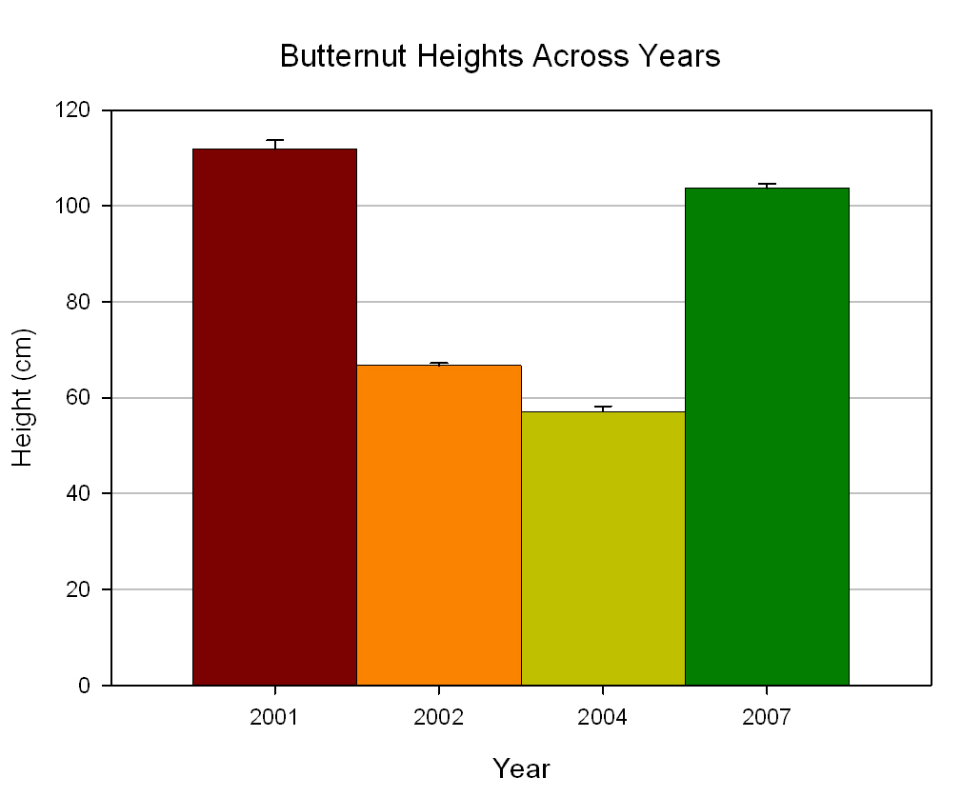
a
b
c
d

Means followed by different letters indicate significant differences at p=0.05 level based on Tukey-Kramer means separation analysis.

Figure III-1. Nursery Trial Totals: Annual variation in initial height.

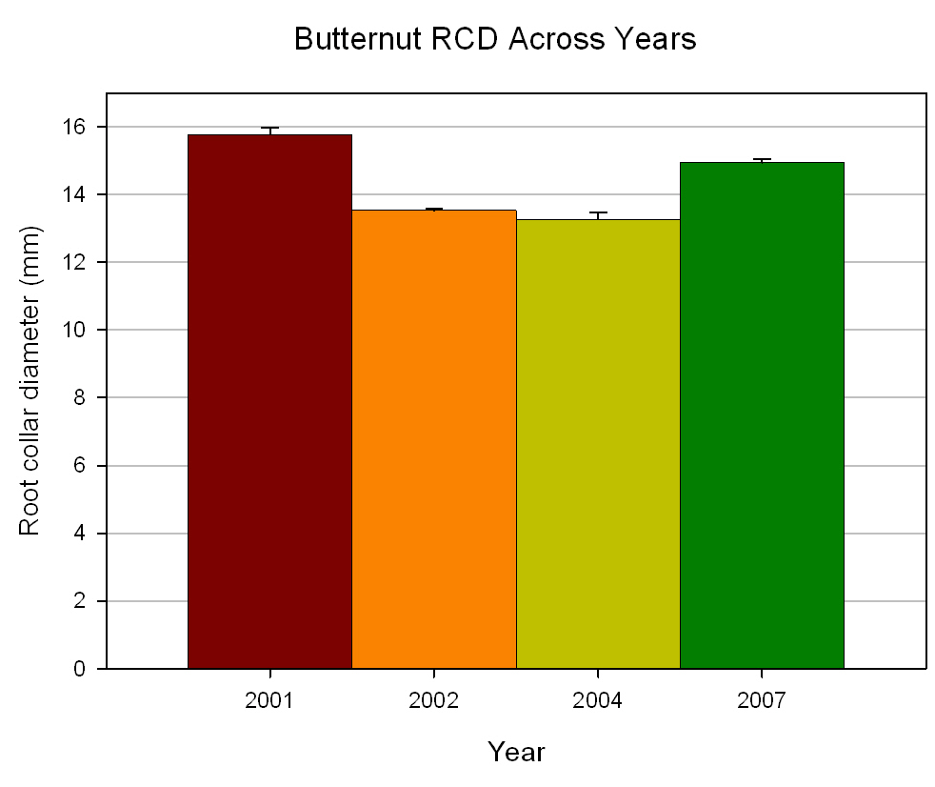
a
a
b
b

Means followed by different letters indicate significant differences at p=0.05 level based on Tukey-Kramer means separation analysis.

Figure III-2. Nursery Trial Totals: Annual variation in initial root collar diameters.

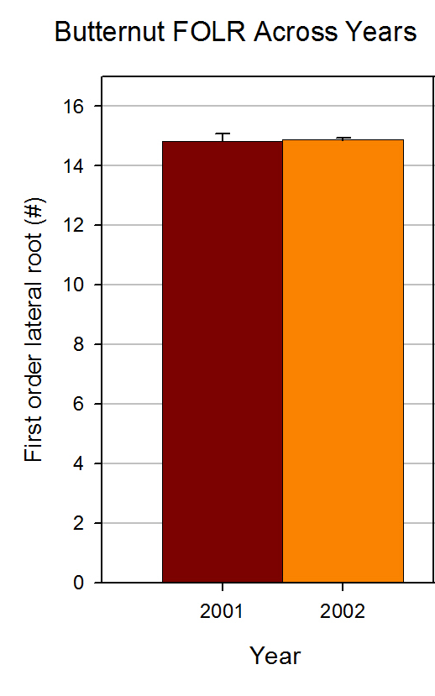
a
a
Means followed by different letters indicate significant differences at p=0.05 level based on Tukey-Kramer means separation analysis.

Figure III-3. Nursery Trial Totals: Annual variation in initial first order lateral root number.
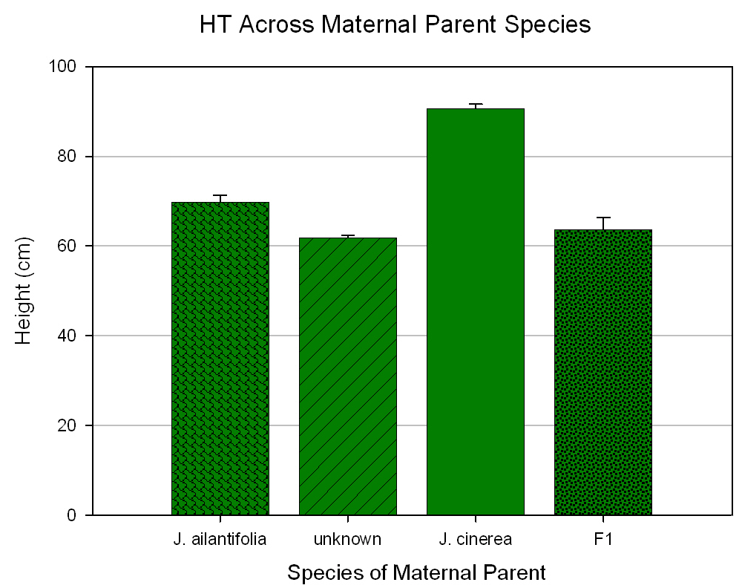
b
bc
c
a
Figure III-4. Nursery Trial Totals: Species variation in heights.
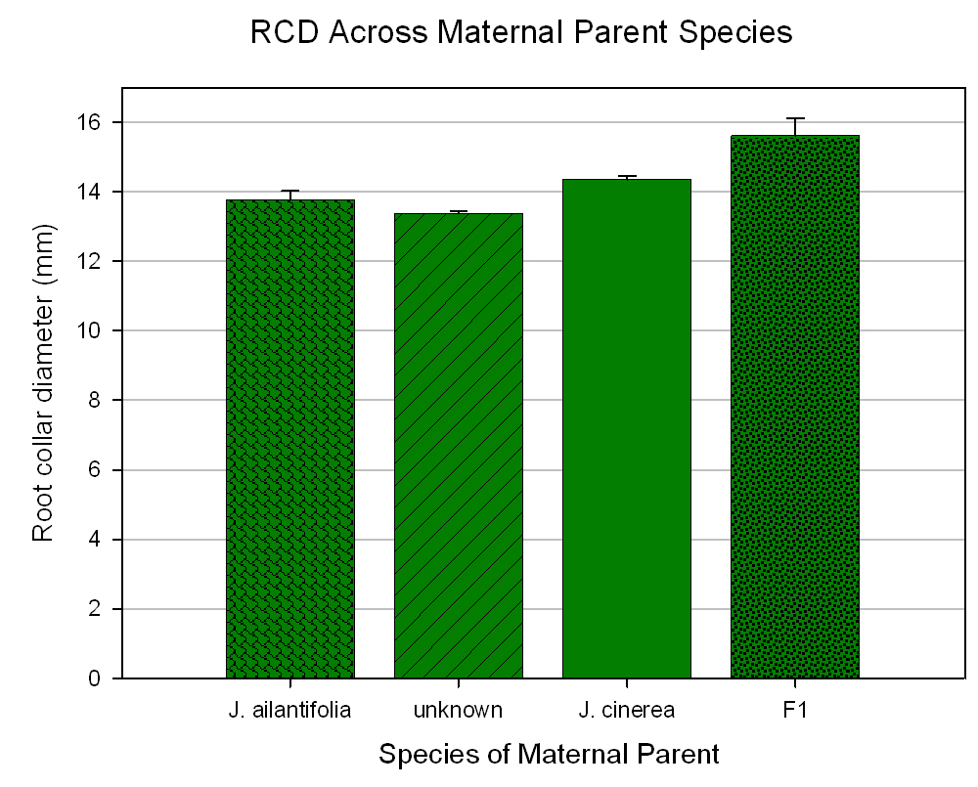
c
a
cc
b

Figure III-5. Nursery Trial Totals: Species variation in root collar diameter.
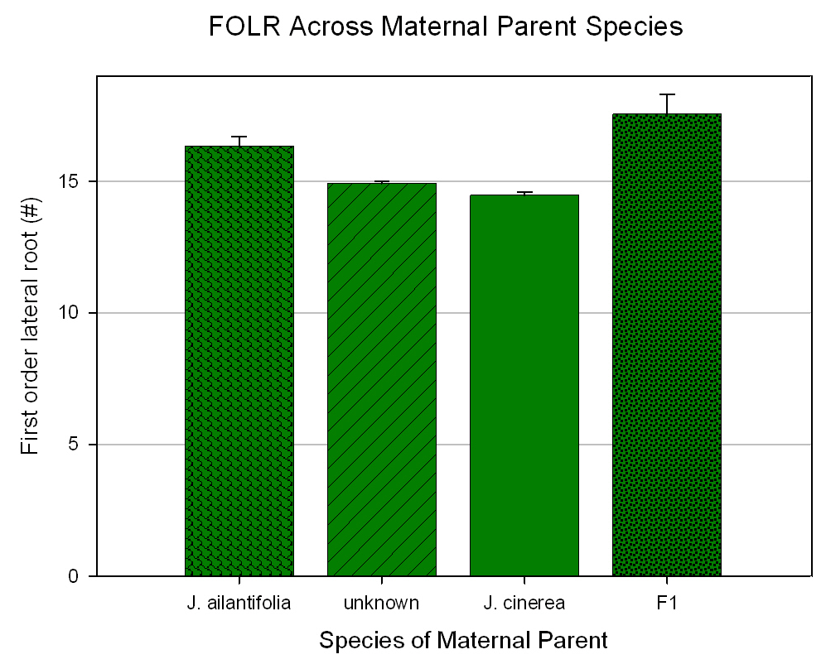
b
a
b
c

Figure III-6. Nursery Trial Totals: Species variation in initial first order lateral root number.

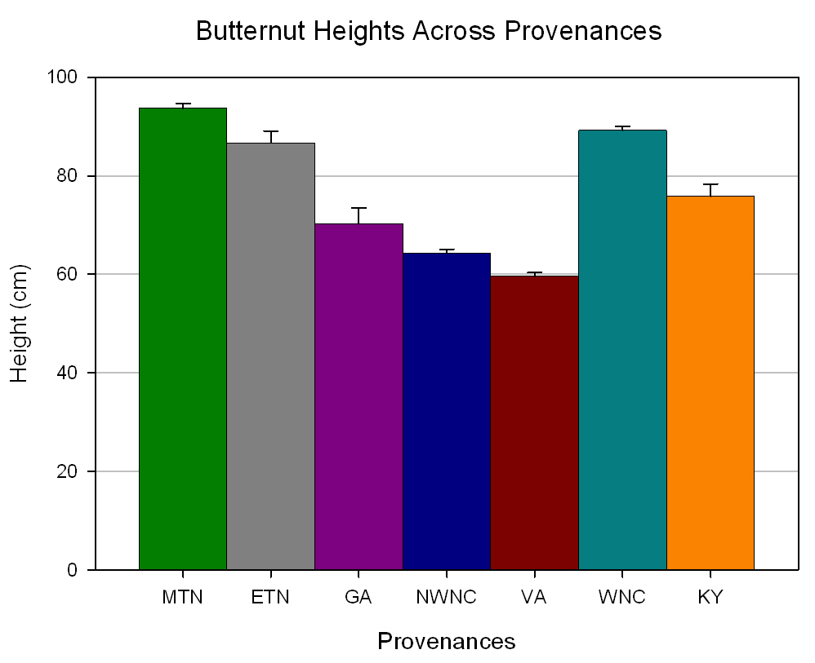

Figure III-7. Nursery Trial Totals: Provenance variation in initial height.

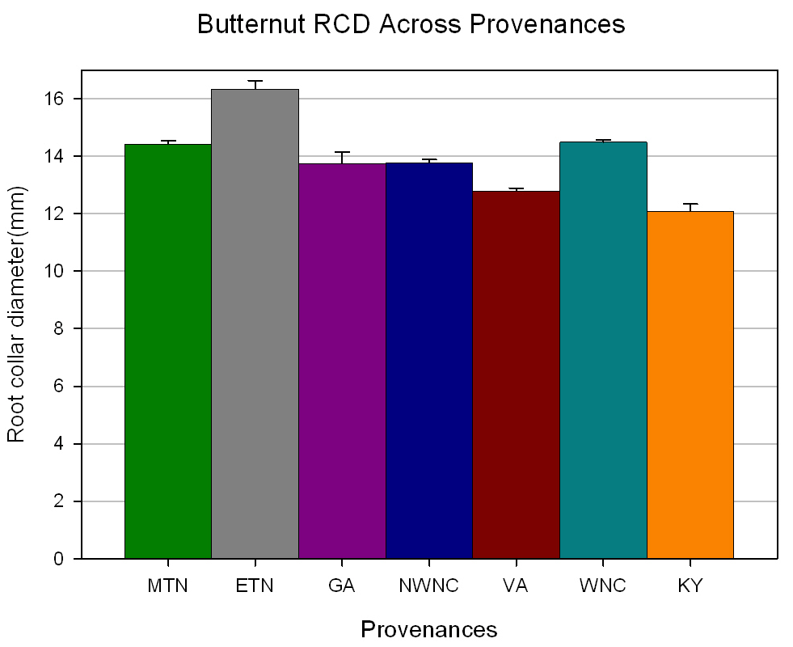

Figure III-8. Nursery Trial Totals: Provenance variation in initial root collar diameters.

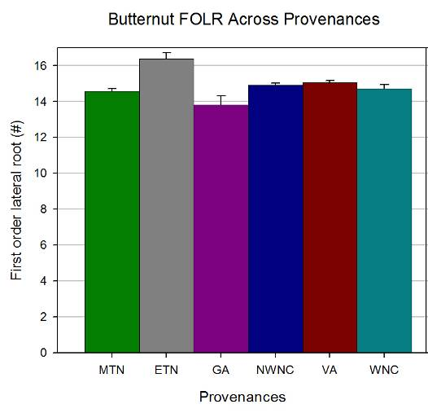

Figure III-9. Nursery Trial Totals: Annual variation in initial first order lateral root number.

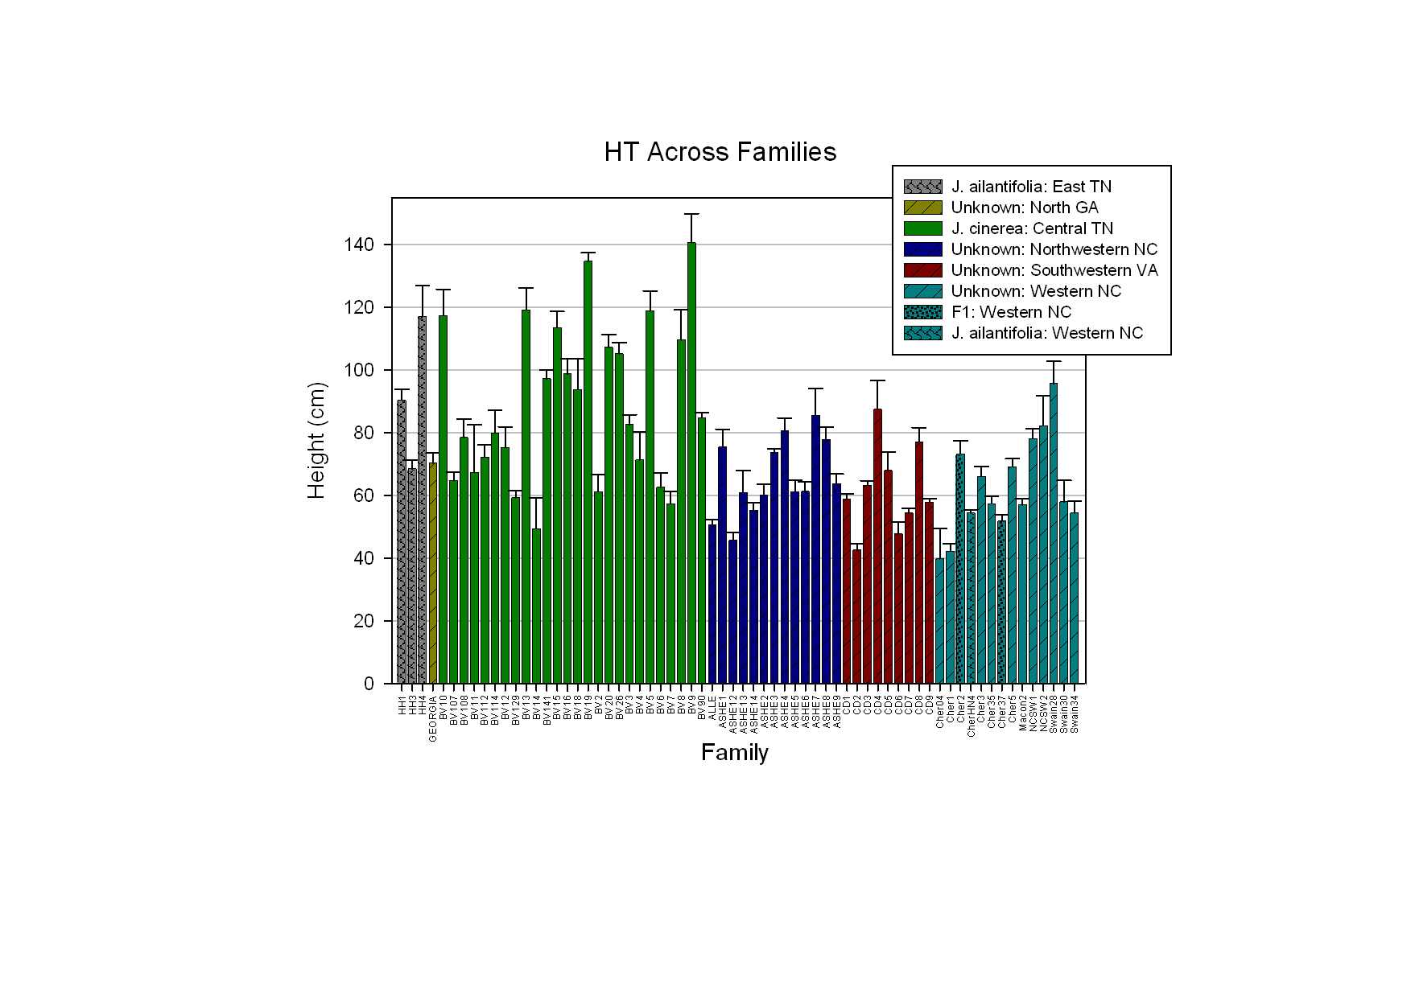

Figure III-10. Nursery Trial Totals: Family variation in initial height.

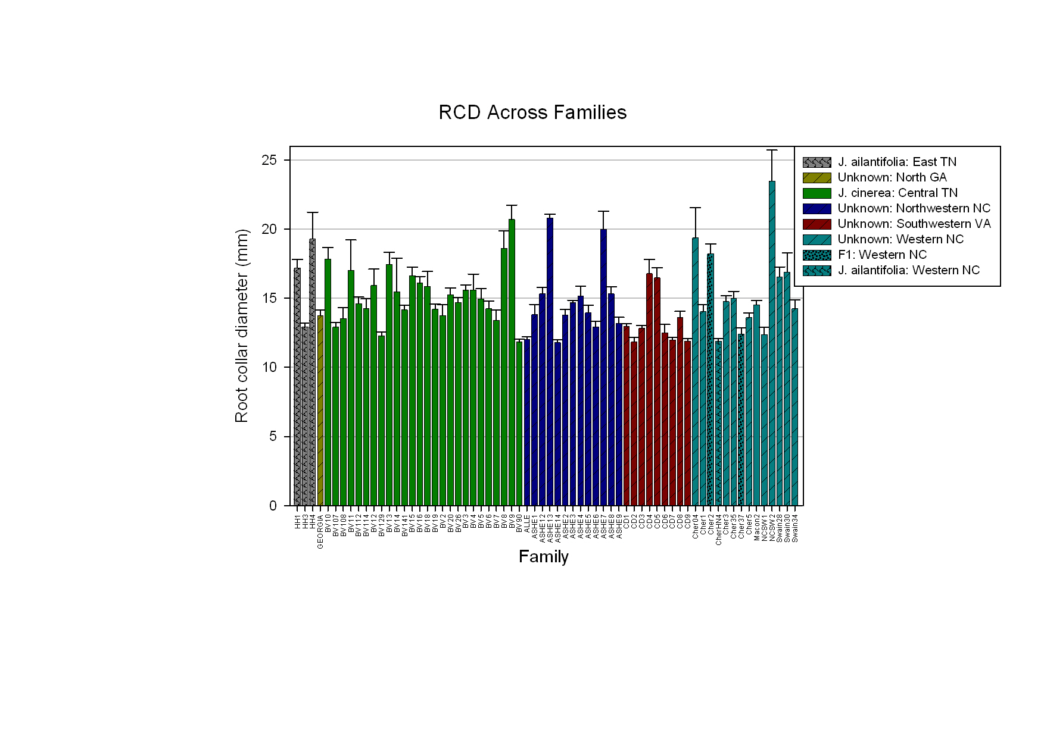

Figure III-11. Nursery Trial Totals: Family variation in initial root collar diameters.

Figure III-12. Nursery Trial Totals: Family variation in initial first order lateral roots.

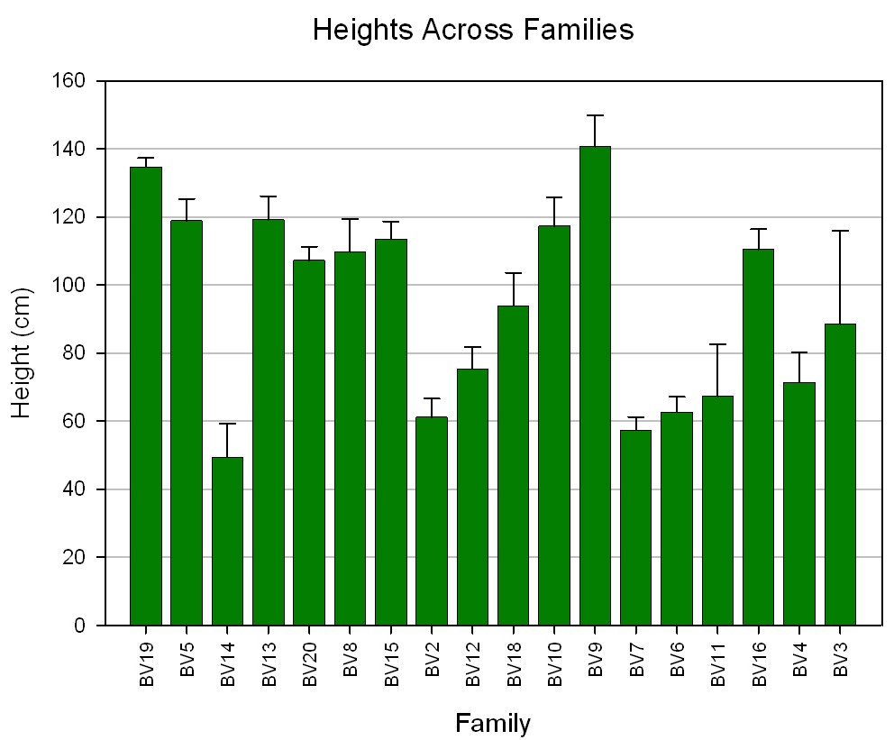
Figure III-13. Height of 1-0 butternut seedlings from across family of origin for Nursery Trial 1.
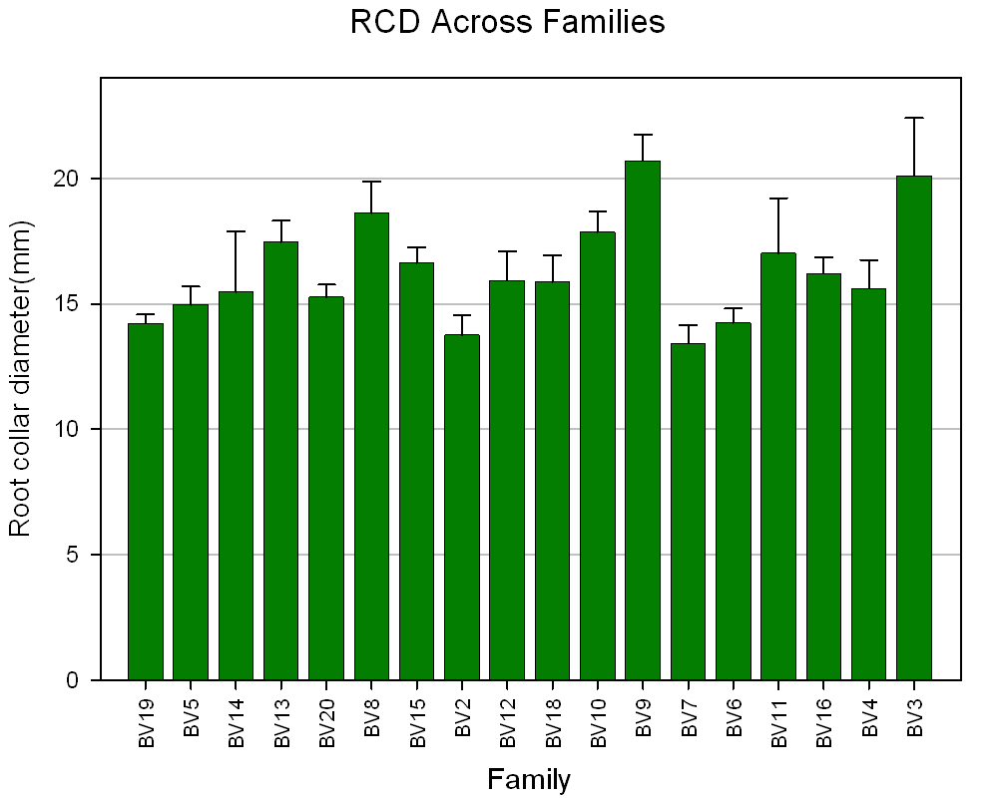
Figure III-14. Root collar diameters of 1-0 butternut seedlings from across family of origin for Nursery Trial 1.

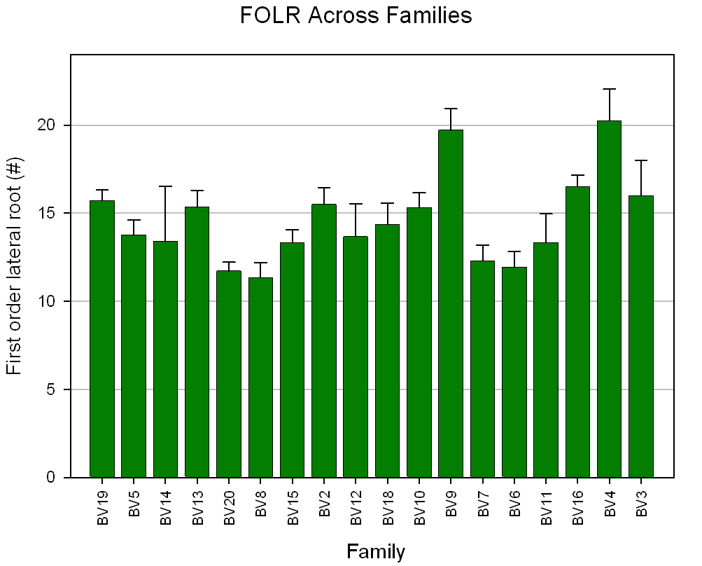
Figure III-15. First-order lateral root number of 1-0 butternut seedlings from across family of origin for Nursery Trial 1.

Figure III-16. Height of 1-0 butternut seedlings from across family of origin for Nursery Trial 2.

Figure III-17. Root collar diameter of 1-0 butternut seedlings from across family of origin for Nursery Trial 2.

Figure III-18. First-order lateral root number of 1-0 butternut seedlings from across family of origin for Nursery Trial 2.

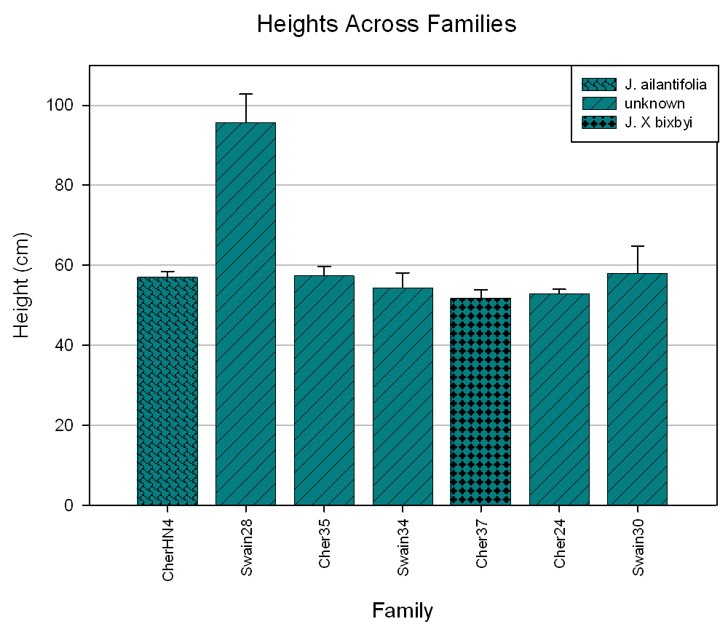
Figure III-19. Height of 1-0 butternut seedlings from across family of origin for Nursery Trial 3.

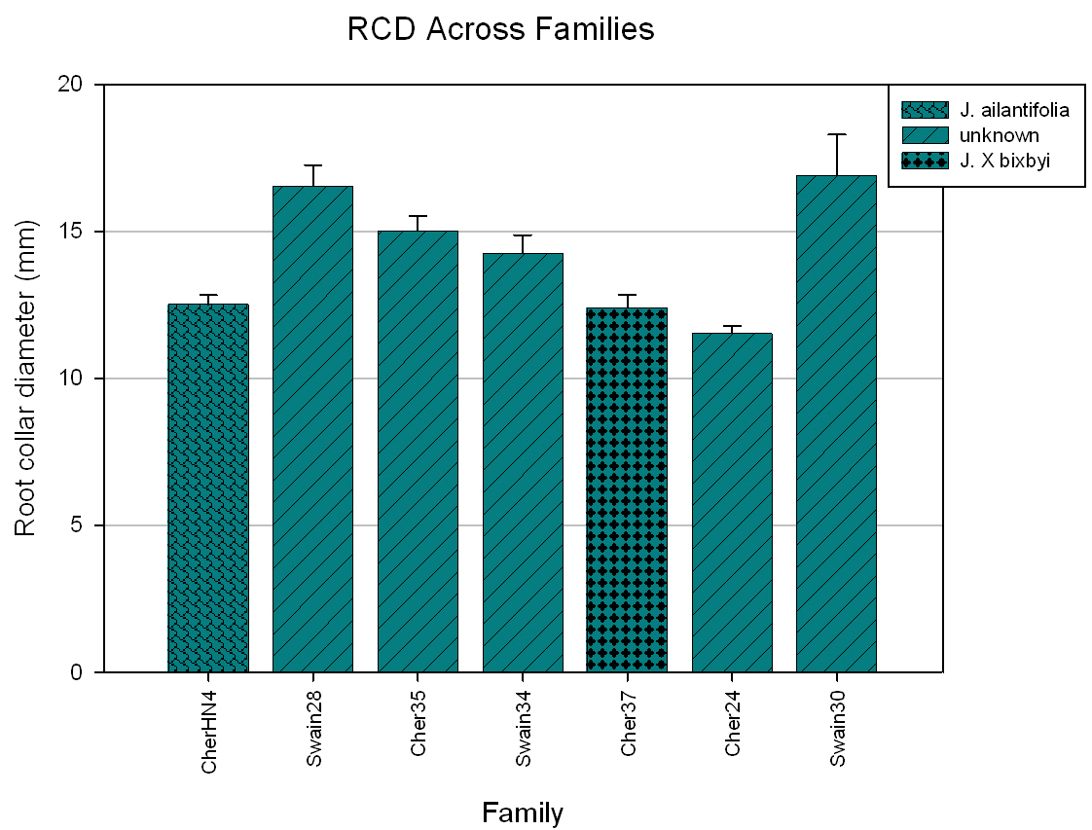

Figure III-20. Root collar diameter of 1-0 butternut seedlings from across family of origin for Nursery Trial 3.

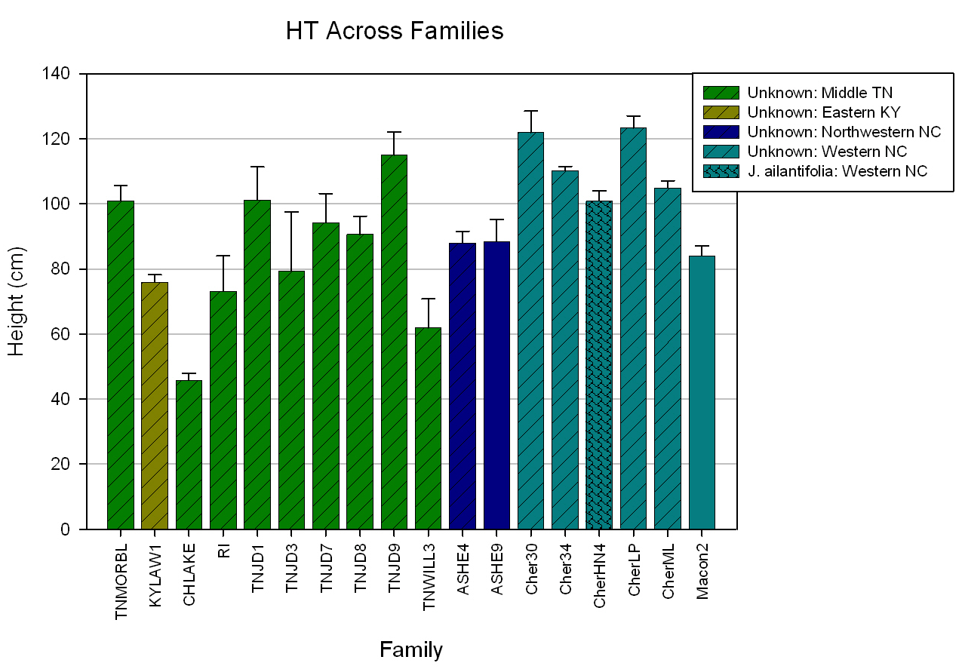

Figure III-21. Height of 1-0 butternut seedlings from across family of origin for Nursery Trial 4.

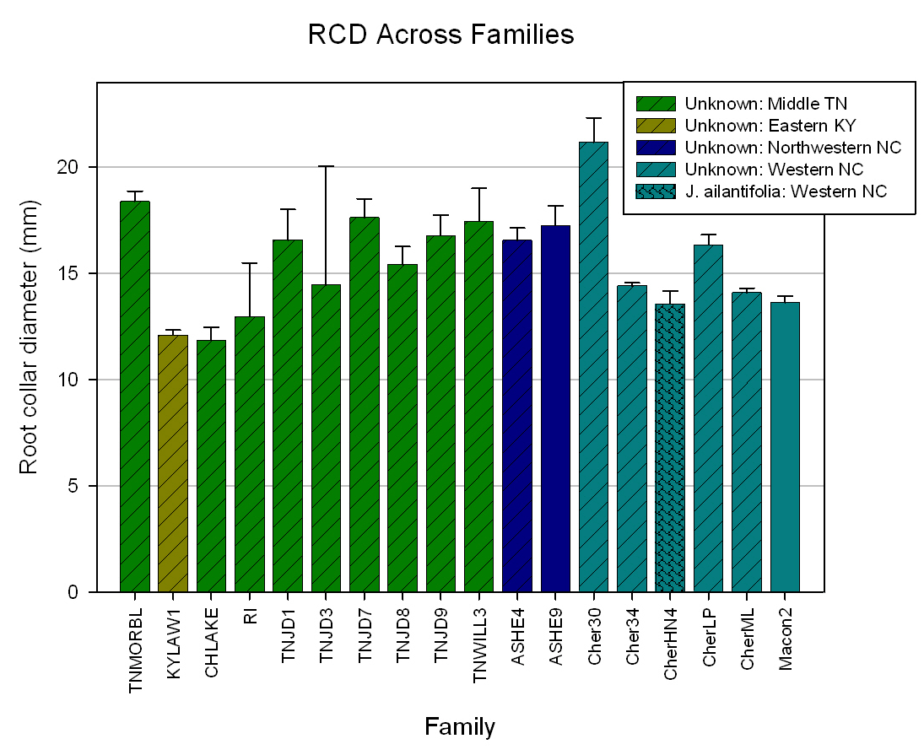

Figure III-22. Root collar diameter of 1-0 butternut seedlings from across family of origin for Nursery Trial 4.

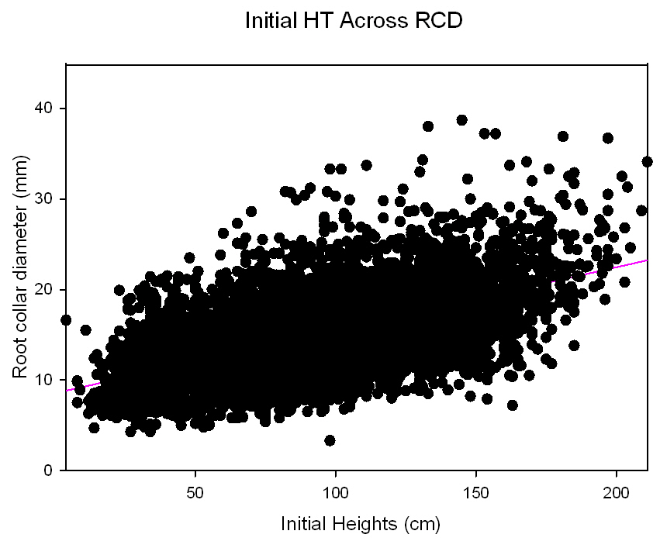
r²=0.4000
Figure III-23. Nursery Trial Totals: Variation in initial heights across initial root collar diameters.

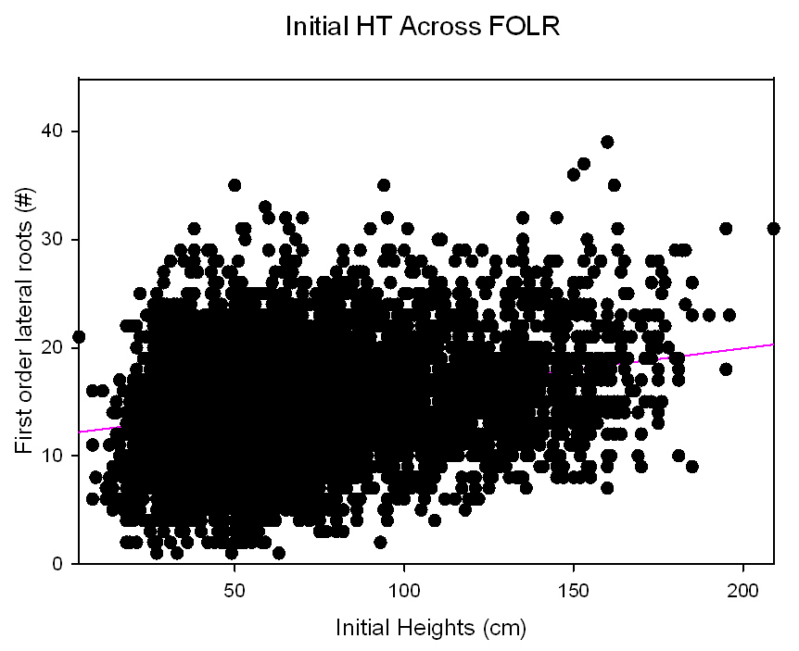
r²=0.0804

Figure III-24. Nursery Trial Totals: Variation in initial heights across initial first order lateral root numbers.

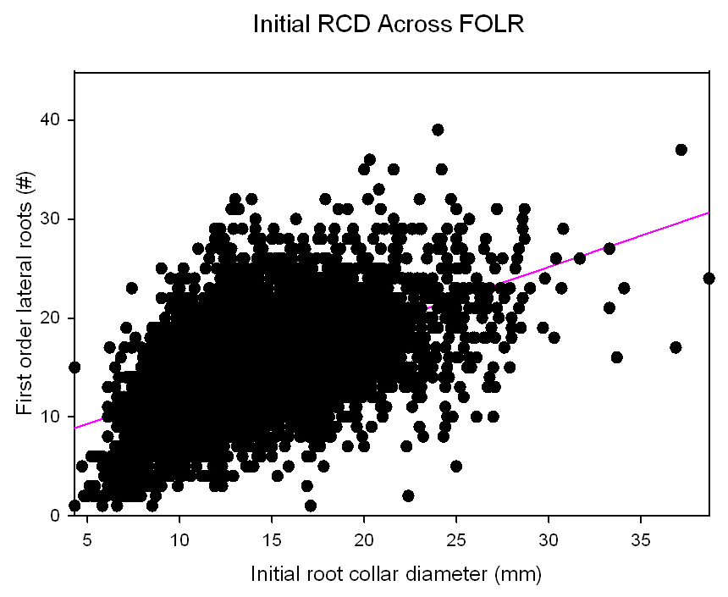
r²=0.2829
Figure III-25. Nursery Trial Totals: Variation in initial root collar diameters across initial first order lateral root numbers.

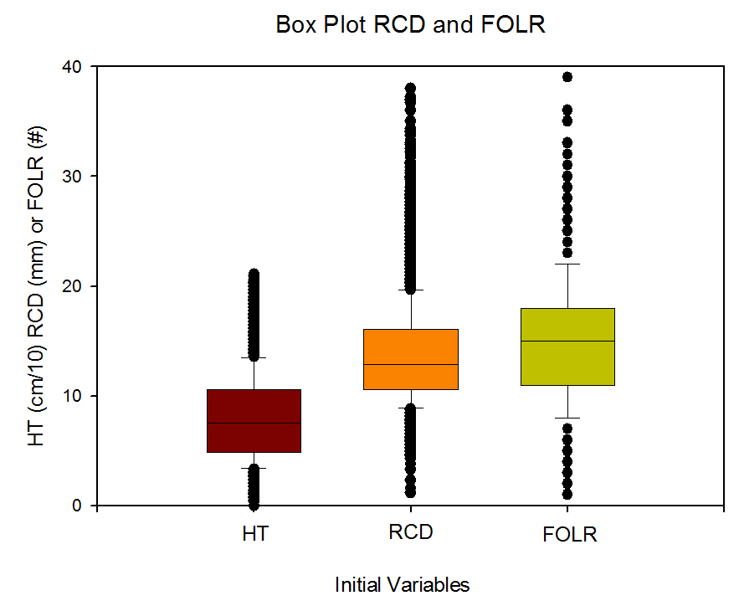

Figure III-26. Nursery Trial Totals: Distribution of initial characteristics of height, root collar diameter and first order lateral root number.
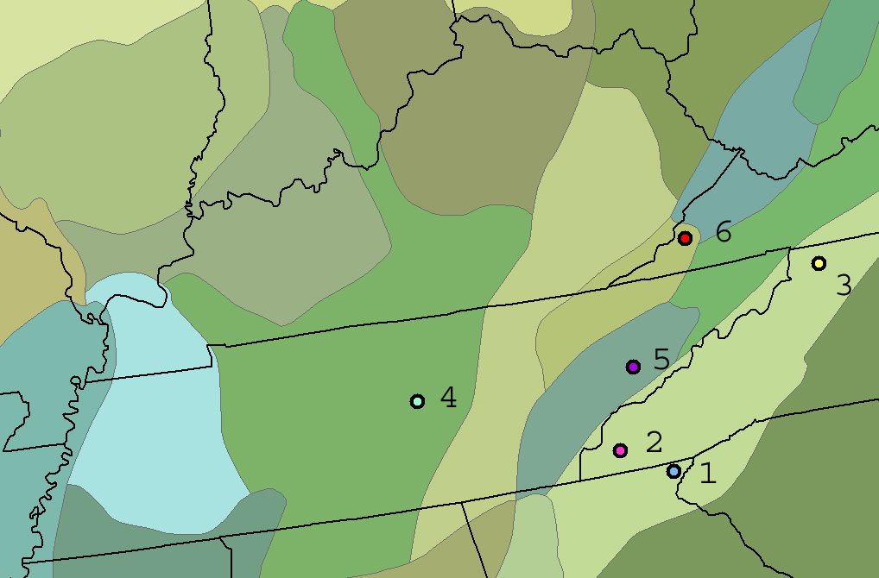

Figure III-27. Nursery Trial 2, origins of provenances for the 42 parent trees where butternut seeds were collected delineated by Bailey’s Ecoregions (Bailey 1995) in the Southern Appalachians.

1. Northern Georgia, N-GA, Blue Ridge Mountains
2. Western North Carolina, W-NC, Blue Ridge Mountains
3. Northwestern North Carolina, N-NC, Blue Ridge Mountains
4. Central Tennessee, M-TN, Interior Low Plateau, Highland Rim
5. East Tennessee, E-TN, Central Ridge and Valley
6. Northwestern Virginia, N-VA, Southern Cumberland Mountains

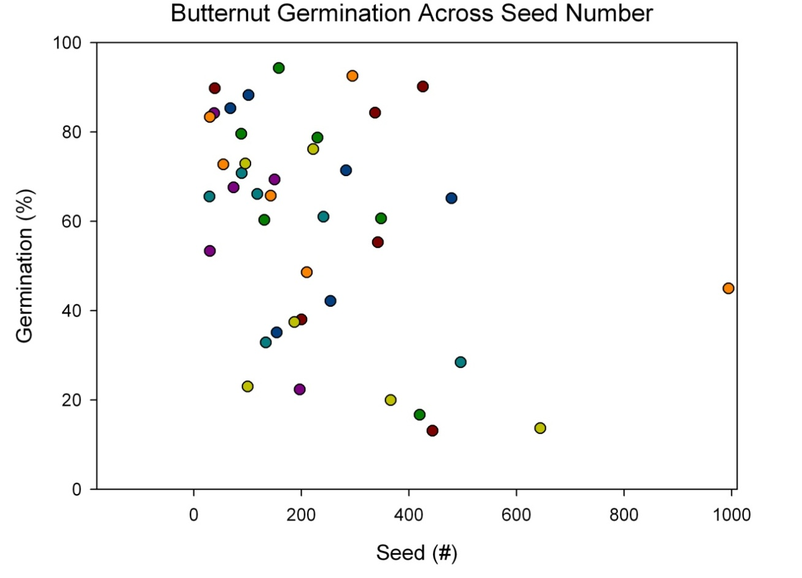
Figure III-28. Nursery Trial 2, percent germination of butternut seed across numbers of seed collected. R² = 0.1592

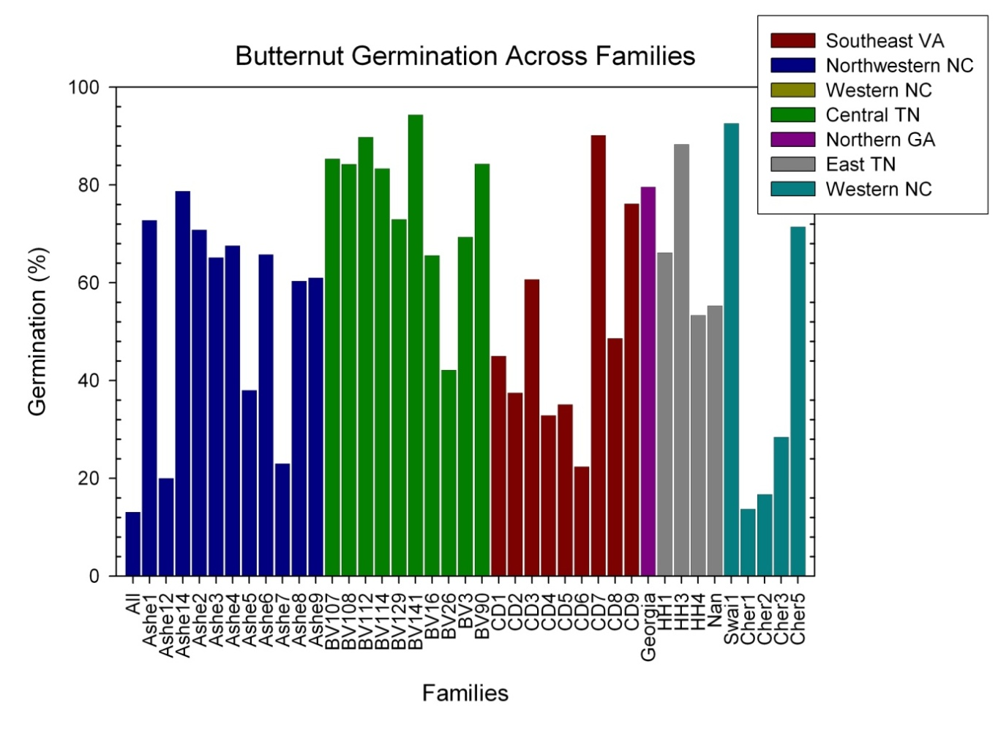

Figure III-29. Nursery Trial 2, percent germination of butternut seed across provenance and family of origin.

SURVIVAL, GROWTH, AND DISEASE OF BUTTERNUT PROGENY IN RESISTANCE SCREENING PLANTINGS

Abstract
Butternut, Juglans cinerea L., is being impacted by butternut canker disease which is eliminating butternut from various locations, particularly in the southeastern United States. Sirococcus clavigignenti-juglandacearum (V.M.G. Nair, Kostichka, & Kuntz), the causational fungus has expected to be impacting trees since at least the 1920s. Butternut is a short-lived, early successional tree species and also is being eliminated due to crown closure of even-aged stands in riparian areas. Locations adequate for enrichment plantings will guide restoration protocols for this important mast producing species. Over two thousand seedlings were planted in various stand histories and manipulations in Tennessee and surrounding states (Kentucky, Virginia, and North Carolina). Seedlings resulted from open-pollinated nut collections from eleven distinct families. Seedlings conditions were evaluated prior to planting to determine potential impacts on establishment success. The plantings took place on fifteen sites at seven locations in Tennessee and surrounding states. Plantings were one of four types: open grasslands, open grasslands with trees in shelters, shelterwoods, and on reclaimed surface mines. Survival and height growth varied across sites, families, and initial seedling conditions. Mortality was 19% in the first year and 26% in the second year with the greatest mortality on surface mines (29, 47%) and the least on open grasslands (9, 17%). Seedlings planted in shelterwoods were taller at the end of the second year (130 cm) than seedlings in all other planting types (92 cm). Seedlings in shelterwoods were competing with seedlings and sprouts for light, which encourages strong apical dominance and height growth. Two specific genetic families were taller than all others and averaged over 120 cm tall. In addition, four families had under 20% mortality compared to one family with greater than 60%. Initial seedling size greatly impacted establishment success. Seedlings < 9 mm in diameter when planted were twice as likely to experience mortality and were 26% shorter than larger diameter seedlings. Seedlings <50 mm in height also experience additional mortality and were 36% shorter after two years than larger seedlings. Selecting larger diameter and taller seedlings from specific genetic families will increase establishment success for butternut.

Introduction

Butternut canker disease caused by the exotic fungal pathogen Sirococcus clavigignenti-juglandacearum (V.M.G. Nair, Kostichka, & Kuntz) is killing butternut (Juglans cinerea L.) trees throughout the native range. A crucial first step in the process of restoration for this species is to determine if genetic resistance to butternut canker disease exists (see Chapter IV). However, successful establishment and growth of resistant seedlings will require an understanding of artificial regeneration procedures and the influences of site, seed source, and seedling quality on establishment success. Success of reintroduction of resistant butternut may increase by incorporating knowledge of the impact of initial conditions on growth and survival (see Chapter IV). In National Parks and National Forests sites in riparian areas for restoration may be limited to areas with various site histories, which area available for planting (National Park Service 1991). These types of areas on public land include previous open fields, riparian areas with an absence of harvesting, and in forested areas with various silvicultural manipulations. Correspondingly, planting success will require a greater understanding of the types of sites where the seedlings can become established and sustain growth.

Artificial regeneration of butternut
Butternut has been cultivated since 1633; a half-century before black walnut and other North American Juglans species (cf. Brinkman 1974). Artificial regeneration of butternut, however, has never been widely practiced in the United States or Canada, due to abundant natural regeneration in some areas and the selection of other walnuts for timber and nut production (Ostry and Pijut 2000). Butternut has been noted to have a quickly developing root system that requires transplanting early in seedling development (Rink 1990). A few recent plantings of butternuts have occurred, but artificial regeneration of butternut has had mixed results. Establishment of 2-0 butternut stock in tree shelters in 1998 was unsuccessful due to shading from competing hardwood spouts and heavy shrubs (Ostry et al. 2003). Success of planted seedlings could be aided by using large seedlings that will compete vigorously with surrounding competition and rapidly grow above deer browse level.

Site selection
Historically, artificial regeneration of butternut was conducted on old field sites for reforestation and for species conversion to timberlands, timber and nut production (Ostry et al. 2003). When butternut seedlings were planted in five different canopy openings in two different habitat types to test for optimal conditions to promote growth, greater height and diameter occurred on better habitat types (Cummings Carlson 1997). A planting of 2-0 nursery stock in 1998 of butternut occurred on a stand in Wisconsin (Ostry et al. 2003). The 2-0 stock was out-competed by hardwood sprouts and heavy shrubs and mortality, unrelated to disease, was high (Ostry et al. 2003). However, seedlings growing on clearcut or heavier thinning treatments were more vigorous (Ostry et al. 2003). Direct seedling of butternut has failed (Ostry et al. 2003).
Progeny plantings from 1995 to 2002, where butternut seedlings were planted under the canopy of trees, have shown butternuts’ ability to survive and grow in various light environments (Brosi et al. 2007, Chapter IV). Butternut seedlings were able to persist and grow under the overstory of a mature tree only in certain conditions. In light-saturated environments, butternut seedlings grow, but encounter competition. Overall, the greatest survival has consistently occurred in areas with more sunlight with the lowest survival in the areas with the most shading. Butternuts on sites without competing vegetation lose apical dominance and become more bush-like in habit. While that form may be ideal for nut production, it is not be suitable for timber and may not be competitive over time if vegetation control would lapse and other woody species invade the site.
Establishment success of butternut for timber production or as a component of the surrounding forest is optimized by selecting sites with characteristics that allow seedlings to become initially established and subsequently have enough competition for the seedlings to retain apical dominance, yet vigorously compete with surrounding vegetation. For butternut in particular, initial seedling height coupled with a corresponding large root system may be paramount to butternut survival. Ostry et al. (1994) observed that vigorously growing saplings may have outgrown the girdling effects of the canker. Therefore, a strong relationship may exist among seedling quality, survival and competitive ability, and delaying the impact of the butternut canker disease.

Seedling origin
Seed source and genetic family can impact survival and growth of butternut seedlings (see Chapter IV). However, genetic families haven’t been evaluated over a large number of sites. Extensive research has shown variation in establishment success of black walnut (Juglans nigra L.) and English walnut (Juglans regia L.) is partially attributed to genetic family and individual genotypes within families (Bey 1973, Rink et al. 1994, Bresnan et al. 1994, Geyer and Rink 1998). Black walnut progeny plantings, after 17, 21, 22, and 35 years have shown significant differences in height growth and heartwood production between open-pollinated families indicating the opportunity for gains from selection (Bresnan et al. 1994, Geyer and Rink 1998). In black walnut progeny plantings selection of superior progenies to improve rotation height and diameter may occur at age 4 to 6 years (Kung 1975, McKeand et al.1979, Rink et al. 1994). Heritability of height growth increased steadily after age until age 10 (Rink 1984), and leveled off at age 10 (Rink and Kung 1995). Evaluation of a 20-year old planting determined that anytime after age 8 was acceptable for selection (Rink and Kung 1995). However, in a spatial non-replicated study Michler et al. (2003) found rank shifting and increases in heritability occurring between ages 10 and 15. Butternut genetic families need long-term evaluation to determine if specific families had superior height growth over time.

Seedling characteristics
Low success in hardwood plantings success is often a result of damage by animal browse (Marquis 1974; Martin and Baltzinger) and herbaceous and hardwood competition which overtop artificial regeneration planted in open areas (Cogliastro et al. 1990, Kolb et al. 1990, Willoughby and McDonald 1999). Variability in planting stock quality of hardwood seedlings often results in planting failures and low vigor (Johnson 1981, Johnson et al. 1986, Wendel 1980). Seedling establishment success has increases with the quality of the nursery stock for northern red oak (Quercus rubra L.) (Zaczek et al. 1997, Dey and Parker 1997, Ward et al. 2000, Jacobs et al. 2004). Traditionally, nurseries grow hardwood seedlings according to their own procedures in dense spacing, producing small, uniform sized seedlings that facilitate shipping and plantings (Johnson 1981, Kormanik and Ruehle 1987). The demand for large stock for black walnut seeding production has been investigated through seed selection and nursery techniques since at least 1947 (Chase). Over the past decade, nursery practices have adjusted density of plantings and fertilization and irrigation applications in order to produce large hardwood seedlings (Kormanik et al. 1994a, Kormanik et al. 1994b).
Field establishment of large seedlings shifts the competitive advantage toward the seedlings and reduces losses due to herbivory (Ward et al. 2000). Large nursery stock can quickly become established in the field and can be produced by adjusting nursery practices (Kormanik et al.1994a). Selecting large seedlings has increased establishment success for a variety of hardwood species including oak species (Quercus L.) (Kormanik et al. 1997, Schlarbaum 1993, Clark et al. 2000). In addition to height (HT), root collar diameter (RCD) at measured at 1.3 cm above the root collar, has been used as an indicator of seedling condition (Ruehle and Kormanik 1986). Nursery-grown hardwood seedlings with larger RCD, prior to outplanting, have been shown to result in better survival and growth after outplanting than smaller stock (Olson and Hopper 1972, Zaczek et al. 1997). Progeny establishment plantings have occurred on black walnut seedlings have been grown under optimal nursery conditions (Schultz and Thompson 1990, 1997). RCD and stem height can also predict establishment success for black walnut seedlings (Schultz and Thompson 1990, 1997).

Objectives
Seedling characteristics, including initial seedling height and RCD, were found to impact survival and growth of butternut seedlings on particular sites (see Chapter IV). Those plantings, however, were designed as butternut canker resistance tests not as restoration experiments. The goal of this experiment was to establish butternut restoration plantings to evaluate the effect of various factors including site, genetic family, and nursery characteristics on initial butternut seedling survival and growth. The objectives of this project are to aid in the restoration of butternut by a better understanding of site requirements, seed source selection, and the impacts of seedling quality.
- Objective 1). Determine establishment success across various individual sites and site categories;
- Objective 2). Determine if some genetic families are superior in terms of growth and establishment success
- Objective 3). Determine if relationships between initial seedling variables (HT and RCD) and establishment success are present. Seedlings will be categorized by initial variable to determine impacts of initial size on establishment success.
This is the first evaluation of butternut progeny tests across various sites using high quality seedlings.

Methods

Progeny collection
In the fall of 2003, 10,984 butternuts were collected from 17 open-pollinated genetic families from three ecoregions Virginia, Tennessee and North Carolina (sensu Bailey 1995, Figure V-1, note tables and figures appear in appendixes). Seven open-pollinated families had over 600 nuts per family. The butternuts were dehusked and planted at the Georgia Forestry Commission’s Flint River Nursery in Byromville, Georgia in December, 2003. The resulting seedlings were grown for one growing season (2004) using fertilization and irrigation regimes developed by the USDA Forest Service’s Institute of Tree Root Biology (Kormanik et al. 1994a). The seedlings were lifted in February, 2005 using a Forbo machine that undercut the root systems at 30 cm.

Planting sites
Over 2,000 seedlings from the half-sibling families were sorted into experimental plantings using an incomplete block within complete block design and single tree plots. Plantings were established on sites with four varying site histories across four southern states. Plantings occurred on 15 sites in seven locations on public and private land in Tennessee, Virginia, North Carolina, and Kentucky (Table V-1, Figure V-2). Seedlings were planted on various sites after various stand manipulations and site histories (Table IV-1, #1-4). The plantings took place on four types of sites: 1. open grasslands, 2. open grasslands using tree shelters, 3. shelterwood harvests, and 4. surface mines. Plantings in open grasslands (1) included a former Forest Service Work Center (TN-OC1), former recreational area (VA-CL), and former hay fields (NC-KA1, KA2). The open grassland with tree shelters (2) included a new orchard site (NC-HO). Shelterwoods (3) included previous year timber harvesting with 30% basal area retention (NC-GF1, GF2, AP1, and AP2) and a site located near a beaver pond with heavy thinning due to beaver activity (TN-OC2). Shelterwood sites had commercial harvest that removed 70% of the total stand basal area (Loftis 1990, 1993). Sites in surface mines (4) were on ripped mine spoil benches near artificial ponds with limited grading to reduce compaction. Tree shelters were manufactured by TreePro© and were 4.5 inches in RCD (11.4 cm) and five feet tall (1.5 m). Seedlings planted in tree shelters are experiencing full sunlight free from any competition. Seedlings were placed in tree shelters at this site due to heavy deer pressure in the planting area. This site was in an area where hunting is prohibited and herd sizes are artificially large due to lack of natural predators. The two plantings in old agricultural fields close to each other had one site where competition was controlled (KA-2) and one where competition was not controlled (KA-1).
The plantings were established in a completely random design using single-tree family plots on 1.5m (5 ft) spacing. The seedlings were manually planted in 30 cm deep holes made by gas powered hand augers with six inch drill bits. At the time of planting the seedlings were measured for initial HT and RCD. HT was measured from the ground to the terminal bud to the nearest 0.5 cm using a meter stick and RCD was measure at ground level using digital calipers. These initial measurements were considered 2004 condition. After the first growing season (2005) and the second growing season (2006), the seedlings were measured for their responses, in terms of survival, HT, RCD, condition, and growth form. Seedling condition, i.e. evidence of dieback, disease, or deer browse, was evaluated.
Seedlings were categorized based on initial seedling size into three HT classes and two RCD classes. HT classes were > 50 cm, 50-100 cm, and >100 cm. RCD classes were < 9 mm or ≥ 9 mm.

Statistical analyses
Statistical analyses were conducted using SAS version 9.1 (for Windows, © 2005 SAS Institute Inc., SAS Campus Drive, Cary, North Carolina 27513, USA). Additional macros developed by A. Saxton (1998, 2004) were used for means separation. Macros included pdmix800 for means separation using multiple range tests (Saxton 1998), Mixed Model Analysis of Variance Macro (mmaov) uses Fisher's Least Significant Difference (LSD) test was conducted at the 5% significance level, determines if standard deviations are within five fold of each other, calculates Levene P values to determine equality of variances, and a Shapero-Wilk W test for normality (Saxton ©2002). Least-square survival and HT means of each family were converted to relative survival and heights, expressed as a percentage of the plantation mean. All percentage data, derived from count data, including survivorship and presence of cankering, underwent inverse trigonometric sine transformations due to lack of homogeneity of variances (Snedecor and Cochran 1998).
Objective 1). Yearly seedling variables (percent HT growth, percent RCD growth, and percent survival) were analyzed across planting sites using analysis of variance (PROC MIXED). Fixed effects included sites and families: site, rep (site), block (site*rep), site*family. Seedling response, in terms of growth and survival, were treated as independent variables. Tukey’s pairwise means comparisons were used to separate means when a statistically significant overall effect was established (SAS 2005).
Objective 2). Yearly seedling variables (percent HT growth, percent RCD growth, and percent survival) were analyzed across families using analysis of variance (PROC MIXED). Seedling response, in terms of growth and survival, were treated as independent variables. Tukey’s pairwise means comparisons were used to separate means when a statistically significant overall effect was established (SAS 2005).
Objective 3). Phenotypic correlations were calculated using Pearson’s correlation analysis for year to year family means on survival and growth (PROC CORR). Correlations were also calculated between year to year seedling variables and between year-before HT and RCD to specific-year survival and HT. Analyses of variance were conducted on categories of initial seedling variables described previously.

Results

Seedling production
The 2004 growing season had relatively high levels of precipitation, which promoted Phytophthora root rot disease [casual agent: P. cinnamomi Rands] at the Flint River Nursery. The disease severely impacted the seedlings and caused a great reduction in the number of families and seedlings available for planting. After culling seedlings affected by root rot, only ten families remained with a total of 2,201 seedlings suitable for planting. The studies were measured immediately following planting for HT and RCD. This data represented the data from the end of the 2004 growing season. Just after planting the seedlings had a HT of 87.61 cm and a RCD of 12.61 mm. Unlike other years (2001, 2002, 2004, and 2007) where seedlings were measured prior to planting (see Chapter III), these seedlings were measured after outplanting.

Overall growth and survival
The average HT at the end of the 2005 growing season was 89.70 and the average RCD was close to 14.96 mm. The seedlings average an increase of HT of two cm since planting, not significant, and a significant increase of 2.35 mm in RCD in the first year after planting (p>0.001). Overall survival was 81.82% for the first year.
At the end of the seedlings second year in the planting locations (2006), the average HT of the seedlings was 110.02 cm; greater than initial HT and first year HT growth (p>0.001, Error! Reference source not found., Error! Reference source not found.). The average RCD, 18.68 mm, was larger than the previous years (p>0.001). Over twenty percent of the seedlings were over 2 meters in HT, and 45% of the seedlings were larger than the mean. The seedlings have had a 19% increase in HT (20 cm) and a 21% increase in RCD (3.9 mm) since the previous year. Since planting the seedlings had increased 20 and 33% for HT and RCD respectively. Overall survival was 71.85%.

Objective 1: Planting sites
Height growth and survival varied in percent among sites (Table V-3). During the first year survival varied across planting sites with 33% of the sites with greater than 90% survival, 53% with greater than 80% survival, and 73% with greater than 70% survival during the first year (Table V-2). First year survival was over 70% on all sites except for two sites on a surface mines and two forested sites (Figure V-6). HT also varied among planting locations in 2005. At both the TN-OC and the NC-AP sites, increased HT was found on sites with greater mortality where competition for with competing vegetation was high.
Second year survival varied across planting sites with the highest survival at 90% and the lowest at 20%. Just under half of the sites had over 80% survival, with 20% of the sites with under 60% survival (Error! Reference source not found.). The tallest sites had seedlings averaging 50% taller (159 cm) compared to the shortest sites (80 cm). RCDs were also 36% larger on one site (25.17 mm - 16.20 mm, Table V-2).
Grouping sites by site types showed that for both years, the greatest survival occurred on open grasslands (9, 17%) and the least on surface mines (29, 47%) (Figure V-6). The sites in open grasslands had the lowest percent mortality for both 2005 and 2006 (9.48 and 16.63%, Table V-3). Percent mortality in 2005 and 2006 was similar in open grasslands with tree shelters (23.80, 25.54) and in shelterwoods (20.85, 28.13). All sites on surface mines had higher mortality for both years compared to all other sites (29.47, 47.38%, Figure V-7).
Total HT in 2006 was largest in sites in shelterwoods (Table V-3). Seedlings planted in shelterwoods were taller at the end of the second year (130 cm) than seedlings in all other planting types (92cm). Sites located on grasslands had the second tallest average HT, followed by sites on surface mines and in tree shelters. Only sites on surface mines and in tree shelters had a decrease in HT over the two growing seasons (Figure V-8). On surface mines dieback during the first year (13.06% decrease in HT), continued though was less dramatic in the second year (1.79% decrease in HT). Reduction in HT also occurred at the one site with tree shelters. In 2006, over six sites had seedlings averaging over 120cm, five of these sites were in forested stands and the other site was in an open grassland with competition controlled: KA-2 (Figure V-5).
The one open grassland with tree shelters had only 74% survival and an average seedling HT of 80.6cm (15-178) and average RCD of 17.13 mm (8-35). This is an increase in RCD of almost 5 mm since outplanting. None of the seedlings are over 2 meters in HT, only 8.52% are over 1.5 meters, 33.52% are over 1 meter, and 49.35% of the seedlings are larger than the mean. The seedlings have RCD growth rates similar to the other plantings, but not similar rates of HT growth.
The KA-1 old field site without competition controlled had 83.33% survival and an average HT of 106.52 (16-192) and a RCD of 19.11mm (3-41). Only 8% of the seedlings were over 1.5 meters and 56% were larger than the mean. The KA-2 site with competition controlled had over 81% survival, lost only 10% in one year, and an average seedling HT of 123.93 cm (15-240) and average RCD of 25.17 mm (3.9-62.5). Five percent of the seedlings at this site were over 2 meters tall, 33% over 1.5 meters, 53% greater than the mean, and over 67% of the seedlings were larger than 1 meter in HT.

Objective 2: Family effect
The impact of genetic family was statistically significant for all variables (Table V-4). Initial seedling HT and RCD varied across family of origin. Prior to planting some genetic families were nearly twice the average HT of others. These family differences continued for the 2005 and 2006 growing season (Figure V-10). Two specific genetic families were s taller than all others and averaged over 120 cm tall in 2006 (Figure V-11). In addition, four families had under 20% mortality compared to one family with greater than 60% (Figure V-12).

Objective 3: Seedling variables
Overall relationships Overall the impact of initial characteristics on 2006 height was significant for HT (Figure V-13) and RCD (Figure V-14). All significant variables were significantly phenotypically correlated except for 2006 HT and mortality (Table V-5). Similar to results found in other years, initial HT and RCD were significantly correlated (0.42), but with a lower value than found when measuring seedlings prior to planting in other nursery trials (see Chapter III). The strongest relationships were between HT of consecutive years: (initial HT and HT05: 0.60, HT05 and HT06 0.56).
Relationships by seedling size category Initial seedling size class greatly impacted establishment success (Table V-6). Seedlings < 9 mm in RCD when planted were twice as likely to experience mortality and were 26% shorter. Seedlings < 50 mm in HT also experience additional mortality and were 36% shorter after two years.

Discussion

Site conditions
Butternuts were successfully established on a variety of site conditions. Large differences in HT over the various planting sites indicate variation in sites for height growth. The greatest survival occurred on old agricultural fields, and the greatest height gains occurred on shelterwoods. Sites with tree shelters and mine spoils experienced heavy mortality and reduced height growth.
Old agricultural fields appear to be particularly good locations for restoration, although long-term survival and growth is not known. Surveys for butternut, however, found many locations in fence rows and by houses on non-typical butternut sites (UT-TIP data on file). Dendrochronology evidence indicates butternut recruitment in old agricultural fields (Clark et al. 2008). Therefore butternut may be an ideal species for Conservation Resource Enhancement Program (CREP) plantings. Timber production on these sites may not be an option, as form becomes more favorable for nut production for hard mast. Butternut may also be an ideal species for agroforestry applications. Temperate agroforestry involves multicropping of agricultural crops under high value plantations and intercropping of high values tree species with other commercially valuable crops and animal grazing (Gold and Hanover 1987). Butternut may also provide the increased profit of nuts prior to harvesting for timber. The impacts of juglone in walnut species, including butternut, have limited companion planting for Juglans. However, agroforestry applications of J. nigra have shown great potential for reforestation, timber and polyculture applications (Scott and Sullivan 2007). Many non-timber forest products that require shade are tolerant to juglone and the juglone could act as a resource reducing unwanted competition (Scott and Sullivan 2007). Production of black walnut in combination with shade-tolerant agroforestry crops could be possible with Ribes L., Sambucus nigra L. ssp. canadensis (L.) R. Bolli, Morus rubra L., Astisima triloba (L) Dunal, and Diospyros virginiana L. Species such as American ginseng (Panax quinquefolius L.) have also been found in association with black walnut (Apsley 2004, Carroll 2004). Black walnut may also provide shade for mushroom production (Scott and Sullivan 2007). In addition mixed species plantings of black walnut have show the ability to plant juglone-tolerant species for increased height growth in walnut and production of Robinia pseudoacacia L., Pinus strobus L., Fraxinus americana L., Quercus rubra L. and Acer rubrum (Scott and Sullivan 2007). Planting butternut in association with juglone tolerant species on open sites may increase profitability for landowners and result in ideal conditions for growth form and establishment. This is especially important as plantings in open areas may require extensive competition control and the application of fertilizers. Agroforestry can offer landowners options for quicker returns on investments in high quality timber species.
Shelterwoods with 30 basal area retention were also ideal sites for butternut plantings. There was lower survival than open field plantings, but increased HT growth was present in surviving seedlings. The seedlings in forested stands are competing with seedlings and sprouts for light, which may result in increased mortality, but also encourages strong apical dominance and HT growth. Mortality on these sites was primarily in smaller seedlings; under 50 cm in height and under 9 mm in diameter. The larger seedlings were able to establish with limited mortality after the first year. Shelterwoods have been important for establishment of Quercus rubra L. (Loftis 1990, 1993). Increased height growth of butternuts in shelterwoods is similar to studies done with American chestnut two years after planting where 3.5 times taller seedlings were found on shelterwoods verses midstory removal treatments (Rhoades et al. 2009).
At the end of the second growing season, the seedlings on shelterwood sites averaged 85 cm at planting, 95 cm after the first year and 130 cm after two years. The height of the seedlings after two years was above deer browse, in southern states with limited snowpack. Deer can be a major obstacle to successful hardwood seedling establishment (Kolb et al. 1990, Gillespie et al. 1996). Gillespie et al. (1996) found decreased growth on Juglans nigra three years after planting due to heavy deer browse on unprotected seedlings. Planting high quality seedlings on sites capable of supporting growth above deer browse in the second year after outplanting will increase establishment success. Survival in the forest shelterwoods indicates potential success for restoration in gap dynamics in riparian areas of state and national parks. Clark (1958) mentions butternut as a component of old-growth stands in forest gaps.
Considering that there was only one site that used tree shelters, it is difficult to make general statements about restoration using this approach for planting butternuts. The use of shelters resulted in large RCD increases in seedlings but also high mortality and decreased HT compared to other sites. Tree shelters cause a general shading of the seedlings with the exception of the open top. Studies using intolerant oak species (Quercus L.) and American chestnuts (Castanea dentata (Marsh.) Borkh.) have shown that tree shelter shading plus general forest shade can reduce seedling growth and ultimately can cause mortality (UT-TIP data on file). Studies on Quercus rubra L. found that shelters increased height growth until seedlings emerged from the shelters (Gillespie et al.1996). Tree shelters have also increased height growth in black walnut (Ponder 1991, Ward and Stevens 1995). However, Gillespie et al. (1996) had the greatest amount of mortality two years after planting on seedlings in tree tubes (12%) compared to control (0%). The use of tree shelters for butternut needs to be further explored with additional studies.
The surface mines plantings were on areas that were not intensively graded and were ripped to decrease compaction. Philo et al. (1982) found increased survival of J. nigra seedlings in areas with limited intensive grading and ripping. Second year survival on the seedlings were 85% and 65% (Philo et al. 1982). Ashby (1996) found survival of J. nigra on ripped mine spoils to be 74% twelve years after outplanting, with seedlings averaging 550 cm tall. Butternut experienced lower survival rates than black walnut indicating that the seedlings are more negatively impacted by the highly compacted spoil. Though surface mine sites may superficially appear to provide habitat for many riparian tree species; planting in mine spoil soils is very different than planting in undisturbed riparian habitats. Butternut showed lower survival than previous black walnut studies on similar sites. Long-term survival on these sites is unknown. In two years almost half of the seedlings planted had died and HT had decreased since outplanting. The root system structure of butternut, with larger lateral roots may have resulted in the lack of suitability on mine spoils.
Though tree shelters and mine spoils appear to negatively impact butternuts height growth; butternut readily establishes on old agricultural sites and in shelterwoods. Butternut is able to establish and compete on a variety of sites with increased success in shelterwoods and agricultural fields. Long-term survival and growth on each site, however, is yet to be determined as site conditions will change over time.

Families
Family identity impacts survival and growth of butternut seedlings. Seedlings from certain genetic families were significantly taller and therefore, more likely to survive. Seedlings from one particular provenance, east Tennessee, had families with very different survival and height than other families. The RF family had the highest average height of seedlings and very little mortality. Another family, Sevier2, came from the same east Tennessee area and was the shortest of all of the seedlings and had by far the highest amount of mortality. The four families with under 20% mortality were from two neighboring counties in western North Carolina. One of these families was the second tallest family in 2006. With butternut, it is important to monitor specific progeny that are sown in the nursery and established in the field. Field testing will allow the selection of maternal parents who consistently produce nuts with high germination rates, seedlings with larger RCD and greater heights, and with higher probabilities of survival after outplanting. The maternal trees can be grafted and planted on seed orchard spacing to aid restoration by providing seeds that will produce seedlings with a higher probability of establishment success and vigorous growth.

Seedling characteristics
Selecting larger RCD seedlings and taller seedlings from specific genetic families will increase establishment success for butternut. Changes of survival were increased by 50% for seedlings having a RCD of at least nine mm at the time of planting. This is consistent with studies from previous years (see Chapter IV). Planting of high-graded seedlings will increase survival and reduce planting costs, as you would plant at a different density. Nursery costs per seedling would increase in respect to the potential survival of each seedling. Refinement in high-graded nursery seedlings offers the ability to purchase a seedling with a high probability of success. Public land managers and private landowners alike could base the grade of the seedling they select on scientific estimates of the establishment potential of individual seedling groups as done in this study. However, smaller seedlings could be given to landowners who can offer the additional attention to establish the smaller seedlings.
Transplant shock is a common obstacle in bare-root hardwood seedlings (Struve and Joly 1992). In establishment of J. nigra, reduced height and RCD growth has been documented even with or without the addition of fertilizer (Jacobs et al. 2005). If the transplant shock continues for several years increased mortality results as the competing vegetation continues to overtop seedlings. Butternut seedlings in this study only experienced this problem in the first growing season. The seedlings showed very little increase in growth over the first growing season. In the second growing season, however, both HT and RCD growth increased significantly. Percent HT change was drastically larger during the second growing season than the first. This lag in establishment time could be due to several factors including the large size of the seedlings resulting in extensive root pruning prior to planting. However, the larger seedlings continued to be larger even after outplanting, indicating that transplant shock or recovery rate was not a significant problem in larger seedlings. Based on this study’s results, outplantings of butternut seedlings will require competition control only during the first-growing season because of this lag time in establishment. Completion control after the first year may not be as necessary.
A potential solution to the impact of transplant shock is planting of seed instead of seedlings. Direct seedling of butternut was tried by Ostry et al. (2003) and failed. Generally, butternut seedlings have been used in reforestation due to the potential for seeds being eaten by various animals. Barrier systems to protect nuts have been investigated for American chestnut. However, their effectiveness has yet to be proven. One unique solution that might be applied to direct seedling of butternut is the use of predator odors (Rosell 2001). The use of red fox (Vulpes vulpes) and raccoon (Procyon lotor) scent deterred foraging by gray squirrels (Sciurus carolinensis) (Rosell 2001). Fox and raccoon scent were more effective than human or white-tailed deer (Odocoileus virginianus) scent (Rosell 2001). If nuts could be protected, by readily available fox scent, there may be an increased benefit in planting individual nuts to reduce transplant shock and transportation costs. Future studies should compare the benefits of direct seeding of butternut, protected by fox scent, compared with transplanting 1-0 nursery stock.

Conclusions

Butternuts were successfully established on a variety of sites with the greatest survival on old agricultural fields and the greatest height growth on shelterwoods. Specific genetic families had increased survival and growth. Maintaining genetic family identity may assist by selecting maternal parents with increase establishment success of offspring. Transplant shock in butternut during the first year resulted in limited height growth. Competition control during this time period will increase chances for survival.

Literature Cited

Anderson, R.L., retired USFS, personal communication, 2002.
Anagnostakis, S. L. 2007, Diaporthe eres (Phomopsis oblonga) as a Pathogen of Butternut (Juglans cinerea) in Connecticut. Plant Disease: Notes. 91 (9): 1198.

Bailey, R.G. 1995. Description of the Ecoregions of the United States, Second ed. USDA Miscellaneous Publication, 1391.

Bixby, W.G. 1919. The butternut and the Japan walnut. American Nut Journal. 10(6): 76-83.
Brosi, S.L., S.E. Schlarbaum, A. M. Saxton, R.L. Anderson, P.S. Spaine, and C. Young. 2007. Restoring butternut (Juglans cinerea L.) to southeastern forests: determining a genetic basis of disease resistance (Tennessee). Ecological Restoration: Vol. 25 (1): 51-54.

Busov, V.B., G. Rink, S.E. Schlarbaum, and J. Zuo. 1997. Allozyme variation within and among several Juglans L. species and their hybrids. Pp 69 In J.W. Van Sambeek, ed. Proceedings of the Fifth Black Walnut Symposium, Knowledge for the Future of Black Walnut, July 28-31, 1996, Springfield, Missouri, Ed., p. 69.

Clark, S.L. S.E. Schlarbaum, and P.P. Kormanik. 2000. Visual grading and quality of 1-0 northern red oak seedlings. Southern Journal of Applied Forestry. 24 (2): 93-97.

Clark, S.L., S.L. Brosi, S.E. Schlarbaum, H.D. Grissino-Mayer. 2008. Dendrochronology of two butternut (Juglans cinerea) populations in the southeastern United States. Forest Ecology and Management. 255 (5-6): 1772-1780.
Cogliastro, A., D. Gagnon, and A. Bouchard. 1997. Experimental determination of soil characteristics optimal for the growth of ten hardwoods planted on abandoned farmland. Forest Ecology and Management. 96: 49-63.
Davis, C. and T. Meyer. 1997. Field guide to tree diseases of Ontario. Noda/NFP Technical Report TR-46. Can. For.Serv. Pp. 135.
Davis, D.D., Torsello, M.L., McClenahen, J.R. 1997. Influence of Cryphonectria parasitica basal cankers on radial growth of scarlet oak in Pennsylvania, Plant Disease, 81 (4): 369-373.
Doyon, F., A. Bouchard, and D. Gagnon. 1998. Tree productivity and successional status in Québec northern hardwoods. Ecoscience. 5(2): 222-231.
Fjellstrom, R. G., and D. E. Parfitt. 1995 Phylogenetic analysis and evolution of the genus Juglans (Juglandaceae) as determined from nuclear genome RFLPs. Plant Systematics and Evolution 197: 19–32.
Hoban, S., T. McCleary, S. Schlarbaum, and J. Romero-Severson. 2009. Geographically extensive hybridization between the forest trees American butternut and Japanese walnut. Biological Letters. 5:324-327.
Hygnstrom, S.E., P.D. Skelton, S.J. Josiah, J.M. Gilsdorf, D.R. Virchow, J.A. Brandle, A.K. Jayaprakash, K.M. Eskridge, and K.C. VerCauteren. 2009. White-tailed Deer Browsing and Rubbing Preferences for Trees and Shrubs That Produce Nontimber Forest Products. HortTechnology. 19 (1): 204-211.

Johnson, P.S., C.D. Dale, and J.R. Law. 1986. Planting northern red oak in the Missouri Ozarks: A prescription. Northern Journal of Applied Forestry. 3: 66-38.

Kobayashi, T. 1970. Bulletin of the Government Forest Experimental Station. No. 226.

Kolb, T.E., T.W. Bowersox, and L.H. McCormick. 1990. Influences of light intensity on week-induced stresses of tree seedlings. Canadian Journal of Forest Research. 20: 503-507.

Kormanik P.P., S.S. Sung, and T.L. Kormanik. 1994. Irrigating and fertilizing to grow better nursery seedlings. p. 115-121 IN Ed. T.D.Landis. Proceedings of the Northeast and Intermountain Forest and Conservation Nursery Association. U.S. Department of Agriculture, Forest Service, General Technical Report RM-243.

Kuntz, J.E, A.J. Prey, S. Jutte, V.M.G. Nair. 1979. The etiology, distribution, epidemiology, histology and impact of butternut canker in Wisconsin. In: Walnut insects and diseases,workshop proceedings; 1978 June 13-14; Carbondale, IL. Gen. Tech. Rep. NC-52. St.Paul, MN: U.S. Department of Agriculture, Forest Service, North Central Forest ExperimentStation: 69-72.

Marquis, D.A. 1974. The impact of deer browsing on Allegheny hardwood regeneration. USDA Forest Service, Northern Forest Experiment Station, Research Paper. NE-308.

Martin, J.L. and L.C. Baltzinger. 2002. Interaction among deer browsing, hunting, and tree regeneration. Canadian Journal of Forest Research. 32: 1254-1264.

Morin, R.J. Beaulieu, M. Deslauriers, G. Daoust, and J. Bousquet. 2000. Low genetic diversity at allozyme loci in Juglans cinerea. Canadian Journal of Botany 78: 1238-1243.
Ostry, M.E., M.E. Mielke, and D.D. Skilling 1994. Butternut-strategies for managing a threatened tree. Gen. Tech. Rep. NC-165. St. Paul, MN: U.S. Department of Agriculture, Forest Service, North Central Forest Experiment Station and Northeastern Area State and Private Forestry. 7 p.

Ostry, M. E. and M. Moore. 2001. Butternut canker research progress report number 8. St. Paul, MN: USDA Forest Serviec, North Central Research Station. 8p.

Rink, G. 1990. Juglans cinerea L. Butternut. Pages 386-390 in Burns, R.M.; Honkala, B.H., tech. cords. Silvics of North America. Washington, DC: U.S. Department of Agriculture, Forest Service.

SAS Institute Incorporated. 2005. Cary, NC.

Saxton, A.M. 1998. A macro for converting mean separation output to letter groupings in Proc Mixed. In Proc. 23rd SAS Users Group Intl., SAS Institute, Cary, NC, p: 1243-1246.

Saxton, A.M. 2004. Genetic analysis of complex traits using SAS. SAS Press, SAS Institute, Cary, NC, 312p.

Schlarbaum, S.E., R.L. Anderson, M.E. Ostry, S.L. Brosi, LM. Thompson, S.L. Clark, F.T. van Manen, P.C. Spaine, C. Young, S.A. Anagnostakis, E.A. Brantley. 2004. An Integrated Approach for Restoring Butternut to Eastern North American Forests. Pages 156-158 in Li, Bailian and Steven McKeand, eds. Forest Genetics and Tree Breeding in the Age of Genomics: Progress and Future, IUFRO Joint Conference of Division 2 Conference Proceedings .

Schultz, R.C. and J.R. Thompson. 1990. Nursery practices that improve hardwood seedling root morphology. p. 21-32. In Proceedings Northeastern Area Nurseryman’s Conference, Peoria, IL. July 24-27, 1990.

Schultz, R.C. and J.R. Thompson. 1997. Effect of density control and undercutting on root morphology of 1+0 bare –root hardwood seedlings: five-year field performance of root-graded stock in the central USA. New Forest. 13: 301-14.

Snedecor, G.W. and W.G. Cochran. 1998. Statistical Methods, Eighth Edition, Iowa State Univ. Press, Ames, Iowa, 503p.

Spaine, P., R. Anderson, C. Young, S. Schlarbaum. 1997. Testing methods of disease resistance screening for butternut canker. Supplement to Phytopathology. 87(6): S93. [Abstract].
Stanford, A. M, R. Harden, and C.R. Parks. 2000. Phylogeny and biogeography of Juglans (Juglandaceae) based on matK and ITS sequence data. America Journal of Botany. 87(6): 872-882.
Thompson, L.M., F.T. vanManen, S.E. Schlarbaum, and M. DePoy. 2006. A spatial modeling approach to identify potential butternut restoration sites in Mammoth Cave National Park. Restoration Ecology 14(2):289–296.

Tisserat, N.A. and J.E. Kuntz. 1982. Epidemiology of butternut canker. In: Black walnut for the future. Gen. Tech. Rep. NC-74. St. Paul, MN: U.S. Department of Agriculture, Forest Service, North Central Forest Experiment Station: 18-22.

Van Sambeek, J.W., M.E. Ostry, and J.J. Zaczek. 2003. Survival and Growth of deep-planted, in-leaf grafts in a germplasm repository of canker-resistant butternuts. In: Proceedings of the 13th Central Hardwood Forest Conference, Eds. J.W. Van Sambeek, J.O. Dawson, F. Ponder, Jr., E.F. Lowenstein, and J.S. Fralish. USDA Forest Service North Central Research Station. General Technical Report. NC-234, St. Paul, MN. pp. 476-479.

Ward, J.S., M.P.N Gent, and G.R. Stephens. 2000. Effects of planting stock quality and browse protection type on height of northern red oak and eastern white pine. Forest Ecology and Management. 127: 205-216.

Wendel, G.W. 1980. Growth and survival of planting northern red oak seedlings in West Virginia. Southern Journal of Applied Forestry. 4: 49-54

Willoughby I. and H.G. McDonald. 1999. Vegetation management in farm forestry: a comparison of alternative methods of inter-row management. Forestry. 72: 109.121.

Appendix: Tables and Figures

Table IV-1. Experimental designs of butternut resistance screening plantings.

Site  (# & abbr.¹) | Families  (#) | Seedling per  family (#) | Incomplete  blocks (#) | Families per  block (#) | Seedling  planted (#)
1) CT | 9 | 5-6 | 20 | 5-6 | 120
2) MO | 12 | 6 | 20 | 6 | 117
3) VA | 10 | 4-5 | 20 | 4-5 | 88
4) KY-DB | 21 | 7 | 27 | 7 | 186
5) KY-TNC | 15 | 7 | 30 | 7 | 210
6) KY- MC1 | 12 | 4 | 30 | 4 | 119
MC2 | 8 | 4 | 30 | 4 | 120
7) TN-OC1 | 16 | 5 | 31 | 5 | 160
OC2 | 10 | 5 | 20 | 5 | 200
8) TN-HS | 15 | 5 | 20 | 5 | 95
9) TN-CHL | 16 | 6 | 27 | 6 | 144
10) NC-NR | 16 | 7 | 30 | 7 | 208
11) NC-PI | 16 | 5 | 29 | 5 | 151
12) NC-WA1 | 20 | 6-7 | 20 | 6-7 | 126
WA2 | 10 | 6 | 30 | 6 | 179
TOTAL (Range) | 41 (8-21) | (4-7) | (20-31) | (4-7) | 2,043  (95-210)
¹ See Figure IV-1 for location information.
Table IV-2. Average annual mortality and height for individual and combined butternut plantings from 2002 until 2004.

Plantation (no.) | 2002 Fall |  | 2003 Spring | 2003 Fall |  | 2004 Fall
Plantation (no.) | Mortality (%) | HT (cm) | Mortality (%) | Mortality (%) | HT (cm) | Mortality (%) | HT (cm)
1) CT | 1.9 | 85.93 | 100 | - | - | - | -
2) MO | 0.0 | 59.74 | 24 | 30 | 91.00 | 36 | 73.27
3) VA | 0.0 | 112.33 | 0 | 0 | 126.01 | 0 | 170.90
4) KY-DB | 19.0 | 95.14 | 25 | 85 | 107.01 | 84 | 108.07
5) KY-TNC | 1.1 | 82.67 | 93 | - | - | - | -
6) KY- MC1 | 7.4 | 84.35 | 100 | - |  | - | -
TN-MC2 | 4.2 | 85.63 | 100 | - | - | - | -
7) TN-OC1 | 1.3 | 79.51 | 24 | 77 | 98.16 | 66 | 108.00
TN-OC2 | 1.2 | 71.58 | 25 | 43 | 71.48 | 73 | 78.39
8) TN-HS | 0.0 | 98.63 | 6 | 8 | 123.02 | 19 | 145.27
9) TN-CHL | 1.4 | 78.47 | 17 | 31 | 106.00 | 25 | 118.23
10) NC-NR | 7.3 | 86.91 | 26 | 43 | 83.19 | 92 | 103.44
11) NC-PI | 10.3 | 89.23 | 37 | 96 | - | - | -
12) NC-WA1 | 12.0 | 92.65 | 23 | 36 | 92.89 | 79 | 75.85
NC-WA2 | 0.0 | 90.86 | 5 | 12 | 90.10 | 20 | 87.70
MEANS  (Ranges) | 4.00  (0-10.3) | 88.07  (60-112) | 40.00  (0-100) | 41.91  (0-96) | 97.52  (72-126) | 68  (0-92) | 100.71  (73-171)

Note: sites with greater than 90% mortality were considered destroyed and not measured in sub sequential years.

Table IV-3. Status and average annual mortality and height for individual and combined butternut plantings until 2005.

Plantation (#) | 2005 | 2005 Fall |  | 2006
Plantation (#) | Status | Mortality (%) | HT  (cm) | Status
1) CT | Destroyed | - | - | Destroyed
2) MO | Viable | 88 | 94.38 | Viable
3) VA | Viable | 5 | 256.05 | Viable
4) KY-DB | Viable | 92 | 160.21 | Destroyed
5) KY-TNC | Destroyed | - | - | Destroyed
6) KY-MC1 | Destroyed | - | - | Destroyed
KY-MC2 | Destroyed | - | - | Destroyed
7) TN-OC1 | Viable | 94 | 101.46 | Destroyed
TN-OC2 | Viable | 89 | 128.32 | Destroyed
8) TN-HS | Viable | 36 | 185.32 | Viable
9) TN-CHL | Viable | 37 | 175.70 | Viable
10) NC-NR | Destroyed | - | - | Destroyed
11) NC-PI | Destroyed | - | - | Destroyed
12) NC-WA1 | Viable | 65 | 104.52 | Viable
NC-WA2 | Viable | 31 | 96.78 | Viable
MEANS  (Ranges) |  | 59.67  (5-94) | 144.75  (94-256)

Note: sites with greater than 90% mortality were considered destroyed and not measured in sub sequential years.

Table IV-4. Survival for individual sites and combined butternut plantings until 2005.

Interval (start and end) YR | # at risk at start of interval | # censored during interval | # at risk at end of interval | # who died at end of interval | proportion surviving this interval | cumulative survival at end of interval | SITE
2001-2002 | 1195 | 0 | 1195 | 176 | 0.8527 | 0.8527 | TOTAL
2002-2003 | 1019 | 0 | 1019 | 236 | 0.7684 | 0.6552 | TOTAL
2003-2004 | 783 | 0 | 783 | 187 | 0.6900 | 0.5587 | TOTAL
2004-2005 | 783 | 0 | 783 | 98 | 0.6300 | 0.3122 | TOTAL
2001-2002 | 144 | 0 | 144 | 17 | 0.8819 | 0.8819 | TN-CHL
2002-2003 | 127 | 0 | 127 | 9 | 0.9291 | 0.8194 | TN-CHL
2003-2004 | 118 | 0 | 118 | 8 | 0.9322 | 0.6737 | TN-CHL
2004-2005 | 110 | 0 | 110 | 19 | 0.8273 | 0.4028 | TN-CHL
2001-2002 | 186 | 0 | 186 | 24 | 0.8710 | 0.8710 | KY-DB
2002-2003 | 162 | 0 | 162 | 88 | 0.4568 | 0.3978 | KY-DB
2003-2004 | 74 | 0 | 74 | 35 | 0.5270 | 0.1826 | KY-DB
2004-2005 | 39 | 0 | 39 | 24 | 0.3846 | 0.0243 | KY-DB
2001-2002 | 95 | 0 | 95 | 6 | 0.9368 | 0.9368 | TN-HS
2002-2003 | 89 | 0 | 89 | 2 | 0.9775 | 0.9158 | TN-HS
2003-2004 | 87 | 0 | 87 | 11 | 0.8736 | 0.7495 | TN-HS
2004-2005 | 76 | 0 | 76 | 15 | 0.8026 | 0.5161 | TN-HS
2001-2002 | 117 | 0 | 117 | 30 | 0.7436 | 0.7436 | MO
2002-2003 | 87 | 0 | 87 | 15 | 0.8276 | 0.6154 | MO
2003-2004 | 72 | 0 | 72 | 25 | 0.6528 | 0.2987 | MO
2004-2005 | 47 | 0 | 47 | 29 | 0.3830 | 0.0523 | MO
2001-2002 | 304 | 0 | 304 | 49 | 0.8388 | 0.8388 | NC-WA
2002-2003 | 255 | 0 | 255 | 15 | 0.9412 | 0.7895 | NC-WA
2003-2004 | 240 | 0 | 240 | 34 | 0.8583 | 0.5684 | NC-WA
2004-2005 | 206 | 0 | 206 | 56 | 0.7282 | 0.2741 | NC-WA
2001-2002 | 179 | 0 | 179 | 37 | 0.7933 | 0.7933 | NC-WA1
2002-2003 | 142 | 0 | 142 | 11 | 0.9225 | 0.7318 | NC-WA1
2003-2004 | 131 | 0 | 131 | 31 | 0.7634 | 0.4432 | NC-WA1
2004-2005 | 100 | 0 | 100 | 75 | 0.2500 | 0.0643 | NC-WA1
2001-2002 | 126 | 0 | 126 | 12 | 0.9048 | 0.9048 | NC-WA1
2002-2003 | 114 | 0 | 114 | 4 | 0.9649 | 0.8730 | NC-WA1
2003-2004 | 110 | 0 | 110 | 3 | 0.9727 | 0.7683 | NC-WA1
2004-2005 | 107 | 0 | 107 | 20 | 0.8131 | 0.4934 | NC-WA1
2001-2002 | 88 | 0 | 88 | 1 | 0.9886 | 0.9886 | VA
2002-2003 | 87 | 0 | 87 | 0 | 1.0000 | 0.9886 | VA
2003-2004 | 87 | 0 | 87 | 0 | 1.0000 | 0.9774 | VA
2004-2005 | 87 | 0 | 87 | 3 | 0.9655 | 0.9224 | VA

Table IV-5. Average initial seedling variables and annual mortality and height for 2005 across provenance and genetic family.
Provenance Name | Family  Name | Parent Species | Initial |  |  |  | 2005
Provenance Name | Family  Name | Parent Species | (#) | HT (cm) ¹ | RCD (mm)² | FOLR (#)³ | HT (cm) | RCD  (mm) | HT Change (%) | Survival (%)
North Georgia | Raba1 | Unknown | 70 | 63 | 13 | 13 | 149 | 23 | 27 | 25
Western  North Carolina | Cher1 | Unknown | 88 | 43 | 14 | 18 | 104 | 13 | 68 | 10
Western  North Carolina | Cher2 | J. X bixbyi | 70 | 74 | 18 | 18 | 107 | 18 | 34 | 27
Western  North Carolina | Cher3 | Unknown | 141 | 66 | 15 | 18 | 67 | 13 | 8 | 23
Western  North Carolina | Cher5 | Unknown | 202 | 69 | 14 | 11 | 62 | 25 | 30 | 37
Western  North Carolina | Maco2 | J. cinerea | 189 | 43 | 14 | 18 | 103 | 15 | 41 | 41
Western  North Carolina | Swai1 | Unknown | 273 | 51 | 12 | 13 | 94 | 17 | -34 | 50
Northwestern  North Carolina | Ashe1 | Unknown | 40 | 68 | 13 | 18 | -- | -- | -- | --
Northwestern  North Carolina | Ashe2 | Unknown | 63 | 53 | 13 | 14 | 180 | 26 | 56 | 11
Northwestern  North Carolina | Ashe3 | Unknown | 312 | 73 | 15 | 16 | 103 | 19 | 0 | 28
Northwestern  North Carolina | Ashe4 | Unknown | 50 | 74 | 14 | 12 | -- | -- | -- | --
Northwestern  North Carolina | Ashe5 | Unknown | 76 | 61 | 14 | 17 | -- | -- | -- | --
Northwestern  North Carolina | Ashe6 | Unknown | 94 | 62 | 13 | 14 | 105 | 17 | 47 | 87
Northwestern  North Carolina | Ashe7 | Unknown | 23 | 87 | 20 | 16 | 100 | 14 | 5 | 53
Northwestern  North Carolina | Ashe8 | Unknown | 79 | 78 | 15 | 15 | 181 | 22 | 26 | 100
Northwestern  North Carolina | Ashe9 | Unknown | 147 | 64 | 13 | 14 | 109 | 17 | 2 | 35
Northwestern  North Carolina | Ashe12 | Unknown | 73 | 46 | 15 | 18 | 137 | 21 | 40 | 45
Northwestern  North Carolina | Ashe14 | Unknown | 181 | 54 | 12 | 14 | 117 | 17 | 42 | 60
Northwestern  North Carolina | Alle1 | Unknown | 58 | 71 | 11 | 16 | 84 | 15 | 42 | 26
Central Tennessee | BV3 | J. cinerea | 104 | 82 | 15 | 16 | 191 | 25 | 37 | 53
Central Tennessee | BV16 | J. cinerea | 19 | 65 | 15 | 17 | 226 | 27 | 66 | 60
Central Tennessee | BV26 | J. cinerea | 107 | 105 | 15 | 16 | 174 | 22 | 10 | 29
Central Tennessee | BV90 | J. cinerea | 284 | 85 | 12 | 13 | 126 | 16 | 14 | 30
Central Tennessee | BV107 | J. cinerea | 58 | 72 | 14 | 14 | 138 | 18 | 57 | 82
Central Tennessee | BV108 | J. cinerea | 32 | 72 | 13 | 14 | 196 | 26 | 49 | 60
Central Tennessee | BV112 | J. cinerea | 35 | 65 | 14 | 12 | 142 | 18 | 4 | 63
Central Tennessee | BV114 | J. cinerea | 25 | 73 | 13 | 17 | 198 | 24 | 39 | 32
Central Tennessee | BV129 | J. cinerea | 70 | 52 | 11 | 13 | 145 | 16 | 43 | 100
Central Tennessee | BV141 | J. cinerea | 149 | 99 | 14 | 14 | 136 | 16 | -15 | 44
East Tennessee | HH1 | ailantifolia | 78 | 89 | 17 | 17 | 208 | 26 | 54 | 44
East Tennessee | HH3 | ailantifolia | 90 | 69 | 13 | 15 | 199 | 22 | 63 | 37
East Tennessee | HH4 | ailantifolia | 16 | 110 | 18 | 17 | -- | -- | -- | --
Southwest Virginia | CD1 | Unknown | 447 | 60 | 13 | 15 | 203 | 29 | 48 | 55
Southwest Virginia | CD2 | Unknown | 70 | 42 | 12 | 17 | 201 | 26 | 67 | 53
Southwest Virginia | CD3 | Unknown | 211 | 67 | 13 | 16 | 173 | 24 | 1 | 52
Southwest Virginia | CD4 | Unknown | 44 | 88 | 17 | 19 | 269 | 46 | 33 | 100
Southwest Virginia | CD5 | Unknown | 54 | 68 | 17 | 16 | 107 | 19 | 26 | 25
Southwest Virginia | CD6 | Unknown | 44 | 49 | 13 | 12 | 273 | 40 | 68 | 60
Southwest Virginia | CD7 | Unknown | 384 | 55 | 12 | 14 | 171 | 23 | 40 | 58
Southwest Virginia | CD8 | Unknown | 102 | 77 | 14 | 15 | 270 | 37 | 62 | 56
Southwest Virginia | CD9 | Unknown | 169 | 57 | 12 | 16 | 159 | 23 | 44 | 70
Mean |  |  | 118 | 63 | 14 | 15 | 154 | 22 | 34 | 57.31
Bold indicates values above the mean of all seedlings. Height of the seedling from the root collar to the first live terminal bud 2 diameter taken 1.3 mm above the root collar3 Number of first order lateral roots, greater than 1 mm in diameter attached to the tap root. Families from sites with greater than 90% mortality were excluded.
Table IV-6. Analysis of variance of provenance, family, and planting sites between nursery stock (1-0) butternut seedling characteristics including heights, root collar diameters, and first-order lateral root numbers.

Variables | Effects | F value | P value | Variables |  | Effects | F value | P value
Initial HT¹ | Provenances | 10.26 | <0.0001 | HT04 |  | Provenances | 0.94 | 0.4556
Initial HT¹ | Families | 9.95 | <0.0001 |  |  | Families | 2.30 | 0.0002
Initial HT¹ | Site | 11.75 | <0.0001 |  |  | Site | 49.68 | <0.0001
Initial RCD² | Provenances | 3.56 | 0.0034 | RCD04 |  | Provenances | 1.39 | 0.2268
Initial RCD² | Families | 8.83 | <0.0001 |  |  | Families | 3.42 | <0.0001
Initial RCD² | Site | 12.82 | <0.0001 |  |  | Site | 61.98 | <0.0001
Initial FOLR³ | Provenances | 1.08 | 0.3684 | MORT04 |  | Provenances | 3.38 | 0.0104
Initial FOLR³ | Families | 7.70 | <0.0001 |  |  | Families | 1.47 | 0.0116
Initial FOLR³ | Site | 6.58 | <0.0001 |  |  | Site | 128.34 | <0.0001
HT02⁴ | Provenances | 10.47 | <0.0001 | HT05 |  | Provenances | 3.07 | 0.0104
HT02⁴ | Families | 4.25 | <0.0001 |  |  | Families | 1.74 | 0.0116
HT02⁴ | Site | 29.62 | <0.0001 |  |  | Site | 56.88 | <0.0001
MORT02⁵ | Provenances | 5.84 | <0.0001 | RCD05 |  | Provenances | 2.91 | 0.0143
MORT02⁵ | Families | 1.02 | 0.4414 |  |  | Families | 2.27 | 0.0003
MORT02⁵ | Site | 5.53 | <0.0001 |  |  | Site | 57.46 | <0.0001
HT03 | Provenances | 3.25 | 0.0067 | MORT05 |  | Provenances | 2.70 | 0.0192
HT03 | Families | 2.64 | <0.0001 |  |  | Families | 1.55 | 0.0266
HT03 | Site | 22.79 | <0.0001 |  | Site |  | 112.41 | <0.0001
MORT03 | Provenances | 11.66 | <0.0001
MORT03 | Families | 1.13 | 0.2843
MORT03 | Site | 44.71 | <0.0001
Bold indicates non-significant results at the p=0.05 level

¹ Height of the seedling from the root collar to the first live terminal bud
2 Diameter taken 1.3 mm above the root collar
3 Number of first order lateral roots, greater than 1 mm in diameter attached to the tap root
4 Height of the seedling at the end of the 2002 growing season
6 Mortality of the seedling at the end of the 2002 growing season
Continued for years 2003, 2004, and 2005
Table IV-7. Survival in 2004 and 2005 of butternut seedlings across initial characteristics, including height, root collar diameter and first order lateral root number.

Initial  Variable | 2004 |  | 2005
 | Alive | Dead | Alive | Dead
HT¹ | 76.09a | 78.61a | 77.08a | 77.10a
RCD² | 14.94a | 14.39a | 14.90a | 14.56a
FOLR³ | 16.14a | 15.14b | 16.22a | 15.36b

Unique letters indicate significantly different values using Tukey’s Mean Separation Analysis across individual rows.

¹ Height of the seedling from the root collar to the first live terminal bud
2 Diameter taken 1.3 mm above the root collar
3 Number of first order lateral roots, greater than 1 mm in diameter attached to the tap root

Table IV-8. Survival and size in 2005 of butternut seedlings across initial characteristics categories, including height, root collar diameter and first order lateral root number.

Initial  Variable | Category Variable | % of seedlings | 2005 mortality (%) | 2005 HT (cm) | 2005 RCD (mm)
HT¹ | < 50 cm | 24.20 | 54.9a | 138.53c | 19.98c
HT¹ | 50-100 cm | 54.02 | 55.4a | 162.87b | 22.23b
HT¹ | > 100 cm | 21.77 | 56.2a | 184.76a | 26.49a
RCD² | < 11 mm | 18.43 | 53.81b | 129.47c | 17.98c
RCD² | 11-19 mm | 59.12 | 56.77a | 167.87b | 22.67b
RCD² | > 20 mm | 22.45 | 50.00b | 196.46a | 29.79a
FOLR³ | < 9 | 7 | 70.01a | 124.48b | 16.77b
FOLR³ | > 9 | 93 | 54.49b | 163.97c | 22.94a

Unique letters indicate significantly different values using Tukey’s Mean Separation Analysis across individual columns for each variable.

¹ Height of the seedling from the root collar to the first live terminal bud
2 Diameter taken 1.3 mm above the root collar
3 Number of first order lateral roots, greater than 1 mm in diameter attached to the tap root

Table IV-9. Phenotypic correlations between nursery stock (1-0) butternut seedling characteristics including heights, root collar diameters, and first-order lateral root numbers n=2,043.

Variables | Phenotypic Correlations
Variables | r² | P value
HT¹-RCD² | 0.60688 | <0.0001
HT-FOLR³ | 0.23383 | <0.0001
RCD-FOLR | 0.49191 | <0.0001

¹ Height of the seedling from the root collar to the first live terminal bud
2 Diameter taken 1.3 mm above the root collar
3 Number of first order lateral roots, greater than 1 mm in diameter attached to the tap root

Table IV-10 .Phenotypic correlations between seedling growth and survival and nursery stock (1-0) butternut seedling characteristics including heights, root collar diameters, and first-order lateral root numbers.

Variables | Phenotypic Correlations
Variables | r² | P value
Initial HT¹- HT02² | 0.45313 | <0.0001
- HT03³ | 0.37746 | <0.0001
- HT04⁴ | 0.16039 | <0.0001
- HT05⁵ | 0.21573 | <0.0001
- RCD04⁶ | 0.21953 | <0.0001
- RCD05⁷ | 0.21573 | <0.0001
- MORT02⁸ | 0.01009 | 0.7278
- MORT03⁹ | -0.02547 | 0.3793
- MORT04¹⁰ | -0.1377 | 0.6347
- MORT05¹¹ | -0.03269 | 0.2591
Initial RCD¹²- HT02 | 0.36382 | <0.0001
- HT03 | 0.36498 | <0.0001
- HT04 | 0.18954 | <0.0001
- HT05 | 0.24291 | <0.0001
- RCD04 | 0.26222 | <0.0001
- RCD05 | 0.30434 | <0.0001
- MORT02 | -0.00435 | 0.8808
- MORT03 | -0.03404 | 0.2399
- MORT04 | -0.06366 | 0.0278
- MORT05 | -0.04386 | 0.1299
Initial FOLR¹³- HT02 | 0.23656 | <0.0001
- HT03 | 0.2703 | <0.0001
- HT04 | 0.11593 | 0.0061
- HT05 | 0.11341 | 0.0213
- RCD04 | 0.014906 | 0.0004
- RCD05 | 0.16692 | 0.0007
- MORT02 | -0.03061 | 0.2908
- MORT03 | -0.06731 | 0.0200
- MORT04 | -0.07585 | 0.0087
- MORT05 | -0.06916 | 0.0168
HT02- HT03 | 0.69556 | <0.0001
- HT04 | 0.42571 | <0.0001
- HT05 | 0.38321 | <0.0001
- RCD04 | 0.42000 | <0.0001
- RCD05 | 0.43939 | <0.0001
- MORT02 | -0.04412 | 0.1595
- MORT03 | -0.24021 | <0.0001
- MORT04 | -0.25813 | <0.0001
- MORT05 | -0.29015 | <0.0001
HT03- HT04 | 0.60448 | <0.0001
- HT05 | 0.53992 | <0.0001
- RCD04 | 0.54545 | <0.0001
- RCD05 | 0.51227 | <0.0001
- MORT03 | 0.04671 | 0.1917
- MORT04 | -0.029004 | <0.0001
- MORT05 | -0.36601 | <0.0001
HT04- HT05 | 0.83266 | <0.0001
- RCD04 | 0.80915 | <0.0001
- RCD05 | 0.69213 | <0.0001
- MORT04 | 0.06535 | 0.01231
- MORT05 | 0.42976 | <0.0001
HT05- RCD05 | 0.78452 | <0.0001
- MORT04 | -0.10748 | 0.0292
- MORT05 | . | .
RCD04- RCD05 | 0.83266 | <0.0001
- MORT04 | 0.06535 | 0.1231
- MORT05 | -0.42970 | <0.0001
RCD05- MORT05 | . | .

Bold indicates not significant at the p=0.05 level
¹ Height of the seedling from the root collar to the first live terminal bud at time of planting
2 Height of the seedling at the end of the 2002 growing season
3 Height of the seedling at the end of the 2003 growing season
4 Height of the seedling at the end of the 2004 growing season
5 Height of the seedling at the end of the 2005 growing season
6 Root collar diameter at the end of the 2004 growing season
7 Root collar diameter at the end of the 2005 growing season
8 Mortality of the seedling at the end of the 2002 growing season
9 Mortality of the seedling at the end of the 2003 growing season
10 Mortality of the seedling at the end of the 2004 growing season
11 Mortality of the seedling at the end of the 2005 growing season
12 Diameter taken 1.3 mm above the root collar at time of planting
13 Number of first order lateral roots, greater than 1 mm in diameter attached to the tap root

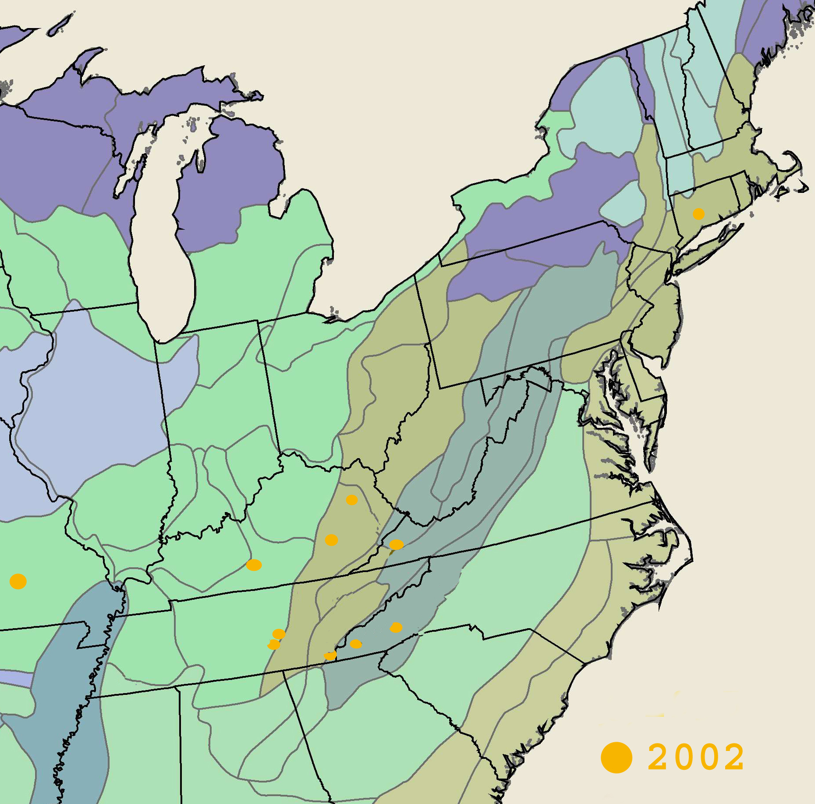
Figure IV-1. Locations of butternut resistance screening plantings established in 2002.
7
2
3
4
5
61
8
9
10
12
11
1

Number, location, nearest town, state (abbreviation)
1. Mattatuck State Forest, Terryville, CT (CT)
2. South Central Missouri, Thomasville, MO (MO)
3. Jefferson National Forest: Clinch River District, Pound, VA (VA)
4. Daniel Boone National Forest, Morehead District, Farmers, KY (KY-DB)
5. The Nature Conservancy: Horse Lick Creek, Sand Gap, KY (KY-TNC)
6. Mammoth Cave National Park, Cave City, KY (KY-MC1 & 2)
7. Cherokee National Forest: Ocoee District, Reliance, TN (TN-OC1 & 2)
8. Healing Stones Foundation, Smithville, TN (TN-HS)
9. US Army Corp Center Hill Lake, Smithville, TN (TN-CHL)
10. New River State Park, West Jefferson, NC (TN-NR)
11. Pisgah National Forest: Brevard District, Brevard, NC (NC-PI)
12. Nantahala National Forest: Wayah District, Bryson City, NC (NC-WA1 & 2)
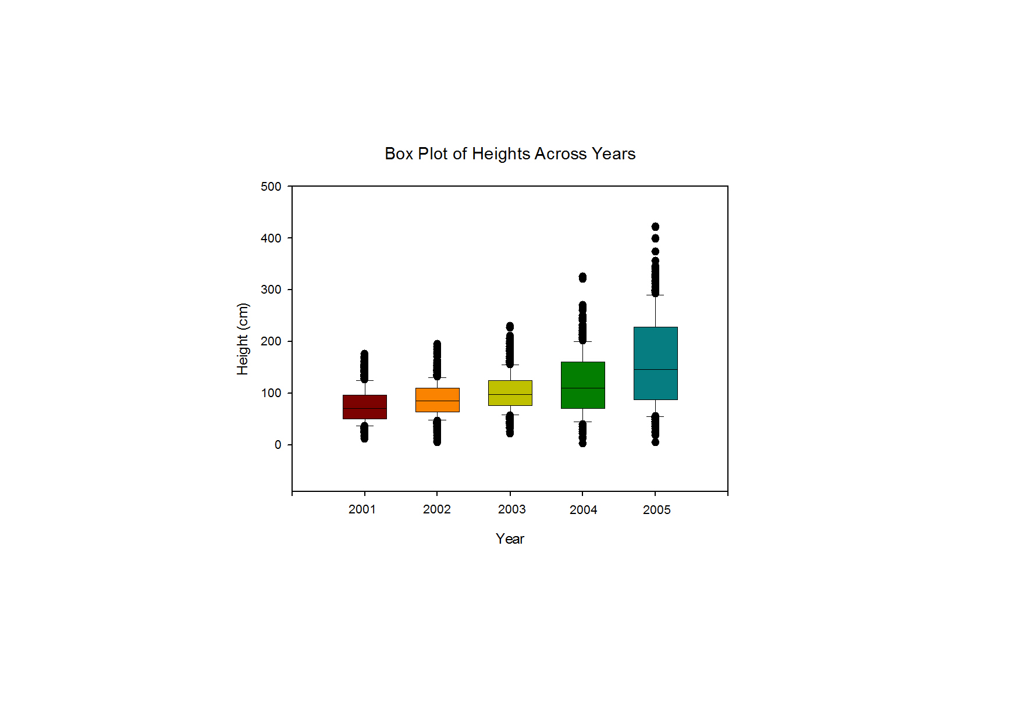
Figure IV-2. Annual heights of butternut seedlings established in 2002.

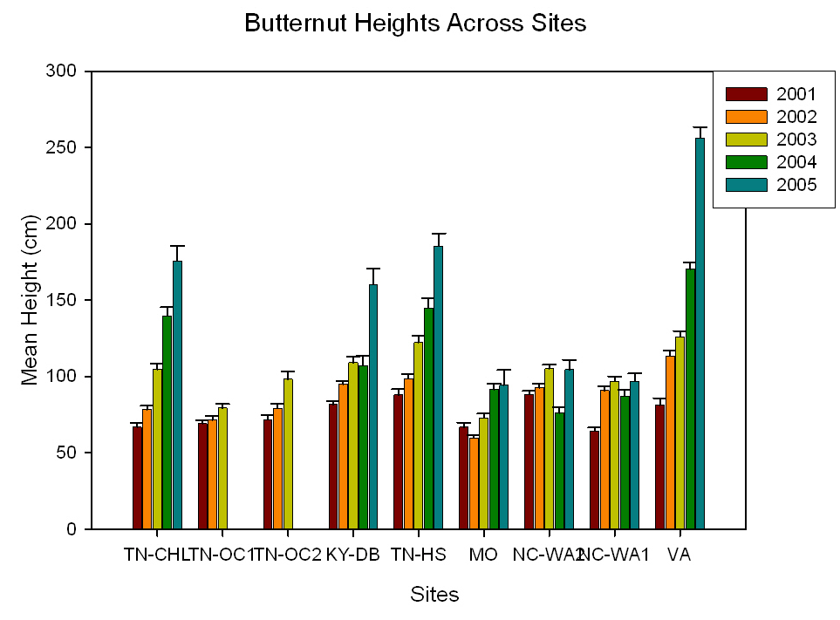

Figure IV-3. Average height of butternut seedlings across surviving planting sites from 2001 until 2005.

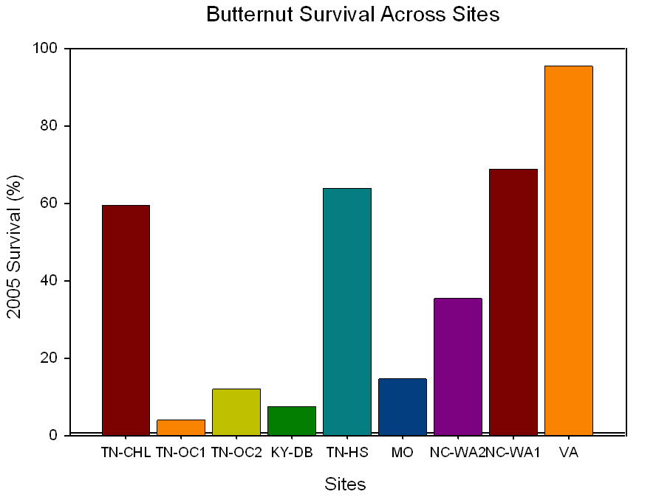
Figure IV-4. Percent of butternut seedlings surviving in 2005 across remaining planting sites.

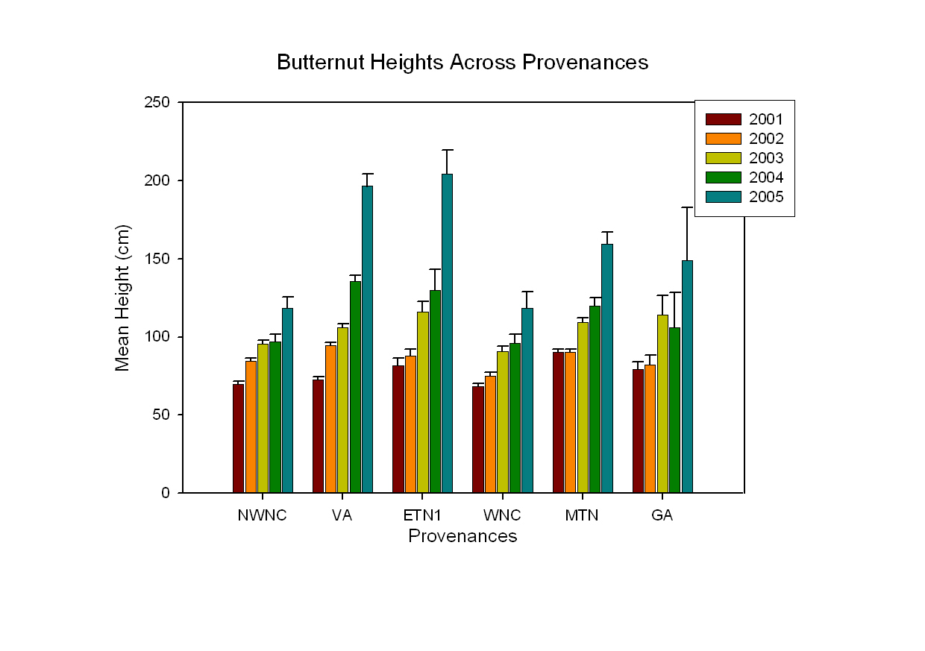
Figure IV-5. Height of butternut seedlings across provenances of origin from 2001 until 2005.
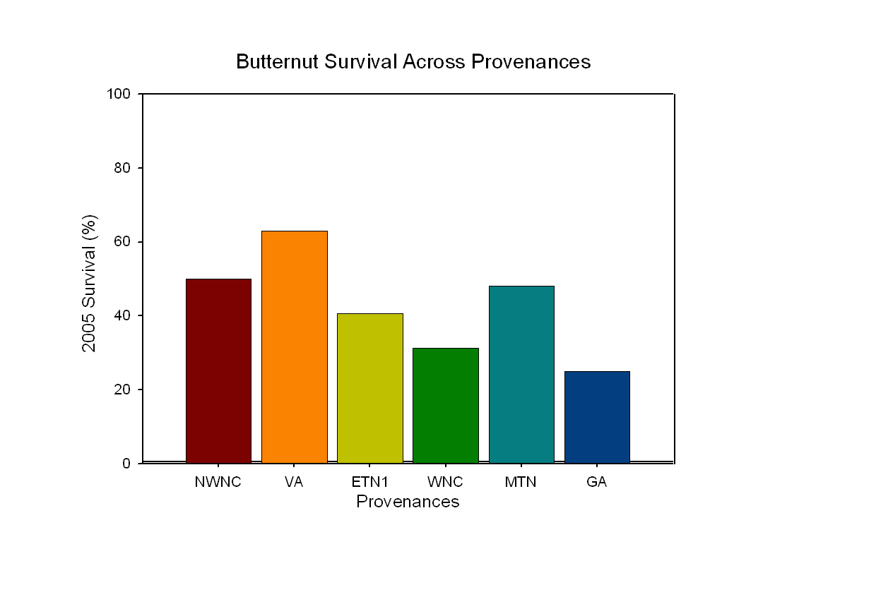
Figure IV-6. Percent of seedlings surviving in 2005 across provenance of origin.
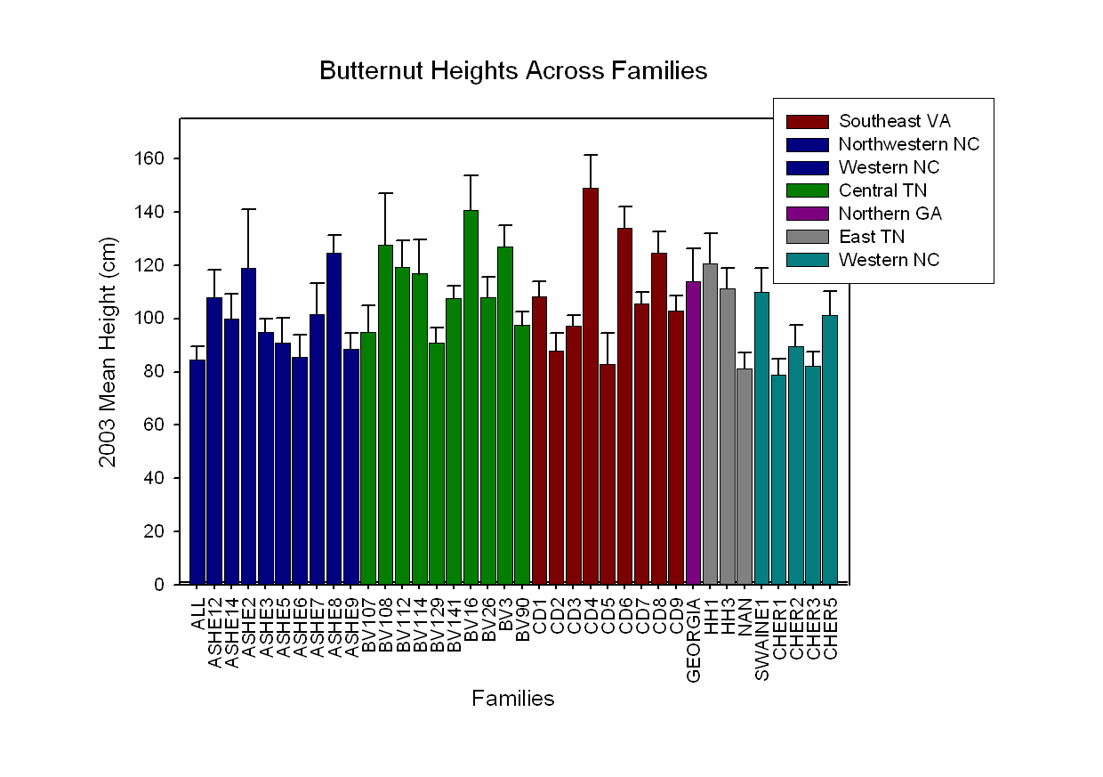
Figure IV-7. Height of butternut seedlings in 2003 across provenance and family of origin.

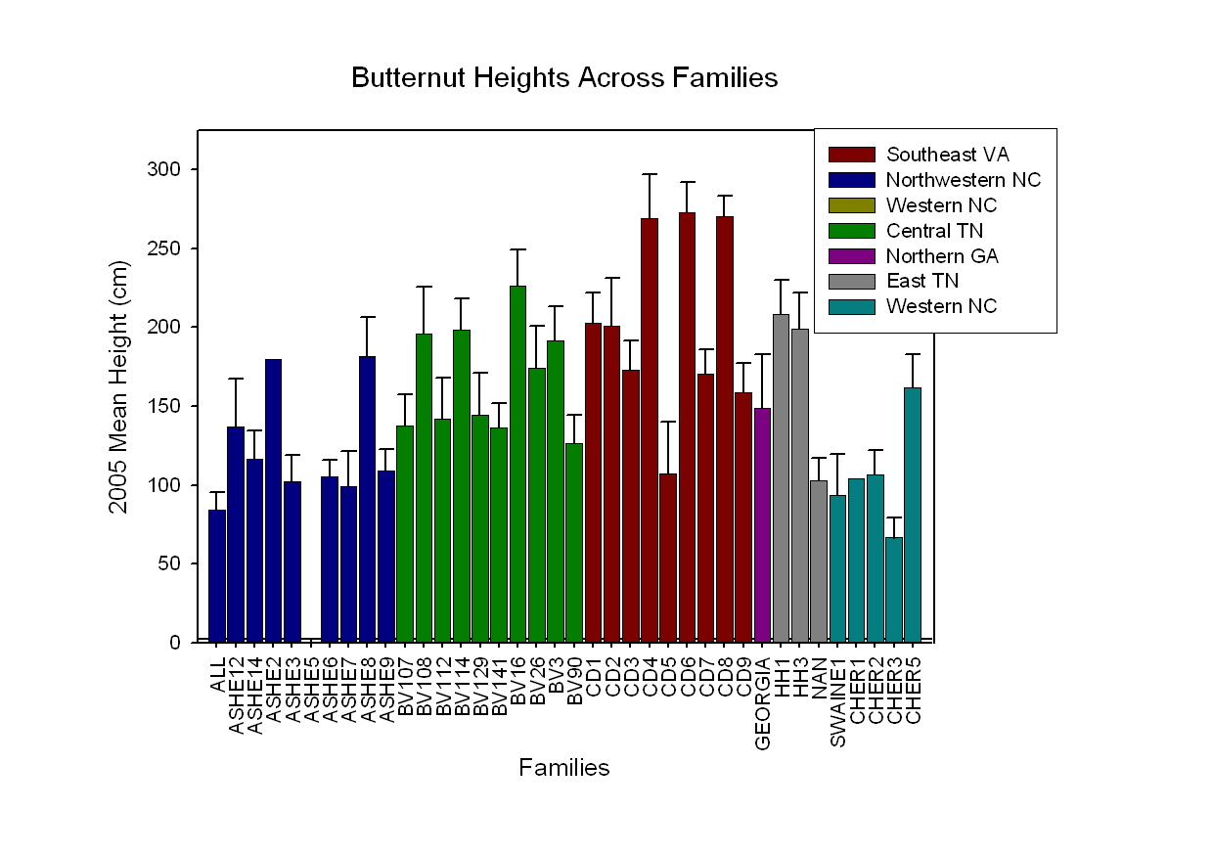

Figure IV-8. Height of butternut seedlings in 2005 across provenance and family of origin.

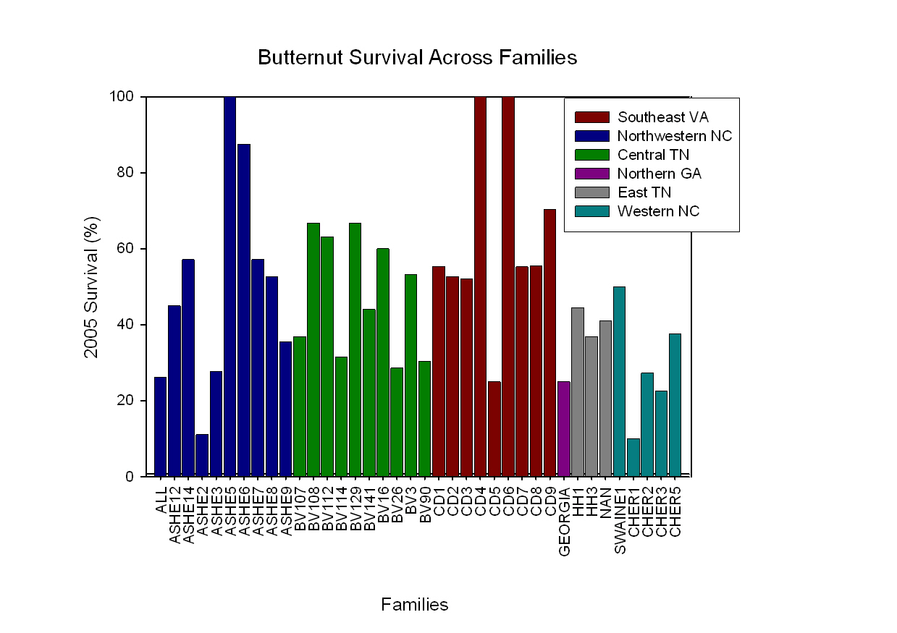
Figure IV-9. Survival of butternut seedlings in 2005 across provenance and families of origin.

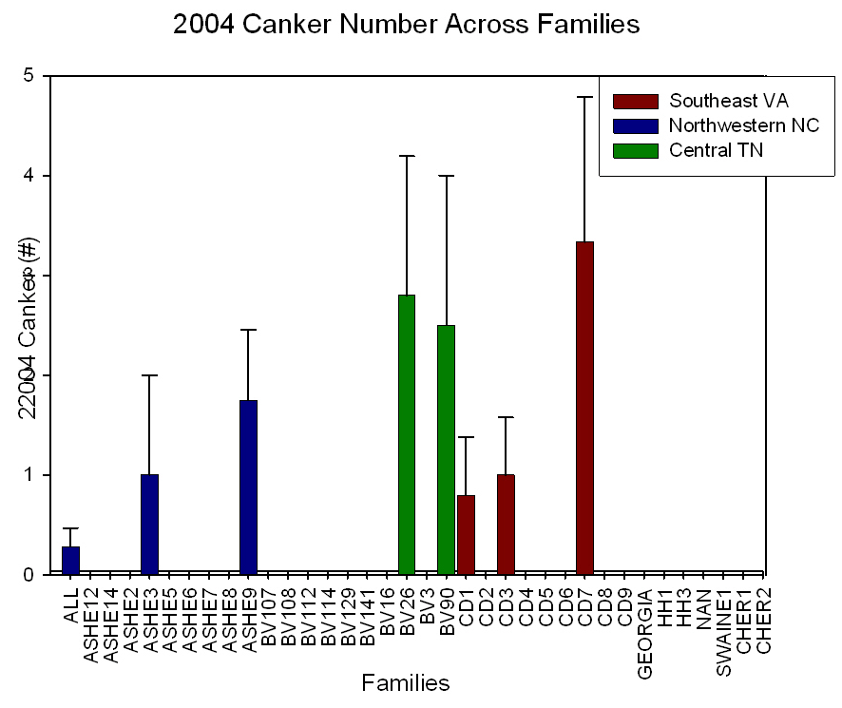

Figure IV-10. Cankering of butternut seedlings in 2004 across provenance and families of origin.

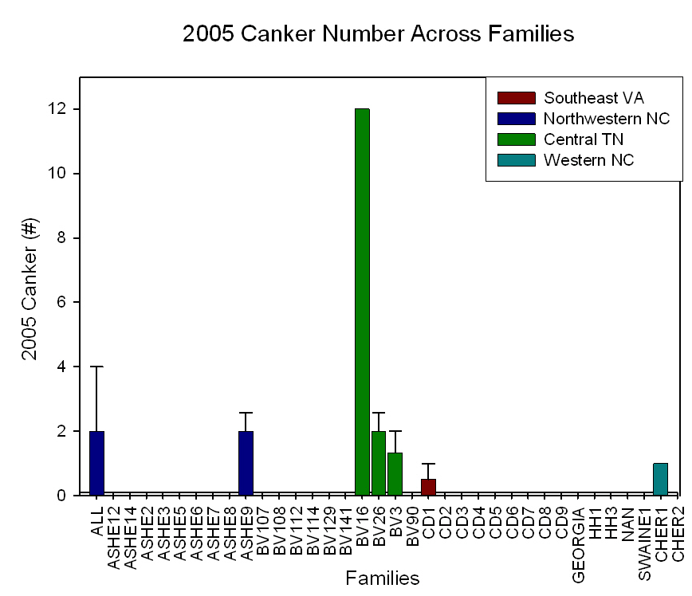

Figure IV-11. Cankering of butternut seedlings in 2005 across provenance and families of origin.

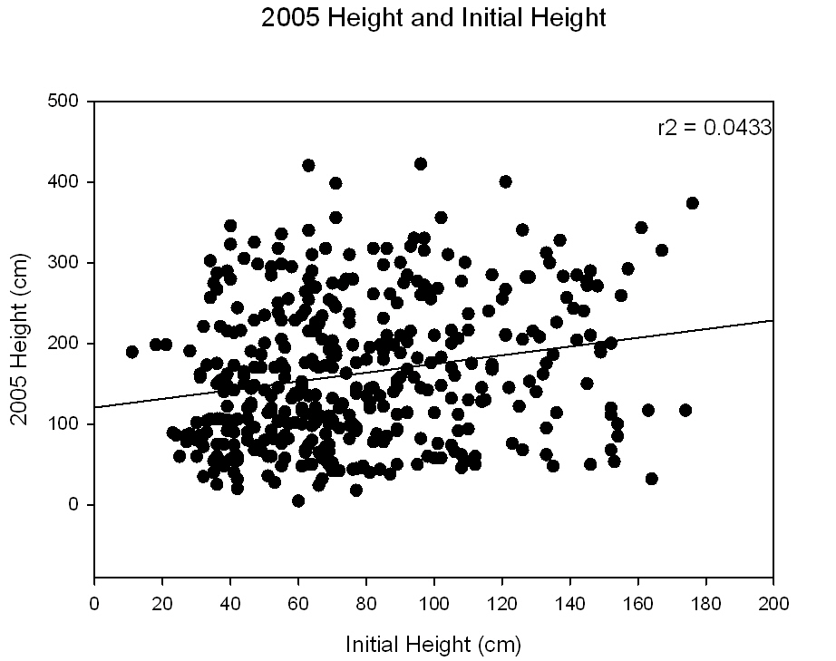

Figure IV-12. Height of butternut seedlings in 2005 across initial height for seedlings prior to planting.

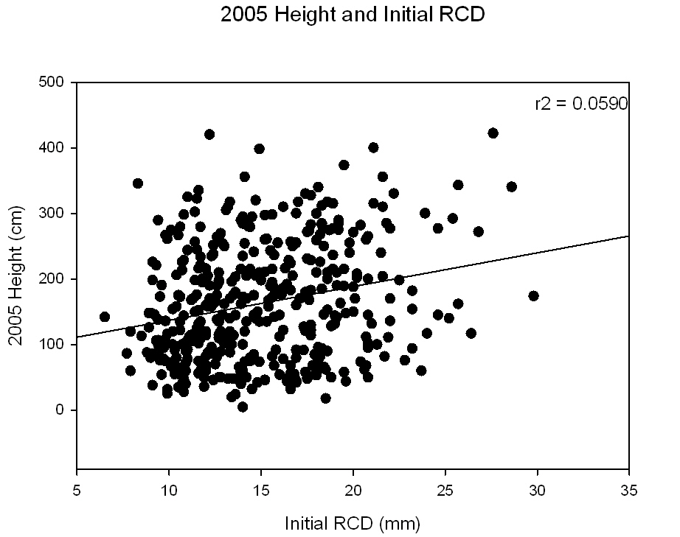

Figure IV-13. Height of butternut seedlings in 2005 across initial root collar diameter for seedlings prior to planting.

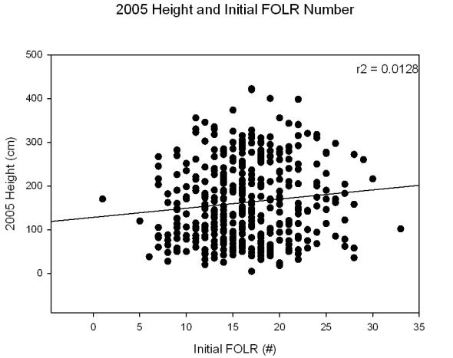

Figure IV-14. Height of butternut seedlings in 2005 across initial number of first-order-lateral root number for seedlings prior to planting.

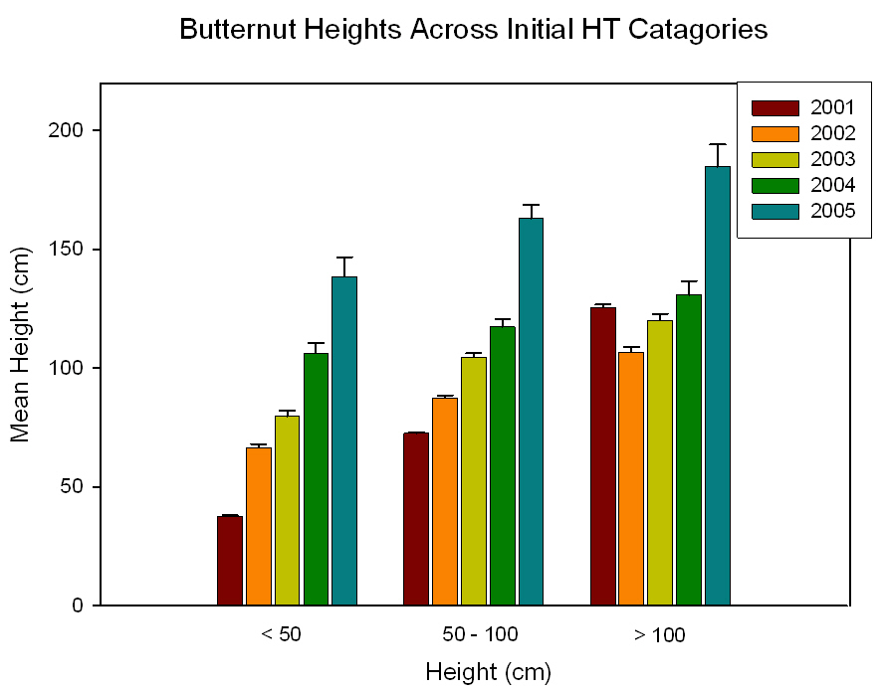

Figure IV-15. Height of butternut seedlings from 2001 until 2005 across initial height categories for seedlings prior to planting.

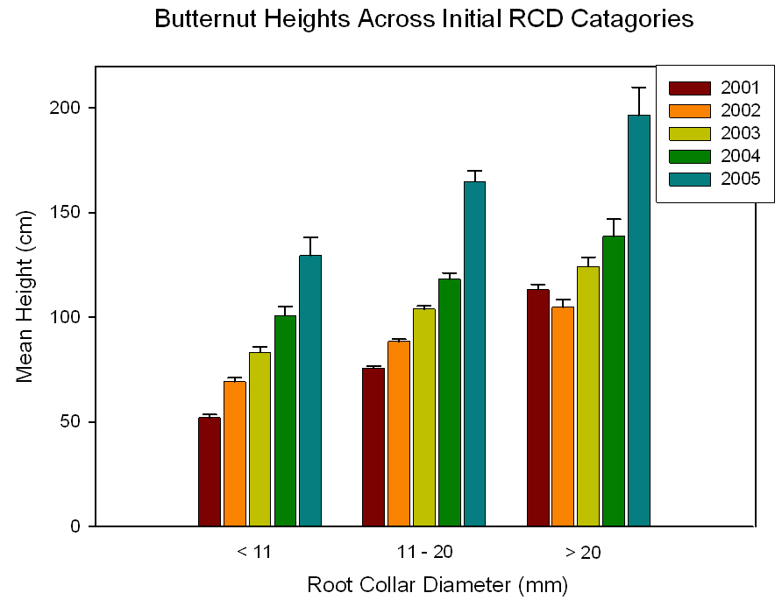

Figure IV-16. Height of butternut seedlings from 2001 until 2005 across initial root collar diameter for seedlings prior to planting.

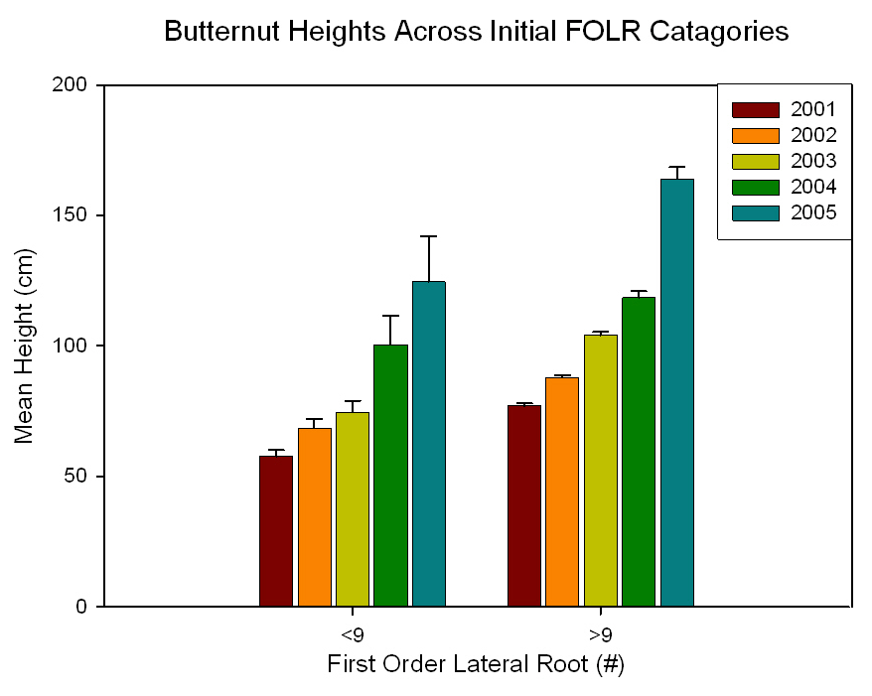

Figure IV-17. Height of butternut seedlings from 2001 until 2005 across initial first-order lateral root number for seedlings prior to planting.

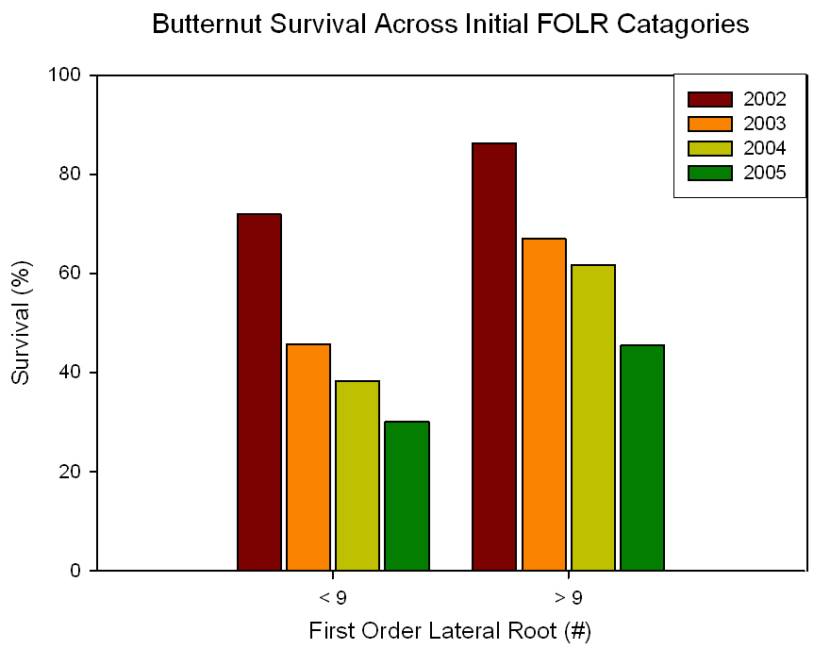

Figure IV-18. Survival of butternut seedlings from 2002 until 2005 across first-order lateral root number for seedlings prior to planting.

BUTTERNUT PROGENY SURVIVAL AND GROWTH ACROSS VARIOUS PLANTING SITES

Abstract
Butternut, Juglans cinerea L., is being impacted by butternut canker disease which is eliminating butternut from various locations, particularly in the southeastern United States. Sirococcus clavigignenti-juglandacearum (V.M.G. Nair, Kostichka, & Kuntz), the causational fungus has expected to be impacting trees since at least the 1920s. Butternut is a short-lived, early successional tree species and also is being eliminated due to crown closure of even-aged stands in riparian areas. Locations adequate for enrichment plantings will guide restoration protocols for this important mast producing species. Over two thousand seedlings were planted in various stand histories and manipulations in Tennessee and surrounding states (Kentucky, Virginia, and North Carolina). Seedlings resulted from open-pollinated nut collections from eleven distinct families. Seedlings conditions were evaluated prior to planting to determine potential impacts on establishment success. The plantings took place on fifteen sites at seven locations in Tennessee and surrounding states. Plantings were one of four types: open grasslands, open grasslands with trees in shelters, shelterwoods, and on reclaimed surface mines. Survival and height growth varied across sites, families, and initial seedling conditions. Mortality was 19% in the first year and 26% in the second year with the greatest mortality on surface mines (29, 47%) and the least on open grasslands (9, 17%). Seedlings planted in shelterwoods were significantly taller at the end of the second year (130 cm) than seedlings in all other planting types (92 cm). Seedlings in shelterwoods were competing with seedlings and sprouts for light, which encourages strong apical dominance and height growth. Two specific genetic families were significantly taller than all others and averaged over 120 cm tall. In addition, four families had under 20% mortality compared to one family with greater than 60%. Initial seedling size greatly impacted establishment success. Seedlings < 9 mm in diameter when planted were twice as likely to experience mortality and were 26% shorter than larger diameter seedlings. Seedlings <50 mm in height also experience additional mortality and were 36% shorter after two years than larger seedlings. Selecting larger diameter and taller seedlings from specific genetic families will increase establishment success for butternut.

Introduction

Butternut canker disease caused by the exotic fungal pathogen Sirococcus clavigignenti-juglandacearum (V.M.G. Nair, Kostichka, & Kuntz) is killing butternut (Juglans cinerea L.) trees throughout the native range. A crucial first step in the process of restoration for this species is to determine if genetic resistance to butternut canker disease exists (see Chapter IV). However, successful establishment and growth of resistant seedlings will require an understanding of artificial regeneration procedures and the influences of site, seed source, and seedling quality on establishment success. Success of reintroduction of resistant butternut may increase by incorporating knowledge of the impact of initial conditions on growth and survival (see Chapter IV). In National Parks and National Forests sites in riparian areas for restoration may be limited to areas with various site histories, which area available for planting (National Park Service 1991). These types of areas on public land include previous open fields, riparian areas with an absence of harvesting, and in various silvicultural manipulations. Correspondingly, planting success will require a greater understanding of the types of sites where the seedlings can become established.

Artificial regeneration of butternut
Butternut has been cultivated since 1633; a half-century before black walnut and other North American Juglans species (cf. Brinkman 1974). Artificial regeneration of butternut, however, has never been widely practiced in the United States or Canada, due to abundant natural regeneration in some areas and the selection of other walnuts for timber and nut production (Ostry and Pijut 2000). Butternut has been noted to have a quickly developing root system that requires transplanting early in seedling development (Rink 1990). A few recent plantings of butternuts have occurred, but artificial regeneration of butternut has had mixed results. Establishment of 2-0 butternut stock in tree shelters in 1998 was unsuccessful due to shading from competing hardwood spouts and heavy shrubs (Ostry et al. 2003). Success of planted seedlings could be aided by using large seedlings that will compete vigorously with surrounding competition and rapidly grow above deer browse level.

Site selection
Historically, artificial regeneration of butternut was conducted on old field sites for reforestation and for species conversion to timberlands, timber and nut production (Ostry et al. 2003). When butternut seedlings were planted in five different canopy openings in two different habitat types to test for optimal conditions to promote growth, greater height and diameter occurred on better habitat types (Cummings Carlson 1997). A planting of 2-0 nursery stock in 1998 of butternut occurred on a stand in Wisconsin (Ostry et al. 2003). The 2-0 stock was out-competed by hardwood sprouts and heavy shrubs and mortality, unrelated to disease, was high (Ostry et al. 2003). However, seedlings growing on clearcut or heavier thinning treatments were more vigorous (Ostry et al. 2003). Direct seedling of butternut has failed (Ostry et al. 2003).
Progeny plantings from 1995 to 2002, where butternut seedlings were planted under the canopy of trees, have shown butternuts’ ability to survive and grow in various light environments (Brosi et al. 2007, Chapter IV). Butternut seedlings were able to persist and grow under the overstory of a mature tree and competition was greatest in the light-saturated environments. However, the greatest survival has consistently occurred in areas with more sunlight with the lowest survival in the areas with the most shading. Butternuts on sites without competing vegetation lose apical dominance and become more bush-like in habit. While that form may be ideal for nut production, it is not be suitable for timber and may not be competitive over time if vegetation control would lapse.
Establishment success of butternut for timber production or as a component of the surrounding forest is optimized by selecting sites with characteristics that allow seedlings to become initially established and subsequently have enough competition for the seedlings to retain apical dominance, yet vigorously compete with surrounding vegetation. For butternut in particular, initial seedling height coupled with a corresponding large root system may be paramount to butternut survival. Ostry et al. (1994) observed that vigorously growing saplings may have outgrown the girdling effects of the canker. Therefore, a strong relationship may exist among seedling quality, survival and competitive ability, and delaying the impact of the butternut canker disease.

Seedling origin
Seed source, open-pollinated genetic families, impacts survival and growth of butternut seedlings (see Chapter IV). However, genetic families haven’t been evaluated over a large number of sites. Extensive research has shown variation in establishment success of black walnut and English walnut is partially attributed to seedling origin in terms of progeny (genetic families), and individual trees within families (Bey 1973, Rink et al. 1994, Bresnan et al. 1994, Geyer and Rink 1998). Black walnut progeny plantings, after 17, 21, 22, and 35 years have shown significant differences in height growth and heartwood production between open-pollinated families indicating the opportunity for gains from selection (Bresnan et al. 1994, Geyer and Rink 1998). In black walnut progeny plantings selection of superior progenies to improve rotation height and diameter may occur at age 4 to 6 years (Kung 1975, McKeand et al.1979, Rink et al. 1994). Heritability of height growth increased steadily after age until age 10 (Rink 1984), and leveled off at age 10 (Rink and Kung 1995). Evaluation of a 20-year old planting determined that anytime after age 8 was acceptable for selection (Rink and Kung 1995). However, in a spatial non replicated study Michler et al. (2003) found rank shifting and increases in heritability between ages 10 and 15. Butternut progeny need to be evaluated to determine if specific families had superior height growth over time.

Seedling characteristics
Low success in hardwood plantings success is often a result of damage by animal browse (Marquis 1974; Martin and Baltzinger) and herbaceous and hardwood competition which overtop artificial regeneration planted in open areas (Cogliastro et al. 1990, Kolb et al. 1990, Willoughby and McDonald 1999). Variability in planting stock quality of hardwood seedlings often results in planting failures and low vigor (Johnson 1981, Johnson et al. 1986, Wendel 1980). Seedling establishment success has increases with the quality of the nursery stock for northern red oak (Quercus rubra L.) (Zaczek et al. 1997, Dey and Parker 1997, Ward et al. 2000, Jacobs et al. 2004). Traditionally, nurseries grow hardwood seedlings according to their own procedures in dense spacing, producing small, uniform sized seedlings that facilitate shipping and plantings (Johnson 1981, Kormanik and Ruehle 1987). The demand for large stock for black walnut seeding production has been investigated through seed selection and nursery techniques since at least 1947 (Chase). Over the past decade, nursery practices have adjusted density of plantings and fertilization and irrigation applications in order to produce large hardwood seedlings (Kormanik et al. 1994a, Kormanik et al. 1994b).
Field establishment of large seedlings shifts the competitive advantage toward the seedlings and reduces losses due to herbivory (Ward et al. 2000). Large nursery stock can quickly become established in the field and can be produced by adjusting nursery practices (Kormanik et al.1994a). Selecting large seedlings has increased establishment success for a variety of hardwood species including oak species (Quercus L.) (Kormanik et al. 1997, Schlarbaum 1993, Clark et al. 2000). In addition to height (HT), root collar diameter (RCD) at measured at 1.3 cm above the root collar, has been used as an indicator of seedling condition (Ruehle and Kormanik 1986). Nursery-grown hardwood seedlings with larger RCD, prior to outplanting, have been shown to result in better survival and growth after outplanting than smaller stock (Olson and Hopper 1972, Zaczek et al. 1997). Progeny establishment plantings have occurred on black walnut seedlings have been grown under optimal nursery conditions (Schultz and Thompson 1990, 1997). RCD and stem height can also predict establishment success for black walnut seedlings (Schultz and Thompson 1990, 1997).

Objectives
Seedling characteristics, including initial seedling height and RCD, were found to impact survival and growth of butternut seedlings on particular sites (see Chapter IV). Those plantings, however, were designed as butternut canker resistance tests not as restoration experiments. The goal of this experiment was to establish butternut restoration plantings to evaluate the effect of various factors including site, genetic family, and nursery characteristics on initial butternut seedling survival and growth. The objectives of this project are to aid in the restoration of butternut by a better understanding of site requirements, seed source selection, and the impacts of seedling quality.
- Objective 1). Determine establishment success across various individual sites and site categories;
- Objective 2). Determine if some genetic families are superior in terms of growth and establishment success
- Objective 3). Determine if relationships between initial seedling variables (HT and RCD) and establishment success are present. Seedlings will be categorized by initial variable to determine impacts of initial size on establishment success.
This is the first application of butternut progeny plantings across various site histories using large seedlings.

Methods

Throughout this manuscript butternut, J. cinerea, is defined by whole-tree silvic characters for identification. For each tree overall phenotype was evaluated based on dendrological characters and nut characters that tend to distinguish the species. It is unknown if the whole-tree silvic can distinguish between pure butternut or hybrids of butternut and heartnut of various generations. Trees classified as butternut (sensu lato) could actually be the result of hybridization between J. cinerea and J. ailantifolia Carr or J. ailantifolia var. cordiformis (Maxim.) Rehd.) or hybridization with advanced generation hybrids, J. x bixbyi Rehd.

Progeny collection
In the fall of 2003, 10,984 butternuts were collected from 17 open-pollinated genetic families from three ecoregions Virginia, Tennessee and North Carolina (sensu Bailey 1995, Figure V-1, note tables and figures appear in appendixes). Seven open-pollinated families had over 600 nuts per family. The butternuts were dehusked and planted at the Georgia Forestry Commission’s Flint River Nursery in Byromville, Georgia in December, 2003. The resulting seedlings were grown for one growing season (2004) using fertilization and irrigation regimes developed by the USDA Forest Service’s Institute of Tree Root Biology (Kormanik et al. 1994a). The seedlings were lifted in February, 2005 using a Forbo machine that undercut the root systems at 30 cm.

Planting sites
Over 2,000 seedlings from the half-sibling families were sorted into experimental plantings using an incomplete block within complete block design and single tree plots. Plantings were established on sites with four varying site histories across four southern states. Plantings occurred on 15 sites in seven locations on public and private land in Tennessee, Virginia, North Carolina, and Kentucky (Figure V-2). Seedlings were planted on various sites after various stand manipulations and site histories (Table IV-1, #1-4). The plantings took place on four types of sites: 1. open grasslands, 2. open grasslands using tree shelters, 3. shelterwood harvests, and 4. surface mines. Plantings in open grasslands (1) included a former Forest Service Work Center (TN-OC1), former recreational area (VA-CL), and former hay fields (NC-KA1, KA2). The open grassland with tree shelters (2) included a new orchard site (NC-HO). Shelterwoods (3) included previous year timber harvesting with 30% basal area retention (NC-GF1, GF2, AP1, and AP2) and a site located near a beaver pond with heavy thinning due to beaver activity (TN-OC2). Shelterwood sites had commercial harvest that removed 70% of the total stand basal area (Loftis 1990, 1993). Sites in surface mines (4) were on ripped mine spoil benches near artificial ponds with limited grading to reduce compaction. Tree shelters were manufactured by TreePro© and were 4.5 inches in RCD (11.4 cm) and five feet tall (1.5 m). Seedlings planted in tree shelters are experiencing full sunlight free from any competition. Seedlings were placed in tree shelters at this site due to heavy deer pressure in the planting area. This site was in an area where hunting is prohibited and herd sizes are artificially large due to lack of natural predators. The two plantings in old agricultural fields close to each other had one site where competition was controlled (KA-2) and one where competition was not controlled (KA-1).
The plantings were established in a completely random design using single-tree family plots on 1.5m (5 ft) spacing. The seedlings were manually planted in 30 cm deep holes made by gas powered hand augers with six inch drill bits. At the time of planting the seedlings were measured for initial HT and RCD. HT was measured from the ground to the terminal bud to the nearest 0.5 cm using a meter stick and RCD was measure at ground level using digital calipers. These initial measurements were considered 2004 condition. After the first growing season (2005) and the second growing season (2006), the seedlings were measured for their responses, in terms of survival, HT, RCD, condition, and growth form. Seedling condition, i.e. evidence of dieback, disease, or deer browse, was evaluated.
Seedlings were categorized based on initial seedling size into three HT classes and two RCD classes. HTclasses were > 50 cm, 50-100 cm, and >100 cm. RCD classes were < 9 mm or ≥ 9 mm.

Statistical analyses
Statistical analyses were conducted using SAS version 9.1 (for Windows, © 2005 SAS Institute Inc., SAS Campus Drive, Cary, North Carolina 27513, USA). Additional macros developed by A. Saxton (1998, 2004) were used for means separation. Macros included pdmix800 for means separation using multiple range tests (Saxton 1998), Mixed Model Analysis of Variance Macro (mmaov) uses Fisher's Least Significant Difference (LSD) test was conducted at the 5% significance level, determines if standard deviations are within five fold of each other, calculates Levene P values to determine equality of variances, and a Shapero-Wilk W test for normality (Saxton ©2002). Least-square survival and HT means of each family were converted to relative survival and heights, expressed as a percentage of the plantation mean. All percentage data, derived from count data, including survivorship and presence of cankering, underwent inverse trigonometric sine transformations due to lack of homogeneity of variances (Snedecor and Cochran 1998).
Objective 1). Yearly seedling variables (percent HT growth, percent RCD growth, and percent survival) were analyzed across planting sites using analysis of variance (PROC MIXED). Fixed effects included sites and families: site, rep (site), block (site*rep), site*family. Seedling response, in terms of growth and survival, were treated as independent variables. Tukey’s pairwise means comparisons were used to separate means when a statistically significant overall effect was established (SAS 2005).
Objective 2). Yearly seedling variables (percent HT growth, percent RCD growth, and percent survival) were analyzed across families using analysis of variance (PROC MIXED). Seedling response, in terms of growth and survival, were treated as independent variables. Tukey’s pairwise means comparisons were used to separate means when a statistically significant overall effect was established (SAS 2005).
Objective 3). Phenotypic correlations were calculated using Pearson’s correlation analysis for year to year family means on survival and growth (PROC CORR). Correlations were also calculated between year to year seedling variables and between year-before HT and RCD to specific-year survival and HT. Analysis of variances was conducted on catagories of initial seedling variables described previously.

Results

Seedling production
The 2004 growing season had relatively high levels of precipitation, which promoted Phytophthora root rot disease [casual agent: P. cinnamomi Rands] at the Flint River Nursery. The disease severely impacted the seedlings and caused a great reduction in the number of families and seedlings available for planting. After culling seedlings and families affected by root rot, only ten families total remained with 2,201 seedlings suitable for planting. The studies were measured immediately following planting for HT and RCD. This data represented the data from the end of the 2004 growing season. Just after planting the seedlings had a HT of 87.61 cm and a RCD of 12.61 mm. Unlike other years (2001, 2002, 2004, and 2007) where seedlings were measured prior to planting (see Chapter III), these seedlings were measured after outplanting.

Overall growth and survival
The average HT at the end of the 2005 growing season was 89.70 and the average RCD was close to 14.96 mm. The seedlings average an increase of HT of two cm since planting, not significant, and a significant increase of 2.35 mm in RCD in the first year after planting (p>0.001). Overall survival was 81.82% for the first year.
At the end of the seedlings second year in the planting locations (2006), the average HT of the seedlings was 110.02 cm; significantly greater than initial HT and first year HT growth (p>0.001). The average RCD, 18.68 mm, was significantly larger than the previous years (p>0.001). Over twenty percent of the seedlings were over 2 meters in HT, and 45% of the seedlings were larger than the mean. The seedlings have had a 19% increase in HT (20 cm) and a 21% increase in RCD (3.9 mm) since the previous year. Since planting the seedlings had increased 20 and 33% for HT and RCD respectively. Overall survival was 71.85%.

Objective 1: Planting sites
Height growth and survival varied significantly in percent among sites (Table V-3). During the first year survival varied significantly across planting sites with 33% of the sites with greater than 90% survival, 53% with greater than 80% survival, and 73% with greater than 70% survival during the first year (Table V-2). First year survival was over 70% on all sites except for two sites on a surface mines and two forested sites (Figure V-6). HT also varied significantly among planting locations in 2005. At both the TN-OC and the NC-AP sites, increased HT was found on sites with greater mortality where competition for with competing vegetation was high.
Second year survival varied across planting sites with the highest survival at 90% and the lowest at 20%. Just under half of the sites had over 80% survival, with 20% of the sites with under 60% survival. The tallest sites had seedlings averaging 50% taller (159 cm) compared to the shortest sites (80 cm). RCDs were also 36% larger on one site (25.17 mm - 16.20 mm, Table V-2).
Grouping sites by site types showed that for both years, the greatest survival occurred on open grasslands (9, 17%) and the least on surface mines (29, 47%) (Figure V-6). The sites in open grasslands had the lowest percent mortality for both 2005 and 2006 (9.48 and 16.63%, Table V-3). Percent mortality in 2005 and 2006 was similar in open grasslands with tree shelters (23.80, 25.54) and in shelterwoods (20.85, 28.13). All sites on surface mines had significantly higher mortality for both years compared to all other sites (29.47, 47.38%, Figure V-7).
Total HT in 2006 was largest in sites in shelterwoods (Table V-3). Seedlings planted in shelterwoods were significantly taller at the end of the second year (130 cm) than seedlings in all other planting types (92cm). Sites located on grasslands had the second tallest average HT, followed by sites on surface mines and in tree shelters. Only sites on surface mines and in tree shelters had a decrease in HT over the two growing seasons (Figure V-8). On surface mines dieback during the first year (13.06% decrease in HT), continued though was less dramatic in the second year (1.79% decrease in HT). Reduction in HT also occurred at the one site with tree shelters. In 2006, over six sites had seedlings averaging over 120cm, five of these sites were in forested stands and the other site was in an open grassland with competition controlled: KA-2 (Figure V-5).
The one open grassland with tree shelters had only 74% survival and an average seedling HT of 80.6cm (15-178) and average RCD of 17.13 mm (8-35). This is an increase in RCD of almost 5 mm since outplanting. None of the seedlings are over 2 meters in HT, only 8.52% are over 1.5 meters, 33.52% are over 1 meter, and 49.35% of the seedlings are larger than the mean. The seedlings have RCD growth rates similar to the other plantings, but not similar rates of HT growth.
The KA-1 old field site without competition controlled had 83.33% survival and an average HT of 106.52 (16-192) and a RCD of 19.11mm (3-41). Only 8% of the seedlings were over 1.5 meters and 56% were larger than the mean. The KA-2 site with competition controlled had over 81% survival, lost only 10% in one year, and an average seedling HT of 123.93 cm (15-240) and average RCD of 25.17 mm (3.9-62.5). Five percent of the seedlings at this site were over 2 meters tall, 33% over 1.5 meters, 53% greater than the mean, and over 67% of the seedlings were larger than 1 meter in HT.

Objective 2: Families
The impact of family was statistically significant for all variables (Table V-4). Initial seedling HT and RCD varied significantly across family of origin. Prior to planting some genetic families were nearly twice the average HT of others. These family differences continued for the 2005 and 2006 growing season (Figure V-10). Two specific genetic families were significantly taller than all others and averaged over 120 cm tall in 2006 (Figure V-11). In addition, four families had under 20% mortality compared to one family with greater than 60% (Figure V-12).

Objective 3: Seedling variables
Overall relationships Overall the impact of initial characteristics on 2006 height was significant for HT (Figure V-13) and RCD (Figure V-14). All significant variables were significantly phenotypically correlated except for 2006 HT and mortality (Table V-5). Similar to results found in other years, initial HT and RCD were significantly correlated (0.42), but with a lower value than found when measuring seedlings prior to planting in other nursery trials (see Chapter III). The strongest relationships were between HT of consecutive years: (initial HT and HT05: 0.60, HT05 and HT06 0.56).
Relationships by seedling size category Initial seedling size class greatly impacted establishment success (Table V-6). Seedlings ≥ 9 mm in RCD when planted were twice as likely to experience mortality and were 26% shorter. Seedlings < 50 mm in HT also experience additional mortality and were 36% shorter after two years.

Discussion

Site conditions
Butternuts were successfully established on a variety of site conditions. Large differences in HT over the various planting sites indicate a strong environmental control for apical dominance in the species. The greatest survival occurred on old agricultural fields and the greatest height gains occurred on shelterwoods. Sites with tree shelters and mine spoils experienced heavy mortality and reduced height growth.
Old agricultural fields appear to be particularly good locations for restoration with the greatest survival. Surveys for butternut found many locations in fence rows and by houses on non-typical butternut sites (UT-TIP data on file). Dendrochronology evidence indicates butternut recruitment in old agricultural fields (Clark et al. 2008). Therefore butternut could be an ideal species for Conservation Resource Enhancement Program (CREP) plantings. However, growth form in these types of openings may not be ideal for timber production but may be good for nut production for mast for wildlife and wildlife habitat. Butternut may also be an ideal species for agroforestry applications. Temporate agroforestry involves multicropping of agricultural crops under high value plantions and intercropping of high values tree species with other commercially valuable crops and animal grazing (Gold and Hanover 1987). Butternut may also provide the increased profit of nuts prior to harvesting for timber. Agroforestry applications of J. nigra have shown great potential for reforestation, timber and polyculture applications (Scott and Sullivan 2007). Many non-timber forest products that require shade are tolerant to juglone and the juglone could act as a resource reducing unwanted competition (Scott and Sullivan 2007). Production of black walnut in combination with shade-tolerant agroforestry crops could be possible with Ribes L., Sambucus nigra L. ssp. canadensis (L.) R. Bolli, Morus rubra L., Astisima triloba (L) Dunal, and Diospyros virginiana L. Species such as American ginseng (Panax quinquefolius L.) have also been found in association with black walnut (Apsley 2004, Carroll 2004). Black walnut may also provide shade for mushroom production (Scott and Sullivan 2007). In addition mixed species plantings of black walnut have show the ability to plant juglone-tolerant species for increased height growth in walnut and production of Robinia pseudoacacia L., Pinus strobus L., Fraxinus americana L., Quercus rubra L. and Acer rubrum (Scott and Sullivan 2007). Planting butternut in association with juglone tolerant species on open sites may increase profitability for landowners and result in ideal conditions for growth form and establishment. This is especially important as plantings in open areas may require extensive competition control and the application of fertilizers. Agroforestry offers landowners options for quicker returns on investments in high quality timber species.
Forested sites in shelterwoods were also ideal sites for butternut plantings with lower survival but increased HT growth. The seedlings in forested stands are competing with seedlings and sprouts for light, which may result in increased mortality, but also encourages strong apical dominance and HT growth. Mortality on these sites was of smaller seedlings; under 50 cm in height and under 9 mm in diameter. The larger seedlings were able to establish with limited mortality after the first year. Butternuts were able to compete with sprouts and seedlings in shelterwoods. Shelterwoods have been extremely important for establishment of Quercus rubra (Loftis 1990, Loftis 1993). Increased height growth on shelterwoods is similar to studies done with American chestnut two years after planting where 3.5 times taller seedlings were found on shelterwoods verses midstory removal treatments (Rhoades et al. 2009).
At the end of the second growing on shelterwood sites the seedlings averaged 85 cm at planting, 95 cm after the first year and 130 cm after two years. The hight of the seedlings after two years was above deer browse, in the south with limited snowpack. Deer can be a major obstacle in hardwood seedling establishment (Kolb et al. 1990, Gillespie et al. 1996). Gillespie et al. (1996) found decreased growth on Juglans nigra three years after planting due to heavy deer browse on unprotected seedlings. Planting seedlings on specific sites which are able to average above deer browse in the second year after outplanting will increase establishment success. Survival in the forest shelterwoods indicates potential success for restoration in gap dynamics in riparian areas of state and national parks. Clark mentions butternut as a component of old-growth stands in forest gaps (1958).
Considering that there was only one site that used tree shelters, it is difficult to make general statements about restoration using this approach for planting butternuts. The use of shelters resulted in large RCD increases in seedlings but also high mortality and decreased HT compared to other sites. Tree shelters cause a general shading of the seedlings with the exception of the open top. Studies using intolerant oak species (Quercus L.) and American chestnuts (Castanea dentata (Marsh.) Borkh.) have shown that tree shelter shading plus general forest shade reduces seedling growth and ultimately can cause mortality (UT-TIP data on file). Studies on Quercus rubra L. found that shelters increased height growth until seedlings emerged from the shelters (Gillespie et al.1996). Tree shelters have also increased height growth in black walnut (Ponder 1991, Ward and Stevens 1995). However, Gillespie et al. (1996) had the greatest amount of mortality two years after planting on seedlings in tree tubes (12%) compared to control (0%). The use of tree shelters for butternut needs to be further explored with additional studies.
The surface mines sites were on areas that were not intensively graded and that were ripped to decrease compaction. Philo et al. (1982) found increased survival of Juglans nigra seedlings in areas with limited intensive grading and ripping. Second year survival on the seedlings were 85% and 65% (Philo et al. 1982). Ashby (1996) found survival of J. nigra on ripped mine spoils to be 74% twelve years after outplanting, with seedlings averaging 550 cm tall. Butternut experienced lower survival rates than black walnut incicating that the seedlings are more negatively impacted by the highly compacted spoil. Though surface mine sites may superficially appear to provide habitat for many riparian tree species; planting in mine spoil soils is very different than planting in undisturbed riparian habitats. Butternut showed lower survival than previous black walnut studies on similar sites. Long-term survival on these sites is unknown. In two years almost half of the seedlings planted had died and HT had decreased since outplanting.
Though tree shelters and mine spoils appear to negatively impact butternuts height growth; butternut readily establishes on old agricultural sites and in shelterwoods. Butternut is able to establish and compete on a variety of sites with increased success in shelterwoods and agricultural fields. Long-term survival and growth on each site, however, is yet to be determined as site conditions will change over time.

Families
Family identity impacts survival and growth of butternut seedlings. Seedlings from specific genetic families were significantly taller and more likely to survive. Seedlings from one particular provenance, east Tennessee, had families with very different survival and height than other famlies. The RF family had the highest average of seedlings and very little mortality. Another family, Sevier2, came from the same east Tennessee area and was the shortest of all of the seedlings and had by far the highest amount of mortality. The four families with under 20% mortality were from two neighboring counties in western North Carolina. One of these families was the second tallest family in 2006. With butternut, it is important to monitor specific progeny that are sown in the nursery and established in the field. Field testing will allow the selection of specific maternal parents who consistently produce nuts with high germination rates, seedlings with larger RCD and greater heights, and with higher probabilities of survival after outplanting. This selection process will aid restoration by providing material with greater changes of establishment success.
Selection of ideal maternal sources of progeny for restoration should also consider the impacts of hybridization with J. ailantifolia. The specific parent trees for this study were of unknown genetic identity. However, recent advancements have allowed for the screening of maternal parents prior to incorporation into a breeding program (Hoban et al. 2009). Genetic analysis of the identity of the parent tree and of surrounding trees would increase the chances of hybrid offspring.

Seedling characteristics
Selecting larger RCD seedlings and taller seedlings from specific genetic families will increase establishment success for butternut. Changes of survival were increased by 50% for seedlings having a RCD of at least nine mm in size at time of planting. This is consistent with studies from previous years (see Chapter IV). Planting of high-graded seedlings will increase survival and reduce planting costs, as you would plant at a different density. Nursery costs per seedling would increase in respect to the potential survival of each seedling. Refinement in high-graded nursery seedlings offers the ability to purchase a seedling with a high probability of success. Public land managers and private landowners alike could base the grade of the seedling they select on scientific estimates of the establishment potential of individual seedling groups. Outplantings on public lands should be done with the larger seedlings for increased success. However, smaller seedlings could be given to landowners who can offer the additional attention to establish the smaller seedlings.
Transplant shock is a common obstacle in bare-root hardwood seedlings (Struve and Joly 1992). In establishment of J. nigra reduced height and RCD growh has been documented even with the addition of fertilizer (Jacobs et al. 2005). If the transplant shock continues for several years increased mortality results as the competing vegetation continues to overtop seedlings. Butternut seedlings in this study did not experience this problem. The seedlings in this study showed very little increase in growth over the first growing season. However, in the second growing season, both HT and RCD growth increased significantly. Percent HT change was drastically larger during the second growing season than the first. This lag in establishment time could be due to several factors including the large size of the seedlings resulting in extensive root pruning prior to planting. However, the larger seedlings continued to be larger even after outplanting, indicating that transplant shock was not more severe in larger seedlings. Seedlings establishment needs to be monitored over several years to determine the overall impact of lack of establishing during the first-growing season. Outplantings of butternut seedlings will require competition control during the first-growing season because of this lag time in establishment. However, completion control after the first year may not be as necessary as with other species that experience more severe transplant shock.
One potential solution to the impact of transplant shock is the planting of seedlings instead of seedlings. Direct seedling of butternut was tried by Ostry et al. (2003) and failed. Seedlings have been used in reforestation of butternut due to potential impact of seeds being eaten by various animals. Barrier systems to protect nuts have been investigated for American chestnut. However, their effectiveness has yet to be proven. One unique solution effective to decrease foraging of butternut is the use of predator odors (Rosell 2001). The use of red fox (Vulpes vulpes) and raccoon (Procyon lotor) scent deterred foraging by gray squirrels (Sciurus carolinensis) (Rosell 2001). Fox and raccoon scent were more effective than human or white-tailed deer (Odocoileus virginianus) scent (Rosell 2001). If nuts could be protected, by readily available fox scent, there may be an increased benefit in planting individual nuts to reduce transplant shock and transportation costs. Future studies should compare the benefits of direct seeding of butternut, soaked in fox scent, compared with transplanting 1-0 nursery stock.

Conclusions

Butternuts were successfully established on a variety of sites with the greatest survival on old agricultural fields and the greatest height growth on shelterwoods. Specific genetic families had increased survival and growth. Maintaining genetic family identity may assist by selecting materal parents with increase establishment success of offrping. Transplant shock in butternut during the first year resulted in limited height growth. Competition control during this time period will increase chances for survival.

Literature Cited

Ashby, W.C. 1996. Red oak and black walnut growth increased with minesoil ripping. International Journal of Mining, Reclamation, and Environment. 10 (3): 113-116.

Bey C.F. 1973. Growth of black walnut trees in eight Midwestern states—a provenance test. Res. Pap. NC-91. St. Paul, MN: USDA Forest Service, North Central Forest Experiment Station. 12 p.

Bresnan, D.F., G. Rink, K.E. Diebel, and W.A. Geyer 1994. Black walnut provenance performance in seven 22-year-old plantations. Silvae Genetica 43: 246–252.

Brinkman, K.A. 1974. Juglans L. Walnut. Pages 454-459 in C.S. Schopmeyer (techn. coord.). Seeds of woody plants in the United States. Agricultural Handbook 450. U.S. Department of Agriculture, Forest Service, Washington, D.C.

Brosi, S.L., S.E. Schlarbaum, A. M. Saxton, R.L. Anderson, P.S. Spaine, and C. Young. 2007. Restoring butternut (Juglans cinerea L.) to southeastern forests: determining a genetic basis of disease resistance (Tennessee). Ecological Restoration: Vol. 25 (1): 51-54.

Chase, S.B. 1947. Eastern black walnut germination and seedbed studies. Journal of Forestry. 45: 661-668

Clark, F.B. 1958. Silvical characteristics of butternut. Misc. Rel. 28. Columbus, OH: USDA Forest service, Central States Forest Experiment Station. 9 p.
Clark, S.L. S.E. Schlarbaum, and P.P. Kormanik. 2000. Visual grading and quality of 1-0 northern red oak seedlings. Southern Journal of Applied Forestry. 24(2): 93-97.

Cogliastro, A., D. Gagnon, C. Coderre, and P. Bhereur. 1990. Response of seven hardwood tree species to herbicide, rototilling, and legume cover crop at two southern Quebec plantation sites. Canadian Journal of Forest Research. 20: 1172-1182.

Cummings Carlson, J. 1997. Silviculture of butternut: relationship between size of canopy opening, disease development and host survival. In: Forest health conditions in Wisconsin annual report 1997. Madison, WI: Wisconsin Department of Natural Resources, Forest Health Protection Unit: 59-63.

Dey, D.C. and W.C. Parker. 1997. Morphological indicators of stock quality and field performance of red oak (Quercus rubra L.) seedlings underplanted in a central Ontario shelterwood. New Forests. 14: 145-156.

Geyer, W.A. and G. Rink. 1998. Interaction effects of seed source, culture, and pest management on growth of Juglans nigra in plantations. Silvae Genetica. 47: 51-58.

Gillespie, A.R., R. Rathfton, and R.K. Myers. 1996. Rehabilitating a young northern red oak planting with tree shelters. Northern Journal of Applied Forestry. 13, 24–29.

Gold, M.A. and J.W. Hanover. 1987. Agroforestry systems for the temperate zone. Agroforestry Systems. 5: 109-121.

Jacobs, D.F., A.L. Ross-Davis, and A.S. Davis. 2004. Establishment success of conservation tree plantations in relation to silvicultural practices in Indiana. New Forests. 28: 23-36.

Jacobs, D.F., K.F. Salifu, and J.R. Seifert. 2005. Growth and nutritional response of hardwood seedlings to controlled-release fertilization at outplanting. Forest Ecology and Management. 214: 28–39.

Johnson, P.S. 1981. Nursery stock requirements for oak plantings in upland forests. p. 2-9. In: Proc. Fifth North Central Tree Improvement Conference, 1987 Madison, WI. Department of Forestry, University of Wisconsin, Madison.

Johnson, P.S., C.D. Dale, and J.R. Law. 1986. Planting northern red oak in the Missouri Ozarks: A prescription. Northern Journal of Applied Forestry. 3: 66-38

Kolb, T.E., T.W. Bowersox, and L.H. McCormick. 1990. Influences of light intensity on weed-induced stresses of tree seedlings. Canadian Journal of Forest Research. 20: 503-507.

Kormanik, P. P. and J. L. Ruehle. 1987. Lateral root development may define nursery seedling quality. Proc. Fourth Biennial South. Silv. Res. Conf. 225–229.

Kormanik P.P., S.S. Sung, and T.L. Kormanik. 1994a. Irrigating and fertilizing to grow better nursery seedlings. p. 115-121 IN Ed. T.D.Landis. Proceedings of the Northeast and Intermountain Forest and Conservation Nursery Association. U.S. Department of Agriculture, Forest Service, General Technical Report RM-243.

Kormanik, P.P., S.S. Sung, and T.L. Kormanik. 1994b. Toward a single nursery protocol of oak seedlings. p.89-98. IN Eds.CW. Lantz and D.J. Moorhead. Proceedings of the 22nd Southern Forest Tree Improvement Conference. June 14-17, 1993. Atlanta, GA

Kormanik, P.P. S.S. Sung, T.L. Kormanik, S.J. Zarnoch, S.E. Schlarbaum. 1997. Heritability of first-order-lateral roots in five Quercus species: effect on 1-0 seedling quality evaluation. Proceedings of the second meeting of working party 2.08.05, Genetics of Quercus, of the International Union of Forest Research Organizations; 1997 October 12-17; University Park (State College), PA.: 194-200.

Kormanik, Paul P., Shi-Jean S. Sung, Taryn L. Kormanik, Stanley J. Zarnock and Scott Schlarbaum. 2000. Heritability of first-order lateral root number in Quercus: implications for artificial regeneration of stands. In The supporting roots of trees and woody plants: form, function, and physiology, A. Stokes (ed.), Kluwer Academic Publishers, Netherlands, pp. 171-178.

Kung, F.H. 1975. Development and use of juvenile-mature correlations in a black walnut tree improvement program. In: Proceedings of the 12th Southern forest tree improvement conference, Baton Rouge, LA. pp. 243-249.

Loftis, D. 1990. A shelterwood method for regenerating red oak in the Southern Appalachians. Forest Science. 36: 917-929.

Loftis, D. L. 1993. Regenerating north red oak on high-quality sites in the Southern Appalachians. In: Lofis, D.L. and C.E. McGee, (Eds). Oak regeneration: serious problems, practical recommendations; 1992 September 8-10; Knoxville, TN. General Technical Report SE-84. Asheville, NC: USDA, Forest Service, Southern Forest Experiment Station, pp. 202-210.

Marquis, D.A. 1974. The impact of deer browsing on Allegheny hardwood regeneration. USDA Forest Service, Northern Forest Experiment Station, Research Paper. NE-308.

Martin, J.L. and L.C. Baltzinger. 2002. Interaction among deer browsing, hunting, and tree regeneration. Canadian Journal of Forest Research. 32: 1254-1264.

McKeand, S.E., W.F. Beineke, and M. Todhunter. 1979. Selection age for black walnut progeny tests. In: Proceedings of the 1st North Central tree improvement conference, August 21-23, 1979, Madison, WI. 1: 68-73.

Michler, C.H. M.J. Bosela, P.M. Pijut, and K.E. Woeste. 2003. The hardwood tree improvement and regeneration center: its strategic plan for sustaining the hardwood resource. In: Proceedings of the 13th Central Hardwood Forest Conference, Eds. J.W. Van Sambeek, J.O. Dawson, F. Ponder, Jr., E.F. Lowenstein, and J.S. Fralish. USDA Forest Service North Central Research Station. General Technical Report. NC-234, St. Paul, MN. pp. 460-465.

National Park Service. 1991. NPS 77, The natural resources management guidelines, Rep. No. NPS-77. National Park Service, Department of the Interior, Washington, D.C.

Olson, D.F. and R.M. Hooper. 1972. Northern red oak plantings survive well in southern Appalachians. Tree Planting Notes.

Ostry, M.E., M.E. Mielke, and D.D. Skilling 1994. Butternut-strategies for managing a threatened tree. Gen. Tech. Rep. NC-165. St. Paul, MN: U.S. Department of Agriculture, Forest Service, North Central Forest Experiment Station and Northeastern Area State and Private Forestry. 7 p.

Ostry, M.E. and P.M. Pijut. 2000. Butternut: an under-utilized resource in North America. HortTech. 10:302-306.
Ostry, M.E., B. Ellingston, D. Seekins, and W. Ruckheim. 2003. The need for silvicultural practices in collection of butternut germplasm for species conservation. In: Proceedings of the 13th Central Hardwood Forest Conference, Eds. J.W. Van Sambeek, J.O. Dawson, F. Ponder, Jr., E.F. Lowenstein, and J.S. Fralish. USDA Forest Service North Central Research Station. General Technical Report. NC-234, St. Paul, MN. pp. 551-555.

Philo, G.R, C.A. Kolar, and W.C. Ashby. 1982. Effects of ripping on mine soil compaction and black walnut establishment. Conference: Symposium on surface mining hydrology, sedimentology, and reclamation, Lexington, KY, USA, Nov. University of Kentucky, Office of Engineering Services Bulletin: 551-557.

Ponder, F. 1991. Growth of black walnut seedlings protected by treeshelters. Annual Report of the Northern Nut Growers Association. 82: 170-174.

Rhoades, C., D. Loftis, J. Lewis, and S. Clark. 2009. The influence of silvicultrual treatments and site conditions on American chestnut (Castanea dentata) seedling establishment in eastern Kentucky, USA. Forest Ecology and Management. 258: 1211-1218.

Rink, G. 1984. Trends in genetic control of juvenile black walnut height growth. Forest Science. 30: 821-827.

Rink, G. 1990. Juglans cinerea L. Butternut. Pages 386-390 in Burns, R.M.; Honkala, B.H., tech. cords. Silvics of North America. Washington, DC: U.S. Department of Agriculture, Forest Service.

Rink, G. and F.H. Kung. 1995. Age trends in genetic control of Juglans nigra L. height growth. In: Proceedings of the 10th Central Hardwood Forest conference. Gen. Tech. Rep. NE-197. Radnor, PA. USDA, Forest Service, Northeastern Forest Experiment Station: 247-255.

Rink, G., F.H Kung, B.E. Cutter. 1994. Selection effectiveness for black walnut nuts and timber. Annual Report Northern Nut Growers Association. 85: 44-52.

Schultz, R.C. and J.R. Thompson. 1990. Nursery practices that improve hardwood seedling root morphology. p. 21-32. In Proceedings Northeastern Area Nurseryman’s Confereence, Peoria, IL. July 24-27, 1990.

Schultz, R.C. and J.R. Thompson. 1997. Effect of density control and undercutting on root morphology of 1+0 bare –root hardwood seedlings: five-year field performance of root-graded stock in the central USA. New. For. 13: 301-14.

Scott. R. and W.C. Sullivan. 2007. A review of suitable companion crops for black walnut. Agroforestry Systems. 71: 185-193.

Snedecor, G.W. and W.G. Cochran. 1998. Statistical Methods, Eighth Edition, Iowa State Univ. Press, Ames, Iowa, 503p.

Struve, D.K. and R.J. Joly. 1992. Transplanted red oak seedlings mediate transplant shock by reducing leaf surface area and altering carbon allocation. Can. J. For. Res. 22, 1441–1448.

Wendel, G.W. 1980. Growth and survival of planting northern red oak seedlings in West Virginia. Southern Journal of Applied Forestry. 4: 49-54

Ward, J.S. and G.R. Stephens. 1995. Protection of tree seedlings from deer browsing. In: Gottschalk, Kurt W.; Fosbroke, Sandra L. C., ed. Proceedings, 10th Central Hardwood Forest Conference; 1995 March 5-8; Morgantown, WV: Gen. Tech. Rep. NE-197. Radnor, PA: U.S. Department of Agriculture, Forest Service, Northeastern Forest Experiment Station. 507-514.

Ward, J.S., M.P.N Gent, and G.R. Stephens. 2000. Effects of planting stock quality and browse protection type on height of northern red oak and eastern white pine. Forest Ecology and Management. 127: 205-216.

Willoughby I. and H.G. McDonald. 1999. Vegetation management in farm forestry: a comparison of alternative methods of inter-row management. Forestry. 72: 109.121.

Zaczek, J.J, K.C. Steiner, and T.W. Bowersox. 1997. Northern red oak planting stock: 6-year results. New Forests. 13: 177-191.

Zobel, B. and J. Talbert 1984. Applied Forest Tree Improvement. New York, John Wiley & Sons, Inc. 505p.

Appendix: Tables and Figures

Table V-1. 2005 Butternut planting distribution and experimental design.
Map  # | Opening Type¹ | State | Location | Site | Abbr. | Seedlings
1 | 1 | TN | Cherokee National Forest | Ocoee | TN-OC1 | 142
1 | 3 | TN | Cherokee National Forest | Ocoee | TN-OC2 | 148
2 | 3 | NC | Pisgah National Forest | Grandfather | NC-GF1 | 147
 |  |  |  |  | NC-GF2 | 144
3 | 3 | NC | Pisgah National Forest | Appalachian | NC-AP1 | 146
 |  |  |  |  | NC-AP2 | 149
4 | 1 | VA | Jefferson National Forest | Clinch1 | VA-CL | 288
5 | 3 | KY | Yatesville WMA | Yatesville1  Yatesville2 | KY-YA1 | 150
 |  |  |  |  | KY-YA2 | 168
6 | 4 | TN | Private Surface Mine | Mine Spoil | TN-SM1 | 32
 |  |  |  |  | TN-SM2 | 30
 |  |  |  |  | TN-SM3 | 33
7 | 1  2 | NC | Qualla Boundary | Kituwah | NC-KA1 | 120
 |  |  |  |  | NC-KA2 | 259
8 | 1  2 | NC | North Carolina Forest Service, State Forest | Holmes Educational SF | NC-HO | 237
 | TOTAL | 3 | 7 | 15 |  | 2093

¹ 1.Grassland sites on edge of forest in open areas: includes former recreation, work center, agricultural areas. 2. Glassland sites with trees in tree shelters. 3. Forested sites in shelterwoods: incluese 30% basal area retention harvest and partial tree removal caused by beaver activity. 4. Reclamation project after surface mining.

Table V-2. 2005 Butternut planting survival and growth across all sites.

Map # | Opening Type¹ | Site Abbreviation | % Survival |  | Height (cm) |  |  | RCD (mm)
Map # | Opening Type¹ | Site Abbreviation | 2005 | 2006 | 2004 | 2005 | 2006 | 2004 | 2005 | 2006
1 | 1 | TN-OC1 | 92.95 | 88.89 | 87.65 | 90.07 | 105.64 | 11.19 | 12.66 | 16.20
1 | 3 | TN-OC2 | 71.62 | 59.46 | 87.87 | 100.37 | 124.92 | 11.09 | 13.17 | 17.87
2 | 3 | NC-GF1 | 80.95 | 20.41 | 85.35 | 81.48 | 104.27 | 10.89 | 12.56 | 16.31
2 | 3 | NC-GF2 | 90.97 | 88.89 | 87.63 | 85.77 | 110.02 | 11.35 | 14.36 | 16.20
3 | 3 | NC-AP1 | 94.44 | 83.56 | 82.71 | 92.37 | 158.57 | 11.08 | 14.63 | 20.37
3 | 3 | NC-AP2 | 87.08 | 89.93 | 80.34 | 104.40 | 132.79 | 10.98 | 14.39 | 16.47
4 | 1 | VA-CL | 92.26 | 90.13 | 81.80 | 95.04 | 112.94 | 11.30 | 14.40 | 18.41
5 | 3 | KY-YA1 | 60.61 | 79.12 | 105.72 | 93.28 | 129.98 | 16.03 | 18.24 | 24.96
5 | 3 | KY-YA2 | 83.33 | 79.53 | 84.87 | 83.63 | 130.14 | 13.33 | 15.32 | 18.03
6 | 4 | TN-SM1 | 63.36 | 53.13 | 105.72 | 93.33 | 81.05 | 16.03 | 18.24 | 20.81
6 | 4 | TN-SM2 | 80.00 | 61.29 | 84.87 | 83.62 | 87.44 | 13.33 | 14.67 | 17.68
6 | 4 | TN-SM3 | 66.66 | 45.45 | 89.55 | 70.82 | 74.93 | 14.52 | 16.49 | 18.27
7 | 1 | NC-KA1 | 95.00 | 83.33 | 73.38 | 78.25 | 106.52 | 12.24 | 13.10 | 19.11
7 | 1 | NC-KA2 | 90.73 | 81.08 | 104.04 | 92.91 | 123.93 | 13.25 | 18.16 | 25.17
8 | 2 | NC-HO | 77.31 | 73.53 | 72.60 | 100.21 | 80.6 | 12.60 | 14.04 | 17.13
Mean |  |  | 81.82 | 71.85 | 87.61 | 89.70 | 110.02 | 12.61 | 14.96 | 18.86
Range |  |  |  |  | 9-196 | 4-200 | 15-370 | 1-29 | 2-34 | 2-42
Standard Deviation |  |  | 0.39 | 0.44 | 29.03 | 32.84 | 48.91 | 3.68 | 4.19 | 6.13

1.Grassland sites on edge of forest in open areas: includes former recreation, work center, agricultural areas. 2. Grassland sites with trees in tree shelters. 3. Forested sites in shelterwoods: includes 30% basal area retention harvest and partial tree removal caused by beaver activity. 4. Reclamation project after surface mining.
Table V-3. 2005 Butternut planting survival and growth across planting types.

Site  Description | Opening Type¹ | Mortality (%) |  | HT (cm)
Site  Description | Opening Type¹ | 2005 | 2006 | 2004 | 2005 | 2006
Open Grasslands | 1 | 9.48 | 16.63 | 82.10 | 88.32 | 114.31
Grasslands, Tree Shelters | 2 | 23.80 | 25.54 | 72.86 | 99.65 | 79.80
Shelterwood | 3 | 20.85 | 28.13 | 84.97 | 94.57 | 129.78
Surface Mines | 4 | 29.47 | 47.38 | 93.55 | 82.45 | 82.30
Mean |  | 18.52 | 25.61 | 83.43 | 92.72 | 117.16

1. Grassland sites on edge of forest in open areas: includes former recreation, work center, agricultural areas. 2. Grassland sites with trees in tree shelters. 3. Forested sites in shelterwoods: includes 30% basal area retention harvest and partial tree removal caused by beaver activity. 4. Reclamation project after surface mining.

Table V-4. Analysis of variance of provenance, family, and planting sites between nursery stock (1-0) butternut seedling characteristics including heights and root collar diameters.

Variables | Effects | F value | P value
Initial HT¹ | Families | 22.48 | <0.0001
Initial HT¹ | Site | 1.38 | 0.2267
Initial RCD² | Families | 17.50 | <0.0001
Initial RCD² | Site | 2.83 | 0.0971
HT05³ | Families | 12.84 | <0.0001
HT05³ | Site | 5.59 | 0.0038
MORT05⁴ | Families | 4.13 | <0.0001
MORT05⁴ | Site | 5.52 | 0.0041
HT06⁵ | Families | 5.90 | <0.0001
HT06⁵ | Site | 6.76 | <0.0001
MORT06⁶ | Families | 2.18 | 0.0105
MORT06⁶ | Site | 4.41 | 0.0004
Bold indicates not significant at the p=0.05 level
¹Height of the seedling from the root collar to the first live terminal bud
2 Diameter taken at ground level at time of planting
3 Height of the seedling at the end of the 2005 growing season
4 Height of the seedling at the end of the 2006 growing season
5 Mortality of the seedling at the end of the 2005 growing season
6 Mortality of the seedling at the end of the 2006 growing season
Table V-5. Phenotypic and genetic correlations between seedling growth and survival and nursery stock (1-0) butternut seedling characteristics including heights, root collar diameters, and first-order lateral root numbers.

Variables | Observations  (n) | Phenotypic Correlations |  | Genetic Correlations
Variables | Observations  (n) | r² | P value | Genetic Correlations
Initial HT¹- RCD² | 1,849 | 0.42263 | <0.0001 | 0.03
- HT05³ |  | 0.60203 | <0.0001 | 0.81
- HT06⁴ |  | 0.35197 | <0.0001 | 0.73
- MORT05⁵ |  | -0.11021 | <0.0001 | 0.94
- MORT06⁶ |  | -0.10964 | <0.0001 | >1.00*
Initial RCD- HT05 | 1,849 | 0.46573 | <0.0001 | 0.31
- HT06 |  | 0.24312 | <0.0001 | -0.59
- MORT05 |  | -0.19285 | <0.0001 | >1.00*
- MORT06 |  | -0.17498 | <0.0001 | >1.00*
HT05- HT06 | 1,561 | 0.56184 | <0.0001 | 0.24
- MORT05 |  | -0.08191 | 0.0012 | >1.00*
- MORT06 |  | -0.26171 | <0.0001 | >1.00*
HT06- MORT06 |  | -0.04901 | 0.0649 | >1.00*
Bold indicates not significant at the p=0.05 level
*Indicates estimate is uncertain

Height of the seedling from the root collar to the first live terminal bud
2 Diameter taken at ground level at time of planting
3 Height of the seedling at the end of the 2005 growing season
4 Height of the seedling at the end of the 2006 growing season
5 Mortality of the seedling at the end of the 2005 growing season
6 Mortality of the seedling at the end of the 2006 growing season

Table V-6. Survival and size of butternut seedlings across initial characteristics categories, including height and root collar diameter.

Initial  Variable | Category Variable | % of seedlings | 2005 mortality (%) | 2006 mortality (%) | 2004 HT (cm) | 2005 HT (cm) | 2006 HT (cm)
HT¹ (cm) | < 50 | 13.84 | 22.7a | 30.67a | 36.89 | 63.03a | 87.14a
HT¹ (cm) | 50-100 | 54.27 | 17.1b | 25.4b | 76.16 | 85.39b | 113.88b
HT¹ (cm) | > 100 | 31.89 | 12.1c | 19.6c | 116.21 | 116.10c | 135.49c
RCD² (mm) | < 9 mm | 18 | 26.94a | 41.51a | 60.35a | 64.54a | 90.68a
RCD² (mm) | > 9 mm | 82 | 13.89b | 21.01b | 88.64b | 98.13b | 122.28b

Unique letters indicate significantly different values using Tukey’s Mean Separation Analysis across individual columns for each variable.

¹ Height of the seedling from the root collar to the first live terminal bud at time of planting
2 Diameter taken at ground level at time of planting

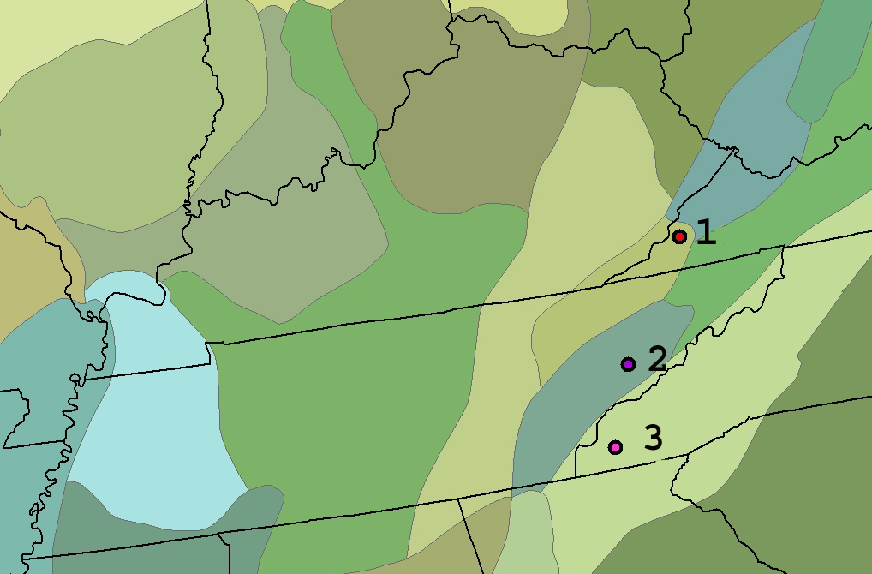

Figure V-1. Origins of provenances for the 10 parent trees, delineated by Bailey’s Ecoregions (Bailey 1995) in the Southern Appalachians.
1. Northwestern Virginia, N-VA, Southern Cumberland Mountains
2. East Tennessee, E-TN, Central Ridge and Valley
3. Western North Carolina, W-NC, Blue Ridge Mountains

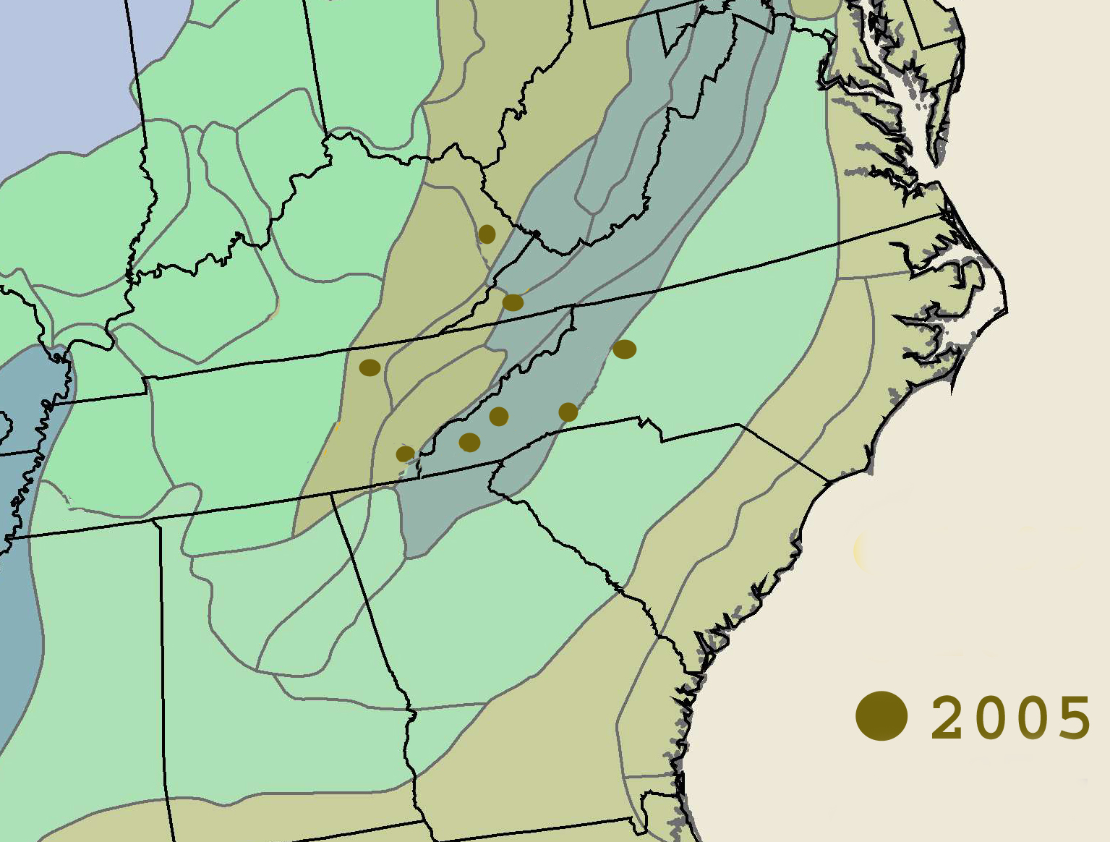
1
2
3
5
61
8
4
7

Figure V-2. Locations of 2005 butternut plantings delineated by Bailey’s major physiographic provenances (Bailey 1995) in the Southern Appalachians.
Number, location, nearest town, state (abbreviation)

1. Cherokee National Forest, Ocoee District, Reliance, TN (TN-OC1 & OC2)
2. Pisgah National Forest: Grandfather District, Old Fort, NC (NC-GF1 & GF2)
3. Pisgah National Forest: Appalachian District, Waterville, NC (NC-AP1 & AP2)
4. Jefferson National Forest: Clinch River District, Pound, VA (VA-CL)
5. Yatesville Lake Wildlife Management Area, Louisa, KY (KY-YA1 & YA2)
6. Surface Mine: Private Mining Company Land, Oak Ridge, TN (TN-SM1, SM2, SM3)
7. Eastern Band of the Cherokee Indians: Qualla Boundary, Ela, NC (NC-KA1 & KA2)
8. North Carolina Forest Service: Holmes Educational State Forest, Hendersonville, NC (NC-HE)

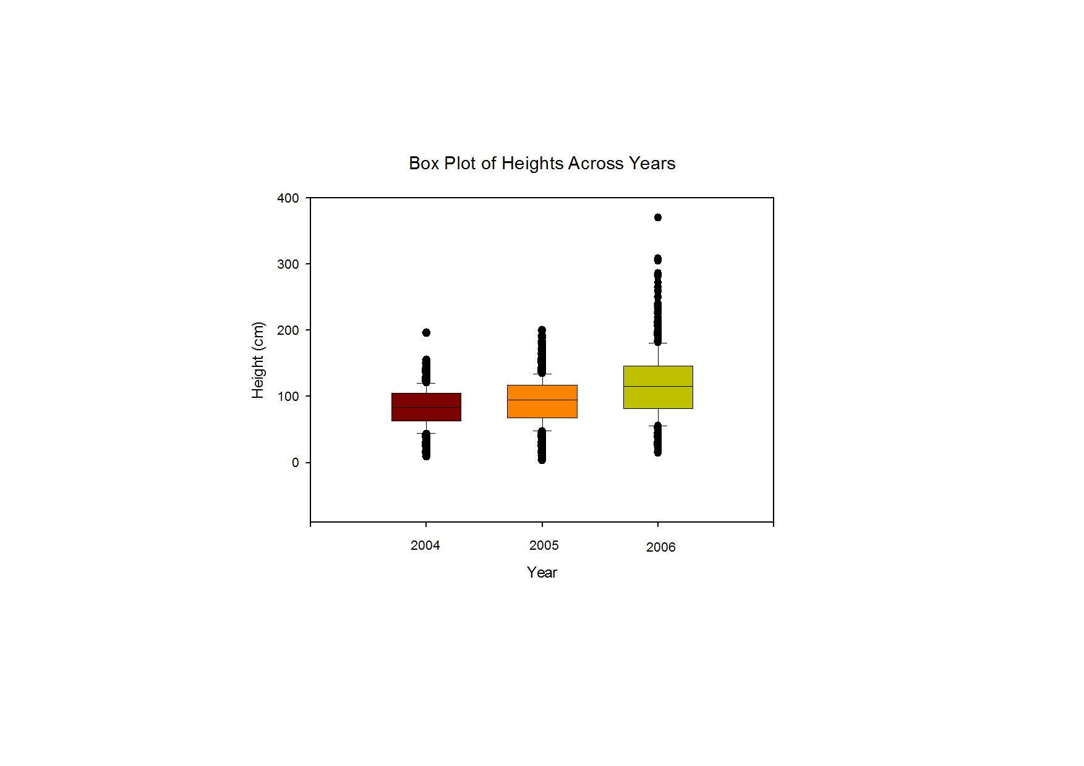
Figure V-3. Average annual heights of butternut seedling established in 2005.

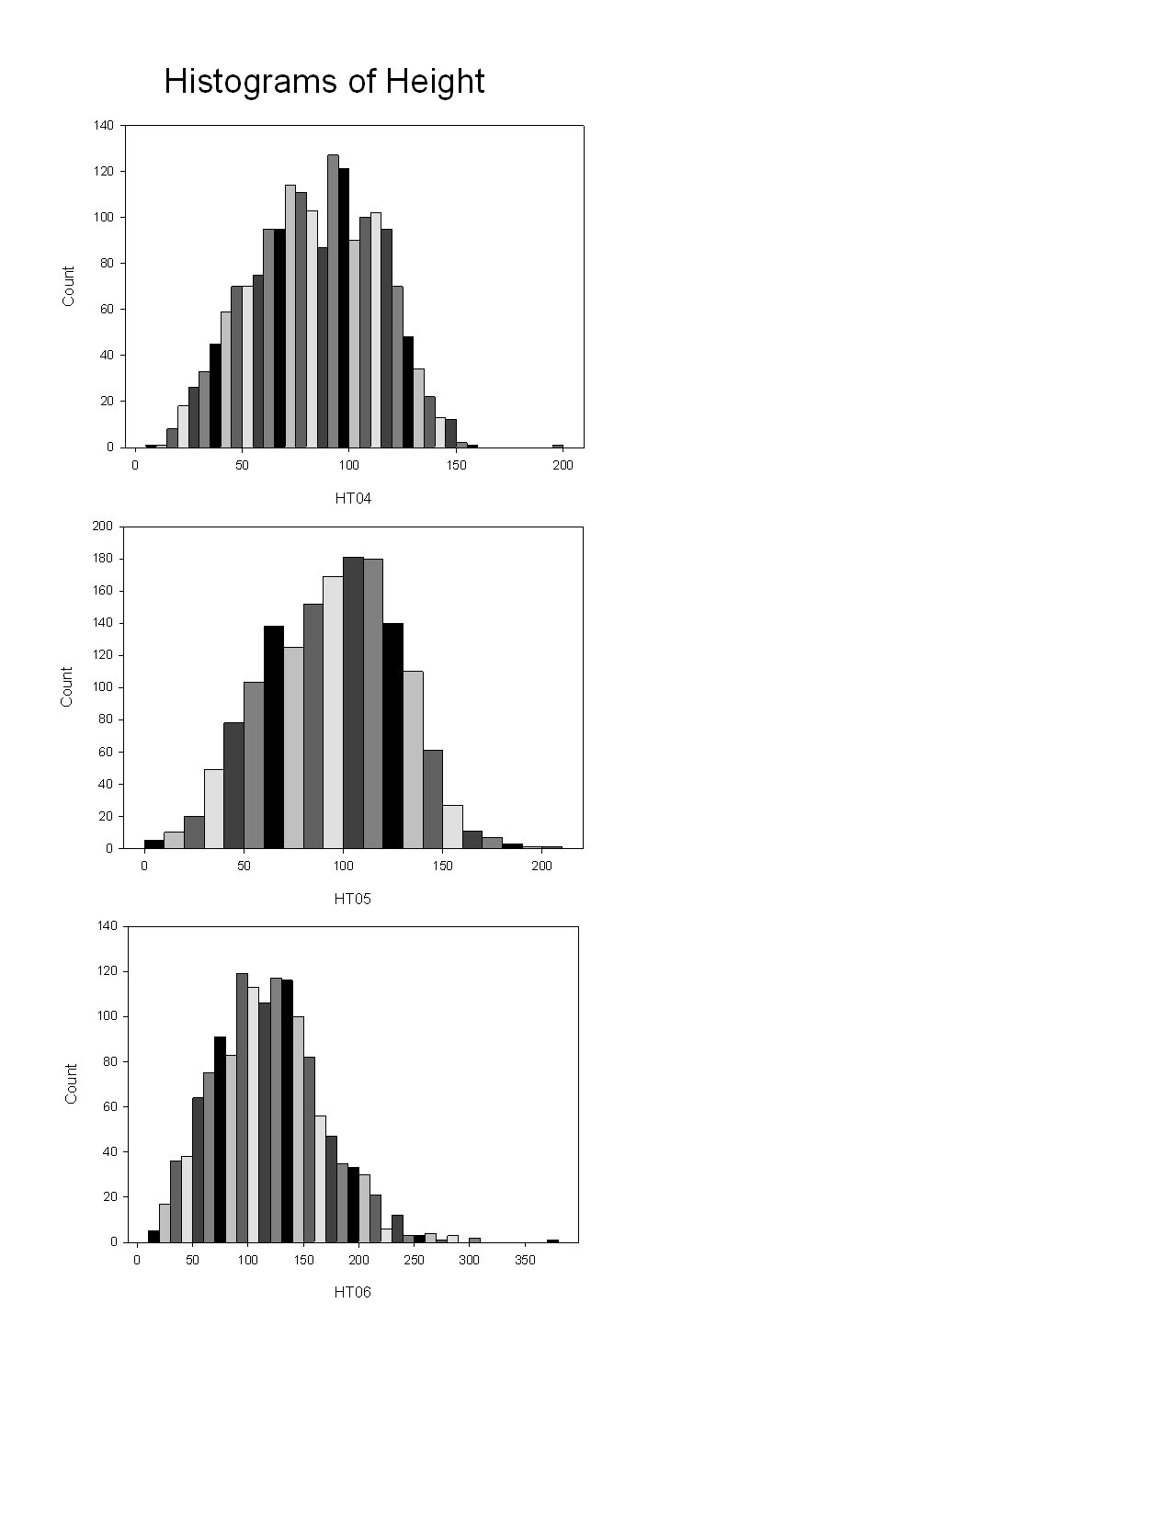
Figure V-4. Distribution of annual heights of butternut seedling established in 2005.

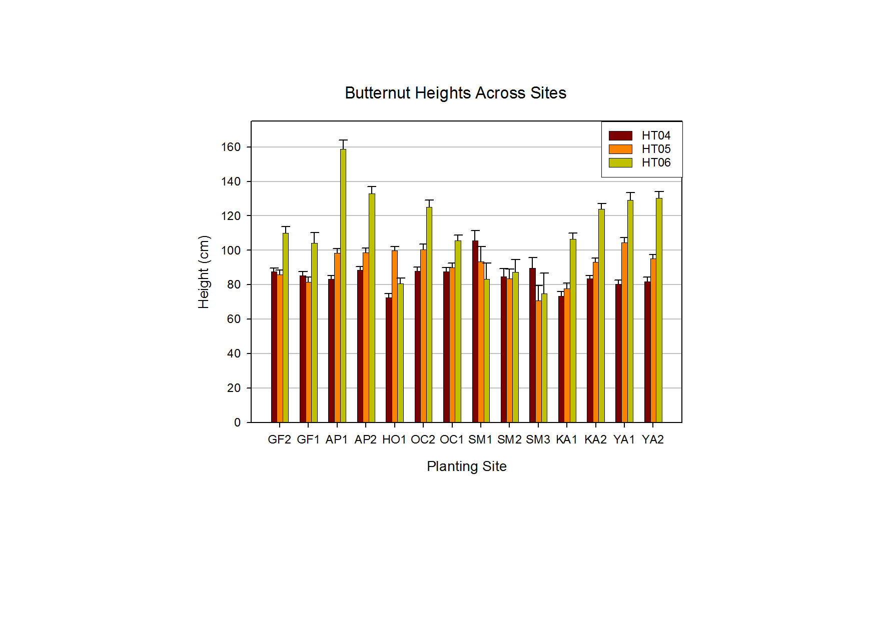
Figure V-5 . Average height of butternut seedlings across planting sites from 2004 until 2006.

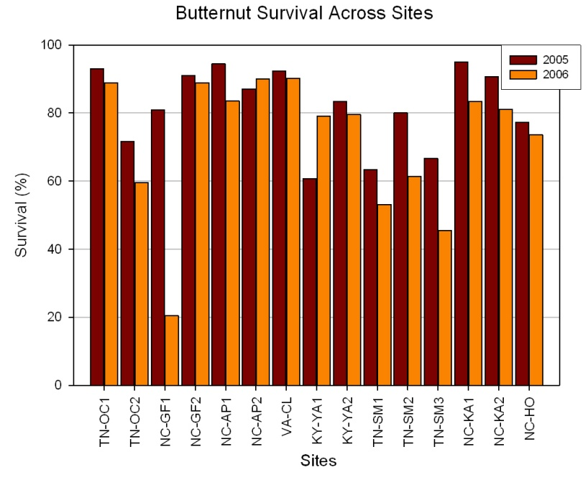

Figure V-6 . Average survival of butternut seedlings across planting sites from 2005 until 2006.

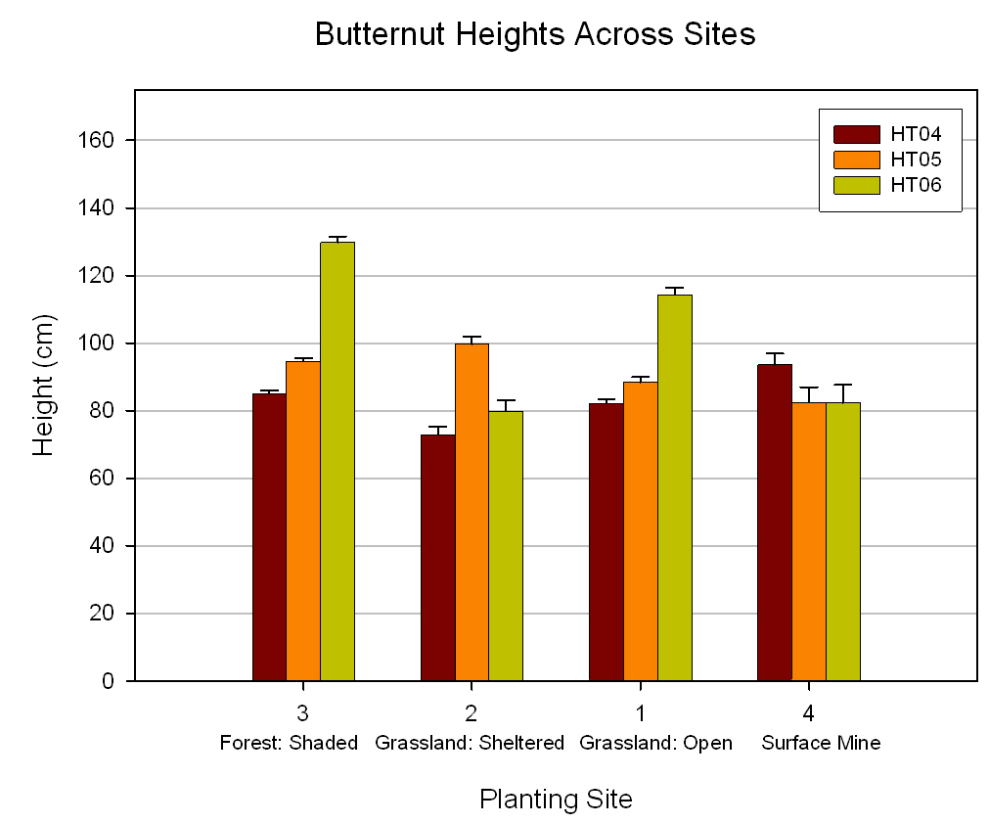

Figure V-7 . Average height of butternut seedlings across planting sites from 2004 until 2006.

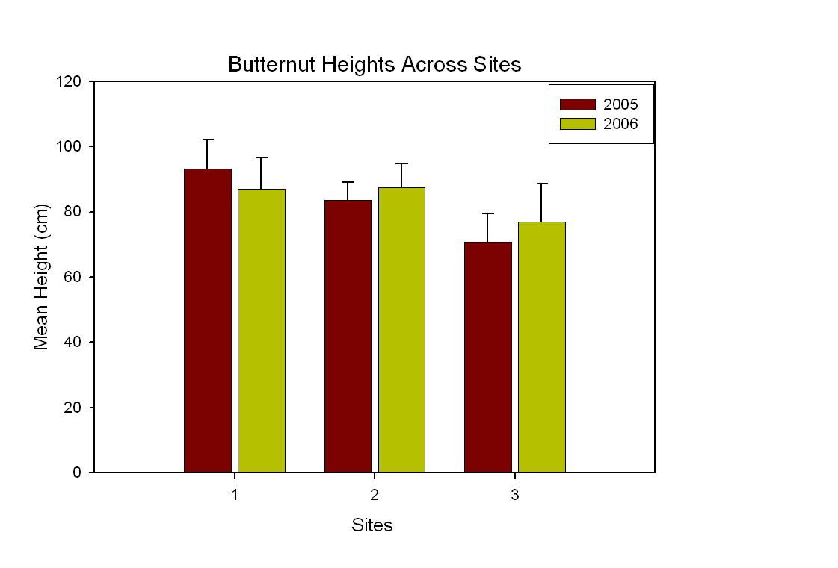
Figure V-8. Height of butternut seedlings at the three sites on surface mines in 2005 and 2006.

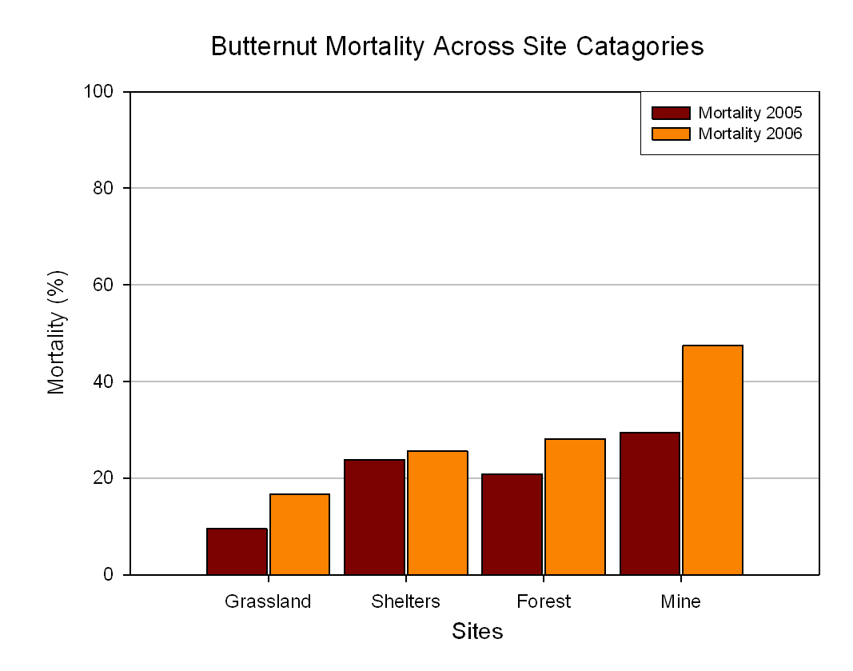

Figure V-9 . Average mortality of butternut seedlings across planting sites from 2005 until 2006.

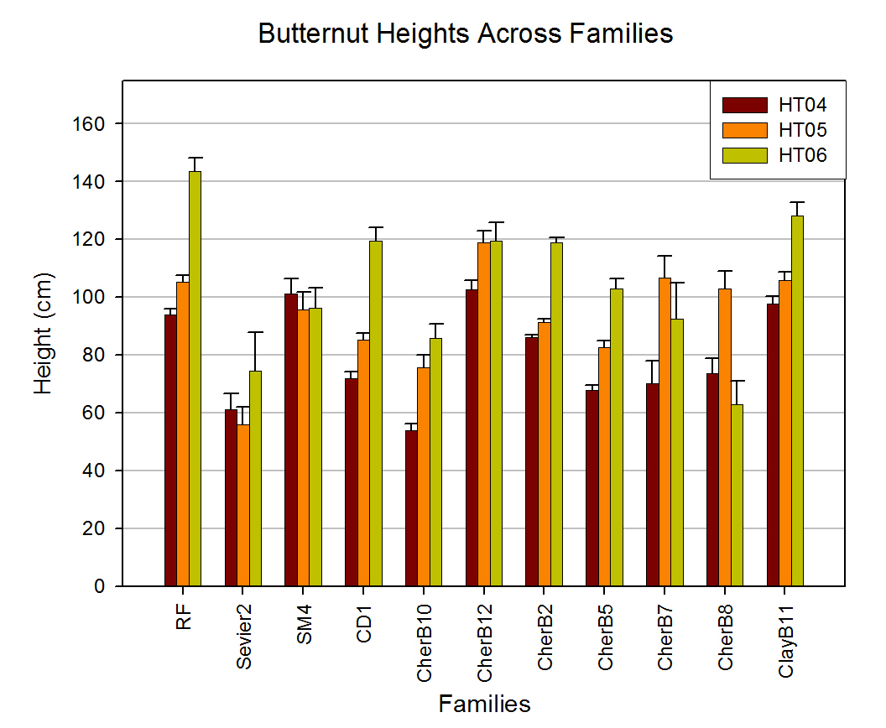
Figure V-10. Height of butternut seedlings across families of origin from 2004 until 2006.

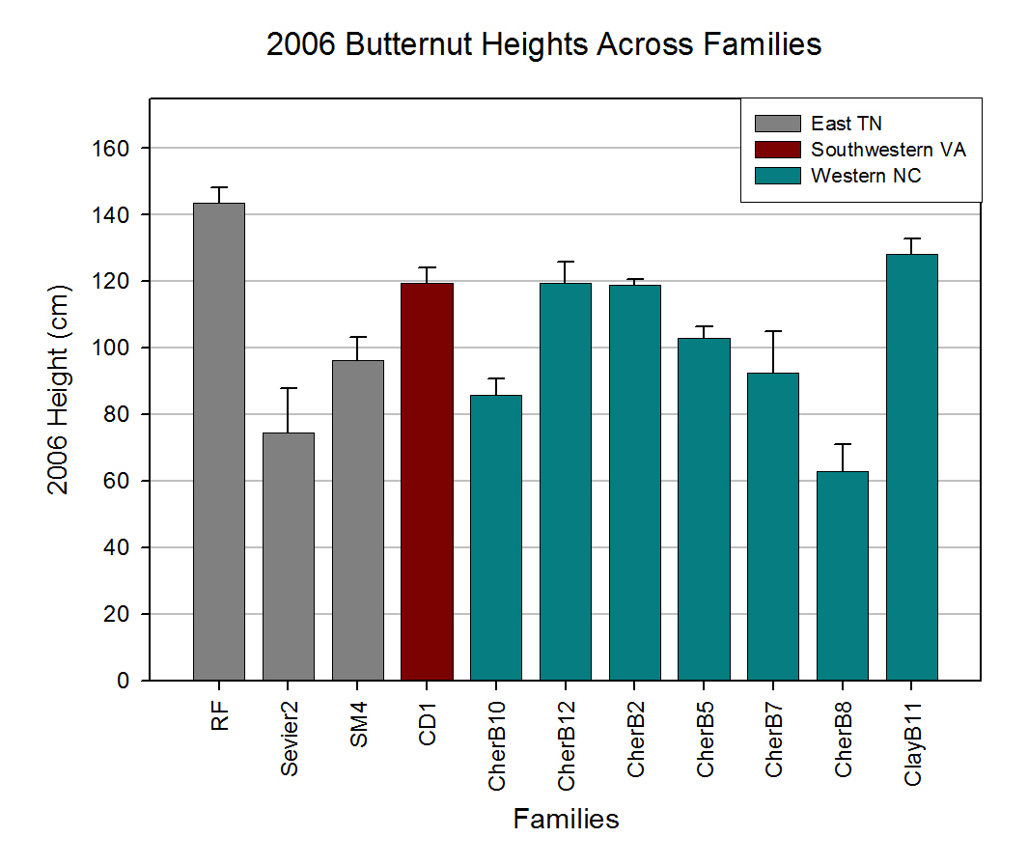
Figure V-11. Height of butternut seedlings across families of origin in 2006.

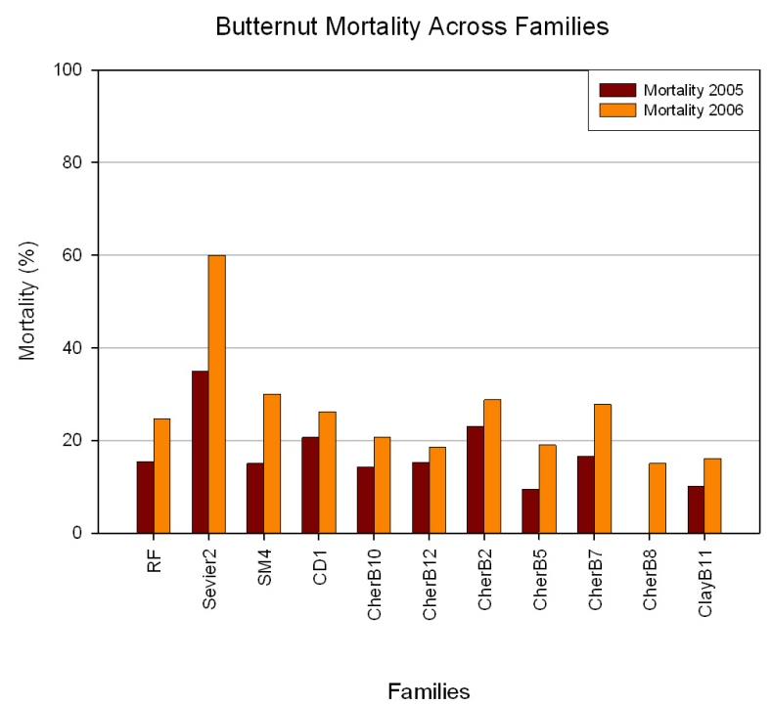

Figure V-12. Average mortality of butternut seedlings across families of origin in 2006.

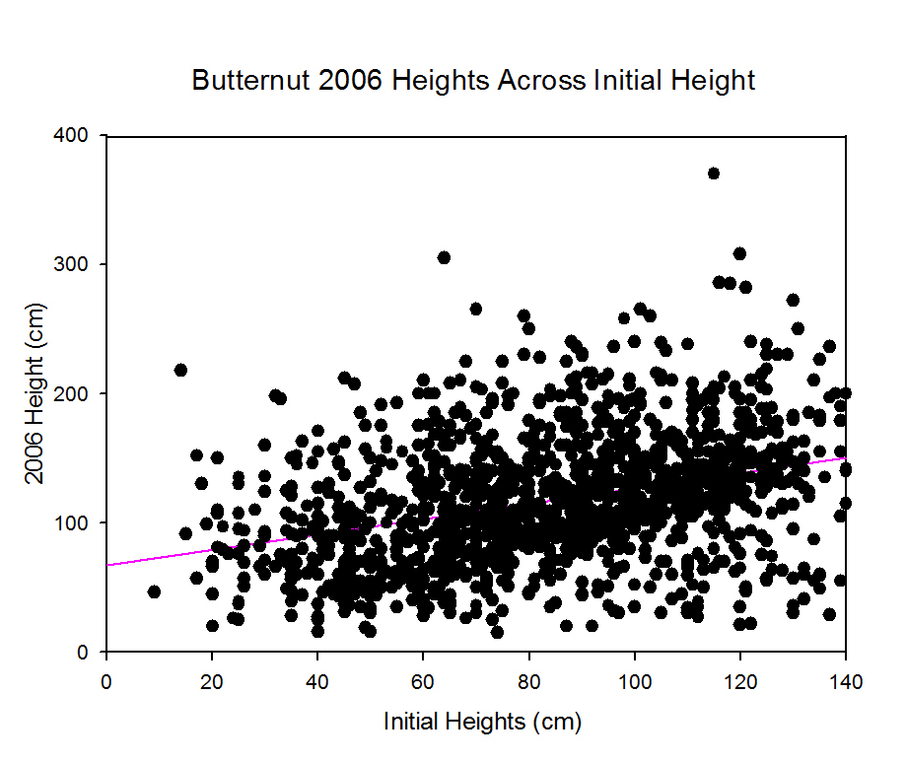
r²=0.123879
Figure V-13. Height of butternut seedlings in 2006 across initial seedling heights.

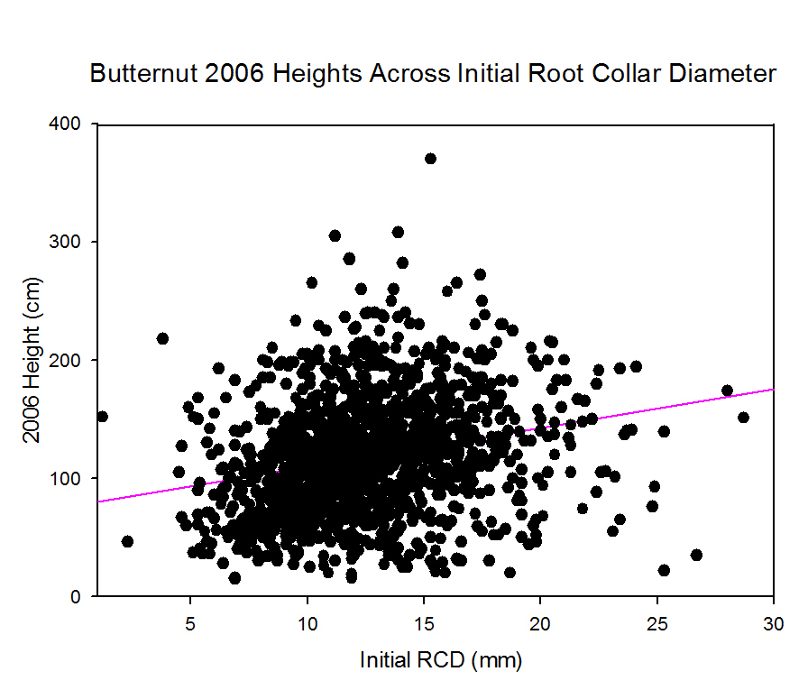
r²=0.059106
Figure V-14. Height of butternut seedlings in 2006 across initial seedling root collar diameter.

CLASSIFICATIONS OF SIZEABLE BUTTERNUT POPULATIONS IN TENNESSEE, MISSOURI, AND ARKANSAS

Abstract

Butternut, Juglans cinerea L., has shown drastic declines due to butternut canker disease, caused by Sirococcus clavigignenti-juglandacearum (Nair, Kostichka, & Kuntz), throughout the native range. Many populations are thought to have been lost. However, there are a very few locations in the south where butternut is still a significant species of the forest community. The current rate of butternut mortality in these communities, however, is unknown. Butternut Valley in central Tennessee is so named due to a high concentration of butternut trees. The four-mile stretch of creek contains over 200 individual trees which were examined for disease development in the late-1990s and then again six years later, in the mid-2000s, to determine percent survival and relate to tree size and disease condition. Mortality in the butternut population was under 9% in six years, even though over 30% of the trees were initially considered heavily diseased. Trees were ranked on a scale of 0-10 with 10 indicating the worst disease condition. Trees that died had a significantly higher average disease rating of 8.22 in the initial survey as opposed to 5.92 for living trees. Trees that died in general existed in lower canopy positions and were significantly smaller in size. Dead trees averaged over 3 m shorter and having a mean diameter at breast height of 17 cm compared to 25 cm for living trees. A major component of disease development may be exaserbated by lack of vigor and in lower canopy positions. The large number of surviving small trees indicates that shade-intolerance alone is also not causing mortality; however, butternut canker may act within the stem-exclusion stage of stand development to remove diseased butternuts during canopy closure. Determining individuals within populations at greatest risk of mortality can guide managers to focus on daylighting by removal of surrounding tress to reduce competition and increase chances of survival.
Determining individual populations at greatest risk is also essential to butternut restoration. The relative health and tree characteristics of the trees in Tennessee were compared to two other large southern populations in Missouri and Arkansas. A numerical canker classification system was developed for comparability between these populations. Phenotypic variables related to tree crown condition were measured to determine if the canker classification was related to tree health. In addition, phenotypic bark characteristics were quantified to determine their relationship with other variables including potential resistance. The three populations were not different in diameter but were different in height. The average canker score was lowest at the Arkansas population, which consequently also had the largest amount of heavily diseased trees. The Missouri population, with a larger overall average disease rating, had a significantly greater percentage of trees in the healthiest disease ranking, but still fewer than ten percent of the population. In the Arkansas population there was no difference in diameter between resistant trees and trees greater than the average disease ranking. In Missouri resistant trees were smaller diameter trees and in Tennessee resistant trees were larger in diameter. Therefore, crown position is not universally an indicator of disease condition. All three populations had lower disease rankings on trees with deeper bark fissures.
Bark fissure depth was closely related to canker classification. However it was also positively related to crown diameter, crown position, height to first live branch, crown light exposure, crown density, and crown dieback. At all populations, increased fissuring occur on trees with healthier canker classifications and healthier crown conditions. Quanitifying canker classification, crown condition, and bark fissure depth allows managers indications of relative disease resistance. These measures are important in selecting potentially resistant trees for breeding programs and monitoring disease development over time.

Introduction

Butternut, Juglans cinerea L., is thought to be a minor component of the eastern United States. Populations of butternut are being threatened by butternut canker disease caused by an exotic fungus, Sirococcus clavigignenti-juglandacearum (Nair, Kostichka, & Kuntz). Little is known however about the impact of this canker on spatial and temporal scales. Individual locations are potential hotspots for butternut and contain trees in greater concentrations and in greater numbers. Some of these hotspots are located in Tennessee, Arkansas, and Missouri.
The largest known natural concentration of butternut in the southeastern United States contains over 300 individual butternut trees in a four-mile stretch of creek in rural DeKalb County, TN (Fig. VI-1). Butternut exists as natural regeneration in various aged old fields and as larger trees that may have been intentionally left unharvested during homesteading years. Butternut Valley contains a large number of both diseased and relatively healthy butternut trees. The age, crown class, and health conditions of the trees are highly variable. Some trees have no stem cankers and appear to be natural resistance to butternut canker disease but on closer examination have cankers in the upper canopy. This location offers an exceptional opportunity for research on the species. Cataloging and monitoring of the butternut trees at Butternut Valley began in 1996 and continues to the present day. Classification of this unique population across multiple scales will provide new information about population dynamics and disease development over time. Two other large concentrations exist in the Arkansas and Missouri and provide locations where characteristics can be assessed across spatial scales as well.

Temporal classification
Many questions still remain about the reaction of butternut trees to butternut canker disease including: What are the physical and climatic conditions that increase susceptibility of the host? and What is the impact of butternut canker on tree growth and vigor? Answering these questions will aid conservation programs for butternut by leading to a greater understanding of disease-host relationships. The impact and epidemiology of any disease is dependent many factors including the environment, the condition of the host, and the attributes of the fungal pathogen causing the disease (Agrios 1997). The complexities in decline and mortality etiology are very difficult to assess especially across various spatial and temporal scales. Butternut canker is one of many factors, including shading and old-age that may result in the death of a butternut tree. The presence of living, heavily diseased trees in the forest that persist over time indicate that butternut canker may not be the primary agent in tree mortality. Butternut may be able to survive for long periods after initial and intensive infection by butternut canker disease. Surveys in Vermont and Wisconsin have shown over 90% infection rates and less than 30% mortality (Bergdahl et al. 1996, Cummings Carlson and Guthmiller 1993 respectively). Ostry et al. (2003) evaluated a stand of butternut on the Nicolet National Forest in Wisconsin since 1993 and found that previously tagged healthy trees remain healthy.
No known surveys have evaluated phenotypic indicators of health, tree crown class, and disease condition in relation to mortality over time. Butternut Valley provides a location where trees have been monitored for a seven-year time period to gain insight into the progression of butternut canker disease including the degree of cankering and mortality over time across trees of various ages, crown positions, and initial health conditions. This study intends to create methods for uniform measurements that can be applied throughout the native range of butternut.

Population comparisons
The impacts and loss of butternut in general have been reduced to mostly incidental personal accounts. In order to assess the overall impact of butternut canker it is essential to compare dynamics of multiple locations. Comparing multiple populations through the southern part of butternuts range will aid in the development of management guidelines for butternut in existing stands. The amount of seedlings that are potentially resistant or heavily infected may vary across populations and indicate populations at greatest threat.

Tree classifications
The relationships between butternut canker disease and phenotypic and environmental tree conditions are unknown. It is believed that butternut canker disease may be behaving like a stress canker and have a larger impact on trees that are stressed by other factors (pers. comm., R.L. Anderson). Insight into the dynamics of butternut canker disease can be determined by evaluations of indications of disease or vigor as well as tree characteristics, such as tree size and crown position.
In addition, phenotypic variables may indicate potential resistance or health condition. Specific crown condition measurements may indicate the levels of which disease is impacting trees or conditions that result in increased succeptability. There has been speculation that certain phenotypic traits may be used as criteria for increased susceptibility to butternut canker disease (Ostry et al.2003). Ostry et al. (2003) noticed that in geographically diverse populations of butternuts, in general, smoother bark type was often associated with an increase in the number of cankers. Ostry et al. (2003) investigated a 40 –acre woodlot containing 544 butternut trees. Of these trees, 17% percent of them were noted to be diseased free. They classified the trees as having two different bark types: dark gray and deeply fissured or light gray and shallow fissured. The dark-deep bark phenotype was present on 73% of the diseased free butternuts compared with 21% of the diseased or dead butternuts (Ostry et al. 2003). Therefore trees with the phenotypic trait of deeper bark furrows may have an increased resistance to butternut canker disease. If genes coding for morphological traits, such as bark furrow depth, are closely linked to genes coding for canker resistance, then butternut morphological traits can be used for selection criteria. Many of these measurements including disease condition and bark characteristics are not uniform. Therefore, subjective measures need to be quantified in order to be repeated in the same stand at various points of time and for comparison of multiple stands.

Objectives
Butternut populations were evaluated to determine population reduction over time and relate to phenotypic characteristics of the trees including disease condition and bark type. Disease development over time was measured at one location. A uniform system was developed to give quantitative measures of several factors of individual trees. Phenotypic characterization of the individual trees and population, if related to genetic resistance, can then be used in breeding efforts and to understand patterns of diversity within the species. This study develops and applies a standardized method of determining disease condition and phenotypic traits of butternut. These evaluations will create a base-line measurement for continued evaluation of tree health over time. The results of this evaluation will directly influence genetic selections in resistance breeding programs.
Objective a). Examine temporal aspects of disease development within the Butternut Valley population to determine percent mortality over a seven-year time period across tree characteristics and canker classifications.
Objective b). Quantify canker classification across three large existing populations to determine the percentage of trees which are potentially resistant or highly diseased as indicators of populations at greatest risk. In addition, tree characteristics will be compared across disease conditions between and among populations to determine universal characteristics related to disease development.
Objective c). Determine if relationships exists between canker classification measures and tree characteristics to determine specific variables indicative of tree health and potential susceptabilty.

Methods

Study locations
Sites were chosen based on personal accounts and preliminary vegetation surveys that identified unusually high abundance of butternut in these areas (Figure VI-1, note tables and figures appear in the Appendix at the end of the text). In all three areas butternut was found close to drainages and streams, indicating typical habitat for the species. All three stands, however, had atypically high numbers of surviving butternut trees. Butternut Valley is located in central Tennessee at approximately 36.1716° N, -86.7848° W around 450 meters elevation on private property owned by the Healing Stones Foundation (Figure VI-2). The valley is located in the Interior Low Plateau of the Eastern Highland Rim Section of the Eastern Broadleaf Forest Provenance (Bailey 1995). Soils are deep, well-drained, cherty silt loam of the Staser series and the site is characterized by steep hillsides and a dry river bottom. The area contains many abandoned homesteads and a few non-residential homes. There are several agricultural subsistence farms that were established by several families beginning in the 1870s into the middle 1900s. By 1960 all families had moved away from the area allowing the old fields to be colonized by early succession species, predominantly butternut. The Butternut Valley population begins along the headwaters of a small seasonally dry creek (Figure VI-3). Some old fields are currently kept open through mowing while others have been allowed to return to forest. Phenotypic surveying of the Butternut Valley site in Tennessee was compared to additional surveys at two other locations with a large number of butternut trees. The St. Francis National Forest in Arkansas and the Ozark National Scenic Riverways in Missouri are two additional locations were a large number of butternut trees are surviving in various health conditions. The St. Francis National Forest is located at approximately 34.545702° N, -90.644346° W in eastern Arkansas on the Mississippi River, The Forest rises from the delta plains of Arkansas and Mississippi with the highest ridge at around 91 meters elevation. The St. Francis Lowland Ecoregion is part of the Mississippi Alluvial Plain. River terraces provide the main elements of relief with poorly drained soils. Much of the hydrologic system has been impacted by levees and river channel dredging projects. Much of the area was clearcut in the mid-1970s resulting in recruitment of a single-aged stand.
The Ozark National Scenic Riverways in Missouri is located at approximately 37.323390° N, -91.959775° W along the Current River and Jacks Fork streams draining northeast into the Mississippi River. The area is at around 350 m elevation and has irregular physiographic and is mostly forested with soils mainly chert and shale origin. The Current River Hills ecoregion of the Ozark Highlands has chert ridges that are deeply dissected with steep-sided hills.

Species classification
Throughout this manuscript butternut, J. cinerea, is defined by whole-tree silvic characters for identification. For each tree overall phenotype was evaluated based on dendrological characters and nut characters that tend to distinguish the species. It is unknown if the whole-tree silvic can distinguish between pure butternut or hybrids of butternut and heartnut of various generations. Trees classified as butternut (sensu lato) could actually be the result of hybridization between J. cinerea and J. ailantifolia Carr or J. ailantifolia var. cordiformis (Maxim.) Rehd.) or hybridization with advanced generation hybrids, J. x bixbyi Rehd. Most trees used in this study were DNA genotyped using 12 microsatellite loci and specific chloroplast markers to determine recent maternal ancestry (Hoban et al. 2009). Trees at Butternut Valley in central TN consisted of all J. cinerea except for two trees; 1 with a 75% of greater probable of an F2 hybrid with J. ailantifolia and one with a 75% or greater probability of not being a pure butternut. Trees at the Ozark Riverways in Missouri consisted of primarily hearnut with one F₁ J. x bixbyi individual and one with a 75% or greater probability of not being a pure butternut. All trees in the St. Francis National Forest were pure J. cinerea.

Canker classification system
In 2004, a Butternut Canker Classification System (Appendix B) was developed in order to provide a more consistent and uniform measurement of trees overall health and the amount of cankering on a tree. Based on the number of bole and branch cankers per linear foot, a tree is given a canker classification rating of 0 to 10. With this rating system, a score of 0 indicates a tree with no evidence of disease, and a score of 10 is the worse disease rating, with at least one canker per foot. This system was field-tested on the St. Francis National Forest in Arkansas, and incorporated into the University of Tennessee’s Tree Improvement Butternut Program in 2005.
In 2004 and 2005, the canker classification system was used to rate the health of 224 butternut trees located in Butternut Valley. For comparison purposes, in 2004 and 2005, approximately 150 trees from the St. Francis National Forest, in Arkansas, and approximately 450 trees in southeastern Missouri including the Ozarks, were also classified according to the system (Figure VI-1).

Tree classification
Butternut trees in Butternut Valley were measured for their relative condition in terms of the number of cankers as well as factors that express a trees health condition and phenotypic variables that may be related to disease resistance. At the Butternut Valley location 224 butternut trees occurring along a four-mile stretch of creek were permanently tagged, measured for height, diameter, and form. Initially measurements were taken in 1998 (initial survey). The trees were evaluated for disease in the limbs and boles (0-5) and overall (0-10 with 0 = no cankers present to 10 = heavily diseased) and some trees were cored for age. In February of 2004 (resurvey), the trees were reevaluated to determine mortality since the previous survey. The GPS data from 1998 was not accurate due to an induced error from the US Military and the locations were not differentially corrected. Therefore the GPS location of each tree was initiated once again in the resurvey. Butternut trees were located based on previous permanent tagging and were mapped using a global positioning system (GPS) receiver (Garmin® GPSMAP 76S, Olathe, Kansas, USA; Magellan® GPS 330, Santa Clara, California, USA) to a 5m accuracy and all location coordinates were recorded (Fig. VI-2).
Additionally, the health of each tree was assessed using the uniform canker classification system (Appendix B). This rating technique is based on the number of cankers on the main stem and branches. Based on this system, trees that exhibited potential resistance to disease (little or no cankers) were recorded. Dead trees were noted to provide an estimate of mortality over time. New individual seedlings that were either not present or very small in size in 1998 were added to the survey, but not included in the reported analyses. The main canker score on a scale from 0-10, with 0 being healthy and 10 being heavily diseased and the bole canker score were evaluated.
A suite of measurements were collected from each tree including survival, height, and diameter at breast height. Bark fissure depth was determined using a tire gauge to create a consistent measurement between deeply-furrowed and smoother bark types (Appendix A). Trees with deeper furrows had higher numbers of bark depth. Height to the first live branch was measured in meters. Crown measurements were completed using protocols developed and used by the USDA Forest Service, Forest Inventory and Analysis as indicators of tree health (Schomaker et al. 2007). Crown diameter is the average of two diameter measurements: (1) widest distance anywhere in the crown between the driplines of two live branches, and (2) the distance perpendicular to the widest measurement; taken in meters. Crown light exposure: estimates the amount of a tree’s foliage receiving direct sunlight; crowns are rated from zero to five depending on the number of crown sections exposed to direct sunlight (0=no sections exposed, 5=all sections exposed. Crown position: estimates the position of a tree’s crown relative to the stand overstory canopy zone; Codes 1 to 4 represent the superstory, overstory,understory, and open-grown crown positions, respectively. Many of the percentage data are recorded in 5-percent classes and coded as 0, 05, 10, 15, . . . , 100, where the code represents the upper limit of the class, e.g., 1 to 5 percent is code 05. Crown density: estimates the amount of light blocked by branches, reproductive structures, and foliage within a tree’s crown; recorded in percent classes. Crown dieback: estimates recent branch mortality in the upper and outer portions of the live crown; recorded in percent classes. Foliage transparency: estimates the amount of skylight visible through the live, normally foliated portion of the crown; recorded in percent classes; recorded in percent classes (Schomaker et al. 2007).

Statistical analysis
Statistical analyses were conducted using SAS version 9.1 (for Windows, © 2005 SAS Institute Inc., SAS Campus Drive, Cary, North Carolina 27513, USA). Additional macros developed by A. Saxton (1998, 2004) were used for means separation and genetic correlations. Macros included pdmix800 for means separation using multiple range tests (Saxton 1998), Mixed Model Analysis of Variance Macro (mmaov) uses Fisher's Least Significant Difference (LSD) test was conducted at the 5% significance level, determines if standard deviations are within five fold of each other, calculates Levene P values to determine equality of variances, and a Shapero-Wilk W test for normality (Saxton ©2002). All percentage data, derived from count data, including survivorship and presence of cankering, underwent inverse trigonometric sine transformations due to lack of homogeneity of variances (Snedecor and Cochran 1998).
Objective a). Surviving and dead trees were compared using t-tests for differences in height, diameter, tree crown position, and previous disease measurement.
Objective b). For all three populations individually trees were grouped by ratings of either greater than or lesser than the mean, healthy (0-rating), resistant (0 and 1 ratings), and heavily diseased (10 rating). Groupings of trees were compared to determine differences in percentages across the three populations using an analysis of variance (PROC ANOVA). Butternut trees from each of the three populations, TN, MO, and AR were compared using a multivariate analysis of variance (PROC MANOVA) for variation in bark depth and crown conditions. Canker classification groups were analyzed for the impacts of canker classification on various other tree measurements including DBH (diameter at breast height), bark fissure depth (mm), and indicators of crown condition.
Objective c). For all three locations combined, ordinal regressions (PROC REG) were preformed on the relationship between canker classification (0-10) and phenotypic tree variables including height, DBH, crown class position, bark fissure depth, and variables indicative of crown condition. All canopy measurements were analyzed for correlations (PROC CORR).

Results

Temporal classification
At the Butternut Valley population in central Tennessee surveys were conducted at two points in time. In 1998, 224 butternut trees were measured for disease condition on limbs, on the main bole, and overall disease condition. Trees averaged 26.83 cm diameter at breast height (dbh) and 15.96 m in height. In general the height of the trees was a bell-shaped curve and the dbh was left skewed with the greatest number of trees in the dbh class of 5-10cm and the height in 10-15m (Figure VI-4). Disease condition on limbs was significantly higher than the condition on the main boles (Figure VI-5). A level 3 disease condition was present on 30% of trees on limbs and 20% on boles. A level 4 disease condition was present on 33% of the trees on limbs and 23% on boles (Figure VI-5). Numerous limb cankers may have less of an overall impact of a tree than a few large bole cankers. This may also indicate disease progression from the limbs initially into the main bole of the tree. Taller and larger trees had significantly lower disease ratings than smaller classes of trees (Figure VI-6). Trees in the lowest limb disease rating of 0 average 30.91 cm dbh and 17.32 m tall compared and consistently larger at the 2-4 disease limb rating (Figure VI-6). However at the worse limb disease rating, this correlation was consistent for dbh but not for height: 13.29 cm dbh and 20.36 cm tall (Figure VI-6). There was less of a downward trend on disease ratings of boles for height; however, the downward trend was evident for dbh except for the worse disease rating (Figure VI-7).
In the initial survey, overall level of disease was fairly consistant across height and diameter of trees (Figure VI-8). There were no relationships among tree size, age, form, and disease rating for the stem, bole, and overall. This indicates that trees with varying levels of disease could be found in any size, form or age class. For the entire population disease pressure was equal across a wide range of tree conditions. Overall disease level was essentially bell-shaped with a slight skew towards the score of 7 out of 0-10 (Figure VI-9).
Objective a). The resurvey found overall mortality in the butternut population was 8.7 percent. This percentage was considered to be low, as over 30 percent of the trees received disease ratings of 8-10 in initial survey. Dead trees in 2004 had a significantly higher average disease rating of 8.22 in 1998, as opposed to 5.92 for living trees (p=0.00106, Figure VI-11). Average canker values on the branch were higher in dead trees (4.44) compared to live trees (3.03, p<0.0001, Figure VI-11). Average canker values on the main stem were also higher on dead trees (3.78) compared to live trees (3.03, p<0.0001, Figure VI-11). The highest amount of mortality occurred among small trees with high disease rankings. 20 percent of surviving trees received a very high disease rating six years prior.
The dead trees in 2004 were smaller trees in the 1998 than trees that remained alive (Figure VI-12). Trees averaged over 3 m shorter; height of 11 m for dead trees and 15 m for living trees (p<0.0001). The mean diameter at breast height of dead tress was 17 cm compared to 26 cm for living trees (p<0.0001). Within the Butternut Valley population, bark fissure depth is higher in trees with lower canker ratings and lower in trees with the most amount of cankering.
There are 53 butternut trees in butternut grove, with an average dbh of 24.7 cm and an average height of 19.5 m. The average butternut canker score on a scale from 0 (most resistant) to 10 (highly susceptible) for this area is 3.88 and ranges from 1 to 10. The second concentration is known as the “old field” is another old field that has not been disturbed in approximately five years. There are 41 seedlings in the old field, with an average dbh of 3.9 cm and an average height of 3.4 m. The butternut canker score for this population is less than 1 (0.70) with a maximum canker score of 4. These two areas provide evidence of regeneration in two distinct time periods and could provide important information in terms of genetic relatedness and parental lineage across two regeneration episodes within the population.

Population comparisons
Objective b). Canker classification The average health rating of the Tennessee population (TN) was compared with populations in the St. Francis National Forest in Arkansas (AR) and the Ozark National Scenic Riverways in Missouri (MO) (Table VI-1). The mean canker rating, on a scale from 0 to 10, of these three populations was: 3.038 for the TN and 3.945 for AR and 2.96 for MO (Table VI-1, Table VI-1, Figure VI-13). The classification system was consistant between the Tennessee and Missouri populations in mean health rating of trees and the percentage of trees with healthy and resistant ratings. The AS population was different that both the TN and MO populations for canker classifications. Cankers on the main bole of the tree were consistant with overall canker score (Table VI-2, Figure VI-14). MO had the largest percent of trees with the healthy rating (9.77), however it was still under ten percent of the population. AS had the healthiest overall rating of trees, but also had the highest percentage of heavily diseased trees (9.52). The AS population all canker classification catagories had the same DBH. In the TN population resistant trees were larger in DBH than trees less than or greater than the mean health rating. The opposite was true in the MS population with the largest trees with the greatest amount of diseased.
Tree characteristics All three populations were not different in diameter at breast height (p= 0.4142, Table VI-2, Figure VI-15). The AS population had the tallest trees followed by TN and then MS (19, 16, 12 m, respectively, Figure VI-16). At all populations combined the average height was consistant across canker scores (Figure VI-17), as was diameters (Figure VI-18), crown positions (Figure VI-19), and crown light exposure (Figure VI-20). AS also had a greater percentage of trees in more dominant crown position and decreased height to first branch. Crown light exposure, height to first live branch, and crown diameter were all greatest in the MS population, followed byAS and then TN. The bark depth overall is less furrowed in the TN and AS populations with the deepest furrows in the MS population (Table VI-3). At all populations trees with greater than average canker scores had lower fissure depth (Figure VI-21), incrased deiback, incrased foliage transparency, and decreased crown diameter.

Phenotypic classification
Objective c). Relationships exist between canker classification ratings and indicators of tree health and vigor (Table VI-3). Increasing canker condition resulted in increased dieback, foliage transparency, and decreased foliage density and diameter, as expected. Therefore, canker condition gives insight into the health of the trees crown. Canker condition was not related to crown position, crown light exposure, or height to first branch; indicating that disease was present in all crown classes. Canker classification was not significent related to DBH or height (Table VI-4). Significent correlations existed between specific measures of crown condition; indicating their reliablilty in assessing crown health (Table VI-5, Figure VI-22, Figure VI-23, Figure VI-24).
Bark fissure depth was closely related to canker classification (Table VI-4). However it was also positively related to crown diameter, crown position, height to first live branch, crown light exposure, crown density, and crown dieback (Table VI-5). At all populations increased fissuring occured on trees with healthier canker classifications and healthier crown conditions. Quanitifying canker classification, crown condition, and bark fissure depth allows managers indications of relative disease resistance. These measures are important in selecting potentially resistant trees for breeding programs and monitoring disease development over time.

Discussion

Temporal classification
Results of the temporal study at Butternut Valley show very little mortality over the six-year time period investigated. This indicates that butternut canker alone may not be the primary agent in tree mortality. A large number of surviving trees are small trees in the suppressed age class indicating that shade-intolerance alone is also not the primary agent of mortality. The relationship between survival and size as well as disease ranking reflects the greatest mortality among trees experiencing a loss of vigor due to suppression from canopy closure and the largest negative effects of butternut canker disease. At this individual population of J. cinerea species, natural resistance to the disease may be fairly high as mortality appears to be primarily caused by stand dynamics.

Population comparisions
The mean rating values and the percentages of seedlings in each rating class are fairly consistent across multiple populations. Therefore, the canker classification system can be used to determine relationships in the average score and number of potentially resistant trees across populations. In addition, it provides evidence that the Butternut Valley population has a similar amount of disease and health trees as other known concentrations of butternut. However, the increased disease among smaller trees may be an artifact of location in Tennessee as the opposite is true in the Missouri population and no difference occurs in the Arkansas population.

Phenotypic classification
Trees with a large number of cankers also had increased dieback, increased foliage transparency and reduced crown density and diameter; therefore canker classification rating can be used as an indicator of overall tree health. Phenotypic variables may give some indications of potential survival of individual trees.
Given the relationship between smooth bark type and cankering, smooth barked trees may be more susceptible to cankering, which is similar to observations by Dr. Mike Ostry, North Central Experiment Station. However, this may also be an artifact of reduced light exposure and lower canopy conditions which may increase succeptabilty to the disease.
One of the impacts of butternut canker disease is cankers causing weakened stem joints on individual trees. These weakened joints may result in loss of limbs during periods of high winds, reducing overall tree vigor and eventually leading to decline and mortality. The impact of weakened stems may be greater in northern sections of butternut’s range where heavy snowfall and icing events occur more frequently. This may be one factor that is resulting in reported high mortality in Vermont and Canada. By examining northern populations, using the same criteria, over time additional trends may be determined.
Surveys including additional populations at northern portions of the range will help determine the impact of location within range on various aspects of disease condition. Genetic refugia from glaciations or populations disjunct from the main range may have various different population dynamics than populations from the middle of butternuts’ range. In 2009, 23 butternuts in western Maryland in Garrett, Allegany, and Washington Counties were evaluated using the same system. In addition, 46 butternuts in Pendleton County, West Virginia were also evaluated. These populations may have very different survival rates give the potential additive impacts of snow and ice damage on cankered limbs.

Conclusions

Assessement of a single population six years after initial assessment showed only eight percent mortality; concentrated in lower crown positions. Assessment of various populations, however, indicates that canker condition is consistant across a variety of tree sizes and canopy positions. The canker classification system developed for assessement can determine the proportion of resistant seedlings in a population and is related to indicators of crown condition and tree health. Trees with smooth bark types have lower canker scores but also appear in higher crown positions with greater exposure to light. This phenotypic variable is related to tree health as well as degree of cankering, with increased health in the deeply furrowed bark type.
Literature Cited

Agrios, G.N. 1997. Plant Pathology (Fourth Edition), Academic Press, London. 635pp.

Anderson, R.L. 1978. The distribution of butternut decline in the eastern United States. Forest Insect and Disease Management Survey Rep. S-3-78. Broomall, PA: U.S. Department of Agriculture, Forest Service, Northeastern Area, State and Private Forestry Report: 4, 5p.

Bailey, R.G., 1995. Description of the Ecoregions of the United States, Second ed. USDA Miscellaneous Publication, 1391.

Boetsch, J, F. T. van Manen, and J.D. Clark. 2003. Predicting rare plant occurrence in Great Smoky Mountains National Park. Natural Areas Journal 23:229–237.

Buchert, G.P. 1995. The application of basic population genetics principles to forest tree gene conservation. In Forest Gene Conservation Principles to Practice .Workshop Proceedings, Ottawa, OFRI, pp. 3-15.

Cummings Carlson, J. and M. Guthmiller. 1993. Incidence and severity of butternut canker in Wisconsin in 1976 and 1992. Phytopathology. 83 (12): 1352.

McNab, W.H. 1989. Terrain Shape Index: Quantifying Effect of Minor Landforms on Tree Height. Forest Science, 35: 91-104.

Ostry, M.E., M.E. Mielke, and D.D. Skilling 1994. Butternut-strategies for managing a threatened tree. Gen. Tech. Rep. NC-165. St. Paul, MN: U.S. Department of Agriculture, Forest Service, North Central Forest Experiment Station and Northeastern Area State and Private Forestry. 7 p.

Ostry, M.E., B. Ellingston, D. Seekins, and W. Ruckheim. 2003. The need for silvicultural practices in collection of butternut germplasm for species conservation. In: Proceedings of the 13th Central Hardwood Forest Conference, Eds. J.W. Van Sambeek, J.O. Dawson, F. Ponder, Jr., E.F. Lowenstein, and J.S. Fralish. USDA Forest Service North Central Research Station. General Technical Report. NC-234, St. Paul, MN. pp. 551-555.

Parker, A.J. 1982. The Topographic relative moisture index: an approach to soil-moisture assessment in mountain terrain. Physical Geography 3; 160-168.

Rothery, E. 1991. Varian SpectrAA-20 Operation Manual. Publication No. 85-100625-00. Varian Australia Pty. Ltd., Mulgrave, Victoria, Australia.

SAS Institute Incorporated. 2005.

Schlarbaum, S.E., F. Hebard, P.C. Spaine, J.C. Kamalay. 1997. Three American tragedies: chestnut blight, butternut canker, and Dutch elm disease. Pages 45-54 in K.O. Britton, ed. Proceedings, Exotic pests of eastern forests; 1997 April 8-10; Nashville, TN. Tennessee Exotic Pest Plant Council.

Schlarbaum, S.E., R.L. Anderson, M.E. Ostry, S.L. Brosi, LM. Thompson, S.L. Clark, F.T. van Manen, P.C. Spaine, C. Young, S.A. Anagnostakis, E.A. Brantley. 2004. An Integrated Approach for Restoring Butternut to Eastern North American Forests. Pages 156-158 in Li, Bailian and Steven McKeand, eds. Forest Genetics and Tree Breeding in the Age of Genomics: Progress and Future, IUFRO Joint Conference of Division 2 Conference Proceedings.

Schomaker, Michael E.; Zarnoch, Stanley J.; Bechtold, William A.; Latelle, David J.; Burkman, William G.; Cox, Susan M. 2007. Crown-condition classification: a guide to data collection and analysis. Gen. Tech. Rep. SRS-102. Asheville, NC: U.S. Department of Agriculture, Forest Service, Southern Research Station. 78 p.

Thompson, L.M., F.T. vanManen, S.E. Schlarbaum, and M. DePoy. 2006. A spatial modeling approach to identify potential butternut restoration sites in Mammoth Cave National Park. Restoration Ecology 14(2):289–296.

USGS, Seamless Data, http://seamless.usgs.gov

van Manen, F. T., J.D. Clark, S.E. Schlarbaum, K. Johnson, and G. Taylor. 2002. A Model to Predict the Occurrences of Surviving Butternut Trees in the Southern Blue Ridge Mountains. Pages 491-498 in J.M. Scott, P.J. Heglund, M.L. Morrison, J.B. Haufler, M.G. Raphael, W.A. Wall, and F.B. Samson, eds. Predicting Species Occurrences: Issues of Accuracy and Scale. Washington, D.C., Island Press.

Wilds, S.P. 1997. Gradient analysis of the distribution of fungal disease of Cornus florida in the southern Appalachian Mountains, Tennessee. Journal of Vegetation Science. 8 (6): 811-818.

Finkelstein, S.A., K. Gajewski, and A.E. Viau. 2006. Improved resolution of pollen taxonomy allows better biogeographical interpretation of post-glacial forest development: analyses from the North American Pollen Database. Journal of Ecology. 94 (2): 415-430.

USDA, ARS, National Genetic Resources Program. 2001. Germplasm Resources Information Network - (GRIN). [Online Database] National Germplasm Resources Laboratory, 2001 Juglans Crop Germplasm Committee Report. Beltsville, Maryland. Available: http://www.ars-grin.gov/npgs/cgc_reports/juglans2001.pdf

Appendix: Tables and Figures

Table VI-1. Disease conditions of three butternut populations using the numerical canker classification rating system.

Location | Number of Trees | Mean Health Rating | % trees < mean | % trees with 0 rating:  HEALTHY | % trees with 0 and 1 rating:  RESISTANT | % trees with 10 rating: HEAVILY DISEASED
St. Francis, AR | 162 | 3.945a | 40.14c | 4.08b | 11.57b | 9.52a
Butternut Valley, TN | 153 | 3.038b | 53.59b | 3.27c | 13.07a | 2.61c
Ozark, MO | 512 | 2.957b | 64.44a | 9.77a | 13.77a | 3.33d
TOTAL/MEAN | 827 | 3.314 | 52.72 | 5.71 | 12.80 | 5.15

Unique letters indicate significantly different values using Tukey’s Mean Separation Analysis across individual columns for each variable.

Table VI-2. Variation between sites with butternut tree characteristics.

Variables | Arkansas | Missouri | Tennessee | F value | P value
Height (m) | 18.59a | 12.21c | 15.91b | 40.53 | <0.0001
Diameter at breast height (cm) | 24.04a | 24.01a | 25.46a | 0.88 | 0.4142
Bark Depth¹ | 1.33b | 2.36a | 1.24c | 71.85 | <0.0001
Canker Score² | 3.95a | 2.96b | 3.04b | 29.91 | <0.0001
Main Bole Cankers³ | 1.90b | 6.92a | 7.76a | 34.67 | <0.0001
Crown Position⁴ | 2.91a | 2.64b | 2.76ab | 3.93 | <0.0001
Crown Light Exposure⁵ | 1.86b | 2.00a | 1.62b | 4.75 | 0.0090
Height to 1st live branch (m) | 1.07c | 8.99a | 5.27b | 73.24 | <0.0001
Crown Diameter (m) | 2.05c | 8.17a | 5.12b | 84.22 | <0.0001
Crown Dieback (%) | -- | 25.24a | 20.51a | 2.67 | 0.1452
Crown Density (%) | -- | 58.87a | 54.71a | 1.04 | 0.3084
Foliage Transparency (%) | -- | 35.51a | 39.26a | 1.54 | 0.2160

Bold indicates not significant at the p=0.05 level
Unique letters indicate significantly different values using Tukey’s Mean Separation Analysis across individual rows for each variable.

¹ bark fissure depth measured with a tire gauge
2 on a scale from 0 healthy to 10 heavily diseased on the main bole and smaller limbs
3 on a scale from 0 healthy to 10 heavily diseased on the main bole
4 Codes 1 to 3 represent the superstory, overstory, and understory crown positions, respectively
5 crowns are rated from zero to five depending on the number of crown sections exposed to direct sunlight
Table VI-3. Butternut tree characteristics at three southern populations using the numerical canker classification rating system.

Location | Trees  % (#) | DBH¹  (cm) | Crown Density² (%) | Crown Diameter (m) | Foliage Transparency (%) | Dieback (%) | Bark Fissure Depth³ (mm)
St. Francis, Arkansas
Resistant | 11 (17) | 24.5a | 33.3c | 7.4a | 34.1b | 15.3b | 3.67a
Health Rating < Mean | 36 (58) | 24.4a | 41.67b | 7.5a | 33.3b | 15.4b | 3.61a
Health Rating >Mean | 54 (87) | 24.6a | 43.57a | 6.5b | 39.3a | 22.0a | 2.90b
Total/ Mean | (162) | 24.5 | 39.5 | 7.1 | 35.6 | 17.6 | 3.40
Butternut Valley, Tennessee
Resistant | 12 (20) | 38.0a | 63.0a | 11.9a | 36.3b | 15.6c | 7.58a
Health Rating < Mean | 47 (82) | 31.5b | 65.0a | 10.0b | 33.0c | 19.3b | 6.10b
Health Rating >Mean | 41 (71) | 27.5c | 56.0b | 8.2c | 44.0a | 27.4a | 4.92c
Total/ Mean | (173) | 32.3 | 61.3 | 10.0 | 37.8 | 20.8 | 6.20
Ozarks, Missouri
Resistant | 12 (62) | 17.0c |  | 5.7a |  | 8.0c
Health Rating < Mean | 57 (290) | 22.5b |  | 5.9a |  | 19.4b
Health Rating >Mean | 31 (160) | 23.2a |  | 6.0a |  | 21.2a
Total/ Mean | (512) | 20.9 |  | 5.9 |  | 16.2
OVERALL | (847) | 25.9 | 50.4 | 7.7 | 36.7 | 18.2 | 4.80

Unique letters indicate significantly different values using Tukey’s Mean Separation Analysis across individual columns for each variable at each specific location.
¹ diameter at breast height, 2 crowns are rated from zero to five depending on the number of crown sections exposed to direct sunlight, ³bark fissure depth measured with a tire gauge
Table VI-4. Canker score, DBH, and Crown positions acroos measures of crown condition and bark depth.

Variables | Regression
Variables | r² | P value
Canker Score²—Dieback (%) | 0.0094 | 0.0335
Crown Density (%) | 0.0339 | 0.0205
Foliage Transparency (%) | 0.0475 | 0.0063
Bark Depth¹ | 0.0356 | <0.0001
DBH—HT | 0.5471 | <0.0001
HT to 1st live branch | 0.0532 | <0.0001
Crown Diameter (m) | 0.1110 | <0.0001
Crown Position³ | 0.0137 | 0.0054
Light Exposure⁴ | 0.0095 | 0.0279
Bark Depth | 0.0691 | <0.0001
Crown Position—Ht to  1st live branch (m) | 0.1241 | <0.0001
Crown Density (%) | 0.1016 | <0.0001
Crown Diameter (m) | 0.1021 | <0.0001
Light Exposure | 0.0322 | <0.0001
Bark Depth | 0.1244 | <0.0001

¹ bark fissure depth measured with a tire gauge
2 on a scale from 0 healthy to 10 heavily diseased on the main bole and smaller limbs
3 Codes 1 to 4 represent the superstory, overstory, understory, and open-grown crown positions, respectively
4 crowns are rated from zero to five depending on the number of crown sections exposed to direct sunlight

Table VI-5. Correlations between measurements of crown conditions and measurements of bark fissure depth.

Variables | Correlations
Variables | r² | P value
Bark Depth¹ —Ht to first branch (m) | 0.38935 | <0.0001
Crown Diameter (m) | 0.46290 | <0.0001
Crown Positon² | 0.35274 | <0.0001
Crown Light Exposure³ | 0.25706 | <0.0001
Crown Density (%) | 0.23815 | 0.0031
Crown Dieback | 0.09559 | 0.0373
Crown Diameter—Crown Density (%) | 0.40130 | <0.0001
Foliage Transparency (%) | -0.22193 | 0.0058
Crown Dieback | -0.29513 | <0.0001
Crown Position—Crown Density (%) | -0.31871 | <0.0001
Crown Light Exposure | -0.17955 | <0.0001
Crown Diameter (m) | 0.1021 | <0.0001
Light Exposure | -0.17955 | <0.0001
Crown Light Exposure—Crown Density (%) | 0.21888 | 0.0059
Crown Dieback (%) | -0.9224 | 0.0438
Crown Dieback—  Ht to first branch (m) | 0.12267 | 0.0073
Crown Dieback (%) | 0.42167 | <0.0001
Crown Density—  Foliage Transparency (%) | -0.70377 | <0.0001
¹ bark fissure depth measured with a tire gauge
2 Codes 1 to 4 represent the superstory, overstory, understory, and open-grown crown positions, respectively
3 crowns are rated from zero to five depending on the number of crown sections exposed to direct sunlight

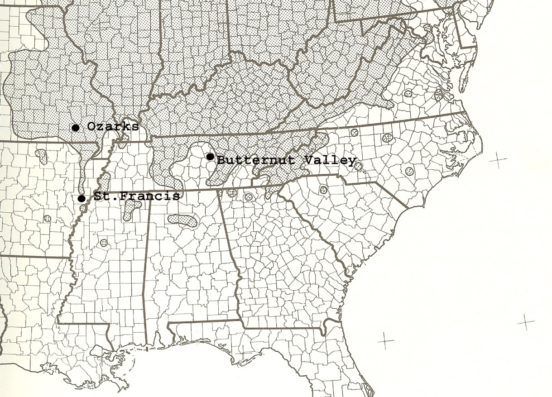

Figure VI-1. Study areas on range of butternut in southern United States, as adapted from Rink (1990).

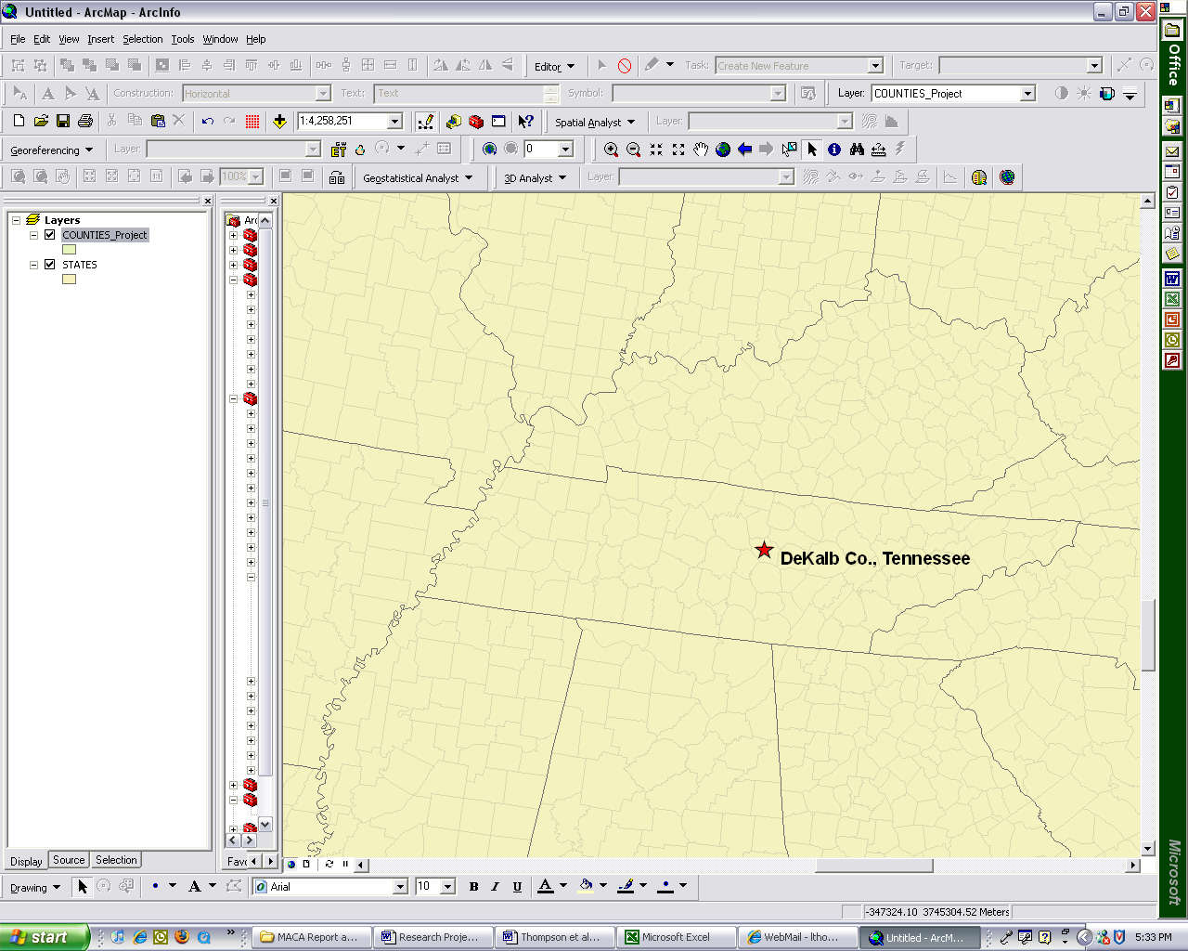

Figure VI-2. Location of Butternut Valley in DeKalb County, TN.

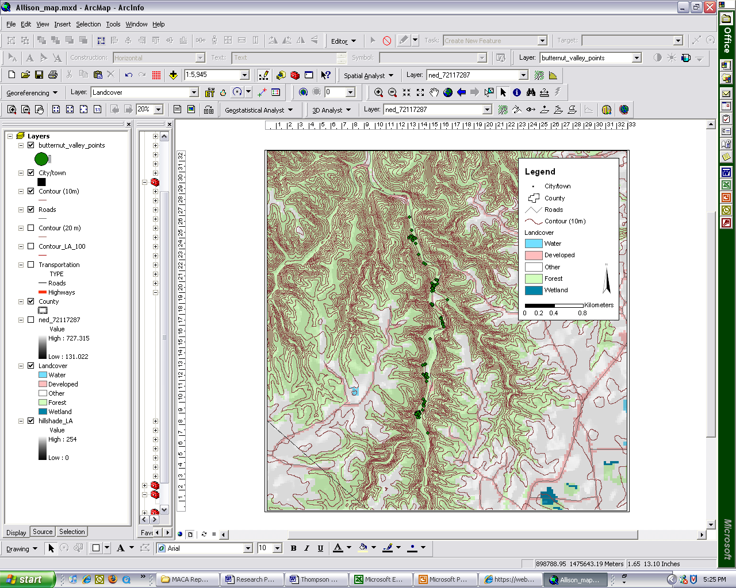
Figure VI-3. Locations of butternut trees along Dry Creek in DeKalb County, TN.
Map courtesy of Laura Thompson

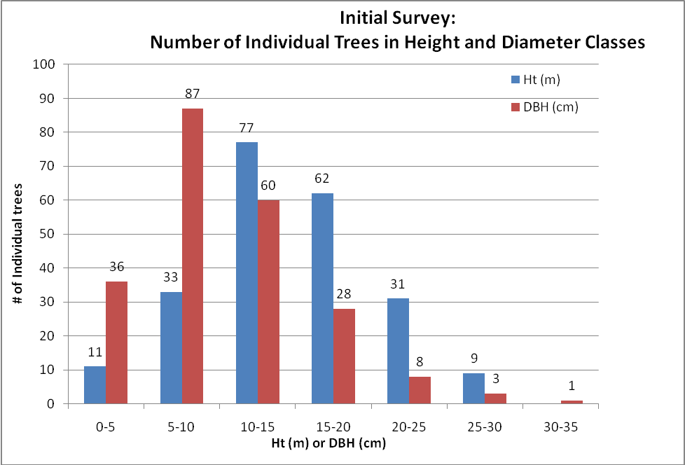
Figure VI-4. Number of individual butternut trees in each tree height and diameter class in initial survey at Butternut Valley.

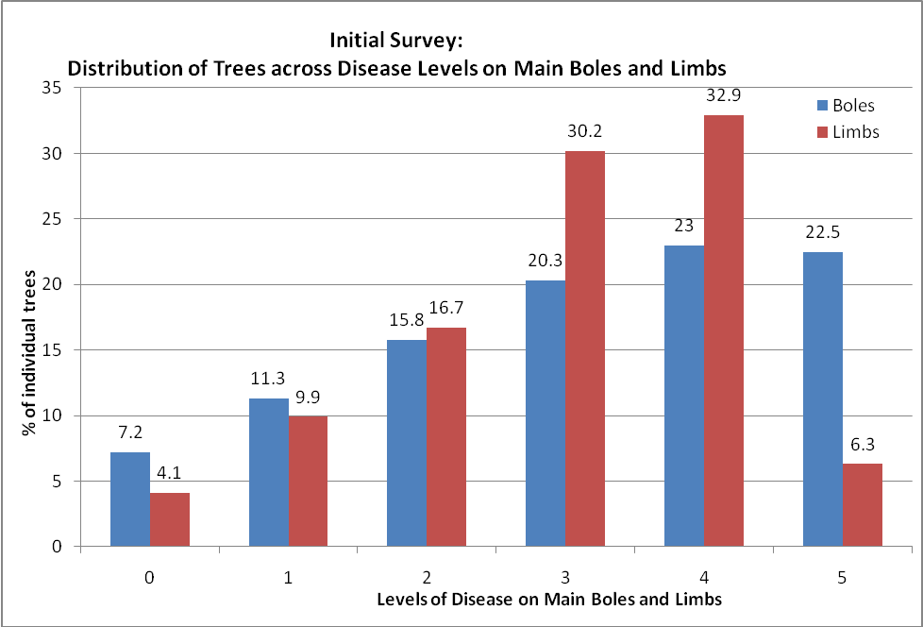
Figure VI-5. Percentages of individual butternut trees with levels of disease on main boles and tree limbs in initial survey at Butternut Valley.

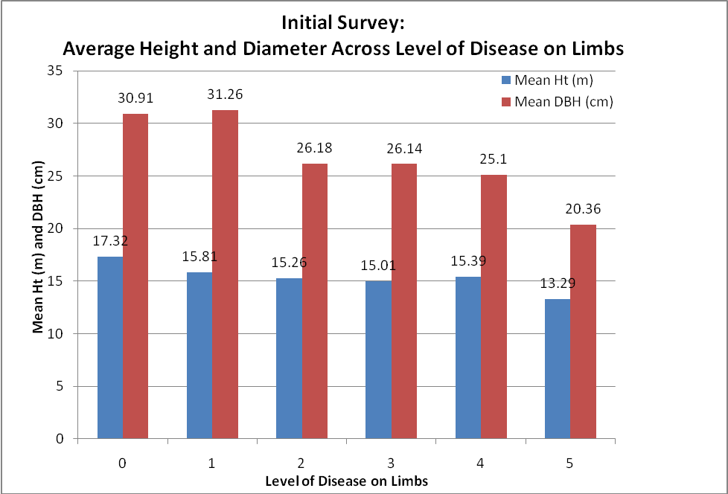
Figure VI-6. Average tree height and diameter across level of disease on limbs in initial survey at Butternut Valley.

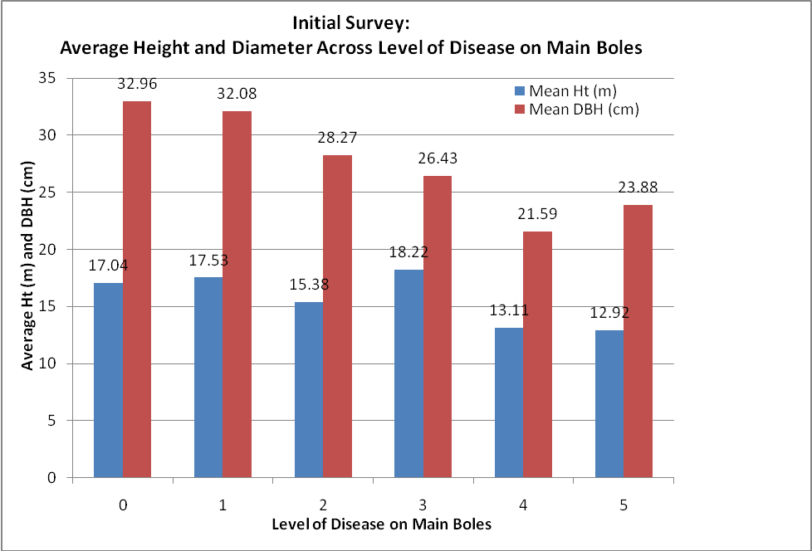
Figure VI-7. Average butternut tree height and diameter across level of disease on main boles in initial survey at Butternut Valley.

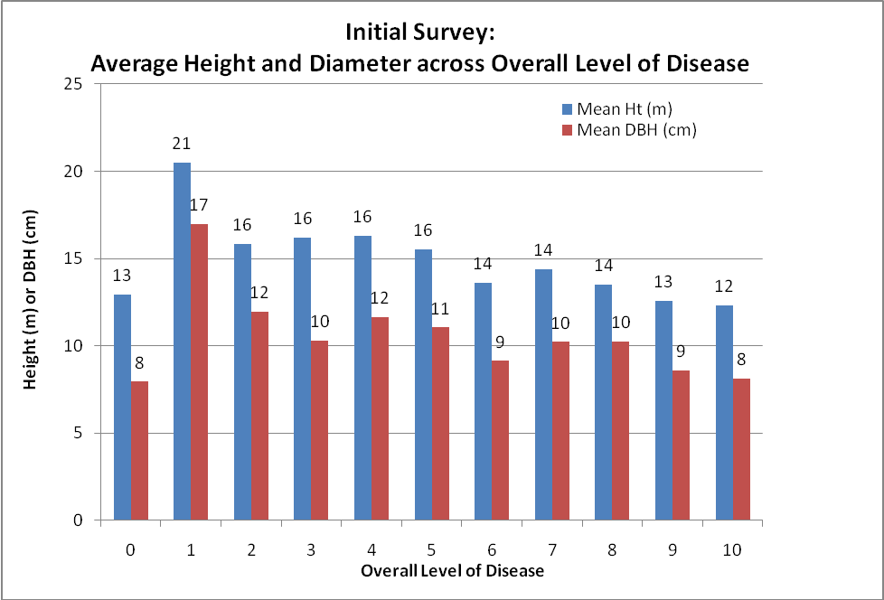
Figure VI-8. Average butternut tree height and diameter at breast height across overall level of disease in initial survey at Butternut Valley.

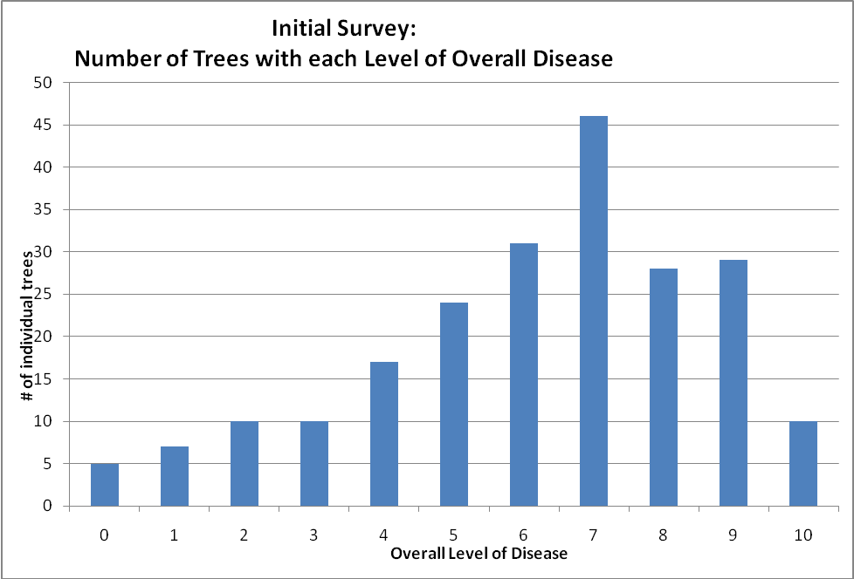
Figure VI-9. Number of individual butternut trees in overall levels of disease in initial survey at Butternut Valley.

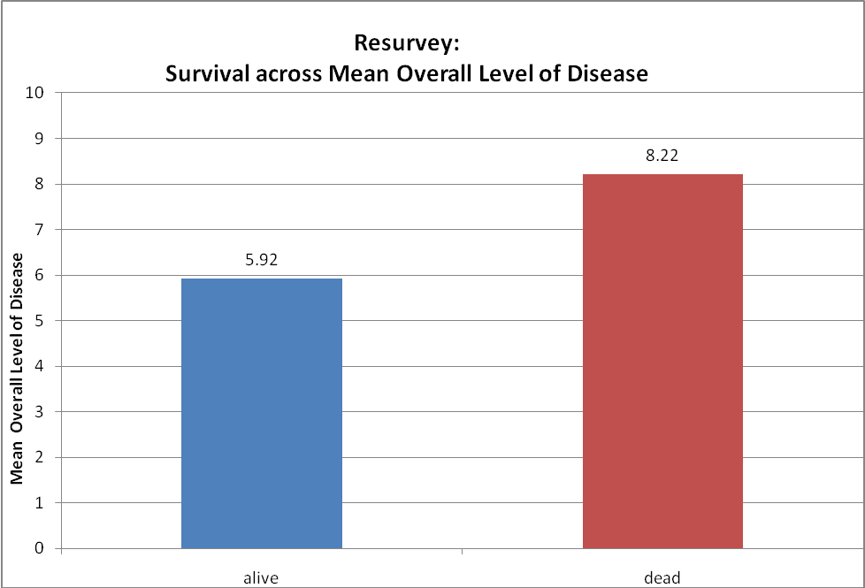
Figure VI-10: Average overall level of disease in initial survey of butternut trees across survival condition in resurvey at Butternut Valley.

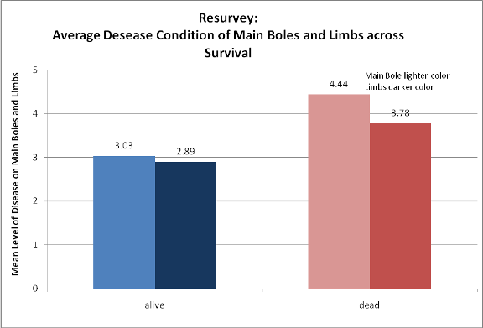

Figure VI-11: Average levels of disease on main boles and limbs of butternut trees across survival condition in resurvey at Butternut Valley.

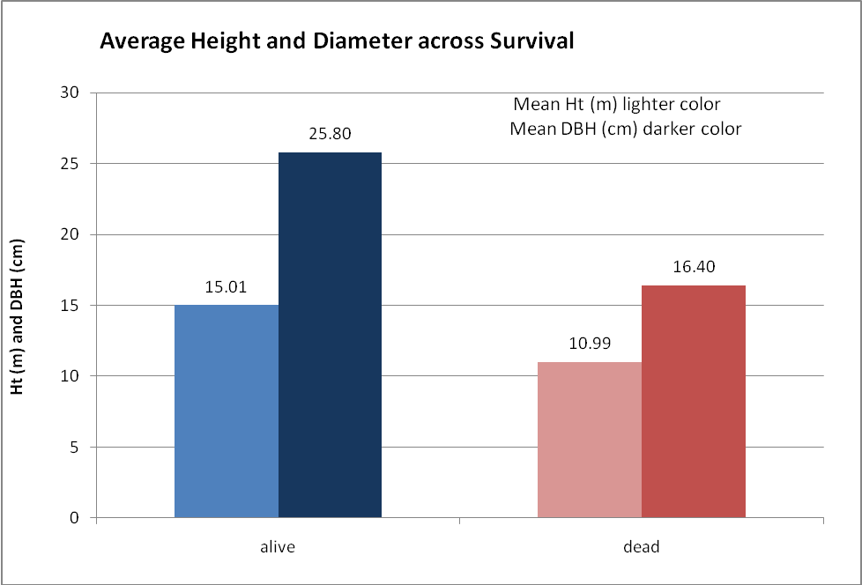
Figure VI-12: Average mean heights and diameter at breast heights of butternut trees across survival condition in resurvey at Butternut Valley.
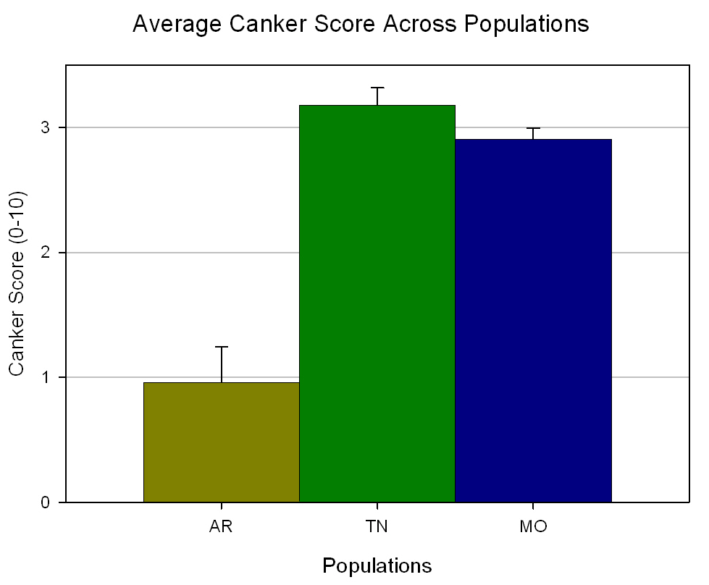

Figure VI-13: Canker score across populations.
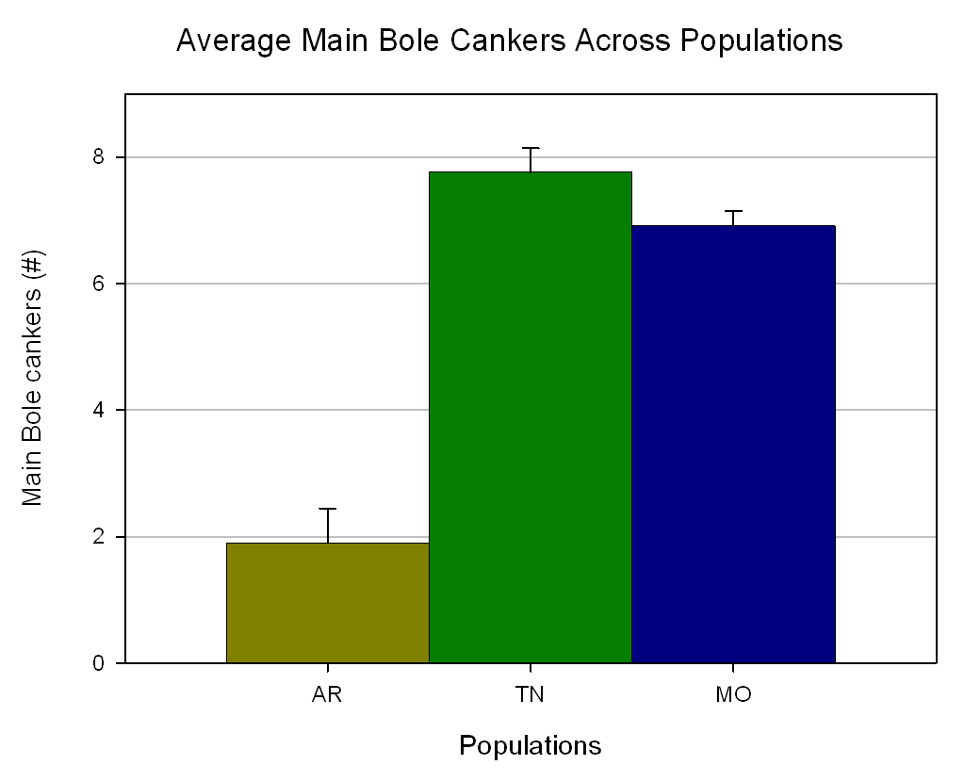
Figure VI-14: Number of main bole cankers across populations.

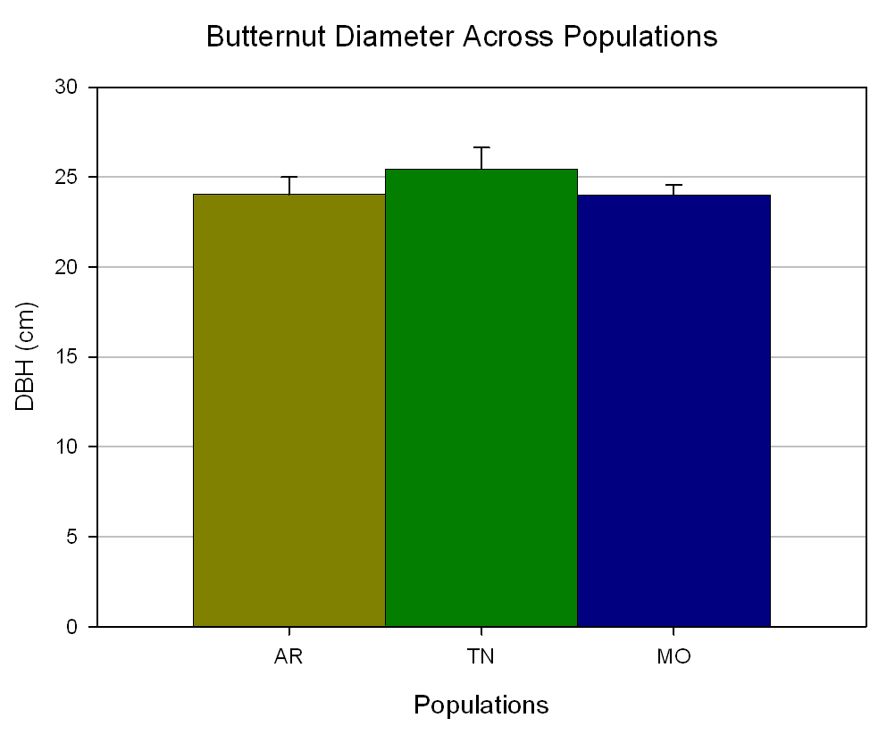
Figure VI-15: Diameter of butternut trees across populations.

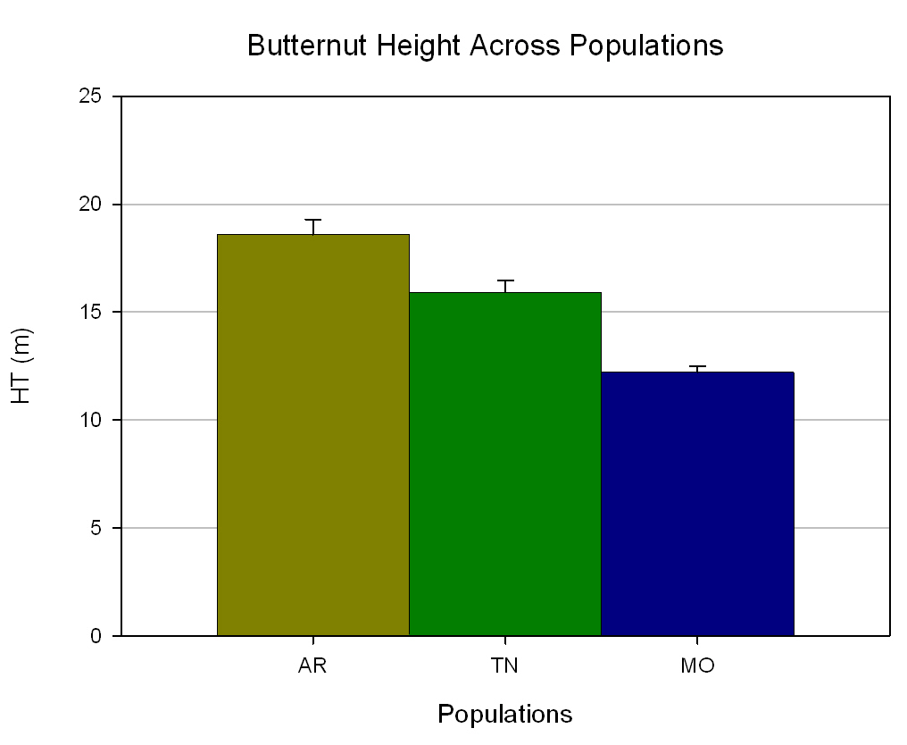
Figure VI-16: Height of butternut trees across populations.
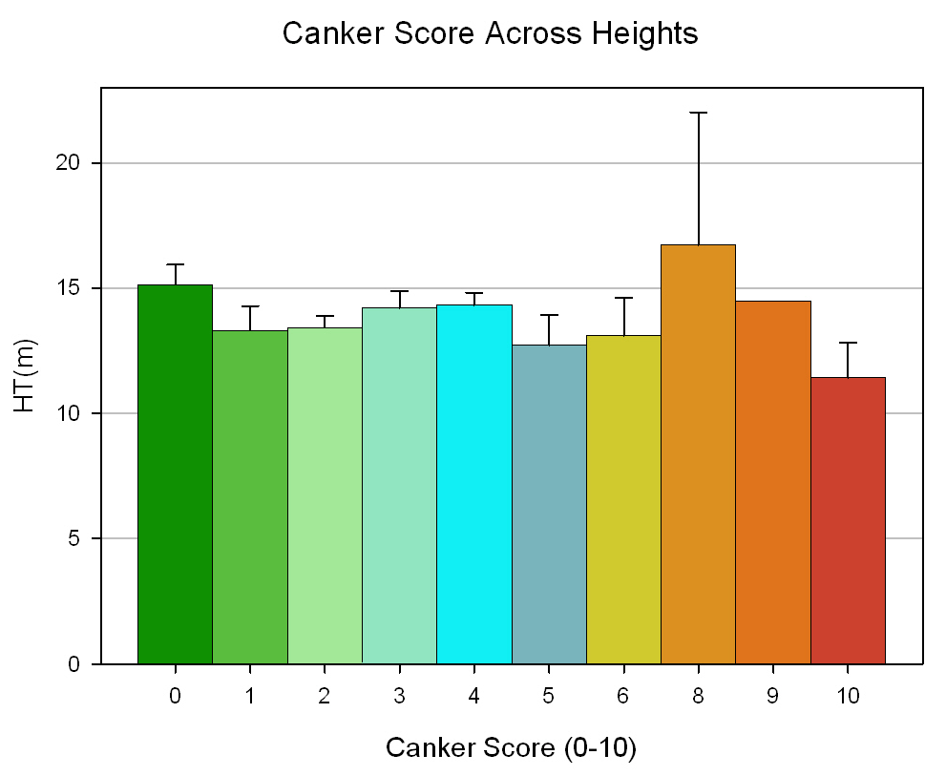

Figure VI-17: Average height of butternut trees at each canker score.

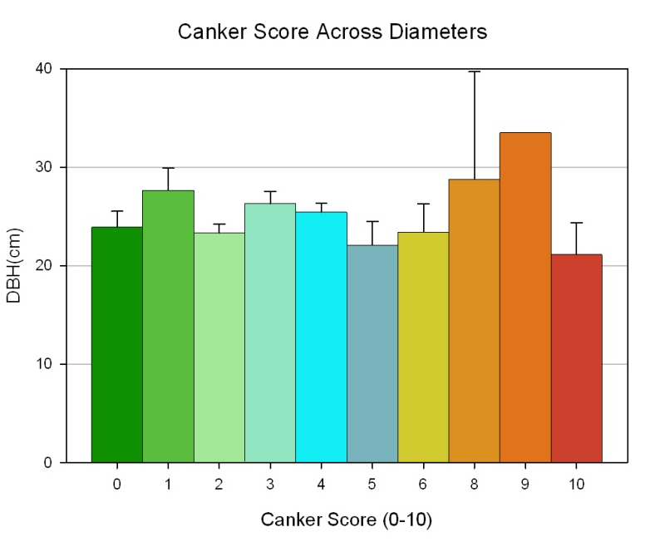

Figure VI-18: Average diameter at breast height of butternut trees at each canker score.

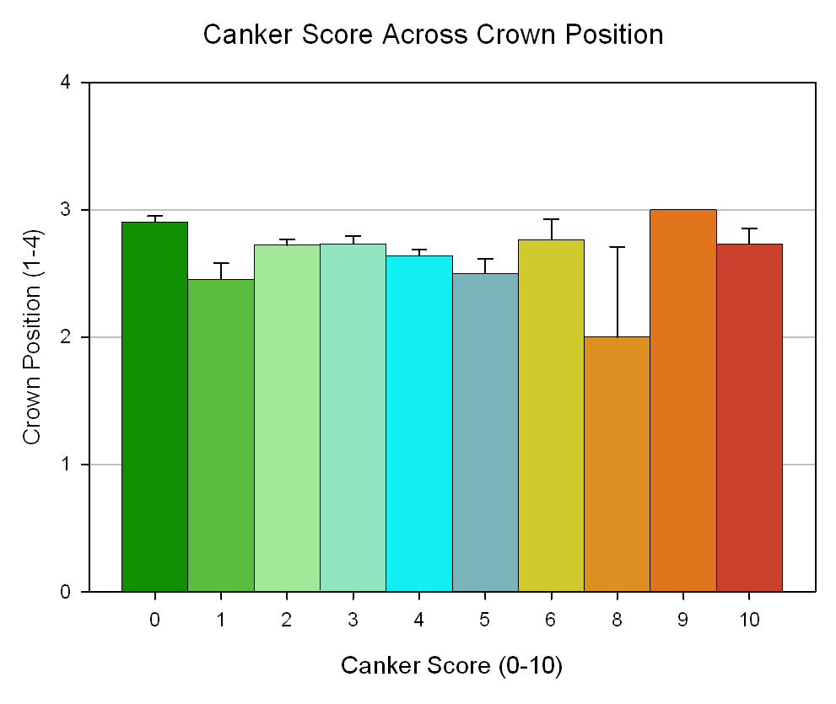

Figure VI-19: Average crown position of butternut trees at each canker score.
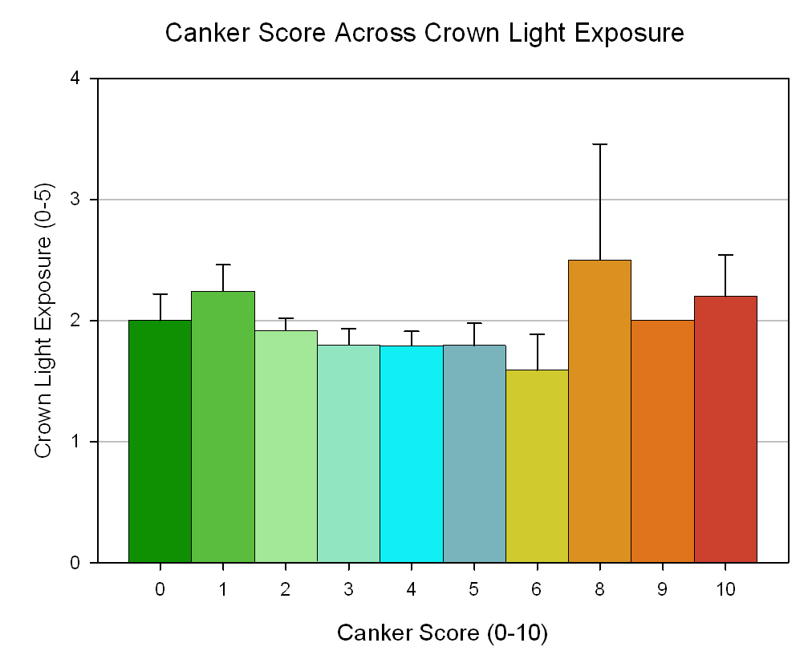

Figure VI-20: Average crown light exposure of butternut trees at each canker score.

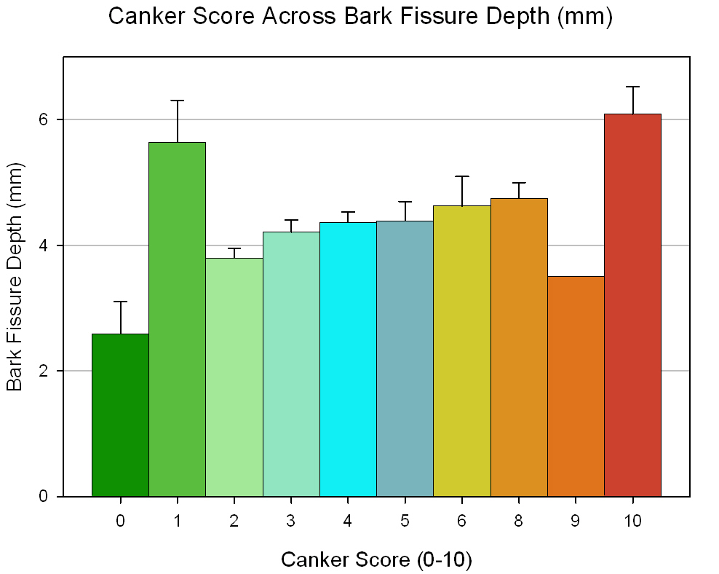

Figure VI-21: Average bark fissure depth of butternut trees at each canker score.

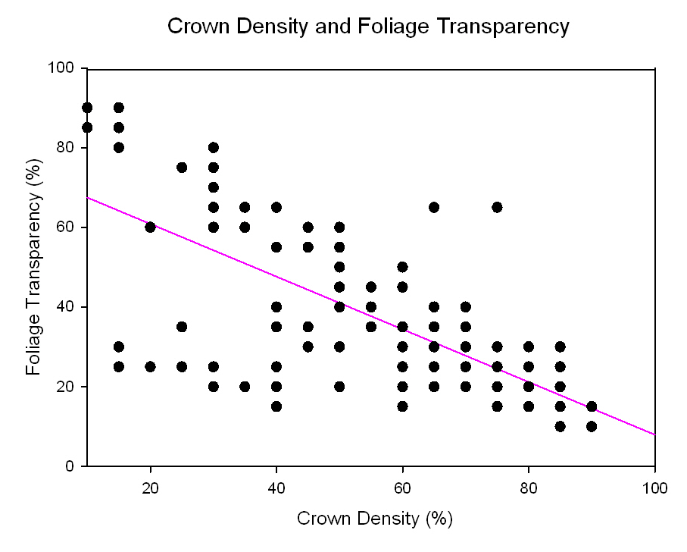
Figure VI-22: Relationship between crown density and foliage transparency.
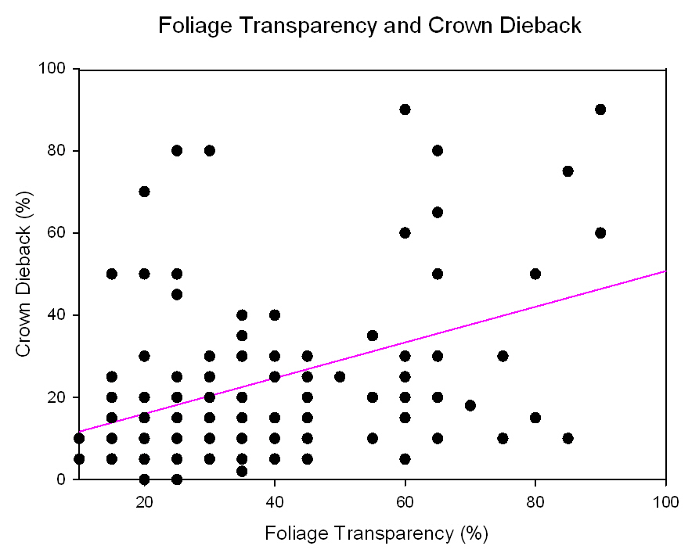

Figure VI-23: Relationship between crown dieback and foliage transparency.
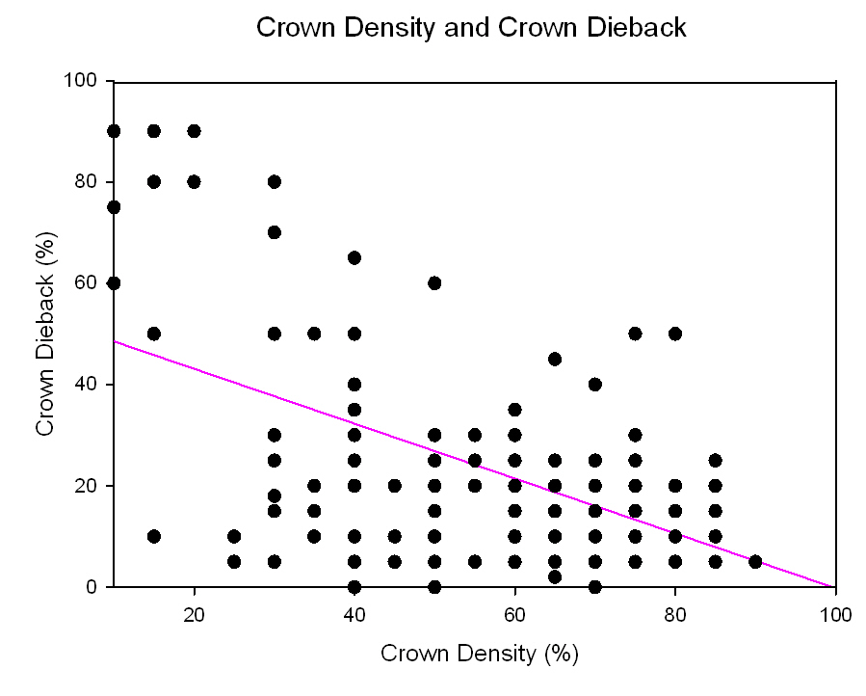

Figure VI-24: Relationship between crown dieback and crown density.

CONCLUSIONS

Summary of Conclusions

The preceding dissertation described many aspects relevant to conservation of butternut, Juglans cinerea L. Butternut has shown drastic declines due to butternut canker disease, caused by Sirococcus clavigignenti-juglandacearum (Nair, Kostichka, & Kuntz), throughout the native range. Limited previous investigation into the ecology of the species is an obstacle in restoration. Even if resistance to butternut canker disease is determined there were still many unknowns around nursery growth, seedling characteristics, and establishment protocols. This research partially answers many questions about butternut, though four different investigations into various aspects of butternut ecology.
Nursery studies have shown the importance of placement of butternut within the nursery for production of plantable seedlings. The rapid growth of butternut seedlings requires placement further from irrigation risers and extensive pruning of lateral roots. Large variations were evident among open-pollinated genetic families in germination rates and seedling sizes including heights (HTs), root collar diameters (RCDs) and first-order lateral roots (FOLRs). This indicates that significant gains could be made through keeping pedigree identity and tree breeding techniques. Characteristics proven in other species to influence establishment success, including HT, RCD, and FOLR, are heritable for butternut across many years with potential gains from selection. RCD should be considered as a visual indicator of seedling quality and a two-way selection approach is most appropriate for improvement of seedling quality. This is the first application of large seedling production techniques and seedling characterization for this species.
A field inoculation technique was used through planting seedlings under infected trees. High mortality of seedlings under these conditions was attributed to many factors aside from cankering. However, specific seedlings from potentially superior genetic families survived even three years after planting. Also, seedlings from known J. ailantifolia and hybrids did not develop cankers. These seedlings may be incorporated into breeding programs for butternut. In the environment under a butternut tree, initial seedling variables of RCD and FOLR impacted seedling survival with increased survival four years after planting for seedlings > 9 mm in RCD and with> 9 FOLRs. Increased HT and RCD resulted in increased diameter after outplanting. Selecting specific genetic families and seedlings with these characteristics will increase establishment success for restoration plantings.
Restoration of butternut will rely on determining optimal locations for planting of resistant nursery stock. Preliminary investigations into survival and growth show successful establishment of butternut on a variety of different land management histories. Butternut is able to initially establish on 30 basal area retention harvests, converted grasslands, and surface mine sites. Initial seedling size greatly impacted establishment success. Seedlings < 9 mm in diameter when planted were twice as likely to experience mortality and were 26% shorter than larger diameter seedlings. Seedlings <50 mm in height also experience additional mortality and were 36% shorter after two years than larger seedlings. Selecting larger diameter and taller seedlings from specific genetic families will increase establishment success for butternut.
An evaluation of a population of mature butternuts over a six-year time period in middle Tennessee resulted in only 8% mortality, even though a large percentage of the seedlings were diseased. This trend may contradict mortality reported in northern sections of the range where the impacts of ice and snow may result in additional damage to cankered limbs. Comparing various southern populations found high variation in phenotypic characteristics and measurements of tree health. A canker classification system was developed to compare disease conditions across multiple populations. The canker classification system developed for assessement can determine the proportion of resistant seedlings in a population and is related to indicators of crown condition and tree health. A disjunct population in Arkansas had a three-fold increase in trees with the highest disease rating than populations in Missouri and Tennessee. The Missouri population had over twice as many trees with the healthiest disease rating. Comparison of population conditions can help to assess which populations are in greatest threat of becoming extinct. Assessment of various populations, however, indicates that canker condition is consistant across a variety of tree sizes and canopy positions. Trees with smooth bark types have lower canker scores but also appear in higher crown positions with greater exposure to light. This phenotypic variable is related to tree health as well as degree of cankering, with increased health in the deeply furrowed bark type.

Research Needs

There are various questions left unanswered about butternut and butternut canker disease. Additional exploration of Sirococcus clavigignenti-juglandacearum biology would assist greatly in determining strategies for resistance breeding. Due to transplant shock with seedlings there is a need for expanding methods of direct seeding of nuts. Classification systems for disease condition need to be expanded to include populations of butternuts throughout the range. This system will help to determine mortality rates and health condition and allow for determinations of which populations are in greatest need of conservation. Continued evaluation of these populations over longer periods of time will allow for a greater understanding of disease dynamics across several gradients. Identification of hybrids within these populations and evaluation of conditions of hybrids would also be extremely beneficial to butternut ecology in determining if hybrids have increased survival compared to pure butternuts and the impact of butternut canker disease on hybrid trees.
Though a minor component of the eastern United States; populations of butternut are in need of conservation through identification, management, genetic conservation and restoration technique development. Conservation and restoration of butternut may have larger implications to many other species; providing juglone to combat invasive herbaceous plants, a host plant for a myriad of invertebrates, supplementing the threatened Alleghany woodrat with high-quality food to survive long winters, and other multiple unknown benefits. Though this dissertation focuses on a single species, butternut is one of many rare or little known trees that have large impacts on biodiversity. Preservation of rare and threatened species is essential for maintaining ecosystem functioning and services. Research on rare species conservation also maintains intergenerational justice allowing future generations the same access to resources and the wonders of the nature world that we have enjoyed.

APPENDICES

Appendix A: Butternut Field Data Sheet
TREE NUMBER_____________________ DATE________________________

STUDY AREA_____________________________________________________

GENERAL LOCATION______________________________________________
X UTM_________________ Y UTM________________ GPS ERROR_______

TREE MEASUREMENTS:
DBH (cm) _______ Crown diameter (m) ¹_____×_____Ave. crown diameter_____
Height (m) __________________Height/1st live branch (m) _________________
No. of nuts collected__________________ Tree living/dead________________

FOREST HEALTH MONITORING CROWN CLASSIFICATION SYSTEM: ²
% Crown dieback______% Crown density______% Foliage transparency______
Crown position_________________ Crown light exposure__________________

CANKER CLASSIFICATION SYSTEM:
#/main stem cankers (>5 inches) in first 20 feet of bole_________#/20_________
#/in-hand branch cankers (>1 inch) _________length/branch material__________
Butternut rating³___________________________________________________

BARK CHARACTERISTICS⁴_________________________________________
⁴Bark Characteristics: 1 = white flat bark, 2 = white bark deep furrow, 3 = gray flat bark, 4 = gray bark deep furrow or enter bark fissure depth measured with a tire gauge

COMMENTS______________________________________________________

1) Measure the width of the crown in 2 (perpendicular) directions and average the 2 widths
2) Refer to FHM crown classification guidelines at the following website: www.na.fs.fed.us/spfo/fhm/
3) Butternut rating:
Branch Cankers per Foot
 | 0.0 | 0.1 | 0.3 | 0.4 | 0.5 | 0.6 | 0.7 | 0.8 | 0.9
Stem Cankers
per Foot
0.0 | 0 | 1 | 2 | 3 | 3 | 4 | 5 | 6 | 8
0.1 | 1 | 2 | 3 | 4 | 4 | 4 | 5 | 6 | 8
0.2 | 2 | 2 | 3 | 4 | 4 | 5 | 6 | 7 | 9
0.3 | 2 | 3 | 3 | 4 | 5 | 5 | 6 | 7 | 9
0.4 | 3 | 4 | 4 | 4 | 5 | 6 | 6 | 8 | 9
0.5 | 4 | 4 | 5 | 5 | 5 | 6 | 7 | 8 | 9
0.6 | 4 | 5 | 5 | 6 | 6 | 6 | 7 | 8 | 9
0.7 | 5 | 5 | 6 | 6 | 7 | 7 | 7 | 8 | 9
0.8 | 6 | 6 | 7 | 7 | 8 | 8 | 8 | 8 | 9
0.9 | 8 | 8 | 9 | 9 | 9 | 9 | 9 | 9 | 9
1.0 | 10 | 10 | 10 | 10 | 10 | 10 | 10 | 10 | 10

Appendix B: Butternut Canker Classification System

Developed and used by: S. L. Brosi, L. M. Thompson, R. L. Anderson, S. L. Clark and S. E. Schlarbaum

Background
Butternut trees are under attack by an exotic fungal disease called butternut canker. The disease is caused by Sirococcus clavigignenti-juglandacearum and is killing butternut trees (Juglans cinerea L.) throughout its range in North America. The disease has killed up to 80 percent of the butternut in some states. The primary hope for control of this disease lies with host plant resistance through utilizing selections with genetic resistance. Healthy trees and infected trees that apparently have resistance have been found in severely affected forest stands in a number of States. Clonal and seedling propagation of trees exhibiting resistance is being used to evaluate breeding and future restoration efforts. Hybrids with heartnut ((J. ailantifolia var. cordiformis (Maxim.) Rehd.), a nut cultivar of Japanese walnut, are also being evaluated as alternatives for development of resistant nursery stock.
Surviving butternut trees need to be comparatively evaluated for disease based on the number of cankers. Initially, a system that classified butternuts in the southern United States was based on the following categories: no cankers, less than five cankers, and more than five cankers on the tree. This system was effective in selecting for trees in the field that appear to be resistant, but limited the comparison of trees in the field with results of progeny plantings and laboratory screening methods. The following methodology provides a quick, reliable method for assessing the canker status of an individual butternut tree according to its relative number of butternut cankers on the main trunk and branches.

Methods
This system evaluates the number of cankers on the bole or main stem of the tree and adjusts this number based on tree height. If possible a branch of the tree is also evaluated and then used in addition to the stem ranking to create a linear ranking for the tree (Figure 1).

Evaluation of the main stem:
- Choose a tree that is alive and only evaluate the portion of the tree that is alive. The system is not reproducible using dead trees.

- If possible, clear around the base of the tree to ensure good visibility of the main stem.

- It is recommended that two people evaluate the tree and average their results. If there is a large variation, they should discuss the difference and agree on a rating.

- Count the number of obvious cankers on the lower twenty feet of the main stem (Figures 2 and 3). These cankers should be at least 5 inches long. Be sure to look at the tree from three different angles to ensure all cankers are found. Different bole lengths pose no problem, since the number of cankers is divided by the bole length. Count only cankers five inches or greater in length, as counting every small canker on a stem resulted in large variations between observers.

- Divide the number of cankers by the length of bole observed and place the number in the table at the end of this paper to get a ranking. The trees will rank from between 0 (no disease) to 10. This number is the ranking for the tree if a branch is not available for evaluation.

Using this system, the tree can be classified using the bole information only if branch counts are not available. If an in-hand branch can be obtained, evaluating branches for the presence of butternut canker will improve the overall ranking of the tree. This process, though not always possible, is important for trees that have no cankers on the main stem. Trees have been found that have heavily cankered branches, but do not have stem cankers. It is not recommended that the number of cankers on branches in the crown be evaluated using binoculars. Estimation of the number of cankers using binoculars and using a branch sample in hand showed little correlation. If possible, obtain an in-hand branch (es) from the tree for examination. Ideally, approximately ten linear feet of branch material should be used. The branch (es) should have a proximal end between 1 and 3 inches in diameter and evaluated as follows.

Evaluation of a branch:
- On the in-hand branch (es), count the number of obvious cankers at least one inch in length on all living shoots (Figures 4, 5, and 6). Add up the total length of the branch material, being sure to count all small shoots.

- Divide the number of cankers by the length of branch material and place the number in the table to refine the estimate that has been made from the bole material.

- The estimate for the tree can be refined by merging the two codes to give a clear picture of the tree status (Table 1). For example, if the trees had 0.7 cankers per linear foot of main stem and 0.5 cankers per linear foot of branch, it would be classified as a 7. This coding system allows the users, access to the actual data and gives them the flexibility to set up a different linear ranking system for their particular data set if needed.

Butternut rating using data from both the main stem and the branch can be used to create a linear ranking of the cankered trees with more weight given to the cankers on the main stem. This numeric code is uniform and can be used to compare a single population over a period of time, or compare multiple populations.

Appendix B: Tables and Figures
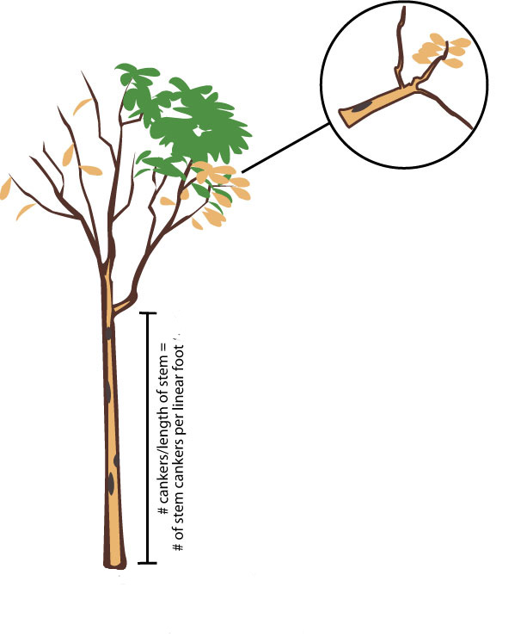

1-3” diameter branch
10 feet of material
Evaluation of cankers > 1”

1-3” diameter branch
10 feet of material
Evaluation of cankers > 5”

Figure 1: Schematic of material for evaluation under the numerical rating system for disease conditions on mature butternut trees.
Table 1: Numerical rating system for disease conditions on mature butternut trees with heavier weight given to main stem cankers.

# branch cankers per linear foot
# main stem cankers per linear foot |  | 0 | .1 | .2 | .3 | .4 | .5 | .6 | .7 | .8 | .9 | 1+
# main stem cankers per linear foot | 0 | 0 | 1 | 1 | 2 | 3 | 3 | 4 | 5 | 6 | 8 | 10
# main stem cankers per linear foot | .1 | 1 | 2 | 2 | 3 | 4 | 4 | 4 | 5 | 6 | 8 | 10
# main stem cankers per linear foot | .2 | 2 | 2 | 3 | 3 | 4 | 4 | 5 | 6 | 7 | 9 | 10
# main stem cankers per linear foot | .3 | 2 | 3 | 4 | 3 | 4 | 5 | 5 | 6 | 7 | 9 | 10
# main stem cankers per linear foot | .4 | 3 | 4 | 4 | 4 | 4 | 5 | 6 | 6 | 8 | 9 | 10
# main stem cankers per linear foot | .5 | 4 | 4 | 5 | 5 | 5 | 5 | 6 | 7 | 8 | 9 | 10
# main stem cankers per linear foot | .6 | 4 | 5 | 5 | 5 | 6 | 6 | 6 | 7 | 8 | 8 | 10
# main stem cankers per linear foot | .7 | 5 | 5 | 6 | 6 | 6 | 7 | 7 | 7 | 8 | 9 | 10
# main stem cankers per linear foot | .8 | 6 | 6 | 7 | 7 | 7 | 8 | 8 | 8 | 8 | 9 | 10
# main stem cankers per linear foot | .9 | 8 | 8 | 9 | 9 | 9 | 9 | 9 | 9 | 9 | 9 | 10
# main stem cankers per linear foot | 1+ | 10 | 10 | 10 | 10 | 10 | 10 | 10 | 10 | 10 | 10 | 10

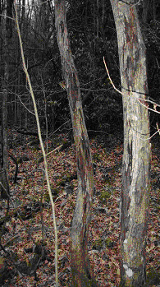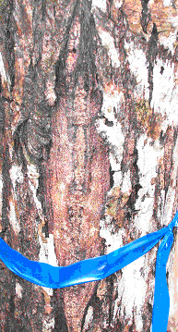Figure 2: Cankers on main stem Figure 3: Multiple old main stem cankers

VITA

Sunshine Liberty Brosi was born on December 8, 1977 in Franklin County, Tennessee to George Ralph Brosi and Connie Carol Fearington Brosi. Sunshine is one of seven children and was raised in Berea, Kentucky. She graduated valedictorian a year early from Berea Community High School in May of 1995. In the fall of that same year, she began an undergraduate program at Warren Wilson College in Swannanoa, N.C. She received her Bachelor’s of Arts degree in Environmental Studies with a concentration in Forest Resource Conservation in May 1999. The following fall she began her graduate work at the University of Kentucky in Lexington. Sunshine completed her Master’s of Science degree in Forestry in May 2001 with a project on American chestnut restoration. In May 2002, Sunshine entered The University of Tennessee, Knoxville graduate program and began to work towards a Ph.D. in Natural Resources in the Department of Forestry, Wildlife and Fisheries. Sunshine received her Ph.D. in August 2010 under the direction of Scott E. Schlarbaum in the Tree Improvement Program on butternut and chestnut restoration.
In August 2007, Sunshine was hired as a tenure-track assistant professor in the Department of Biology at Frostburg State University in Frostburg, Maryland. Sunshine teaches and coordinates the undergraduate Bachelor’s of Science program in Ethnobotany, one of only two such programs in the United States. Sunshine also teaches and advises graduate students in the Master’s of Science program in Applied Ecology and Conservation Biology. Sunshine lives in rural Garrett County, MD with her daughter Summer Ela Shaper, stepson Caeman Thomas Feller, and husband Daniel Joseph Feller. Sunshine plans to continue her work on the conservation of tree species at risk due to exotic diseases as a means to help conserve threatened species for future generations.

Height of the seedling from the root collar to the first live terminal bud
Diameter taken 1.3 mm above the root collar
Number of first order lateral roots, greater than 1 mm in diameter attached to the tap root

