You Win Some, You Lose Some:
Regulatory Focus Theory and Facial Expressions of Emotion to Series of Unfortunate Events
Taylor B. Duncan
University of Tennessee, Knoxville

Abstract
Regulatory focus theory predicts that the type of focus a person is in influences their emotional experience. Using Higgins (1997) and Idson, Liberman, and Higgins (2000) as models for our study, we used facial video data to examine whether negative emotions are more likely to occur following negative outcomes. We also tested regulatory focus’s predictions about discrete emotions to losses (i.e. people lose points) versus non-gains (i.e. people miss out on opportunity to gain points). Regulatory focus predicts that losses are more likely to elicit agitation-related emotions and that non-gains are more likely to elicit dejection-related emotions. Participants engaged in a gaming task where they tried to win or maintain their points, which sometimes they were able to accomplish (positive outcome) and other times they were not (negative outcome). Coders categorized the facial video data taken during the game based on the perceived facial expression. As predicted, people expressed more agitation and dejection after negative vs. positive outcomes. In contrast, people neither expressed more agitation following losses than non-gains nor did they express more dejection following non-gains than losses.
Keywords: regulatory focus theory, negative outcomes, negative emotion

You Win Some, You Lose Some:
Regulatory Focus Theory and Facial Expressions of Emotion to Series of Unfortunate Events
How would it feel to learn that you had just been demoted at work? Are those feelings different from being passed up for a promotion? Each scenario depicts a negative outcome where the situation went badly, resulting in a loss, or did not happen the way you wanted, resulting in a non-gain. According to regulatory focus theory, losses and non-gains elicit different negative emotions (Higgins, 1997). A loss is when one fails to maintain what they have, which is the primary goal of the prevention focus, and is theorized to elicit the negative emotion agitation. In contrast, a non-gain is when one fails to acquire exactly what they wanted, which is the primary goal of the promotion focus, and is theorized to elicit the negative emotion dejection. The present study is interested in whether these negative outcomes elicit the distinct emotions associated with the prevention and promotion foci. We predicted that negative outcomes are more likely to elicit agitation-related and dejection-related emotions than positive outcomes. Additionally, we predicted that the outcomes, losing and not gaining, influence participants’ emotions. Losses are believed to elicit more agitation than non-gains and non-gains are believed to elicit more dejection than losses.
Higgins’ (1997) regulatory focus theory aimed to expand past the hedonic principle of avoiding pain and approaching pleasure, which resulted in numerous implications for self-regulation, decision-making, motivation, and emotion, the focus of the present study. Regulatory focus can be split into two foci, prevention and promotion, which can be provoked by different, momentary situations. In the prevention focus, the presence of a negative outcome, such as a loss, elicits pain. In the promotion focus, the absence of a positive outcome, such as a non-gain elicits pain. Additionally, he theorized that emotions such as disappointment or dissatisfaction, which fall into the category of dejection, occur when individuals do not reach their hopes or desires. Agitation-related emotions, including unease and fear, occur when individuals do not meet their obligations or duties. Idson et al.’s (2000) applied Higgins’ (1997) theory to real world gaming outcomes using an anagram task and self-report measures. After having the participants complete one of four arrangements of anagrams, they would receive positive or negative feedback which had implications for the reward they would receive. The participants would then rate their emotional experience in terms of how tense, relaxed, discouraged, and happy they were, derived from Higgins (1997) emotion words. They predicted that negative outcomes will elicit stronger feelings of agitation when the individual is in prevention focus and stronger feelings of dejection in a promotion focus. Their findings support their predictions as well as Higgins’ (1997) assertion that regulatory focus theory can account for distinctions in emotion based on outcome.
Our study is an extension of Idson et al.’s (2000) with one important modification. Idson et al. (2000) used self-report measures to determine the emotional outcome of their gaming situation. This method may be susceptible to reactivity, meaning if you ask an individual how dejected or agitated an outcome made them feel, they might report more of those emotions than actually happened because they were asked. Our study addresses this issue by recording participant’s faces during their game tasks and having coders categorize their expressions.
Method
Participants
The participants consisted of 34 male and 69 female students enrolled in introductory psychology courses at the University of Tennessee, Knoxville.
Procedures
The participants’ faces were recorded via the desktop computer webcam where they completed eight trials of a game. The objective of the game was to stop the randomly moving marker on one of eight circles, each circle assigned with one of two point values, to accomplish their goal of either gaining points or avoiding loss of points (see Figure 1).
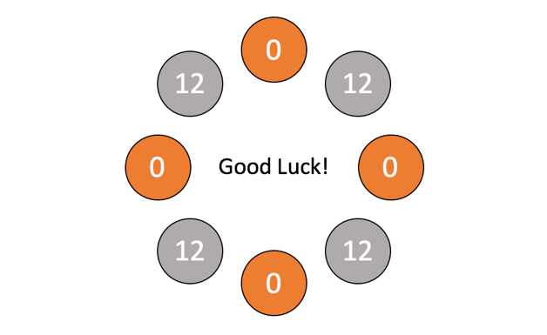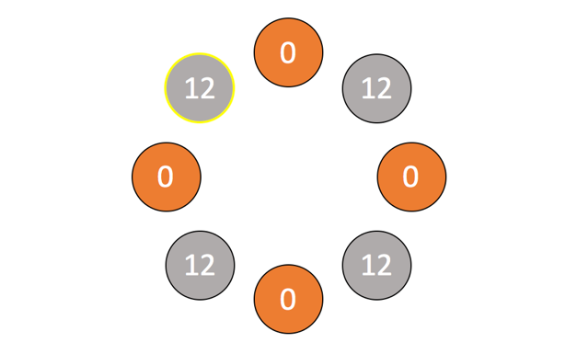
Figure 1. Example of gaming task.
There were five possible values the participant could earn: 0, 12, -12, 24, and -24. However, the participant did not actually have control over the marker as the sequences were predetermined to create the outcome conditions, gain, non-gain, loss, and non-loss. For example, the loss condition was created by offering zero or -12 points and stopping the marker on -12. The non-gain condition was created by offering 0 or 12 points and stopping the marker on 0. These predetermined sequences were important to assigning the participants into the prevention and promotion foci. They were incentivized to do well by being told that they would have to listen to either a pleasant or unpleasant soundscape based on their final score, which they were given a sample of prior to beginning the tasks.
Four coders watched the facial video data and categorized the expression of the participants, blind to the outcome of the game. The video data consisted of four phases: before the game started (baseline), when their goal was made salient (stakes), the actual game, and the outcome of the game. First, the coders would watch a montage with eight, one-second clips of the participant at baseline, taken prior to the start of the gaming task. They would then watch a montage with eight, five-second clips of the same participant during the outcome of the gaming task. Both montages were watched at least five times before the coder could continue. The five-second clip the coder would be categorizing would be appear on screen with a picture of the participant’s baseline face as reference. The coder would watch the clip at least two times before being prompted with the question, “Which of the following expressions did they have at any point during the clip?” They chose at least one of the following seven categories, developed in part from emotion words used by Higgins, Shah, and Friedman (1997): 1) “their face was not visible”, 2) “they did not appear to be experiencing any negative affect”, 3) “the appeared to be agitated, on edge, and/or uneasy about how the trial turned out”, 4) “they appeared to be disappointed, discouraged, and/or bummed out about how the trial turned out”, 5) “they appeared to be angry, irritated, and/or annoyed with something”, 6) “they appeared to be bored, unenthusiastic, and/or uninterested”, and 7) “they appeared to be experiencing some type of negative affect but not one of those listed above”.

Results
Our findings do not support the findings of Idson et al. (2000). We examined whether agitation and dejection are more likely to be expressed following negative outcomes and if the interaction between outcome and prospects (losing and not gaining) affected the emotional output by submitting ratings for each emotion to a 2 (outcome: good, bad) x 2 (prospect: loss, gain) x 2 (magnitude: -12, -24) mixed-model analysis of variance (ANOVA).
Agitation
We predicted the main effect of outcome to be that participants would express more agitation after bad outcomes than good outcomes. We did find a main effect to support this prediction F(1, 101) = 21.69, p < .001 such that bad outcomes elicited more agitation (see Figure 2). Within bad outcomes, we also predicted that losses elicit more agitation than non-gains. Nonetheless, the main effect of the outcome was not moderated by the prospect type, F(1, 101) = .64, p = .43. Moreover, levels of agitation after losses and non-gains were not significantly different, F(1, 101) = 1.36, p = .25 (see Figure 2).
Dejection
We predicted a main effect of outcome such that participants would express more dejection after bad outcomes than good outcomes. We did find a main effect to support this prediction F(1, 101) = 108.3, p < .001 such that bad outcomes elicited more dejection (see Figure 2). Within bad outcomes, we also predicted that non-gains elicit more dejection than losses. Nonetheless, the main effect of the outcome was not moderated by the prospect type, F(1, 101) = .27, p = .60. Moreover, levels of dejection after non-gains and losses were not significantly different, F(1, 101) = .41, p = .52 (see Figure 2).
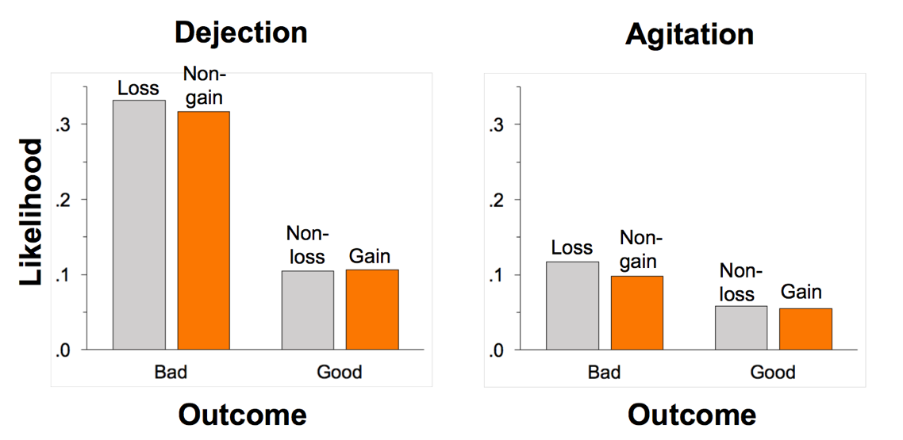
Figure 2. The interaction between outcome and prospect for each emotion.
Note: Likelihood values represent the likelihood that coders detected the relevant emotion.
Discussion
Our findings did not completely replicate the findings of Idson et al. (2000). Negative outcomes elicit more dejection- and agitation-related emotions in comparison to positive outcomes. However, losses did not elicit more agitation than non-gains in the negative outcome. Additionally, non-gains did not elicit more dejection than losses in the negative outcome. The two possible explanations for these discrepant findings are: regulatory focus theory does not accurately predict the effect outcome has on emotion as supported by the Idson et al. (2000) study or our methodology was less effective than theirs.
Idson et al. (2000) study measured emotional experiences following an anagram task using self-report questions. The four emotion words they asked their subjects to rate – tense, relaxed, discouraged, and happy – which might be more susceptible to reactivity, meaning that just asking someone if they felt a certain emotion elicits more reports of that emotion than what actually happened. This implies their measure could be overestimating the emotional reaction to the various outcomes. Because these words were derived from Higgins (1997), Idson et al. (2000) are using the theory to support the theory.
Our study addresses the issue of reactivity by using facial video data and coders to measure the types of emotion elicited in each outcome. However, it is also possible that facial expressions are less sensitive to experienced emotions. Individual differences in facial expressions, such as individuals with flat facial affect, can complicate the perception of emotion. This assumes that agitation and dejection can be conveyed through distinct facial expressions. Perhaps we did not achieve the same results because there is greater difference in experienced emotion than facial emotion.
There are two other ways in which their study may have been methodologically superior. First, Idson et al. (2000) used a between-subjects design while we used a within-subjects design. Idson et al. (2000) used a task to put their participants in one type of focus for several minutes. In contrast, we attempted to use a task to shift participants from one focus to the other several times over the course of a few minutes. As a result, their between-subjects manipulation may have been stronger. If their manipulation was stronger, Idson et al. (2000) provided a stronger test of the theory than we did. The second methodological difference involves the incentives for success. Idson et al. (2000) used money while we used pleasant and unpleasant soundscapes. It is possible that money is a stronger incentive than soundscapes and thus evokes stronger focus during a game, which has been predicted to elicit stronger emotion (Idson et al., 2000).
We asked in our scenarios of demotion and promotion if the emotions elicited by these circumstances are different. This study suggest that, while bad outcomes elicit specific emotions, they are not noticeably different between types of outcome. Despite our null findings, our incorporation of facial video data is important. It offers a measure to questioning the relationship between outcome and emotion that is different from the early work on regulatory focus theory. Future work in this area could focus on the differences between self-report and facial expressions, improving on both studies.

References
Higgins, E. T. (1997). Beyond pleasure and pain. American psychologist, 52, 1280-1300.
Higgins, E. T., Shah, J., & Friedman, R. (1997). Emotional responses to goal attainment: strength of regulatory focus as moderator. Journal of personality and social psychology, 72, 515-525.
Idson, L. C., Liberman, N., & Higgins, E. T. (2000). Distinguishing gains from nonlosses and losses from nongains: A regulatory focus perspective on hedonic intensity. Journal of Experimental Social Psychology, 36, 252-274.

