Investigating the Potential of Postmortem Metabolomics in Mammalian Decomposition Studies in Outdoor Settings

A Dissertation Presented for the

Doctor of Philosophy

Degree

The University of Tennessee, Knoxville

Katharina Melanie Höland
October 2021

Copyright © 2021 by Katharina M. Höland

All rights reserved.

DECICATION

You can't start a fire without a spark.

- Bruce Springsteen

ACKNOWLEDGMENTS

I would like to thank my advisor Dr. Shawn R. Campagna for his support, patience and scientific guidance throughout my Ph.D. He gave me the freedom to set my focus early on in my graduate career toward a major focus in forensic science and let me choose projects/collaborations accordingly which ultimately shaped my future scientific direction. I am very grateful for the education I have received due to him and the University of Tennessee, Knoxville which made me grow as a person and a scientist by enhancing my critical thinking and my sense of integrity. I would also thank my committee members, Dr. Dawnie Steadman, Dr. Ampofo Darko, Dr. Ben Xue, and Dr. Anthony Baker for their time and dedication involved in reading and constructively criticizing my work.
Also, none of my research would have been possible without the forensic taphonomy facility in Knoxville, TN, USA and the donation of multiple bodies. Studying the processes occurring after death in a variety of different outdoor settings has an immensely valuable impact on forensic science and law enforcement agencies that cannot compete with any artificially created research environment in laboratories. Being the director of the Anthropology Research Facility (ARF) in Knoxville, it was a particular pleasure for me to work with Dr. Dawnie Steadman who I also need to thank for her scientific guidance. Likewise, during my time in the Campagna group, I had the pleasure to work with many incredible collaborators. Their research broadened my interdisciplinary knowledge and I do not want them to feel neglected as the content of this dissertation only focuses on three selected projects. All of my colleagues guided my research in multiple discussions due to their scientific feedback which was very much appreciated while I hope that I was likewise a critical and helpful source of input. Katarina Jones and Dr. Hector Castro deserve a special thank you, as they have guided and shaped my research throughout many discussions.
Lastly, and most importantly, I would like to thank my family and close friends. My family has unconditionally supported all my endeavors and they have always encouraged me and my decisions until the day I am writing this dissertation. My dear friends Haley Fielland, Simon Rotzer, and Crystal Battles – thank you for keeping up with me, listening to my endless complains and distracting me when needed most. My dear mentor Dr. Gary Phillips, this dissertation would have probably needed many more drafts without your critical, supportive and guiding inputs. I hardly acknowledge anyone else’s opinion as much as yours. I am very thankful to have met you, your incredible wife Sunny and your daughter Claire who always welcomed me and Josh like family members. That being said, thank you to my incredible boyfriend Joshua Fischer for supporting me in the hardest moments of my Ph.D.; thank you for never letting me give up and being my biggest fan. I hope you know I am yours.

ABSTRACT

By focusing on solely forensic studies, this dissertation gives an overview of three at the first glance independent studies, which however, at a deeper level, reveal their strong interconnectivity by means of their forensic importance. The consistent global theme that was carried through all chapters circles around the application of metabolomics on biological specimens collected postmortem from an outdoor taphonomy facility in Knoxville, Tennessee, USA. The overall intention was to fill the knowledge gab around postmortem metabolomics and at the same time reveal its importance in bridging analytical chemistry and forensic science. Global postmortem metabolomics studies have the potential to contribute to the so-far conducted taphonomic groundwork by providing a better understanding of the fundamental processes of decomposition and ultimately help to build a more comprehensive postmortem biochemical database in future.
That being said, the first chapter applies postmortem metabolomics to soils and human skeletal remains obtained from a multi-individual grave. The primary goals of this study were twofold: (1) obtain insights into the metabolite pulse released from buried remains into grave soils at different depths of a shallow burial and (2) assess metabolic signatures of bones using an inter- and intraindividual analysis approach.
Decomposition progresses differently below ground compared to the soil surface with impacts on rates and patterns of decomposition. As opposed to the first chapter, the second chapter faces an environmental change with a study design constructed around surface decomposition. Additionally, given that rates and patterns of decay seem to vary among species, a comprehensive omics approach including metabolomics and lipidomics was utilized to investigate species-specific metabolic signatures in soils from the cadaver decomposition island.
Lastly, the final chapter completes the aforementioned studies by investigating probably the most complex of all factors – intrinsic drivers of decomposition. We evaluated the trackability of drugs through several postmortem specimens such as serum, larvae, decomposition fluid, and soils from human donors. Furthermore, comprehensive postmortem metabolomics of the same specimens provided (a) matrix-specific metabolic signatures, (b) groups of metabolites potentially useful as decomposition biomarkers, and (c) an assessment of potential impacts of perimortem health conditions on the postmortem metabolome.

TABLE OF CONTENTS

INTRODUCTION 1
A synopsis on decomposition processes and gross postmortem changes 1
Decomposition products – The breakdown of macromolecules 3
The alteration of soil in the cadaver decomposition island (CDI) 5
Metabolic profiling and the analysis of small molecules 6
Postmortem metabolomics – Its application in decomposition studies and the knowledge gap 8

CHAPTER I: POSTMORTEM METABOLIC PROFILING OF SOIL AND SKELETAL REMAINS FROM A MULTI-INDIVIDUAL GRAVE 11

PREFACE 12
1.1 ABSTRACT 13
1.2 INTRODUCTION 14
1.3 EXPERIMENTAL SECTION 17
1.3.1 Field location and study design 17
1.3.2 Biological sample collection 17
1.3.3 Untargeted metabolomics 18
1.3.4 Analytical instrumentation 19
1.3.5 Data processing and statistical analyses 19
1.4 RESULTS AND DISCUSSION 22
1.4.1 Soil metabolic dynamics within a multi-individual grave 22
1.4.2 Comparative analysis of grave and control soil metabolic patterns 28
1.4.3 Postmortem metabolomics of buried human skeletal remains 31
1.4.3.1 Inter-individual comparisons 31
1.4.3.2 Intra-individual comparisons by anatomical region 37
1.4.3.3 Unidentified features of the bone metabolome 43
1.5 CONCLUSION 48
1.6 APPENDIX CHAPTER I 50
CHAPTER II: SPECIES-SPECIFIC DECOMPOSITION PATTERNs – CONTRASTING HUMAN AND PIG DECOMPOSITION USING A COMPREHENSIVE ‘OMICS’ APPROACH 61

PREFACE 62
2.1 ABSTRACT 63
2.2 INTRODUCTION 64
2.3 EXPERIMENTAL SECTION 67
2.3.1 Study design and soil sample collection 67
2.3.2 Experimental procedures 68
2.3.2.1 Soil physicochemistry analyses 68
2.3.2.2 Multi-omics analysis: Metabolomics and lipidomics 68
2.3.2.2.1 Extraction methods 68
2.3.2.2.2 Ultra-High Performance Liquid Chromatography-High Resolution Mass Spectrometry (UHPLC-HRMS) 69
2.3.2.2.3 Data processing and statistical analyses 70
2.4 RESULTS AND DISCUSSION 72
2.4.1 Contrasting biochemistry of human and pig decomposition in soil 72
2.4.1.1 Metabolite profiling and identification during mammalian decay 72
2.4.1.2 Inter-species lipid dynamics in mammalian CDI soils 83
2.4.1.3 Unknown features of human vs pig CDI soils 89
2.5 CONCLUSION 93
2.6 CHAPTER II APPENDIX 96

CHAPTER III: INTRINSIC DRIVERS OF HUMAN DECOMPOSITION – DRUG TRACING IN POSTMORTEM SPECIMENS AND DISEASE IMPACTS ON THE HUMAN POSTMORTEM METABOLOME 113

PREFACE 114
3.1 ABSTRACT 115
3.2 INTRODUCTION 116
3.3 EXPERIMENTAL SECTION 118
3.3.1 Site description 118
3.3.2 Donor collection 118
3.3.3 Sample collection and sampling strategy 118
3.3.4 Supplement data sets – collaborative efforts 120
3.3.5 Experimental procedures 121
3.3.5.1 Untargeted postmortem metabolomics 121
3.3.5.1.1 Extraction method 121
3.3.5.1.2 Liquid Chromatography-Mass Spectrometry (LC-MS) 121
3.3.5.2 Targeted postmortem toxicology 121
3.3.5.3 Data processing and statistical analyses 122
3.4 RESULTS AND DISCUSSION 124
3.4.1 Medical history and general decomposition characteristics 124
3.4.2 Postmortem toxicology 126
3.4.2.1 Method validation 126
3.4.2.2 Drug screens of different cadaveric specimens 126
3.4.3 Postmortem metabolomics 131
3.4.3.1 Investigating the human postmortem metabolome 131
3.4.3.1.1 Metabolic signatures of decomposers, decomposition fluid, and CDI soil 131
3.4.3.1.2 Metabolome alterations over the course of decomposition 136
3.4.3.1.3 Decomposition biomarker potential of metabolites and the prediction of the time elapsed after death 140
3.4.3.2 Impact of medical conditions on the postmortem metabolome 143
3.5 CONCLUSION 154
3.6 CHAPTER III APPENDIX 156

CONCLUSION 177

REFERENCES 181

CURRICULUM VITAE 200
LIST OF TABLES

Table 1.1 – Demographics of skeletonized individuals 51
Table 1.2 – Soil and buried skeletal samples for untargeted metabolomics 52
Table 1.3 – Result of volcano plot analyses comparing relative metabolite abundances among different grave soil depths with those detected in soils from the control grave.. 54
Table 1.4 – Variable importance in projections (VIP) scores for the three inter-individual comparisons shown in Figure 1.4. 56
Table 1.5 – VIP metabolites, fold changes, and p-values for inter-individual bone metabolomics. 57
Table 1.6 – Overview of bone samples by skeletal element and body region.. 58
Table 2.1 – Overview of the sample collection from humans, and pigs throughout all weeks and locations.. 98
Table 2.2 – VIP scores and relative abundance of metabolites in CDI soils from humans and pigs. 104
Table 2.3 – Summary of all metabolites significantly altered in abundance in mammalian CDI soils. 106
Table 2.4 – Detected lipids and their corresponding lipid classes with relative intensities in humans and pigs in decomposition soils. 107
Table 3.1 – Donor demography and medical information 156
Table 3.2 – Additional donor information 159
Table 3.3 – Postmortem toxicology of different human specimens using LC/MS 161
Table 3.4 – Absolute postmortem drug concentrations in different matrices. 163
Table 3.5 – Spearman rank correlation analysis. P-values of creatine, taurine, and pantothenate 176

LIST OF FIGURES

Figure 1.1 – Overview of the distribution of compound class abundances in soils obtained from different depths within a multi-individual grave.. 24
Figure 1.2 – Intra-gave soil metabolic changes at different depths. 27
Figure 1.3 – Postmortem metabolomics contrasting grave and control soil metabolic profiles. 30
Figure 1.4 – Inter-individual bone metabolic signatures. 32
Figure 1.5 – Heat map analysis of differential metabolites of all postmortem bone samples of individual A, B, and C. 36
Figure 1.6 – Intra-individual comparisons of metabolic profiles of anatomical regions for individuals A, B, and C. 40
Figure 1.7 – Unidentified features of the bone metabolome.. 44
Figure 1.8 – Masses of unidentified features of the bone metabolome by anatomical region for all three bodies (A, B, C). 47
Figure 1.9 – Depth profile of the multi-individual grave by individual 50
Table 1.8 – Summary of PLS-DA and volcano plot analysis of unknown features from human skeletal remains (inter-individual analysis).. 60
Figure 2.1 – Line graphs showing the sum of relative ion intensities per compound class detected in CDI soils from decomposing humans (top) and pigs (bottom) over the course of 22 weeks. 75
Figure 2.2 – Changes of relative soil metabolite abundances throughout mammalian decomposition. 78
Figure 2.3 – Postmortem metabolomics of CDI soil from human and pig carcasses.. 80
Figure 2.4 – Total number of metabolites significantly altered in abundance in mammalian CDI soils over the course of decomposition. 82
Figure 2.5 – Postmortem lipidomics of mammalian CDI soils.. 84
Figure 2.6 – Changes of relative soil lipid abundances throughout mammalian decomposition. 91
Figure 2.8 – Unidentified lipid spectral features of mammalian CDI soil. 92
Figure 2.9 – Overview of phospholipids in this study. 96
Figure 2.10 – Study design. 97
Figure 2.11 – Postmortem metabolomics 2D PLS-DA score plots of CDI soils from humans and pigs for all weeks. 100
Figure 2.12 – Postmortem lipidomics 2D PLS-DA score plots of CDI soils from humans and pigs for all weeks. 109
Figure 3.1 – Donor decomposition length. 125
Figure 3.2 – Toxicological screens of different human postmortem matrices.. 130
Figure 3.3 – Metabolic profiles of different matrices collected after death.. 135
Figure 3.4 – Dynamics of the postmortem metabolome during human decomposition. 139
Figure 3.5 – Random Forest models trained on the soil metabolomics data.. 142
Figure 3.6 – Evaluation of disease effects on the postmortem metabolome over time.. 145
Figure 3.7 – Postmortem metabolic signatures of lung cancer and COPD. 149
Figure 3.8 – Disease impacts on the postmortem metabolome.. 153
Figure 3.9 – Extracted ion chromatograms (EICs) and method validation parameters.. 160
Figure 3.10 – Relative abundance of metabolites in three postmortem matrices collected over the course of decomposition until active decay. Compound classes are shown on the right 166
Figure 3.11 – Intra-donor comparison for donor Tox 003 using multivariate analysis.. 167
Figure 3.12 – Multivariate analysis (PLS-DA) of larvae, decomposition fluid, and CDI soil for the remaining 11 donors (Tox 011-Tox 022) 168
Figure 3.13 – 3D PLS-DA plots of metabolomics data showing control and decomposition soil from all 22 donors. 169
Figure 3.14 – Number of significantly increased metabolites in decomposition soil compared to control soil across the entire decomposition period of all 22 donors. 175

LIST OF ABBREVIATIONS

ADD Accumulated degree days
ADH Accumulated degree hours
AGC Acquisition gain control
ANOVA Analysis of variance
ARF Anthropology research facility
ATP Adenosine triphosphate
CDI Cadaver decomposition island
COPD Chronic obstructive pulmonary disease
CTR Control
DF Decomposition fluid
DS Decomposition soil
EIC Extracted ion chromatogram
ESI Electrospray ionization
FC Fold change
GC Gas chromatography
KEGG Kyoto encyclopedia of genes and genomes
LC-MS Liquid chromatography - mass spectrometry
LOD Limit of detection
LOQ Limit of quantification
M/Z Mass to charge
MAVEN Metabolomic analysis and visualization engine
MGDG Monogalactosyldiacylglycerol
MS Mass spectrometry
NAD Nicotinamide adenine dinucleotide
PA Phosphatidic acid
PE Phosphatidylethanolamine
PG Phosphatidylglycerol
PI Phosphatidylinositol
PLS-DA Partial least squares discriminant analysis
PMI Postmortem interval
PPM Parts per million
PS Phosphatidylserine
RF Random forest
RT Retention time
sCCA Sparce canonical correlation analysis
TBS Total body score
TCA Tricarboxylic acid
Tukey HSD Tukey honest significant differences
UHPLC Ultra-high performance liquid chromatography
VFA Volatile fatty acid
VIP Variable importance in projection
VOC Volatile organic compound

INTRODUCTION

A synopsis on decomposition processes and gross postmortem changes

Death initiates a sequence of changes that degrade soft and ultimately hard tissues of a corpse. Decomposition induces noticeable macro- and microscopic alterations which occur in a fairly predictable manner, thus allowing a vague categorization of decay into a series of five (artificial) stages – fresh, bloat, active, advanced, and dry¹⁻⁴. Although decomposition is a continuum and does not occur in discrete stages, the frequent use of stages by researchers allows for an informal, yet more uniform, classification of the physical appearance of a corpse using generalized terms⁵. The first stage (fresh) is associated with the mortis triad and starts immediately after death. A deceased body experiences muscle stiffness (rigor mortis), a reduction of body temperature (algor mortis) in addition to the gravitational pooling of blood (livor mortis)⁶. As a result of a ceased blood circulation, hypoxic conditions cause cells and organelles to swell and rupture, which releases digestive enzymes responsible for cellular self-digestion (autolysis)^{6, 7}. Typically, only minimal macroscopic changes are present at this stage and it lacks strong odor^{8, 9}. However, flies will arrive at the body and insect invasion manifests at sites of the corpse suitable for oviposition such as natural body openings and wounds². As decomposition progresses, anaerobic microbially-mediated digestion of macromolecules produces organic acids (e.g., lactic acid) and gases (e.g., methane, hydrogen sulfide, ammonia) which accumulate within the cadaver, ultimately causing an inflation of the abdominal area and later on other regions of the body like face or genitals^{9, 10}. The entirety of these processes is collectively summarized under the term putrefaction and marks the transitioning of the corpse into the bloating stage¹⁰. As the body’s anaerobic intestinal bacteria (among others Bacteroides, Clostridia, and Streptococci) continue to break down tissue into smaller components, the internal pressure will increase up to an extent where the corpse will ultimately collapse and purge putrefactive fluids^{2, 7, 9, 11}. This fluid, also called decomposition fluid, forms as internal structures of the body liquefy⁷. Likewise, gasses that have formed as a by-product of the decomposition process get released from natural orifices causing a strong-smelling, characteristic odor⁷. The disintegration of the body enables oxygen to return to the body cavity providing ideal growths condition for aerobic microorganisms⁷. Additionally, fly larvae will hatch and start feeding on the body. At the same time, bloating is often noticed together with several visible changes of the corpse such as the purple-greenish discoloration of the skin due to bacterial activity in subcutaneous capillaries (marbling), loosening of epidermis from the underlying dermis on hands and feet (skin slippage or ‘degloving’), and appearance of postmortem blisters on the skin^{1, 3, 6, 8, 9}. Active decay begins shortly after the release of fluids and gases into the surrounding⁸. The largest reduction of cadaveric material happens during this stage and a substantial release of fluid occurs into the surrounding¹⁰. Accordingly, macromolecules along with tissue continue to break down and entomological activity usually peaks at this point^{8, 9}. In case of soil decomposition, purging fluids accumulate around the corpse and create a distinct soil discoloration referred to as cadaver decomposition island (CDI) (see below)⁸. According to Carter et al., the migration of larval masses away from the food source to pupate signals the end of active decay¹⁰. Consequently, minimal insect activity and cadaveric material remain when decomposition proceeds into advanced decay⁷. In this stage, individual bones of the corpse are exposed to the environment, desiccated residual tissue can be found, while higher resistant material such as cartilages or hair is left to degrade^{2, 8, 9}. The strong odor gradually ceases along with the purging of fluids. Lastly, the dry or skeletal stage of decay is reached as soon as a considerably large exposure of bones dominates^{2, 8, 9}. Any remaining skin can adopt a leather-like texture or appearance and closely adheres to the bones⁸. From this point onwards, the breakdown of the skeleton will continue at timeframes of years or decades until it is gradually recycled into the environment¹¹.
Despite the above-described processes of decomposition in a predictable sequence, decomposition stages are fairly subjective and, more importantly, no two individuals are identical, and thus decompose alike¹². Rates and trajectories of decomposition vary strongly based on a complex and simultaneous interplay of multiple extrinsic and intrinsic factors throughout the decomposition period¹³. Intrinsic variables refer for instance to body mass/size, the individuals’ microbiome, perimortem health conditions along with medication, as well as lifestyle, or diet ^{2, 9, 14}. Contrasting this, extrinsic factors are either of abiotic (temperature/humidity/climate, clothing, depositional environment such as indoor, outdoor, buried, water, soil surface) or biotic nature (i.e., microbes, arthropods, carnivores)^{1, 2, 7, 13-15}. All of these factors affect the amount of time needed for a body to decompose, and only some of these variables can be controlled by researchers^{7, 10}.

Decomposition products – The breakdown of macromolecules

Decomposition involves the enzymatic and microbially-mediated breakdown of proteins, carbohydrates, and lipids into smaller compounds and ultimately their structural monomers namely amino acids, monosaccharides, and fatty acids, respectively^{7, 8, 10, 16}. According to Janaway et al., the human body consists of approximately 20% protein, 10% fat, 1% carbohydrates, and 5% minerals – the remaining rest is water¹⁷. Although there is a general understanding of the catabolism of those macromolecules, the composition of decomposition products formed during decay is highly variable based on the aforementioned influence factors. The breakdown of proteins is enzymatically catalyzed by proteases and results in the production of proteoses, peptones, polypeptides, and amino acids^{7, 16}. Microbially-mediated processes further degrade amino acids via (a) deamination, (b) decarboxylation, and (c) desulfhydralation^{7, 8, 16}. Deamination produces nitrogen-containing compounds such as ammonia (e.g., phenylalanine degradation) that can either be released as gas or converted into ammonium ions nourishing for plants and microbes^{4, 16}. Dependent on the soil microbial environment, ammonia can also undergo nitrification to yield nitrate, and alternatively, a lack of nitrifying organisms will accumulate ammonia in the soil¹⁷. Decarboxylation removes the carboxyl group from amino acids which produces gasses (CO₂) or in the case of ornithine and lysine the compounds putrescine and cadaverine, respectively^{6, 7}. Indoles are also compounds produced from the breakdown of proteins^{4, 16}. Sulfur-containing amino acids (e.g., cysteine, methionine) are degraded via desulfhydralation which yields hydrogen sulfide, various sulfides, or thiols^{7, 8, 16}. Proteolysis occurs at a differential rate throughout the corpse and affects organs and tissues on a different temporal scale, hence altering the succession of gases in the decomposition odor profile. For instance, proteins in the intestines tend to degrade first followed by those in the brain, liver, and kidneys, whereas proteins in more resistant tissues such as connective tissue might survive longer^{7, 8, 16}.
Carbohydrates (polysaccharides) degrade into monosaccharides (e.g., glycogen into glucose) which can either be completely oxidized into carbon dioxide (CO₂) and water or result in the formation of several organic acids and alcohols^{8, 11, 16}. Fungal monosaccharide degradation produces glucuronic acid, citric acid, and oxalic acid¹⁶. Glucose can be broken down by bacteria under aerobic conditions via the formation of pyruvic acid, lactic acid, and acetaldehyde to yield CO₂ and water^{4, 16}. In contrast, restricted oxygen availability may produce lactic, butanoic, and acetic acid along with alcohols (i.e., ethanol). Methane and hydrogen sulfide are gasses resulting from bacterial carbohydrate fermentation^{7, 8, 11, 16}. Collectively, these decomposition products increase the acidity in the environment surrounding a decomposing corpse¹¹.
Triglycerides, the main constituents of body fat (90-99%), contain three fatty acids attached to one glycerol molecule^{11, 17}. Lipases are enzymes that degrade neutral lipids via a process called hydrolysis. This process yields glycerol and a mixture of saturated and unsaturated fatty acids^{1, 7, 8, 11}. Further fatty acid degradation is regulated by oxygen accessibility. Broadly, an oxygen-rich environment favors oxidation of unsaturated fatty acids eventually producing aldehydes and ketones⁷. On the other hand, under anaerobic conditions hydrogenation of fatty acids transforms unsaturated fatty acids (double and triple bonds) into saturated fatty acids (single bonds)^{1, 7, 8, 11}. Myristic, palmitic and stearic acid are typical end products via this route^{1, 7, 8, 11}. The formation of a wax-like substance in fatty tissue (adipocere) is frequently seen in oxygen-depleted environments¹¹. Alternatively, lipid degradation can produce progressively shorter fatty acid chains and volatile fatty acids (VFAs), eventually resulting in the production of CO₂ and water^{4, 16, 18}.
Lastly, during the breakdown of macromolecules gaseous by-products, known as volatile organic compounds (VOCs), are also released. These compounds have low boiling points and high vapor pressures, hence largely contribute to the characteristic odor associated with a decomposing cadaver⁷. Among these, the most consistently reported compounds are sulfides (e.g., dimethyl sulfide), while hydrocarbons (lipid catabolism), aldehydes, ketones, aromatic compounds, and alcohols have also been reported¹⁹⁻²⁴. Various studies in literature investigated the ‘smell of death’ to aid postmortem interval estimation (PMI) or to scientifically elucidate components cadaver-detection dogs or canines alert on¹⁹⁻²⁴.

The alteration of soil in the cadaver decomposition island (CDI)

Upon decay, decomposition products are ultimately introduced into the surrounding ecosystem for recycling. In the case of soil decomposition, the localized, nutrient-rich suite of cadaveric material creates a vertical and lateral ‘hotspot’ of fertility and activity – better known as cadaver decomposition island (CDI)^{10, 25}. During active decay, the influx of cadaveric fluids into the soil produces an overload of nutrients that impacts soil pH, carbon-to-nitrogen ratio, and vegetation in close proximity^{10, 26-29}. A distinct CDI around the corpse is still noticeable during advanced decay; distinguishable based on a localized enriched pulse of soil nitrogen, carbon, and nutrient levels in the CDI^{10, 25}. The latter comprise potassium (K), phosphorus (P), calcium (Ca), or magnesium (Mg) and are mainly derived from cadaveric, microbial or plant material entering the soil upon decomposition¹⁰. Vass et al. analyzed soil extracts from 3-5 cm underneath a 68 kg human corpse during active decay and detected 300 μg K/g soil, 50 μg Ca/g soil, and ∼10 μg Mg/g soil along with various volatile fatty acids²⁹. The extent to which decomposition products diverge laterally from the cadaver was assessed in a study by Larizza et al.. Various fatty acids such as myristic, palmitic, stearic, and oleic acid were found up to 50 cm in the lateral extent of the CDI³⁰. Barton et al. noticed in their study a limited spread of cadaveric material in a radius of beyond 30 cm laterally from the cadaver, while an increase in moisture, electrical conductivity (EC), nitrate, ammonium, and phosphorus dominated for samples directly underneath the carcass (0 cm)³¹. The vertical migration of decomposition products within the CDI is assumed to translocate underneath a cadaver to depths of up to 15 cm³². Nutrient concentrations have been shown to stay elevated while a corpse proceeds through the dry stage suggesting that soil chemistry levels have not returned to a basal level at this point^{10, 29}. Benninger and colleagues found concentrations of lipid-phosphorus, total nitrogen, soil-extractable phosphorus significantly increased in cadaveric soils 43, 72, and 100 days postmortem, respectively³³. Other reports estimated the persistence of human cadaver-derived nutrients in the CDI soil for up to nearly five years³². Being a ‘nutrient sink’, the cadaver decomposition island also contributes to biodiversity by providing a beneficial habitat for microorganisms and plant growth, as well as for the reproduction of blowflies and beetles¹⁰. Soil microorganisms in terrestrial ecosystems are the primary mediator for global carbon and nutrient cycling through the soil^{25, 34}. However, functional and compositional shifts in microbial communities underneath a cadaver have been identified and seem most likely induced by the succession of the cadaver through different stages of decomposition³⁵. The work from Cobaugh et al. demonstrated a shift from an aerobic decomposer community prevalent during active decay toward anaerobic taxa at the stage of advanced decay³⁵. Unfortunately, every soil environment is different, not only in terms of soil texture/type but rather with regard to its associated local vegetation, microorganism content, climate or geology. Such factors complicate predictions of the biochemical composition of CDI soil along with processes occurring in or around it and add to the fact that taphonomy processes are still not fully understood.

Metabolic profiling and the analysis of small molecules

‘Omics’ technologies implement large-scale analyses of genes (genomics), transcripts (transcriptomics), proteins (proteomics), and metabolites (metabolomics) to explore the roles, relationships, and actions of various biomolecules. Metabolomics enables a holistic view of temporal changes in metabolic profiles occurring in a biological system of interest by measuring small, low-weight compounds of typically less than 1,000 Da³⁶. Within the field of ‘omics’ research, multiple primary and secondary subdisciplines exist, hence lipidomics for example resulted as a ‘daughter discipline’ of metabolomics focusing on the study of the lipid metabolism³⁶. With the number of distinct cellular lipids being estimated to range between 10,000 and 100,000, lipidomics has been grown to a distinct major field with diverse applications³⁷. Current metabolomics and lipidomics disciplines are designed to either quantitively measure a predetermined small group of chemically similar metabolites (targeted) or detect a broad range of metabolites in a global profiling approach (untargeted) by using a single or several combined analytical platforms^{36, 38}. The latter is a rather exploratory approach aiming to simultaneously measure as many metabolites as possible. Given that targeted metabolomics provides a narrower scope of specific compounds, it encompasses the opportunity to also discover biomarkers. Nowadays, various analytical platforms exist to meet the demands of either of these two described research approaches. From an analytical point of view, usually either nuclear magnetic resonance (NMR) or mass spectrometry (MS) united with a separation technique are most powerful and ideally suited to conduct metabolomics studies. Gas chromatography (GC) coupled to a quadrupole or an ion trap as the mass analyzer is an excellent platform for the analysis of non-polar metabolites that have a small mass-to-charge (m/z) range, and are easily volatilized (i.e., chain fatty acids, alkanes, alcohols, and aromates). Accordingly, GC-MS tends to represent only a limited amount of information from a system as it lacks to efficiently measure highly polar analytes³⁹. In order to do so, techniques that rely on liquid chromatography (LC) are better suited. An LC-MS approach allows for separation and detection of structurally more diverse compounds including those with high polarities while removing the need for a derivatization step necessary for GC-MS. Dependent on the experimental design and research question, multiple LC columns, ionization techniques and types of mass analyzers are available with triple quadrupoles or orbitraps among the more frequently used ones. Rapidly advancing technologies in this field (for instance high-resolution mass spectrometry via a hybrid orbitrap) enable to broaden the scope of detection by not only identifying metabolites from the current state of our (textbook) knowledge (‘known metabolites’) but by detecting tens of thousands of unidentified spectral features (‘unknown metabolites’). These unknowns or unidentified compounds have a characteristic chromatographic and mass domain but are not included in current databases, thus exhibit an unknown structure. Although structural annotation of these unknowns is still one of the bottlenecks of metabolomics, identification can occur in conjunction with isolation (fragmentation) and/or NMR structural analysis. Although promising methods, when detecting several thousand unidentified spectral features in one single run, this seems to be a rather tendinous undertaking. Still, the information gained from these studies provides an unique opportunity to broaden the current understanding of metabolic pathways by aiming to elucidate their role in the metabolism and to expand existing libraries with novel small molecules for more comprehensive platforms with wider metabolome coverage.

Postmortem metabolomics – Its application in decomposition studies and the knowledge gap

Over the last decades, the field of metabolomics has been continuously growing, not only to meet higher demands of metabolite coverage of the metabolome but also as a result of the increasing complexity of analyzed sample matrices (e.g., soils, rhizospheres, or bacteria). Due to the capabilities of metabolomics, it rapidly expanded its growth into multiple interdisciplinary areas of research. Akcan et al. and Castillo-Peinado et al. provide an extensive overview of the potential of (metabol) omics in forensic medicine and science, respectively^{36, 40}, and discuss how forensic specimens such as urine, blood, hair, nails, sweat, or saliva take benefits from metabolomics. Despite a large amount of research, one of the most challenging forensic parameters is still the precise estimation of the time of death or the postmortem interval (PMI)³⁶. Biochemical and metabolic profiles obtained from tissues, fluids or other cadaveric matrices can provide in-depth information regarding the cause of death, in addition to more accurate PMI estimates in case postmortem ‘biochemical markers’ are present in the specimen^{36, 41-45}. This can help to reduce examiner bias in questions related to how much time has passed after death from which traditional, subjective methods such as those based on physical evidence from algor mortis and rigor mortis suffer^{36, 46}. In recent years, an increasing number of studies of microbial community sequences during carcass decomposition have shown promising PMI estimates with the possibility to complement conventional forensic entomological methods^{27, 46-50}. Additionally, after Dr. William Bass founded in 1981 the first taphonomy facility in Knoxville, Tennessee (USA), the establishment of other such research facilities has allowed to study carcass decomposition in several geographical regions under various experimental designs. Studies of decomposition chemistry increased our taphonomic understanding about the degradation of decomposition products, soil chemical responses to decomposition during carcass decay (amino acids, carbon, nitrate, ammonium, phosphorus etc.), and volatile cadaver-derived compounds (VOC)8, 10, 20, 22, 24, 29, 32, 51-53.
Yet, little attention has been paid to what occurs on a metabolic scale postmortem. Due to its ubiquity, especially in outdoor taphonomy facilities, soil holds promising potential for such studies. Generally, soil consists of a complex mixture of minerals, decaying organic remains from microorganisms and plants, with considerable contributions from living organisms⁵⁴. Soil metabolomic approaches can sporadically be found in literature. Fatty acids were reported to exist ubiquitously in soil⁵³. Untargeted metabolomics via GC-MS by Swenson et al. measured in addition to amino acids also sugars (sucrose, glucose, trehalose, fructose) and mannitol in soil extracts⁵⁵. Other metabolomics studies such as the work by Fan et al. originated more from an environmental/ecological aspect of research and contributed to the understanding of microbial processes in soils⁵⁶. However, the primary focus of decomposition-related studies when it comes to understanding the biochemistry of decomposition has centered around soil physicochemical parameters, while global ‘omics’ studies were seldomly reported. To better understand metabolic profiles after carcass decomposition, a microcosm study in a fish model using widely targeted metabolomics was performed by Zhou et al. ⁵⁷. They listed amino acids, carbohydrates, organic acids and their derivatives, as well as benzene among the main cadaveric metabolites⁵⁷. Up to date, Langley et al. performed the only lipidomics approach on human cadaveric specimens (skeletal muscle)⁵⁸. Forensic proteomics of skeletal remains is still in its infancy but broadened the understanding about the progress of decay in such specimens, differential patterns in fresh and buried bones along with inter- and intraindividual variations, and if the protein profile present in bone permits PMI estimations⁵⁹⁻⁶¹. But still, a global metabolic profile reflecting carcass decomposition especially in decomposition-soaked soil is to date unknown. Not a single taphonomy study using soil and state-of-the-art analytical instrumentation has ever been conducted. Postmortem soil metabolomics could not only help to provide an overall impression on metabolic dynamics of carcass decomposition by elucidating the influence of soil characteristics on cadaver decomposition and, conversely, the effect of the cadaver on the soil system, but rather provide a better understanding of the fundamental processes of decomposition. Such a global snapshot can reveal the dynamics and alterations in soil metabolic pathways after death that cannot be detected by an analysis of only one or a few components of soil. The investigation of the metabolome after death and metabolite degradation patterns, combined with previous efforts, will open new avenues to investigate if certain groups of metabolites (including lipids) follow a time-dependent degradation pattern to serve as future PMI markers. Understanding metabolic profiles of carcass decomposition is also important when it comes to elucidating biomolecular signatures of the cadaver decomposition island (CDI) as this could confirm the location of a decomposition site, hence provide immensely valuable insights for forensic investigations and law enforcement agencies. And, last but not least, expanding current efforts in the field of taphonomy using a new global metabolomics platform complements the so far conducted biochemical groundwork to ultimately build a more comprehensive postmortem biochemical database in future.

CHAPTER I: POSTMORTEM METABOLIC PROFILING OF SOIL AND SKELETAL REMAINS FROM A MULTI-INDIVIDUAL GRAVE

PREFACE

This first chapter focuses on understanding metabolic dynamics occurring in the complex setting of a burial by analyzing biological samples obtained from a multi-individual grave. The use of untargeted metabolomics on grave soils and human bones allows to globally assess metabolic profiles predominating both matrices and identify potential small molecule markers characteristic for one matrix by comparing abundances to control (soil) samples.
For this project, I was presented with the opportunity to collaborate with Prof. Amy Mundorff from the Anthropology department at the University of Tennessee, Knoxville. Her multiple peer-reviewed publications in the field of forensic anthropology make her a well-known and reputational biological anthropologist. Given this unique collaboration, I worked with Dr. Alexandra Emmons, at the time an anthropology graduate student in Prof. Mundorff’s group, to elucidate metabolic and microbial signatures from biological specimens associated with buried cadavers at the outdoor research laboratory (Anthropology Research Facility, ARF) in Knoxville, TN, USA. Combining high-resolution mass spectrometry on such samples with a microbial sequencing approach, let to the identification of potential bacterial species and metabolites highly important in such a postmortem environment.

A version of this chapter has been submitted to mSystems and is currently under review:
Alexandra Emmons, Amy Mundorff, Katharina Hoeland, Jonathan Davoren, Sarah Keenan, David Carter, Shawn Campagna, and Jennifer DeBruyn (2021). Postmortem skeletal microbial community composition and function in buried human remains.

Contributions: The study was conceived by JD, AM, and JD. Resources were provided by JD, AM, JD, and SC. Field sampling, laboratory as well as statistical analyses were conducted by SK, AE, KH, and DC. Metabolomics laboratory and data analyses were conducted by KH. Next-generation sequencing and microbial community analysis were performed by AE. Metabolome-microbiome integration analysis was conceptualized by AE and KH. The manuscript was written by AE and KH with input from all authors.

1.1 ABSTRACT

An anaerobic environment where there is limited gas exchange, coupled with reduced insect access and temperatures, promotes different decomposition dynamics than an aerobic (surface) environment^{11, 15, 62}. Buried remains in anaerobic environments will decompose in an ‘enclosed system’ relative to surface carcasses ultimately resulting in longer periods before soft tissues degrade and thus prolonged decomposition rates²⁸. In the past, grave soil has primarily been used to study insect and microbial community patterns^{27, 46, 54, 63}. This formed the current understanding that microbial communities seem to shift over time as decomposition progresses, and the trackability of those changes during decomposition suggests new directions for microbial-associated postmortem interval (PMI) estimations²⁸. However, grave soil biochemistry has attracted attention less frequenlty^{28, 53, 64}. Predominantly, assessing the impact of buried remains years after death on soil chemistry through the investigation of metabolic signatures of decay is a fairly new endeavor. Therefore, the primary goals of our study were twofold: (1) obtain insights into the metabolite pulse released from buried remains into grave soils at different depths of a shallow multi-individual grave (~85 cm depth) and (2) assess metabolic signatures of buried remains, i.e., bones, from individuals in the grave.

1.2 INTRODUCTION

Decomposition progresses very differently in an environment below ground compared to the soil surface, which impacts the rates and patterns of decomposition. Generally, buried corpses will decompose at a much slower rate than bodies above ground^{11, 65}. Buried remains are situated in a unique environment, mostly protected from scavengers and other necrophagous insects. In comparison to surface remains, insect-mediated degradation of soft tissue is limited in a burial, hence resulting in a slower rate of decomposition⁶². Likewise, cooler ambient temperature has a similar effect. According to Troutman et al., this is mainly attributed to microbial activity in soil which decelerates as soil temperature drops, ultimately reducing the speed at which decay progresses⁶². In both cases, burial depth (shallow vs. deep burials) is an important variable influencing the degree of (a) insect access to the body and (b) temperature fluctuations¹¹. In shallow burials (less than 1 meter depth), insect colonization takes place when insects lay eggs on the soil surface or reach the carcass through cracks in the soil matrix¹¹. Flies of the family of Phoridae, Muscidae, and Sarcophagidae are among the dominant families collected from buried carcasses, unlike Calliphoridae – one of the main colonizers of surface remains^{11, 63}. Aside from the entomofauna, a temperature of 37 °C was reported as optimal for tissue degradation, while temperatures below 10 °C and over 40 °C inhibit decomposition⁶³. Early studies from Mann et al. showed that bodies buried at a depth of one or two feet may skeletonize within a few months to one year while a depth of three to four feet significantly increased this period up to several years¹⁵. The nature of the soil itself also alters rates and patterns of decay. In cases where soil is especially dry, mummification can be promoted, whereas acidic or alkaline soils were reported to decrease microbial activity and therefore decomposition rates^{11, 62, 66}. Soil environments prone to retain moisture are usually linked to the formation of adipocere leading to a retardation of decomposition porcesses¹¹. Adipocere refers to a whitish residue on skeletal remains as a result of the postmortem conversion of fat tissue into a lipid mixture ⁵³ (see introduction). Elevated levels of dissolved organic carbon (DOC) and phosphorus have been found in soils associated with adipocere formation¹⁰. Forbes et al. provided evidence that adipocere can leach into the surrounding grave soil environment by developing a gas chromatography-mass spectrometry method that allowed quantitative analysis of trace levels of adipocere⁵³. In addition, the influx of decomposition products into the surrounding soil matrix also comprises various other carbon, nitrogen, and phosphorus compounds, primarily from the breakdown of lipids, carbohydrates, and proteins in the anaerobic host intestinal flora, which can induce a shift in microbial communities present in grave soil, thus creating high variability in species diversity at certain stages of decay⁵⁴. Lastly, oxygen availability is greater with proximity to the soil surface while anaerobic conditions may predominantly exist at the base of a grave. This also controls microbial enzymatic activity and community composition^{62, 63}. Moreover, conditions in a mass grave differ also from those found in single burials. Mass graves have been defined as burials of two or more carcasses⁶². In mass graves where bodies are in direct contact with each other, the remains oftentimes form a contiguous and dense aggregate which may create a synergistic environment⁶². Both Troutmann et al. and Mant et al. noted differential decomposition patterns based on corpse location in mass graves^{62, 67}. A more rapid decomposition toward the top of the grave contrasted decelerated rates of decay for carcasses buried deeper at the center or the bottom of the grave^{62, 67}. Some studies suggest that remains buried in mass graves are driven by temperature; however, Troutman et al. showed that oxygen deficiency prevailing at certain depths could be a major component affecting trajectories of decomposition, as well⁶².
After soft tissue degradation, some of the aforementioned factors also impact bone diagenesis. Diagenesis refers to the changes bones undergo after death, more specifically, the postmortem biochemical alterations as opposed to biogenesis. Mammalian bone consists of organic, inorganic components, and water – a composition that varies considerably with age and type of bone⁶⁸. The vast majority of the organic fraction is collagen (largely type I collagen) – a fibrous protein. Carbonated hydroxyapatite (Ca₅(PO₄)₃OH) comprises the inorganic or mineral fraction⁶⁹. Diagenesis affects the bones of the skeleton differently. Cortical (compact) bones are more densely mineralized and thus less prone to diagenesis, whereas the opposite is true for spongy (cancellous) bones which are generally more porous⁷⁰. The composition of buried bones is the result of changes that happened pre- and post-deposition. In a burial, literature suggests that the chemical composition of buried bones will ultimately begin to mirror that of the surrounding soil⁷⁰. However, the extent and speed of diagenetic processes are highly heterogeneous due to post-depositional time, taphonomy, and the local burial environment, which includes local geology, climate, soil pH, groundwater movements, as well as the diversity of the microbial community⁷¹. Hydroxyapatite is mainly degraded or recrystallized through chemical dissolution and microbial attack⁷², suggesting a correlation to phosphate solubilization⁷³. Phosphorus is an essential element for life, important for multiple cellular processes (e.g., nucleic acid synthesis, phospholipid synthesis, and energy production). Phosphate-solubilizing bacteria reportedly utilize three mechanisms of action to solubilize mineralized phosphorus from bone: the production of (1) acids, (2) chelating agents (e.g., 2-ketogluconate, citrate, oxalate, and lactate), or (3) hydrogen sulfide⁷⁴. Collagen is mainly degraded by bacteria which are capable of producing enzymes called collagenases⁴⁸. Subsequent catabolic processes lead to the breakdown of remaining polypeptides into smaller peptides and ultimately single amino acids by hydrolytic protease activity⁴⁸.
Literature comprises several studies of archeological skeletal remains, yet these seldomly focus on the postmortem metabolic profiles present in a depositional environment⁷². Given that subsurface decomposition is also a rarely explored field of research, this study aimed to combine these two aspects by assessing the biochemical signatures of two postmortem specimens – human bones and grave soil – to broaden our understanding of metabolic dynamics in a multi-individual grave four years after burial.

1.3 EXPERIMENTAL SECTION

1.3.1 Field location and study design
For this study, three subjects obtained from the Body Donation Program at the University of Tennessee (UTK), TN, USA were buried in 2013 in a multi-individual grave at the 3-acre Anthropology Research Facility (ARF) in Knoxville, TN. A schematic representation of the burial with depth profiles is shown with the permission of Dr. Alexandra Emmons in Appendix Figure 1.9. Detailed donor demographics are listed in Appendix Table 1.1. All individuals were positioned unclothed in a stacked, crisscross fashion in the grave with individual A on the grave base and individual C placed above subject B which was located in the middle. Individuals were placed simultaneously to replicate a realistic mass grave scenario and to minimize effects related to seasonality, which is a known factor impacting decomposition rates⁷⁵. However, this experimental design created inter-individual differences in decomposition states, most likely caused by different depths within the grave (see 1.4 results and discussion). In addition to this grave, a second area was excavated and backfilled with soil to serve as a control grave. No individuals were placed in the control grave. The two graves were approximately 2 m x 2 m x 0.7 m and 2 m x 4 m x 0.7 m, respectively. Donors were excavated four years after burial in 2017. Only a subset of both soil and bone samples were used for laboratory metabolomics analyses (see below).

1.3.2 Biological sample collection
Decomposition soil samples were collected at different depths from within the multi-individual grave: 0-5 cm, 30-35 cm, 70-75 cm, and 80-85 cm. Additionally, one sample containing adipocere and other partially decomposed organic material was sampled from within the ribcage of individual C at a depth of 40 cm. The excavations first reached human remains at a depth of 30-35 cm. The base of the grave was 70-75 cm below ground. The collected samples from a depth of 80-85 cm were located around 15 cm below the base of the grave – the deepest sample possible. Soil samples from different depths were collected pre-, syn-, and post-excavation. A total of n = 20 grave soil samples underwent metabolomics analyses (sample details Appendix Table 1.2). Control soils were collected from (a) a control grave (‘negative control’) and (b) from an undisturbed area at a five meter distance from the multi-individual grave (depths of 0-5 cm and 30-35 cm). A 10 cm diameter auger was used to collect all soils and any non-soil debris like plants or roots were manually removed. A more detailed description of the sampling procedure can be found in Keenan et al.²⁸. In addition to metabolomics, soil samples were also subject of soil biological and geochemical analyses, as well as DNA and nematode extractions²⁸.
Human skeletal remains were the second matrix. After excavation, a total of 49 bones from each of the subjects were collected and chemically treated for cleaning. After removal of the outer bone surface using a Dremel® rotary tool, bones were treated with a mixture of bleach and ethanol (10:70). A handheld drill with a 9 mm masonry bit was operated at low speed to drill holes in the bones and obtain bone powder. Bone power was used for human DNA, total DNA, and total bacterial and fungal gene abundance analyses. Metabolomics was applied to a subset of the skeletal samples (n = 41, see 1.3.3 and Appendix Table 1.2). A detailed methodology and sample description of the obtained bone/soil specimens are specified in the publications of this project^{28, 75}.

1.3.3 Untargeted metabolomics
Untargeted metabolomics experiments were performed on a subset of randomly selected soil (n = 20) and bone powder samples (n = 41, A: n =14; B: n =14; C: n =13) (Appendix Table 1.2). Samples were extracted in triplicates from 70-90 mg bone powder and 70-100 mg soils using a procedure adapted from Lu et al.⁷⁶. All matrices were suspended in 1.3 ml of extraction solvent (40:40:20 HPLC grade methanol, acetonitrile, water with 0.1% formic acid), prechilled at 4 °C. Samples were vortexed and allowed to extract for 20 min at 4 ˚C while being shaken on an Orbital Platform Shaker (Bellco, Vineland, NJ). Once the extraction was complete, samples were centrifuged (5 min, 16,100 rcf, 4 °C) and the supernatant collected and transferred to new Eppendorf tubes. An additional 200 µl of extraction solvent was added to the residual specimens and re-extracted as described above. The supernatants were combined and dried to completion under a stream of nitrogen (2-3 hours). The resulting dried residue was re-suspended in 300 µl of sterile HPLC grade water and transferred to 300 µl autosampler vials for subsequent LC-MS analysis.

1.3.4 Analytical instrumentation
To perform ultra-high-performance liquid chromatography coupled to high-resolution mass spectrometry (UHPLC-HRMS) analyses, a 10 µl aliquot was injected through a Synergi 2.5 micron reverse-phase Hydro-RP 100, 100 x 2.00 mm LC column (Phenomenex, Torrance, CA), kept at 25 ˚C. The eluent was then introduced via negative electrospray ionization (ESI) into an Exactive™ Plus Orbitrap Mass Spectrometer (Thermo Scientific, Waltham, MA) through a 0.1 mm internal diameter fused silica capillary tube. The MS was run in full scan mode with a spray voltage of 3 kV. The nitrogen sheath gas was set to a flow rate of 25 psi with a capillary temperature of 300 ˚C. The acquisition gain control (AGC) target was set to 3e6 ions. The samples were analyzed with a resolution of 140,000. A scan window of 72 to 800 m/z was used from 0 to 9 minutes and of 110 to 1000 m/z from 9 to 25 minutes. A flow rate of 0.2 ml/min was maintained throughout the run. The length of the chromatographic analysis was 25 min. Solvent A consisted of 97:3 HPLC grade water:methanol, 10 mM tributylamine, and 15 mM acetic acid. Solvent B was HPLC grade methanol. The gradient was as follows: 0 to 5 min: 0% B, 5 to 13 min: 20% B, 13 to 15.5 min: 55% B, 15.5 to 19 min: 95% B, 19 to 25 min: 0% B.

1.3.5 Data processing and statistical analyses
Following UHPLC-HRMS, raw files generated by Xcalibur were converted to the universal mzML format via the open-source MSConvert software as part of the ProteoWizard package⁷⁷. Metabolomic Analysis and Visualization Engine (MAVEN) software from Princeton University was used to automatically correct the total ion chromatograms based on the retention times for each sample^{78, 79}. Spectral features were manually selected based on mass accuracy (± 5 ppm mass tolerance) and retention times (≤ 2 min). Known metabolite spectra were manually selected using our in-house generated metabolite library with around 278 metabolites. Normalized metabolomics data sets (normalization by weight) were uploaded to the Metaboanalyst online statistical analyzer using the following parameters: sample normalization (none), data transformation (log), and data scaling (autoscaling)⁸⁰. The same software supplies options for uni- and multivariate statistical analyses. Partial least squares discriminant analysis (PLS-DA), which is similar to principal component analysis, was used to find differences in metabolite signatures. This analysis enables a dimension reduction along with a feature selection tool that assigns metabolites ranks based on their variable importance in projection (VIP) scores. Metabolites with a VIP score > 1.0 are generally considered significant contributors to a separation among groups. Analysis of variance (ANOVA) followed by TukeyHSD (tukey honest significant differences) was used for multiple pairwise comparisons. Differences with a p-value less than 0.05 were considered statistically significant. Normalized fold changes allowed the construction of heat maps. ANOVA plots and heat maps were generated using Metaboanalyst and R software (version 1.2.5042), respectively.
The remaining spectral features from metabolomics extractions were classified as unknown or unidentified. On average typically multiple thousands of unidentified metabolites are detected in one run. All spectral features arising from unknown metabolites were automatically detected using XCMS (R package). Afterwards, signals from isotopes and adducts were removed with the open-source R package, CAMERA⁸¹. The resulting ion counts were further filtered by removing features found to be higher in blanks. To annotate the unidentified features, Fiehn’s seven golden rules algorithm can be used to assign hypothetical chemical formulae to an exact mass⁸². The hypothesized atomic H/C and O/C ratios can be used to group the unknown metabolites into major compound classes by constructing a van Krevelen diagram⁸³. In such a diagram every calculated chemical formula is given a ‘ratio-value’ to ultimately determine a generalized compound class e.g., lipids, proteins, carbohydrates, amino-sugars, condensed hydrocarbons, or lignins.
In a collaborative effort with Dr. Alexandra Emmons, known metabolites were also tried to correlate with the microbial data obtained from 16S rRNA sequencing analyses using a sparce canonical correlation analysis (sCCA) paired with principal components analysis (PCA). R packages PMA (Penalized Multivariate Analysis, v. 1.1) and ade4 (Analysis of Ecological Data: Exploratory and Euclidean Methods in Environmental Sciences, v.) were applied. sCCA (penaltyx/penaltyz = 0.15) was used as a data reduction tool. All metabolites were log transformed (base 10) prior to analyses, and DNA degradation index, as a proxy for skeletal integrity, was added to the metabolite dataset. A pseudocount of one was included to eliminate problems with zeros in log transformation.

1.4 RESULTS AND DISCUSSION

Macroscopic observations of the exhumed bodies were important for interpreting soil and bone metabolomics findings and are therefore briefly summarized, while a detailed description can be found in Emmons et al..⁷⁵ In short, the stacked fashion of how the bodies were buried resulted in inter-individual differences in decomposition states at excavation. In 1985, a study conducted by Rodriguez and Bass reported that decomposition states of buried individuals were highly dependent on burial depths and temperature⁶⁵. Thus, in this study, skeletonization was observed for the shallowest donor (body C) with minimal residual soft tissue. Partial skeletonization and some adipocere formation with skin and soft tissue were characteristic for individual B (middle). The last donor (grave bottom, individual A) was least decomposed and nearly intact due to extensive adipocere formation which preserved underlying tissue and muscles²⁸. Brain tissue residue was present in the skull and isolated decomposed muscle tissue covered in skin and adipocere was found at the upper and lower torso including the proximal one-third of the femora and humeri⁷⁵. Observations of differential decomposition states in burial studies have been described by other studies^{62, 67}. Additionally, bones from each individual spanned multiple depths. Individual C was first observed at approximately 27 cm below surface and extended to a depth of 55 cm. Remains from individual B spanned 34 cm and 62 cm, and individual A spanned between depths of 42 cm and 62 cm⁷⁵.

1.4.1 Soil metabolic dynamics within a multi-individual grave
UHPLC-HRMS based untargeted metabolomics was used to profile soil metabolic changes in a buried environment four years after burial. A first overview of the dataset was obtained by categorizing detected metabolites into seven broad compound classes according to their chemical compound attributes using KEGG (Kyoto Encyclopedia of Genes and Genomes) identifiers. When assessing all spectral features globally, 46% were linked to amino acid metabolism, 27% were identified as nucleosides, nucleotides, and analogs, and 7% as carbohydrates or carbohydrate conjugates (not shown). Lipids/lipid-like molecules and vitamins were accounted for with 5% each, while 3% of the total detected metabolome were bile acids and/or bile salts. 7% of all spectral features were grouped under the class name ‘others’ and included metabolites such as allantoin or hydroxybutyrate (data not shown). Next, the sum of relative abundances of metabolites comprising a compound class was monitored across different grave depths within the multi-individual grave (Figure 1.1). This showed that soils at different depths within the grave exhibited varying metabolic profiles. In detail, compound classes dominating at 30-35 cm included bile acids, such as taurine, and nucleosides/nucleotides. Relative abundance changes of carbohydrates/carbohydrate conjugates were minor within the grave as they were detected in fairly comparable amounts at each depth. However, 27% of their overall abundance was found in soils at 70-75 cm (Figure 1.1). Relative abundances of lipid-like compounds (e.g., 2-Oxo-4-methylthiobutanoate, 3-Methylthiopropionate), amino acids (e.g., citrulline, creatine, glutamate, glutamine, or tyrosine), vitamins such as pantothenate, as well as allantoin or hydroxybutyrate (compound class ‘others’) increased with grave depth until a depth of 40 cm. At 40 cm, abundances of these compound classes were highest but subsequently declined at 70-75 cm. Thus, subsurface soil from 40 cm below ground seemed to exhibit a clear abundance shift – for three of those classes abundances more than doubled compared to intensities detected at 30-35 cm. Interestingly, only a minor percentage of each compound class seemed abundant at 15 cm below the base of the grave (80-85 cm) (Figure 1.1; range across compound classes 3-14%).
Combined, abundances of compound classes at the grave surface (0-5 cm) were different when compared to those detected at different depths deeper within the burial. At a depth of 40 cm, abundances of four compound classes were highest, which reinforced and supported observations by Kennan et al., who showed that this soil sample also contrasted sharply from others based on nearby soil microbial ecology and biogeochemirty²⁸. This also implies that based on intrinsic and extrinsic conditions of this mass grave, various microbial systems may have impacted metabolic profiles. As the majority of changes were observed at burial depths of 30-35 cm, 40 cm, and 70-75 cm, we demonstrated differential soil chemistry responses in areas where human decomposition occurred.
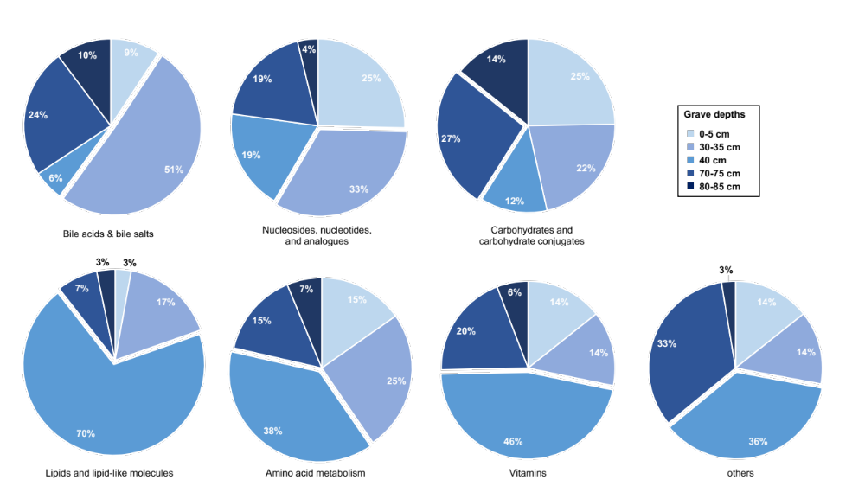

Figure 1.1 – Overview of the distribution of compound class abundances in soils obtained from different depths within a multi-individual grave. Relative abundances of compound classes at different depths are depicted in pie charts and changes in color brightness (bright blue to dark blue) illustrate depths of 0-5cm, 30-35 cm, 40 cm, 70-75 cm, and 80-85 cm, respectively.
To investigate the above-described global metabolic picture on a more in-depth scale, the grave metabolome was further assessed using multivariate analysis (Figure 1.2A). Consistent with Figure 1.1, the 3D PLS-DA plot showed diverse metabolic profiles for soils collected from within the mass grave. A slight overlap appeared for the 0-5 cm and 30-35 cm samples, while the remaining depths formed separate clusters (Figure 1.2A; blue, magenta, and purple clusters). Soils collected from a depth of 40 cm grouped closely to each other, while soils from deeper locations within the grave (70-75 cm and 80-85 cm) had more differentiation within each cluster. A driving factor for this might have been the changing diversity of microbial communities at certain excavation depths as reported by Emmons et al.^{28, 75}. To explain some of the metabolic variation seen among all five depths, metabolites with VIP values > 1 were extracted from the PLS-DA plot and compared to results obtained from one-way ANOVA. The latter was performed to assess significance in metabolite changes among depths (p ≤ 0.05 with Tukey’s HSD correction for multiple comparisons). This analysis found significant variation in abundances among depths for 36 metabolites, while 13 metabolites extrapolated from the PLS-DA plot had VIP scores > 1 (data not shown). Among those 36 and 13 compounds, eight metabolites overlapped. Thus, ‘overlapping metabolites’ were metabolites meeting the screening criteria VIP > 1 and significant metabolites based on ANOVA (Figure 1.2B). These eight showed significant abundance differences at primarily either 40 cm and/or 70-75 cm (Figure 1.2B). Hydroxybenzoate, homocysteine, tyrosine, and tryptophan were identified as involved in the amino acid metabolism. The five-carbon sugar xylitol is commonly used in a variety of food, but is also found in smaller quantities in plants or is microbially produced from xylose⁸⁴. Multiple origins are also known for hydroxybutyrate as well as the water-soluble vitamin pantothenate – both have been related to bacteria, plants, and animals⁸⁵. The compound 3-methylthiopropionate is categorized according to the human metabolome database among lipids and lipid-like molecules and has already been mentioned above with increased abundance at 40 cm.
Given that all compounds were detected at 0-5 cm (grave surface), the significantly increased abundances inside the grave reinforced the above hypothesis of a shift in the biochemistry at deeper depths where a potentially differential influx of decomposition products into the soil matrix may have altered the intra-grave soil biochemical dynamics. A separate study of this project observed among other parameters high concentrations of organic sources including dissolved organic carbon (DOC) and nitrogen (DON) at 40 cm and the grave base (70–75 cm), likely as pooled inputs from all three sets of remains. In addition, with the base of the grave being water-saturated, oxygen availability was limited²⁸. This could have also driven a shift in microbial communities within the grave toward anaerobic colonizers because at around 40 cm and above soil geochemistry parameters suggested enough oxygen for nitrification^{28, 75}. Pontiller et al. recently described the bacterial transformation of labile DOC compounds such as amino acids, glucose, or acetate and the utilization of organic acids, oligomeric or polymeric molecules like proteins and polysaccharides⁸⁶. Therefore, a diverse and highly variable microbiome within the grave could have impacted metabolic dynamics at specific depths.
A
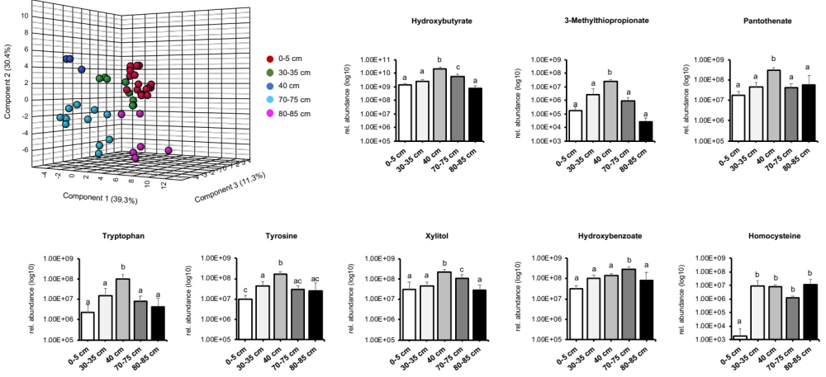
B

Figure 1.2 – Intra-gave soil metabolic changes at different depths. (A) 3D PLS-DA plot of soils collected at multiple depths from the grave. (B) Most significant metabolites resulting from one-way ANOVA and VIP analysis with significant changes in relative abundances at different grave depths. P-values and letters above bar graphs were derived via Tukey's honestly significant difference (HSD) post hoc test.

1.4.2 Comparative analysis of grave and control soil metabolic patterns
Presently, metabolomics analysis focused solely on decomposition-impacted soils from the multi-individual grave. Therefore, we compared decomposition soil samples with samples obtained from the control grave next (0-5 cm and 30-35 cm). Control grave samples were preferred as opposed to off-grave controls to resemble the same environmental conditions for direct evaluations of decomposition effects. To determine which metabolites significantly changed in abundance among the two graves (multi-individual vs. control grave), a volcano plot analysis was performed (FC threshold 1.5, p-adjusted threshold ≤ 0.05). Control grave soils from 30-35 cm were used for comparisons with decomposition soils from 30-35, 40, 70-75, and 80-85 cm, while control soils collected at 0-5 cm were compared to those collected at 0-5 cm from the multi-individual grave. A detailed overview of the analysis with all altered metabolites is summarized in Appendix Table 1.3, while bar graphs in Figure 1.3A visualize the summarized results. The total number of metabolites with significantly altered abundances among the two grave soil types is depicted by depths. For example, a depth of 0-5 cm showed 14 metabolites lowered in abundances in decomposition-impacted grave soils when compared to the controls. Yet, with increasing grave depth we noticed an increased number of compounds that were higher in relative abundance in the mass grave. Particularly, this was the case at 40 cm and to a lesser extent also at 70-75 cm (Figure 1.3A, 36 metabolites and 11 metabolites, respectively). Additionally, features with higher abundance in soils from the multi-individual grave (49 total features) were further evaluated using a Venn diagram to identify common and unique metabolites among all or some of the depths. As depicted in Figure 1.3B, 27 features were elevated solely at a depth of 40 cm, and two features only at 70-75 cm. Seven metabolites were mutually elevated at both 40 and 70-75 cm, while two metabolites had greater abundances at all three depths when compared to control soils. Homocysteine and hydroxybenzoate comprised the latter (Figure 1.3B). Being significantly “upregulated” in decomposition soils, a direct link to human decay processes seemed likely. Reinforcing this, the review of human decomposition products in soils by Dent et al. reported the production of phenolic compounds after the onset of proteolysis together with the occurrence of sulfur-containing amino acids resulting from protein breakdown¹⁶. Hydroxybenzoate has not been reported in the literature as a product of human decomposition, although other benzoic acid derivatives like methyl benzoate were detected among compounds significant to the human remains odor profile⁸⁷. As subsurface decomposition processes are vulnerable to temperature, moisture and the availability of microbes¹⁶, certain circumstances and conditions in a subsurface environment could have preserved carcass-sourced dynamics in decomposition-impacted soils even four years after burial. On the contrary, adenosine, deoxycytidine, and thymidine were among the compounds that showed continuously higher abundances in the control grave soils of either 0-5 cm or 30-35 cm (Figure 1.3A, red bars and Appendix Table 1.3). All of the aforementioned compounds are nucleoside analogues or nucleosides which are structural subunits of nucleic acids. Previous studies have proven the existence of nucleic acids, polynucleotides and also nucleosides in soil organic matter⁸⁸ and recovery studies by Phillips et al. showed that nucleosides adhered tightly to soil particles⁸⁹. Thus, differential microbial community composition in either one of the two soil types with microorganisms exhibiting mechanisms to release extracellular products that solubilize nucleic acids and/or others equipped with necessary nucleoside transporters for facilitating uptake and incorporation of such exogenous compounds seemed a plausible explanation for their mass-spectrometric detection in soils⁹⁰.
Overall, when looking at the soil chemical responses collectively, our results revealed differential dynamics of soil metabolite abundances at different depths within the grave. An overall pattern emerged suggesting that most of the metabolic variability in the soil was predominant at a depth of 40 cm (and possibly 70-75 cm). Given that such intra-grave differences in soil chemistry responses between surface soils (0-5 cm) and soils of increasing depths were also significant in comparison to control grave soils, it can be assumed that soils at a range of 40-75 cm below ground possibly experienced an increased influx of human decomposition due to an additive impulse of the decay of all three bodies. Likewise, this implies that even years after burial, soils might have the capacity to retain traces of decomposition that could aid in locating buried remains.

A
B
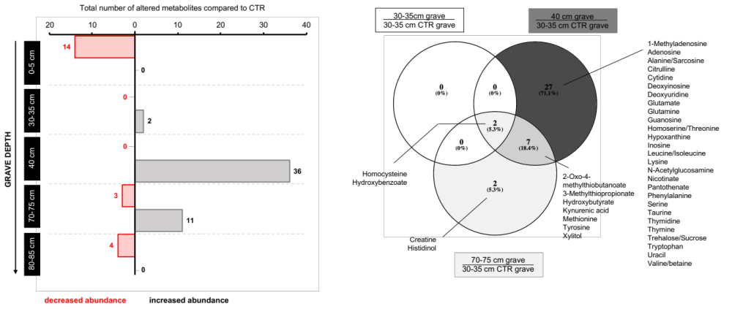

Figure 1.3 – Postmortem metabolomics contrasting grave and control soil metabolic profiles. (A) Result of volcano plot analysis showing the total number of significantly altered metabolites at different grave soil depths when compared to soils from the control grave. Metabolites are shown as having significantly increased (grey bars) and/or decreased (red bars) abundances when compared to their abundances detected in controls. (B) Venn diagram of metabolites from (A) that had significantly increased abundances at 30-35, 40, and 70-75 cm from within the multi-individual grave in comparison to controls. CTR = control, sign. = significantly

1.4.3 Postmortem metabolomics of buried human skeletal remains

1.4.3.1 Inter-individual comparisons
To assess metabolic signatures of bones from buried individuals, all bone samples of each individual were first analyzed comprehensively (inter-individual analysis) followed by an intra-individual analysis of single anatomical regions. For the inter-individual analysis, the PLS-DA plots of all bones resulted in a separation of the metabolomes in a multidimensional space which indicated that gross metabolic signatures differed among all buried bodies (Figure 1.4). All bones from individual A could be separated well along the second component when compared to the entirety of samples from individual B. Similarly, bones from individual B seemed to be metabolically distinguishable from all bones collected from individual C (Figure 1.4). While the majority of samples in the PLS-DA plots did separate, a small number of samples seemed to slightly overlap with each other – a pattern that was absent in the PLS-DA plot of individuals A and C. Here, two distinct clusters are shown comprising all samples from the respective bodies (Figure 1.4). This was most likely a result of the study design and the way individuals were buried. With individuals A and C being located at the bottom and top of the grave, respectively, more diverse metabolic profiles can be expected. On the contrary, metabolic similarity of certain body regions for the comparisons involving individual B could have been a result of the stacked design with individual B being “sandwiched” between A and C. Bones from different individuals in close proximity or even in contact with each other in the grave could have experienced a similar decomposition environment including similar microbial communities, which ultimately led to more comparable metabolic patterns among A and B as well as B and C. Additionally, the overall inter-individual variation in the bone metabolomes was certainly impacted by a variety of other factors – a few to name are general health, medication, lifestyle (tobacco, illicit drugs or alcohol abuse), diet or sex, all of which are aspects forming a person’s, or in this case, a cadaver’s unique metabolome. Nevertheless, it was shown here that even four years after burial, bones from a multi-individual grave still contained a unique metabolic signature that could be ‘reassigned’ to an individual.

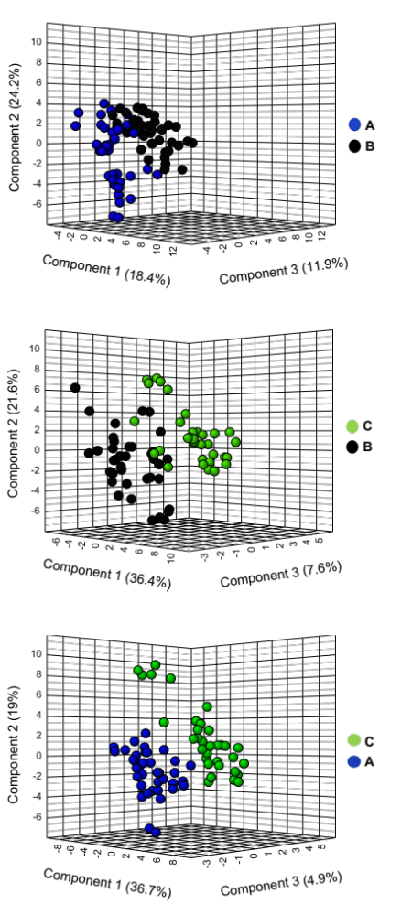

Figure 1.4 – Inter-individual bone metabolic signatures. PLS-DA analysis of bone powder samples obtained from three buried individuals four years after burial.

Aside from global PLS-DA analyses, we can also look at how abundances of single metabolites change across cadavers by converting a numerical value to a defined color scale (heat map Figure 1.5). Differences in the overall patterns of metabolite changes were particularly obvious for individual C. Here, lowered abundances were detected for a large variety of compounds (blue columns Figure 1.5). This contrasted abundance profiles for A and B having overall a greater number of compounds with increased abundances (Figure 1.5 red columns). Knowing about the physical and geochemical environments of bodies A and B compared with C, inter-individual bone metabolome differences were expected. As previously stated, decedents were stacked in the grave prior to burial, and each individual spanned multiple depths or a unique depth regime. This contributed to differential decomposition related to changes in oxygen availability, moisture, soil biogeochemistry, arthropod activity, and temperature. Additionally, cadavers A and B had greater amounts of soft tissue preservation and adipocere (body A) formation, while C was fully skeletonized. Combined influences of all the above factors coinciding with the observation from a previous publication that bacterial and archaeal microbial communities from individual C deviated from A and B⁷⁵. Donors A and B were also more likely impacted by fluctuations in groundwater. Water movement may have promoted microbial accessibility to bone surfaces and enhanced microbial intrusion by increasing bone porosity⁹¹. In addition, intrinsic differences in skeletal integrity may have enhanced microbial accessibility to internal bone surfaces. A and B seemed to have greater skeletal porosity, and B had also a fused vertebral column with fused ribs 1 and 2 (publication under review).
Next, calculated fold changes and significant differential abundances based on p-values shown in the heatmap in Figure 1.5 were assessed with regard to extracted VIP values from the above-shown PLS-DA plots (Figure 1.4). An overview of all metabolites with VIP scores > 1 is given in Appendix Table 1.4, while selected metabolites with similar inter-individual alterations (increase or decrease) are listed in Appendix Table 1.5. Compounds with VIP scores > 1 and significant p-values ( * ≤ 0.1, ** ≤ 0.05, *** ≤ 0.01) were considered most important. Among these, for instance homovanillic acid (HVA), 4-pyridoxate, and tyrosine were increased in abundance for A but found significantly lower in abundance in B and C (Figure 1.5, Appendix Table 1.5 p-values < 0.01). Metabolites from the energy metabolism (TCA cycle) were enriched in bones from individual B, however, lowered in the other two cadavers (e.g., aconitate, 2-oxoglutarate, citrate/isocitrate, succinate; all p-values < 0.01). Amino acid metabolism affected bones of the shallowest body most. While valine, N-acetylglutamate, and alanine/sarcosine were reduced relative to the other bodies, two amino acids, creatine and arginine, were found significantly higher in abundance in individual C (Figure 1.5, Appendix Table 1.5; all p-values < 0.01).

Previous work on animal and human bones revealed a great diversity of biomolecules present in the bone matrix ranging from proteins and lipids to amino acids^{59, 61, 92-95}. An active exchange or substitution of chemical elements between the apatite structure of the bone and those present in the living body is important for the skeleton to store essential minerals⁹⁵. After death, bones are still reactive and undergo constant change⁷⁰. Most of the aforementioned factors determining diverse inter-individual profiles also account for the here identified variations in expression levels of individual metabolites. Perimortem conditions, e.g. diet, underlying health conditions or mobility can affect the size, shape, and composition of the bioapatite crystals⁶⁹, thus could have also triggered differential metabolic signals postmortem. Pathological conditions such as iron or vitamin C deficiency were suggested previously to alter the amino acid composition of collagen⁹⁶. Likewise, gender-induced differences might have occurred for the deepest body. Both B and C were males, while cadaver A (grave bottom) was female. Previous studies uncovered that for instance plasma HVA levels were lower in elderly men than in elderly postmenopausal women⁹⁷. According to Nielsen-Marsh and Hedges, protein content in buried bone is strongly correlated with microporosity and is especially closely related to microbiological action⁹⁸. In our study, donor C was the only fully skeletonized cadaver. Unprotected by residual soft tissue, the skeleton of C could have undergone more extensive microbial-mediated protein degradation. On the contrary, assuming that bones somehow reflect their surroundings, residual tissue on body B might have impacted the chemical composition of these bones to a degree where a more catabolic environment from the skeletal muscle was mirrored. Catabolism of organic molecules i.e., sugars, fatty acids, and amino acids activates a metabolic main route via the TCA or citric acid cycle^{99, 100}, ultimately increasing the pool of TCA cycle intermediates – a hypothetical link to detected compound classes of individual B. Further, all of the processes were possibly accompanied by diverse microbial communities involved in early diagenetic processes which could become embedded within the bone matrix during cycles of demineralization and recrystallization (paper under review). During microbial catabolism, amino acids from collagen are removed for both energy and protein synthesis^{48, 72}.
Lastly, in a combined effort with Dr. Alexandra Emmons, a comparative analysis of metabolite-microbiome interactions modeled microbial taxa with identified metabolite profiles using sparse canonical correlation analysis (sCCA, paper under review, data not shown). This analysis resulted in a correlation of 0.95 between the two matrices (metabolites and taxa) for individual C, with 30 features selected capturing the most covariance. These features included 28 genera and 2 metabolites (acetyllysine and glutamine). For individuals A and B, which were run independently from C due to significant differences in metabolite profiles, sCCA resulted in a correlation of 0.87, with 15 genera and 3 metabolites (N-acetylglutamine, N-acetylglutamate, and 2-Dehydro-D-gluconate (a.k.a., 2-ketogluconate)). These metabolites demonstrated a relationship with high human DNA degradation indices and correlated with relative abundances of Pseudomonas and Lactobacillus. An interesting result because the general mechanism through which Pseudomonas spp. solubilizes inorganic phosphate involves the production of gluconic acid and/or 2-ketogluconic acids via extracellular direct oxidative metabolism of glucose¹⁰¹. The compound 2-ketogluconic acid has demonstrated efficient solubilization of inorganic phosphate from calcium phosphates including hydroxyapatite¹⁰² (paper under review).

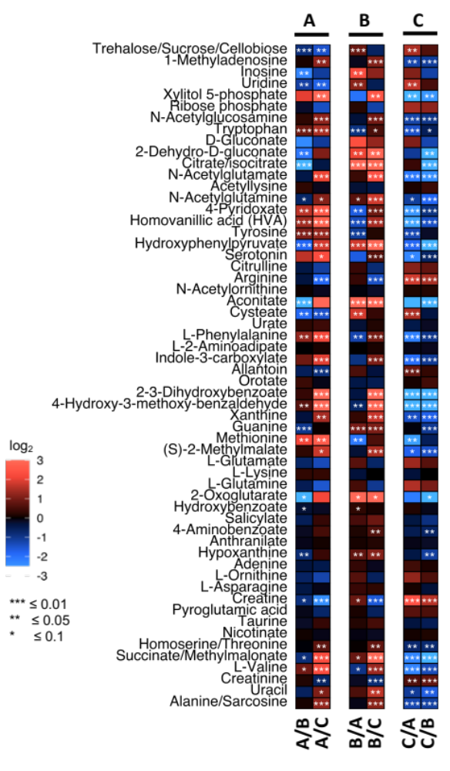

Figure 1.5 – Heat map analysis of differential metabolites of all postmortem bone samples of individual A, B, and C. Heat map illustrates log2 fold changes in relative abundance of metabolites. Increased fold changes are indicated in red and decreases are shown in blue.

1.4.3.2 Intra-individual comparisons by anatomical region

To further examine the postmortem bone metabolome, an analysis focusing on six anatomical regions was conducted: skull, arm, upper torso, lower torso, leg, and foot (Appendix Table 1.6). Prior applied multivariate analysis derived metabolites with VIP scores > 1 that differentiated the six body regions in each of the three donors. They all showed a unique set of relevant metabolites (VIP > 1) that were used for univariate analysis and assigned their metabolic pathways through KEGG annotation (Figure 1.6 donor A: 24 metabolites; donor B: 23 metabolites; donor C: 24 metabolites). Assessing intra-skeletal metabolic signatures, we observed that metabolite abundances differed between several anatomical regions within the same body. The skull and foot bone metabolome of individual A was associated with a striking downregulation of metabolites from several metabolic pathways compared to other regions. Relative increased abundances dominated for the upper and lower torso bones (Figure 1.6). Interestingly, macroscopic evaluation of the exhumed body found isolated decomposed muscle tissue covered in skin and adipocere at the upper and lower torso including the proximal one-third of the femora⁷⁵. For the middle carcass (B) we found a less obvious overall pattern, yet the bone metabolome of the skull had in direct comparisons with distal bones of the body such as foot and leg bones decreased abundances (Figure 1.6). This pattern was also consistent with that of body C. Here, similar to body A, metabolism through amino acids was altered because mostly amino acids, amino acid precursors, and derivatives showed a considerably differential regulation. Aside from the skull and foot bones, comparisons involving arm bones yielded lowered relative metabolites abundances, as well (Figure 1.6). Compounds with higher abundances in the lower torso and leg bones belonged to the amino acid metabolism. Additionally, by assessing the relationship between the in Figure 1.6 depicted relevant individual metabolites, we noticed four commonly shared compounds among all three bodies: anthranilate, creatine, N-acetylglutamine, and indole-3-carboxylate. The former three compounds are amino acids, derivatives of amino acids or are involved in the amino acid metabolism and thus represent a source of organic nitrogen in soils providing carbon and nitrogen for microorganisms and plant use¹⁰³. The compound indole-3-carbocxylate has been detected in several microorganisms and yeasts while in bacteria Davis et al. proposed that indole-3-carboxylic acid is a degradation product of the aromatic amino acid tryptophan. Likewise, anthranilic acid may also originate from the breakdown of tryptophan¹⁰⁴. Differential abundances of all four metabolites between one or more body regions were also evaluated using one-way ANOVA followed by Tukey HSD post-hoc tests and results are listed in Appendix Table 1.7.

Possible explanations for the here detected intraskeletal variation can be gathered from recent forensic literature. Mickleburgh et al. revealed that intra-skeletal differences in bone mineral density induced distinct differences in the variety and abundance of preserved proteins⁶¹ – raising questions about a possible link to the fate of our recovered metabolites. Grupe and Turban-Just provided an overview of amino acids extracted from matrix collagen from archaeological human bone and concluded that non-proteinogenic amino acids recovered from bones were not necessarily contaminations, but rather a marker of decomposition or microbial processes⁹⁶. They demonstrated microbial invasion of the bone specimens and showed large amino acids with five or more carbon atoms were more frequently lost from the collagen remnants than small amino acids to meet bioenergetic requirements of heterotrophic soil bacteria, since high carbon amino acids are more efficient in gaining energy via the citrate cycle and thus better fulfill bacterial demands⁹⁶. Differential distribution of metabolite abundances for certain anatomical regions in the same individual may also be linked to the cellular skeletal composition of that area. Different types of bone might have impacted intra-skeletal metabolic patterns. In adult mammals, cortical (compact) and cancellous (spongy) bones are the two most commonly found types of bones⁶⁹. A higher degree of porosity is characteristic for spongy bones comprising the internal tissue of bones. Flat and short bones such as tarsals (foot bones), sternum, or cranial bones typically have a higher cancellous to cortical bone ratio. The external layer of bones is cortical bone, predominantly present in greater portions in the diaphysis of long bones as well as the appendicular skeleton (upper and lower extremities)⁶⁹. A less dense bone matrix as present for cancellous foot bones could provoke leaching of soluble biomolecules/decomposition products into the external surrounding. Likewise, several elements from donors A and B were also submerged in water at the time of disinterment due to a perched water table⁷⁵. Such influences of site hydrology within the grave could have eased the leaching, as well and caused intra-skeletal metabolic⁷⁵. Alternatively, water movement could enhance the movement of microbes and other extrinsic molecules or the intrusion of plant roots into and throughout cancellous bones^{61, 72}. Aside from that, fluctuations in moisture during the four-year interment period might impact microbial growth and/or diversity of decomposer communities^{75, 105}. Hence, there could be something unique about the foot and skull microbes resulting in greater utilization of prevalent metabolites. Interestingly, according to Child, there is evidence for microbial inter-bone variations during decomposition⁴⁸. During decomposition, the greater degree of putrefaction usually occurs around the intestinal region where the largest bacterial ecosystem of the human body is located. Child proposed that bones within the thorax and abdomen will suffer from greater putrefaction effects and are exposed to the latter for a longer time period than foot, long bones or the skull⁴⁸. A feasible hypothesis explaining why bones with the longest distance from the gut, and presumably less contact to enteric microbes, frequently yielded lowered metabolite intensities across individuals in our study – a theory recently reinforced by Mickleburgh et al.⁶¹. Foot and skull bones begin the decomposition process with less soft tissue covering, and foot bones are exposed to mechanical stress during life which reduces the soft tissue mass on these flat bones. A reduced level of protection might have encouraged a lower metabolic detection rate and/or the formation of a specific postmortem microbiome. Lastly, complementing the discovery of inter-bone metabolic variety, Emmons et al. showed that microbial diversity and richness were variable not only among different bones but also at different sites of the same bone (e.g., midshaft and epiphysis). Bones from the skull and foot from individual A had some of the highest richness and diversity estimates, while mean richness estimates were ranked second highest in foot bones from individuals B and C (paper under review).

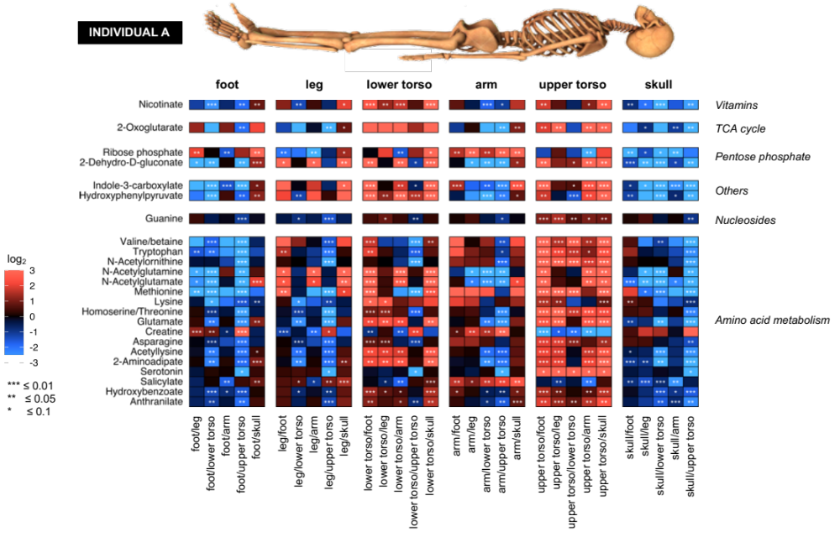
Figure 1.6 – Intra-individual comparisons of metabolic profiles of anatomical regions for individuals A, B, and C. Six anatomical regions were defined (top) for intra-individual comparisons. Represented metabolites were chosen bases on prior multivariate analysis and VIP scores > 1. Metabolic pathways are listed on the right. All fold changes are log2 transformed. Increased fold changes are indicated in red and decreases are shown in blue. The skeleton on top was modified from https://www.dreamstime.com.

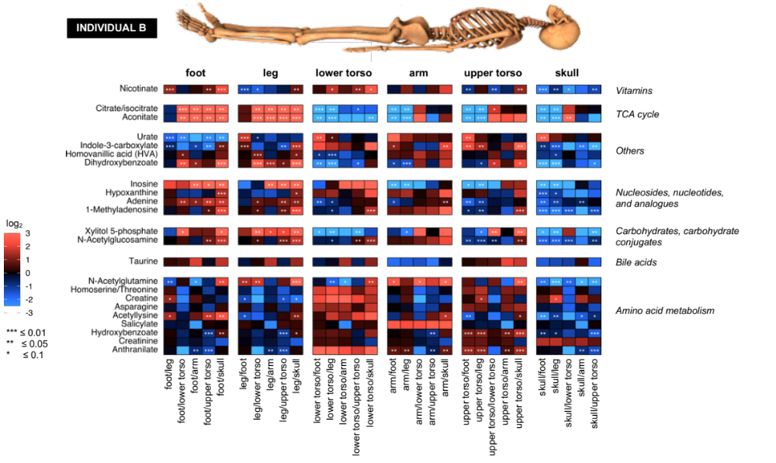

Figure 1.6 – continued

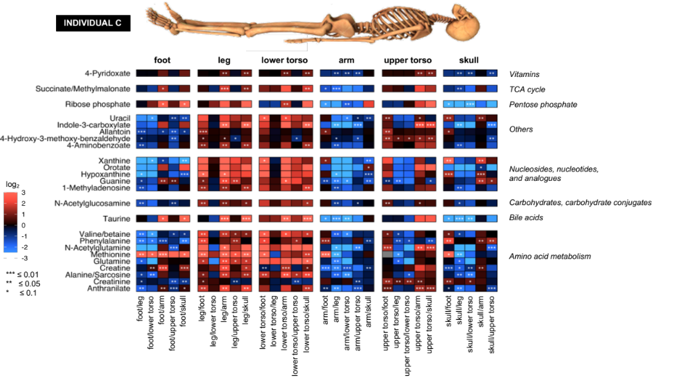

Figure 1.6 – continued

1.4.3.3 Unidentified features of the bone metabolome
Using a high-resolution mass analyzer such as an Orbitrap enables an enormously large coverage of spectral features, containing thousands of unknown spectral m/z features along with known metabolites. Thus, in addition to the identified compounds that matched retention time and m/z of metabolites from our in-house database (knowns), 5,015 unidentified features were also detected in bone extracts. As the number of detected unknowns usually outweighs the knowns, the urge to characterize the unknowns is of great interest and was one secondary aim. Handling the complexity of the unknown metabolites is still one of the current challenges in the -omics field, which is why the subsequent approach is mainly exploratory.
A total of 5,015 unknown spectral features were first subjected to multivariate analysis. Subsequent analysis was performed to visualize the extent to which metabolite abundances discriminated (a) individuals and (b) anatomical regions with the intention to complete the findings for the known compounds from the previous section. First, multivariate inter-individual analysis showed a clear separation for all performed comparisons (3D PLS-DA plots, Figure 1.7A) suggesting distinct effects from these individuals on bone metabolomes – a phenomenon already seen in Figure 1.4; however, it is noteworthy that the unknown bone metabolome revealed an even more drastic inter-individual separation. A volcano plot analysis identified significantly increased or decreased unknowns based on fold change and p-value thresholds of 1.5 and 0.05, respectively (Figure 1.7B and Appendix Table 1.8). These results also confirm previously described trends illustrated in the heat map in Figure 1.5. A large number of significantly increased metabolites in bone extracts from body B (144 features) and likewise from A (118 features), demonstrated drastically lowered metabolite abundances in the shallowest body C (Figure 1.7B). Similar to Figure 1.5, unknown bone metabolic profiles seemed to be relatively similar among the deepest and middle body with 33 unknowns enriched A and 52 in individual B (Figure 1.7B A/B comparison and Appendix Table 1.8).

B
A

Figure 1.7 – Unidentified features of the bone metabolome. (A) PLS-DA and (B) volcano plot analyses for bones of all buried individuals (inter-individual comparisons). Volcano plots in (B) indicate the total number of unknowns significantly (= sign.) increased or decreased in abundance in a respective body.

Lastly, unknown features from bone extracts were assessed by anatomical region in the same manner as done above (Figure 1.6). The complexity of information in the datasets was reduced by focusing on the top 25 differential unknowns with VIP values > 1 resulting from multivariate analysis (PLS-DA). These unknowns significantly discriminated the six anatomical regions in each individual and were visualized using univariate methods (Figure 1.8). The most distal elements of the skeleton, the skull and feet, had for donor A reduced abundances as opposed to the center of the skeleton (lower torso, upper torso, and arm). These accumulating compounds were most likely available as nutrients in the grave, supporting the formation of a specific microhabitat at different locations of the body. This pattern observed for body A shifted for the middle and shallowest cadaver, as abundance profiles appeared to be less distinct. Slightly reduced abundances were still detected for the skull of individual B, yet foot and leg bones had clusters of unknowns with elevated abundances. The shallowest individual (C) had the least uniform signature. Most of the abundance changes for the unknown features were significant for comparisons among anatomical regions of donor A, while C had overall less significant changes (Figure 1.8). Taken together, the unknown analysis confirmed the presence of differential metabolic processes among buried individuals and in different skeletal regions postmortem – processes affected by either decomposition itself or the depositional ecology. Along with Figure 1.7, this diverse and variable metabolic picture of frequent changes in unknown metabolite abundances also reinforced our hypothesis that decomposition processes were still ongoing four years after burial.
Additional efforts were made to assign unknown compounds hypothetical chemical formulas (data not shown). In total, 11,481 empirical formulas arising from the unknown m/z features were found. These were sorted into generalized compound classes based upon their hypothesized atomic H/C and O/C ratios in so-called van Krevelen diagrams¹⁰⁶. In such a diagram, every calculated chemical formula was given a ‘ratio-value’ which ultimately determined the (generalized) compound class e.g., lipids, proteins, carbohydrates, amino-sugars, condensed hydrocarbons, lignins or tannins. A noticeable dense clustering suggested most of the unknown metabolites had characteristics most similar to those of lipids and condensed hydrocarbons (ratios of O/C < 0.25 and H/C 0.5-2.25). Altogether, among others, we found 1,881 unknowns similar to lipids, 1,475 seemed to fit into the category for proteins, 129 amino-sugars, 135 carbohydrates, and 2,317 similar to condensed hydrocarbons, while 4,279 formulas remained with unknown designations (data not shown). Despite limitations in identifying compound classes from unidentified spectral features, the scope of our preliminary analysis showed that most of the trends observed from known biomolecules were reinforced by the unknowns. An outcome that points toward the necessity to refine and expand existing compound libraries to broaden the current state of knowledge of chemical metabolic pathways in the postmortem bone metabolome. More comprehensive libraries would ultimately also help to solve questions of whether compounds solely arose as a result of decomposition or if they were potentially linked to plant/microbial pathways.

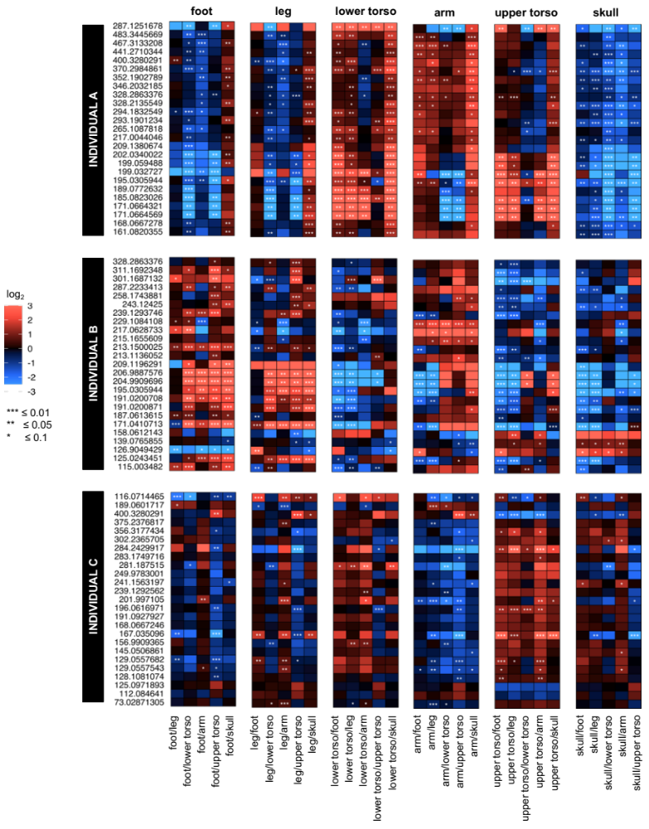
Figure 1.8 – Masses of unidentified features of the bone metabolome by anatomical region for all three bodies (A, B, C). Heat map of the top 25 unknowns with VIP scores > 1 extracted from PLS-DAs (intra-individual comparisons). Six regions are shown as defined in Table 1.6.

1.5 CONCLUSION

Subsurface decomposition is impacted by several abiotic (soil pH, soil temperature, soil type and moisture) and biotic (soil decomposer diversity and accessibility) factors²⁸, differentiating decomposition trajectories from surface decay. In this chapter, untargeted metabolomics was used to investigate soil and bone metabolic signatures present at the time of sampling in a multi-individual grave. The deposition of three individuals and prior to this study performed skeletal analyses allowed us to also investigate the extent to which bone metabolomes were influenced intra- and inter-individually. The dissolved organic matter (DOM) in soils is a cocktail of carbohydrates, aromatic compounds, amino acids, and organic and fatty acids¹⁰⁷. We demonstrated a diverse soil metabolic biochemistry coincided with strong spatial dynamics within the grave as illustrated based on shifts in metabolite abundances within different depths of the burial. Because of diverse metabolomes in-vivo, we expected a considerable portion of the metabolites to be likewise influenced among buried cadavers postmortem. This could be seen not only for comparisons among individuals but also among anatomical regions. Not surprisingly, as a decomposing cadaver is a nourishing source of nitrogen and carbon, for both types of analyses amino acid profiles seemed to be most variable. Furthermore, we displayed a trend of reoccurring lowered compound abundances dominating for foot and skull bones of buried bodies likely related to specific (micro)habitats prevailing at different locations in the burial. The unidentified spectral features of the bone metabolome revealed similar trends to the known metabolites for inter- and intra-individual comparisons. Although annotation of these features is one of the bottlenecks of untargeted metabolomics, the information gained from these early untargeted studies helps to elucidate broad trends of postmortem trajectories in skeletal remains.
The interpretation of our results also demands an understanding of the limitations of this study provoked primarily by the environmental heterogeneity of the burial (biotic and abiotic). Aside from human decomposition, some of the here detected compounds, most likely sourced from plant root exudates and originated from microbes or the decay of plants and microbes. Water-soluble metabolites (< 1000 Da) are exchanged within soil microbial communities (i.e., water-extractable exometabolite pool) and differentiating these molecular products is still one of the biggest challenges in metabolomics. Possible artifacts in differential metabolite abundances could have further been caused due to post-excavation contamination by the application of heat during bone sampling (drilling) or storage/handling of skeletal remains at room temperature – all factors that negatively affect the stability of biomolecules. Pre-burial factors namely the physical state of the bone, residual muscle tissue, vascularity, or adipocere along with individual intrinsic parameters like health conditions may have caused additional bias extremely hard to deconvolute. Yet, this work did not seek to validate any of these influences as a rather exploratory study was anticipated focused on obtaining a metabolic snapshot of soils and bones in a burial at the time of sampling. With only three individuals analyzed, a comparatively small donor size strongly motivates for additional, more comprehensive future research potentially considering various environmental and burial conditions which will ultimately help to complete the here presented picture of subsurface decomposition trajectories.
Taken together, soils and bones retained even four years after burial a diverse metabolome formed by heterogenous influxes from human decomposition and grave ecology. Assuming decomposition was still active in the grave, we showed that grave depth and anatomical region of skeletons were factors revealing metabolic diversity postmortem. Given that buried corpses are common scenarios in forensic invetigations⁴⁶, we provided findings to contribute to the groundwork studies and might open new avenues of investigative approaches for such forensic cases.

1.6 APPENDIX CHAPTER I

Figure 1.9 – Depth profile of the multi-individual grave by individual (picture permission by Dr. Alexandra Emmons). (A) Top individual (donor C), (B) middle individual (donor B), and (C) bottom individual (donor A). Measurements in green indicate the span of depths in meters. Photo credit: Christina Malone.

Table 1.1 – Demographics of skeletonized individuals

Donor ID | Sample Type* | Weight (kg) | Age (yrs) | Medical History | Sex | Position in Grave | Duration of Burial
A | Soil/bone | 60.3 | 68 | Cancer | Female | Bottom | 4 years
B | Soil/bone | 70.8 | 63 | COPD | Male | Middle | 4 years
C | Soil/bone | 51.7 | 63 | Cancer, Coronary Artery Dx | Male | Top | 4 years
* Soil obtained from a control grave served as a negative control

Table 1.2 – Soil and buried skeletal samples for untargeted metabolomics

BONE SAMPLES (n = 41) |  |  | SOIL SAMPLES (n = 20)
Sample Code | Individual | Bone | Sample Code | Sampling Location | Depth (cm)
10001 | A | Fibula | MGR02170001BN | Control, off-grave | 0
10002 | A | Sacrum | MGR02170003BN | Control, off-grave | 30
10003 | A | Sternum | MGR02170005BN | Control grave | 0
10007 | A | Femur | MGR02170007BN | Control grave | 30
10009 | A | Humerus | MGR02170057BN | on grave | 0
10011 | A | Ischium | MGR02170059BN | on grave | 0
10013 | A | L4 | MGR03170002BN | on grave | 0
10018 | A | Radius | MGR03170003BN | on grave | 0
10026 | A | Talus | MGR03170004BN | on grave | 0
10035 | A | Tibia | MGR03170005BN | on grave | 0
10050 | A | Navicular | MGR03170006BN | on grave | 30
10067 | A | Temporal | MGR03170007BN | on grave | 40
10031D | A | Femur | MGR03170008BN | on grave | 30
10058R | A | 1st Cuneiform | MGR03170009BN | on grave | 30
20004 | B | Sternum | MGR03170026BN | on grave | 70
20008 | B | L4 | MGR03170027BN | on grave | 85
20020 | B | Talus | MGR03170028BN | on grave | 70
20027 | B | Navicular | MGR03170029BN | on grave | 85
20048 | B | Tibia | MGR03170030BN | on grave | 70
20049 | B | Fibula | MGR03170031BN | on grave | 70
20053 | B | Femur
20066 | B | Radius
20072 | B | Temporal
20002R | B | Clavicle
20018R | B | Calcaneus
20022R | B | patella
20055D | B | Femur
20065R | B | Ulna
30011 | C | Navicular
30036 | C | Humerus
30041 | C | Radius
30055 | C | Sacrum
30057 | C | Ischium
30061 | C | Fibula
30065 | C | Femur
30073 | C | Tibia
30079 | C | Temporal
30015D | C | 1st Cuneiform
30044R | C | ulna
30045R | C | clavicle
30063R | C | patella
30063R | C | patella

Table 1.3 – Result of volcano plot analyses comparing relative metabolite abundances among different grave soil depths with those detected in soils from the control grave. Shown are significantly increased and decreased metabolites abundances compared to controls based on a fold change threshold of 1.5 and p-adj. threshold ≤ 0.05.

Metabolite name | Fold change (FC) | log2(FC) | p-adjusted | -log10(p)
0-5 cm grave soil vs 0-5 cm control grave soil
Inosine | 0.15347 | -2.7039 | 0.0019871 | 2.7018
Cytidine | 0.15471 | -2.6924 | 0.0073517 | 2.1336
Deoxycytidine | 0.30832 | -1.6975 | 0.010673 | 1.9717
Nicotinate | 0.34848 | -1.5209 | 0.010673 | 1.9717
Thymidine | 0.38641 | -1.3718 | 0.010673 | 1.9717
Glutamate | 0.3198 | -1.6448 | 0.018808 | 1.7256
Adenosine | 0.38815 | -1.3653 | 0.018808 | 1.7256
Uracil | 0.29414 | -1.7654 | 0.02282 | 1.6417
Leucine/Isoleucine | 0.38838 | -1.3645 | 0.029054 | 1.5368
Phenylalanine | 0.43736 | -1.1931 | 0.029054 | 1.5368
Guanosine | 0.39487 | -1.3405 | 0.031937 | 1.4957
Pantothenate | 0.44825 | -1.1576 | 0.041964 | 1.3771
Methionine | 0.33675 | -1.5703 | 0.047542 | 1.3229
Hypoxanthine | 0.39639 | -1.335 | 0.047542 | 1.3229
30-35 cm grave soil vs 30-35 cm control grave soil
Hydroxybenzoate | 4.8397 | 2.2749 | 0.029574 | 1.5291
Homocysteine | 483.34 | 8.9169 | 0.045617 | 1.3409
40 cm grave soil vs 30-35 cm control grave soil
2-Oxo-4-methylthiobutanoate | 1191.7 | 10.219 | 0.00071685 | 3.1446
3-Methylthiopropionate | 727.63 | 9.5071 | 0.00060917 | 3.2153
Methionine | 70.948 | 6.1487 | 0.0012208 | 2.9134
Tryptophan | 56.495 | 5.8201 | 0.0020205 | 2.6945
Tyrosine | 37.011 | 5.2099 | 0.00048769 | 3.3119
Glutamate | 29.442 | 4.8798 | 0.00048769 | 3.3119
Nicotinate | 27.128 | 4.7617 | 0.00076347 | 3.1172
Valine/betaine | 26.875 | 4.7482 | 0.00048769 | 3.3119
Homoserine/Threonine | 26.422 | 4.7237 | 0.00048769 | 3.3119
Alanine/Sarcosine | 23.553 | 4.5579 | 0.00048769 | 3.3119
Deoxyuridine | 23.343 | 4.5449 | 0.00060917 | 3.2153
Citrulline | 21.774 | 4.4446 | 0.00050679 | 3.2952
Leucine/Isoleucine | 19.618 | 4.2941 | 0.00076347 | 3.1172
Glutamine | 18.297 | 4.1936 | 0.00048769 | 3.3119
Taurine | 17.125 | 4.098 | 0.0032166 | 2.4926
Pantothenate | 16.353 | 4.0315 | 0.00060917 | 3.2153
Serine | 15.855 | 3.9868 | 0.00071685 | 3.1446
hydroxybutyrate | 13.745 | 3.7808 | 0.00048769 | 3.3119
Xylitol | 9.9522 | 3.315 | 0.001597 | 2.7967
Phenylalanine | 9.8269 | 3.2967 | 0.00096725 | 3.0145
Lysine | 9.5287 | 3.2523 | 0.0033853 | 2.4704
Uracil | 9.1846 | 3.1992 | 0.024955 | 1.6028
Homocysteine | 7.3116 | 2.8702 | 0.00096725 | 3.0145
Hydroxybenzoate | 6.4489 | 2.689 | 0.0015971 | 2.7967
Kynurenic acid | 6.096 | 2.6079 | 0.00048769 | 3.3119
Inosine | 6.0947 | 2.6075 | 0.003416 | 2.4665
Deoxyinosine | 4.8809 | 2.2871 | 0.0027146 | 2.5663
Thymine | 4.4736 | 2.1614 | 0.006432 | 2.1917
1-Methyladenosine | 4.1223 | 2.0435 | 0.015258 | 1.8165
Guanosine | 3.8163 | 1.9322 | 0.0027146 | 2.5663
Hypoxanthine | 3.5655 | 1.8341 | 0.0021449 | 2.6686
Cytidine | 3.0831 | 1.6244 | 0.045832 | 1.3388
Adenosine | 2.8285 | 1.5 | 0.011098 | 1.9548
Thymidine | 2.4776 | 1.3089 | 0.027117 | 1.5668
Trehalose/Sucrose | 2.4675 | 1.303 | 0.011259 | 1.9485
N-Acetylglucosamine | 2.0961 | 1.0677 | 0.033498 | 1.475
70-75 cm grave soil vs 30-35 cm control grave soil
Hydroxybenzoate | 13.103 | 3.7118 | 7.16E-06 | 5.145
3-Methylthiopropionate | 28.118 | 4.8134 | 6.32E-05 | 4.1995
Homocysteine | 24.224 | 4.5984 | 6.32E-05 | 4.1995
2-Oxo-4-methylthiobutanoate | 33.786 | 5.0784 | 0.00055307 | 3.2572
Histidinol | 33.149 | 5.0509 | 0.00055307 | 3.2572
Kynurenic acid | 12.083 | 3.595 | 0.0013467 | 2.8707
Tyrosine | 6.5536 | 2.7123 | 0.0071571 | 2.1453
Methionine | 5.1955 | 2.3773 | 0.0071571 | 2.1453
Xylitol | 4.8857 | 2.2886 | 0.0074678 | 2.1268
Creatine | 3316.9 | 11.696 | 0.0099793 | 2.0009
Hydroxybutyrate | 3.4864 | 1.8017 | 0.0099793 | 2.0009
Adenosine | 0.19349 | -2.3696 | 0.022572 | 1.6464
Deoxycytidine | 0.13353 | -2.9048 | 0.032913 | 1.4826
Thymidine | 0.24504 | -2.0289 | 0.049645 | 1.3041
80-85 cm grave soil vs 30-35 cm control grave soil
Adenosine | 0.026461 | -5.24 | 0.0061185 | 2.2134
Thymidine | 0.043562 | -4.5208 | 0.0062361 | 2.2051
Deoxycytidine | 0.03101 | -5.0111 | 0.014847 | 1.8284
Deoxyinosine | 0.024224 | -5.3674 | 0.025495 | 1.5935

Table 1.4 – Variable importance in projections (VIP) scores for the three inter-individual comparisons shown in Figure 1.4. Metabolites with VIP scores greater than 1 are indicated. Metabolites with VIPs > 1 in 2 comparisons are bolded; those with VIPs > 1 in 3 individuals are red.

Individuals A vs. B |  | Individuals A vs. C |  |  | Individuals B vs. C
Metabolite | VIP values | Metabolite |  | VIP values | Metabolite | VIP values
Aconitate | 2.1625 | 4-Hydroxy-3-methoxy-benzaldehyde |  | 2.0745 | 2-3-Dihydroxybenzoate | 1.9332
Homovanillic acid (HVA) | 1.8132 | Succinate/Methylmalonate |  | 1.9701 | 4-Hydroxy-3-methoxy-benzaldehyde | 1.7601
Citrate/isocitrate | 1.7967 | Homovanillic acid (HVA) |  | 1.9638 | N-Acetylglutamate | 1.7483
Hydroxyphenylpyruvate | 1.7084 | Creatine |  | 1.9565 | Hydroxyphenylpyruvate | 1.7252
4-Pyridoxate | 1.6824 | Xanthine |  | 1.7634 | Succinate/Methylmalonate | 1.652
2-Dehydro-D-gluconate | 1.4837 | 2-3-Dihydroxybenzoate |  | 1.7317 | Homovanillic acid (HVA) | 1.6031
Guanine | 1.4645 | 4-Pyridoxate |  | 1.5136 | Aconitate | 1.5762
2-Oxoglutarate | 1.3829 | L-Valine |  | 1.4796 | N-Acetylglutamine | 1.5643
D-Gluconate | 1.3275 | Allantoin |  | 1.4305 | 2-Dehydro-D-gluconate | 1.5133
N-Acetylglutamine | 1.2898 | N-Acetylglutamate |  | 1.4053 | Xanthine | 1.4919
N-Acetylglutamate | 1.282 | Indole-3-carboxylate |  | 1.3025 | Indole-3-carboxylate | 1.3365
Inosine | 1.2541 | Arginine |  | 1.2517 | (S)-2-Methylmalate | 1.2981
L-Glutamate | 1.227 | L-Phenylalanine |  | 1.2155 | Creatine | 1.2952
L-2-Aminoadipate | 1.1995 | Hydroxyphenylpyruvate |  | 1.151 | Alanine/Sarcosine | 1.2742
Acetyllysine | 1.147 | Alanine/Sarcosine |  | 1.1171 | Hypoxanthine | 1.226
(S)-2-Methylmalate | 1.1467 | Uracil |  | 1.091 | L-Valine | 1.2256
Adenine | 1.1454 | Trehalose/Sucrose/Cellobiose |  | 1.0876 | 1-Methyladenosine | 1.1962
Cysteate | 1.1401 | Xylitol 5-phosphate |  | 1.0532 | N-Acetylglucosamine | 1.1903
Tyrosine | 1.1129 | Tryptophan |  | 1.0373 | 2-Oxoglutarate | 1.181
Trehalose/Sucrose/Cellobiose | 1.0348 | Creatinine |  | 1.0315 | Arginine | 1.1447
Uridine | 1.0182 | Tyrosine | 1.0041 |  | Guanine | 1.1143
Serotonin | 1.0141 |  |  |  | Citrate/isocitrate | 1.0744
 |  |  |  |  | Xylitol 5-phosphate | 1.0536
 |  |  |  |  | 4-Pyridoxate | 1.0237

Table 1.5 – VIP metabolites, fold changes, and p-values for inter-individual bone metabolomics. PLS-DA plots of Figure 1.4 were analyzed by extrapolating metabolites with VIP > 1 from pairwise PLS-DA (e.g., A vs. B). Fold changes and p-values (student’s t-test) resulted from pairwise univariate comparisons. Fold changes were the ratio of the relative ion intensities.

Individual A
(PLS-DAs A vs. B and A vs. C)
 | Trend of abundance change |  |  | Fold change |  | P
Duplicate metabolites with VIP > 1 | Individual A | Individual B | Individual C | A/B | A/C | A/B | A/C
Homovanillic acid (HVA) | increased | decreased | decreased | 2.61 | 7.02 | < 0.01 | < 0.01
4-Pyridoxate | increased | decreased | decreased | 3.12 | 5.84 | < 0.01 | < 0.01
Tyrosine | increased | decreased | decreased | 2.13 | 2.45 | < 0.01 | < 0.01
Trehalose/Sucrose/Cellobiose | decreased | increased | increased | 0.55 | 0.36 | < 0.01 | 0.02
Individual B
(PLS-DAs B vs. A and B vs. C)
 | Trend of abundance change |  |  | Fold change |  | P
Duplicate metabolites with VIP > 1 | Individual A | Individual B | Individual C | B/A | B/C | B/A | B/C
N-Acetylglutamate | decreased | increased | decreased | 1.31 | 5.48 | 0.12 | < 0.01
Hydroxyphenylpyruvate | decreased | increased | decreased | 3.54 | 12.72 | < 0.01 | < 0.01
Aconitate | decreased | increased | decreased | 33.64 | 277.87 | < 0.01 | < 0.01
N-Acetylglutamine | decreased | increased | decreased | 1.60 | 3.48 | 0.09 | < 0.01
2-Dehydro-D-gluconate | decreased | increased | decreased | 4.23 | 8.90 | 0.04 | 0.02
(S)-2-Methylmalate | decreased | increased | decreased | 0.83 | 2.78 | 0.99 | < 0.01
2-Oxoglutarate | decreased | increased | decreased | 16.23 | 73.10 | 0.09 | 0.09
Guanine | decreased | increased | decreased | 2.01 | 2.06 | < 0.01 | < 0.01
Citrate/isocitrate | decreased | increased | decreased | 9.89 | 7.69 | < 0.01 | < 0.01
Individual C
(PLS-DAs C vs. A and C vs. B)
 | Trend of abundance change |  |  | Fold change |  | P
Duplicate metabolites with VIP > 1 | Individual A | Individual B | Individual C | C/A | C/B | C/A | C/B
4-Hydroxy-3-methoxy-benzaldehyde | increased | increased | decreased | 0.08 | 0.13 | < 0.01 | < 0.01
Succinate/Methylmalonate | increased | increased | decreased | 0.20 | 0.11 | < 0.01 | < 0.01
Homovanillic acid (HVA) | increased | increased | decreased | 0.14 | 0.37 | < 0.01 | < 0.01
Xanthine | increased | increased | decreased | 0.37 | 0.30 | 0.02 | < 0.01
2-3-Dihydroxybenzoate | increased | increased | decreased | 0.09 | 0.11 | < 0.01 | < 0.01
4-Pyridoxate | increased | increased | decreased | 0.17 | 0.53 | < 0.01 | < 0.01
L-Valine | increased | increased | decreased | 0.20 | 0.39 | < 0.01 | < 0.01
N-Acetylglutamate | increased | increased | decreased | 0.24 | 0.18 | < 0.01 | < 0.01
Indole-3-carboxylate | increased | increased | decreased | 0.27 | 0.48 | < 0.01 | < 0.01
Hydroxyphenylpyruvate | increased | increased | decreased | 0.28 | 0.08 | < 0.01 | < 0.01
Alanine/Sarcosine | increased | increased | decreased | 0.42 | 0.44 | < 0.01 | < 0.01
Xylitol 5-phosphate | increased | increased | decreased | 0.04 | 0.17 | 0.05 | 0.01
Creatine | decreased | decreased | increased | 5.50 | 3.02 | < 0.01 | < 0.01
Arginine | decreased | decreased | increased | 3.49 | 2.75 | < 0.01 | < 0.01

Table 1.6 – Overview of bone samples by skeletal element and body region. The number of samples and from which individuals the samples were obtained is also listed.
Body Region | Skeletal Element | Sample Number | Individuals
Skull | Temporal | 3 | A, B, C
Upper Torso | Sternum | 2 | A, B
Upper Torso | Clavicle | 2 | B, C
Lower Torso | Lumbar Vertebrae (L4) | 2 | A, B
Lower Torso | Sacrum | 2 | A, C
Lower Torso | Ischium | 2 | A, C
Leg | Femur | 5 | A, B, C
Leg | Tibia | 3 | A, B, C
Leg | Fibula | 3 | A, B, C
Leg | Patella | 2 | B,C
Arm | Humerus | 2 | A, C
Arm | Radius | 3 | A, B, C
Arm | Ulna | 2 | B, C
Foot | Calcaneus | 1 | B
Foot | 1st Cuneiform | 2 | A, C
Foot | Talus | 2 | A, B
Foot | Navicular | 3 | A, B, C

Table 1.7 – One-way ANOVA and Tukey’s post-hoc tests for creatine, anthranilate, indole-3-carboxylate, and N-acetylglutamine. Representative metabolites were selected based on previously performed PLS-DA analysis and VIP scores > 1.

 | Metabolites | ANOVA |  | Tukey Post-hoc
Individual  A |  | F | p | comparisons | significance
Individual  A | creatine | 6.59 | 0.0003 | leg/arm | p < 0.01
Individual  A |  |  |  | leg/skull | p < 0.05
Individual  A |  |  |  | lower torso/arm | p < 0.05
Individual  A |  |  |  | arm/upper torso | p < 0.01
Individual  A |  |  |  | upper torso/skull | p < 0.05
Individual  A | anthranilate | 3.53 | 0.012 | foot/upper torso | p < 0.05
Individual  A |  |  |  | upper torso/skull | p < 0.05
Individual  A | N-acetylglutamine | 3.68 | 0.0099 | foot/lower torso | p < 0.05
Individual  B | creatine | 21.70 | 7.78e-10 | foot/lower torso | p < 0.01
Individual  B |  |  |  | leg/lower torso | p < 0.01
Individual  B |  |  |  | lower torso/arm | p < 0.01
Individual  B |  |  |  | lower torso/upper torso | p < 0.01
Individual  B |  |  |  | lower torso/skull | p < 0.01
Individual  B | anthranilate | 43.14 | 5.37e-14 | foot/lower torso | p < 0.01
Individual  B |  |  |  | leg/lower torso | p < 0.01
Individual  B |  |  |  | lower torso/arm | p < 0.01
Individual  B |  |  |  | lower torso/upper torso | p < 0.01
Individual  B |  |  |  | lower torso/skull | p < 0.01
Individual  B | indole-3-carboxylate | 11.63 | 1.15e-06 | foot/lower torso | p < 0.01
Individual  B |  |  |  | foot/upper torso | p < 0.01
Individual  B |  |  |  | leg/lower torso | p < 0.01
Individual  B |  |  |  | leg/upper torso | p < 0.01
Individual  B |  |  |  | lower torso/arm | p < 0.05
Individual  B |  |  |  | lower torso/skull | p < 0.01
Individual  B |  |  |  | upper torso/skull | p < 0.01
Individual  B | N-acetylglutamine | 3.78 | 0.0079 | foot/arm | p < 0.05
Individual  B |  |  |  | lower torso/arm | p < 0.05
Individual  B |  |  |  | arm/skull | p < 0.05
Individual C | N-acetylglutamine | 2.80 | 0.0365 | foot/lower torso | p < 0.05
Individual C |  |  |  | lower torso/arm | p < 0.05

Table 1.8 – Summary of PLS-DA and volcano plot analysis of unknown features from human skeletal remains (inter-individual analysis). Shown is the number of differential metabolites based on VIP scores > 1 and volcano plot thresholds of fold change (FC) 1.5 as well as p-value 0.05. A total of 5,015 unknown spectral features were identified via UHPLC-HRMS analysis.

Unidentified features of the bone metabolome (total unknowns 5,015)
 | Cutoff values | Individual A  (A/B) |  | Individual B  (B/C) |  | Individual C  (A/C)
PLS-DA | VIP > 1 | 849 |  | 644 |  | 596
Volcano plot analysis | FC 1.5  P 0.05 | 85 |  | 188 |  | 131
Volcano plot analysis | FC 1.5  P 0.05 | Increased in A | Decreased in A | Increased in B | Decreased in B | Increased in C | Decreased in C
Volcano plot analysis | FC 1.5  P 0.05 | 33 | 52 | 144 | 44 | 13 | 118

CHAPTER II: SPECIES-SPECIFIC DECOMPOSITION PATTERNs – CONTRASTING HUMAN AND PIG DECOMPOSITION USING A COMPREHENSIVE ‘OMICS’ APPROACH

PREFACE

As opposed to the first chapter, this second chapter faces an environmental change for our postmortem metabolomics studies by contrasting species-specific surface decomposition patterns. Given that rates and patterns of decay seem to vary among species^{108, 109}, a comprehensive “omics” approach was utilized to investigate the effects of human and pig decomposition on the cadaveric soil environment. This project was a collaboration with Dr. DeBruyn from the department of Biosystems Engineering and Soil Science, UTK, TN (NSF Award 1549726). Being a microbial ecologist, Dr. DeBruyn’s main research interests are decomposition and biodegradation in both agricultural and natural ecosystems. To assess species-specific decomposition profiles on a biochemical scale, human and porcine carcasses were placed simultaneously in identical environmental conditions in an outdoor facility on soil surface and allowed to decompose naturally (summer 2014 and winter 2014-2015). Collected cadaveric soils from the cadaver decomposition islands (CDI) were then evaluated for their microbial and biochemical composition. The successful completion of this project showed that human and pig decomposition differ in terms of their impacts on soil biochemistry.

A version of this chapter was originally published by DeBruyn, J. M., et al.:
DeBruyn, J. M., Hoeland, K. M., Taylor, L. S., Stevens, J. D., Moats, M. A., Bandopadhyay, S., ... & Steadman, D. W. (2021). Comparative Decomposition of Humans and Pigs: Soil Biogeochemistry, Microbial Activity and Metabolomic Profiles. Frontiers in microbiology, 11, 3521.

Contributions: The study was conceived by JD, DS, AM, and GV. Resources were provided by JD, DS, AM, and SC. Field experiments, sampling, and laboratory analyses were conducted by JD, AD, JS, KH, MM, and SB. Metabolomics and lipidomics laboratory and data analyses were conducted by KH, MM, SD, HC, and KH. Data analysis was conducted by JD, KH, LT, JS, and AD. Manuscript writing was led by JD, KH, and LT with input from all authors.

2.1 ABSTRACT

Using pig carcasses in forensic taphonomy as human proxies is widely accepted in forensic science and seems based on their skin thickness, hairiness, and patterns of insect succession plausible, yet some field studies have demonstrated differential decomposition dynamics for non-human carcasses compared to their human analogues^{24, 109-112}. After the onset of soil surface decomposition, cadaveric fluids leak in the surrounding matrix altering the soil profile. So far, only a few workers have contrasted soil changes among human donors and animal models by mainly assessing physiochemical parameters^{31, 33}. The presented study aimed to investigate the impact of human and pig decomposition products on the terrestrial environment using state-of-the-art analytical ‘omics’ platforms. Soil samples from around decomposing carcasses placed in an outdoor experimental setting at the Anthropology Research Facility (ARF) in Knoxville, TN, were subjected to soil physicochemical measurements performed by collaborators as well as comprehensive metabolomics and lipidomics analyses. The overall findings suggest that decomposition-impacted soils exhibited altered, species-specific soil biochemical signatures along with different decomposer microbial activities.

2.2 INTRODUCTION

Carcasses are a nourishing food and nutrient source for scavengers and arthropods. Following death, bacteria and hydrolytic enzymes initiate the breakdown of cadaveric soft tissue. Proteins, carbohydrates, and lipids are among the first compounds that are further degraded into their molecular constituents e.g., fatty acids or amino acids. A series of subsequent postmortem changes, including putrefaction and liquefication, facilitate the release of a diverse suite of decomposition products from the decaying material into the enviroment¹¹³. This ultimately affects plant communities, micro- as well as macrofauna in the surrounding cadaveric ecosystem, increasing biodiversity and heterogeneity^{35, 114, 115}. Literature refers to such localized areas of carcass-derived decaying organic matter as cadaver “hot spots” or cadaver decomposition islands (CDI)³⁵. The interplay of the above-mentioned postmortem decomposition processes cause CDI-derived soil to exhibit a unique, diverse physicochemical signature comprised of volatile and persistent compounds^{24, 35, 105}.
Our current understanding of forensic taphonomy is obtained from experimental studies using human and non-human cadavers. The use of human cadavers faces typically greater restrictions as their access is limited to taphonomy facilities where donor availability and replication are problematic. Due to these challenges, animal carcasses are commonly preferred alternatives in forensic studies. General similarities in anatomy and physiology favor the use of pigs as analogs for human cadavers to study taphonomy¹⁰⁸. An extensive elaboration on advantages and disadvantages accompanied with the use of either of the two mammals in forensics can be found in Matuszewski et al. However, recently, ambivalent reports emerging from comparative studies of humans and pigs question the practicability of pigs as adequate proxies for human decomposition studies¹¹⁶. It is known that humans and pigs attract similar insect communities and succession patterns¹¹⁷, yet there is also evidence that pigs did not seem to adequately capture patterns and rates of human decomposition^{108, 109, 118}. Furthermore, differential surface decomposition trajectories have shown to be reflected by changes in soil chemistry underneath cadavers³¹. Not only the publication of this chapter but several other studies examined soil changes in response to human and porcine decomposition. Commonly affected variables were soil electrical conductivity, pH, macronutrient concentrations (C, N, P) along with an increase in microbial diversity and lipids (mainly fatty acids and sterols)³¹.
Lipids are important singling molecules, energy storage compounds, and components of membranes. In simple terms, two broad classes of lipids exist – polar and neutral lipids. The latter typically comprise triacylglycerols and wax esters as opposed to membrane glycolipids and phospholipids which are polar lipids¹¹⁹. Polar lipids account for approximately 90% of total lipids⁵¹. Phospholipids form the fundamental matrix of cellular membranes in all living cells by constituting 40% of the membrane dry matter^{51, 119}. Structurally they consist of fatty acids linked by a glycerol molecule to a variable head group (Appendix Figure 2.1). Among phospholipids, a particular class contains numerous molecular species differing in the length of their acyl chains of fatty acids and may be fully saturated or unsaturated with double bonds⁵¹. Approximately 87% of the human fat tissue is made up of lipids.¹²⁰ In skeletal muscle, phosphatidylcholine (PC) was reported as the most abundant phospholipid class, followed by ~30% phosphatidylethanolamine (PE) and ~7% phosphatidylinositol (PI)¹²¹. Likewise, phospholipids were shown to be the major lipid component of pig muscle (38.31%)¹²¹. Generally, soil organic matter receives input of lipid compounds from animals as products of exudation and decomposition in addition to plants. The galactolipid monogalactosyldiacylglycerol (MGDG) for instance, is the most abundant membrane lipid in the biosphere. Additionally, recent LC-MS analysis of soil organic matter listed PC (31.4%) and PE (15.6%) as the most abundant intact polar lipid classes found in soil¹²². Accumulation of lipids in soils is largely influenced by microbes which in turn are impacted by temperature, moisture, pH, or availability of oxygen⁵¹. The unique chemical properties of lipids, particularly their hydrophobic nature, increases stability and persistence of these compounds in the postmortem environment and make them promising target compounds with versatile applications in forensic research.
Despite increasing research interest, comparative inter-species studies are still rare and thus species (dis-) similarities in cadaveric soils are less well understood. In addition, ‘omics’ studies on decomposition-impacted soil seldomly comprise a comparative metabolomics and lipidomics approach. At this point, only one other study has conducted a postmortem lipidomics assay using human skeletal muscle tissue⁵⁸. Given these efforts by Langley et al., our study aims to characterize human and pig decomposition products in CDI soil from a combined untargeted omics perspective using a liquid-chromatography mass spectrometry approach to broaden the understanding of soil dynamics occurring under decomposing mammals.

2.3 EXPERIMENTAL SECTION

2.3.1 Study design and soil sample collection
The presented study took place during the summer of 2014 and the winter of 2014-2015. All samples were obtained from a 3-acre outdoor taphonomic facility, better known as the Anthropology Research Facility (ARF) in Knoxville, TN, USA. The enrolled human donors had no infectious disease, were not autopsied or embalmed, and died of natural causes. The study included ten human donors (n = 6 females, n = 4 males) with weights ranging between 53 to 107 kg. A total of ten pig carcasses were obtained from a local farm in Knoxville and euthanized according to procedures approved in Dautartas et al.¹⁰⁹. The weight range of the pigs was between 47 kg to 59 kg. Appendix Figure 2.2 outlines the experimental setup in the field, whereas the detailed experimental design can be found elsewhere^{109, 112}. Only a subset of the cadavers originally used in a large-scale project by Dautartas et al. and Steadman et al. were utilized here. In brief, the original publication compared decomposition patterns among 45 rabbits, humans, and pigs across three seasons (winter, spring, and summer). Our follow-up study only included humans and pigs which were randomly placed on virgin soil at a three-meter distance from each other to naturally decompose. Due to physical site constraints that limited access to soils, the summer trial included four human subjects and three pigs; the winter trial included five humans and pigs. Tiny Tag data loggers recorded soil and internal temperatures of cadavers. The same instruments measured ambient temperature and humidity to calculate Accumulated Degree Days (ADD). Morphological changes on carcasses over the course of the experiment were documented using the Total Body Score (TBS) method by Megyesi et al.¹²³.
The collection procedure for soils followed a method established by Cobaugh et al.³⁵. To ensure a coherent sampling procedure, a total of around 20 core soil samples were obtained at each sampling time point at different locations from around the carcass where the cadaver decomposition islands (CDI) caused a visible discoloration of the soils (depth ranging from 0-5 cm). Soils were subsequently homogenized in a Whirl-pak bag and stored at -20°C or -80°C until analyses in the laboratory. For each of the two trials (winter vs summer), the sampling procedure was as follows: Weekly soil sampling over a period of five weeks occurred for the summer trial which corresponded to a final ADD of 400 and a TBS of 28 for pigs and 24 for humans. For the winter trial, weekly samples were taken for the first two months followed by a monthly soil collection for a total of 22 weeks (600 ADD and a TBS scoring of 15 for pigs and 25 for humans). Soil samples taken from an area of around five meters away from the carcasses served as control soils (see Appendix Figure 2.1).
Physicochemical analyses were performed on soils from the winter and summer trial, while ‘omics’ experiments could only be performed on soils taken from the winter trial, as these soils had been appropriately flash-frozen in liquid nitrogen and preserved at -80°C. Improper storage of the summer trial samples made them unusable for metabolomics and lipidomics.

2.3.2 Experimental procedures

2.3.2.1 Soil physicochemistry analyses
Soils were analyzed for pH, nitrate, ammonium concentration, enzymatic activity (leucine amino peptidase activity), and soil respiration at the Department of Biosystems Engineering & Soil Science at UTK, TN, USA. More detailed information can be gained from the published version of this study.

2.3.2.2 Multi-omics analysis: Metabolomics and lipidomics

2.3.2.2.1 Extraction methods
Metabolomics and lipidomics were only performed on soil samples from the winter trial (see above). The extraction process was performed at 4°C unless otherwise stated. Soil samples were crushed with a mortar and pestle under liquid nitrogen and weighed into individual 2 ml Eppendorf tubes (approximately 100 mg). To each tube, 1.3 ml of extraction solvent consisting of 40:40:20 HPLC grade methanol, acetonitrile, and water supplemented with 0.1 M formic acid was added¹²⁴. Soil particles were suspended by vortexing and incubated afterwards for 20 minutes while being shaken on an orbital platform shaker (Bellco, Vineland, NJ, USA). Following extraction, samples were centrifuged for 5 minutes at 16,100 rcf and the supernatant collected into new microcentrifuge tubes. The remaining soil was then resuspended in 200 μl extraction solvent and incubated for another 20 minutes. After centrifugation (5 min, at 16,100 rcf) the supernatant was combined with the previously collected supernatant from the first extraction step. All samples were evaporated to dryness under a stream of nitrogen gas. The resulting dried residue was resuspended in 300 μl of sterile Milli-QR grade water and transferred to autosampler vials for subsequent mass spectrometric analysis.
Lipidomics extractions followed a modified procedure described by Bligh and Dyer¹²⁵. This method used two extraction solvents, 1:1 (v/v) 0.1 N hydrochloric acid:methanol (solvent 1), and 100% chloroform (solvent 2) which were added to 50-100 mg of crushed soil. 800 μl of solvent 1 and 400 μl of solvent 2 were mixed and added to the soil samples. Afterwards, samples were vortexed for 10 seconds and centrifuged (16,100 rcf for 5 min). The chloroform layer was isolated, dried under nitrogen gas, and resuspended in 9:1 (v/v) methanol:chloroform in autosampler vials prior to mass spectrometric analysis.

2.3.2.2.2 Ultra-High Performance Liquid Chromatography-High Resolution Mass Spectrometry (UHPLC-HRMS)
Mass spectrometry methods for metabolomics experiments were adapted from Lu et al.^{76, 126}. In short, a 10 μl aliquot was injected through a Synergi 2.5 μl reverse-phase Hydro-RP 100, 100 mm x 2.00 mm liquid chromatography column (Phenomenex, Torrance, CA, United States) maintained at 25°C. Chromatographic elution was ionized via electrospray ionization (ESI; spray voltage: 2 kV, nitrogen sheath gas: 10, capillary temperature: 320°C) and introduced to an Exactive Plus Orbitrap mass spectrometer (Thermo Fisher Scientific, Waltham, MA, United States). UHPLC-HRMS analysis was performed in negative ionization mode with a full-scan covering a range of 85 to 800 m/z from 0 to 9 min and 110 to 1,000 from 9 to 25 min. The resolution was set to 140,000 and the acquisition gain control (AGC) target to 3e6 ions. Mobile phase solvent A was composed of 97:3 water:methanol with 10 mM tributylamine and 15 mM acetic acid. Solvent B consisted of methanol. The gradient was as follows: 0 to 5 min: 0% B, 5 to 13 min: 20% B, 13 to 15.5 min: 55% B, 15.5 to 19 min: 95% B, 19 to 25 min: 0% B using a constant flow rate of 200 μl/min.
For untargeted lipidomics, 10 μl of the sample was injected onto a Kinetex hydrophilic interaction liquid chromatography (HILIC) column (150 mm x 2.1 mm, 2.6 μm; Phenomenex, Torrance, CA, USA). The mobile phases consisted of 10 mM ammonium formate in water (solvent A) and 10 mM ammonium formate in 93% acetonitrile and 7% water (solvent B). Both solvents were adjusted to a pH of 3.0. The flow rate was set to 0.2 μl/min and the column oven to 25°C for a run time of 35 minutes. The chromatographic gradient was as follows: t = 0 min 0% solvent A; t = 1 min 0% solvent A; t = 15 min 19% solvent A; t = 15.1 min 52% solvent A; t =25 min 52% solvent A; t = 25.1 min 0% solvent A; t = 35 min 0% solvent A. The eluent was transferred to an Exactive Plus Orbitrap mass spectrometer equipped with an electrospray ionization (ESI) source. The mass spectrometer was operated under the following settings: spray voltage: 4 kV, heated capillary 350 °C, sheath and aux gas: 25 and 10 units, respectively. Analyses were performed in both positive and negative ESI mode. Full scan and all ion fragmentation (AIF) data were gathered at a resolution of 140,000 with a mass range of 100-1,500 m/z and 30 eV collision energy.

2.3.2.2.3 Data processing and statistical analyses
Mass spectrometry files generated by Xcalibur were converted to mzML format using the Proteowizard package⁷⁷. Sample retention time correction, metabolite identification, and chromatogram integration were performed using MAVEN (Metabolomic analysis and visualization engine)^{78, 79}. Compounds were manually selected based on a ± 5 ppm mass and a > 2 min retention time tolerance from in-house metabolomics and lipidomics libraries (known features). Statistical analysis included uni-and multivariate approaches. Variable importance in projection (VIP) scores were calculated from partial least squares-discriminant analysis (PLS-DA) plots to provide a metric for determining the influence of a metabolite on the group separation. A value > 1 indicates that the compound significantly contributes to the group differentiation. Additionally, student’s t-test and volcano plot analyses were used to determine significance. The significance level was defined as p < 0.05 with a fold change (FC) threshold ≥ 1.5 or ≤ -1.5. Compounds meeting these thresholds in addition to a VIP cut-off > 1 were regarded as the most important metabolites. In addition, heat maps were generated in R v1.1.423 using ggplot2¹²⁷. At the time of the study, the laboratory lipidomics analysis strategy comprised the following lipid classes: phosphatidic acids (PA), phosphatidylethanolamines (PE), phosphatidylglycerols (PG), phosphatidylinositols (PI), phosphatidylserines (PS), and monogalactosyldiacylglycerols (MGDG).
XCMS, an open-source script developed to analyze chromatographic peaks generated by high-resolution mass spectrometry data, was used to annotate m/z-retention time (RT) pairs of unidentified (unknown) spectral features. CAMERA was used to identify m/z-RT pairs as possible adducts and/or isotopes. These features were removed in excel prior to data processing to avoid potential metabolite bias. To further reduce the number of features and reduce the noise, the signal intensity had to be three times the signal intensity of the extraction and media controls. Prior to analysis, features were normalized based on mass measurements. Relative normalized intensities were then uploaded to the online statistical analyzer Metaboanalyst for multivariate analyses such as PLS-DA. The omics data set is published online in the Metabolights database under study MTBLS2254.

2.4 RESULTS AND DISCUSSION

To investigate species-specific decomposition dynamics in CDI soils, metabolite and lipid profiles were generated for the winter trial samples. As mentioned, the summer samples were not stored at -80°C and could therefore not be used for those purposes. In addition, soil physicochemistry analyses of the winter trail soils retrospectively showed variability in the data sets according to the location of the carcass plots. Six of the plots (three human (H1-H3) and three pig (P1-P3), see Appendix Figure 2.9) were on undisturbed forest soils (hereafter referred to as “lower site”), while the other four plots (two human (H4, H5) and two pig (P4, P5) were placed closer to a fence line where soils had previously been disturbed from construction activities (“upper site”). As multivariate analysis of soils collected from the upper and lower sites confirmed metabolic variability among locations, the undisturbed, lower soil samples were utilized for the data in this chapter. An overview of the study design and the samples analyzed in this chapter is listed in Appendix Figure 2.10 and Appendix Table 2.1, respectively.

2.4.1 Contrasting biochemistry of human and pig decomposition in soil

2.4.1.1 Metabolite profiling and identification during mammalian decay
To capture the entire set of small molecular compounds in an unbiased manner, we applied a UHPLC-HRMS platform to analyze the extracted postmortem soil metabolome. Overall, gross metabolomics analysis identified a total 87 metabolites in human and porcine decomposition soils. First, to obtain a very broad overview of the main changes in the metabolomics data, 11 compound classes were defined through KEGG (Kyoto Encyclopedia of Genes and Genomes) annotation and their relative abundances plotted over time (Figure 2.1). Interestingly, all compound classes in animal and human soils flowed similar general dynamics over the course of 22 weeks, yet, week-specific differences among species were noticeable. After carcass placement, relative metabolite concentrations peaked in porcine CDI soils earlier (week 3, Figure 2.1). As decay progressed, abundances rapidly declined (pigs, week 4) and fluctuated on a lowered level until a substantial increase was noted in the tenth week. Thereafter, a final rise in metabolite intensities was seen 8 weeks later (pigs, week 18) before they continuously dropped to levels similar to those in week 3. Biochemical changes in human decomposition soils showed characteristically increased metabolite abundances at week 4, week 10, and week 20 (humans, Figure 2.1). Similar to pigs, relative metabolite concentrations continued to fluctuate, and remained elevated past the tenth week until the 22nd week.
Broad similarities in decomposition trajectories between the two species have previously been described although differences were noticed during their most active stages of decomposition¹⁰⁹. Observed inter-specific variability in soil biochemical responses could have been induced by differences in cadaver masses as humans were substantially larger in size (humans: 53-107 kg vs. pigs: 40-59 kg). Spicka et al. monitored decomposition rates of pig carcasses of contrasting masses and reported a more rapid decay for carcasses of a mass ≤ 20 kg relative to larger cadavers¹²⁸. Additionally, Matuszewski et al. summarized multiple other studies stating that in a forensically relevant mass range (10–90 kg) small pig cadavers decompose significantly faster than larger pigs¹¹⁶. As a consequence, the rate of soil saturation with decomposition products could have been differentially impacted for lower-weight mammals in our study. Hypothesizing smaller pig carcasses had an earlier purging of fluids from the body¹²⁹ into the surrounding soil matrix, this could explain differential timing of a peak detection of compounds in week 3 – an incline noticeable one week later in human soils (Figure 2.1). Supported by recent work from Barton et al., it seems plausible that body fat might be a factor interfering with the temporal movement of carcass fluids into the soil³¹.
The flux of decomposition products in the cadaver decomposition island magnified for both mammals in week 10. A change in external conditions (weather or temperature) as shown in the publication of this study for ambient, soil, and internal carcass temperature at day 70²⁶ might have led to a soil saturation with cadaveric fluids at this time of decay. Early studies by Bass et al. have listed ambient temperature among the most important variables influencing the rate of decay¹⁵. Thereafter, soil biochemistry profiles peaked for humans once again in week 20 and for pigs in week 18 (Figure 2.1). Fluctuations in compound class abundances within this time span were most likely induced by a complex combination of a variety of extrinsic and intrinsic factors. According to Dautartas et al., no insect activity occurred in the initial study in the winter trial for over 100 days¹⁰⁹. Thus, preferential insect succession or/and scavenging as well as species-specific microbial activities are only a few of the above-indicated factors that could have provoked differential decomposition dynamics ultimately represented by variations in soil chemistry^{109, 112}.
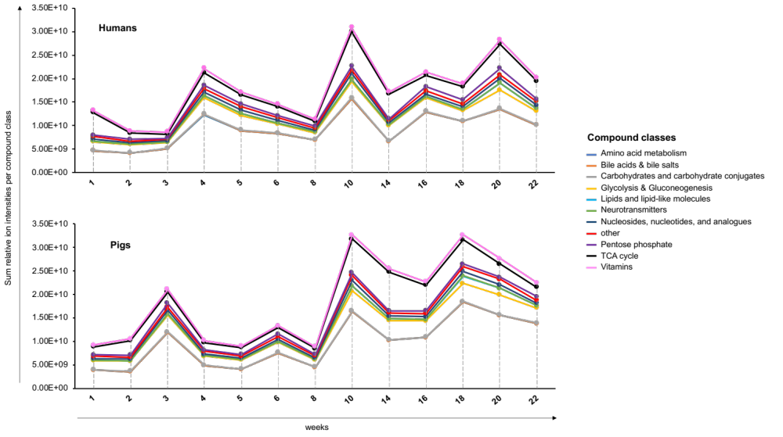

Figure 2.1 – Line graphs showing the sum of relative ion intensities per compound class detected in CDI soils from decomposing humans (top) and pigs (bottom) over the course of 22 weeks.

A more dynamic picture of soil metabolite changes during decomposition was obtained using heat maps (Figure 2.2). Heat maps were generated individually for human and pig soils by comparing each week to the previous week to show dynamic changes throughout decomposition. Overall metabolites linked to the amino acid metabolism depicted the most robust changes with 37% of significant changes in human and 52% in non-human soils. Consistent with Figure 2.1, significant changes in metabolite abundances were concentrated for humans around weeks 4 and 10 (Figure 2.2.). Comparing both weeks, β-Hydroxy β-methylbutyric acid, nicotinate, and pantothenate were the only compounds with significantly increased intensities in week 4 (red column), which thereafter decreased when decomposition progressed between weeks 10 and 14 (blue column). Interestingly, the metabolite which exhibited the most frequent and significant abundance fluctuations throughout human decay was pantothenate, better known as vitamin B5 – a water-soluble vitamin and precursor to coenzyme A (CoA) which has an essential role in numerous biochemical processes such as the fatty acid metabolism and Krebs cycle.
The 22-week pig decay showed significant metabolite changes in relative abundance mainly centered around weeks 3 and 10 – illustrated by an increase in abundance of 6 and 32 compounds, respectively (Figure 2.2). Of these compounds, only glutamine and glycerol-3-phosphate were significantly elevated at both sampling time points relative to the corresponding previous weeks (weeks 2 and 8). Glycerol-3-phosphate is involved in human glucose, lipid, and energy metabolism, yet it also seems to be a plant- and bacterial-derived metabolite¹³⁰. Glutamine is the most abundant amino acid in the human body. It is fundamental for cellular function as it serves in almost every cell as a substrate for nucleotide, energy, sugar, or amino acid biosynthetic pathways¹³¹. As blood circulation and cellular metabolic needs eventually cease after death, an accumulation and ultimate release of glutamine via cell/tissue breakdown could explain its postmortem accumulation. In 2002, Vass et al. identified a steady increase of glutamine postmortem in human liver tissue and even proposed its potential usefulness as PMI marker¹⁸. Notably, the abundance changes of the non-protein amino acid citrulline were significant in pig CDI soils for 6 out of 12 comparisons (Figure 2.2). A possible link to elevated ammonium concentrations measured under decomposing pigs which started to increase approximately around week 5 postmortem can be speculated (see publication of this chapter). After week 5, mean ammonium concentrations in pig soils spiked twice at weeks 9 and 17²⁶. Ammonium ultimately contributes to the pulse of nitrogen introduced to the environment and is available to microbes and plants. As citrulline has been suggested to play a role as nitrogen modulator in higher plants, predominantly due to facilitating nitrogen assimilation, nitrogen storage, and transport¹³² both variables (citrulline and ammonium) could be interconnected.

Figure 2.2 – Changes of relative soil metabolite abundances throughout mammalian decomposition. Metabolites were grouped by corresponding metabolic pathways. Each plotted week was compared to the previous week to show dynamic changes throughout decomposition. All fold changes are log2 transformed. Increased fold changes are indicated in red and decreases are shown in blue.

Next, to further categorize mammalian CDI soil according to its metabolic profile, a more in-depth weekly analysis was performed. Partial Least-Squares Discriminant Analysis (PLS-DA) analyses of each week showed that soils obtained from around both decomposing mammals clustered separately for every single time point (Appendix Figure 2.11). The 2D plots in Figure 2.3A exemplify these findings for the beginning (week 1), the middle (week 10), and the end of decomposition (week 22). Each plot illustrated a distinct separation of soil samples by species, indicating differences in the metabolic profiles of CDI soils. To examine which metabolites were responsible for most of the variation displayed in the PLS-DA plots, variable importance in projection (VIP) values were calculated for each time point. A weekly assessment of the total number of metabolites with VIP scores > 1, found on average 35 metabolites per week that were important for distinguishing both soil types (Figure 2.3B). The most frequent metabolites, detected in at least 7 out of 13 weeks, were further assessed by matching them to their pathways (22 metabolites; Appendix Table 2.2.). Of these 22 metabolites, 12 compounds were involved in the amino acid metabolism and 5 were nucleosides, nucleotides, and analogs (Figure 2.3C). An outcome consistent with findings elaborated above as well as other studies which detected amino acids not only in porcine decomposition fluids but also in soils impacted by human and other mammalian decay^{18, 133}. Aside from that, pH was significantly different between humans, pigs, and controls. During the winter, no significant changes occurred within the first 5 weeks but thereafter (starting at week 14) the lower site decomposition soils exhibited a reduced pH compared to controls²⁶. Such an increase in soil acidity (lower pH) could have been caused by a gradual release of organic acids, including amino acids, into CDI soils as a result of general decomposition processes.

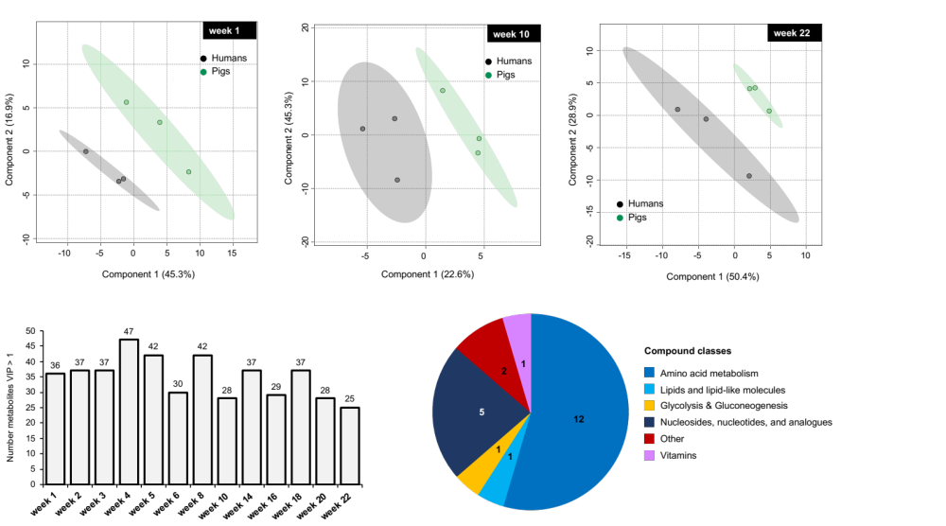
B
A
C
Figure 2.3 – Postmortem metabolomics of CDI soil from human and pig carcasses. (A) 2D PLS-DA score plots of CDI soils for week 1, week 10, and week 22. Hotelling's ellipses denote 95% confidence intervals. (B) Total number of metabolites in each week with VIP score > 1 that caused a separation among soil types via PLS-DA analyses. (C) Pathway analysis of selected VIP metabolites (n = 22, VIP > 1) detected in at least 7 out of all 13 weeks from (B).
Lastly, features important in distinguishing mammalian CDI soils from the above section (VIP values > 1), were further evaluated with regard to their statistical significance. For direct pairwise comparisons, a volcano plot analysis for each time point helped to determine significant alterations in metabolite abundances. The results are illustrated in Figure 2.4. Here, the total number of metabolites with significantly different soil abundances is depicted over the course of decomposition (p-value and FC thresholds of < 0.05 and ≥ 1.5 or ≤ -1.5, respectively). Throughout the first 8 weeks, several compounds were significantly increased in abundance in human soils (green bars Figure 2.4). Week 8 had with 34 metabolites the largest number of altered compounds compared to pig soils. With progress of decomposition, this trend reversed as porcine soils showed consistently a greater number of metabolites increased in relative abundances. Consequently, these metabolites were found in decreased intensities in human soils, thus are represented in red in Figure 2.4. Overall, the analysis revealed 54 unique, differentially abundant metabolites. However, during this study, several metabolites revealed significant variation for multiple of the 13 sampling weeks (compare Appendix Table 2.3). Among these, one metabolite, 2-Oxo-4-methylthiobutanoate, suggested different decomposition chemistry and timing between the two species as it was significantly altered in 5 out of 13 weeks (weeks 2, 8, 10, 18, and week 20). In three of these weeks (weeks 10, 18, 20) significant changes in metabolite abundance occurred in porcine soils. On the contrary, nicotinate and pyroglutamic acid had not only increased abundances solely in human CDI soils but also revealed a similar periodic pattern as increases were noticed in three weeks (weeks 4, 5, and 8). The latter two compounds together with 2-Oxo-4-methylthiobutanoate were reported for the first time as significantly altered compounds in decomposition-impacted soils.

Collectively the soil metabolomics results revealed that certain compound classes dominated in the pool of mammalian decomposition products detected in CDI soils with amino acids as a major compound class to point out. Significant differences in soil biochemistry signatures from human and pig-derived CDI soils imply that observations on a macroscopic level by Dautartas et al. do seem to induce differential biochemistry patterns on a microscopic scale¹⁰⁹.

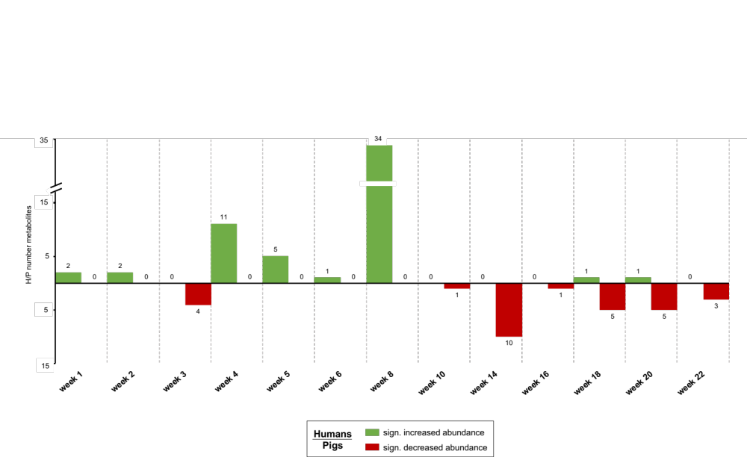
Figure 2.4 – Total number of metabolites significantly altered in abundance in mammalian CDI soils over the course of decomposition. Shown is the total number of metabolites per week that had significantly altered intensities among both soil types. Increased compound abundances in human relative to pig CDI soils are shown in green, while decreased abundances are listed in red. A summary of each individual metabolite with its variation is listed in Table 2.3. sign = significantly

2.4.1.2 Inter-species lipid dynamics in mammalian CDI soils
A similar approach was taken for analyzing the lipidomics data. Comprehensive lipidome profiling of human and pig soils yielded a total of 85 lipids (Appendix Table 2.4). These database-matched lipids were first classified into their lipid classes, namely phosphatidic acids (PA), phosphatidylethanolamines (PE), phosphatidylglycerols (PG), phosphatidylinositols (PI), phosphatidylserines (PS), and monogalactosyldiacylglycerols (MGDG). The most abundant lipid classes in decomposition soils were MGDG and PE with 27 and 16 detected lipids, respectively, closely followed by PS (15 lipids) and PA (12 lipids) (Figure 2.5A). PI and PG were accounted for with nine and six lipids, respectively. These results were consistent with published literature listing PE among the most abundant lipid classes in soil extracts. PG, PI, PS are typically observed in lower abundances^{122, 134}. The same researchers found that plant root extracts contained large amounts of MGDG¹²², therefore potential contamination of soil extracts due to root/plant debris might have occurred in our study. To assess specific patterns in lipid signatures and highlight differences between the two soil types, PLS-DA analyses were performed (Figure 2.5B). A selection of some of these plots is depicted for three of the sampling time points (weeks 1, 10, and 22). Similar to the metabolic profiles (Figure 2.3A), a clear differentiation among both mammalian soil types was shown for most of the weeks (Appendix Figure 2.12). Soil lipids from both mammals produced the formation of two distinct clusters creating an inter-species divergence (Figure 2.5B). From this, it was concluded that variety in the biochemical make-up of the soils below humans and pigs was also manifested in the soil lipidome. Thus, lipids with high importance in the group separation (VIP cut off > 1) were further evaluated based on how often they contributed to distinguishing human soils from pig soils. Lipids detected in more than half of all 13 weeks (in seven and eight weeks out of 13 weeks) are illustrated in Figure 2.5C (black bars). For clarification, the black bars in this figure simply indicate in which week(s) certain lipids were detected to visualize their appearance during decomposition. Here, lipids from the class PE seemed to stand out as most important. Also, almost every listed lipid was detected in weeks 10 and 20 and according to metabolomics, week 10 had major metabolic changes, as well (above section).
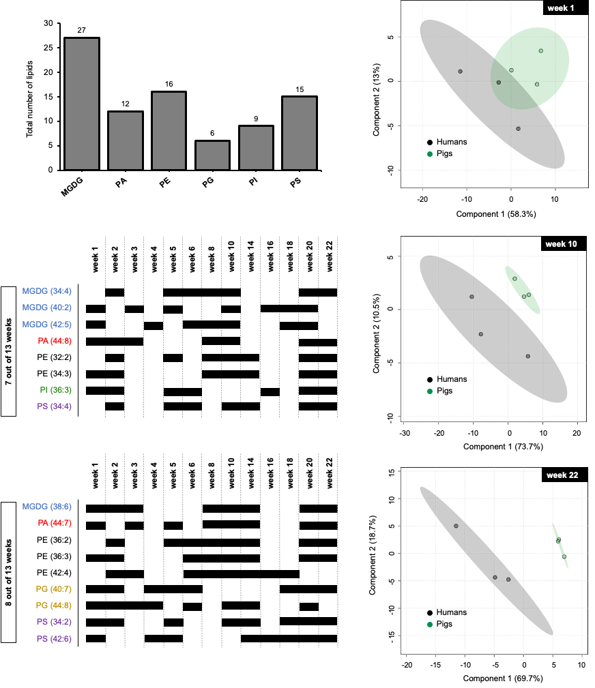
A
C
B

Figure 2.5 – Postmortem lipidomics of mammalian CDI soils. (A) Cumulative number of lipids categorized by major lipid classes. (B) PLS-DA models to discriminate human and pig CDI soils for week 1, week 10, and week 22. (C) Selected VIP lipids (n = 17, VIP > 1) detected in at least 7 out of 13 weeks as a result of weekly PLS-DA analyses. Black bars indicate in which week lipids were detected. PC, phosphatidylcholine; PE, phosphatidylethanolamine; PS, phosphatidylserine; PG, phosphatidylglycerol; PA, phosphatidic acids; MGDG, monogalactosyldiacylglycerols.
To assess the significance of these results and at the same time easily visualize a large number of compounds, a heat map was generated (Figure 2.6). In total, 44 lipids showed significant differences in non-human and human soils for at least one of the sampled weeks. Among them, 13 MGDG, 10 PE, 9 PS, 8 PI, 2 PG, and 2 PA were significantly altered. Over the course of 22 weeks, six lipids of the MGDG class, three of the PE class, as well as PG 40:7, PI 32:1, and PS 34:2 exhibited reoccurring significant changes in abundance among the soil types. Considering the entire decay period, three weeks had a concentration of species-specific altered lipid abundances, namely week 4 (6 significantly altered lipids), week 5 (26 lipids), and week 20 (14 lipids). Generally, in weeks 4 and 5 pig soils exhibited increased lipid abundances relative to human soils – a pattern that was reversed as decomposition progressed for week 20 (Figure 2.6, blue and red columns, respectively). The largest number of differential lipids was detected in week 5. The enrichment of lipids underneath pigs can potentially be related to the significantly reduced pH in decomposition soils when compared to controls which had the lowest observed values in pig soils (see publication)²⁶. It can be hypothesized that greater lipid accumulation in soil with a low pH might have resulted from unfavorable environmental conditions for microbes, which in turn could have preserved lipids in pig soils from microbial degradation. A theory previously discussed in other work for other lipid classes⁵¹. None of the lipids that increased in abundance in pig soil in week 4 showed a significant increase in week 5, however, PE 38:6, PE 38:2, along with three MGDGs were found to be significantly elevated in animal soils during early stages of decay (week 5) but were reduced towards the end of active decay (week 20). Declined soil lipid concentrations for humans in weeks 4 and 5 may represent an aftereffect from more extensive scavenging of humans compared to pigs, as reported by Steadman et al.¹¹². This effect could have considerably reduced tissue degradation and thus retarded fluid leakage into the surrounding soil¹¹². One would assume mammals also differ in their microbiomes³¹ mainly as a result of different dietary restrictions of the two organisms. While there were similar soil bacterial changes between species, Parkinson also identified intra-species microbial differences among pig cadavers¹³⁵. Microbes are a factor supposed to impact the richness and diversity of released volatile organic compounds (VOC) during decay²⁴. Thus, it can be hypothesized that a differential microflora contributed to a species- and time-specific release of metabolites into the surrounding soil. In contrast, Metcalf et al. found that soil microbes did not markedly differ based on carrion type⁵⁰. At this point, more studies are needed focusing on the intrinsic carcass environment as opposed to soil microbes to elaborate on this ambiguous state of knowledge.
The overall chemical profile of adipose tissue composition differs between humans and pigs. Differences in the decay of adipose tissue attributed to a distinct distribution of total fatty acids between species were first described by Notter et al.¹¹⁰. Elemental analysis of adipose tissue by the same group also found varying amounts of sodium, potassium, calcium, and magnesium¹¹⁰. Overall, one can speculate that differences in body composition might influence decomposition patterns and soil processes underneath cadavers. This could ultimately interfere with the nutrient richness available to microbes determining their growth and diversity which may induce a time discrepancy in terms of when liquified tissue is detectable on a biochemical scale in soil. Another explanation for the postmortem inter-individual metabolic fluctuation across decomposition in our study.
As lipidomics is currently an emerging technique in the repertoire of postmortem ‘omics’ analyses, the here presented results have not been reported previously. Only Langley and colleagues used a lipidomics approach in a comparable outdoor setting to capture lipid profiles of the human skeletal muscle after death⁵⁸. They found a decrease in PG 34:0 and PE 36:4 concentrations with tissue degradation over the course of decay. Such a decline in phospholipid concentration after death seems reasonable, however, it is important to note that CDI soil has a completely different level of biochemical complexity compared to skeletal muscle. Figure 2.6 clearly indicates the rapidly changing dynamic of this matrix. Furthermore, soil is incredibly susceptible to external influences (e.g., weather, temperature) and microbial influx from both the internal carcass environment as well as externally with regard to inherent soil microbes. What goes along with this is the microbial synthesis and consumption of lipids as energy sources¹²². Although such analyses were beyond the scope of this chapter, such factors could have contributed to a more variable lipid signature in soils as opposed to a clear lipid degradation seen in the study from Langley et al. On the other hand, we noticed certain differential unsaturated phospholipids (PE 34:3, PE 38:2, PE 38:6, PG 40:7, PI 32:1, and PS 34:2) among humans and pigs at multiple time points throughout decay. An interesting finding that encourages future targeted analysis aiming to find a combination of lipids to provide a more accurate index of certain decomposition stages.

Taken together, these findings point out a pool of polar lipids in mammalian decomposition soil dominated by differing abundances of MGDG and PE. Reduced diversity of other phospholipids (PI, PG, PA, and PS) could potentially indicate the presence of certain microbial taxa using these lipids to form membranes¹³⁶. We observed temporal differences in lipid relative abundances throughout decay as well as multivariate patterns of lipids which were most likely indicative of inter-species differences and potentially induced by differential soil microbial communities. Collectively – also referring to the metabolomics analyses – this demonstrates the complexity and diversity of the postmortem environment as compounds in soil have multiple mixed origins. It is indicated here that pig and human signatures share many of the same compounds; however, the abundances of these compounds were rarely similar at certain time points during decomposition. Our results support recently published findings from VOC analyses between human and pig remains at the Australian Facility for Taphonomic Experimental Research (AFTER) in Sydney¹¹⁸. Overall, our work expanded the repertoire of compounds possibly important in distinguishing carcass types and opens future opportunities to conduct target compound studies.

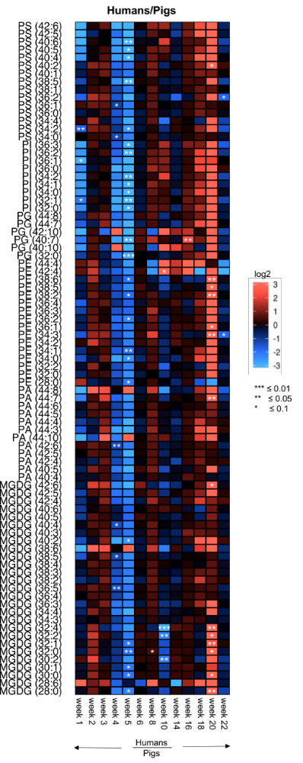

Figure 2.6 – Changes of relative soil lipid abundances throughout mammalian decomposition. For each of the plotted weeks fold changes of relative abundances found in human CDI soils were compared to those present in pig soils. Significance was calculated based on student’s t-test. All fold changes are log2 transformed. Increased fold changes are indicated in red and decreases are shown in blue. For lipid abbreviations see Figure 2.5.

2.4.1.3 Unknown features of human vs pig CDI soils
One benefit of using a high-resolution mass spectrometer in full scan mode is the collection of chromatographic peaks across a large mass to charge (m/z) range (usually 75-1,200 m/z). This means it is possible to identify metabolites based on their mass and retention time if those features match a previously analyzed standard (known metabolites). In addition to the knowns, thousands of other spectral features that did not match any compound in the in-house database. These features exhibited metabolite-like characteristics, but the exact structures were not known (unknowns or unidentified metabolites). The analytical approach for spectral feature selection and data processing is described in the experimental section of this chapter.
After data reduction, 1,615 and 2,429 unidentified features from metabolomics and lipidomics extractions, respectively, were assessed for their profiles in CDI soils. After normalization, 2D PLS-DA plots of those features were created first. The plots for the unknowns (Figure 2.7A and Figure 2.8A) demonstrated a similar distribution of the data as previously seen for the knowns (Figure 2.3A and Figure 2.5B). Profiles of unidentified features from lipidomics and metabolomics analyses appeared to be different among human and pig soils, illustrated by a species-specific clustering of the data (Figure 2.7A and Figure 2.8A). This once again suggested distinct chemical profiles between the suite of compounds leaking from both carcasses into the soil. To assess which features were driving the separation in the PLS-DA plots, VIP values were extrapolated for both data sets and significances between both soil types for each time point assessed (VIP > 1, FC > +/-1.5 and p-value < 0.05, Figure 2.7B and 2.8B). Unidentified features in the metabolomics dataset significantly increased both in number and abundance in pig soils for weeks 3, 8, 10, and 20 (114, 119, 126, and 104 features, respectively, Figure 2.7B). In humans, the top 2 weeks with the majority of unknowns elevated in abundance were week 4 and week 8 when compared to soil profiles of the same weeks from pigs (Figure 2.7B). A trend also reflected in the knowns data set when contrasting decomposition products from human and pig soils (compare Figure 2.4). The soil lipidomics data also revealed differential abundances for the unknowns (Figure 2.8B). Pairwise comparisons among mammalian soils showed main differences in soil signatures for weeks 5, 8, and week 22 (top 3 weeks). For the latter two weeks, a greater number of unknowns were increased in abundance in human soils, while 423 compounds were elevated in week 5 underneath pigs (Figure 2.8B). These results confirmed the above-illustrated distribution of known lipids in decomposition soil (Figure 2.6). Particularly, changes of the knowns relative soil lipid abundances were significantly enriched in week 5 in the pig and in week 20 in the human CDI soils.
The identification of unknown compounds is a major bottleneck in the ‘omics’ field. It is a complex procedure with still various unsolved questions related to ultimate structural annotation. Nevertheless, our preliminary approaches to extract information from a large amount of unknown special features, revealed sporadically consistent patterns with the knowns in terms of species-specificity and temporal occurrence of unknowns throughout mammalian decay. Thus, this shows that unknowns seem to hold promising potential to reflect the biochemical signature and differential species dynamics of mammalian decomposition soils.

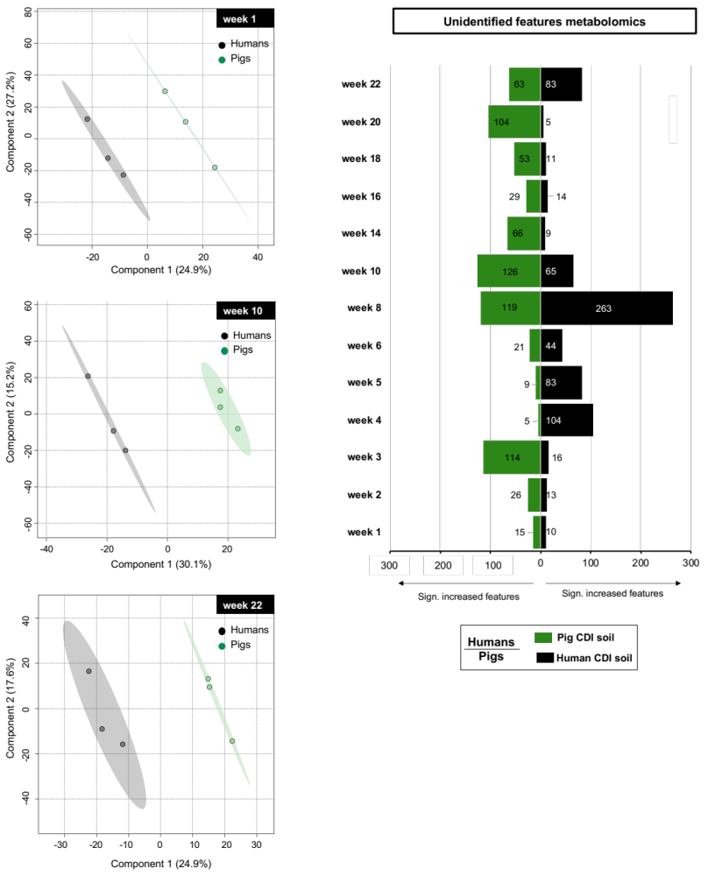
B
A
Figure 2.7 – Metabolomics unknown features of mammalian decomposition soil. (A) PLS-DA plots for weeks 1, 10, and week 22. (B) Significantly increased abundances of unidentified features among pig (green) and human (black) CDI soils detected at each sampling time point. Significance was based on VIP > 1, as well as FC cutoff +/-1.5 and p value < 0.05.

B
A

Figure 2.8 – Unidentified lipid spectral features of mammalian CDI soil. (A) PLS-DA plots for weeks 1, 10, and week 22. (B) Significantly increased abundances of unidentified features among pig (green) and human (black) CDI soils detected at each sampling time point. Significances were based on VIP > 1, as well as FC cutoff +/-1.5 and p value < 0.05.

2.5 CONCLUSION

Currently, this was the first reported study that used combined untargeted metabolomic and lipidomic analytical platforms to investigate the biochemical composition of mammalian CDI soil by focusing on inter-species differences. Collectively, ‘omics’ analyses were congruent with the general responsiveness of the changing biochemistry of an organism after death pointing toward the involvement of similar global metabolic pathways in decomposing humans and pigs, with the distinction of a species-specific and time-dependent occurrence of compounds over the course of decay. This led to the conclusion that, from a biochemical point of view, mammalian decomposition products underneath cadavers were distinguishable. Particularly, weekly multivariate analyses of CDI soils revealed clear separation of soil samples by species, indicating distinct metabolic profiles between the suite of compounds leaking from both carcasses into the soil. Decomposition soils were for instance significantly enriched with metabolites involved in the amino acid metabolism (e.g., glutamine or citrulline). Aside from other identified temporal and species-specific compound patterns discussed in the result section, it was observed that citrulline in pig CDI soils showed in 6 out of 12 weeks significant abundance changes, whereas pantothenate exhibited the most frequent and significant abundance fluctuations throughout human decomposition. Most importantly, in weeks 4 and 10, human soils exhibited most of the significant metabolite abundance changes which were observed in weeks 3 and 10 for pigs. In addition, significant inter-species lipid abundances were predominant for study weeks 5 and 20. Overall, the pool of polar lipids in mammalian decomposition soil was dominated by MGDG and PE with reduced diversity of other phospholipid classes (PI, PG, PA, and PS). Also, certain unsaturated phospholipids with a backbone of 32 to 40 carbon atoms (PE 34:3, PE 38:2, PE 38:6, PG 40:7, PI 32:1, and PS 34:2) showed a significant cyclic appearance throughout decay among species. Lastly, the analysis of unidentified spectral features revealed sporadic consistency with results obtained from the knowns as species-specific and temporal patterns emerged as a discriminating factor in CDI soils.
As originally reported by Dautartas et al. and Steadman et al., the winter trial lacked insect activity for over three months and human decomposition occurred at a much faster rate which was most likely attributed to preferential scavenging^{109, 112}. Such observations could plausibly be an explanation for the observed differential detection of decomposition soil products among species as scavenger preferences for carcass types could have reduced the amount of soft tissue available to decompose. Body composition is another factor to consider – not only with regard to body mass and size but also differential quantity and distribution of fat¹⁰⁹. Pigs also tend to have higher moisture content, which might impact microbial activity and mobilization of decomposition products into the soil²⁶. Microbial influences were most likely the major influence factor. Altered inter-species lipid and metabolite abundances might have been caused by microbial-mediated processes such as the conversion of proteins into amino acids, lipid production, or degradation of lipids^{26, 122}. According to Ding et al., 45-80% of soil lipids are derived from bacteria, fungi, and plants¹²². The phospholipids PE and PG are also major structural components of most bacterial cell membranes¹²². However, it was beyond the scope of this study to precisely elucidate lipid/metabolite origins. Lastly, factors involving mammalian dietary restrictions (e.g., human western diet vs. homogenous diets of farm-fed animals) together with intra-species differences including medical history, lifestyle, or sex represent additional factors with the potential to impact human-pig soil responses. Experimental study limitations arise from the fact that taphonomic research facilities are commonly restricted in space and donor number. As a result of this, our study had a small sample size, a lack of replication in all four seasons as well as appropriate cadaver placement, at least 50 m apart, as it is common in forensic entomological research designs¹¹⁶. With more sampling points it would have also been possible to generate a more detailed understanding of the nutrient cycling and persistence of compounds in soil postmortem and the form in which they will be retained.
Despite those limitations, preliminary findings outlined in this study propose clear species-specific biochemistry patterns in CDI soil during mammalian decomposition. A finding which does not diminish the usefulness of pig carcasses as human analogs, but rather informs about limitations and the existing margins of error of animal use in forensic taphonomy when it comes to soil chemical dynamics. This work also strengthens the importance of ‘omics’ research as a promising forensic tool for elucidating species-specific decomposition biomarkers. A combination of the herein identified compounds in combination with future targeted analyses of other postmortem specimens could help to evaluate their predictive accuracy and power in terms of species uniqueness or temporal postmortem dynamics. Ultimately, biochemical evidence present in the fertile cadaver decomposition islands can be useful in questions related to location and time of death of individuals. With regard to this, the stability of lipids seems a promising feature when it comes to postmortem interval (PMI) estimations over (a) a long postmortem period and (b) in varying environmental conditions.

2.6 CHAPTER II APPENDIX

Figure 2.9 – Overview of phospholipids in this study. (A) The structural backbone of phospholipids is a glycerol molecule linked to acyl chains via ester bonds. Headgroups are linked to glycerol via a phosphate group. A selection of possible headgroups is outlined. (B) Structure of monogalactosyldiacylglycerol (MGDG). PE phosphatidylethanolamine, PG phosphatidylglycerol, PS phosphatidylserine, PI phosphatidylinositol, PA phosphatidic acid.
B
A
Figure 2.10 – Study design. For the winter trial (top) five humans and five pigs were placed 3 m apart on virgin soil at the Anthropology Research Facility, Knoxville, TN. Rabbit carcasses were used in the original study design but were not part of the here presented study. Soils collected from sites 5 m away from the carcasses served as controls. As elaborated in the publication, the other four plots (two humans (H4, H5) and two pigs (P4, P5)) were placed closer to a fence line ( “upper site”) where soils had been disturbed from construction activities nearby. These upper site soils were excluded from the analysis in this chapter. H = Human, P = Pig
Table 2.1 – Overview of the sample collection from humans, and pigs throughout all weeks and locations. Only samples from the lower site (black) were subject of metabolomics and lipidomics analyses in this chapter (H1, H2, H3 and P1, P2, P3).

HUMAN SAMPLES |  |  | PIG SAMPLES |  |  | CONTROL SOIL SAMPLES (CDI)
Sample ID | Cadaver # | Week | Sample ID | Cadaver # | Week | Sample ID | Site Location | Week
HPR12140001BF | H1 | Week 1 | HPR12140006BF | P1 | Week 1 | HPR12140012BF | Lower Control | Week 1
HPR12140013BF | H1 | Week 2 | HPR12140018BF | P1 | Week 2 | HPR12140024BF | Lower Control | Week 2
HPR12140025BF | H1 | Week 3 | HPR12140030BF | P1 | Week 3 | HPR12140036BF | Lower Control | Week 3
HPR12140037BF | H1 | Week 4 | HPR12140042BF | P1 | Week 4 | HPR12140048BF | Lower Control | Week 4
HPR12140049BF | H1 | Week 5 | HPR12140054BF | P1 | Week 5 | HPR12140060BF | Lower Control | Week 5
HPR01150001BF | H1 | Week 6 | HPR01150006BF | P1 | Week 6 | HPR01150012BF | Lower Control | Week 6
HPR02150001BF | H1 | Week 10 | HPR01150018BF | P1 | Week 8 | HPR01150024BF | Lower Control | Week 8
HPR03150001BF | H1 | Week 14 | HPR02150006BF | P1 | Week 10 | HPR03150012BF | Lower Control | Week 14
HPR03150013BF | H1 | Week 16 | HPR03150006BF | P1 | Week 14 | HPR03150024BF | Lower Control | Week 16
HPR03150025BF | H1 | Week 18 | HPR03150018BF | P1 | Week 16 | HPR03150036BF | Lower Control | Week 18
HPR04150001BF | H1 | Week 20 | HPR03150030BF | P1 | Week 18 | HPR04150012BF | Lower Control | Week 20
HPR04150013BF | H1 | Week 22 | HPR04150006BF | P1 | Week 20 | HPR04150024BF | Lower Control | Week 22
HPR12140002BF | H2 | Week 1 | HPR04150018BF | P1 | Week 22 | HPR12140011BF | Upper Control | Week 1
HPR12140014BF | H2 | Week 2 | HPR12140007BF | P2 | Week 1 | HPR12140023BF | Upper Control | Week 2
HPR12140026BF | H2 | Week 3 | HPR12140019BF | P2 | Week 2 | HPR12140035BF | Upper Control | Week 3
HPR12140038BF | H2 | Week 4 | HPR12140031BF | P2 | Week 3 | HPR12140047BF | Upper Control | Week 4
HPR12140050BF | H2 | Week 5 | HPR12140043BF | P2 | Week 4 | HPR12140059BF | Upper Control | Week 5
HPR01150002BF | H2 | Week 6 | HPR12140055BF | P2 | Week 5 | HPR01150023BF | Upper Control | Week 8
HPR01150014BF | H2 | Week 8 | HPR01150007BF | P2 | Week 6 | HPR02150011BF | Upper Control | Week 10
HPR02150002BF | H2 | Week 10 | HPR01150019BF | P2 | Week 8 | HPR03150011BF | Upper Control | Week 14
HPR03150002BF | H2 | Week 14 | HPR02150007BF | P2 | Week 10 | HPR03150023BF | Upper Control | Week 16
HPR03150014BF | H2 | Week 16 | HPR03150007BF | P2 | Week 14 | HPR03150035BF | Upper Control | Week 18
HPR03150026BF | H2 | Week 18 | HPR03150019BF | P2 | Week 16 | HPR04150011BF | Upper Control | Week 20
HPR04150002BF | H2 | Week 20 | HPR03150031BF | P2 | Week 18 | HPR04150023BF | Upper Control | Week 22
HPR04150014BF | H2 | Week 22 | HPR04150007BF | P2 | Week 20
HPR12140003BF | H3 | Week 1 | HPR04150019BF | P2 | Week 22
HPR12140015BF | H3 | Week 2 | HPR12140008BF | P3 | Week 1
HPR12140027BF | H3 | Week 3 | HPR12140020BF | P3 | Week 2
HPR12140039BF | H3 | Week 4 | HPR12140032BF | P3 | Week 3
HPR12140051BF | H3 | Week 5 | HPR12140044BF | P3 | Week 4
HPR01150003BF | H3 | Week 6 | HPR12140056BF | P3 | Week 5
HPR01150015BF | H3 | Week 8 | HPR01150008BF | P3 | Week 6
HPR02150003BF | H3 | Week 10 | HPR01150020BF | P3 | Week 8
HPR03150003BF | H3 | Week 14 | HPR02150008BF | P3 | Week 10
HPR03150015BF | H3 | Week 16 | HPR03150008BF | P3 | Week 14
HPR03150027BF | H3 | Week 18 | HPR03150020BF | P3 | Week 16
HPR04150003BF | H3 | Week 20 | HPR03150032BF | P3 | Week 18
HPR04150015BF | H3 | Week 22 | HPR04150008BF | P3 | Week 20
HPR12140004BF | H4 | Week 1 | HPR04150020BF | P3 | Week 22
HPR12140016BF | H4 | Week 2 | HPR12140009BF | P4 | Week 1
HPR12140028BF | H4 | Week 3 | HPR12140021BF | P4 | Week 2
HPR12140040BF | H4 | Week 4 | HPR12140033BF | P4 | Week 3
HPR12140052BF | H4 | Week 5 | HPR12140045BF | P4 | Week 4
HPR01150004BF | H4 | Week 6 | HPR12140057BF | P4 | Week 5
HPR01150016BF | H4 | Week 8 | HPR01150009BF | P4 | Week 6
HPR02150004BF | H4 | Week 10 | HPR01150021BF | P4 | Week 8
HPR03150004BF | H4 | Week 14 | HPR02150009BF | P4 | Week 10
HPR03150016BF | H4 | Week 16 | HPR03150009BF | P4 | Week 14
HPR03150028BF | H4 | Week 18 | HPR03150021BF | P4 | Week 16
HPR04150004BF | H4 | Week 20 | HPR03150033BF | P4 | Week 18
HPR04150016BF | H4 | Week 22 | HPR04150009BF | P4 | Week 20
HPR12140005BF | H5 | Week 1 | HPR04150021BF | P4 | Week 22
HPR12140017BF | H5 | Week 2 | HPR12140010BF | P5 | Week 1
HPR12140029BF | H5 | Week 3 | HPR12140022BF | P5 | Week 2
HPR12140041BF | H5 | Week 4 | HPR12140034BF | P5 | Week 3
HPR12140053BF | H5 | Week 5 | HPR12140046BF | P5 | Week 4
HPR01150005BF | H5 | Week 6 | HPR12140058BF | P5 | Week 5
HPR01150017BF | H5 | Week 8 | HPR01150010BF | P5 | Week 6
HPR02150005BF | H5 | Week 10 | HPR01150022BF | P5 | Week 8
HPR03150005BF | H5 | Week 14 | HPR02150010BF | P5 | Week 10
HPR03150017BF | H5 | Week 16 | HPR03150010BF | P5 | Week 14
HPR03150029BF | H5 | Week 18 | HPR03150022BF | P5 | Week 16
HPR04150005BF | H5 | Week 20 | HPR03150034BF | P5 | Week 18
HPR04150017BF | H5 | Week 22 | HPR04150010BF | P5 | Week 20
 |  |  | HPR04150022BF | P5 | Week 22

Figure 2.11 – Postmortem metabolomics 2D PLS-DA score plots of CDI soils from humans and pigs for all weeks.

Figure 2.11 – continued

Figure 2.11 – continued

Figure 2.11 – continued

Table 2.2 – VIP scores and relative abundance of metabolites in CDI soils from humans and pigs. The frequency of occurrence of each metabolite with scores > 1 is shown for each week throughout decomposition.

Metabolite name | Molecular weight (g/mol) | Sum relative abundance |  | Number of weeks VIP > 1
 |  | Humans | Pigs | Lower site
1-Methyladenosine | 281.27 | 2.58E+08 | 2.40E+08 | 6
2-Aminoadipate | 161.16 | 2.02E+08 | 2.23E+08 | 5
2-Dehydro-D-gluconate | 194.14 | 8.30E+08 | 3.11E+08 | 5
2-Oxo-4-methylthiobutanoate | 148.18 | 2.37E+09 | 4.27E+09 | 6
2-Oxoisovalerate | 116.11 | 7.95E+09 | 9.53E+09 | 9
3_4-Dihydroxyphenylacetate (DOPAC) | 168.15 | 1.28E+07 | 5.05E+07 | 5
3-Methylphenylacetic acid | 150.17 | 3.14E+08 | 6.07E+07 | 7
3-Methylthiopropionate | 120.17 | 3.82E+07 | 1.14E+08 | 6
4-Aminobutyrate (GABA) | 103.12 | 1.45E+08 | 1.03E+08 | 5
4-Pyridoxate | 183.16 | 7.31E+07 | 7.48E+07 | 4
5-Hydroxyindoleacetic acid (5-HIAA) | 191.18 | 1.39E+07 | 1.55E+07 | 3
Acetoacetate | 102.09 | 3.66E+09 | 5.27E+09 | 6
Acetyllysine | 188.22 | 4.12E+07 | 3.64E+07 | 4
Adenine | 135.13 | 3.00E+08 | 1.76E+08 | 4
Adenosine | 267.24 | 7.98E+08 | 8.11E+08 | 8
Alanine/Sarcosine | 89.09 | 4.97E+08 | 5.61E+08 | 9
Allantoate | 176.13 | 2.42E+07 | 3.11E+07 | 5
Allantoin | 158.12 | 3.92E+08 | 2.49E+08 | 7
alpha-Ketoglutarate | 146.10 | 4.10E+09 | 3.91E+09 | 4
Anthranilate | 137.14 | 3.08E+06 | 9.32E+06 | 8
Asparagine | 132.12 | 5.46E+06 | 3.40E+06 | 3
Aspartate | 133.11 | 2.35E+08 | 3.55E+08 | 6
β-Hydroxy beta-methylbutyrate (HMB) | 118.13 | 9.84E+09 | 9.92E+09 | 3
Citrate/isocitrate | 192.12 | 1.86E+07 | 2.53E+07 | 5
Citrulline | 175.19 | 2.81E+08 | 3.08E+08 | 7
Creatine | 131.13 | 2.00E+06 | 8.04E+05 | 3
Creatinol-O-phosphate | 197.13 | 1.78E+07 | 7.74E+06 | 4
Cysteate | 169.16 | 3.33E+07 | 3.34E+07 | 6
Cytidine | 243.22 | 4.55E+07 | 4.47E+07 | 7
D-Gluconate | 196.15 | 1.30E+09 | 9.61E+08 | 6
Deoxyinosine | 252.23 | 3.21E+08 | 3.74E+08 | 8
Deoxyuridine | 228.20 | 1.57E+08 | 1.30E+08 | 6
Fumarate | 116.07 | 1.35E+08 | 1.10E+08 | 5
Glutamate | 147.13 | 2.26E+10 | 2.46E+10 | 5
Glutamine | 146.14 | 2.67E+08 | 1.68E+08 | 5
Glycerate | 106.08 | 5.46E+09 | 5.35E+09 | 5
Guanine | 151.13 | 7.71E+06 | 1.13E+07 | 3
Guanosine | 283.24 | 2.14E+08 | 2.71E+08 | 9
Homocysteic acid | 183.18 | 2.86E+07 | 2.92E+07 | 2
Homoserine/Threonine | 119.12 | 1.04E+09 | 1.08E+09 | 8
Hydroxybenzoate | 152.15 | 7.87E+07 | 5.04E+07 | 7
Hydroxyisocaproic acid | 132.16 | 2.41E+09 | 1.71E+09 | 8
Hypoxanthine | 136.11 | 2.97E+08 | 1.62E+08 | 1
Indole-3-carboxylate | 161.16 | 5.99E+07 | 3.20E+07 | 6
Inosine | 268.23 | 2.35E+09 | 2.37E+09 | 5
Lactate | 90.08 | 1.75E+10 | 1.94E+10 | 3
Leucine/Isoleucine | 131.17 | 7.99E+09 | 8.56E+09 | 5
Lysine | 146.19 | 5.14E+06 | 5.37E+06 | 6
Malate | 134.09 | 7.56E+07 | 7.07E+07 | 2
Methionine | 149.21 | 1.29E+09 | 1.43E+09 | 8
myo-Inositol | 180.16 | 7.80E+07 | 9.38E+07 | 3
N-Acetyl-beta-alanine | 131.13 | 7.09E+07 | 8.12E+07 | 5
N-Acetylglucosamine | 221.21 | 1.72E+08 | 1.64E+08 | 3
N-Acetylglucosamine 1/6-phosphate | 347.17 | 2.12E+07 | 2.44E+07 | 1
N-Acetylglutamate | 189.17 | 6.33E+08 | 7.27E+08 | 5
N-Acetylglutamine | 188.18 | 1.52E+07 | 1.63E+07 | 4
N-Acetylornithine | 174.2 | 1.10E+08 | 1.03E+08 | 6
Nicotinate | 123.11 | 3.20E+09 | 3.45E+09 | 9
Ornithine | 132.16 | 9.93E+06 | 1.18E+07 | 7
Orotate | 156.10 | 1.58E+08 | 9.73E+07 | 5
Pantothenate | 219.23 | 4.98E+09 | 4.98E+09 | 5
Phenylalanine | 165.19 | 4.22E+09 | 4.91E+09 | 7
Phenylpyruvate | 164.16 | 3.52E+08 | 7.13E+08 | 7
Proline | 115.13 | 4.13E+08 | 3.32E+08 | 7
Pyroglutamic acid | 129.11 | 5.38E+10 | 5.37E+10 | 5
Pyruvate | 88.06 | 1.59E+10 | 1.88E+10 | 7
Salicylate | 138.12 | 1.80E+09 | 7.89E+08 | 6
Sedoheptulose 1/7-phosphate | 290.16 | 7.28E+06 | 6.54E+06 | 4
Serine | 105.09 | 1.36E+08 | 1.47E+08 | 6
Shikimate | 174.15 | 2.08E+08 | 1.21E+08 | 3
sn-Glycerol 3-phosphate | 172.07 | 8.82E+07 | 3.87E+07 | 6
Succinate/Methylmalonate | 118.09 | 3.71E+10 | 3.93E+10 | 4
Taurine | 125.15 | 1.58E+08 | 9.13E+07 | 5
Thymidine | 242.23 | 6.95E+08 | 6.27E+08 | 3
Thymine | 126.11 | 5.72E+08 | 5.52E+08 | 6
Trehalose/Sucrose | 342.3 | 1.08E+09 | 1.07E+09 | 6
Tryptophan | 204.23 | 1.20E+08 | 1.05E+08 | 2
Tyrosine | 181.19 | 9.68E+08 | 9.71E+08 | 5
UDP-N-acetylglucosamine | 607.35 | 2.67E+07 | 2.27E+07 | 9
Uracil | 112.09 | 2.63E+09 | 2.69E+09 | 6
Uridine | 244.20 | 8.57E+08 | 8.70E+08 | 4
Valine | 117.151 | 4.72E+09 | 5.02E+09 | 8
Vanillin | 152.15 | 4.24E+08 | 4.55E+08 | 1
Xanthine | 152.11 | 8.34E+08 | 4.31E+08 | 1
Xanthosine | 284.23 | 3.24E+07 | 3.01E+07 | 3

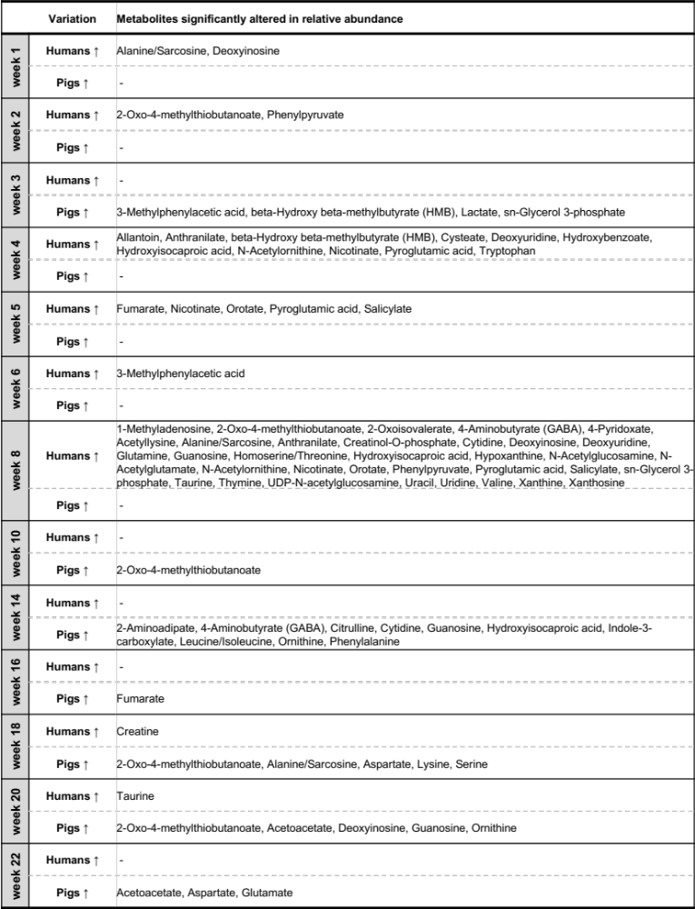
Table 2.3 – Summary of all metabolites significantly altered in abundance in mammalian CDI soils. Denoted variation refers to a significant increase (↑) of metabolite abundance in the corresponding listed soil type (humans vs. pigs).
Table 2.4 – Detected lipids and their corresponding lipid classes with relative intensities in humans and pigs in decomposition soils. VIP scores are a result of weekly PLS-DA analyses.

 |  |  | Sum rel. intensities all weeks (soils) |  | Lower site
Lipid Class | Lipid |  | Humans  (H1, H2, H3) | Pigs  (P1, P2, P3) | Number of weeks VIP > 1
Monogalactosyldiacylglycerol | MGDG (28:0) |  | 2.65E+06 | 3.53E+06 | 5
(MGDG) | MGDG (28:6) |  | 1.64E+06 | 1.51E+06 | 4
 | MGDG (30:0) |  | 1.43E+07 | 1.48E+07 | 5
 | MGDG (30:1) |  | 3.56E+06 | 3.94E+06 | 6
 | MGDG (30:2) |  | 2.58E+06 | 3.00E+06 | 5
 | MGDG (32:0) |  | 1.29E+07 | 1.42E+07 | 6
 | MGDG (32:1) |  | 1.63E+07 | 1.70E+07 | 6
 | MGDG (32:2) |  | 6.51E+06 | 6.80E+06 | 6
 | MGDG (32:4) |  | 3.87E+06 | 5.51E+06 | 5
 | MGDG (34:3) |  | 1.06E+07 | 1.24E+07 | 5
 | MGDG (34:4) |  | 1.19E+06 | 1.32E+06 | 7
 | MGDG (36:3) |  | 2.13E+07 | 2.61E+07 | 5
 | MGDG (36:4) |  | 2.90E+07 | 3.09E+07 | 4
 | MGDG (36:5) |  | 1.17E+07 | 1.21E+07 | 5
 | MGDG (38:2) |  | 4.97E+07 | 5.64E+07 | 5
 | MGDG (38:3) |  | 6.76E+07 | 7.21E+07 | 3
 | MGDG (38:4) |  | 6.99E+07 | 7.21E+07 | 2
 | MGDG (38:5) |  | 5.89E+06 | 7.25E+06 | 6
 | MGDG (38:6) |  | 3.90E+05 | 3.62E+05 | 8
 | MGDG (40:2) |  | 2.59E+06 | 2.88E+06 | 7
 | MGDG (40:3) |  | 8.01E+06 | 8.77E+06 | 5
 | MGDG (40:4) |  | 1.73E+08 | 1.77E+08 | 3
 | MGDG (40:5) |  | 1.66E+07 | 1.87E+07 | 4
 | MGDG (40:6) |  | 2.03E+07 | 2.19E+07 | 1
 | MGDG (42:4) |  | 6.75E+07 | 6.69E+07 | 5
 | MGDG (42:5) |  | 2.66E+06 | 2.70E+06 | 7
 | MGDG (42:6) |  | 1.41E+06 | 1.64E+06 | 9
Phosphatidic acid | PA (40:4) |  | 1.01E+07 | 1.17E+07 | 3
(PA) | PA (40:5) |  | 1.00E+06 | 1.12E+06 | 6
 | PA (42:4) |  | 2.32E+07 | 2.77E+07 | 6
 | PA (42:5) |  | 2.80E+07 | 2.99E+07 | 6
 | PA (42:6) |  | 1.17E+07 | 1.21E+07 | 5
 | PA (44:10) |  | 1.56E+06 | 1.64E+06 | 3
 | PA (44:3) |  | 2.20E+06 | 2.54E+06 | 5
 | PA (44:4) |  | 4.68E+07 | 5.60E+07 | 5
 | PA (44:5) |  | 6.74E+07 | 7.07E+07 | 3
 | PA (44:6) |  | 6.99E+07 | 7.02E+07 | 2
 | PA (44:7) |  | 5.21E+06 | 5.94E+06 | 8
 | PA (44:8) |  | 3.52E+05 | 3.62E+05 | 7
Phosphatidylethanolamine | PE (28:0) |  | 2.64E+06 | 4.27E+06 | 5
(PE) | PE (32:0) |  | 1.45E+07 | 1.74E+07 | 5
 | PE (32:2) |  | 3.37E+07 | 4.51E+07 | 7
 | PE (34:0) |  | 1.01E+07 | 1.31E+07 | 3
 | PE (34:1) |  | 2.33E+07 | 2.61E+07 | 4
 | PE (34:2) |  | 7.57E+06 | 6.55E+06 | 6
 | PE (34:3) |  | 4.40E+06 | 4.61E+06 | 7
 | PE (36:1) |  | 5.36E+06 | 5.08E+06 | 6
 | PE (36:2) |  | 5.38E+07 | 5.92E+07 | 8
 | PE (36:3) |  | 8.16E+06 | 7.81E+06 | 8
 | PE (36:4) |  | 4.63E+06 | 4.12E+06 | 6
 | PE (38:2) |  | 5.61E+06 | 5.34E+06 | 6
 | PE (38:5) |  | 2.58E+06 | 3.36E+06 | 3
 | PE (38:6) |  | 2.00E+06 | 2.74E+06 | 4
 | PE (42:4) |  | 3.01E+06 | 4.18E+06 | 8
 | PE (44:4) |  | 1.73E+06 | 2.49E+06 | 5
Phosphatidylglycerol | PG (32:0) |  | 1.88E+07 | 2.15E+07 | 6
(PG) | PG (40:10) |  | 1.95E+06 | 2.51E+06 | 3
 | PG (40:7) |  | 1.96E+06 | 2.04E+06 | 8
 | PG (42:10) |  | 1.56E+06 | 2.26E+06 | 4
 | PG (44:7) |  | 1.94E+06 | 2.46E+06 | 6
 | PG (44:8) |  | 2.60E+06 | 2.79E+06 | 8
Phosphatidylinositol | PI (32:0) |  | 4.23E+06 | 4.94E+06 | 5
(PI) | PI (32:1) |  | 3.30E+06 | 4.05E+06 | 5
 | PI (34:0) |  | 5.26E+06 | 6.22E+06 | 6
 | PI (34:1) |  | 9.47E+06 | 1.02E+07 | 6
 | PI (34:2) |  | 6.79E+06 | 6.87E+06 | 5
 | PI (36:0) |  | 1.81E+06 | 1.87E+06 | 4
 | PI (36:1) |  | 1.51E+06 | 1.62E+06 | 4
 | PI (36:2) |  | 3.78E+06 | 3.90E+06 | 6
 | PI (36:3) |  | 1.69E+06 | 1.97E+06 | 7
Phosphatidylserine | PS (34:0) |  | 2.04E+07 | 2.28E+07 | 3
(PS) | PS (34:2) |  | 4.41E+06 | 5.47E+06 | 8
 | PS (34:4) |  | 1.40E+06 | 1.89E+06 | 7
 | PS (36:0) |  | 1.49E+08 | 1.76E+08 | 5
 | PS (36:1) |  | 3.23E+07 | 2.99E+07 | 4
 | PS (36:2) |  | 2.57E+06 | 3.89E+06 | 5
 | PS (38:1) |  | 5.10E+07 | 5.27E+07 | 3
 | PS (38:5) |  | 3.01E+06 | 4.10E+06 | 5
 | PS (40:1) |  | 2.42E+08 | 2.41E+08 | 4
 | PS (40:2) |  | 7.43E+06 | 6.45E+06 | 5
 | PS (40:4) |  | 2.57E+06 | 2.81E+06 | 5
 | PS (40:5) |  | 4.55E+06 | 4.97E+06 | 5
 | PS (40:6) |  | 3.11E+06 | 3.37E+06 | 5
 | PS (42:5) |  | 6.60E+05 | 7.74E+05 | 6
 | PS (42:6) |  | 1.81E+06 | 1.75E+06 | 8

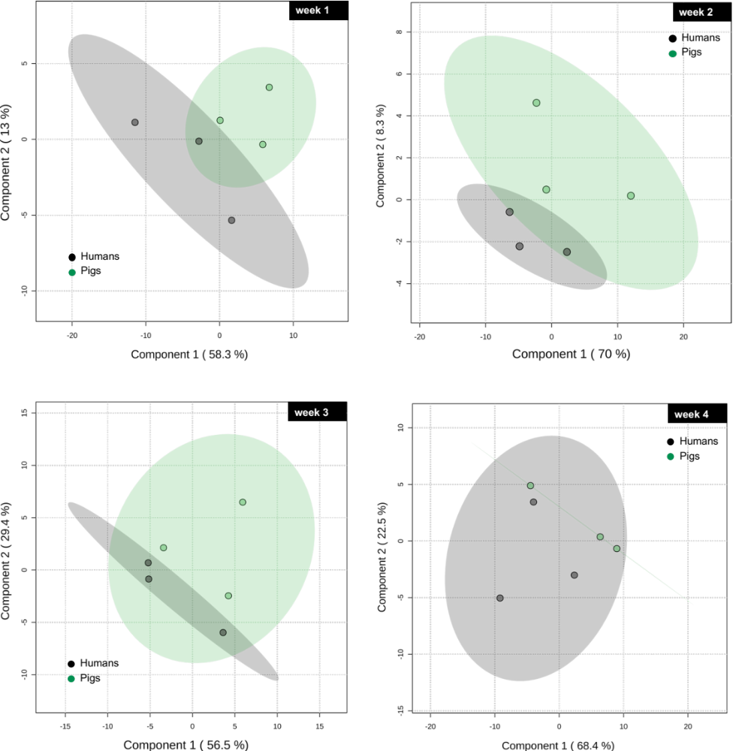
Figure 2.12 – Postmortem lipidomics 2D PLS-DA score plots of CDI soils from humans and pigs for all weeks.

Figure 2.12 – continued

Figure 2.12 – continued

Figure 2.12 – continued
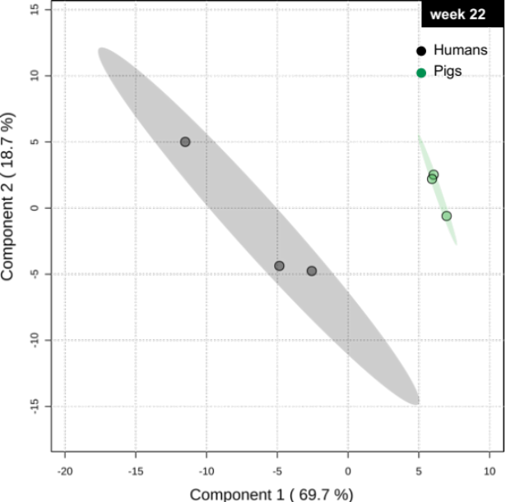

CHAPTER III: INTRINSIC DRIVERS OF HUMAN DECOMPOSITION – DRUG TRACING IN POSTMORTEM SPECIMENS AND DISEASE IMPACTS ON THE HUMAN POSTMORTEM METABOLOME

PREFACE

After elaborating in the previous two chapters on the metabolic profiles of (a) a burial environment and (b) human and non-human carcasses decomposition on soil surface, this final chapter adds one additional factor worth investigating to the equation – intrinsic drivers of human decomposition.
Upon arrival at the University of Tennessee, Knoxville, I had the pleasure of meeting Dr. Dawnie Steadman. She is not only the director of the Anthropology Research Facility (ARF) but moreover a highly recognized researcher in the field of forensic anthropology. In a collaborative effort between the Small Molecule Mass Spectrometry Core (BSMMSC) of UTK’s chemistry department, Dr. Steadman, and Dr. DeBruyn from the Department of Biosystems Engineering & Soil Science at UTK, a project spanning almost 4.5 years was funded by the NIJ to investigate medication impacted decomposition trajectories in humans (NIJ award no. 2018-DU-BX-0180).
As shown previously, the versatility of metabolomics to answer forensically relevant research questions both across matrices (chapter I, bone vs. soil) and species (chapter II, human vs. pig) makes it a useful analysis tool in forensic science. Broadening the knowledge obtained from the previous two chapters, a more complex research question was addressed in this final section. With a focus directed toward investigating the role of intrinsic drivers of human decomposition, in contrast to extrinsic, environmental influence factors, several postmortem matrices such as serum, larvae, decomposition fluid as well as soil were subject of metabolomics studies.

3.1 ABSTRACT

With the herein presented study, several years (2017-2021) of research were dedicated at the 3-acre outdoor laboratory, known as the Anthropology Research Facility (ARF) in Knoxville, TN, USA to investigate intrinsic drivers of human decomposition to ultimately draw conclusions about possible effects on time since death estimations. Here, postmortem toxicological screenings illustrate how drugs and drug metabolites can be traced from a decomposing cadaver through several matrices, including the surrounding soil ecosystem. In addition, comprehensive postmortem metabolomics of biological specimens provided (a) insights into the highly dynamic biochemical environment of decomposing bodies, (b) answers about postmortem metabolic matrix-specific signatures, (c) a group of metabolites proposed to be considered candidates for decomposition biomarker, and (d) estimations of the impact of diseases on postmortem metabolic signatures.

3.2 INTRODUCTION

The stages of human decomposition and the associated changes occurring in a body after death are described elsewhere in this dissertation. Recently described but only rarely investigated influence factors of human decay are focused on in this chapter: As decomposition rates of donors placed in identical environmental conditions appear to be verifiably different, the focus of this chapter is directed to intrinsic drivers of human decay^{112, 137}. Hayman and Oxenham monitored the decomposition of two individuals with different perimortem disease treatment in a shed at the Grady Early Forensic Research Facility of the Texas State University in San Marcos, USA. A slower rate of decomposition, no abdominal bloating and less distinct insect activity was characteristic for a cancer cadaver compared to a donor with known diabetic condition¹³⁷. Health conditions and/or a specific perimortem treatments (insulin versus /chemotherapy) seemed to be the most plausible underlying cause for differential decomposition dynamics. In addition, recently published results by Skopyk et al. proposed that the perimortem use of antibiotics could also impact rates of decay by altering the pre-colonization interval. A diminished microflora as a result of drug use could have led to a prolonged bloating stage and the lack of a phenomena called “marbling”, which was discovered on two of the study individuals with a history of antibiotic treatment¹³⁸. The metabolic fate of a drug in a living organism is generally defined by detoxification and elimination. After death, various other influence factors affect xenobiotic metabolism. Postmortem drug redistribution is for instance responsible for site- and time-dependent concentration variations due to passive drug release from drug reservoirs such as the stomach, liver, or myocardium¹³⁹. The lack of blood circulation inhibits drug transport to detoxifying organs, but certain enzymes present in the blood, or those that are released by apoptotic cells might still be able to degrade certain drugs¹⁴⁰. Furthermore, there is proof of microbial-induced drug degradation: concentrations of the opioid morphine for instance can potentially increase after death due to the hydrolysis of morphine glucuronides to free morphine – a step performed by bacterial β-glucuronidases¹⁴¹.
Being aware of postmortem influences on drug concentrations is of importance for the interpretation of forensic toxicological drug concentrations, yet the intention of the herein presented drug screens was directed toward a proof-of-concept study aiming to trace drugs through cadaveric specimens using an in-house extraction procedure with an adapted drug library for subsequent data analysis. Global postmortem mass spectrometric metabolomics studies are a powerful tool to investigate the complex biochemistry after death, however, they have rarely been performed on human subjects^{41, 43, 44}. Also, such studies commonly hypothesize a correlation between the breakdown products of macromolecules and the time elapsed after death. Various polysaccharides, steroids, nucleosides, and amino acids emerged as proposed biochemical markers with high potential for postmortem interval (PMI) estimation^{41, 43, 44}. Elmjsö et al. could also show the applicability and robustness of postmortem metabolomics as potential tool in death investigations, as the identified postmortem pneumonia biomarkers were known clinically relevant antemortem compounds in patients with such conditions¹⁴².
In this chapter, postmortem Ultra-High Performance Liquid Chromatography-High-Resolution Mass Spectrometry (UHPLC-HRMS) metabolomics was used to enhance the understanding of biochemical processes occurring during human decomposition by analyzing different cadaveric specimens and, at the same time, tease apart the influence of underlying medical conditions on the metabolic dynamics after death.

3.3 EXPERIMENTAL SECTION

3.3.1 Site description
This research was conducted between 2017-2021 on human donors, obtained through the University of Tennessee’s Body Donation Program of the Forensic Anthropology Center (FAC), at the 3-acre woodland outdoor laboratory known as Anthropology Research Facility (ARF) in Knoxville, Tennessee, USA. Founded in 1980 by Dr. William Bass, the ARF is one of the most reputational facilities to study human decomposition in an outdoor setting. All subjects in this study were positioned unclothed and uncaged on virgin surface soil in randomly chosen sectors of the ARF to naturally decompose. Detailed geographic information is stated in chapter I.

3.3.2 Donor collection
For this study eligible donors had to have a perimortem medication record. A total of n = 22 human donors including n = 12 males and n = 10 females with an age range of 40 to 91 years were utilized. Donor characteristics such as gender, age, medical history/condition, and prescribed drugs that were given during the last two weeks of life were recorded for each individual (Appendix Table 3.1). The medication list was available for 18 out of 22 donors. Donor Tox 014 (male, 74 years, white) was excluded from the study as placement conditions on a slope were undesirable. All donors had natural causes of death. No injuries were present at the time of placement nor were autopsies or embalming performed. A donor was unenrolled after it completed active decay as determined by cessation of body fluid from the trunk. To analyze possible disease impacts, donors were categorized based on the information listed in Appendix Table 3.1 into four major disease classes: diabetes, cancer, respiratory, and cardiovascular conditions.

3.3.3 Sample collection and sampling strategy
The sample collection for chemical analyses comprised serum, soils, larvae, and body fluids. Those samples were flash-frozen in liquid nitrogen and analyzed for their toxicological and metabolic composition. Serum samples were collected at donor intake. After donor placement, soil, larvae, and decomposition fluid samples were taken periodically as mentioned below until unenrollment. Approximately 4 ml central (aortic) and peripheral (femoral) blood samples were collected at intake using a veterinary spinal needle. Serum was obtained by allowing the blood to clot for 30-60 minutes at room temperature. After centrifugation (15 min at 2000 rpm), the resulting supernatant was transferred into new cryovials for storage in liquid nitrogen until toxicological analysis.
Decomposition fluid and larvae sampling occurred only in case a sufficient fluid pool or larval mass were present. Both matrices were sampled from various anatomical locations around the body, immediately flash-frozen, and stored at -80 °C until analysis for metabolite and drug profiles. For fluids, a sterile 30 ml syringe was inserted into the fluid pool to collect up to 10 ml which was subsequently aliquoted into 2 ml cryovials. Insects were collected using sterile tweezers and also placed into 2 ml cryovials prior to flash-freezing. Larvae samples were measured and identified along with collected fly samples by the entomologists Dr. Kristi Bugajski and Dr. Charity Owings.
Soil (10 g total) was obtained from within the cadaver decomposition island (CDI) using a sterile, cut 10 mm syringe. From around the cadaver, five to eight soil cores (5 cm depth) were sampled and homogenized in Whirlpak bags. Non-soil debris such as roots or leaves of a size larger than 2 mm were manually removed using tweezers before soils were flash-frozen. In addition, a control, virgin soils sample from an area of approximately one meter away from each donor served as negative control and was also collected at every sampling time point.
Insect and fluid samples were sampled when present, while soil sampling time points were based on Accumulated Degree Hours (ADH) increments. ADH is a measurement of energy produced by ambient heat that drives developmental processes of insects and bacteria. At placement, small on-site data loggers placed in close proximity to donors allowed for local hourly records of temperature and relative humidity for the calculation of ADH. Upon cadaver placement (0 ADH), decomposition and control soils were sampled every 100, 250, 500, 750, 1,000, and 2,000 ADH. Thereafter, 500 ADH increments were used until unenrollment of the donor (no fluid excretion from trunk). The chosen ADH increments capture roughly human decomposition stages independent from the season. However, some sampling time points were missed due to extreme weather, the COVID-19 pandemic or holidays.
Soil, larvae, and decomposition fluid samples were subject of metabolomic studies. All four matrices along with serum were used for screenings of drugs (see 3.3.5).

3.3.4 Supplement data sets – collaborative efforts
Aside from the sample collection mentioned above, a collection of other data sets (field and laboratory data) was gathered in a collaborative effort. Field observational and forensic entomological data interpretation was performed by the Department of Anthropology, UTK. Donors were observed twice daily (mornings and afternoons) using field protocols and a Nikon D5200 digital camera to capture morphological changes and the progress of decomposition along with scavenging and insect activity. Scavenging behavior was monitored using infrared, motion-sensing game cameras positioned near each body. In addition, the Total Body System (TBS) scoring method by Megyesi et al. helped to assess morphological changes throughout different regions of the decomposing body¹²³. It was used to evaluate bloating, tissue discoloration, and tissue loss on the head/neck, extremities, and trunk of cadavers based on the daily taken photographs. The entomologists involved in the project identified the collected insects based on their developmental stage in the life cycle (1st, 2nd, 3rd instar or migrating larvae). Microbial studies were performed on collected fluid and soil samples in Dr. DeBruyn’s lab at the Department of Biosystems Engineering & Soil Science, UTK. Such analyses included for instance DNA extractions (for 16S rRNA sequencing), soil moisture, pH, electrical conductivity, as well as microbial respiration measurements.

3.3.5 Experimental procedures

3.3.5.1 Untargeted postmortem metabolomics

3.3.5.1.1 Extraction method
Metabolites were extracted in triplicates from 50-60 mg soil, 30-50 mg larvae, and 50-60 mg decomposition fluid using a procedure adapted from Lu et al.⁷⁶. For a detailed extraction method description see 1.3.3. To assure extraction and instrumental reproducibility, samples were spiked with four stable isotope-labeled internal standards, namely orotate-15N2, vanillin-13C6, glutamate-d5, and alanine-d4 in a concentration of 100 nM.

3.3.5.1.2 Liquid Chromatography-Mass Spectrometry (LC-MS)
For ultra-high-performance liquid chromatography high-resolution mass spectrometry (UHPLC-HRMS) a Synergi 2.5 micron reverse-phase Hydro-RP 100, 100 x 2.00 mm LC column (Phenomenex, Torrance, CA) was utilized. The Exactive™ Plus Orbitrap Mass Spectrometer (Thermo Scientific, Waltham, MA) was operated in negative electrospray ionization (ESI) mode with parameters listed in 1.3.4. Solvent A consisted of 97:3 HPLC grade water:methanol, 10 mM tributylamine, and 15 mM acetic acid. Solvent B was HPLC-grade methanol. The gradient was set as follows: 0 to 5 min: 0% B, 5 to 13 min: 20% B, 13 to 15.5 min: 55% B, 15.5 to 19 min: 95% B, 19 to 25 min: 0% B. All other parameters are listed in chapter I.

3.3.5.2 Targeted postmortem toxicology
Commercially available toxicology standard stocks (diluted in methanol, >99% purity) were purchased from Restek, Bellefonte, PA. Nicotine, morphine, lorazepam, oxycodone, as well as fentanyl were purchased individually. Two pharmaceutical drug mixtures containing (a) acetaminophen, caffeine, carbamazepine, ciprofloxacin HCL, erythromycin, fluoxetine HCl, sulfamethoxazole, trimethoprim, and (b) gemfibrozil, ibuprofen, naproxen, triclosan were also purchased. Standards were used for method validation purposes, to ensure extraction and instrumental reproducibility, as well as for quantitation. Prior to extractions, standard solutions were diluted to working stocks. Quantitative analysis was performed using external calibration curves. In brief, each methanol-based standard mixture was diluted with methanol to a concentration of 65 ng/ml. Following, serial dilutions were prepared to a minimum of 1 pg/ml. Extractions were carried out using 100 μl serum. The detailed extraction process is described in 1.3.3.
Next, 5 μl of the samples were injected onto a Raptor Biphenyl column (100mm × 2.1 mm ID) with 2.7-μm particle size in combination with a guard column (Raptor Biphenyl EXP guard column cartridge 5mm, 2.1mm ID, 2.7-μm). Separation was performed using the following mobile phases and gradient: (A) water + 0.1% formic acid + 2 mM ammonium formate, (B) methanol + 0.1% formic acid + 2 mM ammonium formate; t = 0 min, 5% B; t = 9 min, 100% B, t = 10 min, 100% B; t = 10.1 min, 5% B; t = 12 min, 5% B. A consistent flow rate was maintained at 0.6 ml/ min. The eluent was introduced into a Q Exactive™ Plus Hybrid Quadrupole-Orbitrap via positive electrospray ionization (heated ESI) using the following parameters: the sheath gas flow was set at 25 psi, and the auxillary gas unit flow at 10 with a spray voltage of 3.0 kV. Capillary heater temperature was set to 300 °C. A full scan MS analysis (m/z 70-1,050) was performed, and samples were analyzed for a total duration of 12 minutes with a resolution of 140,000. The AGC (acquisition gain control) target was set to 3e6.

3.3.5.3 Data processing and statistical analyses
LC-MS raw files generated by Xcalibur were converted and processed in MAVEN in the same manner as mentioned above (chapter I). Known metabolite spectra from postmortem metabolomics experiments were manually selected using an in-house metabolite database with 278 metabolites, whereas toxicological screens were analyzed using an adapted drug database from Restek¹⁴³.
After normalization, metabolomics data were uploaded to Metaboanalyst for uni- and multivariate statistical analyses⁸⁰. Partial least squares-discriminant analysis (PLS-DA) was utilized to find differences in metabolic profiles. Before statistical analysis data were auto-scaled and log-transformed to minimize discrepancy and obtain a Gaussian distribution. Being a supervised multivariate analysis, PLS-DA is also prone to overestimation of the model and potential biased data outcomes. Thus, permutation and cross-validation testing using Metaboanalyst was performed to evaluate the used models. Metabolites with variable importance in projection (VIP) scores > 1.0 were considered significant contributors to a separation among groups. One-way analysis of variance (one-way ANOVA) followed by Tukey HSD (honestly significant difference) was used for multiple pairwise comparisons. Differences with a p-value less than 0.05 were considered as statistically significant. Normalized fold changes allowed the calculation of p-values for the construction of heat maps. ANOVA plots and heat maps were generated in R, version 1.2.5042¹⁴⁴. A detailed data processing description can be found in chapter I, section 1.3.5. Using spearman correlation analysis, associations among metabolites and time (ADH) were evaluated. Pathway analyses was performed using KEGG (Kyoto Encyclopedia of Genes and Genomes) and/or Metaboanalyst¹⁴⁵. As sampling time points were highly variable among donors, percent ADH (% ADH) categories were used as a more uniform comprehensive comparison strategy. Percent ADH was calculated by dividing sample ADH with the total ADH – the total amount of time required by each subject to complete active decomposition.
With the help of Dr. Russell Zaretzki, a Random Forest machine-learning algorithm was applied to a subset of the data to address classification and regression questions. A Random Forest algorithm builds a large number of trees using subsets of features from the original data set and makes predictions based on a subset of features that are best capable of classifying the samples into manually chosen categories. For all predictions, R’s Random Forest algorithm was used. To gain an understanding of the importance of the predictions, R’s VIP package was applied along with the importance function from the random forest package which computes an importance score using an average decrease in node purity as measured by the Gini index. The Gini index measures node purity as the sum of the squared proportions of each class in the node. The more a feature contributes to creating splits with pure nodes the greater its importance¹⁴⁶.

3.4 RESULTS AND DISCUSSION

3.4.1 Medical history and general decomposition characteristics
Table 3.1 in this chapter’s appendix lists donor demographics, prescribed drugs, medical conditions, and causes of death. In short, a total of 187 drugs were reported among which lorazepam, morphine, ondansetron, and levothyroxine were most frequently prescribed. N = 30 drugs fall in the category of analgesics, followed by antihypertensives and anxiolytics comprising n = 26 and n = 18 drugs, respectively. Over 55% of donors were known smokers and more than one-third had high blood pressure. Strokes, pulmonary or metabolic disorders were with 30% part of other commonly reported health conditions. Most donors reported the use of numerous medications based on a variety of underlying illnesses which highlights a key limitation with regard to data processing.
Over the course of this study, it took on average approximately 45 days (44.75 days) to complete active decay in the given environmental setting (Appendix Table 3.2). Aside from Tox 001 and Tox 017 the decomposition period of all other donors ranged from 14 to 315 days (Figure 3.1A). The longest decay times were detected for Tox 001 and Tox 017 with 93 and 191 days, respectively. The season of placement (spring, summer, fall, or winter) seemed to impact the rate of decomposition as donors placed in the winter (n = 5) decompose slower compared to those placed in the spring (ANOVA, p = 0.0079) and summer (ANOVA, p = 0.0082) (Figure 3.1B). Supported by literature, environmental factors with regard to season-specific temperature, weather, humidity but also insect succession, scavenging, and even microbes have been counted among major disturbance factors affecting cadaver decomposition¹⁴⁷⁻¹⁴⁹. None of the tested medical conditions seemed to have a significant effect on the length of decay (Figure 3.1C, cancer p = 0.297, diabetes p = 0.216, cardiovascular and respiratory conditions p = 0.454 and p = 0.877, respectively). These findings diverge from the mentioned studies by Hayman and Oxenham as well as Skopyk et al. where macroscopic changes during decomposition were attributed to perimortem medication use^{137, 138}. However, the limited study size of only n = 22 cadavers and multiple co-morbidities present in all cadavers might have impacted statical significance.
C
A
B

Figure 3.1 – Donor decomposition length. (A) Bar graph comparing the total days required to complete active decay between donors. Slowest decomposition rates are highlighted in dark grey (n = 191 and n = 315 days). (B) One-way ANOVA showing seasonal impacts on the length of decay. p-values were derived via Tukey HSD. (C) Comparing the total ADH required to complete active decomposition between donors with (Yes, color) and without (No, grey) certain medical conditions. All p-values resulted from student’s t-tests. ns= not significant.

3.4.2 Postmortem toxicology

3.4.2.1 Method validation
All toxicological screenings were performed based on an established and published analytical method from Restek with the same intended use for which it was originally validated¹⁵⁰. The above-listed purchased reference solutions were used for method validation. Reference standards and fundamental method validation parameters are provided in Appendix Figure 3.9. In short, all primary reference solutions with a concentration of 1 mg/ml were mixed with methanol to obtain working standard solutions with a concentration of 65 ng/ml for each standard. The working solution was serially diluted with methanol producing seven further solutions. Standards detected along the 12-minute analysis are listed with their spectral features in Appendix Figure 3.9A. Next, calibration curves for each drug standard were analyzed and the linear range, R², limits of detection (LOD) and quantification (LOQ) determined (Appendix Figure 3.9B). Prior to using project samples, test serum collected from a donor not enrolled in this study was successfully used to test the extraction and instrumental method. The serum samples were analyzed for their drug composition against the Raptor drug database containing 231 drugs in total. The minimal retention time shifts seen between this database and the obtained standards ran in-house allowed for confident identification of 10 drugs from this donor (Appendix Figure 3.9C). Acetaminophen, morphine, fentanyl, and lorazepam were matched directly to standards, while the other 6 drugs were identified based on m/z and retention times (Appendix Figure 3.9C). Following those results, the extraction and screening method was applied to all matrices from enrolled donors in the here presented study (serum, larvae, decomposition fluid, and soils).

3.4.2.2 Drug screens of different cadaveric specimens
The original research strategy comprised a presence/absence drug screen of postmortem serum. Over the course of this project this was expanded towards a more comprehensive analysis including all other postmortem matrices. Relative and absolute abundances of drugs detected in each of the matrices are summarized in Appendix Tables 3.3 and 3.4. Toxicological screenings performed on each of the 22 donors led to the overall conclusion that not only parent drugs but also certain drug metabolites are detectable and traceable in different matrices after death (Appendix Table 3.3). Overall, n = 61 drugs were detected among 22 donors. Drug and drug metabolites shown in green in Appendix Table 3.3 were listed on the donor’s medical list and confirmed by analytical analyses. Drugs in yellow were detected but not prescribed, and compounds in blue refer to individuals with no medical history. The density of the color indicates relative drug concentration. The highest concentrations were either detected in decomposition fluid (47%) or serum (29%) although detectable amounts were found in larvae and CDI soils, as well.
Postmortem toxicology of Tox 019 exemplifies this trend of trackability for the analgesic morphine by demonstrating a definite route from the cadaver into the surrounding environment (Figure 3.2A). Not only was morphine found in the donor serum, but it could also be extracted from larvae that were feeding on the cadaver, as well as from different fluid pools on the body, until it was ultimately found in the soil around the carcass. Specifically, central serum obtained from the aorta (4327.46 ng/ml) yielded a significantly higher morphine concentration than serum obtained from the femoral artery (peripheral serum; 170.07 ng/ml) (Figure 3.2A, Appendix Table 3.4). A difference most likely caused by postmortem redistribution (PMR). It is assumed that PMR occurs both in central as well as peripheral blood, yet blood from the aorta might be more prone to PMR due to drug diffusion from major organs after the decline in pH postmortem (pH 7.4 to pH 5.4) which increases permeability of tissue cell membranes¹⁵¹.
Further, the developmental stage of decomposers that ingested drugs from the cadaver seemed to influence drug detectability. An instar is a developmental stage of the larval form of the insect. Briefly, insects entering the larval life cycle undergo three instars (1st, 2nd, and 3rd) before they migrate away from the food source to pupate. Lower intensities of morphine in insects from donor Tox 019 seemed to correlate with an advanced developmental stage. Initial higher drug concentrations detected in a sample mixture of 1st and 2nd instar larvae decreased in 3rd instar samples from 57% to 37%, respectively (Figure 3.2A, p = 0.01). A mixture of 2nd and 3rd instar larvae showed with only 6% the lowest amount of morphine ingested. Dependent on certain stages of the life cycle, an insect’s ability or disability to metabolize the drug might explain instar-dependent concentration differences. During the first stages of development, larvae continuously consume tissue from the cadaver leading to a potential build-up of drugs within the larval body. Once the larvae reach a certain developmental stage, feeding might become a secondary purpose given that metabolic changes direct the development toward the adult stage¹⁵². Unfortunately, limited entomological stage-specific identification of each decomposer complicates testing this hypothesis for multiple donors. However, this was not the first report of drugs detected in insects. For instance, methadone, codeine, antibiotics, zolpidem, or heroin have been used in forensic entomological studies which typically investigate growth and development impairments induced by such drugs in forensically relevant species (mostly Calliphoridae)¹⁵³⁻¹⁶¹. The difference, such studies are predominantly performed under controlled experimental conditions by exposing flies to a food source spiked with drugs. The theory that ingested drugs might have also led to physiological and developmental differences in insects collected in this presented work is currently under investigation by study collaborators (Anthropology department, UTK, TN).
Analysis of drug concentrations from fluid samples had no common trend among donors rather fluctuated for different ADH and sampling locations. Morphine-containing body fluid entering the soil around Tox 019, accumulated over time, and reached maximum concentrations at 3,000 and 5,500 ADH (Figure 3.2A). A more detailed soil toxicological analyses using fold change comparisons of relative drug concentrations confirmed this observation (Figure 3.2B). For all donors, higher drug concentrations in decomposition-impacted soils compared to control soils became statistically significant for individual time points near the beginning and end of active decay. Generally, human decomposition can be classified into five broad stages – fresh, bloating, active, advanced decay, and skeletonization (see introduction). At the end of the bloating stage with the onset of active decay, the abdominal cavity eases the internal pressure created by complex biochemical and microbial processes and ultimately leaks the fluidity content into the surrounding. This explains why decomposition-impacted soils possessed elevated drug concentrations as decay progressed. As expected, soils sampled from control sites were typically drug-free. As of today, no other approach has been made to use either cadaveric fluid or soil for drug detection purposes.
Taken together, this is the first experimental field study of its kind using a postmortem toxicological approach to comprehensively demonstrate not only the presence of drugs after death in various human cadaveric matrices but also a continuous pathway through the latter with eventual xenobiotic accumulation in a completely new ecosystem.

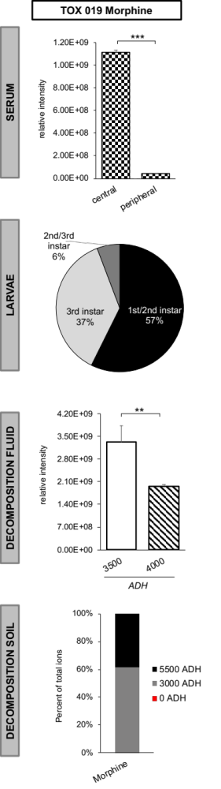
B
A

Figure 3.2 – Toxicological screens of different human postmortem matrices. (A) Detection of morphine in the serum, larvae, fluid, and soil collected from cadaver Tox 019. (B) Comparison of normalized fold changes calculated for decomposition (DS) and control (CTR) soils for three time points (ADH) during decay. Significantly changing drug abundances from donors Tox 005, 010, 011, and Tox 012 are indicated as asterisks. Significance levels are indicated with asterisks.

3.4.3 Postmortem metabolomics

3.4.3.1 Investigating the human postmortem metabolome
Throughout this project, more than 8,000 samples were handled (1,781 fluid/larvae and 6,337 soil samples), thousands of metabolites detected, and multiple terabytes of data generated which provide a massive data set for hypothesis testing. On average, known untargeted data evaluation revealed over 100 spectral features per donor for every analyzed matrix. The same phenomenon as previously described for the toxicological screens – metabolite trackability through different specimens postmortem – was reflected in the metabolomics data set. The metabolomics section of this chapter addresses more complex research questions focusing on (a) a more in depth postmortem analysis of the biochemical dynamics, (b) the identification of groups of metabolites as potential decomposition biomarker beneficial for a more precise classification of decomposition stages along with more accurate PMI estimations, and (c) the influence of perimortem medical conditions on the metabolome after death.

3.4.3.1.1 Metabolic signatures of decomposers, decomposition fluid, and CDI soil
All samples of decomposition fluid, soil, and larvae from 22 donors were extracted to analyze their metabolome. On average 148 spectral features were identified across all donors per matrix. At first, to gain a better understanding of metabolite affiliations they were categorized into 11 broad compound classes (Appendix Figure 3.10). Pathway analysis found minor inter-matrix differences with on average 40% of metabolites linked to the amino acid metabolism, 19% identified as nucleosides, nucleotides, and analogs, and 8% classified as lipids or lipid-like molecules. Krebs cycle, glycolysis, and gluconeogenesis were accounted for with 4% each. Protein catabolic processes in cadavers seemed the most plausible explanation for the increased detection of amino acids in all matrices. After death, protein synthesis ceases which steadily increases the pool of amino acids in cellular compartments. The breakdown of tissue and cells releases not only different amounts of amino acids but permits proteases unhindered access to proteins, ultimately resulting in proteolysis – the breakdown of proteins into polypeptides and amino acids. The fact that proteolysis does not occur in all tissues at the same time but proceeds in a nonuniform fashion, explains why the detection of those compounds ceases only slowly postmortem⁸. In agreement with this, proteinogenic amino acids have previously been described to steadily increase following death which makes them potential targets for PMI biomarkers^{18, 42, 162}. Lastly, multiple researchers found a decline in pH as decay progressed in soil sampled from underneath or close proximity to humans^{26, 31}. Collaborators in this study noticed a decrease in soil pH for n = 14 donors out of 22 donors. Such an increase in acidity (lower pH) can be assumed to result from a gradual release or organic acids, e.g., fatty or amino acids into postmortem matrices which was most likely reflected in the detected increase in amino acid metabolism compounds/intermediates in Appendix Figure 3.10.
Next, to further explore matrix differences, multivariate analyses using PLS-DA was performed (Figure 3.3A). A distinct cluster formation for all three matrices was observed which led to the assumption that the entirety of larvae, fluid, and soil samples defined a donor-specific metabolic signature that was either fairly similar among cadavers (closely grouped clusters) or distinct (separated clusters). This theory can also be confirmed by the fact that across matrices none of the PLS-DA plots showed the same overall donor groupings. Larvae samples showed a grouping of donors Tox 002, 003, and 004 separated from all other subjects, while fluid samples collected on Tox 010 were the only samples not contributing to the overlapping cluster generated by the remaining donors. In the soil, three large groupings comprising between two to four donors pointed out discrepancies among individual metabolomes. Underlying reasons for this are diverse. While microbial communities can be thought of as one contributor, insect physiology, different insect species or environmental factors influencing nutrient availability in the soil are all plausible factors possibly affecting variability of donor metabolomes across matrices postmortem. Along with this, as field samples were taken at different time points (ADH) and/or cadaver locations, intra-donor comparison within one matrix, found metabolic profiles to be impacted by time and anatomical location (Appendix Figure 3.11). Fluid collected from donor Tox 003 at 3,500 ADH from the left food appeared to be metabolically distinguishable from fluid collected at 2,000 ADH (unknown location) and 2,500 ADH (left ankle, homogenized sample, groin) (Appendix Figure 3.11A). This pattern continued for decomposers collected from this donor, whereas metabolomes for larvae were also diverse for developmental stages (aka instars) (Appendix Figure 3.11B). Here, 3rd instar larvae collected at 3,400 ADH from the eyes formed a closely grouped cluster with a set of samples of the same instar and similar body region (3,500 ADH, 3rd instar, mouth). The remaining samples for Tox 003 were separated in component 1 and shifted to the right in the PLS-DA score plot forming a group that might have been more similar in their profiles, yet still exhibited some differentiation among samples. Those samples included 2nd and 3rd instar larvae collected at the same time (1,000 ADH) from the upper body (eyes and mouth). This demonstrated that the same sampling location can have a different suite of molecules dependent on when sampling occurred and which developmental stage of the insect was collected. Analyses for all three matrices for Tox 011-022 are shown in Appendix Figure 3. 12.

Due to the nature of the sampling design, soil sampling had higher sampling consistency as sampling occurred in certain increments throughout decomposition. Also, it was the only matrix for which control samples were available for comparisons. This was why a more in depth analysis for this matrix was done. First, multivariate analyses of soil metabolomes showed good discriminatory power to separate the two soil types. Control soil metabolomes for each donor were metabolically different from soils soaked in decomposition fluid (Appendix Figure 3.13). Next, to discriminate specific metabolites between both soil types, heat map analysis allowed for direct univariate comparisons. Exemplified on Tox 009, significantly increased metabolite concentrations in cadaveric compared to control soils were predominant at later stages of decomposition past the 2,500 ADH marker (Figure 3.3B). During active decay, a phase characterized by the greatest cadaveric mass loss, fluid that leaks from the cadaver creates CDIs around the body. During this stage, an increasing soil saturation with a diverse suite of metabolites can be expected. Early ADH time points showed inconsistent trends of metabolite concentration changes in both soil types – most likely a result of increased microbial activity during the fresh and bloating stage of decay. As metabolites are also a microbial food source for growth and survival, this could explain the diminished detection rate of certain metabolites in cadaver soil. Microbial enzymes are known to break down for instance ornithine and lysine into the foul-smelling decomposition products putrescine and cadaverine, respectively¹⁶³. However, identification of these mammalian-microbial co-interactions as well as bacteria-induced decomposition products was beyond the scope of this work. It is noteworthy that this overall pattern described above for Tox 009 was noted for all 22 donors. Particularly, cross-donor evaluation found that the number of significantly increased metabolites in decomposition soil (log₂-fold change ≥ 1.5, p-value ≤ 0.1) increased from 516 at the onset of decomposition (0% ADH) to 783 metabolites by the time cadavers were halfway decomposed (25-50% ADH) up to 929 and 984 metabolites at the beginning and the end of active decay, respectively (75% and 100% ADH, respectively) (Appendix Figure 3.14). Lastly, mapping of all detected soil compounds into distinct biochemical pathways showed once again that the biochemical environment during decay was reflected by a sequential breakdown of macromolecules (nucleic acids, proteins, carbohydrates or lipids) into their corresponding monomers e.g., nucleosides such as xanthosine or amino acid-metabolites like kynurenic acid. Supporting these outcomes, collaborators found an increase in soil electrical conductivity (a measure of ions in soil) and soil enzymes such as β-glucosidase as decomposition progressed which is interesting as β-glucosidase is involved in the breakdown of sugar.
Summarizing the presented results, from a metabolic perspective, decomposition is not consistent among individuals. Individual-, matrix-specific and time-dependent trends were extracted from analyzed postmortem specimens suggesting a greater variety of extrinsic and intrinsic factors were driving the observed inter-individual variation.

A
B

Figure 3.3 – Metabolic profiles of different matrices collected after death. (A) Multivariate analysis (PLS-DA) of larvae, decomposition fluid, and CDI soil for the first ten donors. (B) Soil metabolomics of Tox 009. Heat map data are plotted as log₂-transformed fold changes of decomposition (DS) and control soil (CTR) with an increase in relative metabolite concentrations shown in red and a decrease shown in blue. P-values are the result of a student's t-test. ADH is listed on the top of the heat map. Metabolic pathways are listed on the right.

3.4.3.1.2 Metabolome alterations over the course of decomposition
Assuming that biochemical signatures in CDI soils are highly variable throughout decomposition, further efforts were done to deconvolute this time-dependent relationship. Soil metabolomics data – the only data sampled in continuous ADH increments – were split by percent ADH classes and analyzed by supervised, multivariate classification techniques (Figure 3.4A). Consistent with the findings for Tox 009 (Figure 3.3B), multiple donors (Tox 005, Tox 011, Tox 020) had diverse dynamics over the course of sampling (Figure 3.4A). Given the distinguishable cluster formation at each time point of decomposition (0% ADH to 100% ADH), the biochemical environment in the cadaveric soil seemed to change drastically over time. Also, the generated 3D representations of the score plots suggested that the 0% ADH and 25% ADH clusters create a more distinct group away from the remaining three ADH categories. A pattern that roughly reflected early (0% ADH and 25% ADH) and later stages of decomposition (75%-100% ADH). Similar to the presented results, initial studies conducted in 1990 at UTK’s outdoor facility concluded that decomposition changes resulting from tissue breakdown into its fundamental components occurred in a predictable order, however, the decay rate of human bodies was greatly variable¹⁵. Over the years, other studies have emerged verifying this observation. One example is the work by Macdonald et al. highlighting the contribution of carcass decay to the biogeochemical cycling of energy and nutrients within the natural ecosystem. Here, decaying cadavers affected the nitrogen, phosphorus, and carbon pools in the soil by providing a significant and long-lasting source of proteins and amino acids¹⁶⁴. A time dependent occurrence of multiple biomolecules present during the early, intermediate, and late PMI periods was reported by Locci and colleagues⁴¹.
In addition to this exploratory analysis, it was tested whether the observed changes had a robust predictive value when considering all individuals. Hence, donor-comprehensive analysis was used next to evaluate factors causing a time dependent shift of the chemical diversity in soils exposed to decomposing remains (Figure 3.4B). Overall, several metabolites showed significant concentration changes upon the onset of decay (ANOVA, p ≤ 0.05 with Tukey’s HSD). Among those, taurine, pantothenate, and creatine emerged as a group of compounds that were previously found to drive metabolic changes over time based on their high VIP scores obtained from the 3D PLS-DA plots (Figure 3.4A data not shown, all metabolite VIPs > 1. Subsequently, to assess their linearity during decomposition, a Spearman rank correlation analysis was performed for all 22 donors between taurine, pantothenate, and creatine, including each corresponding ADH time point (Figure 3.4C). Individual metabolite concentrations obtained from the first ADH sample throughout decay until the last sampled time point showed for 17 out of 22 donors a significant positive correlation when extrapolating pantothenate concentrations over the investigated ADH range. Soil concentrations of taurine showed for nine donors a monotonous and continuous increase over time. Creatine had a less consistent trend with significantly inverse metabolite-ADH associations for Tox 010 and Tox 011. Tox 010 was the only donor who had a significant time-dependent decline of both taurine and creatine concentrations. Measured relative quantities of creatine also dropped in soils collected throughout the decay of Tox 011. However, as such linear decrease in metabolite concentration was only detected in soils from two subjects, it can be assumed that other variables – most likely external or donor-specific, intrinsic components – were the contributing factor for the observed outliers. Overall, even though this correlation analysis focuses on only three metabolites, it was a preliminary proof-of-concept study which identified an existing linear and cyclic nature of certain metabolite concentrations postmortem. Such correlations between spectral features and time after death (ADH) could pave the way for possible future metabolite-based PMI prediction models. Previously reported biochemical analyses of postmortem changes supports this hypothesis. As stated elsewhere in this thesis, several volatile organic compounds, amino or fatty acids have been proposed as promising candidates for PMI estimations^{18, 24, 29, 133, 165}. Taurine, a major constituent of bile, has been shown to positively correlate with late PMI samples of ovine aqueous humor (PMI > 1,000 min)⁴¹. In a rabbit model, the work from Zelentsova et al. confirmed the PMI biomarker potential of taurine by demonstrating significant quantitative changes over time with a slow and regular increase⁴⁵. The same group found in three different human cadaveric specimens creatine to be among the most promising PMI marker. Based on their PMI prediction model, they further postulated that the integration of multiple metabolites rather than just one compound was advantageous for reducing the error in PMI estimations⁴⁴. As creatine is an amino acid derivate mainly located in the muscle its increased postmortem concentrations were most likely caused by cellular lysis of skeletal muscles. Up to this point, pantothenate has not previously been suggested as possible PMI marker, yet Kaszynski et al. recently listed this metabolite among the top compounds having a significant Pearson correlation coefficient in a PMI prediction model (R²: 0.9369; p-value: 0.0001)¹⁶⁶.

A
B
C
 | One-way ANOVA
 | F | P-value | Tukey's HSD
Taurine | 32.66 | 2.10E-22 | 0.25-0; 0.5-0; 0.75-0; 1-0
Pantothenate | 23.485 | 8.66E-17 | 0.5-0; 0.75-0; 1-0; 0.5-0.25; 0.75-0.25; 1-0.25
Creatine | 18.779 | 1.03E-13 | 0.25-0; 0.5-0; 0.75-0; 1-0
Uridine | 10.59 | 5.18E-08 | 0.5-0; 0.75-0; 1-0; 0.5-0.25; 0.75-0.25; 1-0.25
Pyroglutamic acid | 9.6915 | 2.32E-07 | 0.5-0; 1-0; 1-0.25; 1-0.75
Methylthiopropionate | 9.3864 | 3.87E-07 | 0.25-0; 0.5-0; 0.75-0; 1-0
Methylphenylacetic acid | 8.6089 | 1.43E-06 | 0.5-0; 0.75-0; 1-0; 0.5-0.25; 0.75-0.25
Thymine | 8.1416 | 3.15E-06 | 0.5-0; 0.75-0; 1-0
Methionine | 7.3405 | 1.22E-05 | 0.75-0; 1-0
Hydroxyisocaproic acid | 6.6427 | 4.01E-05 | 0.25-0; 0.5-0; 0.75-0; 1-0
Indole-3-carboxylate | 6.0466 | 1.11E-04 | 0.5-0; 0.75-0; 0.5-0.25
Tryptophan | 5.4718 | 2.95E-04 | 0.75-0; 1-0; 1-0.25
Thymidine | 4.8216 | 8.90E-04 | 1-0; 1-0.25
Guanosine | 4.8124 | 9.04E-04 | 0.75-0; 1-0; 1-0.25
Xanthosine | 4.3969 | 1.83E-03 | 1-0

Figure 3.4 – Dynamics of the postmortem metabolome during human decomposition. (A) 3D PLS-DA plots of soil metabolomics data analyzed by percent ADH. (B) One-way ANOVA of soil metabolomics from all study individuals. Tukey’s HSD represents significant time-dependent metabolite changes among ADH classes (0%, 25%, 50%, 75%, and 100% ADH). (C) Spearman correlation analysis of metabolite-time correlations for the top three metabolites from (B). Only significant metabolite-ADH correlations based on Spearman’s Rho and p <0.05 are listed.

3.4.3.1.3 Decomposition biomarker potential of metabolites and the prediction of the time elapsed after death
Global postmortem soil metabolomics implied complex but distinct biochemical signatures of cadaveric soils that were highly susceptible to changes over the course of decay. Uniqueness in biochemical composition and a time-dependent variability were promising features of this matrix for further biomarker discovery analyses. As sampling increments for larvae and decomposition fluid varied strongly based on when the aforementioned matrix was present on donors, both datasets did not align with the ADH classes (0%-100%) and were therefore not major focus of the subsequent approach in this section.
Assuming that molecules leaking from a decomposing cadaver into the surrounding soil are sufficient to differentiate among soil types (Appendix Figure 3.13), a Random Forest classification model was developed. Random Forest algorithms typically handle unbalanced and massive data produced by high-throughput analyses fairly well and are robust to data overfitting. First, it was intended to identify groups of metabolites that could help to accurately classify a soil sample as decomposition or control soil. Preliminary machine learning approaches identified several metabolites as highly correlated with decomposition soils. Performance evaluation of the model showed that it correctly classified in the test data set 889 out of 960 samples as decomposition samples, yielding a class error of 0.0732. For the controls, 944 out of 968 samples were classified correctly, giving a 0.0248 class error (Figure 3.5A). Overall, the Random Forest algorithm predicted control and decomposition samples with a 96% accuracy. The out-of-bag (OOB) estimate of error rate for the test data set was 4.9%. Among the 30 top-ranked metabolites based on their importance for the identification of the two soil types, taurine, pantothenate, and creatine were compounds previously identified (see 3.4.3.1.2) (Figure 3.5A).
To evaluate the strength of metabolites in predicting a time point during decomposition, a prediction model was built using the decomposition soil metabolomics data. Predictions from this model were plotted against actual outcomes and a simple linear regression model was fit to illustrate the strength of the linear relationships between predicted and actual ADH. The response modeled was percent of maximum ADH (current ADH/maximum ADH for the donor; range 0-100% ADH). Thus, for this data set, the Random Forest regression model was used to create a predictive model for %ADH based on relative soil metabolite concentrations. If the model is accurate, it indicates that it is possible to estimate how long a body has been decaying relative to the maximum ADH (% ADH) based on soil biochemical profiles. The differences between the actual and predicted ADH are illustrated in the regression plot in Figure 3.5B. As shown, an R²-value of 0.87 and a p-value < 2.2e-16 indicated great linearity and overall performance of the model. This strong association between the predictive model and actual outcomes provided evidence that metabolic signatures found in cadaveric soil are characteristic of decomposition stages as measured by %ADH. According to the model, the metabolic features with highest predictive importance to correctly predict %ADH intervals are pantothenate, taurine, kynurenic acid, indole-3-carboxylate, and others. The reoccurrence of pantothenate and taurine was noteworthy. This strongly implies that biochemical changes during human decay might follow a cyclic pattern – a pattern that was sufficiently reproducible over the monitored decay period of all study donors and, more importantly, indicative for certain postmortem time intervals.
Taken together, these results suggest new avenues toward incorporating certain groups of metabolites into a complementary forensics tool to provide supporting biochemical information for currently existing entomological and physical PMI estimation methods. It is promising that literature sporadically shows approaches of machine learning-based microbial PMI estimation models using for instance 16S rRNA markers in grave soil or carcass skin as biomarker candidates for highly accurate PMI predictions⁴⁹. Recently, Zhang et al. reported PMI predictions within 1.82 ± 0.33 days by using a model built on grave soil and microbial community⁴⁶.

A
B

Figure 3.5 – Random Forest models trained on the soil metabolomics data. (A) Random forest classification analysis could distinguish between decomposition and control soil with a predictive accuracy of 95%. The figure presents the 30 top-ranked metabolites based on their importance for the identification of the two soil types. The model accuracy is depicted below. OOB= out-of-bag. (B) Random Forest regression model using postmortem metabolite intensities found in decomposition soil to predict ADH (0%, 25%, 50%, 75%, 100% ADH). Each small black dot represents a soil sample. A list of features which had a high predictive power to correctly predict a certain time point of after death is shown on the bottom.

3.4.3.2 Impact of medical conditions on the postmortem metabolome
The hypothesis that after death drugs take a defined path to enter the environment, was confirmed by their mass spectrometric detection in insects, fluid, and soil collected from decomposing bodies (Appendix Table 3.3). As subsequent postmortem metabolomics revealed a highly diverse metabolic make-up of those matrices, questions about possible impacts from the individuals’ health condition arise. Consequently, four broad disease classes were defined as cancer, diabetes, cardiovascular and respiratory conditions. Those classes were chosen according to literature and common age-related medical conditions¹³⁷.
Preliminary data analysis for assessing disease effects on the metabolome after death was performed using decomposition soil metabolomics data (Figure 3.6). To reduce variability, pairwise comparisons were made among donors whose medication and disease history was least complex but most applicable for one disease class. As none of the donors were completely healthy, yet a control needed to be included for statistical analyses, Tox 013 was selected as control donor for these purposes. He died of suicide rather than a chronic disease and took only three drugs (ambien, imitrex, sildenafil) of which two (ambien, acetaminophen) were detected in his postmortem matrices (Appendix Table 3.3). The sum of the relative abundance of all detected metabolites for disease-impacted soils was analyzed over time until completion of active decay (percent ADH) and compared to Tox 013 (Figure 3.6). Of note, the total suite of metabolites detected in CDI soils from decaying cadavers typically exhibited lower overall abundances except for the diabetic donor Tox 012. Here, towards the middle and end of decomposition, at 50% and 100% ADH, a statistically significant increase was noticed (Figure 3.6, p = 0.0287 and p = 0.0224, respectively). Figure 3.6 exemplifies the performed analysis for individuals Tox 019 (cancer), 012 (diabetes), 015 (cardiovascular), and 005 (respiratory impairment). In order to validate the illustrated trends, other donors with minimal comorbidities for each class were also tested (data not shown). Hence, it could also be shown that Tox 002 (colon cancer), 004 (lung cancer), and 009 (lung cancer) had over the course of decay significantly lower total ion intensities when compared to the control donor. Only one donor in this study died from the implications of diabetes which is why Tox 012 was considered the most “unbiased” donor in representing this disease class. Aside from Tox 015, Tox 007 who died of cognitive heart failure, showed a similar trend of decreased metabolite intensities which reached statistical significance at time points 25% ADH (p = 0.027) and 50% ADH (p = 0.00818). Chronic obstructive pulmonary disease (COPD) was the prevalent medical condition for Tox 003 and Tox 020 which both – similar to Tox 005 (Figure 3.6) – showed diminished levels of total ion intensities present in the disease-impacted soils after the onset of decay.
Taken together, such trends of negatively impacted total metabolite intensities in soils collected from cadavers with cancer, cardiovascular and respiratory perimortem health conditions might be indicative of a toxic effect on the metabolome of drugs prescribed to treat these conditions. Such toxicity effects could have been mirrored by soils soaked in decomposition fluid. Tox 012 was known to have suffered from diabetes prior to death and was treated with insulin (Lantus). Diabetes is a “sugar disease” characterized by increased blood glucose levels. Compared to cancer treatments which usually include highly toxic agents, diabetic cadavers might provide a more nourishing postmortem environment – an environment possibly more favorable for microorganisms. This could drive microbial growth and theoretically enhance metabolic activity due to microbial-mammalian co-metabolomic pathways. Similar toxicity effects were proposed from collaborators of this study. The pool of microbes is usually highly variable throughout decay. In this study, fungal communities became more similar across individuals over time, while the richness and diversity of soil bacterial communities decreased. Especially soil from cancer donors had a significantly reduced bacterial community richness (p = 0.014) and a slower increase of microbial activity. This could be additional evidence of a toxic effect due to a perimortem use of anticancer drugs. To date, most of the published studies investigating xenobiotic effects on the metabolome are in-vitro or animal studies, however, they suggest metabolic reprogramming that can occur after medication intake. Cancer treatment for instance has been shown to not only affect microbiota but also multiple metabolic pathways¹⁶⁷. For instance, metabolic responses to multiple anti-cancer agents were investigated on the adenocarcinoma cell line A549 by Guo et al. who found alterations in the glycine, serine and threonine metabolism, cysteine and methionine pathways, purine as well as glutathione metabolism¹⁶⁸.

Figure 3.6 – Evaluation of disease effects on the postmortem metabolome over time. Decomposition soil was used for pairwise comparisons of donors that were assumed to give the most unbiased representation of one illness. Tox 013 was considered a “healthy” control donor. P-values are the result of student’s t-test.

Furthermore, for these four disease classes, a possible common denominator can be assumed among cancer and respiratory medical conditions. Literature shows a high occurrence of lung cancer in individuals with COPD suggesting mutual mechanisms in their pathogenesis. Common pathogenic factors related to altered intracellular pathways can be one likely mechanism¹⁶⁹. This led to a preliminary study aiming to deconvolute postmortem metabolic signatures of COPD and lung cancer cadavers in decomposition soil and fluid. Figure 3.7A shows the total number of metabolites changed in both matrices for certain donors assumed to be primarily impacted by one of the health conditions (lung cancer: Tox 004, Tox 009; COPD: Tox 003, Tox 006). Total metabolite counts resulted from Volcano plot analyses contrasting metabolic profiles of soil and fluid collected from a donor with underlaying illness with the control donor Tox 013 (data not shown, FC ≥ 1.5 or ≤ -1.5 and p.-adjusted values < 0.05). Across both health conditions, decomposition fluid yielded consistently higher abundances of metabolites, while disease-impacted soils showed greater metabolite ‘downregulation’ when compared to the control (Figure 3.7A). A finding potentially related to a more complex microenvironment in cadavers with known perimortem illnesses because fluid collected directly from these bodies might contain greater multifaceted metabolic processes. Processes which might have been less prevalent during the decay of the control donor since there was no underlying chronic condition that could have increased metabolic diversity. Higher metabolic activity in donors with chronic diseases could also turn those cadavers into a better “breeding ground” for microbes which in return produce and release metabolites of their own to meet requirements of growth and survival. This would explain why the overall number of metabolites with higher relative abundances was found in the fluid of donors with COPD and lung cancer. A shift in this pattern is excepted as soon as fluid purges into the surrounding ecosystem. CDI soil appears to be somewhat more indirectly impacted by decay processes and less saturated with cadaveric components which might be condensed in fluid that is directly in contact with the cadaver.
Next, to assess disease-comprehensive features present in both matrices, the distribution of features with common increased and decreased abundances shared by both donors were visualized using Venn diagrams (Figure 3.7B). The same above-mentioned pattern was present within one disease class: mutually shared metabolites with higher intensities were mainly found in fluid (89.5% lung cancer, 83.5% COPD) while soils had a greater total number of features lowered in intensities (77.6% lung cancer, 78.7% COPD). Assuming a role of COPD in the pathogenesis of lung cancer, the overlapping portions of the Venn diagrams were analyzed next. From those sections, metabolites high (8 and 10) and low (7 and 3) in abundance across both diseases were extracted to subsequently assign biochemical pathways. Figure 3.7C shows a summary of all common differential metabolites found in both donors, both matrices, as well as both disease types. Five out of nine metabolites (adenosine, guanosine, xanthosine, allantoin, glycine) were intertwined in the purine metabolism proposing a possible role of this pathway in COPD and lung cancer donors. The lack of postmortem metabolomics studies in the literature complicates the verification of this hypothesis, however, studies in the living reported a potential metabolic interdependence. Yin et al. described that purines and enzymes involved in their biosynthesis are fundamental for tumor cell proliferation¹⁷⁰. Especially the nucleotide adenosine can be produced by cancer and immune cells during tumor pathogenesis under metabolic stress or hypoxia¹⁷¹. This nucleoside acts via adenosine receptors which were also found to be highly expressed in lung cancer cells to regulate their survival¹⁷². The pathophysiologic role of adenosine in COPD was revealed by Esther and colleagues. They linked adenosine to asthma and inflammatory airway disease and reported elevated concentrations in exhaled breath of individuals with stable asthma¹⁷³. Mass spectrometric metabolomics studies of COPD and lung cancer patients identified several altered metabolites among which adenosine concentrations were increased in both diseases¹⁷⁴. All this might explain the detected increase of postmortem adenosine from donors with COPD and lung cancer. Supporting this, levels of the amino acid glycine, which provides carbon and nitrogen atoms during purine biosynthesis, were found lowered in both matrices. A simplified scheme of the proposed metabolic interplay of detected metabolite changes is illustrated in Figure 3.7D.
Lastly, COPD is a common condition found in smokers, and tobacco use is known to be the main risk factor for the development of lung cancer. According to the obtained medical information, 11 out of 22 donors had a known history of tobacco use. Decomposition fluid and soils of those donors were therefore analyzed for the presence of adenosine. In the soil collected from around those cadavers, eight out of 11 had elevated relative adenosine concentrations reinforcing possible perturbations in the energy metabolism (Figure 3.7E, p ≤ 0.01). However, adenosine could not be detected in the fluid of Tox 013 (control donor) which made data unsuitable for pairwise comparisons.
In summary, it appears that physiological processes induced by and characteristic for a disease in the living, exert its “fingerprints” even long after decomposition has progressed. These preliminary studies also add another feature to the versatility of untargeted metabolomics studies in terms of deconvoluting preserved disease features after death.

A
B
C
D
E
Figure 3.7 – Postmortem metabolic signatures of lung cancer and COPD. (A) Total number of differential metabolites in soil (DS) and fluid (DF) evaluated in two donors representing each disease. (B) Venn diagrams of common metabolites in both donors. (C) Summary of common differential metabolites found in both donors, both matrices, and both diseases along with their metabolic pathways. (D) Detected metabolite concentration changes and their relationship in the purine metabolism. (E) Adenosine changes in the decomposition soil of donors with known tobacco use. All comparisons were made using Tox 013 as “control”.

Yet, the above speculations must be made with caution as analyzed cadavers did not suffer from exclusively one health condition, and no actual control or “healthy” donor was available for comparisons. Environmental factors might have impacted decomposition patterns, as well. The 27-day decay period of Tox 013 spanned the fall (Oct 22nd, 2019-Nov 19th, 2019) but due to the study design only two other donors decomposed in this season (Tox 012 and Tox 015). Not to forget, humans are extremely variable to the point where it is challenging to even define a “healthy” metabolome. To remove some of the complexity, subsequent metabolomics data analysis contrasted decomposition soils with soils collected from the control sampling spot (Figure 3.8).
Using the above-mentioned four major disease classes, univariate volcano plot analysis helped to identify differential metabolites with the highest change between groups (FC disease soil/control soil ≥ 1.5 or ≤ -1.5, p.-adjusted values < 0.05). When compared to control soils, higher levels of differential features were exclusively detected in disease soils. Not did a single metabolite have lower intensities in CDI soils for any of the tested diseases (data not shown). Next, to further elucidate disease impacts on the postmortem metabolome, the same data set was subjected to supervised PLS-DA analysis. Cluster formation in 2D-score plots was assessed using the corresponding VIP plots to identify variables relevant to group each cluster (cut-off VIP > 1, Figure 3.8A). Again, all differential metabolites with VIP scores > 1 had increased relative concentrations in disease-impacted soils. Tissue breakdown and accumulation of body fluids which ultimately leak into the soil surrounding a carcass assumingly increased the biochemical heterogeneity in decomposition (= disease) soils compared to soils sampled from an area with no carcass. The differentially abundant metabolites among the two soil types with significant VIP scores, were next visualized in a Venn diagram to discriminate metabolites common to and distinct for the four disease CDI soils (Figure 3.8B). Interestingly, among the 22 discriminant features found in each CDI soil, 17 were previously identified by a Random Forest classification model as highly predictive for decomposition soil (see 3.4.3.1.3) (Figure 3.8C). This emphasized again their potential in being considered decomposition biomarker.
While most of the features were common to cadaveric soils collected from all diseases (42.3%), there was a small number of “disease-specific” metabolites that contributed to the formation of separate clusters upon PLS-DA analysis (Figure 3.8B). The metabolites that best discriminated donors with respiratory conditions were allantoin (p.adjusted = 6.36E-17) and hydroxyphenylacetate (p.adjusted = 5.22E-16). In humans, metabonomic profiling of urine from COPD patients found an enhanced expression levels of hydroxyphenylacetate, a compound involved in the tyrosine and phenylalanine catabolism¹⁷⁵. The end product of the purine catabolism is uric acid. Most mammals except humans, enzymatically oxidize uric acid to allantoin. In human, allantoin is only produced by nonenzymatic oxidation of uric acid which can occur when levels of reactive oxygen species (ROS) increase. Consequently, allantoin has been used as a biomarker of oxidative stress in several studies of individuals with e.g., inflammation, cystic fibrosis or smoking¹⁷⁶. Interestingly, as Figure 3.7C shows, allantoin was also found to be increased in soils and fluid from lung cancer and COPD cadavers. Among the two discriminating metabolites unique for CDI soils of cancer cadavers, kynurenic acid (p.adjusted = 2.51E-11), a compound formed during tryptophan degradation, was mentioned in literature to be associated with Hodgkin lymphoma, lung, and ovarian cancer. Kynurenine induces T-cell death thereby suppressing antitumor immune response¹⁷⁷. Activation of the kynurenine pathway to de-novo synthesize nicotinamide adenine dinucleotide (NAD) is a known mechanism in cancer cells. Increased NAD turnover enhances glycolysis in response to growth and survival demands of cancer cells¹⁷⁸. Increase of relative concentrations of acetyllysine in cancer cadaveric soils was significant based on univariate analysis, however such an association was reported for the first time in this study. The compounds hydroxyisovalerate (p.adjusted = 7.78E-13), anthranilate (p.adjusted = 1.04E-11), and indole (p.adjusted = 2.10E-11) had significant association with soils collected from cadavers with cardiovascular impairments. The two latter metabolites are involved in the tryptophan metabolism. In humans, both are intermediates of the tryptophan biosynthesis, while there is also evidence in literature that several gut microbial species are able to perform the opposite conversion by degrading tryptophan to a variety of break down products including indole and anthranilate^{179, 180}. Findings from Mangge and coworkers identified a disturbed tryptophan metabolism in cardiovascular diseases which could potentially verify the finding in this study¹⁸¹. Increased serum kynurenine to tryptophan ratios were reported to be linked with higher chances of fatal cardiovascular events. Last but not least, tricarballylic acid, and methionine sulfoxide (p.adjusted values: 8.91E-19, and 5.26E-15, respectively) had significant capabilities to discriminate soil from diabetic cadavers. As of now, there is no evidence in literature relating these compounds to directly to diabetes. Tricarballylic acid interferes in the Krebs cycle by inhibiting the enzyme aconitase which could point towards an impaired energy metabolism in diabetes. This is indeed a controversially-discussed topic in literature^{182, 183}. The dietary amino acid methionine is for instance involved in the cellular redox hemostasis. It is susceptible to ROS and thus counteracts potential cellular damage by getting oxidized to methionine-sulfoxide¹⁸⁴. An overproduction of ROS from vascular cells can occur as a result of an hyperglycemic result in diabetes which could reflect the detected increase in methionine-sulfoxide concentrations in diabetic cadaveric soils¹⁸⁵. The proposed hypotheses will have to be further evaluated in a collaborative approach and remain at this point subject of future research.

B
C
A
Figure 3.8 – Disease impacts on the postmortem metabolome. (A) VIP score plots with important features identified by PLS-DA (VIP > 1). Colored boxes indicate the relative concentrations of the corresponding metabolite in each soil group (red, increased relative abundance; blue, decreased relative abundance). (B) Common and unique features from all disease-impacted soils represented in a Venn diagram. For each disease class only metabolites with VIP > 1, as outlined in A, were considered. (C) VIP scores of 22 features from (B) common for all disease soil types.

3.5 CONCLUSION

The herein presented research unfolded the complexity of the postmortem metabolome and demonstrated its extreme variability. Using metabolomics, it was shown that we can not only assign a decomposing body a particular metabolic signature but also specify these profiles on an even smaller matrix-specific level with the potential to uncover intrinsic influences. The established time-dependent metabolic sequences of such changes may ultimately provide chemical biomarkers for more precise classification of decomposition stages with potential to support PMI estimations. Given the accuracy of our Random Forest models, this work provided groups of metabolites as potentially useful for this undertaking. In addition, it was shown that drugs in a decomposing body can cycle through different cadaveric specimens. On their route into the surrounding ecosystem, it is possible that drugs impact both insects and resident soil microbes – speculations not subject of this dissertation yet aspects that will have to be evaluated in future collaborative data integration efforts. Furthermore, this was the first human postmortem field study focused on elucidating a disease-specific metabolic signature in decaying bodies. Here, adenosine stood out as metabolite significantly associated with COPD and lung cancer cadavers. However, being the first postmortem metabolomics study of this kind, its use as potential biomarker in bodies found decomposed is left for future evaluation.
There are a few noteworthy limitations to this study which should be kept in mind for data interpretation. Firstly, inconsistent sampling increments (ADH) not only among donors but also for different matrices complicated data alignment. Along with this, the lack of a healthy control donor and the fact that no two donors assigned to a health category had comparable medical profiles, creates an additional level of intransparency. Secondly, the degree to which microbial- or plant-derived compounds possibly impacted identification of the metabolite origin remains to be determined in future. Additionally, all humans enrolled in this study varied considerably in their body mass (range 34-170 kg), assuming that total body mass including body fat composition may interfered with tissue liquification and subsequent movement of fluids into the soil. This strengthens the assumption that variation in detected soil biomarkers could exist not only between species (humans vs. pigs) as mentioned in chapter II but also among humans. Lastly, heterogeneity in the data may also be attributed to perimortem lifestyle, genetic background and, probably most importantly, external conditions such as weather/season during sampling. When performing metabolomics studies, a sample size that allows for statistically robust results is crucial. It remains to be seen if a larger study size will confirm the correlations established between metabolites postmortem as well as the suggested routes of disease impacts on the metabolome after death. Studies in a controlled laboratory environment using mice are intended future experiments. Mice can be controlled for diet, body weight, and population will be injected with selected drugs to assess drug effects on microbes and insects more directly. Such experiments will help to effectively evaluate the relevance of trends observed in the field. Also, future lipidomics experiments will help to expand the metabolic coverage.
Overall, these preliminary findings could provide an enhanced understanding of the occurring biochemical signatures during human decomposition. Consequently, implications of this and future studies will provide supportive information for forensic toxicologists, medical examiners and law enforcement agencies with regard to estimating the time since death. The proposed use of certain groups of metabolites (especially pantothenate and taurine) as biochemical markers in PMI estimation models could help to reduce examiner bias and increase approximation reliability by narrowing down the time frame of when a death occurred.

3.6 CHAPTER III APPENDIX

Table 3.1 – Donor demography and medical information

Donor ID | Sex | Age | Stature  (cm) | Weight  (lb) | Cause of Death | Medical Conditions | Medications
Tox 001 | F | 63 | 170.5 | 214 | Coronary Artery Disease, Diabetes, Hypertension | Asthma, COPD, Diabetes, Hypothyroidism, Multiple Sclerosis, GERD, IBS, Chronic Kidney Disease, Ovarian Cancer, ASCVD, Coronary Artery Disease, Hypertension, Hypercalcemia, Vitamin D Deficiency, Depression, Tobacco Use | Albuterol, Amlodipine, Atorvastatin, Carvedilol, Clopidogrel, Cymbalta, Gabapentin, Lantus, Levothyroxine, Lisinopril, Nitroglycerin, Novolog, Oxybutynin, Pantoprazole, Trelegy
Tox 002 | F | 78 | 162 | 117 | Colon Cancer | Hypothyroidism, Colon Cancer, Depression, Tobacco Use, Alcohol Abuse | Aspirin, Atorvastatin, Digoxin, Levothyroxine, Losartan, Paroxetine, Tizanidine, Valium, Xanax
Tox 003 | M | 71 | 170 | 127 | COPD | COPD, Pancreatitis, Tobacco Use, Alcohol Abuse | Med List Not Obtained
Tox 004 | F | 84 | 147 | 92 | Lung Cancer | Lung Cancer, Tobacco Use | Haldol, Lidocaine, Lorazepam, Morphine
Tox 005 | F | 71 | 157 | 126 | Pneumonia, Adult Respiratory Distress Syndrome | Pneumonia, Adult Respiratory Distress Syndrome, Breast Cancer | Acetaminophen, Albuterol, Amlodipine, Atenolol, Calcium-Vitamin D, Enoxaparin, Famotidine, Furosemide, Ibuprofen, Iron, Letrozole, Levothyroxine, Lorazepam, Morphine, Omeprazole, Ondansetron, Oxycodone, Palbociclib, Pantoprazole, Sodium Chloride
Tox 006 | M | 64 | 162 | 144 | Lymphoma, Renal Failure, Stroke, Heart Disease | COPD, Chronic Renal Failure, Lymphoma, Peripheral Artery Disease, Stroke, Tobacco Use | Allopurinol, Atorvastatin, Buspirone, Citalopram, Eliquis, Furosemide, Hydrocodone-Acetaminophen, Klor-Con, Lorazepam, Metoprolol
Tox 007 | M | 89 | 179 | 185 | Congestive Heart Failure | CHF, Stroke, Tobacco Use | Aspirin, Furosemide, Lisinopril, Metoprolol, Warfarin
Tox 008 | M | 40 | 160 | 137 | Leukemia | Ulcers, Leukemia, Stroke | Gabapentin, Ondansetron, Oxycodone, Ponatinib, Ranitidine, Warfarin
Tox 009 | F | 72 | 158 | 131 | Lung Cancer | Lung Cancer, Tobacco Use | Albuterol, Atropine, Hyoscyamine, Lorazepam, Metoprolol, Morphine, Ondansetron, Scopolamine, Sodium Chloride
Tox 010 | M | 65 | 177 | 374 | COPD, Hypertension, Pneumonia | COPD, Pneumonia, Diabetes, Hypertension | Med List Not Obtained
Tox 011 | M | 81 | 170 | 140 | Parkinson's Disease | Kidney Cancer, Stroke, Parkinson's Disease | Acetaminophen, Bisacodyl, Hyoscyamine, Lorazepam, Morphine, Prochlorperazine
Tox 012 | F | 77 | 154 | 154 | Renal Disease, Seizures, TIA, Diabetes, Cerebral Hemorrhage | Diabetes, Hyperparathyroidism, Chronic Kidney Disease, Stroke, Dementia, Seizures | Albuterol, Aspirin, Buspirone, Cymbalta, Gabapentin, Geodon, Haldol, Ibuprofen, Lantus, Lisinopril, Lorazepam, Morphine, Voltaren
Tox 013 | M | 54 | 174 | 278 | Asphyxia via Ligature Hanging | Migraines, Depression, Sleep Apnea, Erectile Dysfunction | Ambien, Imitrex, Sildenafil
Tox 015 | M | 78 | 164 | 84 | Pulmonary Fibrosis | Diabetes, Hypertension, Pulmonary Fibrosis | Acetaminophen, Colace, Fentanyl, Glimepiride, Guaifenesin, Hydrocodone-Acetaminophen, Levothyroxine, Lorazepam, MiraLax, Morphine, Ondansetron
Tox 016 | M | 62 | 184 | 280 | Chronic Hypoxic and Hypercapnic Respiratory Failure, Advanced COPD, Obstructive Sleep Apnea | COPD, Seasonal Allergies, GERD, Skin Cancer, Congestive Heart Failure, Peripheral Artery Disease, Stroke, Hypertension, Hyperlipidemia, Depression, Tobacco Use, Alcohol Abuse | Albuterol, Clonidine, Clopidogrel, Hydrochlorothiazide, Lisinopril, Meloxicam, Metoprolol, Omeprazole, Pantoprazole, Spironolactone
Tox 017 | F | 62 | 160 | 311 | Congestive Heart Failure | Diabetes, Hypothyroidism, GERD, Constipation, Uterine Cancer, Congestive Heart Failure, Ventricular Hypertrophy, TIA, DVT, Hypertension, Hyperlipidemia, Vitamin B12 Deficiency, Hypomagnesemia, Anemia, Bipolar Disorder, Insomnia, Paroxysmal Nocturnal Dyspnea, Benzodiazepine Dependence, Opiate Dependence, Restless Leg Syndrome, Rosacea | Albuterol, Amlodipine, Aspirin, Belsomra, Bevespi Aerosphere, Clonazepam, Colace, Eliquis, Ezetimibe, Furosemide, Hydrocodone-Acetaminophen, Iron, Januvia, Levothyroxine, Lidocaine, Magnesium, Mirapex, Montelukast, Myrbetriq, Omeprazole, Promethazine, Sodium Chloride, Trulicity, Xanax
Tox 018 | F | 85 | 146 | 75 | Parkinson's Disease | Parkinson's Disease | Acetaminophen, Atropine, Bactroban, Biofreeze Roll-On, Carbidopa-Levodopa, Escitalopram, Guaifenesin, Hydrocodone-Acetaminophen, Hyoscyamine, Milk of Magnesia, Senna
Tox 019 | F | 67 | 152 | 100 | Lung Cancer | Hypothyroidism, Breast Cancer, Lung Cancer, Tobacco Use | Atorvastatin, Cyclobenzaprine, Dexamethasone, Haldol, Hydrocodone-Acetaminophen, Ibuprofen, Lamotrigine, Levothyroxine, Lorazepam, Morphine, Omeprazole, Ondansetron, Promethazine, Ropinirole
Tox 020 | M | 91 | 164 | 185 | Respiratory Failure, Emphysema | COPD, Emphysema, Seasonal Allergies, Diabetes, GERD, Chronic Kidney Disease, Prostate Cancer, Coronary Artery Disease, Hypertension, Hyperlipidemia, Insomnia, Tobacco Use, Alcohol Abuse | Acetaminophen, Albuterol, Bisacodyl, Famotidine, Flutamide, Furosemide, Haldol, Hydralazine, Hydromorphone, Hyoscyamine, Isosorbide, Mononitrate, Lorazepam, Metoprolol, Ondansetron, Senna, Tramadol, Xanax
Tox 021 | M | 71 | 162.5 | 211 | Acute Respiratory Failure | Acute Kidney Injury, Alcohol Abuse, Ascites, ASCVD, Congestive Heart Failure, COPD, Gout, Stroke, Tobacco Abuse | Med list not obtained
Tox 022 | F | 60 | 155 | 199 | Blunt force trauma | Bipolar, Diabetes, Hypertension, Schizophrenia | Med list not obtained

Table 3.2 – Additional donor information

Donor ID | Date of Death | Date of Placement | Date Removed | Days Observed | Season of Placement | Last ADH Recorded
Tox 001 | 2/19/19 | 2/25/19 | 29 May 19 | 93 | Winter | 16,225
Tox 002 | 3/9/19 | 3/13/19 | 15 Apr 19 | 34 | Spring | 3,997
Tox 003 | 3/30/19 | 4/2/19 | 29 Apr 19 | 28 | Spring | 4,569
Tox 004 | 4/21/19 | 4/23/19 | 8 May 19 | 16 | Spring | 3,520
Tox 005 | 4/21/19 | 4/26/19 | 29 May 19 | 34 | Spring | 8,652
Tox 006 | 5/8/19 | 5/13/19 | 29 May 19 | 17 | Spring | 4,399
Tox 007 | 5/13/19 | 5/16/19 | 3 June 19 | 19 | Spring | 6,099
Tox 008 | 6/4/19 | 6/10/19 | 2 July 19 | 22 | Summer | 6,813
Tox 009 | 6/20/19 | 6/24/19 | 8 July 19 | 14 | Summer | 4,934
Tox 010 | 7/5/19 | 7/9/19 | 28 Aug 19 | 50 | Summer | 17,476
Tox 011 | 7/30/19 | 7/31/19 | 20 Aug 19 | 22 | Summer | 7,238
Tox 012 | 9/19/19 | 9/20/19 | 7 Oct 19 | 17 | Summer | 6,037
Tox 013 | 9/17/19 | 9/20/19 | 15 Oct 19 | 25 | Summer | 7,479
Tox 015 | 10/20/19 | 10/22/19 | 18 Nov 19 | 27 | Fall | 1,425
Tox 016 | 10/29/19 | 11/4/19 | 30 Dec 19 | 57 | Fall | 1,532
Tox 017 | 11/29/19 | 12/4/19 | 12 Jun 20 | 191 | Winter | 18,460
Tox 018 | 1/7/20 | 1/10/20 | 24 Mar 20 | 74 | Winter | 4,028
Tox 019 | 1/22/20 | 1/28/20 | 9 Apr 20 | 72 | Winter | 5,607
Tox 020 | 3/8/20 | 3/11/20 | 28 Apr 20 | 48 | Winter | 6,006
Tox 021 | 9/3/20 | 9/8/20 | 13 Oct 20 | 35 | Summer | 7,526
Tox 022 | 9/25/20 | 10/2/20 | 13 Aug 21 | 315 | Fall | 46,500

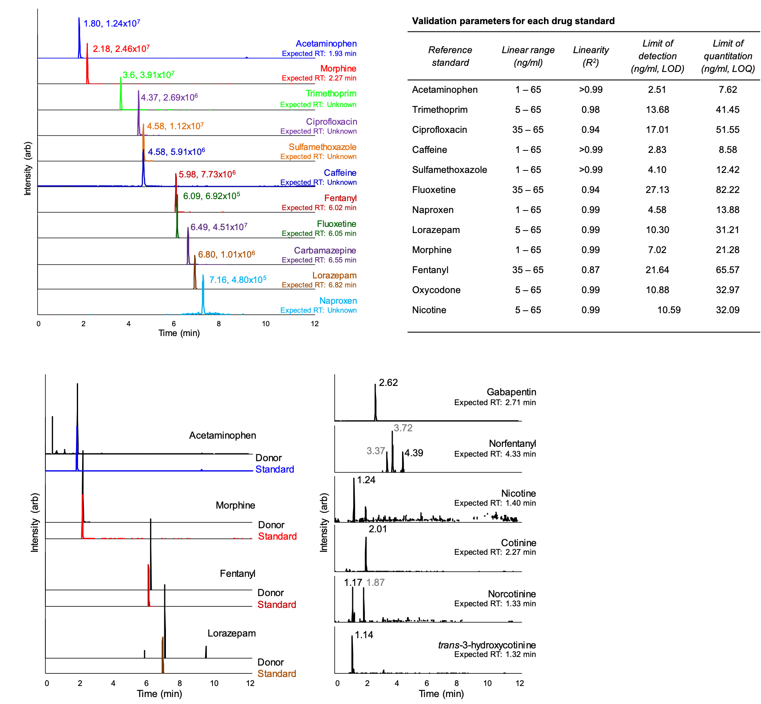
C
B
A

Figure 3.9 – Extracted ion chromatograms (EICs) and method validation parameters. (A) EICs of standards as well as expected and actual retention times and intensities for each drug. (B) Linearity parameters, LOD, and LOQ of detected drug standards. (C) Method validation on a test donor with donor EICs shown in black and standard EICs shown in color (left) together with EICs of the other 6 drugs detected from the donor (right). The expected retention time is shown below the name and the actual retention time of each drug is listed above spectral features. Times shown in black are the most likely match to the drug.

Table 3.3 – Postmortem toxicology of different human specimens using LC/MS
Table 3.4 – Absolute postmortem drug concentrations in different matrices (in ng/ml). Commercially available drug standards included acetaminophen (A), fentanyl (F), lorazepam (L), morphine (M), nicotine (N), and oxycodone (O). No serum could be obtained from donor Tox 001, 003, 005, and 018. No larvae and fluid samples were collected for Tox 015. Tox 014 was excluded from the project. C = central serum (aorta), P = peripheral serum (femoral vein).

SERUM |  |  |  |  |  |  | LARVAE
 | Concentration drug standards (in ng/ml) |  |  |  |  |  | Concentration drug standards (in ng/ml)
Donor ID | A* | F | L | M | O | N | A | F | L | M | O | N
Tox 001 |  |  |  |  |  |  | 8.71-1912.78 |  |  |  |  | 15.36-111.52
Tox 002
Tox 003 |  |  |  |  |  |  | 4.70-47.86
Tox 004 | C: 262.92  P: 226.80 |  | C: 69.66  P: 59.02 | C: 543.21  P: 93.12 |  |  | 0.71-18.86 |  | 1.04-53.71 | 10.42-193.77 |  | 2.13-13.30
Tox 005 |  |  |  |  |  |  | 4.00-96.80 |  | 3.90-15.55 | 2.89-31.15
Tox 006 | C: 9616.33  P: 3705.44 |  |  |  |  | C: 321.21  P: 150.62 | 186.33-1448.68 |  |  |  |  | 9.06-52.27
Tox 007 | C: 6451.37  P: 4956.87 |  |  | C: 189.39  P: 97.53 |  |  | 14.48-1522.26 |  |  | 29.84-271.73
Tox 008 | C: 1109.2  P: 679.75 | C: 630.70  P: 351.66 | C: 95.50  P: 34.97 | C: 34.00  P: 17.23 | C: 1033.29  P: 371.63 |  | 5.67-167.05 |  | 1.88-8.60 | 4.30-28.77 | 36.73-88.71
Tox 009 |  |  | C: 134.31  P: 102.96 | C: 245.21  P: 244.55 |  |  |  |  | 1.39-57.71 | 7.33-133.53 |  | 8.22-13.10
Tox 010 |  |  |  |  |  |  | 19.49-75.70
Tox 011
Tox 012 |  |  | C: 397.52  P: 37.71 | C: 30071.04 P: 304.31 |  |  |  |  | 2.37-54.11 | 57.40-291.12
Tox 013 |  |  |  |  |  |  | 76.31-173.28
Tox 015 |  | C: 43.03  P: 44.13 | C: 13.10  P: 19.77 | C: 186.57  P: 138.99
Tox 016 |  |  |  |  |  |  |  |  |  |  |  | 2.48-5.66
Tox 017 | C: 7774.00  P: 5904.16 |  |  |  |  |  | 26.80-291.08
Tox 018 |  |  |  |  |  |  | 10.72
Tox 019 |  |  | C: 108.46  P: 61.63 | C: 4327.46  P: 170.07 |  | C: 97.18l  P: 44.76 |  |  |  | 58.64-645.53 | 7.01-76.38 | 1.10-2.00
Tox 020
Tox 021 |  |  | C: 383.10  P: 257.51 | C: 39.11  P: 37.23 |  | C: 70.14  P: 46.12 |  |  | 24.38-179.31 | 4.79-65.18 |  | 7.02-73.60
Tox 022
DECOMPOSITION FLUID |  |  |  |  |  |  | DECOMPOSITION SOIL
 | Concentration drug standards (in ng/ml) |  |  |  |  |  | Concentration drug standards (in ng/ml)
Donor ID | A | F | L | M | O | N | A | F | L | M | O | N
Tox 001 | 454.48-6516.36 |  |  |  |  | 25.72-108.06 | 0.63-2.94 |  |  |  |  | 2.38-3.56
Tox 002
Tox 003 | 157.60-1483.72 |  |  |  |  |  | 1.11-164.68
Tox 004 | 253.76 |  | 18.02 | 477.31 |  | 26.56 | 1.22-6.76 |  | 0.94-5.85 | 0.20-6.83 |  | 2.35-3.24
Tox 005 | 20.93-2358.64 |  | 3.74-56.15 | 1.93-243.55 |  |  | 1.48-40.06 |  | 1.22-4.40 | 0.08-20.40
Tox 006 | 7324.05-12938.32 |  |  |  |  | 53.30-214.09 | 7.24-284.48 |  |  |  |  | 2.97-9.44
Tox 007 | 8302.81-10738.76 |  |  | 514.42-884.39 |  |  | 8.83-476.52 |  |  | 0.10-125.48
Tox 008 | 1699.50-3308.79 |  | 3.79-50.43 | 59.93-357.14 | 68.82-245.98 |  | 4.01-6.47 |  | 1.04 | 0.11-4.69 | 0.71-8.01
Tox 009 |  |  | 19.97-29.04 | 0.84-21.96 |  | 6.35-12.03 |  |  | 1.63-6.57 | 0.14-17.55 |  | 2.99-3.51
Tox 010 | 0.20-2096.55 |  |  |  |  |  | 0.12-46.85
Tox 011
Tox 012 |  |  | 17.51-24.41 | 20.74-758.61 |  |  |  |  | 2.34-17.27 | 11.63-13.14
Tox 013 | 64.37-396.50 |  |  |  |  |  | 9.41-339.24
Tox 015
Tox 016 |  |  |  |  |  | 4.48-5.23 |  |  |  |  |  | 0.17-0.23
Tox 017 | 7.23-2332.75 |  |  |  |  |  | 0.12-3.89
Tox 018 |  |  |  |  |  |  | 0.25-0.48
Tox 019 |  |  | 13.07-56.84 | 488.02-827.48 |  | 2.28-3.12 |  |  | 1.36-2.54 | 5.45-8.77 |  | 0.02-0.13
Tox 020
Tox 021 |  |  | 109.45 | 4.79 |  | 42.69
Tox 022
* A=Acetaminophen, F= Fentanyl, L= Lorazepam, M= Morphine, O= Oxycodone, N= Nicotine
C= Central, P= Peripheral

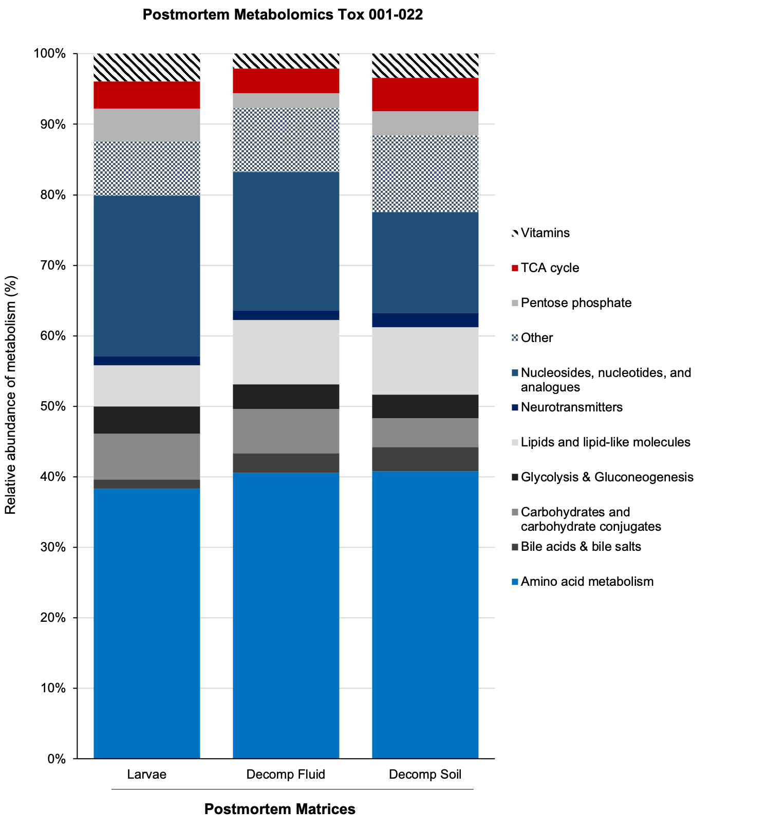
Figure 3.10 – Relative abundance of metabolites in three postmortem matrices collected over the course of decomposition until active decay. Compound classes are shown on the right. In each of the matrices most detected metabolites (around 40%) were linked to the amino acid metabolism.

A
B

Figure 3.11 – Intra-donor comparison for donor Tox 003 using multivariate analysis. Evaluation of decomposition fluid and larvae collected from various locations and time points after death on Tox 003.

Figure 3.12 – Multivariate analysis (PLS-DA) of larvae, decomposition fluid, and CDI soil for the remaining 11 donors (Tox 011-Tox 022)

.

Figure 3.13 – 3D PLS-DA plots of metabolomics data showing control and decomposition soil from all 22 donors.

Figure 3.13 – continued

Figure 3.13 – continued
Figure 3.13 – continued

Figure 3.13 – continued

Figure 3.13 – continued

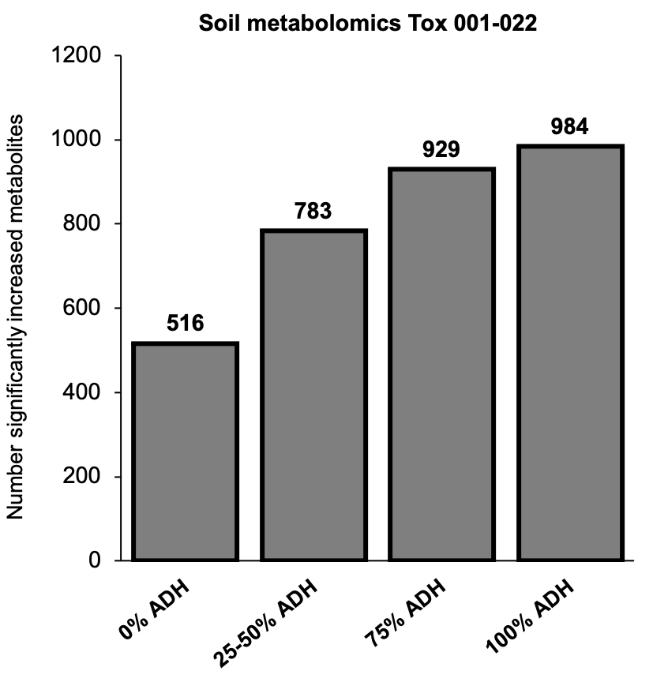

Figure 3.14 – Number of significantly increased metabolites in decomposition soil compared to control soil across the entire decomposition period of all 22 donors. All donor samples were grouped by percent ADH. A significant increase was determined by a fold change decomposition soil/control soil ≥ 1.5 and a p-value ≤ 0.1

Table 3.5 –Spearman rank correlation analysis. P-values of creatine, taurine, and pantothenate

 | Spearman p-values
Tox ID | creatine | taurine | pantothenate
Tox 001 | Not detected | <0.001 | <0.001
Tox 002 | 0.094 | 0.650 | 0.018
Tox 003 | 0.718 | 0.023 | 0.043
Tox 004 | 0.505 | 0.836 | 0.782
Tox 005 | 0.005 | 0.003 | <0.001
Tox 006 | 0.637 | 0.302 | <0.001
Tox 007 | 0.593 | <0.001 | 0.003
Tox 008 | 0.997 | 0.630 | 0.973
Tox 009 | Not detected | 0.003 | 0.002
Tox 010 | 0.002 | 0.081 | 0.375
Tox 011 | 0.075 | <0.001 | <0.001
Tox 012 | 0.802 | 0.008 | 0.002
Tox 013 | 0.484 | 0.126 | 0.098
Tox 015 | 0.466 | 0.289 | 0.852
Tox 016 | 0.518 | 0.878 | 0.404
Tox 017 | Not detected | 0.001 | 0.001
Tox 018 | Not detected | 0.002 | <0.001
Tox 019 | Not detected | 0.210 | 0.021
Tox 020 | 0.442 | 0.629 | 0.040
Tox 021 | 0.48 | 0.02 | <0.001
Tox 022 | <0.001 | <0.001 | <0.001

CONCLUSION

Advances in analytical chemistry have enabled the design of high-resolution mass spectrometry platforms which were used in this study to investigate signatures of mammalian decomposition in an outdoor research taphonomy facility in Knoxville, Tennessee, USA. The work presented in these few chapters exemplifies the exploratory nature of several chemometric strategies promising in uniting analytical chemistry with forensic science. Generated datasets using omics platforms might appear at the first glace overwhelming based on the data amount generated, however, it can hardly be overlooked that the information gain outweighs by opening new avenues of forensic science. It seems fairly obvious that one of the greatest potentials might be in the field of postmortem interval (PMI) estimation – the most central (and challenging) question in every forensic investigation. Using a group of metabolites as decomposition biomarker could help along with current techniques to increase precision and accuracy of such estimates. But even without focusing on individual biomolecules, omics studies yield undoubtfully a great knowledge gain when it comes to understanding overall decomposition trajectories. All the above chapters demonstrated how versatile, complex and dynamic the postmortem environment is, yet, at the same time susceptible to a likewise complex amount of intrinsic and extrinsic factors. Knowing this, it similarly requires a diverse approach to capture these dynamics. Rapidly developing state-of-the-art analytical platforms will meet these needs ever better in near future and therefore allow on a more superior level to elucidate and understand taphonomy.
On the other hand, all of the three studies in this dissertation have also revealed clear limitations. Generally, it should be noted that our outcomes are referring solely to the local environment and soil type prevailing at the Anthropology Research Facility (ARF) in Knoxville, Tennessee, USA. Accordingly, the varying experimental outdoor designs found across literature challenged the interpretation of our results. How and to which extent the nutrient influx from decomposing remains differs for scenarios at other taphonomy facilities for instance the one in Sydney (AFTER, Australian Facility for Taphonomic Experimental Research) remains to be determined in future. Certainly, one of the most intense criticism taphonomy facilities face is related to the contamination or saturation of soil with decomposition-derived products which has been thought of to make it impossible to obtain a feasible molecular baseline from within these facilities^{116, 186}. Studies by Damann et al., revealed high similarity of soils obtained from within the ARF in Knoxville contrasting samples taken from approximately 1 km away in a similar forest biome¹⁸⁶. Characteristic ARF soil features comprised elevated pH, total nitrogen, water, and lipid phosphorus along with a reduced carbon-to-nitrogen (C/N) ratio in areas of high decomposition¹⁸⁶. The proposed homogenization of ARF soils was speculated to result from a continuous decomposition input spanning over 40 years of research. Thus, soil chemistry has most likely not yet returned to a baseline level and soil microbial communities could have adapted to the prevalent soil composition. Secondly, one of the most difficult aspects of metabolomics is the snapshot it obtains when it analyzes metabolic profiles. It cannot be determined, at least at this point, whether changes in metabolite abundances were of catabolic or anabolic nature nor if they appeared due to alteration of transport systems. Furthermore, metabolite abundance changes do not provide a comprehensive and definite conclusion about functional, systemic changes. And, as stated above, the origin of each metabolite (plant-, human-, or microbial-derived) remains to be elucidated in future work, as well.
Nevertheless, the performed untargeted studies considerably contributed to the taphonomy groundwork broadening the understanding of fundamental processes of decomposition and the cycling of decomposition products from carcasses into the surrounding ecosystem important for ultimate biomarker discovery. This dissertation successfully demonstrated the potential of metabolomics throughout several different research designs, specimens, as well as species. Through a comprehensive literature research, we have tentatively interpreted the observed findings with the hope to attract enough scientific curiosity for future researches pursuing these endeavors for a more holistic view of the decomposition. Several biological relevant compounds and their metabolic pathways were identified and tried to link to decomposition. To our knowledge only a few other studies have investigated the postmortem biochemical environment on such a detailed molecular scale with superior analytical instrumentation. Through our analyses we have demonstrated that postmortem samples taken from a burial were susceptible to the heterogenous microhabitat prevailing at different burial depths and likewise on a variety of skeletal remains. An inter- and intraindividual analysis revealed differences in the postmortem biochemical dynamics one should be aware of when sampling from a multi-individual grave. Additionally, we have identified differential molecular signatures in the cadaver decomposition island (CDI) from decomposing humans and pigs. From a biochemical perspective, it was noticeable that decay progressed on a different scale among both mammals. When it comes to deconvoluting intrinsic drivers of human decomposition, i.e., drugs and/or diseases, we demonstrated the urge for more intradisciplinary research to verify our exploratory findings and definitively pinpoint impacts of intrinsic drivers on decomposition. This being said, our work was most certainly the first assigning unique toxicological profiles to a decomposing cadaver with the novelty of detecting drugs/drug metabolites in several cadaveric specimens (serum, larvae, decomposition fluid, and soil). Also, several unknown spectral features were identified, to which future researcher can refer as research and development of analytical instrumentation progresses. Assuming that at this point only a minor percentage, most likely less than 10%, of metabolites have been identified, the unique nature of an untargeted approach enables future studies to refer to such discovery-based approaches like ours.
Last but not least, the attentive reader certainly noticed that soil organic matter was the only constant matrix in all three chapters. Not only decomposition but also control soils were obtained for all projects, which is why a currently ongoing comparative inter-study analysis aims to determine if there is a coinciding metabolic signature of decomposition soil (data not shown). During these early stages, multivariate analysis has drawn the attention to a selected number of metabolites enriched in decomposition-impacted soils. In detail, creatine, methionine, and taurine were the only amino acids consistently and significantly (volcano plot analysis) increased in cadaveric soils when comparing (a) grave soils (chapter I), (b) CDI soils from mammalian cadavers (chapter II), as well as (c) solely humans (chapter III) with controls (inter-study p-value range for creatine, methionine, taurine p = 0.04 – 4.89E-115, data not shown). An exciting result considering the fact that both taurine and creatine can be obtained from the conversion of methionine, thus making them lucrative target biomolecules for future experiments centering around decomposition biomarkers and/or postmortem interval estimation studies.

REFERENCES

1. Nolan, A.-N. Investigating the peptide profile of decomposition fluid by liquid chromatography mass spectrometry to assist in the determination of the post-mortem interval (PMI). Murdoch University, 2020.
2. Goff, M. L., Early post-mortem changes and stages of decomposition in exposed cadavers. Experimental and applied acarology 2009, 49 (1), 21-36.
3. Damann, F. E., Human Decomposition Ecology at the University of Tennessee Anthropology Research Facility. 2010.
4. Stadler, S. Analysis of the volatile organic compounds produced by the decomposition of pig carcasses and human remains. 2013.
5. Comstock, J. L.; Desaulniers, J.-P.; LeBlanc, H. N.; Forbes, S. L., New decomposition stages to describe scenarios involving the partial and complete exclusion of insects. Canadian Society of Forensic Science Journal 2015, 48 (1), 1-19.
6. Clark, M. A.; Worrell, M. B.; Pless, J. E., Postmortem changes in soft tissues. Forensic taphonomy: the postmortem fate of human remains 1997, 151-164.
7. Buis, R. C. The validation of human decomposition fluid as a cadaver-detection dog training aid. 2016.
8. Nolan, A.-N. D.; Mead, R. J.; Maker, G.; Speers, S. J., A review of the biochemical products produced during mammalian decomposition with the purpose of determining the post-mortem interval. Australian Journal of Forensic Sciences 2020, 52 (4), 477-488.
9. Hau, T. C.; Hamzah, N. H.; Lian, H. H.; Hamzah, S., Decomposition process and post mortem changes. Sains Malaysiana 2014, 43 (12), 1873-1882.
10. Carter, D. O.; Yellowlees, D.; Tibbett, M., Cadaver decomposition in terrestrial ecosystems. Naturwissenschaften 2007, 94 (1), 12-24.
11. Forbes, S. L., Decomposition chemistry in a burial environment. In Soil analysis in forensic taphonomy, CRC Press: 2008; pp 215-236.
12. Pinheiro, J.; 00E3o, Decay process of a cadaver. Forensic anthropology and medicine: complementary sciences from recovery to cause of death 2006, 85-116.
13. Dautartas, A. M., The effect of various coverings on the rate of human decomposition. Masters Theses 2009, 69.
14. Wescott, D. J., Recent advances in forensic anthropology: decomposition research. Forensic sciences research 2018, 3 (4), 278-293.
15. Mann, R. W.; Bass, W. M.; Meadows, L., Time since death and decomposition of the human body: variables and observations in case and experimental field studies. Journal of Forensic Science 1990, 35 (1), 103-111.
16. Dent, B. B.; Forbes, S. L.; Stuart, B. H., Review of human decomposition processes in soil. Environmental geology 2004, 45 (4), 576-585.
17. Janaway, R. C.; Percival, S. L.; Wilson, A. S., Decomposition of human remains. In Microbiology and aging, Springer: 2009; pp 313-334.
18. Vass, A. A.; Barshick, S.-A.; Sega, G.; Caton, J.; Skeen, J. T.; Love, J. C.; Synstelien, J. A., Decomposition chemistry of human remains: a new methodology for determining the postmortem interval. Journal of Forensic Science 2002, 47 (3), 542-553.
19. Vass, A. A., Odor mortis. Forensic Science International 2012, 222 (1-3), 234-241.
20. Cablk, M. E.; Szelagowski, E. E.; Sagebiel, J. C., Characterization of the volatile organic compounds present in the headspace of decomposing animal remains, and compared with human remains. Forensic science international 2012, 220 (1-3), 118-125.
21. Statheropoulos, M.; Spiliopoulou, C.; Agapiou, A., A study of volatile organic compounds evolved from the decaying human body. Forensic science international 2005, 153 (2-3), 147-155.
22. Dekeirsschieter, J.; Stefanuto, P.-H.; Brasseur, C.; Haubruge, E.; Focant, J.-F., Enhanced characterization of the smell of death by comprehensive two-dimensional gas chromatography-time-of-flight mass spectrometry (GCxGC-TOFMS). PLoS One 2012, 7 (6), e39005.
23. Brasseur, C.; Dekeirsschieter, J.; Schotsmans, E. M.; de Koning, S.; Wilson, A. S.; Haubruge, E.; Focant, J.-F., Comprehensive two-dimensional gas chromatography–time-of-flight mass spectrometry for the forensic study of cadaveric volatile organic compounds released in soil by buried decaying pig carcasses. Journal of chromatography A 2012, 1255, 163-170.
24. Vass, A. A.; Smith, R. R.; Thompson, C. V.; Burnett, M. N.; Dulgerian, N.; Eckenrode, B. A., Odor analysis of decomposing buried human remains. Journal of Forensic Sciences 2008, 53 (2), 384-391.
25. Aitkenhead-Peterson, J. A.; Alexander, M. B.; Bytheway, J. A.; Carter, D. O.; Wescott, D. J., Applications of soil chemistry in forensic entomology. Forensic entomology: International dimensions and frontiers 2015, 283.
26. DeBruyn, J. M.; Hoeland, K. M.; Taylor, L. S.; Stevens, J. D.; Moats, M. A.; Bandopadhyay, S.; Dearth, S. P.; Castro, H. F.; Hewitt, K. K.; Campagna, S. R., Comparative Decomposition of Humans and Pigs: Soil Biogeochemistry, Microbial Activity and Metabolomic Profiles. Frontiers in microbiology 2021, 11, 3521.
27. Hopkins, D.; Wiltshire, P.; Turner, B., Microbial characteristics of soils from graves: an investigation at the interface of soil microbiology and forensic science. Applied Soil Ecology 2000, 14 (3), 283-288.
28. Keenan, S. W.; Emmons, A. L.; Taylor, L. S.; Phillips, G.; Mason, A. R.; Mundorff, A. Z.; Bernard, E. C.; Davoren, J.; DeBruyn, J. M., Spatial impacts of a multi-individual grave on microbial and microfaunal communities and soil biogeochemistry. PloS one 2018, 13 (12), e0208845.
29. Vass, A. A.; Bass, W. M.; Wolt, J. D.; Foss, J. E.; Ammons, J. T., Time since death determinations of human cadavers using soil solution. Journal of Forensic Science 1992, 37 (5), 1236-1253.
30. Larizza, M.; Forbes, S. L., Detection of fatty acids in the lateral extent of the cadaver decomposition island. Geological Society, London, Special Publications 2013, 384 (1), 209-219.
31. Barton, P. S.; Reboldi, A.; Dawson, B. M.; Ueland, M.; Strong, C.; Wallman, J. F., Soil chemical markers distinguishing human and pig decomposition islands: a preliminary study. Forensic Science, Medicine and Pathology 2020, 16 (4), 605-612.
32. Fancher, J.; Aitkenhead-Peterson, J.; Farris, T.; Mix, K.; Schwab, A.; Wescott, D.; Hamilton, M., An evaluation of soil chemistry in human cadaver decomposition islands: Potential for estimating postmortem interval (PMI). Forensic science international 2017, 279, 130-139.
33. Benninger, L. A.; Carter, D. O.; Forbes, S. L., The biochemical alteration of soil beneath a decomposing carcass. Forensic science international 2008, 180 (2-3), 70-75.
34. Anderson, B.; Meyer, J.; Carter, D. O., Dynamics of ninhydrin‐reactive nitrogen and pH in gravesoil during the extended postmortem interval. Journal of Forensic Sciences 2013, 58 (5), 1348-1352.
35. Cobaugh, K. L.; Schaeffer, S. M.; DeBruyn, J. M., Functional and structural succession of soil microbial communities below decomposing human cadavers. PloS one 2015, 10 (6), e0130201.
36. Castillo-Peinado, L.; de Castro, M. L., Present and foreseeable future of metabolomics in forensic analysis. Analytica chimica acta 2016, 925, 1-15.
37. Marchand, J.; Guitton, Y.; Martineau, E.; Royer, A.-L.; Balgoma, D.; Le Bizec, B.; Giraudeau, P.; Dervilly, G., Combining mass spectrometric platforms for lipidome investigation-Application to the characterisation of disruptions in the lipid profile of pig serum upon β-agonist treatment. bioRxiv 2020.
38. Fiehn, O.; Weckwerth, W., Deciphering metabolic networks. European Journal of Biochemistry 2003, 270 (4), 579-588.
39. Fiehn, O., Metabolomics—the link between genotypes and phenotypes. Functional genomics 2002, 155-171.
40. Akcan, R.; Taştekin, B.; Yildirim, M. Ş.; Aydogan, H. C.; Sağlam, N., Omics era in forensic medicine: Towards a new age. Turkish journal of medical sciences 2020, 50 (5), 1480-1490.
41. Locci, E.; Stocchero, M.; Noto, A.; Chighine, A.; Natali, L.; Napoli, P. E.; Caria, R.; De-Giorgio, F.; Nioi, M.; d’Aloja, E., A 1 H NMR metabolomic approach for the estimation of the time since death using aqueous humour: an animal model. Metabolomics 2019, 15 (5), 76.
42. Pesko, B. K.; Weidt, S.; McLaughlin, M.; Wescott, D. J.; Torrance, H.; Burgess, K.; Burchmore, R., Postmortomics: The potential of untargeted metabolomics to highlight markers for time since death. OMICS: A Journal of Integrative Biology 2020, 24 (11), 649-659.
43. Rousseau, G.; Chao de la Barca, J. M.; Rougé-Maillart, C.; Teresiński, G.; Chabrun, F.; Dieu, X.; Drevin, G.; Mirebeau-Prunier, D.; Simard, G.; Reynier, P., Preliminary Metabolomic Profiling of the Vitreous Humor from Hypothermia Fatalities. Journal of Proteome Research 2021, 20 (5), 2390-2396.
44. Zelentsova, E. A.; Yanshole, L. V.; Melnikov, A. D.; Kudryavtsev, I. S.; Novoselov, V. P.; Tsentalovich, Y. P., Post-mortem changes in metabolomic profiles of human serum, aqueous humor and vitreous humor. Metabolomics 2020, 16 (7), 1-10.
45. Zelentsova, E. A.; Yanshole, L. V.; Snytnikova, O. A.; Yanshole, V. V.; Tsentalovich, Y. P.; Sagdeev, R. Z., Post-mortem changes in the metabolomic compositions of rabbit blood, aqueous and vitreous humors. Metabolomics 2016, 12 (11), 1-11.
46. Zhang, J.; Wang, M.; Qi, X.; Shi, L.; Zhang, J.; Zhang, X.; Yang, T.; Ren, J.; Liu, F.; Zhang, G., Predicting the postmortem interval of burial cadavers based on microbial community succession. Forensic Science International: Genetics 2021, 52, 102488.
47. Carter, D. O.; Yellowlees, D.; Tibbett, M., Temperature affects microbial decomposition of cadavers (Rattus rattus) in contrasting soils. Applied Soil Ecology 2008, 40 (1), 129-137.
48. Child, A. M., Microbial taphonomy of archaeological bone. Studies in conservation 1995, 40 (1), 19-30.
49. Metcalf, J. L.; Parfrey, L. W.; Gonzalez, A.; Lauber, C. L.; Knights, D.; Ackermann, G.; Humphrey, G. C.; Gebert, M. J.; Van Treuren, W.; Berg-Lyons, D., A microbial clock provides an accurate estimate of the postmortem interval in a mouse model system. elife 2013, 2, e01104.
50. Metcalf, J. L.; Xu, Z. Z.; Weiss, S.; Lax, S.; Van Treuren, W.; Hyde, E. R.; Song, S. J.; Amir, A.; Larsen, P.; Sangwan, N., Microbial community assembly and metabolic function during mammalian corpse decomposition. Science 2016, 351 (6269), 158-162.
51. binti Johari, I. S., Lipidomic characterisation and profiling of soil for forensic investigations. 2018.
52. Carter, D. O.; Filippi, J.; Higley, L. G.; Huntington, T. E.; Okoye, M. I.; Scriven, M.; Bliemeister, J., Using ninhydrin to reconstruct a disturbed outdoor death scene. Journal of Forensic Identification 2009, 59 (2), 190-195.
53. Forbes, S. L.; Keegan, J.; Stuart, B. H.; Dent, B. B., A gas chromatography‐mass spectrometry method for the detection of adipocere in grave soils. European Journal of Lipid Science and Technology 2003, 105 (12), 761-768.
54. Procopio, N.; Ghignone, S.; Williams, A.; Chamberlain, A.; Mello, A.; Buckley, M., Metabarcoding to investigate changes in soil microbial communities within forensic burial contexts. Forensic Science International: Genetics 2019, 39, 73-85.
55. Swenson, T. L.; Jenkins, S.; Bowen, B. P.; Northen, T. R., Untargeted soil metabolomics methods for analysis of extractable organic matter. Soil Biology and Biochemistry 2015, 80, 189-198.
56. Fan, T. W.-M.; Bird, J. A.; Brodie, E. L.; Lane, A. N., 13 C-Isotopomer-based metabolomics of microbial groups isolated from two forest soils. Metabolomics 2009, 5 (1), 108-122.
57. Zhou, R.; Yu, Q.; Li, T.; Long, M.; Wang, Y.; Feng, T.; Su, W.; Yang, J.; Li, H., Carcass decomposition influences the metabolic profiles and enriches noxious metabolites in different water types by widely targeted metabolomics. Chemosphere 2021, 269, 129400.
58. Langley, N. R.; Wood, P.; Herling, P.; Steadman, D. W., Forensic Postmortem Interval Estimation from Skeletal Muscle Tissue: A Lipidomics Approach. Forensic Anthropology 2019, 2 (3), 152-157.
59. Procopio, N.; Chamberlain, A. T.; Buckley, M., Intra-and Interskeletal proteome variations in fresh and buried bones. Journal of proteome research 2017, 16 (5), 2016-2029.
60. Prieto-Bonete, G.; Pérez-Cárceles, M. D.; Maurandi-López, A.; Pérez-Martínez, C.; Luna, A., Association between protein profile and postmortem interval in human bone remains. Journal of proteomics 2019, 192, 54-63.
61. Mickleburgh, H. L.; Schwalbe, E. C.; Bonicelli, A.; Mizukami, H.; Sellitto, F.; Starace, S.; Wescott, D. J.; Carter, D. O.; Procopio, N., Human Bone Proteomes before and after Decomposition: Investigating the Effects of Biological Variation and Taphonomic Alteration on Bone Protein Profiles and the Implications for Forensic Proteomics. Journal of proteome research 2021, 20 (5), 2533-2546.
62. Troutman, L.; Moffatt, C.; Simmons, T., A preliminary examination of differential decomposition patterns in mass graves. Journal of forensic sciences 2014, 59 (3), 621-626.
63. Iancu, L.; Junkins, E. N.; Necula-Petrareanu, G.; Purcarea, C., Characterizing forensically important insect and microbial community colonization patterns in buried remains. Scientific reports 2018, 8 (1), 1-16.
64. von der Lühe, B.; Prost, K.; Birk, J. J.; Fiedler, S., Steroids aid in human decomposition fluid identification in soils of temporary mass graves from World War II. Journal of Archaeological Science: Reports 2020, 32, 102431.
65. Rodriguez, W. C.; Bass, W. M., Decomposition of buried bodies and methods that may aid in their location. Journal of Forensic Science 1985, 30 (3), 836-852.
66. Turner, B.; Wiltshire, P., Experimental validation of forensic evidence: a study of the decomposition of buried pigs in a heavy clay soil. Forensic Science International 1999, 101 (2), 113-122.
67. Mant, A. K. A study in exhumation data. University of London, 1950.
68. Pate, F. D.; Hutton, J. T., The use of soil chemistry data to address post-mortem diagenesis in bone mineral. Journal of Archaeological Science 1988, 15 (6), 729-739.
69. Kendall, C.; Eriksen, A. M. H.; Kontopoulos, I.; Collins, M. J.; Turner-Walker, G., Diagenesis of archaeological bone and tooth. Palaeogeography, Palaeoclimatology, Palaeoecology 2018, 491, 21-37.
70. Department, D. U. F. A. a. A. Bone Diagenesis (decay). https://www.futurelearn.com/info/courses/forensic-archaeology-and-anthropology/0/steps/67871 (accessed Aug 26, 2021).
71. López-Costas, O.; Lantes-Suárez, Ó.; Cortizas, A. M., Chemical compositional changes in archaeological human bones due to diagenesis: Type of bone vs soil environment. Journal of Archaeological Science 2016, 67, 43-51.
72. Matthiesen, H.; Eriksen, A. M. H.; Hollesen, J.; Collins, M., Bone degradation at five Arctic archaeological sites: Quantifying the importance of burial environment and bone characteristics. Journal of Archaeological Science 2021, 125, 105296.
73. Marchiafava, V.; Bonucci, E.; Ascenzi, A., Fungal osteoclasia: a model of dead bone resorption. Calcified tissue research 1974, 14 (1), 195-210.
74. Föllmi, K., The phosphorus cycle, phosphogenesis and marine phosphate-rich deposits. Earth-Science Reviews 1996, 40 (1-2), 55-124.
75. Emmons, A. L.; Davoren, J.; DeBruyn, J. M.; Mundorff, A. Z., Inter and intra-individual variation in skeletal DNA preservation in buried remains. Forensic Science International: Genetics 2020, 44, 102193.
76. Lu, W.; Clasquin, M. F.; Melamud, E.; Amador-Noguez, D.; Caudy, A. A.; Rabinowitz, J. D., Metabolomic analysis via reversed-phase ion-pairing liquid chromatography coupled to a stand alone orbitrap mass spectrometer. Analytical chemistry 2010, 82 (8), 3212-3221.
77. Martens, L.; Chambers, M.; Sturm, M.; Kessner, D.; Levander, F.; Shofstahl, J.; Tang, W. H.; Römpp, A.; Neumann, S.; Pizarro, A. D., mzML—a community standard for mass spectrometry data. Molecular & Cellular Proteomics 2011, 10 (1), R110. 000133.
78. Clasquin, M. F.; Melamud, E.; Rabinowitz, J. D., LC‐MS data processing with MAVEN: a metabolomic analysis and visualization engine. Current protocols in bioinformatics 2012, 37 (1), 14.11. 1-14.11. 23.
79. Melamud, E.; Vastag, L.; Rabinowitz, J. D., Metabolomic analysis and visualization engine for LC− MS data. Analytical chemistry 2010, 82 (23), 9818-9826.
80. Chong, J.; Wishart, D. S.; Xia, J., Using MetaboAnalyst 4.0 for comprehensive and integrative metabolomics data analysis. Current protocols in bioinformatics 2019, 68 (1), e86.
81. Treutler, H.; Neumann, S., Prediction, detection, and validation of isotope clusters in mass spectrometry data. Metabolites 2016, 6 (4), 37.
82. Kind, T.; Fiehn, O., Seven Golden Rules for heuristic filtering of molecular formulas obtained by accurate mass spectrometry. BMC bioinformatics 2007, 8 (1), 1-20.
83. Rivas-Ubach, A.; Liu, Y.; Bianchi, T. S.; Tolic, N.; Jansson, C.; Pasa-Tolic, L., Moving beyond the van Krevelen diagram: A new stoichiometric approach for compound classification in organisms. Analytical chemistry 2018, 90 (10), 6152-6160.
84. Zhao, Z.; Xian, M.; Liu, M.; Zhao, G., Biochemical routes for uptake and conversion of xylose by microorganisms. Biotechnology for biofuels 2020, 13 (1), 1-12.
85. Mierziak, J.; Burgberger, M.; Wojtasik, W., 3-Hydroxybutyrate as a Metabolite and a Signal Molecule Regulating Processes of Living Organisms. Biomolecules 2021, 11 (3), 402.
86. Pontiller, B.; Martínez-García, S.; Lundin, D.; Pinhassi, J., Labile dissolved organic matter compound characteristics select for divergence in marine bacterial activity and transcription. Frontiers in microbiology 2020, 11, 2365.
87. DeGreeff, L. E.; Furton, K. G., Collection and identification of human remains volatiles by non-contact, dynamic airflow sampling and SPME-GC/MS using various sorbent materials. Analytical and bioanalytical chemistry 2011, 401 (4), 1295-1307.
88. Senesi, N.; Loffredo, E., The chemistry of soil organic matter. In Soil physical chemistry, CRC press: 2018; pp 239-370.
89. Phillips, D. A.; Joseph, C. M.; Hirsch, P. R., Occurrence of flavonoids and nucleosides in agricultural soils. Applied and environmental microbiology 1997, 63 (11), 4573-4577.
90. Tsuchiya, K.; Sano, T.; Tomioka, N.; Kohzu, A.; Komatsu, K.; Shinohara, R.; Shimode, S.; Toda, T.; Imai, A., Incorporation characteristics of exogenous 15N-labeled thymidine, deoxyadenosine, deoxyguanosine and deoxycytidine into bacterial DNA. PloS one 2020, 15 (2), e0229740.
91. Hedges, R. E.; Millard, A. R., Bones and groundwater: towards the modelling of diagenetic processes. Journal of Archaeological Science 1995, 22 (2), 155-164.
92. Toppe, J.; Albrektsen, S.; Hope, B.; Aksnes, A., Chemical composition, mineral content and amino acid and lipid profiles in bones from various fish species. Comparative Biochemistry and Physiology Part B: Biochemistry and Molecular Biology 2007, 146 (3), 395-401.
93. Narayanan, A.; Khanchandani, P.; Borkar, R. M.; Ambati, C. R.; Roy, A.; Han, X.; Bhoskar, R. N.; Ragampeta, S.; Gannon, F.; Mysorekar, V., Avascular necrosis of femoral head: a metabolomic, biophysical, biochemical, electron microscopic and histopathological characterization. Scientific reports 2017, 7 (1), 1-16.
94. Evershed, R. P.; Turner-Walker, G.; Hedges, R. E.; Tuross, N.; Leyden, A., Preliminary results for the analysis of lipids in ancient bone. Journal of Archaeological Science 1995, 22 (2), 277-290.
95. Alldritt, I.; Whitham-Agut, B.; Sipin, M.; Studholme, J.; Trentacoste, A.; Tripp, J. A.; Cappai, M. G.; Ditchfield, P.; Devièse, T.; Hedges, R. E., Metabolomics reveals diet-derived plant polyphenols accumulate in physiological bone. Scientific reports 2019, 9 (1), 1-12.
96. Grupe, G.; Turban-Just, S., Amino acid composition of degraded matrix collagen from archaeological human bone. Anthropologischer Anzeiger 1998, 213-226.
97. Giltay, E. J.; Kho, K. H.; Blansjaar, B. A.; Verbeek, M. M.; Geurtz, P. B. H.; Geleijnse, J. M.; Gooren, L. J., The sex difference of plasma homovanillic acid is unaffected by cross-sex hormone administration in transsexual subjects. Journal of endocrinology 2005, 187 (1), 109-116.
98. Nielsen-Marsh, C. M.; Hedges, R. E., Patterns of diagenesis in bone I: the effects of site environments. Journal of Archaeological Science 2000, 27 (12), 1139-1150.
99. Martínez-Reyes, I.; Chandel, N. S., Mitochondrial TCA cycle metabolites control physiology and disease. Nature communications 2020, 11 (1), 1-11.
100. Breusch, F., Citric acid cycle; sugar and fat breakdown in tissue metabolism. Science (Washington) 1943, 97, 490-492.
101. Miller, S. H.; Browne, P.; Prigent‐Combaret, C.; Combes‐Meynet, E.; Morrissey, J. P.; O'Gara, F., Biochemical and genomic comparison of inorganic phosphate solubilization in Pseudomonas species. Environmental microbiology reports 2010, 2 (3), 403-411.
102. Moghimi, A.; Tate, M., Does 2-ketogluconate chelate calcium in the pH range 2.4 to 6.4? Soil Biology and Biochemistry 1978, 10 (4), 289-292.
103. Vinolas, L.; Healey, J.; Jones, D., Kinetics of soil microbial uptake of free amino acids. Biology and fertility of soils 2001, 33 (1), 67-74.
104. Davis, P. J.; Gustafson, M. E.; Rosazza, J. P., Formation of indole-3-carboxylic acid by Chromobacterium violaceum. Journal of bacteriology 1976, 126 (1), 544-546.
105. Keenan, S. W.; Schaeffer, S. M.; Jin, V. L.; DeBruyn, J. M., Mortality hotspots: nitrogen cycling in forest soils during vertebrate decomposition. Soil Biology and Biochemistry 2018, 121, 165-176.
106. Van Krevelen, D., Graphical-statistical method for the study of structure and reaction processes of coal. Fuel 1950, 29, 269-284.
107. NandaKafle, G.; Christie, A. A.; Vilain, S.; Brözel, V. S., Growth and extended survival of Escherichia coli O157: H7 in soil organic matter. Frontiers in microbiology 2018, 9, 762.
108. Connor, M.; Baigent, C.; Hansen, E. S., Testing the use of pigs as human proxies in decomposition studies. Journal of forensic sciences 2018, 63 (5), 1350-1355.
109. Dautartas, A.; Kenyhercz, M. W.; Vidoli, G. M.; Meadows Jantz, L.; Mundorff, A.; Steadman, D. W., Differential decomposition among pig, rabbit, and human remains. Journal of forensic sciences 2018, 63 (6), 1673-1683.
110. Notter, S. J.; Stuart, B. H.; Rowe, R.; Langlois, N., The initial changes of fat deposits during the decomposition of human and pig remains. Journal of Forensic Sciences 2009, 54 (1), 195-201.
111. Schoenly, K. G.; Haskell, N. H.; Hall, R. D.; Gbur, J. R., Comparative performance and complementarity of four sampling methods and arthropod preference tests from human and porcine remains at the Forensic Anthropology Center in Knoxville, Tennessee. Journal of Medical Entomology 2007, 44 (5), 881-894.
112. Steadman, D. W.; Dautartas, A.; Kenyhercz, M. W.; Jantz, L. M.; Mundorff, A.; Vidoli, G. M., Differential scavenging among pig, rabbit, and human subjects. Journal of forensic sciences 2018, 63 (6), 1684-1691.
113. Luong, S.; Forbes, S. L.; Wallman, J. F.; Roberts, R. G., Monitoring the extent of vertical and lateral movement of human decomposition products through sediment using cholesterol as a biomarker. Forensic science international 2018, 285, 93-104.
114. Swift, M. J.; Heal, O. W.; Anderson, J. M.; Anderson, J., Decomposition in terrestrial ecosystems. 1979.
115. van Klink, R.; van Laar-Wiersma, J.; Vorst, O.; Smit, C., Rewilding with large herbivores: Positive direct and delayed effects of carrion on plant and arthropod communities. PloS one 2020, 15 (1), e0226946.
116. Matuszewski, S.; Hall, M. J.; Moreau, G.; Schoenly, K. G.; Tarone, A. M.; Villet, M. H., Pigs vs people: the use of pigs as analogues for humans in forensic entomology and taphonomy research. International journal of legal medicine 2020, 134 (2), 793-810.
117. Wang, Y.; Ma, M.-y.; Jiang, X.-y.; Wang, J.-f.; Li, L.-l.; Yin, X.-j.; Wang, M.; Lai, Y.; Tao, L.-y., Insect succession on remains of human and animals in Shenzhen, China. Forensic science international 2017, 271, 75-86.
118. Knobel, Z.; Ueland, M.; Nizio, K. D.; Patel, D.; Forbes, S. L., A comparison of human and pig decomposition rates and odour profiles in an Australian environment. Australian Journal of Forensic Sciences 2019, 51 (5), 557-572.
119. Şen Özdemir, N.; Parrish, C. C.; Parzanini, C.; Mercier, A., Neutral and polar lipid fatty acids in five families of demersal and pelagic fish from the deep Northwest Atlantic. ICES Journal of Marine Science 2019, 76 (6), 1807-1815.
120. Thomas, L. W., The chemical composition of adipose tissue of man and mice. Quarterly Journal of Experimental Physiology and Cognate Medical Sciences: Translation and Integration 1962, 47 (2), 179-188.
121. Heden, T. D.; Neufer, P. D.; Funai, K., Looking beyond structure: membrane phospholipids of skeletal muscle mitochondria. Trends in Endocrinology & Metabolism 2016, 27 (8), 553-562.
122. Ding, S.; Lange, M.; Lipp, J.; Schwab, V. F.; Chowdhury, S.; Pollierer, M. M.; Krause, K.; Li, D.; Kothe, E.; Scheu, S., Characteristics and origin of intact polar lipids in soil organic matter. Soil Biology and Biochemistry 2020, 151, 108045.
123. Megyesi, M. S.; Nawrocki, S. P.; Haskell, N. H., Using accumulated degree-days to estimate the postmortem interval from decomposed human remains. Journal of Forensic Science 2005, 50 (3), 1-9.
124. Rabinowitz, J. D.; Kimball, E., Acidic acetonitrile for cellular metabolome extraction from Escherichia coli. Analytical Chemistry 2007, 79 (16), 6167-6173.
125. Bligh, E. G.; Dyer, W. J., A rapid method of total lipid extraction and purification. Canadian journal of biochemistry and physiology 1959, 37 (8), 911-917.
126. Mueller, L. O.; Borstein, S. R.; Tague, E. D.; Dearth, S. P.; Castro, H. F.; Campagna, S. R.; Bailey, J. K.; Schweitzer, J. A., Populations of Populus angustifolia have evolved distinct metabolic profiles that influence their surrounding soil. Plant and Soil 2020, 1-13.
127. Wickham, H., ggplot2: elegant graphics for data analysis Springer; New York; 2009. URL http://had. co. nz/ggplot2/book.[Google Scholar].
128. Spicka, A.; Johnson, R.; Bushing, J.; Higley, L. G.; Carter, D. O., Carcass mass can influence rate of decomposition and release of ninhydrin-reactive nitrogen into gravesoil. Forensic science international 2011, 209 (1-3), 80-85.
129. Komar, D.; Beattie, O., Effects of carcass size on decay rates of shade and sun exposed carrion. Canadian Society of forensic science journal 1998, 31 (1), 35-43.
130. Information, N. C. f. B., National Center for Biotechnology Information (2021). PubChem Compound Summary for CID 439162, Sn-Glycerol 3-phosphate. . 2021, ( Retrieved July 24, 2021).
131. Hankard, R. G.; Hammond, D.; Haymond, M. W.; Darmaun, D., Oral glutamine slows down whole body protein breakdown in Duchenne muscular dystrophy. Pediatric research 1998, 43 (2), 222-226.
132. Song, Q.; Joshi, M.; DiPiazza, J.; Joshi, V., Functional relevance of citrulline in the vegetative tissues of watermelon during abiotic stresses. Frontiers in Plant Science 2020, 11, 512.
133. Swann, L. M.; Busetti, F.; Lewis, S. W., Determination of amino acids and amines in mammalian decomposition fluid by direct injection liquid chromatography-electrospray ionisation-tandem mass spectrometry. Analytical Methods 2012, 4 (2), 363-370.
134. Warren, C., A liquid chromatography–mass spectrometry method for analysis of intact fatty‐acid‐based lipids extracted from soil. European Journal of Soil Science 2018, 69 (5), 791-803.
135. Parkinson, R., Bacterial communities associated with human decomposition. 2009.
136. Warren, C. R., Soil microbial populations substitute phospholipids with betaine lipids in response to low P availability. Soil Biology and Biochemistry 2020, 140, 107655.
137. Hayman, J.; Oxenham, M., Peri-mortem disease treatment: a little known cause of error in the estimation of the time since death in decomposing human remains. Australian Journal of Forensic Sciences 2016, 48 (2), 171-185.
138. Skopyk, A. D.; Forbes, S. L.; LeBlanc, H. N., Recognizing the Inherent Variability in Dipteran Colonization and Decomposition Rates of Human Donors in Sydney, Australia. Journal of Clinical and Health Sciences 2021, 6 (1 (Special), 102-119.
139. Pélissier-Alicot, A.-L.; Gaulier, J.-M.; Champsaur, P.; Marquet, P., Mechanisms underlying postmortem redistribution of drugs: a review. Journal of analytical toxicology 2003, 27 (8), 533-544.
140. Butzbach, D. M., The influence of putrefaction and sample storage on post-mortem toxicology results. Forensic science, medicine, and pathology 2010, 6 (1), 35-45.
141. Peters, F. T.; Steuer, A. E., Antemortem and postmortem influences on drug concentrations and metabolite patterns in postmortem specimens. Wiley Interdisciplinary Reviews: Forensic Science 2019, 1 (1), e1297.
142. Elmsjö, A.; Vikingsson, S.; Söderberg, C.; Kugelberg, F. C.; Green, H., Post-Mortem Metabolomics: A Novel Approach in Clinical Biomarker Discovery and a Potential Tool in Death Investigations. Chemical Research in Toxicology 2021.
143. Chormatography, R. P., Big Pain Assays Aren’t a Big Pain with the Raptor Biphenyl
LC Column.
144. Team, R. C., R: A language and environment for statistical computing. 2013.
145. Kanehisa, M., Toward understanding the origin and evolution of cellular organisms. Protein Science 2019, 28 (11), 1947-1951.
146. Hastie, T.; Tibshirani, R.; Friedman, J., The elements of statistical learning: data mining, inference, and prediction. Springer Science & Business Media: 2009.
147. Giles, S. B.; Harrison, K.; Errickson, D.; Márquez-Grant, N., The effect of seasonality on the application of accumulated degree-days to estimate the early post-mortem interval. Forensic Science International 2020, 315, 110419.
148. Griffiths, K.; Krosch, M. N.; Wright, K., Variation in decomposition stages and carrion insect succession in a dry tropical climate and its effect on estimating postmortem interval. Forensic Sciences Research 2020, 5 (4), 327-335.
149. Smith, J. K., Raccoon Scavenging and the Taphonomic Effects on Early Human Decomposition and PMI Estimation. 2015.
150. Lupo, S., “The Big Pain”: Development of Pain-Free Methods for Analyzing 231 Multiclass Drugs and Metabolites by LC-MS/MS. MS. Lit. Cat.# CFAR2309-UNV 2016.
151. Apple, F. S., A better understanding of the interpretation of postmortem blood drug concentrations. Journal of analytical toxicology 2011, 35 (6), 381-383.
152. Bhat, M. A.; Shrivastav, A. B.; Qureshi, S. R.; Quadri, S. A., Forensic exploitation of veterinary entomology. Int J Agro Vet Med Sci 2011, 5 (4), 429-437.
153. Kshvary, D.; Rassi, Y.; OSHAGHI, M. A.; RAFIZADEH, S.; ALIMOHAMMADI, A. M.; NAMADI, M. S.; PARKHIDEH, S. Z., Analysis of the effect of methadone and temperature on the development rate of Calliphora vicina (Diptera: Calliphoridae): A forensically important fly. Nusantara Bioscience 2020, 12 (2).
154. Ishak, N.; Ahmad, A. H.; Nor, S. A. M.; Ahmad, A., Developmental cycle and growth of lucilia cuprina (diptera: Calliphoridae) fed on heroin: Implications for post-mortem interval (pmi) estimation in forensic investigations. ESTEEM Acad. J 2018, 14, 63-71.
155. Wang, S.; Zhang, C.; Chen, W.; Ren, L.; Ling, J.; Shang, Y.; Guo, Y., Effects of methamphetamine on the development and its determination in Aldrichina grahami (Diptera: Calliphoridae). Journal of medical entomology 2020, 57 (3), 691-696.
156. Oliveira, H. G.; Gomes, G.; Morlin Jr, J. J.; Von Zuben, C. J.; Linhares, A. X., The effect of Buscopan® on the development of the blow fly Chrysomya megacephala (F.)(Diptera: Calliphoridae). Journal of forensic sciences 2009, 54 (1), 202-206.
157. Al-Shuraym, L. A.; Al-Mekhlafi, F. A.; Abd Al Galil, F. M.; Alhag, S. K.; Al-Keridis, L. A.; Ali El Hadi Mohamed, R.; Wadaan, M. A.; Al-Khalifa, M. S., Effect of Zolpidem Tartrate on the Developmental Rate of Forensically Important Flies Chrysomya megacephala (Diptera: Calliphoridae) and Chrysomya saffranea. Journal of Medical Entomology 2021.
158. Gosselin, M.; Di Fazio, V.; Wille, S. M.; Fernandez, M. d. M. R.; Samyn, N.; Bourel, B.; Rasmont, P., Methadone determination in puparia and its effect on the development of Lucilia sericata (Diptera, Calliphoridae). Forensic science international 2011, 209 (1-3), 154-159.
159. El-Samad, L. M.; Tantawi, T. I.; El-Ghaffar, H. A.; Beltagy, B. I.; El-Abd, E., The effect of morphine on the development rate of flies (Diptera: Calliphoridae, Sarcophagidae) reared on rabbit carcasses containing this drug and its implications to postmortem interval estimates. Swed J BioSci Res 2020, 1 (1), 28-38.
160. Kharbouche, H.; Augsburger, M.; Cherix, D.; Sporkert, F.; Giroud, C.; Wyss, C.; Champod, C.; Mangin, P., Codeine accumulation and elimination in larvae, pupae, and imago of the blowfly Lucilia sericata and effects on its development. International journal of legal medicine 2008, 122 (3), 205-211.
161. Preußer, D.; Bröring, U.; Fischer, T.; Juretzek, T., Effects of antibiotics ceftriaxone and levofloxacin on the growth of Calliphora vomitoria L.(Diptera: Calliphoridae) and effects on the determination of the post mortem-interval. Journal of Forensic and Legal Medicine 2021, 102207.
162. Donaldson, A.; Lamont, I., Metabolomics of post-mortem blood: identifying potential markers of post-mortem interval. Metabolomics 2015, 11 (1), 237-245.
163. Metcalf, J. L.; Carter, D. O.; Knight, R., Microbiology of death. Current Biology 2016, 26 (13), R561-R563.
164. Macdonald, B. C.; Farrell, M.; Tuomi, S.; Barton, P. S.; Cunningham, S. A.; Manning, A., Carrion decomposition causes large and lasting effects on soil amino acid and peptide flux. Soil Biology and Biochemistry 2014, 69, 132-140.
165. Statheropoulos, M.; Agapiou, A.; Spiliopoulou, C.; Pallis, G. C.; Sianos, E., Environmental aspects of VOCs evolved in the early stages of human decomposition. Science of the Total Environment 2007, 385 (1-3), 221-227.
166. Kaszynski, R. H.; Nishiumi, S.; Azuma, T.; Yoshida, M.; Kondo, T.; Takahashi, M.; Asano, M.; Ueno, Y., Postmortem interval estimation: a novel approach utilizing gas chromatography/mass spectrometry-based biochemical profiling. Analytical and bioanalytical chemistry 2016, 408 (12), 3103-3112.
167. Urbaniak, C.; McMillan, A.; Angelini, M.; Gloor, G. B.; Sumarah, M.; Burton, J. P.; Reid, G., Effect of chemotherapy on the microbiota and metabolome of human milk, a case report. Microbiome 2014, 2 (1), 1-11.
168. Guo, K.; Cao, Y.; Li, Z.; Zhou, X.; Ding, R.; Chen, K.; Liu, Y.; Qiu, Y.; Wu, Z.; Fang, M., Glycine metabolomic changes induced by anticancer agents in A549 cells. Amino Acids 2020, 52, 793-809.
169. Durham, A.; Adcock, I., The relationship between COPD and lung cancer. Lung Cancer 2015, 90 (2), 121-127.
170. Yin, J.; Ren, W.; Huang, X.; Deng, J.; Li, T.; Yin, Y., Potential mechanisms connecting purine metabolism and cancer therapy. Frontiers in immunology 2018, 9, 1697.
171. Kumar, V., Adenosine as an endogenous immunoregulator in cancer pathogenesis: where to go? Purinergic signalling 2013, 9 (2), 145-165.
172. Gao, Z.-G.; Jacobson, K. A., A2B adenosine receptor and cancer. International journal of molecular sciences 2019, 20 (20), 5139.
173. Esther Jr, C. R.; Lazaar, A. L.; Bordonali, E.; Qaqish, B.; Boucher, R. C., Elevated airway purines in COPD. Chest 2011, 140 (4), 954-960.
174. Callejón-Leblic, B.; Pereira-Vega, A.; Vazquez-Gandullo, E.; Sánchez-Ramos, J.; Gomez-Ariza, J.; García-Barrera, T., Study of the metabolomic relationship between lung cancer and chronic obstructive pulmonary disease based on direct infusion mass spectrometry. Biochimie 2019, 157, 111-122.
175. Wang, L.; Tang, Y.; Liu, S.; Mao, S.; Ling, Y.; Liu, D.; He, X.; Wang, X., Metabonomic profiling of serum and urine by 1H NMR-based spectroscopy discriminates patients with chronic obstructive pulmonary disease and healthy individuals. PloS one 2013, 8 (6), e65675.
176. Martinez-Moral, M.-P.; Kannan, K., Allantoin as a marker of oxidative stress: Inter-and intraindividual variability in urinary concentrations in healthy individuals. Environmental Science & Technology Letters 2019, 6 (5), 283-288.
177. Lieu, E. L.; Nguyen, T.; Rhyne, S.; Kim, J., Amino acids in cancer. Experimental & molecular medicine 2020, 52 (1), 15-30.
178. Harjes, U., Context determines which pathway to use for NAD synthesis. Nature Reviews Cancer 2019, 19 (7), 365-365.
179. Kurnasov, O.; Jablonski, L.; Polanuyer, B.; Dorrestein, P.; Begley, T.; Osterman, A., Aerobic tryptophan degradation pathway in bacteria: novel kynurenine formamidase. FEMS microbiology letters 2003, 227 (2), 219-227.
180. Roager, H. M.; Licht, T. R., Microbial tryptophan catabolites in health and disease. Nature communications 2018, 9 (1), 1-10.
181. Mangge, H.; Stelzer, I.; Reininghaus, E.; Weghuber, D.; Postolache, T.; Fuchs, D., Disturbed tryptophan metabolism in cardiovascular disease. Current medicinal chemistry 2014, 21 (17), 1931-1937.
182. Lin, G.; Brownsey, R.; MacLeod, K., Regulation of mitochondrial aconitase by phosphorylation in diabetic rat heart. Cellular and Molecular Life Sciences 2009, 66 (5), 919-932.
183. Sivitz, W. I.; Yorek, M. A., Mitochondrial dysfunction in diabetes: from molecular mechanisms to functional significance and therapeutic opportunities. Antioxidants & redox signaling 2010, 12 (4), 537-577.
184. Lee, B. C.; Gladyshev, V. N., The biological significance of methionine sulfoxide stereochemistry. Free Radical Biology and Medicine 2011, 50 (2), 221-227.
185. Ha, H.; Hwang, I.-A.; Park, J. H.; Lee, H. B., Role of reactive oxygen species in the pathogenesis of diabetic nephropathy. Diabetes research and clinical practice 2008, 82, S42-S45.
186. Damann, F. E.; Tanittaisong, A.; Carter, D. O., Potential carcass enrichment of the University of Tennessee Anthropology Research Facility: a baseline survey of edaphic features. Forensic Science International 2012, 222 (1-3), 4-10.

CURRICULUM VITAE

Katharina M. Höland

9033 Fox Lake Dr, Knoxville, TN 37923
Home: 865-283-5432
Email: katharinahoeland@gmx.de

EDUCATION

Analytical Chemistry, Ph.D. (Specialization: Forensics) Completion date: 12/2021
The University of Tennessee, Knoxville (UTK), TN
Gross Human Anatomy Completion date: 05/2021
Forensic Entomology/Crime Scene Investigation Completion date: 08/2019

Biomedicine, MSc. Completion date: 02/2016
Julius-Maximilians-University Würzburg, Germany

Biomedicine, BSc. Completion date: 08/2013
Julius-Maximilians-University Würzburg, Germany

HONORS AND GRANTS

- U.S. Dept. of Justice, National Institute of Justice (NIJ) ‘The Impact of Drugs on Human Decomposition and the Postmortem Interval (PMI): Insect, Scavenger and Microbial Evidence’ Grant # 2018-DU-BX-0180, PI: D.W Steadman. Co-PIs: S.R. Campagna, UTK BSMMSC Chemistry, J. DeBruyn, UTK Soil Sciences; (2017-2021)
- UT Genomics Core Mini Grant Winner, UTK (2020)
- Tennessee Fellowship for Graduate Excellence, UTK (2017)

VOLUNTEER EXPERIENCE

Forensic Anthropology Center (FAC), Knoxville 01/2018
1924 Alcoa Hwy, Knoxville, TN 37920
- Processing skeletons from the Anthropology Research Facility (ARF) for the WM Bass Donated Skeletal Collection

Institute of Forensic Medicine 10/2016-05/2017
Versbacher Str. 3, 97078 Würzburg, Germany
Internship
- Assist autopsies and medico-legal death investigations
- Involved in research investigating the determination of the postmortem interval (PMI) of animal bones
PUBLICATIONS

- Alexandra L. Emmons, Amy Z. Mundorff, Katharina M. Hoeland, Jonathan Davoren, Sarah W. Keenan, David O. Carter, Shawn R. Campagna, Jennifer M. DeBruyn (2021). Postmortem skeletal microbial community and function (under review).
- DeBruyn, J. M., Hoeland, K. M., Taylor, L. S., Stevens, J. D., Moats, M. A., Bandopadhyay, S., ... & Steadman, D. W. (2021). Comparative Decomposition of Humans and Pigs: Soil Biogeochemistry, Microbial Activity and Metabolomic Profiles. Frontiers in Microbiology, 11, 3521.
- Jellinghaus, K., Hachmann, C., Hoeland, K., Bohnert, M., & Wittwer-Backofen, U. (2018). Collagen degradation as a possibility to determine the post-mortem interval (PMI) of animal bones: a validation study referring to an original study of Boaks et al.(2014). International journal of legal medicine, 132(3), 753-763.
- Jellinghaus, K., Hoeland, K., Hachmann, C., Prescher, A., Bohnert, M., & Jantz, R. (2018). Cranial secular change from the nineteenth to the twentieth century in modern German individuals compared to modern Euro-American individuals. International journal of legal medicine, 132(5), 1477-1484.
- Grimmig, T., Matthes, N., Hoeland, K., Tripathi, S., Chandraker, A., Grimm, M., ... & Gasser, M. (2015). TLR7 and TLR8 expression increases tumor cell proliferation and promotes chemoresistance in human pancreatic cancer. International journal of oncology, 47(3), 857-866.

CONFERENCE PRESENTATIONS

2021 Katharina M. Hoeland, MSc, Amanda May, PhD; Hayden McKee-Zech, MSc; Mary Davis, MSc; Sarah Schwing, BSc; Thomas Delgado, BA; Charity Owings , PhD; Allison R. Mason, BSc; Shawn R. Campagna, PhD Jennifer M. DeBruyn, PhD; Dawnie W. Steadman, PhD; Russell Zaretzki, PhD. Expanding Frontiers in Postmortem Toxicology: Drug Tracing in Different Postmortem Matrices During Human Decomposition Using Ultra High-Performance Liquid Chromatography–High-Resolution Mass Spectrometry (UHPLC-HRMS). American Academy of Forensic Sciences (AAFS) 73rd Annual Scientific Meeting (virtual).
2021 Dawnie W. Steadman, PhD, D-ABFA; Shawn R. Campagna, PhD, Jennifer M. DeBruyn, PhD; Russell L. Zaretzki, PhD, Katharina M. Hoeland, MSc; Amanda L. May, PhD; Hayden S. McKee, MSc; Allison R. Mason, BS; Sarah T. Schwing, BS; Charity G. Owings, PhD; Thomas Delgado, BS; Mary C. Davis, MSc. The Impact of Drugs on Human Decomposition and the Postmortem Interval: Insect, Scavenger and Microbial Evidence. 2021 NIJ Forensic Science Research and Development (R&D) Symposium (virtual).
2021 Amanda L. May, PhD; Katharina M. Hoeland, MSc; Hayden S. McKee, MSc; Allison R. Mason, BS; Sarah T. Schwing, BS; Charity G. Owings, PhD; Thomas Delgado, BS; Mary C. Davis, MSc; Russell L. Zaretzki, PhD; Jennifer M. DeBruyn, PhD; Dawnie W. Steadman, PhD, D-ABFA; Shawn R. Campagna, PhD. Using Metabolomics to Gain a Deeper Understanding of Human Decomposition. American Academy of Forensic Sciences (AAFS) 73rd Annual Scientific Meeting (virtual).
2020 Katharina M. Hoeland MSc, Amanda May, PhD; Hayden McKee-Zech, MSc; Mary Davis, MSc; Sarah Schwing, BSc; Thomas Delgado, BA; Allison R. Mason, BSc; Shawn R. Campagna, PhD Jennifer M. DeBruyn, PhD; Dawnie W. Steadman, PhD. Utilizing Metabolomics Towards Time-Dependent Metabolite Monitoring in Different Postmortem Specimens during Human Decomposition. American Academy of Forensic Sciences (AAFS) 72nd Annual Scientific Meeting, Anaheim, CA.
2020 Mason AR, HS McKee, KM Hoeland, ST Schwing, T Delgado, JM DeBruyn, DW Steadman, SR Campagna. Assessment of variability in soil chemistry and microbial ecology during early stages of human decomposition. American Society for Microbiology Microbe Meeting (virtual).
2020 Mason AR, HS McKee, KM Hoeland, ST Schwing, T Delgado, JM DeBruyn, DW Steadman, SR Campagna. Variability in soil chemistry and microbial ecology during human decomposition. Soil Science Society of America Soils meeting (virtual).
2020 Hayden S. McKee, MSc, Charity G. Owings, PhD, Katharina M. Hoeland, MSc, Liesel Schneider, PhD, Allison R. Mason, BS, Kristi Bugajski, PhD, Shawn R. Campagna, PhD, Jennifer M. DeBruyn, PhD, Dawnie W. Steadman, PhD. Prescription drugs detected in humans postmortem impact Phormia regina Meigen (Diptera: Calliphoridae) larval length. Entomological Society of America (ESA) 2020 Virtual Annual Meeting.
2020 Alexandra L. Emmons , A.Z. Mundorff , K.M. Hoeland , S.R. Campagna , J.M. DeBruyn. Bone microbes and metabolites: Understanding microbial community assembly and function in postmortem remains. International Microbiome conference at Cold Spring Harbor Laboratory (virtual).
2018 Emmons, AL, Keenan, SW, Mason, A, Hoeland, K, Campagna, SR, Davoren, J, DeBruyn, JM, Mundorff, AZ. Edaphic and biogenic influences of skeletal DNA degradation in a multi- individual grave. 17th International Symposium on Microbial Ecology, ISME, Leipzig, Germany.

PROFESSIONAL CONFERENCE ATTENDANCE

2021 AAFS 73rd Annual Scientific Meeting (virtual due to COVID)
2020 AAFS 72nd Annual Scientific Meeting, Anaheim, CA

PROFESSIONAL MEMBERSHIPS

The American Chemical Society, ACS

ADDITIONAL INFORMATION

- Language skills: German (native speaker), English (fluent), Spanish & French (novice)
- Computer/Programming skills: MS Excel, MS Word, MS PowerPoint, R Studio

