The Effect of Individual and Employer Characteristics on Hourly Employee Retention: an Empirical Study

A Thesis Presented for the
Master of Arts
Degree
The University of Tennessee, Knoxville

Robert Allen Cobb
August 2015

ABSTRACT
High employee retention is one of the fundamental characteristics of successful organizations. Currently, the attraction and retention of high producing employees is a huge issue that firms are trying to address. In the retail world, poor retention rates has correlated with low employee morale, low productivity, poor customer service, and employee backlash in the workplace. High rates of site-specific turnover will also have a detrimental effect on an individual worker who would have, in an environment with less turnover, had a higher rate of marginal productivity. This paper argues that employee tenure length can be a function of pre-employment characteristics, which can be identified and used in the employee selection process. The information learned from this study can help hiring managers in identifying potentially high-producing workers, by looking at several key components that are derived from a pre-employment application.

Table of Contents
1: Introduction 1
1.1: What is employee turnover? 1
1.2: Context 1
1.3: Scope of the data 2
1.4: Econometric analysis background 2
2: Literature Review 4
2.1: Minimizing operating costs 4
2.2: Wage 4
2.3: Low-wage turnover 5
2.4: Turnover as a strategic move for the firm 6
2.5: Turnover as a strategic move for the worker 7
2.6: Effects of turnover on the firm 7
2.7: Effects of turnover on the employee 7
2.8: Findings from other analysis 8
3: Pilot Travel Centers, LLC. 9
3.1: Outline of the company 9
3.2: Turnover at Pilot Travel Centers 9
3.3: Analytics at Pilot Travel Centers 10
3.4: Application of predictive modeling to Human Resource Departments 10
4: Wage and Work Environment 12
4.1: Industrial wage theory 12
4.2: Labor quality and the reservation wage as applied to Pilot Travel Centers 13
4.3: Job duties 16
4.4: Scheduling 17
5: Data 19
5.1: Collection of data 19
5.2: Descriptive statistics 20
6: Econometric Analysis 22
6.1: Significance testing 22
6.2: Dependent variable distribution 23
6.3: Model background 24
6.4: Preliminary linear regression 24
6.5: Expanded linear regression 26
6.6: Full regression output 28
6.7: Age 30
6.8: Race and gender 31
6.9: Wage 32
6.10: Scheduling 33
6.11: Criminal history 34
6.12: Education 35
7: Quantile Regression 36
7.1: Background 36
7.2: Age, race, gender, and marital status 39
8: Conclusions with Regard to Pilot Travel Centers. 40
9: List of References 43
Appendix 45
Sample employment application 46
Vita 65

List of Tables
Table 1: Descriptive Statistics 21
Table 2: Dimension Effects 25
Table 3: Regression Output –log(Days Employed) 27
Table 4: Quantile Regression 37

List of Figures
Figure 1: Labor Quality and Dictated Wage 15
Figure 2: Graphical Representation of the Dependent Variable Distribution 23
Figure 3: Saturated 2011 Linear Regression Summary 26
Figure 4: Log(Days Employed) vs Employee Age 31
Figure 5: Log(Days Employed) vs Preferred Hours Per Week 34
Figure 6: Quantile Regression Summary 36

- Introduction
  - What is employee turnover?
Turnover is the result of employees quitting or being fired. Workers move across a defined set of jobs in the world, and the rate of movement between those jobs at a particular location is the turnover. The annual job reallocation rate is around 20 percent, and the quarterly reallocation rate is over 40 percent. This means that about one out of every five jobs is either destroyed or created every year (Lane, The Low-Wage Labor Market: Challenges and Opportunities for Economic Self-Sufficiency, 2000).
Employee attraction and retention is vital to a firm’s success. High employee turnover has a negative effect on employee productivity and overall employee morale within the firm. Within hourly, line-level positions, self-termination is the leading main contributor to turnover rates (people quit much more often than they are fired). And while some turnover at any level of job duty is inevitable for all firms, any time a firm can reduce turnover rates, they will see quantifiable benefits.
Efforts to alleviate employee turnover, at all levels, help offset the cost incurred from employee turnover, both economic and explicit. Effective retention also helps with regards to attraction of new talent. Potential employees are more likely to show interest in a company that fosters an environment that is beneficial to the employee. This increases the number of applicants, and thus hiring managers have a larger sample of potential employees to choose from.

1.2 Context
The purpose of this paper is to define a model that shows how pre-employment application answers and individual characteristics significantly affect the tenure rate. The purpose of the model is not necessarily to predict tenure rate, rather to help identify statistically significant key features of individuals, thus to help hiring managers identify specific traits of individuals that will correlate with higher tenure rates. These recommendations are not proprietary to the specific company to which the data came from, as the data is from a ‘general’ application, which asks questions that are similar to most retail based employment applications. Thus, the results from this paper can applied to companies in the retail space.
1.3 Scope of the data
The model takes pre-employment data, which include answers to a standard pre-employment application and a personality test that maps 77 personality-specific questions to 13 unique dimensions. These dimensions will be discussed later in this paper.
The responses to the general application and the personality test are mapped to the length of tenure of each individual, holding constant the fixed effects associated with individual retail locations (state, general manager at the specific location, etc...). These effects can then be used to make a data-driven hiring decision by the individual hiring manager at each location.
Essentially, we can show that the conceptual steps when making a data-driven hiring decision are: (i) Identify key characteristics that will influence an individual’s tenure length; (ii) use those historical characteristics to help hiring managers identify potential candidates with traits that map to higher tenure rates. Once hired, firms must retain the employees with incentive structures that keep the employee engaged and loyal (This is beyond the scope of this paper, however some interesting bits of information will be shared in the results).

1.4 Econometric analysis background
The techniques that will be used for this paper include standard OLS regression, and quantile regression that will indicate the characteristics of the top-tier and bottom-tier employees. I will also outline the implementation of machine learning techniques that will be used in the production version of this project. The steps taken in this paper are as follows: (i) Discuss the significance that employee retention plays to retail firms that include relatively low paying, line-level, hourly positions; (ii) build two models.
The first model will include variables that are not allowed to be included by the Equal Employment Opportunity Commission (EEOC). These variables include age, race, marital status, and sex. This model will also include variables that are not observable until after a hiring decision has been made. This model will include Lounsbury scores, which are only available from March, 2014 – December, 2014. The second model, which excludes the Lounsbury scores, will allow us to increase the size of the sample dramatically. This paper will model the extremes of the data using quantile regression.
Preliminary findings show that individual characteristics, such as race, age, and marital status play a statistically significant impact in the length of tenure, when holding the fixed effects of a location constant. Moving forward, this paper is also able to show that the decisions made by the firm after an employee is hired play the largest role in maximizing the expected tenure of employees. These decisions are in the realm of employee scheduling, job duties and how quickly an individual is promoted/given a raise.
Beyond the scope of this paper, this project will be used in building a new Employee Application System that will ‘score’ potential candidates based on the input set of answers to the application and personality test. Machine learning techniques will be used in this portion, specifically Random Forest Ensemble Decision Trees and Support Vector Machines (SVM). SVM can account for the non-linearity associated with this proprietary data, as it uses kernel based classifiers, which are non-parametric. The estimated completion date for this complete project is December 2015.

- Literature Review
  - Minimizing operating costs
Previous literature unanimously acknowledges the fact that successful firms all agree that hiring and retaining quality employees is a pivotal action, at any skill level. It is demonstrated that the retention of quality employees is a fundamental way of achieving a competitive advantage inside a particular market (Walker, 2001).
The attraction and retention of these employees is a function of many things, the largest of which being: advancement opportunities, work environment and culture, work/leisure balance, and the outward image of the company (Cappelli, 2000). Other research suggests that site-specific HR management plays a large role in the retention rate of individual stores. Site-specific practices in compensation and bonuses, job security, training, supervisory attitude and culture, and work environment all play significant roles in the retention of employees.
This notion of site-specific characteristics of individual retail environments is also bolstered by the idea that if an individual or group of individuals all within the same location identify as part of a group, the tenure rate and employee production increases (Van Knippenberg, 2000). This group can be identified as part of the ‘core’ group of an individual location. The definition of being part of the ‘core’ is subjective, however it is usually comprised of seasoned employees who are highly efficient with regards to work flow and day-to-day activities. (This particular term, ‘core’, was coined by PTC executives that had a notion of the existence of a ‘core’ group of hourly employees in each particular store.)

  - Wage
There exists an extensive amount of research with regards to compensation in the workplace, and how tenure rates and productivity map to compensation. Compensation plays an enormous role in the attraction of potential employees, especially those with unique skillsets (It can be argued in the sense of PTC, skillsets needed to succeed at the hourly, line-level position are minimal). For all types of employers, higher wages signal a culture of excellence (Lawler), which can then be leveraged by the managers when making hiring decisions. Although higher starting wages are necessary to attract talent at every level of employment, it is not a driving factor of substantial tenure length (Smith, 2001). Money plays a secondary role to overall happiness while inside of the job.
With regard to wage, specifically starting wage, there exists a positive relationship between initial starting wage, relative to peers in the same position, and tenure length. This leads to the intuition that individuals with higher relative education and experience, will inevitably have longer tenure rates, as their initial starting wage will be higher than their peers. This paper will also demonstrate that an even bigger effect is quantified by the differential between desired starting wage, and the wage actually given by the hiring manager, holding all else constant.

  - Low-wage turnover
Low-wage workers have on average, shorter tenure lengths than higher wage workers. This is due to the disparity between poor and non-poor low-wage workers. Poor, low-wage workers work on average the same number of hours per week as non-poor low-wage workers, but are employed 20 percent fewer weeks per year (Lane, The Low-Wage Labor Market: Challenges and Opportunities for Economic Self-Sufficiency, 2000). Less educated workers are also less likely to voluntarily quit, and are more likely to be terminated.
Low-wage turnover is also more susceptible to job reallocation, as in low-wage positions, job creation and destruction is much more common than in higher wage positions. In the past, the Economic Cooperation and Development (OECD) has used this job reallocation rate as an index for the strength of a particular labor market. This reallocation comes with a cost, both to the firm and to the individual whose job has been reallocated. Longer tenured individuals are most devastated by job destruction, both on a monetary and emotional level. Further, long tenured individuals who have lost their job are much more likely to turn over faster in new positions, versus individuals who are fresh to the job market; thus creating another wave of emotional hardship for these individuals (This also is true for higher wage jobs).
These findings ring especially true for line-level retail employees. Internal research at Pilot Travel Centers shows that there is an economic cost of about $2,152 to hire, train, and get an employee to a skill-level that they can function properly inside of a retail location. Not only is this cost incurred when an employee has to be replaced, you are also losing the customers who were socially attached to that employee, the knowledge of day-to-day activities, and workflow efficiency. For Pilot Travel Centers, many of the customers (professional drivers) drive redundant routes year over year, and they develop deep personal relationships with particular employees at the retail locations. Some proprietary survey data shows that on more than one occasion, drivers quit shopping with specific PTC locations due to the termination of one specific employee.
Previous studies also show that the degree in which an employee ‘matches’ the job that they are designated to do plays a large role in the tenure length and productivity (Lofquist, 1969). This is a function of proper interviewing and making sure, pre-employment, that the potential employee has the aptitude and social skills to be successful in these types of positions.

  - Turnover as strategic move for the firm
Firms expect a calculated amount of turnover each year. This rate varies from market to market, but on average, part-time retail employee’s turnover at a rate of 67 percent. Compared to higher wage, salaried positions, line-level hourly retail positions are relatively inexpensive. With low-skill jobs (such as a retail cashier or janitor), the economic replacement cost is far less than that of high skill jobs. Thus, some level of turnover is optimal, as long as the replacement employee is producing at a higher level (For this reason, higher skilled workers carry a higher replacement cost, as there are fewer individuals with the skills that are needed to fulfill the job duties that were just vacated).
It is also true that turnover in firms with economically expensive production costs is more detrimental than those firms where production processes are easy to replicate. With this notion, it is intuitive that line-level retail employees have a lower replacement cost with regards to turnover, but the firms with a higher turnover rate incur this cost many more times, often times off-setting the relatively cheaper marginal cost incurred by their employees terminating. This scenario would argue that individuals with a higher replacement cost, should indeed be paid a premium, in an attempt to discourage the individual from terminating (thus also attracting a larger pool of applicants for hiring managers to choose from).
There exists a firm-specific strategy that sets the marginal cost of firing and hiring an individual to the marginal benefit received of hiring a new employee to do the same job. This is mapped to the ‘O-Ring Theory’ (Kremer, 1993). This theory states that high skilled workers (who make few mistakes) will be matched together in equilibrium, and that the wages and output of these individuals will drastically increase. The theory holds true for lower skilled workers, however the rate of output will not rise as fast as that of high skilled workers.
Specifically, the Starbucks franchise has chosen to offer a relatively high wage, low-turnover strategy, in hopes of attracting higher skilled workers with higher productivity rates; and ultimately higher tenure rates.

  - Turnover as strategic move for worker
Sometimes, there exists an optimal strategy for the individual to leave the workplace, whether it be due financial reasons or otherwise. It has been shown that younger workers turn over at a faster rate than older workers, especially in the high-school and college aged individuals. Moreover, married workers are much more likely to have higher tenure rates than unmarried workers (as shown by Lane, and later in this paper). Also, there will be much more turnover in times of economic expansion, especially in low skill jobs, and lower during times of recession.

  - Effects of turnover on the firm
As stated before, there exists an optimal level of turnover for the firm, at each position, at each skill level (Lane, Stevens, & Burgess, Worker and Job Flows, 1996). If the assumption holds that a specific firm can control its level of turnover, then the firm then can control the consequences from having turnover at a given level. For example, if a firm is willing to pay a lesser wage, relative to market value for a specific job, then they can expect a higher rate of turnover. This higher rate of turnover can be offset by the fact that information exchange inside the job function is non-essential, thus training costs for an additional, new worker, is low. Conversely, if there exists job-specific information that is exchanged at an expensive rate within the firm, the firm may pay a premium to retain specific workers in these roles. Positive or negative consequences for turnover are industry and site specific.
The measurement of employee turnover may also be understated. The thought that there exists a ‘quit and stay’ phenomenon, which means that the employee mentally quits their job, and ceases to put forth an effort that would yield in productive behavior. During this time of disengagement, the employee is usually searching for other jobs.

  - Effects of turnover on the employee
The labor market is like any competitive market, and individual workers will self-terminate if in doing so, they increase their overall utility level. This especially holds true for younger workers in high skill jobs. Job movement accounts for one-third of all real wage increases for individual workers, during the first 10 years of employment (Lane, The Low-Wage Labor Market: Challenges and Opportunities for Economic Self-Sufficiency, 2000). However, the effect on low-skill workers as compared to high-skill workers is dramatically different. The marginal benefit from a job change for low skill workers is much less, with respect to wage and benefits increments. Low-skill workers also suffer from turnover by the fact that lost work time is being exponentiated by time lost not gaining new skills.
Employer initiated lay-offs hurt low-skill workers the most. The individual has a lower probability of becoming employed again (directly as a function of low-skill), a higher probability of the subsequent job they take is of lesser value than their previous job (with regards to wage and benefits). These implications have higher relative costs for low-skilled individuals. Low skill workers who have been laid off also have been given the reputation of being a ‘lemon’ (A derivative of Akerlof’s lemon problem), due to their relatively low productivity levels, as demonstrated by their performance for the firm which laid them off (Gibbons & Katz, 1991).

  - Findings from other analysis
One factor that is virtually universally agreed upon across all previous literature, is that work environment plays a pivotal role in the attraction and retention of productive employees. 35 percent of American workers will quit their job within the first 6 months of being hired (Branham, 2005). The main reason of this voluntary turnover is the workplace was not what they expected it to be. Many workers (especially in low-skill, hourly positions) have unrealistic expectations of the job that they were hired to do. Of all new hires, 60 percent experienced some sort of initial shock during the transition to their new job.
Another major influencer for turnover is the work-life balance that low-skill workers incur. Usually, low-skill workers are at one time or another, scheduled to work off hour shifts. The work life balance that these employees incur is much less attractive than that of a high-skill worker, who would usually work during normal business hours.
These types of findings are not bounded by hourly retail and low-skill jobs. In his book, Captain Michael Abrashoff of the U.S. Navy wrote that he inherited the U.S.S Benfold, which was plagued with a retention rate of 28 percent. One year after taking command of the ship, he had adjusted that number to just under 100 percent retention rate, explicitly by getting to know each member of the crew, one by one (Abrashoff, 2002).

- Pilot Travel Centers, LLC.
  - Outline of the company
Pilot Travel Centers (PTC) is the 7th largest privately held company in the United States, and is currently worth $6 billion, and total revenue in 2014 being $51 billion ($22 billion being diesel fuel alone). One-third of all diesel fuel gallons in the United States are sold by PTC. At any given time, PTC employs around 22,000 people nationwide, of which around 17,000 are hourly, low-skill, line-level employees. These line-level employees serve as the liaison between Professional Drivers and their on-road necessities. These necessities include showers, ATM’s, internet access kiosks and WI-FI hotspots in parking lots, laundry services, CAT Scales, workout facilities, medical care, religious services, and of course diesel fuel and food.

  - Turnover at Pilot Travel Centers
In 2014, Pilot Travel Centers hired over 22,000 new employees, to fill roughly 14,000 hourly, line-level positions, thus resulting in a turnover rate of over 158%. According to an internal audit, PTC spent roughly $51 million dollars in realized costs to hire and train these new employees in 2014 alone. This number includes the first month’s (training period) pay, uniform, tax filings, and training programs. Not accounted for here are the economic costs that are associated with hiring these people, including the lost marginal revenue from each individual employee, or the opportunity cost of either a fellow hourly employee or manager taking the time out to train “on the fly” while the new employee is on a register or dealing with a customer.
As mentioned in section 2.6, firms can sometimes offset the cost of turnover by accounting for the relatively low cost of information exchange within the firm. Pilot Travel Centers does not have this luxury. Although the positions that are analyzed in this paper, the complexity of the duties are not something that can typically be picked up by the average applicant (thus also raising the argument that the marginal benefit of the wage employees receive does not exceed the marginal cost for coming to work, thus implicitly contributing to a higher turnover rate).

  - Analytics at Pilot Travel Centers
Analytics at PTC is a budding field. PTC has traditionally been an ‘off-the-cuff’ decision making institution, as decisions historically have had to be made in an extremely timely fashion. This has shown to be successful in the past. However due to the exponential growth that PTC has seen over the past 5 years (Pilot merged with a major competitor Flying J in July 2010, and has opened on average 25 stores per year since), it is becoming harder and harder for humans to factor all information before making a decision on a particular issue (not only with regards to employee retention).
This is especially true within the Human Resources department, due to the large number of people that are employed at PTC at any given time. Until now, even the most elementary predictive modeling techniques were not being used when determining (pre-employment) what a prospective employee’s performance would be. This ‘low hanging fruit’ is something that this paper attempts to quantify, with the hopes of improving PTC’s hiring practices going forward.

  - Application of predictive modeling to Human Resource Departments
In the current corporate culture, HR departments are starting to rely on analytics to gain foresight into who to hire, at every pay grade. The world of reporting in Excel spreadsheets has morphed into one that requires heavy analytics to predict future events. Predictive modeling helps bolster corporate objectives, by quantifying the bottom line dollar value of what it costs to hire, train, and terminate a given employee.
Including PTC, one-fifth of American workers have ‘bad’ jobs. (Ton, 2012). These people have low wages (The average starting wage for cashiers at PTC is $8.63 per hour, the nationwide average starting wage for cashiers is $9.52). PTC culture has engrained multiple business practices that this paper shows to be detrimental to not only tenure rate, but work productivity. These practices include, but are not limited to: (i) paying minimum wage when possible, (ii) not adhering to employees requested shifts, and (iii) not giving the requested amount of hours per week. ‘Bad jobs’ translate to employees not being loyal to their respective employer, and thus leaving earlier had they been in a job which met the specific needs of the individual.
By forecasting an individual’s human capital (with regards to their productivity and tenure length when employed at PTC), we are able to select the most promising candidates from a specified applicant pool.
Industry wide, the ability to analyze ‘big data’ is starting to empower firms to maximize revenues by better grasping the relationship of biodata and worker productivity. Firms have slowly begun to model how workforce training programs drive sales and overall productivity, however only 44 percent of firms use any kind of analytics to make hiring decisions (Fallaw & Kantrowitz, 2011). Firms are also investing heavily in formally trained Industrial Organization Psychologists and formally trained Data Scientists to address questions that stem from Human Resource departments.

- Wage and Work Environment
  - Industrial wage theory
“In the free market, employers have an incentive to lower costs by driving wages down, which is bad for workers. Since driving down wages is what efficiency requires, it follows that efficiency is bad for workers.”- (Ikeda, 2014)
The argument that wages should be determined endogenously inside a respective market is subjective depending on one’s philosophical leanings, however the most common laws of economics applies to this particular situation: people respond to incentives (and disincentives).
Retail industry wide, the convention is that if a company wants to operate at a low cost, they must reduce controllable costs. There are multiple controllable costs in retail environments, but the biggest is labor. Similar to the Phillip’s curve philosophy, retail theory (albeit analytically wrong) states there exists an inverse relationship between customer service and profit margins. Customer service being a function of the type of person that you hire, which is a direct function of the type of wage that you pay. Thus, classic retail thought says that the higher your wages, the better your customer service, but the lower your profit margins. This thought assumes that the revenue that is brought in by stores with better customer service is equivalent, ceteris paribus, to stores with poor customer service. In her paper, Ton points out that more often than not, labor dollars are interpreted as a cost driver rather than a revenue driver.
This is also demonstrated in real world retail chains. Specifically; Costco, Trader Joe’s, and one of PTC’s direct competitors Quik-Trip; all pay well above the mean for their respective positions, and all have a healthy bottom line and phenomenal customer service, when compared to their competitors (Ton, 2012). These stores invest heavily in human capital, not only with regards to higher starting and mid-career wages, but also with profound training programs, and professional development seminars. In the short run, cutting employee hours and wages does cause an immediate and quantifiable monetary benefits. However the long run effects of this practice are much harder to measure, thus are usually lost in white noise, and accounted for as ‘negative natural growth’.
A habit that PTC is guilty of is evaluating (and giving bonuses to) store General Managers based on the revenue dollar to labor dollar ratio, and the maximization of that number. Thus, when sales dollars are down for a given month, PTC immediately cuts labor hours to preserve the ratio. This practice is common among retail environments.
In 2000, Robert Nardelli became the CEO of Home Depot. His first order of business was to cut the number of full time employees and increase the number of part time employees, in order to keep labor dollars down. This act almost instantaneously decreased Home Depot’s customer service rating (as administered by a third party “Secret Shopper” service), and as a result year over year sales growth by store began to dip, and even turn negative in some cases. (This paper will argue that the behavior of part-time vs full-time employees differs drastically) This paper will show that ceteris paribus, full-time employees stay much longer than part-time employees.

  - Labor quality and the reservation wage as applied to Pilot Travel Centers
Continuing with the notion that individuals respond to incentives, individuals also intertemporally choose a reservation wage that is equal to exactly what they are willing to accept when choosing whether to take a job or not. PTC dictates ‘required starting wages’. These required wages cannot be exceeded when extending a job offer to a potential employee.
For more than one reason, the reservation wage that an employee has, could circumstantially be broken, if the need for immediate employment outweighs the utility that would be attained by postponing and continuing the job search; this is explicitly demonstrated by a job offer acceptance rate of roughly 40 percent at PTC. In these cases, the employee would continue to seek employment, and when a job is offered that brings the employee equal to or above their reservation wage, they take the job. It is worth noting that higher reservation wages are held by individuals with higher levels of employment, experience, as well as other factors. The important point to consider here, is that reservation wages are directly correlated with an applicant’s labor quality, under the assumption that individuals can correctly identify their labor quality. Reservation wages solve the following equation:
$$w^{r}=b+\frac{δ}{ρ}\int_{w^{r}}^{∞}{\left(w-w^{r}\right)dF\left(w\right)=b+}\frac{δ}{ρ}P\left(w>w^{r}\right)E(w-w^{r}|w>w^{r})$$

Where b is the monetary value of present state of individual (their net worth), δ is the constant probability that that an individual receives an job offer in each time period, the job offer comes with wage w, and follows a random distribution F(w). $ρ$ is a time discount factor, that gets larger as time goes on; meaning that the longer the individual goes without having a job, the lower the reservation wage becomes (van Ophem, Hartog, & Berkhout, 2011). If this equation holds, the optimal strategy is to accept a job offer if $w≥w^{r}$ . We can write the right hand side of the equation as:
$$b+\frac{δ}{ρ}g(w^{r},w)$$
$g(w^{r},w)$ is the gap between the reservation wage and the market wage (In PTC’s case, the dictated wage for each individual position). Comparing internal dictated wages to a study done by the Economic Research Institute, which measured the average starting wages for positions in which this paper was studying, PTC pays on average only 90% of market value for starting wages in hourly, line-level positions. Thus, for virtually all cases, $w^{r}≥w^{D}$. If the majority of individuals set reservation wages at market levels, PTC will not attract labor talent with adequate quality.
Note, that if an individual has a lower monetary value b, the individual has a lower reservation wage. This is demonstrated well by applicants in low-skill positions, including those applying to line-level jobs at PTC, as most of the people applying for these jobs are of low income. Thus this model fits well to PTC’s applicants.
Following intuition, the model is solved when the market (in our case, the PTC dictated) wage is greater than or equal to the reservation wage of the individual. (van Ophem, Hartog, & Berkhout, 2011) This finding is supported also by the notion that ultra-high wages are not overbearingly important, but ‘fair’ wages are extremely important. Fair salaries is highly correlated with employee retention. Thus, as long as the compensation being given to any level of worker is fair, the expectation is that all else equal, that particular employee will have the intention to remain employed (Higginbotham, 1997). Once this ‘fair’ wage has been reached, employees begin to shift their primary focus onto other things, such as work-life balance, vacation time, upward mobility, and supervisory support. It has also been shown that single acts of recognition by supervisors has been shown to not effect probability of turnover. Small, non-cash rewards that are given at a more frequent time were much more effective in reducing the probability of voluntary termination (Farris, 2000).
Continuing with the thought that wages should be set endogenously within the market directly supports the idea that a worker will not work unless the wage being offered is greater than or equal to the individual’s reservation wage. Combining the reservation wage and the quality of labor demanded yields figure 1.

$$Q_{L}S$$

$$\frac{δ}{ρ}g(w^{r},w)$$

$$w^{*}$$

$$w^{D}$$

$$Q_{L}D$$

Figure 1: Labor Quality and Dictated Wage
$${QL}^{D}$$

$${QL}^{S}$$

$${QL}^{*}$$

Note, in figure 1, there exists a w* that satisfies the quality of labor demand/supply. As stated above, if w* ≥ w^{r} then the market clears and the quality of labor that is needed for the job is met. However, if a wage is dictated ($w^{D}$)-and below w* (an act in which PTC is very guilty of), there exists a labor quality shortage (LQS) equal to the shaded in triangle’s area. Analytically:
$$LQS=\int_{{QL}^{s}}^{{QL}^{*}}{LdQL+\int_{{QL}^{*}}^{{QL}^{D}}{DdQL}-((}{QL}^{D}-{QL}^{S})*(W^{D}))$$
This equation represents the quality shortage in the labor demanded to fill a specific job, given that a job attracts an individual with reservation wage w*, but will only be paid w^{D}. This quality shortage will then lead to reduced tenure and poor performance on the job. This theory is supported by PTC’s data, as there exists an inverse relationship between relative starting wages, and tenure length (shown later in this paper). This model is also analogous to the situation where an individual has a reservation wage that is lower than the dictated wage. The individual will work for a wage that is higher than their reservation wage, however the quality of labor lost due to the individual having skills that map to their correctly identified reservation wage will be equal to the quality of labor lost, as shown above (hiring someone that is not skilled enough for the job at hand, and them not being able to keep up with their duties). There are assumptions that must be made with this model. The first is that people know their worth, and are able to correctly identify their own unique reservation wage. The second assumption that must be made is that w is increasing in QL, thus: $w^{'}(QL)>0$.
Intuitively, lower starting wages attracts candidates with lower motivation, lower skillsets, less loyalty, and who are more likely to leave given another job offer with marginally better pay (again, under the assumption that an individual has correctly identified their reservation wage). Couple that with the demanding tasks that these positions require (cleaning restrooms/floor, dealing with Professional Drivers, working a complex cash register, working in fast food restaurants when necessary) and no health insurance (for part-time workers), the economic cost, more often than not, far outweighs the economic benefit from coming to work for a certain set of individuals at Pilot Travel Centers.
The correlation between labor (quality and quantity) and financial success is a positive one, which has decreasing marginal returns. The quick fix of cutting labor when financial stress is present is an incorrect response, as demonstrated by Robert Nardelli of Home Depot.

  - Job duties
The line-level positions that are included in this study are repetitive. The tasks that are a part of the daily duties of these jobs have ‘by the book’ guidelines on how the tasks must be completed, thus allowing for little or no creative thinking when completing day to day activities. These positions are usually heavily supervised; something that has shown to have an inverse relationship with the length of tenure, at all levels of employment.
Under the assumption that employees need to be employed, there exists a large amount of utility that is gained from having a purpose at work. This supports the notion that people do not just work for the monetary rewards, but also for the intellectual rewards that are associated with a job, at any level (including hourly line-level jobs like PTC offers). The lack of creative freedom in the workforce has shown to have negative impacts on the length of tenure, at any job level (Pfeffer, 1998).
Highly capable employees with more freedom to inject personal creativity were shown to have higher rates of job satisfaction and higher rates of tenure length, when compared to their non-skilled peers (Glynn, 1996). This also leads to the finding that highly-skilled employees who are unengaged or underutilized will self-terminate quickly. This means that PTC must identify top talent quickly, and do what it can to retain them (higher pay, more responsibility). If the people in leadership positions are of high skill, it will create a trickle-down effect at the store level, to which other highly skilled people will be attracted to, thus recruiting new talent with higher skill levels, and fostering an environment with higher skills for current employees to learn from. This effect, will in turn require a wage to attract and retain top talent. This again supports the notion that a higher relative wage (relative to positions that require similar skillsets), will attract the top of the distribution with regards to talent (recall that higher talent also correlates with higher tenure).

  - Scheduling
Although labor dollars has the biggest impact on initial tenure rates for employees, other factors also play major roles in determining how long an employee will stay employed. A significant set of findings came centered around employee scheduling. When an employee initially applies for a position at PTC, the digital application has a section in which the company explicitly asks the candidate to fill out their desired weekly schedule. This is used for fitting a candidate to a specific job (if the job requires odd hours), and the candidate has the option to put ‘open availability’, which means they are available at any time, any day. Currently, if open availability is selected, the potential employee is given the ‘green check-mark’ in the scheduling column during application evaluation, and they are evaluated on the next criteria. I will show later in the paper that this is actually a negative signal when the candidate indicates that they have open availability.
With regard to assigned scheduling, PTC has created some common practices that show to decrease tenure length. Unpredictable work schedules, short shifts, and shifts that do not match the desired schedule are all factors that lead to early termination within the PTC culture. The average age for employees that are in the data is about 30, leading to the fact that a large portion of the sample have families, thus other obligations that need attention outside of work. One of the biggest reason employees quit their position with PTC is their needs were not accommodated with regards to scheduling. Over 90% of employees in the training dataset had at least once been scheduled for a shift that they had previously explicitly said they could not work.

- Data
  - Collection of data
This paper will analyze two datasets: (i) a dataset over the time range March 14, 2014 to December 31, 2014 {dataset #1} which includes EEOC sensitive variables, Lounsbury results, and standard application questions (15,731 observations). (ii) A dataset over the time range January 1, 2011 to December 31, 2014 {dataset #2} which includes only EEOC sensitive variables and the standard application questions. This is the same as dataset #1, with the 7 dimensions removed. There are two purposes of having this dataset; the first is to measure the statistical effect when removing this data from the model, and the second is that we are able to drastically increase our sample size (to 71,213 observations).
Each row of this dataset represents an individual person that was hired at PTC. This means that the individual must have gone through the entire pre-employment process, obtained all prerequisites, and agreed to work (as indicated by a letter of intent to begin work on a certain day). The individual must also have passed both a background check, and a pre-employment drug screening. The applicant must also have agreed to be willing to submit to random drug tests at any time during their tenure at PTC. From the date an applicant applies, that individual’s application stays current for 365 days.
As stated earlier, the Lounsbury test is a personality test that was specifically designed for PTC. This test has been altered over the years to emphasize different personality traits. From 2011-2013 the test was specifically designed to identify candidates with strong customer service skills. On March 14, 2014 the test shifted its purpose to identifying candidates that had particularly strong sales ability.
The test was never intended to directly measure longevity of tenure. Inside each of these different Lounsbury tests, ‘dimension’ scores were calculated that attempted to summarize characteristics of an individual. The current dimensions being calculated are Helpfulness, Enthusiasm, Work Drive, General Reasoning, Ethical Behavior, Service Urgency and Comfort with Procedures.
Because these dimensions were not consistent going back in time, the dataset that started in March of 2014 cannot be joined with the dataset that begins in 2011. Although these dimensions are statistically significant with regards to modeling tenure, the 79% reduction in sample size does not warrant the inclusion of these variables.
However, other characteristics of individuals that are consistent across both datasets can be used in both populations (age, sex, race, and answers to general application questions). The purpose of analyzing both of these datasets is to define a reduced, final model, which includes variables that are only statistically significant with regards to identifying what traits map to higher tenure rates, and maximize the sample size.
The data consists of any hourly, non-leadership employee that applied and was subsequently hired at any Travel Center across PTC’s entire network, for the data range of each respective dataset. With the exception of a few EEOC variables, application input data was required for all new employees in these positions. Omission of EEOC data was around 4 percent of total observations for each data set, thus incomplete rows were dropped from the set.

  - Descriptive statistics
The data is a mix of continuous, dummy, and factor variables. Factor variables were utilized when non-continuous response variables had more than 2 levels, for example race. The data is a mix of variables taken directly from the raw employment application, and data that has been transformed to represent a variable that was not directly captured by the application. An example of this type of variable is ‘Test Length’, which is the time in minutes that an applicant took to finish the application, measured in minutes. This was extracted by finding the starting timestamp and ending timestamp in the associated applicant’s application file. Descriptive statistics of each dataset are as follows in Table 1:

Table 1: Descriptive Statistics 1
Variable | Description | Mean Dataset_1(SD) |  |  | Mean Dataset_2(SD)
Days employed | LHS variable of days employed (discrete) |  | 118.44(103.54) | 151.07(201.92)
Age | Applicant i’s age in years (discrete) |  | 28.11(10.48) | 29.36(10.4)
ANYTIME.1 | Indicator if applicant i can work anytime on Sunday (dummy) |  | 0.72(0.45) | 0.75(0.43)
ANYTIME.2 | Indicator if applicant i can work anytime on Monday (dummy) |  | 0.71(0.45) | 0.73(0.44)
ANYTIME.3 | Indicator if applicant i can work anytime on Tuesday (dummy) |  | 0.71(0.45) | 0.73(0.44)
ANYTIME.4 | Indicator if applicant i can work anytime on Wednesday (dummy) |  | 0.71(0.45) | 0.73(0.44)
ANYTIME.5 | Indicator if applicant i can work anytime on Thursday (dummy) |  | 0.71(0.45) | 0.73(0.44)
ANYTIME.6 | Indicator if applicant i can work anytime on Friday (dummy) |  | 0.72(0.45) | 0.75(0.44)
ANYTIME.7 | Indicator if applicant i can work anytime on Saturday (dummy) |  | 0.76(0.43) | 0.79(0.4)
AVAILABLETOWORK.1 | Indicator if applicant i can work anytime on Sunday(dummy) |  | 0.88(0.32) | 0.91(0.29)
AVAILABLETOWORK.2 | Indicator if applicant i can work anytime on Monday (dummy) |  | 0.97(0.16) | 0.97(0.16)
AVAILABLETOWORK.3 | Indicator if applicant i can work anytime on Tuesday(dummy) |  | 0.97(0.16) | 0.97(0.16)
AVAILABLETOWORK.4 | Indicator if applicant i can work anytime on Wednesday(dummy) |  | 0.97(0.16) | 0.97(0.16)
AVAILABLETOWORK.5 | Indicator if applicant i can work anytime on Thursday(dummy) |  | 0.98(0.15) | 0.98(0.15)
AVAILABLETOWORK.6 | Indicator if applicant i can work anytime on Friday(dummy) |  | 0.98(0.15) | 0.98(0.14)
AVAILABLETOWORK.7 | Indicator if applicant i can work anytime on Saturday(dummy) |  | 0.93(0.25) | 0.95(0.22)
Average hours per week | Average hours per week applicant i worked (continuous) |  | 27.55(8.9) | 28.17(8.88)
Can begin immediately | Indicator if applicant can begin immediately (dummy) |  | 0.94(0.23) | 0.95(0.22)
Convicted | Indicator of whether applicant is a convicted felon (dummy) |  | N/A | N/A
Desired wage difference | Wage requested minus wage received (continuous) |  | 0.2(1) | 0.1(1.04)
Wage negotiable | Indictor of whether starting wage is negotiable (dummy) |  | N/A | N/A
DIMENSIONSCORE.1022 | Lounsbury score: dimension 1022-Helpfulness (discrete) |  | 11.41(3.56) | OMITTED
DIMENSIONSCORE.1023 | Lounsbury score: dimension 1023-Service Urgency (discrete) |  | 10.85(3.26) | OMITTED
DIMENSIONSCORE.1024 | Lounsbury score: dimension 1024-Comfort with Procedures (discrete) |  | 10.31(2.33) | OMITTED
DIMENSIONSCORE.1025 | Lounsbury score: dimension 1025-Enthusiasm (discrete) |  | 8.96(3.66) | OMITTED
DIMENSIONSCORE.1026 | Lounsbury score: dimension 1026-Work Drive (discrete) |  | 13.58(2) | OMITTED
DIMENSIONSCORE.1027 | Lounsbury score: dimension 1027-Ethical Behavior (discrete) |  | 10.1(3.17) | OMITTED
DIMENSIONSCORE.1031 | Lounsbury score: dimension 1031-General Reasoning (discrete) |  | 4.03(1.09) | OMITTED
Desired first position | Requested position title as indicated on application (factor) |  | N/A | N/A
Fulltime | Indicator to whether employee was assigned full time (dummy) |  | 0.39(0.49) | 0.35(0.48)
Hour differential | Hours requested minus average hours per week (continuous) |  | -8.89(9.91) | -8.02(9.99)
Job title | Job title assigned to employee at time of hire (factor) |  | N/A | N/A
Last unit | The most recent store that i worked at, or is still at (factor) |  | 447.96(248.66) | 425.8(234.87)
Male | Indicator if employee is a male (dummy) |  | 0.39(0.49) | 0.4(0.49)
Marital status | Marital status of employee (factor) |  | N/A | N/A
Max education | Highest level of education attained (factor) |  | N/A | N/A
Moving next year | Does the applicant intend on moving in the next year? (factor) |  | N/A | N/A
Open | Did they applicant say they have open availability? (dummy) |  | 0.59(0.49) | 0.62(0.49)
Presently employed | Is the applicant currently employed (dummy) |  | 0.26(0.44) | 0.25(0.43)
Preferred Hours per week | Applicant’s requested number of hours (discrete) |  | 36.34(6.58) | 36.45(7.03)
Prior Pilot employee | Has the applicant worked for PTC before? (dummy) |  | 0.1(0.3) | 0.09(0.29)
Race | What is the applicant’s race? (factor) |  | N/A | N/A
Relative of Pilot employee | Is the applicant related to a current PTC employee? (dummy) |  | 0.08(0.27) | 0.07(0.26)
Requested schedule | The type of schedule the applicant requested[PT/FT/E](factor) |  | N/A | N/A
Starting wage | Actual starting wage of employee (continuous) |  | 8.71(1.22) | 8.38(1.09)
Terminated | Has the applicant ever been fired before? (dummy) |  | N/A | 0.13(0.33)
Test length | Minutes applicant took to complete application (continuous) |  | 36.83(20.6) | 36.26(19.15)
Total Experience | Total experience of previous jobs of applicant, in months (continuous) |  | 39.56(276.87) | 44.67(297.64)
- Econometric Analysis
  - Significance testing
This paper will employ different linear techniques, with the hopes of all telling a similar story and answering the same question – “What measurable characteristics influence an individual’s tenure rate?” We will evaluate a continuous left hand side variable, the number of days that an individual was employed with PTC.
It is worth noting that Wald tests will be used in this paper to test for statistical significance, both on individual parameters, and jointly on multiple parameters. This decision was made because the Wald test only requires the estimation of the full model. Wald tests are applied to models built via maximum-likelihood estimation$\left(\hat{θ}\right)$.
Denote $I\left(\hat{θ}\right)$ as the information matrix (expected Fisher information matrix).
Thus, for single parameters:
The simple hypothesis of$H_{0}:θ= θ_{0}$,$H_{A}:θ≠ θ_{0}$
The test statistic for a single parameter is defined as:
$$W=\frac{{\left(\hat{θ}-θ_{0}\right)}^{2}}{{\hat{σ}}^{2}}\sim χ_{df=1}^{2}$$
The test statistic for a p-dimensional restricted model:
$$W=\left(\hat{θ}-θ_{0}\right)\left[I_{n}\left(\hat{θ}\right)\right]\left(\hat{θ}-θ_{0}\right)\sim χ_{df=p}^{2}$$
It is interesting to point out that the Wald test statistic is asymptotically equivalent to the t-test statistic, as $n→∞$ (the t-test is a special case of the Wald). This is because the t-test statistic has an exact$\sim F(1,n-1)$, which converges on $\sim χ^{2}$ with 1 df as$n→∞$.

  - Dependent variable distribution
It must first be noted that the dependent variable, the number of days employed, is not normally distributed, due to some individuals having very long tenure lengths when compared to their peers. This can be addressed by logging the dependent variable, and interpreting the regression results accordingly. The assumption of normality is not necessary for linear estimation of the dependent variable, but coefficient estimates could be biased due to the non-normality. This is demonstrated graphically:
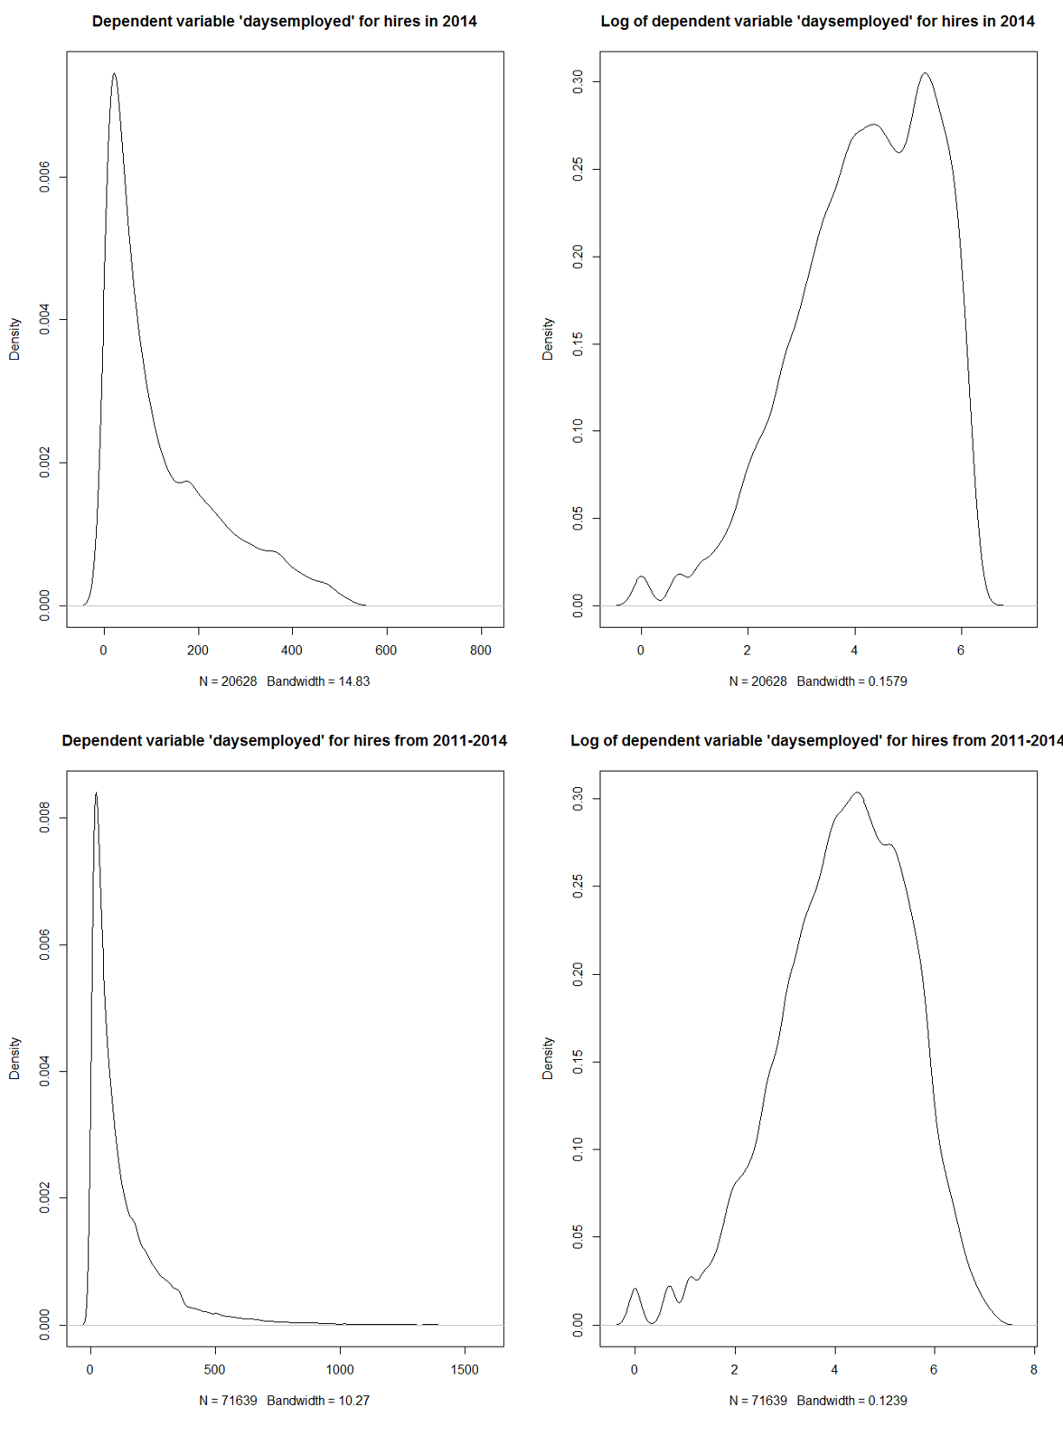
Figure 2: Graphical Representation of the Dependent Variable Distribution
  - Model background
Coefficient estimates will be derived using maximum likelihood, accounting for fixed effects associated with individual stores. A more granular level of fixed effects could have been introduced by controlling for the general manager that hired an individual, however introducing this set of variables would cause almost perfect multicollinearity with the individual stores, as most General Managers at PTC have extremely long tenure rates at each individual store. Models are estimated with robust standard errors.
The dependent variable in the model is the continuous variable ‘daysemployed’, which is the numeric count of days employed at PTC. This includes individuals moving across similar hourly line-level positions, and promotions.
In an effort to further clean the data, the model only takes into consideration employees who were hired as of December 31st, 2014. This alleviates the possibility of including an individual whose tenure length is arbitrarily small, due to the fact of being a recent hire. At the time of model estimation, the data includes 5,772 employees that are still employed with PTC, the other 65,752 observations are employees that have either been terminated, or self-terminated.

  - Preliminary linear regression
We will start by estimating a saturated linear regression, using the data set that includes data from March 14, 2014 to December 31, 2014 {dataset # 1}. The left hand side variable is ‘daysemployed’ which is continuous. We will call this model ‘sat_reg2014’. A complete regression output for this model is attached in the appendix, entitled “Saturated 2014 Linear Regression”. From this saturated model (Using data from March 14, 2014 to December 31, 2014), some interesting points can be made. A full output of the regression is in the appendix. (Adjusted R² of .2011)
The first set of variables analyzed are the ‘DIMENSIONSCORE.xxxx’ variables. These 7 scores are an aggregated function of 77 personality questions that are asked on the pre-employment application that potential hourly employees take. These 7 dimension scores are calculated off-campus from PTC, by Dr. John Lounsbury’s group at the University of Tennessee in Knoxville. They are proprietary scores that score an individual with a continuous number in the categories mentioned earlier.
The following joint hypothesis was tested using the Wald:
$$H_{0}:\sum_{i=1}^{7}{β_{i}=0}$$
$$H_{A}:\sum_{i=1}^{7}{β_{i}≠0}$$
Resulting in the following:
$$χ_{df=7}^{2}=72.9, p value=3.8e-13$$
Thus, we reject the null hypothesis, and conclude the overall effect of these 7 dimension scores together, is statistically different than 0. However as stated before, although this particular set of variables is statistically significant, removing them from the model allows us to increase our dataset size from 15,731 observations to 71,213 (pre-employment questions have not been consistent over time). Interpretation of the rest of the regression is omitted, as from here on dataset #2 will explicitly be used.
It is interesting to report the effects of these dimensions on tenure rate, albeit we are eliminating them from estimation of the final model. Note that the output of these estimates is from the full model with all other variables included, however those outputs are omitted from this table.
Table 2: Dimension Effects
Variable | Estimate(Sig) | Std. Error | t value | Pr(>|t|)
DIMENSIONSCORE.1023(Service Urgency) | -0.01181** | 3.81E-03 | -3.097 | 0.001957
DIMENSIONSCORE.1031(General Reasoning) | 0.04116*** | 7.26E-03 | 5.668 | 1.47E-08
DIMENSIONSCORE.1026(Work Drive) | -0.01276* | 6.11E-03 | -2.088 | 0.036789
DIMENSIONSCORE.1025(Enthusiasm) | -0.005455. | 2.79E-03 | -1.953 | 0.050872
DIMENSIONSCORE.1027(Ethical Behavior) | -0.01011*** | 3.01E-03 | -3.362 | 0.000776
DIMENSIONSCORE.1022(Helpfulness) | 0.009673*** | 2.51E-03 | 3.855 | 0.000116
DIMENSIONSCORE.1024(Comfort with Procedures) | 0.01387** | 4.88E-03 | 2.844 | 0.004464

Although the effect sizes is rather small in this output for each of these dimensions, (recall they are jointly significant) the signs of the coefficients are the interesting pieces. Each one of these dimensions was a continuous number, over the support$\left[0,15\right]$.
Particularly, DIMENSIONSCORE.1031 is a measure of mathematical reasoning, as measured by a set of high school level math problems that potential candidates take at the end of the application process. Note that the positive (significant) sign attached to this variable. This follows suit with previous literature that higher tenure rate correlates with mental aptitude. Internal PTC studies have also shown that mental aptitude highly correlates with quality of work, and quality of work correlates with tenure rate as well (thus creating a ‘chicken and the egg’ scenario).

  - Expanded linear regression
After the elimination of the dimension variables, we are able to run a regression that expands our dataset size significantly. A summary of the overall model is as follows:
Saturated 2011 Linear Regression
Observations | 71,213
R² | 0.3517
Adjusted R² | 0.3457
Residual Std. Error | .9799 (df = 67,595)
F Statistic | 58.76*** (df = 624; 67,595)
Figure 3: Saturated 2011 Linear Regression Summary
Looking at the standard Adjusted R², the preliminary conclusion is that the model does not provide much predictive power, being that only 34% of the variation in the log of number of days employed is being explained by the model. However, the point of this model is not to predict the number of days employed, rather it is to show what characteristics of an individual prove to be statistically significant when regressed against the number of days employed. This information then can be used to help hiring managers select the best possible candidates, by maximizing (or minimizing) the values of the variables that input into this equation. Although the predictive power of the model as a whole is low, the overall model is indeed significant when showing what factors affect tenure length (as indicated by the F- statistic).
Although there exists other random variables in the world that would allow us to increase the predictive power of this linear model, the model was intentionally kept relatively parsimonious with regards to the number of right hand side variables that were included. This is allowable because the human element of the hiring process is not meant to be replaced, only bolstered from the findings of this study. Indeed, if the models job was to predict tenure rate, it would be poor, however that is not the case. Again, we are only concerned with the significance and sign of each variable.
As with the preliminary model, variable effect sizes were small. Traditionally, small effect sizes require large sample sizes to find significance. This is not a problem in these models, as we have over 71,000 observations included. Effect sizes can be misleading when not interpreted within the context of the model at hand.
The following section contains a complete regression output. The remainder of the chapter will dissect the model section-by-section.
  - Full regression output
Table 3: Regression Output- log(Days Employed) 1
Variable | Estimate(Sig) | Std. Error | t value | Pr(>|t|)
(Intercept) | 1.6647*** | 0.2521 | 6.6027 | 4.07E-11
hour_diff | -0.0051102* | 0.0026 | -1.974 | 0.0483882
age | -0.0011349* | 0.0005 | -2.356 | 0.0184758
RACEIDAA | 0.13102*** | 0.0122 | 10.7325 | < 2.2e-16
RACEIDAIAK | -0.042998 | 0.0309 | -1.3936 | 0.1634325
RACEIDASPI | 0.12782* | 0.0550 | 2.3255 | 0.0200507
RACEIDHISP | 0.021275 | 0.0153 | 1.3879 | 0.165165
RACEIDMLTI | -0.0061682 | 0.0222 | -0.2776 | 0.7813394
RACEIDNHPI | 0.023235 | 0.0704 | 0.3299 | 0.7414388
RACEIDUNKN | -0.049809 | 0.0535 | -0.9313 | 0.3517175
MARITALSTATUSIDD | -0.02644 | 0.0538 | -0.4916 | 0.623008
MARITALSTATUSIDL | -0.096191 | 0.0591 | -1.629 | 0.1033276
MARITALSTATUSIDM | -0.016974 | 0.0517 | -0.3284 | 0.7426304
Table 3: Regression Output- log(Days Employed) 2
Variable | Estimate(Sig) | Std. Error | t value | Pr(>|t|)
MARITALSTATUSIDS | 0.047462 | 0.0509 | 0.9321 | 0.3512746
MARITALSTATUSIDW | 0.053362 | 0.0753 | 0.7085 | 0.478643
MALE | -0.015788. | 0.0094 | -1.6835 | 0.0922821
starting_wage | 0.21307*** | 0.0087 | 24.4074 | < 2.2e-16
JOB_TITLEDLCoffeeHost | -0.124 | 0.2158 | -0.5745 | 0.5656125
JOB_TITLEDLCoffeeHost-HC | -0.0282 | 0.2623 | -0.1075 | 0.9143939
JOB_TITLEDLProduction | -0.28677 | 0.2146 | -1.3361 | 0.1815245
JOB_TITLEDLProduction-HC | -0.32144 | 0.2342 | -1.3724 | 0.1699325
JOB_TITLERestHourlyTeamMember | 0.15823 | 0.2060 | 0.7682 | 0.4423936
JOB_TITLERestHourlyTipped | 1.0724*** | 0.2296 | 4.6717 | 2.99E-06
JOB_TITLERestHrlyTeamMember-HC | -0.31849 | 0.2391 | -1.3319 | 0.182884
JOB_TITLERestNewHrlyTeamMember | -0.20692 | 0.2146 | -0.9644 | 0.3348576
JOB_TITLERestNewHrlyTeamMember-HC | -0.49046* | 0.2348 | -2.089 | 0.0367124
JOB_TITLETCHourlyTeamMember | 0.37721. | 0.2177 | 1.7328 | 0.0831306
JOB_TITLETCHourlyTeamMember-HC | -0.21827 | 0.2291 | -0.9527 | 0.3407331
JOB_TITLETCNewHrlyTeamMember | -0.21829 | 0.2143 | -1.0187 | 0.3083334
AVAILABLETOWORK.1 | 0.016637 | 0.0174 | 0.9542 | 0.3399797
AVAILABLETOWORK.2 | -0.011218 | 0.0315 | -0.3558 | 0.7220131
AVAILABLETOWORK.3 | -0.057501. | 0.0340 | -1.692 | 0.0906541
AVAILABLETOWORK.4 | -0.11434*** | 0.0315 | -3.633 | 0.0002804
AVAILABLETOWORK.5 | 0.031068 | 0.0336 | 0.9244 | 0.3552673
AVAILABLETOWORK.6 | -0.039642 | 0.0318 | -1.2479 | 0.2120659
AVAILABLETOWORK.7 | -0.039157. | 0.0222 | -1.7618 | 0.0781089
ANYTIME.1 | -0.0052893 | 0.0173 | -0.3064 | 0.7593248
ANYTIME.2 | -0.024044 | 0.0291 | -0.8273 | 0.4080568
ANYTIME.3 | -0.038752 | 0.0316 | -1.2253 | 0.2204754
ANYTIME.4 | -0.015229 | 0.0293 | -0.5201 | 0.6029754
ANYTIME.5 | -0.052599. | 0.0313 | -1.6814 | 0.0926879
ANYTIME.6 | -0.086077*** | 0.0230 | -3.7422 | 0.0001825
ANYTIME.7 | 0.12813*** | 0.0183 | 7.0171 | 2.29E-12
CONVICTEDUNKNOWN | 0.047266 | 0.0507 | 0.9325 | 0.3510627
CONVICTEDY | 0.0085769 | 0.0138 | 0.62 | 0.5352333
max_edAssociates | -0.017301 | 0.0148 | -1.1651 | 0.2439722
max_edBachelors | 0.063573*** | 0.0193 | 3.297 | 0.0009776
max_edGED | -0.05559*** | 0.0157 | -3.5357 | 0.000407
max_edHighSchool | 0.029211** | 0.0103 | 2.8396 | 0.004518
max_edMasters | 0.20312** | 0.0737 | 2.7579 | 0.0058189
max_edOther | 0.0037846 | 0.0147 | 0.2566 | 0.797465
max_edPhD | 0.20051 | 0.1726 | 1.1619 | 0.2452988

Table 3: Regression Output- log(Days Employed) 3
Variable | Estimate(Sig) | Std. Error | t value | Pr(>|t|)
TotalExperienceinMonths | 0.000010176 | 0.0000 | 0.884 | 0.3766977
PRESENTLYEMPLOYED | 0.061409*** | 0.0093 | 6.6026 | 4.07E-11
TERMINATED | 0.11921*** | 0.0112 | 10.6632 | < 2.2e-16
PRIORPILOTEMPLOYEE | -0.037652** | 0.0141 | -2.6725 | 0.0075313
RELATIVEPILOTEMPLOYEE | 0.1595*** | 0.0153 | 10.4563 | < 2.2e-16
MOVINGINNEXTYEARN | -0.028169. | 0.0154 | -1.8272 | 0.067679
MOVINGINNEXTYEARY | 0.014709 | 0.0277 | 0.5307 | 0.5956349
FIRSTCHOICEPOSITIONIDDSC | -0.016128 | 0.1364 | -0.1182 | 0.905881
FIRSTCHOICEPOSITIONIDDSS | -0.091609. | 0.0503 | -1.822 | 0.0684575
FIRSTCHOICEPOSITIONIDDTM | -0.054936. | 0.0285 | -1.9293 | 0.0537031
FIRSTCHOICEPOSITIONIDM | -0.044905. | 0.0238 | -1.8868 | 0.059197
FIRSTCHOICEPOSITIONIDPC | 0.045188. | 0.0250 | 1.811 | 0.0701388
FIRSTCHOICEPOSITIONIDRS | -0.077738 | 0.0742 | -1.0475 | 0.2948826
FIRSTCHOICEPOSITIONIDRSC | 0.12074*** | 0.0251 | 4.8066 | 1.54E-06
FIRSTCHOICEPOSITIONIDRSSS | -0.18671*** | 0.0356 | -5.2465 | 1.56E-07
FIRSTCHOICEPOSITIONIDRTC | -0.0454* | 0.0216 | -2.1051 | 0.035289
FIRSTCHOICEPOSITIONIDRTSS | -0.1509*** | 0.0302 | -4.9946 | 5.91E-07
DESIREDWAGENEGOTIABLEUNKNOWN | 0.090182** | 0.0334 | 2.7022 | 0.0068908
DESIREDWAGENEGOTIABLEY | 0.036887* | 0.0151 | 2.4498 | 0.0142971
CANBEGINIMMEDIATELY | -0.11789*** | 0.0188 | -6.2801 | 3.40E-10
SCHEDULETYPEIDF | -0.037679*** | 0.0085 | -4.415 | 1.01E-05
SCHEDULETYPEIDP | 0.34917*** | 0.0148 | 23.6567 | < 2.2e-16
PREFERREDHOURSPERWEEK | -0.017844*** | 0.0028 | -6.2636 | 3.79E-10
DESIRED_WAGE_DIFFERENTIAL | 0.082295*** | 0.0045 | 18.346 | < 2.2e-16
FULLTIME | 0.13621*** | 0.0097 | 14.0298 | < 2.2e-16
open | -0.075291*** | 0.0161 | -4.682 | 2.85E-06
avghoursperweek | 0.07731*** | 0.0027 | 29.1365 | < 2.2e-16
TESTLENGTH | 0.00065795** | 0.0002 | 3.2206 | 0.0012796
Signif. codes: 0 ‘***’ 0.001 ‘**’ 0.01 ‘*’ 0.05 ‘.’ 0.1 ‘’ 1

  - Age
Note the negative significant sign associated with the variable ‘age’ (albeit the coefficient arbitrarily close to 0). The findings here are not consistent with a study conducted by the Bureau of Labor Statistics from 2004-2014, that showed that average tenure length increased with age. (Bureau of Labor Statistics, 2014) Other research has shown that as people age, the utility gained from switching jobs in search of higher wages, diminishes. Internal research at PTC has indicated that older individuals treat hourly line-level positions as ‘stepping stone’ or ‘time-filler’ jobs, while in search of other, higher paying employment.
Loess (locally weighted scatterplot smoothing) regression lines are useful for visualizing scatterplot data, as it indicates a weighted slope at each individual data point within a given support. Loess regression uses a second degree polynomial to graphically show $\frac{∂y}{∂x}$ at any given x. Weights are calculated via the following function:
$$W_{i}={\left(1-{\left|\frac{x-x_{i}}{d(x)}\right|}^{3}\right)}^{3}$$
Where x is the predicted value associated with the response value (the value to be smoothed), and x_{i} are the nearest neighbors of x, defined by the span, and d(x) is the distance along the support from x to the farthest predictor within the given span. A weighted linear least square regression is performed, and the smoothed value is given by the weighted regression value.
This can be visualized using the PTC data from this study: The red line is a standard linear regression line, with slope -0.0004964***, and the blue line is a standard loess regression line.
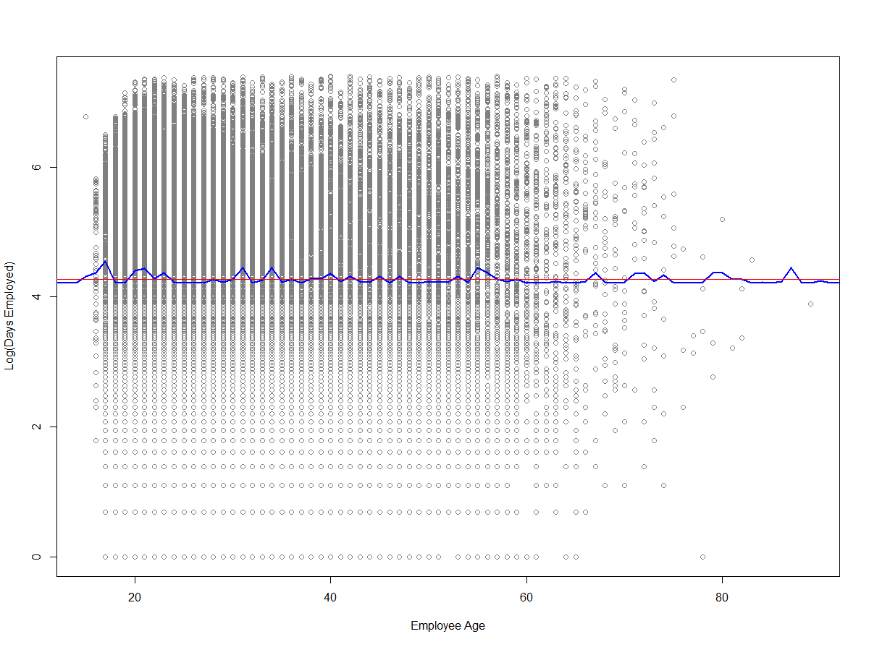
Figure 4: Log(Days Employed) vs Employee Age

  - Race and gender
The baseline race of reference is ‘RACEIDCAU’, or Caucasian. We see a large, significant effect of African American employee’s tenure when compared to Caucasian. It needs to be noted that this is essentially regression to the mean, as we could slice this regression by State, PTC Region, PTC Division, or PTC Store Tier. It also needs to be addressed that these estimations are inherently biased by self-selection, because in certain regions, there are high concentrations of only one particular race. This is verified by PTC purchased Neilson data, that includes racial demographics for radii surrounding each of our retail locations. Previous studies have shown that alternative employment options for African American individuals is smaller than those for Caucasian individuals. Thus, the value of a job is greater for African American individuals (Weisskopf, 2013).
The findings in this study is in line with another study produced by the BLS, which showed that the mean and median duration (in weeks) of Caucasian workers compared to African American workers was 37.7 vs 44.9 and 17.6 vs 24.7, respectively (Bureau of Labor Statistics, 2012).
There is virtually no statistical difference between men and women with regards to tenure. This is also in line to the findings by the BLS, in which the results were men stay on average 2.5% longer in their jobs (a number close to 0). This is consistent with prior research that suggests it does not matter the level of the job that an individual is in, they react to their environment consistently across all levels of employment.

  - Wage
Wage is a variable that can be directly controlled by PTC, thus is of heavy interest in decision making. Two of variables reported here are the starting wage that an individual is granted when they first become employed with PTC, and the differential between that number and the number that they stated that they wanted on their application. These are of utmost importance, as for all of the positions included in this study, the starting wage is dictated by the corporate office for each individual store, for each position. The coefficient that is attached to DESIRED_WAGE_DIFFERNTIAL is statistically significant and .082295, which means for every dollar we pay an applicant above what they asked for, we can expect an 8.3% increase in the average number of day employed, all else equal. This is consistent with all research discussed previously in this paper. At hourly, line level positions, starting wage is one of the biggest influences on tenure length, at the beginning of a new employee’s job tenure.
One of the recommendations (discussed in the conclusion of this paper) will be to reevaluate the dictated starting wages, as traditionally PTC’s dictated wage for each of these positions is minimum wage, as compared to similar positions in PTC competitors which pay on average 20% more.
The other included variable in this section lists if the employee listed if their starting desired wage was negotiable or not. The model shows that if an individual states that their desired starting wage is not negotiable, this is a bad signal.

  - Scheduling
Pre-employment, applicants reveal their desired schedules, with regards to hours, if they want part-time or full-time, and if they are able to begin immediately. Recall that SCHEDULETYPEID is the requested employment status (FT, PT, or either). There is a small statistical difference between someone who says they would prefer FT and someone who says they are indifferent between the two. However, if someone says they want part-time classification, this is a good signal.
More importantly, the biggest impact a function of how PTC assigns the new employee. If we classify a new employee as full-time (thus giving them benefits), we can expect 75 days more than if we were to classify them as part-time. This is controlling for the seasonal part-time employees that PTC hires during peak summer months.
The preferred hours per week is a variable that is negative, significant. This is the requested number of hours per week that an employee put on their initial application. Visualization of the data would create the argument that there does not exist an optimal number of requested hours, and the significance assigned to this parameter is incorrect. As before, the red line is the standard linear regression line with slope close to -.017.
It is also worth noting that if an employee says that they can begin immediately, or that they have open availability (meaning that they responded that they can work anytime at any day), these are both bad signals with regard to tenure length. This can be thought of as ‘fishing’ for a job, as most applicants that respond this way are unemployed at the time of application. Also, if an individual says they have open availability on their application, the scheduling manager for that particular store will schedule the majority of that individual’s hours on the night shift. The majority of an individual’s shifts being at night tend to push them out more quickly. (Traditionally, PTC looks for individuals with open availability who can begin work immediately. The data shows that this trait is not a positive signal.)
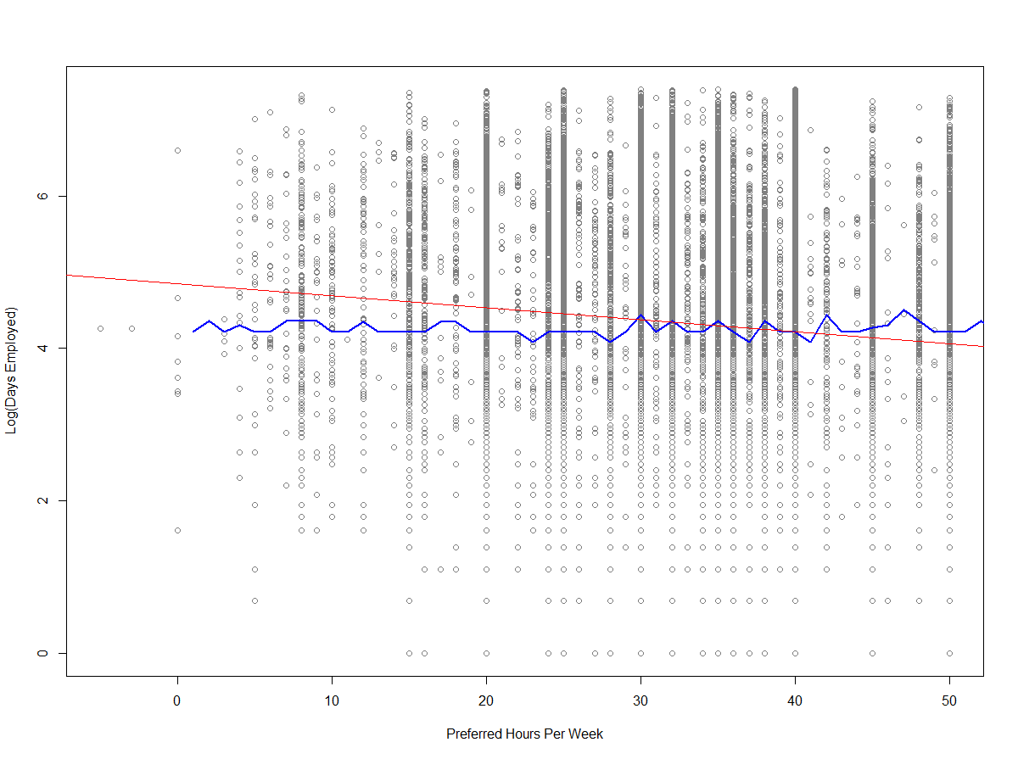
Figure 5: Log(Days Employed) vs Preferred Hours Per Week
The blue line is a loess regression line. The red line is a standard linear regression line with slope -.0156692.
  - Criminal history
There is no statistical difference between individuals who reported they had not been convicted of a felony, and those who did not answer. However, it is very interesting to note the positive, significant sign attached to those who had self-reported that they were a convicted felon. This data is completely contradictory to PTC’s policy to blackball an individual who self-reported themselves as a felon. The data would argue that if someone openly admits that they are a felon, this is a positive signal with regards to tenure length. This could also be an implicit instrument for how honest an individual is, meaning that if they are willing to tell you that they have been convicted in the past, they are most likely an honest individual. (Previous Lounsbury tests correlate work ethic and honesty). The discovery of an individual’s honesty is something that is difficult to quantify. In his book, Jayanta shows the correlation between honesty and work ethic, both at an economy wide scale and an individual scale (Sarkar, 2007).

  - Education
With regard to education, the maximum level of education attained was used for the model, as a factor variable. The baseline for regression comparison was “NONE”. The most important observation to make here was the comparison between people who obtained a GED vs those who obtained a high school diploma the traditional way. Again, even though effect size is small, the sign and significance tell an intuitive story. People that obtain their GED as compared to someone who graduated high school have shorter tenure lengths.
Previous experience plays has a very small, but positive (significant) effect on tenure rate. This is intuitive, as the hourly line-level jobs at PTC do not require much specific training or experience. Hiring managers within PTC are explicitly told to heavily weight previous experience when making a hiring decision. The data would argue that experience is close irrelevant in these positions.

- Quantile Regression
  - Background
Recall that the full model only had an adjusted R² of .3457. It can be inferred that because this number is low, there must be individual (worker) characteristics that are not measureable. Because of this, we can ask the question: “If an individual is has a predisposition to work a certain number of days (determined exogenously), and this characteristic is not quantifiable, how can we measure the statistical impact on these individuals, by changing variables that are controllable?” These relationships can be modeled using quantile regression. The benefit from answering these questions, is to maximize the ‘fringe’ tenure, which an individual was not predisposed to have. This stresses the fact that PTC must be able to accurately identify talent during the interview process, and that the processes once an employee is hired are beneficial to the employee. With the following results, we are most concerned with sign and significance, as effect sizes will be implicitly biased due to characteristics which cannot be measured. The following tables will show the comparison of the 10th percentile and the 90th percentile. Note that in the quantile regression model, we are dealing with the discrete number, ‘days employed’ (as compared to OLS regression model, we transformed the dependent variable by taking the natural log).
The constant in quantile regression is the value at which the dependent variable is cut. In our data, these values are roughly 15 and 250 days, respectively. Output for the quantile regression is represented in table 4, standard error in parenthesis
 | Dependent variable:
 | daysemployed
 | Tau = .1 | Tau = .9
Constant | 16.075*** | 163.81***
 | (2.17) | (36.90)
Note: | *p<0.1; **p<0.05; ***p<0.01
Figure 6: Quantile Regression Summary
Table 4: Quantile Regression 1
Variable | Parameter, τ= .1 | t value, τ = .1 | Parameter, τ = .9 | t value, τ= .9
(Intercept) | 16.07554 *** (2.17015) | 7.40755 | 163.8104 *** (36.90403) | 4.43882
age | -0.07931 *** (0.01104) | -7.18621 | 5.21023 *** (0.29185) | 17.85254
RACEIDAA | 3.2214 *** (0.3002) | 10.73083 | 52.68551 *** (4.86672) | 10.82567
RACEIDAIAK | -1.05341 *** (0.40201) | -2.62038 | -30.56926 *** (8.9504) | -3.41541
RACEIDASPI | 4.99479(4.71731) | 1.05882 | 5.31224(13.05786) | 0.40682
RACEIDHISP | 0.64021 *** (0.3695) | 1.73267 | 15.43197 *** (6.34001) | 2.43406
RACEIDMLTI | 0.5136(0.64944) | 0.79084 | 3.1912(10.46509) | 0.30494
RACEIDNHPI | 6.20251 * (0.62373) | 9.94426 | -19.71494(34.69054) | -0.56831
RACEIDUNKN | -1.86456(1.86969) | -0.99725 | 13.98174(20.93502) | 0.66786
GENDERIDM | 0.27706(0.25213) | 1.09888 | -4.76305(3.977) | -1.19765
MARITALSTATUSIDD | -0.25232(1.57559) | -0.16014 | 17.152(23.44986) | 0.73143
MARITALSTATUSIDL | -0.59316(1.59527) | -0.37182 | -8.97027(24.9696) | -0.35925
MARITALSTATUSIDM | -0.93787(1.5407) | -0.60873 | 44.58694 ** (23.34392) | 1.91
MARITALSTATUSIDS | 1.07465(1.53606) | 0.69961 | 63.45681 *** (22.94777) | 2.76527
MARITALSTATUSIDW | -0.00382(1.8294) | -0.00209 | -1.06861(37.82278) | -0.02825
starting_wage | 0.22166 *** (0.10028) | 2.21042 | 29.95254 *** (2.33655) | 12.81914
CONVICTEDUNKNOWN | 0.61202 ** (0.35458) | 1.72603 | -7.75663(39.78157) | -0.19498
CONVICTEDY | 0.55692 ** (0.31076) | 1.79214 | -8.83792(5.4611) | -1.61834
max_edAssociates | 0.06266(0.35107) | 0.1785 | 6.71499(7.84742) | 0.85569
max_edBachelors | 0.19106(0.38878) | 0.49144 | 23.53139 *** (6.9478) | 3.38688
max_edGED | -0.60194 ** (0.36337) | -1.65655 | -25.15612 *** (6.08521) | -4.13398
max_edHighSchool | 0.36281(0.25568) | 1.419 | 14.47087 *** (5.31149) | 2.72445
max_edMasters | -0.2444(0.9549) | -0.25594 | 21.56048(19.91514) | 1.08262
max_edOther | 0.41732(0.41765) | 0.99921 | 2.09328(7.6389) | 0.27403
max_edPhD | 5.21025 *** (0.98171) | 5.30734 | -1.53699(18.71954) | -0.08211
TotalExperienceinMonths | 0.00002(0.00044) | 0.04409 | 0.00927 ** (0.00541) | 1.71332

Table 4: Quantile Regression 2
Variable | Parameter τ= .1 | t value, τ= .1 | Value τ= .9 | t value, τ=.9
TERMINATED | 3.02393 *** (0.37539) | 8.05543 | 42.34195 *** (5.57621) | 7.59332
PRIORPILOTEMPLOYEE | 5.46716 *** (0.50302) | 10.86876 | 44.63804 *** (6.22691) | 7.16857
RELATIVEPILOTEMPLOYEE | 4.78739 *** (0.5207) | 9.19413 | 61.93731 *** (7.48111) | 8.27916
MOVINGINNEXTYEARN | -2.41977 *** (0.56086) | -4.31441 | 14.62924 *** (7.12036) | 2.05456
MOVINGINNEXTYEARY | 0.33623(0.72355) | 0.46469 | 10.42684(11.62269) | 0.89711
FIRSTCHOICEPOSITIONIDDSC | 0.77893(35.93024) | 0.02168 | -95.5822 *** (19.4198) | -4.92189
FIRSTCHOICEPOSITIONIDDSS | -0.6705(0.66267) | -1.01182 | -70.34904 *** (29.0066) | -2.42528
FIRSTCHOICEPOSITIONIDDTM | -0.18672(0.70362) | -0.26537 | -93.68055 *** (14.03303) | -6.67572
FIRSTCHOICEPOSITIONIDM | 0.76939(0.56392) | 1.36438 | -30.33102 *** (12.77281) | -2.37466
FIRSTCHOICEPOSITIONIDPC | 1.53679 *** (0.55887) | 2.74979 | -9.75052(12.65742) | -0.77034
FIRSTCHOICEPOSITIONIDRS | 1.76323 *** (0.73978) | 2.38347 | 256.05984 *** (20.42972) | 12.53369
FIRSTCHOICEPOSITIONIDRSC | 2.6993 *** (0.60809) | 4.43901 | 6.62079(13.04351) | 0.50759
FIRSTCHOICEPOSITIONIDRSSS | -0.58414(0.51894) | -1.12564 | -34.73736 *** (15.81752) | -2.19613
FIRSTCHOICEPOSITIONIDRTC | 0.09652(0.46703) | 0.20667 | -41.07113 *** (12.14687) | -3.38121
FIRSTCHOICEPOSITIONIDRTSS | -0.85779(0.54734) | -1.56721 | -34.46788 *** (16.34511) | -2.10876
DESIREDWAGENEGOTIABLEUNKNOWN | 2.3079(1.49912) | 1.5395 | 16.92944(20.30593) | 0.83372
DESIREDWAGENEGOTIABLEY | 0.96471 *** (0.37133) | 2.59798 | 27.88997 *** (4.74586) | 5.8767
CANBEGINIMMEDIATELY | -0.07769(0.56967) | -0.13637 | -24.53942 *** (6.12893) | -4.00387
SCHEDULETYPEIDF | -0.16576(0.20706) | -0.80053 | -15.7931 *** (3.63953) | -4.33933
SCHEDULETYPEIDP | 3.22648 *** (0.46996) | 6.86546 | 83.853 *** (6.79797) | 12.33501
PREFERREDHOURSPERWEEK | -0.05284 *** (0.02149) | -2.45848 | -3.40667 *** (0.34967) | -9.74251
DESIRED_WAGE_DIFFERENTIAL | 1.52932 *** (0.0673) | 22.72538 | 53.11988 *** (1.73397) | 30.63481
EMP_STATUSPartTime | -4.65934 *** (0.28493) | -16.35245 | -233.3195 *** (4.92042) | -47.41861
EMP_STATUSSeasonalPartTime | -1.38998(1.46311) | -0.95002 | -82.61255 *** (11.61802) | -7.11073
open | -0.72665 *** (0.22765) | -3.19197 | -20.17767 *** (4.13638) | -4.8781
TESTLENGTH | 0.01758 *** (0.0049) | 3.58703 | 0.08712(0.09514) | 0.91574
Signif codes; .1 '**', .05 '***'

  - Age, race, gender, and marital status
With regard to personal characteristics, it is interesting to point out which variables are significant vs insignificant, when comparing the 10th percentile to the 90th percentile. For example, note that being married has no statistical impact on those who are in the bottom 10%, however for those in the 90th percentile, it does make a difference. To show the significance of these findings, take the following example:
If a hiring manager was presented with two candidates which had identical applications, except for the fact that one was married, and one chose not to disclose this information on the application (The reference level for MARITALSTATUSID in the regression is ‘C’ for “Choose not to Disclose”.). The manager would maximize the potential tenure length by selecting the married individual, ceteris paribus. This statement holds for when the probability of an individual being in the 10th or 90th percentile is known or unknown (or any arbitrary value for P), as shown by the expected value function below:

Assume P is the probability of being in the 10th percentile, and 1-P is the probability of being in the 90th percentile (with regards to tenure length).
$$E(Tenure\left(STATUS=M||STATUS ≠C\right))=$$
$$P*\left(16.075+\sum{β_{-i}x_{-i}}-.937\left(M\right)\right)+$$
$$\left(1-P\right)*\left(163.81+\sum{β_{-j}x_{-j}}+44.58\left(M\right)\right)$$
Since we know the coefficient attached to M when the individual is in the bottom 10th percentile, we can assume the -.937 to be equivalent to 0. We also assume the effects are being measured ceteris paribus, thus we can hold fixed $\sum{β_{-i}x_{-i}}$ and$\sum{β_{-j}x_{-j}}$, thus essentially setting them to 0. We can then expand then simplify the equation:
$$E(Tenure\left(STATUS=M||STATUS ≠C\right))=$$
$$16.075P+163.81+44.58M-163.81P-44.58P*M$$
Note that the equation for expected tenure is decreasing in P. Thus, for all levels of$P∈(0,1)$ the expected tenure length is increasing if an individual is married, as shown by the data.
The same type of inferences can be made with regard to all RHS variables included in this output. The expected value equation above relies on the assumption that the individuals predisposition to stay any length of tenure is determined before they are hired, and that predisposition can be mapped to probability P.

- Conclusions with Regard to Pilot Travel Centers
The purpose of this paper was to demonstrate how predictive modeling can help identify causes of premature employee termination. These conclusions allow us to answer the question, “How do hiring managers isolate specific characteristics of measurable, pre-employment information that map to higher rates of tenure?” With this information, hiring managers will have a better grasp on how to identify individuals that display these characteristics. This will also help hiring mangers select interview questions that are more tailored to each potential employee. The linear models presented in this paper are not intended to replace traditional hiring practices.
With regard to the behavioral differences of individual applicant candidates, there does exist a measureable difference with regards to race. Although these findings cannot be used in the implementation of any new hiring practices, for the purpose of this study it is interesting to point out that African America applicants have the highest rates of tenure of all, followed by Hispanic, and then Caucasian. There is no statistical difference between male and female applicants.
The starting wage that an employee receives is important, however more important was the wage differential between the requested wage and the actual starting wage; which was highly significant, with a large effect. As stated before, because previous experience has no statistical impact on length of tenure, PTC would be better off hiring an individual with no experience, and paying a wage above what was requested on the application, than hiring someone with experience and paying exactly what they asked for (under the assumption that the person with higher experience would command a higher starting wage). It is imperative that PTC adheres to employee requests with respect to required scheduling and wages.
It would also be beneficial to PTC to either remove entirely the dictated starting wage, or to have the dictated starting wage match that of the region’s market average wage for similar positions. PTC has been notorious for paying on average 10 percent less than the market for any given hourly, line level position. This act has attracted lower quality talent (thus stifling productivity), and has also driven higher quality talent out, as those individuals can command a higher wage elsewhere.
Full time employees stay drastically longer than part time employees. Previous research shows that this is a function of an individual getting a feeling of reliance on their employer, due to higher wages (on average) and health benefits. It is also shown that full time employees have higher productivity rates than part time employees. This was demonstrated by Home Depot in 2000.
Individuals who are not willing to begin work immediately (as they must give notice to another job) have higher tenure rates. If they are currently employed and are able to begin immediately, this is a very bad signal, as they are willing to quit their current employer immediately and will be willing to do the same to PTC if another (better) opportunity comes along. If someone is not currently employed and can begin immediately, this is not a bad sign, as the individual has no work obligations.
Most importantly, during the interview process it is imperative to identify the applicant’s needs. If these needs are not met, it creates a foul work environment, and the individual will be more at risk to quit earlier. The data tend to argue that the more an employer can satisfy the intangible needs of its employees, the higher the employee morale will be, thus leading to longer and more productive tenure rates.

List of References

Bureau of Labor Statistics. (2012). Labor Force Characteristics by Race and Ethnicity, 2012. BLS. Retrieved May 2015, from http://www.bls.gov/cps/cpsrace2012.pdf
Bureau of Labor Statistics. (2014). United States Department of Labor, Table 1. Retrieved May 19, 2015, from BLS: http://www.bls.gov/news.release/tenure.t01.htm
Cappelli. (2000). A Market-Driven Approach to Retaining Talent. Harvard Business Review, 78, 103-112.
Farris, G. (2000). Rewards and Retentino of Technical Staff. IEEE International Engineering Management Conference, (pp. 617-619).
Glynn, M. (1996). Innovative Genius: A Framework for Relating Individual and Organisational Intelligences to Innovation. Academy of Management Journal, 21(4), 1081-1011.
Higginbotham, J. (1997). The Satisfaction Equatino. Research & Developement, 39(10), 1-9.
Ikeda, S. (2014, September 18). fee.org. Retrieved from Foundation for Economic Education: http://fee.org/freeman/detail/wages-and-the-free-market-part-1
Kremer, M. (1993). The O-Ring Theory of Economic Development. MIT Press.
Lane, J. (2000). The Low-Wage Labor Market: Challenges and Opportunities for Economic Self-Sufficiency. U.S. Department of Health and Human Services. Retrieved from http://aspe.hhs.gov/hsp/lwlm99/lane.htm
Lane, J., Stevens, D., & Burgess, S. (1996). Worker and Job Flows. Economics Letters, 109-113.
Lawler, E. (n.d.). Compensation Mangement.
Lofquist, L. a. (1969). Adjustment to Work. Wiley and Sons.
Pfeffer, J. (1998, May-June). Six Myths About Pay. Harvard Business Review, 38-57.
Smith, M. (2001). Young People, Informal Education and Association. Retrieved from www.infed.org/youthwork/ypandassoc.htm
Ton, Z. (2012). Why “Good Jobs” Are Good for Retailers. Harvard Business Review. Retrieved from https://hbr.org/2012/01/why-good-jobs-are-good-for-retailers
Van Knippenberg, D. (2000). Work Motivation and Performance: A Social Identity Perspective. Applied Psychology, 49(3), 357-371.
van Ophem, H., Hartog, J., & Berkhout, P. (2011). Reservation Wages and Starting Wagess. Institute for the Study of Labor (IZA) .
Walker, J. (2001). Perspectives. Human Resource Planning, 1, 6-10.

Appendix

Blank sample application from Pilot Travel Centers
This is the current application (at time of writing July 2015) that PTC gives to potential employees. The average time needed to complete the application is 36 minutes.








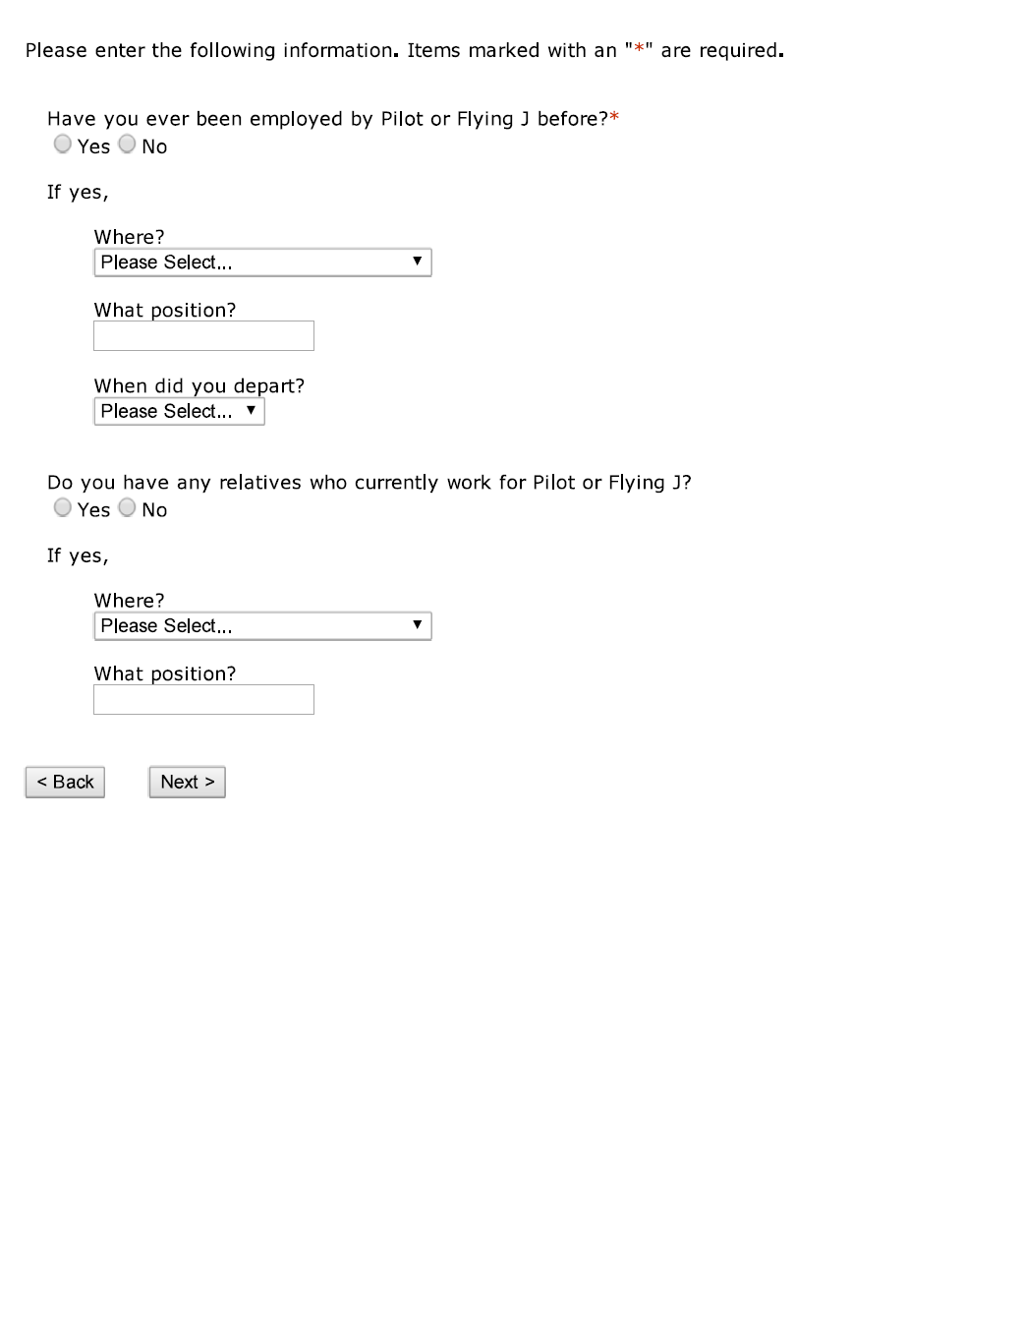
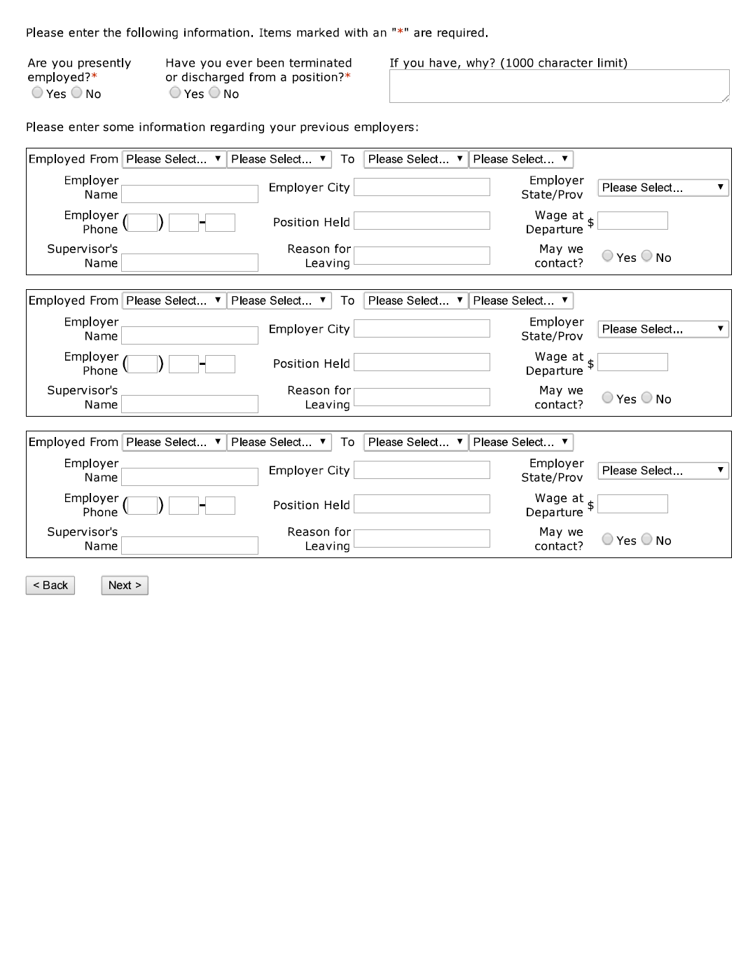




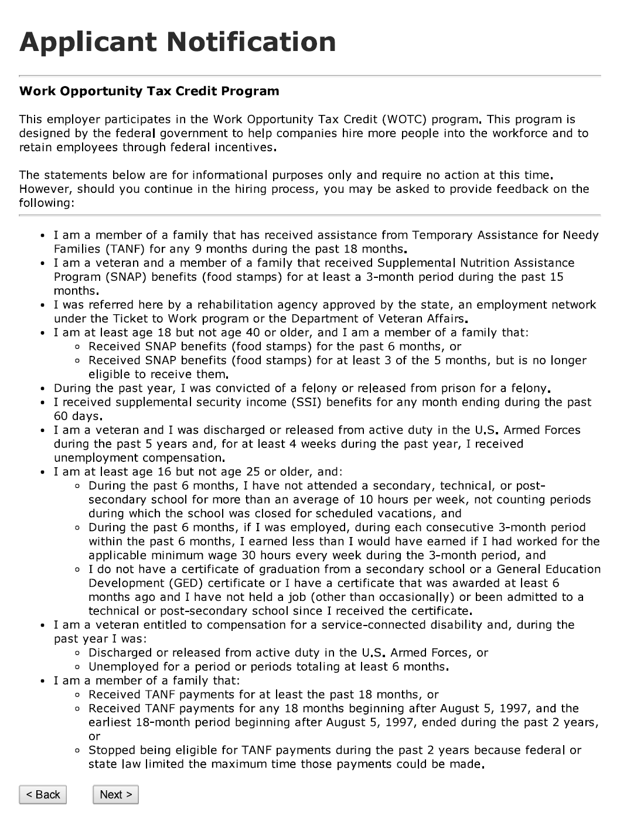

Vita
Robert Allen Cobb was born in Bowling Green, Kentucky. After graduating from Warren Central High School, he attended Western Kentucky University, double majoring in Economics and Computer Information Technology, and was a kicker on the WKU football team from 2006-2009. Upon completion of undergraduate work in 2011, he enrolled in WKU’s M.A. in Applied Economics program, and graduated at the top of his class with a concentration in Econometrics. After completion of his M.A. in 2013, he enrolled in the University of Tennessee’s PhD program in Economics. After completion of core coursework, he took a job at Pilot Travel Centers as a Business Intelligence Data Scientist, in Knoxville, Tennessee. This thesis fulfills the requirements for the M.A. in Economics from the University of Tennessee.

Mathematically, turnover is the ratio of total departures at a firm, divided by the average number of employees over the given time range.
In addition, 2 million Americans voluntarily quit their job every month (Bureau of Labor Statistics, 2013).
John Lounsbury, a Professor of Psychology at the University of Tennessee. http://psychology.utk.edu/lounsbury.php
The preliminary findings of this study were presented February 12-16 at the Pilot Travel Centers General Managers Meeting (GMM) in San Antonio Texas. The GMM gathers about 2,000 employees, which includes all of the retail general managers and about 400 employees from the corporate office.
One of the projects currently assigned to the Business Intelligence department is to create a new employee screening system, which takes into consideration the convex combination of answers to the pre-employment application and personality test. This new system will hopefully allow PTC to identify and retain quality employees, based on personal characteristics not previously explored.
This is especially true for this particular study, as Pilot Travel Centers has a history of scheduling workers during shifts they explicitly said they could not work.
http://www.forbes.com/largest-private-companies/
Relative term
Biodata is the generalized term in Organizational Psychology that refers to biographical data. The most popular applications of biodata include analysis that attempt to quantify future behavior, as a function of past behavior.
Pilot Travel Centers recently hired Dr. Craig BeVier, an IO Psychologist as Director of Talent Management. General Motors recently hired Dr. Michael Arena, a PhD in Organizational Dynamics to lead their talent acquisition department.
With regard to PTC, full time employees (at line-level positions) stayed an average of 255 days, compared to 109 for part time employees. (There also exists an optimal full time/part time mix that will be identified later in this paper)
This paper will imply that the required wage needs to be omitted completely, as to let the market sort out what the fair market wage is for the required positions.
PTC purchased wage data from the Economic Research Institute (ERI) specifically for this study.
It is worth noting, that if w^{D}> w*, then the dictated wage does not constrain the market-clearing wage, and thus the optimal quality of labor is attained through the market paying w*.
At w* we are in steady state.
The following question then arises: “Do we attract top talent by giving a higher starting wage to everyone, or do we pay low starting wages, identify top talent, and then promote them quickly?”(Classic ‘chicken or the egg’ problem) PTC does neither of these things.
It is worth noting, that if an individual puts ‘open availability’ on their application, it may be a function of them “fishing” for a job, out of being desperate. These people historically have left when another job is offered that pays marginally more. They also sometimes quit when the majority of their shifts are night shifts (General Managers take ‘open availability’ literally and schedule new employees 100% night shifts).
Note that in a period of less than 10 months, PTC hired almost 16,000 people across hourly, non-leadership positions.
Both drug tests and pre-employment background checks are administered through a third party, not affiliated with PTC.
Recall that general managers inside of the stores have no way of differentiating applicants, and the applicants are ranked from most recently applied to oldest. Thus, when selecting candidates to come in for interviews, general managers will usually select the individual at the top of the list, and work their way down until an applicant agrees to come in for an interview. One of the benefits of this project for PTC, is that it will be able to provide a way to force rank individuals inside the ATS (applicant tracker system).
Again, for defining a model that can be implemented into PTC’s Applicant Tracker System (ATS), we cannot use these EEOC sensitive variables.
Factor variables were converted to dummy variables when applicable for the sake of simplicity. Examples of this include ‘MALE’, as on the application, applicants are able to select ‘M’ or ‘F’ for their gender. We transformed all applicants that responded ‘M’ to 1, and ‘F’ to 0.
Although some of the questions on the application were not required to be answered (some sensitive, personal information such as age, race, gender, or marital status), around 98% of applicants who were hired, willfully gave this information when applying for a job. The individuals who were hired and did not disclose this information were omitted from the analysis when estimating the model.
A dichotomous variable could also be evaluated here: A true/false value to whether an individual stayed over a certain number of days (The number of days that executives at PTC determined as the dichotomous cut off was 120).
It is also noteworthy that the Wald test does not calculate standard errors, under the assumption of that the null is true, thus is robust to heteroskedasticity. This is the primary reason why we cannot use an F-test. An F-test is constructed under the assumption of heteroskedasticity.
Helpfulness, Enthusiasm, Work Drive, General Reasoning (math), Ethical Behavior, Service Urgency, and Comfort with Company Procedures are the 7 dimensions.
A likelihood-ratio test was also done, and it was concluded that the models were indeed statistically different when excluding the dimension scores. The decision was made by the analyst to exclude these variables, solely based on the sample size increase.
For DIMENSIONSCORE.1031, a one point increase in the score obtained will cause a 4% increase in the number of days employed, all else equal.
Recall that the null hypothesis for the F-Statistic is that all of the regression coefficients are equal to zero. The F value is the ratio of the mean regression sum of squares, divided by the mean error sum of squares.
With regards to predictive modeling, deep learning (machine learning) techniques have proven to be quite efficient with regards to this data. As stated earlier in the paper, Ensemble Decision Trees (Random Forest), Support Vector Machine (SVM) and Neural Network methods are all being employed with regards to the productionalized version of the predictive analytics for this PTC study.
The study that was conducted by the BLS examined hourly positions across all types of work, not just hourly retail.
Note that loess regression differs from lowess regression, in the sense that lowess regression uses a first degree polynomial to graphically show$\frac{∂y}{∂x}$.
All of these classifications are PTC proprietary measurements that allow us to designate different geographic regions for all of our stores.
This could also be a function of PTC’s policy to hire employees and assign part-time classification, and then promote to full time once the individual has established their intent to stay employed for a long time. This practice is something that is being addressed, but for our purposes, could cause some self-selection bias.
Employee scheduling is a topic that PTC does not put much thought in to. With regard to weekly scheduling, PTC follows a ‘paint by numbers’ approach to scheduling. This is something that the Business Intelligence department has been tasked with: creating an optimal scheduling tool that maximizes labor dollars at peak times of the day.
PTC receives a large number of applicants from individuals who have been convicted of felonies. There also exists an unknown number of applicants who do not self-report themselves as felons, but whose criminal record shows up on the background check. If an individual fails to report themselves as a felon (within the time limits of the law), and their background check shows them as a convicted felon, then their application is dismissed immediately. This policy will not change, as the individual has subsequently lied to PTC’s hiring manager about their criminal history.
The recommendation is NOT, however, to hire all convicts. A pre-employment background check is still a necessity.
PTC will continue to ask applicant-specific interview questions that will allow the hiring manger to discover how honest a potential employee is. Again, higher honesty correlates with work ethic.
Internal research at PTC has also shown that those with GED’s vs those with traditional high school educations have much poorer performance.
This falls under the assumption that the number of days employed by an individual is known by that individual before beginning employment, thus we seek to maximize the ‘fringe’ number of days employed.
This is something that is at the top of PTC’s priority list. Once this talent is identified (empirically and during the interview process), maximizing the ‘fringe’ tenure is what becomes of interest.
Larger effect sizes in higher quantiles are inconsequential. Again, we are looking to determine what factors matter the most to those who were predisposed to have a higher tenure length.
This is not a recommendation, as this is illegal.
This information is illegal to use in hiring decisions. These conclusions should not be invoked when making a hiring decision.

