The Effect of Soluble Soybean Polysaccharide on Crystallization Behavior of Lactose

A Thesis Presented for the
Master of Science
Degree
The University of Tennessee, Knoxville

Xueqian Shi
August 2014

Copyright © 2014 by Xueqian Shi. All rights reserved.

ACKNOWLEDGEMENTS

I want to express my thanks to Dr. Qixin Zhong, my major professor in Food Science and Technology Department. He came up with the whole idea of this project and provided assistance in experimental design and report writing.
Thanks are due to Dairy Research Institute (Rosemont, IL) for providing the funding of this project.
I am also grateful to Kang Pan and all my lab mates, who provided a professional and pleasant environment at work as well as in daily life.
I also want to thank Dr. Svetlana Zivanovic. As my committee member, she gave me suggestions on my experiment. Thank you, Dr. Arnold Saxton, my minor advisor, for bring me into the field of statistics.
Last but not least, I want to thank my parents for their love, support and always being there for me.

Introduction
Lactose can be recovered from cheese whey permeate concentrate by crystallization, and improving the recovery efficiency and purity of lactose crystals is significant to the profitability of the dairy industry. Lactose is also the major component in spray-dried dairy ingredients such as milk and whey powder. Lactose in spray-dried powder is amorphous and causes quality problems such as caking due to the crystallization of amorphous lactose during storage. Technologies are thus needed to improve the crystallinity of spray-dried lactose. In this study, soluble soybean polysaccharide (SSPS) was studied for the effects on lactose crystallization in aqueous solutions and during spray drying. In aqueous solutions with 40% w/w lactose, the addition of less than 1% w/w SSPS facilitated lactose crystallization, more significant at 0.1% SSPS than at 0.5 and 1% SSPS, and the improvement in crystal yield was more significant under seeded conditions than spontaneous crystallization. SSPS was observed to promote the nucleation of lactose, but the promotion effect was offset by the reduction in crystal growth due to increases in viscosities at increased SSPS concentrations. The highest crystal yield after 24 h at 30 °C (54.7%) was observed for the treatment with 0.1% SSPS and 0.5% lactose seed, was significantly higher than the 34% yield of the control without SSPS, and reached about 84.4% of the maximum possible yield. The purity of lactose crystals was not affected by addition of SSPS based on differential scanning calorimetry, X-ray diffraction spectroscopy, and Fourier transform infrared spectroscopy. For spray-dried powder produced at SSPS:lactose mass ratios of 0:1, 1:9, and 1:19, the addition of SSPS improved the crystallinity and yield of spray-dried powders. The highest crystallinity, 57.7%, was obtained at a SSPS:lactose mass ratio of 1:9, and the increased crystallinity prevented the clump formation of spray-dried powder during ambient storage and accelerated testing at 65% relative humidity and 25 °C. Therefore, SSPS can be used to facilitate lactose recovery from cheese whey and improve the quality of spray-dried powder containing lactose.
Key words: lactose, crystallization, soluble soybean polysaccharide, spray drying, crystallinity

Contents
Introduction iv
Chapter Ⅰ. Review of Literature 10
1.1. Introduction 11
1.2. Basic properties of lactose 11
1.2.1. Molecular structure of lactose 11
1.2.2. Polymorphs and Mutarotation 12
1.2.3. Solubility of lactose 12
1.2.4. Production and utilization of lactose 13
1.3. Crystallization of lactose in bulk solutions 14
1.3.1. Crystallization processes 15
1.3.2 Physical properties of lactose crystals 16
1.3.3. Factors affecting crystallization rate 17
1.4. Properties and problem of spray-dried lactose 18
1.4.1. Properties and problem of spray-dried powder containing lactose 18
1.4.2. Glass transition and water plasticization 19
1.4.3. Crystallization behavior of spray-dried lactose as affected by other factors 20
1.5. Scope of this thesis research 22
References 23
CHAPTER Ⅱ ENHANCING LACTOSE CRYSTALLIZATION IN AQUEOUS SOLUTIONS BY SOLUBLE SOYBEAN POLYSACCHARIDE 38
Abstract 39
2.1. Introduction 40
2.2. Materials and methods 42
2.2.1. Chemicals 42
2.2.2. Crystal yield 43
2.2.3. Viscosity 43
2.2.4. Determination of water solubility of lactose 43
2.2.5. Nucleation studied by absorption spectroscopy 44
2.2.6. Crystal morphology 44
2.2.7. Differential scanning calorimetry (DSC) 44
2.2.8. X-ray diffraction spectroscopy (XRD) 45
2.2.9. Fourier-transform infrared spectroscopy (FTIR) 45
2.2.10. Statistical analysis 45
2.3. Results and discussion 45
2.3.1. The effect of SSPS on lactose crystal yield 45
2.3.2. The effect of SSPS on lactose solubility 47
2.3.3. The effect of SSPS on lactose nucleation and crystal growth 47
2.3.4. Morphology of crystals 49
2.3.5. Structure and purity of crystals 50
4. Conclusions 51
References 53
Chapter III Crystallinity and Quality of Spray-dried Lactose Powder Improved by Soluble Soybean Polysaccharide 65
Abstract 66
3.1. Introduction 67
3.2. Materials and methods 69
3.2.1. Materials 69
3.2.2. Preparation of spray-dried samples 69
3.2.3. Moisture content 69
3.2.4. Scanning electron microscopy (SEM) 70
3.2.5. Polarized light microscopy 70
3.2.6. Differential scanning calorimetry (DSC) 70
3.2.7. X-ray diffraction spectroscopy (XRD) 70
3.2.8. Moisture sorption properties 70
3.2.9. Statistical analysis 71
3.3. Results and discussion 71
3.3.1. Moisture content and yield of spray-dried powder 71
3.3.2. Morphology of spray-dried lactose 73
3.3.3. Crystallinity of spray-dried powder 74
3.3.4. Moisture sorption properties of spray-dried powder 77
4. Conclusions 79
References 80

LIST OF TABLES
Table 1.1. Composition of milk of different mammals 27
Table 1.2. Physical properties of α- and β-lactose crystals 28
Table 2.1. Solubility of lactose at 30 °C evaluated from solutions with 40% w/w lactose and 0-1.0% w/w SSPS. 56
Table 3.1. Moisture content and yield of spray-dried powder with different mass ratios of lactose and SSPS, prepared at 15 or 30% pump rate. 84
Table 3.2. Crystallinity of spray-dried powder with different mass ratios of lactose and SSPS, prepared at 15 or 30% pump rate, estimated in DSC. 85

LIST OF FIGURES
Fig. 1.6. Mechanism of nucleation. 34
Fig. 1.7. Lactose solubility diagram proposed by Hunziker (11) and Vu et al 35
Fig. 1.8. The morphology of α-lactose monohydrate crystals produced at decreasing crystallization rate from A to I 36
Fig. 1.9. Effect of water activity on glass transition temperature of amorphous lactose 37
Fig. 2.1. Lactose crystal yield in 40% w/w lactose solutions with 0, 0.1, 0.5 and 1% w/w SSPS, with or without 0.05% w/w lactose seed, after incubation at 30 °C for 24 h. Error bars are standard deviations from triplicates. 57
Fig. 2.2. Rheograms of 40% w/w lactose solutions with 0, 0.1, 0.5 and 1% w/w SSPS at 30 °C. 58
Fig. 2.3. Absorbance at 500 nm (Abs500) of 40% w/w lactose solutions with and without 0.1% w/w SSPS, with or without 0.05% w/w lactose seed, during incubation at 21 °C. 59
Fig. 2.4. Lactose crystal yield in 40% w/w lactose solutions with and without 0.1% w/w SSPS, with and without 0.05% w/w lactose seed, after incubation at 30 °C for up to 24 h. 60
Fig. 2.5. Crystals produced from 40% w/w lactose solutions without (top panel) and with (bottom panel) 0.1% w/w SSPS, in (A) spontaneous crystallization after inubation at 30 °C for 6,12, and 24 h or (B) with 0.05% w/w lactose seed after inubation at 30 °C for 3, 9, 12 and 24 h (from left to right in each panel). 61
Fig. 2.6. XRD curves of lactose crystals obtained from 40% w/w lactose solutions with and without 0.1% w/w SSPS, with and without 0.05% w/w lactose seed, by incubation at 30 °C for 24 h. 62
Fig. 2.7. DSC curves of lactose crystals obtained from 40% w/w lactose solutions with and without 0.1% w/w SSPS, with and without 0.05% w/w lactose seed, by incubation at 30 °C for 24 h. 63
Fig. 2.8. FTIR spectra of lactose crystals obtained from 40% w/w lactose solutions with and without 0.1% w/w SSPS, with and without 0.05% w/w lactose seed, by incubation at 30 °C for 24 h. 64
Fig. 3.1. Images of fresh spray-dried powder with lactose:SSPS mass ratios of 1:0 (A), 19:1 (B) and 9:1 (C), prepared at 30% pump rate. 86
Fig. 3.2. SEM micrographs of spray-dried powder with lactose:SSPS mass ratios of 1:0 (A), 19:1 (B), 9:1 (C), and 0:1 (D), prepared at 30% pump rate. The arrow highlights a cavity in lactose-only particles (A) or sharp edges in particles with 10% SSPS (C). 87
Fig. 3.3. Polarized light microscopy images of spray-dried powder with lactose:SSPS mass ratios of 1:0, 19:1 and 9:1(from left to right), prepared at 15% (A) or 30% (B) pump rate. Scale bar = 100 µm. 88
Fig. 3.4. DSC curves of spray-dried powder with lactose:SSPS mass ratios of 1:0, 19:1 and 9:1, prepared at 15 (A) or 30% (B) pump rate. 89
Fig. 3.5. XRD curves of spray-dried powder with lactose:SSPS mass ratios of 1:0, 19:1 and 9:1, prepared at 30% pump rate. 90
Fig. 3.6. Dry-basis (db) moisture content changes of spray-dried powder with lactose:SSPS mass ratios of 1:0, 19:1, 9:1, and 0:1, produced at (A) 15% or (B) 30% pump rate, during incubation at 65% RH and 25 °C. 91
Fig. 3.7. Images of spray-dried powder with lactose:SSPS mass ratios of 1:0, 19:1, and 9:1 (from left to right), produced at 30% pump rate, before (A) and after (B) incubation at 65% RH and 25 °C for 60 min. 92

Chapter Ⅰ. Review of Literature

1.1. Introduction
Lactose is the main carbohydrate in milk of almost all mammals. As shown in Table 1.1, its concentration varies from 0% to 10% w/w in milk from different species (1). Lactose has two important functions in milk. It serves as a source of energy for neonates (2). The concentration of lactose in milk has an inverse relationship with fat content because more energy is needed from fat from mammals in cold areas and this results in a lowered concentration of lactose (1). The other function of lactose is to produce the osmotic pressure of milk together with minerals, and there also exists an inverse relationship between lactose and mineral contents (3). The reason why lactose rather than other carbohydrates exists in milk is not yet clear.
The separation of lactose from whey, the liquid stream derived after formation of curd in cheese-making, dated as early as 1633 (4). Lactose was first commercially produced in the eighteenth century, and it is now widely used in pharmaceutical and food products (5). The sweetness of lactose is lower than other carbohydrates, and it is thus more commonly used as an additive to increase osmotic pressure and viscosity of food and pharmaceutical products without changing their taste (6). This chapter briefly reviews physical and chemical properties of lactose, with focuses on crystallization behavior of lactose in aqueous systems and during spray drying.

1.2. Basic properties of lactose
1.2.1. Molecular structure of lactose
Lactose is a disaccharide consisting of D-galactose and D-glucose linked by a β-1→4 glycosidic bond (Fig. 1.1) (7). Lactose partially exists with the open aldehyde group in the glucose, which makes it a reducing sugar. By opening and forming/reforming the ring structure, lactose can change between two isomers, α and β (2). The transformation between α- and β-lactose isomers is called mutarotation that follows the first order reaction (5).
1.2.2. Polymorphs and Mutarotation
The properties of the two lactose isomers are significantly different. Solubility difference will be discussed below. The specific rotation angle of α- and β-lactose, ${[α]}_{D}^{20}$ are +89°and +35°, respectively (8). When α- and β-lactose isomers reach equilibrium at 20 °C in solutions, ${[α]}_{D}^{20}$ is +55.3°, corresponding to 37% α-lactose and 63% β-lactose. No matter what form of lactose is added into water, mutarotation continues until the final equilibrium is reached (8). The mutarotation rate is affected by both temperature and pH. The ratio of α- and β-lactose at equilibrium has a linear relationship with temperature (Fig. 1.2) (9), and the mutarotation rate is slower at a lower temperature (10). The mutarotation rate is low at pH 2-7 and the pH effects are not significant (Fig. 1.3) (11). At extreme pH conditions, the mutarotation becomes active and is pH-dependent (Fig. 1.3) (11).
1.2.3. Solubility of lactose
The solubility of α- and β-lactose at 20°C is 7 and 50 g/100 ml, respectively (2). When α-lactose is added to 100 ml water at 20 °C, about 7g can be immediately dissolved. However, some α-lactose starts to mutarotate to β-lactose, and as a result, α-lactose becomes unsaturated and this allows the continued dissolving of α-lactose until reaching the equilibrium. When equilibrated at 20 °C, α-lactose is saturated (7g/100 ml water) and the ratio of α- and β-lactose (1:1.6) is a constant, leading to an overall lactose solubility of 18.2g/100ml water. When β-lactose is first dissolved in water, the result is the same (12).
The solubility of lactose is temperature-dependent and is overall higher at a higher temperature (Fig.1.4) (13). The solubility of β-lactose is higher than α-lactose below 93.5 °C, but it is the opposite above 93.5 °C. When lactose is dissolved at a high temperature, cooling the solution can result in the supersaturation of lactose because of the reduced solubility. The excess of lactose will slowly crystallize as small crystals out of solution until the concentration of lactose decreases to the solubility. Because of the difference in solubility, α-lactose is the general form in crystals formed below 93.5 °C, while β-lactose crystals can be only obtained by crystallization above 93.5 °C (13).
The water solubility of lactose is low compared to other sugars (5) and is affected by the presence of other polar solvents and other solutes. Sugars like sucrose decrease the solubility of lactose (14). Alcohols such as methanol have been reported to greatly reduce the solubility of lactose (15). These solubility properties have been used to facilitate the recovery of lactose from cheese whey (16). The crystallization of lactose is discussed below.
1.2.4. Production and utilization of lactose
Commercial lactose is obtained by crystallization from cheese whey or cheese whey permeate. Around 400,000 tons of lactose are produced each year (8). Crystallization of lactose from bulk solutions is discussed in the next section. Because of its low solubility and sweetness (17), the application of lactose is less than sucrose and glucose. As shown in Fig.1.5, the major application of lactose is being an important component in infant formula (18). In spray-dried milk powder, lactose is present mostly as the amorphous form and tends to absorb moisture, which leads to caking problem after storage (19). In ice creams and sweetened condensed milk, lactose is supersaturated, and the presence of lactose crystals can cause ‘sandy’ texture (20). Thus controlling crystallization of lactose is important in the food industry and is reviewed in greater details below. Lactose can also affect crystallization properties of other sugars and is thus used in the candy industry to obtain products with desired texture, chewiness, and shelf life (21). As an additive, lactose can be added in certain kinds of beer to improve flavor and viscosity, because it cannot be fermented by yeast (22). In other applications, lactose can act as a carrier of aromas, flavors and pigments, and anhydrous lactose has better absorption ability than other forms of lactose and other sugars (23).

1.3. Crystallization of lactose in bulk solutions
As discussed previously, crystallization of lactose from cheese whey or cheese whey permeate is the main method to obtain commercial lactose in the food industry (24). Cheese whey is the by-product after removal of casein during cheese-making. Cheese whey contains 4.5-5% w/v lactose, 0.6-0.8% w/v protein, 1% w/v minerals, and a small amount of lactic acid (25, 26), which means 60-70% of total solid in whey is lactose. The industrial crystallization processes can be summarized in three steps. First, whey/whey permeate, preferably deproteinized and demineralized whey, is concentrated to 50-70% total solids by evaporation at 70 °C or higher temperature. Second, lactose spontaneously crystallizes in the supersaturated solution while being gradually cooled down to ambient conditions. Lactose seeds can be added to induce the crystallization. Third, lactose crystals are harvested by centrifugation (17). The principle and factors of crystallization are discussed below.

1.3.1. Crystallization processes
The driving force of lactose crystallization is supersaturation (27). From a thermodynamic point of view, a supersaturated solution has a higher chemical potential than that at equilibrium, and therefore crystallization proceeds until the system reaches the equilibrium state (12).
Crystallization includes two steps: nucleation and crystal growth (28). Nucleation process is associated with molecules in solution coming together to form clusters that may dissociate and reform many times before finally forming nuclei (29, 30). Specifically, in a diluted lactose solution, each lactose molecule is surrounded by a hydration layer formed by several (up to six) water molecules. These water molecules continue migrating to or away from lactose molecule. In a supersaturated lactose solution, more lactose molecules are competing water molecules. When water molecules are not enough to fill all the hydration sites, lactose molecules start to interact with each other (12). As a result, lactose molecules get together to form clusters and finally nuclei (12). Nucleation is usually classified as primary or secondary mechanisms, and the primary nucleation can be further classified into homogeneous and heterogeneous mechanisms (Fig. 1.6) (28). Homogeneous nucleation happens spontaneously, which rarely occurs in practical situations. Heterogeneous nucleation is promoted by a foreign impurity. Secondary nucleation occurs due to contacts between a crystal and other substances like another crystal, container wall or a stirrer (12). It may cause the formation of nuclei in the metastable zone (discussed below), where nucleation would not usually occur (12).
After nuclei are formed, crystal growth proceeds, involving several steps. First, lactose in the solution needs to mutarotate to the right form (31). Then, the crystallization species, usually α-lactose, transfer from the bulk to the existing surface, with molecules other than lactose being removed, usually known as the diffusion or mass transfer step (32). Once the crystallization species reach the surface, they are oriented to the right arrangement before being incorporated into the lattice (30). The heat of fusion generated by phase change needs to be removed. One or multiple mechanisms can be the rate-limiting steps (30).
Lactose solution can be highly supersaturated before spontaneous crystallization. Based on temperature and lactose concentration, three zones can be classified with respect to crystallization: undersaturated, metastable, and labile (Fig. 1.7). In the undersaturated zone, neither nucleation not crystal growth will occur. In the metastable zone, nucleation can occur under the seeded situation. In the labile zone, crystallization can occur spontaneously. Crystal growth occurs in both metastable and labile zones.
1.3.2 Physical properties of lactose crystals
Lactose can exist as either amorphous or crystalline at the solid state. α- monohydrate, α-anhydride and β- anhydride are several forms of crystalline lactose. α-monohydrate (C₁₂H₂₂O₁₁·H₂O) is the most stable form of solid lactose solid prepared from supersaturated solutions below 93.5 °C (5). It normally contains 5% water. Other solid forms tends to transform to α-monohydrate in the presence of a small amount of water (5). Because of this reason, α-monohydrate is the dominant form of commercial lactose. In the food system, the hardness and lack of solubility of crystals may cause ‘sandiness’, depending on the dimension of lactose (33). Crystals smaller than 10 µm cannot be detected in the mouth, while those bigger than 16 µm start to affect mouth feel, eventually impacting the overall texture when crystals are bigger than 30 µm (33). The shape of α-monohydrate crystals is affected by crystallization conditions such as the crystallization rate (Fig. 1.8), with the tomahawk (Fig. 1.8E&F) being the most common (34).
Anhydrous α-lactose is only stable in dry conditions. It can be obtained by dehydrating α-lactose monohydrate in vacuum (5). As discussed above, β-isomer is much more water-soluble than α-isomer below 93.5 °C, and β-lactose anhydride can form above 93.5 °C, e.g., during spray drying. Physical properties of α-lactose monohydrate and β-lactose anhydride are compared in Table 1.2 (8).
1.3.3. Factors affecting crystallization rate
Supersaturation is the driving force of lactose crystallization and affects both nucleation and crystal growth (28). Increasing the degree of supersaturation first results in a shorter nucleus formation time and faster crystal growth; however, when the concentration of lactose is so high that molecular mobility is limited, the rate of crystal growth can decrease significantly (12).
Temperature affects crystallization in two ways. In one aspect, a decrease of temperature results in a higher degree of supersaturation and thus a faster crystallization rate (35). In other aspect, a lower temperature favors the formation of β-lactose (36). That means decreasing temperature will reduce the mutarotation rate, resulting in an opposite effect to supersaturation. The phase diagram describing temperature and crystallization has been discussed above (11, 37).
Cooling rate is commonly used to control crystal size in sugar refining (38). Rapid cooling leads to small crystals with a wide range of crystal size distribution, while slow cooling leads to regular nuclei, corresponding to larger crystals that are favored by the industry (39).
The effect of viscosity on crystallization has been reported by Nickerson (6, 40). Hartel (12) believed that viscosity is not directly correlated to crystallization rate because viscosity is controlled by temperature and solute concentration of the solution. In addition, addition of hydrocolloids has shown no effect on nucleation of ice crystals (41). Hydrocolloids do reduce the crystal growth rate (42) by lowering the molecular mobility.
Some ingredients are added to control lactose crystallization. Insoluble substances tend to act as seeds, thus promoting crystallization, while most soluble substances have the potential to inhibit crystallization rate. Potassium, calcium, sodium, and lactate individually have a negative effect on both nucleus formation and/or lactose crystallization growth, while phosphate alone has little influence (43). When these ions co-exist in solutions, KCl, K₂HPO₄ and lactose phosphate have been reported as inhibitors (44-47), while CaCl₂ added at 10% of total solids increased the crystallization rate (44). Herrington (48) and Nickerson and Moore (49) thought the addition of salt influences the solution pH that affects the mutarotation rate of α-lactose and therefore crystallization yield. Bhargava and Jelen (50) and Mullin (51) noticed that ions can affect the solubility of lactose thus influencing the crystallization rate.

1.4. Properties and problem of spray-dried lactose
1.4.1. Properties and problem of spray-dried powder containing lactose
Lactose is a major component in spray-dried dairy products such as milk powder and whey powder and accounts for 35-50% mass of infant formula (52). In addition to being an energy source, lactose has been reported to promote the absorption of minerals such as calcium, magnesium, and manganese (53). Additionally, lactose is widely used as the filler in pharmaceutical tablet products because of its solubility, physical and chemical stability, excellent compressibility, blend taste and economical advantage (54).
Lactose accounts for 30, 50 and 70% in whole milk, skim milk and whey powder, respectively (8).Thus, the physical state of lactose can affect the properties of spray-dried powder. Spray-dried lactose tends to be amorphous with an α/β ratio of 1:1.6 (8), because rapid solidification does not provide enough time for lactose to crystallize (2, 8). Amorphous lactose is at the unstable glassy state. Because of its hygroscopic nature, it tends to adhere to the chamber wall, which decreases the total yield of spray drying (2). After absorbing moisture, amorphous becomes crystallized, and, as a consequence, this causes caking of powder during storage impairing product quality and shelf life (2).
1.4.2. Glass transition and water plasticization
Glass transition is an intermediate state between amorphous and crystalline states (12). Amorphous lactose below glass transition temperature (T_{g}) acts as highly viscous ‘glass’ and becomes rubber-like at T_{g}, but the molecules are not regularly organized as in a crystal lattice (12). At a temperature above T_{g}, crystallization can occur (12). T_{g} can be determined using differential scanning calorimetry by identifying changes in heat capacity between amorphous and crystalline states (2).
Water is an effective plasticizer of lactose (55). T_{g} decreases with an increase in water activity as shown in Fig. 1.9 (43, 56). The effect of moisture on T_{g} can be predicted by the Gordon–Taylor equation (57):
T_{g} = (w₁T_{g1}+ kw₂T_{g2})/ (w₁+ kw₂)
Where T_{g}, T_{g1,} and T_{g2} are the glass transition temperature of the mixture, the solid and water, respectively, and w₁ and w₂ are the respective solid weight fractions of solids and water.
Amorphous lactose can get through glass transition by absorbing moisture and depressing T_{g} to below storage temperature (58). This can be observed by an increase of mass of the spray-dried powder exposed to humidity air (2), followed by the release of water, suggesting crystallization of lactose (19). Amorphous lactose in milk powder has different crystallization behavior when exposed to different relative humility (RH) during storage (59, 60). Only a small amount of lactose crystallizes below RH 50%; however, as RH increases to above 50%, the water content of spray-dried milk powder increases sharply (61). The crystallization rate reaches the maximal at RH of 70% (59) but is suppressed at RH of 87% because of the dissolving of crystals by excessive water. T_{g} is an important parameter to study lactose or lactose-containing powders, because caking and stickiness usually occur at 10 °C above the T_{g} (2, 62).
1.4.3. Crystallization behavior of spray-dried lactose as affected by other factors
Increasing inlet temperature from 170 to 230 °C decreased the crystallinity of spray-dried lactose from 48% to 20% in a pilot-scale spray drying experiment (63). Conversely, Chiou et al. (64) reported the increase of crystallinity when the inlet temperature increased from 134 to 230 °C using a laboratory-scale spray dryer. Chidavaenzi et al. (65) reported that as the lactose concentration in the feed increased from 10 g/100 mL to 40 g/ 100 mL, the crystallinity of spray-dried lactose powder increased from 0% to 18%. However, high lactose concentration in the feed can result in the formation of lactose crystals that can damage spray-dryers (66). The flow rate of atomizing air was observed to have no effect on the crystallinity of spray-dried lactose powder (63).
Minerals affect the crystallization behavior of lactose in spray-dried powder. The spray-dried powder with lactose and KCl at a mass ratio of 5:1 had a strong moisture sorption behavior, while that with lactose and NaCl at a mass ratio of 5:2 increased the crystallinity of spray-dried lactose that had the decreased crystallization rate during storage (67). Salt crystals were observed to be covered by lactose in this study.
Proteins in the feed solution also affect the physical state and moisture sorption behavior of spray-dried lactose during storage. Casein has been reported to have no promotion effect on crystallinity of spray-dried lactose. However, the crystallization of lactose during storage was delayed when co-spray dried with casein (68). Similar results were observed when co-spray drying lactose with other proteins including whey protein isolate, albumin and gelatin that showed different degrees of delaying the crystallization of lactose after exposure to humid air (69). Unlike salts, proteins tend to migrate to the particle surface forming a non-sticky layer (68). As a result, proteins increase the total yield of the spray-dried powder (70) and delay crystallization by separating lactose from contacting with humid air directly.
Polysaccharides including gum arabic (71) and chitosan (72) have been reported to delay the crystallization of lactose in spray-dried powder. Gum arabic is similar to proteins in terms of high molecule weight and surface activity. The retardation of crystallization by gum arabic and other polysaccharides are not always correlated to the increase of crystallinity (72).

1.5. Scope of this thesis research
In this thesis, soluble soybean polysaccharide (SSPS) was studied for the effects of lactose crystallization in bulk solutions and during spray-drying. SSPS has multiple hydroxyl groups like other polysaccharides but its solutions have much lower viscosities than those of linear polysaccharides (73). Based on the theory of crystallization discussed above, SSPS might be a good candidate to assist lactose crystallization in two ways. Firstly, the hydroxyl groups of SSPS can compete with water molecules interacting with lactose molecules, potentially facilitating lactose-lactose interations and thus nucleation and crystallization. Secondly, the low viscosity of SSPS may not inhibit the mobility of lactose molecules and therefore crystal growth significantly. The impacts of SSPS on lactose crystallization in bulk solutions were studied in Chapter 2. Similarly, SSPS may impact lactose-lactose interactions during dehydration by spray-drying and thereby increase the crystallinity of spray-dried lactose. Like other polysaccharides discussed previously, the presence of SSPS in spray-dried lactose may retard the crystallization of amorphous lactose and therefore prevent the caking problem. This was studied in Chapter 3.

References
1. Jenness, R.; Sloan, R. In The composition of milks of various species: a review, Dairy Sci. Abstr, 1970; 1970; pp 599-612.
2. McSweeney, P.; Fox, P., Lactose: Chemistry and properties. In Advanced Dairy Chemistry, Springer: New York, 2009; Vol. 3, pp 1-105.
3. Holt, C.; Jenness, R., Interrelationships of constituents and partition of salts in milk samples from eight species. Comparative Biochemistry and Physiology Part A: Physiology 1984, 77, 275-282.
4. Holsinger, V. H., Lactose. In Fundamentals of Dairy Chemistry, Springer: New York, 1995; pp 279-342.
5. Jenness, R., Composition of milk. In Fundamentals of Dairy Chemistry, Springer: New York, 1988; pp 1-38.
6. Nickerson, T.; Patel, K., Crystallization in solutions supersaturated with sucrose and lactose. Journal of Food Science 1972, 37, 693-697.
7. Herrington, B. L., Some physico-chemical properties of lactose: V. The influence of other substances upon the equilibrium rotation of lactose. Journal of Dairy Science 1934, 17, 701-707.
8. Fox, P. F.; McSweeney, P. L., Dairy Chemistry and Biochemistry. Springer: New York, 1998.
9. Hudson, C. S., Further studies on the forms of milk sugar. Journal of the American Chemical Society 1908, 30, 1767-1783.
10. Troy, H. C.; Sharp, P. F., α and β lactose in some milk products. Journal of Dairy Science 1930, 13, 140-157.
11. Hunziker, O.; Nissen, B., Lactose solubility and lactose crystal formation: I. Lactose solubility. Journal of Dairy Science 1926, 9, 517-537.
12. Hartel, R. W., Crystallization in Foods. Aspen Publishers: Gaithersburg, Maryland Mar, 2001.
13. Jenness, R.; Patton, S., Principles of Dairy Chemistry. John Wiley & Sons Inc.: New York, 1959.
14. Nickerson, T.; Moore, E., Solubility interrelations of lactose and sucrose. Journal of Food Science 1972, 37, 60-61.
15. Majd, F.; Nickerson, T., Effect of alcohols on lactose solubility. Journal of Dairy Science 1976, 59, 1025-1032.
16. Henderson, R. J., Lactose manufacture. In Google Patents: 1970.
17. Webb, B. H.; Johnson, A. H., Fundamentals of dairy chemistry. AVI Publishing: Westport, CT, 1965; p 273-324.
18. Affertsholt-Allen, T. In Market developments and industry challenges for lactose and lactose derivatives, IDF Symposium ‘‘Lactose and its Derivatives’’. Alisa Ltd. Stavropol, Russia. , 2007; 2007.
19. Thomas, M. E.; Scher, J.; Desobry-Banon, S.; Desobry, S., Milk powders ageing: Effect on physical and functional properties. Critical Reviews in Food Science and Nutrition 2004, 44, 297-322.
20. Nickerson, T., Lactose crystallization in ice cream. IV. Factors responsible for reduced incidence of sandiness. Journal of Dairy Science 1962, 45, 354-359.
21. Webb, B., Whey—A low-cost dairy product for use in candy. Journal of Dairy Science 1966, 49, 1310-1313.
22. Lund, A., Some beer-spoilage yeasts and their heat-resistance. . Journal of the Institute of Brewing 1951, 57, 36-41.
23. Nickerson, T. A., Lactose chemistry. Journal of Agricultural and Food Chemistry 1979, 27, 672-677.
24. Pratt, W. J. Recovery of lactose from mother liquor. 1952.
25. Siso, M., The biotechnological utilization of cheese whey: a review. Bioresource Technology 1996, 57, 1-11.
26. Desai, M.; Patel, V.; Madamwar, D., Effect of temperature and retention time on biomethanation of cheese whey-poultry waste-cattle dung. Environmental Pollution 1994, 83, 311-315.
27. Mersmann, A., Crystallization Technology Handbook. CRC Press: Florida, 2001.
28. Mullin, J. W., Crystallization. 4th ed.; Butterworth-Heinemann: Oxford, UK, 2001.
29. Zettlemoyer, A. C., Nucleation. M. Dekker New York: 1969.
30. Mullin, J. W.; Mullin, J., Crystallization. Butterworth-Heinemann Oxford: 1993; Vol. 4.
31. Pigman, W.; Isbell, H. S., Mutarotation of Sugars in Solution: Part I: History, Basic Kinetics, and Composition of Sugar Solutions. Advances in Carbohydrate Chemistry 1968, 23, 11-57.
32. Doremus, R. H., Rates of phase transformations. 1985.
33. Nickerson, T., Lactose crystallization in ice cream. I. Control of crystal size by seeding. Journal of Dairy Science 1954, 37, 1099-1105.
34. van Kreveld, A.; Michaels, A. S., Measurement of crystal growth of α-lactose. Journal of dairy science 1965, 48, 259-265.
35. VanHook, A., Growth of sucrose crystals. A review. Sugar Technology Reviews 1981, 8.
36. Haase, G.; Nickerson, T., Kinetic reactions of alpha and beta lactose. I. Mutarotation. Journal of Dairy Science 1966, 49, 127-132.
37. Wong, S. Y.; Bund, R. K.; Connelly, R. K.; Hartel, R. W., Determination of the dynamic metastable limit for α-lactose monohydrate crystallization. International Dairy Journal 2011, 21, 839-847.
38. Myerson, A., Handbook of industrial crystallization. Butterworth-Heinemann: Woburn, MA, 2002.
39. Van Hook, A.; Bruno, A. J., Nucleation and growth in sucrose solutions. Discussions of the Faraday Society 1949, 5, 112-117.
40. Smythe, B., Sucrose crystal growth. III. The relative growth rates of faces and their effect on sucrose crystal shape. Australian Journal of Chemistry 1967, 20, 1115-1131.
41. Van Hook, A.; VanHook, A. P., Crystallization: Theory and practice. Reinhold New York: 1961.
42. Budiaman, E.; Fennema, O., Linear rate of water crystallization as influenced by viscosity of hydrocolloid suspensions. Journal of Dairy Science 1987, 70, 547-554.
43. Guu, M. Y. K.; Zall, R. R., Lactose crystallization : effects of minerals and seeding. Process Biochemistry 1991, 26, 167-172.
44. JELEN, P.; COULTER, S. T., Effects of certain salts and other whey substances on the growth of lactose crystals. Journal of Food Science 1973, 38, 1186-1189.
45. Smart, J. B.; Smith, J. M., Effect of selected compounds on the rate of α-lactose monohydrate crystallization, crystal yield and quality. International Dairy Journal 1992, 2, 41-53.
46. Van Hook, A., Kinetics of crystallization growth of crystals. Principles of Sugar Technology 1959, 2.
47. Lifran, E.; Vu, T.; Durham, R.; Hourigan, J.; Sleigh, R., Crystallisation kinetics of lactose in the presence of lactose phosphate. Powder Technology 2007, 179, 43-54.
48. Herrington, B., Some physico-chemical properties of lactose: I. The spontaneous crystallization of supersaturated solutions of lactose. Journal of Dairy Science 1934, 17, 501-518.
49. Nickerson, T. A.; Moore, E. E., Factors Influencing Lactose Crystallization. Journal of Dairy Science 1974, 57, 1315-1319.
50. Bhargava, A.; Jelen, P., Lactose solubility and crystal growth as affected by mineral impurities. Journal of Food Science 1996, 61, 180-184.
51. Mullin, J., Crystal growth in pure and impure systems. Industrial Crystallization 1979, 78, 93-103.
52. Nasirpour, A.; Scher, J.; Desobry, S., Baby foods: formulations and interactions (a review). Critical Reviews in Food Science and Nutrition 2006, 46, 665-681.
53. Ziegler, E. E.; Fomon, S. J., Lactose enhances mineral absorption in infancy. Journal of Pediatric Gastroenterology and Nutrition 1983, 2, 288-294.
54. Gohel, M.; Jogani, P. D., A review of co-processed directly compressible excipients. J Pharm Pharm Sci 2005, 8, 76-93.
55. Roos, Y.; Karel, M., Applying state diagrams to food processing and development. Food Technology 1991, 45, 66, 68-71, 107.
56. Lloyd, R. J.; Dong Chen, X.; Hargreaves, J. B., Glass transition and caking of spray‐dried lactose. International Journal of Food Science & Technology 1996, 31, 305-311.
57. Gordon, M.; Taylor, J. S., Ideal copolymers and the second‐order transitions of synthetic rubbers. i. non‐crystalline copolymers. Journal of Applied Chemistry 1952, 2, 493-500.
58. Roos, Y. H., Phase transitions in foods. Academic Press: 1995.
59. Jouppila, K.; Kansikas, J.; Roos, Y., Glass transition, water plasticization, and lactose crystallization in skim milk powder. Journal of Dairy Science 1997, 80, 3152-3160.
60. Berlin, E.; Anderson, B.; Pallansch, M., Water vapor sorption properties of various dried milks and wheys. Journal of Dairy Science 1968, 51, 1339-1344.
61. Jouppila, K.; Roos, Y., Water sorption and time-dependent phenomena of milk powders. Journal of Dairy Science 1994, 77, 1798-1808.
62. Roos, Y. H., Importance of glass transition and water activity to spray drying and stability of dairy powders. Le Lait 2002, 82, 475-484.
63. Das, D.; Husni, H. A.; Langrish, T. A., The effects of operating conditions on lactose crystallization in a pilot-scale spray dryer. Journal of Food Engineering 2010, 100, 551-556.
64. Chiou, D.; Langrish, T.; Braham, R., The effect of temperature on the crystallinity of lactose powders produced by spray drying. Journal of Food Engineering 2008, 86, 288-293.
65. Chidavaenzi, O. C.; Buckton, G.; Koosha, F.; Pathak, R., The use of thermal techniques to assess the impact of feed concentration on the amorphous content and polymorphic forms present in spray dried lactose. International Journal of Pharmaceutics 1997, 159, 67-74.
66. Jelen, P. C., Samuel T, Effects of supersaturation and temperature on the growth of lactose crystals. Journal of Food Science 1973, 38, 1182-1185.
67. Imtiaz-Ul-Islam, M.; Langrish, T., The effect of the salt content on the crystallization behaviour and sorption fingerprints of spray-dried lactose. Food and Bioproducts Processing 2008, 86, 304-311.
68. Wang, S.; Langrish, T.; Leszczynski, M., The effect of casein as a spray-drying additive on the sorption and crystallization behavior of lactose. Dry Technol. 2010, 28, 422-429.
69. Haque, M.; Roos, Y., Water sorption and plasticization behavior of spray‐dried lactose/protein mixtures. Journal of Food Science 2004, 69, E384-E391.
70. Adhikari, B.; Howes, T.; Bhandari, B.; Langrish, T., Effect of addition of proteins on the production of amorphous sucrose powder through spray drying. Journal of Food Engineering 2009, 94, 144-153.
71. Das, D.; Lin, S.; Sormoli, M. E.; Langrish, T. A., The effects of WPI and Gum Arabic inhibition on the solid-phase crystallisation kinetics of lactose at different concentrations. Food Research International 2013, 54, 318-323.
72. Edrisi Sormoli, M.; Imtiaz Ul Islam, M.; Langrish, T., The effect of chitosan hydrogen bonding on lactose crystallinity during spray drying. Journal of Food Engineering 2012, 108, 541-548.
73. Maeda, H.; Phillips, G.; Williams, P., Soluble soybean polysaccharide. Handbook of Hydrocolloids 2000, 309-320.

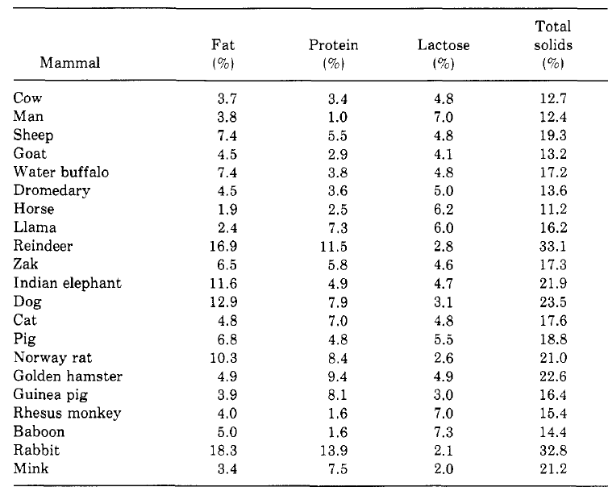
Table 1.1. Composition of milk of different mammals (1).

Table 1.2. Physical properties of α- and β-lactose crystals (13).
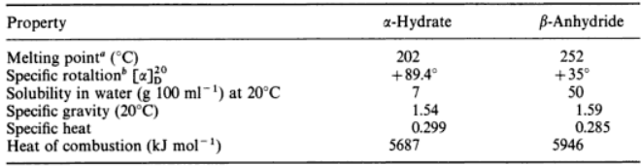

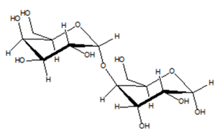
Fig. 1.1. Molecular structure of α-lactose (7).

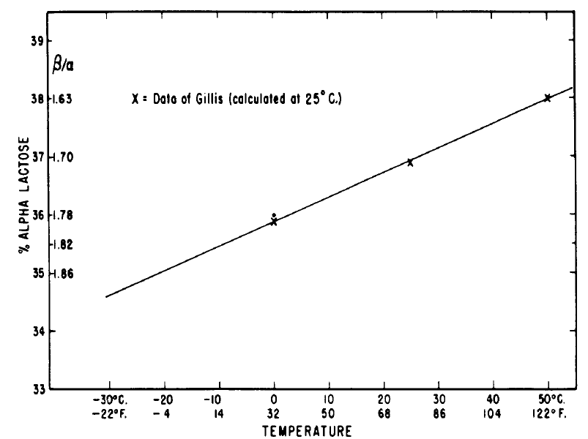
Fig. 1.2. Effect of temperature on the ratio of α- and β-lactose isomers at equilibrium (10).

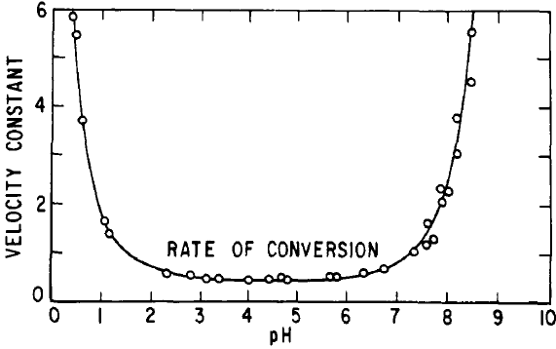
Fig. 1.3. Effects of pH on the maturation rate of lactose (11).

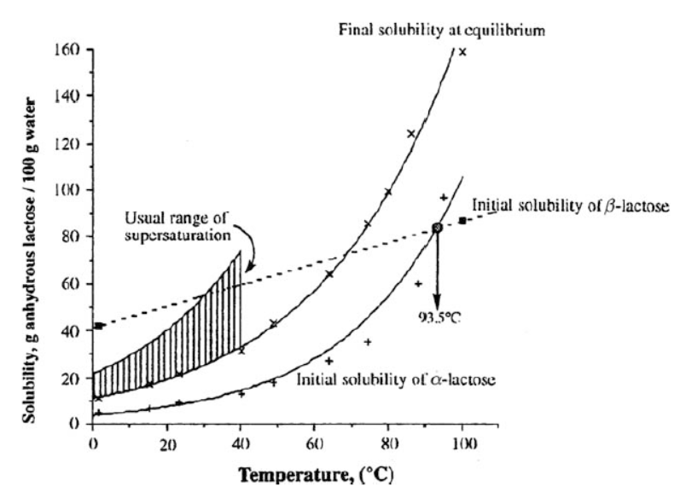
Fig. 1.4. Solubility of α- and β-lactose at different temperatures (13).

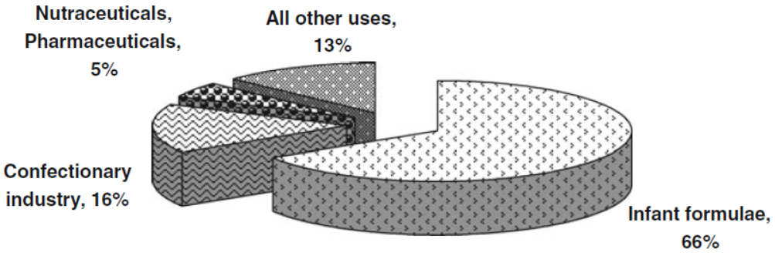
Fig. 1.5. Usage of lactose in USA in 2005 (18).

Fig. 1.6. Mechanism of nucleation.

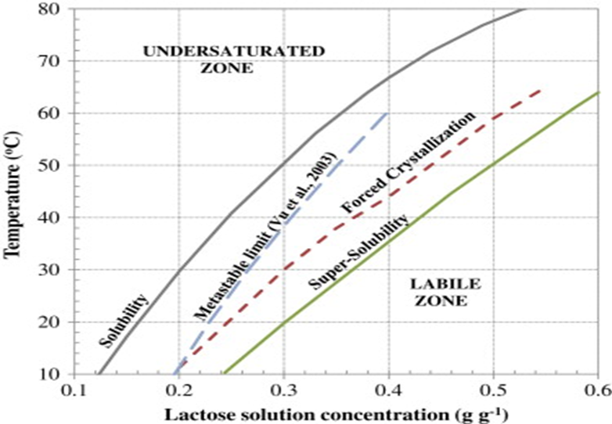
Fig. 1.7. Lactose solubility diagram proposed by Hunziker (11) and Vu et al (34).

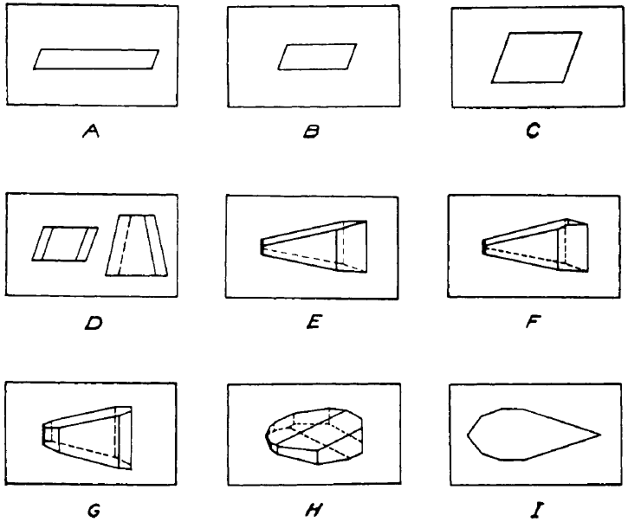
Fig. 1.8. The morphology of α-lactose monohydrate crystals produced at decreasing crystallization rate from A to I (34).

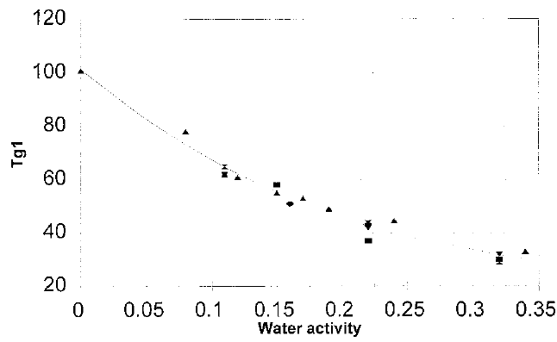
Fig. 1.9. Effect of water activity on glass transition temperature of amorphous lactose (56) .

CHAPTER Ⅱ ENHANCING LACTOSE CRYSTALLIZATION IN AQUEOUS SOLUTIONS BY SOLUBLE SOYBEAN POLYSACCHARIDE

Abstract
Increasing the crystallization rate without compromising purity is critical to lactose recovery from cheese whey. In this study, soluble soybean polysaccharide (SSPS), a low viscosity polysaccharide, was studied for the impact on lactose crystallization. SSPS was dissolved at 0-1.0% w/w in 40% w/w lactose solutions to study spontaneous and seeded (with 0.5% w/w lactose crystals) crystallization at 30 °C. The addition of SSPS enhanced the crystallization that was the most significant at 0.1% w/w SSPS, resulting from the facilitation of nucleation. Further addition of SSPS to 0.5% and 1.0% w/w increased sample viscosity and reduced the crystal growth and therefore yield. The purity and structure of lactose crystals were not affected by addition of SSPS, based on DSC, FTIR, and XRD. A high (54.7%) yield of lactose crystals in 24 h after adding 0.1% SSPS and 0.5% w/w seed showed the great potential of SSPS to facilitate lactose recovery.
Key words: lactose, crystallization, soluble soy bean polysaccharide, nucleation, purity

2.1. Introduction
Crystallization is the main method used in the dairy industry to recover lactose from cheese whey and crystallization rate is vital to the economic viability. Nucleation and crystal growth are generally two steps involved in crystallization of lactose in an aqueous solution (1). Supersaturation is the driving force in both steps, and the crystallization process proceeds until the concentration of a solute in the liquid phase reduces to its maximum solubility (2). The formation of nuclei is a process of forming lactose molecule clusters because the lactose-lactose interactions are favored over those of lactose and water (1). The growth of nuclei involves several steps initiated by the mutarotation of lactose from the β- to α-form followed by diffusion of lactose molecules from the continuous phase to water/crystal interfaces and then incorporation into the crystal lattice (1). Heat generated by the phase change and impurity molecules are to be removed during crystallization (1, 2).
Impurities may affect the crystallization rate of lactose positively or negatively. Protein (3.49-5.64 g/100g), potassium (140 mg/100g), chloride (90- 127 mg/100g), calcium (111-120 mg/100g), sodium (47- 77 mg/100g), and phosphorus (61- 79 mg/100g) are the major non-lactose compounds in the whey (3). Potassium, calcium, sodium, and phosphorus by themselves were observed to inhibit the nucleation or crystallization of lactose to different extents, while coexistence of calcium and phosphate showed the promotion effect (4). Calcium chloride (1-15 g/100g water) promoted the lactose crystallization in spontaneous single crystal experiments (5-7) but had no detectable effect in seeded crystallization (8). Potassium phosphate and potassium chloride were reported to inhibit crystallization (5, 6). Sodium phosphate showed no effect on lactose crystallization at 5% total solids (4) but showed a promotion effect at 20% of total solids (8). Lactic acid is a major organic acid in whey and was reported to act as an inhibitor of lactose crystallization (4, 6, 9). In comparison, calcium lactate (up to 5 g/100g water) slightly increased the growth rate of lactose crystals (5, 8).
Different mechanisms have been proposed to explain the effects of different additives on crystallization. Additives can impact lactose solubility and thereby supersaturation and crystallization rate (2). Lactose has a higher crystallization rate in alcohol-water mixtures than in water alone because of the reduction of lactose solubility by alcohol (10). Sucrose has also been reported to promote lactose crystallization, resulting from the decreased water solubility of lactose (11). In some cases, impurities can act as nuclei and be entrained in crystals (4). Sodium phosphate and calcium chloride were reported to promote lactose crystallization without changing the solubility of lactose, and both salts were detected in lactose crystals (8). It was also proposed that crystal growth rate can be enhanced by increasing the ionic strength, but the effects become less significant at high concentrations of salts (12). This theory was supported by the maximum crystallization rate of lactose when calcium chloride was added at 10% of total solids (6).
The effects of polysaccharides on crystallization properties of lactose have only been studied in frozen dairy food systems. Hydrocolloids such as gelatin, guar gum, xanthan, and locus bean gum are commonly used as stabilizers in ice cream (13). They have been reported to inhibit the formation of ice and lactose crystals by increasing system viscosity (14) that constrains the formation of nuclei at low temperatures (15). In our preliminary studies, we also observed the inhibition of lactose crystallization in aqueous solutions at 30 °C by guar gum, locus bean gum, xanthan, and gum arabic. However, soluble soybean polysaccharide (SSPS) was observed to promote lactose crystallization. SSPS is an acidic polysaccharide with a small fraction of conjugated polypeptide (16). The viscosity of SSPS is much lower than other polysaccharides and this is an important property that enables the wide use of SSPS as a functional additive to obtain a high content of dietary fiber (17) and prevent the precipitation of proteins (18).
The aim of this study was to evaluate the effects of SSPS on lactose crystallization with or without initially-added lactose seed. Nucleation and crystal growth were characterized by absorption spectroscopy and yield, respectively. The morphology of lactose crystals was studied using polarized light microscopy. The purity and physicochemical properties of lactose crystals were studied by X-ray diffraction spectroscopy (XRD), differential scanning calorimetry (DSC), and Fourier transform infrared spectroscopy (FTIR).

2.2. Materials and methods
2.2.1. Chemicals
α-D-(+)-lactose monohydrate was from Fisher Scientific (Pittsburgh, PA). SSPS was a gift from Fuji Oil Corp. (Osaka, Japan). Lactose crystal seed (100-mesh fineness) was from Hilmar Ingredients (Hilmar, CA). Other chemicals used in this study were obtained from either Sigma-Aldrich Corp. (St. Luis, MO) or Fisher Scientific (Pittsburgh, PA).

2.2.2. Crystal yield
The unseeded (spontaneous) and seeded crystallization experiments were conducted at the fixed lactose concentration and temperature. Briefly, 40% w/w α-lactose monohydrate and 0, 0.1, 0.5 or 1.0% SSPS w/w were dissolved in distilled water at 70 °C in a water bath until clear solutions were obtained. After cooling to 30 °C in an ice bath, samples for seeded crystallization were added with 0.05% w/w lactose seed. Samples were incubated at 30 °C in a water bath for 6, 12 and 24 h for unseeded crystallization and 3, 9, 12 and 24 h for seeded crystallization. Crystals were collected after decanting the upper serum, followed by washing with absolute ethanol two times and vacuum-drying overnight at 30 °C. The final crystals were collected, weighed, and stored in a desiccator until use. The net mass of lactose crystals was used to calculate the yield according to equation 1. Triplicate experiments were conducted at each combination of conditions.
Yield (%) = 100% × [Crystal obtained (g)/total lactose in solution (g)] (1)
2.2.3. Viscosity
The viscosity of solutions with 40% w/w lactose and 0, 0.1, 0.5, or 1.0% w/w SSPS prepared as above was measured using an AR2000 rheometer (TA Instruments, New Castle, DE). The cone-plate geometry, with a cone angle of 1° and a cone diameter of 40 mm, was adopted. The shear rate ramp was performed from 5 to 100 s⁻¹ at 30 °C after equilibration at 30 °C for 2 min. Experiments were conducted in duplicate.
2.2.4. Determination of water solubility of lactose
The solubility of lactose without or with different amounts of SSPS was tested in distilled water at 30 °C. Lactose solutions prepared as in crystallization experiments were incubated in a water bath at 30 °C and the crystal mass was determined daily for 10 days to determine the equilibrium of crystallization. The crystal mass after reaching a constant was used to calculate solubility of lactose (5) according to equation 2. Triplicate experiments were conducted.
Solubility (g/100 g water) = $\frac{total lactose mass \left(g\right)-crystal mass (g)}{water mass (g)}$ × 100 (2)
2.2.5. Nucleation studied by absorption spectroscopy
Lactose (40% w/w) solutions with 0 and 0.1% w/w SSPS, with and without 0.05% w/w seed, were prepared as above. Samples were placed in the plastic cuvette immediately after cooling to 30 °C. The absorbance of each sample at 500 nm was recorded every 5 min for 12 h using a spectrophotometer (BioMate 5, Thermo Electron Corporation, Rochester, NY) at ambient conditions (21 °C). Experiments were conducted in duplicate.
2.2.6. Crystal morphology
Crystals collected after 3, 9, 12 and 24 h incubation were observed using a polarized light microscope (model BX-51, Olympus America Inc., Center Valley, PA). Images were recorded with an Olympus DP70 camera (Ver.2.3.1.231, Olympus America Inc.).
2.2.7. Differential scanning calorimetry (DSC)
The DSC experiments were conducted using a model Q2000 instrument (TA Instrument, New Castle, DE). Around 5 mg powder was sealed in hermetic aluminum pans and heated from 25 to 250 °C at a rate of 10 °C/min. Nitrogen was used as the transfer gas at a flow rate of 50 mL/min.

2.2.8. X-ray diffraction spectroscopy (XRD)
X-ray powder diffraction experiments were performed using a model X’Pert instrument (PANalytical Inc., Westborough, MA). Crystals were ground to fine powder prior to analysis. Scanning at a 2θ scale from 5 to 35° was performed at a step size of 0.05 °/s.
2.2.9. Fourier-transform infrared spectroscopy (FTIR)
FTIR spectra were measured using a Nexus670 spectrometer (Thermo Nicolet Corp., Madison, MI). The background spectrum was calibrated using KBr for each sample. Pellets were prepared after grinding lactose crystals together with KBr at a mass ratio of 1:20. The scanning in the wavenumber range of 400-4000 cm⁻¹ was conducted with a resolution of 4 cm⁻¹.
2.2.10. Statistical analysis
Statistical analyses were performed using the JMP program (version pro 11.1.1, SAS Institute, Cary, NC). One-way analysis of variance (ANOVA) was carried out. Differences between pairs of means were compared using student’s t-test with a significance level of 0.05.

2.3. Results and discussion
2.3.1. The effect of SSPS on lactose crystal yield
The lactose crystal yield after incubation for 24 h with and without SSPS in the solution is shown in Fig. 2.1. SSPS increased the crystal yield under both unseeded and seeded conditions, and the increase was not significant (P > 0.05) only for the unseeded crystallization with 1.0% SSPS. The promotion effect was the most significant at 0.1% SSPS, with the yield increasing from about 22.2% and 34.9% of the control without SSPS to 27.4% and 54.7% in unseeded and seeded crystallization, respectively, corresponding to a net yield increase of 5.2% and 19.8%. When the concentration of SSPS increased to 0.5% and 1.0%, the crystal yield decreased to 26.3% and 23.5% in unseeded crystallization, and 51.4% and 40.0% in seeded crystallization, respectively. The promotion effect of SSPS is more significant in seeded than unseeded crystallization. Furthermore, based on the solubility of lactose (Table 2.1), the maximum yield of lactose crystals in solutions with 0, 0.1% and 0.5% SSPS was around 64.8%, and that with 1.0% SSPS was around 66.6%. Thus, the treatment with 0.1% SSPS (54.7% yield) under seeded crystallization achieved about 84.4% of the maximum possible yield in 24 h.
SSPS might affect lactose crystallization in two opposite ways. On one hand, SSPS molecules may assist lactose crystallization by promoting lactose-lactose interactions. In aqueous solutions, each lactose molecule is surrounded by a hydration layer containing up to six water molecules that are continuously replaced (1). SSPS, with multiple hydroxyl groups, may compete with water molecules at the hydration layer, which can promote lactose-lactose interactions. An increase of supersaturation rate resulting from the decreased solubility of lactose after addition of SSPS may also facilitate lactose crystallization (1), discussed below. On the other hand, SSPS is an impurity and needs to be removed from lactose molecule lattice surface during crystal growth (1). Thus, SSPS can be a factor limiting the crystal growth, especially when it is used at higher concentrations (Fig. 2.1). In addition, the viscosity of lactose solutions increased with an increase in SSPS concentration (Fig. 2.2), which reduces the mobility of lactose molecules and therefore inhibits both nucleation (1) and crystal growth (19, 20). It appears that the promotion effect was dominant at 0.1% SSPS, while inhibition effects became more apparent at 0.5% and 1.0% SSPS.
2.3.2. The effect of SSPS on lactose solubility
To test whether SSPS affected lactose crystallization by changing the solubility of lactose, the solubility of lactose with different concentrations of SSPS was examined at 30 °C. The addition of 0.1% and 0.5% SSPS did not significantly affect the solubility of lactose (P > 0.05), while 1.0% SSPS significantly (P < 0.05) decreased the solubility by about 1 g per 100 g water (Table 2.1).
Changes in solubility can affect the supersaturation of lactose. A reduction of lactose solubility is expected to increase the degree of supersaturation and the crystal growth rate. The lactose crystal growth rate (r, mg/m²/min) at 30 °C was correlated with the difference between the overall concentration of lactose in the solution (C) and the solubility (C_{s}) at 30 °C to be r = 0.148 (C - C_{s})^{2.52} (7). However, lactose in solutions with 0.1% and 0.5% SSPS had a solubility similar to that without SSPS (Table 2.1) but had a higher yield after 24 h (Fig. 2.1). Conversely, the solubility of lactose reduced after addition with 1.0% SSPS (Table 2.1) but the crystal yield after 24 h was lower than treatments with 0.1% and 0.5% SSPS (Fig. 2.1). Therefore, multiple mechanisms such as solubility of lactose, viscosity of solution, and lactose-lactose interactions are involved with the observations in Fig. 2.1.
2.3.3. The effect of SSPS on lactose nucleation and crystal growth
To further investigate the effects of SSPS on lactose crystallization, lactose solutions with and without 0.1% w/w SSPS under spontaneous and seeded crystallization were monitored for absorbance at 500 nm (Abs₅₀₀) during incubation. As shown in Fig. 2.3, during spontaneous crystallization without SSPS, Abs₅₀₀ increased gradually and slightly. In comparison, Abs₅₀₀ increased more sharply after addition of 0.1% SSPS and reached a maximum in about 2 h, followed by gradual reduction to Abs₅₀₀ similar to the sample without SSPS. The data indicated that SSPS assisted the nucleation during spontaneous crystallization of lactose. The increase of Abs₅₀₀ during seeded crystallization started at the very beginning and was far more intensive than spontaneous crystallization. The seeded sample with 0.1% SSPS showed a higher and wider peak than that without SSPS. The decrease in Abs₅₀₀ likely was due to the precipitation of crystals that grew to a dimension no longer being suspended. The data again suggested the facilitation of nucleation by SSPS during the seeded crystallization.
The yield of lactose crystals with or without 0.1% w/w SSPS after spontaneous and seeded crystallization for different durations is shown in Fig. 2.4. The rate of crystal yield increase was significantly accelerated by addition of 0.1% SSPS in both cases. Under spontaneous crystallization, no significant difference (P > 0.05) in the yield was observed in the first 6 h for solutions with or without 0.1% SSPS. Between 6 and 12 h incubation for spontaneous crystallization, the growth of crystal yield was gradual in the lactose only solution but was drastic in the sample with 0.1% SSPS. The yield of crystals in the treatment with 0.1% SSPS after 12 h, about 20%, was similar to that without SSPS after 24 h. In seeded crystallization, both samples with and without 0.1% SSPS showed the first-order increase in crystal yield, and the initial slope of crystal yield curve increased after addition of 0.1% SSPS. Although the growth rate decreased in both samples at longer incubations, the sample with 0.1% SSPS consistently showed the higher slope than that without SSPS.
2.3.4. Morphology of crystals
The morphology of crystals formed with or without addition of 0.1% SSPS is compared in Fig. 2.5. For spontaneous crystallization (Fig. 2.5A), crystals from the solution with 0.1% SSPS were much smaller than those from the lactose only solution after 6 h. Considering the similar yield in the two solutions after 6 h (Fig. 2.4), a larger amount of crystals formed in the solution with SSPS indicates the promotion of nucleus formation by SSPS, which is consistent with the Abs₅₀₀ data (Fig. 2.3). Tomahawk-shaped crystals from the solution without SSPS continued to grow and many were bigger than 1 mm after 24 h. For the treatment with 0.1% SSPS, crystals grew significantly from 6 to 12 h and had a dimension similar to those from the lactose only solution. This further supports that the much greater increase in the crystal yield from 6 to 12 h for the treatment with 0.1% SSPS than that without SSPS (Fig. 2.4) resulted from a greater number of nuclei for crystal growth. The crystals from the treatment with SSPS kept growing and became more rounded after 24 h than those from the lactose only solution. Previously, impurities like salts have also been reported to affect the size and shape of lactose crystals (21). The smaller size difference between crystals obtained after 12 and 24 h from the solution with SSPS than that without SSPS (Fig. 2.5A) agrees with the smaller net increase in the total crystal yield of the former (Fig. 2.4). This can be interpreted by the smaller growth rate when there are more sites available but the amount of free lactose becomes less.
For seeded crystallization with and without 0.1% SSPS, small crystals (≤100 μm) formed after 3 h and the size of crystals was similar in the two samples (Fig. 2.5B). Because the treatment with 0.1% SSPS had a higher yield than that without SSPS (Fig. 2.4), the results indicated that SSPS promoted the formation of nuclei that increased the number (yield, Fig. 2.4) but not the dimension of crystals (Fig. 2.5B), which is similar to spontaneous crystallization. The results agreed with changes in Abs₅₀₀ during incubation (Fig. 2.3), as discussed previously. Crystals continued to grow after 9 h, and the presence of small crystals (Fig. 2.5B) indicate the continuous formation of nuclei. From 9 to 12 h, many big crystals over 500 μm were observed in both treatments with and without SSPS. Crystals from the lactose-only solution also showed the tomahawk shape. With SSPS and seed, some of the crystals were narrower at the bottom face while some appeared in the tomahawk shape (Fig. 2.5B), different from those from spontaneous crystallization (Fig. 2.5A). Crystals became even bigger after 24 h incubation and some small crystals (<300 μm) were also presented. The effect of SSPS on crystal shape was more significant in spontaneous than seeded crystallization. The difference in crystal shape and dimension can be caused by the crystallization rate (1). The crystals were larger in spontaneous than seeded crystallization because a smaller crystallization rate favors the growth of each crystal and the formation of bigger and fewer crystals.
2.3.5. Structure and purity of crystals
The XRD results are shown in Fig. 2.6. No difference in the XRD diffraction patterns was observed for crystals produced from lactose solutions with and without SSPS, in both spontaneous and seeded crystallization. Peaks at 2θ of 12.5° and 15.4° suggest crystals were α-lactose monohydrate, which was further supported by the absence of the characteristic peak of β-lactose crystals at 10.5° (22). The results indicated that the increased crystallization rate by SSPS and seed did not affect the structure of lactose crystals.
The DSC curves are shown in Fig. 2.7. SSPS showed two exothermal peaks at 160 and 202 °C that were not present in the curves of lactose crystals obtained from lactose solutions with and without 0.1% SSPS in spontaneous or seeded crystallization. The DSC data indicated the absence of SSPS in the crystals or the content of SSPS was too low to be detected. For lactose crystal samples, the exothermic peak at 150 °C was caused by the loss of water, and peaks above 220 °C indicated the melting of lactose crystals (23). Similar DSC curves of crystals formed with and without the addition of SSPS verified the XRD results about the same structures of these crystal samples.
The FTIR spectra of crystals obtained from solutions with and without SSPS are shown in Fig. 2.8. A peak at 1614 cm⁻¹ corresponding to the amide group was observed for SSPS (24) but was absent in the spectra of all lactose samples that showed identical FTIR spectra. The FTIR data further confirmed the absence of SSPS in lactose crystals.

4. Conclusions
SSPS was observed to facilitate lactose crystallization with and without seed, especially at low concentrations. Despite no impacts on solubility of lactose, 0.1% SSPS appeared to facilitate the formation of nuclei and thereby increased the crystal growth rate and yield. At high SSPS concentrations, SSPS inhibited the crystal growth, partially contriuted by the reduced mobility of lactose molecules due to increases in viscosity. The seeded crystallization showed the faster kinetics, and the addition of 0.1% SSPS enabled the yield of 54.7% after incubating the 40% w/w lactose solution for 24 h, close to the maximum possible yield (64.8%). The faster crystallization after addition of SSPS resulted in more abundant and less-tomahawk–shaped crystals. The increased yield of lactose crystals after addition of SSPS with and without seed did not change the structure and purity of α-lactose monohydrate crystals based on XRD, FTIR, and DSC. The findings from this study suggest the potential of enhancing lactose recovery by supplementing a low concenration of SSPS.

Acknowledgements
This work was supported by the University of Tennessee and Dairy Research Institute (Rosemont, IL). We thank the Materials Science and Engineering Facility at the University of Tennessee for use of XRD.

References
1. Hartel, R. W., Crystallization in Foods. Aspen Publishers: Gaithersburg, MD, 2001.
2. Mullin, J. W., Crystallization. 4th ed.; Butterworth-Heinemann: Oxford, UK, 2001.
3. Jenness, R., Composition of milk. In Fundamentals of Dairy Chemistry, Springer: 1988; pp 1-38.
4. Guu, M. Y. K.; Zall, R. R., Lactose crystallization : effects of minerals and seeding. Process Biochem. 1991, 26, 167-172.
5. Bhargava, A.; Jelen, P., Lactose solubility and crystal growth as affected by mineral impurities. Journal of Food Science 1996, 61, 180-184.
6. Jelen, P.; Coulter, S. T., Effects of certain salts and other whey substances on the growth of lactose crystals. J. Food Sci. 1973, 38, 1186-1189.
7. Jelen, P. C., Samuel T, Effects of supersaturation and temperature on the growth of lactose crystals. J. Food Sci. 1973, 38, 1182-1185.
8. Smart, J. B.; Smith, J. M., Effect of selected compounds on the rate of α-lactose monohydrate crystallization, crystal yield and quality. Int. Dairy J. 1992, 2, 41-53.
9. Nickerson, T. A.; Moore, E. E., Factors influencing lactose crystallization. J. Dairy Sci. 1974, 57, 1315-1319.
10. Majd, F.; Nickerson, T., Effect of alcohols on lactose solubility. J. Dairy Sci. 1976, 59, 1025-1032.
11. Nickerson, T.; Moore, E., Solubility interrelations of lactose and sucrose. J. Food Sci. 1972, 37, 60-61.
12. Hook, A. V., Kinetics of sucrose crystallization: Pure sucrose solutions. Ind. Eng. Chem. 1944, 36, 1042-1047.
13. Bahramparvar, M.; Mazaheri Tehrani, M., Application and functions of stabilizers in ice cream. Food Rev. Int. 2011, 27, 389-407.
14. Nickerson, T., Lactose crystallization in ice cream. IV. Factors responsible for reduced incidence of sandiness. J. Dairy Sci. 1962, 45, 354-359.
15. McSweeney, P.; Fox, P. F., Advanced Dairy Chemistry: Lactose, Water, Salts and Minor Constituents. Springer: New York, 2009; Vol. 3.
16. Chivero, P.; Gohtani, S.; Ikeda, S.; Nakamura, A., The structure of soy soluble polysaccharide in aqueous solution. Food Hydrocolloids 2014, 35, 279-286.
17. Maeda, H.; Phillips, G.; Williams, P., Soluble soybean polysaccharide. In Handbook of Hydrocolloids, CRC Press, Boca Raton, FL: 2000; pp 309-320.
18. Pan, K.; Chen, H. Q.; Davidson, P. M.; Zhong, Q. X., Thymol nanoencapsulated by sodium caseinate: Physical and antilisterial properties. J. Agric. Food Chem. 2014, 62, 1649-1657.
19. Smythe, B., Sucrose crystal growth. II. Rate of crystal growth in the presence of impurities. Aust. J Chem. 1967, 20, 1097-1114.
20. Budiaman, E.; Fennema, O., Linear rate of water crystallization as influenced by viscosity of hydrocolloid suspensions. J. Dairy Sci. 1987, 70, 547-554.
21. Jelen, P.; Coulter, S. T., Effects of certain salts and other whey substances on the growth of lactose crystals. Journal of Food Science 1973, 38, 1186-1189.
22. Drapier-Beche, N.; Fanni, J.; Parmentier, M.; Vilasi, M., Evaluation of lactose crystalline forms by nondestructive analysis. J. Dairy Sci. 1997, 80, 457-463.
23. Lerk, C.; Andreae, A.; De Boer, A.; De Hoog, P.; Kussendrager, K.; Van Leverink, J., Alterations of α‐lactose during differential scanning calorimetry. J.Pharm. Sci. 1984, 73, 856-857.
24. Pandeya, S. N.; Raja, A. S.; Stables, J. P., Synthesis of isatin semicarbazones as novel anticonvulsants-role of hydrogen bonding. J. Pharm. Pharm. Sci. 2002, 5, 266-271.

Table 2.1. Solubility of lactose at 30 °C evaluated from solutions with 40% w/w lactose and 0-1.0% w/w SSPS.
SSPS concentration (% w/w) | Solubility (g/100 g water)*
0 | 23.42 + 0.44ª
0.1 | 23.76 + 0.01ª
0.5 | 23.24 + 0.58ª
1.0 | 22.28 + 0.01^{b}
*Numbers are mean ± standard deviation from triplicate experiments. Different superscript letters represent significant difference between groups (P < 0.05).
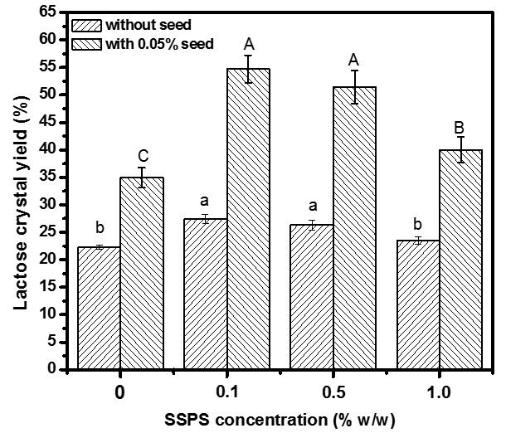
Fig. 2.1. Lactose crystal yield in 40% w/w lactose solutions with 0, 0.1, 0.5 and 1% w/w SSPS, with or without 0.05% w/w lactose seed, after incubation at 30 °C for 24 h. Error bars are standard deviations from triplicates. Different letters above bars indicate significant differences of the mean within the same group, i.e., with or without seed (P < 0.05).
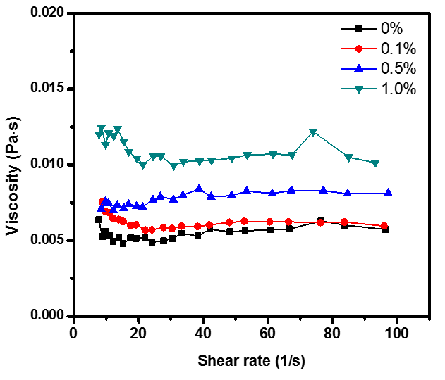
Fig. 2.2. Rheograms of 40% w/w lactose solutions with 0, 0.1, 0.5 and 1% w/w SSPS at 30 °C. Data are averages from duplicate measurements.
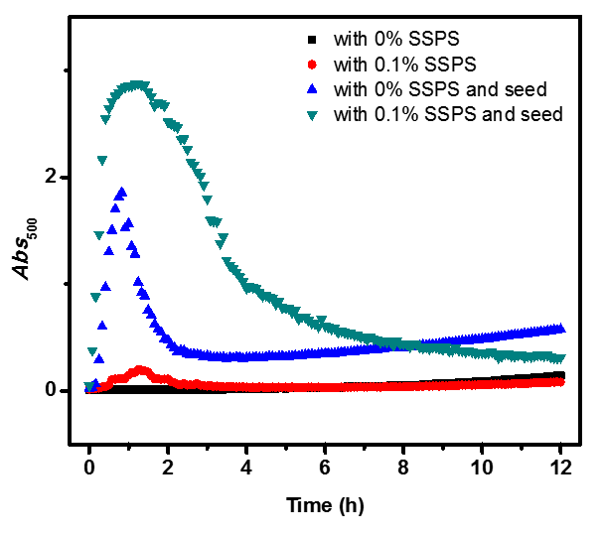
Fig. 2.3. Absorbance at 500 nm (Abs500) of 40% w/w lactose solutions with and without 0.1% w/w SSPS, with or without 0.05% w/w lactose seed, during incubation at 21 °C. Data are averages from duplicates.
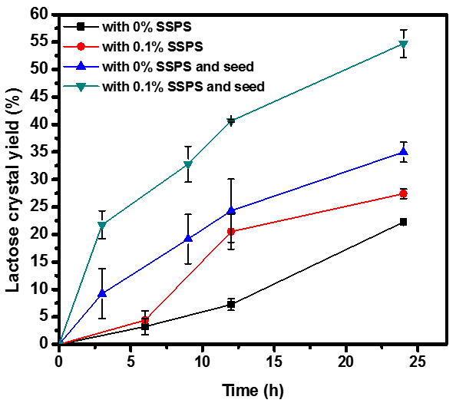
Fig. 2.4. Lactose crystal yield in 40% w/w lactose solutions with and without 0.1% w/w SSPS, with and without 0.05% w/w lactose seed, after incubation at 30 °C for up to 24 h. Error bars are standard deviations from triplicates.
(A)
(B)
Fig. 2.5. Crystals produced from 40% w/w lactose solutions without (top panel) and with (bottom panel) 0.1% w/w SSPS, in (A) spontaneous crystallization after inubation at 30 °C for 6,12, and 24 h or (B) with 0.05% w/w lactose seed after inubation at 30 °C for 3, 9, 12 and 24 h (from left to right in each panel). White/black bar = 500 μm.
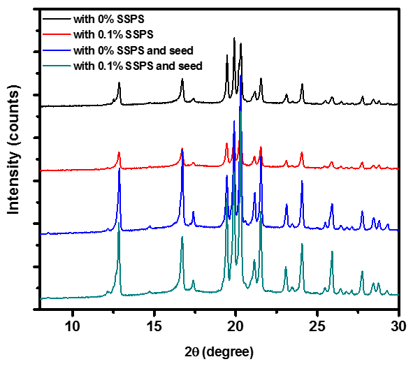
Fig. 2.6. XRD curves of lactose crystals obtained from 40% w/w lactose solutions with and without 0.1% w/w SSPS, with and without 0.05% w/w lactose seed, by incubation at 30 °C for 24 h.
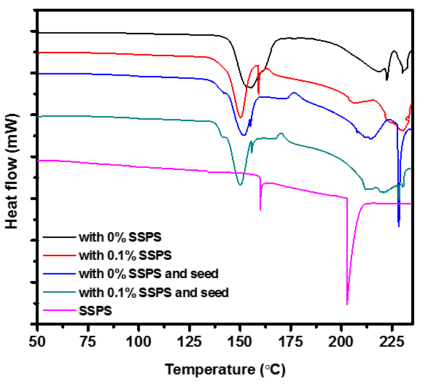
Fig. 2.7. DSC curves of lactose crystals obtained from 40% w/w lactose solutions with and without 0.1% w/w SSPS, with and without 0.05% w/w lactose seed, by incubation at 30 °C for 24 h. SSPS powder was used directly for comparison.
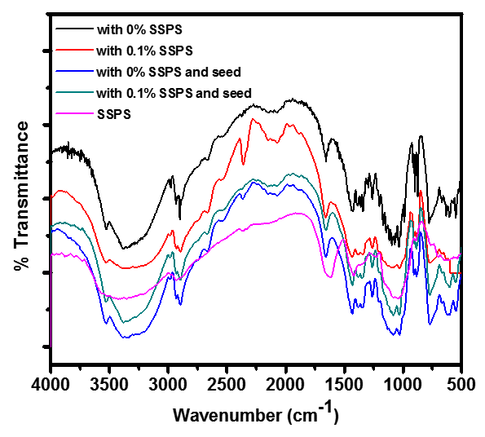
Fig. 2.8. FTIR spectra of lactose crystals obtained from 40% w/w lactose solutions with and without 0.1% w/w SSPS, with and without 0.05% w/w lactose seed, by incubation at 30 °C for 24 h. SSPS powder was used directly for comparison.

Chapter III Crystallinity and Quality of Spray-dried Lactose Powder Improved by Soluble Soybean Polysaccharide

Abstract
The crystallinity of lactose is significant to the quality and shelf-life of spray-dried dairy products. In this study, the properties of spray-dried lactose powder were studied after co-spray drying with soluble soybean polysaccharide (SSPS) at mass ratios of 1:0, 19:1 and 9:1. Spray-dried samples with SSPS had the significantly increased crystallinity based on polarized light microscopy, differential scanning calorimetry, and X-ray diffraction spectroscopy (XRD). Increasing the pump rate also increased the crystallinity and moisture content of lactose powder. The XRD data indicated the presence of both α- and β-lactose crystals in the spray-dried powder with 10% SSPS. Moisture sorption tests at 65% relative humidity and 25 °C indicated that SSPS delayed the crystallization of amorphous lactose in the powder, which agreed with the reduced caking and clumping. Findings from this study may be valuable in extending the shelf-life and improving the transportation property of spray-dried powder containing lactose.
Key words: lactose, spray-dried powder, soluble soybean polysaccharide, crystallinity, moisture absorption, transportation property

3.1. Introduction
Lactose is a major component in spray-dried whey and milk powder products that are widely used in food products including infant formulas, dry mixes, and protein powders (1). One of the major problems of these powdered products is the possible occurrence of caking during storage, causing degradation of product quality and shelf-life. Caking is mainly caused by the crystallization of lactose in spray-dried powder (2). This is because lactose in spray-dried powder is mostly amorphous and thermodynamically unstable but can absorb moisture and become crystallized to a more organized and stable state (3). The amorphous lactose also is more reactive and promotes nonenzymatic browning and flavor deterioration (4, 5). Therefore, increasing the crystallinity of lactose in spray-dried dairy ingredients is of significance to maintain their quality and extend their shelf-life.
Effects of spray-drying conditions on lactose crystallinity have been studied. Chiou et al. (6) reported the increased crystallinity of spray-dried lactose powder after increasing the inlet temperature from 134 to 210 °C. Chidavaenzi et al. (7) reported that the crystallinity of spray-dried lactose powder increased from 0% to 18% when the lactose concentration in the feed increased from 10 g/100 mL to 40 g/ 100 mL. However, since the water solubility of lactose is around 20 g/ 100 ml at room temperature (8), the feed with a high concentration of lactose might result in the formation of lactose crystals that can damage spray-dryers. In another study, the atomizing air-flow rate was observed to have no effect on the crystallinity of spray-dried lactose powder (9).
Other components in the feed solution can affect the physical state and moisture sorption behavior of spray-dried lactose during storage. The effects of minerals vary with their types and concentrations. Lactose and sodium chloride at a mass ratio of 5:2 increased the crystallinity of spray-dried lactose that had the decreased crystallization rate during storage, but potassium chloride did not show such effects (10). Proteins such as whey protein isolate, sodium caseinate, albumin, and gelatin (1, 11, 12) and polysaccharides such as gum arabic (13) were reported to delay the crystallization of lactose in spray-dried powder after exposure to humid air. The mechanism, i.e., impacts of biopolymers on nucleation or growth, depended on the amount of biopolymers (13).
Soluble soybean polysaccharide (SSPS) separated from the byproduct of soybean protein production is a branched polymer with a small fraction of protein (14). SSPS has a molecule weight of about 100 kDa (15) and its solutions have a relatively low viscosity when comparing to linear chain polysaccharides (14). With the protein-polysaccharide conjugate structure, SSPS has been widely used as an emulsifier and stabilizer in beverages (16). In chapterⅡ, we observed the addition of SSPS in lactose solutions promoted the nucleation and crystallization rate. Furthermore, with its hydroscopic property favoring the delay of lactose crystallization in spray-dried powder, SSPS may be a good candidate to improve the crystallinity and quality of skim milk. The aim of this chapter was thus to study the effects of co-spray drying lactose with SSPS on physical properties on spray-dried powder.

3.2. Materials and methods
3.2.1. Materials
α-D-(+)-lactose monohydrate was purchased from Fisher Scientific (Pittsburgh, PA). SSPS was a gift from Fiji Oil Corp. (Osaka, Japan). Other chemicals used in this study were obtained from either Sigma-Aldrich Corp. (St. Luis, MO) or Fisher Scientific.
3.2.2. Preparation of spray-dried samples
SSPS was mixed with lactose at mass ratios of 0:1, 1:19, 1:9 and 1:0. The mixture was dissolved at 10% w/w total solids in deionized water at 30 °C. The SSPS-only sample was prepared by dissolving at 3% w/w total solids in deionized water at 50°C. The solutions were spray-dried using a Buchi-B290 Mini Spray dryer (BÜCHI Corporation, Flawil, St. Gallen, Switzerland) at an inlet temperature of 170 °C, an outlet temperature of 87-93 °C, a pump rate of 6 mL/min (15% pump rate) or 11 mL/min (30% pump rate), an air flow rate of 470-600 L/h, and an aspirator setting of 100% (38 m³/h). All powdered samples were immediately collected, weighed, and stored in a desiccator before analyses. The yield of spray-drying was calculated using Eq. 1.
$Yield\% =100\% \frac{Mass of collected powder (g)* (100\%- moisture\%) }{Mass of SSPS and lactose in the feed (g)}$ (1)
3.2.3. Moisture content
About 2 or 3 g spray-dried powder was dried at 100 °C in a convection oven (model Precision 6958, Thermo Scientific, Inc., MA, USA) for 24 h. The dry-basis (db) moisture content was calculated based on sample mass difference before and after drying (loss of mass, Eq. 2). Each sample was measured two or three times.
$Moisture content \left(\%db\right)= \frac{Loss of mass (g)}{Total mass \left(g\right)- loss of mass (g) } 100\%$ (2)
3.2.4. Scanning electron microscopy (SEM)
The morphology of spray-dried powders was characterized by SEM. Small amounts of samples were glued to the specimen holder. The samples were then coated with gold under vacuum and imaged at 20-200× magnifications (model LEO 1525, SEM/FIB Zeiss Auriga, Oberkochen, Germany).
3.2.5. Polarized light microscopy
A polarized light microscope (model BX-51, Olympus America Inc., Center Valley, PA) was used to observe birefringence of the spray-dried samples.
3.2.6. Differential scanning calorimetry (DSC)
The thermal stability and crystallinity of powdered samples were characterized using a model Q2000 calorimeter (TA Instruments, Inc., New Castle, DE). The powder samples were sealed in hermetic aluminum pans and heated from 20 to 250 °C at a rate of 10 °C/min. Nitrogen was used as the transfer gas at a flow rate of 50 mL/min. The results were analyzed using TA Universal Analysis 2000 software (TA Instruments, Inc., New Castle, DE).
3.2.7. X-ray diffraction spectroscopy (XRD)
X-ray powder diffraction experiments were performed using a model X’Pert instrument (PANalytical Inc., Westborough, MA). Powder samples were scanned at a 2θ range from 5 to 35° at a step size of 0.05° per s.
3.2.8. Moisture sorption properties
One gram of each spray-dried sample was weighed into an uncovered petri dish and incubated in an environmental chamber (model IG420U, Yamato Scientific Co., Tokyo, Japan) controlled at 65% relative humidity (RH) and 25 °C. The samples were applied into a layer as thin as possible in petri dishes to avoid the crystallization of the outer layer that may interfere with the water sorption of inner particles. The spray-dried samples prepared at a 15% pump rate were weighed after 5, 30, 60, 120, 180, 360 and 1440 min, while those prepared with a 30% pump rate were weighed after 5, 60, 80, 100, 120, 180, 240, 1200 and 3600 min using an analytical balance with an accuracy of 0.0001 g. The moisture sorption and desorption were calculated based on the overall mass and dry matter of the sample (11). Each sample was measured in duplicate.
3.2.9. Statistical analysis
Statistical analyses were performed using the JMP program (version pro 11.1.1, SAS Institute, Cary, NC, USA). One-way analysis of variance (ANOVA) was carried out. Differences between pairs of means were compared using student’s t-test with a significance level of 0.05.

3.3. Results and discussion
3.3.1. Moisture content and yield of spray-dried powder
The moisture content of spray-dried samples is listed in Table 3.1. For the lactose-only sample, the moisture content of spray-dried powder produced with 30% pump rate (3.43%db) was significantly higher (P < 0.05) than that produced at 15% pump rate (2.08%db). The results are in agreement with a previous study (10) using the same type of spray dryer. This is expected because a shorter residence time during spray drying results in less complete evaporation of water at a higher pump rate. At 15% pump rate, the moisture content of powder with both SSPS and lactose was higher (P < 0.05) than that with lactose only. However, at 30% pump rate, the addition of SSPS did not have significant impact on the moisture content when compared to the lactose-only sample (P > 0.05). Overall, the pump rate had insignificant (P > 0.05) influence on SSPS-containing samples (Table 1). This might be because SSPS itself absorbs water easily and thus offsets the effect of pump rate.
Moisture content is important to product quality during storage because it is related to glass transition temperature (T_{g}). Amorphous lactose starts to crystallize when the temperature is above T_{g} and crystallization rate is controlled by the difference between T_{g} and storage temperature (17). Because T_{g} decreases with an increase in moisture content (18), a low moisture content is desired for spray-dried powder. The moisture content of spray-dried powder with lactose:SSPS mass ratios of 19:1 and 9:1 were between 2.3 and 2.8%db. These values were lower than that of spray-dried lactose with salts (10) and chitosan (19).
As for the yield of spray dried samples (Table 3.1), the lactose-only sample had a yield (50%) similar to a previous study (10). With an increase in SSPS content, the yield increased, reaching 77% at a lactose:SSPS mass ratio of 9:1. Previously, salts were reported to reduce the yield of spray-dried lactose (10), while chitosan showed a similar promoting effect on yield as SSPS (19). Adhikari et al. (20) reported a significant increase in the yield of spray-dried sucrose after addition of sodium caseinate and whey protein isolate. The authors suggested that the increase of yield is due to the reduction of powder stickiness by forming a film of non-sticky protein at the particle surface. Other researchers also reported the migration of proteins to particle surface after spray-drying, resulting from the surface activity of proteins (12). In our study, the spray-dried lactose without SSPS was sticky and adhered to the drying chamber wall easily, reducing the amount of collectable powder. It was also observed that the spray-dried sample with lactose only had clumps, while those with SSPS did not (Fig. 3.1). As discussed previously, SSPS is surface active (16) and likely adsorbs onto the surface of atomized droplets during spray-drying. As a result, SSPS can be enriched on the surface of spray-dried particles, reducing the stickiness of powder and increasing the yield of spray drying.
3.3.2. Morphology of spray-dried lactose
SEM images of spray-dried lactose samples are shown in Fig. 3.2. The lactose sample without SSPS had spherical particles with a dimension between 1 and 10 µm and had mostly smooth surfaces, with some cavities (Fig. 3.2A), indicating an amorphous state (21). Some small particles adhered to bigger particles, which may be correlated to the formation of macroscopic clumps (Fig. 3.1A). In contrast, particles with SSPS only were collapsed and were more discrete than those of lactose (Fig. 3.2D). Chan et al. (22) stated that particles with wrinkled surface had less interaction with each other and, as a result, they appeared less adhesive and had better dispersion performance. For samples with both SSPS and lactose (Fig. 3.2B, C), an increase in SSPS content corresponded to particle morphology being closer to that with SSPS only, agreeing with macroscopically less agglomerated powder (Fig. 3.1). There were also differences between samples with both lactose and SSPS and that of SSPS or lactose only. Some particles with both SSPS and lactose were more irregular and compact, with some sharp edges that may have resulted from the formation of lactose crystals.

3.3.3. Crystallinity of spray-dried powder
Birefringence is a unique property of crystals but not the amorphous structure of the same substance (23). As shown in Fig. 3.3, no birefringence and thus no crystalline structure was observed for the sample with lactose only. In contrast, an increasing extent of colored particles (birefringence) was observed for spray-dried samples with an increasing content of SSPS. This indicated that SSPS assisted lactose crystallization during spray-drying.
The crystallinity of spray-dried samples was further studied using DSC (Fig. 3.4). Exothermal peaks between 120 and 150 °C after glass transition indicated the instant crystallization of amorphous lactose during heating. The subsequent endothermic peaks between 150 and 180 °C indicated the loss of water belonging to crystallized lactose monohydrate. The endothermic peaks above 180 °C for the SSPS-containing samples indicated the presence of SSPS.
T_{g} of spray-dried lactose has been reported to increase with the presence of high molecular weight substances like proteins (18). In the present study, the onset of T_{g}, between 60 -65 °C, was not significantly different among spray-dried lactose samples with and without SSPS. It may be because the content of SSPS was low (≤ 10%) when compared with the ≥25% biopolymers in other studies (18, 24). Besides, it was previously shown that lactose dominated the T_{g} of lactose-protein mixtures (11). Nevertheless, the glass transition was more noticeable in the DSC curve of the lactose-only sample than those with SSPS, suggesting different forms of solids in these samples (18).
The instant crystallization temperature differed for the spray-dried samples with different amounts of SSPS and pump rate. This temperature is affected by factors including composition, moisture content (18), and crystallinity of the spray-dried powder (24). In the present study, the peak temperature of instant crystallization was higher in samples with SSPS (Table 3.2). Exothermal peaks of samples with a higher content of SSPS were flatter and broader, indicating a larger degree of interactions between SSPS and lactose.
No endothermic peak was observed after the exothermal peak in the curve of spray-dried sample with lactose-only produced at 15% pump rate (Fig. 3.4), indicating it was mostly amorphous. In contrast, a small endothermic peak appeared in the lactose-only sample produced at 30% pump rate, indicating the appearance of lactose monohydrate. Two endothermic peaks representing crystalline lactose and SSPS were observed in the powder with both lactose and SSPS.
Because anhydrous lactose crystals do not show the endothermic peak (loss of water), crystallinity can be quantified using the exothermic peak resulting from the instant crystallization. The area of instant crystallization peak represents the transition energy (9) and is smaller for samples with a higher degree of crystallinity. The crystallinity of a spray-dried sample (α) can be calculated based on the respective crystallization enthalpy of partially-crystallized (${ΔH}_{cr}$) and totally amorphous lactose (${ΔH}_{cr}^{0}$) according to Eq. 3 (24).
α = 1 - $\frac{{ΔH}_{cr}}{ {ΔH}_{cr}^{0}}$ (3)
The transition energy and crystallinity estimated from DSC are summarized in Table 3.2. The crystallinity was higher for samples produced at a higher pump rate and a higher content of SSPS. The spray-dried lactose with 10% SSPS produced at 30% pump rate had the highest crystallinity (57.7%) and lowest transition energy (43.4 J/g). The transition energy of pure lactose (102.7 J/g) was lower than that (112 J/g) reported by Das et al. (9). The difference may have resulted from differences in spray dryer and DSC testing conditions.
XRD was further used to study the crystallinity of spray-dried powder, with results shown in Fig. 3.5. Although DSC curves indicated the partial crystallization of spray-dried lactose with SSPS produced at both pump rates (Fig. 3.4), only the sample with SSPS:lactose mass ratio of 1:9 showed crystalline peaks (shown in Fig. 3.5 for the sample produced at 30% pump rate). Diffraction peaks at 2θ of 12.5° and 10.5° suggested both α- and β-forms of lactose crystals existing in the sample with a SSPS:lactose mass ratio of 1:9 (25). Peaks at 2θ of 23.5° indicating the existence of anhydrous α- and β-lactose (26) The samples with SSPS:lactose mass ratio of 1:19 showed the partially crystalline structures in DSC (Fig. 3.4) but not XRD (Fig. 3.5), possibly because of the low crystallinity. Nevertheless, the XRD intensity of the sample with SSPS:lactose mass ratio of 1:19 was higher than that with lactose only. Some authors used the intensity of the amorphous peak and peak area to calculate crystallinity (6, 19), while others questioned the reliability of such calculations because the intensity can be affected by the quantity and thickness of powdered sample used in XRD (12, 27). Therefore, crystallinity was not calculated from XRD data in the present study.
3.3.4. Moisture sorption properties of spray-dried powder
Moisture sorption properties of spray-dried lactose samples are illustrated in Fig. 3.6. With exposure to humid air, moisture sorption test is also known as water induced crystallization (13). All samples showed an initial increase in moisture content, reaching a maximum before decreasing to a constant value. The moisture uptake indicated the glass transition of samples (28). Debolina et al. (13) suggested this ascending portion of curves also indicates the nucleation phase of lactose. The time for moisture absorption reaching the maximum postponed from ~5 min (the first incubation time point) for the lactose-only sample to 60 min for the samples with SSPS:lactose mass ratio of 1:19 produced at both pump rates and that with 1:9 mass ratio and a pump rate of 15%. The delay effect was the most significant (to 100 min) for the sample produced with SSPS:lactose mass ratio of 1:9 and 30% pump rate. Therefore, the presence of SSPS in spray-dried powder delayed glass transition.
The moisture desorption at longer storage periods indicates the crystallization of lactose that is mostly complete when the moisture content reaches equilibrium (29). It took about 2 h to reach equilibrium for lactose-only samples produced at both pump rates. For samples with SSPS:lactose mass ratio of 1:19, it took 2 and 3 h for the sample produced at 15% and 30% pump rate, respectively. This time was longer for samples with SSPS:lactose mass ratio of 1:9, corresponding to 5 and 20 h for the sample produced at 15% and 30% pump rate, respectively. The moisture desorption results indicated that an increase in crystallinity after addition of SSPS (Table 3.2) delayed the crystal growth.
For pure lactose samples, a larger moisture sorption area means a larger content of amorphous lactose (24). In this study, the powdered sample with lactose only produced at both pump rates reached the highest moisture content and started to crystallize in the first 5 min. The highest moisture content of lactose powder was lower when produced at 30% pump rate (~9%) than that at 15% pump rate (around 13%). Samples with SSPS:lactose mass ratio of 1:19 had a similar peak moisture content as the lactose-only sample but had a higher moisture content after reaching equilibrium. The sample prepared at a SSPS:lactose mass ratio of 1:9 had the highest peak moisture content and the highest equilibrium moisture content (~5%), especially that produced at 30% pump rate. In contrast, the SSPS-only powder absorbed a similar amount of moisture as the lactose-only sample and but the desorption of moisture was much less after reaching equilibrium. Two reasons may have led to the observations. Firstly, the moisture absorbed by SSPS can contribute to the final moisture content. Secondly, part of the lactose might be trapped in the particle center and stay amorphous, therefore holding more moisture. Similar changes in the moisture sorption properties of spray-dried lactose has also been reported after co-spray drying with proteins (whey protein isolate, bovine albumin, gelatin, and sodium caseinte) (18), salts (10), and polysaccharides (chitosan and gum arabic) (13, 19)
Differences in moisture sorption properties were evident in the appearance of spray-dried powder, as shown in Fig. 3.7. The sample with lactose-only showed the agglomeration of powder after incubation at 65% RH and 25 °C for 60 min. The sample with SSPS: lactose mass ratio of 1:19 showed partial agglomeration, while that with a mass ratio of 1:9 did not show apparent change. In a previous study, protein including whey protein isolate and sodium caseinate was observed to delay the crystallization of spray-dried lactose and was speculated to have resulted from interactions between protein and lactose (11). Because proteins are surface-active, they tend to migrate to the surface of atomized droplets during spray-drying and therefore are present as a surface layer of the spray-dried particles (20, 30). The protein surface layer can then delay the moisture sorption of internal lactose in spray-dried powder. Likewise, SSPS is also surface active (31) and can be enriched on the surface of spray-dried powder to prevent agglomeration.

4. Conclusions
The crystallinity and moisture sorption properties of spray-dried lactose were changed by co-spray drying with SSPS. Polarized light microscopy, DSC and XRD results all showed a higher degree of crystallinity in spray-dried powder with a higher content of SSPS. The spray-dried lactose with 10% SSPS had the highest crystallinity (57.7%), with both α- and β-forms of lactose crystals. The presence of SSPS in spray-dried lactose powder delayed the crystallization of amorphous lactose during storage at 65% RH and prevented caking and clumping of lactose powder. The current findings proved that SSPS can be used as an additive to improve the quality of spray-dried powder containing lactose.
Acknowledgements
This work was supported by the University of Tennessee and Dairy Research Institute (Rosemont, IL). We thank the Materials Science and Engineering Facility at the University of Tennessee for use of XRD.

References
1. Nijdam, J.; Ibach, A.; Eichhorn, K.; Kind, M., An X-ray diffraction analysis of crystallised whey and whey-permeate powders. Carbohydrate Research 2007, 342, 2354-2364.
2. Hartel, R. W., Crystallization in Foods. Aspen Publishers: Gaithersburg, Maryland Mar, 2001.
3. Mullin, J. W., Crystallization. 4th ed.; Butterworth-Heinemann: Oxford, UK, 2001.
4. Cardona, S.; Schebor, C.; Buera, M. P.; Karel, M.; Chirife, J., Thermal stability of invertase in reduced‐moisture amorphous matrices in relation to glassy state and trehalose crystallization. Journal of Food Science 1997, 62, 105-112.
5. Kim, M. N.; Saltmarch, M.; LABUZA, T. P., Non-enzymatic browing of hygroscopic whey powders in open versus sealed pouches. Journal of Food Processing and Preservation 1981, 5, 49-57.
6. Chiou, D.; Langrish, T.; Braham, R., The effect of temperature on the crystallinity of lactose powders produced by spray drying. Journal of Food Engineering 2008, 86, 288-293.
7. Chidavaenzi, O. C.; Buckton, G.; Koosha, F.; Pathak, R., The use of thermal techniques to assess the impact of feed concentration on the amorphous content and polymorphic forms present in spray dried lactose. International Journal of Pharmaceutics 1997, 159, 67-74.
8. Jelen, P. C., Samuel T, Effects of supersaturation and temperature on the growth of lactose crystals. Journal of Food Science 1973, 38, 1182-1185.
9. Das, D.; Husni, H. A.; Langrish, T. A., The effects of operating conditions on lactose crystallization in a pilot-scale spray dryer. Journal of Food Engineering 2010, 100, 551-556.
10. Imtiaz-Ul-Islam, M.; Langrish, T., The effect of the salt content on the crystallization behaviour and sorption fingerprints of spray-dried lactose. Food and Bioproducts Processing 2008, 86, 304-311.
11. Haque, M.; Roos, Y., Water sorption and plasticization behavior of spray‐dried lactose/protein mixtures. Journal of Food Science 2004, 69, E384-E391.
12. Wang, S.; Langrish, T.; Leszczynski, M., The effect of casein as a spray-drying additive on the sorption and crystallization behavior of lactose. Drying Technology 2010, 28, 422-429.
13. Das, D.; Lin, S.; Sormoli, M. E.; Langrish, T. A., The effects of WPI and Gum Arabic inhibition on the solid-phase crystallisation kinetics of lactose at different concentrations. Food Research International 2013, 54, 318-323.
14. Chivero, P.; Gohtani, S.; Ikeda, S.; Nakamura, A., The structure of soy soluble polysaccharide in aqueous solution. Food Hydrocolloids 2014, 35, 279-286.
15. Wang, Q.; Huang, X.; Nakamura, A.; Burchard, W.; Hallett, F. R., Molecular characterisation of soybean polysaccharides: an approach by size exclusion chromatography, dynamic and static light scattering methods. Carbohydrate Research 2005, 340, 2637-2644.
16. Pan, K.; Chen, H.; Davidson, P. M.; Zhong, Q., Thymol nanoencapsulated by sodium caseinate: Physical and anti-listerial properties. Journal of Agricultural and Food Chemistry 2014.
17. Jouppila, K.; Kansikas, J.; Roos, Y., Glass transition, water plasticization, and lactose crystallization in skim milk powder. Journal of Dairy Science 1997, 80, 3152-3160.
18. Haque, M. K.; Roos, Y., Water plasticization and crystallization of lactose in spray‐dried lactose/protein mixtures. Journal of Food Science 2004, 69, FEP23-FEP29.
19. Edrisi Sormoli, M.; Imtiaz Ul Islam, M.; Langrish, T., The effect of chitosan hydrogen bonding on lactose crystallinity during spray drying. Journal of Food Engineering 2012, 108, 541-548.
20. Adhikari, B.; Howes, T.; Bhandari, B.; Langrish, T., Effect of addition of proteins on the production of amorphous sucrose powder through spray drying. Journal of Food Engineering 2009, 94, 144-153.
21. Cano-Chauca, M.; Stringheta, P.; Ramos, A.; Cal-Vidal, J., Effect of the carriers on the microstructure of mango powder obtained by spray drying and its functional characterization. Innovative Food Science & Emerging Technologies 2005, 6, 420-428.
22. Chan, H.-K.; Chew, N. Y., Novel alternative methods for the delivery of drugs for the treatment of asthma. Advanced Drug Delivery Reviews 2003, 55, 793-805.
23. Kahr, B.; Freudenthal, J.; Gunn, E., Crystals in Light†. Acc. Chem. Res 2010, 43, 684-692.
24. Roos, Y.; Karel, M. A., Crystallization of amorphous lactose. Journal of Food Science 1992, 57, 775-777.
25. Drapier-Beche, N.; Fanni, J.; Parmentier, M.; Vilasi, M., Evaluation of lactose crystalline forms by nondestructive analysis. Journal of Dairy Science 1997, 80, 457-463.
26. Simpson, T.; Parrish, F. W.; Nelson, M. L., Crystalline forms of lactose produced in acidic alcoholic media. Journal of Food Science 1982, 47, 1948-1951.
27. Forbes, R. T.; Davis, K. G.; Hindle, M.; Clarke, J. G.; Maas, J., Water vapor sorption studies on the physical stability of a series of spray‐dried protein/sugar powders for inhalation. Journal of Pharmaceutical Sciences 1998, 87, 1316-1321.
28. Burnett, D.; Thielmann, F.; Booth, J., Determining the critical relative humidity for moisture-induced phase transitions. International Journal of Pharmaceutics 2004, 287, 123-133.
29. Jouppila, K.; Roos, Y., Glass transitions and crystallization in milk powders. Journal of Dairy Science 1994, 77, 2907-2915.
30. Adhikari, B.; Howes, T.; Shrestha, A.; Bhandari, B., Development of stickiness of whey protein isolate and lactose droplets during convective drying. Chemical Engineering and Processing: Process Intensification 2007, 46, 420-428.
31. Dickinson, E., Hydrocolloids as emulsifiers and emulsion stabilizers. Food Hydrocolloids 2009, 23, 1473-1482.

Table 3.1. Moisture content and yield of spray-dried powder with different mass ratios of lactose and SSPS, prepared at 15 or 30% pump rate.*
Mass ratio of lactose:SSPS | Moisture content (% dry-basis) |  | Yield (%) #
Mass ratio of lactose:SSPS | Pump rate: 15% | Pump rate: 30% | Yield (%) #
1:0 | 2.08 ± 0.15 ^{c} | 3.43± 0.23 ^{b} | 54± 3 ^{d}
19:1 | 2.32 ± 0.09 ^{b} | 2.55± 0.59 ^{b} | 68± 2 ^{c}
9:1 | 2.80 ± 0.13 ^{b} | 2.80± 0.09 ^{b} | 77± 2 ^{b}
0:1 | 4.98 ± 0.56 ª | 5.21± 0.69 ª | 89± 5 ª
*Numbers are mean ± standard deviation from duplicate experiments. Different superscript letters in the same parameter indicate significant differences of treatments (P < 0.05).
#No differences were observed at two pump rates.

Table 3.2. Crystallinity of spray-dried powder with different mass ratios of lactose and SSPS, prepared at 15 or 30% pump rate, estimated in DSC.*
Mass ratio of lactose: SSPS |  | 15% pump rate |  |  | 30% pump rate
Mass ratio of lactose: SSPS | T_{cr}^{p}  (°C)# | Peak area (J/g) | Crystallinity  (%) | T_{cr}^{p}  (°C) # | Peak area  (J/g) | Crystallinity (%)
1:0 | 121.2± 6.8 ^{Y} | 103.9± 1.7 ª | 0 ^{D} | 123.9±  3.1 ^{Y} | 78.6± 5.6 ^{b} | 24.3± 5.4 ^{C}
19:1 | 132.8± 10.5 ^{XY} | 72.7± 1.5 ^{bc} | 30.0± 1.4 ^{BC} | 132.2±  2.7^{Y} | 57.9± 3.3 ^{cd} | 44.3± 3.1 ^{AB}
9:1 | 129.5± 9.3 ^{Y} | 51.5± 9.1 ^{d} | 50.4 ± 8.8 ^{A} | 151.5±  9.8^{X} | 43.9± 0.8 ^{d} | 57.4± 0.4 ^{A}
0:1 | No instant crystallization peak was detected.
*Numbers are mean ± standard deviation from duplicate experiments. Different superscript letters in the same parameter indicate significant differences of treatments (P < 0.05).
#T_{cr}^{p}: peak temperature of the crystallization exotherm.

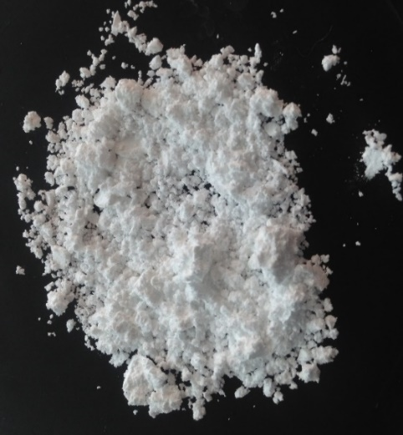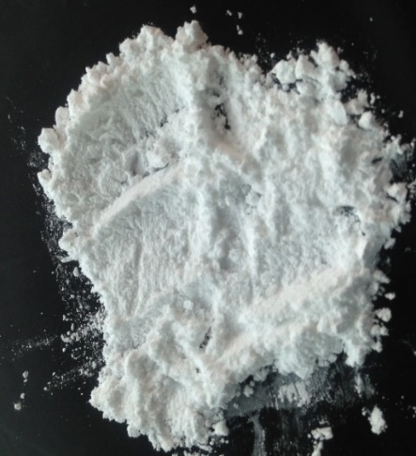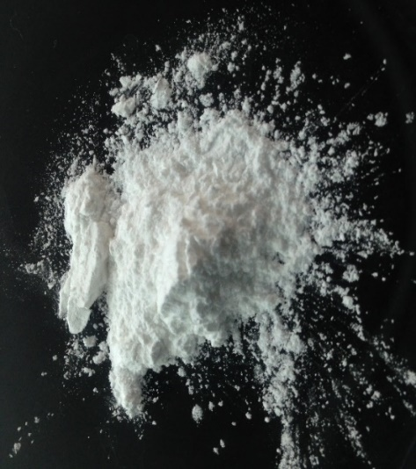
A
B
C

Fig. 3.1. Images of fresh spray-dried powder with lactose:SSPS mass ratios of 1:0 (A), 19:1 (B) and 9:1 (C), prepared at 30% pump rate.

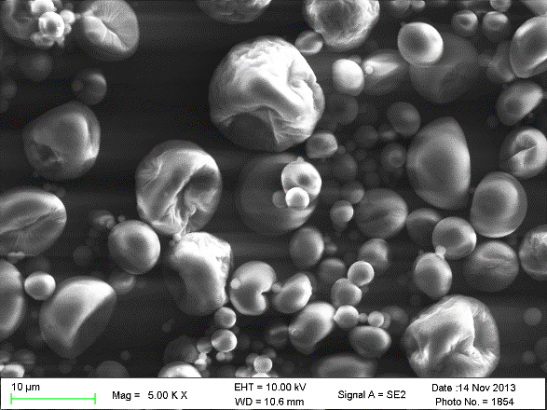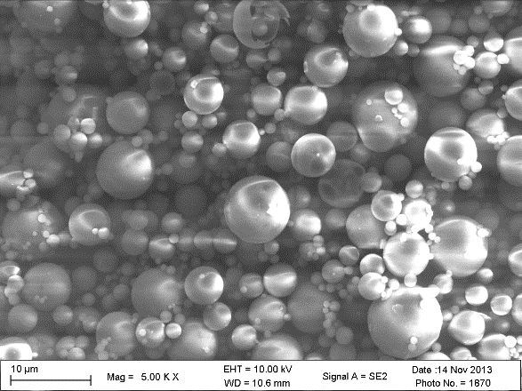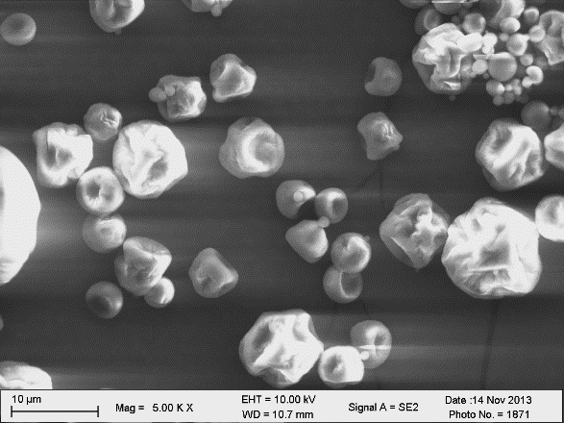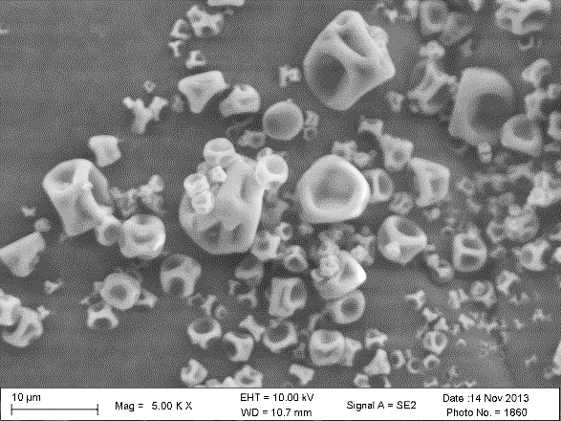
B
A
C
D
Fig. 3.2. SEM micrographs of spray-dried powder with lactose:SSPS mass ratios of 1:0 (A), 19:1 (B), 9:1 (C), and 0:1 (D), prepared at 30% pump rate. The arrow highlights a cavity in lactose-only particles (A) or sharp edges in particles with 10% SSPS (C).

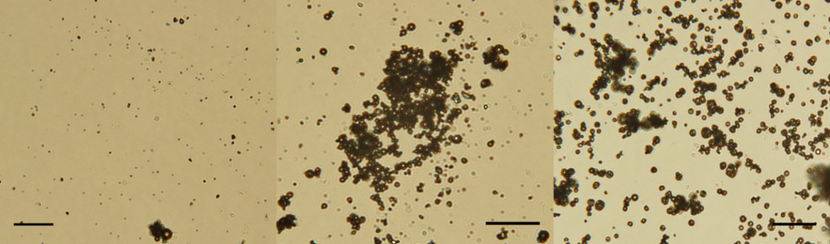
(A)
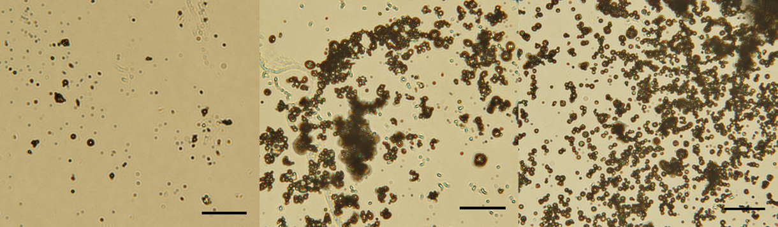
(B)
Fig. 3.3. Polarized light microscopy images of spray-dried powder with lactose:SSPS mass ratios of 1:0, 19:1 and 9:1(from left to right), prepared at 15% (A) or 30% (B) pump rate. Scale bar = 100 µm.
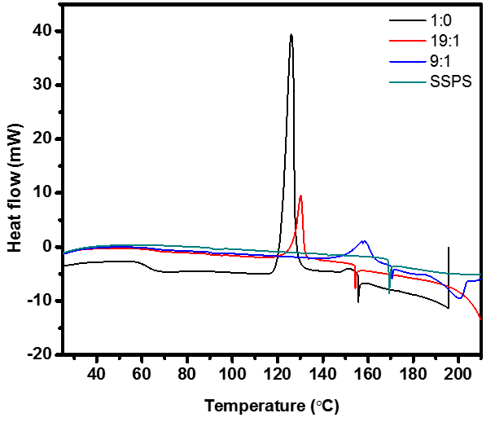
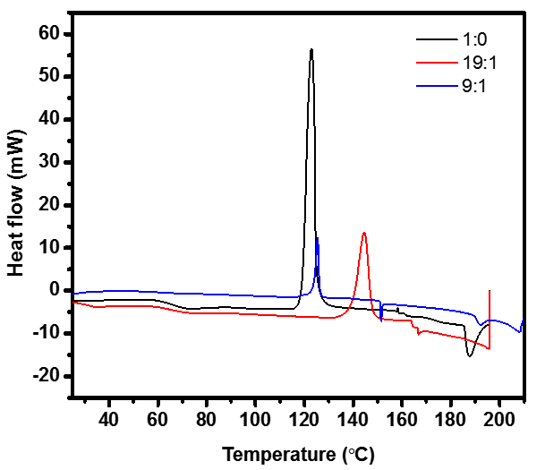
B
A

Fig. 3.4. DSC curves of spray-dried powder with lactose:SSPS mass ratios of 1:0, 19:1 and 9:1, prepared at 15 (A) or 30% (B) pump rate.
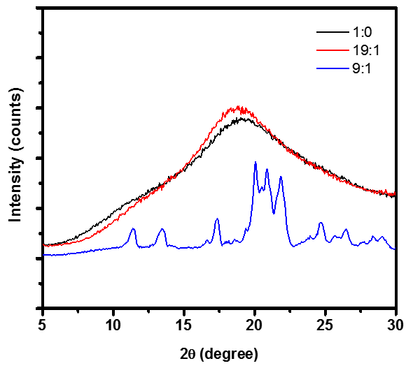
Fig. 3.5. XRD curves of spray-dried powder with lactose:SSPS mass ratios of 1:0, 19:1 and 9:1, prepared at 30% pump rate.

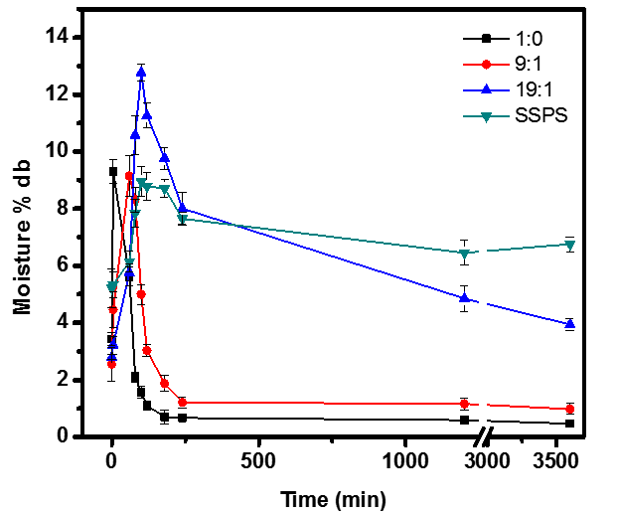
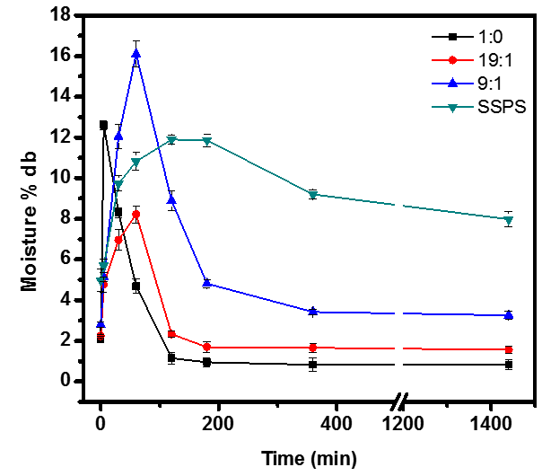
B
A
Fig. 3.6. Dry-basis (db) moisture content changes of spray-dried powder with lactose:SSPS mass ratios of 1:0, 19:1, 9:1, and 0:1, produced at (A) 15% or (B) 30% pump rate, during incubation at 65% RH and 25 °C. Error bars are standard deviations from duplicates.
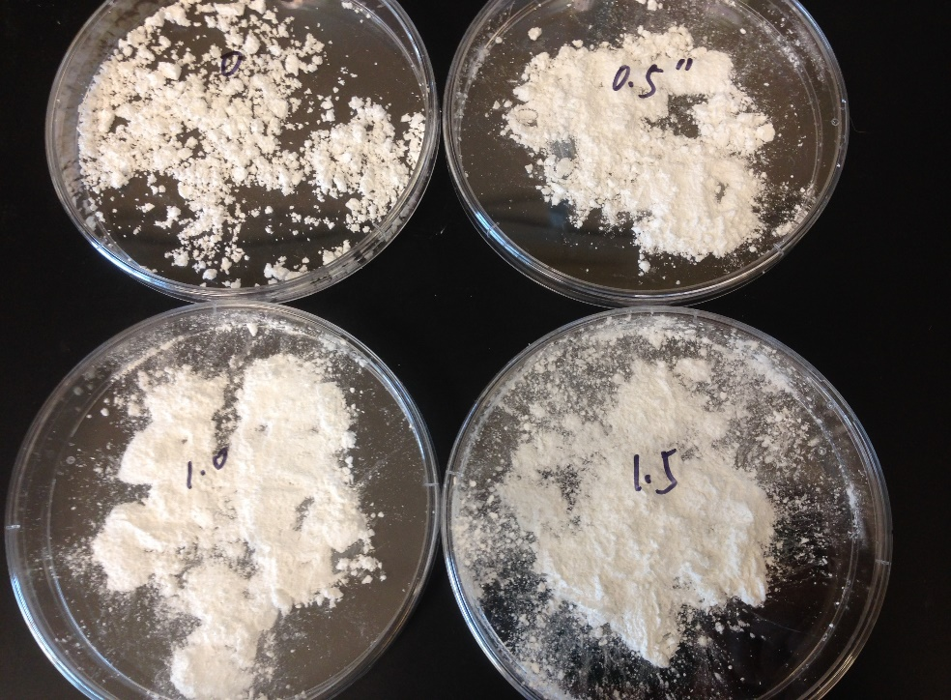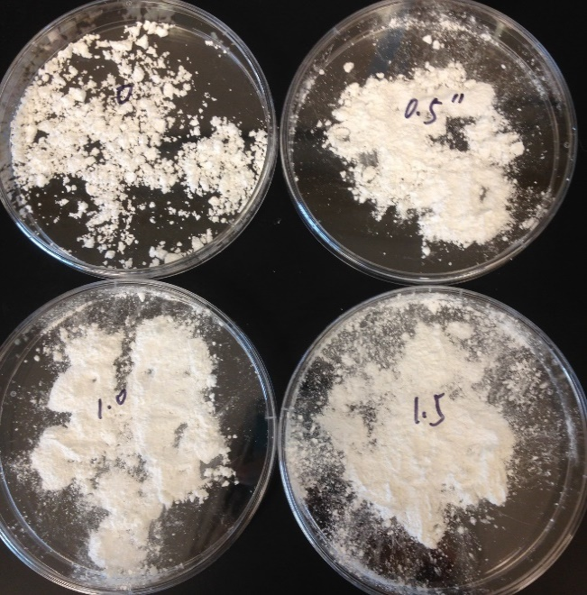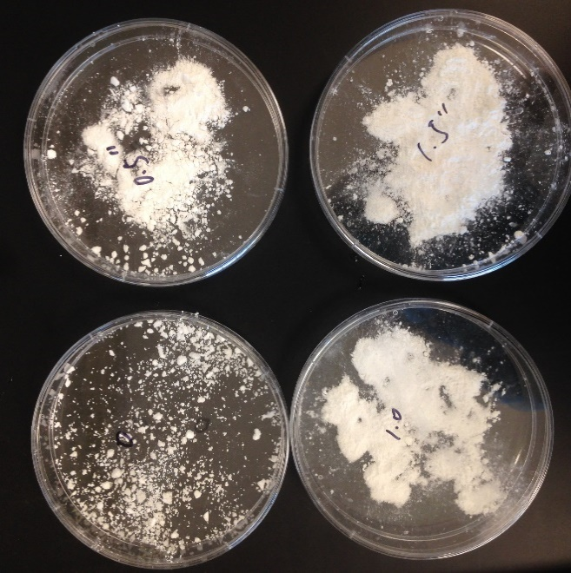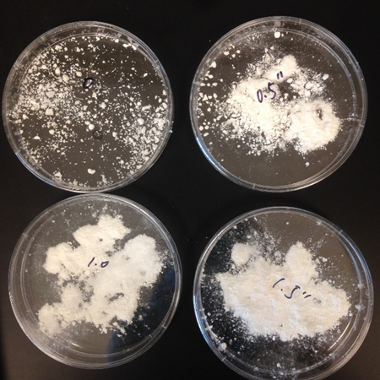
(A)
B
A
Fig. 3.7. Images of spray-dried powder with lactose:SSPS mass ratios of 1:0, 19:1, and 9:1 (from left to right), produced at 30% pump rate, before (A) and after (B) incubation at 65% RH and 25 °C for 60 min.

Conclusion
In this study, SSPS was found to be valuable in lactose related industry. Firstly, it was observed to facilitate lactose crystallization with and without seed, especially at low concentration (0.1%). The assistance of crystallization by SSPS resulted from the increase of lactose molecule interaction without increasing viscosity. In seeded crystallization, the addition of 0.1% SSPS enabled the yield of 54.7% after incubating the 40% w/w lactose solution for 24 h, compared with yield of 35% in pure lactose solution. Purity and crystal structure has not been affected by additional SSPS. Secondly, SSPS delayed crystallization of spray-dried lactose during storage at 65% RH by increasing its crystallinity during co-spray-drying. Thus it also prevented caking and clumping of lactose powder. The spray-dried lactose with 10% SSPS had the highest crystallinity (57.7%), with both α- and β-forms of lactose crystals. The findings from this study suggest the potential of enhancing lactose recovery and improving the quality of spray-dried powder containing lactose by additional SSPS.

VITA
Xueqian Shi was born in Inner Mongolia, China. She went to University of Tennessee in 2012, to further her study in food science after graduation in Jiangnan University, China.

