#Learningtoteach: Using Instagram to Elicit Pre-service Teacher Reflection

A Dissertation Presented for the
Doctor of Philosophy
Degree
The University of Tennessee, Knoxville

Monica Thomas Billen
May, 2015

Copyright © 2014 by Monica Thomas Billen
All rights reserved.

Dedication
This dissertation is dedicated to Margaret Zenda Billen, who has been with me every step of the way. As I wrote my prospectus, I felt your tiny movements inside the womb. As I collected data, I felt your swift kicks to the ribs. Through data analysis and the final stages of writing, I dangled toys over your head with my left hand, while I typed with the right. Though you will never remember this time, I will always remember you being a part of this process.

Acknowledgements
I have been very fortunate to have the support of strong, adept individuals who have influenced me throughout my life and throughout my educational journey. While I think of these individuals often and how they have shaped me, I would like to formally acknowledge their impact.
My spouse, Rhett Billen, has supported me with a smile on his face and a pep talk up his sleeve. Thank you, Rhett, for your support and guidance. Thank you for encouraging me when I didn’t think I could manage.
I acknowledge the support and influence of my mentors at Brigham Young University, Tim Morrison and Brad Wilcox. Thank you for your mentorship, friendship, and for introducing me to the fascinating world of educational research.
Throughout the past five years, I have had the support of a doctoral committee in which I am deeply indebted. Dr. Allington, Dr. McGill-Franzen, Dr. Botzakis, Dr. Huck, and Dr. Jordan, I am so grateful for your kindness, encouragement, and patience over the years. Thank you, Dr. Jordan, for supporting my Instagram idea and constantly discussing and reflecting with me. Thank you, Dr. Allington for championing every crazy idea I brought to you.
My mother always told me to, “Work first, play later.” As a young child who wanted to go jump on the trampoline, rather than do chores or practice the piano, I did not particularly approve of this message. But as the first female to obtain a doctorate on either side of my family, I look back at this advice that has stuck with me throughout the years and realize the impact. Thank you, mom and dad, for teaching me hard work and commitment. Thank you for instilling in me the importance of education. Thank you for spending innumerable hours tutoring and counseling me. I have earned a Ph.D., is it time to play now?
Abstract
The ability to reflect has been identified as a crucial element of teacher expertise. In the past, teacher education programs have encouraged pre-service teachers to become reflective practitioners by keeping journals, creating portfolios, and/or engaging in conversation. However, these methods do not allow individuals to utilize parts of the brain that process visual information. This qualitative study investigated the reflective practice of fourteen pre-service teachers who utilized visual information through photos on Instagram. The purpose of this naturalistic qualitative study was to describe and better understand the development and reflective practice of beginning teachers through observation, interview, and documents. Specifically, this study focused on how pre-service teachers reflected, the content of their reflections, and how Instagram influenced the reflection process. Participants collected daily photos throughout a yearlong internship and posted them on Instagram. Throughout the year, participants were observed and interviewed about this reflective process. Through thematic analysis, several themes were identified across the data. The teachers reflected using five reflective techniques, photojournaling, noticing, noticing and extending, noticing and problem solving, and noticing and changing. The content of their photoreflections focused on themselves as teachers, their pupils, and the system of education. Instagram seemed to positively influence the reflective process because the pre-service teachers enjoyed the process, were influenced by the visual aspect of photographs, and noticed a lot of their surroundings that later became catalysts for further reflection.

Table of Contents
Chapter One: Introduction 1
Statement of the Problem 2
Purpose of the Study and Research Questions 7
Significance of the Study 8
Limitations & Assumptions 9
Limitations 9
Delimitations 9
Assumptions 10
Organization of the Study 10
Chapter Two: Literature Review 12
Chapter Introduction 12
Theoretical Framework 12
Kolb Learning Theory 12
Reflection 15
Reflection in Teacher Education Programs 16
Reflection and National Organizations 18
Critique of Reflection 22
Definitions of Reflection 23
Influence of Donald Schön 26
Reflection in Teacher Education 30
Technology in Teacher Education 37
Teacher Development 42
Photographs 49
Photographs as Visual Language 50
Smartphone Photography 51
Instagram 54
Chapter Summary 57
Chapter Three: Methodology 59
Chapter Introduction 59
Positionality Statement 59
Methodological Approach 61
Participant Selection 63
Access and Entry Procedures 64
Participant and School Descriptions 65
Research Setting 67
Data Sources 67
Documents 67
Interviews 69
Data Collection Procedures 69
Data Analysis Procedures 70
Summary of Chapter 72
Chapter Four: Results 73
Chapter Introduction 73
Research Question One 74
Photojournaling 75
Noticing 78
Noticing and Extending 81
Noticing and Problem Solving 89
Noticing then Changing 92
Research Question Two 97
The Teacher 98
The Student 106
The Education System 117
Research Question Three 127
High Interest Reflecting 130
The Visual 131
Constant Noticing 136
Catalyst for Future Reflection 138
Chapter Summary 144
Chapter Five: Discussion 146
Chapter Introduction 146
Summary and Interpretation of Findings 146
RQ1: How Participants Reflected 147
RQ2: Content of Participants’ Reflections 151
RQ3: Impact of Instagram 153
Implications of Findings 155
Future Directions 157
Conclusion 158
Epilogue 160
References 161
Appendix 173
Appendix A 174
Appendix B 176
November Interview Protocol 176
April Interview Protocol 176
Appendix B 178
University Class Schedule 178
VITA 179

List of Tables
Table 1 67
Table 2 70
Table 3 131

List of Figures
Figure 1. Kolb Learning Theory 14
Figure 2. Categories of Results 74
Figure 3. Reflective Techniques 75
Figure 4. Journaling Photo 1 76
Figure 5. Journaling Photo 2 76
Figure 6. Journaling Photo 3 77
Figure 7. Journaling Photo 3 78
Figure 8. Noticing Photo 1 79
Figure 9. Noticing Photo 2 80
Figure 10. Noticing Photo 3 81
Figure 11. Noticing and Extending 82
Figure 12. Noticing and Commenting Photo 1 83
Figure 13. Noticing and Commenting Photo 2 84
Figure 14. Noticing and Commenting Photo 3 85
Figure 15. Noticing and Wondering Photo 1 86
Figure 16. Noticing and Wondering Photo 2 87
Figure 17. Noticing and Wondering Photo 3 88
Figure 18. Noticing then Problem Solving Photo 1 89
Figure 19. Noticing and Problem Solving Photo 2 90
Figure 20. Noticing and Problem Solving Photo 3 91
Figure 21. Noticing then Changing Photo 1 93
Figure 22. Noticing then Changing 94
Figure 23. Noticing then Changing Photo 3 95
Figure 24. Noticing then Changing Photo 4 96
Figure 25. Results of Research Question 2 98
Figure 26. Teacher Feelings Photo 1 99
Figure 27. Teacher Feelings Photo 2 100
Figure 28. Teacher Feelings Photo 3 101
Figure 29. Teacher Development Photo 1 103
Figure 30. Teacher Development Photo 2 104
Figure 31. Teacher Development Photo 3 105
Figure 32. Student Situations Photo 1 107
Figure 33. Student Situations Photo 2 108
Figure 34. Student Situations Photo 3 109
Figure 35. Student Situations Photo 4 110
Figure 36. Student Situations Photo 5 111
Figure 37. Student Engagement Photo 1 113
Figure 38. Student Engagement Photo 2 114
Figure 39. Student Engagement Photo 3 114
Figure 40. Student Engagement Photo 4 116
Figure 41. Student Engagement Photo 5 116
Figure 42. Tensions Photo 2 118
Figure 43. Tensions Photo 3 119
Figure 44. Tensions Photo 4 120
Figure 45. Tension Photo 5 121
Figure 46. Tensions Photo 6 122
Figure 47. Tensions Photo 7 122
Figure 48. Tensions Photo 8 123
Figure 49. Content Photo 1 125
Figure 50. Content Photo 2 126
Figure 51. Content Photo 3 127
Figure 52. Research Question 3 Results 128
Figure 53. The Visual Photo 1 133
Figure 54. Visual Photo 2 133
Figure 55. The Visual Photo 2 134
Figure 56. The Visual Photo 3 135
Figure 57. Constant Noticing Photo 1 137
Figure 58. Discourse Photo 1 139
Figure 59. Discourse Photo 2 140
Figure 60. Discourse Photo 3 142

Chapter One: Introduction
Most agree that “good teachers” are central to creating “good education” and likewise educating “good students.” In fact, these terms are consistently used in many current local, national, or international news outlets. The Washington Post argued that good teachers make up good schools in their recent article, “12 Ways to Identify a Good School” (Matthews, 2014). According to the article, parents should seek out schools with good teachers, rather than finding schools with good test scores. Likewise, the Wall Street Journal published an article entitled, “Four Ways to Spot a Great Teacher” (Goldstein, 2014). The article is accompanied by an image of a famous scene from the movie Dead Poets Society where the schoolteacher is standing on a desk demanding the attention of a group of adolescent students. The caption under the image suggests that there are “real life versions of [this] inspiring teacher” (p. 1) shown in the photo. The article goes on to suggest that what should matter most to parents is “getting one’s child inside the classroom of an effective teacher” (p. 1), again highlighting that a competent teacher is crucial.
Similarly, educational scholars have postulated that an effective teacher is paramount. The effectiveness of a teacher has large effects on student achievement and can dwarf effects of many educational interventions (Bembry, Jordan, Gomez, Anderson, & Mendro, 1998). In fact, some have touted that teacher expertise is one of the most important factors in student success. Allington (2002) stated that “it has become clearer that investing in good teaching . . .is the most research-based strategy available” (p. 740).
If good teaching is very important to the success of students and likewise education as a whole, then it is important to understand traits of effective teachers. Many have posited that one foundational element of effective teachers is their ability to reflect (Boud & Walker, 1998; Calderhead & Gates, 1993; Gore & Zeichner, 1991; Hatton & Smith, 1995). These scholars among others, (Lyons, 1998; Nicholson & Bond, 2003; Rogers, 2001; M. Romano & Schwartz, 2005) have argued that teacher reflection should not be overlooked. In this study, reflection is understood as Dewey (1938) defined it, a meaning making process of understanding surroundings by engaging in experience.
Yet, encouraging teachers to become reflective is not an easy task. Many look to teacher education programs as an important first step in the quest to creating a field of reflective practitioners. Teacher education programs across the nation have made reflection a major component of their programs and have experimented with different methods to encourage reflection (Applegate & Shaklee, 1992; McCaleb, Borko, & Arends, 1992; Oja, Diller, Corcoran, & Andrew, 1992). This qualitative dissertation describes the journey of one foundational element of teacher expertise—reflection.

Statement of the Problem
Over twenty five years ago, Smyth (1989) called for a change in teacher education and teacher supervision. Specifically he touted that we need less teacher measurement, we need better ways of helping teachers manage bureaucratic intrusions and we need to help teachers see that their voices are being silenced. Additionally, we (teacher educators) need to help teachers analyze pedagogy and judge the correctness of their work. We should encourage teachers to celebrate what they do. And most profoundly, Smyth argued that we should be encouraging teachers to engage in the study of teaching and inspire a shift from passive and silent practitioners. Teachers should shift to engaging in active, informed discourse about the profession.
Some might say that Smyth’s arguments are just as relevant today as they were twenty-five years ago. However, this is not to say that the educational field has not made efforts to shift toward Smyth’s vision. One way in which teacher educators have made efforts to encourage active, analytical teachers is in mentoring teachers to become reflective. As Gore & Zeichner (1991) acknowledged, “There is not a single teacher educator who would say that he or she is not concerned about preparing teachers who are reflective” (p. 120). The value of reflection has growing consensus among educators (Ward & McCotter, 2004) and has become quite “fashionable throughout all segments of the U.S. teacher education community” (Gore & Zeichner, 1991, p. 119), under the assumption that if a teacher is more reflective, he or she will be a better teacher (Calderhead & Gates, 1993). Indeed, educators hope that teacher reflection may encourage a departure from a factory model teacher education approach where teachers ask how-to instead of what and why (John Smyth, 1989). In order to influence teachers to think in this way, teacher education programs should concern themselves with how they are influencing their future teachers to become reflective (Rich & Hannafin, 2008).
What we know is this, the field of education needs good teachers (Allington, 2002). Good teachers are teachers who constantly reflect. Teacher education programs can influence new teachers (Zeichner, 1980), therefore, reflection must be mentored and taught in teacher education programs (Calderhead, 1989). Yet, teacher education programs must consider a myriad of obstacles that may stand in their way to achieve this goal.
Pre-service teachers who enter into teacher education programs, “are not just bundles of skill, competence, and technique: they are creators of meaning, interpreters of the world . . .” (Hargreaves, 1988, p. 216). And these individuals who are constantly creating meaning and interpreting the world, are unique individuals with various backgrounds, and different personalities. Additionally, teacher education programs face the task of teaching future teachers who have already been apprentices of observation in their very field of work through years of experiences in the public school system (Lortie, 1975). Not only are the students entering our teacher education programs unique individuals with years of experience in the school system, they are also most likely millenials (Considine, Horton, & Moorman, 2009). Millenials are individuals who have “grown up since the emergence of the World Wide Web and the assortment of related digital technologies (e.g., cell phones, text messaging, video games and instant messaging) . . .” (p. 472). This adds an additional component to the difficult feat placed in front of teacher educators as they are faced with educating a generation of individuals who may be very different than their own generation. Often this may result in failing to bridge the gap “between the technological world Millennials live in and the classrooms we expect them to learn in” (p. 473). The world in which they live and are constantly interpreting is a world of technology, social media, and digital communication.
Thus, our teacher education programs must include parts of this world into instruction, if we wish to reach and influence the Millennials. The notion that learning should be connected to the learner’s life is not a new idea. Dewey (1938) argued that learning should be connected to learners’ experiences. He also posited that individuals do not enter into the learning environment as a blank slate, rather an individual is constantly building on prior experiences and knowledge. Dewey believed that a learner should not be left alone to figure out how to build upon prior knowledge, rather, an educator should mentor the learner through bridging their world with new knowledge (O’Brien, 2002). As the educator mentors the learner, Dewey (1938) argued that experiences should always be as closely related to the “actual life-experience of some individual” (p. 89).
The actual life experience of the Millenials in our teacher education programs includes technology. However, when teaching reflection in teacher education programs, many have turned to reflective assignments that do not mirror the actual life-experience of the students. For example, some have used journals to encourage teacher reflection (Francis, 1995) while others have used narrative writing (Van Halen-Faber, 1997). Yet, some have reported that pre-service teachers often dread and avoid sitting down to write in a journal (Bolin, 1990). This could be because this learning activity does not mirror the world in which they live.
Many young adults are avid users of social media or social network sites (SNS), which are virtual collections of personal profiles that can be shared with others (Hughes, Rowe, Batey, & Lee, 2012). SNS include services such as Facebook, Twitter, Pinterest, and Instagram. The most likely demographic to use SNS are individuals between the age 18-29, who account for 83% of the users, according to survey research conducted by the Pew Research Center. Additionally, women are more likely to use these sites. Likewise, 69% of individuals who reported having some college education attainment reported using SNS (Duggan & Brenner, 2013). As many individuals engaging in teacher education programs are between the age of 18-29 and are generally a large proportion of women (Montecinos & Nielsen, 1997), we can assume that a high percentage of our students enrolled in teacher education programs are using SNS.
Instagram is a photo sharing SNS that is specifically used on mobile devices (e.g., iPhone, iPad, android phone). With more than 200 million monthly active users, over twenty billion uploaded photos, and an average of 60 million photos uploaded per day, Instagram is becoming one of the fastest growing SNS (Instagram, 2014d). This photo sharing application (app) allows an individual to take photos with a mobile device and upload the photo to the app, usually accompanied with a caption describing or commenting on the uploaded photo. The app is social in nature, as individuals “follow” friends to view the photos that they have uploaded and “like” or comment on photos. The app, with its relatively easy interface and user-friendly homepage allows individuals to quickly upload photos while out and about. Additionally, scrolling through other’s photos is simple. You may view all of your friend’s photos in a stream, similar to Facebook or Twitter or you can view an individual’s entire photo collection by accessing their personal profile.
With over 200 million people using Instagram, it is very possible that Instagram is an element of many pre-service teachers’ “actual life-experience” (Dewey, 1938, p. 89). Using this SNS in teacher education programs may allow teacher educators to bridge the gap between their world and the information teacher educators would like them to learn (O’Brien, 2002). In other words, if many pre-service teachers are using Instagram in their everyday life, teacher education program can use this to their advantage by using it in the classroom. Instagram could be a beneficial way to encourage teacher reflection.
Using Instagram as an avenue to develop pre-service teachers’ ability to reflect may have a few advantages. First, as mentioned earlier, it may connect learning to students’ life-experience. Second, Instagram is visual in nature because it is photo-based. Most reflective practical assignments are limited to verbal communication. However, communicating with visuals and photos drastically improves communication as it may “evoke deeper elements of human consciousness that do words” (Harper, 2010, p. 13). Turgenev (1975) stated in his novel, “The drawing shows me at one glance what might be spread over ten pages in a book” (p. 85). Photos can be used to arouse deeper discourse that encourages greater reflection and new understanding. Third, Instagram is quick, easy to access, and easy to use. This could encourage teachers to consistently and constantly reflect on the fly. Fourth, Instagram is social and collaborative in nature. This would allow teachers to engage in a community of teachers and learn from one another, which some have touted to be very beneficial for pre-service teachers (Oja et al., 1992).
Though the idea of using Instagram to influence and encourage teacher reflection might make sense theoretically, this idea has not been researched. To my knowledge, there are no studies that use Instagram in teacher education programs. Similarly, there are only a handful of publications that have focused research on Instagram. Through my research, I have not found any education studies that used Instagram as a data collection method. This study seeks to fill these gaps. This research will provide understanding and evidence to, (a) the greater theoretical understanding of pre-service teacher reflection, (b) theoretical understanding of pre-service teacher development, and (c) Instagram as an avenue to encourage teacher reflection.

Purpose of the Study and Research Questions
The purpose of this study was to describe and better understand the development and reflective practice of pre-service teachers while in the midst of a yearlong internship, who use visual and written forms of expression using a mobile device based application called Instagram. More specifically, the following questions were addressed:
- How do pre-service teachers reflect using photos on Instagram, throughout a yearlong internship?
- What is the content of pre-service teachers’ reflections?
- How do pre-service teachers describe the process of using Instagram as a form of reflective practice?

Significance of the Study
The need for reflective, expert teachers is a crucial element of creating a strong education system. Educational scholars should be doing more to better understand how to best prepare individuals who play such a vital role in educating children. Teacher education and professional development programs should be a huge concern. We cannot blame teachers for their ineffectiveness if the programs in which they are trained are weak.
This study is significant for many reasons. First, this study highlights the importance of the role teacher education programs play in the creation of teachers. In an era of teacher accountability and teacher evaluation, we also need to consider the mentoring and resources that teachers have received and will receive. Second, this study underscores the need for teachers who are thoughtful, reflective, and able to engage in deep inquiry. As teachers enter into an ever-changing field where policymakers’, administrators’, and politicians’ voices are loud and clear, teachers must have the ability to critically think and reflect upon new programs, new laws, and top-down education agendas. Lastly, this study aims to find a better way to encourage reflective practitioners by utilizing technologies that many young adults are using in their everyday lives. It is my desire that this study is disseminated into the larger body of educational research and influences educational theory.

Limitations & Assumptions

Limitations
Qualitative study allows for an individual to understand and describe a phenomenon in great depth. This study sought to deeply understand the development and reflective practice of fourteen pre-service teachers. However, there are some research limitations to consider. First, I was a participant researcher in this project and had a relationship with each of the participants. This relationship could have influenced what participants said and how they acted. Second, I completed all data analysis. As is the case with all qualitative research, the researcher is an integral part of interpreting the data. My unique positionality and the relationship I have with research participants influenced the lens in which I viewed each data source.

Delimitations
Because I was particularly interested in gaining an in-depth understanding of pre-service teachers’ development and reflective practice, I chose to work with a small sample of fourteen pre-service elementary teachers. It was not my intent to gather shallow information from a large sample to be generalized to the larger population. Additionally, I specifically chose to study elementary pre-service teachers and did not include early childhood or secondary teachers. I chose to do this because of my background, interest, and passion for elementary teachers. Because of my background and interest, I also view elementary teaching as an extremely crucial area of research. Likewise, only pre-service teachers participated in this study. I was specifically interested in this population because I was interested in better understanding the development and reflective practice of teachers who were engaging in their very first practical experience.

Assumptions
This research was conducted under several assumptions. First, I assumed that as a researcher I could gain insight into the development and reflective practice of pre-service teachers and add to the greater teacher education literature. Second, I assumed that I might be able to do this through participant-driven photographs in addition to participant writing, interviews, and seminars. Last, I assumed that I might be able to paint a pure picture of the participants’ stories without my own biases conflicting through ongoing reflexivity and member checking.

Organization of the Study
The purpose of this study was to better understand the development and reflective practice of pre-service teachers who use Instagram as a reflective tool. To better understand these topics, it is important to understand what has already been researched in this area. Thus, in Chapter two, I reviewed various research in regards to teacher reflection, teacher development, photography, and technology. In Chapter three, I have described my research methodology. This includes a description of the researcher’s role, the research population and setting, data collection methods, and data analysis methods. Chapter four is a report of the research findings, which aim to address the research questions identified earlier. Lastly, chapter five is a discussion of the research findings, interpretations thereof, as well as implications for teacher education and future research.

Chapter Two: Literature Review

Chapter Introduction
The purpose of this study was to describe the reflective process and development of fourteen preserive teachers throughout a yearlong internship. In order to describe the reflective process and development of the teachers, participant driven photographs were collected throughout a school year. The photographs were shared on a social networking site called Instagram. In sum, this dissertation focuses on (a) reflection and (b) teacher development through the use of (c) photos and (d) technology with theoretical underpinnings of experiential learning theory. With this in mind, those topics of literature were reviewed in this chapter.

Theoretical Framework

Kolb Learning Theory
Building upon work by John Dewey, Kurt Lewin, and Jean Piaget, David A. Kolb developed a theory of learning in his seminal publication Experiential Learning: Experience as the Source of Learning and Development (1984). After studying the work of these scholars, he sought to create a theory that answers how an individual progresses through stages of learning. For example, he identified that Piaget theorized developmental stages (sensory-motor stage, representational stage, stage of concrete operations, and formal operations stage) (as cited by (Kolb, 1984), yet did not mention how one might move through these stages. While he did not mention the developmental stages of teachers, his theory relates to teacher development as they go through stages. Further, his theory of learning directly relates to reflection.
Kolb’s learning theory is entitled experiential learning. He refers to the theory in that way because of the heavy focus on learning from experience. Additionally, the theory has foundational ties to previous theories from the work of Dewey, Lewin and Piaget, which all focus on experience. Kolb (1984) suggested that experiential learning theory is not a departure from behavioral and cognitive learning theories, rather “ . . . experiential learning theory [provides] a holistic integrative perspective on learning that combines experience, perception, cognition, and behavior” (p. 21). In other words, experiential learning includes cognitive and behavioral theories.
Kolb identified and proposed a theory to be applied in education, work places, and adult development. The notion that human development occurs when one learns from experience is the main thesis of his theory. In other words, learning is the “process whereby knowledge is created through the transformation of experience” (p. 41). Kolb might argue that an individual cannot learn unless he creates knowledge from experience. At times, an individual may have engaged in an experience prior to learning from that experience. Kolb (1984) quoted a stanza by T. S. Eliot before delving into his theory. The poem reads,
We shall not cease from exploration
And the end of all our exploring
Will be to arrive where we started
And know the place for the first time
This poem suggests that through exploring experiences, one learns and develops. However, after development and reflection, the same experience may shed knew knowledge. While the actual experience that an individual experiences may not change, his or her understanding of the experience may have changed. As the understanding changes, knowledge is created. This knowledge is created throughout a process.
Kolb posited that an individual engages in a cyclical four-stage process that includes experience, reflection, conceptualization, and experimentation. He argued, “The structural bases of the learning process lie in the transactions among these four adaptive modes . . .” (p. 41). Knowledge is a result of one grasping experience and transforming that experience. In the first stage, concrete experience, an individual encounters a new experience or considers an existing experience. Next, the individual observes the new experience and considers his or her understanding of the experience. The individual might ponder inconsistencies between the experience and his or her understanding of that experience. In the next stage, abstract conceptualization, reflection gives rise to a new idea. Lastly, in active experimentation, the learner applies the new ideas into the world around them. Below is a simple visual and description of Kolb’s theory of experiential learning.

Figure 1. Kolb Learning Theory
In order for one to transform experience, one must first engage in some sort of experience. This experience is not transformed into knowledge without careful reflection of the observed experience. After reflecting upon the experience, the individual creates his or her own theory to explain the experience. Finally, the learner aims to test and experiment with the proposed theory in new situations and future experiences.
Kolb’s theory of learning provides a foundation in understanding how individuals learn from experience as they learn, develop, and progress through stages. This theory highlights the importance of reflection in this process. Without reflection, an individual would remain stagnant in the cyclical process that Kolb has proposed.

Reflection
Many have touted the importance of individual reflection. Boud and Walker identified reflection as “one of the key ideas and features of all aspects of learning from experience . . .” (1998, p. 191), arguing that reflective practice leads to more learning. Larrivee (2008) posited that many scholars view reflection as the “hallmark of professional competence” (p. 341). And some have argued that reflection has an underlying metaphor of liberation, as individuals are encouraged to exercise their own judgment (Zeichner & Liston 1987). Ward and McCotter (2004) argued that through reflection, teachers can broaden their perspective and become more aware of others.
Some have even argued that reflection is the key element of progressing teachers through developmental stages. Without reflection, then, teachers would remain stagnant (Fuller & Brown, 1975). It is also understood that reflection drives teachers to “develop the attitudes, skills, and confidence to frame their own agendas, use their puzzlement to drive useful inquiry, and to influence policy and educational thinking beyond the classroom context (Francis, 1995, p. 229). Spalding and Wilson (2002) postulated that without reflective thinking teachers would not be able to identify classroom problems. Hence, without teacher reflection classroom problems would persist and teachers would not progress through developmental stages. Additionally, teachers would have limited interaction with the greater educational policy and educational theory. The importance of a reflective practitioner is not a new idea. In fact, it has become common for teacher education programs to highlight this ability in their program goals.

Reflection in Teacher Education Programs
Many teacher preparation programs have incorporated reflective practice as a foundational principle (Calderhead, 1989). LaBoskey (1994) identified three main reasons why reflection should be incorporated in teacher education programs. First, in order for pre-service teachers to learn anything throughout the entirety of a teacher preparation program, reflection must occur. In other words, if a pre-service teacher is simply hearing and taking information but not reflecting upon the meaning, learning does not occur. Second, teachers need to practice a skill that is necessary in their practical career. LaBoskey (1994) argued that a professional teacher engages in the reflective process often and therefore, this skill needs to be addressed in preparation programs. Lastly, teachers are moral agents of change in the education system. With this in mind, teachers “need to reflect critically on the injustice and inhumanity present in our society and our educational institutions” (p. 17). And one cannot consider such important issues if teacher education programs are not considering reflection as a key element of teacher preparation. There are several examples across the nation where university programs have incorporated reflection.
The Masters Certification Program at the University of Maryland acknowledges the importance of reflection in their teacher education program (McCaleb et al., 1992). In fact, the three stated goals of the program are repertoire, research, and reflection. This program certifies persons who have completed a baccalaureate degree in an academic field. Before acceptance to the program, a panel assesses individuals’ reflective capabilities through a written statement and through an interview, specifically accepting folks who are thoughtful and who manifest attributes of a future reflective practitioner. The program faculty considered the ability to reflect as paramount and strived to create a culture wherein pre-service teachers viewed themselves as “reflective scholar-teachers” (p. 43) rather than an apprentice. Throughout two semesters in a field placement, the pre-service scholar-teachers attend university courses once a week for the main purpose of reflecting upon their practical work. Through field placements, interpersonal relations in cohorts, journal writing, action research, case studies, and examinations, the university hopes to create scholar-teachers that will positively influence the field of education
Similarly, the University of New Hampshire has placed a heavy focus on preparing a reflective teacher or in their words, preparing “teacher[s] as reflective decision maker[s]” (Oja et al., 1992). In order to accomplish this goal, the program identified three key components: (a) inquiry focused course work, (b) an internship, and (c) collaborative supervision. The key components are addressed in a five-year undergraduate-graduate program where students complete a baccalaureate degree in a subject area. The degree concludes with graduate work in education, which includes a yearlong internship. The program highlights the importance of communities of inquiry in preparing reflective decision makers.
Kent State University has also identified reflection as a major component of their teacher preparation program (Applegate & Shaklee, 1992). The Academically Talented Teacher Education Program (ATTEP) focuses on accepting very bright students and pushing these teachers by maintaining a very rigorous program, under the assumption that in order to retain such talented individuals, they must be challenged. The rigorous program highlights the importance of reflective thinking and fosters students’ reflective thinking through a variety of program components including, inquiry-oriented seminars, journaling, classroom experimentation, and action research projects.
Many teacher education programs have agreed that reflection is an important element of teacher expertise. The preparation programs discussed above are just a few examples. Because many teacher education programs are incorporating reflection, it is also important to note the national organizations that influence teacher preparation programs.

Reflection and National Organizations
NCATE. The National Council for Accreditation of Teacher Education (NCATE) assumes the responsibility of ensuring high quality teacher preparation programs. The council includes teachers, teacher educators, content specials, and policymakers (NCATE, 2014a). In 2008, the council identified a series of standards to be used when programs are seeking accreditation.
Many standards address the importance of teacher reflection. For instance, standard 1c highlights pedagogical knowledge of teacher candidates, stating that teachers should reflect on their practice and monitor instruction as to enhance student learning. Additionally, teachers should be able to reflect upon their individual teaching and highlight their strengths and weaknesses. Standard two addresses the notion that teacher education programs should be collecting data and analyzing how their program can be improved. Standard 2c states that teacher candidates should be made aware of such assessments so they may reflect upon their performance.
Similarly, NCATE identified that teacher education programs should include fieldwork that encourages teachers to be reflective about their content knowledge, pedagogical knowledge, and professional dispositions. Likewise, teacher candidates should also be taught in teacher education programs to be reflective of others’ work and practice, so that they may learn from those around them. NCATE also touts the importance of working with diverse populations and reflecting upon diversity in standard four. Education programs and education candidates should have the ability to reflect on diverse and multicultural perspectives. Standard five discusses the importance of teacher education programs having highly qualified faculty who are capable of reflecting and of teaching teacher candidates to reflect. Through five broad yet explicit standards, NCATE explicates the importance of reflection in teacher education (NCATE, 2014b).
NEA. The National Education Association (NEA) also identified main points that should be addressed in comprehensive teacher growth systems and explicated a process for developing a teacher evaluation system. The association argues that the purpose of teacher assessment and evaluation is to strengthen teacher skill, disposition, and practice. Indeed, the association contends that reflection is an important aspect of teacher skill and disposition. Therefore, reflection should be a part of teacher assessment and evaluation (NEA, 2014).
National Board. The National Board for Professional Teaching Standards (NBPTS) are a set of standards developed by the National Board with the purpose of defining and clarifying an accomplished educator. Similar to prestigious fields such as medicine and law, individuals in education can be nationally certified. Through certification, the National Board hopes to elevate the status and prestige of the educational field by setting high standards. The NBPTS included five main propositions. Proposition number four states, “Teachers think systematically about their practice and learn from experience” (National Board, 2014, p.1) and continues to say that individuals critically examine and reflect on their practice.
InTASC Standards. Members from national organizations have congregated and developed standards to be disseminated in the field of education. Interstate Teacher Assessment and Support Consortium (InTASC) standards have been used across the nation and influenced many teacher evaluation systems (Assessment & Consortium, 2011). For instance, the education Teacher Performance Assessment (edTPA) aligned their assessment scale with InTASC standards (“edTPA FAQ,” n.d.). The InTASC standards were created by a committee with individuals from various national organizations including but not limited to, American Association of Colleges for Teacher Education (AACTE), American Assosication of School Administrators (AASA), National Council for Accreditation of Teacher Education (NCATE), and National Education Association (NEA). The standards were created to outline “what teachers should know and be able to do to ensure every K-12 student reaches the goal of being read to enter college or the workforce in today’s world” (Assessment & Consortium, 2011, p. 3).
The InTASC standards “articulate what effective teaching . . .looks like . . .” (p. 3) which includes the importance of a reflective practitioner. The standards address the seriousness of the educational task of a teacher, one who bears the responsibility of educating children. The standards state that in order to do this, “teachers must engage in meaningful and intensive professional learning and self-renewal by regularly examining practice through ongoing study, self-reflection, and collaboration” (p. 9). Additionally, the InTASC standards repeatedly address the importance of a reflective teacher throughout many different indicators. Standard 9(d) states, “The teacher actively seeks professional, community, and technological resources, within and outside the school, as supports for analysis, reflection, and problem solving” (p. 18). Further, standard 9(e) states, “The teacher reflects on his/her own understanding of cultural, ethnic, gender, and learning differences to build stronger relationships and create more relevant learning experiences” (p. 18). Similarly, standards 9(g), 9(l), 9(n) specifically address the need for a teacher to be reflective.
TEAM. Standards like those addressed above have been used to develop teacher evaluation systems. Indicators in these assessment models have included reflection as part of their evaluative system. For example, the Teacher Educator Acceleration Model (TEAM) used in Tennessee has a series of rubrics used for evaluating teachers (Education, 2014b). The professionalism rubric highlights the importance of reflection in the first indicator entitled, professional growth and learning. The standard states that the teacher candidate “Consistently self-reflects on evidence of instruction, accurately matching evidence to the rubric in both areas of strength and areas of growth” (p. 1). The rubric also states that individuals should be able to reflect on student assessment data and what it may mean for their practice. The general educator rubric repeatedly discusses the importance of teachers encouraging and teaching students to become reflective. The professional rubric infers that in order for a teacher to teach reflection, he or she must be reflective as an individual (Education, 2014a).

Critique of Reflection
Reflection has been addressed by many national educational organizations as a necessary skill for teacher to develop. Additionally, standards that guide teacher education programs and teacher evaluation models include teacher reflection. However, while many tout the importance of reflection, some would argue that this is unnecessary and uncalled for. Fendler (2003) stated, “If educational researchers believe that all teachers think about what they do, then why is there so much talk about making teachers into reflective practitioners?” (p. 23). Fendler continued to argue that there is too much focus on reflection, as reflection often times teaches individuals to rationalize their beliefs instead of question and interrogate one’s beliefs. In addition, reflection is often taught in a heavy-handed, top-down approach, where a teacher educator displays how reflection should be done. This, of course, teaches teachers to follow and mimic rather than push boundaries and think critically about reform (Smyth, 1989). While some question the heavy focus on reflection (Fendler, 2003; McNay, 1999), many argue that learning to become reflective is paramount. Yet, what, exactly, is reflection? Though many national organizations tout the importance, and some scholars critique the importance, very few actually specify, define, or operationalize the term.
Rodgers (2002) has argued that while everyone believes they understand what reflection is, it has lost its meaning. She stated, “In becoming everything to everybody, it has lost its ability to be seen” (p. 843). While many define reflection very similarly, some consider the concept more simply than others. Some simply use various synonyms to define reflection including, “debrief, process, consider, ponder, weigh analyze and evaluate . . .” (Wade & Yarbrough, 1996, p. 64), while others have specific elements that must be included in the reflective process (McCaleb et al., 1992).

Definitions of Reflection
Many date the term reflection in education to the early 1900s when John Dewey published two seminal pieces that discussed and highlighted this important concept. In his publication How We Think, Dewey (1910) described how he believes individuals think, learn, and develop. Central to these developments is one’s ability to reflect, which he defined as active and careful consideration of a belief or knowledge. Dewey argued that individuals reflect in order to understand their surroundings; reflection is a meaning-making process. He stated, “We reflect in order that we may get hold of the full and adequate significance of what happens” (p. 119). This reflection occurs as an individual interacts with the world in meaningful experiences. Through reflection, one will reorganize and reconstruct experiences as he seeks to make meaning of the experience (Dewey, 1938).
However, since Dewey’s landmark publications, many have defined reflection in slightly different ways. Zeichner and Liston (1987) defined the term reflective action, which is inspired by John Dewey. They defined reflective action as “the active, persistent, and careful consideration of any belief or supposed form of knowledge” (p. 24). Which is very similar to Dewey’s definition of reflection, however, they labeled the process reflective action.
While Dewey mentioned that individuals engage in experiences that prompt reflection, Osterman (1990) maintained that a practitioner is prompted by a problem. Once the problem is noticed, he engages in a “dialectic process of thought and action” (p. 134). Osterman defined reflection as simply “careful consideration” and reflective practice as “the mindful consideration of one’s actions, specifically, one’s professional actions” (Osterman, 1990 p. 134). In addition, one who engages in reflective practice focuses on developing his or her craftsmanship through careful, focused, and critical assessment of his behavior. She believed that through reflective practice, a practitioner becomes more effective and more skillful.
Osterman (1990) linked reflection to the notion that an individual seeks to develop or become more effective. Similarly, Hatton and Smith (1995) defined reflection as “deliberate thinking about action with a view to its improvement” (p. 40). This is quite different than Dewey’s notion of reflection, which mainly focused on engaging in experiences and creating meaning. Osterman (1990) and Hatton and Smith (1995) seem to believe the reflection has a purpose of improvement while Dewey (1910) and Zeichner and Liston (1987) believe the point of reflection is to make meaning.
Wade and Yarbrough touted that reflection must include four core elements. Among these four elements is, again, the notion that reflection should inform practice. The four elements are, (a) one thinks deliberately about an experience, idea, or issue, (b) the more time one spends reflecting the greater potential for learning, (c) reflection can lead to new understanding and learning, and (d) reflection should inform future action. Indeed, another scholar argues that reflection is not reflection unless it is informing future action or is improving the individual.
Likewise, McCaleb et al., (1992) specified a conceptual and an operational definition for reflection. Conceptually identified as a process in which one problem solves. The authors operationalized reflection as “(1) taking action (sometimes routine); (2) reflecting (thinking back, analyzing) upon that action (what happened, why what it meant); (3) if resolution is not reached, moving on to a higher level of reflective or critical thought (multiple causes, conflicting goals, larger moral or ethical conflicts); and (4) coming up with alternative actions and this continuing the cycle” (p. 51).
Halen-Faber (1997) introduced the concept of critical reflection, which “may be described as the type of thinking that serves to challenge notions of prior learning (p. 51). This occurs when one questions personal beliefs, goals, or expectations. “Critical reflection and transformative learning are the tenets of reflective practice” (p. 52). In other words, reflective practice must include deep thinking and questioning of one’s beliefs.
Francis (1995) also agreed that reflection includes challenging and changing beliefs, who defined reflection to pre-service teachers by describing six key activities. These six activities included (a) selecting information to attend to, (b) noting existing beliefs, (c) question assumptions and beliefs, (d) relate to social, political, cultural factors, (e) generate alternatives, and (f) anticipate consequences. However, the author found that a more simple definition including four elements influenced by the work of Smyth (1989) to be more manageable for pre-service teachers. The four elements of reflection include (a) description of observation, (b) make meaning of the observation, (c) examine what influenced this observation, and (d) reconstruct a different possibility. The author also posited that an additional step should be added to the work of Smyth (1989) which would be challenging beliefs and changing action. No matter, Francis (1995) and Smyth (1989) understand and explain reflection as a series of actions beginning with noticing information and concluding with considering alternate possibilities.
After analyzing seven different theoretical approaches in regards to reflection, Rogers (2001) identified main commonalities. From his theoretical analysis he defined reflection as a cognitive process that is triggered by a perplexing situation. This cognitive process requires active engagement by the participant as he or she examines one’s beliefs after noticing the unusual situation. Additionally, Rogers contended that reflection also must include creating a new understanding of a topic and integration of this understanding into experience.
When a teacher, teacher educator, national organization, or educational policymaker, use the word reflection, it is unclear what, exactly, is meant by the term. Many agree that reflection is more than just simply considering a concept. Many would say that reflection must be tied to practice, this idea originated from Donald Schon.

Influence of Donald Schön
In his landmark publication, Schon (1983) described how professionals confront and manage surprising dilemmas that their training did not adequately prepare them for. These problems are solved as professionals think while engaging in their craft, coining the terms reflection-in-action and reflection-on-action. Schon’s work closely examined several professions including engineering, architecture, management, psychotherapy, and town planning. While he did not specifically study professionals in the field of education, his work has been recognized by education scholars (Calderhead & Gates, 1993; Grimmett & Erickson, 1988; Hatton & Smith, 1995) and thus, has drastically influenced education as scholars have interpreted the meaning for education.
Schon, a university educator, was interested in the knowledge honored in academia and the knowledge valued in practice, this dichotomy was the impetus of his work. Schon maintained that universities pay little attention to the practical knowledge needed in the field, arguing that more understanding of professional action and thought is needed. With this in mind, he analyzed the work of practitioners, more specifically; he examined how senior practitioners helped junior practitioners.
From his analysis, Schon noted that practitioners were thinking and reflecting while they were engaged in a task, which he named reflection-in-action. In Schon’s words, “Reflection-in-action is a reflective conversation with the materials of a situation” (Schon, 1987, p. 31). When one reflects-in-action “he becomes a researcher in the practice context” (p. 68). This, then, is a rebuttal to the notion that a practitioner is a technician. Rather, the practitioner is understood as one who constantly engages in deep thought which is a “legitimate form of professional knowing” (p. 69). Schon also contended that professionals considered the practice after completing a task, which he named reflection-on-action. On the same note, Schon posited that understanding a professional as one who simply applies theory in a practical situation undervalues the practitioner. Rather, practitioners continually, act and reflect. In fact, professionals show this unique skill through their actions, rather than what they say as “knowing is ordinarily tacit” and “knowing is in our action” (p. 49). While a professional may not be able to perfectly verbally express their knowing, they are “thinking on their feet” (p. 54) while engaged in an action. Schon described a simple way to understand this concept. While an athlete may not be able to verbally describe why he or she lunged to the left in a specific way to catch a ball, he did so after practicing and learning to adjust in the midst of engaging in the skill. This would be considered reflection-in-action. Perhaps the athlete missed the ball after lunging in a specific way to retrieve it, then considered how and why this happened, this would be an example of reflection-on-action.
Schon argued that professionals constantly confront problems and harmoniously combine reflection and action to solve such problems. However, a problem is not a problem unless the professional has identified and perceived the situation as such. Schon refers to this notion as problem setting. “Problem setting is a process in which, interactively we name the things to which we will attend and frame the context in which we will attend to them” (Schon, 1987, p. 40). A professional decides and constructs what will be attended to. Problems do not simply present themselves to the practitioner—a practitioner notices things, and frames the things that he noticed to create the problem at hand. Once the problem has been constructed, the practitioner then allows himself to feel confused, surprised or puzzled by the situation. After problem setting and confusion, one then reflects on the phenomena. From here, according to Schon, the individual then engages in an experiment in hopes of better understanding the problem and to change the problem. In short, Schon proposed a circular process the begins with problem setting, “It is the surprising result of action that triggers reflection, and it is the production of a satisfactory move that brings reflection temporarily to a close” (p. 280).
Another major element of Schon’s theory is the importance and relevance of past experience. He simply stated, “What I want to propose is this: The practitioner has built up a repertoire of examples, images, understandings, and actions” (p. 138). These examples and images stand at the foundation of the problem setting, for an individual cannot name things and frame them if they are not in his understanding or vocabulary. Additionally, the repertoire of examples and images influence the way in which he reflects on the problem and the solution he or she creates for the problem at hand. In other words, an individual would not be able to create a solution to a problem if his repertoire was lacking foundational elements. This repertoire or past experience greatly influences reflection. Schon stated,
When a practitioner makes sense of a situation he perceives to be unique, he sees it as something already present in his repertoire. To see this site as that one is not to subsume the first under a familiar category or rule. It is, rather, to see the unfamiliar, unique situation as both similar to and different from the familiar one, without at first being able to say similar or different with respect to what. The familiar situation functions as a precedent, or a metaphor . . .p. 138.
Past experiences add to an individual’s repertoire and can stand as a metaphor for future reflective thought and solutions. It is possible that a solution that one used in the past can be a solution for a new problem or it can influence a new solution that one had not considered in the past.
Donald Schon has influenced the way in which scholars understand reflection. He coined and gave meaning to the terms reflection-in-action and reflection-on-action, highlighting the notion that practitioners are much more than technicians; they are reflective researchers in a practical context. He also uncovered the reflective process as one attends to a problem, reflects on the problem, and creates a solution. Finally, he also introduced that a practitioner’s repertoire of examples, images, understandings, and actions stand at the foundation of this reflective process. Many teacher education programs have taken this idea to heart and have used a myriad of methods to encourage the reflective process.

Reflection in Teacher Education
In the previous pages, I have described the prevalence of reflection in the educational field and how reflection has been defined. This dissertation describes a practical method of encouraging reflection in a teacher education program. The information below explicates ways reflection has been taught or facilitated in teacher education programs in the past.
LaBoskey (1994) suggested that there are three very common and widely used strategies to encourage teacher reflection, interpersonal interaction, journal writing, and practitioner research. Similarly, Zeichner and Kenneth (1987) declared the most commonly used reflection strategies are action research, ethnography, writing, supervision, and curriculum development.
Portfolios. Portfolios have been used as a means of encouraging teacher reflection (Wade & Yarbrough, 1996). Portfolios are generally a collection of one’s best writings and assignments throughout a course or even throughout an academic program (Graves & Sunstein, 1992). Portfolios have been used in pre-service teacher education to encourage individuals to examine their own work over time, to evaluate and analyze one’s early efforts and recognize change and growth.
Writing. Journals have also been used to promote teacher reflection. Francis (1995) described journal writing as a necessary component of teacher development, who asked pre-service teachers to keep a journal with four sections including (a) teaching plans, (b) reflective writings, (c) professional diary of events which may influence individuals views of teaching, and (d) critical reviews of professional literature. A journal such as this, “allows pre-service teachers to determine their own focus and what they want to understand . . .” (p. 230). Journals have also been used to record pre-service teachers’ thoughts about their personal teaching (Lee, 2005). In this study, journals were used in conjunction with personal recorded lessons. Teachers were asked to record themselves teaching and write their thoughts as they observed and analyzed their own teaching.
Spalding and Wilson (2002) also used journal writing to promote reflective thinking. Pre-service teachers in this study used both hand written journals and e-mail journals that were read by their university professor. The university professors also responded to the journals. The authors postulated that journal writing has four main benefits for pre-service teachers: (a) teachers have a permanent record of experiences, (b) teachers can build a relationship with professors, (c) teachers can address personal concerns, and (d) teachers engage in internal dialogue. The authors also argued that while journals give teachers a space to reflect, university instructors must actually teach pre-service teachers how to reflect.
Journals have also been used to specifically promote “disciplined reflection on a regular basis” (McCaleb et al., 1992, p. 52). By requiring pre-service teachers to write in their journals weekly as part of university credit, reflection has become habitual. Again, while this does not teach an individual how to reflect, it may urge them to continue a reflective habit after weekly reflections are no longer required for course credit.
Bolin (1990) used journals similarly to Spalding and Wilson (2002) but called them dialogue journals. Bolin used dialogue journals to promote connection and communication between supervisors and student teachers. Dialogue journals can also be evidence of teacher growth, teacher beliefs and teacher reflection. Through deep analysis of one student teacher’s dialogue journal, Bolin identified 466 thought units that included thoughts about himself, the classroom, the school, and the teacher profession. Through writing, this student teacher was able to record and reflect on many different topics. However, the individual did not view journaling as a way to encourage professional growth. Bolin divulged that most of the individual’s journal entries were descriptions of events, rather than deep reflections or reflective critiques. Again, this study highlights the importance of a mentor or instructor teaching a student teacher how to reflect. Simply allowing space (e.g., a dialogue journal) for reflection is not enough.
With that said, however, writing in general has been theorized as a positive way to encourage teacher reflection in teacher education for many reasons (Stover, 1986). Writing has been identified as a way to reinforce learning, as the mind must pay attention to many things at once. “Writing involves the fullest possible functioning of the brain, which entails the active participation in the process of both the left and the right hemispheres” (Emig, 1977, p. 125). In other words, Emig asserted that when one writes, a reoccurring cycle of using the brain, eye, and hand encourages a powerful mode for learning. This argument can be attributed back to Bruner's (1973) work, who concluded that individuals learn through kinesthetic experience, visual experience, and reflective experience. Emig (1977) connected this to writing as she argued that writing focuses on each of these experiences. Additionally, writing is a slow process that requires deep analysis and synthesis as one constantly engages and commits to thoughts (Emig, 1977).
Stover (1986) asserted that writing should be used to ensure that teachers are “wise decision makers, capable of problem solving . . .” (p. 21) as they reflect upon the theoretical and practical connection of utilizing knowledge gleaned in the university setting and applying it in practical situations. However, not just any writing assignment would ensure that individuals are deeply reflecting. Stover declared that when teacher educators create a writing assignment for teachers, several things should be considered. Teacher educators should encourage future teachers to consider their personal beliefs and personal past as they develop a philosophy of education. Stover argued that future teachers should be asked to write in different genres and asked to step into the shoes of another through role-playing. Likewise, all of this should be done as individuals consider the main objective of each assignment. Stover concluded that writing can be an extremely powerful tool for teacher reflection, however, the teacher educator must be mindful of the kind of writing assignments that are given.
Some have used narrative writing to facilitate teacher reflection (Van Halen-Faber, 1997). Narrative writing is the telling of stories. Connelly and Clandindin (1994) argued that “teachers’ . . .stories are central to teacher education and to the improvement of schools” (p. 158). The authors contend that if we want to improve the educational field, we must improve teacher education. If we want to improve teacher education, we must understand teacher development and in order to understand teacher development, we must understand teachers’ stories. Telling stories in the form of narrative writing has been used in teacher education by helping teachers tell stories and retell stories. By retelling and rewriting stories, teachers can analyze and transform their thinking (Connelly, Clandinin, & Connelly, 1994).
However, some pre-service teachers have noted that writing is not an enjoyable task and they often dread sitting down to write (Bolin, 1990). Additionally, Yinger and Clark (1981) noted that some teachers do not find writing to be comfortable, which could be because the teaching profession is mainly an oral profession.
Interpersonal interaction. Because teaching is mainly an oral profession, many have used oral communication as a strategy to encourage teacher reflection. Zeichner and Liston (1987) used student seminars in their teacher education program with the hopes of encouraging pre-service teachers to “broaden their perspective on teaching, consider the rationales underlying alternative possibilities for classrooms and pedagogy, and assess their own developing perspectives toward teaching” (p. 32). The seminars were done in a group setting where all teachers could consider several different perspectives and ideas. Through oral communication, participants were encouraged to analyze their own perspective and that of others. Additionally, the authors also employed analysis of educational research through discussion. The authors posited that this approach to reflection may encourage teachers to use a collaborative approach to problem solving and inquiry.
McCaleb and colleaguges (1992) organized cohort groups in their masters degree teacher education program. The cohort groups were designed to encourage deep reflection amongst the participants. Pre-service teachers in these groups spent an intensive 12-month period together and frequently met together in seminars to discuss and reflect with one another. The authors posited that the cohort was a safe place where pre-service teachers felt comfortable engaging in reflection and discussing diverse perspectives.
Furthermore, communities of inquiry have been used to instill reflective practices in pre-service teachers (Oja et al., 1992). William James stated that communities of inquiry encourage each member to bring their own perspective as “the truth is too great for any one actual mind . . . to know the whole of it. The facts and worths of life need many cognizers to take them in” (as cited in Oja et al., 1992, p. 4). Oja and colleagues (1992) argued that each of the pre-service teachers in their program are encouraged to act as a “cognizer” in communities of inquiry, arguing that social, personal, intellectual, and ethical achievements can be created through constant exchanged among group members.
Action research. Action research has become common in many teacher education programs to encourage teacher reflection (Gore & Zeichner, 1991). Action research is not a new endeavor. Hodgkinson (1957) discussed the possibility and influence of action research over fifty-five years ago. Actions research is self-reflective inquiry in a social situation when the individual hopes to improve their own social practice (Kemmis & McTaggart, 1982). This self-reflective inquiry generally has a few basic characteristics including, a focus on concrete problems, studying a problem in the actual situation, hoping to change and improve practice, and changing one’s attitudes and behaviors. Additionally, action research is often done in a group setting wherein collaborative discussions can take place (Hodgkinson, 1957). Many have used action research in teacher education.
One example, McCaleb and colleagues (1992) required masters students to engage in action research for a culminating project. The students self selected an aspect of their own teaching that they were particularly interested in or a topic they may have wanted to understand in more depth. Keeping in mind, however, that the main goal is to become more reflective of his or her teaching. After drawing upon recent literature in textbooks and research reports, they engaged in systematic inquiry to explore their individual topic. Some students even designed their projects to better understand teacher reflection. For example, one student studied her own thinking during discussions with students and analyzed her reflection on the topic. McCaleb et al., (1992) encouraged masters students to use their action research projects as a foundation for a career of reflective teaching.
Ethnography. Asking teachers to engage in ethnographic research has also been employed as a possible avenue to encourage teachers to become more reflective (Andrew & Teitelbaum, 1983). In this reflective method, teachers systematically spend time in schools studying elements of the classroom, students, and educational curriculum. Andrew & Teitelbaum (1983) argue that in-depth observations help teachers notice and deeply reflect about the legitimacy of practices.
Visual Narrative. In addition, some have used visual narrative or narrative inquiry through photographs, to encourage reflection (Lemon, 2007) arguing that, “Visual narrative makes visible the different parts or narratives of a story as well enabling opportunity to explore different positions within a dynamic environment or situation” (p. 4). In addition, individuals can learn from themselves and others as visual narratives are completed. Visual narratives can help teachers discover identity and understanding.
Many different educational tactics have been employed in teacher education with the goal of creating reflective teachers. Many publications, like those discussed above, highlight a particular reflective technique and discuss how the technique may help teachers become more reflective. The reflective technique used in this study, photo sharing on Instagram, has similarities with many of the practices described. The pre-service teachers in this study compiled daily photos throughout a yearlong internship. These photos are similar to creating a portfolio for reflection as Wade and Yarbrough (1996) mentioned. The photos serve as a collection of artifacts. Similarly, the collection of photos is similar to keeping a journal (McCaleb et al., 1992), however, it would be considered a photojournal. Additionally, Instagram allows users to create a caption and add comments to photos. While this may not be traditional writing like writing a paper, teachers are still telling stories as Connelly & Clandinin (1994) have argued is effective. Instagram also allows for individuals to engage in interpersonal relationships with other individuals through the use of technology. Technology has been commonly used in teacher education for over 25 years. As technology is a component of this study, in the next section, I briefly describe some background on technology in teacher education.

Technology in Teacher Education
In 1989, the notion of linking university faculty, student teachers, and mentor teachers via email was introduced by Bull, Harris, Lloyd, and Short in the noteworthy publication entitled “The Electronic Academical Village.” The authors discussed and examined how electronic mail can be used in teacher education. Because teachers and student teachers are often widely dispersed throughout a large geographical area, the idea that folks could be linked via email was legendary. The authors describe the luxury of email in this short anecdote describing how difficult communication can often be, “Suppose that a student teacher needs to consult her faculty advisor . . . She may call her during her lunch break . . .The faculty advisor calls back later that afternoon, but now the student teacher is in class” (p. 27). Besides the ease of email, the authors also introduced that email can be used to “share a lesson plan with an advisor, obtain support from peers during a stressful period and share ideas with one another” (p. 28). The authors mentioned, however, that the technology does not automatically lend the individuals to engage in deeper thinking or produce greater quality of ideas; yet, it provides an avenue to continue discussion and connections that may have the opportunity to become greater quality.
In 1991, the use of computer networks was used to support beginning teachers (Merseth, 1991). While computer networks had been a part of the scientific and business communities for quite some time, using these networks in higher education was relatively new. However, the Harvard Graduate School of Education created a computer network specifically for the use of beginning teachers. The computer network included “the electronic transfer of text messages from one person to another or to a group of individuals where the form of exchange is printed text on a computer screen” (p. 141). In other words, participants engaged in email, both personal exchanged between two people and group emails, exchanged between more than two people. After analyzing the discussions on the network, the author concluded that the computer network allowed teachers to provide support to one another even though they were geographically separated arguing that this support and the feeling of being supported is foundational to teacher reflection and development.
In 1996, the use of email among student teachers and instructors was further examined (Thomas, Clift, & Sugimoto, 1996). The authors specifically analyzed how electronic mail affected communication and learning when compared to traditional types of communication. The results indicated that email aided students in meeting requirements and maintaining close communication with instructors.
In 1999, Levin examined electronic exchanges among a group of 35 pre-service teacher education students. More specifically, Levin (1999) analyzed four different type of electronic communications, (a) student to peer journals, (b) student to keypal journals, (c) student to instructor email communications, and (d) student to group of peers discussions. The discussions were completed on a web-based software program that utilized threaded discussions for asynchronous exchanges. The author concluded that groups discussions using the software program were most effective in that they “promot[ed] and support[ed] reflection on a range of personal, technical or instructional, and critical issues” (p. 147). The author resolved that the electronic discussion board allowed the students to engage with a larger audience and prompted social construction of knowledge. This publication among others,(Schlagal, Trathen, & Blanton, 1996; Souviney, Saferstein, & Chambers, 1995) discussed the plausibility of utilizing email to aid in the development of teachers through reflective discussions.
In 2001, the boundaries of utilizing emails to aid in teacher development expanded to the use of computer-mediated communications (CMC) (Hawkes & Romiszowski, 2001). While CMC can include email, it extends communication to the use of “listservs, threaded forums, electronic bulletin boards, network videoconferencing, conferencing software, and multi-user domains” (p. 288). Similar to email, a noteworthy aspect of CMC is the speed in which participants can participate in communication. Specific to CMC, the authors noted, is the ease in which participants can retrieve portions of previous conversations, engage in ongoing dialogue, and collaborate in reflective processes. After analyzing the discourse of 28 teachers on a seven-point scale, the authors concluded that communication completed on computers was significantly more reflective than face-to-face discourse. Teachers in this study found “that the convenience, quality, breadth, and volume of peer-provided information facilitated by network technology improved their knowledge of educational theory, policy, and the educational community” (p. 301).
Similarly, two years later Nicholson & Bond (2003) examined the use of electronic discussion boards to encourage teacher reflection, arguing that computer-mediated communication (CMC) allows pre-service teachers to circumvent possible time, scheduling, and geography issues. In addition, CMC allows pre-service teachers to have professional support, feel a sense of community, and continue reflective growth by engaging in conversation outside of the classroom.
Five years later, discussion boards were still noted and touted as a possible avenue for teachers to engage in reflection and professional development (M. E. Romano, 2008). The authors argued that discussion boards give teachers an opportunity to engage in deep discussion about issues related to teaching—which “is essential to a teacher’s professional development” (p. 53). The authors also posited that this type of discussion is imperative for beginning teachers as they are just beginning to reflect upon their beliefs and knowledge. Additionally, the authors analyzed the type of conversation and reflection that occurred in the discussion boards. The results indicated several categories including, (a) student motivation and classroom management, (b) administration and politics, (c) philosophy of education and realities of teaching, (d) resources for teaching, (e) assessments and report cards, (f) time management, and (g) short week teaching. The authors concluded that engaging in the online discussion board showed evidence of learning and cognitive development, which resulted in positive impacts on the students’ teaching.
In a relatively short amount of time, the use of technology in education exploded with various new tools giving educators a variety of options to enhance education. Richardson (2006) introduced many powerful technological tools to be used in education. Some of these tools included weblogs, wikis, rich site summary (RSS), aggregators, social bookmarking, online photo galleries, and podcasts. The introduction of these tools, undoubtedly, influenced the field of teacher education. Using a weblog (blog) became a useful way to engage student teachers in reflection. Yang (2009) posited that using blogs may enhance critical reflection through communities of practice. This study focused on the blog usage of 43 English as Foreign Language student teachers. The student teachers engaged in posting messages and comments on a blog throughout a semester. Through this process, Yang argued that the student teachers not only reflected through responding to blog posts, they also reflected as they posed problems, or in other words, asked questions. While this could be done in face-to-face interaction, Yang maintained, “using blogs as a platform for reflection, participants got more opportunities to make comments and challenge each other’s viewpoints” (p. 18). Again noting that reflection done with the use of technology encourages teachers to reflect.
While many have argued that blogs are an effective educational tool (Clyde, 2005; Dickey, 2004; Kajder, Bull, & Noy, 2004; Martindale & Wiley, 2004; Oatman, 2005; Poling, 2005) Blogs, however, may not always lead to deeper reflection. West, Wright, Gabbitas, and Graham, (2006) found that the participants in their study, which utilized blogs in the university setting, struggled to learn the technology and did not necessarily find value in the process. This could have been one reason why the pre-service teachers did not create reflective blog posts. The participants also noted that the technology did not enhance their interaction and did not see any benefit to communicating through technology instead of face-to-face. However, Dickey (2004) might argue that blogs still have an important place for pre-service teachers who may not see each other face-to-face very often, as blogs decrease teachers feelings of isolation and alienation.

Teacher Development
In this literature review, I have highlighted the importance of teacher reflection. I discussed the notion that reflection is a ubiquitous element of teacher education programs and has been highlighted as imperative by many national organizations. I have also discussed how technology has influenced teacher education. It is also important to consider how this information relates to the type of participant in this study. It seems one-sided to spout the importance of a deep process such as reflection, without addressing the developmental stage of pre-service teachers. It is one thing to say that pre-service teachers should be engaging in deep critical reflection, and it is another to understand their developmental stage and what can be expected of their reflective process.
Stages of Teacher Concern
Becoming a skillful teacher is “complex, stressful, intimate, and largely covert . . .” (Fuller & Brown, 1975, p. 25). This process is complicated by years of experience in the classroom as students. Teachers come to their teacher education programs with preconceived notions and prior beliefs about education, learning, and teaching (Borko & Putnam, 1996). Lortie (1975) presented the idea that teachers come into education already knowing the workplace—the classroom—through observation. Numerous hours have been spent in the classroom as a student, and as these students become teachers, they already possess myriad experiences that affect their own classrooms (Holt-Reynolds, 1992; Lortie, 1975). These countless hours spent in their future workplace influence the beginning of teachers’ thoughts, stand at the core of their future teaching, and are an inextricable part of their decision making (Goodson, 1992; Theriot & Tice, 2008).
The early experiences of pre-service teachers greatly influence the expectations and concerns that come during their teacher preparation program. Fuller & Bown (1975) posited three different types of concerns that teachers may focus on. First, teachers are concerned about survival. In this stage, students are more focused on their status as a learner, learning a new skill. They are worried about “adequacy and survival as a teacher, about class control, about being liked by pupils, about supervisor’s opinions, and being observed, evaluated, praised and failed” (p. 37). Concerns in this cluster are very individual/ teacher centered. Second, the teachers are concerned with teaching situations. Teaching situations could include, time pressures, need for instructional materials, or inflexible situations. Another example of a teaching situation concern could be the frustration of working with too many students. Lastly, teachers become concerned with pupils. This might include the concern that some curriculum material is inappropriate for some students or the concern about being fair to all students. Another example of a pupil concern would be feeling concerned about the social and emotional need for students.
After introducing three basic concerns of teachers, Fuller & Bown (1975) identify that these concerns may happen in a series of stages. The stages begin with preteaching concerns, where pre-service teachers identify with teachers “only in fantasy” (p. 38). In this stage, pre-service teachers have not experienced the realities of teaching and are often very critical toward classroom teachers they may have observed. Pre-service teachers may also perceive education courses to be irrelevant. Next, teachers may enter into early concerns about survival. As stated above, teachers become concerned with surviving as a teacher. This is quite a radical change from the critical stage mentioned earlier. Teachers wonder if they will ever be a successful teacher and are in a great period of stress. They quickly become concerned with managing a class and are stressed about evaluations from others. Stress in the stage could be exacerbated by the dichotomy seen between what is taught at the university and what they are witnessing in the classroom. Next, teachers may enter into the stage labeled teaching situation concerns where teachers identify and encounter concerns of the actual teaching situation. As identified above, this could include lack of resources or too many students. In this stage, teachers still may focus on survival concerns but also begin to focus on the teaching situation. Lastly, teachers enter into the stage labeled concerns about pupils. Although teachers may not be able to meet the demands of each of the concerns they have about pupils, they express awareness of the pupil. They may not be able to fully respond to pupils’ needs until they resolve their own survival needs.
Fuller and Bown’s (1975) stages can be seen as a movement from a teacher-centered view to a student-centered view. First they are concerned with self, then tasks, then the impact they may have on students.
Many other scholars have identified stages that teachers may go through. Unruh and Turner (1970) identified three periods that teachers may go through, the initial teaching period, the period of building security, and the maturing period. During the initial teaching period teachers are focused on classroom management, organizing curriculum, and also concerned about personal things such as being accepted by peer teachers. The period of building security is characterized by feelings of security, satisfaction, and confidence as teachers build up practice and experience. The maturing period refers to the period in a teacher’s career where he or she is capable of viewing change in a positive light. In this stage, the teacher love new ideas and searches out new concepts.
Similarly, Gregorc (1973) identified four stages of teacher development, after closely examining practicing teachers. The becoming stage includes teachers who are “beginning to develop initial concepts about the purposes of education” (p. 3). The perceptions of a teacher in this stage are rather limited, and he may focus on getting through a textbook or doing what his principal has asked of him. A teacher in the growing stage begins to create and understand basic concepts of the educational process. However, “A person who reaches this stage and stops developing maintains static concepts. He will reject new experiences which do not fit his view of reality” (p. 3). Because of this, Gregorc marks this stage as highly crucial in teacher development. A teacher may continue to the next stage, or remain stagnant in this stage. If one remains stagnant, he or she may be very resistant to change. However, if a teacher does accept new experiences, he may move onto the maturing stage, where he restructures reality. Reality is restructured as one tests and experiments with new concepts, subject matter, and the environment. Maturing, growing, and gaining new insights generally characterize this stage. However, this can cause stress as a teacher makes realizations and pushes oneself to develop. Lastly, teachers enter into the fully functioning professional stage wherein they have made a strong commitment to the educational field. Often young educators seek out these individuals for help and guidance. A teacher in this stage understands practical problems and has command of such issues. However, a teacher in this stage is constantly restructuring and questioning beliefs through experiments and tests.
Burden (1982) concluded that teachers develop through three stages: (a) survival stage, (b) adjustment stage and (c) mature stage. The survival stage includes teachers who are concerned about their performance in the classroom. They often feel confused and uncertain as they have limited knowledge of the teaching environment. Additionally, teachers in this stage are generally unwilling to try new teaching methods as they still feel uncomfortable engaging in simple, traditional methods. Teachers in this stage have “little insight into the complexity of their teaching environment” (p. 3) and because of this they teach “the subject matter rather than the child” (p. 3). These teachers are primarily concerned with three things, “(1) maintaining classroom control, (2) teaching the subject, and (3) improving their teaching skills—lesson planning, organizing units and materials, grading, and knowing the curriculum and what to teach” (p. 3). The adjustment stage is characterized by individuals who do not feel they can handle every situation in the classroom, but who have learned and grown a lot. These teachers are generally more relaxed and confident and continue to look at larger concerns rather than just worrying about themselves. They often notice the complexities of children and seek to meet their needs. In the final stage, the mature stage, teachers feel more confident that they can handle anything that may come their way. They are continually trying new techniques and are very perceptive to the needs of their students. “Teachers in the mature stage knew what they were doing, where they were going and what they wanted to do” (p. 7).
However, pre-service teachers, would not be understood as teachers in a mature stage, developmentally, they are in what Burden (1982) would refer to as the survival stage or what Gregorc, (1973b) would refer to as the becoming stage. Teachers at this beginning stage of development in each of the examples discussed above are primarily concerned with themselves.
Beginning teacher concerns. The stages mentioned in the above section, distinguish the differences between teachers among different stages of teaching. Fuller & Bown (1975) noted that beginning teachers are often concerned about themselves. Later in their teaching career they may shift and concern themselves with thoughts about students.
Veenman (1984) analyzed 83 different studies to better understand the most commonly perceived and reported concerns of beginning teachers. From each study, the author identified the fifteen most serious problems. The problems were ranked by frequency and perceived importance and collapsed into manageable categories. Twenty-four main problems were identified from the 83 studies. The most seriously perceived problem noted was classroom management or classroom discipline. The seriated list below identifies the 24 problems noted by Veenman (1984).
- Classroom discipline
- Motivating students
- Dealing with individual differences
- Assessing students’ work
- Relations with parents
- Organization of class work
- Insufficient materials and supplies
- Dealing with individual student problems
- Heavy teaching load, insufficient prep time
- Relations with colleagues
- Planning of lessons and schooldays
- Different teaching methods
- School policies and rules
- Learning level of students
- Knowledge of subject matter
- Burden of clerical work
- Administration relationships
- Inadequate school equipment
- Dealing with slow learners
- Dealing with students of various backgrounds
- Effective use of textbooks and curriculum guides
- Lack of spare time
- Inadequate guidance and support
- Large class size

The 24 problems and concerns noted by beginning teachers coincide with the notion that teachers begin with main concerns about themselves (Fuller & Bown, 1975). Of the 24 mentioned, a handful may reflect teaching situation concerns- where teachers become concerned with problems of the actual teaching situation (e.g., large class size, lack of resources, insufficient prep time). Some of the 24 also may show that teachers have concerns about pupils. The two from the list reflecting this category could be, number 14, the learning level of students, and possibly motivating students. However, the rest of the concerns generally show a concern with self as the individual learns the art and skill of teaching. This corroborates the stages discussed earlier.
Evans and Tribble (1986) posited that the concerns of pre-service teachers are somewhat different than the concerns of beginning teachers as identified by Veenman (1984). In Evans and Tribble’s study, they sought to identify and compare perceived teaching problems of pre-service teachers with the problems mentioned in Veenman’s study of beginning teachers—to understand if pre-service teachers’ concerns were similar to those of beginning teachers. The authors postulated that pre-service teachers’ concerns were dissimilar from those of beginning teachers. Pre-service teachers showed to be concerned with motivating students, dealing with individual student problems, and knowledge of subject matter. While classroom discipline was the highest ranking problem among beginning teachers, it was not the most valid concern of pre-service teachers. However, both pre-service teachers and beginning teacher reported being concerned about motivating students. It was ranked second among beginning teachers and first among pre-service teachers. This argument may not be incongruent with Fuller & Bown (1975) who touted that concerns for pupils are not major concerns of beginning teachers. However, if one understands developmental stages as general guidelines with some overlap, you could argue that while teachers are mainly concerned with self, they still consider pupils on occasion.

Photographs
Photographs are everywhere and mostly a part of everyone’s lives in developing countries. It is common to see photographs hanging in people’s homes, offices, and even placed in wallets. Universities, hospitals, and businesses have photographs hanging in their buildings. Likewise, individuals take photos quite regularly. Individuals might document a special occasion, such as a wedding, first day of school, or a religious holiday. Photographs are embedded in our culture. Photographs are extremely important to people and are often one of the few things one might rush to save in the even of a house fire (House, Davis, & Ames, 2005).

Photographs as Visual Language
Verbal language and communication consists of an individual speaking in symbols and a listener understanding the symbols and constructing meaning. In other words, an individual uses syntax, or arranges words, to create semantics, or meaning. The interpretation of language is based on context or pragmatics (Moran & Tegano, 2005). Likewise, written communication uses written symbols to convey meaning. An individual will communicate by encoding symbols to be decoded by another. However, comprehension and interpretation of decoded text depends on the individual. Rosenblatt (2004) postulated that individuals are a part of nature who constantly transact with the environment. Several key elements influence the meaning that an individual constructs, including, personal, social and cultural factors. An individual “picks out elements that will be organized and synthesized into what constitutes ‘meaning’” (p. 1370).
In a similar manner, photographs can be used as a form of language and communication. Just like verbal and written communication, photography is a system that uses signs to communicate. Dissimilarly, however, words and textual symbols are not used, rather, a visual depiction is produced. Just as one might encode text, photographs are also encoded and decoded (Sturken, Douglas, & Cartwright, 2015). An individual decodes the visual image and interprets meaning based on his or her unique and individual background.

Smartphone Photography
Photography has drastically changed over the past two hundred years. Photographs have come a long way from the beginning of consumer photograph in 1888 and even further from the1830s when photography was first invented. Digital photography has changed the way in which people photograph. Individuals no longer have to purchase film, take photos, and get the film developed. Instead, many take photos on digital cameras, view the photos instantly, and then upload them to computers (Sarvas & Frohlich, 2011).
Smartphones and social media have also changed the way in which we take photos. Almost all smartphones come equipped with a digital camera. The fact that smartphones have embedded smartphones and are constantly online has revolutionized sharing photos. Rather than taking digital images with a digital camera, and uploading them to a computer with Internet, photos are taken directly on smartphones with Internet capabilities and many instantly share these photos online (Okabe, 2004).
The constant access to a digital camera stuffed in a pocket or purse has also changed the kind of pictures we take. In the past, the camera might have been retrieved for a special occasion. Conversely, camera phones have changed the definition of what might be worth capturing (House et al., 2005). “By contrast, camera phones capture the more fleeting and unexpected moments of surprise, beauty and adoration in the everyday. The everyday is now the site of potential news and visual archiving as a user might snap a scene from a familiar train station or a friend who just fell into a puddle” (Okabe, 2004 p. 16). The ability to capture an event at any given moment has encouraged individuals to photograph any image that they may want to remember. For instance, an individual may wish to remember a job advertisement poster seen on the street or a book he wishes to find at the library. These images can be captured instantly and retrieved later to restore one’s memory as they remember titles, dates, and numbers. This is a powerful tool—to be able to capture any image at any given moment for pleasure or for purpose.
Whether smartphone cameras are used for capturing a big event, a funny moment, or for the purpose of remembering a book title, the instant access to cameras are “contributing to a kind of everyday photojournalism, where people are attentive to images and events that might be interesting or newsworthy events” (p. 16). The photojournalistic nature of photo taking and photo sharing allows for individuality and is strongly associated with one’s viewpoint. The photos one takes shows their viewpoint of the world, and a collection of fragments that he or she may see as important or noteworthy—important enough to be placed into their photojournal (Okabe, 2004).
In the same vein, some have posited that individuals tell stories with captured images (Miller & Edwards, 2007). Some have referred to the photojournal of smartphone photos to be “personal flipbooks of images” (Kindberg, Spasojevic, Fleck, & Sellen, 2005, p.48)
Kindberg, Spasojevic, Fleck, and Sellen, (2005) studied camera phone use through analyzing photos and interviewing participants. The authors created a taxonomy of reasons to capture photographs. In other words, they were interested in understanding the participants’ intentions behind taking photos. The authors found that individuals used their camera phone to for affective reasons and functional reasons. Affective reasons included photos that were sentimental to participants. Functional reasons were photos purely for functional purposes. The authors also delineated photos in this study by social intentions and individual intentions. Photos that were affective and for individual purposes were understood as and labeled as personal reflection photos. These photos accounted for 41% of the photos in this study, more than any other group in the taxonomy. Photos were taken for personal reasons and referred to later for reflective purposes. For example, an individual photographed a subway station sign that symbolized that he had overcome panic attacks. He referred back to this photo to remember this triumph. The authors contended that camera phones allow individuals to use their “personal flipbook of images” (p. 48) to reflect.
Likewise, House and colleagues (2005) studied how and why individuals take photos with camera phones. They identified five reasons, (a) to create social relationships, (b) to capture a memory, (c) to self-express oneself, (d) to present oneself to others, and (e) to collect functional photos. The authors noted that camera phones were often used to take photos that could stand in place of writing, copying, or even scanning. These functional photos represented thought and purpose.
In summary, photographs have drastically changed as technology has improved. While photographs used to be taken at specific events and for specific purposes, photographs are now taken almost daily (House et al., 2005). This has changed the type of photos that people take. Individuals are now documenting and capturing a plethora of thoughts and ideas and creating photojournals (Okabe, 2004) or personal flipbooks of images (Kindberg et al., 2005). These images are used for functional and affective purposes. In addition, these photos are used to represent feelings and are often viewed after having been captured for reflective purposes. Photos are often a part of social media, as well. The next section introduces a form of social media that utilizes photographs.

Instagram
Instagram is a “fast, beautiful, and fun way to share your life with friends and family” (Instagram, 2014, p. 1). It is a mobile device based photo sharing application (app). An individual may take photo with a mobile device (e.g., iPhone, iPad, android phone) and upload the photo to the app, usually accompanied with a caption describing or commenting on the uploaded photo. The photo is automatically visible to the individual’s “followers” and is saved to the individual’s account photo collection. The photo collection can be understood as an online photo journal. One can also “follow” friends to see the photos that friends are uploading. The user can then “like” or comment on friends’ photos. The intent of Instagram is “to allow you to experience moments in your friends’ lives through pictures as they happen” (Instagram, 2014c). Very simply put, Instagram is a way to collect photos in an electronic photo album with accompanying captions. Additionally, one can view others’ photo albums instantly, as they are uploaded, and view their entire photo album. Each Instagram user has a personal photo album where all of their photos are compiled. Additionally, each Instagram user has a homepage where all of their “friends” or people that they “follow” instantly upload photos. This new online photo-sharing app has grown rapidly over the past several years.
Instagram launched on October 6, 2010. Kevin Systrom (CEO and cofounder) and Mike Krieger (cofounder), two Stanford graduates, created the app after graduating and working in technology and social media positions (Instagram, 2014b). Two months later, the Instagram user community how already grown to 1 million. On August 3, 2011 150 million photos had been uploaded to the photo sharing app. On September 26, 2011 the app reached 10 million users, less than one year after the app was created. During this time, Instagram was just for Apple product users (e.g., iPhone, iPods) and was named iPhone app of the year in December, 2011. However, in April of 2012, Instagram became available for Android users in addition to Apple users (Instagram, 2014d).
April 9, 2012 was a notable day in Instagram history when Facebook purchased the app for 1 billion in cash and stock. Facebook acquired the company and the Instagram team became Facebook employees (Rusli, 2014). Three months later, the Instagram user community grew to 80 million. In December of 2012, Instagram launched a new app version that included 25 different languages, showing the growth the app has had internationally. June 20, 2013, Instagram followed trend and introduced the app’s ability to also upload short videos. The 15-second videos caught wind and millions of users now began uploading videos in addition to their photos (Instagram, 2014d).
Currently, as of September 2014, Instagram has over 200 million monthly active users. Sixty-five percent of the users are from outside the United States. Further, over twenty billion photos have been shared and an average of 60 million photos are uploaded per day.
Because Instagram is relatively new, research studies and publications regarding and using the app are quite slim. Hochman and Schwartz (2012) used Instagram to trace cultural rhythms. They analyzed approximately 550,000 Instagram photos from New York City and Tokyo. The photos were analyzed using cultural analytics, which is used for massive image collections by using computer science techniques to detect patterns. An image processing application called QTIP was used to create montages, visualizations, and slices of images for analysis.
Weilenmann, Hillman, and Jungselius, (2013) analyzed Instagram photos to better understand museum visitors’ experiences while visiting a natural history museum. More specifically, the authors were interested to see how instagrammers construct their own narratives through photo during their museum visits. Instagram makes narrative analysis possible because of the stream display on a user’s profile. The authors analyzed individual narratives, as well as individual photos, photo captions and photo hashtags.
The Powell Library at The University of California, Los Angeles (UCLA) has used Instagram to interact with university students (Salomon, 2013). Salomon (2013) reported that using Instagram has deemed a very successful endeavor to engage undergraduate students in teaching and learning. While the university also engages in other social networks including Facebook and Twitter, they have found the most rewarding interactions with students through the use of Instagram. In fact, the library considered using Instagram as a mode of communication while monitoring the library’s Twitter feed, and noticing that so many of the Twitter users were using Instagram to take photos of the library. Many of the students were documenting their time inside of the library on Instagram. The university library decided to use this to their advantage and bagn using the space to post photos of campus, the library, study spaces, historic photos and events. In fact, the library has even adopted hashtags to be used by the library staff and university students.
A few books have been written specifically about Instagram. One book, Getting the Most From Instagram, published only a year after the launch of Instagram simply walks the reader through the basic elements of the mobile device app (Linaschke, 2011). The Instagram Handbook is a book geared to help individuals and businesses succeed on Instagram (Landsverk, 2014). This “how-to” book teaches readers how to set up an account and how to use the application. In addition, the author explains how to optimize your Instagram presence, how to create engagement, and how to grow your own business. Similarly, Instagram Power: Build Your Brand and Reach More Customers with the Power of Pictures also has a heavy business focus (Miles, 2013). The book addresses how to use Instagram as a marketing tool through the social network and how to brand a business using a business account.
To my knowledge, there are no published studies or publications involving Instagram in education. Additionally, I have not been able to locate publications that have addressed using Instagram in teacher education. More specifically, I do not believe that Instagram has been used to encourage teacher reflection and teacher development in a yearlong education internship program.

Chapter Summary
First, because I studied the reflective process of pre-service teachers, literature on reflection was discussed. I presented a foundation for this study as I identified a learning theory by Kolb (1984), which stands at the foundation of understanding how teachers develop through stages as well as provides background information as to the importance of reflection.
I discussed the relevance of reflection by presenting a picture of how this concept is discussed by national organizations and teacher education programs. However, even though many often tout this concept as important, the definition of such a term is somewhat unclear. I then defined the term and concluded that some define the term with an understanding of action and change while some simply define the term as a mental process. From here, I presented how teacher education programs have sought to prepare teachers to become reflective.
As this research uses a social networking site, Instagram, to collect data, a component of this dissertation focuses on technology. The second portion of this chapter highlighted how technology has been used in teacher education programs.
This study also looks at the developmental processes of beginning teachers in a yearlong internship. Because of this, I also provided some background information regarding the development of teachers. The participants in this study are pre-service teachers who are in the midst of a yearlong internship. The literature presented provides an understanding as to where, developmentally, the participants in this study are along the developmental spectrum.
A major data source in this dissertation is participant driven photos. A brief history of photos and general information is provided to give background on visual information. As these photos are uploaded to a social networking site called Instagram, some information was provided about this site.

Chapter Three: Methodology

Chapter Introduction
In this chapter, I introduce the methods I used to complete this research. I was specifically interested in better understanding and describing the process of using Instagram in a teacher education program as pre-service teachers completed a yearlong internship. The purpose of this research was to describe the development and reflective practice of pre-service teachers who use visual and written forms of expression using a mobile device based application called Instagram. More specifically, the following questions were addressed:
- In what ways do pre-service teachers reflect using photos on social media, throughout a yearlong internship?
- What is the content of pre-service teachers’ reflections?
- How do pre-service teachers describe the process of using Instagram as a form of reflective practice?
The rest of the chapter explicates how each question was addressed. However, before identifying specifics about this project and how I conducted this study, it is important to note my positionality as the participant researcher.

Positionality Statement
As a former elementary teacher, I perfectly remember the feeling of entering an empty classroom and realizing that I was in charge. I was in charge of educating thirty students. I was in charge of teaching them math, science, social studies, reading, and writing. I was in charge of ensuring they produced decent standardized test scores. I was in charge of encouraging, motivating, and influencing children to want to learn. These feelings and the weight of the tasks overwhelmed me. I realized at that time, as I realize now, the value and importance teacher education programs have on preparing competent teachers. I also realized that teacher education programs were not capable of ongoing mentorship throughout the rest of my career, therefore, I must be competent, reflective and capable of influencing and educating children.
Life experiences, like the anecdote described above, and who I am as an individual have influenced me to adopt a particular research paradigm and have undoubtedly influenced the data I have collected and analyzed. Thus, it is important to make these positions transparent. I am a white, twenty-nine year old female who was raised in a middle class, conservative home in California. I am the product of two well-educated parents and am the youngest of five children. Additionally, my experience teaching elementary school, mentoring beginning teachers, and teaching education courses have all influenced who I am and my research agenda. I acknowledge that my past and personal, unchangeable attributes have influenced the data collected and analyzed in this research. In this qualitative study, it was impossible to remove me, the researcher, from the analysis and interpretation. Additionally, I believe that the nature of teacher development and reflection cannot be quantified. Indeed, throughout the process it was my goal to maintain a position of reflectivity as I continually acknowledged my positions, made them transparent and engaged in constant reflection.
I am a constructivist researcher. As a constructivist researcher, with ontological beliefs that “absolute realities are unknowable” (Hatch, 2002, p. 15) and epistemological beliefs that individuals symbolically construct reality, I participated in a naturalistic qualitative study to better understand development and reflective practice of pre-service teachers. I believe that qualitative research is a promising avenue to better understand individuals and their unique reflective path.
I have studied pre-service teachers’ journey throughout a yearlong internship as they have developed and reflected. As a constructivist, I believe several things about teachers and their development and reflective practice. I believe that pre-service teachers have myriad backgrounds and experiences that influence who they are and what they believe about teaching and learning. I also believe that their background and experiences influences how and what they may reflect upon. I believe that an individual’s beliefs about teaching and learning are socially constructed through interaction with others. As I sought to understand the participants’ individual journey, I interpreted their process of development and reflection through my own lens based on what I have observed through the collected data sources.

Methodological Approach
Previous life experiences have influenced me to align with the constructivist paradigm. Before engaging in research, it is advised to explore and unpack one’s ontological and epistemological beliefs. This project and methodology is a result of many hours of pondering my own beliefs (Hatch, 2002).
As a constructivist researcher, the aim of my inquiry is understanding (Guba & Lincoln, 1994). The main methodological approach of this study is to gain a better understanding of (a) teacher reflection, (b) teacher development, and (c) using Instagram as a reflective tool. In order to understand these phenomena, I developed a study that would provide understanding. While other methodological approaches may provide some understanding in regards to a phenomenon, they may not allow the researcher and participants to construct reality, which is a major element of the constructivist approach.
I believe that individuals symbolically construct reality (Hatch, 2002). Similarly, I believe that the researcher and the participants directly affect the results and interpretations of research. In Guba & Lincoln's (1994) words, “The investigator and the object of investigation are assumed to be interactively linked so that the findings are literally created as the investigation proceeds” (p. 113). In this study, findings about teacher reflection, teacher development, and Instagram were created throughout the yearlong investigation. Both the participants and I, constructed meaning as the study unfolded. With this in mind, the methodology is both hermeneutical and dialectical. Guba and Lincoln (1994) stated,
The variable and personal (intramental) nature of social construction suggests that individual construction can be elicited and refined only through interaction between and among investigator and respondents. These varying constructions are interpreted using conventional hermeneutical techniques, and are compared and contrasted through a dialectical interchange. The final aim is to distill a consensus construction that is more informed and sophisticated than any of the predecessor constructions . . . (p. 111).
Because of my constructivist beliefs that in order to understand phenomena, I must interact with participants, I am a participant researcher in this study. As a participant researcher, I sought a methodological approach that would align with my beliefs and research paradigm.
This study is an in depth naturalistic qualitative study using ethnographic research procedures. Naturalistic inquiry is considered “the archetype for constructivist qualitative research” (Hatch, 2002, p. 27). The term refers to the study of natural activity in real life settings. In naturalistic inquiry, the researcher must decide on their role as either complete observer, complete participant, or participant observer (Frey, Botan, & Kreps, 2000). I was a participant observer in this study. I participated as the researcher as well as a mentor to the participants in this study. My role as the researcher was to construct meaning with participants. Additionally, my role as the participant was to coach, mentor, and counsel.
The real life setting in this study was at a university and in public elementary schools. Ethnographic research procedures utilize data sources to understand and describe the perspective of the individuals in a particular culture. The culture in this study is pre-service teachers, more specifically; I investigated pre-service teachers engaged in a yearlong internship. Ethnographic procedures employ observation, interviews, and artifacts. Utilizing observations, interviews, and artifacts, I explored the reflective process and development of fourteen pre-service teachers throughout a school year.

Participant Selection
Because of my interest in pre-service teachers, I chose a purposive sample of fourteen teachers earning a master’s degree and completing a credential program. The program is a five-year credential program where candidates choose an undergraduate major and complete a master’s degree in education, which includes a yearlong internship in a public school classroom. As mentioned earlier, my ontological and epistemological beliefs led me to utilize a methodology that allows for the researcher and the participants to construct meaning together. This desire lead me to choose a group of pre-service teachers that I might be able to work very closely with. As a graduate assistant, I supervise and mentor interns. I chose the group of interns that I work with to be the participants in this study. Studying this cohort of interns allowed me to construct reality with participants as a participant researcher.

Access and Entry Procedures
As a graduate assistant and pre-service teacher mentor, I already had access to the participants. The participants in this study were part of a cohort that started taking classes together during the 2012-2013 school year. I was assigned to work with this group during that year. Before the pre-service teachers’ internship during the 2013-2014 school year, I discussed and brainstormed this project with Jennifer Jordan, the director of clinical studies for this cohort. After much deliberation and discussion, I thought of the idea of using Instagram as a reflective tool. The group was excited about the project. At this point, I decided I would like to research the cohort’s experience as they reflect and develop throughout the year. After obtaining IRB approval from the university, I received informed consent from every member of the cohort
The cohort of pre-service teachers in this study participated in a clinical internship in a nearby county. The purpose of this study was to better understand their reflective practice while they completed clinical experience. The interns would be reflecting and developing while participating in an elementary school. Thus, it was important that I gain access from the nearby schools in which they interned. Because I had worked in the elementary schools before, I had a relationship with the teachers and administrators. After receiving IRB approval, I contacted the principals at each elementary school to obtain approval. I met with each principal, explained the project, and asked for his or her permission. I explained that the interns would be taking photos of objects and reflecting on the photos, and highlighted that children’s faces would not be in the photos. The principals read and signed an approval letter (see Appendix A). I also discussed the project with the mentor teachers whose classrooms the pre-service teachers would be interning. I explained to the mentor teachers that the interns would be using their smart phones throughout the day and asked if this would be a problem. All of the practicing mentor teachers agreed to allow the interns to reflect throughout the day using their cellular device.

Participant and School Descriptions
The participants in this study were a group of fourteen pre-service teachers completing a master’s degree in education at a large university in the southeastern part of the United States. This nationally ranked five year degree program requires application and admission. Before entry to the program, candidates have completed a bachelor’s degree with at least 75 semester hours of college courses and have maintained at least a 2.7 GPA. The candidates also complete an admission process, which includes a written application and interview. After admittance to the program, students are chosen to be a part of one of three elementary cohorts. Students then complete a series of education classes before the commencement of the clinical internship.
The pre-service teachers can be considered both teachers and students. During the internship, they spend four days per week teaching in an elementary school, and one day per week as a master’s student at the university. The interns also complete master’s degree work and projects that are completed in the clinical setting. The mean age of the participants in this study was 21. There were 13 females and one male. The table below (See Table 1) explicates the school and grade in which each participant interned.
Table 1
Pre-service Teacher Participants
School | Participant | Grade
Central Elementary | Moxie | 5
 | Ella | K
 | Barbie | 1
Golden View Elementary | Leslie | 3
 | Pat | 3
 | Holly | K
 | Charlotte | 5
 | Camille | 1
 | Marisa | 5
 | Khloe | 2
Northwood Elementary | Rebekah | 5
 | Josie | 1
 | Kimberly | K
 | Erin | 1
Table 1

Research Setting
This naturalistic qualitative study had two main research settings. The participants in this study were both intern teachers and graduate students. As they completed their master’s degree, they spent four days per week in a nearby county elementary school and one day per week (Friday) on the university campus. I collected data in each of these settings. The elementary setting was in a public school somewhat near the university. The pre-service teachers were interns under a mentor teacher in the elementary setting. Every Friday, the pre-service teachers would take two master’s level courses. I was the co-instructor for one of their teacher education master’s level course, which was the university setting in this study.

Data Sources
As mentioned earlier, this study is an in depth naturalistic qualitative study using ethnographic research procedures. Ethnographic procedures generally entail observations, interviews, and documents. Each data source is expounded upon below.

Documents
Three different types of documents were collected for this study. First, participant driven photos were collected on an online social networking site called Instagram. Second, photo captions and comments accompanying photographs were also analyzed.
Photographs. The fourteen participants in this study uploaded photos to Instagram several times per week. On average, each intern uploaded three photos per school week from August through May. The participants did not upload photos during weeks where schools were not in session. Some individuals were consistent with their photographs and uploaded a photo every day or every other day. Some, however, would forget for several days and then upload three to four photos at one time.
Captions and comments. All photographs that were uploaded to Instagram were accompanied with a caption. For instance, one participant posted a photo of an object from a lesson she had given and typed a caption describing how the object influenced her lesson. Additionally, other individuals from the cohort may have added their thoughts or added questions to the photograph, these I called comments. While captions were specifically connected to the photos, comments were not always connected. Additionally, every single photo had a caption while only some photos had additional comments. The caption is always connected to the individual who posted the photo. Comments, on the other hand, were almost always made my other members of the cohort, other than the photo and caption publisher.
Observations
As a participant observer, I had many opportunities to observe the participants. There were two main settings in which I observed them. First, I observed each participant in the elementary classroom several times throughout the school year. During these observations, I collected field notes and wrote analytic memos. All field notes and memos were typed on my laptop. Second, I observed the participants engage in discussions every week at the university. Once a week the pre-service teachers came to the university to complete courses. During a course in which I co-taught, 30 minutes was set-aside to each Friday to reflect on the week. As the participants discussed and reflected as a cohort, I observed the group and collected field notes. The thirty-minute time block changed each week. Some weeks I started off the conversation with a question or an activity (See Appendix C for list of topics discussed). Yet, some weeks the students were already engaged in discussions before I arrived. Some weeks, I only observed. As a participant researcher, though, throughout the year we constructed meaning together.

Interviews
I interviewed each participant two times during the course of the year, in late November and mid April. However, there was one participant who was unable to be interviewed during November due to personal circumstances. Interviews included both open- ended questions (Hatch, 2002) and photo elicitation techniques (Samuels, 2004). Additionally, in each interview I asked participants to respond to photos that they had posted on Instagram (see Appendix B).

Data Collection Procedures
The four data sources were collected throughout one academic school year, August 2013- May 2014. Table 2 provides more information about the data collection process.
Table 2: Research Timeline
Date | Action
May 2013 | Created Project Idea
June-July 2013 | Principals Contacted
July 2013 | IRB approval
Semester 1: August-December, 2013 | Photos uploaded
Weekly: August 23 - November 22, 2013 | University Observations
Weekly: August-December, 2013 | Clinical Observations
November 2013 | Interviews
Semester 2: January -April 2013 | Photos uploaded
Weekly: January 10-April 25, 2013 | University Observations
Weekly: January- May | Clinical Observations
April 2013 | Interviews
Table 2

Data Analysis Procedures
Observations, interviews, and documents were qualitatively analyzed through my lens as a researcher. It is important to note that the results in this study are a product of what I, as the researcher, coded. I placed codes into the data and interpreted the data through my own understanding of what was occurring. Additionally, I believe that qualitative researchers are engaging in analysis throughout the data collection process as they decide what to include and what to ignore (Hatch, 2002). Throughout the school year, I informally analyzed data as I decided what questions to ask participants and what data to pay attention to. I engaged in formal analysis of all data sources by using inductive analysis procedures as I commenced with specific, particular observations and moved to general, explanatory statements (Potter, 1996). Before engaging in formal analysis, all documents, interview notes, and field notes were uploaded to a qualitative software package. In order to upload photos to the software package, each photo and caption was saved to my password secured computer then uploaded to the software. After all data sources were uploaded, I began formally analyzing.
This included three phases, (a) coding, (b) analytic memos, and (c) categories. I conducted each of these three phases per research question. In other words, first I analyzed the data for how teachers reflected. Next, I analyzed the data for the content of their reflections. Last, I analyzed the data to understand the impact of Instagram.
I began by assigning in vivo codes (Saldana, 2009) to the data. In vivo codes highlight the actual words of participants. From here, I noted descriptive codes as I sought to condense the participants’ actual words into shorter, key words or phrases. For instance, a participant wrote, “It is cool to use science and writing together” I wrote in the margin, “content area literacy.” During and after coding observations, interview transcripts, and documents, I kept a document open to explore my thoughts and wonderings. These are often called analytic memos (Saldana, 2009). I informally wrote down concepts I had been pondering as I coded data. This writing was often incomplete sentences and most often bullet points of random, sometimes disjointed thoughts. However, the disjointed thoughts generally included a summary statement toward the end of the document. Lastly, through analytic memo writing and rereading codes, I moved from codes to broader categories. I compiled all codes through the qualitative software program by grouping codes that were similar in nature- or codes that look alike and feel alike (Lincoln & Guba, 1985). I collapsed categories into broader categories. Codes from observations, documents, and interview were included in this phase. This analysis resulted major findings for each research question, which provided understanding for the research purpose, with themes within each category.

Summary of Chapter
In this chapter, I explained the methodology of this study. I began by introducing my research questions. I then described the foundational elements of my methodological approach. This included an explanation of why I chose qualitative study. I also described the participants and schools under investigation. Three data sources, observation, interview, and artifacts were described. In addition, the way in which I analyzed the three data sources was explicated.

Chapter Four: Results

Chapter Introduction
In order to better understand the development and reflective practice of pre-service teachers while in the midst of a yearlong internship, photographic reflections were collected on Instagram. More specifically, the following questions were addressed:
- How do pre-service teachers reflect using photos on Instagram?
- What is the content of pre-service teachers’ reflections on Instagram?
- How do pre-service teachers describe the process of using Instagram as a form of reflective practice?
As explicated in chapter three, observations, interview, and data sources were collected and analyzed to answer the research questions. This chapter illustrates a verbal and visual depiction of the findings and results from the analysis. Words, phrases, and summaries of participants’ words are used to paint a picture of the broader categories. In addition, participant photographs are also inserted when applicable and when the photos enhance the theme descriptions.
Throughout informal and formal analysis, codes were assigned to the data and larger categories were decided. This chapter describes each larger category in great detail. Specifically, the research questions addressed how participants reflected with photos, what the participants reflected about, and why Instagram influenced the reflective process. Each research question will be addressed separately, discussing the larger categories assigned for that research question. Figure two below presents each larger category under each research question that will be addressed in this chapter.

Figure 2. Categories of Results

Research Question One
Research question number one addressed how the participants in this study reflected throughout a yearlong internship. The data suggested that the interns engaged in different types of reflection. Dewey argued that individuals reflect in order to understand their surroundings. He stated, “We reflect in order that we may get hold of the full and adequate significance of what happens” (p. 119). The teacher interns reflected in many different ways as they sought to understand and get hold of what happens in education.
Dewey, (1938) also posited that reflection occurs as an individual interacts with the world in meaningful experiences. As the interns in this study interacted with the educational world, they searched for meaning. As they searched for meaning, they reflected in many different ways. Through analysis of documents, I created several larger categories that described the way in which the interns reflected. The categories are, (a) journaling, (b) noticing, (c) noticing then extending, (d) noticing then problem solving, and (e) noticing then changing. Below is a visual of the larger categories in this section (See Figure) and each of the broad categories are expounded upon in this section.

Figure 3. Reflective Techniques

Photojournaling
Many times throughout the course of the school year, participants used Instagram to simply journal their experience. The category, journaling, included all Instagram posts where individuals stated what had happened that day or something they had done. This category also included posts where the individual recorded a lesson they had done. Posts that were coded as such generally started with “Today I…”.
For instance, Barbie, posted the photo below (See Figure 4) with the attached caption, “Today we had the students read their spooky stories to the class. "We made a campfire and s’mores for the students! We also turned off the lights and had spooky music playing in the background as student read them! #halloween.”
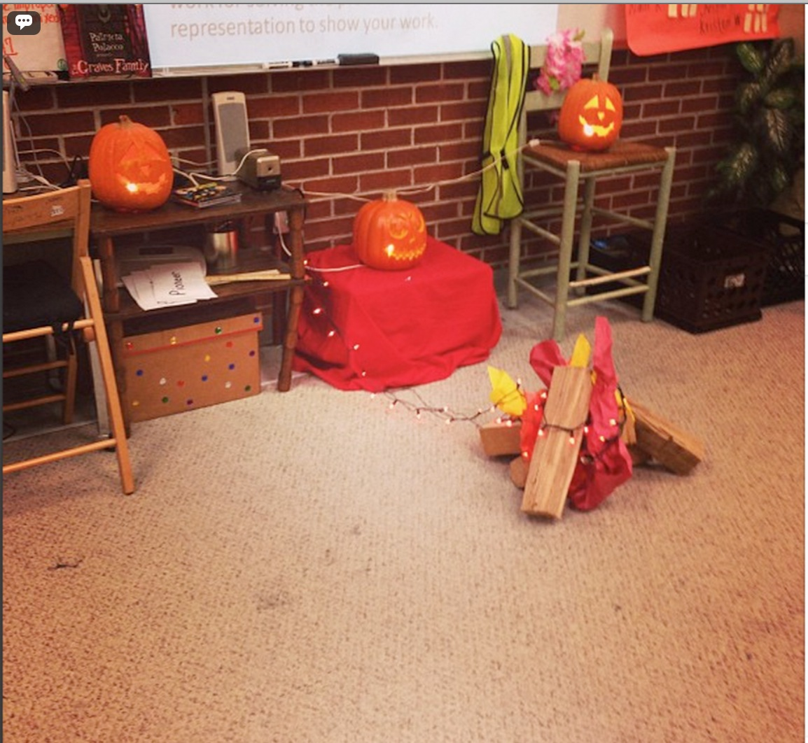
Figure 4. Journaling Photo 1
Barbie stated and recorded information from her surroundings and journaled what happened. She identified what she did that day and then put that information into her photojournal. Many interns also recorded specific lessons they taught or specific projects that their elementary students completed. Similarly, the pre-service teachers also recorded information about experiences and students in their journal. For example, Charlotte uploaded the photo below (Figure 4) and explained that one of her students came to school with this necklace then at one point during a lesson began twisting the necklace repeatedly until he was choking himself.


Figure 5. Journaling Photo 2
The purpose in posting this photo and caption seemed to be to record a new experience that she had never experienced before. Charlotte sought to record the behavior about the student and keep it in her photojournal of teaching experiences. Camille also recorded a moment in her journal (See Figure 5).

Figure 6. Journaling Photo 3
Camille captioned this photo, “My mentor is the best! She brought in tons of boxes of books . . .I took 4 boxes home. . .” Again, this is another example of a time when a pre-service teacher used Instagram as an opportunity to record a moment for their photojournal. Camille made the decision to journal about her feelings for her mentor and the excitement of getting new materials for her future classroom.
Another intern, Erin, took a photograph of the first note she received from a student. She stated, “After a long day of keeping them focused . . .She handed me this note as she left! :) #MadeMyDay”. This particular experience was memorable and photo worthy for Erin because the student made her feel happy and turned her day around.

Figure 7. Journaling Photo 3
Each of the experiences the pre-service teachers recorded that were coded as journaling did not include an analysis of the experience. Each of the experiences that the intern teachers presented in their journal was a new experience that they felt was worth photographing and putting in their collection. These recordings showed that interns were beginning and seeking to understand their surroundings.

Noticing
Participants in this study also used Instagram to reflect about things they noticed. Rather than stating what he or she did that day, as with journaling, the participant would notice something about an experience, the environment, or others and record that noticing. The noticing would not include conversation about how he or she felt about that particular topic. However, a noticing was something that they noticed for, possibly, the first time. Imagine for a moment that you are trying to learn a new skill that you have not experienced. When in a new environment, it might be helpful to journal different things that happened and also notice things that were new to you.
Although the noticing posts are also a form of journaling, this category is different than journaling. Noticing adds another layer as the pre-service teachers were making a realization. For instance, Erin noticed something about her spelling lesson. In regards to the photo below (See Figure 8), Erin wrote, “Planning a spelling lesson, #lessonsdontflow mentor doesn’t like the flow either, but this is what he was given and was told to use.”
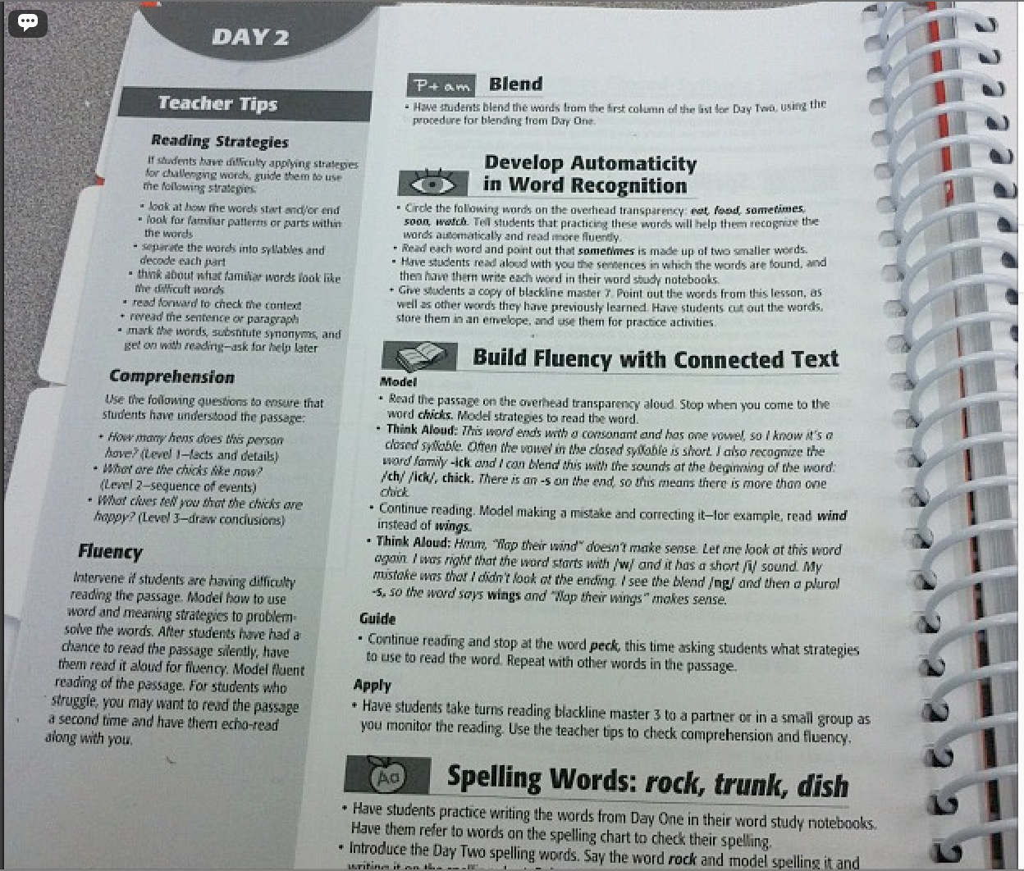
Figure 8. Noticing Photo 1
This example of reflection is no longer just stating what lesson was taught that day or how a student misbehaved, rather, the pre-service teacher was noticing something. In this instance, Erin was noticing and recording that something felt off about their spelling lesson. She did not extend this thought to wonder why she wasn’t pleased with the lesson or how it could be improved; she was just making an observation and recording this observation.
Kimberly also noticed something interesting about a little girl in her class who is a native German speaker. The students were writing sentences on whiteboards and when Kimberly saw the little girl’s sentence she noticed that her German accent influenced the way she invented spelling for words she did not know how to spell. Kimberly photographed the writing she produced and posted the photo to Instagram (See Figure 9).
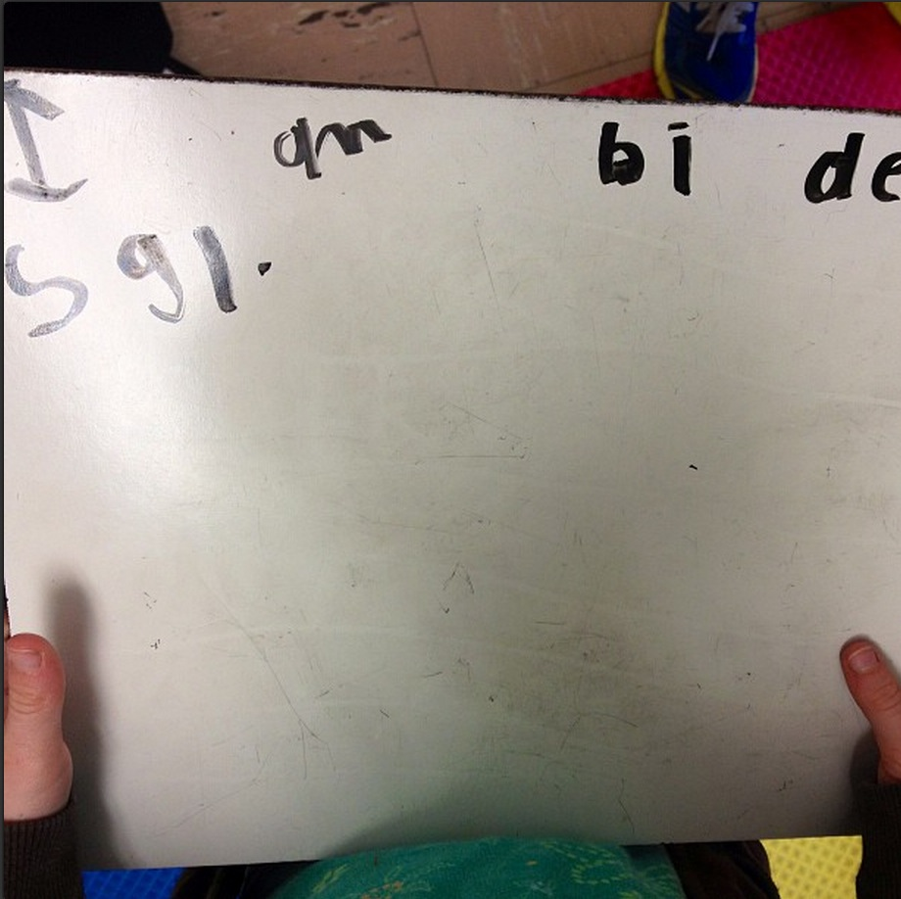
Figure 9. Noticing Photo 2
The little girl wrote on her whiteboard “I am by the school” however, as she sounded out and encoded the words, she wrote “de” for “the” and “sgl” for “school”. For Kimberly, this was a new idea that a child’s accent would heavily influence their writing, so she captured it and explained this noticing to be put in her photojournal.
The two examples identified above seemed to be important for children and future children’s learning. These noticings were first steps in understanding and influencing the type of teaching they might engage in. Some noticings by the pre-service teachers were not necessarily epiphanies or deep in any way. As an illustration, see Figure 10 below.

Figure 10. Noticing Photo 3
In this photo, Pat noticed that a silly fiction book was placed in a bin entitled Realistic Fiction. The main point of this photo was more for humor than anything else; however, this example still illustrates the content of this reflective technique. The pre-service teachers were in a new environment and reflected in order to understand everything around them. Whether it was noticing that lessons were not flowing or noticing the organization of trade books in a classroom, the pre-service teachers used noticing as they made sense of their new world.

Noticing and Extending
The participants in this study also used Instagram as a platform to extend their “noticings.” An extension was coded as such when an individual reflected or expounded upon something that he or she noticed. For example, Khloe was subbing in a different classroom one day and noticed that the sub plans called for assignments out of a language arts textbook that she used when she was a student (See Figure 11).

Figure 11. Noticing and Extending
Khloe captioned under this photo the following,
I was subbing again today and my lesson plan said for students to complete pages from their "old green language arts book." So, this morning I pulled out one of the books to look over what we would be doing. I was shocked to find the same LA textbook that I used in 3rd grade. Crazy! It brought back lots of memories! This textbook is from 1991, so really it was kind of old even when I used it. I'm not sure how helpful the activities in this book are, especially since most schools don't seem to use LA textbooks anymore . . .
If this intern had only noticed that the language arts books were the same that she had when she was a child, she would have just recounted her noticing of finding a familiar book. However, she added an extension as she mentioned that she is not sure how helpful activities in the book might be. From this comment, it can be understood that she has made the jump to reflecting about the influence that these books may or may not have on children. Additionally, she extended this noticing as she posited that many schools do not use language arts textbooks anymore.
While analyzing and coding, I also noticed that the pre-service teachers extended their noticing in two ways, commenting or wondering. When commenting, the teachers often agreed or disagreed with something that they noticed. When wondering, the teachers either did not know how they felt about what they noticed or had a specific question about something.
Noticing and Commenting. After spending a few days at Central Elementary for a six-week pull out, Marisa noticed and commented on the professional environment. She uploaded the following photo to Instagram (See Figure 12).
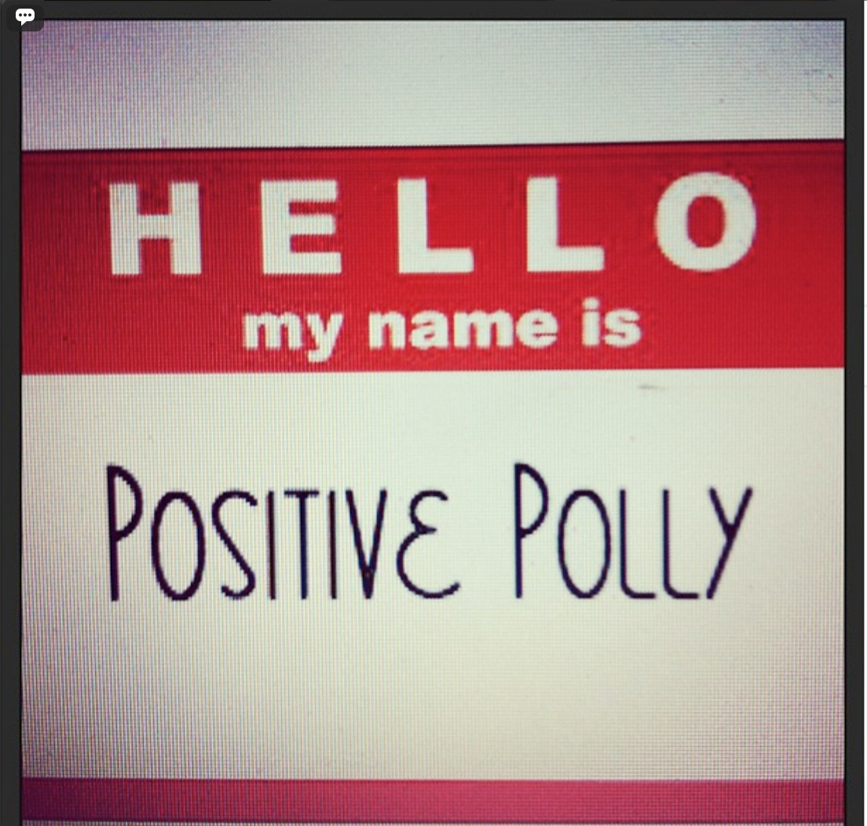
Figure 12. Noticing and Commenting Photo 1
Marisa uploaded this photo to discuss that she noticed that the community was negative. However, she didn’t just stop at this noticing, she extended this to comment on a connection that she had made with a lesson she had learned in one of her master’s level courses. She stated, “I am constantly reminded of [an] activity we did in class where we looked at what our students can do well. Rather than immediately looking for the negative, begin by looking at the positive!”
Similarly, Camille noticed something disheartening when she visited Northwood elementary. She noticed that the students in the fifth grade class were doing a lot of worksheets throughout the day. One Monday morning she arrived to see a stack of papers on her mentor teacher’s desk (See Figure 13).

Figure 13. Noticing and Commenting Photo 2
Camille noticed the stack of worksheets and found out that they were the worksheets that the students would be completing throughout the week. Camille commented on this noticing.
This is the stack of worksheets that we have ready to go next week. We aren't even in the school on Tuesday because of a field trip. I'm really struggling with giving so many worksheet that really aren't helpful in learning. I know that sometimes worksheets are great! It shows what kids know or what they struggle on. But school can't just be worksheets.
Camille noticed the worksheets and the time in which students were sitting down to complete them. She also inserted her opinion on the matter as she mentioned that school should not be just worksheets. Again, in this example Camille was not just simply journaling or noticing, she was extending her experience by commenting on the experience.
Marisa also inserted an opinion as she commented on a noticing. After viewing a reading nook in a kindergarten classroom, she felt surprised that the children did not have more books to choose from. She extended this by saying; “I personally feel that it is important to have an abundance of books in a kindergarten classroom to get our beginning readers excited about learning to read” (See Figure 14).
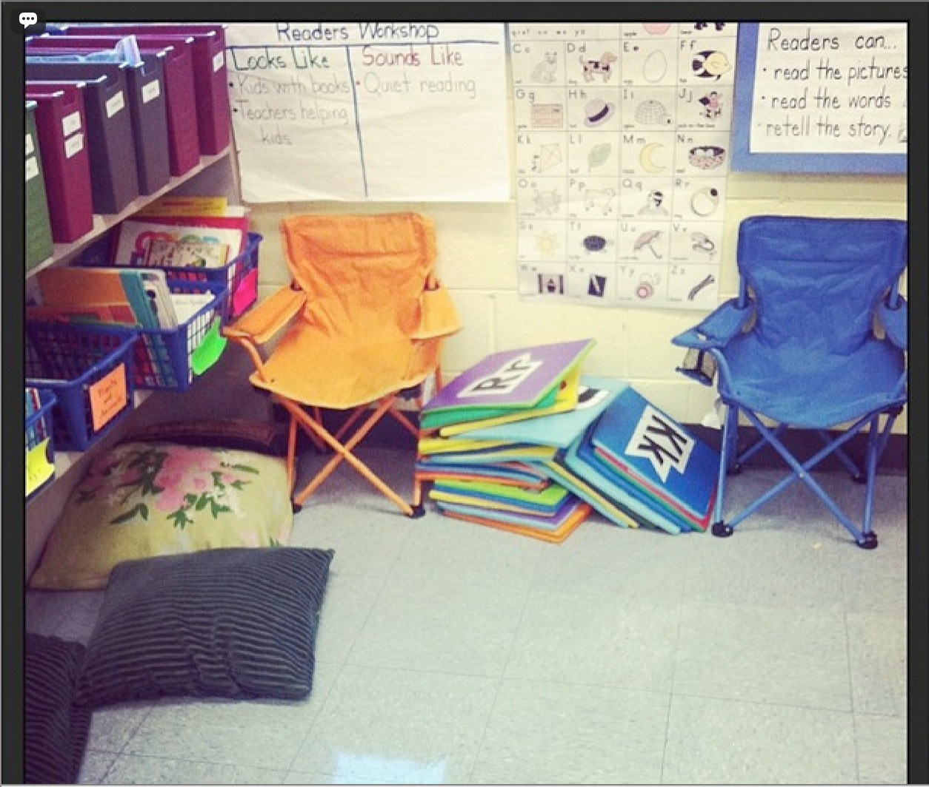
Figure 14. Noticing and Commenting Photo 3
As the pre-service teachers began to better understand their surroundings (Dewey, 1938), they started to comment in regards to particular things they were noticing. The comments often were opinions about what they had noticed. Likewise, the teachers also questioned things that they noticed.
Noticing and wondering. Often times throughout the reflection process, a teacher would question something that they noticed. These questions were wonderings about the content in which they were reflecting upon. The questions might involve a wondering if a particular teaching method was effective, wondering if a colleague had a solution to a problem, or even wondering what influenced a child’s growth, like Josie wondered about the photo below.
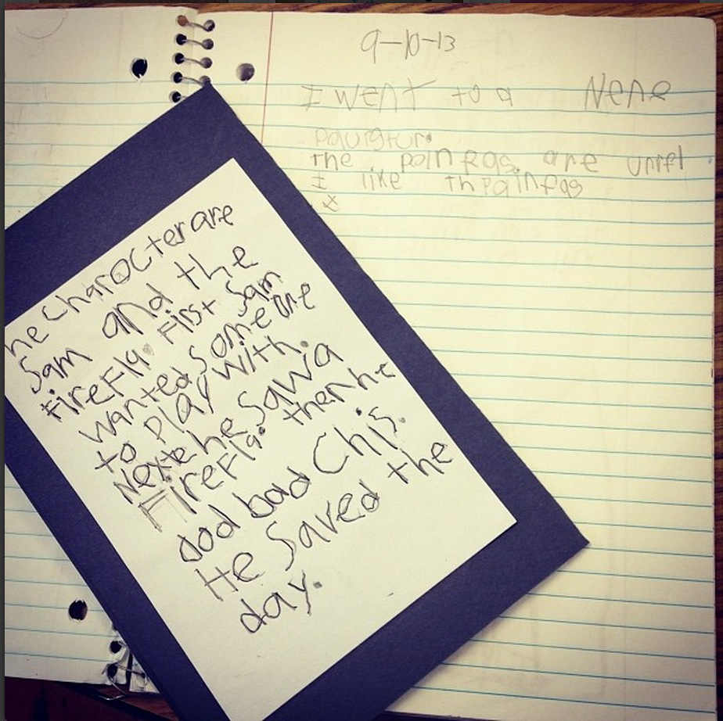
Figure 15. Noticing and Wondering Photo 1
In conjunction with the photo above, Josie wrote,
This kiddo could not write a complete thought in the beginning of the year (here in September), much less was it legible for reading. The book sleeve (on black paper) was finished this week for EdTPA. Just thought this would be beneficial for everyone to see. I'm not sure if this is naturally the growth you see in first grade or if the tool they used to organize their thoughts accounts for this progress . . .
First, Josie noticed that a particular student had grown a lot since the beginning of the year. After noticing this, she wondered if the growth could be attributed to the lesson and tools that she had prepared for her students throughout a unit.
Similarly, Ella took a photo of student work to pose a noticing and wondering. While working in a literacy center, Ella noticed that the students were copying down words and repeat writing the words for practice. She wondered if this practice was a good idea or if that is just how it is done in lower grades. She stated, “Do you guys think our kids need more support than this for their spelling, or do you think this is appropriate for first grade?”
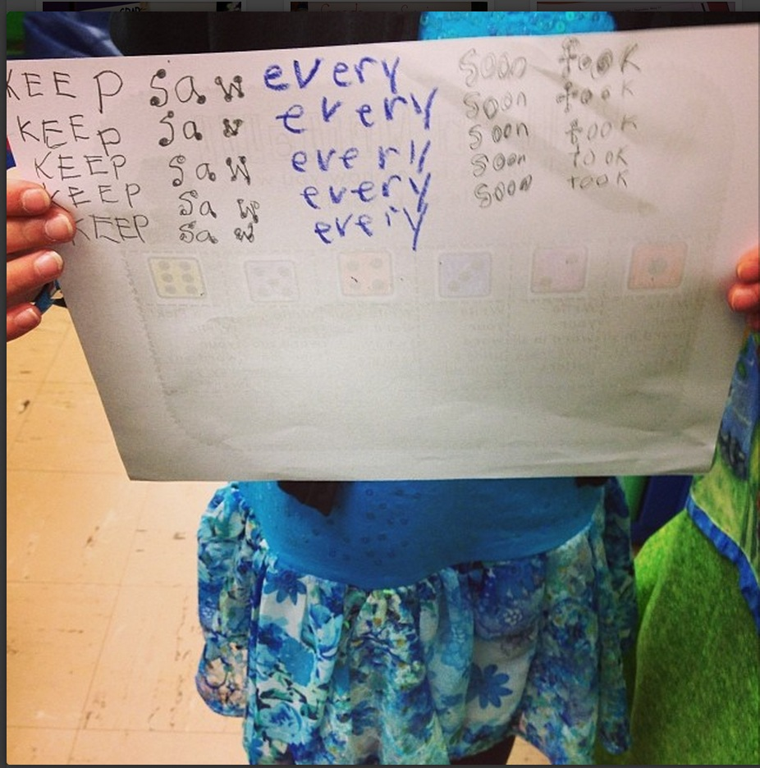
Figure 16. Noticing and Wondering Photo 2
While the two examples above were wonderings about teaching and learning, sometimes the pre-service teachers wondered about more simple things, such as classroom management ideas. For instance, Barbie took the photo below (See Figure 17) when she noticed that students in her class were breaking a lot of pencils, which left her having to sharpen a lot of pencils. She wondered if there was a better way to handle this situation and posed that question to her colleagues. In the comment section, one of her colleagues gave an idea of how to handle broken pencils.
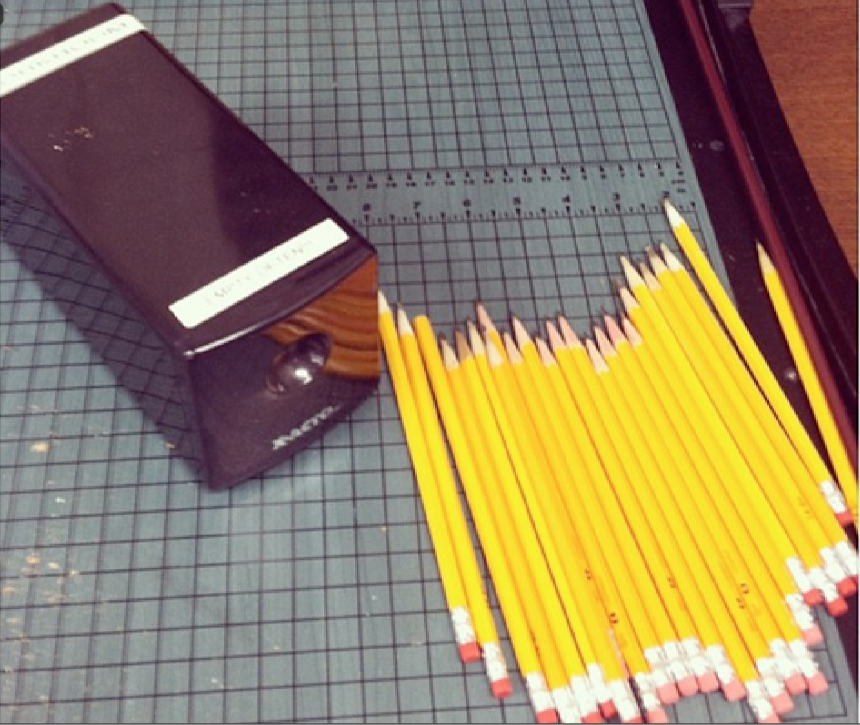
Figure 17. Noticing and Wondering Photo 3
Each of the examples illustrated above describes noticing and extending, a form of reflection. Some might consider some of the reflective photos and captions to be classified as more worthwhile than others. However, each of the examples showed that the participants were extending their thought from noticing their surroundings to reconstructing meaning (Dewey, 1938). In order to reorganize and reconstruct experiences as Dewey (1938) has stated, the interns noticed, commented, and also wondered.

Noticing and Problem Solving
There were many photographic reflections when the pre-service teachers noticed something as a problem and posited a solution to the problem. Problems ranged from classroom management issues, behavior management, teaching ideas, and student needs. Charlotte recorded a problem in her instruction when she noticed something about a particular student in third grade who was struggling to learn English. She noticed that the student was at a much higher math level than the other students in the class. Whenever the student engaged in a math activity, he was way ahead of his peers. The pre-service teacher was surprised. She took a photo of his math work to reflect upon his abilities and her instruction.
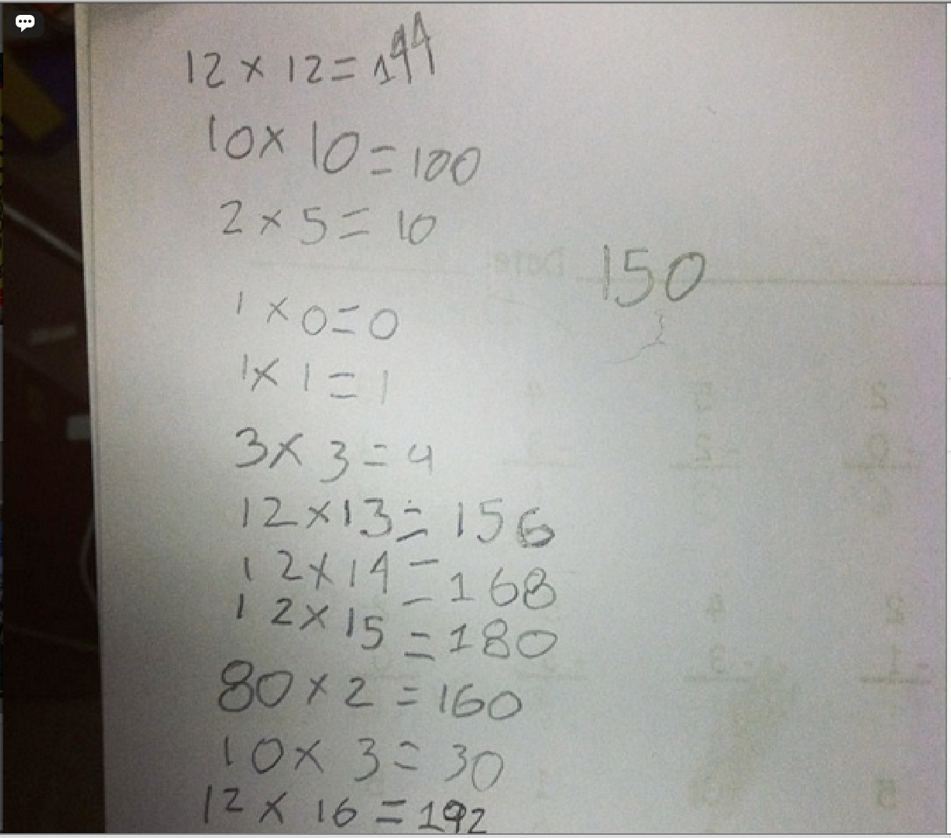
Figure 18. Noticing then Problem Solving Photo 1
When reflecting about how to best help the child who struggled with English but excelled in math, Charlotte came up with a possible solution. She stated,
I am just mind boggled by his math skills! I am thinking that we need to focus on literacy during math through word problems with more complex math. This will still challenge him in math but focus on his need in literacy.
Charlotte’s reflection about this particular student moved beyond noticing and extending, she noticed a problem and identified a possible solution. Notice, however, that Charlotte was not reflecting about enacting the solution, just considering a possible solution.
Sometimes when the pre-service teachers were problem solving, they didn’t necessarily identify a specific solution, rather, they just identified that there was a solution. One day while sitting down to plan a fifth grade social studies lesson, Holly, took this photo of the social studies textbook in which she was required to teach (See Figure 19).

Figure 19. Noticing and Problem Solving Photo 2
Holly noticed that the fifth grade social studies lessons often involved the students sitting down and reading a chapter from the textbook or popcorn reading the text. She then explained that she was researching alternate methods of teaching the information in the text. You’ll notice she also has a blank piece of paper next to the textbook. The blank piece of paper symbolizes that she did not yet have a solution to a problem she had identified. However, she noticed a problem and was in the process of problem solving.
Khloe identified a problem in her first grade class as she noticed that she was calling on the same students repeatedly. As she reflected on this problem, she considered a solution of creating Popsicle sticks with each student’s name written on them. This would allow her to pick a Popsicle stick with a name on it and call on a student. Khloe stated, “I'm hoping it will help students who never raise their hands to answer questions to pay more attention now that they know they could be called on at anytime.”

Figure 20. Noticing and Problem Solving Photo 3
Similar to the picture of pencils described in the previous section, some may wonder the importance of classroom management reflections such as this. The pre-service teachers reflected about a wide range of issues, some may seem menial and some may seem deeper. However, the point of this research question was to identify the ways in which the pre-service teachers reflected. Thus far, I have described four different ways the pre-service teachers reflected, (a) photojournaling, (b) noticing, (c) noticing and extending, and (e) noticing and problem solving. Each of these reflective techniques discussed thus far did not include the participants stating that they had changed their practice in anyway. They may have discussed a possible change in practice, however, did not report that they practice actually changed as a result of their noticing, extending, or problem solving. The final form of reflection that I identified in the pre-service teachers’ reflections did include a conversation of their practice.

Noticing then Changing
(Kolb, 1984) identified that in order to learn from experience, an individual reflects, creates a theory, and tests a theory in practice. Pre-service teachers in this study, included in their reflections moments when their personal theories were used in practice. This category, noticing then changing, included these experiences. Each reflection coded under this category, had evidence that the teacher changed behavior or practice after noticing something. While substituting in a fifth-grade class, Holly, noticed that the sub plans were very unlike the type of instruction she prefers. She took a photo of the sub plans (See Figure 21) and added the following reflection.
I love and much appreciate the opportunity to earn a little money. However, on the other hand I am sitting in a classroom and force feeding kids worksheets, because that's what the sub plans are :( sad story... But I guess its easy that way, good heavens as long as it is easy ! (jeeesshhh) on a lighter note I rush them through the worksheet, and so we can do a read aloud that I found around the room and have an awesome time reading that, and the kids love it, and they are still learning. #readaloudsforthewin
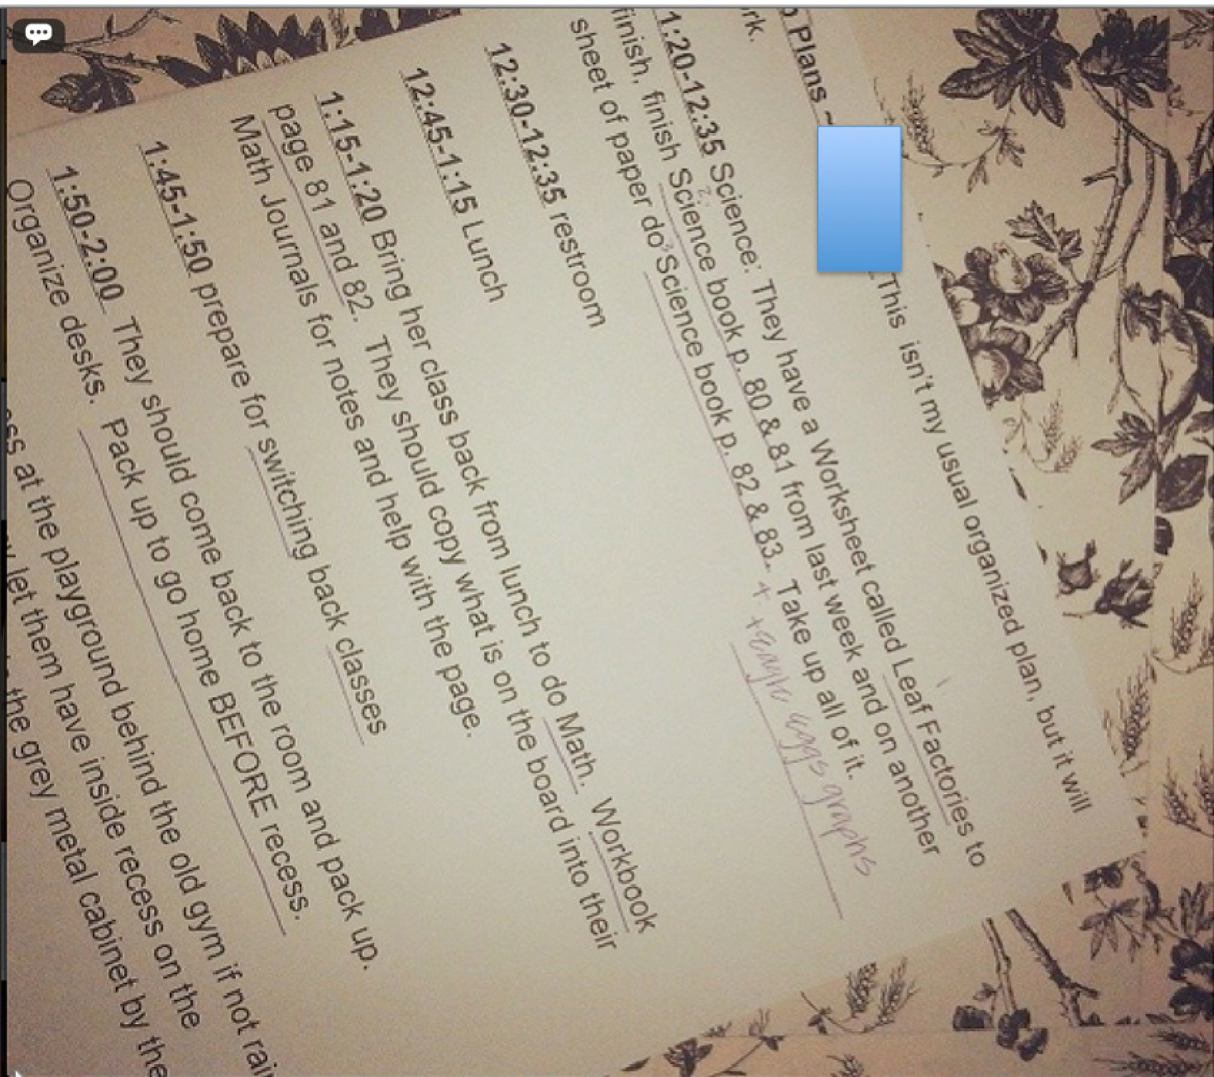
Figure 21. Noticing then Changing Photo 1
Holly did not feel that giving students worksheets all day was the best form of instruction. She noticed that the students would be doing worksheets all day, then changed her practice to include read alouds. This form of reflection is different than those discussed earlier in this chapter. For instance, if this had been an example of noticing and extending, Holly may have noticed that the students were doing worksheets and then wondered if that was a good use of their time. Similarly, if Holly had just been problem solving she would have noticed the students were doing worksheets and then suggested a possible solution to the identified problem. This form of reflection is different because Holly actually enacted the solution that she had considered.
In a like manner, Moxie, reflected about behavior management in a kindergarten classroom. She uploaded the following photo to Instagram (See Figure 22).
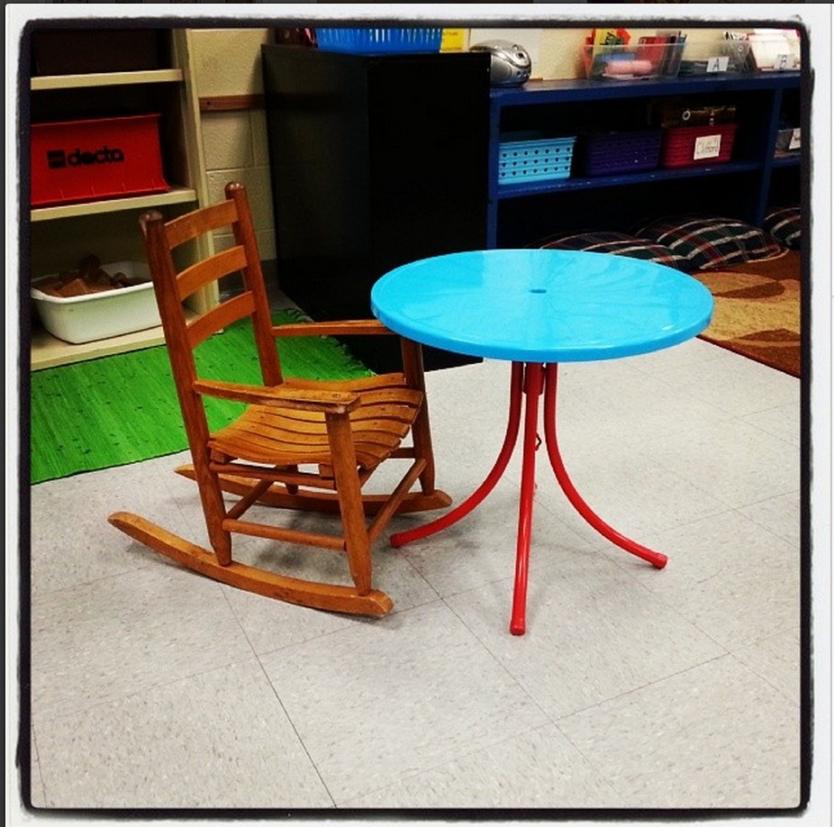
Figure 22. Noticing then Changing
Moxie reflected about this photo.
There is one student in my Kindergarten class that honestly seems unable to stayed seated and complete any assignments independently. He constantly self-stimulates with distractive behaviors and seeks some kind of interaction with others. So yesterday I tried sitting him this rocking chair at his own private table, and the difference was almost insane! He sat quietly, finished the assignment without getting up, and seemed focused on his work. Also he managed to control his motor abilities much better, which is something that he really struggles with.
Moxie noticed a problem, considered a solution, and changed something in the classroom to help a student’s behavior.
By the same token, Erin noticed a problem and changed her practice. Erin noticed that she did not approve of the math textbook lessons that the administrators had provided for all of the teachers. Erin noticed that the textbook math lessons lacked authenticity and that her students did not like engaging in the worksheets. She posted the following photo and caption.
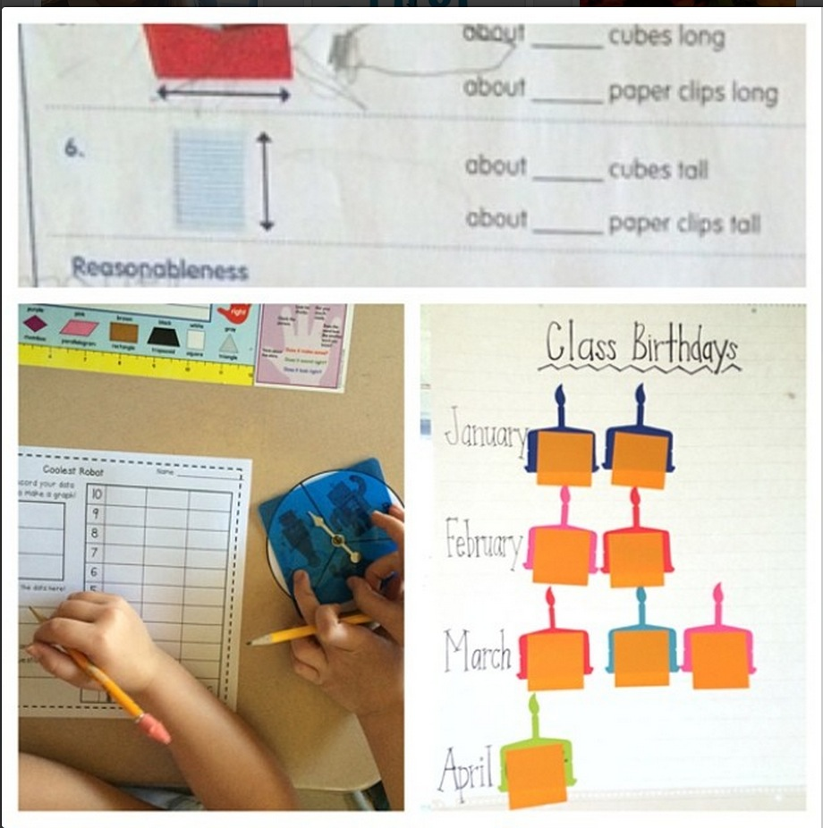
Figure 23. Noticing then Changing Photo 3
I have taken over math completely! I've changed it up from [the textbook]..Still going by [the textbook] lessons to stay with the other 2nd grade class, but my mentor told me to do it however I wanted to/would like to teach math! Yesterday when I told them we were ready for recess I had two kids say, "but Ms. Anderson, we haven't done math yet" and he is usually a lower student hating everything to do with school. They have made their own graphs using spinners, worked together to complete tasks, we made a graph using their lunch count, and a pictograph of their birthdays.
In this caption and photo, Erin reflected about a change that she made in her classroom. She noticed the textbook wasn’t effective for her students, she theorized of a possible solution, tried the solution in practice and received positive feedback from the students.
The pre-service teachers in this study reflected about changes they made in their teaching practice. Some changes were permanent teaching changes, such as avoiding a math textbook for several months. Some changes were brief changes, such as choosing to forego sub plans and do a read aloud or having a student sit in a rocking chair. Additionally, some changes that the teachers reflected about may not have influenced instruction in any way. Sometimes the changes they reflected about were classroom management techniques, scheduling, planning, or student rewards. Like Ella, for example, who took a photo of stickers when she decided to change the way she was rewarding the children for behavior, (See Figure 24).

Figure 24. Noticing then Changing Photo 4
Throughout this section, I illustrated five reflective techniques that the pre-service teachers utilized in order to understand their surroundings. At the beginning of this section, I provided a graphic (See Figure 3) that showed the reflective techniques with an arrow that pointed in both directions. Upon first glance of the reflective techniques, one might assume that as the techniques move to the right, they also become deeper or more reflective. It might be understood that simply journaling is less reflective than noticing and changing because journaling did not include much analysis. However, as one might infer from my descriptions, the topic in which the pre-service teacher was reflecting about mattered. For instance, problem solving may be understood as an important skill for a teacher to manifest. However, if the only problem solving the teacher did revolved around the best method for sharpened pencils or how to best call on their students (e.g., with popsicle sticks) then problem solving no longer seems adequate. The content in which the pre-service teachers reflected influenced the depth of their reflections.
In this section, I sought to illustrate the types of reflective thought in which the pre-service teachers engaged. The different techniques of reflecting are not the only thing that matter in encouraging and producing analytical, reflective practitioners. The next research question addresses the content of the reflections.

Research Question Two
The second research question in this study focused on the content of photo reflections. As I formally analyzed the data sources in this study, I was initially overwhelmed with the amount of topics in which the pre-service teachers reflected. As you might imagine, there was a lot of content in over 1,800 photo reflections. However, after a lot of deep analysis and engaging in analytic memos, I found that the content of the reflections could be generalized into three larger categories. The myriad of topics covered by the teachers could be grouped into reflections about (a) themselves, the teacher, (b) the students, and (c) the education system. Figure 25 provides a summary of the subcategories within the larger three categories.

Figure 25. Results of Research Question 2

The Teacher
Being “the teacher” in a public school classroom was a new role for the participants in this study. Therefore, the pre-service teachers often reflected about themselves as teachers. They reflected about their feelings and their development.
Teacher Feelings. Anyone who has taught children, can identify with the idea that a teacher can feel many different feelings throughout the days and weeks. As the teachers learned to teach content, manage student behavior, organize a classroom, collaborate with teachers, and the many others skills that come with learning to teach, they often discussed their feelings about learning such things and engaging in such a new and different experience.
Barbie discussed her feelings about being nervous to meet the parents of her students at a school open house. She posted this photo of a bulletin board displayed at the open house to symbolize these feelings (See Figure 26).
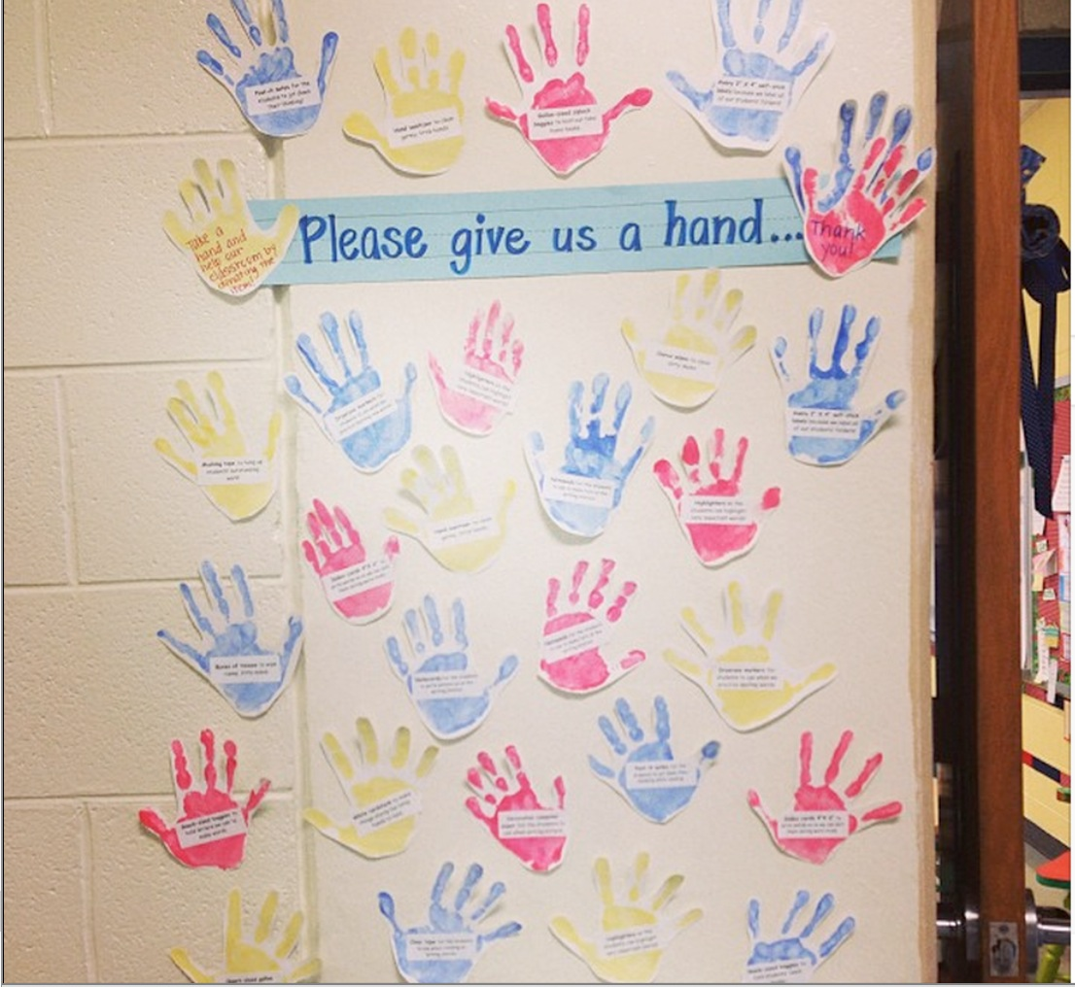
Figure 26. Teacher Feelings Photo 1
After feeling nervous to meet the parents, Barbie noticed that very few parents actually came to the open house. She understood the parents’ absence to be lack of support. She then discussed her feelings about her “shock” and “amazement” that parents did not come to support their children. This realization struck a cord and she felt the need to notice and comment upon these feelings.
Josie experienced mixed emotions when her mentor teacher was sick one day. She captured her feelings by typing emoticons into a blank document and taking a screenshot (See Figure 27).

Figure 27. Teacher Feelings Photo 2
The images of little faces described the way in which Josie felt throughout the day. She then attached the following caption.
Well y'all, didn't have time to post a picture today because I taught the ENTIRE DAY. My mentor was out sick and the substitute gave me the full leadership role. I experienced completely mixed emotions today, as I didn't expect to be thrown in so quickly. Luckily I swam instead of sinking! This would definitely be valuable to share this experience with all of you #exhausted
Teaching a full day was a big deal to Josie. Up to this point, she had taught a few lessons then was asked to manage a whole day. She felt a lot of emotions throughout the experience. As you can see in her photograph, she ended the day with a happy face and reported that she swam instead of sinking. Yet, she also mentioned, through a hashtag, that she is exhausted. Learning to teach was emotional and draining to her and she reflected about this experience through photojournaling and noticing.
Josie felt overwhelmed at the idea of teaching a full day, initially. Ella also felt overwhelmed when she considered planning and teaching math for a week. She uploaded the following photo (See Figure 28) and then reflected through noticing and wondering.
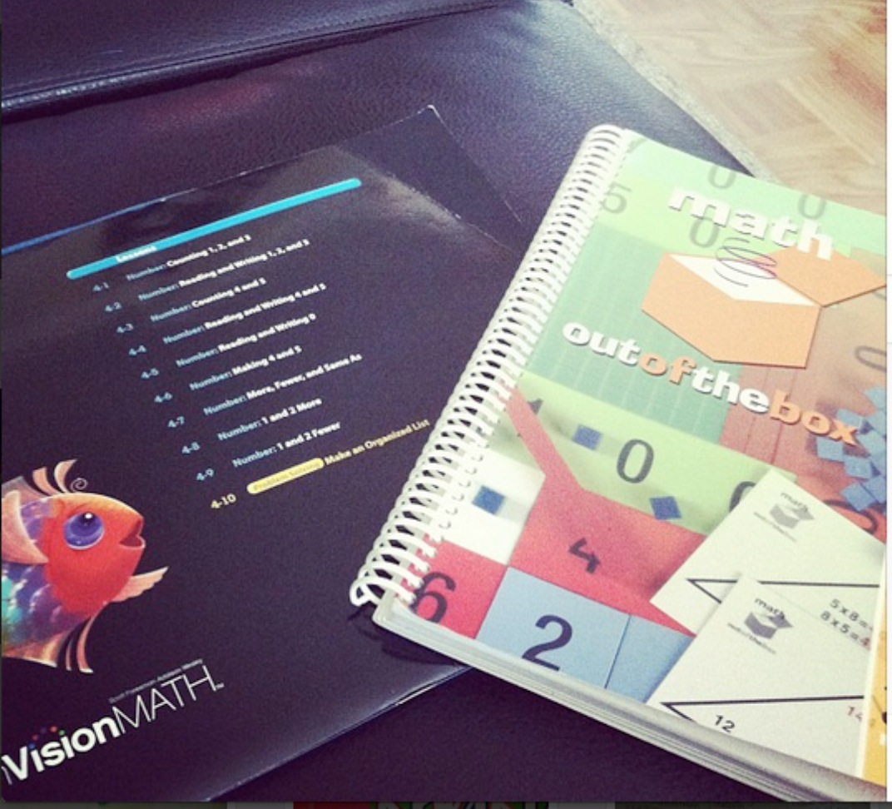
Figure 28. Teacher Feelings Photo 3
I am in charge of planning and teaching math for next week. Just looking at these books makes me freak out because I feel like I just don't even know where to start. Also, my teacher said that envision is not common core aligned so she does not use it (other than some of the workbook pages). Do your all's teachers use envision and to what extent? Anyone else not really planned a lot and feel nervous about it?
The initial impetus in posting this photo was the stress Ella was feeling as she considered the idea that she would be teaching math the following week. She took the photo because of her feelings, she was looking at the books and feeling stress. While the reflection spurred from emotions, she continued to notice other elements of teaching such as common core and the implementation of textbook instruction in education. She also wondered about how others use a math textbook in their courses. Though she noticed and wondered about math, she brought the reflection back to her initial feelings and was curious if her colleagues were also nervous about planning, indicating the impact her feelings had on her reflection.
The participants in this study reflected about their feelings often. Additionally, as Ella portrayed in her reflection, feelings often spurred taking photos and instigated a reflection. Sometimes even when a reflection began with initial feelings about one topic, the teachers noticed and reflected about other things in addition to their feelings. The feelings seemed to facilitate further reflection. Further reflection regularly included noticing their own development.
Teacher Development. Throughout the participants’ yearlong journey of learning to teach, they often perceived that they had grown and developed in one way or another. Sometimes they noticed they had become more confident, competent, or had changed in some way. Conversely, the teachers also noted when they wished they had developed more in an area or when they identified something that they needed to work on. This category incorporated all reflective thoughts that included conversation about individuals’ personal development.
Teacher development reflections included times when the pre-service teacher reflected on a particular lesson and included thoughts about what they needed to do to become a stronger teacher. Rebekah taught a lesson on verbs and verb tenses and reflected about the specific lesson as well as her development. After completing the lesson, she took the photo of the anchor chart she and the children had made (See Figure 29).
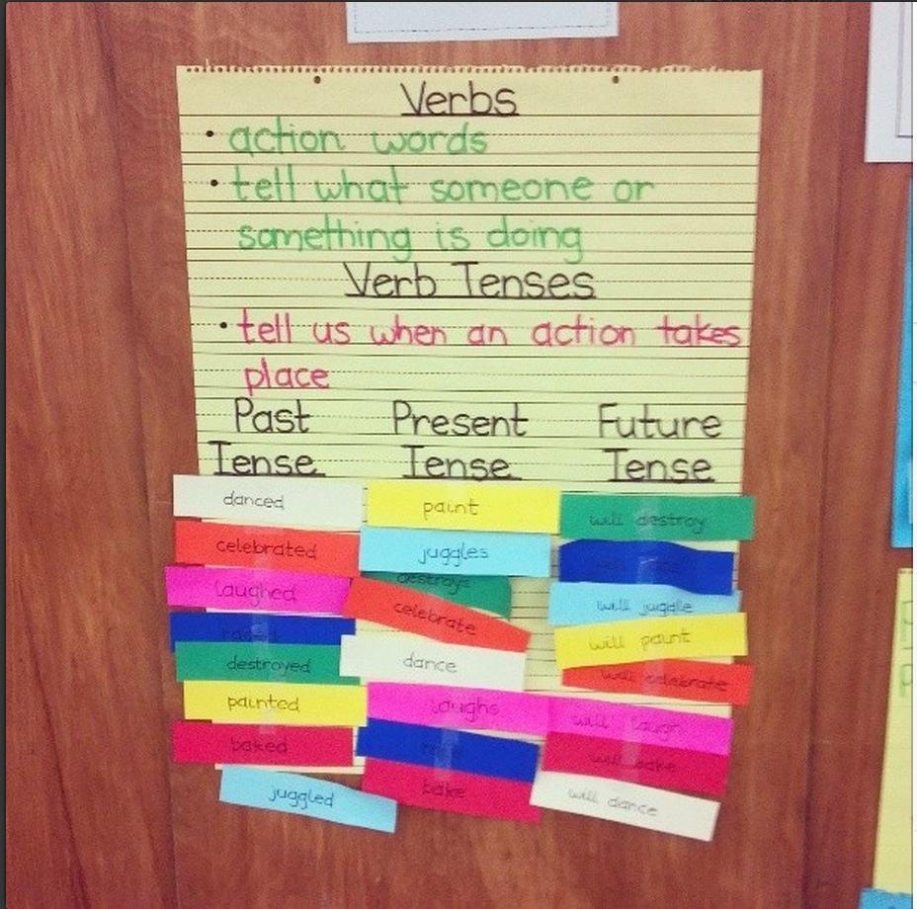
Figure 29. Teacher Development Photo 1
Rebekah reflected about this particular lesson but also furthered thoughts about this lesson to future development.
This activity would have also worked better had I had students complete it in pairs. Takeaway= maximize engagement for all students!!! In planning future lessons, I need to always ask myself, "how can I make sure all of my students are thinking for the majority of the lesson?"
While Rebekah did not say, “I am reflecting about my future development as a teacher,” she was noticing and problem solving about this initial lesson on verbs as well as her development as a teacher, as she planned how to improve.
On the same note, Charlotte noticed and commented about how her thoughts have changed about teaching content in the classroom. She put two photos side by side that represented her old way of thinking and her new way of thinking (See Figure 30).
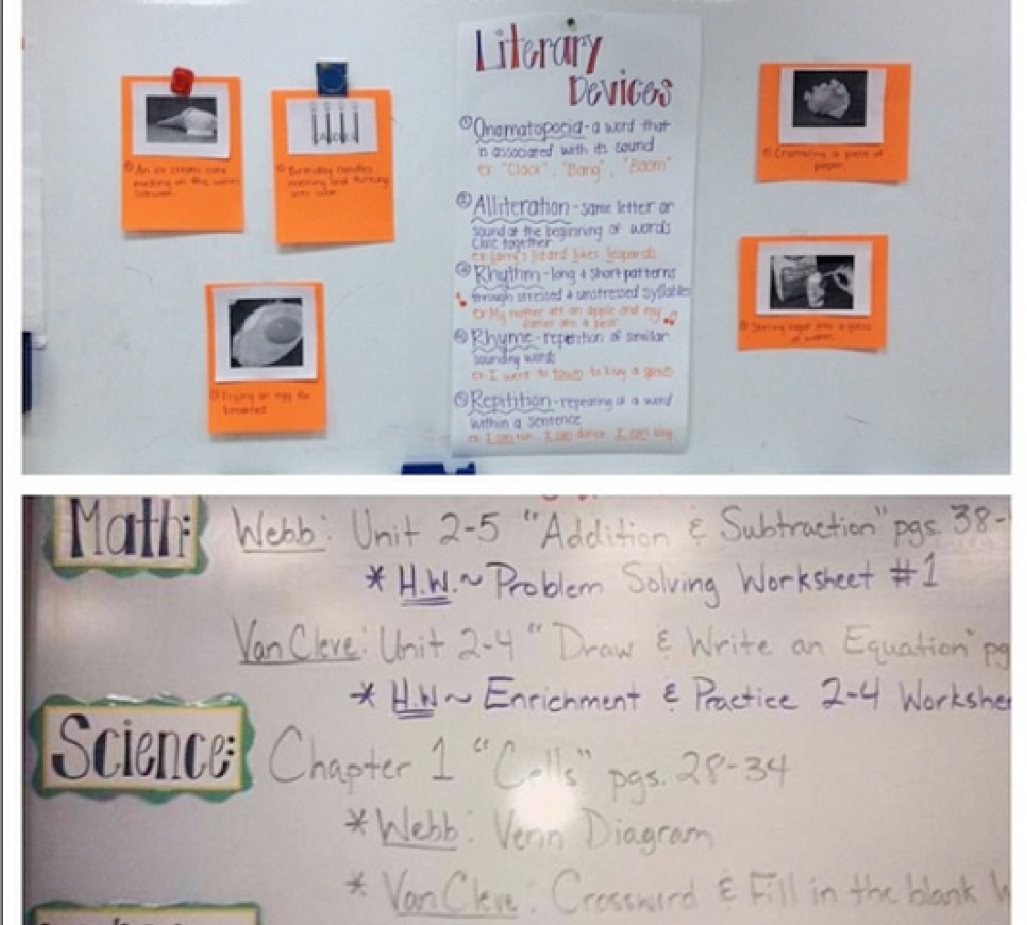
Figure 30. Teacher Development Photo 2
Charlotte wrote about her change of thinking.
I used to find it hard to find time to thoroughly teach every subject. I also found it difficult to plan cross-curricular lessons. I believed that there was no possible way to accomplish this task in 5th grade. However, I have completely changed my thinking since then! I have learned that it is extremely beneficial to student learning to incorporate multiple subjects within a lesson. It also makes our schedule more feasible when we teach social studies within reading and science within writing. I definitely want to continue this within my own classroom next year!
Charlotte changed and developed as she gained more teaching experience. She found that multiple subjects could be taught in project-centered lessons. She showed her development through juxtaposing a picture of a segmented schedule next to a lesson that incorporated writing and science.
As part of a class assignment to look for change, Moxie also reflected about experiences she had had in her internship and how the experiences had influenced her development. Moxie entered into her internship excited to observe great teachers and learn a lot. However, she found her experience to be different than anticipated. She spent a majority of her time in a fifth grade classroom and spent six weeks in kindergarten for a pull out program. She took a photograph of each classroom to represent the difference between the two (See Figure 31).
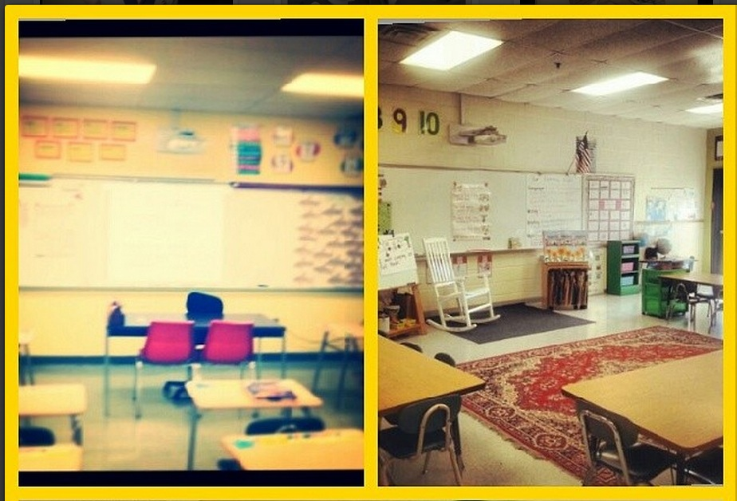
Figure 31. Teacher Development Photo 3
Moxie noticed that both teachers she worked with were very different. She also noticed and commented that she can learn and grow from learning from different teachers. She wrote,
I feel like I have made a drastic change. I was excited about going into a real classroom and learning new strategies to help me in my future classroom. I was somewhat shocked at the beginning because I would see teachers often doing things that were ineffective. I have realized that everyone has their own teaching styles and beliefs, and by analyzing someone who is different than you, you can reflect on your own strengths and weaknesses.
The pre-service teachers in this study were completing a master’s program where they were paying tuition with the intent that they would learn how to be a teacher. They were absolutely concerned with themselves and they reflected about themselves and their growth often.

The Student
While the pre-service teachers reflected a lot about themselves as teachers, their feelings and their development, they also spent a lot of time and energy thinking and reflecting about the students they taught. These reflections included thoughts and feelings about individual students, a group of students, or public school students in general. There were two main categories of reflections regarding students. The first category I labeled student situations. I created this category because many reflections about students involved noticings of students’ individuality and unique backgrounds. The second category, entitled student learning through engagement, highlights the teachers’ reoccurring focus and concern of truly engaging students in learning.
Student Situations. The participants in this study heavily focused on the children they taught. They constantly noticed interesting things about students and often expressed their feelings about the students. Many times these noticings were about the students’ background and home life. However, they also reflected about student disabilities, students’ unique needs, and particular student’s understanding of content.
Leslie posted the photo below (See Figure 32) on Instagram and reflected about a particular student who came to her classroom in tears one day and asked, "Ms. Ostler am I in your class because I'm not smart?" After answering the child and explaining that she is smart and that the student’s hard work makes her very proud, the child then said, “My mommy told me that I'm in your class because I'm just stupid and I’m too stupid to be in class with the other kids.” To signify this experience, Leslie wrote a few words on a post it note and took a photo.
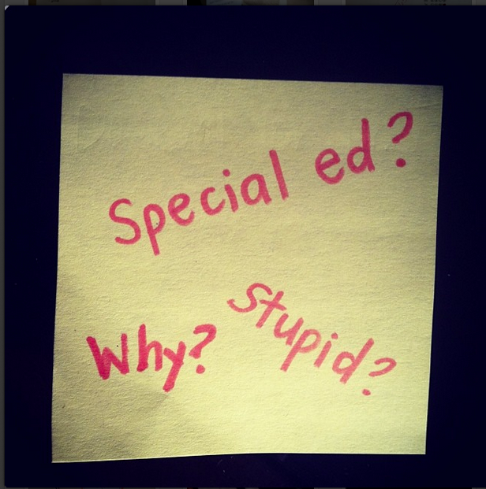
Figure 32. Student Situations Photo 1
Leslie noticed and commented about this experience in the following photo caption.
I haven't stopped thinking about that comment since I heard it early today! As teachers we MUST help students feel confident and have self-esteem! For students who are struggling to achieve they must first believe in themselves and know that it's possible for them to achieve! I encourage everyone to give little self-esteem boosting comments to your students as often as you can!
Leslie noticed the student’s comment and made an assumption about what the child’s home situation might be like. She also extended her reflection to think about what this might mean for teachers, positing that the role of the teacher is to help students feel confident and have self-esteem.
In a like manner, Camille also reflected about a student’s situation at home. She uploaded the photo below of a student’s bracelet (See Figure 33) and explained how the student was unable to focus while taking a test.

Figure 33. Student Situations Photo 2
The student came up to Camille during the test and asked if she could fix her broken bracelet.
At first I didn't think anything of it and told her I would try. But then I looked at it and the charm had the word "mom" written on it. Last week the teacher had told me that this little girl’s mother was dying of an illness. It made me think about our students. They are expected to come to school everyday and show what they are learning. But kids are kids...and we must think about what is going on in their lives when we are thinking about their performance. My guess would be that this girl didn't do great on the test because I know she was really worried about her bracelet. I thankfully was able to fix it.
Camille noticed and commented about how the child’s home life was affecting her performance at school.
On a slightly different note, Charlotte reflected on a situation at school that affected a particular child. She posted the following photo and caption on Instagram that represented how a teacher spoke to one of the students in the class (See Figure 34).


Figure 34. Student Situations Photo 3
Today I learned how important it is to control your words no matter how frustrated you are with a student. My teacher called on a student to answer a question. The student did not know the answer and my teacher chanted "tick tock tick tock" and said it was her fault she was not paying attention. This student has a learning disability and cannot produce verbal answers at the drop of a hat. The student was humiliated and I would have been too. I want to always monitor myself and put myself in the student’s position. I do not want my students to ever feel rushed, scared or embarrassed in my classroom.
Charlotte noticed the teacher’s response as well as the student’s feelings and commented on the situation as she considered her future classroom. Charlotte reflected on the situation between the teacher and the student, and took the side of the student.
The pre-service teachers constantly reflected about students and their situations in a quest to understand the children. In an attempt to notice and understand the community in which she teaches, Leslie snapped a photo of a tractor as she left the school parking lot. Each day a student’s grandfather came to school to pick her up in the tractor (See Figure 35).

Figure 35. Student Situations Photo 4
After describing the photo, Leslie stated,
Knowing what these students' culture is like is so important in trying to relate to them. On Friday my principal is taking all the teachers on a community mapping type field trip to see the roughest areas where [our] students live. [The school] is also a title 1 school . . .It will really help me to know where my students come from!
Very often, the purpose in reflecting on students and their situations was to better understand them, as Leslie did. However, not every teacher reflection about student situations sought understanding. There were times when teachers reflected about student situations and were frustrated and did not seek to understand. For instance, Pat photojournaled about a situation with a student who was misbehaving.

Figure 36. Student Situations Photo 5
Pat wrote, “He was yelling and crying not to leave my group, but his behavior was unacceptable. He threw his glasses on the ground and stepped on them in anger. Just a crazy day with writing assessment and then this! Ahhhhh”. In this example, Pat was not necessarily seeking to understand the student or what in his background or home life might be causing this behavior. Nor was Pat seeking to be on the student’s side like Charlotte and Camille. Rather, he was photojournaling the student situation.
The pre-service teachers paid close attention to the students they taught. In this section, I discussed a handful of examples to illustrate this category. While there are similarities and dissimilarities among all of the reflections within this category, the overarching idea remains that teachers were concerned with students’ situations and reflected about them often.
Student Learning Through Engagement. As the pre-service teachers learned to teach, they placed heavy emphasis on learning ways to teach children through engaging practices. They often asked questions about how to best engage children, shared engaging ideas, and talked about how children cannot learn without being engaged in the content. In addition, they criticized practices that were not engaging.
Erin focused on student engagement as she planned a math lesson about estimating and measuring length. The students in her class measured actual personal items and items from the classroom (See Figure 37).
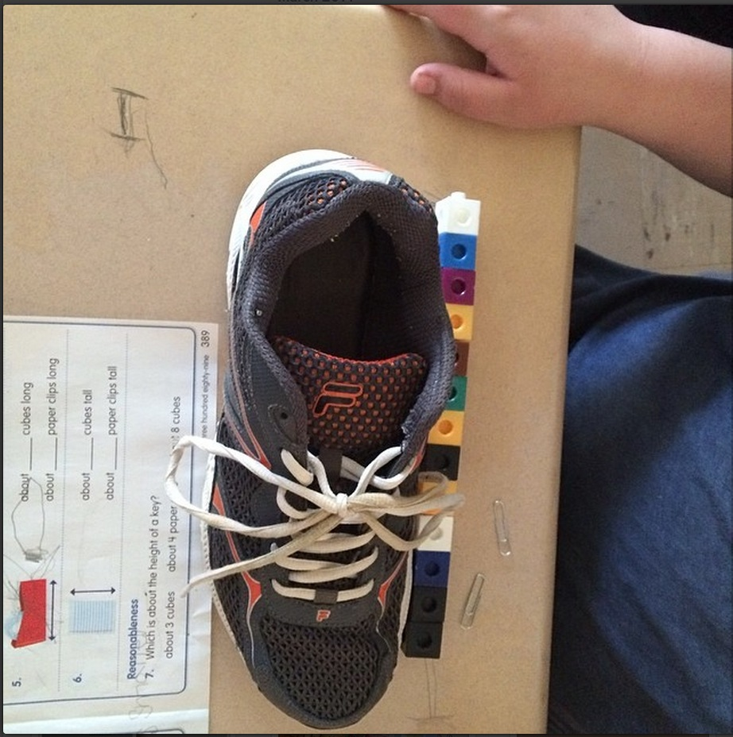
Figure 37. Student Engagement Photo 1
Erin continued, “We estimated and recorded our guess on the length of our room, how tall my mentor teacher is and so on.. The students loved this and loved being able to work hands on in math! It was engaging for the students.” Similarly, Rebekah reflected about an engaging lesson that she taught about supply and demand (See Figure 38). In order to teach these concepts, she organized an auction of various items, including items the children might not want, like a ketchup packet, and items they did want, like chapstick. In the lesson she described why the chapstick went for a higher price than the ketchup packet. Rebekah photographed the chapstick to represent this reflection. In her caption, she noted the importance of planning and preparation that comes along with engaging lessons.

Figure 38. Student Engagement Photo 2
In a like manner, Holly, took a photograph of some real artifacts she brought in to her social studies lesson including kepis and civil war bullets collected from an archaeological dig. She noticed that bringing in artifacts hooked the students and influenced their engagement throughout her unit.
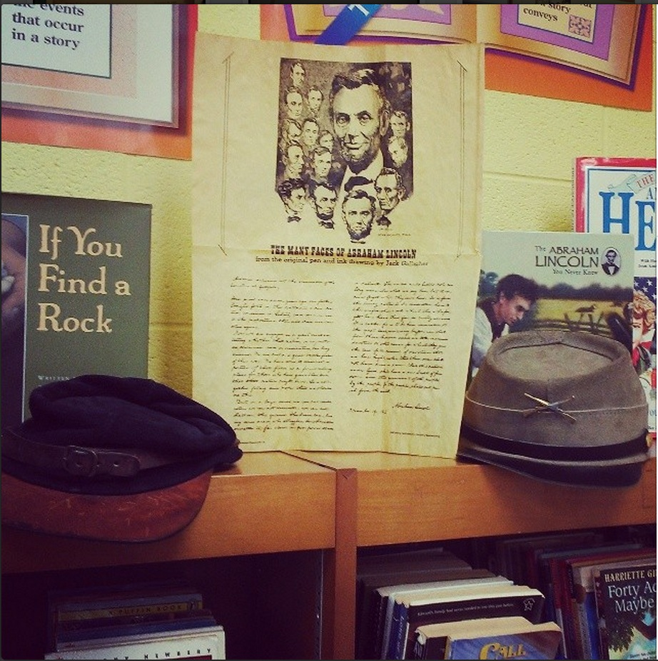
Figure 39. Student Engagement Photo 3
The pre-service teachers also discussed times when they observed or participated in lessons that were lacking student engagement. Most often, these reflections were tied to textbooks and worksheets and the lack of authenticity these provided. For example, Khloe uploaded a photo of a social studies textbook (See Figure 40) and reflected about observing her mentor teacher. She stated,
Every subject throughout the entire day consisted of reading from a textbook, answering the questions, and filling out worksheets. It was really painful to sit through these dry, inauthentic lessons . . .from looking at her lesson plans it looks like a highly textbook and worksheet driven class.
The pre-service teachers were hyper focused on excluding “boring” worksheets and “boring” lessons from textbooks. Charlotte uploaded a photo of a plant cell activity that she observed that she felt was highly engaging (See Figure 41). Even when she observed an engaging lesson that involved students creating a chart with index cards, she still brought up worksheets. She stated, “This is so much more engaging than completing pointless worksheets!”

Figure 40. Student Engagement Photo 4
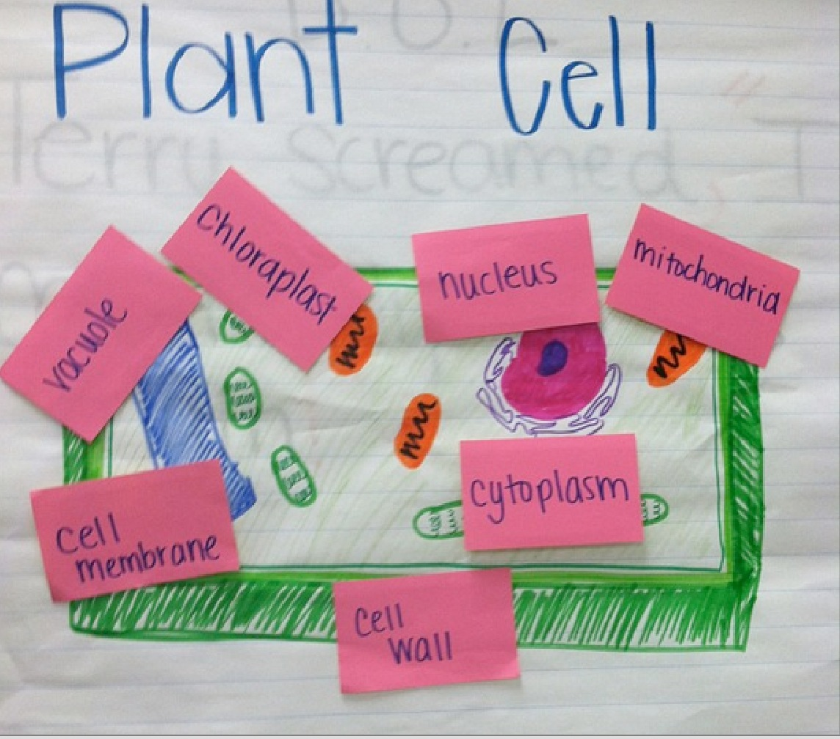
Figure 41. Student Engagement Photo 5
Even when the pre-service teachers were not seeing engaging lessons from their mentor teachers in the clinical environment, they still held on to the belief that engaging lessons are best for students. Charlotte, during a discussion at the university, stated, “I think it is important to know your students and make a decision that would be most beneficial to their learning.” This statement highlights and describes the two categories I have addressed in this section. The pre-service teachers reflected about the students in two ways, (a) specific student situations, and (b) how to involve the students. Or as Charlotte said, they reflected about knowing students and making decisions that are beneficial to their learning.

The Education System
As the pre-service teachers considered decisions about what was beneficial to the students, they considered this in the system in which they taught. The pre-service teachers entered into an educational system that has a long history of what is taught and how things are taught. The pre-service teachers tried to make sense of these things in conjunction with their beliefs and understandings. They sought to understand how information is taught in this system and what is taught. Tensions within the system and content that was taught in the system were highlighted and reflected upon by the participants in the study. Each of these categories is expounded upon in greater detail below.
Tensions in the system. Although all of the participants in this study had spent numerous years in the public school system as a student, they entered the educational system with new eyes as a teacher. With their new eyes, they sought to make sense of their surroundings. As they observed this system, they recognized, and sometimes became uncomfortable, with what they were seeing. They reflected about tensions in their local schools and tensions in education as a whole.
Josie identified tension in the educational system after reviewing results from the SAT-10 assessment. She took a photo of the results in regards to one student (See Figure 42) and stated,
Today in our PLC, we received our students' SAT-10 scores. I was shocked by the lack of authenticity in some of the feedback. Some comments on the data are not reflected in the classroom, which could pose a problem . . .For example, one student's sheet said they have strong listening skills and we have had an issue with the student focusing in the room.
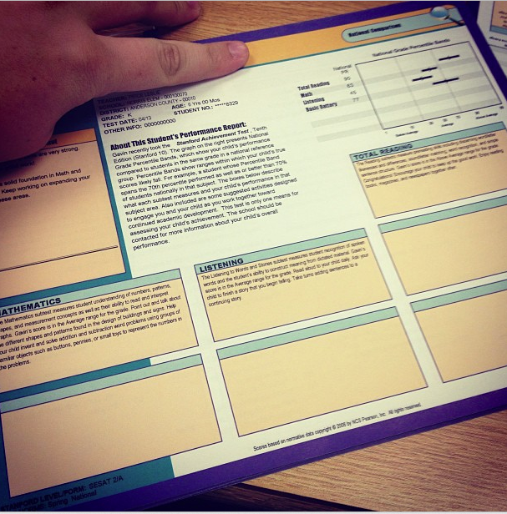
Figure 42. Tensions Photo 2
Josie questioned the results of the test, as well as noticed the tension in using some assessment data to inform instruction. The SAT 10 is supposed to help teachers understand what children know and can do, however, Josie did not seem to believe that this was the case.
In the same vein, Pat also noticed tension in standardized assessments. While looking at a test question, he saw the question that asked the respondent to identify the picture that illustrates an individual being a good citizen. Pat wrote, “That is a hard question because all are being good citizens. Basically, our students must be able to share the same opinion as the test makers. Just interesting.” Similar to Josie, Pat noticed tension in tests. Pat specifically remarked about the issue of test makers’ writing unclear or bias questions while Josie questioned the usefulness of standardized test data.
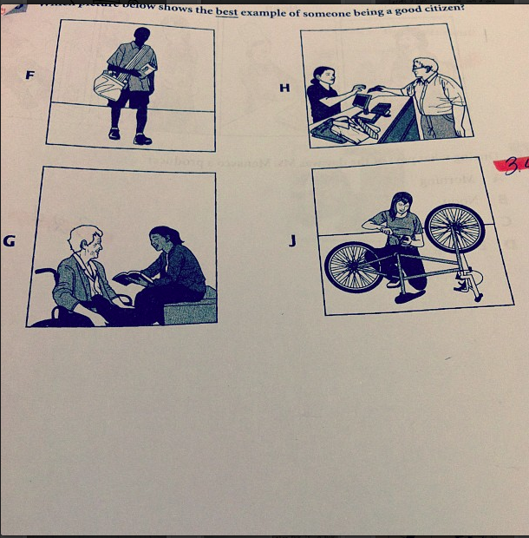
Figure 43. Tensions Photo 3
Similarly, Khloe noticed tension in testing and assessment but on the local level. She posted a picture of a student’s test on quotation marks and an attached note that her mentor teacher wrote to parents. Khloe described that the students in the class had not been adequately taught the content, however, the teacher insisted that tests are given every Friday. Therefore, the mentor teach would test the students on the material. Khloe commented on the tension,
I don't think parents should be responsible for teaching something that almost the entire class struggled with just because my mentor feels like she has to give the test on the Friday of the week she taught something. Especially when the test is going to be a multiple choice worksheet that really won't even let us know if they got the concept or not.
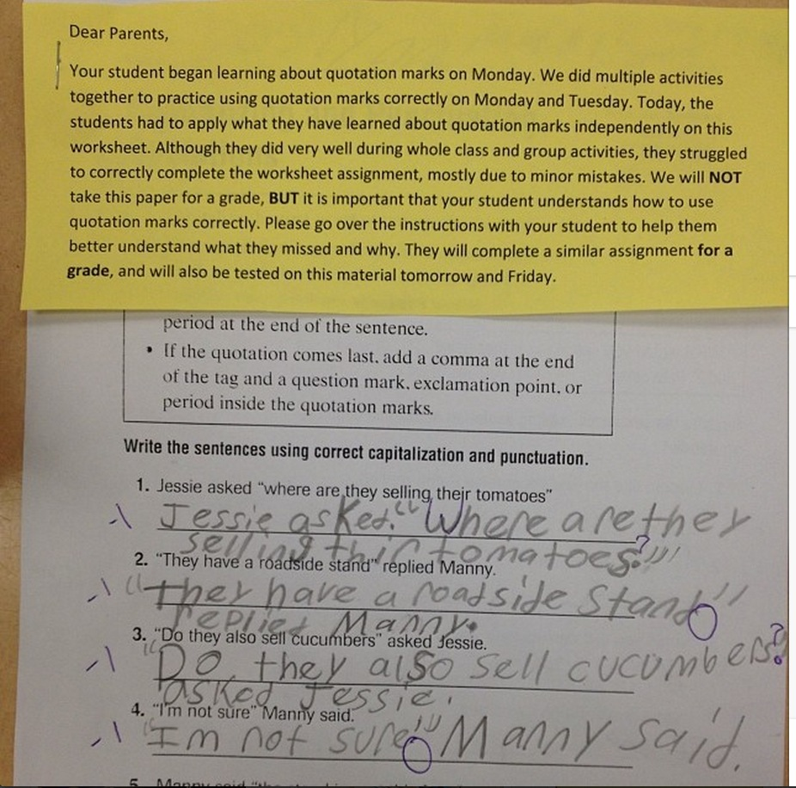
Figure 44. Tensions Photo 4
Khloe extended her noticing of this tension through commenting as she expressed her opinion about the way in which her mentor teacher chose to test her students.
Emily felt tension about assessment and questioned the way in which she observed a teacher assessing their students. Emily took a photo of the paper that her mentor teacher used to record how many students received the wrong answer (See Figure 45). When reviewing a test, the mentor teacher asked students to raise their hand if they got the question wrong. The mentor teacher put tally marks down for the amount of students who missed the question. Emily commented about how humiliating this form of assessment was for the children.
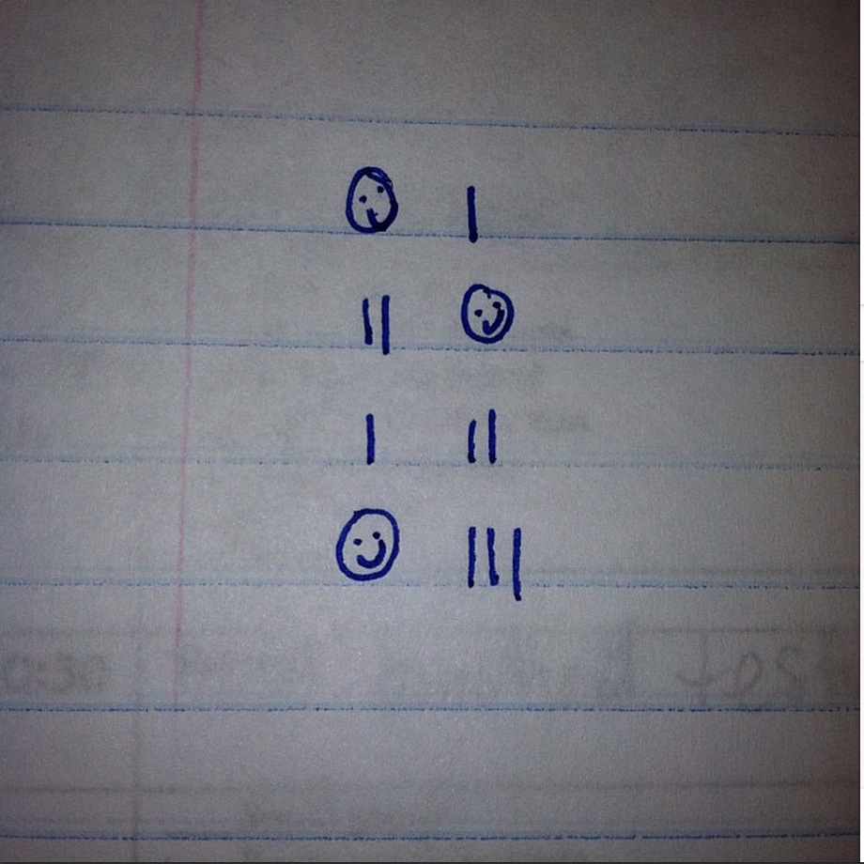
Figure 45. Tension Photo 5
The pre-service teachers also noticed tensions in regards to instruction. Camille noticed and commented on a stack of papers that she saw on her mentor teachers’ table (See Figure 46). She was shocked to see that the stack of papers was the worksheets that the students would be completing the following few days. Camille remarked that she was really struggling with the amount of worksheets that are given in school. She stated that every once in a while it is okay but “school can’t just be worksheets”.
Because of Camille’s beliefs and views that school is more than just worksheets, she felt tension as she collided with the reality of the type of teaching that is done inside her mentor’s classroom. The image of the stack of paper stayed with her as she reflected on this tension for the rest of the school year.
Figure 46. Tensions Photo 6
The very first day of school Moxie felt tension as she noticed the way two students were being treated in her classroom. As she entered the classroom, she was surprised to see two desks in the corner of the classroom (See Figure 47). She stated, “Some students are already singled out and treated differently on the first day.” Because of anticipated behavior problems, the students had designated seats away from the other children.

Figure 47. Tensions Photo 7
Several weeks later, Moxie, again, noticed tension in behavior management techniques when she observed students repeatedly writing a phrase on a piece of paper as a form of punishment. Moxie reflected on this tension (See Figure 48). She thought she might give that approach a try for her personal growth. As she was learning to teach, she had found that she really struggled with time management and pacing. Moxie noticed and wondered about this situation. She wrote a sentence about her identified problem over and over, and wondered if that would change her behavior and help her problem. She wrote,
So I thought I'd give it a try... oh wow, I haven't learned anything new and this did not help me pace my lessons better, shocker. I just don't understand why this is even considered as an appropriate punishment for anything.

Figure 48. Tensions Photo 8
The tension that the pre-service teachers perceived in the education system in which they were a part, was prompted by noticings that directly opposed their beliefs about instruction, assessment, and behavior management.
Content in the system. While the pre-service teachers sought to understand the educational system, they reflected about the content they were asked to teach. As I mentioned in the section about teacher development, Charlotte reflected about how her views about teaching subjects had changed (See Figure 30). She stated, “I have learned that it is extremely beneficial to student learning to incorporate multiple subjects within a lesson.” This statement summarizes this subcategory of content in the system. The pre-service teachers often remarked and reflected on the notion that school should no longer be a separated by subjects. They seemed to move away from the idea of having separate subjects throughout the day and most commonly, the pre-service teachers touted the importance of using literacy all throughout the school day.
Khloe took a photo of an Olympic wall that her class had created outside of the classroom and mentioned how motivating and engaging the winter Olympics had been with her students. She extended this noticing as she considered plans for her future teaching that would include using the Olympics for a whole unit to teach various subjects. She wrote,
I've seen few ideas for whole units in multiple subjects that are Olympic themed and I know it will be 4 more years, but I think I want to go all out with my students for the Olympics in future years.
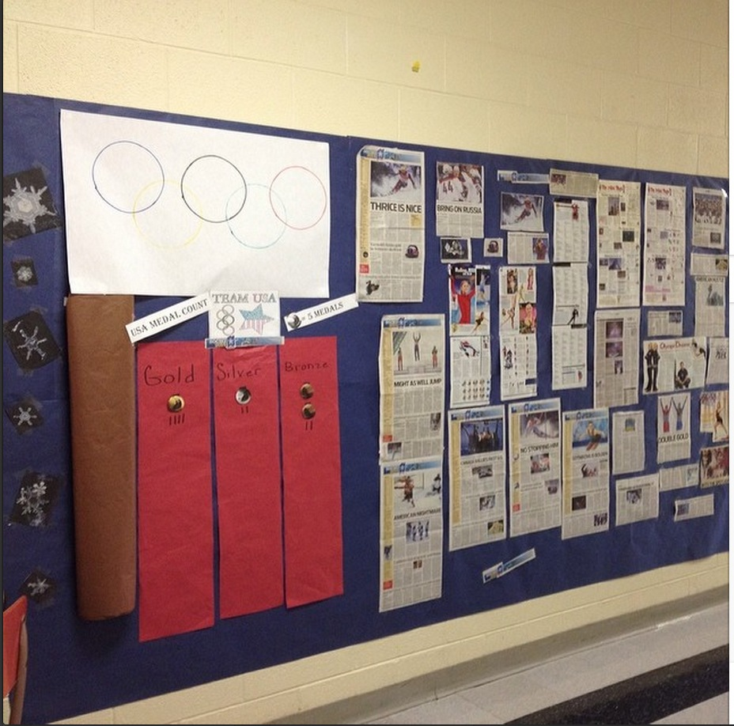
Figure 49. Content Photo 1
Most of the time when pre-service teachers commented that multiple subjects should be taught together, they most often talked about the importance and ease of incorporating literacy into every lesson and every aspect of the school day. This also ties into the pre-service teachers’ concern about engagement as they consistently discussed literature and literacy as engaging children.
Charlotte posted a picture of a bat from a recent read aloud (See Figure 50) and stated,
It is so rewarding to see your students get so excited about learning through read alouds. This reinforces my belief that there is always time for a read aloud because it can really make the difference in whether or not your students are engaged in your lesson.

Figure 50. Content Photo 2
While the impetus for and main purpose of her photo was to discuss how literacy should be used across the school day, Charlotte also commented that a read aloud makes a difference in students’ engagement.
Camille also posted about using literacy throughout the school day as she reflected about using literacy throughout her science unit. As Camille taught her children about seeds and plants, she used literature to teach the content (See Figure 51). She wrote, “I am learning that it is a lot easier to connect [subjects] than I had originally thought.” Camille reflected on the notion of connecting subjects in lessons as well as noticed her teaching development as she became more confident and comfortable with the idea.

Figure 51. Content Photo 3
In this study, question two addressed the content in which pre-service teachers reflected. I reported a summary of the categories and subcategories at the beginning of this section (See Figure 25). The participants reflected about themselves, their students, and education. While I have separated these three areas for purposes of description, the reflections were not always separated by topic. In other words, many times as a teacher reflected about their development, they were also reflecting about their students’ engagement or how to better incorporate literacy in their lessons, as Camille exemplified in the previous paragraph. For question two, it was my intent to provide an overview of the topics covered.

Research Question Three
Thus far, I have introduced and described how pre-service teachers reflected (research question number one) and the content of their reflections (research question number two). The third and final focus of this study was to better understand how Instagram influenced the reflection process. In this section, I first identify the participants’ words as I illustrate their experience using Instagram and the impact that it had on their reflective practice. Next, I unpack four categories that explained why Instagram had the effect that it did. The four categories are (a) high interest reflections, (b) visual reflections, (c) constant noticing, and (d) reflective catalyst. The Figure below provides a visual summary of the results.

Figure 52. Research Question 3 Results
“I can’t imagine not having Instagram,” admitted Leslie as I asked her to help me understand her thoughts about using Instagram as a reflective tool, “The entire thing is the greatest idea ever.” Throughout the year, it was quite clear that the pre-service teachers approved of the idea of using Instagram to engage in reflection. My field notes in both the clinical and university setting, included several instances in which a participant mentioned how Instagram has influenced their reflective practice. Similarly, in one-on-one interviews the participants said the same, that Instagram worked and impacted their ability to reflect. Through data analysis, I repeatedly coded that yes, Instagram did affect the reflection process. The participants stated that it positively influenced them to reflect.
In an interview, Pat stated how Instagram influenced him,
[Instagram] forced me to reflect daily . . .It instilled in me to always be reflecting. I looked for something to always reflect on. Me doing a post everyday made me a better reflecter. Now, I’m thinking about a million things everyday. Even while I’m teaching, I would reflect right then, during the lesson. The everyday thing, made me reflect everyday. IT made me more aware of my teaching and reflect on the spot.
Similarly, Kimberly stated, “I am more reflective because of this,” and Holly touted that, “My reflective thought would be less deep without Instagram.” Erin stated, “It worked as a reflective tool because it was fun and we wanted to do it.” The preservice teachers mentioned that Instagram impacted their reflective practice, however, they also mentioned things that did not work. Among these critiques was the frustration of typing on a cell phone. The participants highlighted that if they wanted to say a lot about a topic, it was annoying to type on such a small screen. In addition, Instagram text is difficult to edit, and the participants wished this had been more manageable. All critiques of the process were specifically tied to the mechanics of using a mobile device for reflection. No matter, the participants reported this as being a high interest learning activity.

High Interest Reflecting
In the past, pre-service teachers have been asked to keep reflective journals or write blog posts in order to encourage reflection. The pre-service teachers were very clear that they did not enjoy this process nor did they think it was effective. They were also very clear that one of the reasons that Instagram was effective and influencing reflection was because they liked doing it. Below is a table indicating the participants’ words as they commented about Instagram. Each of the comments indicated that the participants believed that Instagram was a high interest form of reflecting.
Table 2
Participants’ high interest comments
Name | Comment
Moxie | “I brag about this assignment to other people”
Ella | “I love it and it is more beneficial than writing”
Barbie | “I love seeing other people’s posts”
Leslie | “This is engaging for us”
Pat | “It is interesting, it is new age, it’s not just a blog”
Holly | “I liked it because it made me reflective”
Charlotte | “I really like Instagram because I am a visual person”
Camille | “This worked really great for our class”
Marisa | “I loved the visual”
Khloe | “This is so quick and easy, it’s great.”
Rebekah | “I loved it and like that we can share ideas”
Josie | “I loved it, anything else would be stale, this was innovative.
Erin | “It was fun and we wanted to do it”
Kimberly | “It’s like a picture book, I love picture books”
Table 3
As mentioned earlier in this chapter, the participants in this study were very interested in finding ways to engage their own students. Likewise, they were very appreciative of a school assignment in which they felt engaged. Erin said that this idea worked as a reflective tool simply because they enjoyed doing it. One reason they liked Instagram rather than other forms of reflection, was because it was low stress. Moxie stated,
Other types of reflection feel all academic instead of being a real person. I didn’t feel the pressure to be formal. I just wrote what I was thinking. People were, like, misspelling things but no one cared, that’s not what its about.
In addition, the participants all mentioned that having a visual attached to their reflections impacted the reflection process.

The Visual
Both interview data and field observations yielded information that confirmed the idea that the participants’ reflective capabilities were impacted by the visual nature of Instagram.
Affected memory. The participants suggested that having an image attached to their photo helped their memory. Leslies stated, “I wouldn’t ever remember what I was thinking or feeling in August but I can look back and see it.” This was important because the participants actually did go back to their photos and look through them quite often. Rebekah stated, “The image helps my reflection, you are able to look at a photo and pinpoint that moment . . . I can pinpoint that lesson immediately. I can’t do that with text.” Similarly, Pat said, “When I look at the picture, I knew exactly what I was talking about. Whereas, if I was reading a blog or something, I’d have to read all that . . . it made it easier to reflect.” When the pre-service teachers looked through their own photos, the image influenced more reflection.
Similarly, the image helped their memory in another way. Several participants mentioned that throughout the day they would take photos of things that they wanted to reflect about later. After school or when they got home, the image instantly reminded them of what they wanted to reflect about. For instance, Moxie was feeling frustrated with summative assessments that were being given in the computer lab, so she took a photo of the computer lab through the class door (See Figure 53). She did not have time to write down her thoughts about how she “despises these assessments” as they take up class time and the teachers do not use the data. However, later when she did have time to expound on this photo, she looked at the photo and instantly remembered how she felt. She then was able to write her reflection.
While interviewing the participants, the notion that the image influenced memory became apparent. During the interview, I would bring up a photo on my iPad and ask the participants to tell me about the photo. The participants were able to instantly recall what the particular photo was about. During an interview in April, I asked Ella if she could tell me about a photo that she posted on Instagram in September (See Figure 54). I showed her the photo and she instantly started talking.
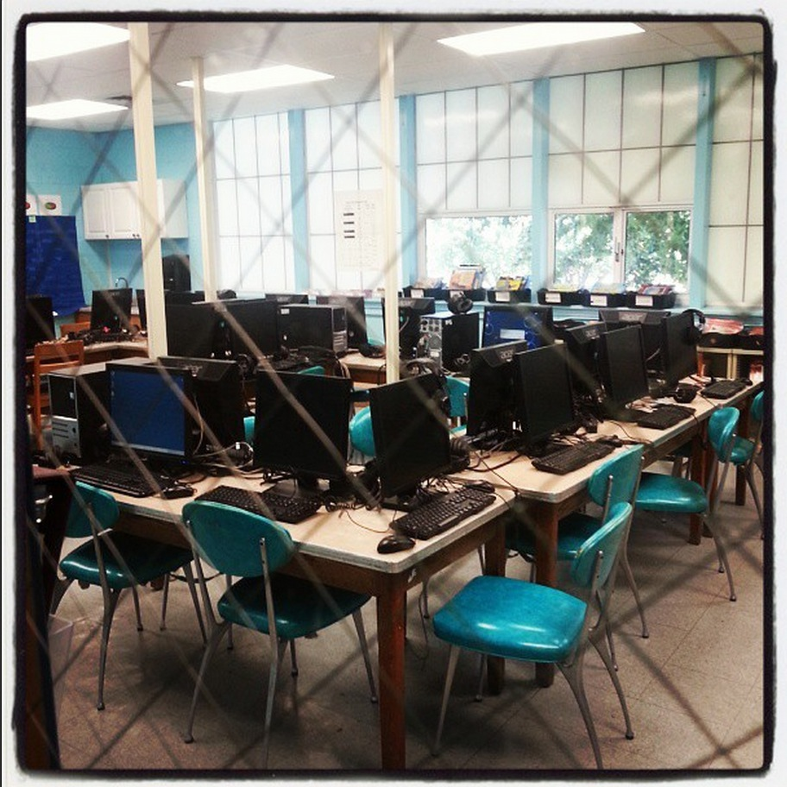
Figure 53. The Visual Photo 1
Yeah, that was the very first thing that I planned, was math, and it is still the subject that I struggle with the most. I remember sitting on the couch and crying and I wasn’t receiving much guidance. I felt, like, thrown into it, and I was really upset about it.
Ella was able to recall what the reflection was about, how she felt, and even where she was when she posted the image.
Figure 54. Visual Photo 2
Instagram is unique in that you must have a photo in order to create a post. While some may see that as a disadvantage, the participants saw the image as a strength. There were times that a teacher could not take a photo of something they wanted to reflect about. If this happened, they would create a drawing (See Figure 55) or write a word that summed up their thoughts (See Figure 56). The ability to sum up their thoughts and reflections into a drawing or small group of words influenced their reflection, as well, by forcing themselves to synthesize information and events. In addition, the image still seemed to capture the strengths that have been mentioned here, even when they did not capture something in the moment.

Figure 55. The Visual Photo 2
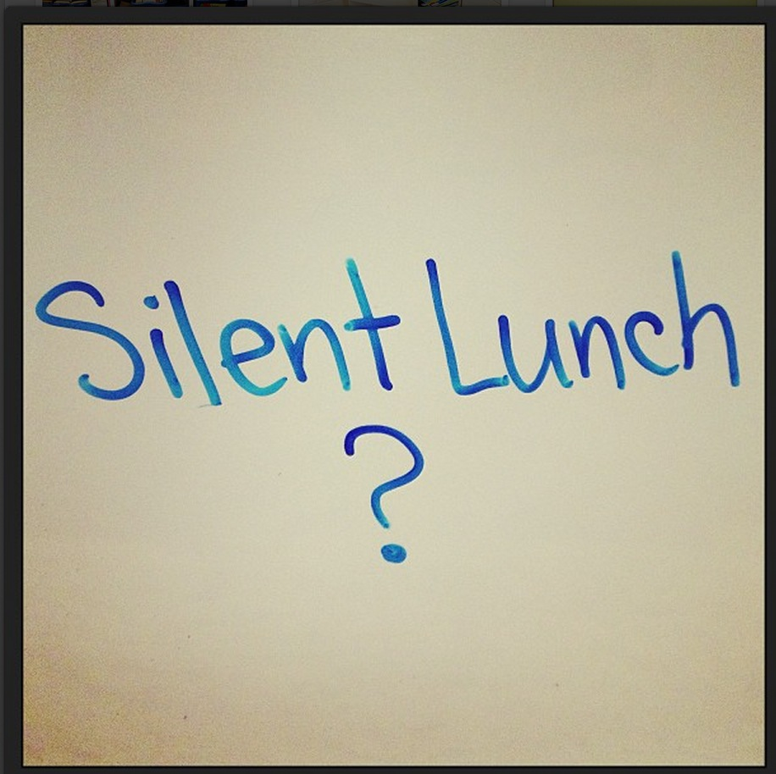
Figure 56. The Visual Photo 3
Affected emotions. The image impacted the teachers to think about their experiences and thoughts because the image instantly brought them back to the moment, what they were thinking, feeling, and seeing. Moxie stated, “ I scroll through the photos and emotions come up . . .My senses are enacted when I look at the photos.” As I mentioned earlier in this chapter, the teachers often reflected about their feelings. Moxie described that this was the case because the visual influenced emotions.
Affected reflecting style. Some participants touted that the image was so powerful that it was a form of reflection in itself. Charlotte mentioned that simply taking a photo and seeing an image could have taken the place of reflecting all together because of the thoughts and feelings that one considers when viewing the photo. She stated, “I don’t even need words anymore, it has changed my reflecting style.” Camille agreed, “I think about everything in terms of visuals now. I was at a writing conference and was thinking about what I could take a picture of. The pattern is sticking with me.” Camille continued, “Sometimes I even think about an image that represents my thoughts even if I am not going to take a picture.”
As described throughout this section, the visual nature of Instagram influenced the participants’ reflections as it affected their memory, their emotions, and their reflection style. The participants identified that they would reflect as they took a photo and then they would reflect on the photo later as they viewed the image. The visual nature of this reflective practice influenced the pre-service teachers to notice a lot more.

Constant Noticing
In order to reflect about teaching and learning, an individual must first think of something to reflect about. As mentioned earlier with Moxie’s example of the computer lab, taking a photo encouraged her to reflect on the fly. In a field such as education, it is impossible to stop what you are doing in the moment and get out your journal and write a reflective entry about a thought. When working with small children, this would not work well. However, constant access to a camera allows an individual to quickly record something they noticed to be extended upon later. For instance, if a teacher wanted to reflect or analyze a piece of a children’s writing that the student was going to keep in their desk or bring home with them, the teacher could quickly take a photo as Camille did in the photo below (See Figure 57).
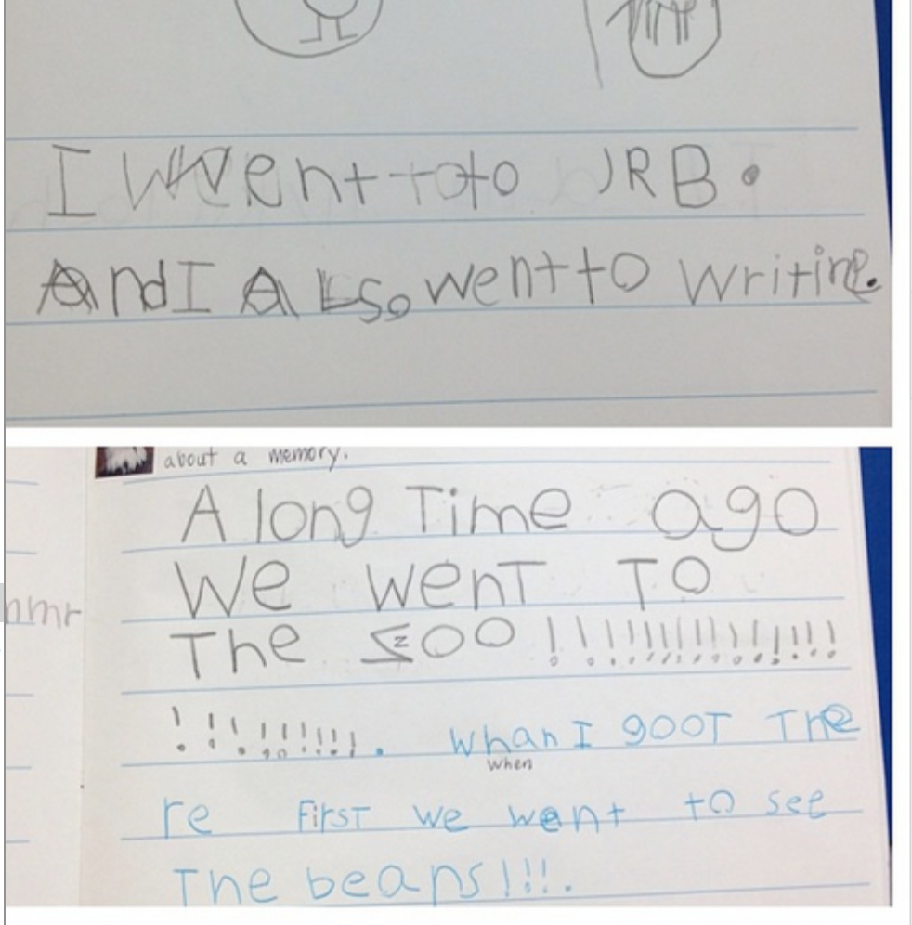
Figure 57. Constant Noticing Photo 1
At the end of the day, the teachers were generally tired and couldn’t remember back to everything that had happened that day. Yet, they were able to take out their phone and be reminded of things that they noticed. The teachers reported that they noticed more things (e.g., tensions, content, student situations) because they were able to quickly document it.
Instagram seemed to increase the number of things that the teachers would notice on their own (and think about later) throughout the day. Additionally, the teachers increased their noticings by viewing their colleagues posts on Instagram. The teachers would scroll through the photos that had been uploaded and then think about the noticings that their peers were considering. Rebekah stated, “I liked being able to see what other people were posting and thinking about.” While Pat stated that he looked at colleagues’ posts because of the image.
[The image] made it interesting for viewers. I’ve had to do comments on blogs before and it wasn’t interesting to me. Seeing their picture, it made it more clear, and I felt like I could comment on it. I could look at someone’s picture, comment on it, and then assimilate that into my classroom.
Noticing things throughout the school days and school weeks encouraged teachers to have various things to think about. They noticed things in their own experiences and also noticed happenings and topics in their colleagues’ experiences. After the interns had a collection of photographic noticings, these became a catalyst for future reflection.

Catalyst for Future Reflection
“Instagram gives us a springboard for conversation, when we see each other we have stuff to talk about. It influenced how we talk.” Josie explained in the preceding quote that Instagram elicited further reflection through conversation with colleagues. However, this was not the only way that the noticings the teachers collected influenced further reflection. The Instagram photos acted as a catalyst for further thinking and reflection in two ways, (a) further reflection through discourse, and (b) through personal reflection.
Reflection through discourse. The collection of noticings were used in conversations amongst the participants. The pre-service teachers mentioned that the discourse about Instagram photos started in the hallway, the lunchroom, car rides to school, and in the university setting before, during, and after their master’s level courses. While the participants engaged in discourse throughout the days, I was not observing each of these conversations. However, every Friday during class, we would spend thirty minutes reflecting on the week. During these discussions, the pre-service teachers would extend, problem solve, and sometimes discuss how they had changed.
One Friday, the pre-service teachers began talking about a photo that Josie posted of her plan book (See Figure 58). In her post she captioned the photo, “Learning the importance of planning very quickly during this process. Planning ensures you have a goal, as well as staying on target with time throughout the day.”
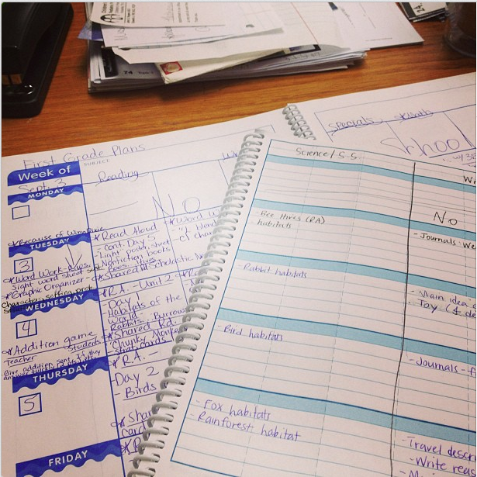
Figure 58. Discourse Photo 1
The conversation surrounding the photo, however, was extended and the pre-service teachers commented on various topics.
Pat | I was thinking a lot Josie's post about planning and schedules, they change so much. And speech changes every day, and we are trying to build our schedule around others and interventions.
Josie | Yeah, and some kids are being pulled out for intervention, and it is hard to strike a balance because we also need them in our classroom. Our kids go to reading recovery and it is hard to deal with.
Rebekah | In our PLC this week we talked about the intervention, it means they will not receive 30 minutes of regular instruction...but they need every lesson.
Barbie | We have a person being pulled out from writing but he needs so much help in writing, I don't want him missing writing lessons.
While the conversation began with Josie noticing that planning and scheduling are important, the conversation turned to commenting about intervention and children missing regular instruction.
Similarly, one Friday the pre-service teachers engaged in a conversation about recess. Holly posted a photo of a video that she put on for the children during inside recess (See Figure 59). Her caption accompanying the photo discussed that it had been cold and rainy outside. Holly asked her colleagues what they do for inside recess. The following conversation is a snippet of the conversation that occurred after Holly’s question.
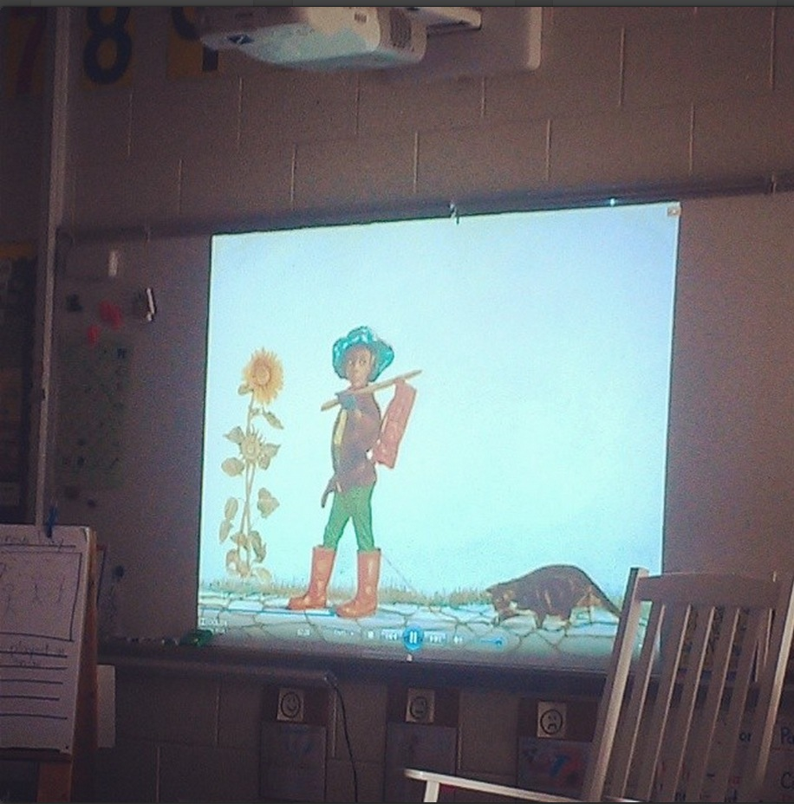
Figure 59. Discourse Photo 2
Holly | What do you do for indoor recess?
Pat | Yeah, they’re just getting cabin fever.
Holly | We watched a video.
Khloe | Would they be able to focus more if they had time to run around? Do you think there should there be more recess?
Camille | We were in a classroom where they sat in their desk for 4 hours.
Moxie | That’s how my classroom is, they just sit there for hours quietly.
Holly | And then they take their recess if they don’t finish their work. Only half the class gets recess.
Moxie | At recess they don’t get it done anyway and they don’t get help at recess and then they still don’t understand [their work].
Khloe | Why is schoolwork a punishment?
Marisa | But if you aren’t behaving in class, you don’t deserve to go out for recess.
Pat | What if their work was differentiated at recess?
Charlotte | From our PLC on Monday, it was such a god reminder that these are kids. We’re so quick to treat these kids like adults.
The conversation started as a conversation about how to manage children for recess. However, then the interns began questioning as Khloe asked if schools should have more time for recess. They also began extending through commenting as Moxie noted that kids stay inside to complete schoolwork. In addition, Pat began problem solving in response to Moxie who said that the students did not understand their work during recess. While this conversation could have turned into a list of fun recess ideas, the teachers extended the conversation to discuss deeper issues.
Similarly, Moxie posted the following photo (See Figure 60) on Instagram of a sign that is outside the school cafeteria. She wrote about how the students at their school have to be quiet in the lunchroom and often have to have a silent lunch. When a colleague brought up her photo, the following conversation ensued.
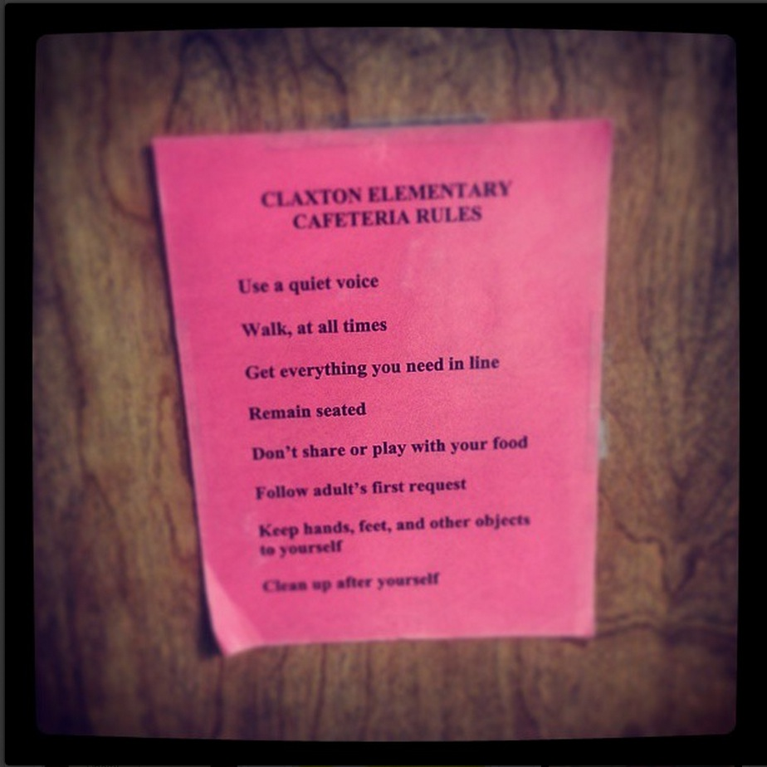
Figure 60. Discourse Photo 3
Moxie | Some children got in trouble for talking in the cafeteria.
Kimberly | Kids should be able to discuss things and freely talk to teachers.
Moxie | Some kids were innocent and were taught to not stand up for themselves. We’re teaching them to be submissive. This is like the Milgram study. You’re just teaching them to listen to what you say.
Khloe | They don’t ask questions about the instruction in class- because they’re not being taught to do this.
Kimberly | We should [be] teach[ing] them to make an argument.
In this conversation the noticing was extended as Moxie made a connection to social science research. In addidion, Kimberly began to problem solve as she considered that schools should be teaching children to make arguments.
Through these brief snippets from conversations, one can observe that the pre-service teachers continued their thoughts and reflections from their initial noticings on Instagram. The participants stated that the reason that conversations were often lively and engaging was because of the images that they had already shared on Instagram. Khloe stated,
The Friday conversations were my favorite, they were so lively because of the photos, we already had things that we noticed that we wanted to talk about. Without the pictures, that would have been really hard. The pictures were almost a prompt for us.
In addition to discourse, the pre-service teachers’ photos on Instagram acted as a catalyst for further personal reflection.
Personal reflection. The collection of noticings were used in conversations amongst the participants, in addition, the photographs were also used as a catalyst for future personal reflection. The participants noted that they believed that looking back to previous experiences and previous thoughts helped them reflect further and deeper. Though they believed this, each of them stated they had never gone back and read a previous blog post from a class or reread a written reflection they wrote. However, the teachers repeatedly said that they looked back through their photos on a regular basis and considered specific experiences and thoughts as well as pondered their development as a teacher.
As the school year continued and the teachers became more experienced, they also noticed that as they looked through their photos their thoughts changed. They would look at their photos and think a different caption than the one they had written on the photo months before. Camille stated, “I scroll through my photos and the photos are still relevant but my thoughts on the photos have changed. The photos mean different things now.” Likewise, Khloe stated that as she created a portfolio from the Instagram photos, “I used the picture but then I said something different.” The pre-service teachers enjoyed looking through their photos. As they perused through their photojournals, they found that they had become more thoughtful and reflective throughout the year as their thoughts and feelings were different than the captions that they had originally typed.

Chapter Summary
In this chapter, I presented my analysis from a yearlong study on the reflective practice of fourteen pre-service teachers. In order to best understand the experience of pre-service teachers using Instagram to engage in reflection, I identified three research questions, (a) How do pre-service teachers reflect using photos on Instagram, throughout a yearlong internship? (b) What is the content of pre-service teachers’ reflections? and (c) How do pre-service teachers describe the process of using Instagram as a form of reflective practice? In this chapter, I described results that I identified from the data sources.
To answer the first question, I explained that pre-service teachers used five reflective techniques including, (a) photojournaling, (b) noticing, (c) noticing and extending, (d) noticing and problem solving and (e) noticing and changing. To answer the second question, I described the content of the pre-service teachers’ reflections which included information about (a) themselves, the teacher, (b) the students, and (c) the education system. To answer the last question, I described the way in which the participants described the experience of using Instagram. I illustrated their thoughts and feelings through four categories, (a) high interest reflections, (b) visual reflections, (c) constant noticing, and (d) Instagram as a reflective catalyst. In the next section, I aim to provide greater understanding of what the results mean in conjunction with available literature in the area.

Chapter Five: Discussion

Chapter Introduction
In this study, I examined the reflective practice of fourteen pre-service teachers who were completing a master’s degree and a yearlong clinical internship. Through ethnographic research procedures, I sought to better understand their experience using photographs on Instagram as an avenue to elicit reflection. Specifically, I hoped to find out how teachers reflected, what they reflected about, and how Instagram influenced the reflection process. Artifacts, observations, and interviews were collected throughout the school year and analyzed through the use of qualitative software. I identified several large categories for each research question. In this chapter, I hope to provide a discussion of the large categories that were addressed in Chapter Four. I begin by summarizing and interpreting the findings. Next, I present implications of the study. I conclude with suggestions for future research.

Summary and Interpretation of Findings
This study provides depth and understanding to the greater literature in regards to teacher reflection in teacher education. Because of the knowledge gleaned here, we have evidence to believe that the pre-service teachers’ experiences, thoughts, and reflections in this study are much more intricate and profound than some have posited. The yearlong investigation provides a clearer picture as to how the pre-service teachers reflected. The teachers’ reflections included photojournaling and noticing their surroundings. The different techniques they used as they made sense of their surroundings were extending their noticings through commenting and questioning, as well as problem solving and changing their practice. As they noticed and constructed meaning, they were particularly concerned with themselves, their pupils, and the system of education. These concerns were manifested through photographs and writing on Instagram. Instagram seemed to positively influence the reflective process because the pre-service teachers enjoyed the process, were influenced by the visual aspect of photographs, and noticed a lot of their surroundings that later became catalysts for further reflection. Throughout the rest of this section, I go through each research question and provide a summary and an interpretation of the results.

RQ1: How Participants Reflected
The teachers in this study used five different reflective methods (photojournaling, noticing, noticing and extending, noticing and problem solving, noticing and changing) (See Figure 3). The first technique I described was photojournaling. This technique involved the teachers explaining an event or an experience. For example, Barbie photojournaled with an image of a fake campfire and said, “Today we had our students read their spooky stories to the class” (See Figure 4). The second reflective technique I called noticing because the teachers were noticing new things about their environment and their experiences. The preservie teachers also extended their noticings through commenting and questioning. These techniques included discussing something that they noticed and then either commenting or wondering about the content. Commenting generally included inserting their opinion and wondering usually involved questioning something that they noticed. The teachers also problem solved after they explained something they noticed. For instance, Khloe noticed she kept calling on the same students repeatedly, so she reflected about the problem that she solved as she made popsicle sticks. The last reflective technique that I identified was noticing then changing which is when the pre-service teachers discussed how they had changed their practice after noticing something.
The five techniques, (photojournaling, noticing, noticing and extending, noticing and problem solving, noticing and changing) are not ranked. In other words, one form of reflection is not more or less analytical than another. As the teachers reflected constantly throughout the year, they used all five techniques intermittently. As they continued to grow and develop they did not abandon one type of reflective technique and take hold of another. As they became more mature, they still found it necessary to engage in reflective practices that did not include any analysis, such as photojournaling and noticing. It was important the teachers continued to journal their thoughts and feelings and mention things that they noticed. It was also important that teachers continued to extend their noticings, problem solve, and change.
As I mentioned in Chapter Four, sometimes the teachers noticed something that was quite important, such as student understanding or educational policy. Even though they did not provide analysis, it was still significant to their journey in understanding education. Likewise, sometimes they may have been engaging in analysis as they problem solved or changed their instruction, however, it may have been something surface level like how to best keep pencils sharpened. Yet, each reflective technique was important to the teachers’ development and in this study, each was considered a form of reflection. This data suggests a more expansive and encompassing definition of reflection that includes all five techniques listed here.
The idea that each technique was, indeed, “reflection,” can be corroborated and contradicted in the available literature. Some might disagree, for instance, that photojournaling or noticing can be considered reflection. Hatton and Smith (1995) noted that reflection is “deliberate thinking about action with a view to its improvement” (p. 40). Neither photojournaling or noticing included deliberate thinking and participants were not seeking to improve their actions. Similarly, Wade and Yarbrough (1996) posited that reflection should include, (a) thinking deliberately about an experience, (b) providing new understanding, and (c) informing future action. Some of the reflective techniques that I introduced are not necessarily providing new understanding. In addition, the reflections did not always include thinking deliberately about an experience while informing future action.
While some of the reflective techniques in this study may not be considered a true form of “reflection” by some, a more comprehensive understanding and definition of the term more aligns with the results of this study. Schon (1987) touted that practitioners must build up a “repertoire of examples, images, understandings, and actions” (p. 138). The examples, images, understandings, and actions must first be noticed before an individual can think deliberately about an experience and inform future action (Wade & Yarbrough, 1996). The skill of building up a repertoire of examples must also be considered a form of reflection.
This study provides a more inclusive view of the term reflection. Reflection no longer has to be understood as just analysis. It doesn’t just have to be the end product—the lengthy reflection paper turned in for an education course. These papers or reflective journals are generally graded on a rubric for how well the individual was able to deliberately analyze and inform instruction (Wald, Borkan, Taylor, Anthony, & Reis, 2012). Yet, these papers and view of reflection do not help individuals throughout the entire reflective process. Reflection should be understood as the entire process as an individual collects a repertoire of examples and images (Schon, 1987) and formulates these examples and images into meaning, and then begins to interrogate the meaning. In order for an individual to begin asking why questions (John Smyth, 1989), they have to start to make meaning of their surroundings (Dewey, 1938).
The term “pre-service teacher” means teachers before they begin their service in the field. In other words, they do not have experience teaching, yet. The teachers need to notice a lot about the teaching world before they can critically analyze experiences. While reflection may look different on their first day in the field compared to the last day in the field, it is still reflection, and should be considered as such.
However, I realize that the definitions in which people are suggesting as reflection, are generally referring to the end product. With this in mind, I posit that the participants in this study were photoreflecting, which is, they sought to make meaning of their surroundings by collecting a repertoire of images, to be referred to in reflective thought and reflective conversation. Encouraging participants to photoreflect will encourage participants to notice and photojournal. This gives them ample opportunity to consider a myriad of topics that can be considered further at a later time. Teacher educators should be teaching teachers how to reflect (Spalding & Wilson, 2002) and shouldn’t simply ask teachers to create a reflective paper without scaffolding them through the building of examples and images.

RQ2: Content of Participants’ Reflections
As the pre-service teachers photoreflected they paid particular close attention to themselves, their students, and the education system. As they thought about themselves and their new identity as a teacher, they heavily considered their feelings and their development. When reflecting about the students, they focused on the students’ unique situations and student engagement. While seeking to make sense of the education system, they specifically noted the tensions in the system and the content taught.
Fuller and Brown (1975) theorized three different types of concerns of teachers. First, teachers are concerned about survival as they learn a new skill. Second, the teacher can also be concerned with teaching situations (e.g., time pressures, too many students). Lastly, teachers are concerned with pupils. The findings in this study substantiate these concerns noted by Fuller and Brown over thirty years ago. The teachers in this study showed to also be concerned with survival (or themselves), the teaching situation (the education system), and pupils (their students).
It is also understood that teachers move through a series of stages. Unruh and Turner (1970) identified three stages that teachers go through, the initial teaching period, the period of building security, and the maturing period. The teaching period highlights the idea that teachers are concerned with themselves. The building security stage is characterized by feelings of security and satisfaction as teachers build up practice and experience. And the maturing period has to do with the time when a teacher feels comfortable with change and seeks out new ideas and concepts. According to Unruh and Turner (1970) the pre-service teachers in this study are in the maturing period as they searched out new concepts and ideas and viewed change in a positive light. They searched for new concepts that would best engage students and sought to integrate curriculum and subjects, which was a change from the instruction they often observed.
Similarly, Burden (1982) argued that teachers go through three stages, (a) survival, (b) adjustment, and (c) mature stage. Similar to those stated above, the mature stage, is described as the time in a teacher’s career when they feel more confident and are perceptive to the needs of their students. Again, the teachers in this study showed to be amongst the description of the final stage as they placed heavy emphasis on the needs of their students.
Veenman (1984) identified 24 concerns of teachers. The full list of concerns can be found in chapter one of this dissertation. Each of the 24 concerns Veenman noted were also seen in pre-service teachers’ photos in this study. For example, Veenman (1984) noted that teachers feel concerned with different teaching methods. The teachers in this study often photoreflected about what method might be best for their students. Further, Veenman noted that teachers were concerned with dealing with students of various backgrounds. The teachers in this study often considered the unique situations of students. The findings in this study align with the literature on the concerns of teachers.
The pre-service teachers throughout the course of a yearlong internship, seemed to have developed into a mature teacher (Burden, 1982) that was concerned with many of the same concerns that the literature suggests concerns teachers. With this in mind, it is important to consider the possibilities or explanations behind why the pre-service teachers were showing signs of a mature teacher before they had their own classroom. This could be attributed to their teacher education program, their teacher mentor, their personal abilities, and even their ability to reflect.

RQ3: Impact of Instagram
The participants in this study explained that using Instagram as a reflective technique impacted their reflective abilities. Instagram was engaging and the teachers felt it was an interesting assignment that they enjoyed doing. The participants stated that they preferred this method to writing. This corroborates previous work that noted that writing is not an enjoyable task and pre-service teachers often dread sitting down to write (Bolin, 1990). The teachers in this study particularly felt that the incorporation of images into reflective thinking was powerful. The images, they felt, influenced them to notice a lot of concepts in the educational environment. These noticings with images attached, became catalysts of further reflection as individuals reflected personally and through collegial discourse.
Dewey (1938) argued that learning should be connected to learners’ experiences and that educational experiences should always be closely related to the “actual life-experience of some individual” (p. 89). The teachers in this study used social media in their life. Using Instagram to elicit pre-service teacher reflection closely mirrored the teachers’ actual life experience. This could be why the pre-service teachers felt that Instagram was engaging and interesting.
The participants consistently declared that having an image attached to their reflective thought was powerful. This is similar to the argument that Lemon (2007) presented, that images can encourage teachers to communicate the learning environment, which encourages reflective practice and then reflective action. The images, the teachers in the current study explained, influenced their memory and provoked feelings and emotions. Bruner's (1973) posited that individuals learn through kinesthetic experience, visual experience, and reflective experience. The notion that an individual learns from visuals, or photographs, is not a new idea. Photographs have been used to elicit feelings and memories for a long time. Harper (2010) touted, “images evoke deeper elements of human consciousness that do words” (p. 13). In addition, photos have been shown to sharpen memory and “reduce the areas of misunderstanding” (p. 13). Photographs have been used in newspaper articles, advertisements, and magazines for these very reasons. The teachers in this study were not highlighting new information about the power of photos, however, they were describing that old information (the power of photographs) can be used in new ways (teacher reflection).
It is common for teacher education programs to organize reflective journals to encourage pre-service teacher reflection (Francis, 1995). However, writing a journal entry or blog post once per week encourages the teacher to notice one or two things to reflect upon, when teachers should be engaging in reflection “on a regular basis” (McCaleb et al., 1992, p. 52). Instagram, however, encouraged the teachers to notice several things everyday. While they may not have extended every noticing, they continued to build “a repertoire of examples, images, understandings, and actions” (Schon, 1987, p. 138). The repertoire influenced the teachers to reflect more deeply through conversation and through personal reflection. As Josie stated, Instagram became a “springboard” for further reflection.
The pre-service teachers in this study used photoreflecting as they sought to uncover and make known the previously unknown world of learning to teach. Through their photoreflections, there is evidence to believe that they were participating in thought and action that can be identified as a mature teacher (Burden, 1982). This could, possibly, be attributed to the constant photoreflecting that occurred almost daily.
With all that has been identified here as results as related to teacher reflection, it is important to note that this was a description of one cohort in one teacher education program. The purpose was to provide an understanding of the particularity. While the purpose was not to generalize to greater populations, the results can be generalized to those who identify with the particularity. With this in mind, I have considered and provided implications below as they pertain to this unique cohort and teacher education program.

Implications of Findings
This study aimed to better understand the reflect process and the influence of Instagram. The findings can be interpreted and can have implications for teacher education programs. Throughout this section I suggest a few implications for teacher preparation programs. The implications discussed in this section are suggestions and implications based on my own understanding of the data as I constructed meaning with my participants.
First, the teachers in this study used five different reflective techniques as they sought to make sense of their surroundings. Teacher educators should be aware of these reflective techniques and encourage pre-service teachers to engage in diverse forms of reflection. In addition, teacher educators should avoid narrowly defining reflection. All reflective thought should be encouraged as pre-service teachers enter into an unfamiliar world- that of the teacher. While moving past just noticing surroundings, teacher educators should never underestimate the power of creating hundreds of noticings, for these are the seed of future deep reflections.
Second, pre-service teachers should be understood as capable of reaching higher stages of teacher development than just surviving. Teacher educators should continue to encourage growth to focus on topics and content that mature teachers seem to consider. Mature teachers focus on change and their pupils, these topics should be a major focus in teacher education.
Third, noticings can be catalysts for future reflection through discourse or progressive discourse (Bereiter, 1994), wherein individuals share and arrive at a new understanding. Allowing a space for pre-service teachers to interrogate, discuss, and wonder with colleagues can further their thoughts, provide new noticings, and encourage problem solving, and changing practice. In this study, the pre-service teachers were given an opportunity to engage in discourse online through Instagram comments as well as face-to-face in the university setting. The images acted as a catalyst for reflection. If the teachers did not have that visual to reflect upon, reflective discourse would not have been as effective. Conversations in the hallway, in the lunchroom, and in class on Fridays had a place to start; they already had a catalyst to begin deep reflection. Teachers stated in interviews, “If we didn’t have Instagram to start our conversations, what would we have discussed?” While encouraging progressive discourse, the conversations need a “springboard” and images can be the instigator of conversation.
Fourth, photographs can be used to influence memory and evoke emotions. Photographs can be used in a myriad of ways to teach countless topics. The implications of the results are not narrowly understood for teacher reflection. Any topic that a teacher would like to facilitate learning, photos can be used.

Future Directions
While this study provides a surface level understanding of how teachers reflected using photographs, the content of their reflections, and the impact Instagram had on the reflective process, a deeper understanding of each category is needed. While I presented five reflective techniques that the pre-service teachers utilized, a better understanding of how each participant used each technique would shed even more light on the reflective development of the pre-service teachers. Providing narrative research of each participant’s journey through the reflective process might provide more information as to how to encourage reflection among individuals. In addition, the reflections are spewing information about teacher identity that needs to be better understood. Analyzing the individuals’ photos with a focus on identity is desired.
Additionally, while I uncovered three main topics of content in which the teachers reflected (teacher, student, education system), a greater look at each category is needed. Embedded in each of these larger categories is information about the teachers’ beliefs that was not highlighted in this study. In addition, the education system category needs to be further analyzed to better understand how this information can be understood in terms of educational policy.
This study provided understanding about how pre-service teachers believed Instagram affected the reflective process. Yet, the teachers could have had the same thoughts, reflections, and growth without this assignment. It would be a good idea to comparatively study teachers who used photos to engage in reflect and teachers who did not.
One reason the participants enjoyed the process was because it mirrored their every day life. However, as technology changes and new social networks emerge, the every day life of teachers will also change. More research will need to be conducted to understand these future changes and how they can be used in teacher education. Education and educational research must stay abreast and continue to use techniques that are connected to the students’ world.
Last, while the participants seemed to feel that taking photos was worthwhile during their clinical internship, it is essential to know how the teachers have chosen to reflect in their future teaching. As reflection is a lifelong practice, there is value in continuing to understand how the teachers reflect and what the teachers reflect upon. Investigation into whether or not photographs have been maintained in their current practice is needed.

Conclusion
While meeting with Moxie one day, I asked her casually how Instagram was going, she began, “It’s funny, we talk about it all the time, me and the others. We’re like, yeah, I know, I saw it on Instagram. Then we skip the story and go right to our thoughts.”
The impetus of the research presented here was to inspire a shift from passive and silent practitioners to teachers who engage in active, informed discourse about the profession (Smyth, 1989). The first step in doing this is encouraging teachers to notice and make sense of their surroundings. Allowing teachers to engage in photoreflecting where they feel free to constantly consider topics, while constantly viewing the concerns of their peers, teachers may begin to build a personal repertoire of examples and images to be referred to throughout their development. When teachers can “skip stor[ies] and go right to [their] thoughts” they may begin to consider, analyze, and investigate a myriad of concepts and become active members of the profession.

Epilogue
Upon completion of the master’s degree program, the participants in this study searched for jobs in the surrounding area. Many of the teachers used their Instagram feed in interviews as a digital portfolio. Some printed out photos and created a hard copy portfolio. In addition, during interviews, the pre-service teachers mentioned that they used their Instagram feed to remember specific ideas and experiences that they wanted their future employers to know. Throughout the summer following this study, the teachers logged on to Instagram to announce where they had been hired. All fourteen of the participants in this study are currently full time teachers in various regions in the southern part of the United States. During our final class together, each mentioned that they plan to take photos throughout their first year of teaching.

References

Allington, R. L. (2002). What I’ve learned about effective reading instruction from a decade of studying exemplary elementary classroom teachers. Phi Delta Kappan, 83, 740–747.
Andrew, A., & Teitelbaum, K. (1983). Linking theory and practice: the use of ethnographic methodology by prospective teachers. Journal of Education for Teaching, 9(3), 225–234. doi:10.1080/0260747830090303
Applegate, J., & Shaklee, B. (1992). Stimulating reflection while learning to teach: The ATTEP at Kent State University. In L. Valli (Ed.), Reflective teacher education: Cases and critiques (pp. 65–81). Albany, New York: State University of New York Press.
Assessment, I., & Consortium, S. (2011). InTASC model core teaching standards: A resource for state dialogue. Washington, DC: Council of Chief State …, (April). Retrieved from http://scholar.google.com/scholar?hl=en&btnG=Search&q=intitle:InTASC+Model+Core+Teaching+standards:+A+resource+for+state+dialogue#0
Bembry, K. L., Jordan, H. R., Gomez, E., Anderson, M. C., & Mendro, R. L. (1998). Policy implications of long-term teacher effects on student achievement. In Annual Meeting of …. San Diego, CA April 1998. Retrieved from http://dallasisd.schoolwires.net/cms/lib/TX01001475/Centricity/Shared/evalacct/research/articles/Bembry-Policy-Implications-of-Long-Term-Teacher-Effects-on-Student-Achievement-1998.pdf
Bereiter, C. (1994). Implications of postmodernism for science, or, science as progressive discourse. Educational Psychologist, 29, 3–12. doi:10.1207/s15326985ep2901_1
Board, N. (2014). Think Systematically and Learn from Experience. Retrieved from http://www.nbpts.org/think-systematically-learn-experience
Bolin, F. S. (1990). Theme: Teachers’ Beliefs: Helping Student Teachers Think about Teaching: Another Look at Lou. Journal of Teacher Education, 41(1), 10–19. doi:10.1177/002248719004100103
Borko, H., & Putnam, R. T. (1996). Learning to teach. In D. C. Berliner & E. Calfee (Eds.), Handbook of educational psychology (pp. 673–708). New York, NY: Macmillan.
Boud, D., & Walker, D. (1998). Promoting reflection in professional courses: The challenge of context. Studies in Higher Education, 23(2), 191–206. doi:10.1080/03075079812331380384
Bruner, J. (1973). The Relevance of Education. New York, NY: W. W. Norton. Retrieved from http://books.google.com/books?id=2aMXJ877HjEC
Bull, G., Harris, J., Lloyd, J., & Short, J. (1989). The Electronic Academical Village. Journal of Teacher Education, 40(4), 27–31. doi:10.1177/002248718904000405
Burden, P. (1982). Developmental Supervision: Reducing Teacher Stress at Different Career Stages. In Association of Teacher Educators National Conference. Phoenix, AZ. Retrieved from http://eric.ed.gov/?id=ED218267
Calderhead, J. (1989). Reflective teaching and teacher education. Teaching and Teacher Education, 5(1), 43–51. Retrieved from http://ac.els-cdn.com.proxy.lib.utk.edu:90/0742051X89900188/1-s2.0-0742051X89900188-main.pdf?_tid=05ee8d4e-40d3-11e3-9af0-00000aacb35d&acdnat=1383076263_18f82b47e440f64a33e6df9ea3553233
Calderhead, J., & Gates, P. (1993). Conceptualizing Reflection in Teacher Development. (J. Calderhead & P. Gates, Eds.). London: The Falmer Press.
Clyde, L. A. (2005). Educational blogging. Teacher Librarians, 32(3), 43–45. Retrieved from http://www.educause.edu/pub/er/erm04/erm0450.asp?bhcp=1
Connelly, F., & Clandinin, D. (1994). Telling teaching stories. Teacher Education Quarterly, 21(1), 145–158. Retrieved from http://www.jstor.org/stable/23475539
Connelly, F. M., Clandinin, D. J., & Connelly, B. F. M. (1994). Telling teaching stories. Teacher Education Quarterly, 21(1), 145–158. Retrieved from http://www.jstor.org/stable/23475539
Considine, D., Horton, J., & Moorman, G. (2009). Teaching and Reaching the Millennial Generation Through Media Literacy. Journal of Adolescent & Adult Literacy, 52(6), 471–481. doi:10.1598/JAAL.52.6.2
Dewey, J. (1910). How We Think. D.C. Heath & Company. Retrieved from http://books.google.com/books?id=WF0AAAAAMAAJ
Dewey, J. (1938). Experience and education. New York, NY: Macmillan Publishing Company.
Dickey, M. (2004). The impact of web-logs (blogs) on student perceptions of isolation and alienation in a web-based distance-learning environment. Open Learning: The Journal of Open and Distance Learning, 19(3), 279–291. doi:10.1080/0268051042000280138
Duggan, M., & Brenner, J. (2013). The demographics of social media users, 2012. Washington DC: Pew Research Center’s Internet & American Life Project. Retrieved from http://www.lateledipenelope.it/public/513cbff2daf54.pdf
edTPA FAQ. (n.d.). Retrieved from http://edtpa.aacte.org/faq
Education, T. D. of. (2014a). TEAM General Educator Rubric. Retrieved from http://team-tn.org/wp-content/uploads/2013/08/TEAM-General-Educator-Rubric.pdf
Education, T. D. of. (2014b). TEAM Teacher Evaluation. Retrieved from http://team-tn.org/evaluation/teacher-evaluation/
Emig, J. (1977). Writing as a mode of learning. College Composition and Communication, 28(2), 122–128. Retrieved from http://www.jstor.org/stable/356095
Evans, E., & Tribble, M. (1986). Perceived teaching problems, self-efficacy, and commitment to teaching among preservice teachers. The Journal of Educational Research, 80(2), 81–85. Retrieved from http://www.jstor.org/stable/40539614
Fendler, L. (2003). Teacher Reflection in a Hall of Mirrors: Historical Influences and Political Reverberations. Educational Researcher, 32(1996), 16–25. doi:10.3102/0013189X032003016
Francis, D. (1995). The reflective journal: A window to preservice teachers’ practical knowledge. Teaching and Teacher Education, 11(3), 229–241. Retrieved from http://www.sciencedirect.com/science/article/pii/0742051X9400031Z
Frey, L. R., Botan, C. H., & Kreps, G. L. (2000). Investigating Communication: An Introduction to Research Methods. Boston, MA: Allyn and Bacon. Retrieved from https://books.google.com/books?id=4pThAAAAMAAJ
Fuller, F., & Brown, O. (1975). Becoming a teacher. IN Ryan, K. Seventy-Fourth Year Book of the National Society for the Study of Education: Pt. 2. Teacher Education, 25–52.
Fuller, F. F., & Bown, O. H. (1975). Becoming a teacher. In K. Ryan (Ed.), Teacher education (74th yearbook of the national society for the study of education (pp. 25–52). Chicago, IL: University of Chicago Press. Retrieved from http://www.scribd.com/doc/208183569/Becoming-a-Teacher-by-Frances-Fuller-Oliver-Bown-1975
Goldstein, D. (2014, September 4). Four ways to spot a great teacher. Wall Street Journal. Retrieved from http://online.wsj.com/articles/four-ways-to-spot-a-great-teacher-1409848739
Goodson, I. F. (1992). Studying Teachers’ Lives. London, UK: Routledge. Retrieved from http://books.google.com/books?id=644cwpP_fcsC
Gore, J., & Zeichner, K. (1991). Action research and reflective teaching in preservice teacher education: A case study from the United States. Teaching and Teacher Education, 7(2), 119–136. Retrieved from http://www.sciencedirect.com/science/article/pii/0742051X9190022H
Graves, D. H., & Sunstein, B. S. (1992). Portfolio portraits. Portsmouth, NH: Heinemann. Retrieved from http://books.google.com/books?id=5c2cAAAAMAAJ
Gregorc, a. F. (1973). Developing Plans for Professional Growth. NASSP Bulletin, 57(377), 1–8. doi:10.1177/019263657305737701
Grimmett, Peter, P., & Erickson, Gaalen, L. (Eds.). (1988). Reflection in Teacher Education. Columbia University: Teachers College Press.
Guba, E., & Lincoln, Y. (1994). Competing paradigms in qualitative research. Handbook of Qualitative Research. Retrieved from https://noppa.aalto.fi/noppa/kurssi/23e88001/luennot/23E88001_competing_paradigms_in_qualitative_research.pdf
Hargreaves, A. (1988). Teaching quality: A sociological analysis. Journal of Curriculum Studies, 20(3), 211–231.
Harper, D. (2010). Talking about pictures : A case for photo elicitation Talking about pictures : a case for photo elicitation, (April 2013), 37–41. doi:10.1080/1472586022013734
Hatch, J. A. (2002). Doing qualitative research in education settings. Research in Education (Vol. 22, p. 320 ST – Doing Qualitative Research in Education). doi:10.1097/01.JPN.0000311869.00334.06
Hatton, N., & Smith, D. (1995). Reflection in teacher education: Towards definition and implementation. Teaching and Teacher Education, 11(1), 33–49. Retrieved from http://www.sciencedirect.com/science/article/pii/0742051X9400012U
Hawkes, M., & Romiszowski, A. (2001). Examining the reflective outcomes of asynchronous computer-mediated communication on inservice teacher development. Journal of Technology and Teacher Education, 9(2), 283–306. Retrieved from http://surface.syr.edu/idde/1/
Hochman, N., & Schwartz, R. (2012). Visualizing Instagram : Tracing Cultural Visual Rhythms. Proceedings of the Workshop on Social Media …, 6–9. Retrieved from http://www.aaai.org/ocs/index.php/ICWSM/ICWSM12/paper/viewPDFInterstitial/4782/5091
Hodgkinson, H. (1957). Action research: A critique. The Journal of Educational Sociology, 31(4), 137–153. Retrieved from http://www.jstor.org/stable/2264741
Holt-Reynolds, D. (1992). Personal History-Based Beliefs as Relevant Prior Knowledge in Course Work. American Educational Research Journal, 29(2), 325–349. doi:10.3102/00028312029002325
House, N. Van, Davis, M., & Ames, M. (2005). The Uses of Personal Networked Digital Imaging : An Empirical Study of Cameraphone Photos and Sharing. CHI’05 Extended …, (Chi 2005), 1853–1856. Retrieved from http://dl.acm.org/citation.cfm?id=1057039
Hughes, D., Rowe, M., Batey, M., & Lee, A. (2012). A tale of two sites: Twitter vs. Facebook and the personality predictors of social media usage. Computers in Human Behavior, 28(2), 561–569. Retrieved from http://www.sciencedirect.com/science/article/pii/S0747563211002457
Instagram. (2014a). Instagram. Retrieved from http://instagram.com/
Instagram. (2014b). Instagram About Us. Retrieved from http://instagram.com/about/us/
Instagram. (2014c). Instagram FAQ.
Instagram. (2014d). Instagram Our Story. Retrieved from http://instagram.com/press/
Kajder, S., Bull, G., & Noy, E. Van. (2004). A space for “writing without writing” blogs in the language arts classroom: Mining the Internet. Learning & Leading with Technology, 31(6), 32–35. Retrieved from http://eric.ed.gov/?id=EJ695756
Kemmis, S., & McTaggart, R. (1982). The Action Research Planner. Victoria, Australia: Deakin University. Retrieved from http://books.google.com/books?id=PVXFAAAACAAJ
Kindberg, T., Spasojevic, M., Fleck, R., & Sellen, A. (2005). An In-Depth Study of Camera Phone Use. Pervasive Computing, 4(3), 42–50.
Kolb, D. A. (1984). Experiential learning: experience as the source of learning and development. Prentice-Hall. Retrieved from http://books.google.com/books?id=ufnuAAAAMAAJ
LaBoskey, V. K. (1994). Development of Reflective Practice: A Study of Preservice Teachers. New York, NY: Teachers College Press.
Landsverk, K. H. (2014). The Instagram Handbook: 2014 Edition. Retrieved from http://books.google.com/books?id=op7IAwAAQBAJ
Larrivee, B. (2008). Development of a tool to assess teachers’ level of reflective practice. Reflective Practice, 9(3), 341–360. doi:10.1080/14623940802207451
Lee, H.-J. (2005). Understanding and assessing preservice teachers’ reflective thinking. Teaching and Teacher Education, 21(6), 699–715. doi:10.1016/j.tate.2005.05.007
Lemon, N. (2007). Take a photograph: teacher reflection through narrative. Reflective Practice, 8(2), 177–191. doi:10.1080/14623940701288982
Levin, B. (1999). Analysis of the content and purpose of four different kinds of electronic communications among preservice teachers. Journal of Research on Computing in Education, 32(1), 139–156. Retrieved from http://www.tandfonline.com/doi/abs/10.1080/08886504.1999.10782620
Linaschke, J. (2011). Getting the Most from Instagram. Pearson Education. Retrieved from http://books.google.com/books?id=zI3Km4v6kqQC
Lincoln, Y. S., & Guba, E. G. (1985). Establishing Trustworthiness. In Naturalistic Inquiry (pp. 289–331). doi:10.1177/1473325006070288
Lortie, D. C. (1975). Schoolteacher: A Sociological Study. Chicago, IL: University of Chicago Press. Retrieved from http://books.google.com/books?id=C6tisPtX4mgC
Lyons, N. (1998). Reflection in teaching: Can it be developmental? A portfolio perspective. Teacher Education Quarterly, 25(1), 115–127. Retrieved from http://www.jstor.org/stable/23478112
Martindale, T., & Wiley, D. a. (2004). Using weblogs in scholarship and teaching. TechTrends, 49(2), 55–61. doi:10.1007/BF02773972
Matthews, J. (2014, August 24). 12 ways to identify a good school. The Washington Post. Retrieved from http://www.washingtonpost.com/local/education/12-ways-to-identify-a-good-school/2014/08/23/469a229e-23f0-11e4-86ca-6f03cbd15c1a_story.html
McCaleb, J., Borko, H., & Arends, R. (1992). Reflection, research, and repertoire in the Masters Certification Program at the University of Maryland. In L. Valli (Ed.), Reflective teacher education: Cases and critiques (pp. 40–64). Albany, New York: State University of New York Press.
McNay, L. (1999). Gender, Habitus, and the Field: Pierre Bourdieu and Limits of Reflexivity. Theory, Culture & Society, 16, 95–117. doi:0803973233
Merseth, K. K. (1991). General Interest: Supporting Beginning Teachers with Computer Networks. Journal of Teacher Education, 42(2), 140–147. doi:10.1177/002248719104200207
Miles, J. (2013). Instagram Power: Build Your Brand and Reach More Customers with the Power of Pictures: Build Your Brand and Reach More Customers with the Power of Pictures. McGraw-Hill Education. Retrieved from http://books.google.com/books?id=Ed5rAAAAQBAJ
Miller, A., & Edwards, W. (2007). Give and take: a study of consumer photo-sharing culture and practice. In Proceedings of the SIGCHI conference on …. San Jose, California. Retrieved from http://dl.acm.org/citation.cfm?id=1240682
Montecinos, C., & Nielsen, L. E. (1997). Gender and Cohort Differences in University Students’ Decisions to Become Elementary Teacher Education Majors. Journal of Teacher Education, 48(1), 47–54. doi:10.1177/0022487197048001007
Moran, M., & Tegano, D. (2005). Moving toward visual literacy: Photography as a language of teacher inquiry. Early Childhood Research and Practice, 7(1). Retrieved from http://ecrp.uiuc.edu/v7n1/Moran.html
NCATE. (2014a). About NCATE. Retrieved from http://www.ncate.org/Public/AboutNCATE/tabid/179/Default.aspx
NCATE. (2014b). Unit Standards in Effect 2008. Retrieved from http://www.ncate.org/Standards/UnitStandards/UnitStandardsinEffect2008/tabid/476/Default.aspx#stnd1
NEA. (2014). Teacher assessment and evaluation: The National Education Association’s framework for transforming education systems to support effective teaching and improve student learning. Retrieved from http://www.nea.org/assets/docs/HE/TeachrAssmntWhtPaperTransform10_2.pdf
Nicholson, S., & Bond, N. (2003). Collaborative reflection and professional community building: An analysis of preserice teachers’ use of an electronic discussion board. Journal of Technology and Teacher Education, 11(2), 259–279. Retrieved from http://www.editlib.org/p/14609
O’Brien, L. M. (2002). A Response to “Dewey and Vygotsky: Society, Experience, and Inquiry in Educational Practice.” Educational Researcher, 31(5), 21–23. doi:10.3102/0013189X031005021
Oatman, E. (2005). Blogomania! School Library Journal, 51, 35–39. Retrieved from http://eric.ed.gov/?id=EJ786272
Oja, S. N., Diller, A., Corcoran, E., & Andrew, M. D. (1992). Communities of inquiry, communities of support: The five year teacher education program at the University of New Hampshire. In L. Valli (Ed.), Reflective teacher education: Cases and critiques (pp. 3–23). Albany, New York: State University of New York Press.
Okabe, D. (2004). Emergent social practices, situations and relations through everyday camera phone use. In … Conference on Mobile Communication and Social …. Seoul, Korea. Retrieved from http://www.itofisher.com/mito/archives/okabe_seoul.pdf
Osterman, K. F. (1990). Reflective practice: A new agenda for education. Education and Urban Society, 22(1), 133–152.
Poling, C. (2005). Blog on: Building communication and collaboration among staff and students. Learning & Leading with Technology, 32(6), 12–15. Retrieved from http://eric.ed.gov/?id=EJ697316
Rich, P. J., & Hannafin, M. (2008). Video Annotation Tools: Technologies to Scaffold, Structure, and Transform Teacher Reflection. Journal of Teacher Education, 60(1), 52–67. doi:10.1177/0022487108328486
Richardson, W. (2006). Blogs, Wikis, Podcasts, and Other Powerful Web Tools for Classrooms. Thousand Oaks, CA: Corwin Press. Retrieved from http://books.google.com/books?id=6PFjF9BQe2AC
Rodgers, C. (2002). Defining Reflection: Another Look at John Dewey and Reflective Thinking. Teachers College Record, 104(4), 842–866. doi:10.1111/1467-9620.00181
Rogers, R. (2001). Reflection in higher education: A concept analysis. Innovative Higher Education, 26(1), 37–57. Retrieved from http://link.springer.com/article/10.1023/A:1010986404527
Romano, M. E. (2008). Online discussion as a potential professional development tool for first‐year teachers. Technology, Pedagogy and Education, 17(1), 53–65. doi:10.1080/14759390701847591
Romano, M., & Schwartz, J. (2005). Exploring technology as a tool for eliciting and encouraging beginning teacher reflection. Contemporary Issues in Technology and Teacher Education, 5(2), 149–168. Retrieved from http://www.editlib.org/p/6026
Rosenblatt, L. M. (2004). The Transactional Theory of Reading and Writing. In Theoretical Models and Processess of Reading (Vol. 1, pp. 1363–1398). doi:10.1598/0872075028.48
Rusli, E. M. (2014, April 9). Facebook buys Instagram for $1 Billion. The New York Times. Retrieved from http://dealbook.nytimes.com/2012/04/09/facebook-buys-instagram-for-1-billion/?_php=true&_type=blogs&_r=0
Saldana, J. (2009). An Introduction to Codes and Coding. In The coding manual for qualitative researchers. (pp. 1–31). doi:10.1519/JSC.0b013e3181ddfd0a
Salomon, D. (2013). Moving on from Facebook Using Instagram to connect with undergraduates and engage in teaching and learning. College & Research Libraries News, (September), 408–412. Retrieved from http://crln.acrl.org/content/74/8/408.short
Samuels, J. (2004). Breaking the Ethnographer’s Frames: Reflections on the Use of Photo Elicitation in Understanding Sri Lankan Monastic Culture. American Behavioral Scientist, 47(12), 1528–1550. doi:10.1177/0002764204266238
Sarvas, R., & Frohlich, D. M. (2011). From Snapshots to Social Media - The Changing Picture of Domestic Photography: The Changing Picture of Domestic Photography. Springer. Retrieved from http://books.google.com/books?id=0N-hMblACNAC
Schlagal, B., Trathen, W., & Blanton, W. (1996). Structuring Telecommunications to Create Instructional Conversations about Student Teaching. Journal of Teacher Education, 47(3), 175–183. doi:10.1177/0022487196047003003
Schon, D. A. (1987). Educating the Reflective Practitioner: Toward a New Design for Teaching and Learning in the Professions. San Francisco: Jossey-Bass. Retrieved from http://books.google.com/books?id=qqxsQgAACAAJ
Schon, Donald, A. (1983). The Reflective Practitioner: How Professionals Think in Action. New York: Basic Books.
Smyth, J. (1989). Agenda : AN ALTERNATIVE VISION AND AN “ EDUCATIVE ” AGENDA FOR SUPERVISION AS A FIELD OF STUDY, 4(2), 162–177.
Smyth, J. (1989). Developing and Sustaining Critical Reflection in Teacher Education. Journal of Teacher Education, 40, 2–9. doi:10.1177/002248718904000202
Souviney, R., Saferstein, B., & Chambers, E. (1995). Internet: Network communication and teacher development. Journal of Computing in Teacher Education, 11(4), 5–15.
Spalding, E., & Wilson, A. (2002). Demystifying Reflection: A Study of Pedagogical Strategies That Encourage Reflective Journal Writing. Teachers College Record, 104(7), 1393–1421. doi:10.1111/1467-9620.00208
Stover, L. (1986). Writing To Learn in Teacher Education: Theme. Journal of Teacher Education, 37(4), 20–23. doi:10.1177/002248718603700404
Sturken, M., Douglas, S. J., & Cartwright, L. (2015). Practices of Looking: An Introduction to Visual Culture. Oxford University Press. Retrieved from http://books.google.com/books?id=4iU3AwEACAAJ
Theriot, S., & Tice, K. C. (2008). Teachers’ Knowledge Development and Change: Untangling Beliefs and Practices. Literacy Research and Instruction, 48(1), 65–75. doi:10.1080/19388070802226287
Thomas, L., Clift, R. T., & Sugimoto, T. (1996). Telecommunication, Student Teaching, and Methods Instruction: An Exploratory Investigation. Journal of Teacher Education, 47(3), 165–174. doi:10.1177/0022487196047003002
Turgenev, I. (1975). Fathers and sons. London: Penguin.
Unruh, A., & Turner, H. E. (1970). Supervision for Change and Innovation. Boston, MA: Houghton Mifflin. Retrieved from http://books.google.com/books?id=jta62EYanOoC
Van Halen-Faber, C. (1997). Encouraging Critical Reflection in Preservice Teacher Education: A Narrative of a Personal Learning Journey. New Directions for Adult and Continuing Education, 1997(74), 51–60. doi:10.1002/ace.7406
Veenman, S. (1984). Perceived Problems of Beginning Teachers. Review of Educational Research (Vol. 54, pp. 143–178). doi:10.3102/00346543054002143
Wade, R., & Yarbrough, D. (1996). Portfolios: A tool for reflective thinking in teacher education? Teaching and Teacher Education, 12(1), 63–79. Retrieved from http://www.sciencedirect.com/science/article/pii/0742051X9500022C
Wald, H. S., Borkan, J. M., Taylor, J. S., Anthony, D., & Reis, S. P. (2012). Fostering and Evaluating Reflective Capacity in Medical Education: Developing the REFLECT Rubric for Assessing Reflective Writing. Academic Medicine, 87(1), 41–50. doi:10.1097/ACM.0b013e31823b55fa
Ward, J. R., & McCotter, S. S. (2004). Reflection as a visible outcome for preservice teachers. Teaching and Teacher Education, 20(3), 243–257. doi:10.1016/j.tate.2004.02.004
Weilenmann, A., Hillman, T., & Jungselius, B. (2013). Instagram at the museum: communicating the museum experience through social photo sharing. In Proceedings of the SIGCHI … (pp. 1843–1852). Retrieved from http://dl.acm.org/citation.cfm?id=2466243
West, R., Wright, G., Gabbitas, B., & Graham, C. (2006). Reflections from the introduction of blogs and RSS feeds into a preservice instructional technology course. TechTrends, 50(4), 54–60. Retrieved from http://www.springerlink.com/index/C1G64V6L91Q03317.pdf
Yang, S. (2009). Using blogs to enhance critical reflection and community of practice. Educational Technology & Society, 12(2), 11–21. Retrieved from http://www.ifets.info/others/download_pdf.php?j_id=43&a_id=928
Zeichner, K. M. (1980). Myths and Realities: Field-Based Experiences in Preservice Teacher Education. Journal of Teacher Education, 31(6), 45–55. doi:10.1177/002248718003100620
Zeichner, Kenneth, M. (1987). Preparing reflective teachers: An overview of instructional strategies which have been employed in preservice teacher education. Retrieved from http://ac.els-cdn.com.proxy.lib.utk.edu:90/0883035587900164/1-s2.0-0883035587900164-main.pdf?_tid=7327d7cc-40d2-11e3-9f21-00000aacb35f&acdnat=1383076017_0f8294a4b9c720b77ed534c2ccf4c79b
Zeichner, Kenneth, M., & Liston, Daniel, P. (1987). Teaching student teachers to reflect. Harvard Educational Review, 57(1), 23–49. Retrieved from http://www.metapress.com.proxy.lib.utk.edu:90/content/j18v7162275t1w3w/fulltext.pdf

Appendix

Appendix A
Dear Principal,
The University of Tennessee’s elementary interns, who will be mentored in your particular school, will be participating in a research study. The purpose of this qualitative study is to document and understand the reflective journey of 14 pre-service teachers in the midst of a yearlong education internship. The study was designed to explore the reflective practices, thought processes, and development of education interns through the analysis of participant-driven photos, interviews, written reflections, and observations. Throughout one school year, (August- May) data will be collected at the elementary school placement and during UT courses. The documents will be collected throughout the semester and analyzed qualitatively. The researcher hopes to contribute to the literature on teacher education describing the journeys that pre-service teachers engage as they learn education practices.
The interns will be using their smart phones to take photos of objects to document their internship experience in your school. The interns have been told to avoid photographing human subjects. These photos will be shared with interns in their cohort. These photos will also stand as the foundation of interviews, written reflections, and peer discussions.
The photos, interviews, observations, and written documents will all remain confidential. Pseudonyms will be used so that interns’ words, photos, and reflections cannot be tied to them. All data will be stored in a secure location at the University of Tennessee for three years, and then destroyed.
Finally, in order to protect the safety of participants, the Institutional Review Board of the University of Tennessee will review the procedures of the research project, and this project will not proceed until approval has been received.
Sincerely,
Monica Billen
Principal Investigator
I agree to allow UT interns to photograph and document their internship experience on school premises.
Principal name __________________________________

Principal’s signature ______________________________ Date __________

Appendix B

November Interview Protocol
- If you had to pick one picture to sum up your experience, thus far, what would you pick?
- What does that picture show? Why did you pick that picture? Will you talk me through your thought process through posting this photo?
- Can you tell me a little bit about this photo?
- Can you find one picture from your feed that you feel is important?
- Can you find one picture that someone else posted that you identified with?
- Has Instagram influenced your reflective thinking? If so, how?
- Has this reflection influenced your teaching? If so, how?
- Has there ever been at time you reflected about how you might change your practice in the future?
- Has there ever been a time that you changed your teaching because of your reflection?
- What has been your experience with using instagram this semester?
- Has having to take out your camera (phone) to shoot the photo ever upset the balance of the classroom (lesson/activity) you are photographing?

April Interview Protocol
- Can you show me the two photos that you picked to create your “#acsChange” hashtag?
- What change did you see as you looked through all of your posts?
- What influenced that change?
- Can you show me a few photos that you picked to put in your portfolio? Tell me about why you picked those photos.
- Why were those important?
- What do they say about you as a teacher?
- Is there anything interesting you noticed as you scroll through your yearlong journey?
- Can you tell me a little more about *this* photo?
- What has been your experience with using instagram this semester?
- Has Instagram influenced your reflective thinking? If so, how?

Appendix B

University Class Schedule
Week | Topics of Discussion
1 | Pick a phrase from Instagram and discuss with partner.
2 | How did your week go?
3 | Small group- what was important this week?
4 | Write a sentence about what stood out to you this week.
5 | What was on your mind this week? #onmymind
6 | What “ah ha” moment did you have this week? #ahha
7 | What would you want to ask a colleague? #phoneafriend
8 | #differentiation
9 | #engagement
10 | #lightbulb
11 | Create your own hashtag
12 | #change
13 | #mystory
14 | #futurereflection

VITA
Monica Thomas Billen was born in Clovis, California to two educators, Michael and Terri Thomas. As the youngest of five children, she constantly observed her siblings and parents engage in the local education system. With a passion for teaching and learning, she earned a Bachelor of Arts from Brigham Young University in Elementary Education. She lived in New Zealand for five months, where her desire to teach young children literacy grew. While teaching in the public school system, she became interested in educating and preparing teachers to teach literacy. She completed a Master of Arts in Teacher Education at Brigham Young University. During this time she realized the importance and need for educational research. Monica moved to Tennessee to obtain a Ph.D. and work under the tutelage of Dr. Richard Allington. During the course of the program, Monica continued to strengthen her resolve to influence the field of education through educating and preparing teachers to teach literacy. Upon the completion of this dissertation, Monica will have completed her Ph.D. and has accepted a position as an assistant professor at California State University, Fresno, where she hopes to continue to influence the field of education.

