Drew Keller
Dr. Retherford
SCI Cleveland: Infrastructure Improvements on Inman Street
CE400 Honors Component
November 21, 2014

Overview of Personal Contribution to Final Report
The city of Cleveland, Tennessee has partnered with the University of Tennessee for the purpose of creating a design for the renovation of Inman Street in downtown Cleveland. Inman Street is a major route through Cleveland and has significant potential to draw people to the downtown area if effective improvements are made to this area of the city. The design work done by UT’s senior design class includes a complete restructuring of the road, with a reduction of lanes allowing space for both the inclusion of bike lanes and the widening of sidewalks. Inman Street, which passes beneath a railroad bridge with a clearance of merely 10’ 10”, will be lowered to allow a minimum clearance of 14’. The stormwater infrastructure, which currently does not prevent flooding on Inman Street underneath the railroad bridge, has been redesigned to eliminate flooding at this low point in the road.
In order to accomplish this large amount of work, the tasks were divided among four groups, with my group focusing on the water resources renovations. My group consisted of Steven Turaski, Sam Hensley, and Brett Carter. While the group also coordinated closely with the other groups to be efficient and eliminate redundancy in the project, the majority of my contributions can be attributed to the scope of work related to the stormwater issues related to Inman Street underpass at the railroad bridge. In the end, however, all of the work completed by the twenty-three students was combined into one coherent deliverable that was presented to Cleveland. In order to gain a better understanding of the magnitude of flooding that was occurring, we quantified the extent of flooding through the use of a few different methods. First, my teammates delineated the watershed area to find the number of acres that have rainfall flowing towards the underpass. Using the rational method, they found a conservative estimate of the peak flow rate of water that flows into a box culvert under the railroad. This box culvert had been indicated by the city engineers as a likely cause of the flooding. I calculated the max allowable flow rate through the box culvert and compared it with the peak flow rate calculated by my teammates. After analysis of the data, it was determined that the peak flow during a 10 year, 24 hour design storm was 363 cfs, which is too large to be accommodated by the box culvert (page 33). After considering several options for preventing flooding, including enlarging the box culvert or routing stormwater around the culvert, we decided to utilize some land at the old nearby Whirlpool property. Detention ponds implemented at this site would be a very useful way to reduce peak flows in the stormwater pipes while still leaving the current infrastructure essentially intact. Using HEC-HMS software, which is useful for modeling watersheds, a model with two detention basins was able to decrease the peak flow into the box culvert to the acceptable level of 13.8 cfs (page 33). In other words, this design, if implemented, will eliminate flooding underneath the railroad on Inman Street.
After addressing the flood problem, the team realized that the stormwater infrastructure underneath the railroad would most likely need to be lowered when the road itself was lowered. Although the sewer line could be moved laterally to a position underneath the parallel sidewalk, a shallow storm gravity main was perpendicular to the road. Due to the limited knowledge of the stormwater system in this area, I traveled to Cleveland to see what information I could obtain about the underpass. I confirmed that the stormwater structure was indeed very shallow and would need to be moved. However, the gravity main would not meet the Tennessee Department of Transportation (TDOT) specifications in the TDOT Design Manual for pipe slope if it was lowered and made less steep. In other words, the pipe must be angled downward so that the water will flow to the nearest discharge point. The driving force for the water is currently gravity, but if it is lowered, the slope of the pipe will not be able to move the water to its discharge location. After much discussion with the senior design teams, the decision was made to still lower the road; in order to do this a pump system was sized to raise the water in the lower pipe to the elevation of the box culvert, which was not lowered (CAD page 15).
Given the design work done by myself and the rest of the senior design team, our findings and design recommendations were presented to the city of Cleveland. The desired outcomes of our work are to have our designs implemented by Cleveland in the near future and to have downtown Cleveland revitalized by the new infrastructure.

SCI Cleveland: Infrastructure Improvements on Inman Street
Senior Design Class Fall 2014
SIDEWALK PLAN
Introduction
The City of Cleveland is considering revitalizing the section of Inman Street extending from Keith Street to Broad Street. This section of roadway has several issues, both functionally and aesthetically. The experience for vehicles traveling down Inman Street will change due to the implementation of a road diet. Vehicles will still be able to access shops and adjoining streets down Inman Street while enjoying the experience. Not only will vehicles have the opportunity to go from Keith Street to Broad Street, but pedestrians and cyclists will also have that opportunity in a safe manner.
Currently the section of Inman from Keith Street to Broad Street has limited sidewalk space. With the proposed design, sidewalks will extend the entire length down Inman Street from Keith Street to Broad Street. This will not only make the businesses in this section more accessible by pedestrians, but also make it safer for pedestrians to travel along this section due to wider sidewalks and greenery between the roadway and the pedestrians. The existing sidewalks change grade with no markings for pedestrians to see and are made of different types of concrete. The final design has continuous sidewalks down Inman Street and the grades will be much more evident where the grade changes from elevated to level with the street. There will be sections of the sidewalk at grade with the street to allow for vehicles to access existing businesses and parking lots.
Not only are sidewalks being installed with the final design, the design includes implementing a road diet on Inman Street. The section of Inman Street from Keith Street to Harle Avenue will remain a four-lane road. However, after Harle Avenue, moving Eastbound on Inman Street, the road will become a three-lanes. The far right lane will be a one-way turning lane onto Harle Ave, keeping traffic moving eastbound but diverting traffic to 1st Street. Reducing the number of lanes will give space for larger, safer sidewalks as well as bicycle lanes. This will not only help the aesthetics of Inman Street but also help the drivers of vehicles enjoy the experience along Inman Street.
Road Diet Approach
A road diet is defined by the Federal Highway Administration as the conversion of a four-lane undivided roadway to a two-lane roadway with the addition of a center two-way left turn lane. Figure 1-1 shows a standard before and after visual. The lane reduction creates room for other methods of transportation such as bicyclists and pedestrians. Many cities across the nation have utilized the road diet to improve roadways. For example, in Orlando, Florida on Edgewater Drive, engineers wished to improve their roadways to accommodate pedestrians and bicyclists. Objectives were wider sidewalks and bike lanes, and to accomplish these goals, the City of Orlando implemented a road diet by reducing from four lanes to three. With the lane reduction, the city saw an increase in pedestrian traffic by 23% and a 30% increase in bicyclist traffic (FHWA). Similar results are targeted for Inman Street pedestrian and bicycle traffic.
The road diet explained above will be applied to Inman Street. Introducing the road diet will allow for reallocation of right of way for bike lanes, wider sidewalks, streetscaping, and pedestrian crossing islands. The road diet begins at the intersection of Harle Avenue SW and Inman Street.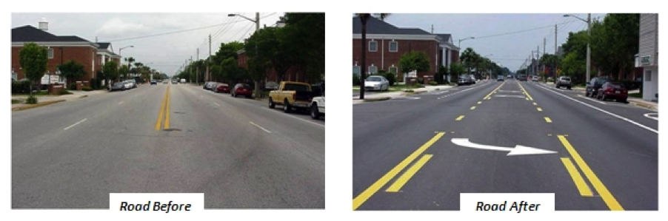
Eastbound Traffic
Harle Avenue will become a one-way street at the intersection of 1st Street NW and continue to 1st Street SW where Harle dead ends. Traffic will continue east along 1st Street SW until it reaches Johnston Park at the intersection of Broad Street SW. The far right eastbound lane on Inman Street will be converted into a right turn only lane prior to this intersection, thus, moving traffic onto Harle Avenue SW. The transition allows for continuity of number of lanes on both sides of the road.
Westbound Traffic
Westbound traffic on Inman will transition from one to two lanes at the intersection of Harle and Inman. The current number of lanes along Inman Street will not be altered between Harle and Keith Street due to the major intersection at Keith Street.
Benefits
According to FHWA, roads with 15,000 ADT or less had good results after installing a road diet. TDOT’s traffic counts show there are approximately 15,000 vehicles traveling on Inman Street per day. Eq 1.3 determined that the required number of lanes for this ADT value was one lane, proving that the road diet will be able to handle the given traffic volume.
There are many benefits that come from lane reductions, including safety, livability, and operation of traffic (FHWA). Previous road diets have caused decreases in the number of crashes and the severity of crashes. The decrease in crashes is due to the center two-way turn lane. Vehicles turning left along Inman are no longer preventing traffic flow, as they would be if there were four lanes. Drivers will naturally slow down as they enter the center turn lane. The decreased speed will lessen the chances rear-end and sideswipe crashes.
The road diet creates a safer environment for pedestrian traffic. Pedestrians will cross fewer lanes of traffic while utilizing the crosswalks, which results in less cars entering the crosswalk for pedestrians to encounter. Bicycle safety will be increased along Inman, and the installation of a bike lane will creates a safer and more convenient commute for bicyclists. The bike lane will create a buffer between the sidewalk and road, ensuring a more comfortable walking experience for pedestrians. Certain sections of the road will have shared lane pavement markings installed to promote bicycle awareness.
The road diet also allows room for streetscaping. The livability relates to the addition of trees, bushes, and benches, which will provide a more pleasant look and feel to the downtown area.
Number of Lanes and LOS Required the Road Diet and Proposed Truck Route
Using a system of equations from the Highway Capacity Manual 2010 Volume 3, Urban streets and data provided by the city of Cleveland and the University of Tennessee – Center of Transportation Research, the number of lanes, N, and Level of Service, LOS, was determined for Inman Street. These calculations can be found in the Excel Spread Sheet Labeled “Inman Street Calcs Final” and in the hand-written example calculations. The Average Daily Traffic, ADT, provided by Matt Cate of the University of Tennessee - Center of Transportation Research, “EB Inman 30” and “WB Inman 45” PDFs, was converted to Annual Average Daily Traffic, AADT, in 2039 using a 2% growth rate, which is common practice when designing a road system. Then using a k-factor, the 30th highest hour factor, from a TDOT Traffic Monitoring and Forecasting Manual, Design Hour Volume, DHV, is able to be calculated. From this step Directional DHV, DDHV, can be determined once Directional Distribution is determined. Then from the data given by the city of Cleveland and The University of Tennessee – Center of Transportation Research, the Peak Hour Factor, PHF, can be determined. This was done by finding the highest hour volume period during the day and divided by the highest 15 minute period during that hour multiplied by 4. For Harle and Oak Streets, and Table 8-3 was used due to the inability to determine PHF. Then the Service Flow can be determined. Service Flow per Lane, SFL, is determined from table 3-12. For Inman Street, it was assumed that 5% truck and LOS C was used. Once these were pulled from tables and calculated, Number of Lanes, N, could be calculated. For Inman, with a LOS C, both directions would be suitable for 1 lane. However westbound traffic number of lanes is 0.99 which is below 1 but extremely close. Further investigation would be needed to determine if this is appropriate due to the closeness of these two numbers.
When determining LOS, it was found that Inman Street, Broad Street and Ocoee Street were the only ones that could be calculated through the Highway Capacity Manual 2010 Volume 3. This used a system of equations in chapters 16 and 17. The main inputs needed for this was Base Free Flow Speed for the Facility (mph), Travel Speed of Through Vehicles for the facility (mph), and Volume to Capacity Ratio. Exhibit 16-4 was used in comparing these numbers and was determined that the LOS of Inman was found to be an E or F throughout the facility. However, when left as 2 lanes in each direction with the proposed growth of traffic, LOS was determined to be an E throughout the facility, only a slight improvement. Broad and Ocoee were found to have an LOS of F throughout the facility. It should be noted that only the proposed changed areas were given consideration. These calculations can be found on Excel Spreadsheet “Inman Street Calcs Final” and “Broad and Ocoee Streets Calcs Final” with the sheet labeled “LOS”.
When determining LOS for the rest of the proposed truck route, v/c equations from CE355 Exam 1 Equation Sheet were used due to lack of information obtained. This only affects Harle Avenue/1st SW Street and 3rd Street. Using a variety of factors which were influenced by lane and shoulder width, directional distribution, and percentages of heavy vehicles, and Service Flow, v/c can be calculated. Certain factors were influenced by which LOS was chosen, so the goal was chossing the best LOS through trial and error. as long as the v/c ratio was below 1, then the LOS could be considered. After Doing this process an LOS of B was determined for Harle Avenue/1st SW Street and 3rd Street. The information used was given by Matt Cate of the University of Tennessee - Center of Transportation Research and Brain Beck, City Engineer for the City of Cleveland.

Level of Service for Pedestrians and Bicyclists:
Level of Service Calculations were also done for pedestrian and bicycle use. While the road diet along Inman will surely decrease the LOS for automobiles, the LOS for the other two modes should increase. Using the Highway Capacity Manual, a LOS score for individual segments along Inman Street was determined. These segments consist of one boundary intersection and the corresponding link of road stretching East of that intersection. In terms of the pedestrian LOS for the facility, equations in Chapter 17 were used to determine a LOS score. This number was then compared with a value for average pedestrian space using Exhibit 17-3 in the HCM. The Pedestrian LOS for the facility was found to be “B”. In terms of the bicycle LOS for the facility, equations from Chapter 17 were again used to determine a LOS score. A corresponding LOS was then found using Exhibit 17-4. It was determined that the Bicycle LOS for the facility is “A”. These results show that implementing a road diet and allowing more room for other modes increases the likelihood that Cleveland will have a thriving downtown area in the future.
Crash Report
Crash reports over a three year span along Inman Street were compiled by the City of Cleveland and sent to our team. From this data, it was determined that no further measures are needed to account for any type of crash pattern (or lack thereof) in the downtown section of Inman Street. However, on either end of downtown, more specifically the intersections on Inman Street at Keith Street on the west side and Wildwood Avenue on the east side, it seems that speed is an issue. Both intersections are signalized, yet there is a reoccurring pattern of vehicles either trying to beat a red light or not having enough room to slow down and therefore rear-ending the vehicle in front of them. Further investigation is required to determine if a new speed limit is needed.
Converting Harle Ave into a One-Way Road
In order to have the road diet starting on Inman Street and Harle Avenue, Harle Avenue will be turned into a one-way road starting at the intersection of Harle Avenue NW and 1ST Street NW. It will then continue as a one-way road onto 1ST Street SW until it intersects with Broad Street SW. Converting Harle Avenue into a one-way road allows for a smoother transition from four to three lanes on Inman Street. A “right turn only” lane will be added to Inman Street onto Harle Avenue, allowing for continued flow for through traffic towards the proposed fly-over bridge on 3RD Street SE. This also eliminates the need to design for traffic turning left onto Inman Street from Harle Avenue SW.
Lane Width
The lane width for the Sidewalk Plan project will be designed for 10 feet. Typically, wider travel lanes, with upwards of 12 foot widths, create a larger buffer for drivers, which causes travelers to feel more comfortable driving faster. By decreasing the lane width and therefore buffer width, traffic will naturally slow down. Figure 1-2, obtained from the National Association of Transportation Officials, shows the correlation between lane width and speed. With a design speed of 30mph, narrower lanes will ensure travelers maintain a slow and safe speed. A slower speed results in a higher driver reaction time and therefore less severe crashes.
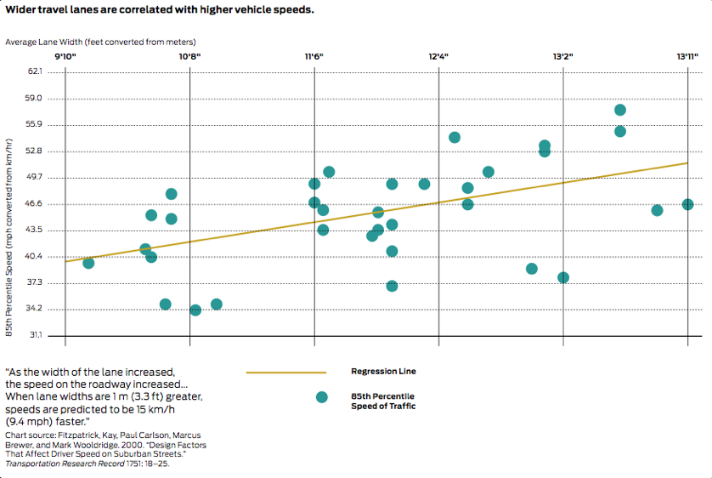

Bicycle Traffic Awareness
SDOT has proven that since 2005, commuting by bicycle has increased in U.S. cities by 53%. To accommodate the growing bicycle traffic in downtown Cleveland, three different steps will be taken. Shared lane pavement markings, also known as sharrows, will be installed in all lanes on Inman St. between Keith St. and Harle Ave. As bicyclists travel eastbound from Keith St., commuters will enter a bike lane that begins via a right turn onto Harle Ave. The bike lane will continue onto 1st St. until it dead-ends at Johnston Park on Broad St. Westbound bicycle commuters will enter the bike lane on Inman Street beginning at Broad Street. This bike lane will continue along Inman Street until commuters reach Harle Avenue, where the lane will dead end, and bicyclists will merge with traffic.
Bicyclists’ commute will be easier because they will not have to navigate around pedestrians on the sidewalk or be concerned about cars driving too close. Each mode of transportation in the westbound direction on Inman will have its own dedicated travel lane, and each will travel at a speed comfortable for their mode of transportation.
On street parking will not be an issue when considering bike lane safety. A Toronto study showed the most frequently reported type of bicycle/vehicle collision in Toronto involved a vehicle door opening into the path of a passing cyclist. This issue will not be addressed due to lack of space for on street parking along Inman.
Bicycle Traffic Along Inman Street: Keith St. to Harle Ave.
As mentioned previously, bicycle traffic traveling in both directions on Inman St. between Keith Street and Harle Avenue will be riding with the flow of traffic due to lack of right-of-way. A common alternative to a bike lane is a shared lane pavement marking, or a sharrow. Sharrows will be installed in the both the westbound and eastbound lanes on Inman Street between Keith St and Harle Ave.
Figure 1-4, obtained from Manual on Uniform Traffic Control Devices (MUTCD), illustrates the standard dimensions of a sharrow. MUTCD states that shared lane markings should not be placed on roadways that have a speed limit higher than 35 mph. The design speed limit on Inman Street is 30 mph, so this standard will not be an issue. According to MUTCD standards, the centers of the sharrows must be at least 4 feet from the face of the curb for streets with no on street parking. Due to the fact that Inman Street has no on-street parking, the center of the sharrow will be placed in the center of the outer lanes at 5 feet from the white line. The interior lanes will have sharrows installed with the center at 15 feet from the white line.
The markings will be placed immediately after the intersection of Inman and Keith Street and will be spaced at intervals of 250 feet between Keith and Harle.
The installation of sharrows will alert motorists of the presence of bicyclists on the road. The on pavement markings will also encourage safe passing of bicyclists by motorists.

Eastbound Bike Lane: Harle Ave. to Broad St.
A bike lane is defined as “a portion of a roadway which has been designated by striping, signing, and pavement markings for the preferential or exclusive use of bicyclists,” by the AASHTO Guide for the Development of Bicycle Facilities. The purpose of the bike lane is to encourage more bicycle traffic towards downtown Cleveland. A Toronto study found that customers arriving by foot and bicycle visited the most often and spent the most money per month.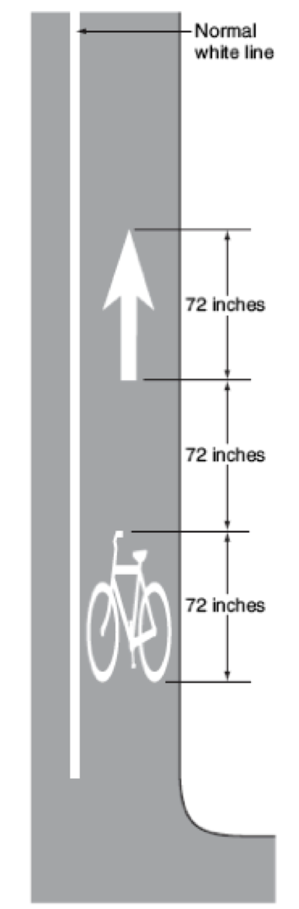
Bicyclists commuting East on Inman St. will be traveling with traffic to Harle Ave. At this intersection, both drivers in the right hand lane and bicyclists headed east on Inman will be forced to make a right turn onto Harle Ave. which becomes 1st St. This one-way road will carry bicyclists via bike lane to Johnston Park on the corner of Broad and Inman. Here, the bike lane will dead end, and bicyclists will have a designated area to park their bike. The diversion
of bicycles to 1st Street will eliminate bike traffic eastbound on Inman Street between Harle and Broad.
The design of the bike lane will ensure the bicyclists safety and comfort. The lane will be five feet wide and will be installed adjacent to the sidewalk. Figure 1-3 shows the exact dimensions. Not shown in this figure is the dimension of the outer solid white line, which will be six inches, according to AASHTO.
Maintaining a smooth ride for bicyclists in the bike lane is important for reducing the frequency of crashes, according to AASHTO’s Green Book. Bicycle-compatible drainage grates and manhole covers at grade will be constructed within the bike lane to ensure a safer ride for bike commuters.
Westbound Bike Lane: Broad St. to Harle Ave.
Bicycle traffic traveling westbound on Inman Street will enter a bike lane at the Northwest corner of the Inman-Broad Street intersection. Johnston Park, in which a bike parking lot will be constructed, is located at the Southeast corner of this intersection. Bicyclists will have easy access to the bike lane by making a left turn off of Broad onto Inman, and thus into the bike lane.
This bike lane will also be five feet wide with a six inch outer solid white line, as shown in Figure 1-3.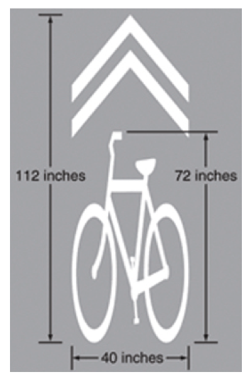
AASHTO states that bike lane striping should not be installed across any intersections or crosswalks; therefore, the bike lane on Inman will begin immediately after the crosswalk on the West side of the Inman-Broad Street intersection. There are no traffic signals between Keith St. and Harle Ave., so the bike lane will be continuous as bicyclists commute along Inman Street.
Conclusion
All modes of transportation will have a safer experience because of the installation of the bike lane and shared lane pavement markings. Bikelongbranch.org conducted a study on a similar downtown road, which found that one year after the installation of a protected bike lane in downtown Long Beach, there was a decrease in the number of bicycle and car crashes. The study also showed an increase in walking and bicycling traffic.
The construction of a bike lane and the installation of Shared Pavement Markings will result in more bicycle traffic commuting to downtown Cleveland in a safer manner.

COMPLETE STREETS
The National Complete streets Coalition states that “complete streets are designed and operated to enable safe access for all users. Pedestrians, bicyclists, motorists and bus riders of all ages and abilities are able to safely move along and across a complete street.”
The goal for this sub-project is to improve the existing infrastructure of downtown Cleveland streets, starting at Broad Street and ending with Linden Avenue. Currently, this section of Inman Street does not possess adequate sidewalk space which is deterring pedestrians from the downtown area. This is causing businesses to move away from downtown thus Cleveland losing potential revenue from said businesses. This section of roadway is in need of a road diet to control vehicular traffic that is going along Inman Street; the road diet will potentially transform this roadway to a multimodal road which will serve pedestrians, bicyclists, and vehicles.
The final project design will include a new sidewalk design, an improved road system by the implementation of the road diet, and thus smooth traffic flow across this roadway.
Street Design Parameters
Functional Classification
This project spans from Broad Street to Linden Avenue. This stretch of road currently serves as an inter-city route and an intra-city road which connects the east-west route, truck route, and a transit corridor. The goal is to reroute semi-trucks into an adjacent road which will free Inman Street from truck traffic. This will create an environment more suitable for pedestrians and bicyclists.
Speed

The most influential design control in urban areas is speed. Inman street design will be based on both design speed and target speed. Design speed governs certain geometric features of a roadway such as horizontal and vertical curves. In order to make Inman Street pedestrian friendly, the target speed is set for 25 mph which puts the design speed at 30 mph. A speed limit of 30 mph, in addition the reduced number of lanes and lane width, will help minimize traffic incidents and increase pedestrian safety on Inman Street.
Intersection Modifications on Inman St. (From Broad St. to the railroad underpass)
All intersections on Inman will be modified with new sidewalks, crosswalks, signals, signs, lighting, greenery, gutters, and road realignment. The current right of way on Inman is 60’ as stated in the 2004 Downtown Cleveland Master Plan. This includes four 12’ lanes with curb and 6’ of existing sidewalks on either side. Our road diet will take Inman Street from a four-lane street to a 3-lane street. Lanes will be narrowed to 10’, making the total travel width 30’. The total road width will be 33’ including 18” wide gutters. Increasing the current sidewalks by 3’ will give a total width of 9’ for sidewalks on Inman St. Greenery will be placed between the sidewalks and curbs. These greeneries will be 4.5’ wide on each side. When there is a break in landscape, the sidewalk will continue to the curb, given a width of 13.5’ in some areas. By using the greenery as a buffer between vehicles and pedestrians along with the increase in sidewalk width, this stretch of road will be more pedestrian friendly and help revitalize the downtown Cleveland area.
Crosswalks
All crosswalks will be installed parallel and perpendicular to Inman Street. These crosswalks shall be 10’ in total width and extend from sidewalk to sidewalk. Crosswalks that extend across Inman Street will be 33’ in length. Crosswalks parallel to Inman will vary in length, dependent on road width of side streets. Crosswalks will comprise of brick layover with two parallel white retro-reflective transverse lines that are 8” wide to be in accordance with TDOT Traffic Design Manual 4. The brick layover will make the overall streetscape of Inman more pleasing to pedestrians. At all crosswalks, there will be approved ramps to stay in code with the Americans with Disabilities Act (ADA). Two ramps will be at each corner for each direction to allow users to easily maneuver from the sidewalk to the crosswalk. These shall match the color of brick chosen. All on-street parking will be at least 25 feet from the intersection to allow for adequate sight distance for both vehicles and pedestrians. Stop bars will be placed 4 feet behind crosswalk.
Traffic Signals
All traffic signals and pedestrian heads will be placed on black circular posts. These posts will be put on all corners of the intersection. Two posts will contain two pedestrian heads each. These posts will be on opposite corners of the intersection to allow pedestrians to have a clear view of the crosswalk symbols as they cross either crosswalk towards these corners. The other two corners will have posts that include mast arms that extend out with traffic signals. These corners will also have two pedestrian heads pointing out towards the two crosswalks that intersect at this corner. All pedestrian heads will be 8’ high on all posts with 12” tall symbols in accordance with TDOT standards. 2 Push buttons will also be placed on all for the two different directions of travel. These shall be located 42” from the ground and have necessary signage in accordance with MUTCD 4E.08. Traffic signals will be placed at appropriate distances in accordance with the 2009 MUTCD Part 4. Since posts will have push button detectors for pedestrian crossing, all posts will be 10’ from either curb to be in accordance with MUTCD 4E.08.
Lighting
Uniform lighting will be placed throughout the complete street landscape. These will conform to RP-8 “American National Standard Practice for Roadway Lighting”. Also, all intersections will have lights on the traffic posts to help increase lighting at these corners.
Greenery
Between intersections, 4.5’ of greenery will be added between the road and sidewalk. This will include, but not limited to shrubs, trees, grass, and other local vegetation. As intersections will have right turns onto Inman from the minor street, trees will not be placed within 309’ of intersection. This distance is in accordance with American Association of State Highway Transportation Official’s (AASHTO) A Policy on Geometric Designs of Highways and streets.
Intersections
Broad St. and Inman St.
As motorists approach the new downtown Cleveland, they will be greeted with all new, pedestrian friendly intersections. Driving southeast on Inman, drivers will come to the first intersection of Broad St and Inman St. This intersection will have bold-outs to enhance pedestrian safety. Traveling southeast, the furthest right lane will be a right turn only onto Broad St, while the center lane will continue on Inman St. Both posts for the traffic signals will be 25.6’ high from the road to the top of the lights to be in accordance with MUTCD 4D.15.

Traffic Modeling Inputs
The vehicle inputs for traffic modeling is derived from the peak hour inputs for the four major entry portals of downtown Cleveland: W Inman St, E Inman St, Broad Ave, and Ocoee St. Each of the peak hours occur at similar times in the afternoon somewhere between 3:00 p.m. and 5:00 p.m. Due to the similar timing, the peak hour values are assumed to occur within one hour for the purposes of inputs. This assumption may result in a small overestimation of vehicular traffic. The vehicle composition is split between cars and HGV’s based upon the traffic counts received from the City of Cleveland. Table 1-1 displays the traffic volumes used vehicular composition for the current state of traffic.
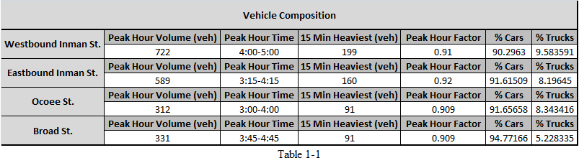
To account for potential future traffic and model how the proposed system would react to the influx of vehicles, the current volumes were scaled up by 25%. The scale is an assumption based on the forecasted 30% population growth over the next twenty-five years as documented in the Cleveland MPO’s Long Range Transportation Plan. The proposed volumes, documented in Table 1-2, maintain the same vehicular composition in terms of cars and trucks.
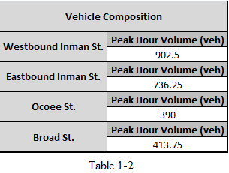
Traffic Modeling
Current traffic conditions in downtown Cleveland are modeled in VISSIM, a traffic modeling program that simulates the flow of traffic and driver behavior within the built system. The following roads represent the boundaries of the Cleveland model: Highway 11 on the west side, Bates Street on the east side, Central Avenue on the north side, and 3rd Street on the south side. This assumption grants a scope of work that is feasible while still simulating an accurate depiction of downtown Cleveland. The model employs a static vehicle route choice methodology, meaning all potential vehicle route decisions are modeled by the user. The route decisions remain on the major arterials of downtown Cleveland barring the truck routes, which were modeled according to the current and proposed routes. The driver behavior for the system remains at the default for the VISSIM modeling program. The default behavior is slightly aggressive for a system such as downtown Cleveland due to the VISSIM program typically being used for highway situations. Some of the results, therefore, potentially fall lower time-wise than is accurate as cars may be moving quicker and more aggressively.
The variables in the model consist of three factors: roadway system, truck route, and traffic volume inputs. The current roadway system refers to the state of downtown Cleveland today. The proposed roadway system refers to the system put forth by this design document. The current truck route refers to the truck route using Edwards Street and Linden Ave; the proposed east-bound truck route the one-way Harle to Broad Street, leading it to 3rd Street; the truck route up Ocoee Street refers to the west-bound truck route taking Linden Avenue to 3rd Street, then using Ocoee Street to reach Inman Street; the truck route through 3rd Street refers to trucks using Linden Avenue then taking 3rd Street through to Keith Street.
The model simulates five, distinct scenarios based on roadway system, truck route, and traffic volume inputs as follows: Simulation 1 in which the current roadway system, current truck route, and current traffic inputs apply; Simulation 2 in which the proposed roadway system, truck route up Ocoee, and current traffic inputs apply; Simulation 3 in which the new roadway system, truck route through 3rd Street, and current traffic inputs apply; Simulation 4 in which the new roadway system, the truck route up Ocoee, and new traffic inputs apply; Simulation 5 in which the new roadway system, truck route through 3rd Street, and new traffic inputs apply. Each simulation was run a total of five times and the averages for each important data parameter were used in observation.
TRAFFIC MODELING RESULTS:
The major results observed are as follows: Average Network Delay (sec), Average Network Speed (mph), and Vehicular Travel Times (sec). All results from VISSIM are located in the Transportation Section under the VISSIM Data Sheets.
Network Delay
The overall network delay of the system increased by an average of 10-13 seconds overall when comparing the current roadway and current traffic to the proposed roadway and current traffic. Trucks were slightly more delayed than cars on average. The truck route on 3rd Street consisted of an approximate 7.7 seconds shorter delay compared to the truck route up Ocoee Street. The projected traffic volumes also increased the delays, but only on an average of 3-4 seconds. Again, the model employing the truck route through 3rd Street decreased the overall delay by approximately 2.3 seconds and decreased the truck delay by 9-10 seconds while also slightly decreasing the car delay.
This data confirms the road diet’s ability to slow traffic through the main stretch of Inman Street, as the overall network delay increased significantly. This increase means cars are naturally moving slower for the system, accommodating a more pedestrian and bike-friendly environment. Further, the trucks overall delay time significantly lowers when using the 3rd Street truck route. This route does come at the expense of a smaller car delay, meaning cars move faster when the trucks use the 3rd Street route. However, this difference in car delay is negligible, only 1-2 seconds on average.
Average Network Speed
The overall network speed decreased slightly, though not by more than 1-2 mph overall. Trucks were most affected by the system changes, while cars only decreased slightly with regard to the current traffic and proposed network. With the new vehicular volume, the average network speed stayed very similar, again only changing within 1-2 mph.
A larger decrease in network speed is ideal, specifically with regards to the cars. However, part of this network speed consistency can be explained by the VISSIM driver behavior, which is fairly aggressive for the network given. Thus, an assumption can be made that these decreases are likely lower bounds, and the reality of the network changes would have slightly more impact if VISSIM driver behavior were better suited for the downtown area.
Vehicular Travel Times
The average vehicular travel times with regards to the current traffic volumes increased an average of 20-40 seconds for trucks and 14-18 seconds for cars when applied to the new roadway system. With projected traffic inputs, the vehicular travel times for cars and trucks remained within 5-10 seconds of the previous times.
These results display further the effect the new roadway system has on the vehicular traffic as each vehicle is slowed significantly on average. The truck travel time is significantly lower (20 seconds) when using the 3rd Street truck route. Further, cars move slower through Inman Street both eastbound and westbound due to the new system. The influx of proposed traffic seemingly does not have a large impact, indicating the proposed system can hold such traffic in the future.
VISSIM Conclusions
Overall, the VISSIM model confirmed the proposed network as a way of slowing traffic through the downtown corridor, as cars are slowed down across all parameters. Though the speed averages did not decrease significantly, this may be caused by the overly-aggressive driver behavior modeled in VISSIM. Trucks are slowed a fair amount by the new system, but not by more than 40 seconds. Further, the truck route through 3rd street proved to be a quicker and more efficient westbound route.
RAILROAD UNDERPASS
A low-lying underpass has become a complex problem for the City of Cleveland. A request has been made to address the low clearance underpass while also addressing the drainage issues that occur in this low-lying area. Issues related to the underpass include flooding due to existing drainage designs, a low height clearance, and displeasing aesthetic appeal. The railroad tracks above the underpass are part of the Norfolk Southern Corporation Georgia Division, Cohutta District and serve as the main line from the Cleveland rail yard to the Atlanta North District. The surrounding terrain leading up to the underpass acts as a collection point for water runoff due to the higher elevation of the surrounding areas, which has resulted in occasional flooding following heavy storms. A clearance height of 10’10” poses problems for larger trucks and recreational vehicles (RV’s) that do not meet this clearance.
The University of Tennessee, in partnership with Cleveland, TN through the Smart Communities Initiative program at UT, has been contracted to conduct a cost and impact study for alternative methods of increasing the clearance height of the underpass. Design solutions will lead to a decrease in the amount of vehicles hitting the underpass due to the low clearance, while also encouraging pedestrian traffic and destination traffic to utilize this existing corridor. A diversion of through traffic to other locations without dramatically increasing the vehicular traffic at the at-grade crossings has also been designed. Improvements to the underpass in regards to its aesthetic character in view of the proposed redevelopment of Cleveland will also be addressed.
Underpass
The railroad tracks that cross over Inman Street are owned by Norfolk Southern Railway and any such modifications made to the bridge must go through the approval of Norfolk Southern and the requirements set forth by them. Consideration was given to bringing the road to the same elevation as the tracks on Inman Street but in an effort to minimize altering the current construction of the bridge a drop in elevation is preferred. The rail line serves as a major line to the Atlanta district, it is frequented by up to twenty trains per day and would certainly result in heavy traffic delays on Inman Street at each train crossing instance. This directly opposes the overall objectives for this project of converting Inman Street to a pedestrian dominated roadway with minimal vehicular traffic. Thus, the most feasible options are to maintain the flow of traffic under the bridge or to direct traffic over the bridge. In order to abide by the Norfolk Southern Bridge Design criteria manual, a vertical clearance of 23 feet above the rail line must be obtained. Since diversion of through traffic is a desirable outcome, the design team has also decided to evaluate the option of a flyover at the 3rd Street at-grade crossing location.

Lowering Road beneath Railroad Tracks
Our design solution includes reducing the lanes in unison with the road diet along Inman Street. The current four lanes will be condensed to two lanes while extending the sidewalks on both sides to accommodate pedestrians. A decrease in the elevation of the lanes will occur to accommodate for taller vehicles. For addressing the drainage issues, a pump may be necessary to raise the stormwater to an elevation at which the water can flow down to Woolen Mill Creek at the TDOT specified slope of 2%. Aesthetic details will consist of new signage, a new façade on abutments and piers, and pedestrian friendly railings to separate pedestrians from vehicular traffic.
Road Geometry In order to accommodate vehicles taller than the 10’ 10” clearance allowance, the current four lanes will be condensed to two lanes while also lowering their elevation to achieve a height clearance of 14 ft. The existing underpass contains four lanes that are 12 ft wide with 2’6” sidewalks on either side. The center pier is 2 ft wide. In accordance with the road diet and sidewalk improvements along Inman Street, a reduction in the number of lanes will be implanted and as is follows: two 12 ft lanes, one in each direction with 9 ft wide sidewalks. The total width of the underpass is currently 55 ft. New improvements will require 44 ft of underpass width. The remaining 11 ft will be used for crash wall barriers and road surface markings.
Removing one lane in each direction and increasing lane width will help to enhance traveler safety by adding more room error allowances in this hazardous location. This will allow for a buffer zone between the vehicular traffic and the pedestrian traffic. Driver error, whether it is swerving or distracted drivers, will be minimized to pedestrians. Also, the added width in the lanes is valuable for the structural integrity of pavement.
Sidewalks at the underpass will remain at the current elevation and will be extended to 9 ft wide on both sides. A 3’ 2” drop in road elevation will create a 3’2” barrier between pedestrians and vehicular traffic. Railings will be installed to add another level of protection against vehicular impacts as well as to create a sense of pedestrian security and safety. Railing will be ADA compliant. By separating pedestrian traffic from vehicular traffic and installing railings, we are creating two different levels of modes of traffic and thus helping to create a safer walking route. In the off chance that a driver loses control while driving through the underpass, the elevation separation will act as a barrier for pedestrians against cars and trucks. Crash barriers will also be installed on either sides of the 12 ft lanes. Crash barriers will help to protect both pedestrians and the center pier of the bridge.

Geotechnical Aspects Due to the lack of available information regarding the existing bridge infrastructure, we have made several educated assumptions in the design of lowering the roadway. All soil data used to assess the current subsurface conditions were provided to us by GeoServices, LLC and came from borehole logs depicting boreholes drilled for the Lee University Communications Building approximately one mile northeast of 3rd Street. All geotechnical calculations are preliminary and involve justifiable estimations and assumptions that will be stated as the calculations progress. Extensive geotechnical investigation upon project funding will be required before any of the following designs are implemented with the exact locations for subsurface investigation being dictated by the design of the structure itself. Upon the obtainment of information from Norfolk Southern Corporation, these assumptions may be revised.
The railway experiences heavy loads and vibrations due to frequent train traffic. We have assumed that the existing foundation consists of some sort of piling system extending into the bedrock below. This is likely the case as excessive settlement of a railroad bridge cannot be tolerated. Due to the age of this bridge, we have also assumed that the current support system no longer meets current seismic codes. However, we have decided to follow the assumption that any structural alterations to the bridge are the responsibility of Norfolk Southern and that the roadway, itself, is in no way providing structural support for the bridge pier and abutments. Thus, lowering the roadway, would not have any negative impacts on the structural integrity of the overpass.

Aesthetic Appeal The Norfolk Southern (NS) railway bridge over Inman Street is a major detractor from the appearance of downtown Cleveland. The goal of an aesthetic design is to produce a structure that is pleasing to the eye while also blending into its environment. The position of the bridge acts as a gateway to downtown Cleveland and should welcome motorists and pedestrians to the city. However, options for improving the appearance are limited due several constraints. One being, the railway above is active, and therefore any interference with NS operations should be avoided. The bridge is considered structurally sound according Norfolk Southern, regardless of repeated collisions from vehicles.
At this point in the project, a cosmetic façade anchored into the existing structure is the best option to increase the aesthetic appeal of the overpass. Façades can be made of many materials (brick, thin granite panels, faux stone panels) and attached with a variety of anchor systems. Attachment of the façade depends on the existing capabilities of the structure and the method of anchoring into the structure. In addition different places on the bridge such as the superstructure may need to use a different anchoring system than used in the abutments. The methods of anchoring into the current structure range from epoxy sheets, to track mounted panels, or masonry steel angle anchors.
Each anchoring system has possible applications on different parts of the bridge. The superstructure could utilize either the track mounted or epoxy adhesive to attach the façade. It would be optimal to have low weight stone panels or faux stone panels on the superstructure in case of an impact from a vehicle. It is uncertain how many impacts, if any, a panel could take before it becomes a hazard to motorists or pedestrians. In light of this it would be prudent to install a sacrificial steel beam to take any hits from passing vehicles. Sacrificial beams protect the structure from impacts that would otherwise come into contact with a bridge or other low obstacle. The abutments and central pier, on the other hand, would use the masonry anchor system where the added weight would not be a hindrance.
Fly-over Bridge at Third Street SE
A fly-over is a bridge constructed along a highway over an at-grade intersection. The location of the fly-over will occur at the 3rd Street at-grade crossing. The bridge will be constructed of four steel plate girders with a concrete decking. This decision was based on cost and constructability constraints. Steel was chosen over concrete due to concrete’s long curing time, cost for materials and formwork, and difficulty of shaping the underside of the bridge. The steel provides a longer span length and quick construction, which is desirable for this project due to time and cost constraints.
Superstructure The superstructure of the bridge is composed of a concrete deck supported by four steel plate girders. The deck is made of concrete with an assumed compressive strength of 4000 psi which is standard and reinforcement made of grade 60 steel. The reinforcement used should be epoxy coated due to deterioration due to chlorides. This deck will not have an asphalt overlay because the clear cover on the top side of the deck (2.5 inches) is large enough to prevent deterioration of the reinforcement. Federal Highway Administration LRFD design guidelines as well as simplified one-way slab design steps were followed while designing the deck. The deck was designed as 7 inches thick with an 8 inch overhang. The Federal Highway Administration supports using ¾ to 1 inch thicker on the overhang, compared to the deck, due to crash testing of railing systems and this being proven beneficial in the past [8]. Reinforcement in the deck will be comprised of #4 reinforcement spaced at 6 inches on center. No shear ties are needed in the deck due to the design shear calculations exceeding the shear requirements.
The girders carry the load supported by the deck as well as the weight of the deck itself. Due to the loads and spans in this project, plate girders will be required, as conventional rolled steel members do not have enough flexural capacity to support the required spans and loads. Plate girders consist of a vertical plate for the web and two horizontal plates that make up the flanges. These members are welded together to form a plate girder. In spans of less than 50 ft rolled and stiffened shapes are more economical. Beyond the range of 100 ft plate girders are a better choice. A plate girder is a cheaper substitute for a steel truss as its fabrication costs are much lower and less complicated to construct. The application of continuous girders results in a less deep section and easier construction that would not be possible with simply supported spans. A consequence of reducing the steel section for the flyover is that deflection will control over required strength when the depth to section ration is less than 1/25, which is the case for the flyover since the ratio is 1/30 is less.
A multitude of steel grades are produced as plate steels. For the girders of the flyover A572 grade 50 steel was chosen for its high strength (Fy = 50 ksi) and savings when compared to girders made of A36 steel. A572 is a high strength low alloy steel with excellent formability and weldability. These characteristics make A572 a good candidate for plate girder construction. A572 is offered as plate steel in thicknesses up to 4 inches, width of 72 inches, and length of 480 inches. These dimensions are adequate for the webs and flanges but the flange ends must be welded at the ends to create long enough members. The concrete deck and steel girders are connected by shear studs. The advantages of the design are two fold; The girders are continuously braced (ruling out lateral-torsional buckling) and the combined strength of the slab and girder is greater than the strength of the girder alone. Given the depth and strength of the concrete slab combined with the girder section, the plastic neutral axis is located in the flange of the steel girder, resulting in a partially composite beam. In order for composite action to take place ¾ inch studs must be placed at no more than 10 ½ inches apart as specified in the design drawings.These dimensions are adequate for the webs and flanges but the flange ends must be welded at the ends to create long enough members.
Deflection under live load is limited to L/800, where L is the span length, as specified in the AASHTO LRFD bridge manual. The deflection under live load is the greater of two criteria; the design truck (72 kips) alone or the lane load (0.64kips per linear foot) plus 25% of the design truck. The calculations and RISA 2-D outputs for live load deflection are located in the calculation notebook. According to the AASHTO LRFD bridge manual deflection for the longest span (175ft) cannot be larger than 2.625 inches. Given the design specification for the girders the largest deflection that exists is 2.12 inches under the loading condition of the design truck alone. This being the most serious case for deflection the flyover design meets the criteria for deflection under live load. Excessive deflection when placing concrete can result in a ponding action at mid-span. Ponding action increases deflection and may reduce the serviceability and aesthetic appeal of the structure. One way to prevent ponding is by adding camber to the beams. Camber is achieved by inducing residual stresses by means of either hot or cold bending for rolled shapes or in the case of plate girders shaping the web so the constructed shape has the necessary shape. The residual stresses associated with cambering do not affect the design strength of the beam as such stresses are taken into account by the American Institute for Steel Construction (AISC). Under a combined load of 1.13 kips per linear foot (concrete load of 0.78 kips per linear foot and a beam dead load of 0.35 kips per linear foot) the resulting maximum deflection for the flyover is 2.8 inches at the mid-span of span 2.
The concrete piers support the girders, the concrete slab, and the weight of the vehicles crossing the fly-over. The pier is a spiral tie design with a diameter of 36 inches and there are three different heights which are placed along the span of the fly-over. The first pier is 20 feet, the second 23 feet, and the last pier 25 feet. Each column will have 6 #14 bars spaced at 2 inches with 1 #5 tie.
Geometrics The choice for the location of the fly-over bridge was supported by the analyses of alternatives with consideration given to economics, engineering, social, and environmental concerns as well as costs of maintenance and inspection associated with the structures. The fly-over must fit within its environment, pass all design criteria standards, provide for the desired level of traffic service and safety, and minimize adverse highway impacts.
According to the Norfolk Southern Design Criteria for Overhead Grade Separation, a minimum vertical clearance of 23’-0” shall be provided at all times, measured from the top of the high rail to the lowest point of the structure in the horizontal clearance area. A vertical clearance for footings, piers, or columns shall be no closer than 10’ from centerline of tracks. For constructability and for ease of construction a horizontal clearance of 15’ will be established at all times giving five feet of workspace for scaffolding and excavation to take place.
Through geometric analysis based on required clearances above the railroad tracks and streets, it has been decided that a fly-over beginning west of Broad St. would be excessively long and expensive, and could potentially create a geographic barrier between downtown Cleveland and the surrounding area to the southwest.
The best choice for a fly-over location will begin approximately 135’ east of Church Street SE on 3rd Street SE and will terminate on the west side of Linden Avenue SE. These locations were selected based on several reasons. The flyover needed to begin either east of Church St. or west of Broad St. to avoid excessive alterations at critical intersections at Broad St., Ocoee St. and Church St. A fly-over beginning east of Church St. will exhibit an overall grade of approximately 6.4%, which complies with “A Policy on Geometric Design of Highways and Streets” as set forth by American Association of State Highway and Transportation Officials (AASHTO) for an urban arterial with a design speed of 40 mph. AASHTO’s recommended maximum grade is 8%. Our team found that a grade of approximately 6.5% currently exists in the area on 3rd St. between the railroad tracks and Linden St SE. By incorporating a fly-over, we have effectively kept the same grade, but removed a hazardous at-grade crossing by altering where vehicles experience this grade.
The fly-over will consist of two lanes at 12 ft wide with 4 ft of shoulder on either side. Given that this road is to accommodate larger traffic (i.e. Semi trucks and tractor trailers), wider lanes will help to minimize sideswipes, and side tracking into adjacent lanes. A speed limit of 35 MPH will control and help to minimize stopping sight distance.
Traffic speed data were taken at three locations along Inman St. in order to determine a design speed for the flyover on 3rd St. Speed data taken on Inman St. is more representative of what the future speeds will be like on the 3rd Street fly-over. Additionally, the somewhat small frequency of cars traveling along 3rd Street would not have provided an adequate number of cars to consider the results valid.
Based on approximately 240 speed readings taken at three points along Inman St., an operating speed of 38-39 mph was determined. This represents the 85th percentile of speeds traveled by cars along Inman St. Because the speed limit on Inman St. is planned to be decreased, the anticipated future operating speed should decrease as well. For this reason, an overall design speed of 40 mph has been selected and will be used in all geometric calculations related to the 3rd St. flyover.

Aesthetic Appeal It is the structural members of a bridge that dominate the viewer’s impressions. By shaping the structural members, the designer controls the aesthetic impact. The flyover would be one of the most prominent structures in the Cleveland skyline. Therefore attention must be paid to its impact on the downtown area. Currently the majority of the buildings in proximity to the site will be demolished as Whirlpool Corporation vacates the property. This is because of the age and condition of the buildings does not justify revitalization or repurposing. Due to the decreasing elevation heading west from the intersection of 3rd St and Linden Ave the flyover will noticeably longer and especially prominent as it crosses the tracks to the West. Multiple design options are available and the flyover could utilize either concrete or steel girders as a primary support. A slender bridge profile is the best since it minimizes visual impact of deep girders and provides for a less steep grade.

Design Loads In accordance to AASHTO LRFD Bridge Design Specifications, the dead loads for concrete shall be Class A concrete for all structural elements and Class B concrete for footings. Class A concrete is 611 pcy and Class B concrete is 517 pcy. Structural components contributing to the dead loads are the concrete deck, concrete barriers, steel girders, piers, and foundations. Live loads to be considered include wind loads, snow loads, seismic loads, and vehicle loads. Vehicle loads are specified in AASHTO LRFD Bridge Design Specifications with several loads cases. The case applying the most extreme effects for each load type was implemented into the design process. A design lane load of 0.64 KLF, uniformly distributed in a longitudinal direction, is to be applied in certain load cases. Addition load case factors include a design truck with three axles as well as a design tandem. Design truck specifications include 8 kips on the front axle with 32 kip load on both back axles with the front spacing being 14 ft and the back axle spacing to be 14 ft to 30 ft as shown in Figure 3. The design tandem is two 25 kip axles spaced 4 feet apart and 6 feet transversely. For interior piers, an extreme circumstance of negative moment between points of contraflexure is to be taken in account for. Two design trucks with a minimum spacing of 50 feet between front axle of one truck and the rear axle of the other truck. The two design trucks shall be placed in adjacent spans to produce maximum force effects.
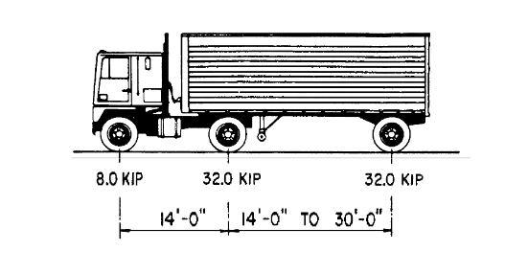
Figure 1-1: Characteristics of the Design Truck via AASHTO LRFD Bridge Design Specifications.
Vehicular braking force load cases can be taken as percentages of design truck, design tandem, and design lane load combinations. Breaking forces are assumed to act horizontally at a distance of 6 feet above the roadway surface. Wind loads shall be determined in accordance to AASHTO LRFD Bridge Design Specifications when wind pressures are acting on both the bridge and vehicles. Pressures exerted on the structure by wind were tabulated according to section 3.8.1.1. Individual structural components are loaded based on wind direction, location, and surface area. A base wind velocity was assumed to be 100 mph and suburban environment factor were assumed for wind calculations. Wind pressures acting on vehicles shall be represented by a moving force of 0.10 klf acting normal to the roadway and transferred to the bridge.
Seismic loads shall be taken to be horizontal force effects on the basis of the elastic response coefficient, the equivalent weight of the superstructure, and then adjusted by the response modification factor. Seismic parameters can be determined using Geographic Information Systems (GIS). Snow loads shall be determined using the ground snow load which is available from the National Weather Service, state and local agencies, and ASCE. Estimated snow loads can be determined from historical records or other reliable data. Pedestrian loads shall not be taken in account for as there will be no pedestrian access. For preliminary structural design, dead and live loads acting normal to, or in the vertical direction were considered as the primary design criteria. Further in depth load analysis is recommended for bridge design. Current loads were calculated for preliminary design only and are not to be issued for construction.

Geotechnical Aspects The elevations and the corresponding soil types depicted in the Lee University Communications Building borehole logs were used to develop a soil profile along 3rd Street and extending over the at-grade crossing up to 6th Street. This data primarily came from boreholes starting at an elevation of 870 ft and sampling down to an elevation of approximately 830 ft. These elevations coincide with the elevations at the proposed fly-over. Borehole log #9 indicates auger refusal at a depth of 37.5 ft meaning that a bedrock layer exists at this depth. This is consistent with the “Geotechnical Report Manual” issued by the Tennessee Department of Transportation in 2007 for regions not in West Tennessee (Regions 1-3), which typically exhibit bedrock at depths less than 100 ft. The heavier presence of shale fragments with increasing depth at other boreholes is also an indication of harder, more rock-like layers beginning to emerge approximately 30-40 ft below the surface. As shown in the boreholes, the soil stratigraphy is heavily dominated by the presence of lean clay (CL) in every borehole. The lack of significant variation in soil type supports our decision to utilize these boreholes for the area in close proximity to Inman Street and 3rd Street. The Standard Penetration Test uncorrected N values from the borehole logs were used to estimate the following empirical values: Unconfined Compressive Strength (q_{u}), Saturated Unit Weight (γ_{sat)}, and Undrained Shear Strength (1/2*q_{u)}. It should be noted that these correlations are generally unreliable and serve only as preliminary estimates.
Typical values for specific gravity (Gs) of inorganic clays generally range from 2.70 to 2.80. We have decided to use a value of 2.75. From the values of Gs and γsat, void ratios (e) can be determined. Once void ratios have been determined, dry unit weights (γdry) and porosities (η) can be calculated from basic soil relationships. These values were all utilized in our formulations for bearing capacity of the soil layers below the foundations.
The average value for the elevation of the water table was determined from the borehole logs to be approximately 19.57 ft below the surface. Considering this is the only source of information available at this time for this area, a water table depth of 20 ft will be used for all designs and calculations. Again, this will need to be further explored in order to confirm the depth of the water table at various locations along Inman Street and 3rd Street and to assess the seasonal variation of the water table.
Due to the fact that the bedrock layer exists at a relatively shallow depth of 40 ft., the following foundation system will be used for the flyover supports: End-bearing drilled shafts will be anchored a minimum of 10.5 ft into the bedrock and will tie into a 30 in diameter spiral column. The drilled shafts with casing were chosen based on the consistent lean clay down to rock layer. The high ground water table makes drilled shafts with casings necessary to prevent water from infiltrating the freshly poured concrete piles. Rock in this region is typically limestone, which can vary greatly in depth over a short distance. A depth of 40 ft is considered conservative given no boring was done during preliminary design. A rock quality designation (RQD) of 100% was selected and a unconfined compressive strength of 36,000 psi was determined based on empirical values. These assumptions lead to the selection of 7 ft and 6 ft drilled shaft foundations. The drilled shaft pile foundations are considered to be end bearing only with minimal consideration given to skin resistance in terms of total capacity.
Bridge abutments at either end of the fly-over will be supported by spread footings on top of mechanically stabilized earth (MSE) walls. The eastern abutment will exhibit a design height of 20 ft measured from top of grade to top of spread footing. The western abutment has been designed for a design height of 15 ft. Excavation will be required to replace 5 ft of existing foundation material along the entire MSE wall length. A sandy clay material is desired as a foundation fill with a minimum friction angle of 30 degrees and a unit weight of 125 pcf per FHWA guidelines. The MSE abutments will be reinforced with 65 ksi galvanized steel ribbed strips with a design life of 100 years. The precast panels on the walls perpendicular to the roadways will be 10 ft wide and 5 ft tall with 6 in thickness while panels on the parallel facing walls will be 5 ft by 5 ft with 6 in thickness. Panels will be connected with shear pins. All calculations and MSE wall starting parameters were based on FHWA’s “MSE Walls and RSS - Vol II”.
MSE walls were chosen based on several parameters, primarily for the advantages MSE walls exhibit. The last twenty years have shown MSE walls replacing traditional concrete retaining walls mainly because MSE walls are typically easier to install. No specialized labor is required and they simple installation can result in quick construction. MSE walls are more resistant to seismic forces as they are susceptible to elastic deformation. MSE walls are ideal for areas of poor soil, in this case, soft clay. Therefore, the amount to which excavation and fill is required is kept to a minimum. MSE walls are compatible with many different types of facing elements and can therefore be designed creatively and in an aesthetic fashion.

Signage
The Manual on Uniform Traffic Control Devices will be used to define the standards of the roadway and maintain traffic control devices. Regulatory signs will be used to inform road users of selected traffic laws and regulations and indicate the applicability of the legal requirements.
One-Way
A Mandatory Movement Lane Control sign will be installed to alert eastbound traffic on Inman Street of the right turn only lane. The Right Lane Must Turn Right sign, shown in Figure 2-1, will be located in advance of the intersection. MUTCD states, “If used at unsignalized intersections with one-way streets, one-way signs shall be placed on the near right and the far left corners of the intersection facing traffic entering or crossing the one-way street.” A one-way sign, as shown in Figure 2-2, will be installed at the intersection of Harle Ave. NW and 1st Street NW. Figure 2-2 will also be installed at the intersection of 1st Street and Broad Street facing traffic traveling south along Broad Street.
If used at signalized intersections with one-way streets, one-way signs shall be placed on the near right and the far left corners of the intersection facing traffic entering or crossing the one-way street. (MUTCD) Therefore, at the intersection of Inman and Harle, the sign shown in Figure 2-2 will be placed accordingly.
The Mandatory Movement Lane Control sign (see Figure 2-3) shall indicate only the single vehicle movement that is required from the lane. The Begin Right Turn Lane sign shall be located in advance of the intersection of Inman and Harle near the upstream end of the mandatory movement lane; therefore, the Figure 2-3 will be installed at the beginning of the right turn only lane.
A new stop sign (Figure 2-4) will be installed at the intersection of 1st Street and Broad to replace the current stop sign that is being held upright by a caution cone. An End One Way sign, as shown in Figure 2-5, will also be installed below the stop sign.
According to MUTCD, “the DO NOT ENTER sign, if used, should be placed directly in view of a road user at the point where a road user could wrongly enter a divided highway, one-way roadway, or ramp. The sign should be mounted on the right-hand side of the roadway, facing traffic that might enter the roadway or ramp in the wrong direction.” Therefore, Figure 2-6 will be installed at the northwest corner of the 1st Street and Broad Street intersection facing traffic traveling from the east.
Pedestrian Awareness
MUTCD states that Figure 2-7 may be installed at certain locations to clarify signal control. The regulatory sign will alert vehicles to yield to pedestrians and will be installed on the overhead traffic signal at the intersection of Inman Street and Harle Avenue. This will alert the right hand eastbound traffic turning right off to Inman Street onto Harle Avenue of pedestrian crossing. Figure 2-7 is currently installed above several intersections along Inman Street, and those signs will remain in place.
Two-Way Turn Lane Along Inman
MUTCD states that a Two-Way Left Turn Only sign, as shown in Figure 2-8, should be used in conjunction with the required pavement markings where a lane is reserved for the exclusive use of left-turning vehicles in either direction and is not used for passing, overtaking, or through travel. Figure 2-9 will be used as a supplement to Figure 2-8, and both will be installed at the overhead traffic light at the intersection of Inman Street and Harle Avenue, facing eastbound traffic. This sign combination will also be installed at the intersection of Linden Avenue SE and Inman Street to alert westbound traffic traveling along Inman of the road diet. The “Begin” sign will be placed directly above Figure 2-8.
Similarly, Figure 2-8 will be installed in conjunction with Figure 2-10 at the intersection of Inman and Harle facing traffic traveling west along Inman. This sign combination will also be installed at the intersection of Inman and Linden facing westbound traffic as vehicles exit the road diet. The “End” sign will be placed directly above Figure 2-8.
Speed Limit Enforcement Signs
The appropriate speed limit along Inman Street was determined to be 30 mph. Appropriate signage, as shown in Figure 2-11, will be installed along Inman Street immediately after Keith Street facing eastbound traffic. MUTCD states that speed limit signs shall be installed beyond major intersections and at other locations where it is necessary to remind road users of the speed limit. Signage will be installed after the along Inman Street after Linden Ave., Church Street, and Harle Ave. for both Eastbound and Westbound traffic.
Traffic Signals
All traffic signals will be installed as shown in the drawings folder.
Truck Route
The Truck Route sign, as shown in Figure 2-12, will be used to mark the route that has been designated to allow truck traffic.
Downtown Cleveland currently has necessary signage to divert trucks off of Inman prior to the railroad underpass. Preceding Parker Street, both eastbound lanes on Inman Street have “TRUCKS USE RIGHT LANE” painted in each lane. This signage will remain due to safety issues; however, it will be repeated on Inman Street in both eastbound lanes immediately after the Highland Ave. NW, 1st Street NW, and Inman Street intersection. Figure 2-12, in accordance with Figure 2-12, will also be installed at this location to provide appropriate reaction time.
The new truck route is shown in Figure 2-15 below. Figure 2-12 will be installed in accordance with Figure 2-14 at necessary intersections. These intersections include 1st Street and Broad, 3rd Street and Broad, 7th Street SE and Linden Ave, and Inman Street and Linden Ave.
Bicycle Awareness
Bicycles in Full Lane MUTCD states, “The Bicycles May Use Full Lane sign… may be used on roadways where no bicycle lanes or adjacent shoulders usable by bicyclists are present and where travel lanes are too narrow for bicyclists and motor vehicles to operate side by side.” The placement should be in locations where it is important to inform road users that bicyclists might occupy the travel lane. Therefore, Figure 2-16 will be installed facing westbound traffic along Inman immediately after Broad Street and after Harle Avenue. These signs, along with the Shared Lane Markings mentioned earlier, will adequately inform vehicles of bicycle traffic.
Bike Route Bike Route Guide signs may be provided along designated bicycle routes to inform bicyclists of bicycle route direction changes and to confirm route direction, distance, and destination. A Bike Route Guide sign, as shown in Figure 2-17, will be installed facing eastbound traffic on Inman Street after Keith Street. Figure 2-18 shows a Bicycle Destination sign that will be installed at the intersection of Inman and Harle facing both directions of traffic on Inman Street.
MUTCD states, “An arrow pointing to the right shall be at the extreme right-hand side of the sign. An arrow pointing left or up, if used, shall be at the extreme left-hand side of the sign,” and, “on Bicycle Destination signs, a bicycle symbol shall be placed next to each destination or group of destinations. If an arrow is at the extreme left, the bicycle symbol shall be placed to the right of the respective arrow.” Hence the arrows and bicycle symbols for each sign will be placed accordingly. The destination listed on Figure 2-18 will read “Johnston Park,” to direct bicyclists to the bike parking lot.
The legend and border of the Bicycle Parking Area sign shall be green on a retroreflectorized white background due to MUTCD Standards. Figure 2-19 will be installed at the southwest corner of Johnston Park to inform bicyclists of the bike parking area.
Bicycle Crossing Bicycle Warning signs (Figure 2-19), when used at the location of the crossing, shall be supplemented with a diagonal downward pointing arrow plaque (Figure 2-18) to show the location of the crossing. To alert southbound traffic on Broad Street of bicycle crossing, this sign combination will be installed on both sides of the Broad Street.
Signage Placement
According to MUTCD, all signs must be laterally offset by a minimum of six feet from the traveled roadway. MUTCD later states, however, “on conventional roads in areas where it is impractical to locate a sign with the lateral offset prescribed by this Section, a lateral offset of at least 2 feet may be used.” Due to the lack of available right of way, all signs will be placed either directly on telephone poles or on installed posts. All current destination signage alerting traffic of Ducktown, Dalton, Atlanta, Highway 64, and Highway 11 will be reinstalled.

Construction
Scheduling
This project will be constructed in phases due to the amount of work being done. This breaks the large project into smaller sections and allows the tasks to be done timely without dependence on larger tasks. The phases and sub-phases were chosen due to workability and are of the project. The construction of the underpass and construction of the flyover are separate tasks but have their respective phases as well. The total duration of the project can be taken as Phase One and Two with the addition of either Phase Three (Fly-Over) or Phase Four (Underpass) or both added. All phases in this schedule use a finish-to-start relationship. Some relationships in the schedule are start-to-start, trying to get simultaneous activities, but the majority are finish-to-start for the most conservative situation of the project. No milestones were created for this project, however, VFL Inc. recommends that milestones be put within the sub-phases to ensure work is being done timely and efficiently.
Phase One includes the demolition and construction of sidewalks and roads from Harle Ave to Broad Street. This is considered the Phase One or Sidewalk Section. The main emphasis of this section of roadway is incorporating sidewalks and introducing the road diet. The expected duration of this phase is 43 days. Tasks of clearing of old sidewalks, placement of new sidewalks, milling of existing asphalt, placement of new asphalt, and landscaping are the major tasks in this phase.
Phase Two includes demolition and construction of sidewalks and roads from Broad Street to Edwards Street. This phase is broken into smaller sub-phases to accommodate smaller working area and traffic re-routing. Each subphase is anywhere from 350 feet to 400 feet in length. This allows for quick completion of each subphase so businesses will not be as affected as if the entire length of Inman Street was shut down for the entire duration of the project. Figure 3-1 shows the sub-phases and the activities under each subphase. The different sub-phases are Broad St. to Ocoee St., Ocoee St. to Church St., and Church St. to Edwards St. Each subphase in Figure 3-1 shows the major activities for that sub-phase. More exact activities can be found in the calculations binder.
Phase Three is the underpass remediation section. This phase includes demolition, excavation, regrading of sub-surfaces, milling of old pavement, installation of new pavement, formwork for new sidewalks, placement of new sidewalks, and final installations. The expected duration of this phase is 71 days. This phase does not include any activities including utilities (moving, installation, or any other changes that would need to be made). This estimated duration for this phase is not realistic due to the lack of activities including utilities, however, it does give a baseline estimate for concrete work, and asphalt work. Also, the activity for excavation was estimated at 20 days. This does give some room for float and unexpected occurrences while excavating, but it should be noted that this is not realistic either because of the lack of knowledge of what is truly underneath the existing asphalt.
Phase Four is the construction of the fly-over bridge. The bridge will be constructed on 3rd street running parallel to Inman St. The expected duration of this phase is 136 days. The construction includes land preparation, construction of the pier foundations, MSE wall and Abutments, pier columns, erection of section beams, and formation of decking. This phase will utilize heavy equipment, including multiple cranes to erect the section beams. Detour routes will need to be established to accommodate large trucks through cleveland during the construction of the fly-over as 3rd street is currently the primary route for large trucks.

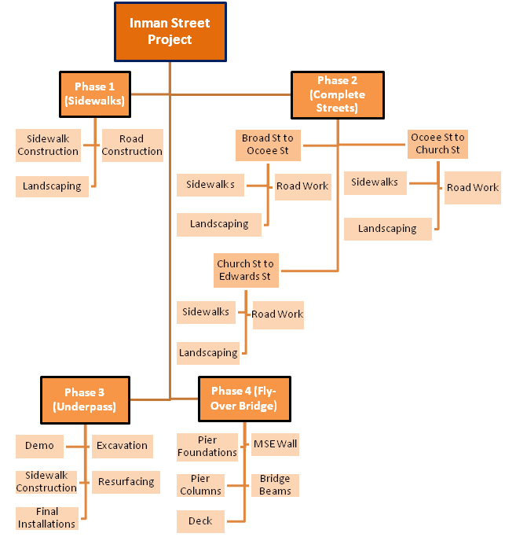

(Figure 3-1 - Scheduling Hierarchical Diagram)

Cost
A cost estimate was conducted for this project , however it was not completed. RSMeans software was used to look at estimated costs associated with the project. Some research into material cost and labor was done, but we could not come up with a solidified estimate of what was needed, so a cost estimate was not created. When conducting our research using RSMeans, we looked into using sturdier materials and machinery (i.e. aluminum formwork compared to wooden formwork).
The cost estimate would be broken down by phasing. Each phase has a different cost associated with that phase depending on labor intensive or machinery intensive. Phase One is more manual labor and some machinery (asphalt milling machine, asphalt trucks, concrete pumper truck), however, getting an estimate on how many crews to use for concrete placement can vary depending on the area the project is located. Phase Two is also labor intensive with using only the machinery needed. Cranes and other large equipment are not needed. Phase Three is machinery intensive unlike Phase One and Two. Large trucks, drilling equipment, excavators, and possible cranes are needed in this phase due to the extensive work on the underpass. Phase Four is a mix of labor intensive and machinery intensive. The fly-over bridge entails all types of labor needed.

WATER RESOURCES
Storm-water is an important consideration in the infrastructure improvements for Inman Street. Two local streams in the downtown area are listed by the Tennessee Department of Environment and Conservation (TDEC) as impaired. Inadequate storm-water management is listed by TDEC as one of the causes of impairment. The listed streams are Fillauer Creek, which runs north of Inman Street, and Woolen Mill Branch, which is located to the south. Efforts to improve the quality of these existing streams will enhance the aesthetic appeal of the downtown corridor; whereas, continued degradation of water quality would detract from the appearance of the streams.
On Inman Street, Ocoee Street is a topographic high point. Storm-water runoff on Inman will drain from Ocoee towards Keith to the west and towards the railroad underpass to the east. In order to address the flooding issues reported for the underpass, the drainage areas were delineated and the peak flow was calculated. All of the storm-water runoff in the vicinity of Inman Street to the west of the underpass is intercepted and conveyed to a 36-inch culvert. Most of the runoff from the area that is east of the railroad and north of Inman Street is intercepted and conveyed to the 36-inch pipe, as well; it does not reach the underpass, except for a small portion shown as Drainage Area C in Figure XX. The surface areas that contribute runoff to the underpass are located primarily to the east of the railroad and south of Inman Street, shown as Areas A and B. The runoff that flows to the underpass is combined in a 32” x 42” box culvert that transitions into a 42-inch round culvert.

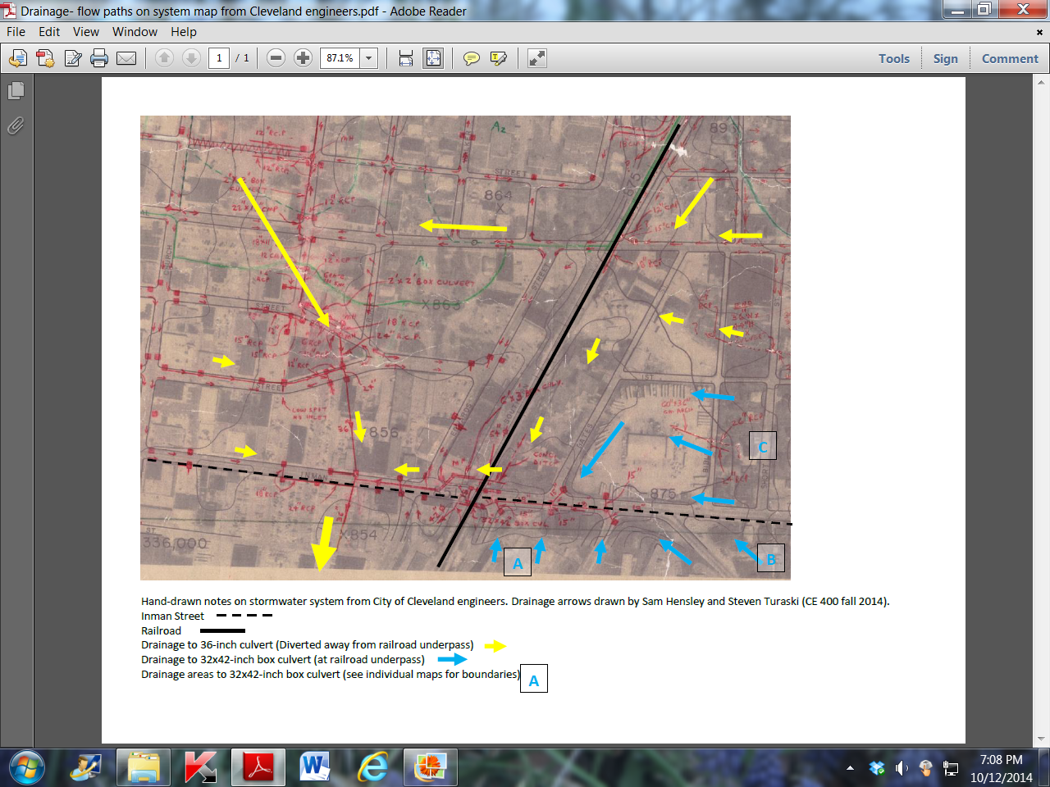
Figure XX. The yellow arrows show the flow paths for runoff that is intercepted and conveyed to a 36-inch culvert to the west of the railroad underpass on Inman Street. The blue arrows show the runoff from Drainage Areas A, B, and C that combine in a 32x42-inch box culvert at the underpass.
In order to assess storm-water infrastructure, peak runoff was calculated. A 24 hour design storm with a ten-year return interval was used in the assessment, as recommended by TDOT for local roads. The rainfall intensity for the design storm is based upon the time of concentration for runoff to collect from all drainage areas that contribute flow to the box culvert.
Given the limited amount of prior knowledge about the box culvert, a sensitivity analysis was conducted to assess a range of conditions. After looking at the worst case and best case scenarios for flow rates through the 32” by 42” box culvert located underneath the railroad and Inman Street, a range of discharge rates between 12 and 105 cfs were determined to be the allowable flows through the culvert. 12 cfs was the maximum flow when the culvert material was the roughest and the slope was the smallest, and 105 cfs was the maximum flow when the culvert material was smoothest and the slope was the largest. Due to flooding taking place at the culvert under current conditions, according to this analysis it is likely that either the slope or the smoothness of the culvert is not optimal. Upon field verification, it was confirmed that the slope of the culvert system was approximately 1%, with a roughness coefficient of 0.030, which would make the maximum allowable flow approximately 40 cfs.

Storm water runoff will have a tendency to accumulate at the underpass of the railroad bridge. The elevation on Inman Street falls in both directions towards the underpass. Excavating the road to a lower depth will only exaggerate this bowl-like effect; therefore, drainage must be considered throughout the design process for improvements to the underpass. Several alternatives are available to the City to reduce the flooding at the underpass and to improve storm-water quality. These are listed below and described in the following paragraphs:
- Divert runoff away from the box culvert where possible
- Implement storm-water BMP’s (best management practices)
- Install a pump station to convey water from the underpass during flood episodes
It appears that elevations of Drainage Area C and the 36-inch culvert would allow storm-water from this area to be diverted around the box culvert and avoid the underpass. This would reduce the peak flow the box culvert is expected to carry.

It appears that there is space available in Drainage Areas A and B for additional storm-water detention basins. These basins would reduce the peak flow of runoff to the box culvert at the underpass. The basins could be “dressed up” to provide landscaping and educational opportunities. For instance, the basins could be designed as wetlands, and instructional signs could be posted to inform the public of the benefits to area waterways. .

By implementing two detention ponds to catch flow during storm events, the peak discharge into the culvert underneath the railroad at Inman Street will be greatly reduced. Using HEC-HMS 3.5 software, these detention ponds were sized and tested against the 10 year, 24 hour storm for Cleveland, TN, which is 4.97 inches. The storm, which would exceed the 32” by 42” culvert’s capacity under current conditions, did not flood the underpass after the addition of the two proposed reservoirs. The peak discharge without implementing the two detention ponds into the culvert was 363 cfs. However, the peak discharge into the culvert after the detention ponds were included in the design was 13.8 cfs, which is far less than the culvert’s maximum capacity of approximately 40 cfs. The design is based on the assumption that if the flow rate through the culvert under the railroad is always less than its maximum allowable rate, then flooding will not occur. The dimensions for the larger detention basin at the top are 200 feet by 400 feet, with a maximum depth of 10 feet and side slopes of 2 to 1 (horizontal to vertical). The dimensions of the smaller detention basin at its top are 300 feet by 300 feet, with a maximum depth of 6 feet and side slopes of 2 to 1.

If the street is to be lowered beneath the underpass and a pump station is determined to be necessary, a single layer of coarse gravel should be installed beneath the asphalt on Inman Street to intercept groundwater seepage. Calculations indicate the amount of groundwater is minimal (less than 1 cfs) compared to the peak flow of storm-water runoff (over 100 cfs). The underlying parent material should be graded to drain to the pumping station. The pump station could be constructed of a concrete manhole and would serve as a storage reservoir to house the needed pump. The size of the pump, which would be approximately 5 horsepower, is based on the combined peak flows from the adjacent basin areas. Since the elevation of the box culvert would almost certainly be higher than the new elevation of the incoming stormwater pipe, gravity flow would no longer apply and the pressure head of the water in the pipe would have to be raised to a value of 3 feet and 2 inches. This value is equivalent to the change in elevation that the water will have to undergo if it is to successfully reach the box culvert from the pipe.

Fly-Over at Third Street Crossing
The final consideration for storm-water is to provide the needed drainage infrastructure if a new flyover is constructed as a transportation alternative to the existing underpass. Runoff from the new roadway will need to be transported to local waterways via storm-water conveyances. The profile of 3rd Street shows a local low point near the intersection with Euclid and that is where a surface conveyance could be located.

References

[1] www.nacto.org

[2] www.pedbikeinfo.org

[3] http://www.tdot.state.tn.us/traffichistory/

[4] http://www.cmfclearinghouse.org/study_detail.cfm?stid=23

[5] https://www.fhwa.dot.gov/publications/publicroads/11septoct/05.cfm

[6] http://tnmap.tn.gov/wpc/

[7]http://www.tdot.state.tn.us/Chief_Engineer/assistant_engineer_design/design/DrainManChap%201-11.htm
[8] http://www.fhwa.dot.gov/bridge/lrfd/pscus04.cfm

Appendix:
Equations for Determining Number of Lanes and Design Volume-to-Capacity Ratio
Equations for Determining Number of Lanes
Given ADT, 2% Growth, Forecast Year of 2039, K, SFL
1.1 AADT = ADT * (1+ % Growth)^(Forecast Year-Current Year)
ADT=Average Daily Traffic
AADT=Annual Average Daily Traffic
1.2 DHV = AADT * K
DHV=Design Hour Volume
K=30th Highest Hour Factor for the Design Year,
1.3 D = ADT in A Given Direction/ADT of Both Directions
D=Directional Distribution
1.4 DDHV = DHV * D
DDHV=Directional Design Hour Volume
1.5 PHF = Highest Hour Volume/(Highest 15 Minute Period Volume In That Hour * 4)
PHF=Peak Hour Factor
1.6 N = DDHV/(SFL*PHF)
SFL=Service Flow per Lane
Equations for Determining Design Volume-to-Capacity Ratio
Given: f(W), E(T), P(T), E(R), P(R), E(B), P(B), f(d)
2.1 f(HV) = 1/(1+P(T)*[E(T)-1]+P(R)*[E(R)-1]+P(B)*[E(B)-1])
F(HV)=Factor for Heavy Vehicles
P(T)=Percent Trucks
E(T)=Equivalent for Trucks
P(R)=Percent RV’s
E(R)=Equivalent for RV’s
P(B)=Percent Buses
E(B)=Equivalent for Buses
2.2 SF = DDHV/PHF
SF=Service Flow
2.3 v/c = SF/(2800*f(d)*f(W)*f(HV))
f(D)=Factor for Directional Usage
f(W)=Factor for Width of Road and Shoulders
Equations for SSD and Length of Curve
Equations for Determining SSD
Given: Grades, g(1) & g(2); Design Speed, V; reaction time, t; braking deceleration, a
3.1 SSD or S = 1.47Vt+1.075((V^2)/a)
Equations for Determining Length of Curve
Given: Grades, g(1) & g(2); Design Speed, V; Heights for Truck Drivers, h(1) & h(2); Stopping Sight Distance, SSD or S; Height above the Road, C
4.1 A = Absolute Value(g(2)-g(1))
4.2 Headlight SSD: S<L, L(min)=A(S^2)/(400+3.5*S)
4.3 Comfort: L(min) = A(V^2)/46.5
4.4 Appearance: L(min) = 100*A
Overhead SD:
4.5 If S<L, L(min) = A(S^2)/[800(C-(h(1)-h(2))/2)]
4.6 If S>L, L(min) = 2*S-[(800(C-(h(1)-h(2))/2))/A]
[S1] Equations for Determining Pedestrian/Bicycle LOS
5.1 I(p,f) = ped. LOS score for facility = [sum of I(p,seg)*L]/[total length of facility]
5.2 A(p) = AVG ped. space =60*[S(p)/v(p)]
5.3 I(b,f) = bicycle LOS score for facility = [sum of I(b,seg)*L]/[total length of facility]
[S2]

