Effect of Urbanization on Base Flow Hydrology Among Ecoregion II Catchments in Eastern United States

A Thesis Presented for the
Master of Science
Degree
The University of Tennessee, Knoxville

Barry Nolan Blanton
December 2014

Copyright © 2014 by Barry Nolan Blanton
All rights reserved.
DEDICATION

I would like to dedicate this thesis to my wife, Christina. Your interest and adoption of my goals and dreams are far from overlooked. I greatly appreciate the endless love, support, and listening from you throughout this process. You are my best friend and I know my success is tied to your dedication to our marriage, your belief in me, and the unselfishness you exhibit. I love you more than anything.

Barry

ACKNOWLEDGEMENTS

I would like to thank Dr. John Schwartz and Dr. Jon Hathaway for serving as co-advisors for this project. I would also like to thank Dr. Liem Tran for serving on my committee and providing a vast amount of technical assistance. I would like to thank each committee member for their general interest in my education, the mentorship, and advice.
I would also like to thank Matt Aplin, Jordan Hayes, Robert Woockman, James Jones, Zachariah Seiden, Benjamen Abban, and Joseph Rungee for all the research conversations and the technical assistance.

Abstract

Urbanization is a common parameter discussed among hydrologists and its effect on base flow hydrology and the 7Q10 [seven Q ten] statistic varies wildly. Population growth and urban development has grown at an alarming rate in recent years; especially in the Southern and Mid-Atlantic United States. This is due to the fact that 50% of the world’s inhabitants live in cities and over 500 cities house more than 1 million people. Development as it sprawls from urban centers is thought to have negative effects on groundwater recharge and the 7Q10. There are still questions as to how urbanization effects stream base flow. Much focus has been made regarding the use storm water control measures to control peak flows, but literature lacks analysis on the effect of urbanization on stream base flow. This study seeks an understanding of the combined effect or increased urbanization and drainage area size on the 7Q10. This study also examines the effect of reduced forest volumes on watershed hydrology. The aforementioned parameters will be the focus of more in-depth research surrounding the hydrologic responses of 95 catchments in US EPA Eco-Region II. The 95 catchments are a mixture of urban and rural and vary size from 8,815 mi² [miles squared] to 4 mi². These catchments are randomly selected inside the relatively large scale homogenous ER2 [eco region two] in an effort to detect trend that may not be visible via small more geographically concentrated studies. The 7Q10 was calculated for each gaging station and related to land cover attribute from the 1992 and 2006 NLCD. Strong correlation was found when relating the 7Q10 to drainage area. Thus, signifying a need to normalize the 7Q10 to drainage area and use this parameter as the response variable for regression. Regression shows a distinct lowering in 7Q10 at the 15-20 % [percent] urbanized situation. This result signifies that an increase in urbanization ultimately reduces the capacity of a watershed to process precipitation and recharge aquifers. The fact that 50-90 % of the true base-flow is from groundwater flow to streams only further proves this hypothesis.

Table of Contents
1.0 INTRODUCTION 1
2.0 METHODS 8
2.1 Study Design Area 8
2.1.1 Eco-Region II 8
2.1.2 USGS Gaging Stations 9
2.1.3 Stream-flow Data 10
2.1.4 Weibull Method for 7Q10 12
2.3 Defining watershed boundary 15
2.3.1 Hydrologic Data 15
2.3.2 GIS methodology (Watershed Delineation) 17
2.4 Land use 21
2.4.1 Data Reclassification 23
2.5 Statistical Modeling 27
2.5.1 Exploratory Data Analysis 27
2.5.2 Multi-Linear Regression 27
2.5.3 Classifying by percent developed 29
3.0 RESULTS 32
3.1 Results 32
3.1.1 Changes in 7Q10 32
3.1.2 Changes in Land-use 32
3.1.3 Normalized 7Q10 related to NLCD 1992 and NLCD 2006 33
4.0 DISCUSSION 42
5.0 CONCLUSION 46
LIST OF REFERENCES 48
APPENDIX 54
VITA 59

LIST OF TABLES

Table 1: Number of USGS gaging stations per state and how the spread of those stations per state vary with watershed size and development percentage. The three watershed size columns sum to equal the total number of stations per state. Similarly, the development columns also sum to equal the state totals. 11
Table 2: Big Black River near Bovina, MS. Summary table of Weibull Plotting Position Calculations 15
Table 3: Changes in 7Q10 with changes in development and forest from the early and late period. 34
Table 4: Mean, % Developed Class, and Standard Deviation from mean for 95 USGS Stations for both time periods 40
Table 5: 95 USGS Stream Gauging Stations selected for continuous average daily stream-flow data. Source is waterdata.usgs.gov. 55

LIST OF FIGURES

Figure 1: Study Design Area of ER 2 including 95 USGS Gaging Station locations 12
Figure 2: 7Q10 Graphical Procedure for the Big Black River near Bovina, MS using the Weibull plotting position 18
Figure 3: Flow Accumulation Grid showing the Relationship of USGS coordinates to the Pearl River at Burnside, MS. 21
Figure 4: Big Blue River Watershed in Shelbyville, IN with flow direction grid underlain. 22
Figure 5: Watershed Delineation Model created in Arc Map 10.0 for file iteration and standard output. 23
Figure 6: 95 Delineated Watersheds with Respective USGS Gaging Stations from Figure 1 24
Figure 7: Conceptual Model used to extract Land-cover by Mask for NLCD 1992 and 2006 reclassifications. 26
Figure 8: Bivariate fit of 7Q10 (cfs) for 1990-2008 and Drainage Area (sq. mi.) 29
Figure 9: Bivariate fit of 7Q10 (cfs) and Drainage Area for 1990-1999 and 1999-2008. 30
Figure 10: Relationship for 7Q10/DA and Percent Urbanization (Dev%) for two periods (1990-1999, 92) and (1999-2008, 06) showing a Threshold at 10-15% developed land. 31
Figure 11: Bivariate fit of 7Q10/DA for 1990-2006 to Land-use percentages for Developed (Dev%), Agricultural (Ag%), and Forested lands (FW%) from NLCD 1992 38
Figure 12: Bivariate fit of 7Q10/DA for 1999-2006 to Land-use percentages for Developed (Dev%), Agricultural (Ag%), and Forested lands (FW%) from NLCD 2006 39
Figure 13: Bivariate fit of ∆ 7Q10/DA from 1990-1999 to 1999-2008 over the ∆ in Land-use for Developed (Dev), Agricultural (Ag), and Forested/Wetlands (FW) from NLCD 1992 to NLCD 2006 41
Figure 14: 7Q10 for 1990-1999 and 1999-2008 vs Percent Development for 1992 and 2006 45

1.0 INTRODUCTION

The effect of sprawling urban and metropolitan areas is a concern for water resources management from a hydrological state of impairment (Rougé and Cai 2014). More than 50% of the world’s population resides within an urban center; with this percentage forecasted to rapidly increase in the next decade (Grimm et al. 2008). Grimm et al. (2008) reported the alarming statistic that just 10% of the world’s population lived in cities in 1900 compared to 50% in 2008. In the United States, the southern portion of the country is experiencing the largest urban growth compared to the rest of the country (Milesi et al. 2003). This is concerning with respect to watershed vulnerability, as Tran et al. (2010) showed that non-urban watersheds neighboring urban watersheds are the most vulnerable to environmental change.
One impact of urbanization is the change on catchment water budgets (Opijah and Mukabana 2004). Urbanization increases the impermeable surface area of a catchment and acts as a complex web of extremely modified natural systems and anthropogenic routing infrastructure making the landscape vulnerable to extreme weather (Barrett et al. 1999). Connected imperviousness, or impervious areas which route directly to conveyance infrastructure without a chance to slow or infiltrate, is also irrefutably a driving force in the robustness of urban hydrology degradation and should be disconnected when possible (Brabec 2009). Lee and Heaney (2003) performed small scale studies in Miami, Florida, which resulted in connected imperviousness attributing to 72% of total runoff, showing the need for disconnection. Disconnected watershed surface area attributes need to be present for the water budget to remain intact in the urbanized environment. The water budget balance is altered by excess urbanization because of the enhanced hydrologic routing. Evapotranspiration is negatively impacted by the removal of vegetation and groundwater recharge is hindered with the implementation of impervious surfaces. In addition to flow routing, aquifer pumping as a water resource activity in response to urbanization can also significantly affect the water budget (Brandes et al. 2005).
Several contradictory results are available as to how urbanization influences base flow (Fletcher et al. 2013). Base flow is defined as the flow that exists between storm events and is a necessity for stream functionality (Price 2011). O’Driscoll et al. (2010) reviews the effects of urbanization on base flow, showing that in some locations of the southern US, groundwater recharge is stimulated in heavily urbanized areas due to leaky water/wastewater infrastructure and over watering. In contrast, other studies show that base flow declines in Atlanta were attributed to urbanization (Rose and Peters 2001). Increased impermeable area would, in theory, decrease groundwater recharge and in turn, weaken base flow (Lerner 1990). Conversely, others agree with Rose and Peters (2001) and show that leaky water and waste-water infiltration and the overwatering of green-space have little effect on the base flow and can in some cases stimulate recharge (Lerner 2002, Lerner et al. 1990). However, quantifiable data on the stimulation of urban aquifers due to urban recharge from infrastructure is scarce (Lerner et al. 1990). Simmons and Reynolds (1982) found a gradual decrease in base flow with urbanization but Ku et al. (1992) found the opposite results for the same area in New York. As noted above, the general assumption by the scientific and regulatory communities is that urbanization will lower groundwater recharge such that base flow declines with increased impervious area (O’Driscoll et al. 2010). However, this relationship is complex, and Ferguson and Suckling (1990) reported that evapotranspiration, precipitation variability, and excess irrigation are likely to cause the inconsistent findings noted in literature. To add to the complexity, Easterling et al. (2000) documented precipitation increases for daily and multi-day heavy storm events for the central and eastern US. Although readily available, there has been little conclusive research about urbanization’s effect on stream base flow (Price 2011). A study which encapsulates several spatial scales, land uses, and drainage area sizes would be useful in determining general hydrological response to intense urbanization.
The 7Q10 statistic is a reasonable predictor of base flow degradation (Arnold and Allen 1999, Memon 1995). Price (2011) defines the 7Q10 as the seven day low flow average expected to occur once every ten years. The inability of a watershed to effectively infiltrate precipitation is thought to be the driving force behind base flow degradation (Shuster et al. 2007). Recharge accounts for 90% of low flows in some areas of the United States making watershed recharge capabilities irrefutably significant to base flow hydrology (Williams and Pinder 1990). The ability to recharge aquifers disintegrates over time with an increase in urbanization without appropriate storm water control measures that include infiltration (Hatt et al. 2004). Price (2011) noted that permeability is the one of the lost parameters when catchments are highly urbanized. Likewise, percolation through in situ soils is also lost in urbanized watersheds without the use of control measures due to impervious land covers (Hsieh and Davis 2005). Best management practices (BMPs) are an integral mechanism in the urban landscape for volume reduction, aquifer regeneration, storm water contamination treatment, and storm flow sequestration in an attempt to minimize channel geomorphic change (Hager 2003, Hunt et al. 2008). For this reason, stormwater management has focused on urbanization’s effect on ecosystems via high flow analysis, not low flow analysis (Hamel et al. 2013). BMPs concentrating on the treatment, harnessing, and infiltration of stormwater should be focused on in the urban environment (Hatt et al. 2004). The natural system follows a system of pathways: precipitation, evapotranspiration, runoff, infiltration, and groundwater flow (Lerner 1990). With the natural system disrupted, base flow degradation is a reasonable negative externality of insufficient groundwater recharge.
Research on land-use effects on base flow hydrology exists and is broad in scope and result. Price (2011) displays the necessity in understanding base flow processes because poor conditions are often fatally stressful for sensitive organisms and can substantially influence stream geomorphology (Boulton 2003). Schwartz and Herricks (2007) show that urbanization is the driver of ecological degradation pertaining to fish habitat in urban Illinois streams as it relates to channel morphology, contamination, and unsustained flow. Price (2011) emphasizes the need for understanding relationships between human anthropogenic alterations on watershed landscape. These studies ascertain that urbanization is harmful hydrologically and ecologically.
As stated earlier, the 7Q10 represents the lowest stream flow for seven consecutive days that would be expected to occur once every 10 years (Feaster and Cantrell 2010, USEPA 1986). The 7Q10 statistic is used extensively in the water quality realm as it pertains to waste load allocations to receiving streams in most states (Feaster and Cantrell 2010, USEPA 1986). The 7Q10 statistic is also used extensively in water resource planning (Hatcher 1984). USGS, other federal agencies, and states regularly collaborate on improvement projects concerning stream flow statistics like the 7Q10 (Dudley 2004). The 7Q10 is used expansively as a hydrologically based design flow (USEPA 1986).
Studies are prevalent with respect to stream flow responses from land use. Bellot et al. (2001) suggested that afforestation (establishment of new forest in locations where they have previously never been) hinders deep drainage to aquifers, differing from other studies. Gebert and Krug (1996) found that low flow was on the rise in agricultural and forested areas in Wisconsin. Meyer (2004) showed that median base flow rates have increased in northeastern Illinois but average flow has remained unchanged. In response to the aforementioned study by Meyer (2004), it is desirable to compare 7Q10 response over many spatial scales for trends. Base flow is defined by Sophocleous (2002) as the persistent flow that maintains stream flow between water runoff events. Meyer (2004) further noted that USGS stream flow data was not obtainable from for the period of post-war urbanization in the urban and rural environment. This rural/urban comparison and persistent flow is imperative when trying to show the affect urbanization has on base flow. Meyer (2004) concluded that an increase in urbanization did not play a role in the increase/decrease in low flows for three northern Illinois sites.
Urbanization affects channel health related to ecological and physical conditions. Leopold (1973b) conducted a substantial study of a 3.7 mi² watershed, where he concentrated on a river reach at the watershed mouth on Watts Branch River, a tributary of the Potomac River. This river is located near Rockwell, Maryland, just north of Washington, D.C., and it was monitored for 20 years. Leopold (1973b) used a standard survey methodology to measure the channel cross-sectional area, depth, width, and geographic location. He also noted sediment deposition and extreme bank erosion. Notably, from 1965 to 1971 the number of houses grew in some cases from 3 to 40 homes when comparing aerial photos of the study area. Leopold (1973b) also noted flood variability. The stream in question achieved flows of 913 cfs for the period of record. This value is nearly 24 % greater than the average flood discharge for the basin. The changes in channel shape, position, and sediment deposition are attributed to an increase in urbanization.
Hundecha and Bárdossy (2004) successfully created a model in the Rhine river basin in France using a regionalization of model parameters. Model parameters such as land use, soil type, catchment size, and topography were incorporated and sensitivity analysis was conducted. They used optimization to predict the systems response to a change in land cover (increase in urbanization). The results (predictions) of this model showed negative impacts from urbanization, including summer storms increasing peak flow and lower recharge and base flow. Hundecha and Bárdossy (2004) also found winter storms did not have a significant change in peak flow.
Hydrology of forested lands is of great interest to water resources professionals. It is believed that evapotranspiration potential is a critical parameter associated with storm water harboring and processing. Hibbert (1965) conducted a study in the 1960s with an aim to review world-wide studies on a forest’s effect on water yield. After a thorough analysis of 39 watersheds world-wide, some generalizations were made: deforestation increases water yield, afforestation decreases water yield and responses to specific forestry treatment (clear cutting or regrowth) operations vary. Interestingly, a site in Coweeta, NC was actually clear-cut and allowed to regrow for a period of time while the study was conducted. The watershed was analyzed before and after the clear-cutting of forest as well as during the regrowth stages for stream flow response to grubbing. Hibbert (1965) concluded deforestation increased water yield on the stream.
The main objective of this research was to calculate the 7Q10 for 95 selected USGS gaging stations inside three semi-homogeneous zones of Ecoregion II for two, evenly distributed time periods between 1990 and 2008.These parameters were then related to the changes in catchment land-use from 1992 to 2006 in an effort to develop a better understanding of hydrological responses associated with urbanization. Ecoregions are ecological and geological consolidations of a large regions (CEC 1997). Ecoregions provide useful homogeneity pertaining to soil classification, vegetative cover, and hydrologic function. Therefore, three zones Ecoregion II will serve as the boundary for this study. This study will analyze evenly distributed sites across the same ecoregion in differing urban versus non-urban/rural catchments. The National Land Cover Database (NLCD) for 1992 and 2006 was used for land use data (Fry et al. 2008, Fry et al. 2011). The National Hydrology Dataset (NHD) Plus Version II was used for hydrologic data (McKay et al. 2012). The aim of this research was to determine if a change in urbanization increases or decreases the base-flow (using 7Q10 as a surrogate) while considering catchment size. This work is intended to extricate the variability of previous studies by modeling the changes in base flow with respect to changes in land use at a very large spatial scale. An area of concern is artificial discharges (sewer exfiltration) and control structures. Stream gauges near weirs or storm drains will alter the flow and will impose a threat to true base flow calculations. The climatic variable was removed from this study since the period of record and large study area possess substantially differently climatic sequences across scales and considering that precipitation variability at a smaller scales is noise in the dataset over the period of record (Kokkonen and Jakeman 2002). Gaging stations 50 miles near riverine control structures were removed from the analysis. The lack of deforestation will also be explored as it pertains to catchment hydrology.

2.0 METHODS

The 7Q10, the lowest stream flow for seven consecutive days that would be expected to occur once every 10 years, was calculated using the Weibull method per each station (Helsel and Hirsch 1992). The 7Q10 values for each station were then compared to percent catchment areas of different land covers/uses to determine if there is a relationship between base flow and urbanization.

2.1 Study Design Area

2.1.1 Eco-Region II

Ecoregion II (ER2) was selected as the study design area in an effort to achieve large scale ecological and geological homogeneity. Ultimately, a large range in drainage area, hydrologic features and land use were preferred throughout the region in an effort to obtain statistically significant trends concerning 7Q10 responses to urbanization from a random population. This was accomplished by using ecoregion zones which overlay a broad range of ecological characteristics founded on geology and forest types and are essentially homogeneous at the national or sub-continental scale (CEC 1997). The three areas of ER2 selected were 8.2, 8.3, and 8.4, which are the Central USA Plains, South-Eastern USA Plains, and the Ozark and Appalachian mountains, respectively (Figure 1). Most of the gaging stations were located in the Central and Southeastern USA plains zones which consists of substantial regional homogeneity (CEC 1997). The coordinate system for US EPA ER(2) is Lambert Azimuthal Equal Area Projection (CEC 1997) (http://www.epa.gov/wed/pages/ecoregions/na_eco.htm#Level II). This coordinate system was transformed to USA Contiguous Equal Area Albers Conical USGS version to compliment NHD Plus II data hydrological data.

2.1.2 USGS Gaging Stations

Initially, a substantial number of USGS gaging stations were populated from the National Water Information System (NWIS) residing within the aforementioned regions. The USGS daily surface water interface provides daily data for more than 26,000 sites (USGS 2001). Of these sites, all sites in the continental United States reporting continuous daily mean discharge (cfs) from January 1, 1990 to December 31, 2008 were downloaded simultaneously in “comma separated value” (csv) format. Relevant gaging stations were then extracted from the study design area using ArcMap 10.0. The csv from NWIS was imported into ArcMap as a point feature class and the gaging stations that overlain the study design area were extracted using the clip tool in ArcMap. This operation yielded 2,071 gaging stations with reported continuous mean discharge data for the study design area (ESRI 2011).
Next, the alteration of flow-regime from control structures had to be considered. Richter et al. (1996) explored hydrologic regime features such as magnitude, frequency, rate of change, duration and timing; all of which can be altered by control structures such as dams. Richter et al. (1996) accomplished this through a series of pre- and post-dam hydrographs from altered river systems. For this reason, all USGS gaging stations within a 50 mile radius of a dam were excluded from the data set (US Army Corps of Engineers 1998). Future studies could narrow this exclusion using a river tracing method in ArcMap 10.0. This method could capture more usable gaging stations by linearly tracing the stream network and not excluding usable stations adjacent to dams residing in a catchment essentially unaffected by the dam (ESRI 2011). Buffering the stations at 50 miles narrowed the population to 294 stations with reported continuous data to be used as pour points (USGS Gaging Stations) for this study. The final culling of sites was performed based on the presence of continuous stream-flow data, which was present over the period of record for 95 sites (Appendix Table 5). USGS uses the World Geodetic System (WGS) 1984 as the coordinate system for gaging stations (USGS 2001). This coordinate system was transformed to USA Contiguous Equal Area Albers Conical USGS version to compliment NHD Plus II data hydrological data.

2.1.3 Stream-flow Data

Daily mean stream flow data were readily available from USGS via the National Water Information System (NWIS) web interface (USGS 2001) (http://waterdata.usgs.gov/nwis). The collection of continuous mean daily flow over the period of January 1, 1990 to December 31, 2008 was attempted for 294 stations but could only be obtained for 95 stations as noted above. Table 1 represents a summary of the 95 watersheds corresponding to USGS gaging stations by state, drainage area size, and development percentage. The importance of period of record revolves around the accurate representation of 7Q10 for a time period. Moreover, the longer the continuous record, the more representative the calculated 7Q10 is of the true lowest flow statistic to occur once every 10 years. Since the 7Q10 is an important low flow statistic, a long period of record is desirable to balance out very high and very low flows (Feaster and Cantrell 2010). Feaster and Cantrell (2010) explored the 7Q10 for South Carolina streams for the first 10 years of the period of record adding 5 years to the period of record in a step wise fashion until reaching present day. The difference in the high and low 7Q10 reported by Feaster and Cantrell (2010) was 14%. This study design removes this phenomenon caused by climate variably, by expanding several spatial scales, drainage areas, and catchment land use (Kokkonen and Jakeman 2002).

Table 1: Number of USGS gaging stations per state and how the spread of those stations per state vary with watershed size and development percentage. The three watershed size columns sum to equal the total number of stations per state. Similarly, the development columns also sum to equal the state totals.
State | Number of USGS Gaging Stations | Small Watersheds (< 100 mi²) | Medium Watersheds (100 mi² - 500 mi²) | Large Watersheds (> 500 mi²) | Less than 10 % Developed (2006) | Average Developed 10-40 % (2006) | More than 40 % Developed (2006)
AL | 4 | 1 | 1 | 2 | 1 | 3 | -
AR | 1 | - | - | 1 | 1 | - | -
FL | 1 | - | - | 1 | 1 | - | -
GA | 7 | 2 | 1 | 4 | 7 | - | -
IL | 17 | 9 | 6 | 2 | 4 | 5 | 8
IN | 9 | - | - | 9 | 7 | 2 | -
KY | 1 | - | 1 | - | - | 1 | -
LA | 5 | 1 | 3 | 1 | 5 | - | -
MI | 8 | 2 | 4 | 1 | 4 | 2 | 2
MO | 2 | - | 1 | 1 | 2 | - | -
MS | 6 | - | 3 | 3 | 6 | - | -
NC | 12 | - | 3 | 9 | 8 | 4
NJ | 1 | - | - | 1 | 1 | - | -
NY | 2 | - | 2 | - | 2 | - | -
OH | 1 | - | - | 1 | 1 | - | -
OK | 1 | - | 1 | - | 1 | - | -
SC | 3 | - | 1 | 2 | 1 | 2 | -
TX | 3 | 1 | 2 | 1 | 3 | - | -
VA | 5 | 1 | 1 | 3 | 4 | 1 | -
WI | 4 | 1 | 2 | 1 | 2 | 1 | 1
WV | 2 | - | 2 | - | 2 | - | -
Totals | 95 | 18 | 34 | 43 | 63 | 21 | 11
Range | - | 4-100 | 123-498 | 499-8815 | 0.02-0.10 | 0.10-0.40 | 0.40-1.0
Mean | - | 53 | 306 | 2144 | 0.70 | 0.18 | 0.44
Median | - | 34 | 306 | 1229 | 0.07 | 0.16 | 0.28
Standard Deviation | - | 37 | 123 | 2129 | 0.02 | 0.07 | 0.33

Many stations reported no data and had missing years making the calculation of 7Q10 impossible without interpolating the data and filling these gaps. Once data were populated for each gaging station, a Microsoft (MS) Excel spreadsheet was created for each respective station in exact format. Complimentary formatting is imperative where repetitive calculations over several spreadsheets are needed as the use of programming can drastically lessen time requirements (Abban 2014, Seiden 2014).

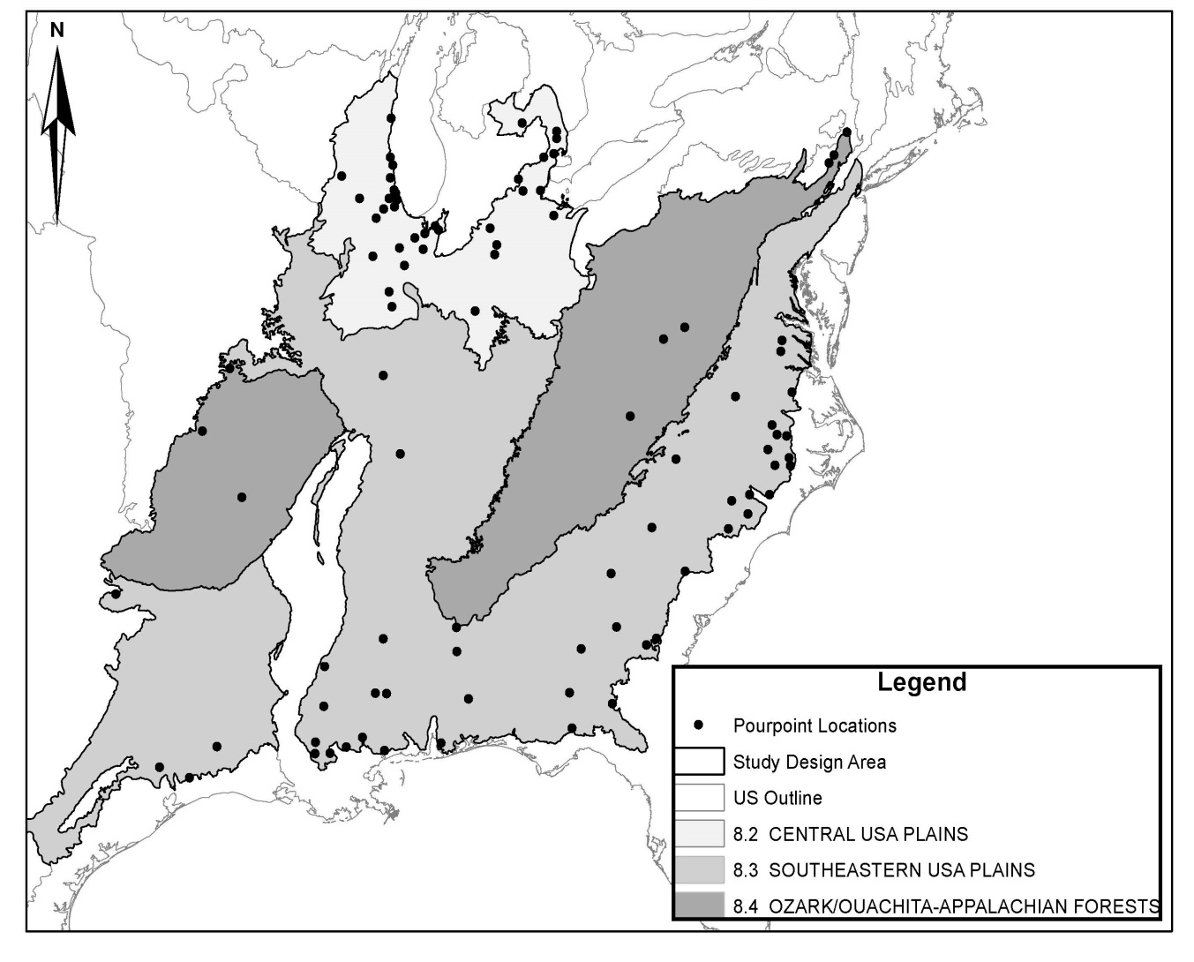
Figure 1: Study Design Area of ER 2 including 95 USGS Gaging Station locations

2.1.4 Weibull Method for 7Q10

The data from USGS and the NWIS were assumed accurate. From this data, the 7Q10 was found using the Weibull method via MS Excel. Substantial research exists on appropriate probability distributions for flood flow; however, few references exist for low flow probability studies (Vogel and Kroll 1989). The wide spread of use probability plotting for estimating goodness of fit for flood flow distributions was employed by Vogel and Kroll (1989) for regional low flow estimations via the Weibull and log-Pearson distribution (Vogel and Wilson 1996). The Weibull plotting position methodology commonly used among hydrologists for flood flow frequencies and can also be applied to effectively estimate low flow frequencies (Langbein 1960).
Flow duration curves were created to calculate exceedance frequencies for each of the 95 stations (Figure 1). The lowest 7 day average for each year in the period of record was calculated using MS Excel software by taking the average flow for the first week of data and copying this formula over the entire period in a moving window. Next, the minimum flow value was selected from the range of recurring 7-day averages for each year. This formula was copied over the entire range producing an associated lowest 7 day average for each year in the period of record. This was performed by utilizing a custom sorting tool in MS Excel that will allow neighboring columns to follow the sort. The flows were then ranked in ascending order with the lowest flow receiving a rank of one and so on. The Weibull plotting position was then calculated using the following equation (Weibull 1939).

W = i / ( n + 1) (1)
Where;
W is the non-exceedance probability
i is the rank assigned to year
n is the number of years

The recurrence interval (RI) was then taken to be the quotient of the rank to the non-exceedance probability. The base 10 logarithm of the flow was then plotted over the recurrence interval and a logarithmic line of best fit was added to the graph (Helsel and Hirsch 1992, U.S. Interagency Advisory Committee on Water Data 1982). This curve represents the theoretical low flow or the fundamental curve of low flow (Martin and Arihood 2010). However, relying on the statistical output alone is ill-advised and should be compared to actual low flows and verified based on hydrologic judgment (Riggs 1972). Table 2 displays the aforementioned procedure for the Big Black River near Bovina, MS, and Figure 2 displays the graphical representation. The tables for the short period of records are not displayed but were built in the same manner. The Big Black River watershed is 2,749 mi² and was primarily a forested catchment in 1992 with 68% forest and 6% development. The 7Q10 can be calculated either from the line of best fit at a 10 year recurrence interval or from the MS Excel gradient and intercept functions embedded in the ordinate and abscissa columns (log flows to RI). For this study, a macro was written to perform the necessary Excel movements for all 95 catchments (Abban 2014, Seiden 2014). Each 7Q10 value was extracted and added to master file for interpretation. The 7Q10 for this station was reported as 106 cfs, 91 cfs, and 101 cfs for the entire range, 1990-1999 range, and 1999-2008 range, respectively. The 7Q10 for the final range (1999-2008) was most similar to the actual lowest flow at a 10 year recurrence interval from Table 1. This was true for almost every station.

2.3 Defining watershed boundary

2.3.1 Hydrologic Data

Watershed delineation was performed in ArcMap 10.0. Data were available for the entire US in the form of flow accumulation and flow direction raster layers from the National Hydrology Dataset (NHD) Version II web interface (McKay et al. 2012) (http://www.horizon-http://www.horizonsystems.com/NHDPlus/NHDPlusV2_data.php). The NHDPlus II data is divided into regions referred to as vector processing units (VPUs) which are essentially the major drainage areas of the United States (McKay et al. 2012). The resolution of this data was 30 by 30 meter grid. Each VPU is comprised of smaller areas known as raster processing units (RPUs). The study design area required 13 VPUs as followed: 03S South Atlantic Region, 03N South Atlantic North, 02 Mid-Atlantic, 01 Northeast, 03W South Atlantic West, 04 Great Lakes, 06 Tennessee, 05 Ohio, 08 Lower Mississippi, 07 Upper Mississippi, 10L Lower Missouri, 11 Arkansas-Red-White, and 12 Texas. Flow accumulation and flow direction RPUs were downloaded from the NHDPlus Version II and imported into ArcMap 10.0.
Table 2: Big Black River near Bovina, MS. Summary table of Weibull Plotting Position Calculations
year | Min flow (cfs) | Ranked Year | Ranked Min Flow (cfs) | Rank | W | RI (YR) | log( 7 Day Min) (cfs)
1990 | 88 | 1990 | 88 | 1 | 0.0500 | 20.00 | 1.944482672
1991 | 326.7143 | 2000 | 100.71429 | 2 | 0.1000 | 10.00 | 2.003091077
1992 | 134 | 1992 | 134 | 3 | 0.1500 | 6.67 | 2.127104798
1993 | 204.7143 | 2007 | 143.14286 | 4 | 0.2000 | 5.00 | 2.155769682
1994 | 319.7143 | 2006 | 165.85714 | 5 | 0.2500 | 4.00 | 2.21973418
1995 | 188.5714 | 1999 | 168.14286 | 6 | 0.3000 | 3.33 | 2.225678423
1996 | 293.1429 | 1998 | 178.14286 | 7 | 0.3500 | 2.86 | 2.250768413
1997 | 257.4286 | 1995 | 188.57143 | 8 | 0.4000 | 2.50 | 2.275475891
1998 | 178.1429 | 1993 | 204.71429 | 9 | 0.4500 | 2.22 | 2.31114815
1999 | 168.1429 | 2002 | 212 | 10 | 0.5000 | 2.00 | 2.326335861
Table 2 Continued.
YEAR | Min flow (cfs) | Ranked Year | Ranked Min Flow (cfs) | Rank | W | RI (YR) | log( 7 Day Min) (cfs)
2000 | 100.7143 | 2004 | 246.14286 | 11 | 0.5500 | 1.82 | 2.391187237
2001 | 249.2857 | 2001 | 249.28571 | 12 | 0.6000 | 1.67 | 2.396697391
2002 | 212 | 2008 | 254.71429 | 13 | 0.6500 | 1.54 | 2.406053303
2003 | 339.4286 | 1997 | 257.42857 | 14 | 0.7000 | 1.43 | 2.410656747
2004 | 246.1429 | 1996 | 293.14286 | 15 | 0.7500 | 1.33 | 2.467079316
2005 | 324 | 1994 | 319.71429 | 16 | 0.8000 | 1.25 | 2.504762042
2006 | 165.8571 | 2005 | 324 | 17 | 0.8500 | 1.18 | 2.51054501
2007 | 143.1429 | 1991 | 326.71429 | 18 | 0.9000 | 1.11 | 2.514168125
2008 | 254.7143 | 2003 | 339.42857 | 19 | 0.9500 | 1.05 | 2.530748396

Flow direction was defined by evaluating 8 cells in a grid from the center cell determining the steepest slope. This was performed for every grid and surrounding neighbors until the entire raster was converted into a direction raster from slope (Chinnayakanahalli et al. 2006). From the flow direction raster, flow accumulation was obtained by summing all uphill cells. This results win a grid of cells (30 by 30 meters in this case) that looks similar to a stream network (Chinnayakanahalli et al. 2006). A fundamental component of this procedure is having a mosaic of the required VPUs. A mosaic joins several files into one. This is beneficial for analyzing data over very large spatial scales or when file iterators are employed for repetitive operations. The iterator gathers data from one large dataset instead of several small datasets. The mosaic tool within ArcToolbox (GIS tools) was utilized while exercising caution over seam line distortion. The seam lines need to blended together (option as part of the mosaic tool) or the product of the mosaic will not perform watershed delineation properly (ESRI 2011) (McKay et al. 2012).

2.3.2 GIS methodology (Watershed Delineation)

GIS allows delineation without the human perception of topography; thus, removing the potential of human error (Chinnayakanahalli et al. 2006). This assumes the appropriate coordinate systems are used and the latitude and longitude of the USGS data have been correctly reported. The fundamental goal considering the use of GIS for this research was precise watershed delineation. Watershed delineation via GIS requires USGS coordinates, a hydro-digital elevation model (DEM), flow accumulation, and flow direction input files (Chinnayakanahalli et al. 2006). The DEM was not a necessary input for this study because

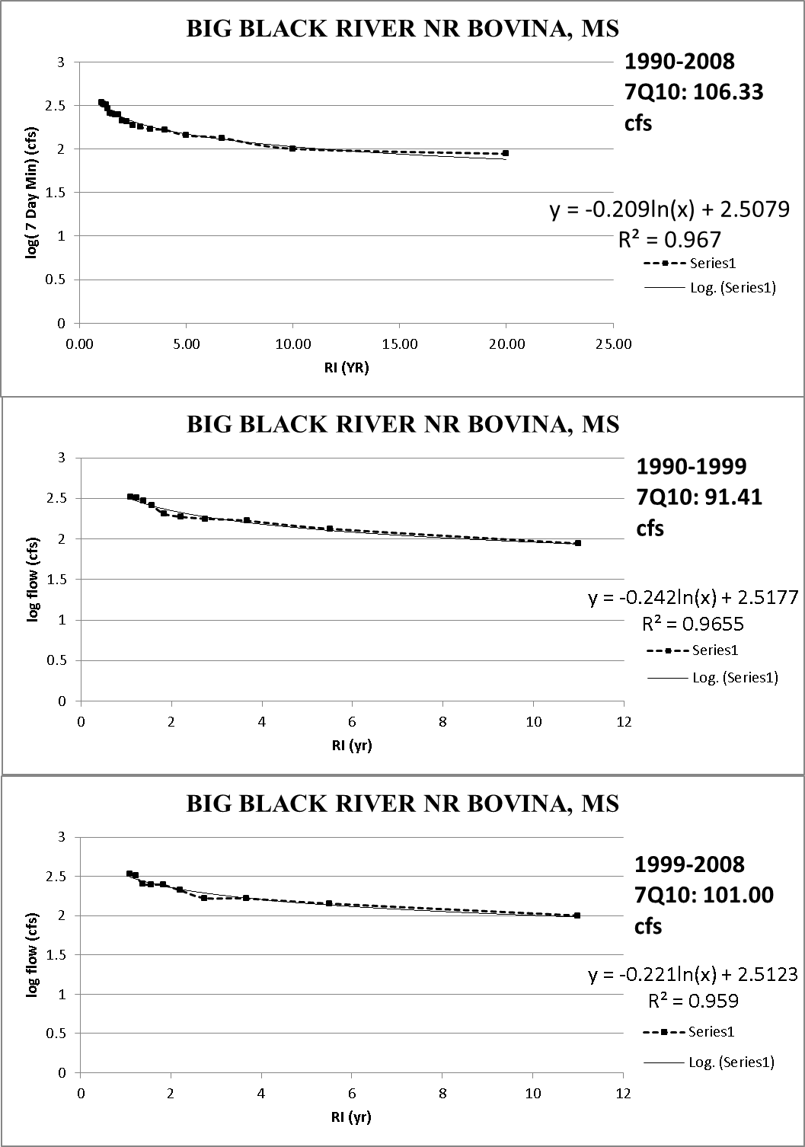
Figure 2: 7Q10 Graphical Procedure for the Big Black River near Bovina, MS using the Weibull plotting position

of the readiness of flow accumulation and flow direction files from NHD Plus II (McKay et al. 2012). Flow accumulation and direction were downloaded, unzipped, and imported into ArcMap. Once the mosaic was a success, pyramids needed to be built for each mosaic to ensure
appropriate display performance of layers (ESRI 2011).
The first step in effective watershed delineation is ensuring that USGS latitude and longitude lie within the appropriate flow accumulation grid cell. This must be accomplished either with the snap to pour point tool within the hydrology toolset in Arc Map or by visually inspecting the disparity between USGS reported latitude and longitude and the stream or river. The latter must be done remotely using Google Earth for a study of this caliber. One must search the gaging station coordinates in google earth and inspect where the coordinate is in relation to the stream. The actual USGS gaging station can be viewed via Google Earth Street View tool in most cases (https://www.google.com/earth/). The gaging station is almost always near a road bridge which makes viewing the station easy via satellite. It was imperative to adjust the pour point locations to a point inside the appropriate flow accumulation grid for accurate watershed delineation. Simply using the snap to pour point tool in GIS works for short snapping distances but should be avoided for distances exceeding the square root of the grid area (30 meters). If pour point adjustment was not performed, watersheds with a very large or small surface area compared to the actual area could possibly be delineated which would not be representative of corresponding gaging station flows. This would lead to misleading results when trying to account for changes in low flows with changes in land use. A pictorial representation of the above mentioned issue can be viewed in Figure 3. Once the appropriate location of the gaging station was identified, the editor toolbar was utilized to create a new point feature class for the gaging station. The new points are referred to as adjusted points. Figure 3 shows the proximity of USGS Gaging Station 02481880 corresponding to the Pearl River in Burnside, MS. The coordinates gathered from USGS reported this station being nearly 50 meters from the stream. Each station was inspected using this above methodology and points were created for stations not aligning with the stream. The adjusted points were used for watershed delineation (Chinnayakanahalli et al. 2006, ESRI 2011).
Watershed delineation was effectively accomplished using watershed tool in the Hydrology toolbox in Arc Map 10.0 (ESRI 2011). There are effective tools for multi-watershed delineation that account for pour point snapping using very intelligent algorithms which reports snapping distance and the snapped flow accumulation cell (Chinnayakanahalli et al. 2006). However, these tools are for earlier versions of GIS and were not used. Model Builder is a powerful tool in GIS which can also be used to iterate through a file of folders when a repetitive task is necessary. Since 95 watersheds were delineated, Model Builder was an appropriate and necessary tool. The adjusted pour point folder was the input feature class and the mosaic of all 13 flow direction rasters was used for flow direction input in the watershed tool. As a visual representation of the flow direction grid, Figure 4 is provided. The flow direction grid essentially mirrors the DEM. Figure 4 is a map of the Big Blue River in Shelbyville, IN, with its respective transparent watershed overlain the flow direction raster. Once the watershed model was complete, attribute tables were populated for each output raster so watershed area could be calculated. The conceptual model can be viewed in Figure 5. This tool populated 95 delineated watersheds. A check was performed between the delineated watershed size and published watershed areas from USGS. These comparative results were good; as the average watershed
area from delineation was only 0.17 % different from the reported watershed size from USGS. Figure 6 displays a map all 95 delineated watersheds with their respective pour points.

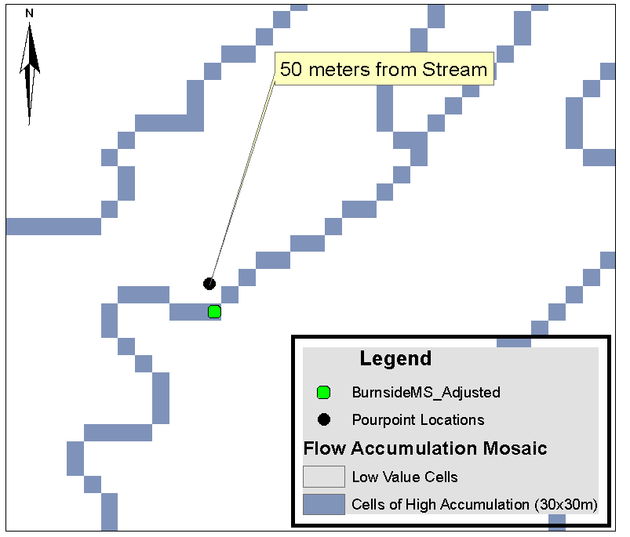
Figure 3: Flow Accumulation Grid showing the Relationship of USGS coordinates to the Pearl River at Burnside, MS.

2.4 Land use

The task of extracting land cover for 95 catchments required the use of a Model Iterator tool in Arc Map 10.0. The (NCLD) 1992 and 2006 were downloaded from the Multi-Resolution Land Cover Characteristics Consortium (MRLC) and imported into Arc Map (http://www.mrlc.gov/).

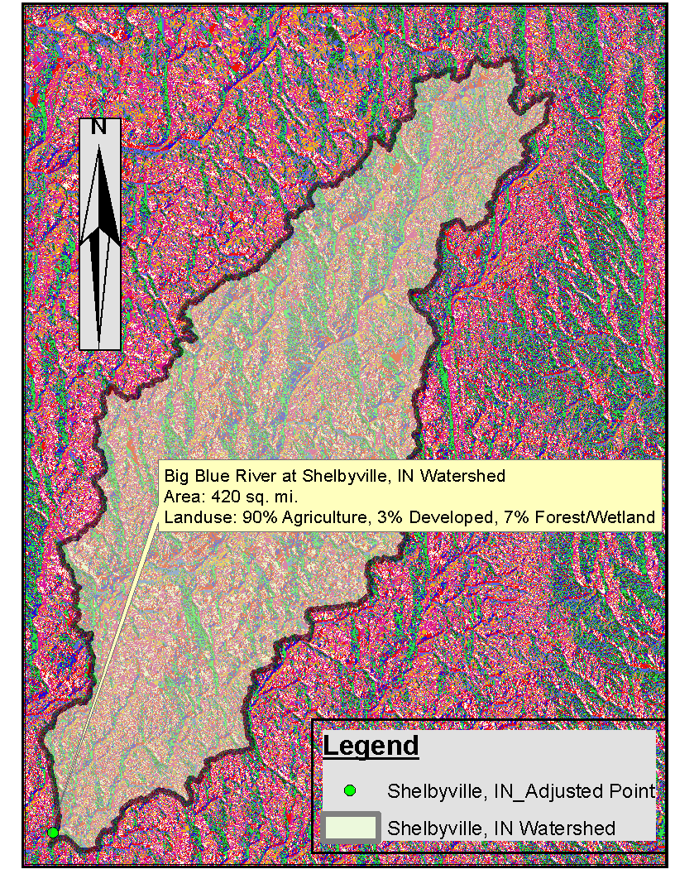
Figure 4: Big Blue River Watershed in Shelbyville, IN with flow direction grid underlain.
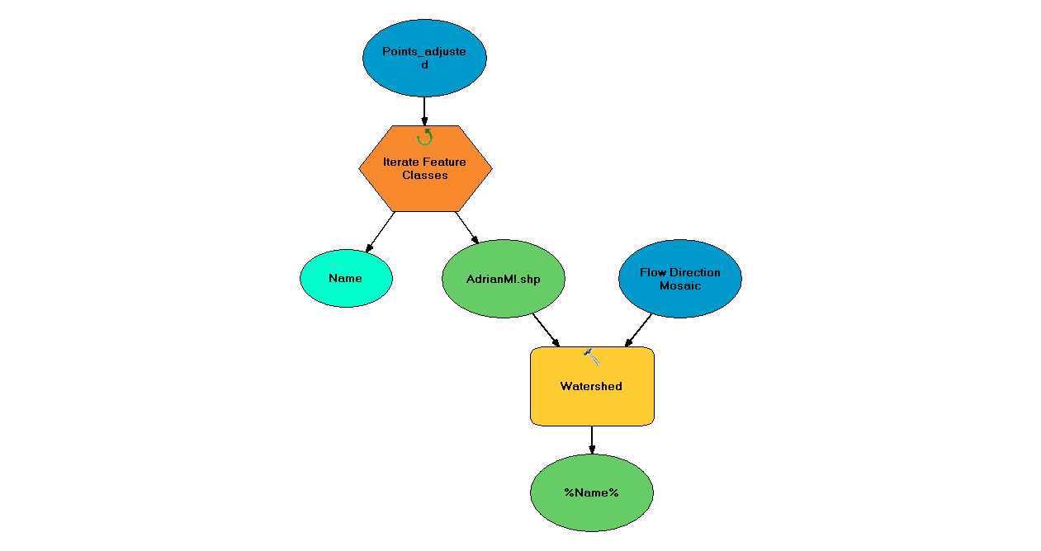
Figure 5: Watershed Delineation Model created in Arc Map 10.0 for file iteration and standard output.

2.4.1 Data Reclassification

Land use was extracted from 95 watersheds in the eastern US by means of Model Builder in Arc Map 10.0. It was necessary to reclassify the both the 1992 and the 2006 land cover data
sets to a common system for comparison. NLCD 1992 is a 21 class system modified from the Anderson classification system with a spatial resolution of 30x30 meters (Vogelmann et al. 2001). NLCD 2006 is a 16 class system modified from the Anderson classification scheme at a resolution of 30x30 meters (Fry et al. 2011). Since the previous data have different classifications and were mapped differently, a common classification scheme is needed to compare them directly (Fry et al. 2008).

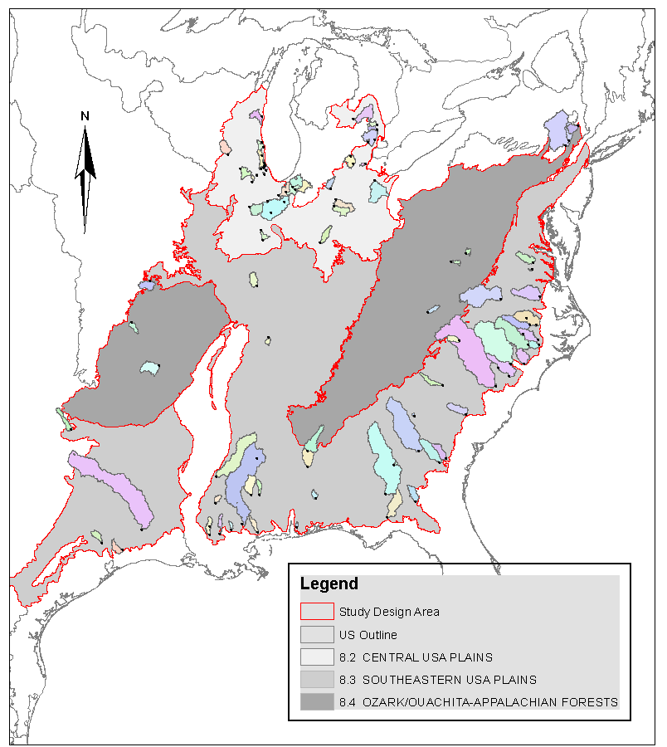
Figure 6: 95 Delineated Watersheds with Respective USGS Gaging Stations from Figure 1

The NLCD 1992 retrofit change product manual is provided as a guide for land cover reclassification and was used in this study. All forested and wetland areas were grouped, all developed areas were grouped, and agricultural areas were grouped. The 1992 legend was transformed to match the 2006 legend before reclassification. This was necessary as many of the classes in 1992 did not exist for 2006. Urban and recreational grasses were reclassified as developed open space and the barren class (clear cut forests) was added to the forest class to match 2006. As far as agricultural differences, orchards and vineyards in the 1992 dataset were reclassified to agricultural land to match 2006. Once the legends for both NLCD 1992 and NLCD 2006 matched, they were both re-classified into a four class system: Forest/Wetland, Agricultural, Developed, and No Data. No data was populated from open water and barren rocks (Fry et al. 2008). Land use was then extracted in an in iterative fashion using spatial analyst tools embedded in Model Builder. The spatial reference of the NLCD already matched the NHD Plus II data so no transformation was needed. The NLCD raster files were imported to GIS as an .IMG raster requiring a transformation to a GRID raster before raster processing could occur. The first process in Figure 7 shows the conversion of each watershed raster to a polygon feature class. The land cover extraction from each shape was then performed followed by pyramid building which was required to stimulate processing time (turning on and off layers). The final steps signify the addition of a column to each individual attribute table and the insertion of a formula in that field to automatically calculate the area in mi² for forests/wetlands, agriculture, developed area, and areas of no data (Chinnayakanahalli et al. 2006, ESRI 2011). The 1992 dataset will be defined as ‘early’ and the 2006 dataset as ‘late’ throughout this study.

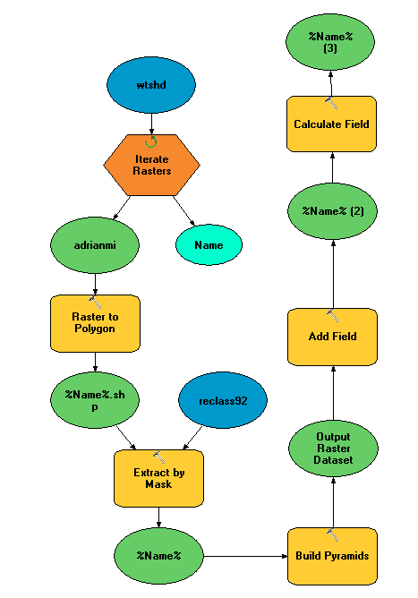
Figure 7: Conceptual Model used to extract Land-cover by Mask for NLCD 1992 and 2006 reclassifications.

2.5 Statistical Modeling

2.5.1 Exploratory Data Analysis

Exploratory data analysis (EDA) is considered a first look at a collected system of data and can often suggest appropriate statistical models for a given analysis (Helsel and Hirsch 1992). EDA was accomplished in this study by plotting scatter plots comprised of flows on the ordinate and explanatory variables on the abscissa. The flows chosen as response variables were: 7Q10 (cfs) for the entire period of record, 7Q10 (cfs) from 1990-1999 (early period), 7Q10 (cfs) for 1999-2008 (late period), the change in 7Q10 (cfs) between the two intervals, and the % change in 7Q10. Explanatory variables included land use percentages for 1992 and 2006, drainage area, the change in land use between 1992 and 2006, and the percent change in land use between 1992 and 2006. Early period 7Q10 was related to 1992 land use. Similarly, late period 7Q10 was related to 2006 land use. Results from EDA showed strong correlation between 7Q10 and drainage area. Because of the strong presence of co-variance between 7Q10 and drainage area, it was decided that 7Q10 would be normalized by drainage area for further statistical analyses.

2.5.2 Multi-Linear Regression

Regression statistics were performed for a variety of scenarios. 7Q10 values were always respondents (dependent variable) and land use percentages were always the predictors (independent or explanatory variables). Step wise regression was performed in the statistical software package JMP for trend identification. A desirable R² of 0.88 was initially obtained in performing the regression but was found to be spurious because of a strong correlation between 7Q10 and certain predictors that have no practical relationship to the respondent. For example, the regression that reported an R² of 0.88 correlated the ∆7Q10 to only the land cover in 1992 instead of the ∆ land cover between 1992 and 2006. Caution should be exercised when performing multiple linear regression analysis on data. Immediate results from software should never be trusted alone (Hathaway et al. 2010, Helsel and Hirsch 1992). Using linear regression models, the normalized 7Q10 for each time period was regressed against corresponding land use percentages. Break points or thresholds were desired with respect to land use percentages relationships. For example, if the 7Q10 of a normalized watershed is not affected until the development reaches a certain percentage, one can hypothesize that as the development increases, the base flow is degraded. The bivariate fit of the 7Q10 for 1990-2008 over drainage area can be viewed in Figure 8 (R² = 0.68). Figure 9 represents the bivariate fit of the early and late 7Q10 distributions over the respective drainage area and also each exhibit fair correlation (R² = 0.74 for 1990-1999 and R² = 0.61 for 1999-2008). The correlation between 7Q10 and drainage area for each 7Q10 value is good and demonstrates co-variance. For this reason, the 7Q10 for each snap shot in time was normalized to create a new variable which served as the response variable for regression.
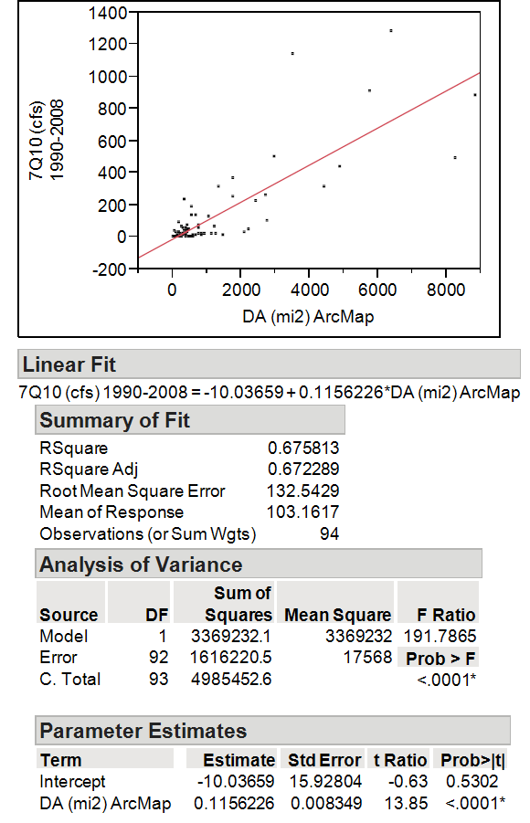
Figure 8: Bivariate fit of 7Q10 (cfs) for 1990-2008 and Drainage Area (sq. mi.)

2.5.3 Classifying by percent developed

Linear regression models displaying significant thresholds when a certain percent of land cover was reached on the abscissa warranted additional analysis. When regressing the normalized 7Q10 (7Q10/Drainage Area) over the percent of developed land, agricultural land, and forests/wetlands, some distinct thresholds existed for the developed land regression which appeared to be change points in the data. For instance, near the 10-15% developed range, the scatterplot between 7Q10/DA and Dev (%)_92 resembled a 90 degree angle and moved

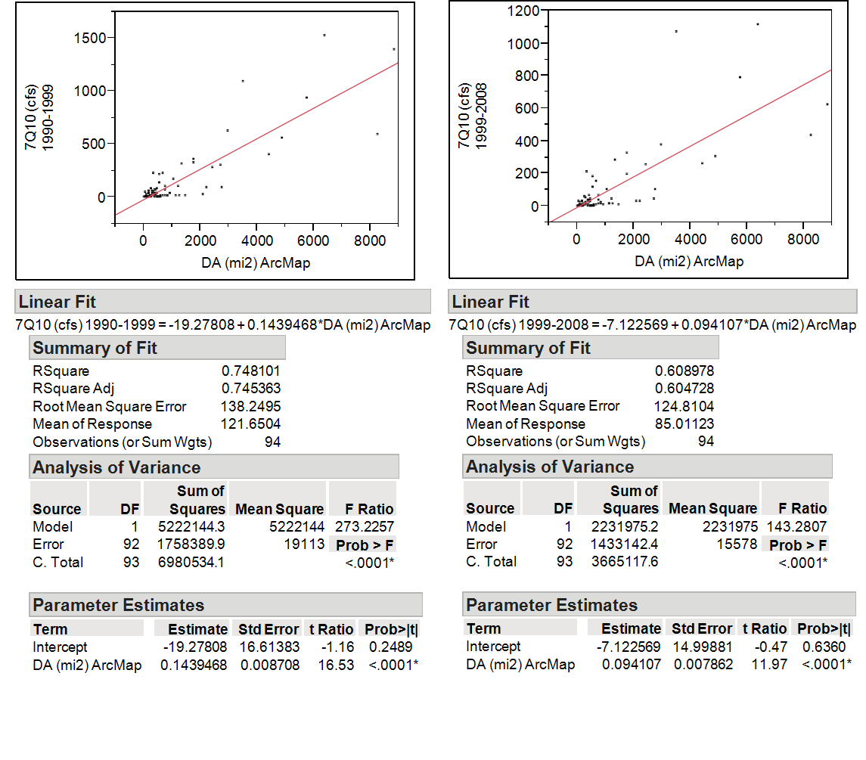

Figure 9: Bivariate fit of 7Q10 (cfs) and Drainage Area for 1990-1999 and 1999-2008.

horizontally across the abscissa signifying a change in the relationship between 7Q10/DA and Dev(%)_92 when watershed development reached this point, and the hypothesis that base flow degradation appears to strike a threshold of importance at this level of development (Figure 10). These relationships were also explored for the 2006 land cover classes. Dividing data into a class variables of > or <, 10-15% was performed and further explored.

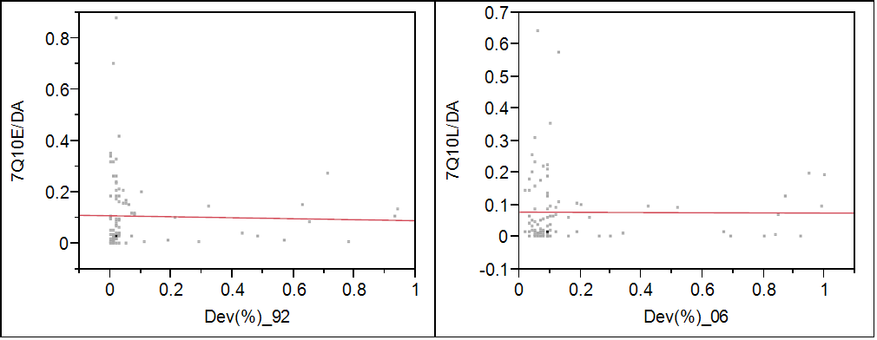
R²= 0.006
P= 0.211
R²= 0.063
P= 0.014
Figure 10: Relationship for 7Q10/DA and Percent Urbanization (Dev%) for two periods (1990-1999, 92) and (1999-2008, 06) showing a Threshold at 10-15% developed land.

3.0 RESULTS

3.1 Results

3.1.1 Changes in 7Q10

The change in 7Q10 over each time period was of note, as 82% of the watersheds had a 7Q10 decrease from (1990-1999) to (1999-2008). Table 3 below shows this change for each watershed. This result displays a general trend of base flow lowering throughout time over a very large spatial scale. Given that land use and climate are the only explanatory variables and that climate can be removed at this scale, base flow lowering can be attributed to land use changes.

3.1.2 Changes in Land-use

Land cover was successfully extracted from 95 catchments for NLCD 2001 and 2006. The 7Q10 was calculated for 95 USGS gaging stations with a period of record from 1990-2008. An early period 7Q10 was calculated from 1990-1999 to compare to NLCD 1992 for each catchment. A late period 7Q10 was calculated from 1999-2008 to compare NLCD 2008 for each catchment. The percentage of the developed area across the population increased from 10% to 18% of the combined total watershed surface areas. An 8% increase in development translates into 7,373 mi² of new watershed development from 1992-2008 across all basins. The largest increase was in a 128 mi² watershed in Dyer, WV. The developed area in this watershed increased by 63%. The smallest urban land increase occurred in a 4 mi² in Urbana, IL that was 93% developed in 1992. This watershed increased by almost 8% making it 100% developed. Every watershed possessed an increase in development (Table 3). Most watersheds showed a decrease in agricultural use (Table 3). More often than not, the percentage of forests/wetlands went down. However, in some cases the percentage of forests/wetlands increased. This is most certainly due to the increased incorporation of constructed wetlands as BMPs, the mandated stimulation of emergent wetlands, and park construction. This could also be attributed to small scale agricultural land abandonment which would lead to forest growth without proper maintenance.

3.1.3 Normalized 7Q10 related to NLCD 1992 and NLCD 2006

Normalized 7Q10/DA values were used as the response for each land cover predictor. It was expected that watershed with high forest content would show a high 7Q10. Similarly, it was expected that 7Q10 values remain high when agricultural land dominated. However, both of these relationships for both the early and late period reported insignificant p-values (Figure 11). The aforementioned relationships can be seen in Figure 11 which shows percent land use as a decimal. Interestingly, the points on the developed graph in Figure 10 prominently display an L shape representing a threshold.

Table 3: Changes in 7Q10 with changes in development and forest from the early and late period.
USGS Gaging Station | City | State | DA (sq mi) ArcMap | 7Q10 (cfs) 1990-2008 | 7Q10 (cfs) 1990-1999 | 7Q10 (cfs) 1999-2008 | Change in Q | Change in Dev | Change in Forest | Change in Agriculture
2374500 | Evergreen | AL | 176 | 93.63 | 61.6 | 31.93 | Decrease | Increase | Decrease | Decrease
2378500 | Silver Hill | AL | 56 | 37.88 | 49.09 | 32.28 | Decrease | Increase | Decrease | Decrease
2425000 | Marion Junction | AL | 1765 | 250.41 | 322.6 | 194.38 | Decrease | Increase | Decrease | Decrease
2424000 | Centreville | AL | 1026 | 131.46 | 169.09 | 103.16 | Decrease | Increase | Increase | Decrease
7056000 | St. Joe | AR | 829 | 15.1 | 15.4 | 13.02 | Decrease | Increase | Decrease | Increase
2329000 | Havana | FL | 1142 | 20.27 | 16.4 | 18.69 | Increase | Increase | Decrease | Increase
2193340 | Washington | GA | 34 | 0.03 | 0.058 | 0.006 | Decrease | Increase | Decrease | Increase
2349900 | Byromville | GA | 48 | 1.98 | 2.5 | 1.61 | Decrease | Increase | Increase | Decrease
2225500 | Reidsville | GA | 1132 | 16.42 | 16.44 | 13.38 | Decrease | Increase | Increase | Decrease
2203000 | Claxton | GA | 560 | 0.46 | 0.357 | 0.394 | Increase | Increase | Increase | Decrease
23177483 | Bemiss | GA | 498 | 0.508 | 0.792 | 0.248 | Decrease | Increase | Decrease | Decrease
2353000 | Newton | GA | 5756 | 908.42 | 933.98 | 791.42 | Decrease | Increase | Increase | Decrease
2223500 | Dublin | GA | 4403 | 313.61 | 406.59 | 259.5 | Decrease | Increase | Increase | Decrease
3380500 | Wayne City | IL | 455 | 0.004 | 0.006 | 0.0009 | Decrease | Increase | Decrease | Increase
5525500 | Milford | IL | 447 | 3.88 | 2.53 | 4.05 | Increase | Increase | Increase | Decrease
5554500 | Pontiac | IL | 579 | 0.017 | 0.013 | 0.005 | Decrease | Increase | Decrease | Increase
5526000 | Chebanse | IL | 2097 | 35.39 | 25.45 | 29.83 | Increase | Increase | Decrease | Decrease
3343400 | Camargo | IL | 186 | 0.02 | 0.008 | 0.03 | Increase | Increase | Decrease | Increase
5439500 | Fairdale | IL | 387 | 9.58 | 12.57 | 6.57 | Decrease | Increase | Increase | Decrease
5527800 | Russel | IL | 123 | 0.0013 | 0.0007 | 0.0002 | Decrease | Increase | Increase | Decrease
5551700 | Yorkville | IL | 70 | 1.376 | 2.007 | 0.798 | Decrease | Increase | Decrease | Decrease
5529000 | Des Plaines | IL | 366 | 25.57 | 36.39 | 34.76 | Decrease | Increase | Decrease | Decrease

Table 3 continued.
USGS Gaging Station | City | State | DA (sq mi) ArcMap | 7Q10 (cfs) 1990-2008 | 7Q10 (cfs) 1990-1999 | 7Q10 (cfs) 1999-2008 | Change in Q | Change in Dev | Change in Forest | Change in Agriculture
5540060 | Chicago | IL | 19 | 0.107 | 0.096 | 0.056 | Decrease | Increase | Decrease | Decrease
5535000 | Lake Forest | IL | 12 | 0.12 | 0.44 | 0.05 | Decrease | Increase | Decrease | Increase
5535070 | Highland Park | IL | 20 | 0.16 | 0.19 | 0.109 | Decrease | Increase | Increase | Decrease
5536000 | Niles | IL | 98 | 8.015 | 8.22 | 6.85 | Decrease | Increase | Increase | Decrease
5535500 | Northbrook | IL | 12 | 1.86 | 1.83 | 1.4998 | Decrease | Increase | Increase | Decrease
5530990 | Meadows | IL | 27 | 0.23 | 0.13 | 0.12 | Decrease | Increase | Decrease | Decrease
5532000 | Bellwood | IL | 17 | 1.997 | 2.24 | 1.64 | Decrease | Increase | Increase | Decrease
3337000 | Urbana | IL | 4 | 0.48 | 0.43 | 0.78 | Increase | Increase | Decrease | Decrease
5517000 | Knox | IN | 435 | 71.14 | 75.31 | 63.58 | Decrease | Increase | Increase | Decrease
5522500 | Rensselaer | IN | 203 | 9.09 | 6.21 | 9.27 | Increase | Increase | Increase | Decrease
3322900 | Linn Grove | IN | 499 | 4.25 | 3.35 | 3.29 | Decrease | Increase | Increase | Decrease
4181500 | Decatur | IN | 575 | 12.79 | 14.89 | 9.25 | Decrease | Increase | Decrease | Decrease
5518000 | Shelby | IN | 1756 | 365.57 | 357.2 | 328.97 | Decrease | Increase | Increase | Decrease
5517530 | Kouts | IN | 1353 | 315.14 | 313.22 | 285.4 | Decrease | Increase | Decrease | Increase
3361500 | Shelbyville | IN | 420 | 45.38 | 39.36 | 35.71 | Decrease | Increase | Increase | Decrease
5515500 | Davis | IN | 521 | 187.38 | 217.53 | 183.38 | Decrease | Increase | Decrease | Decrease
4180000 | Cedareville | IN | 303 | 20.22 | 18.5 | 19.26 | Increase | Increase | Increase | Decrease
3610200 | Almo | KY | 135 | 32924.94 | 32523.63 | 35807.86 | Increase | Increase | Decrease | Decrease
7377500 | Olive Branch | LA | 146 | 31.94 | 38.24 | 29.43 | Decrease | Increase | Decrease | Decrease
7375000 | Folsom | LA | 96 | 27.97 | 32.52 | 24.53 | Decrease | Increase | Decrease | Increase
7376000 | Holden | LA | 251 | 66.7 | 78.898 | 58.66 | Decrease | Increase | Decrease | Increase
2489500 | Bogalusa | LA | 6389 | 1285.68 | 1526.103 | 1112.08 | Decrease | Increase | Decrease | Increase
7378000 | Comite | LA | 348 | 40.31 | 52.66 | 33.82 | Decrease | Increase | Increase | Decrease
4159900 | Avoca | MI | 167 | 2.18 | 1.68 | 1.82 | Increase | Increase | Decrease | Decrease
Table 3 Continued.
USGS Gaging Station | City | State | DA (sq mi) ArcMap | 7Q10 (cfs) 1990-2008 | 7Q10 (cfs) 1990-1999 | 7Q10 (cfs) 1999-2008 | Change in Q | Change in Dev | Change in Forest | Change in Agriculture
4151500 | Frankenmuth | MI | 843 | 24.13 | 22.07 | 20.59 | Decrease | Increase | Decrease | Decrease
4176605 | La Salle | MI | 63 | 0.0007 | 0.0001 | 0.0025 | Increase | Increase | Increase | Decrease
4160600 | Memphis | MI | 151 | 6.68 | 6.26 | 5.84 | Decrease | Increase | Decrease | Decrease
4175600 | Manchester | MI | 128 | 9.02 | 9.08 | 8.23 | Decrease | Increase | Decrease | Decrease
4176000 | Adrian | MI | 460 | 47.62 | 44.23 | 42.77 | Decrease | Increase | Decrease | Increase
4165500 | Mt. Clemons | MI | 748 | 78.13 | 108.56 | 66.52 | Decrease | Increase | Increase | Decrease
4166000 | Birmingham | MI | 15 | 3.47 | 4.06 | 2.95 | Decrease | Increase | Increase | Decrease
6918460 | Greenfield | MO | 251 | 8.52 | 12.42 | 5.5 | Decrease | Increase | Increase | Decrease
6906800 | Otterville | MO | 546 | 0.92 | 1.41 | 0.45 | Decrease | Increase | Increase | Decrease
7291000 | Eddiceton | MS | 186 | 29.87 | 33.97 | 26.97 | Decrease | Increase | Decrease | Increase
2481510 | Landon | MS | 309 | 23.29 | 32.34 | 13.73 | Decrease | Increase | Decrease | Increase
2472000 | Collins | MS | 744 | 53.45 | 73.38 | 38.68 | Decrease | Increase | Decrease | Increase
2473500 | Laurel | MS | 239 | 4.54 | 4.64 | 3.2 | Decrease | Increase | Decrease | Increase
2481880 | Burnside | MS | 520 | 0.81 | 1.26 | 0.34 | Decrease | Increase | Increase | Decrease
7290000 | Bovina | MS | 2749 | 106.33 | 91.41 | 101.03 | Increase | Increase | Decrease | Increase
2082950 | White Oak | NC | 178 | 0.65 | 1.56 | 0.21 | Decrease | Increase | Increase | Decrease
2106500 | Tomahawk | NC | 678 | 12.76 | 19.07 | 6.87 | Decrease | Increase | Increase | Decrease
2118000 | Mocksville | NC | 305 | 14.69 | 56.31 | 6.07 | Decrease | Increase | Decrease | Decrease
2083500 | Tarboro | NC | 2224 | 46.05 | 92.2 | 31.95 | Decrease | Increase | Increase | Decrease
2134500 | Boardman | NC | 1229 | 70.52 | 108.44 | 41.17 | Decrease | Increase | Increase | Decrease
2090380 | Lucama | NC | 159 | 1.13 | 2.9 | 0.4 | Decrease | Increase | Increase | Decrease
2082585 | Rocky Mount | NC | 933 | 19.29 | 34.97 | 9.65 | Decrease | Increase | Decrease | Increase
2091500 | Hookerton | NC | 732 | 20.84 | 21.23 | 14.73 | Decrease | Increase | Decrease | Increase
2133624 | Maxton | NC | 366 | 53.69 | 75.36 | 33.78 | Decrease | Increase | Decrease | Decrease

Table 3 Continued.
USGS Gaging Station | City | State | DA (sq mi) ArcMap | 7Q10 (cfs) 1990-2008 | 7Q10 (cfs) 1990-1999 | 7Q10 (cfs) 1999-2008 | Change in Q | Change in Dev | Change in Forest | Change in Agriculture
2105500 | Tarheel | NC | 4858 | 439.57 | 556.16 | 301.73 | Decrease | Increase | Increase | Decrease
2089500 | Kinston | NC | 2710 | 266.08 | 306.81 | 47.04 | Decrease | Increase | Decrease | Decrease
2089000 | Goldsboro | NC | 2406 | 224.79 | 279.13 | 255.88 | Decrease | Increase | Decrease | Decrease
1438500 | Montague | NJ | 3480 | 1141.41 | 1099.12 | 1067.78 | Decrease | Increase | Decrease | Increase
1367500 | Rosendale | NY | 383 | 37.29 | 32.02 | 32.45 | Increase | Increase | Increase | Increase
1437500 | Godeffroy | NY | 306 | 55.17 | 47.51 | 48.15 | Increase | Increase | Decrease | Decrease
4198000 | Fremont | OH | 1255 | 20.6 | 15.88 | 19.06 | Increase | Increase | Decrease | Increase
7332500 | Blue | OK | 477 | 3.82 | 9.61 | 1.68 | Decrease | Increase | Decrease | Increase
2173500 | Orangeburg | SC | 687 | 141.82 | 224.69 | 151.73 | Decrease | Increase | Decrease | Increase
2131000 | Peedee | SC | 8815 | 884.72 | 1392.18 | 623.82 | Decrease | Increase | Decrease | Decrease
2160700 | Whitmire | SC | 443 | 46.05 | 87.41 | 27.48 | Decrease | Increase | Increase | Decrease
8041700 | Sour Lake | TX | 374 | 1.023 | 2.798 | 0.486 | Decrease | Increase | Decrease | Decrease
8070000 | Cleveland | TX | 324 | 238.87 | 226.41 | 208.61 | Decrease | Increase | Increase | Decrease
8028500 | Bon Wier | TX | 8269 | 493.156 | 591.75 | 432.3 | Decrease | Increase | Decrease | Decrease
3488000 | Saltville | VA | 221 | 18.45 | 20.47 | 13.94 | Decrease | Increase | Increase | Decrease
2047000 | Sebrell | VA | 1441 | 14.2754 | 19.65 | 7.98 | Decrease | Increase | Decrease | Decrease
1674500 | Beaulahville | VA | 603 | 1.54 | 1.94 | 0.659 | Decrease | Increase | Decrease | Decrease
2066000 | Randolph | VA | 2966 | 499.387 | 630.73 | 375.45 | Decrease | Increase | Decrease | Decrease
1673550 | Studley | VA | 26 | 0.16 | 0.096 | 0.031 | Decrease | Increase | Decrease | Decrease
4086000 | Sheboygan | WI | 426 | 28.07 | 29.08 | 24.16 | Decrease | Increase | Decrease | Decrease
5436500 | Brodhead | WI | 522 | 134.94 | 137.31 | 118.09 | Decrease | Increase | Decrease | Decrease
4087240 | Racine | WI | 189 | 0.81 | 1.623 | 0.28 | Decrease | Increase | Decrease | Decrease
4087204 | Milwaukee | WI | 25 | 0.6 | 0.71 | 0.39 | Decrease | Increase | Decrease | Decrease
3186500 | Dyer | WV | 128 | 1.7 | 0.95 | 2.02 | Increase | Increase | Decrease | Increase
3180500 | Durbin | WV | 133 | 1.77 | 0.85 | 2.61 | Increase | Increase | Decrease | Decrease

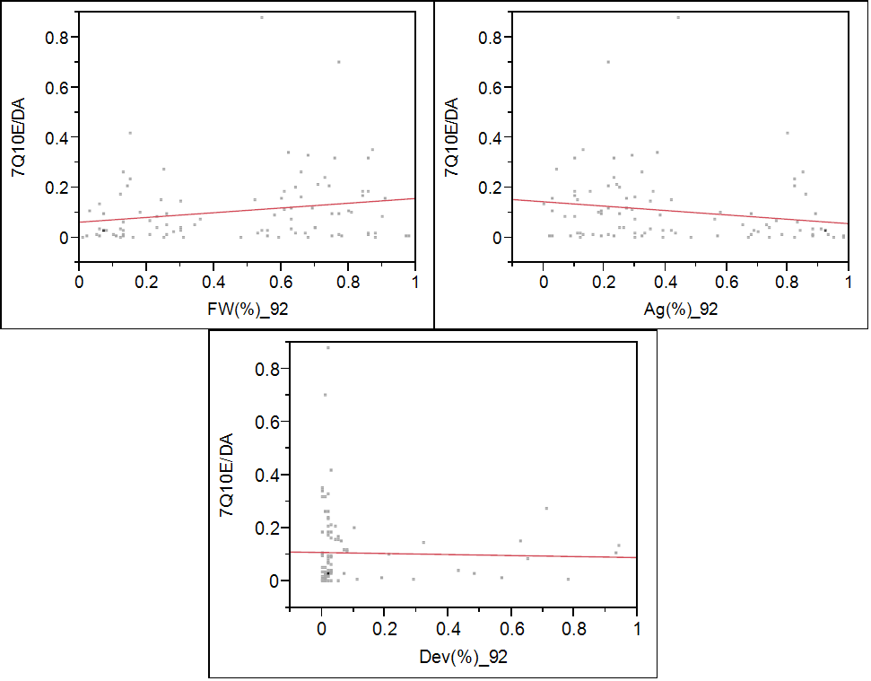
R²= 4.47e-5
P= 0.049
R²= 0.063
P= 0.014
R²= 0.033
P= 0.079

Figure 11: Bivariate fit of 7Q10/DA for 1990-2006 to Land-use percentages for Developed (Dev%), Agricultural (Ag%), and Forested lands (FW%) from NLCD 1992

This shape visually shows 7Q10 alteration when the watershed reaches roughly 10 % development, which is in agreement with Schueler (1994) who indicated that when a catchment
reaches 10-20% impervious, watershed characteristics are affected. Plainly, when a watershed reaches the observed development threshold, the capacity for groundwater recharge is severely influenced. Figure 11 shows very similar results for the later 7Q10 period for the normalized 7Q10/DA and NLCD 2006.
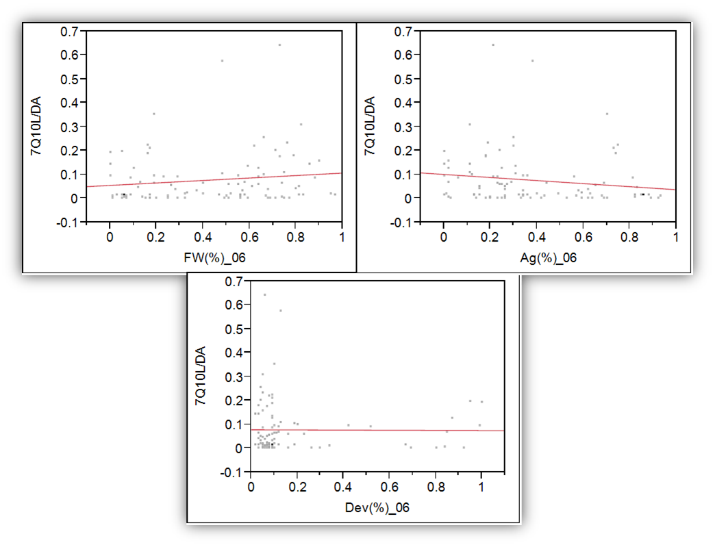
R²= 0.018
P= 0.203
R²= 0.006
P= 0.211
R²= 0.024
P= 0.138
Figure 12: Bivariate fit of 7Q10/DA for 1999-2006 to Land-use percentages for Developed (Dev%), Agricultural (Ag%), and Forested lands (FW%) from NLCD 2006

Table 4: Mean, % Developed Class, and Standard Deviation from mean for 95 USGS Stations for both time periods
Mean 7Q10/DA 1992 | Population (n) | % Developed 1992 | Standard Deviation
0.11 | 82 | 0-20 | 0.15
0.09 | 3 | 20-40 | 0.05
0.02 | 3 | 40-60 | 0.01
0.13 | 4 | 60-80 | 0.10
0.12 | 2 | 80-100 | 0.01
Mean 7Q10/DA 2006 | Population (n) | % Developed 2006 | Standard Deviation
0.08 | 78 | 0-20 | 0.12
0.02 | 4 | 20-40 | 0.03
0.09 | 2 | 40-60 | 0.00
0.01 | 3 | 60-80 | 0.01
0.10 | 7 | 80-100 | 0.07

The change in 7Q10 between the first and second period was also of interest as it relates to the change in land cover between the time intervals. Figure 13 is comprised of the raw change in 7Q10 from 1990-1999 to 1999-2008 against the raw change in land cover. The negative numbers represent an increase in the magnitude of change. All land use change calculations were performed by subtracting the 2006 land use from the 1992 land use. Thus, the reason negative numbers are shown on the graph in Figure 13. The R² for this regression was 0.67 suggesting strong co-variance between the two variables and was statistically significant. Thus, as the change in urbanization approaches zero, the effect on 7Q10 becomes negligible. This further indicated the negative effect of urbanization on base flow. The changes in 7Q10 over agricultural and forested lands shown in Figure 12 were less significant.
Table 4 notates the mean 7Q10/DA broken by percent developed classes. This table was desired to show the range of the random population of USGS gaging stations. Heterogeneity is sought after when analyzing a distribution of stations. Table 4 shows that the majority of stations are rural in nature. Given the threshold of 15-20% for the non-linear data in Table 4, it is believed that a more heterogeneous population with respect to development would warrant more obvious relationships between land use and base flow change. However, further study is warranted to support this assertion.
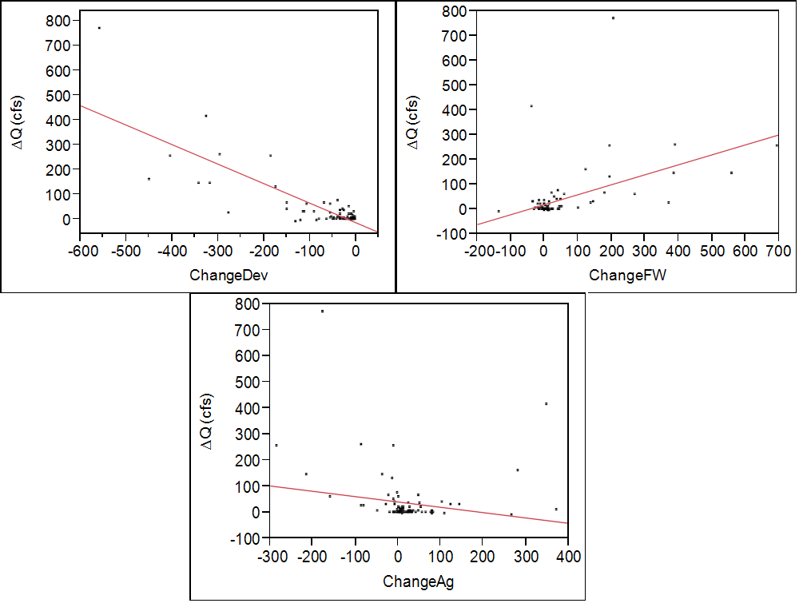
R²= 0.677
P= 0.001
R²= 0.031
P= 0.087
R²= 0.236
P= 0.001
Figure 13: Bivariate fit of ∆ 7Q10/DA from 1990-1999 to 1999-2008 over the ∆ in Land-use for Developed (Dev), Agricultural (Ag), and Forested/Wetlands (FW) from NLCD 1992 to NLCD 2006

4.0 DISCUSSION

This study derived an interesting statistic revolving around land use development and its influence on the 7Q10. To reiterate, the 7Q10 is an essential parameter to maintain ecologically healthy ecosystems as well as provide states with a metric to evaluate and maintain water quality (Feaster and Cantrell 2010). The main objective of this research was to calculate the 7Q10 for 95 randomly selected USGS gaging stations inside three semi-homogeneous zones of Ecoregion II from 1990-2008 and relate this parameter to the changes in catchment land use from 1992-2006 in an effort to better understand hydrological responses to land use changes.
GIS was the main tool utilized for data collection. Published data from USGS, NLCD, and the NHD Version II were accessed. Watersheds were delineated and land use was extracted to show not only changes in land use between two snap shots in time, but to relate the 7Q10 to the discrete land use. Randomness regarding site selection was desired in this study. The necessity to populate random USGS stations across a very large area signifies a true lack of bias to the effect of urbanization on catchment hydrology.
The fundamental theme in this study was base flow response to urbanization. Watersheds vary in size and land use characteristics, as seen from the results. A distinct threshold has been identified revolving around urbanized watersheds. When the watershed reaches 10-15% developed, the 7Q10 appears to degrade. This is evident from the development graphs in Figures 10 and 11. Non-coincidentally, these finding agree with a study performed almost 40 years ago in the Piedmont Province of Maryland by Richard Klein. Klein (1979) studied the effect of urbanization on 29 small watersheds displaying land-use homogeneity. He also found a threshold for urban impairment on the stream. He noted the first signs of ecological impairment (driven by base flow) occurred at 12% imperviousness and that the watershed becomes severely degraded at about 30% imperviousness. Klein (1979) analyses differed in the fact the he chose homogenous watersheds and looked at imperviousness; this study design concentrated on non-homogenous watersheds from a developed perspective. Interestingly, the results were similar. This further supports the threshold hypothesis and that watersheds are impacted hydrologically past 15-20% percent. Without disconnecting the imperviousness and implementing BMPs, hydrologic dampening will not occur and recharge will not be stimulated.
Significant changes in 7Q10 were observed across the datasets. Given the randomness and spatial variability of this gaging station data, climate variability can reasonably be excluded as a predictor of base flow changes (Kokkonen and Jakeman 2002). Significant changes in land use from the early to the late period were also observed. The result that 82% of this study population had a lowering of base flow from the early to the late period, and that every site had an increase in developed space and a decrease in agricultural use, cannot be ignored. Given the pure randomness of this study and that drainage area is co-variant of 7Q10, it is reasonable to say that land-uses are driver in groundwater recharge capabilities.
EDA showed common trends for agriculture and forested areas. Small changes in land use from agricultural use to developed space showed very small decreases in 7Q10. This could potentially be from this interconnectedness of agricultural land and how rivers and streams are used for water sources (Wilson 1995). More sound results came from the forested graphs from 1992 and 2006. From visual inspection, the 7Q10 tends to increase when the percentage of forested lands per mi² increases. This is intuitive, as the un-disturbed system (mostly forest in the eastern US) is the best mechanism to process precipitation above and below the soil surface (McMahon et al. 2003).
Hydrologic (water budget) system components ultimately suffer when watersheds are urbanized past a certain threshold (10-20%). This study suggests recharge capabilities are surrendered with intense urbanization lacking sufficient BMPs. Funneling volumes of precipitation through impervious infrastructure to ill-equipped BMPs for recharge is a problem in itself and should be explored further. However, strategically placing BMPs throughout the catchment is desired in comparison to large centrally located BMPs. Vietz et al. (2014) showed effective imperviousness (EI) proves a better predictor than total imperviousness (TI) of the hydrological impacts of urbanization. EI is the percentage of direct impervious connections to the stream where TI is the total impervious area in a watershed (Vietz et al. 2014). This suggests the water budget is shifted to a state of impairment by the nature of the imperviousness in a watershed. This geomorphic threshold has been reported as low as 2-3% EI in Australia by Vietz et al. (2014). If channels are geomorphically impaired at EI of 2-3%, it is reasonable to hypothesize that the water budget shifts due to the nature of imperviousness and that the base flow will be degraded along with geomorphic degradation.
The non-normalized 7Q10 for 1990-1999 and 1999-2008 was plotted over the development percentage for each time period as a further analysis to better understand the aforementioned thresholds. This time, small (<200 mi²) watersheds and large (>200 mi²) watersheds were plotted as different data sets on the same graph. Notably, the same L shape as previously reported emerged; but with the large watersheds showing little effect from urbanization. The small watersheds run across the abscissa and show low 7Q10 values and high urbanization. The large watersheds show high 7Q10 values and low urbanization. Heteroscedasticity (sub-populations have different variability than others) is present in this data set and shows that watersheds should be viewed by size classes. This helps the hypothesis of urbanization negatively affecting base flow but more urban watersheds of varying sizes are needed to further this investigation. Figure 14 shows this relationship for both time periods.

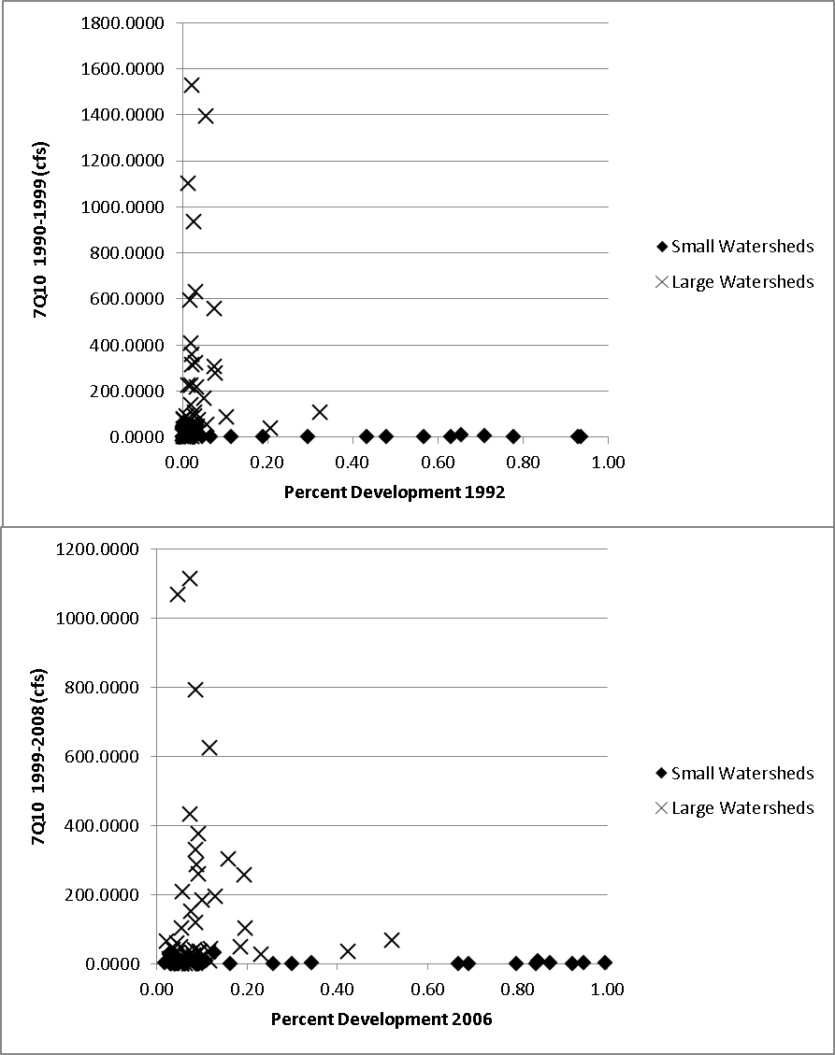
Figure 14: 7Q10 for 1990-1999 and 1999-2008 vs Percent Development for 1992 and 2006

5.0 CONCLUSION

The main research question of this study considered the hydrological response of base-flow to temporal land cover changes. The main objective of this research was to calculate the 7Q10 for 95 randomly selected USGS gaging stations inside three semi-homogeneous zones of Eco-Region II from 1990-2008 and relate this parameter to the changes in catchment land use from 1992-2006 in an effort develop a better understanding of hydrological responses. 7Q10 was found to be co-variant with drainage area and was subsequently normalized to drainage area as the response variable in this study. Results indicated relationships for 7Q10 with an increase in development. Valuable information was drawn from this analysis concerning reasonable thresholds of watershed imperviousness. This research suggests that watershed base flow may be degraded once a threshold of 15-20% imperviousness is exceeded. This supports the previous studies such as Klein (1979) and others. However, this relationship depends on watershed size with respect to development. Figure 14 reveals that 7Q10/DA vs development and 7Q10 vs DA are related but are separated by the watershed size. This demonstrates heteroscedasticity between the small and large watersheds (Figure 14).
Anthropogenic activities have changed the natural landscape into a mosaic of inter-connected pathways which provide swift conveyance of storm water runoff to surface waters. With rural exodus occurring, and predictions that each developing area of the world will hold more urban than rural inhabitants by 2030, the necessity of sound water quality management practices is paramount. The southern United States is an example of such land use modification. The southern United States is the fastest developing area of the nation (O’Driscoll et al. 2010). Although BMPs are increasingly common in urban environments, more emphasis should be placed on BMP location with respect to recharge capabilities. This study suggests that future development consider the combined effects of urbanization (and the associated lack of groundwater recharge under traditional development) on the 7Q10 statistic. Rural watersheds are the most vulnerable as they are the nearest neighbor to urban sprawl (Tran et al. 2010). These vulnerable watersheds should require BMP placement to facilitate recharge consistent with predevelopment conditions. The watersheds that are already developed past the suggested threshold should be re-fitted to a quasi-natural state by estimating the recharge potential of the pre-developed natural system and applying the results to BMP design. In addition, new BMP design should focus on disconnected impervious as EI is thought to be more of a culprit than TI (Vietz et al. 2014). Future studies revolving around the effect of urbanization on 7Q10 should categorize land use and drainage area but remain at a large enough spatial scale that climate variability can be ignored (Kokkonen and Jakeman 2002). The research question of hydrologic response to urbanization was investigated and the results can be applied to future research toward implementation of BMPs which facilitate urban storm-water infiltration.

LIST OF REFERENCES

Abban, B. (2014) Personal Correspondence. Blanton, B. (ed).
Arnold, J.G. and Allen, P.M. (1999) Automated methods for estimating baseflow and ground water recharge from streamflow records, Wiley Online Library.
Barrett, M.H., Hiscock, K.M., Pedley, S., Lerner, D.N., Tellam, J.H. and French, M.J. (1999) Marker species for identifying urban groundwater recharge sources: a review and case study in Nottingham, UK. Water Research 33(14), 3083-3097.
Bellot, J., Bonet, A., Sanchez, J. and Chirino, E. (2001) Likely effects of land use changes on the runoff and aquifer recharge in a semiarid landscape using a hydrological model. Landscape and Urban Planning 55(1), 41-53.
Boulton, A.J. (2003) Parallels and contrasts in the effects of drought on stream macroinvertebrate assemblages. Freshwater Biology 48(7), 1173-1185.
Brabec, E.A. (2009) Imperviousness and land-use policy: Toward an effective approach to watershed planning. Journal of Hydrologic Engineering 14(4), 425-433.
Brandes, D., Cavallo, G.J. and Nilson, M.L. (2005) Base Flow Trends in Urbanizing Watersheds of the Delaware River Basin1, Wiley Online Library.
CEC (1997) Ecological regions of North America: toward a common perspective. EPA (ed), The Commission.
Chinnayakanahalli, K., Kroeber, C., Hill, R., Tarboton, D., Olson, J. and Hawkins, C. (2006) The Multi-Watershed Delineation Tool: GIS Software in support of regional watershed analyses. Utah State University, Logan.
Dudley, R.W. (2004) Estimating monthly, annual, and low 7-day, 10-year streamflows for ungaged rivers in Maine, US Department of the Interior, US Geological Survey.
Easterling, D.R., Meehl, G.A., Parmesan, C., Changnon, S.A., Karl, T.R. and Mearns, L.O. (2000) Climate extremes: observations, modeling, and impacts. science 289(5487), 2068-2074.
ESRI (2011) ArcGIS desktop: Release 10, Environmental Systems Research Institute Redlands, CA.
Feaster, T.D. and Cantrell, W.M. (2010) The 7Q10 in South Carolina Water-Quality Regulation: Nearly Fifty Years Later, Columbia, SC.
Ferguson, B.K. and Suckling, P.W. (1990) Changing rainfall-runoff relationships in the urbanizing peachtree creek watershed, Atlanta, Georgia. JAWRA Journal of the American Water Resources Association 26(2), 313-322.
Fletcher, T., Andrieu, H. and Hamel, P. (2013) Understanding, management and modelling of urban hydrology and its consequences for receiving waters: A state of the art. Advances in Water Resources 51, 261-279.
Fry, J., Coan, M., Homer, C., Meyer, D. and Wickham, J. (2008) Completion of the National Land Cover Database (NLCD) 1992–2001 land cover change retrofit product. US Geological Survey open-file report 1379, 18.
Fry, J.A., Xian, G., Jin, S., Dewitz, J.A., Homer, C.G., LIMIN, Y., Barnes, C.A., Herold, N.D. and Wickham, J.D. (2011) Completion of the 2006 national land cover database for the conterminous United States. Photogrammetric Engineering and Remote Sensing 77(9), 858-864.
Gebert, W.A. and Krug, W.R. (1996) Steamflow trends in Wisconsins's driftless area, Wiley Online Library.
Grimm, N.B., Faeth, S.H., Golubiewski, N.E., Redman, C.L., Wu, J., Bai, X. and Briggs, J.M. (2008) Global change and the ecology of cities. science 319(5864), 756-760.
Hager, M.C. (2003) Lot-level approaches to stormwater management are gaining ground. Stormwater. January/February.
Hamel, P., Daly, E. and Fletcher, T.D. (2013) Source-control stormwater management for mitigating the impacts of urbanisation on baseflow: A review. Journal of Hydrology 485, 201-211.
Hatcher, K.J. (1984) Characterisitcs of the "Seven-day, ten-year minimum streamflow" statistic, pp. 30-37.
Hathaway, J., Hunt, W. and Simmons III, O. (2010) Statistical evaluation of factors affecting indicator bacteria in urban storm-water runoff. Journal of Environmental Engineering 136(12), 1360-1368.
Hatt, B.E., Fletcher, T.D., Walsh, C.J. and Taylor, S.L. (2004) The influence of urban density and drainage infrastructure on the concentrations and loads of pollutants in small streams. Environmental Management 34(1), 112-124.
Helsel, D.R. and Hirsch, R.M. (1992) Statistical methods in water resources, Elsevier.
Hibbert, A.R. (1965) Forest treatment effects on water yield, Coweeta Hydrologic Laboratory, Southeastern Forest Experiment Station.
Hsieh, C.-h. and Davis, A.P. (2005) Evaluation and optimization of bioretention media for treatment of urban storm water runoff. Journal of Environmental Engineering 131(11), 1521-1531.
Hundecha, Y. and Bárdossy, A. (2004) Modeling of the effect of land use changes on the runoff generation of a river basin through parameter regionalization of a watershed model. Journal of Hydrology 292(1), 281-295.
Hunt, W., Smith, J., Jadlocki, S., Hathaway, J. and Eubanks, P. (2008) Pollutant removal and peak flow mitigation by a bioretention cell in urban Charlotte, NC. Journal of Environmental Engineering 134(5), 403-408.
Klein, R.D. (1979) Urbanization and stream quality impairment, Wiley Online Library.
Kokkonen, T. and Jakeman, A. (2002) Structural effects of landscape and land use on streamflow response. Environmental Foresight and Models: A Manifesto, 303-321.
Ku, H.F., Hagelin, N.W. and Buxton, H.T. (1992) Effects of Urban Storm‐Runoff Control on Ground‐Water Recharge in Nassau County, New York. Ground Water 30(4), 507-514.
Langbein, W. (1960) Plotting positions in frequency analysis. Dalrymple, Tate, Flood frequency analysis: US Geol. Survey Water-Supply Paper, 48-51.
Lee, J.G. and Heaney, J.P. (2003) Estimation of urban imperviousness and its impacts on storm water systems. Journal of Water Resources Planning and Management 129(5), 419-426.
Leopold, L.B. (1973a) River Channel Change with Time: An Example. Geological Society of America Bulletin 84(6), 1845.
Leopold, L.B. (1973b) River channel change with time: an example address as Retiring President of The Geological Society of America, Minneapolis, Minnesota, November 1972. Geological Society of America Bulletin 84(6), 1845-1860.
Lerner, D.N. (1990) Groundwater recharge in urban areas. Atmospheric Environment. Part B. Urban Atmosphere 24(1), 29-33.
Lerner, D.N. (2002) Identifying and quantifying urban recharge: a review. Hydrogeology Journal 10(1), 143-152.
Lerner, D.N., Issar, A.S. and Simmers, I. (1990) Groundwater recharge: a guide to understanding and estimating natural recharge, Heise Hannover.
Martin, G.R. and Arihood, L.D. (2010) Methods for estimating selected low-flow frequency statistics for unregulated streams in Kentucky, U. S. Geological Survey.
McKay, L., Bondelid, T., Rea, A., Johnston, C., Moore, R. and Deward, T. (2012) NHDPlus Version 2: user guide, Available.
McMahon, G., Bales, J.D., Coles, J.F., Giddings, E.M. and Zappia, H. (2003) USE OF STAGE DATA TO CHARACTERIZE HYDROLOGIC CONDITIONS IN AN URBANIZING ENVIRONMENT1, Wiley Online Library.
Memon, B. (1995) Quantitative analysis of springs. Environmental Geology 26(2), 111-120.
Meyer, S.C. (2004) Analysis of base flow trends in urban streams, northeastern Illinois, USA. Hydrogeology Journal 13(5-6), 871-885.
Milesi, C., Elvidge, C.D., Nemani, R.R. and Running, S.W. (2003) Assessing the impact of urban land development on net primary productivity in the southeastern United States. Remote Sensing of Environment 86(3), 401-410.
O’Driscoll, M., Clinton, S., Jefferson, A., Manda, A. and McMillan, S. (2010) Urbanization Effects on Watershed Hydrology and In-Stream Processes in the Southern United States. Water 2(3), 605-648.
Opijah, F.J. and Mukabana, J.R. (2004) On the influence of urbanization on the water budget in Nairobi city: A numerical study. GeoJournal 61(2), 121-129.
Price, K. (2011) Effects of watershed topography, soils, land use, and climate on baseflow hydrology in humid regions: A review. Progress in Physical Geography 35(4), 465-492.
Richter, B.D., Baumgartner, J.V., Powell, J. and Braun, D.P. (1996) A method for assessing hydrologic alteration within ecosystems. Conservation biology 10(4), 1163-1174.
Riggs, H.C. (1972) Low-flow investigations, US Government Printing Office.
Rose, S. and Peters, N.E. (2001) Effects of urbanization on streamflow in the Atlanta area (Georgia, USA): a comparative hydrological approach. Hydrological Processes 15(8), 1441-1457.
Rougé, C. and Cai, X. (2014) Crossing-scale hydrological impacts of urbanization and climate variability in the Greater Chicago Area. Journal of Hydrology 517, 13-27.
Schueler, T.R. (1994) The importance of imperviousness. Watershed protection techniques 1(3), 100-111.
Schwartz, J.S. and Herricks, E.E. (2007) Evaluation of pool‐riffle naturalization structures on habitat complexity and the fish community in an urban Illinois stream. River Research and Applications 23(4), 451-466.
Seiden, Z. (2014) Personal Correspondence. Blanton, B. (ed).
Shuster, W., Gehring, R. and Gerken, J. (2007) Prospects for enhanced groundwater recharge via infltration of urban storm water runoff: A case study. Journal of soil and water conservation 62(3), 129-137.
Simmons, D.L. and Reynolds, R.J. (1982) Effects of urbanization on stream base flow of selected south-shore streams, Long Island, New York. JAWRA Journal of the American Water Resources Association 18(5), 797-805.
Sophocleous, M. (2002) Interactions between groundwater and surface water: the state of the science. Hydrogeology Journal 10(1), 52-67.
Tran, L.T., O'Neill, R.V. and Smith, E.R. (2010) Spatial pattern of environmental vulnerability in the Mid-Atlantic region, USA. Applied Geography 30(2), 191-202.
U.S. Interagency Advisory Committee on Water Data (1982) Guidelines for determining flood flow frequency. Subcommittee, B.-B.o.t.H. (ed), U.S. Geological Survey, Reston, Virginia.
US Army Corps of Engineers (1998) National inventory of dams.
USEPA (1986) Technical Guidance Manual for Performing Wasteload Allocation. Book IV: Design Conditions, Chapter 1. , EPA, Reston, VA.
USGS (2001) National Water Information System data available on the World Wide Web (Water Data for the Nation), Department of the Interior.
Vietz, G.J., Sammonds, M.J., Walsh, C.J., Fletcher, T.D., Rutherfurd, I.D. and Stewardson, M.J. (2014) Ecologically relevant geomorphic attributes of streams are impaired by even low levels of watershed effective imperviousness. Geomorphology 206, 67-78.
Vogel, R.M. and Kroll, C.N. (1989) Low-flow frequency analysis using probability-plot correlation coefficients. Journal of Water Resources Planning and Management 115(3), 338-357.
Vogel, R.M. and Wilson, I. (1996) Probability distribution of annual maximum, mean, and minimum streamflows in the united states. Journal of Hydrologic Engineering 1(2), 69-76.
Vogelmann, J.E., Howard, S.M., Yang, L., Larson, C.R., Wylie, B.K. and Van Driel, N. (2001) Completion of the 1990s National Land Cover Data Set for the conterminous United States from Landsat Thematic Mapper data and ancillary data sources. Photogrammetric Engineering and Remote Sensing 67(6).
Weibull, W. (1939) The phenomenon of rupture in solids, Generalstabens Litografiska Anst.
Williams, J.B. and Pinder, J.E. (1990) Groundwater flow and runoff in a coastal plain stream.
Wilson, K. (1995) 'Water Used to be Scattered in the Landscape': Local Understandings of Soil Erosion and Land Use Planning in Southern Zimbabwe. Environment and History 1(3), 281-296.

APPENDIX

Table 5: 95 USGS Stream Gauging Stations selected for continuous average daily stream-flow data. Source is waterdata.usgs.gov.

Site # | Agency | Site # | Station Location | LAT | LONG | Drainage Area (mi²)
1 | USGS | 2118000 | SOUTH YADKIN RIVER NEAR MOCKSVILLE, NC | 35.845 | -80.658889 | 306
2 | USGS | 7375000 | Tchefuncta River near Folsom, LA | 30.616022 | -90.248695 | 103
3 | USGS | 2160700 | ENOREE RIVER AT WHITMIRE, SC | 34.509304 | -81.598159 | 444
4 | USGS | 3488000 | N F HOLSTON RIVER NEAR SALTVILLE, VA | 36.896781 | -81.746229 | 221
5 | USGS | 4086000 | SHEBOYGAN RIVER AT SHEBOYGAN, WI | 43.741389 | -87.752111 | 418
6 | USGS | 2374500 | MURDER CREEK NEAR EVERGREEN AL | 31.4185 | -86.98664 | 176
7 | USGS | 2378500 | FISH RIVER NEAR SILVER HILL AL | 30.545471 | -87.798601 | 55.3
8 | USGS | 8041700 | Pine Island Bayou nr Sour Lake, TX | 30.106046 | -94.334632 | 336
9 | USGS | 4087240 | ROOT RIVER AT RACINE, WI | 42.751389 | -87.823611 | 190
10 | USGS | 4086500 | CEDAR CREEK NEAR CEDARBURG, WI | 43.32306 | -87.978701 | 120
11 | USGS | 2091500 | CONTENTNEA CREEK AT HOOKERTON, NC | 35.428889 | -77.5825 | 733
12 | USGS | 2353000 | FLINT RIVER AT NEWTON, GA | 31.306944 | -84.338889 | 5740
13 | USGS | 5517530 | KANKAKEE RIVER NR KOUTS, IN | 41.253928 | -87.033914 | 1376
14 | USGS | 3180500 | GREENBRIER RIVER AT DURBIN, WV | 38.543727 | -79.833115 | 133
15 | USGS | 7376000 | Tickfaw River at Holden, LA | 30.503802 | -90.677316 | 247
16 | USGS | 4160600 | BELLE RIVER AT MEMPHIS, MI | 42.900862 | -82.769091 | 151
17 | USGS | 23177483 | WITHLACOOCHEE RIVER AT MCMILLAN RD,NEAR BEMISS, GA | 30.9527 | -83.268487 | 502
18 | USGS | 2223500 | OCONEE RIVER AT DUBLIN, GA | 32.544611 | -82.894587 | 4400
19 | USGS | 5535000 | SKOKIE RIVER AT LAKE FOREST, IL | 42.2325 | -87.845278 | 13
20 | USGS | 5522500 | IROQUOIS RIVER AT RENSSELAER, IN | 40.933371 | -87.128911 | 203
21 | USGS | 2427250 | PINE BARREN CREEK NEAR SNOW HILL, AL. | 31.996258 | -87.068319 | 261
22 | USGS | 2131000 | PEE DEE RIVER AT PEEDEE, SC | 34.204325 | -79.54839 | 8830
23 | USGS | 7377500 | Comite River near Olive Branch, LA | 30.756572 | -91.043994 | 145
24 | USGS | 5551700 | BLACKBERRY CREEK NEAR YORKVILLE, IL | 41.671667 | -88.441389 | 70.2
25 | USGS | 8028500 | Sabine Rv nr Bon Wier, TX | 30.747146 | -93.608508 | 8229
26 | USGS | 2489500 | Pearl River near Bogalusa, LA | 30.793243 | -89.820907 | 6573
27 | USGS | 7332500 | Blue River near Blue, OK | 33.997041 | -96.241099 | 477
28 | USGS | 1367500 | RONDOUT CREEK AT ROSENDALE NY | 41.843056 | -74.086111 | 383

Table 5 continued.
Site # | Agency | Site # | Station Location | LAT | LONG | Drainage Area (mi²)
29 | USGS | 6906800 | Lamine River near Otterville, MO | 38.70225 | -92.978833 | 543
30 | USGS | 2225500 | OHOOPEE RIVER NEAR REIDSVILLE, GA | 32.078528 | -82.177343 | 1110
31 | USGS | 2425000 | CAHABA RIVER NEAR MARION JUNCTION AL | 32.444025 | -87.180272 | 176
32 | USGS | 5518000 | KANKAKEE RIVER AT SHELBY, IN | 41.182813 | -87.34031 | 1779
33 | USGS | 2481880 | PEARL RIVER AT BURNSIDE, MS | 32.841389 | -89.097778 | 520
34 | USGS | 3322900 | WABASH RIVER AT LINN GROVE, IN | 40.656157 | -85.032747 | 453
35 | USGS | 5515500 | KANKAKEE RIVER AT DAVIS, IN | 41.389639 | -86.706167 | 542
36 | USGS | 4165500 | CLINTON RIVER AT MORAVIAN DRIVE AT MT. CLEMENS, MI | 42.595867 | -82.90881 | 734
37 | USGS | 7291000 | HOMOCHITTO RIVER AT EDDICETON, MS | 31.503056 | -90.7775 | 181
38 | USGS | 1674500 | MATTAPONI RIVER NEAR BEULAHVILLE, VA | 37.883889 | -77.165278 | 603
39 | USGS | 1673550 | TOTOPOTOMOY CREEK NEAR STUDLEY, VA | 37.662643 | -77.257755 | 25.5
40 | USGS | 5590800 | LAKE FORK AT ATWOOD, IL | 39.806422 | -88.476169 | 149
41 | USGS | 5535070 | SKOKIE RIVER NEAR HIGHLAND PARK, IL | 42.159722 | -87.798056 | 21.1
42 | USGS | 4176000 | RIVER RAISIN NEAR ADRIAN, MI | 41.904769 | -83.980776 | 463
43 | USGS | 2082950 | LITTLE FISHING CREEK NEAR WHITE OAK, NC | 36.183333 | -77.876111 | 177
44 | USGS | 1437500 | NEVERSINK RIVER AT GODEFFROY NY | 41.441111 | -74.601944 | 307
45 | USGS | 2173500 | NORTH FORK EDISTO RIVER AT ORANGEBURG, SC | 33.483487 | -80.873426 | 683
46 | USGS | 3337000 | BONEYARD CREEK AT URBANA, IL | 40.111143 | -88.226438 | 4.46
47 | USGS | 4181500 | ST. MARYS RIVER AT DECATUR, IN | 40.848103 | -84.937744 | 621
48 | USGS | 2483001 | SOUTH CANAL TUSCOLAMETA CREEK NR WALNUT GROVE, MS | 32.573611 | -89.468611 | 411
49 | USGS | 2481510 | WOLF RIVER NR LANDON, MS | 30.483611 | -89.274444 | 308
50 | USGS | 3343400 | EMBARRAS RIVER NEAR CAMARGO, IL | 39.791421 | -88.185599 | 186
51 | USGS | 3065000 | DRY FORK AT HENDRICKS, WV | 39.072329 | -79.622837 | 349
52 | USGS | 4166000 | RIVER ROUGE AT BIRMINGHAM, MI | 42.545868 | -83.223542 | 33.3
53 | USGS | 2326372 | PALMER MILL BRANCH AT MONTICELLO,FL | 30.543814 | -83.844885 | 0.48
54 | USGS | 7375960 | Tickfaw River at Montpelier, LA | 30.686297 | -90.643151 | 220
55 | USGS | 4184500 | Bean Creek at Powers OH | 41.659495 | -84.249115 | 206
56 | USGS | 5532000 | ADDISON CREEK AT BELLWOOD, IL | 41.881698 | -87.869228 | 17.9
57 | USGS | 2472000 | LEAF RIVER NR COLLINS, MS | 31.706944 | -89.406944 | 743
Table 5 Continued.
58 | USGS | 4175600 | RIVER RAISIN NEAR MANCHESTER, MI | 42.168095 | -84.076058 | 132
59 | USGS | 4159900 | MILL CREEK NEAR AVOCA, MI | 43.054471 | -82.734649 | 169
60 | USGS | 5536000 | NORTH BRANCH CHICAGO RIVER AT NILES, IL | 42.012222 | -87.795833 | 100
61 | USGS | 7048800 | Richland Creek at Goshen, AR | 36.104167 | -94.0075 | 138
62 | USGS | 8164300 | Navidad Rv nr Hallettsville, TX | 29.466908 | -96.812756 | 332
63 | USGS | 2357000 | SPRING CREEK NEAR IRON CITY, GA | 31.040278 | -84.74 | 490
64 | USGS | 5527800 | DES PLAINES RIVER AT RUSSELL, IL | 42.489187 | -87.926466 | 123
65 | USGS | 4085200 | KEWAUNEE RIVER NEAR KEWAUNEE, WI | 44.458331 | -87.556475 | 127
66 | USGS | 5535500 | WF OF NB CHICAGO RIVER AT NORTHBROOK IL | 42.138333 | -87.834722 | 11.5
67 | USGS | 5540060 | KRESS CREEK AT WEST CHICAGO, IL | 41.856389 | -88.203889 | 18.1
68 | USGS | 5554500 | VERMILION RIVER AT PONTIAC, IL | 40.877811 | -88.636173 | 579
69 | USGS | 4180000 | CEDAR CREEK NEAR CEDARVILLE, IN | 41.218938 | -85.076359 | 270
70 | USGS | 2082585 | TAR RIVER AT NC 97 AT ROCKY MOUNT, NC | 35.954722 | -77.787222 | 925
71 | USGS | 3361500 | BIG BLUE RIVER AT SHELBYVILLE, IN | 39.528659 | -85.782202 | 421
72 | USGS | 2203000 | CANOOCHEE RIVER NEAR CLAXTON, GA | 32.184914 | -81.888727 | 555
73 | USGS | 5517000 | YELLOW RIVER AT KNOX, IN | 41.30282 | -86.62057 | 435
74 | USGS | 2090380 | CONTENTNEA CREEK NEAR LUCAMA, NC | 35.691111 | -78.109722 | 161
75 | USGS | 6918460 | Turnback Creek above Greenfield, MO | 37.402361 | -93.802028 | 252
76 | USGS | 5529000 | DES PLAINES RIVER NEAR DES PLAINES, IL | 42.081667 | -87.890556 | 360
77 | USGS | 2193340 | KETTLE CREEK NEAR WASHINGTON, GA | 33.682628 | -82.857923 | 33.9
78 | USGS | 3186500 | WILLIAMS RIVER AT DYER, WV | 38.378999 | -80.483974 | 128
79 | USGS | 8070000 | E Fk San Jacinto Rv nr Cleveland, TX | 30.336598 | -95.1041 | 325
80 | USGS | 8023080 | Bayou Grand Cane near Stanley, LA | 31.962723 | -93.941161 | 72.5
81 | USGS | 4151500 | CASS RIVER AT FRANKENMUTH, MI | 43.327802 | -83.74802 | 841
82 | USGS | 2349900 | TURKEY CREEK AT BYROMVILLE, GA | 32.195556 | -83.902222 | 47.5
83 | USGS | 5436500 | SUGAR RIVER NEAR BRODHEAD, WI | 42.612306 | -89.397972 | 523
84 | USGS | 2133624 | LUMBER RIVER NEAR MAXTON, NC | 34.772778 | -79.331944 | 365
85 | USGS | 5525500 | SUGAR CREEK AT MILFORD, IL | 40.630036 | -87.723918 | 446
86 | USGS | 3610200 | CLARKS RIVER AT ALMO, KY | 36.691722 | -88.273647 | 134
87 | USGS | 7056000 | Buffalo River near St. Joe, AR | 35.983056 | -92.747222 | 829
88 | USGS | 2106500 | BLACK RIVER NEAR TOMAHAWK, NC | 34.755 | -78.288611 | 676
Table 5 Continued.
Site # | Agency | Site # | Station Location | LAT | LONG | Drainage Area (mi²)
89 | USGS | 5530990 | SALT CREEK AT ROLLING MEADOWS, IL | 42.060556 | -88.016667 | 30.5
90 | USGS | 4087204 | OAK CREEK AT SOUTH MILWAUKEE, WI | 42.925016 | -87.870082 | 25
91 | USGS | 2473500 | TALLAHALA CREEK AT LAUREL, MS | 31.680833 | -89.115556 | 238
92 | USGS | 7378000 | Comite River near Comite, LA | 30.512689 | -91.073716 | 284
93 | USGS | 5439500 | SOUTH BRANCH KISHWAUKEE RIVER NR FAIRDALE IL | 42.110581 | -88.900653 | 387
94 | USGS | 2483000 | TUSCOLAMETA CREEK AT WALNUT GROVE, MS | 32.588333 | -89.465 | 411
95 | USGS | 3380500 | SKILLET FORK AT WAYNE CITY, IL | 38.363333 | -88.587778 | 464

VITA

Mr. Barry N. Blanton Jr. was born in North Charleston, SC on November 21, 1985. Barry’s family moved home to Lenoir City, TN in 1987. Barry graduated from Lenoir City High School in 2004 and joined the United States Navy Seabees on September 15, 2004. He attended basic training at Recruit Training Command Great Lakes, IL and relocated to Port Hueneme, CA for Construction Mechanic Apprentice “A” School. Upon graduating from “A” school, Barry was assigned to Naval Mobile Construction Battalion (NMCB) ONE located at Construction Battalion Center, Gulfport, MS. While assigned to NMCB ONE, Barry deployed to Rota, Spain, Sasebo, Japan, and Iraq. On June 16, 2009 he was honorably discharged from the USN and moved to Knoxville, TN. He obtained an Associate of Arts in Business Preparation from Mississippi Gulf Coast Community College and an Associate of Arts in Electrical/Mechanical Engineering Technology from Coastline Community College while on Active Duty. Barry joined the Naval Reserve Force in August of 2009 in Knoxville, TN and started attending the University of Tennessee Knoxville. After two semesters in the College of Business Administration, Barry changed his major to Civil Engineering and graduated from the College of Civil and Environmental Engineering the Spring of 2013 with a Bachelor of Science in Civil Engineering and a Business Minor. Barry was granted an assistantship within the same department and graduated with a Master of Science in Environmental Engineering with a Water Resources concentration in August of 2014. Barry lives in Farragut, TN with his wife, Christina, and their Labrador retriever, Oliver.

