Investigation on the Impact of Property-Microstructure of Spark Plasma Sintered MgB₂ Superconducting Bulks in Manufacturing Operations

A Dissertation Presented for the

Doctor of Philosophy

Degree

The University of Tennessee, Knoxville

Fabiano Carvalho de Castro Sene

December 2022

Copyright © 2022 by Fabiano Carvalho de Castro Sene
All rights reserved.

DEDICATION
I would like to dedicate this work to my family above all else. Without their support and encouragement, the Ph.D. journey would have become extremely heavy if not unbearable to carry on. I would also like to dedicate this work to my friends and co-workers who were a part of this journey and have, somehow, contributed with brainstorming sessions, comments, suggestions, and advice.

ACKNOWLEDGEMENTS
I would like to express my sincere gratitude to my mother Luciana, my grandma Clelia, and my siblings Gustavo and Giulianna. Their love and unconditional support and encouragement were able to brighten even the hardest days that I had throughout this PhD journey. My sincere thanks to my uncles Miguel and Otavio, who have always been alongside me despite the six-thousand-mile distance. My sincere thanks to my Ph.D. committee members, Dr. Rupy Sawhney for supporting and challenging me to always strive for the best I can be, Dr. Bradley Jared for supporting and believing in my work, Dr. Kobza for his advice and always being constructive in his feedbacks, and Dr. Lynn Reed for his thoughtfulness, support to my research, and enthusiasm during our conversations about research, nuclear science, and strategic management of technical organizations. I thank my collaborators, Dr. Jacques Noudem, Dr. Pierre Bernstein, and Ms. Yiteng Xing for their prompt support and always very productive discussions about SPS of MgB₂. I would like to thank my girlfriend Sara for her love, support, and lots of peer review, and being by my side throughout good and not-so-pleasant moments. I would like to acknowledge the support from my research colleagues at CASRE and the ISE department, especially Drs. Enrique Macias de Anda, Ninad Pradhan for the brainstorming sessions and encouragement, especially in the early stages of my Ph.D. work. I also thank Ms. Carla Arbogast for being thoughtful and supportive throughout these years that I have spent as a Graduate Student at UTK. Also, to Dr. Messias Borges Silva for encouragement, support, and friendship. To everyone who has been involved in my life over the course of these years, I would like to express my sincere gratitude.

ABSTRACT

In manufacturing systems over the years, distinct clusters of research have been created around manufacturing science and manufacturing operations separately. Despite the need for their connection in cases of knowledge transfer for production scalability, those areas have remained largely isolated. With advances in the areas of advanced and additive manufacturing, digitization and automation of manufacturing processes have shown the potential to strengthen the line connecting manufacturing science and operations of increasingly complex production systems. The integration of tools for part property testing and data analytics will support solutions concerning predictive modeling for quality, reliability, process throughput, and overall system effectiveness. In this work, the Spark Plasma Sintering of superconducting Magnesium Diboride is investigated with respect to its potential for scalability. Steps for part property testing, part qualification, and production scalability are taken from a systematic perspective. The aim of this work is to prove how material requirements play a role not only in the quality of superconducting bulks produced but the downstream effect that it causes in the manufacturing operations related to such a process. To validate this analysis, a performance measurement system is proposed and experimented to prove the relationships derived and explained throughout this dissertation. Assessments of scrap rate, process yield, as well as reliability and maintenance schedules are evaluated in order to shed some light on sustainably scaling up the production processes that currently are constrained to laboratory environments. This work is separated into three different chapters, which relate to three manuscripts that will or have been submitted to peer-reviewed journals.

TABLE OF CONTENTS

INTRODUCTION 1
CHAPTER I PERFORMANCE COMPARISON BETWEEN CONVENTIONALLY AND ADDITIVELY MANUFACTURED SUPERCONDUCTING MGB₂ FOR LARGE-SCALE APPLICATIONS 8
Abstract 9
INTRODUCTION 10
Superconductivity of MgB₂ 13
CONVENTIONAL MANUFACTURING OF MgB₂ 16
ADDITIVE MANUFACTURING OF MgB₂ 18
SPS-PRODUCED MgB₂ IN NUCLEAR FUSION REACTORS 25
BASIC DESIGN REQUIREMENTS FOR SUPERCONDUCTING MAGNETS IN MAGNETIC CONFINEMENT FUSION REACTORS 27
SUPERCONDUCTOR PROPERTY-BASED ASSESSMENT IN SPARK PLASMA SINTERING OF MgB₂ FOR LARGE-SCALE APPLICATIONS 31
CONCLUSIONS 35
APPENDIX I – TABLES AND FIGURES 38
CHAPTER II CHARACTERIZATION AND STATISTICAL QUALIFICATION OF SPARK PLASMA SINTERED MAGNESIUM DIBORIDE SUPERCONDUCTING BULKS 51
Abstract 52
INTRODUCTION 53
Review on Manufacturing of Magnesium Diboride Superconductors 53
ENTROPY-ASSISTED CHARACTERIZATION OF SPARK PLASMA SINTERED MgB₂ BULKS 55
CHARACTERIZATION OF SPS-PRODUCED MgB₂ BULKS 58
Sample M108 – Results and Discussion 61
Sample M110 – Results and Discussion 63
Sample M118 – Results and Discussion 64
Sample M186 – Results and Discussion 65
DISCUSSION 66
Statistical Analysis of SEM Images of MgB₂ 66
Distribution Fitting of SEM Samples of MgB₂ 68
Potential Effects in Superconductor Quality 70
CONCLUSIONS 71
APPENDIX II – TABLES AND FIGURES 73
CHAPTER III MODELING THE OVERALL SYSTEM EFFECTIVENESS OF MANUFACTURING OPERATIONS FOR SPARK PLASMA SINTERING OF MAGNESIUM DIBORIDE SUPERCONDUCTING BULKS 101
Abstract 102
INTRODUCTION 103
OPERATIONS IN MANUFACTURING OF MGB₂ SUPERCONDUCTING BULKS 105
Operations Management, Quality and Reliability in Additive and Advanced Manufacturing Processes 105
PERFORMANCE OF SPS OF MGB₂ BULKS AS A SINGLE STEP PRODUCE-TO-ORDER PROCESS (SSPTO) 110
Process Overview 110
Arrival Times, Cycle Time, and Throughput 111
IDENTIFICATION OF FAILURE MODES AND OPERATIONAL BENCHMARKING FOR SPS OF MGB₂ 114
Reliability Analysis of Spark Plasma Sintering of MgB₂ Superconducting Bulks 115
Reliability Modeling of Spark Plasma Sintering Process 116
Analysis of Material Path and Cut Vectors 119
Analysis of Safety-Related Equipment Path and Cut Vectors 121
Analysis of Secondary Equipment Path and Cut Vectors 122
Analysis of Inspection Path and Cut Vectors 125
Reliability-based Performance Measurement System for SPS of MgB₂ 126
Critical-to-Quality Items ($CQ$) 130
Critical-to-Schedule Items ($CS$) 131
Critical-to-Reliability Items ($CR\%$) 132
Reliability-Based Overall System Effectiveness ($OSE$) 132
Computational Model of the Performance Measurement System 136
Design of Experiments and Results 138
Impacts on Throughput 141
Impact on Process Yield 142
Impact on Overall System Reliability 143
Impact on Overall System Effectiveness 145
Optimized System Design Increase of Response Variables 147
CONCLUSIONS 148
APPENDIX III – TABLES AND FIGURES 150
CONCLUSIONS 203
FUTURE WORK 207
REFERENCES 208
VITA 228

LIST OF TABLES
Table 1 - non-Arsenic-based, High-Temperature Superconducting Materials 39
Table 2 - Fracture Strength of MgB₂ versus RE-Ba-Cu-O 40
Table 3 – Entropy calculations, relative density, and superconducting properties of samples M108, M110, M118, and M186. 75
Table 4 - Comparison of entropies, densities, and superconducting properties of M110 and M186 76
Table 5 - post-SPS measurements of relative density, bulk composition, and superconducting properties of the MgB₂ samples 77
Table 6 – SPS processing conditions, sample content, and superconducting properties of samples M108, M110, and M186. 78
Table 7 - Metrics for the samples M108, M110, M118, M186 90
Table 8 – Entropy-based metrics for the samples M108, M110, M118, M186 91
Table 9 - ICOMP of each MgB₂ region in sample M108 92
Table 10 - ICOMP of each MgB₂ region in sample M110 93
Table 11 - ICOMP of each MgB₂ region in sample M118 94
Table 12 - ICOMP of each MgB₂ region in sample M186 95
Table 13 - Sample M108 parameters and region scores 96
Table 14 - Sample M110 parameters and region scores 97
Table 15 - Sample M118 parameters and region scores 98
Table 16 - Sample M186 parameters and region scores 99
Table 17 - Average scores for MgB2 samples 100
Table 18 - Metrics for qualification of superconductors 151
Table 19 – Categorized failure modes in SPS of MgB₂ 153
Table 20 – Conditions for material failure modes for SPS of MgB₂ 157
Table 21 – Material failure modes for SPS of MgB₂ 158
Table 22 – Thresholds for safety-related equipment failure modes in SPS of MgB₂ 162
Table 23 – Scenarios for safety-related failure modes in SPS of MgB₂ 163
Table 24 – Thresholds for secondary equipment failure modes in SPS of MgB₂ 168
Table 25 – Combinations of secondary equipment failure modes in SPS of MgB₂ 169
Table 26 – Thresholds for inspection failure modes in SPS of MgB₂ 172
Table 27 – Combinations of inspection failure modes in SPS of MgB₂ 173
Table 28 – Template for sample choice, experimental conditions 178
Table 29 – Variables for experiment for different material conditions for MgB2 bulk production 180
Table 30 – Response variables for experiment for different material conditions for MgB₂ bulk production 182

LIST OF FIGURES
Figure 1 - Superconducting materials according to critical temperature and year of discovery. 41
Figure 2 - Magnesium Diboride lattice. Source: [165] 42
Figure 3 - Literature Search utilizing terms “MgB₂” or “Magnesium Diboride”, “Manufacturing” or “Fabrication” from 2014-2021 (limit). Source: Scopus 43
Figure 4 - Literature Search utilizing terms “MgB₂”, “Magnesium Diboride”, “Superconductor Application” and “Superconductors” from 2014-2021 (limit). Source: Scopus 44
Figure 5 - Literature Search utilizing terms “Hot Pressing”, “Infiltration”, “Diffusion”, “MgB₂” and “Magnesium Diboride” from 2014-2020 (limit). Source: Scopus 45
Figure 6 - Literature Search utilizing terms “Spark Plasma Sintering” and “Superconductors” from 2014-2022. Source: Scopus 46
Figure 7 - Spark Plasma Sintering process diagram. Source: [91] 47
Figure 8 - Roadmap from discovery to industry application of superconducting material 48
Figure 9 - Systematic Approach to Magnets for Magnetic Confinement Fusion Reactors 49
Figure 10 – Performance Measurement System for SPS of MgB2 Superconductors. 50
Figure 11 –SEM Image processing-based characterization of MgB2 cryomagnets 74
Figure 12 – PPMS critical temperature results for in-situ and ex-situ MgB₂ powders 79
Figure 13 – (left to right) SEM image of M108 MgB₂ bulk sample, binarized and characterized content, entropy-based filtered, and histogram equalization of the filtered sample for regions (a - c) 1, (d - f) 2, (g - i) 3, and (j - l) 4. 80
Figure 14 –Kernel of SEM image of all four regions of the M108 MgB₂ bulk according to the yielded crystal growth via SPS. 81
Figure 15 – (left to right) SEM image of M110 MgB₂ bulk sample, binarized and characterized content, entropy-based filtered, and histogram equalization of the filtered sample for regions (a - c) 1, (d - f) 2, (g - i) 3, (j - l) 4, (m - o) 5, and (p - r) 6. 82
Figure 16 –Kernel of SEM image of all six regions of the M110 MgB₂ bulk according to the yielded crystal growth via SPS. 84
Figure 17 – (left to right) SEM image of M118 MgB₂ bulk sample, binarized and characterized content, entropy-based filtered, and histogram equalization of the filtered sample for regions (a - c) 1, (d - f) 2, (g - i) 3, (j - l) 4, and (m - o) 5. 85
Figure 18 - Kernel of SEM image of all six regions of the M118 MgB₂ bulk according to the yielded crystal growth via SPS. 86
Figure 19 – Kernel of SEM image of all three regions of the M186 MgB₂ bulk according to the yielded crystal growth via SPS. 87
Figure 20 – (left to right) SEM image of M186 MgB₂ bulk sample, binarized and characterized content, entropy-based filtered, and histogram equalization of the filtered sample for regions (a - c) 1, (d - f) 2, and (g - i) 3. 88
Figure 21 – Comparison of kernels densities of MgB₂ sample microstates based on SEM imaging obtained for all regions of the samples (a) M108, (b) M110, (c) M118, and (d) M186. 89
Figure 22 – SPS Process map for MgB₂ 152
Figure 23 - Determination of failure modes for determining reliability of Spark Plasma Sintering of MgB₂ superconducting bulks. 156
Figure 24 - Material path vectors 160
Figure 25 - Material cut vectors 161
Figure 26 – Safety-related equipment path vector 166
Figure 27 – Safety-related equipment cut vectors 167
Figure 28 – Secondary equipment path vectors 170
Figure 29 – Secondary equipment cut vectors 171
Figure 30 – Inspection path vectors 174
Figure 31 – Inspection cut vectors 175
Figure 32 - Reliability-based performance measurement system for SPS of MgB₂ 176
Figure 33 - Steps of characterization and qualification for MgB2 bulks produced via SPS 177
Figure 34 - Experimental design diagnostics 179
Figure 35 - Log-worth and statistical significance of main effects and second order interaction of the experimental design 184
Figure 36 – Predicted plot and summary of fit for throughput 185
Figure 37 – Prediction and studentized residual errors of throughput fit 186
Figure 38 –Main effects and 2nd order interactions estimates of parameters in throughput fit 187
Figure 39 – Statistical significance test of effects in throughput fit 188
Figure 40 – Predicted profile for process yield according to experimental design 189
Figure 41 – Residual error of the process yield fit 190
Figure 42 – Parameter estimates for process yield fit. 191
Figure 43 – Statistical testing of main effects and 2nd order interactions in process yield fit 192
Figure 44 – Profile prediction for system reliability fit according to experimental design 193
Figure 45 – Residual plots of system reliability fitted through the experimental design 194
Figure 46 – Parameter estimates for system reliability fit 195
Figure 47 – Statistical testing of main effects and 2nd order interactions of system reliability fit 196
Figure 48 – Profile prediction for overall system effectiveness fit 197
Figure 49 – Residual plot of overall system effectiveness fit 198
Figure 50 – Parameters estimates for prediction of overall system effectiveness fit 199
Figure 51 – Testing of main effects and 2nd order interactions of the overall system effectiveness fit 200
Figure 52 – Optimal profiles of throughput, process yield, system reliability, and overall system effectiveness optimized for desirability. 201
Figure 53 – Contour plots of (a) system reliability, (b) throughput, and (c) overall system effectiveness. 202
Figure 54 - Summary of research presented in this dissertation 206

INTRODUCTION
Manufacturing is an area that has always been paramount to the development of the national economy. The expertise in the areas of manufacturing science, management, and operations hold the core for innovations that will secure a country’s hegemony in energy, computing, transportation, and national security. Over time, technologies categorized as advanced manufacturing have taken place to support or substitute older procedures that impose roadblocks concerning precision, material waste, monitorability and fault detection. However, most of those techniques still require large efforts in areas such as manufacturing operations, reliability, failure detection and mitigation until they are put in place to dictate the production of multi-billion-dollar facilities.
Advanced manufacturing techniques comprise a large number of techniques that range from polymer extrusion and silicon wafer production to superconductor sintering and nuclear fissile rod production. By specifically targeting energy applications, next-generation technologies such as nuclear fusion reactors require enhancement in superconductor manufacturing technology to fulfill the goal of net energy and posterior commercialization. To tackle such problems at their core, not only the boundaries of manufacturing science must be pushed forward, but also its integration with manufacturing operations is of utmost importance. Within the domain of superconductor material manufacturing, the technology available to produce such materials considered as the holy grail of energy harvesting and transmission still lack precision. Despite the potential societal benefit of production of such compounds at a large scale, superconductor manufacturing technology has largely remained a topic of study or research at laboratories of research or educational institutions. Comparatively with the large area of additive manufacturing, superconductor manufacturing has had timid development. Between 1968 and 2022 according to the Scopus platform, while additive manufacturing as a whole has shown an exponential growth of yearly contributions peaking at 10 thousand research papers in 2020, superconductor manufacturing has barely reached fifty contributions at its peak.
Superconducting compounds as well as the superconductivity theories still remain largely unknown. The causes of superconductivity in long-known compounds are also subjects of interest and study by several groups worldwide. Amongst the known superconductors, just a few are stable after synthesis and within those, property reproducibility of large scales of wires, tapes, and bulks is still lacking. Compounds such as NbTi and Nb₃Sn, known as low temperature superconductors (LTS) have been utilized to compose superconducting magnets for particle accelerators and prototypes of nuclear fusion reactors. One of the impeding factors to utilizing those at larger scales is their critical temperature below 10 K. Other compounds such as fullerenes, copper oxides, and selenides have shown promise, but their manufacturing maturity still lacks largely due to their complex chemical composition, stability, and toxicity. In the case of copper oxides, those rely on rare earth elements, whose supply chain is dominated by very few countries that does not include the United States.
An alternative is the study, research, and development of superconducting compounds that is stable at environmental conditions, whose manufacturing has achieved acceptable level of maturity, and whose elements are produced within the United States. By considering those factors, the Magnesium Diboride (MgB₂) rises as a promising option. Regarding supply chain, the United States have vast mining operations for extraction of magnesite, and figures as one of the largest Boron producers in the world. To develop or perfect techniques for large-scale manufacturing of superconducting bulks, wires and tapes based on MgB₂ is then the challenge to be tackled.
For development and diffusion of the superconductor industry, not only the knowledge on the compound, superconductivity type (i.e., type I or type II), and stoichiometry is needed. To produce at a rate that can fulfill demands for use in magnets, devices that may trigger developments in magnetic levitation-based transportation, deep-space propulsion systems, and quantum computing, precision with respect to quality relies on control and reliability of the superconducting manufacturing systems. In order to leverage the efforts within superconducting material manufacturing, and specifically MgB₂, this dissertation proposes a set of steps where composition and purity, superconducting properties, and overall bulk quality exerts high level of influence in its potential for production scalability.
In order to diminish the gap between advanced manufacturing science and operations for production scalability of superconducting compounds considering from bulk property to process reliability and throughput, this dissertation has targeted Spark Plasma Sintering of Magnesium Diboride (MgB₂) superconducting cryomagnets. This work has been divided into three chapters written in the format of a journal paper.
Chapter One corresponds to the fundamental theoretical background on MgB₂, where such a compound is compared with several other high-temperature superconductors (HTS) with respect to critical temperature, toxicity, and need for high pressure while in operation. In manufacturing terms, considerations on complexity and cost for production are made. Conventional manufacturing processes for production of MgB₂ are compared with Spark Plasma Sintering (SPS). Advantages of utilization of SPS over other techniques such as Powder-in-Tube (PIT) and Hot Pressing (HP) are defined with respect to control of process conditions, processing time, process energy expenditure, and yield of byproducts. Benchmark metrics for MgB₂ quality assessment are then established with respect to relative density, chemical composition, as well as critical temperature, critical current density, and critical magnetic field. The use of MgB₂ as bulk magnets produced via SPS is assessed based on the literature. The identification of requirements for use of MgB₂ in nuclear fusion reactors is made with respect to items such as lifecycle, its effect in the choice of the manufacturing techniques, as well as the relationships with magnet assembly, operability, maintainability, and structural reliability while operating under harsh conditions. The establishment of potential and shortcomings related to conventional manufacturing, as well as benchmark properties of MgB₂ bulks is done for quality assessment. This chapter ends by providing foundational knowledge on production aspects and considerations for production of high-quality MgB₂ bulks.
Chapter Two comprises the modeling and experimental procedure performed for quality assessment of MgB₂ bulks produced via SPS. In order to verify the effect of pressure and powder modality (i.e., in- and ex-situ) in both mechanical and superconducting properties of the bulks, processing pressures between 50 MPa and 140 MPa has been applied in the production of cylindrical MgB₂ bulks at 950ºC and 30 minutes. A comprehensive assessment of each bulk has been performed with the use X-Ray Diffraction (XRD) of the powder, Scanning Electron Microscope (SEM) for microstructural analysis and Physical Property Measurement System (PPMS). The SEM micrographs bulk specimens have been taken from different regions of each bulk in order to provide evidence of homogeneity and property similarity. All of the micrographs were then processed with a set of image processing techniques defined by histogram equalization, thresholding, image segmentation, and entropy filtering. The use of Shannon Entropy, interchangeably called Structural Entropy in this work, has been quantified for each raw SEM micrograph as a manner to identify the breadth of species within the same MgB₂ specimen. Such a metric has been utilized in the bulk scoring, which has been performed after statistical analysis of the information complexity (ICOMP) of each SEM micrograph. Thresholding and overall SEM sample segmentation was utilized in the identification of byproducts such as MgB₄ and MgO, as well as detection of failure modes such as voids, fractures, and Magnesium vaporization sites. Overall, both in- and ex-situ bulks were assessed with respect to superconducting, chemical, and mechanical properties, and the two best samples were chosen for the analysis of scalability.
Chapter Three comprises the modeling of a manufacturing array for production of MgB₂ bulks via SPS. The process design of SPS has been performed with respect to tasks prior and post-production of MgB₂ bulks. Tasks such as material collection and powder mixing, transportation pre-SPS processing and post-bulk production, as well as post-processing and inspection have been considered in the total process cycle time. Definitions regarding process preemptive and natural setups have been modeled. The reliability modeling for the manufacturing array has been done with respect to material, equipment, and information components. Based on the assessment of critical components for process operability and maintainability, categories of damage have been defined along with respective severities to identify conditions that may impede the process from operation. Degradation levels were modeled with respect to the effect of categories of damage unresolved over the course of production cycles. Dynamic reliability modeling was done according to the fulfillment of initial process requirements, as well as the impact of categories of damage over time. Effects of maintenance thresholds, material requirements, and powder processing modality over the system response variables have been validated statistically. Such an analysis was enabled via system modeling in MATLAB/Simulink. The performance measurement system developed served as a ground for testing of scenarios based on experiment designed in the software JMP.
Conclusions are presented in order to provide an overview of the developed performance measurement system, briefly describe the obtained results, as well as provide a graphical summary of the work performed. Future Work elaborates on the opportunities related to the implementation of such a performance measurement system experimentally, the transferability and potential use of this tool in other additive techniques, and topics related to further SPS experimental work aiming for the improvement of MgB₂ bulk properties.

CHAPTER I
PERFORMANCE COMPARISON BETWEEN CONVENTIONALLY AND ADDITIVELY MANUFACTURED SUPERCONDUCTING MGB₂ FOR LARGE-SCALE APPLICATIONS

A version of this chapter has been submitted to the journal Fusion Science and Technology and is currently under review according to the information below. This manuscript has been written by the main author Fabiano Carvalho de Castro Sene with his co-authors Ninad Pradhan, Bradley Howell Jared, and Rapinder Singh Sawhney, respectively. This paper has been written by the main author in the submission, and all co-authors have provided feedback on the writing, depth of explanations, and overall flow of the manuscript.

Abstract
Nuclear fusion energy carries the promise of changing the world’s paradigm concerning energy harvesting while generating short-lived radioactive isotopes if compared to fission. In order to harness the energy source that powers the sun, it is necessary to manufacture materials that can assure a stable, reliable operation of fusion reactors. In the case of Magnetic Confinement Fusion reactors (MCF), superconducting magnets play a major role in the device stability. However, superconducting materials remain as a major roadblock in the pathway towards net-energy generation by the tokamak topology of MCF reactors. This challenge is a direct effect of the shortcomings of current manufacturing techniques utilized in producing magnet-grade superconductors. This work presents a pathway to producing well-known superconducting compounds such as Magnesium Diboride (MgB2) through the utilization of additive manufacturing techniques. It focuses on the performance comparison between MgB2 processed through powder-in-tube (PIT), magnesium infiltration, hot pressing and the additive technique called Spark Plasma Sintering (SPS). The performance advantage reported in the SPS-produced MgB2 superconductors ranges from higher concentrations of MgB2, tighter control of impurities and byproducts, and enhancement of critical current density while under magnetic fields in the order of 9T at 20K. The use of MgB2 in this work relates to the potential that such a compound has in terms of manufacturability, cost effectiveness, and operating performance in comparison with Niobium-based superconductors utilized in poloidal coils of tokamaks. Next steps of this research work concern the characterization of the SPS-produced MgB2 targeting both electromagnetic and mechanical property enhancement for productions scalability, with focus on large-scale applications. Lastly, this work opens a venue for envisioning future applications of additively manufactured superconductors in large-scale energy devices, an area that remains currently untapped.

INTRODUCTION
Superconductivity has always represented a major point of interest in science due to its applicability in several fields. Materials that have the properties to carry large amounts of current and generate multi-Tesla magnetic fields while releasing negligible heat represents the holy grail of power systems, energy generation [1], and transportation technology. However, such exotic properties happen to occur only in a few compounds, and under temperatures around the absolute zero [2]. Moreover, the level of maturity and availability of superconductors is highly contingent upon the manufacturing technique utilized. The manufacturing techique must be capable of improving the physical properties of raw materials to produce cost-effective superconductors for large-scale devices [3]. The synthesis and manufacturing of superconducting materials have been considered a major milestone sought by varied fields of science ever since superconductivity was first discovered by in 1911 by Kamerlingh Onnes [4].
Over time, new materials have been synthesized and manufacturing techniques developed as attempts of bringing superconductors into the application spectrum. In the energy industry, devices such as Magnetic Confinement Nuclear Fusion Reactors and Superconducting Material Energy Storage (SMES) have been theorized and experimented, but still remain impractical for applicatiosn due to issues related to manufacturing of superconductors [5]. Figure 1 shows the set of discovered superconducting compounds [6-9]. On consideration of factors related to practical feasibility – for example, ease to synthesize, abundance on Earth, thermal stability, and transition temperature above 39 K – only a small subset of superconducting materials remains. These comprise compounds known as Cuprates, Fullerene-based, Arsenic-based, and Magnesium Diboride (MgB₂). For instance, Niobium-based superconductors are amongst the first discoveries and are widely utilized in facilities such as the FNSF and ITER, but its reported critical temperature is around 18.3K [7, 10, 11]. Compared with these, Cuprates are high-temperature superconductors (HTS) that have the potential to become widely used in large scale applications, given their reduced need for cryogenic cooling power. However, their molecular shapes are complex, which incurs the need for complex, expensive manufacturing techniques to produce them. Table 1 exhibits the comparison amongst all non-Arsenic-based superconducting compounds.
Currently, H₂S and FeSe are the HTS with the highest transition temperature $T_{C}$. However, these require remarkably high pressures (e.g., more than 260 GPa) to enter the superconducting regime [9, 12]. Cuprates and Iron-based superconductors enter the superconducting regime in temperatures between 77 K and 164 K, and for most of them, only ambient pressure is enough for them to operate as a superconductor [13-17]. For such materials, liquid Nitrogen is enough to take them under their $T_{C}$. For materials such as Cs₃C₆₀ and MgB₂, the cooling method must be based on liquid Hydrogen, given that their transition temperatures are between 35 to 40 K [18, 19]. Although the consensus is that HTS have not achieved maturity in terms of both applicability and manufacturability, MgB₂ may represent an exception to this statement.
Components of some Cuprates such as Barium (Ba), Yttrium (Y), Bismuth (Bi), and Mercury (Hg) are highly toxic. This leads to the possibility that its utilization or waste in synthesis techniques have the potential to be harmful to both people and the environment [14-16]. Arsenic-based superconducting compounds also present a challenge in both their production and waste management. Arsenic (As) is acutely toxic, so outside a controlled environment the risk of contamination is real. By ruling out superconducting compounds whose components are either radioactive, rare, or require extremely high pressure to achieve superconducting regime, Magnesium Diboride (MgB₂) becomes the only remaining material.

Superconductivity of MgB₂
Magnesium Diboride (MgB₂) has been first synthesized in the 1953, reviving the hopes of researchers of superconducting borides (i.e., Boron-based compounds) due to their higher transition temperature, flux pinning potential, and a higher phonon-frequency interaction of their lattices. The superconducting effect of these ceramics was confirmed experimentally in 2001 [3, 19-22]. Advantages of MgB₂ over Cuprates are not limited to the molecular complexity and consequent high manufacturing cost but also relate to anisotropy. Due to heterogeneity in conducting layers of copper oxide-based superconductors, its application in multi-Tesla magnets are limited by the capacity of conducting high current densities across the bulk. As superconductivity of Cuprates gets compromised by anisotropy, it creates an opportunity for the consideration of MgB₂. [23-26].
MgB₂ has risen as a promising superconducting compound due to its molecular simplicity and low cost of its constituents compared to rarer superconductors. Figure 2 exhibits the MgB₂ molecule, where Magnesium is centered in the hexagonal lattice, surrounded by Boron atoms. MgB₂ is a viable option for applications requiring lightweight and stable superconductors operating within the range of 20 K. Classified as a Type-II superconductor according to the BCS Theory [27], its reported critical temperature is around 37-39 K [3, 28-30]. The significance of such a situation is that MgB₂ presents more stable operation at 20 K. Several research groups across the world have worked on the characterization of MgB₂, especially related to its applicability to superconducting wires, tapes, magnets, electromechanical energy conversion devices, fusion reactors, amongst others [31-34].
MgB₂ is a low cost superconducting material compared with complex and expensive Cuprates. Its components, Magnesium (Mg) and Boron (B), are non-expensive substances, and relatively abundant in nature. At room temperature, MgB₂ is a dark, nonreactive powder which is insoluble in water. These properties corroborate its use in applications where the formation of water as a byproduct is inherent. Its melting point has been reported around 1,100K. Under a higher temperature, MgB₂ recombines into MgB₄, MgB₇, and MgO, compounds that are more likely to be produced due to the reactivity of Magnesium with Oxygen, or recombination of MgB₂ into more complex molecules [19, 21, 35-37].
Despite the disparity between transition temperatures of Cuprates and MgB₂, where Copper-based compounds have a large advantage, MgB₂ conceals an important feature in terms of its production. MgB₂ is a superconducting compound based on the combination of two relatively abundant elements on Earth: Magnesium and Boron. Being a Type-II superconductor according to the BCS Theory brings out some remarkable features. Those include magnetic flux pinning effects, high critical current density, and mechanical hardness peculiar to ceramic borides [19, 27, 38, 39].
Figure 3 visualizes the literature published about MgB₂ between 2014-2021, indexed in the platform Scopus. The surveyed literature contains the keywords “MgB₂” or “Magnesium Diboride”, “Manufacturing” or “Fabrication”. Clusters in the figure are scaled according to occurrence of the keywords and the connection of such papers with other areas. For example, the literature related to research in MgB₂ in the period shows that the term “Magnesium compounds” is related to publications concerning “superconducting properties”, “superconduting materials”, and “manufacturing process”. Other clusters are smaller, but still relate to the research performed in other compounds, and bulk superconductors.
Literature has been surveyed to understand the relation of Magnesium Compounds with current efforts in superconductivity. The terms “MgB₂”, “Magnesium Diboride”, “Superconductor Application” and “Superconductors” have been utilized for a search from 2014-2021 in the platform Scopus. Figure 4 exhibits that Magnesium Compounds compose the largest cluster where its links are tied to items such as “superconducting magnets”, “superconducting coils”, and “superconducting tapes”. Such components are deemed as promising options for advances in devices such as particle accelerators [40, 41], magnetic levitation-based transportation [38, 42], and experimental nuclear fusion reactors [43, 44].

CONVENTIONAL MANUFACTURING OF MgB₂
Several synthesis processes have been explored over the years as attempts to produce high-quality MgB₂ powder. Techniques such as in- or ex-situ powder-in-tube, vapor deposition, Mg infiltration [45, 46], and hot pressing have been utilized for production of bulks and wires [31, 33, 47-49]. These techniques consist of the insertion of MgB₂ powder in a tube, then submitted to pressure while under temperatures between 400º and 800º Celsius for timespans of 5 to 16 hours. Other techniques such as infiltration have been utilized to produce MgB₂ bulks and wires, but this process is costly both in terms of time and energy [35, 50-52]. Hot pressing has been performed for bulk production of MgB₂ [53] but relative densities obtained barely surpass 90%. Besides, the high content of MgB₄ and MgO contributes to the anisotropy factor, which decreases superconductive properties of the MgB₂, causing reductions in the transition temperature and critical current density [53, 54]. Pressure and temperature provide the conditions for the grain growth process through thermal diffusion solely. The connections between conventional manufacturing techniques for MgB₂ have been captured by performing a literature search on Scopus (for the period 2014-2020) utilizing the terms “Hot Pressing”, “Infiltration”, “Diffusion”, “MgB₂”, and “Magnesium Diboride”. Figure (4) exhibits the clusters related to “Magnesium Compounds” pertaining to superconductivity and its applications, from superconducting materials (e.g., MgB₂), superconducting properties (e.g., critical current density), mechanical properties (e.g., grain size, and porosity), to manufacturing processes (e.g., hot pressing, spark plasma sintering, infiltration, and diffusion).
Bulks of MgB₂ are yet to be enhanced in terms of mechanical properties for large scale applications due to its characteristic brittleness. In [55], authors have explored the disorder effect created by impurities such as carbohydrates in the enhancement of in-field current density of MgB₂. For wire production, the amorphous powder is usually injected in hollow metallic envelopes made out of metal alloys [47] to create a more robust structure for MgB₂ applications as large magnets and superconducting coils through multifilamentary wires, where high resistance to tensile stresses, ductility, and fracture strength are detrimental to both system operability and maintainability. These conditions poses a challenge to the sole application of MgB₂ in large-scale systems [25, 56-58].
Mechanical properties of hot pressed MgB₂ samples with a 92% relative density have been tested to quantify the bulk toughness to fracture under 77 K [53]. Findings indicate that MgB₂ bulks with different packing ratios exhibited higher fracture strength compared to RE-Ba-Cu-O commercial bulks in Table 2. Such tests help understand the bulk reaction to magnetic pressure of multi-Tesla fields under cryogenic temperatures, in view of applications in environments that demand high reliability and resilience to stresses such as Nuclear Fusion Reactors [44].
Despite a relative density of 95% for MgB₂ bulk form in Hot Pressing, anisotropy plays a major role in its mechanical and electromagnetic properties. This is due to unpredictability of MgB₂ lattices, poor density in the bulk interior, migration of Mg to MgB₂ crystal boundaries, evaporation of Mg, and recombination of MgB₂ into more complex borides [59]. While the transforming agents pressure, time, and temperature can be controlled, anisotropy in MgB₂ rises from intrinsic material properties and diffusion processes. Hence, major drawbacks of conventional MgB₂ production cannot be addressed by methods where the controllability of the sintering dynamics of ceramics such as MgB₂ is limited. Besides, the understanding of sintering processes for micro to nanopowders is still limited despite efforts to develop a multiscale sintering theory [60-63].

ADDITIVE MANUFACTURING OF MgB₂
AM techniques have enabled opportunities to manufacturing complex materials with greater speed, reduced material waste, increased process control and monitorability to enhancing decision-making for the process [64-69]. They have also enabled the design of parts in a range of micrometers to meters and the ability to strategize and operate manufacturing processes from perspective of high variation in part shapes and custom features for a plethora of applications [68, 70-74]. Authors have leveraged the understanding of AM process dynamics to propose modifications in the supply chain targeting improvements of manufacturing production planning, and scheduling [70, 75]
AM techniques such as Powder Bed Fusion that comprises SLM, SLS, EBM [76] and Material Extrusion (ME) [77] are most commonly used in the production of structural parts (e.g., metal and metal alloys [78-80], polymers [81, 82], and ceramics [83, 84]) for automotive, aerospace, and defense industry segments [85-88]. AM has made it possible to manufacture ceramics with complex geometries, high density, and good mechanical properties through techniques such Spark Plasma Sintering (SPS) [89-91]. Studies have been performed in producing ceramics through PBF techniques but remain a challenge due to the melting process that may decompose ceramic-like molecules such as MgB₂ over 650ºC, that introduces impurity into the sample [37, 92]. Due to phenomena of grain spilling and inherent brittleness of ceramics, local laser action would not be able to promote the sintering to reduce generation of byproducts and overall contamination of the bulk microstructure. Hence, the combination of Hot Pressing with Field Assisted Sintering (FAST), also known as SPS has risen as a promising option to fabricate superconducting ceramic bulks and wires [37, 39, 93-99] .
Manufacturing of MgB₂ has been largely investigated due to the promise of application of cryogen-free superconducting magnets. A remarkable feature of MgB₂ is that its grain boundaries do not represent weak spots in structural terms such as in Cuprates. Instead, they represent sites where magnetic flux pinning acts [39, 98, 100]. In applications that require material toughness due to both mechanical and electromagnetic stresses, sintered MgB₂ through SPS reaches relative densities between 98% and 99%. SPS allows better control of the sintering dynamics. For Magnesium Diboride, pressure and temperature profile have been demonstrated to interfere to the final MgB₂ %wt. and grain boundary pinning forces [37, 38, 101]. Nevertheless, SPS has been shown as the most effective MgB₂ powder sintering procedure across the evaluated literature, as measured by the current, plasma, and microwave emission throughout SPS [37, 38, 102, 103].
A literature search on Scopus was performed to identify the major points of interest regarding AM of MgB₂ for the terms “Spark Plasma Sintering” and “Superconductors”. Figure 6 exhibits the connections between “magnesium compounds”, “plasma applications”, and “polycrystalline materials” in the green cluster up to the red cluster, where keywords that relate to the performance of superconducting materials such as “critical current density” and “magnetic fields” are exhibited.
SPS exhibits better results in terms of compactness and densification for ceramic materials, as demonstrated in [104]. On a larger scale, homogeneous compactness leads to an enhancement of quality and reliability of the part. SPS is shown to be more effective in comparison with HIP and Microwave Sintering (Figure 7). For ceramics such as Bi₂Te₃ produced through SPS, the compactness of the produced material is 99%, compared to 97% and 90.5% of HIP and Microwaves, respectively [104]. Successful examples are shown in [105, 106] where the SPS-processed MgB₂ bulk exhibited larger volumetric pinning force $F_{P}$ and critical current density $J_{c}$ at 20 K. MgB₂ has been produced in-situ using SPS by combining ex-situ, ball-milled Magnesium Hydride (MgH₂) with Boron powder. As the dissociation of MgH₂ absorbs energy (i.e., endothermic process) and releases H₂, the further exothermic formation of MgB₂ increases the pressure of H₂ within the SPS machine. This causes the MgB₂ to suffer higher compression, yielding a higher displacement of the sample and consequently an increase in its relative density [36].
SPS provides conditions of sintering in- and ex-situ ceramic powders where both heating and cooling rates are controlled according to the material properties, as relative density, %wt., as well as grain size are only a few characteristics directly affected by the powder format [97, 98]. Such effects are measured through trapped magnetic field intensity, grain boundaries, and maximum current density. By sintering MgB₂ using thermal gradients and plasma arcs, the energy supplied to the entire powder quantity tends to be more homogeneously distributed [94, 103, 107-112]. To promote grain growth and sintering of the sample, control of the energy applied to the sample is crucial for manufacturing dense parts with relatively low anisotropy. Authors have reported ex-situ MgB₂ samples processed through SPS to verify the response of perpendicular planes of the same samples in the superconducting regime [110]. The bottom line of this analysis is the impact that anisotropy exerts over superconducting properties of the solids. It has been shown that the sample processed in 150min/950ºC/50MPa exhibited the largest crystallite sizes, which relates to fracture toughness. However, the sample produced in 45min/950ºC/50MPa exhibits the highest critical current density $J_{C}$. The maximum difference between transition temperatures of each superconducting plane reported is in the order of 0.5 K.
Through SPS, SiC-doped MgB₂ bulk samples achieved critical current densities equivalent to $670kA/cm^{2}$, one of the highest values reported in the literature [107]. To compare the behavior of MgB₂ samples with respect to their critical current density $J_{C}$, ex-situ MgB₂ (S1), in-situ Mg+2B (S2), and in-situ amorphous Mg+B/C (S3) have undergone SPS process. S3 exhibited the largest critical current density amongst all other at self-field at 20 K, where $J_{C_{S3}}=500 kA/cm²$. It has also been verified experimentally that $J_{C}$ depends upon the bulk density of MgB₂ [39]. Also, with the addition of cubic BN and Germanium-based dopants in the SPS of MgB₂, critical current density and magnetic field have been enhanced, while maintaining the relative densities within 88-99% [113-116]. Also, doping processes of MgB₂ with Carbon and Silicon have been performed to enhance the stability of superconducting properties of the MgB₂ bulk as well as factors such as levitation force, critical current and temperature, and irreversible field [117-121]. Carbon enveloping techniques are commonly utilized in SPS to isolate the tooling components from contacting the MgB₂ powder for both ex-situ and in-situ sintering processes [52, 102, 118, 122, 123].
Ex-situ MgB₂ powder under 1150ºC – 80 MPa in a SPS setting yielded pellets where a 99% relative density was achieved. Such density yields enabled critical current density of $200kA/cm²$ in self magnetic field and a critical temperature of 38.5 K. These conditions are linked to the grain connectivity that allows for a larger MgB₂ layer for supercurrents to flow [101]. Dopants such as BN and n-C60 (fullerenes) have been considered to enhance superconducting properties of ex-situ SPS-produced MgB₂ pellets. This produces high-density pellets with the intent of introducing defects in the MgB₂ layers as a manner to create regions for flux-pinning centers. In the samples collected, the optimum result in terms of %wt. MgB₂ was (MgB₂)_{0.95}(C)_{0.05}. It has been shown that the sample doped with Carbon (C) enhanced the %wt. MgB₂ and reduced MgO content [124].
Authors have reported the production of superconducting MgB₂ pellets through SPS in short timespans, which represents an important condition for further advances towards mass production. For purposes of mechanical and electromagnetic testing, samples have been produced within 20 minutes under temperatures between 950ºC and 1150ºC, and pressure equivalent to 50 MPa [38, 125]. Along with these, [110] reported results where a 15 to 240 minute-range has been considered for sintering MgB₂. Superconducting properties reached optimum conditions (e.g., critical current density and self-field at 20 K) for the sample produced within 45 minutes. In [103], the analysis was extended to both processing and dwelling time. The same study reported that dwelling time is not a factor that plays a key role in the superconducting characteristics of the MgB₂ bulks. Techniques such as Electron Backscattered Diffraction (EBSD) have been utilized to evaluate the microstructure of polycrystalline MgB₂ pellets concerning crystal orientation, byproducts (e.g., MgB₄, MgO) and to provide an understanding of the Kikuchi patterns encountered within the structure. Such studies contribute towards an understanding of the structural arrangement of MgB₂ pellets produced with SPS, where both content of MgB₂ and crystal orientation play a role in superconducting effects and fracture toughness [112].
SPS-prepared MgB₂ bulk magnets have shown that, for an extensive range of temperatures, its flux-pinning peaks in low fields shift. For the design of large magnets, the critical current density is an indicator that plays a significant role. The size of defects is inversely proportional to the current supported by the MgB₂ bulk, and SPS techniques have proved to produce samples with improvement between 22% and 36% in comparison with the benchmark bulk [96, 126]. A uniform levelled structural density is desired to maintain an average coherence length $ξ$. Factors such as material density and composition exert influence in the correlation of electron parity since the conditions for both to flow should roughly be the same. In case the material is not well-sintered (i.e., low structural density, high level of Mg and B separately in the MgB₂ grain boundaries), the coherence length tends to increase [125, 127]. This may lead the MgB₂ bulk to transition to its superconducting regime in lower temperatures than 39 K, requiring extensive cooling power to achieve such state [98, 126].
As research in sintering MgB₂ through AM techniques intensifies, authors have proved the benefits of the combination of both hot pressing and field-assisted methods. This corroborates the increase of interest in developing large-scale manufacturing setups to supply superconducting MgB₂ for large applications. The controlled atmosphere along with tight in-process monitoring paves the way to understanding grain growth mechanisms, identification of patterns regarding organization of Mg colonies, and role of in- and ex-situ reactive SPS in the final %wt. of MgB₂ bulks. Advances in SPS-based MgB₂ compounds may pave the way towards harnessing the full potential of flux-pinning centers for magnetic levitation-based transportation, enhanced critical current density for applications in Nuclear Magnetic Resonance (NMR) [128] and Magnetic Confinement Nuclear Fusion Reactors [43].

SPS-PRODUCED MgB₂ IN NUCLEAR FUSION REACTORS
As shown previously in sections CONVENTIONAL MANUFACTURING OF MgB2 and ADDITIVE MANUFACTURING OF MgB2, superconducting MgB₂ produced via SPS in large-scale has the potential to attain mechanical and electromagnetic requirements for application in fusion reactors and propulsion. Compared with REBCO and Nb-based [43] superconductors, MgB₂ presents a rapid decrease in its critical current density with the increase of magnetic field. Such an issue has been investigated and linked with MgO colonies, and poor MgB₂ grain bonding. Additional barriers are yet to be overcome for application as poloidal magnets in magnetic confinement nuclear reactors. Magnetic confinement fusion reactors require stability and reliability while withstanding extremely high mechanical stresses and electrical currents [1, 5, 129]. Fusion reactors require the ability to carry high current densities to establish multi-Tesla, steady magnetic fields for Deuterium-Tritium plasma confinement for extended periods, withstand radiation effects, as well as a multitude of thermal, magnetic, and mechanical stresses. Currently, Nb₃Sn has been utilized in facilities such as ITER [130] and FNSF [131, 132], but the required cryogenic cooling power needed for Nb₃Sn superconductors is one of the energy expenditure-based roadblocks faced by current magnetic confinement NFRs.
Compared to Nb₃Sn-based superconductors currently utilized in experimental reactor facilities, MgB₂ is a promising alternative for magnets in nuclear fusion in terms of affordability and manufacturability, transition temperature $T_{C}$ and critical current density $J_{C}$. Techniques such as Isotopic doping of MgB₂ have been tested, where Mg¹¹ was utilized to enhance superconducting properties of MgB₂ bulks [133]. Such experiments provide an understanding of how MgB₂-based superconductors would behave in case of neutron absorption in the occasion where high-energy neutron fluxes in the interior of the NFR are able to go through the radiation blanket and reach the magnet system. The Isotope Effect in MgB₂ is thought to interfere with the phonon frequency of the lattice, which enhances the ability of superconducting current to flow through the lattice [133]. However, further research must be performed on how the MgB₂ structure withstands the radiation emitted by high-energy neutrons, which is a limiting factor in the magnet life-cycle due to neutron embrittlement.
Nb₃Sn and MgB₂ are the main competitors in terms of maturity for application in large-scale devices. Both present a brittle structure and still need work in terms of structural strengthening. However, considering the six phases that a material must go through from a superconductor discovery to a magnet-grade superconductor, both Nb₃Sn and MgB₂ have advantage compared to YBCO in both LTS and HTS applications [2]. Figure 8 exhibits a 6-phase roadmap from the discovery of a superconducting compound up to its maturity phase in terms of manufacturability and reliability.

BASIC DESIGN REQUIREMENTS FOR SUPERCONDUCTING MAGNETS IN MAGNETIC CONFINEMENT FUSION REACTORS
Material quality and manufacturing technique are not the only factors playing a role in the design process of magnets. Strategies such as design for manufacturability, affordability, and reliability must also be considered to reduce costs and complexity while optimizing operation with the targeted functionality. The feasibility of superconducting magnets for fusion is based on the manufacturing costs and complexity of shape and techniques involved in the part fabrication. The material to be utilized in manufacturing is contingent upon the required magnetic field intensity, geometry/dimensions, and operating temperature.
Due to stresses of thermal, magnetic, and neutronic nature, longevity of magnet systems for fusion reactors depends upon protection against radiation (i.e., high-energy neutron flux) generated by the D-T fusion reaction. Reliability of such magnet systems also depends on the ability to bear major strains due to magnetic pressure that may achieve 40-50 MPa. Anisotropy of the fabricated part may lead to reduced fracture toughness, inducing the system to quench and cease the magnet superconductivity regime. Major conditions related to manufacturing and stresses in magnets are presented in Figure 9.
Researchers across the world highlight the importance of an accurate design of magnetic-confinement nuclear reactors, based on the geometry and current capacity of the HTS coils [11]. As this component represents an important pillar in the start-up of the nuclear fusion reaction, the superconductor utilized is the component to constrain the design in terms of efficiency.
In designs such as the Nuclear Science Facility (FNSF), Nb₃Sn has been used for cryomagnetic designs to achieve a 7.5 T magnetic field in the plasma center in the Tokamak. However, Nb₃Sn cryo-magnets have their transition temperature around 18.3 K and are therefore considered to be an LTS. Despite the low temperature required, Nb₃Sn has the capacity of producing magnetic fields in the order of 15 T [6, 10, 11]. For practical applications on Nuclear Fusion in facilities such as NFSF and ITER, Nb₃Sn has been utilized due to cost and effectiveness, along with the capacity of conducting currents densities around 1kA/mm² at 4.2 K [6, 134, 135].
Authors have also reported the utilization of Nb₃Sn in the DEMO facility in Europe, for demonstration of nuclear fusion. In this case, tests have been performed having the cryomagnetic coils conduct currents between 102 and 109 kA, where strands of Nb₃Sn and Cu were intercalated. In such experiments, 24-mm and 25-mm thermal jackets were designed [6]. Authors have reported, the plan to develop thermonuclear fusion reactors based on a toroidal design, where it is expected to generate up to 1GW of power [11, 136, 137]. Their magnetic design is based on the utilization of Nb₃Sn, while HTS have not yet reached a mature point, from the perspective of the application. However, an issue with the utilization of Nb₃Sn in [138, 139] is the captured quench voltage. Usually, this voltage is expected to be no more than 0.2 V, whereas the Chinese design has yielded 0.5 V. This leads to hotspots in the reactor design that range of 250-260 K [11, 136, 139].
The literature exhibits that the current methods for cryogenic cooling of superconductors still requires enhancements, for the purpose of achieving net energy. Mostly, hotspots create thermal instabilities in the cryomagnetic coils. This phenomenon occurs due to effects such as pulsed current loads in the superconducting coils, inducing AC losses (i.e., operation in low duty cycle) related to the operation in a non-stable DC regime. To maintain such devices operating reliably, enhanced thermal control of such systems is required. For magnetic confinement-based reactors, not only the establishment but the continuity of multi-Tesla magnetic fields is the key for the reactor stability [139-141].
Due to the increasing need for LTS and HTS, facilities have started getting set up to produce and test such products, as a part of the efforts of speeding up the process between conceptual design and final superconducting wires [142]. Scientists at the Lawrence Livermore National Laboratory have started the development of the so-called “Test Facility Dipole”. In this facility, topologies of HTS will undergo a ground-up set up to develop and test cryo-magnets for energy systems and particle accelerators [142]. However, due to the enhanced energy amount to cool down superconductors below their transition temperature, efforts are needed in turning current superconducting materials more competitive for future large-scale applications [1, 143].
The understanding of the type of fusion plant is one of the most important aspects in conceptual designs. Parameters such as duty cycle and operating regime impose certain requirements for plasma start-up, which is directly affected by the magnet capacity of the plant [11, 138, 141]. Considering that superconducting materials exhibit a trade-off between the critical current density $J_{C}$ and the produced magnetic flux density $B$, the magnet design plays a major role in the fusion system efficiency, especially regarding the plasma stability [11, 138, 141]. Based on that, authors have presented their work on magnet design for nuclear fusion systems based on LTS materials. However, most of those large magnet systems are required to count on a liquid Helium-based cooling process. In terms of efficiency, such systems are not effective due to the cooling power required [8, 141].

SUPERCONDUCTOR PROPERTY-BASED ASSESSMENT IN SPARK PLASMA SINTERING OF MgB₂ FOR LARGE-SCALE APPLICATIONS
Although treated as two separate worlds, manufacturing science and manufacturing production operations dictate each other’s functioning. For instance, in additive manufacturing, the transformation that the raw material undergoes towards becoming a final product relies on multiple parameters, including temperature, pressure, cooling time, and scanning speed [50, 51, 103, 116, 125, 144, 145]. As exhibited in sections 2 and 3, it has been shown that authors have reported how physical variables and process conditions play a key role in superconductor properties and, consequently, in its operational stability. By considering the production of MgB₂ magnets based on SPS and HP, physical indicators have been spotted to be the bridge between manufacturing physics and manufacturing operations for superconductor production. As such a class of materials relies on its properties to remain stable in operational conditions [146], in-process physical properties are deemed as a relevant set of metrics to understanding causes of defects in MgB₂ superconductors [31, 39, 93, 94, 106, 110] . This causative analysis has the potential to support the enhancement of product quality, product reliability, and manufacturing throughput while minimizing production and quality costs.
Despite the certainty of the equipment variables along with material and information requirements, manufacturing processes rely on physical phenomena and material properties [147]. Physical processes that take place to transform the raw material into final product comprise a plethora of stochastic phenomena. This means that process conditions may be clear, but the thermodynamic transformation of the material in process may yield property variation [148]. This occurs due to irregular molecular aggregation throughout the mechanical structure, where the lack of order in the compound structure yields irregularity in properties. As a result, the material property variation is expected to increase, as both quality and reliability are compromised [149].
Despite the popularity that AM techniques have acquired over time due to the capability of producing parts from the micro [150] to larger scales [151], the control of operations of AM is still an open question [152]. According to [72], the case made for metal additive manufacturing techniques has milestones related to internal logistics, choice of techniques and how environmentally friendly those applications are supposed to be. More than that, scheduling [153] represents an important point to be solved for AM mass production due to the need for specific conditions for the process to happen [154, 155]. For instance, when dealing with sensitive materials such as superconductors, preparation for the manufacturing process may play an important role in the quality and overall performance of the final wires, cables, or tapes [156].
For AM, as well as regular manufacturing techniques, the less variation in the process steps, the more stable is the control of its operations. This means that, for purposes of production scheduling, quality control and production requirements [157], variation may be a cause of not attending demand due to capacity problems [158]. As the process variation affects both the total value-added and non-value-added times, it is necessary to understand the process parameters that play a major role in the production [159].
To establish effective production of superconducting bulks for potential fusion applications, it is crucial that the qualification process of the superconductors is established. As explained in sections 1 through 3, stability of physical properties of superconductors relates to withstanding conditions related to thermal, mechanical, electromagnetic, and neutronic stresses. For applications where safety is the primary concern, reliability of the product comes from the reliability of the qualification method. Based on this, Figure 10 presents a systematic view of the production process of superconducting MgB₂ bulks via SPS. The significance of this system comes from the integration between superconductor property testing and eventual impacts of quality in the MgB₂ bulk manufacturing operations.
As reported by the authors in [160] and [161], there is a remarkable discrepancy in the level of understanding of additive manufacturing science if compared with the manufacturing operations. Most of the approaches consider the reliability of product and process as independent conditions when, in fact, one builds upon another. A starting point could be to understand superconductor reliability and to standardize and benchmark its quality. For this purpose, superconducting tests are performed, and SEM samples obtained for different regions of the MgB₂ bulk. This would serve as a basis to understand the level of variation in $J_{c}$, $T_{c}$, $H_{c}$, and $ρ_{\%}$. With those metrics, it is possible to quantify the disparity of superconducting properties in the MgB₂ bulk for different SPS runs, considering different process conditions. Also, it is possible to investigate the effects of thermo-electromechanical phenomena in the material powder, reaching a conclusion related to how the powder format and forming process may affect the process performance. This approach incorporates the perspective of modeling manufacturing operations of superconductor production via bulk properties. Especially for parts designed to withstand high stress, such physics-to-operations-related approach to quality may pave the way towards more effective utilization of superconducting materials.
On the operational side of the process, the percentage of defects is defined by the number of products that do not fulfill the expected product requirements. For superconducting magnets, the tests to be performed are related to, first, mechanical, then electromagnetic properties. The effect of material impurities is another factor that plays a role in the superconductor property variation. This may yield a potential non-compliance of the superconductor for its designated application. Hence, the tighter the control over MgB₂ powder purity, whether in- or ex-situ, the more likely the SPS process is to produce a bulk superconductor according to the standards required.
Considering that the percentage of defects is linked to the scrap rate of material in the manufacturing process, an increase of the superconductor property variation may lead to a reduction of the process yield. Based on this, it can be implied that the percentage of defects has a direct impact in the product reliability, considering that the product is less likely to perform its intended function in case it presents issues related to its properties. That raises the question of how much it affects the overall production costs, ultimately affecting the system throughput.

CONCLUSIONS
This paper presents the state-of-the-art Magnesium Diboride superconducting bulks in terms of its manufacturability and applications in future nuclear fusion reactors. Comparisons between conventional and additive manufacturing of MgB₂ bulk magnets has been established through an extensive analysis comprising property testing, operating requirements for large-scale energy harvesting applications, and fundamental results obtained through experimental procedures. Shortcomings related to the current MgB₂ mechanical and electromagnetic properties have been shown with the aim of exhibiting possible paths to solve the problem of SPS-produced MgB₂ magnet qualification.
The reliability of MgB₂ magnets for application in nuclear fusion relies on the maintainability of magnetic field over extended periods of time, fracture toughness, and coating mechanism for neutron embrittlement prevention. As quality measures of such magnets relate to critical current density and magnetic field, material properties such as %wt. MgB₂, average grain size, material purity and dopants must be tightly understood and controlled throughout the manufacturing process. A key step described throughout this paper is the effect that manufacturing processes have in the superconducting properties of the MgB₂ bulks.
Lastly, the shortcomings in MgB₂ bulk quality highlight the importance of elaborating and implementing physics-to-operations manufacturing frameworks. Desirably, those should consider a bottom-up perspective, where MgB₂ superconducting properties are quantified, then linked to manufacturing operations. Such a perspective may give rise to a better understanding of how material property transformation throughout superconductor manufacturing affects the operations of the production concerning throughput, cycle time, defect rate, and process yield.

APPENDIX I – TABLES AND FIGURES

Table 1 - non-Arsenic-based, High-Temperature Superconducting Materials
Family | Compound | Critical Temperature | High Pressure needed? | Toxicity | Source
Borides | MgB₂ | 37-39 K | No | Low | [19, 37, 99, 101]
Fullerenes | Cs₃C₆₀ | 35-38.3 K | Yes | Low | [18, 162]
Cuprates | YBaCuO | 120-138 K | No | Low | [17]
Cuprates | BiSrCaCuO | 77 K | No | Low | [13, 163]
Cuprates | TlBaCaCuO | 120 K | No | Low | [16]
Cuprates | HgBaCaCuO | 77-150 K | Both | Low | [14, 15]
Cuprates | HgTlBaCaCuO | 164 | No | Low | [16]
Sulphur-based | H₂S | 267 K | Yes | Low | [164]
Iron-based | FeSe | around 100 K | No | High | [12]

Table 2 - Fracture Strength of MgB₂ versus RE-Ba-Cu-O
Compound | Fabrication Method | Time (h) | Pressure (MPa) | Sintering Temperature (K) | Test Temperature (K) | Packing Ratio (%) | Fracture Strength (MPa)
MgB₂ | Hot Pressing | 3 | 98 | 1173 | 77 | 92 | 257
MgB₂ | Hot Pressing | - | - |  | 77 | 100 | 419
REBCO | - | - | - | - | 77 | - | 99-132

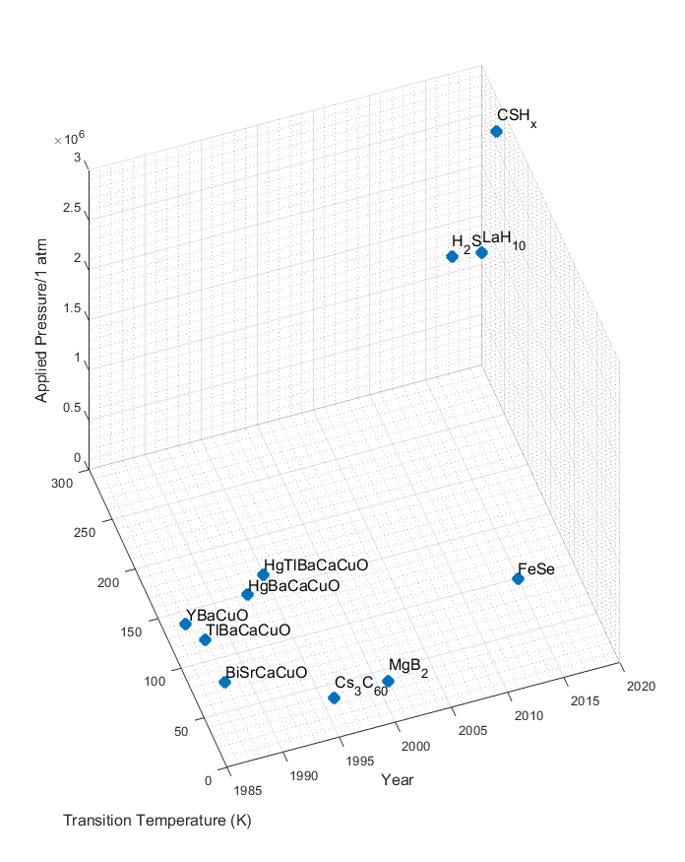
Figure 1 - Superconducting materials according to critical temperature and year of discovery.

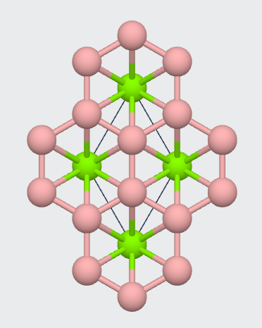
Figure 2 - Magnesium Diboride lattice. Source: [165]

Figure 3 - Literature Search utilizing terms “MgB₂” or “Magnesium Diboride”, “Manufacturing” or “Fabrication” from 2014-2021 (limit). Source: Scopus


Figure 4 - Literature Search utilizing terms “MgB₂”, “Magnesium Diboride”, “Superconductor Application” and “Superconductors” from 2014-2021 (limit). Source: Scopus


Figure 5 - Literature Search utilizing terms “Hot Pressing”, “Infiltration”, “Diffusion”, “MgB₂” and “Magnesium Diboride” from 2014-2020 (limit). Source: Scopus


Figure 6 - Literature Search utilizing terms “Spark Plasma Sintering” and “Superconductors” from 2014-2022. Source: Scopus

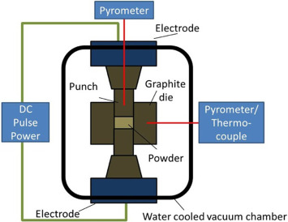
Figure 7 - Spark Plasma Sintering process diagram. Source: [91]

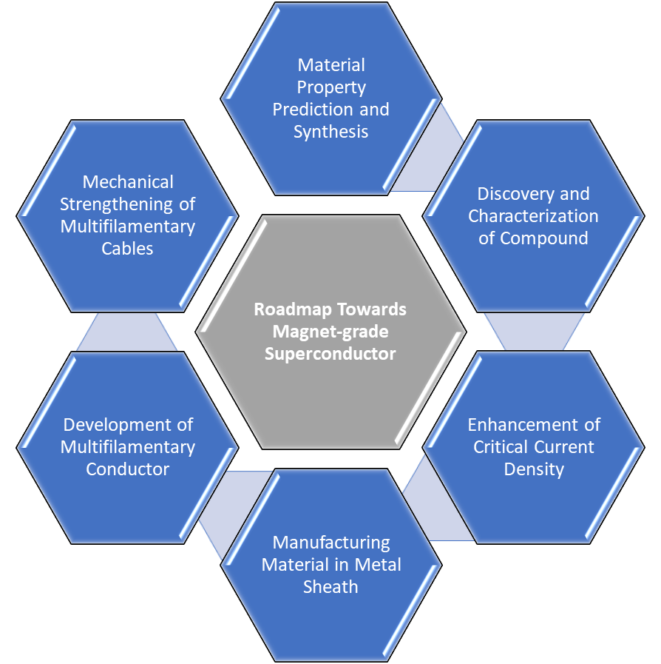
Figure 8 - Roadmap from discovery to industry application of superconducting material

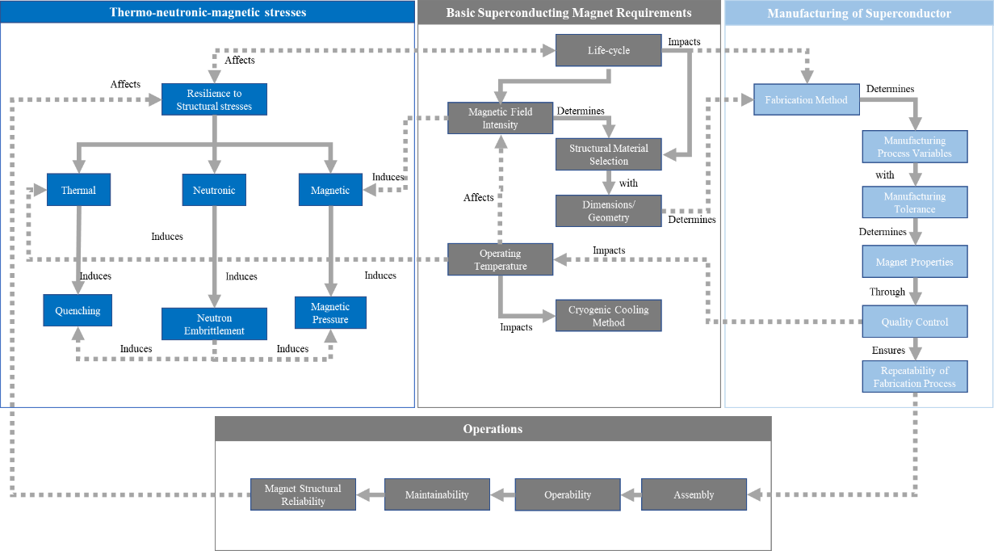
Figure 9 - Systematic Approach to Magnets for Magnetic Confinement Fusion Reactors

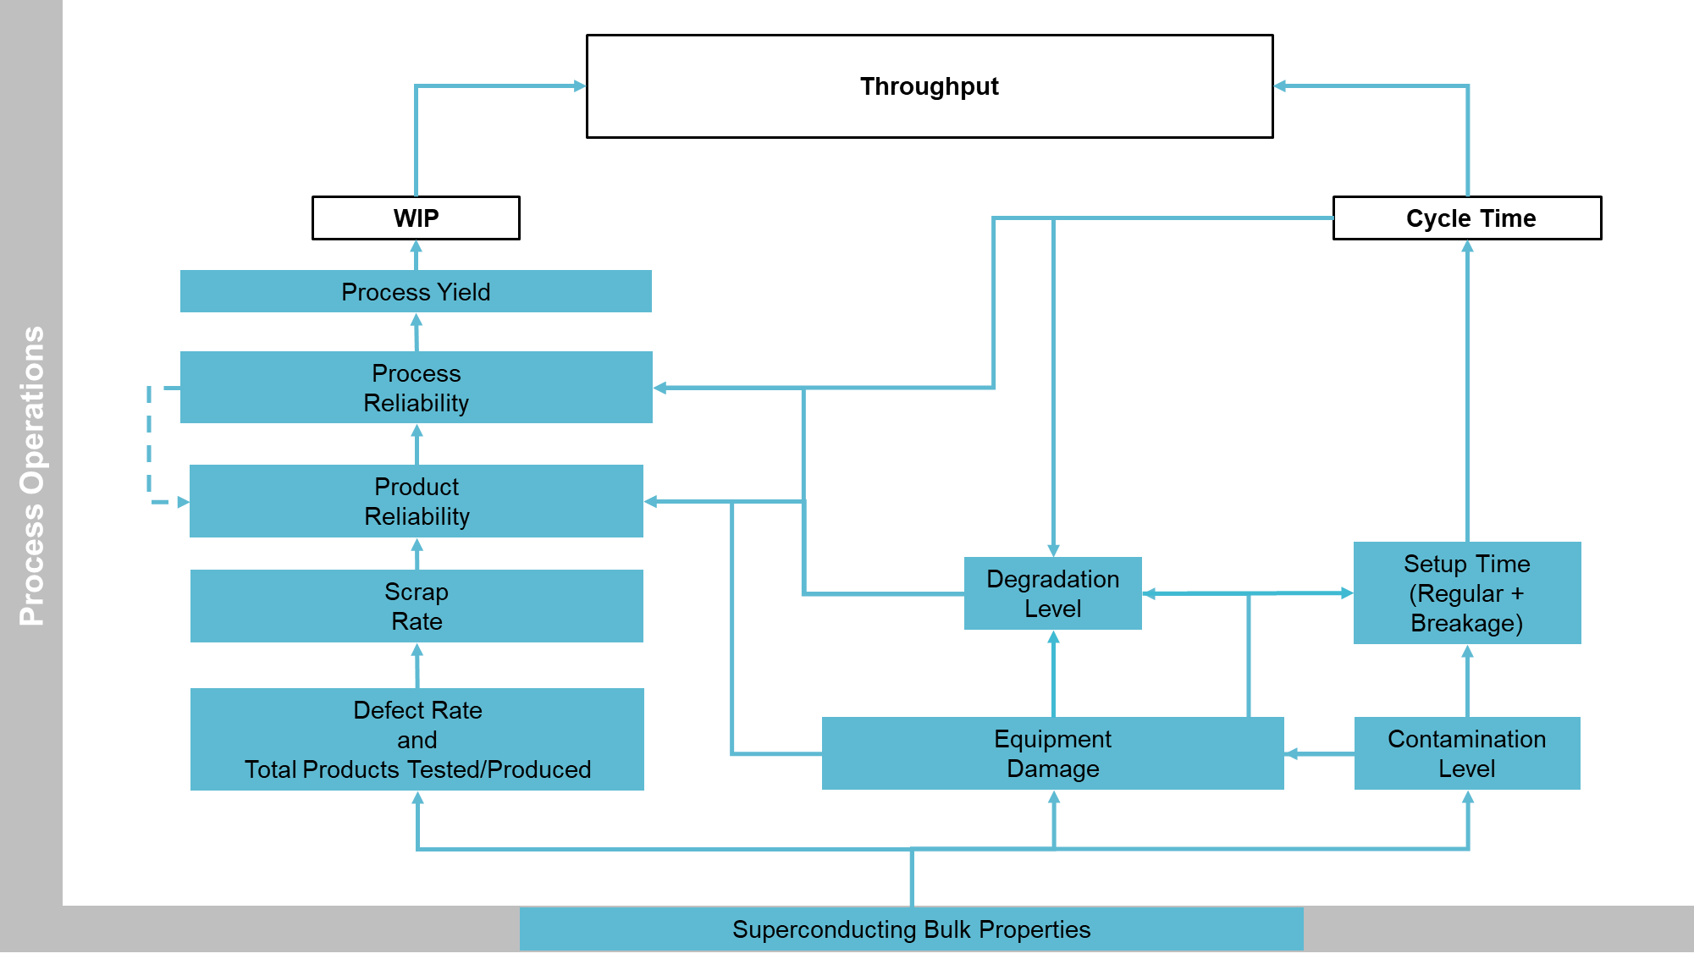
Figure 10 – Performance Measurement System for SPS of MgB2 Superconductors.

CHAPTER II
CHARACTERIZATION AND STATISTICAL QUALIFICATION OF SPARK PLASMA SINTERED MAGNESIUM DIBORIDE SUPERCONDUCTING BULKS

A version of this chapter has been submitted to the Journal of Material Processing Technology and is currently under review according to the information below. This manuscript has been written by the main author Fabiano Carvalho de Castro Sene with his co-authors Rapinder Sawhney, Yiteng Xing, Pierre Bernstein, and Jacques Noudem. This paper has been written by the main author in the submission, and all co-authors have provided feedback on the writing, depth of explanations, and overall flow of the manuscript.

Abstract
In the pursuit of high-quality superconducting materials, material properties and processing conditions play a key role in the final reliability of the part while in superconducting regime. To provide an understanding of effects of processing conditions in superconducting properties of MgB₂ bulks produced via Spark Plasma Sintering, sample characterization is performed. Variables such as processing pressure, temperature, time, and powder modality (in- or ex-situ) have been tested with respect to their effects in the MgB₂ bulk mechanical and superconducting properties. Post-production characterization has been done using micrographs via scanning electron microscopy, and bulk superconducting properties via physical property measurement system. Complementary to the characterization, image processing of the SEM micrographs has been performed in order to assess how the Shannon entropy of each sample relate to both microstructural defects and measured superconducting properties. Techniques such as thresholding, binarization, entropy-filtering and masking have been utilized in order to identify byproducts as well as structural defects such as fractures and pores in each sample. Lastly, statistical characterization of the MgB₂ bulk samples is performed and the experimental conditions are evaluated for potential production scalability.

INTRODUCTION

Review on Manufacturing of Magnesium Diboride Superconductors
Magnesium Diboride (MgB₂)[20] is a binary compound discovered as superconductor at 39K in 2001 [2, 19, 21]. The attractiveness of such a superconducting material comes from its molecular simplicity [20], and ease to synthesize it if compared to Copper-oxides [3], and higher critical temperatures than Niobium-based and other non-Copper-oxide superconductors [29, 30, 56, 166]. As a manner to push the boundaries of manufacturing MgB₂, efforts through vapor deposition [166], powder-in-sealed-tube [167], magnesium infiltration [46], magnesium diffusion [24, 31], and hot isostatic pressing [53] have been made. However, these techniques have failed in providing property homogeneity for larger scales in production of bulks, wires, and cables. MgB₂ is also a brittle compound, as a ceramic-like metalloid, which requires samples to undergo effective sintering to have its properties enhanced [101].
Such challenges in the synthesis and sintering of MgB₂ have given rise to the development and utilization of Spark Plasma Sintering (SPS), also known as Field Assisted Sintering [101, 104, 107]. It comprises the simultaneous action of both Hot Pressing (HP) and electrical current flow through the powder for enhancement of features such as mechanical properties. The combination of mechanical work, thermal stress, and electrical current command grain growth, volume diffusion, and surface diffusion of the MgB₂ desired shape [38, 118]. By enhancing mechanical properties and wt.% MgB₂, SPS has reportedly been able to generate substantial effects in the superconducting properties of MgB₂ bulks [38, 96, 124, 168]. Arguably, SPS is considered an additive technique [90] due to both promoting grain bonding, growth, and diffusion for the formation of a given geometry.
The qualification of SPS-produced MgB₂ superconductors rely on electromagnetic and mechanical properties. Authors have reported sample property enhancements with respect to current density, critical magnetic field, relative density, and irreversible field [39, 101, 107]. Overall, the most common techniques for mechanical and electromagnetic properties of MgB₂ are X-Ray Diffraction (XRD), Scanning Electron Microscope (SEM) [169], and Physical Properties Measurement System (PPMS). However, those depend upon the operator’s experience and take extensive periods to be performed. So, this work aims to elaborate on a one-step characterization based on a microstructure-level image via SEM micrographs for MgB₂ bulk qualification purposes.

ENTROPY-ASSISTED CHARACTERIZATION OF SPARK PLASMA SINTERED MgB₂ BULKS
The first step is the calibration of the microscope, which serves as the primary post-SPS mechanism to obtain information on the MgB₂ sample. The microscope utilized is manufactured by Japan Electron Optics Laboratory (JEOL), configuration as SEM, calibrated for magnification x15,000 times, acceleration voltage of 5kV, and hatch width of 6.00mm.
The next step after obtaining the MgB₂ bulk micrographs is to evaluate them with respect to their features. Since the generation of byproducts and structural defects in the manufacturing superconductors is represents a risk to quality and reliability of such parts, tight control and identification is performed via micrograph histogram extraction and Shannon entropy calculation. Image thresholding, histogram equalization for contrast adjustment, and further binarization [170] are employed in the micrograph segmentation. From micrograph segmentation, it is possible to extract topological features of the SEM image that may describe hollow areas, voids, cracks, content of MgB₂+MgB₄, and other byproducts such as MgO. This supports the analysis of MgB₂ sample microstructure disorder, which will be quantified by the micrograph Shannon Entropy. Such a metric has been interchangeably called Structural Entropy, given its use in quantifying the structural health of sparse regions of each MgB₂ sample based on their micrograph histogram.
Discrepancies in pixel brightness of micrographs exposes different properties within each sample. Hence, not only the volume content (e.g., voids and solid) will be considered, but the chemical content of the part also comprises an important part of the analysis of the bulk properties (e.g., MgB₂,MgB₄, MgO, and porosity). Properties of the bulk will be treated as a histogram extracted from a grayscale image and have its entropy measured through equation (5). Considering principles of each sample frequency response to the electron beam, it has been possible to identify different light intensities throughout the yielded grayscale images. Such a step is important in identifying spots of surface roughness, voids and fractures, as well as MgO grain formation. The analysis for the samples M108, M110, M118, and M186 has been performed based on their respective SEM images, as explained in Figure 11.
The entropy filtering [171] is also utilized to detect correlation levels in pixel neighborhoods of the image, as a way to evaluate the aggregation of the MgB₂, MgB₄, and MgO grains in each region with respect to grayscale levels. When filtered with the entropy filter, disordered structures within predetermined square pixel neighborhoods $N=[n n]$ of the image are represented in clearer colors within the grayscale range (i.e., 0=black, 255=white), which indicates low property correlation between neighboring pixels. Darker clusters of pixels correspond to regions where the microstructure is well formed, corresponding to more homogeneous composition and higher MgB₂ content. By considering the generalized Shannon Entropy [172, 173] in equation (5), may be utilized to quantify the variation of microstructural configurations of each sample properties. Important to note that, this process comprises the evaluation of MgB₂ and potential byproducts such as MgB₄ and MgO.
$S_{ω}=-\sum_{i}{p_{i}ln}{(p}_{i})$ (5)
In equation (5) $S_{ω}$ represents Structural Entropy, $p_{i}$ is the probability of obtaining different compounds derived from SPS of MgB₂ in the sample domain $ω$, and $ln⁡(p_{i})$ accounts for the natural logarithm of the probability of identifying contaminants such as higher borides and MgO originated throughout the SPS process. Both structural density and entropy are continuous, real variables. The entropy of each MgB₂ sample region comprises the number of states and configurations for each sample at the scale of sample observation.
Ideally, the statistical distribution for a perfectly uniform, dense bulk is a unitary distribution. This represents that all the points of the bulk domain $℧$ are equivalent, both in space and time. However, due to effects of material sintering, generation of byproducts such as MgB_{4,} and MgO, and other external factors, it is expected that the solid contains several responses to the SEM test. As this alters the distribution of MgB₂ grains and adds other molecular structures to the bulk, the range in the grayscale of the SEM image increases, and so does the entropy of the image histogram. This would culminate in the observation of different distributions whose skewness may exhibit discrepancies from the benchmark distribution. The determination of these distributions will be performed by breaking the domain $℧$ into sections, then utilizing the ICOMP criterion [174] to verify their similarity between the regions. Such a test is performed for five statistical distributions: (i) Normal, (ii) Lognormal, (iii) Exponential, (iv) Gamma, and (v) Weibull.
In this analysis, larger entropy contributes with the increase of bulk defects, leading to higher likelihood of mechanical or electromagnetic instability. The hypothesis to be evaluated in this case is that the process physics of SPS exerts influence in the production process operations through the Structural Entropy $S_{ω}$, that h represents a measure of sintered MgB₂ property variation in the scale of observation of $μ$m. To connect material property variation to the percentage of defects, a statistical framework based on image processing of SEM, measurement of in-process variables (i.e., Pressure, Temperature) and measurements made through PPMS, and SQUID will take place.

CHARACTERIZATION OF SPS-PRODUCED MgB₂ BULKS
It is known that material purity [175] and grain size [176] directly affect the performance of the sintering procedures. The first comprises the percentage of impurities per unit volume in comparison to the total volume powder, and the second describes what is the average powder grain size of MgB₂ in the sample. The grain size plays a role in the densification of MgB₂ throughout the SPS process due to the surface energy. It means that a larger amount of energy from SPS is required to break the surface energy film of the MgB₂ grain to activate it and provide proper conditions for grain growth and consolidation. A hypothesis to be evaluated is that the MgB₂ grain consolidation using ex-situ powder is larger than for in-situ. Hence, this may lead the MgB₂ ex-situ to have its surface energy comparable to MgB₄ and MgO activation energies.
To establish a comparison between the samples M186, M118, M110, and M108, the initial consideration for this analysis is that the grayscale images obtained through SEM correspond to different beam absorption levels, where the color levels regard to the frequency response of the material while undergoing the SEM. Based on the procedure for analysis described, when utilizing ex-situ MgB₂ powder, the pressure has been shown to cause an upward trend in the sample densities. Concurrently, the Entropy of the respective SEM images decreases with the increase of relative density (See Table 4 and
Table 5).
This means that higher pressure tends to compact samples to a smaller volume, while promoting the growth of larger MgB₂ grains. Such a process indicates a reduction in the property randomness of the sample. Based on this, a trend has been identified where the increase of grain connectivity and both Critical Current $J_{C}$ at 0T and 2T with the decrease of Structural Entropy. The electrical connectivity of the samples which represents the capacity of current transfer between the grains was estimated with the Yamamoto expression [177] shown in equation (6).
$K=\frac{∆ρ_{g}}{∆ρ}$ (6)
In equation 6, $∆ρ = ρ_{300K} - ρ_{40K}$ and $∆ρ_{g} = ρ_{g_{300K}}- ρ_{g_{40K} }$ are respectively the differences in the resistivity of the samples and in that of the MgB₂ grains between 300 K and 40 K. According to [177], the average $∆ρ_{g}$ in randomly oriented polycrystalline MgB₂ samples is equal to 6.32 µΩ cm. This information is available in Table 3. Table 4 exhibits that the MgB₂ sample M186, processed via in-situ SPS, yielded better properties if compared to ex-situ, M110 sample. The sample SEM imaging of M186 exhibits more cohesive connection between grains despite Mg vaporization spots. M110 presents a rougher surface, yielding poor grain connectivity, low %wt. of MgB₂, lower critical densities at zero field and 2T, and lower critical temperature at 9T. A smoother surface is result of effective grain bonding and small presence of Boron or MgO in the MgB₂ grain boundaries. Such an aspect can be visualized in the smaller percentage of MgO and MgB₄ in sample M186 if compared to M110.
To analyze all samples through the same bases utilized for M110 and M186, Table (3) and Table (4) show data on processing conditions, and yielded properties for the ex-situ samples M108, and M118 as well. It has been shown that ex-situ samples exhibit a higher content of their weight composed by byproducts such as MgO and MgB₄. The in-situ sample M186 is still the one whose electromagnetic properties are the best, whose density is only smaller than in sample M108. As aforementioned, the upward trend in density is related to the increase in the applied uniaxial pressure during SPS.
Further effects of the difference between in-situ and ex-situ powders have been shown in Figure 12, where the electrical resistivity of the samples is exhibited. Comparatively, the resistivity for in-situ MgB₂ samples have a significative advantage in comparison with ex-situ in terms of the critical temperature $T_{C}$ and the variations of resistivity. While in-situ samples range from $20 μΩ.cm$ to $0 μΩ.cm$, the ex-situ presents a range of electrical resistivity that is around three times larger. Besides, the critical temperature for the ex-situ samples is 38.25 K, lower than the 39.25 K measured for sample M186 (in-situ).

Sample M108 – Results and Discussion
To identify conditions related to the inhomogeneity of the sample regions, an Entropy Filter with 9-by-9 neighborhood analysis has been applied to the SEM images. It is a tool utilized in identifying both disordered and similar structures throughout an image. In the case of MgB₂ analysis, the raw images have been processed computationally, binarized, then filtered with the entropy-based technique. In comparison with the raw SEM image of the M108 sample, boundaries and crystal structures cannot be identified without the use of techniques such as thresholding and filtering. Figure 13 (a) through Figure 13 (c) exhibit the total feature extraction after the entropy-based filtering. Scaled entropy, represented in a 0-1 scale, accounts for the overall level of discrepancy between image neighborhoods with slightly and highly non-homogeneous areas. The larger the scaled entropy, the higher the property anisotropy of the image neighborhood analyzed.
In the manufacturing of MgB₂ magnets, it is desirable that the crystal growth process occurs as shown in Figure 13. The right-bottom edge of such SEM image identifies an area of small entropy where the MgB₂ crystal is dense and has same orientation. Other areas shown in Figure 13 (a), Figure 13 (d), Figure 13 (j) exhibit low scaled entropy regions but are far less connected than the right-bottom section of Figure 13 (g). Such disparity influences how the whole sample will respond to stimuli when in superconducting regime. Low grain connectivity is a feature that interferes with the critical current density, field penetration depth, and may decrease the sample critical temperature.
Entropy-based masks represent the connectivity amongst all MgB₂ crystals of each sample region. Derived from the entropy-based filtered SEM images, the mask is a dual level image, where one corresponds no connection or presence of byproducts and high entropy, while zero accounts for high-connected MgB₂ grains throughout the sample section evaluated. The sample regions M108 - regions 3 (see Figure 13 (g)) and 4 (See Figure 13 (j)) account for the lowest scaled entropy levels found for M108.
For the four regions of the sample M108 whose properties were investigated, Figure 14 exhibits the superimposed profile histograms. Alignment of the statistical distributions that describe the SEM images of each region, represents that there is a certain degree of homogeneity in the sample. For sample M108, the maximum difference between entropies is exhibited between regions 3 and 2, respectively. It is expected that the SEM image distribution, as shown in Figure 14, have its peak between 50-100 of the grayscale range. These account for the radiation emitted by the MgB₂ and MgB₄ content of the sample, while anything below 50 or above 150 correspond to voids, fractures, or MgO flakes. Figure 14 exhibits the profiles of both joint and separate visualizations of all regions in sample M108 with respect to their entropy-based metrics.

Sample M110 – Results and Discussion
For sample M110, six sample regions have been evaluated with respect to their microstructure. Figure 15 (a) through (r) exhibit the SEM images whereby orientation, binarization, entropy filtering, and masking have been applied. Throughout the feature identification process, Figure 15 (a), (j), and (m) have been found to have the smallest entropy values amongst all regions. This represents that the SPS process has consolidated the preprocessed MgB₂ powder into a bulk, whose properties are similar. Though, Figure 15 (p) exhibits that the MgB₂ grains are not bonded as in the previous regions, causing the microstructure to become more brittle due to the excess of MgO grains. This compromises the superconductivity of MgB₂, since MgO grains grow in between MgB₂. Such factor reduces the content of MgB₂ in the sample, hence reducing $J_{c}$, $T_{c}$, $H_{c}$ as well as the bulk packing ratio.
Figure 16 exhibits the kernel histograms of all six regions analyzed for sample M110. The estimated entropies of all sample regions, except for region 6, lie in an interval between 5.85 and 5.96. If observed, the histogram of region 6 exhibits significant discrepancy if compared to Regions 1-5. This corresponds to different composition, given the frequency response of the grains of such region to the electron beam. As Regions 1-5 have peaked between 50-100, Region 6 exhibits its peak between 100-150.

Sample M118 – Results and Discussion
Sample M118, due to its SPS fabrication parameters, has been shown as the most mechanically fragile sample. Throughout its regions, the structural entropy variation has been found to vary between 5.72 and 6.33, which renders significant property variations throughout the superconducting part. For regions 2, 3, and 5, the SEM image histograms peak in the interval 0-50. This leads to the fact that there are more voids or fractures in different sample regions. Such porosity is what turns the part produced into a mechanically unstable magnet, where the cross section is comprised by MgB₂ neck formations and voids. Both mechanically and electromagnetically, this sample is more likely to perform as the worst amongst the ex-situ samples M108, and M110.
Besides, the vast majority of sample M118 neighborhoods has been found to contain elevated levels of randomness. Such condition is confirmed when comparing the M118 scaled entropies, considered high if compared with the other two ex-situ MgB₂ samples. Figures 10(c) and 10(d) exhibit more homogeneous neighborhoods of the M118 sample, which leads such regions to have lower scaled entropies if compared to the overall M118 sample. Region 5 (Figure 18 (e)) comprises the highest connectivity of MgB₂ grains throughout the whole sample M118, where the crystal growth has notably grown with less disorder, conserving the material aspect and, potentially, its properties locally.

Sample M186 – Results and Discussion
The M186 is the only sample where the reactive SPS has been utilized, where the proportion of powders of Magnesium and Boron is 1:2, or Mg+2B. When the powder is not pre-processed, the sample in superconducting regime exhibits higher critical temperature, critical current density, and critical magnetic field. Through the entropy-based analysis of the SEM images of the M186 sample, the superimposed histograms (see Figure 19) correspond to similar patterns of frequency responses to the electron beam.
Region 1 exhibits the lowest structural entropy amongst all three regions, and Region 3 exhibits the highest level of disorder in terms of MgB₂ crystal growth. Such condition can be ascribed to the reactivity of both powders, Mg and 2B, throughout the SPS process. As the vaporization enthalpy of Mg is lower than for B, the thermal energy accumulation in the sample volume causes, eventually, the Mg powder to reach its vaporization point. Hence, circular sites are shown in Figure 20 (a) ,(d), and (g). The entropy-based filtering enhances both evaporation sites, MgO flakes, and visualization of the grain connectivity throughout the regions. Region 1 (Figure 20 (a)) has a more complex, connected crystal arrangement represented through the darker areas. Such region is also responsible for the smallest scaled entropy amongst all three sample regions. Figures 11 (c), (f), and (i) exhibit the difference in composition of the sample region, where yellow peaks represent content of MgO, dark blue represents pores and fractures, and light blue corresponds to MgB₂ and MgB₄.

DISCUSSION

Statistical Analysis of SEM Images of MgB₂
Through statistical analysis of the SEM images for samples M108, M110, M118, and M186, it has been possible to spot variation in the sample properties in each region. Depending upon the processing conditions such as pressure and type of SPS fabrication (i.e., in- or ex- situ), patterns of variation represented in Figure 21 shown the property similarity for each region analyzed.
Samples processed under pressures of 100-140 MPa exhibit a more orderly behavior, whose peak within the range 50-100 in the grayscale represents smoother surface. Spark Plasma Sintering comprises four different phenomena that are subsequent in the consolidation of the sample: (i) grain growth, (ii) grain diffusion, (iii) volume diffusion, and (iv) surface diffusion). Deformation or “necks” represent poor volume and surface diffusion, triggered by inadequate processing pressure. Higher smoothness and minimized number of voids are seen in sample processed under pressures of 100 MPa upward.
Another factor that plays a key role in the four steps of SPS is the choice between in- or ex-situ processing. The formation enthalpy of Mg+2B is smaller than for preprocessed MgB₂, which enhances the %wt. of MgB₂. The use of in-situ SPS processing is also supported by the reduction in %wt. of byproducts such as MgB₄ and MgO, whose are seen in quantities around 10% when using preprocessed MgB₂ powder.
As evidenced in sections 2 and 3, the use of structural entropy as a sole parameter to categorize MgB₂ samples quantitatively is feasible and can be obtained through image segmentation and entropy calculation. For this, firstly utilizing the concept of image entropy (equation 1), then scaling it between 0 and 1 with the entropy filter for a pixel neighborhood [9 9], it is possible to link the trends of such a variable with electromagnetic properties of their respective MgB₂ sample, regardless of the utilized powder type.
Table 7 and Table 8 exhibit processing conditions and yielded results from the SEM image segmentation, thresholding, and entropy calculations. Boundaries and grains are calculated based on the radiation intensity in the response of sample regions to the electron beam. MgB₂ and MgB₄ have a similar response to the electron beam, whereas MgO tends to cause more reflection than absorb the beam.

Distribution Fitting of SEM Samples of MgB₂
The MgB₂ samples have also been evaluated with regards to the statistical distribution that better fits them through the parameter ICOMP criterion. The rule for statistical data fitting through the ICOMP criterion indicates the best distribution is the one for which the ICOMP is minimized. Amongst the five distributions evaluated, Weibull distribution has consistently been shown to be either the best or second best fit for all samples evaluated. Given the minimal statistical difference between Weibull, Gamma, and Lognormal in this analysis, as shown through the results of ICOMP criterion (Table 9 to Table 12), Weibull distribution has been utilized for fitting each sample statistically (see equation 7). However, the samples analyzed, Lognormal and Gamma distributions could also be utilized in the data fitting.
$f\left(α, β\right)=e^{{-\left(\frac{x}{α}\right)}^{β}}$ (7)

In equation (7) shape $β$ and scale $α$ parameters define the breadth and skewness of the distribution. The goal of this analysis is to score each of the samples evaluated regarding their distribution parameters and scaled entropy. The scale $α$ corresponds to the breadth of the distribution, while $β$ accounts for the shape. A minimized $α$ corresponds to more homogeneous properties throughout the sample analyzed. A score based on $α$ and $β$ for each region compose the sample score, as shown in equation (8).
$Score_{1}=\left(α^{β}\right)$ (8)
Tables 11 to 14 exhibit the Weibull distribution parameters for each of the regions in the MgB₂ samples analyzed. The minimization of both absolute values and variation of the scores calculated through equation (7) is a factor that determines the quality of the samples.
The samples that exhibit smaller profile of variation are both M108 and M186, exactly the samples that exhibit the best superconducting properties amongst all four analyzed. By considering a second scoring method utilizing the entropy as the exponent, the ranking in the scores is conserved. This means that the entropy of the distribution corresponding to each sample is directly impacted by both shape and scale. Equation (8) exhibits the score of equation (7) to the power of the average scaled entropy for each sample.

$Score_{S}={\left(α^{β}\right)}^{S_{scaled}}$ (8)

Hence, the statistical analysis comprised by data fitting and scoring of samples reinforces that M108 and M186 represent the best samples obtained. Structurally, M108 has slight advantage to M186 due to their relative densities, $ρ_{M108}=98\%$ and $ρ_{M108}=95\%$ respectively. Considering that from 95% upward is acceptable for practical application of the MgB₂ bulks, either M108, M110, or M186 could be utilized. Such score provides an understanding of, operationally speaking, what are the samples with best properties. These metrics also provide insights on the processing conditions (i.e., processing time, temperature, pressure, in- or ex-situ powder) for further bulk property enhancement.

Potential Effects in Superconductor Quality
The equipment and material parameters utilized to produce each sample serve as a basis for the further analysis and prediction of overall process and product quality and reliability. Based on the image processing techniques and features extracted from the SEM samples, an approach from the data analytics standpoint is reasonable.
Both structural and scaled entropy, previously utilized in identifying the different grain orientation in the sample y, will be utilized as the link between the physics of SPS and the percentage of defective parts. Both entropies will compose the predictor of product quality which, in this case, means to achieve relative density equal or larger than 95%, critical temperature equal or larger than 39 K, and critical magnetic field equal or larger than 9 T at 4.2 K. The inverse relation between relative density and processing pressure with scaled entropy will serve as evidence that segmentation and filtering of SEM images are good techniques to characterize MgB₂ samples.

CONCLUSIONS
Considering the parameters measured and computed throughout this analysis, there is an opportunity for further analysis of SPS-produced samples of MgB₂ in terms of their physical properties. It is envisioned that a quality assessment of the sample can be made by measuring the Shannon Entropy of SEM image of the part surface, where % wt. of MgB₂ and potential byproducts can be measured with confidence. The understanding of the part quality from the physics perspective is crucial for size enhancement and eventual mass production.
Based on the analysis of all four samples, comprising 18 sample regions, trends were identified between relative density, process pressure, grain connectivity, and SEM image entropy. By treating the SEM imaging process as a storage of information, features from such images provide hints of how decisions toward physical parameters (e.g., temperature, pressure, in- and ex-situ powder choice) play a role in the overall part quality. In this case, product quality has been quantified in terms of relative density, grain connectivity, critical temperature, and critical current density. Quantities such as Structural Entropy, and Scaled Entropy represent both global and local metrics that quantify sample patterns in terms of response to the electron beam of the Scanning Electron Microscope. For the ex-situ samples, Structural Entropy $S_{ω}$ has been shown to decrease as grain connectivity increases. Such a condition makes a case for the enhancement in the ability of the sample to transport current in superconducting regime, hence increasing the critical current density.
Scaled entropy represents the response of image filtering regarding local similarities of the sample. Through this technique, it has been possible to observe the variations that each sample presented due to their fabrication have occurred under different physical conditions. A trend between the scaled entropy and relative density has been identified for all samples, as shown in Table 5.
It has been shown that the Structural Entropy of SEM images is higher when the %wt. of byproducts of MgB₂ is higher. Structural inconsistencies such as voids, grain boundaries, and fractures are agents that account for such a condition. This analysis is to be extended to conditions for mass production of MgB₂ bulks. For this reason, qualification of MgB₂ bulks is aimed with the SEM sample image analysis and segmentation. Such a technique presents an opportunity to reduce the time taken to evaluate MgB₂ samples, if compared to procedures where PPMS are utilized. Further investigations are planned to be done in terms of considering structural entropy as the bridging factor between physics of SPS for MgB₂ and production operations. Along with electromagnetic testing (i.e., material characterization), part uniformity and mechanical strength tests are in the scope of this research project. Process operational indicators such as percentage of defects, scrap rate, process yield, cycle time, process throughput, reliability, process capacity, and process capability are to be analyzed.

APPENDIX II – TABLES AND FIGURES

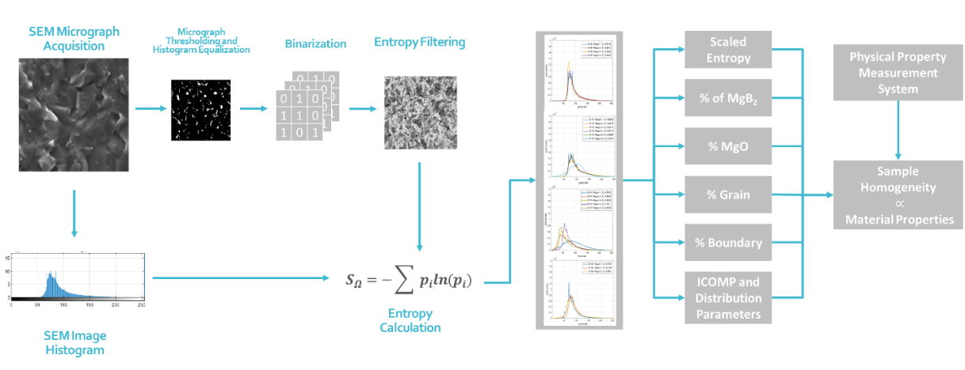
Figure 11 –SEM Image processing-based characterization of MgB2 cryomagnets

Table 3 – Entropy calculations, relative density, and superconducting properties of samples M108, M110, M118, and M186.
Sample | Powder | Pressure (MPa) | SEM Micrograph Entropy | Density % | T_{c} (K) ^{H=9T} | Jc-0T (A/cm²) | Jc-2T (A/cm²) | Connectivity [177]
M108 | MgB₂ | 140 | 5.5019 | 98 | 12.4 | 4.32E+05 | 6.78E+04 | 0.259
M110 | MgB₂ | 100 | 5.8401 | 95 | 12.4 | 4.31E+05 | 6.50E+04 | 0.194
M118 | MgB₂ | 50 | 6.3336 | 85 | 10.4 | 3.33E+05 | 4.15E+04 | 0.166
M186 | Mg+2B | 100 | 5.5655 | 95 | 13.4 | 4.99E+05 | 7.85E+04 | 0.466

Table 4 - Comparison of entropies, densities, and superconducting properties of M110 and M186
Sample | Powder | Pressure (MPa) | SEM Micrograph Entropy | Density (%) | T_{c} (K) ^{H=9T} | Jc-0T (A/cm²) | Jc-2T (A/cm²) | MgB₂ (%) | MgO (%) | MgB₄ (%) | Connectivity
M110 | MgB₂ | 100 | 5.8401 | 95 | 12.4 | 4.31E+05 | 6.50E+04 | 80.97 | 8.04 | 10.99 | 0.194
M186 | Mg+2B | 100 | 5.5655 | 95 | 13.4 | 4.99E+05 | 7.85E+04 | 92.53 | 3.57 | 3.9 | 0.466

Table 5 - post-SPS measurements of relative density, bulk composition, and superconducting properties of the MgB₂ samples
Sample | Powder | Sintering Process | Time (min) | Density (%) | MgB₂ (%) | MgO (%) | MgB₄ (%) | a (Å) | c (Å) | a (mm) | b (mm) | c (mm) | T_{c} (K) | J_{c-0T} (A/cm2) | J_{c-2T} (A/cm2)
M108 | MgB2 | 140Mpa-950°C | 30 | 98% | 81.04 | 7.81 | 11.15 | 3.0840 | 3.5280 | 1.44 | 1.59 | 1.83 | 38.25 | 4.32E+05 | 6.78E+04
M110 | MgB2 | 100Mpa-950°C | 30 | 95% | 80.97 | 8.04 | 10.99 | 3.0840 | 3.5270 | 1.58 | 1.5 | 1.87 | 38.25 | 4.31E+05 | 6.50E+04
M118 | MgB₂ | 50Mpa-950°C | 30 | 85% | 82.41 | 7.26 | 10.33 | 3.0850 | 3.5260 | 1.48 | 1.56 | 2.16 | 38.25 | 3.33E+05 | 4.15E+04
M186 | Mg+2B | 100Mpa-950°C | 30 | 95% | 92.53 | 3.57 | 3.9 | 3.0850 | 3.5270 | 1.56 | 1.58 | 1.81 | 39.25 | 4.99E+05 | 7.85E+04

Table 6 – SPS processing conditions, sample content, and superconducting properties of samples M108, M110, and M186.
Sample | Powder | Pressure (MPa) | Temperature (ºC) | MgB₂ (%) | MgO (%) | MgB₄ (%) | Tc (K) | Jc-0T (A/cm2) | Jc-2T (A/cm2) | H_{c2 (T)} ^{T=20 K} | T_{c} (K) ^{H=9T} | Connectivity* [177]
M108 | MgB₂ | 140 | 950 | 81.04 | 7.81 | 11.15 | 38.25 | 4.32E+05 | 6.78E+04 | 8.7 | 12.4 | 0.259
M110 | MgB₂ | 100 | 950 | 80.97 | 8.04 | 10.99 | 38.25 | 4.31E+05 | 6.50E+04 | 8.6 | 12.4 | 0.194
M118 | MgB₂ | 50 | 950 | 82.41 | 7.26 | 10.33 | 38.25 | 3.33E+05 | 4.15E+04 | 8.6 | 10.4 | 0.166
M186 | Mg+2B | 100 | 950 | 92.53 | 3.57 | 3.9 | 39.25 | 4.99E+05 | 7.85E+04 | 8.2 | 13.4 | 0.466

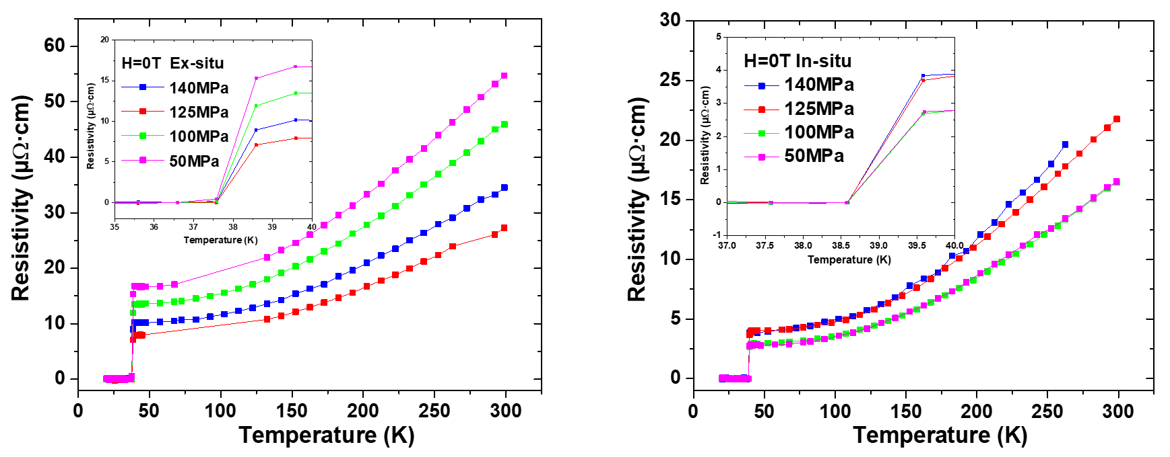
Figure 12 – PPMS critical temperature results for in-situ and ex-situ MgB₂ powders
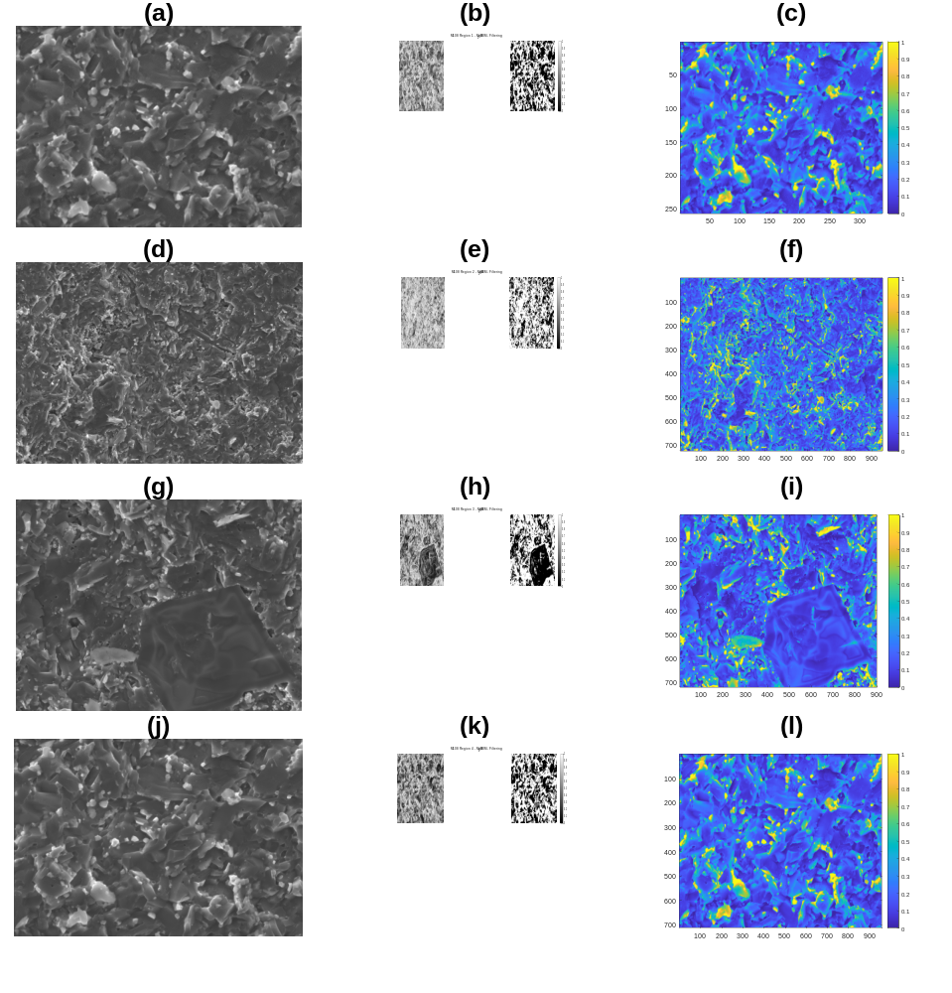
Figure 13 – (left to right) SEM image of M108 MgB₂ bulk sample, binarized and characterized content, entropy-based filtered, and histogram equalization of the filtered sample for regions (a - c) 1, (d - f) 2, (g - i) 3, and (j - l) 4.

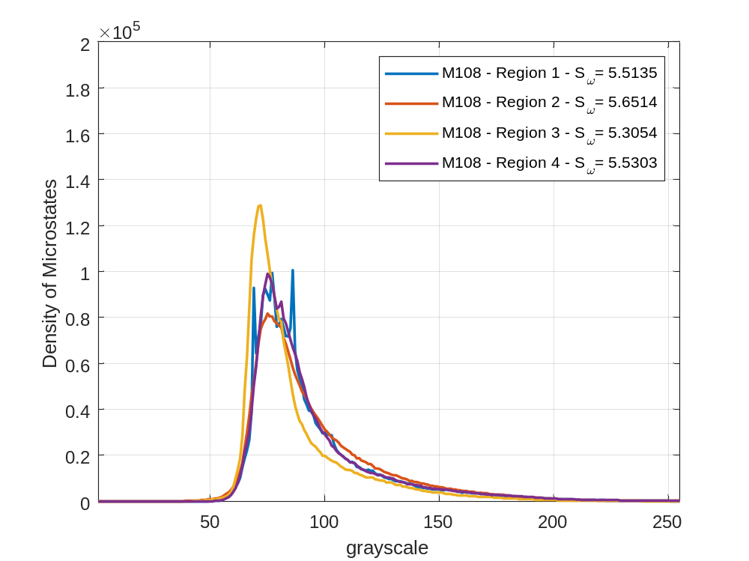
Figure 14 –Kernel of SEM image of all four regions of the M108 MgB₂ bulk according to the yielded crystal growth via SPS.

Figure 15 – (left to right) SEM image of M110 MgB₂ bulk sample, binarized and characterized content, entropy-based filtered, and histogram equalization of the filtered sample for regions (a - c) 1, (d - f) 2, (g - i) 3, (j - l) 4, (m - o) 5, and (p - r) 6.
(a) | (b)  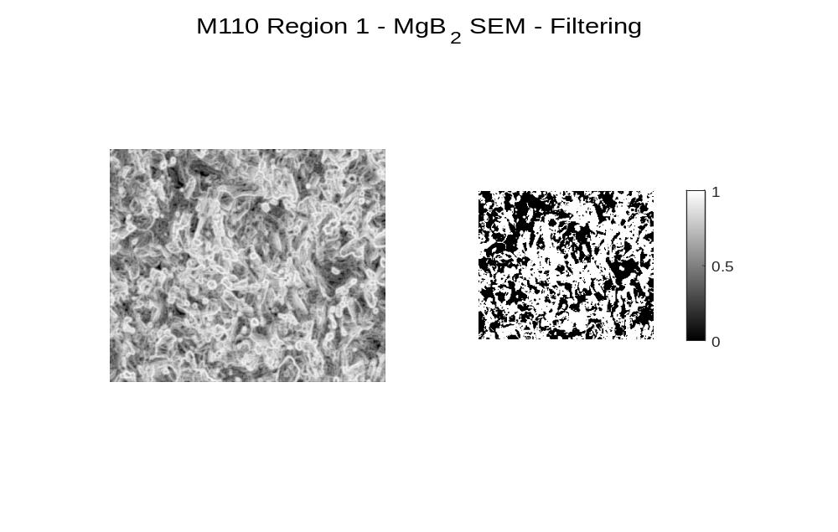 | (c)  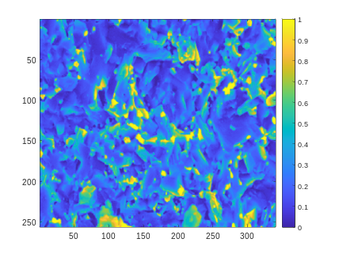
(d) | (e) | (f)  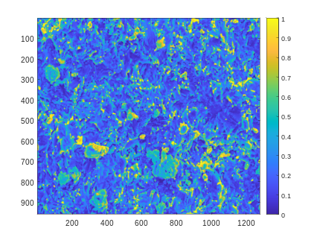
(g) | (h)  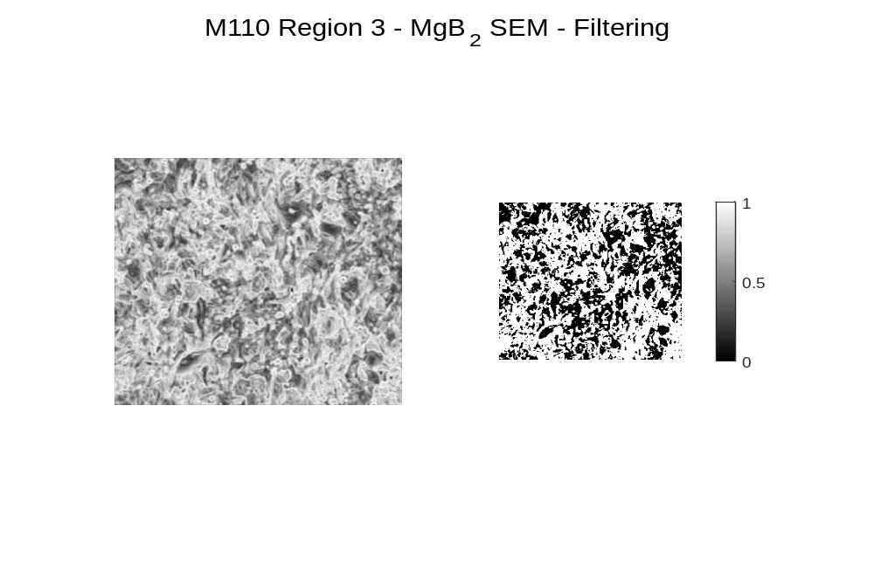 | (i)  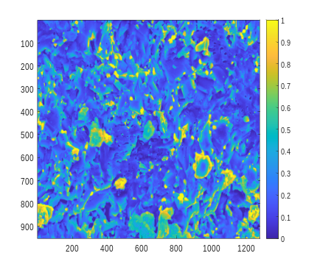
(j) | (k)  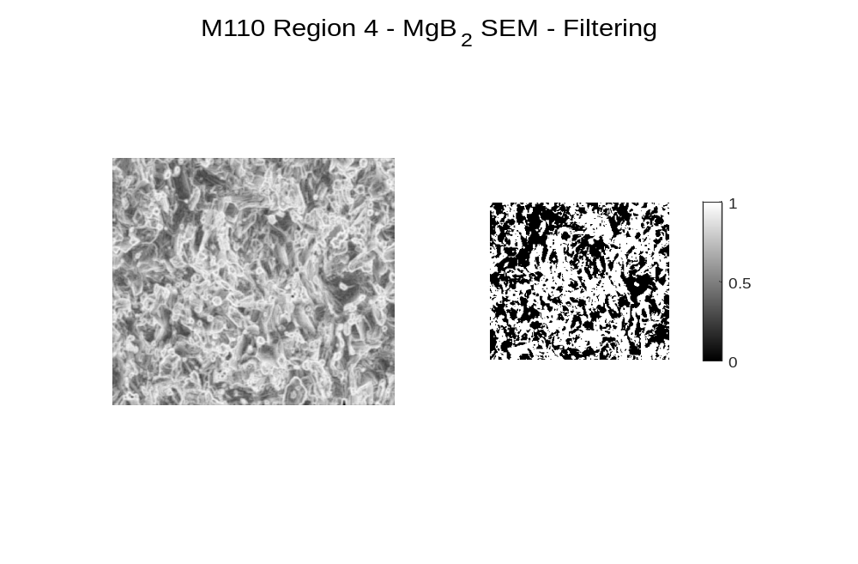 | (l)  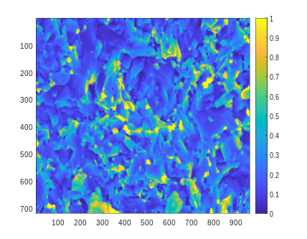
(m) | (n)  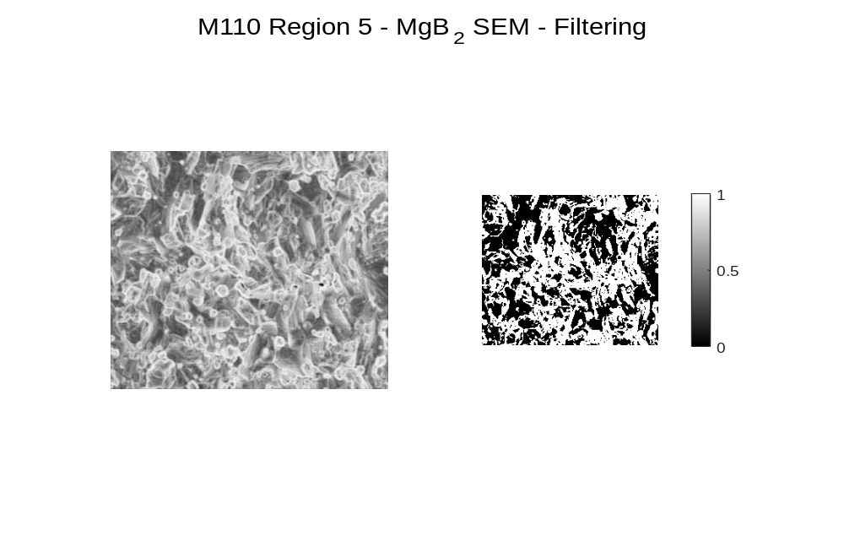 | (o)  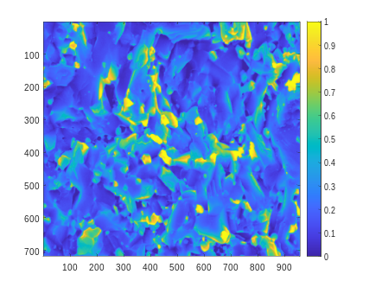
(p) | (q)  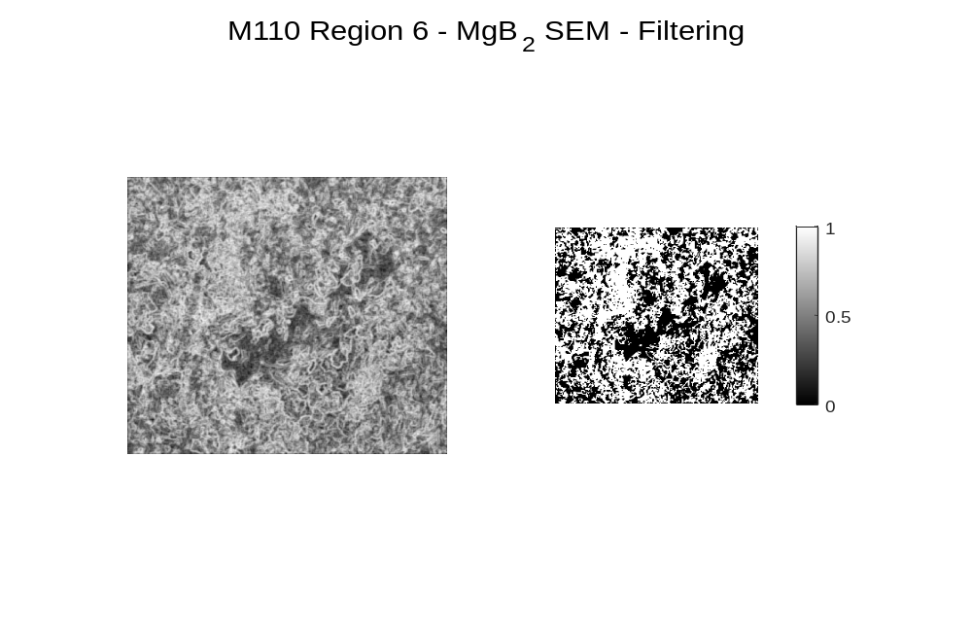 | (r)  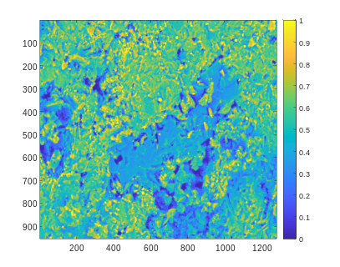

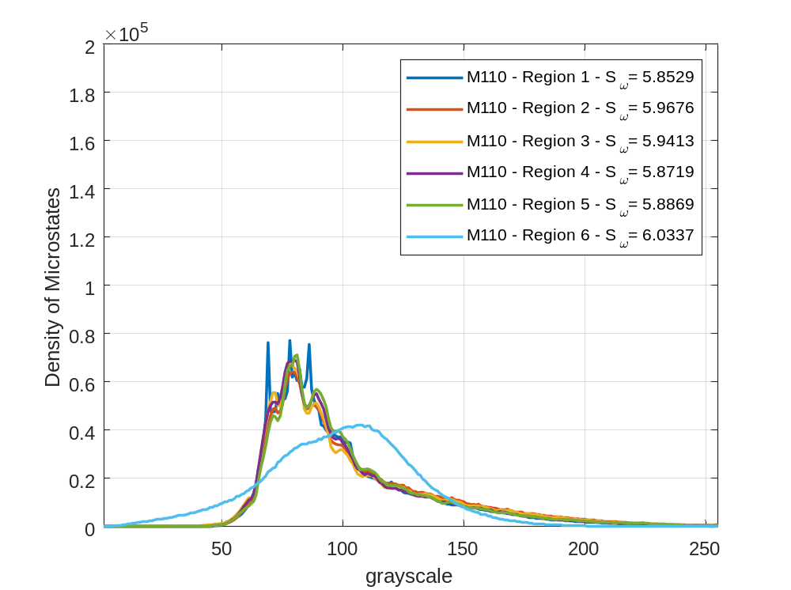
Figure 16 –Kernel of SEM image of all six regions of the M110 MgB₂ bulk according to the yielded crystal growth via SPS.

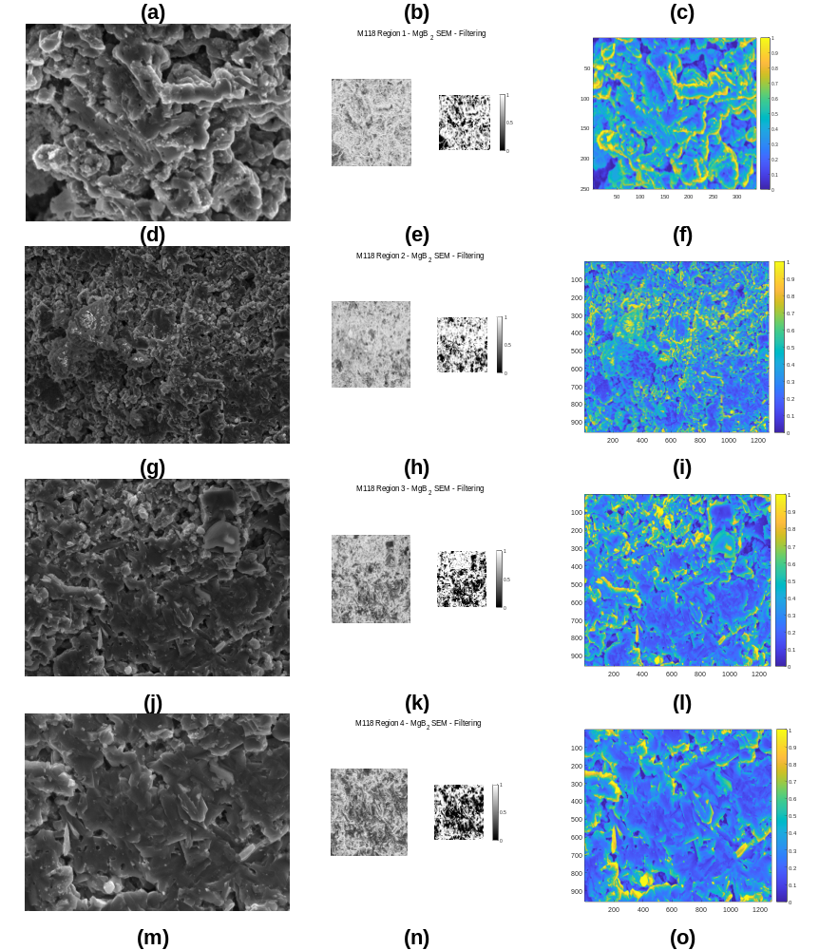
Figure 17 – (left to right) SEM image of M118 MgB₂ bulk sample, binarized and characterized content, entropy-based filtered, and histogram equalization of the filtered sample for regions (a - c) 1, (d - f) 2, (g - i) 3, (j - l) 4, and (m - o) 5.

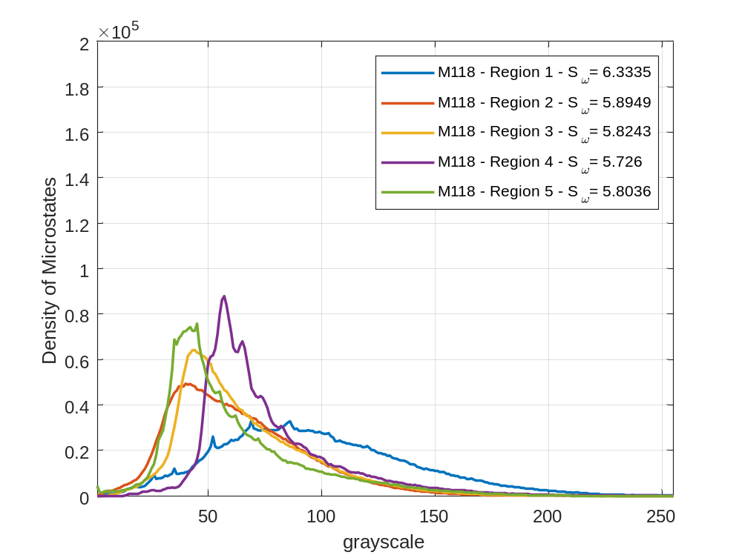
Figure 18 - Kernel of SEM image of all six regions of the M118 MgB₂ bulk according to the yielded crystal growth via SPS.

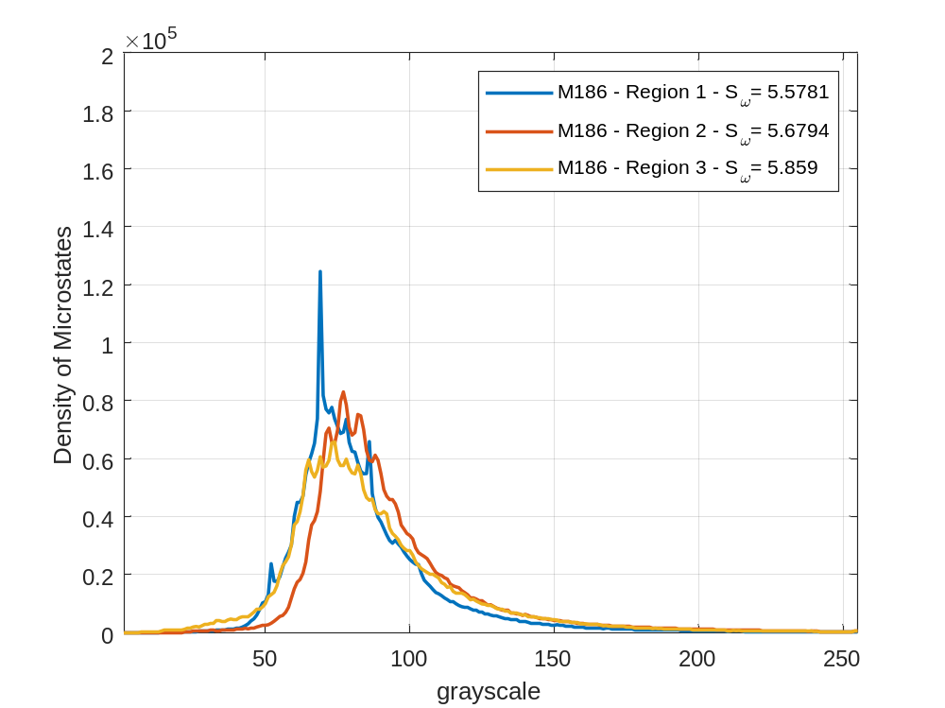
Figure 19 – Kernel of SEM image of all three regions of the M186 MgB₂ bulk according to the yielded crystal growth via SPS.

(a) | (b)  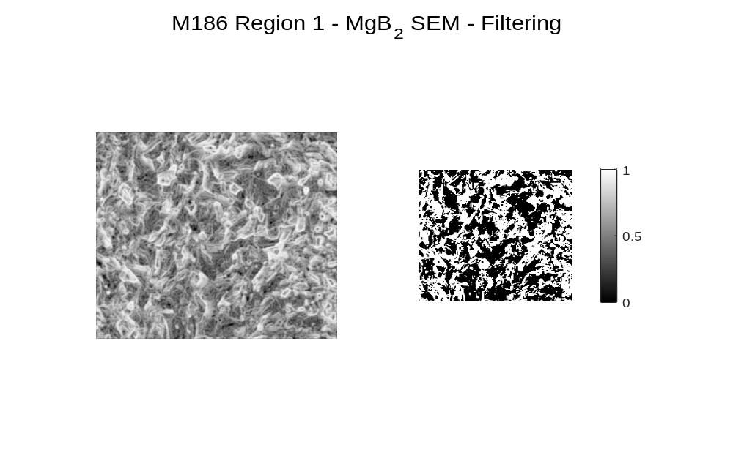 | (c)  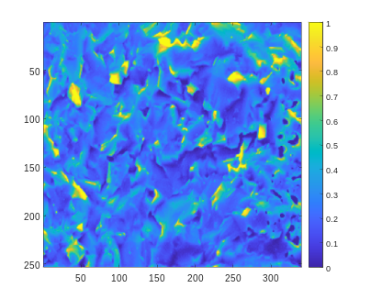
(d) | (e)  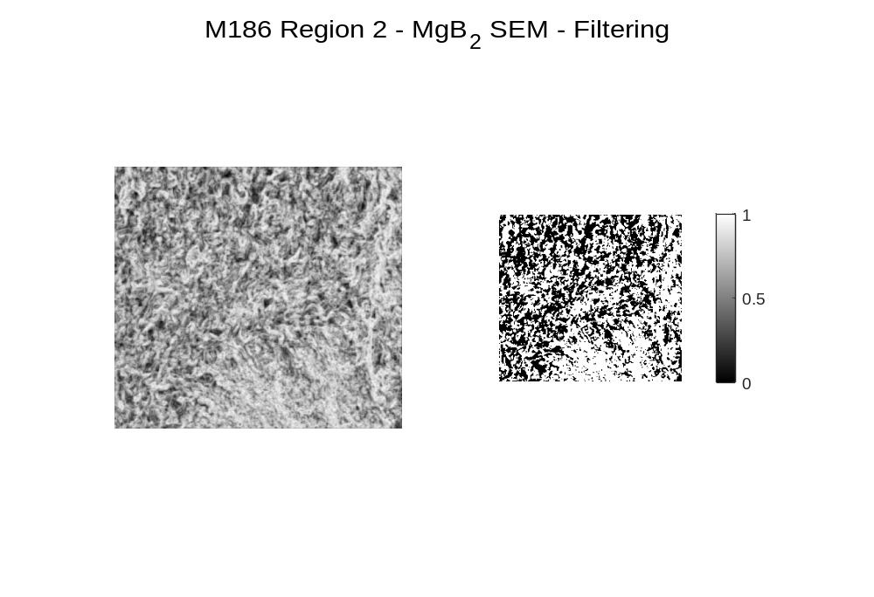 | (f)  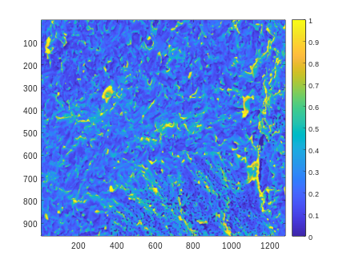
(g) | (h)  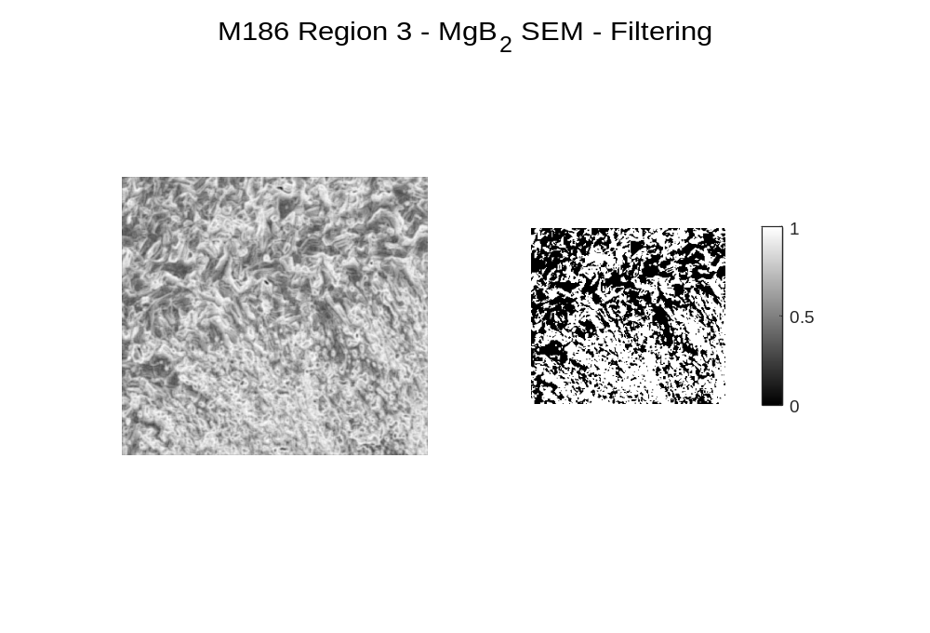 | (i)  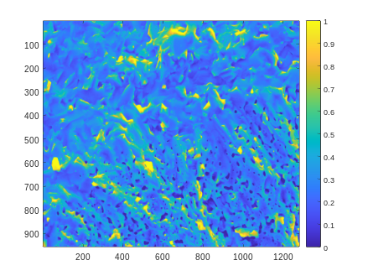
Figure 20 – (left to right) SEM image of M186 MgB₂ bulk sample, binarized and characterized content, entropy-based filtered, and histogram equalization of the filtered sample for regions (a - c) 1, (d - f) 2, and (g - i) 3.

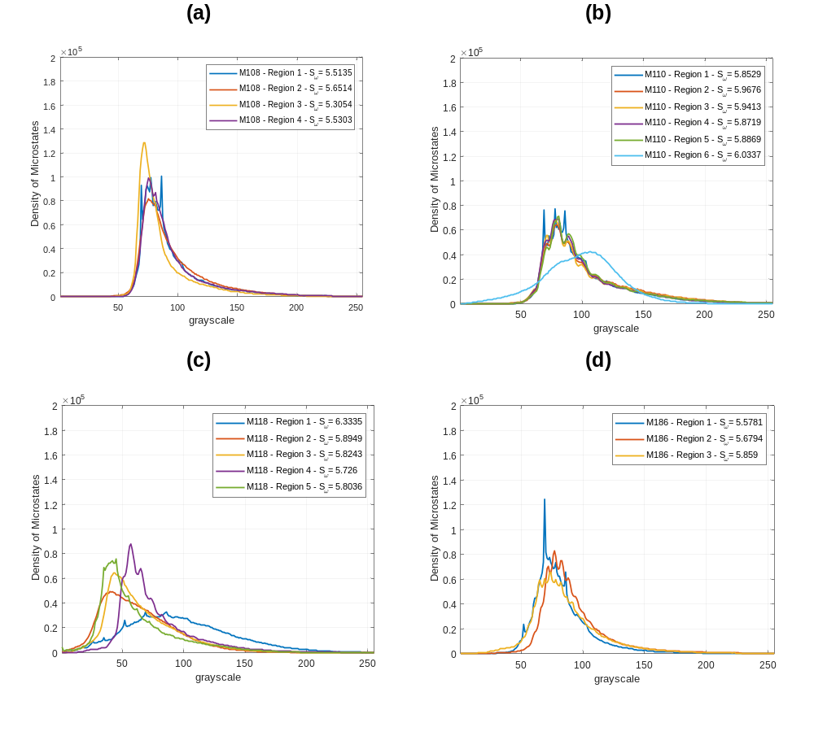
Figure 21 – Comparison of kernels densities of MgB₂ sample microstates based on SEM imaging obtained for all regions of the samples (a) M108, (b) M110, (c) M118, and (d) M186.

Table 7 - Metrics for the samples M108, M110, M118, M186
Sample | Temperature (Celsius) | Pressure (MPa) | Mode | Region | Scaled Entropy | Estimated Entropy | Boundary (%) | Grain (%) | MgB₂ + MgB₄ (%) | MgO (%)
M108 | 950 | 140 | Ex-situ | 1 | 0.5364 | 5.3054 | 3.9355 | 96.0645 | 97.1462 | 2.8538
 |  |  |  | 2 | 0.6039 | 5.5135 | 4.9475 | 95.0525 | 94.8640 | 5.1360
 |  |  |  | 3 | 0.5483 | 5.5303 | 5.1733 | 94.8267 | 94.5540 | 5.4460
 |  |  |  | 4 | 0.6966 | 5.6514 | 5.7796 | 94.2204 | 94.4388 | 5.5612
M110 | 950 | 100 | Ex-situ | 1 | 0.6436 | 5.8529 | 5.9653 | 94.0347 | 90.6480 | 9.3520
 |  |  |  | 2 | 0.6679 | 5.8719 | 6.2680 | 93.7320 | 90.2049 | 9.7951
 |  |  |  | 3 | 0.6337 | 5.8869 | 5.8792 | 94.1208 | 89.8528 | 10.1472
 |  |  |  | 4 | 0.6735 | 5.9413 | 7.3123 | 92.6877 | 88.4307 | 11.5693
 |  |  |  | 5 | 0.7060 | 5.9676 | 8.2893 | 91.7107 | 87.6948 | 12.3052
 |  |  |  | 6 | 0.5745 | 6.0337 | 4.3768 | 95.6232 | 94.1569 | 5.8431
M118 | 950 | 50 | Ex-situ | 1 | 0.5711 | 5.7260 | 6.6287 | 93.3714 | 96.4083 | 3.5917
 |  |  |  | 2 | 0.6572 | 5.8036 | 9.4953 | 90.5047 | 92.2551 | 7.7449
 |  |  |  | 3 | 0.6142 | 5.8243 | 9.1853 | 90.8148 | 94.9992 | 5.0008
 |  |  |  | 4 | 0.7021 | 5.8949 | 11.1440 | 88.8560 | 90.9877 | 9.0123
 |  |  |  | 5 | 0.7260 | 6.3335 | 9.4934 | 90.5067 | 85.8147 | 14.1853
M186 | 950 | 100 | In-situ | 1 | 0.5924 | 5.5781 | 4.0634 | 95.9366 | 97.4475 | 2.5525
 |  |  |  | 2 | 0.6259 | 5.6794 | 5.5088 | 94.4912 | 95.0987 | 4.9013
 |  |  |  | 3 | 0.6822 | 5.8590 | 6.0328 | 93.9672 | 94.8159 | 5.1841

Table 8 – Entropy-based metrics for the samples M108, M110, M118, M186
Sample | Temperature (Celsius) | Pressure (MPa) | Mode | Region | Scaled Entropy  (0-1) | Mean Scaled Entropy  (0-1) | Relative Density (%)
M108 | 950 | 140 | Ex-situ | 1 | 0.5364 | 0.5963 | 98
 |  |  |  | 2 | 0.6039 | 0.5963 | 98
 |  |  |  | 3 | 0.5483 | 0.5963 | 98
 |  |  |  | 4 | 0.6966 | 0.5963 | 98
M110 | 950 | 100 | Ex-situ | 1 | 0.6436 | 0.6499 | 95
 |  |  |  | 2 | 0.6679 | 0.6499 | 95
 |  |  |  | 3 | 0.6337 | 0.6499 | 95
 |  |  |  | 4 | 0.6735 | 0.6499 | 95
 |  |  |  | 5 | 0.7060 | 0.6499 | 95
 |  |  |  | 6 | 0.5745 | 0.6499 | 95
M118 | 950 | 50 | Ex-situ | 1 | 0.5711 | 0.6541 | 85
 |  |  |  | 2 | 0.6572 | 0.6541 | 85
 |  |  |  | 3 | 0.6142 | 0.6541 | 85
 |  |  |  | 4 | 0.7021 | 0.6541 | 85
 |  |  |  | 5 | 0.7260 | 0.6541 | 85
M186 | 950 | 100 | In-situ | 1 | 0.5924 | 0.6335 | 95
 |  |  |  | 2 | 0.6259 | 0.6335 | 95
 |  |  |  | 3 | 0.6822 | 0.6335 | 95

Table 9 - ICOMP of each MgB₂ region in sample M108
Sample: M108 |  | ICOMP of each Sample Region
 |  | 1 | 2 | 3 | 4
Statistical Distributions | Normal | 4786.986 | 4982.811 | 4987.580 | 4693.771
Statistical Distributions | Lognormal | 4218.691 | 4439.792 | 4185.614 | 4171.503
Statistical Distributions | Exponential | 4399.857 | 4609.944 | 4514.595 | 4323.140
Statistical Distributions | Gamma | 4217.380 | 4440.311 | 4204.060 | 4191.084
Statistical Distributions | Weibull | 4207.928 | 4433.660 | 4185.740 | 4178.088

Table 10 - ICOMP of each MgB₂ region in sample M110
Sample: M110 |  | ICOMP of each Sample Region
 |  | 1 | 2 | 3 | 4 | 5 | 6
Statistical Distributions | Normal | 4984.537 | 5071.086 | 5043.256 | 4999.281 | 4906.277 | 5053.555
Statistical Distributions | Lognormal | 4607.812 | 4765.980 | 4710.315 | 4637.363 | 4566.160 | 4790.116
Statistical Distributions | Exponential | 4666.985 | 4780.516 | 4742.433 | 4685.704 | 4609.552 | 4818.980
Statistical Distributions | Gamma | 4593.229 | 4726.952 | 4701.310 | 4620.093 | 4567.514 | 4717.132
Statistical Distributions | Weibull | 4589.892 | 4727.530 | 4697.802 | 4616.778 | 4562.564 | 4731.627

Table 11 - ICOMP of each MgB₂ region in sample M118
Sample: M118 |  | ICOMP of each Sample Region
 |  | 1 | 2 | 3 | 4 | 5
Statistical Distributions | Normal | 5423.217 | 5648.831 | 5479.537 | 5498.190 | 5028.541
Statistical Distributions | Lognormal | 5339.448 | 4967.953 | 4817.798 | 4863.917 | 4603.106
Statistical Distributions | Exponential | 5271.385 | 5290.135 | 5102.304 | 5064.612 | 4686.100
Statistical Distributions | Gamma | 5254.501 | 4926.205 | 4761.157 | 4865.389 | 4543.948
Statistical Distributions | Weibull | 5262.406 | 4942.616 | 4777.901 | 4856.203 | 4549.511

Table 12 - ICOMP of each MgB₂ region in sample M186
Sample: M186 |  | ICOMP of each Sample Region
 |  | 1 | 2 | 3
Statistical Distributions | Normal | 5669.526 | 5377.514 | 5596.418
Statistical Distributions | Lognormal | 4854.745 | 4774.357 | 5064.220
Statistical Distributions | Exponential | 5177.510 | 4951.057 | 5195.716
Statistical Distributions | Gamma | 4899.274 | 4823.069 | 5093.228
Statistical Distributions | Weibull | 4875.095 | 4801.801 | 5079.323

Table 13 - Sample M108 parameters and region scores
Sample | Distribution Parameters and Scoring | Sample Regions
Sample | Distribution Parameters and Scoring | 1 | 2 | 3 | 4
M108 | Beta | 0.5254 | 0.5408 | 0.4536 | 0.5668
M108 | Alpha | 7948.5332 | 8004.3147 | 5757.7076 | 8879.6431
M108 | Score | 112.0264 | 129.1098 | 50.7947 | 173.0010
M108 | Scaled Entropy | 0.5483 | 0.6039 | 0.5364 | 0.6966

Table 14 - Sample M110 parameters and region scores
Sample | Distribution Parameters and Scoring | Sample Regions
Sample | Distribution Parameters and Scoring | 1 | 2 | 3 | 4 | 5 | 6
M110 | Beta | 0.6550 | 0.7002 | 0.7220 | 0.6699 | 0.7140 | 0.6250
M110 | Alpha | 10032.4200 | 10504.7222 | 10762.8902 | 10203.0569 | 10962.6962 | 9776.5439
M110 | Score | 417.8728 | 654.5468 | 814.8503 | 484.6661 | 766.4520 | 311.9050
M110 | Scaled Entropy | 0.6436 | 0.6679 | 0.6337 | 0.6735 | 0.7060 | 0.5745

Table 15 - Sample M118 parameters and region scores
Sample | Distribution Parameters and Scoring | Sample Regions
Sample | Distribution Parameters and Scoring | 1 | 2 | 3 | 4 | 5
M118 | Beta | 0.8503 | 0.4410 | 0.4480 | 0.5338 | 0.5739
M118 | Alpha | 11010.9693 | 5592.0090 | 5969.4215 | 7024.9013 | 8879.3660
M118 | Score | 2732.9833 | 44.9587 | 49.1475 | 113.0460 | 184.4120
M118 | Scaled Entropy | 0.5711 | 0.6572 | 0.6142 | 0.7021 | 0.7260

Table 16 - Sample M186 parameters and region scores
Sample | Distribution Parameters and Scoring | Sample Regions
Sample | Distribution Parameters and Scoring | 1 | 2 | 3
M186 | Beta | 0.4895 | 0.5890 | 0.6242
M186 | Alpha | 5641.0991 | 7864.9579 | 8215.9945
M186 | Score | 68.5656 | 197.0202 | 277.6154
M186 | Scaled Entropy | 0.5924 | 0.6259 | 0.6822

Table 17 - Average scores for MgB2 samples
Sample | $$S_{scaled}$$ | $$\overline{α^{β}}$$ | $$\overline{{\left(α^{β}\right)}^{S_{scaled}}}$$ | Ranking
M108 | 0.5963 | 116.2330 | 17.0444 | 1
M110 | 0.6499 | 575.0488 | 62.1448 | 3
M118 | 0.6541 | 624.9095 | 67.4136 | 4
M186 | 0.6335 | 181.0671 | 26.9351 | 2

CHAPTER III
MODELING THE OVERALL SYSTEM EFFECTIVENESS OF MANUFACTURING OPERATIONS FOR SPARK PLASMA SINTERING OF MAGNESIUM DIBORIDE SUPERCONDUCTING BULKS

A version of this chapter has been submitted to the Journal of Manufacturing Processes and is currently under review according to the information below. This manuscript has been written by the main author Fabiano Carvalho de Castro Sene with his co-author Rapinder Sawhney. This paper has been written by the main author in the submission, and the co-author have provided feedback on the writing, depth of explanations, and overall flow of the manuscript.

Abstract
With advances in manufacturing science, new techniques have been developed to enable manufacturing of materials that are either sensitive or require exposure to extreme conditions. Examples are graphene nanotubes, ceramics, and intermetallic compounds for utilization in radiation shielding, and superconductors for energy applications. However, it has been noticed that the literature on manufacturing science has grown much more rapidly than the manufacturing operations for certain manufacturing techniques. In this manuscript, the authors explore the manufacturing technique Spark Plasma Sintering utilized in the production of MgB₂ superconducting magnets from the perspective of linking the process conditions to the potential impact in the manufacturing operations such as throughput, process yield, system availability, and overall reliability-based system effectiveness. Such a connection is made through a reliability-based performance measurement system, where process and material conditions are defined and their impact in part quality is assessed via design of experiments. A thorough analysis is performed with respect to the reliability of the Spark Plasma Sintering-based system designed, where equipment and information conditions are defined. The overall system effectiveness is assessed via analysis of product quality, overall system reliability, and overall system availability according to maintenance thresholds of reliability. An experimental design is executed in order to establish the statistical relationship between the process and material conditions with manufacturing operations for potential scalability of production of MgB₂ superconducting magnets via performance measurement system.

INTRODUCTION
As novel materials are discovered, engineering solutions for materials manufacturing industry become more complex and require enhanced precision [178, 179]. Recently, institutions such as the Department of Energy (DoE) and Department of Defense (DoD) have extensively funded projects to foster advancements in manufacturing of advanced materials through rising technologies within Additive Manufacturing (AM) (e.g., grants N00014-22-S-B002, DE-FOA-0002677, and PD-19-088Y). These conditions then have stimulated researchers to develop solutions capable to speed up processes, qualification, while aiming for diminished production costs [67, 68, 180].
Amongst advanced materials such as carbon fibers [181, 182] and composites [183, 184], ceramics [89], and polymers [185], superconducting materials [22, 27, 29] have grown in interest throughout both industry and academia. Superconducting materials are electrical conductors that, under their transition temperatures, do not release heat and do present interesting effects such as the Meissner Effect and Flux Pinning [23, 96]. Their utilization in fields such as quantum computing and energy generation [186] relate to their capacity to produce multi-Tesla magnetic fields while transporting electrical current densities in the order of ${10}^{6} A.cm^{-2}$.
However, current drawbacks mostly relate to the sensitivity of the superconducting material to property variations due to exposure to ambient atmosphere, lack of in-processes control, and yielded structural brittleness in the case of ceramic-like materials. Amongst well-known superconductors, Magnesium Diboride (MgB₂) [28] represents a promising option due to the abundance of its components in nature, molecular simplicity, and high transition temperature if compared to Nb₃Sn and NbTi [2, 166]. Yet, aspects such as operating current density and magnetic fields at both 4.2 K and 20 K remain challenges for larger scale applications of MgB₂.
Issues of both structural and electromagnetic nature have been presented to MgB₂ produced through powder-in-tube (PIT) [187], Magnesium Infiltration [49], and Hot Pressing [188, 189], so other processes have been investigated in order to enhance properties of such a compound. Advanced, and arguable additive techniques such as Spark Plasma Sintering (SPS) [90] have been utilized and successfully yielded MgB₂ relative densities larger than 95% for processing times below 60 minutes [38, 39, 99, 101].
Building up on the current challenges of transferability and scalability of SPS-based production of MgB₂ bulks for large-scale applications, this paper details the system design, and operational parameters envisioning successful scalability of production. The approach to this problem is made through the link between material, equipment, and information requirements for successful SPS-process completion. Product, equipment, and information reliabilities calculated to provide insights on future in-scale applications of Spark Plasma Sintering production not only for MgB₂, but for other ceramics, metals, and intermetallic compounds.

OPERATIONS IN MANUFACTURING OF MGB₂ SUPERCONDUCTING BULKS

Operations Management, Quality and Reliability in Additive and Advanced Manufacturing Processes
With the change of paradigms from conventional to additive and advanced manufacturing, operations management presents new challenges. Additive manufacturing promotes the flexibility in product design, part production concerning material, geometry, and other properties [190, 191]. However, such a flexibility imposes challenges concerning production planning, prioritization, part scrapping [192], maintenance schedule [193], and product quality [194].
In order to scale up additive manufacturing production into an industrial level, not only product properties but operations must be understood. On a general view, investigations have been made concerning the application of heuristics such as the greedy algorithm to optimize schedule for additive manufacturing production. Other frameworks have also highlighted the importance of the conjunction between AM and Industry 4.0 in promoting sustainability and reducing production waste [195]. Empirical research has also been carried out to characterize complexity in supply chains[196], and how it affects manufacturing capacity and capability [197]. Frameworks concerning metal AM value chain adoption in a business-to-business level has also been developed in order to promote collaboration in AM production and further production transferability, without the need for acquiring AM equipment [198].
Quality and reliability are interconnected concepts in any manufacturing environment [199]. The first comprises a result of a well-controlled, deterministic process that yields products according to the expectations. On the other hand, reliability is what defines the conditions of all components involved in the manufacturing process (e.g., people, equipment, material, and information [200, 201]) to ensure successful production within a specified period.
Both reliability and quality are priority items when taking the first step towards large-scale production settings. The premise for such environments is that the product being manufactured is reproducible [201], which means that the product properties have small or negligible variations in different production cycles, and do not disrupt the flow. However, to control and mitigate conditions related to reliability in additive manufacturing-based production remains an unsolved problem [202]. In this analysis, defects and defective parts represent the same event. It is defined as any product or part whose properties deviate from the threshold established as acceptable for a specific intended application.
Based on this, questions related to scalability started to be asked from the standpoint of product quality concerning property repeatability. For this matter, authors have developed methodologies to enhance product quality by combining aspects such as real-time thermal imaging for FDM [203] and PBF [204-206]. Control systems have also been implemented with neural networks to adapt the manufacturing process based on the thermal map of the part to spot deformations and other quality issues.
Other physics-based optimization approaches have been taken to enhance printing quality and reliability utilizing Fused Filament Fabrication (FFF) in large-scale applications [207]. Computational approaches for optimization in [208] enable part topology recognition as a way to reduce number of defects and enhance part properties. Quality requirements for AM of structural parts in aerospace and automotive industries regards mechanical properties such as ductility, strength, hardness, and part uniformity.
However, for superconducting materials, electromagnetic properties must be assessed by setups such as Physical Property Measurement System. Such procedure evaluates the product’s ability to operate under temperature, electrical current density, and magnetic field conditions for which the product has been manufactured. For additively manufactured superconductors, the fundamental quality metrics are comprised in Table 18.
Currently, clearer quality systems for superconductors produced by SPS are required, where the predictability of mechanical, thermal, and electromagnetic properties is paramount to manufacturability and reliability. Several authors have utilized the metrics in Table 18 to evaluate superconductor performance, as a starting point for quality enhancement of such materials [39, 96-98]. Opportunities for quality assessment are also comprised in the utilization of neural networks as shown in [209, 210]. In SPS, such approaches could be taken to predict critical current, temperature, and magnetic field, along with part density and %wt. of the superconductor.
In this paper, the analysis of performance in Spark Plasma Sintering of MgB₂ bulks is performed via systems reliability. The base methodology for such a work is available in [211, 212]. This work has modified the reliability groups available in [211] to adapt such a framework to the development of a performance measurement system for production of MgB₂ superconducting bulks. The modeling performed over the next sections concern operational aspects in the modeling of a performance measurement system for such a case. The benchmark of each step is described as follows.

- Identification of system components, critical path, and performance variables
- Development of performance measurement system concerning impact of material, equipment, and information
- Reliability assessment of the system with respect to material, equipment, and information relevant to the process and product performance

The analysis of reliability in the present process concerns solely material, information, and equipment. The modeling of reliability for such components pose as an opportunity to estimate and predict the performance of SPS of MgB₂ concerning operational metrics. Parameters classified under critical-to-schedule, critical-to-reliability, and critical-to-quality are also developed and described throughout the following sections.

PERFORMANCE OF SPS OF MGB₂ BULKS AS A SINGLE STEP PRODUCE-TO-ORDER PROCESS (SSPTO)

Process Overview
The system has been treated as “single step produce-to-order” (SSPTO). This means that only a piece of equipment is needed to perform the Spark Plasma Sintering process of all MgB₂ superconducting bulks. For such a process topology, material, equipment, and information must be readily available. Material relates to the raw material powder Mg+2B to undergo sintering; equipment concerns safety-related and secondary tooling utilized; and information relates to any instruction needed to perform the process successfully.
In such SSPTO manufacturing process, operational conditions related to material processing, idle time, and process interruptions are deemed crucial for both product quality and production capacity. Firstly, the material arrival in the process is completely independent from the dynamics of the SPS shop. This means that quality of the Mg+2B powder is assumed according to the specifications provided by the supplier. Once the amorphous material arrives in the SPS equipment and starts undergoing sintering, it can only come out of the SPS machine once the process is completed. This measure assures that no in-process contamination of the powder occurs. Besides, a no-interruption policy is applied based on the nature of the manufacturing process. In case of any issue related to safety-related equipment (See Table 19), the process must halt immediately for assurance of safe equipment operation. At this point, any service or maintenance procedure performed should be counted as non-preemptive setup time.
The utilization of such a process targets production of superconducting bulks for assembly in a facility for experimental work utilizing superconducting magnets. The decision for production of bulks of MgB₂ has been made due to controllability of bulk properties in SPS, yielding better superconducting and mechanical properties such as critical current, critical magnetic field, critical temperature, and relative density. In the production setup, a single SPS machine is set to perform the production. The raw materials are Magnesium and Boron in amorphous form. Figure 22 exhibits the process steps and respective times.

Arrival Times, Cycle Time, and Throughput
The queuing modeling of this process is based on a G/G/1/b model, where both the arrival and departure rates are gaussian times. This represents that the system has a memory regarding the flow of raw material into the SPS equipment. The transport of material is performed by an operator after every cycle time (CT) of SPS. Both material collection $t_{MC}$ and transport time $t_{TR_{1}}$ are considered to follow a normal distribution $N(μ,σ)$. Since the arrival rate of material in the SPS equipment is affected by both $t_{TR_{1}}$ and $t_{MC}$, equation (1) exhibits the mathematical expression corresponding to it.
$r_{A}=\frac{1}{t_{TR_{1}}+t_{MC}}$ (1)
The arrival rate is given in parts per unit time, and follows the normal distribution, given its inverse relationship with the transport time. The raw material is transported by the operator from the material storage to the SPS equipment in quantities to perform production of bulks one-by-one. The arrival rate of material for SPS processing occurs sequentially due to the processing capacity of the machine of one bulk per cycle. The equality of the total cycle time $CT$ is shown by equations (2) to (5).
$CT_{PrP}=t_{MC}+t_{TR_{1}}$ (2)
$CT_{Pr} =t_{ST_{N}}+t_{ST_{P}}+t_{PR}$ (3)
$CT_{PostP}=t_{TR_{2}}+t_{PP}+t_{INS}$ (4)
$CT_{Total}=t_{MC}+t_{TR_{1}}+t_{ST_{N}}+t_{ST_{P}}+t_{PR}+t_{TR_{2}}+t_{PP}+t_{INS}$ (5)
For such model, $CT$ is the combination of the time spent in pre-processing, processing, and post-processing the part. Variables $t_{MC}$, $t_{TR_{1}}$, $t_{TR_{2}}$, $t_{PR}$, $t_{PP}$, $t_{INS}$ correspond to material collection, transport after collection, transport after inspection, processing, post-processing, and inspection times. Those follow normal distributions $N(μ,σ)$ according to each of their respective components’ dynamics. The setup time $t_{ST}$ is divided in two components: preemptive ($t_{ST_{P}}$) and natural components ($t_{ST_{N}}$) as shown in equation (6).
$\left\{\begin{aligned}t_{ST_{N}}=ST_{0} \\ t_{ST_{P}}=\frac{ST_{0}}{\left(\frac{m_{f}}{m_{f}+m_{r}}\right)}\end{aligned}\right.$ (6)
In equation (6), preemptive causes regard to equipment failure due to the following failure modes: overtemperature, graphite tooling breakage, vacuum pressure compressor breakage, vacuum sealant breakage, excessive contamination, and power source damage. Such failure modes have different degrees of severity. For those, $m_{f}$ and $m_{r}$ and times to failure and to repair concerning the SPS equipment.
Time-to-failure $m_{f}$ comprise the sum of time taken in consecutive scenarios for which the system is considered function, until the system reliability $R_{sys}$ drops below the maintenance threshold $MT$, for $MT,R_{sys}∈[0,1]$. Meanwhile, time-to-repair $m_{r}$ is the sum of time taken in consecutive scenarios for $t=1, 2, …, n$ while the faulty component in the system is still undergoing any maintenance procedure (i.e., $R_{sys}<MT$). Both conditions are represented according to equations (7) and (8).
$m_{f}=\sum_{t=1}{CT_{t}(K_{t}=p|MT<R_{sys})}$ (7)
$m_{r}=\sum_{t=1}{CT_{t}(K_{t}=q|MT≥R_{sys})}$ (8)
With all components of $CT(t)$ laid out, for all $t>0$, the system throughput can be calculated according to Little’s Law [159] as shown in equation (9).
$TH=\frac{WIP}{CT}$ (9)
The system throughput relates to $CT(t)$ through equation (4), which makes $TH$ a function of time. Since both components of setup time $t_{ST_{N}}$ and $t_{ST_{P}}$ compose $CT$, random variation is taken into account in the modeling. Considering $TH=1 unit/CT$ and combining equations (5), (6), and (9), equation (10) is obtained.
$TH_{1-piece_{SPS}}=\frac{1}{t_{MC}+t_{TR_{1}}+t_{TR_{2}}+t_{ST_{N}}+\frac{ST_{0}}{\left(\frac{m_{f}}{m_{f}+m_{r}}\right)}+t_{PR}+t_{PP}+t_{INS}}$ (10)

IDENTIFICATION OF FAILURE MODES AND OPERATIONAL BENCHMARKING FOR SPS OF MGB₂
In order to assess the overall system reliability function $ϕ_{γ}$, the component reliability functions $ϕ_{M}$, $ϕ_{E}$, and $ϕ_{I}$ must be assessed according to their respective failure modes. In such case, the failure mode benchmarking has been made through a Failure Modes and Effects Analysis (FMEA) [212]. Table 19 exhibits the potential effects caused by each failure mode for all steps of the SPS production of MgB₂ superconducting bulks.
Each failure mode corresponds to an activity that, if performed improperly, may lead to issues ranging from MgB₂ bulk contamination to the complete halt of the process due to safety reasons. This procedure exhibits failure modes separated into four groups, where each one concern a different process step: (i) material collection and transport, (ii) process setup, (iii) in-process SPS, (iv) part quality inspection. A subcategorization of each failure mode is made with respect to the severity of effects generated to both (i) the superconducting bulk, and to (ii) equipment and overall manufacturing setup.
The effects related to material quality are related to when the SPS process can be finished, without any urgency for process stoppage. These aspects relate to incorrect material quantity measurement and handling, and process setup. On the other hand, any in-process failure mode is responsible for halting the entire operation of the Spark Plasma Sintering process. Since such case may compromise the equipment’s integrity as well as the operator’s safety, preemptive maintenance must be performed before the system gets back in operation.
Part quality inspection failure modes concern the utilization of Scanning Electron Microscope (SEM) images to determine whether the sample, according to its properties, is qualifiable or not. For such case, the image acquisition and processing are prior steps to image entropy quantification and overall sample scoring guided by an algorithm that performs this analysis automatically. Information-based failure modes comprise malfunction of the SEM, error in the image acquisition, and error in the entropy calculation related to image processing architecture.

Reliability Analysis of Spark Plasma Sintering of MgB₂ Superconducting Bulks
The reliability modeling for the SPS process of MgB2 has been performed according to system functions that play key roles in equipment reliability, part quality, and information reliability. For the purposes of this work, the people component has been neglected based on the premise that the operator is skilled and experienced in the production environment of SPS. The overall structure followed in this analysis is exhibited in Figure 23.

Reliability Modeling of Spark Plasma Sintering Process
The production of MgB₂ superconducting bulks via Spark Plasma Sintering comprises several material and equipment-related conditions that directly affect the reliability of the manufacturing setup. Based on the failure modes defined for each process step, it is possible to detail the paths whereby the process may or may not occur. The importance of modeling both cut and path vectors come from the unstructured system topology. For instance, a set of conditions may lead the system to function while another similar set of conditions may mean that the system has failed. Those are called, respectively, path and cut vectors. Path vector is the minimum condition for which a system is operational.
The notation of cut and path vectors has been utilized in order to identify the components whose operability is paramount to the success of the present SPS process. The combination of Condition-Based (CBM) [213] and Time-Based Maintenance (TBM) [214] has been utilized to model reliability of material, equipment, and information variables. Such a strategy enables a platform for real-time monitoring as a manner to assess operational risk and initial conditions of process requirements, along with time-and-event-based reliability decay of the process.
$ϕ_{M}$ is the reliability function contingent upon the material components deemed as failure modes for SPS production of MgB₂ superconducting bulks. This function relates to the reliability of material handling and processing specifications throughout any manufacturing operation. Similarly, $ϕ_{E}$ is the reliability function that depends upon the two equipment components: safety-related equipment ($ϕ_{E_{SR}}$) and secondary equipment ($ϕ_{E_{SEC}}$) reliability functions.
Safety-related equipment must be operational whenever the SPS process is in execution, whereas secondary equipment could withstand operational conditions without some of its requirements fulfilled. However, the non-compliance of secondary equipment would trigger negative effects in production such as part deformation, and deterioration of the MgB₂ bulk quality. Lastly, $ϕ_{I}$ concerns the reliability function of information requirements fulfilled for the SPS process. All components in terms of information are related to the inspection process, which plays a key role in both product quality and reliability. Without all components and requirements in place, the information component would halt the inspection.
In order to cause the SPS process to be completely functional, all reliability functions must be operational. Hence, the process reliability function $ϕ_{γ}(M,E,I,t)$ corresponds to the probability of success of all reliability functions at an instant $t$ of operation. The system reliability calculation is performed according to equation (11).
$ϕ_{γ}\left(t\right)=ϕ_{M}(t)×ϕ_{E}(t)×ϕ_{I}(t)$ (11)
Considering that each of the reliability functions are described by cut and path vectors according to their specific requirements, the reliability calculated through equation (11) gives a range of reliability, where the lower bound of $ϕ_{γ}$ is the reliability of the cut vector, and the upper bound concerns the reliability of the path vector. The reliability of each path is denoted by the state of their respective reliability functions. Those are modelled to characterize the level of operational requirements fulfilled, named as operational criticality. For this, both path and cut vectors can be calculated according to equation (12).
$R(t)\left\{\begin{aligned}R_{path}=\coprod_{j}^{m}{\prod_{i}^{n}{P(X_{i}=p|t)}} \\ R_{cut}=\prod_{k}^{o}{\coprod_{l}^{p}{P(X_{i}=q|t)}}\end{aligned}\right.$ (12)
Where $i,j,k,l,m,n,o,p∈Z$, $R\left(t\right)∈\left[0,1\right]$ $∀ t>0$, $p$ and $q$ represent the event of success and failure, respectively. Given the nature of each reliability function concerning cut and path vectors, each will be represented as an interval of reliability as shown in equation (13).
$\left\{\begin{aligned}ϕ_{M}\left(t\right)=\left\{R_{M_{cut}}\left(t\right),R_{M_{path}}\left(t\right)\right\} \\ ϕ_{E}\left(t\right)=\left\{R_{E_{cut}}\left(t\right),R_{E_{path}}\left(t\right)\right\} \\ ϕ_{I}\left(t\right)=\left\{R_{I_{cut}}\left(t\right),R_{I_{path}}\left(t\right)\right\}\end{aligned}\right.$ (13)
Following what has been exhibited in equation (13), the final form of the overall system reliability function is shown in equations (14) to (16).
$ϕ_{γ}\left(t\right)=\left\{{ϕ_{γ}}_{LB},{ϕ_{γ}}_{UB}\right\}, ϕ_{γ}∈[0,1]$ (14)
${ϕ_{γ}}_{LB}(t)=R_{M_{cut}}\left(t\right)×R_{E_{cut}}\left(t\right)×R_{I_{cut}}\left(t\right)$ (15)
$ϕ_{γ_{UB}}(t)=R_{M_{path}}\left(t\right)×R_{E_{path}}\left(t\right)×R_{I_{path}}\left(t\right)$ (16)

Analysis of Material Path and Cut Vectors
To characterize the system as “functional” or “faulty”, it is needed to define acceptable conditions for such a categorization. For the materials function, Table 20 exhibits the thresholds for each component: quantity, exposure to oxygen, temperature, pressure, and processing time.
Through the baseline conditions concerning scenarios for each failure mode of Table 20, the system can assume either the “failure” or “success” states. Those are defined, respectively, by the process or component function as 0 or 1. Considering that the system operation comprises two possibilities, and five components play a role in each case, the number of system scenarios is $2^{5}$, or 32 scenarios (See Table 21). Critical components such as pressure and material quantity are the ones that dictate the process behavior due to playing a key role in the MgB₂ bulk mechanical and superconducting properties. Hence, the material reliability function and overall process reliability rely heavily on the fulfillment of the premises for both components.
Material cut and path vectors are calculated according to the rules of high and low-level redundancy, respectively. Figure 24 exhibits that all components comprised in a path vector are put in series, and all paths are put in parallel. Operationally, such a diagram corresponds to the number of ways whereby the process can be successfully accomplished. Figure 25 exhibits the cut vector, or the minimal conditions for which the system remains faulty before changing into functional. The topology difference between cut and path diagrams correspond to how the components are arranged. The cut vector, or low-level redundancy system diagram, relate to the parallel configuration of the components represented in the cut vectors.
Based on experimental investigation on the production of MgB₂ bulks, pressure and quantity have been deemed as the determining factors in SPS. Then, the modeling of the material function $ϕ_{M}$ have conditions to be fulfilled as shown in equation (17).

$\left\{\begin{aligned}ϕ_{M}=1,n-3≤\sum_{i}^{n}{M_{var_{i}}×({M_{var}}_{1}×{M_{var}}_{4})≤n}: Pressure,Quantity=1, M_{var_{i}}∈\left\{0,1\right\}, n∈Z,n∈[1,5], ∀t>0 \\ ϕ_{M}=0,n-3≤\sum_{i}^{n}{M_{var_{i}}({M_{var}}_{1}×{M_{var}}_{4})≤n}-1: Quantity=0,M_{var_{i}}∈\left\{0,1\right\}, n∈Z,n∈[1,5], ∀t>0 \\ ϕ_{M}=0,n-3≤\sum_{i}^{n}{M_{var_{i}}({M_{var}}_{1}×{M_{var}}_{4})≤n}-1: Pressure=0, M_{var_{i}}∈\left\{0,1\right\}, n∈Z,n∈[1,5], ∀t>0\end{aligned} \right.$ (17)

Material reliability $R_{ϕ_{M}=1}(t)$ corresponds to the probability that all material requirements will be fulfilled while the SPS process is executed for all $t≥0$. Based on the material variables $M_{var_{1}}$to $M_{var_{5}}$, its reliability function has been defined as shown in equation (18).
$R_{ϕ_{M}=1}\left(t\right)=\frac{\left(\sum_{i=1,2,…}{K\left(\sum_{i}^{n}{M_{var_{i}}\left(t\right) }\right)}×\left({M_{var}}_{1}\left(t\right)×{M_{var}}_{4}\left(t\right)\right)\right)}{\sum_{i}^{2^{n}}{K_{i} }}$ (18)
In equation (18), $K_{i}$ represents the $2^{n}$ scenarios originated from the combination of ${M_{var}}_{1}$ to ${M_{var}}_{n}$ for all $i∈[{1,2}^{n}]$, $i∈Z$. $R_{ϕ_{M}=1}∈[0,1]$. Should the product $\left({M_{var}}_{1}\left(t\right)×{M_{var}}_{4}\left(t\right)\right)=0, ∀t>0$, cause the reliability of the operating mode (i.e., path) to change its state into a cut. Cut cases ($ϕ_{M}=0$), cause the operational reliability of the material components to be $R_{ϕ_{M}=0}=0$.

Analysis of Safety-Related Equipment Path and Cut Vectors
Safety-related equipment components relate to any part or activity that must be fully functional for successful, safe operation of the SPS process. Such a reliability function plays a role in the system by considering the scenarios of failure and success for components such as plasma arc controller, graphite tooling, power source, vacuum sealant, vacuum pump, and digital process monitoring. Table 22 exhibits the minimal conditions for which the components are considered functional or faulty.
Based on the Table 22 constraints, scenarios for SPS safe operation have been defined as shown in Table 23. If any of them does not function properly, neither product reliability, nor process safety can be ensured. Hence, the only condition where the equipment will properly function is when all components listed are fully operational. This is the only condition for the $ϕ_{E_{SR}}$ be equivalent to 1. For the six failure modes, there are $2^{6}$, or 64 scenarios.
As exhibited in both Table 22 and Table 23, the severity of equipment-related failure modes pose not only a risk to product quality, but to the operators and process safety. So, by analyzing the equipment needed to perform the SPS of MgB₂, every component deemed as a potential source of failures must be fully operational. Based on this, the only path vector that ensures reliable operation of safety-related equipment must comprise all components, as exhibited in Figure 26.
For the analysis of the system when it assumes the maximal conditions before triggering a change from cut to path vector, the cut vector system diagram is shown in Figure 27. It represents six scenarios, where the repair or replacement of the faulty component will enable successful completion of the SPS process. The diagrams shown in Figure 26 and Figure 27 are the same, due to the need for operation of all components when processing MgB₂ superconducting bulks via Spark Plasma Sintering. To account for the rules related to safety-related equipment function, these are exhibited through the set of equations (19).

$\left\{\begin{aligned}ϕ_{E_{SR}}=1,\sum_{i}^{n}{{E_{SR}}_{var_{i}}=n}: {E_{SR}}_{var_{i}}∈\left\{0,1\right\}, n∈Z,n∈\left[1,6\right], ∀t>0 \\ ϕ_{E_{SR}}=0,\sum_{i}^{n}{{E_{SR}}_{var_{i}}=n-1}: {E_{SR}}_{var_{i}}∈\left\{0,1\right\}, n∈Z,n∈[1,6], ∀t>0 \\ ϕ_{E_{SR}}=0,\sum_{i}^{n}{{E_{SR}}_{var_{i}}<n}-1: {E_{SR}}_{var_{i}}∈\left\{0,1\right\}, n∈Z,n∈[1,6], ∀t>0\end{aligned} \right.$ (19)

Analysis of Secondary Equipment Path and Cut Vectors
Secondary equipment in the SPS process regards the parts or machine components that play a role in the product quality, but do not pose safety risks to the operator of the SPS process. The reliability function for secondary equipment comprises the failure modes: graphite tooling calibration, heating pad resistance, pyrometer breakage, and graphite tooling cleanliness. Table 24 exhibits the thresholding for consideration of a component as faulty or functional.
Considering that the reliability function for secondary equipment comprises four components, or failure modes, the analysis of scenarios is made according to the number of possible combinations amongst them. Based on the four components and two possible states that can be ascribed to each component, $2^{4}$ or 16 scenarios are possible. To gauge the total possible functional or faulty scenarios (i.e., path and cut vectors), Table 25 exhibits the possibilities for the secondary equipment reliability function. According to the scenarios established in Table 25, Figure 28 and Figure 29 exhibit the path and cut vectors that describe the secondary equipment reliability range. Figure 7 shows that graphite tooling calibration, heating pad resistance, and pyrometer are preponderant for successful SPS process execution.
Those conditions are congruent with laboratory experiments due to the following factors. Poor tooling calibration may lead to part deformation, while heating pad resistance breakage leads to no heating. Also, pyrometer fault may correspond to incorrect or no temperature measurement throughout the SPS process. In low-temperature processing, the last condition may lead to MgB₂ bulk contamination through the generation of byproducts. In extreme cases, this could cause equipment damage and incur preemptive maintenance costs. The first path corresponds to the absence of proper tooling cleanliness, which may cause sample contamination. The second path exhibits the proper execution and check of all components accounting for secondary equipment reliability.
Marginally faulty conditions for secondary equipment reliability have also been defined. For all combinations, at least three of the four components must function properly. For instance, the first array in the left exhibits that, by performing graphite tooling calibration, the system can be brought back up to operation. The second, third, and fourth scenarios exhibit the need for bringing the heating pad resistance, pyrometer, and performing cleaning of the graphite tooling, respectively (See Figure 29).
To represent the relations exhibited in terms of cut and path vectors for the secondary equipment function, equation (20) defines the baseline conditions for operation.
$\left\{\begin{aligned}ϕ_{E_{SEC}}=1,\sum_{i}^{n}{{E_{SEC}}_{var_{i}}=n}: {E_{SEC}}_{var_{i}}∈\left\{0,1\right\}, n∈Z,n∈\left[1,4\right], ∀t>0 \\ ϕ_{E_{SEC}}=0,\sum_{i}^{n}{{E_{SEC}}_{var_{i}}=n-1}: {E_{SEC}}_{var_{i}}∈\left\{0,1\right\}, n∈Z,n∈\left[1,4\right], ∀t>0 \\ ϕ_{E_{SEC}}=0,\sum_{i}^{n}{{E_{SEC}}_{var_{i}}<n}-1: {E_{SEC}}_{var_{i}}∈\left\{0,1\right\}, n∈Z,n∈\left[1,4\right], ∀t>0\end{aligned} \right.$ (20)
The calculation of reliability for both groups of equipment, safety-related and secondary, are calculated according to equation (21). The multiplication of $ϕ_{E_{SEC}}{ϕ_{E}}_{SR}$ corresponds to the need for full functionality, namely path vector, in this step to establish a non-zero equipment reliability at any $t>0$.
$R_{ϕ_{E}}\left(t\right)=\frac{1}{n×m}\left(\sum_{i}^{n}{E_{{SR}_{{var}_{i}}}\left(t\right)}\sum_{j}^{m}{E_{{SEC}_{{var}_{i}}}\left(t\right)}\right)×ϕ_{E_{SR}}ϕ_{SEC}$ (21)

Analysis of Inspection Path and Cut Vectors
The part of the process whose aggregated complexity is the smallest, if compared to other reliability functions, is the inspection. It comprises only three components that, mostly, relate to the functioning of the quality analysis components. Failure modes related to the setup of the Scanning Electron Microscope, image acquisition algorithm, and quality analysis algorithm are the main factors in such a process step. Table 26 exhibits the thresholding defined concerning task success or failure. Considering the three failure modes for the inspection stage and the two possible states (i.e., success or failure), the total number of combinations amount to $2^{3}$, or 8, as shown in Table 27. Amongst those, there are cut vectors and only one corresponds to a path vector.
The path vector for the inspection reliability function comprises a single combination, where all components must work for successful completion of this process step. Even though inspection is designed as an after-production step, it is a crucial component in determining the quality of the superconducting bulks produced. Differently from the path vector, the cut vector exhibit three possible combinations whereby the inspection step can be considered marginally functional. For each of the three scenarios, the needed actions to force a change of state from cut to path vector are as follows. Re-perform a proper setup of the SEM, repair the image acquisition system from the SEM, and/or repair the algorithm/software for quality analysis. Figure 30 and Figure 31 correspond to the same diagram given the combinations that would bring the inspection function into full operation, or to a marginal state where any change may lead the process to successful completion.
Concerning the information/inspection requirements for the SPS process, it has been shown in Table 27 that all three components must be functional so the inspection function $ϕ_{I}=1$. On the other hand, there are three conditions for which a cut vector is identified. Mathematically, these relations are shown in equation (22).
$\left\{\begin{aligned}ϕ_{I}=1,\sum_{i}^{n}{I_{var_{i}}=n}: I_{var_{i}}∈\left\{0,1\right\}, n∈Z,n∈\left[1,4\right], ∀t>0 \\ ϕ_{I}=0,\sum_{i}^{n}{I_{var_{i}}=n-1}: I_{var_{i}}∈\left\{0,1\right\}, n∈Z,n∈[1,4], ∀t>0 \\ ϕ_{I}=0,\sum_{i}^{n}{I_{var_{i}}<n}-1: I_{var_{i}}∈\left\{0,1\right\}, , n∈Z,n∈[1,4], ∀t>0\end{aligned} \right.$ (22)
The reliability calculation of the inspection stage can be done according to equation (23). The multiplication of $ϕ_{I}$ corresponds to the need for full functionality, namely path vector, in this step to establish a non-zero reliability value at any $t>0$.
$R_{ϕ_{I}}\left(t\right)=\frac{1}{n}\left(\sum_{i}^{n}{I_{var_{i}}\left(t\right)}\right)×ϕ_{I}$ (23)

Reliability-based Performance Measurement System for SPS of MgB₂
To integrate both material processing and its effect in manufacturing operations, a performance measurement system has been developed. Based on material, equipment, and information reliability functions, the potential relationships between MgB₂ bulk properties and effects in scrap rate, manufacturing yield, and throughput have been designed. In Figure 32, equipment, material, and information failure modes are utilized in the propagation of uncertainty, which adversely affect properties of the MgB₂ superconducting bulks. As demonstrated previously, the only way to perform the process is when all equipment-based components function properly, $ϕ_{E_{SR}}=ϕ_{E_{SEC}}=ϕ_{I}=1$.
Through the processing conditions comprising material and equipment requirements, it has been verified that their non-fulfilment generates property changes in the product. Such a property variation can be gauged through assessing the produced parts through SEM, assessing their relative density, and %wt. of MgB₂.
MgB₂ bulks that do not attend the minimal conditions for qualification are scrapped, considering that reprocessing bulks is not viable due to contamination. With a non-zero scrap rate, the process yield decreases, then stimulating the need to produce a larger quantity of parts to attend the customer demand. Considering that yield is affected by the part quality, so does the process throughput, then capacity and capability. These relationships are exhibited in Figure 32.
Aspects such as category of damage $C_{dm}$, contamination $C_{l}$ and degradation $D_{l}$ levels characterize adverse operational conditions originated in both material and equipment. Contamination comprises the level of residue or impurity contained from one cycle into another. The presence of contaminants changes the Mg+2B powder ratio, introducing particulates that may affect the part properties. The modeling of $C_{l}$ is a function of both time and impurity levels of the part, characterized during the inspection process. Such a relationship is shown in equation (24).

$C_{dm}\left(t\right)=\left[\left(ξ_{M}×n\right)+\left(ξ_{E_{SEC}}×m\right)+\left(ξ_{E_{SR}}×o\right)+\left(ξ_{I}×q \right)\right]-\left[ξ_{M}\sum_{i=1}^{n}{M_{var_{i}}}++ξ_{E_{SEC}}\sum_{j=1}^{m}{E_{SEC_{j}}}+ξ_{E_{SR}}\sum_{k=1}^{o}{E_{SR_{k}}}+ξ_{I}\sum_{l=1}^{q}{I_{l}}\right]+ϵ_{dm}$ (24)

In equation (20), $ξ_{M}$, $ξ_{E_{SEC}}$, $ξ_{E_{SR}}$, and $ξ_{I}$ are weights ascribed to material, safety-related equipment, and secondary equipment, respectively. These are constants that indicate the severity of the issue occurred and what impact over equipment damage it would have. The variable $ϵ_{dm}$ represents residual effects of material conditions, which are modeled as an Additive White Gaussian Noise (AWGN). As an ergodic variable, the expected value of the AWGN corresponds to the average of its observable samples in time. Considering the severity of effects caused by each disruptive event characterized in $ϕ_{E_{SR}}$, $ϕ_{E_{SEC}}$, $ϕ_{M}$, and $ϕ_{I}$, the order of magnitude of each weight $ξ_{M}$, $ξ_{E_{SEC}}$, $ξ_{E_{SR}}$, and $ξ_{I}$ has been modeled according to equation (25):
$ξ_{M}<ξ_{I}<ξ_{E_{SEC}}<ξ_{E_{SR}}$ (25)
To create a clear distinction between each severity level, each weight assumes the values shown in equation (26), and the conditions for disruptive event identification are shown in equation (27).
$\left\{\begin{aligned}ξ_{M}=0.1 \\ ξ_{I}=1 \\ ξ_{E_{SEC}}=10 \\ ξ_{E_{SR}}=100\end{aligned}\right.$ (26)

$\left\{\begin{aligned}C_{dm}\left(t\right)=0, no operational issue \\ 0<C_{dm}(t)≤ξ_{M}×n, risk to product quality \\ ξ_{M}×n<C_{dm}\left(t\right)≤ξ_{I}×q, risk to product quality and information integrity \\ ξ_{I}×q<C_{dm}(t)≤ξ_{E_{SEC}}×m, risk to product and equipment integrity \\ ξ_{E_{SEC}}×m<C_{dm}(t)≤ξ_{E_{SR}}×o, risk to quality, equipment integrity, and operator safety\end{aligned}\right.$ (27)

As the category of damage represents the severity of disruptive events occurred in material, equipment, and information, the effect of a high-severity event leads to impacts in degradation levels $D_{l}$. Such a metric defines the expected percentage of degradation due to the occurrence of disruptive events throughout the operation cycles of the SPS process. The mathematical definition of $D_{l}$ is directly impacted by $C_{dm}$ as shown in equation (28). Such an equation describes that the increase in the degradation level is a function of the failure mode taking place in the process (i.e., material, equipment, or information related), over the course of the operation cycles.
$D_{l}\left(t\right)=tanh\left((\sum{C_{dm}\left(t\right)×CT\left(t\right))} \right)=\frac{e^{2\left[\sum{\left(C_{dm}\left(t\right)×CT\left(t\right)\right)}\right] }-1}{e^{2\left[\sum{\left(C_{dm}\left(t\right)×CT\left(t\right)\right)}\right]}+1}$ (28)

Accumulated effects of non-fulfilled requirements as well as equipment aging cause the system to degrade. Over the course of the processing shifts, the system reliability decays due to such effects. Considering the weighted severities for degradation due to material, equipment, and information, equation (29) is written in terms of both initial system reliability and its potential decay due to degradation. Events such as product contamination and equipment maintenance are taken into account in quantifying the overall reliability decay and, posteriorly, how it impacts the overall system effectiveness.
$R_{sys}=R_{ϕ_{γ\left(t=0\right)}}-R_{ϕ_{γ\left(t=0\right)}}D_{l}\left(t\right), ∀ t≥0$ (29)

Considering the relatively large number of metrics involved in the analysis of SPS of MgB₂ bulks, those have been categorized into criticality levels. From an operational perspective, each subgroup comprises metrics that are critical to success in attending schedules, product quality level, and overall system reliability. Some of these metrics are shared between each subgroup, as they may play a role in both quality and reliability, or reliability and schedule for instance.

Critical-to-Quality Items ($C_{Q}$)
Critical-to-quality items represent the metrics that directly interfere in the final product quality. Based on the definition of quality given in section 0, $C_{Q}$ determines the conditions to maintain and enhance the properties of the MgB₂ superconducting bulks. It has been shown in the identification of failure modes that material reliability ties back to both its processing conditions and exposure to external contaminants such as O₂. In essence, process yield $PY$ is the metric considered critical-to-quality in this process analysis.

Critical-to-Schedule Items ($C_{S}$)
Critical-to-schedule items represent variables within the manufacturing process that affect the production planning concerning allotted production time, service level, capacity, and capability. As established in $C_{Q}$, quality metrics play a role in the service level of the SPS process. This effect comes from the impact that quality produces downstream the manufacturing process, especially in scrap rate and process yield. Hence, $C_{S}$ is also a function of $C_{Q}$ metrics. Aspects concerning schedule mostly relate to the cycle time $CT$. Preemptive setups $t_{ST_{P}}$ due to random equipment breakages represent a risk to the overall line performance and process quality through the sample image entropy $S_{ω}$ and part scoring, considering that these items are intertwined. Parameters leading to product quality also impact production schedule, where its relationship with production planning derives from the effect in the process yield $PY$. In the instance of low level of fulfilled process requirements, the product may not reach the minimal conditions for qualification. This leads to an increase in the number of defective parts (i.e., scrap rate $SR_{\%}$), sacrificing throughput $TH$ through the need of producing more parts to fulfill orders. Hence, the key, critical-to-schedule metrics are cycle time $CT$, setup time $ST$, and throughput $TH$.

Critical-to-Reliability Items ($C_{R_{\%}}$)
Critical-to-reliability items comprise the metrics that directly affect the overall system reliability from the perspectives of material, equipment, and information. For this, functions $R_{ϕ_{M}}$, $R_{ϕ_{E}}$, and $R_{ϕ_{I}}$ are utilized in the determination of criticality levels concerning both process functions and product quality.
Criticality in reliability terms concern the SPS production within acceptable thresholds with respect to the process requirements. Each group or reliability function represents the state of material, equipment, and information requirements fulfilled at a time $t$ of operation. The smaller the number of requirements fulfilled, the lower the initial reliability of the SPS process.

Reliability-Based Overall System Effectiveness ($OSE$)
Overall Equipment Effectiveness (OEE) [215] is a metric utilized to determine the performance of manufacturing systems concerning three operational aspects: (i) product quality, (ii) equipment performance, and (iii) availability. From its very definition, quality is the ability of a product or service to attend a previously established purpose without deficiencies or significant property variation [216]. In manufacturing processes, product quality and product reliability have a tight relationship, as the second metric is defined as the potential that the product performing a function, under specified conditions, for a predetermined period of time [199].
Although quality and reliability are not interchangeable definitions within the manufacturing domain, a quality product is assumed to be reliable, and vice versa. The last metric of OEE is availability, which is defined as the total time for production according to mean-time-to-failure and mean-time-to-repair. Equation (30) is defined as the mathematical definition of OEE [159].
$OEE=Quality×Performance×Availability$ (30)
Specifically for Spark Plasma Sintering of MgB₂ superconducting bulks, product quality relates to the ability of the product to achieve the previously defined operational properties. It comprises the minimal requirements regarding critical temperature, critical current density, critical magnetic field, and part relative density. Concerning these measurements, experimental work has been developed to evaluate the efficacy of sample Scanning Electron Microscopy (SEM) imaging [217] in establishing whether the part was likely or not to achieve, or surpass, the minimum standards.
At the SPS process level, the reliability range is identified by the function $ϕ_{γ}$, determined through cut and path vectors as derived in section 0. Since $ϕ_{γ}$ has been modeled for material, equipment, and information, such a function identifies the likelihood for the process to effectively produce the MgB₂ superconducting bulks according to distinct levels of requirements.
Considering that product properties and equipment reliability have been covered by quality and performance, production availability is addressed. The amount of time available to produce MgB₂ superconducting bulks can be calculated through the ratio between the time-to-failure ($m_{f}$) and time-to-repair ($m_{r}$). Such a relationship is described in equation (31):
$A_{V}=\frac{m_{f}}{m_{f}+m_{r}}$ (31)
By combining the product property quality measurement via sample micrograph entropy and scoring, equipment performance level via system reliability, and production availability based on the time to fail and repair, equation (32) defines a system reliability-based performance metric for the system, the reliability-based Overall System Effectiveness $OS{E_{R}}_{\%}$. Even though the term OSE has been previously coined by authors, whose approaches presented in [218] consider the system performance to be solely related to maintenance policies in arbitrary processes, where either specific metrics for product quality or system deterioration are not taken into account. Authors in [219] propose the performance metric OSE with a focus solely on time-based metrics and no categorization of system with respect to the reliability of its components, where the focus is placed in efficiency. However, for system functionality under different conditions related to material, equipment, and information as shown in section 5, it is important that system requirements are monitored as they affect component requirements and their respective reliabilities.
To assess the overall system effectiveness with respect to the reliability of material, equipment, and information, it is convenient to develop a specific metric for such a case. Such a calculation accounts for the sampled microstructural quality of the part, overall system reliability with respect to material, equipment, and information requirements, system degradation over time, and availability of the system for production.
$OS{E_{R}}_{\%}(t)=Pr\left(S_{ω}<0.65 | t\right)×{R_{ϕ}}_{γ}\left(M,E,I,t\right)×\left(\frac{m_{f}}{m_{f}+m_{r}}\right)$ (32)
The definition of $OS{E_{R}}_{\%}$ hereby presented regards to the reliability assessment of performance of the SPS of MgB₂ bulks. Instead of taking into account solely equipment as a measure of process effectiveness, the difference in the approach concerns the utilization of the overall system reliability $R_{ϕ_{γ}}\left(M,E,I,t\right)$. Times to failure and repair (i.e., $m_{f}$ and $m_{r}$) are calculated from scenarios considered as failure and process success, whose are tightly related to the overall process reliability. Lastly, the term $P(S_{ω}<0.65|t)$ concerns the quality assessment of the part produced at a microstructure levels, as advanced materials such as superconductors rely heavily on their formed microstructure throughout the manufacturing process. Through the triple product of OSE, a metric to characterize the success of the system operations is quantified at different process levels.
The time dependence of $OSE_{R\%}$in this model is due to its relationship with quality, reliability, and availability that fluctuate throughout production cycles. Similar to $CT$, $m_{f}$, $m_{r}$, and ${R_{ϕ}}_{γ}$, $OSE_{R\%}$ is also a function of $t$, where $t>0$. Events that may take place concerning time-to-failure occur randomly and influence both preemptive and natural setups for all discrete time instants $t>0$. The incidence of time-dependent random events characterizes the stochastic nature of operations, hence to the system $OSE$.

Computational Model of the Performance Measurement System
In order to validate the both the equations and the performance measurement system (See Figure 32), a computational model has been developed in the software MATLAB/Simulink. The model is comprised by an algorithm that performs the MgB₂ bulk characterization with respect to mechanical and superconducting properties as well as microstructural analysis via SEM micrographs. Furthermore, qualification has been performed via statistical characterization of each sample with respect to its physical properties. The process sequence is explained through the workflow of Figure 33.
Following the description of the steps for qualification, the first algorithm reads the experimental design developed in JMP. Table 28 exhibits the columns that represent the categorical and discrete variables utilized in each run of the experiment. Material variables $M_{var_{1}}$ to $M_{var_{5}}$ are shown along with maintenance threshold and MgB₂ bulk processing choice (i.e., in- or ex-situ). Equipment-related failure modes are shown in the center and left of the Table 28, and considered processing conditions and not variables. Since the SPS equipment must be fully operational for quality and safety purposes, any adverse conditions in the equipment will halt the SPS process immediately.
The second algorithm performs the image acquisition, reading, and identification of the sample content through segmentation, filtering, and binarization of grayscale images produced by the SEM. This process relates to the analysis of consistency of the MgB₂ sample with respect to the crystal structure of its surface. Based on this, the histograms of each sample region are obtained and superimposed to verify the level of property similarity among different areas of the sample.
The third algorithm accounts for the analysis of pores and grain boundaries of the sample. Considering the sample region dimensions, regions in the grayscale that get closer to zero are considered regions where there was not backscattering of the electron beam that analyzes the sample. This provides an understanding of not only the composition of the sample, but potential defects such as voids, convex sites created due to evaporated Magnesium, as well as grain size and overall sample homogeneity.
Following the analysis made throughout the execution of algorithms one to three, the fourth algorithm actuates in the statistical fitting of each sample. In order to replicate the results obtained via sample modeling for the manufacturing operations model, it is crucial to understand what statistical distribution fits each sample and their statistical significance. Each MgB₂ sample is evaluated with respect to the information complexity (ICOMP) of its SEM image, which is dependent upon the processing conditions such as temperature, pressure, processing time, and reaction type (in- or ex-situ).
With the statistical analysis performed for all samples, the best subset of MgB₂ samples are defined, and their properties are replicated utilizing bootstrapping within the fifth algorithm. This step is defined according to the number of runs of the manufacturing operations model in MATLAB/Simulink. The number of replications utilized while running the experimental design created in JMP is 1000 process cycle runs. The computational model is based on discrete events, where each discrete step corresponds to a production cycle.

Design of Experiments and Results
Based on the mathematical model and performance measurement system derived over the previous sections, a computational model has been developed on MATLAB/Simulink as a verification platform. The initial step comprises the part testing and qualification. Furthermore, bootstrapping has been utilized in order to expand the data set to model the part qualification for multiple samples with same characteristics. The MgB₂ samples M108 and M186 have been utilized and analyzed according to powder type (i.e., in-, or ex-situ), processing pressure, processing temperature, and processing time. The processing temperature has been held constant to 950 degrees Celsius for processing, while the processing time was 30 minutes. The processing pressure utilized was 140 MPa for M108 and 100MPa for M186.
Through quality testing performed via SEM imaging, PPMS and X-ray diffraction, it has been shown that only two out of the four MgB₂ samples would comply with the standards of 85% of %wt. MgB₂ and 95% of relative density. Samples M108 and M186 were the ones determined as qualifiable, while M110 and M118 would lack either relative density or %wt. MgB₂. According to the design developed via JMP, the recommended number of experiment runs was 30. The need for the combination of categorical, 2-level and 5-level discrete variables originated the design shown in Table 29. In order to assess the accuracy of prediction of the model, metrics such as D, A, and G-efficiencies are crucial before running the experimental design. The design diagnostics shown in Figure 34 comprises such metrics as well as the average variance of prediction for this D-optimal-based criterion model.
Considering that the processing pressure comply with the production standards and material quantities are equivalent, variables utilized are Temperature, Processing Time, Exposure to Oxygen, processing type (i.e., in-situ or ex-situ), and maintenance threshold of system degradation.
The experiment designed tested both main effects and second order interactions amongst the predictors. The response variables for such an experiment are the averages of throughput ($TH$), process yield ($PY$), system reliability ($R_{ϕ_{γ}}$), and the reliability-based overall system effectiveness ($OSE$) over the total cycle runs of the MATLAB/Simulink model as exhibited in Table (13). Their averages have been obtained over 1000 MATLAB model runs in order to avoid ill-conditioned statistical analysis.
According to the mathematical model derived in the section 0, the trends for response variables $TH$ and $PY$ are similar. This occurs due to their direct relationship with the qualification process of MgB₂ bulks. The determination of qualifiable and non-qualifiable parts is done according to the properties. This affects the manufacturing operations downstream such as scrap rate, process yield, throughput, and overall system effectiveness. $R_{ϕ_{γ}}$ and $OSE$ will not necessarily follow the trend of $TH$ and $PY$. These depend upon conditions such as maintenance threshold and dynamical system degradation, whose relate to all unfulfilled material requirements. According to the custom experimental design, predictors have been evaluated with respect to both their main effects and 2nd order interactions. Log-worth and p-values were assessed to quantify the statistical significance of their impacts in the response variables. The only 2nd interaction that does not represent statistical relevant in predicting the response variables is described by Maintenance Threshold squared. This shows that the combinations amongst $M_{var_{1}}$ to $M_{var_{5}}$, Reaction Type, and Maintenance Threshold are more relevant to predict the response variables than the self-relationship of Maintenance Threshold.

Impacts on Throughput
The prediction for $TH$ by the input variables is represented in Figure 36. Throughout 30 runs, the data points obtained fit a line whose R² is equivalent to 0.99447. This indicates that the experiment designed is adequate with respect of the variables chosen as inputs, range, as well as the effects and interactions between themselves. For a potential deployment of such a model, $TH$ can be accurately predicted by the input variables and conditions defined in Table 29.
The hypothesis for such a model is proven relevant according to the p-value below 5% (p<0.05) obtained. Another endorsing factor is the root-mean-squared error that is two orders of magnitude smaller than the predicted limits for $TH$.
In order to verify the high log-worth of the input variables in this model, the obtained Akaike Information Criterion is equivalent to -149.596. This indicates that $TH$ has been fitted with minimal loss of information in the process, while endorsing the significance of the inputs in predicting such a response variable.
The residual prediction error for $TH$ shown in Figure 37 exhibits the discrepancies between the data generated through the MATLAB/Simulink model and the predictions obtained in JMP. By comparing prediction and studentized residuals, those remain within boundaries of 10%, where the vast majority of predicted values remain below 5%.
Parameter estimates that predict $TH$ based on the experimental design are shown in Figure 38. The effects of main variables such as $M_{var_{2}}$, $M_{var_{3}}$, and $M_{var_{5}}$ alone are shown not to affect $TH$ significantly. However, reaction type and maintenance threshold separately, as well as their second order interactions with $M_{var_{2}}$, $M_{var_{3}}$, and $M_{var_{5}}$ carry statistical relevance due to high t-ratios with p-values under 5% for a confidence interval of 95%.
To complement the analysis shown in Figure (18), the tests of $TH$ predictors in Figure (19) confirms that the sole effects of $M_{var_{2}}$, $M_{var_{3}}$, and $M_{var_{5}}$ are statistically insignificant. Such conclusion is endorsed by the low signal-to-noise ratio (i.e., f-ratio) and p-values that surpass the range of 0-5%.

Impact on Process Yield
The second response variable is defined by the process yield $PY$, shown in Figure 40. According to the experimental design, its predicted model indicates an R² equivalent to 0.98891, while maintaining a root-mean-squared error lower than 0.02 and p-value under 0.01%. The mean of response indicates that the intercept of the process yield is equivalent to 0.843183 with adjusted R² of 0.975261.
Besides, the Akaike Information Criterion (AIC) has been measured and indicated a value of -88.1091. This is due to high log-worth of the model input variables, which indicates statistical relevance with minimal information loss while generating the fit. Such an analysis endorses the results for high total and adjusted R², as well as diminished lack of fit.
The residuals of the fit for $PY$ are shown in Figure 20. Those describe very concentrated profiles of errors according to the model, which remain within a range of $±$3% of the predicted process yield. Studentized residuals exhibit four data points outside the range of 5% from the predicted fit.
Parameter estimates shown in Figure 42 exhibit that 2nd interactions do not play a major role in fitting prediction model for $PY$. Main effects of reaction type and intercept solely are the most relevant inputs. Their high t-ratios compared to the other parameters indicate that their generated estimates are higher than the standard error of the model, which increases accuracy in predicting $PY$. Similar to the parameter estimates, the effect tests shown in Figure 43 define that solely the reaction type carries statistical relevance in the process yield fit. When statistically comparing samples M186 and M108, the targeted properties (i.e., relative density and %wt. of MgB₂) are comparable. Since the performances of both samples achieved similar results, the reaction type (i.e., M186 or M108) is the most significant to fitting $PY$.

Impact on Overall System Reliability
The prediction plot of the systems reliability response is exhibited in Figure 44. The distribution of data points for such a variable over the course of the 30 experimental design runs generated a fit whose predicted R² is equivalent to 0.9968, a root mean squared error lower than 0.02, end up value smaller than 0.01%. These results indicate the accuracy of prediction of the variable response according to the input variables.
In order to verify the accuracy of prediction of this fit, the adjusted R² of 0.992591 and Akaike Information Criterion of -75.8373. The log-worth of the parameter estimates define the negative AIC, which indicates accuracy of the model with respect to the number of variables utilized as inputs while having the ability to estimate outcomes with minimal information loss. For such a response variable, all obtained data points lie within the prediction interval of the fitted model.
By examining the residual of the predictions for system reliability response (See Figure 45), it can be seen that most of the residuals lie within the interval of ± 2% of the mean predicted response as exhibited in the residual by prediction and by row plots. This indicates the accuracy of the model is high enough To predict process conditions that affect reliability according to the scenarios designed, and still perform at a high level of statistical significance (i.e., p-value<0.05).
Integral components of the system reliability fit are comprised in Figure 46, where parameter estimates according to the experimental conditions have been generated. It can be seen that only two parameters do not carry statistical significance in the prediction of the system reliability. Main effects such as the intercept, $M_{var_{2}}$, $M_{var_{3}}$, $M_{var_{5}}$ separately, as well as second order interactions between material requirements, reaction type, and maintenance threshold exhibit probabilities lower than 5% of having estimates of comparable magnitude to their respective standard errors. Such an analysis entails that for most predictors, their t-ratio is high enough in order to conserve the accuracy of the model in comparison to the noise generated throughout the model runs.
Similar to the conditions exhibited in Figure 46, the effects tests shown in Figure 47 exhibit that the very same parameters, or predictors, carry statistical significance when predicting the system reliability. Only reaction type, end the second order interaction of maintenance threshold squared represent high probability for their estimates to be of comparable magnitude with their standard errors. Input variables with high f-ratio such as maintenance threshold, $M_{var_{2}}$, $M_{var_{3}}$, $M_{var_{5}}$ indicate that amongst all possible combinations, the main effects play a major role in predicting system reliability accurately.

Impact on Overall System Effectiveness
The fit obtained for overall system effectiveness through the experimental design performed has followed similar patterns as shown in the system reliability fit. In Figure 48 it is possible to see that all data points are obtained over the course of the 30 experimental runs the light within the prediction interval fit in JMP. The overall R square for such a model is equivalent to 0.99739, while having a root mean squared error lower than 0.02 end up p-value lower than 0.01%. As primary indicators of the model fit, These metrics exhibit high-accuracy prediction for $OSE$. the adjusted R², which measures the level of reproducibility of the results obtained in such a model is equal to 0.994183. This provides a clear picture of the statistical significance of all input variables of the model to predict $OSE_{R\%}$.
By Inspecting the residual plots for such a model fit (See Figure 49), it can be seen that the predicted $OSE$ fit carries small residual errors compared to the data obtained via MATLAB/Simulink model. Here residual errors observed and both residual by predicted plot and residual by row plot exhibit errors that light within a range of ± 3% of the actual data obtained. Studentized residuals exhibit stable behavior of prediction where most data points obtained via experimental run lie within the plus or minus 5% relevance level.
Concerning the parameter estimates for the overall system effectiveness, all main effects are statistically significant for the model fit. Inputs such as intercept, $M_{var_{2}}$, $M_{var_{3}}$, $M_{var_{5}}$, reaction type, and maintenance threshold have high t-ratios if compared to all second order interactions. This means that the many effects are of with most importance in the accuracy of this model’s fit.
Similar to the analysis made in Figure 50 for parameter estimates, parameter effects have been tested for all main effects and second order interactions (See Figure 51). Most main effects and second order interactions exhibit low probability of surpassing the 5% statistical significance level while maintaining high f-ratios. However, the interaction of maintenance threshold with itself, as well as the combinations of $M_{var_{2}}$ $M_{var_{3}}$, and $M_{var_{5}}$ with reaction type show high probabilities of lying outside the desired range. By comparing the f-ratios of all predictors, main effects are vastly more relevant for such a model. This could suggest that, for independent fits, a simplified version of experimental design may fit $OSE$ with smaller influence in R², RMSE, or signal-to-noise ratios.

Optimized System Design Increase of Response Variables
Based on the model fit, whose predictors show statistical significance in predicting responses, it is possible to analyze the experimental design in order to indicate optimal conditions for a process or system. As a result of this experiment, the model profiler shown in Figure 52 comprises response variables optimized for desirability. In practical terms, this comprises the ideal conditions for which an operational model can be improved in terms of the response variables. According to the predictors, the ideal scenario is when $M_{var_{2}}$ $M_{var_{3}}$, and $M_{var_{5}}$ requirements are in place, maintenance threshold of system degradation equivalent to 40%, and the sample processed is M108.
The operational conditions analyzed in this system correspond to the reality of the SPS for MgB₂ superconducting bulks, where the properties of MgB₂ ex-situ exhibited higher mechanical resistance than in-situ. Considering the optimized conditions obtained in JMP, a scaled-up SPS process of MgB₂ bulks with all material requirements in place and 40% of maintenance threshold comprises runs with approximately $OSE$ of 72.11%, $R_{ϕ_{γ}}$ equivalent to 80.4061, and $PY$ of 92.5358%. Besides, system $TH$ is of 0.422107 units per unit cycle, considering processing capacity of the SPS equipment of one part per cycle. Such relationships can be seen through the contours of Figure 54.
The contour plots shown exhibit the behavior of the system reliability and throughput with respect to the maintenance threshold and process yield. These contour plots are bounded by a black line that constrains the contours within an irregular 6-sided area. Both system reliability and throughput in each contour plot are colored according to their intensities. The contour plots are bounded two-dimensional maps, where the color scheme depicts solely the intensities of system reliability (See Figure 53a) and throughput (See Figure 53b). Figure 53c exhibits the contour map where the intensities of the reliability-based overall system effectiveness are shown with respect to the throughput and process yield. Similar to the contour plots of Figure 53a and Figure 53b, the surface of the contour plot is bounded by 6 edges delimited by a black line to clearly define these bounds.

CONCLUSIONS
This manuscript proposed a computation model to identify, assess, and predict manufacturing operations of Spark Plasma Sintering of Magnesium Diboride bulks. Basic SPS operational conditions have been defined in section 2, and system performance assessment defined in section 3. Section 4 explained the derivation of reliability for the system considering material, equipment, and information components. Sections 5 and 6 defined the performance measurement system for SPS manufacturing operations, and section 7 explained the computational workflows and routines involved in part qualification, production assessment, and system performance measurement.
Section 8 exhibited the results obtained from running the custom experimental design. Material requirements and maintenance threshold were modeled as 2- and 5-level discrete variables to identify effects of requirements into scrap rate, process yield, system degradation and reliability, setup time, throughput, and overall system effectiveness. Based on the mathematical model derived in sections 3 and 4, the optimal conditions for operability of the SPS manufacturing process of MgB₂ have been defined and compared with practical conditions. Next steps for this work comprise, experimental validation of the model for real-time implementation as well as transferring the methodology to other advanced/additive manufacturing processes, where the integration between process conditions and predictive modeling of operations may help reduce operational expenditure in energy, material, and overall production costs.

APPENDIX III – TABLES AND FIGURES

Table 18 - Metrics for qualification of superconductors
Electromagnetic | Mechanical
Critical Current Density | Part Uniformity
Critical Temperature | Relative Density
Critical Magnetic Field | wt.% of MgB₂

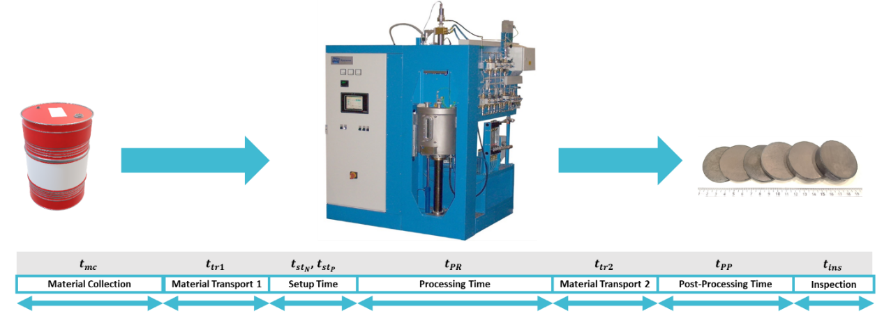
Figure 22 – SPS Process map for MgB₂

Table 19 – Categorized failure modes in SPS of MgB₂
Process Step | Potential Failure Mode | Potential Failure Effect
Material Collection and Transport | Incorrect Quantity | Part deformation/low %wt. of MgB2/High part entropy/ negative impact in part properties
Material Collection and Transport | Exposure to Oxygen | Part deformation/low %wt. of MgB2/High part entropy/ negative impact in part properties
Process Setup | Incorrect Temperature | Part deformation/low %wt. of MgB2/High part entropy/ negative impact in part properties
Process Setup | Incorrect Pressure | Part deformation/low %wt. of MgB2/High part entropy/ negative impact in part properties
Process Setup | Incorrect Processing Time | Part deformation/low %wt. of MgB2/High part entropy/ negative impact in part properties
In-process SPS | Plasma Arc Controller | Part deformation/low %wt. of MgB2/High part entropy/ negative impact in part properties/ Process stoppage (disruption)
In-process SPS | Graphite Tooling Breakage | Part deformation/low %wt. of MgB2/High part entropy/ negative impact in part properties/ Process stoppage (disruption)
In-process SPS | Incorrect Graphite Tooling Calibration | Graphite tooling breakage/ Posterior process stoppage (disruption)
Table 19 continued
 | Heating Pad Resistance Breakage | Process stoppage (disruption)
In-process SPS | Power Source Damage | Process stoppage (disruption)
In-process SPS | Sample Overheating | Process stoppage (disruption)/ Part deformation/low %wt. of MgB2/High part entropy/ breakage of graphite tooling/ pyrometer damage
In-process SPS | Vacuum Sealant Damage | Part deformation/low %wt. of MgB2/High part entropy/ negative impact in part properties/Process stoppage (disruption)
In-process SPS | Vacuum Pump Damage | Part deformation/low %wt. of MgB2/High part entropy/ negative impact in part properties/Process stoppage (disruption)
In-process SPS | Excessive contamination due to prior cycles | Part deformation/low %wt. of MgB2/High part entropy/ negative impact in part properties
In-process SPS | Digital process monitoring failure | Graphite tooling breakage/ Vacuum sealant and pump damage/ Process stoppage (disruption) /Part deformation/low %wt. of MgB2/High part entropy/ negative impact in part properties
Table 19 continued
Part Quality Inspection | Wrong setup of sample magnification in the Scanning electron microscope | Erroneous entropy calculation
Part Quality Inspection | Error in SEM image acquisition | Erroneous entropy calculation
Part Quality Inspection | Error in algorithm for quality analysis (entropy-based) | Erroneous entropy calculation

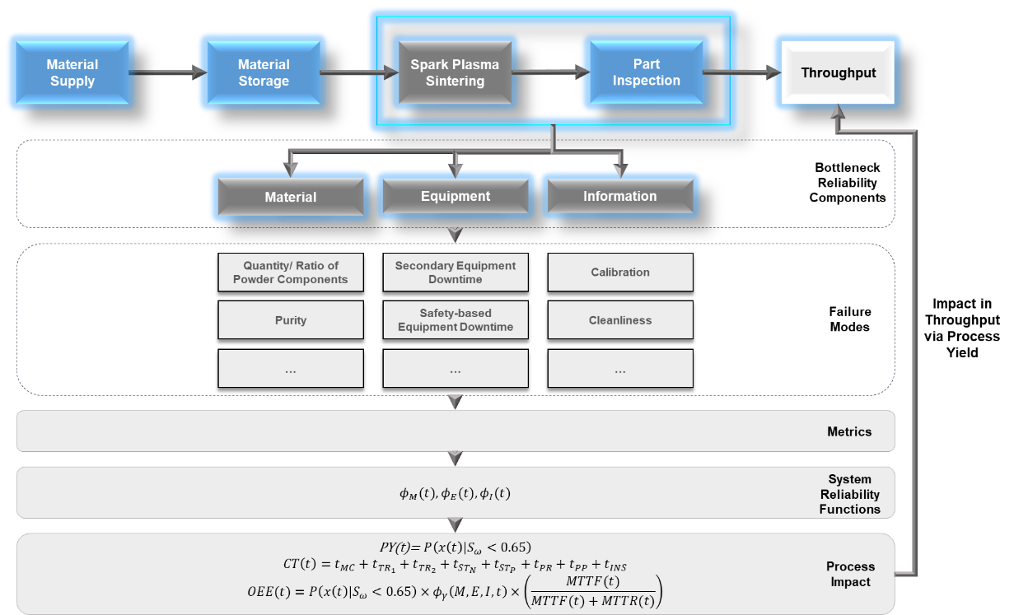
Figure 23 - Determination of failure modes for determining reliability of Spark Plasma Sintering of MgB₂ superconducting bulks.

Table 20 – Conditions for material failure modes for SPS of MgB₂
Conditions for Path Vector Material - SPS of MgB₂ Superconducting Bulks
Quantity  (${M_{var}}_{1}$) | Exposure to Oxygen (${M_{var}}_{2}$) | Temperature  (${M_{var}}_{3}$) | Pressure  (${M_{var}}_{4}$) | Processing Time  (${M_{var}}_{5}$) | Component State
Exact amount | Less than 5 minutes | Exact Temperature | Exact Pressure | Exact Processing time | 1
$$<95\%$$ | $$5 min<t≤15 min$$ | $$900ºC≤T≤950ºC$$ | $$100 MPa≤P≤125 MPa$$ | $t<30$ min | 0

Table 21 – Material failure modes for SPS of MgB₂
Material Path Vectors - SPS of MgB₂ Superconducting Bulks
Quantity  (${M_{var}}_{1}$) | Exposure to Oxygen (${M_{var}}_{2}$) | Temperature  (${M_{var}}_{3}$) | Pressure  (${M_{var}}_{4}$) | Processing Time  (${M_{var}}_{5}$) | Material Function ($ϕ_{M}$) | Comments
0 | 0 | 0 | 0 | 0 | 0
0 | 0 | 0 | 0 | 1 | 0
0 | 0 | 0 | 1 | 0 | 0
0 | 0 | 0 | 1 | 1 | 0
0 | 0 | 1 | 0 | 0 | 0
0 | 0 | 1 | 0 | 1 | 0
0 | 0 | 1 | 1 | 0 | 0
0 | 0 | 1 | 1 | 1 | 0
0 | 1 | 0 | 0 | 0 | 0
0 | 1 | 0 | 0 | 1 | 0
0 | 1 | 0 | 1 | 0 | 0
0 | 1 | 0 | 1 | 1 | 0
0 | 1 | 1 | 0 | 0 | 0
0 | 1 | 1 | 0 | 1 | 0
0 | 1 | 1 | 1 | 0 | 0
0 | 1 | 1 | 1 | 1 | 0
1 | 0 | 0 | 0 | 0 | 0
1 | 0 | 0 | 0 | 1 | 0
1 | 0 | 0 | 1 | 0 | 1 | Path Vector
1 | 0 | 0 | 1 | 1 | 1 | Path Vector
1 | 0 | 1 | 0 | 0 | 0
Table 21 continued.
1 | 0 | 1 | 0 | 1 | 0 | Cut Vector
1 | 0 | 1 | 1 | 0 | 1 | Path Vector
1 | 0 | 1 | 1 | 1 | 1 | Path Vector
1 | 1 | 0 | 0 | 0 | 0
1 | 1 | 0 | 0 | 1 | 0 | Cut Vector
1 | 1 | 0 | 1 | 0 | 1 | Path Vector
1 | 1 | 0 | 1 | 1 | 1 | Path Vector
1 | 1 | 1 | 0 | 0 | 0 | Cut Vector
1 | 1 | 1 | 0 | 1 | 1 | Path Vector
1 | 1 | 1 | 1 | 0 | 1 | Path Vector/ Cut Vector
1 | 1 | 1 | 1 | 1 | 1 | Path Vector
Path Vectors |  |  |  |  |  | 9
Cut Vectors |  |  |  |  |  | 4

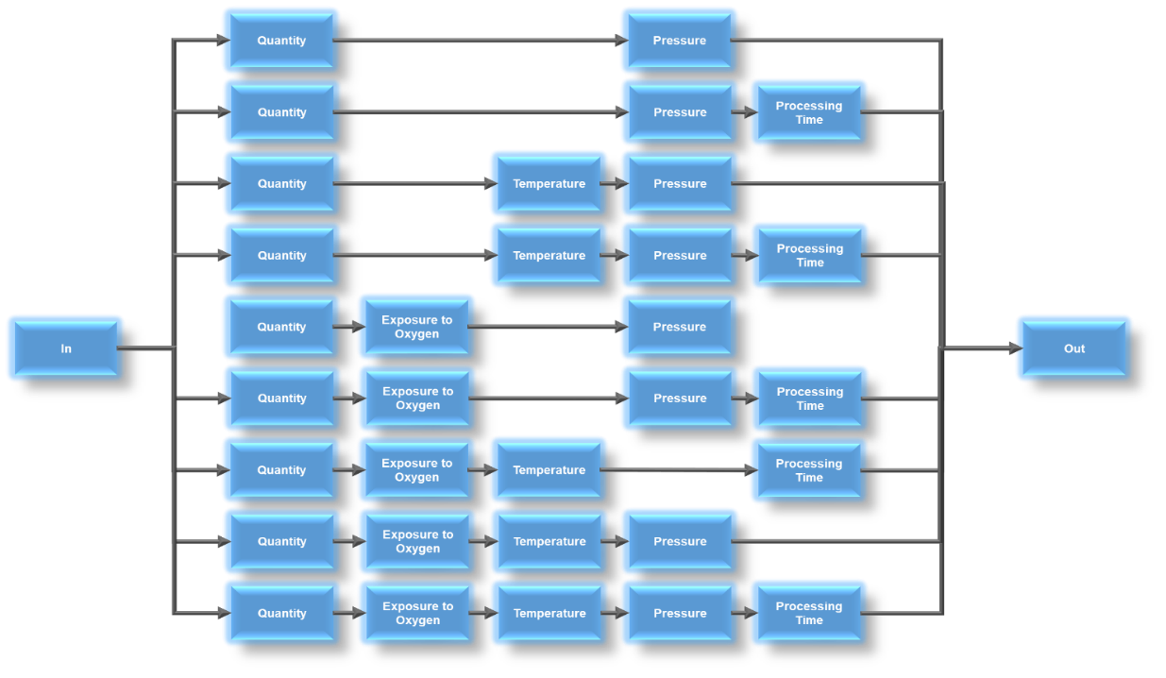
Figure 24 - Material path vectors

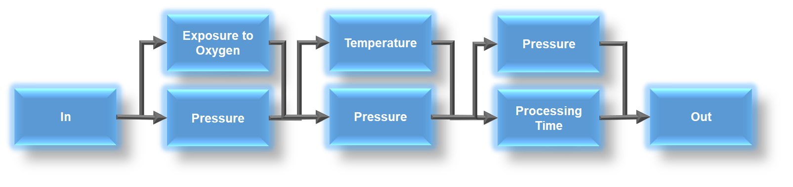
Figure 25 - Material cut vectors

Table 22 – Thresholds for safety-related equipment failure modes in SPS of MgB₂
Conditions for Equipment Path Vector - SPS of MgB₂ Superconducting Bulks
Plasma Arc Controller (${{E_{SR}}_{var}}_{1}$) | Graphite Tooling  (${{E_{SR}}_{var}}_{2}$) | Power Source  (${{E_{SR}}_{var}}_{3}$) | Vacuum Sealant  (${{E_{SR}}_{var}}_{4}$) | Vacuum Pump  (${{E_{SR}}_{var}}_{5}$) | Digital process monitoring failure  (${{E_{SR}}_{var}}_{6}$) | Component State
Function properly | Function properly | Function properly | Function properly | Function properly | Function properly | 1
Does not function | Does not function | Does not function | Does not function | Does not function | Does not function | 0

Table 23 – Scenarios for safety-related failure modes in SPS of MgB₂
Essential for Safety and Operability - Equipment Path Vectors - SPS of MgB₂ Superconducting Bulks
Plasma Arc Controller  (${{E_{SR}}_{var}}_{1}$) | Graphite Tooling  (${{E_{SR}}_{var}}_{2}$) | Power Source  (${{E_{SR}}_{var}}_{3}$) | Vacuum Sealant  (${{E_{SR}}_{var}}_{4}$) | Vacuum Pump  (${{E_{SR}}_{var}}_{5}$) | Digital process monitoring failure  (${{E_{SR}}_{var}}_{6}$) | Essential Equipment Function  ($ϕ_{E_{SR}}$) | Comments
0 | 0 | 0 | 0 | 0 | 0 | 0
0 | 0 | 0 | 0 | 0 | 1 | 0
0 | 0 | 0 | 0 | 1 | 0 | 0
0 | 0 | 0 | 0 | 1 | 1 | 0
0 | 0 | 0 | 1 | 0 | 0 | 0
0 | 0 | 0 | 1 | 0 | 1 | 0
0 | 0 | 0 | 1 | 1 | 0 | 0
0 | 0 | 0 | 1 | 1 | 1 | 0
0 | 0 | 1 | 0 | 0 | 0 | 0
0 | 0 | 1 | 0 | 0 | 1 | 0
0 | 0 | 1 | 0 | 1 | 0 | 0
0 | 0 | 1 | 0 | 1 | 1 | 0
0 | 0 | 1 | 1 | 0 | 0 | 0
0 | 0 | 1 | 1 | 0 | 1 | 0
0 | 0 | 1 | 1 | 1 | 0 | 0
0 | 0 | 1 | 1 | 1 | 1 | 0
0 | 1 | 0 | 0 | 0 | 0 | 0
0 | 1 | 0 | 0 | 0 | 1 | 0
0 | 1 | 0 | 0 | 1 | 0 | 0
0 | 1 | 0 | 0 | 1 | 1 | 0
0 | 1 | 0 | 1 | 0 | 0 | 0
0 | 1 | 0 | 1 | 0 | 1 | 0
0 | 1 | 0 | 1 | 1 | 0 | 0
0 | 1 | 0 | 1 | 1 | 1 | 0
0 | 1 | 1 | 0 | 0 | 0 | 0
0 | 1 | 1 | 0 | 0 | 1 | 0
0 | 1 | 1 | 0 | 1 | 0 | 0
0 | 1 | 1 | 0 | 1 | 1 | 0
0 | 1 | 1 | 1 | 0 | 0 | 0
Table 23 continued
0 | 1 | 1 | 1 | 0 | 1 | 0
0 | 1 | 1 | 1 | 1 | 0 | 0
0 | 1 | 1 | 1 | 1 | 1 | 0 | Cut Vector
1 | 0 | 0 | 0 | 0 | 0 | 0
1 | 0 | 0 | 0 | 0 | 1 | 0
1 | 0 | 0 | 0 | 1 | 0 | 0
1 | 0 | 0 | 0 | 1 | 1 | 0
1 | 0 | 0 | 1 | 0 | 0 | 0
1 | 0 | 0 | 1 | 0 | 1 | 0
1 | 0 | 0 | 1 | 1 | 0 | 0
1 | 0 | 0 | 1 | 1 | 1 | 0
1 | 0 | 1 | 0 | 0 | 0 | 0
1 | 0 | 1 | 0 | 0 | 1 | 0
1 | 0 | 1 | 0 | 1 | 0 | 0
1 | 0 | 1 | 0 | 1 | 1 | 0
1 | 0 | 1 | 1 | 0 | 0 | 0
1 | 0 | 1 | 1 | 0 | 1 | 0
1 | 0 | 1 | 1 | 1 | 0 | 0
1 | 0 | 1 | 1 | 1 | 1 | 0 | Cut Vector
1 | 1 | 0 | 0 | 0 | 0 | 0
1 | 1 | 0 | 0 | 0 | 1 | 0
1 | 1 | 0 | 0 | 1 | 0 | 0
1 | 1 | 0 | 0 | 1 | 1 | 0
1 | 1 | 0 | 1 | 0 | 0 | 0
1 | 1 | 0 | 1 | 0 | 1 | 0
1 | 1 | 0 | 1 | 1 | 0 | 0
1 | 1 | 0 | 1 | 1 | 1 | 0 | Cut Vector
1 | 1 | 1 | 0 | 0 | 0 | 0
1 | 1 | 1 | 0 | 0 | 1 | 0
1 | 1 | 1 | 0 | 1 | 0 | 0
1 | 1 | 1 | 0 | 1 | 1 | 0 | Cut Vector
1 | 1 | 1 | 1 | 0 | 0 | 0
1 | 1 | 1 | 1 | 0 | 1 | 0 | Cut Vector
1 | 1 | 1 | 1 | 1 | 0 | 0 | Cut Vector
Table 23 continued
1 | 1 | 1 | 1 | 1 | 1 | 1 | Path Vector
Path Vectors |  |  |  |  |  |  |  | 1
Cut Vectors |  |  |  |  |  |  |  | 5


Figure 26 – Safety-related equipment path vector


Figure 27 – Safety-related equipment cut vectors
Table 24 – Thresholds for secondary equipment failure modes in SPS of MgB₂
Conditions for Equipment Path Vector - SPS of MgB2 Superconducting Bulks
Graphite Tooling Calibration  ($E_{SEC_{var_{1}}}$) | Heating Pad Resistance  ($E_{SEC_{var_{2}}}$) | Pyrometer  ($E_{SEC_{var_{3}}}$) | Graphite Tooling Cleanliness  ($E_{SEC_{var_{4}}}$) | Component State
Done properly | Function properly | Function properly | No residue | 1
Not done properly | Does not function | Does not function | Residual amount of powder from previous processing | 0

Table 25 – Combinations of secondary equipment failure modes in SPS of MgB₂
Secondary Equipment Function - Not considered risks to process safety
Graphite Tooling Calibration  ($E_{SEC_{var_{1}}}$) | Heating Pad Resistance  ($E_{SEC_{var_{2}}}$) | Pyrometer  ($E_{SEC_{var_{3}}}$) | Graphite Tooling Cleanliness  ($E_{SEC_{var_{4}}}$) | Secondary Equipment Function ($ϕ_{E_{SEC}}$) | Comments
0 | 0 | 0 | 0 | 0
0 | 0 | 0 | 1 | 0
0 | 0 | 1 | 0 | 0
0 | 0 | 1 | 1 | 0
0 | 1 | 0 | 0 | 0
0 | 1 | 0 | 1 | 0
0 | 1 | 1 | 0 | 0
0 | 1 | 1 | 1 | 0 | Cut Vector
1 | 0 | 0 | 0 | 0
1 | 0 | 0 | 1 | 0
1 | 0 | 1 | 0 | 0
1 | 0 | 1 | 1 | 0 | Cut Vector
1 | 1 | 0 | 0 | 0
1 | 1 | 0 | 1 | 0 | Cut Vector
1 | 1 | 1 | 0 | 1 | Path Vector/ Cut Vector
1 | 1 | 1 | 1 | 1 | Path Vector
Path Vector |  |  |  |  | 2
Cut Vector |  |  |  |  | 4

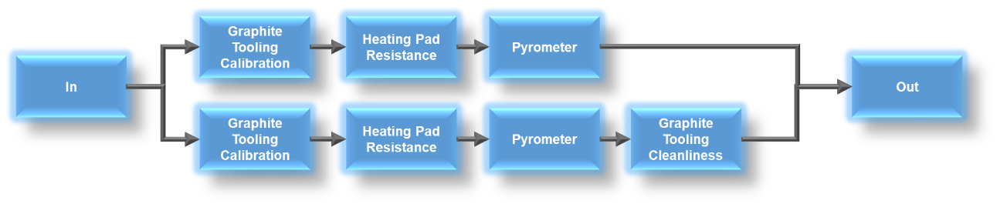
Figure 28 – Secondary equipment path vectors


Figure 29 – Secondary equipment cut vectors

Table 26 – Thresholds for inspection failure modes in SPS of MgB₂
Conditions for Inspection (Information) Path and Cut Vectors - Entropy-based Analysis
Setup of SEM  ($I_{var_{1}}$) | Image Acquisition from SEM  ($I_{var_{2}}$) | Algorithm for quality analysis  ($I_{var_{3}}$) | Component State
Done properly | Function properly | Function properly | 1
Not done properly | Does not function | Does not function | 0

Table 27 – Combinations of inspection failure modes in SPS of MgB₂
Inspection (Information) Path and Cut Vectors - Entropy-based Analysis
Setup of SEM  ($I_{var_{1}}$) | Image Acquisition from SEM  ($I_{var_{2}}$) | Algorithm for quality analysis  ($I_{var_{3}}$) | Inspection (Information) Function ($ϕ_{I}$) | Comments
0 | 0 | 0 | 0
0 | 0 | 1 | 0
0 | 1 | 0 | 0
0 | 1 | 1 | 0 | Cut Vector
1 | 0 | 0 | 0
1 | 0 | 1 | 0 | Cut Vector
1 | 1 | 0 | 0 | Cut Vector
1 | 1 | 1 | 1 | Path Vector
Path Vector |  |  |  | 1
Cut Vector |  |  |  | 3


Figure 30 – Inspection path vectors

Figure 31 – Inspection cut vectors

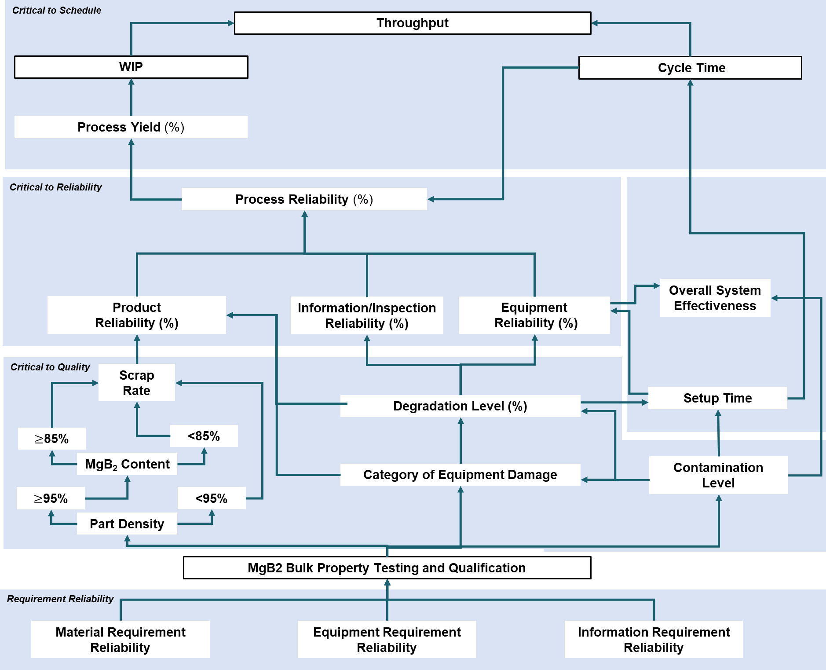
Figure 32 - Reliability-based performance measurement system for SPS of MgB₂

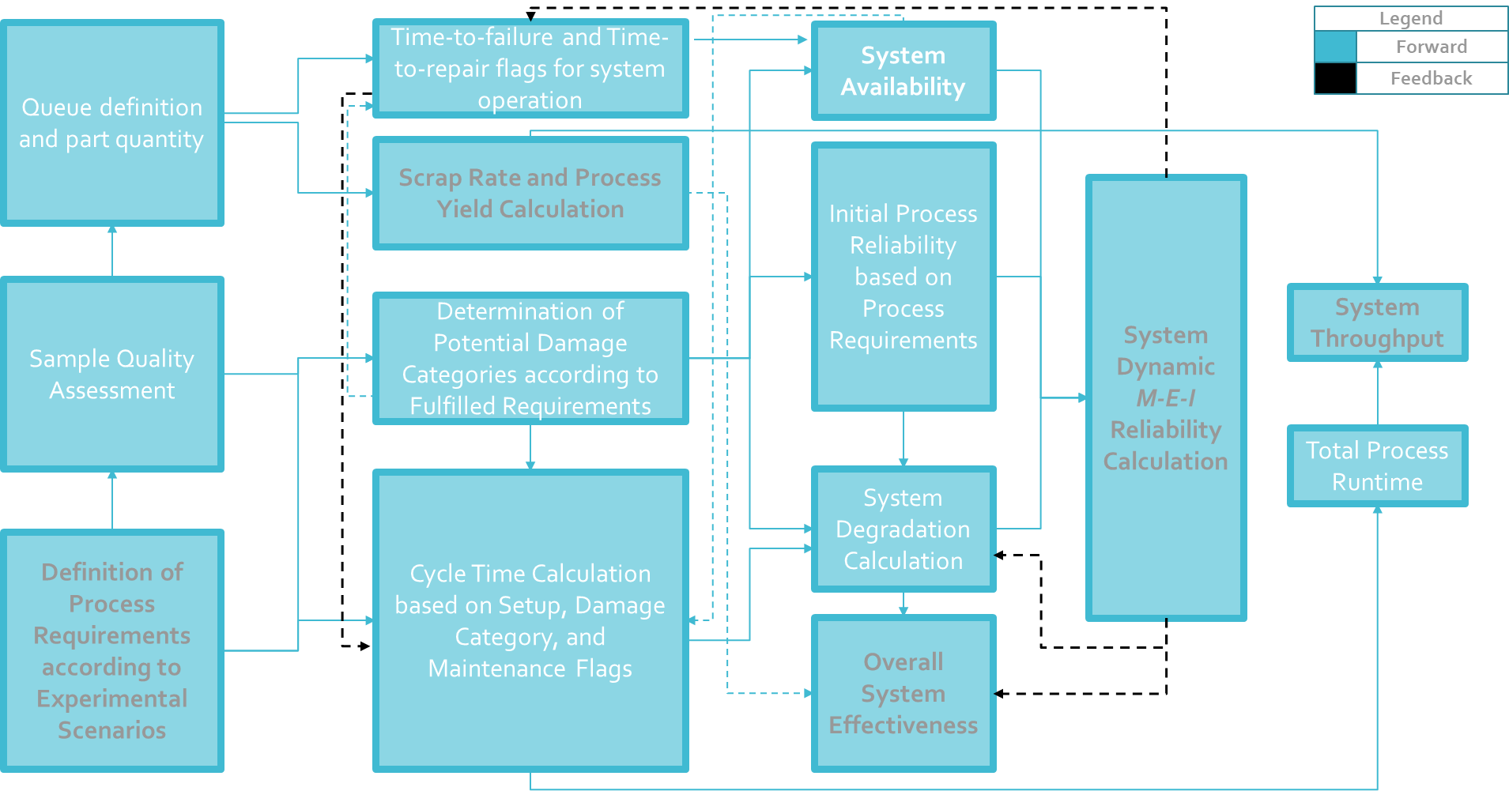
Figure 33 - Steps of characterization and qualification for MgB2 bulks produced via SPS

Table 28 – Template for sample choice, experimental conditions
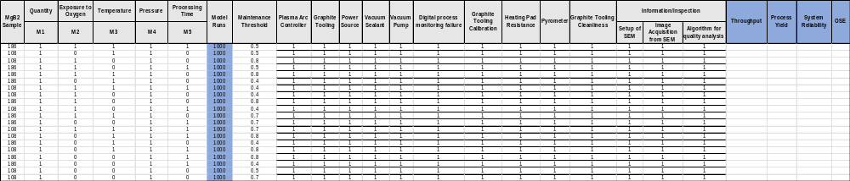

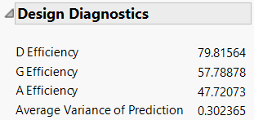
Figure 34 - Experimental design diagnostics

Table 29 – Variables for experiment for different material conditions for MgB2 bulk production
MgB2 Sample | Quantity | Exposure to Oxygen | Temperature | Pressure | Processing Time | Model Runs | Maintenance Threshold
MgB2 Sample | $$M_{var_{1}}$$ | $$M_{var_{2}}$$ | $$M_{var_{3}}$$ | $$M_{var_{4}}$$ | $$M_{var_{5}}$$ | Model Runs | Maintenance Threshold
108 | 1 | 1 | 0 | 1 | 0 | 1000 | 0.5
186 | 1 | 0 | 1 | 1 | 0 | 1000 | 0.7
108 | 1 | 0 | 1 | 1 | 0 | 1000 | 0.5
108 | 1 | 1 | 0 | 1 | 0 | 1000 | 0.4
186 | 1 | 1 | 1 | 1 | 0 | 1000 | 0.4
108 | 1 | 1 | 1 | 1 | 1 | 1000 | 0.5
108 | 1 | 0 | 1 | 1 | 1 | 1000 | 0.8
186 | 1 | 0 | 0 | 1 | 0 | 1000 | 0.4
108 | 1 | 1 | 0 | 1 | 1 | 1000 | 0.8
186 | 1 | 0 | 0 | 1 | 1 | 1000 | 0.8
186 | 1 | 0 | 1 | 1 | 0 | 1000 | 0.8
186 | 1 | 1 | 1 | 1 | 0 | 1000 | 0.4
186 | 1 | 0 | 1 | 1 | 1 | 1000 | 0.4
186 | 1 | 1 | 1 | 1 | 1 | 1000 | 0.8
186 | 1 | 1 | 0 | 1 | 0 | 1000 | 0.8
108 | 1 | 0 | 1 | 1 | 0 | 1000 | 0.4
108 | 1 | 1 | 1 | 1 | 1 | 1000 | 0.4
186 | 1 | 1 | 1 | 1 | 1 | 1000 | 0.7
108 | 1 | 0 | 0 | 1 | 0 | 1000 | 0.8
186 | 1 | 1 | 0 | 1 | 1 | 1000 | 0.4
108 | 1 | 1 | 1 | 1 | 0 | 1000 | 0.8
186 | 1 | 0 | 0 | 1 | 1 | 1000 | 0.7
Table 29 continued
108 | 1 | 0 | 1 | 1 | 1 | 1000 | 0.8
186 | 1 | 1 | 0 | 1 | 0 | 1000 | 0.7
108 | 1 | 0 | 0 | 1 | 1 | 1000 | 0.5
108 | 1 | 1 | 0 | 1 | 1 | 1000 | 0.8
108 | 1 | 0 | 0 | 1 | 1 | 1000 | 0.4
186 | 1 | 0 | 1 | 1 | 1 | 1000 | 0.4
108 | 1 | 0 | 0 | 1 | 0 | 1000 | 0.8
108 | 1 | 1 | 1 | 1 | 0 | 1000 | 0.8

Table 30 – Response variables for experiment for different material conditions for MgB₂ bulk production
Throughput (unit) | Process Yield (0-1) | System Reliability (0-1) | OSE (0-1)
0.3771960 | 0.9718967 | 0.1793665 | 0.1414189
0.3470020 | 0.7283585 | 0.0026200 | 0.0015476
0.3647838 | 0.9600875 | 0.1764608 | 0.1379819
0.3543318 | 0.9402600 | 0.2479441 | 0.1845628
0.2882436 | 0.7285129 | 0.4398732 | 0.2699796
0.4258884 | 0.9186189 | 0.7116012 | 0.6411395
0.4393199 | 0.9367987 | 0.0440470 | 0.0400920
0.3500641 | 0.7499522 | 0.0224055 | 0.0162527
0.4415931 | 0.9380159 | 0.0381925 | 0.0347406
0.3535617 | 0.7451179 | 0.0024063 | 0.0014629
0.3613784 | 0.7596604 | 0.0026453 | 0.0015735
0.2979477 | 0.7481379 | 0.4409501 | 0.2776429
0.2931418 | 0.7305519 | 0.4434573 | 0.2719047
0.3472826 | 0.7370068 | 0.4971021 | 0.3599318
0.3445088 | 0.7228800 | 0.0026036 | 0.0016253
0.3530851 | 0.9518615 | 0.2492164 | 0.1870877
0.4295229 | 0.9290922 | 0.7685291 | 0.6993621
0.3363818 | 0.7199713 | 0.5758543 | 0.4078906
0.4483795 | 0.9401239 | 0.0014191 | 0.0009764
0.3004703 | 0.7599729 | 0.4390811 | 0.2811135
0.4379983 | 0.9337111 | 0.0465823 | 0.0425375
Table 30 continued
0.3540143 | 0.7414416 | 0.0026629 | 0.0011531
0.4312806 | 0.9243190 | 0.0447626 | 0.0402024
0.3253993 | 0.6845205 | 0.0025075 | 0.0010295
0.3667179 | 0.9415551 | 0.1784183 | 0.1368212
0.4440828 | 0.9511144 | 0.0424724 | 0.0392645
0.3466304 | 0.9129443 | 0.2458202 | 0.1782071
0.2936396 | 0.7270614 | 0.4411130 | 0.2695740
0.4410252 | 0.9258441 | 0.0012856 | 0.0008348
0.4418600 | 0.9360901 | 0.0459057 | 0.0410344

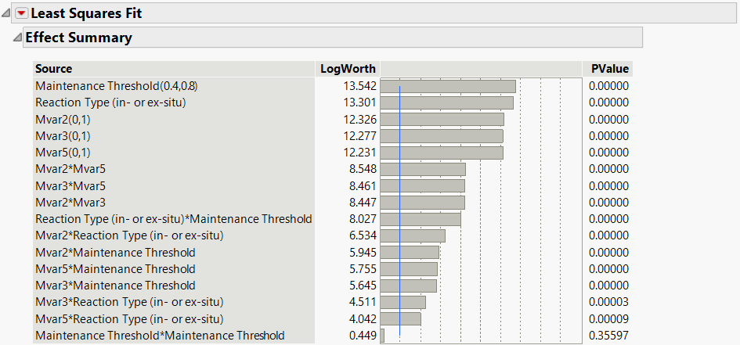
Figure 35 - Log-worth and statistical significance of main effects and second order interaction of the experimental design

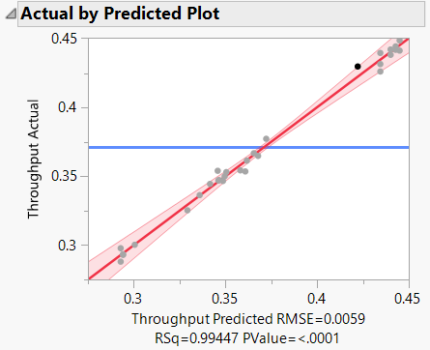
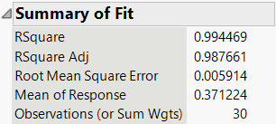
Figure 36 – Predicted plot and summary of fit for throughput

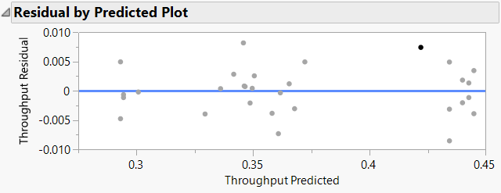
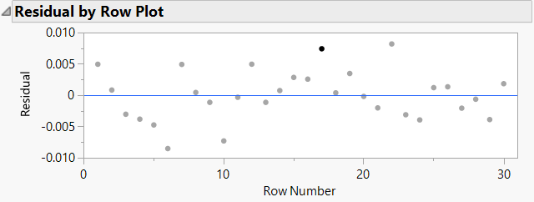
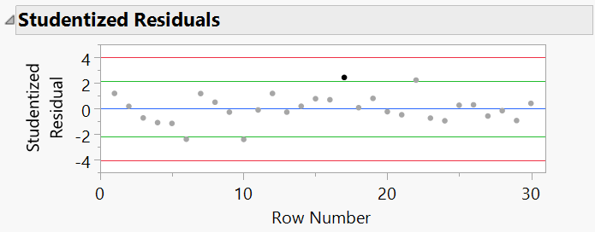
Figure 37 – Prediction and studentized residual errors of throughput fit

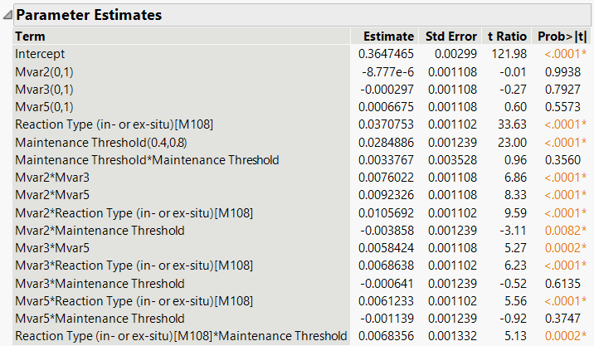
Figure 38 –Main effects and 2nd order interactions estimates of parameters in throughput fit

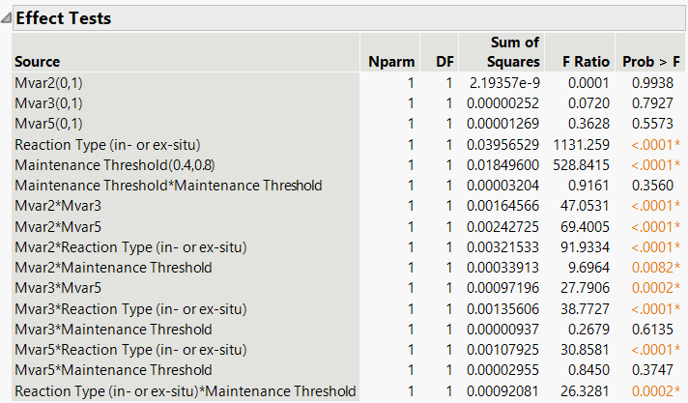
Figure 39 – Statistical significance test of effects in throughput fit

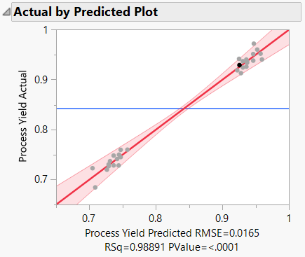
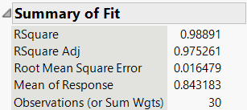
Figure 40 – Predicted profile for process yield according to experimental design

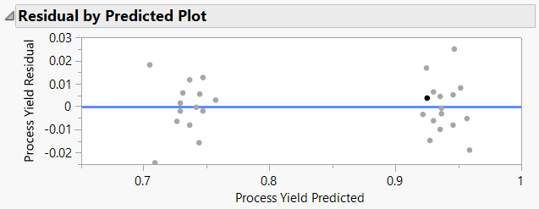
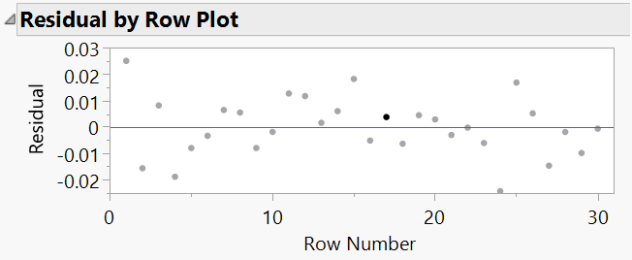
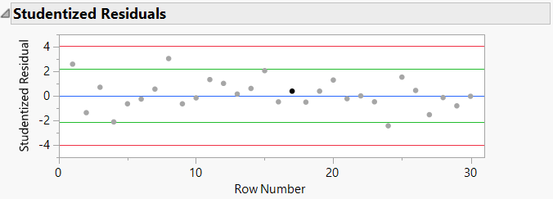
Figure 41 – Residual error of the process yield fit

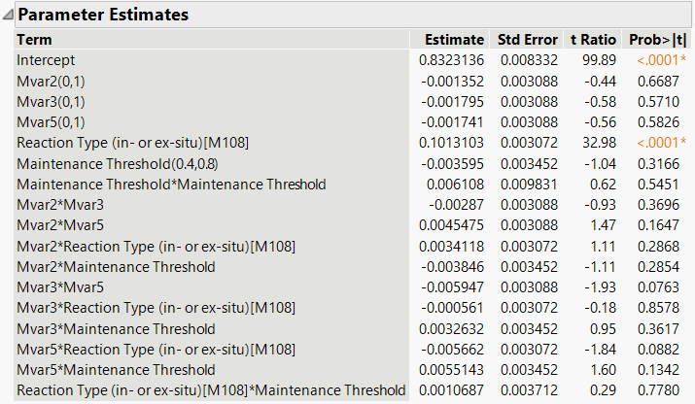
Figure 42 – Parameter estimates for process yield fit.

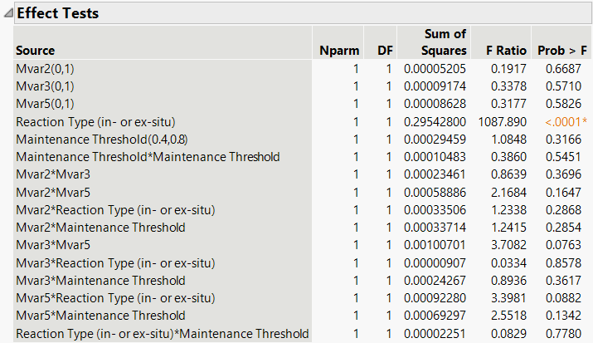
Figure 43 – Statistical testing of main effects and 2nd order interactions in process yield fit

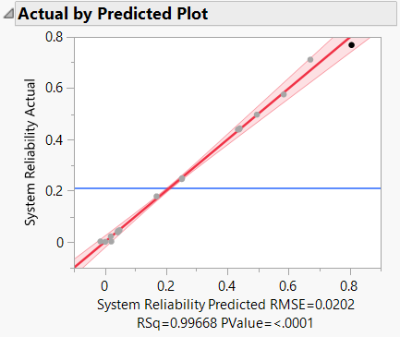
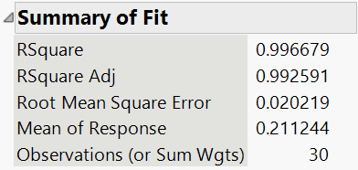
Figure 44 – Profile prediction for system reliability fit according to experimental design

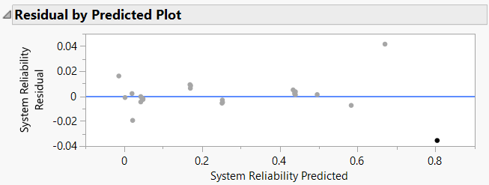
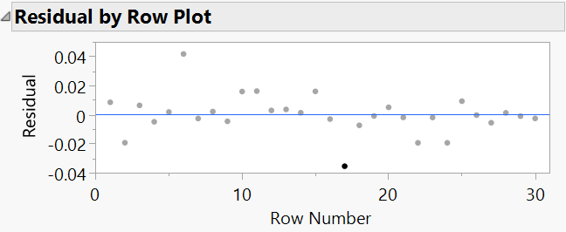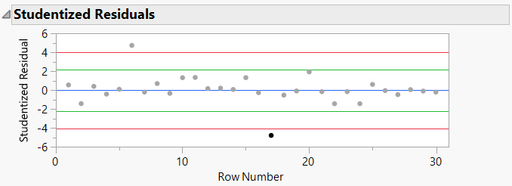
Figure 45 – Residual plots of system reliability fitted through the experimental design

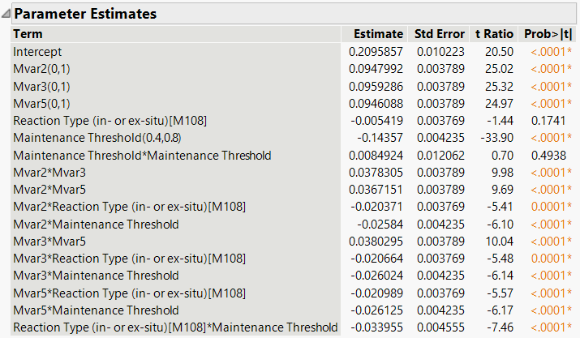
Figure 46 – Parameter estimates for system reliability fit

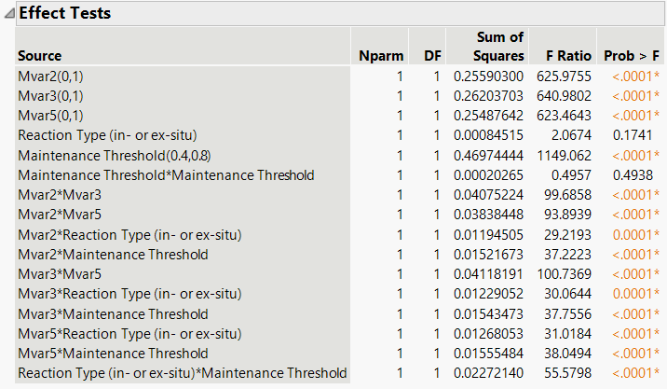
Figure 47 – Statistical testing of main effects and 2nd order interactions of system reliability fit

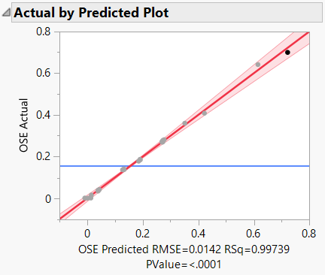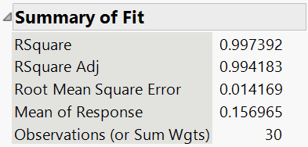
Figure 48 – Profile prediction for overall system effectiveness fit

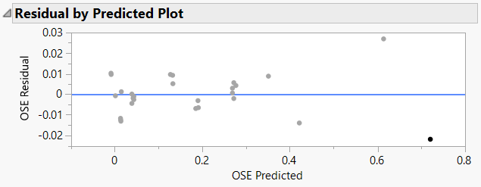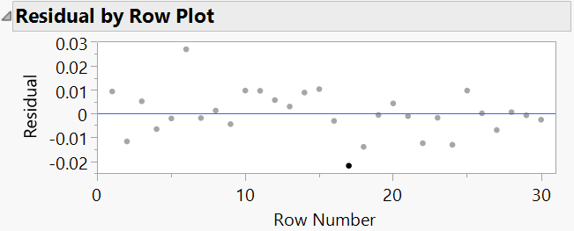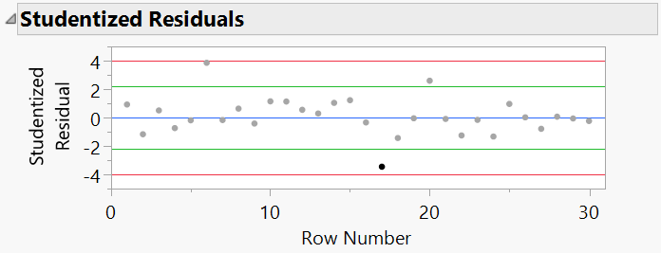
Figure 49 – Residual plot of overall system effectiveness fit

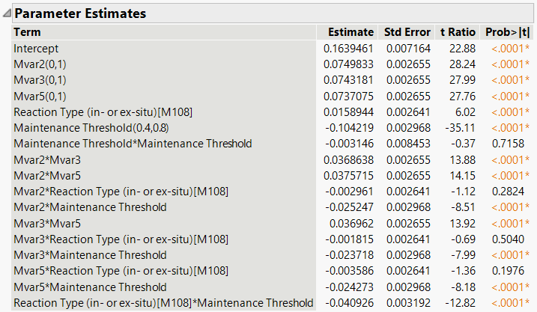
Figure 50 – Parameters estimates for prediction of overall system effectiveness fit

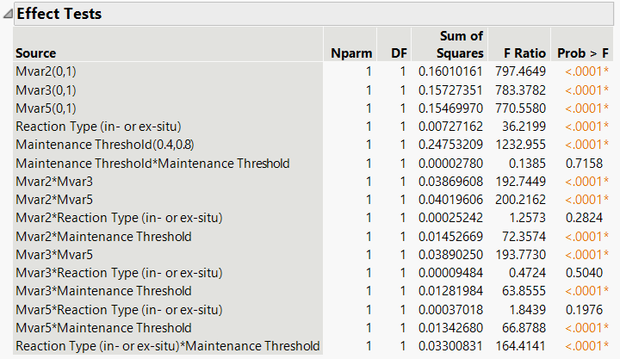
Figure 51 – Testing of main effects and 2nd order interactions of the overall system effectiveness fit

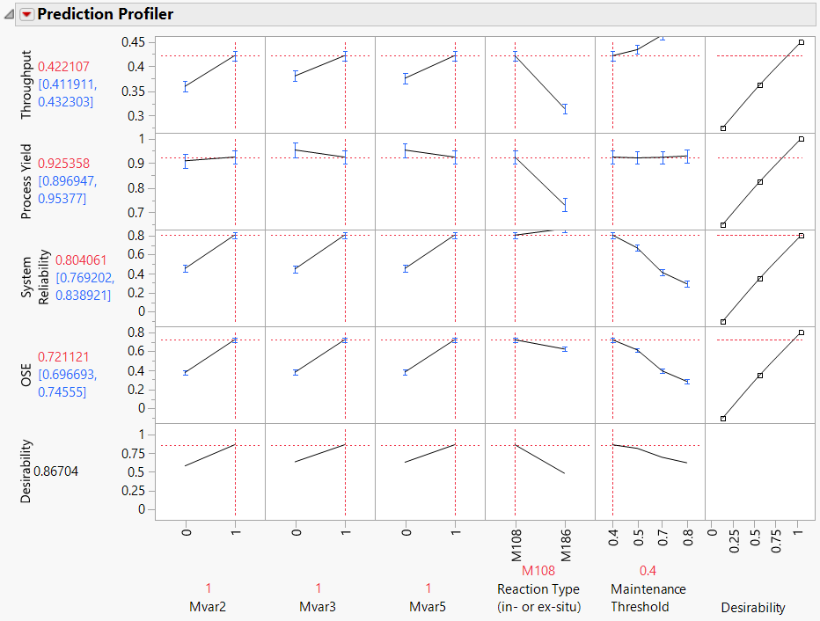
Figure 52 – Optimal profiles of throughput, process yield, system reliability, and overall system effectiveness optimized for desirability.

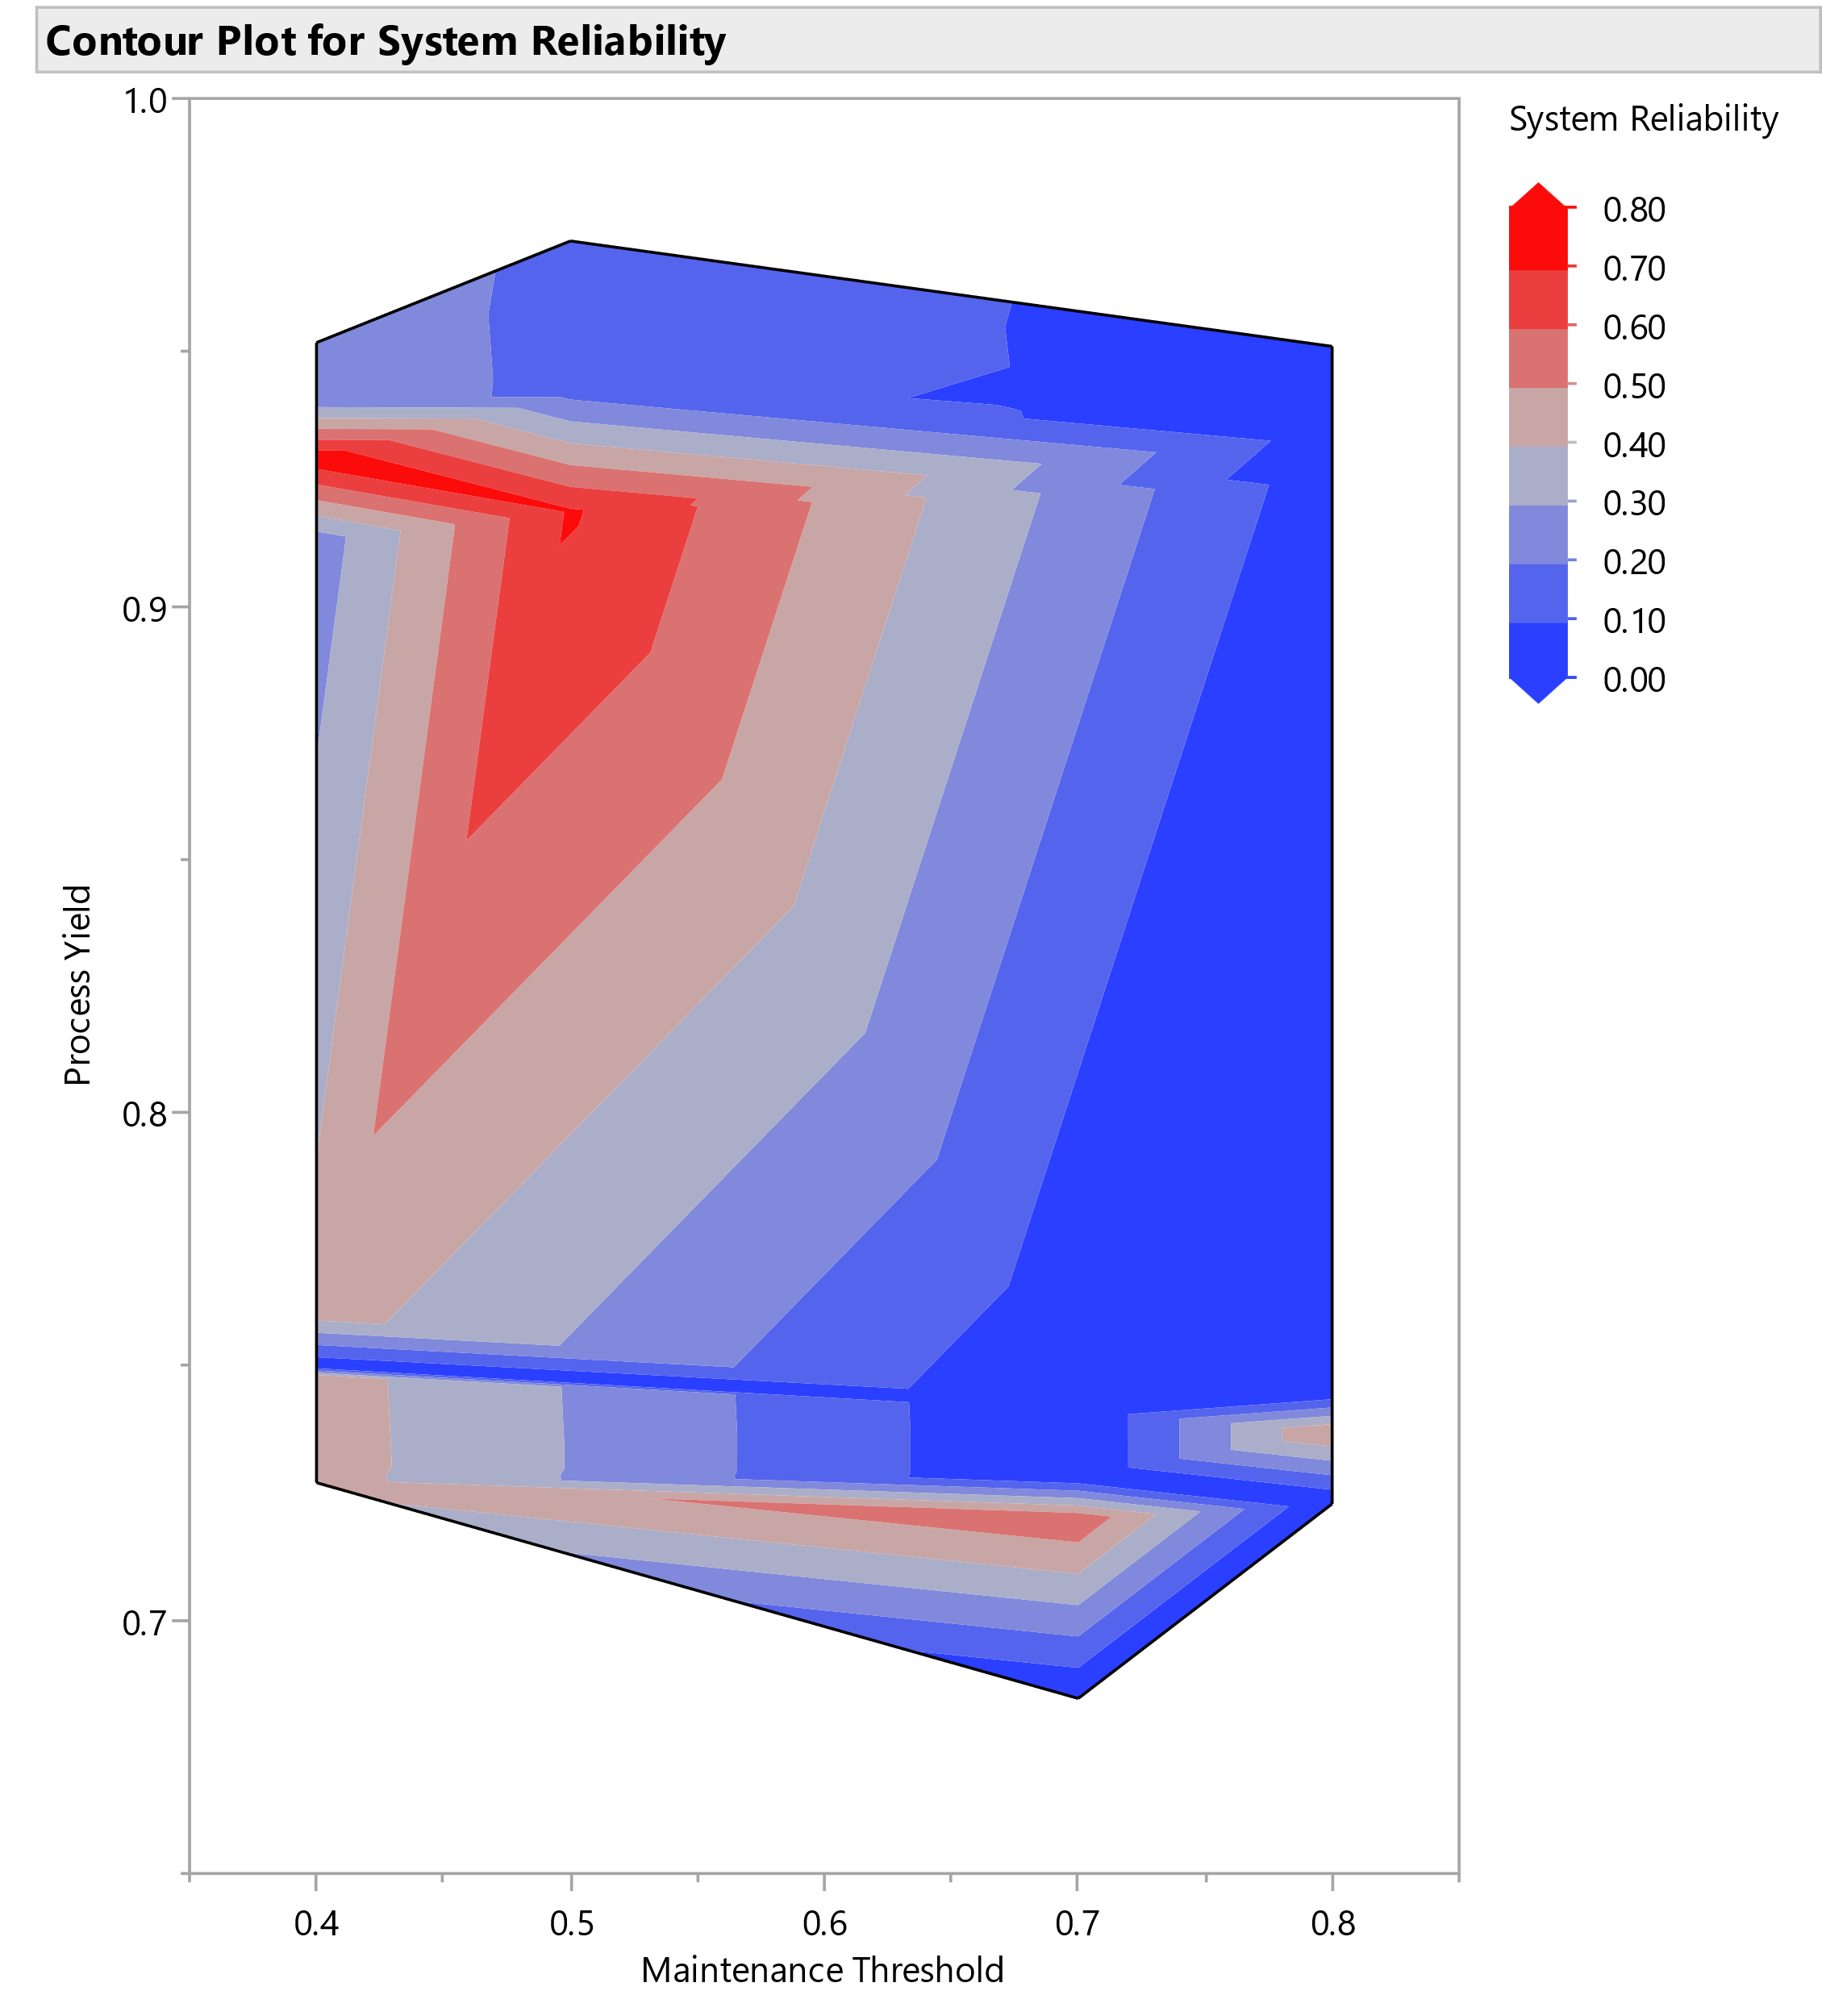 | 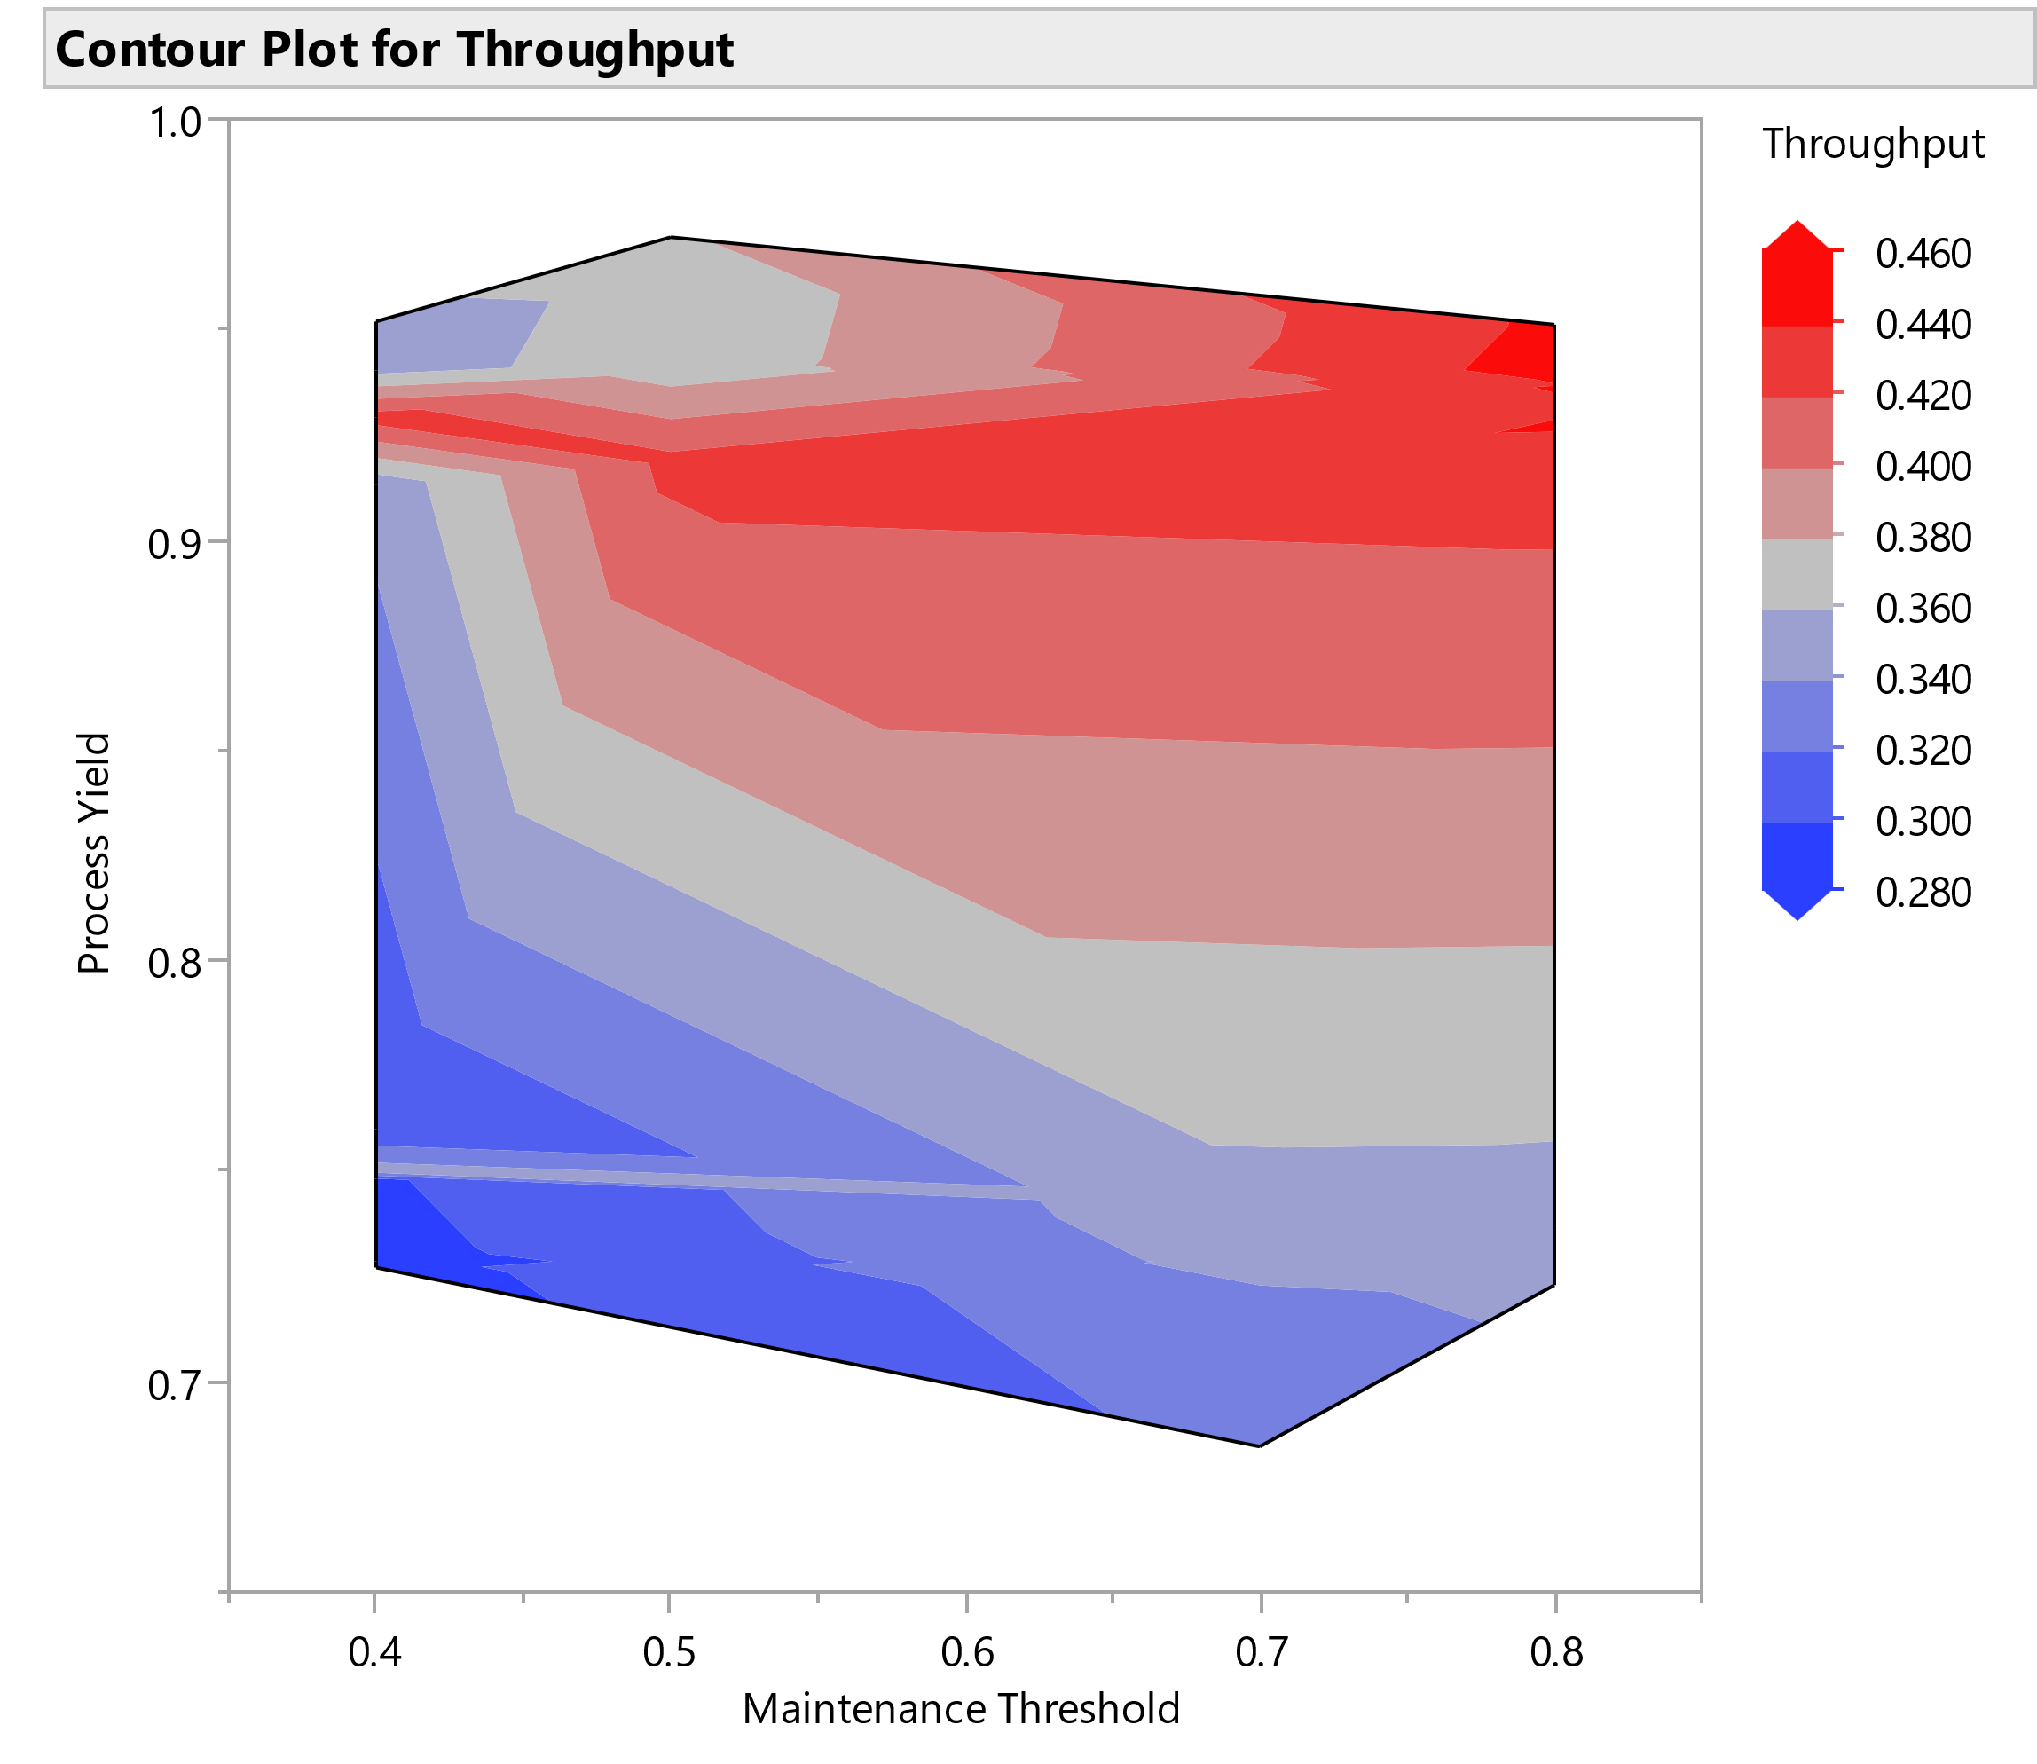
(a) | (b)
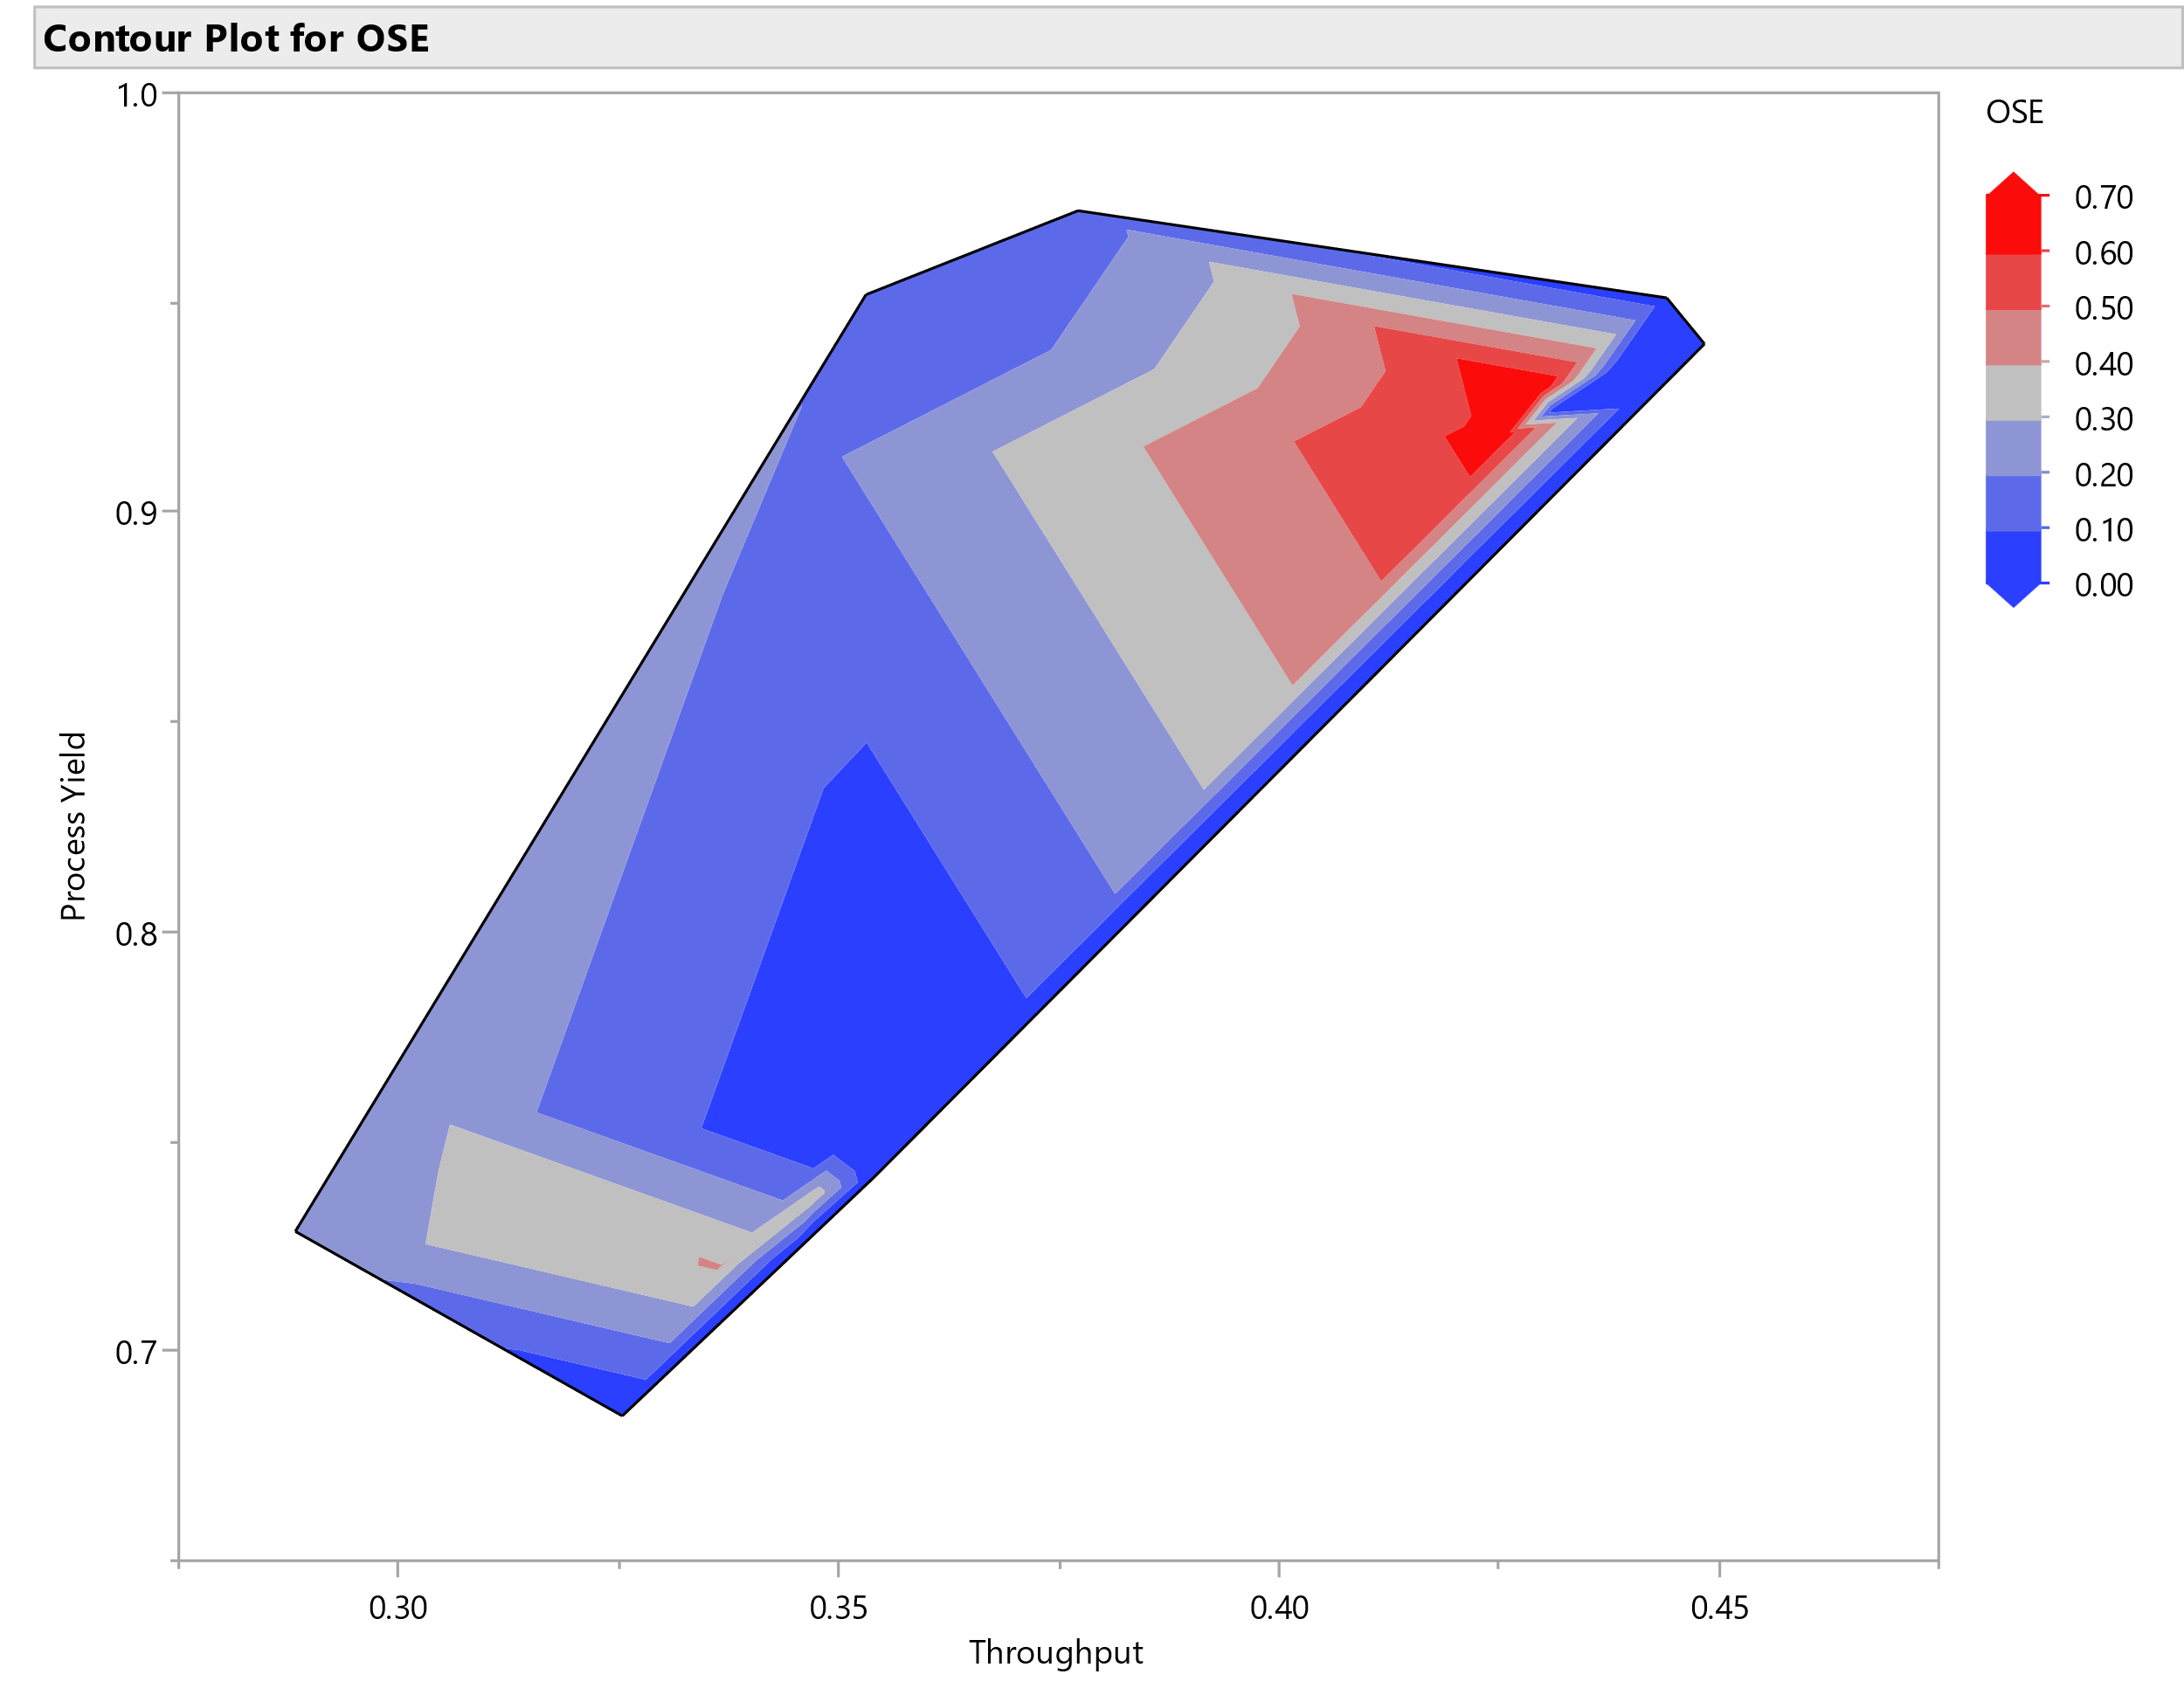
(c)
Figure 53 – Contour plots of (a) system reliability, (b) throughput, and (c) overall system effectiveness.

CONCLUSIONS
This dissertation provided the background on the need for developments in the manufacturing of superconductors, as well as evidenced nature of compounds, manufacturing maturity needs, and requirements for utilization of superconducting compounds in high-reliability devices such as nuclear fusion reactors. The information comprised in chapter one served as the steppingstone for understanding available low and high-temperature superconducting compounds, as well as the challenges and opportunities for their applications. Deficiencies in the currently available manufacturing technology for Magnesium Diboride has been compared with respect to additive and conventional techniques.
Establishment of metrics for quality assessment of superconducting bulks have been extracted from the literature as a manner to standardize the parameters looked at in this work. Chapter two provided evidence of relationship between processing conditions with mechanical, chemical, and superconducting properties of MgB₂ bulks. Well-known techniques for characterization of materials such as XRD, SEM, and PPMS have been utilized in conjunction with the image processing and Structural Entropy assessment of each sample. Statistical analysis on the relevance of Structural Entropy and relative density, as well as MgB₂, MgB₄, and MgO %wt. has been done and yielded positive results. Processing powder and pressure were agents that affected mechanical and superconducting stability of each bulk analyzed. Results of the characterization of MgB₂ bulk were used in determining the top two samples to be analyzed with respect to potential scalability of MgB₂ bulk production. Chapter three exhibited basic conditions, modeling, and equations for the SPS-based production of MgB₂ bulks.
The analysis of such a system has been made through the development of a performance measurement system on MATLAB/Simulink. By utilizing the software JMP, experimental scenarios were elaborated and run in the MATLAB model to obtain the statistical impact of material production requirements and maintenance, into throughput, process yield, system reliability, and reliability-based overall system effectiveness. Each of the thirty scenarios was run for thousand production cycles to account for modeling outliers. Statistical significance for a confidence interval of 95% has been achieved.
Experimental scenarios provided ground for main effects and second order interactions in the D-optimal experimental design to achieve high statistical significance, yielding R² and adjusted R² from 0.96 upwards. System responses such as throughput, system reliability, and reliability-based overall system effectiveness were largely affected most main effects and second order interactions of the experimental design. Process yield was affected largely by the powder processing modality, since both benchmarked MgB₂ bulk samples had comparable performance with respect to superconducting and mechanical properties. In the design optimized for desirability, the ex-situ sample M108 was chosen for less fluctuations obtained in the computational modeling for production according to its requirements. Process stability maps were created in order to evaluate the maintenance threshold and process yield into overall system reliability, reliability-based OSE, and throughput. Challenges and limitations regard to the unavailability of accessible SPS capability at the University of Tennessee, for purposes of obtaining more samples and expanding the model for other potential superconductors produced via such a technique.
Besides, scarcity with respect to groups that actively work with manufacturing of MgB₂ within the United States was one of the challenges faced along the way. Furthermore, the simulation model developed in MATLAB/Simulink was a manner to tackle the problem where we have not had the chance to perform experiments for analysis of manufacturing operations with the SPS equipment. In order to illustrate and summarize the extent of this research project, Figure 54 exhibits the highlights of each chapter in the form of a block diagram.

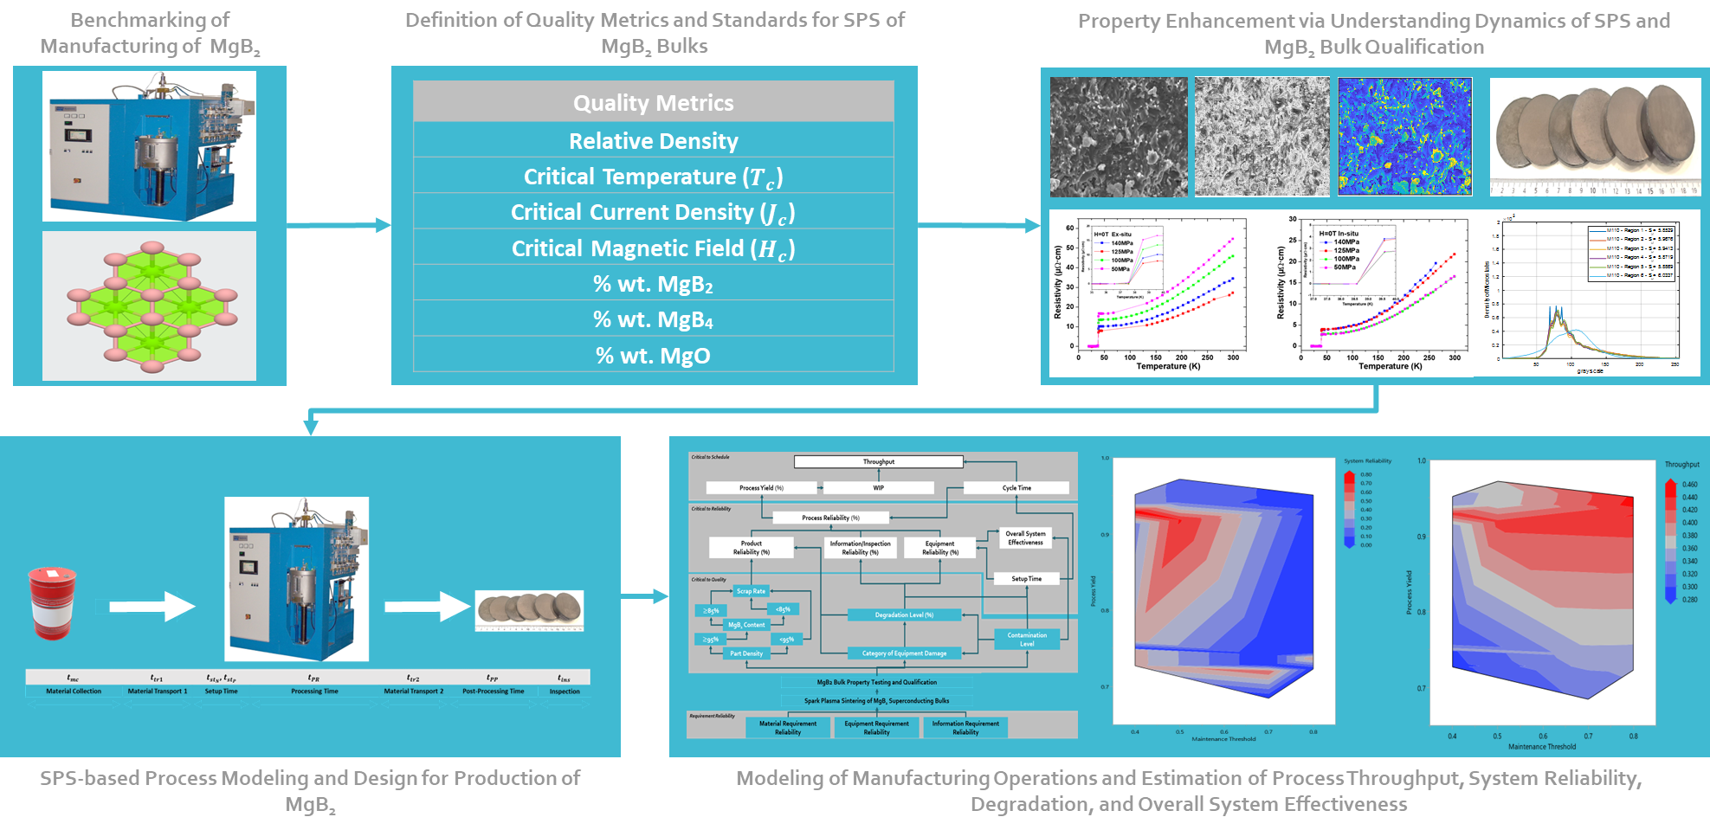
Figure 54 - Summary of research presented in this dissertation

FUTURE WORK
While this dissertation provided substantial knowledge on the production requirements, characterization methods, and manufacturing scalability modeling, future work on this topic may comprise the following items.
- Experimental implementation of model for assessment of SPS of MgB₂, and further development on such process monitorability
- Transfer from modeling concept into different additive techniques such as Powder Bed Fusion, Direct Energy Deposition, and Polymer Extrusion.
- Impact of operator-controlled current pulses of SPS for grain consolidation, purity, and property enhancement of MgB₂ bulks
- Testing of this methodology for production of other superconducting compounds via SPS

REFERENCES
[1] N. Mitchell et al., "Superconductors for fusion: a roadmap," (in English), Supercond Sci Tech, Review vol. 34, no. 10, p. 57, Oct 2021, Art no. 103001, doi: 10.1088/1361-6668/ac0992.
[2] Y. Iwasa, Case Studies in Superconducting Magnets: Design and Operational Issues, 2. Aufl. ed. New York, NY: Springer-Verlag, 2009.
[3] R. Hott, R. Kleiner, T. Wolf, and G. Zwicknagl, "Review on Superconducting Materials," in digital Encyclopedia of Applied Physics, 2016, pp. 1-55.
[4] D. v. Delft, "History and significance of the discovery of superconductivity by Kamerlingh Onnes in 1911," Physica C: Superconductivity, vol. 479, pp. 30-35, 2012, doi: 10.1016/j.physc.2012.02.046.
[5] C. Yao and Y. W. Ma, "Superconducting materials: Challenges and opportunities for large-scale applications," (in English), iScience, Article vol. 24, no. 6, p. 17, Jun 2021, Art no. 102541, doi: 10.1016/j.isci.2021.102541.
[6] X. Xu, "A review and prospects for Nb3Sn superconductor development," Superconductor Science and Technology, vol. 30, no. 9, 2017, doi: 10.1088/1361-6668/aa7976.
[7] P. J. Ray, "Structural investigation of La2-xSrxCuO4+y - Following staging as a function of temperature," Master's degree in Physics, Faculty of Science, University of Copenhagen, 2015.
[8] R. J. Buttery et al., "The advanced tokamak path to a compact net electric fusion pilot plant," Nuclear Fusion, vol. 61, no. 4, Apr 2021, Art no. 046028, doi: 10.1088/1741-4326/abe4af.
[9] D. Castelvecchi, "First room-temperature superconductor excites — and baffles — scientists," Nature, vol. 586, no. 7829, pp. 349-349, 2020, doi: 10.1038/d41586-020-02895-0.
[10] Y. H. Zhai, D. van der Laan, P. Connolly, and C. Kessel, "Conceptual design of HTS magnets for fusion nuclear science facility," (in English), Fusion Eng Des, vol. 168, Jul 2021, doi: ARTN 112611
10.1016/j.fusengdes.2021.112611.
[11] Y. H. Zhai, A. Otto, and C. Kessels, "Conceptual Design of High Field Central Solenoid for Fusion Nuclear Science Facility," Ieee Transactions on Applied Superconductivity, vol. 31, no. 5, Aug 2021, Art no. 4201505, doi: 10.1109/tasc.2021.3063056.
[12] L. Deng et al., "Pressure-induced high-temperature superconductivity retained without pressure in FeSe single crystals," Proceedings of the National Academy of Sciences, vol. 118, no. 28, 2021, doi: 10.1073/pnas.2108938118.
[13] S. H. Lee, "Electrical and superconducting properties of BiSrCaCuO ceramics superconductors," Physica C: Superconductivity and its Applications, vol. 471, no. 21-22, pp. 774-776, 2011, doi: 10.1016/j.physc.2011.05.051.
[14] C. H. Wolters, K. M. Amm, Y. R. Sun, and J. Schwartz, "Preparation of HgBaCaCuO Polycrystals and Silver Sheathed Tapes by a Two-Zone Technique," in Advances in Cryogenic Engineering Materials, 1996, ch. Chapter 91, pp. 679-685.
[15] A. Schilling, M. Cantoni, J. D. Guo, and H. R. Ott, "Superconductivity above 130 K in the Hg–Ba–Ca–Cu–O system," Nature, vol. 363, no. 6424, pp. 56-58, 1993, doi: 10.1038/363056a0.
[16] Z. Z. Sheng and A. M. Hermann, "Bulk superconductivity at 120 K in the Tl–Ca/Ba–Cu–O system," Nature, vol. 332, no. 6160, pp. 138-139, 1988, doi: 10.1038/332138a0.
[17] B. Zheng, J. Zheng, D. He, Y. Ren, and Z. Deng, "Magnetic characteristics of permanent magnet guideways at low temperature and its effect on the levitation force of bulk YBaCuO superconductors," J Alloy Compd, vol. 656, pp. 77-81, 2016, doi: 10.1016/j.jallcom.2015.09.116.
[18] D. R. Harshman and A. T. Fiory, "High-TCsuperconductivity in Cs3C60compounds governed by local Cs–C60Coulomb interactions," Journal of Physics: Condensed Matter, vol. 29, no. 14, 2017, doi: 10.1088/1361-648X/aa5dbd.
[19] J. Nagamatsu, N. Nakagawa, T. Muranaka, Y. Zenitani, and J. Akimitsu, "Superconductivity at 39 K in magnesium diboride," Nature, vol. 410, no. 6824, pp. 63-64, 2001, doi: 10.1038/35065039.
[20] M. E. Jones and R. E. Marsh, "The Preparation and Structure of Magnesium Boride, MgB2," Journal of the American Chemical Society, vol. 76, no. 5, pp. 1434-1436, 2002, doi: 10.1021/ja01634a089.
[21] D. C. Larbalestier et al., "Strongly linked current flow in polycrystalline forms of the superconductor MgB2," Nature, vol. 410, no. 6825, pp. 186-189, 2001, doi: 10.1038/35065559.
[22] D. van Delft and P. Kes, "The discovery of superconductivity," Physics Today, vol. 63, no. 9, pp. 38-43, 2010, doi: 10.1063/1.3490499.
[23] E. Babaev and M. Speight, "Semi-Meissner state and neither type-I nor type-II superconductivity in multicomponent superconductors," Physical Review B, vol. 72, no. 18, 2005, doi: 10.1103/PhysRevB.72.180502.
[24] Y.-U. Heo et al., "Preferential growth of boron layer in magnesium diboride (MgB2) by Mg diffusion method," J Alloy Compd, vol. 725, pp. 526-535, 2017, doi: 10.1016/j.jallcom.2017.07.186.
[25] P. Trtik, C. Scheuerlein, P. Alknes, M. Meyer, F. Schmid, and E. Lehmann, "Neutron Microtomography of MgB 2 Superconducting Multifilament Wire," Physics Procedia, vol. 88, pp. 95-99, 2017, doi: 10.1016/j.phpro.2017.06.012.
[26] A. E. Ţuţueanu et al., "Non-destructive characterisation of dopant spatial distribution in cuprate superconductors," Physica C: Superconductivity and its Applications, vol. 575, 2020, doi: 10.1016/j.physc.2020.1353691.
[27] J. Bardeen, L. N. Cooper, and J. R. Schrieffer, "Theory of Superconductivity," Physical Review, vol. 108, no. 5, pp. 1175-1204, 1957, doi: 10.1103/PhysRev.108.1175.
[28] L. Gozzelino et al., "Magnetic Characterization of MgB2 Bulk Superconductor for Magnetic Field Mitigation Solutions," J Supercond Nov Magn, vol. 24, no. 1-2, pp. 307-312, 2010, doi: 10.1007/s10948-010-0993-4.
[29] C. Poole, Farach, H., Creswick, R., & Prozorov, R., Superconductivity 3rd edition. Elsevier, 2014, p. 870.
[30] S. L. Bud’ko and P. C. Canfield, "Superconductivity of magnesium diboride," Physica C: Superconductivity and its Applications, vol. 514, pp. 142-151, 2015, doi: 10.1016/j.physc.2015.02.024.
[31] P. Kováč et al., "Structure and properties of barrier-free MgB2 composite wires made by internal magnesium diffusion process," J Alloy Compd, vol. 829, 2020, doi: 10.1016/j.jallcom.2020.154543.
[32] K. Maekawa, M. Takeda, Y. Matsuno, S. Fujikawa, T. Kuroda, and H. Kumakura, "Fundamental Study of Tank with MgB2 Level Sensor for Transportation of Liquid Hydrogen," Physics Procedia, vol. 67, pp. 1164-1168, 2015, doi: 10.1016/j.phpro.2015.06.181.
[33] A. Matsumoto and H. Kumakura, "Superconducting Joints Made With Internal-Magnesium-Diffusion-Processed MgB2 Wires," IEEE Transactions on Applied Superconductivity, vol. 28, no. 3, pp. 1-4, 2018, doi: 10.1109/tasc.2017.2772813.
[34] L. B. Bayu Aji et al., "Superconducting magnesium diboride films for levitation of laser targets," Thin Solid Films, vol. 710, 2020, doi: 10.1016/j.tsf.2020.138260.
[35] D. K. Aswal et al., "Synthesis and characterization of MgB2 superconductor," Physica C: Superconductivity, vol. 363, no. 3, pp. 149-154, 2001, doi: 10.1016/s0921-4534(01)00913-3.
[36] J. Schmidt, W. Schnelle, Y. Grin, and R. Kniep, "Pulse plasma synthesis and chemical bonding in magnesium diboride," Solid State Sci, vol. 5, no. 4, pp. 535-539, 2003, doi: 10.1016/s1293-2558(03)00026-8.
[37] T. Prikhna et al., "Synthesis Pressure-Temperature Effect on Pinning in MgB2-Based Superconductors," (in English), J Supercond Nov Magn, vol. 26, no. 5, pp. 1569-1576, May 2013, doi: 10.1007/s10948-012-2001-7.
[38] J. G. Noudem et al., "Spark plasma sintering of bulk MgB2 and levitation force measurements," Superconductor Science and Technology, Article vol. 33, no. 2, 2020, Art no. 024001, doi: 10.1088/1361-6668/ab5f3e.
[39] J. G. Noudem et al., "Improvement of critical current density of MgB(2)bulk superconductor processed by Spark Plasma Sintering," (in English), J Am Ceram Soc, vol. 103, no. 11, pp. 6169-6175, Nov 2020, doi: 10.1111/jace.17366.
[40] A. Yamamoto et al., "Applying Superconducting Magnet Technology for High-Efficiency Klystrons in Particle Accelerator RF Systems," IEEE Transactions on Applied Superconductivity, vol. 30, no. 4, pp. 1-4, 2020, doi: 10.1109/tasc.2020.2978471.
[41] S. Mariotto et al., "Fabrication and Results of the First MgB2Round Coil Superferric Magnet at LASA," IEEE Transactions on Applied Superconductivity, vol. 30, no. 4, pp. 1-5, 2020, doi: 10.1109/tasc.2020.2972212.
[42] Y. Xing, P. Bernstein, and J. Noudem, "Superconductor-Magnetic Levitation: Investigation of the Restoring Force," IEEE Transactions on Applied Superconductivity, vol. 31, no. 5, pp. 1-4, 2021, doi: 10.1109/tasc.2021.3056036.
[43] D. Gajda et al., "High transport critical current density in high magnetic fields at Mg11B2 wires made with nano 11B," Fusion Eng Des, vol. 168, 2021, doi: 10.1016/j.fusengdes.2021.112383.
[44] Q. Cai et al., "Doping-Induced Isotopic Mg11B2 Bulk Superconductor for Fusion Application," Energies, vol. 10, no. 3, 2017, doi: 10.3390/en10030409.
[45] S. Hui, S. Di, P. Xifeng, Y. Guo, W. Qingyang, and X. Xiaomei, "Improved Critical Current Density and Magnetic Properties of Pr6O11-doped MgB2 Bulks Synthesized by Mg-diffusion Method," Rare Metal Mat Eng, vol. 47, no. 10, pp. 2976-2979, 2018, doi: 10.1016/s1875-5372(18)30220-0.
[46] G. Z. Li, M. D. Sumption, and E. W. Collings, "Kinetic analysis of MgB2 layer formation in advanced internal magnesium infiltration (AIMI) processed MgB2 wires," (in English), Acta Mater, vol. 96, pp. 66-71, Sep 1 2015, doi: 10.1016/j.actamat.2015.06.013.
[47] I. Ahmad and P. M. Sarun, "Theoretical study of electrical current transport in various metal sheathed MgB2 superconducting wires," Physica B: Condensed Matter, vol. 603, 2021, doi: 10.1016/j.physb.2020.412675.
[48] X. Xiong et al., "Improved superconducting properties of multifilament internal Mg diffusion processed MgB2 wires by rapid thermal processing," Physica C: Superconductivity and its Applications, vol. 580, 2021, doi: 10.1016/j.physc.2020.1353800.
[49] G. Z. Li, M. D. Sumption, and E. W. Collings, "Kinetic analysis of MgB 2 layer formation in advanced internal magnesium infiltration (AIMI) processed MgB 2 wires," Acta Mater, vol. 96, pp. 66-71, 2015, doi: 10.1016/j.actamat.2015.06.013.
[50] H. Yanrong et al., "Synthesis of High Critical Current Density MgB 2 Bulks by an Improved Mg-diffusion Method," Rare Metal Mat Eng, vol. 47, no. 5, pp. 1406-1410, 2018, doi: 10.1016/s1875-5372(18)30142-5.
[51] S. Choi et al., "Evaluation and control of residual amorphous phases in carbon-doped MgB2 superconductors," J Alloy Compd, vol. 864, 2021, doi: 10.1016/j.jallcom.2021.158867.
[52] H. Yetiş, F. Karaboğa, D. Avcı, and İ. Belenli, "Nano-sized amorphous/semi-crystalline boron ratio and external Mg effects on transport and structural properties in MgB2 IMD wires," Physica C: Superconductivity and its Applications, vol. 581, 2021, doi: 10.1016/j.physc.2020.1353807.
[53] A. Murakami, H. Teshima, T. Naito, H. Fujishiro, T. Kudo, and A. Iwamoto, "Low-temperature Mechanical Properties of Bulk MgB2 Fabricated by Hot Isostatic Pressing," Physics Procedia, vol. 67, pp. 982-986, 2015, doi: 10.1016/j.phpro.2015.06.166.
[54] M. Shahabuddin et al., "Percolative nature of current transport in polycrystalline MgB2 wires," Solid State Communications, vol. 181, pp. 20-23, 2014, doi: 10.1016/j.ssc.2013.11.029.
[55] M. Maeda et al., "Influence of out-of-plane disorder formed by low-temperature sintering on carbohydrate-doped MgB2 wire," Ceram Int, vol. 46, no. 13, pp. 21752-21756, 2020, doi: 10.1016/j.ceramint.2020.05.284.
[56] C. Buzea and T. Yamashita, "Review of the superconducting properties of MgB2," Superconductor Science and Technology, vol. 14, no. 11, pp. R115-R146, 2001, doi: 10.1088/0953-2048/14/11/201.
[57] I. I. Smolyaninov and V. N. Smolyaninova, "Hybrid acousto-electromagnetic metamaterial superconductors," Physica C: Superconductivity and its Applications, vol. 577, 2020, doi: 10.1016/j.physc.2020.1353730.
[58] M. Capra et al., "Characterization of Freeze-Dried Boron Nanopowders and Parameter Optimization in Ex Situ MgB2 Wire Production," IEEE Transactions on Applied Superconductivity, vol. 31, no. 1, pp. 1-7, 2021, doi: 10.1109/tasc.2020.3014318.
[59] T. Sasaki, T. Naito, and H. Fujishiro, "Trapped Magnetic Field of Dense MgB2 Bulks Fabricated under High Pressure," Physics Procedia, vol. 45, pp. 93-96, 2013, doi: 10.1016/j.phpro.2013.04.060.
[60] E. A. Olevsky, "Theory of sintering: from discrete to continuum," Materials Science and Engineering: R: Reports, vol. 23, no. 2, pp. 41-100, 1998, doi: 10.1016/s0927-796x(98)00009-6.
[61] E. A. Olevsky, V. Tikare, and T. Garino, "Multi-Scale Study of Sintering: A Review," J Am Ceram Soc, vol. 89, no. 6, pp. 1914-1922, 2006, doi: 10.1111/j.1551-2916.2006.01054.x.
[62] V. V. Skorokhod and M. B. Shtern, "Rheological Model of Sintering and Viscous Flow of Porous Materials with 2D Defects," Powder Metallurgy and Metal Ceramics, vol. 58, no. 7-8, pp. 399-405, 2019, doi: 10.1007/s11106-019-00089-6.
[63] M. Renaux et al., "Mechanical modelling of microwave sintering and experimental validation on an alumina powder," J Eur Ceram Soc, vol. 41, no. 13, pp. 6617-6625, 2021, doi: 10.1016/j.jeurceramsoc.2021.06.013.
[64] O. Abdulhameed, A. Al-Ahmari, W. Ameen, and S. H. Mian, "Additive manufacturing: Challenges, trends, and applications," Advances in Mechanical Engineering, vol. 11, no. 2, 2019, doi: 10.1177/1687814018822880.
[65] M. E. H. Korner, M. P. Lamban, J. A. Albajez, J. Santolaria, L. D. N. Corrales, and J. Royo, "Systematic Literature Review: Integration of Additive Manufacturing and Industry 4.0," Metals, vol. 10, no. 8, Aug 2020, Art no. 1061, doi: 10.3390/met10081061.
[66] A. Bandyopadhyay and B. Heer, "Additive manufacturing of multi-material structures," Materials Science & Engineering R-Reports, vol. 129, pp. 1-16, Jul 2018, doi: 10.1016/j.mser.2018.04.001.
[67] T. D. Ngo, A. Kashani, G. Imbalzano, K. T. Q. Nguyen, and D. Hui, "Additive manufacturing (3D printing): A review of materials, methods, applications and challenges," Composites Part B: Engineering, vol. 143, pp. 172-196, 2018, doi: 10.1016/j.compositesb.2018.02.012.
[68] Y. Lu, S. Choi, and P. Witherell, "Towards an Integrated Data Schema Design for Additive Manufacturing: Conceptual Modeling," (in English), International Design Engineering Technical Conferences and Computers and Information in Engineering Conference, 2015, Vol 1a, 2016. [Online]. Available: <Go to ISI>://WOS:000379883000032.
[69] N. K. Dev, R. Shankar, and F. H. Qaiser, "Industry 4.0 and circular economy: Operational excellence for sustainable reverse supply chain performance," (in English), Resour Conserv Recy, vol. 153, Feb 2020, doi: ARTN 104583
10.1016/j.resconrec.2019.104583.
[70] O. A. Arik, "Additive manufacturing scheduling problem considering assembly operations of parts," (in English), Oper Res-Ger, May 28 2021, doi: 10.1007/s12351-021-00649-y.
[71] M. E. Hernandez Korner, M. P. Lambán, J. A. Albajez, J. Santolaria, L. d. C. Ng Corrales, and J. Royo, "Systematic Literature Review: Integration of Additive Manufacturing and Industry 4.0," Metals, vol. 10, no. 8, 2020, doi: 10.3390/met10081061.
[72] P. Manco, R. Macchiaroli, P. Maresca, and M. Fera, "The Additive Manufacturing Operations Management Maturity: a Closed or an Open Issue?," Procedia Manufacturing, vol. 41, pp. 98-105, 2019, doi: 10.1016/j.promfg.2019.07.034.
[73] S. L. Sing and W. Y. Yeong, "Laser powder bed fusion for metal additive manufacturing: perspectives on recent developments," Virtual and Physical Prototyping, vol. 15, no. 3, pp. 359-370, 2020, doi: 10.1080/17452759.2020.1779999.
[74] J. Shah, B. Snider, T. Clarke, S. Kozutsky, M. Lacki, and A. Hosseini, "Large-scale 3D printers for additive manufacturing: design considerations and challenges," International Journal of Advanced Manufacturing Technology, vol. 104, no. 9-12, pp. 3679-3693, Oct 2019, doi: 10.1007/s00170-019-04074-6.
[75] M. Thurer, Y. Huang, and M. Stevenson, "Workload control in additive manufacturing shops where post-processing is a constraint: an assessment by simulation," (in English), International Journal of Production Research, vol. 59, no. 14, pp. 4268-4286, Jul 18 2021, doi: 10.1080/00207543.2020.1761038.
[76] A. Foroozmehr, M. Badrossamay, E. Foroozmehr, and S. i. Golabi, "Finite Element Simulation of Selective Laser Melting process considering Optical Penetration Depth of laser in powder bed," Materials & Design, vol. 89, pp. 255-263, 2016, doi: 10.1016/j.matdes.2015.10.002.
[77] A. Das, A. E. C. Marnot, J. J. Fallon, S. M. Martin, E. G. Joseph, and M. J. Bortner, "Material Extrusion-Based Additive Manufacturing with Blends of Polypropylene and Hydrocarbon Resins," Acs Applied Polymer Materials, vol. 2, no. 2, pp. 911-921, Feb 2020, doi: 10.1021/acsapm.9b01127.
[78] P. A. Hooper, "Melt pool temperature and cooling rates in laser powder bed fusion," Additive Manufacturing, vol. 22, pp. 548-559, 2018, doi: 10.1016/j.addma.2018.05.032.
[79] P. Köhnen, M. Létang, M. Voshage, J. H. Schleifenbaum, and C. Haase, "Understanding the process-microstructure correlations for tailoring the mechanical properties of L-PBF produced austenitic advanced high strength steel," Additive Manufacturing, vol. 30, 2019, doi: 10.1016/j.addma.2019.100914.
[80] S. Chen, Y. Tong, and P. Liaw, "Additive Manufacturing of High-Entropy Alloys: A Review," Entropy, vol. 20, no. 12, 2018, doi: 10.3390/e20120937.
[81] F. Y. He and M. Khan, "Effects of Printing Parameters on the Fatigue Behaviour of 3D-Printed ABS under Dynamic Thermo-Mechanical Loads," (in English), Polymers-Basel, vol. 13, no. 14, Jul 2021, doi: ARTN 2362
10.3390/polym13142362.
[82] F. Saenz, C. Otarola, K. Valladares, and J. Rojas, "Influence of 3D printing settings on mechanical properties of ABS at room temperature and 77 K," Additive Manufacturing, vol. 39, 2021, doi: 10.1016/j.addma.2021.101841.
[83] J. G. Noudem and Y. Xing, "Overview of spark plasma texturing of functional ceramics," Ceramics, Article vol. 4, no. 1, pp. 97-107, 2021, doi: 10.3390/ceramics4010009.
[84] A. Paolini, S. Kollmannsberger, and E. Rank, "Additive manufacturing in construction: A review on processes, applications, and digital planning methods," Additive Manufacturing, vol. 30, 2019, doi: 10.1016/j.addma.2019.100894.
[85] M. Roudnicka et al., "Microstructural instability of L-PBF Co-28Cr-6Mo alloy at elevated temperatures," (in English), Additive Manufacturing, vol. 44, Aug 2021, doi: ARTN 102025
10.1016/j.addma.2021.102025.
[86] S. Rosenthal, M. Hahn, A. E. Tekkaya, S. Platt, S. Kleszczynski, and G. Witt, "Speeding up Additive Manufacturing by Means of Forming for Sheet Components with Core Structures," (in English), Int J Pr Eng Man-Gt, Aug 30 2021, doi: 10.1007/s40684-021-00384-x.
[87] G. Wang, W. Zhao, Y. F. Liu, and T. J. Cheng, "Review of space manufacturing technique and developments," (in Chinese), Sci Sin-Phys Mech As, vol. 50, no. 4, 2020, doi: Artn 047006
10.1360/Sspma-2019-0416.
[88] P. Davies, G. Parry, K. Alves, and I. Ng, "How additive manufacturing allows products to absorb variety in use: empirical evidence from the defence industry," (in English), Prod Plan Control, Aug 24 2020, doi: 10.1080/09537287.2020.1810763.
[89] Y. Lakhdar, C. Tuck, J. Binner, A. Terry, and R. Goodridge, "Additive manufacturing of advanced ceramic materials," Progress in Materials Science, vol. 116, 2021, doi: 10.1016/j.pmatsci.2020.100736.
[90] A. Nisar, C. Zhang, B. Boesl, and A. Agarwal, "Unconventional Materials Processing Using Spark Plasma Sintering," Ceramics, vol. 4, no. 1, pp. 20-39, 2021, doi: 10.3390/ceramics4010003.
[91] O. Guillon et al., "Field‐Assisted Sintering Technology/Spark Plasma Sintering: Mechanisms, Materials, and Technology Developments," Advanced Engineering Materials, vol. 16, no. 7, pp. 830-849, 2014, doi: 10.1002/adem.201300409.
[92] S. L. Sing et al., "Direct selective laser sintering and melting of ceramics: a review," Rapid Prototyping J, vol. 23, no. 3, pp. 611-623, 2017, doi: 10.1108/rpj-11-2015-0178.
[93] M. Prakasam, F. Balima, J. Noudem, and A. Largeteau, "Dense MgB2 Ceramics by Ultrahigh Pressure Field-Assisted Sintering," Ceramics, vol. 3, no. 4, pp. 521-532, 2020, doi: 10.3390/ceramics3040042.
[94] L. Wang et al., "Enhanced critical current density at high magnetic fields in MgB2 wire processed by in-situ spark plasma sintering," J Alloy Compd, vol. 891, 2022, doi: 10.1016/j.jallcom.2021.162007.
[95] P. Badica, G. V. Aldica, M. Burdusel, H. Borodianska, Y. Sakka, and O. Vasylkiv, "Challenges of nanostructuring and functional properties for selected bulk materials obtained by reactive spark plasma sintering," (in English), Jpn J Appl Phys, vol. 53, no. 5, May 2014, doi: Artn 05fb22
10.7567/Jjap.53.05fb22.
[96] M. R. Koblischka, A. Wiederhold, A. Koblischka-Veneva, and C. Chang, "Pinning Force Scaling Analysis of Polycrystalline MgB2," (in English), J Supercond Nov Magn, vol. 33, no. 11, pp. 3333-3339, Nov 2020, doi: 10.1007/s10948-020-05456-8.
[97] G. A. B. Matthews, J. Liu, C. R. M. Grovenor, P. S. Grant, and S. Speller, "Design and characterisation of ex situ bulk MgB2 superconductors containing a nanoscale dispersion of artificial pinning centres," Superconductor Science and Technology, Article vol. 33, no. 3, 2020, Art no. 034006, doi: 10.1088/1361-6668/ab6959.
[98] G. A. B. Matthews, S. Santra, R. Ma, C. R. M. Grovenor, P. S. Grant, and S. C. Speller, "Effect of the sintering temperature on the microstructure and superconducting properties of MgB2 bulks manufactured by the field assisted sintering technique," Superconductor Science and Technology, Article vol. 33, no. 5, 2020, Art no. 054003, doi: 10.1088/1361-6668/ab7c53.
[99] J. G. Noudem, L. Dupont, L. Gozzelino, and P. Bernstein, "Superconducting Properties of MgB2 Bulk Shaped by Spark Plasma Sintering," Materials Today: Proceedings, vol. 3, no. 2, pp. 545-549, 2016, doi: 10.1016/j.matpr.2016.01.088.
[100] V. Sandu and C. Y. Chee, "On the Scaling Law of the Pinning Force in MgB2 Superconducting Composites with Magnetic Nanoinclusions," (in English), J Supercond Nov Magn, vol. 26, no. 1, pp. 125-131, Jan 2013, doi: 10.1007/s10948-012-1732-9.
[101] J. G. Noudem, M. Aburras, P. Bernstein, X. Chaud, M. Muralidhar, and M. Murakami, "Development in processing of MgB2 cryo-magnet superconductors," (in English), J Appl Phys, vol. 116, no. 16, Oct 28 2014, doi: Artn 163916
10.1063/1.4900725.
[102] G. Aldica et al., "Addition of Ho2O3 of different types to MgB2 in the ex-situ Spark Plasma Sintering: Simultaneous control of the critical current density at low and high magnetic fields," (in English), Mater Chem Phys, vol. 146, no. 3, pp. 313-323, Aug 14 2014, doi: 10.1016/j.matchemphys.2014.03.030.
[103] G. Aldica, S. Popa, M. Enculescu, I. Pasuk, A. M. Ionescu, and P. Badica, "Dwell Time Influence on Spark Plasma-Sintered MgB2," (in English), J Supercond Nov Magn, vol. 31, no. 2, pp. 317-325, Feb 2018, doi: 10.1007/s10948-017-4236-9.
[104] G. Delaizir et al., "A comparative study of Spark Plasma Sintering (SPS), Hot Isostatic Pressing (HIP) and microwaves sintering techniques on p-type Bi2Te3 thermoelectric properties," (in English), Mater Res Bull, vol. 47, no. 8, pp. 1954-1960, Aug 2012, doi: 10.1016/j.materresbull.2012.04.019.
[105] M. R. Koblischka et al., "On the origin of the sharp, low-field pinning force peaks in MgB2 superconductors," Aip Adv, Article vol. 10, no. 1, 2020, Art no. 015035, doi: 10.1063/1.5133765.
[106] M. Miryala et al., "Complex pulse magnetization process and mechanical properties of spark plasma sintered bulk MgB2," Materials Science and Engineering B: Solid-State Materials for Advanced Technology, Article vol. 273, 2021, Art no. 115390, doi: 10.1016/j.mseb.2021.115390.
[107] V. Sandu, G. Aldica, R. Damian, Z. C. Guo, and H. L. Suo, "One-Step Synthesis and Sintering of MgB2 by Spark Plasma Sintering," (in English), J Supercond Nov Magn, vol. 26, no. 2, pp. 361-369, Feb 2013, doi: 10.1007/s10948-012-1766-z.
[108] P. Badica, M. Burdusel, S. Popa, Y. Hayasaka, M. A. Ionescu, and G. Aldica, "Addition of Sb2O5 into MgB2 Superconductor Obtained by Spark Plasma Sintering," J Supercond Nov Magn, Article vol. 30, no. 8, pp. 2073-2080, 2017, doi: 10.1007/s10948-017-4016-6.
[109] P. Badica et al., "Compressive properties of pristine and SiC-Te-added MgB2 powders, green compacts and spark-plasma-sintered bulks," (in English), Ceram Int, vol. 44, no. 9, pp. 10181-10191, Jun 15 2018, doi: 10.1016/j.ceramint.2018.03.008.
[110] J. Y. Zhang et al., "The discrepancies in different facets of MgB2 bulk superconductors prepared under various sintering durations by spark plasma sintering," (in English), Supercond Sci Tech, vol. 34, no. 4, Apr 2021, doi: ARTN 045011
10.1088/1361-6668/abe3f2.
[111] J. V. Zaikina, M. Y. Kwong, B. Baccam, and S. M. Kauzlarich, "Superconductor-in-an-Hour: Spark Plasma Synthesis of Co- and Ni-Doped BaFe2As2," Chem Mater, vol. 30, no. 24, pp. 8883-8890, 2018, doi: 10.1021/acs.chemmater.8b04039.
[112] A. Koblischka-Veneva, M. R. Koblischka, J. Schmauch, J. Noudem, and M. Murakami, "Analysis of the microstructure of bulk MgB2 using TEM, EBSD and t-EBSD," (in English), J Microsc-Oxford, vol. 274, no. 3, pp. 123-131, Jun 2019, doi: 10.1111/jmi.12790.
[113] P. Badica et al., "Significant enhancement of the critical current density for cubic BN addition into ex situ spark plasma sintered MgB2," (in English), Supercond Sci Tech, vol. 27, no. 9, Sep 2014, doi: Artn 095013
10.1088/0953-2048/27/9/095013.
[114] D. Batalu, G. Aldica, and P. Badica, "Ge2C6H10O7- Added MgB2 Superconductor Obtained by Ex-Situ Spark Plasma Sintering," (in English), Ieee Transactions on Applied Superconductivity, vol. 26, no. 3, Apr 2016, doi: 10.1109/Tasc.2016.2533560.
[115] D. Batalu, G. Aldica, S. Popa, A. Kuncser, V. Mihalache, and P. Badica, "GeO2-added MgB2 superconductor obtained by Spark Plasma Sintering," (in English), Solid State Sci, vol. 48, pp. 23-30, Oct 2015, doi: 10.1016/j.solidstatesciences.2015.06.013.
[116] K. Berger et al., "High Magnetic Field Generated by Bulk MgB2 Prepared by Spark Plasma Sintering," IEEE Transactions on Applied Superconductivity, vol. 26, no. 3, pp. 1-5, 2016, doi: 10.1109/tasc.2016.2537143.
[117] T. Oka et al., "Study on Magnetic Flux Dissipation and Field-Trapping Performance of HTS Bulk-Shaped Magnesium Diboride in Pulse-Field Magnetizing Processes," IEEE Transactions on Applied Superconductivity, Article vol. 29, no. 5, 2019, Art no. 8678817, doi: 10.1109/TASC.2019.2908752.
[118] J. Noudem et al., "Superconducting cryo-magnets processed by spark plasma sintering and texturing," (in English), Spark Plasma Sintering: Current Status, New Developments and Challenges: A Review of the Current Trends in Sps, pp. 185-199, 2019, doi: 10.1016/B978-0-12-817744-0.00008-8.
[119] S. B. Güner et al., "Investigation on superconducting and magnetic levitation force behaviour of excess Mg doped-bulk MgB2 superconductors," Cryogenics, vol. 101, pp. 131-136, 2019, doi: 10.1016/j.cryogenics.2019.05.002.
[120] Z. Guo, H. Suo, V. Sandu, and G. Aldica, "Experimental study on phase formation of SiC doped MgB2: processing of Mg-B-SiC powders by spark plasma sintering," (in English), Mater Res Innov, vol. 18, no. 6, pp. 407-411, Oct 2014, doi: 10.1179/1433075x13y.0000000164.
[121] J. H. Kim et al., "Microscopic role of carbon on MgB2 wire for critical current density comparable to NbTi," NPG Asia Materials, vol. 4, no. 1, pp. e3-e3, 2012, doi: 10.1038/am.2012.3.
[122] I. D. R. Mackinnon, A. Winnett, J. A. Alarco, and P. C. Talbot, "Synthesis of MgB2 at Low Temperature and Autogenous Pressure," (in English), Materials, vol. 7, no. 5, pp. 3901-3918, May 2014, doi: 10.3390/ma7053901.
[123] G. Aldica, M. Burdusel, and P. Badica, "Trapped magnetic field in a (NdFeB)-(MgB2) pair-type bulk magnet," (in English), Physica C, vol. 505, pp. 18-23, Oct 15 2014, doi: 10.1016/j.physc.2014.07.001.
[124] A. M. Ionescu et al., "Spark plasma sintered MgB2 co-added with c-BN and C-60," (in English), Mater Chem Phys, vol. 170, pp. 201-209, Feb 15 2016, doi: 10.1016/j.matchemphys.2015.12.040.
[125] A. Murakami, A. Iwamoto, and J. G. Noudem, "Mechanical Properties of Bulk MgB2 Superconductors Processed by Spark Plasma Sintering at Various Temperatures," IEEE Transactions on Applied Superconductivity, Article vol. 28, no. 3, 2018, Art no. 8234692, doi: 10.1109/TASC.2017.2786210.
[126] S. S. Arvapalli, M. Miryala, M. Jirsa, and M. Murakami, "Size reduction of boron particles by high-power ultrasound for optimization of bulk MgB2," Superconductor Science and Technology, vol. 33, no. 11, 2020, doi: 10.1088/1361-6668/abb63e.
[127] B. Dermeik and N. Travitzky, "Laminated Object Manufacturing of Ceramic-Based Materials," (in English), Advanced Engineering Materials, vol. 22, no. 9, Sep 2020, doi: ARTN 2000256
10.1002/adem.202000256.
[128] Y. Iwasa, J. Bascuñán, S. Hahn, and D. K. Park, "Solid-Cryogen Cooling Technique for Superconducting Magnets of NMR and MRI," Physics Procedia, vol. 36, pp. 1348-1353, 2012, doi: 10.1016/j.phpro.2012.06.303.
[129] M. Zucchetti et al., "Neutronics Scoping Studies for Experimental Fusion Devices," (in English), Fusion Science and Technology, Article; Proceedings Paper vol. 75, no. 6, pp. 423-428, 2019, doi: 10.1080/15361055.2019.1613141.
[130] B. Bigot, "Progress toward ITER's First Plasma," (in English), Nuclear Fusion, Article vol. 59, no. 11, p. 11, Nov 2019, Art no. 112001, doi: 10.1088/1741-4326/ab0f84.
[131] P. H. Titus and C. Kessel, "FNSF Structural Sizing Studies," (in English), Fusion Science and Technology, Article; Early Access p. 11, doi: 10.1080/15361055.2021.1898303.
[132] Y. H. Zhai, C. Kessel, C. Barth, and C. Senatore, "High-Performance Superconductors for Fusion Nuclear Science Facility," Ieee Transactions on Applied Superconductivity, vol. 27, no. 4, Jun 2017, Art no. 4200505, doi: 10.1109/tasc.2016.2627010.
[133] Q. Cai et al., "Doping-Induced Isotopic (MgB2)-B-11 Bulk Superconductor for Fusion Application," (in English), Energies, Article vol. 10, no. 3, p. 7, Mar 2017, Art no. 409, doi: 10.3390/en10030409.
[134] L. Zani et al., "Progresses at CEA on EU demo reactor cryomagnetic system design activities and associated R&D," (in English), Nuclear Fusion, Article vol. 59, no. 8, p. 9, Aug 2019, Art no. 086033, doi: 10.1088/1741-4326/ab25d6.
[135] L. Zani et al., "CEA Broad Studies on EU DEMO CS and PF Magnet Systems," Ieee Transactions on Applied Superconductivity, vol. 30, no. 4, Jun 2020, doi: 10.1109/tasc.2020.2976056.
[136] L. Zani et al., "Updates on Magnet Design For EU-DEMO Reactor: Optimization Studies on TF and CS Systems," (in English), Ieee Transactions on Applied Superconductivity, Article vol. 31, no. 5, p. 6, Aug 2021, Art no. 4202606, doi: 10.1109/tasc.2021.3068560.
[137] Y. Xu, "A general comparison between tokamak and stellarator plasmas," Matter and Radiation at Extremes, vol. 1, no. 4, pp. 192-200, 2016, doi: 10.1016/j.mre.2016.07.001.
[138] X. J. Wen et al., "Manufacture and Behaviors of Superconducting Busbar Joint for ITER Correction Coil Feeder," Ieee Transactions on Applied Superconductivity, vol. 29, no. 5, Aug 2019, Art no. 4801704, doi: 10.1109/tasc.2019.2901583.
[139] X. H. Wen, J. J. Li, A. G. Sang, Y. Ren, X. G. Liu, and X. Gao, "Quench Analysis of the CFETR TF Coil Using the Gandalf Code," Ieee Transactions on Applied Superconductivity, vol. 31, no. 3, Apr 2021, Art no. 4201205, doi: 10.1109/tasc.2021.3057079.
[140] H. Vaghela, V. J. Lakhera, and B. Sarkar, "Forced flow cryogenic cooling in fusion devices: A review," Heliyon, vol. 7, no. 1, Jan 2021, Art no. e06053, doi: 10.1016/j.heliyon.2021.e06053.
[141] K. Risse et al., "The magnet system of Wendelstein 7-X stellarator in operation," (in English), Fusion Eng Des, Article; Proceedings Paper vol. 136, pp. 12-16, Nov 2018, doi: 10.1016/j.fusengdes.2017.12.008.
[142] I. Pong et al., "Cable Design and Development for the High-Temperature Superconductor Cable Test Facility Magnet," Ieee Transactions on Applied Superconductivity, vol. 31, no. 7, Oct 2021, Art no. 4804505, doi: 10.1109/tasc.2021.3094410.
[143] N. Mitchell, A. Devred, I. O. D. Agencies, and Su, "The ITER magnet system: configuration and construction status," (in English), Fusion Eng Des, Article; Proceedings Paper vol. 123, pp. 17-25, Nov 2017, doi: 10.1016/j.fusengdes.2017.02.085.
[144] S. Fukui, Z. Wang, and M. Kato, "Dependences of local density of state on temperature, size, and shape in two-dimensional nano-structured superconductors," Physica C: Superconductivity and its Applications, vol. 580, 2021, doi: 10.1016/j.physc.2020.1353785.
[145] W. B. Min, S. Yang, Y. Zhang, and Y. F. Zhao, "A Comparative Study of Metal Additive Manufacturing Processes for Elevated Sustainability," (in English), Proceedings of the Asme International Design Engineering Technical Conferences and Computers and Information in Engineering Conference, 2019, Vol 4, 2020. [Online]. Available: <Go to ISI>://WOS:000519154600009.
[146] D. Uglietti, "A review of commercial high temperature superconducting materials for large magnets: from wires and tapes to cables and conductors," Superconductor Science and Technology, vol. 32, no. 5, 2019, doi: 10.1088/1361-6668/ab06a2.
[147] R. G. Landers, K. Barton, S. Devasia, T. Kurfess, P. Pagilla, and M. Tomizuka, "A Review of Manufacturing Process Control," Journal of Manufacturing Science and Engineering, Transactions of the ASME, Review vol. 142, no. 11, 2020, Art no. 110814, doi: 10.1115/1.4048111.
[148] K. Somlo et al., "Anisotropic yield surfaces of additively manufactured metals simulated with crystal plasticity," European Journal of Mechanics - A/Solids, vol. 94, 2022, doi: 10.1016/j.euromechsol.2022.104506.
[149] I. Paprocka and W. M. Kempa, "Model of Production System Evaluation with the Influence of FDM Machine Reliability and Process-Dependent Product Quality," Materials, vol. 14, no. 19, 2021, doi: 10.3390/ma14195806.
[150] J. Salobir, J. Duhovnik, and J. Tavčar, "Methods and principles of product design for small-scale production based on 3D printing," in Proceedings of the International Conference on Engineering Design, ICED, 2019, vol. 2019-August, pp. 789-798, doi: 10.1017/dsi.2019.83. [Online]. Available: https://www.scopus.com/inward/record.uri?eid=2-s2.0-85079765143&doi=10.1017%2fdsi.2019.83&partnerID=40&md5=31691d1660e3ca0cdbe77322d4a3230c
[151] G. Costabile, M. Fera, F. Fruggiero, A. Lambiase, and D. Pham, "Cost models of additive manufacturing: A literature review," International Journal of Industrial Engineering Computations, Article vol. 8, no. 2, pp. 263-282, 2016, doi: 10.5267/j.ijiec.2016.9.001.
[152] W. Alkhader, N. Alkaabi, K. Salah, R. Jayaraman, J. Arshad, and M. Omar, "Blockchain-based traceability and management for additive manufacturing," Ieee Access, Article vol. 8, pp. 188363-188377, 2020, doi: 10.1109/ACCESS.2020.3031536.
[153] M. S. Kapadia, R. Uzsoy, B. Starly, and D. P. Warsing, Jr., "A genetic algorithm for order acceptance and scheduling in additive manufacturing," International Journal of Production Research, Article 2021, doi: 10.1080/00207543.2021.1991023.
[154] N. Judalet, A. Kazakçi, E. Le Gouguec, and A. Balvay, "Performance monitoring & control for an additive manufacturing factory - A case study in the aerospace industry," in Proceedings of the International Conference on Engineering Design, ICED, 2017, vol. 5, DS87-5 ed., pp. 249-258. [Online]. Available: https://www.scopus.com/inward/record.uri?eid=2-s2.0-85029815782&partnerID=40&md5=bf943f31ccb7f7f666cbc5a96328b3d9. [Online]. Available: https://www.scopus.com/inward/record.uri?eid=2-s2.0-85029815782&partnerID=40&md5=bf943f31ccb7f7f666cbc5a96328b3d9
[155] O. P. Singh, S. M. Ahmed, and M. Abhilash, "Modern 3D printing technologies: Future trends and developments," Recent Patents on Engineering, Article vol. 9, no. 2, pp. 91-103, 2015, doi: 10.2174/1872212109666150213000747.
[156] D. Yang et al., "Performance of first Bi-2212 cable with pre-over pressure and over pressure heat treatment," Superconductor Science and Technology, vol. 35, no. 1, 2021, doi: 10.1088/1361-6668/ac30ea.
[157] H. Kose, M. Jin, and T. Peng, "Quality and productivity trade-off in powder-bed additive manufacturing," Progress in Additive Manufacturing, Article vol. 5, no. 2, pp. 199-210, 2020, doi: 10.1007/s40964-020-00122-w.
[158] J. J. Heinen and K. Hoberg, "Assessing the potential of additive manufacturing for the provision of spare parts," (in English), J Oper Manag, vol. 65, no. 8, pp. 810-826, Dec 2019, doi: 10.1002/joom.1054.
[159] W. J. Hopp, & Spearman, M. L. , Factory Physics. Waveland Press, Inc., 2008.
[160] D. R. Eyers and A. T. Potter, "Industrial Additive Manufacturing: A manufacturing systems perspective," Computers in Industry, vol. 92-93, pp. 208-218, 2017, doi: 10.1016/j.compind.2017.08.002.
[161] S. Mellor, L. Hao, and D. Zhang, "Additive manufacturing: A framework for implementation," International Journal of Production Economics, vol. 149, pp. 194-201, 2014, doi: 10.1016/j.ijpe.2013.07.008.
[162] A. Y. Ganin et al., "Polymorphism control of superconductivity and magnetism in Cs3C60 close to the Mott transition," Nature, vol. 466, no. 7303, pp. 221-225, 2010, doi: 10.1038/nature09120.
[163] C. S. Li, S. N. Zhang, Q. B. Hao, X. B. Ma, T. N. Lu, and P. X. Zhang, "Optimization of intergrain connection in high-temperature superconductor Bi2Sr2CaCu2Ox," (in English), Chinese Phys B, vol. 24, no. 7, Jul 2015, doi: Artn 077401
10.1088/1674-1056/24/7/077401.
[164] E. Snider et al., "Room-temperature superconductivity in a carbonaceous sulfur hydride," Nature, vol. 586, no. 7829, pp. 373-377, 2020, doi: 10.1038/s41586-020-2801-z.
[165] "mp-763: MgB2 (hexagonal, P6/mmm, 191) (materialsproject.org)." https://materialsproject.org/materials/mp-763/ (accessed 2021).
[166] R. G. Sharma. Practical Magnesium Diboride (MgB2) Superconductor, Springer Series in Materials Science, vol. 214, pp. 277-312, 2021.
[167] I. Ahmad, S. N. Sarangi, and P. M. Sarun, "Enhanced critical current density and flux pinning of anthracene doped magnesium diboride superconductor," J Alloy Compd, Article vol. 884, 2021, Art no. 160999, doi: 10.1016/j.jallcom.2021.160999.
[168] M. Burdusel et al., "B4C in ex-situ spark plasma sintered MgB2," (in English), Curr Appl Phys, vol. 15, no. 10, pp. 1262-1270, Oct 2015, doi: 10.1016/j.cap.2015.07.017.
[169] T. Salditt, A. Egner, and D. R. Luke, Nanoscale Photonic Imaging (Topics in Applied Physics). Springer, Cham, 2020, pp. XXII, 634.
[170] N. Chaki, S. H. Shaikh, and K. Saeed, Exploring Image Binarization Techniques (Studies in Computational Intelligence). New Delhi: Springer, 2014, pp. XII, 82.
[171] C. Liu, C. Yang, and J. Wang, "Window‐aware guided image filtering via local entropy," IET image processing, vol. 15, no. 7, pp. 1459-1470, 2021, doi: 10.1049/ipr2.12117.
[172] Z. Wang, X. Chu, D. Li, H. Yang, and W. Qu, "Cost-sensitive matrixized classification learning with information entropy," Applied Soft Computing, Article vol. 116, 2022, Art no. 108266, doi: 10.1016/j.asoc.2021.108266.
[173] Y. Lee, S. Zhang, M. Li, and X. He, "Blind inverse gamma correction with maximized differential entropy," Signal Processing, Article vol. 193, 2022, Art no. 108427, doi: 10.1016/j.sigpro.2021.108427.
[174] H. Bozdogan, "Akaike's Information Criterion and Recent Developments in Information Complexity," Journal of mathematical psychology, vol. 44, no. 1, pp. 62-91, 2000, doi: 10.1006/jmps.1999.1277.
[175] L. Jaworska et al., "The influence of powder characteristics on the sintering behaviour and impurity content of spark-plasma-sintered zirconium," International Journal of Refractory Metals and Hard Materials, vol. 82, pp. 259-267, 2019, doi: 10.1016/j.ijrmhm.2019.04.018.
[176] J. S. Chappell, T. A. Ring, and J. D. Birchall, "Particle size distribution effects on sintering rates," J Appl Phys, vol. 60, no. 1, pp. 383-391, 1986, doi: 10.1063/1.337659.
[177] A. Yamamoto, J.-i. Shimoyama, K. Kishio, and T. Matsushita, "Limiting factors of normal-state conductivity in superconducting MgB2: an application of mean-field theory for a site percolation problem," Superconductor Science and Technology, vol. 20, no. 7, pp. 658-666, 2007, doi: 10.1088/0953-2048/20/7/012.
[178] B. R. Lawn, H. Huang, M. Lu, Ó. Borrero-López, and Y. Zhang, "Threshold damage mechanisms in brittle solids and their impact on advanced technologies," Acta Mater, Article vol. 232, 2022, Art no. 117921, doi: 10.1016/j.actamat.2022.117921.
[179] Q. Hu et al., "The influence of printing parameters on multi-material two-photon polymerisation based micro additive manufacturing," Additive Manufacturing, Article vol. 51, 2022, Art no. 102575, doi: 10.1016/j.addma.2021.102575.
[180] J. Savolainen and M. Collan, "How Additive Manufacturing Technology Changes Business Models? – Review of Literature," Additive Manufacturing, vol. 32, 2020, doi: 10.1016/j.addma.2020.101070.
[181] D. M. Sanchez, M. de la Mata, F. J. Delgado, V. Casal, and S. I. Molina, "Development of carbon fiber acrylonitrile styrene acrylate composite for large format additive manufacturing," Materials & Design, vol. 191, Jun 2020, Art no. 108577, doi: 10.1016/j.matdes.2020.108577.
[182] P. Parandoush et al., "A finishing process via ultrasonic drilling for additively manufactured carbon fiber composites," Rapid Prototyping J, Article vol. 27, no. 4, pp. 754-768, 2021, doi: 10.1108/RPJ-10-2019-0260.
[183] M. E. Lamm et al., "Material Extrusion Additive Manufacturing of Wood and Lignocellulosic Filled Composites," Polymers-Basel, vol. 12, no. 9, Sep 2020, Art no. 2115, doi: 10.3390/polym12092115.
[184] K. M. M. Billah, F. A. R. Lorenzana, N. L. Martinez, R. B. Wicker, and D. Espalin, "Thermomechanical characterization of short carbon fiber and short glass fiber-reinforced ABS used in large format additive manufacturing," Additive Manufacturing, Article vol. 35, 2020, Art no. 101299, doi: 10.1016/j.addma.2020.101299.
[185] C. O. Balderrama-Armendariz et al., "Folding behavior of thermoplastic hinges fabricated with polymer extrusion additive manufacturing," International Journal of Advanced Manufacturing Technology, vol. 105, no. 1-4, pp. 233-245, Nov 2019, doi: 10.1007/s00170-019-04196-x.
[186] Y. Hishinuma, A. Kikuchi, Y. Iijima, Y. Yoshida, T. Takeuchi, and A. Nishimura, "Fabrication of MgB2 superconducting wires as low activation superconducting materials for an advanced fusion reactor application," Fusion Eng Des, vol. 81, no. 20-22, pp. 2467-2471, 2006, doi: 10.1016/j.fusengdes.2006.07.041.
[187] Hendrik et al., "The effect of Ni doping in powder-in-tube-MgB2material," in AIP Conference Proceedings, 2021, vol. 2382, doi: 10.1063/5.0059999. [Online]. Available: https://www.scopus.com/inward/record.uri?eid=2-s2.0-85113928584&doi=10.1063%2f5.0059999&partnerID=40&md5=471078920a9db5ac07b65578cb6378ae
[188] T. Naito, A. Ogino, H. Fujishiro, and S. Awaji, "Effects of Carbon Doping on Trapped Magnetic Field of MgB2 Bulk Prepared by in-situ Hot Isostatic Pressing Method," IEEE Transactions on Applied Superconductivity, Article vol. 30, no. 4, 2020, Art no. 9057401, doi: 10.1109/TASC.2020.2985355.
[189] T. Naito, Y. Takahashi, and S. Awaji, "A record-high trapped field of 5.6 T in the stacking of MgB2/TiB2composite bulks prepared by an in-situ hot isostatic pressing method," Superconductor Science and Technology, Article vol. 33, no. 12, 2020, Art no. 125004, doi: 10.1088/1361-6668/abb203.
[190] E. Verna and D. A. Maisano, "A benchmark analysis of the quality of distributed additive manufacturing centers," International Journal of Quality & Reliability Management, vol. 39, no. 6, pp. 1488-1505, 2022, doi: 10.1108/IJQRM-07-2021-0214.
[191] J. N. Pires, A. S. Azar, F. Nogueira, C. Y. Zhu, R. Branco, and T. Tankova, "The role of robotics in additive manufacturing: review of the AM processes and introduction of an intelligent system," Industrial Robot: the international journal of robotics research and application, vol. 49, no. 2, pp. 311-331, 2022, doi: 10.1108/IR-06-2021-0110.
[192] D. L. de Mattos Nascimento, R. Mury Nepomuceno, R. G. G. Caiado, J. M. Maqueira, J. Moyano-Fuentes, and J. A. Garza-Reyes, "A sustainable circular 3D printing model for recycling metal scrap in the automotive industry," J Manuf Technol Mana, vol. ahead-of-print, no. ahead-of-print, 2022, doi: 10.1108/JMTM-10-2021-0391.
[193] F. k. Fasuludeen Kunju, N. Naveed, M. N. Anwar, and M. I. Ul Haq, "Production and maintenance in industries: impact of industry 4.0," Industrial Robot: the international journal of robotics research and application, vol. 49, no. 3, pp. 461-475, 2022, doi: 10.1108/IR-09-2021-0211.
[194] V. Tūtlys and G. Spöttl, "Disruption of qualifications in manufacturing: challenges and prospects," European Journal of Training and Development, vol. 46, no. 5/6, pp. 390-412, 2022, doi: 10.1108/EJTD-07-2020-0121.
[195] A. Malik, M. I. Ul Haq, A. Raina, and K. Gupta, "3D printing towards implementing Industry 4.0: sustainability aspects, barriers and challenges," Industrial Robot: the international journal of robotics research and application, vol. 49, no. 3, pp. 491-511, 2022, doi: 10.1108/IR-10-2021-0247.
[196] P. Chand, A. Kumar, J. Thakkar, and K. K. Ghosh, "Direct and mediation effect of supply chain complexity drivers on supply chain performance: an empirical evidence of organizational complexity theory," Int J Oper Prod Man, vol. 42, no. 6, pp. 797-825, 2022, doi: 10.1108/IJOPM-11-2021-0681.
[197] S.-H. Liao, D.-C. Hu, and S.-T. Chen, "Supply chain integration, capability and performance – a business-to-business network cooperation," Journal of Business & Industrial Marketing, vol. 37, no. 5, pp. 1127-1137, 2022, doi: 10.1108/JBIM-10-2020-0467.
[198] T. Luomaranta and M. Martinsuo, "Additive manufacturing value chain adoption," J Manuf Technol Mana, vol. 33, no. 9, pp. 40-60, 2022, doi: 10.1108/JMTM-07-2021-0250.
[199] K. C. Kapur and M. Pecht, Reliability Engineering. Somerset, UNITED STATES: John Wiley & Sons, Incorporated, 2014.
[200] R. Sawhney and E. M. de Anda, "Industrial engineers articulate their critical thinking for problem solving via the D.R.I.V.E.S. model," presented at the Engineering Leaders World Congress on Engineering Education 2013, 2014.
[201] R. S. Keyser and R. S. Sawhney, "Reliability in lean systems," International Journal of Quality & Reliability Management, vol. 30, no. 3, pp. 223-238, 2013, doi: 10.1108/02656711311299818.
[202] D. Franco, G. M. D. Ganga, L. A. de Santa-Eulalia, and M. Godinho, "Consolidated and inconclusive effects of additive manufacturing adoption: A systematic literature review," (in English), Comput Ind Eng, vol. 148, Oct 2020, doi: ARTN 106713
10.1016/j.cie.2020.106713.
[203] Q. Zhong, X. Tian, X. Huang, C. Huo, and D. Li, "Using feedback control of thermal history to improve quality consistency of parts fabricated via large-scale powder bed fusion," Additive Manufacturing, Article vol. 42, 2021, Art no. 101986, doi: 10.1016/j.addma.2021.101986.
[204] Y. Zhang and Y. F. Zhao, "Hybrid sparse convolutional neural networks for predicting manufacturability of visual defects of laser powder bed fusion processes," J Manuf Syst, Article 2021, doi: 10.1016/j.jmsy.2021.07.002.
[205] E. Malekipour and H. El-Mounayri, "Scanning strategies in the PBF process: A critical review," in ASME International Mechanical Engineering Congress and Exposition, Proceedings (IMECE), 2020, vol. 2A-2020, doi: 10.1115/IMECE2020-24589. [Online]. Available: https://www.scopus.com/inward/record.uri?eid=2-s2.0-85101224203&doi=10.1115%2fIMECE2020-24589&partnerID=40&md5=fc3c479a137ce2944435ce654bab66a3
[206] S. A. Andersen, E. H. Valente, V. K. Nadimpalli, H. N. Hansen, and D. B. Pedersen, "A method for identification and quantification of thermal lensing in powder bed fusion," in European Society for Precision Engineering and Nanotechnology, Conference Proceedings - 19th International Conference and Exhibition, EUSPEN 2019, 2019, pp. 230-233. [Online]. Available: https://www.scopus.com/inward/record.uri?eid=2-s2.0-85070998295&partnerID=40&md5=6daf3d9c3197f1cbf7f6f55c9fe05e8b. [Online]. Available: https://www.scopus.com/inward/record.uri?eid=2-s2.0-85070998295&partnerID=40&md5=6daf3d9c3197f1cbf7f6f55c9fe05e8b
[207] F. Wang, S. Fathizadan, F. Ju, K. Rowe, and N. Hofmann, "Print Surface Thermal Modeling and Layer Time Control for Large-Scale Additive Manufacturing," Ieee T Autom Sci Eng, Article vol. 18, no. 1, pp. 244-254, 2021, Art no. 9127507, doi: 10.1109/TASE.2020.3001047.
[208] T. H. T. Tran, M. M. Mbow, F. Vignat, and D. S. Nguyen. Surface accessibility detection in cad environment for additive manufacturing, Lecture Notes in Mechanical Engineering, pp. 799-807, 2021.
[209] R. Mojahed Yazdi, F. Imani, and H. Yang, "A hybrid deep learning model of process-build interactions in additive manufacturing," J Manuf Syst, Article vol. 57, pp. 460-468, 2020, doi: 10.1016/j.jmsy.2020.11.001.
[210] R. Narkhede, R. T. Karumuri, A. R. Prajapati, and H. K. Dave. Application of Neural Network to Predict Printability of Polycaprolactone Using FDM, Lecture Notes in Mechanical Engineering, pp. 263-276, 2021.
[211] R. Sawhney, S. Treviño-Martinez, E. M. d. Anda, G. L. Tortorella, and O. Pourkhalili, "A Conceptual People-Centric Framework for Sustainable Operational Excellence," Open Journal of Business and Management, vol. 08, no. 03, pp. 1034-1058, 2020, doi: 10.4236/ojbm.2020.83066.
[212] R. Sawhney, K. Subburaman, C. Sonntag, P. Rao Venkateswara Rao, and C. Capizzi, "A modified FMEA approach to enhance reliability of lean systems," International Journal of Quality & Reliability Management, vol. 27, no. 7, pp. 832-855, 2010, doi: 10.1108/02656711011062417.
[213] S. Alaswad and Y. Xiang, "A review on condition-based maintenance optimization models for stochastically deteriorating system," Reliab. Eng. Syst. Saf., vol. 157, pp. 54-63, 2017, doi: 10.1016/j.ress.2016.08.009.
[214] H. Wang, "A survey of maintenance policies of deteriorating systems," European Journal of Operational Research, vol. 139, no. 3, pp. 469-489, 2002, doi: 10.1016/s0377-2217(01)00197-7.
[215] I. Mjimer, E. S. S. Aoula, and E. L. H. Achouyab, "Monitoring of overall equipment effectiveness by multivariate statistical process control," International Journal of Lean Six Sigma, vol. 13, no. 4, pp. 847-862, 2021, doi: 10.1108/ijlss-12-2020-0218.
[216] M. Gustavsson and C. Wänström, "Assessing information quality in manufacturing planning and control processes," International Journal of Quality & Reliability Management, vol. 26, no. 4, pp. 325-340, 2009, doi: 10.1108/02656710910950333.
[217] C. E. Lyman et al., Scanning Electron Microscopy, X-Ray Microanalysis, and Analytical Electron Microscopy : A Laboratory Workbook, 1st ed. New York, NY: Springer, 1990.
[218] M. M. AlDurgam and S. O. Duffuaa, "Optimal joint maintenance and operation policies to maximise overall systems effectiveness," International journal of production research, vol. 51, no. 5, pp. 1319-1330, 2013, doi: 10.1080/00207543.2012.659351.
[219] B. A. Nicholds, J. P. T. Mo, and L. O’Rielly, "An integrated performance driven manufacturing management strategy based on overall system effectiveness," Computers in industry, vol. 97, pp. 146-156, 2018, doi: 10.1016/j.compind.2018.02.008.

VITA
Fabiano Carvalho de Castro Sene is a Ph.D. Candidate in the Department of Industrial and Systems Engineering at the University of Tennessee, Knoxville. Fabiano’s Ph.D. research establishes connections between material requirement impact in the performance of Spark Plasma Sintering of Magnesium Diboride (MgB₂) with operational metrics for quality assessment and production scalability of such a superconductor. His research interests include reliability modeling of complex systems, image processing for material characterization, manufacturing and qualification of superconductors and structural materials for applications in nuclear technology.

